University of Oklahoma

Graduate College

TECHNOLOGICAL INNOVATIONS CULMINATING IN THE
AMERICAN SYMPHONIC ORGAN, 1880-1920

A DOCUMENT

submitted to the graduate faculty

in partial fulfillment of the requirements for the

Degree of

Doctor of Musical Arts

By

ADAM MARK PAJAN
Norman, Oklahoma
2014

TECHNOLOGICAL INNOVATIONS CULMINATING IN THE
AMERICAN SYMPHONIC ORGAN, 1880-1920

A document approved for the
School of Music

By

______________________________
Dr. John Schwandt, Chair

______________________________
Dr. Eugene Enrico

______________________________
Dr. Kenneth Stephenson

______________________________
Dr. Richard Zielinski

______________________________
Dr. Maeghan Hennessey

© Copyright by ADAM MARK PAJAN 2014
All Rights Reserved.

ACKNOWLEDGEMENTS

I wish to express my most sincere thanks to the following people:
Dr. John Schwandt without whose guidance this study would not have been possible. His creation of the American Organ Institute and the subsequent exposure I had to organ technology motivated my choice of this subject matter.
My committee members, whose feedback greatly enhanced the quality of this document and whose challenging questions have inspired me to consider the expansion of this study in the future.
My friends, family, and church community, who tirelessly supported me and listened to hours of concerns and joys and who readily engaged in discussion of the details of my research. Without their support, I would not have been able to finish this process with such focus and intent. They are my rock.
God, who has consistently pointed me down the right path, led me to this point in my academic career, and sustained me through the process.

CONTENTS

FIGURES viii

ABSTRACT xii

Chapter

1. Introduction 1

2. Developments in Actions 18

Roosevelt Pneumatic Action 19

Roosevelt Electric Action 23

Frank Roosevelt Tracker-Pneumatic Action 26

Votey and Wood Tubular Pneumatic Action 30

Hope-Jones Electro-Pneumatic Action 35

Disadvantages of Slider and Ventil Chests 40

Skinner Pitman Chest 42

Fleming Combined Electrical and Tubular Action 47

Fleming Electro-Pneumatic Action 51

Skinner Duplex Action 54

3. Developments in Electromagnets 59

Roosevelt Hollow Core Magnet 59

Hope-Jones Horseshoe Magnet 61

Votey and Wood Electromagnet 64

Skinner Adapted Electromagnet 67

Chapter Page

4. Developments in Swell Mechanisms 72

Roosevelt Tubular-Pneumatic Swell 73

Skinner Pneumatic Swell 75

Hope-Jones Electro-Pneumatic Swell 78

Hope-Jones Individual Shade Electro-Pneumatic Swell 81

Skinner Whiffle-Tree Swell Engine 83

Individual Shade Pneumatics 86

5. Developments in Key Contacts and Actions 90

Hope-Jones Key Contact and Double Touch 92

Skinner Rubbing Contacts 95

Hope-Jones Pneumatic Key Weight 97

Tracker Touch 100

Contact Metals 102

6. Developments in Console Design 104

Roosevelt Terraced Console 105

Skinner “Batwing” Console 107

Skinner “Modern” Console 111

Standardization of Console Measurements 113

7. Developments in Combination Action 116

Roosevelt Composition Stop-Action for Organs 117

Duval Double-Acting Fan 121

Chapter Page

Hutchings Combination Organ Stop-Action 122

Transition from Mechanical to Pneumatic Combination
Actions 125

Wirsching Pneumatic Combination Action 127

Austin Combination Organ Stop-Action 130

8. Developments in Multi-Fan Blowers 136

Cousans Air-Compressor 138

Spencer Organ-Blowing Apparatus 141

Cousans Modifications 144

Spencer Modifications 148

Schantz Organ-Blower 151

9. CONCLUSION 156

GLOSSARY 162

BIBLIOGRAPHY 173

APPENDIX 179
FIGURES

Figure Page

1. Barker Lever 5

2. Roosevelt Pneumatic Chest 20

3-A. Improved Roosevelt Pneumatic, large bellows 21

3-B. Improved Roosevelt Pneumatic, small bellows 21

3-C. Improved Roosevelt Pneumatic in chest, pipe sounding 22

3-B. Improved Roosevelt Pneumatic in chest, pipe silent 22

4. Roosevelt Electric Action 25

5. Fan Frame 27

6. Roller Board 27

7. Frank Roosevelt Pneumatic Action, plan view 28

8. Frank Roosevelt Pneumatic Action, sectional view 28

9. Votey and Wood Pneumatic Stop Action 31

10. Votey and Wood Pneumatic Stop Action, detail sectional view 32

11. Votey and Wood Pneumatic Key Action 33

12. Hope-Jones Electro-Pneumatic Action, first design 36

13. Hope-Jones Electro-Pneumatic Action, second design 38

14. Skinner Pitman Chest, sectional detail view 43

15. Skinner Pitman Chest, stop action magnet box 44

16. Skinner Pitman Chest, sectional distance view 45

Figure Page

17. Fleming Pouch Pneumatic 48

18. Fleming Combined Electrical and Tubular Action 49

19. Fleming Electro-Pneumatic Action 51

20. Fleming Electro-Pneumatic Action, magnet sectional view 52

21. Skinner Duplex Chest 54

22. Skinner Duplex Action, shifter detail sectional view 56

23. Roosevelt Hollow Core Magnet 60

24. Hope-Jones Horseshoe Magnet 62

25-A. Votey and Wood Electromagnet, sectional view in chest 65

25-B. Votey and Wood Electromagnet, elevation view 65

26-A. Votey Improved Electromagnet, sectional view 66

26-B. Votey Improved Electromagnet, elevation view 66

27. Skinner Electromagnet 69

28. Skinner Electromagnet, sectional view of Figure 26 69

29. Skinner Electromagnet Armature 70

30. Roosevelt Tubular-Pneumatic Swell 74

31. Skinner Pneumatic Swell 76

32. Hope-Jones Electro-Pneumatic Swell 78

33. Hope-Jones Individual Shade Electro-Pneumatic Swell 81

34. Skinner Whiffle-Tree Swell Engine, diagram 84

35. Skinner Whiffle-Tree Swell Engine, photograph 85

Figure Page

36. Kimball Individual Shade Pneumatic 87

37. Hope-Jones Key Contact and Double Touch 93

38. Hope-Jones Key Contact, sectional view 93

39-A. Skinner Rubbing Contacts, sectional distance view 95

39-B. Skinner Rubbing Contacts, sectional detail view 95

40. Skinner Rubbing Contacts, elevation view 95

41. Hope-Jones Pneumatic Key Weight 98

42. Skinner Tracker Touch 101

43. Henry Willis Console at St. George’s Hall, Liverpool 105

44. Roosevelt Console, Grace Church, NYC 106

45-A. Skinner “Batwing” Console, front elevation 107

45-B. Skinner “Batwing” Console, top elevation 107

46. Skinner 1902 Console, Grace Church 108

47. Willis Concave Radiating Pedalboard 110

48. Skinner 1912 Console, Grace Church 111

49. Skinner 1928 Console, Grace Church 112

50. Roosevelt Console, Church of the Holy Trinity 118

51. Roosevelt Composition Stop-Action, sectional view 118

52. Roosevelt Composition Stop-Action, rear elevation 120

53. Hutchings Combination Organ Stop-Action 121

54. Oscillatory Duplex Cam for Hutchings Combination Action 123

Figure Page

55. Duval Double-Acting Fan for Combination Action 123

56. Wirsching Pneumatic Combination Action 127

57. Pneumatic Thumb Piston for Actuating Combination Action 128

58. Austin Combination Organ Stop-Action 132

59. Austin Combination Action Actuator 133

60. Skinner Sketch of Multi-Fan Blower 138

61. Cousans Air-Compressor, sectional view 139

62. Cousans Air-Compressor, perspective view 140

63. Spencer Organ-Blowing Apparatus, sectional view 141

64. Deflectors for Spencer Blower 143

65. Cousans Blower with modified casing and outlets, sectional view 144

66. Cousans Blower Valve 146

67. Cousans Metal Casing 147

68. Spencer Metal Casing 148

69. Spencer Air Intake Assembly 149

70. Spencer and Kinetic Advertisements, 1916 150

71. Schantz Organ-Blower 151

72. Schantz Sound Deadening Assembly for Blower 152

73. Schantz Shaft Packing 153

ABSTRACT
The middle nineteenth century saw the rise of the Romantic Era and, with it, a change in the prevailing musical aesthetics. Composers expanded musical forms and pioneered new ones with the goal of expressing intense emotions. With the expansion in musical forms came an expansion in the size and tonal variety of the symphony orchestra. Audiences welcomed the aesthetic changes of Romanticism, and their preference for a warmer, richer sound carried over to the organ world. Dispositions of instruments of the early nineteenth century lacked the variety in tone and power to adequately produce the sound desired by performers and listeners. As organbuilders attempted to meet the demands of players and audiences, it became clear that the organ’s mechanism could not sustain the desired aesthetic. European organbuilders introduced a number of technological advances to try and remedy this problem, but it was left to American organbuilders to pioneer new methods of construction that finally met the demands of performers and audiences: the American Symphonic Organ.
The entire existence of the mature American Symphonic Organ of the 1920s relied on the technological advances of the late nineteenth and early twentieth centuries that enabled organbuilders to produce the dark tone colors and orchestral imitative voices associated with high wind pressures in instruments exhibiting superb musical flexibility. Defining a specific aesthetic end as the basis for discussion, this document examines the developments of various components of the organ’s mechanism in the hands of American organbuilders between the years 1880 and 1920 that each played a requisite role in the formation of the American Symphonic Organ, including developments in actions, electromagnets, swell mechanisms, key contacts, console designs, combination actions, and blowers. In every area of the instrument’s development, organbuilders strove to reduce the strain on the performer through the introduction of electricity and a steady, copious wind supply to enable quick, reliable manipulation of the tonal resources.
The last decade has seen a resurgence of interest in the organs of the early twentieth century and their associated tonal disposition after years of neglect. Just as changes in aesthetic preferences brought about the American Symphonic Organ, changes in the middle of the twentieth century brought about its fall from favor. Many of the organs of the early 1900s that were not entirely discarded were substantially altered to meet the demands of a new generation of musicians and listeners that desired a decisively brighter tone inspired by instruments of previous centuries. The pendulum swung from one extreme of robust tone and color in the American Symphonic Organ of 1920 to one of extreme brilliance and clarity in the Neo-Baroque organs of the 1960s.
Since the 1960s, the pendulum has swung back toward the center, and both organists and organbuilders are finding a new balance between the extremes outlined above. With a renewed interest in the tonal philosophy espoused in the early twentieth century, numerous instruments from this time period have recently been restored, rebuilt, or rescued from storage and are finding a home in churches and concert halls where they are stirring the hearts and minds of listeners as they did a century ago. With this renewed interest in the American Symphonic Organ, this document seeks to trace a history of technological progress that guided the instrument from its state in 1880 to a golden age in the 1920s.

CHAPTER 1

Introduction

“I have no quarrel with the past but, to me, the present is more interesting, not to say important, and while tradition may delay progress somewhat, the delay will be incidental and forgotten in due time.” – Ernest M. Skinner

The United States has been considered a land of progress since its inception. Individuals came to the colonies with no guarantees except the hope of building a better life for themselves. Pioneers crossed the plains and explored the American West with no assurances of stability. Despite looming unknowns and great challenges, industrious, brave individuals forged ahead and plunged into the possibilities of what could be and ultimately changed the course of a nation’s history. The same can be said of industrialists, engineers, philosophers, and artists. The early twentieth century was a time of great change as industry exploded and the United States thrust itself forward in innovation and expansion to become a world power. One has to look no farther than Henry Ford’s establishment of the assembly line or the Wright brothers’ experiments in aviation to recognize the groundbreaking changes abreast in the first decade of the last century.
Yet in other areas, Americans still turned to “mother Europe” as a model. With an amalgamation of many national influences, the United States struggled to discover its own identity and claim a culture for its own; in some ways, that very struggle continues today. Musicians, in particular, looked to the great European composers and performers of past centuries as examples of the highest achievements in the arts. Many of the earliest notable American composers returned to Europe to study with the greats abroad and fused European ideas with their own to create an art that would be representative of their still-young nation. In much the same way, the earliest American organbuilders imitated European models, building modestly-sized instruments with mechanical or “tracker” key action and traditional slider-and-pallet chests. Tonal schemes remained somewhat limited and showed a decided influence of early English trackers: a few 8’ stops across one or two manuals and a single 16’ pedal stop with manual couplers.
With the growing population in the States, larger churches were built to house ever-expanding communities, and larger buildings required larger organs to fill the space with sufficient sound, as “bigger, better, and louder was the motto as the United States began to transform itself from an agrarian to an industrial colossus in the decades before World War I.” Organ historian Orpha Ochse noted that “as more emphasis was placed on size, more importance was also placed on loudness, and by the end of [the 1850s] one had to admit that the popularity of loud organs was increasing.” The industrialization of the early twentieth century also saw a population boom in urban centers, accompanied by the building of municipal auditoriums. The public flocked to hear orchestras, bands, singing societies, and organ concerts, but their “support was not so enthusiastic as to assure the continued existence of orchestras devoted too strictly to the symphonic repertoire.” In response, many cities, such as Portland, Cleveland, and Philadelphia, installed significant municipal organs in these auditoriums to fulfill a specific musical need: imitation of the symphony orchestra.

European Mechanical Innovations of the Nineteenth Century

The practical need for large organs capable of filling massive churches and auditoriums with sufficient sound did not evolve only in the United States; European countries had already grappled with how to build an instrument capable of making a significant impact in immense Gothic and Romanesque buildings. Simply building organs of great proportions did not satisfy this need, as the excessive weight of mechanical key action disallowed the coupling of multiple manual divisions. Even if the performer could exert enough force to support the joining of vast divisions for increased volume, human bellows pumpers could not keep up with the demands of the wind supply. Charles Spackman Barker introduced the first significant advance in reducing the physical effort required by the player to manipulate a large instrument: the Barker Lever. The Barker Lever was a pneumatic device that was attached to each key of the organ’s action. When manual divisions were coupled together, the mechanical linkage (tracker) exhausted said pneumatic, causing it to pull down the action of the secondary (or tertiary, etc.) manual. Therefore, the performer had only to physically manipulate the weight of one manual plus the resistance of opening the pneumatic to play as many divisions as were available. A simplified diagram of the Barker lever is depicted in Figure 1 (see following page).
The Barker Lever quickly found its way into wide use throughout Europe, especially as popularized by the iconic French organbuilder Aristide Cavaillé-
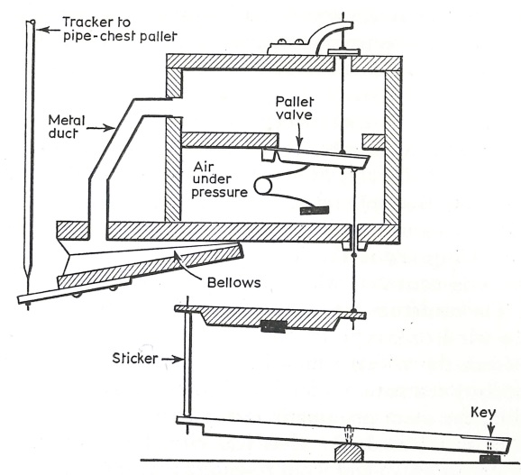
Figure 1
Coll. Significant German builders, such as Friedrich Ladegast, likewise incorporated the Barker Lever into their instruments, and the English reluctantly followed suit into the middle and latter half of the nineteenth century. Having at least solved the problem of overly-heavy key action, organs of the nineteenth century grew in size. But the problem of a steady, stable wind supply still remained a major issue. Builders first attempted to remedy the situation by providing organs with multiple wind reservoirs that provided an instant reserve of air available in immediate proximity to chests, but they proved to be unwieldy and needed to be excessive large. Increasingly high wind pressures and larger chests soon taxed these additional reservoirs beyond their practical functional capacity, and new forms of supplying the wind to the reservoirs in the form of hydraulic blowers and steam-powered blowers were found to adequately meet the needs of the instruments.
With an improved mechanism and consistent wind supply, organs continued to grow in size. The organs of Cavaillé-Coll contained nearly all technological advances available at the time of their construction. Yet even with modern mechanism, he still grappled with the challenges of producing enough tone to fill significant French churches despite the means available to him; Cavaillé-Coll responded by increasing the wind pressures supplied to divisions or portions of a division, especially the reeds. He achieved a further increase in tone production from reeds by maximizing the opening of shallot faces, allowing for greater harmonic development in tone, and employing harmonic (double-length) resonators for the treble pipes to create increased dynamic power. English builders had likewise begun experimentation with higher wind pressures in the nineteenth century, especially as seen in the powerful, rich Tuba Mirabilis, the “miraculous” tuba. Higher wind pressures in slider chests resulted in an increased resistance against the pallet (opening to the key channel and to the pipe), and even with the introduction of the Barker Lever, organbuilders were still impeded from introducing heavy wind throughout their instruments by the physical inability of organists to overcome the weight of the action for any extended period of time without significant physical strain. Nonetheless, larger instruments with greater power, stable mechanisms, and steady wind appeared throughout Europe and the United States, and the organ was enjoying a renaissance in both sacred and secular settings.
But advancements in certain areas of the instrument’s construction led to the identification of deficiencies in other areas. Combination action had been limited to a number of presets operated by levers located directly above the pedalboard, and performers lacked the ability to select the exact stops they wished to engage or retire at will. Cavaillé-Coll again popularized an advancement that sought to remedy this deficiency: ventils. Through the separation of pipework onto flue and reed chests within each division, performers could shut off the air to either chest and draw or remove stops placed on it while playing with no audible change until the ventil was engaged. Once engaged, wind would reenter the chest and allow the selected stops to sound. Nonetheless, adjustable combination action eluded European organbuilders and placed restraints on performers.
While French organs demonstrated improvements in both key action and combination action, English organs likewise evolved as a result of the demands placed upon them. Because of the physical layout of English Cathedrals with choir and organ divided between left and right sides in the front, the preference for a console detached from the main case of the instrument arose. While this was possible with mechanical action, as seen in Cavaillé-Coll’s reversed, detached console on his instrument at Saint-Sulpice in Paris, the drawbacks of running trackers from the console, through the floor, and into the organ nearly always outweighed the benefits. Weight in key action increases as the distance between the key and chest increases, and adding turns to the action only multiplies the heaviness. Tracker runs through floors did allow for consoles to be placed outside of the main case, but the complexity of designing far-reaching mechanical action and the resultant weight in the key action made this option unfavorable. Divided instruments located on both sides of the chancel made this arrangement physically and mechanically impossible. Organbuilders responded with the tubular pneumatic action, which substituted an impulse of air for the direct mechanical linkage. Key weight and physical placement issues found further refinement in this organization, but it too had its drawbacks. Tubular pneumatic instruments were notorious for their sluggish key action, and divisions at varying distances did not sound in concert.
Pipes housed in wooden boxes with shades resembling large Venetian blinds could be made to sound louder or softer by controlling the amount of tone emitting from the enclosure. While an enclosed swell division had already been in use by Cavaillé-Coll, the English substantially changed the nature of the division by increasing its size and making it the foil to the Great. This trend quickly spread to the continent and was applied to other divisions of the instrument. The player’s control of the dynamic presence of individual stops made the organ of the later nineteenth century more flexible than its predecessor with respect to variety and strength of tone within a given registration. With the advent of high wind pressures, builders were able to place powerful stops in enclosed divisions where their dynamic could be suitably subdued or appropriately unleashed.
Despite heavy key actions limiting the use of high wind pressures, fixed console positions that required the organist to sit close to the mechanism, and restricted combination actions, the organ of the middle nineteenth century reached a point of technical refinement and musical flexibility that far exceeded its predecessor of only a few decades. In that time, the advent of the Barker lever and tubular pneumatic action reduced the physical energy necessary to play large instruments and allowed them to be produced and controlled with ease. The beginnings of combination action provided performers with the opportunity to manipulate the addition or subtraction of stops, creating broader coloristic opportunities. Dynamic control of large departments of the organ through the introduction of swell boxes afforded subtlety to registrational changes. In these ways, the organ had become an increasingly flexible vehicle for musical expression.
Developing Aesthetics of the Nineteenth Century

Aesthetic principles developed alongside mechanical innovations as the Romantic movement swept across Europe. Romanticism turned away from Classical Era models of clarity and form, placing an emphasis on individual expression and subjectivity. Composers pushed the boundaries of musical forms, expanding them to vast proportions, and pioneered new forms of programmatic music to create a narrative that was capable of expressing intense emotion over the course of an extended period of time. The orchestra grew in size and color in parallel with the expansion of musical forms, reaching its height in the early twentieth century.
Being intrinsically linked with the overarching trends of the musical world, organs built at the dawn of the Romantic Era mimicked the prevailing musical preference for clarity and form. Divisions of instruments could easily be identified through their physical placement and formal design, and tonal schemes reflected a desire for clarity: minimal unison (8’) stops provided the backdrop for bright upperwork and mixtures. The developing aesthetic of the nineteenth century, however, quickly invaded the organ world, marked by a desire for a greater variety of 8’ stops with a gradation of color and power. Dorothy Holden identifies the importation of the 1863 Walcker for the Boston Music Hall as the beginning of the “trend toward orchestral sound in American organs.” It reflected the developing preference for a broader mass of unison tone and constituted a rather significant divergence from the prevailing trends in American organbuilding, which tended to mirror earlier European models possessing limited tonal resources and balanced tonal schemes that avoided significant breadth of tone. Physically, façade designs gradually moved away from the inclusion of multiple unenclosed divisions separable visually and toward cases with fewer exposed pipes or an artful arrangement of pipes in a “pipe fence.” The stage was set for an industrious, forward-thinking nation to combine the best elements from European models with innovations unique to this country to produce an aesthetic found nowhere else in the world.

The American Symphonic Organ

The American Symphonic Organ evolved as a result of prevailing aesthetic changes influenced by the Romantic Era and the subsidiary need to fill large rooms with sound, but without the technological advances brought forth by innovative organbuilders in the late nineteenth and early twentieth centuries, its existence would not have been possible. Authors too frequently have addressed either the technical or aesthetic principles of this style of organbuilding but have not considered them as two complementary aspects. The growing desire for power and warmth in tone in combination with imitative orchestral voices found in instruments of significant size and power motivated organbuilders to pioneer new forms of construction to meet the demands. Greater power necessitated further development of stop controls and swell mechanisms to allow for increased musical flexibility. Instruments utilizing mechanical key action with its attendant slider chests as produced in the nineteenth century, even with the addition of playing assists like the Barker lever, could not sustain high wind pressures due to the excessive force required by performers to overcome the resistance of the action. Increased wind required pipes of more substantial metal construction, both in terms of pipe walls and languids, which in combination produced the richness of tone and color desired by organists and listeners in accordance with the evolution of prevailing aesthetics. The only way to deliver this aesthetic was to completely divorce the player from the mechanical linkage between the key and the pipe, and this separation was achieved through the introduction of electricity into the organ’s action.
The evolution of the American Symphonic Organ relied on the introduction of a generous, steady wind source and electricity into the components of the operating mechanism. A panel in 1998 was asked “what technical development in the recent history of the organ has had the greatest impact on the instrument and its players,” and the members agreed that mechanical blowing exerted the most influence. Barbara Owen further comments on the panel’s findings, stating that
this invention not only allowed organists to practice long hours on the organ (rather than on the clavichord, harpsichord, or piano), but also opened the door to higher wind pressures, greater use of pneumatic devices in the action, and the monster organs of the early twentieth century.

Not to be overlooked, however, was the necessity of reliable electricity to enable blowers to supply the wind. As electricity became consistently available, larger blowers of vast size and capacity appeared and provided for heavy wind pressures and the aforementioned pneumatic devices such as the electro-pneumatic chest, pneumatic swell engines, and pneumatic combination action. In order to entirely separate the performer from mechanical hindrances, these devices all required the addition of an electromagnet. Rather than physically move a pneumatic bellow, an electrical current produced by the closing of contacts attached to a power supply operated the organ’s mechanisms. All ingredients were then at organbuilders’ disposal to create the desired aesthetic.
Musicologist Peter Williams attacks the “Nadir of 1890-1930” by claiming that “technical ingenuity outran musical demands, or at least reduced their importance;”, however, it was the very musical demands themselves that acted as a catalyst for developments in technical ingenuity. Musical tastes motivated changes in organ composition that could not be supported by the mechanisms available. Successful builders invented new ways of designing organs such that the mechanism would meet the demands of the desired tonal palette and manner in which the performer interacted with the instrument. Those organbuilders who produced instruments approximating the desired aesthetic without the technology to support them ultimately failed. These innovations subsequently led to increasingly higher standards in music-making at the organ. Because of the expanded flexibility in dynamic and registrational control, performers were able to more subtly manipulate the instrument and were expected to take full advantage of the aids made available to them. Ernest Skinner believed that “the American organist has capitalized the potentialities of the American organ action and developed a technique, artistic finesse and resource all his own.” Organbuilders today employ many of the innovations of the early twentieth century despite the technological explosion of the twentieth century, and many have become standards still in use.
For the purposes of this paper, the following features of tonal composition, playing action, swell mechanisms, combination action, and blowers are all necessary components of the American Symphonic Organ, the aforementioned characteristics describing the aesthetic and technical properties of the instrument. Tonally, it is composed predominantly of 8’ flue stops in the manuals that represent gradations in power and color. While upperwork and mixtures are still present in the specifications, they play a subsidiary role and, in some cases, may be completely absent from divisions. One need not look beyond the specifications of Skinner, Möller, and Kimball from the 1920s to see Choir or Solo divisions without mixtures and often without stops above 4’ pitch. Undulating (celeste) stops must be part of the specification and often (ideally) appear in multiple divisions. Reed tone includes dark-voweled chorus stops that nearly always switch to harmonic pipes for the treble, such as the Tromba, Cornopean, and Oboe Horn, and a variety of orchestral imitative voices: French Horn, English Horn, Bassoon, Clarinet, Basset Horn, Orchestral Oboe, etc. Imitative voices do not appear in great numbers in the smallest instruments, but at least one is nearly always present.
To the tonal composition of the instrument is added a mechanism capable of sustaining the aesthetic. Chests utilizing some form of electricity are necessary as perhaps best exemplified by the electro-pneumatic pitman chest developed by Skinner and appropriated by most major builders of the early twentieth century. Stops are voiced on wind pressures of at least 5” and predominantly higher, made possible by the electric action. Electricity also enabled a reduction in the complexity of swell mechanism designs and infinitely simplified the process of designing systems that controlled the instrument’s dynamic range. Multiple manual divisions must be enclosed when more than two are available and are controlled by a balanced swell pedal that operates an electro-pneumatic swell shade motor either in the form of a whiffle-tree engine or individual shade pneumatics. Adjustable combination action allows for the instantaneous change of any console control, which is housed in a standardized shell with angled stop knob jambs, couplers available above the top manual, and a concave radiating pedalboard. Stop key consoles appear occasionally in the American Symphonic Organ but represent the minority of designs. Electric, centrifugal, multi-fan blowers as produced by the Kinetic, Spencer, and Schantz Companies provide a steady and copious wind supply that can be sectioned off of the blower at multiple pressures, making various wind pressures available for different divisions.
Before the emergence of entertainment available at home seen in records and television, the demand for musical entertainment by an urban population paved the way for organists to capture the imagination of audience members in concerts presented both at churches and civic halls. The marriage of color, warmth, and power produced by the American Symphonic Organ enabled performers to present programs containing wildly popular orchestral transcriptions in ways never before heard. The environment that enabled this specific style of organ to develop all came into focus at the turn of the twentieth century: aesthetics and technology met at precisely the right moment in time to enable the creation of an instrument that could not have existed fifty years earlier and that may not have survived fifty years later.
Sources discussing the American Symphonic Organ fall broadly into three categories: organbuilding texts that describe mechanical innovations without a defined style as their end, discussions of aesthetic trends with some peripheral mention of technological innovations, and texts that focus on the contributions of one individual that may or may not place their work in context with that of his predecessors or successors. The goal of this document is to remedy this gap in the literature by clearly defining a style of instrument as the objective of the discussion and supplying a historical narrative of developments supporting and justifying its existence.
CHAPTER 2

Developments in Actions
The introduction of electricity into organbuilding perhaps influenced the development of chest actions more than any other area of the instrument’s mechanism. In order to support a variety of unison stops on high wind pressures, the player had to be physically separated from the associated weight of mechanical key actions. Organbuilders experimented with various playing assists and devices that attempted to reduce the strain on the performer while supporting the developing trends in tonal disposition before electricity and electromagnets were entirely reliable. Such efforts, as put forth by Hilborne and Frank Roosevelt, in addition to improvements in electromagnets and current supply, gradually guided the progress of the organ through multiple stages of development to its state in the early 1920s, where a combination of electricity and wind pressures in Ernest Skinner’s pitman chest rendered the action light, fast, reliable, and capable of sustaining heavy pipes on high pressures.
Organbuilders constantly strove to achieve “two primary requirements” in order to make their electric actions successful as outlined by William Barnes: “1. reliability and 2. speed; that is, quickness in attack and repetition.” This definition, however, may be extended to apply to all chest designs, with reliability and speed being the test of their success.

Roosevelt Pneumatic Action
The Roosevelt firm, led by brothers Hilborne and Frank, was among the first to experiment with electricity in organ actions in the United States, yet even before introducing electromagnets, Hilborne sought to “render the action more rapid and attended with less noise and relieve weight of touch” through the application of a pneumatic to the standard ventil chest in use by the company. In traditional slider chests, a pallet box on the underside of the chest was filled with air when the organ was in use. Each key channel was supplied with a pallet that governed the admittance of air to the channel. In other words, all pipes sounding C¹, C♯¹, D¹, etc. on a given chest were located on a common channel, and when the appropriate key was depressed, the pallet dropped and allowed air to fill the key channel and, therefore, the pipe if the slider was engaged.
The ventil windchest utilized at the time of the invention did away with pallets and replaced them with individual pneumatics under each pipe, and Roosevelt was “for many years the only builder using the sliderless individual valve type of wind chest.” For this reason, Ernest Skinner identified Roosevelt as the “pioneer of the modern individual valve chest.” This design allowed for the charging of each individual stop channel with air upon drawing the appropriate stop knob. If a stop remained in the “off” position, no air was admitted to the respective stop channel in the chest. In 1884, Hilborne Roosevelt teamed with Charles Haskell, a shop supervisor at his Philadelphia factory, to design a pneumatic device that eliminated the need for a Barker lever by placing a wedge pneumatic on each note within a given stop channel, the speech of the pipe being governed by the inflation or exhaustion of the pneumatic. A diagram of its application in the chest is shown in Figure 2.
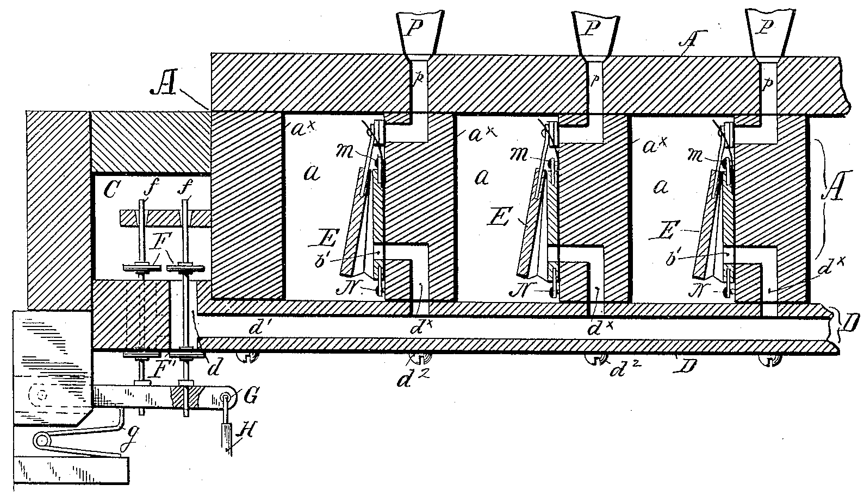
Figure 2
The pneumatic “E” was affixed to the chest by means of a screw “N” and contained at the top a papier-mâché disk pallet that was attached via a stiff spring. When the pneumatic was inflated, the disk sat against the pipe duct “p” and kept the pipe from sounding. When the appropriate key was pressed at the console, the pneumatic exhausted through the channels in the bottom board “d¹,” drawing the valve and spring assembly away from the pipe duct, and the air was admitted to the pipe.
The pneumatics received their air from a pallet box “C” that was constantly charged with air when the organ’s wind supply was on. It is important to recall that wind only filled the stop chambers “a” when the drawknob was activated at the console; however, all pneumatics were always inflated when the organ was on regardless of whether or not the stop was drawn, as the air that inflated them traveled from pallet box “C” through the channeling in bottom board “d¹” to the pneumatics themselves. Therefore, all pneumatics in the chest associated with a note exhausted when it was played regardless of whether or not a given stop channel was charged with air. This process led to an inefficient amount of wind leakage at a time when wind supplies were still limited.
In order to stop the exhaustion of all pneumatics upon depressing a key, Roosevelt and Haskell produced an improved pneumatic in the same year. The same basic chest design was utilized, but the new pneumatic contained two compartments of differing area as seen in Figures 3-A and 3-B; Figures 3-C and 3-D show the pneumatic’s application in a chest (see following page). Figure 3-C
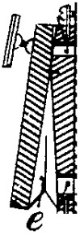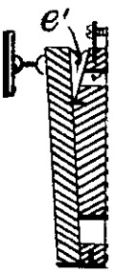
Figure3-A: Large Bellows Figure 3-B: Small Bellows
shows the chest with the pipe sounding, as evidenced by the position of disk “M” away from the pipe duct “p,” and Figure 3-D shows the chest with the pipe silent and disk “M” situated against the pipe duct “p.” When the stop is drawn, air is exhausted from the small bellows “e¹” through partition-way “J,” but the greater area of the large bellows “e” keeps the disk seated on the pipe duct. When the key is depressed, the tracker “H” closes valve “F¹” and allows compressed air to move from the pallet box “C” through channel “d¹” and inflate the large pneumatic. The greater area of the large bellows causes the small
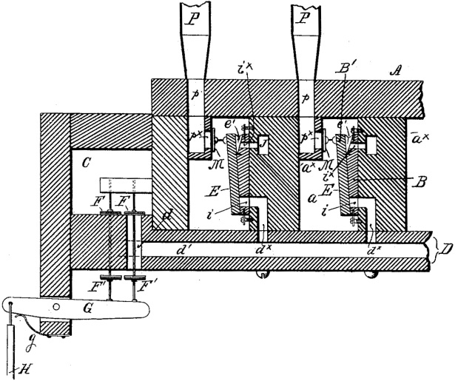
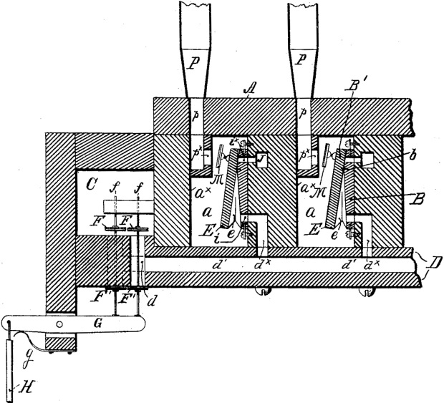
Figure 3-C Figure 3-D

bellows to collapse and move the disk from its seat, whereby air in the stop channel “a” may enter the pipe and cause it to sound. If the stop is not drawn, the stop channel will not contain any compressed air; therefore, no pressure is exerted on the large bellows. The continuous air in the partition-way will keep the small bellows inflated and the disk seated on the pipe duct. If the small bellows remains inflated, the large bellows will not inflate when the key is depressed, remedying the problem of leaking pneumatics in the first Roosevelt-Haskell design. In the previous design, wind was exhausted from pneumatics to allow pipes to play, but in the present design, pneumatics were inflated to allow the pipe to sound. The pneumatics therefore acted oppositely, but the same guiding principle applied in both cases.
In both cases, Roosevelt and Haskell retained mechanical key action but attempted to reduce the force required from the performer by having individual pneumatics actuate the pipes rather than the large pallets found in nineteenth century slider chests. By removing the Barker lever and placing pneumatics in the chest, the noise of the Barker lever was entirely obviated from the mechanism. Though substantially higher wind pressures could not be used with the Roosevelt-Haskell action, their invention illustrates the first major step in divorcing the player from the heaviness of mechanical action and was popular enough to be adopted by the firms of Kimball, Hedgeland, Wirsching, and Compton.

Roosevelt Electric Action
Just a few short years after the introduction of the Roosevelt-Haskell pneumatic action, Hilborne produced his groundbreaking electric organ action that entirely did away with mechanical linkages between the keys and chest and replaced them with an electromagnet and a power source “for the first time in America,” “mark[ing] the beginning of a new era in organ history.” As early as December 1872, Roosevelt began manufacturing a battery designed by Parisian Georges L. Leclanche under the name of the “Leclanche Battery Company.” David Fox describes it as
a direct ancestor of the modern dry cell battery. In its original form, the Leclanche cell consisted of a cylindrical glass jar filled with a mixture of magnesium dioxide power and some inert material such as sand or sawdust. The contents were then saturated with an aqueous ammonium hydroxide solution and the jar sealed with a glass cover that held the electrodes: zinc for the anode (+) and graphite [carbon] for the cathode (-) . . . The chemical reaction that took place within the cell was extremely complex and varied depending on how much current was drawn from the cell . . .

Because the contents of the jar could not sustain a chemical reaction indefinitely, the batteries had to be exchanged every three to six months depending on the amount of use. With an available power source, Roosevelt connected the battery with a contact at the back of the key and the electromagnet, as depicted in Figure 4 (see following page).
When a key is depressed, a contact “N” brings the wires “M¹” and “M²” into circuit with the power source “P” and the electromagnet “H.” All magnets were placed inside an airtight chest “A,” which “avoid[ed] the necessity of making an air-tight connection at the upper part of the magnet” and “afford[ed] a convenient means of admitting the air-pressure through the magnet core.” Once energized, the magnet draws the bar armature “C” upward and into contact with the hollow core “G,” allowing air to exhaust from the round pneumatic “D”
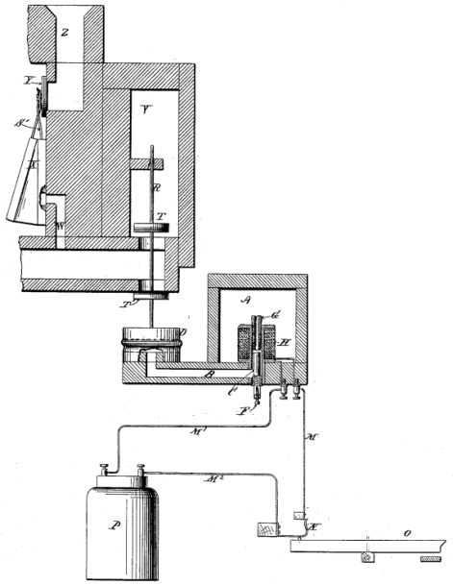
Figure 4

through channeling “B” and escape to the atmosphere through the valve seat “E.” As the round pneumatic exhausts, the valve wire “R” draws down the valve “T” and allows air from the pneumatic bellows “X” to exhaust through channel “W” to the atmosphere. Roosevelt retained the basic pneumatic bellows design utilized in his first ventil chest patent, wherein a stiff spring “S¹” draws a disk “Y” away from or against the pipe duct “Z” according to the position of the bellows. Once exhausted, air could freely move into the pipe duct and allow it to sound.
Roosevelt’s design allowed for either a vertical arrangement of the magnet as depicted in Figure 4 or a horizontal arrangement utilizing two magnets. Because of the ready access to the screw “F,” fine adjustments to the armature’s range of motion were quick and easy. In this form of action, Roosevelt successfully separated the player from any mechanical connection to the pipes. In so doing, he was able to place divisions of organs in various places throughout a building; echo divisions placed in the ceiling at some distance from the console found their way into many of his instruments and notably in the firm’s “magnum opus” at the Cathedral of the Incarnation in Garden City, New York. Unfortunately, “the earliest [electric] organ actions were unreliable largely because of the inability of contemporary batteries to provide relatively high currents at infrequent intervals,” “giving them the name of being unreliable.” For this reason, electric actions did not become commonplace until the final years of the nineteenth century.

Frank Roosevelt Tracker-Pneumatic Action

Following the death of Hilborne Roosevelt, his brother Frank assumed leadership of the firm. Without the reliability of electricity, Frank returned to Hilborne and Haskell’s 1884 ventil chest construction. In the spirit of his brother, however, Frank sought to further reduce the complexity of the mechanical components of the action by shortening the length of tracker runs.
Organ chests are typically constructed in one of two formats: chromatic or diatonic. With chromatic chests, all pipes are arranged in ascending pitch order from the bottom to the top of any respective manual or pedalboard. With diatonic chests, the tallest pipes, C and C♯, are situated on opposite ends of the chest and continue to grow smaller toward the center. In this layout, each subsequent pipe is one whole step higher or lower than its immediate neighbor. Because of the overall shape of the pipes, diatonic chests are also commonly referred to as “M” chests. When builders employ chromatic chests, the motion of the tracker from the back of the key may be transmitted to the chest with little difficulty through a fan frame, whose purpose is communicate the tracker from its comparatively narrow position at the console to the pipe’s wider position on a chest. When builders employ diatonic chests, the motion must be transmitted from one end of a manual to the opposite end and back to the chest, and this transference of motion is accomplished through a roller board. The trackers associated with keys whose respective pipes are located at the far end of a chest are attached to small dowels or metal tubes (rollers) that, when the player depresses the key, turn and activate a secondary tracker that connects to the chest. Figures 5 and 6 depict these two manners of transference of motion.
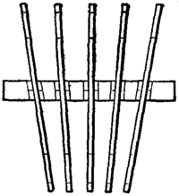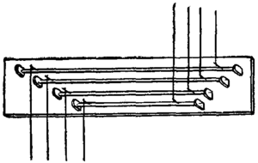
Figure 5: Fan Frame Figure 6: Roller Board

In order to eliminate the need for long tracker runs and roller boards, Frank Roosevelt designed a system whereby trackers connected to a pallet box, to which was affixed a “wind chest channel board” that communicated the remainder of the organ’s action pneumatically as depicted in Figures 7 and 8.
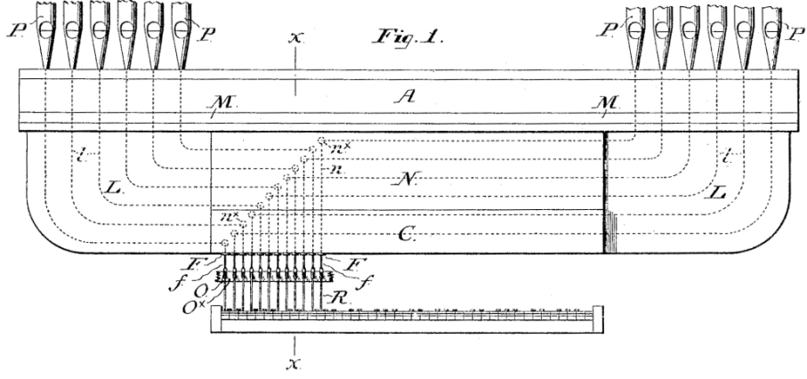
Figure 7

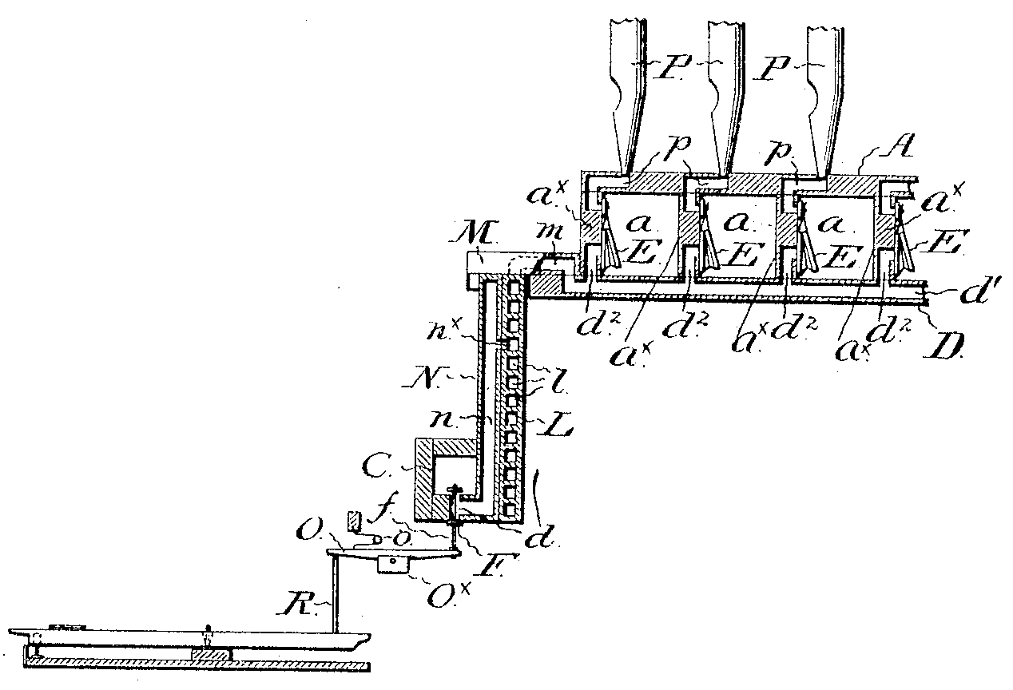
Figure 8

In this design, the wind chest channel board “L” runs the entire length of the chest and contains channels “n^{x}” that connect to each key channel “d¹.” Trackers run from the keys to the pallet box “O,” which is constantly charged with air when the respective stop is drawn and is connected to the channels “n^{x}” that perform essentially the function and are located in roughly the same position as a roller board. When a key is depressed, the tracker opens valve “F” and allows air to exhaust from the pneumatic “E” by means of channeling in the bottom board “d²,” a connecting channel “m,” longitudinal grooves “l” that transmit the air from the central pallet box to the respective key channel on the chest, and through channeling “n^{x}” in the wind chest channel board. Rather than have an extensive system of transference of motion from the keys to the chests through mechanical linkages, the depression of a key leads directly to the pallet box that has been “brought down to key scale” and
is situated in or about the position usually occupied by the . . . roller board . . . By the removal of the pallet box to a position nearer to the manual, the mechanical action . . . is correspondingly simplified or shortened . . . the provision of channels between it and the wind chest being a proportionate substitution for a mechanical action.

It should be borne in mind that the action described above is a key action, or a means by which the depression of a key is communicated to the chest. The chests still operated under a ventil action whereby the entire stop channel was supplied with air or left without air based on the engagement of a stop knob at the console.
Frank Roosevelt teamed with William Elbert to modify the above design in a subsequent invention that moved the channel board closer to the respective windchest in an effort to reduce the complexity of tubular pneumatic action. The remote location of the pallet box and channel board necessitated the reintroduction of complicated tracker runs and roller boards into the action, but it did eliminate the need for excessive tubing as was common in tubular pneumatic instruments and allowed a single chest to house pipes of two different manuals. Progress continually led toward a simplified action of the organ and the replacement of mechanical linkages with impulses of air. In this way, both Roosevelt brothers anticipated the electro-pneumatic action of the fully-developed American Symphonic Organ.

Votey and Wood Tubular Pneumatic Action

As demonstrated by the developments of the Roosevelts, organbuilders were discovering the benefits of using wind to operate the organ’s mechanism in place of trackers as had been the practice for centuries. Edwin Votey and William Wood continued the trend of utilizing air pressure in the development of their tubular pneumatic action in 1891. Whereas Frank Roosevelt employed trackers to actuate a pneumatic on a pallet box located near the console, Votey and Wood devised a system whereby a series of pneumatics in sequence from the key to the pipe allowed compressed air to actuate the pipe’s speech; furthermore, they introduced at the same time a sequence of pneumatic connections that admitted compressed air to the chests, fed from a wind box attached to the bottom of said chest.
A primary purpose in their design was to remedy a phenomenon known as “robbing,” whereby pipes on a given chest would not receive their full allotment of wind due to the fact that “the lower octave of any stop requires as much wind as the remaining four octaves together.” When playing several ranks at the same time,
the robbing action . . . gives to the larger pipes more than their share of air and subtracts from the smaller pipes the air sufficient to give them their requisite amount, resulting, obviously, in an abnormal and disordered action both of the larger and the smaller pipes, neither sounding normally in exact tune.

In order to remedy this problem, Votey and Wood divided chests into two pieces and arranged the pipes diatonically, resulting in an “M” chest. Air was supplied to both ends of the chest from one central location, allowing each half to receive an appropriate volume of wind to speak promptly and in tune as depicted in Figure 9.
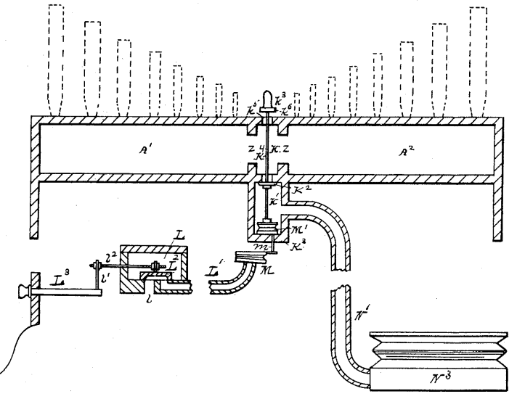
Figure 9
In Figure 9, sections “A¹” and “A²” denote the two sections of the divided windchest, and “K¹” represents a wind trunk supplied with air when the organ is running. One wind trunk still fed the entire chest, but separating the bass pipes kept them from drawing large amounts of air from a comparatively small available volume at one end of the chest. A valve chamber “L” is located near the console and is likewise charged with compressed air. When a given stop “L³” is engaged by the player, it draws back valve “L²” and allows the compressed air in the valve chamber to inflate pneumatic “M” by means of tube “L¹.” Figure 10 depicts a detailed view of the pneumatic “M” and its accompanying valves.
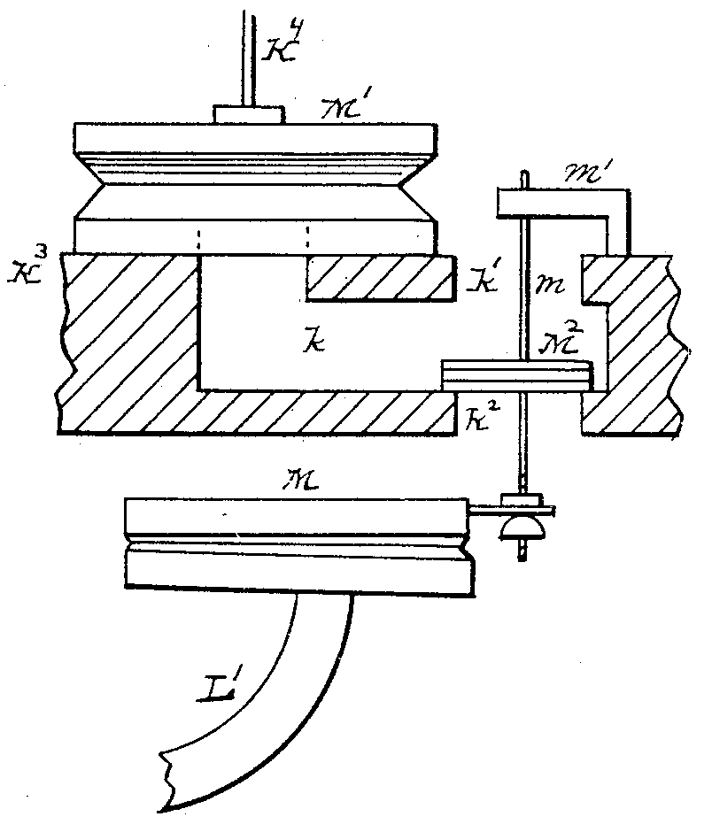
Figure 10

As pneumatic “M” inflates in the manner described above, it raises valve wire “m” and opens valve “K²,” allowing air to exhaust from pneumatic “M¹” through channeling “K.” Rod “K⁴” appropriately draws downward in conjunction with “M¹” and allows air compressed air from bellows “N³” (Figure 9) to enter chambers “A¹” and “A²” through valve “K².” It will be understood that the wind trunk “K¹” runs the entire length of the chest and supplies it with air when the corresponding stop is engaged at the console. This design anticipates the stop channel found in the pitman windchest as designed by Ernest Skinner, the pinnacle of electro-pneumatic chest designs.
Once supplied with air, the pipes could sound with the application of Votey and Wood’s tubular pneumatic key action as shown in Figure 11. The key
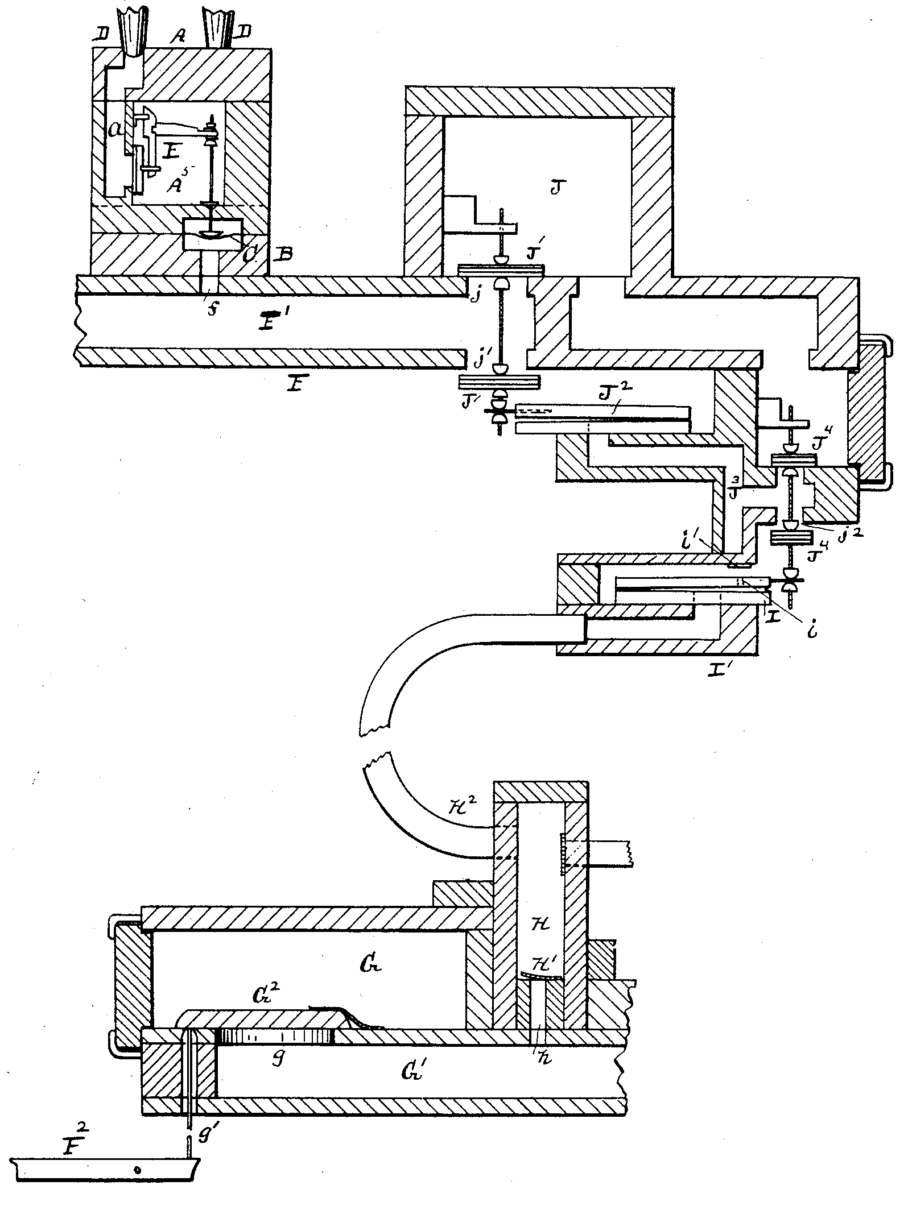
Figure 11

action of Votey and Wood’s invention operates on the same principle as the stop action, substituting impulses of air for mechanical linkages. Key box “G” is charged with compressed air when the organ is on and communicates with pneumatic “I” in the following manner. When key “F²” is depressed, a short sticker “g¹” lifts pallet “G²” and allows the air to travel through valve “g,” channel “G¹,” and opening “h,” where it reaches flapper box “H.” From the box, it further travels through tube “H²” to channeling in box “I¹” to inflate pneumatic “I,” which at its fullest point of inflation rests on a felt washer “i¹” at point “i.” Upon distending, pneumatic “I” raises the double valve “J⁴,” serving multiple purposes. With port “j²” closed, air from the fresh-wind box “J” can pass through channeling “J³” to inflate pneumatic “J²,” which in turn raises double valve “J¹” and concurrently closes port “j¹” while opening port “j.” With port “j” open to the fresh wind box, compressed air may travel through bottom board channeling “F¹” to raise the membrane “C,” made of a leather strip, and raise the attending rod to draw the disk away from pipe duct “a” and allow the pipe to speak. When the key is released, the reverse operation occurs, allowing port “j¹” to open and air to exhaust from bottom board channeling “F¹” and lower membrane “C,” causing the disk to draw away from the pipe duct and stop the speech of said pipe.
Though tubular pneumatic action was known to be sluggish depending on the distance between the console and the chests, Votey and Wood’s design marked yet another stage of development in the path to electro-pneumatic action. They successfully removed any physical connection between the player and the chest with the exception of the short sticker that connected the key to the first pallet, harnessing the power of compressed air to do the work in the action. The application of one common wind trunk supplying air to multiple ranks of a chest relied on the availability of a steady wind supply and further anticipated the stop channels found in later electro-pneumatic actions.

Hope-Jones Electro-Pneumatic Action
Robert Hope-Jones, English by birth, received training as an electrical engineer but was an interested amateur musician, being trained in the arts from a young age. As the organist and choirmaster of St. John’s Church in Birkenhead, England, he undertook the rebuilding of a previous instrument in the church and applied his electro-pneumatic chest design. According to William Barnes, Hope-Jones “made most improvements in the electric action . . . In a way, he was at an advantage knowing little concerning organs and the previous attempts that had been made to utilize electricity for this service.” Hope-Jones’s electro-pneumatic action design received patents in England, France, Germany, Belgium, and Austria-Hungary prior to the assignment of its United States patent, but its application in the United States and Hope-Jones’s career in this country merits its inclusion in the discussion of American inventions.
In his patent of 1894, Hope-Jones included two electro-pneumatic chest designs, both of which connected the player to the chest only through a series of wires and electricity and essentially added an electromagnet to the traditional slider-and-pallet chest design as depicted in Figure 12; any mechanical link had
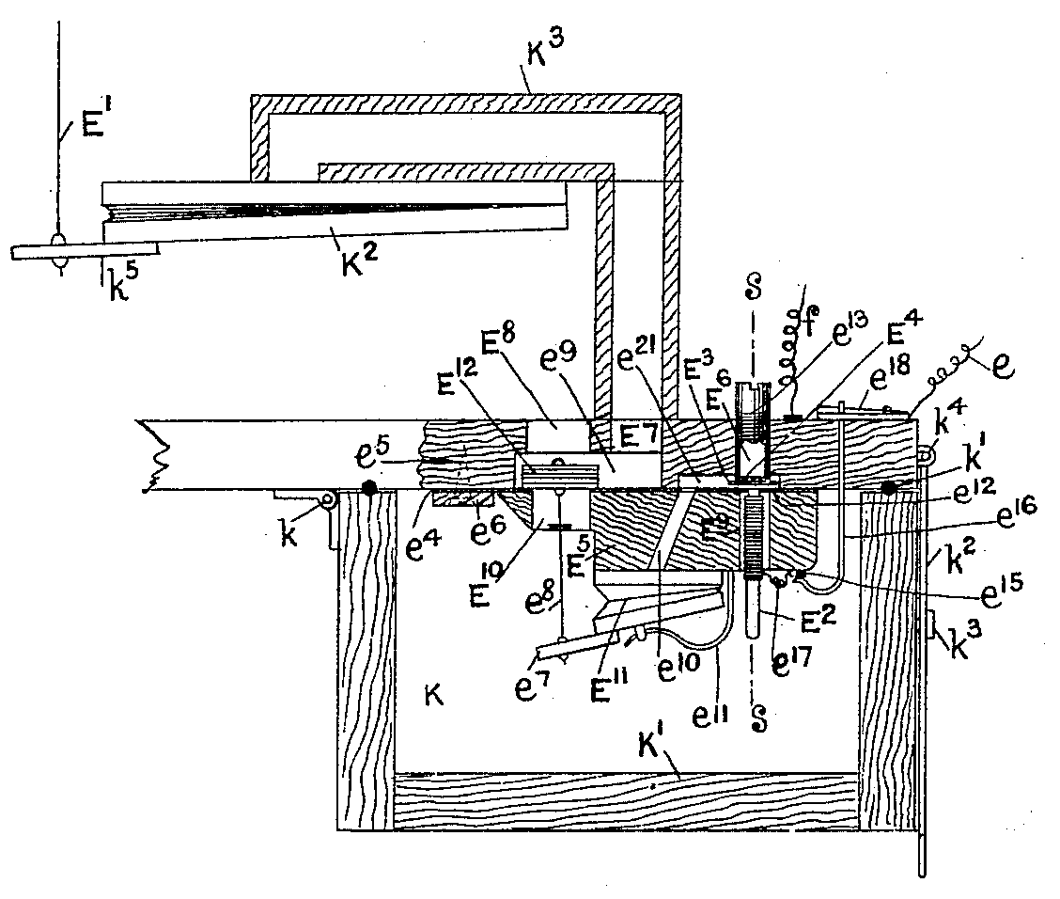
Figure 12
been entirely removed. In traditional slider chest designs as constructed with mechanical action instruments, trackers would run to a pallet located inside the chest. When opened, the pallets would allow air to pass into the key channel of the selected stop and allow the pipes to speak. In Hope-Jones’s design, the mechanism pictured in Figure 12 replaced the trackers, the rod (pull-down) “E¹” fulfilling the role of the final section of the tracker run leading to the pallet and “form[ing] the last member of the electro-pneumatic train or lever.”
In the diagram, a box “K” is provided to house the electro-pneumatic pallets and is charged with air from the blower. The magnet “E²” is connected to the key through wire tails “e¹⁷” that are soldered one each onto two metallic studs “e¹⁵” within the box. The studs are in contact with hooks “e¹⁶” that continue to the outside top of the box, one of which is attached to the organ terminal board (relay) and the other to a conducting strip from which a return wire leads to a power source. When the appropriate key is depressed, the magnet is energized and draws down the armature “E³,” which also functions as the primary valve, away from a small metal tube “E⁶,” which is threaded so as to be adjustable with a screwdriver, against the face of the electromagnet. Hope-Jones constructed his armatures out of soft iron, “which may, if desired, be tinned or varnished and be coated with a thin soft material such as paper, kid, cloth, &c.” in order to reduce residual magnetism.
With the armature drawn down against the magnet, air within the electro-pneumatic pallet “E¹¹” may exhaust through channels “e¹⁰” and “e²¹” to the atmosphere by means of small holes in the valve seat “E⁴.” As the electro-pneumatic pallet exhausts, it draws upwards and closes the secondary valve “E¹².” With the secondary valve seated against port “E⁸,” compressed air within box “K” may travel through channeling “e⁹” and the supply pipe “K³” to inflate the pneumatic bellows “K².” When fully distended, the bellows draws down rod “E¹” and opens the correlating pallet in the wind chest.
When the key is released, the electromagnet is no longer energized, causing the armature to be blown up against pipe “E⁶” by the pressurized air within the box. A spring “e¹¹” helps ensure that the electro-pneumatic pallet returns to its lowest position, which is inflated with air from the chest that gains access to the pallet by moving around the poles of the magnet and through channels “e²¹” and “e¹⁰.” With the pallet inflated, the secondary valve closes and allows air from the pneumatic bellows to exhaust through the supply pipe, channel “e⁹,” and port “E⁸” into the atmosphere. Of particular note in Hope-Jones’s design is the miniscule distance traveled by the armature, measuring only a fraction of an inch (see discussion of Hope-Jones magnets in Chapter 3 for more specific information). In this design, the entire electro-pneumatic operation essentially replaces the Barker lever as a means of opening a pallet, the pneumatic bellows “K²” being the equivalent of the Barker lever itself; however, with no mechanical connection between the key and the lever itself, the action requires no physical exertion from the player and allows for greater ease of facility at the keyboard.
The second application of Hope-Jones’s electro-pneumatic action follows the first design closely and is depicted in Figure 13. A flexible diaphragm “E¹⁷”
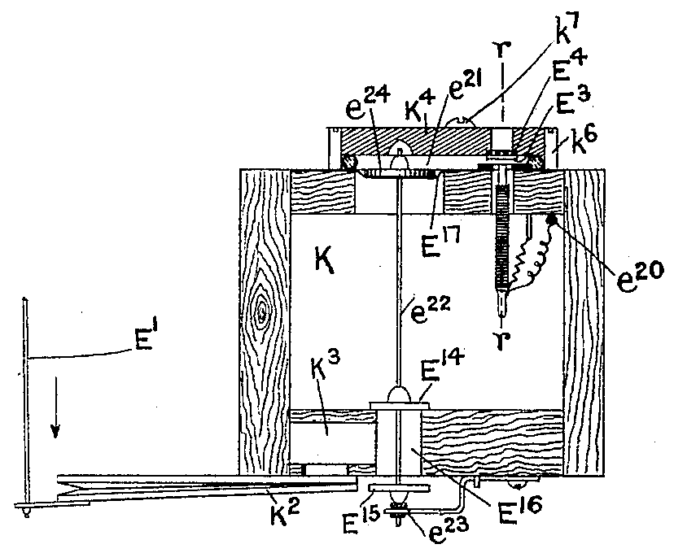
Figure 13
replaces the electro-pneumatic pallet found in the first design, to which is attached a rod “e²².” Affixed to both ends of the rod are disks, “e²⁴” being slightly larger than “E¹⁴” and “E¹⁵.” The metal strip “e²⁰” to which the return wire is attached is moved inside the box “K” but is connected with the magnet wire tails in the same manner. When a key is depressed, a circuit is completed, and the electromagnet is energized, drawing the armature down against its face. Air exhausts from channel “e²¹,” and the pressure inside the chest being greater than the pressure in the channel causes the diaphragm to move upward and raise disk “e²⁴” to its highest position. Disks “E¹⁴” and “E¹⁵” follow the same motion in conjunction with rod “e²²,” thereby closing chamber “E¹⁶” to access to atmospheric pressure and filling it with pressurized air from the box. The air then travels through channel “K³” and inflates the pneumatic bellows “K²,” the remainder of the process functioning as in the first application. A removable cover “K⁴” forms the top of the chamber containing the primary valve and the diaphragm, which is sealed with a rubber gasket or similar material and is attached by means of screws. The easy access to the primary valve and diaphragm allows for simplicity in regulation of the valve and any necessary repairs.
With the entire action governed by electricity, Hope-Jones enabled the “performer to admit or shut off the supply of wind to each pipe with unusual rapidity irrespective of his distance from the instrument.” Whereas tubular pneumatic action relied on the speed of the wind impulse to actuate the chests, electro-pneumatic action required only the fraction of a second for the electrical impulse to activate the pipes and therefore increased the speed with which the chests operated. Unfortunately, Hope-Jones released and incorporated his system into instruments before it was entirely reliable, as evidenced by the replacement of his electro-pneumatic action with a tubular pneumatic system only four years after its installation at Saint Frideswide’s Church of Poplar, London. Despite its shortcomings, the Hope-Jones system represents one the first designs in a wave of electrically-controlled instruments that would soon dominate American organbuilding.

Disadvantages of Slider and Ventil Chests
Despite the significant advances seen in the increased simplicity of construction and speed in the response of organ actions and chests, both ventil and slider chests had associated deficiencies that required further innovation. Since slider chests are constructed with one pallet that fed an entire key channel regardless of the number of stops engaged, they respond differently depending on the number of stops drawn because “the demand on the wind supply will vary the attack.” Furthermore, “due to the weight and consequent inertia of the valve, time is consumed in closing it . . . The longer a valve remains open the longer the pipe speaks. This lag . . . gives the impression of better speech.” In his substantial work The Composition of the Organ, Ernest Skinner identified five deficiencies with ventil chests:
First . . . we will name the unduly large motors required to overcome both the wind resistance against the valves and the tension of the [flat wire] springs.

Second, when all stops are drawn, the exhaust of so many motors choked the channels and caused a sluggish response.

Third, when the stops were off and no wind was in the stop chambers, the motors, having no pressure exterior to them, were blown out by the channel wind . . .

Fourth, the long crooked channels between the valves and the pipes they supplied were common to all chests having valves on a side bar. Channels impede the flow of air and interfere with perfect speech, especially in large pipes.

Fifth, as is true of all stops having a ventil stop action to supply or cut off the wind from the stop chambers, the ventil is slow in action and prohibits the rapid stop changes necessary for precision in registration.

Referring to Barnes’s necessary features for a successful organ action, namely reliability and speed, it is apparent that both chest designs fail to meet the requirements. Slider chests lack the ability to repeat notes quickly, as the time needed for the pallet to close results in a slightly extended speech of the pipe, which can be readily heard. While Hope-Jones’s application of an electro-pneumatic apparatus to the slider chest design did increase the speed of the opening of the pallet, it lacked the ability to quicken the pallet’s closure. Ventil chests produce slow speech from the factors stated above, largely associated with channeling. Any pneumatic’s susceptibility to flexing and leakage rendered even the best designs not completely reliable. Despite the advances seen in the improvements of slider and ventil chests, neither could produce the speed and reliability desired in organ actions. These features, however, found their fulfillment in the electro-pneumatic pitman chest of Ernest Skinner.

Skinner Pitman Chest
In 1898, Ernest Skinner furnished drawings of his pitman chest to architect and organ historian George Ashdown Audsley for inclusion in his monumental The Art of Organ-Building. He claimed to have invented it himself, though one must question this statement as Skinner never applied for a patent on the design. It seems more likely that Skinner adapted the general principle of a chest design by Englishman Charles Frederick Brindley but applied certain improvements that made it far superior to any predecessor. Skinner built upon the idea of a sliderless chest with individual pneumatics for each pipe but reduced the complexity of the construction as pictured in Figure 14 (see following page). “The name ‘pitman’ is a wordplay that describes the mechanism of the wind chest, ‘a man-in-the-pit, so to speak, to let the air into the pipe on signal

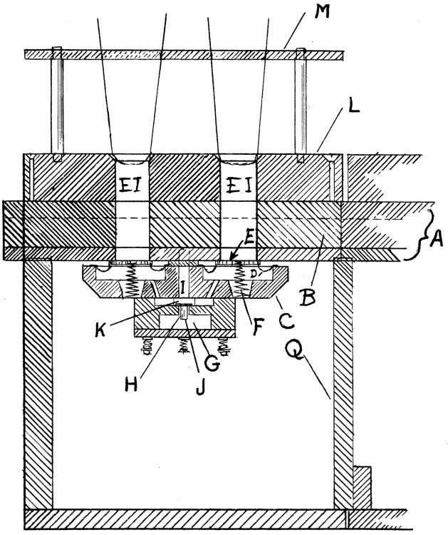
Figure 14
from the organist playing the keys.’” Like Roosevelt’s pneumatic chest design, each pipe has a pneumatic valve placed underneath it, but unlike Roosevelt’s large wedge pneumatics, Skinner placed a small pouch pneumatic “D” containing within it a spring “F.” Unlike ventil chest designs that admitted air to stop channels only when a stop was drawn, the pitman chest is completely filled with compressed air any time the blower is running. Because the entire chest receives air at all times, stop chambers did not need to be sectioned off with dividers, resulting in an economy of space.
Referring to Figure 14, “G” represents the stop channel that runs the entire longitudinal length of the chest, and “B” represents the key channel that runs the entire latitudinal length of the chest. Each note on the chest has a corresponding electromagnet that serves to exhaust the key channel. Likewise, each stop has an electromagnet as pictured in Figure 15. In Figure 15, an electromagnet “A” is energized when the respective stop is drawn at the console, causing an armature (not pictured) that hovers between the base plate of the magnet and its poles to be drawn upward and seat against the base of the magnet’s poles. Pouch “M”
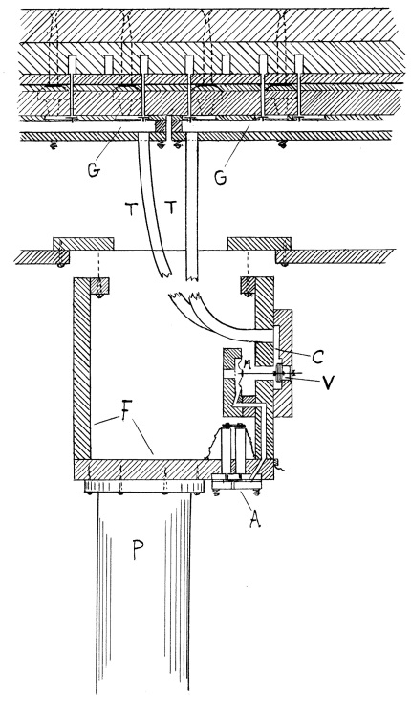
Figure 15*
exhausts through channeling to the atmosphere and opens valve “V” to the atmosphere. Compressed air within the stop channel “G” exhausts through tube “T,” channeling “C,” and valve “V,” leaving the stop channel at atmospheric pressure.
The pitman valve “consists of a small piece of hard wood with square sides about 1/2” long and 1/8” on each side, on one end of which is securely tacked and glued a disc about 1/2” in diameter of suitable leather.” Referring back to Figure 14, the pitman valves “J,” one for each note, drop when the stop channel exhausts, as the pressure inside the valve “K” and channel “I” exceeds atmospheric pressure and serves to hold down the pitman valves. When a note is played, an electromagnet at the end of the chest not pictured in Figure 16 is energized and
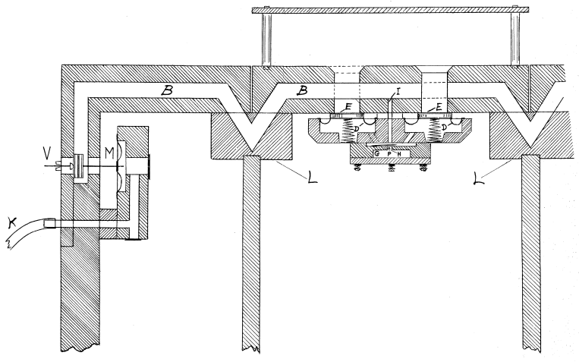
Figure 16
draws back an armature that allows pouch “M” to exhaust through tubing “K,” drawing with it valve “V.” With pouch “M” exhausted, the key channel “B” is open to the atmosphere and exhausts the pouch “D” through channeling “I.” When the individual pouch pneumatics “D” collapse, compressed air from within the chest may move around the valve “E” and enter the pipe, which will continue to sound as long as the key is held and the stop channel is exhausted.
Upon releasing the key, the stop channel again fills with air and causes the pouch pneumatic to inflate, ceasing the pipe’s speech. The springs located within the pouches assist in raising the valve “E” against the base of the pipe duct “EI,” Figure 14, promptly and efficiently. When a stop is retired, air refills the stop chamber and raises the pitman to its original position. Should a stop not be engaged but a key depressed, the pitman will stay in its raised position and keep the pouches from exhausting through the key channel.
Most major builders adapted Skinner’s chest design with few modifications. The Reuter, Schantz, and Kimball companies of the United States and Casavant Frères of Canada retained the key channel in the top board, whereas M. P. Möller of Hagerstown, Maryland relocated the channeling to the bottom board. Möller likewise modified the pitman valve by eliminating the wooden tail piece and replacing it with a leather disk.
All deficiencies identified with ventil chests are completely obviated with the pitman chest. Small pouch pneumatics replace the large pneumatic motors found in the ventil chest, and they cannot be blown out since their total range of motion is restricted by the bottom edge of the top board. Because each pouch pneumatic is so much smaller than the pneumatic motors in ventil chests, the volume of air exiting the chest when multiple pouches exhaust simultaneously is much smaller and therefore does not choke the channels. All channels in the pitman chest run in straight lines with the exception of small turns necessary at the pouches and ends of the chest; therefore, no lag exists while air travels through crooked channeling. Finally, the miniscule range of motion of the pitman valves allows the stop action to act as quickly as the key action, making near-simultaneous changes possible. Because air pressure moves all parts of the chest once the magnet has been energized and the parts need only move a miniscule distance, pitman chests can easily sustain the highest of wind pressures. The large volume of air present in the chests at all times makes winding a large number of 8’ stops easily attainable. The pitman chest represents the first playing mechanism possible of sustaining the aesthetic associated with the American Symphonic Organ and remains in wide use today.

Fleming Combined Electrical and Tubular Action
Even with the advent of the pitman chest, innovative organbuilders continued to develop existing technologies and refine new designs to farther advance the state of the organ in the United States. William Fleming produced a combined electric and tubular action with the goals of avoiding the cost of electric current consumption and providing two consoles on one instrument, one located in close proximity to the chests and another at a distance., The chests in Fleming’s design may employ pneumatics “of any desired construction,” but he chose to use the design for which he received a patent in 1897. It did not represent a significant advance from previous pouch constructions but is represented in Figure 17 because of its association with the current invention.
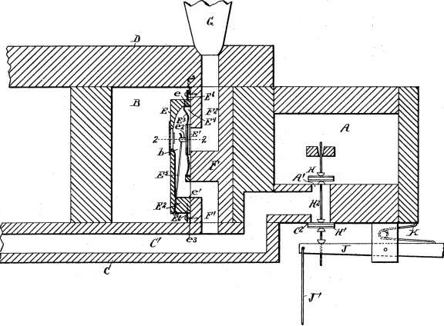
Figure 17

As with other pouch designs already discussed, the wind chest “B” is charged with air when its stop knob is engaged at the console. The pallet box “A” contains compressed air at all times when the blower is running. The pneumatic itself is housed within a block “E” that has been cut away at its ends to form a pocket on both sides of the flexible membrane “E³.” Upon depressing a key, the valve stem “H²” drops and closes port “A¹” while opening port “C²” to the atmosphere. The air within the pneumatic may then exhaust through channels “F¹” and “C¹” and port “C²,” allowing the valve arm “E⁵” to draw away from the pipe duct “F²” and admit air to the pipe. Whereas previous pneumatics were of a circular construction, the most substantial difference with the Fleming pouch was its rectangular shape.
A diagram of Fleming’s invention is represented in Figure 18. A pallet box “A” is constantly supplied with wind from the blower and houses two pneumatics, a wedge pneumatic “J” and a pouch pneumatic “a³.” An
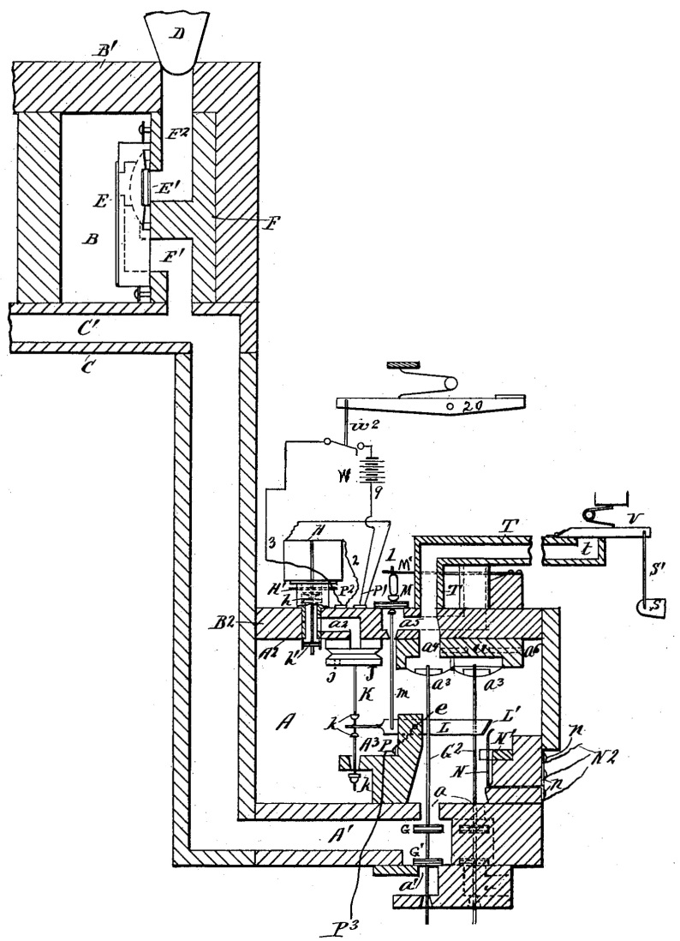
Figure 18
electromagnet “H” and its attendant armature “H¹” control the electric portion of the action in the following manner. When a key “20” from the electric-action console is depressed, a circuit is completed, energizing the magnet. The armature draws upward and allows the wedge pneumatic “J” to exhaust through channeling “a²,” drawing with it rod “K.” The rod is attached to a metal conducting bar “L,” with which is also connected valve wire “m.” When the bar raises in concert with rod “K,” valve “M” is unseated and allows pouch pneumatic “a³”to exhaust through channel “a⁵” to the atmosphere. With the second pneumatic exhausted, valve wire “G²” draws upward and seats valve “G” against port “a,” opening channel “A¹” to the atmosphere through port “a¹.” Air may then exhaust from the pneumatic “E” through channels “F¹,” “C¹,” and “A¹,” allowing compressed air in stop channel “B” to fill the pipe through channel “E².” It will be evident that, upon releasing the key, the armature will drop and seat against valve “h,” allowing the reverse of the previous operation to cease the pipe’s speech. A spring “M¹” helps return valve “M” to its seat promptly, and small bleed holes “j” and “a⁶” aid in inflating pneumatics “J” and “a³” promptly.
The tubular portion of the action only requires the exhaustion of the pneumatic “a³,” actuated by the depression of key “S.” Pallet “V” opens and allows the pouch pneumatic to exhaust through tube “t,” the remainder of the action functioning in the same manner. With tube “t” at atmospheric pressure, channel “a⁵” also exhausts to the atmosphere; with the air pressure being equal both in channel “a⁵” and tube “t,” valve “M” remains seated and is aided in maintaining its position by spring “M¹.”
Though Fleming’s invention did not enjoy wide popularity, it appears to be the first successful attempt at combining two different types of organ action into one instrument. He capitalized on the advancements in electromagnets and the flexibility they afforded. Only two years later, Fleming turned his attention completely to electro-pneumatic action and designed his own version of the ventil chest as hereinafter described.

Fleming Electro-Pneumatic Action
Fleming’s electro-pneumatic action followed closely the electrical portion of his combined action chest as pictured in Figure 19. Of particular importance
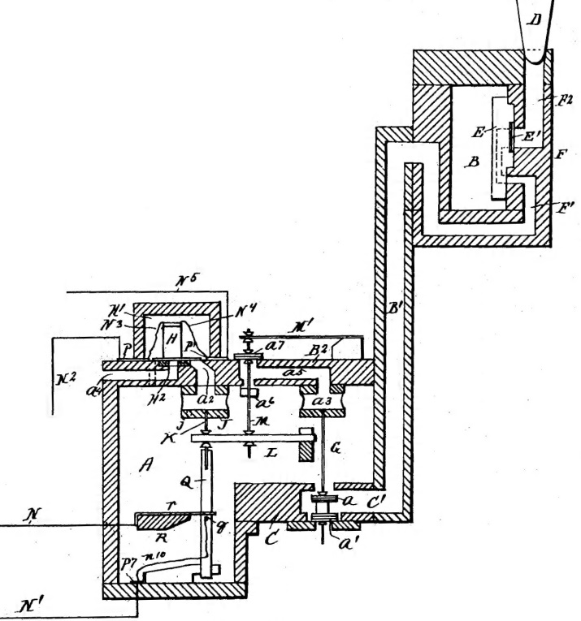
Figure 19
is the location of a bar “Q” within the chest that serves to complete a circuit, allowing couplers to engage. The wire “N²” proceeds from a contact at the back of the key (not pictured) and is soldered to a metal plate “P” in the key action magnet box. To plate “P” is also connected one wire from electromagnet “H,” the other magnet wire being connected to a different metal plate “P¹.” The return wire “N⁵” is likewise soldered to plate “P¹” and continues to a power source, allowing the magnet to energize. Upon being energized, the magnet “H” draws up armature “h¹” and allows air from within pneumatic “J” to exhaust through channels “a²” and “a⁴” as depicted in Figure 20.
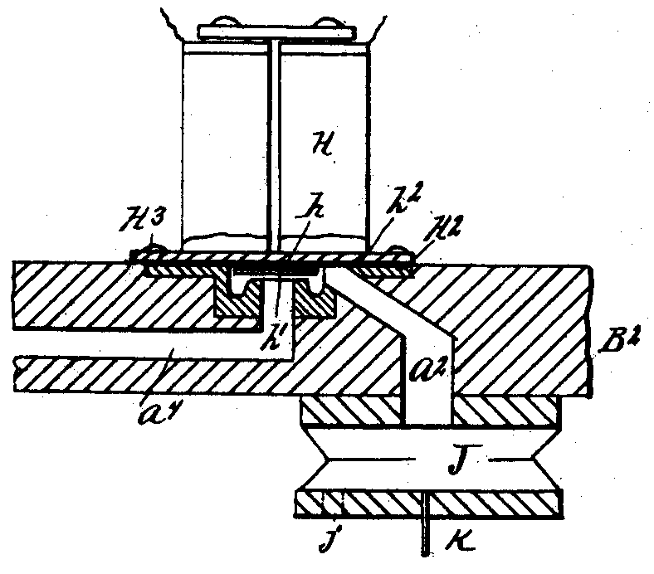
Figure 20
Of particular note in Figure 20 is the magnet base plate “h” to which the electromagnet is affixed and against which the armature “h¹” seats when the magnet is energized. Because of the uniformity of the design, “each of the parts may be made in duplicate, so as to be conveniently and readily assembled.” Fleming supplied small borings on either side of the armature seat to facilitate quick and efficient airflow underneath the magnet. As pneumatic “J” exhausts, it draws up pin “K,” which is also in contact with bar “Q.” Attached to bar “Q” is a small metal pin “q” that, when the bar is raised, rubs against contact “T” and completes a circuit that enables a coupler to engage if it has been selected at the console. Wire “N” leads from contact “T” to the division with which the current division is to be coupled. The power for the coupler is supplied through a wire “n¹⁰” that is soldered to a metal plate “P⁷,” to which is soldered return wire “N¹” that leads to the battery. It will be understood that there are as many metal pins “q” within each note action as there are divisions to which the sounding note is to be coupled.
As bar “K” rises with pneumatic “J,” arm “L” likewise rises and unseats valve “a⁷”, allowing pneumatic “a³” to exhaust through channel “a⁵.” This in turn closes valve “a” to chest pressure and allows the pneumatic “E” to exhaust through channels “E¹,” “B¹,” and “C¹,” at which time compressed air in stop channel “B” may move through channel “E¹” and allow the pipe to sound. As in the combined action design, a spring “M¹” assists in quickly closing valve “a⁷” when the note is released. The Los Angeles Art Organ Company employed Fleming’s design in the construction of the then world’s largest organ for Festival Hall in St. Louis, and in promotional materials commented that “the entire Organ is fitted with the Fleming Patent Individual Valve Electro-Pneumatic Action, which for promptness and certainty of operation and durability stands at the head of electro-pneumatic actions.” While sales rhetoric certainly motivated the strength of the brochure’s language, especially given the financial strain the “Big Organ” placed on the firm, Fleming’s electro-pneumatic chests fulfilled both of Barnes’s requirements for a successful electric action and therefore warrants inclusion in a discussion of the development of the American Symphonic Organ.
Skinner Duplex Action
In order to grant his instruments greater musical flexibility and “increase the combination possibilities of stops belonging to different manuals without the use of couplers,” Ernest Skinner devised his duplex chest around the year 1902. The duplex principle allowed a single stop to be available for use in two divisions while engaging the same pipes. For example, an 8’ flute in the Swell could be drawn independently in the Great, allowing a solo stop to be drawn in the Swell; this arrangement would provide the Great a quiet 8’ stop under dynamic expression to accompany the solo voice in the swell. Skinner retained his pitman chest design in his invention as pictured in Figure 21.
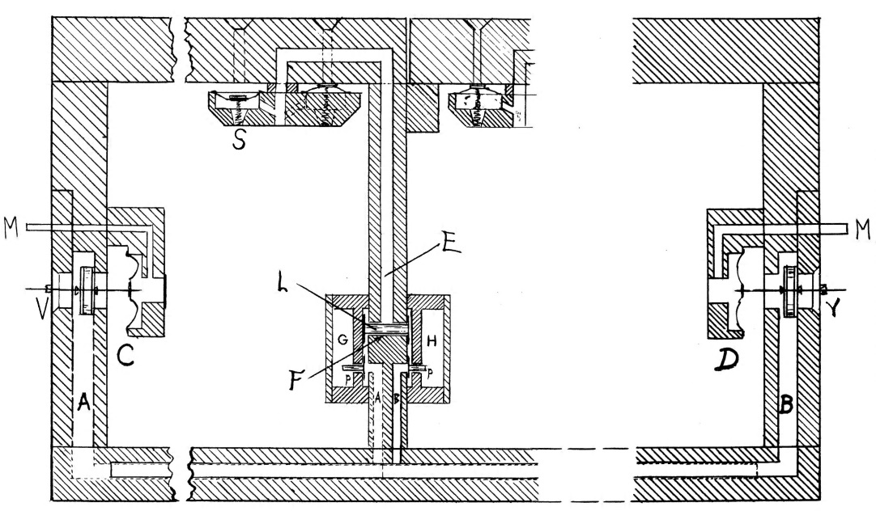
Figure 21

In the drawing, the stop to which the duplexing principle is applied is supplied with two stop channels “G” and “H,” one for each division in which the stop is to speak; for the sake of clarity, it will be assumed that stop channel “G” controls the respective voice on the Swell and stop channel “H” on the Great. The pitman valves “P” operate horizontally as opposed to vertically but are effected in the same manner as the straight pitman chest. Should the stop on the Swell be drawn, a magnet will become energized and allow stop channel “G” to exhaust in the same fashion as Skinner’s original pitman chest (refer to Figure 15), causing the pitman “P” to shift to the left since the pressure inside channel “A” is greater than the atmospheric pressure in channel “G.” Without a note being played, the shifter “L” remains in a central position, as the pressure in channels “A” and “B” is still the same.
Channel “A” communicates with pneumatic “C” that controls the Swell key action, and channel “B” communicates with pneumatic “D” that controls the Great key action as in Figure 16. If the Swell stop is drawn and a key depressed, pneumatic “C” will exhaust and cause the shifter “L” to move to the left since the pressure in chamber “B” is greater than that in “A.” The pouch pneumatic “S” may then exhaust through the common channel “E”, around shifter “L,” through key channel “A,” and out valve “V.” The Great action operates in the same manner, governed by stop channel “H,” key channel “B,” pneumatic “D,” and valve “Y.” Figure 22 depicts shifter’s position with the Great stop drawn (see following page).
Should both stops be engaged at the same time, the shifter “L” will retain a
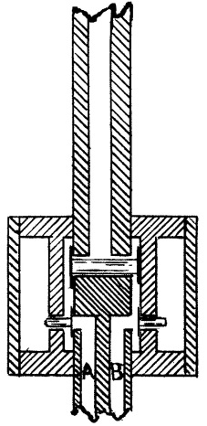
Figure 22

central position since there exists no difference in the pressure in channels “A” and “B.” Skinner provides a succinct summary of the duplex chest’s usefulness in The Composition of the Organ, stating:
This duplexing has proved to be valuable in increasing the scope of small organs. Where funds are limited, as is usual with small organs, duplexing gives the necessary resource to both manuals . . . Without duplexing, there would be a soft accompanimental stop or 4’ Flute on but one of the manuals . . . Providing these stops without duplexing must, at increased cost, result in essential duplication . . .

In a period of only forty years, the organ’s action developed substantially in order to make it more musically flexible, reduce strain on the performer, and allow wind pressures capable of producing tone in accordance with prevailing aesthetic changes. Cumbersome mechanical action gave way to early experiments in ventil chests that replaced one pallet for each key channel with individual pipe pneumatics as seen Roosevelt’s designs. Roosevelt’s earliest experiments in electro-pneumatic action, innovative but unreliable with the technology available, anticipated the strides in action designs that followed in the next decade. The performer gradually gained distance from the action through the development of tubular pneumatic chests, and the organ’s action became more compact and quiet; however, the lack of immediate, quick response saw the mechanism disappear after a short time. Division of pipework between two halves of the chest, as in Votey and Wood’s tubular pneumatic action, guaranteed a sufficient wind supply to all pipes and improved speech and tuning issues. Robert Hope-Jones’s application of electromagnets to traditional slider chests increased the speed of the action and began a revolution in chest action designs, leading to Ernest Skinner’s pitman chest.
The pitman chest ensured a generous wind supply at all times and allowed stop changes to be enacted as quickly as notes could be played. Continuation of Skinner’s pioneering work saw the appearance of Fleming’s designs, incorporated into one of the landmark organs of the early twentieth century, and the later development of the duplex chest. The ability to rapidly change stops enabled organists to convincingly perform orchestral transcriptions, whose scores often change colors or instrumentation quickly. The pitman chest’s capability of sustaining high wind pressures enabled pipe constructions of substantial metal that created power and warmth. The abundance of air present in electro-pneumatic chests enabled organbuilders to provide a wealth of unison tone graduated both in color and power that mirrored the tonal palette of the nineteenth century orchestra. Reeds gained stability of speech through high wind pressures and permitted organbuilders to develop chorus stops and orchestrally-imitative stops desired by listeners and performers alike. By 1920, the organ had reached a state of development far beyond its ancestor of forty years: actions were fast and reliable and could finally produce the desired aesthetic of the early twentieth century.

CHAPTER 3
Developments in Electromagnets

Having established that electro-pneumatic actions provide the quickest, most reliable designs, it is evident that these actions required an electromagnet possessing the same qualities. Hilborne Roosevelt produced one of the earliest versions of an electromagnet in the United States for use in organ construction, but as previously discussed, the reliability of his design, advanced as it was with the available technology, ultimately failed to reach a standard of the highest quality. Robert Hope-Jones made the first significant stride in the development of magnets, constructing them with a U-shaped iron core and multiple wire windings. Further discoveries concerning the use of direct current and low voltage increased the reliability of electromagnets and provided them with the stability necessary to operate the evolving action designs of the late nineteenth and early twentieth centuries.

Roosevelt Hollow Core Magnet
In his electric chest action depicted in Figure 4, Hilborne Roosevelt employed a hollow core magnet with a cylindrical valve armature, also known as a solenoid. The base construction of the magnet was patented by New Yorker George G. Wacker, but Roosevelt altered the design to make it applicable to his electric action, as depicted in Figure 23.
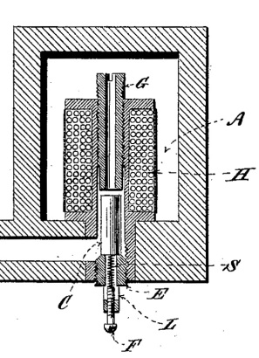
Figure 23

In Figure 23, “H” represents the electromagnet itself, between the halves of which is secured its hollow core “G.” The solid cylindrical valve armature “C” freely moves between the hollow core and the adjustable valve seat “E.” Within the valve seat is located a spring “S” that may be adjusted with screw “F.” Though the spring and screw are not essential in the design, they provide for a lighter valve armature that helps provide a prompt response. The design of the valve seat and the hollow core allows for the distance of travel of the valve armature, which “may be provided with leather faces” to reduce residual magnetism, to be adjusted to provide an entire cessation of wind passage. Because there exists a slight gap in the boring in which the valve armature rests, wind from within box “A” may travel around the armature when it is not energized, as pictured in Figure 23.
When the magnet receives an impulse from the key and energy from a battery, the armature draws upward and seats against the base of the hollow core, stopping airflow from the chest. By placing the magnets entirely within a box, Roosevelt eliminated the need to make “an air-tight connection at the upper part of the magnet.” As discussed in conjunction with Roosevelt’s electric chest design, the armature may be arranged as pictured above or may be placed horizontally, in which case two magnets dictate its range of motion.

Hope-Jones Horseshoe Magnet
Robert Hope-Jones created “one of the earliest forms of magnet” whose construction provided superior efficiency and whose model was retained for decades. His knowledge of electrical properties undoubtedly aided in his design process, which resulted in a horseshoe-shaped magnet as pictured in Figure 24 (see following page). The core “C” is constructed of “specially prepared and treated soft iron” that has been bent and mounted to a plate “P” of an appropriate metal such as zinc or brass “for electrical reasons.” “Hard” and “soft” iron each possess specific magnetic properties:
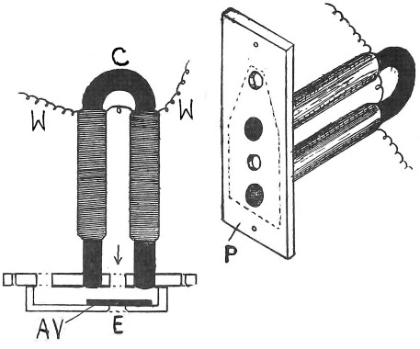
Figure 24

The former is not easily magnetized, but will retain its magnetism permanently, while the latter more readily realigns with any transitory magnetic field. All materials that contain iron possess both hard and soft qualities to some degree; their ratio determines their actual magnetization properties.

Because soft iron readily exhibits a magnetic property when the wires that are wrapped around it are charged with an electrical current but releases its magnetism when the current no longer passes through the wires, it represents the ideal metal from which to construct the core. Hope-Jones soldered the poles of the core into the metal plate and covered the metal components with a coat of lacquer for protection.
This particular style of construction, consisting of an “all metal magnet and valve unit, was first invented by Robert Hope-Jones as an improvement (and, indeed, a very great improvement) on his former type with wooden caps.” In the previous design, the magnets were secured in a wooden block; any atmospheric change in temperature or humidity had the potential to cause the blocks and caps to swell or shrink and cause a misalignment in the armature that could lead to ciphers.
As mentioned above, when the wires “W” are charged with current, the poles of the core became magnetized and draw armature valve “AV” to draw upward, though “a thin bedding prevents AV from ever touching the poles.” Because of its extremely thin construction, the armature needs to move only about 1/100” in order to open the valve and allow it to exhaust the associated pneumatic. To avoid sparking at the contact point, an event common when the contact is broken, Hope-Jones wound “the magnet coils in two, three, or more separate layers of different lengths or of wire of different gage, the adjacent ends of the wires being all connected together and to the circuit wire.”
Hope-Jones also stressed “the need for a high magnet resistance to prolong battery life in those cases where his organs were thus powered,” as magnets with high resistance consumed less current. The knowledge he obtained during his tenure as a telephone engineer would have helped him determine flux leakage, which gauges the amount of the magnetic field lost due to gaps in the apparatus. English physicist Colin Pykett further explains the incorporation of flux leakage in Hope Jones’s magnet:
Minimising flux leakage means that the magnetic circuit has to be complete (hence his use of a hairpin configuration so that the flux from both poles was returned to the armature and passed through it), and air gaps in the magnetic circuit had to be minimised (hence the armature movement had to be minimal while still enabling it to do its job).

In its final design, the electromagnet he produced provided an armature with a much smaller range of motion than the solenoid arrangement of Roosevelt and consumed less current, making it quicker and more reliable than earlier forms. Organbuilders subsequently modified and adapted Hope-Jones’s magnet construction, but its general concept and design has endured for decades.

Votey and Wood Electromagnet
In an attempt to make electromagnets more reliable, Edwin Votey and William Wood invented their own for use in their electro-pneumatic chest, whose construction closely mirrored their tubular pneumatic chest design. The magnet, as shown in a chest in Figure 25-A, resembles Hope-Jones’s design with a horseshoe shaped core and multiple wire windings; Figure 25-B presents an elevation view (see following page). The core “C” is permanently fixed to a plate “C²” in which are provided small holes “c” and “c¹” to allow for the free passage of air. Wire windings “C³” surround the core, and their tails are connected to a key
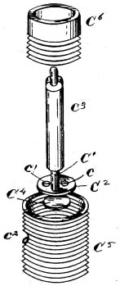
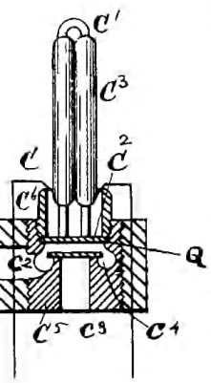
Figure 25-A Figure 25-B

(or stop, coupler, etc.) and power source as in any other design. An armature “C⁴,” constructed of solid metal, rests inside the base “C⁵” and is “covered with leather to make its operation noiseless.” The cylindrical base is threaded, which allows for a secure fit within the chest to which it is applied. An exhaust hole “c²” in the base provides a connection between the channeling in the chest and the port “c³” in the bottom of the base. A threaded thimble “C⁶” screws into the base and ensures an airtight seal with the baseplate “C²” as pictured in Figure 25-A. Air may only travel through the two holes “c” and “c²” provided in the baseplate.
When the magnet is energized, the armature draws up against the plate and allows air from within the chest to move through the exhaust hole and out of the bottom of the chest. When the note is released, the armature retains its lower position on the port “c³,” aided by the air traveling down between the poles of the magnet and through holes “c” and “c¹.” As with Hope-Jones’s design, all components are constructed of metal and are therefore resistant to any atmospheric changes. Furthermore, the compact magnet unit may be removed from the chest and easily disassembled for cleaning purposes, an improvement on the Hope-Jones magnet that must be attached to the chest with small screws.
A year after the patent of Votey and Wood’s electromagnet, Edwin Votey received a patent for his improvements on the previous design. In its subsequent form, the core became a single soft iron shaft in a vertical arrangement (not horseshoe in contour) and was housed within a metal shell as pictured in section in Figure 26-A and in elevation in Figure 26-B. Votey retained a metal base “A”
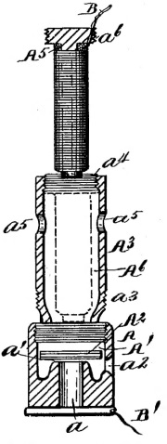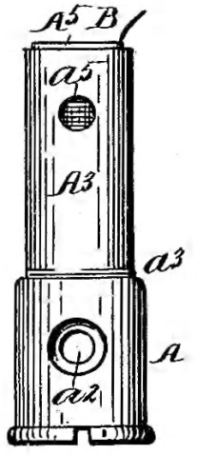
Figure 26-A Figure 26-B

to which the core of the magnet “A⁵” is permanently affixed and which is threaded so as to form an interior chamber “A¹.” At the base of the interior chamber is located an opening “a” and a valve seat “a¹.” The interior chamber of the base contains an armature “A²” that functions in the usual manner and that may exhaust through an opening “a².” The core itself is housed within a tubular shell “a⁵” that also contains openings “a⁵” through which compressed air from within the chest may travel. The head of the core “a⁶” has threaded engagements that, when in the position indicated by dotted lines in Figure 26-A, conform to the threaded engagements “a⁶” in the top of the shell “A³.” The shell also contains threaded engagements that connect with the base, securing all parts of the magnet unit into place.
In his improved design, Votey allowed for a “large wind area about the core of the magnet” that was readily able to enter through the openings “a⁵” in the shell. By enclosing the core in the shell, “the inner core forms one pole and the shell forms the other pole of the magnet,” which are energized through connections to a power source through wires attached to the shell “B” and the base plate “B¹.” As with the previous design, all components are made of metal and resistant to temperature and humidity fluctuation, and the “construction of the magnet is simple and economical and also of superior efficiency.”

Skinner Adapted Electromagnet

Hope-Jones joined the Skinner firm in 1905, and despite their contentious work relationship, Skinner adopted the wooden-cap magnet design and retained it for a number of years. Joseph Dzeda, curator of organs at Yale University and a Skinner authority, describes the Skinner adaptation in the following way:
The standard Skinner Maple Cap magnet had been designed some thirty years before the merger of the [E. M. Skinner and Aeolian] firms. Although it could operate on high wind pressures while consuming only a modest amount of current (an important consideration in the early days of electric actions), its wind-ways were of small bore, limiting its pneumatic capacity and necessitating a two-stage primary/secondary valve arrangement for all key- and stop-actions. The resulting action was wonderfully responsive, but the complicated construction of the Maple Cap magnet and the need for a two-stage chest action raised production costs and ultimately doomed this magnet despite its many other redeeming qualities.

The two-stage chest action refers to the necessity of two pneumatics to actuate a given pipe or stop, the first (primary) exhausted by the magnet and the subsequent pneumatic (secondary) exhausted by means of a valve that opened as a result of the first. In Skinner’s design, “the motion of the armatures is made exact and uniform in construction and in no way can it be disarranged or affected either by a climatic change or by a removal of the block.” Figure 27 shows the application of the magnet in a chest (see following page).
In the drawing, magnet poles “B” are mounted by means of threaded ends into a block “A” that forms the top of chest “Q” “to a point slightly below the surface in order to prevent actual contact with the armature when the magnet is energized.” Wire wrapping “E” surrounds the poles, which are connected by an iron bar “F” that completes the circuit when current is passed
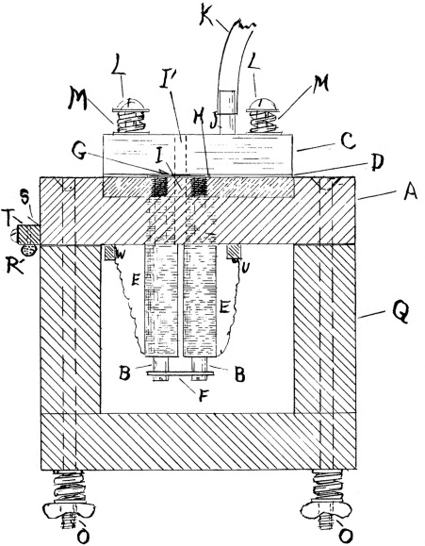
Figure 27

through the wires. The wire tails lead to metal studs “W” and “V” that connect to a power source and a contact so as to allow the completion of the circuit. A brass plate “D” that has been cut away in the center to provide a cell “H” for the armature sits on top of the block “A.” Figure 28 presents a sectional view taken along the dotted line in Figure 27, wherein “h” represents the block, “J” the brass plate, “I” the armature, and “C” the chest.
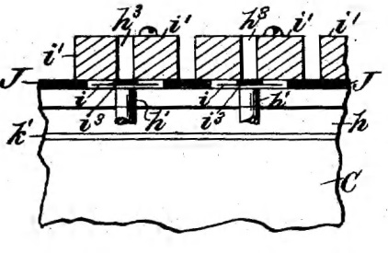
Figure 28

The armatures “I” that hover in cell “H” (Figure 27) are “made of tin-coated iron and [are] bare – not covered by leather or similar substance – since these vary in thickness with humidity, catch dust, and may occasionally become detached.” Leather bushings were attached to the armature disk in previous designs but were replaced with an indentation (“N,” Figure 29), raised only 1/50”, to keep at a sufficient distance from the wooden cap “C” (Figure 27).
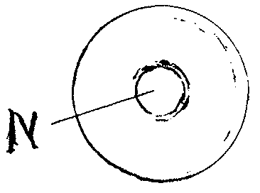
Figure 29
By retaining a brass plate in which the armatures hovered, Skinner was able to completely regulate their range of motion and disallow any regulation beyond removal of the block for cleaning of any dirt or dust that may collect around the armature. The maple blocks resisted changes due to fluctuations in humidity and provided a completely reliable seal. Skinner chose maple blocks in place of “metal mountings, as moisture does not collect on wood mountings” and lead to corrosion. Despite its eventual disappearance due to the complexity of construction, Skinner’s wood-cap magnet demonstrates an advancement toward his goal of “eliminat[ing] delays occasioned by slow or unresponsive mechanism” by providing a magnet that, once regulated, fired with consistent speed and accuracy.
A quick, reliable electro-pneumatic action required electromagnets exhibiting the same qualities. The earliest experiments in organ magnets paved the way for refinements and the introduction of the horseshoe magnet with a soft iron core. Organbuilders constantly strove to produce magnets with less variables to reduce the likelihood of malfunction, as seen Votey’s magnet enclosed in a cap or Skinner’s wood-cap magnet in which every moving part was regulated at the time of construction. As technology progressed, magnets with higher resistance and lower voltage consumption allowed electro-pneumatic chests to be designed with the current supplies then available. Ready access to fast, reliable magnets allowed organbuilders to apply them to nearly every aspect of the organ’s mechanism and made them an indispensable component of the American Symphonic Organ.

CHAPTER 4
Developments in Swell Mechanisms

As improvements in electromagnets made fast, reliable electro-pneumatic actions capable of sustaining high wind pressures, organbuilders constructed pipes of heavier metal that produced a greater volume of tone and the possibility of darker color. This presence of tone did not necessarily equate to louder instruments, a common misconception, but it did allow for louder stops to appear in instruments – and they did appear with increasing frequency. In order to retain the color produced by pipes voiced on high wind pressures without building instruments of overwhelming dynamic proportions, builders sought out new ways to control the swell mechanism. The orchestral concept of the early twentieth century required the organ to imitate the symphony orchestra as closely as possible, and extremes of dynamics remained an important element of the organ’s design. French and English organs exhibited the first stages of development in this area as previously discussed, but American innovations furthered the flexibility of divisions under expression. As in the development of other aspects of the organ, builders sought to disconnect the player from the swell operating mechanism. Beginning with an entirely pneumatic operation by Roosevelt, American swell designs moved toward electro-pneumatic designs that allowed performers to open and close the swell boxes as quickly as they could play the keys and engage or retire the stops.
Roosevelt Tubular-Pneumatic Swell
In his early instruments, Hilborne Roosevelt introduced a balanced tubular-pneumatic swell engine to replace a mechanical swell. “Balanced swell” refers to a lever (swell pedal) that is centrally pivoted so as to rock back and forth on its fulcrum. An arm attaches to the pedal and moves the swell shades in accordance with its position, thereby opening or closing the shades and emitting or reducing the amount of tone coming from the box. George Audsley claims that the French first introduced the balanced swell whereas William Barnes credits the German firm of Walcker, but its application in English organs found quicker reception. In instruments of great size, the amount of weight associated with mechanical swell mechanisms became cumbersome for the player, and pneumatic devices, such as that developed by Roosevelt, quickly replaced mechanical forms.
Roosevelt’s tubular-pneumatic swell mechanism followed closely the motion of the swell pedal, as pictured in Figure 30 (see following page), and therefore closely approximated its precision. A balanced swell pedal “A” connects to a horizontal lever “C” that serves to inflate or exhaust a primary pneumatic “B.” The primary communicates with a secondary pneumatic “E” through tube “D,” which is filled with compressed air. Pneumatics “B” and “E” share in inverse relationship: when the swell pedal is closed, pneumatic “B” is
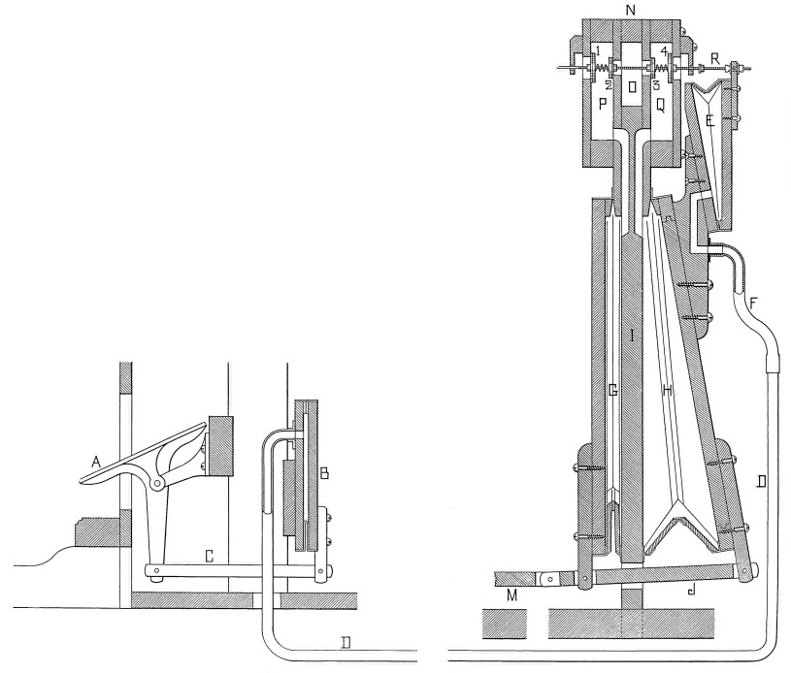
Figure 30
inflated and pneumatic “E” exhausted, and vice versa as pictured. A rod “R” passes through chambers “Q,” “O,” and “P” and is governs valves 1-4. Between each pair of valves (1-2, 3-4) is located a spring, the function of which is described below. Chamber “O” is filled with compressed air and communicates with chambers “P” and “Q” that respectively communicate with pneumatics “G” and “H.” A trace rod “M” attaches to bar “J” of the pneumatic assembly and attaches directly to the swell shades.
When the swell pedal is opened, bar “C” draws toward the pedalboard (to the left in Figure 30) and correspondingly closes pneumatic “B,” causing air to travel through tube “D” and inflate pneumatic “E.” As the secondary pneumatic inflates, it draws rod “R” to the right. In so doing, valve “1” compresses the spring and allows pneumatic “G” to exhaust, while valve “3” compresses the spring and allows air from within chamber “O” to inflate pneumatic “H.” When the pneumatic inflates, bar “J” draws with it trace rod “M,” which opens the swell shades. In the above process, valves “2” and “4” remain seated, and the spring returns all valves to their seated position when the swell pedal remains stationary. The opposite chain of events unfolds when the swell pedal is closed. As the secondary pneumatic exhausts and inflates the primary pneumatic, valve “4” opens to exhaust pneumatic “H” and valve “2” opens to the compressed air in “O,” thereby inflating pneumatic “G” and causing bar J and trace rod “M” to close the swell shades.
It will be understood that the above process applies to any position of the swell pedal and is not limited to fully open or fully closed positions. Since the volume of air traded between the primary and secondary pneumatics remains constant, each may be inflated to any possible degree, always exhibiting an inverse relationship. The pneumatics “G” and “H” receive or exhaust only as much air as dictated by the position of the secondary pneumatic. Ernest Skinner patented a modified version of the Roosevelt tubular-pneumatic swell in 1893 that retained the basic design but simplified the construction.

Skinner Pneumatic Swell
Ernest Skinner’s adaptation of the Roosevelt pneumatic swell did away with primary and secondary pneumatics as well as the tubular communication between the swell pedal and the operating pneumatic. He replaced them with a series of levers connected directly to the swell pedal and employed square pneumatics in place of wedge pneumatics as see in Figure 31. The balanced
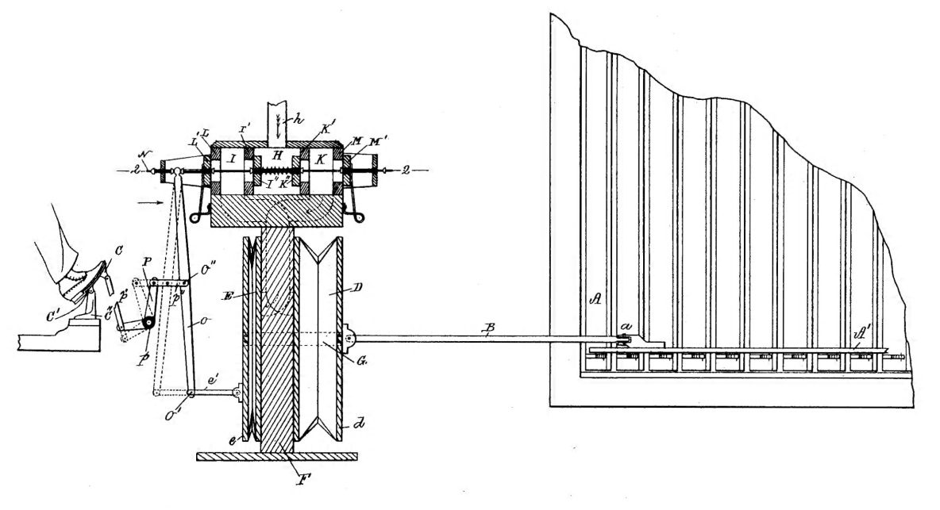
Figure 31
swell pedal “C” connects to rods “P” that transfer the motion of the pedal to another rod “O,” connected at one end to the pneumatic assembly and to the valve rod at the other end. The lever need not necessarily attach to the pneumatic assembly, but the contact provides the guarantee of successful operation by placing force on both the small rod and the larger pneumatic assembly. Skinner attached the two pneumatics braces “G” that secure the pneumatics in place, aided by the flow of the pressurized air. Rather than place two springs between the pairs of puppet valves (1-2, 3-4 in Figure 30), he placed a spring in chamber “H” between valves “I²” and “K²” and attached wire springs on the exterior of valves “L¹” and “M¹.” The operation of the device follows the same pattern as Roosevelt’s design, the trace rod “B” opening or closing the swell shades “A” as previously described.
Both swell mechanisms allowed the performer to “place the pneumatic balanced bellows, and swell folds connected thereto, in any desired position corresponding to the position of the foot and [swell pedal]; and the pneumatic action will exactly follow the movement of the foot both as to speed and distance within its capacity.” Skinner’s design built on that of Roosevelt but simplified the mechanism and necessarily increased the speed with which the swell pneumatics operated by eliminating primary and secondary pneumatics, time being consumed in their communication. Despite the improvements brought forth in Skinner’s patent, pneumatic swell mechanisms contained inherent deficiencies, as Skinner himself commented:
The valves which controlled the pneumatics had to be sufficiently large to cause them to move the shades from the open to the shut position with expedition. These same valves were also expect to supply the pneumatic for moving shorter distances. When the machine was moved slowly from one extreme position to the other, the transition took the form of a series of hysterical jerks; a pneumatic frequently went too far and was kicked back again by its vis-à-vis, as this arrangement made each half of the device exceedingly jealous of the other. An oscillation called “hunting” was a common occurrence, in which the organist moved the swell-shoe to another position and hoped for the best. The defect in this machine was in that it furnished a uniform power for a widely varying load.

With defects still present in the swell operating mechanism, organbuilders turned to electro-pneumatic designs to provide quick, efficient means of expression.

Hope-Jones Electro-Pneumatic Swell
Robert Hope-Jones produced one of the earliest electro-pneumatic swell operation mechanisms, employing an electro-pneumatic valve as designed for his chest action. Much like Roosevelt and Skinner’s designs, Hope-Jones incorporated two pneumatics, one each to open and close the swell shades, but operated the pneumatics electrically as shown in Figure 32. The swell box “N”
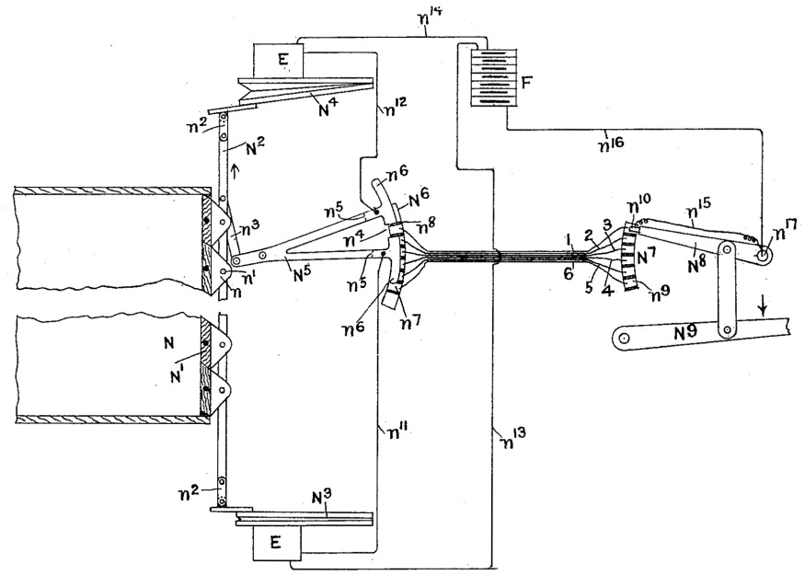
Figure 32
is fitted with swell shades “N¹” that are connected by a rod “N²” so as to move simultaneously. Each end of the rod connects to a pneumatic “N³” and “N⁴” to open and close the shades respectively. The swell pedal “N⁹” moves a lever “N⁸” that has at its end an insulated contact piece “n¹⁰.” Connected in sequence are wires 1-6 that each correspond with a stage (degree) of the swell shade opening. When the performer changes the position of the swell pedal, the insulated contact piece “n¹⁰” receives current from the battery “F” through wire “n¹⁶,” stud “n¹⁷,” wire “n¹⁰,” and the numbered wire corresponding with the position of the pedal. Each position on the quadrant “N⁷” correlates with a position and contact on the quadrant “N⁶.” The current flows through the numbered wire to its pairing position on quadrant “N⁶,” drawing with it the switch lever “N⁵.” Wires “n¹²” and “n¹³” then receive the impulse and appropriately engage the elector-pneumatic lever “E” with which they are associated, inflating or exhausting their associated pneumatics.
The gap in the switch lever is slightly larger than the contact points “n⁸,” allowing the contacts to break the circuit once the desired position has been reached. The switch lever likewise attaches to the trace rod “N²” to ensure that the motion of the swell shades follows the position of the lever and, by consequence, the pneumatics. In the design shown in Figure 32, the swell shades open in only “five distinct and approximately equal steps;” however, Hope-Jones allowed that many more contacts may be added to the apparatus at both quadrants “N⁶” and “N⁷” to provide fine gradations of dynamic changes. Moreover, the spacing of the contact points need not necessarily be exactly equal such that the first few stages of the operation open the shades in smaller amounts than the later stages, as “it is well known to organists that the first small opening movement of the swell shutters permits the escape of a volume of sound which is much greater, in proportion to the movement of the shutters and swell pedal, than the increase of volume effected by any subsequent movement of a similar amount.” Should a varied distance between contacts be employed, the switch lever is modified such that each arm mounts on a separate pivot point. This arrangement causes the arms to move appropriately and always allow a gap between the arms and the contacts so as to break the circuit.
Because wires convey electrical impulses between the swell pedal and the operating mechanism, Hope-Jones’s system allowed for a detached console. Even with Skinner’s improvement on Roosevelt’s pneumatic swell, a lever running from the swell pedal to the pneumatic apparatus required the console to maintain physical proximity and attachment to the device. Hope-Jones’s electro-pneumatic swell eliminated hunting and guaranteed that the swell shades moved to their appropriate position when engaged by the performer. One significant defect still remained: the ability to move all the shades quickly. Even with the speed of electromagnets, the above mechanism still required pneumatics to inflate or exhaust to move the shades. For example, if a performer wanted to fully open the swell box for a quick accent, the pneumatic controlling the opening mechanism would need to inflate completely before the shades covered their maximum range of motion. In response, Hope-Jones designed a system by which individual swell shades could be opened by their own magnet.
Hope-Jones Individual Shade Electro-Pneumatic Swell
In response to the need for opening or closing all swell shades quickly, Hope-Jones invented a swell operating mechanism that employed multiple electro-pneumatic levers for each shade or group of shades as depicted in Figure 33. Unlike designs that followed by other organbuilders, Hope-Jones
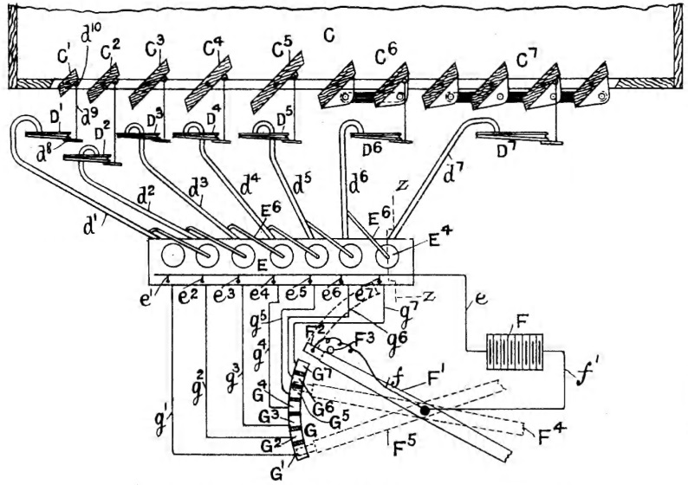
Figure 33
constructed the above system with springs (not pictured) that held the shades open, and the electro-pneumatic levers “e⁷,” “e⁶,” etc. closed the shades to which they were attached. He did provide in his patent that the springs may be arranged to hold the shutters closed and the pneumatics open them accordingly. In Figure 33, the swell shades “C¹” through “C⁷ attach to wedge pneumatics “D¹” through “D⁷” by means of tail pieces “d⁹.” Rather than construct each swell shade of the same dimensions, Hope-Jones graduated the size of the smallest five shades and grouped the remaining shades in units of two and four to accomplish the smoothest possible crescendo and diminuendo.
When the performer depresses the swell pedal “F¹,” an insulated contact piece “F²” comes into circuit with a contact “G¹” through “G⁷,” located on a quadrant “G,” by means of current supplied by battery “F” and return wire “f¹.” Upon completing the circuit, an electrical impulse is sent through wire “e¹” through “e⁷” and energizes an electro-pneumatic lever in box “E,” one for each shade or set of shades. Air from within box “E” travels through tubes “d¹” through “d⁷” to the wedge pneumatics “D¹” through “D⁷” associated therewith. As each pneumatic inflates, it draws with it the tail pieces and closes the associated swell shade or group of shades. Upon returning the swell pedal to its original position, the springs attached to the shades reopen them as the pneumatics exhaust.
The pedal contact “F²”extends upward as indicated by the dotted line so as to keep the previous contacts in circuit and prevent the springs from reopening the swell shades. However, if electrical current were supplied continually to maintain the closed position of the shades, a large amount of energy would be consumed. To prevent this occurrence, Hope-Jones provided a pneumatic device located within box “E” that communicates an impulse of air through the sectioned-off tubing “E⁶” to each previously-closed shade (and therefore inflated wedge pneumatic) to keep it from reopening without consuming copious amounts of current.
The Hope-Jones system described above demonstrates an early attempt to move the swell shutters quickly and in a graded manner so as to provide maximum control and musical flexibility. Should the swell pedal be moved to either its extreme open or closed position, all electro-pneumatic levers would fire in immediate succession and move the shades appropriately. By providing each individual shade or group of shades with a magnetic control, Hope-Jones enabled performers to control the amount of tone emanating from the swell box much more quickly than any other previous design. The graduated individual shade action concept was adapted and made standard by the Wurlitzer Organ Company, who assumed rights to many of Hope-Jones’s patents. The complexity of the mechanism likely led to its demise among other organbuilders, paving the way for the predominance of the whiffle-tree swell engine as designed by Skinner or individual shade pneumatics.

Skinner Whiffle-Tree Swell Engine
Ernest Skinner claimed the whiffle-tree swell engine as his own invention, and Reginald Whitworth likewise credited Skinner with the invention; however, without a patent for the device, it seems more likely that Skinner adapted a well-understood principle. The mechanism divides the work of moving the swell shades evenly among sixteen pneumatic devices located within a pressurized wind box as shown in Figure 34 (see following page). As with the previous Hope-Jones design, the pneumatics serve to close the shades, and a spring opens them – motion is always controlled in one direction by the
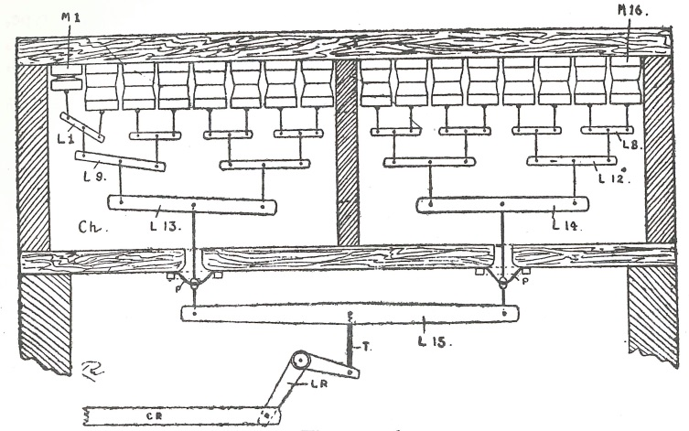
Figure 34

mechanism and by a spring in the other. In this arrangement, the shades automatically open when the organ is not supplied with air. The pneumatics deflate without the presence of compressed air, and the springs push the shades to their open position, allowing air from within the building to enter the chest and maintain a consistent temperature for stability of tuning.
Referring to Figure 34, a series of pneumatics “M¹” through “M¹⁶” are mounted to the top of a chest “Ch” containing air from the blower. Each measures 4” x 5” in moderately-sized organs or 5” x 6” in large instruments and is equipped with a magnet (not pictured) mounted to the top exterior of the chest. When the performer depresses the swell pedal, it completes a series of electrical circuits by means of contacts mounted underneath the swell pedal. An electrical impulse energizes the magnets mounted to the chest and allows the pneumatics to exhaust. A system of levers connects the individual pneumatics in continually larger groups, beginning with two connected by “L¹,” four connected by “L⁹” (controlling “L¹” and “L²”), and continuing such that all are connected to a long lever “L¹⁵” located outside of the chest. The pneumatics are arranged to operate from the outside toward the center (“M¹,” “M¹⁶,” “M²,” “M¹⁵,” etc.) so as to produce an even balance from side to side. As they exhaust, they draw the levers up and transfer the motion to a rod connected to the swell shades. In Skinner’s design, the first three pneumatics are adjusted to move in approximately two seconds, the remaining acting in about a second and a half. The delay serves two purposes: “it acts as a check to prevent slamming in rapid closing and second, to make more gradual the initial opening when the foot is moved slowly.” A photograph of a constructed whiffle-tree swell engine may be seen in Figure 35.
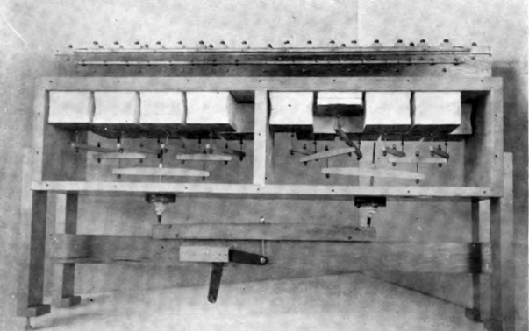
Figure 35

Should the performer move the swell pedal quickly from its closed to open position, all the magnets would be simultaneously energized and correspondingly move all the pneumatics. The resulting dynamic change would be heard in approximately a second and a half, allowing virtually instantaneous control of the entire dynamic capability of the pipework located within the swell box. According to Skinner, “the great advantage of the whiffle-tree motor is its development of power in proportion to the load.” If the full range of the swell be demanded, each motor may only work to its fullest capacity, but the engagement of all sixteen accomplishes the desired effect. A number of other builders adapted the whiffle-tree swell mechanism, including Austin. Skinner saw his swell mechanism as the pinnacle of innovation, stating that he “perfected the behavior of this mechanism, thereby accomplishing as much for swell expression as electro-pneumatic mechanism has done for key action.” Personal accolades aside, the whiffle-tree swell eliminated hunting and enabled performers to quickly and accurately obtain a range of dynamic expression from enclosed divisions. The reliability of the design made it extremely popular; it still remains in use today.

Individual Shade Pneumatics
In addition to the whiffle-tree swell engine, individual shade pneumatics appeared most frequently in the American Symphonic Organ. The firms of M. P. Möller, W. W. Kimball, and Wurlitzer exclusively used individual shade pneumatics in their instruments. With this form of mechanism, each swell shade is fitted with an electromagnet and an accompanying pneumatic that directly operated the shade. Like the whiffle-tree design, the pneumatic operated one motion and a spring the opposite. A diagram of Kimball’s design appears in Figure 36.
Figure 36
Each swell shade “K” is connected to a pneumatic “H” by means of a rod “I.” Kimball employed square pneumatics, “which will produce twice as much power from a given size and pressure as the hinged pneumatic,” whereas Möller used wedge pneumatics. Unlike Skinner’s construction, Kimball chose to have the spring “L” return the shade to its closed position and the pneumatic open it. With this design, the spring pulled the swell shades closed when the instrument was not supplied with wind. Compressed air fills the upper chamber holding the small square pneumatic “B,” which remains inflated when the swell shades are closed. When the performer advances the swell pedal, completed circuits send electrical impulses that energize the magnet “A.” The magnet’s armature moves off of a port and allows the small pneumatic “B” to exhaust, drawing with it valve rod “C.” The upper half of valve “E” opens to the compressed air in the upper chamber while the lower half of valve “E” closes off communication with the lower chamber. Compressed air may then move through channel “G” (indicated by the dotted lines” into the pneumatic “H” and open the swell shade. When the contact is broken, the spring returns the swell shade to its closed position, pneumatic “H” exhausts to the atmosphere, and the small pneumatic “B” inflates.
Figure 36 depicts the swell shades mounted such that they open horizontally. Möller designed instruments with the same configuration but also built swell boxes with vertically-opening shades. In both situations, a quick motion of the foot completed all circuits and caused all electromagnets to fire nearly simultaneously. Careful consideration of the dimensions of the pneumatics and the tension of the springs factored significantly into the effectiveness of the mechanism. The first stage of whiffle-tree swell opened all shades, whereas individual shade pneumatic designs opened only one shade at the first stage, but it opened to its fullest extent. Performers seem to have been divided on which system provided the best results:
some organists have contended that with the individual shutter control, the tone is more or less localized by issuing from a restricted opening at one end or other of the shutter front, rather than from a series of openings across the entire front as is the case when all the shutters are hooked together and moved at the same time to a greater or less extent.

Personal preference notwithstanding, both systems offer quick and consistent control of the dynamic variation of pipes placed under expression. The earliest attempts to enable such control with pneumatic devices gave way to refined electro-pneumatic mechanisms that provided speed and accuracy, meeting the requirements for a successful electro-pneumatic action. Greater dynamic control facilitated greater musical flexibility, an essential element of the American Symphonic Organ.

CHAPTER 5
Developments in Key Contacts and Actions
Chests and swell mechanisms employing some form of electro-pneumatic action required the components to be brought into electrical circuit as previously discussed. Speed and reliability in the mechanisms’ operations necessitated a reliable contact point to initiate the transmittance of the electrical impulse to the magnets controlling the devices. In the earliest examples, an electrified piece of metal was dipped into a small pot of mercury when the key was depressed, and a wire leading from the pot to the associated electromagnet communicated the electrical impulse. This system quickly fell from favor due to the evaporation of the mercury and the possibility of “splashing” when playing staccato. With the demise of mercury pots, three forms of contact construction rose to prominence: touching, rubbing, or a combination of the two.
Some combination of touching and rubbing contacts proved most common in instruments produced in the late nineteenth and early twentieth centuries, but each builder took a slightly different approach to their construction. Hope-Jones mounted contacts directly under the keys, which were brought into circuit when the key was fully depressed. Ernest Skinner reduced the complexity of regulating the point of communication by reducing the number of contacts to but one per key, each connected with a conducting metal bar that transmitted the signal to a series of magnets linked to different key and coupler operations. Many builders retained multiple key contacts mounted directly underneath the keys as in Hope-Jones’s design but installed them in contact blocks with as many as thirty-six possible contact points under each key; Skinner also eventually transitioned to multiple key contacts. Möller and Kilgen, rather than place the contacts underneath the keys, devised a system in which multiple contact fingers were located in a block behind the key and came into communication with coupler slide bars whose position was governed by a pneumatic.
Regardless of arrangement, organbuilders sought out the most reliable metals from which to construct their contacts. Like each other area of the instrument’s development, a number of stages of trial and error transpired before builders achieved satisfactory results; even still, a variety of metals were employed for such purposes. Sparking at the contact point and oxidation of the metal were among the most significant barriers to be overcome. Low-consumption magnets and noncorrosive metals reduced the arcing of contact metals caused by the constant introduction and removal of current. Any lack of cleanliness could potentially interrupt the completion of the circuit at the point where the pieces come into communication. To ensure a consistently reliable contact point, builders placed the two metal pieces at right angles to each other such that the repeated motion of coming into and out of circuit wiped or cleaned the two metal pieces, best exemplified by the combined rubbing and touching contact construction. In their most refined state, key contacts exhibited both the speed and reliability necessary of all organ actions and enabled the various components of the American Symphonic Organ to operate appropriately.

Hope-Jones Key Contact and Double Touch
In his first electro-pneumatic design, Robert Hope-Jones mounted contacts directly underneath the keys for each individual note and for its associated couplers. He further supplied an additional spring to “momentarily increase the volume of tone or to produce a sforzando effect,” commonly referred to as double touch or second touch and depicted in Figure 37 (see following page). In the above arrangement, “A” represents any manual key that is pivoted at its rear and supplied with contact pieces “a*” and “b*.” Each key is
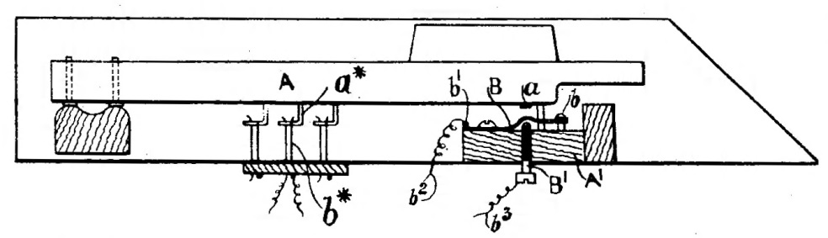
Figure 37
supplied with as many contacts as are necessary to operate the note and couplers associated with the key. When the performer depresses the key, pieces “a*” come into contact with pieces “b*” and complete an electrical circuit. The wires that lead from the plate underneath piece “b*” are connected to an electromagnet operating the associated stop or coupler and to a power source. If no couplers are drawn, no current will pass through the wires and the “making” of the contact will have no effect on any of the instrument’s devices. Figure 38 represents a sectional view of the contact arrangement wherein piece “B⁶” mounts to the underside of the key and comes into communication with metal fingers “B²” and “B²*” when the key is depressed.
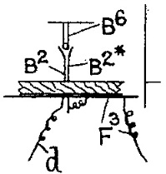
Figure 38
In addition to the standard arrangement, Hope-Jones provided an additional contact situated at a greater depth than contact pieces “a*” and “b*” (Figure 37), actuated by depressing the key with greater force. This additional contact piece “B” takes the form of a rigid, insulated metal spring and is mounted on a pin rail “A¹” at the front of the key. A pin “b” may hold the spring in place and prevent it from rising above its desired position. A metal pin “B¹” constitutes the second component of the additional contact and is connected to “any suitable electrically controlled device or devices such as an electro-pneumatic lever or levers for operating the octave or octaves of the note in question or other pipe” through wire “b³.” After the primary sets of contacts have been engaged, the player may depress the key with greater force to cause spring “B,” connected to a power source through wire “b²,” to come into contact with pin “B¹” and complete the secondary circuit. A thin piece of felt “a” cushions the impact of the additional force required to “make” the contact. Through this invention, Hope-Jones enabled performers to engage additional stops or couplers on individual notes, allowing solo lines to be drawn out of the texture without needing to play the line on a different manual. Although the “second touch” system did not retain popularity in classical literature, its application in the theatre organ found a permanent home and is still in use today. The compact design of Hope-Jones’s arrangement allowed for the placement of multiple contacts underneath each key, and the rubbing motion of the metals against each other helped ensure the removal of any oxidation that may build as a result of the “making” and “breaking” of the contacts.

Skinner Rubbing Contacts
Skinner developed a key contact construction that eliminated the need for multiple contact points underneath the key and replaced them with one contact at the rear. He employed a combination of rubbing and touching contacts to guarantee consistency of operation and cleanliness as seen in Figure 39-A, 39-B and Figure 40. Each key “1” is mounted at its center with a pin “2” cut away at
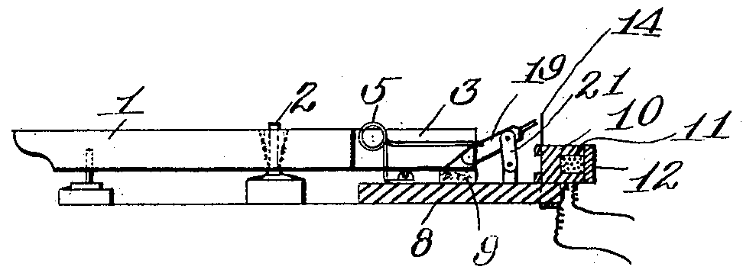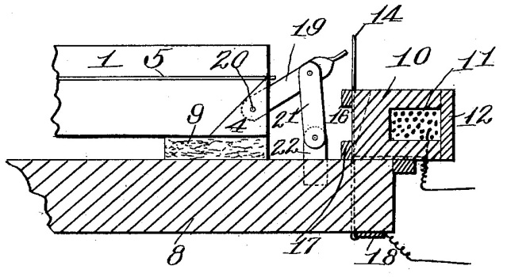
Figure 39-A Figure 39-B

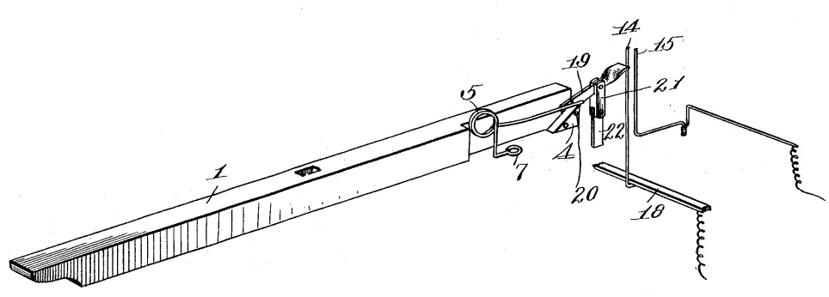
Figure 40
its rear “3” to make space for a stiff wire spring “5” that holds the key in its raised (off) position. The spring turns at its lower end “7” to form a loop through which a screw attaches it to the base of the keyboard. A small triangular block “4” attaches at the rear of the key and provides both a resting point for the end of the spring “5” and a location against which contact lever “19” may rest. The contact lever mounts to the keyboard through a link “21” and a support “22.” At the rear of the lever is mounted a block “10” that houses two contact fingers “14” and “15.” Contact finger “15” connects to the electro-magnet controlling the key, and contact finger “14” connects through a metal bar “18” to a power source.
When the performer depresses the key, the spring “5” raises with the key and allows the contact lever “19” to come into communication with the contact fingers “14” and “15,” constituting a touching contact motion and completing the circuit. Skinner described the motion of the contact pieces in the following manner: as the key is depressed,
the free end of said [contact] lever is caused to oscillate as well as to move forward, and during such oscillating movement it has a rubbing contact with the terminal contacts 12 and 15, and such rubbing contact operates to keep said terminal contacts and the contact end of the lever clean and polished, so as to insure perfect electrical contact between said parts whenever they shall be brought into engagement.

When the key is released, the spring returns the parts to their original position. A further concern in the design of key contacts was the removal of any physical perception of the meeting of the contact pieces.
With the above construction, the pivot pin “2” absorbs any friction from the contact pieces coming into communication and renders the key action light and free of extraneous hindrances. Because each key has only one contact to operate all function, organs equipped with Skinner’s key contacts require multiple wire windings around action magnets to transfer the electrical signal. The benefit of regulating only one contact point made the single contact attractive despite the multi-wound magnets. Skinner successfully created a design that provided quick, reliable transmission of signals from the key to the pipes that allowed performers to exploit one or all tonal resources with very little effort. The extreme removal of weight from the keys left performers with a touch significantly different from that encountered in the trackers of previous decades, as Hope-Jones explained:
The introduction of electric actions into organs has so greatly relieved the work required to be performed by the key itself, in the previously existing types of organs, that it has been possible to render these keys as quick and responsive in their movement as those of a pianoforte. This, however, carries with it it disadvantages as many organists of the present day are accustomed to the old type of keyboard with its sluggish action, known as “tracker action” . . . it is desirable that the individual keys be so controlled that they require the performer to exercise a certain amount of force or exertion to move them out of their normal position.

With the goal of introducing some of the weight back into the key action, Hope-Jones invented a pneumatic device that retarded the motion of the key.

Hope-Jones Pneumatic Key Weight
More than two decades after the introduction of his first electric action and key mechanism with double touch, Robert Hope-Jones produced a key action mechanism that retained contact placement under the center of the keys but incorporated a pneumatic device that provided some resistance in the action. Pictured in Figure 41, the device sits at the rear of the key and occupies little space, allowing it to be placed within the normal confines of the console and in the key bed. The contact pieces for the primary touch “c²” and “c³” and those
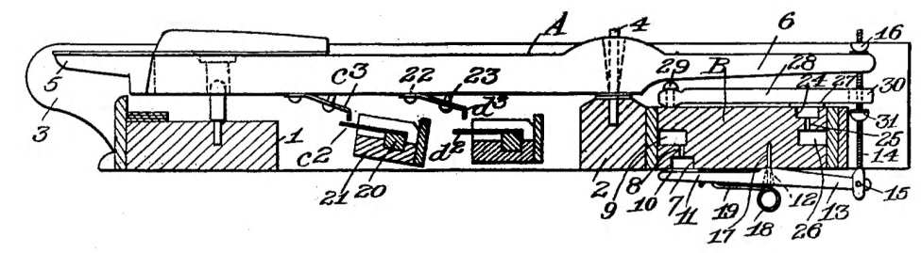
Figure 41
for the second touch “d²” and “d³” remained underneath the key, but Hope-Jones built them in an identical fashion rather than have the second touch activated by a spring as in the original design. Both pieces not attached to the key were mounted in blocks “21,” the block for the primary touch being mounted at a slight angle so as to ensure its reliable interaction with the piece mounted on the underside of the key before the depth of the second touch had been completed.
The key “A” pivots near its rear on a pin “4” that secures in pivot rail “2.” A lever “11” attaches to the rear of the key “6” by means of a pivot pin “15” and a rod “14,” whose range of motion is regulated by two leather nuts “16” and “31.” Attached to the bottom of lever “11” is a spring “18” whose end “19,” in combination with atmospheric pressure, guarantees that the valve seat “10” remains in the position shown when the key is not depressed. In communication with the valve seat are a series of chambers “7,” “8”, and “9” that contain a partial vacuum. When the performer depresses the key, the rod “14” raises in concert with it and increases tension on lever “11” until enough force has been imparted to move the valve “10” from its seat and allow contact pieces “c²” and “c³” to come into communication. After the valve has been unseated, the performer must impart no additional pressure to keep the key in position to activate the primary touch. The pressure necessary to unseat the valve is “proportional to the area of the head 10 and the degree to which the air is rarefied in or exhausted from the passage 9” and should “be so proportioned that a normal organ action touch equal to about three and a half ounces in weight will be required to move the key downwardly or cause it to dip.” The sensation of overcoming the initial weight of the key action mimics the “pluck” felt in tracker-action instruments when the performer applies enough pressure to break the pallet’s seal and allows air to enter the key channel.
A similar operation activates the second touch, with channels “24,” “25,” and “26” operating in the same fashion as “7,” “8,” and “9” to unseat valve “27.” As with the primary touch, the amount of force required to complete this action is proportionate to the area of the valve and the amount of air present in or exhausted from the channels; therefore, the channels and valve are slightly larger so as to require additional force and not potentially activate when only the primary touch is desired. The leather nut “31” draws lever “28” upward when the player exerts the additional force and allows contact pieces “d²” and “d³” to come into communication. As the key is released, the contact pieces wipe against each other and contribute to cleanliness and, therefore, accuracy of operation. The system described mirrors the single contact in Skinner’s design and reduces the difficulty of regulating multiple contact points. Its complexity, however, saw its demise in favor of tracker touch manuals that evolved in the years approaching 1920. Though it did not enjoy longevity, Hope-Jones’s invention represents an early attempt to meet the demands of performers and paved the way for tracker touch manuals that are still in common use today, imparting the sense of a true physical connection with the pipes despite their disassociation due to electro-pneumatic actions.

Skinner Tracker Touch
In his 1917 publication The Modern Organ, Ernest Skinner mentions manuals equipped with tracker touch, exhibiting “four-oz. initial [pressure] and one and one-half oz. when depressed . . . [making] the organ and piano touches almost identical.” He provided no further detail regarding the specifics of construction but does mention its application in the Trinity Church, Boston (1914) and Girard College, Philadelphia (1931) instruments in The Composition of the Organ. A brief description of the tracker touch application in these two instruments illustrates the principles of design as seen in Figure 42. The key
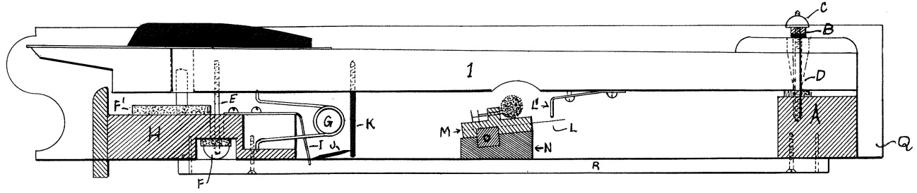
Figure 42
“1”is pivoted at its rear through a pin “D” that mounts into a block “A.” Skinner moved the contact pieces “C” and “L” to the center of the key as opposed to their rear position in his first design previously described. A flat steel spring “I” mounts to a block “H” that forms the base of the key bed. Also attached to the key is a metal post “K” that connects to a pin “J.” A spring “G” mounts to the front edge of the key and serves to hold it in its upright position until depressed and return it to said position when released.
Because the spring “I” rests against the pin “J,” it provides upward thrust to the key through pin “K.” When the key is depressed, the spring moves in concert with the pin and the metal post, transferring its force horizontally and no longer acting to retard the key’s movement. In this later design, Skinner regulated the tracker touch spring “I” to require an initial weight of 3.5 oz. and the primary spring “G” to require 1.5 oz. to keep the key engaged once depressed. Like Hope-Jones’s pneumatic device, the tracker touch spring gave the sensation of breaking the seal of the pallet in mechanical action instruments and produced the effect of a “pluck.” The simplicity and effect of the design contributed to its endurance.

Contact Metals
Just as organbuilders each had their own modification of a generally-accepted system of chest construction or swell mechanism, so they also had a slightly different form of key contact organization and preference for metals that would produce the speed and accuracy desired by performers. Roosevelt and Farrand & Votey, among the first builders to introduce electro-pneumatic actions, constructed their contact pieces of flat spring brass to which were soldered short pieces of platinum. The use of “dissimilar non-corrosive metals” assisted in making the contacts entirely reliable, but true reliability was not achieved until “low voltage, good insulation and the avoidance of self-induction” were incorporated into organ designs. Skinner identified gold, platinum, and silver as among the earliest metals employed but preferred phosphor bronze for its cost efficiency and ease of service. William Barnes classified three metals as the most reliable for contact purposes after testing them in repeated actions for six months: platinum, tungsten, and silver. Concerning phosphor bronze, Barnes noted that it exhibits the desired qualities of speed and reliability in nearly all conditions but that the contacts may not “‘make’ the first time . . . in very damp weather.” Silver, however, exhibits superior electricity conduction and but may lose favor in comparison to phosphor bronze due to the latter’s springy quality. Today, silver-tipped brass contacts appear most frequently and are standard among many organbuilders and suppliers.
Ultimately, the material constituting the contact pieces exerts less influence than the construction of the mechanism, and even metals such as gold and platinum that may not prove to be the most reliable can suffice with the proper design. One of the most important factors was the cleanliness of the contact point, as described above, and thus wiping contacts, regardless of metal, provided the best results for reliability and speed. Robert Hope-Jones introduced round wire contacts that provided the “ideally perfect ‘rubbing points’” for cleanliness, and numerous builders adopted this system of construction. Skinner reportedly commented that “the world owes you its thanks for the round wire contact,” though the authenticity of the comment cannot be verified. With the evolution of contact metals and designs yielding results equal in speed and reliability to that of the chest actions, organbuilders were able to produce instruments on high wind pressures with dark colors and imitative orchestral voices desired by performers with a consistency and musical flexibility unmatched in instruments of the mid-nineteenth century.
CHAPTER 6
Developments in Console Design

It has already been established that early American organs closely followed European models in terms of tonal disposition and general construction. Consoles for mechanical action instruments nearly always formed part of the case, the keydesk facing the façade so as to reduce the complexity of tracker runs. European organs exhibited a wide variety of stop layouts with there being some trends within certain countries. For example, French organs of the latter nineteenth century often had curved, terraced stop jambs in an amphitheater-style layout as popularized by Cavaillé-Coll. German instruments of the same time period were frequently constructed with straight, terraced stop jambs, occasionally placed at an angle to the performer for ease of registrational changes; both Walcker and Sauer used this arrangement in a number of their instruments. Despite these developments, a number of builders in Europe and most in the United States ordered stop draws vertically in the case on both sides of the manuals. English instruments were the first to boast stop jambs at roughly 45º angles to the performer with the stops arranged in vertical rows as seen in the 1855 Henry Willis organ for St. George’s Hall in Liverpool (Figure 43, from the firm’s website, see following page).
Before the United States adopted the general principles of the English system of console construction, a variety of other designs emerged. As electro-
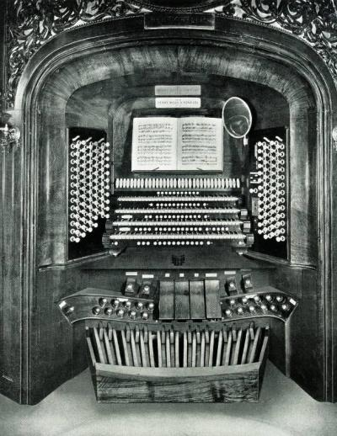
Figure 43
pneumatic actions allowed for consoles to be detached from the operating mechanism, requiring only a cable to transmit the electric signals, organbuilders experimented with various layouts and spacing before arriving at what would become the industry standard and be codified by the American Guild of Organists. The first committee of the Guild to discuss standardization of consoles did not convene until 1932, but many of the committee’s specifications were already in use by a number of builders and can been seen in consoles throughout the 1920s.

Roosevelt Terraced Console
A survey of instruments housed at Grace Church, New York between 1878 and 1928 demonstrates the evolution of console design in the United States. Hilborne Roosevelt completed the first new instrument in the present church in 1878, incorporating a pervious organ by Henry Erben (ca. 1830) that had been moved from the church’s previous home. Roosevelt applied an electric action to the Erben, located in the rear gallery, and installed a new instrument in the front chancel equipped with tracker-pneumatic action with a two rank echo division in the ceiling connected electrically. A photograph of the console is represented in Figure 44.
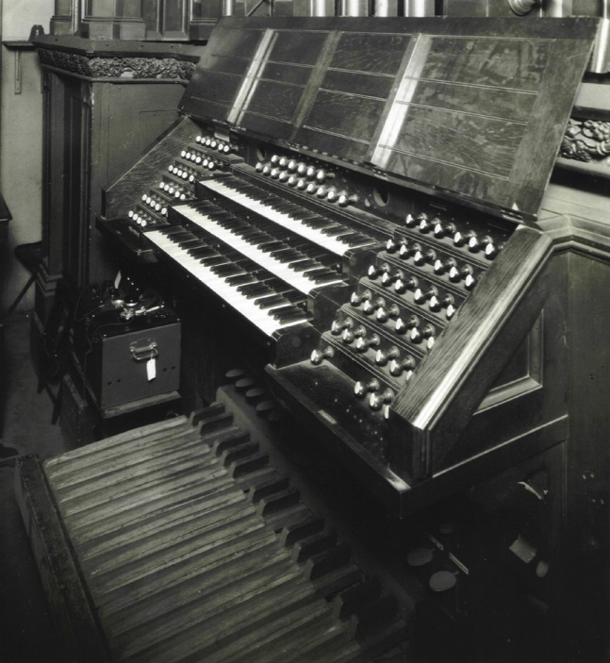
Figure 44
Roosevelt’s console demonstrates similarities to German consoles of the middle nineteenth century with flat terraced stop jambs arranged on either side of the manuals. The couplers are located above the top manual as additional drawknobs, a location that later became permanent, for convenient access while playing. Roosevelt built flat pedalboards with a compass of 30 notes extending from "C” to “f’.” A close inspection of the pedalboard reveals that the natural pedals decrease in thickness for approximately the rear two-thirds of their length in an attempt to situate the foot comfortably on the key, providing the appropriate elevation for both the heel and the toe. Located above the pedalboard were levers in the shape of small paddles that controlled fixed combinations; his system of adjustable combination action did not appear until the following decade (see Chapter 7). The generously-scaled music rack acted as a cover for the keydesk and was mounted on hinges just above the top manual.

Skinner “Batwing” Console
While still an employee at the Hutchings firm, Ernest Skinner devised a console that could truly qualify as movable:
In the case of large organs the console has ceased to be portable in the strict sense of the term, often generally requiring three or four persons to move it. In an organ of sixty speaking stops by the . . . use of . . . swing sides the weight of the console with the pedal-keyboard included is three hundred and thirty pounds, and it can be moved about easily by one person.

Figures 45-A and 45-B respectively present a front elevation and a top elevation of Skinner’s “batwing” console, in which “Z” represents the stop jambs.
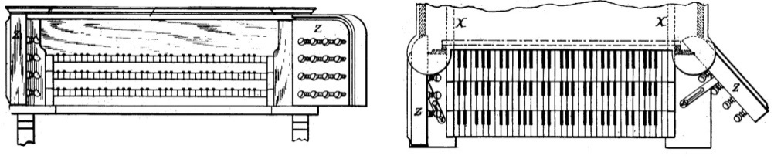
Figure 45-A Figure 45-B
Both stop jambs are hinged to the frame of the console and held in their outermost position by means of a concealed spring. The swing sides contain all drawknobs and their attendant operating mechanism, the entirety of which remains completely out of sight regardless of the position of the jambs. Dotted lines “X” in Figure 45-B indicate the grooves in which the roll top moves; when both swing sides are folded inwardly, the top may be retracted from within the console and guided through the grooves in the sides, thereby locking them in the inward position. With the above arrangement, the entire width of the console could be reduced to the width of the pedalboard, “which is less by nearly two feet than would otherwise be possible in large organs where registers are employed.”
In 1902, Grace Church commissioned the Skinner firm to rebuild the 1878 Roosevelt whose electrical and mechanical systems exhibited defects associated with age. In addition to some new pipework, Skinner provided a four manual
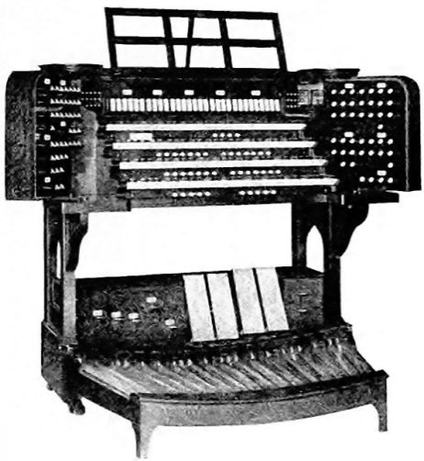
Figure 46
console, pictured in Figure 46, following the design described above. A number of features noticeably changed from the 1878 Roosevelt console to the 1902 Skinner console. The stop jambs were constructed as swing sides with the locking mechanism and roll top associated with the design. With the advance of electro-pneumatic actions and wiring systems, builders could easily provide couplers for each division at the unison (8’), sub-octave (16’), and super-octave (4’) pitch levels, which granted instruments greater musical flexibility by allowing nearly every stop to be played on any manual or in the pedal at various pitches. A consequence of the increased number of couplers was the corresponding increase in the number of coupler controls required on the console. Couplers retained their position over the top manual but were converted to rocker tabs, allowing for more compact spacing. Expression pedals found a home in the center of the pedalboard with the Swell expression shoe located slightly to the left and above the gap between middle “e” and “f.” Pedal levers still in the form of paddles retained their position above the pedalboard and operated combination functions.
The pedalboard itself followed the design of English organbuilder “Father” Henry Willis who, in his 1855 organ for St. George’s Hall pictured in Figure 43, provided a new design wherein the pedalboard was both concave and radiating as pictured in Figure 47 (see following page). Developed in conjunction with Samuel Sebastian Wesley, the concavity of the “Willis pedalboard” placed the
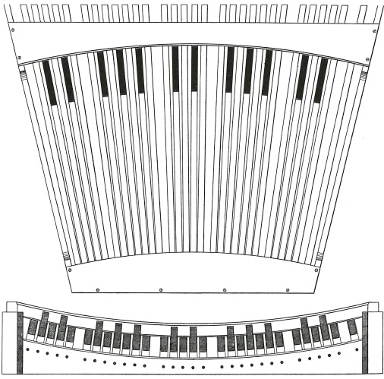
Figure 47
notes at the extremities higher than those in the center and reduced the distance the performer had to reach in order to play the highest and lowest pedals. It made its way to the United States and found a home in a number of instruments around the turn of the twentieth century; the American Guild of Organists later adopted a modification of the concave radiating pedalboard as a standard console feature.
Only a decade after Skinner’s first installation in Grace Church, the firm was again contracted to build a new chancel organ and provide another new console. The 1912 console followed the “batwing” design and remained largely the same as the previous one with only a few modifications. Figure 48 presents a picture of the new 1912 console (see following page). The most significant change was the horizontal placement of drawknobs in offset rows whereas the 1902 console had all stopknobs arranged in a straight grid. Skinner retained rocker tablets for couplers and left them intact above the top manual. Expression pedals likewise retained their position, the swell shoe being centered again just left of
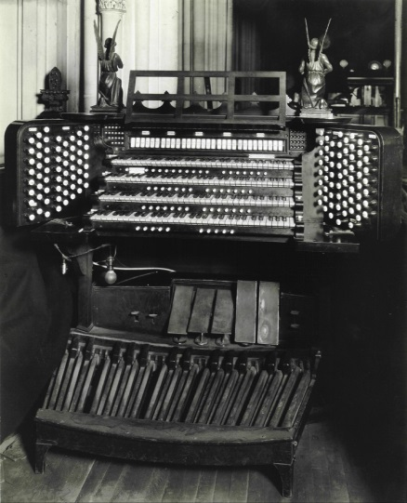
Figure 48
the gap between middle “e” and “f.” Only a few years later in The Modern Organ, Skinner commented that “the console of a high grade modern organ is a very handsome affair.” He never specifically mentioned why the “batwing” design eventually lost favor, but given his comments, one could surmise that he strove to find a better balance between consoles of function and pleasing aesthetic qualities.

Skinner “Modern” Console
The Skinner firm was engaged one final time in 1928 to rebuild the chancel organ and provide yet another new four manual drawknob console, but by this time, Skinner had abandoned the “batwing” design in favor of a construction more familiar to modern eyes as seen in Figure 49 (see following page). Stops jambs were no longer hinged and movable but were fixed at an angle of 43º to the
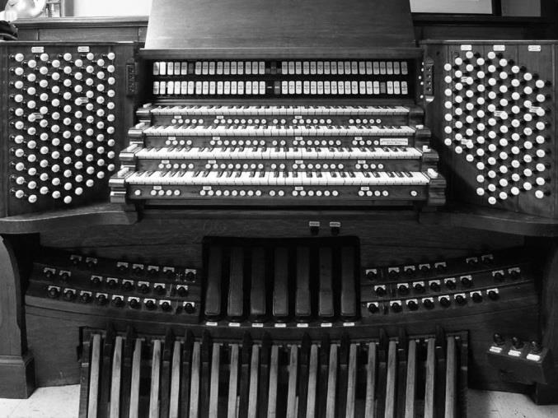
Figure 49
manuals. Due to the vast tonal resources of the Grace Church instrument, two coupler rails appeared above the fourth manual. The increased width of the console’s shell allowed for multiple rows of toe studs controlling the adjustable combination action presets. The pedalboard increased to 32 notes, covering a compass of “C” to “g’,” a range that by that time had become an industry standard. Because the instrument essentially comprised two organs (chancel and gallery) with multiple divisions under expression, there were too many swell pedals to retain shoes of a common width; Skinner instead employed narrower swell pedals to accommodate comfortable control of each expressive division.
The number of stop controls expanded so significantly from 1912 to 1928 to that they needed to be located both below the manuals and in the key cheeks at the extremities of the manuals. Skinner provided both a standard and an orchestral crescendo setting as well as the ability to select the order of stops for the crescendo, located in a drawer underneath the choir manual. The 1928 console at Grace Church contained the newest and most advanced technology available to organbuilders with the goal of “provid[ing] the organist every facility which will enable him to realize his artistic aims with a minimum of effort:” it represents one of the great achievements of the 1920s and one of the finest examples of the American Symphonic Organ in a religious institution.

Standardization of Console Measurements
As previously discussed, the American Guild of Organists did not convene a committee to standardize the measurements of the console until the 1930s, so the task of identifying such proportions in instruments preceding that date remains a difficult task. By the middle nineteen teens, consoles predominantly took the form of the latest console at Grace Church: fixed stop jambs, central placement of the swell expression shoe over the pedalboard, and so on. As one of the leaders in American Symphonic organbuilding, Ernest Skinner’s work exemplifies the highest of standards of the era. In light of his influence, the following list of console measurements is drawn from The Composition of the Organ not as a rule but as an example of console features incorporated by one of the most significant builders of the early twentieth century.
In Skinner’s instruments, drawknobs were located in solid wood jambs fixed at a 47º angle to the keys, facing the organist in a convenient manner. The pedalboard was moved forward for convenience of the player, accomplished by placing “the end of the Pedal sharp key nearest the organist . . . 10-1/2 inches back of the front line of the Choir manual keys.” Manuals were separated 2-1/2” vertically and 4-1/2” horizontally, the latter being 1/4” greater than previous designs so as to give “greater facility in striking staccato chords and reduc[ing] the liability of striking keys of the manual above.”
With the advent of adjustable combination action (see Chapter 7), organists debated the merits of visible combinations or “blind” combinations that effected the stops engaged but did not physically move them. Skinner provided his instruments with visible combination action, and nearly every builder followed suit into the twentieth century. Multiple general and divisional pistons were located below each manual; general pistons were often duplicated on pedal toe studs, which were also provided for pedal divisional pistons. The “Willis pedalboard” underwent slight modifications to arrive at a concavity of 8’6” “measured from the points of the sharp keys,” again with the goal of providing the most natural playing position for the performer. The swell expression shoe found a permanent home above the gap between middle “e” and “f” of the pedalboard, notes 17 and 18. Coupler rocker tabs retained their position above the top manual and below the music rack and were grouped by division. Some organbuilders placed all unison couplers together and grouped sub-octave and super-octave couplers, whereas others placed all coupler tabs effecting one division in succession by pitch level.
Drawknobs were distributed in a somewhat standard ordering, with the Pedal and Swell always located to the left of the manuals and the Great and Choir to the right. When other supplemental divisions appeared (Solo, String, Orchestral, etc.), their location on the stop jambs varied. All stop knobs were constructed either of ivory or Ivoroid for ease of reading the black engraving. Skinner promoted elements in his consoles that would allow the greatest control of all tonal resources in the most convenient and efficient manner, all of which were housed in a true piece of art unto itself.

CHAPTER 7
Developments in Combination Action
As instruments grew in size, it became evident that performers could no longer manipulate the tonal resources of the organ without the assistance of some form of combination action. George Audsley commented that
we may reasonably suppose that so soon as the Organ assumed proportions that rendered it difficult, if not impossible, to quickly change a large number of stops at one time by hand; or to suddenly change from a piano combination to a forte one, or vice versa, some mechanical expedient was resorted to whereby such important changes could be instantly made without requiring the hands to leave the claviers.

The earliest forms of combination action existed in the form of levers placed above the pedalboard that mechanically controlled fixed stop settings regulated by the organbuilder to engage registrations of terraced dynamic levels. As Audsley commented, however, “a fixed combination is only useful up to a certain point, while it is always disappointing, if not embarrassing, to the virtuoso, who naturally desires his own system of registration, and who requires special combinations of stops for every composition he performs.” Thumb pistons controlling fixed combinations were introduced in English instruments employing pneumatic actions, as seen in the 1855 Willis organ for St. George’s Hall, but the performer’s inability to select preset registrations remained a hindrance to complete musical flexibility of the organ.
American organbuilders developed and installed the first adjustable combination action, whereby the performer could select any desired stops and control their engagement or disengagement at will. Hilborne Roosevelt produced a patented system of adjustable combination action that paved the way for other organbuilders to reduce the complexity of his system and provide more combination possibilities in less space. The increased prevalence of electro-pneumatic chest actions led to the introduction of electricity into combination actions, providing a vast number of pistons that allowed performers to quickly draw any desired registration. Especially in organs of significant proportions, a reliable combination action became a necessary element in the instrument’s musical flexibility and a requisite feature of the American Symphonic Organ.

Roosevelt Composition Stop-Action for Organs
Hilborne Roosevelt applied for his first patented system of adjustable combination action in 1893, at which time he had already applied it to his installation in the First Congregational Church of Great Barrington, MA. The invention introduced an early version of double acting fans that would both bring stops into and out of engagement, whereas previous systems could only serve to draw stops into their “on” position but not retire them. Roosevelt duplicated the stops on rocker tabs for as many combinations as were available and mounted them to the organ case above both stop jambs as pictured in the sketch of his Op. 2 for the Church of the Holy Trinity in New York, represented in Figure 50. In order to actuate stops with the combination pedals, the performer had
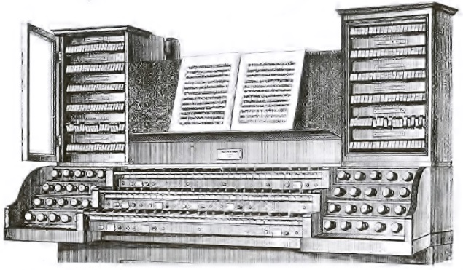
Figure 50
to place the rocker tabs in their “on,” “off,” or “neutral” position, which would draw connecting rods as pictured in the sectional view, Figure 51.
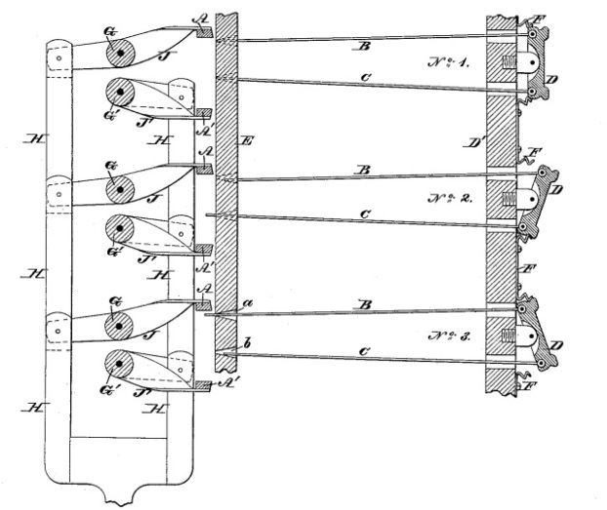
Figure 51
Figure 51 presents a sectional view of Roosevelt’s combination action wherein the rocker tabs “D” rest against springs “F” and connect to rods “B” and C.” The position at No. 1 indicates a neutral position, No. 2 indicates the “on” position, and No. 3 indicates the “off” position. The rods “B” and “C” pass through a draw stop rod “E” at openings “a” and “b.” Bars “A” and “A¹” run the entire width of the console and are attached to a forked frame “H” that is actuated by depressing a foot lever. As pictured at No. 3, the rocker tab is placed in its uppermost position, drawing the rod “C” toward the console and pushing rod “B” through the back side of the draw stop rod. When the associated combination lever is depressed, the bars “A” and “A¹” move toward the rods projecting from the rocker tabs and move the draw stop rod to its appropriate position, thereby activating or disengaging the associated stop. For example, should the combination lever be depressed with stops set as in Figure 51, the draw stop rod for No. 3 will move downward and disengage the stop, that for No. 2 will move upward and engage the stop, and that for No. 1 will not move, leaving the associated stop in its then-current position.
Figure 52 presents a rear elevation of the system (see following page) and more clearly shows the lateral movement of the bars “A” and A¹.” The forked frame “H” connects to a foot lever at its lowest extremity and to pedal arms “J” and “J¹” at its upper extremity. In his patent, Roosevelt allowed that the rods “B” and “C” may be eliminated, the rocker tabs therefore connecting directly to

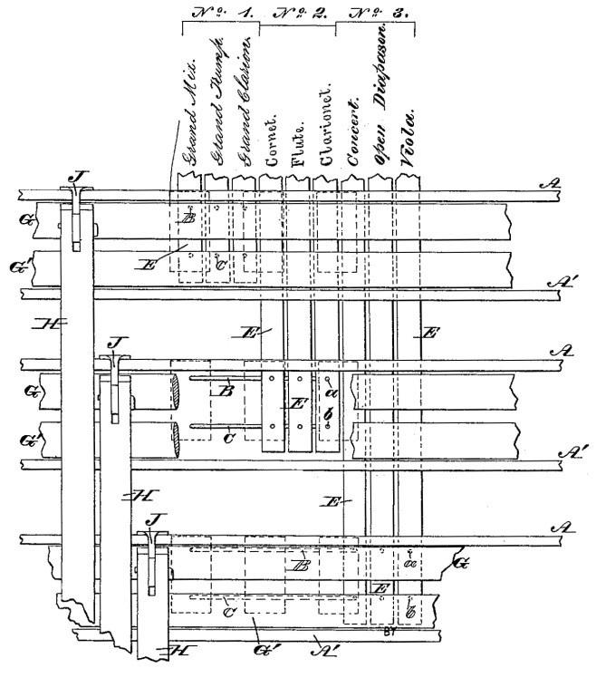
Figure 52
the draw stop rods. Furthermore, he provided for the possible provision of a pneumatic device to engage the system of levers. While Roosevelt’s system did represent the first application of an adjustable combination action system to an organ, the number of combinations remained limited due to the space required for the mechanism. Combinations initially required foot levers, but subsequent designs substituted thumb pistons, affording easier access to the performer. An additional drawback was the necessity of an attached console, for the mechanism required direct contact with the interior of the instrument. Roosevelt’s significant first step in the development of adjustable combination actions spurred other organbuilders into action who, in turn, produced improvements upon the design.
Duval Double-Acting Fan
The Roosevelt firm abandoned their own mechanism in favor of one patented by Salluste Duval of Montreal in 1889. Duval’s system provided multiple combination pedals and employed a system of double-acting fans that could both engage and retire stops as seen in Figure 53. In Figure 53, the “W”-
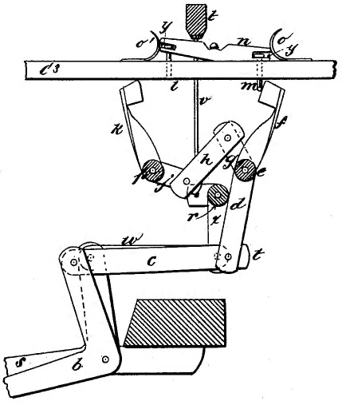
Figure 53
shaped piece extending upward from rod “d” constitutes the double-acting fan. The performer sets the stops in the desired position by moving the register rod “C³” in the usual manner. As oscillating rocker “n” is placed into its active or passive position by depressing a setting foot lever that causes bar “t” do draw downward and move the rocker and its associated pins “l” and “m.” When a foot combination pedal (not pictured) is depressed, its connecting arm leads to bell crank lever “b” and forces it to the right, as indicated in dotted lines. Connecting bar “c” likewise moves to the right and causes rod “d” to come into contact with roller “r” that, through transference of motion, causes arms “k” and “f” to move inward and push on the pins “l” or “m” as previously set. The arms “k” and “f” physically push the pins and therefore also the register rod to its appropriate position. Duval’s combination action significantly influenced the evolution of similar American mechanisms, as seen in the design produced by George Hutchings.

Hutchings Combination Organ Stop-Action
Less than a decade after the introduction of the first system of adjustable combination action, George Hutchings devised an improved system that did not require the stops to be duplicated above the manuals as they had in Roosevelt’s design. Instead, Hutchings employed a pushbutton resembling the modern setter button that actuated a setting rod to place the stops in an “on” or “off” position as pictured in Figure 54 (see following page). The pushbutton “C” has an associated foot pedal “G¹” that serves to bring the stops into their playing or silent position when depressed. Tripper bar rods “C¹” connect to the rear of the button (or tripper bar pushbutton) through a series of bell-crank levers “c” and “C⁶,” hinged at points “c¹” and “C⁷” respectively, and a connecting arm “C⁸.”
Each register “B” is faced with a traditional drawknob “B²” and connects to a register rod “B¹” in the same fashion as the tripper bar rod through a series of bell-crank levers “b” and “b³” and a connecting arm “b².” An “oscillatory duplex
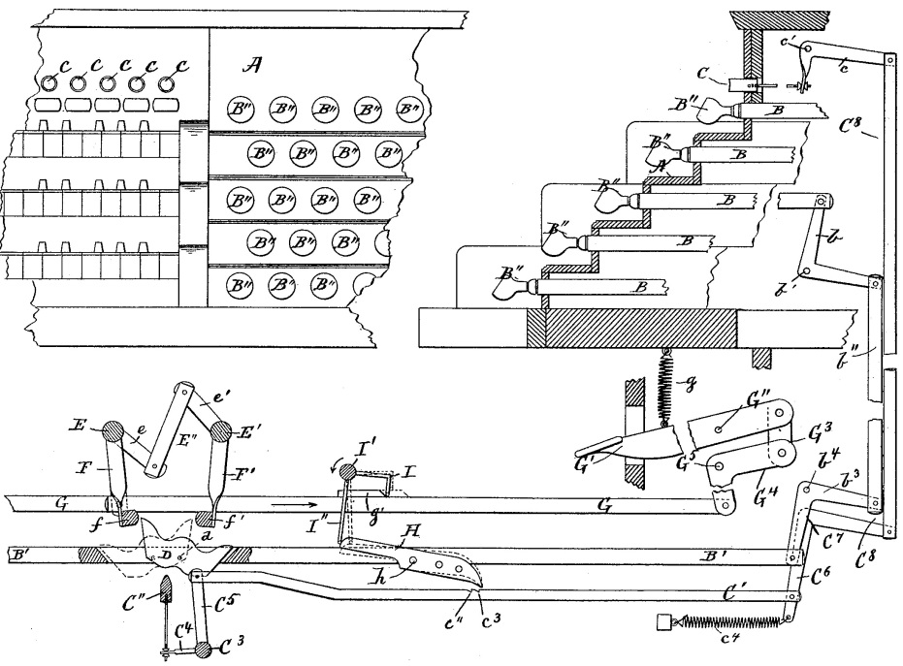
Figure 54
cam” “D” pivots to each register rod at point “d;” a detailed view of the cam appears in Figure 55. It contains projections at the top left and right sides, “D¹”
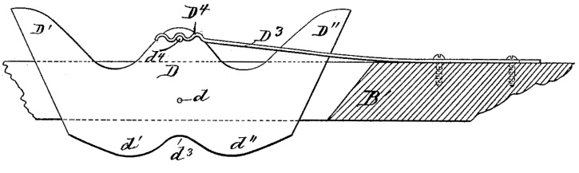
Figure 55
and “D²,” as well as a central notch in the bottom center at point “d³.” A pin “d⁴” serves as a mounting point for a spring “D³” that holds the cam in whatever position it is situated by the remaining portions of the mechanism. Mounted immediately below each duplex cam is a tripper bar “C²” that runs the entire width of the combination action system and connects to the tripper bar rod “C¹” by means of a lever “C⁴,” a rock shaft “C³,” and another lever “C⁵.” Located above the duplex cam are two rock shafts “E” and “E¹” that are connected by a link “E²” and two short arms “e” and “e¹.” Two additional arms “F” and “F¹” project through the combination rod “G” and affix to rocker bars “f” and “f¹.” The combined components derive from Duval’s double-acting fan but actuate the cam from above rather than from below.
To set a combination, the performer depresses the tripper bar pushbutton “C,” which raises the tripper bar rod “C¹” to its highest position. When the desired stops are selected, the tripper bar “C²” moves the cam either to the left or right, the leftmost (off) position indicated by dotted lines in Figure 54. At the first movement of the pedal “G¹,” the knife “H” dislodges from the notch “c³” or “c⁴” and releases the tripper bar to its lowest position so that it can no longer alter the position of the cams. To engage the set combination, the performer depresses pedal “G¹,” which draws the combination rod “G” in the direction indicated by the arrow in Figure 54. At that time, the rocker bars “f” and “f¹” either come into contact with the duplex cam or do not make contact depending on the position of the cam set by the performer. If the cam be in the position indicated by the dotted lines in Figure 54, the rocker bar “f¹” will come into contact with the raised portion “D²” of the cam and retire the stop by appropriately moving the register “B” through the series of connections described above, the opposite being true if the cam is in the opposite position.
Through this invention, Hutchings was able to “obtain absolute certainty of operation, which is an advantage over rockers provided with pins, in that where pins are employed failure of operation of some one or more of the registers which it is intended to work frequently occurs.” Pins, as provided in Roosevelt’s system, may tilt in time due to use and cause sufficient friction so as to render the combination action ineffective. Furthermore, the performer may change any combination while playing. When the pushbutton is depressed, the tripper rod “C¹” raises to its uppermost position, at which time the player may change the stops drawn and, therefore, change the position of the cams; at the first motion of the pedal “G¹,” the tripper rod falls and the combination may be engaged. Hutchings allowed that the registers “B” may be connected directly to sliders or to a pneumatically-operated stop action, both of which require fixed console positions. The ability to quickly change stops, even while performing, and the reliability of the mechanism described above provided greater flexibility than Roosevelt’s combination action, but the required physical connection of the console to the operating mechanism and the availability of only one adjustable combination still made the system short of ideal. It nonetheless represented an advancement in combination actions and furthered the progress of the organ’s design.

Transition from Mechanical to Pneumatic Combination Actions
The two American combination action systems discussed above both operate mechanically: the performer, when depressing the combination pedal, physically moves the associated levers and register rods to draw the set registration. As demonstrated in the other areas of the organ’s evolution, organbuilders constantly worked toward making the instrument more musically flexible and reducing the strain on the performer. Roosevelt’s combination action required all registrations to be selected before playing, as the location of the rocker tabs prohibited changes during performance. While Hutchings’s design allowed for changes during performance, the availability of only one preset combination placed significant limitations on the organist.
George Audsley identified a system of combination action patented by Jesse Woodberry as another stepping stone to fully pneumatic combination actions. Woodberry’s design employed fans that could both engage and disengage stops in a manner much like that of Duval and Hutchings. The improved design placed the components directly behind the register rods in a vertical plane rather than having them actuated by a complicated series of bell-crank levers and connecting rods, “thus economizing space and enabling [the organbuilder] to dispense with the lever mechanism . . . thereby greatly simplifying the mechanism, facilitating its operation, rendering it less noisy, and reducing the friction of its operation.” Woodberry’s combination action further contained “separate foot-levers to command the several combination movements; and, accordingly, all the required combinations [could] be set by the organist before commencing to play.” Mechanical combination action, however, quickly gave way to pneumatic systems that could operate the mechanism more quickly and efficiently.

Wirsching Pneumatic Combination Action
Philipp Wirsching of Salem, Ohio designed a pneumatic system of combination action that drew upon the innovations of Duval and Hutchings while enabling greater facility and speed through the use of compressed air and a simplified construction. A diagram of his device is shown in Figure 56.
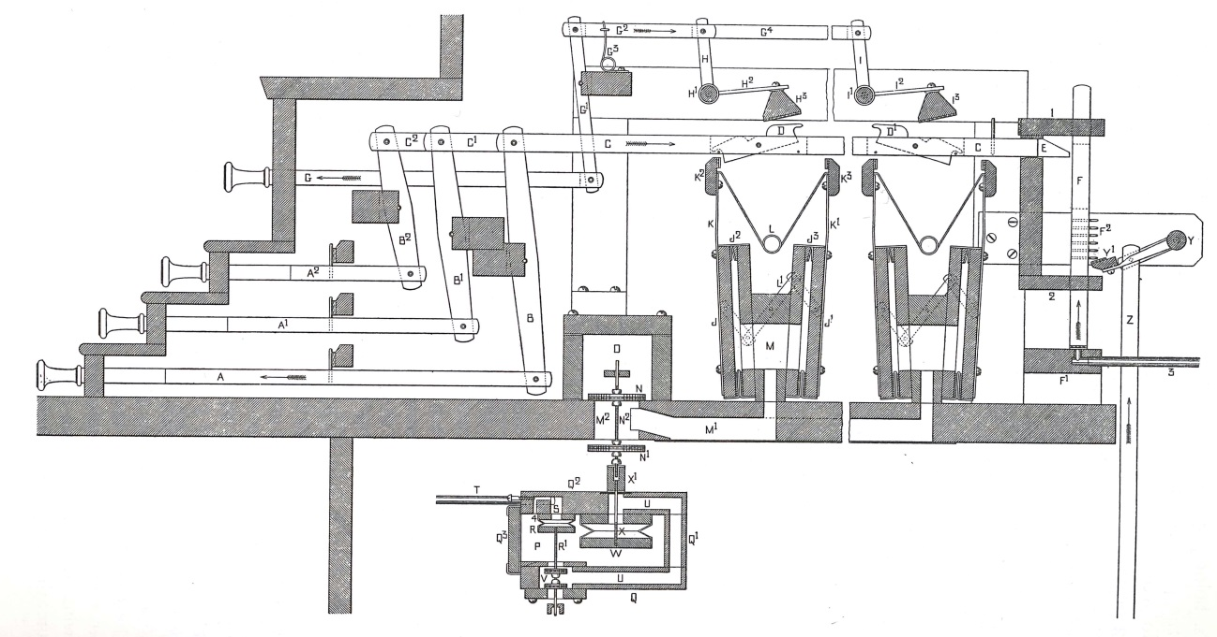
Figure 56
Register rods “A,” A¹,” and “A²” connect to horizontal, parallel traces “C,” “C¹,” and “C²” respectively by means of rocking levers “B,” “B¹,” and “B².” Attached to each parallel trace rod are catches “D” and “D¹” that function as do the oscillatory duplex cams in Hutchings’s design. Each trace contains as many rocking catches as there are adjustable pistons, one for each combination. Each piston also has an associated setting rod “G” that connects to a secondary horizontal rod “G²” through a vertical connecting lever “G¹.” Rods “H” extend downward from each horizontal bar “G^{n}” and communicate with a roller bar “H¹” that transfers motion through a bar “H²” to a setter bar “H³.” It will be understood that the setter bar extends the entire horizontal length of the combination action system so as to actuate each drawknob.
When the desired stops have been selected, the performer draws the setter drawknob associated with the desired piston, thereby drawing the series of rods “G,” “G¹” and “G²” in the direction indicated by the arrows in Figure 56. The catch “D” will assume the position indicated in full lines if the stop has been drawn, and drawing the setter drawknob “G” will cause the setting bar “H³” to descend and move the catch to its opposite position as indicated in full lines at “D¹.”
Once the combination has been set, it may be recalled by depressing a piston “T” as shown in Figure 57. When depressed, the piston moves its
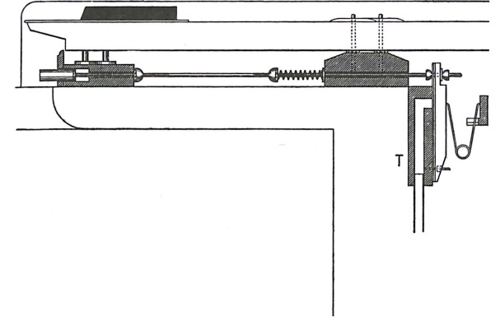
Figure 57
associated rod and opens the pallet on the rear side of the mechanism. Compressed air from chamber “S” (Figure 56) fills tube “T” when the organ is in operation and additionally inflates primary pneumatic “R” and secondary pneumatic “W.” The engagement of the piston and opening of the pallet at the rear of its assembly allows air to exhaust from tube “T” and primary pneumatic “R.” Rod “R¹” draws upward and closes supply valve “V” to the compressed air filling chamber “P.” This compressed air will act on secondary pneumatic “W” and allow it to exhaust through channeling “U” to the atmosphere. With pouch “W” exhausted, its attendant rod “X” draws upward and closes valve “N¹” to the atmosphere, allowing compressed air within chamber “O” to pass through valve “N” and channeling “M¹” to inflate the combination pneumatic assembly “M.”
The combination pneumatic assembly consists to two wedge pneumatics “J” and “J¹” that are connected by a trace “L¹,” largely indicated in dotted lines. Two metal rods “K” and “K¹” attach respectively to pneumatics “J” and “J¹,” linking them to wooden fan pieces “K²” and “K³.” A spring “L” joins the fan pieces and keeps them in their outermost position, pictured in Figure 56. When compressed air fills the pneumatic assembly “M,” both pneumatics “J” and “J¹” inflate and cause the fan pieces “K²” and “K³” to move inward, serving to move the drawknob accordingly. For example, if the catch occupies the position shown at “D¹,” the compression of the fan pieces will cause the rear fan to press on the back edge of the catch and move the bar, and therefore the stop, into its forward and “on” position.
While the chain of events comprises many individual phases, the speed of the mechanism greatly increased with the application of wind. Wirsching’s design provided multiple combination pistons that the performer could set in advance of a performance, and the number of possible settings was limited only by the number of catches provided on each register rod. Wirsching retained a mechanical form of setting the position of the catches but removed all physical engagement from the performer in recalling the registration while facilitating quick stop changes. Because the setting of the catches required a physical connection to the mechanism and the process of recalling the registration required the connection of a tube from the rear of the piston assembly to the combination action primary box, consoles still had to be attached to the case. Organbuilders were still yet to develop a combination action that provided the movable console associated with the American Symphonic Organ, but innovations began to provide the speed and accuracy desired of all organ mechanisms that enable the highest forms of musical flexibility.

Austin Combination Organ Stop-Action
As previously discussed, electric stop action became increasingly popular by the early 1900s and allowed for detached, movable consoles; however, adjustable combination actions prior to 1900 required the console to be located in close proximity to the chests and operating mechanism, as a system had not yet been devised that allowed the console to operate such a system from a remote position. The Austin Organ Company of Hartford, Connecticut held a prominent place in American organbuilding in the early half of the twentieth century, but their instruments never rose to the popularity enjoyed by firms such as Kimball and Skinner among the most elite clientele. Nonetheless, the firm continually sought to improve their mechanisms and was granted a number of United States patents. Although many of their innovations did not enter the mainstream of organbuilding, they represent continual advancements in the mechanical operation of the organ.
John T. Austin patented a system of combination action that was entirely contained within the console and allowed it to stand completely separate from the chests and pipework. In the first decade of the twentieth century, the Austin Company employed tubular-pneumatic stop and key actions for all two manual and three manual instruments, the latter containing electro-pneumatic key action about half of the time. By the time the firm released their patented adjustable combination action, an Austin console was “direct electric in its entire equipment; no wind [was] used,” and the console was likewise “complete in itself, containing all couplers and combination action.” A diagrammatic view in perspective of John Austin’s design is pictured in Figure 58 (see following page) without the details of the electric stop action.





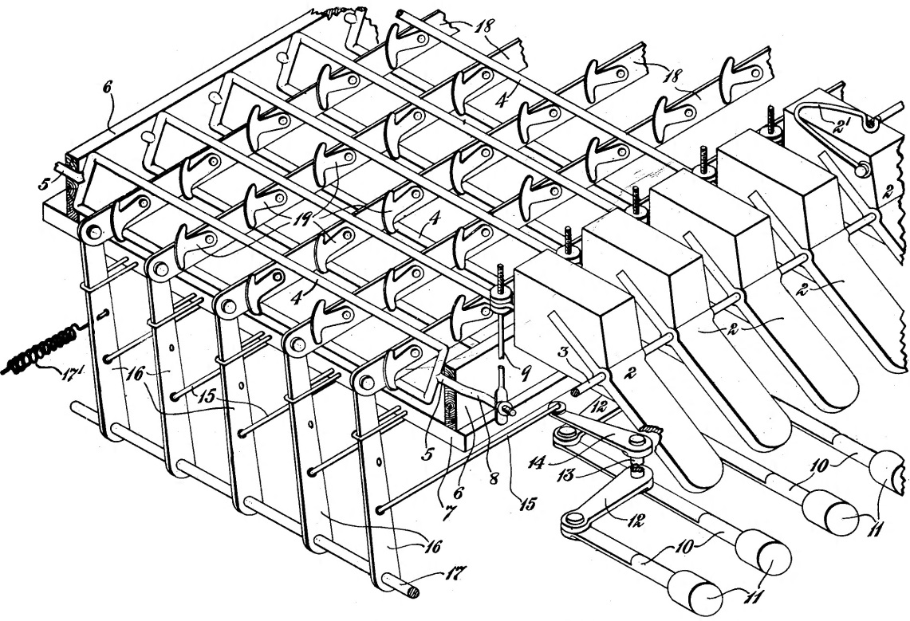
Figure 58
Robert Hope-Jones worked for only one year (1903-1904) at the Austin Organ Company, but his short-lived tenure produced some enduring results, among them being the use of stop keys in place of the traditional drawknobs. In Figure 58, the stop keys “2” reside above the top manual and are held in place by a shaft “3” whose position remains essentially constant. A link “9” extends from the rear end of the stop key and connects to a crank “8” and a forward pivot “5” that transfers the motion of the stop key to a roller “4.” The roller comes to a single point or pivot “5” and extends through a rear strip “6” that is mounted to the board “7.” When the performer depresses a stop key (pictured in the inoperative position in Figure 58), the system of linkages causes the roller to oscillate to the left and engage the stop. Pistons “11” are located underneath each manual and, by means of arms “12,” rock-shafts “13,” rock-arms “14,” and links “15,” connect to vertical rocker bars “16.” The vertical rocker bars attach at their lower end to a stationary shaft “17” and at their upper end to stop traces “18,” on which are mounted the combination action devices.
Actuators “19,” constructed of “sheet metal in order to secure a certain amount of resiliency,” attach to each stop trace and are shown in detail in Figure 59 (see following page). A fixed pivot point allows the actuator to oscillate between the position shown in dotted lines and the position shown in full lines in Figure 59, whereby the head of the actuator may extend either above or below
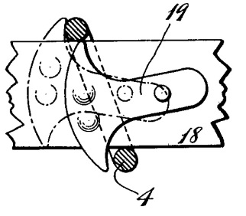
Figure 59
the stop trace. To set a combination piston, the organist depresses and holds a combination piston (“11,” Figure 58) and moves the stop tabs according to the desired registration. In so doing, the rollers “4” move either to the left (active) or right (disengaged) position and move the actuators to extend above or below the stop trace. If the stop is to be disengaged, the actuator will assume the position pictured in Figure 59, where the stop currently occupies the active position, the roller positioned to the left. If the piston associated with Figure 59 is engaged, the trace will shift to the right, and the lower portion of the actuator will draw the lower end of the roller to the right and cause the stop to retire.
Referring back to Figure 58, it will be noted that the actuators attached to stop traces “A,” “B,” “C,” and “D” do not all occupy the same position. The first actuator on stop trace “B” is positioned above the trace, and the second is positioned below. Following the process outlined above, depressing piston “b” will cause stop trace “B” to move to the right. The first actuator’s head will swing below the stop trace but will not move the roller “4,” as it is already in the off position. Similarly, the second actuator will act on the lower arm of the second roller and cause it to swing to the left, thereby engaging the stop. Austin’s patent only concerned the specific means of arranging the stop traces, linkages, and actuators. He allowed that the system could be applied to various means of stop controls: “it will be evident that the stops may be primarily operated by other means, the keys constituting one common device for securing this particular function.”
Austin’s compact, reliable system of combination action provided the organist with immediate, total control of the tonal resources of the organ and significantly increased its musical flexibility. In only a few decades, the instrument transitioned from mechanical action with a select number of fixed pistons regulated by the organbuilder to electro-pneumatic action and electric stop action with a number of adjustable combination pistons. Jonathan Ambrosino, a specialist in instruments of the early twentieth century, commented on the growing expectations concerning combination action:
In 1910, generals were probably received with joy and wonder. By 1927, organists were likely numbed to the technology and began asking for reasonably-sized consoles with more generals. With the cult of the general underway, builders devised methods of decreasing console size. Some, like Austin, had long since miniaturized their in-console combination systems to provide as many as 15 generals in consoles of average size, even prior to World War I.

The availability of multiple adjustable combination pistons enabled organists to shift textures and colors immediately and advanced the instrument’s progress toward being a successful imitation of the symphony orchestra. Without such a system in place, the American Symphonic Organ could never have reached its fully mature state.

CHAPTER 8
Developments in Multi-Fan Blowers
Virtually every component of the American Symphonic Organ’s mechanism discussed required a generous wind supply for operation. Electro-pneumatic devices, by their very nature, necessitated compressed air, and aside from the communication of a signal to a magnet, the remainder of each component operated through the force of compressed air or atmospheric pressure. Because of the vital role of wind in increasing organ tone and operating new mechanical features, organbuilders sought a more reliable source of organ wind than that provided by human bellows pumpers.
As early as the 1830s, organbuilders in Europe devised feeder bellows, which “expel air under pressure to a receiver or reservoir, which then delivers the wind to the trunks at a constant and required pressure.” Gas and water motors were applied to early blowing apparatuses to attempt to remedy the lack of steady wind, and the water-powered motor proved especially popular in America because of religious institutions’ exemption from water taxes. After the introduction of the first water motor in an American organ in the 1860s, “their use increased, and many were retained long after practical electric motors were available.” Electric fan blowers appeared in England in the late 1880s at the hand of Robert Hope-Jones, and they eventually replaced water- and gas-powered motors in the United States in the first decade of the twentieth century.
Of the various models of blowers produced, those devices patented by Louis Bertram Cousans, Ira Spencer, and Abraham Schantz proved the most enduring – Spencer and Zephyr, produced by Schanzt, remain prominent today (Kinetic is no longer in business). Inventers discovered that multiple fans provided the best source of steady, high wind pressures, as Ernest Skinner described: “the question of wind supply was finally solved by the multiple fan, which consisted of a number of fans mounted on a single motor-driven shaft, each fan occupying a compartment of its own, and all serving equally in the labor of raising the pressure to the point desired.” His drawing in The Modern Organ provides a basic sectional sketch demonstrating the gradual increase of wind pressures provided by multiple fans and is pictured in Figure 60 (see following page). Organbuilders discovered that wind trunks could be provided to section off air at the various fans, making multiple pressures easily attainable. The first significant developments in blower designs emerged in the first decade of the twentieth century and continued into the second. By 1920, the organbuilding industry had finally reached a point where an endless supply of steady air could be supplied to organs of vast size requiring high pressures, enabling the desired aesthetic of the age to be produced.
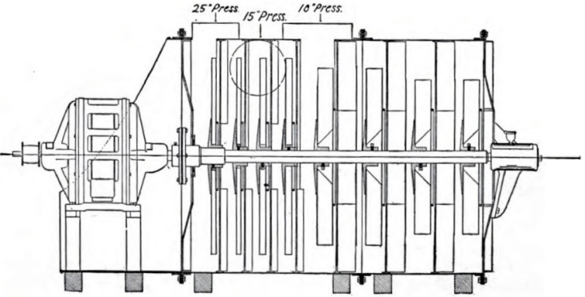
Figure 60

Cousans Air-Compressor
Reginald Arthur Cousans and Louis Bertram Cousans, residents of England, obtained a number of patents for their blower designs and received the first in 1907 for a design submitted in 1903. In their first US patent for a multi-fan blower, the Cousans sought to “provide means whereby a series of air compressors of the compound centrifugal fan type may be employed . . . means also being provided for allowing of separate air reservoirs in an organ being supplied with air simultaneously at the different pressures required for each reservoir.” The design likewise reduced or eliminated end thrust by employing an even number of fans (or making it essentially negligible with an odd number) and diminishing the noise produced by the blower while increasing the inflow of air, as pictured in Figure 61.
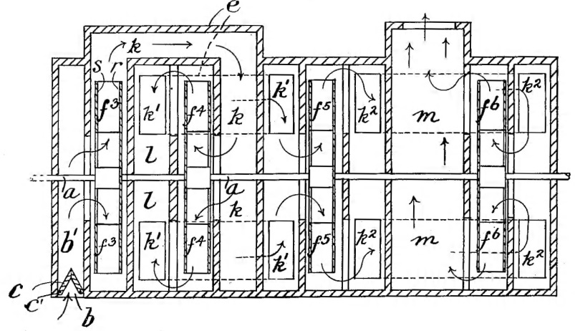
Figure 61
Figure 61 presents a drawing of a blower employing four fans, “f³” through “f⁶” that are mounted on a central shaft “a.” Each fan consists of a rear disk plate “r” and a front circular plate “s” between which the blades are mounted. A hole in the central portion of the front plate creates the inlet opening for each chamber of the blower. An inlet valve “c” hinges upon pins “c¹” and remains closed when the organ is not playing; when wind is required, the vacuum created by the turning of the fans opens valve “c” and allows air to pass into an inlet chamber “b¹.”
Upon entering the inlet chamber, air is generated to a higher pressure by fan “f³” and transmitted through a passage “k” in trunk “e” to a second fan “f⁴,” which raises the pressure a similar amount. The two fans “f³’ and “f⁴” are mounted in opposite directions so as to reduce the end thrust produced by each. Air from fan “f⁴” passes into a chamber “l,” from which it is communicated by a trunk “k¹” to the opposite end of the same trunk in the center of the blower. The pressure is correspondingly increased by fan “f⁵,” transmitted through trunk “k²” and raised to its final pressure by fan “f⁶.” Upon leaving the chamber that houses fan “f⁶,” the compressed air enters a chamber “m” that sends the air to the instrument.
With the step-up increase in pressure afforded by multiple fans, different pressures could be sectioned off and transmitted to individual reservoirs as pictured in Figure 62. Wind generated by fan “f³” may be drawn through pipe
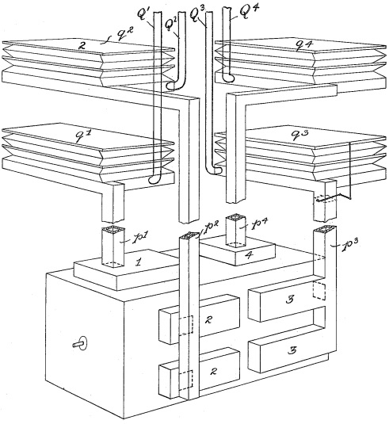
Figure 62
“p¹” and passed to reservoir “q¹,” from which windline “Q¹” transmits it to the proper division of the instrument. The process may be repeated for as many fans as are available. For example, if fan “f³” generates 5” of wind pressure, the remaining fans may increase the pressure to 10”, 15”, and 20”, each of which may be supplied to any division of the organ. Cousans was able to produce a quiet blower by reducing the amount of work required of each fan and by designing chambers for the fans such that the fans never touched the walls of the chambers. It will also be seen from Figure 62 that the entire assembly is housed in a box that helps to reduce the transmittal of noise. Louis Bertram Cousans further refined the blower design in subsequent patents, but not before Ira Spencer produced his first blower and provided competition for Cousans.

Spencer Organ-Blowing Apparatus
Only two years after the introduction of the first Cousans blower, Ira Spencer applied for a patent for his own centrifugal multi-fan blower. While the basic principle of construction remained the same, Spencer’s design sought to further reduce the noise produced by the apparatus and increase the efficiency with as little current consumption as possible. A sectional diagram may be seen in Figure 63. Unlike the Cousans design, Spencer’s blower was encased in a
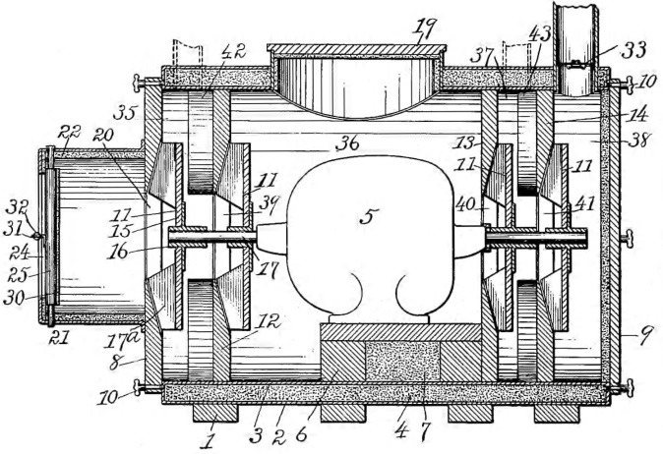
Figure 63
circular sheet metal shell “2” that was entirely padded with a fireproof and soundproof material “4.” A second case “3” sat within the first to ensure a reduction of noise. The motor “5” sits centrally in the interior of the blower unit, though Spencer allowed for the external mounting of the motor, and its base “6” is likewise supplied with packing as at “4.” If it was situated interiorly as pictured in Figure 63, a manhole “19” in the top of the casing allowed access to the motor for maintenance. A shaft “17” projects from the motor to which are secured fans “11” in a series of chambers divided by partitions “12,” “13,” and “14.” Spencer constructed the fans of the lightest possible material, commonly employing wood, aluminum, or sheet metal, and secured metal blades to their faces at 90⁰ angles.
The air inlet “20” is surrounded by a circular metal casing provided with packing “22” and a cheek valve “25” that is regulated by a spring. Two semi-circular panels cover the end of the inlet casing and open according to the amount of vacuum created by the turning of the fans. When the organ requires little air, the panels remain essentially closed, reducing the amount of noise emitted from the interior of the blower. When the organ requires a greater volume of air, the suction created by the fans forces the panels inward and allows for a large volume of wind to pass into the blower. While this allows more noise to escape, the greater volume of tone produced by the higher volume of air masks the sound. A similar cheek valve “33” mounts at the outlet of the final compression chamber “38” and functions in the same manner and with the same goal of reducing the amount of perceptible noise.
Spencer fixed deflectors “42” and “43” as pictured in Figure 64 to the walls of the chambers (as at “12”) to facilitate the movement of the compressed air from one chamber to the next and to reduce the amount of circular air movement.
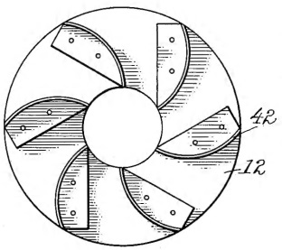
Figure 64
The deflectors funnel the air into the successive chamber “without frictional loss” and enable the fans to be constructed of varying diameters without changing out the deflectors. The central chamber housing the motor does not require deflectors, as the motor itself and its block serve to disrupt the central motion of the air. As in the Cousans design, outlets may be provided at any of the successive chambers to deliver multiple wind pressures to different divisions of the organ. The elimination of trunks as seen in the Cousans blower simplifies the construction of Spencer’s apparatus, and the additional provision of soundproof and fireproof packing resulted in quieter, safer blowers. Cousans and Spencer both subsequently released patents improving the blower components and moved toward a design that still remains in use.

Cousans Modifications
In the years following the production of the first Cousans blower, Louis Bertram Cousans introduced several improvements in its design with the goal of making it quieter, more efficient, and as practical as possible. A patent filed in 1905 presented a modification of the blower’s casing and output valves to facilitate the diffusion of heat and the reduction of noise as pictured in Figure 65. The operation of the mechanism remained the same as in the previous
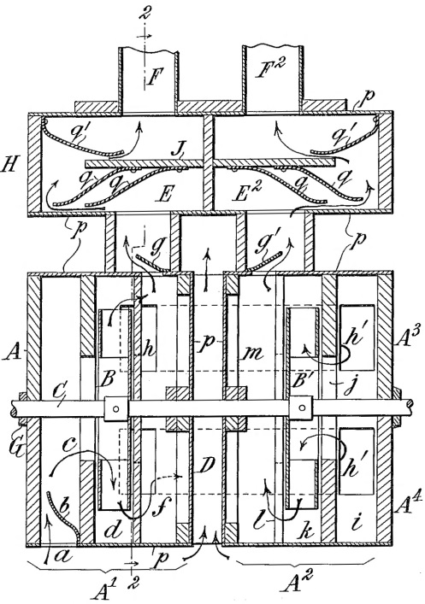
Figure 65
design, the present containing only two fans “B” and “B¹.” Cousans divided the casing “A” into two separate sections or boxes “A¹” and “A²” and separated them by a central space “D.” Each box consisted of an upper and lower half “A³” and “A⁴” respectively that were constructed of both wood and metal, the outermost walls made of wood and the innermost of metal. Any portion of the blower casing constructed of metal is labeled “p.” All joints are secured by wood strips “G.”
Due to the motion of the fans and the friction created by the heightening of the wind pressure, a significant amount of heat may be generated during the process. To avoid the transference of the heat to the reservoirs and chests, Cousans introduced a metal casing so as to conduct the heat from the inside of the blower to the atmosphere but retained wood strips and panels to absorb any vibration and maintain quiet operation. The central open passage “D” is provided for the same reasons and permits atmospheric air to circulate between the two blower boxes and keep the mechanism cool. The provision of two boxes likewise allows easy access to the central chambers, fans, and shaft for maintenance.
The modifications stipulated in the above design also serve to reduce any noise created by the blower to a minimum. To this end, a number of felt or felt-covered valves “b” and “q” are placed at the air intake and output ports. The valves freely open as airflow increases and easily close as it diminishes. The porous quality of the leather enables free airflow even if the valves set in an essentially closed position. The chambers “E” and “E²” both appear in the above specification for the purpose of reducing the sound of the mechanism. The silencing valves “q” extend from the bottom of plate “J” and interrupt the horizontal flow of the air as do the silencing valves “q¹” extending from the top panel of the box “H.”
The final improvement embodied in the design provides a valve for stopping the airflow from the blower to the reservoir when it is sufficiently full by means of a valve “R” as seen in Figure 66. Cousans cut off the airflow in the
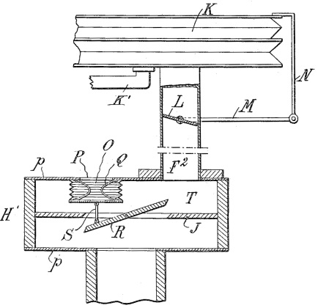
Figure 66
“H” rather than at a point closer to the reservoir “K” to minimize the perception of the “hissing noise” produced in the process. The wind trunk “F²” leading from the blower to the reservoir is provided with a valve “L” to which is attached a rod “N” that terminates at the top of the reservoir. As the reservoir receives air, the top rises and closes valve “L,” and as the organ is played, the use of air from the reservoir causes the top to fall and open valve “L.” A small pneumatic “O” connects to valve “R” through a link “S” and holds the valve open through springs “Q.” As valve “L” closes, the increased pressure in chamber “T” causes the pneumatic to exhaust either partially or fully depending of the amount of air required by the reservoir. The remaining air surrounding valve “L” remains at the same pressure as that in the reservoir and quietly admits through the valve.
In a final US patent, Cousans transitioned to a circular fan casing constructed entirely of sheet metal as show in Figure 67. The sheet metal
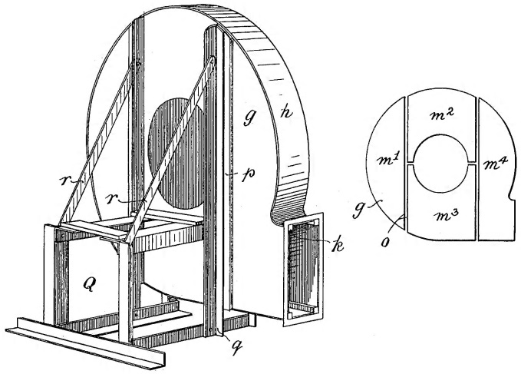
Figure 67
sides are constructed in four pieces “m¹” through “m⁴” that attach to wooden bars “p” on the frame supporting the blower. The end piece “g” is supplied with small tabs that fit into slots in the body case “h” and which are turned once in place to secure their position. A small wooden block “k” may also be nailed into place to accomplish the same. With the incorporation of this final modification, Cousans’s blower took the form found in numerous instruments in the early twentieth century. He successfully constructed a blower that provided multiple pressures through the use of multiple fans and enabled it to function quietly while maintaining a consistent temperature in the compressed air for the organ. Because the size of the blower’s motor could greatly increase in size as could the number of fans, one substantial blower could provide enough wind for an entire instrument of significant size requiring high wind pressures to produce the tone color desired by organists and requiring wind for the operation of the organ’s various systems.

Spencer Modifications
Like Louis Bertram Cousans, Ira Spencer sought to improve his blower design by providing a metal casing that was both rigid and lightweight and by reducing the noise of its operation. He relocated the motor to the exterior of the blower assembly to make it “readily accessible” for maintenance as seen in Figure 68. The extreme weight of the motor “9” requires a stable base “11,” that in this
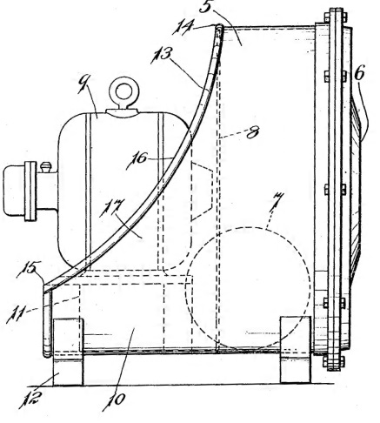
Figure 68
case is mounted on a projection from the main body of the casing “11.” To further facilitate access to the motor, the casing is cut away as at locations “13” through “16.” The cut-away “forms a brace ‘17’ between the projecting part or support ‘10’ for the motor and the upper portion of the body part ‘5,’ this brace by this formation being integral with the body and motor support and producing a very rigid structure.”
Spencer developed an air inlet assembly that eliminated the need for an intake valve to reduce the amount of sound emitting from the blower as pictured in Figure 69. In previous designs, a cheek valve mounted at the point of air
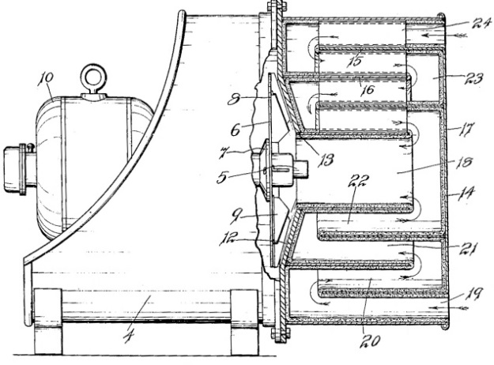
Figure 69
intake helped regulate the amount of noise escaping from the blower assembly, but such a valve only accomplished this goal when it was closed; no means were provided to reduce the noise when the valve was open, the sound of the pipework serving to accomplish the same. In Spencer’s above modification, a series of deflectors disturb the air’s path to the fan and reduces residual noise. Air flows into the blower at the two intake points “19” and “24” and must travel around the deflectors “15” and “16” and through passages “20”-“22” or those unlabeled passages corresponding to the intake “24,” which are lined with felt or another sound-absorbing material. Valves no longer needed to be situated at the intake points, as the tumultuous path of air sufficiently deadened the noise of the operation and prohibited it from escaping into the room.
Spencer released one more revision to his blower design in 1912, but its form remained essentially the same as in previous incarnations. Deflector plates gave way to deflector chambers located immediately behind the fans that served the same goal of funneling air into the next pressure chamber. Like Cousans, Spencer sought to refine his organ blower to provide an efficient apparatus that could supply the instrument with a generous supply of air to operate its various mechanisms and enable heavy wind pressures. The Spencer “Orgoblo” and Cousans’s blower released by the Kinetic Engineering Company dominated the organ blower market, and their designs appeared in instruments by nearly every builder; their side-by-side ads placed in The Living Church Annual of 1916 are pictured in Figure 70.
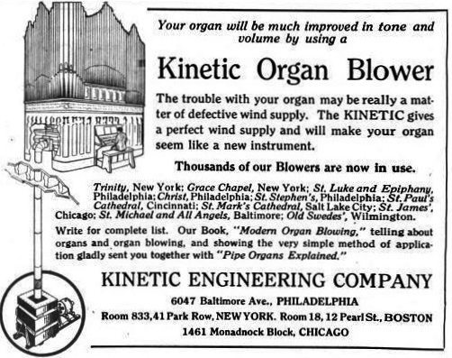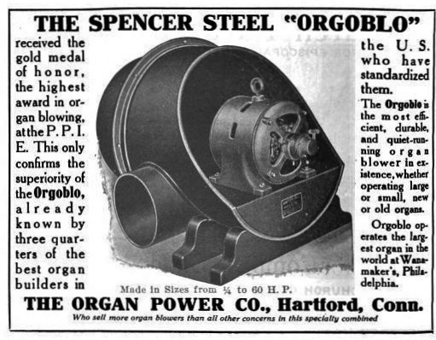
Figure 70
Schantz Organ-Blower
Nearly one decade after Cousans released his first blower, Abraham Schantz also designed an organ blower that was marketed under the name Zephyr. Though not substantially different in operation than either of the other two blowers designed, Schantz’s entrance into the market provided organbuilders with yet another option for winding their instruments and introduced various new means for building a blower that was both efficient and quiet. Schantz’s design, pictured in Figure 71, provided three ways of reducing blower noise: an air intake extension, a hinged cover for the motor, and a gasketed frame plate to separate the motor chamber from the fan chamber.
The air intake extension “11” is provided with sound-deadening flanges
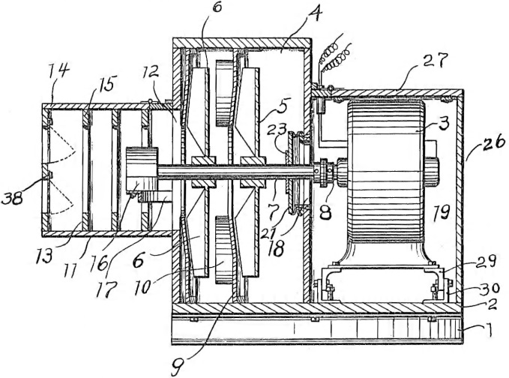
Figure 71
“13”-“16” that mount to the top and bottom of the intake casing. As the air enters, the flanges sufficiently disturb its direct flow and serve to reduce the associated noise. The motor chamber “19” is enclosed in its own box, formed by a hinged top “27” and a removable side panel “26.” All may be easily disassembled for complete access to the motor, but the hinged top allows the same for maintenance while only requiring the removal of a few screws. By enclosing the motor in its own chamber, the sound of its operation remains largely contained within the blower mechanism. Schantz supplied a gasketed frame-and-plate assembly to separate the motor chamber from the fan chamber and reduce the communication of operational noise from the former to the latter. As seen in Figure 72, the assembly consists of a frame “20” and a plate “21” that are
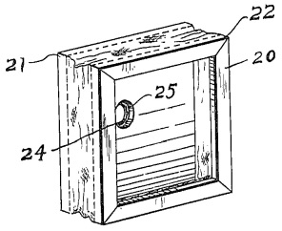
Figure 72
connected by a leather gasket “22.” The plate contains a central hole “25” for the communication of the motor shaft and is furnished with a leather gasket on the side of the fan chamber (Figure 71). Any sound emitting from the motor chamber will be sufficiently trapped by the bellows-like assembly, will reduce the communication of sound between the two chambers, and will make the blower “practically silent in its operation.” Normal wear will compromise the soundproofing qualities of the above arrangement, but its simple and inexpensive repair made its application both practical and beneficial.
Schantz provided a valve for closing the flow of air from the blower to the reservoirs much like Cousans, but he relocated it to the windline at a point near the reservoir. A chord connects the valve to the reservoir top and functions as the valve previously described; in the current design, however, it is covered with leather in an attempt to reduce the noise of its opening and closing, as the leather is the only portion of the valve that comes into direct communication with the windline.
In a final patent, Schantz modified the manner of muffling the communication of sound between the motor and the blower casing by creating a shaft packing member that mounted to the inside of the casing nearest the motor. The shaft packing, shown in perspective and in section in Figure 73,
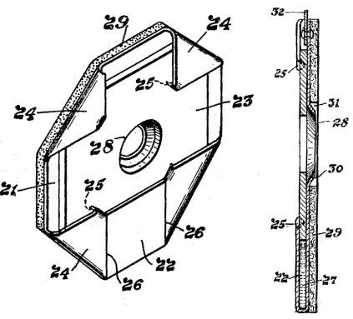
Figure 73
consists of a metal plate “21” to which is affixed a leather piece “23” of smaller proportions than the metal plate. After the leather has been applied, the corners of the plate are turned inward as at “24,” and a depending piece “22” is also turned upward and soldered to the bent pieces “24.” A central opening “28” is formed in the leather to conform to the shaft and provides an air-tight seal. To the opposite side of the plate is attached a layer of felt “29” that rests against the wall of the casing nearest the motor, and a conical flange “30” secures the assembly to the shaft. The application of felt ensures an air-tight seal
and allows the packing member to move with the shaft, as its position may change in time due to use and wear on the bearings. The leather piece is saturated with oil to allow its free movement on the shaft, and the well formed by the soldering of the angled pieces “24” and the bent piece “22” provides a well in which the oil may collect without leaking into the blower casing. The packing assembly mounts to the wall of the blower casing by means of a vertical suspension assembly that likewise allows it to move with the shaft. Abraham Schantz’s design was later modified by moving the motor inside the metal casing, making the entire unit compact and quiet; the Zephyr company has retained this design and employs it in their current blowers.
The Kinetic Engineering Company blower, Spencer “Orgoblo,” and the Zephyr blower each provided organbuilders with the necessary elements for success: a quiet, efficient blower that could produce a sufficient supply of air to wind the instrument and operate the pneumatic mechanisms controlling its operation. Without the advent of the multi-fan blower, the heavy wind pressures required to create the aesthetic intrinsically linked to the American Symphonic Organ could not have been supplied. Each modification introduced by the above inventors served the end of filling the lungs of the instrument while making their presence hidden so as to leave the organ completely uninhibited in its expression.

CHAPTER 9
Conclusion

By the year 1920, the technological face of American organbuilding looked significantly different than it had only forty years prior. With the exception of pipes, chests, keys, and drawknobs, virtually every element of the organ’s mechanism and physical appearance had changed. Electromagnets controlling the organ mechanisms, pitman chests, whiffle-tree swell engines, individual swell shade pneumatics, balanced swell pedals, coupler rocker tabs, movable detached consoles, adjustable combination action pistons and toe studs, key contacts of any variety, and multi-fan blowers had never been seen before 1880. Yet in a comparatively narrow timeframe, significant changes revolutionized the organ’s construction and design and the way in which performers interacted with the instrument – all to serve an aesthetic end. The warmth and breadth of tone desired by performers and listeners as heard in the symphony orchestra finally translated to the organ. Its color palette grew immensely, and the ability to quickly and reliably control its tonal resources enabled a range of expression and flexibility not previously experienced.
The organ did indeed enter a kind of golden age that it, arguably, has not experienced since the 1920s for a number of reasons. In the early twentieth century, the urban population boom acted as the catalyst for growth in the arts in major cities. Public auditoriums equipped with massive organs appeared throughout the country. Materials and labor were both readily available and reasonably affordable. But the Great Depression gave the organ industry a significant blow, and “by 1942 the organ building industry . . . was ordered by the U.S. Government to convert to defense work.” The metals utilized in pipe construction were needed for the war, and the organbuilders were restricted to rebuilding instruments; materials could only be used to complete contracts that had been signed prior to the 1942 construction ban. The record industry grew exponentially during the 1920s, and despite a downturn at the end of the decade, it recovered heartily after the war. People no longer had to leave their homes to hear the great symphonic masterpieces, and the appearance of television gave the US population another form of entertainment available in their own home. A wave of migration from city centers to the newly-forming suburbs, seen as “desirable solutions to emerging urban problems,” reduced the demand for live entertainment in urban centers as had been seen in the previous decades. Despite the inauspicious future awaiting the organ in the middle of the twentieth century, its popularity in the early decades of the 1900s drew thousands to concerts. The series of four programs celebrating the dedication of the St. Paul Auditorium Skinner drew a combined crowd of “more than 30,000 people, with ‘3,000 more who were unable to get in.’”
Given the popularity of the organ and its apparent ability to draw immense attention from the public, one must again question the validity of Peter Williams’s statement regarding mechanical progress in the organ: “technical ingenuity outran musical demands, or at least reduced their importance.” The prevalence of the American Symphonic Organ and its demonstrated success suggest that technical ingenuity did not outrun musical demands but rather met them with such satisfactory results that the instrument’s allure exploded. One must recognize, however, that every style of art in every generation has pushed the boundaries of acceptability and success. The only way to discover the point of diminishing returns is to exceed the limits of artistry and retract to an acceptable compromise. Robert Hope-Jones experimented with extreme wind pressures and successfully placed a Tuba Mirabilis on 50”, while the Midmer-Losh company utilized 100” in their iconic organ for the Atlantic City Convention Hall. Such extremes did not endure, and a brief survey of specifications from the early twentieth century reveals that organbuilders rarely employed wind pressures beyond 25” or 30”, and those values typically applied only to one or two substantial solo stops. The tonal philosophy of 1900 also developed in the following years. Specifications with a limited number of stops above 4’ pitch, if any, gave way to designs that sought out a better balance between breadth and clarity.
The general technological environment of the turn of the century in combination with the changes in musical preferences provided the necessary environment for the development of the American Symphonic Organ. Had technology achieved the same state of development fifty years earlier, musical demands may not have necessitated the expanse in tone; a similar scenario fifty years later would have met the recession from the Romantic era and the move toward the objectivity of the 1950s. All the necessary ingredients were present for the formation of a new sound that synthesized the best ideas of the past with the groundbreaking ideas just then unfolding. This synthesis process did not occur overnight as this document demonstrates: years of trial and error and the introduction of new thoughts guided the instrument through its evolution. In his doctoral research document “Ernest M. Skinner and the American Symphonic Organ,” James Gerber boldly credits Ernest Skinner with the “creat[ion of] the American Symphonic Style.” While Skinner may have emerged as the most prominent builder of the American Symphonic Organ, he stood on the shoulders of his predecessors and was among the first to codify the style through the integration of technology and tone. Skinner’s superior workmanship, the visibility of his early work, and the use of new technology undoubtedly furthered his prominence and visibility, but one need not look farther than Kimball and Möller to find outstanding examples of the style appearing at the same time. Evolution is a process worked out in time, and the American Symphonic Organ’s birth and rise to prominence was no different.
Even when tonal preferences in the middle of the twentieth century placed the symphonic organ in an unfavorable light, the mechanical innovations developed at the turn of the century remained in use. Pitman chests, balanced swell pedals, pneumatic swell devices, adjustable combination action, and console designs remained popular among organbuilders, and they are still in use today. Today’s pitman chest has seen very little change from the time of its refinement in the 1920s. Pneumatic swell devices likewise closely resemble their 100 year old ancestors, and consoles with angled stop jambs appear virtually identical. Modern technology has reduced the complexity of combination action and allowed for thousands of combinations to be set by the performer and retained by a computer. With this exception, mechanical innovations of the early twentieth century have indeed stood the test of time, and most have become industry standards.
The American Symphonic Organ is enjoying a renaissance today. Numerous instruments from this time period have recently been restored, rebuilt, or rescued from storage and are finding a home in churches and concert halls where they are stirring the hearts and minds of listeners as they did a century ago. Organbuilders such Michael Quimby and the Schoenstein company have incorporated many features of the early twentieth century into their own style, most notably in the use of heavy wind pressures and the development of tonal designs. Organists and organbuilders alike are recognizing the quality of pipework and mechanical components of the American Symphonic Organ and are preserving them for another 100 years of life and music. Though the symphonic organ’s popularity dwindled in the middle of the nineteenth century, it is quickly reappearing, and if these trends continue to develop as they have in the first decade of the twenty-first century, instruments inspired by the great American Symphonic masterpieces will continue to grow in popularity in the coming years. Early twenty-first century American organs will continue to look to their century-old ancestors and will bring about a new wave of organbuilding that capitalizes on the finest elements of the past, both tonally and technologically, and combines them with the wisdom that 100 years of separation affords. The symphonic organ is here to stay and will live a long life in the hands of inspired organbuilders and performers who readily recognize the inherent musical and technological merits it has to offer.

GLOSSARY

Mechanism Components
CHANNELS or CHANNELING: Windways that are bored into a portion of the organ’s mechanism that allow for the movement of air from one compartment to another or from one compartment to the atmosphere.
COMBINATION ACTION: The means by which a stop or the combination of a group of stops may be engaged or retired by a thumb piston or foot lever.
COUPLERS: Mechanical devices by which different divisions may be controlled from a single manual or the pedal. Couplers may also indicate pitch levels and make the ranks of one division available on a different division at the sub-octave (16’) or super-octave (4’). For example, the “Swell to Great 4” would enable the swell stops to play one octave higher on the Great, and “Great to Pedal 8” would allow the stops of the Great to sound in the pedal. In the mature American Symphonic Organ, the couplers are controlled by rocker tabs located above the top manual (see Console Components below).
ELECTRO-PNEUMATIC: Refers to a form of construction governing an organ’s operating action. The “electro” portion indicates the use of a magnet that transfers a signal to a “pneumatic” portion that utilizes air to complete the desired operation.
HEAVY WIND PRESSURES: A relative term denoting the number of inches compressed air will displace the water column in an aenometer. In organs with mechanical action, wind pressures generally do not exceed 4” due to the increased force required to break the seal on the pallet. In the American Symphonic Organ, wind pressures rarely went below 5”; thus, for the sake of this document, heavy wind pressures designate anything in excess of 5”.
INDIVIDUAL VALVE CHEST: A windchest containing a valve for each pipe as opposed to earlier forms of slider chests where one pallet controlled the airflow to multiple pipes.
KEY CHANNEL: Division of a chest that connects the airways leading to all pipes associated with one key.
MECHANICAL KEY ACTION: Refers to the construction of organs prior to and throughout much of the nineteenth century. In mechanical action organs, a physical linkage extending from the back of the key, known as a “tracker,” connects the key to the windchest. When the performer depresses the key, he or she must exert enough force to cause the tracker to pull down the pallet in a chest and allow air to enter the pipes.
PALLET: see “SLIDER-AND-PALLET CHESTS”
PNEUMATIC: May refer either to the general use of wind in operating an organ mechanism or a component constructed of wood and leather that controls a pneumatic function. See ELECTRO-PNEUMATIC, SQUARE PNEUMATIC, or WEDGE PNEUMATIC.
RESERVOIRS: Large wooden boxes that hold an instant supply of air for a division or chest in close proximity to said division or chest. Leather strips adhere to each joint to ensure an airtight seal. In early organs, one large reservoir in the form of a wedge bellows provided wind for the entire instrument. In the nineteenth century, multiple reservoirs were provided for divisions or separate chests. In the twentieth century, some instruments contained reservoirs for individual stops on extremely high pressures or for a few select bass chests.
SLIDER-AND-PALLET CHESTS: A form of chest construction utilized in all tracker-action organs prior to the introduction of tubular-pneumatic action. The name implies two components: “slider” refers to the stop action, and “pallet” refers to key action. Sliders are relatively thin pieces of wood containing holes of an equivalent size of the toe holes of the rank with which they are associated and are located somewhere near the top of the chest. They move horizontally on a chest, and one slider is provided for each stop on a given chest. When a stop knob is drawn at the console, the slider is pushed into a position such that its holes move into a location directly underneath the toe holes of the pipe; this allows the air to enter through the slider and into the pipe when the key is depressed. If a stop is not drawn, the slider will be offset in such a position that solid wood forms a barrier between the air supply and the pipe, disallowing its speech.
Pallets refer to the means by which air is communicated to the pipes. They are constructed as long wooden pieces that run latitudinally down a chest and control all the pipes of one specific key (i.e. every pipe associated with C¹, C♯¹, D¹, etc.). Air is supplied to the chest from below the pallets and places pressure on them, assisting in keeping them shut when a note is not played. When a note is depressed at the console, the tracker running from the key pulls down on the pallet and allows the air from underneath it to enter the key channel, the division of the chest communicating air to pipes associated with that key. The following diagram demonstrates this form of construction.
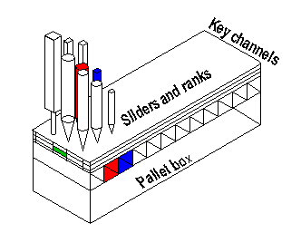
The diagram [above] illustrates a simplified chest that contains three ranks of pipes and 12 key channels. To avoid the appearance of a crowded forest of pipes, only the first three pipes in each rank are shown. The small green rectangle on the side is placed there as an indication that the slider for the second rank of pipes is in the open position. If the second key is played, the pipe that stands above both the second slider and the second key channel will play if the pallet below the key channel is opened. Both the second key channel and its corresponding pipe in the second rank are colored red for identification. Similarly, the third key channel and the corresponding pipe above it are both blue, so that pipe would sound if the pallet below the third key channel were open.

STOP CHANNEL: Division of a chest that contains the air for all pipes of one stop, be it a single rank or a compound stop of multiple ranks.
SQUARE PNEUMATIC: Device whose inflation or deflation triggers a chain of events that enables an organ’s mechanism to operate. Square pneumatics are constructed of two square or rectangular pieces of wood that are joined in the center by leather, making them air-tight.
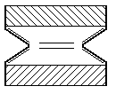
Wood
Leather
VENTIL: Refers to the control of air and derived from the French “vent” (wind); a valve that admits air to or prohibits air from entering a specific portion of the organ. It may be applied to stop action or chests.
WEDGE PNEUMATIC: Device whose inflation or deflation triggers a chain of events that enables an organ’s mechanism to operate. Wedge pneumatics are constructed of two pieces of wood that are joined in the center by leather, making them air-tight. One piece of wood is fixed and the other is hinged with the leather, creating a fan shape.
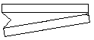
Wood
Leather
Console Components

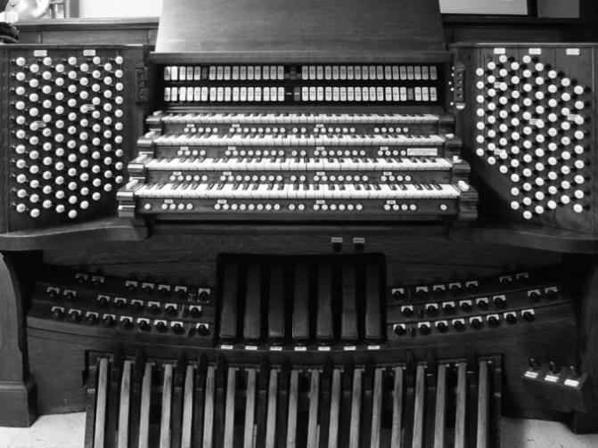
Coupler Stop jamb
Rail
Coupler Tabs

Thumb Drawknob
Piston
Manual

Toe Stud

Pedalboard Balanced Swell Pedals

BALANCED SWELL PEDAL: Designation of a type of swell-controlling lever operated by the foot at the console that will “balance” or hold any position in which it is placed. In early forms of expression controls, swell levers were equipped with a spring that would return the shades to the closed position if the pedal was not latched in a half-open or open position. Various degrees of openness could only be obtained if the organist consistently “rode” the pedal and held it at an intermediary stage. With the balanced swell pedal, the lever and shades would open or close to any position indicated by the organist and remain there until further activated.
COUPLER RAIL: The horizontal assembly that contains the coupler rocker tabs. While organs typically have only one coupler rail, extremely large instruments may have two (as pictured above).
STOP JAMBS: The surface in which stops are mounted; may be arranged horizontally and terraced, terraced and curved, terraced and angled, or vertically arranged at angles to the performer (typically at 43⁰-47º).
THUMB PISTON: A round button with a depressed center located below each manual that controls various portions of the combination action.
TOE STUD: A round button located above the pedalboard that controls various portions of the combination action.

Pipe Forms
FLUE refers to one of two major classifications of pipe construction that constitutes the majority of the organ’s tonal composition. Flue pipes comprise Principals, Flutes, and Strings, whose specific construction are discussed under Timbre Designations. Flue pipes are “constructed in two sections: the foot and the body, which are separated by the languid, an internal, cross-section piece.” The languid is shaped such that a small slit, the flue, allows for the communication of air between the foot and the body. Air is admitted through the toe hole. The mouth is the opening “at the juncture of the flue and the body” and is flanked by an upper lip and a lower lip.
REED pipes are also constructed in two sections: a boot and a resonator. The boot is the housing that contains the sound-producing portion of the assembly. The block is a lead piece in which the remaining sound-producing portions are anchored. The shallot is a semi-circular piece with an opening on its front that may take various shapes. The size and shape of the shallot opening influences the harmonic content of the resultant sound. Shallots with extremely open faces encourage the development of upper harmonics, while shallots with narrower openings encourage the development of the fundamental tone. The tongue, a relatively thin brass piece, sits against the shallot and is secured by a wedge that may be made of brass or wood. A tuning wire placed pressure on the tongue and regulates how much of the tongue may vibrate against the shallot. When wind enters the toe, it flows through the shallot and causes the tongue to beat against the shallot face, producing tone in a similar manner to the clarinet or saxophone (hence the name “reed”). A conical or cylindrical resonator, the equivalent of the body of a flue pipe, amplifies the sound produced by shallot-tongue assembly. Resonators may be constructed of varying lengths. Full-length resonators encourage the natural development of the harmonic series with an emphasis on the fundamental tone that gradually tapers as the harmonic series progresses. Harmonic, or double-length, resonators encourage a greater emphasis on the fundamental tone and produce more power. Resonators of fractional length (1/4, 1/8, 1/16) deemphasize the fundamental tone and amplify upper harmonics.
Timbre Designations
CHORUS REEDS are those whose tone is conducive to blending with other stops, specifically with flues, and primarily include varieties of the Trumpet family (Trumpet, Tromba, Trombone, Clarion, etc.).
FLUTE pipes may be constructed of wood or metal are subdivide into various categories: open, stopped, half-stopped, harmonic (double-length), tapered open, tapered stopped, or stopped harmonic. The specific form of construction encourages or discourages the development of harmonics. Some flute tones, such as the Orchestral Flute or Transverse Flute, are imitative of their orchestral counterpart.
IMITATIVE REEDS attempt to mimic the tone of orchestral instruments and include the Clarinet, English horn, French horn, Oboe, and Basset horn, among others.
PRINCIPAL or DIAPASON pipes produce the “true organ sound” and are the only non-imitative voices in the instrument. They are constructed either as cylindrical, open metal pipes or rectangular wood pipes (typically reserved for broad Pedal stops as in the Double Open Diapason). “The characteristics of principal tone are a full-bodied fundamental and harmonic development that tapers gradually and evenly.”
STRING pipes are constructed primarily of metal, though some Pedal strings are constructed of wood (notably the Violone). They are always open pipes and are primarily cylindrical; some specific strings, such as the Gemshorn, have tapered bodies. String bodies have the narrowest scale of any flue pipe, which encourages the development of upper harmonics. The emphasis on upper harmonics is suggestive of a bowed string instrument.

Other Terms
CELESTE: Designates a rank of pipes that are tuned slightly sharp or flat of their parent rank, which is comprised of similarly-constructed pipes that are tuned to the remainder of the organ. When combined with the parent rank, the celeste produces an undulating tone that is suggestive of the vibrato produced by bowed string instruments or simulates an entire group of strings that do not play entirely in tune.
CHORUS: The combination of coalescing ranks of different pitch levels.
FOUNDATION (STOPS): Flue stops sounding at the 8’ pitch level in the manuals that provide the backbone of the instrument, just as the violins form the foundation of the orchestra.
MIXTURE: A compound stop containing multiple ranks of similarly-constructed pipes, most often principals. Mixtures contain both unison and off-unison pitches and are usually pitched no lower than 5-1/3’ in the pedal and 2-2/3’ in the manuals. On the drawknob or stop key, a Roman numeral indicates the number of ranks contained in the stop, and the optional provision of an Arabic numeral indicates the pitch level of the lowest-sounding rank.
PITCH LEVELS: Stop pitch levels are indicated by Arabic numerals that represent the length in feet of the longest pipe of an open rank. The 8’ pitch level is the unison pitch, or “piano pitch.” If an 8’ stop is drawn and middle C played, the corresponding note on the piano would produce a tone of the same frequency. 16’ stops sound one octave lower, 4’ stops one octave high, and so on. Stops with fractions, such as 2-2/3’ or 1-3/5’, sound off-unison and reinforce the natural harmonic series. A 2-2/3’ stop will sound the pitch and octave plus a fifth above the note played; a 1-3/5’ stop will sound the pitch two octaves and a major third above the note played.
SCALE: The ratio of a pipe’s diameter to its height. In considering timbre designations, flutes represent the broadest scale and strings the smallest. Pipes with large scale encourage the development of fundamental tone while those of narrow scale encourage the development of upper harmonics.
UPPERWORK: Refers to stops higher than the 4’ pitch level.

BIBLIOGRAPHY
Books

Audsley, George Ashdown. The Art of Organ-Building: A Comprehensive Historical, Theoretical, and Practical Treatise on the Tonal Appointment and Mechanical Construction of Concert-Room, Church, and Chamber Organs. New York: Dodd, Mead, 1905. New York: Dover Publications, Inc., 1965.

Barnes, William H. The Contemporary American Organ. 7th ed. Glen Rock, NJ: J. Fischer & Bro., 1964.

Barnes, William Harrison and Edward B. Gammons. Two Centuries of American Organ Building: From Tracker to Tracker. Melville, NY: Belwin Mills Publishing Corp., 1970.

Bicknell, Stephen. The History of the English Organ. Cambridge: Cambridge University Press, 1996.

Fox, David H. Hilborne and Frank Roosevelt. Richmond, VA: OHS Press, 2012.

_____. Robert Hope-Jones. Richmond, VA: The Organ Historical Society, 1992.

Grout, Donald Jay, J. Peter Burkholder, and Claude V. Palisca. A History of Western Music. 7th ed. New York: W.W. Norton, 2006.

Holden, Dorothy J. The Life and Work of Ernest M. Skinner. 2nd ed. Richmond, VA: The Organ Historical Society, 1987.

Jonkers, A. R. T. Earth’s Magnetism in the Age of Sail. Baltimore: The Johns Hopkins University Press, 2003.

Kinetic Engineering Co. Kinetic: The Perfect Organ Blower. Philadelphia: Kinetic Engineering Co., 1910.

Lewis, James. The Los Angeles Art Organ Company. Richmond, VA: OHS Press, 2012.

Miller, George Laing. The Recent Revolution in Organ Building, Being an Account of Modern Developments. New York: The Charles Francis Press, 1913.

Ochse, Orpha. Austin Organs. Richmond, VA: Organ Historical Society, 2001.

_____. The History of the Organ in the United States. Bloomington, IN and London: Indiana University Press, 1975.

Owen, Barbara. “Technology and the Organ in the Nineteenth Century.” In The Organ as a Mirror of its Time: North European Reflections, 1610-2000, ed. Kerala J. Snyder, 213-229. New York: Oxford University Press, 2002.

Schlesinger, Kathleen. “Organ.” In Encyclopedia Britannica, 260-261. Cambridge: Cambridge University Press, 1911.

Skinner, Ernest M. The Composition of the Organ. Edited by Leslie A. Olsen. Ann Arbor, MI: Melvin J. Light, 1981.

_____. The Modern Organ. New York: The H. W. Gray Co., 1917.

Skinner Organ Company, Ernest M. Skinner, Fay Leone Faurote, and Stephen L. Pinel. Stop, Open and Reed: A Periodical Presentation of Pipe Organ Progress. Richmond, VA: Organ Historical Society, 1997.

The Living Church Annual and Churchman's Almanac: A Church Cyclopedia and Almanac. Milwaukee, Wis: Young Churchman Co, 1916.

The Los Angeles Art Organ Company. Philadelphia: The Friends of the Wanamaker Organ, Inc.: 2011.

Whitney, Craig R. All the Stops: The Glorious Pipe Organ and Its American Masters. New York: Public Affairs, 2003.

Whitworth, Reginald. The Electric Organ. London: Musical Opinion Ltd., 1948.

Williams, Peter. A New History of the Organ. Bloomington: Indiana University Press, 1980.

Thesis

Gerber, James. “Ernest M. Skinner and the American Symphonic Organ.” DMA Diss., Arizona State University, 2012.

Journal Articles

Baldassare, Mark. “Suburban Communities.” Annual Review of Sociology 18 (1992): 475-494, accessed February 16, 2014, http://www.jstor.org/stable/2083463.

Bethards, Jack M. “A Brief for the Symphonic Organ.” The Diapason 96:9 (September 2005): 22-26.

Dzeda, Joseph. “The Aeolian-Skinner ‘Altron’ Magnet.” Journal of American Organbuilding 22, no. 1 (March 2007): 4-9.

Gronow, Pekka. “The Record Industry: The Growth of a Mass Medium.” Popular Music 3 (1983): 53-75. Accessed February 16, 2014. http://www.jstor.org/stable/853094 .

Website

Pykett, Colin. “The Evolution of Electric Actions.” Last modified December 19, 2011. http://www.pykett.org.uk/the_evolution_of_electric_actions.htm.

_____. “Robert Hope-Jones: The Evolution of his Organ Actions in Britain from 1889 to 1903.” Last modified September 29, 2010. http://www.pykett.org.uk/HJ_OrganActions1889-1903.pdf.

US Patents

Austin, John T. Combination Organ Stop-Action. US Patent 1,078,079, fiiled January 17, 1913, and issued November 11, 1913.

Bierck, Harold A. Combination-Blower. US Patent 1,132,237, filed January 22, 1914, and issued March 16, 1915.

Cousans, Louis Bertram. Air-Compressor. US Patent 855,697, filed February 28, 1905, and issued June 4, 1907.

_____. Apparatus for Blowing Pipe-Organs, Harmoniums, or Like Musical Instruments. US Patent 1,018,483, filed January 3, 1910, and issued February 27, 1912.

_____. Casing for Centrifugal Fans and Pumps. US Patent 1,019,762, filed December 3, 1910, and issued March 12, 1912.

_____. Starter for Blowers. US Patent 855,046, filed December 17, 1904, and issued May 28, 1907.

Cousans, Reginald Arthur and Louis Bertram Cousans. Air-Compressor. US Patent 852,541, filed November 30, 1903, and issued May 7, 1907.

Duval, Salluste. Combination Organ Stop-Action. US Patent 416,158, filed August 17, 1888, and issued December 3, 1889.

Fleming, William B. Combined Electrical and Tubular Organ-Actions. US Patent 643,840, filed June 11, 1898, and issued February 20, 1900.

_____. Electropneumatic Organ-Action. US Patent 666,658, filed January 16, 1900, and issued January 29, 1901.

_____. Pouch-Pneumatic for Pipe-Organs. US Patent 594,391, filed February 6, 1897, and issued November 30, 1897.

Hope-Jones, Cecil, assignee. Mechanism for Producing Sforzando Effects in Organ-Playing. US Patent 1,325,294, filed November 14, 1914, and issued December 16, 1919.

Hope-Jones, Robert. Device for Tuning Reeds. US Patent 1,059,365, filed July 15, 1910, and issued April 22, 1913.

_____. Electropneumatic Organ-Valve. US Patent 1,201,585, filed July 15, 1910, and issued October 17, 1916.

_____. Key Mechanism for Organs. US Patent 1,203,621, filed September 12, 1910, and issued November 7, 1916.

_____. Organ. US Patent 514,146, filed August 8, 1892, and issued February 6, 1894.

_____. Organ. US Patent 522,209, filed September 18, 1891, and issued July 3, 1894.

_____. Organ-Swell. US Patent 1,021,149, filed July 28, 1910, and issued March 26, 1912.

_____. Shutter for Organ Swell-Boxes. US Patent 1,230,165, filed February 12, 1914, and issued June 19, 1917.

_____. Shutter for Sound-Proof Boxes. US Patent 1,110,441, filed August 5, 1910, and issued September 15, 1914.

_____. Sound-Producing Device. US Patent 787,984, filed November 6, 1903, and issued April 25, 1905.

Hutchings, George S. Combination Organ Stop-Action. US Patent 451,380, filed October 13, 1890, and issued April 28, 1891.

Roosevelt, Frank. Organ. US Patent 449,177, filed October 5, 1889, and issued March 31, 1891.

Roosevelt, Frank and William N. Elbert. Organ. US Patent 449,590, filed October 5, 1889, and issued March 31, 1891.

Roosevelt, Hilborne L. Composition Stop-Action for Organs. US Patent 323,211, filed March 21, 1883, and issued July 28, 1885.

_____. Electric Organ-Action. US Patent 374,088, filed September 28, 1886, and issued November 29, 1887.

Roosevelt, Hilborne L. and Charles S. Haskell. Pneumatic Action for Organs. US Patent 323,829, filed July 24, 1884, and issued August 4, 1885.

_____. Pneumatic Action for Organs. US Patent 336,351, filed July 24, 1884, and issued February 16, 1886.

Schantz, Abraham J. Organ-Blower. US Patent 1,117,605, filed May 1, 1913, and issued November 17, 1914.

_____. Shaft-Packing. US Patent 1,279,452, filed November 12, 1917, and issued September 17, 1918.

_____. Valve for Organ-Bellows. US Patent 1,248,926, filed April 6, 1917, and issued December 4, 1917.

Scripture, Eliphalet S. Improvement in organ-blowers. US Patent 200,349, filed January 23, 1878, and issued February 12, 1878.

Skinner, Ernest M. Electric-Circuit-Closing Mechanism for Keyed Musical Instruments. US Patent 725,598, filed October 1, 1902, and issued April 14, 1903.

_____. Organ. US Patent 807,510, filed November 4, 1902, and issued December 19, 1905.

_____. Pipe-Organ. US Patent RE11,669, filed January 25, 1898, and issued June 14, 1898.

_____. Swell Pedal-Action for Pipe-Organs. US Patent 500,040, filed October 29, 1892, and issued June 20, 1893.

Spencer, Ira H. Casing for Organ-lowers. US Patent 1,044,098, filed March 9, 1912, and issued November 12, 1912.

_____. Organ-Blowing Apparatus. US Patent 869,868, filed January 12, 1095, and issued October 29, 1907.

_____. Organ-Blower. US Patent 1,115,873, filed August 12, 1912, and issued November 3, 1914.

_____. Organ-Blower. US Patent 1,158,738, filed September 13, 1912, and issued November 2, 1915.

Stanley, Robert L. Organ Blower. US Patent 1,453,416, filed February 14, 1922, and issued May 1, 1923.

Votey, Edwin S. Electromagnet for Pipe-Organs. US Patent 546,834, filed January 21, 1895, and issued September 24, 1895.

_____. Organ-Case. US Patent 348,505, filed October 29, 1884, and issued August 31, 1886.

Votey, Edwin S. and William D. Wood. Electrically-Controlled Magnet and Valve for Pipe-Organs. US Patent 536,975, filed April 7, 1894, and issued April 2, 1895.

_____. Wind-Chest for Pipe-Organs. US Patent 475,831, filed July 20, 1891, and issued May 31, 1892.

Votey, Edwin S., William B. Fleming, and William D. Wood. Electropneumatic Stop-Action for Pipe-Organs. US Patent 536,978, filed April 16, 1894, and issued April 2, 1895.

Woodberry, Jesse. Combination Organ Stop-Action. US Patent 481,089, filed May 31, 1892, and issued August 16, 1892.

APPENDIX

METHODOLOGY

In approaching the investigation of the technological advances culminating in the American Symphonic Organ, the first task was to define a timeframe that would provide the most concise collection of data pertaining to the subject and that, by exclusion of previous and following innovations, would provide a comprehensive historical narrative. Prior to 1880, American organs largely mirrored European designs of the middle nineteenth century: tracker-action instruments with low wind pressures, no adjustable combination action, and a limited number of 8’ stops appeared most commonly. Hilborne Roosevelt was the first significant American organbuilder to begin investigating the introduction of electricity and pneumatic playing aids into his instruments. Since for the purposes of this document these two features constitute requisite elements, significant investigation of technological advances pertaining to mechanical-action organs was excluded. A brief summary of such developments in European organs of the nineteenth century was included in the introduction as a way of establishing a precedent for evolution in organ design and the growing trend of enabling greater musical flexibility in instruments of significant power and size.
By 1920, the major components of the American Symphonic organ (action designs, electromagnets, swell mechanisms, key contacts and actions, console design, and multi-fan blowers) had reached a state of refinement that was not exceeded in the following decade; many have not been changed or only slightly modified to this day. The only area that changed significantly in the decades following 1920 was combination action; however, the expansion and growth seen in only one area did not merit the extension of the given timeframe. By limiting the research to a forty-year window, it became possible to exhaust the literature discussing this timeframe.
George Audsley’s The Art of Organ-Building and William Barnes’s The Contemporary American Organ served as the primary sources discussing technological advances within the given timeframe. Audsley’s research concluded in the first decade of the twentieth century, and Barnes’s research began in the second decade. Each author mentioned some components that applied only peripherally to their study but that that merited inclusion in this discussion and provided a starting ground from which to conduct further research. Because of the gap in timeframe discussed in the two works, this document allowed for the investigation of advances present in that period that had not been fully discussed.
In an attempt to find the most accurate and detailed information regarding each technological development included in the current study, the US Patent Database was consulted thoroughly. Referring to patents guaranteed that the data gathered was entirely accurate and detailed, all information therein provided by the inventor. When inventors release patents that draw upon previous patents, they are required to reference the work of the original inventor and the device. For each patent consulted in the preparation of this document, all referenced patents were gathered and considered for inclusion if falling within the limitations. The US Patent Database was also searched thoroughly with the names of specific inventors, assignees, and organbuilding companies whose names appeared in the literature as significant figures in the development of organ technology.
After gathering an extensive collection of patents, they were organized chronologically and studied in detail. The patents were then divided into subcategories according to content, still ordered chronologically, that ultimately formed the chapters of the present study. Information from Audsley and Barnes has been included as a way to help contextualize the importance of each invention. When technological advances that furthered the state of the American Symphonic Organ represented an innovation, not an invention, the details of the operation were gathered from literature produced by the individual (for example, Skinner’s The Modern Organ and The Composition of the Organ). In this document, the term inventor is used to describe an individual who pioneered a new form of mechanism and who received a patent for his work, whereas innovator refers to an individual who refined and modified a previous invention without substantially altering the method of its operation; the innovation refers to any advancement put forth either by an inventor or innovator. When such information was not available from an innovator, it was drawn from Audsley or Barnes. The records from the Kimball Company were largely lost when it closed, so the Barnes text is one of the only sources for technical drawings from the company.
Most components under discussion are best demonstrated through technical drawings, all of which were drawn directly from US Patents when available. In other cases, such as console design, technical drawings either do not exist or were unavailable. Furthermore, the subject of console design relates less specifically to inventions or innovations and more directly concerns the changes in the physical placement of standard features. For this portion of the current study, photographs provided the most accurate and descriptive sources to support the discussion. The New York City Organ Project, a collection of information and photographs about instruments in the five boroughs of the city, contains the most comprehensive collection of historical information regarding the evolution of instruments in and given institution and is constantly being revised and supplied with additional details as the historians uncover them. Because the source’s content is constantly growing, the only form in which it may be accessed is through the internet. Significant references accompany each entry and guarantee its accuracy and authenticity.
Once all the data had been collected and analyzed, it was reconsidered for its importance to the thesis of this study. Some inventions and innovations represent significant advances in organ technology and support the thesis, and they were therefore included in the discussion. Other portions, however, represent curiosities or points of progress that are, in themselves, interesting but that did not significantly advance the technological development of the American Symphonic Organ. Therefore, they were excluded from the discussion. Through the process outlined above, the data was pared down to a concise collection of sources that adequately described the technological innovations culminating in the American Symphonic Organ.

Ernest M. Skinner, The Composition of the Organ, ed. Leslie A. Olsen (Ann Arbor, MI: Melvin J. Light, 1981), 9-10.
“American Frontiers: Exploration of the West,” Occidental College American Frontier Research Seminar, last modified March 12, 2013, accessed December 13, 2013, http://sites.oxy.edu/special-collections/amer-frontier/americanfrontiersgroup-westernexploration.htm.
Jonathan M. Hansen, The Lost Promise of Patriotism: Debating American Identity, 1890-1920 (Chicago: University of Chicago Press, 2003).
“America’s ‘identity crisis,’” Washington Post, June 8, 2008, accessed November 21, 2013, www.washingtontimes.com/news/2008/jun/08/americas-identity-crisis.
Donald Jay Grout, J. Peter Burkholder, and Claude V. Palisca, A History of Western Music, 7th ed. (New York: W.W. Norton, 2006), 748.
William Harrison Barnes and Edward B. Gammons, Two Centuries of American Organ Building: From Tracker to Tracker (Melville, NY: Belwin Mills, 1970), 9.
Craig R. Whitney, All the Stops: The Glorious Pipe Organ and Its American Masters (New York: Public Affairs, 2003), 21.
Orpha Ochse, The History of the Organ in the United States (Bloomington, IN and London: Indiana University Press, 1975), 103.
Ibid., 322.
Ibid., 329.
Ibid., 322.
William H. Barnes, The Contemporary American Organ, 7th ed. (Glen Rock, NJ: J. Fischer & Bro., 1964), 129.
Ibid., 23.
James Gerber, “Ernest M. Skinner and the American Symphonic Organ” (DMA thesis, Arizona State University, 2012), 166.
Peter Williams, A New History of the Organ (Bloomington, IN and London: Indiana University Press, 1980), 167.
Barnes, 131.
Ibid., 131.
Williams, 164.
Ibid.
Gerber, 23.
Ibid., 33.
Barnes, 188.
Ibid., 25.
Stephen Bicknell, The History of the English Organ (Cambridge: Cambridge University Press, 1996), 260, 268.
Barnes, 131.
Ibid.
Ibid.
Ibid., 133.
Gerber, 32.
Ibid., 38-39.
Dorothy J. Holden, The Life and Work of Ernest M. Skinner, 2nd ed. (Richmond, VA: The Organ Historical Society, 1987), 13-14.
Grout, 605.
Williams, 97.
Holden, 14.
Ibid.
Barnes and Gammons, Two Centuries, 32.
Ibid., 30.
Barbara Owen, “Technology and the Organ in the Nineteenth Century,” in The Organ as a Mirror of Its Time: North European Reflections, 1610-2000, ed. Kerala J. Snyder (New York: Oxford University Press, 2002), 223-24.
Ibid., 224.
Williams, 182.
In order to properly contextualize Williams’s statement, one must read between the lines of his comment and understand his own biases. Williams presents his bias against the symphonic organ at the conclusion of the referenced chapter in saying that, for example, “electric action [was] slow, remote, invariable, insensitive, unreliable, [and] unpleasant to the touch” (187). Of those characteristics, only “remote” and “invariable” are objective observations. Within A New History of the Organ, Williams devotes only six pages to the years 1890-1930 but spends thirty pages discussing the foundations and tenets of the Orgelbewegung (Organ Reform Movement) that rejected the tonal philosophy of the symphonic organ. In the context of the quoted statement, Williams seems to delegitimize musical preferences of the early twentieth century. If technology rose to meet the desired aesthetic of the age, and it “outran musical demands,” the quotation suggests that the very musical demands of the early 1900s hold no standing: the symphonic organ had no need to develop if the music of the late Romanic era (symphonies, transcriptions, etc.) maintained no valued place in its time.
Skinner, Composition, 143-145.
Ibid., 129-130.
Barnes, 138, 146.
Barnes, 134.
Hilborne L. Roosevelt and Charles S. Haskell, “Pneumatic Action for Organs” (US Patent 323,829, filed July 24, 1884, and issued August 4, 1885), 1.
Skinner, Composition, 96.
Ibid., 93.
Roosevelt and Haskell, “Pneumatic action,” sheet 2.
David H. Fox, Hilborne and Frank Roosevelt (Richmond, VA: OHS Press, 2012), 78.
Hilborne L. Roosevelt and Charles S. Haskell, “Pneumatic Action for Organs” (US Patent 336,351, filed July 24, 1884, and issued February 16, 1886), sheet 1.
Fox, Roosevelt, 79.
Barnes and Gammons, 34.
Ochse, 263.
Ibid., 29.
Ibid.
Hilborne L. Roosevelt, “Electric Organ-Action” (US Patent 374,088, filed September 28, 1886, and issued November 29, 1887), sheet 2.
Roosevelt, “Electric organ-action,” 2.
Fox, Roosevelt, 66.
Colin Pykett, “The Evolution of Electric Actions,” last modified December 19, 2011, http:// http://www.pykett.org.uk/the_evolution_of_electric_actions.htm.
Barnes, 142.
Kathleen Schlesinger, "Organ," in Encyclopedia Britannica (Cambridge: Cambridge University Press, 1911), 260-261.
Frank Roosevelt, “Organ” (US Patent 449,177, filed October 5, 1889, and issued March 31, 1891), 2.
Ibid., sheets 1-2.
Ibid., 2.
Frank Roosevelt and William N. Elbert, “Organ” (US Patent 449,590, filed October 5, 1889, and issued March 31, 1891), 3.
Fox, Roosevelt, 97.
Edwin S. Votey and William D. Wood, “Wind-Chest for Pipe-Organs” (US Patent 475,831, filed July 20, 1891, and issued May 31, 1892), 1.
Ernest M. Skinner, The Modern Organ (New York: The H. W. Gray Co., 1917), 7.
Votey and Wood, 1.
Ibid., sheet 2.
Ibid.
Ibid., sheet 1.
David Fox, Robert Hope-Jones (Richmond, VA: The Organ Historical Society, 1992), 6.
Ibid., 10.
Barnes, 134.
Robert Hope-Jones, “Organ” (US Patent 522,209, filed September 18, 1891, and issued July 3, 1894), 1.
Ibid., sheet 7.
Ibid., 9.
Ibid.
Ibid., sheet 7.
Ibid., 1.
Fox, Hope-Jones, 16.
Skinner, Composition, 88.
Ibid., 89.
Ibid., 96.
Ibid., 96-97.
Barnes, 162.
George Ashdown Audsley, The Art of Organ-Building: A Comprehensive Historical, Theoretical, and Practical Treatise on the Tonal Appointment and Mechanical Construction of Concert-Room, Church, and Chamber Organs, Vol. 2 (New York: Dodd, Mead, 1905; repr., New York: Dover Publications, Inc., 1965), 344.
Skinner, Composition, 97.
Gerber, 169.
Skinner, Composition, 99. * The letters identifying portions of the drawings in Figures 13, 14, and 15 do not necessarily correlate.
Barnes, 168.
Skinner, Composition, 100-101.
Barnes, 172.
William B. Fleming, “Combined Electrical and Tubular Organ-Action” (US Patent 643,840, filed June 11, 1898, and issued February 20, 1900), 3-4.
Canadian by birth, Fleming’s first American jobs were held with the Roosevelt Company, first at their Philadelphia branch and later in New York. He moved to Detroit in 1893 to work for Farrand & Votey, later Hutchings and Votey, and by the time of his invention had previously teamed with Edwin Votey and William Wood to produce patent-bearing innovations in organbuilding. At this very time, Ernest Skinner was employed by the Hutchings and Votey Company and was working on the design of his pitman chest. Fleming consequently moved to California to work for Murray Harris, whose company became the Los Angeles Art Organ Company and produced the mammoth organ for the St. Louis Exhibition that would later form the core of the famous Wanamaker organ in Philadelphia. The Farrand/Hutchings and Votey Company, though not of substantial historical significance in terms of tonal design, employed some of the most innovate minds in the years approaching the turn of the twentieth century. [Compiled partially from James Lewis, The Los Angeles Art Organ Company: Its Short and Troubled Life (Richmond, VA: OHS Press, 2012), xiv.]
Fleming, “Combined action,” 1.
William B. Fleming, “Pouch-Pneumatic for Pipe-Organs” (US Patent 594,891, filed February 6, 1897, and issued November 30, 1897), sheet 1.
Fleming, “Combined action,” sheet 1.
William B. Fleming, “Electropneumatic Organ-Action” (US Patent 666,658, filed January 16, 1900, and issued January 29, 1901), sheet 1.
Ibid., sheet 2.
Ibid., 2.
The Los Angeles Art Organ Company (Philadelphia: The Friends of the Wanamaker Organ, Inc., 2011).
Lewis, xi, 4.
Ernest M. Skinner, “Organ” (US Patent 807,510, filed November 4, 1902, and issued December 19, 1905.
Skinner, Composition, 106-107.
Ibid., 107.
Skinner, Composition, 108.
Barnes, 136.
Hope-Jones, “Organ,” 16.
Reginald Whitworth, The Electric Organ, 3rd ed. (London: Musical Opinion Ltd., 1948), 26.
Fox, Roosevelt, 65.
Hilborne Roosevelt, “Electric organ-action,” sheet 1.
Ibid., 1.
Ibid.
Ibid., 2.
Barnes, 136.
Whitworth, 27.
Ibid.
A.R. T. Jonkers, Earth’s Magnetism in the Age of Sail (Baltimore: The Johns Hopkins University Press, 2003), 168.
Hope-Jones, “Organ,” 9.
Whitworth, 27.
Ibid., 16.
Ibid., 27.
George L. Miller, The Recent Revolution in Organ Building, 2nd ed. (New York: The Charles Francis Press, 1913), 36.
Hope-Jones, “Organ,” 10.
Colin Pykett, “Robert Hope-Jones: The Evolution of his Organ Actions in Britain from 1889 to 1903,” last modified September 29, 2010, http://www.pykett.org.uk/HJ_OrganActions1889-1903.pdf.
Barnes, 143.
Pykett, 16.
Edwin S. Votey and William D. Wood, “Electronically-Controlled Magnet and Valve for Pipe-Organs” (US Patent 536,975, filed April 7, 1894, and issued April 2, 1895), sheet 1.
Ibid., 1.
Edwin S. Votey, “Electromagnet for Pipe-Organs” (US Patent 546,834, filed January 21, 1895, and issued September 24, 1895), sheet 1.
Ibid., 1.
Ibid., 2.
Ibid.
Holden, 31.
Joseph Dzeda, “The Aeolian-Skinner ‘Altron’ Magnet,” Journal of American Organbuilding 22, no. 1 (March 2007): 5.
Ernest M. Skinner, “Pipe-Organ” (US Patent RE11,699, filed on January 25, 1898, and issued June 14, 1898), 3.
Skinner, Composition, 127.
Ibid., 128.
Skinner, “Pipe-organ,” sheet 2.
Skinner, Composition, 127.
Skinner, “Pipe-organ,” 3.
Skinner, Composition, 128.
Ibid.
Ibid., 129.
Barnes, 23.
Audsley, Vol. 2, 670.
Ibid.
Barnes, 114.
Audsley, Vol. 2, 671.
Ernest M. Skinner, “Swell Pedal-Action for Pipe-Organs” (US Patent 500,040, filed October 29, 1892, and issued June 20, 1893), sheet 1.
Ibid., 2.
Skinner, Modern Organ, 10-12.
Hope-Jones, “Organ,” sheet 9.
Ibid., 12.
Ibid., 13.
Robert Hope-Jones, “Organ” (US Patent 514,415, filed August 8, 1892, and issued February 6, 1894), sheet 2.
Skinner, Composition, 311.
Whitworth, The Electric Organ, 147.
Ibid., 148.
Skinner, Composition, 159.
Ibid., 162.
Ibid.
Skinner, Modern Organ, 12.
Skinner, Composition, 162
Barnes, 116.
Skinner, Composition, 162.
Barnes, 116.
Barnes, 122.
Ibid.
Ibid., 117.
Whitworth, 19.
Ibid.
Ibid.
Hope-Jones, “Organ,” US Patent 514,146, 1.
Skinner, “Pipe-organ,” 1-2.
Barnes, 203.
Ibid., 206.
Ibid., 143.
Ibid.
Hope-Jones, “Organ,” US Patent 514,146, 1.
Ibid., sheet 1.
Hope-Jones, “Organ,” US Patent 522,209, sheet 4.
Ibid., 1.
Ernest M. Skinner, “Electric-Circuit-Closing Mechanism for Keyed Musical Instruments” (US Patent 725,598, filed October 1, 1902, and issued April 14, 1903), sheet 1.
Ibid., sheet 2.
Ibid., 2.
Skinner, “Pipe-organ,” 2.
Robert Hope-Jones, “Key Mechanism for Organs” (US Patent 1,203,621, filed September 12, 1910, and issued November 7, 1916), 1-2.
Ibid., sheet 1.
Ibid., 2.
Skinner, Modern Organ, 13.
Skinner, Composition, 143.
Ibid., 142.
Barnes, 135.
Miller, 33.
Skinner, Modern Organ, 3.
Barnes, 144.
Ibid.
Skinner, Modern Organ, 3.
Miller, 33.
Ibid., 144.
Pykett, 74.
Barnes, 198.
All information regarding the evolution of organs at Grace Church has been drawn from the New York City Organ Project, an endeavor to document the history of organs installed in the five boroughs of the city. http://www.nycago.org/Organs/NYC/index.html, Accessed February 1, 2014. While the time period extends beyond that defined for the purposes of this document, a study of the consoles at Grace Church during these fifty years provides an unparalleled view into the evolution of American organ designs.
Skinner, “Pipe-organ,” 5.
Ibid., sheet 6.
Ibid., 5.
Audsley, Vol. 2, 135.
Barnes, 198.
Skinner, Modern Organ, 13.
Ibid.
Skinner, Composition, 137.
Ibid., 137-143.
Ibid., 137.
Ibid.
Skinner, Modern Organ, 13.
Skinner, Composition, 137.
Audsley, Vol. 2, 406.
Ibid.
Ibid., 408.
Ibid., 407.
Ibid.
Ibid., 408.
Ibid., 406.
New York City Organ Project, http://www.nycago.org/organs/bkln/html/stannholytrinity.html, Accessed February 3, 2014.
Hilborne L. Roosevelt, “Composition Stop-Action for Organs” (US Patent 323,211, filed March 21, 1883, and issued July 28, 1885), sheet 2.
Ibid.
Fox, Roosevelt, 78.
Salluste Duval, “Combination Organ Stop-Action” (US Patent 416,158, filed August 17, 1888, and issued December 3, 1889), sheet 2.
George S. Hutchings, “Combination Organ Stop-Action” (US Patent 451,380, filed October 13, 1890, and issued April 28, 1891), sheet 1.
Ibid., sheet 2.
Ibid., 2.
Ibid., 1.
Jesse Woodberry, “Combination Organ Stop-Action” (US Patent 481,089, filed May 31, 1892, and issued August 16, 1892), sheet 1.
Ibid., 1.
Audsley, Vol. 2, 414.
Ibid., 417.
Ibid., 401.
Orpha Ochse, Austin Organs (Richmond, VA: Organ Historical Society, 2001), 97.
Ibid., 134.
John T. Austin, “Combination Organ Stop-Action” (US Patent 1,078,079, filed January 17, 1913, and issued November 11, 1913), sheet 1.
Fox, Hope-Jones, 56-57.
Austin, “Stop-Action,” sheet 2.
Ibid., 1.
Jonathan Ambrosino, e-mail message to author, February 5, 2014.
Williams, 164.
Ibid.
Barnes, 19.
Ochse, History of the Organ, 207.
Ochse, Austin Organs, 54.
Skinner, Modern Organ, 5.
Ibid., 6.
Reginald Arthur Cousans and Louis Bertram Cousans, “Air-Compressor” (US Patent 852,541, filed November 30, 1903, and issued May 7, 1907), 1.
Ibid.
Ibid., sheet 1.
Ibid., sheet 2.
Ira H. Spencer, “Organ-Blowing Apparatus” (US Patent 869,868, filed January 12, 1905, and issued October 29, 1907), sheet 1.
Ibid., sheet 2.
Ibid., 2.
Louis Bertram Cousans, “Air-Compressor” (US Patent 855,697, filed February 28, 1905, and issued June 4, 1907), sheet 2.
Ibid., sheet 1.
Ibid., 2.
Louis Bertram Cousans, “Casing for Centrifugal Fans and Pumps” (US Patent 1,019,762, filed December 3, 1910, and issued March 12, 1912), sheet 1.
Ira H. Spencer, “Casing for Organ-Blowers” (US Patent 1,044,098, filed March 9, 1912, and issued November 12, 1912), 1, sheet 1.
Ibid., 1.
Ira H. Spencer, “Organ-Blower” (US Patent 1,115,873, filed August 12, 1912, and issued November 3, 1914), sheet 1.
Ira H. Spencer, “Organ-Blower” (US Patent 1,158,738, filed September 13, 1912, and issued November 2, 1915), 1.
The Living Church Annual and Churchman's Almanac: A Church Cyclopedia and Almanac (Milwaukee, WI: Young Churchman Co, 1916), 514.
Abraham J. Schantz, “Organ-Blower” (US Patent 1,117,605, filed May 1, 1913, and issued November 17, 1914), sheet 1.
Ibid., sheet 2.
Ibid., 2.
Abraham J. Schantz, “Valve for Organ-Bellows” (US Patent 1,248,926, filed April 6, 1917, and issued December 4, 1917), 1.
Abraham J. Schantz, “Shaft-Packing” (US Patent 1,279,452, filed November 12, 1917, and issued September 17, 1918), sheet 2.
Holden, 209.
Ibid.
Pekka Gronow, “The Record Industry: The Growth of a Mass Medium,” Popular Music 3 (1983): 64-65, accessed February 16, 2014, http://www.jstor.org/stable/853094.
Mark Baldassare, “Suburban Communities,” Annual Review of Sociology 18 (1992): 477, accessed February 16, 2014, http://www.jstor.org/stable/2083463.
Holden, 82.
Fox, Hope-Jones, 26.
The 1907, 4-manual, 49-rank Skinner for Tompkins Avenue Congregational Church in Brooklyn contained only three stops about 4’ pitch (2’ Flutes in the Choir and Swell and a 3-rank Swell Mixture), while the 1928, 4-manual, 56-rank Skinner for the Masonic Temple Auditorium in Rochester contained six stops (including a more substantial 5-rank Swell mixture).
Gerber, 2-3.
James H. Cook, “Pallet and Slider Chests,” accessed February 14, 2014, http://faculty.bsc.edu/jhcook/orghist/works/works10.htm.
Johan Liljencrants, “Creating an Organ Harp,” accessed February 15, 2014, http://www.mmdigest.com/Tech/chimes.html.
Ibid.
Gerber, 160.
Ibid.
Gerber, 162.

