UNIVERSITY OF OKLAHOMA
GRADUATE COLLEGE

EVALUATING THE IMPACTS OF WASTEWATER ON
AQUATIC BIOTA IN THE RED RIVER BASIN

A THESIS
SUBMITTED TO THE GRADUATE FACULTY
in partial fulfillment of the requirements for the
Degree of
MASTER OF SCIENCE

BY
Hannah Alyse Mattes
Norman, Oklahoma
2023

EVALUATING THE IMPACTS OF WASTEWATER ON
AQUATIC BIOTA IN THE RED RIVER BASIN

A THESIS APPROVED FOR THE
DEPARTMENT OF GEOGRAPHY AND ENVIRONMENTAL SUSTAINABILITY

BY THE COMMITTEE CONSISTING OF

Dr. Thomas Neeson, Chair
Dr. Bruce Hoagland
Dr. Jason Vogel

© Copyright by HANNAH ALYSE MATTES 2023
All Rights Reserved.

Table of Contents
Acknowledgements v
List of Figures vi
List of Tables vii
Abstract viii
Introduction 1
Methods 5
Results 15
Discussion 39
References 43
Appendix 51

Acknowledgements
I would first like to thank my advisor, Dr. Thomas Neeson, for his guidance and support throughout my time at OU. I truly could not have done this without his assistance and am so grateful that I had the opportunity to work with, and learn from, him. I would also like to thank the members of my committee, Dr. Bruce Hoagland and Dr. Jason Vogel, for their willingness to serve on my committee and provide their insights and perspectives; my thesis and graduate education have both certainly benefitted from their input.
I would also like to thank my lab mates in the Water Systems Research Lab, my cohort, and the Department of Geography and Environmental Sustainability community for their friendship and encouragement throughout my graduate education. I feel so lucky to have been surrounded by such knowledgeable and supportive people through every step of this process.
Next, I would like to thank my family and partner, Mason, for their unwavering support throughout this process. Through all the late nights and never-ending to-do lists they have always believed in me, and I’ve been so glad to have such an incredible support network. I would also like to thank the friends I’ve made in graduate school, for being willing to talk through my research ideas and struggles at any hour of the day. I’m so glad to have met them at this chapter in my life, and I feel like our paths have crossed at the perfect time.

List of Figures
Figure 1. Overview of the study region, with each source dataset displayed 8
Figure 2. Sample R ‘riverdist’ output depicting river network segment delineation 10
Figure 3. Results of t-tests comparing mean species richness values 30
Figure 4. Results of t-tests comparing mean species evenness values 31
Figure 5. Results of t-tests comparing mean Shannon’s diversity index values 32
Figure 6. Results of t-tests comparing mean Simpson’s diversity index values 33
Figure 7. Results of t-tests comparing mean inverse Simpson’s diversity index values 34
Figure 8. Percentage of significant t-test results in macroinvertebrate communities 35
Figure 9. Percentage of significant t-test results in fish communities 36
Figure 10. Macroinvertebrate communities; relationships between flows and biodiversity 37
Figure 11. Fish communities; relationships between flows and biodiversity 38

List of Tables
Table 1. Summary descriptions of datasets used in this study 7
Table 2. The five biodiversity metrics used in this study 12
Table 3. T-tests that identified significant differences in biodiversity between sampling sites 21
Table 4. Summary statistics for global linear regressions; fish biodiversity 22
Table 5. Summary statistics for global linear regressions; macroinvertebrate biodiversity 23
Table 6. Summary statistics for global linear regressions; fish biodiversity 24
Table 7. Summary statistics for global linear regressions; macroinvertebrate biodiversity 25
Table 8. Summary statistics for global linear regressions; fish biodiversity 26
Table 9. Summary statistics for global linear regressions; macroinvertebrate biodiversity 27
Table 10. Summary statistics for global quadratic regressions; fish biodiversity 28
Table 11. Summary statistics for global quadratic regressions; macroinvertebrate biodiversity 29
Table A1. Mean species richness, standard deviation in fish communities 51
Table A2. Mean species richness, standard deviation in fish communities 52
Table A3. Mean species richness, standard deviation in macroinvertebrate communities 53
Table A4. Mean species richness, standard deviation in macroinvertebrate communities 54
Table A5. Mean species evenness, standard deviation in fish communities 55
Table A6. Mean species evenness, standard deviation in fish communities 56
Table A7. Mean species evenness, standard deviation in macroinvertebrate communities 57
Table A8. Mean species evenness, standard deviation in macroinvertebrate communities 58
Table A9. Mean Shannon’s diversity, standard deviation in fish communities 59
Table A10. Mean Shannon’s diversity, standard deviation in fish communities 60
Table A11. Mean Shannon’s diversity, standard deviation in macroinvertebrate communities 61
Table A12. Mean Shannon’s diversity, standard deviation in macroinvertebrate communities 62
Table A13. Mean Simpson’s diversity, standard deviation in fish communities 63
Table A14. Mean Simpson’s diversity, standard deviation in fish communities 64
Table A15. Mean Simpson’s diversity, standard deviation in macroinvertebrate communities 65
Table A16. Mean Simpson’s diversity, standard deviation in macroinvertebrate communities 66
Table A17. Mean inverse Simpson’s diversity, standard deviation in fish communities 67
Table A18. Mean inverse Simpson’s diversity, standard deviation in fish communities 68
Table A19. Mean inverse Simpson’s diversity, standard deviation in macroinvertebrates 69
Table A20. Mean inverse Simpson’s diversity, standard deviation in macroinvertebrates 70

Abstract
The capture and reuse of wastewater is a promising strategy for increasing water availability, but the environmental benefits and costs are poorly quantified. In water-limited river basins, wastewater outfalls are an important component of stream flows and may buffer ecosystems from drought. How does wastewater influence the biodiversity of fish and macroinvertebrate communities? We investigated two competing hypotheses. First, we hypothesized that if wastewater flows buffer aquatic communities from drought, then measures of biodiversity should be higher at sampling sites near wastewater outfalls than at sites not near wastewater outfalls. On the other hand, if wastewater outfalls negatively impact water quality or homogenize flow regime, then measures of biodiversity may be lower at sites near wastewater outfalls. To test these competing hypotheses, we calculated a suite of biodiversity indices at 320 biological sampling sites in the Red River basin and analyzed for significant differences in communities based on proximity to wastewater outfalls. We found that wastewater outfalls had varied impacts on biodiversity in fish and macroinvertebrate communities, and in most cases the effects were not significant. Findings from this study could be used to provide insight to management decisions on wastewater reuse initiatives in beneficial subbasins while minimizing harmful ecological impacts.

Introduction
Across the globe, unsustainable increases in human water consumption have led to water shortages (Tortajada 2020). As the climate crisis progresses, it is imperative for water managers, decision makers, and society as a whole to cultivate a common understanding of the available water resources (Valdes Ramos et al. 2019). Water availability is changing alongside the climate, and it is predicted that there will be significant changes to freshwater availability if the pace of global warming continues at the current rate (Lavrnić et al. 2017). Furthermore, population growth and increased rates of urbanization are exacerbating these issues; because worldwide water consumption continues to grow, it is estimated that 160% of the total water volume available globally will be needed to support the needs of humanity by 2030 (Lavrnić et al. 2017). Water availability issues are even further pronounced in arid and semiarid regions around the globe. In these areas, changes in water quality and quantity are further amplified as economic activities and developments are limited by the availability of water (Valdez Ramos et al. 2019). Droughts and water shortages are common, and expected to not only persist but worsen as the climate crisis progresses in these already-vulnerable areas as these levels of water scarcity place critical levels of pressure on aquatic ecosystems (Lavrnić et al. 2017; Garcia and Pargament 2015).
Reuse of treated wastewater has emerged as a promising option for increasing the supply of water available for human use (Grant et al. 2012). Historically, treated wastewater has not been reused for human consumption; rather, the treated effluent has been discharged into rivers, streams, or the oceans (United States Geological Survey, 2018). This practice of discharging effluent into aquatic systems extends worldwide and is very common, especially in arid and semiarid regions (Valdes Ramos et al. 2019). The discharge from wastewater treatment plants can comprise a large portion of the flows in nearby streams, especially in ephemeral or intermittent systems where effluent is a majority of the measured stream flows (Brooks et al. 2006). Reuse of this treated effluent has the potential to alleviate some of the pressure from already-strained water systems around the globe (Garcia and Pargament 2015). Treated wastewater can be utilized for a variety of nonpotable uses, such as golf course irrigation or power plant cooling. These reuse strategies reduce application of potable water in instances where not absolutely necessary. This is especially pertinent in arid and semiarid climates: in Egypt, over 15 percent of annual water usage is composed of recycled wastewater from agricultural drainages alone (Arnon et al. 2017). Wastewater reuse strategies have massive potential to increase water availability in the South-Central United States as well, and are of high priority for water managers. In Texas, for example, planned reuse of treated wastewater will nearly double by 2060 to provide increased water quantity in the state (McDonald and Nellor 2015).
Although wastewater reuse can increase the water available for human uses, it may have both positive and negative impacts on river ecosystems. On one hand, wastewater reuse may contribute to improvements in instream water quality as streams experience decreases in human impact and return to previous flow patterns by decreasing the volume of effluent discharged; decreases in human impact may lead to increases in biodiversity as sensitive taxa return (Tran et al. 2017; Haase et al. 2013; Feld et al. 2011). Alternatively, wastewater flows may serve to buffer aquatic communities from drought: because drought is a primary agent of community change in aquatic ecosystems, it can cause direct mortality of organisms along with many indirect or residual impacts (Matthews et al. 2013). Because wastewater is consistently produced and remains generally unaffected by variation in climatic conditions, the flows that are generated from effluent discharge might help to buffer the aquatic ecosystems from the harshest effects of prolonged droughts (Lavrnić et al. 2017, Luthy et al. 2015). However, these same consistent flows may also negatively impact aquatic biota due to homogenization of instream flow regimes, as wastewater flows are produced in generally consistent amounts (Perkin and Bonner, 2011; Jones et al. 2021). These varied, and oftentimes conflicting, impacts are worth considering when evaluating wastewater reuse decisions.
The Red River basin is a watershed in the South Central United States which spans five states (New Mexico, Texas, Oklahoma, Arkansas, and Louisiana). The basin exhibits a strong climatic gradient from the Eastern portion of the basin to the Western portion. At its headwaters, the Red River basin drains some of the most arid areas within the southern plains and, by extension, the country as a whole (Annis et al. 2012). Additionally, the Red River and its tributaries are home to a wide variety of species that span a range of ecological niches and conservation statuses (Gill et a. 2020). Species present in the basin are heavily influenced by the abiotic conditions of the portions of the basin in which they are found, as conditions within a given stream segment have major influences on abundance and community composition of riverine biota (Annis et al. 2012). These abiotic factors can include measurable phenomena such as annual mean air temperature, average mean precipitation, and soil type, to name a few (Gill et al. 2020). Aquatic biota are influenced by numerous abiotic instream processes and factors that take place on multiple spatial and temporal scales (Annis et al. 2012). A common indicator of the impacts of these abiotic influences on aquatic community health and stability is to study the composition and stability of these communities over time: this is based on the assumption that biodiversity will reflect how changes or shifts in abiotic factors affect ecological interactions (Arnon et al. 2015).
In this study, we investigate the impacts of wastewater on fish and macroinvertebrate community biodiversity in the Red River basin. Specifically, we investigated two competing hypotheses. First, we hypothesized that if wastewater flows buffer aquatic communities from drought, then measures of biodiversity should be higher at sampling sites near wastewater outfalls than at sites not near wastewater outfalls. On the other hand, if wastewater outfalls negatively impact water quality or homogenize the flow regime, then measures of biodiversity may be lower at sites near wastewater outfalls. To test these competing hypotheses, we calculated a suite of biodiversity indices on biological sampling sites in the Red River basin and analyzed for significant differences in communities based on proximity to wastewater outfalls and the percentage of river flow comprised of wastewater. Ultimately, this study aims to inform decision makers of the potential ecological impacts of wastewater reuse in the Red River basin.

Methods
To explore the influence of wastewater on stream communities, we used historical data from the Oklahoma Conservation Commission on the presence of fish and macroinvertebrates across the Red River basin. Records were taken from 320 sampling locations and span the years 1990-2020 (Table 1; Oklahoma Conservation Commission, n.d.). The data was collected as a component of the agency’s statewide river monitoring program, which includes sampling of water quality, algae, as well as fish and macroinvertebrate communities (Oklahoma Conservation Commission, n.d.). This presence-only dataset can be suitably applied in our large-scale community composition analyses (Kent et al. 2011). We analyzed fish and macroinvertebrate communities separately: these two assemblages are commonly studied in tandem to assess lotic ecosystem quality as the different groups of taxa vary in sensitivity and response magnitude, both spatially and temporally, to different environmental stimuli (Feio et al. 2022).
All extant macroinvertebrate genera that occurred in the OCC dataset (368 genera) were included in this research. We chose to evaluate a subset of the fish species in the OCC dataset basin based on Gill et al. (2020). The 31 species analyzed by Gill et al. (2020) were selected by a group of academic and agency scientists, and encompass a wide range of life history strategies, occurrence ranges, conservation statuses, and economic values. This subset of species is assumed to be generally representative of the range of ecological niches and life history strategies of species in the basin, as well as representative of regional conservation and management priorities.
Analysis was performed on the Oklahoma portion of the Red River basin, on the HUC8 subbasin scale (Fig. 1). Watershed boundaries were sourced from the United States Geological Survey (USGS) at the HUC8 scale from the Watershed Boundaries Dataset (Table 1; United States Geological Survey, n.d.). River network flowlines data was also sourced from USGS, in the National Hydrography Dataset (Table 1; United States Geological Survey, n.d.). We then modified the NHD flowlines by removing smaller-order tributaries because it was not computationally feasible for us to use the high-resolution NHD flowlines to calculate river network distances for our analyses. While this included removal of some tributaries containing OCC sampling locations, we snapped those sampling locations to the nearest segment-vertex combination on the modified flowlines. Flowlines were cropped to the extent of each HUC8 in the Red River basin in order to process each subbasin independently.
Wastewater outfall location data was sourced from the United States Environmental Protection Agency (US EPA) National Pollution Discharge Elimination System (NPDES) database (Table 1; United States Environmental Protection Agency, n.d.). The US EPA issues permits for any wastewater discharge into water of the United States as delineated by the Clean Water Act, and the State of Oklahoma is authorized to issue NPDES permits on behalf of the EPA. The database provides information on outfall location, permit type, and some basic information on discharge volumes at each site. Due to insufficient data, we could not include every HUC8 in the study region. Subbasins that were excluded from analysis either did not contain any NPDES-permitted outfalls (n = 6 HUCs) or biological sampling data (n = 6 HUCs), or modified flowlines were unavailable (n = 2 HUCs). In total, 17 HUCs were retained in our analysis.

Table 1. Summary descriptions of datasets used in this study.
Dataset | Source | Number of data points
Fish presence records | Oklahoma Conservation Commission | 32,271
Macroinvertebrate sampling records | Oklahoma Conservation Commission | 113,557
Watershed boundaries | US Geological Survey | 17
River flowlines | US Geological Survey | -
Wastewater outfalls | US Environmental Protection Agency | 158

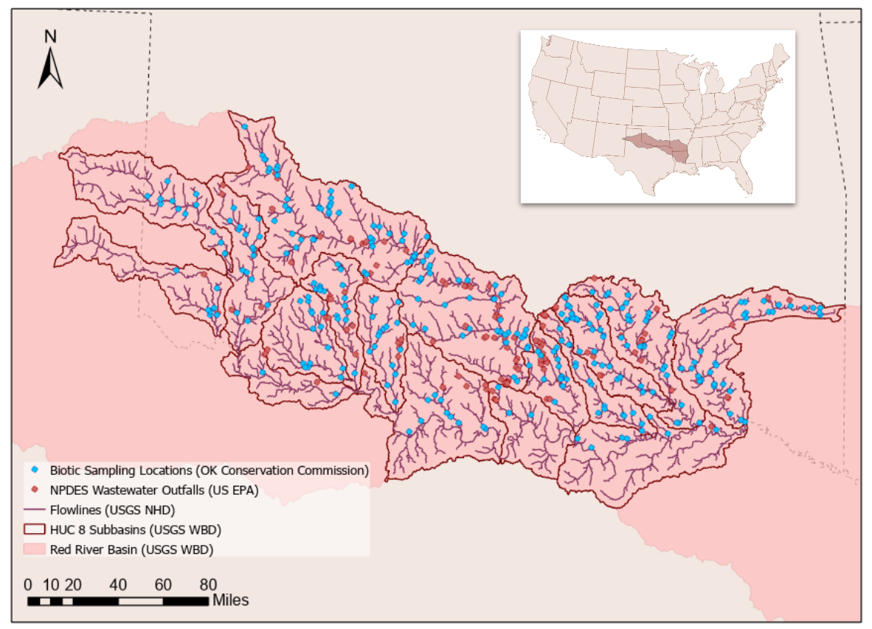
Figure 1. Overview of the study region, with each source dataset displayed.

Our analysis consisted of three major steps. First, we calculated the distance along the river network between each biological sampling location and the nearest wastewater outfall, in both the upstream and downstream directions. Next, to quantify fish and macroinvertebrate community composition at each site, we calculated a suite of biodiversity metrics at each OCC sampling location. Third, we conducted a series of statistical tests to investigate the impact of proximity to wastewater outfalls and flow composition (i.e., the proportion of flow made up of wastewater) on biodiversity metrics.
We used the R package ‘riverdist’ to calculate the river network distances from each biological sampling site to the closest upstream wastewater outfall and to the closest downstream wastewater outfall in each HUC8 subbasin (Tyers 2022). In order to calculate network distances, each subbasin was converted into a model of segments and vertices (Fig. 2). After this model was created, the biological sampling sites and wastewater outfall locations were snapped to the nearest segment-vertex combination. Based on this information, distances along the river from each biological sampling location to the nearest wastewater outfall, both upstream and downstream, were calculated.
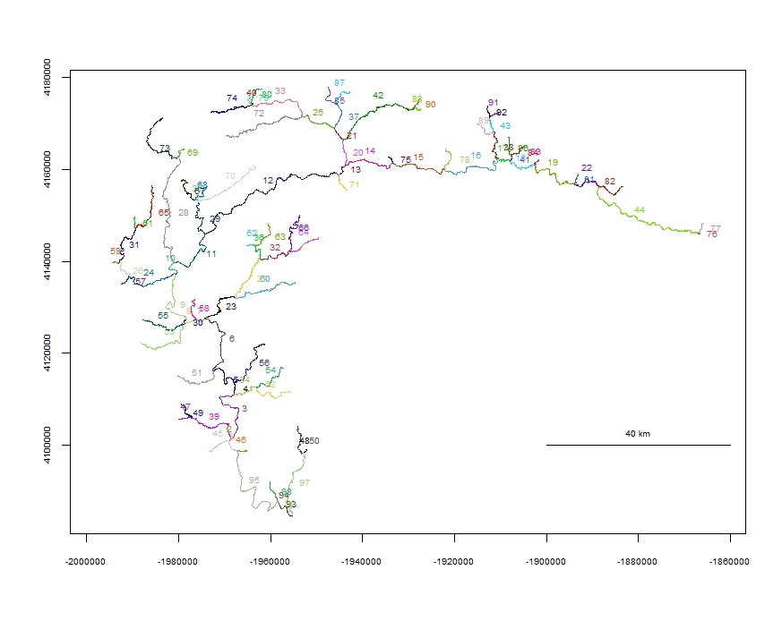
Figure 2. Sample R ‘riverdist’ output depicting river network segment delineation in the Kiamichi subbasin (HUC 11140105). River segments are randomly assigned a color and number at this intermediate stage in network delineation.

For each OCC biological sampling point, we calculated five biodiversity metrics for fish and macroinvertebrate communities: species richness, species evenness, Shannon’s diversity index, Simpson’s diversity index, and inverse Simpson’s diversity index (Table 2). Species richness is the count of the number of species present at a site (Feder and Zvarikova, 2018). Species evenness is utilized to quantify distributions of abundance among species in a community (Wilsey and Potvin, 2000). Lower values of species evenness indicate that one or a few species are dominant; higher values indicate that species in the sample have similar abundances. Shannon’s diversity index, also known as the Shannon-Wiener index, combines species richness and relative abundance to provide insight into community diversity; values start at 0 and increase (Tramer 1969). A Shannon-Wiener index of 0 represents a community that only contains one species, and typical values range from about 1.5 to 3.5. Simpson’s diversity index expresses the probability that any two individuals drawn at random from the sampled community belong to the same species (Gregorius and Gillet 2008). This index ranges from 0 to 1 with 1 representing a community that only contains one species, and 0 representing a community that contains an infinite number of species. Thus, it is sensitive to both the number of species in the community and their relative abundances. The inverse of Simpson’s diversity index, also known as the Gini-Simpson index, starts at 1 and increases, with 1 representing no diversity or a community that only contains one species (Jost et al. 2010).

Table 2. The five biodiversity metrics used in this study. Columns give the name of the metric, the range of possible values, and the formula for calculating it. Variables in these formulas are defined as: N = number of species; C = species evenness; H = Shannon’s diversity index; p_{i} = proportion of the community consisting of species i; D = Simpson’s diversity index; n = number of species in sample N; S = Inverse Simpson’s diversity index.
Biodiversity metric | Value range | Formula
Species Richness | [0, ∞) | $$N$$
Species Evenness | [1, ∞) | $$C = \frac{\hat{H}}{logN}$$
Shannon Diversity Index | [0, ∞) | $$H= -\sum_{j = 1}^{s}{}p_{i} ln{ p_{i}}_{}$$
Simpson Diversity Index | [0, 1] | $$D=1 -( Σn(n-1)/N(N-1))$$
Inverse Simpson Diversity Index | [1, ∞) | $$S= 1 / D$$

We used two-sided t-tests to determine whether the mean value of each of the five biodiversity metrics (Table 2) differed between sites near a wastewater outfall versus sites not near a wastewater outfall. We defined biological sampling sites to be near a wastewater outfall if they were within 10km on the river network (Wear et al. 2021). We ran a total of 225 t-tests. We tested whether the mean value of a biodiversity metric at biological sampling sites with a wastewater outfall within 10 kilometers upstream were significantly different from mean biodiversity values at biological sites without a wastewater outfall within 10 kilometers upstream. These tests were repeated to test whether mean biodiversity values at biological sampling sites with a wastewater outfall within 10 kilometers downstream are significantly different from mean biodiversity values at biological sampling sites without a wastewater outfall within 10 kilometers downstream. We also calculated upstream drainage area to test whether this determinant significantly influenced our findings. These analyses were conducted on fish and macroinvertebrate communities. The results of these tests were compared on both HUC4 (collated) and HUC8 basis to investigate patterns at both scales.
We also used linear regression models to determine whether flow composition (i.e, the proportion of streamflow composed of wastewater; our independent variable) was related to fish and macroinvertebrate community biodiversity (our independent variables) across the entire basin. We first fit ten linear regression models (one for each of the five biodiversity metrics for fish, hereafter referred to as models 1-5; and the same five models for macroinvertebrates, hereafter referred to as models 6-10) with all biological sampling points in the basin. A post-hoc analysis revealed that four points had very high leverage and a disproportionate impact on the slope of the regression line. To address this issue, we removed these four data points and fit a second set of regression models (models 11-20). In this second set of models, we still found that a large number of sites with zero wastewater were potentially influencing the results. We hypothesized that sites with a non-zero amount of wastewater may exhibit a different relationship between wastewater and biodiversity. Thus, we fit a third set of ten regression models in which we removed sites with zero proportion of the flow consisting of wastewater (models 21-30). Finally, we hypothesized that the highest levels of biodiversity may occur at points with intermediate levels of wastewater. To test this hypothesis, we fit a fourth set of ten regression models using a quadratic (i.e, parabolic and concave-down) response term (models 31-40).

Results
Overall, we find that wastewater outfalls have had weak and inconsistent impacts on aquatic biodiversity in the Red River basin. For macroinvertebrate assemblages, only 6 out of 105 t-tests detected a significance difference in mean biodiversity metrics between biological sampling sites within 10 kilometers of a wastewater outfall, and sampling sites not within 10km of a wastewater outfall point (Table 3). All of the statistically significant differences in mean biodiversity metrics occurred in t-tests comparing macroinvertebrate communities with wastewater outfalls within 10km upstream to communities without wastewater outfalls within 10km upstream: 4 of the 6 statistically significant differences in mean biodiversity values were higher at sites not within proximity to wastewater outfalls (Table A3; Table A7; Table A11; Table A19). The observed effects of proximity to wastewater outfalls in macroinvertebrate communities were most pronounced in the Lower North Fork Red subbasin (HUC 11120303), with 40% of statistically significant differences in mean biodiversity metrics between sites in proximity to wastewater outfalls and sites not in proximity to wastewater outfalls (Fig. 8).
Wastewater outfalls had greater impacts on fish community diversity, but these effects were still inconsistent overall. In fish communities in the Red River basin, 17 out of 120 t-tests identified significant differences in mean biodiversity metrics between sampling locations within 10 km of wastewater outfalls and sites not within 10 km of wastewater outfalls (Table 3). Of the 17 statistically significant differences in mean biodiversity metrics, 10 were observed when comparing biodiversity metrics between sites with wastewater outfalls within 10km upstream to sites without wastewater outfalls upstream; 7 out of the 10 statistically significant tests showed increases in biodiversity metrics at sites without wastewater outfalls within 10km upstream (Table A1, Table A5, Table A9, Table A13, Table A17). Of the 7 significant t-tests examining differences in mean biodiversity values between sampling sites with wastewater outfalls within 10 km downstream and sites without wastewater outfalls within 10km downstream, 5 t-tests found higher biodiversity metrics at sites not in proximity to wastewater (Table A2, Table A10, Table A14, Table A18). The effects of proximity to wastewater outfalls were the most prominent in the Middle Washita subbasin (HUC 11130303) in which 70% of t-tests found statistically significant differences in mean biodiversity values (Fig. 9).
Our regression analyses revealed that, for macroinvertebrate communities, some biodiversity metrics are significantly positively related to the proportion of a site’s flow that consists of wastewater (models 6-10; Table 5; Fig. 10a-e). However, these relationships were highly influenced by a small number of points with high leverage (i.e., a small number of sites at which a very high percentage of flow has wastewater). When we fit linear regressions after removing these high-leverage sites (models 16-20), species evenness, Shannon’s diversity index, and inverse Simpson’s diversity index were significantly positively related to the proportion of flow made up of wastewater (models 16-20; Fig. 10f-j; Table 7, p < 0.05). After further removing sampling sites with 0% of flows consisting of wastewater, there were no significant relationships between wastewater and biodiversity (models 26-30; Fig. 10k-o; Table 9; p > 0.05). Fitting a quadratic function to these points produces similarly significant results in these metrics (models 36-40; Table 11). For fish communities in the Red River basin, we did not find any statistically significant relationships between biodiversity metrics and the proportion of flows composed of wastewater (models 1-5, 11-15, 21-25, and 31-35; Fig. 11; Table 4; Table 6; Table 8; Table 10, p > 0.05).
Exploring the results of the t-tests in more detail, we did not identify any consistent spatial patterns in the effects of wastewater outfalls on each of the five metrics of aquatic biodiversity. When exploring species richness, for example, in the Lower North Fork Red, we found that macroinvertebrate species richness was significantly higher (t-test; p < 0.05) at sites downstream of a wastewater outfall (mean richness = 32.461) than at sites not near a wastewater outfall (mean = 14.00; Table A2); and not significantly different in the remaining nine subwatersheds. For all ten subwatersheds, we found no significant difference in macroinvertebrate species richness between sites upstream of a wastewater outfall and sites not near an outfall (Table A3). In the case of fish, we found that in three of the twelve subwatersheds we analyzed (Lower North Fork Red, Northern Beaver, and Clear Boggy subwatersheds), that species richness was significantly higher at sites without a wastewater outfall within 10km upstream (mean = 16.909, 17.2, and 21.375, respectively; Table A1). In the Northern Beaver subwatershed, we found that species richness was significantly higher in fish communities with a wastewater outfall within 10km downstream from the sampling location (mean richness = 16.545); conversely, we found the opposite was true in the Middle Washita subbasin (mean = 18.208; Table A2) The geographic location of the subwatersheds in which wastewater had a significant effect on species richness did not align with spatial patterns of water availability (Fig. 3).
When focusing on species evenness, we found significant increases in species evenness in the Farmers-Mud subwatershed (mean evenness = 3.731) at sites with wastewater outfalls within 10km upstream compared to sites without wastewater outfalls upstream: in another of the ten subwatersheds (Lower North Fork Red), we found the opposite, that sites without wastewater upstream had significantly higher mean values of species richness (mean = 2.954; Table A7). We did not find any statistically significant differences in mean macroinvertebrate species evenness values between sites with wastewater outfalls within 10km downstream from the sampling location, and sites not in proximity to wastewater outfalls (Table A8). When evaluating species evenness in fish communities, similar patterns emerge. In the Middle Washita subwatershed, we found a significant increase in mean species evenness at sampling locations with wastewater outfalls within 10km upstream (mean evenness = 2.55, Table A5). However, we found that the opposite pattern was present in the Clear Boggy subbasin; mean values of species evenness were significantly higher at sampling locations that did not have wastewater outfalls within 10km upstream (mean = 3.128, Table A5). None of the subwatersheds had significant differences in mean species evenness when comparing sites with outfalls within 10km downstream versus sampling sites without outfalls in proximity (Table A6). Subbasins in which proximity to wastewater outfalls had significant impacts on species evenness did not coincide with water availability patterns across the basin (Fig. 6).
In the Lower North Fork Red subwatershed, we find statistically significant (t-test, p < 0.05) differences in mean values of Shannon’s diversity index when analyzing macroinvertebrate communities (Table A11). In this subbasin, biological sampling sites without wastewater outfalls within 10km upstream have significantly higher mean values of Shannon’s diversity (mean = 2.327; Table A11). We did not find significant differences in mean Shannon’s diversity when comparing sites with wastewater outfalls within 10km downstream to sites without wastewater outfalls present (Table A12). In the case of fish communities, we found some different patterns when comparing mean values of Shannon’s diversity. In the Middle Washita subbasin, we found that there mean values of Shannon’s diversity index were significantly higher at sampling locations with wastewater outfalls within 10km upstream as compared to sites without wastewater outfalls upstream (mean = 1.895; Table A9). In the Lower Salt Fork Red, however, we find that mean values of Shannon’s diversity index are significantly higher at sites without wastewater outfalls upstream (mean = 1.352; Table A9). When comparing between sampling sites with wastewater outfalls within 10km downstream and sites without wastewater outfalls close downstream, we find that mean values of Shannon’s diversity index are significantly higher at sites not in proximity to wastewater outfalls in two subwatersheds: the Middle Washita and Lower Washita (mean = 1.868, 2.345, respectively; Table A10). Significant differences in Shannon’s diversity across subbasins do not appear to match up with patterns of water availability in the basin (Fig. 5).
When evaluating for differences in Simpson’s diversity index in macroinvertebrate communities, we did not find any statistically significant differences in mean values between sites within 10km of wastewater outfalls upstream compared to sites without wastewater outfalls in proximity upstream (Table A15). We also did not find any statistically significant differences in this metric when comparing sampling sites with wastewater outfalls within 10km downstream and sites without wastewater outfalls downstream (Table A16). These patterns, or lack thereof, did not persist for fish communities. In the Middle Washita subwatershed, mean values of Simpson’s diversity index were significantly higher at sites without wastewater outfalls within 10km upstream than at sites with wastewater outfalls upstream (mean = 0.654; Table A13). In the Upper Washita subbasin, mean values of Simpson’s diversity index were significantly higher at sites with wastewater outfalls within 10km downstream than at sampling sites without wastewater outfalls in proximity downstream (mean = 0.538; Table A14). Geographic positioning of subwatersheds in which proximity to wastewater have significant impacts on Simpson’s diversity also do not mimic spatial water availability distributions (Fig. 6).
When we evaluated for significant differences in inverse Simpson’s diversity index in macroinvertebrate communities, we found inconsistent results. In the Lower North Fork Red subwatershed, we found that mean values of inverse Simpson’s diversity were significantly higher at sites without wastewater within 10km upstream compared to sites with wastewater outfalls upstream (mean = 7.543; Table A19). Conversely, in the Farmers-Mud subbasin, we found that mean values of inverse Simpson’s diversity index were significantly higher at sites with wastewater outfalls upstream (mean = 9.021; Table A19). We did not find significant differences in mean values of this metric when examining macroinvertebrate sampling sites with wastewater outfalls downstream versus sites without outfalls downstream (Table A20). Our evaluation of differences in inverse Simpson’s diversity in fish communities did not produce clear patterns, either. In the Middle Washita subbasin, mean values of inverse Simpson’s diversity are significantly higher at sampling sites with wastewater outfalls within 10km upstream than at sites without wastewater outfalls in upstream proximity (mean = 4.985; Table A17). On the other hand, in the Clear Boggy subwatershed, mean values of inverse Simpson’s diversity are significantly higher at sites without wastewater outfalls within 10km upstream, compared to sites with outfalls upstream (mean = 7.347; Table A17). In examining mean values of inverse Simpson’s diversity between sampling sites with wastewater outfalls within 10km downstream and sites without wastewater downstream, we find significantly higher values at sites without wastewater outfalls downstream in two of the twelve subbasins (Middle Washita, mean = 4.727; Lower Washita, mean = 6.683; Table A18). When examined spatially, subbasins in which inverse Simpson’s diversity is significantly impacted by wastewater do not align with water availability patterns across the Red River basin (Fig. 7).

Table 3. The proportion of t-tests that identified statistically significant differences in biodiversity between sites within 10km of wastewater outfalls versus sampling sites not within 10km of wastewater outfalls. Rows give the biodiversity metric used in the test, and columns give the taxa (i.e., fish or macroinvertebrates) and distance (i.e., sites upstream or downstream of a wastewater outfall).
Biodiversity metric | Fish sampling sites, wastewater outfalls upstream | Fish sampling sites, wastewater outfalls downstream | Macroinvertebrate sampling sites, wastewater outfalls upstream | Macroinvertebrate sampling sites, wastewater outfalls downstream
Richness | 3/12 | 2/12 | 1/10 | 0/11
Evenness | 2/12 | 0/12 | 2/10 | 0/11
Shannon's diversity index | 2/12 | 2/12 | 1/10 | 0/11
Simpson's diversity index | 1/12 | 1/12 | 0/10 | 0/11
Inverse Simpson's diversity index | 2/12 | 2/12 | 2/10 | 0/11

Table 4. Summary statistics for global linear regression models describing the relationship between fish biodiversity metrics (column 2; dependent variable) and the proportion of the flow at a site made up of wastewater (independent variable). Models were fit using all data points and a linear response term (models 1-5 in the text).
Model no. | Biodiversity metric | R² | Adjusted R² | p value
1 | Species richness | 0.0020 | -0.0022 | 0.49
2 | Species evenness | 0.012 | 0.0082 | 0.085
3 | Shannon’s | 0.0096 | 0.0055 | 0.13
4 | Simpson’s | 0.016 | 0.011 | 0.054
5 | Inverse Simpson’s | 0.0091 | 0.0050 | 0.14

Table 5. Summary statistics for global linear regression models describing the relationship between macroinvertebrate biodiversity metrics (column 2; dependent variable) and the proportion of the flow at a site made up of wastewater (independent variable). Models were fit using all data points and a linear response term (models 6-10 in the text).
Model no. | Biodiversity metric | R² | Adjusted R² | p value
6 | Richness | 0.0013 | 0.0041 | 0.23
7 | Evenness | 0.0065 | 0.0056 | 0.0075
8 | Shannon’s | 0.0048 | 0.0038 | 0.022
9 | Simpson’s | 0.0035 | 0.0026 | 0.050
10 | Inverse Simpson’s | 0.0064 | 0.0055 | 0.0080

Table 6. Summary statistics for global linear regression models describing the relationship between fish biodiversity metrics (column 2; dependent variable) and the proportion of the flow at a site made up of wastewater (independent variable). Models were fit using a linear response term but omitting a small number of high-leverage points in which more than 15 percent of flow was wastewater (models 11-15 in the text).
Model no. | Biodiversity metric | R² | Adjusted R² | p value
11 | Species richness | 0.00080 | -0.0032 | 0.66
12 | Species evenness | 0.0084 | 0.0042 | 0.16
13 | Shannon’s | 0.0016 | -0.0026 | 0.54
14 | Simpson’s | 0.00038 | -0.0038 | 0.77
15 | Inverse Simpson’s | 0.0052 | 0.00099 | 0.27

Table 7. Summary statistics for global linear regression models describing the relationship between macroinvertebrate biodiversity metrics (column 2; dependent variable) and the proportion of the flow at a site made up of wastewater (independent variable). Models were fit using a linear response term but omitting a small number of high-leverage points in which more than 15 percent of flow was wastewater (models 16-20 in the text).
Model no. | Biodiversity metric | R² | Adjusted R² | p value
16 | Richness | 0.0016 | 0.00068 | 0.19
17 | Evenness | 0.0053 | 0.0044 | 0.016
18 | Shannon’s | 0.0040 | 0.0031 | 0.036
19 | Simpson’s | 0.0025 | 0.0016 | 0.096
20 | Inverse Simpson’s | 0.0056 | 0.0047 | 0.013

Table 8. Summary statistics for global linear regression models describing the relationship between fish biodiversity metrics (column 2; dependent variable) and the proportion of the flow at a site made up of wastewater (independent variable). Models were fit using a linear response term but omitting points in which either 0 percent or more than 15 percent of flow was wastewater (models 21-25 in the text).
Model no. | Biodiversity metric | R² | Adjusted R² | p value
21 | Species richness | 0.0058 | -0.013 | 0.58
22 | Species evenness | 0.0034 | -0.015 | 0.67
23 | Shannon’s | 0.0068 | -0.012 | 0.55
24 | Simpson’s | 0.0016 | -0.017 | 0.77
25 | Inverse Simpson’s | 0.0069 | -0.011 | 0.54

Table 9. Summary statistics for global linear regression models describing the relationship between macroinvertebrate biodiversity metrics (column 2; dependent variable) and the proportion of the flow at a site made up of wastewater (independent variable). Models were fit using a linear response term but omitting points in which either 0 percent or more than 15 percent of flow was wastewater (models 26-30 in the text).
Model no. | Biodiversity metric | R² | Adjusted R² | p value
26 | Richness | 0.0051 | 0.0010 | 0.26
27 | Evenness | 0.0054 | 0.0013 | 0.25
28 | Shannon’s | 0.010 | 0.0062 | 0.11
29 | Simpson’s | 0.0069 | 0.0028 | 0.19
30 | Inverse Simpson’s | 0.0061 | 0.0020 | 0.22

Table 10. Summary statistics for global quadratic regression models describing the relationship between fish biodiversity metrics (column 2; dependent variable) and the proportion of the flow at a site made up of wastewater (independent variable). Models were fit using a quadratic response term but omitting a small number of high-leverage points in which more than 15 percent of flow was wastewater (models 31-35 in the text).
Model no. | Biodiversity metric | R² | Adjusted R² | p value
31 | Species richness | 0.0019 | -0.0066 | 0.80
32 | Species evenness | 0.016 | 0.0075 | 0.15
33 | Shannon’s | 0.0043 | -0.0042 | 0.60
34 | Simpson’s | 0.0036 | -0.0049 | 0.65
35 | Inverse Simpson’s | 0.0091 | 0.00070 | 0.34

Table 11. Summary statistics for global quadratic regression models describing the relationship between macroinvertebrate biodiversity metrics (column 2; dependent variable) and the proportion of the flow at a site made up of wastewater (independent variable). Models were fit using a quadratic response term but omitting a small number of high-leverage points in which more than 15 percent of flow was wastewater (models 36-40 in the text).
Model no. | Biodiversity metric | R² | Adjusted R² | p value
36 | Richness | 0.0032 | 0.0014 | 0.17
37 | Evenness | 0.0093 | 0.0075 | 0.0060
38 | Shannon’s | 0.0067 | 0.0049 | 0.025
39 | Simpson’s | 0.0041 | 0.0023 | 0.10
40 | Inverse Simpson’s | 0.0097 | 0.0079 | 0.0049

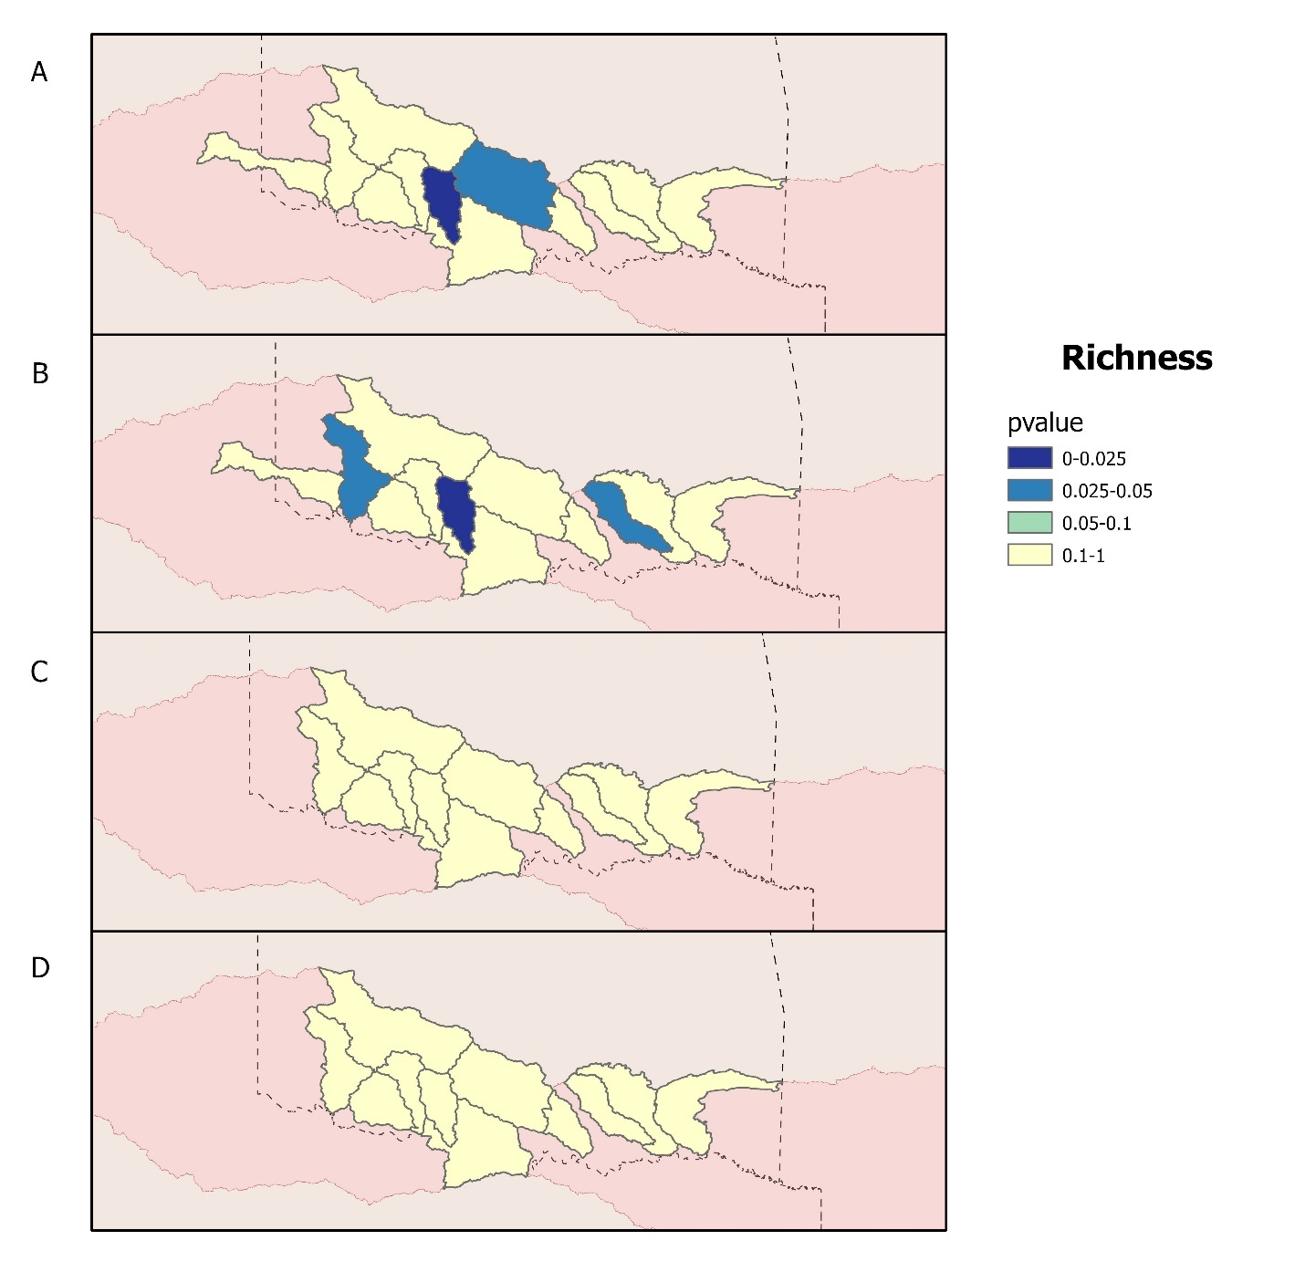
Figure 3. Results of t-tests comparing mean richness values at biological sampling sites within 10km of wastewater outfalls to sites not within 10km of wastewater outfalls. A) Fish communities with wastewater outfalls upstream B) Fish communities with wastewater outfalls downstream C) Macroinvertebrates with wastewater outfalls upstream D) Macroinvertebrates with wastewater outfalls downstream

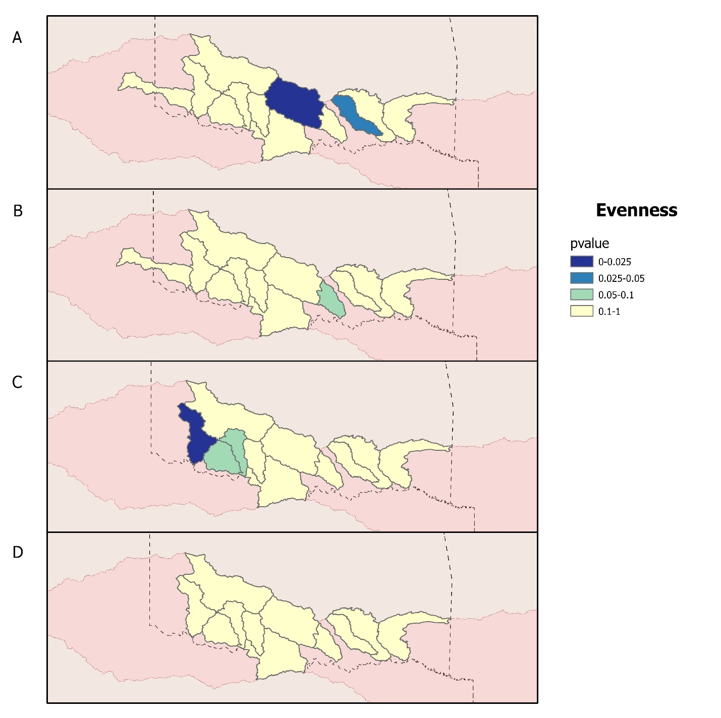
Figure 4. Results of t-tests comparing mean evenness values at biological sampling sites within 10km of wastewater outfalls to sites not within 10km of wastewater outfalls. A) Fish communities with wastewater outfalls upstream B) Fish communities with wastewater outfalls downstream C) Macroinvertebrates with wastewater outfalls upstream D) Macroinvertebrates with wastewater outfalls downstream

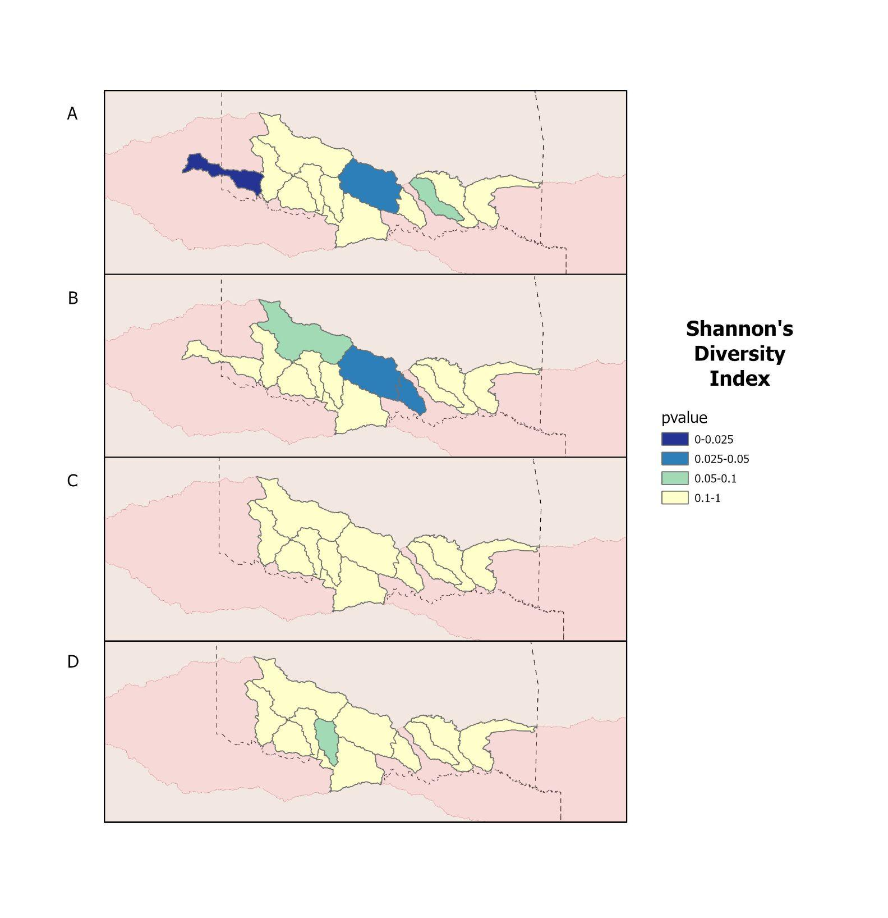
Figure 5. Results of t-tests comparing mean Shannon’s diversity index values at biological sampling sites within 10km of wastewater outfalls to sites not within 10km of wastewater outfalls. A) Fish communities with wastewater outfalls upstream B) Fish communities with wastewater outfalls downstream C) Macroinvertebrates with wastewater outfalls upstream D) Macroinvertebrates with wastewater outfalls downstream

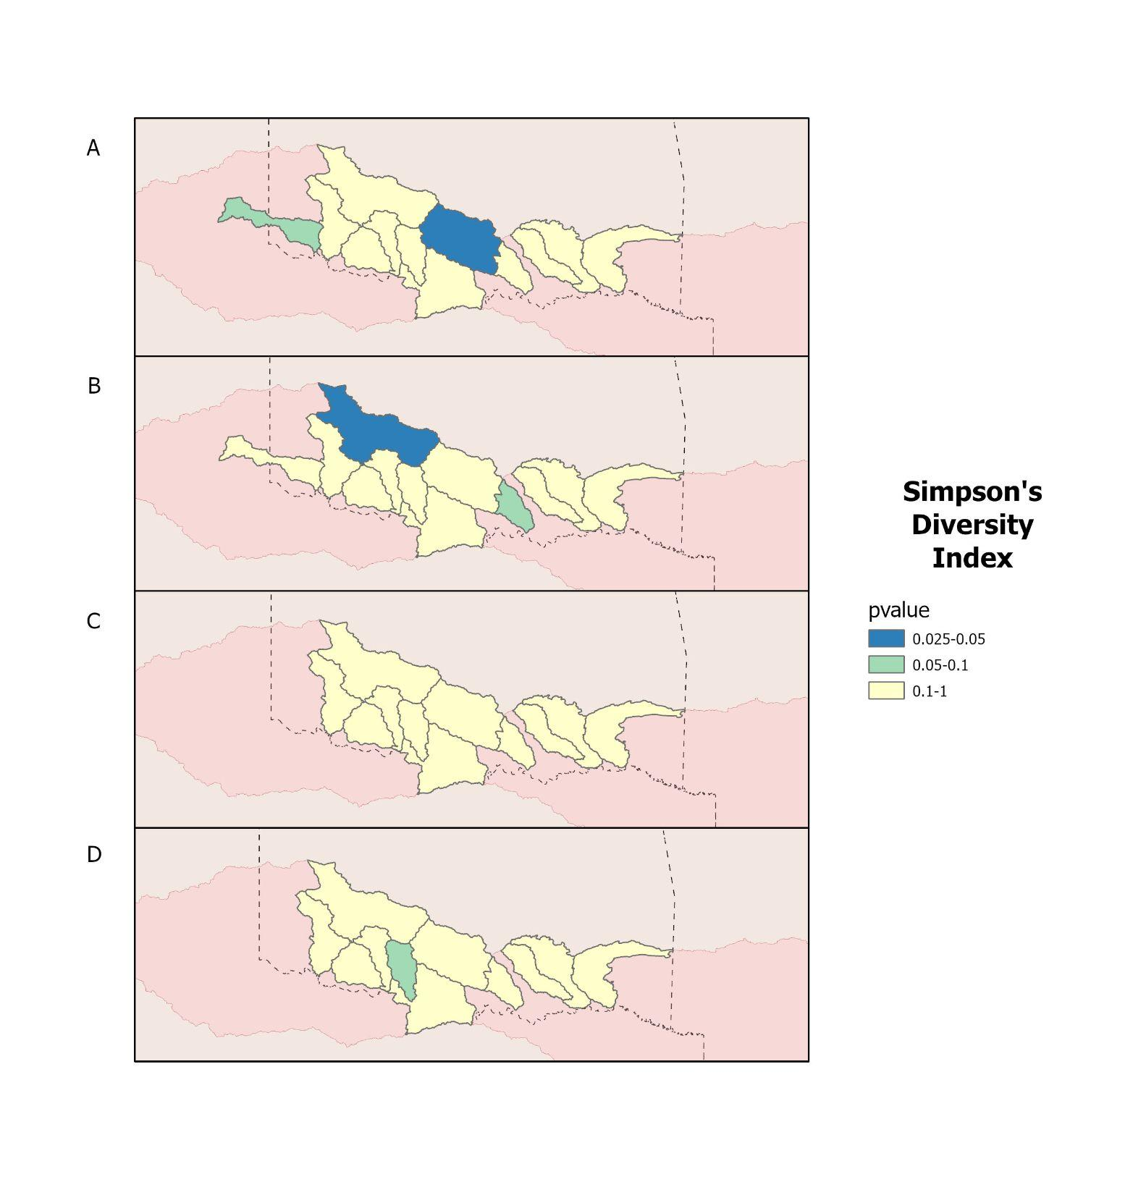
Figure 6. Results of t-tests comparing mean Simpson’s diversity index values at biological sampling sites within 10km of wastewater outfalls to sites not within 10km of wastewater outfalls. A) Fish communities with wastewater outfalls upstream B) Fish communities with wastewater outfalls downstream C) Macroinvertebrates with wastewater outfalls upstream D) Macroinvertebrates with wastewater outfalls downstream

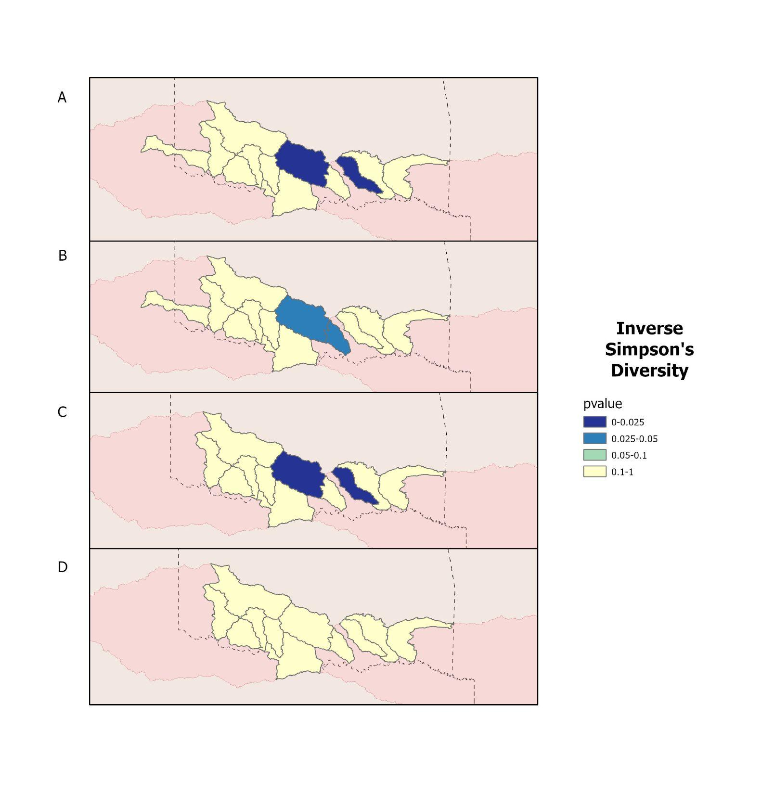
Figure 7. Results of t-tests comparing mean inverse Simpson’s diversity index values at biological sampling sites within 10km of wastewater outfalls to sites not within 10km of wastewater outfalls. A) Fish communities with wastewater outfalls upstream B) Fish communities with wastewater outfalls downstream C) Macroinvertebrates with wastewater outfalls upstream D) Macroinvertebrates with wastewater outfalls downstream

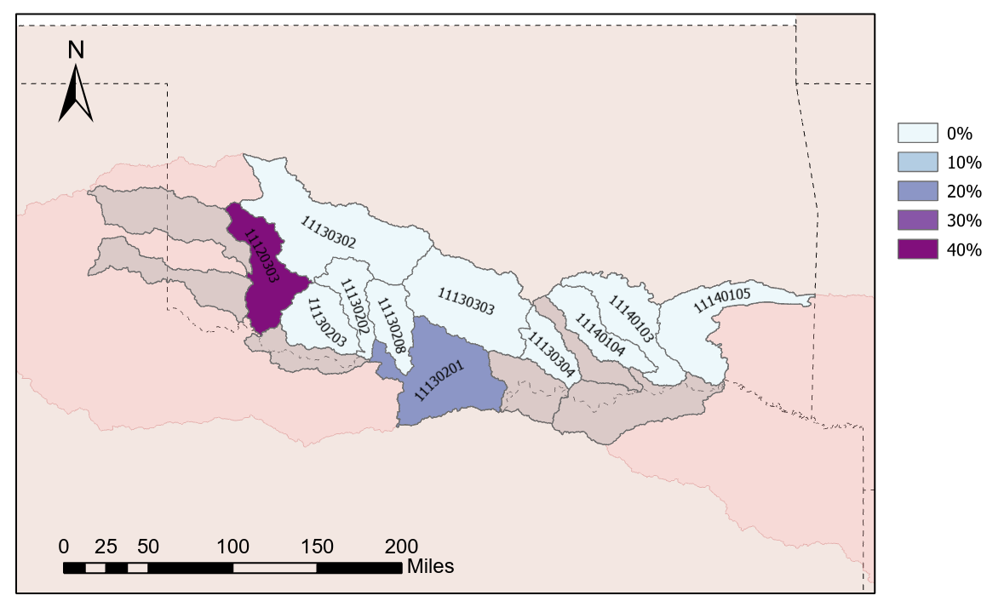Figure 8. Percentage of significant t-test results in macroinvertebrate communities, in each subbasin.

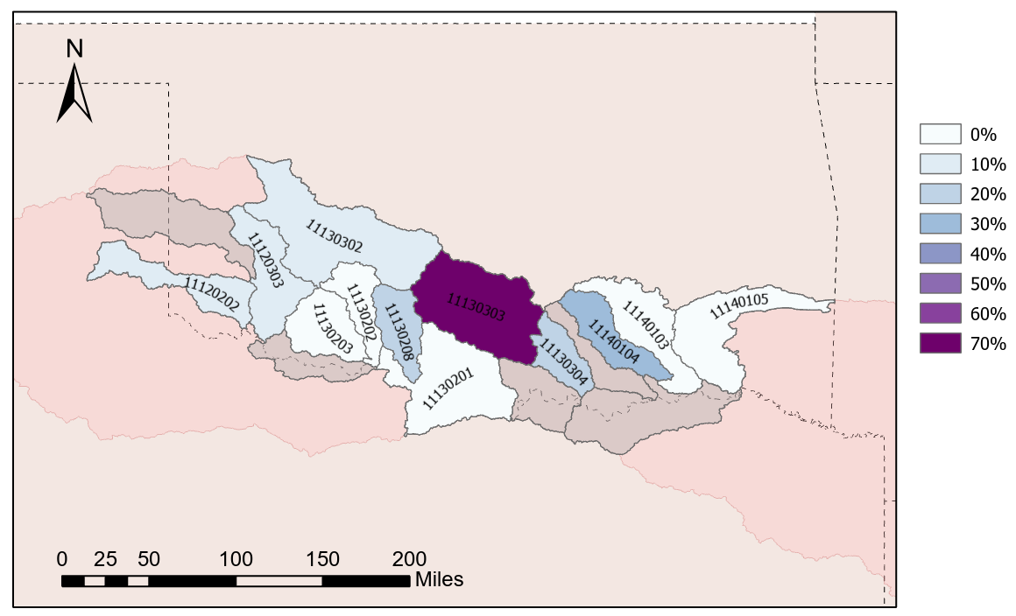Figure 9. Percentage of significant t-test results in fish communities, in each subbasin.
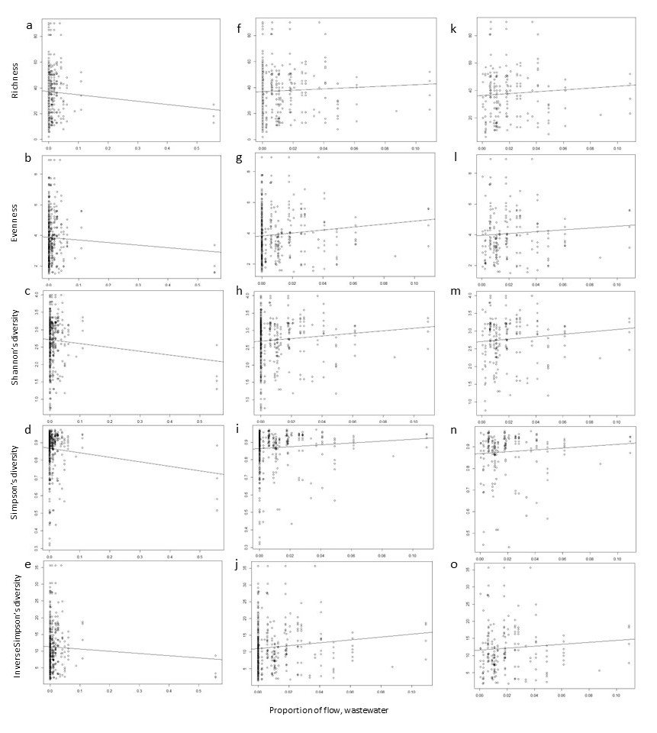
Figure 10. For macroinvertebrate communities, relationships between the proportion of flow at a site made up of wastewater (horizontal axes) and five metrics of diversity (vertical axes). Lines are best-fit linear regressions. In panels a-e, regressions were fit using all data points and a linear response term (models 6-10 in the text). In panels f-j, regressions were fit using a linear response term but omitting four high-leverage data points (models 16-20). In panels k-o, regressions were fit using a linear response term but omitting points with zero wastewater as well as the four high-leverage points (models 26-30).
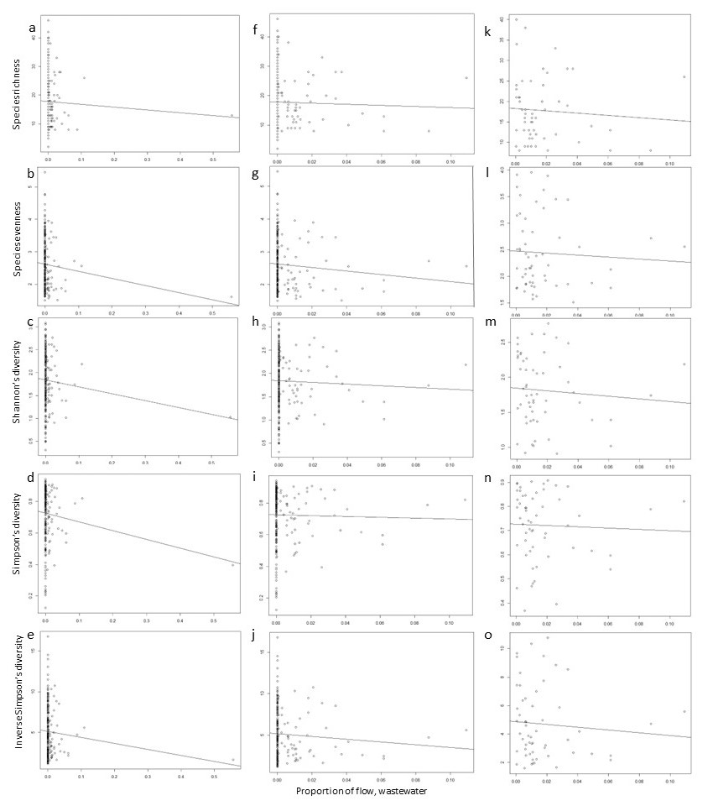
Figure 11. For fish communities, relationships between the proportion of flow at a site made up of wastewater (horizontal axes) and five metrics of diversity (vertical axes). Lines are best-fit linear regressions. In panels a-e, regressions were fit using all data points and a linear response term (models 1-5 in the text). In panels f-j, regressions were fit using a linear response term but omitting four high-leverage data points (models 11-15). In panels k-o, regressions were fit using a linear response term but omitting points with zero wastewater as well as the four high-leverage points (models 21-25).

Discussion
Overall, we were unable to detect a significant and consistent impact of wastewater on fish and macroinvertebrate communities. Macroinvertebrate community analysis has not led to support for our hypothesis that wastewater flows positively impact biodiversity. While we find that increasing proportions of wastewater in flow have positive correlations with macroinvertebrate community biodiversity, particularly species richness, species evenness, Shannon’s diversity, and inverse Simpson’s diversity in some of our regression analyses, this is not the case in all four sets of regressions (Fig. 10). The opposite of these patterns, however, appear to be present in the more arid portions of the basin that may experience more intense drying over time: in the Lower North Fork Red subbasin (HUC 11120303), measures of diversity are higher at sites without wastewater (Fig. 8; Bogan et al. 2020). This is at odds with our hypothesis that wastewater flows buffer aquatic communities from drought. Interestingly, we do not see this in the case of Simpson’s diversity; this could be because the index takes into account not only the number of species present, but also their relative abundances (Barcelona Field Studies Centre, n.d.).
Alternatively, increased macroinvertebrate community biodiversity may be related to water quality metrics in wastewater effluent. With the increased levels of nutrients found in effluent, primary productivity may be elevated at sites within proximity to wastewater outfalls (Red River Authority of Texas, 2016). This increase in primary productivity could be causing boosts in community biodiversity because higher levels of algae and phytoplankton enable support of larger communities (Parker et al. 2012; McCullough and Jackson 1985). It is also possible that the smaller size of macroinvertebrate individuals, as opposed to fish, are less able to move throughout the basin as a whole and communities tend to collect in these places, resulting in higher levels of biodiversity (Winemiller et al. 2010).
Fish community analysis across the Red River basin has not provided sufficient evidence to support our hypothesis that wastewater flows negatively impact biodiversity by decreasing water quality or homogenizing flow regimes. In our regression analysis, the proportion of flow composed of wastewater did not have a significant relationship with any five of the biodiversity indices (Fig. 9). We also do not find any clear spatial patterns in the distribution of significant differences in mean biodiversity metrics in fish communities throughout the basin (Fig. 7). This could be due in part to the increased mobility that fish have as compared to macroinvertebrates due to differences in size; fish are more able to move themselves away from areas with poorer water quality than macroinvertebrates might be. Because of this, fish could be less likely to occupy habitats with high proportions of wastewater in flows (Dudgeon et al. 206). Alternatively, fish could be more likely to move themselves into reaches with more consistent flows (i.e., closer to wastewater outfalls) in times of drought; this consideration further complicates our findings. These differences in how the different taxa experience the river environment may be influencing the patterns we found in our analyses: alternatively, some other factor or process could be driving these patterns.
Data limitations may have hampered our ability to detect the effects of wastewater on fish and macroinvertebrates. The list of species included in this analysis did not incorporate all extant species of fish in the Red River basin, and it is likely that not all extant species of macroinvertebrates were captured by the biological sampling dataset we utilized in this study (Oklahoma Conservation Commission). However, this group of fish species does cover a wide range of ecological niches, life history strategies, and conservation statuses, so we do not believe species selections significantly impacted our findings (Gill et al. 2020). We did not consider how, or to what effect, any ecological interactions (i.e., predator-prey interactions, etc.) or other environmental factors could have influenced our findings. For example, the distributions and abundances of fishes in the Red River are known to be strongly impacted by habitat fragmentation, nonpoint source pollution, invasive species, and climate change, and the effects of these factors may make it difficult to detect the effects of wastewater on biota (Labay and Hendrickson, 2014; Perkin et al. 2015; Panlasigui et al. 2018). Computing a different grouping of biodiversity metrics may have influenced the patterns we found in our analyses: while we utilized compositional metrics, functional metrics may have revealed different trends entirely (Peru and Doledec 2010). Additionally, we did not incorporate any environmental or climatological variables other than input of wastewater; there are multiple means by which water can enter a watershed, which could influence our results (Berndhart et al. 2008). For example, agricultural runoff can have much higher nutrient concentrations than wastewater effluent, which could have hidden the impacts of wastewater on biodiversity (Kill et al. 2022).
Our analyses spell out important considerations for decisionmakers in water resources management, particularly as they consider implementation of wastewater reuse strategies to increase societal water availability. Although we did not find clear, consistent effects of wastewater on aquatic community biodiversity, water managers may want to consider how wastewater reuse decisions could impact ecosystems. Watersheds with effluent-dominated flow regimes have seen improvements in habitat quality and biodiversity, so the potential removal of those flows could lead to decreases in ecosystem health (Luthy et al. 2015; Garcia and Pargament 2015). This is the case in the Trinity River basin in Texas, where effluent-dominated flows support ecosystems that, without those flows, would not exist entirely (Luthy et al. 2015). Wastewater reuse decisions have the potential to dramatically impact macroinvertebrate communities, as their relative body sizes mean that they experience fluctuations in water quality more intensely than fish might (Kenney et al. 2009). Anthropogenic actions are dramatically altering the availability of freshwater resources, so it is imperative to understand the nuanced ecological implications of these types of management decisions (Rodell et al. 2018). As climates continue to shift, a complete understanding of the water resources that are available will be foundational in making these types of plans and decisions (Valdes Ramos et al. 2019). While our findings are geared towards the South-Central United States, these analyses could be useful in other similar regions across the globe to inform wastewater reuse decisions that minimize negative ecological impacts. Decisionmakers considering implementation of wastewater reuse strategies in other semiarid basins might also be interested in the potential impacts of these decisions on aquatic biodiversity.

References
Annis, G., Diamond, D., Garringer, A., Hanberry, P., & Morey, M. (2012). Modeling fish species distributions throughout the Arkansas, Red, and White river basins. Final report to the Missouri Resource Assessment Partnership. https://morap.missouri.edu/wp-content/uploads/2018/12/AWR_Final_Report.pdf
Arnon, S., Avni, N. & Gafny, S. (2015). Nutrient uptake and macroinvertebrate community structure in a highly regulated Mediterranean stream receiving treated wastewater. Aquatic Sciences 77, 623–637. https://doi.org/10.1007/s00027-015-0407-6
Barcelona Field Studies Centre. (n.d.). Simpson's diversity index. https://geographyfieldwork.com/Simpson'sDiversityIndex.htm
Berndhart, E. S., Band, L. E., Walsh, C. J., & Berke, P. E. (2008). Understanding, Managing, and Minimizing Urban Impacts on Surface Water Nitrogen Loading. Annals of the New York Academy of Sciences. https://nyaspubs.onlinelibrary.wiley.com/doi/full/10.1196/annals.1439.014
Bogan MT, Eppehimer D, Hamdhani H, Hollien K. (2020). If you build it, they will come: rapid colonization by dragonflies in a new effluent-dependent river reach. PeerJ 8:e9856 https://doi.org/10.7717/peerj.9856
Brooks, B.W., Riley, T.M. & Taylor, R.D. (2006). Water Quality of Effluent-dominated Ecosystems: Ecotoxicological, Hydrological, and Management Considerations. Hydrobiologia 556, 365–379. https://doi.org/10.1007/s10750-004-0189-7
Dudgeon, D., Arthington, A. H., Gessner, M. O., Kawabata, Z.-I., Knowler, D. J., Lévêque, C., et al. (2006). Freshwater biodiversity: importance, threats, status and conservation challenges. Biol. Rev. 81, 163–182. doi: 10.1017/S1464793105006950
Elbana, T.A., Bakr, N., Elbana, M. (2017). Reuse of Treated Wastewater in Egypt: Challenges and Opportunities. In: Negm, A. (eds) Unconventional Water Resources and Agriculture in Egypt. The Handbook of Environmental Chemistry, vol 75. Springer, Cham. https://doi.org/10.1007/698_2017_46
Fedor, P., &; Zvarikova, M. (2018). Biodiversity indices. Encyclopedia of Ecology (Second Edition). https://www.sciencedirect.com/science/article/pii/B9780124095489105585
Feio, M. J., Hughes, R. M., Serra, S. R. Q., Nichols, S. J., Kefford, B. J., Lintermans, M., Robinson, W., Odume, O. N., Callisto, M., Macedo, D. R., Harding, J. S., Yates, A. G., Monk, W., Nakamura, K., Mori, T., Sueyoshi, M., Mercado-Silva, N., Chen, K., Baek, M. J. … Sharma, S. (2023). Fish and macroinvertebrate assemblages reveal extensive degradation of the world's rivers. Global Change Biology, 29, 355– 374. https://doi.org/10.1111/gcb.16439
Feld, C. K., Birk, S., Bradley, D. C., Hering, D., Kail, J., Marzin, A., ... & Friberg, N. (2011). From natural to degraded rivers and back again: a test of restoration ecology theory and practice. Advances in ecological research (Vol. 44, pp. 119-209). Academic Press.
Gill KC, Fovargue RE, Neeson TM. (2020). Hotspots of species loss do not vary across future climate scenarios in a drought-prone river basin. Ecol Evol. 2020;10:9200–9213. https://doi.org/10.1002/ece3.6597
Grant, S.B., Saphores, J., Feldman, D.L., Hamilton, A.J., Fletcher, T.D., Cook, L.M.C, Stewardson, M., Sanders, B.F., Levin, L.A., Ambrose, R.F., Deleric, A., Brown, R., Jiang, S.G., Rosso, D., Cooper, W.J., and Marusic, I. (2012). Taking the “waste” out of “wastewater” for human water security and ecosystem sustainability. Science. https://www.science.org/doi/10.1126/science.1216852
Gregorius, H.R., Gillet, E. M. (2008). Generalized simpson-diversity. Ecological Modelling, 211(1-2), 90–96. https://doi.org/10.1016/j.ecolmodel.2007.08.026
Haase, P., Hering, D., Jähnig, S. C., Lorenz, A. W., & Sundermann, A. (2013). The impact of hydromorphological restoration on river ecological status: a comparison of fish, benthic invertebrates, and macrophytes. Hydrobiologia, 704, 475-488.
Jones, E. R., van Vliet, M. T. H., Qadir, M., and Bierkens, M. F. P. (2021). Country-level and gridded estimates of wastewater production, collection, treatment and reuse, Earth Syst. Sci. Data, 13, 237–254, https://doi.org/10.5194/essd-13-237-2021
Jost, L., DeVries, P., Walla, T., Greeney, H., Chao, A. and Ricotta, C. (2010), Partitioning diversity for conservation analyses. Diversity and Distributions, 16: 65-76. https://doi.org/10.1111/j.1472-4642.2009.00626.x
Kenney, M. A., Sutton-Grier, A. E., Smith, R. F., & Gresens, S. E. (2009). Benthic macroinvertebrates as indicators of water quality: The intersection of science and policy. Terrestrial Arthropod Reviews, 2(2), 99.
Kent, R. and Carmel, Y. (2011), Presence-only versus presence–absence data in species composition determinant analyses. Diversity and Distributions, 17: 474-479. https://doi.org/10.1111/j.1472-4642.2011.00755.x
Kill, K., Grinberga, L., Koskiaho, J., Mander, U., Wahlroos, O., Lauva, D., Parn, J., & Kasak, K., (2022). Phosphorus removal efficiency by in-stream constructed wetlands treating agricultural runoff: Influence of vegetation and Design. Ecological Engineering. https://doi.org/10.1016/j.ecoleng.2022.106664
Labay, B. J., & Hendrickson, D. A. (2014), Final Report: Conservation assessment and mapping products for GPLCC priority fish taxa. Submitted to the United States Department of Interior, Fish & Wildlife Service, Great Plains Landscape Conservation Cooperative; The University of Texas at Austin. http://hdl.handle.net/2152/27744
Lavrnić, S., Zapater-Pereyra, M. & Mancini, M.L. (2017). Water Scarcity and Wastewater Reuse Standards in Southern Europe: Focus on Agriculture. Water, Air, & Soil Pollution 228, 251. https://doi.org/10.1007/s11270-017-3425-2
Luthy, R.G., Sedlak, D.L., Plumlee, M.H., Austin, D. and Resh, V.H. (2015), Wastewater-effluent-dominated streams as ecosystem-management tools in a drier climate. Frontiers in Ecology and the Environment, 13: 477-485. https://doi.org/10.1890/150038
Matthews, W. J., Cashner, R. C., & Gelwick, F. P. (1988). Stability and Persistence of Fish Faunas and Assemblages in Three Midwestern Streams. Copeia, 1988(4), 945–955. https://doi.org/10.2307/1445718
Matthews, W.J. and Marsh-Matthews, E. (2003), Effects of drought on fish across axes of space, time and ecological complexity. Freshwater Biology, 48: 1232-1253. https://doi.org/10.1046/j.1365-2427.2003.01087.x
Matthews, W.J., Marsh-Matthews, E., Cashner, R.C. et al. (2013). Disturbance and trajectory of change in a stream fish community over four decades. Oecologia 173, 955–969. https://doi.org/10.1007/s00442-013-2646-3
McCullough, J. D., & Jackson, D. W. (1985). Composition and Productivity of the Benthic Macroinvertebrate Community of a Subtropical Reservoir. Hydrobiology 70:2; 221-235. https://doi.org/10.1002/iroh.19850700206
McDonald, E., and Nellor, N.H. (2015). Direct Potable Reuse Resource Document. Final report to the Texas Water Development Board. https://www.twdb.texas.gov/innovativewater/reuse/index.asp
Oklahoma Conservation Commission. n.d. Assessment of Stream Aquatic Communities. https://conservation.ok.gov/qa-monitoring-program-assessment-of-stream-aquatic-communities
Panlasigui, S., Davis, A. J. S., Mangiante, M. J., & Darling, J. A. (2018). Assessing threats of non-native species to native freshwater biodiversity: Conservation priorities for the United States. Biological Conservation. https://doi.org/10.1016/j.biocon.2018.05.019
Parker, A. E., Houge, V. P., Wilkerson, F. P., & Dugdale, R. C. (2012). The effect of inorganic nitrogen speciation on primary production in the San Francisco estuary. Estuarine, Coastal and Shelf Science. https://www.sciencedirect.com/science/article/pii/S027277141200114X
Perkin, J.S. and Bonner, T.H. (2011). Long-term changes in flow regime and fish assemblage composition in the Guadalupe and San Marcos rivers of Texas. River Res. Applic., 27: 566-579. https://doi.org/10.1002/rra.1373
Perkin, J. S., Gido, K. B., Cooper, A. R., Turner, T. F., Osborne, M. J., Johnson, E. R., & Mayes, K. B., (2015). Fragmentation and dewatering transform Great Plains stream fish communities. Ecological Monographs, 85(1), 73–92. https://doi.org/10.1890/14-0121.1
Peru, N., & Doledec, S. (2010). From compositional to functional biodiversity metrics in bioassessment: A case study using stream macroinvertebrate communities. Ecological Indicators. https://www.sciencedirect.com/science/article/abs/pii/S1470160X10000452
Radeloff, V.C., Williams, J.W., Bateman, B.L., Burke, K.D., Carter, S.K., Childress, E.S., Cromwell, K.J., Gratton, C., Hasley, A.O., Kraemer, B.M., Latzka, A.W., Marin-Spiotta, E., Meine, C.D., Munoz, S.E., Neeson, T.M., Pidgeon, A.M., Rissman, A.R., Rivera, R.J., Szymanski, L.M. and Usinowicz, J. (2015), The rise of novelty in ecosystems. Ecological Applications, 25: 2051-2068. https://doi.org/10.1890/14-1781.1
Red River Authority of Texas (2016). 2016 Basin Highlights Report: an Overview of Water Quality Throughout the Canadian and Red River Basins. Red River Authority of Texas. https://rra.texas.gov/publications/crp/crp2018/Quality%20Assurance%20Project%20Plan%20FY2018-FY2019%20Amendment1.pdf
Rodell, M., Famiglietti, J. S., Wiese, D. N., Reager, J. T., Beaudoing, H. K., Landerer, F. W., et al. (2018). Emerging trends in global freshwater availability. Nature 557, 651–659. doi: 10.1038/s41586-018-0123-1
Tortajada, C. Contributions of recycled wastewater to clean water and sanitation Sustainable Development Goals. NPJ Clean Water 3, 22 (2020). https://doi.org/10.1038/s41545-020-0069-3
Tramer, E.J. (1969), Bird Species Diversity: Components of Shannon's Formula. Ecology, 50: 927-929. https://doi.org/10.2307/1933715
Tran, Q. K., Jassby, D., & Schwabe, K. A. (2017). The implications of drought and water conservation on the reuse of municipal wastewater: Recognizing impacts and identifying mitigation possibilities. Water Research. https://doi.org/10.1016/j.watres.2017.07.069
Tyers, M. (2022). Riverdist. River Network Distance Computation and Applications: riverdist. https://jsta.github.io/riverdist/index.html
UN General Assembly, (2015). Transforming our world: the 2030 Agenda for Sustainable Development, A/RES/70/1. https://www.refworld.org/docid/57b6e3e44.html
United States Environmental Protection Agency. n.d. National Pollutant Discharge Elimination System (NPDES). https://www.epa.gov/npdes
United States Geological Survey, (2018). Wastewater Treatment Water Use. https://www.usgs.gov/special-topics/water-science-school/science/wastewater-treatment-water-use
United States Geological Survey, n.d. National Hydrography Datasets. https://www.usgs.gov/national-hydrography
United States Geological Survey, n.d. Watershed Boundary Dataset. https://www.usgs.gov/national-hydrography/watershed-boundary-dataset
Valdes Ramos, A.; Aguilera Gonzalez, E.N.; Tobón Echeverri, G.; Samaniego Moreno, L.; Díaz Jiménez, L.; Carlos Hernández, S. (2019). Potential Uses of Treated Municipal Wastewater in a Semiarid Region of Mexico. Sustainability, 11:2217. https://doi.org/10.3390/su11082217
Wear, S. L., Acuña, V., McDonald, R., & Font, C. (2021). Sewage pollution, declining ecosystem health, and cross-sector collaboration. Biological Conservation. https://doi.org/10.1016/j.biocon.2021.109010
Wilsey, B.J. and Potvin, C. (2000). BIODIVERSITY AND ECOSYSTEM FUNCTIONING: IMPORTANCE OF SPECIES EVENNESS IN AN OLD FIELD. Ecology, 81: 887-892. https://doi.org/10.1890/0012-9658(2000)081[0887:BAEFIO]2.0.CO;2
Winemiller, K. O., Flecker, A. S., & Hoeinghaus, D. J., (2010). Patch Dynamics and environmental heterogeneity in Lotic Ecosystems. Freshwater Science. https://doi.org/10.1899/08-048.1
X. Garcia, D. Pargament, (2015). Reusing wastewater to cope with water scarcity: Economic, social and environmental considerations for decision-making. Resources, Conservation and Recycling, 101: 154-166, https://doi.org/10.1016/j.resconrec.2015.05.015.

Appendix
Table A1. Mean species richness and its standard deviation (in parentheses) in fish communities at biological sampling sites with wastewater outfalls within 10km upstream (column 2) versus sites without wastewater outfalls within 10km upstream (column 3). Statistically significant differences (as determined by a two-way t-test) are bolded, with levels of significance denoted as follows: 0.05>p * ; 0.01>p **; 0.001>p *** .
HUC8 | Mean at sampling sites with wastewater outfalls upstream | Mean at sampling sites without wastewater outfalls upstream
11120202 | 9.5 (3.54) | 10.67 (2.34)
11120302 | NA | NA
11120303 | 11.67 (2.31) | 16.91* (4.68)
11130102 | NA | NA
11130201 | 18.8 (10.52) | 17 (7.38)
11130202 | 19 (6.56) | 18.1 (7.43)
11130203 | 22.5 (7.78) | 12.1 (8.31)
11130208 | 8 (1.63) | 17.2** (6.21)
11130210 | NA | NA
11130302 | 12.94 (4.37) | 13.29 (5.41)
11130303 | 17.8 (6.70) | 15.24 (6.16)
11130304 | 29.6 (10.41) | 24.25 (9.67)
11140101 | NA | NA
11140102 | NA | NA
11140103 | 24.14 (6.23) | 24.76 (6.63)
11140104 | 14 (4.18) | 21.38* (10.58)
11140105 | 21.75 (11.70) | 22.6 (8.32)

Table A2. Mean species richness and its standard deviation (in parentheses) in fish communities at biological sampling sites with wastewater outfalls within 10km downstream (column 2) versus sites without wastewater outfalls within 10km downstream(column 3). Statistically significant differences (as determined by a two-way t-test) are bolded, with levels of significance denoted as follows: 0.05>p * ; 0.01>p **; 0.001>p *** .
HUC8 | Mean at sampling sites with wastewater outfalls downstream | Mean at sampling sites without wastewater outfalls downstream
11120202 | 10.5 (2.38) | 10.25 (2.87)
11120302 | NA | NA
11120303 | 15.82 (5.23) | 15.67 (3.21)
11130102 | NA | NA
11130201 | 16.33 (7.00) | 20.25 (11.35)
11130202 | 19.13 (5.57) | 17 (9.41)
11130203 | 13.33 (6.93) | 15.33 (15.31)
11130208 | 16.55*** (6.28) | 7.33 (1.15)
11130210 | NA | NA
11130302 | 12.63 (5.21) | 14.62 (4.33)
11130303 | 13.69 (6.18) | 18.21* (6.22)
11130304 | 22.75 (6.65) | 30.8 (11.19)
11140101 | NA | NA
11140102 | NA | NA
11140103 | 24.75 (8.11) | 24.42 (4.40)
11140104 | 18.08 (8.83) | 22.13 (11.59)
11140105 | 22.46 (9.47) | 21 (5.66)

Table A3. Mean richness and its standard deviation (in parentheses) in macroinvertebrate communities at biological sampling sites with wastewater outfalls within 10km upstream (column 2) versus sites without wastewater outfalls within 10km upstream (column 3). Statistically significant differences (as determined by a two-way t-test) are bolded, with levels of significance denoted as follows: 0.05>p * ; 0.01>p **; 0.001>p *** .
HUC8 | Mean at sampling sites with wastewater outfalls upstream | Mean at sampling sites without wastewater outfalls upstream
11120202 | NA | NA
11120302 | NA | NA
11120303 | 14 (3.61) | 32.46** (16.09)
11130102 | NA | NA
11130201 | 21.2 (18.60) | 20 (8.89)
11130202 | 23.67 (18.48) | 43.46 (12.74)
11130203 | NA | NA
11130208 | 33.75 (20.47) | 29.6 (10.57)
11130210 | NA | NA
11130302 | 31.43 (11.06) | 35.2 (13.44)
11130303 | 41.06 (19.71) | 38.47 (22.79)
11130304 | 50.11 (18.09) | 46.4 (26.06)
11140101 | NA | NA
11140102 | NA | NA
11140103 | 34.6 (10.92) | 27 (18.63)
11140104 | 48.2 (19.77) | 39.25 (6.67)
11140105 | 29.6 (18.11) | 38.95 (17.26)

Table A4. Mean richness and its standard deviation (in parentheses) in macroinvertebrate communities at biological sampling sites with wastewater outfalls within 10km downstream (column 2) versus sites without wastewater outfalls within 10km downstream (column 3). Statistically significant differences (as determined by a two-way t-test) are bolded, with levels of significance denoted as follows: 0.05>p * ; 0.01>p **; 0.001>p *** .
HUC8 | Mean at sampling sites with wastewater outfalls downstream | Mean at sampling sites without wastewater outfalls downstream
11120202 | NA | NA
11120302 | NA | NA
11120303 | 30.15 (17.16) | 24 (13.00)
11130102 | NA | NA
11130201 | 17.5 (8.68) | 24 (19.95)
11130202 | 40.9 (15.10) | 37.83 (17.31)
11130203 | 30.86 (14.62) | 48 (14.93)
11130208 | 27.64 (11.96) | 42.33 (13.65)
11130210 | NA | NA
11130302 | 33.47 (12.84) | 35.14 (12.88)
11130303 | 47.57 (25.16) | 34.96 (17.07)
11130304 | 45.2 (23.36) | 50.78 (19.67)
11140101 | NA | NA
11140102 | NA | NA
11140103 | 28.56 (19.40) | 31 (12.35)
11140104 | 42.73 (14.17) | 42.5 (10.61)
11140105 | 36.86 (18.50) | 38.25 (12.55)

Table A5. Mean species evenness and its standard deviation (in parentheses) in fish communities at biological sampling sites with wastewater outfalls within 10km upstream (column 2) versus sites without wastewater outfalls within 10km upstream (column 3). Statistically significant differences (as determined by a two-way t-test) are bolded, with levels of significance denoted as follows: 0.05>p * ; 0.01>p **; 0.001>p *** .
HUC8 | Mean at sampling sites with wastewater outfalls upstream | Mean at sampling sites without wastewater outfalls upstream
11120202 | 1.97 (0.21) | 2.03 (0.41)
11120302 | NA | NA
11120303 | 2.22 (1.03) | 2.36 (0.65)
11130102 | NA | NA
11130201 | 3.08 (1.04) | 2.85 (0.85)
11130202 | 2.84 (0.45) | 2.92 (0.59)
11130203 | 2.68 (1.23) | 2.60 (0.80)
11130208 | 2.28 (0.40) | 2.35 (0.55)
11130210 | NA | NA
11130302 | 2.13 (0.45) | 2.17 (0.49)
11130303 | 2.55* (0.47) | 2.17 (0.48)
11130304 | 2.47 (0.83) | 2.43 (0.62)
11140101 | NA | NA
11140102 | NA | NA
11140103 | 3.01 (0.67) | 3.32 (0.84)
11140104 | 2.36 (0.58) | 3.13* (0.84)
11140105 | 2.89 (0.76) | 3.02 (0.72)

Table A6. Mean species evenness and its standard deviation (in parentheses) in fish communities at biological sampling sites with wastewater outfalls within 10km downstream (column 2) versus sites without wastewater outfalls within 10km downstream (column 3). Statistically significant differences (as determined by a two-way t-test) are bolded, with levels of significance denoted as follows: 0.05>p * ; 0.01>p **; 0.001>p *** .
HUC8 | Mean at sampling sites with wastewater outfalls downstream | Mean at sampling sites without wastewater outfalls downstream
11120202 | 2.13 (0.49) | 1.89 (0.14)
11120302 | NA | NA
11120303 | 2.23 (0.65) | 2.70 (0.91)
11130102 | NA | NA
11130201 | 2.74 (0.84) | 3.31 (1.02)
11130202 | 2.82 (0.49) | 3.03 (0.67)
11130203 | 2.38 (0.52) | 3.30 (1.29)
11130208 | 2.30 (0.56) | 2.46 (0.22)
11130210 | NA | NA
11130302 | 2.18 (0.50) | 2.10 (0.38)
11130303 | 2.24 (0.46) | 2.45 (0.52)
11130304 | 2.00 (0.55) | 2.81 (0.62)
11140101 | NA | NA
11140102 | NA | NA
11140103 | 3.34 (0.91) | 3.13 (0.68)
11140104 | 3.05 (0.81) | 2.78 (0.92)
11140105 | 2.99 (0.73) | 2.87 (0.91)

Table A7. Mean evenness and its standard deviation (in parentheses) in macroinvertebrate communities at biological sampling sites with wastewater outfalls within 10km upstream (column 2) versus sites without wastewater outfalls within 10km upstream (column 3). Statistically significant differences (as determined by a two-way t-test) are bolded, with levels of significance denoted as follows: 0.05>p * ; 0.01>p **; 0.001>p *** .
HUC8 | Mean at sampling sites with wastewater outfalls upstream | Mean at sampling sites without wastewater outfalls upstream
11120202 | NA | NA
11120302 | NA | NA
11120303 | 1.76 (0.22) | 2.95** (1.04)
11130102 | NA | NA
11130201 | 3.73** (1.57) | 2.65 (0.72)
11130202 | 2.64 (1.18) | 4.73 (1.32)
11130203 | NA | NA
11130208 | 3.08 (0.85) | 3.18 (0.82)
11130210 | NA | NA
11130302 | 3.44 (0.88) | 3.40 (0.96)
11130303 | 3.96 (1.41) | 3.75 (1.37)
11130304 | 4.91 (1.72) | 5.93 (1.93)
11140101 | NA | NA
11140102 | NA | NA
11140103 | 3.42 (0.92) | 3.45 (1.32)
11140104 | 4.48 (1.69) | 3.86 (1.09)
11140105 | 4.39 (1.61) | 4.35 (1.63)

Table A8. Mean evenness and its standard deviation (in parentheses) in macroinvertebrate communities at biological sampling sites with wastewater outfalls within 10km downstream (column 2) versus sites without wastewater outfalls within 10km downstream (column 3). Statistically significant differences (as determined by a two-way t-test) are bolded, with levels of significance denoted as follows: 0.05>p * ; 0.01>p **; 0.001>p *** .
HUC8 | Mean at sampling sites with wastewater outfalls downstream | Mean at sampling sites without wastewater outfalls downstream
11120202 | NA | NA
11120302 | NA | NA
11120303 | 2.81 (1.13) | 2.38 (0.56)
11130102 | NA | NA
11130201 | 2.42 (0.49) | 4.24 (1.45)
11130202 | 4.38 (1.62) | 4.25 (1.48)
11130203 | 3.59 (1.82) | 3.21 (1.60)
11130208 | 3.07 (0.86) | 3.45 (0.50)
11130210 | NA | NA
11130302 | 3.36 (0.83) | 3.52 (1.13)
11130303 | 4.31 (1.76) | 3.58 (1.02)
11130304 | 5.01 (1.89) | 5.43 (1.84)
11140101 | NA | NA
11140102 | NA | NA
11140103 | 3.54 (1.35) | 3.29 (0.92)
11140104 | 4.05 (1.30) | 4.35 (1.95)
11140105 | 4.53 (1.59) | 3.45 (1.43)

Table A9. Mean Shannon’s diversity index and its standard deviation (in parentheses) in fish communities at biological sampling sites with wastewater outfalls within 10km upstream (column 2) versus sites without wastewater outfalls within 10km upstream (column 3). Statistically significant differences (as determined by a two-way t-test) are bolded, with levels of significance denoted as follows: 0.05>p * ; 0.01>p **; 0.001>p *** .
HUC8 | Mean at sampling sites with wastewater outfalls upstream | Mean at sampling sites without wastewater outfalls upstream
11120202 | 0.92 (0.01) | 1.35** (0.28)
11120302 | NA | NA
11120303 | 1.37 (0.59) | 1.78 (0.51)
11130102 | NA | NA
11130201 | 2.07 (0.63) | 2.01 (0.50)
11130202 | 2.05 (0.25) | 2.12 (0.33)
11130203 | 1.92 (0.64) | 1.66 (0.51)
11130208 | 1.44 (0.27) | 1.79 (0.56)
11130210 | NA | NA
11130302 | 1.27 (0.48) | 1.32 (0.50)
11130303 | 1.90* (0.40) | 1.59 (0.43)
11130304 | 2.12 (0.55) | 2.06 (0.30)
11140101 | NA | NA
11140102 | NA | NA
11140103 | 2.32 (0.29) | 2.39 (0.30)
11140104 | 1.61 (0.54) | 2.24 (0.50)
11140105 | 2.09 (0.64) | 2.25 (0.38)

Table A10. Mean Shannon’s diversity index and its standard deviation (in parentheses) in fish communities at biological sampling sites with wastewater outfalls within 10km downstream (column 2) versus sites without wastewater outfalls within 10km downstream (column 3). Statistically significant differences (as determined by a two-way t-test) are bolded, with levels of significance denoted as follows: 0.05>p * ; 0.01>p **; 0.001>p *** .
HUC8 | Mean at sampling sites with wastewater outfalls downstream | Mean at sampling sites without wastewater outfalls downstream
11120202 | 1.241 (0.46) | 1.25 (0.12)
11120302 | NA | NA
11120303 | 1.62 (0.55) | 1.93 (0.47)
11130102 | NA | NA
11130201 | 1.92 (0.49) | 2.22 (0.63)
11130202 | 2.10 (0.26) | 2.10 (0.40)
11130203 | 1.62 (0.37) | 1.98 (0.86)
11130208 | 1.74 (0.55) | 1.50 (0.30)
11130210 | NA | NA
11130302 | 1.24 (0.51) | 1.49 (0.40)
11130303 | 1.540 (0.43) | 1.87* (0.40)
11130304 | 1.78 (0.37) | 2.35* (0.29)
11140101 | NA | NA
11140102 | NA | NA
11140103 | 2.37 (0.32) | 2.36 (0.27)
11140104 | 2.12 (0.50) | 2.03 (0.70)
11140105 | 2.20 (0.47) | 2.24 (0.41)

Table A11. Mean Shannon’s diversity index and its standard deviation (in parentheses) in macroinvertebrate communities at biological sampling sites with wastewater outfalls within 10km upstream (column 2) versus sites without wastewater outfalls within 10km upstream (column 3). Statistically significant differences (as determined by a two-way t-test) are bolded, with levels of significance denoted as follows: 0.05>p * ; 0.01>p **; 0.001>p *** .
HUC8 | Mean at sampling sites with wastewater outfalls upstream | Mean at sampling sites without wastewater outfalls upstream
11120202 | NA | NA
11120302 | NA | NA
11120303 | 1.35 (0.42) | 2.33* (0.76)
11130102 | NA | NA
11130201 | 2.07 (0.95) | 2.14 (0.34)
11130202 | 2.06 (0.74) | 3.08 (0.38)
11130203 | NA | NA
11130208 | 2.42 (0.85) | 2.48 (0.40)
11130210 | NA | NA
11130302 | 2.60 (0.47) | 2.64 (0.50)
11130303 | 2.82 (0.58) | 2.70 (0.64)
11130304 | 3.16 (0.46) | 3.25 (0.50)
11140101 | NA | NA
11140102 | NA | NA
11140103 | 2.69 (0.42) | 2.35 (0.79)
11140104 | 3.09 (0.44) | 2.83 (0.33)
11140105 | 2.61 (0.88) | 2.81 (0.72)

Table A12. Mean Shannon’s diversity index and its standard deviation (in parentheses) in macroinvertebrate communities at biological sampling sites with wastewater outfalls within 10km downstream (column 2) versus sites without wastewater outfalls within 10km downstream (column 3). Statistically significant differences (as determined by a two-way t-test) are bolded, with levels of significance denoted as follows: 0.05>p * ; 0.01>p **; 0.001>p *** .
HUC8 | Mean at sampling sites with wastewater outfalls downstream | Mean at sampling sites without wastewater outfalls downstream
11120202 | NA | NA
11120302 | NA | NA
11120303 | 2.21 (0.81) | 1.84 (0.88)
11130102 | NA | NA
11130201 | 1.90 (0.35) | 2.28 (1.02)
11130202 | 2.93 (0.56) | 2.83 (0.70)
11130203 | 2.35 (0.98) | 2.79 (0.56)
11130208 | 2.36 (0.55) | 2.84 (0.24)
11130210 | NA | NA
11130302 | 2.62 (0.47) | 2.66 (0.53)
11130303 | 2.94 (0.68) | 2.64 (0.54)
11130304 | 3.12 (0.54) | 3.24 (0.43)
11140101 | NA | NA
11140102 | NA | NA
11140103 | 2.41 (0.84) | 2.55 (0.46)
11140104 | 2.93 (0.38) | 2.97 (0.55)
11140105 | 2.78 (0.78) | 2.74 (0.61)

Table A13. Mean Simpson’s diversity index and its standard deviation (in parentheses) in fish communities at biological sampling sites with wastewater outfalls within 10km upstream (column 2) versus sites without wastewater outfalls within 10km upstream (column 3). Statistically significant differences (as determined by a two-way t-test) are bolded, with levels of significance denoted as follows: 0.05>p * ; 0.01>p **; 0.001>p *** .
HUC8 | Mean at sampling sites with wastewater outfalls upstream | Mean at sampling sites without wastewater outfalls upstream
11120202 | 0.44 (0.07) | 0.61 (0.11)
11120302 | NA | NA
11120303 | 0.55 (0.26) | 0.71 (0.16)
11130102 | NA | NA
11130201 | 0.80 (0.12) | 0.79 (0.11)
11130202 | 0.82 (0.05) | 0.82 (0.07)
11130203 | 0.75 (0.18) | 0.73 (0.10)
11130208 | 0.68 (0.11) | 0.71 (0.15)
11130210 | NA | NA
11130302 | 0.56 (0.17) | 0.57 (0.19)
11130303 | 0.76* (0.12) | 0.65 (0.17)
11130304 | 0.76 (0.14) | 0.78 (0.07)
11140101 | NA | NA
11140102 | NA | NA
11140103 | 0.84 (0.06) | 0.86 (0.05)
11140104 | 0.67 (0.21) | 0.83 (0.11)
11140105 | 0.79 (0.15) | 0.83 (0.09)

Table A14. Mean Simpson’s diversity index and its standard deviation (in parentheses) in fish communities at biological sampling sites with wastewater outfalls within 10km downstream (column 2) versus sites without wastewater outfalls within 10km downstream (column 3). Statistically significant differences (as determined by a two-way t-test) are bolded, with levels of significance denoted as follows: 0.05>p * ; 0.01>p **; 0.001>p *** .
HUC8 | Mean at sampling sites with wastewater outfalls downstream | Mean at sampling sites without wastewater outfalls downstream
11120202 | 0.56 (0.18) | 0.57 (0.06)
11120302 | NA | NA
11120303 | 0.65 (0.19) | 0.77 (0.14)
11130102 | NA | NA
11130201 | 0.73 (0.11) | 0.83 (0.11)
11130202 | 0.82 (0.07) | 0.83 (0.06)
11130203 | 0.71 (0.10) | 0.80 (0.13)
11130208 | 0.69 (0.15) | 0.72 (0.08)
11130210 | NA | NA
11130302 | 0.54* (0.19) | 0.64 (0.12)
11130303 | 0.65 (0.19) | 0.75 (0.13)
11130304 | 0.69 (0.11) | 0.84 (0.05)
11140101 | NA | NA
11140102 | NA | NA
11140103 | 0.86 (0.05) | 0.85 (0.06)
11140104 | 0.81 (0.12) | 0.75 (0.19)
11140105 | 0.82 (0.11) | 0.83 (0.08)

Table A15. Mean Simpson’s diversity index and its standard deviation (in parentheses) in macroinvertebrate communities at biological sampling sites with wastewater outfalls within 10km upstream (column 2) versus sites without wastewater outfalls within 10km upstream (column 3). Statistically significant differences (as determined by a two-way t-test) are bolded, with levels of significance denoted as follows: 0.05>p * ; 0.01>p **; 0.001>p *** .
HUC8 | Mean at sampling sites with wastewater outfalls upstream | Mean at sampling sites without wastewater outfalls upstream
11120202 | NA | NA
11120302 | NA | NA
11120303 | 0.54 (0.19) | 0.79 (0.18)
11130102 | NA | NA
11130201 | 0.78 (0.17) | 0.80 (0.07)
11130202 | 0.76 (0.13) | 0.92 (0.04)
11130203 | NA | NA
11130208 | 0.81 (0.16) | 0.86 (0.06)
11130210 | NA | NA
11130302 | 0.87 (0.07) | 0.86 (0.08)
11130303 | 0.89 (0.06) | 0.87 (0.08)
11130304 | 0.92 (0.03) | 0.94 (0.03)
11140101 | NA | NA
11140102 | NA | NA
11140103 | 0.88 (0.05) | 0.82 (0.15)
11140104 | 0.92 (0.03) | 0.90 (0.04)
11140105 | 0.86 (0.14) | 0.88 (0.11)

Table A16. Mean Simpson’s diversity index and its standard deviation (in parentheses) in macroinvertebrate communities at biological sampling sites with wastewater outfalls within 10km downstream (column 2) versus sites without wastewater outfalls within 10km downstream (column 3). Statistically significant differences (as determined by a two-way t-test) are bolded, with levels of significance denoted as follows: 0.05>p * ; 0.01>p **; 0.001>p *** .
HUC8 | Mean at sampling sites with wastewater outfalls downstream | Mean at sampling sites without wastewater outfalls downstream
11120202 | NA | NA
11120302 | NA | NA
11120303 | 0.75 (0.19) | 0.67 (0.28)
11130102 | NA | NA
11130201 | 0.77 (0.06) | 0.81 (0.18)
11130202 | 0.89 (0.08) | 0.83 (0.10)
11130203 | 0.76 (0.26) | 0.86 (0.09)
11130208 | 0.83 (0.11) | 0.90 (0.02)
11130210 | NA | NA
11130302 | 0.87 (0.08) | 0.87 (0.08)
11130303 | 0.89 (0.09) | 0.87 (0.06)
11130304 | 0.92 (0.04) | 0.93 (0.03)
11140101 | NA | NA
11140102 | NA | NA
11140103 | 0.82 (0.16) | 0.86 (0.06)
11140104 | 0.91 (0.03) | 0.91 (0.06)
11140105 | 0.88 (0.12) | 0.86 (0.10)

Table A17. Mean inverse Simpson’s diversity index and its standard deviation (in parentheses) in fish communities at biological sampling sites with wastewater outfalls within 10km upstream (column 2) versus sites without wastewater outfalls within 10km upstream (column 3). Statistically significant differences (as determined by a two-way t-test) are bolded, with levels of significance denoted as follows: 0.05>p * ; 0.01>p **; 0.001>p *** .
HUC8 | Mean at sampling sites with wastewater outfalls upstream | Mean at sampling sites without wastewater outfalls upstream
11120202 | 1.80 (0.21) | 2.83 (1.25)
11120302 | NA | NA
11120303 | 3.45 (3.07) | 4.41 (2.35)
11130102 | NA | NA
11130201 | 6.90 (4.19) | 6.04 (3.18)
11130202 | 5.88 (1.55) | 6.33 (2.11)
11130203 | 5.52 (4.05) | 4.66 (3.40)
11130208 | 3.35 (1.12) | 4.44 (2.26)
11130210 | NA | NA
11130302 | 2.80 (1.68) | 2.84 (1.41)
11130303 | 4.99*** (1.86) | 3.47 (1.38)
11130304 | 5.53 (2.96) | 5.11 (1.90)
11140101 | NA | NA
11140102 | NA | NA
11140103 | 7.13 (2.25) | 8.16 (3.12)
11140104 | 4.03 (2.10) | 7.35* (3.33)
11140105 | 6.40 (3.19) | 7.04 (2.57)

Table A18. Mean inverse Simpson’s diversity index and its standard deviation (in parentheses) in fish communities at biological sampling sites with wastewater outfalls within 10km downstream (column 2) versus sites without wastewater outfalls within 10km downstream (column 3). Statistically significant differences (as determined by a two-way t-test) are bolded, with levels of significance denoted as follows: 0.05>p * ; 0.01>p **; 0.001>p *** .
HUC8 | Mean at sampling sites with wastewater outfalls downstream | Mean at sampling sites without wastewater outfalls downstream
11120202 | 2.78 (1.70) | 2.36 (0.35)
11120302 | NA | NA
11120303 | 3.86 (2.29) | 5.50 (2.98)
11130102 | NA | NA
11130201 | 5.58 (3.09) | 7.80 (4.19)
11130202 | 6.03 (1.56) | 6.54 (2.63)
11130203 | 3.98 (1.84) | 7.26 (5.93)
11130208 | 4.24 (2.25) | 3.73 (1.01)
11130210 | NA | NA
11130302 | 2.77 (1.51) | 3.23 (1.43)
11130303 | 3.47 (1.37) | 4.73* (1.89)
11130304 | 3.67 (1.76) | 6.68* (2.04)
11140101 | NA | NA
11140102 | NA | NA
11140103 | 8.17 (3.44) | 7.55 (2.32)
11140104 | 6.80 (3.18) | 6.17 (3.82)
11140105 | 6.87 (2.74) | 6.63 (3.23)

Table A19. Mean inverse Simpson’s diversity index and its standard deviation (in parentheses) in macroinvertebrate communities at biological sampling sites with wastewater outfalls within 10km upstream (column 2) versus sites without wastewater outfalls within 10km upstream (column 3). Statistically significant differences (as determined by a two-way t-test) are bolded, with levels of significance denoted as follows: 0.05>p * ; 0.01>p **; 0.001>p *** .
HUC8 | Mean at sampling sites with wastewater outfalls upstream | Mean at sampling sites without wastewater outfalls upstream
11120202 | NA | NA
11120302 | NA | NA
11120303 | 2.40 (0.91) | 7.54** (4.56)
11130102 | NA | NA
11130201 | 9.02* (7.75) | 5.77 (2.08)
11130202 | 6.05 (4.88) | 14.98 (5.60)
11130203 | NA | NA
11130208 | 7.98 (4.22) | 8.16 (3.25)
11130210 | NA | NA
11130302 | 9.30 (3.66) | 9.39 (3.95)
11130303 | 11.87 (6.51) | 10.90 (6.30)
11130304 | 16.19 (8.02) | 20.08 (9.65)
11140101 | NA | NA
11140102 | NA | NA
11140103 | 9.45 (3.36) | 8.98 (5.85)
11140104 | 14.43 (7.87) | 11.25 (4.49)
11140105 | 12.54 (7.40) | 13.13 (7.34)

Table A20. Mean inverse Simpson’s diversity index and its standard deviation (in parentheses) in macroinvertebrate communities at biological sampling sites with wastewater outfalls within 10km downstream (column 2) versus sites without wastewater outfalls within 10km downstream (column 3). Statistically significant differences (as determined by a two-way t-test) are bolded, with levels of significance denoted as follows: 0.05>p * ; 0.01>p **; 0.001>p *** .
HUC8 | Mean at sampling sites with wastewater outfalls downstream | Mean at sampling sites without wastewater outfalls downstream
11120202 | NA | NA
11120302 | NA | NA
11120303 | 7.02 (4.88) | 4.65 (2.91)
11130102 | NA | NA
11130201 | 4.63 (1.32) | 10.99 (7.84)
11130202 | 13.59 (6.75) | 12.84 (6.43)
11130203 | 3.98 (7.36) | 7.26 (6.07)
11130208 | 7.63 (3.56) | 9.87 (2.29)
11130210 | NA | NA
11130302 | 9.13 (3.42) | 9.85 (4.65)
11130303 | 13.73 (8.17) | 9.93 (4.52)
11130304 | 16.43 (9.03) | 18.22 (8.65)
11140101 | NA | NA
11140102 | NA | NA
11140103 | 9.45 (6.01) | 8.68 (3.74)
11140104 | 12.30 (5.93) | 13.44 (8.16)
11140105 | 13.57 (7.42) | 10.09 (5.83)

