SUPPLEMENTAL ONLINE APPENDIX

Table A1: Descriptive Statistics.
Measures | Range | Mean or % | SD
Outcomes
Who chooses president if Electoral College tied | 0-1 | 0.41 | 0.5
One of the rights guaranteed by the First Amendment | 0-1 | 0.58 | 0.5
What determines number of House representatives states get | 0-1 | 0.71 | 0.5
Length of full Senate term | 0-1 | 0.45 | 0.5
Length of Supreme Court appointment | 0-1 | 0.79 | 0.4
Part of government requiring 60% majority to end filibuster | 0-1 | 0.51 | 0.5
Party currently in control of Senate (in June 2023) | 0-1 | 0.65 | 0.5
Party currently in control of House (in June 2023) | 0-1 | 0.68 | 0.5
Civics Knowledge Score | 0-1 | 0.57 | 0.3
Current Politics Knowledge Score | 0-2 | 1.33 | 0.8
Predictors
Atheist or Agnostic (reference) | 0-1 | 12.4
Evangelical Prot. | 0-1 | 21.4
Non-Evangelical Prot. | 0-1 | 14.4
Black Protestant | 0-1 | 7.4
Roman Catholic | 0-1 | 17.1
Other Religion | 0-1 | 8.3
Nothing in Particular | 0-1 | 19.1
Worship Attendance | 0-1 | 0.34 | 0.3
Educational Attainment | 0-1 | 0.51 | 0.3
Conservative Ideology | 0-1 | 0.53 | 0.3
Republican (reference) | 0-1 | 29.8%
Democrat | 0-1 | 28.9%
Independent | 0-1 | 27.8%
Something Else | 0-1 | 13.5%
Certain Registered (reference) | 0-1 | 73.8
Probably Registered | 0-1 | 9.1
Not Registered | 0-1 | 17.1
Age 18-29 (reference) | 0-1 | 18.8%
Age 30-49 | 0-1 | 32.6%
Age 50-64 | 0-1 | 25.8%
Age 65+ | 0-1 | 22.8%
White (reference) | 0-1 | 65.7%
Black | 0-1 | 11.3%
Hispanic | 0-1 | 14.0%
Asian | 0-1 | 4.2%
Other Race | 0-1 | 4.7%
Man | 0-1 | 49.0%
Income: Less than $30K (reference) | 0-1 | 19.6%
Income: $30K to $60K | 0-1 | 28.1%
Income: $60K to $100K | 0-1 | 24.5%
Income: $100K or More | 0-1 | 24.4%
Income: Did not answer | 0-1 | 3.4%
Northeast (reference) | 0-1 | 16.9%
Midwest | 0-1 | 21.6%
South | 0-1 | 28.1%
West | 0-1 | 23.4%
Born in US State (reference) | 0-1 | 88.0%
Born in US Territory | 0-1 | 2.2%
Foreign Born | 0-1 | 9.8%
Pew ATP Wave 129 (N = 4,571).

Table A2: Regression Models Predicting Which Americans Skipped Questions About Civics or Current Political Conditions and Scores Without Skips.
 | Predicting Who Skipped |  | Scores Without Skips
 | Basic Civics | Current Politics | Basic Civics | Current Politics
Predictors | OLS | Ordered Logit | OLS | Ordered Logit
Evangelical Prot. | 0.05** | 0.64 | -0.03 | -0.52**
Non-Evangelical Prot. | 0.02 | 0.14 | -0.04+ | -0.57**
Black Protestant | 0.06* | 0.37 | -0.09* | -0.80**
Roman Catholic | 0.05** | 0.41 | -0.06** | -0.60***
Other Religion | 0.03+ | 0.03 | -0.06* | -0.51**
Nothing in Particular | 0.03** | 0.16 | -0.06*** | -0.44**
Worship Attendance | -0.04* | -0.64* | 0.01 | 0.22
Educational Attainment | -0.08*** | -1.21*** | 0.18*** | 0.83***
Conservative Ideology | -0.01 | -0.48 | -0.09*** | -0.24
Democrat | 0.00 | -0.17 | -0.04* | -0.18
Independent | 0.01 | 0.44 | -0.02 | -0.20
Something Else | 0.01 | 0.64* | 0.01 | -0.20
Probably Registered | 0.04* | 0.51 | -0.07*** | -0.03
Not Registered | 0.03** | 0.50* | -0.03* | -0.15
Age 30-49 | 0.01 | 0.17 | -0.01 | 0.30*
Age 50-64 | 0.03* | 0.17 | 0.04* | 0.50***
Age 65+ | 0.04** | 0.01 | 0.09*** | 0.94***
Black | -0.00 | 0.12 | -0.03 | 0.02
Hispanic | -0.01 | -0.24 | -0.07*** | -0.25*
Asian | -0.01 | -0.21 | -0.06* | -0.38
Other Race | -0.02 | -0.06 | 0.00 | 0.07
Man | -0.03*** | -0.47** | 0.09*** | 0.54***
Income: $30K to $60K | -0.01 | -0.25 | 0.04* | 0.21
Income: $60K to $100K | 0.01 | 0.15 | 0.08*** | 0.35**
Income: $100K or More | -0.01 | -0.37 | 0.11*** | 0.46***
Income: Did not answer | 0.07** | 0.87* | 0.06* | 0.15
Midwest | -0.01 | 0.01 | 0.00 | -0.08
South | -0.01 | 0.20 | -0.01 | -0.00
West | 0.00 | 0.16 | 0.03* | 0.07
Born in US Territory | -0.01 | -0.23 | -0.03 | -0.19
Foreign Born | 0.00 | -0.14 | 0.01 | 0.23
Constant | 0.10*** |  | 0.53***
Cut 1 |  | 2.08*** |  | -1.13***
Cut 2 |  | 2.66*** |  | 0.26
Adjusted R² | 0.06 | 0.06 | 0.23 | 0.54
N | 4,571 | 4,571 | 3,598 | 4,305
Source: Pew ATP Wave 129. Note: Unstandardized betas; p values calculated with robust standard errors. All variables rescaled to range from 0 to 1. Excluded categories are Atheist or Agnostic, Certain Registered, Republican, Age 18-29, White, Income: Less than $30K, Northeast, and Born in US State. + p < .10; * p < .05; ** p < .01; *** p < .001 (two-tailed tests).

Table A3: Ordinary Least Squares Regression Models Predicting Americans’ Civics Test Score with Collapsed Party Identification.
Predictors | Model 1 | Model 2 | Model 3 | Model 4 | Model 5
Evangelical Prot. |  | -0.07*** | -0.13*** | -0.21*** | 0.05
Non-Evangelical Prot. |  | -0.04* | -0.06 | -0.11** | -0.05
Black Protestant |  | -0.11** | -0.21*** | -0.14** | 0.00
Roman Catholic |  | -0.09*** | -0.19*** | -0.14*** | -0.02
Other Religion |  | -0.06** | -0.15** | -0.04 | -0.04
Nothing in Particular |  | -0.09*** | -0.12** | -0.10*** | 0.04*
Worship Attendance | 0.02 | 0.04* | 0.03 | 0.03 | 0.22***
Educational Attainment | 0.23*** | 0.22*** | 0.13*** | 0.22*** | -0.01
Conservative Ideology | -0.03 | -0.02 | -0.02 | -0.13** | 0.10***
Democrat/Lean Democrat | 0.02 | 0.01 | 0.02 | 0.01 | -0.08***
Probably Registered | -0.08*** | -0.08*** | -0.08*** | -0.08*** | -0.04*
Not Registered | -0.04** | -0.04** | -0.04** | -0.04** | 0.00
Age 30-49 | -0.00 | 0.00 | 0.00 | 0.01 | 0.05**
Age 50-64 | 0.04* | 0.05** | 0.05** | 0.05** | 0.10***
Age 65+ | 0.10*** | 0.10*** | 0.10*** | 0.10*** | -0.05
Black | -0.08*** | -0.04 | -0.04 | -0.04 | -0.05**
Hispanic | -0.07*** | -0.05** | -0.05** | -0.05** | -0.07**
Asian | -0.07** | -0.06* | -0.06* | -0.07* | -0.01
Other Race | -0.01 | -0.01 | -0.01 | -0.01 | 0.10***
Man | 0.10*** | 0.10*** | 0.10*** | 0.10*** | 0.05**
Income: $30K to $60K | 0.05** | 0.05** | 0.05** | 0.05** | 0.06***
Income: $60K to $100K | 0.07*** | 0.06*** | 0.06*** | 0.06*** | 0.12***
Income: $100K or More | 0.12*** | 0.12*** | 0.11*** | 0.11*** | 0.02
Income: Did not answer | 0.02 | 0.02 | 0.02 | 0.02 | 0.01
Midwest | 0.01 | 0.01 | 0.01 | 0.01 | -0.01
South | -0.00 | -0.00 | -0.00 | -0.00 | 0.02
West | 0.02 | 0.02 | 0.02 | 0.02 | -0.04
Born in US Territory | -0.04 | -0.04 | -0.03 | -0.04 | 0.01
Foreign Born | 0.01 | 0.01 | 0.01 | 0.01 | 0.05
Evangelical Prot. × Education |  |  | 0.10
Non-Evangelical Prot. × Education |  |  | 0.03
Black Protestant |  |  | 0.17*
Roman Catholic × Education |  |  | 0.18***
Other Religion × Education |  |  | 0.15*
Nothing in Particular × Education |  |  | 0.04
Evangelical Prot. × Cons. Ideology |  |  |  | 0.26***
Non-Evangelical Prot. × Cons. Ideology |  |  |  | 0.17**
Black Protestant |  |  |  | 0.10
Roman Catholic × Cons. Ideology |  |  |  | 0.14*
Other Religion × Cons. Ideology |  |  |  | 0.01
Nothing in Particular × Cons. Ideology |  |  |  | 0.07
Evangelical Prot. × Dem./Lean Dem. |  |  |  |  | -0.11**
Non-Evangelical Prot. × Dem./Lean Dem. |  |  |  |  | -0.14***
Black Protestant × Dem./Lean Dem. |  |  |  |  | -0.08
Roman Catholic × Dem./Lean Dem. |  |  |  |  | -0.13***
Other Religion × Dem./Lean Dem. |  |  |  |  | -0.03
Nothing in Particular × Dem./Lean Dem. |  |  |  |  | -0.05
Constant | 0.37*** | 0.42*** | 0.48*** | 0.45*** | 0.33***
Adjusted R² | 0.23 | 0.24 | 0.24 | 0.24 | 0.24
Source: Pew ATP Wave 129 (N = 4,477). Note: Unstandardized betas; p values calculated with robust standard errors. All variables rescaled to range from 0 to 1. Excluded categories are Atheist or Agnostic, Certain Registered, Age 18-29, White, Income: Less than $30K, Northeast, and Born in US State. * p < .05; ** p < .01; *** p < .001 (two-tailed tests).

Table A4: Ordinal Logistic Regression Models Predicting Americans’ Civics Test Score with Collapsed Party Identification.
Predictors | Model 1 | Model 2 | Model 3 | Model 4 | Model 5
Evangelical Prot. |  | -0.49** | -0.80* | -1.78*** | 0.13
Non-Evangelical Prot. |  | -0.43* | -0.54 | -1.24*** | 0.25
Black Protestant |  | -0.66** | -1.04** | -0.60 | 0.39
Roman Catholic |  | -0.55*** | -1.01** | -1.11*** | 0.17
Other Religion |  | -0.39* | -0.68 | -0.44 | 0.05
Nothing in Particular |  | -0.45** | -0.66* | -0.83** | -0.02
Worship Attendance | 0.06 | 0.18 | 0.17 | 0.17 | 0.18
Educational Attainment | 0.88*** | 0.85*** | 0.38 | 0.85*** | 0.83***
Conservative Ideology | 0.03 | 0.14 | 0.12 | -1.27** | 0.17
Democrat/Lean Democrat | 0.16 | 0.14 | 0.16 | 0.16 | 0.92**
Probably Registered | -0.06 | -0.08 | -0.08 | -0.04 | -0.07
Not Registered | -0.24* | -0.25* | -0.25* | -0.23* | -0.22*
Age 30-49 | 0.18 | 0.23* | 0.24* | 0.25* | 0.23*
Age 50-64 | 0.39** | 0.46*** | 0.48*** | 0.46*** | 0.47***
Age 65+ | 0.79*** | 0.85*** | 0.87*** | 0.85*** | 0.87***
Black | -0.35** | -0.18 | -0.20 | -0.21 | -0.25
Hispanic | -0.33** | -0.27* | -0.25* | -0.26* | -0.24
Asian | -0.35 | -0.34 | -0.33 | -0.37 | -0.36
Other Race | 0.01 | 0.04 | 0.04 | 0.02 | 0.04
Man | 0.59*** | 0.55*** | 0.56*** | 0.55*** | 0.57***
Income: $30K to $60K | 0.14 | 0.15 | 0.15 | 0.15 | 0.15
Income: $60K to $100K | 0.25* | 0.24* | 0.23* | 0.21 | 0.22
Income: $100K or More | 0.45*** | 0.43*** | 0.43*** | 0.41** | 0.43***
Income: Did not answer | 0.03 | 0.04 | 0.03 | -0.02 | 0.02
Midwest | -0.16 | -0.14 | -0.13 | -0.14 | -0.14
South | -0.05 | -0.04 | -0.03 | -0.04 | -0.04
West | -0.03 | -0.03 | -0.03 | -0.01 | -0.01
Born in US Territory | -0.20 | -0.20 | -0.18 | -0.24 | -0.20
Foreign Born | 0.18 | 0.18 | 0.19 | 0.19 | 0.19
Evangelical Prot. × Education |  |  | 0.59
Non-Evangelical Prot. × Education |  |  | 0.16
Black Protestant |  |  | 0.73
Roman Catholic × Education |  |  | 0.90*
Other Religion × Education |  |  | 0.52
Nothing in Particular × Education |  |  | 0.32
Evangelical Prot. × Cons. Ideology |  |  |  | 2.65***
Non-Evangelical Prot. × Cons. Ideology |  |  |  | 2.05***
Black Protestant |  |  |  | 0.41
Roman Catholic × Cons. Ideology |  |  |  | 1.63**
Other Religion × Cons. Ideology |  |  |  | 0.56
Nothing in Particular × Cons. Ideology |  |  |  | 1.24*
Evangelical Prot. × Dem./Lean Dem. |  |  |  |  | -0.98*
Non-Evangelical Prot. × Dem./Lean Dem. |  |  |  |  | -1.12**
Black Protestant × Dem./Lean Dem. |  |  |  |  | -1.22**
Roman Catholic × Dem./Lean Dem. |  |  |  |  | -1.06**
Other Religion × Dem./Lean Dem. |  |  |  |  | -0.49
Nothing in Particular × Dem./Lean Dem. |  |  |  |  | -0.49
Cut 1 | -0.34 | -0.64** | -0.90** | -1.09*** | -0.03
Cut 2 | 0.93*** | 0.64** | 0.39 | 0.20 | 1.25***
Source: Pew ATP Wave 129 (N = 4,477). Note: Unstandardized betas; p values calculated with robust standard errors. All variables rescaled to range from 0 to 1. Excluded categories are Atheist or Agnostic, Certain Registered, Age 18-29, White, Income: Less than $30K, Northeast, and Born in US State. + p < .10; * p < .05; ** p < .01; *** p < .001 (two-tailed tests).

Table A5: Binary Logistic Regression Models Predicting Americans’ Correct Answers on Civics Questions.
Predictors | Election  Tie | First  Amend. | House Rep. Size | Senate  Term | SCOTUS Term | Senate Filibuster | Current Senate Maj. | Current House Maj.
Evangelical Prot. | -0.12 | -0.07 | -0.44* | -0.24 | -1.10*** | -0.67*** | -0.63** | -0.44*
Non-Evangelical Prot. | 0.06 | -0.37* | -0.43* | -0.16 | -0.49 | -0.47** | -0.53** | -0.40*
Black Protestant | 0.03 | -0.16 | -0.85** | -0.54 | -1.46*** | -0.68* | -0.34 | -0.98***
Roman Catholic | -0.18 | -0.43* | -0.66*** | -0.33* | -1.17*** | -0.59*** | -0.72*** | -0.35
Other Religion | 0.20 | -0.34 | -0.50* | -0.18 | -1.37*** | -0.56** | -0.36 | -0.45*
Nothing in Particular | -0.11 | -0.37* | -0.74*** | -0.33* | -1.02*** | -0.53** | -0.46** | -0.31
Worship Attendance | 0.10 | -0.00 | -0.10 | 0.32* | 0.55* | 0.25 | 0.33* | 0.23
Educational Attainment | 0.52*** | 0.80*** | 1.33*** | 1.37*** | 2.20*** | 0.90*** | 0.73*** | 0.89***
Conservative Ideology | -0.13 | -0.38* | 0.12 | -0.30 | -0.66* | -0.29 | 0.02 | -0.17
Democrat | -0.07 | -0.16 | 0.01 | 0.15 | -0.27 | -0.23 | -0.02 | -0.28*
Independent | -0.05 | 0.01 | 0.10 | 0.09 | -0.10 | -0.12 | -0.18 | -0.35**
Something Else | 0.17 | 0.08 | 0.26 | 0.11 | -0.19 | 0.12 | -0.32* | -0.36*
Probably Registered | -0.28 | -0.50** | -0.24 | -0.47** | -0.69*** | -0.51** | -0.20 | -0.06
Not Registered | -0.09 | -0.22 | -0.18 | -0.27* | -0.54*** | -0.22 | -0.19 | -0.28*
Age 30-49 | -0.15 | -0.29* | -0.20 | 0.02 | 0.28 | 0.18 | 0.27* | 0.12
Age 50-64 | -0.18 | -0.58*** | -0.02 | 0.24 | 1.19*** | 0.45** | 0.28* | 0.44**
Age 65+ | -0.10 | -0.57*** | 0.30 | 0.68*** | 1.67*** | 0.76*** | 0.70*** | 0.71***
Black | -0.22 | -0.66*** | -0.23 | -0.17 | -0.20 | -0.01 | -0.24 | 0.26
Hispanic | 0.21 | -0.17 | -0.35* | -0.35* | -0.47* | -0.34* | -0.20 | -0.02
Asian | 0.04 | -0.35 | -0.35 | -0.59** | -0.45 | -0.25 | -0.60** | -0.07
Other Race | -0.02 | 0.20 | 0.07 | -0.26 | 0.09 | 0.04 | -0.06 | 0.14
Man | 0.24** | 0.33*** | 0.44*** | 0.49*** | 0.75*** | 0.75*** | 0.51*** | 0.41***
Income: $30K to $60K | -0.06 | -0.02 | 0.38** | 0.02 | 0.54*** | 0.21 | 0.11 | 0.29*
Income: $60K to $100K | -0.01 | 0.18 | 0.44** | 0.09 | 0.66*** | 0.14 | 0.19 | 0.33*
Income: $100K or More | 0.19 | 0.35** | 0.64*** | 0.54*** | 1.27*** | 0.45** | 0.35* | 0.47***
Income: Did not answer | -0.45* | 0.01 | 0.74** | -0.49* | 0.60 | -0.15 | -0.29 | 0.10
Midwest | 0.15 | -0.02 | 0.18 | -0.15 | -0.07 | 0.05 | -0.21 | 0.07
South | 0.05 | 0.02 | 0.02 | -0.11 | -0.02 | 0.09 | -0.20 | 0.17
West | 0.02 | 0.03 | 0.27 | 0.08 | 0.32 | 0.11 | -0.06 | 0.11
Born in US Territory | 0.17 | -0.05 | -0.49 | 0.31 | -0.70 | 0.16 | -0.19 | -0.17
Foreign Born | -0.09 | -0.17 | -0.03 | 0.36* | -0.30 | 0.10 | 0.23 | 0.20
Constant | -0.58* | 0.72** | 0.15 | -1.11*** | 0.38 | -0.58* | 0.30 | 0.08
Pseudo R² | 0.02 | 0.05 | 0.09 | 0.09 | 0.24 | 0.08 | 0.06 | 0.06
Source: Pew ATP Wave 129 (N = 4,571). Note: Unstandardized betas with p values calculated using robust standard errors. All variables rescaled to range from 0 to 1. Excluded categories are Atheist or Agnostic, Certain Registered, Republican, Age 18-29, White, Income: Less than $30K, Northeast, and Born in US State. + p < .10; * p < .05; ** p < .01; *** p < .001 (two-tailed tests).

Table A6: Regression Models Predicting Americans’ Political Knowledge with Interaction Terms for Religious Identification by Worship Attendance.
 | Basic Civics | Current Politics
Predictors | OLS | Ordered Logit
Evangelical Prot. | -0.06* | -0.58*
Non-Evangelical Prot. | -0.03 | -0.57**
Black Protestant | -0.12** | -0.76**
Roman Catholic | -0.12*** | -0.66**
Other Religion | -0.05 | -0.43
Nothing in Particular | -0.07*** | -0.47**
Worship Attendance | 0.17 | -0.28
Educational Attainment | 0.23*** | 0.94***
Conservative Ideology | -0.05* | -0.09
Democrat | -0.02 | -0.13
Independent | -0.01 | -0.25*
Something Else | 0.02 | -0.33*
Probably Registered | -0.09*** | -0.14
Not Registered | -0.05** | -0.25*
Age 30-49 | 0.00 | 0.22
Age 50-64 | 0.05** | 0.41***
Age 65+ | 0.11*** | 0.83***
Black | -0.03 | -0.02
Hispanic | -0.05** | -0.16
Asian | -0.06* | -0.32
Other Race | -0.01 | 0.05
Man | 0.10*** | 0.55***
Income: $30K to $60K | 0.05** | 0.22*
Income: $60K to $100K | 0.06*** | 0.29*
Income: $100K or More | 0.11*** | 0.47***
Income: Did not answer | 0.01 | -0.12
Midwest | 0.01 | -0.07
South | -0.00 | -0.03
West | 0.03 | 0.04
Born in US Territory | -0.03 | -0.16
Foreign Born | 0.01 | 0.21
Evangelical Prot. × Worship Attendance | -0.14 | 0.53
Non-Evangelical Prot. × Worship Attendance | -0.15 | 0.66
Black Protestant × Worship Attendance | -0.11 | 0.61
Roman Catholic × Worship Attendance | -0.04 | 0.72
Other Religion × Worship Attendance | -0.16 | 0.44
Nothing in Particular × Worship Attendance | -0.23 | 0.72
Constant | 0.42***
Cut 1 |  | -0.82***
Cut 2 |  | 0.44
Adjusted R² | 0.24 | .06
Source: Pew ATP Wave 129 (N = 4,571). Note: Unstandardized betas; p values calculated with robust standard errors. All variables rescaled to range from 0 to 1. Excluded categories are Atheist or Agnostic, Certain Registered, Republican, Age 18-29, White, Income: Less than $30K, Northeast, and Born in US State. + p < .10; * p < .05; ** p < .01; *** p < .001 (two-tailed tests).
Figure A1: Predicted Values of Americans’ Civics Knowledge.
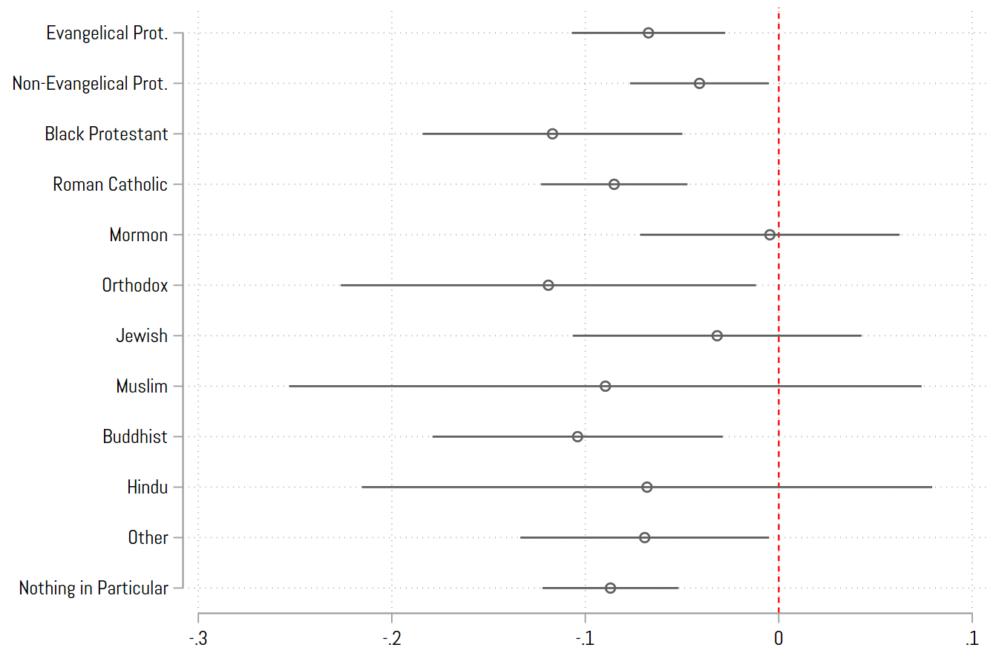
Source: Pew ATP Wave 129 (N = 4,571).
Note: Comparison category is atheist or agnostic. From full model replicating Model 2 in Table 3. Bars are 95% confidence intervals.

Figure A2: Predicted Cumulative Probability of Americans’ Current Political Knowledge.
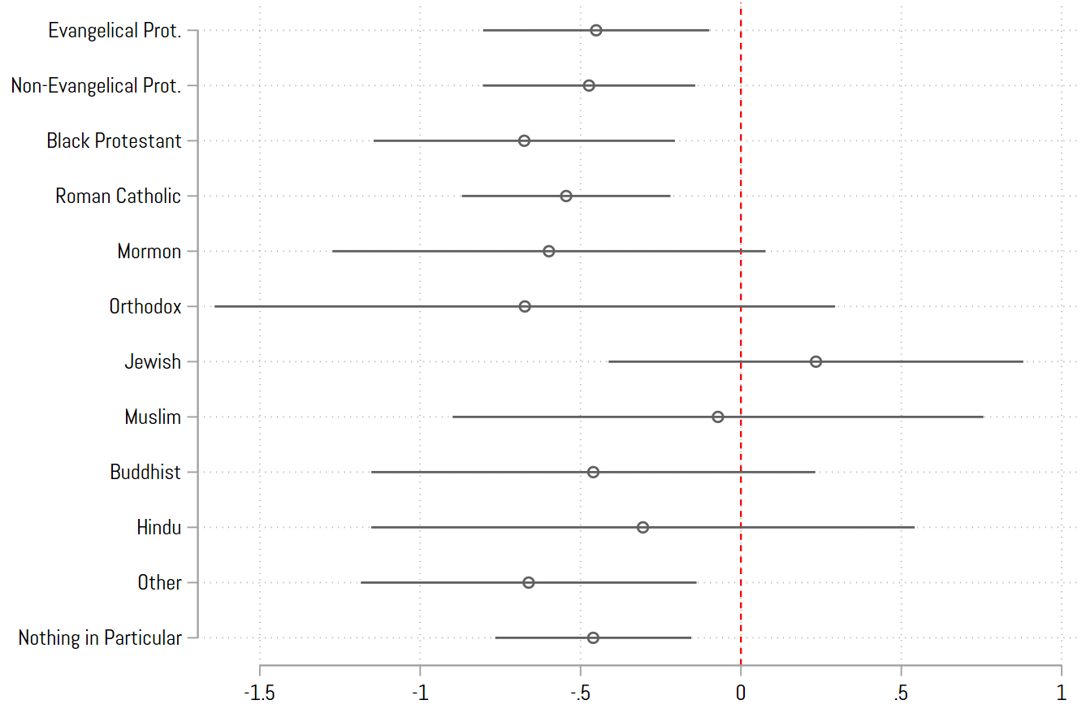
Source: Pew ATP Wave 129 (N = 4,571).
Note: Comparison category is atheist or agnostic. From full model replicating Model 2 in Table 3. Bars are 95% confidence intervals.

Figure A3: Americans’ Predicted Civics Test Score and Knowledge of Current Politics By Religious Identification and Party Identification.
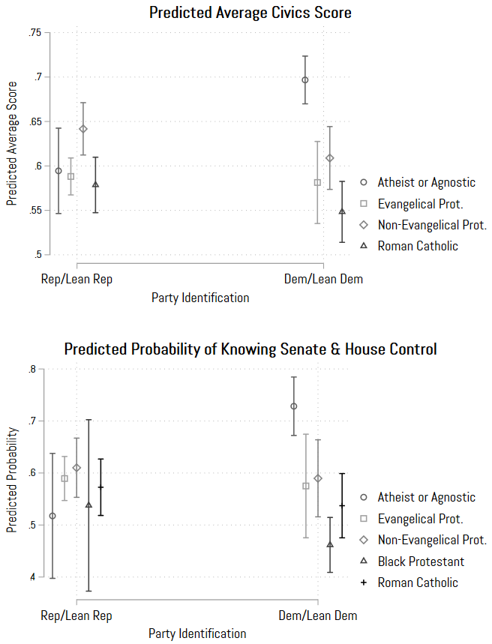
Source: Pew ATP Wave 129 (N = 4,477).
Note: Error bars are 95% confidence intervals. All controls held at their means.
Figure A4: Americans’ Predicted Average Civics Test Score By Religious Identification and Religious Attendance.
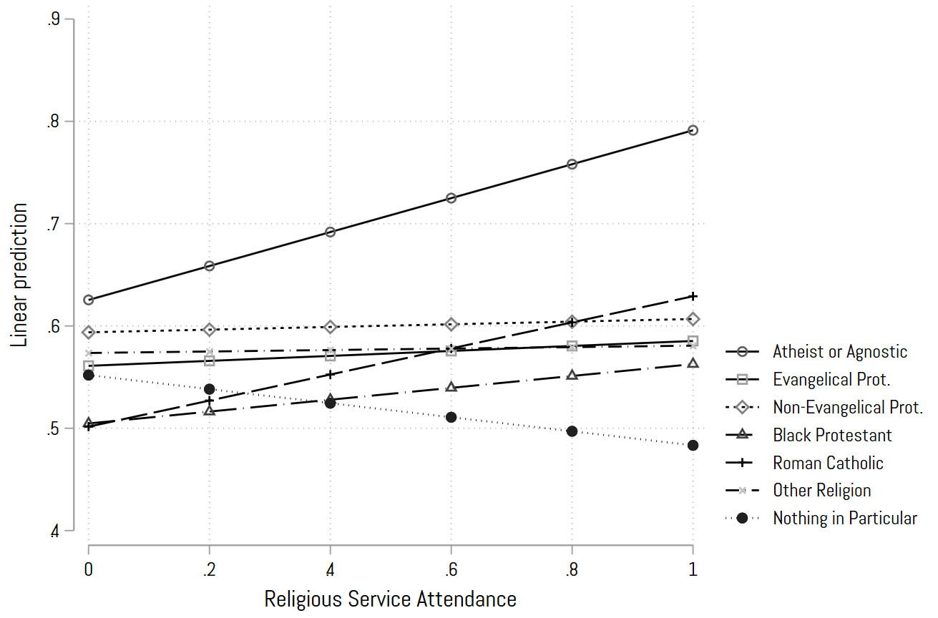
Source: Pew ATP Wave 129 (N = 4,571).
Note: Bars are 95% confidence intervals. All controls held at their means. From full OLS model presented in Appendix Table AX. No interactions are statistically significant. Though it appears that Atheist/Agnostics increase in their civics knowledge as worship attendance increases, this increase is not statistically significant as the sample size of regularly attending atheist/agnostics is quite small and thus confidence intervals across worship attendance are quite large.

Figure A5: Americans’ Predicted Probability of Current Political Knowledge By Religious Identification and Religious Attendance.
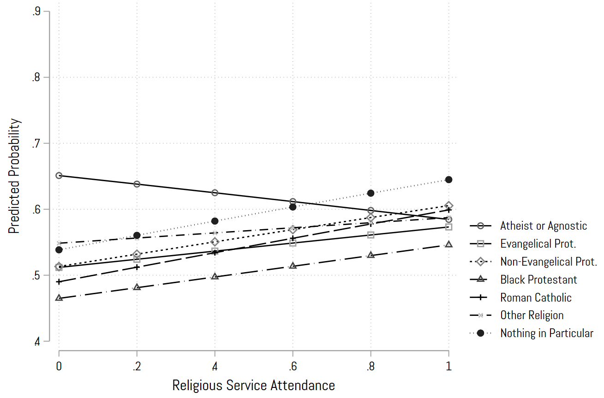
Source: Pew ATP Wave 129 (N = 4,571).
Note: Bars are 95% confidence intervals. All controls held at their means. From full ordinal logistic regression model presented in Appendix Table AX. No interactions are statistically significant.

Figure A6: Americans’ Predicted Average Civics Test Score By Religious Identification and Educational Attainment.
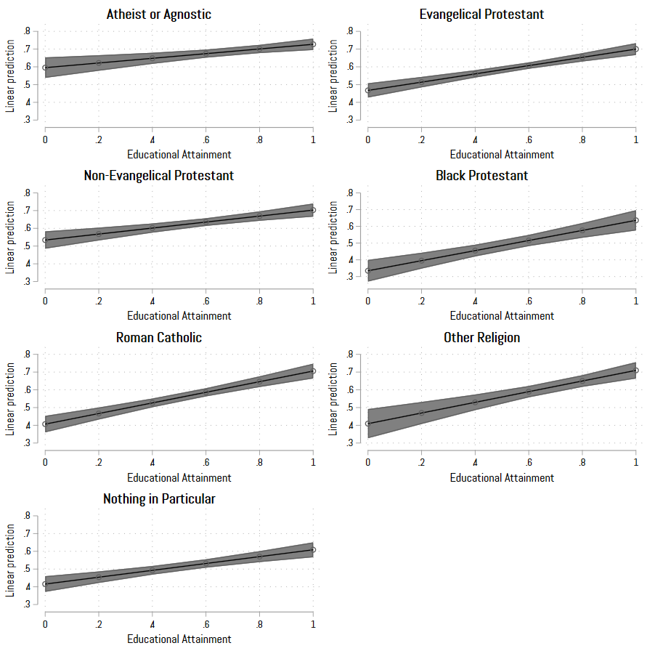
Source: Pew ATP Wave 129 (N = 4,571).
Note: Bands are 95% confidence intervals. All controls held at their means.

