UNIVERSITY OF OKLAHOMA
GRADUATE COLLEGE

HISTORICALLY BLACK COLLEGE AND UNIVERSITY DANCE LINES: REDEFINING AND IDENTIFYING ELEMENTS TO DETERMINE AESTHETIC VALUE

A THESIS
SUBMITTED TO THE GRADUATE FACULTY
in partial fulfillment of the requirements for the
Degree of
MASTER OF FINE ARTS IN DANCE

BY
J’AIME GRIFFITH
Norman, Oklahoma
2022

HISTORICALLY BLACK COLLEGE AND UNIVERSITY DANCE LINES: REDEFINING AND IDENTIFYING ELEMENTS TO DETERMINE AESTHETIC VALUE

A THESIS APPROVED FOR THE
SCHOOL OF DANCE

BY THE COMMITTEE CONSISTING OF

Roxanne Lyst, Chair
Leslie Kraus Steffensen
Marie Casimir

© Copyright by J’AIME GRIFFITH 2022
All Rights Reserved.
ABSTRACT
This research study identifies the elements that combine to define the HBCU dance line aesthetic as an Africanist dance aesthetic, European dance aesthetic, and influences of male embodied femininity. Dance lines, the group of dancers that perform during the football games with the marching band at Historically Black Colleges and Universities (HBCUs), are an ever-evolving subculture within the larger HBCU culture. The Africanist dance dominates the HBCU dance line aesthetic and should be viewed through that lens. To avoid dismissing the growing interest in European dance seen in the use of tricks in their field show choreography, the HBCU dance line community should study the root of the trick, the technique, approaching the tricks from the lens of a European dance aesthetic. As these dance lines gain attention outside of their community, it is now more important than ever to define and document to preserve the aesthetic so that it is not lost and misinterpreted. When viewing and judging a community and its dance, it is vital to consider the history and context. The Southwestern Athletic Conference (SWAC) set the standard in 1968 when Mississippi’s Alcorn State University Golden Girls were the first to drop their batons and dance, paving the way. In this study, the discovery of the Africanist dance aesthetic via Jackson State University Prancing J-Settes and the European dance aesthetic via Grambling State University Orchesis Dance Company is presented through an analysis of interviews conducted with current and former HBCU dancers and directors, an observation of video content on YouTube and social media, and my personal experience as an HBCU dancer and concert dancer. Lastly, to investigate male embodied femininity visible in HBCU dance lines, I interviewed and was coached in person by two male hip hop majorette coaches and choreographers.
TABLE OF CONTENTS
Page
Abstract………………………………………………………………………………………… iv
Chapters:
- Introduction………………………………………………………………………………..1

Research Aims, Objectives, and Questions……………………………………………….4
Methodology………………………………………………………………………………4

- History of Historically Black Colleges and Universities (HBCU) and Its Subcultures
……………………………………………………………………………………………..6

History of the HBCU Marching Band…………………………………………………….8
March-ins, Stand Routines, and Field Shows……………………………………..……..10
From Majorette to Dancer: The History of the HBCU Dance Lines...…………………..12
The Mother of All Dance Lines, Alcorn State University Golden Girls…………...……14
The Trill of a Thousand Eyes, Jackson State University Prancing J-Settes……………..19

- Africanist Dance Aesthetic: Jackson State University Prancing J-Settes……………….21

Ephebism, Polycentrism, Polyrhythm, and Repetition…………………………….…….22
The Assumption of Promiscuity…………………………………………………..……..26
Social and Commercial Dance…………………………………………………..……….31
Imitative yet Original, Nuances and Stylistic Choices…………………………………..34

- European Dance Aesthetic, Grambling State University Orchesis Dance Company
……………………………………………………………………………………...…….39

Dianne Maroney Grigsby..……………………………………………………………….43
Elodie Davis Killins……………………………………………………………..……….47
Ahsaki Thomas………………………………………………………………...………...54

- Male Embodied Femininity …………………………………………………………………………………………....64

Male J-Setters………………………………………………………………………….…67
She Dance Like a Big Ol’ Queen………………………………………………….…..…68
Hip Hop Majorette…………………………………………………………………….…70
Behind the Scenes with Leonardo Devine, A Traveling Majorette Coach………………70
Behind the Scenes with Willie Miller and Drumline Jazz……………………….………74

- The Aesthetic of the Cool, the Finishing Touch of the HBCU Dance Line Aesthetic……....................................................................................................................78

Costumes…………………..……………………………………………………………79
Déjà vu: Three Costumes Inspired by Beyonce’s Déjà vu Music Video and Costume Trends in the SWAC...…………………………………………………………………..90
A Designer’s Perspective: Teisha Lincoln and Tyree Tucker..………………………...101

- Conclusion……………………………………………………………………………...111

Bibliography……………………………………………………………………………………113

Appendices:

Appendix A: IRB Research Participants’ Consent Forms...……………………117

Appendix B: Glossary of Terms………………………………………………..124

Introduction
This thesis research originated from an experience in 2021 when I judged a hip hop majorette dance competition presented by Explosive Legacy Dance Company in Oklahoma City, Oklahoma. The routines performed were for combined field show, combined open dance, and combined pom categories. They integrated familiar movement from my background in modern and jazz dance as well as my background in the Historically Black College and University (HBCU) dance line aesthetic. Judging the teams through the lens of my concert dance background, the movements rooted in modern and jazz dance were not technically executed correctly. As a former HBCU dancer at Grambling State University, I had also observed technically incorrect movement from other HBCU dance lines. Hip hop majorette dance is derived from the HBCU dance lines, and because this trend shows up in both, I questioned if it is an intentional stylistic choice. I also questioned: was I correct to view the routines from a modern and jazz dance lens? The routines weren’t primarily modern and jazz influenced, so why did I choose to view the routine as a whole through that particular lens? If I should not judge them this way, how then should I view the HBCU dance line aesthetic and its predecessor, hip hop majorette dance? This line of thought led me to the larger question, what is the HBCU dance line aesthetic? What are the elements that contribute, and which elements should dominate in how it is viewed, received by the audience or crowd, and judged? This is the question I have based my thesis research.
In my research I found four descriptions of the HBCU dance line aesthetic:
1. Anne Brice suggest in “Berkeley’s Bearettes first to bring majorette-style dance to UC system” [sic]:
“It combines the liveliness of the high-step marching styles of HBCU marching bands with modern, West African, hip hop, and jazz choreography.”
2. Danielle Allen wrote in “Throwback: The History of the Drum Majorette”:
“It merges the energy of the high-step marching styles of black college bands with modern, West African, jazz, and many other modern dancers.”
3. Susan Pierre claims in “Reality TV show spurs growth of hip-hop majorettes locally” [sic]:
“Hip hop majorette dancing is rhythmic, high energy, syncopated dance moves that draw from hip hop, modern dance, jazz, ballet and gymnastics.”
4. Peggy Ussery informs the reader in “Hip hop majorettes combine cheerleading, majorette, and hip hop moves” [sic]:
“The style is part dance, part majorette, part cheerleader. Gymnastics and cheerleading moves are combined with hip hop dance moves. Pom poms and batons are sometimes used.”
The terms HBCU dance lines, j-setters, majorette dance lines or teams, and hip hop majorette dance lines or teams, are believed to have the same definition, therefore used interchangeably by some. Others use these terms to refer to unconnected performance styles and groups. The use of interchangeable terms proposes that there’s no confirmed definition and no set referents for these performance styles. In this study, I will use the term HBCU dance lines to refer to the group of dancers who perform at HBCU football games with the marching band and the term HBCU dance line aesthetic to refer to the movement vocabulary, nuances, and stylistic choices. Given the lack of research and documentation on the creation and evolution of the HBCU dance lines, I could not prove these definitions to be true. In other words, I couldn’t identify a lineage that shows how and when ballet, hip hop, modern, jazz, West African dance, cheerleading, and gymnastics were combined to create the HBCU dance line aesthetic. However, based on the four definitions listed above, I can divide the elements listed into two categories: Africanist dance aesthetic and European dance aesthetic. Hip hop and West African dance is placed in the Africanist dance category and ballet, modern, and jazz in the European dance category. When the authors listed jazz dance, they did not mention black social dance or popular dances of a particular era (vernacular jazz dance). I assumed they meant concert jazz dance which is why I placed jazz dance with European and not Africanist. In my research, I found evidence of both concert jazz and vernacular jazz dance.
HBCU dance lines are female presenting. But considering the abundance of gay black male presence behind the scenes, I also suspect they have influenced the aesthetic. Jackson State University Prancing J-Settes had a male choreographer in the formative years, Hollis Pippins. Currently, a lot of hip hop majorette teams are led by male coaches and choreographers. In the roles of choreographer and coach, the gay black male presence is undeniable.

Research Aim, Objectives, and Questions
This study will aim to identify the elements that the HBCU dance line aesthetic consists of to define and determine how the dance should be viewed and judged. The focus of this study is the HBCU dance lines in the Southwestern Athletic Conference (SWAC) referencing the Jackson State University Prancing J-Settes and Grambling State University Orchesis Dance Company. My objective is to investigate in what ways an Africanist dance aesthetic, a European dance aesthetic, and male embodied femininity appear in the HBCU dance lines in the SWAC. My research will answer the following questions:
- What are the elements that combine to create the HBCU dance line aesthetic?
- What Africanist and European dance principles are evident in the SWAC HBCU dance lines and how are they presented?

- What role does the gay black male dancer play in the HBCU dance line SWAC community and how has male embodied femininity influenced the HBCU dance lines in the SWAC?

- Of the elements that make up the HBCU dance line aesthetic, which have had or should have dominance and determines how the dance should be viewed and judged?

Methodology

The methodology used in this study includes interviews conducted via phone or Zoom conference call with current and former HBCU dancers, directors, and costume designers. As I used the Prancing J-Settes to represent the Africanist dance aesthetic, my information is limited because I was only able to interview one former Prancing J-Sette. Because of my past involvement with the Orchesis Dance Company, the European dance aesthetic, I had access to more interviewees resulting in more information from different generations. As a guideline to further investigate both Africanist and European dance in the HBCU dance lines, I referenced: Brenda Dixson Gottschild’s Digging the Africanist Presence in American Performance: Dance and Other Contexts, the Black Dancing Body: a geography from coon to cool, and Kariamu Welsh Asante’s African Dance: An Artistic, Historical, and Philosophical Inquiry. I also analyzed the HBCU dance lines through video content found on YouTube and social media platforms. The amount of video content available in 2022 is substantially more than the video content available from 1968-1980s. This limited my ability to fully analyze the HBCU dance lines during their formative years. To experience male embodied femininity, I was interviewed and was coached in person by two male hip hop majorette coaches and choreographers. Lastly, in my analysis of the HBCU dance lines, I include my own personal experience as an HBCU dancer and concert dancer.

History of Historically Black Colleges and Universities (HBCUs) and Its Subcultures
HBCUs were created with the purpose to provide educational opportunities to African Americans. Working the crops on southern plantations, enslaved black people were not allowed to learn to read or write. Without an education, a job, or money, the white populations of the south and north felt that this unemployed, uneducated group of people were not at all capable of taking care of their own affairs. The federal government established the U.S. Bureau of refugees, freedom, and abandoned land. The Freedmen’s Bureau as it was most referred to, helped ease the transition of the American South from a slave-owning economy to one ruled by free labor. The organization established hospitals, provided medical care, labor dispute resolution or mediation, and assisted in locating family members of the freedmen due to slavery, and created schools and colleges specifically for freedmen. The American Mission Society assisted the Freedmen’s Bureau and brought Christian religious denominations to staff and fund schools. As the number of illiterate African Americans in the United States rapidly decreased, a higher level of education was desired. At first, these colleges planned to offer education close to what would be received in high school. Then the curricula developed into a true university-level education. By 1870, approximately 22 HBCUs existed in the United States. Ten years later the number more than doubled to 45. About 64 existed in 1890 and by 1932 there were 117 HBCUs in the United States.
My research is based on the HBCU dance line aesthetic in the Southwestern Athletic Conference, the athletic conference comprised of HBCUs in the Southern United States. It is affectionately referred to as the SWAC. In 2022, it consists of 12 universities that travel to play each other in a series of football games during the fall semester. Football season allows each university’s football team to be challenged and exposed to the talent from the other SWAC university football teams. Football season also provides exposure for the marching bands and the dance lines. This is how the HBCU marching band style developed and spread. This is also how the movement vocabulary used by HBCU dance lines in the SWAC developed before social media. Each game, the dance line may see something they like from the opposing university dance line that they take back with them and make it their own.
Current Universities in the Southwestern Athletic Conference | Location | Year Joined
Prairie View Agricultural and Mechanical (A&M) University | Prairie View, Texas | 1920
Southern University A&M University | Baton Rouge, Louisiana | 1935
University of Arkansas at Pine Bluff | Pine Bluff, Arkansas | 1936 (left and rejoined in 1997)
Texas Southern University | Houston, Texas | 1954
Grambling State University | Grambling, Louisiana | 1958
Jackson State University | Jackson, Mississippi | 1958
Alcorn State University | Lorman, Mississippi | 1962
Mississippi Valley State University | Itta Bena, Mississippi | 1968
Alabama State University | Montgomery, Alabama | 1982
Alabama Agriculture and Mechanical (A&M) University | Huntsville, Alabama | 1999
Florida Agriculture and Mechanical University | Tallahassee, Florida | 2021
Bethune-Cookman University | Daytona Beach, Florida | 2021
The twelve universities in the SWAC and the year each joined.
History of the HBCU Marching Band
At an HBCU football game, in addition to the competition between the two football teams, there’s an unofficial competition happening between the marching bands and the dance lines. The band competes from across the field with each musical selection; the objective is to outplay the competition. Black college band showmanship is believed to be connected to black drill sergeants who added foot-stomping syncopation and melody into their cadence counting. In the military, the earliest musicians in black marching bands were fifers, pipers, trumpeters, and drummers. Black military units in the Civil War and World War I had such bands. After World War I, some of the musicians joined the faculty of music departments at black colleges and universities. These music departments, starting in 1862, were created to raise money. Many of the first university marching bands were connected to the Reserve Officers’ Training Corps (ROTC). University marching bands performed military drill exercises until 1905 when the University of Illinois band created letters, words, and patterns on the football field while playing. In 1946 the style and showmanship of the HBCU marching band were established at Florida A&M University (FAMU). Credit is given to the director at the time of FAMU’s marching band, Marching 100, Dr. William Foster. The change started with steps, high knee lifts, and horns swinging. Foster’s split from tradition led to a change in the marching band style- and forever adjusted the emotion, look, and feel associated with halftime performances. Those high-energy, upbeat shows replaced the militaristic, block, corps-style band performances.
One thing that set the Marching 100 apart is the band-wide choreographed dance routines which consisted of the popular dances of that day. They also played up-beat popular songs, and at that time ragtime and jazz were popular. HBCU bands and black high school bands from all over the United States followed their lead and this tradition carries on today. Dr. Foster visualized HBCU marching bands as institutions specifically for Black audiences, with halftime shows that focused on Black excellence, Black music, Black joy, and Black culture [sic]. Today’s musical selections are an eclectic mix of black music. The HBCU marching bands mix the old with the new, old school songs with today’s Rap and R&B and sometimes Gospel, and a mixture of block marching formations and military marches with Black art forms and Black joy [sic].
The marching band is the heartbeat of the HBCU campus. They provide the soundscape for various events on campus. The football game is the most common event to witness a performance by your favorite HBCU marching band. Current and alumni students take pride in their HBCUs, the marching band and auxiliary groups, and sports teams. The diehard fandom is because on our HBCU campuses and at events like our football games, we can celebrate ourselves and each other freely. We are able to be black unapologetically and celebrate HBCU culture which is also black culture. Because of and as a result of this freedom to be unapologetically black, the HBCU marching band and dance line aesthetic was birth.

March-ins, Stand Routines, and Field Show
HBCU dance lines are the official group of dancers who perform in the stadiums, stands or bleachers, and on the football field during halftime, accompanied by their school’s marching band. For the dancers, the objective is to out-dance the competition (the opposing school’s dance line) and to entertain. At an HBCU football game, the dance line’s performance can be broken down into three categories: the march-in, stand routines, and the field show.
A march-in is a choreographed sequence meant to travel the dance line forward in space with a stylized strut, walk, march, prance, or glide. For example, the legs can go through a passé, one pointed foot slides up the opposite leg creating a triangle with the knee facing straight forward. The leg can also create a ninety-degree angle before stepping forward on that same leg, like the marching band’s high knee lifts. The arms can be whatever the dance line decides. Each dance line has its signature strut, walk, march, prance, or glide that is its go-to march in. Some march-ins have more complicated choreography that includes intricate arms and formation changes. March-ins are used to enter and exit the stadium with the marching band. This is the first and last time the audience sees the dance line. March-ins are also used in parades.
A stand routine is a choreographed sequence performed in the stands or bleachers. The sequence is counted in numbers one through eight. After eight, you start over at one and repeat until there is no more choreography. For that reason, stand routines are also called, “eight counts” and “counts.” Some dance lines stick to one eight count stand routines. Others expand to two eight counts, sixteen counts. The Orchesis Dance Company (ODC) at Grambling State University is known to perform thirty-two or more counts with a rock out at the end of the routine. The ODC rock outs are one to two eight counts of choreography that concludes the stand routine. The idea was to make sure the group stops together; it’s like the period at the end of the sentence. The dancers are usually positioned in front of the band. The captain sits in the first row by herself followed by the rest of her team in rows two and three. The stand routines are performed in a call and response format, like the relationship between the dancers and drummers in traditional African dance. In the HBCU dance aesthetic, to “call” is to “throw” and to “respond” is to “catch.” The thrower is the captain, and the catcher is the rest of the line. There is a third party in this relationship, the marching band. The stand routine that the captain throws depend on the song selected by the band. The marching band starts to play, then the captain decides what stand routine she will throw on the spot, she performs the first eight counts of the stand routine to communicate to her team, then she repeats the stand routine but this time with the entire dance line. Usually, whatever the captain throws, the dancers repeat one eight count later. When she stops, the rest of the line stops an eight count after. The stands or bleachers in a stadium do not allow much space side to side and front to back, so the stand routines are stationary. However, the choreography is big and explosive. Stand routines are performed at any time during the game when the marching band plays, before the game (zero quarter), during the game, and after the game (fifth quarter).
At HBCU football games, halftime is not the time to go to the restroom or concession stands for it is one of the main attractions of the event. Both marching bands perform their field show and within the field show, the dance line is featured for one song. The dance line uses the same movement vocabulary in their stand routines. Fortunately, on the field, there is more room, so the movement can travel. Tricks like leaps, turns, jumps, and leg extensions are incorporated to add another layer to the choreography.

From Majorette to Dancer: The History of the HBCU Dance Lines
HBCU dance lines in the SWAC all pull from the same movement vocabulary but what sets each team apart is their style, the nuances, and stylistic choices create individuality. Adding to their individuality, each HBCU dance line has a unique name that may correspond with their school’s mascot or marching band. Or the name can have nothing to do with the school’s mascot or marching band but everything to do with placing the dancers on a pedestal by using words that glorify and dignify. “Orchesis,” as in Grambling State University’s Orchesis Dance Company, means the art of dance. Texas Southern University Motion of the Ocean is a play on their marching band’s name, Ocean of Soul. Same for the Alabama State University, the band: Mighty Marching Hornets, the mascot: Hornets, and their dance team: the Sensational Stingettes. Florida A&M University Venom pom squad coordinates with their mascot, the Rattlers. Mississippi Valley State University Satin Dolls and Southern University and A&M College Fabulous Dancing Dolls use of the word “Dolls” can be interpreted as someone who is attractive. Both dance line names have nothing to do with the band or the school’s mascot. The Fabulous Dancing Doll’s founder Gracie Perkins’ daughter loved dolls. Perkins’ sister recommended the name “Dancing Dolls” because every little girl loves dolls. University of Arkansas Pine Bluff and Alcorn State University dance lines are both named the Golden Girls. “Golden” for UAPB may be a nod to their mascot the Golden Lions. For Alcorn State University “Golden” may refer to their school colors which is gold and purple. One definition of “Golden” is exceptionally valuable, highly talented and favored, destined for success. This could be another reason for using “Golden” to describe their dance lines. 14 Karat Gold dancers at Bethune-Cookman University falls in the same category. The Dancing Divas of Alabama A&M University and the Black Foxes of Prairie View A&M University have names that again place their dancers on a pedestal. “Diva” is the Latin word for goddess and “fox” is slang for an attractive woman. The adjectives sensational, golden, and fabulous do the same. At Jackson State University, the “prancing” in Prancing J-Sette describes the way that they march. Prancing means to walk or travel in a lively and proud way like a horse: to travel by taking high steps: to lift each hoof up high when traveling, to strut. The “J” stands for Jackson. “Ette” as used in Stingettes and J-Settes can be used to feminize a masculine name. Furthermore, majorette is the female version of drum major.
The official group of dancers who perform in the stadiums’ stands or bleachers and on the football field during halftime, accompanied by their school’s marching band, the HBCU dance lines, are sometimes referred to as “majorettes” instead. One reason may be because some HBCU dance lines have roots in majorette-baton twirling. On a blog post by Azizi Powell, a reader commented their thoughts about the use of the term “majorette” when referring to the group of dancers that perform at football games in the stands or bleachers and featured during the marching bands’ half time field shows. They said:
I am NOT a fan of calling what we see with majority black bands Majorette dancing. They are NOT majorettes. They are dancers. Some lines are rooted from an existing majorette team that put down their batons and never picked them back up and held on to their historical names. However, once the batons were gone they were no longer majorettes. I would even venture to say that most dance lines don't consider their style of dance "majorette"

As a former HBCU dancer from the SWAC, I can agree that I have never heard anyone who is or has been a part of these specific group of dancers refer to themselves or others alike as “majorettes.” Growing up in New Orleans, Louisiana I remember seeing the baton twirlers at the Mardi gras parades. This is what I know “majorettes” to be. Majorette- baton twirling originated in Rhineland. It was a carnival dance performed by women called Tanzmariechen (Dance Marys) in German. In the late 1930 and early 1940s, Baton twirling and majorettes expanded to Canada. By the 1960s it had made its way to other countries. Traditionally majorettes have been female auxiliaries for marching bands; the girls dress in sparkled costumes, throw batons into the air or twirl them in eight-count cadences of rigid-arm movements to the band's music. Majorette- baton twirling is still prevalent today. At some high schools and universities there are majorette teams that perform with the marching band separate from the dance team.
The Mother of All Dance Lines, Alcorn State University Golden Girls
Going back to the comment made on Azizi Powell’s Blog, “some lines are rooted from an existing majorette team that put down their batons and never picked them back up and held on to their historical names.” Venomtip, the commenter, is referring to university dance lines like the Alcorn State University Golden Girls and Jackson State University Prancing J-Settes. Alcorn State University was established in 1871 in Lorman, Mississippi. The university’s marching band, Sounds of Dyn-O-Mite, was founded in the 1960’s along with the Golden Girls. Samuel Griffin, the founder of the Sounds of Dyn-O- Mite, also formed the Golden Girls and the Purple Flashers Flag Corp. According to the Sounds of Dyn-O-Mite website, Alcorn State University Golden Girls (GG’s) claim to be the first dance line to perform as a featured squad with choreographed movements to a marching band’s live music:
In the fall of 1968, the Golden Girls made their national debut in Miami, Florida during the Orange Blossom Classic. During this time, no one had ever seen a female dance team perform during halftime. A silence fell upon the crowd as these eight regal, African American ladies took the field. The capes were snatched off in a quick one, two motion, revealing Alcorn’s most prized possessions.

The information I was able to find on the “mother of all dance lines” came from the Sounds of Dyn-O-Mite’s website, blog posts, and social media. The official Golden Girls page on the Sounds of Dyn-O-Mite’s website did not mention anything before the Orange Blossom Classic. To be more specific, there was nothing about the dance line twirling batons before that day. I also reached out to an Alcorn State University Golden Girl alumna and the current director to better understand the group before this iconic game. Neither responded. On an online forum, “1968 Alcorn Golden Girls 1st Ever Collegiate Dance Line,” I found some information. (However, I do not know how creditable this source is, and I do not know for sure the creator’s level of involvement with the Sounds of Dyn-O-mite and the Golden Girls.) The author of the forum, Brave, mentioned he marched in SOD in the 90s. In the initial post, he included a photo of what seems to be from the Orange Blossom Classic when the GG’s as a dance line made their debut. Six of the eight dancers in gold were holding a baton in their hand visible to the camera. In front of the eight dancers, one drum major and a woman in a white biketard embellished with fringe. They both held one baton. One commenter, JAG89, asked if they were both majorettes (baton twirlers) and dancers. When I first saw the photo, I was also confused because it was said that they were the first dance line of the SWAC with an emphasis on “dance,” indicating that they did not use batons anymore and their debut as a dance line was at the Orange Blossom Classic. So why were they holding batons? Brave replied, giving a name to the only majorette in the photo, the woman in white. He said her name was Betty Brown and the guy next to her twirled with her. He looks more like a member of the band, or a drum major based on his uniform. Furthermore, Brave said the GGs danced with & without the batons back in that time (but they were not twirlers/majorettes). Truthteller, another commenter, based on his profile picture of the university of discussion seems to be affiliated with Alcorn State University in some way. He seconds Brave’s statement that the women both danced and twirled. According to him, they danced and twirled as far back as the 1950s but what happened in 1968 was the first time in HBCU history.
In 1963 Florida A&M University Marching 100 performed at the Orange Blossom Classic. FAMU’s football team lost, but the performance that the marching 100 gave during halftime is still talked about decades later. FAMU’s Marching 100 revolutionized how marching bands performed during half time, including trailblazing choreography and fast high-stepping marches. Of course, when the word spread about that halftime show, it inspired other marching bands to revamp their styles and to come up with the next big thing to outdo FAMU. In 1968 FAMU played Alcorn State University and what happened during the halftime show again revolutionized how marching bands performed. On the forum, “1968 Alcorn Golden Girls 1st Ever Collegiate Dance Line,” JaySBlue, inquired about what exactly happen that day of the game. The author, Brave, gave insight:
[sic] well that game changed the landscape & craft of halftime for showbands. Dancing girls became a feature & focus at halftime. It was viewed on TV so plenty of people saw the game. More Bands followed suit after that as well. The GGs "stole the show" so to speak. It was one of the main reasons why they were so popular back in the day. It put them on the map.
Another commenter, Mr.THUNDA!!!!, added to the information that Brave shared by explaining the reasoning behind the chosen angle of attack. He alluded that Samuel Griffin decided to have the GG’s drop the batons and just dance to do something no one had seen before. If it was done right, they would be successful at outshining the Marching 100. They did! The GG’s “stole the show”:
Far as the GG's go, Griff stated that no one had just girls dancing in front of the band and he needed something for FAMU band. So, he told the Majorettes that they was getting rid of the baton and was going to dance for this game and that was the beginning of the Golden Girls. [sic]
The classic was televised that year, and so word spread faster than usual. This single halftime show prompted other HBCU majorette teams to put down the baton and just dance or influenced HBCU marching bands to add “dancing girls” to their already established band program. Outshining the opposing university is still the motivation behind evolving the HBCU dance line movement vocabulary.
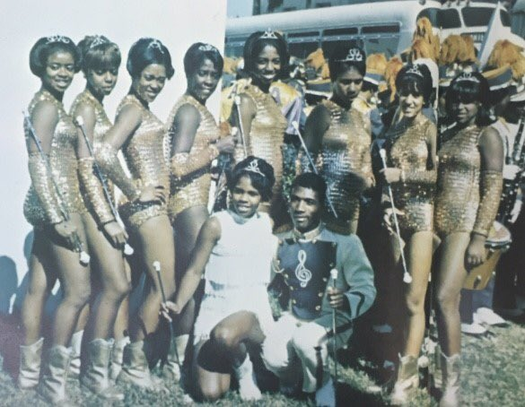

The Trill of a Thousand Eyes, Jackson State University Prancing J-Settes
The Prancing J-Settes from Jackson State University is another HBCU dance line that started as majorettes-baton twirlers. Jackson State University’s marching band, Sonic Boom, started in the 1940s. On their website, I found photos of their majorettes from 1948 and 1969. In the black and white photo from 1948 the majorettes looked more like drum majors with the hat and even the pose. In 1969, the costume looked more like the typical majorette costume. Nothing on the Sonic Boom website talks about the Prancing J-Settes as majorettes. The history shared starts at 1971. According to the Prancing J-Sette’s page on the Sonic boom’s website, Shirley Middleton was responsible for initiating the concept of the then Prancing Jaycettes discarding the batons and dancing to popular musical selections provided by the band. Shirley Middleton, the majorette sponsor, convinced the university’s president to allow them to “put down their batons.” What transpired after “the trill of a thousand eyes” put down their batons inspired a generation of dancers. An exciting and explosive new style of dance that became popular in the black community and beyond.

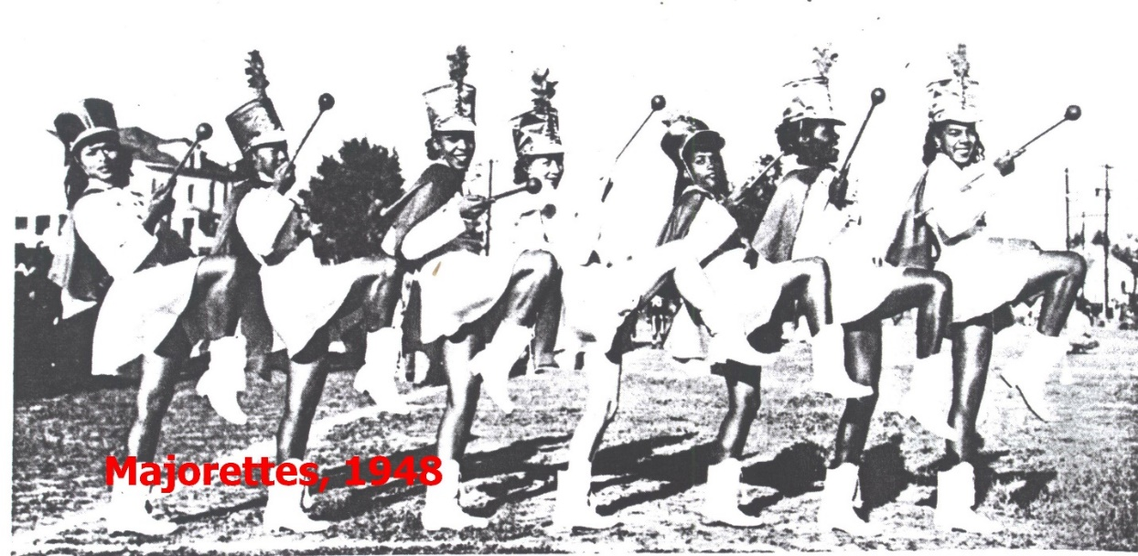
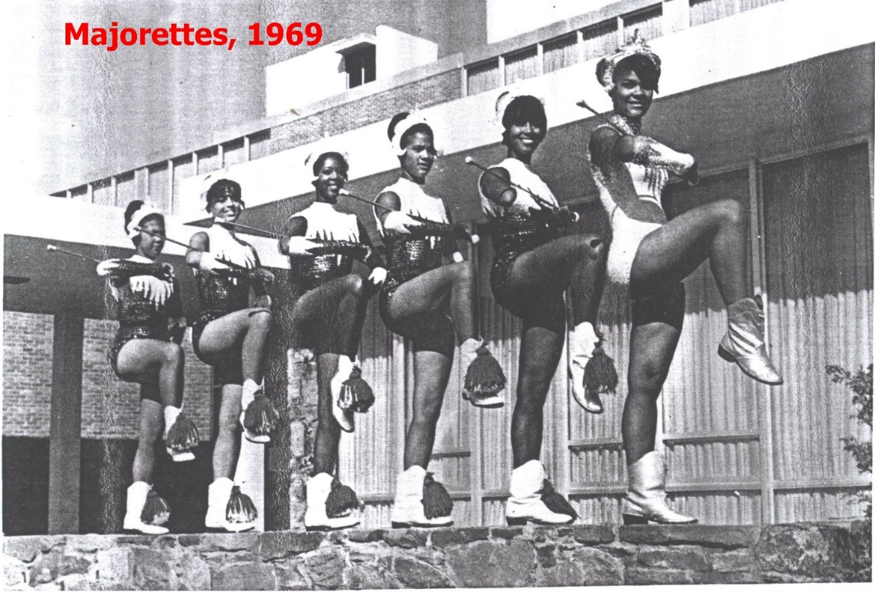

Africanist Dance Aesthetic: Jackson State University Prancing J-Settes
I presented my thesis research in a lecture-demonstration presentation, Beat AF (and faceted): A Celebration and Exploration of the “Rich, Black, Southern heritage” of Majorette, J-setting, and HBCU Dance Lines was performed March 19th, 2022 at 1984 Studios in Oklahoma City. During the presentation, I explained the history of HBCU dance lines and the transition from majorette-baton twirler to dance line. I found it most beneficial to begin with Jackson State University Prancing J-Settes. It allowed a seamless transition into a discussion on male j-setters and hip hop majorette competition dance teams. Bucking, a pelvis thrusting motion seen throughout the SWAC, was introduced to my audience as I physically demonstrated a stand routine. When I talked about the Grambling State University Orchesis Dance Company, I showed a video of the dance line performing a stand routine. I pointed out the differences between the Prancing J-Settes and the Orchesis Dance Company. One is the spine when dancing. At the end of the presentation, I opened the floor for questions. The question that resonated with me the most was from a woman who wanted to know more about what caused the difference in the two dance lines’ use of the spine in their movement styles. I explained that the director of the Orchesis Dance Company came from a Europeanist dance aesthetic background that values an erect spine. Because of this, she taught her dancers what she knew to be considered correct technique. The Prancing J-Settes, on the other hand, allow the spine freedom to move, which is more aligned with an Africanist dance aesthetic. The SWAC dance lines are a fusion of Africanist and Europeanist dance, with each dance line having their preferred combination of the two. This question prompted me to investigate other ways the SWAC dance lines favor Africanist and or Europeanist dance.
In Brenda Dixon Gottschild Digging the Africanist Presence in American Performance, the first chapter, “First Premises of an Africanist Aesthetic,” gives a method to understand the Africanist aesthetic. She says to isolate specific aspects of that principle for the purposes of discussions, apply them to a specific Africanist example, and discuss that example considering the European aesthetic. For the purposes of my research, I will use the HBCU dance line style as a whole (more specifically, the bucking and movement in the pelvis, butt, hips, and breast done to a certain degree in all SWAC dance lines) to represent the Africanist example. For the European aesthetic, I will use the leaps, turns, and tricks often referred to as technique, and a more vertical spinal alignment. Both technique and alignment, have infiltrated the HBCU dance line style (the Africanist aesthetic). Furthermore, I decided to use the Prancing J-Settes (Africanist dance aesthetic) because bucking and movement in the pelvis, butt, hips, and breast are most prevalent in their style; the Orchesis Dance Company (Europeanist dance aesthetic) because technique and alignment is used more than any other university in the SWAC.
Ephebism, Polycentrism, Polyrhythm, and Repetition
Gottschild’s speaks of five Africanist elements: high-affect juxtapostion, polycentrism and polyrhythm, ephebism, embracing the conflict, and the aesthetic of the cool. In this chapter polycentrism, polyrhthm, and ephebism are my “specific aspect of the principle” used to analyze the movement done by the Prancing J-Settes. Along with the view of the black dancing body and the presumption of promiscuity. Polycentrism is described by Gottschild as movement simultaneously originating from more than one focal point and one part of the body played against another. Polyrhythm, in the context of dance, is when two or more body parts are dancing to multiple rhythms at once. Ephebism, emerging from the ancient Greek word for youth, encompasses characteristics such as vitality, attack, flexibility, power, and drive.
The term “j-setting” is a tribute to Jackson State University Prancing J-Settes’ marching and dance style. Shirley Middleton, Hollis Pippins, and Narah Oatis pioneered what is now known as j-setting. Shirley Middleton was the sponsor from 1970 to 1975. Narah Oatis succeeded Middleton in 1975. Hollis Pippins was a JSU twirler and early choreographer for the Prancing J-Settes.
J-Setting is high-energy full-body movement. It’s joyful, exciting, full of life, fierce, and in your face. This explosive movement has the power to command any room. You cannot be soft and apologetic in your approach; the movement calls for confidence and must be done with the fullest physicality. As it relates to ephebism, sharpness is associated with sudden or abrupt changes in dynamics. This is visible when the J-Settes perform stand routines and even more so during the field show. When watching j-setting choreography, the excitement comes from the dynamics of the choreography and the wide range of motion that makes up the Prancing J-Settes’ movement vocabulary. Ephebism contains traits such as attack, flexibility, vitality, drive, and power. Attack signifies sharpness, force, and speed. Flexibility implies the ability to articulate a body part going from one extreme to the next. Within this dance style, there is a sense of freedom in the body and control over the body at the same time. Bucking demonstrates attack and flexibility. Bucking, a movement the J-Settes are known for uses the entire torso but is initiated by the pelvis. The pelvis tilts forward and back in a “thrusting” manner (attack). The entire torso creates a “C,” alternating front and back, contract and release (flexibility). In the documentary on the history of bucking, “When the Beat Drops,” the Prancing J-Settes bucking motion is compared to when a horse kicks out its back legs. It’s a jolting and jerking motion. Polycentrism and Polyrhythm are evident in bucking as well because, in addition to the movement in the torso, the legs and arms also contribute to bucking. From the Africanist viewpoint, movement may be produced by any body part, the center(s). Polycentrism is when two or more centers produce movement simultaneously. I’ve identified the pelvis as one center when bucking. The knees are another. The leg position when bucking varies. However, regardless of the position of the legs, to buck, the knee must remain at least slightly bent. The knees have to stay relaxed to bend more or less (flexibility). The legs can be open wide in a second position with the knees bent. The point from the hip to the knee and the knee to the ankle creates a 90-degree angle. The angle can be increased by straightening the legs a little or decreased by lowering the pelvis closer to the floor and below the knees. Bucking can also be performed with the feet, ankles, knees, and inner thigh muscles squeezing together. Both legs parallel and pelvis squared to the front, moving one leg forward to buck in a fourth position. With the pelvis square to the right or left forward diagonal, step one leg forward on the diagonal. The leg that is forward is parallel and angled at the same diagonal as the pelvis. The leg that is back is usually slightly turned out, with the knee at the opposite forward diagonal. The back heel is down as much as possible. The shoulders, arm socket, and upper back area represent the third center. The third center produces the movement in the arms, which varies as well when bucking. They can be over the head creating an “O” connected at the hands. The arms can be in front of the chest, bent at the elbows. The arms can follow the movement in the pelvis and prescribe to the same rhythm or practice dancing with polyrhythms; the arm can follow a completely different rhythm. With the hand in a fist moving in a circular motion toward the chest, when the fist is furthest away from the chest the pelvis is tilted forward and the rest of the torso falling into the forward “C” (the chest is concaved). With locked elbows and hands in fist, the arm moves in one piece circularly. With the arm straight up with the fist to the sky, the pelvis is tilted back, and the torso follows making a backward “C” or arched position with the chest and rib cage forward. As the arms travel back down and forward the pelvis gradually tilts forward and the torso ends in a contracted position with the belly button to the spine. Although bucking can be choreographically placed anywhere in the dance sequence, The Prancing J-Settes are known to choreograph three quick bucks in a row. The Africanist dance aesthetic and the HBCU dance line aesthetic as a whole value repetition. The stand routines are repeated multiple times back-to-back during one song, at the captain’s discretion. Also, a signature movement may be repeated throughout the football game, like the Prancing J-Settes and bucking. In both cases, the repetition is intensification, but also, to make sure you saw us. Gottschild explains where repetition stems from in an Africanist perspective:
To the Europeanist ear, reprises may seem monotonous and superfluous; in the Africanist perspective each repeat is different than the one that went before, is shaped by the one that went before, and predicates the one that will follow. The repetition principle exemplifies the transcendent power of the Africanist worldview, for there is much repetition in traditional quotidian African life: pounding grain, seeding ground, kneading bread, reaping the crop. In transferring repetition from the chores of daily life to the realm of creative expression, the Africanist aesthetic transforms the prosaic into the sublime and makes a spiritual conceptual connection between the two.
I could not find any information supporting the idea that the Prancing J-Settes created bucking nor the intent behind the movement when added to the Prancing J-Settes’ movement vocabulary. In “When the Beat Drops,” during an interview with three Prancing J-Sette dancers, they acknowledge that they are not the only dance line that bucks but, what sets them apart is that they buck with class, style, and form. Bucking was not as edgy and hardcore as it is now, but it has always been a part of the Prancing J-Settes’ movement vocabulary. It became bigger and more dynamic to be seen across the field.
Other HBCU dance lines incorporate bucking into choreography but not all HBCU dance lines buck. For example, Southern University Fabulous Dancing Dolls focuses more on the port de bra, the movement of the arms. They also use the torso and pelvis with a more fluid, delicate, and softer approach, like body rolls and sitting in the hip. Furthermore, there are dance lines that combine both, like the Alabama State University Stingettes. A fluid, soft and delicate approach and a sharp and forceful approach create “sudden or abrupt changes in dynamics.” The meshing of these two extremes once again showcases ephebism in the HBCU dance line aesthetic.
The Assumption of Promiscuity
In the United States, Africanist culture is seen by European culture in a negative way. The Africanist and European culture do not see eye to eye when it comes to moving the body. For example, the butt and pelvis. From the Europeanist perspective, Africanist ways of moving the body when dancing are vulgar and promiscuous. Partly because, in the Protestant Christian underpinnings of mainstream white culture, visible use of the separate parts of the torso comes off as sexually suggestive. On the other hand, the eminence of the buttocks is a positive cultural and aesthetic value indicator in Africa and African diasporan communities, daily postures and dance aesthetics emphasizing the buttocks have been practiced for centuries. My experience has led me to understand, the big problem is we critique each other’s culture through our own perspective; through the lens of what we know to be correct. (This way of using perception has led me to question how we judge HBCU dance lines.) The presumption of promiscuity is associated with and leads directly to the sexually corrupt stereotypes that the Europeanist perspective assigns to Africanist dance and its people. Perhaps movement in the torso, specifically the pelvis and butt, is sexually suggestive even without that intention because it is near the “hidden treasure.” Gottschild offers a perspective in “Part ll Mapping the Territories” of The Black Dancing Body: A Geography from Coon to Cool:
In fact, the positive or negative male fixation on the female backside seems to be a given (at least in Europeanist and Africanist cultures), regardless of era or ethnicity. The buttocks are a secondary stand-in for what they hide— the labia, the vagina. As sexualize as other characteristics may be –from feet and legs, to hair and skin, and most of all, breast – the butt is the sentinel standing guard over the hidden treasure.

Surrounded by mainstream white culture, some African Americans have adopted a traditional European American outlook on the black dancing body. Bucking is described as aggressive, explicit, and sexually suggestive by Frederick McKindra in his Buzzfeed News article, “The Rich, Black, Southern Heritage of Hip-Hop Majorettes.” He says:
…the J-Settes employ a style that is more explicit. J-Settes prefer grounded, flat-footed movement; they squat or bend or buck. To buck is to aggressively thrust the pelvis forward, a movement that is obviously sexually suggestive — and in the rubric of American sexuality, deviant when cast on a feminine body. It’s almost an inversion of twerking — another dance phenomenon white Americans took some time to fully metabolize. Bucking is done to the bawdy, pulsating fortissimo of a raucous brass section, the crack of a snare, or the explosive boom of a bass drum. Doing so becomes an affirmation that a receptive sexual partner can also claim pleasure by thrusting ecstatically, a rebuff against an American sexual politics that historically resigns the passive partner to demuring sex. Straight black women and gay black bottoms reclaim power through the movement by refuting a white, puritanical dictum that bodies should not desire or enjoy the passive position...though, of course, it’s classier than that.
Once again, I do not know the intention behind the movement when first performed by the Prancing J-Settes but I do know “obviously sexually suggestive” is a common interpretation of bucking, and any of the movement done by the HBCU dance lines that involves moving the pelvis, hips, butt, and breast. Kariamu Welsh Asante comprised a group of essays written by herself and multiple other African dance scholars, African Dance: An Artistic, Historical and Philosophical Inquiry. In Doris Green’s chapter, “Traditional Dance in Africa,” she writes about her inquiry of the intention behind the pelvis in so many of traditional African dances:
When I first went to Africa, I had a perplexing question—”Why are there so many pelvic contractions in African dances?” This movement, pelvic contractions, was used in all categories of dances—war, religion, recreation, and puberty. Puzzled by this movement, I demanded an answer and found that many of my younger cultural informants did not have a plausible answer and had accepted the answer of a “sexual notion” to explain the existence of this movement. My retort was “if so, then why does it appear in your war dance”---to which there was no response. Relentlessly, I continue to ask this question. When I asked older (first generation) cultural informants, they related movement to instrumentation of the dance. In Nigeria, Chris Olude stated that secondary rattles are worn on the body in many dances. These rattles must be moved in accordance to the music. If the rattles are worn on the waist, then the dance has to move the waist. Moving the waist will produce a “pelvis contraction”. Therefore, one will see the pelvic contraction in various categories of dances. This answer was the general response by first generation cultural informants, while second generation cultural informants often did not have an answer.
It’s interesting that the younger cultural informant had accepted the answer of “sexual notion” to explain the intention behind the movement and the older cultural informants related the pelvis movement to the need to produce sound with the rattles. If I were to ask older African American Christians the reason for the pelvis movement in today’s popular dances or the HBCU dance lines, they would say it is sexually suggestive. However, in African and Africanist Diasporan culture the movement in the torso is an aesthetic value based on whole-body dancing. When encouraged to learn the latest social dances, black children are not being trained by the older generations to lead a life of promiscuity, but to continue a tradition of polycentric, polyrhythmic body fluency. Growing up in a Christian household, I wasn’t allowed to listen to secular music or learn and perform secular dances. One day at a family function, my cousins and I started dancing in the doorway of the living room where the adults were talking. Everyone’s parents seemed to be amused except my dad. He told me to stop that “nasty dancing.” At that moment our “Protestant Christian underpinnings of mainstream white culture” perspective trumped our Africanist aesthetic value in the torso. When I asked Onecia Ford, an alumna Prancing J-Sette, to describe their style, she did not mention anything sexual. Even when taught to buck, they aren’t instructed to imitate anything with sexual suggestive underpinnings. They are instead instructed to create a “C” in the back. Like learning the latest social dances, when taught to buck, they are not being trained by the older generation of Prancing J-Settes to lead a life of promiscuity, but to continue a tradition of polycentric, polyrhythmic body fluency.
J-Setting and the movement of the pelvis itself are not necessarily sexually suggestive but the delivery can be. The placement of the arms can have a lot to do with the intention behind the movement and how the choreographer wants the audience to perceive the movement. I’ve noticed the dance lines in the SWAC exude sensuality more so in 2022 compared to the past. This has to do with the arm and hand placements. When performing the body rolls and any movement isolating the pelvis, butt, breast, and hips, the hands are placed on the body sliding over the breast, hips, and butt. The face can also add to the movement being delivered and perceived in an “obviously sexually suggestive” way. For example: licking and biting the bottom lip, smizing, winking, poking out the lips, squinting the eyes, and slightly separating the lips. I’ve noticed this same trend in commercial dance, more specifically in heels class and choreography. The choreography in these popular heels classes and in music videos has become less suggestive and more literal. The dancers are placing their hands directly on their private parts. The choreography also focuses on body rolls and accenting the butt, hips, and breast and is incomplete without the sensual facials acting out the explicit lyrics. The choreography performed by HBCU dance lines that is sexually suggestive is definitely on trend for 2022. The level of sexually suggestive choreography cannot be compared back then and now. A matter of going too far and crossing the line depends on where the line is drawn, and the line seems to continue to move further away each year.

Social and Commercial Dance
In the comment section on a YouTube video, “Stands Battle - 2015 Last Dance Team Standing,” youngdaughter spoke on the J-Settes and the Golden Girls:
if you want to know the truth, it all started with the golden girls not jsettes....history back from the 60's.... Golden Girls are the first and was known for bucking, they use to say they were nasty before it became popular in 90s. From back then until later 90s early 2000s the jsettes did alot of kicks and walks. Jsettes started as twirlers and later became majorette in the 70s. But it's great to see everyone doing there (their) thing, but thought I give a little history fact [sic].
How society sees the HBCU dance line aesthetic depends on what’s acceptable at the time.
Like youngdaughter said about this type of movement, “they used to say they were nasty before it became popular in the 90s.” Seeing movement in the pelvis like bucking and other dances that emphasize the butt more often on TV made it less taboo. Society starts to warm up to it. It becomes less offensive or shocking. It also helps when the lyrics to the songs that the popular dances are performed to encourage this type of movement. It challenges the narrative and gives people the confidence and freedom to move in a “nasty” way in public. Gottschild identify two popular songs, Da Butt and Baby Got Back, that proclaim, acclaim, and reclaim the black female body— buttock, particular—as pro-active and powerful in its seductive beauty: the buttocks as agent, not victim. “Da Butt” by Marcus Miller and Mark Stevens came out in 1988 and was on the soundtrack for Spike Lee’s “School Daze.” The movie was set on an HBCU campus and in one scene the song, Da Butt, accompanied a pool party. In swim attire, black college students fill the screen as they dance. Gottschild points out that in this scene, articulation of separate parts of the torso (shoulder, chest, butt, and pelvis) in the Africanist aesthetics is not only done by the female. The men and women equally articulate the butt side to side and in a circle with soft knees. I also saw some movement in the torso similar to bucking. The pelvis moved forward and backward while the torso reacted. However, the vibe was different than when performed by the Prancing J-Settes and other HBCU dance lines. All-Mighty10 commented “Aah the 80’s, a fantastic year where there’s groovy tunes, fantastic clothing, and a party in a large gym where we all dance in our undercarriages shaking our asses with a song all about it XD [sic].” From this comment, I assume the pool scene is very similar to how Da Butt was performed in black social environments in the late 1980s. It had more of a groove to it, more bounce. Also, the torso was inclined more forward. Similar to the HBCU dance line aesthetic, in this perspective there is no embarrassment in having a big butt- or, proclaimed in the words of the song, “a big ol’ butt”- as long as it is flexible, expressive, rhythmic,“ phat.” In Sir Mix-A-Lot’s 1992 hit song “Baby Got Back,” he praises the black female body, particularly the butt. He talks about not subscribing to the mainstream definition of beauty. In the music video for “Baby Got Back,” there are four dancers in gold and black spandex costumes. Throughout the music video, the dancers pulse the pelvis forward. I found a video of the Prancing J-Settes from 1992, the same year that “Baby Got Back” music video was released, although the video was briefly banned by MTV, it was released in May. College football season starts in August, so the Prancing J-Settes could have seen the video by then and been inspired by the choreography in some way. Four years earlier, in a video from 1988 of the Prancing J-Settes and the Golden Girls performing stand routines, the Golden Girls’ choreography looks more like the four dancers from “Baby Got Back.” The Prancing J-Settes’ Choreography in a 1992 video looks more like the choreography in the “Baby Got Back” music video than they did in 1988 but the choreography in 1988 wasn’t far off. The movement in the pelvis is recycled Africanist dance with a new twist for a new era which could be the reason it’s so hard to pinpoint where it comes from and who did it first. When I watch videos of HBCU dance lines in 2022, I recognize the same movements but performed with a new flare. For example, the plie or squat is deeper, and the pelvis is even more accented. That is the story of popular social dances of the 20th century. These movements arose from Africa with Africans and were revamped first into plantation dances, then minstrel dances, and then social dances for the ballroom floor. To that statement, I would like to add social dances for the ballroom floor to the TV screen, and then HBCU football games via the HBCU dance lines. I (JG) interviewed Teisha Lincoln (TL), Orchesis Dance Company alumna and former field coordinator. She gives her opinion on HBCU dance lines, social dance, and pop culture:
JG: When I worked in the costume shop for the Ailey School, we costumed many of the shows produced by the school. This particular show always started with a West African piece. It’s high energy and the audience usually loves it. There is a lot of pelvis thrusting and articulating the torso. I overheard one audience member say “I can’t believe they allow them to do that!” You know, implying that it was vulgar. It comes with not really knowing the history of that dance and the culture it comes from. Samba dancers wear thongs when performing. The accent is in the hips. By accenting the hips side to side, the butt moves. It’s a celebration of a woman’s body. It’s not supposed to be vulgar like a stripper’s performance. Not having knowledge of that culture, it’s looked at through the lens of your culture where it may be vulgar. Right now, the HBCU dance line aesthetic is looked at as raunchy. It has become raunchy but, in the beginning, do you think the intention behind the movement was to be sexually suggestive or raunchy?
TL: No. It was a different caliber of hip thrusting and isolations.
JG: Where do you think it comes from?
TL: Society. Social dances. I was infatuated with Jackson State (Prancing J-Settes). My high school emulated the J-Settes. The band was Grambling but the dancers were J-Settes and Alcorn. I remember going to a game between Grambling and Alcorn and Men taking out binoculars to look at the women from Alcorn. They used to call them thoroughbreds because they were thick. They had thighs and butts and they used to dance. It wasn’t raunchy they were just dancing naturally. As the industry change that’s how we viewed what was right and what was the next level. MC Hammer came out with a song, when I was a kid, called “Pumps and a Bump.” “All that we want is a man that is right who can hit it all night.“ The girls (in the video) did a heel straight and dropped down into the splits and was bouncing up and down in the split. That was the first time I had ever seen that. Then they had Caribbean rhythms on BET. There was an artist called patra. To see how patra and her dancers were dancing, that split had nothing on patra dancers. But this came from the West Indies. I was engulfed in it. I couldn’t wait until it came on. There was a difference, we hip thrust and they wind the waist. I almost got a whopping! My aunt caught me and asked what I was doing. I said I was dancing and she replied “that’s not what that is.” Those videos back then pushed the envelope but it was tasteful. You couldn’t take your eyes off it. So this is what the commercial world has come to now. It used to be something of taboo [sic].
Imitative yet Original, Nuances and Stylistic Choices
The Alcorn State University Golden Girls and the Jackson State University Prancing J-Settes movement style is very similar, from their marches to the stand routines. There is often a debate on who created the style, particularly bucking. It’s important to acknowledge that each SWAC dance line creates choreography with the same movement vocabulary, but each school has its own style. We don’t know for sure who among the SWAC dance lines is responsible for creating certain movements. We also don’t know for sure if the movement associated with the HBCU dance line aesthetic is original or if it was taken from someone outside of the HBCU dance line community. HBCU dance lines weren’t heavily documented up until the last ten to fifth teen years which makes it hard to review the formative years. Each dance line adds its own twist to the HBCU dance line aesthetic, establishing its style. Cheryl Willis links tap dance to its African roots in her chapter, “Tap Dance: Manifestation of the African Aesthetic” found in Kariamu Welsh Asante‘s African Dance: An Artistic, Historical and Philosophical Inquiry. She mentions a philosophy popular among the tap dance masters, “take it and make it your own.” When Gregory Hines tried to copy Teddy Hale, the older tap dancers told him,
You can’t hope to be a great artist like he is by copying him. You have to take all the steps that you’re stealing from him and that we’re feeding you and assimilate it; have it come out in your own way…Each man, each great dancer has their own unique style and it separates them.
The individual style is what makes each dance line stand out from the next. It also helps prospective dancers choose a dance line that suits their movement quality. There are often controversies between HBCU dance lines around who did what first but also, who is copying off of whom. HBCU dance lines rarely worked together creatively in the past. In recent years with the creation of social media accounts like @Swacdancers that celebrate all SWAC dance lines and their individual styles, there have been collaborations among SWAC dancers. Willis continues with style and imitation as a part of the African Aesthetic:
At the 1990 African Dance Conference, Dr. Bernice Reagan addressed the issue of African artistic expression in dance. Imitation in dance is part of the African Aesthetic; however, as long as the dance is in the imitative stage it is a premature expression. She stated that the maturity of a movement is measured by the degree that the dancer takes a movement and makes it his/her own. Only by making one’s own statement does dance mature. Therefore, creativity, imitative yet original, is highly valued by African and African-American culture
With black social dance, it is seen as a good thing if someone performs the dance you created. Also, with black social dance, a single dance can be interpreted and performed in a million different ways. In a social setting that’s what you expect to see; to look around and see many versions of the same dance. The excitement comes when you find a version you like and take it home and make it your own. And just know someone else saw your version and made it their own. Even though this exchange happens at every football game, when spotted, the reaction is always, “They got that from so and so” in a negative way. From my experience, the imitation is usually pointed out by a spectator not someone on the HBCU dance line. When I spoke with 2015-2020 Prancing J-Sette, Onecia Ford, I asked her about this alleged feud between the Golden Girls. She says:
I would say bucking is definitely J-Settes and that’s from me even talking to Golden Girls. Golden Girls will tell you all day that they “hump”, which there is a significance in how they dance and how we (Prancing J-Settes) dance. It can look similar but once you’re actually doing it you can tell the motion in the body and the muscles you’re using are different. Golden Girls actually scoop and hump which is why they call it the “hump”. They will scoop and hump it up like you you’re actually scooping some ice-cream. J-Settes, we push it back to make our back form a “C’”. It might sound the same or look the same but I promise you once you’re doing it, it’s two completely different motions. We’ve done experiments where we’ve tried to dance like GG’s while we’re with GG’s and GG’s try to do some J-Sette stuff and you can tell it’s a difference. Even with our.. In videos you’ll hear them say “Whop, Whop, Whop”, that’s just us bucking. We (J-Sette) do it in threes. Ours roll in a circle when GG’s go back and forth [sic].
From my observation, the Golden Girls don’t move the entire torso. They isolate the pelvis forward and back with an emphasis on the forward motion. Their signature move, the “hump” is done in a grande plie second position with the legs turned out to where the toes are facing at an outward diagonal. The “scooping” action that Onecia mentioned, often happens on each number when counting in increments of 8. The “scoop” is in the forward action or the pelvis. In between each number, on the “and,” the bottom of the pelvis travels back. There is a slight bounce that happens on the “and” too.
Onecia describes Jackson State University’s Sonic Boom marching style as “swaying.” The marching band’s march is called the “Swing n Sway.” She says, “You would see the J-Settes coming in swaying and then you’ll see the band coming in swaying. They all had that same sway.” The Prancing J-Settes’s signature walk is called the “Salt n Pepper.” One arm is in a half T with a fist to the chest while the other arm straightens to flick the hands out. The dancers travel forward with high ninety-degree legs with the torso “swaying” in the opposite direction of the Right or Left arm extended. According to Onecia, Narah Oatis was responsible for creating the “Salt n Pepper,” the “Pull” also known as the “Tip Toe,” and the J-Sette strutt. However, their website used “perfected.” When asked if anyone had ever told her about what inspired Narah Oatis to create some of the signature marches for the Prancing J-Settes, she said no. However, Onecia was able to spend some time with Narah Oatis before she was a member of the Prancing J-Settes and ask her herself. Narah Oatis said it wasn’t anything that inspired her, she just wanted something different from the other squads around at the time. The PJ’s and GG’s marching style is also similar with differing details, the nuances and stylistic choices, but they both have the most Africanist dance aesthetics present in their individual style out of the SWAC dance lines. According to Onecia, “people don’t expect the Prancing J-Settes to incorporate technique (tricks and skills like jumps, leaps, and turns) in their field show.” It wasn’t something they did until one of the recent former captains, who had technical training, incorporated it into her field show choreography. Today, it’s still used sparingly compared to other HBCU dance lines in the SWAC.

The European Dance Aesthetic, Grambling State University Orchesis Dance Company
White Americans have picked up on the Africanist aesthetic, and black Americans have picked up on European American Culture. In Digging the Africanist Presence in American Performance: Dance and Other Context, Gottschild seeks to “turn an Africanist eye on American performance.” She talks about George Balanchine and his influence on the Americanization of Ballet; what he brought artistically to Ballet. In the chapter, “Stripping the Emperor,” Gottschild’s goal was to make clear that Balanchine introduced to Ballet, Africanist aesthetic principles. He also introduced Africanist-based steps from the modern, social, and so called jazz dance vocabulary. He did this while still maintaining his foundation in the Ballet aesthetic. She describes the result as still ballet but with a twist. A marriage of Africanist and Europeanist aesthetic principles. The marriage of Africanist and Europeanist aesthetic principles is evident in the HBCU dance lines with the introduction of “technique”. In HBCU dance line culture, the term “technique” refers to jumps, leaps, kicks, and turns. The terms “skills or tricks” make more sense because the term “technique” means the way you do something. Thus, as it relates to dance, every genre has a technique that teaches the proper way to execute movement from said genre. Dianne Maroney Grigsby brought the Lester Horton technique, ballet technique, and jazz techniques to the Grambling State University Orchesis Dance Company. She would implement “tricks” (the leaps, turns, and kicks that stem from ballet, modern, and jazz techniques) into the field show and gave the dancers class in ballet, modern, and jazz techniques. The other schools caught on and started adding tricks as well. However, it did not look the same because the Orchesis Dance Company were trained dancers; they had “technique.” The other dance lines were executing the tricks without knowing the technique behind the trick. In other words, they were imitating what they saw. They were executing movement from the Europeanist dance aesthetic through an Africanist dance perspective, a marriage of the European and Africanist principles. Orchesis Dance Company started with a Europeanist dance aesthetic and gradually incorporated Africanist dance aesthetics. They perform bucking through a Europeanist dance perspective.
The most visual difference between traditional European and Africanist dance is the movement in the torso or the lack thereof and the spine’s alignment. Contrary to the freedom of the torso in Africanist dance, European dance values a quiet torso. Polycentrism is not welcomed in European dance as it is in Africanist dance. All movement comes from the upper center of the aligned torso, and the pelvis is never used as an initiate of movement. Shapes are fundamental in academic European dance aesthetics like ballet. In these shapes, the arms and legs create lines. The movement is clear and disciplined. The shape is not as crucial in Africanist dance aesthetics. In the case of HBCU dance lines, shapes are only essential to look alike when dancing in a group, but still, Africanist ephebic energy trumps form.
The Orchesis Dance Company is the resident dance company of Grambling State University. This group of dancers consists of the Visual and Performing Arts (VAPA) Dance Concentration Majors, Dance Minors, and any GSU student who desires to train and perform at a collegiate level. All VAPA Dance Concentration majors and minors must audition and participate in the company as a degree requirement. Additionally, all GSU male and female undergraduate and graduate students interested in training and performing at a collegiate level are welcome to audition. The company provides entertainment for events on and off-campus. One of the most popular events is the football games, where ODC dances with the World Famed Tiger Marching Band in the stands and is featured during the halftime show. Each spring semester, the company is presented at the Strand Theatre in Shreveport, La, for their Dance His High Praise concert. The concert showcases ODC performing modern dance-based works to gospel and inspirational music. Other events include basketball games, pep rallies, pageants, convocations, GSU theatre productions, and more.
According to the Orchesis Dance Company website, In 1948 Catherine Jones Williams founded the Orchesis Dance Company to accomplish four major purposes:
They were and are: to train dancers aesthetically, to develop high artistic standards and foster an appreciation of dance as an art form, to create a community awareness of modern dance and make it an accessible experience, and to develop an on-going repertoire that educates as it entertains.
The Orchesis started as a club and went by Orchesis Club and Orchesis Dance Troupe. Due to their increase in popularity; by 1957 ODC was in high demand for performances on and off campus like halftime performances at athletic events. The first time they appeared with the band was in the late 70s, but in 1978 they were officially a part of the band. According to Elodie Killins, an alumna, “they started dancing with the band before that (the late 1970s) because Ms. Williams took the dancers to Africa and Tokyo. They would not dance every game but only when there was something special like Bayou Classic or a big trip.” Currently, the Orchesis Dance Company is a separate entity, not a part of the band. However, it doubles as a student club or organization and an extension of the VAPA dance department. Since the conception of ODC, there have been three artistic directors, Catherine Jones Williams, Virgie Broussard, and Dianne Maroney Grigsby. In the fall of 2022, I will step in as the fourth director.
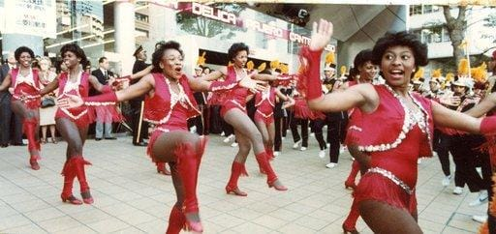

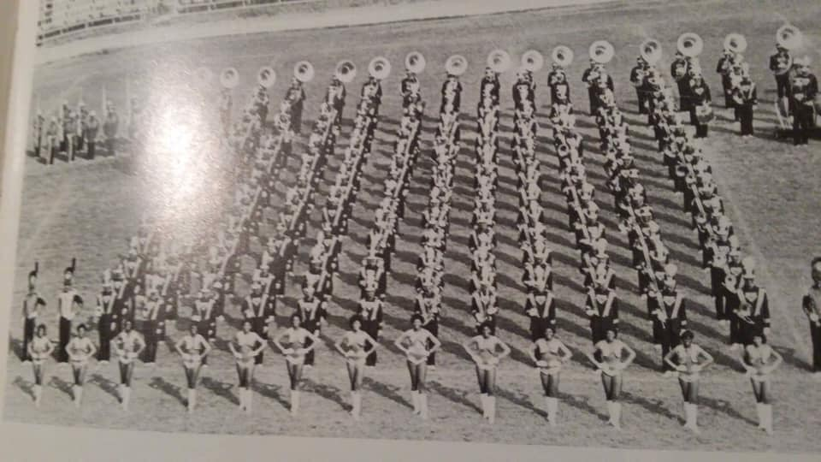
Because I am an alumna. I have access to more current and alumni Orchesis than the other dance lines I researched, so my information comes directly from the source. I was fortunate to interview the former Orchesis Dance Company Artistic Director-Dianne Maroney Grigsby, ODC alumna, former mascot, and former assistant director-Ahsaki Thomas, and ODC alumna-Elodie Davis-Killins.
Dianne Maroney Grigsby
A native of Norfolk, VA, Dianne Maroney Grigsby started dancing at fourteen. In 1973 she left for New York City to study at the Ailey school. She later danced with Ailey ll and was rehearsal director and the assistant to the artistic director of Ailey ll. In 1983, she left Ailey ll to become the director of the Orchesis Club and to pursue a bachelor’s degree at Grambling State University. She continued her education at Louisiana Tech University and received a master’s level degree in Theatre. Dianne had a long artistic relationship with Carol Anglin’s Louisiana Dance Foundation and its resident dance company, Louisiana Dance Theatre which led to the appointment of artistic associate. Over the past thirty-plus years, she has been instrumental in the dance scene in Northern Louisiana. As a judge on lifetime’s hit reality TV show Bring it!, she has reached dancers throughout the nation.
JG: How did you end up at Grambling State University?
DMG: This is how it happened. I was in the second company and Sylvia’s assistant (At the time, Sylvia Waters was the artistic director of Ailey ll). We taught at Texas Woman’s University, we left there the next day and taught a workshop/ master class for Ms. Carol (Carol Smitherman Anglin was the founder and owner of Carol Anglin Dance Center and Artistic Director of Louisiana Dance Theatre in Shreveport, LA). I taught a master class at Grambling. Ms. Carol took my class. She walked through the door and I’m like, “girl you following me?” I just remember Ms. Carol and Sylvia saying Dianne this is a historical black university do you think you can do “Cry” tonight. I was like, “Yeah.” Did you bring your honey and molasses? I said, “yeah!” She put it on the program. That was lyceum at that time so everyone was required to attend. That next morning Sylvia and I had a breakfast and she said “Dianne you always said you wanted to go back to school maybe this is the opportunity you have been waiting on. They’re looking for an instructor.” I got back to New York. I had Ms. Carol’s number, maybe she can put me in contact with the right person. I called her. She said “I’ll call you back in 3 mins!” I put the phone down. RING! She said, the number is … Ms. Williams. And Ms. Williams said, “Oh wow you are the answer to my prayers. If you move here, I’ll build a school.” She always wanted her own dance school. She said, “I tell you what, you write a letter to the president and I’ll do my part.” [sic]
JG: How would you describe the Orchesis style before you started working with them?
DMG: I never got a chance to see them perform before I got here. I just know I brought something different and taught skills. Like a warm up before we start dancing. They didn’t have a technical warmup. There were about three girls that had previous training like dancer 1. Dancer #1 had ballet training. Dancer # 2 was overweight. I was really strict about that back then but she could move and she had some training…I tell you what, whatever they did, it was clean. There was no gyration of the pelvis or anything like that because Ms. Williams didn’t tolerate that. They couldn’t wear jeans. I mean they dressed to travel. They looked presentable all the time. [sic]
JG: How did you decide what to teach them?
DMG: I stayed in the theatre. I felt at home. All of the classes and everything was there. Leaving Ailey at that time, the Graham technique was still there. I was teaching them Graham technique, I was teaching them Horton technique, and I was teaching ballet class. I was just sharing what I learned from Ailey (the training she received as a student at the Ailey school and as a member of Ailey ll). I think in the beginning they had things structured already. They had a fight song. I don’t remember them having a break down. I remember choreographing the break down with the figure eight. [sic]
JG: Yup, I always recognized the Horton influence in the break down.
It is important to note that Dianne Maroney Grigsby’s foundation is in modern dance. At the Ailey school, she definitely took ballet and modern, and for, electives it most likely was jazz, or West African, or hip hop. Her point of view is from her experience in the concert dance world in the 1970s- 1980s. In the 1970s when she arrived in NYC to study at The Ailey School, and even in the 1980s when she relocated to rural Grambling, La to be director of the Orchesis Dance Company, European Dance aesthetics were seen as the standard. Which is still evident in the concert dance world and dance in academia. When she came to Grambling, she brought a view of dance from a European dance aesthetic perspective. She mentioned, “there were about three girls that had previous training” and then says dancer #1 had ballet training. I don’t know if the other dancers had any type of dance training or if she was only considering ballet as proper training. I do know that even today, in most university dance programs, only ballet and modern training that prospective students obtain is considered relevant. Second, she pointed out that dancer #2 was overweight. Being a student at the Ailey school; one of my instructors talked about the school “back in the day” and how strict it was. The conversation was about hair. They mentioned how the then director of the school would walk the halls and peek in the studio. If she saw someone with an unacceptable hairstyle like corn rows, she would pull them out of class. Ms. Maroney would often tell the Orchesis Dance Company about how she was told she had to lose weight as a student at the Ailey school. Third, the use of the word “clean” to describe the Orchesis Dance Company movement that did not involve the pelvis. 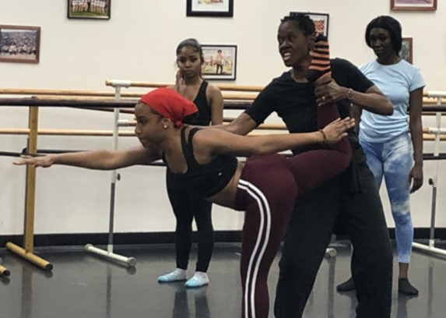 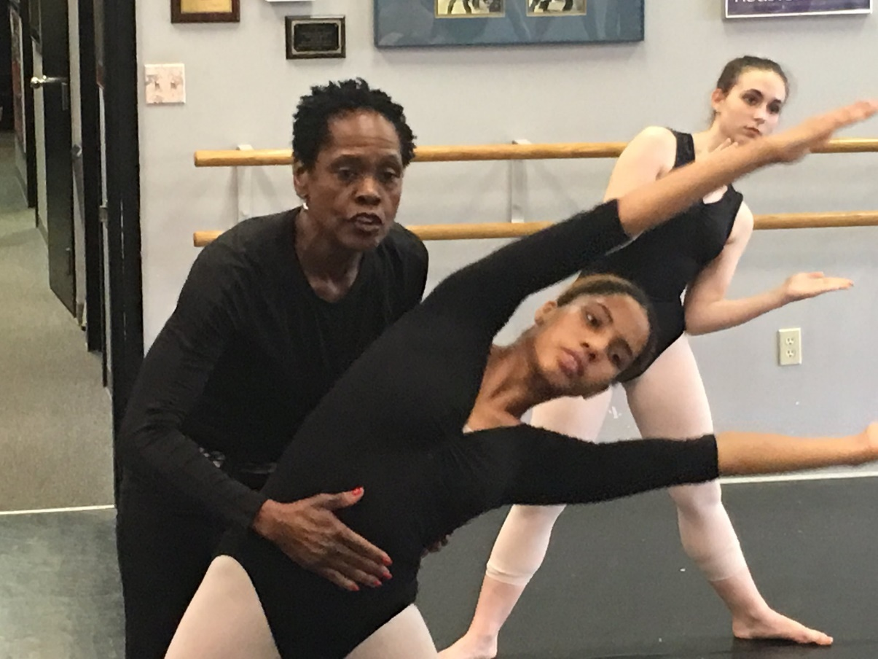 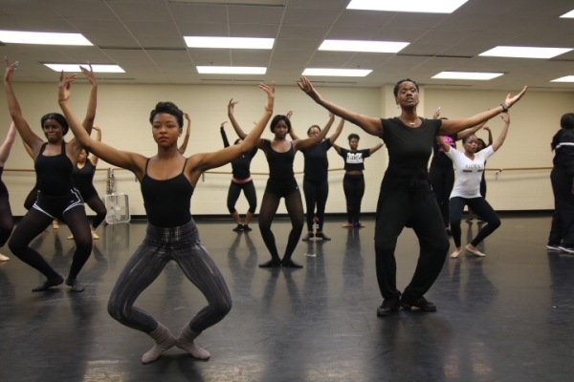
Elodie Davis- Killins
Elodie Davis-Killins was a member of the Orchesis Dance Company from 1980 to 1984. Recruited by Virgie Broussard, she attended Grambling State University on a dance/band scholarship. At this time ODC was a part of the band so the scholarship was through the band. She recalls impressing Virgie Broussard with her ballet training. “I think she knew with the training that I had, it would expand Grambling’s program. So that’s why she was trying to really recruit me because she wanted to use that, which she did.”
JG: When you said you were recruited at an audition. What did the audition consist of?
EDK: Basically, they just gave you some combinations. It was like a class.[sic]
JG: Was it ballet, modern, jazz?
EDK: Yeah, we did all of that. She did some ballet but it was more modern. They didn’t give me any field work type of dance at all. I didn’t get any of that. No march, no cadence.[sic]
JG: Growing up in New Orleans you saw Bayou Classic. Were you familiar with Grambling? If so, how would you describe the movement performed on the field back then?
EDK: I was familiar with both of the schools. Grambling was clearly defined. I had seen other dancers too. I think because I was focusing more on the artistic side so I always liked Grambling. I liked Southern too but I saw a clear distinction between Grambling, Southern, Jackson State, and all of those schools. Everybody knew Grambling because Grambling was known for their poise, their grace, their sophistication. And all that to me was an extension of Ms. Williams. Ms. Williams was dignified. That’s what she was known for. She was very polished. Her girls reflected that.[sic]
JG: The clear distinction. Do you think it had anything to do with the technique/ classical training?
EDK: Yes, I think it did. Because even though Ms. Williams wasn’t classically trained … if you talk to Ms. Jeff (dance educator located in New Orleans, La), they were always going to Connecticut and New York. They were always training and she was always bringing people to Grambling to train. She was just a natural. They would always say she was before her time. Ms. Williams locked on to Ms. Jeff too because she knew Ms. Jeff had a lot to contribute too. So yeah, it was a clear distinction. It was their technique, execution, and they had a strong performance level. They had a strong presence in my opinion. And she worked hard to keep that distinction.[sic]
JG: So, the HBCU marching bands also have a distinctive style as well. The way that they march. The way that they play the popular tunes of the particular era. They also have their dance breaks, for example Grambling (marching band) dances the entire field show which consist of popular dances. So, I was wondering if that was something Grambling and the other dance lines did as well. Do you remember performing or seeing other school perform popular dances of that day?
EDK: Texas Southern was doing stuff like that. Jackson State was doing that. Grambling never did. Dianne would say we gonna get technical right here and then we’ll get a lil funky. But it was never popular dances of the day.[sic]
JG: So, before Ms. Maroney came ya’ll were doing technique on the field?
EDK: Oh yes, by all means. She just enhanced it. We had more everyday exposure to it. We trained every day. We did train with Ms. Williams, but like I said, you had people who was heavily trained and then a whole other set that was not. So she had a better balance of dancers. That’s what I would love to see personally for Orchesis. You don't see that distinction as much as you did in the past. You were able to define Orchesis.[sic]
JG: Do you think back then the Orchesis were the trend setters of the SWAC?
EDK: Oh my god, yes! By all means. Back then they had all those bands but it was only two. And even for the dancers it was only two. That competition, Grambling and Southern. That was it. They set the standard.[sic]
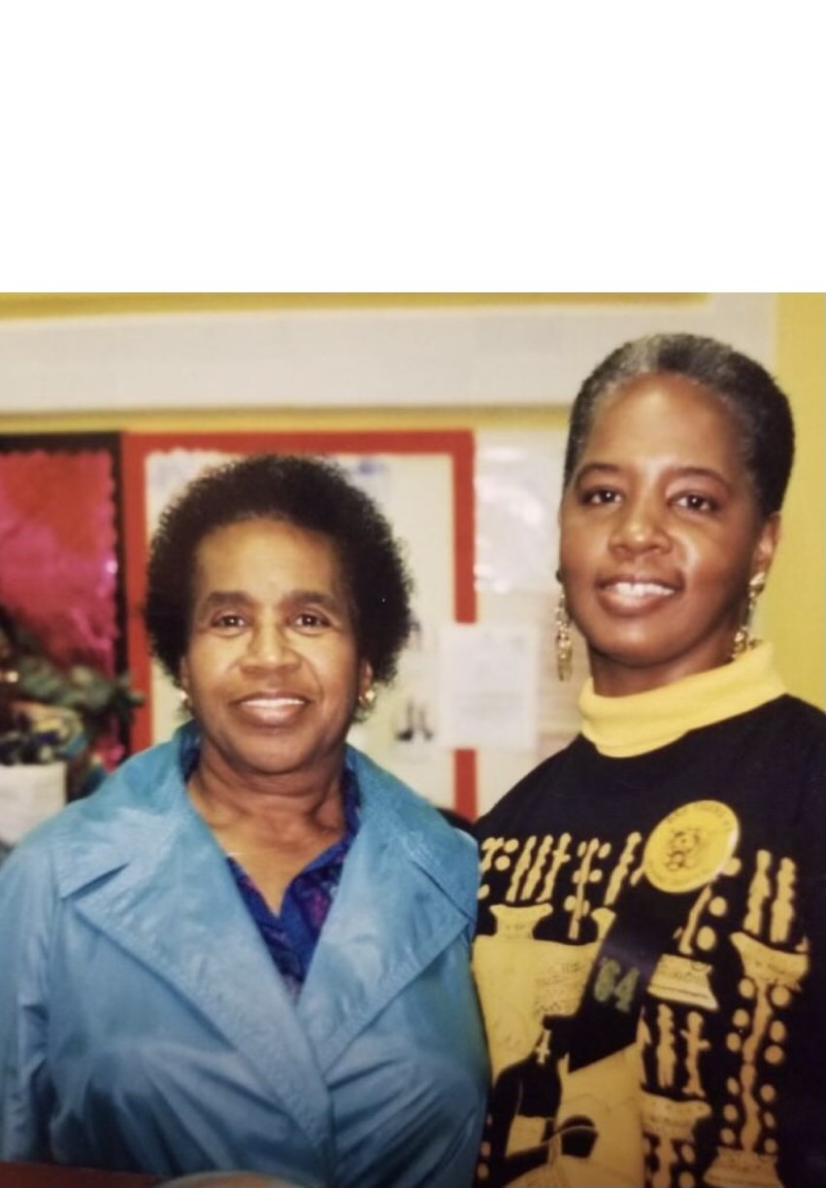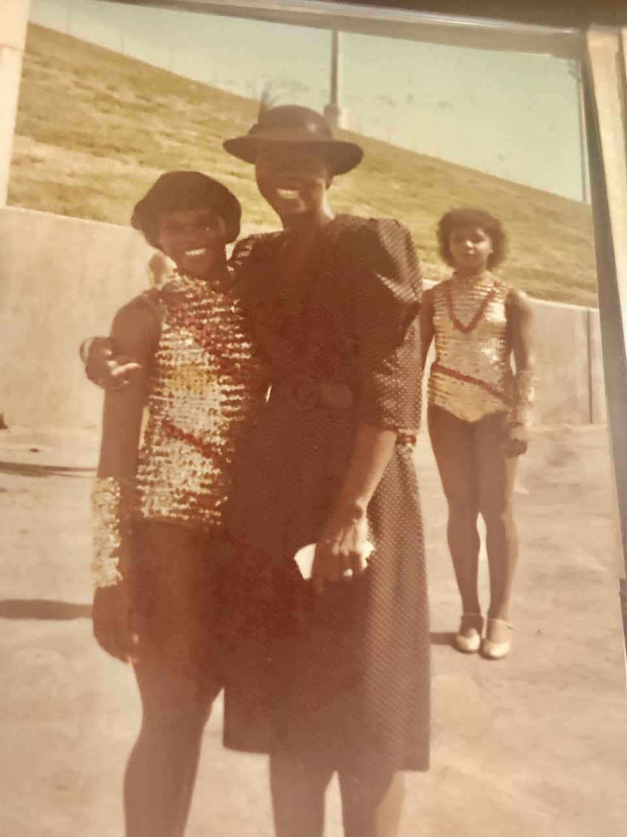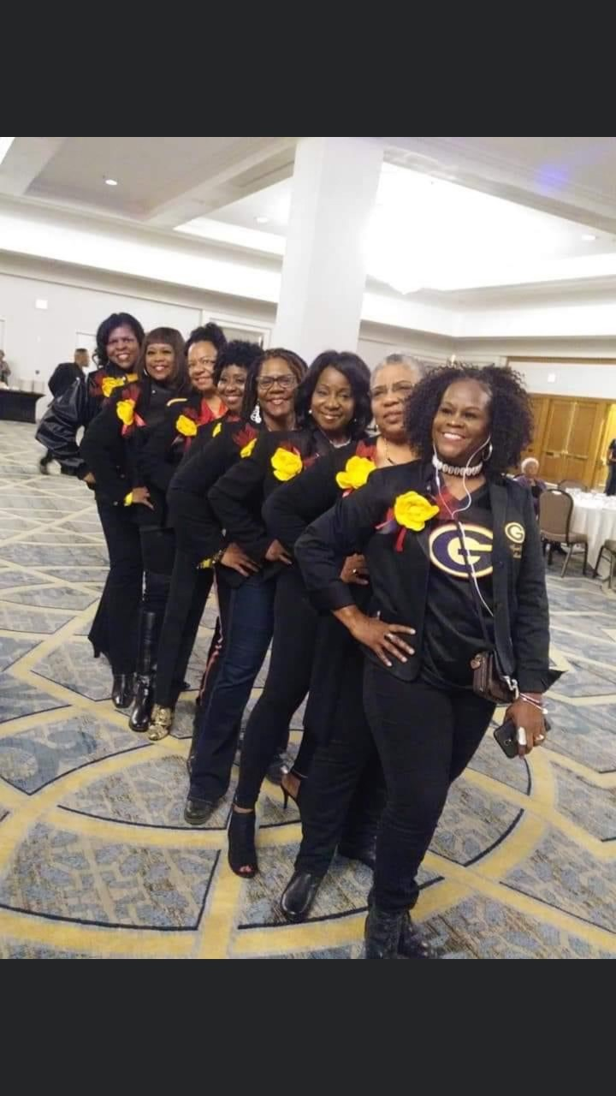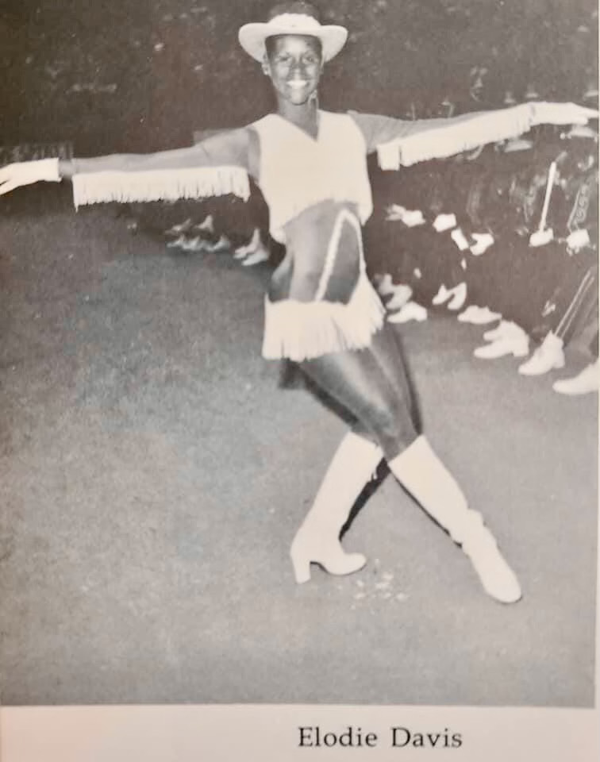

Ahsaki Thomas
Ahsaki Thomas was a member of the Orchesis Dance Company from 2001 to 2006. She had the pleasure of knowing and working with Catherine Jones Williams and Dianne Maroney Grigsby. As a native of Grambling, Louisana, Ahsaki completed all of her schooling in the Grambling school system elementary-high school, and Grambling State University. Since she was three years old she studied with Dianne Maroney Grigsby at Catherine’s Dance Art and Fitness Center in ballet, modern, jazz, and what she called an Aileyesque style. When explaining her faith to be a member of the Orchesis dance company she says “it was just something I was brought into because I was with Ms. Maroney a lot of the time. So, it was more like being brought into the fold.” In this interview, my goal was to find out her perspective of what the Orchesis style is and the emphasis on European dance aesthetics as a foundation of the Orchesis Dance Company. Here is a portion of our dialogue:
AT: The Orchesis don’t have a pinpointed style. It’s not one that you can just look and put it in a class of its own. You would say ok this is a Prancing J-Sette, this is a Dancing Doll, and this is a Motion of the Ocean. The Orchesis stand out because we utilize various aspects of dance. Not just the traditional or foundationary stuff, but whatever members of the company pick up… Because you know Maroney encourages everyone “go somewhere for the summer and expand your dance knowledge” With everyone bringing those different flavors and styles back, and you incorporate that, you know you may have stands that are more sassy, others that are sensual, some that are more energetic, and some that are more aggressive. We don’t have a pin point style so it makes it hard for people to understand exactly what it is. It makes it hard for them (prospective dancers) to pre train to try to get there. But mainly, we don’t function as a traditional dance team. It’s a program; it’s a company. Whatever you are lacking, you will learn if you just come. It’s not something that you have to train a year out in advance before you come to audition.[sic]
JG: I feel the same way. I talk to Willie (a male Orchesis alumnus) about these types of things all the time. We talk about the different styles throughout the SWAC and I could never pin point what the Orchesis Style was. I feel like the Prancing J-Settes and the Dolls are the two most distinctive styles in the SWAC. Especially if you’ve never been in the company, it’s hard for people to grasp what is going on. We pull from everything. So it’s unpredictable. Willie feels like our aesthetic is a “trained” dancer. I agree. A “trained” dancer as in you are given a foundation and then expected to pull off whatever the choreographer throws at you. And that choreographer is pulling from their dance vocabulary. You were talking about the foundational elements incorporated in the stand routines. We value European Dance Aesthetics, like a straight spine.
JG: Did the Orchesis Dance Company ever buck in the very beginning? As far as you remember. I know you talked about how the ripples were modern and jazz base. When did we start to look around like, “oh they’re bucking, lets buck. Let’s add that into the equation?”
AT: That didn’t really start to occur until the late 90s when Keitha was captain. She started incorporating it in. The thing is because Ms. Maroney and her views on what actual dance is… Even me being in the company, we kinda had to tip toe around it and kind of ease it in because it was always a “no, no, no don’t drop your derriere below your knees” Once we started adding it in here and there and she didn’t say anything, you let some time pass and you add a little more. You had to kinda work with her. “Look shug!” At that time we were calling her Boney Maroney. “Look this what they doing! Look, this is where dance is going!” and “See this is how we gon get attention.” It was a little by little feed in. Honestly, it didn’t start popping up and being really dominate until the teens (2010 and later). At that point, she was like “ok shug, well just go head.”[sic]
JG: So even before Ms. Maroney they weren’t doing that type of dancing (bucking)?
AT: Oh no! Ms. Virgie wasn’t letting that happen and definitely not Ms. Catherine.[sic]
JG: So, they were basically in the same realm as Ms. Maroney, where they valued more ballet and jazz and modern?
AT: They valued the art of dance not what’s going on now “cause that's gonna change”, Ms. Catherine would say that all the time. “That kind of stuff changes all the time. You need to learn the basics. When you learn the basics and the foundation then you can do anything. That’s not going to last.” She was real strict on that. I never worked with Ms. Broussard directly as far as having some type of training under her but just seeing how she functions throughout the unit whenever we get together you can tell she’s that traditional old school dance studio teacher. Like this is the make it or break it way.[sic]
JG: Back then, did ya’ll ever incorporate social dances of that day into the stand routines and field shows?
AT: Yeah. When she allowed it. Again, things like that weren’t allowed until late 90s early 2000s.[sic]
JG: There’s this video on YouTube of the Orchesis Dance Company posted by Gods1stdyme 10 years ago. They had on the tuxedo costume and they did “box” and “boogie wonderland” (“box” and “boogie wonderland” are ODC stand routines). They look very clean. You Know, you can clearly see the lines. They get down a little bit but I can tell they weren’t getting down as much as others (HBCU dance lines). Someone in the comment section said something along the lines of Orchesis are stiff. I’ve heard that a lot over the years from people outside of the company.
AT: Like you said before, if you’re not familiar with the company and our aesthetics and our background you’re not going to fully understand it. Because when it comes to the HBCU culture and that dance team environment, they rely more on those grounded like African based movement and our stuff is traditional so we know that placement. We know how to lift, we know how to be grounded, and cleanliness is what we try to work towards we pride ourselves on that. Because you don’t want to go out there and be sloppy. Not to say other teams look sloppy. If when it comes to teaching their moves or their style, if they’re not consistent in making sure everyone looks alike. That’s still a form of cleanliness. You just have a more chaotic cleanliness. We don’t function on that. Like I told you, “You’re still just as placed as I remember.”[sic]
JG: Well, you know, it’s like when Ms. Maroney would say, “Don’t allow the arms to disconnect from the back”, stuff like that. And that comes from that ballet, modern, jazz background.
AT: That’s because we have company class. People don’t understand, we don’t show up to practice like the Dolls and the J-Settes and say “ok let’s warm up, here’s the routine” We are actually at a barre or in the center of the floor, rolling down rolling up.[sic]
JG: We come from two different worlds. So, when they (other HBCU dance lines and fans) try to look at what we (ODC) do from their point of view, from their lens it doesn’t work. The same for us. We look at them like “Oh, you arching your back, your rib cage is out”
AT: “Girl you saw that back leg? That foot wasn’t turned out.” They look at us and say “Girl they stiff, they not shaking hard enough.” It all comes with how you incorporate things. When me and smiley was there and were trying to help them with field shows and stands. That was one of the issues we ran into constantly. Like loosen up! You did the barre stuff you did across the floor. Well now you’re doing stands (stand routines). This is a whole other environment. Make your movements bigger. Scoop! Swoop! Give us something! And you have to really incorporate that and really drill that and make sure they know the difference. It not only helps the program but it helps them to grow too. A lot of them expressed when I leave Grambling I want to go and be in someone’s concert. Ok, well you don’t know what they’ll ask of you. They may want you to do a little one two twizzle but they may also want you to get down brown. You need to really understand the difference.[sic]
European dance like ballet and modern are taught as foundational techniques. In academia, they are both offered at multiple levels. African and African diasporan dance is mostly only offered at a beginner level as if it is not worth studying in-depth. Ahsaki mentioned Dianne and “her views of what actual dance is” and what Catherine said, “That kind of stuff (social dance) changes all the time. You need to learn the basics. When you learn the basics and the foundation, then you can do anything. That’s not going to last.” The perspective that only European dance is worth training in and will sustain you as a dancer is echoed in Catherine’s and Dianne’s words and how they chose to run their program. They “valued the art of dance.” As they prepared their dancers for a professional dance career, their perspective is on trend according to the concert dance community.
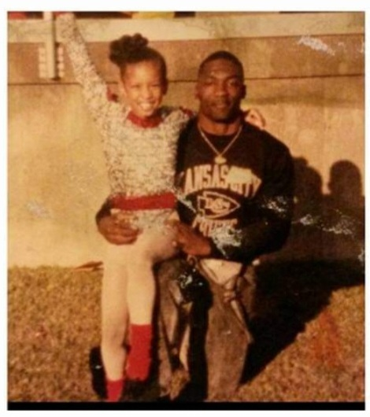
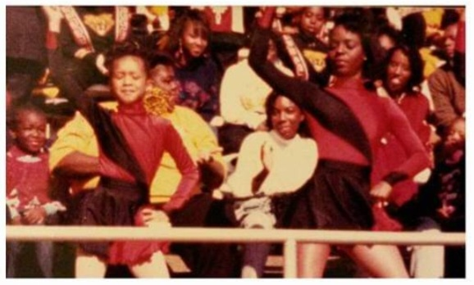
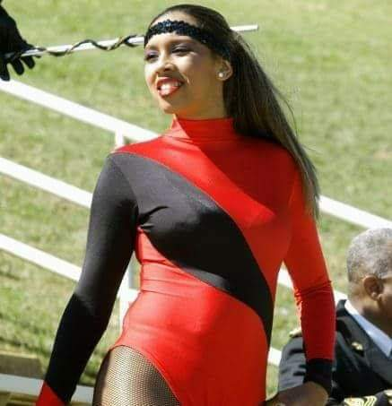
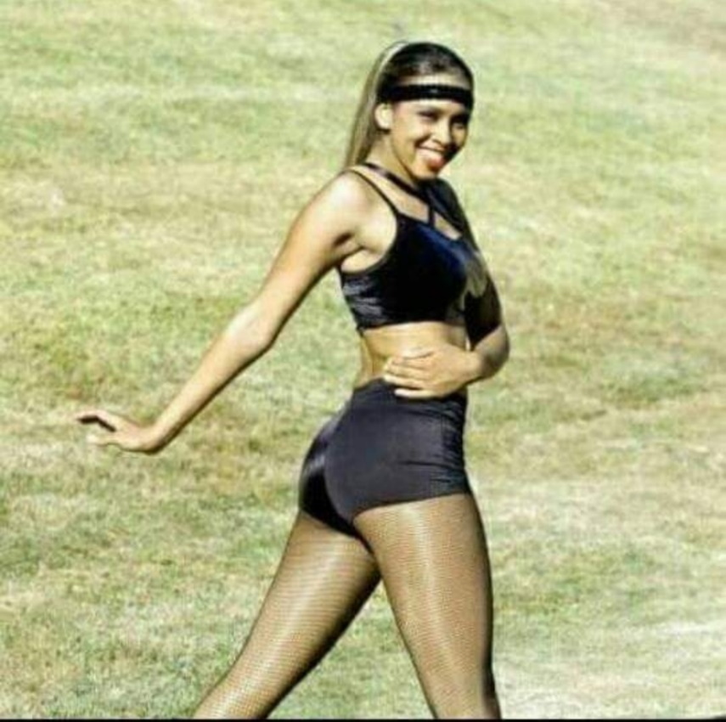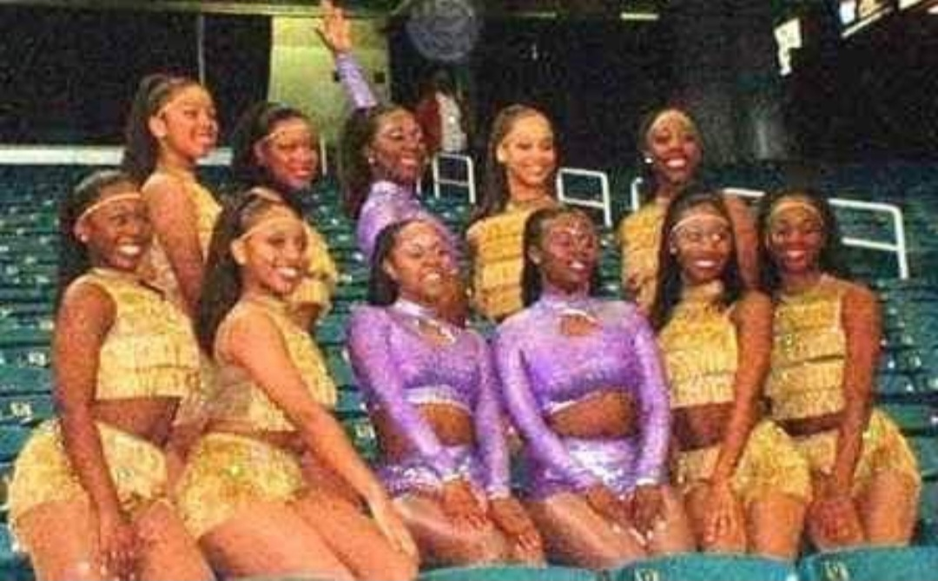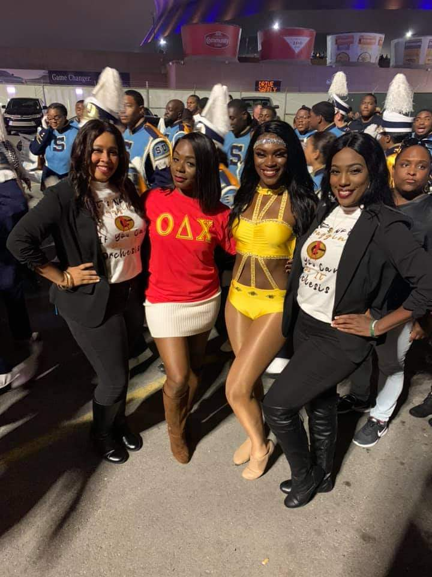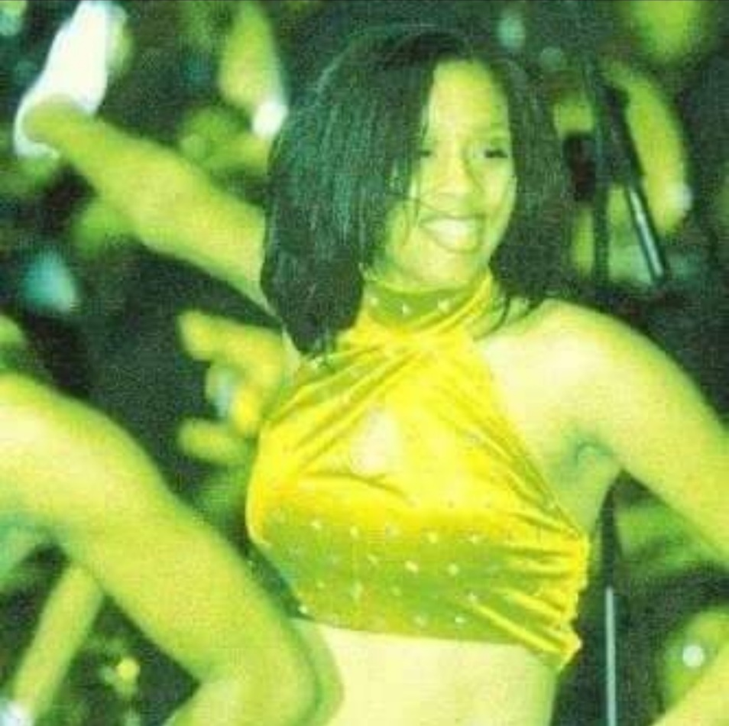

Male Embodied Femininity
Hollis Pippins, once a male twirler at Jackson State University, is recorded as a choreographer for the Prancing J-Settes in the formative years. I could not find any information on what and how much he choreographed. In Lamont Loyd-Sims’ thesis, “J-Setting in Public: Black Queer Desires and Worldmaking,” Lamont Loyd-Sims offers his opinion on Pippins’ involvement in the creation of the Prancing J-Sette’s style:
While there is not much written that elaborates on Pippins’ contribution to the early formation of the Prancing J-Settes, his existence and work is a reminder of men’s early influence on the majorette style. Many j-setters often explain that the style of dance began with women, but this bit of information regarding the history of JSU’s majorette style illustrates how gay men have also been creative influences on the style.
Hollis Pippins “existence and work” is worth mentioning. It makes me think about my own experience as an HBCU dancer. When I first became a member of the Orchesis Dance Company, I could not help but notice the male presence when the field girls were rehearsing. Appearances at the football game are one of the many performance obligations of the Orchesis Dance Company. The company had about 35 dancers but not all dancers performed for each football game. After the weekly audition, the girls chosen to perform at the football game were called the field girls. Up until the midweek audition, everyone had to attend the stand routine and field show rehearsals. The male dancers had to participate because the director, Dianne Maroney Grigsby, felt it could help all company members with their technique and placement. A lot of the male Orchesis liked it so much that even when they didn’t have to be at field rehearsals, they came anyway to watch, critique, and sometimes dance on the side. They knew all the stand routines and even choreographed their own. If the captain at the time liked the choreography, it was added to the repertoire and performed at the games. This happened often. As captain, I even used choreography that male cheerleaders pitched to me. I befriended a lot of the male Orchesis during my time in the company and when we hung out outside of rehearsals, they loved to watch videos of the field girls, from Grambling State University and other HBCUs. I learned so much about the HBCU dance culture from my male dance friends. They were able to tell the history of the company and all other HBCU dance lines. They were also familiar with the dance style of other dance lines and were able to perform stand routines from multiple HBCU dance lines. Investigating the male presence in this traditionally exclusively female community, I found this is a common thing. Gay and straight male dancers at HBCUs are fascinated with the field girls and the choreography. Anthony Hamilton, an alumnus of JSU, recalls how men would be on the sidelines during the Prancing J-Settes’ practice watching and learning:
My friends would be on the side doing the dance alongside the girls.” However, their imitation was not seen by all as flattery. “Teachers and coaches would run the gay boys away,” Hardaway says with a laugh, “because when it was time for the games, the gay boys would be in the stands doing the routine and outperforming the girls on the field.
It isn’t always the case that these male dancers are invited and welcomed to attend the rehearsals with the field girls like the male Orchesis. Whether invited or watching and learning from the sidelines or videos, they are paying attention and soaking it up. Just like my male friends taught me history about our dance line and other dance lines, I find that other gay and sometimes straight male dancers take pride in learning everything about these HBCU dance line organizations and the field girls themselves. On social media platforms like Instagram, whenever there is a post about HBCU dance lines or an HBCU dancer, the comment section is full of men watching and commenting critiques, praises, and fact-checking other commenters. I’ve also noticed that a majority of the amateur videographers who film and post HBCU dance line content are men. These amateur videographers film at the football games and any other event you can find the marching band and dancers. They then post on platforms like Instagram and YouTube. While watching an abundance of these videos, I noticed that the audience that surrounds the girls are mainly men. These HBCU Dance Line content creators include videos of football performances but also, they talk about their favorite dancers. Verses videos are popular as well. This is when they compare two HBCU dance lines’ performances and decide who was better. YouTuber, Morgan Williams has a series called “Incoming Call.” In this series he has different HBCU dancers join him on screen for an interview. He asks questions that he and other viewers want to know about their experience.
Before the ordinary person could go out and buy a video camera, these men were documenting the history by physically learning and doing the choreography behind the scenes. With their knowledge of the HBCU dance lines and eagerness to be a part in some way, they became the keeper of the history along with the women who actually danced at the football games. Behind the scenes, they are the coaches and choreographers. When Onecia Ford, a former Prancing J-Sette, was planning to try out for the Prancing J-Settes the first time, she would watch videos on YouTube to pick up the style. When she did not make it, the sponsor told her she just did not have the style, precisely the tiny but essential details like the placement of the hand. As she prepared for the following year’s audition, she “met up with a lot of the gay guys at Jackson State.” She said they knew the J-Sette style better than she did and without them, she probably still would not have been a Prancing J-Sette.
Male J-Setters
The term J-Setting came to also mean the practice of male dancers performing dance routines that include the Prancing J-Settes marching and dance style. The Prancing J-Settes and other HBCU dance lines are showcased in public in a place that demands heteronormativity, the football field, and the stadium. Women rarely participate as football players and there is also no space for gay men to perform in front of the marching band. Therefore, the male j-setters perform where they can be the central focus. This practice developed in the early 1990s in underground gay clubs throughout the south. Underground, they were able to experiment with femininity freely. Soon teams formed among the male j-setters. Competitions followed, as it allowed j-setters to “battle” one another and take part in communion with dancers and other supporters. During these competitions, the male j-setters pay homage to traditions by including categories such as a field show. They perform a rendition of a traditional halftime performance to band music. Lamont Loyd Sims interviewed such male J-Setters in his thesis “J-Setting in Public: Black Queer Desires and Worldmaking.” He notes that the male J-Setters referred to the female dancers who dance at the football games as the “real girls” similar to how the Orchesis Dance Company calls them the “field girls.” “Traditional,” in this context, also refers to the female dancers who dance at the football games and what they performed. Underground the male j-setters experimented with femininity through the j-setting style but also added their own flare. When dancing in the stands, the “real girls” had very little room to travel, resulting in a lot of the movement being stationary. The male j-setters did not have this problem. They could go beyond the limits the “real girls” had in terms of physicality.
“She Dance Like a Big Ol’ Queen”
The male Orchesis who provided choreography for the “field girls”, the “gay guys” at Jackson State who helped Onecia with the details, and Hollis Pippins training the “real girls” at JSU shows that men have been and continue to be present creatively. It also shows that embodying femininity is not only possible in the female body. Outside of the male j-setters interacting with each other underground, above ground, they’re in a female-dominated community. Above ground, they are truly behind the scenes and are utilized in the role of coach and choreographer in the majorette/hip hop majorette community. What exactly do the men bring creatively? As the coach and/or choreographer, they’re in a position to be very influential. Their students, male and female, pick up on how their male coach and or choreographer embody femininity. There is a saying in the HBCU dance line community “she dance like a big ol’ queen.” It is said as an insult. This means that the female dancer is approaching the movement in a way that a “queen” would. “Queen” means a gay male who publicly displays characteristics associated with femininity in the traditional sense. Usually, it is displayed in an over-the-top exaggerated way. In this context, the “queen” is a dancer, and the female dancer who “dance like a queen” is exaggerating the movement. Particularly the nuances of the choreography that make it feminine, feminine in the traditional sense. Traditional femininity in dance is translated as soft, and delicate. Traditional masculinity in dance is translated as strong, and powerful. The “queen” embodies femininity in a harder, way more exaggerated way. I interviewed Leonardo Devine, a traveling majorette coach. Leonardo learned his first eight count or stand routine from his aunt when he was five. Later he danced on a j-sette team in Augusta, Georgia. Currently, he travels all over the United States teaching the j-sette style. In our interview, he gave his opinion on women performing the j-sette style as opposed to men performing j-sette movement: “The females have the body, the hair, it’s just the overall look. The male we do too, but we’re going to do it a little bit harder, and a little bit tougher than how the female body would move soft and fluid, as far as the dancing.” I asked if he felt like men should dance on HBCU dance lines. He felt they shouldn’t but would be best behind the scenes for the reasons mentioned above. From what I’ve gathered from his Instagram, his students are mainly female youth dancers. I do not know his sexual preference but regardless he is a man teaching J-Setting, which is considered a feminine style. I see this phenomenon as a cycle, female dancers looking to learn how to be feminine from a man who is imitating female embodied femininity. Male coaches have to sometimes also teach their female dancers about their overall appearance. For example, make-up. I’m reminded of the current social media make-up trends. The eyeshadow and contour techniques and bold eyelashes and eyebrows are similar to drag makeup. The result of the cycle is exaggerated femininity on not only men but women as well.
When I look at HBCU dance lines in 2022, I notice the movement is done hard or aggressive. There is little subtlety. Even the movement that is supposed to be soft is hit harder. This could be because of the setting in which the HBCU dance lines perform and the need for the team to see you on the other side of the field. Another reason could be the connection to the Africanist aesthetic, ephebism, which shows up through characteristics such as power, vitality, flexibility, drive, attack, sharpness, and intensity. Perhaps the hardness is in part a result of having male coaches and choreographers.
Hip Hop Majorette
Hip hop majorette, also known as majorette, is the competitive and more exaggerated version of the Prancing J-Settes marching and dance styles along with other HBCU dance line styles. It is made up of a majority female but also male youth. Hip hop majorettes visibility and popularity have grown since the debut of the Lifetime show, Bring It! The reality dance TV show follows the Dancing Dolls from Jackson, Mississippi, and Coach Dianna Williams as they compete and dominate the hip hop majorette scene. The term “majorette” was used earlier to describe a baton twirler. Because the term majorette is also used to describe the black youth competition dance teams and studios, I will use the term hip hop majorette when talking about the competitive youth dance teams and studios to differentiate the two.
Behind the Scenes with Leonardo Devine, A Traveling Majorette Coach
Leonardo Devine and I met at a majorette competition in Oklahoma City, Ok during the summer of 2021. I had seen him on Instagram a couple of times but after we met in person, I wanted to learn more about his work as a male j-setter and hip hop majorette coach. He refers to himself as a traveling majorette coach. It started in his hometown Augusta, Georgia, but after Bring It! came out his clientele expanded across the United States. He told me “a lot of the coaches that didn't have the style (Prancing J-Settes), they would contact me to learn the style. The Salt and Pepper, the marches, the struts, learning how to perform a field show the correct way (HBCU style), and just dancing to band music period.”
I invited Leonardo, also known as, @MrSetteitoff on Instagram to come out to Norman, Oklahoma. The plan was to book him to teach me a mini workshop on j-setting. I first reached out to him via Instagram, inquiring about a workshop he was advertising on his page. The dates of the workshop didn’t work with my schedule so we decided it would be best if we met up for a private lesson. The initial schedule I pitched to him was a one-hour and 30-minute J-Sette class, one hour and 30 minutes to teach and clean 30 seconds of J-Sette choreography, and an interview. He agreed and we met on the campus of the University of Oklahoma in one of the dance studios. Videographer, Mat Miller, was there to capture footage of the class, choreography, and the interview. With the footage, Mat and I, edit down to a four-minute overview of Leonardo’s and I time together. I showed “Behind the Scenes with Leonardo Devine, a Traveling Majorette Coach” at my Thesis Presentation, Beat AF (and faceted): A Celebration and Exploration of the “Rich, Black, Southern Heritage” of HBCU Dance Lines, Majorette, and J-Setting.
For the class I was expecting a warm up, warming up the large muscle groups first. Then more intricate exercises that expand the movement introduced during the warm up. When I teach a modern dance class this is how I organize my class. This has also been my experience taking a ballet, jazz, and contemporary class. Leonardo did not do a warm up and, when reflecting on his class, I realized I don’t know what a warm up would look like that specifically caters to the j-sette style. His class was in a game format: march-ins, then stands routines, and field show last. We started with the salt and pepper and the pull or tip toe. The salt and pepper and the pull/tip toe are both signature Prancing J-Settes marches. We moved on to mark times which fall under the march-in category. The purpose of the mark time is to keep the tempo as the dancers wait to travel forward. This is taken off of the marching band. If the dancers travel too far away from the marching band, they use mark time choreography to allow the marching band to catch up. If the marching band stops moving for any reason, mark time choreography is done until the band starts moving forward again. Next, we did stand routines. Stand routines are routines performed in the stands or bleachers. A stand routine is choreographed in increments of eight. It can be eight counts, sixteen counts, Thirty-two counts, or more. Leonardo taught two slow stand routines, two medium, and two fast. Slow stand routines are choreographed to be performed to slow music. Same for the medium and fast. We finished with a field show. The field show is a combination of the march in, stand routines, and larger movements that travel. Skills like turns, leaps, and kicks are added in to increase the wow factor. I learned from Leonardo that the Prancing J-Sette style is very detailed. Like the placement of the hands. We talked about blades where there is no space in between the fingers. Pretty fingers are when the pinky, ring, and pointer fingers are stretching up and the middle is stretched down towards the thumb. A fist is made by folding four fingers over the thumb. An “L” is a blade made with four fingers and the thumb perpendicular. All of these hand placements can be used in one stand routine. There were a lot of times in the class I wasn’t catching on to the style. I was too upright and needed to relax my torso. Throughout the class, he gave me notes on being too stiff and placed. In one particular conversation he said “with your style and background, you’re going to make everything clean but when you add that sass and attitude and a little harder than it will look like us (J-Sette). We try to look pretty but we also try to look more gritty and spicy.” [sic] He demonstrated what he meant by repeating the same movement twice, once in my style and once in his style. Stepping back onto the right leg, keeping the weight on the right leg he plied two legs and pushed the pelvis back as he sat into the back (right) hip. The arm went up into a high “V” and the head and sternum lifted towards the ceiling as he sat into the back hip. The difference was all in the torso. My spine was barely affected. He, on the other hand, as he sat into the back hip, he pushed the butt out as far as possible. As he lifted the head and sternum he went as far as possible, and his spine was arched. Throughout the class I was taking notes of the similarities and differences between our dance backgrounds. Leonardo is from a J-Sette background which is rooted in an Africanist aesthetic. I come from a modern dance background which is rooted in European dance aesthetics. I also come from an HBCU dance line background, so I am able to identify both. A kick or battement was choreographed into the field show Leonardo taught me. It is when the leg is moved outwards from the body and then in again. When performed with a European dance aesthetic, the spine is a straight line and is not disturbed by the movement of the leg. The straight line starts at the heel of the foot of the leg that is connected to the floor and ends at the top of the head. From an Africanist dance perspective, there doesn’t need to be a straight line from the heel to the top of the head. The energy or height of the kick or battement is more important. So, the standing leg may be bent, and the spine may be rounded. I’ve seen this kick or battement in the Prancing J-Settes choreography and hip hop majorette choreography. Azizi Powell talks about this particular kick/battement in her blog post, “Jackson State University J-Settes' ‘Get Ready’ Routine.” They wonder if it is inspired by the high kicks that are a signature part of the traditional dances in South Africa [the region, and not just the nation of South Africa.] A video of such dances was included on the blog post. The Prancing J-Settes “Get Ready” routine is also included. In both videos as the leg goes up, the head is down and to the side of the leg in the air. It seems intentional, a stylistic choice. I asked Leonardo about the head and the battement in his choreography. He told me “because of the force, in our style of dance (j-setting), we will cock the head to the side a little bit.”
Behind the Scenes with Willie Miller and Drumline Jazz
Willie Miller, @Willietabillie on Instagram, is a dancer, choreographer, and dance instructor. He is also the creator of Drumline Jazz which is a style rooted in Willie’s commercial and HBCU dance line training. “I’m a commercial dancer, that’s what I specialize in, and of course, I have this HBCU dance line background. And so, I combined the two.” In high school he started dancing when he was a cheerleader. In college, he was afforded the opportunity to be a member of the Orchesis Dance Company at Grambling State University where he began his formal training. As a theatre major he knew dance could add value to his work as an actor. His theater background is a big influence on Drumline Jazz. “We work on facial expressions and what our face is doing at the time. Being able to adjust to different characters or facial expressions is a must in Drumline Jazz.”
I traveled to Norfolk, VA to take a private class with Willie. It followed the same format as with Leonardo: one hour and thirty minutes Drumline Jazz class, one hour and thirty minutes to teach Drumline Jazz choreography, and an interview. Allen Mays filmed the “Behind the Scenes with Willie Miller and Drumline Jazz” footage and Mat Miller edited. I also showed this footage at my thesis presentation.
Willie and I come from a similar dance background so the format of his class was familiar to me. The pre warm up consisted of, a jog around the studio, jumping jacks in place, and abdominal work like planks. We both were introduced to the Lester Horton technique (a modern dance technique created by Lester Horton) at Grambling State University. His warm up is a combination of Lester Horton exercises and Jazz exercises he explains:
We roll down. We won’t go into specifics like flat backs but we’ll roll down. We’ll do a tendu exercise to warm up the feet. Of course isolations of the head and shoulders just to get the whole body moving. It’s an intense style. It’s a lot! You gonna work, so let’s get the body moving and the whole body warmed up and prepared for what it’s about to partake in.
From there, his class format was similar to Leonardo’s as he also used a football game format: march-ins, stand routines, field show. The march-ins Willie taught resembled the Orchesis Dance Company signature march-ins with his own added flavor. His theatre influence shines through his performance exercises where the movement is simple because the point is to “engage the eyes, face, and develop your character.” This exercise is done in a call and response like a stand routine. He “calls” a particular eight count of choreography by performing it by himself. Then the rest of the class “responds” by repeating the same eight count of choreography an eight count later. This class ended in a longer movement phrase that includes everything we did prior to.
Like Leonardo, Willie is a coach and choreographer in the hip hop majorette community. His students are mainly women and young girls. I also do not know his sexual preference either but regardless he is a man coaching in the hip hop majorette community, which is considered a feminine style. Unlike Leonardo, Willie does not teach the Prancing J-Sette style. However, as an Orchesis he did do some of the same movement. When I asked: “HBCU dance lines and hip hop majorette started as a female dominated style, so how do you feel as a man teaching this style?” He answered:
I usually have females taking my class. Me being a male dancer teaching females, I feel that I’m very conscious of what I do. Because I do feel that females should take from female dancers and males should take from male dancers. However not to say that they can’t learn from each other. Personally, in my class I would love for another female instructor to be in there that knows where they can see ok this is a female that’s doing it because males are naturally stronger. They can do things stronger. Unless you can pretty much differentiate as a male dancer it should be softer because this style made by females so it should have a softer look. So, I try to when teaching to elaborate on that and try to show it as much as I can. [sic]
Willie feels that as it relates to dance, femininity is a style and masculinity is a style. In his Drumline Jazz class, he challenges the male dancers, who usually only wants to embody femininity, to switch it up and try to embody masculinity. He teaches neutral choreography and then ask the male dancer to make it masculine and next perform the same choreography with a feminine style. He believes that knowing how to go back and forth between femininity and masculinity will help the male dancer go further in the commercial dance world. He explains to the male dancers that take his class and only want to embody femininity that there isn’t many dance gigs for femme male dancers, so you have to be able to do both. This is an exercise he learned from Debbie Wilson who teaches at Broadway Dance Center in New York City.
Currently, there aren’t any spaces for a professional hip hop majorette dancer. When the dancers graduate from their studio at 18, they are done dancing unless they decide to coach a team. The dancers from the Lifetime reality TV show, Bring It! are now going on to dance on HBCU dance lines more than ever before. This is because of the recent interest in “technique” in the hip hop majorette community. As the hip hop majorette dancers continue to make the tricks and skills apart of their choreography, more hip hop majorette dancers now have the skills to make an HBCU dance line. The increase of hip hop majorette dancers chosen to dance on the HBCU dance lines means more male trained dancer are dancing on HBCU dance lines. As I seek to identify all the elements that consist of the HBCU dance line aesthetic, I have to take into consideration the male coach and choreographer’s male embodied femininity that is passed down. Although the male coaches and choreographer may or may not have contributed in creating the movement vocabulary of the HBCU dance lines, they have influenced the way the movement is approached and performed.

The Aesthetic of the Cool, the Finishing Touches of the HBCU Dance Line Aesthetic
The “unbothered” facial expression in the Historically Black College and University (HBCU) dance line community, in my opinion, was recently made popular by Southern University’s Fabulous Dancing Doll, Kayla Pittman. Video clips of her dancing at games with this unbothered demeanor reached a wide audience as the video clips often went viral. Making it look easy is a goal for dancers across all genres. Dancers are trained to not let the physical labor of dance show on the face. Even though our bodies are working really hard, our face remains pleasant. In Brenda Dixon Gottschild’s Digging the Africanist Presence in American Performance: Dance and Other Contexts, this concept is an Africanist dance aesthetic and is referred to as the aesthetic of the cool,
It is an attitude (in the sense that African Americans use that word) that combines composure with vitality. Its prime components are aesthetic visibility and lucidity (dancing the movements with clarity, presenting the self with clarity), and luminosity or brilliance. The picture is completed by facial composure, the actualized “mask of the cool.”
While working with Leonardo Devine, a traveling majorette coach, he said the difference between just dancing and j-setting, is the attitude. I learned some of the signature Prancing J-Settes’ marches. It is a completely different style than what I am used to with the Orchesis Dance Company. When he had me perform the march for him, I wasn’t confident in the movement and it showed on my face. Again, he said the attitude wasn’t right. What I interpreted is that the movement is not complete until it’s performed with attitude. Attitude equals confidence, and confidence presents itself in the entire body and adds another layer to the movement.
Dancers are also taught to practice the way you want to perform. Usually that means dancing with full physicality in the body and performing with feeling or intention. However, when it is time to perform for real, adrenaline kicks in which can help or hinder your performance. Also, with the costume, hair, and makeup some people tap into an alter ego. Physical appearance in the HBCU dance line community is important. There is a transformation that happens when the dancer is in full costume, hair, and makeup. I think the costumes aid in the presentation of the aesthetic of the cool in HBCU dance lines. In this chapter, I will explore the costumes worn by HBCU dance lines during their performances at football games. By sharing my experience as a costume designer and former HBCU dancer and the experience of two HBCU dance line costume designers, I will uncover another element that contributes to the overall aesthetic of the HBCU dance lines.
Costumes
Costumes are a part of each dance line’s identity. For an HBCU football game, the dance line will have prepared two costumes. One for the march-in and one for the half time performance. The dancer arrives to the game in costume #1 and march into the stadium with the band and settle in the stands or bleacher where they perform stand routines every time the band plays. At the beginning of the second quarter the dance line leaves to change into costume #2. When they re-enter the game, this time it is for the halftime performance. The dancers are usually fully covered in some form of cape to hide the costume before a dramatic reveal. Right before the musical cue to march on to the field, the dancers dispose of the cape revealing costume #2. The dancers stay in this costume for the remainder of the game, in the stands and marching out of the stadium.
Always in some combination of the school colors and sometimes pink during Breast Cancer awareness month, the costume can be a leotard, biketard, unitard, or a combination of a crop top paired with either leggings, shorts, briefs, or a mini skirt. Sequence and rhinestone are added for the wow factor but also to be seen by the audience. The sequence is used to outline the costume and sometimes highlight designs on the costume. The neckline, leg or arm openings, the straps, under the bust, and around the waist are popular places to place the sequence. If the costume is made of more than one fabric, the sequence may be placed on the seam that connects the two fabrics. Fringe is added to the costumes to highlight certain body parts. The movement of the pelvis is a big part of the HBCU dance line aesthetic. So, fringe is placed horizontally around the waist. A vertical line down the outside of the leg of the leggings highlights the movement of the entire leg. When the entire costume is covered in fringe, it brings an added layer to the movement. Common accessories consist of gloves, sequence wrist bands, sequence headbands, and gauntlets which covers the wrist and forearm.
Hairstyles worn by the HBCU dancers have evolved over time. Back in the 70’s the dancers wore their natural hair pressed out with heat to achieve a straighter style. Each girl had individuality when it came to the hairstyle that they chose to wear each game. In the 90’s some teams rocked a high ponytail or a doughnut or bun. The current trend is for the coach or captain to decide what hair style(s) the entire team will wear. A short straight bob, body wave with a middle part, low slick ponytail with curly kinky hair, and long wavy hair are a few popular hairstyles which are on trend with the European beauty standards. I have rarely seen a full HBCU dance line wear their natural hair in its natural state. When performing with a HBCU dance line, the dancer transforms to a more confident, elegant, sexier, poised, put together version of themselves. In 2022, straight and loose curls are worn by HBCU dancers when they “transform” for performances. Curly and kinky hair, small tight curls, are rarely a part of the polished game day look.
As I mentioned earlier each of the HBCU dance lines have a signature style. I examined three HBCU dance lines in the Southwestern Athletic Conference (SWAC): Southern University Fabulous Dancing Dolls, Jackson State University Prancing J-settes, and Grambling State University Orchesis Dance Company. I researched videos and pictures of football game performances in the stands and on the field to find reoccurring trends with costumes and if the costumes accent the movement or not for each dance line. The Fabulous dancing dolls’ style is dainty, resembling a southern belle. White gloves, medium length natural looking bouncy hair, glitter covered character shoes, sweetheart neckline, skirts, and french cut leotards are all a part of their signature style. Their costumes are a variety of shades of blue, gold, and white, and jaguar print, Southern University’s school colors.
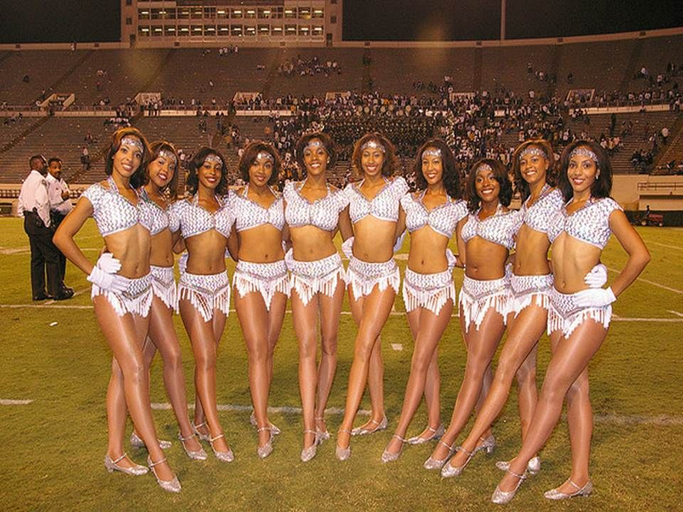
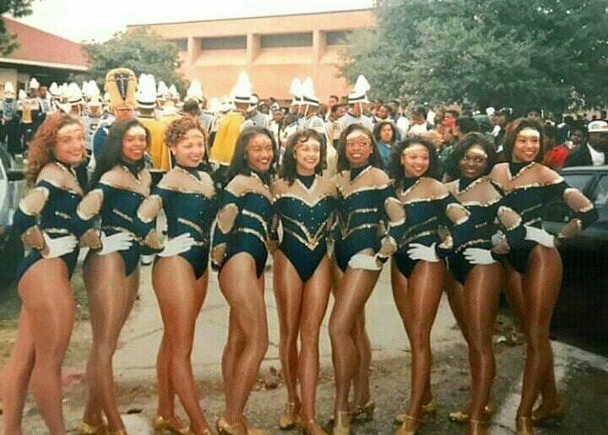
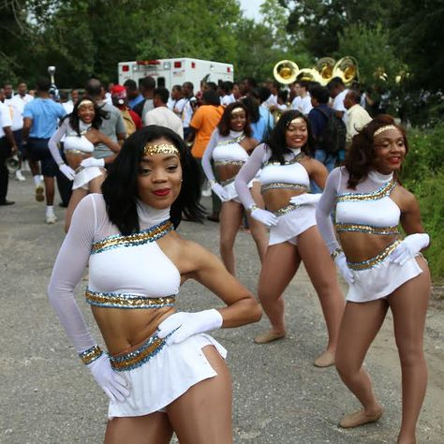
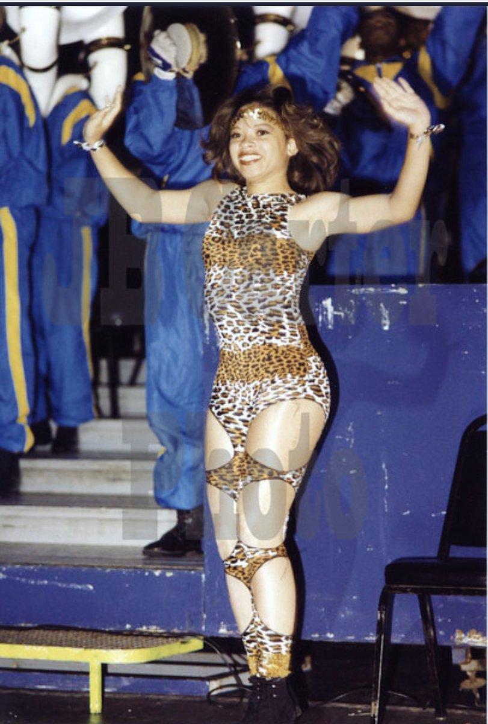
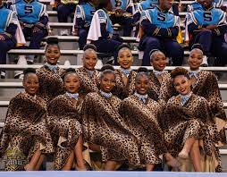

Nancy boots, fringe, and black fishnet tights are uniquely the Prancing J-Settes (PJ’s). "Nancy boots" as a referent for the high white boots that the J-Settes wear was probably inspired by Nancy Sinatra's Grammy award winning 1966 song "These Boots Were Made for Walking." Leotards, unitards, and bra tops paired with leggings are commonly worn by the PJ’s. Jackson State University’s school colors are blue and white, and the mascot is a tiger.
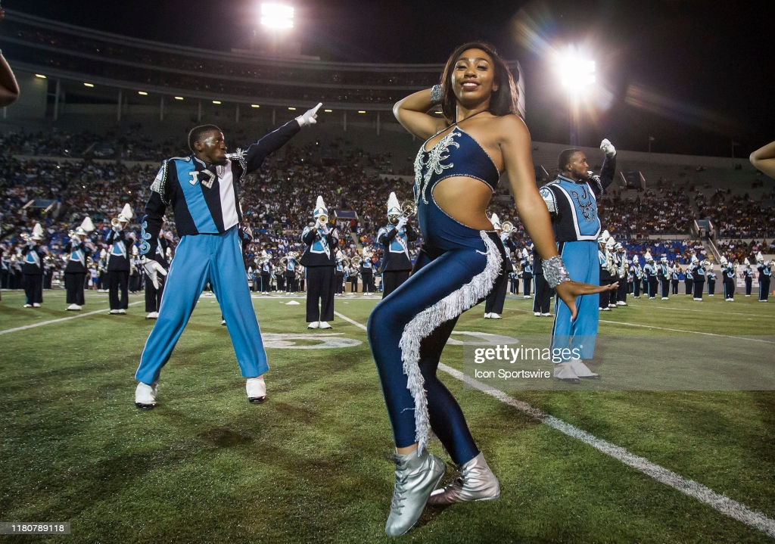
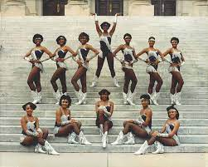
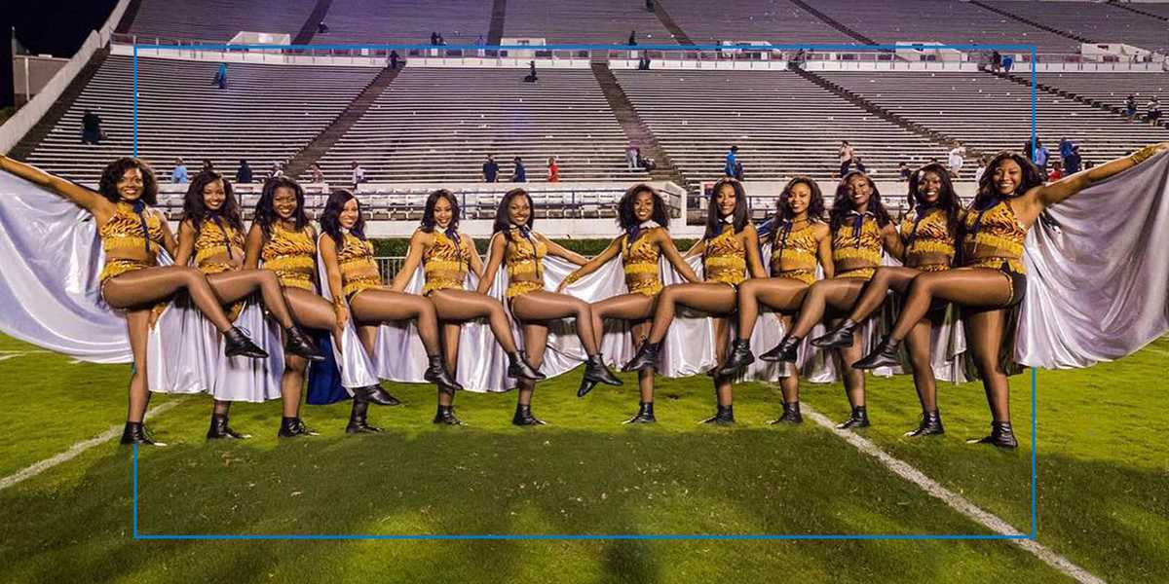
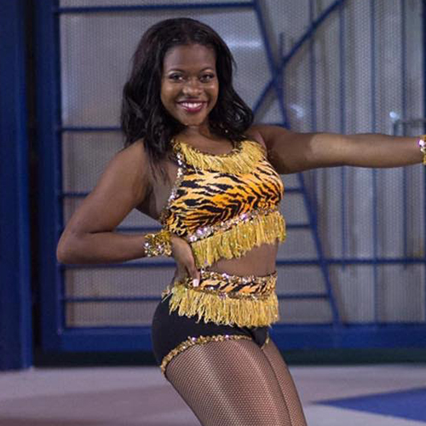

The Orchesis Dance Company is the wild card of the SWAC. There isn’t a distinct style, they are unpredictable. You can expect their costumes to be black, gold, red, tiger print, white, or silver. They were the first to wear lace up jazz boots which are usually spray painted to coordinate with the costume. They also frequently have worn ponytails and buns in the past.
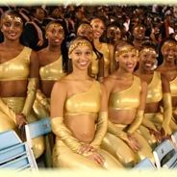

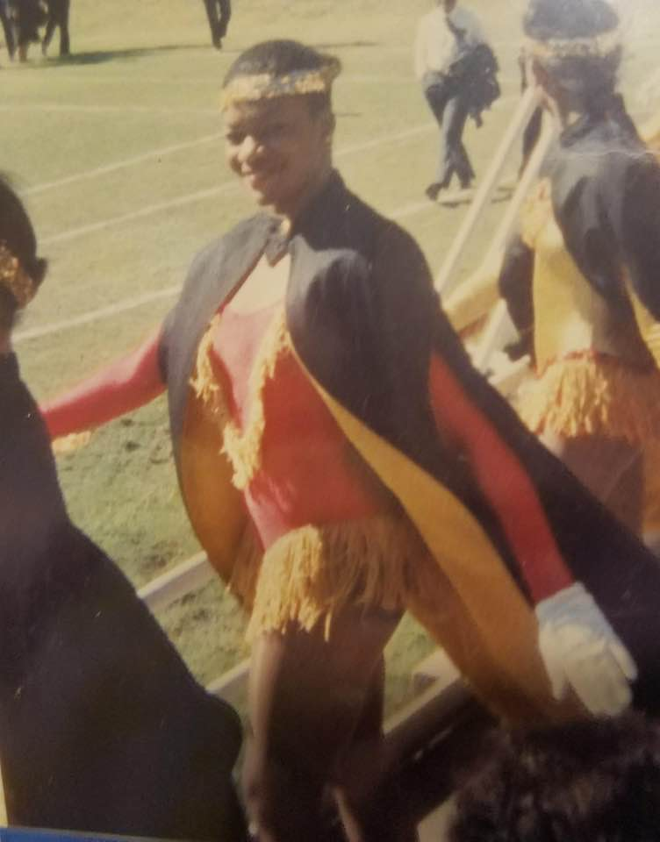

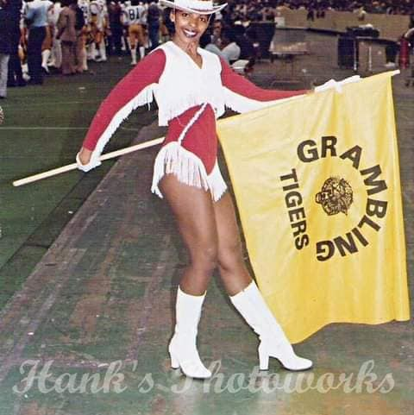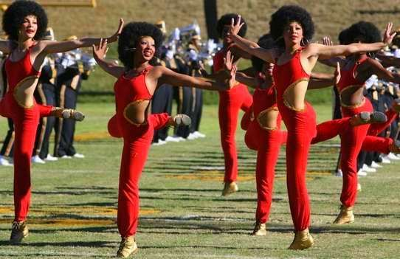
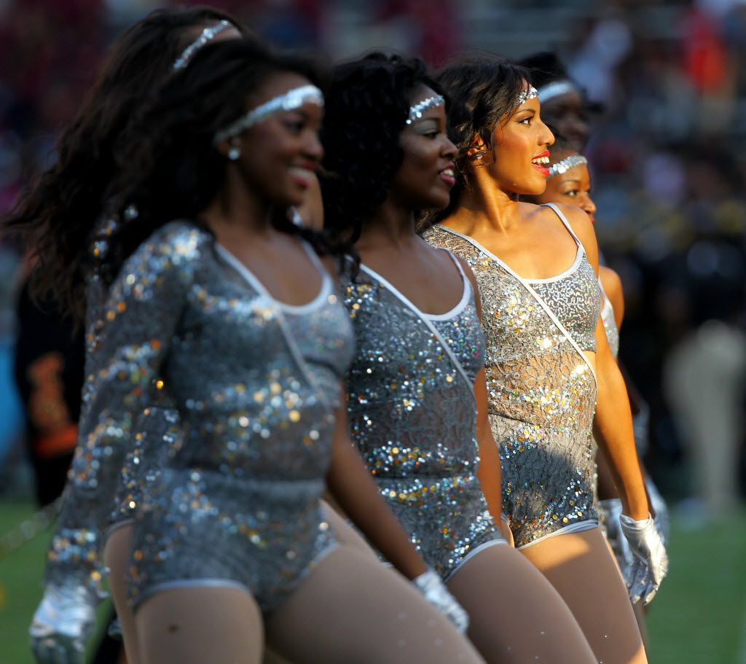
Déjà vu: Three Costumes Inspired by Beyonce’s Déjà vu Music Video and Costume Trends in the SWAC
I created a dance film called Déjà vu with the help of Mat Miller and 1984 Studios. The dance film is inspired by Beyoncé’s Déjà vu music video, of which I chose three of her outfits as inspiration. The task was to recreate each outfit as if it were going to be worn by an HBCU dance line during a football game. This was achieved by incorporating common costume trends among HBCU Dance Lines.
We shot the dance film in Mat’s film studio, 1984 Studios, in Oklahoma City, OK. I painted one wall black and white stripes and a different wall red to resemble two scenes from the music video. On the black and white striped wall, I recreated Beyoncé’s black and brown dress. The leotard resembled the stripes on the tights, black rhinestones were placed down the solid black stripes. I also recreated the dress as a cape-like long vest. As it flew open, it revealed the leotard. To complete the look, I paired it with black character shoes. In the music video, Beyoncé wears a turquoise leotard with balloon sleeves and a brown lace up corset belt against a red wall. My rendition was a solid turquoise leotard with balloon sleeves and plunging neck line. I also made a corset belt out of the same fabric then covered the belt with iridescent rhinestones. This design was intended for a halftime show, so I paired it with silver spray painted lace up jazz boots. Lastly, I recreated the skirt and bra top worn when Beyoncé is dancing barefoot in the dirt. I chose the same olive-green color for the skirt. The shorts underneath and the waist band were made of a solid olive-green four way stretch shiny spandex; the skirt was made of mesh. I wanted volume in the skirt, so I used multiple layers cut three times the width of the waist. I then gathered at the waist to create a full skirt. The skirt was paired with a solid cream colored four way stretch shiny spandex with an appliqued cream and olive-green silk ribbon on one side. I left some of the ribbon dangling to created movement. Because I had to think about functionality for the dancer, I couldn’t leave the top strapless. Instead I added gold stretch sequence as straps. The same gold sequence was wrapped around my wrist. This costume was worn with nude character shoes. For the shoot, I wanted to make sure I found nude tights and nude fishnets that matched my skin tone. I found a perfect match at NudeBarre, an online store with a focus in skin tone underwear and hosiery and is dedicated to redefining nude. I also wanted to challenge the hairstyle trends worn by HBCU dancers in 2022 that are deemed appropriate. The two hairstyles in my short film showcased curly, coily, and kinky textures. I wore an afro and a long ponytail, which was achieved with added in extensions close to my natural texture.
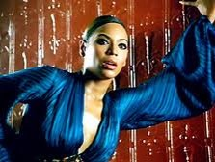
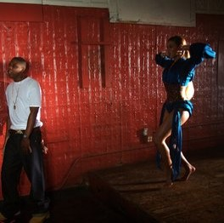

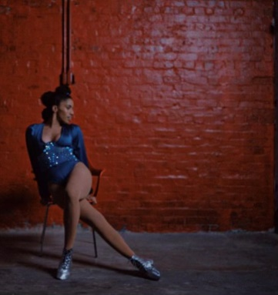

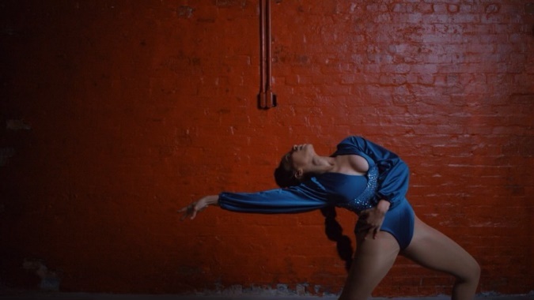
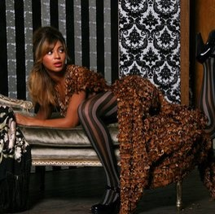

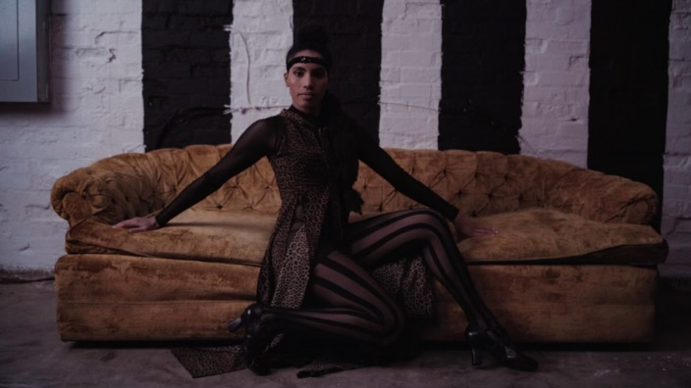

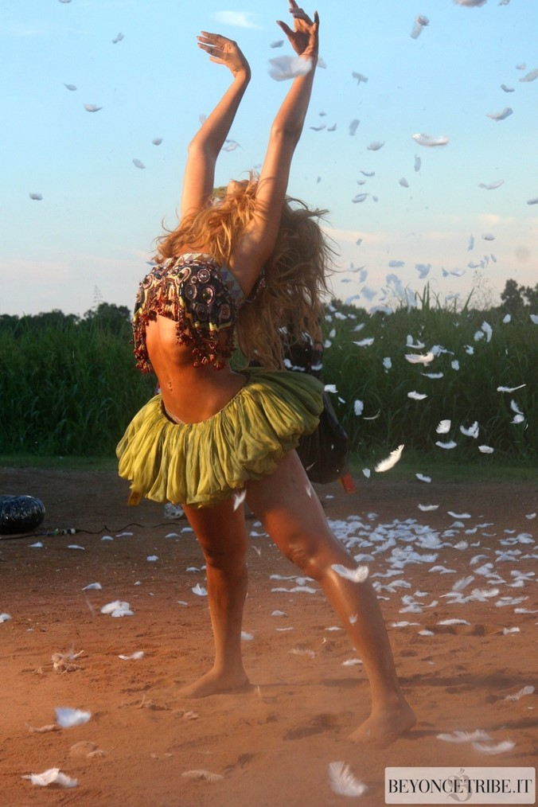

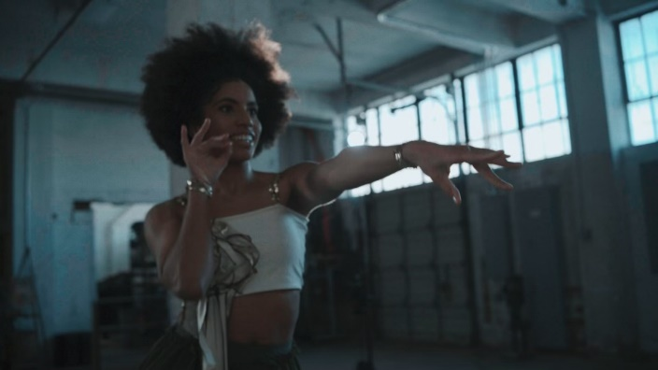

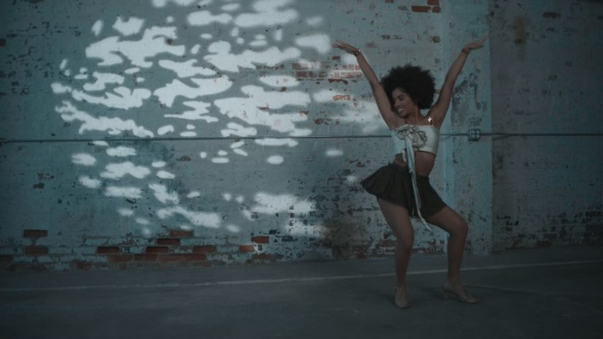

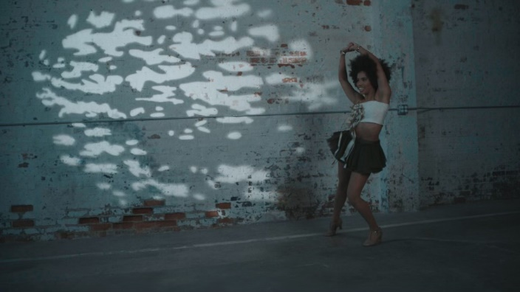

A Designer’s Perspective: Teisha Lincoln and Tyree Tucker
There is a lot of attention put into the costumes for HBCU dance line performances. Each team has their own style that's embodied through their overall physical appearance from the costumes to the choreography. Of course, this wouldn't be possible if not for the costume designers. I interviewed two costume designers who have experience designing for HBCU dance lines, Teisha Lincoln and Tyree Tucker.
Teisha Lincoln was the field coordinator for the Orchesis Dance Company (ODC) at Grambling State University 2014-2020. As field coordinator, Teisha was responsible for the group of dancers who performed on the football field and at the basketball games. She choreographed the majority of the routines performed, ran rehearsal, traveled to the games, designed costumes and styled the dancers, and more. The years 2014-2020 for ODC was a rebranding era. Sometime before 2014 ODC had lost their reputation as the innovators and a technically sound dance line in the SWAC. As a result of the work Teisha Lincoln started, the Orchesis gained the attention of many HBCU dance line fans. In 2019 they were invited to perform at Beyoncé’s private album release party alongside the Grambling State University World Famed Tiger Marching Band. The overall appearance of the Orchesis Dance Company was important to Teisha, from the dance to the costumes. As an alumna, she was mindful of traditions but also found ways to challenge the traditions. The Orchesis have become known to deliver a fierce look, which is probably what caught the attention of Beyoncé with their rendition of her Homecoming Coachella costume. In an interview with Teisha Lincoln, she took me through her thought process of designing some of her most popular costumes.
Tyree Tucker of Tye Designs, was introduced to the HBCU dance lines through the lens of costume designer. In 2012, he was friends with the director of Talladega College’s dance line, the Dega Diamonds. Because of Tyree’s talent as a visual artist, the director reached out to him to assist with a costume design. “He saw the potential I had, as far as the knowledge of colors and the placement of lines and being able to put together concepts.” Together they designed the first costume Tyree’s ever drew, a maroon velvet uniform. Since 2012 he continued to do mutual collaborations with the Dega Diamonds. He has also branched off to design for other dance lines. Although he has a team of a professional pattern maker and a seamstress, he has also recently learned to sew and construct the costumes himself. After 10 years of creating, he seems confident of the identity of Tye Designs. If Tye Designs were a character Tyree describes it as a combination of Cruella from 101 Dalmatians and someone high up in a hierarchy “That’s who Tye Designs is. That’s the style. That’s the flavor. That’s the attitude. It’s very ‘bitchy’ but it’s very classy, sexy, and rich. It’s a statement! It’s that person that walks into the room and commands attention.” With that, I think he is able to capture the essence of the HBCU dance lines in the SWAC, which is why I chose to interview him. In our interview, he (TT) took me (JG) back to the beginning of Tye Designs and his collaboration with the director of The Dega Diamonds:
Tyree Tucker (TT): The concepts got better and better. We ended up creating a style, like a category of uniforms. The concepts that I was creating were concepts that were new to the world. Everybody was still wearing a basic leotard. Everyone was still wearing costumes that were created back in the 90’s. They were just getting them revamped. To me I felt like it was a time for a change. It was a time to elevate as a culture, as the HBCU culture. I felt like we had so much more potential and no one was trying to tap into that potential. No one wanted to be the person that was going to present something that was out the box. [sic]
HBCU dance lines often use themes for their game day march in or half time look. In the context of fashion, a “look” is synonymous to the terms “style” and “fashion.” It is a noun used to state physical appearance. I believe when Tyree uses the word “concept” he is referring to the theme which inspired the design. The design of a costume or uniform inspired by a “theme” or “concept” brings the “look” together. An example of a theme could be a color and/or something in pop culture like a movie, music video, vocal artist, ect.
J’aime Griffith (JG): How did you step out the box with your designs and cater to the HBCU dance lines?
TT: I like to use a lot of silhouettes cuts. Especially with HBCU dance teams, black women are figurly shaped differently than other women around the world. Black women have a certain look that no one can duplicate. I noticed that with the HBCU dance lines they wear a lot of leotards to show the firmness of the thigh and the shrinkingness of the waist. Its overall sex appeal that they try to give through these team so why not create something that’s complimented to them. That compliments not only one team but that can be versatile across the entire community. [sic]
JG: What was different about the costumes? I know you talked about using a lot of silhouette cuts. Was it also the use of nude mesh material and having a floating top?
TT: I wanted to make sure my designs flowed in a 360 view. I wanted to make sure the concepts made sense. I think that’s what makes me stand out from a lot of people is my concepts. My concepts are thought out, they are very detailed. They are structurally placed in the right area. [sic]
JG: For the HBCU dance lines, there are trends among these dance teams. When it comes to costumes, we use sequence. We use rhinestones so that we can see the dancer from a far. The fringe is strategically placed to accent the body parts being used. Is that something the dancer or team ask for or do you add that yourself?
TT: It depends on the organization. I work with a lot of organizations that like fringe and I’ve also worked with organizations that really hate fringe. It depends on the style of the team. When I have a consultation with my clients, I tell them, “tell me everything you like and tell me everything you don’t like.” Their taste and my taste are totally different, but we have to mutually agree on the things that we are putting into this costume. So, I need to know those things firsthand before I even go into the sketching process. As far as fringe go, I like to use fringe because it adds an extra accent and extra movement depending on the style of dance. I wouldn’t use fringe on the Dancing Dolls unless it had something to do with something with a skirt. I wouldn’t use fringe on them because their body movements are very soft and slow so the fringe is not going to move. The fringe would be a distraction to what it is the dancer is doing. With Jackson State it could be different. They use a lot of fringe because of their dancing style. They do a lot of bucking, a lot of hip thrusting movement to pop the fringe in certain areas. They do a lot of roll overs and flips so having fringe or detachable objects works for their overall appearance.[sic]
The use of fringe on Jackson State University’s Prancing J-Settes costumes or uniforms is for a purpose. It highlights the part of the body that is important to their aesthetic. For example, around the hips to accent the movement in the pelvis. On the field during the halftime show, the Prancing J-Settes incorporate a lot of stunts which is similar to acrobatic movement. Not restricted by the stands or bleachers, the movement is bigger. There’s a lot of emphasis on the legs because of the kicks and stunts. For that reason, the fringe is also placed vertically along the outside of the leg. This is a common costuming trend in traditional African dance, where there is a lot of movement in the hips, pelvis, and butt and is related to the instrumentation of the dance. Rattles are placed on specific body part and must be moved in accordance to the music. The dancer has to move the waist if the rattles are worn on the waist.
When I asked Teisha the same question, she gave a similar answer. She thought back to the costumes she wore as a member of the Orchesis Dance Company in 2003-2008. Like Tyree, she also feels like the costumes worn by HBCU dancers should accentuate the body. Unlike mainstream white culture, in the HBCU dance community thick thighs and curves are celebrated.
JG: How did you step out the box with your designs and cater to the HBCU dance lines?
TL: My background is in theater and my work study was with the costume department. Ms. Jones was very creative. In her portfolio she used to design beautiful pieces. And I would think why can’t we use those things? I was a dancer in undergrad and to me our costumes were hideous. They were terrible. We would look like a high school at best. We had young women who were very curvaceous and voluptuous. We have beautiful waist lines and long legs but we look like we were going to Sunday school. The uniforms were very block, “A” line. The neckline was very basic, not even a 2–3-inch plunge. Even though classy is better, it was very boring to see. What I was afforded the chance to be assistance to Orchesis and help with costuming, that’s the first thing I wanted to change appearance wise, I feel like if you look good and you feel good in your outfit or your costume, your whole attitude changes. It gives you confidence. I know one thing, when you see me, you’re going to be wowed! Whether I dance or not, it sets the tone. Every year I tried to have a theme with my babies and it depended on what they gave me. Meaning body size and height. Everything does not look good on every body so I tried to get a token pattern that accentuates and gathers the way that it needed to.[sic]
As a dancer who has trained and performed in many different environments, I’ve noticed differences in costume trends. At a predominately white institution, the dancers who dance at football games are usually costumed more on the plain side. They wear the schools’ colors and most likely have the institution’s initials, full name, or mascot somewhere on the costume somethings with rhinestones. Bra tops worn with shorts, skirt, and pants are common. They may also wear a dress. The uniform is closer to what the cheerleaders would wear. At HBCUs the dance lines often wear leotards. Cut outs that show skin are popular. Bra tops worn with shorts, skirt, and pants are also commonly worn by HBCU dance lines. HBCU dance lines costumes are typically sexier and more revealing. Sequence, fringe, and rhinestones are heavily used. In concert dance, the costumes for a modern dance piece may be a muted color with no rhinestones at all. The focus is more on the dancing. A classical ballet piece can be a bit flashier with an occasional tiara and rhinestones.
JG: Our costumes are very extra compared to costumes that I see at predominately white institutions. We go over the top, with the themes, with the sequence, with the fringe. Where do you think that comes from? Us as a people (African Americans) but also the dance lines at HBCUs. You know? Even the majorette teams (baton twirlers) in New Orleans, they have to have the tiara...
TT: I feel like it all comes from the culture. It’s the black culture. Certain things, I feel like as black people we try to suppress a lot of our natural cultural instincts. Instead, I think we need to act on it a little more. For so many years I feel like we’ve been scared to do our own thing. We’ve been so scared to step outside the box and say this is what we like as a culture and this is what were gonna do. Instead of conforming to the PWI look or conforming to the quote-on-quote status quo of what America feels is the professional look of a dance team. We have our own look and we need to start expressing that look a lot more. That’s how I look at it. I’ve talked to so many people when doing concepts for these designs. The black culture is talented. We are creative but so scared of what people are going to say. The common audience of my costumes don’t get to see this. They’ve never seen this before. So, when they see it, it’s either a yay or nay.[sic]
Mainstream white culture decides what is acceptable. It determines the beauty standard. And for the most part it favors facial features and body types of the typical white body. The straighter the hair, the closer to white hair. Historically African Americans and other ethnicities that have more curly or kinky hair textures, have straightened their hair to maintain a more acceptable and beautiful appearance. They achieve this with blowouts, relaxers, silk press, roller set, ect. The same for skin, the brighter the skin the closer to white. To achieve a lighter skin tone, bleaching creams are used. Thinner lips and skinnier noses are common white facial features. Mainstream white culture has said that big lips, commonly seen on African Americans, were not beautiful for so long. Now bigger plumper lips have become fashionable and are considered beautiful. Certain hair styles worn by African Americans in the past has been seen as ghetto. For example, bold hair colors, Bantu knots (a hair style that comes from the Zulu people of Southern Africa. The hair is sectioned and twisted to create a spiraled knot), cornrow (hair braided close to the scalp) hairstyles. Now that mainstream white culture has taken a liking to these trends, it’s considered fashionable. This idea that- it’s not good enough until mainstream white culture says its good so we will conform until they say it’s good- is what Tyree was explaining when he said: “Certain things, I feel like as black people we try to suppress a lot of our natural cultural instincts. Instead, I think we need to act on it a little more. For so many years I feel like we’ve been scared to do our own thing.”
TL: I feel our elaborate taste for costumes stem from the roaring 20s. In the night clubs, it was heavy on the sequence and fringes. They went from knee length dresses to thigh. When they started doing cabaret burlesque, they (the dresses) started to get shorter. Which leads us into the leotard age. In the Paramount movies, the sexier you were the shorter the garment was. So, movies like Cleopatra and even Lady Sings the Blues…You have a lady of the night. She’s in the nightclub and she’s doing her burlesque show and she would have tassels and her panties and garters would have sequence and fringe. It accentuated the hips, the waist line, and the bust area. Cher has been one of the top-tier anybody’s inspiration. Beyoncé’s inspiration came from Cher for me. I love her costumes! A couple of the Orchesis costumes have been depictions of some of Cher’s costumes. [sic]
Teisha designed the costumes for Orchesis. On occasion she has also constructed costumes because of a minimal budget, most of the time it’s sent to a seamstress who then constructs them. Tyree is more hands on. He not only designs but also choses the fabrics. I asked him: How difficult is it to find that flesh tone mesh and spandex for these black dancers?
TT: It’s hard but it’s not hard. Finding the right tone and the right vendor is more so the question. Because Mesh is created in so many colors. There's black. There’s mesh in all colors of the spectrum. The name of the mesh that’s actually used for people of color is called a brown sugar mesh. It blends with pretty much every skin tone. Sometimes on a person that’s more like a chocolate verse a caramel tone, it shows a little lighter on them. I am working on finding a material that is suitable for people of color with darker skin.[sic]
JG: I find that that’s a recurring thing in the HBCU dance community, the mesh don’t match the dancers’ skin tone.
TT: It depends on the designer. I feel like me as a designer I’m good at what I do because I can relate. I relate to the small details that people would frown their face up at. I use the negative comments as guidelines of what to do and what not to do.[sic]
JG: Even down to the tights, jazz shoes, and character shoes. When it’s supposed to be flesh tone, it’s a tan or sand color. And it’s just the fact that the dance world does not cater to black dancers, so it’s difficult for us to find our nude. That’s why I asked that question: “if it was difficult for you to find those flesh tone materials in many shade of brown.” But I think we are working on it; we’re getting it together. I see more dancewear companies starting to offer more shades of brown.
My personal skin tone is closer to that tan and sand color and I have difficulty finding my shade of nude. For the dancer who is a deeper brown tone, it is much more difficult. I’ve experienced this as a performer but also as a costume designer. When I want to design a costume for a deeper brown tone, I find that it’s not easy to find. Some of the major dance wear companies like Bloch and Capezio, have come out with a more shades of brown. There are also, black owned and founded brands like NudeBarre and Blendz. Capezio shimmery toast tights are commonly worn in the HBCU dance line and hip hop majorette community. Shimmery toast is a medium tan bronze color that more times than not, does not match the skin tone of the dancer. Some teams have switched over to brands like Nudebarre to find a closer match but are met with another problem. The tights match their skin tone but now the jazz shoes and character shoes are still a lighter color which breaks the line of the leg.
During Teisha’s time as field coordinator, The Orchesis had become known for their costumes. Often inspired by pop culture, Teisha came up with unique themes for her costume designs. Her creativity made the Orchesis stand out.
JG: Can you talk more about the costumes that you designed for the Orchesis Dance Company that was based off of a theme?
TL: Homecoming, School daze, and fight night. Well fight night was because we were going to a battle. We’re going to TKO the other team. When you’re doing a battle of the bands hence “battle”, all eyes are on us just like a boxing match. My inspiration and motivation… I watch a lot of movies and musicals. I just watch a lot of TV period. Anything with dance I watch. I watch synchronized swimming and rhythmic gymnastics, and ice skating. Their costumes are beautiful but they are also expensive. I’ll take a picture on TV and then I’ll try to reconstruct it on a budget. I don’t want to look like anybody else and I know no one else is going to look like us. I have done things that were popular, like a Beyoncé theme. I recreated one of her Homecoming Coachella looks because I felt like it was geared towards us (HBCU dancer). We are Homecoming. She was trying to emulate us (the essence of a HBCU dancer) so I’ll show you how to do it.[sic]
JG: What is the essence of the HBCU dancer? As far as appearance, the hair, makeup, costume, and overall aura…
TL: We are a statement. We are powerful. We are beautiful. We are sassy. We are second to none. What I mean by second to none… sometimes we are second rated when it comes to this style in the realm of dance. Just because we are not what you consider traditional dance. You have many genres of dance and so nothing is truly traditional. HBCU dancers, you can’t label us as just one thing because we are a multitude of things. But what I can say, what we can exude if not anything else, power. We are powerful.[sic]
Tyree Tucker of Tye designs creates costumes for HBCU dance lines with attention to the details as he pulls from his visual art background. Teisha Lincoln uses her background in theater and creates with that stage quality in mind. Both designers create designs specifically to satisfy the standards of the HBCU dancers. On game day the dancers aim to transform into a higher more elevated version of themselves. This is achieved with help of the costume and the attitude fueled by the dancer’s overall appearance. The overall appearance and attitude when dancing, shines through in a confident, disinterested, I’ve got it all under control manner. Without the costumes, the “look”, and attitude, the HBCU dance line aesthetic is incomplete.

Conclusion
The elements that make up the HBCU dance line aesthetic are an Africanist dance aesthetic, a European dance aesthetic, pop culture and commercial and social dance, male embodied femininity on female bodies, the attitude, and the “look”. The SWAC dance lines’ choreography is from the same movement vocabulary. However, each dance line adds their own nuances or stylistic choices that establishes their style. As a whole, the HBCU dance line aesthetic in the SWAC has evidence of European dance and Africanist dance. Each dance line may incorporate more Africanist dance principles like Jackson State University Prancing J-Settes or more Europeanist dance principles like Grambling State University Orchesis Dance Company.
This study identified the elements that make up the HBCU dance line aesthetic to redefine and determine how the aesthetic should be viewed and judged. In the HBCU dance line aesthetic the Africanist dance aesthetic has dominance and should be viewed through that lens. At the same time, the growing interest in European dance aesthetics seen in the use of tricks in the field show choreography should not be dismissed. When it comes to incorporating the tricks into the HBCU dance line aesthetic, the HBCU dance line community should study the root of the trick, the technique. Therefore, approaching the tricks from the lens of a European dance aesthetic as far as alignment and placement. By adding the nuances and stylistic choices, there is a marriage of Africanist and European aesthetics.
Male embodied femininity is taught by male choreographers and coaches in the HBCU dance line community and its predecessor, hip hop majorette. Male embodied femininity is manifested in female embodied femininity when the female dancer approaches movement in a harder and exaggerated way. The gay black male influence is present in the HBCU dance line aesthetic and will continue to be present because of their roles as coach, choreographer, and documenters.
The HBCU dance lines have and will continue to evolve with pop culture as the aesthetic finds inspiration in commercial and social dance. The same can be said about the costumes, hair, and makeup. The costume compliments the dance and highlights important body parts. The attitude of the dancer when performing completes the “look”. Without both, the HBCU dance line aesthetic is incomplete.

Bibliography

Brave, 1968 Alcorn Golden Girls 1st Ever Collegiate Dance Line, HBCU Sports Forum, July 14, 2015, https://www.hbcusports.com/forums/threads/1968-alcorn-golden-girls-1st-ever-collegiate-dance-line.122661/
Birmingham Times. “History of African-American Marching Bands.” The Birmingham Times, August 18, 2016. https://www.birminghamtimes.com/2016/08/history-of-african-american-marching-bands/.
Allen, Danielle. “Throwback: The History of the Drum Majorette.” Atkins HS News, March 27, 2019. https://atkinshighschoolnews.blogspot.com/2019/03/throwback-history-of-drum-majorette.html.
Allen, Doug. “The Legacy and Culture of HBCU Marching Bands: BestColleges.” BestColleges.com, November 18, 2021. https://www.bestcolleges.com/resources/hbcu/legacy-culture-of-marching-bands/.
Bordelon, Pam. “Story of the Dancing Dolls: How Beloved Dance Troupe Brought 'Pizzazz' to Southern 50 Years Ago.” The Advocate, October 27, 2019. https://www.theadvocate.com/baton_rouge/entertainment_life/article_88bcedb0-f59a-11e9-ad69-c7e95ab7289f.html.
Brice, Anne. “Berkeley's Bearettes First to Bring Majorette-Style Dance to UC System.” Berkeley News, July 12, 2021. https://news.berkeley.edu/2019/06/25/bearettes-sf-ethnic-dance-festival/.
Ebright, Wanda K.W., and Gary C. Guffrey. Dance on the Historically Black College Campus: The Familiar and the Foreign. Cham (Suisse): Palgrave Macmillan, 2019.
“Golden Definition & Meaning.” Dictionary.com. Dictionary.com. Accessed March 27, 2022. https://www.dictionary.com/browse/golden.
“Golden Girls: Sounds of Dyn-o-Mite.” soundsofdynomite. Accessed March 14, 2022. https://www.soundsofdynomite.com/golden-girls.
Gottschild, Brenda Dixon. “First Premises of an Africanist Aesthetic.” Essay. In Digging the Africanist Presence in American Performance: Dance and Other Contexts, 11–20. Westport, CT: Praeger, 1998.
Gottschild, Brenda Dixon. “Part Ll Mapping the Territories.” Essay. In The Black Dancing Body: A Geography from Coon to Cool, 102–219. New York, NY: Palgrave Macmillan, 2008.
Gottschild, Brenda Dixon. “Stripping the Emperor: George Balanchine and the Americanization of Ballet.” Essay. In Digging the Africanist Presence in American Performance: Dance and Other Contexts, 59–80. Westport, CT: Praeger, 1998.
Gottschild, Brenda Dixon. “Up from Under: The Africanist Presence.” Essay. In Digging the Africanist Presence in American Performance: Dance and Other Contexts, 1–10. Westport, CT: Praeger, 1996.
Griffith, J’aime. “Behind the Scenes with Leonardo Devine.” YouTube video, 4:06. March 21, 2022.

Griffith, J’aime. “Behind the Scenes with Willie Miller and Drumline Jazz.” YouTube video, 4:36. March 21, 2022.

HBCU Pride Network “’Get Ready’ Sonic Boom of the South Marching In to the Liberty Stadium (2014).” YouTube video, 3:18. September 14th, 2014.
“History of Ragtime.” The Library of Congress. Accessed April 27, 2022. https://www.loc.gov/item/ihas.200035811/#:~:text=Ragtime%20%2D%2D%20A%20genre%20of,over%20a%20rhythmically%20steady%20bass.
Loyd-Sims, Lamont. “J-Setting in Public: Black Queer Desires and Worldmaking.” Thesis, ScholarWorks @ Georgia State University, 2014.
McKindra, Frederick. “The Rich, Black, Southern Heritage of Hip-Hop Majorettes.” BuzzFeed News. BuzzFeed News, May 7, 2019. https://www.buzzfeednews.com/article/frederickmckindra/marching-bands-hip-hop-majorettes-jsettes-prancing-elites.
“Nude Barre.” FleshTone.net, January 26, 2017. https://fleshtone.net/dance-tights/nude-barre/.
“Orchesis Dance Company.” Grambling State University - Orchesis Dance Company. Accessed February 26, 2022. https://www.gram.edu/student-life/clubs/orchesis/history.php.
Pennant, J. “Da Butt from the movie.” YouTube video, 5:05. Aug 24, 2012.
Pierce, Susan. “Reality TV Show Spurs Growth of Hip-Hop Majorettes Locally.” timesfreepress.com, October 18, 2015. https://www.timesfreepress.com/news/life/entertainment/story/2015/oct/18/reality-tv-show-spurs-growth-hip-hop-majorett/330733/.
Powell, Azizi. “J-Setting, JSU's Prancing J-Settes, and Black Gay J-Setters.” Web log. Pancocojams (blog), April 23, 2015. http://pancocojams.blogspot.com/2015/04/j-setting-jsus-prancing-j-settes-and.html.
Powell, Azizi. “Jackson State University J-Settes' ‘Get Ready’ Routine.” Web log. Panacocojams (blog), July 16, 2016. http://pancocojams.blogspot.com/2016/07/jackson-state-university-j-settes-get.html.
Powell, Azizi. “Two Videos Of Historically Black Colleges & Universities Majorette Dance Lines and Excerpts About The History Of HBCU Majorette Dance Lines.” Web log. Pancocojams (blog), December 14, 2020. http://pancocojams.blogspot.com/2020/12/two-videos-of-historically-black.html.
“Prancing J-Settes.” JSU Bands Sonic Boom of the South. Accessed February 26, 2022. https://sites.jsums.edu/sonicboom/?page_id=300.
Rao, Jay. “A Look Back at the Orange Blossom Classic.” Miami's Community News, March 2, 2022. https://communitynewspapers.com/featured/a-look-back-at-the-orange-blossom-classic/.
Sims, Jamal, dir. When the Beat Drops. 2018; Atlanta, GA: World of Wonder.net.
SirMixALotVEVO. “Baby Got Back (Official Music Video).” YouTube video, 4:13. March 1st, 2019.

TAPEMASTER. “JSU Vs. TSU 1992 (5th Quarter)” YouTube video, 8:39. March 31, 2013.
Regal. “JSU vs Alcorn State Golden Girls 1988 (stands).” YouTube video, 3:13. December 4th, 2019.
TRIN, “Can You Stand the Rain Southern University Human Jukebox & Dancing Dolls,” YouTube, November 9, 2014, Video, https://youtu.be/1DWn7Mb0TKI.
TV YABANTU “INDLAMU Kwazulu Natal Best Zulu Dance (Must Watch).” YouTube video, 1:23:32. April 12, 2015.
Ussery, Peggy. “Hip-Hop Majorettes Combine Cheerleading, Majorette and Hip-Hop Moves.” Dothan Eagle, September 15, 2016. https://dothaneagle.com/lifestyles/local/hip-hop-majorettes-combine-cheerleading-majorette-and-hip-hop-moves/article_932f19b2-7b68-11e6-8e1a-9b40f793db33.html.
VenomTip. “Two Videos of Historically Black Colleges & Universities Majorette Dance Lines And Excerpts About The History Of HBCU Majorette Dance Lines.” Web log. Pancocojams (blog), December 14, 2020. http://pancocojams.blogspot.com/2020/12/two-videos-of-historically-black.html.
Welsh-Asante, Kariamu, and Cheryl Willis. “Tap Dance: Manifestation of the African Aesthetic.” Essay. In African Dance: An Artistic, Historical, and Philosophical Inquiry, 145–59. Trenton, NJ: Africa World Press, 2002.
Welsh-Asante, Kariamu, and Doris Green. “Traditional Dance in Africa.” Essay. In African Dance: An Artistic, Historical, and Philosophical Inquiry, 13–28. Trenton, NJ: Africa World Press, 2002.
youngdaughter, “Alcorn State University Golden Girls - 1990 Video &amp; 1999 Video (with Selected Comments),” Alcorn State University Golden Girls - 1990 Video &amp; 1999 Video (with Selected Comments) (blog), July 30, 2016, http://pancocojams.blogspot.com/2016/07/alcorn-state-university-golden-girls.html.

Videographer Confidentiality Agreement

J'aime Griffith's Research for Thesis Presentation: J-setting, Majorette, and HBCU dance line

I, __________________________, agree to video-record data for this study. I agree that I will:

1. Keep all research information shared with me confidential by not discussing or sharing
the information in any form or format (e.g., disks, tapes, transcripts) with anyone other
than __J’aime Griffith________, the researcher/s on this study.

2. Keep all research information in any form or format (e.g., disks, tapes, transcripts)
secure while it is in my possession. This includes:
• using closed headphones when viewing/editing recorded information
• keeping all documents and digitized interviews in computer password-protected
files
• closing any programs and documents when temporarily away from the
computer
• keeping any physical recordings in a secure location such as a locked file cabinet
• permanently deleting any e-mail communication containing the data

3. Give all research information in any form or format (e.g., disks, tapes, transcripts) to the
primary investigator when I have completed the research tasks

4. Erase or destroy all research information in any form or format that is not returnable to
the primary investigator (e.g., information stored on my computer hard drive) upon
completion of the research tasks.

_________________________________________ __________
Signature of videographer Date

_________________________________________ __________
Signature of principal investigator Date

Signed Consent to Participate in Research

Would you like to be involved in research at the University of Oklahoma?
I am J’aime Griffith from the School of Dance and I invite you to participate in my
research project entitled J’aime Griffith’s Thesis Research Presentation. This research
is being conducted at the University of Oklahoma. You were selected as a possible
participant because of your expertise in J-setting/Majorette/HBCU Dance Line. You
must be at least 18 years of age to participate in this study.

Please read this document and contact me to ask any questions that you may
have BEFORE agreeing to take part in my research.

What is the purpose of this research? The purpose of this research is to answer the
following questions: What does it look like when J-setting, Majorette, and HBCU dance
line styles fuse with contemporary dance? How does J-setting, Majorette, and HBCU
dance line styles translate to the theatre stage?

How many participants will be in this research? About 2 (2 dancers/choreographers)
people will take part in this research.

What will I be asked to do? If you agree to be in this research, you will:
• Teach a private J-sette/Majorette/HBCU dance line class/workshop to J’aime (1
hour 30 mins)
• Teach and clean 30 seconds of J-sette/Majorette/HBCU dance line
choreography to J’aime (1 hour 30 mins)
• Be interviewed by J’aime (1 hour)

How long will this take? Your participation will take 5 hours + travel time (depending
on your location)
• Teach a private J-sette class/workshop to J’aime (1 hour 30 mins)
• Teach and clean 30 seconds of J-sette choreography to J’aime (1 hour 30 mins)
• Break (30 mins)
• Be interviewed by J’aime (1 hour)

What are the risks and/or benefits if I participate? You will receive professional
footage of the interaction to use as you please. Risks include dance-related injuries.

What do I do if I am injured? If you are injured during your participation, report this to
a researcher immediately. Emergency medical treatment is available. However, you or
your insurance company will be expected to pay the usual charge from this treatment.
The University of Oklahoma Norman Campus has set aside no funds to compensate
you in the event of injury.

Will I be compensated for participating? You will be reimbursed for your time and
participation in this research, as described below:
• Travel accommodations (flight/gas)
• Hotel accommodations (if applicable)
• $100 for food + $400 for class, choreography, and interview (will receive half of
$500 upon completion of Consent form and half after filming)
• A copy of “Behind the Scenes with ____________” footage that will be presented
February 26th at J’aime Griffith's Thesis Research Presentation.

Who will see my information? All dance instruction, choreography sessions, and
interviews will be video recorded for possible inclusion in a short film to be presented as
a part of this research. The footage may also be shared on social media.
Research records, including video footage and transcripts of interviews, will be stored
securely and only approved researchers and the OU Institutional Review Board will
have access to those records.
You have the right to access the research data that has been collected about you as a
part of this research. However, you may not have access to this information until the
entire research has completely finished, and you consent to this temporary restriction.

Do I have to participate? No. If you do not participate, you will not be penalized or lose
benefits or services unrelated to the research. If you decide to participate you can stop
participating at any time but will need to return all compensation.

Will my identity be anonymous or confidential? No. Your identity will be reported in
the thesis itself, and you will appear in the short film “Behind the Scenes with _____.”

What will happen to my data in the future?
We might share your data with other researchers or use it in future research without
obtaining additional consent from you.

Video Recording of Research Activities To assist with accurate recording of your
responses, interviews and choreography observations will be recorded on a video
recording device. If you do not agree to video-recording, you cannot participate in this
research. Please select one of the following options:
I consent to video recording. ___ Yes ___ No

Photographing of Research Participants/Activities In order to preserve an image
related to the research, photographs may be taken of participants. You have the right to
refuse to allow photographs to be taken without penalty. If you do not agree to
photography, you cannot participate in this research. Please select one of the following
options:
I consent to photographs. ___ Yes ___ No
Your photographs or video images may be used in university research reports unless
you tell me not to do this.

Will I be contacted again? The researcher might like to contact you to gather
additional data or recruit you into new research.
I give my permission for the researcher to contact me in the future. ___Yes ___ No

Who do I contact with questions, concerns or complaints? If you have questions,
concerns or complaints about the research or have experienced a research-related
injury, contact:

J’aime Griffith
(903) 452-6033
Jaime.A.Griffith-2@ou.edu
Roxanne Lyst
Rlyst@ou.edu

You can also contact the University of Oklahoma – Norman Campus Institutional
Review Board (OU-NC IRB) at 405-325-8110 or irb@ou.edu if you have questions
about your rights as a research participant, concerns, or complaints about the research
and wish to talk to someone other than the researcher(s) or if you cannot reach the
researcher(s).

You will be given a copy of this document for your records. By providing information to
the researcher(s), I am agreeing to participate in this research.

-----------------------------------------------
Participant Signature

-----------------------------------------------
Print Name Date

-----------------------------------------------
Signature of Researcher
Obtaining Consent

-----------------------------------------------
Print Name Date

Signed Consent to Participate in Research

Would you like to be involved in research at the University of Oklahoma?
I am J’aime Griffith from the School of Dance and I invite you to participate in my
research for my thesis. This research is being conducted via video conference or
phone call. You were selected as a possible participant because I am interested in
learning more about your personal experience with_______________ (J-Setting/
Majorette/HBCU dance lines) in a
_____________ (dancer/instructor/choreographer/costume designer) role(s).

You must be at least 18 years of age to participate in this study.

Please read this document and contact me to ask any questions that you may
have BEFORE agreeing to take part in my research.

What is the purpose of this research? Through interviews with
dancers/instructor/choreographers/costume designer in the J-Setting/Majorette/HBCU
dance line community: I hope to find a better understanding of the movement
vocabulary and thought process behind teaching these styles, creating choreography,
and designing costumes.

How many participants will be in this research? Up to 12 (dancers, choreographers,
instructors, costume designers) people will take part in this research.

What will I be asked to do? If you agree to be in this research, you will: Participate in
an interview answering questions about your experience as a
dancer/instructor/choreographer/costume designer in the J-setting/Majorette/HBCU
dance line community. Quotes from the interview will be used in my written Thesis.

How long will this take? Your participation will take about 1 hour

What are the risks and/or benefits if I participate? There are no risks and no
benefits from being in this research.

Will I be compensated for participating? No

Who will see my information? Quotes from the interview will be quoted in a written
document and published for my thesis at the University of Oklahoma

Do I have to participate? No. If you do not participate, you will not be penalized or lose
benefits or services unrelated to the research. If you decide to participate you can stop
participating at any time before April 16th, the scheduled thesis defense date for this
thesis.

Will my identity be anonymous or confidential? No. Your identity will be reported in
the thesis itself.

What will happen to my data in the future?
We might share your data with other researchers or use it in future research without
obtaining additional consent from you.

Audio Recording of Research Activities To assist with accurate recording of your
responses interviews will be recorded on a phone, iPad, or laptop. If you do not agree
to audio-recording, you cannot participate in this research. Please select one of the
following options:
I consent to audio recording. ___ Yes ___ No

Will I be contacted again? The researcher might like to contact you to gather
additional data or recruit you into new research.
I give my permission for the researcher to contact me in the future. ___Yes ___ No

Who do I contact with questions, concerns or complaints? If you have questions,
concerns or complaints about the research or have experienced a research-related
injury, contact:

J’aime Griffith
(903) 452-6033
Jaime.A.Griffith-2@ou.edu

Roxanne Lyst
Rlyst@ou.edu

You can also contact the University of Oklahoma – Norman Campus Institutional
Review Board (OU-NC IRB) at 405-325-8110 or irb@ou.edu if you have questions
about your rights as a research participant, concerns, or complaints about the research
and wish to talk to someone other than the researcher(s) or if you cannot reach the
researcher(s).

You will be given a copy of this document for your records. By providing information to
the researcher(s), I am agreeing to participate in this research.

--------------------------------------------
Participant Signature

--------------------------------------------
Print Name Date

--------------------------------------------
Signature of Researcher
Obtaining Consent

--------------------------------------------
Print Name Date

Glossary

HBCU dance lines- A group of female dancers at a historically black college or university that performs at football games and other events with the marching band on the field and in the stands or bleachers.

J-Setting-
- A tribute to Jackson State University Prancing J-Settes, an HBCU dance line, marching and dance style.
- The format in which the choreography is performed. The dancers perform eight-count sequences in the stand/bleachers in a call & response or throw & catch format.
- The practice of male dancers performing dance routines that includes the Prancing J-Settes marching and dance style. This was developed throughout the early 1990s in underground gay clubs.

Majorette- Baton twirlers

Hip hop majorette- The competitive and exaggerated version of the Prancing J-Settes marching and dance style along with other HBCU dance line styles. Usually performed by female and male youth dancers.

Stand routines, stands, counts, eight counts- Choreography performed in the stadium’s stands or bleachers. The choreography is stationary because of the lack of space side to side and front to back. However, the movement is explosive.

Field show- Choreography performed on the football field during the halftime show. The dance line uses the same movement vocabulary as their stand routines. On the field, there is more room, so the movement travels and takes up more space. Tricks like leaps, turns, jumps, and leg extensions are incorporated to add another layer to the choreography.

The Field show category is similar to the choreography performed during halftime at an HBCU football game. For the combined open dance category, the team can perform the routine of their choice. The combined pom category is choreography performed while holding pomp poms. In this category the movement is very sharp.
Anne Brice, “Berkeley's Bearettes First to Bring Majorette-Style Dance to UC System,” Berkeley News, July 12, 2021, https://news.berkeley.edu/2019/06/25/bearettes-sf-ethnic-dance-festival/.
Danielle Allen, “Throwback: The History of the Drum Majorette,” Atkins HS News, March 27, 2019, https://atkinshighschoolnews.blogspot.com/2019/03/throwback-history-of-drum-majorette.html.
Susan Pierce, “Reality TV Show Spurs Growth of Hip-Hop Majorettes Locally,” timesfreepress.com, October 18, 2015, https://www.timesfreepress.com/news/life/entertainment/story/2015/oct/18/reality-tv-show-spurs-growth-hip-hop-majorett/330733/.
Peggy Ussery, “Hip-Hop Majorettes Combine Cheerleading, Majorette and Hip-Hop Moves,” Dothan Eagle, September 15, 2016, https://dothaneagle.com/lifestyles/local/hip-hop-majorettes-combine-cheerleading-majorette-and-hip-hop-moves/article_932f19b2-7b68-11e6-8e1a-9b40f793db33.html.
Azizi Powell, “Pancocojams,” Pancocojams (blog), December 14, 2020, http://pancocojams.blogspot.com/2020/12/two-videos-of-historically-black.html.
Wanda K.W. Ebright and Gary C. Guffrey, Dance on the Historically Black College Campus: The Familiar and the Foreign (Cham (Suisse): Palgrave Macmillan, 2019), 20.
Ebright and Guffrey, Dance on the Historically Black College Campus, 22.
Birmingham Times -, “History of African-American Marching Bands,” The Birmingham Times, August 18, 2016, https://www.birminghamtimes.com/2016/08/history-of-african-american-marching-bands/.
“History of Ragtime,” The Library of Congress, accessed April 27, 2022, https://www.loc.gov/item/ihas.200035811/#:~:text=Ragtime%20%2D%2D%20A%20genre%20of,over%20a%20rhythmically%20steady%20bass. A genre of musical composition for the piano, generally in duple meter and containing a highly syncopated treble lead over a rhythmically steady bass.
Doug Allen, “The Legacy and Culture of HBCU Marching Bands: BestColleges,” BestColleges.com, November 18, 2021, https://www.bestcolleges.com/resources/hbcu/legacy-culture-of-marching-bands/.
Allen, “The Legacy and Culture of HBCU Marching Bands.”
Pam Bordelon, “Story of the Dancing Dolls: How Beloved Dance Troupe Brought 'Pizzazz' to Southern 50 Years Ago,” The Advocate, October 27, 2019, https://www.theadvocate.com/baton_rouge/entertainment_life/article_88bcedb0-f59a-11e9-ad69-c7e95ab7289f.html.
“Golden Definition & Meaning,” Dictionary.com (Dictionary.com), accessed March 27, 2022, https://www.dictionary.com/browse/golden.
Azizi Powell, “Pancocojams,” Pancocojams (blog), April 23, 2015, http://pancocojams.blogspot.com/2015/04/j-setting-jsus-prancing-j-settes-and.html.
VenomTip, “Pancocojams,” Pancocojams (blog), December 14, 2020, http://pancocojams.blogspot.com/2020/12/two-videos-of-historically-black.html.
Powell, “Two Videos of Historically Black”.
“Golden Girls: Sounds of Dyn-o-Mite.” soundsofdynomite. Accessed March 14, 2022. https://www.soundsofdynomite.com/golden-girls.
Brave, 1968 Alcorn Golden Girls 1st Ever Collegiate Dance Line, HBCU Sports Forum, July 14, 2015, https://www.hbcusports.com/forums/threads/1968-alcorn-golden-girls-1st-ever-collegiate-dance-line.122661/.
Jay Rao, “A Look Back at the Orange Blossom Classic,” Miami's Community News, March 2, 2022, https://communitynewspapers.com/featured/a-look-back-at-the-orange-blossom-classic/. The Orange Blossom Classic was played between FAMU and different HBCU each year. The first game was against Howard University in 1933 and the last game against Grambling State University in 1978. The classic returned to HBCU football in 2021 between Jackson State University.
Brave, “1968 Alcorn Golden Girls 1st Ever Collegiate Dance Line”.
I believe the commenter is referring to Samuel Griffin, the founder of Sounds of Dyn-O-mite, Golden Girls, and Purple Flasher Flag Corp.
Brave, “1968 Alcorn Golden Girls 1st Ever Collegiate Dance Line”
The eight original Golden Girls were Gloria Gray Liggans, Mar Deen Bingham Boykin, Delores Black Jenkins, Patricia Gibbs, Barbara Heidelberg Fox, Paulette McClain Moore, Josephine Washington Parker, and Margaret Bacchus Wilson
“Prancing J-Settes.” JSU Bands Sonic Boom of the South. Accessed February 26, 2022. https://sites.jsums.edu/sonicboom/?page_id=300. The group was first named Prancing Jaycettes in 1971. Then changed to Prancing J-Settes in 1982 because of a name conflict with a local organization named Jackson Jaycees/Jaycettes.
“Prancing J-Settes.” JSU Bands Sonic Boom of the South. Accessed February 26, 2022. https://sites.jsums.edu/sonicboom/?page_id=300
Jackson State University Sonic Boom Majorettes photographed in 1948.
Jackson State University Sonic Boom Majorettes photographed in 1969.
Brenda Dixon Gottschild, “First Premises of an Africanist Aesthetic,” in Digging the Africanist Presence in American Performance: Dance and Other Contexts (Westport, CT: Praeger, 1998), pp. 11-20, 12.
Brenda Dixon Gottschild, “Up from Under: The Africanist Presence,” in Digging the Africanist Presence in American Performance: Dance and Other Contexts (Westport, CT: Praeger, 1996), pp. 1-10, 8.
Gottschild, “First Premises of an Africanist Aesthetic”, 15.
Powell,”j-setting, jsus prancing j-settes”.
Gottschild, “First Premises of an Africanist Aesthetic”, 16.
Gottschild, “First Premises of an Africanist Aesthetic”, 15.
When the Beat Drops, directed by Jamal Sims (2018; Atlanta, GA) World of Wonder.net.
Gottschild, “Up from Under: The Africanist Presence,” 8.
Sims, When the Beat Drops.
Brenda Dixon Gottschild, “Part ll Mapping the Territories,” in The Black Dancing Body: A Geography from Coon to Cool (New York, NY: Palgrave Macmillan, 2008), pp. 102-219, 104.
Gottschild, “Part ll Mapping the Territories,” 146.
Gottschild, “Up from Under: The Africanist Presence”, 9.
Gottschild, “Part ll Mapping the Territories”, 146.
Frederick McKindra, “The Rich, Black, Southern Heritage of Hip-Hop Majorettes,” BuzzFeed News (BuzzFeed News, May 7, 2019), https://www.buzzfeednews.com/article/frederickmckindra/marching-bands-hip-hop-majorettes-jsettes-prancing-elites.
Kariamu Welsh-Asante and Doris Green, “Traditional Dance in Africa, “ in African Dance: An Artistic, Historical, and Philosophical Inquiry (Trenton, NJ: Africa World Press, 2002), pp. 13-28, 15-16
Gottschild, “Part ll Mapping the Territories”, 104.
Choreography created to be performed in pumps/ high heels.
youngdaughter, “Alcorn State University Golden Girls - 1990 Video &amp; 1999 Video (with Selected Comments),” Alcorn State University Golden Girls - 1990 Video &amp; 1999 Video (with Selected Comments) (blog), July 30, 2016, http://pancocojams.blogspot.com/2016/07/alcorn-state-university-golden-girls.html.
Gottschild, “Part ll Mapping the Territories”, 169.
Pennant, J. “Da Butt from the movie.” YouTube video, 5:05. Aug 24, 2012. 1988 Da Butt Pool Scene from School Daze: https://youtu.be/UsWnrkQl7yI .
Gottschild, “Part ll Mapping the Territories”, 168.
Pennant, J. “Da Butt from the movie.” YouTube video, 5:05. Aug 24, 2012.
Gottschild, “Part ll Mapping the Territories”, 169.
SirMixALotVEVO. “Baby Got Back (Official Music Video).” YouTube video, 4:13. March 1st, 2019. 1992 Sir Mix-A-Lot “Baby Got Back”: https://youtu.be/X53ZSxkQ3Ho.
TAPEMASTER. “JSU Vs. TSU 1992 (5th Quarter)” YouTube video, 8:39. March 31, 2013. 1992 JSU Prancing J-Settes (Blue sequin leotards with white fringe): https://youtu.be/e3UXLrrsggw .
Regal. “JSU vs Alcorn State Golden Girls 1988 (stands).” YouTube video, 3:13. December 4th, 2019. 1988 JSU Prancing J-Settes (White) vs Alcorn Golden Girls (Gold): https://youtu.be/N6_CL8OI-3M.
Gottschild, “Part ll Mapping the Territories”, 167.
Teshia Lincoln, in discussion with the author, February 2022.
Lincoln, in discussion with the author.
Kariamu Welsh-Asante and Cheryl Willis, “Tap Dance: Manifestation of the African Aesthetic”, 154.
Welsh-Asante and Willis, “Tap Dance: Manifestation of the African Aesthetic” 155.
Another name for Alcorn State University’s Danceline, Golden Girls.
Onecia Ford, in discussion with the author, February 2022.
Ford, in discussion with the author.
Brenda Dixon Gottschild, “Stripping the Emperor: George Balanchine and the Americanization of Ballet,” in Digging the Africanist Presence in American Performance: Dance and Other Contexts (Westport, CT: Praeger, 1998), pp. 59-80, 60.
“Orchesis Dance Company,” Grambling State University - Orchesis Dance Company, accessed February 26, 2022, https://www.gram.edu/student-life/clubs/orchesis/history.php.
“Orchesis Dance Company,” Grambling State University - Orchesis Dance Company, accessed February 26, 2022, https://www.gram.edu/student-life/clubs/orchesis/history.php.
An annual football game and battle of the bands held in New Orleans, LA between Grambling State University and Southern University.
Elodie Davis-Killins, in discussion with the author, February 2022.
The Orchesis Dance Company in performing in Japan.
The Orchesis Dance Company and the World Famed Tiger Marching Band.
Dianne Maroney Grigsby, in discussion with the author, February 2022.
Maroney Grigsby, in discussion with the author.
Maroney Grigsby, in discussion with the author.
Dianne Maroney Grigsby teaching a Lester Horton class before rehearsal
Dianne Maroney Grigsby and J’aime Griffith
Dianne Maroney Grigsby teaching a Lester Horton class before rehearsal
Elodie Davis-Killins, in discussion with the author, February 2022.
Davis-Killins, in discussion with the author.
Davis-Killins, in discussion with the author.
Davis-Killins, in discussion with the author.
Davis-Killins, in discussion with the author.
Davis-Killins, in discussion with the author.
Davis-Killins, in discussion with the author.
Davis-Killins, in discussion with the author.
Catherine Williams the founder of the Orchesis Dance Company and Ms. Jeff a dance educator from New Orleans,LA
Elodie Davis-Killins and Dianne Maroney Grigsby, former ODC artistic director and dance instructor at Grambling State Univeristy
Elodie Davis- Killins and other alumni Orchesis
Elodie Davis-Killins , a member of the Orchesis Dance Company posing at a football game
Ahsaki Thomas, in discussion with the author. February 2022.
Ahsaki Thomas, in discussion with the author.
Thomas, in discussion with the author.
Thomas, in discussion with the author.
Thomas, in discussion with the author.
Thomas, in discussion with the author.
Thomas, in discussion with the author.
Thomas, in discussion with the author.
Thomas, in discussion with the author.
Ahsaki Thomas as a mascot
Ahsaki Thomas dancing with the Orchesis Dance Company as a young mascot
Ahsaki Thomas performing as a member of the Orchesis Dance Company
Ahsaki Thomas performing as a member of the Orchesis Dance Company
Ahsaki Thomas and other members of the Orchesis Dance Company pose on set while filming Drumline
Former assistant director Ahsaki Thomas , ODC Alumna, current ODC dancer, former field coordinator Teisha Lincoln
Ahsaki Thomas performing as a member of the Orchesis Dance Company
I assume that when Lamont used “majorette” he is referring to the HBCU Dance line many styles. HBCU dance lines are commonly called Majorette. However, I have never heard anyone who dances or have danced on an HBCU dance line refer to themselves as majorettes.
Lamont Loyd-Sims (ScholarWorks @ Georgia State University, 2014), pp. 20-38, 24.
Powell, “J-Setting, JSU's Prancing J-Settes, and Black Gay J-Setters". This first note is written by Azizi Powell as an introduction to the 2015 pancocojams post "J-Setting, JSU's Prancing J-Settes, and Black Gay J-Setters".
Ford, in discussion with the author.
Lamont Loyd-Sims (ScholarWorks @ Georgia State University, 2014), pp. 20-38, 21-22.
Lamont Loyd-Sims (ScholarWorks @ Georgia State University, 2014), pp. 20-38, 22.
Lamont Loyd-Sims (ScholarWorks @ Georgia State University, 2014), pp. 20-38, 27.
Lamont Loyd-Sims (ScholarWorks @ Georgia State University, 2014), pp. 20-38, 27.
Leonardo Devine, in discussion with the author, February 2022.
Devine, in discussion with the author.
Griffith, J’aime. “Behind the Scenes with Leonardo Devine.” YouTube video, 4:06. March 21, 2022. https://youtu.be/uV_b7u4ifGY. When Leonardo uses the term “majorette”, he is referring to the youth dance teams not baton twirlers.
Devine, in discussion with the author.
Powell, “J-Setting, JSU's Prancing J-Settes, and Black Gay J-Setters". TV YABANTU “INDLAMU Kwazulu Natal Best Zulu Dance (Must Watch).” YouTube video, 1:23:32. April 12, 2015. https://www.youtube.com/watch?v=nExzW8NbaZY. The dancers in the red costumes show the best example of dropping the head when kicking the leg up, starting at 8:00 minutes.
Devine, in discussion with the author.
Miller, in discussion with the author.
Miller, in discussion with the author.
Griffith, J’aime. “Behind the Scenes with Willie Miller and Drumline Jazz.” YouTube video, 4:36. March 21, 2022. https://youtu.be/zzggRKUPH9M.
Willie Miller, in discussion with the author, February 2022.
Miller, in discussion with the author.
Miller, in discussion with the author.
TRIN, “Can You Stand the Rain Southern University Human Jukebox & Dancing Dolls,” YouTube, November 9, 2014, video, https://youtu.be/1DWn7Mb0TKI.
Gottschild, “First Premises of an Africanist Aesthetic”, 16.
Southern University Fabulous Dancing Dolls pose for a picture at a football game
Southern University Fabulous Dancing Dolls
Southern University Fabulous Dancing Dolls
Southern University Fabulous Dancing Dolls
Southern University Fabulous Dancing Dolls
HBCU Pride Network “’Get Ready’ Sonic Boom of the South Marching In to the Liberty Stadium (2014).” YouTube video, 3:18. September 14th, 2014.
Jackson State University Prancing J-Settes
Jackson State University Prancing J-Settes
Jackson State University Prancing J-Settes
Onecia Ford, a Prancing J-Sette
Grambling State University Orchesis Dance Company
Grambling State University Orchesis Dance Company
Grambling State University Orchesis Dance Company
Grambling State University Orchesis Dance Company
Orchesis Dance Company members Jackie Brown, Zia Gordon, and J’aime Griffith
“Nude Barre,” FleshTone.net, January 26, 2017, https://fleshtone.net/dance-tights/nude-barre/.
Video still from Beyonce’s Déjà vu music video
Video still from Beyonce’s Déjà vu music video
Video still from J’aime Griffith’s Déjà vu inspired dance film
Video still from J’aime Griffith’s Déjà vu inspired dance film
Video still from Beyonce’s Déjà vu music video
Video still from J’aime Griffith’s Déjà vu inspired dance film
Video still from Beyonce’s Déjà vu music video
Video still from J’aime Griffith’s Déjà vu inspired dance film
Video still from J’aime Griffith’s Déjà vu inspired dance film
Video still from J’aime Griffith’s Déjà vu inspired dance film
Tyree Tucker, in discussion with the author, February 2022.
Tucker, in discussion with the author.
Tucker, in discussion with the author.
Tucker, in discussion with the author.
Tucker, in discussion with the author.
Tyree, in discussion with the author.
Kariamu Welsh-Asante and Doris Green, “Traditional Dance in Africa,” in African Dance: An Artistic, Historical, and Philosophical Inquiry (Trenton, NJ: Africa World Press, 2002), pp. 13-28, 16.
Lincoln, in discussion with the author.
Tucker, in discussion with the author.
Tucker, in discussion with the author.
Lincoln, in discussion with the author.
Tucker, in discussion with the author.
Tucker, in discussion with the author.
Lincoln, in discussion with the author.
Lincoln, in discussion with the author.

