UNIVERSITY OF OKLAHOMA

GRADUATE COLLEGE

WORKING STUDENTS AND MAJOR INTENTION: CONSIDERING PROXIMAL CONTEXTUAL INFLUENCES AND ENTRANCE INTO STEM FIELDS

A THESIS

SUBMITTED TO THE GRADUATE FACULTY

in partial fulfillment of the requirements for the

Degree of

MASTER OF SCIENCE

By

AMANDA BUTLER STEPHENS
Norman, Oklahoma
2024
WORKING STUDENTS AND MAJOR INTENTION: CONSIDERING PROXIMAL CONTEXTUAL INFLUENCES AND ENTRANCE INTO STEM FIELDS

A THESIS APPROVED FOR THE
DEPARTMENT OF PSYCHOLOGY

BY THE COMMITTEE CONSISTING OF

Dr. Lori Snyder, Chair

Dr. Eric Day

Dr. Keri Kornelson

© Copyright by AMANDA BUTLER STEPHENS 2024
All Rights Reserved.

Acknowledgments
There are so many people to thank I don’t know where to start. First and foremost, I would like to thank my Heavenly Father for encouraging and guiding me along the way. Secondly, I would like to thank my advisor, Dr. Lori Snyder. This project and major milestone would not be possible without you. Thank you for your time and patience in meeting with me each week. You helped me find my passion for research and gave me hope to continue. I would like to thank my husband for being patient with me over the years as “my thesis” has consumed much of our conversations. I could not have finished without your love and support. You have walked with me every step of the way. Thank you for being the best companion I could ask for. I am especially thankful for my parents, who have encouraged me from day 1 of grad school. Thank you, Mom, for the nightly texts, and checking in on my goals, and Dad for editing early drafts of my thesis and paving the way.
I would also like to thank my committee Dr. Eric Day and Dr. Keri Kornelson for your time and support. I want to thank my former advisor, Dr. Rachel “Seulki” Jang for teaching me writing skills and preparing me for this project. I would also like to thank my honorary committee member who helped me with the final parts of the analysis when I thought all hope was lost, Dr. Patrick Manapat. I would like to thank my colleague Catherine Bain, M. S. for the many R coding sessions and statistics meetings. I would not have learned as much as I did without your help. I would like to thank my colleague Ares Boria Lopez, M. S. for our coffeeshop thesis meetings that helped get me started both times…I would like to thank Dr. Hairong Song, Dr. Dingjing Shi, and Dr. Robert Terry for teaching me statistics sufficient to finish this project. I would also like to thank my professors at BYU-Idaho for preparing me for grad school and introducing me to the world of statistics and data science.
I would like to thank Dr. Katie Holloway for the hours and hours she spent in Zoom meetings looking at data and encouraging me through it all. I would like to thank my former lab mate Alise Dabdoub, who significantly improved the data-pulling process and answered random questions about this data, and my current lab mates Cooper Delafield, M. S., Raechel Sanger, and Yomna Helmy. Each of you pushed me to keep going and have been so supportive of each step I took and how I took those steps (e.g., abnormal working hours). Finally, I would like to thank all my friends and family who were patient with me when I missed out on social events to work on this and rooted with me for every mini milestone I accomplished along the way. There have been so many people who were involved in making this goal attainable, I cannot and will not forget what they did for me.

Table of Contents
Abstract viii
Introduction 1
Theoretical Overview 3
Social Cognitive Career Theory and STEM Major Intention 3
Self-Efficacy: Including Math Self-Efficacy and Science Identity 5
Outcome Expectations of Entering or Persisting in STEM Fields 7
STEM Interests 8
Proximal Contextual Influences 9
Working Students 11
Financial Stress and the Remaining SCCT Predictors 17
Method 18
Procedure 18
Participants 19
Measures 20
Data Analytic Plan 23
Results 24
Preliminary Analyses 24
Factor Analytic Models 26
Hypothesized Model 28
Discussion 33
Theoretical Contributions 37
Practical Implications 40
Limitations 41
Future Directions 43
References 45
Table 1a 60
Table 1b 60
Table 2 60
Table 3 61
Table 4 61
Table 5 62
Table 6 63
Table 7 63
Table 8 64
Table 9 64
Figure 1 65
Figure 2 65
Figure 3 66
Figure 4 67
Figure 5 67
Appendix 68

Abstract
High demand for science, technology, engineering, and mathematics (STEM) knowledge and expertise continues in the U.S. workforce, and the shortages of workers in many STEM positions persist. Social Cognitive Career Theory (SCCT) proposes that in addition to the core SCCT predictors (i.e., self-efficacy, outcome expectations, and interests), proximal influences (i.e., external factors) will influence undergraduates’ intention to declare a STEM major. College costs are on the rise and many students feel compelled to work to mitigate these costs. Two proximal contextual influences that have not been adequately explored are students’ working hours and financial stress. Participants included 496 undergraduate students from a southcentral university with a substantial population identifying as Native American. Structural equation modeling and factor score regression were used across three time points to investigate the relative effect core SCCT predictors and students’ working hours have on intention to declare a STEM major and examine the moderating role of financial stress in these relationships. Results highlight the importance of making adequate financial resources available to students and augmenting their science identity, as both can impact entrance into STEM fields. The number of hours a student worked was not a significant predictor of STEM major intention but financial stress did moderate the relationship between science identity and STEM major intention. Theoretical and practical implications are given along with several future research directions.
Keywords: Social Cognitive Career Theory, Proximal Contextual Influences, Science Identity, Working Hours, Financial Stress, STEM

Introduction

Increasing students’ participation and persistence in the fields of science, technology, engineering, and mathematics (STEM) has become critical to maintaining the United States’ global economic status (National Science Board, 2021). The current workforce has an increased demand for STEM knowledge and expertise (National Science Foundation, 2023) and is reliant on educational institutions to provide employees with these critical skills (National Science Board, 2018a). According to the U. S. Bureau of Labor Statistics, between 2022 and 2032, STEM occupations are projected to grow 8.5% faster than non-STEM occupations (BLSa, 2023) with some level of STEM training being required for the top ten fastest-growing occupations (e.g., data scientists, statisticians, nurse practitioners) (BLSb, 2023). The United States is not the only country to recognize the importance of supplying the workforce with STEM knowledge; many other countries such as China have prioritized growing the STEM field (National Science Board, 2018a; National Science Board, 2022). To remain globally competitive, the United States must ensure there is a sufficient supply of STEM-trained employees starting with college education (National Science Board, 2007, 2018a).
Although there is a high demand for STEM expertise in the workplace, there is a limited supply at the college level. The National Science Board (2018b) in one of their Indicators reports analyzed data collected in 2011-2012 from 2,224,700 students who attended a 4-year university. They found that most of these students were declaring non-STEM majors. Specifically, 22.7% declared a STEM major (e.g., natural sciences, engineering, engineering technology), 10.2% declared a social science major (e.g., behavioral sciences), 61.0% declared a non-STEM major (e.g., non-science or engineering major), 5.3% were undecided, and 0.8% did not give their academic major information. In an attempt to increase the number of students entering STEM fields, researchers have started investigating factors influencing undergraduates’ academic major intention (Evans et al., 2020; Lent, Brown, Sheu, et al., 2005; Moakler & Kim, 2014; Myers & Major, 2017; Wang, 2013) with many employing Lent, Brown, and Hackett's (1994; 2000) social cognitive career theory (Byars-Winston et al., 2010; Fouad & Santana, 2017; Lent, Sheu, Miller, et al., 2018; Sahin et al., 2017).
The social cognitive career theory suggests that there are several reasons why individuals pursue or choose not to pursue academic or career goals such as choosing a STEM major. Research and reports looking at those who are underrepresented in STEM fields (e.g., women; African American, Hispanic, and Native American students) (National Science Board, 2022; National Science Foundation, 2023) have discovered that though many of these individuals have an interest in STEM, they choose not to go into these fields due to outside environmental influences such as uncomfortable classroom experiences, feeling excluded, and not having adequate financial support (Blickenstaff, 2005; The National Academies, 2011). Additionally, many students must work full or part-time jobs to address financial needs, taking time away from their classwork and studies (The National Academies, 2011). A recent study looking at STEM major intention and these “proximal influences” (Lent, Brown, and Hackett, 1994; 2000) found that undergraduates who were employed were less likely to pursue a STEM major (Dabdoub et al., 2023). More research on these proximal influences (e.g., employment status, financial needs) is needed to better understand the influence on students’ academic major intention.
The current study seeks to investigate a critical outcome, STEM major intention, in efforts to increase entrance into STEM fields and address gaps in the literature. Most of the previous studies investigating STEM major intention did so using samples of those already enrolled in STEM majors (e.g., life sciences, computing, engineering) (Byars-Winston et al., 2010; Lent, Lopez, Sheu, et al., 2011; Lent, Miller, Smith, et al., 2013, 2016) or samples of high school students using archival datasets from over a decade ago (e.g., Evans et al., 2020; Wang, 2013). More research investigating students’ decisions to pursue a STEM major rather than persist in a STEM major is needed as it can give valuable insight into how to increase entrance into STEM fields.
Furthermore, research on proximal influences that impact students’ major intention has been neglected. Dabdoub et al. (2023) acknowledged that although many students work during their undergraduate years, few researchers have investigated the relationship specifically between employment and STEM major intention. In another recent study, Findlater (2022) recommended researchers investigate the impact that financial indicators such as financial stress have on working hours. He further suggested researchers examine whether those who feel compelled to work to meet their financial needs differ in their academic goals from those who do not have these same financial needs. The current study addresses these gaps by using the social cognitive career theory to investigate the influence of both STEM-related variables (e.g., math self-efficacy, STEM interests) and proximal influences (e.g., working hours, financial stress) on undergraduates’ STEM major intention.

Theoretical Overview

Social Cognitive Career Theory and STEM Major Intention
The theoretical basis for the present study comes from Lent, Brown, and Hackett's (1994; 2000) social cognitive career theory (SCCT) shown in Figure 1. The SCCT consists of three models built from Bandura's (1986) social-cognitive theory that looks at how an individual’s fundamental academic and career interests develop, factors impacting their educational and career choices, and how their academic and career goals (e.g., persistence) are achieved. The current study primarily focuses on undergraduates’ academic goals, specifically their intent to choose a STEM major. The SCCT is a stable, robust theory that is appropriate for investigating predictors of STEM major intention and interests (Lent, Sheu, Miller, et al., 2018); it takes both personal and environmental factors into account (Lent, Brown, & Hackett, 1994) and acknowledges the complexity that goes into career and academic decisions (Lent, Brown, Brenner, et al., 2001).
According to the SCCT, person and background factors influence learning experiences, which then affect self-efficacy, outcome expectations, and interests, which then impact academic/career goals (i.e., intentions) and actions. Lent, Lopez, Sheu, et al., (2011) define goals as “the intent to choose or persist at a particular course of action” (p. 185); goals can be academic or career plans, aspirations, intended behaviors, decisions, or expressed choices (Lent, Brown, & Hackett, 1994). Major intention, particularly STEM major intention, is a commonly used goal in this framework (Lent, Sheu, Singley, et al., 2008; Lent, Lopez, Lopez, et al., 2008; Wang, 2013). Primary predictors of these academic and career goals include self-efficacy (an individual’s beliefs in their abilities), outcome expectations (foreseen consequences of taking certain actions), and related interests (attraction to specific subjects or activities) (Lent, Brown, Sheu, et al., 2005). In addition to these three core predictors, the SCCT acknowledges that proximal environmental influences such as an individual’s supports and barriers affect academic and career choices and intentions as well (Lent, Brown, Brenner, et al., 2001). The current study first addresses the literature on these central components of the SCCT and their relationships with career and academic goals before further discussing proximal environmental influences.

Self-Efficacy: Including Math Self-Efficacy and Science Identity
Self-efficacy or an individual’s belief that they have the power and capability to succeed at certain behaviors (Lent, Brown, Hackett, et al., 2000) is one of the more prominent predictors of interests and goals (i.e., intentions) (Lent, Brown, Sheu, et al., 2005). Lent, Brown, and Hackett (1994) consider self-efficacy an essential part of their model as it relates to multiple outcomes (e.g., outcome expectations, interests, goals). When individuals feel they can do or will excel at a certain task they are more likely to predict favorable outcomes (i.e., outcome expectations), have more interest in the activity (i.e., interests), and are more likely to aspire or intend to engage in an associated action (i.e., goals) (see Lent, Sheu, Miller, et al., 2018).
Specifically, regarding goals, several studies have found support for the relationship from self-efficacy to goals. Lent, Sheu, Singley, et al. (2008) detected a small but significant relationship between self-efficacy and engineering students’ intention to major and persist in engineering (.15) in their longitudinal study of the SCCT model. Lent, Brown, Schmidt, et al. (2003) also looking at engineering students observed a similar yet stronger relationship between self-efficacy and intention to major in engineering (.44). Moreover, several other studies have discovered a direct positive relationship between self-efficacy and major intention (Lent, Brown, Sheu, et al., 2005; Lent, Lopez, Lopez, et al., 2008; Lent, Lopez, Sheu, et al., 2011). Most studies looking explicitly at the relationship between self-efficacy and STEM major intention have employed more domain specific self-efficacy measures such as math self-efficacy (Evans et al., 2020; Wang, 2013) and science identity (Chemers et al., 2011; Holloway, 2020).
Math self-efficacy is one’s belief in their mathematics capabilities. Past studies have used this or a similar predictor (e.g., Eccles & Wang, 2016) and identified math self-efficacy as an important factor to consider when investigating major intention (Lent, Brown, Schmidt, et al., 2003; Lin et al., 2018) and other related factors (e.g., STEM persistence, STEM occupation). Eccles and Wang (2016) in their 10-year longitudinal study discovered both men and women who felt confident in their math abilities were more likely to enter a STEM occupation post-graduation (.53). Evans et al. (2020) looking at STEM major intention for students about to start community college observed that as students’ high school math self-efficacy increased, students were 43% more likely to declare a STEM major. Wang (2013), looking at different racial groups, also found support for the relationship between math self-efficacy and students’ intention to pursue a STEM major. Following the literature on self-efficacy and more specifically, math self-efficacy, I propose the following hypothesis regarding STEM major intention:
H1: Math self-efficacy will have a positive direct effect on STEM major intention such that those with higher self-efficacy will be more likely to pursue a STEM major.

Another domain specific predictor related to self-efficacy is science identity, or one’s identity as a scientist. Science identity is the degree to which an individual views themselves as a scientist and feels others confirm this identity. Like math self-efficacy, science identity is commonly viewed as predicting entrance into STEM careers and STEM major intention. Specifically, Chemers et al. (2011) detected a strong relationship between science identity and commitment to a science career. Estrada et al. (2011) also confirmed science identity’s importance in their study looking at minority undergraduate students’ long-term persistence and integration in science fields; science identity (.43) was a stronger predictor of integrating in science fields than science self-efficacy (see also Chow-Garcia et al., 2022). Furthermore, Dabdoub et al. (2023) suggested that professors promoting science identity could increase STEM major intention. Following the literature on self-efficacy and more specifically science identity, I propose the following hypothesis regarding STEM major intention:
H2: Science identity will have a positive direct effect on STEM major intention such that those who identify more strongly as a scientist will be more likely to pursue a STEM major.

Outcome Expectations of Entering or Persisting in STEM Fields
Outcome expectations, the second primary component of the SCCT, refer to the beliefs about potential consequences for taking a certain action (i.e., “if I do this, what will happen”) (Lent, Brown, & Hackett, 1994, p. 83). In relation to STEM major intention, outcome expectations examine a student’s expectations about what graduating with a STEM degree would allow them to do (e.g., get respect from others, do work that “makes a difference” in people’s lives) (Lent, Brown, Brenner, et al., 2001). According to the SCCT, outcome expectations are related to interests which are then related to goals; they also have a direct relationship with goals (Lent, Sheu, Miller, et al., 2018). Flores et al., (2014) testing the SCCT model on engineering majors discovered that outcome expectations were significantly related to engineering interests (.36) and persistence goals (.29). Similarly, Byars-Winston et al. (2010) also looking at STEM majors (e.g., engineering, biological sciences) found this relationship held with both interests (.14) and intention to complete a STEM degree (.16).
Although several studies using the SCCT have observed significant relationships between outcome expectations and STEM-related outcomes such as major persistence (Lent, Miller, Smith, et al., 2013, 2015, 2016) or career exploration goals (Lent, Ireland, Penn, et al., 2017) there have been some inconsistencies with this relationship. Several earlier studies looking at outcome expectations and major persistence among engineering majors did not find a significant relationship (Lent, Brown, Schmidt, et al., 2003; Lent, Brown, Sheu, et al., 2005; Lent, Sheu, Singley, et al., 2008; Lent, Sheu, Gloster, et al., 2010; Navarro et al., 2014). Lent and colleagues also did not detect a significant relationship between outcome expectations and major intention or persistence in computing majors (Lent, Lopez, Lopez, et al., 2008; Lent, Lopez, Sheu, et al., 2011).
Lent, Lopez, Sheu, et al. (2011) commented on the inconsistencies reported in studies looking at outcome expectations in the SCCT; though they were unsure on the exact reason for the conflicting results, they suggested using a measure that covers a broader range of outcome expectations. More specifically, newer measures of outcome expectations (e.g., Kozlowski & Fouad, 2023; Lent, Miller, Smith, et al., 2013) have a multi-factor structure with intrinsic (e.g., “do work that I find satisfying”) and extrinsic (e.g., “earn an attractive salary”) values. Earlier measures had a smaller selection of items and did not explicitly have two factors. Studies using this new outcome expectations measure (Lent, Miller, Smith, et al., 2013; 2015; 2016) or similar measures (Byars-Winston et al., 2010) have found significant positive relationships between outcome expectations and goals, making outcome expectations a universally accepted part of the SCCT’s interest, choice, and persistence models (Lent, Sheu, Miller, et al., 2018; Lent & Brown, 2019; Sheu et al., 2010). Moreover, the current study utilizes a measure inspired by Byars-Winston et al. (2010) which incorporates Lent, Miller, Smith, et al.’s (2013) suggested intrinsic and extrinsic outcomes. Following the research on the SCCT and outcome expectations, I propose the following hypothesis regarding STEM major intention:
H3: Outcome expectations relating to STEM fields will have a positive direct effect on STEM major intention such that those who have higher outcome expectations for STEM fields will be more likely to pursue a STEM major.

STEM Interests
Interests, or in the present study, interests in STEM fields, are the third key predictor of goals (i.e., STEM major intention). Like self-efficacy, interests also have a strong relationship with goals or major intentions (Lent, Brown, Sheu, et al., 2005; Lent, Lopez, Lopez, et al., 2008; Lent, Lopez, Sheu, et al., 2011). When individuals are interested in a subject or certain activities, they are more likely to make decisions that align with those interests (i.e., pursue related goals). Many studies have established solid support for this relationship. In a study looking at Native American undergraduates, interests in STEM subjects (.30) and STEM-related activities (e.g., problem solving, taking science and math courses) (.37) were statistically significant predictors of STEM major intention (Dabdoub et al., 2023). Both Lent, Lopez, Lopez et al. (2008) and Lent, Lopez, Sheu, et al. (2011) in their studies on computing majors found interests in STEM activities predicted STEM major persistence (.19-.21). Byars-Winston et al. (2010) further confirmed this relationship between interests in STEM activities and STEM major persistence in their study with engineering students (.19). Following this research and the overwhelming consensus on the relationship between interests and goals within the SCCT framework, I propose the following hypothesis:
H4: STEM interests will have a positive direct effect on STEM major intention such that those who have higher interests in STEM subjects and activities will be more likely to pursue a STEM major.

Proximal Contextual Influences
In addition to the core predictors (i.e., self-efficacy, interests, outcome expectations) of career or academic goals, the SCCT recognizes that there are proximal influences that can impact an individual’s academic and career-related intentions and decisions. Lent, Brown, Brenner, et al. (2001) identify two types of proximal influences, supports and barriers; Lent and colleagues (2001) define supports and barriers as “environmental factors that persons perceive as having the potential, respectively, to aid (e.g., supports) or hinder (e.g., barriers) their efforts to implement a particular educational or occupational goal” (p. 475). Supports positively impact career or academic goals such as having a good mentor or adequate family/spousal support and barriers negatively impact these goals such as having high levels of work-family conflict or financial stress (Lent, Brown, & Hackett, 2000). Lent, Brown, and Hackett (2000) discovered that college students can perceive these proximal influences, and that they do directly impact students’ academic and career-related choices. The SCCT further acknowledges that individuals are agents and may appraise supports and barriers differently with some supports and/or barriers having a stronger impact on particular individuals (Lent, Brown, & Hackett, 1994; 2000).
According to Lent, Brown, and Hackett's (1994; 2000) SCCT model, these proximal influences have both direct and moderating effects on academic and career-related goals and actions. Several studies have reported statistical support for both direct and moderating effects of proximal influences on academic and career-related goals. Regarding the direct effect of proximal influences, Lent, Sheu, Miller, et al.'s (2018) SCCT meta-analysis found supports (.06) and barriers (-.09) had weak but significant direct relationships with goals (see also Johnston-Fisher, 2021; Lent, Brown, Brenner, et al., 2001; Lent, Brown, Sheu, et al., 2005). This relationship is not always as strong for proximal influences; Lent, Brown, Sheu, et al. (2005) discovered barriers but not supports had a direct effect on students’ major choice and persistence goals.
Similar results were also reported for the moderating effect of proximal influences on the interest-goal and goal-action relationship. Regarding moderation effects, the SCCT suggests the relationships between self-efficacy, outcome expectations, and interests with an individual’s academic goals and actions will be stronger for those who perceive fewer barriers or more supports. Lent, Brown, Brenner, et al. (2001) studied the moderation effect of proximal influences and discovered interests were more strongly related to actions in the low barrier rather than the high barrier condition; the relationship between interests and actions did not differ between the high and low support conditions. Because the previous research on both the direct and moderating effects of proximal influences is stronger for barriers than supports (Lent, Brown, Brenner et al., 2001; Lent, Brown, Sheu, et al., 2005), the current study will primarily focus on proximal influences.
There are many barriers that negatively impact college students’ major intentions and persistence. In a recent cross-sectional study looking at White and Native American undergraduates, proximal influences such as academic stress levels, having children, being married, and being employed had a negative effect on students’ STEM major intentions (Dabdoub et al., 2023). Dabdoub and colleagues (2023) further note that although some studies have looked at family responsibilities and their impact on STEM goals (Barth et al., 2016; Buse et al., 2013; Turner et al., 2022), few studies have investigated the effect undergraduates’ employment status has on choosing a STEM major. In addition to student employment, another proximal influence that negatively affects college students’ academic goals is financial stress. In their study of Native American undergraduates, Turner et al., (2022) observed that students believed financial barriers were more likely to hinder their STEM career goals than any of the other seven types of barriers identified (e.g., insufficient math/science self-efficacy, discrimination, family responsibilities). The current study further investigates how these two distinct and widely experienced barriers, student employment and financial stress, impact college students’ academic goals.

Working Students
Most students work, have worked, or will work at some point while pursuing their undergraduate degree. Pike et al. (2008) considers working while in school as the standard for the American college student. According to the National Center for Education Statistics (2022) 40% of full-time and 74% of part-time undergraduate students in the United States worked while enrolled in school. Past studies on working students found that over 80% of students were working (Curtis, 2007; Holmes, 2008; Mounsey et al., 2013) with most students working considerable hours (Perna, 2010). King (2006) found that full-time students tend to work between 1-20 hours per week with part-time students putting in more hours. Although the majority of students are not working above 20 hours per week, 40% of part-time students are working 35 or more hours per week and 15% of full-time students are working 20-34 hours per week (NCES, 2022).
Students hold a wide range of jobs and work for a variety of reasons. The primary reason students give for seeking out a job while enrolled in school is for financial purposes (Bozick, 2007; Holmes, 2008; King, 2006). Students work to pay fees, tuition, basic living expenses, pay off student loans, and to earn extra spending money (Dundes & Marx, 2006; Holmes, 2008; Patterson, 2016; Richardson et al., 2013; Summer et al., 2023). Students also work to gain opportunities and because they wish to keep their high school jobs (King, 2006; Mounsey et al., 2013). Student-workers have several different job titles, but their jobs are most often in the hospitality and retail industries (Curtis, 2007), with few students working jobs that align with their future career goals (e.g., research assistantships, internships) (Dundes & Marx, 2006; King, 2006).
The effect working has on students is a well-studied yet complex topic in research. Although the results of studies vary, there is general agreement among researchers that the intensity or number of hours a student is working is more influential than a students’ employment status (Summer et al., 2023). Students-workers experience both positive and negative outcomes though the outcomes are highly dependent on students’ work intensity. Student-workers who work what Dundes and Marx (2006) consider to be the optimal number of hours (i.e., 10-19) experience several benefits that their non-employed peers do not. These students are forced to balance multiple roles and responsibilities and gain improved time-management, self-motivation, and organizational skills (Curtis, 2007; Lucero, 2022; Patterson, 2016). They also gain more professional connections, improved interpersonal skills, and have unique opportunities to transfer learning to the classroom (Curtis, 2007; Patterson, 2016; Pierard et al., 2022). Douglas and Attewell (2019) found these student-workers also receive higher post-college earnings and overall find their work fulfilling (Summer et al., 2023).
Those who work more than this “optimal” range of hours (i.e., those who work more than 20 hours a week) while enrolled in school struggle more academically and have more health issues. Researchers have observed that students working 20+ hours a week enroll in fewer credits (Bound et al., 2012; Darolia, 2014; Trombitas, 2012) (i.e., taking longer to graduate) and are less likely to finish college altogether (Baker, 2019; Bozick, 2007; King, 2006). Many researchers, though not all (e.g., Darolia, 2014; Mounsey et al., 2013), have detected a negative relationship between working hours and students’ GPA (King, 2006 Lucero, 2022; Pike et al., 2008; Richardson et al., 2013; Stinebrickner & Stinebrickner, 2003). Student-workers also report being tired in lectures, not having sufficient time to study or complete assignments, and are limited in the classes they can take (Curtis, 2007; Holmes, 2008; King, 2006; Patterson, 2016; Stinebrickner & Stinebrickner, 2004). Furthermore, student-workers experience more stress and anxiety compared to non-working students (Curtis, 2007; Mounsey et al., 2013).
One academic outcome that has not been covered extensively in the literature is the relationship between working hours and major intention, specifically enrollment in a STEM major. Lucero (2022) acknowledges that science majors are known for being particularly challenging. These majors require demanding coursework, high GPAs, enrollment in clubs/extracurricular activities, and many require post-undergraduate education or certification. Hurtado et al. (2010) recognizing this, suggested that working full-time may have a negative impact on students’ enrollment in STEM majors. Moreover, Patterson (2016) in his qualitative study on working students found one student that had plans to switch from her double major in the social sciences to a single non-STEM major due to her inabilities to balance her demanding coursework with her job. Richardson et al. (2013) observed that working hours had a more damaging effect on engineering students’ grades than students in other majors. Two longitudinal studies to my knowledge have looked at the impact of working hours on STEM major enrollment. Although neither of these studies detected a significant effect, students in both samples were working on average five or fewer hours per week (Holloway, 2020; Wang, 2013). Wang (2013) himself notes that past research has shown positive outcomes for students working fewer hours, which may explain the null effect.
When researchers discuss why working hours negatively impacts students’ academic success and career goals, they typically hold one of two perspectives – the zero-sum or selection-to-work perspective (Bozick, 2007). The zero-sum perspective proposes that working takes away from students’ valuable time that could be used for studying; every hour a student is behind a cash register or wiping down tables is an hour that student is not studying for their organic chemistry final. This perspective aligns with Kahn et al.'s (1964) role theory which states that individuals have multiple life roles which can come into conflict when these roles compete with one another.
Role theory also relates to what Markel and Frone (1998) introduced as work-school conflict which is similar to Greenhaus and Beutell's (1985) conception of work-family conflict. Work-school conflict is defined as “the extent to which work interferes with an adolescent's ability to meet school-related demands and responsibilities” (Markel & Frone, 1998, p. 278). Both Markel and Frone (1998) and Butler (2007) discovered working hours and demands drain needed resources from students, negatively impacting their capacity to meet schoolwork demands. As STEM majors are perceived as particularly demanding, working substantial hours is likely to cause conflict which will deter students from choosing a STEM major. According to the SCCTs conceptual framework, proximal contextual influences such as working hours can have a direct effect on individuals’ career and academic goals. Building off the SCCT and the literature discussed here, I propose the following hypothesis regarding STEM major intention:
H5: Working hours will have a negative direct effect on STEM major intention such that those who are working more hours will be less likely to pursue a STEM major.

Introducing the second perspective in the working students’ literature – selection-to-work, Warren (2002) argues that looking at working hours alone is insufficient; the students’ reasons for working and their attitudes towards employment and school are also likely to impact academic outcomes. He suggests that students who are more school-oriented will prioritize school such that if they saw their grades dropping or their future academic goals slipping away from them, they would cut back on their work hours. Moreover, those who are work-oriented or prioritize work over school will work more intensively than those who put school first. One reason individuals may be work-oriented rather than school-oriented is due to having high financial needs or high financial stress.
Financial stress, like student employment, is a barrier most college students experience to some degree. Perna and Odle (2020) report that the cost of college attendance in the United States is outpacing parental incomes and financial aid and many feel compelled to work while going to school. According to Heckman et al. (2014), out of the 4,488 students in his study 71% of college students were experiencing some level of financial stress with 8% experiencing extreme financial stress. Baker (2019) reported that of the 11,987 students in her study, two-thirds had taken out some form of student loan to finance their education. College costs have increased over the past several decades and not all students have access to financial aid (Bound et al., 2012). Students are also not getting sufficient parental aid to cover college costs and need their jobs to pay for not only college costs but their basic living needs (Curtis, 2007; Holmes, 2008; Richardson et al., 2013). Joo et al. (2008) discovered those who are financially strained are more likely to work full or part-time.
Students who view their job as essential to meeting their needs (i.e., more financially strained, work-oriented students) are likely to work more hours (Joo et al., 2008) and have more demands on their time than those who are school-oriented and have the flexibility to cut back their hours (Warren, 2002). Findlater (2022) in his dissertation looked at working hours as a predictor of STEM retention after students’ first year. Although he did not find working hours to be a significant predictor of STEM retention, he suggested future researchers look at financial stress, a financial hardship indicator, to see if working hours has a different effect for STEM students who need the paycheck. Baker (2019) acknowledged the financial struggle college students face and proposed that financial factors such as financial stress could influence college students’ goals. In addition to viewing proximal influences as having a direct relationship with individuals’ academic goals, the SCCT also suggests proximal influences have a moderation effect on academic and career goals (see Figure 2). Building off the SCCT and the literature discussed here, I propose the following hypothesis regarding STEM major intention:
H6: Financial stress will moderate the relationship between number of hours worked and STEM major intention such that the relationship between number of hours worked and STEM major intention will be more strongly negative for high financially stressed than low financially stressed students.

Financial Stress and the Remaining SCCT Predictors
Financial stress is not only an important moderator for student employment, but it can also impact other relationships in the SCCT. According to the SCCT, the interest-goal and goal-action relationships will be stronger for those who perceive beneficial environmental conditions and weaker for those who perceive harmful environmental conditions (Lent, Brown, & Hackett, 1994). In addition to the SCCT, Hobfoll's (2001; 2018) conservation of resources theory (COR) suggests that individuals have a limited number of resources and prioritize maintaining those resources. People seek objects such as money or energy resources and experience stress when those critical resources are lost. In relation to college students, those who are financially stressed are likely to be focused on getting back or maintaining their limited physical and energy resources and may be less attuned to developing their self-efficacy, outcome expectations, or interests in STEM-related activities. Considering the tenets of COR theory, the strength of the relationship between students’ self-efficacy, outcome expectations, and STEM interests with their STEM major intention will likely be weaker for students who are striving to conserve their resources (i.e., financially stressed students). Building off the SCCT and COR theory, I propose the following hypotheses regarding STEM major intention:
H7: Financial stress will moderate the relationship between math self-efficacy and STEM major intention such that the relationship between math self-efficacy and STEM major intention will be more strongly positive for low financially stressed than high financially stressed students.

H8: Financial stress will moderate the relationship between science identity and STEM major intention such that the relationship between science identity and STEM major intention will be more strongly positive for low financially stressed than high financially stressed students.

H9: Financial stress will moderate the relationship between outcome expectations associated with STEM fields and STEM major intention such that the relationship between outcome expectations associated with STEM fields and STEM major intention will be more strongly positive for low financially stressed than high financially stressed students.

H10: Financial stress will moderate the relationship between STEM interests and STEM major intention such that the relationship between STEM interests and STEM major intention will be more strongly positive for low financially stressed than high financially stressed students.

Method
The data used in the current study was collected as part of a larger longitudinal study conducted with Native American, White, and Asian undergraduate students at a university in the southcentral United States. The aims of the larger study were to investigate student experiences among these those in the specified racial groups (e.g., Native American, White, and Asian students) with a special focus on recruiting Native Americans, an underrepresented group in the sciences (Williams & Shipley, 2018). Data was collected once every semester from Spring 2014 to Spring 2021.

Procedure
The present study uses data collected from Fall 2014 to Spring 2022. Participants include undergraduates who took the survey at three different timepoints. Surveys were given every Spring and Fall semester or about 6-months apart. Participants included in the final sample took their first survey between their freshman and junior years, their second survey in their junior or senior years, and their final survey also in their junior or senior years after their first and second surveys. The average time between the first and second surveys was 1.13 semesters and the average time between the second and third surveys was 1.14 semesters. Data was collected using Qualtrics surveys after IRB approval was obtained from the university and only kept for those who gave their consent to be used for the purposes of the current study.
Participants were recruited through university email accounts and given a link to an online survey that takes about 30-45 minutes to complete. Only students whose university records showed self-identification as White, Asian, or Native American were invited, based on the study focus. There were some participants who after being recruited reported their race as something other than White, Asian, or Native American (e.g., mixed race, African American, Latino/a); data for these students was kept and their race marked as “Other”. Participants were included in the study if they completed at least 60% of the survey and answered at least 50% of the attention check questions correctly. Attention check questions were scattered throughout the survey to improve data quality; an example question is “In order to demonstrate that you are reading the items, please choose ‘strongly disagree’ as your answer”. Participants who met these study requirements were compensated with an Amazon gift card; they were recruited every semester following their initial survey for the duration of the study.

Participants
The present study only included undergraduates who completed at least three surveys each about 6 months apart with the first survey taken in their freshman, sophomore, or junior year and the last two surveys taken in either their junior or senior year. Included participants also had to pass the other study requirements (e.g., completed at least 60% of the survey, passed at least 50% of the attention check questions). The total number of undergraduates who took the first survey was 1,754. Of these undergraduates, 1,136 took this initial survey in their freshman, sophomore, or junior years. Of these students, 946 took the second survey. Only those who took the second survey in their junior or senior years were retained, leaving 650 students. Of these students included in our sample, 505 took the third survey. Only those who took the third survey in their junior or senior years were retained, leaving 496 students as our final sample.
Participants included in the final sample were 64.9% (N = 322) female and 35.1% (N = 174) male. About 24% (N = 119) of students were Native American, 31.9% (N = 158) identified as Asian, 28.8% (N = 143) identified as White; the remaining 15.3% (N = 76) of students were coded as “Other”. Students are on average 19.86 years old (SD = 5.67, 18-45). Only eight participants were married, three of whom have kids, and 131 students reported being in a romantic relationship. Additionally, of the 331 students who reported their employment status (see Table 1a), 57.1% (N = 189) were employed working on average 17.85 (SD = 9.45, range = 2-40) hours per week in a variety of jobs such as food service, sales, administrative assistants, and academic or campus jobs (see Table 1b).

Measures
Math Self-Efficacy
Math self-efficacy was measured at time 1 using an 18-item reduced version of Usher and Pajares’ (2009) original 24-item scale. This scale includes four subscales with six items on each scale: mastery experience, vicarious experience, social persuasions, and physiological state. The vicarious experience subscale was excluded because it did not align well with the population (i.e., college students) and purposes of the current study. Students were asked to indicate on a scale of 1 (Definitely false) to 6 (Definitely true) how true or false each statement was for them. It was clarified that the term mathematics or math referred to subjects such as algebra, geometry, calculus, etc. They were then given statements such as “I make excellent grades on math tests” and “I have always been successful with math.” The items were averaged with higher scores indicating higher math self-efficacy. The Cronbach’s alpha for the current study is .97.
Science Identity
Science identity was measured at time 1 using a 6-item scale from Chemers et al., (2011). Students were asked to indicate how strongly they agreed with the following statements using a 1 (Strongly disagree) to 5 (Strongly agree) rating scale. Items include “In general, being a scientist is an important part of my self-image” and “I have come to think of myself as a ‘scientist’”. The items were averaged with higher scores indicating more science identity. The Cronbach’s alpha for the current study is .96.
Outcome Expectations
Outcome expectations were measured at time 1 using a modified version of Byars-Winston et al.’s (2010) measure which was originally adapted from Lent, Brown, Brenner et al.’s (2001) scale. The current study utilizes a 14-item scale of positive outcomes that includes primarily intrinsic and extrinsic outcomes and has two additional items that were added to better meet the goals of the larger study. This measure assesses students’ perceived outcomes of graduating with a STEM major by asking students to rate on a scale from 1 (Strongly disagree) to 5 (Strongly agree) their agreement with the following statement “graduating with a bachelor’s degree with a major in a science, technology, engineering, or mathematics field would allow me to…” followed by items such as “receive a good job offer” (extrinsic), “do exciting work” (intrinsic), etc. The two new items are “help the community I grew up in” and “help the community where I will be living in the future”. The items were averaged with higher ratings indicating more positive perceived outcomes of graduating with a STEM degree. The Cronbach’s alpha for the current study is .93.
STEM Interest
STEM interest was measured at time 1using a 7-item measure from Lent, Brown, Brenner, et al., (2001). It assesses students’ interests in STEM-related activities (e.g., solving practical math or science problems, solving computer science problems). Students were asked to rate their level of interest in the following activities on a scale from 1 (Strongly disagree) to 5 (Strongly agree) followed by items such as “reading articles or books about scientific issues” or “solving computer software problems”. The items were averaged together with higher scores indicating more interest in STEM-related activities. The Cronbach’s alpha for the current study is .86.
Working Hours
Working hours were measured at time 2 by asking all students if they were employed. If they marked yes, they were asked on average how many hours they worked per week. Students could then select any number between 1 and 40 with an option for 40+ hours per week. Higher numbers indicate more hours worked per week.
Financial Stress
Financial stress was measured at time 3 using the 6-item financial subscale from Solberg et al.'s (1993) College Stress Inventory. All items remained the same except “quarter” was changed to “semester”. Students were asked to rate on a scale from 1 (Never) to 5 (Very often) how often in the last year they experienced the following statements. Example statements include “difficulty paying rent”, “difficulty paying for food”, “difficulty paying student fees next semester”, etc. The items were averaged with higher ratings indicating higher levels of financial stress. The Cronbach’s alpha for the current study is .93.
STEM Major Intention
STEM major intention was measured at time 3 using a 3-item scale adapted from Lent, Brown, Schmidt, et al.'s (2003) 4-item educational goals measure. Students were asked to rate their level of agreement with the following statements on a scale from 1 (Strongly disagree) to 5 (Strongly agree). Example items were “I intend to major in a science/technology/engineering/math field” and “I am fully committed to getting my college degree in science/technology/engineering/ math”. The item “I plan to remain enrolled in an engineering or biology major over the next semester” was removed from Lent, Brown, Schmidt, et al.’s (2003) original measure as the present study seeks to look at intention to major in any STEM major rather than a specific STEM major (e.g., engineering, computing). The items were averaged with higher ratings indicating higher STEM major intention or more commitment to majoring in a STEM field. The Cronbach’s alpha for the current study is .98.
Covariates
Gender and Race
Women (Blickenstaff, 2005) and underrepresented minorities (URM) (Hurtado et al., 2008) remain marginalized in STEM fields. Both gender and race influence STEM major intention (Sahin et al., 2017). Furthermore, race has a significant impact on financial concerns (Cadaret & Bennett, 2018; Fosnacht & Calderone, 2017; Grable & Joo, 2006) and work hours (Hurtado et al., 2010). The current study will control for both gender and race when running the analyses. Students were asked to report their gender which was coded as 0 for males and 1 for females. Students were also asked to report their race which was coded as 1 for Native American, 2 for Asian, and 3 for White students.

Data Analytic Plan
The data were cleaned and prepared for analysis using R version 4.3.2 (R Core Team, 2023). There were 1,136 students who met inclusion criteria and took the first survey but were not included in the final sample (N = 496) due to not taking subsequent surveys. Demographic comparisons were made between these participants who were initially included (N = 1,136) and those included in the final sample (N = 496). Independent samples t-tests between the groups did not detect any significant differences in demographic (e.g., gender, race, age) or study-related (e.g., working hours, financial stress) variables (see Table 2).
Analyses were run primarily using the lavaan package (Rosseel, 2012). Structural equation modeling (SEM) was used to conduct and guide the current study’s analysis. SEM is an analytic procedure that allows researchers to estimate relationships between latent and observed variables (Kline, 2015, p. 9). Factor score regression (FSR) was used (see Devlieger et al., 2016) to estimate factor scores for the interaction terms, addressing hypotheses 6-10. FSR is a multi-step procedure where, according to a prespecified factor structure for each latent variable, factor scores are first estimated for each latent variable then used in a subsequent regression or path analysis (Devlieger et al., 2019). FSR is especially useful for large and/or complex models, where estimation is computationally intensive. Additionally, given constraints on other aspects such as sample size, FSR can help avoid unstable parameter estimates. For the current study, the factor measurement models were determined first by running several confirmatory factor analyses (CFAs). Once adequate model fit was obtained for each individual factor (e.g., math self-efficacy, science identity), a measurement model was run with all the factors and then used to estimate the factor scores; these factor scores were used in the structural model.

Results

Preliminary Analyses
Descriptive statistics were run in R using the psych package (R Core Team, 2023; Revelle, 2023) and included the variable ranges, means, standard deviations, skewness, kurtosis, and missing data percentages (see Table 3). All participants completed each survey, but some participants skipped questions throughout their survey; the percentages of missing data were under 2% for all variables except math self-efficacy (2.8%), outcome expectations (19.6%), working hours (55.6%), and STEM major intention (2.2%). The high missing data percentage for working hours may be due to the study design and question format; the working student questions were not added to the survey until after the larger study had been going for a few years, meaning not all students may have had the opportunity to report their working hours information. Regarding question format, participants were asked to report the average number of hours they worked per week, requiring them to select a number from the dropdown menu with 40 options ranging between 1-41+. Many young adults work part-time with fluctuating hours (NCES, 2022). Participants whose average work week varies significantly may have found it difficult to choose a single number. These participants may have skipped the question rather than decided on one number. Several procedures to address this missing data were considered.
According to Rubin (1976) data can be missing completely at random (MCAR), missing at random (MAR), or missing not at random (MNAR). Identifying the missing data mechanism is critical for determining the most appropriate missing data analysis procedure (Enders, 2022). The Baylor Ed Psych package in R (Beaujean, 2012) was used to run Little's (1988) MCAR test. The results indicated that that data was not missing completely at random, χ²(118) = 513.93, p < .001, which is not surprising given data is rarely MCAR (Little et al., 2014). Fortunately, most modern missing data analyses work under MCAR and MAR assumptions (Collins et al., 2001; Schafer & Graham, 2002) with MAR being much more common (Enders, 2022; Little et al., 2014). Thus, MAR is the assumed mechanism for the current study.
To appropriately address missing data, both multiple imputation (MI) and full-information maximum likelihood (FIML) were considered for the current study as both are widely accepted in the literature (Schafer & Graham, 2002; Woods et al., 2021; 2023); both methods yield similar results when adequate identical models are run (Collins et al., 2001; Lee & Shi, 2021; Olinsky et al., 2003) with FIML particularly being best suited for latent variables (Olinsky et al., 2003; Woods et al., 2021). FIML accounts for missingness by determining parameter values based on the probability these values will be seen given the provided data (Collins et al., 2001). It has been shown to have less biased point estimates than MI, is easier to use, and is recommended when given the choice between the two methods for handling missing data (von Hippel, 2016). Given these considerations, the current study chose to utilize FIML to account for missing data. Correlations between the study variables were run with FIML and are shown in Table 4. Correlations show no strong signs of multicollinearity (e.g., no predictors are correlated above .80), though there is a strong correlation between science identity and the outcome variable STEM major intention (r = .64) which should be noted.

Factor Analytic Models
In starting the analysis, the factor structure was first determined for each individual latent variable. Confirmatory factor analyses (CFAs) were run for each variable starting with all the items loading onto a single factor with the variance constrained to 1. Multiple models were run for each variable except financial stress which showed adequate fit after running the first model with all the items loading onto it (see Table 5). Model fit was determined using several fit indices including a χ² fit index, Root Mean Square Error of Approximation (RMSEA), Comparative Fit Index (CFI), Tucker-Lewis Index (TLI), and Standardized Root Mean Square Residual (SRMR). Models with RMSEA and SRMR below .10 and CFI and TLI above .90 were considered adequate fit (Hu & Bentler, 1999). If multiple fit indices were not within the recommended ranges, subsequent models were run. Each model was run after a single change was made and was outlined in the model’s name (e.g., Sci_Id #6 Rm indicates the sixth item from the science identity factor was removed). After running multiple models, χ² difference tests were run to determine which model should be kept (i.e., identify differences between model fit). All final factor structures are shown visually in the Appendix (see Figures A1-A6); additionally, see the Appendix for individual items (Tables A1-A6).
The first model for math self-efficacy did not have adequate fit. This was expected since the original measure includes several subfactors. For the next model, each item loaded onto its respective factor (see Table A1 for the item breakdown) with factors correlated with one another; this resulted in significantly better model fit, χ²_{D} (3) = 2174.19, p < .001. Math self-efficacy was then added as a second-order factor and showed comparable model fit with the previous model. The slightly more parsimonious second-order factor model was retained (see Figure A1).
After running the first model for science identity, item 6 was removed in accordance with other studies (Dabdoub et al., 2023; Holloway, 2020). This change also resulted in significantly better model fit χ²_{D} (4) = 150.42, p < .001.
Like math self-efficacy and science identity, the initial model for outcome expectations did not have adequate fit. Again, this was expected since the original measure includes intrinsic (e.g., “feel good about myself”) and extrinsic (e.g., “get respect from other people”) items and has two new items added as part of the larger study. Unfortunately, though it is clear there are multiple factors in this measure, the measure does not specify which items load on to each proposed factor (e.g., Byars-Winston et al., 2010; Lent, Brown, Brenner, et al., 2001). An exploratory factor analysis (EFA) was run using an oblique quartimin rotation as recommended in the literature (Browne, 2001; Manapat et al., 2023); three factors were identified based on the parallel analysis and scree plot. Using .32, as the factor loading cut-off, all items were assigned a factor (see Table A3 and Figure A3) with item 7 removed due to cross-loading. These changes significantly improved model fit, χ²_{D} (12) = 137.51, p < .001. Similar to math self-efficacy, outcome expectations was added as a second-order factor (see Figure A3); this slightly more parsimonious model showed comparable model fit to the previous model and was retained.
For STEM interest activities, no items were removed but the residual variance for two sets of items were correlated (see Figure A4 and Table A4) following modification indices. Both sets of items discussed similar activities involving shared content or materials to engage in them (e.g., science, computers). Model fit improved significantly once these slight modifications were made, χ²_{D} (1) = 131.68, p < .001. As mentioned previously, financial stress did not have any modifications made to the original model; fit statistics are shown in Table 5. The model fit indices were not included for STEM major intention due to this model being fully saturated, having zero degrees of freedom and no fit indices. Both the factor structure and items for financial stress and STEM major intention are found in the final tables and figures in the Appendix (see Table A5, A6; Figure A5, A6).

Hypothesized Model
Once the factor structure for all the variables was determined, a measurement model was run. This model included all the above factors and showed adequate model fit, χ²(1251) = 2921.17, p < 0.001, RMSEA = .052 [.049, .054], CFI = .935, TLI = .931, and SRMR = .06. Next, factor scores were estimated in lavaan (Rosseel, 2012) using the empirical Bayes modal (EBM) approach. Interaction terms were created from these factor scores and added to the structural model. Both the measurement model and structural model were run simultaneously; the structural model also showed adequate model fit, χ²(1660) = 2990.04, p < 0.001, RMSEA = .06 [.057, .064], CFI = .895, TLI = .890, and SRMR = .083. The R-squared for the structural model was 56.4% indicating that this model is explaining 56.4% of the variance in STEM major intention. Standardized estimates are reported in Figure 3 and Table 6.
Hypotheses 1-2
Hypotheses 1 and 2 looked at the direct effect of self-efficacy expectation variables, specifically math self-efficacy and science identity, with STEM major intention. Both hypotheses predicted there would be a positive direct effect on STEM major intention such that those with higher math self-efficacy and higher science identity would be more likely to choose a STEM major. Although both math self-efficacy and science identity were considered STEM-related self-efficacy expectations, their relationships with STEM major intention differed. The relationship between math self-efficacy (time 1) and STEM major intention (time 3) was not statistically significant, while the relationship between science identity (time 1) and STEM major intention (time 3) was statistically significant, (β = .37, p < .001). Thus, Hypothesis 1 was not supported, but Hypothesis 2 was supported.
Hypothesis 3
Hypothesis 3 tested the direct effect of outcome expectations on STEM major intention, hypothesizing that outcome expectations would have a positive direct effect on STEM major intention; those with higher outcome expectations for STEM fields would be more likely to pursue a STEM major. Results revealed that undergraduate students’ outcome expectations for STEM fields (time 1) had a statistically significant impact on their intention to choose a STEM major (time 3; β = .31, p < .001). Thus, Hypothesis 3 was supported.
Hypothesis 4
Hypothesis 4 examined the direct effect of undergraduates’ interest in STEM activities on STEM major intention. This hypothesis proposed that those who have higher interests in these STEM activities will have more intention to pursue a STEM major. Results revealed that undergraduates’ STEM interest (time 1) was a significant predictor of their STEM major intention (time 3; β = .23, p < .05). Thus, Hypothesis 4 was supported.
Hypotheses 5-6
Hypothesis 5 studied the relationship between undergraduate students’ average weekly working hours and their STEM major intention. This hypothesis suggested that working hours would have a negative direct effect on students’ intention to pursue a STEM major such that those who work more hours would be less likely to pursue a STEM major. Although there is a significant negative correlation between working hours and STEM major intention in the current study (r = -.20, p = .005), the the direct relationship between working hours (time 2) and STEM major intention (time 3) in the structural model was not significant, β = -.04, p = .428). Thus, Hypothesis 5 was not supported.
Hypothesis 6 tested financial stress as a moderator in the relationship between students’ average working hours and their intention to major in STEM suggesting that this relationship would be more strongly negative for students with high financial stress. This relationship was also not significant; there was not sufficient evidence that financial stress (time 3) moderated the effect of undergraduates’ working hours (time 2) on their STEM major intention (time 3; β = .00, p = .993). Thus, Hypothesis 6 was also not supported.
Hypotheses 7-10
Hypotheses 7-10 tested financial stress as a moderator between the core SCCT predictors (e.g., self-efficacy related-variables, outcome expectations, STEM interest) and STEM major intention. These hypotheses proposed that financial stress (time 3) would moderate these relationships such that the relationship between math self-efficacy (time 1), science identity (time 1), outcome expectations (time 1), and STEM interest (time 1) with STEM major intention (time 3) would be more strongly positive for students with low financial stress compared to students with high financial stress. Results show that financial stress did not significantly moderate the relationships of math self-efficacy (β = -.04, p = .529), outcome expectations (β = .07, p = .319), or STEM interest (β = .07, p = .371) with STEM major intention. However, financial stress (time 3) did significantly moderate the relationship between science identity (time 1) and STEM major intention (time 3; β = -.16, p < .05). Thus, Hypotheses 7, 9, and 10 were not supported, but Hypothesis 8 was supported.
To probe the significant interaction between science identity and STEM major intention, a simple slopes analysis was run in R (R Core Team, 2023) using the interactions package (Long, 2019); this analysis tested if science identity was impacting STEM major intention equally for average, lower than average (-1 SD), and higher than average (+1 SD) levels of financial stress. The results are shown in Table 7 and report a statistically significant relationship for each level indicating differences in the relationship between science identity and STEM major intention across students’ reported levels of financial stress. The interaction plot in Figure 4 displays this relationship; the relationship between science identity and financial stress is more strongly positive for those with lower-than-average financial stress (-1 SD) than those with average or above average financial stress (+1 SD). More specifically, the relationship between science identity and STEM major intention was stronger for undergraduate students who reported lower-than-average levels of financial stress (β = .96, p < .001) compared to undergraduate students who reported average (β = .85, p < .001) or higher-than-average financial stress (β = .75, p < .001). Thus, our analyses indicate that financial stress is moderating the relationship between science identity and STEM major intention, but is not moderating the relationships between the other core SCCT variables and STEM major intention.
Covariates
Gender and race were both included as covariates in the SEM analysis. Although neither covariate had a direct effect on STEM major intention in the SEM analysis, many studies have reported gender and race differences, particularly with STEM-related variables (Anderson & Kim, 2006; National Science Foundation, 2023). To further investigate gender and race differences on the variables in the current study, one-way between subjects’ ANOVAs were run for each variable and both covariates (see Tables 8 and 9). The 76 individuals whose racial group was coded as “Other” were not included in these specific comparisons (N = 420). For gender, science identity, STEM interest, financial stress, and STEM major intention all showed significant differences between male and female students with males having higher science identity (M = 2.99; SD = 1.10), STEM interest (M = 3.56; SD = .78), and STEM major intention (M = 3.74; SD = 1.52) than females’ science identity (M = 2.48; SD = 1.18), STEM interest (M = 2.95; SD = .90), and STEM major intention (M = 3.23; SD = 1.61). Female students reported significantly higher financial stress (M = 2.15; SD = 1.01) than male students (M = 1.93; SD = .84).
For race, science identity, working hours, and STEM major intention showed significant differences between undergraduates who identified as Native American, Asian, or White. Post hoc comparisons further compared the three groups of individuals using the Tukey HSD test for science identity, working hours, and STEM major intention. Results indicated the mean science identity score for undergraduate students who identified as White (M = 2.42; SD = 1.13) was significantly lower than those who identified as Asian (M = 2.91; SD = 1.01), p < .001. Undergraduates who identified as Native American did not have a significantly different science identity score from either group (M = 2.64; SD = 1.37). Although it appears there are racial differences in working hours with undergraduates who identified as Native American working significantly more hours than undergraduates who identified as Asian (p = .014) and White (p < .001) (see Figure 5), these results are not reliable due to uneven patterns of missing working hours data for employed students by racial group (e.g., White students). These data patterns may be related to when participants took the survey as the working student questions were added to the larger study several years into the longitudinal data collection. Despite concerns regarding the results related to working hours, racial differences were seen for STEM major intention. The post hoc test for STEM major intention showed students who identified as Asian reported significantly higher STEM major intention (M = 3.83; SD = 1.24) than Native American (M = 3.30; SD = 1.71), p = .015, and White students (M = 3.06; SD = 1.74), p < .001. Overall, it appears that in line with previous studies (Blickenstaff, 2005; Estrada et al., 2011), there are some gender and racial group differences for undergraduate students’ STEM-related and other variables (e.g., financial stress).

Discussion
The purpose of the current study was to broaden our understanding of the factors influencing undergraduate students to pursue degrees in STEM in hopes of increasing entrance into these fields. The current study used and contributed to Lent, Brown, and Hackett's (1994; 2000) SCCT by investigating the impact of two widely experienced proximal contextual influences on undergraduate students’ major intention. Specifically, the current study considered the effect of students’ working hours, financial stress, and other STEM-related predictors (e.g., science identity, STEM interest) on STEM major intention. The current study makes several contributions to the working student and SCCT literature while offering critical theoretical and practical implications.
In alignment with Lent, Brown, and Hackett's (1994; 2000) SCCT, factors relating to self-efficacy expectations, outcome expectations, and interests had statistically significant direct relationships with participants’ goals, namely their STEM major intention. Self-efficacy expectations are considered a key component of the SCCT because of their relationship with the other parts of their proposed framework (e.g., goals, interests, outcome expectations) (Lent, Brown, Sheu, et al., 2005; Lent, Sheu, Miller, et al., 2018). Although the current study did not investigate the relationships between self-efficacy expectations and either outcome expectations or interests, it did find a significant direct relationship between participants’ science identity, which is considered a self-efficacy expectation, and STEM major intention (i.e., goals) (β = .37) which is in line with other studies (Holloway, 2020; Marsh, 2020). Surprisingly, this relationship did not hold for the other self-efficacy expectation-related factor, math self-efficacy. This finding is not consistent with other studies (e.g., Evans et al., 2020; Lin et al., 2018) and may be due to the number of related predictors (e.g., STEM interest, outcome expectations); several of these STEM-related predictors have strong correlations (see Table 3) and there is likely overlap in the variance explained. All other direct relationships between the SCCT-related variables and STEM major intention in the structural model were statistically significant.
While most of the hypotheses involving the core SCCT predictors were supported as expected, those associated with proximal influences (e.g., working students, financial stress) were not supported. Undergraduates’ average working hours did not have a significant direct relationship with STEM major intention. This aligns with Holloway (2020) and Wang (2013), who also failed to find working hours as a significant predictor of STEM major enrollment. Although the participants in the current study are working more hours than those in these previous studies (i.e., Holloway, 2020; Wang, 2013) (see Table 1b), many of these students are still working in what Dundes and Marx (2006) consider to be the optimal range of working hours, 10-19 hours per week. Only 19 undergraduate students reported working over 20 hours per week, indicating that most of these participants are seeing more positive benefits and may not consider working hours as a barrier in selecting their academic major (Curtis, 2007; Patterson, 2016). This finding is in line with and gives additional support to Warren’s (2002) selection-to-work hypothesis which suggests students who are more school-oriented may prioritize schoolwork over their job. Moreover, school-oriented students who are financially stressed and are more reliant on their jobs for income (Holmes, 2008; Summer et al., 2023), may seek higher paying jobs to avoid increasing their work hours. Working students who focus on obtaining their degree and value this goal more than their job may not allow working hours to become a barrier, causing it to have a null effect on their academic major intention and related variables (e.g., STEM major enrollment).
Another consideration as to why working hours did not significantly predict STEM major intention is the outcome itself. It is possible that the results of the current study and past studies (e.g., Evans et al., 2020; Lent, Brown, Sheu, et al., 2005; Moakler & Kim, 2014; Myers & Major, 2017) would differ using an outcome variable similar to, but distinct from, STEM major intention. To better understand factors deterring individuals from entering STEM fields and employment, examining students’ graduation rates in STEM degrees or time-to-degree rather than intention to or enrollment in STEM majors may provide additional insight. As previously mentioned, students who work more than 20 hours a week take longer to graduate (Bound et al., 2012) and are more likely to drop out of college (Baker, 2019; Bozick, 2007). It may be that the average hours a student works per week does not impact their STEM enrollment or intention to major in STEM but rather impacts their STEM degree attainment (e.g., Stets et al., 2017) or time-to-degree. Thus, working hours, specifically working over 20 hours per week, could still be a critical proximal influence impacting the growth of the number of qualified works within STEM fields.
Financial stress is also a proximal influence worth considering in STEM-focused studies. While financial stress did not significantly moderate the majority of the relationships between STEM-related predictors and STEM major intention in the structural model (see Table 5), it did significantly moderate the relationship between science identity and STEM major intention. The current study found those who were less financially strained had a stronger relationship between science identity and STEM major intention than those who experienced higher levels of financial stress. Referring back to Hobfoll's (2001; 2018) COR theory, undergraduate students who are financially strained have more limited resources and may prioritize obtaining those needed resources. Assuming financial stress is a barrier (Baker, 2019; Heckman et al., 2014), these findings are in line with SCCT-related studies (see Lent, Brown, Brenner, et al., 2001).
Previous studies have shown a strong relationship between science identity and STEM major intention (e.g., Chemers et al., 2011; Estrada et al., 2018; Robinson et al., 2018) especially for Native American students (Chow-Garcia et al., 2022; Dabdoub et al., 2023). In their study with Native American students, Chow-Garcia et al. (2022) discovered that science identity was intertwined with students’ native identity and that science identity had a strong positive relationship with students’ intent to pursue a STEM career. Dabdoub et al. (2023) identified science identity as a predictor of several variables related to STEM major intention (e.g., outcome expectations). They along with others (Stets et al., 2017) recommended researchers continue to study and understand science identity and why it is consistently a strong predictor of STEM-related outcomes. Due to the objectives of the larger study, about one-third of the current study’s participants identified as Native American. The large percentage of Native American students in the current study along with their unique relationship with science identity and STEM-related outcomes may add insight to the statistically significant moderation effect financial stress had specifically on science identity and STEM major intention.

Theoretical Contributions
Although not all the hypotheses were supported as predicted, the current study makes several key contributions to the working student and SCCT literature. Past studies have looked into the relationship of students’ working hours with GPA (Pike et al., 2008; Stinebrickner & Stinebrickner, 2003), enrollment hours (Douglas & Attewell, 2019; Trombitas, 2012), persistence (Bozick, 2007), and a host of other outcomes (Holmes, 2008; Lucero, 2022; Stinebrickner & Stinebrickner, 2004), yet few have looked at its relationship with choosing an academic major or choosing a STEM major in particular. The current study introduces working hours as an understudied proximal influence and studies its relationship with other proximal influences (e.g., financial stress). It also uses both the zero-sum (Bozick, 2007) and selection-to-work (Warren, 2002) theories commonly used in the working student literature to examine these relationships. In looking at both theories, the current study gives additional support for Warren’s (2002) selection-to-work hypothesis. Working hours did not have a statistically significant relationship with STEM major intention; students’ school or work orientation likely influences their decisions (e.g., intention to choose a STEM major) more than the hours they work.
In addition to the working student literature, the current study contributes to the SCCT literature by studying two major components past researchers have suggested need further investigation, namely outcome expectations (Lee et al., 2018; Lent, Lopez, Sheu, et al., 2011; Navarro et al., 2014) and proximal contextual influences (Dabdoub et al., 2023; Findlater, 2022; Turner et al., 2022). Although outcome expectations are considered a key component of the SCCT, past literature has discovered several inconsistencies with the outcome expectation-goal relationship (Lent, Brown, Schmidt, et al., 2003; Lent, Lopez, Sheu, et al., 2011). The present study gives more support for outcome expectation-goal relationship in the SCCT by using a measure similar to the one suggested by Lent, Miller, Smith, et al. (2013) and looking at the outcome expectation-goal relationship with a diverse sample as recommended (Lee et al., 2018).
The current study also looks at both Lent, Brown, and Hackett's (1994, 2000) proposed direct and moderating effects of proximal contextual influences with the core SCCT predictors (e.g., self-efficacy expectations, outcome expectations, interests) and goals (i.e., STEM major intention). Lent, Brown, Sheu, et al. (2005) encouraged researchers to keep studying these proximal influences with different racial groups and different majors. Most of the research looking at the SCCT have used people in STEM majors (e.g., engineering, computing, life sciences) and have looked at STEM major persistence, as the individuals in these studies had already declared a STEM major or were recruited from an introductory STEM course (Byars-Winston et al., 2010; Lent, Miller, Smith, et al., 2013; Navarro et al., 2014). The current study looked at the effect proximal influences had on an understudied STEM outcome (i.e., STEM major intention) with sample including a substantial number of students from an underrepresented group (Flory et al., 2021), namely students who identified as Native American.
The current study specifically looked at comparisons between these multiple racial groups (e.g., Native American, Asian, White) and gender with working hours, financial stress, and the other study variables (see Tables 8-10). Although the structural model was not tested by gender or race, our comparisons did highlight mean differences in several of the current study’s variables. Specifically, gender differences were seen in financial stress; females reported higher financial stress than males, a finding which is consistent with previous studies (Archuleta et al., 2013). Regarding race, Asian students reported higher STEM major intention than Native American and White students and Native American students reported higher STEM major intention than their White peers. This high STEM major intention particularly for Native American students is interesting because as past studies have noted Native Americans are one of the most underrepresented populations in the science fields (Chow Garcia et al., 2022; National Science Board, 2022). In looking at the IPEDS report (NCES, 2023) for the university the current study collected data from, American Indian or Alaska Natives (AIAN) have the lowest overall graduation rates in the 2016 cohort with only 63% of these students graduating with a bachelor’s degree. The racial group differences on these key variables in the current study underline the need to investigate the relationships between proximal influences and outcome variables such as STEM degree attainment as well as STEM degree intention. Literature on STEM fields refers to the increasing loss of underrepresented students from STEM fields throughout the path from youth to adulthood as the “leaky pipeline” (Chow-Garcia et al., 2022; Stets et al., 2017); clearly, intention to major in STEM may not correspond to actual degree attainment equally across groups. The current study addresses critical needs in the literature by investigating the relationships between understudied proximal influences, student employment (e.g., Dabdoub et al., 2023) and financial stress (e.g., Findlater, 2022), with STEM major intention using a diverse sample of undergraduate students.

Practical Implications
The current study joins with previous research (Perna & Odle, 2020; Summer et al., 2023; Turner et al., 2022) in emphasizing the importance of ensuring that undergraduate students, especially underrepresented groups, have access to sufficient financial resources. Turner et al. (2022) in their study looking primarily at Native American students, discovered that “ﬁnancial barriers were perceived as signiﬁcantly more likely to hinder STEM career preparation than all of the other barriers identiﬁed in this study” (p. 998). The current study found that financial stress significantly moderated the relationship between a key predictor, science identity, and intention to choose a STEM major. Previous studies have also observed that financial stress is associated with increased work hours (Joo et al., 2008) and decreased enrollment in a STEM major (Holloway, 2020).
The current study underlines one way to increase students’ intention to major in STEM is to provide students with adequate financial resources and knowledge on how to obtain those resources (i.e., financial literacy) (Holloway, 2020; Zhang & Chatterjee, 2023). Many universities have financial aid packages available for students, but these resources are not well advertised or accessible. Additionally, awareness and access to financial resources differ by SES and race (George-Jackson & Gast, 2015; Zhang & Chatterjee, 2023). Universities should make efforts to increase the availability and education of these resources to all students. One way universities can disseminate this information is by building it into the curriculum of a mandatory introductory course. Access to financial resources could also be made available to students earlier such as in high school; high school advisors and counselors can work with students on finding sufficient resources prior to starting college, allowing them to enter higher education with sufficient resources. Educational institutions could also hold financial literacy seminars for parents as they are key to helping students access and learn about financial resources (George-Jackson & Gast, 2015). Further, universities could help students manage financial stress by providing more on-campus jobs with sustainable pay and encouraging teachers to give financially strained working students flexibility in assignments as they do with other groups (e.g., college athletes) (Summer et al., 2023).
Moreover the current study recommends parents, teachers, and mentors help build students’ science identity in efforts to increase intention to choose a STEM major and potentially enter a STEM field (Stets et al., 2017). High schools and universities can also educate students on potential intrinsic and extrinsic outcome expectations and help students engage and build interest in STEM activities. It is also important to build students’ self-efficacy expectations in STEM-related courses (Byars-Winston et al., 2010; Chemers et al., 2011; Lent, Miller, Smith et al., 2013).

Limitations
Although the current study does make several significant contributions to the literature, there are a few limitations. First, the current study is made up primarily of students who identify as Native American, Asian, or White, the proportions of which are not representative of the larger United States’ population. This sampling strategy was determined as part of the larger study from which the data for the current project was taken. While this does incorporate a larger number of Native American students than in many other studies, resulting in a more diverse sample, the numbers were not sufficient to test the model separately by racial group, which poses a challenge to generalization. Future studies should test similar models with other racial and ethnic groups (e.g., African American, Hispanic/Latino).
The current study also had a large percentage of missing data on students’ average working hours. Several students reported their working status (e.g., employed, not employed) (see Table 1a), but they did not report their average working hours. Additionally, there were 165 students who did not report either piece of information. Unfortunately, the larger study did not originally include these questions related to working hours and employment status when it first started. These questions were added to the survey several years into the study; it is possible that some of the students in the current sample did not answer either question because they may not have had the opportunity to do so. The significant amounts of missing data on working hours made it difficult to make racial group comparisons as the amounts of missing data on both working student and employment status differed by racial group; for example, no working students who identified as White reported working hours, making their average 0 (Table 9). The current study also reveals that Native Americans potentially work more and a wider range of hours than their peers (Figure 5), but this cannot be confirmed due to the uneven amounts of missing data by racial group. Future studies should investigate working hours for Native American and other students to see if these suggested findings hold.
Moreover, the question students were asked included a dropdown box where participants were forced to choose a number indicating their average work hours from 1-40+. As shown in Table 1b and in accordance with other studies (Anderson & Kim, 2006; Holmes, 2008; NCES, 2022), undergraduate students’ working hours vary significantly and some students may have been overwhelmed being forced to choose one number. Questions that will likely have varied responses such as working hours may have higher response rates with open text box formats. The current study recommends studies looking at working hours adopt these question formats to capture more information on working undergraduate students.
Finally, the variables examined in the current study were measured using self-report measures which may be subject to common method bias (Podsakoff et al., 2003). As most of these constructs are considered latent, this question format is appropriate though not ideal. Other methods could be used to measure working hours such as participants being asked to submit timesheets or official documentation on their work hours if available. Future studies should look into multiple methods of collecting this information and making efforts to correct for self-reporting biases (Rosenman et al., 2011).

Future Directions
The current study introduces several avenues for future research with the SCCT and with the specific proximal contextual influence variables of working hours and financial stress. Science identity has emerged in this study as a strong predictor of STEM major intention and was the only predictor moderated by financial stress. These results suggest future researchers should look further into factors that influence science identity as previously suggested (e.g., Dabdoub et al., 2023) and investigate the relationship between science identity and strong proximal influences (e.g., barriers) (Lent, Brown, and Hackett, 1994; 2000). Regarding proximal influences, as previous research has shown varying effects with working hours (Bozick, 2007; Curtis, 2007), when considering working hours as a barrier the current study recommends researchers include working at least 20 hours per week as part of the study inclusion criteria rather than look at all working hours (e.g., look outside the optimal range of working hours; Dundes & Marx, 2006) as this is where more of the deleterious effects start to occur (Anderson & Kim, 2006; Trombitas, 2012). Future studies can also extend research on barriers impacting students and their time by looking at how students’ extracurricular activities, such as athletics or religious/service groups impact students’ intention to major in and attainment of STEM degrees, again investigating students who specifically spent at least 20 hours per week engaged in these activities. Moreover, future studies should investigate these extracurricular activities and/or the impact of working hours on students’ time-to-degree, looking specifically at the moderating relationship between these barriers and STEM-related variables with STEM degree attainment in the standard graduation time (e.g., 4-5 years). As Stets et al. (2017) point out, there may be other factors that influence students’ not obtaining STEM degrees and working in STEM-related jobs.
The United States workforce is reliant on STEM knowledge and expertise (National Science Board, 2021); the Nation cannot advance economically or on a global scale without having a sufficient supply of STEM majors or students who graduate with STEM degrees (Anderson & Kim, 2006; National Science Board, 2022). While the number of students in STEM majors is insufficient to match the workforce demand (National Science Board, 2018b), researchers must identify factors that predict STEM major intention and more importantly, STEM degree attainment.

References
Anderson, E. L., & Kim, D. (2006). Increasing the success of minority students in science and technology (The Unfinished Agenda: Ensuring Success for Students of Color Series 4, Issue 310736). American Council on Education. https://www.acenet.edu/Documents/Increasing-the-Success-of-Minority-Students-in-Science-and-Technology-2006.pdf
Archuleta, K. L., Dale, A., & Spann, S. M. (2013). College students and financial distress: Exploring debt, financial satisfaction, and financial anxiety. Journal of Financial Counseling and Planning, 24(2), 50–62.
Baker, A. R. (2019). Implications of financial concerns for college goal commitment among undergraduate students in the United States. Social Psychology of Education, 22(1), 63–89.
Bandura, A. (1986). Social foundations of thought and action: A social cognitive theory. Prentice-Hall, Inc.
Barth, J. M., Dunlap, S., & Chappetta, K. (2016). The influence of romantic partners on women in STEM majors. Sex Roles, 75(3), 110–125.
Beaujean, A. A. (2012). BaylorEdPsych: R package for Baylor University educational psychology quantitative courses (Version 0.5) [Computer software]. https://CRAN.R-project.org/package=BaylorEdPsych
Blickenstaff, J. C. (2005). Women and science careers: Leaky pipeline or gender filter? Gender and Education, 17(4), 369–386.
Bound, J., Lovenheim, M. F., & Turner, S. (2012). Increasing time to baccalaureate degree in the United States. Education Finance and Policy, 7(4), 375–424.
Bozick, R. (2007). Making it through the first year of college: The role of students’ economic resources, employment, and living arrangements. Sociology of Education, 80(3), 261–285.
Browne, M. W. (2001). An overview of analytic rotation in exploratory factor analysis. Multivariate Behavioral Research, 36(1), 111–150.
Buse, K., Bilimoria, D., & Perelli, S. (2013). Why they stay: Women persisting in US engineering careers. Career Development International, 18(2), 139–154.
Butler, A. B. (2007). Job characteristics and college performance and attitudes: A model of work-school conflict and facilitation. Journal of Applied Psychology, 92(2), 500–510.
Byars-Winston, A., Estrada, Y., Howard, C., Davis, D., & Zalapa, J. (2010). Influence of social cognitive and ethnic variables on academic goals of underrepresented students in science and engineering: A multiple-groups analysis. Journal of Counseling Psychology, 57(2), 205–218.
Cadaret, M., & Bennett, S. (2018). College students’ reported financial stress and its relationship to psychological distress. Journal of College Counseling, 22, 225–239.
Chemers, M. M., Zurbriggen, E. L., Syed, M., Goza, B. K., & Bearman, S. (2011). The role of efficacy and identity in science career commitment among underrepresented minority students. Journal of Social Issues, 67(3), 469–491.
Chow-Garcia, N., Lee, N., Svihla, V., Sohn, C., Willie, S., Holsti, M., & Wandinger-Ness, A. (2022). Cultural identity central to Native American persistence in science. Cultural Studies of Science Education, 17(2), 557–588.
Collins, L. M., Schafer, J. L., & Kam, C.-M. (2001). A comparison of inclusive and restrictive strategies in modern missing data procedures. Psychological Methods, 6(4), 330–351.
Curtis, S. (2007). Students’ perceptions of the effects of term‐time paid employment. Education + Training, 49(5), 380–390.
Dabdoub, A., Snyder, L. A., Finken, A., & Lin, L. (2023). The importance of personal and contextual background factors on declaration of STEM majors: A focus on Native American undergraduates. Science Education, 107(2), 459–509.
Darolia, R. (2014). Working (and studying) day and night: Heterogeneous effects of working on the academic performance of full-time and part-time students. Economics of Education Review, 38, 38–50.
Devlieger, I., Mayer, A., & Rosseel, Y. (2016). Hypothesis testing using factor score regression: A comparison of four methods. Educational and Psychological Measurement, 76(5), 741–770.
Devlieger, I., Talloen, W., & Rosseel, Y. (2019). New developments in factor score regression: Fit indices and a model comparison test. Educational and Psychological Measurement, 79(6), 1017–1037.
Douglas, D., & Attewell, P. (2019). The relationship between work during college and post college earnings. Frontiers in Sociology, 4(78), 1–13.
Dundes, L., & Marx, J. (2006). Balancing work and academics in college: Why do students working 10 to 19 hours per week excel? Journal of College Student Retention, 8(1), 107–120.
Eccles, J. S., & Wang, M.-T. (2016). What motivates females and males to pursue careers in mathematics and science? International Journal of Behavioral Development, 40(2), 100–106.
Enders, C. K. (2022). Applied missing data analysis (2nd ed.). The Guildford Press.
Estrada, M., Woodcock, A., Hernandez, P. R., & Schultz, P. W. (2011). Toward a model of social influence that explains minority student integration into the scientific community. Journal of Educational Psychology, 103(1), 206–222.
Estrada, M., Hernandez, P. R., & Schultz, P. W. (2018). A longitudinal study of how quality mentorship and research experience integrate underrepresented minority into STEM careers. CBE Life Sciences Education, 17(1), ar9.
Evans, C. A., Chen, R., & Hudes, R. P. (2020). Understanding determinants for STEM major choice among students beginning community college. Community College Review, 48(3), 227–251.
Findlater, N. (2022). Expectancy-value model: Investigating academic success and retention predictors of first-year STEM majors (Publication No. 2658284821) [Doctoral dissertation, The University of North Carolina at Charlotte]. ProQuest Dissertations and Theses Global.
Flores, L. Y., Navarro, R. L., Lee, H. S., Addae, D. A., Gonzalez, R., Luna, L. L., Jacquez, R., Cooper, S., & Mitchell, M. (2014). Academic satisfaction among Latino/a and White men and women engineering students. Journal of Counseling Psychology, 61(1), 81.
Flory, J. A., Leibbrandt, A., Rott, C., & Stoddard, O. (2021). Increasing workplace diversity: Evidence from a recruiting experiment at a fortune 500 company. Journal of Human Resources, 56(1), 73–92.
Fosnacht, K., & Calderone, S. M. (2017). Undergraduate financial stress, financial self-efficacy, and major choice: A multi-institutional study. Journal of Financial Therapy, 8(1), 107–123.
Fouad, N. A., & Santana, M. C. (2017). SCCT and underrepresented populations in STEM fields: Moving the needle. Journal of Career Assessment, 25(1), 24–39.
George-Jackson, C., & Gast, M. J. (2015). Addressing information gaps: Disparities in financial awareness and preparedness on the road to college. Journal of Student Financial Aid, 44(3), 202-234.
Grable, J. E., & Joo, S. (2006). Student racial differences in credit card debt and financial behaviors and stress. College Student Journal, 40(2), 400–408.
Greenhaus, J. H., & Beutell, N. J. (1985). Sources of conflict between work and family roles. Academy of Management Review, 10(1), 76–88.
Heckman, S., Lim, H., & Montalto, C. (2014). Factors related to financial stress among college students. Journal of Financial Therapy, 5(1), 19–39.
Hobfoll, S. E. (2001). The influence of culture, community, and the nested‐self in the stress process: Advancing conservation of resources theory. Applied Psychology, 50(3), 337–421.
Hobfoll, S. E., Halbesleben, J., Neveu, J.-P., & Westman, M. (2018). Conservation of resources in the organizational context: The reality of resources and their consequences. Annual Review of Organizational Psychology and Organizational Behavior, 5, 103–128.
Holloway, K. (2020). The impact of socioeconomic and first-generation status on STEM-major enrollment [Unpublished master’s thesis]. University of Oklahoma.
Holmes, V. (2008). Working to live: Why university students balance full‐time study and employment. Education + Training, 50(4), 305–314.
Hu, L., & Bentler, P. M. (1999). Cutoff criteria for fit indexes in covariance structure analysis: Conventional criteria versus new alternatives. Structural Equation Modeling: A Multidisciplinary Journal, 6(1), 1–55.
Hurtado, S., Eagan, M. K., Cabrera, N. L., Lin, M. H., Park, J., & Lopez, M. (2008). Training future scientists: Predicting first-year minority participation in health science research. Research in Higher Education, 49(2), 126–152.
Hurtado, S., Newman, C. B., Tran, M. C., & Chang, M. J. (2010). Improving the rate of success for underrepresented racial minorities in STEM fields: Insights from a national project. New Directions for Institutional Research, 2010(148), 5–15.
Johnston-Fisher, J. (2021). Testing an integrated social-cognitive career theory model among STEM students: Model fit across gender and race/ethnicity [Unpublished doctoral dissertation]. University of Oklahoma.
Joo, S.-H., Durband, D. B., & Grable, J. (2008). The academic impact of financial stress on college students. Journal of College Student Retention: Research, Theory & Practice, 10(3), 287–305.
Kahn, R. L., Wolfe, D. M., Quinn, R. P., Snoek, J. D., & Rosenthal, R. A. (1964). Organizational stress: Studies in role conflict and ambiguity. John Wiley & Sons, Inc.
King, J. (2006). Working their way through college: Student employment and its impact on the college experience. (Issue Brief). American Council on Education. https://www.acenet.edu/Documents/IssueBrief-2006-Working-their-way-through-College.pdf
Kline, R. B. (2015). Principles and practice of structural equation modeling. Guilford publications.
Lee, T., & Shi, D. (2021). A comparison of full information maximum likelihood and multiple imputation in structural equation modeling with missing data. Psychological Methods, 26(4), 466–485.
Lee, H.-S., Flores, L. Y., Navarro, R. L., & Suh, H. N. (2018). Development and validation of the negative outcome expectations scale in engineering (NOES-E). Journal of Career Assessment, 26(1), 52–67.
Lent, R. W., Brown, S. D., & Hackett, G. (1994). Toward a unifying social cognitive theory of career and academic interest, choice, and performance. Journal of Vocational Behavior, 45(1), 79–122.
Lent, R. W., Brown, S. D., & Hackett, G. (2000). Contextual supports and barriers to career choice: A social cognitive analysis. Journal of Counseling Psychology, 47(1), 36–49.
Lent, R. W., Brown, S. D., Brenner, B., Chopra, S. B., Davis, T., Talleyrand, R., & Suthakaran, V. (2001). The role of contextual supports and barriers in the choice of math/science educational options: A test of social cognitive hypotheses. Journal of Counseling Psychology, 48(4), 474–483.
Lent, R. W., Brown, S. D., Schmidt, J., Brenner, B., Lyons, H., & Treistman, D. (2003). Relation of contextual supports and barriers to choice behavior in engineering majors: Test of alternative social cognitive models. Journal of Counseling Psychology, 50(4), 458–465.
Lent, R. W., Brown, S. D., Sheu, H.-B., Schmidt, J., Brenner, B. R., Gloster, C. S., Wilkins, G., Schmidt, L. C., Lyons, H., & Treistman, D. (2005). Social cognitive predictors of academic interests and goals in engineering: Utility for women and students at historically Black universities. Journal of Counseling Psychology, 52(1), 84–92.
Lent, R. W., Lopez, A. M., Lopez, F. G., & Sheu, H.-B. (2008). Social cognitive career theory and the prediction of interests and choice goals in the computing disciplines. Journal of Vocational Behavior, 73(1), 52–62.
Lent, R. W., Sheu, H.-B., Singley, D., Schmidt, J. A., Schmidt, L. C., & Gloster, C. S. (2008). Longitudinal relations of self-efficacy to outcome expectations, interests, and major choice goals in engineering students. Journal of Vocational Behavior, 73(2), 328–335.
Lent, R. W., Sheu, H.-B., Gloster, C. S., & Wilkins, G. (2010). Longitudinal test of the social cognitive model of choice in engineering students at historically Black universities. Journal of Vocational Behavior, 76(3), 387–394.
Lent, R. W., Lopez, F. G., Sheu, H.-B., & Lopez, Antonio M. (2011). Social cognitive predictors of the interests and choices of computing majors: Applicability to underrepresented students. Journal of Vocational Behavior, 78(2), 184–192.
Lent, R. W., Miller, M. J., Smith, P. E., Watford, B. A., Lim, R. H., Hui, K., Morrison, M. A., Wilkins, G., & Williams, K. (2013). Social cognitive predictors of adjustment to engineering majors across gender and race/ethnicity. Journal of Vocational Behavior, 83(1), 22–30.
Lent, R. W., Miller, M. J., Smith, P. E., Watford, B. A., Hui, K., & Lim, R. H. (2015). Social cognitive model of adjustment to engineering majors: Longitudinal test across gender and race/ethnicity. Journal of Vocational Behavior, 86, 77–85.
Lent, R. W., Miller, M. J., Smith, P. E., Watford, B. A., Lim, R. H., & Hui, K. (2016). Social cognitive predictors of academic persistence and performance in engineering: Applicability across gender and race/ethnicity. Journal of Vocational Behavior, 94, 79–88.
Lent, R. W., Ireland, G. W., Penn, L. T., Morris, T. R., & Sappington, R. (2017). Sources of self-efficacy and outcome expectations for career exploration and decision-making: A test of the social cognitive model of career self-management. Journal of Vocational Behavior, 99, 107–117.
Lent, R. W., Sheu, H.-B., Miller, M. J., Cusick, M. E., Penn, L. T., & Truong, N. N. (2018). Predictors of science, technology, engineering, and mathematics choice options: A meta-analytic path analysis of the social–cognitive choice model by gender and race/ethnicity. Journal of Counseling Psychology, 65(1), 17–35.
Lent, R. W., & Brown, S. D. (2019). Social cognitive career theory at 25: Empirical status of the interest, choice, and performance models. Journal of Vocational Behavior, 115, 103316.
Lin, L., Lee, T., & Snyder, L. A. (2018). Math self-efficacy and STEM intentions: A person-centered approach. Frontiers in Psychology, 9, 1–13.
Little, R. J. A. (1988). A test of missing completely at random for multivariate data with missing values. Journal of the American Statistical Association, 83(404), 1198–1202.
Little, T. D., Jorgensen, T. D., Lang, K. M., & Moore, E. W. G. (2014). On the joys of missing data. Journal of Pediatric Psychology, 39(2), 151–162.
Long, J., A. (2019). interactions: Comprehensive, user-friendly toolkit for probing interactions (1.1.0) [Computer software]. https://cran.r-project.org/package=interactions
Lucero, M. C. (2022). Employment in college: Its effect on academic success, mental health, and preparedness beyond college [Unpublished bachelor’s thesis]. University of Arizona.
Manapat, P. D., Anderson, S. F., & Edwards, M. C. (2023). Evaluating avoidable heterogeneity in exploratory factor analysis results. Psychological Methods. Advance online publication. https://dx.doi.org/10.1037/met0000589
Markel, K. S., & Frone, M. R. (1998). Job characteristics, work–school conflict, and school outcomes among adolescents: Testing a structural model. Journal of Applied Psychology, 83(2), 277–287.
Marsh, D. D. (2020). Am I a math or science person? How high school students’ attitudes towards mathematics and science influence their decision to major in STEM (Publication No. 27958875) [Doctoral dissertation, University of New Hampshire]. ProQuest LLC.
Moakler, M. W., & Kim, M. M. (2014). College major choice in STEM: Revisiting confidence and demographic factors. The Career Development Quarterly, 62(2), 128–142.
Mounsey, R., Vandehey, M., & Diekhoff, G. (2013). Working and non-working university students: Anxiety, depression, and grade point average. College Student Journal, 47(2), 379–389.
Myers, D. P., & Major, D. A. (2017). Work–family balance self-efficacy’s relationship with STEM commitment: Unexpected gender moderation. The Career Development Quarterly, 65(3), 264–277.
National Center for Education Statistics. (2023). Integrated postsecondary education data system (IPEDS). https://nces.ed.gov/ipeds/use-the-data
National Center for Education Statistics. (2022). College student employment. https://nces.ed.gov/programs/coe/indicator/ssa
National Science Board. (2007). A national action plan for addressing the critical needs of the US science, technology, engineering, and mathematics education system (NSB Publication No. 07-114). National Science Foundation. https://www.nsf.gov/nsb/documents/2007/stem_action.pdf
National Science Board. (2018a). Our nation’s future competitiveness relies on building a STEM‐capable U.S. workforce (NSB Publication No. 2018-7). National Science Foundation. https://www.nsf.gov/nsb/sei/companion-brief/NSB-2018-7.pdf
National Science Board. (2018b). Science and engineering indicators 2018 (NSB Publication No. 2018-1). National Science Foundation. https://www.nsf.gov/statistics/2018/nsb20181/report
National Science Board. (2021). The STEM labor force of today: Scientists, engineers, and skilled technical workers. (NSB Publication No. 2021-2). National Science Foundation. https://ncses.nsf.gov/pubs/nsb20212/executive-summary
National Science Board. (2022). The state of U.S. science and engineering 2022: Science and engineering indicators (NSB Publication No. 2022-1). National Science Foundation. https://ncses.nsf.gov/pubs/nsb20221/
National Science Foundation. (2023). Diversity and STEM: Women, minorities, and persons with disabilities 2023 (NSF Publication No. 23-315). National Center for Science and Engineering Statistics. https://ncses.nsf.gov/pubs/nsf23315/
Navarro, R. L., Flores, L. Y., Lee, H.-S., & Gonzalez, R. (2014). Testing a longitudinal social cognitive model of intended persistence with engineering students across gender and race/ethnicity. Journal of Vocational Behavior, 85(1), 146–155.
Olinsky, A., Chen, S., & Harlow, L. (2003). The comparative efficacy of imputation methods for missing data in structural equation modeling. European Journal of Operational Research, 151(1), 53–79.
Patterson, R. M. (2016). Exploring the nexus of students’ academic and employment experiences (Publication No. 268) [Master’s thesis, University of Nebraska]. Educational Administration: Theses, Dissertations, and Student Research.
Perna, L. W. (2010). Understanding the working college student. Academe, 96(4), 30–33.
Perna, L. W., & Odle, T. K. (2020). Recognizing the reality of working college students. Academe, 106(1), 18–22.
Pierard, C., Baca, O., & Schultz, A. (2022). Connecting student employment to student learning and post-graduation goals: Findings from a multi-semester study. Journal of Library Administration, 62(5), 633–655.
Pike, G., Kuh, G., & Massa-McKinley, R. (2008). First-year students’ employment, engagement, and academic achievement: Untangling the relationship between work and grades. NASPA Journal, 45(4), 560–582.
Podsakoff, P. M., MacKenzie, S. B., Lee, J.-Y., & Podsakoff, N. P. (2003). Common method biases in behavioral research: A critical review of the literature and recommended remedies. Journal of Applied Psychology, 88(5), 879–903.
R Core Team. (2023). R: A language and environment for statistical computing. (4.3.1) [Computer software]. R Foundation for Statistical Computing. https://www.r-project.org/
Revelle, W. (2023). Psych: Procedures for psychological, psychometric, and personality research (2.3.3) [Computer software]. https://CRAN.R-project.org/package=psych
Richardson, J. J., Kemp, S., Malinen, S., & Haultain, S. A. (2013). The academic achievement of students in a New Zealand university: Does it pay to work? Journal of Further and Higher Education, 37(6), 864–882.
Robinson, K. A., Perez, T., Nuttall, A. K., Roseth, C. J., & Linnenbrink-Garcia, L. (2018). From science student to scientist: Predictors and outcomes of heterogeneous science identity trajectories in college. Developmental Psychology, 54(10), 1977–1992.
Rosenman, R., Tennekoon, V., & Hill, L. G. (2011). Measuring bias in self-reported data. International Journal of Behavioural & Healthcare Research, 2(4), 320–332.
Rosseel, Y. (2012). Lavaan: An R package for structural equation modeling. Journal of Statistical Software, 48(2), 1–36.
Rubin, D. B. (1976). Inference and missing data. Biometrika, 63(3), 581–592.
Sahin, A., Ekmekci, A., & Waxman, H. C. (2017). The relationships among high school STEM learning experiences, expectations, and mathematics and science efficacy and the likelihood of majoring in STEM in college. International Journal of Science Education, 39(11), 1549–1572.
Schafer, J. L., & Graham, J. W. (2002). Missing data: Our view of the state of the art. Psychological Methods, 7(2), 147–177.
Sheu, H.-B., Lent, R. W., Brown, S. D., Miller, M. J., Hennessy, K. D., & Duffy, R. D. (2010). Testing the choice model of social cognitive career theory across Holland themes: A meta-analytic path analysis. Journal of Vocational Behavior, 76(2), 252–264.
Solberg, V. S., Hale, J. B., Villarreal, P., & Kavanagh, J. (1993). Development of the college stress inventory for use with Hispanic populations: A confirmatory analytic approach. Hispanic Journal of Behavioral Sciences, 15(4), 490–497.
Stets, J. E., Brenner, P. S., Burke, P. J., & Serpe, R. T. (2017). The science identity and entering a science occupation. Social Science Research, 64, 1–14.
Stinebrickner, R., & Stinebrickner, T. R. (2003). Working during school and academic performance. Journal of Labor Economics, 21(2), 473–491.
Stinebrickner, R., & Stinebrickner, T. R. (2004). Time-use and college outcomes. Journal of Econometrics, 121(1), 243–269.
Summer, R., McCoy, M., Trujillo, I., & Rodriguez, E. (2023). Support for working students: Understanding the impacts of employment on students’ lives. Journal of College Student Retention: Research, Theory & Practice, 0(0), 1–24.
The National Academies. (2011). Expanding underrepresented minority participation. The National Academies Press.
Trombitas, K. (2012). Financial stress: An everyday reality for college students. Inceptia. https://www.inceptia.org/PDF/Inceptia_FinancialStress_whitepaper.pdf
Turner, S. L., McWhirter, E. H., Lee, H., Mason-Chagil, G., Smith, S., Jacobs, S. C., & Jackson, A. P. (2022). Barriers to STEM efficacy and outcome expectations among Native American college students. The Counseling Psychologist, 50(7), 981–1008.
U. S. Bureau of Labor Statistics (BLSa) (2023, September 6). Employment in STEM occupations. https://www.bls.gov/emp/tables/stem-employment.htm
U. S. Bureau of Labor Statistics (BLSb) (2023, September 6). Fastest growing occupations. https://www.bls.gov/ooh/fastest-growing.htm
Usher, E. L., & Pajares, F. (2009). Sources of self-efficacy in mathematics: A validation study. Contemporary Educational Psychology, 34(1), 89–101.
von Hippel, P. T. (2016). New confidence intervals and bias comparisons show that maximum likelihood can beat multiple imputation in small samples. Structural Equation Modeling: A Multidisciplinary Journal, 23(3), 422–437.
Wang, X. (2013). Why students choose STEM majors: Motivation, high school learning, and postsecondary context of support. American Educational Research Journal, 50(5), 1081–1121.
Warren, J. R. (2002). Reconsidering the relationship between student employment and academic outcomes: A new theory and better data. Youth & Society, 33(3), 366–393.
Williams, D. H., & Shipley, G. P. (2018). Cultural taboos as a factor in the participation rate of Native Americans in STEM. International Journal of STEM Education, 5(1), 17–24.
Woods, A. D., Davis-Kean, P., Halvorson, M. A., King, K., Logan, J., Xu, M., Bainter, S., Brown, D., Clay, J. M., Cruz, R. A., Elsherif, M. M., Gerasimova, D., Joyal-Desmarais, K., Moreau, D., Nissen, J., Schmidt, K., Uzdavines, A., Van Dusen, B., & Vasilev, M. R. (2021). Missing data and multiple imputation decision tree.
Woods, A. D., Gerasimova, D., Van Dusen, B., Nissen, J., Bainter, S., Uzdavines, A., Davis-Kean, P. E., Halvorson, M., King, K. M., Logan, J. A. R., Xu, M., Vasilev, M. R., Clay, J. M., Moreau, D., Joyal-Desmarais, K., Cruz, R. A., Brown, D. M. Y., Schmidt, K., & Elsherif, M. M. (2023). Best practices for addressing missing data through multiple imputation. Infant and Child Development, e2407.
Zhang, Y., & Chatterjee, S. (2023). Financial well-being in the United States: The roles of financial literacy and financial stress. Sustainability, 15(5), 4505.

Table 1a
Participants’ Employment Status
Employment Status | N
Not working | 142
Employed/Working | 189
Missing | 165
Note. N = 496.

Table 1b
Participants’ Working Hours
Average Weekly Working Hours | N
0 hrs./Not working | 142
1-10 hrs. | 22
11-15 hrs. | 20
16-20 hrs. | 17
21-30 hrs. | 14
31+ hrs. | 5
Missing | 276
Note. N = 496; Hrs. = Hours.

Table 2
Demographic Comparison Between Included and Excluded Participants
 | Included M | Excluded M | t | df | p
Gender | 0.65 | 0.63 | -0.60 | 950.88 | .551
Age | 20.12 | 20.05 | -0.54 | 840.18 | .588
Emp. Status | 0.57 | 0.57 | -0.07 | 646.83 | .937
Working Hours | 17.85 | 17.28 | -0.29 | 79.15 | .770
Financial Stress | 2.08 | 2.18 | 1.86 | 1091.9 | .063
Note. Emp. = Employment; included contains the final sample, 496 students, and excluded contains the 1,136 who met the initial inclusion criteria (i.e., were in their sophomore, junior, or senior year when they took the first survey) but were not retained in the final sample. Gender was coded as 0 for males and 1 for females.

Table 3
Descriptive Statistics for Study Variables for All Students Pre-Missing Data Analysis
Variable | N | Min | Max | M | SD | Skew | Kurtosis | Percent Missing
Math SE | 482 | 1 | 6 | 4.07 | 1.19 | -0.57 | -0.39 | 2.8%
Science Identity | 489 | 1 | 5 | 2.63 | 1.18 | 0.07 | -1.14 | 1.4%
Out. Exp. | 399 | 1 | 5 | 3.95 | 0.71 | -0.67 | 0.93 | 19.6%
STEM Interest | 490 | 1 | 5 | 3.12 | 0.92 | -0.40 | -0.37 | 1.2%
Working Hours | 220 | 0 | 40 | 5.89 | 9.51 | 1.47 | 1.10 | 55.6%
Financial Stress | 492 | 1 | 5 | 2.08 | 0.94 | 0.85 | 0.14 | 0.8%
STEM Maj. Int. | 485 | 1 | 5 | 3.39 | 1.60 | -0.41 | -1.49 | 2.2%
Note. N = 496 participants. SE = Self-Efficacy; Out. Exp = Outcome Expectations; Maj. Int. = Major Intention.

Table 4
Correlations and Descriptives of Study Variables for All Students with FIML
Variable | M | SD | 1 | 2 | 3 | 4 | 5 | 6 | 7

1. Math SE | 4.07 | 1.19 | –
2. Science Identity | 2.63 | 1.18 | .24*** | –
3. Out. Exp. | 3.96 | 0.71 | .33*** | .41*** |  | –
4. STEM Interest | 3.12 | 0.92 | .53*** | .55*** |  | .47*** |  |  | –
5. Working Hours | 5.87 | 9.55 | -.18** | -.17* |  | -.07 |  |  | -.19** |  |  | –
6. Financial Stress | 2.08 | 0.94 | -.16** | .02 |  | -.03 |  |  | -.05 |  |  |  | .22** |  | –
7. STEM Maj. Int. | 3.37 | 1.61 | .35*** | .64*** |  |  | .46*** |  |  | .55*** |  | -.20** |  |  | -.02 |  | –
Note. N = 496 participants. *** p < .001, ** p < .01, and * p < .05. FIML = Full information maximum likelihood. SE = Self-Efficacy; Out. Exp = Outcome Expectations; Maj. Int. = Major Intention.

Table 5
Confirmatory Factor Analysis of Study Variables and their Fit Indices
Model Name | χ² | df | RMSEA | CFI | TLI | SRMR
MSE 1 Factor | 2877.874*** | 135 | .203 [.196, .209] | .728 | .692 | .107
MSE with Subfactors | 703.678*** | 132 | .094 [.087, .100] | .943 | .934 | .047
MSE Second-Order Factor | 703.678*** | 132 | .094 [.087, .100] | .943 | .934 | .047
Sci_Id 1 Factor | 160.476*** | 9 | .185 [.160, .210] | .959 | .931 | .022
Sci_Id #6 Rm. | 10.055 | 5 | .045 [0, .086] | .998 | .997 | .006
OE 1 Factor | 1344.154*** | 77 | .200 [.191, .210] | .709 | .656 | .119
OE 3 Factors All items | 386.423*** | 74 | .101 [.092, .111] | .928 | .911 | .064
OE 3 Factors, #7 Rm. | 248.916*** | 62 | .086 [.075, .097] | .953 | .940 | .047
OE Second-Order Factor | 248.916*** | 62 | .086 [.075, .097] | .953 | .940 | .047
SInt 1 Factor | 585.57*** | 14 | .287 [.268, .308] | .742 | .613 | .115
SInt #3 & #6 Corr. | 163.299*** | 13 | .153 [.133, .174] | .932 | .890 | .061
SInt #2 & #7 Also Corr. | 31.62** | 12 | .058 [.034, .082] | .991 | .985 | .032
FS 1 Factor | 215.246** | 9 | .215 [.191, .240] | .919 | .864 | .035
Note. *** p < .001, ** p < .01, and * p < .05; RMSEA = Root Mean Square of Approximation; CFI = Comparative Fit Index; TLI = Tucker-Lewis Index; SRMR = Standardized Root Mean Residual; MSE = Math Self-Efficacy; Sci_Id = Science Identity; OE = Outcome Expectations; SInt = STEM Interest Activities; FS = Financial Stress; Corr. = Residual variances correlated; Rm = Removed. Bolded rows indicate the model used in the full structural equation model.

Table 6
Model Standardized Estimates
Variable | β |  |  | p |  | SE
Math Self-Efficacy | -.018 |  |  | .822 |  | .121
Science Identity | .370*** |  |  | .000 |  | .102
Outcome Expectations | .313*** |  |  | .000 |  | .110
STEM Interest | .230* |  |  | .011 |  | .137
Working Hours | -.041 |  |  | .428 |  | .008
Math S-E.*Fin. Stress |  | -.044 | .529 |  | .124
Sci. Id.*Fin. Stress |  | -.162* | .013 |  | .103
Out. Exp.*Fin. Stress |  | .066 | .319 |  | .114
STEM Int.* Fin. Stress |  | .072 | .371 |  | .138
Work Hrs.*Fin. Stress |  | .000 | .993 |  | .006
Gender |  | .046 | .361 |  | .158
Race |  | -.023 | .646 |  | .049
Note. *** p < .001, ** p < .01, and * p < .05.

Table 7
Science Identity and STEM Major Intention: Simple Slopes Analysis
FS Value | β |  |  | SE | Lower CI | Upper CI | t | p
FS = 1.13 (-1 SD) | .96 |  |  | .07 | .83 | 1.09 | 14.59 | .00
FS = 2.07 (Mean) | .85 |  |  | .05 | .76 | .95 | 17.71 | .00
FS = 3.02 (+1 SD) |  | .75 | .07 |  | .61 | .89 | 10.59 | .00
Note. CI = Confidence Level; FS = Financial Stress.

Table 8
Gender Comparison and One-Way ANOVA Results
 |  | Gender
Variable |  | Male M (SD) | Female M (SD) | df | F | p
Math Self-Efficacy | 4.25 (1.13) |  | 4.03 (1.20) | 1, 405 | 3.40 | .066
Science Identity | 2.99 (1.10) |  | 2.48 (1.18) | 1, 412 | 18.71*** | .000
Outcome Expectations | 3.94 (.76) |  | 3.98 (.68) | .1, 328 | .27 | .602
STEM Interest | 3.56 (.78) |  | 2.95 (.90) | 1, 412 | 48.27*** | .000
Working Hours | 2.95 (7.77) |  | 4.40 (8.46) | 1, 155 | 1.16 | .283
Financial Stress | 1.93 (.84) |  | 2.15 (1.01) | 1, 405 | 3.40 | .066
STEM Major Intention | 3.74 (1.52) |  | 3.23 (1.61) | 1, 412 | 18.71*** | .000
Note. *** p < .001, ** p < .01, and * p < .05. Working hours comparisons are not interpretable due to uneven missing data patterns (e.g., data was missing for all employed White students).

Table 9
Racial Group Comparison and One-Way ANOVA Results
 |  | Racial Groups
Variable | Nat. Am. M (SD) |  | Asian M  (SD) |  |  | White M  (SD) |  | df |  | F |  | p
Math Self-Efficacy | 4.03 (1.32) |  |  | 4.21 (1.00) | 4.07 (1.24) |  |  | 2, 404 |  |  | .92 | .398
Science Identity | 2.64_{ab} (1.37) |  | 2.91_{a} (1.01) |  | 2.42_{b} (1.13) |  |  |  | 2, 411 |  | 6.81** | .001
Outcome Expectations | 4.01 (.76) |  | 4.00 (.58) |  | 3.88 (.79) |  |  |  | 2, 327 |  | 1.53 | .317
STEM Interest | 3.07 (1.02) |  | 3.30 (.77) |  | 3.12 (.93) |  |  |  | 2, 411 |  | 2.47 | .086
Working Hours | 7.15_{a} (11.35) |  |  | 3.12_{b} (6.02) | 0.00_{b} (0.00) |  |  |  | 2, 154 |  | 9.49** | .001
Financial Stress | 2.17 (1.00) |  |  | 2.10 (1.00) | 1.96 (.87) |  |  |  | 2, 414 |  | 1.59 | .205
STEM Major Intention | 3.30_{a} (1.71) |  |  | 3.83_{b} (1.24) | 3.06_{a} (1.74) |  |  |  | 2, 409 |  | 9.50*** | .000
Note. *** p < .001, ** p < .01, and * p < .05. The 76 students who reported their race as “Other” (e.g., African American) were not included in this supplemental analysis. Working hours comparisons are not interpretable due to uneven missing data patterns (e.g., data was missing for all employed White students). Means with differing subscripts (i.e., a, b) within rows are significantly different at p < .05.

Figure 1
The Social Cognitive Career Theory (SCCT) Model
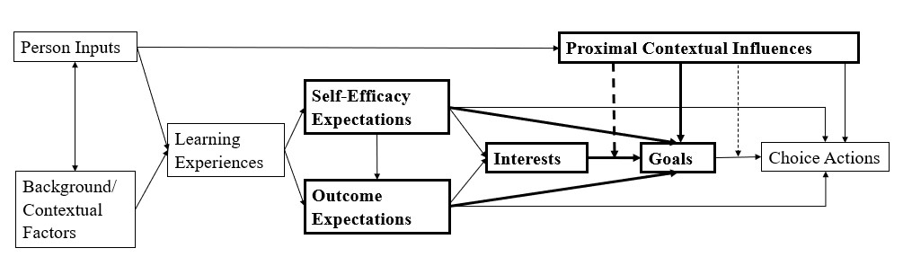
Note. Depiction of Lent, Brown, & Hackett’s (1994) SCCT model. Bolded sections were used in the present study’s model.

Figure 2
The Present Study’s Model
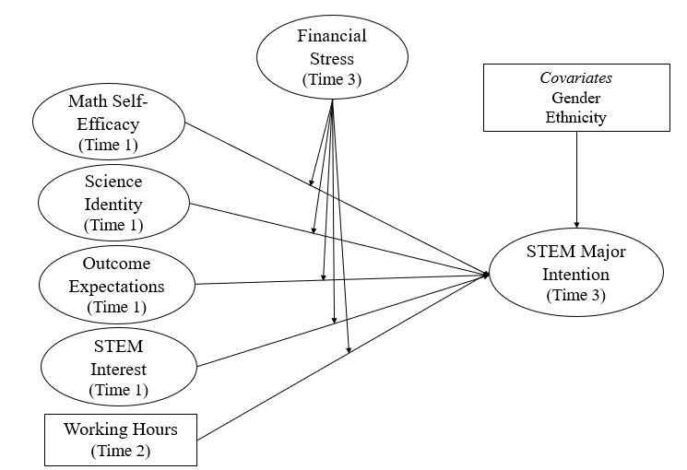

Figure 3
The Present Study’s Model with Standardized Estimates
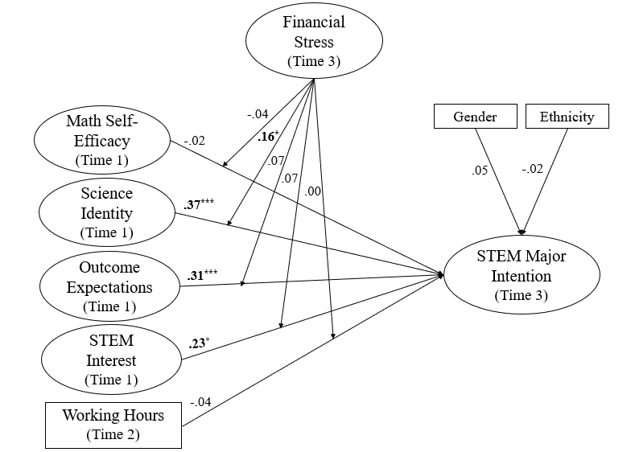

Figure 4
Interaction Plot for Science Identity and STEM Major Intention with Financial Stress as a Continuous Moderator
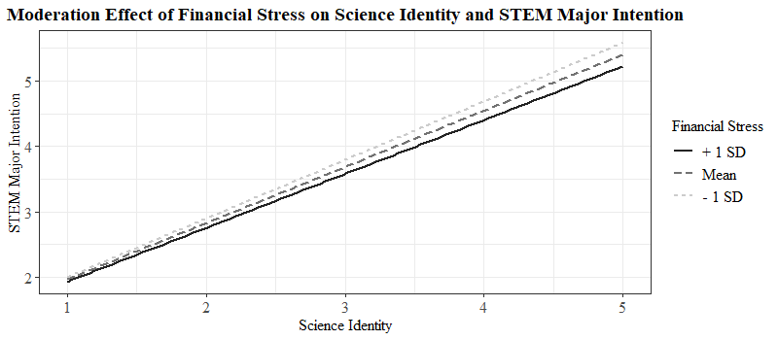

Figure 5
Boxplot Highlighting Racial Group Differences in Undergraduate Students’ Working Hours
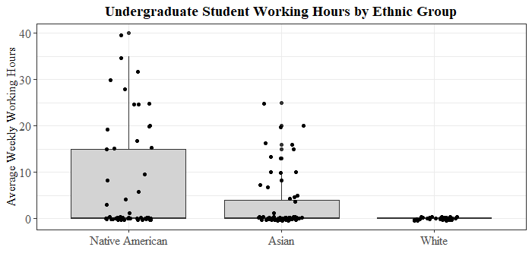

Appendix
Figure A1

Math Self-Efficacy CFA Model with Standardized Loadings
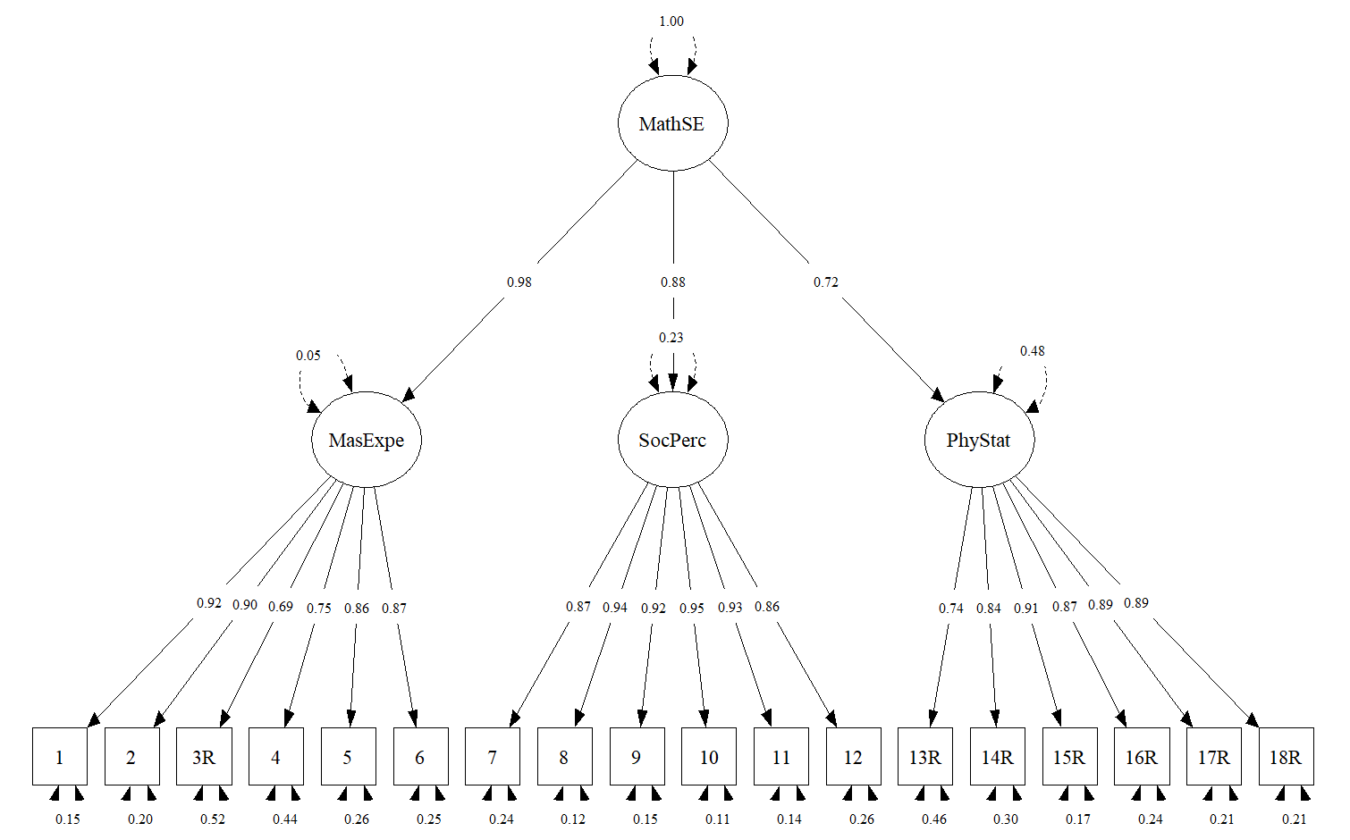
Note. CFA = Confirmatory Factor Analysis; MasExpe = Mastery Experience; SocPerc = Social Perception; PhyStat = Physical State; MathSE = Math Self-Efficacy.

Figure A2

Science Identity CFA Model with Standardized Loadings
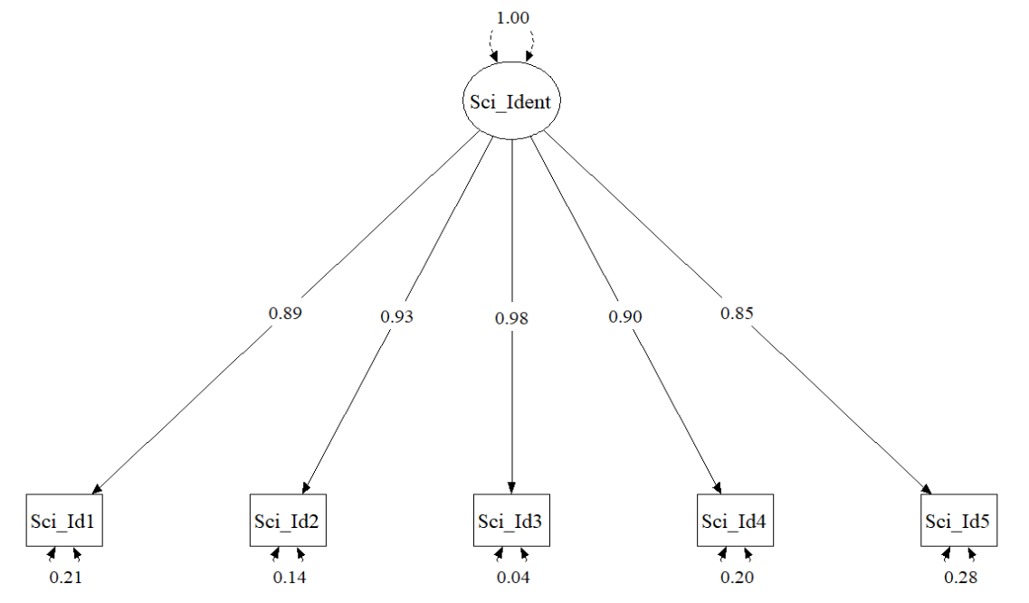
Note. CFA = Confirmatory Factor Analysis; Sci_Id or Sci_Ident = Science Identity.

Figure A3

Outcome Expectations CFA Model with Standardized Loadings
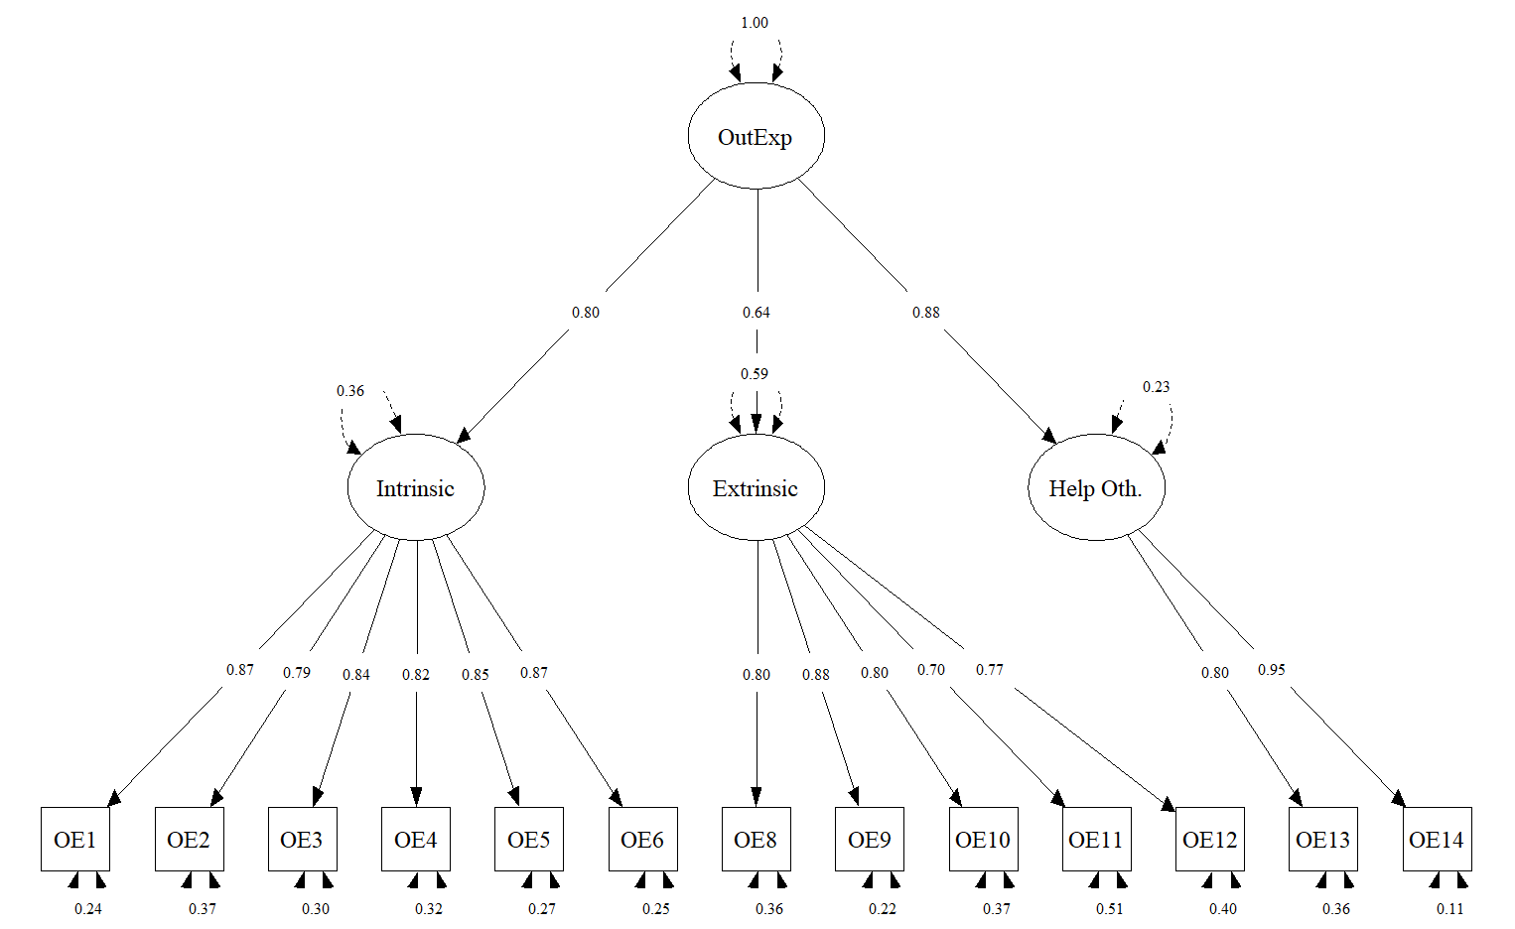
Note. CFA = Confirmatory Factor Analysis; Help Oth. = Helping Others. OutExp and OE = Outcome Expectations.

Figure A4

STEM Interest Activities CFA Model with Standardized Loadings
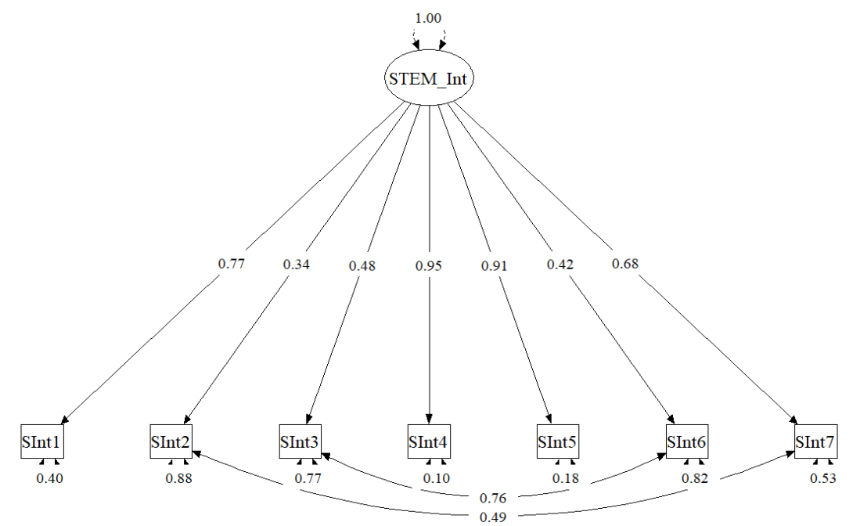
Note. CFA = Confirmatory Factor Analysis; STEM Int or SInt = STEM Interest. The residual variances for items 3 and 6 and 2 and 7 are correlated due to similarity in the items’ content.

Figure A5

Financial Stress CFA Model with Standardized Loadings
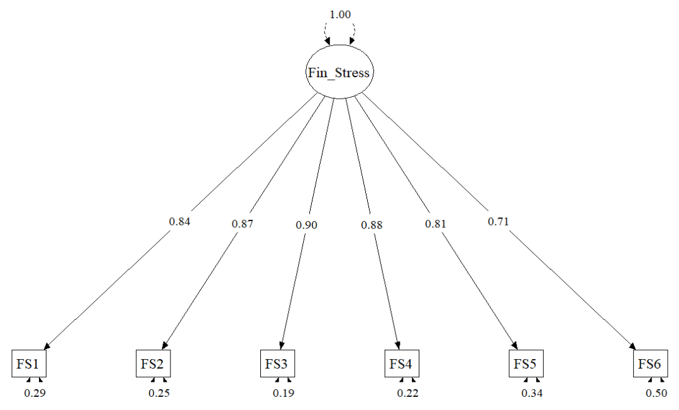
Note. CFA = Confirmatory Factor Analysis; Fin Stress or FS = Financial Stress.

Figure A6

STEM Major Intention CFA Model with Standardized Loadings
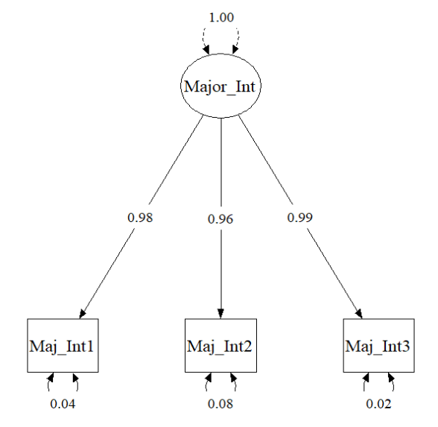
Note. CFA = Confirmatory Factor Analysis; Major Int or Maj Int =
STEM Major Intention.

Table A1

Usher and Parajes’ (2009) Math Self-Efficacy Items
Stem: Please indicate how true or false each statement below is for you. In the statements below, “mathematics” refers to subjects like algebra, geometry, calculus, and trigonometry.
Mastery Experience
MSE1 – I make excellent grades on math tests.
MSE2 – I have always been successful with math.
MSE3R – Even when I study very hard, I do poorly in math.
MSE4 – I got good grades in math on my last report card.
MSE5 – I do well on math assignments.
MSE6 – I do well on even the most difficult math assignments.
Social Persuasions
MSE7 – My math teachers have told me that I am good at learning math.
MSE8 – People have told me that I have a talent for math.
MSE9 – Adults in my family have told me what a good math student I am.
MSE10 – I have been praised for my ability in math.
MSE11 – Other students have told me that I am good at learning math.
MSE12 – My classmates like to work with me in math because they think I am good at it.
Physiological State
MSE13R – Just being in math class makes me feel stressed and nervous.
MSE14R – Doing math work takes all my energy.
MSE15R – I start to feel stressed-out as soon as I begin my math work.
MSE16R – My mind goes blank, and I am unable to think clearly when doing math work.
MSE17R – I get depressed when I think about learning math.
MSE18R – My whole body becomes tense when I have to do math work.
Note. A 6-point scale was used (1 = Definitely false to 6 = Definitely true). Higher scores indicate higher math self-efficacy. MSE = Math self-efficacy; R refers to reverse coded items. Italicized titles (e.g., Mastery Experience) are the subfactors with their associated items below.

Table A2

Chemers et al.’s (2011) Science Identity Items
Stem: Please indicate the extent that you agree or disagree with the following statements.
Sci_Id1 – In general, being a scientist is an important part of my self-image.
Sci_Id2 – I have a strong sense of belonging to the community of scientists.
Sci_Id3 – Being a scientist is an important reflection of who I am.
Sci_Id4 – I have come to think of myself as a “scientist”.
Sci_Id5 – I feel like I belong in the field of science.
Sci_Id6 – I am a scientist.
Note. A 5-point scale was used (1 = Strongly disagree to 5 = Strongly Agree). Higher scores indicate higher science identity. Sci_Id = Science identity. Item 6 was not used in the current study following practices done in similar studies (Dabdoub et al., 2023; Holloway, 2020).
Table A3

Lent et al. (2001)’s Outcome Expectations Items
Stem: Graduating with a bachelor’s degree with a major in a science, technology, engineering, or mathematics field would likely allow me to…
Intrinsic
OE4 – do work the I would find satisfying.
OE5 – increase my sense of self-worth.
OE9 – do exciting work.
OE10 – have the right type and amount of contact with other people (i.e., “right” for me).
OE11 – get the job I want most.
OE12 – feel good about myself.
Extrinsic
OE1 – receive a good job offer.
OE2 – earn an attractive salary.
OE3 – get respect from other people.
OE6 – have a career that is valued by my family.
OE8 – go into a field with high employment demand.
Helping Others
OE13 – help the community that I grew up in.
OE14 – help the community where I will be living in the future.
Cross-loaded on Extrinsic and Helping Others
OE7 – do work that can “make a difference” in people’s lives.
Note. A 5-point scale was used (1 = Strongly disagree to 5 = Strongly Agree). Higher scores indicate higher science identity. OE = Outcome Expectations. Italicized titles (e.g., Intrinsic) are the subfactors with their associated items below. Item 7 was not used in the analysis due to cross-loading and better model fit when removed.

Table A4

Lent et al.’s (2001) STEM Interest Activities Items
Stem: Please indicate your degree of interest in doing each of the following activities. Use the scale below to show how interested you are in each activity.
SInt1 – Solving practical math or science problems.
SInt2 – Reading articles or books about scientific issues.
SInt3 – Solving computer software problems.
SInt4 – Working on a project involving lots of math or science problems.
SInt5 – Solving complicated math or science problems.
SInt6 – Learning new computer programs.
SInt7 – Working on a project involving scientific concepts.
Note. A 5-point scale was used (1 = Strongly dislike to 5 = Strongly like). Higher scores indicate higher interest in STEM activities. SInt = STEM interest.

Table A5

Solberg et al.’s (1993) Financial Stress Items
Stem: In the last YEAR, how often did you experience the following:
FS1 – Difficulty paying student fees next semester.
FS2 – Financial difficulties due to owing money.
FS3 – Difficulty paying rent.
FS4 – Difficulty paying for food.
FS5 – Difficulty paying for recreation and entertainment.
FS6 – Difficulty due to your family experiencing money problems.
Note. 5-point scale was used (1 = Never to 5 = Very Often). Higher scores indicate higher financial stress. FS = Financial stress.

Table A6

Lent et al.’s (2001) Major Intention Items
Stem: Please indicate how strongly you agree or disagree with the following statements:
Maj_Int1 – I intend to major in a science/technology/engineering/math field.
Maj_Int2 – I think that earning a bachelor’s degree in science/technology/engineering/math
is a realistic goal for me.
Maj_Int3 – I am fully committed to getting my college degree in
science/technology/engineering/math.
Note. 5-point scale was used (1 = Strongly disagree to 5 = Strongly agree). Higher scores indicate higher intention to major in a STEM field. Maj_Int = STEM major intention.

