UNIVERSITY OF OKLAHOMA
GRADUATE COLLEGE

SYSTEMATICS AND BIOSTRATIGRAPHY OF DUNDERBERGIA AND RELATED TRILOBITES FROM CAMBRIAN (MID-STEPTOEAN) STRATA OF NEVADA, UTAH, TEXAS, AND NEWFOUNDLAND

A THESIS
SUBMITTED TO THE GRADUATE FACULTY
in partial fulfillment of the requirements for the
Degree of
MASTER OF SCIENCE

By
ROBERT MAYER
Norman, Oklahoma
2022

SYSTEMATICS AND BIOSTRATIGRAPHY OF DUNDERBERGIA AND RELATED TRILOBITES FROM CAMBRIAN (MID-STEPTOEAN) STRATA OF NEVADA, UTAH, TEXAS, AND NEWFOUNDLAND

A THESIS APPROVED FOR THE
DEPARTMENT OF BIOLOGY

BY

Dr. Cameron Siler, Chair

Dr. Stephen Westrop

Dr. Richard Cifelli

© Copyright by ROBERT MAYER 2022
All Rights Reserved.

Acknowledgements

Thanks to Dr. Westrop, who helped me get my foot in the door of academia, from getting me a job at the museum handwashing fossils, to giving me some trilobites to do some research on, to guiding me on my thesis from start to finish. The Invertebrate Paleontology class I took with you was one of the first classes I took that truly focused on paleontology. It helped remind me how much I love paleontology and I enjoyed the class immensely.
Thanks to Dr. Siler for both a truly fun class and for your help as a part of my committee, especially regarding the circumstances surrounding it, and thanks to Dr. Masly for helping me keep on track.
Special thanks to Dr. Cifelli for what you did to help me finish my journey as an undergrad and to start my journey as a graduate student. From the first conversation I had with you as a freshman to my final class as a senior, thank you for your encouragement.
Thanks to Roger Burkhalter for his help with cataloging specimens. I enjoyed the brief time I had working with you and every one of your stories and conversations.
Thanks to friends and family. Thanks to my parents and stepfather, Alastair, Jill, and Robert; and my siblings, Selena and Arthur; for your love and support. When do you get to drop the “budding” from “budding paleontologist”? Thanks to Claudia for prompting me to hurry up and finish the thesis, and to Faith, Jessica, and Topher for giving me a distraction when I needed one and preventing me from burning out. And thanks to Farris for keeping me focused and supporting me every step of the way.

Table of Contents

Acknowledgements iv
Table of Contents v
List of Tables vii
List of Figures viii
Abstract ix
Chapter I: Introduction 1
Importance of the Cambrian of the Great Basin and its trilobite faunas 1
Sample localities and geological setting 3
Great Basin, Nevada and Utah 3
Central Texas 6
Western Newfoundland 7
Trilobite biostratigraphy of the upper Candland Shale and correlatives, Utah and Nevada 9
A preliminary species-based zonation of the upper Candland Shale and correlatives 11
References 40
Chapter II: Phylogenetic analysis of Dunderbergia and related trilobites 48
Taxon selection and coding sources 49
Character coding 51
Results 51
An interim classification of Dunderbergia and its relatives 52
References 59
Chapter III: Systematic Paleontology 62
Genus Dunderbergia Walcott, 1924 62
Dunderbergia (s.l.) nitida (Hall and Whitfield, 1877) 63
Dunderbergia (s.l.) anyta (Hall and Whitfield, 1877) 66
Dunderbergia (s.l.) cf. D. bigranulosa Palmer, 1960 70
Dunderbergia (s.l.) cf. D. calculosa Palmer, 1965 72
Dunderbergia (s.l.) astropletha n. sp. 73
Dunderbergia (s.l.) bovicephala n. sp. 77
Dunderbergia (s.l.) multichauna n. sp. 83
Dunderbergia (s.l.) n. sp. 1 86
Dunderbergia (s.l.) n. sp. 2 87
Dunderbergia (s.l.) sp. indet. 1 88
Dunderbergia (s.l.) sp. indet. 2 89
Subgenus Dytremacephalus Palmer, 1954 90
Dunderbergia (Dytremacephalus) granulosa Palmer, 1954 91
Dunderbergia (Dytremacephalus) aphropeca n. sp. 92
Dunderbergia (Dytremacephalus) chondramma n. sp. 96
Dunderbergia (Dytremacephalus) craniophysa n. sp. 99
Dunderbergia (Dytremacephalus) pluviguttata n. sp. 101
Subgenus Elburgia Palmer, 1960 104
Dunderbergia (Elburgia) granulosa (Hall and Whitfield, 1877) 105
Dunderbergia (Elburgia) magnatubercula n. sp. 108
References 112
Appendix A: Character Traits 114
Appendix B: Plates 117

List of Tables

Table 1: Character coding matrix 54

List of Figures

Figure 1: Locality maps for the stratigraphic sections 16
Figure 2: Sections at Orr Ridge and in the Fish Springs Range 18
Figure 3: Stratigraphic columns at Orr Ridge, Fish Springs, and Cherry Creek Ranges 20
Figure 4: Cherry Creek Range, Orr Ridge, and the Fish Springs Range Lithography 22
Figure 5: Dunderberg Formation at Barton Canyon, Cherry Creek Range 24
Figure 6: Orr Formation exposed at Orr Ridge 26
Figure 7: Orr Formation exposed in the Fish Springs Range 28
Figure 8: Riley Formation, central Texas 30
Figure 9: Cambrian strata exposed at the Hoover Point road cut 32
Figure 10: Locality maps for sites in the Cow Head region 33
Figure 11: Stratigraphic context for samples from western Newfoundland 36
Figure 12: Trilobite zones proposed for the Steptoean succession of the Great Basin. 38
Figure 13: Composite stratigraphic range chart for included species 40
Figure 14: Strict consensus of 27 trees 56
Figure 15: Optimized character distribution 58

Abstract
The Great Basin of Nevada and Utah has been a classic region for Cambrian geology and paleontology for some 150 years. Studies in the late 19th century were prompted by the discovery of commercial ore deposits and led to the initial documentation of the trilobite faunas in the 1870s and 1880s. Further work on these faunas in the 1950s and early 1960s cemented the importance of the region, particularly as a standard succession for Cambrian trilobite biostratigraphy. However, many species are poorly documented by modern standards, and a revision is long overdue. This thesis focuses on the Dunderberg Formation in Nevada and coeval parts of the Orr Formation in Utah. With more than 100 trilobite species reported from the Dunderberg alone, a full revision of the fauna will not be attempted. Instead, the thesis deals with three genera of Family Elviniidae, Dunderbergia Walcott, 1924 and two close relatives, Dytremacephalus Palmer, 1954 and Elburgia, Palmer, 1960, and is based on new field collections from the Dunderberg and Orr formations. In addition, some species from the Riley Formation of central Texas and the Shallow Bay Formation of western Newfoundland are included in the study. A total of 18 species are documented, and eight of them are new. An analysis using computer- based parsimony methods places the species in a broader phylogenetic context. The results indicate that species of Dytremacephalus and Elburgia form monophyletic subclades that are nested within a set of species that have been assigned to Dunderbergia in previous studies; Dunderbergia is paraphyletic. An improved understanding of the relationships of these species must await a much larger analysis of the entire Family Elviniidae, a major undertaking that is beyond the scope of this thesis. As an interim step that preserves as much of the existing classification as possible, Dytremacephalus and Elburgia are treated as subgenera of Dunderbergia, with species of the latter referred to simply as Dunderbergia sensu lato. New species named in this thesis are: Dunderbergia (s.l.) astroplethes, Du. (s.l.) bovicephala, Du. (s.l.) multichauna, Du. (Dytremacephalus) aphropeca, Du. (Dy.) chondramma, Du. (Dy.) craniophysa, Du. (Dy.) pluviguttata, and Dunderbergia (Elburgia) magnatubercula. Species range data are used to develop a high- resolution zonation of four zones for the upper Candland Shale and correlatives in Nevada and Utah, in ascending order, the Du. (Dy.) pluviguttata, Prehousia alata, Dunderbergia (s.l.) anyta, and Dunderbergia (Elburgia) granulosa zones. They will allow detailed correlation of strata throughout the Great Basin region.

Chapter I: Introduction

Importance of the Cambrian of the Great Basin and its trilobite faunas
There is a long history of study of Great Basin Cambrian faunas going back to the 19th century, in a period of exploration immediately following the Civil War (Meek 1870; Hall and Whitfield, 1877; Walcott, 1884; White 1874). The region was important because of the discovery of commercial ore deposits in Cambrian strata (e.g., Hague, 1892), particularly in the Eureka region of Nevada. The economic importance of mining led to a renewed focus on the geology in the 1950s (Nolan et al., 1956; Palmer, 1960; Nolan, 1962). The classic monographs by Palmer (1960, 1965) on the trilobites of the Dunderberg Formation of Nevada were a product of field work during this period and have been used as a standard reference. Palmer’s work is now 60 years old, however, and a new program of field work on the entire Upper Cambrian of the region began in 2000 (e.g., Westrop and Adrain, 2007, 2009a, b, 2013, 2016; Westrop et al., 2007, 2008, 2010). This thesis is a contribution to this new research, and includes both systematic revisions of selected trilobites, and the development of a biostratigraphic zonation for part of the Steptoean Stage.
The primary geological application of fossils is in relative age dating, the basis of biostratigraphy. This use of fossils as an aid to correlating strata goes back to the beginning of the 19th century (e.g., Smith, 1816), and arguably played a key role in the development of geology as a science. In its modern form, biostratigraphy involves the development of zonations and correlation of zones, which can be defined simply as bodies of strata characterized by their fossil content (e.g., Ludvigsen et al., 1986). Because of their diversity and abundance, trilobites and agnostoid arthropods have figured prominently in development of Cambrian zonations (see Peng et al., 2012 for a general review). Early work (e.g., Howell et al., 1944; Lochman-Balk and Wilson, 1958) used the geological ranges of genera to establish sets of zones. Well-exposed, fossiliferous successions in Nevada and Utah (Palmer, 1960, 1965; Robison, 1964), such as those in the Dunderberg formation, were particularly important.
More recently, trilobite zonations have been developed at the species level, simply because species have shorter durations and consequently offer higher resolution. (e.g., Ludvigsen et al., 1986; Pratt, 1992; Westrop, 1995; Webster, 2011; Sundberg, 2018). Palmer’s widely used zonation is genus-based, so developing an alternative, species- based zonation is a part of this thesis. However, many of the species from the Dunderberg Formation and its correlatives are poorly known and are in need of revision. Palmer (1965) reported 112 species from 51 genera, so a full evaluation of the fauna is well beyond the scope of a single M.S. thesis. Instead, this thesis focuses on an important biostratigraphic interval, the Dunderbergia Zone (first proposed by Lochman and Wilson, 1958), and species of Family Elviniidae that occur within it, including those of Dunderbergia itself. The thesis also includes coeval species from central Texas and Newfoundland that were available for study. It represents a first step towards systematic revision of trilobite faunas and development of a high-resolution zonation for one of the more important Cambrian successions in North America.
This thesis will revise elviniid trilobites from the Dunderbergia Zone from Nevada, Utah, Texas and Newfoundland, including description of new species, and perform a cladistic analysis to place them in a broader phylogenetic context. This analysis will then be used to reclassify species as necessary and incorporate newly discovered species. Information on the stratigraphic distribution of species from new collections will then be used as a basis to develop a zonation of the Dunderbergia Zone in Nevada and Utah.

Sample localities and geological setting

Great Basin, Nevada and Utah
Localities. — Samples from Nevada were collected from the Dunderberg Formation in the Cherry Creek Range, White Pine County, by S.R. Westrop, J. Adrain, J. Bean and D. Shultz in 2001. They were included in a paleoecological study by Bean (2002), but the systematics of the trilobites has not been treated previously. The locality at Barton Canyon (Fig. 1A) has been described briefly in the literature (e.g., Palmer, 1965, p. 93; Westrop and Adrain, 2007, p. 988). The section through the Dunderberg Formation was measured on the ridge on the north side of the canyon by Westrop, Bean, and Schultz, with lithological descriptions of the section by Westrop. The lower part of the formation is not exposed above the contact with the underlying Hamburg Formation, and the lowest collection, which yields Dicanthopyge convergens Palmer, 1965 and Tumicephalus depressus Palmer, 1965 belongs to the upper part of Palmer’s (1965) Dicanthopyge Zone (Bean, 2002; M. Mehlman and S.R. Westrop, unpublished). The section along the valley floor measured by Palmer exposed this lower part of the formation in the late 1950s but was covered by alluvium and vegetation in 2001.
The Candland Shale Member of the Orr Formation (Hintze et al., 1976) yielded samples at two localities in western Utah. A section at Orr Ridge in the northern House Range, Millard County (Fig. 1B, 6A), was measured by R. Burkhalter and described lithologically by S.R. Westrop in 2007. The locality is on the south side of Big Horse Canyon, where the Orr Formation was judged to be better exposed than at the type section, which lies on the ridge immediately to the north. The Candland Shale was measured in two segments (ORR lwr and ORR lwr2) to minimize the extent of covered intervals. The segments were tied together by pacing out a prominent marker bed of thrombolitic microbial boundstone (“lower marker bed”; Figs. 2A, 3, 6B) that occurs at 87.5 m above the base of ORR lwr and at 29.3 m above the base of ORR lwr2 (Westrop unpublished). This marker, and a second buildup horizon (“upper marker bed”), which occurs at 40.5 m above the base of ORR lwr2, can be identified in the Candland Shale in the Fish Springs Range (Fig. 2B), and provides a physical basis for correlating the study interval at the two localities (Fig. 3; Westrop, unpublished). A fauna with Dicanthopyge convergens and Tumicephalus depressus at 51.8 m above the base of ORR lwr is identical to the fauna at the base of the exposed section in the Cherry Creek Range and provides a biostratigraphic tie point between these two localities (Fig. 3; Melman and Westrop, unpublished data).
The Fish Springs Range locality is 56 km to the north of Orr Ridge and exposes a comparable succession of the Orr Formation. A section was measured and logged (by R. Burkhalter and S.R. Westrop, respectively) in two segments on the east side of the range, on a south-facing slope to the north of a steep-side gulley that is the path of a 4x4 trail. The lower segment (FSR1) begins within the Candland Shale and ends at the “upper marker bed”. The upper segment (FSR2) begins 23.1 m below the “lower marker bed” in the Candland Shale, and extends through the overlying Johns Wash Limestone, Corset Spring Shale, and Sneakover Limestone. Only the Candland Shale is included here.
Geological setting. — In the type area of the Eureka Mining District, central Nevada, the Steptoean Stage is represented by the Dunderberg Formation, which is composed of interbedded carbonate and shale (Nolan et al., 1956; Palmer, 1960; Nolan, 1962). New mining activities have now covered the most complete section at Windfall Canyon (Westrop, personal communication), and this has prevented restudy of the formation in this region. Farther east, in the Cherry Creek and Schell Creek ranges, the Dunderberg Formation retains its shaly character. At Barton Canyon, much of the succession consists of a cyclic alternation of shales with various thin carbonate interbeds (lime mudstone and bioclastic carbonate), and bioclastic carbonates (Fig. 5). The bioclastic units are concentrations of disarticulated trilobite sclerites that likely formed from storm action and/or condensation (e.g., Brett et al., 2008), and deposition occurred above average storm wave base.
In west-central Utah, the upper two-thirds of Orr Formation of the northern House and Fish Springs ranges is correlative with the Dunderberg Formation farther to the east (Fig. 4). The Orr Formation (Fig. 4, 6A) includes a thick carbonate unit, the Johns Wash Limestone Member, in the Dunderbergia Zone (Hintze et al., 1976; Rees et al., 1976) that separates two shaly units (the underlying Candland Shale Member and the overlying Corset Spring Shale Member). Trilobites described in this thesis were collected by Burkhalter and Westrop from a roughly 30 m interval of the upper Candland Shale (Fig. 3). This interval includes the “lower” and “upper” marker units and is composed mostly of thin-bedded (cm-thick) calcisiltite, grainstone, and minor rudstone with thin silty or shaly partings and interbeds. Thicker (dm-thick) intraclastic rudstone (“flat-pebble conglomerate”) layers are also present (Fig. 3). Intraclastic rudstone can form in a variety of ways (Myrow et al., 2004), but the overall facies association is consistent with deposition in a shallow subtidal setting that was above storm wave base (e.g., Westrop, 1989; Saltzman, 1999)

Central Texas
Localities. — The samples (HP 3.1, 3.65, 3.7, 3.75) from Texas were collected from a road cut at Hoover Point on Farm Road 1431, just to the southeast of Kingsland, in Burnet County (Figs. 8A, 9A). The section was measured by R. Burkhalter and logged lithologically by S.R. Westrop in 2007. Armstrong (2018) included these samples in her study of the Riley Formation but gave only a cursory treatment of species of Dunderbergia and Dytremacephalus.
Geological setting. — At Hoover Point, the upper Riley Formation (uppermost Cap Mountain Limestone Member and the entire Lion Mountain Sandstone Member) is disconformably overlain by the Wilberns Formation (Welge and lower Morgan Creek Members) (Figs. 8C, 9A). The Cap Mountain Limestone is exposed on the west side of the highway at the pull-off (Figs. 8A, B), where it consists of sandy, glauconitic limestone. The overlying Lion Mountain Sandstone comprises eight meters of glauconitic sandstone with carbonate nodules in the lower five meters (Figs. 8B, 9A, B); bioclastic nodules are the source of the trilobite faunas. The sandstone lacks trilobites, apparently because of diagenetic dissolution of carbonate (McBride, 1988).
The most comprehensive assessment of the depositional environment of the Lion Mountain Sandstone was published in a series of papers by Chafetz (1978, 1979; Chafetz and Reid, 2000). He interpreted the succession as having formed in the tidal inlets of a nearshore barrier island complex (Chafetz, 1978, fig. 6). The trilobite-bearing bioclastic nodules were deposited as trough cross-bedded shell lags (e.g., Fig. 9B), and have a "halo" of lithified glauconitic sandstone. Cementation of the shell lags occurred close to the sediment-water interface, and protected the trilobite sclerites from compaction (Chafetz, 1979; McBride, 1988), but the lithification of the sandstone occurred later in the diagenetic history (McBride, 1988).

Western Newfoundland
Localities. — The samples are from boulders in conglomerates of the Downes Point Member of the Shallow Bay Formation (Cow Head Group) exposed in coastal sections in the Cow Head region of northwestern Newfoundland (Fig. 10). They were collected by C.H. Kindle and H.B. Whittington as part of an extensive program of field work, mostly between 1955 and 1965, and were acquired by the Geological Survey of Canada in 1978 (Kindle, 1981). Two boulders (CH 49, CH 54) are from a conglomerate exposed on the north shore of Cow Head (Figs. 10B, 11B) with an additional boulder (HC 180) from Hickey Cove, one km south of Cow Head (Figs. 10C, 11C). Also included is a boulder collected from Martin Point (MP 528), which is 35.5 km south of Cow Head. Eoff (2002) included the samples in her thesis research, but additional work done in in this study has revised and updated her identifications of species of Dunderbergia and Dytremacephalus and has also placed them in a broader phylogenetic context.
Geological setting. — The Cow Head Group is part of a deep-water succession that was thrust onto shallower water, continental shelf strata during the lower Ordovician Taconic Orogeny (Humber Arm Terrane of Williams and Hatcher, 1982; Humber Zone of Lavoie et al., 2003), which is the first stage in the history of the Appalachian Mountain chain. The stratigraphy and sedimentology of the Shallow Bay Formation was documented in detail by James and Stevens (1986). They showed that the Downes Point Member accumulated as a series of conglomerate debris sheets at the base of the continental slope (James and Stevens, 1986, fig. 57). The boulders themselves originated in shallow water at the margin of the continental shelf and include such lithologies as microbial (“algal”) boundstone, bioclastic grain- and packstone, and oolitic grainstone (James and Stevens, 1986). The shelf margin itself was destroyed during the Taconic Orogeny, so that the boulders provide one of the few records of marginal faunas in what is now eastern North America. Pohler et al. (1987) characterized the faunas as the remnants of a “lost faunal realm”.

Trilobite biostratigraphy of the upper Candland Shale and correlatives, Utah and Nevada
The foundations of modern Cambrian biostratigraphy in North America were laid down by a committee chaired by B.F. Howell that produced a comprehensive correlation chart of formations across the United States and Canada (Howell et al., 1944). They proposed a series of zones based on the stratigraphic distribution of trilobite genera that provided the relative time scale for their correlations. Shortly after, W.C. Bell and his students undertook new field studies of the Cambrian stratigraphy and trilobite faunas of the Upper Mississippi Valley (e.g., Nelson, 1951; Bell et al., 1952) and Texas (e.g., Wilson, 1949; Palmer, 1954) that applied and refined some of these new zones. Lochman and Wilson (1958) published a review of Cambrian biostratigraphy that updated Howell et al.’s original work. At the same time, new field work by Palmer (1960, 1965) in Nevada discovered numerous new trilobite species that led to a complete zonation for the Dunderberg Formation (Palmer, 1960, 1965; Fig. 12).
The genus-based approach was modified in some studies by dividing zones into species-based subzones (e.g., Winston and Nicholls, 1967; Stitt, 1971), but genus-based zones still provide the time scales for a variety of geological and paleontological studies (e.g., Miller et al., 2012, fig. 13). However, there is now a movement towards species- based zonations (e.g., Ludvigsen, 1982; Pratt, 1992; Westrop, 1995; Webster, 2011; Sundberg, 2018). Ludvigsen et al. (1986) and Webster (2011) commented on the advantages of this approach. Shorter durations of species provide finer temporal resolution, whereas first occurrences of genera are often strongly diachronous (although this can often be detected in the context of species zonations: see for example, Ludvigsen et al., 1986, fig. 18). As noted by Webster (2011, p. 122), the widespread use of genera “comes at a cost of precision”.
Because of excellent exposures of reasonably accessible, thick stratigraphic successions, the Great Basin is one of the classic regions for Cambrian paleontology. It is also a region in which high resolution Cambrian trilobite zonations have yet to be developed, although there has been recent progress in the Lower Ordovician (Adrain et al., 2009, 2014). Development of an entirely new zonation for the entire Steptoean stage is a major undertaking that is far beyond the scope of this thesis, which will focus on the interval represented by Palmer’s (1965) Dunderbergia Zone. Even in this shorter interval, there are far too many species to deal with. The thesis will focus on species of Family Elviniidae Kobayashi, 1935. Co-occurring species of another large clade, Family Pterocephaliidae Kobayashi, 1935, are under study by S.R. Westrop.

A preliminary species-based zonation of the upper Candland Shale and correlatives
Because only part of the fauna of the Dunderbergia Zone is treated in this thesis, the species zones described below are a first step, and they will be refined as associated pterocephaliid species are documented. As with all zonal schemes, the methodology is straight forward: species ranges are compiled within stratigraphic sections (Fig. 13) and first occurrences are used to define packages of strata defined by fossil content. Ideally, species used to define zonal boundaries should be abundant and geographically widespread. Species ranges at Orr Ridge and the Fish Springs Range define the boundaries of four zones (Fig. 13).
Dunderbergia (Dytremacephalus) pluviguttata Zone. — The oldest collections included in this study are from strata that belong to Palmer’s (1965) Prehousia Zone (Fig. 12). A succession of species of Prehousia is present in this part of the Candland Shale and will likely provide the foundation for new zones (Mehlman and Westrop, unpublished). The entry of Du. (Dytremacephalus) pluviguttata and Du. (s.l.). cf. calculosa at 66.15 m above the base of section ORR lwr provides an additional criterion for placement of a zonal boundary.
Prehousia alata Zone. — This species is not included in this thesis and is under study by Mehlman and Westrop. It occurs through a four-meter interval in ORR lwr2 (12 m –16 m above the base of the section) and has been reported widely from other localities in Nevada and Utah (Palmer, 1965). It will provide the basis for a new zone (Westrop, personal communication) and it is included in Fig. 13 to fill in the stratigraphic gap between the Du. (Dytremacephalus) pluviguttata Zone and the overlying Du. (s.l.) anyta Zone. Dunderbergia (s.l.) sp. indet. 2 also occurs in the P. alata Zone, underscoring the limitations of genus-based zones: Prehousia and Dunderbergia (s.l.) actually overlap in stratigraphic ranges.
Dunderbergia (s.l.) anyta Zone. — Dunderbergia (s.l.) anyta is abundant through an interval of at least 3 m in ORR lwr2 (appearing 23.5 m above the base of the section), and in section FSR2; covered intervals in the upper part of the zone prevent the full stratigraphic range from being determined. The species also occurs in Nevada (Palmer, 1965). Dunderbergia (s.l.) sp. nov. 2 enters the succession at the base of the zone; other species present that are not treated in this thesis include Aphelotoxon spinosus Palmer, 1965 (Westrop, unpublished).
Dunderbergia (Elburgia) granulosa Zone. — This species appears in abundance 34 m above the base of ORR lwr2, and Palmer (1965) reported it from most of his sample localities in Nevada. As such, the entry of Du. (Elburgia) granulosa into the Steptoean succession provides a significant datum for biostratigraphic correlation. Younger elviniid species occurring in the Cherry Creek Range, including Du (s.l.) nitida, may provide the basis for an overlying zone. However, a variety of other taxa occur in this interval (Westrop, unpublished), including species of the pterocephaliid trilobites Sigmocheilus and Cernuolimbus, and the agnostoid arthropod Oncagnostus, and placement of zonal boundaries should be deferred until they are documented fully.
Conclusions. — Although the zones defined above are preliminary in nature, they demonstrate the potential for finely-divided biostratigraphic time scales. The global Paibian Stage encompasses the Candland Shale and Johns Wash Limestone and is at most three million years in duration (Peng et al, 2012, fig. 19.11). The combined thickness of the Candland Shale and Johns Wash Limestone at Orr Ridge is about 160 m of strata. The four zones have a combined thickness of about 35 m. While it is difficult to translate stratal thickness into time with confidence, this suggests that the zones have a duration on the order of 150,000 years. They offer a high-resolution time scale that is essential for unravelling geological histories of sedimentary basins, and also for understanding Cambrian extinction events and the intervening radiations (e.g., Westrop and Cuggy, 1999).

Figure 1: Locality maps for the stratigraphic sections.
A. Section CCDu at Barton Canyon, Cherry Creek Range, White Pine County, Nevada.
B. Section ORR at Orr Ridge, northern House Range, Millard County, Utah.
C. Section FSR, Fish Springs Range, Juab County, Utah.

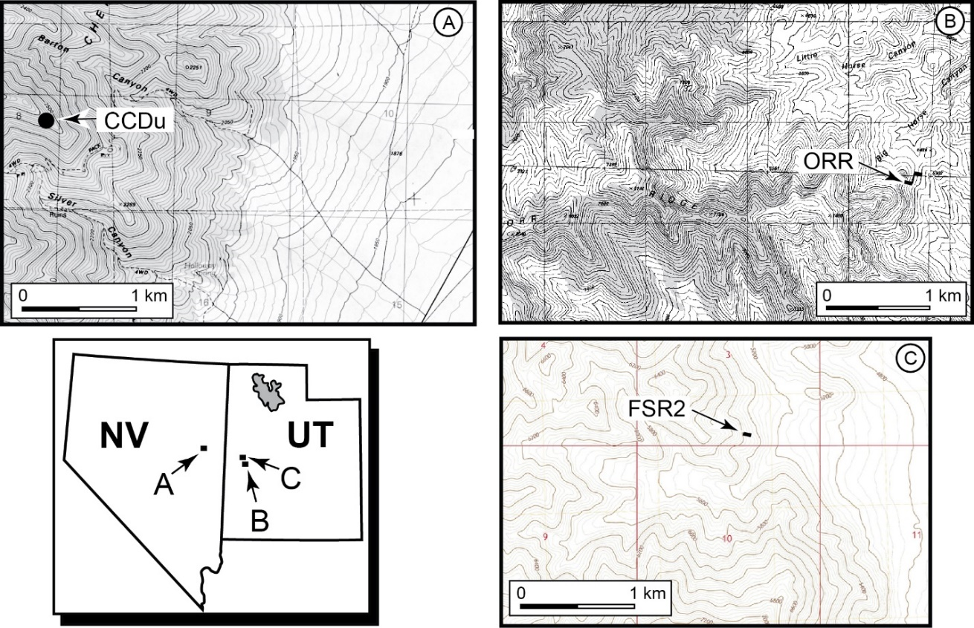
Figure 2: Sections at Orr Ridge and in the Fish Springs Range can be correlated physically with two conspicuous thrombolitic microbial buildup horizons that act as marker beds (S.R. Westrop, unpublished photographs).
A. Buildup at 40.5 m in the ORR lwr2 section.
B. The correlative buildup at FSR1 40.4 m.

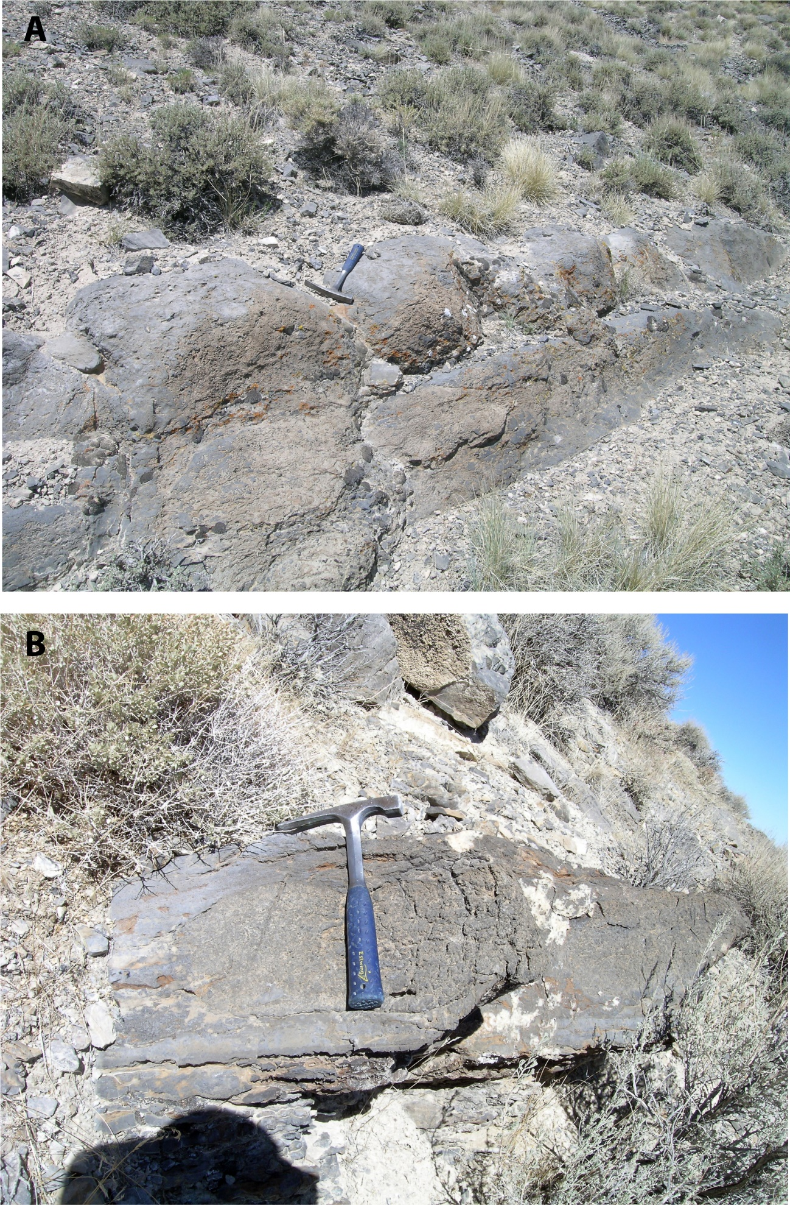
Figure 3: Stratigraphic columns (S.R. Westrop, unpublished data) for the upper Candland Shale Member of the Orr Formation at Orr Ridge and the Fish Springs Range, and the lower Dunderberg Formation in the Cherry Creek Range, showing occurrences of species of Dunderbergia (s.l.), Du. (Dytremacephalus) and Du. (Elburgia). The sections through the Orr Formation are correlated physically using microbial buildups (red shading; see also figs. 2, 6). The sections in the Cherry Creek Range and at Orr Ridge are correlated biostratigraphically using the occurrences of Dicanthopyge convergens Palmer, 1965 and Tumicephalus depressus Palmer, 1965 in collections CCDu 50.6 (Cherry Creek Range) and ORR lwr 51.8 (Orr Ridge) (Mehlman and Westrop, unpublished).

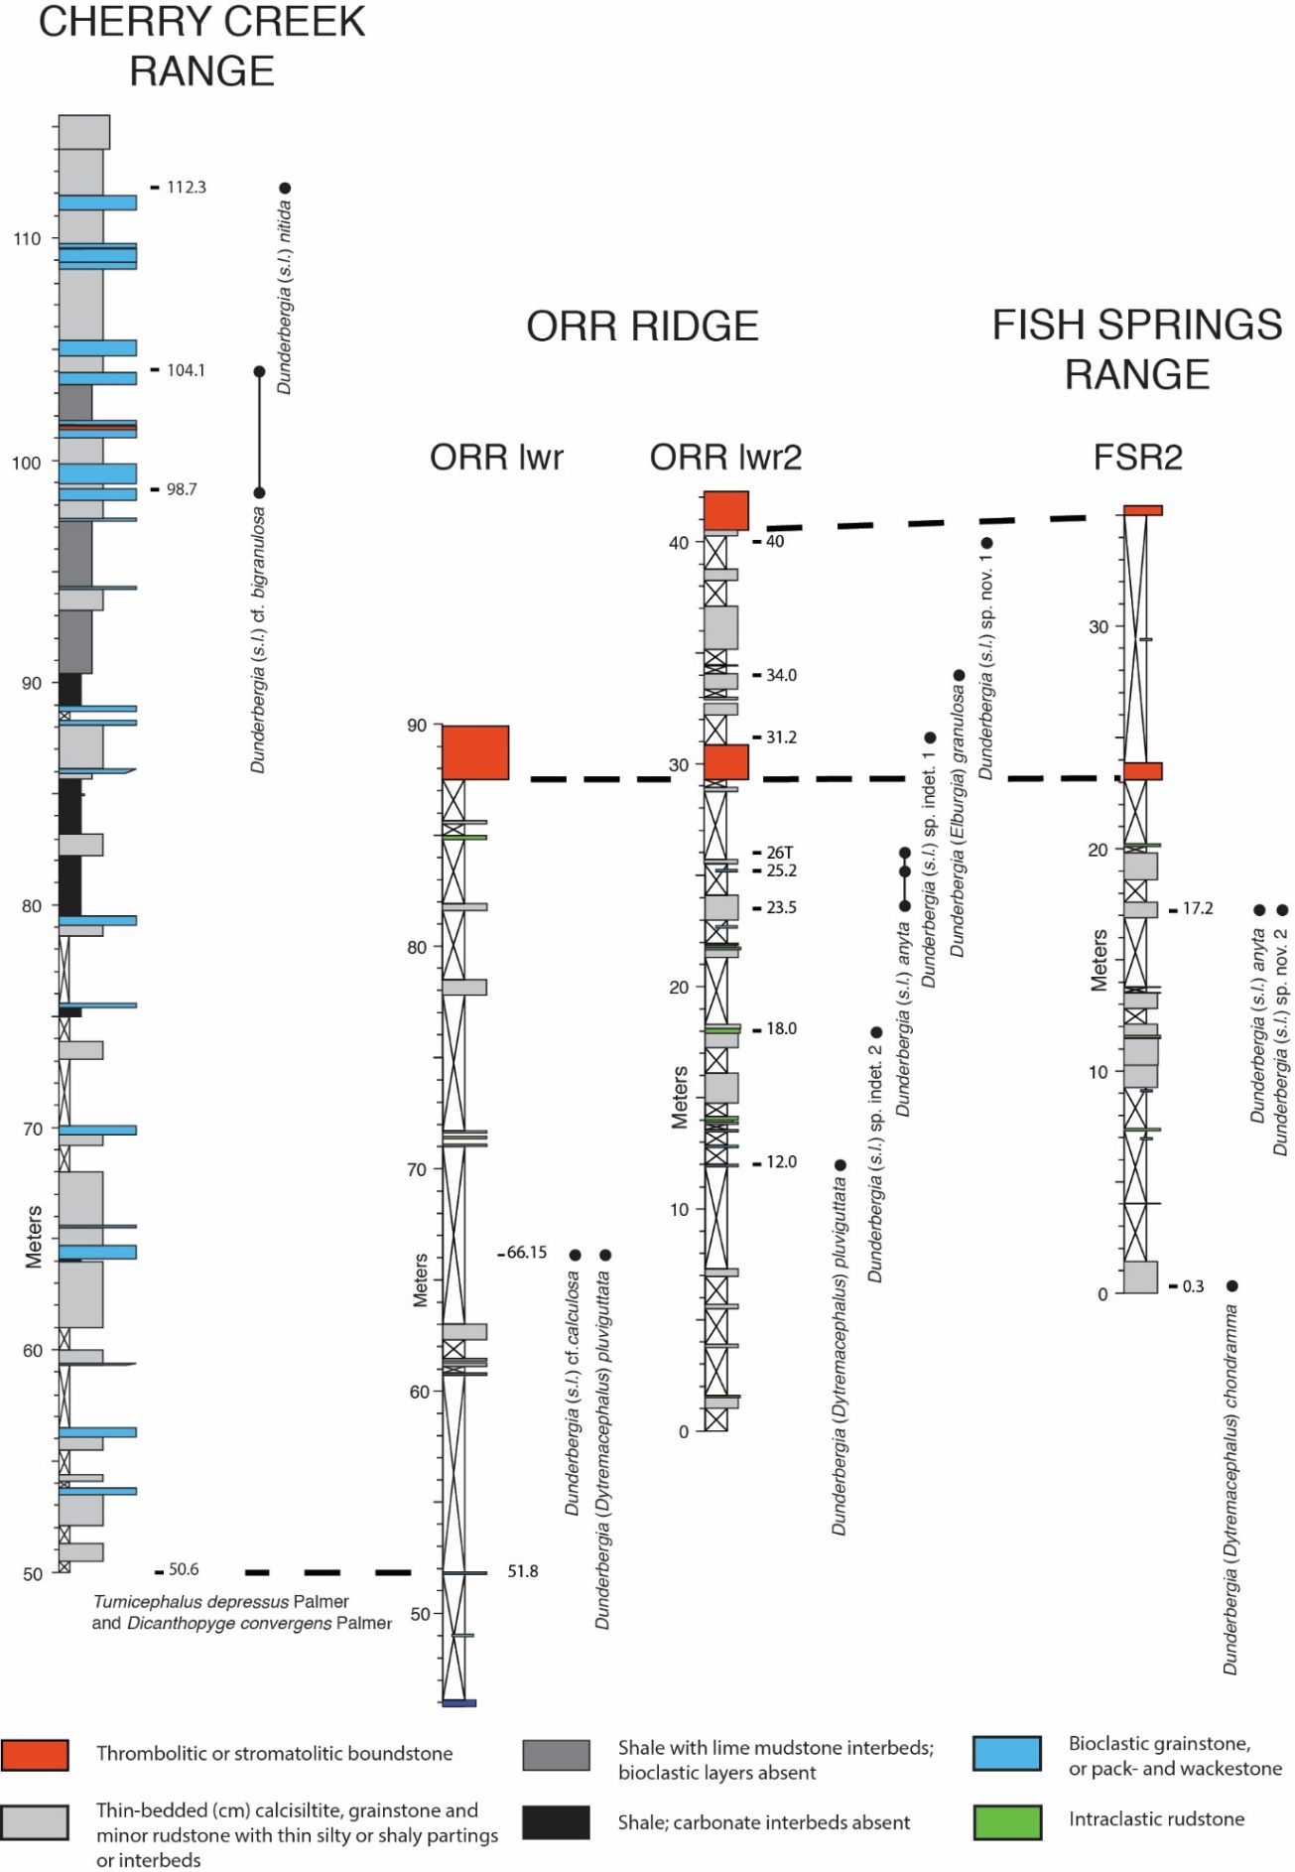
Figure 4: Lithostratigraphy of the Steptoean Stage in the Cherry Creek Range (Palmer, 1965; Westrop, unpublished) and at Orr Ridge and the Fish Springs Range (Hintze and Palmer, 1976). The yellow shading highlights the study interval in the lower Dunderberg Formation and the upper Candland Shale.

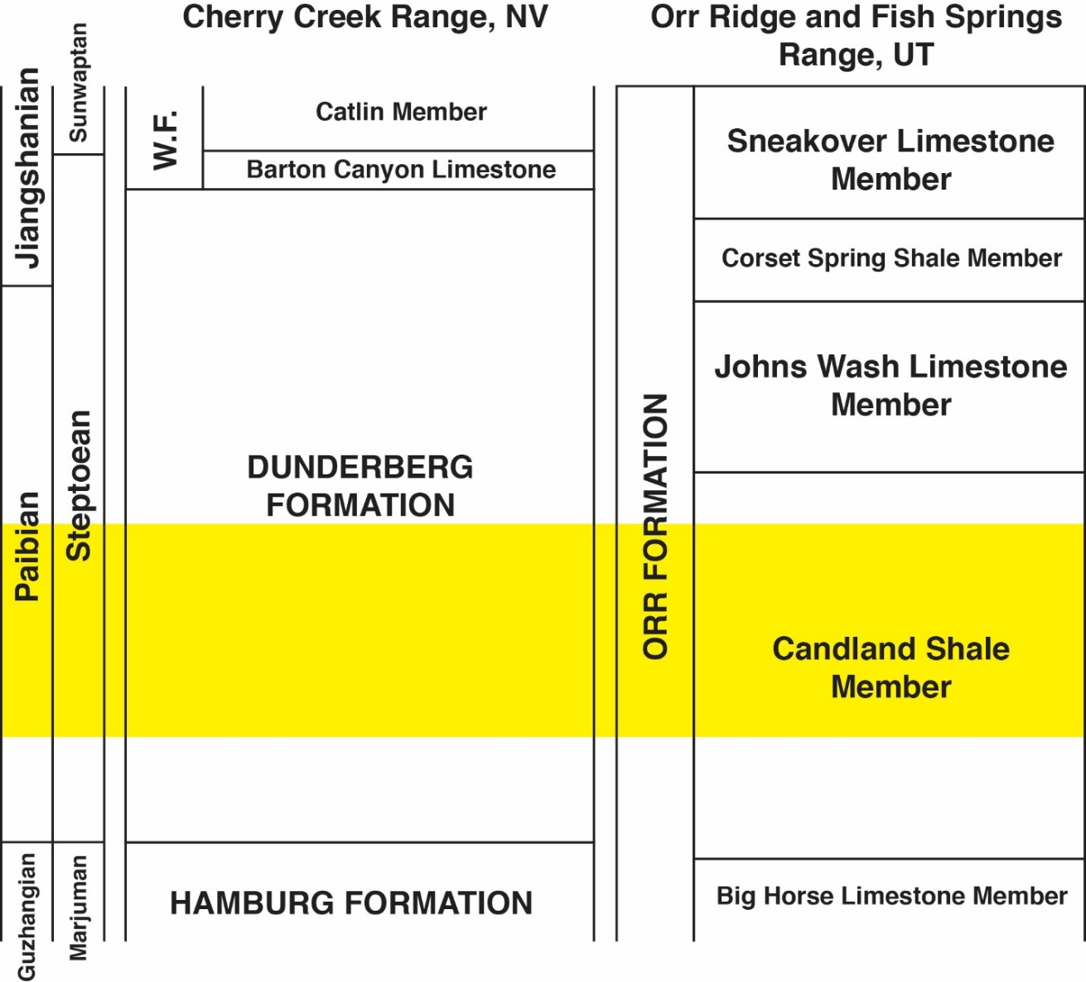

Figure 5: Dunderberg Formation at Barton Canyon, Cherry Creek Range (S.R. Westrop, unpublished photographs).

A: Expression of the Dunderberg Formation on the skyline on the south side of Barton Canyon, where it forms a recessive slope between the resistant carbonates of the underlying Hamburg Formation and the Barton Canyon Limestone Member of the overlying Windfall Formation.
B: Typical lithologies of the Dunderberg Formation. Shale with thin (cm) carbonate interbeds of lime wackestone and bioclastic grain- and rudstone overlain by thicker bedded (dm) bioclastic wackestone to packstone. Staff is 1.5 m in length.

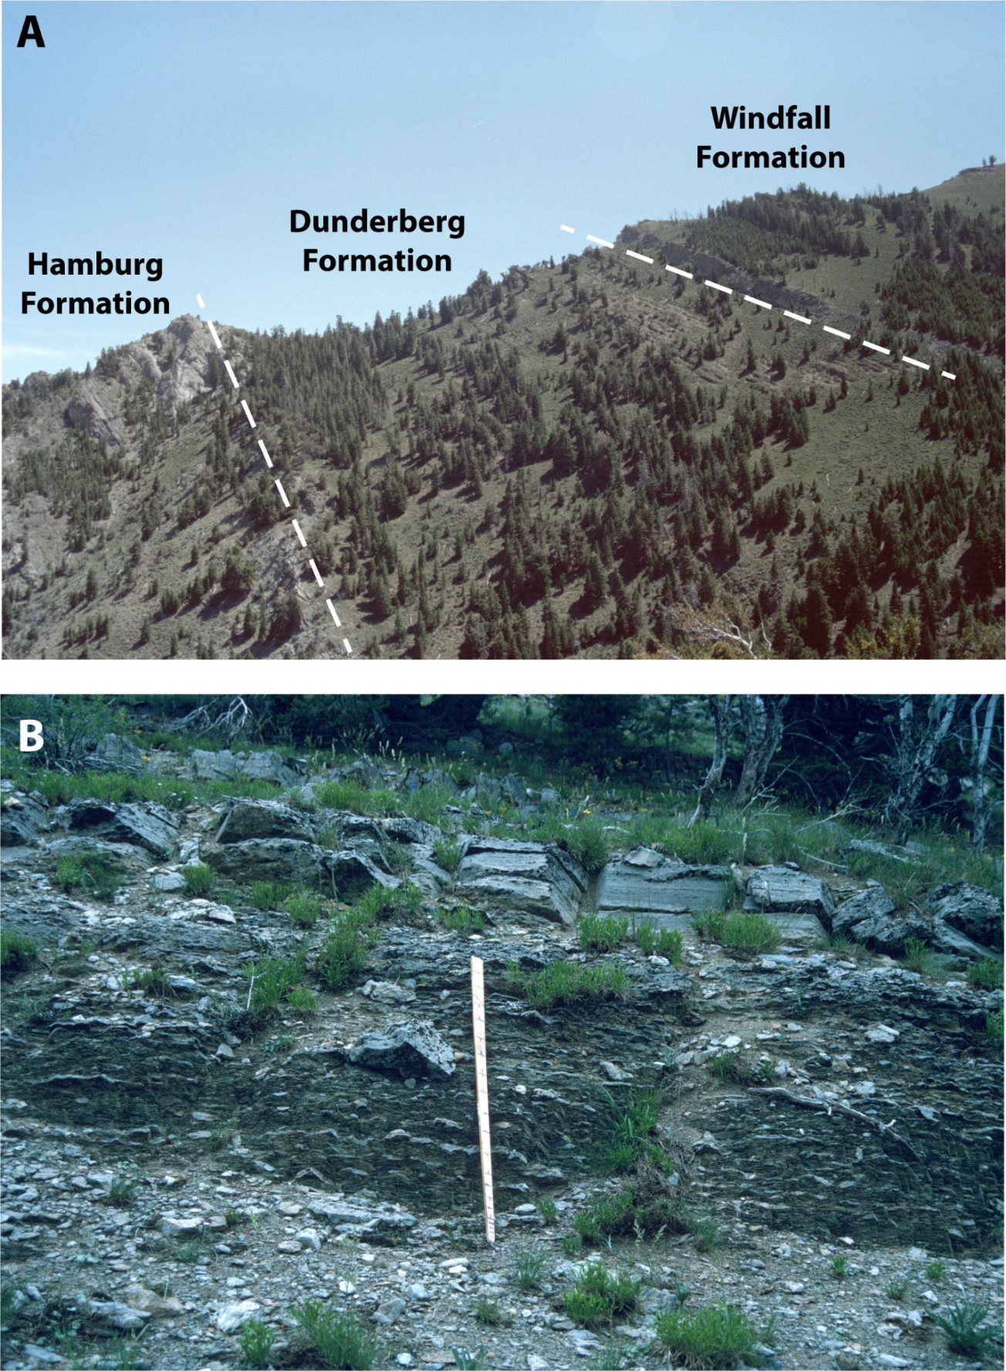

Figure 6: Orr Formation exposed at Orr Ridge (S.R. Westrop, unpublished photographs).
A: View to the south of section ORR showing the various members of the Orr Formation and the lower part of the overlying Notch Peak Formation.
B: View to the north of ORR lwr2 showing the upper Candland Shale and overlying Johns Wash Limestone; boundary between the two units is covered. The two microbial buildups that form marker horizons in the upper Candland Shale can be traced across Orr Ridge and can also be identified in the Fish Springs Range.

Figure 7: Orr Formation exposed in the Fish Springs Range (S.R. Westrop, unpublished photographs).
A, B: Contact between the Candland Shale and Johns Wash Limestone.

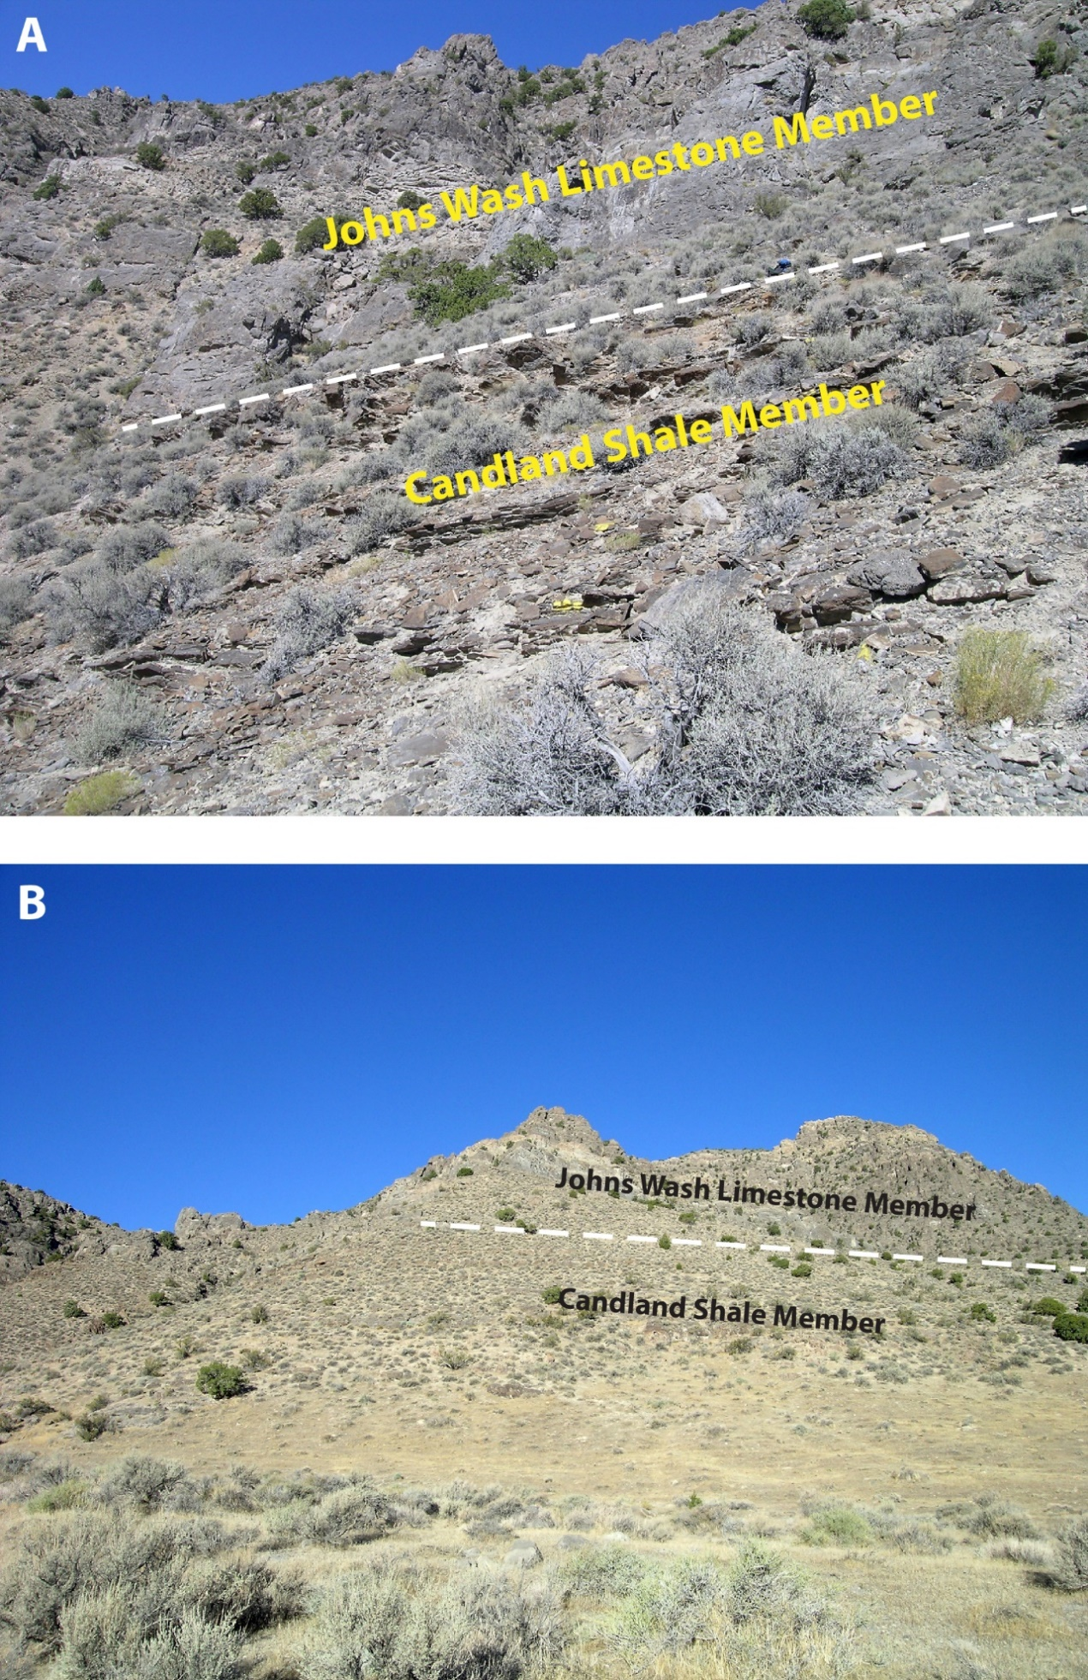
Figure 8: Riley Formation, central Texas.
A: Map showing location of section HP in a roadcut on Farm Road 1431 at Hoover Point, near Kingsland, Burnet County, Texas.
B: Stratigraphic nomenclature for the Steptoean Stage in central Texas. The Lion Mountain Sandstone Member yielded the specimens of Dunderbergia (s.l.) and Du. Dytremacephalus that are included in this thesis.
C: Stratigraphic column for section HP showing the positions of the samples included in this thesis (S.R. Westrop, unpublished data).

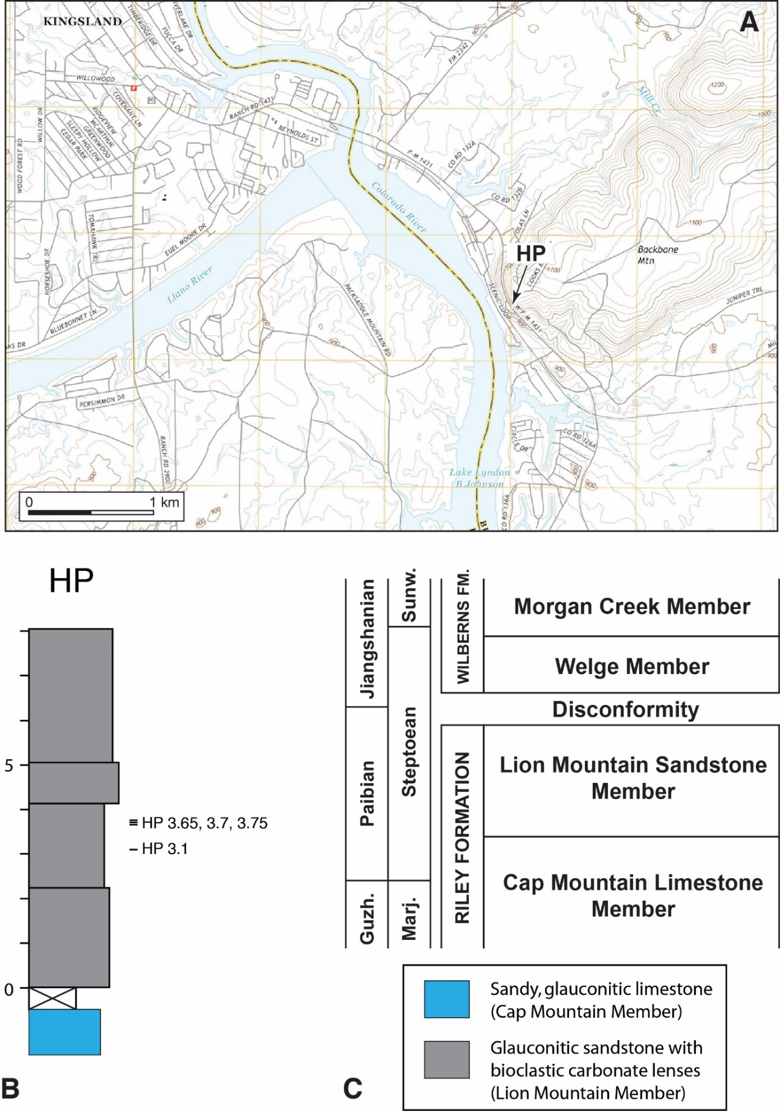
Figure 9: Cambrian strata exposed at the Hoover Point road cut (S.R. Westrop, unpublished photographs).
A: The Lion Mountain Sandstone in the lower half of the cut is overlain disconformably by the Wilberns Formation. Trilobites were collected carbonate nodules from the lower half of the exposed Lion Mountain Sandstone.
B: Strongly glauconitic, trough cross-bedded sandstone with carbonate nodules formed by accumulations of trilobite sclerites. These shell-rich layers were sites of early diagenetic cementation, which helped preserve the trilobites (Chafetz, 1979; McBride, 1988).

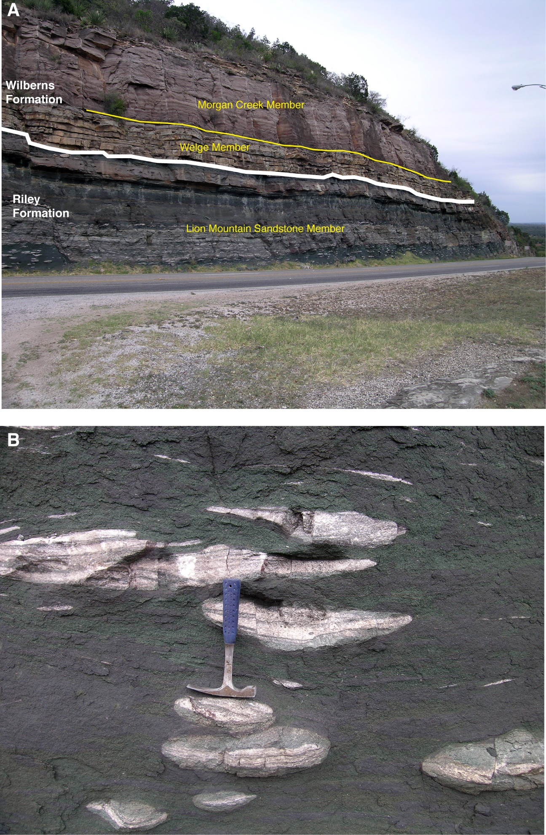
Figure 10: Locality maps for sites in the Cow Head region of western Newfoundland included in the thesis (modified from Westrop and Eoff, 2012).
A: General map showing Cow Head and Hickey Cove areas.
B: Map showing sample locality on the Cow Head Peninsula.
C: Map showing the sample locality at Hickey Cove.

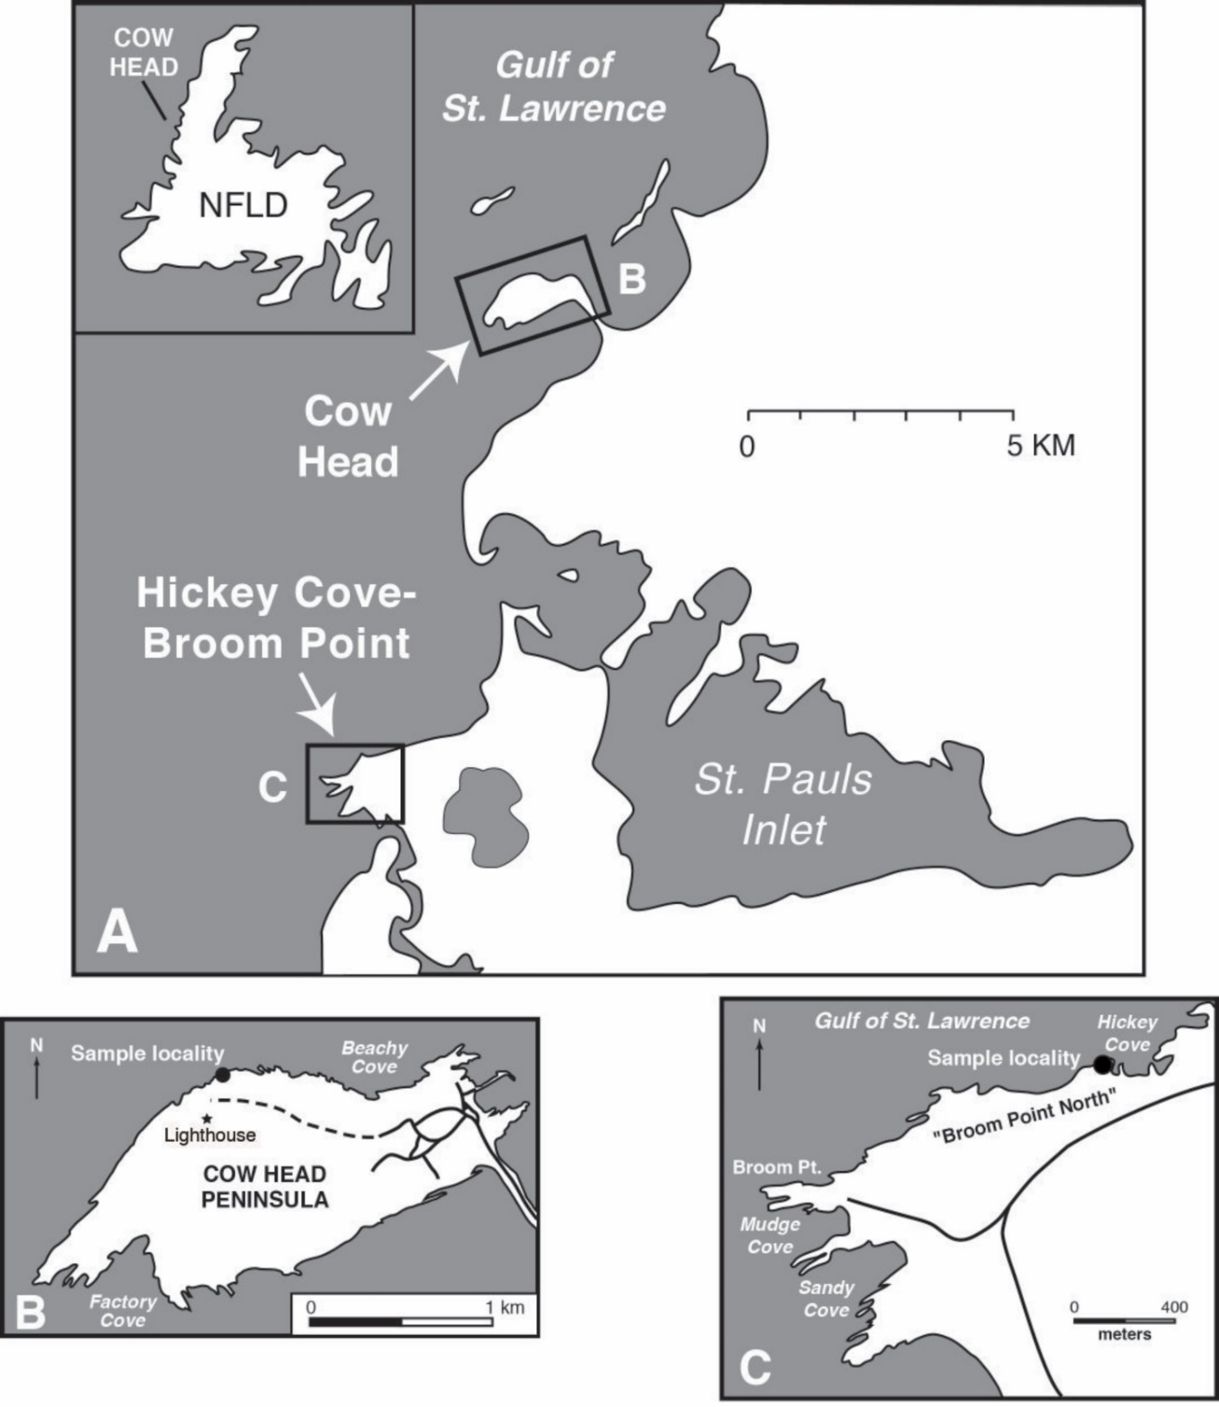

Figure 11: Stratigraphic context for samples from western Newfoundland included in the thesis (modified from Westrop and Eoff, 2012).
A: Stratigraphic nomenclature for the Cambrian of the Cow Head-Hickey Cove region. The samples were collected from conglomerates in the Downes Point Member of the Shallow Bay Formation.
B: Stratigraphic column for the upper Downes Point and lower Tuckers Cove member on the shore of Cow Head. Boulders CH 49 and CH 54 were collected from conglomerates beds at the top of the Tuckers Cove Member.
C: Stratigraphic column for the upper Downes Point and lower Tuckers Cove member on the shore of Hickey Cove. Boulder HC 180 was collected from a conglomerate bed near the top of the Tuckers Cove Member.

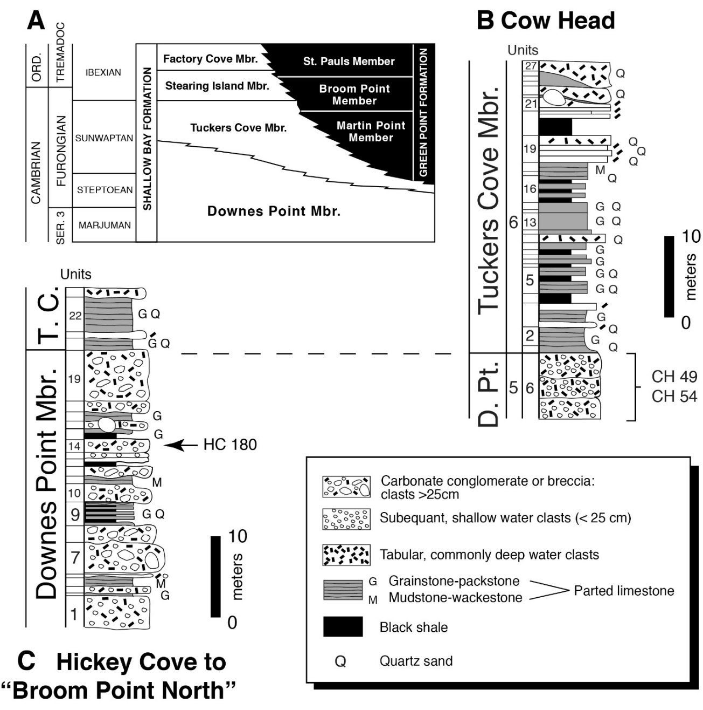

Figure 12: Trilobite zones proposed by Palmer (1965) for the Steptoean succession of the Great Basin. Stages shown are for Laurentian North America (right column; Ludvigsen and Westrop, 1985) and recently proposed global stages (Peng et al., 2004, 2009, 2012).

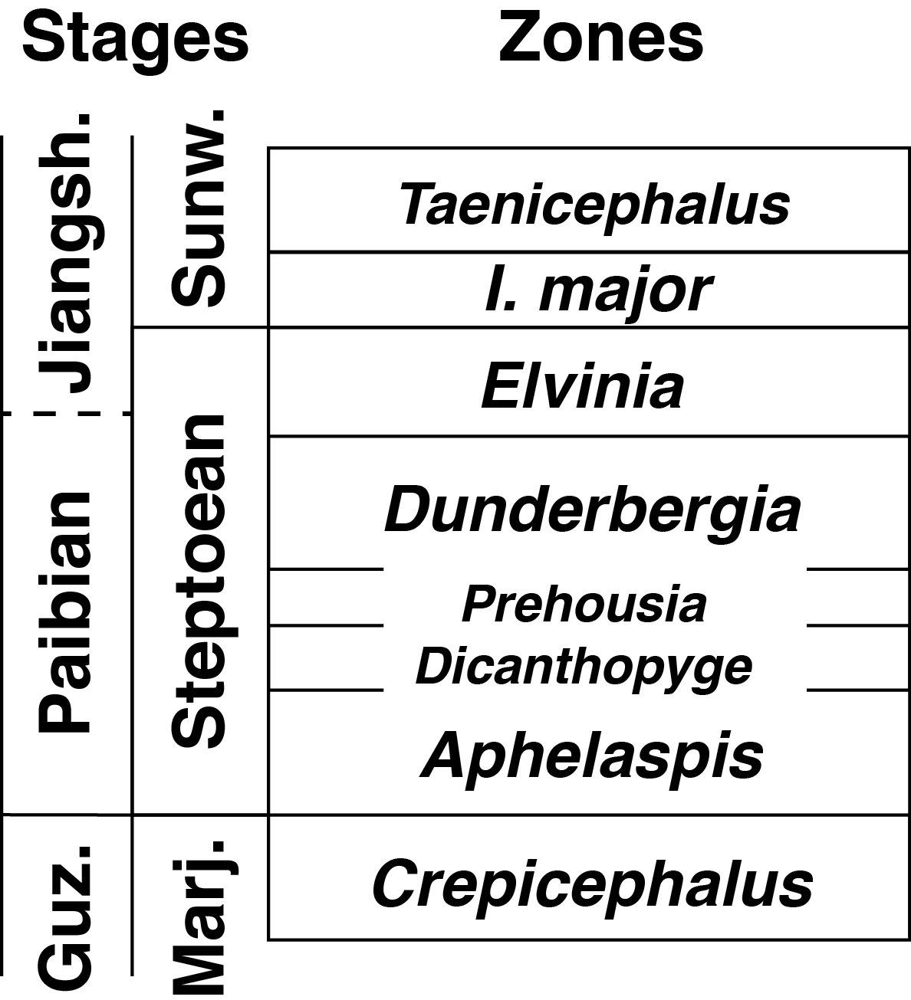

Figure 13: Composite stratigraphic range chart for species of Dunderbergia s.l., Du. (Dytremacephalus) and Du. (Elburgia). It combines information from sections ORR lwr, ORR lwr2 and FSR2, which were correlated using the microbial buildup marker beds, and from CCDu, which was correlated biostratigraphically. Also included is the stratigraphic range of Prehousia prima Palmer (white bar), which also occurs in ORR lwr, and is a candidate for defining a zone (Mehlman and Westrop, unpublished). Four species-based zones are proposed to replace the upper Prehousia and Dunderbergia zones in the study interval.

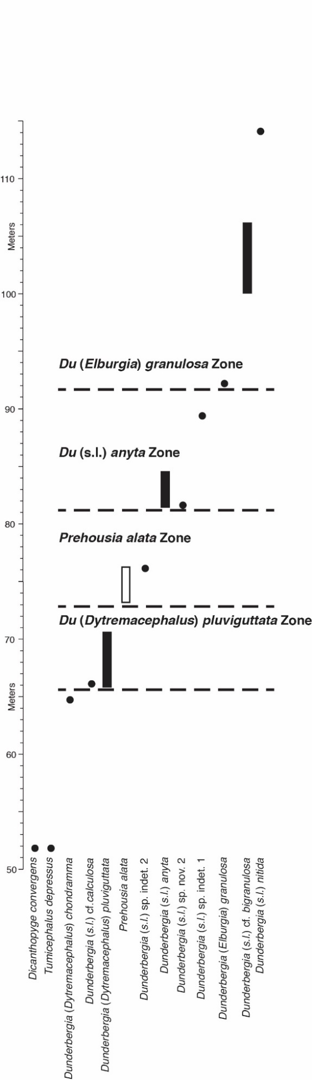

References
Adrain, J.M., McAdams, N.E., and Westrop, S.R., 2009. Trilobite Biostratigraphy and Revised Bases of the Tulean and Blackhillsian Stages of the Ibexian Series, Lower Ordovician, Western United States: Australasian Association of Paleontologists Memoir, 37: 541–610.
Adrain, J.M., Westrop, S.R., Karim, T.S., and Landing, E., 2014. Trilobite biostratigraphy of the Stairsian Stage (upper Tremadocian) of the Ibexian Series, Lower Ordovician, western United States: Memoirs of the Association of Australasian Palaeontologists, 45: 167–214.
Armstrong, M. 2018. Trilobites from a Cambrian extinction interval at the base of the Steptoean Stage, Riley Formation, central Texas. M.S. Thesis, University of Oklahoma.
Bean, J. 2002. Trilobite paleoecology and biostratigraphy of the Upper Cambrian (Steptoean) Dunderberg Formation, Cherry Creek Range and Schell Creek Range, Nevada. M.S. Thesis, University of Iowa, Iowa City, IA.
Bell, W.C., Feniak, O.W., and Kurtz, V.E., 1952. Trilobites of the Franconia Formation, Southeast Minnesota. Journal of Paleontology, 26: 175–198.
Chafetz, H. S. 1978. A trough cross‐stratified glaucarenite: a Cambrian tidal inlet accumulation. Sedimentology, 25: 545–559.
Chafetz, H. S. 1979. Petrology of carbonate nodules from a Cambrian tidal inlet accumulation, central Texas. Journal of Sedimentary Research, 49: 215–222.
Chafetz, H. S., and A. Reid. 2000. Syndepositional shallow-water precipitation of glauconitic minerals. Sedimentary Geology, 136: 29–42.
Dattilo, B.F., Brett, C.E., Tsujita, C.J., and Fairhurst, R., 2008. Sediment supply versus storm winnowing in the development of muddy and shelly interbeds from the Upper Ordovician of the Cincinnati region, USA. Canadian Journal of Earth Sciences, 45: 243–265.
Eoff, J.D. 2002. Late Cambrian (Steptoean) trilobites from the Cow Head Group, western Newfoundland. M.S. Thesis, University of Oklahoma.
Evans, K.R., J.F. Miller and B.F. Dattilo. 2003. Sequence stratigraphy of the Sauk Sequence: 40th anniversary field trip in western Utah. In Swanson, T.W. (ed.), Western Cordillera and adjacent areas. Geological Society of America Field Guide, 4: 17–35.
Hall, J., and Whitfield, R.P., 1877. Report of the Geological Exploration of the Fortieth Parallel. Part 2 Palaeontology. Professional Papers of the Engineer Department, US Army, 18: 199–299.
Hague, A., 1892. Geology of the Eureka district, Nevada, with an atlas.: Monographs of the US Geological Survey, 20: 1–419.
Hintze, L. F., and A. R. Palmer. 1976. Upper Cambrian Orr Formation; its subdivisions and correlatives in western Utah. United States Geological Survey Bulletin, 1405 – G: 1–36.
Howell, B.F., Bridge, J., Deiss, C., Edwards, I., Lochman, C., Raasch, G.O., and Resser, C.E., 1944. Correlation of the Cambrian formations of North America.: Gological Society of America Bulletin, 55: 993–1004.
James, N. P., and R. K. Stevens. 1986. Stratigraphy and correlation of the Cambro-Ordovician Cow Head Group, Western Newfoundland. Geological Survey of Canada Bulletin, 366:1–143.
Kindle, C. H. 1981. The CH Kindle collection: Middle Cambrian to Lower Ordovician trilobites from the Cow Head Group, western Newfoundland. Current Research Geological Survey of Canada, 82-1C: 1–17.
Lavoie, D., Burden, E. & Lebel, D. 2003. Stratigraphic framework for the Cambrian– Ordovician rift and passive margin successions from southern Quebec to western Newfoundland. Canadian Journal of Earth Sciences, 40: 177–205.
Lochman-Balk, C., and Wilson, J.L. 1958. Cambrian biostratigraphy in North America. Journal of Paleontology, 32: 12–350.
Ludvigsen, R. and S.R. Westrop. 1985. Three new Upper Cambrian stages for North America. Geology, 13: 139-143.
Ludvigsen, R., Westrop, S.R., Pratt, B.R., Tuffnell, P.A., and Young, G.A., 1986. PALEOSCENE #3. Dual Biostratigraphy: Zones and biofacies. Geoscience Canada, 13: 139–154.
McBride, E. F. 1988. Contrasting diagenetic histories of concretions and host rock, Lion Mountain Sandstone (Cambrian), Texas. Geological Society of America Bulletin, 100: 1803–1810.
Meek, F.B., 1870. Descriptions of fossils collected by the U.S. Geological Survey under the change of Clarence King, Esq.: Proceedings of the Academy of Natural Sciences of Philadelphia: 56–64.
Myrow, P.M., Tice, L., Archuleta, B., Clark, B., Taylor, J.F., and Ripperdan, R.L., 2004, Flat-pebble conglomerate: its multiple origins and relationship to metre-scale depositional cycles. Sedimentology, 51: 973–996.
Nelson, C.A., 1951. Cambrian Trilobites from the St. Croix Valley. Journal of Paleontology, 25: 765–784.
Nolan, T.B., 1962. The Eureka Mining District, Nevada. United Geological Survey Professional Paper, 406: 1–78.
Nolan, T.B., Merriam, C.W., and Williams, J.S., 1956. The stratigraphic section in the vicinity of Eureka, Nevada. US Geological Survey Professional Paper, 276: 1–77.
Palmer, A. R. 1954. The faunas of the Riley Formation in central Texas. Journal of Paleontology, 28: 709–786.
Palmer, A.R., 1960. Trilobites of the Upper Cambrian Dunderberg Shale, Eureka District, Nevada. United States Geological Survey Professional Paper, 334–C: 53–109.
Palmer, A. R. 1965. Trilobites of the Late Cambrian Pterocephaliid Biomere in the Great Basin, United States. US Geological Survey Professional Paper, 463: 1–105.
Peng, S., Babcock, L.E., and Cooper, R.A., 2012. The Cambrian Period. In Gradstein, F., Ogg, J.G., Schmitz, M. and Ogg, G. (eds.). The Geologic Time Scale 2012: 437–488. Elsevier, Boston.
Pohler, S. L., Barnes, C.R. and James, N. P. 1987. Reconstructing a lost faunal realm: conodonts from the Ordovician Cow Head Group, western Newfoundland. In Austin, R. (ed.). Conodonts: Investigative Techniques and Applications: 314–362.
Pratt, B.R., 1992. Trilobites of the Marjuman and Steptoean Stages (Upper Cambrian), Rabbitkettle Formation, Southern Mackenzie Mountains, Northwest Canada. Palaeontographica Canadiana, 9: 1–179.
Rees, M.N., Brady, M.J., and Rowell, A.J., 1976. Depositional environments of the upper Cambrian Johns Wash Limestone (House Range, Utah). Journal of Sedimentary Petrology, 46: 38–47.
Robison, R.A., 1964. Late Middle Cambrian faunas from western Utah. Journal of Paleontology, 38: 510–566.
Saltzman, M.R., 1999. Upper Cambrian carbonate platform evolution, Elvinia and Taenicephalus Zones (Pterocephaliid–Ptychaspid Biomere boundary), Northwestern Wyoming. Journal of Sedimentary Research, 69: 1–13.
Smith, William, 1816. Strata identified by organized fossils. W. Arding.
Stitt, J.H., 1971. Late Cambrian and earliest Ordovician trilobites, Timbered Hills and lower Arbuckle Groups, western Arbuckle Mountains, Murray County, Oklahoma: Oklahoma Geological Survey Bulletin, 110: 1–83.
Sundberg, F.A., 2018. Trilobite biostratigraphy of the Cambrian 5 and Drumian stages, Series 3 (Laurentian Delamaran, Topazan, and Marjuman stages, Lincolnian Series) of the lower Emigrant Formation at Clayton Ridge, Esmeralda County, Nevada. Journal of Paleontology, 92:1–44.
Webster, M. 2011. Trilobite biostratigraphy and sequence stratigraphy of the Upper Dyeran (traditional Laurentian “Lower Cambrian”) in the southern Great Basin, USA. Museum of Northern Arizona Bulletin, 67: 121–154.
Westrop, S.R., 1989. Facies anatomy of an Upper Cambrian grand cycle: Bison Creek and Mistaya formations, southern Alberta. Canadian Journal of Earth Sciences, 26, 2292–2304.
Westrop, S.R., 1995. Sunwaptan and Ibexian (Upper Cambrian-Lower Ordovician) trilobites of the Rabbitkettle Formation, Mountain River region, northern Mackenzie Mountains, Canada. Palaeontographica Canadiana, 12: 1–75.
Westrop, S.R., and Cuggy, M.B., 1999. Comparative paleoecology of Cambrian trilobite extinctions. Journal of Paleontology, 73: 337–354.
Westrop, S. R., and J. M. Adrain. 2007. Bartonaspis new genus, a trilobite species complex from the base of the Upper Cambrian Sunwaptan Stage in North America. Canadian Journal of Earth Sciences, 44: 987–1003.
Westrop, S.R., and Adrain, J.M., 2009a. The Late Cambrian (Furongian; Steptoean) trilobite genus Xenocheilos Wilson, 1949. systematics and biostratigraphic significance: Memoirs of the Association of Australasian Palaeontologists, 37: 351–368.
Westrop, S.R., and Adrain, J.M., 2009b. The Late Cambrian (Steptoean; Furongian) trilobite Pseudokingstonia Palmer, 1965 in North America. Canadian Journal of Earth Sciences, 46: 355–360.
Westrop, S.R., Waskiewicz, R.A., and Adrain, J.M., 2007. The Late Cambrian (Steptoean) trilobite genus Bynumina Resser, 1942, in North America. Memoirs of the Association of Australasian Palaeontologists, 34: 357–376.
Westrop, S.R., Eoff, J.D., Ng, T.-W., Dengler, A.A., and Adrain, J.M., 2008. Classification of the Late Cambrian (Steptoean) trilobite genera Cheilocephalus Berkey, 1898 and Oligometopus Resser, 1936 from Laurentia. Canadian Journal of Earth Sciences, 45: 725–744.
Westrop, S.R., Poole, R.A.W., and Adrain, J.M., 2010. Systematics of Dokimocephalus and related trilobites from the Late Cambrian (Steptoean; Millardan and Furongian Series) of Laurentian North America. Journal of Systematic Palaeontology, 8: 545–606.
Westrop, S. R., and J. D. Eoff. 2012. Late Cambrian (Furongian; Paibian, Steptoean) agnostoid arthropods from the Cow Head Group, Western Newfoundland. Journal of Paleontology, 86: 201–237.
Williams, H., and Hatcher, R.D., 1982. Suspect terranes and accretionary history of the Appalachian orogen. Geology, 10: 530–536.
Wilson, J.L., 1949. The trilobite fauna of the Elvinia Zone in the basal Wilberns Limestone of Texas. Journal of Paleontology, 23: 25–44.
Winston, D., and Nicholls, H., 1967. Late Cambrian and Early Ordovician faunas from the Wilberns Formation of Central Texas. Journal of Paleontology, 41: 66–96.

Chapter II: Phylogenetic analysis of Dunderbergia and related trilobites

Knowledge of Paibian elviniid trilobites of Laurentian North America is mostly a product of classic studies by Palmer in Texas (Palmer, 1954) and the Great Basin of Nevada and Utah (Palmer, 1960, 1965), with important contributions from Rasetti’s (1965) research in Tennessee and Pratt’s (1992) study of the Mackenzie Mountains of northern Canada. This work has been mostly descriptive and focused on biostratigraphy. Palmer (1965, figs. 13, 15) offered some scenarios of the evolutionary history of some species, but these are now more than 50 years old, and used stratigraphic approaches to phylogenetic reconstruction that have fallen out of favor. Computer-based parsimony analysis of morphological data has been applied to Cambrian trilobites and other arthropods of North America for some time (e.g., Westrop et al., 1996, 2010; Lieberman, 1998; Edgecombe and Ramsköld, 1999; Sundberg, 2004; Westrop and Adrain, 2009; Hopkins, 2011) but, despite their unquestionable biostratigraphic significance (e.g., Palmer, 1965), elviniid trilobites remain unstudied. Elviniidae is a large group of species, and an analysis of the entire family is beyond the scope of an M.S. thesis. Instead, I begin the task by examining Dunderbergia Walcott, 1924 a genus that is common in mid-Paibian strata of North America, Dytremacephalus Palmer, 1954 and Elburgia Palmer, 1960. These are generally viewed as basal to a group of more derived taxa from younger strata, including Elvinia Walcott, 1924 itself (e.g., Palmer, 1965), so this study focuses on the early history of Elviniidae.

Taxon selection and coding sources
Many elviniid species are poorly documented in the literature by modern standards, with few specimens illustrated with small photographs (e.g., Palmer, 1965). Recent revisionary systematic studies of Paibian trilobites have made extensive use of type material to rectify these problems (e.g., Westrop et al., 2010), but COVID–related shutdown of major repositories, including the U.S. National Museum in Washington, prevented this. Instead, I focused on collections from Nevada, Utah, Texas and Newfoundland that were available for study at the Sam Noble Museum, supplemented by coding sources from the literature. Many species are known from only a limited selection of sclerite types, and this presents problems of extensive missing data. Only those species that could be coded adequately were included, which in practical terms meant species for which at least the cranidium and pygidium were available. In a few cases, species known from cranidia and librigenae were included. New images by S.R. Westrop of the holotype and paratype of the type species of Dytremacephalus, D. granulosus Palmer, 1954, were available, and this species was included even though it is represented only by cranidia.
The ingroup comprised 25 species. Thirteen of these belong to Dunderbergia, two are assigned Elburgia, and five represent Dytremacephalus. Five exemplar species of four younger elviniid genera, Elvinia Walcott, 1924, Dartonaspis Miller, 1936, Drumaspis Resser, 1942 and Irvingella Ulrich and Resser in Walcott, 1924 were included to capture the broader diversity of Elviniidae. Species coded from new specimens that are described in this thesis are: Dunderbergia nitida (Hall and Whitfield, 1877), Du. anyta (Hall and Whitified, 1877); Du. bovicephala n. sp.; Du. astropletha n. sp. 1; Du. multichauna n. sp.; Du. N. sp. 1; Du. cf. bigranulosa Palmer, 1960; Dytremacephalus granulosus Palmer, 1954; Dy. chondramma n. sp.; Dy. pluviguttata n. sp.; Dy. aphropeca n. sp.; Elburgia granulosa (Hall and Whitfield, 1877) and E. magnatubercula n. sp. Species coded from the published literature are Du. bigranulosa Palmer, 1960; Du. polybothra, 1960; Du. revispina Palmer, 1965; Du. calculosa Palmer, 1965; Du. tennesseensis Rasetti, 1965; Dy. angulatus Rasetti, 1965; and Elburgia quinnensis (Resser, 1942). Other species were coded from new images provided by S.R. Westrop but are not described as part of this thesis: Elvinia roemeri (Shumard, 1861); Dartonaspis wichitaensis Resser, 1942; Drumaspis idahoensis Resser, 1942; Irvingella angustilimbata Kobayashi, 1938; and I. flohri Resser, 1942.
The closest relative of Elviniidae is Dokimocephalidae Kobayashi, 1935, and some authors consider them to be sister subfamilies (e.g., Palmer, 1965). A subset of dokimocephalid genera include species with highly derived cephalic morphologies with long, tongue-shaped to spinose projections from the anterior margin (Westrop et al., 2010), and would be poor choices for the outgroup. I instead selected an undescribed species of Dellea Wilson, 1949 from Nevada because it had a more generalized morphology that is closer to Dunderbergia, and high-resolution digital images were available from S.R. Westrop.

Character coding
The matrix (Table 1) comprised 12 binary characters and nine multistate characters (Appendix A); all multistate characters were unordered. Following the recommendations of Strong and Lipscombe (1999), Reductive coding (“?”) was used for cases in which characters had states that were inapplicable for some species.

Results
The analysis was performed in PAUP* v. 4a (build 169) (Swofford, 2004), and checked with TNT v. 1.1 (Goloboff et al., 2008); character optimization was run in both PAUP* and Winclada v. 1.00.08 (Nixon, 2002), and Bremer and bootstrapping support indices were calculated using TNT. Except in a few cases in which they were parts of multistate characters, autapomorphies of individual species were not included, so branch-collapsing rules were not enforced. The matrix was too large to perform a branch-and-bound search, but a heuristic search in PAUP* and the equivalent traditional search in TNT yielded the same set of 27 trees with length of 75 (CI, 0.47; RI, 0.65; RC, 0.30). The strict consensus is shown in Fig. 14, and character optimization (unambiguous [optimize to the same node under the assumptions of both ACCTRAN and DELTRAN] character transformations only) in Fig. 15. Support metrics are relatively low, with no nodes having Bremer support >1, and only one node with bootstrap support greater than 50%

An interim classification of Dunderbergia and its relatives
Dytremacephalus forms a derived group of species. that is united by three apomorphic characters: a pygidium that reaches maximum width opposite or behind the second axial ring (character 15, state 1; originates independently in Dartonaspis; Fig. 15) and with pygidial border that expands anteriorly (character 20, state 1), and a pair of large rectangular pits in the anterior border furrow (character 10, state 1; originates independently in some species of Elburgia; Fig. 15). Elburgia emerges as a monophyletic group of four species supported by the presence of a very short genal spine on the free cheek (character 11, state 1). The basal member of this clade, Dunderbergia brevispina Palmer, 1965, was thought to be part of a lineage leading to Elburgia by Palmer (1965, fig. 13), and it possesses a very short genal spine.
However, Dunderbergia is clearly not monophyletic, and some species (e.g., Du. tennesseensis and Du. anyta) are more closely related to species within Dytremacephalus than they are to other species which occupy more basal positions, including the type species, Du. nitida. Moreover, Elburgia is nested within the set of species than have been assigned traditionally to Dunderbergia. One solution would be to collapse the current classification into a single taxon, but any decision on this should be deferred until a broader analysis of Elviniidae can be conducted. As an interim step, the two unequivocal monophyletic subclades, Dytremacephalus and Elburgia, are treated as subgenera of Dunderbergia (the senior name); the remaining species are simply assigned to Dunderbergia sensu lato. Westrop and Landing (2012, p. 217, fig. 3) used a similar approach in their analysis of Serrodiscus Richter and Richter, 1941 and related genera.

Table 1: Character coding matrix. See Appendix A for a list of characters.

Taxon \ Character | 1 | 2 | 3 | 4 | 5 | 6 | 7 | 8 | 9 | 10 | 11 | 12 | 13 | 14 | 15 | 16 | 17 | 18 | 19 | 20 | 21
Dellea sp. | 0 | ? | 0 | 0 | 0 | 0 | 0 | 0 | 0 | 0 | ? | ? | 0 | 0 | 0 | 0 | 0 | 0 | 0 | 0 | 0
Elb. granulosa | 2 | 2 | 0 | 1 | 2 | 0 | 0 | 1 | 1 | 1 | 1 | 0 | 0 | 0 | 0 | 0 | 1 | 0 | 1 | 0 | 1
Elb. quinnensis | 0 | ? | 0 | 1 | 2 | 0 | 0 | 1 | 1 | 1 | 1 | 0 | ? | 0 | ? | ? | ? | ? | ? | ? | ?
Dy. granulosus | 2 | 2 | 0 | 1 | 2 | 0 | 0 | 0 | 0 | 1 | ? | ? | ? | 0 | ? | ? | ? | ? | ? | ? | ?
Dy. chondramma n. sp. | 1 | ? | 1 | 1 | 2 | 0 | 0 | 0 | 0 | 1 | 0 | 1 | 0 | 3 | 1 | 0 | 1 | 0 | 1 | 1 | 1
Dy. pluviguttata n. sp. | 2 | 2 | 1 | 1 | 2 | 0 | 0 | 0 | 0 | 1 | ? | ? | 1 | 0 | 1 | 0 | 1 | 0 | 0 | 0 | 1
Dy. aphropeca n. sp. | 2 | 2 | 1 | 1 | 2 | 0 | 0 | 0 | 0 | 1 | 0 | 1 | 1 | 3 | 1 | 1 | 1 | 0 | 1 | 1 | 0
Dy. angulatus | 1 | ? | ? | 1 | 2 | 0 | 0 | 1 | 1 | 1 | 0 | 0 | 0 | 0 | 1 | 0 | 1 | 0 | 1 | 1 | 1
Du. anyta | 1 | ? | 1 | 1 | 2 | 0 | 0 | 0 | 1 | 0 | 0 | 1 | 1 | 1 | 0 | 1 | 0 | 0 | 1 | 0 | 1
Du. bovicephala n. sp. | 3 | 2 | 1 | 1 | 2 | 0 | 0 | 1 | 0 | 0 | 0 | 1 | 0 | 0 | 0 | 1 | 1 | 1 | 1 | 0 | 1
Du. astroplethes n. sp. | 1 | ? | 1 | 1 | 2 | 0 | 0 | 1 | 0 | 0 | 0 | 0 | 0 | 0 | 0 | 0 | 0 | 0 | 1 | 0 | 1
Elb. magnatubercula n. sp. | 3 | 2 | 0 | 1 | 2 | 0 | 0 | 1 | 1 | 0 | ? | ? | 0 | 0 | 0 | 0 | 1 | 1 | 0 | 0 | 1
Du. nitida | 0 | 1 | 0 | 1 | 0 | 0 | 0 | 1 | 1 | 0 | 0 | 0 | 1 | 0 | 0 | 0 | 0 | 0 | 1 | 0 | 0
Du. multichauna n. sp. | 4 | ? | 1 | 1 | 2 | 0 | 0 | 1 | 0 | 0 | ? | ? | 0 | 0 | 0 | 0 | 1 | 0 | 1 | 0 | 1
Du. calculosa | 3 | ? | 1 | 1 | 1 | 0 | 0 | 1 | 1 | 0 | 0 | 0 | 0 | 0 | 0 | 0 | 1 | 0 | 1 | 0 | 1
Du. bigranulosa | 3 | 1 | 1 | 1 | 0 | 0 | 0 | 1 | 1 | 0 | 0 | 0 | 0 | 0 | 0 | 0 | 1 | 0 | 1 | 0 | 0
Du. polybothra | 4 | ? | ? | 1 | 0 | 0 | 0 | 1 | 1 | 0 | 0 | 0 | 0 | 0 | 0 | 0 | 1 | 0 | 1 | 0 | 0
Elb. brevispina | 3 | 2 | 1 | 1 | 2 | 0 | 1 | 1 | 1 | 0 | 1 | 0 | 0 | 0 | 0 | 0 | 0 | 0 | 1 | 0 | ?
Du. tennesseensis | 3 | 2 | 1 | 1 | 2 | 0 | 0 | 1 | 0 | 0 | 0 | 0 | 0 | 0 | 1 | 0 | 0 | 0 | 1 | 0 | 1
Du. n. sp. 1 | 1 | ? | 1 | 1 | 2 | 0 | 0 | 0 | 0 | 0 | ? | ? | 0 | 3 | 0 | 0 | ? | 0 | 1 | 0 | 0
Du. cf. bigranulosa | 3 | 1 | 1 | 1 | 1 | 0 | 0 | 1 | 1 | 0 | ? | ? | 0 | 0 | 0 | 0 | 0 | 0 | 1 | 0 | 0
Elv. roemeri | 0 | ? | 0 | 1 | 1 | 1 | 0 | 1 | 0 | 0 | 0 | 0 | 0 | 3 | 0 | 0 | 1 | 0 | 1 | 0 | 1
Dr. idahoensis | 1 | ? | 0 | 2 | 2 | 1 | 2 | 2 | 3 | 0 | ? | ? | 0 | 2 | ? | 0 | 0 | 0 | 1 | 0 | 0
Da. wichitaensis | 0 | ? | 0 | 2 | 1 | 1 | 3 | 1 | 2 | 0 | ? | ? | 0 | 2 | 1 | 0 | 1 | 0 | 1 | 0 | 0
I. angustilimbata | 0 | ? | 0 | 0 | 2 | 1 | 3 | 3 | 2 | 0 | ? | ? | 1 | 2 | 0 | 0 | 0 | 0 | 1 | 0 | 0
I. flohri | 0 | ? | 0 | 0 | 1 | 1 | 3 | 3 | 2 | 0 | ? | ? | 1 | 2 | 0 | 0 | 0 | 0 | 1 | 0 | 0

Figure 14: Strict consensus of 27 trees (CI, 0.47; RI, 0.65; RC, 0.30) retrieved both by an heuristic search with PAUP* and a traditional search with TNT. Dytremacephalus and Elburgia as defined by Palmer (1965) are monophyletic subclades, but Dunderbergia is not. Although a case could be made to subsume Dytremacephalus and Elburgia in Dunderbergia, an interim step is to treat the former two taxa as subgenera of Dunderbergia, with species traditionally assigned to Dunderbergia simply assigned to Dunderbergia sensu lato. Further progress on the classification of these species must await a more comprehensive analysis of Elviniidae that is beyond the scope of this thesis.

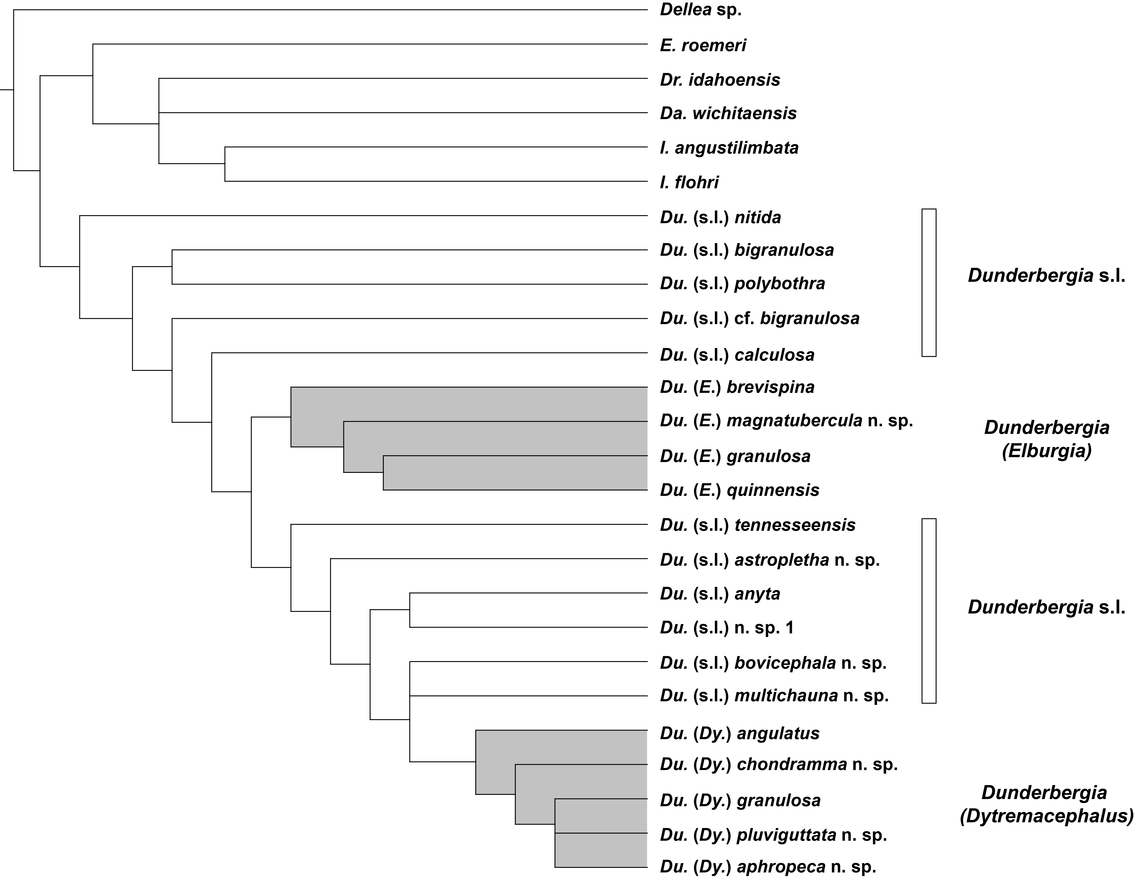

Figure 15: Optimized character distribution (unambiguous transformations that optimize to the same node under the assumptions of both ACCTRAN and DELTRAN); white circles show homoplasy. Numbers above the circles correspond to characters in Table 1; numbers below indicate states for each character in Table 1.

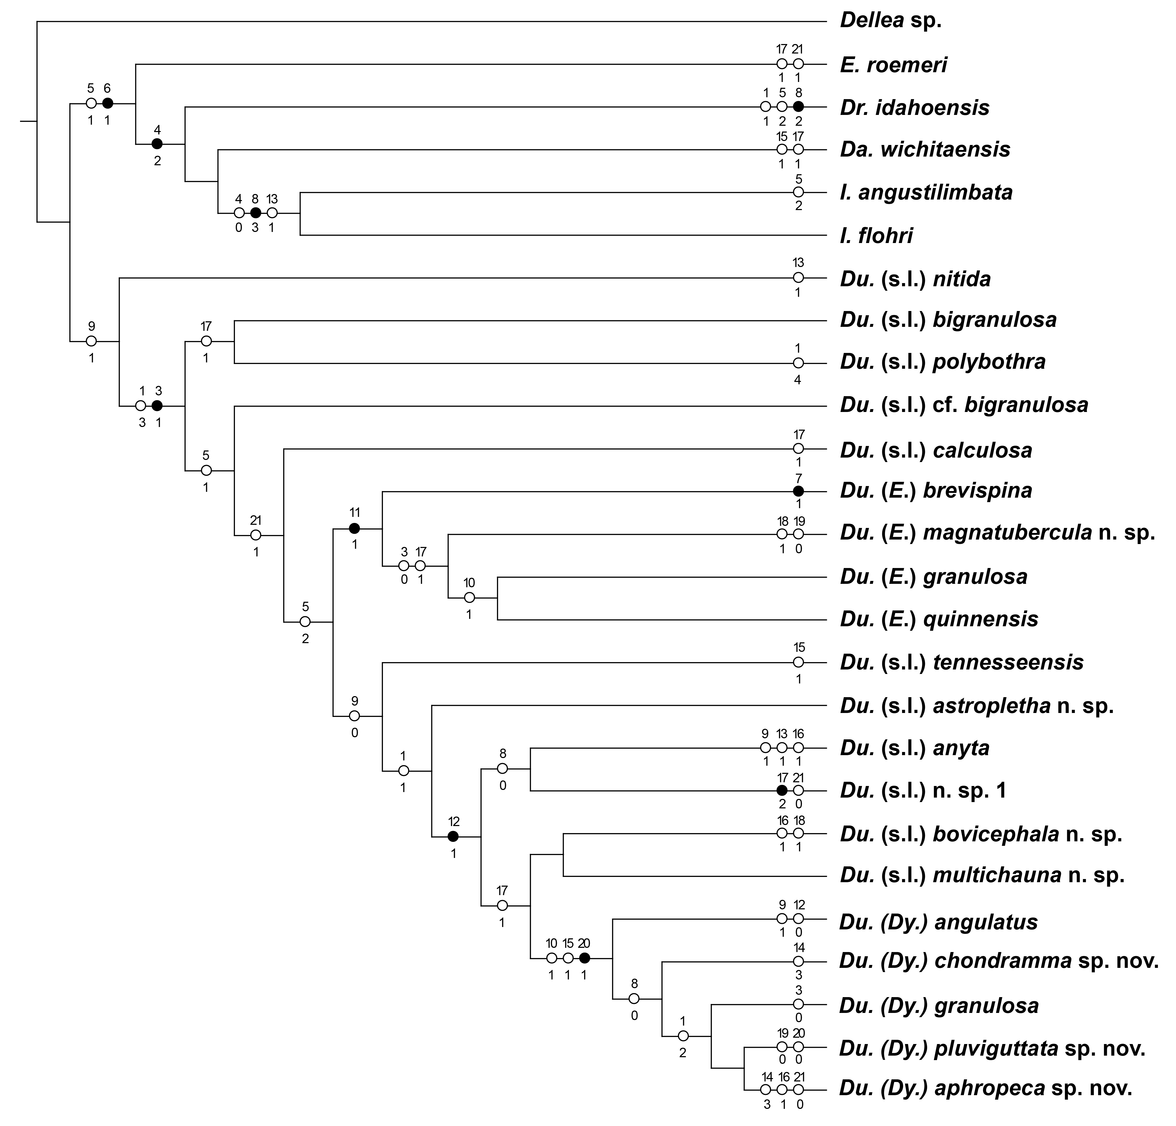

References
Edgecombe, G. D., and L. Ramsköld. 1999. Relationships of Cambrian Arachnata and the systematic position of Trilobita. Journal of Paleontology, 73: 263–287.
Goloboff, P. A., J. S. Farris, and K. C. Nixon. 2008. TNT, a free program for phylogenetic analysis. Cladistics, 24: 774–786.
Hall, J., and R. P. Whitfield. 1877. Report of the Geological Exploration of the Fortieth Parallel. Part 2 Palaeontology. Professional Papers of the Engineer Department, US Army, 18: 199–299.
Hopkins, M. J. 2011. Species-Level Phylogenetic Analysis of Pterocephaliids (Trilobita, Cambrian) from the Great Basin, western USA. Journal of Paleontology, 85: 1128– 1153.
Kobayashi, T. 1938. Upper Cambrian fossils from British Columbia with a discussion of the isolated occurrence of the so-called “Olenus” Beds of Mt. Jubilee. Japanese Journal of Geology and Geography, 15: 149–192
Lieberman, B. S. 1998. Cladistic analysis of the Early Cambrian olenelloid trilobites. Journal of Paleontology.
Miller, B. M. 1936. Cambrian trilobites from northwestern Wyoming. Journal of Paleontology, 10:23–34.
Nixon, K.C. 2002. WinClada v. 1.00.08. Published by the author, Ithaca, NY.
Palmer, A. R. 1954. The faunas of the Riley Formation in central Texas. Journal of Paleontology, 28:709–786.
Palmer, A. R. 1960. Trilobites of the Upper Cambrian Dunderberg Shale, Eureka District, Nevada. US Geological Survey Professional Paper, 334–C: 57.
Palmer, A. R. 1965. Trilobites of the Late Cambrian Pterocephaliid Biomere in the Great Basin, United States. US Geological Survey Professional Paper, 463: 1–105.
Pratt, B. R. 1992. Trilobites of the Marjuman and Steptoean Stages (Upper Cambrian), Rabbitkettle Formation, Southern Mackenzie Mountains, Northwest Canada, 9: 1- 179.
Rasetti, F. 1965. Upper Cambrian Trilobite Faunas of Northeastern Tennessee. Smithsonian Miscellaneous Collections, 148: 1–127.
Resser, C. E. 1942. New Upper Cambrian Trilobites. Smithsonian Miscellaneous Collections, 103: 1–136.
Richter, R., and E. Richter. 1941. Die Fauna des Unter-Kambriums von Cala in Andalusien. Abhandlungen der Senckenbergische Naturforschende Gesellschaft, 455: 1-90
Strong, E. E., and D. Lipscomb. 1999. Character Coding and Inapplicable Data. Cladistics, 15: 363–371.
Sundberg, F. A. 2004. Cladistic analysis of Early–Middle Cambrian kochaspid trilobites (Ptychopariida). Journal of Paleontology, 78:920–940.
Swofford, D. L. 2004. PAUP*. Phylogenetic Analysis Using Parsimony (*and Other Methods). Version 4. Sinauer Associates, Sunderland, Massachusetts.
Shumard, B. F. 1861. The Primordial Zone of Texas, with descriptions of new fossils. American Journal of Science, 32: 213–221.
Walcott, C. D. 1924. Cambrian Geology and Paleontology V. Smithsonian Miscellaneous Collections, 75: 53–60.
Westrop, S. R., R. Ludvigsen, and C. H. Kindle. 1996. Marjuman (Cambrian) agnostoid trilobites of the Cow Head Group, western Newfoundland. Journal of Paleontology, 70: 804–829.
Westrop, S. R., and J. M. Adrain. 2009. The Late Cambrian (Furongian; Steptoean) Trilobite Genus Xenocheilos Wilson, 1949: systematics and biostratigraphic significance. Memoirs of the Association of Australasian Palaeontologists, 37: 351– 368.
Westrop, S. R., R. A. W. Poole, and J. M. Adrain. 2010. Systematics of Dokimocephalus and related trilobites from the Late Cambrian (Steptoean; Millardan and Furongian Series) of Laurentian North America. Journal of Systematic Palaeontology, 8: 545– 606.
Westrop, S. R., and E. Landing. 2012. Lower Cambrian (Branchian) eodiscoid trilobites from the lower Brigus formation, Avalon Peninsula, Newfoundland, Canada. Memoirs of the Association of Australasian Palaeontologists, 42: 209–262.
Wilson, J. L. 1949. The trilobite fauna of the Elvinia Zone in the basal Wilberns Limestone of Texas. Journal of Paleontology, 23: 25–44.

Chapter III: Systematic Paleontology

Illustrated material is housed in the Invertebrate Paleontology Collection of the Sam Noble Oklahoma Museum of Natural History (OMNH) and the National Museum of Natural History (USNM). Locations of stratigraphic sections are indicated by the following abbreviations: CCDu, Barton Canyon, Cherry Creek Range, White Pine County, Nevada; ORR, ORR lwr, and ORR lwr2, Orr Ridge, northern House Range, Millard County, Utah FSR1 and FSR2, Fish Springs Range, Juab County, Utah.
Terminology for trilobite skeletal anatomy follows Whittington (1997). Proportions (percentages) are expressed as means with ranges. Specimens were prepared under a binocular microscope using a pneumatic scribe. They were blackened with dilute India ink prior to coating with a sublimate of ammonium chloride for photography. Most of the photographs were rendered in Helicon Focus from stacks produced at 0.1 mm increments using a StackShot focusing rail and controller.

Family Elviniidae Kobayashi, 1942

Genus Dunderbergia Walcott, 1924

Type species: Crepicephalus (Loganellus) nitida Hall and Whitfield, 1877 from the Dunderberg Formation, northern Schell Creek Range, White Pine County, Nevada (by original designation).

Diagnosis: Elviniidae with angulate anterior border on cranidium. Cranidial sculpture includes granules, tubercles, and caecal markings.

Discussion: angulate anterior border on the cranidium is used to diagnose Dunderbergia s.l. and was one of the character states that Palmer (1965, p. 39: “Anterior margin and border furrow commonly come to a blunt point on axial line...”) considered to be one of the diagnostic features of the genus. However, there are reversals to the plesiomorphic state, a rounded anterior border, at higher nodes in the cladogram. In all but the most basal species, sculptural elements that include granules, tubercles, and caecal markings although, again, there are some reversals at higher nodes.
As discussed above, subclades that correspond to Dytremacephalus Palmer, 1954 and Elburgia Palmer, 1960 are treated as subgenera, with the remaining species referred to as Dunderbergia (s.l.).

Dunderbergia (s.l.) nitida (Hall and Whitfield, 1877)
Pl. 1, figs. 1–8; Pl. 2, figs. 1–10

1877 Crepicephalus (Loganellus) nitida Hall and Whitfield, p. 212, pl. 2, fig. 8.
1965 Dunderbergia nitida; Palmer, p. 41, pl. 4, figs. 1, 2, 5, 6 (see for additional synonymy)

Diagnosis: Cranidium with mostly smooth external surface; some, usually smaller individuals, with scattered tubercles. Narrow, rounded, anterior border. Pygidium smooth aside from granular sculpture and terrace ridges on border.

Lectotype: A cranidium (USNM 24572) from the Dunderberg Formation, Eureka, Nevada (designated by Palmer, 1960, p. 67, pl. 4, fig. 15).

Material: Five cranidia and three pygidia.

Occurrence: Dunderberg Formation, Barton Canyon, Cherry Creek Range, White Pine County, Nevada, collection CCDu 112.3.

Description. Cranidium convex. Posterior cranidial width 144% (125–155) cranidial length. Width between palpebral lobes 60% (56–63) cranidial length. Width at anterior border 60% (56–63) width of posterior border. Frontal area 31% (26–34) cranidial length; preglabellar field long, accounting for 26% (21–28) of frontal area length, separated from short, convex anterior border by forwardly bowed border furrow, usually with distinct angular bend medially. Glabella trapezoidal, weakly rounded anteriorly. Preglabellar and axial furrows well defined. Glabellar width at S2 65% (62–69) glabellar length, widening to 74% (70–77) at S0. S0 firmly impressed, nearly transverse medially but curved gently forward abaxially. L0 16% (15–17) length of glabella. Two pairs of faint lateral glabellar furrows, expressed most clearly on internal mold, directed backward. S1 curved to sigmoidal; may bifurcate abaxially. S2 weakly curved. Palpebral area of fixigenae wide, gently upsloping from axial furrow. Palpebral ridges extend from anterior of S3 to tip of palpebral lobes. Palpebral lobes arcuate, 32% (28–37) of glabellar length, centered a little behind anterior tip of S2. Posterior sutures diverge backward along faintly sigmoid path. Posterolateral projection 30% (29–32) total width, tapering to fine point. Posterior border furrow well defined, expanding abaxially; length equal to 5% (4–6) of glabellar length near axial furrow, increasing to 11% (8–12) near sutural margin. Posterior border forms narrow rim. External surface of exoskeleton smooth, but smaller cranidia (Pl. 1, fig. 5; Pl. 2, fig. 2) carry scattered fine tubercles; punctae may be visible on internal mold, expressed most clearly on preglabellar and preocular fields, and palpebral and posterior areas of fixigenae.
Pygidium about twice as wide as long. Anterior edge curves forward before turning sharply backwards. Axial width one-third total width; axial length about 80% total length. Axis consists of articulating half ring, one clearly defined, transverse axial ring and ring furrow, and a terminal piece with two or three segments, and may display incomplete ring furrow. Broad, shallow pleural furrow present at anterior; furrows over rest of pleural field indistinct. Pygidial border defined in part by presence of sculpture of terrace ridges and fine granules in external surface; remainder of external surface is smooth. Internal mold smooth aside from fine punctae behind axis and along border.

Discussion: Palmer (1965, p. 41) diagnosed Dunderbergia (s.l.) nitida as having external surfaces of the cephalon that are “generally smooth”, and this is the case for cranidia from collection CCDu 112.3 (Pl. 1 figs. 2, 7). Palmer also noted fine granules along the pygidial border that are also present on pygidia from CCDu 112.3 (Pl. 2, figs. 6–10). In other respects, cranidia from CCDu 112.3 are closely comparable to type and other specimens illustrated by Palmer (1960, pl. 4, figs. 15–19).

Dunderbergia (s.l.) anyta (Hall and Whitfield, 1877)
Pl. 3, figs. 1–9; Pl. 4, figs. 1–9; Pl. 5, figs. 1–5; Pl. 6, figs. 1–12

1877 Crepicephalus (Loganellus) nitida Hall and Whitfield, p. 219, pl. 2, figs. 19–21.
1971 Dunderbergia? anyta; Hu, p. 92, figs. 1–40, Text-fig. 44 (see for additional synonymy).

Diagnosis. Palpebral lobe short, equal to 25% (19–35) of glabellar length, centered opposite anterior tip of S2 glabellar furrow. Cranidium narrowest between palpebral lobes with width equal to 74% (67–80) of cranidial length. Sculpture consists of small granules with no tubercles. Very long, slender genal spine. Pygidium wide, length 46% (43–48) of maximum width.

Holotype. A cranidium (USNM 24576) from the Dunderberg Shale, northern Schell Creek Range, east of Schellbourne, White Pine County, Nevada, illustrated by Palmer (1965, pl. 4, fig. 14).

Material: Eight cranidia, three librigenae, one hypostome, one segment, and six pygidia; additional unfigured material includes 17 cranidia, one hypostome and two pygidia.

Occurrence. Candland Shale Member, Orr Formation, Orr Ridge, Millard County, Utah, collections ORR lwr2 23.5, 25.5 and 26T; Fish Springs Range, Juab County, Utah, collection FSR2 17. For other occurrences, see Palmer (1965, p. 40).

Description. Cranidial outline almost hourglass shaped, with width at palpebral lobe equal to 73% (67–77) of cranidial length and maximum width at posterior margin equal to 145% (127–166) of maximum length. Frontal area accounts for 30% (28–33) of cranidial length. Preglabellar and preocular fields gently inflated and forward sloping. Anterior border furrow well defined, curved gently forward. Anterior border nearly flat, accounts for 30% (25–34) of frontal area length medially but narrows slightly abaxially. Axial and preglabellar furrows gently impressed grooves. Glabella 70% (68–74) total length, raised well above adjacent fixigenae; trapezoidal in outline, weakly rounded anteriorly; width at S0 equal to 71% (63–79) of glabellar length but narrowing to 60% (57–63) at anterior tip of S2. L0 with curved posterior margin, occupies 18% (16–22) of glabellar length. S0 well defined, nearly transverse medially, but bifurcates abaxially,
outlining weakly inflated, roughly oval secondary lobe of L0. Three pairs of shallow lateral glabellar furrows defined in part by absence of granulose sculpture. S1 strongly oblique, directed backward and inward along faintly sigmoid course; may bifurcate abaxially on some specimens. S2 less strongly oblique, directed backward at shallower angle than S1. S3 narrower (tr.) than S1 and S2, nearly transverse. L1, L2 and L3 roughly equal in length; frontal lobe about half length of L1. Palpebral area of fixigena slopes gently upward from axial furrow. Palpebral lobe short, weakly upturned, semielliptical, centered opposite anterior tip of S2; length equal to 25% (19–35) of glabellar length. Palpebral furrow shallow groove. Palpebral ridge proceeds obliquely forward, reaching axial furrow just in front of S3. Anterior branches of facial diverge forward along nearly straight path between palpebral lobe and anterior border furrow, then converge abruptly inward along anterior cranidial margin. Posterior branches diverge backward along faintly sigmoid path. Postocular area of fixed cheeks flexed downward abaxially; posterolateral projection wide, tapers to fine point. Posterior border furrow well incised, widens slightly towards sutural margin; posterior border also expands abaxially, length equal to 7% (5–8) of glabellar length near axial furrow, increasing to 12% (10–14) near sutural margin. External surface with sculpture of closely spaced granules over entire surface of smaller cranidia, except for border furrows, S1–S3, and abaxial portion of S0 (Pl. 3, fig. 2); granules mounted on network of caecal markings on preglabellar and preocular fields. Granules lost on palpebral and postocular fixigenae of larger individuals (Pl. 3, fig. 2) and reduced in size and more widely spaced elsewhere. Anterior border with terrace ridges at anterior margin. Granules not expressed on faintly pitted internal mold.
Librigena slightly inflated. Genal field and border granulated. Genal spine 60% total length of librigena. Width at posterior of palpebral suture equal to 27% total length; palpebral suture 10% total length. Anterior suture 17% total length; posterior suture 29% total length. Border width 5% total length.
Single thoracic segment composed of axis and right pleural section. Segment length about 25% axis width, with distinct pleural bands abaxial to fulcrum. Distance between axis and fulcrum equal to axial width. Segment curves sharply posteriorly, forming a long spine; spine length roughly 2.5 times axis width. Diffuse granulation on axis; pleural section smooth.
Pygidium shape broadly semi-ellipsoidal, length almost half width at 46% (43–48). Anterior edge of pygidium curves gently forward, then strongly backwards abaxially. Axis 34% (31–38) width of pygidium at first axial ring; length 81% (79–83) of pygidial length. Axis composed of articulating half-ring with distinct articulating furrow; two axial rings separated by well-defined furrow, and terminal piece with two or three segments separated by shallow furrows or absence of granulation. Pleural furrows merge into border furrow, along with faint interpleural furrows. Broad, shallow border furrow; indistinct from pygidial border. Surface covered in granules; concentrated along caecal lines in pleural field.

Discussion. As noted by Palmer (1965), there are a number of differences between Dunderbergia (s.l.) anyta and other species assigned to the genus. The palpebral lobe is relatively small and anteriorly positioned (e.g., Pl. 3, fig. 2), and the anterior border and occipital ring are relatively long. The extremely long, slender genal spine on the librigena (Pl. 5, figs. 1–4) is also unusual (e.g., compare with Palmer, 1965, pl. 4, figs. 6, 12; pl. 5, figs. 3, 5, 12). The pygidium is wide (e.g., Pl. 6), whereas those other species are relatively narrow (e.g., Palmer, 1965, pl. 4, figs. 1, 2, 4, 11, pl. 5, figs. 3, 10, 13). However, the phylogenetic analysis (Figs. 14, 15) places the species well within Dunderbergia (s.l.).
There is some variability in proportions of the cranidium, with specimens from FSR2 17 typically having a longer frontal area and preglabellar field, and a shorter occipital ring. However, there is overlap between collections in these characters (compare Pl. 3, fig. 2 and Pl. 4, fig. 2). Moreover, cranidia at both Orr Ridge and in the Fish Springs Range are associated with the unusually wide pygidium (Pl. 6, figs. 1–12) that is one of the diagnostic character states of D. (s.l.) anyta.

Dunderbergia (s.l.) cf. D. bigranulosa Palmer, 1960
Pl. 7, figs. 1–9; Pl. 8, figs. 1–6

cf. 1960 Dunderbergia bigranulosa Palmer, p. 66, pl. 5, figs. 10–13, 15–23.
cf. 1965 Dunderbergia bigranulosa; Palmer, p. 40, pl. 4, figs. 9, 11–13

Material: Four cranidia and one pygidium.

Occurrence: Dunderberg Formation, Barton Canyon, Cherry Creek Range, White Pine County, Nevada, collections CCDu 98.7, 104.1.

Discussion: In the interval below D. (s.l.) nitida at section CCDu in Barton Canyon, cranidia of Dunderbergia have scattered large tubercles on both the external surface and internal molds, and a variable extent of fine granules over the external surface only.General proportions of cranidia of D. nitida illustrated by Palmer (e.g., 1960, pl. 5, figs. 10–12, 18–19), including the lengths of the frontal area and preglabellar field, and the size and position of palpebral lobe are similar to those of the specimens illustrated here. However, the only pygidium recovered from collection CCDu 104.1 (pl. 7, figs. 7–9) is relatively narrow and well-rounded posteriorly, and contrasts with the relatively wider and less rounded pygidia attributed to D. (s.l.) bigranulosa (e.g., Palmer, 1960, pl. 5, figs. 20–23). Because of the small sample size available from Barton Canyon, open nomenclature is used.

Dunderbergia (s.l.) cf. D. calculosa Palmer, 1965
Pl. 9, figs. 1–10

cf. 1965 Dunderbergia calculosa Palmer, p. 41, pl.

Material: Four cranidia and one librigena; additional unfigured material includes one cranidium.

Occurrence: Candland Shale Member, Orr Formation, Orr Ridge, Millard County, Utah, collection ORR lwr 66.5.

Description: Cranidium convex. Posterior cranidial width 142% (136–147) cranidial length. Width between palpebral lobes 63% (62–66) cranidial length. Width at anterior border 64% (61–63) width of posterior border. Frontal area long at 31% (29–33) cranidial length. Anterior margin 29% (26–32) length of anterior border. Preglabellar and axial furrows moderately to deeply incised. Glabella subtrapezoidal, rounded anteriorly. Glabellar width at S0 73% (67–77) glabellar length, decreasing to 63% (58–65) at S2. Glabellar furrows more distinct in smaller specimens (Pl. 9, fig. 7). S1 arcuate to weakly sigmoidal. S2 weakly to strongly curved; S1 curved to sigmoidal. S2 and S3 are faint but arcuate. Occipital ring 16% (14–17) length of glabella. Palpebral ridges extend from anterior of S3 to tip of palpebral lobes, which are centered between S2 and S3. Palpebral lobes arcuate, 32% (28–40) of glabellar length. Anterior suture straight. Posterolateral projection 30% total width, angled slightly back. Posterior border lengthens abaxially, from 6% (5–7) axially 10% near the suture. Sculpted features visible on internal mold include caecal lines, punctae, and faint, sometimes paired (Pl. 9, fig. 4) tubercles. Sculpting on exoskeleton includes granules on entirety of exoskeleton, densely packed on occipital ring. Granules follow caecal lines on frontal area.

Discussion: Sclerites from ORR lwr 66.5 resemble those of Dunderbergia (s.l.) calculosa. Open nomenclature is used because of the small number of sclerites available, and difference in sculpture; specimens have a consistently granular external surface without any tubercles. However, Palmer (1965) did note that not all specimens had tubercles.

Dunderbergia (s.l.) astropletha n. sp.
Pl. 10, figs. 1–8; Pl. 11, figs. 1–7

2002 Dunderbergia anyta (Hall and Whitfield); Eoff, p. 74, pl. 8, figs. 1–11

Diagnosis: Long glabella, 76% (75–79) cranidial length, short preglabellar field 24% (23–25) cranidial length. Small to medium sized granules, visible on exoskeleton and on internal mold, sometimes connected into constellation-like patterns, especially on fixigena and frontal area. S1 deep, S3 only marked by lack of granules. Pygidium uniformly covered in small granules, including pleural fields.

Name: From astropletha (G), meaning “full of stars” in reference to the sculpture, which in certain sections of the internal molds resemble constellations, especially on the fixigena and along caecal markings, which form a “connect-the-dots” pattern reminiscent of a depiction of a constellation.

Material: The holotype cranidium (Pl. 10, fig. 1) and four paratype cranidia (Pl. 10, figs. 2–8.); one paratype librigena (Pl. 11, fig. 3) and four paratype pygidia (Pl. 11, figs. 1, 2, 4–7).

Occurrence: Downes Point Member, Shallow Bay Formation, western Newfoundland. Cow Head Peninsula, boulder CH 54.

Description: Cranidium gently convex. Maximum width 134% (121–144) cranidium length at posterior margin. Width at anterior border 72% (68–79) width of posterior margin. Cranidial width between palpebral lobes is 69% (64–76) posterior width. Anterior cranidial margin and anterior border curved forward, anterior border furrow well-incised. Frontal area 24% (23–25) cranidial length; anterior border 35% (32–37) frontal area length. Preglabellar field weakly inflated. Axial furrows distinct, preglabellar furrow less so, shallowing medially to produce slit-like pits in front of palpebral ridge. Glabellar outline subtrapezoidal, rounded anteriorly. Glabellar length 76% (75–79) cranidial length. Width at S2 53% (58–69) glabellar length, increasing to 72% (64–74) at S0. S0 deep and narrow, curved gently backwards. Furrows S1–S3 all marked by a lack of granulation on external surface. S1 deeply incised, curving backwards. S2 nearly parallel to S1 and about the same length, shallow on the internal mold but only distinguished by a lack of sculpture on the exoskeleton. S3 is similarly distinguished but only half the length. L0 17% (14–18) glabellar length. Palpebral area of fixigenae gently upsloping from axial furrow; width equal to 18% (17–19) of cranidial length. Palpebral ridges present, extending back from just anterior of S3. Palpebral lobes arcuate and 32% (29–35) glabellar length, centered just anterior to S1. Anterior sutures weakly sigmoidal to gently curved; posterior sutures are weakly sigmoidal. Sculpture of external surface except for glabellar furrows consists of large, closely spaced granules also expressed on internal mold. Granules decrease in size approaching the anterior margin, arrayed along crests of caecal ridges. Punctae present on palpebral and anterior fields.
Librigena gently inflated; genal spine incomplete, preserved part less than 24% total length of librigenal, but likely much longer. Width at posterior of palpebral suture equal to 48% total length. Border convex width 10.5% total length. Granules present on entirety of free cheek, following faint caecal network on genal field.
Two posterior segments partially intact. Broad pleural furrow, about half the length of the segment. Segment length (exsag.) 35% segment width (tr.). Axial width 35% of total width. Segment terminates at narrow, backwardly directed spine. Granulation present on exoskeleton, punctae present on internal mold on pleural lobe.
Pygidium semielliptical; anterior edges arcuate. Shallow border furrow defines narrow border. Pygidial length 53% (50–56) pygidial width; axial length 87% (84–90) length. Axial width 38% (34–40) pygidial width. Axis consists of articulating half-ring, two distinct segments, one indistinct segment, and an endpiece. 3–4 interpleural furrows apparent. Caecal markings present outside of furrows. Granulation present on entirety of exoskeleton, decreasing in size on pygidial border. Punctae on internal mold.

Discussion: In an unpublished thesis, Eoff (2002) assigned the sclerites of this species from boulder CH 54 to Dunderbergia (s.l.) anyta (Hall and Whitfield, 1877). New collections of D. (s.l.) anyta (Pl. 3–6) from the type area in Nevada demonstrate that the material from CH 54 represents an entirely different, new species. Dunderbergia (s.l.) astropletha n. sp. differs from D. (s.l.) anyta in having a larger, more posteriorly positioned palpebral lobe, a shorter frontal area and preglabellar field, and a narrower pygidium with a relatively wider axis.
Dunderbergia (s.l.) astropletha n. sp. primarily differs from other species of Dunderbergia (s.l.), such as D. (s.l.) bovicephala n. sp., D. (s.l.) nitida, and D. (s.l.) simplex, in having a longer glabella and shortened frontal area (glabella length 75% or greater than total length) (compare Pl. 10, figs. 3, 4 to Pl. 12, fig. 1; Pl. 1, fig. 4; Rasetti, 1961, pl. 24, figs. 1–6). Sculpture differs from D. (s.l.) bovicephala, D. (s.l.) tennesseensis and D. (s.l.) variagranula by only consisting of granules without any tubercles. Dunderbergia (s.l.) astropletha also has a flatter, less convex glabella than D. (s.l.) tennesseensis and D. (s.l.) variagranula. The pygidium of D. astropletha is also wider than most species, such as D. (s.l.) bigranulosa, D. (s.l.) bovicephala, D. (s.l.) polybothra, and D. (s.l.) tennesseensis.

Dunderbergia (s.l.) bovicephala n. sp.
Pl. 12, figs. 1–7; Pl. 13, figs. 1–11; Pl. 14, figs. 1–11

2002 Dunderbergia seducta Palmer; Eoff, p. 73, pl. 5, figs. 1–18; pl. 6, figs. 1–15; pl. 7, figs. 21–26, 28.

Diagnosis: Anterior cranidial margin evenly rounded, not coming to a point. Anterior border long, occupying 40% (34–51%) of frontal area length. Palpebral lobes equal to 31% (26–40) of glabellar length, centered between S1 and S2. Width between palpebral lobes greater than 85% width of anterior border. Sculpture of fine granules with scattered tubercles. Pygidium with relatively short axis that occupies 79% (76–83) of pygidia length.

Name: From bovis (L), cow, and kephalos (G), head. Named after the Cow Head Formation.

Material: The holotype cranidium (Pl. 12, figs. 1–3) and five paratype cranidia (Pl. 12, figs 4–7; pl. 13, figs. 1–7); two paratype librigenae (Pl. 12, figs 9–11.), one paratype hypostome (Pl. 12, fig. 8), one paratype segment (Pl. 13, fig. 3,) and eight paratype pygidia (Pl. 13, figs 1, 2, 4–11); additional unfigured material includes six cranidia and one hypostome.

Occurrence: Downes Point Member, Shallow Bay Formation, western Newfoundland. Cow Head Peninsula, boulder CH 49; Hickey Cove, boulder HC 180. Innitagnostus inexpectans Fauna (Westrop and Eoff 2012).

Description: Cranidium strongly arched in anterior and lateral views; anterior margin curves smoothly forwards. Maximum cranidial width at posterior margin equal to 143% (134–157) of maximum length; width between palpebral lobes 67% (61–74) width of posterior margin. Frontal area occupies 28% (26–30) of total cranidial length; divided into downsloping preglabellar field and convex anterior border; border accounts for 40% (34–51) frontal area. Anterior border furrow well-defined; oblique abaxially, becoming weakly (Pl. 13, fig. 1) to strongly (Pl. 13, fig. 4) curved forward medially. Axial and preglabellar furrow narrow grooves. Glabella raised well above fixed cheeks; roughly trapezoidal but rounded anteriorly. Width at S0 equal to 69% (65–75) of glabellar length; but narrows to 60% (56–68) at anterior tip of S2. L0 occupies 16% (13–20) of glabellar length. S0 shallowest medially, deepening and curving forward abaxially, and bifurcating weakly on larger specimens. S1–S3 defined in part by absence of sculpture. S1 strongly oblique, firmly impressed on external surface and internal mold; directed backward and inward, bifurcates as it approaches axial furrow. S2 shallower but similarly angled, though sometimes directed backward less steeply. S3 barely incised on external surface, more so on internal mold, and half the length of S2. Palpebral area of fixigena gently inflated, nearly flat. Palpebral ridges conspicuous, angled backward from just anterior S3 to palpebral lobes. Palpebral lobes on smaller specimens weakly upturned; most arcuate and centered between S1 and S2; length equal to 31% (26–40) of glabellar length. Palpebral furrows weakly incised on external surface, deeper on internal mold. Anterior facial sutures straight or faintly sigmoid between palpebral lobes and anterior border, diverging so that frontal area widens anteriorly; course changes abruptly at anterior border furrow, following a forwardly curved path. Posterior sutures diverge backward along faintly sigmoid path. Postocular area of fixed cheeks flexed downward abaxially; posterolateral projection 32% (29–34) total width, tapering to fine point. Posterior border furrow well defined, expanding abaxially. Posterior border length increases abaxially; length equal to 4.9% (3.4–6.8) of glabellar length near axial furrow, increasing to 9% (6.9–10.7) near sutural margin. Cranidial surface sculpture consists of small, closely spaced granules and scattered larger tubercles. Granulation absent in border furrows and S1–S3; tubercles lost on abaxial portion of S0 and on palpebral lobe. Granules aligned along caecal markings on preglabellar and preocular fields. Tubercles expressed on internal mold; granules absent.
Librigena gently inflated; genal spine incomplete, preserved part less than 30% total length of librigenal, but likely much longer. Width at posterior of palpebral suture equal to 30% total length. Border convex width 10% total length; doublure narrow, inner edge terminates beneath shallow lateral border furrow. Genal field with caecal network and granules but lacks tubercles. Internal mold of border and genal spine smooth and lacks tubercles. Incomplete thoracic segment has well defined pleural furrow, extending onto very long, strongly tapered pleural spine. Sculpture includes closely spaced fine granules with occasional larger tubercles confined to anterior and posterior bands of pleura; granules reduced on tapered, distal parts of spine.
Pygidium roughly semielliptical with weakly rounded posterior margin; length 61% (60–63) width. Maximum axis width 37% (35–41) pygidial width; axis length 79% (76– 83) pygidial length. Axis comprises articulating half-ring, two transverse axial rings, and rounded terminal piece of at least two segments. Each ring is distinguished by wide, prominent ring furrows that lack granules abaxially; shallower, incomplete furrow may be expressed on terminal piece. At least two pairs of distinct, broad pleural furrows separate narrow anterior and posterior pleural bands; interpleural furrows faint but visible on some specimens; beyond level of second axial ring, pleural field weakly furrowed on all but smallest specimens (e.g., Pl. 14, fig. 10). Border furrow nearly flat, defined largely by change in slope at base of pleural field; narrows gradually backward and merges with low, indistinct post-axial ridge medially. Granules present everywhere, except in parts of axial furrows. Tubercles also present, arranged symmetrically. Typically, two (three on one specimen, Pl. 13, fig. 7) paired tubercles present on axial rings, along with first segment of terminal piece. Tubercles also found on pleural field next to axial rings, with two on each side of the rings, in alignment with pleural furrows. Indistinct caecal marking on some pleural bands and in the region of post-axial ridge.

Discussion. (2002) identified the material from CH 49 and HC 180 as Dunderbergia (s.l.) seducta, but it is best regarded as a new species. The combination of closely spaced, fine granules and scattered large tubercles on the cranidium of D. (s.l.) bovicephala n. sp. resembles the sculpture of D. (s.l.) seducta Palmer, 1968 (p. 62, pl. 7, figs. 21, 26–28) from the Jones Ridge Limestone, Jones Ridge region, east-central Alaska. Both species also share a relatively long anterior border. However, D. (s.l.) seducta differs in having palpebral areas of the fixed cheeks that are upsloping, rather than flat, a shorter frontal area, and palpebral lobes that are farther forward on the cranidium, so that the palpebral ridges are more transversely oriented (e.g., Palmer, 1968, pl. 7, fig. 26). The pygidium of D. (s.l.) seducta (e.g., Palmer, 1968, pl. 7, fig. 21) is similar to D. (s.l.) bovicephala (e.g., Pl. 14, fig. 7), but has a proportionately longer and wider axis.
Among species from the Dunderberg Shale in Nevada, D. (s.l.) nitida (Hall and Whitfield, 1877; Palmer, 1960, pl. 4, figs. 14–21, 23, 24), D. (s.l.) polybothra Palmer, 1960 (pl. 5, figs. 1–4, 6, 7, 9, 14), D. (s.l.) bigranulosa Palmer, 1960 (pl. 5, figs. 10–13, 15–23), and specimens attributed to D. (s.l.) variagranula Palmer, 1954 by Palmer (1960, pl. 4, figs. 22, 25) all possess short, rim-like anterior borders and anteriorly pointed cranidial margins that contrast with the longer border and evenly rounded anterior margin of D. bovicephala. Dunderbergia (s.l.) calculosa Palmer, 1965 (pl. 5, figs. 6–10) has a proportionately longer pygidial axis that extends almost to the posterior margin, and a cranidial sculpture of fine granules with very few coarse tubercles.
Dunderbergia (s.l.) anyta (Hall and Whitfield, 1877) is abundant in the Candland Shale Member of the Orr Formation in the northern House Range of western Utah. It differs clearly from D. (s.l.) bovicephala in having a much smaller, more anteriorly positioned, flap-like palpebral lobe, much wider pygidium, and finely granulose sculpture.
Dunderbergia (s.l.) simplex Rasetti, 1961 (pl. 24, figs. 1–6) and D. (s.l.) cf. D. variagranula of Rasetti, 1961 (pl. 24, figs. 7–9), both from loose blocks of Frederick Limestone in the Frederick Valley of Maryland, possess nearly transverse anterior border furrows that are distinct from the more arcuate border furrow of D. (s.l.) bovicephala. In addition, D. (s.l.) simplex has an external sculpture of “fine, indistinct granules” (Rasetti 1961, p. 112), whereas D. (s.l.) cf. D. variagranula has numerous, closely spaced tubercles (Rasetti 1961, pl. 24, fig. 7).
Rasetti (1965) described two new species of Dunderbergia (s.l.) from the Nolichucky Formation of Tennessee. Of these, D. (s.l.) tennesseensis has a relatively long border, as in D. (s.l.) bovicephala, but has a more posteriorly positioned palpebral lobe that extends back to the mid–point of L1 (e.g., Rasetti, 1965, pl. 15, fig. 1), and a proportionately shorter and wider pygidium with a nearly transverse posterior margin (e.g., Rasetti, 1965, pl. 15, fig. 9). Dunderbergia (s.l.) longifrons Rasetti, 1965 (pl. 15, figs. 13–18) has a much shorter frontal area than D. (s.l.) bovicephala.

Dunderbergia (s.l.) multichauna n. sp.
Pl. 15, figs. 1–7; Pl. 16, figs. 1–9; Pl. 17, figs. 1–7

2018 Dunderbergia cf. variagranula Palmer; Armstrong, p. 129, pl. 40, figs. A–I.

Diagnosis: Exoskeletal sculpture variable, ranging from irregular pitting to smooth; internal mold shows punctae and evidence of tubercles. Palpebral lobe equal to 30% (26–34) of glabellar length, centered opposite anterior tip of S2 glabellar furrow. Anterior border rounded to angular, not straight. Wide posterior border angled backward. Long genal spine. Pygidium wide, length 46% (43–48) of maximum width.

Name: From multus (L), much, multiple, and chaunos (G), spongey, porous. Named for the different amounts of the spongey sculpture on the specimens.

Material: The holotype cranidium (Pl. 14, figs. 1–3) and five paratype cranidia (Pl. 14, figs 4–7; Pl. 15, figs. 1–9) and five paratype pygidia (Pl. 16, figs 1–7); additional unfigured material includes five cranidia and one pygidium.

Occurrence: Lion Mountain Sandstone Member, Riley Formation, Hoover Point, Burnet County, Texas, collections HP 3.65, HP 3.7, and HP 3.75.

Description: Cranidium moderately convex. Maximum width at posterior margin 139% (117–152) cranidial length. Width of anterior margin 71% (65–92) posterior margin; width between palpebral lobes 69% (62–82) of posterior margin. Frontal area 28% (26– 30) of cranidial length divided into anterior border and preglabellar field. Anterior border convex; length is 34% (30–41) frontal area length. Axial and preglabellar furrow narrow grooves. Glabella raised above fixed cheeks; roughly trapezoidal but rounded anteriorly, length is 72% (69–76) total length. Width at S0 equal to 75% (70–81) of glabellar length, narrowing to 63% (60–66) at anterior tip of S2. S0 thin, sometimes creased. S1–S3 poorly defined, forming shallow depressions. S1 strongly oblique, directed backward and inward, bifurcates as it approaches axial furrow. S2 directed back at a shallower angle. S3 arcuate, projecting anteriorly before curving posteriorly, with a length of about half of S2. Palpebral area of fixigena gently inflated, nearly flat. Palpebral ridges conspicuous, angled backward from just anterior S3 to palpebral lobes. Palpebral lobes range from semicircular to arcuate and centered between S1 and S2; length equal to 30% (26–34) of glabellar length. Palpebral furrows broad and weakly incised. Anterior facial sutures straight or faintly sigmoid between palpebral lobes and anterior border, diverging so that frontal area widens anteriorly; course changes at anterior border furrow, following a forwardly curved path. Posterior sutures diverge backward along faintly sigmoid path. Postocular area of fixed cheeks flexed downward abaxially; posterolateral projection 32% (29–34) total width, tapering to fine point. Posterior border furrow well defined, expanding abaxially. Posterior border length increases abaxially; length equal to 5% (4–7) of glabellar length near axial furrow, increasing to 10% (8–12) near sutural margin. Posterolateral projections angled back. Caecal lines present on anterior border. Sculpture consists of pits on the surface of the exoskeleton, also present on internal mold. Some individuals show evidence of tubercles on internal molds (Pl. 15, fig. 4; Pl. 16, fig. 4), though no tubercles are visible where exoskeleton is present.
Pygidium roughly semielliptical with weakly rounded posterior margin; length 51% (47–56) width. Maximum axis width 37% (35–40) pygidial width; axis length 87% (82–92) pygidial length. Axis comprised of articulating half-ring, two transverse axial rings, and rounded terminal piece of at least two segments. Each ring is distinguished by wide, prominent ring furrows; shallower, incomplete furrows may be expressed on terminal piece. At least two pairs of distinct, broad pleural furrows, usually defined by a lack of caecal markings, separate anterior and posterior pleural bands; interpleural furrows faint but visible on some specimens (e.g., Pl. 17, fig. 6). Border furrow distinct; post-axial ridge distinct. Pits present on axial lobe of certain specimens (Pl. 17, fig. 1). Distinct caecal marking on pleural bands and in the region of post-axial ridge.

Discussion. Armstrong (2018) gave a brief treatment of this species in her thesis on the faunas of the Riley Formation of Texas and placed it in open nomenclature. Preparation and photography of additional specimens shows that the sclerites represent a new species. Dunderbergia (s.l.) multichauna n. sp. can be distinguished from almost every other species of Dunderbergia (s.l.) by its sculpture, which consists of pitting, as opposed to being smooth, granulose, or tuberculate. Dunderbergia (s.l.) polybothra has pitted sculpture but the pits are more uniform in outline rather than irregularly shaped as in D. (s.l.) multichauna. Dunderbergia (s.l.) multichauna also has a relatively straighter anterior suture (compare Palmer 1965 pl. 4 fig. 3 with Pl. 15, fig. 7); the posterolateral projections are angled farther back than on other species. Details on the internal mold include punctae and tubercles that are not expressed on the external surface exoskeleton. Additionally, this species shows variable sculpture, in that some specimens are smoother than others. This is unlikely to be ontogenetic, as the amount of pitting does not correlate with sizes of sclerites (e.g., compare Pl. 15, fig. 1 to Pl. 15, fig. 7 and Pl. 16, fig. 1 to Pl. 16, fig. 7).

Dunderbergia (s.l.) n. sp. 1
Pl. 18, fig. 1–9; Pl. 19, figs. 1–5

Material: Three cranidia, one librigena, and one pygidium; additional unfigured material includes one cranidium.

Occurrence: ORR lwr2 40

Discussion: The long genal spine and the shape of the pygidium place this species within Dunderbergia (s.l.). Cranidia have a relatively short and flat glabella, not forming a prominent arch. They differ from most species in that their sculpture only contains small granules, with no large tubercles. Dunderbergia (s.l.) anyta is the only other Dunderbergia (s.l.) species to have only granular sculpture, but it can be distinguished in that Du. (s.l.) anyta has a shorter glabella, smaller palpebral lobes, and a much smaller distance between the palpebral lobes.

Dunderbergia (s.l.) n. sp. 2
Pl. 20, figs. 1–4

Material: Two cranidia

Occurrence: FSR2 17 2

Discussion: Two cranidia of Dunderbergia (s.l.) almost certainly represent a new species that differ from all others (e.g., Pl. 8, figs. 1–3; Pl. 9, fig. 4; Pl. 12, fig. 5) by possessing a far more prominent, strongly domed glabella. Because of the small number of specimens available, however, it will not be named formally.
Dunderbergia (Dytremacephalus) craniophysa n. sp. (Pl. 28, figs. 1–10) is closest to D. (s.l.) n. sp. 2 in glabellar convexity but differs in having pits at the anterior corners of the glabella and has a noticeably shorter preglabellar field. Tuberculate sculpture of D. (Dy.) craniophysa is restricted to the glabella, where the tubercles are closely spaced. In contrast, D. (s.l.) n. sp. 2 has widely spaced tubercles over the entire surface of the cranidium except for within the various furrows and on the palpebral lobe.

Dunderbergia (s.l.) sp. indet. 1
Pl. 22, figs. 1–9

Material: Three cranidia and one librigena.

Occurrence: Candland Shale Member, Orr Formation, Orr Ridge, Millard County, Utah, collection ORR lwr2 31.2

Discussion: This species has granulose sculpture over the entire cranidium, augmented by scattered, ill-defined tubercles. In addition, the palpebral lobe is long, extending from S2 to the mid-point of L1. It is most like Dunderbergia (s.l.) n. sp. 2, especially with its prominent glabella, but differs in lacking scattered tubercles on the glabella.

Dunderbergia (s.l.) sp. indet. 2
Pl. 22, figs. 1–9

Material: Two cranidia and one pygidium

Occurrence: Candland Shale Member, Orr Formation, Orr Ridge, Millard County, Utah, collection ORR lwr2 18.

Discussion: Rare sclerites of Dunderbergia (s.l.) record an early occurrence of the genus in the Prehousia Zone, in association with Prehousia alata Palmer, 1960. It is most like D. (s.l.) nitida, differing most clearly in the pygidium, which is relatively shorter and wider, (compare Pl. 2, figs. 8–10 with Pl. 22, figs. 7–9). Aside from terrace ridges at the edge of the border, the pygidium of D. (s.l.) nitida is smooth both on the external surface and the internal mold, whereas D. (s.l.) sp. indet. 2 carries a network of caecal markings that is augmented by pits on the internal mold.

Subgenus Dytremacephalus Palmer, 1954

Type species: Dytremacephalus granulosus Palmer, 1954 from the Lion Mountain Sandstone Member, Riley Formation, central Texas (by original designation).

Diagnosis: Pygidium reaches maximum width opposite or behind the second axial ring (character 15, state 1) and with pygidial border expanding anteriorly (character 20, state 1). Cranidium with pair of large rectangular pits in the anterior border furrow (character 10, state 1).

Discussion: In his original diagnosis of Dytremacephalus from material from Texas, Palmer (1954, pp. 749, 750, pl. 85, figs. 1–6) emphasized, and indeed derived the name from, the pair of large pits in the anterior border furrow at the corners of the glabella. This remains an apomorphic state of Du. (Dytremacephalus) in the phylogenetic analysis, although it displays homoplasy, and originates independently in a subset of species of Du. (Elburgia) (see Fig. 15). The pygidium of Du. (Dytremacephalus) was unknown to Palmer in 1954, but two pygidial characters also emerge from the phylogenetic analysis as key apomorphic states in the diagnosis. Maximum width of the pygidium occurs at a relatively posterior position, opposite or behind the second axial ring (e.g., Pl. 27, figs. 1, 3), whereas maximum width in species of Dunderbergia (s.l.) occurs farther forward, opposite the first axial ring (e.g., Pl. 6, figs. 1–12); posteriorly positioned maximum width originates independently in Dartonaspis (Fig. 15).

Dunderbergia (Dytremacephalus) granulosa Palmer, 1954
Pl. 23, figs. 1–6

1954 Dytremacephalus granulosus Palmer, p. 750, pl. 85, figs. 5, 6.
Non 1971 Dytremacephalus granulosus Palmer; Hu, p. 94, pl. 16, figs. 1–36; text- fig. 45

Diagnosis: Glabella prominent and well-rounded anteriorly; glabellar width at S2 67% glabellar length. Short frontal area 27% total cranidial length. Uniformly granular sculpture.

Holotype: A cranidium (USNM 123319; Pl. 23, Figs. 4–6) from the Lion Mountain Sandstone Member, Riley Formation, USGS collection 11 (CO), Lion Mountain, Burnet County, Texas.

Description: Cranidium convex; glabella appears almost triangular in anterior view. Posterior cranidial width 133% (126–139) cranidial length. Width between palpebral lobes 90% (89–92) cranidial length. Width at anterior border 85% width of posterior border. Frontal area 27% (27–28) cranidial length; preglabellar field long, accounting for 35% (33–38) of frontal area length, separated from short, convex anterior border by forwardly bowed border furrow. Glabella raised above fixed cheeks; roughly subtrapezoidal, rounded anteriorly with convex sides. Pits present at anterior border of glabella. Width at S0 equal to 77% (75–79) of glabellar length; but narrows to 67% (64– 70) at anterior tip of S2. L0 occupies 20% (18–20) of glabellar length. S0 shallowest medially, deepening and curving forward abaxially. All furrows deeply incised. Palpebral area of fixigenae gently upsloping from axial furrow; width equal to 28% (27–28) of cranidial length. Palpebral ridges present, extending back from just anterior of S3. Palpebral lobes arcuate and 37% (36–40) glabellar length, centered just anterior to S1. Anterior sutures weakly curved; posterior sutures weakly sigmoidal. Sculpture of external surface except for glabellar furrows consists of large, closely spaced granules. Punctae present on anterior fields.

Discussion: Even though Dunderbergia (Dytremacephalus) granulosa from the Riley Formation of central Texas is the type species, it has not been restudied in more than 60 years. The pair of pits at the anterior corners of the glabella, one of the primary features that characterizes Du. (Dytremacephalus) are expressed clearly. The species is compared with Du. (Dytremacephalus) aphropeca n. sp., also from the Riley Formation, below.

Dunderbergia (Dytremacephalus) aphropeca n. sp.
Pl. 24, figs. 1–8; Pl. 25, figs. 1–10

2018 Gen. nov. aff. Dunderbergia; Armstrong, p. 143, pl. 51, figs. A–I

Diagnosis: Long, rounded (not angular) anterior border with width equal to or greater than width between palpebral lobes. Long frontal area 31% cranidial length. Distinct “foamy” sculpture of irregular granules. Librigena narrow with long genal spine. Pygidial axis rounded anteriorly.

Name: From aphros (G), froth, foam, and pecos (G), skin. Named for the foamy appearance of the sculpting and in reference to Pecos Bill, a fictional cowboy from Texas.

Material: The holotype cranidium (Pl. 24, figs. 6–8) and four paratype cranidia (Pl. 24, figs 1–5; Pl. 25, figs. 1–4), two paratype librigenae (Pl. 25, figs. 8–10), and one paratype pygidium (Pl. 25, figs 5–7); additional unfigured material includes six cranidia.

Occurrence: Lion Mountain Sandstone Member, Riley Formation, Hoover Point, Burnet County, central Texas, collections HP 3.1, 3.65, 3.7.

Description: Cranidium convex, with roughly quadrate outline, except for posterolateral projections; maximum width at posterior margin 136% (127–153) cranidial length; width at anterior border 62% (57–70) width of posterior margin; cranidial width between palpebral lobes 59% (55–63) posterior width. Frontal area accounts for 31% (28–33) cranidial length. Anterior border curved forward and slopes gently upward; occupies 39% (37–77) frontal area length. Preglabellar field weakly inflated near preglabellar furrow, slopes steeply forward. Axial and preglabellar furrows shallow but clearly defined. Glabella convex, subtrapezoidal in outline with gently rounded anterior margin; length 69% (66–73) cranidial length; width at S0 77% (73–79) glabellar length. L0 20% (14– 22) glabellar length; posterior margin well rounded. Lateral glabellar furrows weakly incised but also lack sculpture. S1 straight or weakly curved, angled backward and inward. S2 similar to, but shorter than, S1; S3 nearly transverse. Palpebral area of fixigena slopes gently upward from axial furrow. Palpebral ridges extend from S3 to palpebral lobes. Palpebral lobes 38% (33–44) glabellar length, arcuate and centered over S1 and S2. Anterior facial sutures are directed backwards with a slight convex curve until they meet the palpebral lobes. The posterior facial sutures are sigmoidal, directed posteriorly. Posterolateral projection 30% (28–32) total width. Posterior border lengthens abaxially, from 6% (4–8) near the axis to 13% (10–15) near the suture. Sculpture consists of irregular, variably sized granules over entire surface except furrows, giving it a bubbly or foamy appearance. Granules smaller near furrows and decrease in size down the preglabellar field. Anterior half of border carries irregular terrace ridges. Sculpture weakly expressed on some specimens (Pl. 25, fig. 1). Indistinct punctae present on internal mold.
Pygidium broad, length almost half (42%) width. Anterior edge of pygidium curves forward, then strongly backwards abaxially. Axis wider than long, occupies 37% width of pygidium between axial rings and length 84% of pygidial length. Axis composed of articulating half-ring, two axial rings, and terminal piece. Pleural field gently inflated with distinct pleural furrow at anterior, but remainder with indistinct furrows. Border furrow broad and shallow, barely differentiated from pygidial border; border nearly flat, narrows (exsag.) conspicuously towards axis. Axis and pygidial border with same sculpture as cranidium; ill-defined granules may be present on pleural fields.

Discussion: Armstrong (2018) noted the occurrence of this species in the Riley Formation but did not describe it. She suggested that it might represent a new genus possibly allied with Dunderbergia (s.l.) Preparation of additional sclerites and discovery of the pygidium now show that it is a species of Dytremacephalus. Dunderbergia (Dytremacephalus) aphropeca n. sp. differs from Du. (Dy.) granulosa, also from the Riley Formation of Texas (Pl. 24, figs. 1–8) by having a glabellar outline that is evenly tapered, rather than barrel-shaped, and a longer anterior border. Both species have granulose sculpture, but the granules are more varied and closer together in Du. (Dy.) aphropeca, instead of uniform granules as in Du. (Dy.) granulosa. Compared to Du. (Dy.) angulata Rasetti, 1965 (e.g., pl. 21, figs. 1, 4), Du. (Dy.) aphropeca has a less angular anterior border and a rounder glabella. In comparison to Du. (Dy.) asperaxis Palmer, 1965 (pl. 18, figs. 10–13) Du. (Dy.) stricta Rasetti, 1965 (pl. 21, figs. 10–13) and Du. (Dy.) sulcifrons Rasetti, 1965 (pl. 12, figs. 23–25), Du. (Dy.) aphropeca can be distinguished by its comparatively longer preglabellar field and anterior border. In addition, the anterior border is less angulate than in Du. (Dy.) sulcifrons. Additionally, despite other species being described as having coarse granules or tubercles, the large irregular granules producing a foamy appearance are unique to Du. (Dy.) aphropeca. The internal mold can appear similar to Du. (Dy.) pluviguttata n. sp. (Pl. 29, fig. 7), but the patterning on Du. (Dy.) aphropeca is more distinct.
Dunderbergia (Dytremacephalus) aphropeca occurs through a 0.65 m-thick stratigraphic interval of the Lion Mountain Sandstone Member at the Hoover Point road cut (Fig. 8B). Cranidia vary in the expression of the granulose sculpture of the external surface, from barely perceptible (Pl. 25, figs. 1, 4) to well defined (Pl. 24, figs. 3, 6). The variation is not related to sclerite size because effacement of the sculpture occurs in both small (Pl. 25, figs. 1, 4) and larger specimens (Pl. 24 figs. 1, 2). It is therefore unlikely to
be ontogenetic in nature. Cranidia with weakly and strongly developed sculpture do not differ in any other characters and are interpreted as recording a single species.

Dunderbergia (Dytremacephalus) chondramma n. sp.
Pl. 26, figs. 1–9; Pl. 27, figs. 1–8

Diagnosis: Short anterior border. Convex anterior sutures. Large palpebral lobes, long posterolateral projections. Small occipital spine. Distinct pleural furrows on pygidium; border widens, and border furrow shallows posteriorly. Granulose sculpture over entire cranidial surface, including palpebral lobes and axial furrows.

Name: From chondro (G), meaning rough, and ammos (G), meaning sand. References the rough, sandpaper-like appearance of the sculpture.

Material: The holotype cranidium (Pl. 26, figs. 4–7) and two paratype cranidia (Pl. 26, figs 1–3, 8), two paratype librigena (Pl. 27, figs. 6–8), and three paratype pygidia (Pl. 26, fig 9; Pl. 27, figs. 1–5).

Occurrence: Candland Shale Member, Orr Formation, Fish Springs Range, Juab County, Utah, collection FSR2 0.3

Description: Cranidium gently inflated. Maximum width at posterior margin 150% cranidial length. Width of anterior margin 60% (55–63) posterior margin; width between palpebral lobes 60% of posterior margin. Frontal area 27% of cranidial length. Anterior border convex; length is 28% (24–33) frontal area length. Axial furrows well defined grooves; border furrow bordered by pits. Glabella raised above fixed cheeks, almost triangular in anterior view; outline roughly trapezoidal but rounded anteriorly; length is 73% total length. Width at S0 equal to 67% (66–67) of glabellar length, narrowing to 60% (59–60) at anterior tip of S2. S1–S3 well defined. S1 gently curved and directed backward and inward. S2 directed back parallel to S1. S3 small. Palpebral ridges present, angled slightly backward from just anterior S3 to palpebral lobes. Palpebral lobes large and arcuate, and centered between S1 and S2; length equal to 41% (40–43) of glabellar length. Palpebral furrows weakly incised. Anterior facial sutures straight or convex between palpebral lobes and anterior border. Posterior sutures diverge backward along faintly sigmoid path. Postocular area of fixed cheeks flexed downward abaxially; posterolateral projection 32% total width. Posterior border furrow well defined, expanding abaxially. Posterior border length increases abaxially; length equal to 4% of glabellar length near axial furrow, increasing to 12% near sutural margin. Posterolateral projections angled slightly back. Sculpture consists of small granules on entirety of exoskeleton including palpebral lobes), excluding furrows.
Pygidium wide with ellipsoidal to rounded rectangle outline; length 53% (52– 55) width. Maximum axis width 42% (38–46) pygidial width; axis length 86% (84– 88) pygidial length. Axis comprised of articulating half-ring, two transverse axial rings, and rounded terminal piece of at least two segments. Each ring distinguished by wide, prominent ring furrows. Three pairs of distinct pleural furrows present on pleural fields. Border narrow anteriorly, widening and flattening posteriorly, becoming less distinct. Punctae present on internal mold on pleural fields. Granules present on entirety of exoskeleton, including axial and ring furrows.

Discussion: Preparation of the largest of the three specimens of Dunderbergia (Dytremacephalus) chondramma n. sp. shows that a small occipital spine is present (Pl. 26, figs. 1–3), whereas all other members of the genus lack spines. Additionally, the sculpting on Du. (Dytremacephalus) chondramma is finer – more granulate than tuberculate – distinguishing it from other species, such as Du. (Dy.) granulosa (compare Pl. 26, fig. 4 to Pl. 23, figs. 1, 4). Additionally, when compared to Du. (Dy.) granulosa, Du. (Dy.) chondramma has a squarer glabella and narrower posterolateral projections. Compared to Du. (Dy.) stricta Rasetti, 1965 (pl. 21, figs. 10–13), Du. (Dy.) asperaxis, and Du. (Dy.) sulcifrons, Du. (Dy.) chondramma has a longer frontal area. In comparison to Du. (Dy.) angulata Rasetti, 1965 (pl. 21, figs. 1, 4), Du. (Dy.) chondramma has a more rounded glabellar outline and a less angular anterior border.

Dunderbergia (Dytremacephalus) craniophysa n. sp.
Pl. 28, figs. 1–10

2002 Dytremacephalus cf. D. strictus Rasetti; Eoff, p. 79, pl. 11, figs. 1–26

Diagnosis: Relatively straight anterior border with width approximately equal to width between palpebral lobes. Short frontal area. Greatly inflated glabella. S1 bifurcates medially. Wide palpebral areas. Small occipital ring. Small occipital ring 15% (14–15) glabellar length. Sculpture consists of granules of variable size.

Name: from kranio (G), head and physa (G) bubble, in reference to the domed and inflated appearance of the cranidium

Material: The holotype cranidium (Pl. 28, figs. 1–4) and two paratype cranidia (Pl. 28, figs. 5–10).

Occurrence: Downes Point Member, Shallow Bay Formation, western Newfoundland. Cow Head Peninsula, boulder CH 54.

Description: Cranidium highly convex, almost domed. Maximum width 137% (132– 139) cranidium length at posterior margin. Width at anterior border 68% (64–74) width of posterior margin. Cranidial width between palpebral lobes is 74% (72–78) posterior width. Anterior border weakly to moderately curved. Frontal area 23% (21–26) cranidial length; anterior border 42% (32–45) frontal area length. Preglabellar field convex. Axial furrows deep and distinct; preglabellar furrow less distinct, bordered by pits. Glabellar outline sub-trapezoidal. Glabellar length 77% (74–79) cranidial length. Width at S2 68% (64–71) glabellar length, increasing to 79% (74–81) at S0. Furrows S1–S3 all marked by a lack of granulation. S1 deeply incised, angled backwards; may bifurcate medially. S2 parallel and about half length and shallower. S3 only distinguished by lack of sculpting. L0 15% (14–15) glabellar length. Palpebral ridges present, extending back from just anterior of S3. Palpebral lobes arcuate and 38% (34–40) glabellar length, centered over the anterior tip of S1. Anterior sutures straight. Postocular area of fixed cheeks flexed downward abaxially; posterolateral projection 28% (26–29) total width. Posterior border furrow well defined, expanding abaxially. Posterior border length increases abaxially; length equal to 5% (4–6) of glabellar length near axial furrow, increasing to 15% near sutural margin. Sculpture consists of irregularly shaped medium to large sized granules on glabella, with smaller granules on frontal and palpebral areas.

Discussion: Eoff (2002) placed this species in open nomenclature, but restudy of the type material of the type species, Du. (Dy.) granulosa (Pl. 23) supports an assignment to a new species. Dunderbergia (Dytremacephalus) craniophysa n. sp. differs from other Dunderbergia (Dytremacephalus) species in the lateral profile of the glabella, which is much more inflated. Additionally, the outline of the anterior border is more rounded and less angular than those of Du. (Dy.) angulata and Du. (Dy.) sulcifrons Rasetti, 1965 (pl. 12, figs. 23–25). The sculpture of the external surface is also less uniform in size than in other species, including Du. (Dy.) granulosa, Du. (Dy.) stricta Rasetti, 1965 (pl. 21, figs. 10–13) and Du. (Dy.) sulcifrons. While this is a trait shared by Dunderbergia (Dytremacephalus) aphropeca n. sp., the granules of the fixigenae and frontal area of Du. (Dy.) craniophysa are finer and more irregularly shaped. In addition, the anterior border of Du. (Dy.) aphropeca is much longer than that of Du. (Dy.) craniophysa, and is flat, rather than convex (compare Pl. 24, fig. 7 with Pl. 28, figs. 4, 8).

Dunderbergia (Dytremacephalus) pluviguttata n. sp.
Pl. 29, figs. 1–9

Diagnosis: Long, narrow, anteriorly rounded glabella. Round anterior border. Anterior border width equal to or greater than width between palpebral lobes. Large palpebral lobes 39% (35–42) of glabellar length, and maze-like sculpture consisting of small pits on external mold, with variable expression on the internal mold.

Name: pluvius (L) meaning rain, guttatus (L) spot, speckled, dappled; referring primarily to the raindrop-imprint appearance of the external mold of the cranidia, as well as the smudged, watercolor looking pattern on the internal molds of some of the specimens.

Material: The holotype cranidium (Pl. 29, figs. 2, 3), four paratype cranidia (Pl. 29, figs. 1, 4–12), and one paratype pygidium (pl. 29, figs 13–15).

Occurrence: Candland Shale Member, Orr Formation, Orr Ridge, Millard County, Utah, collection ORR lwr 66.15; ORR lwr2 12.0.

Description: Cranidial outline quadrate, anteriorly rounded. Maximum width at posterior margin 141% cranidial length. Width of anterior margin 60% posterior margin; width between palpebral lobes 72% of posterior margin. Frontal area 28% (25–31) of cranidial length. Anterior border convex; length is 38% (35–40) frontal area length. Axial furrows broad and distinct; preglabellar furrow indistinct, bordered by pits. Glabella raised above fixed cheeks, rounded anteriorly, length is 72% (68–76) total length. Width at S0 equal to 72% (71–74) of glabellar length, narrowing to 60% at anterior tip of S2. Glabellar furrows short, angled backward and inward. Palpebral area of fixigena gently inflated. Palpebral ridges conspicuous, angled backward from just anterior S3 to palpebral lobes. Palpebral lobes arcuate, centered just anterior S2; length equal to 39% (35–42) of glabellar length. Palpebral furrows broad and weakly incised. Anterior facial sutures straight to convex. Postocular area of fixed cheeks flexed downward abaxially; posterolateral projection 29% total width. Posterior border furrow well defined, expanding abaxially. Posterior border length increases abaxially; length equal to 6% of glabellar length near axial furrow, increasing to 10% near suture. Posterolateral projections straight. Internal mold shows punctae on fixigena and frontal area, decreasing in density on the glabella. Tubercles absent.
Pygidium broad and elliptical in outline, length almost half width at 44%. Axis 34% (31–38) width of pygidium at first axial ring; length 81% (79–83) of pygidial length.Axis comprised of articulating half-ring, two axial rings separated by a well-defined ring furrow, and a terminal piece consisting of two segments separated by a very shallow, indistinct furrow. Pleural furrows merge into border furrow, along with faint interpleural furrows. Broad, shallow border furrow; indistinct from pygidial border anteriorly. Border broadens and flattens posteriorly. Internal mold contains punctae on pleural field and axial rings.

Discussion: Compared to Dunderbergia (Dytremacephalus) asperaxis Palmer, 1965 (pl. 18, figs. 10–13) and Du. (Dy.) stricta Rasetti, 1965 (pl. 21, figs. 10–13), Du. (Dy.) pluviguttata has a longer frontal area (Pl. 29, fig. 1). Unlike Du. (Dy.) granulosa (Pl. 23, fig. 1), Du. (Dy.) pluviguttata has a longer and narrower glabella, with a tapered, rather than barrel-shaped, outline. Dunderbergia (Dytremacephalus) pluviguttata is also dissimilar to Du. (Dy.) angulata Rasetti, 1965 (e.g., pl. 21, figs. 1, 4) and Du. (Dy.) sulcifrons Rasetti, 1965 (pl. 12, figs. 23–25) by having a less angular and more smoothly rounded anterior border outline. The sculpture of Du. (Dy.) pluviguttata also differs from other species by appearing less like distinct granules and more like connected pits; the imprints on the internal mold are similarly indistinct and appear “smudged” or “blurred” (Pl. 29, figs 1, 2, 7).

Subgenus Elburgia Palmer, 1960

Type species: Crepicephalus (Loganellus) granulosus Hall and Whitfield, 1877 from the Dunderberg Formation, Eureka Mining District, Eureka County, Nevada (by original designation).

Diagnosis: Dunderbergia (Elburgia) is separated from Dunderbergia (s.l.) by a single apomorphic character state, the very short genal spine on the librigena. As revised here, D. (Elburgia) includes Dunderbergia brevispina Palmer, 1965. Dunderbergia (Elburgia) magnatubercula n. sp. is nested within D. (Elburgia), although the librigena is unknown and, consequently, the presence of a very short genal spine cannot be demonstrated

Dunderbergia (Elburgia) granulosa (Hall and Whitfield, 1877)
Pl. 30, figs. 1–7; Pl. 31, figs. 1–10; Pl. 32, figs. 1–8

1877 Crepicephalus (Loganellus) granulosus Hall and Whitfield, p. 214, pl. 2, figs. 2, 3.
1960 Elburgia granulosa (Hall and Whitfield): Palmer, p. 69, pl. 6, figs. 16, 17, 19 (see for synonymy
1965 Elburgia granulosa (Hall and Whitfield): Palmer, p. 42, pl. 5, figs. 14, 16–19

Holotype: A cranidium (USNM 24573) from the Dunderberg Formation, Eureka Mining District, Eureka County, Nevada (Palmer, 1960, pl. 6, fig. 19).

Occurrence: Candland Shale Member, Orr Formation, Orr Ridge, Millard County, Utah, collection ORR lwr2 34.1.

Material: Six cranidia, three librigenae, and one pygidium; additional unfigured material includes two cranidia.

Diagnosis: Arcuate anterior border, long frontal area. Narrow palpebral areas. Wide librigenal with short genal spines. Pygidium short and wide. Sculpting consists of granules, with tubercles present on internal molds of librigena and pygidium.

Description: Cranidium convex. Maximum width at posterior margin 145% (132–159) cranidial length. Width of anterior margin 55% (49–66) posterior margin; width between palpebral lobes 64% (57–75) of posterior margin. Frontal area 28% (27–29) of cranidial length divided into anterior border and preglabellar field. Anterior border convex; length is 36% (26–42) frontal area length. Axial furrow deep, wide, and well-defined. Preglabellar furrow narrow, with small pits at either end. Glabella raised above fixed cheeks and trapezoidal in outline. Glabellar length is 73% (72–73) cranidial length. Width at S0 equal to 78% (72–84) glabellar length, narrowing to 62% (58–65) at anterior tip of S2. S0 wide and well-defined. Glabellar furrows well defined. S1 strongly oblique, directed backward and inward, bifurcating medially. Posterior tip may also bifurcate. S2 sigmoidal, arcing backward before straightening out. S3 arcuate and less defined than S1 or S2. Palpebral area gently inflated. Palpebral ridges present, either straight or angled backward from just anterior S3 to palpebral lobes. Palpebral lobes semicircular to arcuate and centered between S1 and S2; length equal to 33% (32–37) of glabellar length. Palpebral furrows broad. Anterior facial sutures sigmoidal to convex. Posterior sutures diverge backward along straight path. Postocular area of fixed cheeks flexed downward abaxially; posterolateral projection 28% (26–31) total width, tapering to fine point. Posterior border furrow well defined, expanding abaxially. Posterior border length increases abaxially; length equal to 6% (5–7) of glabellar length near axial furrow, increasing to 13% (10–18) near sutural margin. Posterolateral projections straight. Sculpture consists of granulation on cranidium, excluding furrows, with decreased density on frontal area of pits on the surface of the exoskeleton, also present on internal mold. Granules visible on internal mold; punctae sometimes visible on frontal and palpebral areas.
Librigena gently inflated; short and narrow genal spine 9% (9–10) librigenal length. Width at posterior of palpebral suture equal to 48% (41–51) total length. Border convex, width 6% (13–20) width. Large granules present on genal field, spine, and border. Scattered tubercles and punctae present on internal mold of genal field.
Pygidium semielliptical with weakly arcuate anterior margin; length 44% (42–47) width. Maximum axis width 35% (34–37) pygidial width; axis length 87% (85–90) pygidial length. Axis comprised of articulating half-ring, transverse axial ring, and rounded terminal piece of at least three segments. Each ring is distinguished by wide, prominent, nearly transverse ring furrows. Furrows on terminal piece bifurcated but distinct. Three pairs of distinct pleural furrows present; interpleural furrows sometimes expressed. Border distinct, flattening posteriorly. Punctae present on internal mold on pleural fields and axial rings. Paired tubercles present on rings and on pleural fields. Sculpture on external mold consists of large granules except in ring furrows, decreasing in size on border.

Discussion: Palmer (1965) separated species of D. (Elburgia) from Nevada and Utah on the basis of cranidial sculpture: D. (E.) granulosa is, as the name indicates, strongly granulose over the entire surface, D. (E.). quinnensis (Resser, 1942) is nearly smooth both on the external surface and the internal mold (e.g., Palmer, 1965, pl. 6, figs. 1–4) whereas D. (E.) intermedia Palmer, 1965 (pl. 6, figs. 5, 6) has well-developed granules confined largely to the preglabellar field and the fixigenae. New material illustrated in this thesis (Pls. 30–32) expands the record of D. (E.). granulosa, but the other species from the Great Basin are known only from a handful of specimens. Both D. (E.) quinnensis and D. (E.) intermedia appear to have wider fixigenae than E. granulosa, and the former also seems to have shorter palpebral lobes. Dunderbergia (Elburgia) disgranosa Palmer, 1968 (pl. 7, figs. 18–20, 23–25) from Alaska is also poorly known. As noted by Palmer (1968, p. 64), the genal spine, although relatively short, in noticeably longer than the minute spine of D. (E.) granulosa (e.g., pl. 32, figs. 2–4). The palpebral lobe of D. (E.). disgranosa is larger, both other characters are similar to D. (E.) granulosa. Although a new addition to the subgenus, D. (E.) brevispina (Palmer, 1965) shares the angulate anterior border and granulose texture of other species of D. (Elburgia) (Palmer, 1965, pl. 5, figs. 11, 15), but it lacks pits at the anterior corner of the glabella.

Dunderbergia (Elburgia) magnatubercula n. sp.
Pl. 33, figs. 1–8; Pl. 34, figs. 1–8

2002 Dunderbergia cf. D. variagranula Palmer; Eoff, p. 75, pl. 9, figs. 1–15.

Diagnosis: Narrow occipital ring, posterolateral projections angled backward. Wide cranidium between palpebral lobes 65% (58–75) posterior width. Sculpture consists of fine grains and much larger, widely spaced tubercles. Pygidium has tubercles on pleural field but lacks granulation.

Name: From magnus (L), large, and tuberculum (G), bump or protuberance. Named for the tubercles on the exoskeleton, which appear relatively larger than those of related species.

Material: The holotype cranidium (Pl. 33, figs. 5–7), five paratype cranidia (Pl. 33, figs. 1–4, 8; Pl. 34, figs. 1–6), and two paratype pygidia (Pl. 34, figs. 7, 8).

Occurrence: Downes Point Member, Shallow Bay Formation, western Newfoundland. Cow Head Peninsula, boulder MP 528.

Description: Cranidium convex. Outline is a rough square, except for posterolateral projections. Maximum width 149% (133–165) cranidium length at posterior margin. Width at anterior border 64% (56–74) width of posterior margin. Cranidial width between palpebral lobes is 65% (58–75) posterior width. Anterior border gently curved. Frontal area 29% (27–31) cranidial length; anterior border 31% (28–34) frontal area length. Preglabellar field convex. Axial and preglabellar furrows range from deeply incised (e.g., Pl. 33, fig. 3) to sharp and distinct, but shallow (Pl. 33, fig. 1). Glabella convex and sub-trapezoidal to rounded. Glabellar length 71% (70–73) total length. Width at S0 74% (66–80) glabellar length. S0 well-defined, 5 % (5–7) total length. S1 distinct, sigmoidal, and angled back. May bifurcate at tip on larger specimens (Pl. 34, fig. 1). S2 parallel to S1, arcing backward. S3 indistinct, only noticeable due to a lack of granulation. L0 narrow, 13.5% (12.5–14.5) glabellar length. Palpebral ridges present, curving backward from just anterior S3 to palpebral lobes. Palpebral lobes large, 34% (28–38) glabellar length, arcuate and centered over S1 and S2. Anterior facial sutures straight to concave between palpebral lobes and anterior border. Posterior suture sigmoid, curving sharply from palpebral lobe before gently curving to the tip of posterolateral projection. Projection 32% (27–35%) total width, angled backward. Posterior border lengthens abaxially, from 5% (4–5) near the axis to 10% (8–11) near the suture. Granules and tubercles present in sculpting, punctae present on internal mold. Granules present everywhere except furrows and palpebral lobes. Tubercles present on palpebral lobes.
Pygidial outline semicircular. Length 58% width. Axial length 87% total length; axial width 36% total width. Interpleural furrows present; border furrow indistinct. Axial lobe consists of two segments, articulating half-ring, and endpiece consisting of three segments. Pits present along border; tubercle pairs on axial lobe; scattered tubercles in pleural field.

Discussion: Although the free cheek is unknown, Dunderbergia (Elburgia) magnatubercula can be placed within the subgenus Elburgia because it shares a combination of traits, such as the sculpture, depth of glabellar furrows, and anterior border shape with other species within the subgenus. Dunderbergia (Elburgia) magnatubercula has a relatively long glabella with a short occipital ring. The posterior border is generally wider and angled back more than on other species. The sculpture differs from other species by being composed of small granules interspersed with large, widely spaced tubercles.
Dunderbergia (Elburgia) magnatubercula differs from D. (E.) granulosa (e.g., Pl. 30, fig. 1) by having a wider anterior border. It also differs from D. (E.) intermedia Palmer 1965 (pl. 6, fig. 5) and D. (E.) quinnensis Palmer 1965 (pl. 6, fig. 4) by having a more tapered and rounded glabella. Its sculpture has widely spaced tubercles, differing it from D. (E.) disgranosa Palmer, 1968 (pl. 7, figs. 19, 20), which has closely packed tubercles. In comparison to D. (E.) brevispina Palmer, 1965, (pl. 5, figs. 11, 15), D. (E.) magnatubercula has a straighter anterior border and has larger tubercles that are more widely spaced.

References
Armstrong, M. 2018. Trilobites from a Cambrian extinction interval at the base of the Steptoean Stage, Riley Formation, central Texas. M.S. Thesis, University of Oklahoma.
Eoff, J.D. 2002. Late Cambrian (Steptoean) trilobites from the Cow Head Group, western Newfoundland. M.S. Thesis, University of Oklahoma.
Hall, J., and R.P. Whitfield. 1877. Paleontology: fossils of the Potsdam Group. U.S. Geol. Explor. 40th Parallel (King), 4: 199-231
Hu, C., 1971, Ontogeny and Sexual Dimorphism of Lower Paleozoic Trilobita: Palaeontographica Americana, 44: 1–155.
Kobayashi, T. 1935. The Briscoia fauna of the late Upper Cambrian in Alaska with descriptions of a few Cambrian trilobites from Montana and Nevada. Japanese Journal of Geography and Geology, 12: 40–57.
Palmer, A.R. 1954. The faunas of the Riley formation in central Texas. Jour. Paleontology, 28: 709–786.
Palmer, A.R. 1960. Trilobites of the Upper Cambrian Dunderberg shale in the Eureka district, Nevada. U.S. Geol. Survey Prof. Paper 334-C: 1–109.
Palmer, A.R. 1965. Trilobites of the Late Cambrian Pterocephaliid Biomere in the Great Basin, United States. U.S. Geol. Survey Prof. Paper 493.
Palmer, A.R., 1968. Cambrian Trilobites of East-central Alaska: United States Geological Survey Professional Paper, 559-B: 1–115.
Rasetti, F., 1961. Dresbachian and Franconian trilobites of the Conococheague and Frederick limestones of the central Appalachians: Journal of Paleontology, 35: 104–124.
Rasetti, F. 1965. Upper Cambrian Trilobite Faunas of Northeastern Tennessee. Smithsonian Miscellaneous Collections, 148: 1–127.
Walcott, C. D. 1924. Cambrian Geology and Paleontology V. Smithsonian Miscellaneous Collections, 75: 53–60.
Westrop, S. R., and J. D. Eoff. 2012. Late Cambrian (Furongian; Paibian, Steptoean) agnostoid arthropods from the Cow Head Group, Western Newfoundland. Journal of Paleontology, 86: 201–237.
Whittington, H.B. 1997. The morphology of the exoskeleton. In Treatise on Invertebrate paleontology Part O, Arthropoda 1, Trilobita Revised: 1–85.

Appendix A: Character Traits

1. Surface sculpture. 0, smooth (e.g., Pl. 1, fig. 2); 1, granules only (e.g., Pl. 3, fig. 2); 2, tubercles only; 3, tubercles and granules (e.g., pl. 12, fig. 1); 4, pitted (e.g., Pl. 16, fig. 1).
2. Number of tubercles: 1, scattered on fixigenae (e.g., Pl. 1, fig. 5); 2, over most of cranidium (e.g., Pl. 12, fig. 1); inapplicable states codes as "?".
3. Caecal markings: 0, absent (e.g., Pl. 8, fig. 1); 1, present (e.g., Pl. 10, fig. 1).
4. Glabellar outline: 0, weakly tapered, well-rounded anteriorly (e.g., Westrop, 1986, pl. 32, fig. 15); 1, strongly tapered, trapezoidal (e.g., Pl. 3, fig. 2); 2, weakly tapered, truncate to weakly rounded anteriorly (e.g., Westrop, 1986, pl. 31, fig. 6).
5. Glabellar furrows: 0, effaced to barely perceptible on external surface (e.g., Palmer 1965 pl. 4, fig. 13); 1, S1 expressed clearly (e.g., Pl. 9, fig. 1); 2, S2 incised groove on at least internal mold (e.g., Pl. 2, fig. 1).
6. S1 glabellar furrows: 0, disconnected even on internal mold (e.g., Pl. 20, fig. 1); 1, connected across glabella at least on internal mold (e.g., Westrop, 1986, pl. 31, fig. 1).
7. Preglabellar field length: 0, long, equal to at least 33% of preoccipital glabellar length (e.g., Pl. 18, fig. 1); 1, short, sloping, equal to about 25% of preoccipital glabellar length (e.g., Palmer 1965 pl. 5, fig. 11); 2, short, slot-like, equal to up to 10% of preoccipital glabellar length (e.g., Westrop, 1986, pl. 31, fig. 1) ; 3, border defined only by preglabellar furrow (e.g., Westrop, 1986, pl. 30, fig. 3).
8. Border: 0, flat to gently upturned (e.g., Pl. 24, fig. 7); 1, convex rim (e.g., Pl. 12, fig. 7); 2, upturned (e.g., Westrop, 1986, pl. 31, fig. 9); 3, weak, becoming effaced during ontogeny (e.g., Westrop and Adrain, 2016, fig. 16A).
9. Anterior border and border furrow shape: 0, evenly curved (e.g., Pl. 29, fig. 2); 1, angulate (e.g., Pl. 33, fig. 1); 2, nearly transverse (e.g., Westrop and Adrain, 2016, fig. 17A); 3, subtriangular (e.g., Westrop, 1986, pl. 31, fig. 9).
10. Pits in anterior border furrow: 0, absent (e.g., Pl. 13, fig. 1); 1, large, subrectangular (e.g., Pl. 24, fig. 2).
11. Genal spine length: 0, long (e.g., Pl. 5, fig. 1); 1, very short, vestigial (e.g., Palmer, 1965 Pl. 5, fig. 17).
12. Border furrows extend onto genal spine: 0, absent (e.g., Pl. 11, fig. 3); 1, present (e.g., Pl. 25, fig. 9).
13. Pygidial outline: 0, "narrow semielliptical", length >half maximum width (e.g., Pl. 17, fig. 1); 1, transversely broadened (length < half maximum width) (e.g., Pl. 6, fig. 3).
14. Extent and position of palpebral lobe: 0, extends just behind S1 to just beyond S2 (e.g., Pl. 13, fig. 1); 1, mid L2–S3 (e.g., Pl. 3, fig. 2); 2, in front of S3 to at minimum behind S1 (e.g., Westrop, 1986, pl. 30, fig. 3); 3, S1–S3 (e.g., Pl. 24, fig. 6).
15. Point of maximum pygidial width: 0, anterior, opposite first axial ring or ring furrow (e.g., Pl. 32, fig. 1); 1, posterior (opposite or behind second axial ring) (e.g., Pl. 27, fig. 3).
16, Width of axis: 0, more than one third pygidial width (e.g., Pl. 17, fig. 1); 1, less than one third pygidial width (e.g., Pl. 14, fig. 1).
17. Number of axial rings in front of terminal piece: 0, one (e.g., Pl. 11, fig. 1); 1, two (e.g., Pl. 26, fig. 9).
18. Paired tubercles on axis: 0, absent (e.g., Pl. 17, fig. 9); 1, present (e.g., Pl. 34, fig. 7).
19. Pygidial border: 0, identifiable only by change of slope (e.g., Pl. 34, fig. 8); 1, distinct border furrow present (e.g., Pl. 14, fig. 1).
20. Border width: 0, even width around margin of pygidium (e.g., Pl. 19, fig. 4); 1, expands posteriorly (e.g., Pl. 27, fig. 3).
21. Furrowing of pleural field: 0, weak and restricted to anterior pair of pleural furrows (e.g., Pl. 7, fig. 7); 1, more than one clearly defined pairs of pleural furrows (e.g., Pl. 17, fig. 4).

Appendix B: Plates

Plate 1
Fig. 1–8. Dunderbergia (s.l.) nitida, from the Barton Canyon Member, Dunderberg Formation, Barton Canyon, Cherry Creek Range, White Pine County, Nevada, collection CCDu 112.3.

1–3. Cranidium (OU 238208), right lateral, dorsal, and anterior views, x8.5.
4–6. Cranidium (OU 238209), right lateral, dorsal, and anterior views, x11.9.
7, 8. Cranidium (OU 238210), dorsal and anterior views, x10.2.
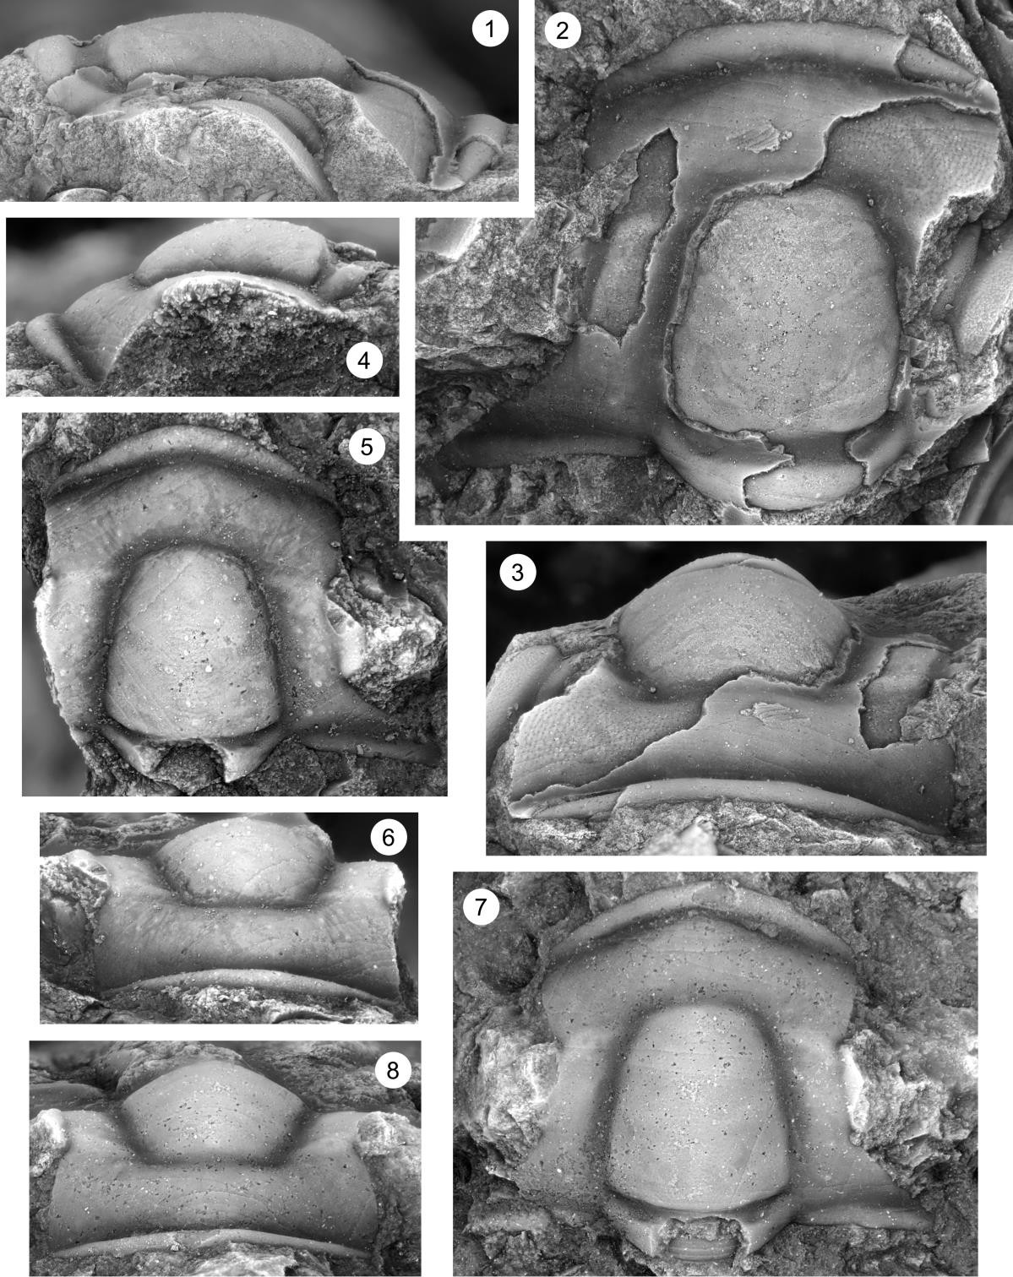
Plate 2
Fig. 1–10. Dunderbergia (s.l.) nitida, from the Barton Canyon Member, Dunderberg Formation, Barton Canyon, Cherry Creek Range, White Pine County, Nevada, collection CCDu 112.3.

1. Cranidium (OU 238211), dorsal view, x8.5.
2–4. Cranidium (OU 238212), dorsal, anterior, and right lateral views, x13.6.
5, 6. Pygidium (OU 238213), posterior and dorsal views, x10.2.
7. Pygidium (OU 238214), dorsal view, x8.5.
8–10. Pygidium (OU 238215), posterior, dorsal, and right lateral views, x8.5.

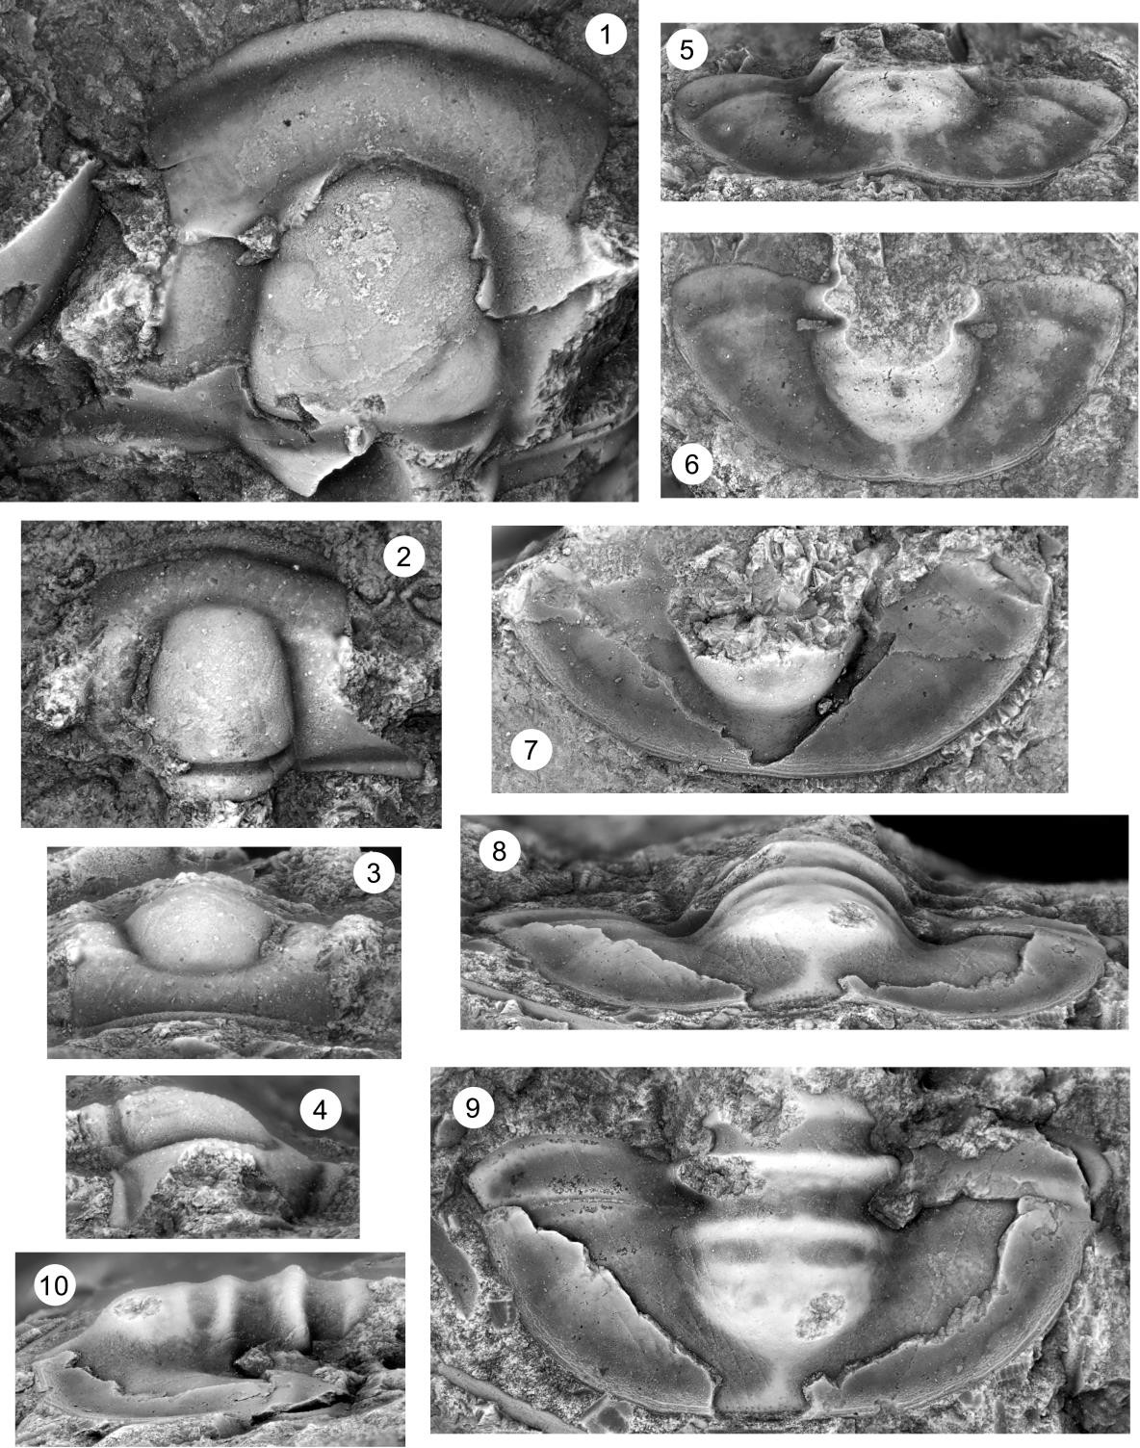

Plate 3
Fig. 1–11. Dunderbergia (s.l.) anyta, Candland Shale Member, Orr Formation, Orr Ridge, Millard County, Utah, collections ORR lwr2 23.5, 25.5 and 26T; Fish Springs Range, Juab County, Utah, collection FSR2 17.

1–3. Cranidium (OU 238216), anterior, dorsal, and right lateral views, ORR lwr2 26T x3.4.
4. Cranidium (OU 238217), dorsal view, ORR lwr2 26T x3.4.
5. Cranidium (OU 238218), dorsal, anterior, and left lateral views, ORR lwr2 26T, x3.4.
8. Cranidium (OU 238219), dorsal view, ORR lwr2 26T, x3.4.
9–11. Cranidium (OU 238220), right lateral, anterior, and dorsal views, ORR lwr2 26T x8.5.

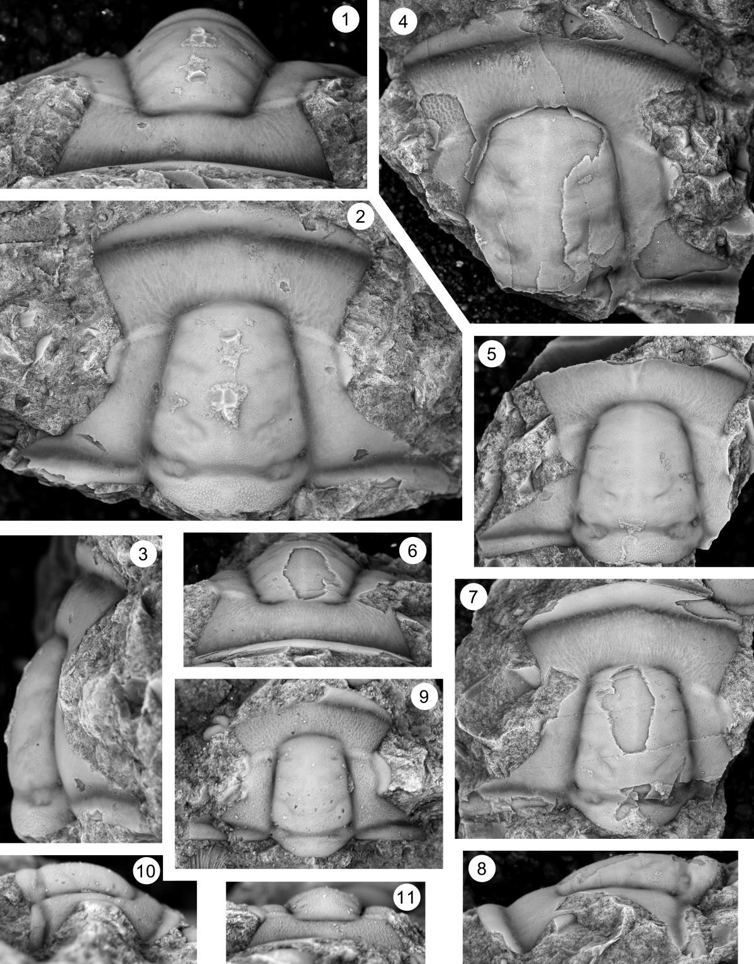

Plate 4
Fig. 1–9. Dunderbergia (s.l.) anyta, Candland Shale Member, Orr Formation, Orr Ridge, Millard County, Utah, collections ORR lwr2 23.5, 25.5 and 26T; Fish Springs Range, Juab County, Utah, collection FSR2 17.

1–3. Cranidium (OU 238221), left lateral, dorsal, and anterior views, FSR2 17, x5.1.
4. Cranidium (OU 238222), dorsal view, ORR lwr2 23.5, x5.1.
5–7. Cranidium (OU 238223), anterior, dorsal, and left lateral views, ORR lwr2 26T, x5.1.
8. Hypostome (OU 238224), dorsal view, ORR lwr2 26T, x9.
9. Segment (OU 238225), dorsal view, FSR2 17, x6.8.

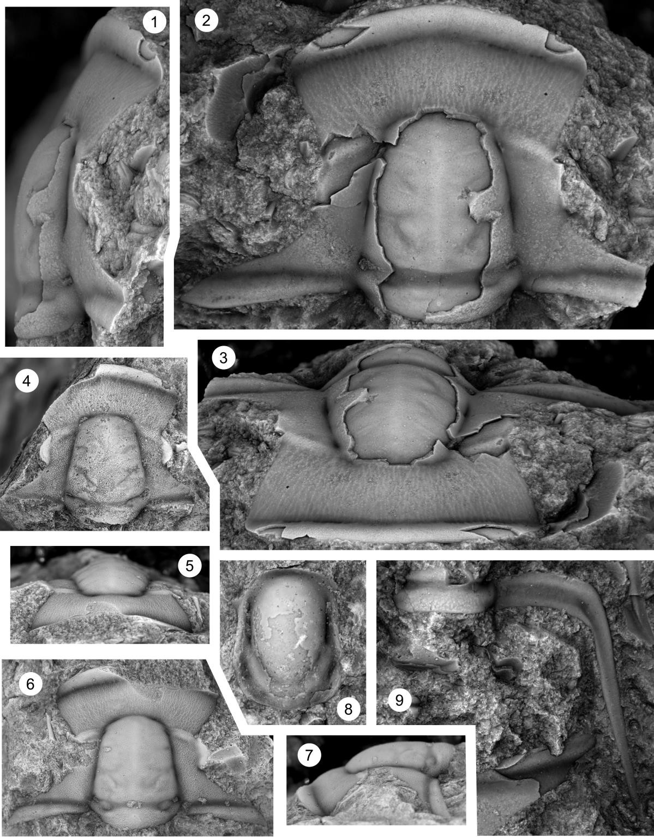

Plate 5
Fig. 1–5. Dunderbergia (s.l.) anyta, Candland Shale Member, Orr Formation, Orr Ridge, Millard County, Utah, collections ORR lwr2 23.5, 25.5 and 26T; Fish Springs Range, Juab County, Utah, collection FSR2 17.

1, 2. Librigena (OU 238226), dorsal and left lateral views, ORR lwr2 26T, x5.1.
3, 4. Librigena (OU 238227), dorsal and left lateral views, ORR lwr2 23.5, x10.2.
5. Librigena (OU 238228), dorsal view, ORR lwr2 26T, x5.1.

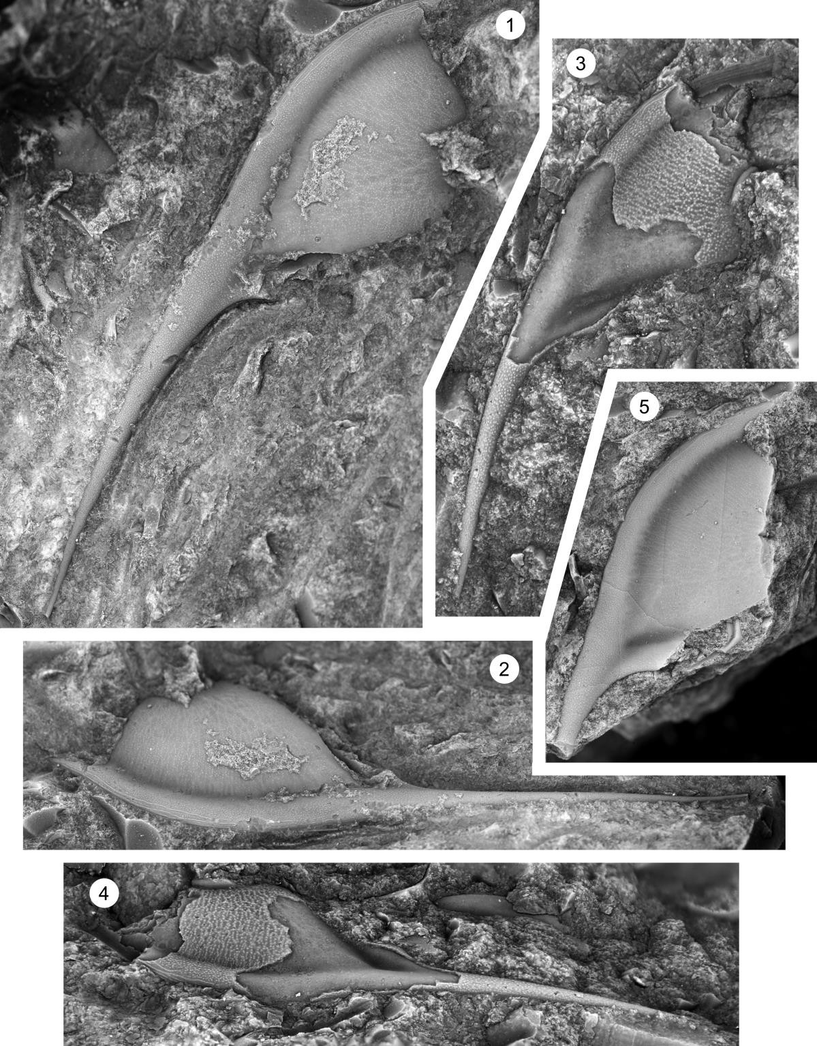

Plate 6
Fig. 1–12. Dunderbergia (s.l.) anyta, Candland Shale Member, Orr Formation, Orr Ridge, Millard County, Utah, collections ORR lwr2 23.5, 25.5 and 26T; Fish Springs Range, Juab County, Utah, collection FSR2 17.

1, 2. Pygidium (OU 238229), dorsal and anterior views, FSR2 17, x13.6.
3, 4. Pygidium (OU 238230), dorsal and anterior views, ORR lwr2 23.5, x12.7.
5, 6. Pygidium (OU 238231), dorsal and anterior views, ORR lwr2 26T, x8.5.
7. Pygidium (OU 238232), dorsal view, ORR lwr2 26T, x6.8.
8, 9. Pygidium (OU 238233), dorsal and anterior views, ORR lwr2 26T, x5.9.
10–12. Pygidium (OU 238234), right lateral, dorsal, anterior views, ORR lwr2 26T, x6.8.

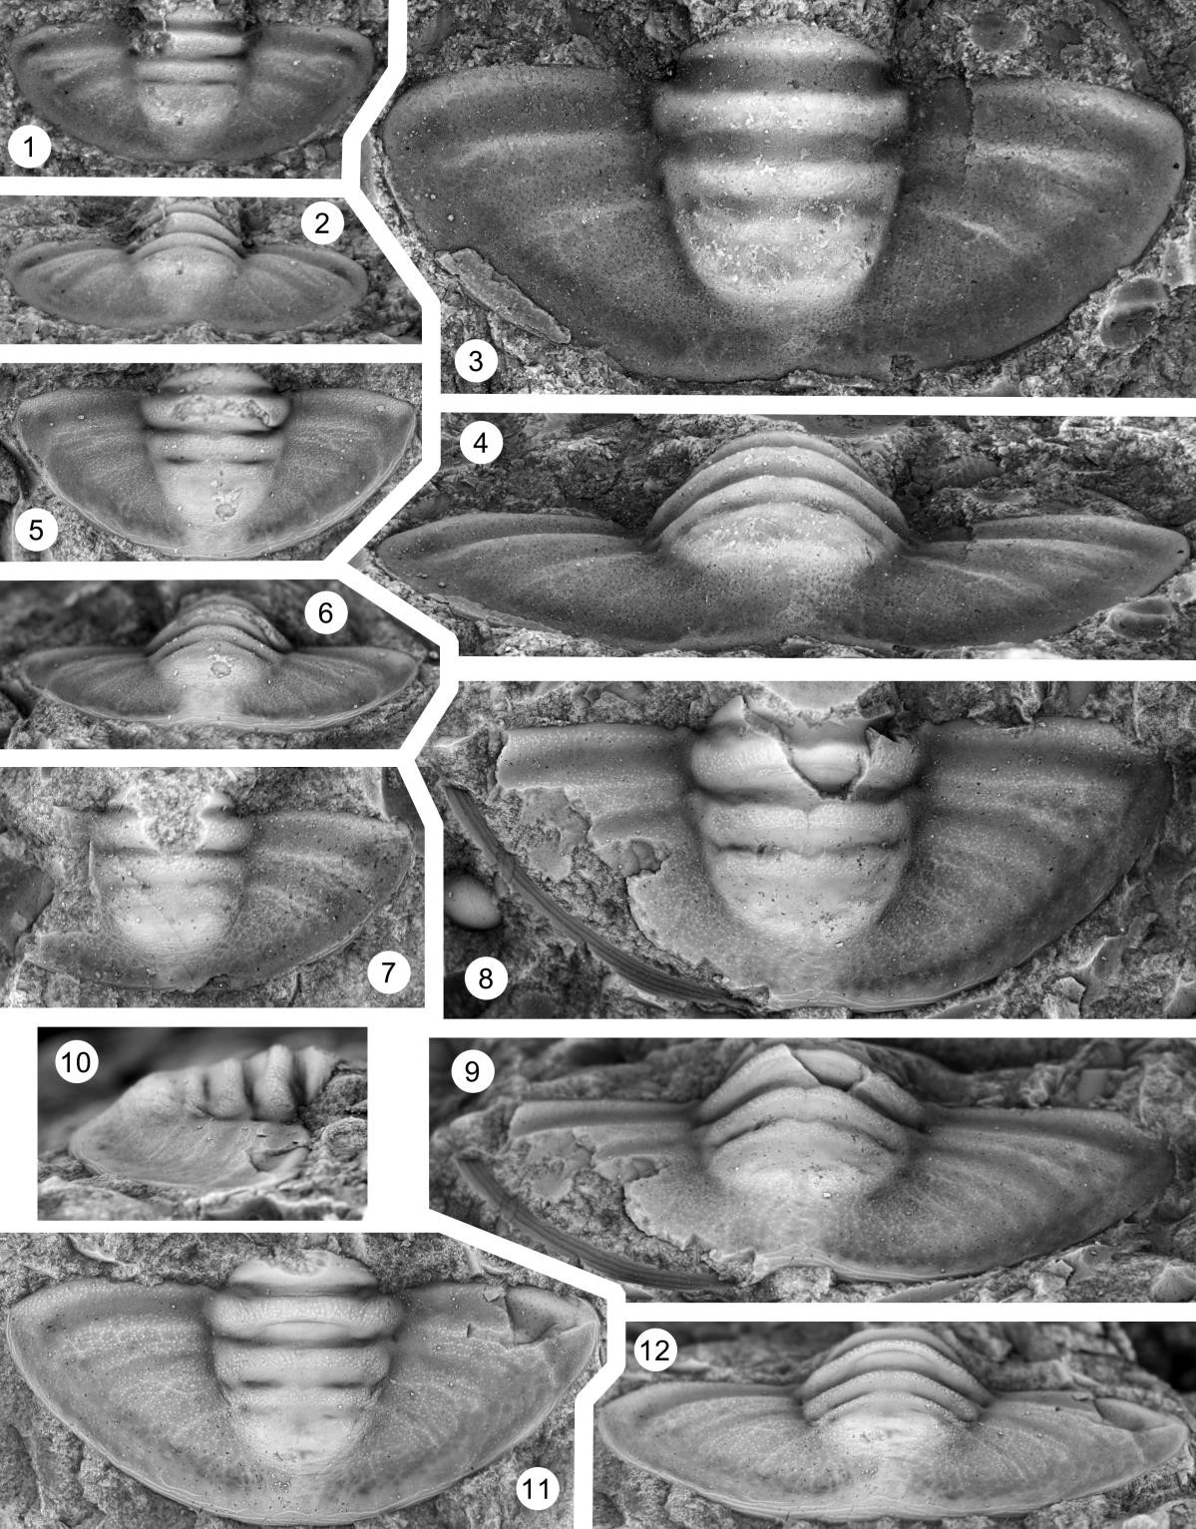

Plate 7
Fig. 1–9. Dunderbergia (s.l.) cf. D. bigranulosa, Dunderberg Formation, Barton Canyon, Cherry Creek Range, White Pine County, Nevada, collections CCDu 98.7, 104.1.

1–3. Cranidium (OU 238255), dorsal, left lateral, and anterior views, CCDu 98.7, x8.5.
4–6. Cranidium (OU 238256), anterior, left lateral, and dorsal views, CCDu 98.7, x8.5.
7–9. Pygidium (OU 238257), right lateral, dorsal, and anterior views, CCDu 104.1, x10.2.

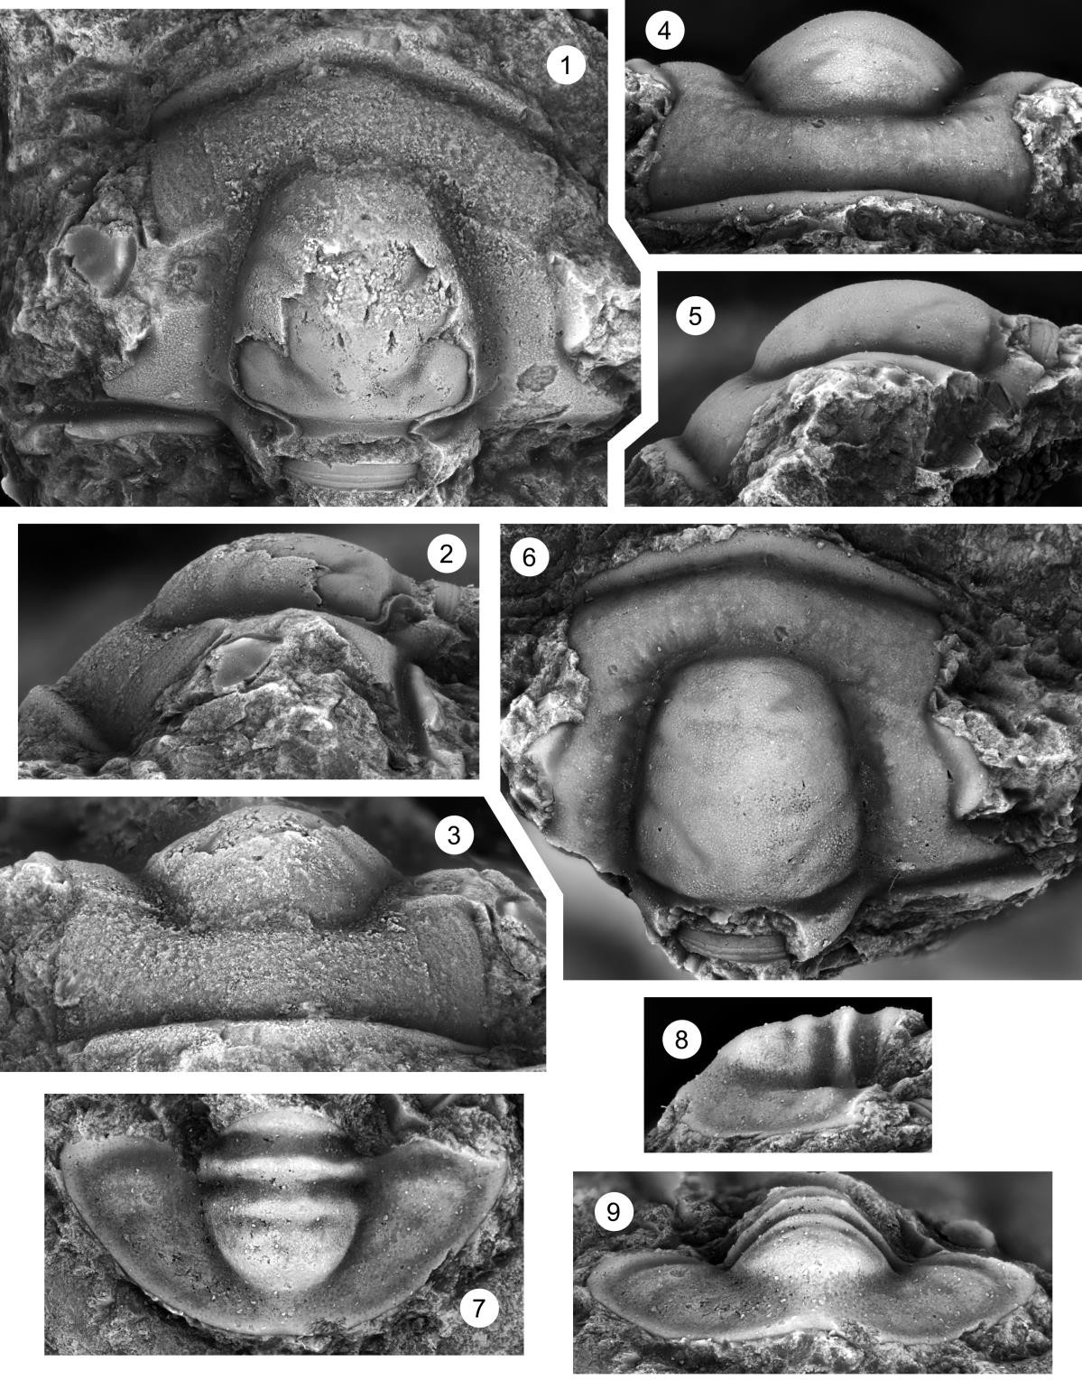

Plate 8
Fig. 1–6. Dunderbergia (s.l.) cf. D. bigranulosa, Dunderberg Formation, Barton Canyon, Cherry Creek Range, White Pine County, Nevada, collections CCDu 98.7, 104.1.

1–3. Cranidium (OU 238258), dorsal, anterior, and left lateral views, CCDu 104.1, x10.2.
4–6. Cranidium (OU 238259), right lateral, anterior, and dorsal views, CCDu 104.1, x11.9.

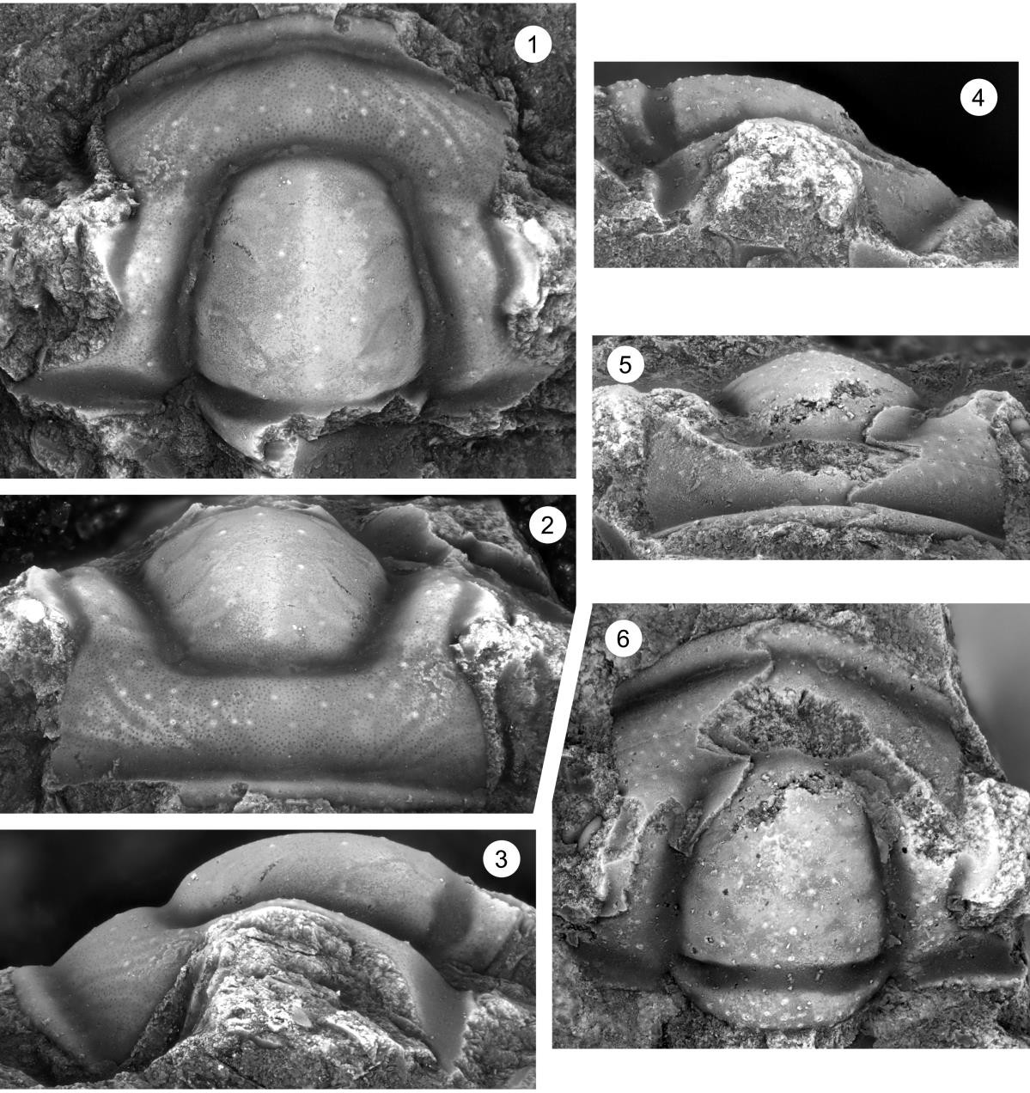
Plate 9
Fig. 1–10. Dunderbergia (s.l.) cf. D. calculosa, Candland Shale Member, Orr Formation, Orr Ridge, Millard County, Utah, collection ORR lwr 66.5.

1. Cranidium (OU 238260), dorsal view, ORR lwr 66.5, x5.1.
2, 3. Librigena (OU 238261), left lateral and dorsal views, ORR lwr 66.5, x5.1.
4–6. Cranidium (OU 238262), dorsal, anterior, and left lateral views, ORR lwr 66.5, x5.1.
7–9. Cranidium (OU 238263), dorsal, anterior, and left lateral views, ORR lwr 66.5, x5.1.
10. Cranidium (OU 238264), dorsal view, ORR lwr 66.5, x5.1.

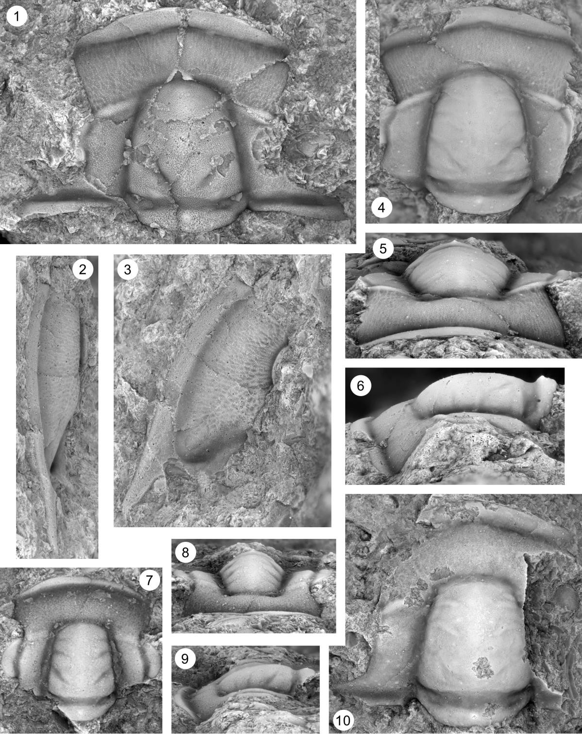

Plate 10
Fig. 1–8. Dunderbergia (s.l.) astroplethes n. sp., Downes Point Member, Shallow Bay Formation, western Newfoundland. Cow Head Peninsula, boulder CH 54.

1. Cranidium, dorsal view, CH 54, x6.8.
2. Cranidium, dorsal view, CH 54, x6.8.
3. Cranidium, dorsal view, CH 54, x6.8.
4. Cranidium, dorsal view, CH 54, x6.8.
5–8. Cranidium, dorsal, anterolateral, anterior, and left lateral views, CH 54, x6.8.

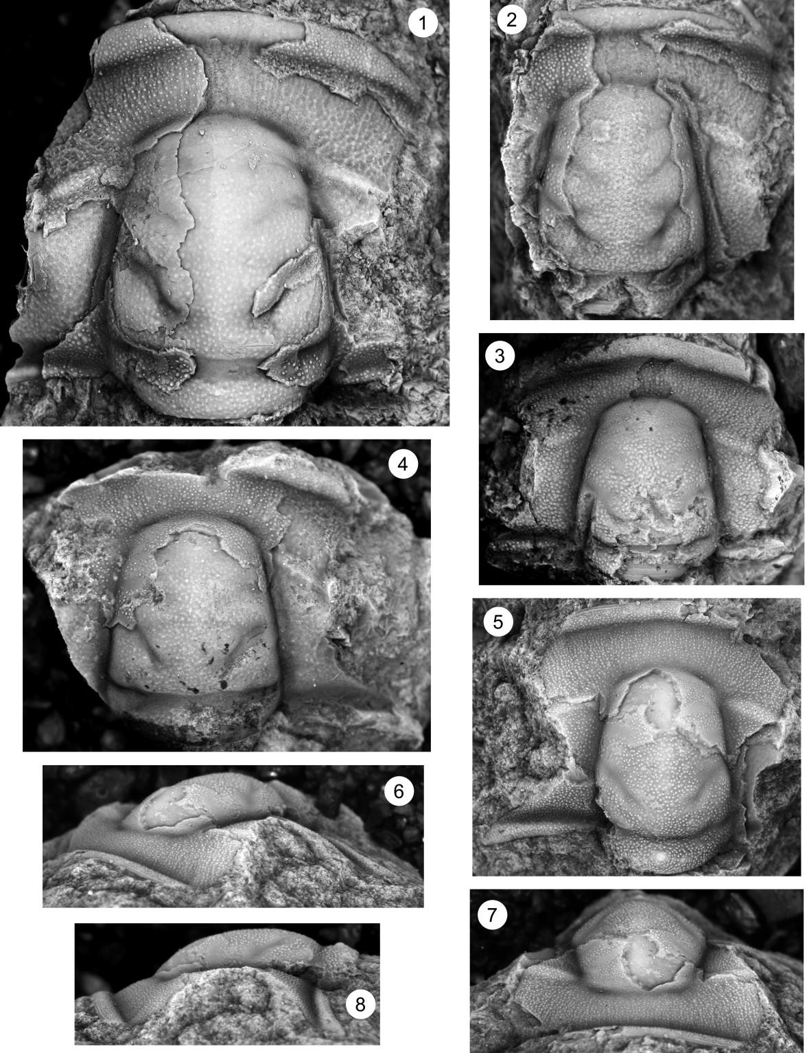

Plate 11
Fig. 1–7. Dunderbergia (s.l.) astroplethes n. sp., Downes Point Member, Shallow Bay Formation, western Newfoundland. Cow Head Peninsula, boulder CH 54.

1, 2. Pygidium, dorsal and posterior views, CH 54, x6.8.
3. Librigena, dorsal view, CH 54, x4.2.
4. Pygidium and partial segment, dorsal view, CH 54, x7.7.
5, 6. Pygidium, dorsal and posterior views, CH 54, x7.7.
7. Pygidium, dorsal view, CH 54, x7.7.

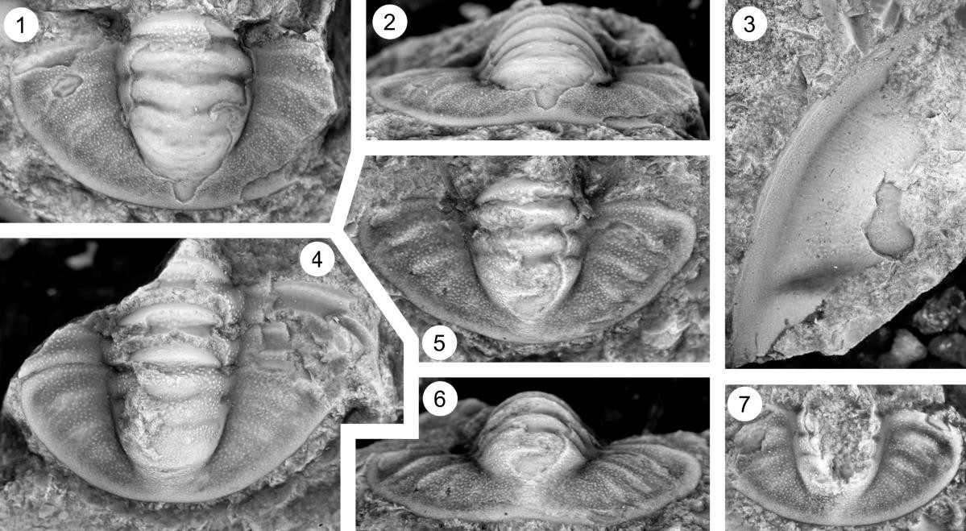

Plate 12
Fig. 1–7. Dunderbergia (s.l.) bovicephala n. sp., Downes Point Member, Shallow Bay Formation, western Newfoundland. Cow Head Peninsula, boulder CH 49; Hickey Cove, boulder HC 180. Innitagnostus inexpectans Fauna (Westrop and Eoff 2012).

1–3. Cranidium, dorsal, right lateral, and anterior views, CH 49, x5.1.
4. Cranidium, dorsal view, CH 49, x5.1.
5–7. Cranidium, dorsal, anterior, and right lateral views, CH 49, x5.1.

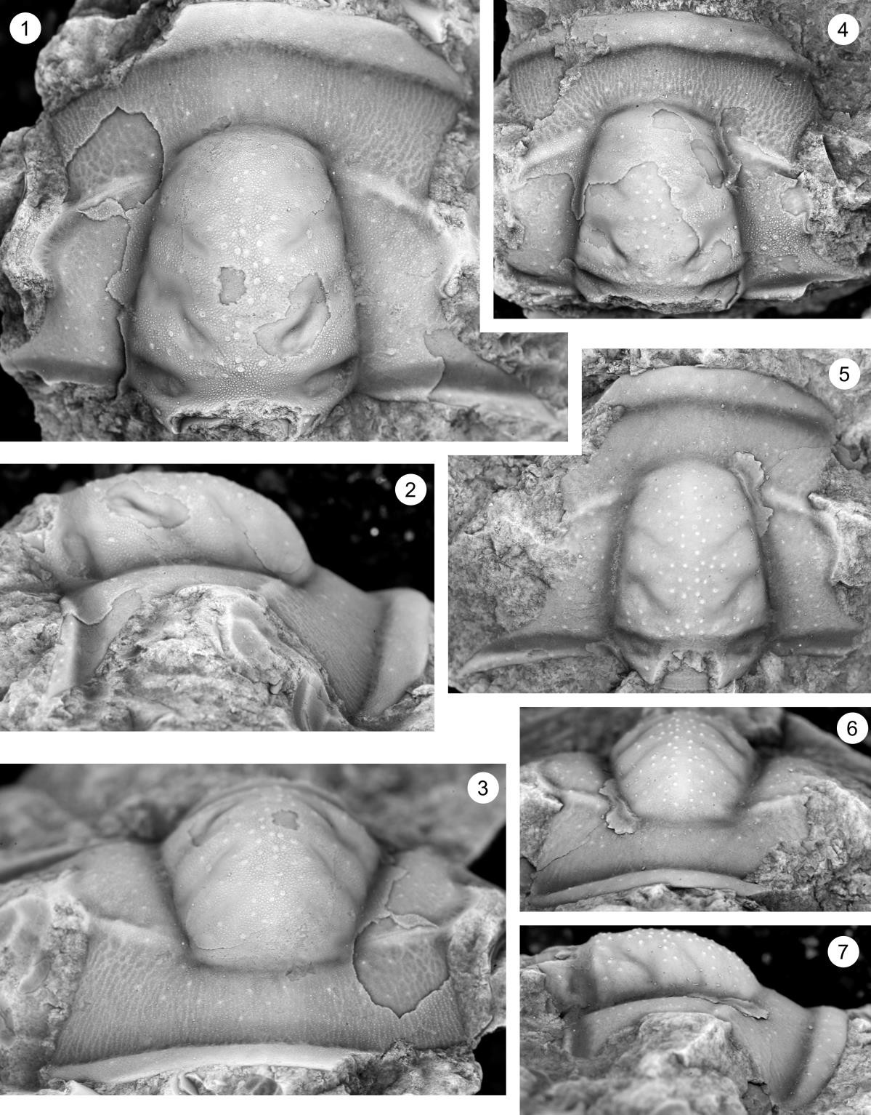

Plate 13
Fig. 1–11. Dunderbergia (s.l.) bovicephala n. sp., Downes Point Member, Shallow Bay Formation, western Newfoundland. Cow Head Peninsula, boulder CH 49; Hickey Cove, boulder HC 180. Innitagnostus inexpectans Fauna (Westrop and Eoff 2012).

1–3. Cranidium, dorsal, anterior, and right lateral views, CH 49, x5.1.
4–6. Cranidium, dorsal, left lateral, and anterior views, HC 180, x5.1.
7. Cranidium, dorsal view, CH 49, x17.
8. Hypostome, dorsal view, CH 49, x5.1.
9, 10. Librigena, dorsal, and left lateral views, CH 49, x4.2.
11. Librigena, dorsal view, CH 49, x4.2.

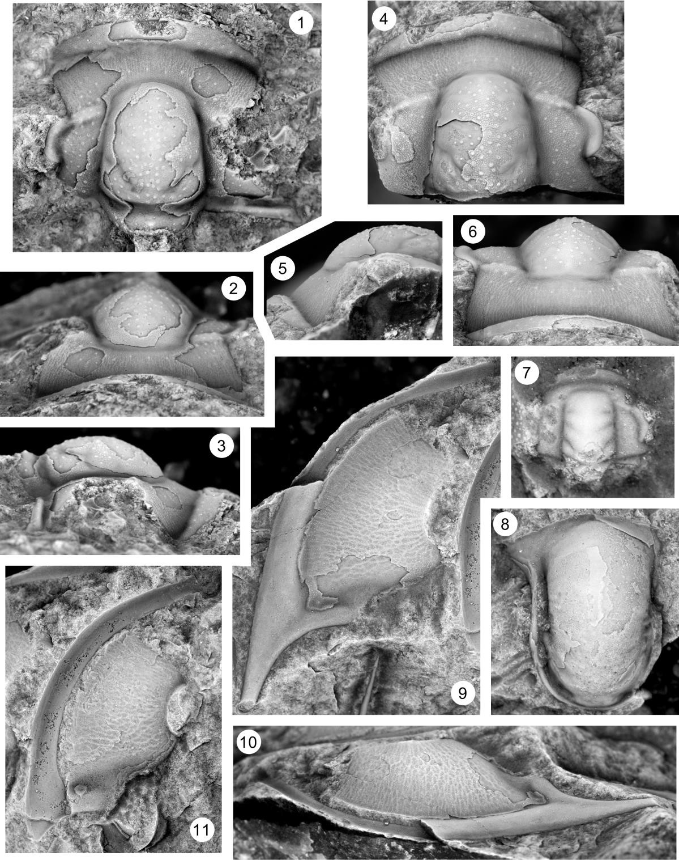

Plate 14
Fig. 1–11. Dunderbergia (s.l.) bovicephala n. sp., Downes Point Member, Shallow Bay Formation, western Newfoundland. Cow Head Peninsula, boulder CH 49; Hickey Cove, boulder HC 180. Innitagnostus inexpectans Fauna (Westrop and Eoff 2012).

1,2. Pygidium, dorsal and anterior views, CH 49, x6.8.
3. Segment, dorsal view, CH 49, x6.8.
4. Pygidium, dorsal view, CH 49, x6.8.
5, 6. Pygidium, dorsal and anterior views, CH 49, x7.4.
7. Pygidium, dorsal view, CH 49, x6.8.
8. Pygidium, dorsal view, CH 49, x6.8.
9. Pygidium, dorsal view, CH 49, x6.8.
10. Pygidium, dorsal view, CH 49, x8.5.
11. Pygidium, dorsal view, CH 49, x6.8.

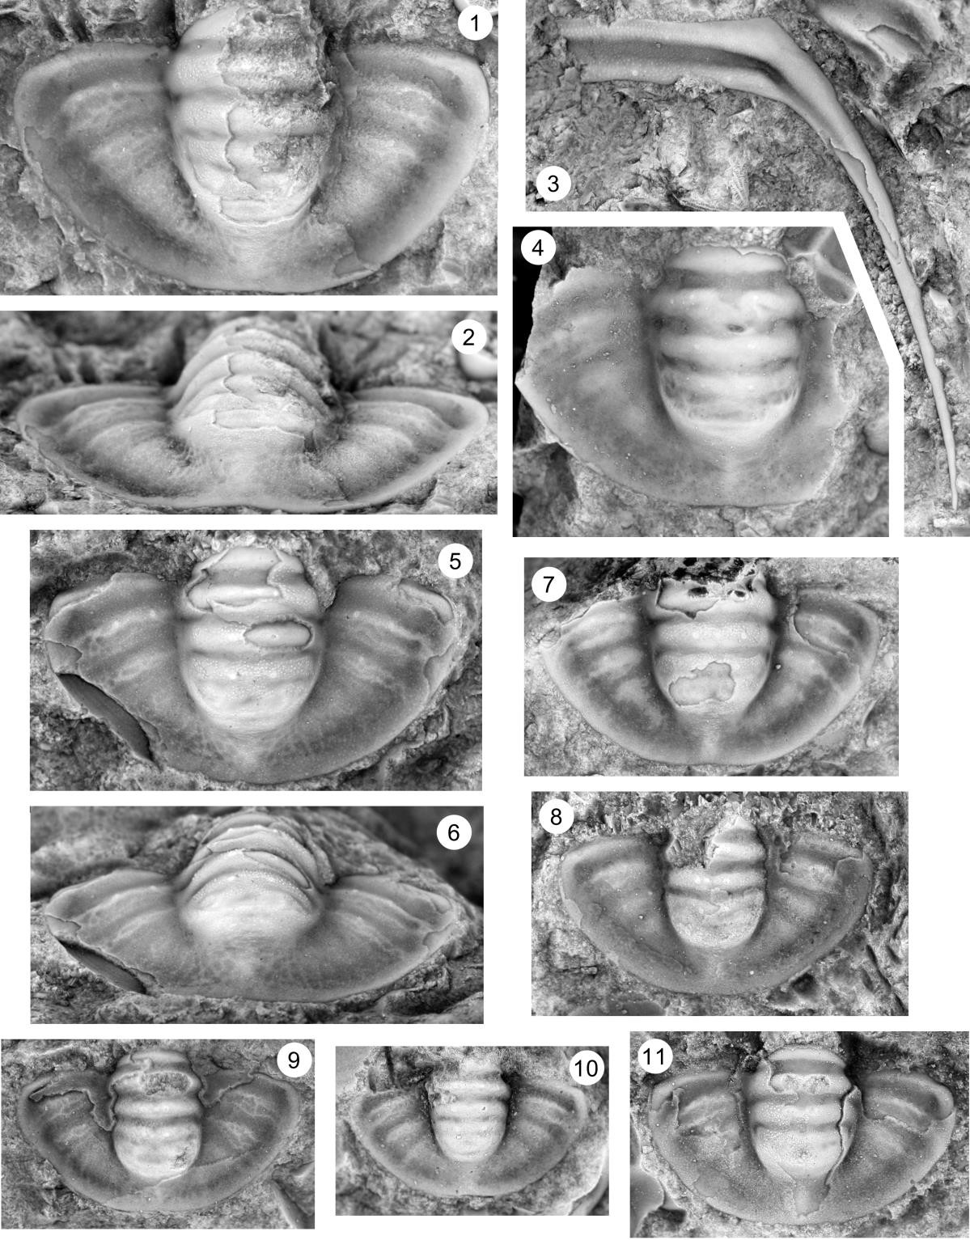

Plate 15
Fig. 1–7. Dunderbergia (s.l.) multichauna n. sp., Lion Mountain Sandstone Member, Riley Formation, Hoover Point, Burnet County, Texas, collections HP 3.65, HP 3.7 and HP 3.75.

1–3. Cranidium (OU 238266), dorsal, anterior, and left lateral views, HP 3.75, x5.9.
4–6. Cranidium (OU 238267), dorsal, left lateral, and anterior views, HP 3.65, x8.5
7. Cranidium (OU 238268), dorsal view, HP 3.7, x5.9.

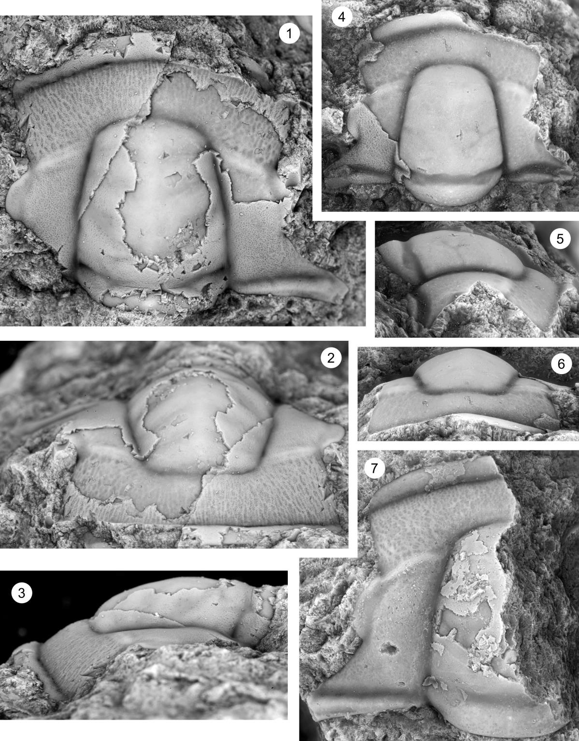

Plate 16
Fig. 1–9. Dunderbergia (s.l.) multichauna n. sp., Lion Mountain Sandstone Member, Riley Formation, Hoover Point, Burnet County, Texas, collections HP 3.65, HP 3.7 and HP 3.75.

1–3. Cranidium (OU 238269), dorsal, anterior, and right lateral views, HP 3.7, x5.9.
4–6. Cranidium (OU 238270), dorsal, anterior, and left lateral views, HP 3.7, x5.9.
7–9. Cranidium (OU 238271), dorsal, anterior, and right lateral views, HP 3.7, x5.9.

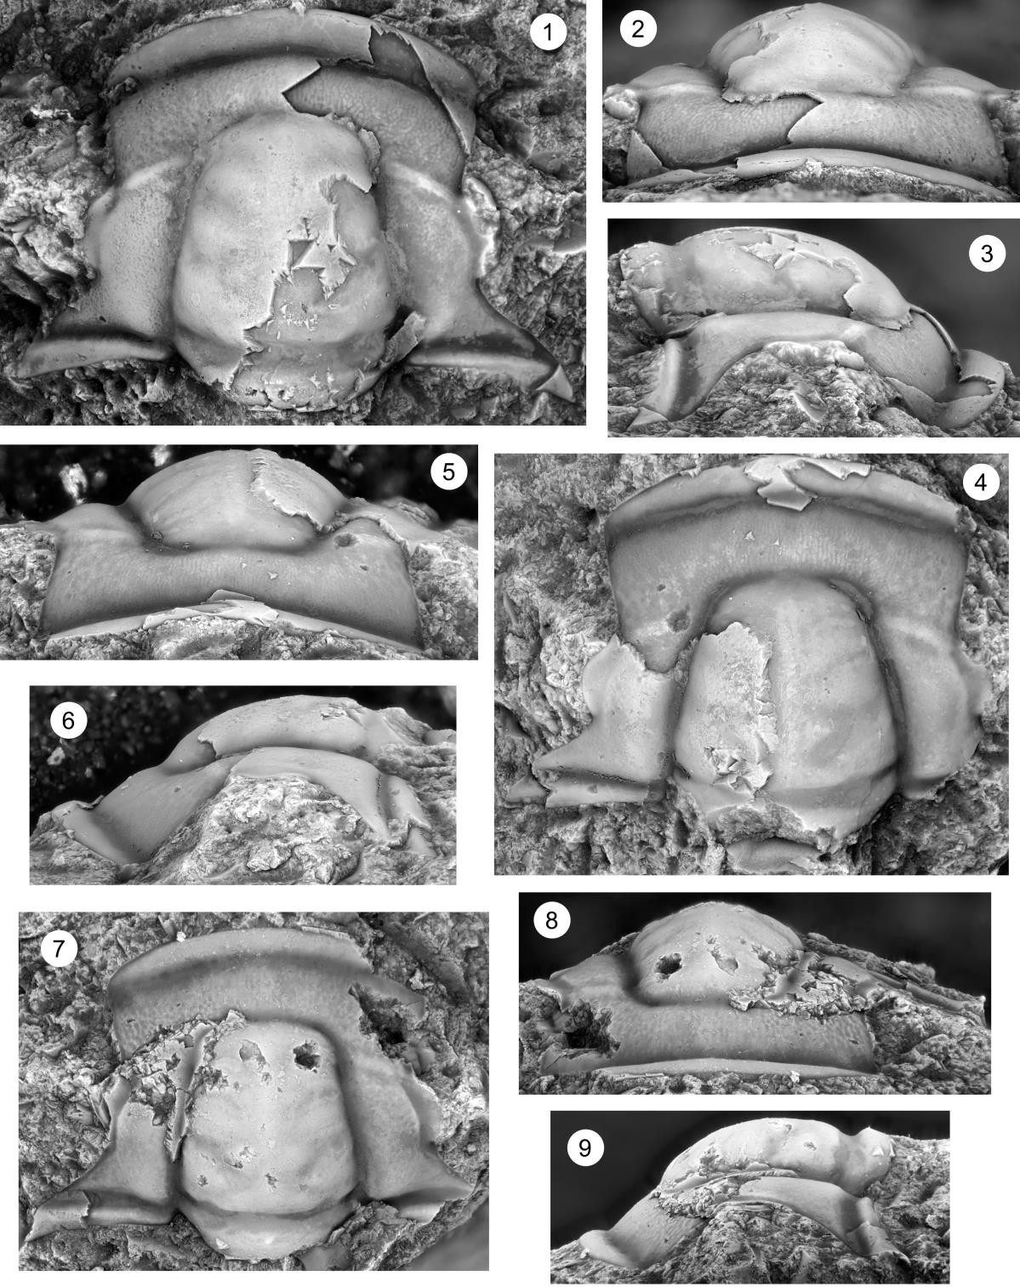

Plate 17
Fig. 1–7. Dunderbergia (s.l.) multichauna n. sp., Lion Mountain Sandstone Member, Riley Formation, Hoover Point, Burnet County, Texas, collections HP 3.65, HP 3.7 and HP 3.75.

1–3. Pygidium (OU 238272), dorsal, right lateral, and posterior views, HP 3.65, x5.9.
4, 5. Pygidium (OU 238273), posterior and dorsal views, HP 3.7, x5.9.
6. Pygidium (OU 238274), dorsal view, HP 3.75, x5.9.
7, 8. Pygidium (OU 238275), posterior and dorsal views, HP 3.7, x5.9.
9. Pygidium (OU 238276), dorsal view, HP 3.75, x15.2.

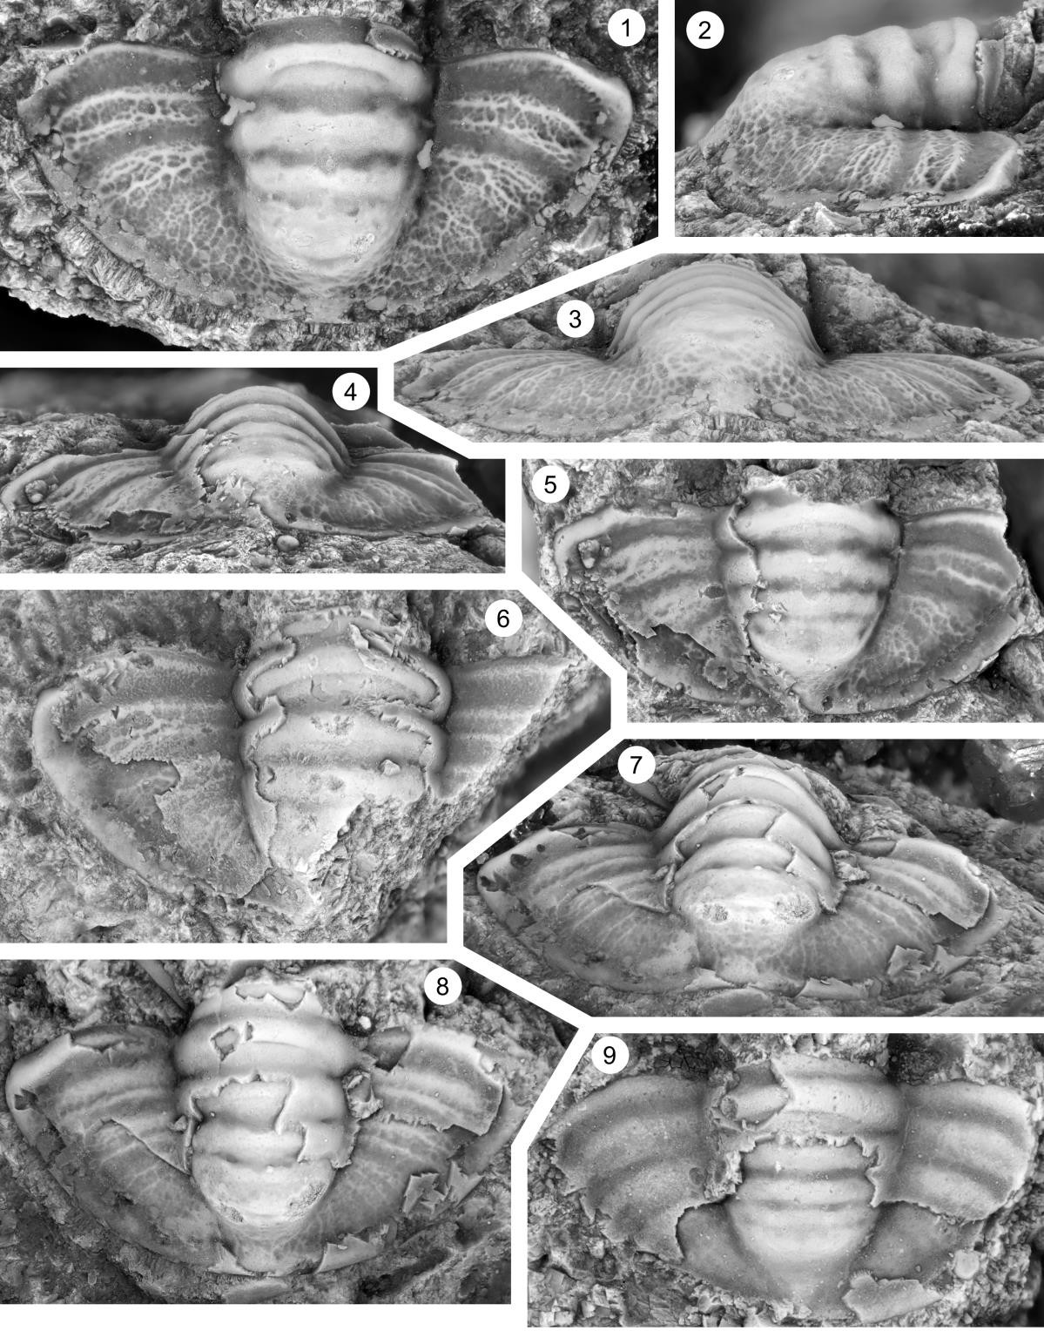

Plate 18
Fig. 1–9. Dunderbergia (s.l.) n. sp. 1., Candland Shale Member, Orr Formation, Orr Ridge, Millard County, Utah, collections ORR Lwr2 40.

1–3. Cranidium (OU 238282), dorsal, anterior, and right lateral views, ORR Lwr2 40, x13.6.
4–6. Cranidium (OU 238283), dorsal, anterior, and left lateral views, ORR Lwr2 40, x10.2.
7–9. Cranidium (OU 238284), dorsal, anterior, and left lateral views, ORR Lwr2 40, x13.6.

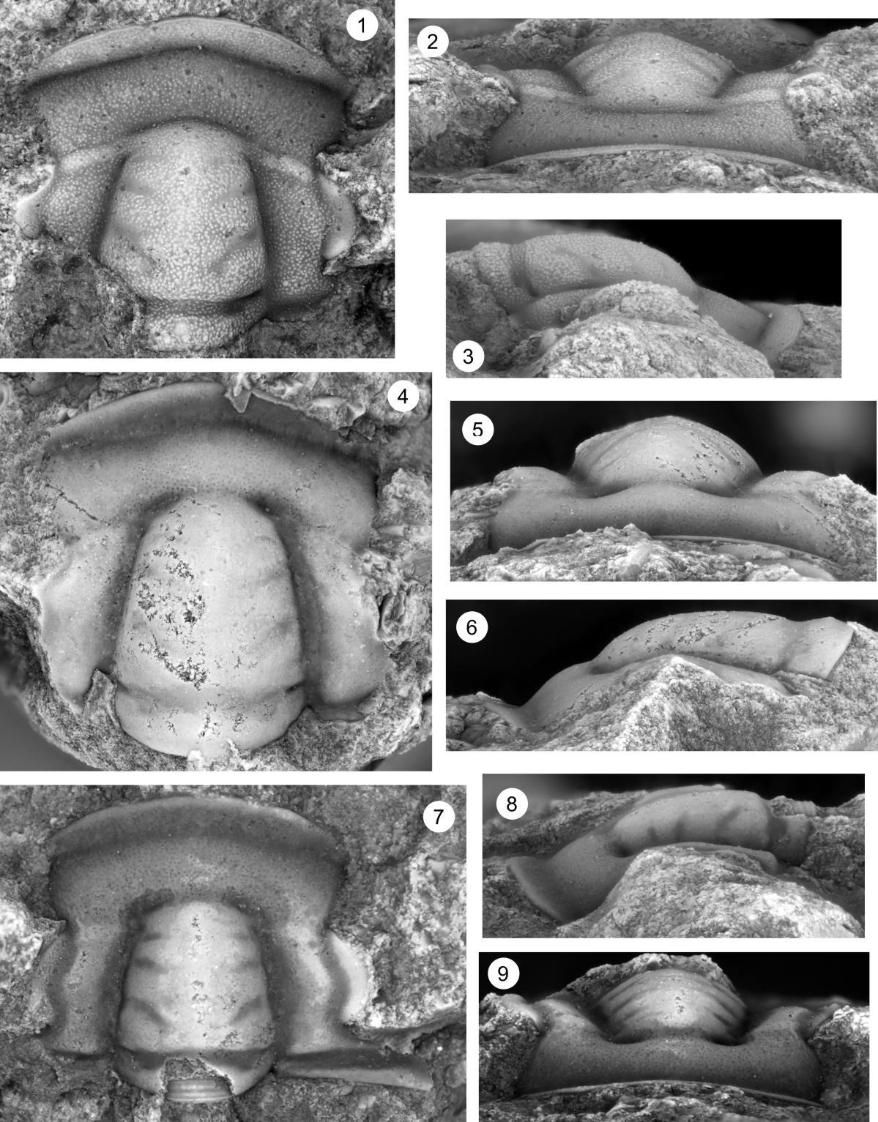

Plate 19
Fig. 1–5. Dunderbergia (s.l.) n. sp. 1., Candland Shale Member, Orr Formation, Orr Ridge, Millard County, Utah, collections ORR Lwr2 40.

1,2. Librigena (OU 238285), dorsal and left lateral views, ORR Lwr2 40, x12.7.
3–5. Pygidium (OU 238286), posterior, dorsal, and right lateral views, ORR Lwr2 40, x12.7.

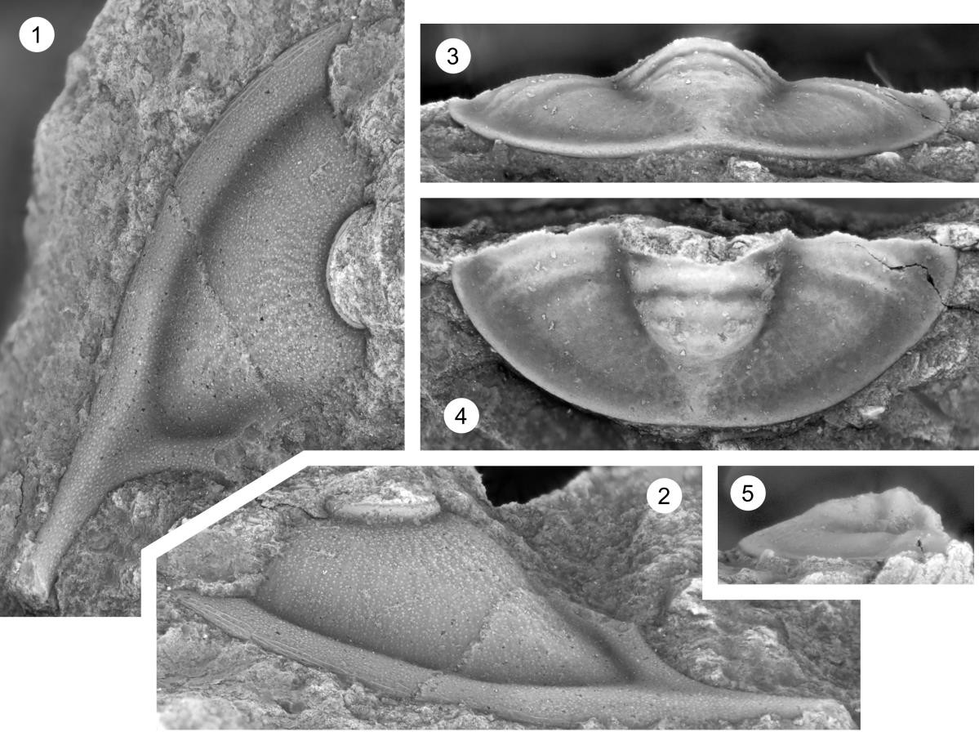

Plate 20
Fig. 1–5. Dunderbergia (s.l.) n. sp. 2., Fish Springs Range, Juab County, Utah, collection FSR2 17.

1–3. Cranidium (OU 238288), dorsal, right lateral, and anterior views, FSR2 17, x7.7.
4. Cranidium (OU 238289), dorsal view, FSR2 17, x7.7.

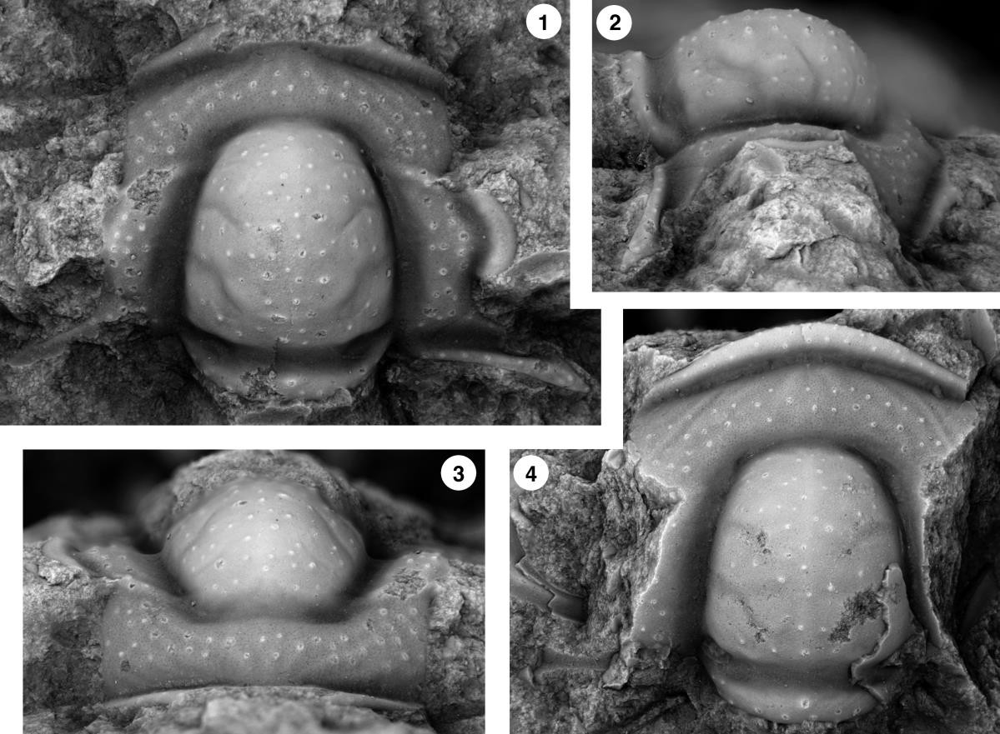

Plate 21
Fig. 1–9. Dunderbergia (s.l.) sp. indet. 1, Candland Shale Member, Orr Formation, Orr Ridge, Millard County, Utah, collection ORR lwr2 31.2

1–3. Cranidium (OU 238290), dorsal, anterior, and left lateral views, ORR Lwr2 31.2, x13.6.
4, 5. Librigena (OU 238291), dorsal and left lateral views, ORR Lwr2 31.2, x13.6.
6, 7. Cranidium (OU 238292), dorsal and right lateral views, ORR Lwr2 31.2, x13.6.
8, 9. Cranidium (OU 238293), dorsal and anterior views, ORR Lwr2 31.2, x13.6.

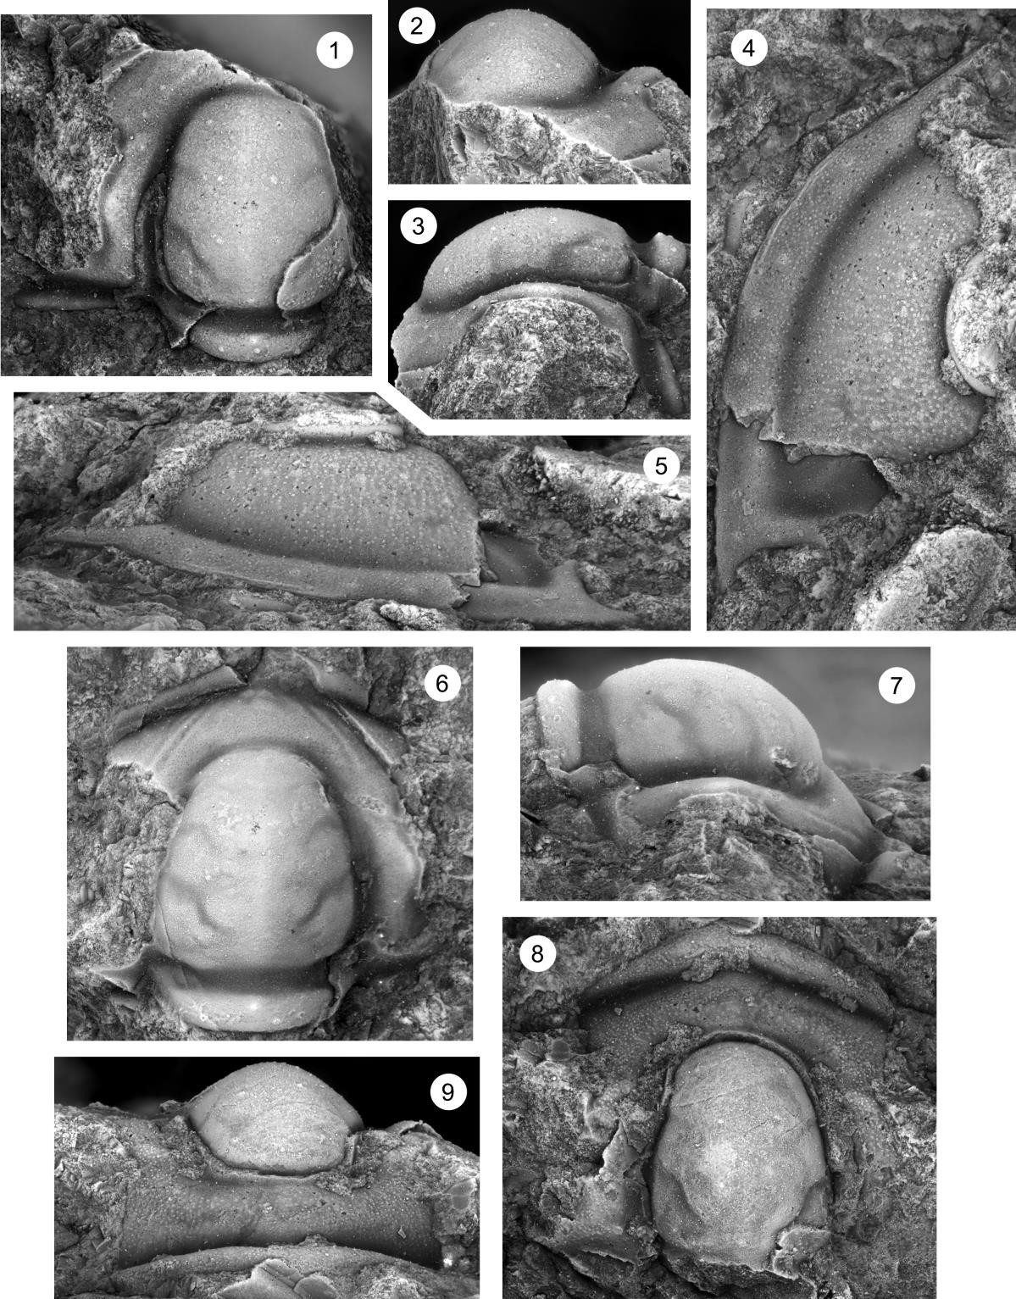

Plate 22
Fig. 1–9. Dunderbergia (s.l.) sp. indet. 2, Candland Shale Member, Orr Formation, Orr Ridge, Millard County, Utah, collections ORR Lwr2 18.

1–3. Cranidium (OU 238294), dorsal and left lateral views, ORR Lwr2 18, x6.8.
4–6. Cranidium (OU 238295), dorsal and anterior views, ORR Lwr2 18, x6.8.
7–9. Pygidium (OU 238296), posterior, dorsal, and left lateral views, ORR Lwr2 18, x5.9.

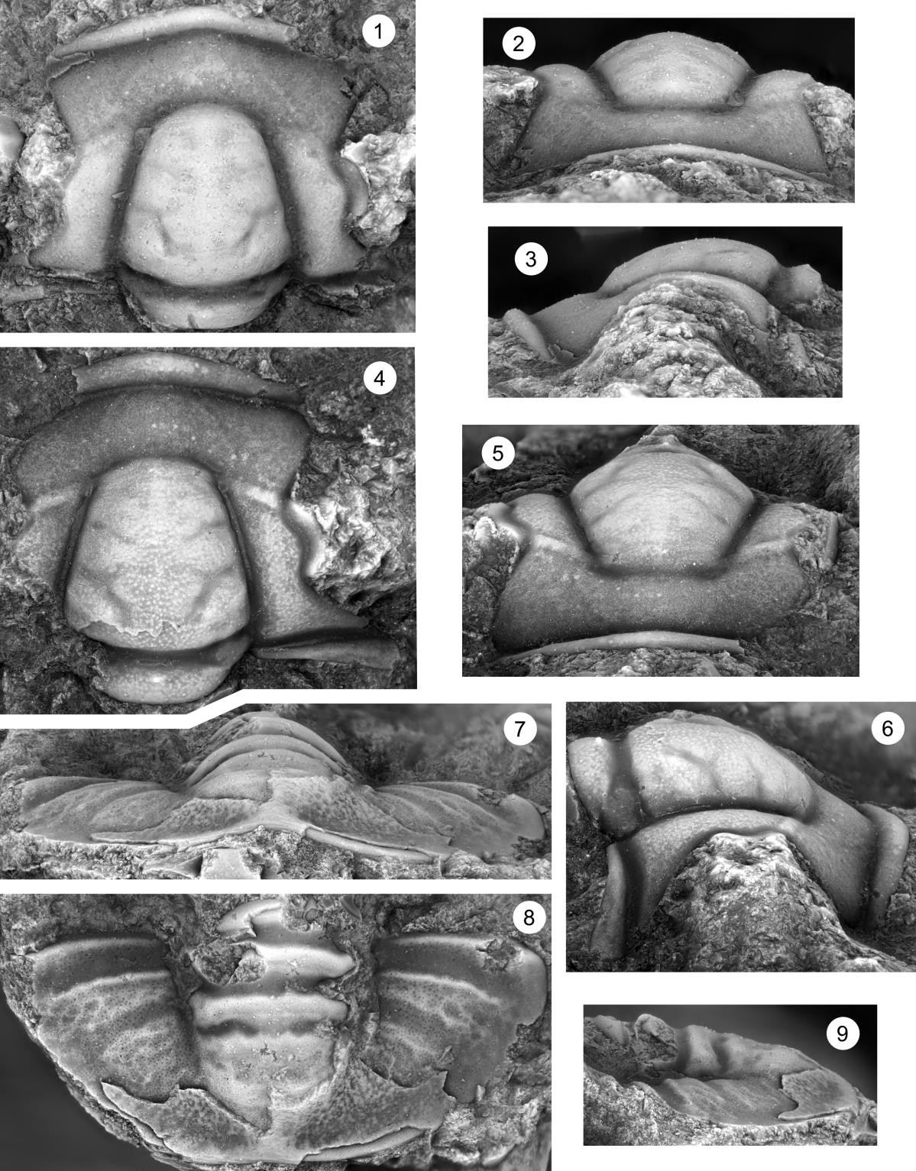

Plate 23
Fig. 1–6. Dunderbergia (Dytremacephalus) granulosa, from the Lion Mountain Sandstone Member, Riley Formation, USGS collection 11 (CO), Lion Mountain, Burnet County, Texas.

1–3. Cranidium (USNM 195691), dorsal, anterior, and right lateral views, x10.2.
4–6. Cranidium (USNM 123319), dorsal, anterior, and left lateral views, x10.2.

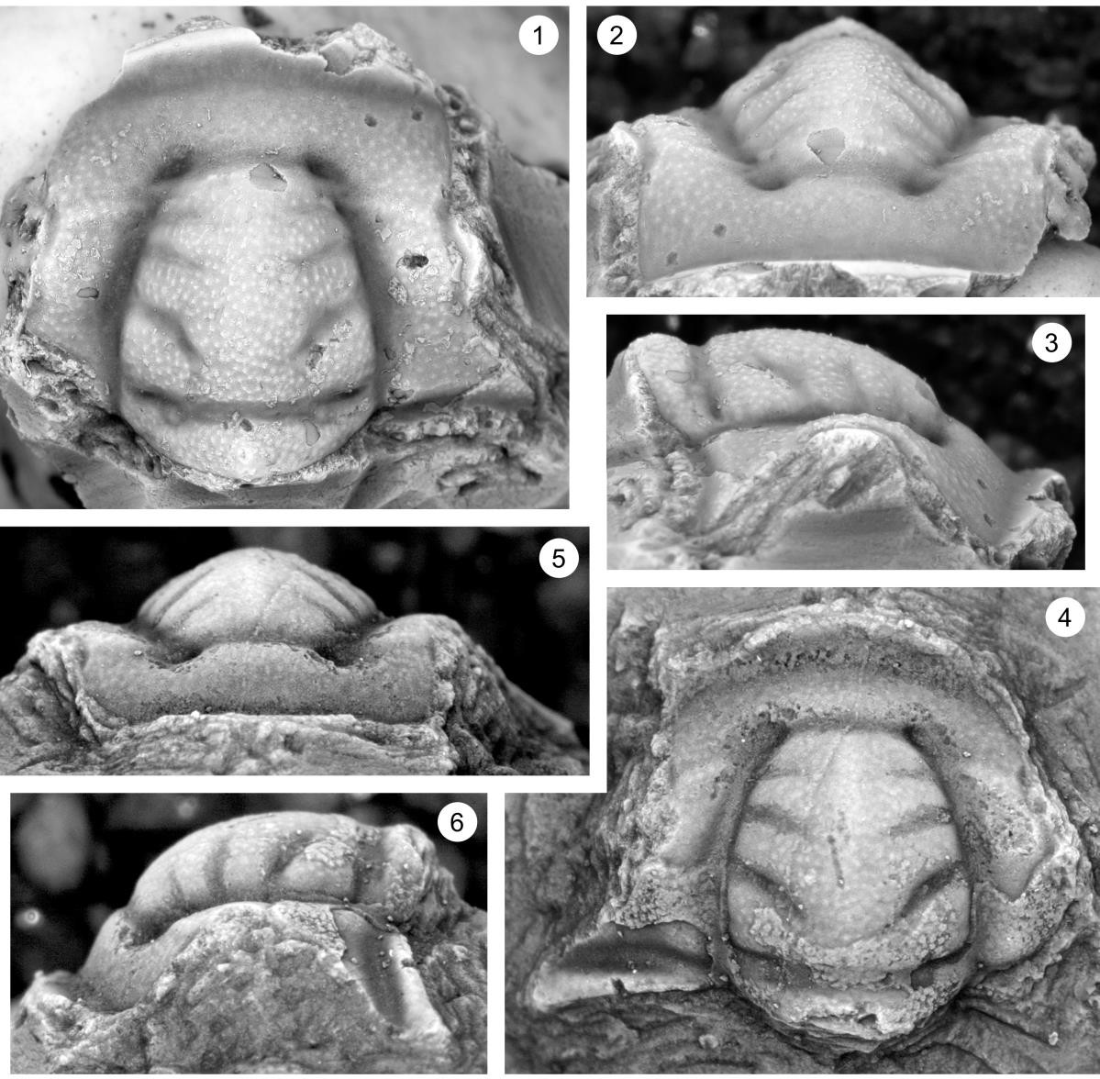
Plate 24
Fig. 1–8. Dunderbergia (Dytremacephalus) aphropeca n. sp., from the Lion Mountain Sandstone Member, Riley Formation, Hoover Point, Burnet County, central Texas, collections HP 3.1, 3.65, 3.7.

1, 2. Cranidium (OU 238297), right lateral and dorsal views, 3.65, x8.5.
3–5. Cranidium (OU 238298), dorsal, anterior, and right lateral views, HP 3.1, x17.
6–8. Cranidium (OU 238138), dorsal, left lateral, and anterior views, HP 3.1, x8.5.

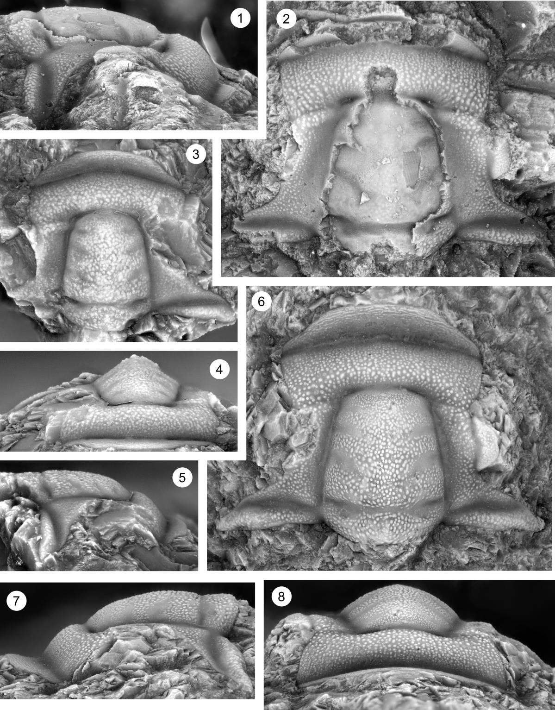

Plate 25
Fig. 1–10. Dunderbergia (Dytremacephalus) aphropeca n. sp., from the Lion Mountain Sandstone Member, Riley Formation, Hoover Point, Burnet County, central Texas, collections HP 3.1, 3.65, 3.7.

1–3. Cranidium (OU 238299), dorsal, left lateral, and anterior views, HP 3.7, x8.5.
4. Cranidium (OU 238300), dorsal view, HP 3.75 x17.
5–7. Pygidium (OU 238301), dorsal, posterior, and right lateral views, HP 3.1, x17.
8. Librigena (OU 238302), dorsal view, HP 3.1, x7.7.
9, 10. Librigena (OU 238141), dorsal and left lateral views, HP 3.1 x6.8.

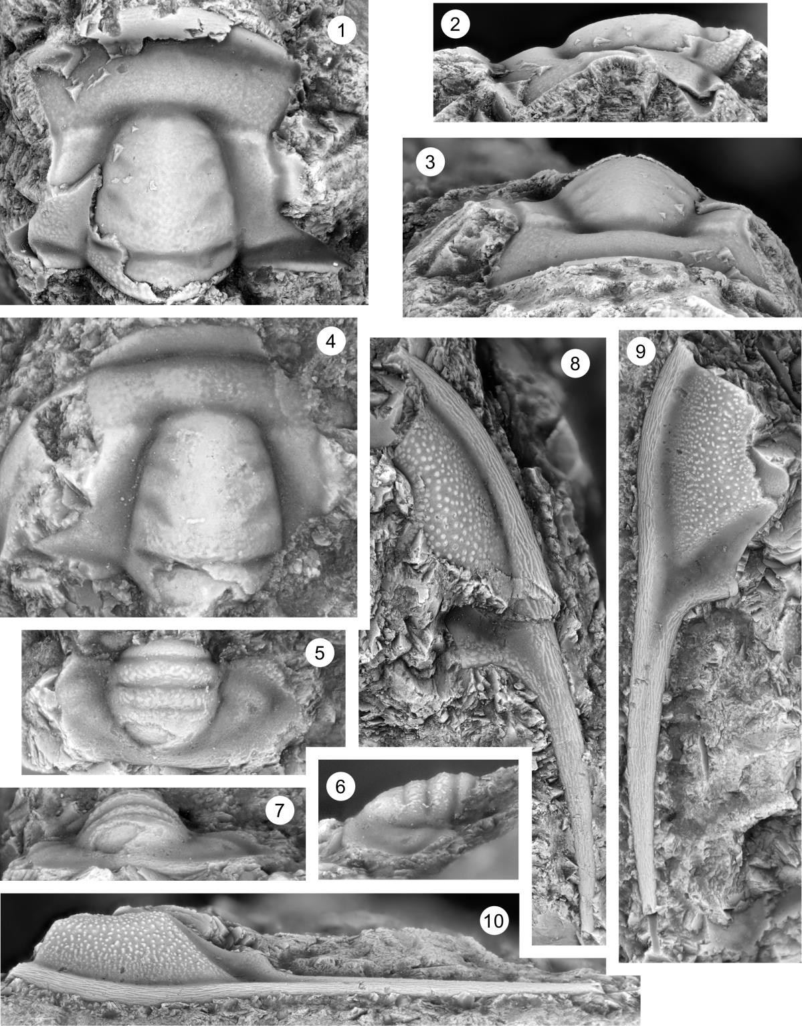

Plate 26
Fig. 1–9. Dunderbergia (Dytremacephalus) chondramma n. sp., Candland Shale Member, Orr Formation, Fish Springs Range, Juab County, Utah, collection FSR2 0.3.

1–3. Cranidium (OU 238309), dorsal, anterior, and right lateral views, FSR2 0.3, x10.2.
4–7. Cranidium (OU 238310), dorsal, anterior, dorsal, left lateral, and right anterolateral views, FSR2 0.3, x17.
8. Cranidium (OU 238311), dorsal view, FSR2 0.3, x17.
9. Pygidium (OU 238312), dorsal view, FSR2 0.3, x17.

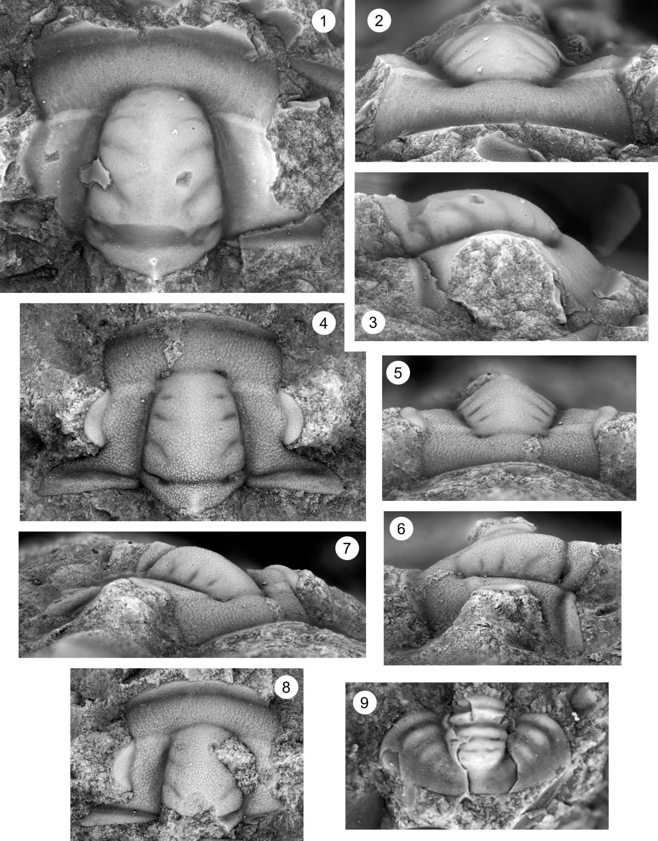

Plate 27
Fig. 1–8. Dunderbergia (Dytremacephalus) chondramma n. sp., Candland Shale Member, Orr Formation, Fish Springs Range, Juab County, Utah, collection FSR2 0.3.

1, 2. Pygidium (OU 238313), dorsal and posterior views, FSR2 0.3, x13.6.
3–5. Pygidium (OU 238314), dorsal, left lateral, and posterior views, FSR2 0.3, x17.
6, 7. Librigena (OU 238315), dorsal and right lateral views, FSR2 0.3, x16.6.
8. Librigena (OU 238216), dorsal view, FSR2 0.3, x16.6.

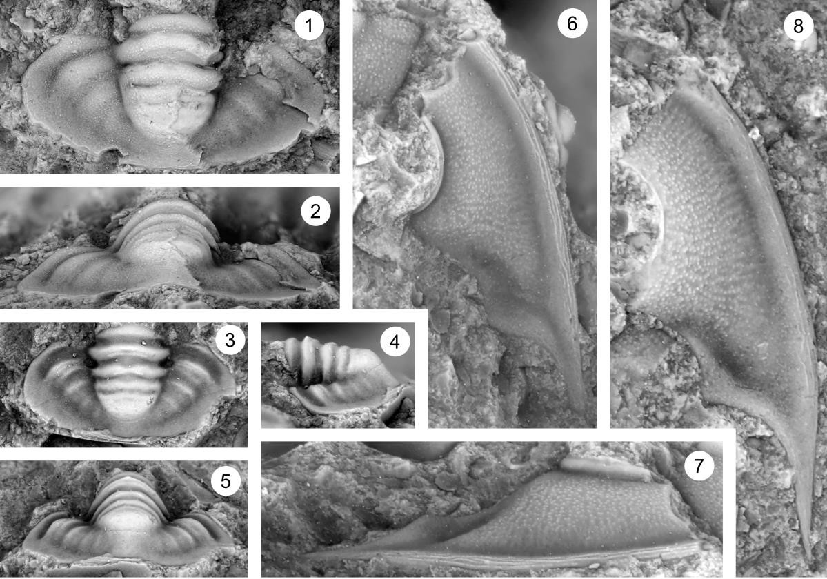

Plate 28
Fig. 1–10. Dunderbergia (Dytremacephalus) craniophysa n. sp, Downes Point Member, Shallow Bay Formation, western Newfoundland. Cow Head Peninsula, boulder CH 54.

1–4. Cranidium, dorsal, anterior, right anterolateral, and right lateral views, CH 54, x7.7.
5, 6. Cranidium, dorsal and left anterolateral views, CH 54, x7.7.
7–10. Cranidium, anterior, left lateral, dorsal, and left anterolateral, views, CH 54, x7.7.

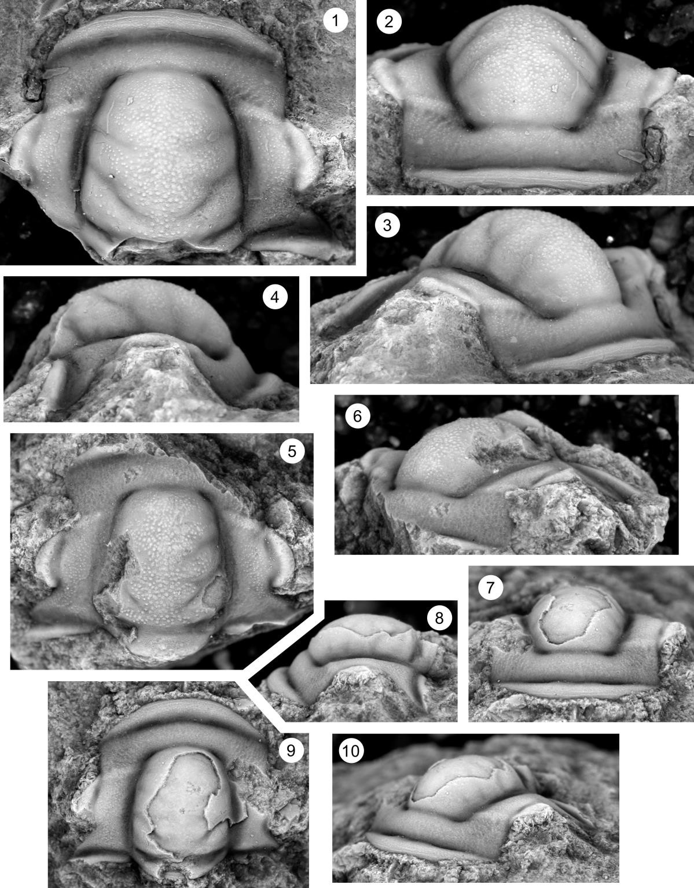

Plate 29
Fig. 1–9. Dunderbergia (Dytremacephalus) pluviguttata n. sp, Candland Shale Member, Orr Formation, Orr Ridge, Millard County, Utah, collection ORR lwr 66.15; ORR lwr2 12.0.

1. Cranidium (OU 238317), dorsal views, ORR lwr2 12.0, x12.7.
2, 3. Cranidium (OU 238318), dorsal and anterior views, ORR lwr2 12.0, x12.7.
4–6. Cranidium (OU 238319), dorsal, anterior, and left lateral views, ORR lwr 66.15, x17.
7–9. Cranidium (OU 238320), dorsal, left lateral, and anterior views, ORR lwr2 12, x17.
10–12. Cranidium (OU 238321), right lateral, anterior, and dorsal views, ORR lwr 66.15, x12.7.
13–15. Pygidium (OU 238322), posterior, dorsal, and right lateral views, ORR lwr2 12.0, x17.

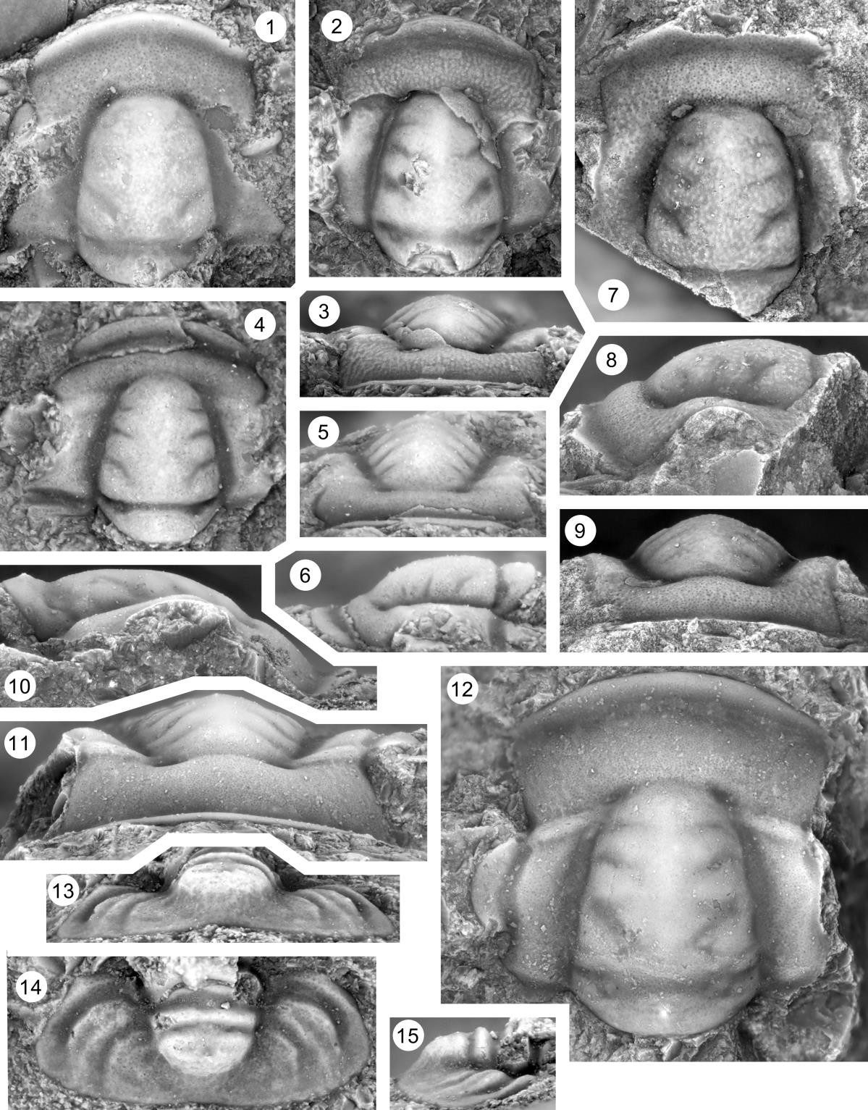

Plate 30
Fig. 1–7. Dunderbergia (Elburgia) granulosa, Candland Shale Member, Orr Formation, Orr Ridge, Millard County, Utah, collection ORR lwr2 34.1.

1. Cranidium (OU 238323), dorsal view, ORR lwr2 34.1, x5.9.
2–4. Cranidium (OU 238324), dorsal, anterior, and right lateral views, ORR lwr2 34.1., x6.8.
5–8. Cranidium (OU 238325), dorsal, right lateral, and anterior views, LCN 6.5, x6.8.

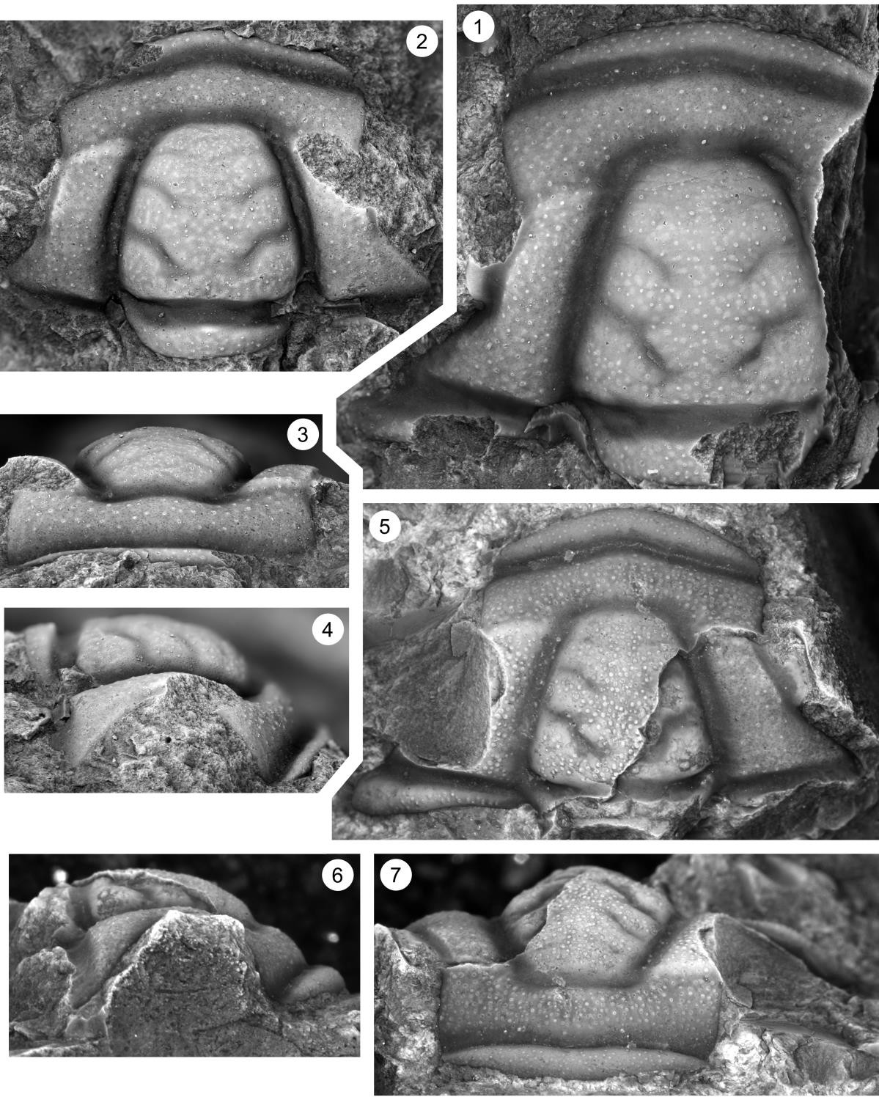

Plate 31
Fig. 1–10. Dunderbergia (Elburgia) granulosa, Candland Shale Member, Orr Formation, Orr Ridge, Millard County, Utah, collection ORR lwr2 34.1.

1–3. Cranidium (OU 238326), dorsal, left lateral, and anterior views, ORR lwr2 34.1, x5.9.
4–6. Cranidium (OU 238327), dorsal, anterior, and right lateral views, ORR lwr 34.1, x6.8.
7. Cranidium (OU 238328), dorsal view, ORR lwr 34.1, x5.9.

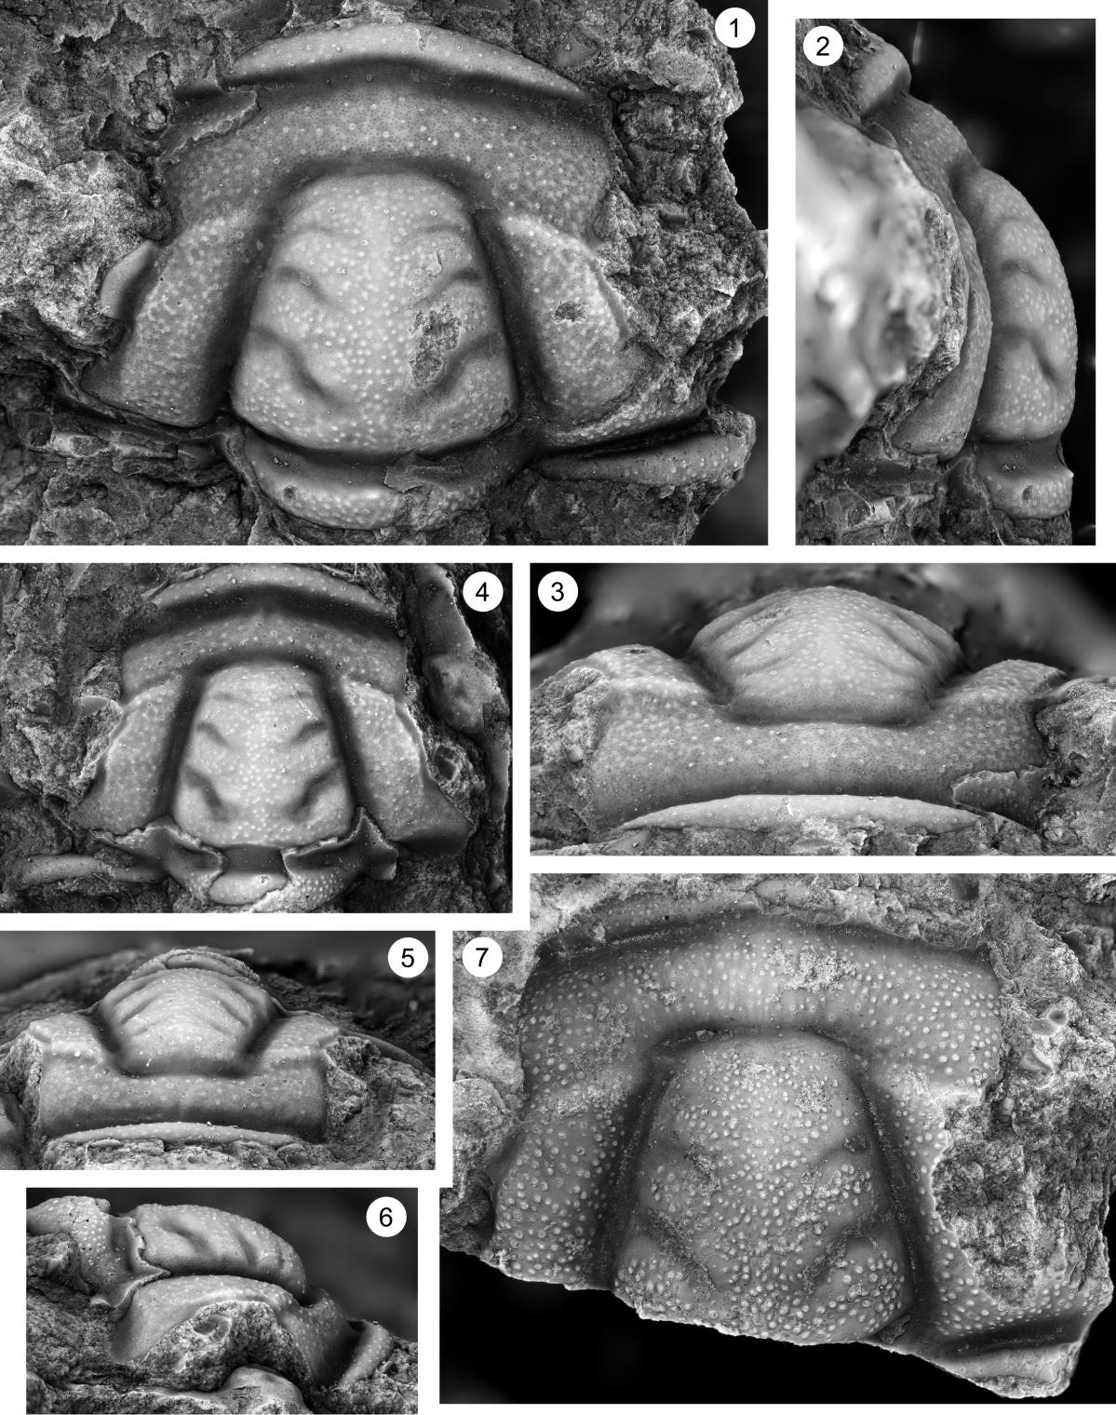

Plate 32
Fig. 1–8 Dunderbergia (Elburgia) granulosa, Candland Shale Member, Orr Formation, Orr Ridge, Millard County, Utah, collection ORR lwr2 34.1.

1, 2. Pygidium (OU 238329), dorsal and posterior views, ORR lwr2 34.1, x7.7.
3. Librigena (OU 238330), dorsal view, ORR lwr2 34.1, x7.7.
4, 5. Librigena (OU 238331), right dorsolateral and dorsal views, ORR lwr2 34.1, x7.7.
6. Librigena (OU 238332), dorsal view, ORR lwr2 34.1, x7.7.

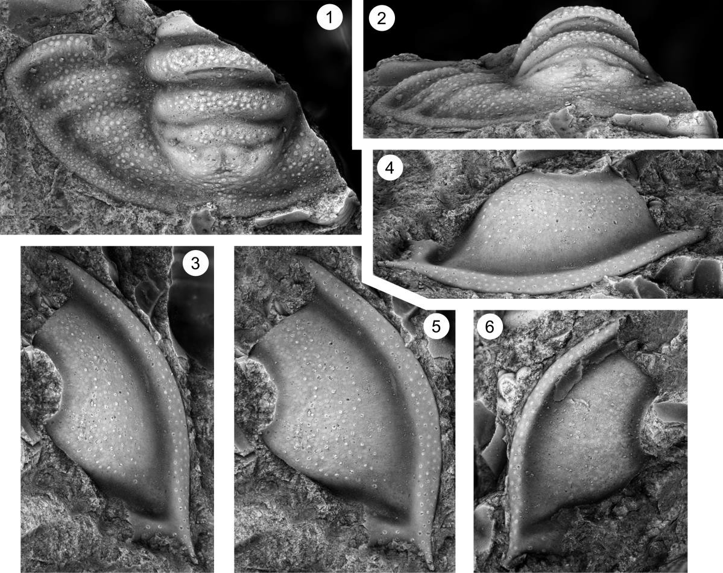

Plate 33
Fig. 1–8. Dunderbergia (Elburgia) magnatubercula n. sp., Downes Point Member, Shallow Bay Formation, western Newfoundland. Cow Head Peninsula, boulder MP 528.

1, 2. Cranidium (OU 238335), dorsal and anterior views, MP 528, x8.5.
3, 4. Cranidium (OU 238336), dorsal and anterior views, MP 528, x8.5.
5–7. Cranidium (OU 238337), dorsal, anterior, and right lateral views, MP 528, x5.9.
8. Cranidium (OU 238338), dorsal view, MP 528, x5.1.

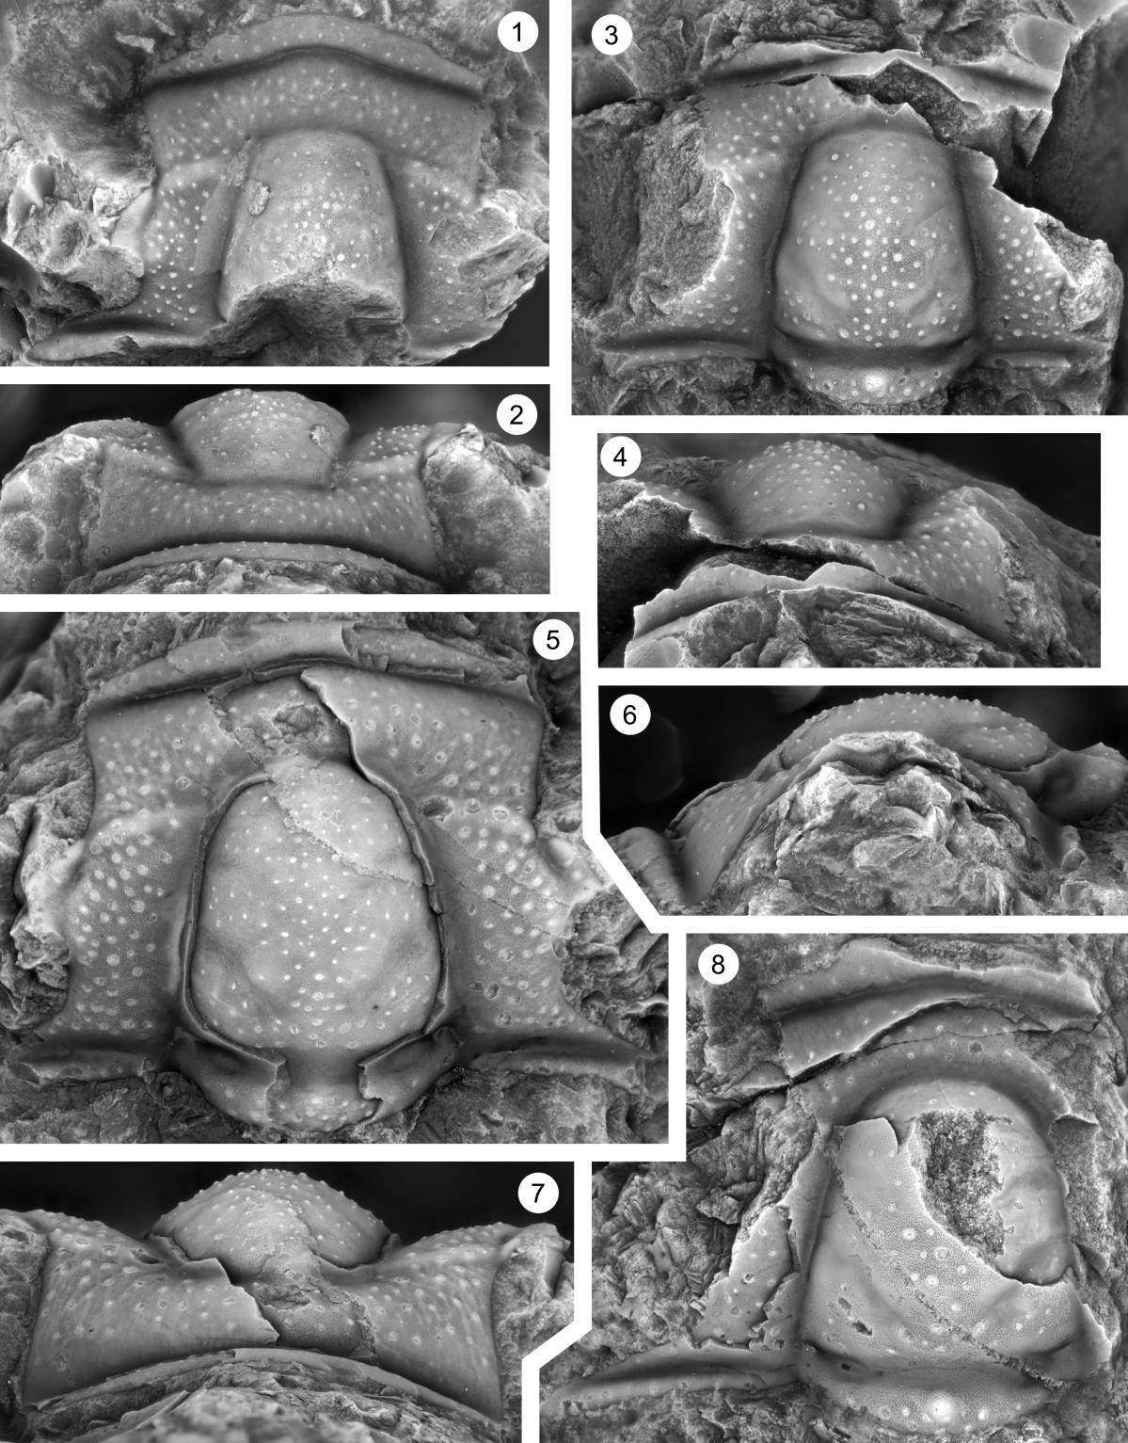

Plate 34
Fig. 1–8. Dunderbergia (Elburgia) magnatubercula n. sp., Downes Point Member, Shallow Bay Formation, western Newfoundland. Cow Head Peninsula, boulder MP 528.

1–3. Cranidium (OU 238339), dorsal, anterior, and left lateral views, MP 528, x5.1.
4–6. Cranidium (OU 238340), dorsal, anterior, and right lateral views, MP 528, x6.8.
7, 8. Pygidium (OU 238341), dorsal and posterior views, MP 528, x7.7.

