UNIVERSITY OF OKLAHOMA
GRADUATE COLLEGE

Global Reconnaissance of Reef Spur and Groove Variability: A Systematic Geomorphic Classification.

A THESIS
SUBMITTED TO THE GRADUATE FACULTY
in partial fulfillment of the requirements for the
Degree of
MASTER OF SCIENCE

By
Carson Broaddus
Norman, Oklahoma
2021

Global Reconnaissance of Reef Spur and Groove Variability: A Systematic Geomorphic Classification

A THESIS APPROVED FOR SCHOOL OF GEOSCIENCES

BY THE COMMITTEE CONSISTING OF

Dr. John Pigott, Chair
Dr. Richard Elmore
Dr. Kulwadee Pigott

© Copyright by Carson Broaddus 2021 All Rights Reserved.

Table of Contents
Acknowledgements……….………………......…………………………………..……...……....ix
Abstract…………………………………………………………………………..………………x
Key Terms………………………………………………………………………..………………x
1 Introduction …………………………………………………………………………………..1
  - What are Spur and Grooves?………………..……………………..………………..…..1
1.1.2 Basic Spur and Groove Features…..……………………….………..………........3
1.1.3 Modern SaG Systems…………………………………..…………………………3
1.1.4 Ancient SaG Systems………………………………..………………………...….5
  - Problem Definition………………………………………………………………...…....6
  - Previous Work…………………………………………………………………..………6
  - SaG Morphology Controls……………………………………………………………....7
    - Wind and Waves……………………………………………….…….…..….….8
    - Biology………………………………………………………………………….8
    - Sea Level Control and Inherited Topography……………………………… ….9
2. Data and Methods
2.1 Data………………………………………………….…………………..………..…….........9
2.2.1 Site Imagery Data………………………………………………..…….…………9
2.2.2 Atmospheric Data………………………………………………...………..……..10
2.2.3 Oceanographic Data………………………………….…………………….……..10
2.2.4 Biological Data…………………………………………………………….……..11
2.2 Methods
2.2.1 Categorical Variables………………………………………………………………….11
2.3 Mapping SaG Zones………………………………………………………………...……….11
2.3.1 Length Considerations…………………………………………………………....12
2.3.2 Sinuosity Calculation……………………………………………….…………….13
2.3.3 Feature Aspect and Angle…………………………………………………..……13
2.3.4 Groove Wavelength………………………………………………………………15
2.4 Physical Morphology…………………...……………………………………………………16
2.4.1 Groove Shape………………………………………………….……...…………..17
2.4.2 Groove Ratio……………………………………………………….…..…………18
2.4.3 Groove Definition/Entrenchment……………………………………..…….…….19
2.5 Analysis Methods of SaG Features…...…………………………..………………….………19
2.5.1 Statistical Analysis………………………………………………………………..19
3 Locations………………………………………………………………………………………21
3.1 Seychelles
Setting………………………………….……………………………...…………22
Observations…………………………..……………………………....…………22
3.2 Diego Garcia
Setting………………………………….………………………...………………22
Observations…………………………..………………………...……………….23
3.3 Maldives
Setting………………………………….………………………...………………24
Observations…………………………..………………………...……………….25
3.4 Banda Islands
Setting………………………………….………………………...………………26
Observations…………………………..………………………...…………….…27
3.5 Witsunday Island
Setting……………………………….………………………………...…………27
Observations…………………………..……………………………...…….……27
3.6 Lady Musgrave Island
Setting………………………………….……………………………...…………28
Observations…………………………..……………………………...……….…28
3.7 Palmyra Atoll
Setting………………………………….……………………………...…………29
Observations…………………………..…………………….………...…………29
3.8 Rose Atoll
Setting………………………………….……………………...…………………29
Observations…………………………..……………………...………………….30
3.9 Cook Islands
Setting………………………………….……………………...…………………30
Observations…………………………..……………………...……………….…30
3.10 Hawaii
Setting………………………………….……………………...…………………31
Observations…………………………..………………………………....………31
3.11 Discovery Bay
Setting………………………………….……………………….………..………31
Observations…………………………..……………………….………..……….32
3.12 Florida Keys
Setting………………………………….…………………………………...……32
Observations…………………………..……………………………....…………32

4 Results…………………………………………………………………………………………32
4.1 Study Wide Characteristics…………………………………………….………………..33
4.1.1 Study Wide Correlations………………………………………….………………..33
4.2 Site Specific Correlations………………….………………..…………………………..37
4.2.1 Seychelles……….……………….…………………….…………………..………38 4.2.2 Diego Garcia……….……………….…………………….………………..………48
4.2.3 Maldives……….……………….…………………….……………..……..………40
4.2.4 Banda Islands……….……………….…………………….……………….………42
4.2.5 Witsunday Island……….……………….……………….…….…………..………43
4.2.6 Lady Musgrave……….……….…………………….……………………..………46
4.2.7 Palmyra Atoll……….……………….…………………….…...…………..………48
4.2.8 Rose Atoll……….……………….…………………….…………………..………49
4.2.9 Cook Islands……….……………….………...………….…..……………..………52
4.2.10 Hawaii……….……………….…………………….……………………..………54
4.2.11 Discovery Bay……….……………….…………………….……………..………56
4.2.12 Florida Keys……….……………….…………………….……...………..………58
4.3 Group Correlations………………………………………………………………………57
4.3.1 Length and Angle Correlation………………………………………………….….58
4.3.2 Length and Exposure Correlation………………………………………………….59
4.3.3 S/G Ratio and Exposure Correlation………………………………………………59
4.4 Morphology Controls Site Wide………………………………………………………...60
4.4.1 Sea Level Variations……………………………………………………………….60
4.4.2 Dependence of Tide………………………………………………………………..61
4.4.3 Reef Biology………………………………………………………………...……..62
5 Interpretation and Discussion……………………………………………………………….63
5.1 Site Wide Correlation Interpretation…………………………………………………….66
5.1.1 Length and Angle Correlations Interpretation…………………………..…………66
5.1.2 Interpretation of Dependence on Exposure………………………………………...67 5.1.3 Sea Level Control on SaG Development……………………………………….….67
5.1.4 Reef Biology and Development……………………………………………………68
5.1.4 Tidal Dependance Interpretation…………………………….……………………..72
5.1.6 Platform Genesis/Origin……………………………...……………………………73
6 Conclusions ……………………………………………………………………………..…….75
Coda…..……………………………………………………………………………………..79
References…………………………………………………………………………..….……80
Appendix A………………………………………………………….……………………....82

Acknowledgements

I dedicate this research to my Father, Mark Broaddus. He introduced me to geology as a child and has always supported my choice to pursue a career in the same field that he made his own. Without his support and encouragement, I would not be half of the scientist or man I am today.
Secondly, I would like to acknowledge my amazingly supportive girlfriend Ali. Her constant encouragement throughout this process has kept me going and on track. I would not be here without her, thank you Ali for your many sacrifices in the past two years to help support me though out the process.

Of course, I need to thank Dr. John Pigott. You have taught me many concepts through not only coursework but through life lessons as well. I have been presented with several great opportunities thanks to your teachings and reputation. You always reminded me to stay humble and grateful for the good fortune that has come my way and for that I thank you! Finally, thank you to my other wonderful committee members Dr. Elmore and Dr. Kulwadee Pigott, it has been an insightful and great experience working with each of you.

Abstract
Spur and Groove (SaG) formations are found on the fore reef of many coral reef systems around the world. SaG features are constructed of coral buildups called “spurs”, and separated by erosive channelized features, or “grooves”. But, while almost ubiquitous to tropical reefs, their variability in form among reefs as well as within reef settings is far from constant. But before one can ascribe processes to the geomorphic responses, one must first describe the SaG geomorphology in terms that can be then related to hydrodynamic and biologic processes. Using Google Earth, Landsat and NAIP, this study examined twelve reef sites spanning the major reef bearing ocean basins from around the globe. A categorical classification scheme was developed to facilitate the statistical analysis of the variability of SaG features measurement methods. The data revealed several statistically significant associations which are related to physical process associations. These dominating factors are (a) wave exposure and energy, (b) wave and wind direction, (c) reef biology and associated latitude, and (d) tidal magnitude. Wave energy and exposure, and tidal magnitude control feature length, definition, density and more. Increasing incoming wave angle to shore can result in features that are up to twice the length of normal features. Higher abundance of hard coral is correlated to higher SaG density. While these correlations represent idealized affects from an individual attribute, the reality is that each of these factors is codependent and all have varying effects on SaG morphology from one site to the next. Viewing these morphological processes though the lens of a quantitative classification scheme contributes to the understanding of the complexity of geomorphologic responses and controlling processes of SaG formations.
Key Terms: Spur and Groove (SaG), Categorical Analysis, Carbonate Platform

1 Introduction
1.1 What are Spur and Grooves?
1.1.2 Basic Spur and Groove Features
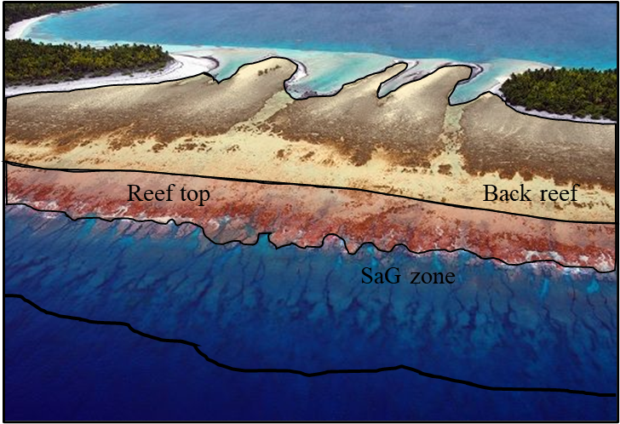
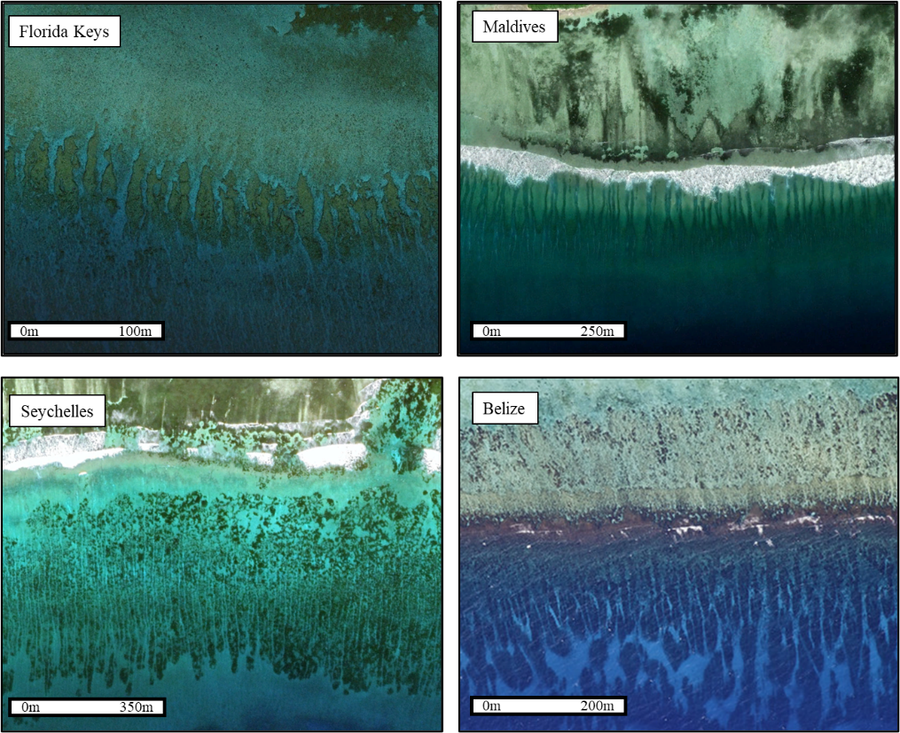
SaG features are geomorphic features that occur on the distil portions of coral reefs around the world (Figure 1). Spurs are the positive bathymetric features growing from the reef body, typically composed of dead loose coral and red coralline algal rubble, living coral, red coralline algae, a variety of attached and cryptic fauna and flora, and submarine cemented reef rock. Grooves are the channel features between spurs that may result from spur deposition (Shinn, 1963), inherited radial island fracture sets (Pigott, unpublished course notes, 2018), lack of biolithified deposition (Pigott and Land, 1986,) and/or significant erosion (Munk and Sargent 1954). SaG features are observable on nearly every reef globally and are often preserved in the rock record of carbonate environments (Wood and Oppenheimer, 2000). SaG features vary in their morphology and have many different physical attributes. For example, the overall length of these features can range from only a few meters to hundreds of meters (as observed in this study). Along with length, width, shape, depth, and composition, these features vary tremendously from site to site and even within one reef system (Figure 2). The overall development and maturity of these features is variable, but it has been shown that windward portions of reefs have a higher likelihood of developing SaG features than leeward zones (Shinn, 1963.) There has been ample research on the formations of these features from both modeling perspectives (Silva et al., 2020) and field observations (Gischler 2010, Mung and Sargent 1954, etc.), however as of now there has not been a standardized, quantitative method to describe the morphology and classify SaG features from site to site. The global approach to quantifying morphology developed here hopes to purpose a standard set of observations that will allow for the classification and description of SaG features in future research.
Figure 1 – Ideal section of platform and SaG zone. This is a photo from the Maldives study area (Credit to: https://www.livingoceansfoundation.org/).
Motu
Motu
Hoa
N
N
N
N
Figure 2 – Satellite imagery of four reef systems showing the variability in morphology that exists globally. Erosive V-shaped grooves of the Maldives, long narrow grooves of the Seychelles, constructive lobe like spurs in Florida and Belize.

While the goal of this research is to quantify the morphological differences of SaG features, it is equally important to understand the practical application of this research. SaG features serve an important role in both modern reef systems and as markers for past environments.
1.1.3 Modern SaG Systems
Spur and groove features provide a critical function in modern reef systems. SaG systems serve as a living wave break, dissipating wave energy onto the main reef (Munk and Sargent, 1954). SaG features also serve as sediment transportation channels, transporting lagoonal muds into deeper water (Hamylton et al., 2016). This function is essential to reef health. Fine sediment that does not get removed from the reef will choak coral and kill productive reef growth. SaG features also allow for water to drain through channels when a high tide is retreating.
1.1.4 Ancient SaG Systems
SaG features have been recognized and studied as far back in the rock record as the Devonian (Wood and Oppenheimer, 2000). One goal of this research is to gain a better understanding of the variability in environmental factors around SaG systems and the associated morphologies. These concepts can also be applied to ancient systems. SaG features indeed play an important role in the interpretation of ancient environments. Modern 3D seismic surveys have the fine resolution to be able to detect these features in the rock record. Caf and Pigott (2021) interpret dolomitized, high permeability streaks within ancient SaG systems in the Permian Basin of West Texas. The importance of these features exists not only as hydrocarbon targets but in combination with interpretations from later in the paper, will allow for a coarse understanding of the paleoenvironment at the time of development. With the rapid development of higher resolution seismic surveys, it is feasible to assume that we will be able to detect well preserved SaG features as increasing resolution in the coming years.
1.2 Problem Definition
In a modern carbonate reef facies tract, whether a barrier or fringing reef, an important series of channels and interchannel positive relief ridges for the water-sediment flux between the back reef lagoon and the deep forereef are grooves separated by spurs. These are vital components of reef systems both geologically as well as biologically. For without them, without a bypass conduit the productive lagoonal sediment mud (Land, 1970) would overrun and drown the reef if it could not bypass the reef. Biologically they allow incoming oceanic waters to not only cool the coral from tropical solar insolation but increase their oxygen content through atmospheric equilibrium through wave action turbulence as well as bringing in increased nutrients for the biota (Rogers et al., 2016; Rogers et al., 2013). But while this important physical link in the reef system is critical to its existence, there are three important questions with respect to spur and grooves which are posed. One, why does its geomorphic shape vary among and within reef systems? Two, what processes (erosive versus depositional) control their evolution? And three, how does one classify physically their variability in a way that allows a statistical comparison so that questions one and two may be addressed? It is this third question which this investigation will focus primarily upon.
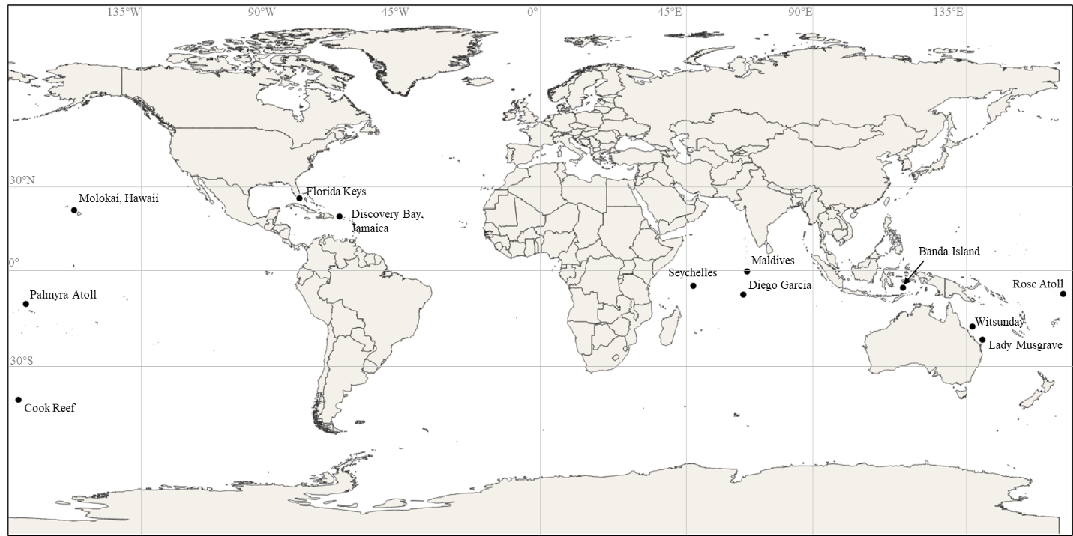
Through the selection and examination of twelve reef sites globally, this study aims to describe aspects of the relationship between a reef’s physical environment and the resulting spur and groove (SaG) morphology (Figure 1). This study also will attempt to interpret how the unique environmental factors at each site may control the resulting morphology created. The results of this study will yield insight on the dominant control of reef SaG morphology and highlight the variability that is present within and among sites. Additionally, this research will add to the knowledge base of SaG descriptive morphology and suggest key interpretations made in this comprehensive globally scaled study.
Figure 3 – Location map of the 12 study sites. Covering the Pacific Ocean, Banda Sea, Coral Sea, Indian Ocean, and the Caribbean. Specific sites include, Banda Islands, Cook Islands, Discovery Bay, Diego Garcia, Hawaii, Lady Musgrave Island, Hawaii, Maldives, Palmyra, Rose Atoll, and the Seychelles.
1.3 Previous Work
Research around SaG systems began in the 1940’s when Mung and Sargent (1948) studied the genesis on Caribbean SaG systems in Jamaica. Shinn (1963) furthered this investigation by describing the SaG systems around the barrier reefs of the Florida Keys. Both Shinn and Mung recognized SaG features as constructive fe3atures of coral that were building vertically. It wasn’t until the 1980’s when Shinn revisited the developed models for SaG formations that an alternative hypothesis was develop. Shinn (1986) examined SaG systems from other reef regional globally and revisited his model of purely constructive systems. Shinn purposed that sites are the Indian ocean exhibited more erosive characteristics and attributed this the to the difference in general reef biology. This hypothesis remained until 2010 when Gischler confirmed the differing morphology. Gischler (2010) suggested the model on U-Shaped SaG in the Caribbean and V-Shaped SaG in the Indo-Pacific regions.
More recently a push to model SaG systems has dominated the field. Using 3D flow models Silva et al., (2019) examined the result of changing wave energy. Similarly, Duce et al. (2020) focused on modeling the effects that undercurrents had on groove development and the balance between erosion and accretion. Duce also proposed in a 2016 publication, the correlation between length and wavelength. He purposed that as length increased, wavelength decrease. Duce also concludes that high wave energy serves to destroy SaG morphology, correlating increasing energy to decreasing length of SaG features.
1.4 SaG Morphology Controls
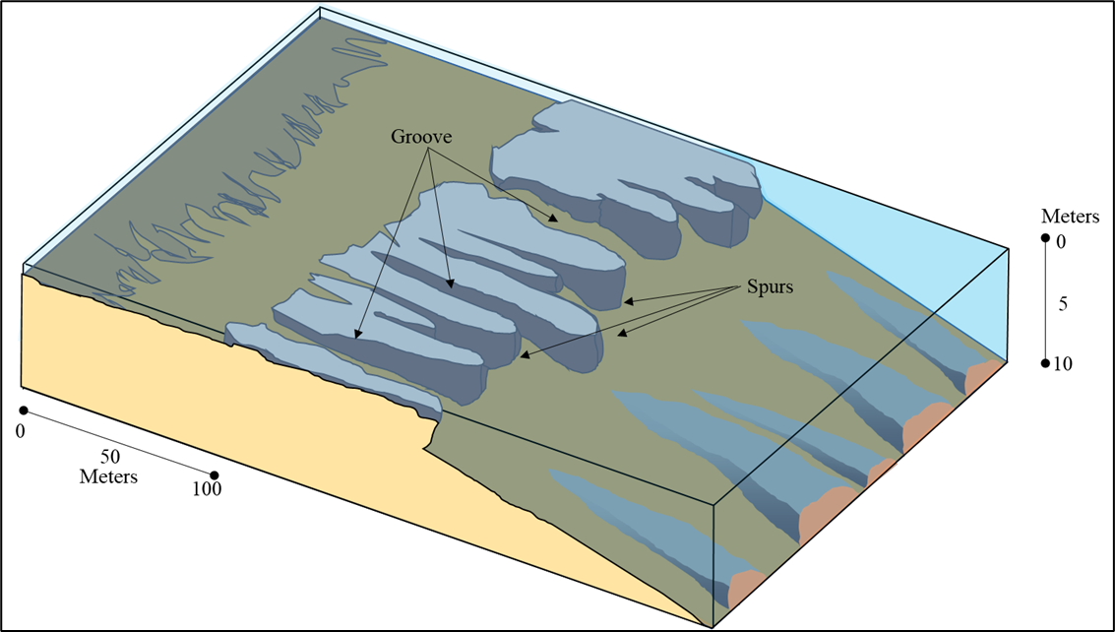
There are a variety of physical processes that influence the development of SaG features (Figure 3 and 4). However, the main physical influence causing the variability of SaG features is still not fully understood. Examples of erosion, coral accretion, and antecedent topography have all been used to explain the feature variability (Duce et al.,2019, Mung and Sargent, 1954, and Shinn 1981.) The following section outlines some of the purposed influences.
Figure 4 – Cartoon of typical SaG features observable in this study. Example here has two-tiered morphology like the Caribbean systems. Note the variability in length as well as continuity into the reef crest.
1.4.1 Wind and Waves
The influence of wind and wave energy is among the most important considerations in the formation of SaG features. Energy that drives fetch wind waves serves to move water and energy through the reef front. This constant energy disturbance results in the formation of grooves through erosion. Direct evidence of an erosion-based theory was proposed by Newell et al. (1951) where grooves were being craved into Pleistocene oolites in the Bahamas. These groove features were interpretated to be created by the water develops a backflow undercurrent when the wave is receding. Silva et al. (2020), used hydrodynamic modeling to describe the water circulation patterns of different SaG and reef configurations. This mechanism of erosion-based SaG formation is postulated to be a strong controlling process in this study.
1.4.2 Biology
Shinn (1963) hypothesized that SaG features in some environments were constructive rather than erosive. Productive coral growth serves to build out of the seabed to create spurs rather than the grooves being eroded into the main reef body (Shinn, 1963). These U-Shaped grooves are purported to be caused by coral growth were observed in the Caribbean and differ from Indo-Pacific V-Shaped grooves thought to be produced by erosion. The dominant “breakwater” coral in the Caribbean since the Plio-Pleistocene is Acropora palmata (McNeill et al. 1954), these corals grow perpendicular the wave motion and eventually coalesce to form spurs (Shinn 1963). These differences in general groove shape, as well as variable reef biology is observed and will be discussed in this paper later.
1.4.3 Sea Level Control and Inherited Topography
While global sea level fluctuation has occurred rapidly since the last ice age, reef accretion and growth rates have for the most part been fast enough to be able to keep pace with changes over the last few thousand years. When sea level rises a spur can aggrade owing to the increased accommodation space (Duce et al.,2019). Conversely, a fall in sea level serves to create a decrease in accommodation and forces a reef to prograde laterally (Gischler 2010). The theory of sea level variations effecting reef morphology has been tested and confirmed by many (Andrefouet et al., 2009; Hongo and Kayanne, 2010; etc.) so it is reasonable to assume the veracity of such mechanisms to the modern SaG formations observed here. Platforms where established reefs grow in shallow water have been abandoned and reinhabited multiple times on the shelves of our continents (Mung and Sargent, 1954). This lasting bathymetric feature allows for reefs and SaG features to reestablish themselves when the conditions become suitable again (i.e., sea level fall). This inherited platform is still visible and SaG features may be set at multiple water depths with large distances between bodies, as will be shown herein when we examine the Florida Keys.
2. Data and Methods
2.1 Data
Data obtained to be used in this study relies solely on remotely sensed Landsat, NAIP, and Google Earth and referenced directly measured and modeled atmospheric and oceanographic data. A combination of physical data and imagery was collected for each site in this study. The quality and quantity of the data was the most important criteria when selecting sites. Figure 5 summarizes the workflow utilized throughout the study.
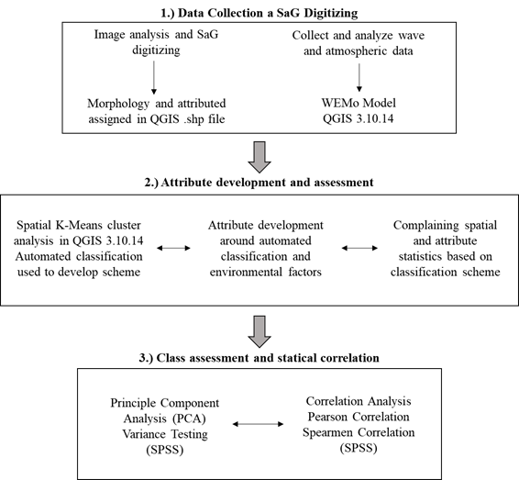
2.1.1 Site Imagery Data
Figure 5 – Generalized workflow for this research. Multiple iterations of Step 1 were performed to finalize the workflow and perform on multiple sites.
High spatial resolution satellite and ariel imagery was the most important data set in this study. Imagery was collected by a variety of platforms. The Landsat program and platforms were the most available imagery data for these sites, but resolution was variable ranging for 30m to 2m. The World View II sensor was utilized where available and provided 2m pixel resolution, multispectral imaging solution the was used in 4 of the 12 sites (Banda, Cook, and both GBR sites). Arial imagery captured by the USGS’s NAIP program provided 1 foot pixel resolution data for the Florida study site. The most convenient imagery source however was Google Earth Engine. Google Earth provide high resolution imagery at each site and was used secondary for locations with alternate imagery but used as the primary data source for 7 of the 12 sites. Using multiple sources of imagery introduces a level of variability in the digitizing process between sites. To mitigate this resolution basis, only true-color imagery was used and only grooves that were visible at the lowest resolution of any site were digitized (5m resolution).
2.1.2 Atmospheric Data
A variety of atmospheric data was applied in this study. An average monthly wind strength and direction was gathered for each site through a variety of platforms. Wavefinder.com was the most utilized resource for historic averages for air temperatures, wave magnitude/direction, and current data. Surface air temperature for each site was collected for each site on a monthly average. Seasonal changes in weather patterns such as monsoons were also studied, and relevant data was gathered.
2.1.3 Oceanographic Data
Oceanographic data was collected for each site in this study. Water current data recording direction and velocity was gathered for each site using the NOAA data portal. Season patterns were also gathered and considered. Tidal data for each site was gathered recording the average magnitude and velocity of tides (cm/s) as well as the nape and spring tide for each site. Wave magnitude/amplitude and direction was collected though wavefinder.com, rose diagrams were plotted using the data. Wave energy has been shown to be an influential factor in the production of SaG systems (Shinn, 1981; Duce et al., 2016). Wave energy is attributed to control both groove definition and feature width (Shinn, 1981).
2.1.4 Biological Data
Each site in this study is in a different environment both physically and biologically. Reef building organisms and their abundance vary between regional ecosystems and even within a single reef. Reef surveys for each site in this study were gathered and distilled. There is no standard format for reef surveys and the level of detail in each survey varies. This required a method to standardize these surveys for each site to provide a reliable platform to compare biology between sites. Each survey recorded the abundance and type of substrate, algae, and hard coral species in some manner in their survey. These three bins were then standardized across each site and proportions adjusted. Gischler (2010) analyzed SaG complexes in the Indo-Pacific and Caribbean to conclude that reef biology was a determining factor in SaG morphology. He observed V-Shaped features in the Indo-Pacific and U-Shaped features around Caribbean sites. The proportions of coralline algae versus branch corals was attributed to be the controlling factor.
2.2 Methods
2.2.1 Categorical Variables
This study deploys with use of categorical variables in its classification scheme. A categorical variable has one of a limited (in this case three) number of possible integer values, where each integer is assigned to a particular nominal category or qualitative property (Yates et al., 2003). A categorical variable can be assigned numeric indices, e.g., 1 through K where K is the number of possible values. An example of the application of a categorical variable would be assigning the feeling of “hot” to 1, “neutral” to 0, and “cold” to -1. In this case K would be equal to 3, that is, 3 possible values: -1,0,1. The statistical operation that can then be applied is termed “effects coding” (Cohen et al. 2003) which allows clustering and regression analysis to be statistically interpreted.
2.3 Mapping SaG Zones
This study required the detailed mapping of SaG features to compile a critical number of cases to be used in the statistical analysis. This digitizing process resulted in over 10,500 unique SaG features across 12 sites. Grooves can be identified in imagery as channelized shadowed features near or on the reef edge. SaG features are easily distinguished from their surroundings on the reef and with high quality imagery, and digitizing is simple. The open-source geographic information system software, QGIS was utilized for image analysis, mapping, and calculations in this study. Imagery was loaded into the software as .tiff and a .shp file was generated to house the line features representing the grooves. Attributes were simultaneously assigned as the digitizing process continued. Length, sinuosity, exposure, and aspect were all calculated in the sites .shp file using .py commands in the QGIS command console. Along with grooves being digitized for each site, several other layers were created to supplement. A layer mapping the reef shelf around each site was generated width and area calculated for use in the correlation process.
2.3.1 Length Considerations
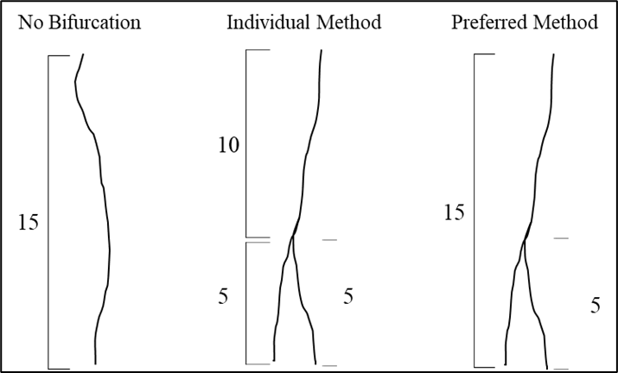
A consideration during the process of mapping and digitizing SaG features arises with bifurcations and their associated lengths, and these will be noncategorical. Bifurcated grooves create two separate features. The method for digitizing either creates one short feature that represents the minor branch and one long feature that represents the main features, or you create three total features, the main trunk and the two limbs of the bifurcation. The former is used in this study, resulting in multipart features that represents on groove. This was done for ease and simplicity in the data (Figure 6). The main limb of a SaG was digitized from start to termination and the minor branch was digitized as a separate feature. Because the minor feature is generally much shorter than any other features in the site, this data can be conditioned during analysis. If the individual method (Figure 6) is the chosen method the resulting data will represent the overall length and density of features to be much shorter and denser than the true nature of the features.
Figure 6 – Illustration of challenges when mapping length of grooves with bifurcations and without bifurcations. For example, the middle figure shows a method that result in two small segments. The method on the right is the method used in this study. This method perseveres the observed length of features. Measured from shoreline (top of figure) to offshore (bottom of figure).
2.3.2 Sinuosity Calculation
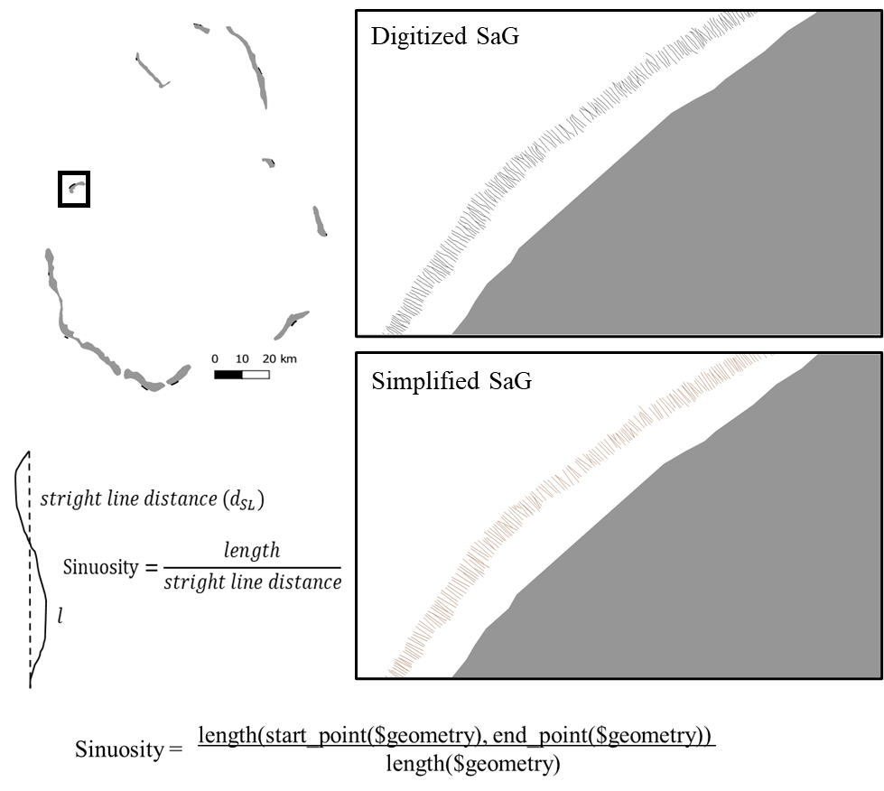
Sinuosity is a noncategorical measure of curve over a specified length. In general, this is calculated by dividing the true measured length by the straight-line length from start point to end point (Figure 7). The observed length of a groove feature was simply divided by the straight-line length of the feature. Sinuosity is mostly applied to river classifications but has been adapted to this study to attempt to understand the characteristics of features from site to site.
Figure 7 – Method used for sinuosity calculation through the python console in QGIS. Grey represents the shoreline. Example is set in the Maldives. Bottom map shows simplified SaG features, top shows the original SaG features.
0m
150m
150m
0m
N
N
2.3.3 Feature Aspect and Angle
The calculation of the heading of a SaG or a feature’s aspect is a measurement used to quantify the direction of its heading and this will be categorical. This is done by calculating a straight line between the start point and end point on a feature and projecting that to a compass bearing. This measurement is plotted against predominant wind and swell direction to observe the number of features exposed to these energy types. Angle is another attribute calculated whole mapping an area. This angle is that of a feature heading and its variation from the shore. Three bins are used for simplification in this study, and to highlight the level of angularity. In general, a feature is expected to be near perpendicular to the shoreline. This study will refer to these as “normal” features and are binned at 90°-61° or [1]. Features that take a moderate angle from shore are categorized as another bin from 60°-31° or [0]. Lastly a bin from 30°-0° or [-1] where features are nearly parallel to the shoreline.
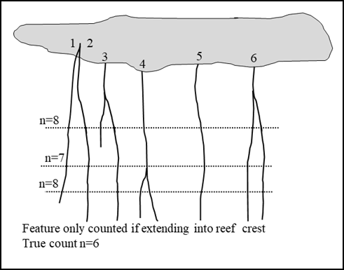
2.3.4 Groove Wavelength
Figure 8 – Applied method used to account for bifurcations in wavelength calculation. Maintains proper representation of density when only considering features extending into reef crest.
Reef Crest
Groove wavelength, also called frequency or regularity, is a noncategorical measure of the spacing between subsequent groove sets. This attribute measures the density of features in an area and is measured from the middle of the two features being observed. Bifurcations create possible issues when calculating wavelength depending on where the split is (Figure 8). If the bifurcation splits above the middle of the feature there is the possibility of a single groove feature being counted twice in the wavelength. This will result in the density being misrepresentative of the true groove density. This study will account for smaller bifurcations by calculating wavelength at the reef crest. This mean only features that extent the full length of the reef slope will be used for the calculation of wavelength.
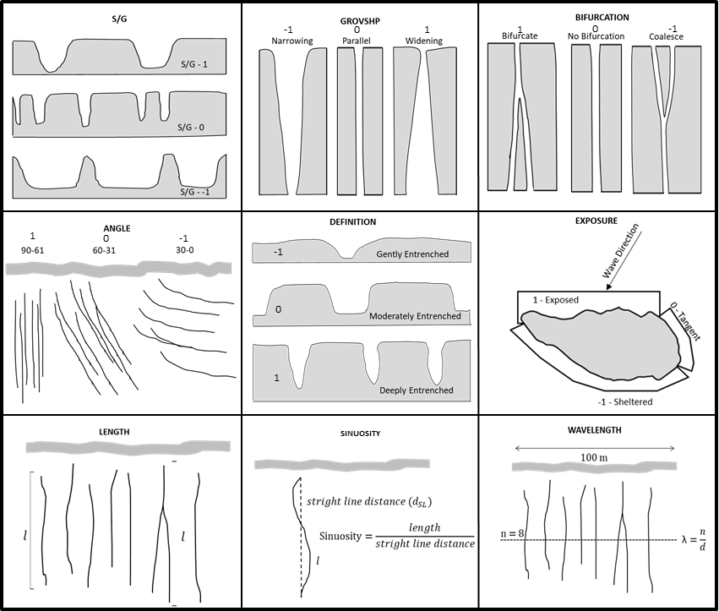
2.4 Physical Morphology
Figure 9A – Classification scheme used in this study as a visual representation. All attribute types are quantitative in nature and applicable to every feature in the study. See text for detailed explanation.
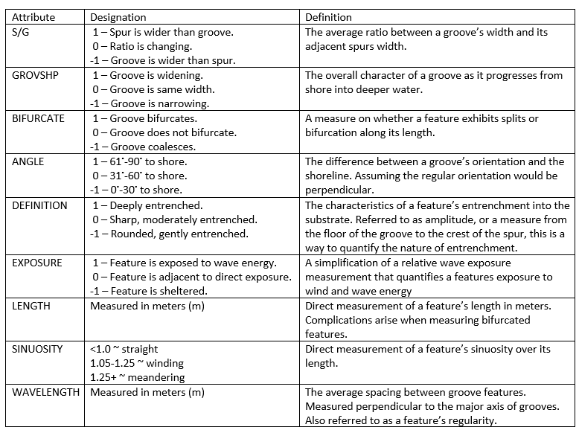
The ability to classify the physical morphology of SaG features is the first step in the process to compare features between sites. This study developed a unique classification scheme to statistically compare the differences in physical morphology of SaG features (Figure 8 and 9). While the variables length and wavelength were directly measurable in meters, the remaining attributes were assigned as categorical variables.
Figure 9B – Table of classification variables used in the study. Assigning larger “bins” and the incorporation of categorical variables for each classification allowed for the simplification of the system to be largely applicable globally.
Three qualitative attributes are used in this classification of morphology, groove shape, spur to groove ratio, and groove definition or entrenchment. Combining the following with the physical directly measurable attributes discussed above, this study has developed a comprehensive classification scheme to use as a comparison and correlation tool.
2.4.1 Groove Shape
Groove shape (GROVSHP) is a categorical measure of a grooves width as it progresses into deeper water. There are three categories utilized in this classification: Narrowing [-1], Parallel [0], and Widening [1] (Figure 8 and 9). Grooves that are narrowing show a groove mouth that is not as wide as the foot or termination of the groove. Narrowing grooves are features that open and get wider as they progress deeper. Parallel grooves are features that remain the same width from the origin to the terminus. Lastly, grooves that are widening are features that open as they progress into deeper water. The most common classification is parallel and widening classes with narrowing being rare. Groove shape has not been an attribute recognized in the literature surround SaG features.
2.4.2 Spur Groove Ratio
The ratio between spur to groove width is another important and easily measurable categorical attribute. By measuring the difference in width of groove and width of spur we can compare density in yet another way besides wavelength. Classifications are broken into three easily observable ratios. Spur is wider than groove [-1], groove width is staying the same [0], and groove is wider than spur [1] as you get deeper (Figure 9A and 9B). An examination of Figure 9 S/G ratio also points out a very important property, which unfortunately is beyond the scope of this thesis. But it has to do with strength. The more solid the reef bulwark, the stronger it is. Yet, as the S/G ratio decreases to -1, observe that the surface area to volume is increasing, but at the same time, the strength of the spur to waves is most likely decreasing. On the other hand, a S/G ratio of 1 indicates the greatest potential strength of the bulwark to waves. Now, morphologies are vitally important to fore reef architecture which must permit backreef sediment to bypass and not kill the fore reef. Thus, the larger the groove or channel, the more efficient the sediment transport is, but again at the expense of the reef bulwark and the strength of the reef bulwark against waves. Moreover, the more negative the S/G ratio, there is much more surface area to volume for reef fauna and flora to current and nutrient exposure. So, the ratio is critical for structural, sedimentologic, and biologic considerations.
2.4.3 Groove Definition/Entrenchment
Groove definition or entrenchment is a categorical classification of the degree that a groove has eroded into the reef or platform substrate. While physical data here were not available to directly measure spur height, or groove depth, utilizing high resolution imagery allows for three broad classes to be identified. The three classification groups are: deeply entrenched [1], moderately entrenched [0], and gently entrenched [-1] (Figure 8 and 9). This degree of entrenchment is also a way to qualify how well established or mature the SaG features are. The entrenchment of features has been studied by many (Duce et al.,2016; Gischler, 2010) as an attribute associated with relative wave energy. Both have purposed that groove entrenchment is a function of increased energy.
2.5 Analysis Methods of SaG Features
2.5.1 Statistical Analysis
After the completion of mapping and compilation of all the data, a QC (quality control) workflow to condition the data occurred. Multipart features (bifurcation example) were removed to maintain density, duplicate digitization’s were account for and extreme outliners owing to errors were removed or rectified. The QC process was not a subjective data conditioning process, but rather a process to exclude errors in digitizing or duplicate digitization’s. The result was a total of 10,712 lines of data were compiled with 10 attributes for each line. This data set permitted robust statistical analysis owing to 107,120 individual pieces of information.
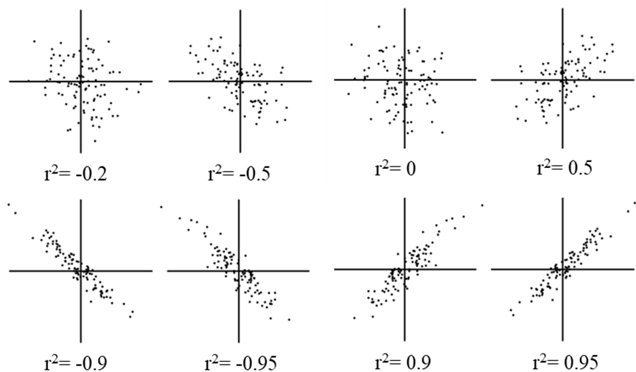
Pearson Correlations were performed on the entire data set along with induvial sites and unique combinations of sites. The Pearson correlation is a bivariate correlation between two variables to measure the variance between. A correlation coefficient is returned as an r² value. This value ranges from -1 to 1. Values between ± 0.50 and ± 1 have a high degree of correlation, values between ± 0.30 and ± 0.49 have a moderate degree of correlation, and values below these values have a poor degree of correlation (Figure 10) (Dr. Ian Price, University of New England Lecture notes, 2006). The output for this method is a correlation matrix displaying correlation values for each combination of attributes. If a correlation was flagged between two groups, more analysis was performed to better understand the significance to the study. Correlation matrices between multiple sites were run if there were similar flagged correlations between each site. Example: If site x, y, and z individually had correlations between length and exposure, then a correlation matrix to be generated between site x, y, and z to determine the strength and identify any other possible correlations between the sites.
Figure 10 – Representation of the trends of correlated data and their associated Pearson Correlation Coefficient. Where 0 is no correlation a 1 is a perfect positive correlation (Pearson, 1985)
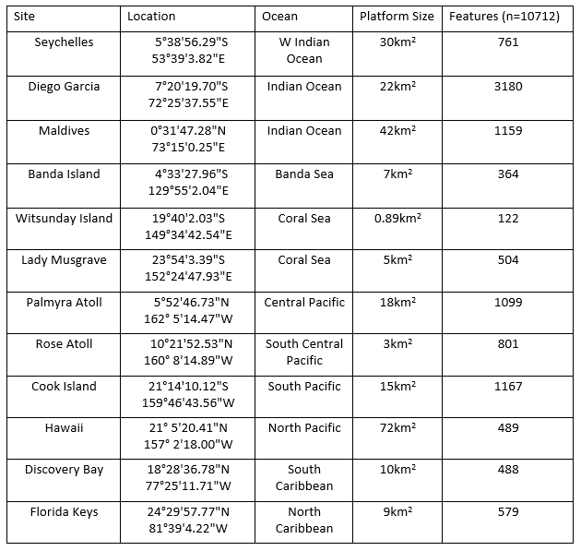
3 Site Locations
Figure 11 – Table of all 12 sites depicting locations (DMS), Ocean basin, platform size, and number of features recognized.
A goal of this study is to understand the differences in SaG morphology globally. Therefore, the selection of sites spanning every major ocean and reef system is essential to gather a robust sample to study. Twelve locations were examined in this study across 10 seas ranging from 25°N to 20°S (Figure 11). Selection of each site was based on a variety of variables, chief among these was the availability of high-quality data. Imagery was the most critical data type used in this study and a site was not viable is the imagery was not conducive to digitizing SaG features.
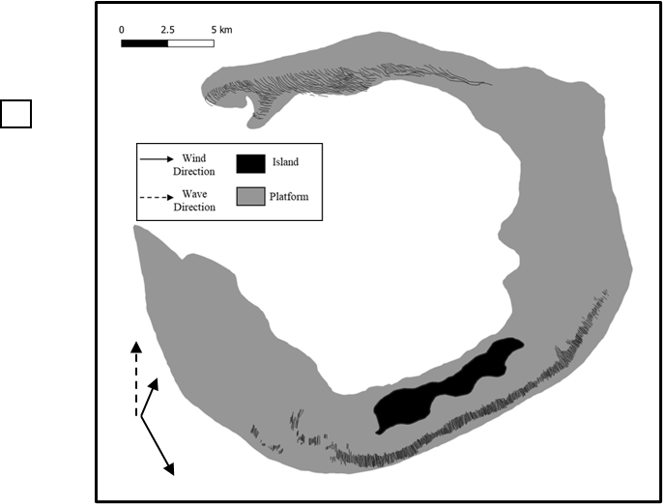
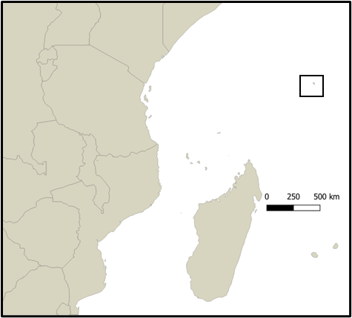
3.1 Seychelles
N

Figure 12 – Seychelles location map. Developed platform in grey, island in black. Predominant swell and wind direction provided in text below.
Desroches Island is a small land area, large platform (30km²) located in the Seychelles Island chain, 1400km east of continental Africa at 5°38'56.29"S53°39'3.82"E in the West Indian Ocean. There are 761 observed SaG features at this site. A large portion of features here are disconnected from the main shelf and have attributes unique to this location. SaG morphology is overall well developed, and some features comprise the longest grooves in this study. Wind at this site has two predominate directions, a weaker NE wind December through April (12km/h), and a stronger SE wind May through November (28km/h). Working swell direction is most commonly from the SE and averages 1.8m annually, but 2.9m during the winter months (May-Nov). The wave break type is reef break at this location.
3.2 Diego Garcia
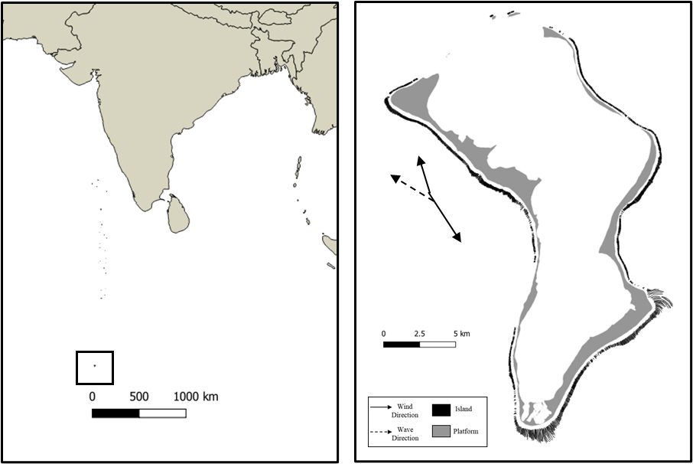
Diego Garcia is in the British Indian Ocean, 650km south of the Maldives at 7°20'19.70"S 72°25'37.55"E (Figure 13). The atoll has a large shallow platform of 22km² and a well-established reef system on all sides. Wind in the summer months (Dec-Mar) blow WNW, while winter winds come from the SE and are generally slightly stronger. Average wind strength is 16km/h in the summer and 21km/h in the winter. Current speeds average 12cm/s and approach from the south into the lagoon. SaG features are variable but generally well established and present on all sides of the island, but longest on the southern protruding platform. There are 3180 features digitized at this site, which is the most of any site in this study. The wave break type is reef break on the SW margins and shore beak on the northern shore at this location.
N

N

Figure 13 – Diego Garcia location map. Developed platform in grey, island in black. Predominant swell and wind direction provided by arrows.

3.3 Maldives
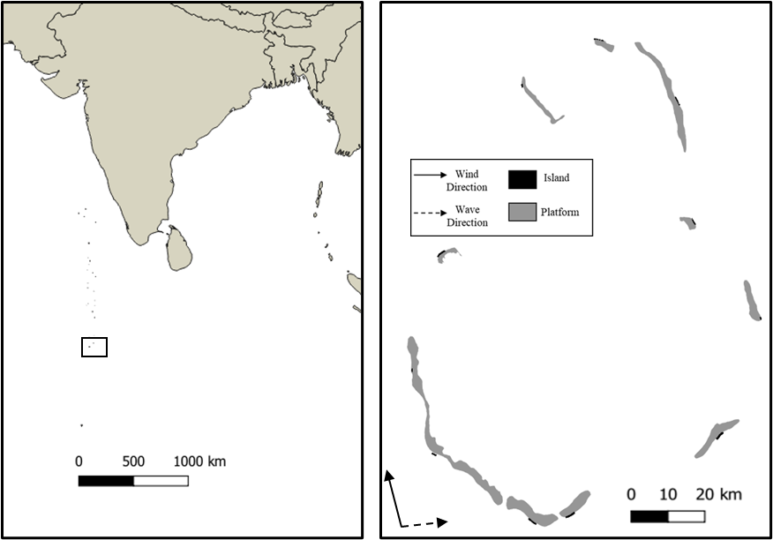
This site is focused on the major atoll of Huvadhoo in Maldives chain of islands in the Indian Ocean at 0°31'47.28"N 73°15'0.25"E. A smaller subset of twelve 1km long precincts were chosen to study owing to the overall size of the atoll and density of SaG features. These precincts represent every major and minor direction to get an equal representation of the quality and distribution of SaG features around is atoll. The total shelf area of the studied sites is 42km² and has a total of 1159 SaG features observed. The predominant wind direction is from the west with an average magnitude of 25km/h with the strongest winds developing from the 8-month westerly monsoon (Apr-Nov). However, a monsoon shift for 4 months (Dec-Mar) brings wind from the NE at a lower magnitude. The bidirectional wind patterns the island bares has resulted in widespread SaG formation around the island, but the more developed features reside on the western portions of the atoll where the higher magnitude winds prevail. The wave break type is reef break at this location.

N
Figure 14 – Maldives location map. Developed platform in grey, island in black. Predominant swell and wind direction provided.
3.4 Banda Island
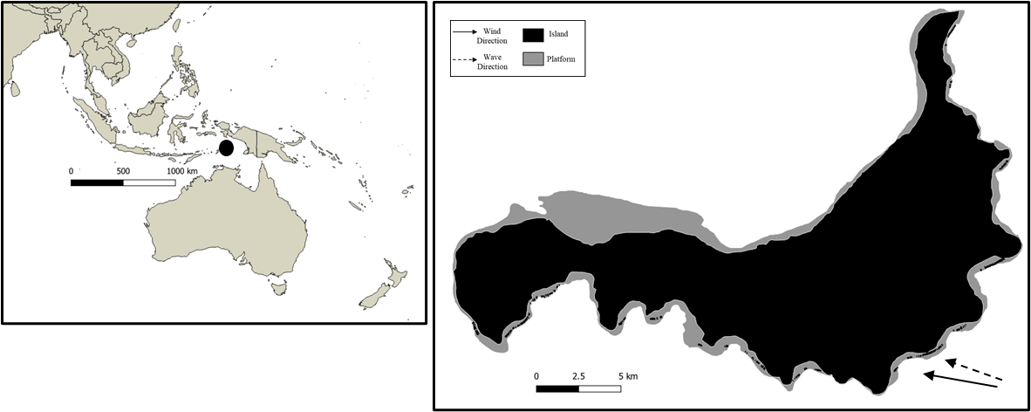
This site is in the central Banda Islands on Palau Banda at 4°33'27.96"S 129°55'2.04"E in the Banda Sea, 650km North of Australia (Figure 15). The island is moderate in size with a 7km² platform. Current averages 8cm/s and approaches from the SE. The dominate wind and wave direction is SSE, leaving the north side of the island sheltered. Average wind speed is low, averaging 13km/h. The development of SaG features is overall poor at this site with a relatively low number of features (n = 364). The working swell direction is SE with refraction reaching some S facing shoreline. The wave break type is a combination of reef and shore break at this location.

N
Figure 15 – Banda Island location map. Developed platform in grey, island in black. Predominant swell and wind direction provided.
3.5 Witsunday Island
This site is the second location in the Great Barrier Reef (GBR) and is located 500km north of Lady Musgrave Island. Witsunday island is the smallest site in this study at only 0.89km² of shelf area and is located at 19°40'2.03"S 149°34'42.54"E in the Coral Sea. There are 122 observed features at this site making it again the smallest study site. SaG characteristics here are poorly developed and short, in fact, even less well established than its southern counterpart. Wind at this site its consistent and generally strong averaging 28km/h from the ESE. Witsunday Island is generally sheltered from wind waves owing to its central location within the GBR where waves average less than 0.5m. Any waves that are generated have short fetch and low.
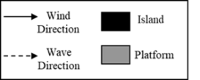
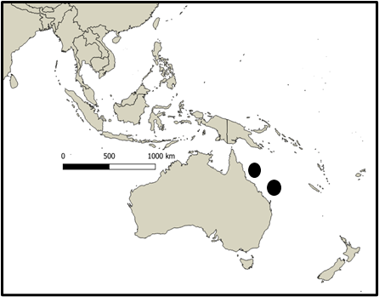
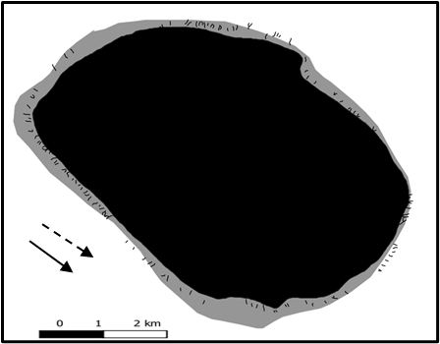
relative wave energy. Significant storms in the area however can create larger waves in the central reef which will be disturbed by the shallow reefs as reef break waves.

N
Figure 16 – Witsunday Island location map. Developed platform in grey, island in black. Predominant swell and wind direction provided.
3.6 Lady Musgrave
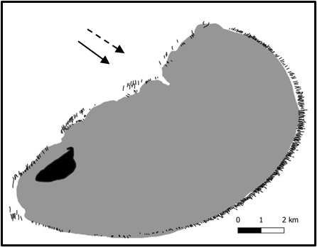
Lady Musgrave Island is one of the two sites in this study on the Great Barrier Reef (GBR) in the Coral Sea north of Australia. This site is located on the southern reaches of the GBR at 23°54'3.39"S 152°24'47.93"E and is a relatively small island with a platform area of 5km². A total of 504 SaG features were digitized. The overall character of these features is poorly developed and short relative to this study, but the better developed site in the GBR. Wind is mainly from the ESE at an average of 28km/h. The wave break type is reef break at this location.
N

Figure 17 – Lady Musgrave location map. Developed platform in grey, island in black. Predominant swell and wind direction provided.
3.7 Palmyra Atoll
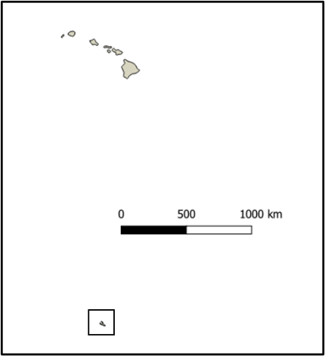
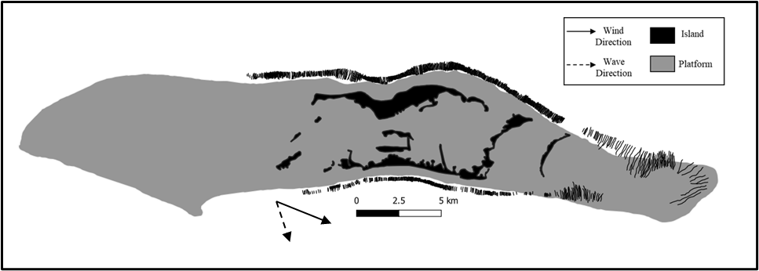
Palmyra Atoll is in the South-Central Pacific Ocean, 1700km south of Hawaii at 5°52'46.73"N 162° 5'14.47"W. This is a small uninhabited island with a large, submerged platform of 18km². Palmyra Atoll is part of the largest marine protected area in the world, the Pacific Remote Islands Marine National Monument. SaG features vary in length, quality, and heading and are present on all side of the platform. A total of 1099 features were observed in two distinct groups, on-shelf, and off-shelf. Wind averages 16km/h from the ESE. There is no monsoonal shift in wind or wave direction. This site experiences one of the highest magnitude average swells of any site in this study with an average height of 1.9m and 10 second period. The wave break type is reef break at this location.

N
Figure 18 – Palmyra location map. Developed platform in grey, island in black. Predominant swell and wind direction provided.
3.8 Rose Atoll
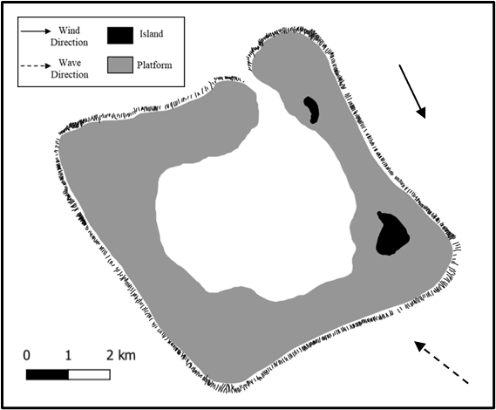
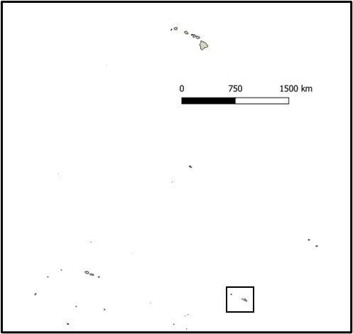
Rose Atoll is in the Central Pacific Ocean, 250km east of the American Samoa Islands at 5°52'46.73"N 162° 5'14.47"W. There is very little land area at this site and the platform is one of the smallest in the study at only 3km². Given the small platform size there is dense population of SaG features observed at just over 800. The overall quality of these features is low (gently entrenched) and relatively short. The established reef on the platform is fringing and narrow, inhibiting the development of mature SaG features. The wind is dominantly NEE, averaging 19km/h. The dominant swell direction however is opposite of the wind direction at WSW. The average wave height is 1.5m. The wave break type is reef break at this location.

N
Figure 19 – Rose Atoll location map. Developed platform in grey, island in black. Predominant swell and wind direction provided.
3.9 Cook Islands
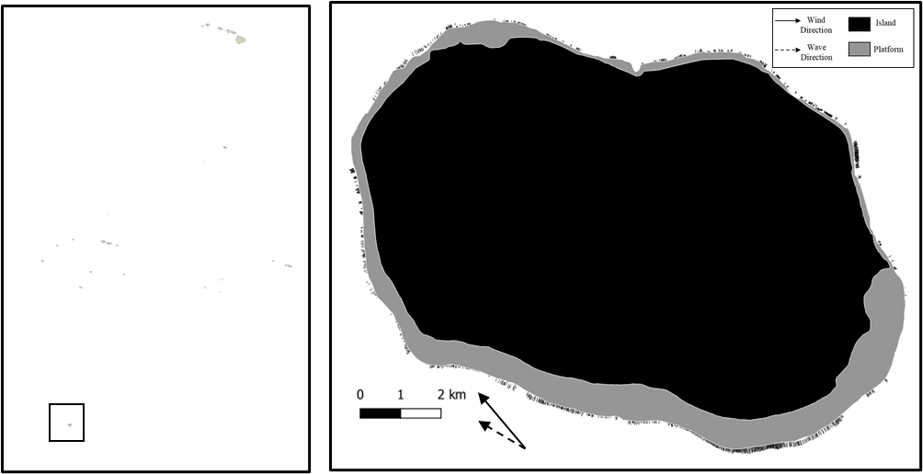
This site is on Rarotonga in the Cook Islands are in the South Pacific 1000km east of French Polynesia at 21°14'10.12"S 159°46'43.56"W (Figure 20). Rarotonga is 65km² with an established platform of 15km². Current speeds average 7 cm/s and approach from the east. The reef is most established on the S-SE side of the island but is present around the whole island. Wind is bidirectional from the E and W and an average wind speed of 16km/h. SaG features are generally poor quality and short, scattered in clusters with variable density. There are 1167 features digitized at this site ranging is quality and attributes. The wave break type is reef break at this location.

N
Figure 20 – Cook Islands location map. Developed platform in grey, island in black. Predominant swell and wind direction provided.
3.10 Hawaii
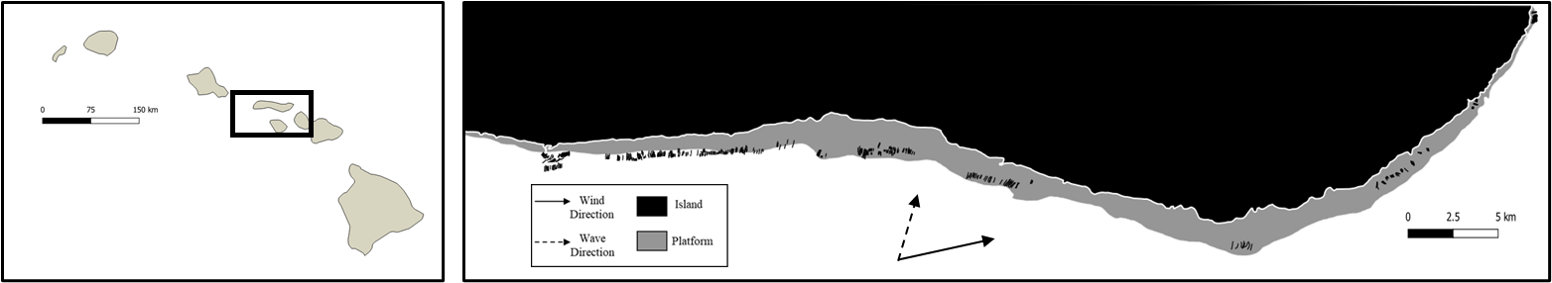
This study site is located on the south side of Molokai island in the North Pacific at 21° 5'20.41"N 157° 2'18.00"W. The shelf studied at this site is 72km² with very low, patchy density of SaG features. Wind is strong form the east at an average of 25km/h. Molokai is a unique island in this study owing to its recent volcanic events. The platform on this island is determined by lava flows rather than erosion and deposition meaning that reefs cannot form anywhere there is favorable conditions but rather where there is suitable platform. There are 498 SaG features digitized in the study site, however depth limited imagery resulted in some deeper grooves to not be digitized owing to the uncertainty. The wave break type is shore break at this location.
N

Figure 21 – Hawaii location map. Developed platform in grey, island in black. Predominant swell and wind direction provided.
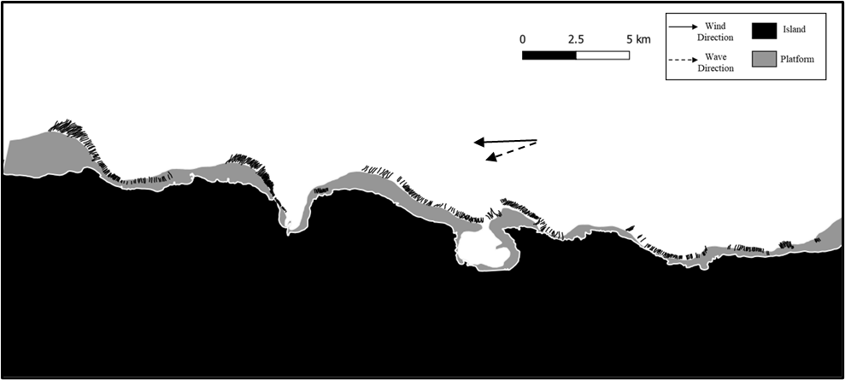
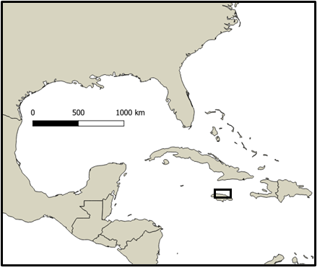
3.11 Discovery Bay

N
Figure 22 – Discovery Bay location map. Developed platform in grey, island in black. Predominant swell and wind direction provided.
Discovery bay is located on the north side of the island of Jamaica in The Caribbean Ocean. The site focused on in this study stretches 4 km on either side of the bay and has a platform size of 10km². The dominant wind and wave direction is ENE and averages 19km/h. Wind direction and strength was little to no variation annually. Swell direction is NEE and is relatively weak. There are 488 SaG features digitized at this site. The water depth is relatively deeper than other sites and the features are generally larger overall. SaG characteristics are mature and well developed. The wave break type is shore break at this location.
3.12 Florida Keys
This particular site named Sombrero Key is in the south Florida Keys 9km off the coast of Marathon Key in the north Caribbean at 24°29'57.77"N 81°39'4.22"W. The site spans a total of 60km along the barrier reef but has patchy platforms where SaG’s can develop (9km²). Winds approach from the ESE in the summer and the ENE in the winter and average 17km/h annually. There are two distinct platform sets in shallow and deep water with a total of 579 features. SaG characteristics are unique to this site and are extremely mature. The wave break type is shore break at this location.

N
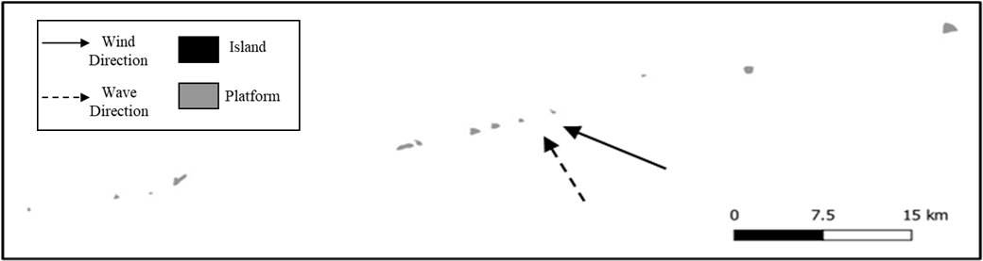
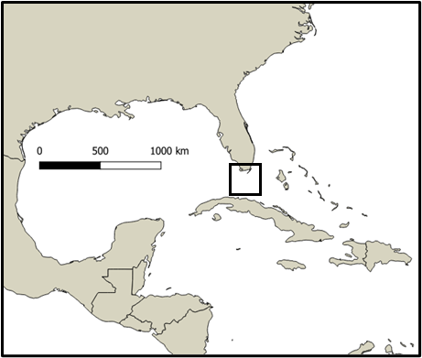
Figure 23 – Florida Keys location map. Developed platform in grey, island in black. Predominant swell and wind direction provided.
4. Results
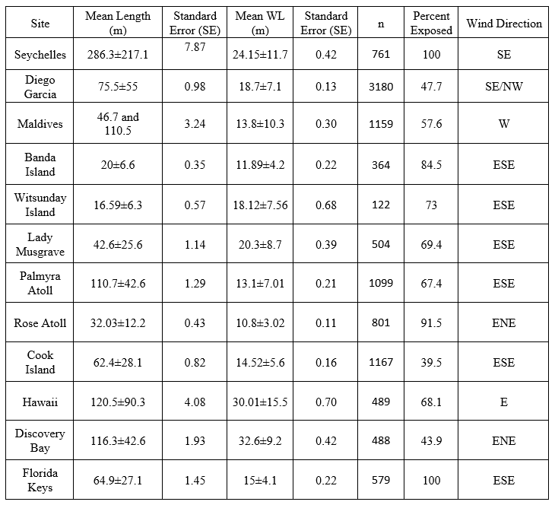
4.1 Study Wide Characteristics
Table 1 – Study wide statistics with standard deviation (SD) and standard error (SE) for length of spur and grooves and wavelength of spur and grooves perpendicular to length for each site. See text for explanation.
Initial analysis was performed to gather an understanding of general characteristics and correlations of SaG features in this study. The physical statistics for the study are outlined below. (1) The mean length of SaG features in this study was 97.6 meters with a very large variance of 108 meters. Site specific length standard deviations (SD) is smaller than overall SD. Discussion of why the variance is so large will be outlined later in this paper. (2) Mean wavelengths for all twelve sites was 17.96 ±9.2 meters. Wavelength has a bimodal distribution with another grouping near 50 meters spacing. (3) Groove heading or azimuth is most heavily distributed to the SE-S from 115°-210°, while there are very few features that have NW aspects. (4) More than 75% of SaG features were directly expose or tangent to exposure with 55.9% exposed, 28.25% tangent, 15.85% sheltered. (5) Bifurcations were present in 60.5% of features, while coalesce features only comprised 1.5% of features and 38% of features exhibited no splits. Parallel grooves make up 67.6% of total features, 28.7% are widening, and 3.6% of grooves narrow. Moderately or deeply entrenched feature dominated the definition attribute, composing 48.9% and 42.9% of all features, respectively. Gently entrenched features only account for 8.2% of the sample. While the comprehensive statistics give a broad view of SaG features, it is equally as important to consider the variance in these statistics and consider what that implies about the differences present between sites. Similarly, examining groups of similar sites and well as opposing sites will reveal useful information that may not be obvious in the site wide statistics.
Standard Error (SE) is a statistical method that calculated the variability of a attribute regardless of the sample size or density. SE is calculated by dividing the SD by the root of the population. Larger SE values represent sites with higher overall variance in an attribute. The SE for length is highest in the Seychelles (7.87) and lowest in the Banda Islands (0.35). Likewise, SE for the wavelength is highest in Hawaii (0.7) and lowest at Rose Atoll (0.11). The implications and interpretation will be discussed below.
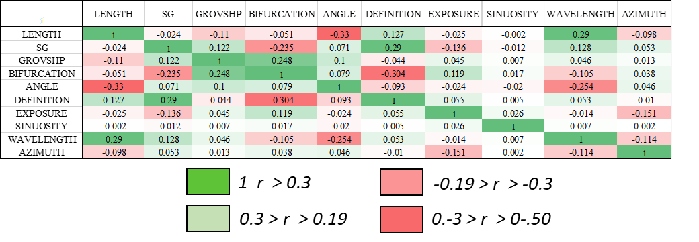
4.1.1 Study Wide Correlation
Table 2 – Study wide correlation matrix. Heat-map to show relative correlation strength. Red is strong negative correlation while green is a strong positive correlation. The strongest correlation existing between all 12 locations is that of Length and Angle and is negative. It is important to consider that many strong correlations may only be present in 3-6 of the sites and will appear to be less significant in this matrix.
Using the statistical program IBM SPSS, the data was used to calculate a Pearson Correlation Coefficients and its associated matrix. This process results in an output with a level of correlation between variables. The matrix output for all 12 sites attempts to pull out correlations observed at every site. In general, there are few strong correlations that are consistent throughout the whole site. The highest degree of correlations is a r²=-0.33 between length and angle. This relationship does not exist in every sight, but only 4 sites where the correlation is so strong that it appears to be present study wide. The remainder of this study will discuss statically strong correlations that exist between three or more sites. It is important to consider that the variability between sites cause the site wide correlations to be relatively weak. The presence of apparent weak correlations is because many significant correlations only exist between a smaller sample of the sites. Examining smaller groups of sites that share characteristics is a more powerful interpretation tool than attempting to use every site in one matrix. Correlation smaller groups of sites allow ensures that finer resolution correlations that may only exist between 2-4 sites do get overlooked.
4.2 Site Specific Correlations
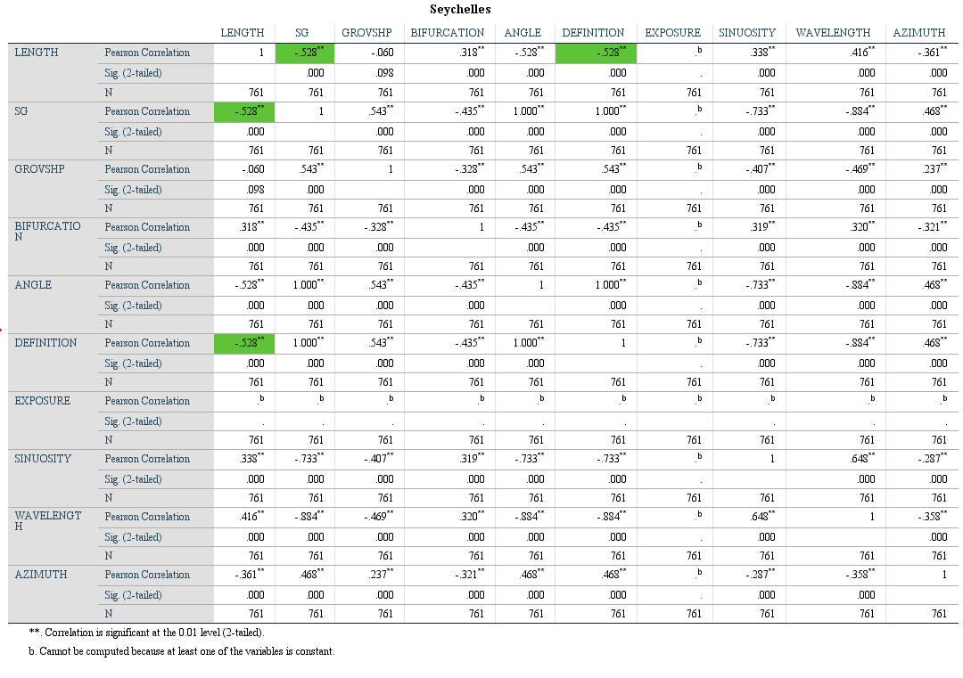
4.2.1 Seychelles Correlation and Interpretations
Table 2: Correlation matrix for the Seychelles
DEFINITION and LENGTH
There is a strong negative correlation (r²=-0.528) between groove length and definition at this site. Grooves that are sharp and moderately entrenched [0] have lengths ranging from 10-500 meters. Grooves that are rounded and gently entrenched are very continuous and are much longer ranging from 50-1500 meters.
Interpretation – There is a significant number of features staged on the shallow platform that run parallel to the long axis of the platform. These features follow the dominant current direction. The energy forming these is more constant and predictable than the harsh wave energy. Also, owing to the flat slope of these areas the features are not deeply entrenched but extremely long and form features that resemble mega-ripples more than SaG’s.
S/G and LENGTH
There is a strong negative correlation (r²=-0.528) between the ratio of spur to groove width (S/G) and groove length. Areas that the spur and wider than the groove [1] have generally shorter while areas that the groove is wider than the spur [-1] lengths are generally longer.
Interpretation – The S/G ratio in this case is getting smaller on longer features, meaning that longer features have wider grooves and more narrow spurs than shorter features. This could be explained by a wider platform and lower slope angle. The wider reef platform allows for the development of longer SaG features. Similarly, a lower angle slope results in the groove widening and becoming dispersed, thus decreasing the S/G ratio.
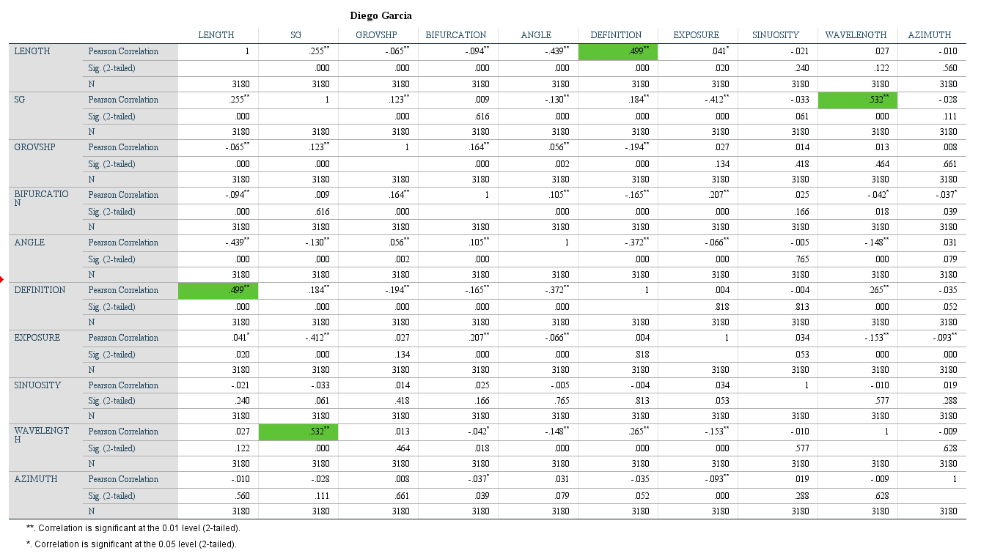
4.2.2 Diego Garcia Correlation and Interpretations
Table 3: Correlation matrix for Diego Garcia
LENGTH and DEFINITION
Diego Garcia has some of the longest examples of SaG features in this study. There is a moderate positive correlation (r²=0.499) between length and definition at this site. Grooves with rounded or gently entrenched features [-1] have lengths that do not exceed 500m. Grooves that are sharp and moderately entrenched [0] are very short not exceeding 50 meters in length. Grooves that are well defined and deeply entrenched [1] are the longest of the group with nothing under 250 meters.
Interpretation – The definition, or entrenchment, of these features is well understood. Roberts (1974) documented the regularity of spur amplitude (definition) can be linked with hydrodynamic regimes, where increased energy results in deeper entrenchment and regularity. This coupled with the idea of length increasing as wave energy increases, we can understand the correlation between definition and length at this site. Both attributes seem to be a function of wave energy.
S/G and WAVELENGTH
The ratio between spur and groove width and wavelength exhibits a strong positive correlation (r²=0.532) significant at this site. Groove features that are wider than spurs [-1] have the shortest wavelengths (more densely packed) and features that have grooves that are much narrower than spurs [1] are the most spaced-out features.
Interpretation – S/G is the ratio between the spur width and the groove width. This relationship is misleading. The S/G ratio is negative not because the grooves are wide, but because of the density of the features. There are so many grooves in some locations that the spurs end up narrower than the grooves. The dense packing of features results in the correlation rather than wide grooves.
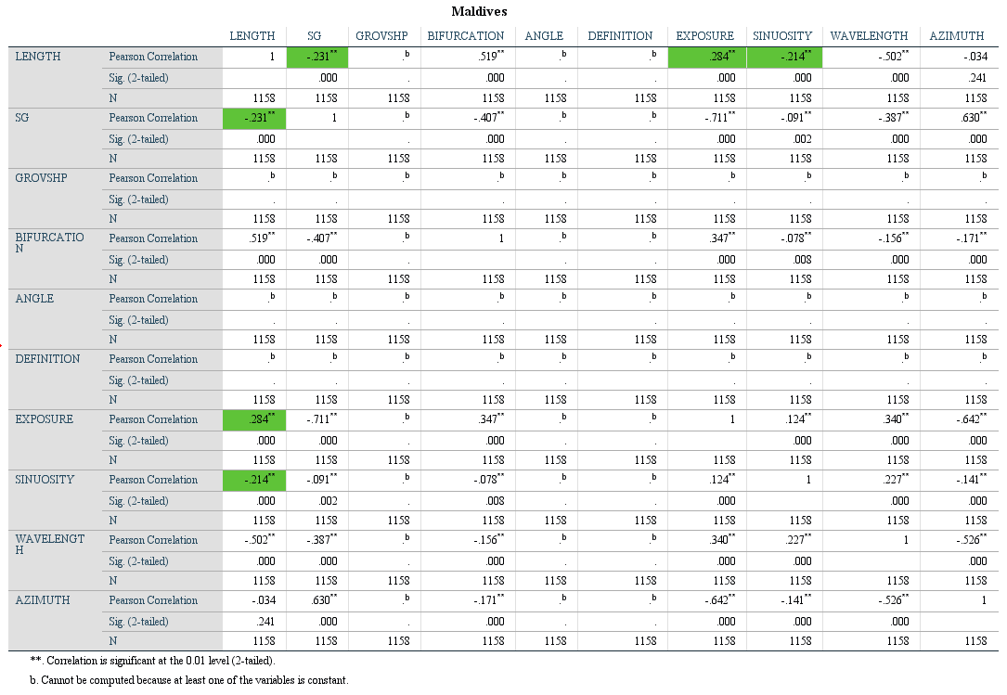
4.2.3 Maldives Correlation and Interpretations
Table 4: Correlation matrix for Maldives
SINUOSITY and LENGTH
There is a statistically significant correlation between groove length and groove sinuosity. Overall, sinuosity decreases as length increases. Meaning that the grooves become less meandering the longer the overall feature is.
Interpretation – Groove length increases as a function of wave energy. It is also known that high sinuosity is a common feature in low energy environments. It is reasonable to assume that longer features are less sinuous because of the relatively higher energy.
LENGTH and EXPOSURE
There is a strong correlation between exposure and length at this site. Features that have the most exposure [1] have the longest overall length while tangent features [0] have the shortest overall length and features that are sheltered from wave energy [-1] are intermediate in length and have a range between the two.
Interpretation - Exposure and length correlation is possibly explained by wave exposure accelerating the formation of spur and groove features. Exposure has been shown to accelerate the formation of SaG features (Kan et al., 1996). Higher wave energy results in a deeper disturbance and deeper wave base, thus increased wave energy grooves can form in deeper water and have an overall longer profile. The correlation between these attributes exists in most of the sites.
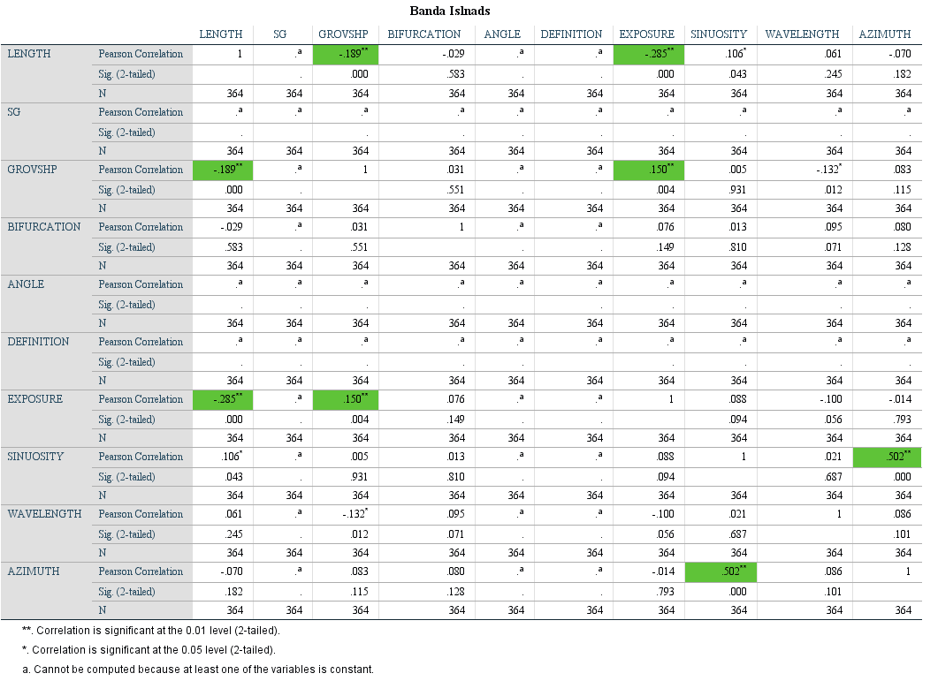
4.2.4 Banda Correlation and Interpretations
Table 5: Correlation matrix for Banda Island
LENGTH and GROVSHP
There is a weak statistical correlation between groove shape (GROVSHP) and length (r²=-0.19). Grooves of the same width [0] correlate to shorter grooves (10-20m). Grooves that are narrowing [-1] have the largest range of lengths and grooves that widen [1] are less than 35m.
Interpretation – Grooves here are not acting as expected. Even in this case we have observed a unique correlation. The general expectation is that grooves of moderate to long lengths will generally belong to grovshp class 0. This is because they are the most stable with constant energy and wave exposure. However, this class [grovshp 0] best aligns with areas tangent to exposure [0]. Narrowing grooves [-1] are longer and are more likely to be directly exposed or sheltered from wave energy. The mechanism behind this requires more devoted research beyond the scope of this project.
LENGTH and EXPOSURE
A weak negative correlation (r²=-0.285) between length and exposure exists at this site. This is the opposite as expected as we observe grooves with no exposure [-1] being generally longer (25-40m) then areas of exposure or adjacent to exposure. However, we would expect to observe the opposite.
Interpretation – This correlation is less significant than expected. There are a small number of SaG features that are sheltered from the waves and they are clustered very tightly. Isolated features as this do not hold much weight in the overall view of these features.
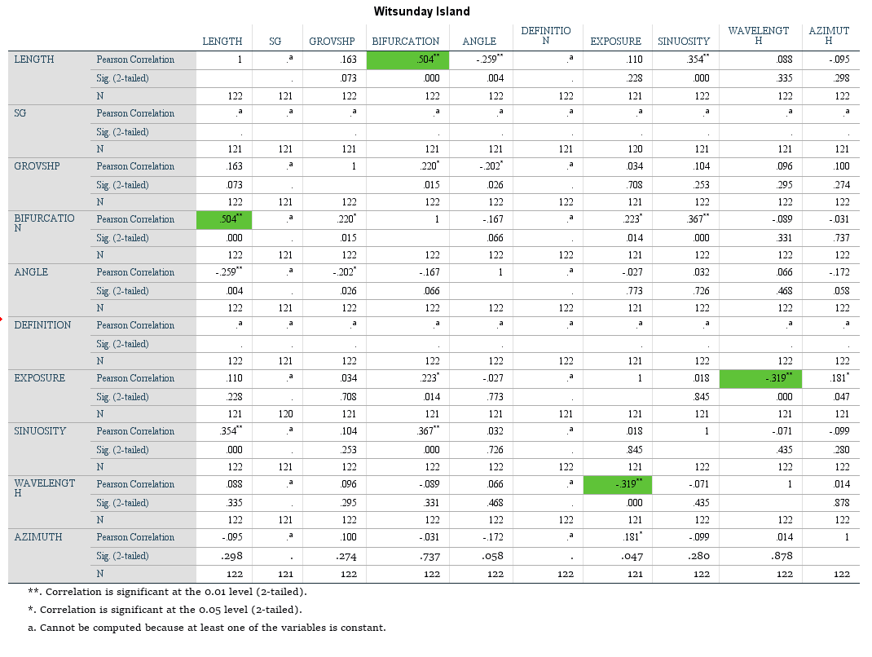
4.2.5 Witsunday Correlation and Interpretations
Table 6: Correlation matrix for Witsunday
BIFURCATION and LENGTH
There is a strong positive correlation(r²=0.504) between length and bifurcation. Features that exhibit bifurcations [1] tend to be longer ranging from 15-40 meters, while features that are not bifurcated [0] or features the coalesce [-1] are shorter, 5-30 and 7-20 meters, respectively.
Interpretation – The relationship between length and energy has been shown in many of the sites reviewed above. There is also believed to be a link between bifurcation and energy in a system (Duce et al., 2020). The relationship can easily be extrapolated to understand the link between length and bifurcation as both variables are somewhat dependent on relatively higher energy systems. As interpreted above, length and energy correlate as a dependent factor.
WAVELENGTH and EXPOSURE
Wavelength and exposure have a moderate negative correlation (r²=-0.319) at this site. Areas that have direct exposure [1] have a larger range of wavelength ranging from 10 to 50 meters. However, features with tangent exposure [0] have shorter wavelengths are more condensed.
Interpretation – Partially explained above, increased energy results in increased spacing (Duce et al.,2020). This study uses exposure as an indirect classification of energy where exposed sites are high energy, tangent sites are moderate energy, and sheltered sites are low energy.
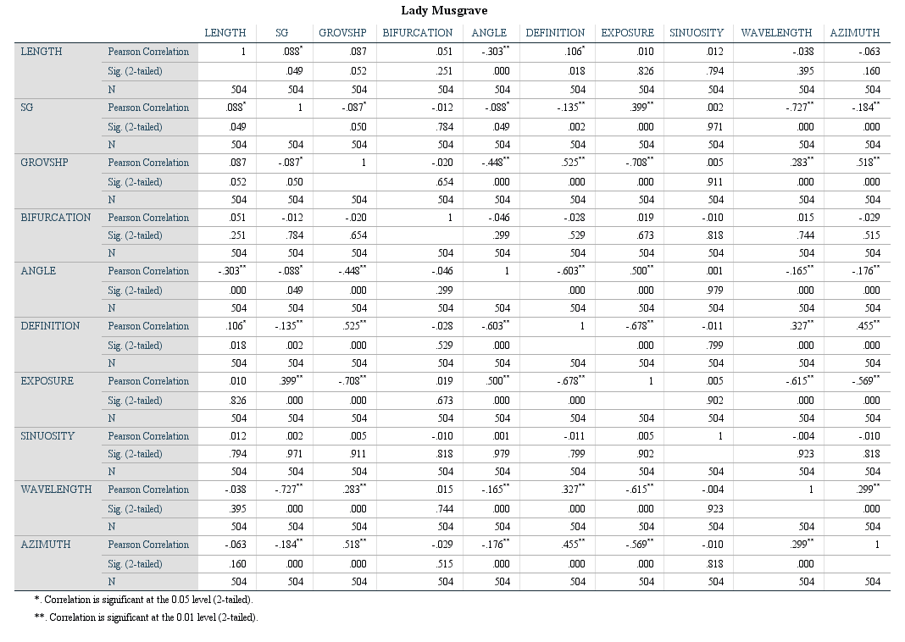
4.2.6 Lady Musgrave Correlation and Interpretations
Table 7: Correlation matrix for Lady Musgrave
There are not enough independent samples at this sight to drawl meaningful statistical analysis. Many attributes at this site are constant. Exposure for example is [1] throughout every feature. S/G ratio is also a constant. Owing to the small size and homogony of the site it would be irresponsible to attempt to make any independent correlation interpretations. Hamylton et al. (2016), discusses the SaG dynamics as it relates to platform sedimentation in the GBR.
4.2.7 Palmyra Correlation and Interpretations
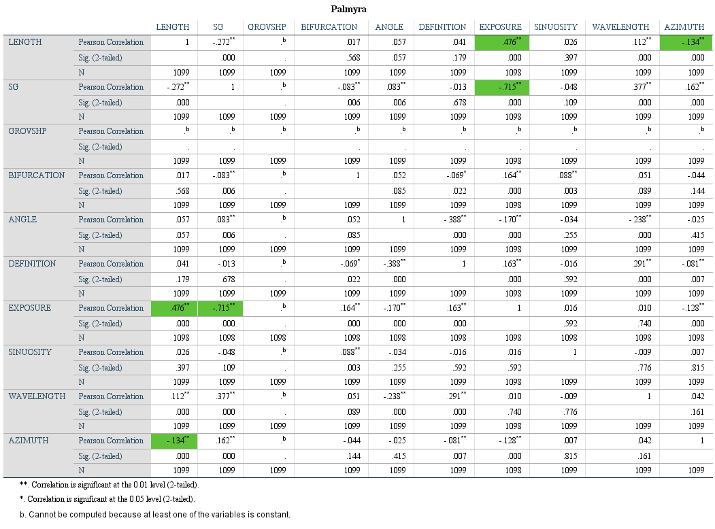
LENGTH and EXPOSURE
Table 8: Correlation matrix for Palmyra
A moderate positive correlation (r²=0.476) between length and exposure exists at this site. Features that are directly exposed [1] have the largest range of lengths from 40-275m, features tangent to wave exposure [0] have an intermediate range of lengths from 25-160m, and features sheltered from the dominant wave direction [-1] have the shorted range of length from 35-150m.
Interpretation – Exposure and length correlation is possibly explained by wave exposure accelerating the formation of spur and groove features. Exposure has been shown to accelerate the formation of SaG features (Kan et al., 1996). Higher wave energy results in a deeper disturbance and deeper wave base, thus increased wave energy grooves can form in deeper water and have an overall longer profile. The correlation between these attributes exists in most of the sites.
EXPOSURE and S/G
A strong negative correlation (r²=-0.715) exists between and areas wave exposure (EXPOSURE) and it spur to groove ratio (S/G). Grooves that are changing width and ratio [0] only exist in areas of adjacent exposure [0], features that the spur is wider than the groove [-1] exist in area of adjacent exposure [0] or direct exposure [1], and features that have a wider groove than spurs [1] exist in all exposure conditions.
Interpretation – This correlation is the ideal relationship expected in energy transitioning environments. Features directly exposed to wave energy should be densely packed on echelon features with 1:1 S/G ratios. Tangent environment would be a mix of high and low energy depending on wave direction at any time. This variability results in S/G ratio changing in these areas. Finally, sheltered environments should have much wider spacing and should not change owing to the steady wave regiment. This correlation is an ideal example of the theoretical relationship these attributes have.
4.2.8 Rose Atoll Correlation and Interpretations
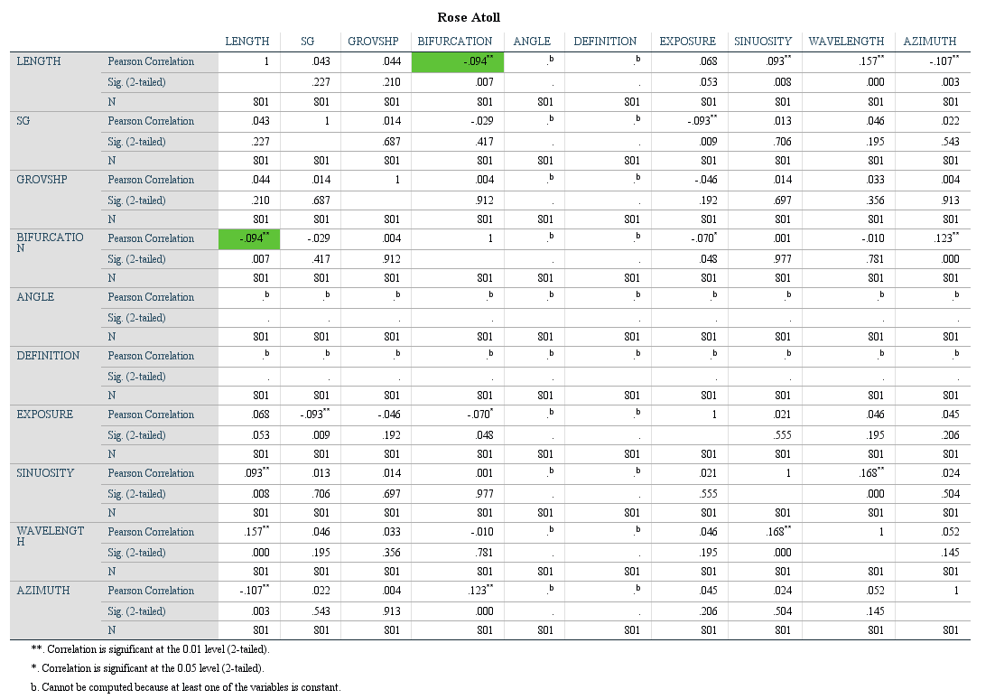
The small sample size yields no moderate or strong statistical correlations at Rose Atoll.
Table 9: Correlation matrix Rose Atoll
Table 9: Correlation matrix Rose Atoll
4.2.9 Cook Islands Correlation and Interpretations
S/G and LENGTH
Spur to Groove ratio and length have a strong negative correlation (r²=-0.547) at this site. Specifically, longer grooves (>50m) have a stronger likelihood to changing in width ratio [0]. While grooves that are shorter (<50m) tend to be more constant with the spur being significantly wider than the groove [1].
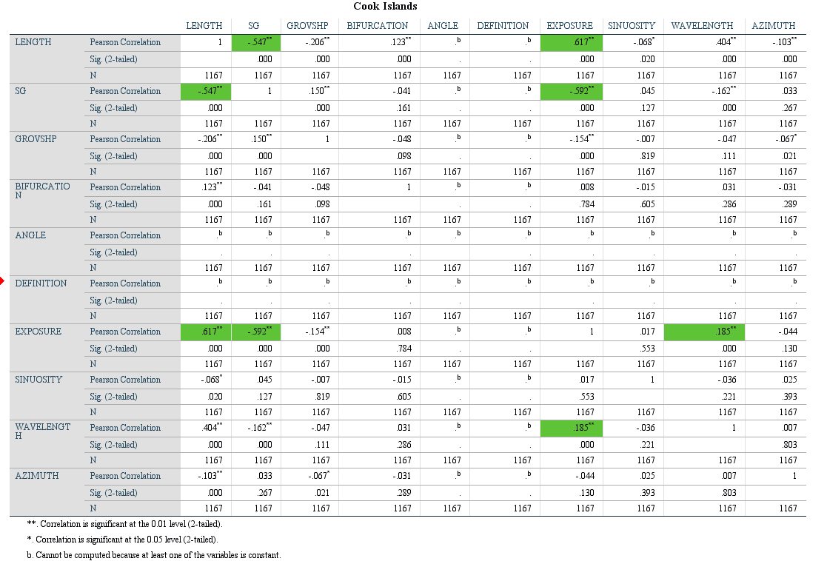
Interpretation – The S/G ratio in this case is getting smaller on longer features, meaning that longer features have wider grooves and more narrow spurs than shorter features. This could be explained by a wider platform and lower slope angle. The wider reef platform allows for the development of longer SaG features. Similarly, a lower angle slope results in the groove widening and becoming dispersed, thus decreasing the S/G ratio.
Table 10: Correlation matrix for Cook Islands
LENGTH and EXPOSURE
There is a strong positive correlation (r²=0.617) between exposure and length at Cook Island. Sheltered areas of this island [-1] contain the shortest grouping of grooves while areas adjacent to exposure [0] have variable lengths and sites of exposure [1] have the longest grooves at the site.
Interpretation – Exposure and length correlation is possibly explained by wave exposure accelerating the formation of spur and groove features. Exposure has been shown to accelerate the formation of SaG features (Kan et al., 1996). Higher wave energy results in a deeper disturbance and deeper wave base, thus increased wave energy grooves can form in deeper water and have an overall longer profile. The correlation between these attributes exists in most of the sites.
S/G and EXPOSURE
There is a strong negative correlation (r²=-0.592) between S/G ratio and exposure at this site. Sites that have changing ratios of spur to groove widths [0] only exist in areas of direct wave exposure [1]. Examples where spur is significantly wider than groove [1] exist is sheltered, adjacent, and exposed locations.
Interpretation – Sites where there is low or no wave exposure have low hydrodynamic energy and are unable to form SaG features, therefore the SaG density in these zones is low and spacing is variable (Silva et al., 2020). Conversely, in zones exposure to wave energy SaG formation is favorable and other variables control the morphology of the resulting features. This can result in variable widths, spacing, and density of SaG’s.
LENGTH and WAVELENGTH
There is a moderate positive correlation (r²=0.404) between wavelength and length at this site. As the overall length of the SaG features increase the wavelength also increase. Meaning longer features are more spaced further apart.
Interpretation – High rates of sediment flux through SaG features serves to inhibit the lateral aggregation of these features and thus increasing wavelength or mean spacing (Kan et al., 1996). Increases in sediment flux are caused in part by higher energy and wave exposure. These high energy, high sediment flux features can prograde out into deeper water. The wave base reaches deeper as the energy is increased, allowing for this SaG morphology to continue deeper. Length and wavelength correlation is observable at many sites; however, the opposite also exists in some areas and require more investigation.
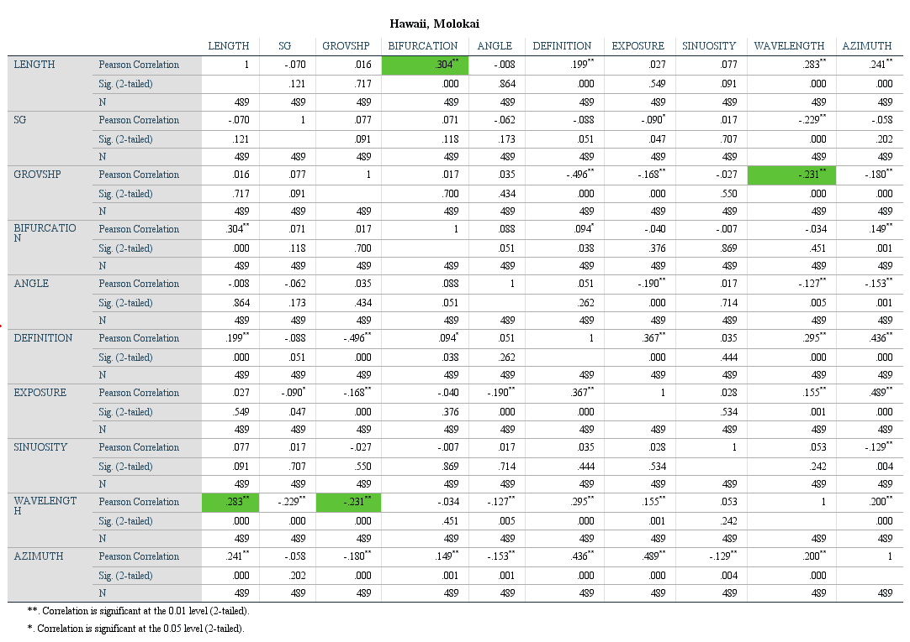
4.2.10 Hawaii Correlation and Interpretations
Table 11: Correlation matrix for Hawaii
LENGTH and BIFURCATION
There is a moderate positive correlation (r²=0.304) between bifurcation and length. Features that do not exhibit bifurcation [0] are more typically shorter. While bifurcated grooves are generally longer but less tightly grouped. The wavelength of bifurcated features is 25% more than that of groups of non-bifurcated features.
Interpretation – The relationship between length and energy has been shown in many of the sites reviewed above. There is also believed to be a link between bifurcation and energy in a system (Duce et al., 2020). The relationship can easily be extrapolated to understand the link between length and bifurcation as both variables are somewhat dependent on relatively higher energy systems. As interpreted above, length and energy correlate as a dependent factor.
GROVSHP and WAVELENGTH
Groove shape (GROVSHP) and wavelength have a weak negative correlation (r²=-0.231) at this site. Features that have shorter wavelengths (more densely spaced) tend to have a groove shape that is widening at it stretches deeper. However, grooves in higher wavelength zones tend to be more consistent and stay the same width.
Interpretation – This correlation may be linked to the slope of the platform where the SaG is set. This site is unique as it is not a typical carbonate platform. It was a thin carbonate foundation the is built upon recent basalt deposits. The resulting platform is variable with greatly ranging width and slope. The density of features is mostly based on the presence and width of a platform, and secondary to wave energy.
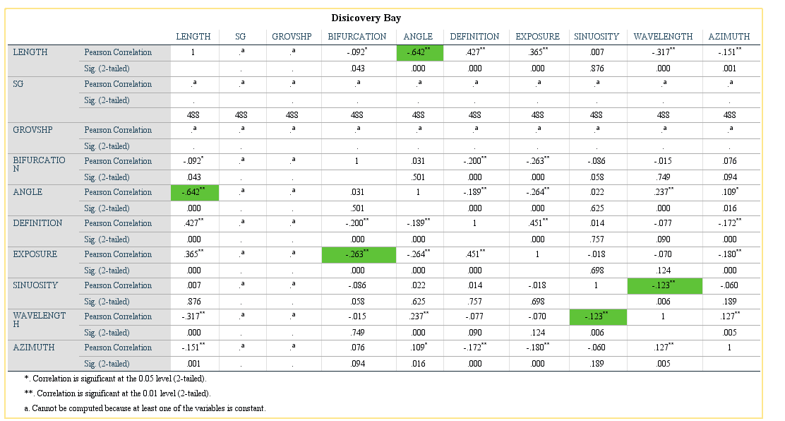
4.2.11 Discovery Bay Correlation and Interpretations
Table 12: Correlation matrix for Discovery Bay
LENGTH and ANGLE
There is a positive correlation (r²=0.642) between the overall length of a feature and its angle to shore. The longest features at this site are 300-500 meters long and subparallel to the shore at an angle between 31-60 degrees from the shore [0]. Most features are perpendicular to shore [1] and less than 300 meters long.
Interpretation – Some areas surrounding Discovery Bay have shallow reef platforms that extend off-shore up to 1km. All of these extend shallow platforms have SaG features that exist at the edge of the shelf. There is a dominate wind and wave directing that is at a 45◦ angle to the coastline. The correlation exists between these two attributes because the wave energy can develop long SaG features on the shallow extended platforms that are present in some sites. These features establish themselves with the wave direction which is sub-parallel to shore, thus creating the correlation between length and angle. Shorter SaG features are traditionally perpendicular with shore and established on more narrow sections of the reef platform.
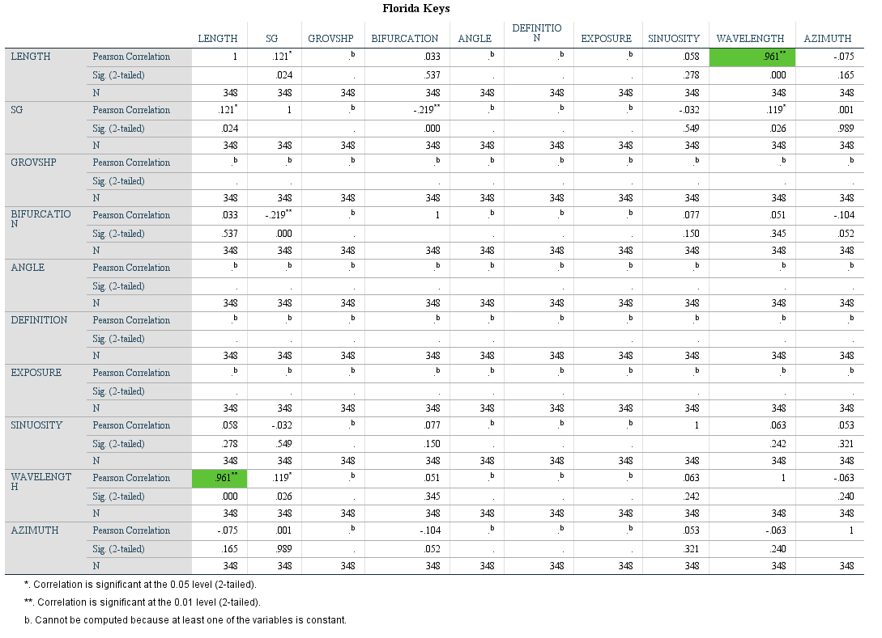
4.2.12 Florida Keys Correlation and Interpretations
Table 13: Correlation matrix for Florida Keys
Two well defined and separated sets of SaG features are present at this site. This is a shallow zone (3-15m) and a deeper zone (10-30m). The reefs composing the shallow sites are patchy and discontinuous where deep SaG’s are set in continuous reefs the stretch the width of the study area. Shallow SaG sites are narrow ranging between 100 meters to 1km. Examining Holocene sea level changes helps understand the modern setting of SaG features.
SHALLOW WATER
WAVELENGTH and LENGTH
There is a strong correlation (r²= 0.961) between length and wavelength in the shallow set of SaG features in Florida. As length increases there is also a measurable and constant increase in wavelength. Short grooves are densely packed, while the longer grooves are more spread out and have longer wavelengths.
Interpretation – High rates of sediment flux through SaG features serves to inhibit the lateral aggregation of these features and thus increasing wavelength or mean spacing (Kan et al., 1996). Increases in sediment flux are caused in part by higher energy and wave exposure. These high energy, high sediment flux features can prograde out into deeper water. The wave base reaches deeper as the energy is increased, allowing for this SaG morphology to continue deeper. Length and wavelength correlation is observable at many sites; however, the opposite also exists in some areas and require more investigation.
DEEP WATER
SINUOSITY and WAVELENGTH
There is a weak correlation between wavelength (r²=-0.199)
and sinuosity at this site in the deep water. This means that as wavelength increase (grooves are further apart) that sinuosity also increases. However, the increase in sinuosity is minimal.
Interpretation – The possible explanation for this is that as energy increased so does wavelength. An increase in energy results in longer and deeper features. The energy dissipates toward the deepest reach of the feature, and where that energy reaches low enough levels, the sinuosity increases. Alternatively, these meanders or increased in sinuosity could be inherited from lower Holocene sea levels and the morphology has not been reworked with the increase in SL because the energy is progressively decreasing in deeper waters. More detailed research may need to be conducted to fully understand the variation in sinuosity at many of the study sites.

4.3 Site Groups Correlations
The following section will discuss the results produced by correlating smaller groups of sites. Each correlation below is present in at least 3 individual sites and has a strong statistical significance -0.3 >r² >0.3.
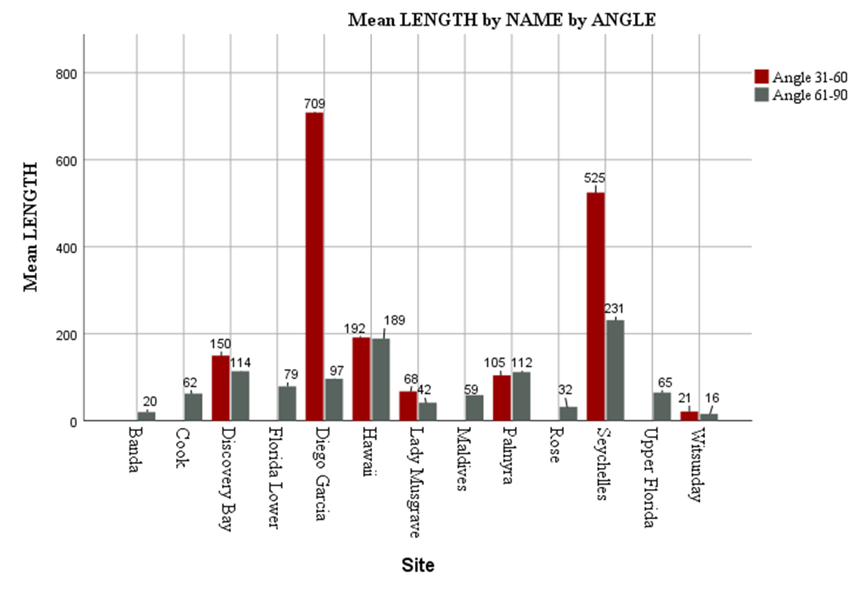
4.3.1 Length and Angle Correlation
Figure 24 – SPSS generated chart of mean length as a function of angle for each of the sites. Notice the variability in lengths between the red bars (31°-60°) and grey bars (61°-90°)
A strong negative correlation exists between groove length and the grooves angle to the shore. The attribute ANGLE is a measure of a features heading parallel to shore and is broken into three categories, [-1] 0°-30° to shore, [0] 31°-60° to shore, [1] 61°-90° to shore, with class 1 being the regular expected orientation. This correlation means that grooves set >60° to shore, it will likely be longer than grooves set normal to the shore. The correlation between length and angle is present in six sites, but strongest at Discovery Bay (r²= -0.64), Seychelles (r²= -0.53), and Diego Garcia (r²= -0.45). Mean length of features of angle class [0] are 225m, which is 130m longer than the study average of 97m. In Discovery Bay the grooves that are set at an angle are on a deeper platform whereas angled grooves at Diego Garcia and Seychelles are at the edge of the platform. There is an observable difference in SaG morphology between these sites and the interpretation of the mechanism causing this correlation will be discussed in a later section.
4.3.2 Length and Exposure Correlation
There is a significant correlation between feature length exposure at multiple study sites. This correlation is best observed in the Cook Islands (r²=0.62) and Palmyra (r²=0.48). The correlation between length and exposure means that length is generally shorter for tangent or sheltered features, and length is longer in zones of exposure (Figure 25). In the Cook Islands mean length of exposed features is 86m, and sheltered or tangent features have a mean length of 43m. At Palmyra, the mean length for exposed features in 127m, and sheltered or tangent features have a mean length of 77m.
4.3.3 S/G Ratio and Exposure Correlation
A strong correlation exists between S/G ratio and Exposure at several sites in this study. Most strongly observed at Diego Garcia (-0.42), Palmyra (-0.72), and the Maldives (-0.71). This correlation exists where S/G ratios of 1 (spur is wider than groove) are only on sheltered portions of the island and S/G ratios of -1 (groove wider than spur) are only present on exposed portions of the site. In the Maldives S/G ratios of 1 are exclusively around tangent and sheltered areas. Half (n=634) of S/G ratios of -1 exist on the wind exposed side of the Maldives. On the sheltered side of Palmyra only S/G class 1 exist. Class 0, and -1 are the only present classes at tangent and exposed areas around Palmyra.
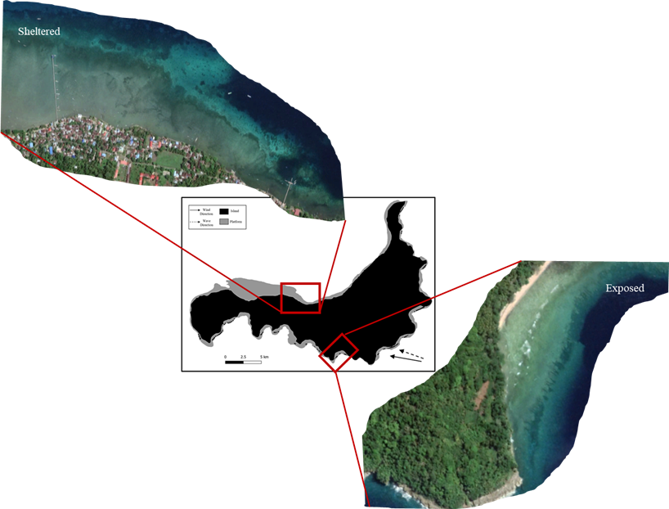
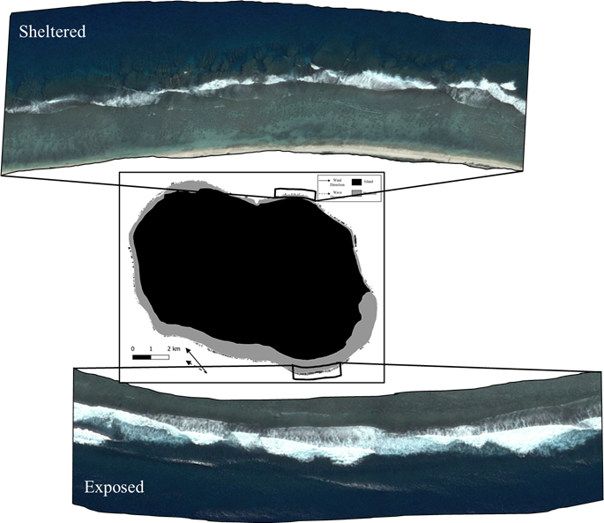
4.4 Morphology Controls Site Wide
0km
1km
100m
0km
100m
0km

N

N
Figure 25 – Banda Island (right) showing developed platform that is sheltered with no SaG, Cook Islands (left) showing difference in groove morphology and its relation to prevailing wave direction.
There are a variety of other environmental factors that were observed statistically and visually to have a demanding control over the morphology of SaG features in this study. Many of these attributes were difficult to quantify into a classification scheme owing to their complexity. To better understand the control these factors have the following will outline each process and describe how it is affecting some of the attributes used in this classification method.
4.4.1 Sea Level Variations
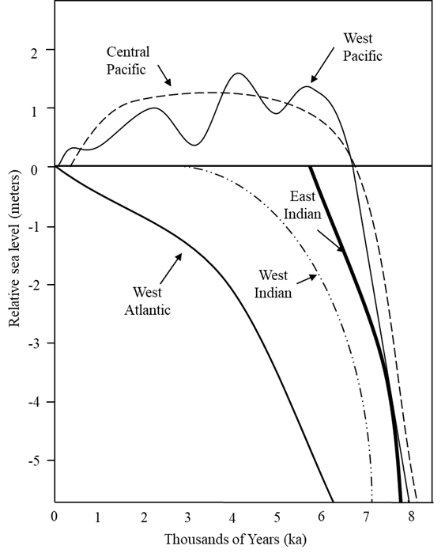
During the Holocene sea level has greatly varied globally, alongside there is constant variation in relative sea level (RSL) between basins (Engelhart and Horton, 2011). Sea level rise has not been a steady tick upward everywhere around the globe, however. Montaggioni and Braithwaite (2009), compiled Holocene sea level curves for the major reef bearing seas globally. The rates and variations in sea level rise compiled for each site were used in the interpretation of SaG morphology. One important relationship to recognize in the SL graph (Figure 26) is the relatively constant SL in the Indian Ocean for the least 7 ka, and the changing nature of the West Pacific and slow rise of the West Atlantic. The variable rate of SL change in different ocean basins will be interpreted as an important factor later.
Figure 26 – Sea level curves for each of the major ocean basins in this study for the past eight thousand years. Variable rates and levels of RSL throughout the Holocene (Modified from Montaggioni and Braithwaite, 2009)
4.4.2 Dependence on Tide
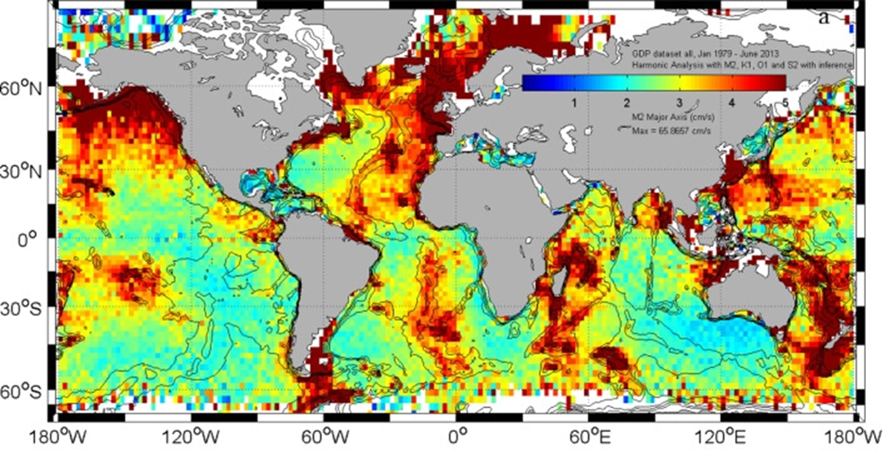
Like the variations observed in SL, tidal factors may greatly impact SaG configurations and morphology. Tidal magnitudes vary from a few centimeters to multiple meters between the study sites (fig 27). The Gulf of Mexico and West Atlantic experience low magnitude tides often referred to as “microtides” while the Indian Ocean experiences large magnitude tides on the order of meters. The difference in tidal magnitudes has a great effect on the morphology of SaG’s and reef crests in general. These observations are shown in the data and seen in correlations but will be discussed in a later section.
Figure 27 – Modified from Poulain and Centurioni (2015), global mean tidal range in meters.
4.4.3 Reef Biology
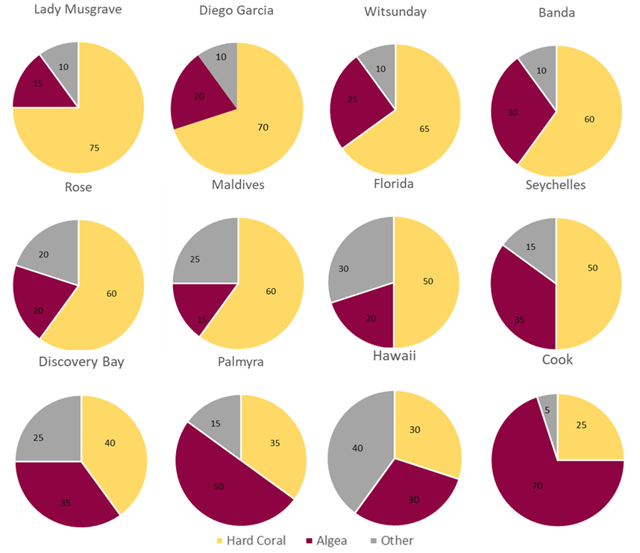
A significant correlation exists between reef biology and SaG morphology. The biodiversity and main reef building organisms of a reef are variable globally with latitude and many other factors. Many reefs are dominated by hard or stony corals while others are dominated by coralline algae (Figure 28). The data from this study show a relatively strong correlations between the abundance of hard corals (Acropora var.) and groove density and development. Data shows that reef systems that have higher abundances of hard coral correlated to sites with higher SaG density. The correlation between hard coral abundance and SaG density is a positive correlation observed throughout the study and has also been observed in research from Gischler, (2010). The understanding and interpretation of these correlations will be discussed in the following section.
Figure 28 – Compiled and simplification of reef biology into three major groups, coralline algae (red/purple), hard corals (yellow), and other like rubble and sand (grey).
5. Interpretation and Discussion
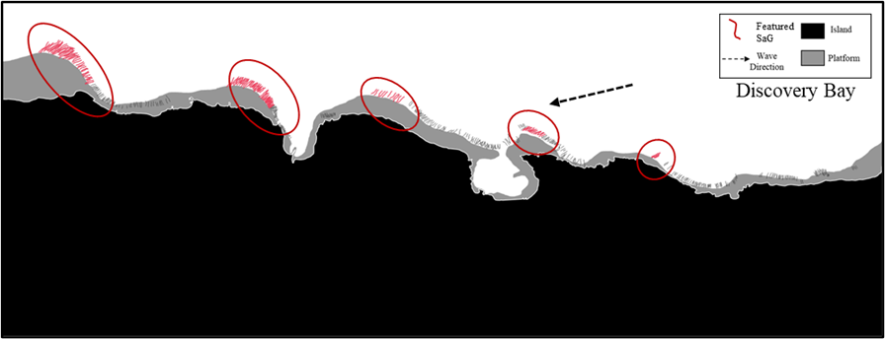
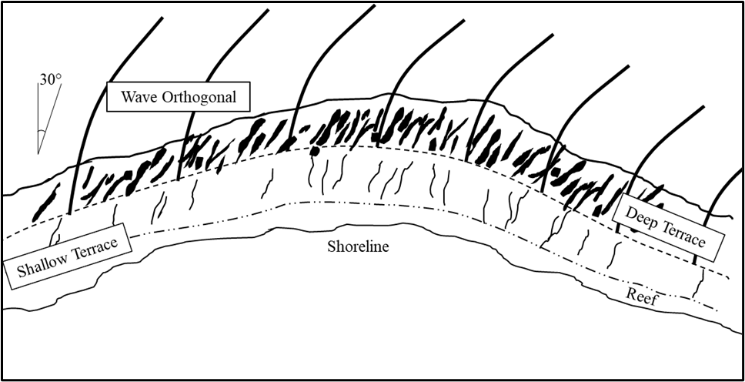
5.1 Site Wide Correlation Interpretation
100m
0km
Representation of Wave Orthogonal
0km
1km

N

N
Figure 29a – Diagram of orthogonally angles SaG features in Discovery Bay. Thick black bent lines represented the angle and deflection of incoming waves. Notice the changing angle of features depending on the angle the wave is intercepting the platform.
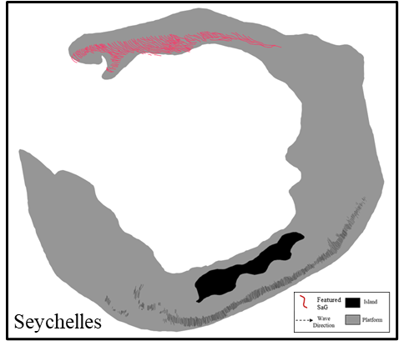
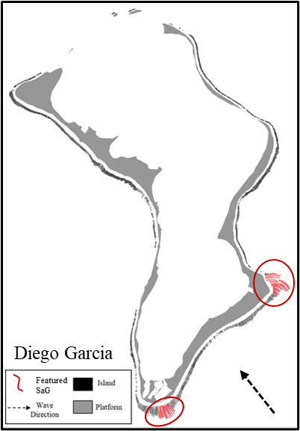
This following section will discuss some of the possible mechanisms behind the correlations observed throughout the study as outlined above. The total interpretation of some correlations is based on observations while others are based on knowledge produced from other researchers. Many of these correlations are significant enough to deserve more detailed specific work to describe the mechanism.
5km
0km
5km
0km

N

N
Figure 29b – Diego Garcia (left) shows example of SaG features at an angle owing to waves wrapping around the edge of the island on a shallow platform. Seychelles (right) show a submerged atoll with long orthogonal features.

5.1.1 Length and Angle Correlation Interpretation
The correlation between length and angle outlined above exists in multiple sites and is understood well. Kan et al. (1996), noted that waves that approach orthogonally to shore produce SaG features that are not regular to shore. Kan observed this relationship in Jamaica and other Caribbean sites. However, there was an essential idea that Kan’s research bypassed and that is the angles relationship to length. In all sites we observed this relationship the working wave direction was subparallel to the shore, as the wave approached shore it is deflected and bent (Figure 29). The mechanisms behind the relationship to length becomes obvious when examining the increased platform area that the waves cross before encountering the shore. The increased area the wave is affecting means there is more room for SaG features to develop. As mentioned above, the more platform a wave interacts with, the more likely an abnormally long feature is to develop (Rogers et al., 2013). This correlation is observed at both atolls and larger islands, showing it to be independent from platform shape or size. In the Seychelles, the northern reaches of the large, submerged platform interact with refracted waves and SaG features set up nearly parallel with the long axis of the platform. In Discovery Bay the carbonate platform has developed such that the wide zones have prograded towards the sea in the direction of incoming waves. The resulting platform and associated grooves are parallel with the wave vector but still at an angle with the shoreline (fig 28). This correlation is observable in Diego Garcia in a different manner than described above. The shape of the island has two protruding edges on the windward side. These shallow edges deflect the incoming waves and develop long bending SaG features around the shelf (Figure 29). The mechanism controlling this formation is almost entirely wave driven. While the existence of SaG features orthogonal to shore has been noted in the literature, the correlation and interpretation of the mechanism between this and greater length has not been established until now.
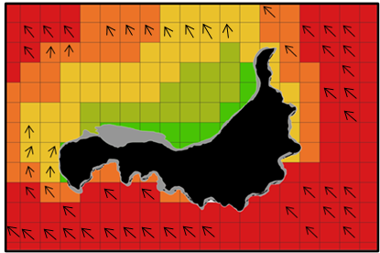
5.1.2 Interpretation of Dependence on Exposure
1km
0km
1km
0km

N
Figure 30 – Banda Island platforms and Wave Exposure Model (WEMo). Illustrates the affect that exposure has on SaG features. Although the northern platform is well developed, no wave energy interacts and the are no SaG features.
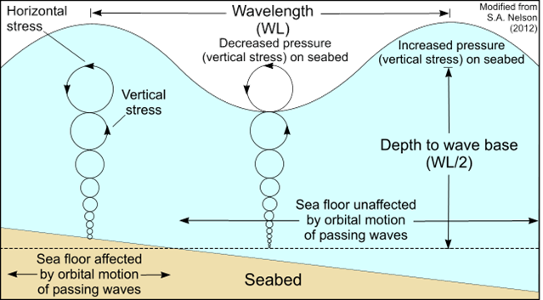
Shinn (1981) purposed that SaG features width were controlled by the strength of the prevailing waves, and the definition of grooves increased with higher wave energy. Exposure is the key attribute responsible for SaG formation, without a relatively high level of wave action SaG features will not form. Banda Islands are an example of SaG features not developing in sheltered sites despite a well-developed platform (Figure 30). There is a correlation between length and exposure as mentioned above and observed at many sites in this study. Understanding wave base and wave energy allows for the interpretation of the mechanism responsible. Wave base, or the depth at which a waves energy can reach, is a simple function. Wave base is roughly ½ the swells wavelength (Figure 31). This means that a 2m wavelength results in a 1m wave base. Higher energy will result in large waves and deeper wave bases. Development of SaG features are dependent on wave energy (Shinn, 1981). It is reasonable to then interpret that an increase in wave energy and a deeper-seated wave base will result in deeper and more continuous SaG formation. This deeper disturbance in wave energy will ultimately result in longer features. Conversely, low energy, shallow wave base features will only be able to disrupt narrow portions of the platform and develop shorter features in general. In some cases, however wave energy can be detrimental to a SaG’s development through increased erosion. Duce et al. (2020), modeled this idea and provided evidence that erosion can outpace accretion in some cases and hinder SaG growth. This theory by Duce may be observable in some sites where energy is highest.
Figure 31 – Cartoon depicting the mechanism behind wave base and the calculation to determine it. For Energy is gained wavelength is increased, resulting in a deeper wave base. Modified from USGS

5.1.3 Sea level Controls on SaG Development
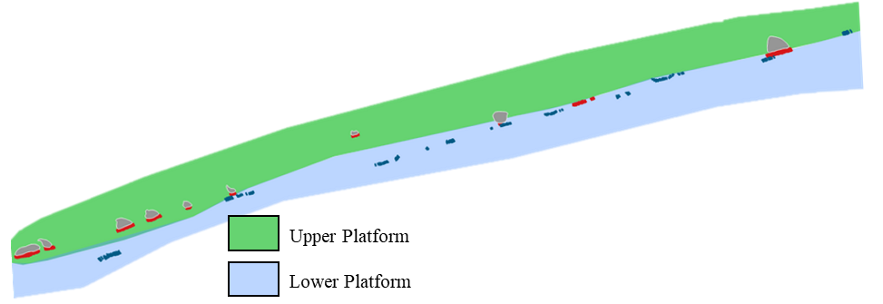
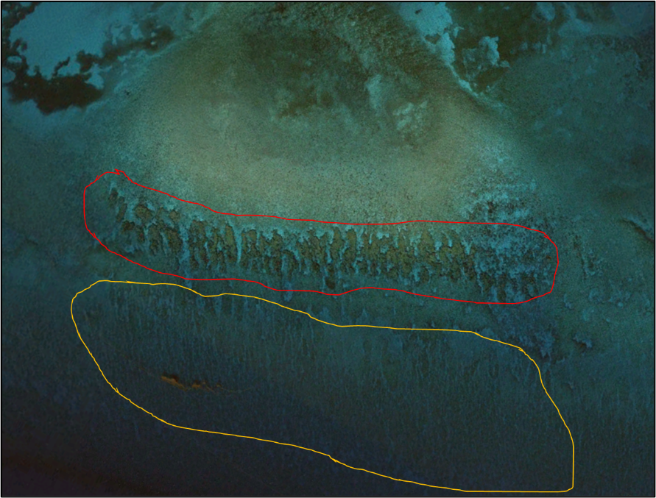
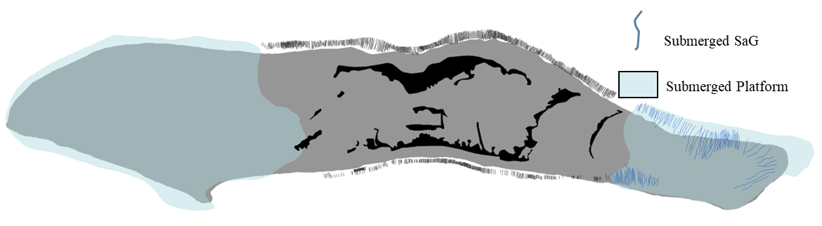
The correlation between sea level and SaG development hinges on the existence of accommodation space. A rise in relative sea level (RSL) will allow the spur to prograde seaward through the creation of accommodation space. Conversely, if there is a fall in RSL spurs will stop vertical and horizontal aggregation and grooves will continue to erode. This is observable in the Indo-Pacific sites where RSL has been relatively constant for the last 3ka. Grooves here are well defined and entrenched features. In the Caribbean RSL has greatly fluctuate (fig 26). Grooves are multi-tiered and possess several morphologies. The upper set of SaG features is nearly 10m shallower than the lower set with only sand between (Figure 33 and 34). This may represent a rapid rise in RSL that reef systems could not pace, and SaG features were not able to form. Some atolls in this study have broad areas of platform that have been submerged deep enough to not cause waves to break but still in fair weather wave base where SaG morphology will form (Figure 34). The variation of RSL between basins may greatly affect the formation and morphology of SaG features in this study.
10km
0km

N
Figure 33 – Florida Keys site. Shallow tier of SaG features in green, deep features in blue. Showing the separations of the two levels of features. May be a symptom of sea level variations.
0km
150m
N

Figure 34 – Florida Keys site. Shallow tier of SaG features (red), and deep features (yellow). Interpreted as two generations of SaG features as SL rise inundated the deep features it allowed for reef development on the upper platform.
5km
0km
N

Figure 35 – Palmyra map showing submerged platform shaded in blue. Sea level rise over the past 5ka has partially submerged the platform that may have previously been in the fair-weather wave base.
5.1.4 Reef Biology and Development
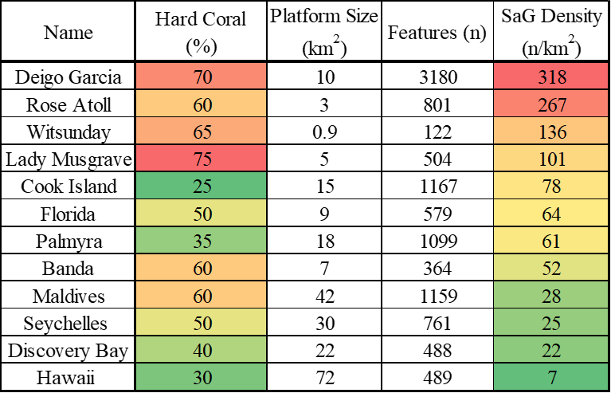
Data from this study shows a strong correlation between reef biology and several factors. The best observed correlation is of that with SaG density. As discussed above, SaG density directly correlates with percent of hard coral present. The higher the amount of hard coral with denser the features are. This correlation may be a function of many other factors, however. Of the top 4 sites all of them are in the Indo-Pacific or Coral Sea (GBR). Sites in these locations are exposed to much greater wave energy that the other listed sites. Along with that, platform development is very mature at these sites with a seasonal shift in the working swell direction. This correlation is still significant however as it shows the abundance of hard corals though the latitudes and alludes to the variation in wave energy in different ocean basins.
Table 14 – Correlation table between (%) hard coral and SaG density by site. Visual and statistical correlation exists between these two variables. Higher hard coral percentages may result in higher overall SaG density.
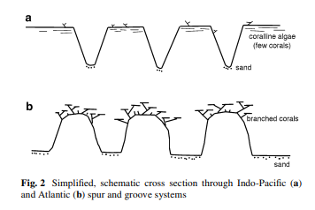
There is strong evidence of there being a meaningful correlation between sea level changes and reef biology as it relates to SaG development. Gischler (2010), proposed that the combination of negative sea-level trends and the slow coralline algal accretion resulted in the development of the erosive SaG morphology of Indo-Pacific SaG features. He also observed that Caribbean sites experienced a continuous deepening during the Late Holocene sea-level rise and proposed that this allowed for the continued growth of coral through the creation of accommodation space. These ideas align well with what the data shows in this study. Caribbean sites exhibit U-shaped SaG features and Indo-Pacific reefs have V-Shaped SaG feauters (Figure 36). The morphologyical differneces in these feautres can be explained by the codepoendeve of reef biology and wavbe energy (Gischler, 2010).
Figure 36 – Simplified schematic cross section of through Indo-Pacific SaG (top), and Caribbean SaG features (bottom). Modified from Gischler, 2010.
5.1.5 Tidal Dependance Interpretation
Data from analysis shows a correlation and dependance of tides and their magnitude on the morphology of SaG features. The Caribbean experiences very low magnitude tides while in sites in the Indian Ocean experience very large Meso-tidal events. Duce et al. (2020) theorized that tides have two major impacts on SaG morphology. Increased wave energy lower on fore reef at low tide and erosion after hightide as water drains from the lagoon and is channeled into the path of least resistance (grooves). This observation holds in the current research, but Duce never provided a mechanism is logic behind his observations.
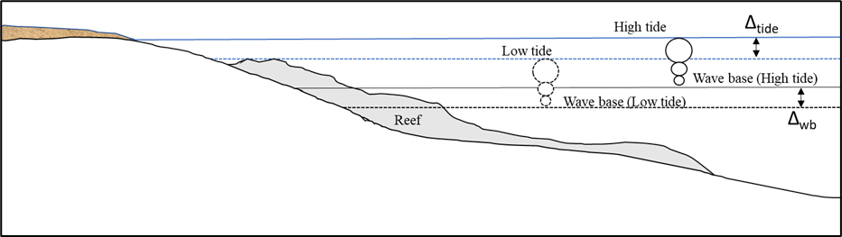
The increase in exposure at low tide effectively has the same effect as increasing wave energy. Low tide does not directly result in an increase in wave energy, wave base does not become deeper. Water depth over the reef decreases allowing for the effective wave base to reach further down reef slope that would otherwise be too deep at high tide given the same wave energy (fig 37). All Indo-Pacific sites experience reef break waves (wave energy being directly dissipated by the reef body) whereas Caribbean sites all have shore break waves. This means that heavy direct energy does not impact the reef on a regular basis in the Caribbean. The larger magnitude tides resulting in more relative wave exposure along the reef around Indo-Pacific sites helps with the interpretation of the influence that tidal magnitude has on SaG morphology.
Figure 37 – Diagram depicting how change in tide will affect the wave base and the total reef area that is disrupted by this. Δ_{wb}= change in wave base Δ_{tide}= change in tide
5.1.6 Platform Genesis/Origin
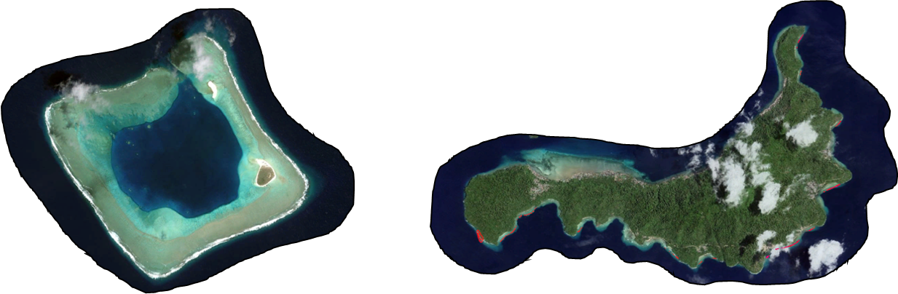
Past research has examined the links between platform shape, reef zone sedimentation, and SaG morphology (Gardiner, 2017). Gardiner’s study focused on the patterns of SaG features related to shape of platform and platform-top sedimentation. However, Gardiner’s study neglected to consider the platforms geologic origin. Proposed here is the idea that the origin of the platform is a relatively important contribution to SaG development. Two of the twelve sites (Banda, and Hawaii) have had recent volcanic activity are geologically new features. These sites have platforms that are established on basalt flows that extended into the water to make shallow platform for reefs to establish on. Naturally, the continuity of these features is limited as the extent of these flows are confined. Observable at both sites is this discontinuous nature of the platform (Figure 38). SaG density at these sites is extremely low, 7/km² in Hawaii, and 52/km² at Banda. The overall development and slope of the platform seems to be a relevant aspect controlling both placement and morphology of SaG features. Unlike Gardiner however, no obvious link between platform shape and SaG morphology was observed. Additional research will help distinguish the differences in SaG morphology found at these platform types.
0km
500m
3km
0km

N
N

Figure 38 – Rose Atoll (left) has very little exposed land mass, where Banda Island (right) has a large landmass and sheltered platform around the northern side of the island.
There is an observable link between atolls and larger developed islands. Atolls that have little to no land above sea level tend to have SaG features surrounding the entirety of the platform (Rose, Seychelles, etc.). Larger islands or atolls with a significant land mass and only one prevailing wave direction tend to have limited development on sheltered sides. A possible interpretation is that Atolls with little to no land do not have the ability to dissipate wave energy across the small lagoon and SaG features form on all sides. Larger islands obviously can stop wave energy, thus limiting SaG development on the leeward side of the island.
Observations of standard error (SE) of length and wavelength may also lead to a meaningful interpretation that platform genesis has on SaG morphology. Table 3 shows a color coded, ranked table of the SE between length and wavelength around all sites. The table is descending from largest SE in length to smallest SE in length. The Seychelles has the largest SE in length and Banda Islands has the smallest (Table 15). The Seychelles are built on a granite substrate while the Banda Islands are built on recent volcanic deposits. More research will need to be conducted to understand the roll with could play. It is also important to understand the discrepancy in the SE between length and wavelength as they do not correlate. This could mean that length and wavelength are not necessarily dependent on each other contrary to Duce et al. (2016) hypothesis.
Table 15 – Standard Error (SE) difference between length and wavelength. Hot colors show higher relative error, while cold colors represent less error.
6. Conclusions
The intent of this study was to develop a quantitative classification system to describe the morphologic controls on spur and groove systems around the globe, while simultaneously gathering evidence to purpose an interpretation of the most influential controls on SaG morphology. Numerous studies have attempted to classify SaG systems (Gischler, 2010; Duce et al., 2014, 2016, 2020; Gardiner, 2017), yet no attempt has been made to classify and describe these features on a global scale with a direct focus on morphology and morphologic controls. Sampling twelve sites globally with a large variety of platform types, reef biology, and geographic location and the application of categorical variables provides statistical correlations between the physical attributes within and between each site to interpret the dominating physical and biological controls on SaG features.
Several statistically significant correlations were observed and interpreted in this study developed from over 10,500 SaG features (Appendix 1). Many of these correlations were observed in only a small number of sites or were less strongly correlated (r²<0.30) throughout multiple sites. While still relevant to the understanding of SaG morphology, these correlations may not serve a crucial role in the understanding of the physical controls observed globally. The variability of SaG features is vast and as with any natural phenomena, each factor is codependent, and no single factor can be responsible for all the variation observed. However, three overarching correlations-dependencies were observed in the data and interpreted from this study. These are the correlations between, length and angle, length and exposure, and exposure and SaG development. Data revealed a strong correlation (r² < -0.3) between angle to shore and increased features length around every site that contains features set at an angle to shore. Features that were less than 60° to shore correlated to 50% longer features in general. Exposure and feature length was found to be a significant correlation as also observed by Duce et al. (2020). As relative exposure to wave energy increases feature length also was observed to increase. Features that were directly exposed or tangent to exposure were typically twice as long as those sheltered to wave energy. The dependance on exposure for SaG development was present in all 12 sites in this study, as well as hypothesizes upon by Shinn (1981) and modeled by Silva et al. (2020). This study reveals that areas around sites with limited or no exposure typically did not develop or developed very little SaG features, while exposed sites always developed SaG features to some degree.
This study has provided a list of variables found to be related to the development of SaG features from the major ocean basins around the world. Development of these factors was based upon the interpretation derived from the numerous correlations and their underlying processes. These most influential physical attributes were determined through statistical correlations and interpretations based around eleven individual attributes in the classifications scheme. Wave exposure and wave energy are found to be one of the most influential factors creating the variability in SaG morphology. Affecting groove shape, definition, length, and overall development, wave exposure and energy is shown to be an important factor in SaG morphology. Statistical correlations at every site show ample evidence to support this claim. Tide magnitude at each site was also concluded to be an influential factor affecting groove length, groove placement on reef front, and continuity of groove down the platform. Sites of high tidal magnitude develop continuous groove sets from the reef crest into the reef slope, while micro-tidal sites develop less extensive SaG zones that are less continuous. Reef biology was also found to be an influential factor in SaG development as the only non-physical attribute in the study. Variable biology was found to affect SaG density, and spur/groove shape. The relative abundance of hard corals is concluded to be the driver behind this variation as sites with large proportions of hard coral exhibit the highest SaG density. The changes in reef biology are mostly a function of latitude, and thus are easily predictable (Gischler, 2010). Lastly, SaG morphology was shown to be greatly influenced by wave and wind direction in this study. Feature length as well as SaG distribution around the platform was interpreted to be greatly affected by this attribute. The angle of incoming swells and refraction that occurs when waves approach at an angle is shown to result in longer features. Similarly, waves that encounter shallow shelfs will dissipate in energy and result in less developed features overall. These four driving factors are what has been interpreted as the most influential between most of the sites, however, other physical process is responsible for the variation within sites and the above controls do not account for every factor present in the study.
Future research is proposed around several subjects generated from this research. Work from Duce et al. (2020) suggested a link between feature length and wavelength where wavelength increases as length also increase. However, analysis from this research disputes this finding, as instead the data reveal variable correlations between these two attributes ranging from r² = -0.50 (Maldives) to 0.40 (Cook Island) with equal distribution between positive and negative correlations in the remaining sites. Further research into the discrepancies between these two variables is required to understand the process behind the phenomenon. Additional research is recommended to study the effect that platform development/genesis has on SaG morphology. Gardiner (2017) proposed a link between reef flat zone (RFZ) sedimentation and SaG morphology, however the link between the geologic processes underlying the development of the RFZ and SaG morphology is unknown. This study has uncovered possible correlations between the geologic development of the platform and the resulting SaG features that should be studied in the future. Additionally, applying the classification method developed here to a sample of other classification systems developed by Duce, and Gischler will aid in the calibration and confirmation of this system as a viable option in future studies. Research into ancient SaG features is an underdeveloped area. Spur and Groove features can be used as important markers in ancient environments. Using this classification system in the ancient will allow research to work out many paleo-environment factors like possible tides, wave direction, etc. Using this system as an interpretation tool in the rock record should be a focus of future research.
CODA
SaG morphologies are vitally important to fore reef architecture which must permit backreef sediment to bypass and not kill the fore reef and balance the strength of the reef bulwark against waves while at the same time decreasing strength by permitting more surface area to volume of reef fauna and flora to current and nutrient exposure. The bottom line of this investigation is that while the major responses can now be systematically described for the construction of reefal spur and grooves, what are the effective processes?

References
Andréfouët, S., Cabioch, G., Flamand, B., (2009). A reappraisal of the diversity of geomorphological and genetic processes of New Caledonian coral reefs: a synthesis from optical remote sensing, coring and acoustic multibeam observations. Coral Reefs (2009) 28, 691-707
Cohen, J.; Cohen, P.; West, S. G.; Aiken, L. S., 2003, Applied multiple regression/correlation analysis for the behavioural sciences (3rd ed.). New York, NY: Routledge.
da Silva, R.F., Storlazzi, C.D., Rogers, J.S., Reyns, J., and McCall, R., 2020, Modelling three-dimensional flow over spur-and-groove morphology: Coral Reefs, v. 39, p. 1841–1858, doi: 10.1007/s00338-020-02011-8.
Duce, S., Dechnik, B., Webster, J.M., Hua, Q., Sadler, J., Webb, G.E., Nothdurft, L., Salas-Saavedra, M., and Vila-Concejo, A., 2020, Mechanisms of spur and groove development and implications for reef platform evolution: Quaternary Science Reviews, v. 231, p. 106155, doi: 10.1016/j.quascirev.2019.106155.
Duce, S., Vila-Concejo, A., Hamylton, S., Bruce, E., and Webster, J.M., 2014, Spur and groove distribution, morphology and relationship to relative wave exposure, Southern Great Barrier Reef, Australia: Journal of Coastal Research, v. 70, p. 115–120, doi: 10.2112/si70-020.1.
Duce, S., Vila-Concejo, A., Hamylton, S.M., Webster, J.M., Bruce, E., and Beaman, R.J., 2016, A morphometric assessment and classification of coral reef spur and groove morphology: Geomorphology, v. 265, p. 68–83, doi: 10.1016/j.geomorph.2016.04.018.
Engelhart, S., Horton, B., and Kemp, A., 2011, HOLOCENE SEA-LEVEL CHANGES ALONG THE UNITED STATES’ ATLANTIC COAST: Oceanography, v. 24, p. 70–79, doi: 10.5670/oceanog.2011.28.
Gardiner, C., Robert, 2017. Variable Patterns in Spur and Groove Reef Morphology Explained by Physical Controls and their Relevance for Platform-Top Sedimentology. Master's thesis. Nova Southeastern University. Retrieved from NSUWorks. (443) https://nsuworks.nova.edu/occ_stuetd/443.
Gischler, E., 2010, Indo-Pacific and Atlantic spurs and grooves revisited: the possible effects of different Holocene sea-level history, exposure, and reef accretion rate in the shallow fore reef: Facies, v. 56, p. 173–177, doi: 10.1007/s10347-010-0218-0.
Hamylton, S.M., Carvalho, R.C., Duce, S., Roelfsema, C.M., and Vila-Concejo, A., 2016, Linking pattern to process in reef sediment dynamics at Lady Musgrave Island, southern Great Barrier Reef: Sedimentology, v. 63, p. 1634–1650, doi: 10.1111/sed.12278.
Hongo, C., Kayanne, H., (2009). Holocene coral reef development under windward and leeward locations at Ishigaki Island, Ryukyu Islands, Japan. Sedimentary Geology 214, 62–73
Kan, H., Hori, N., Ichikawa, K., (1997) Formation of a coral reef-front spur. Coral Reefs 16, 3-4
McNeill DF, Budd AF, Borne PF (1997) Earlier (Late Pliocene) Wrst appearance of the Caribbean reef-building coral Acropora palmata: stratigraphic and evolutionary implications. Geology 25:891–894
Munk, W., Sargent M., (1948). Adjustment of Bikini Atoll to ocean waves.
Transcript: American Geophysics Union 29, 855-860

Newell, N.D., 1954. Reefs and sedimentary processes of Raroia. Atoll Res. Bull. 36, 1–35

Pearson, Karl (20 June 1895). "Notes on regression and inheritance in the case of two parents". Proceedings of the Royal Society of London. 58: 240–242.

Pigott, J.D. and L.S. Land, 1986, Interstitial water chemistry of Jamaican reef sediment: sulfate
reduction and submarine cementation: Marine Chemistry, v. 20, p. 60-84.
Roberts, H.H., Wilson, P.A., and Lugo-Fernández, A., 1992, Biologic and geologic responses to physical processes: examples from modern reef systems of the Caribbean-Atlantic region: Continental Shelf Research, v. 12, p. 809–834, doi: 10.1016/0278-4343(92)90046-m.
Rogers, J.S., Monismith, S.G., Feddersen, F., and Storlazzi, C.D., 2013, Hydrodynamics of spur and groove formations on a coral reef: Journal of Geophysical Research: Oceans, v. 118, p. 3059–3073, doi: 10.1002/jgrc.20225.
Shinn, E., (1963). Spur and groove formation on the Florida reef tract. Sedimentary
Petrology, 33, 291-303

Shinn E., Hudson J., Robbin D., Lidz, B., (1981). Spurs and grooves revisited: construction versus erosion Looe Key Reef, Florida. Proceedings at 4th International Coral Reef Symposium 1, 475-483
Tidecharts.2021, Tudecharts.com
Windfinder. 2019, https://www.windfinder.com/
Wood, R., and Oppenheimer, C., 2000, Spur and groove morphology from a Late Devonian reef: Sedimentary Geology, v. 133, p. 185–193, doi: 10.1016/s0037-0738(00)00032-4.
Yates, Daniel S.; Moore, David S.; Starnes, Daren S., 2003, The Practice of Statistics (2nd ed.). New York: Freeman. ISBN 978-0-7167-4773-4.

Appendix A

