UNIVERSITY OF OKLAHOMA
GRADUATE COLLEGE

EVALUATION OF CAUSES OF TRANSVERSE AND FATIGUE CRACKING IN FLEXIBLE PAVEMENTS USING LABORATORY AND FIELD TESTING
AND PMED SIMULATION

A THESIS
SUBMITTED TO THE GRADUATE FACULTY
in partial fulfillment of the requirements for the degree of
MASTER OF SCIENCE

By
SAGAR GHOS
Norman, Oklahoma
2020

EVALUATION OF CAUSES OF TRANSVERSE AND FATIGUE CRACKING IN FLEXIBLE PAVEMENTS USING LABORATORY AND FIELD TESTING
AND PMED SIMULATION

A THESIS APPROVED FOR THE SCHOOL OF CIVIL ENGINEERING AND ENVIRONMENTAL SCIENCE

BY THE COMMITTEE CONSISTING OF

Dr. Musharraf Zaman, Chair
Dr. Gerald A. Miller
Dr. Dominique M. Pittenger

© Copyright by SAGAR GHOS 2020
All Rights Reserved.

Dedicated
to
My Beloved Parents

ACKNOWLEDGEMENTS
First and foremost, I would like to express my deep and sincere gratitude to God, The Almighty, for His countless blessings in every step of my life. Secondly, I would like to thank my parents and uncle who have always encouraged me and sacrificed everything for fulfilling my goals.
I would like to express my sincerest appreciation, deepest gratitude, and heartiest thanks to my supervisor and the Chair of my thesis committee, Professor Musharraf Zaman, for his guidance, encouragement, and unparalleled support throughout my graduate studies at the University of Oklahoma. His deep insights, critical comments, edits, and valuable suggestions contributed greatly to the completion of this study. It was him who helped me to grow into a researcher. His mentoring style, high expectations and trust greatly elevated my critical thinking and writing skills and confidence.
I would like to acknowledge and thank Dr. Gerald A. Miller for serving on my thesis committee. I have learned a lot from his “Forensic Geotechnical Engineering” class. I would like to thank him for sharing his knowledge, ideas and providing valuable inputs for completing this thesis. Also, I wish to thank Dr. Dominique M. Pittenger for serving on my thesis committee. Her valuable comments and ideas helped finalize this study. I want to thank Dr. Amy B. Cerato, Dr. Kianoosh Hatami, Dr. P. Scott Harvey and Dr. Shima Mohebbi for helping me with their knowledge and experience through their courses at OU. I would like to express my deepest gratitude to all the staff of the School of Civil Engineering and Environmental Science and the Southern Plains Transportation Center (SPTC) for their help and support. I would also like to extend my gratitude to Dr. Michael Molina for his help in reviewing manuscripts.
I would like to acknowledge and thank every member of Dr. Zaman’s research group, especially Mr. Syed Ashik Ali for his enormous help and guidance throughout my research. He is an excellent example of a mentor, good friend, sincere researcher, and a fine person. He was always there to guide me in the field and laboratory testing and to help me in developing ideas throughout my graduate study here at OU. His valuable comments and suggestions helped me to improve my research and writing skills. I want to extend my gratitude to Mr. Matias Larrain Mendez, Mr. Kenneth R. Hobson, and Mr. Donnie Lacky for their help in field and laboratory work throughout my thesis research.
I must thank Dr. Michael Behm and his research group from the School of Geoscience for sharing their knowledge and help with Ground Penetrating Radar (GPR) data collection and analysis. Special thanks to Mr. Deepankar Dangwal for his help with the GPR data collection. I would like to thank Dr. Dar-Hao Chen from the Texas A&M Transportation Institute for his ideas and help in conducting this research. Special thanks to Mr. Victor Pozadas, Mr. Michael Schmitz, Dr. Naji Khoury, Dr. James B. Nevels, ROCA Engineering, and EST Engineering Inc. for help in conducting field tests and collecting samples. I would like to thank Dr. George Tsoflias from University of Kansas for providing equipment for GPR testing.
The financial supports provided by the Oklahoma Department of Transportation (ODOT) are greatly acknowledged. I wish to express my gratitude to Mr. Ron McDaniel, Mr. Jon Logan, Mr. Scott Armstrong, Mr. Brantley Hendrex, Mr. Rick Howland, and Mr. Jonathan Ryan, all from ODOT’s Division VI and Division IV for their help and support with this study. I am also thankful to ODOT’s Office of Research and Implementation for assistance with this study.
Finally, I want to thank my beautiful wife, Shoumita Ghosh for her love, inspiration, encouragement, prayers, and support.

TABLE OF CONTENTS

ACKNOWLEDGEMENTS v
TABLE OF CONTENTS vii
LIST OF TABLES xi
LIST OF FIGURES xii
ABSTRACT xv
CHAPTER 1 INTRODUCTION 1
1.1 BACKGROUND 1
1.2 OBJECTIVES 4
1.3 OUTLINE 4
CHAPTER 2 SENSITIVITY OF PAVEMENT MED INPUT PARAMETERS FOR CHARACTERIZATION OF CRACKING IN PAVEMENTS IN OKLAHOMA 6
2.1 INTRODUCTION 7
2.2 SENSITIVITY ANALYSIS 10
2.3 METHODOLOGY 12
2.4 RESULTS AND DISCUSSION 14
2.4.1 Effect of Pavement Thickness 14
2.4.2 Effect of Traffic Level 15
2.4.3 Effect of Subgrade Resilient Modulus 16
2.4.4 Effect of High- and Low-temperature PG 17
2.4.5 Sensitivity Analysis 19
2.5 CONCLUSIONS 22
CHAPTER 3 EVALUATION OF TRANSVERSE CRACKING IN FLEXIBLE PAVEMENTS USING FIELD INVESTIGATION AND AASHTOWARE PAVEMENT ME DESIGN 23
3.1 INTRODUCTION 24
3.2 OVERVIEW OF RELATED STUDIES 25
3.3 OBJECTIVES 29
3.4 PRELIMINARY INVESTIGATION AND SITE DESCRIPTION 29
3.5 METHODOLOGY 33
3.5.1 Field and Laboratory Investigations 36
3.5.1.1 Field Investigation 36
3.5.1.1.1 Ground Penetrating Radar (GPR) 36
3.5.1.1.2 Falling Weight Deflectometer (FWD) 38
3.5.1.1.3 Dynamic Cone Penetration (DCP) 40
3.5.1.2 Physical Inspection of Asphalt Cores 42
3.5.1.3 Laboratory Testing 43
3.5.1.3.1 Tests on Asphalt 43
3.5.1.3.1.1 Roadway Density 43
3.5.1.3.1.2 Illinois Flexibility Index Test (IFIT) 44
3.5.1.3.2 Tests on Soils 45
3.5.1.3.2.1 Soil Properties 45
3.5.2 Effect of Temperature Differential Cycles 45
3.5.3 Parametric Study using AASHTOWare PMED 47
3.5.3.1 Effect of Pavement Thickness 48
3.5.3.2 Effect of High- and Low-temperature PG of Binder 49
3.5.3.3 Effect of Temperature Variation 51
3.6 CONCLUSIONS AND RECOMMENDATIONS 52
CHAPTER 4 CAUSES OF FATIGUE CRACKING IN FLEXIBLE PAVEMENTS IN OKLAHOMA: A CASE STUDY USING LABORATORY AND FIELD INVESTIGATION AND AASHTOWARE SIMULATION 55
4.1 INTRODUCTION 56
4.2 OVERVIEW OF PREVIOUS STUDIES 57
4.3 OBJECTIVES 59
4.4 SITE DESCRIPTION 60
4.5 METHODOLOGY 62
4.5.1 Field Investigations 64
4.5.1.1 Ground Penetrating Radar (GPR) 64
4.5.1.2 Falling Weight Deflectometer (FWD) 66
4.5.1.3 Dynamic Cone Penetration (DCP) Tests 68
4.5.1.4 Physical Inspection of Asphalt Cores 70
4.5.1.5 Test on Asphalt Cores 74
4.5.1.5.1 Roadway Density 74
4.5.1.5.2 Illinois Flexibility Index Test (IFIT) 75
4.5.1.5.3 Binder Extraction and Performance Grading (PG) 76
4.5.1.6 Tests on Soils 76
4.5.2 PMED Simulation 77
4.5.2.1 Influence of Pavement Thickness 78
4.5.2.2 Influence of Layer Modulus of Existing Pavement 80
4.5.2.3 Influence of Roadway Density 83
4.5.2.4 Influence of High- and Low-temperature PG of Binder 84
4.6 CONCLUSIONS AND RECOMMENDATIONS 86
CHAPTER 5 CONCLUSIONS AND RECOMMENDATIONS 88
5.1 CONCLUSIONS 88
5.2 RECOMMENDATIONS 89
REFERENCES 91

LIST OF TABLES
Table 2.1 PMED input variables 14
Table 3.1 Normalized W1 Deflections of US 270 and US 287 39
Table 3.2 DCP test results of US 287 and US 270 41
Table 3.3 Core Inspection Results of US 270 and US 287 43
Table 3.4 Roadway densities of US 270 and US 287 43
Table 3.5 IFIT test results of the asphalt cores from US 270 and US 287 44
Table 3.6 Highest variations in temperature in two consecutive days 46
Table 3.7 Minimum and maximum temperatures observed for the test sites 47
Table 3.8 PMED input variables 48
Table 4.1 DCP test results 69
Table 4.2 Thicknesses of Asphalt cores extracted from US 412 72
Table 4.3 Input variables for PMED simulations 78

LIST OF FIGURES
Figure 2.1 Pavement structure of US 270 (Harper County) 13
Figure 2.2 Variation of thermal cracking with surface thickness 15
Figure 2.3 Variation of top-down fatigue cracking with base thickness 15
Figure 2.4 Variation of bottom-up fatigue cracking with AADTT 16
Figure 2.5 Variation of top-down fatigue cracking with subgrade resilient modulus 17
Figure 2.6 Variation of thermal cracking with high-temperature PG 18
Figure 2.7 Variation of thermal cracking with low-temperature PG 18
Figure 2.8 Variation of top-down fatigue cracking with low-temperature PG 19
Figure 2.9 Sensitivity analysis summary of transverse cracking 20
Figure 2.10 Sensitivity analysis summary of top-down fatigue cracking 21
Figure 2.11 Sensitivity analysis summary of bottom-up fatigue cracking 21
Figure 3.1 Typical pavement structures of US 287 30
Figure 3.2 Typical transverse crack observed on US 287 in Cimarron County: (a) aerial view; (b) width; and (c) depth of crack 31
Figure 3.3 Typical pavement structure of US 270 32
Figure 3.4 Typical transverse crack observed on US 270 in Harper County: (a) aerial view; (b) width; and (c) depth of crack 33
Figure 3.5 Workflow diagram for investigating transverse cracking in US 270 and US 287 35
Figure 3.6 Processed longitudinal GPR profiles along US 270 (a) and US 287 (b). Depth conversion velocities are 0.1 m/ns (a) and 0.12 m/ns (b) 38
Figure 3.7 Variation of pavement layer modulus obtained from FWD testing: (a) US 270; and (b) US 287 40
Figure 3.8 Inspection of asphalt cores of (a) US 270 and (b) US 287 42
Figure 3.9 Variation of thermal cracking with surface thickness 49
Figure 3.10 Variation of thermal cracking with pavement thickness 49
Figure 3.11 Variation of thermal cracking with high- and low-temperature PG 51
Figure 3.12 Variation of thermal cracking with change in average hourly temperature 52
Figure 4.1 Typical fatigue cracks observed in US 412 in Noble County: (a) project location; and (b) Google satellite view 61
Figure 4.2 Typical pavement section of US 412 in Noble County 62
Figure 4.3 Flowchart for investigating fatigue cracking in US 412 63
Figure 4.4 Calibration of GPR image with core 65
Figure 4.5 Longitudinal profile of US 412 66
Figure 4.6 Variation normalized maximum W1 deflection for US 412 68
Figure 4.7 Variation of asphalt layer modulus with FWD station for US 412 68
Figure 4.8 Delamination in asphalt cores: (a) cores; and (b) core-hole 73
Figure 4.9 Bottom-up crack at Core#11: (a) full core; and (b) core after removing 1.5-in. from the top 73
Figure 4.10 Top-down crack at Core#7: (a) core-hole; and (b) disintegrated core 74
Figure 4.11 Density of asphalt cores 75
Figure 4.12 Variation of fatigue cracking with pavement thickness: (a) top-down; and (b) bottom-up 80
Figure 4.13 Fatigue cracks observed in the vicinity of: (a) Core#9M; and (b) Core#11M 80
Figure 4.14 Variation of fatigue cracking with layer modulus of existing pavement: (a) top-down; and (b) bottom-up 82
Figure 4.15 Fatigue cracking observed in the vicinity of FWD test stations: (a) 507-ft; and (b) 2424-ft 82
Figure 4.16 Variation of fatigue cracking with roadway density: (a) top-down; (b) bottom-up 84
Figure 4.17 Fatigue cracking observed near cores: (a) Core#3M; and (b) Core#9M 84
Figure 4.18 Variation of fatigue cracking with high- and low-temperature PG: (a) top-down; (b) bottom-up 86

ABSTRACT
Fatigue cracking and transverse cracking are two of the most prevalent distresses in flexible pavements. In this study, probable causes of these distresses were evaluated using field and laboratory testing and simulations using AASHTOWare Pavement ME Design (PMED). For this purpose, three pavement test sections, located in US 270, US 287 and US 412 in Oklahoma, were selected. The test sections in US 270 and US 287 have experienced significant transverse cracking, while the test section in US 412 has seen major fatigue cracking. A series of non-destructive and destructive testing involving Ground Penetrating Radar (GPR), Falling Weight Deflectometer (FWD) and Dynamic Cone Penetration (DCP) was performed at each test section. Also, soil samples and asphalt cores were collected for laboratory testing.
In US 270 and US 287, numerous transverse cracks were found to extend full width of the pavement, including shoulder indicating that these transverse cracks resulted from thermal cracking. Analysis of weather data from nearby climate stations indicated a large number of low-temperature events, high temperature differential cycles and hourly temperature fluctuations. These factors were a likely contributor to thermal cracking at both sites. The PMED simulations supported these findings. Field and laboratory testing indicated that severities of transverse cracking were influenced by high variations in asphalt layer moduli, pavement thicknesses and low cracking resistance of both pavements, in addition to extreme low temperature events and temperature differentials. The GPR tests indicated that pavement thickness varied along longitudinal and transverse directions and cracks initiated from the surface and propagated downward through the entire asphalt layer(s) at both sites. The FWD and DCP tests revealed that both pavement sections were structurally adequate to support the existing traffic for ten plus years, with appropriate maintenance. However, FWD results indicated high variations in asphalt layer moduli throughout the pavement section, at both sites. The Illinois Flexibility Index Test (IFIT) on the extracted cores from both sites indicated that stiffer and brittle asphalt mixes resulting from aging during the long service life were a major contributor to transverse cracking at both sites. A parametric study and sensitivity analysis using PMED simulations indicated that binder grade and pavement thickness were the most influential factors for transverse cracking at both sites.
In US 412, GPR tests revealed significant delamination, top-down fatigue cracking, bottom-up fatigue cracking and variations in pavement thickness in both longitudinal and transverse direction. Also, GPR images indicated that the disturbance zone was confined within the asphalt layer. Physical inspection of asphalt cores and core-holes validated these findings. Stripping was found to worsen the delamination at several locations. Analysis of FWD data indicated that the pavement section in US 412 was structurally inadequate to support traffic and is in need of rehabilitation in the near future. Also, variations in moduli of the asphalt layers and high deflections of geophone sensors were observed from the field FWD tests at this site. Roadway density tests indicated very low densities of asphalt cores of the pavement than expected. In addition, true PG of the extracted binder indicated excessive aging of the binder at this site. Furthermore, IFIT tests revealed very poor cracking resistance of the field cores. Therefore, delamination, variations in layer moduli, variations in pavement thickness, low roadway densities, excessive aging of binder and poor cracking resistance were found to be potential contributors to fatigue cracking at this test section. In addition, PMED simulations indicated pavement thickness, high-temperature performance grade of binder, roadway densities and layer moduli of the existing pavement were influential factors for fatigue cracking at this site.
The hybrid approach involving laboratory and field testing and PMED simulations is found to be an effective tool for identifying probable causes of transverse and fatigue cracking in asphalt pavements. Assessment of these distresses using this hybrid approach would be helpful in designing new pavements as well as in selecting remedial measures of existing pavements.

INTRODUCTION

BACKGROUND
Roadway pavements are an integral part of the surface transportation infrastructure and economic vitality of the United States (Islam and Buttlar, 2012; Papagiannakis and Masad, 2017). A recent ASCE survey assigned an overall grade of D+ to the pavement infrastructure, which means the pavement systems in the US are in dire need of maintenance, rehabilitation and reconstruction (ASCE, 2017). Evaluation of causes of pavement distresses proactively allows transportation agencies at both federal and state levels to undertake appropriate measures to extend the life of the existing pavements through timely maintenance, rehabilitation and reconstruction. Because roadway pavements experience many distresses and these are caused by various factors, evaluation of probable causes of specific distresses in specific pavements is an important step (Chen and Scullion, 2008; Islam and Buttlar, 2012; Papagiannakis and Masad, 2017). To that end, the present study was undertaken to evaluate probable causes of transverse cracking and fatigue cracking in asphalt pavements at selected sites in Oklahoma. The hybrid evaluation method employed in this study is based on both laboratory and field testing and simulations using the Pavement ME Design (PMED) software, which is widely used nationally for pavement design and performance evaluation. The findings are presented in this thesis as conference and journal papers, along with some general background and overarching conclusions and recommendations.
Cracking is one of the most common distresses in flexible pavements (Huang, 2004; Adlinge and Gupta, 2013; Rada, 2013; West et al., 2018). According to West et al. (2018), more than 85% of asphalt pavements in the United States experience some form of crack, which includes transverse cracking, reflective cracking, fatigue cracking and longitudinal cracking. About 60% of asphalt pavements experience transverse cracking and fatigue cracking in their service lives (West et al., 2018).
Transverse cracking in flexible pavements is prevalent in the cold regions in the US and Canada (Marasteanu, et al., 2004; Zhang, 2015). Pavements located in relatively milder regions in the country with large variations in temperatures over a relatively short period of time and a large number of such thermal cycles are also found to experience transverse cracking (Yavuzturk et al., 2005). These types of cracks are generally uniformly spaced and appear in the perpendicular direction of the traffic (Huang, 2004; Al-Qadi et al., 2005). Transverse cracks are generally categorized into two types: thermal cracking due to low-temperature cycles and reflective cracking (Huang, 2004; Pszczoła et al., 2008; Pais, 2013; Zhang, 2015). Thermal cracking in asphalt pavement occurs when the thermal stresses exceed the tensile strength of the asphalt layer(s). These cracks generally initiate at the surface and propagate through the entire or partial depth of the pavement (Huang, 2004; Pszczoła et al., 2008; Zhang, 2015). Size of thermal cracks and their spacing change with the level of low-temperature as well as thermal gradient and cycle, among other factors (e.g., pavement materials, resistance to thermal cracking, etc.). Conversely, reflective cracks appear in the overlays under the action of repeated traffic load and temperature variations, if there are cracks in the existing underlying pavement layer(s) (Pais, 2013).
Fatigue cracking is a load-related distress in asphalt pavement and is developed due to repeated traffic loading (Huang, 2004; Pszczoła et al., 2008; Zhang, 2015). Once fatigue cracking starts, it can increase rapidly as the pavement weakens. Mechanistically, fatigue cracking occurs when the stresses in an asphalt layer due to repeated traffic loading exceeds its tensile strength. Generally, two types of fatigue cracks are observed in asphalt pavements namely, top-down fatigue cracking and bottom-up fatigue cracking (Huang, 2004; Papagiannakis and Masad, 2017; Sun et al., 2018). Top-down fatigue cracks are generally caused by the excessive tensile stresses at the asphalt surface due to non-uniform contact pressure at the interface between the tire and the pavement(i.e., when the localized tensile stress exceeds the tensile strength of the asphalt). Once initiated at the surface, these cracks gradually propagate downward (Myers, 2000; Wang et al., 2003; Wang and Al-Qadi, 2010). The bottom-up cracks, however, are developed when the tensile stress at the bottom of the asphalt layer exceeds the tensile strength of the pavement under repeated traffic loading. These cracks propagate upward from the bottom and appear as interconnected alligator skin (also called “alligator crack”) (Huang, 2004; Molenaar and Pu, 2008; Islam and Tarefder, 2015).
In the current study, probable causes of transverse cracking and fatigue cracking are examined using a hybrid approach involving laboratory and field testing and PMED simulations at three selected pavement sections in Oklahoma. Two of these sites, US 270 in Harper County and US 287 in Cimarron County, have experienced extensive transverse cracking, while the third site in US 412 in Noble County has experienced significant fatigue cracking. Field testing at each site consisted of Ground Penetrating Radar (GPR), Falling Weight Deflectometer (FWD) and Dynamic Cone Penetration (DCP). Asphalt cores and soil samples were collected for laboratory testing. Laboratory testing on extracted asphalt cores involved density, air voids, and resistance to cracking (using Illinois Flexibility Index Test or IFIT). Performance grade (PG) of the extracted binder was also determined from the asphalt cores. Soil tests primarily involved Atterberg limits and AASHTO classification. In addition to field and laboratory testing, a parametric study was conducted using AASHTOWare Pavement ME Design (PMED) simulation to identify relative influence of pavement geometry, material properties, traffic and climate on transverse cracking and fatigue cracking. Specific objectives of the current study are given below.

OBJECTIVES
This study is aimed to investigate the cracking potential of flexible pavements using a hybrid approach involving field and laboratory testing and a parametric study using PMED simulation. The PMED simulation was intended to identify relative influence of pavement geometry, material properties, traffic and climate on transverse cracking and fatigue cracking. The specific objectives of this study are:
- To investigate probable causes of transverse cracking in US 270 and US 287 using field and laboratory testing and a parametric study using PMED simulation.
- To determine probable causes of fatigue cracking in US 412 using field and laboratory testing and a parametric study using PMED simulation.
- To identify relative influence of pavement geometry, material properties, traffic and climate on transverse cracking and fatigue cracking.

OUTLINE
This thesis consists of five chapters. An overview of each chapter is given in this section.
Chapter 1: This chapter provides the overall background and a brief overview of transverse cracking and fatigue cracking in flexible pavements. The objectives of the thesis are also included in this chapter.
Chapter 2: This chapter presents the findings of a parametric study to determine the level of sensitivity or relative influence of input parameters used in AASHTOWare Pavement ME Design (PMED) to simulate asphalt pavement performance under transverse cracking and fatigue cracking. A local sensitivity analysis of PMED input variables was conducted using a Normalized Sensitivity Index (NSI). The results of this sensitivity study are presented in this chapter. Relative ranking of each parameter using in the sensitivity analysis is also presented in this chapter.
Chapter 3: This chapter includes the findings of a study that was conducted to identify probable causes of transverse cracking in selected pavement sections in Oklahoma, namely US 270 and US 287. A series of field and laboratory testing and analysis of weather data from nearby climate stations were conducted in this study. The results are presented in this chapter. In addition, a parametric study was conducted using PMED to determine the degree of influence of pavement structural components, materials and traffic on transverse cracking. The results are presented in this chapter.
Chapter 4: This chapter presents the results of a case study in which probable causes of fatigue cracking in US 412 in Oklahoma were investigated. A series of field and laboratory tests was performed. In addition to field and laboratory testing, PMED simulations were performed to determine the degree of influence of pavement structural components and materials on fatigue cracking. The results are presented in this chapter.
Chapter 5: Overall conclusions from this study are presented in this chapter along with pertinent recommendations. The recommendations are focused on the remedial measures for the pavement sections studied herein as well as recommendations for future work.

SENSITIVITY OF PAVEMENT MED INPUT PARAMETERS FOR CHARACTERIZATION OF CRACKING IN PAVEMENTS IN OKLAHOMA

ABSTRACT
One of the common distresses in asphalt pavements observed in northwest Oklahoma is depression or localized settlements and cracking in the transverse direction. This paper focuses on the sensitivity study of the Pavement ME Design (PMED) input parameters by comparing them with the field observations, when feasible. Specifically, Performance Grades (PG) of binders, thicknesses of different structural layers and traffic levels were used as design variables in PMED and each variable was changed within a practical range to examine its sensitivity relative to other variables. A Normalized Sensitivity Index (NSI) with a ranking scale from 0 to 5 (0 being non-sensitive and 5 being hypersensitive) was used to analyze the sensitivity level for each input variable. It was found that, transverse cracking is very sensitive to high- and low-temperature PG of asphalt binder. Also, thicknesses of surface and base layers were found to be sensitive to the transverse cracking performance. In addition, the fatigue cracking performance was observed to be hypersensitive to pavement layer thicknesses, high-and low-temperature PG of the binder, and traffic level. A hybrid approach involving field and laboratory testing and sensitivity analysis using the PMED is found to be a powerful tool for forensic investigation.
Keyword: Transverse Cracking; Pavement ME Design; Sensitivity Analysis; Normalized Sensitivity Index.

INTRODUCTION
A significant amount of household expenditure of the nation is directly related to transportation (Papagiannakis and Masad, 2017). A significant amount of this cost goes to vehicle maintenance due to poor pavement condition. State and federal Departments of Transportation (DOTs) spend millions of dollars annually for pavement maintenance and reconstruction to address distresses (Chen and Scullion, 2008). In flexible pavements, major distresses include cracking, rutting, and moisture-induced damage (Adlinge and Gupta, 2013; Rada, 2013). Asphalt pavement cracks are generally categorized as fatigue cracking, alligator or longitudinal cracking, transverse cracking and reflective cracking (Huang, 2004; Pszczoła et al., 2008). In northwestern Oklahoma, the most common distresses in flexible pavements are depression or localized settlements, cracking in the transverse direction, and fatigue cracking.
Generally, transverse cracks are uniformly spaced at a few yards to several hundred yards (Huang, 2004). According to Vinson et al. (1989), crack spacings are usually larger than 100-ft for new pavements and they reduce with time. The width of these cracks increases with aging and repeated cold temperature cycles (Anderson et al., 2001). The default threshold limit for transverse cracking is considered 1,000-ft/mile in the AASHTOware Pavement ME Design (PMED) (Zhang, 2015). Transverse cracking in flexible pavements can result from shrinkage of asphalt surface due to low temperatures (thermal stress), asphalt hardening, and reflective cracking from underlying layers (Huang, 2004; Charlier et al., 2009). However, Al-Qadi et al. (2005) mentioned two significant mechanisms for thermal cracking of flexible pavement, namely, low-temperature cracking and thermal fatigue cracking. Low-temperature transverse cracking occurs when tensile stresses exceed the strength of Hot Mix Asphalt (HMA) at a given temperature. These cracks are generally initiated at the surface and propagate through the entire depth of HMA. However, thermal fatigue cracking does not require a low level of temperature. Thermal fatigue cracking generally occurs as a result of repeated temperature fluctuations within a short period. Repeated fluctuations in temperature, in turn, lead to fluctuating stresses and strains and irrecoverable deformations (Al-Qadi et al., 2005).
Fatigue cracking is one of the common distresses in the flexible pavements of Oklahoma. Fatigue cracks are a series of interconnecting cracks developed due to the fatigue failure of an asphalt layer or a stabilized base under the action of repeated traffic loading (Huang, 2004; Suo and Wong, 2009). Two types of fatigue cracking are usually observed in the flexible pavements, namely bottom-up fatigue cracking and top-down fatigue cracking (Sun et al., 2018; Huang, 2004). The bottom-up cracks generally initiate at the bottom of the asphalt layer or stabilized base, where the tensile stress under wheel load exceeds the tensile strength of the material. These cracks propagate to the surface under the action of repeated traffic loads (Huang, 2004).
The top-down fatigue cracking is observed alongside the wheel path in asphalt pavements (Sun et al., 2018). This type of cracking is generally observed within 2-6 years of opening to traffic (Schorsch et al., 2004). These cracks initiate at the top part of the asphalt surface and then propagate towards the bottom. Two different hypotheses have been reported in the literature regarding the mechanisms of top-down fatigue cracking. Some researchers believe that top-down fatigue cracking is caused by the tensile stresses induced by pressure at the tire edges (Molenaar, 1984; Hugo and Kennedy, 1985; Wang and Al-Qadi, 2010; Zhang, 2015) and non-uniform tire-pavement contact pressure initiated at the top of asphalt surface (Myers, 2000). According to the second hypothesis, top-down fatigue cracking occurs due to shear stress or shear strain at the asphalt surface (Bensalem et al., 2000; Wang et al., 2003). As many factors/mechanisms can contribute to the development of transverse and fatigue cracks in the flexible pavement, it is essential to evaluate the effects of different influencing factors.
To identify the factors and mechanisms of transverse and fatigue cracking observed in the northwestern part of Oklahoma, a forensic investigation was conducted by the University of Oklahoma on two national highways, namely US 287 in Cimarron County and US 270 in Harper County. The forensic investigation included field survey, Ground Penetrating Radar (GPR) test, Falling Weight Deflectometer (FWD) test, rutting measurement using Face Dipstick, International Roughness Index (IRI) measurement using Pave-Vision 3D, Dynamic Cone Penetration (DCP) test, and collection of asphalt cores and subgrade soil samples. The results of the field investigation indicated a strong base support for both pavements in spite of the existence of significant pavement cracking. As the results of the forensic investigation led to unclear conclusions, the research team decided to conduct a sensitivity analysis of each material property against cracking performance.
The PMED is widely used and accepted as a powerful design tool for new and rehabilitated flexible pavements (Orobio and Zaniewski, 2011; Haas et al., 2007). The PMED utilizes traffic, soil and aggregate properties, asphalt binder, and mix properties and climate data for flexible pavement design (AASHTO, 2008). The structural response of the pavement is calculated using the layered-elastic model for each axle type and load. The PMED predicts the pavement performance in terms of rutting, fatigue cracking, transverse cracking and IRI (AASHTO, 2008). Several studies have been conducted previously on the sensitivity analysis of design input parameters on pavement performance (Kim et al., 2005; Kim et al., 2007; Li et al., 2012; Li et al., 2013; Schwartz et al., 2013). Based on these studies, a sensitivity analysis can be useful for local calibration and development of pavement management databases (Kim et al., 2005; Li et al., 2012; Li et al., 2013; Graves and Mahboub, 2006; Orobio and Zaniewski, 2011; Schwartz et al., 2013). In the present study, the sensitivity analysis is used to investigate the influence of different parameters on pavement distresses, specifically transverse and fatigue cracking.

SENSITIVITY ANALYSIS
Sensitivity analysis is the way of assigning uncertainty in the output of a model (numerical or otherwise) to different sources of uncertainty in the model input (Saltelli, 2002). Sensitivity analysis methods are categorized into two classes, namely Local Sensitivity Analysis (LSA) and Global Sensitivity Analysis (GSA) (Graves and Mahboub, 2006). In LSA, one input parameter is varied while holding the other parameters constant. This is known as One-At-A-Time approach (OAT). All the input parameters are varied simultaneously in sensitivity analyses using GSA. Graves and Mahboub (2006) conducted a sampling-based sensitivity analysis of Mechanistic-Empirical Pavement Design Guide (MEPDG) input parameters. In that study, a pilot project was used to identify the feasibility of GSA of MEPDG input parameters by using random sampling techniques. For this purpose, several input parameters, namely nominal aggregate size of HMA base, climate location, HMA thickness, Annual Average Daily Truck Traffic (AADTT), subgrade strength, truck traffic category, construction season, and binder grade were selected as design variables. It was found that AADTT, HMA thickness, and subgrade strength had a significant impact on performances, whereas the remaining parameters had lesser impacts (Graves and Mahboub, 2006). Orobio and Zaniewski (2011) conducted a sampling-based sensitivity analysis of material input parameters to determine their influence on flexible pavement performance. Two base structures, with a fixed traffic level and climatic condition, were used in that study. Latin Hypercube Sampling (LHS) was used to sample the input space of the material parameters. A total of 500 trial runs were performed using the MEPDG (version 1.1). The sensitivity of input parameters for IRI, rutting and cracking was determined by using Standardized Regression Coefficients (SRC) and Gaussian Stochastic Process (GPS) methods. The material input parameters were ranked from 1 to 3, according to the level of sensitivity (high to low) (Orobio and Zaniewski, 2011). Li et al. (2012) conducted a sensitivity analysis using LSA to determine the effect of unbound material MEPDG input parameters on performance of flexible pavements. A total of 15 base cases with 3 traffic levels and 5 climatic conditions were selected for that investigation. The parameters were varied to a maximum and minimum value with respect to a baseline value. A parameter, called Normalized Sensitivity Index (NSI) was used to rank the sensitivity of input variables. The NSI was defined using Equation (2.1).
$S_{JK}^{DL}= \frac{∆Y_{J}}{∆X_{K}}\frac{X_{K}}{{DL}_{J}}$ (2.1)
where, $S_{JK}^{DL}$ = Normalized Sensitivity Index (NSI);
$X_{K}$ = baseline value of the design input K;
${∆X}_{K}$ = change in design input K from the baseline value $X_{K}$;
${∆Y}_{J}$ = change in predicted distress J corresponding to ${∆X}_{K}$;
${DL}_{J}$ =design limit for distress J.
Li et al. (2012) proposed a ranking system of the design inputs using the overall maximum NSI. The design input parameters were ranked in four categories, namely hypersensitive (|NSI|>5), very sensitive (1<|NSI|<5), sensitive (0.1<|NSI|<1) and non-sensitive (|NSI|<0.1). The base and subgrade resilient modulus, base thickness, and HMA properties were found as very sensitive input parameters using maximum |NSI| for fatigue cracking, thermal cracking, rutting and IRI. Poisson’s ratio, subgrade Plasticity Index (PI), Liquid Limit (LL), groundwater depth, and P200 were found in the sensitive category. However, the top-down longitudinal cracking was found as the most sensitive distress to unbound material design inputs (Li et al., 2012). Ceylan et al. (2014) conducted a sensitivity analysis of design input parameters for continuously reinforced concrete pavement. In that study, both GSA and LSA were performed to understand the sensitivity of each design input. Multivariate linear regression and artificial neural network methods were used for the GSA. An NSI similar to Li et al. (2012) was used to rank the design variables. Also, Yang et al. (2017) conducted an LSA of MEPDG input parameters related to climate. Specifically, climate data of six weather stations from six geographically distributed areas of Michigan were used along with two traffic levels (medium and high). Five climate input parameters, namely temperature, wind speed, precipitation, percent sunshine and relative humidity were varied in the MEPDG analysis. An NSI, similar to Li et al. (2012) was used in that study to quantify the sensitivity of each input parameter to thermal cracking, rutting, top-down and bottom-up fatigue cracking and IRI. The MEPDG predicted performances were most sensitive to the changes in temperature.

METHODOLOGY
This paper represents the sensitivity analysis of PMED input parameters focusing the structure of US 270 in Harper County of Oklahoma. Information regarding pavement structure and existing traffic of US 270 was collected from the Oklahoma Department of Transportation (ODOT) (see Figure 2.1). A base structure identical to US 270 was modeled in the AASHTOware PMED (version 2.5). The material properties, namely gradation of aggregate, and Superpave binder Performance Grade (PG) were obtained from ODOT personnel and databases. The weather data from Guymon climate station was used in the PMED since it is the nearest weather station for this highway. Subgrade resilient modulus was estimated from DCP tests. The other input parameters, namely binder PG, Poison’s ratio, dynamic modulus, truck traffic classification, monthly and hourly adjustment factors, were obtained from Level 3 database of AASHTOWare PMED.
2-in.-Asphalt Concrete Type B

2-in.-Asphalt Concrete Type B

3-in.-Asphalt Concrete Type A
3-in.-Asphalt Concrete Type A
Subgrade
Figure 2.1 Pavement structure of US 270 (Harper County)
The design input variables along with the baseline values (identical to US 270) used in this study are presented in Table 2.1. A total of 972 PMED design trial runs were performed to complete the test matrix for each base structure. Each designed structure was designated as Base Thickness*Surface Thickness* (B*S*), such as B6S4. The B6S4 indicates a pavement structure with 6-in. of asphalt base and 4-in. of asphalt surface. The local OAT sensitivity analysis was performed to determine the sensitivity of each input parameter. The sensitivity of each input variable was determined by calculating the |NSI| values using Equation (2.1). The NSI scale, namely Hypersensitive (|NSI|>5), Very Sensitive (1<|NSI|<5), Sensitive (0.1<|NSI|<1), or Non-Sensitive (|NSI|<0.1) was used to rank the sensitivity of each input variable.

Table 2.1 PMED input variables
Input variables | Input values | Baseline
Base Thickness (in.) | 6, 7, 8 and 9 | 6
Surface Thickness (in.) | 2, 3, 4 and 5 | 4
Traffic Level (AADTT) | 1000, 2700, 5000 and 10000 | 2700
High temperature PG (˚C) | 58, 64, 70 and 76 | 64
Low temperature PG (˚C) | -16, -22, -28 and -34 | -22
Subgrade M_{r} (psi) | 20,000, 16,000, 5000 and 30,000 | 16,000

RESULTS AND DISCUSSION

Effect of Pavement Thickness
The sensitivities of different design inputs with respect to pavement responses, namely thermal cracking, top-down fatigue cracking, and bottom-up fatigue cracking were analyzed in this study. Figure 2.2 presents the variation of thermal cracking performance with surface thickness. From Figure 2.2, it was observed that thermal cracking decreased with an increase in surface thickness. For example, the thermal cracking was found to reduce from 1,602-ft/mile to 1,575-ft/mile with a change in surface thickness from 4-in. to 5-in. Also, it was observed that thermal cracking decreased with an increase in base thickness for a fixed surface thickness (Figure 2.2). Similarly, top-down fatigue and bottom-up fatigue cracking were found to decrease with an increase in surface and base thickness. The variation of top-down fatigue cracking with surface and base thickness is illustrated in Figure 2.3. According to AASHTOWare PMED, the design threshold for thermal cracking is 1,000-ft/mile (AASHTO, 2008). All the above combinations did not satisfy the threshold limit of 1,000-ft/mile for thermal cracking. The results indicate that an increase in pavement thickness would not be enough for resisting the thermal cracking in US 270. However, an increase in pavement thickness was found to decrease fatigue cracking and hence, satisfied the threshold limit of 2,000-ft/mile. Therefore, increasing the pavement thickness are expected to be helpful for resisting fatigue cracking in US 270.

Figure 2.2 Variation of thermal cracking with surface thickness

Figure 2.3 Variation of top-down fatigue cracking with base thickness

Effect of Traffic Level
Variation of bottom-up fatigue cracking with AADTT is presented in Figure 2.4. Both top-down and bottom-up fatigue cracking were found to increase with an increase in traffic level (AADTT). The trend was expected as fatigue crack is a load-related distress. Also, from Figure 2.4, it was found that US 270 did not exhibit fatigue cracking at an AADTT of 2,700. These results support the field investigation result of structurally sound base for this pavement to withstand the current level of traffic. However, AADTT was found not to have any significant impact on thermal cracking performance.

Figure 2.4 Variation of bottom-up fatigue cracking with AADTT

Effect of Subgrade Resilient Modulus
Variation of top-down fatigue cracking with subgrade resilient modulus is illustrated in Figure 2.5. Both top-down and bottom-up fatigue cracking decreased with an increase in subgrade resilient modulus. As expected, an increase in subgrade resilient modulus increases the load-bearing capacity of the pavement, which resulted in less top-down fatigue cracking. For example, the top-down fatigue cracking was found to reduce from 4,200-ft/mile to 3,869-ft/mile with a change in resilient modulus from 16,000-psi to 20,000-psi. However, the variation of subgrade resilient modulus did not have any significant impact on the thermal cracking performance.

Figure 2.5 Variation of top-down fatigue cracking with subgrade resilient modulus

Effect of High- and Low-temperature PG
Thermal cracking decreased with an increase in high-temperature PG and a decrease in low-temperature PG of asphalt binder (Figures 2.6 and 2.7). For example, the thermal cracking for US 270 was found to reduce from 1,484-ft/mile to 939-ft/mile with a change in high- temperature PG from 70°C to 76°C. As expected, the change in thermal cracking was found as much flatter for stiff binders (such as PG 70-34 to PG 76-34). Similarly, fatigue cracking also decreased with an increase of high-temperature PG. However, a reverse trend was observed for fatigue cracking (both top-down and bottom-up) in case of low-temperature PG (Figure 2.8). As binder becomes stiffer with a decrease in low-temperature PG, so, this trend was expected for fatigue cracking. It is observed that thermal cracking could be reduced by selecting proper binder grade in reconstructing US 270.

Figure 2.6 Variation of thermal cracking with high-temperature PG

Figure 2.7 Variation of thermal cracking with low-temperature PG

Figure 2.8 Variation of top-down fatigue cracking with low-temperature PG

Sensitivity Analysis
Variations of transverse cracking and fatigue cracking with design inputs were discussed in the previous sections. However, the changes in performances due to the changes in input variables were not same for all distresses. In this context, the |NSI| was calculated for each input variable against transverse cracking, top-down fatigue cracking, and bottom-up fatigue cracking. The |NSI| was calculated by changing each design inputs from its baseline values. The summarized sensitivity analysis results are presented in Figures 2.9, 2.10, and 2.11. Transverse cracking was found to be very sensitive to high- and low-temperature PG of asphalt binder. However, asphalt surface thickness, base thickness, subgrade resilient modulus and traffic level were found to be sensitive for transverse cracking. Also, top-down fatigue cracking-was found hypersensitive to high-temperature PG, asphalt base thickness and subgrade resilient modulus. Moreover, asphalt surface thickness, low-temperature PG and traffic level was found very sensitive for top-down fatigue cracking performance. Similarly, the bottom-up fatigue cracking was found as very sensitive to subgrade resilient modulus, high-temperature PG, asphalt surface and base thickness, and traffic level. On the other hand, the low-temperature PG of asphalt binder was found sensitive for bottom-up fatigue cracking. Based on these results, the amount of thermal cracking could be reduced by properly selecting asphalt binder PG during the pavement design stage.

Figure 2.9 Sensitivity analysis summary of transverse cracking

Figure 2.10 Sensitivity analysis summary of top-down fatigue cracking

Figure 2.11 Sensitivity analysis summary of bottom-up fatigue cracking

CONCLUSIONS
The AASHTOware PMED utilizes complex models to predict pavement performance (Graves and Mahboub, 2006). Knowledge of the sensitivity of components of asphalt pavement structure to each distress can be beneficial in determining the causes of a deteriorated pavement. Based on the results presented in the preceding sections, the following conclusions can be drawn:
- Transverse cracking was found to be very sensitive to high- and low-temperature PG of asphalt binder followed by asphalt surface thickness, base thickness, traffic and subgrade resilient modulus.
- Top-down fatigue cracking was hypersensitive to high-temperature PG, subgrade resilient modulus and asphalt base-thickness. Asphalt surface thickness, traffic and low-temperature PG was found as very sensitive factors.
- Bottom-up fatigue cracking was very sensitive to subgrade resilient modulus, high-temperature PG, traffic, base thickness and surface thickness followed by low-temperature PG.
- From the parametric study, it is evident that the transverse cracking and fatigue cracking in US 270 could be reduced by selecting proper binder grade and increasing pavement thickness.
- A hybrid approach involving field and laboratory testing and sensitivity analysis using the PMED can be a powerful tool for forensic investigation.

EVALUATION OF TRANSVERSE CRACKING IN FLEXIBLE PAVEMENTS USING FIELD INVESTIGATION AND AASHTOWARE PAVEMENT ME DESIGN

ABSTRACT
Transverse cracking is a major distress in asphalt pavements in north-western Oklahoma. Assessment of probable causes of such distresses is helpful to the design of new pavements and maintenance and rehabilitation of existing pavements. In this study, probable causes of transverse cracking were identified using field investigation and a parametric study using AASHTOWare Pavement ME Design (PMED). Specifically, non-destructive and destructive tests were performed on two flexible pavements sections, namely US 270 and US 287 in Oklahoma. Also, soil samples and asphalt cores were collected for laboratory testing. The Ground Penetrating Radar (GPR) results revealed that the disturbance zone was confined within the pavement structure and cracks were generated at the surface and propagated downward at both sites. The Dynamic Cone Penetration (DCP) and Falling Weight Deflectometer (FWD) test results indicated that both pavement sections were structurally adequate to support the current level of traffic for 10 years or more, with proper maintenance. The cracking resistance of the asphalt cores collected from both pavement sections was ranked as poor based on the Illinois Flexibility Index Test (IFIT). The field and laboratory investigations indicated that stiffer and brittle asphalt mixes at both sites resulting from aging during the long service life were primarily responsible for the transverse cracking observed in the field. Also, a large number of thermal cycles with significant difference between low and high temperature, observed from the weather data, was a likely contributing factor. In addition to field and laboratory investigations, a parametric study was conducted using the PMED. The influence of the changes in pavement structural components, material properties and the average hourly temperature on transverse cracking was examined. Binder grade and pavement thickness were found to be the most influential factors. A hybrid approach involving field and laboratory testing and a parametric study using the PMED was found to be a useful tool for assessment of probable causes of transverse cracking in asphalt pavements.
Keywords: Transverse Cracks; Pavement ME Design; Ground Penetrating Radar; Falling Weight Deflectometer; Parametric Study.

INTRODUCTION
Transverse cracking is one of the major pavement distresses in the cold and warm regions of the United States. This type of distress is generally spaced uniformly with a spacing of a few feet to several hundred feet (Huang, 2004; Zhang, 2015). Crack spacings are usually larger than 100-ft for new pavements and become much closer with aging (Vinson et al., 1989; Zhang, 2015). Transverse cracks can grow up to several inches in width with aging and repeated cold temperature cycles (Anderson et al., 2001; Zhang, 2015). Transverse cracks are believed to be caused by shrinkage of asphalt surface due to low temperature (thermal stress), asphalt hardening or reflective cracking propagated from underlying layers or a combination of these factors (Huang, 2004; Pszczoła et al., 2008; Zhang, 2015). Two significant mechanisms, namely low-temperature cracking and thermal fatigue cracking have been reported in the literature for the development of thermal cracking in asphalt pavements (Al-Qadi et al., 2005; Rajbongshi and Das, 2008; Islam and Tarefder, 2015). Low-temperature transverse cracks occur when the tensile stress exceeds the strength of Hot Mix Asphalt (HMA) at a given temperature (Al-Qadi et al., 2005; Islam and Tarefder, 2015; Zhang, 2015). These cracks generally initiate at the surface and propagate through the entire or partial depth of the HMA. However, thermal fatigue cracking does not require a specific level of low-temperature, although temperature is one of the important controlling factors. Thermal fatigue cracking occurs due to repeated thermal cycles. It is caused by fluctuating stress and strain in the HMA creating irrecoverable deformations (Al-Qadi et al., 2005; Rajbongshi and Das, 2008; Islam and Tarefder, 2015).

OVERVIEW OF RELATED STUDIES
Several researchers have investigated the transverse cracking performance of asphalt pavements in the field (Snethen and Ahmed, 1991; Al-Qadi et al., 2005; Pszczoła et al., 2008; Zhang, 2015). For example, Pszczoła et al. (2008) investigated transverse cracking of asphalt pavements in north-eastern Poland. In that study, transverse cracking was found to depend on the base type of asphalt pavement. The probability of transverse cracking in asphalt pavements with rigid bases (e.g., cement stabilized soil, cement-treated aggregates base) was found to be higher than that in asphalt pavements with flexible bases (unbound material). Also, an increase in transverse cracking was observed in a colder climate as compared to that of a milder climate. Moreover, transverse cracking was found to increase with aging. Transverse cracking was found to reduce with an increase in the asphalt and base layer thicknesses (Pszczoła et al., 2008). Zhang et al. (2015) developed a crack initiation and propagation model to predict field transverse cracking in asphalt pavements. The probability of initiation of transverse crack was found to depend on low-temperature cycles, percentage passing #200 sieve, Indirect Tensile Strength (ITS) of asphalt cores and service life of pavement. The propagation of transverse crack was found to be influenced by creep compliance of HMA, density, low-temperature hour, percentage passing of #200 sieve, overlay thickness and Annual Average Daily Truck Traffic (AADTT) (Zhang et al., 2015). In addition, transverse cracking can be caused by poor material selection, insufficient compaction, poor mix gradation, low strength of the mix, high air void content, high asphalt binder viscosity, rapid aging of the binder, incorrect binder selection, freeze-thaw cycles, large daily temperature variation cycles, reflective cracking, shrinkage in stabilized base, expansive soil and loss of subgrade support due to erosion (Pszczoła et al., 2008; Charlier et al., 2009; Rada, 2013; Zhang, 2015).
As many factors and mechanisms can contribute to the development of transverse cracks in flexible pavements, it is important to identify influencing factors and the associated mechanisms specific to a pavement section. A series of destructive and non-destructive tests was suggested by the National Cooperative Highway Research Program (NCHRP) as guidelines for assessing transverse cracking in asphalt pavements (Rada, 2013). Ground-Penetrating Radar (GPR), Falling Weight Deflectometer (FWD) and drain inspections were recommended as non-destructive tests by the NCHPR 747 guidelines for investigating transverse cracking in the field. Also, air void content, Performance Grade (PG) of binder, Hamburg Wheel Tracking (HWT) tests and Indirect Tensile Strength (ITS) tests were considered important for evaluating transverse cracking performance in the laboratory (Rada, 2013). Different Departments of Transportation (DOTs) are using forensic investigations of transverse cracking either following the NCHRP 747 guidelines or modifying the NCHRP 747 guidelines according to their need and experience (Rada, 2013; Johnson et al., 2017). For example, the Oklahoma Department of Transportation (ODOT) was found to have its own guideline, OHD L-57 (ODOT, 2014a), for conducting forensic investigation of transverse cracking in asphalt pavements. In OHD L-57 (ODOT, 2014a), FWD and GPR tests were suggested as non-destructive tests along with preliminary investigation for evaluating field transverse cracking (ODOT, 2014a). Hong and Chen (2009) used FWD test results for evaluating the effect of surface preparation, thickness, and material type on the propagation of transverse crack in asphalt pavement overlay. Krysiński and Sudyka (2013) evaluated the capabilities of GPR in investigating the transverse cracking of pavements in Poland.
In addition to field and laboratory investigations, the AASHTOWare Pavement ME Design (PMED) can be used as a powerful tool for understanding the mechanisms and causes of pavement distresses. The PMED is the upgraded version of the Mechanistic-Empirical Pavement Design Guide (MEPDG) software (AASHTOWare, 2012). Although some improvements have been made, the core predictive models for pavement distresses and the Enhanced Integrated Climatic Model (EICM) are essentially the same as that in the MEPDG (AASHTOWare, 2012). The PMED utilizes traffic, soil and aggregate properties, asphalt binder and mix properties and climate data for designing flexible pavement (AASHTO, 2008). The structural response of the pavement is calculated using the layered-elastic model for each axle type and load. The pavement performance is predicted in terms of rutting, fatigue cracking, transverse cracking, and international roughness index or IRI (AASHTO, 2008). These models can be used to determine the effect of different structural components and material properties on the pavement distresses.
Several studies have been conducted previously on the sensitivity analysis of design input parameters on pavement performance using PMED (Kim et al., 2005; Kim et al., 2007; Li et al., 2012; Li et al., 2013; Schwartz et al., 2013). Nazzal et al. (2012) investigated the effect of Warm Mix Asphalt (WMA) on the performance of asphalt pavement using the MEPDG and compared to that of HMA. Kim et al. (2005) conducted a local sensitivity analysis on the material input parameters of flexible pavements. The binder grade, volume of effective binder content and type of base (unbound, bound, composite) were found as sensitive design inputs for transverse cracking. Also, Kim et al. (2007) conducted a study to evaluate the effect of MEPDG inputs on the performance of flexible pavements. The effects of 20 individual inputs on five different performance measures, namely longitudinal cracking, alligator cracking, transverse cracking, rutting and roughness were studied for each pavement structure from 200 simulations using the MEPDG. Transverse cracking was found to increase with an increase in asphalt volumetric (air void content, effective binder content and voids in mineral aggregate) and binder PG. However, transverse cracking was found to decrease with an increase in the mean annual air temperature (Kim et al., 2007). Graves and Mahboub (2006) conducted a global sensitivity analysis of MEPDG design input parameters for flexible pavement performances. The HMA dynamic modulus, effective binder content, HMA creep compliance (slope ‘m’ and exponent), tensile strength at -10°C, HMA thickness and coefficient of contraction of aggregates of HMA were found as the most sensitive material properties for transverse cracking. Hasan et al. (2016) investigated the effect of mean annual temperature and mean annual precipitation on the performance of flexible pavements using the MEPDG software. Transverse cracking was found to be significantly influenced by the variation of mean annual temperature. Yang et al. (2017) conducted a correlation analysis between the temperature indices and the flexible pavement distresses, predicted by the MEPDG. The mean annual temperature and the mean temperature in cold months were found to have strong correlations with thermal cracking in flexible pavements. Based on these studies, a sensitivity analysis can be a useful tool for understanding the causes and mechanisms of distresses in flexible pavements (Kim et al., 2005; Li et al., 2012; Li et al., 2013; Graves and Mahboub, 2006; Orobio and Zaniewski, 2011; Schwartz et al., 2013). In the present study, a parametric study was used to investigate the influence of different input variables on the transverse cracking performance of flexible pavement.

OBJECTIVES
One of the common distresses in flexible pavements in Oklahoma is transverse cracking. Specifically, extensive transverse cracking in the pavement has been reported in US 270 in Harper County and US 287 in Cimarron County. In this study, a hybrid approach using both field and laboratory investigations and a parametric study using the AASHTOWare (called PMED in this paper) was taken to determine probable causes of transverse cracking. Assessment of probable causes of such distress is expected to be helpful to design of new pavements and maintenance and rehabilitation of existing pavements. The specific objectives of this study are:
- To investigate the transverse cracks in US 270 and US 287 using field and laboratory testing.
- To identify the influence of different input variables on the transverse cracking characteristics of these pavements through a parametric study using the PMED.
- To determine probable causes of the transverse cracking from the field and laboratory testing and the parametric study.

PRELIMINARY INVESTIGATION AND SITE DESCRIPTION
A significant amount of transverse cracking was observed in US 287 in Cimarron County starting from 7.0-miles north of the Texas State line and continuing for 6-miles in the same direction. A 1,200-ft long test site was selected within this segment. As a part of the preliminary investigation, Google satellite images, construction records, historical weather data, and documents collected from the Oklahoma Department of Transportation (ODOT) were examined carefully. The pavement in this test section was constructed in the 1980s. Figure 3.1 shows the typical structure of the pavement in the test section. A 4.5-in. asphalt concrete with “Type A” mix with AC-20 binder was constructed over the existing pavement. In this study, the binder AC-20 was considered equivalent to Superpave PG 64-22. A 1.5-in. asphalt concrete “Type B” mix with modified binder was used as the surface course. The equivalent Superpave PG of modified binder for “Type B” mix was assumed as PG 70-28. Also, it was determined that the existing pavement had “Type A” mix with AC-20 (i.e., PG 64-22) binder. Thickness of the existing pavement layer was calculated from the GPR images and inspection of asphalt cores. The GPR and core inspection results are discussed subsequently. The effect of variation in pavement thickness, high- and low-temperature PG on transverse cracking characteristics was evaluated using the PMED simulations. Based on the pavement maintenance data, the transverse cracks were developed at this section before 2008. Figure 3.2 (a) shows the aerial view of the test section, collected from Google Earth. The spacings of these cracks were found to vary between 30-ft and 90-ft along the pavement length. Also, the width and depth of these cracks varied throughout the section, the maximum width being about 3-in. Figures 3.2 (b) and 3.2 (c) show the photographic view of a typical crack that was 2-in. wide and 4.5-in. deep. In addition to lanes carrying traffic, many cracks extended in the shoulders.
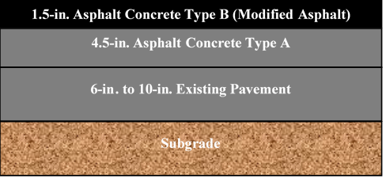
Figure 3.1 Typical pavement structures of US 287
(a)
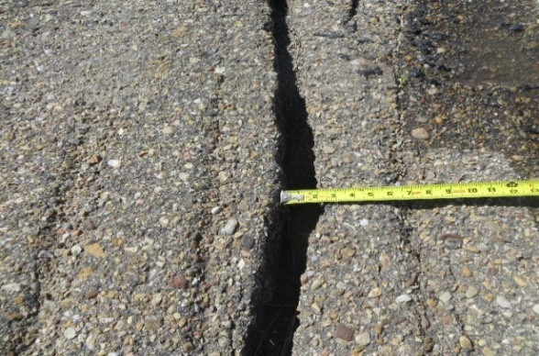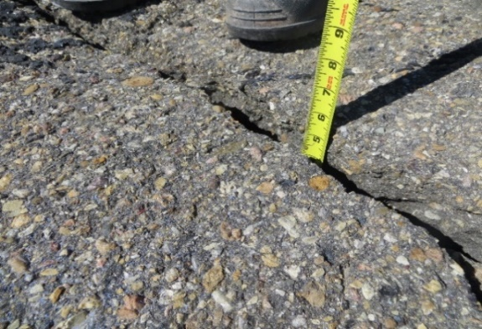
Crack width = 2-in.
Crack depth = 4.5-in.
(b) (c)
Figure 3.2 Typical transverse crack observed on US 287 in Cimarron County: (a) aerial view; (b) width; and (c) depth of crack
A similar problem was observed over a large segment of US 270 in Harper County. In this study, a segment of the pavement starting from 3-miles east of the US 283 and US 270 junction and extending 2-miles toward east was inspected initially for selecting the test site. A 1,500-ft test site was then selected within this segment. The pavement at this site was constructed in the 1980s. Figure 3.3 shows the typical structure of the pavement in the test section. A 2-in. asphalt concrete “Type B” mix with AC-20 binder was used to level the existing pavement. Another 2-in. asphalt concrete “Type B” mix with AC-20 binder was used as a surface course. Also, it was determined that the existing pavement had “Type A” mix with AC-20 binder. Thickness of the existing pavement was calculated using GPR images and inspection of asphalt cores. Based on the pavement maintenance data many of these cracks were developed before 2008. Figure 3.4 (a) shows a photographic view of the transverse cracks obtained from a Google Earth image. The width and depth of these cracks varied throughout the test section. Widths of some of these cracks varied between 1-in. and 5-in., with cracks often extending into the shoulder. Figures 3.4 (b) and 3.4 (c) show a photographic view a trasversed crack that was 4-in. wide and 9-in. deep. As noted above, many of these cracks were found to extend over the full width of the pavement, including shoulder.
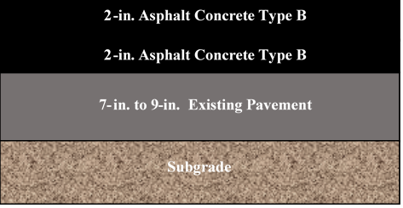
Figure 3.3 Typical pavement structure of US 270
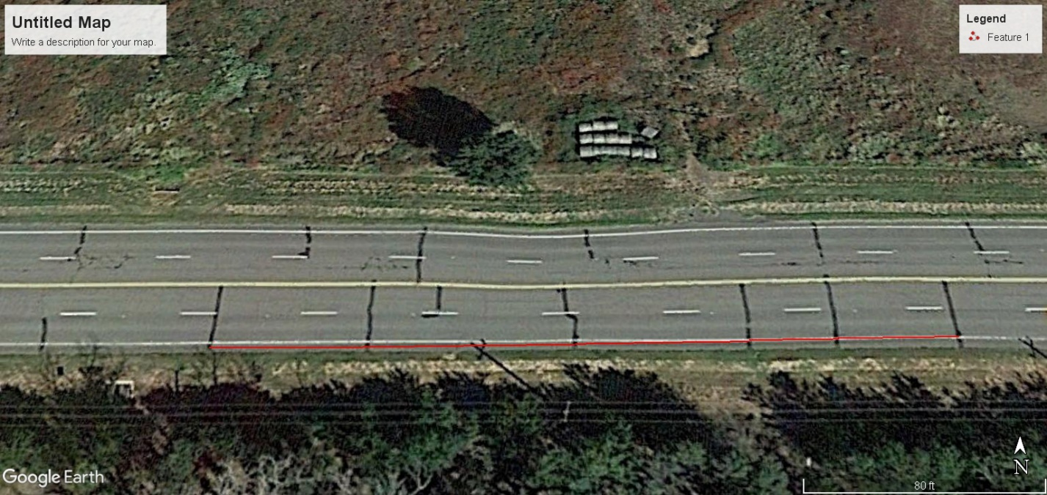
44-ft
32-ft
63-ft
75-ft
57-ft
(a)
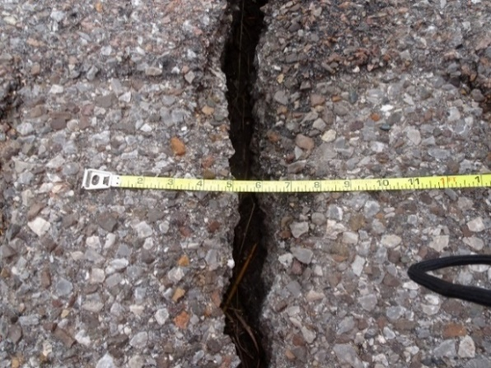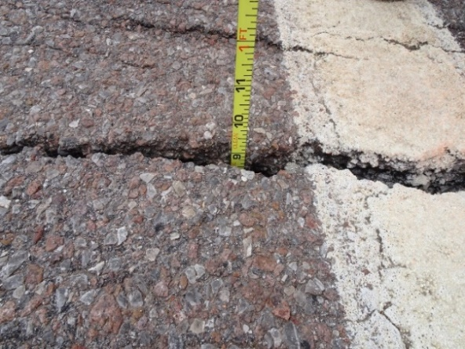
Crack depth = 9-in.
Crack width = 2.5-in.
(b) (c)
Figure 3.4 Typical transverse crack observed on US 270 in Harper County: (a) aerial view; (b) width; and (c) depth of crack

METHODOLOGY
In this study, a series of field and laboratory tests was selected, following the NCHRP 747 guidelines (Rada, 2013), to identify probable causes of transverse cracks at the selected test sites. In addition to field and laboratory testing, historical temperature data were used to examine the influence of thermal cycles with significant temperature differential. PMED simulations were used to identify the degree of influence of selected factors pertaining to pavement geometry, materials and traffic. As shown in Figure 3.5, field and laboratory investigations were used to determine the pavement thickness, crack propagation path, modulus of pavement layers, remaining life of the pavements, cracking resistance of asphalt, and subgrade support in terms of California Bearing Ratio (CBR) and composite modulus. Probable causes of transverse cracks in US 270 and US 287 were identified based on these findings. Temperature data from nearby weather stations were analyzed to determine extreme temperature events and variation of temperature in a single day. Also, a parametric study using PMED was performed to understand the influence of pavement thickness, binder PG, traffic and temperature on the development of transverse crack. Different test methods and their findings are presented in in the following sections. The results of the parametric study are discussed subsequently.
Figure 3.5 Workflow diagram for investigating transverse cracking in US 270 and US 287

Field and Laboratory Investigations

Field Investigation

Ground Penetrating Radar (GPR)
The ability of GPR tests in determining pavement distresses has been reported in a number of studies (Chen et al., 2003; Chen et al., 2005a; Chen et al., 2008; Krysiński and Sudyka, 2013). It is a versatile geophysical tool to investigate shallow subsurface features based on reflected electromagnetic (EM) waves (Krysiński and Sudyka, 2013; Everett, 2013). The GPR tests were used here to determine the layer thicknesses as well as voids, cracks, and other anomalies in the pavement structure. Several GPR profiles were selected at each site and data collected in both transverse and longitudinal directions surrounding cracks. The GPR unit used in this study was equipped with a 1,000-MHz antenna. Processing of the data included dewow filter, band pass filter (200–400–1600–2000 Hz), background removal, and automatic gain control (window length 10 ns). The GPR images were calibrated using the asphalt cores, which together with diffraction hyperbola analysis allowed assessment of the average EM wave propagation velocity of the pavement (0.1 m/ns for US 270 and 0.12 m/ns for US 287, respectively). Knowledge of this velocity is crucial to convert the GPR data to a depth image. Specifically, the GPR data were analyzed to identify disturbance zones and the probable crack propagation process (bottom-up or top-down).
Depth extent of the cracks was less prominently developed in the outer lane. Also, diffraction was more prominent in US 287 in the traffic lane than in shoulder. These results indicate that the cracks were likely initiated at the surface and propagated through the pavement (top-down cracks), as evident from Figures 3.6 (a) and 3.6 (b) and visual inspection of cores. One of the main observations from the GPR data is that the damage/disturbance zone was contained within the asphalt layer. Also, the GPR data did not find indication of settlements in the base and underlying layers. In addition, no reflective cracks were found from the GPR test results. Finally, asphalt layer thicknesses of both pavements were obtained from the GPR results. The asphalt layer thicknesses at both sites were found to vary along both transverse and longitudinal directions, as evident from Figures 3.6 (a) and 3.6 (b). The average asphalt thickness for US 270 and US 287 were found as 12-in. and 14-in., respectively. These results were also verified by the thicknesses of the cores taken from both sites. Mechanistically, pavement thickness is a major contributor to stiffness. Effect of variation in pavement thickness on transverse cracking characteristics was investigated using the PMED simulation. The results of the parametric study are discussed subsequently.
(a)
(b)
Figure 3.6 Processed longitudinal GPR profiles along US 270 (a) and US 287 (b). Depth conversion velocities are 0.1 m/ns (a) and 0.12 m/ns (b)

Falling Weight Deflectometer (FWD)
A total of 40 and 19 FWD tests were conducted on US 270 and US 287 test sites, respectively. The FWD tests were conducted on both non-cracked and close to cracked areas along the investigated sections. When the pavement surfaces were non-uniform, FWD tests were conducted near the cracks as an uneven surface would cause an uneven distribution of contact stress between the FWD plate and the pavement. In the FWD test used herein, impact loads were applied to the pavement surface and the pavement responses (vertical deflections) were measured using a series of geophone sensors (W1 to W7). The FWD test data were analyzed using MODULUS 7.0 (a back-calculation program for analyzing FWD data). In addition to normalized deflection (with respect to 9-kip load) and layer modulus, the software provides remaining pavement life. The normalized maximum deflections for sensor W1 for both sites are presented in Table 3.1. Typically, pavement structures with deflections less than 0.01-in. are considered structurally adequate (Chen and Scullion, 2008). The average normalized maximum deflection for US 270 and US 287 were found as 0.009-in. and 0.005-in., respectively. However, the normalized maximum deflections at few locations in US 270 exceeded 0.01-in. These test locations were near the cracked surface.
Table 3.1 Normalized W1 Deflections of US 270 and US 287
Normalized W1 Deflection (in.) | US 270 | US 287
Maximum | 0.019 | 0.007
Minimum | 0.004 | 0.002
Average | 0.009 | 0.005
Standard Deviation | 0.004 | 0.002
Variations in the modulus of asphalt layers for US 270 and US 287 are illustrated in Figures 3.7 (a) and 3.7 (b), respectively. The layer modulus of US 270 was found to vary between 100-ksi to 1,185-ksi with an average modulus of 545-ksi and a standard deviation of 293.2-ksi. The average layer modulus of US 287 was found as 907-ksi, with the maximum and minimum values being 1,328-ksi and 179-ksi, respectively, and a standard deviation of 333.4-ksi. The layer modulus of HMA generally varies between 100-ksi and 1,000-ksi (Rada, 2013; Smith et al., 2017). The probable reason behind these large variations in modulus are aging, variations in densities, and variations in asphalt thicknesses. Because the layer thicknesses varied throughout the test sites, the layer moduli obtained from the FWD data should be viewed accordingly. Overall, both pavements were found to have more than 10 years of remaining life, if maintained appropriately. The actual remaining life would also depend on traffic growth and other distresses. From the FWD tests, it can be concluded that both pavements sections currently have enough structural support except at few locations. The high modulus of asphalt layer is a potential contributing factor for transverse cracks observed in both pavements.

(a)

(b)
Figure 3.7 Variation of pavement layer modulus obtained from FWD testing: (a) US 270; and (b) US 287

Dynamic Cone Penetration (DCP)
DCP is used frequently to determine the in-situ strength of natural, compacted and stabilized soils. In this study, a 0.0176-kip DCP was used to determine the DCP index. The CBR and composite modulus of subgrade soils were estimated from the DCP index. Three DCP tests were conducted at the US 270 test section, whereas four tests were conducted at the US 287 test section, following the ASTM D 6951 test method (ASTM, 2009). The following equations were used to estimate the CBR and the composite modulus values:
$CBR= \frac{292}{{(DCP Index)}^{1.12}}$ (3.1)
where,
DCP Index = Rate of penetration of DCP (mm/blow).
$E \left(ksi\right)=2.55 {(CBR)}^{0.64}$ (3.2)
The DCP results for both sites are presented in Table 3.2. The CBR indices for the US 270 test site were found to vary from 17.8 to 35.8 with an average of 27.2 and a standard deviation of 9.0. Comparatively, the CBR indices of US 287 were found to vary from 18.3 to 43.7 with an average of 32.9 and a standard deviation of 10.6. The corresponding average composite modulus was found as 21.0-ksi and 23.6-ksi for the US 270 and US 287 test sites, respectively. These results indicate that the pavement at the US 287 test site has better base support than the pavement at the US 270 test site. The DCP test results were consistent with the FWD results where lower FWD deflections were observed in US 287. For US 287, except for one location, all moduli were larger than 10-ksi. The composite moduli of subgrade typically vary from 10-ksi to 50-ksi (Rada, 2013). Based on these results, it can be concluded that the base support under the asphalt layers is still structurally sound for both test sites. These composite subgrade moduli were used in the PMED simulations.
Table 3.2 DCP test results of US 287 and US 270
DCP Results | US 270 |  | US 287
DCP Results | CBR | Modulus (ksi) | CBR | Modulus (ksi)
Maximum | 35.8 | 25.2 | 43.7 | 28.6
Minimum | 17.8 | 16.1 | 18.3 | 16.4
Average | 27.2 | 21.0 | 32.9 | 23.6
Standard Deviation | 9.0 | 4.6 | 10.6 | 5.2

Physical Inspection of Asphalt Cores
Asphalt cores were extracted from selected locations of the US 270 and US 287 test sections. In US 270, 32 cores were extracted compared to 17 cores at the US 287 test section. Core dimensions were measured to determine the pavement thicknesses (Table 3.3) and to identify the crack initiation and propagation patterns and presence of reflective cracking and stripping (Figures 3.8 (a) and 3.8 (b)). The average core thickness of US 270 was 12.1-in. with a minimum and maximum thicknesses of 11.1-in. and 13.0-in., respectively. The core thicknesses of US 287 were found to vary from 12.4-in. to 16.0-in. with an average thickness of 13.4-in. and a standard deviation of 0.9-in. Influence of thickness variation on transverse cracking was further analyzed in the parametric study using the PMED simulations. However, no reflective cracking was found in any cores of both pavements. These results were consistent with the findings of GPR tests that did not detect any reflective cracking.
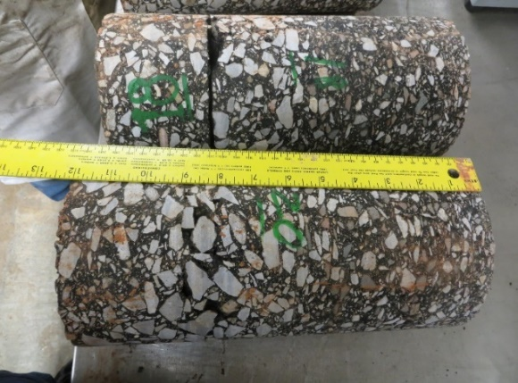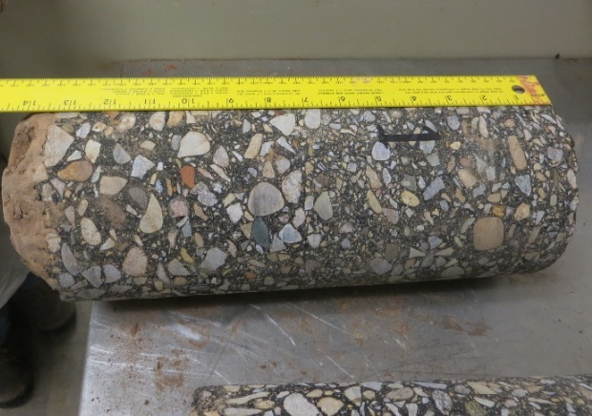
(a) (b)
Figure 3.8 Inspection of asphalt cores of (a) US 270 and (b) US 287

Table 3.3 Core Inspection Results of US 270 and US 287
Core Thickness (in.) | US 270 | US 287
Maximum | 13.0 | 16.0
Average | 12.1 | 13.4
Minimum | 11.1 | 12.4
Standard Deviation | 0.5 | 0.9

Laboratory Testing

Tests on Asphalt

Roadway Density
Roadway density tests were conducted on the top lifts of the asphalt cores according to OHD L-14 (ODOT, 2018) and AASHTO T 209 (AASHTO, 2012) test methods. Areas close to the transverse cracks were not tested for density as those would not represent the rest of the pavement structure. Roadway density test results are summarized in Table 3.4 for both sites. The minimum roadway density for the US 270 test site was found as 94.4% with an average of 95.7% and a standard deviation of 0.7%. Comparatively, the minimum roadway density of the US 287 test site was found as 93.5% with an average of 94.8% and a standard deviation of 1.0%. The percent densities observed at both pavements were within the range of normal service life. So, poor compaction of asphalt was not a likely contributing factor for the formation of transverse cracks.
Table 3.4 Roadway densities of US 270 and US 287
Roadway Density (%) | US 270 | US 287
Maximum | 97.3 | 96.9
Average | 95.7 | 94.8
Minimum | 94.4 | 93.5
Standard Deviation | 0.7 | 1.0

Illinois Flexibility Index Test (IFIT)
The Illinois Flexibility Index (IFIT) tests were conducted on semi-circular disk-shaped specimens at intermediate temperature (25°C) to determine the Illinois Flexibility Index (FI). These tests were performed on the top lift of the asphalt cores from both sites, following the AASHTO TP 124 (AASHTO, 2018a) method. For this purpose, a 2-in. thick asphalt core was separated from the top. The core was then cut into two semi-circular pieces and a notch of 0.6-in. depth was cut carefully on each of the semi-circular pieces. These tests were conducted by applying a monotonic load at 2-in./min until failure. For new asphalt pavements, a FI of 8 or more is considered as good cracking resistance. A FI value of less than 6 is considered as poor cracking resistance (Ozer et al., 2016). The IFIT test results are summarized in Table 3.5 for both sites. The FI of US 270 was found to vary from 1.6 to 5.6 with an average of 3.0 and a standard deviation of 1.5. Also, the FI of US 287 was found to vary from 2.1 to 10.1 with an average of 4.5 and a standard deviation of 2.2. According to Mandal et al. (2019), the FI value decreases with the aging of asphalt mixes and is very sensitive to binder’s high- and low-temperature PG. These results indicated poor cracking resistance for both sites. Therefore, the aging of asphalt could be a potential contributing factor for the formation of transverse cracks. The effect of binder high- and low-temperature PG on transverse cracking characteristics was evaluated using the PMED simulations. As noted above, the results of the parametric study are discussed in the subsequent section.
Table 3.5 IFIT test results of the asphalt cores from US 270 and US 287
Flexibility Index (FI) | US 270 | US 287
Average | 3.0 | 4.5
Maximum | 5.6 | 10.1
Minimum | 1.6 | 2.1
Standard Deviation | 1.5 | 2.2

Tests on Soils

Soil Properties
Soil samples were collected from boreholes close to pavement shoulder at the US 270 test section. Boring locations and frequency were decided after a preliminary field visit. Both disturbed and undisturbed or push-tube samples were collected for testing following ASTM D 1452 (ASTM, 2000). Laboratory tests were conducted to determine engineering properties of subgrade soils. Specifically, Atterberg Limits (namely, Liquid Limit (LL), Plastic Limit (PL) and Plasticity Index (PI)) were determined from the soil samples collected from each borehole. These tests were conducted according to the ASTM D 4318 (ASTM, 2017) method. The average LL, PL and PI was found as 30.0%, 13.2% and 16.8%, respectively. Also, the natural moisture content of the soil sample was determined following AASHTO T 265 (AASHTO, 2009). The water contents of soil samples were varied from 17.4% to 24.3%, with an average of 21.0%. The percentage passing #200 sieve was found as 61%. The soil sample was categorized as A-6 (i.e., lean clay). These soil properties were used in the PMED for modeling the subgrade.

Effect of Temperature Differential Cycles
Thermal cracking is a likely contributor to transverse cracking in areas where extreme low-temperature events and large variations in temperature take place within a short period of time (Islam and Tarefder, 2015; Zhang, 2015). Therefore, monthly data reports for the past 20 years (1999 to 2019) from the weather station close to US 270 and US 287 were collected in this study from the Oklahoma MESONET (MESONET, 2019). The temperature differential was computed from the difference in average temperatures for two consecutive days and maximum and minimum temperature of a day. The results are summarized in Table 3.6. Also, the highest and lowest temperature events and dates were identified and are presented in Table 3.7. It was found that the US 270 test site experienced a maximum difference of 20.4°C in two consecutive days. This site experienced 627 cycles of daily temperature differentials of 20°C or more in the past 20 years. The minimum temperature for this site was recorded as -22°C. Also, this test site experienced a minimum temperature of -10°C or lower 397 days in the past 20 years. Comparatively, the US 287 test site experienced a minimum temperature of -16°C, with a maximum difference in temperature being 26.7°C in two consecutive days. This site was found to experience 2,285 cycles of temperature differentials of 20°C or more in a day from 1999 to 2019. Also, the US 287 test site experienced a minimum of -10°C or lower temperature for 779 days during the same time. It is known that asphalt pavements become stiffer and brittle at low temperature, which can result in transverse crack. Therefore, extreme low-temperature events and large temperature differential cycles were likely contributing factors for the transverse cracking in pavements at both sites. The variations in transverse cracking with the variation of average daily temperatures are further discussed in the parametric study.
Table 3.6 Highest variations in temperature in two consecutive days
US 270 |  | US 287
Date | Differential (°C) | Date | Differential (°C)
3/16/2000 | 16.5 | 2/11/1999 | 17.1
9/23/2000 | 16 | 9/2/1999 | 16.7
11/29/2006 | 17.7 | 12/31/2010 | 17.8
1/12/2007 | 18.4 | 4/9/2013 | 18.1
12/31/2010 | 18.1 | 5/1/2013 | 16.2
2/21/2011 | 16.4 | 3/1/2014 | 16.5
4/4/2011 | 16.7 | 11/11/2014 | 16.1
1/17/2012 | 18.1 | 12/17/2016 | 26.7
11/11/2012 | 16.4 | 2/12/2017 | 15.8
11/11/2014 | 17.9 | 4/2/2018 | 16.4
2/15/2015 | 16.1 | -- | --
12/17/2016 | 19.4 | -- | --
1/12/2017 | 17.2 | -- | --
2/16/2018 | 16.1 | -- | --
4/1/2018 | 20.4 | -- | --
Table 3.7 Minimum and maximum temperatures observed for the test sites
US 270 |  | US 287
Minimum (°C) | Maximum (°C) | Minimum (°C) | Maximum (°C)
-22  (12/18/2016) | 44  (8/1/2012) | -16  (2/3/2011) | 41  (7/1/2018)

Parametric Study using AASHTOWare PMED
As noted throughout this paper, to attain a better understanding of transverse cracking of pavements at the test site, a parametric study was conducted using the PMED simulations. The pavement structure (layer thicknesses), material properties and existing traffic at these sites were obtained from the laboratory and field tests reported previously as well as from the ODOT databases. Specifically, subgrade resilient modulus was estimated from the DCP test results. Poison’s ratio, dynamic modulus, truck traffic classification, and monthly and hourly adjustment factors were obtained from the Level 3 database in PMED. The weather data from the climate station at Guymon was used in this study because it is the nearest weather station from both sites. It was assumed that the pavements at both sites were constructed in 1984. The design life of these pavements was considered as 20 years. Effect of the following parameters on transverse cracking was studied: pavement thickness, high- and low-temperature PG, and temperature differential. The design input variables along with the baseline values used in this parametric study are summarized in Table 3.8. A total of 1,115 PMED trial runs were performed to complete the test matrix for each site.

Table 3.8 PMED input variables
Input Variables | Input Values | Baseline (US 270) | Baseline (US 287)
Surface Thickness (in.) | 1.5, 2, 3, 4 and 5 | 4 | 1.5
Base Thickness (in.) for US 270 | 6, 7, 8 and 9 | 6 | --
Layer-2 Thickness* (in.) for US 287 | 4.5, 5.5, 6.5 and 7.5 | -- | 4.5
Layer-3 Thickness* (in.) for US 287 | 6, 7, 8 and 9 | -- | 6
High-temperature PG (°C) | 58, 64, 70 and 76 | 64 | 70
Low-temperature PG (°C) | -16, -22, -28 and -34 | -22 | -28
Temperature | -10%, -5%, 0%, +5%, and +10% | Temperature data of Guymon weather station, OK
Note: Asphalt layers of US 287 were divided into three layers, namely surface, Layer-2 and Layer-3 due to the variation of binder PG.

Effect of Pavement Thickness
Figures 3.9 and 3.10 show the variation of thermal cracking with pavement thickness. Thermal cracking intensity (ft/mile) was used as an indicator of transverse cracking performance. From Figure 3.9, it was observed that thermal cracking reduced with an increase in pavement thickness (surface layer). For example, the thermal cracking was found to reduce from 1,602-ft/mile to 1,575-ft/mile with a change in surface thickness from 4-in. to 5-in. for US 270. Also, it was observed that thermal cracking decreased with an increase in base thickness for a fixed surface thickness of both pavements (Figure 3.10). As noted in previous studies, a thicker pavement generally exhibits increased resistance to cracking and it takes longer time for cracks to propagate for pavements with sufficient ductility (Wagoner et al., 2005; Zhang 2015). Also, the fracture energy required for cracks to propagate increases with an increase in pavement thickness, which results in more resistances to thermal cracking (Wagoner et al., 2005; Zhang 2015). According to PMED, the design threshold for thermal cracking is 1,000-ft/mile (AASHTO, 2008). Based on this criterion, an increase in surface thickness would not have lowered the thermal cracking of the pavement in US 270 test site below this threshold. However, an increase in surface and base thicknesses lowered the thermal cracking below the threshold limit for the pavement at the US 287 test site.

Figure 3.9 Variation of thermal cracking with surface thickness

Figure 3.10 Variation of thermal cracking with pavement thickness

Effect of High- and Low-temperature PG of Binder
Figure 3.11 shows the variation of thermal cracking with high- and low-temperature PG of asphalt binder. From Figure 3.11, it was observed that thermal cracking reduced with an increase in high-temperature PG and a decrease in low-temperature PG. For example, thermal cracking was found to reduce from 1,832-ft/mile to 1,573-ft/mile with a change in high-temperature PG from 70°C to 76°C, while the low-temperature PG remained constant at -22°C for US 287. Also, the thermal cracking for US 270 was found to reduce from 1,483-ft/mile to 939-ft/mile with a change in high- temperature PG from 70°C to 76°C while the low-temperature PG remained constant at -22°C . Thermal cracking was found to decrease from 1,602-ft/mile to 483-ft/mile with a change in low-temperature PG from -22°C to -28°C while the high-temperature remained constant at 64°C for US 270. The curve was found to get flatter for stiffer binder (high-temperature PG of 70°C to 76°C) for US 287 and US 270, as shown in Figure 3.11. Also, as evident from Figure 3.11, the variation in thermal cracking with high-temperature PG for both pavements was found to be small when the low-temperature PG remained constant at -34°C. However, significant variations in thermal cracking with high-temperature PG were observed at low-temperature PGs less than -34°C. It was evident that for the same pavement thickness, low-temperature PG contributed more in resisting thermal cracking than high-temperature PG. Based on these results, it is evident that the PG of the binders was a likely contributing factor for thermal cracking at both test sites. The cracks could have been reduced by selecting proper binder grade during construction. These results indicate that using a PG 70-28 binder or a PG 76-28 binder would be a better choice in rehabilitation and reconstruction at these and other sites in the region than using a PG 64-22 binder.

Figure 3.11 Variation of thermal cracking with high- and low-temperature PG

Effect of Temperature Variation
As noted earlier, average daily temperature and hourly temperature variations play a vital role in the development of thermal cracks. Frequent temperature fluctuations have been observed in Harper County and Cimarron County, after analyzing the temperature data. In the parametric study conducted herein. The hourly temperature of Guymon weather station was varied between -10% to +10% of the average hourly temperature. The climate data from 1985 to 2020 were used for this purpose. For each case, PMED trial runs were performed for both sites. Variations of thermal cracking with temperature changes are presented in Figure 3.12. It was observed that the thermal cracking increased with an increase in hourly temperature fluctuations. For example, the thermal cracking increased from 1,602-ft/mile to 2,025-ft/mile with a change in hourly temperature fluctuation from 0% to 5% for US 270. According to Islam and Tarefder (2015), daily and yearly temperature fluctuations can cause 5% and 33% of total cracking of asphalt pavement, respectively. The hourly damage may be small for an hour or a single day. However, over time, this variation could cause significant cracking in the pavement.

Figure 3.12 Variation of thermal cracking with change in average hourly temperature

CONCLUSIONS AND RECOMMENDATIONS
In this study, the probable causes of transverse cracking in pavements observed at two sites in north-western Oklahoma were identified using laboratory and field investigation and parametric studies with PMED. Two pavement sections, namely, US 270 in Harper County and US 287 in Cimarron County of Oklahoma, were used for field and laboratory investigations. Based on the results presented in the preceding sections, the following conclusions can be drawn:
- From field investigation, many transverse cracks were found to extend over the full width of the pavement, including the shoulder. The GPR results indicated that the transverse cracks at both sites initiated at the surface and propagated through the pavement. The GPR results also indicated that these cracks did not result from reflective cracking of underlying layers. Based on the CBR and FWD results, the composite subgrade moduli indicated good subgrade support of the pavement structures and remaining service life of ten plus years, with proper maintenance. Furthermore, the PMED simulations indicated no significant contributions of traffic to transverse cracking.
- Analysis of extreme temperature events data collected from nearby climate station supported the probability of the formation of transverse cracks due to low-temperature events and temperature differential cycles. Also, the PMED simulations indicated that hourly temperature fluctuations over the service lives of both pavements could have contributed to the formation of thermal cracking. Therefore, it can be concluded that the transverse cracks at both sites might have resulted from thermal cracking.
- In addition to extreme low-temperature events and temperature differential cycles, the severities of transverse cracks were influenced by high variations in asphalt layer modulus and core thickness, low cracking resistance and aging of the pavement. These findings were validated by the GPR results, physical inspection of asphalt cores, FWD tests and IFIT tests results. The parametric study using PMED simulations indicated that the hourly variation of temperature might have caused significant cracking over time.
- The parametric study indicated that the transverse cracking in US 270 and US 287 could have been reduced by selecting proper binder grade and increasing pavement thickness. Selection of binder with appropriate PG for reconstruction or rehabilitation (e.g., milling and overlays) would be helpful to resisting transverse cracking in both pavements in the future.
- A hybrid approach involving field and laboratory testing and a parametric study using the PMED simulation was found to be an effective tool in identifying probable causes of transverse cracking in pavements.
The findings of this study can be used in designing new pavements and selecting the remedial options for limiting transverse cracking in pavements in areas with low temperatures and large hourly temperature differential. Alternative remedial measures, for example, milling and overlays of different thicknesses and binder PGs may be evaluated using PMED simulations to limit future transverse cracking problems. Because the results of this study are based on the traffic, material and climatic condition of US 287 in Cimarron County and US 270 in Harper County, appropriate judgments should be exercised in using these findings to pavements with different conditions. Also, effects of undulations along the longitudinal profile and soil sulfate on transverse cracking were not considered in this study due to limited scope. Such effects can be addressed in future studies.

CAUSES OF FATIGUE CRACKING IN FLEXIBLE PAVEMENTS IN OKLAHOMA: A CASE STUDY USING LABORATORY AND FIELD INVESTIGATION AND AASHTOWARE SIMULATION

ABSTRACT
Fatigue cracking is one of the major structural distresses in flexible pavements. In this study, probable causes of fatigue cracking were investigated using field and laboratory testing and AASHTOWare Pavement ME Design (PMED) simulations. A set of field tests was performed on a flexible pavement section of US 412 located in Noble County, Oklahoma. Also, asphalt cores and soil samples were collected for laboratory testing. The Ground Penetrating Radar (GPR) test results revealed significant delamination in the asphalt layer. Also, the GPR images indicated that the disturbance zone was confined within the asphalt layer and cracks were generated from surface as well as from existing pavement layers below. The Dynamic Cone Penetration (DCP) and Falling Weight Deflectometer (FWD) test results indicated that the pavement section was not structurally adequate to support traffic and needed rehabilitation in the near future. The moduli of the asphalt layers were found to be quite low indicating improper compaction during construction. Also, the densities of the top-lifts of the asphalt cores were found to be low. Moreover, the cracking resistance of the extracted asphalt cores was poor based on the Illinois Flexibility Index Test (IFIT) results. Superpave Performance Grade (PG) of the extracted binder indicated excessive aging of the binder due to the long exposure to the environment. The brittleness of mix resulting from aging was considered a potential contributor to fatigue cracking of the pavement at this site. A parametric study was conducted to understand the variation of fatigue cracking with the changes in input properties in PMED, namely pavement structural components and material properties. Pavement thickness, roadway densities and layer moduli of existing underlying pavement were found as the most influential factors. The findings of the parametric study supported the findings of the field and laboratory investigation.
Keyword: Fatigue cracking; PMED; Delamination; Aging.

INTRODUCTION
Fatigue cracking is one of the common pavement distresses and is responsible for failure of approximately 38% asphalt pavements in the U.S. and many other countries (Huang, 2004; Wang et al., 2005; Suo and Wong, 2009; West et al., 2018). Fatigue cracks generally appear as a series of interconnected cracks developed due to the fatigue failure of an asphalt layer or a stabilized base layer or both under the action of repeated traffic loading. Two types of fatigue cracks are usually observed in asphalt pavements, namely bottom-up fatigue cracking and top-down fatigue cracking (Huang, 2004; Papagiannakis and Masad, 2017; Sun et al., 2018). The bottom-up cracks generally initiate at the bottom of an asphalt layer or a stabilized base layer, where the tensile stress under wheel load exceeds the tensile strength of the material. These cracks propagate to the surface under the action of repeated traffic loads (Huang, 2004; Molenaar and Pu, 2008). Top-down fatigue cracks are generally observed alongside the wheel path in asphalt pavements (Uhlmeyer et al., 2000; Schorsch et al., 2004; Sun et al., 2018). This type of cracking is generally observed within 2-6 years of opening to traffic (Schorsch et al., 2004). These cracks initiate at the surface of the asphalt layer and propagate towards the bottom. Two different hypotheses have been reported in the literature regarding the mechanisms of top-down fatigue cracking. Some researchers believe that the top-down fatigue cracks are caused by the shear stresses induced by repeated excessive pressure at the tire edges (Molenaar, 1984; Hugo and Kennedy, 1985; Wang and Al-Qadi, 2010). According to the second hypothesis, these cracks are caused by non-uniform tire-pavement contact pressure at the top of asphalt surface (Bensalem et al., 2000; Myers, 2000; Wang et al., 2003).

OVERVIEW OF PREVIOUS STUDIES
Several studies have been conducted previously to investigate fatigue cracking performance of asphalt pavements in the field (Uhlmeyer et al., 2000; Raad et al., 2001; Park and Kim, 2015; Shen et al., 2016; Norouzi and Kim, 2017; Alae et al., 2020). For example, Uhlmeyer et al. (2000) investigated the field fatigue cracking performance of 24 asphalt pavements in Washington. In that study, top-down fatigue cracking was observed in thicker pavements, whereas full depth cracks were observed in thinner pavements. Increased traffic load and excessive thickness of asphalt layer were identified as the reasons behind top-down fatigue cracking (Uhlmeyer et al., 2000). Raad et al. (2001) investigated the effect of field aging on the fatigue cracking performance of asphalt pavements. In that study, laboratory fatigue tests were conducted on beam specimens collected from a 10-year old pavement section located in Southern California at -2°C and 22°C. A comparison of these results with unaged specimens indicated a reduction in fatigue resistance with aging in the field. Also, fatigue life was found to depend on the stiffness of pavement components (Raad et al., 2001). Chen (2009) investigated the causes of bottom-up fatigue cracking in US 281 in Texas. In that study, week and moisture susceptible base was found as the root cause of bottom-up fatigue cracking. Lee et al. (2013) investigated the causes of delamination and its effect on top-down fatigue cracking in Interstate-65 (I-65) in Indiana. Weak interface bond, aging of binder and inadequate compaction resulting higher air void contents were identified as the causes of delamination. The weak bonding at the delaminated interface was found to be a major contributor of top-down fatigue cracking in I-65 (Lee et al., 2013). Park and Kim (2015) investigated the causes of fatigue cracking of asphalt pavements in North Carolina. In that study, pavements with high binder content were found to be less prone to top-down fatigue cracking. Also, mixes with finer gradation were found to exhibit better fatigue resistance compared to coarse graded mixes. Also, debonding at interfaces between layers and road widening works were found to be responsible for top-down fatigue cracking in asphalt pavements in North Carolina (Park and Kim, 2015). Shen et al. (2016) developed a statistical framework for predicting the top-down cracking of asphalt pavement. The probability of initiation of top-down crack was found to depend on overlay thickness, density, binder fracture energy, percentage passing #200 sieve and service life of the pavement. The propagation of top-down crack was found to be influenced by total pavement thickness, air void percentage, percentage passing #200 sieve, Indirect Tensile Strength (ITS) of asphalt cores and Annual Average Daily Truck Traffic (AADTT) (Shen et al., 2016). Alae et al. (2020) investigated the effect of interlayer bonding conditions on top-down fatigue cracking. Thickness of asphalt layer, type of base material and temperature were found to affect the horizontal strains at the surface and debonding locations significantly. Thick pavements with a granular base showed significant top-down fatigue cracking at high temperatures, whereas thinner pavements exhibited bottom-up fatigue cracking (Alae et al., 2020). Also, fatigue cracking can be influenced by poor compaction, moisture damage, excessive aging and inaccurate binder grade, (Lee et al., 2013; Rada, 2013; Zhang, 2015).
Selection of appropriate field and laboratory tests is necessary to identify probable causes and mechanisms of fatigue cracking in flexible pavements. The Ground Penetrating Radar (GPR), Falling Weight Deflectometer (FWD) and Dynamic Cone Penetration (DCP) have been mentioned as important field tests for assessing fatigue cracking (Chen and Scullion, 2007; Chen and Scullion, 2008; Rada, 2013). Chen and Scullion (2007) used GPR to determine pavement thickness, presence of stripping and crack propagation (top-down and bottom-up) inside the asphalt layers. The FWD test is generally used to determine the structural capacity of pavements using deflections of geophone sensors (Chen and Scullion, 2008; Rada, 2013). The structural capacity of aggregate base and subgrade in terms of composite moduli and California Bearing Ratio (CBR) indices can be determined from the DCP test (Rada, 2013). Also, roadway density test, Semi-Circular Bend (SCB) test, Texas Overlay and Direct Tension (DT) test have been recommended as important laboratory tests for assessing fatigue characteristics of asphalt pavements (Uhlmeyer et al., 2000; Lee et al., 2013; Rada, 2013; Park and Kim, 2015).
The above reviews suggest that a hybrid approach, by combining field and laboratory investigations with a parametric study using PMED, would be a useful tool for determining probable causes of fatigue cracking in asphalt pavements. The present case study uses a hybrid approach to investigate fatigue cracking in asphalt pavements. Several studies have been conducted previously to determine the degree of influence of design input variables on fatigue cracking performance of flexible pavement using AASHTOWare Pavement ME Design (PMED) (Kim et al., 2005; Graves and Mahboub, 2006; Li et al., 2012; Schwartz et al., 2013). The same software is used in the present case study to examine the influence of the following parameters on fatigue cracking: Asphalt layer thickness, PG of binder, moduli of existing pavement, and roadway densities.

OBJECTIVES
This case study aims to investigate the probable causes of fatigue cracking in flexible pavement using a hybrid approach involving both laboratory and field testing and PMED simulations. Specifically, fatigue cracking observed at a test site in US 412 in Noble County, Oklahoma was investigated using the hybrid approach. The specific objectives of this study are:
- To determine probable causes of fatigue cracking in US 412 using field and laboratory testing.
- To evaluate the influence of different design input variables, namely pavement geometry and material properties on fatigue cracking performance using a parametric study using PMED. Use the combined results from the parametric study and laboratory and field investigations to identify the major contributors of fatigue cracking in US 412.

SITE DESCRIPTION
The pavement section of US 412 in Noble County, starting from Garfield/Noble County line and contuniung eastward for seven miles, has experienced severe fatigue cracking, as shown in Figures 4.1 (a) and 4.1 (b). Specifically, significant amounts of alligator cracks and longitudinal cracks have been observed along the wheel path. A 2,500-ft long test section, from (36.397838, -97.416591) to (36.397864, -97.408843), was selected within this segment for evaluation. Based on the available construction records collected from the Oklahoma Department of Transportation (ODOT), the existing pavement was built in the 1980s using “Type A” mix with AC-20 binder. The AC-20 binder was considered equivalent to Superpave PG 64-22. A resurfacing work was performed in 2009. During that work, a 2.5-in. asphalt layer was constructed with a “Type S4” mix with PG 70-28 OK binder on the top of the existing pavement. Figure 4.2 shows a typical pavement section of the study site, collected from the resurfacing work. This section was constructed to carry an Average Daily Traffic (ADT) of 5,500 with 20% truck. Thicknesses of the existing asphalt and base layers were obtained from the GPR tests and inspection of extracted cores. Also, laboratory tests, namely Atterberg Limits, were performed to classify the subgrade soil. These inputs were also used in the PMED for simulating the pavement structure in PMED. These investigations are discussed subsequently.
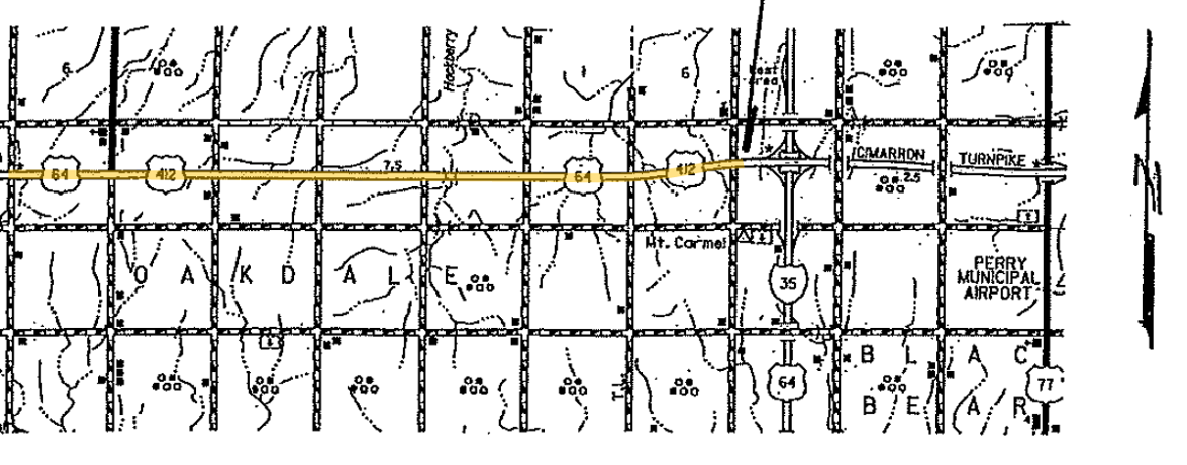
END
Garfield/Noble County line

START

(a)
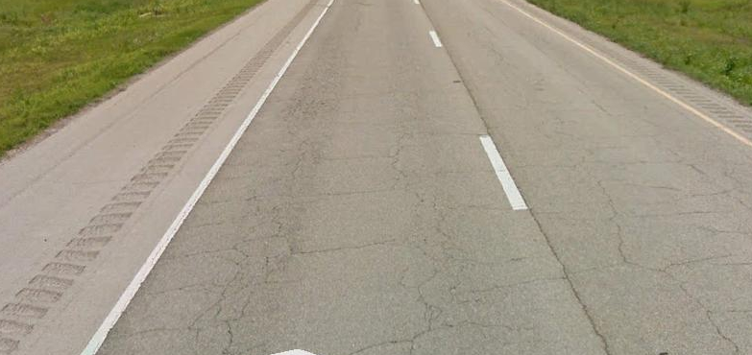
(b)
Figure 4.1 Typical fatigue cracks observed in US 412 in Noble County: (a) project location; and (b) Google satellite view
Figure 4.2 Typical pavement section of US 412 in Noble County

METHODOLOGY
To investigate the causes of fatigue cracking, several field tests, namely Ground Penetrating Radar (GPR), Falling Weight Deflectometer (FWD), and Dynamic Cone Penetration (DCP), were conducted at the test site. Asphalt cores and soil samples were collected for laboratory testing, namely Illinois Flexibility Index Test (IFIT), roadway density, binder PG and Atterberg Limits. In addition to field and laboratory testing, PMED simulations were performed to identify the relative influence of layer thicknesses and material properties on the fatigue cracking characteristics. The methodology used in the present study is presented as a flow-chart in Figure 4.3. Pavement thickness, presence of delamination, layer moduli, roadway densities and cracking resistance of asphalt mix were determined from the field and laboratory investigations. Input variables for the PMED simulations were selected based on the field and laboratory test results. Relative influence of pavement thickness, layer moduli, roadway density and binder PG on fatigue cracking was determined using the parametric study.
Figure 4.3 Flowchart for investigating fatigue cracking in US 412

Field Investigations

Ground Penetrating Radar (GPR)
Ground penetrating radar (GPR) is a frequently used nondestructive field test for pavement inspection which employs radio waves to map structures and subsurface features (Chen and Scullion, 2008; Solla et al., 2014). In this study, GPR tests were performed at selected locations in both longitudinal and transverse directions. The GPR images were calibrated by comparing with the asphalt cores, as shown in Figure 4.4. Significant delamination in the asphalt layers was observed from the GPR images, as shown in Figures 4.4 and 4.5. Also, delamination of asphalt layers was verified by physical inspection of extracted asphalt cores. Core inspection results are discussed in the subsequent section. Delamination is believed to be one of the major influential factors for initiating top-down and bottom-up fatigue cracking and reduction in fatigue life of a pavement (Kulkarni, 2005; Paul, 2010; Tarefder and Bateman, 2011; Lee et al., 2013; Park and Kim, 2015; Cho et al., 2019; Alae et al. 2020). As noted in previous studies, significant transverse strains develop at the surface of a delaminated and debonded pavement, which appear as top-down fatigue cracking (Alae et al., 2020). Also, after delamination, bottom asphalt layers act as a base support for the top asphalt layer. The tensile strains at the bottom of the upper layer (called “delaminated layer” for convenience) cannot be transferred to asphalt layers below. As a result, tensile stress concentration develops at the bottom of the delaminated layer. Due to repeated traffic loading these tensile stresses exceed the tensile strength of the material and result in bottom-up fatigue cracking (Zaghloul et al., 1995; Walubita and Scullion, 2007; Ziari and Khabiri, 2007). It has been reported that delamination in asphalt layers can be caused by weak interface bond, stripping, aging of the binder and/or low roadway density (Kulkarni, 2005; Paul, 2010; Lee et al, 2013). All of these factors were evaluated in this study. It was evident from the GPR images that cracks were generated from the surface (top-down) as well as from the existing pavement layer (bottom-up) (Figure 4.5). Distinct delamination was observed at two different depths, dividing the overall asphalt into three layers. Also, significant stripping was observed in several extracted asphalt cores. Thickness of the top layer was found to vary from 2-in. to 2.5-in. Thickness of the middle layer was found to vary from 4-in. to 7-in. and thickness of the bottom asphalt layer was found to vary from 3-in. to 4-in. In addition, thickness of asphalt treated aggregate base (also known as “hot sand”) in US 412 was obtained from the GPR images. The base thickness at this site was observed to vary from 7-in. to 8.5-in. These results were also verified by physically inspecting the cores extracted from the test site. Relative influence of the variation in asphalt thickness on fatigue cracking characteristics was further investigated using the PMED simulations. The results of the PMED simulations are discussed subsequently.
Figure 4.4 Calibration of GPR image with core
Figure 4.5 Longitudinal profile of US 412

Falling Weight Deflectometer (FWD)
In this case study, 20 FWD tests were conducted on the test section following the ASTM D4694 – 09 (ASTM, 2015) test method. In this study, a JILS-20 FWD equipment with a 12-in. diameter loading plate and 7 geophone sensors (W1 to W7) was used for the FWD tests. The impact loads were varied between 11.4-kip to 12.2-kip. The MODULUS 7.0 program was used to analyze the FWD data and calculate normalized maximum deflection of W1 sensor (with respect to 9-kip load), layer modulus and remaining life of the pavement. Figure 4.6 shows the variation of normalized maximum deflections of W1 sensor with FWD stations at the test site. It was observed that the normalized maximum deflections for W1 sensor varied from 0.011-in. to 0.021-in. with an average of 0.015-in. and a standard deviation of 0.002-in. According to Chen and Scullion (2008), normalized deflection of W1 sensor for typical pavement should be less than 0.01-in. Thus, the normalized maximum deflections at all locations exceeded this limit. Based on this criterion, it can be concluded that the pavement section at this test site was not structurally sound. Delamination leads to loss of integrity of the pavement structure and increased deflections or deflection bowl in FWD testing. Also, presence of cracks on the surface and within the pavement layer leads to increased normalized deflections experienced during FWD testing (Qiu et al., 2014; Wang et al., 2019). These increased deflections resulted in low asphalt layer moduli (Qiu et al., 2014). Presence of numerous cracks at this site made it difficult to avoid cracks within the deflection bowl.
Figure 4.7 shows the variation of layer modulus of the asphalt layer with FWD stations. The layer modulus was found to vary from 75.0-ksi to 200.0-ksi with an average of 120.8-ksi and a standard deviation of 40.0-ksi. The layer modulus of HMA generally varies between 100-ksi to 1,000-ksi (Rada, 2013; Smith et al., 2017). Several locations exhibited a layer modulus less than 100-ksi, which is very low. Overall, the layer moduli were low and found to vary throughout the pavement section (Figure 4.7). The probable reasons behind these low layer moduli could be aging, low roadway densities and variations in asphalt layer thicknesses (Qiu et al., 2014). Effects of these factors on fatigue cracking are discussed in respective sections. Also, the layer moduli of base and subgrade were determined from the FWD test results. The layer modulus of subgrade was found to vary from 4.0-ksi to 26.6-ksi with an average of 11.0-ksi and a standard deviation of 6-ksi. Effect of variations in layer moduli on fatigue cracking was further investigated using PMED simulations. Results of the PMED simulation are discussed subsequently. Overall, the pavement section was found to have 2 to 5 years of remaining life, based on the FWD analysis.

Figure 4.6 Variation normalized maximum W1 deflection for US 412

Figure 4.7 Variation of asphalt layer modulus with FWD station for US 412

Dynamic Cone Penetration (DCP) Tests
The DCP is a versatile testing device that can be used to determine the in-situ strength of the base and subgrade without digging a test pit or collecting soil samples. In this study, a 0.0176-kip DCP was used to determine the subgrade support condition in terms of California Bearing Ratio (CBR) and composite modulus of subgrade soil. In this study, DCP tests were conducted at three core locations following the ASTM D6951 (ASTM, 2009) test method. The CBR indices and subgrade composite moduli were calculated using Equations (4.1) and (4.2) (Chen et al., 2005b), respectively.
$CBR= \frac{292}{{(DCP Index)}^{1.12}}$ (4.1)
where,
DCP Index = Rate of penetration of DCP (mm/blow).
$E \left(ksi\right)=2.55 {(CBR)}^{0.64}$ (4.2)
Table 4.1 presents a summary of the DCP results. The CBR indices were found to vary from 5.5 to 26.1 with an average of 17.3 and a standard deviation of 10.7. Also, the average modulus was found to vary from 7.6-ksi to 20.1-ksi with an average of 14.7-ksi and a standard deviation of 6.5-ksi. According to Rada (2013), typically the composite moduli of subgrade vary from 10-ksi to 50-ksi. It was observed that the composite subgrade modulus at Core#11M was less than 10-ksi. Also, it was found that the DCP results are consistent with the higher FWD deflections observed at the test site. Based on these results, it can be concluded that the subgrade support under the asphalt layer is still structurally sound except at Core#11M. DCP results were used in the PMED simulations for modeling subgrade.
Table 4.1 DCP test results
Parameters | Maximum | Minimum | Average | Standard Deviation
CBR | 26.1 | 5.5 | 17.3 | 10.7
Modulus (ksi) | 20.1 | 7.6 | 14.7 | 6.5

Physical Inspection of Asphalt Cores
Eleven asphalt cores were extracted from the test site to physically observe the conditions of the existing pavement and to measure thickness. Core dimensions were measured and are summarized in Table 4.2. The total asphalt layer thickness of this pavement was found to vary between 10.5-in. and 12.5-in., with an average of 11.7-in. and a standard deviation of 0.57-in. Effect of pavement thickness on top-down and bottom-up fatigue cracking was further investigated using PMED simulations. These cores were inspected to identify the presence of delamination and stripping, as shown in Table 4.2 and Figure 4.8. Significant delamination was observed in all extracted cores (Figure 4.8 (a)). Delamination was also verified by visually inspecting inside the core-holes just after drilling (Figure 4.8 (b)). Asphalt cores were found to be delaminated and divided into three layers namely, a top layer of 2-in. to 2.5-in thick, a middle layer of 4.9-in. to 6.1-in. thick and a bottom layer of 3-in. to 3.5-in thick. As mentioned in the construction record, a 2.5-in. overlay was constructed in 2009. The overlay layer was found to be delaminated from the existing pavement as evident from the GPR images and cores inspections (2-in. to 2.5-in. top delaminated layer). As reported in the literature, delamination or debonding is one of the important contributors to both top-down and bottom-up fatigue cracking (Lee et al., 2013; Park and Kim, 2015; Alae et al., 2020). Significant stripping was observed near the delaminated layer at several locations as shown in Figure 4.8 (a). In the present test site, both bottom-up and top-down cracks were observed, as shown in Figures 4.9 and 4.10, respectively. For example, in Core#11M, a bottom-up crack was observed to start from 2.5-in. below the surface (Figure 4.9 (a)). A 1.5-in. segment was removed from the surface of this core to observe the extent of the crack. Figure 4.9 (b) shows the crack after removing the top 1.5-in layer. As noted previously, the pavement structure lost its integrity after delamination and the bottom layers acted as base support and not as an integral part of the overlay. It is postulated that tensile stresses developed at the bottom of the overlay exceeding its tensile strength and developing bottom-up cracking. Figure 4.10 shows a top-down fatigue crack observed in Core#7M. The crack was found to start from the top and extend to a depth of 1.6-in. (Figure 4.10 (a)). As Core#7M was severely damaged due to excessive cracks and stripping, it completely disintegrated into several pieces during extraction, as shown in Figure 4.10 (b). These results were found to be consistent with the GPR results, as described in the previous section. However, no reflective cracking from the aggregate base was observed in any of these cores. Therefore, it was concluded that the cracking problem was confined in the asphalt layer itself.

Table 4.2 Thicknesses of Asphalt cores extracted from US 412
Core ID* | Thickness of Asphalt Cores (in.) | Thickness of Asphalt treated Aggregate Base (in.) | Remarks**
1M | 12.5 | 8.1 | Delamination at 2.17-in., 8.27-in. and 12.36-in.
2W | 11.6 | 9.4 | Delamination at 7.87-in. and 11.61-in.
3M | 11.4 | 9.1 | Delamination at 2.17-in., 7.68-in. and 11.61-in.
4W, 4M | 12.2 | 8.3 | 4W disintegrated into several pieces; 4M delaminated at 1.97-in., 8.27-in., and 12.20-in.
5M | 11.8 | 8.3 | Delamination at 2.56-in. and 8.46-in.
6M | 11.8 | 9.3 | Delamination at 1.97-in, 8.15-in. and 11.81-in.
7M | Disintegrated into several pieces
8M | 12.1 | 8.7 | Delamination at 2.09-in., 8.07-in. and 12.01-in.
9M | 11.4 | 8.7 | Delamination at 8.66-in.
10M*** | 7.5 | -- | Delamination at 1.77-in.; Bottom-part could not be pulled-out by coring. Discarded from thickness calculation
11M | 10.5 | 8.5 | Delamination at 7.48-in.
Average | 11.7 | 8.7 | --
Maximum | 12.4 | 9.4 | --
Minimum | 10.5 | 8.1 | --
Standard Deviation | 0.57 | 0.5 | --
*W and M indicates core locations at the wheel path and at the middle of two wheel paths, respectively.
**Delamination was measured from top of the cores.
***Core#10M could not extracted fully during coring. May be there was a delamination in the bottom part of the pavement. Therefore, this core was excluded from thickness calculations.
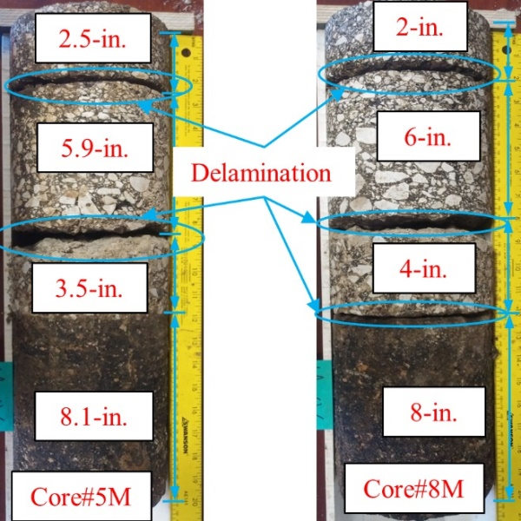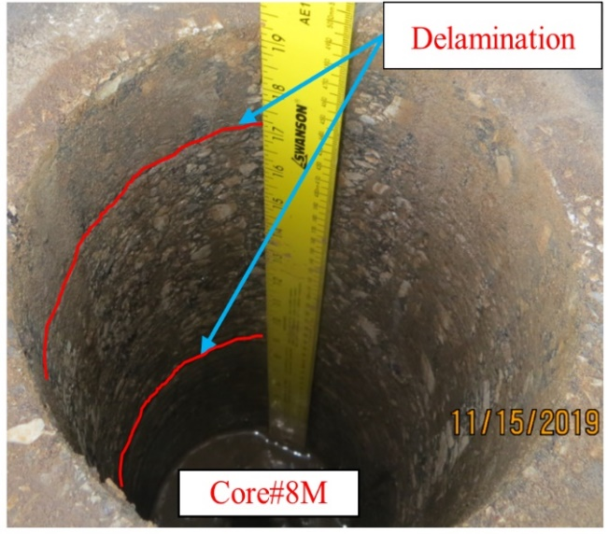
(a) (b)
Figure 4.8 Delamination in asphalt cores: (a) cores; and (b) core-hole
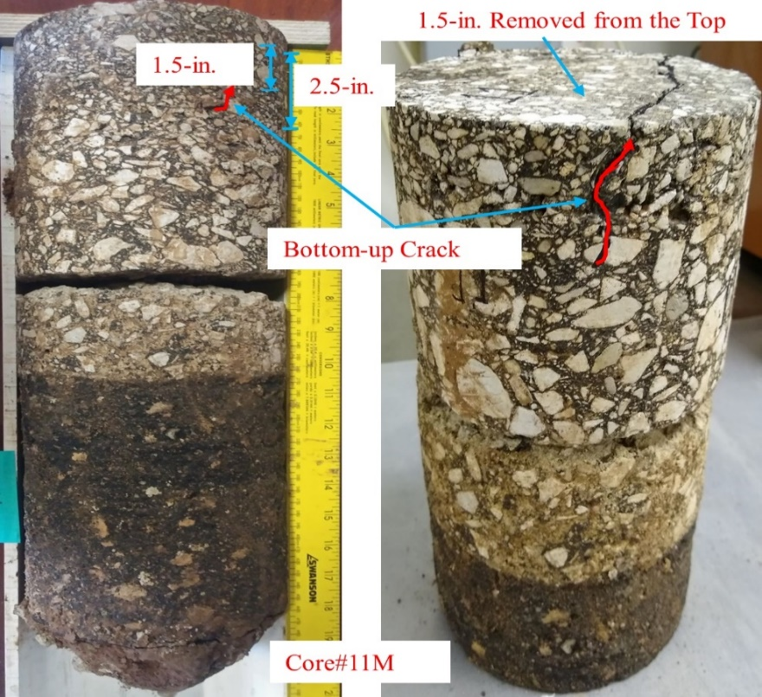
(a) (b)
Figure 4.9 Bottom-up crack at Core#11: (a) full core; and (b) core after removing 1.5-in. from the top
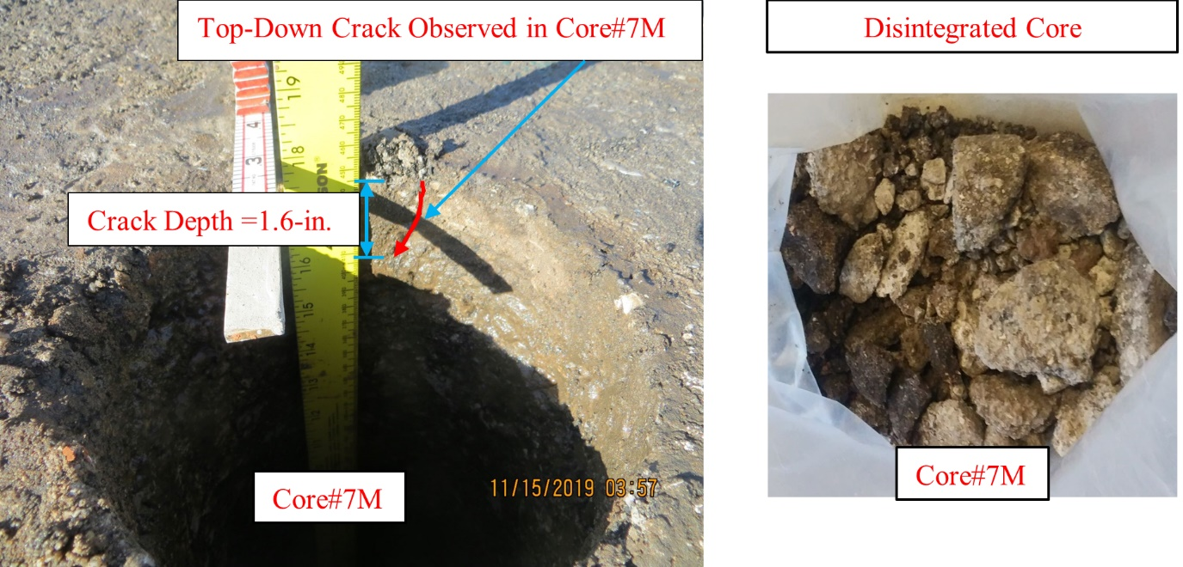
(a) (b)
Figure 4.10 Top-down crack at Core#7: (a) core-hole; and (b) disintegrated core

Test on Asphalt Cores

Roadway Density
The OHD L-14 (ODOT, 2018) and AASHTO T 209 (AASHTO, 2012) methods were used to conduct the roadway density tests on the top lift of asphalt cores. Variations in roadway densities are presented in Figure 4.11. The density of the top lift of asphalt cores was found to vary between 91.4% to 94.3% with an average of 92.7% and a standard deviation of 1.2%. ODOT requires a minimum density of 92% during the construction of HMA (ODOT, 2014b). Also, roadway density is expected to increase over time with the increase in cumulative traffic (ESAL). The percent densities observed in this pavement were well below the range of normal service life. Poor compaction of asphalt layer during construction might have resulted in low roadway densities as well as delamination and fatigue cracking. The influence of roadway densities on fatigue cracking was further evaluated using PMED simulations and their results are discussed subsequently.

Figure 4.11 Density of asphalt cores

Illinois Flexibility Index Test (IFIT)
The IFIT tests were performed on semi-circular asphalt specimens at an intermediate temperature to assess the overall cracking resistance. In this study, a total of 6 semi-circular disk-shaped specimens were tested at intermediate temperature (25°C) by applying a monotonic load of 2-in./min. The fracture energy (G_{f}) and the Illinois Flexibility Index (FI) values of the specimens were determined following the AASHTO TP 124 (AASHTO, 2018a) method. For this purpose, the top-lift (approximately 2-in.) was separated from the asphalt core using a laboratory saw. Two semi-circular specimens with a notch of 0.6-in. depth were prepared carefully from each top-lift. Typically, a FI value of 8 or more is considered as good cracking resistance whereas a FI value of less than 6 is considered as poor (Ozer et al., 2016). The FI was found to vary from 0.07 to 0.23 with an average of 0.15 and standard deviation of 0.06. These results indicated extremely poor cracking resistance of the asphalt mix. It is likely that both low roadway density and aging of asphalt mix have played an influential role in the poor cracking resistance as well as in the development of fatigue cracks in US 412. It should be noted that the IFIT limits are applicable to fresh asphalt mixes. The FI values for in-service pavements are expected to reduce due to the aging of the mix, among other factors. No limits for the FI values of in-service pavements are currently available (Ozer et al., 2016). Such limits may be established in future research.

Binder Extraction and Performance Grading (PG)
The high-temperature PG of the extracted binder was determined to assess the aging of the mix used in constructing the 2.5-in asphalt layer. Asphalt binders were extracted from the top-lifts of cores following AASHTO T164-14 (AASHTO, 2018b) and using a reagent grade Trichloroethylene (TCE) solvent. The extracted binder was then recovered using a Rotary evaporator following ASTM D5404/D5404M-12 (ASTM, 2012). The high-temperature true PG of the extracted binder was determined following AASHTO M 320-17 (AASHTO, 2018c). The high-temperature true PG of extracted binder was found as 112.9°C. From the construction records, the high-temperature PG of the original binder of the overlay was found as 70°C. Therefore, it can be concluded that the mix has undergone significant aging during service. It is known that aging of binder reduces the cracking resistance of asphalt mixture. This finding is consistent with the IFIT results.

Tests on Soils
Soil samples from boreholes close to pavement shoulder of the test section were collected for testing using a hand auger following ASTM D1452 (ASTM, 2000). The ASTM D4318 (ASTM, 2017) method was used to determine the Atterberg Limits (namely Liquid Limit (LL), Plastic Limit (PL) and Plasticity Index (PI)) of the collected soil samples. The average LL, PL and PI was found as 29, 46 and 17%, respectively. Also, the percentage passing #200 sieve was determined as 65%. The soil sample was categorized as A-7-6. These soil properties were used in representing the subgrade in PMED simulations.

PMED Simulation
A pavement structure identical to US 412 was modeled in the PMED (Version 2.5). The construction date of the existing pavement was assumed as 1986, as per ODOT record. A 2.5-in. overlay of “Type S4” mix with PG 70-28 OK was constructed in 2009. An ADT of 5,500 and a design life of 10 years were used in designing this overlay. The percentage of truck traffic was assumed as 20% of the total traffic, as per ODOT traffic data. It was assumed that the asphalt layers were intact (i.e., no delamination) prior to constructing the overlay. Material properties, namely aggregate gradation and binder PG were obtained from ODOT personnel and database maintained by the agency. The weather data from Red Rock Climate Station was used in the simulation because it is the nearest weather station. Layer moduli of existing pavement were obtained from the FWD data, as discussed earlier. Subgrade resilient modulus was estimated from the DCP test results, as noted in the previous section. Thickness of existing pavement was estimated from the GPR images and measurements of extracted cores. The other input parameters, namely Poison’s ratio, dynamic modulus, truck traffic classification, monthly and hourly adjustment factors, were obtained from the Level 3 database of PMED. The design input variables used in this study are presented in Table 4.3. In all 110 PMED trial runs were performed to complete the test matrix, following the combinations given in Table 4.3.

Table 4.3 Input variables for PMED simulations
Input variables | Input values
Overlay Thickness (in.) | 2.5 and 3
Existing Pavement Thickness (in.) | 8, 9, 10, 11 and 12
Layer Modulus of Existing Pavement (ksi) | 25, 50, 75, 100, 125, 150, 175, 200, 225 and 250
High-temperature PG (˚C) | 58, 64, 70 and 76
Low-temperature PG (˚C) | -16, -22, -28 and -34
Roadway Density (%) | 89, 90, 91, 92, 93 and 94

Influence of Pavement Thickness
Variations in top-down and bottom-up fatigue cracking with pavement thicknesses are presented in Figures 4.12 (a) and 4.12 (b). The thickness of existing pavement below the overlay was varied between 8-in. to 11-in. based on the actual thicknesses of the pavement found from core measurements. The top-down fatigue cracking was found to increase from 3,180-ft/mile to 3,344-ft/mile with a reduction in existing pavement thickness from 9-in. to 8-in., while the overlay thickness remained constant at 2.5-in. However, bottom-up fatigue cracking was found less sensitive to the variation in pavement thickness. For example, bottom-up fatigue cracking was found to remain constant at 99.0% with an increase in existing pavement thickness from 8-in. to 9-in. while the overlay thickness remained constant at 2.5-in. These thicknesses represent the thickness of Core#9M (2.5-in. thick overlay and 9-in. thick existing pavement) and Core#11M (2.5-in. thick overlay and 8-in. thick existing pavement). Increased fatigue cracking was observed in the vicinity of Core#11M compared to that of Core#9M, as shown in Figure 4.13. High fracture energy of thicker pavements resulted in increasing top-down fatigue cracking resistance in the vicinity of Core#9M (Wagoner et al., 2005; AASHTO, 2008; Zhang, 2015). As reported in previous studies, bottom-up fatigue cracking is less sensitive to the pavement thickness for thicker pavements (Alae et al., 2020). Also, as noted previously, no delamination was considered in PMED simulations. Therefore, the pavement structure behaved like thicker pavements and the effect of pavement thickness on bottom-up fatigue cracking could not be captured through the PMED simulations. Also, it was observed that top-down fatigue cracking decreased with an increase in the overlay thickness. For example, the top-down fatigue cracking was found to reduce from 3,240-ft/mile to 2,356-ft/mile with an increase in overlay thickness from 2.5-in. to 3.0-in. while the existing pavement thickness remained constant at 9.0-in. This result indicated that 2.5-in. milling and 3-in overlay would be helpful in reducing top-down fatigue cracking in future rehabilitation. Thus, lower overlay thickness and variations in existing pavement thickness throughout the test site have likely contributed to the variations in top-down fatigue cracking throughout the pavement section.

(a)

(b)
Figure 4.12 Variation of fatigue cracking with pavement thickness: (a) top-down; and (b) bottom-up
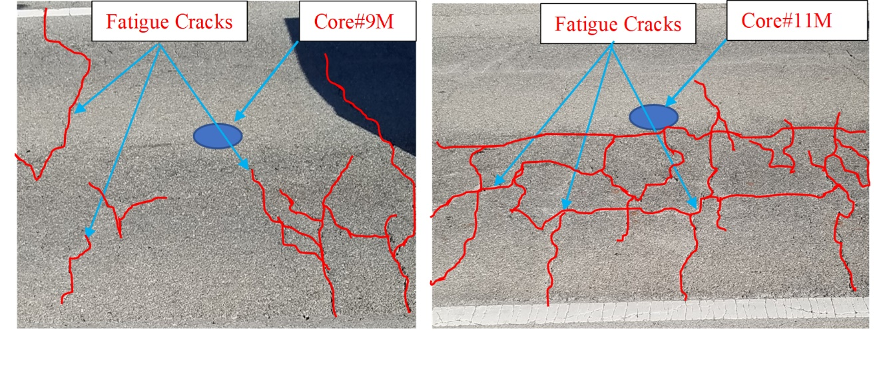
(a) (b)
Figure 4.13 Fatigue cracks observed in the vicinity of: (a) Core#9M; and (b) Core#11M

Influence of Layer Modulus of Existing Pavement
Figures 4.14 (a) and 4.14 (b) show the variation of fatigue cracking with layer modulus of existing pavement. Both top-down and bottom-up fatigue cracks were found to decrease with an increase in layer modulus. For example, top-down fatigue cracking decreased significantly from 7,182-ft/mile to 1,406-ft/mile with the change in existing layer modulus from 75-ksi to 200-ksi. Also, bottom-up fatigue cracking was found to reduce significantly from 100% to 0.57% of the lane area with an increase in layer modulus of 75-ksi to 200-ksi. PMED simulation results were found to be consistent with the FWD results and the field observations. Higher fatigue cracking was observed in the vicinity of FWD test station having a modulus of 75-ksi as compared to FWD test station having a modulus of 200-ksi as shown in Figures 4.15 (a) and 4.15 (b). Therefore, it is postulated that this variation of layer modulus throughout the test site with low modulus at several locations has contributed to the fatigue cracking in US 412 and its level.

(a)

(b)
Figure 4.14 Variation of fatigue cracking with layer modulus of existing pavement: (a) top-down; and (b) bottom-up
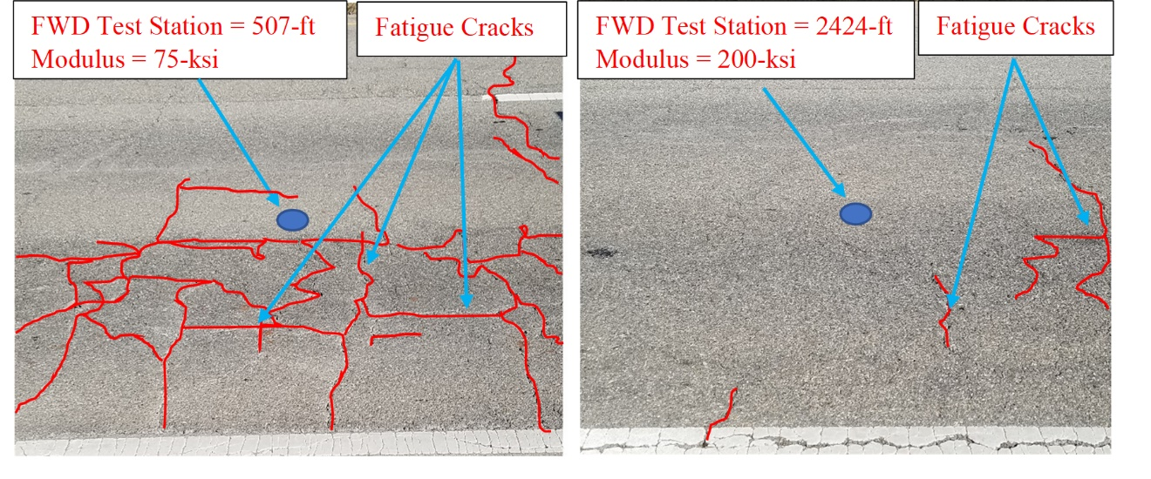
(a) (b)
Figure 4.15 Fatigue cracking observed in the vicinity of FWD test stations: (a) 507-ft; and (b) 2424-ft

Influence of Roadway Density
Figure 4.16 (a) and 4.16 (b) show variations in top-down and bottom-up fatigue cracking with roadway densities. It was observed that both top-down and bottom-up fatigue cracking increased with a decrease in the roadway density. For example, top-down fatigue cracking was found to increase from 2,729-ft/mile to 3,895-ft/mile with a change in roadway density from 94% to 92%. Also, bottom-up fatigue cracking was found to increase from 86.8% to 99.7% of lane area with a change in roadway density 94% to 92%. The current roadway density of US 412 at the test site was found to vary from 91.4% to 94.3% with an average of 92.7%, as evident from the roadway density test results. A similar trend was also observed in the field. Overall, higher fatigue cracking was observed in the vicinity of Core#3M (density 91.8%) as compared to that of Core#9M (density 94.3%), as shown in Figures 4.17 (a) and 4.17 (b). Therefore, it can be concluded that the low density was a potential contributor for fatigue cracking at the test site. Also, obtaining a higher density (e.g. 94% or above) during reconstruction or rehabilitation would be helpful for limiting fatigue cracking in future.

(a)

(b)
Figure 4.16 Variation of fatigue cracking with roadway density: (a) top-down; (b) bottom-up
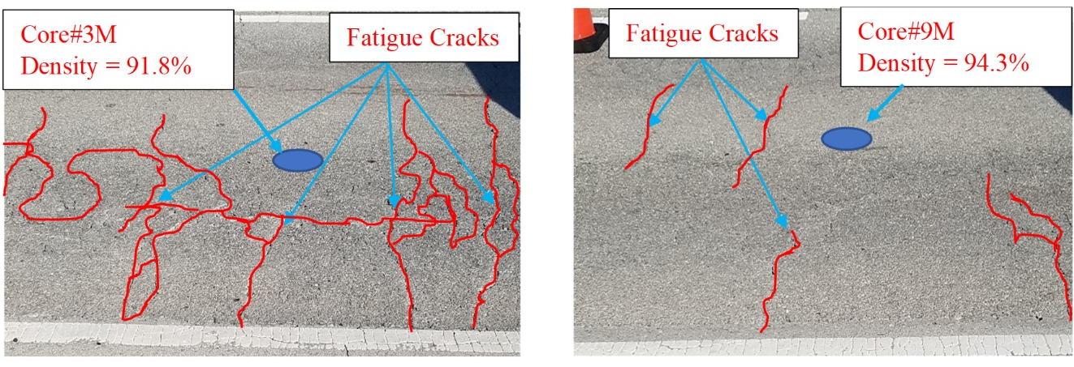
(a) (b)
Figure 4.17 Fatigue cracking observed near cores: (a) Core#3M; and (b) Core#9M

Influence of High- and Low-temperature PG of Binder
Figures 4.18 (a) and 4.18 (b) show variation of top-down and bottom-up fatigue cracking with high- and low-temperature PG of asphalt binder. Top-down fatigue cracking was found to decrease with an increase in high- and low-temperature PG of the binder. For example, top-down fatigue cracking was found to reduce from 3,240-ft/mile to 3,174-ft/mile with an increase in low-temperature PG from -28°C to -22°C while the high-temperature PG remained constant at 70°C. Also, top-down fatigue cracking was found to reduce from 3,240-ft/mile to 3,058-ft/mile with a change in high-temperature PG from 70°C to 76°C while the low-temperature PG remained constant at -28°C. Overall, it was observed that high-temperature PG was more sensitive to top-down fatigue cracking as compared to low-temperature PG. However, bottom-up fatigue cracking was found to be less sensitive to binder PG (Figure 4.18 (b)). Therefore, selection of proper binder PG (for example PG 76-16 or PG 76-22) would be important in reducing top-down fatigue cracking during rehabilitation or reconstruction.

(a)

(b)
Figure 4.18 Variation of fatigue cracking with high- and low-temperature PG: (a) top-down; (b) bottom-up

CONCLUSIONS AND RECOMMENDATIONS
This case study was aimed at investigating the causes of fatigue cracking of asphalt pavement in US 412 in Noble County, Oklahoma. Field and laboratory testing along with PMED simulations were performed to identify probable causes of fatigue cracking at this site in a rational manner. Based on the results presented in the preceding sections, the following conclusions can be drawn.
- From the field and laboratory testing, probable causes of both top-down and bottom-up fatigue cracking were identified as delamination, low asphalt layer moduli, variation in pavement thickness, low roadway density and aging of the mix. Significant delamination was observed in the asphalt layer from the GPR images and asphalt cores. Stripping was found to be worsen delamination at several locations. Also, GPR images indicated that the disturbance zones were confined in the asphalt layer itself. The FWD results indicated low layer moduli of the existing pavement as compared to regular HMA. Also, layer modulus and pavement thickness were found to vary throughout the pavement section. The roadway density tests indicated significantly lower densities of the pavement than expected. In addition, the true PG of extracted binder indicated significant aging of the binder. Furthermore, the IFIT results indicated extremely low cracking resistance due to excessive aging and lower density of the pavement.
- From PMED simulations, asphalt layer moduli, pavement thickness and roadway densities were found to have significant impact on both top-down and bottom-up fatigue cracking. Bottom-up fatigue cracking was less sensitive to pavement thickness than top-down fatigue cracking. Overall, PMED simulations reinforced the observations from the field and laboratory investigations.
- During reconstruction or rehabilitation, results of the PMED simulations can be used in selecting appropriate pavement thickness and binder PG for anticipated traffic condition.
- This case study demonstrated that a hybrid approach by combining field and laboratory testing with PMED simulations is an effective tool for identify probable causes of fatigue cracking in asphalt pavements. Identifying specific causes is important to undertaking appropriate and cost-effective maintenance and rehabilitation measures to extend the life of existing pavements.

CONCLUSIONS AND RECOMMENDATIONS

CONCLUSIONS
In this study, probable causes of transverse cracking and fatigue cracking in flexible pavements were investigated using a hybrid approach involving field and laboratory testing and PMED simulations. Specifically, probable causes of transverse cracking in US 270 and US 287 and causes of fatigue cracking in US 412 were identified. Specific conclusions of each topic were presented in the respective chapter. The overall conclusions of this study are given below.
- In US 270 and US 287 test sites, probable causes of transverse cracking were identified as thermal cracking due to large number of extreme low-temperature events, large temperature differential cycles and hourly temperature fluctuations, and poor cracking resistance of stiffer and brittle asphalt mixes resulting from aging during the long service lives. Several transverse cracks extending over the full width of both pavements, including shoulder indicated that transverse cracks resulted from thermal cracking. Analysis of weather data indicated that a large number of extreme low-temperature events and large temperature differential cycles (hourly temperature fluctuations) have contributed to transverse cracking at these sites. The PMED simulations supported these causes. Field and laboratory testing indicated that severities of transverse cracking were influenced by high variations in asphalt layer moduli, pavement thicknesses and low cracking resistance of both pavements, in addition to extreme low temperature events and temperature differentials. Based on the PMED simulations, binder grade and pavement thickness were found to be the most influential factors for transverse cracking at both sites.
- Delamination, low asphalt layer moduli, variation in pavement thickness, low roadway densities and aging of asphalt over the service life of the pavement were found as the most likely contributors of both top-down and bottom-up fatigue cracking in US 412. The GPR images and asphalt cores indicated significant delamination in asphalt layer. FWD test results indicated that low layer moduli of this pavement as compared to regular HMA have contributed to fatigue cracking. Also, pavement thicknesses and layer moduli were found to vary throughout the test section. Roadway density test indicated that significantly low densities of this pavement have contributed to both top-down and bottom-up fatigue cracking. In addition, low cracking resistance due excessive aging and low roadway density were found as a likely contributor to fatigue cracking at this site. These findings were consistent with the PMED simulations. From PMED simulations, both top-down and bottom-up fatigue cracks were found to be influenced by asphalt layer moduli, pavement thickness and roadway densities.
- Finally, it can be concluded that the hybrid approach employed in this study by combining both field and laboratory testing with PMED simulations can be used as an effective tool for identifying both transverse cracking and fatigue cracking in asphalt pavements.

RECOMMENDATIONS
The findings of this study can be used in designing new pavements and selecting the remedial options for limiting transverse and fatigue cracking in asphalt pavements in areas with similar climatic condition. Alternative remedial measures, for example, milling and overlays, Fibercrete (INFRASTRUCTURE, 2019) and rich intermediate layers of different thicknesses and binder PGs may be evaluated using PMED simulations to limit future transverse and fatigue cracking problems. Site-specific investigations are recommended for site specific distresses in pavement because of the uniqueness of pavement structure, materials and climate. Future studies on this topic can involve additional case studies for determining probable causes of other distresses (e.g. rutting, stripping) in flexible pavements. Reliability of the findings of the hybrid approach can be increased by obtaining more Level 1 inputs for PMED simulations. Also, suitability of this approach for determining causes of distresses in rigid pavements may be examined.

REFERENCES
AASHTO (2008). Mechanistic-Empirical Pavement Design Guide–A Manual of Practice. American Association of State Highway and Transportation Officials.
AASHTO (2009). T 265: Standard Method of Test for Laboratory Determination of Moisture Content of Soils. Standard Specifications for Transportation Materials and Methods of Sampling and Testing.
AASHTO (2012). T 209: Standard Method of Test for Theoretical Maximum Specific Gravity (G_{mm}) and Density of Hot Mix Asphalt (HMA). Standard Specifications for Transportation Materials and Methods of Sampling and Testing.
AASHTO (2018a). TP 124: Standard Method of Test for Determining the Fracture Potential of Asphalt Mixtures Using the Flexibility Index Test (FIT). Standard Specifications for Transportation Materials and Methods of Sampling and Testing.
AASHTO (2018b). T 164-14: Quantitative Extraction of Asphalt Binder from Hot Mix Asphalt (HMA). Standard Specifications for Transportation Materials and Methods of Sampling and Testing.
AASHTO (2018c). M 320-17: Standard Specification for Performance-Graded Asphalt Binder. Standard Specifications for Transportation Materials and Methods of Sampling and Testing.
AASHTOWare (2012). AASHTOWare Pavement ME Design version 1.0 Release Notes. Washington, DC: American Association of State Highway and Transportation Officials.
Adlinge, S. S., and Gupta, A. K. (2013). Pavement Deterioration and Its Causes. International Journal of Innovative Research and Development, 2(4), pp. 437-450.
Alae, M., Zhao, Y., Zarei, S., Fu, G., and Cao, D. (2020). Effects of Layer Interface Conditions on Top-Down Fatigue Cracking of Asphalt Pavements. International Journal of Pavement Engineering, 21(3), pp. 280-288.
Al-Qadi, I. L., Hassan, M. M., and Elseifi, M. A. (2005). Field and Theoretical Evaluation of Thermal Fatigue Cracking in Flexible Pavements. Transportation Research Record, 1919(1), pp. 87-95.
Anderson, D. A., Lapalu, L., Marasteanu, M. O., Le Hir, Y. M., Planche, J. P., and Martin, D. (2001). Low-Temperature Thermal Cracking of Asphalt Binders as Ranked by Strength and Fracture Properties. Transportation Research Record, 1766(1), pp. 1-6.
ASCE (2017). 2017 Infrastructure Report Card: A Comprehensive Assessment of America’s Infrastructure. American Society of Civil Engineers. (https://www.infrastructurereportcard.org/wp-content/uploads/2016/10/2017-Infrastructure-Report-Card.pdf (Accessed Date: 7/5/2020)).
ASTM (2000). D 1452-80: Standard Practice for Soil Investigation and Sampling by Auger Borings. ASTM International, 100 Barr Harbor Drive, PO Box C700, West Conshohocken, PA 19428-2959, United States.
ASTM (2009). D6951: Standard Test Method for use of the Dynamic Cone Penetrometer in Shallow Pavement Applications. ASTM International, 100 Barr Harbor Drive, PO Box C700, West Conshohocken, PA 19428-2959, United States.
ASTM (2012). D5404/D5404M-12: Standard Practice for Recovery of Asphalt from Solution using the Rotary Evaporator. ASTM International, 100 Barr Harbor Drive, PO Box C700, West Conshohocken, PA 19428-2959, United States.
ASTM (2015). D4694 – 09: Standard Test Method for Deflections with a Falling-Weight-Type Impulse Load Device. ASTM International, 100 Barr Harbor Drive, PO Box C700, West Conshohocken, PA 19428-2959, United States.
ASTM (2017). D4318: Standard Test Methods for Liquid Limit, Plastic Limit, and Plasticity Index of Soils. ASTM International, 100 Barr Harbor Drive, PO Box C700, West Conshohocken, PA 19428-2959, United States.
Bensalem, A., Broen, A. J., Nunn, M. E., Merrill, D. B., and Lloyd, W. G. (2000, October). Finite Element Modeling of Fully Flexible Pavements: Surface Cracking and Wheel Interaction. In Proceedings of the 2nd International Symposium on 3D Finite Element for Pavement Analysis, Design, And Research, pp. 103-113.
Ceylan, H., Kim, S., Gopalakrishnan, K., Schwartz, C. W., and Li, R. (2014). Sensitivity analysis frameworks for mechanistic-empirical pavement design of continuously reinforced concrete pavements. Construction and Building Materials, 73, pp. 498-508.
Charlier, R., Hornych, P., Sršen, M., Hermansson, Å. Bjarnason, G., Erlingsson, S., and Pavšič, P. (2009). Water Influence on Bearing Capacity and Pavement Performance: Field Observations. Water in Road Structures. Springer, Dordrecht, pp. 175-192.
Chen, D. H., Scullion, T., Bilyeu, J., and Won, M. (2005a). Detailed Forensic Investigation and Rehabilitation Recommendation on Interstate Highway-30. Journal of Performance of Constructed Facilities, 19(2), pp. 155-164.
Chen, D. H., Lin, D. F., Liau, P. H., and Bilyeu, J. (2005b). A Correlation Between Dynamic Cone Penetrometer Values and Pavement Layer Moduli. Geotechnical Testing Journal, 28(1), pp. 42-49.
Chen, D. H., Bilyeu, J., Scullion, T., Lin, D. F., and Zhou, F. (2003). Forensic Evaluation of Premature Failures of Texas Specific Pavement Study–1 Section. Journal of Performance of Constructed Facilities, 17(2), pp. 67-74.
Chen, D. H., and Scullion, T. (2007). Using Nondestructive Testing Technologies to Assist in Selecting the Optimal Pavement Rehabilitation Strategy. Journal of Testing and Evaluation, 35(2), pp. 211-219.
Chen, D. H., and Scullion, T. (2008). Forensic Investigations of Roadway Pavement Failures. Journal of Performance of Constructed Facilities, 22(1), pp. 35-44.
Chen, D. H. (2009). Investigation of a Pavement Premature Failure on a Weak and Moisture Susceptible Base. Journal of Performance of Constructed Facilities, 23(5), pp. 309-313.
Cho, S., Mahboub, K. C., Jeon, J., and Kim, Y. R. (2019). Evaluation of Fatigue Cracking Performance in a Debonded Asphalt Pavement. International Journal of Pavement Research and Technology, 12(4), pp. 388-395.
Everett, M. E. (2013). Near-Surface Applied Geophysics. Cambridge University Press, New York.
Graves, R. C., and Mahboub, K. C. (2006). Pilot Study in Sampling-Based Sensitivity Analysis of NCHRP Design Guide for Flexible Pavements. Transportation Research Record, 1947(1), pp. 122-135.
Haas, R., Tighe, S., Dore, G., and Hein, D. (2007, October). Mechanistic-Empirical Pavement Design: Evolution and Future Challenges. In Annual Conference and Exhibition of the Transportation Association of Canada, Saskatoon, SK.
Hasan, M. R., Hiller, J. E., and You, Z. (2016). Effects of Mean Annual Temperature and Mean Annual Precipitation on the Performance of Flexible Pavement using ME Design. International Journal of Pavement Engineering, 17(7), pp. 647-658.
Hong, F., and Chen, D. H. (2009). Effects of Surface Preparation, Thickness, and Material on Asphalt Pavement Overlay Transverse Crack Propagation. Canadian Journal of Civil Engineering, 36(9), pp. 1411-1420.
Huang, Y. H. (2004). Pavement Analysis and Design. Second Edition. Pearson Education, Inc.
Hugo, F., and Kennedy, T. W. (1985). Surface Cracking of Asphalt Mixtures in Southern Africa (with Discussion). In Association of Asphalt Paving Technologists Proc (Vol. 54).
INFRASTRUCTURE (2019). https://www.fptinfrastructure.com/products/hot-applied-flexible-concrete-repairs/fibrecrete/ (Accessed Date: 09/14/2019)
Islam, M. R., and Tarefder, R. A. (2015). Quantifying Traffic- and Temperature-Induced Fatigue Damages of Asphalt Pavement. Transportation Infrastructure Geotechnology, 2(1), pp. 18-33.
Islam, S., and Buttlar, W. G. (2012). Effect of Pavement Roughness on User Costs. Transportation Research Record, 2285(1), pp. 47-55.
Johnson, C., Chorzepa, M. G., Durham, S., and Kim, S. S. (2017). Forensic Investigation of Pavement: Practices in North America and a Pilot Investigation. Journal of Performance of Constructed Facilities, 31(4), pp. 04017031.
Kim, S., Ceylan, H., and Heitzman, M. (2005, August). Sensitivity Study of Design Input Parameters for Two Flexible Pavement Systems using the Mechanistic-Empirical Pavement Design Guide. Proceedings of the 2005 Mid-Continent Transportation Research Symposium, Ames, Iowa.
Kim, S., Ceylan, H., and Gopalakrishnan, K. (2007). Effect of ME Design Guide Inputs on Flexible Pavement Performance Predictions. Road Materials and Pavement Design, 8(3), pp. 375-397.
Krysiński, L., and Sudyka, J. (2013). GPR Abilities in Investigation of the Pavement Transversal Cracks. Journal of Applied Geophysics, 97, pp. 27-36.
Kulkarni, M. B. (2005). Effect of Tack and Prime Coats, and Baghouse Fines on Composite Asphalt Pavements. Ph.D. Dissertation, North Carolina State University, Raleigh, NC.
Lee, J., Ahn, H., Shah, A., and Sommer, K. (2013). Investigation of Delamination on I-65 in Indiana. Journal of Testing and Evaluation, 41(5), pp. 745-753.
Li, R., Schwartz, C. W., Kim, S., and Ceylan, H. (2012). Local Sensitivity of Mechanistic-Empirical Flexible Pavement Performance Predictions to Unbound Material Property Inputs. GeoCongress 2012: State of the Art and Practice in Geotechnical Engineering, pp. 1495-1504.
Li, R., Schwartz, C. W., and Forman, B. (2013). Sensitivity of Predicted Pavement Performance to Climate Characteristics. Airfield and Highway Pavement 2013: Sustainable and Efficient Pavements, pp. 760-771.
Mandal, T., Ling, C., Chaturabong, P., and Bahia, H. U. (2019). Evaluation of Analysis Methods of the Semi-Circular Bend (SCB) Test Results for Measuring Cracking Resistance of Asphalt Mixtures. International Journal of Pavement Research and Technology, 12(5), pp. 456-463.
Marasteanu, M. O., Li, X., Clyne, T. R., Voller, V., Timm, D. H., and Newcomb, D. (2004). Low Temperature Cracking of Asphalt Concrete Pavement.
MESONET (2019). (http://www.mesonet.org/index.php/weather/category/past_data_files (accessed Date: 09/15/2019)).
Molenaar, A. A. A. (1984). Fatigue and Deflection Cracking due to Traffic Loads (with Discussion). In Association of Asphalt Paving Technologists Proceedings (Vol. 53).
Molenaar, A. A. A., and Pu, B. (2008, July). Prediction of Fatigue Cracking in Cement Treated Base Courses. In Proceedings of 6th RILEM International Conference on Cracking in Pavements, Pavement Cracking Mechanisms, Modeling, Detection, Testing and Case Histories, Chicago, pp. 191-199.
Myers, L. A. (2000). Development and Propagation of Surface-Initiated Longitudinal Wheel Path Cracks in Flexible Highway Pavements (Doctoral Dissertation, University of Florida).
Nazzal, M., Abbas, A. R., Ali, A. W., and Roy, A. (2012). Investigation of Foamed Warm Mix Asphalt Performance using the MEPDG. In GeoCongress 2012: State of the Art and Practice in Geotechnical Engineering, pp. 1602-1611.
Norouzi, A., and Richard Kim, Y. (2017). Mechanistic Evaluation of Fatigue Cracking in Asphalt Pavements. International Journal of Pavement Engineering, 18(6), pp. 530-546.
ODOT (2014a). OHD L-57: Guide for Forensic Evaluation of Distress in Hot Mix Asphalt and Portland Cement Concrete Pavement. Oklahoma Department of Transportation.
ODOT (2014b). 2009 ODOT Standard Specification for Highway Construction. Oklahoma Department of Transportation
ODOT (2018). OHD L-14: ODOT Standard Method of Test for Bulk Specific Gravity, Percent Density, and Longitudinal Joint Density of Compacted Asphalt Mixtures. Oklahoma Department of Transportation.
Orobio, A., and Zaniewski, J. P. (2011). Sampling-Based Sensitivity Analysis of the Mechanistic–Empirical Pavement Design Guide Applied to Material Inputs. Transportation Research Record, 2226(1), pp. 85-93.
Ozer, H., Al-Qadi, I. L., Singhvi, P., Khan, T., Rivera-Perez, J., and El-Khatib, A. (2016). Fracture Characterization of Asphalt Mixtures with High Recycled Content using Illinois Semicircular Bending Test Method and Flexibility Index. Transportation Research Record, 2575(1), pp. 130-137.
Pais, J. (2013). The Reflective Cracking in Flexible Pavements. Romanian Journal of Transport Infrastructure, 2(1), pp. 63-87.
Papagiannakis, A. T., and Masad, E. A. (2017). Pavement Design and Materials. John Wiley and Sons.
Paul, H. R. (2010). Eliminating Delamination in Asphalt Overlays: Louisiana Researchers Evaluate the Importance of Tack Coat. HMAT: Hot Mix Asphalt Technology, pp. 16-17.
Park, H. J., and Kim, Y. R. (2015). Primary Causes of Cracking of Asphalt Pavement in North Carolina: Field Study. International Journal of Pavement Engineering, 16(8), pp. 684-698.
Pszczoła, M., Judycki, J., and Dołżycki, B. (2008, June). Investigation of Transverse Cracking of Asphalt Pavements in the North-Eastern Poland. In 6th International RILEM Conference on Cracking in Pavements: Mechanisms, Modeling, Testing, Detection, Prevention and Case Histories, Chicago USA, pp. 853-860.
Qiu, X., Yang, Q., and Wang, F. (2014). Diagnostic Analysis of Dynamic Deflection for Cracked Asphalt Pavements Under FWD Impulsive Loading. Journal of Vibroengineering, 16(5), pp. 2426-2437.
Raad, L., Saboundjian, S., and Minassian, G. (2001). Field Aging Effects on Fatigue of Asphalt Concrete and Asphalt-Rubber Concrete. Transportation Research Record, 1767(1), pp. 126-134.
Rada, G. R. (2013). Guide for Conducting Forensic Investigations of Highway Pavements (with supplemental material on CD-ROM) (Vol. 747). Transportation Research Board.
Rajbongshi, P., and Das, A. (2008). Thermal Fatigue Considerations in Asphalt Pavement Design. International Journal of Pavement Research and Technology, 1(4), pp. 129-134.
Saltelli, A. (2002). Sensitivity analysis for importance assessment. Risk analysis, 22(3), pp. 579-590.
Schorsch, M., Chang, C. M., Baladi, G. Y., Petit, C., Al-Qadi, I. L., and Millien, A. (2004, May). Effects of Segregation on the Initiation and Propagation of Top-Down Cracks. In Fifth International RILEM Conference on Reflective Cracking in Pavements, RILEM Publications SARL, pp. 3-10.
Schwartz, C. W., Li, R., Ceylan, H., Kim, S., and Gopalakrishnan, K. (2013). Global Sensitivity Analysis of Mechanistic–Empirical Performance Predictions for Flexible Pavements. Transportation Research Record, 2368(1), pp. 12-23.
Shen, S., Zhang, W., Shen, L., and Huang, H. (2016). A Statistical Based Framework for Predicting Field Cracking Performance of Asphalt Pavements: Application to Top-Down Cracking Prediction. Construction and Building Materials, 116, pp. 226-234.
Snethen, D. R., and Ahmed, S. (1991). Depressed Transverse Cracks in Asphalt Pavements in Oklahoma. Final Report (No. FHWA/OK 92 (01)).
Smith, K. D., Bruinsma, J. E., Wade, M. J., Chatti, K., Vandenbossche, J., and Yu, H. T. (2017). Using Falling Weight Deflectometer Data with Mechanistic-Empirical Design and Analysis, Volume I (No. FHWA-HRT-16-009). United States. Federal Highway Administration.
Solla, M., Lagüela, S., González-Jorge, H., and Arias, P. (2014). Approach to Identify Cracking in Asphalt Pavement Using GPR and Infrared Thermographic Methods: Preliminary Findings. NDT & E International, 62, pp. 55-65.
Sun, L., Wang, G., Zhang, H., and Liu, L. (2018). Initiation and Propagation of Top-Down Cracking in Asphalt Pavement. Applied Sciences, 8(5), pp. 774.
Suo, Z., and Wong, W. G. (2009). Analysis of Fatigue Crack Growth Behavior in Asphalt Concrete Material in Wearing Course. Construction and Building Materials, 23(1), pp. 462-468.
Tarefder, R. A., and Bateman, D. (2011). Determining Effects of Layer Bonding and De-Bonding on Perpetual Pavements. In Emerging Technologies for Material, Design, Rehabilitation, and Inspection of Roadway Pavements, pp. 192-199.
Uhlmeyer, J. S., Willoughby, K., Pierce, L. M., and Mahoney, J. P. (2000). Top-Down Cracking in Washington State Asphalt Concrete Wearing Courses. Transportation Research Record, 1730(1), pp. 110-116.
Vinson Ted, S., Janoo, V. C., and Haas Ralph, C. G. (1989). Low Temperature and Thermal Fatigue Cracking. Summary Report SR-OSU-A-003A-89-1, Strategic Highway Research Program Contract A-033A.
Wagoner, M. P., Buttlar, W. G., Paulino, G. H., and Blankenship, P. (2005). Investigation of the Fracture Resistance of Hot-Mix Asphalt Concrete using a Disk-Shaped Compact Tension Test. Transportation Research Record, 1929(1), pp. 183-192.
Wang, Y., Mahboub, K. C., and Hancher, D. E. (2005). Survival Analysis of Fatigue Cracking for Flexible Pavements Based on Long-Term Pavement Performance Data. Journal of Transportation Engineering, 131(8), pp. 608-616.
Wang, L. B., Myers, L. A., Mohammad, L. N., and Fu, Y. R. (2003). Micromechanics Study on Top-Down Cracking. Transportation Research Record, 1853(1), pp. 121-133.
Wang, H., and Al-Qadi, I. L. (2010). Near-Surface Pavement Failure Under Multiaxial Stress State in Thick Asphalt Pavement. Transportation Research Record, 2154(1), pp. 91-99.
Wang, H., Li, M., Szary, P., and Hu, X. (2019). Structural Assessment of Asphalt Pavement Condition using Backcalculated Modulus and Field Data. Construction and Building Materials, 211, pp. 943-951.
Walubita, L. F., and Scullion, T. (2007). Perpetual Pavements in Texas: The Fort Worth SH 114 Project in Wise County (No. FHWA/TX-07/0-4822-2).
West, R., Rodezno, C., Leiva, F., and Yin, F. (2018). Development of a Framework for Balanced Mix Design. NCHRP Project 20-07/Task 406, National Center for Asphalt Technology, Auburn University.
Yang, X., You, Z., Hiller, J., and Watkins, D. (2017). Correlation Analysis Between Temperature Indices and Flexible Pavement Distress Predictions using Mechanistic-Empirical Design. Journal of Cold Regions Engineering, 31(4), pp. 04017009.
Yavuzturk, C., Ksaibati, K., and Chiasson, A. D. (2005). Assessment of Temperature Fluctuations in Asphalt Pavements Due to Thermal Environmental Conditions using a Two-Dimensional, Transient Finite-Difference Approach. Journal of Materials in Civil Engineering, 17(4), pp. 465-475.
Zaghloul, S. M., ANDERTON, G., and Smith, D. (1995, January). Use of a Three-Dimensional Dynamic Finite Element Model to Study the Effect of Unbound Layer Characteristics on Pavement Response to a Moving Aircraft Load. In Proceedings of 74th Annual Meeting of the Transportation Research Board, pp. 341-353.
Zhang, W. (2015). Evaluation of Field Transverse Cracking of Asphalt Pavements. Doctoral Dissertation, Washington State University.
Zhang, W., Shen, S., Basak, P., Wen, H., Wu, S., Faheem, A., and Mohammad, L. N. (2015). Development of Predictive Models for Initiation and Propagation of Field Transverse Cracking. Transportation Research Record, 2524(1), pp. 92-99.
Ziari, H., and Khabiri, M. M. (2007). Interface Condition Influence on Prediction of Flexible Pavement Life. Journal of Civil Engineering and Management, 13(1), pp. 71-76.

This chapter has been accepted for publication in the Proceedings of the ASCE International Conference on Transportation and Development 2020 under the title “Sensitivity of Pavement MED Input Parameters for Characterization of Cracking in Pavements in Oklahoma.” The current version has been formatted for this thesis.
This chapter has been submitted to the International Journal of Pavement Research and Technology under the title “Evaluation of Transverse Cracking in Flexible Pavements using Field Investigation and AASHTOWare Pavement ME Design.” The current version has been formatted for this thesis.
This chapter is being prepared for submitting as a manuscript to the International Journal of Pavement Research and Technology under the title “Causes of Fatigue Cracking in Flexible Pavements in Oklahoma: A Case Study Using Laboratory and Field Investigation and AASHTOWare Simulation.” The current version has been formatted for this thesis.

