UNIVERSITY OF OKLAHOMA
GRADUATE COLLEGE

RELATIONAL AGGRESSION IN ROMANTIC RELATIONSHIPS: HOW DO HONOR-ENDORSING WOMEN TRAVERSE CONFLICT WITH THEIR PARTNERS?

A DISSERTATION
SUBMITTED TO THE GRADUATE FACULTY
in partial fulfillment of the requirements for the
Degree of
DOCTOR OF PHILOSOPHY

By
STEPHEN FOSTER
Norman, Oklahoma
2020

RELATIONAL AGGRESSION IN ROMANTIC RELATIONSHIPS: HOW DO HONOR-ENDORSING WOMEN TRAVERSE CONFLICT WITH THEIR PARTNERS?

A DISSERTATION APPROVED FOR THE
DEPARTMENT OF PSYCHOLOGY

BY THE COMMITTEE CONSISTING OF

Dr. Mauricio Carvallo, Chair
Dr. Aimee Franklin
Dr. Lara Mayeux
Dr. Jorge Mendoza
Dr. Luz-Eugenia Fuenzalida

© Copyright by STEPHEN FOSTER 2020
All rights reserved.
Acknowledgments
First and foremost, I would like to thank my advisor, Mauricio, for his guidance and support over my 5 years here in the program. I would also like to thank my committee, Dr. Mayeux, Dr. Mendoza, Dr. Franklin, and Dr. Fuenzalida for their valuable contributions to my training and research during graduate school. I am also appreciative of my fellow graduate students who have been by my side throughout graduate school, whether we were struggling through the writing process, traversing data analysis, or working with students. I’d like to acknowledge my parents for supporting me my whole life and being incredibly helpful along the way. Finally, I’d like to thank Jazzmine, who has been there through some of my more stressful graduate school experiences, and helped to keep me on my feet and moving forward.

Table of Contents
List of Tables vi
List of Figures vii
Abstract viii
Introduction 1
Study 1 Overview 10
Methods 11
Measures 11
Results 13
Study 1 Discussion 15
Study 2 Overview 15
Methods 16
Measures 16
Results 17
Study 2 Discussion 19
Study 3 Overview 19
Methods 20
Measures 20
Results 21
General Discussion 23
References 29
Appendix A 46
Appendix B 47

List of Tables
Table 1. Bivariate correlations, means, and standard deviations for the variables of
interest in Study 1..........................................................................................................................37
Table 2. Final analysis for Study 1................................................................................................38
Table 3. Bivariate correlations, means, and standard deviations for the variables of
interest in Study 2..........................................................................................................................39
Table 4. Final analysis for Study 2 ...............................................................................................40
Table 5. Bivariate correlations, means, and standard deviations for the variables of
interest in Study 3..........................................................................................................................41

List of Figures
Figure 1. Zuroff and Neil’s (1999) model of self-criticism predicting relational schemas,
negative cognitive-affective reaction, and hostile behaviors.........................................................42
Figure 2. Moderated mediation analysis from Study 1..................................................................43
Figure 3. Moderated mediation analysis from Study 2..................................................................44
Figure 4. Moderated mediation analysis from Study 3..................................................................45

Abstract
Prior research on cultures of honor have shown that individuals are expected to defend their reputations at all costs, even to the point of physical violence. However, this research has almost exclusively demonstrated this phenomenon in honor-endorsing men, and have implicitly assumed that women are not partaking in aggressive behavior as a reputation defense strategy. Based on prior work indicating the importance of studying relationally-aggressive behaviors, in combination with the very small body of work researching the impact of honor endorsement on female behaviors, the current research intended to assess how honor endorsement may impact women’s relationally aggressive behavior. More specifically, I investigated this phenomenon in the context of romantic relationships, where honor endorsement has been shown to heighten levels of intimate partner violence, albeit exclusively in a physical form committed by men. I hypothesized that aggressive conflict resolution scripts may be an important factor which predisposes honor-endorsing women to partake in relational aggression in their relationships. Across three studies and 1,483 participants, I found that a link between honor endorsement and female’s romantic relational aggression was mediated by an aggressive conflict resolution style (Study 1); women show support for relationally aggressive behavior, believing that it is a positive way to resolve a conflict (Study 2 and Study 3); and support for such aggression does not depend on the presence of an explicit honor threat. These findings suggest that honor-endorsing women play a more active role in the aggression that takes place within the context of relationships, and negative conflict resolution scripts may predispose women to engage in maladaptive conflict behaviors that help perpetuate domestic violence shown to be frequent in cultures of honor.

Introduction
For most individuals who are maintaining a romantic relationship, the way in which the couple resolves conflict is often seen as an extremely important facet of the relationship maintenance process. Prior psychological research that supports this view has shown that the style and tactics couples use to resolve conflict is associated not only with the likelihood of the conflict being successfully resolved, but with relationship satisfaction and the likelihood that a couple will break up as well (Cramer, 2000; Ha, Overbeek, Lichtwarck-Aschoff, & Engels, 2013; Kurdek, 2005; Pistole, 1989; Sanderson & Karetsky, 2002; Shulman, Tuval-Mashiach, Levran, & Anbar, 2006). Conflict resolution styles in romantic relationships are also important due to the implications they may have for individuals who choose to stay in relationships where maladaptive resolution styles are present. For example, studies have shown that styles of conflict resolution centered around pushing demands or withdrawing from the conflict have been associated with intimate partner violence, along with conflict styles that feature reciprocal verbal aggression between partners (Babcock, Waltz, Jacobson, & Gottman, 1993; Eldridge, Sevier, Jones, Atkins, & Christensen, 2007; Feldman & Ridley, 2000; Fournier, Brassard, & Shaver, 2011; Overall & McNulty, 2017). Consequently, one can imagine that understanding factors underlying poor conflict resolution skills can help to address not only forms of intimate partner violence, but also strategies that may be employed to keep couples together and happier in their relationships.
Conflict resolution styles come in many shapes and forms. Researchers have proposed many different models of conflict resolution styles based on different frameworks that help delineate the difference between them. These models can be broken down into three main groups. The first, content models, tend to analyze conflict resolution within different facets of a relationship, which are viewed as being separate in nature (e.g., conflict about parenting, conflict about finances). These models are relatively dated and have been refuted by evidence that shows a consistency in conflict styles across many different content domains (see Sternberg & Steriano, 1984). The second group of models tend to be focused around goal conflict, essentially proposing that conflict styles differ based on motivations individuals have in the relationship and goals they would like to achieve. For example, the approach-avoidance dichotomy of motivation (see Carver & White, 1994; Gray, 1987) has been applied to determine whether individuals are more or less likely to sacrifice for their relationship partners, and is based on the premise that conflict arises when approach-avoidance motivations clash (Impett, Gable, & Peplau, 2005). M. Afzalur Rahim (1983), a supporter of this approach, proposed that self-serving as opposed to other-serving motivations lead to specific conflict resolution approaches. However, while they are useful in incorporating motivational themes, these approaches to conflict resolution fail to fully address the learned aspects of conflict resolution which may predispose individuals to the approach-avoidance motivations in the first place. Thus, these approaches fail to explain the root causes of certain resolution styles.
The third and final group of models tend to be centered around an interactional process format, which posit that people have interactional styles they apply across contexts and goals. This approach posits that individuals are predisposed to certain conflict resolution styles which they are likely to use in each conflict scenario they enter. According to Sternberg and Steriano (1984), this help to explain the consistency in conflict resolution styles observed across domains. These models also incorporate aspects of the goal-oriented approach with an interactional approach. For example, Metz and colleagues’ (1994) Styles of Conflict Model of conflict resolution categorizes conflict resolution styles on two axes. One axis utilizes the approach-avoidance approach, labeled as engaging or avoiding. The other axis breaks styles into constructive and destructive actions. Generally speaking, resolution styles centered around aggression would be seen as engaging yet destructive. A similar approach to conflict resolution styles in intimate relationships was proposed by Lawrence Kurdek (1995), who developed four separate conflict styles. The engagement conflict resolution style is characterized by personally attacking (verbally or physically), losing control, and throwing digs and insults. The positive conflict resolution style is characterized by negotiation and considering both sides of the argument. The withdrawal conflict style involves actively refusing to take part in the resolution, while the compromise style involves giving in and not defending one’s opinion. One can clearly see the incorporation of both approach-avoid and destructive-constructive frameworks into this model, and how such frameworks function well in determining how a person may deal with conflict in their relationship.
One major assumption of the approaches proposed by Kurdek, is that if individuals are predisposed to certain styles of conflict resolution, this must be due to learned styles of conflict resolution—after all, these models are normally rooted in the social learning paradigm (Bandura, 1977). Researchers have proposed that relational schemas, or schemas that develop to guide behavior in relational contexts such as within intimate relationships, may contain content and scripts that guide individuals towards maladaptive resolution styles (see Baldwin, 1992). These relational schemas can be defined as “cognitive structures representing regularities in interpersonal relatedness” (Baldwin, 1995, p. 548), which contain a series of if-then statements, or scripts, to help guide a person through behaviors with their interaction partner. For example, those with a withdrawal conflict resolution style may have a conflict resolution script that states “if my partner raises his voice, I disengage from the conflict”. While the specific behaviors may differ in minor ways, the general if-then framework remains consistent across conflict situations. The concept of relational schemas has been explored by studies incorporating other realms of research, particularly regarding attachment styles. Prior research has shown that certain attachment styles, which can be seen as an individual’s very first relational schema as derived from interactions with one’s caregivers, are associated with maladaptive conflict resolution styles (Bonache, Gonzalez-Mendez, & Krahé, 2019; Feeney & Karantzas, 2017; Fowler & Dillow, 2011; Mikulincer & Shaver, 2012; Pistole, 1989; Shi, 2003). It should be noted that while attachment styles can involve schema construction based on observation of behaviors between parents, children learn about conflict resolution directly from parents as well from the conflicts they explicitly have with their parents (Jutengren & Palmérus, 2007; Koerner & Fitzpatrick, 2002). These findings illustrate a critical source of conflict resolution schemas, which continue to influence styles of conflict resolution in adulthood.
Marc Baldwin (1992) also proposes that these schemas contain affective and motivational components. More specifically, when an individual’s relational schema is activated, it may also activate positive or negative emotions associated with relational concepts, along with common goals or objectives that the individual tends to pursue in relational contexts. In regard to conflict scenarios, a specific intimate relationship conflict resolution schema may be activated. For example, consider an individual who has what one would consider a positive relational schema. In scenarios where this schema is activated, positive emotions like joy and satisfaction will likely surface, as well as constructive goals (i.e. positive relationship maintenance) and ways that person tends to achieve those goals (i.e. pro-relationship behaviors, sacrifice for the partner). Sequences of conflict resolution will likely follow a similar, generally constructive path. However, another individual’s relational schema may be a negative one. For this individual, negative emotions will likely be activated (such as fear or anger), along with destructive goals (i.e. undermining the partner) and ways to achieve those goals (i.e. aggression or insult). When it comes to conflict resolution, it is clear to see how this may manifest in the aforementioned destructive resolution styles. This process has been detailed by Zuroff and Neil (1999), with negative relational schemas leading to negative affective/motivational reactions, and with these reactions ultimately leading to negative behaviors such as destructive conflict resolution behaviors. Figure 1 demonstrates the model proposed by Zuroff and Neil (1999), which used self-criticism as a precursor to the process previously described.
Given this process, one might ask which other factors might lead a person to having developed a negative relational schema that can contain these destructive conflict styles. As has been noted previously, it is apparent that parental influence is a major factor. For example, those who develop insecure attachment styles based on parental interaction not only tend to be more likely to engage in destructive conflict resolution styles (Bonache, Gonzalez-Mendez, & Krahé, 2019; Feeney & Karantzas, 2017; Fowler & Dillow, 2011; Mikulincer & Shaver, 2012; Pistole, 1989; Shi, 2003), they also tend to be more insensitive to their romantic partner, engage in hostile attributions for ambiguous interactions with their partner, and demonstrate hostile behavior towards their partner (Collins, 1996; Pearce & Halford, 2008; Simpson, Rhodes, & Phillips, 1996). Researchers have theorized that childhood abuse may lead to negative relational schemas—for those who experience some form of childhood emotional or physical trauma, the impact of such events may create negative relational schemas that can cause risky or maladaptive behavior when activated (Godbout et al., 2019; Herman, 1992; MacIntosh, Godbout, & Dubash, 2015). As shown by Zuroff and colleagues (1999), those who are more self-critical tend to have more negative self-concepts as well. Interestingly, aside from parental influence, scenarios of abuse or trauma, and self-critical predispositions, other factors exist that may render some individuals particularly likely to have these negative schemas and scripts regarding relationships, conflict, and conflict resolution.
One of the factors which may influence development of negative relational and conflict resolution schemas, that has not yet received much research attention, involves cultural influence. It is likely that cultural values and norms influence to what extent behaviors are not only observed on a regular basis, but which behaviors are seen as normal and justified. For example, Gelfand and colleagues (2001) found that Japanese participants were more likely to see conflict scripts as compromise-focused compared to Americans participants and Ohbuchi and Takahashi (1994) showed that Japanese participants were more motivated to avoid conflict altogether. These findings were consistent with the assumption that collectivistic cultures tend to stress social harmony as an imperative goal in social interactions and conflict resolution specifically. In addition, Tinsley (1988) found that, in an organizational context, cultural values impacted the likelihood to defer to authority figures during conflict resolution practices. Tinsley also found that different cultures varied in their support for conflict resolution models centered around status, individual interest, and normative regulations between active parties. Moreover, Guerrido (2017) found that Hispanic participants displayed lower levels of obliging and compromising conflict styles than non-Hispanic participants. These findings seem to indicate that perhaps cultural norms and values might influence the presence or application of certain conflict resolution schemas when it comes to intimate relationships as well.
A cultural perspective that has not yet been incorporated into this literature regards cultures of honor. Cultures of honor exist all over the world, and are characterized by reputation defense, often through aggressive means (Brown, 2016; Cohen, Nisbett, Bowdle, & Schwartz, 1996; Mosquera, Manstead, & Fischer, 2002; Saucier & McManus, 2014; Uskul et al., 2012). While men are expected to appear “strong and fearless” (Barnes, Brown, & Tamborski, 2012), women are primarily expected to be chaste and loyal, avoiding dishonor by maintaining “sexual purity” (Brown, Imura, & Mayeux, 2014; Guerra, Giner-Sorolla, & Vasilijevic, 2013; Rodriguez Mosquera, 2016; Vandello & Cohen, 2008; Vandello & Cohen, 2003). For honor-endorsers, it appears that scripts centered around conflict resolution may be more likely to be centered around aggression due to honor endorser’s frequent exposure to aggression as a conflict resolution tool. These scripts also appear to be particularly applicable to intimate relationships. For example, Vandello and Cohen (2003) found that both male and female honor endorsers tended to hold implicit scripts regarding domestic violence. These scripts not only support violence in response to feminine infidelity, but also encourage women to stay in abusive relationships to maintain their perceived loyalty. Dietrich and Schuett (2013) revealed similar findings, showing that honor endorsers were supportive of intimate relationship violence which intended to restore honor lost due to infidelity. The researchers also showed honor endorsers were less likely to support the victim seeking help, a finding congruent with the work of Vandello and Cohen (2003). In recent work, Brown and colleagues (2018) findings suggest that honor endorser’s scripts about reactions to insult from a romantic partner may lead to an increased likelihood of rape and sexual assault, as a means of retaliation for such slights of honor. It should be noted that in each of these studies, some form of honor slight has occurred within the relationship. When an insult or honor slight is not present, recent research seems to indicate that honor endorsers are actually more cooperative than non-honor endorsers, and that conflict resolution tactics that undermine the partner only take place when the honor endorser is insulted (Harinck, Shafa, Ellemers, & Beersma, 2013). These findings suggest that implicit scripts to react in an aggressive, oftentimes destructive manner, are not found “across the board”, but only in circumstances where a perceived slight has occurred. Unfortunately, many intimate partner conflicts involve such insults or slights.
It should be noted that the prior culture of honor research has almost exclusively focused on male aggression in relationships, enacted upon females. While violent responses to female infidelity are certainly important, it is unclear if honor-endorsing women are engaging in similar aggression tactics when it comes to approaching and resolving relationship conflict. After all, the prior studies on honor endorser’s support for male interpersonal violence (Brown et al., 2018; Dietrich & Schuett, 2013; Vandello & Cohen, 2003) included both men and women, and did not find gender differences in this support. These findings suggest that the aggressive behavior embedded in scripts for resolving conflict is functioning in the cognitions of women as well as men. Is it possible that women who endorse a culture of honor also have scripts regarding the use of aggression to address conflict in intimate relationships as well? While no work has been conducted regarding this topic, recent research suggest that scripts appear to function for the utilization of relational aggression in women in response to slights from other women. Foster and colleagues (2020, in preparation) found that honor-endorsing women, but not men, were more likely to engage in reactive relational aggression, and were more supportive of women who used relational aggression to defend their honor. Interestingly, women who engaged in relationally-aggressive behavior were supported by honor-endorsing men as well. These findings suggest that similar scripts for aggression may be functional for women when it comes to conflict resolution, albeit in the form of relational aggression. It should be noted that, while prior research had suggested that relational aggression is more frequently used by women than men (Crick & Grotpeter, 1995; Crick, Bigbee, & Howe, 1996; Lagerspetz et al., 1988; Shahaeian, 2017), more recent research has suggested that relational aggression is enacted by men and women at similar levels, both with peers as well as in romantic relationships (Archer, 2004; Archer & Coyne; Bagner, Storch, & Presont, 2007; Murray-Close et al., 2010; Storch, Bagner, Gefken, & Baumeister, 2004). Given the seemingly consistent levels of relational aggression between men and women, one can consider the following phenomenon: physical aggression in male-male dyads is what is dictated by honor-endorsers’ scripts of conflict resolution, and such physical aggression is utilized by men within intimate relationships to resolve conflicts as well. If relational aggression in female-female dyads is what is dictated by honor-endorsers’ scripts of conflict resolution, as suggested by recent research, then it is likely that such relational aggression may be utilized by women in intimate relationships as well. It is also possible that romantic relational aggression is dictated by men as well, and has simply not been documented by prior honor research.
Relationally-aggressive behavior, similar to physically-aggressive behavior, is clearly not adaptive or beneficial behavior in any relationship. The current research also does not condone either form of aggression. However, it is possible that both male and female honor endorsers in intimate relationships may be using destructive and maladaptive styles of conflict resolution which ultimately undermine the strength of the relationship and increase the likelihood of the relationship failing, or of physical and emotional abuse continuing to manifest. These behaviors may also trigger a cycle of relationship violence that increases the likelihood of abuse to occur. Based on the work of Baldwin’s (1992) approach to negative relational schemas, as well as Zuroff and Duncan’s (1999) application of scripts and schemas towards hostile intimate partnership behaviors, I intend to employ these frameworks towards understanding whether honor-endorsing women may bring particular scripts of conflict resolution into relationships, and if these scripts might contribute to deleterious outcomes for couples. More specifically, I intend to test whether honor endorsement might contribute to maladaptive conflict resolution scripts and might lead to predictable, negative cognitive-affective responses, which ultimately lead to hostile behaviors like reactive relational aggression. I also intend to examine whether there is consistency between men and women in these effects.
Hypothesis 1a: Honor-endorsing women will tend to display higher levels of romantic relational aggression.
Hypothesis 1b: A significant indirect effect will be found from honor endorsement to romantic relational aggression through the engagement conflict style.
Hypothesis 2a: Honor-endorsing men will display higher levels of romantic relational aggression.
Hypothesis 2b: A significant indirect effect will be found from honor endorsement to romantic relational aggression through the engagement conflict style.
Hypothesis 3. Honor endorsing women (but not men) will tend to demonstrate greater support for a woman partaking in romantic relational aggression, and will perceive the behavior as a positive way to solve conflict in a relationship context.

Study 1 Overview
The goal of Study 1 was to establish that honor-endorsing women partake in relational-aggressive behavior within intimate relationships, and determine if this behavior is explained by a destructive, engaging conflict resolution script. I predicted that women and men will self-report engaging in more relationally aggressive behavior within relationships, and a significant indirect effect will be found from honor endorsement to romantic relational aggression through the engagement conflict style. Study 1 intended to address Hypotheses 1a through Hypothesis 2b.

Methods
932 participants (264 male) were collected from a Southwestern research institution in the United States. The majority of participants identified as Caucasian (72.1%), with the remainder of participants identifying as Hispanic or Latino/a (9.3%), Asian (7.6%), African-American (5.2%), American Indian (3.9%) or “Other” (1.9%). 65.6% of the participants reported that they were not currently in a relationship.

Measures
Honor Concerns Scale (HC; α = .84). The HC Scale was developed by IJzerman and colleagues (2007), and assesses a general sense of one’s concern for honor. It includes 9-items such as, “I think that honor is one of the most important things that I have as a human being” and “My honor is the basis for my self-respect”. Participants indicated to what extent they agreed or disagreed with the statements on a scale from 1 (Strongly Disagree) to 7 (Strongly Agree).
Honor Ideology for Manhood Scale (HIM; α = .94). The 16-item HIM Scale (Barnes et al., 2012) measures how much participants endorse the masculine facet of honor. Participants indicated to what extent they agreed or disagreed with statements such as “A real man doesn’t let other people push him around” and “A real man will never back down from a fight”. Participants responded on a scale from 1 (Strongly Disagree) to 7 (Strongly Agree).
Honor Ideology for Womanhood Scale (HIW; α = .91). The 12-item HIW Scale (Barnes et al., 2014), indicates the extent to which participants endorse the feminine facet of honor. Participants indicated to what extent they agreed or disagreed with statements such as “A good woman never tolerates disrespect” and “A respectable woman knows that what she does reflects on her family name”. Participants responded on a scale from 1 (Strongly Disagree) to 7 (Strongly Agree).
Romantic Relational Aggression (RRA; α = .91). To assess relational aggression within the context of a relationship, we used the 4-item relational aggression within intimate relationships subscale of Morales and colleagues’ (2002) aggressive behavior scale, along with 6 items which followed the same format as the 4-item scale and were produced through discussion with researchers from a lab which has researched developmental trends in aggression. These items included “I have given my romantic partner the silent treatment when my feelings were hurt in some way by him or her” and “I have tried to make my romantic partner jealous when mad at him/her”. Participants were asked to indicate how true the statements were in describing their behavior in either their current or most recent romantic relationship on a scale from 1 (Not at All True) to 7 (Very True).
Engagement Conflict Style (ECS; α = .85). In order to assess participant’s propensity to use maladaptive conflict resolution tactics in conflict resolution scenarios with their partner, we used the engagement subscale of Kurdek’s (2000) Conflict Resolutions Styles Scale. This scale asked participants to think about their current or most recent romantic relationship, and indicate the frequency with which they used certain styles and tactics in order to deal with conflicts or disagreements. This subscale contained tactics such as “launching personal attacks” and “exploding and getting out of control”. Responses were recorded on a scale from 1 (Never) to 5 (Always).
Covariates. In order to control for other conflict resolution tactics, we also incorporated the other 3 conflict resolution styles found in Kurdek’s (2000) scale (all αs > .83). These other styles included the positive conflict style (i.e. “sitting down and discussing differences constructively”), the withdrawal conflict style (i.e. “remaining silent for long periods of time”), and the compliance conflict style (i.e. “giving in with little attempt to present my side of the issue”). These were included so as to ensure that we were isolating the effect of the engagement conflict resolution style. We also included whether or not participants were currently in a relationship (0 = No, 1 = Yes), and the Gender Role Beliefs Scale (Kerr & Holden, 1996; α = .61).

Results
In order to test the relationships predicted for the current study, I first constructed a latent honor endorsement variable in SPSS Version 24.0, as has been done in prior honor research (Barnes et al., 2012). We entered the HIM, the HC scale, and the HIW as indicators (Factor Loadings = .61, .65, and .77, respectively) and extracted scores using the principal axis factoring method. Scores were then estimated using the regression method and saved as the main predictor variable in the subsequent analyses.
Bivariate correlations, means, and standard deviation can be found in Table 1. As shown in the Table, honor endorsement was significantly associated with romantic relational aggression for both men and women (rs = .13, ps < .01), evidence which supports Hypothesis 1a but does not support Hypothesis 2a. Honor was also associated with the engagement conflict style for women (r = .14, p < .01), but not for men (r = .07, p = .28). Honor was not significantly associated with any of the remaining conflict styles for men (|r|s < .02, ps > .77). For women, honor was negatively related to the positive conflict style (r = -.10, p = .02). The engagement conflict style was associated with romantic relational aggression for both men and women (rs > .44, ps < .01).
In order to test whether significant indirect effects would be found honor endorsement to romantic relational aggression through the engagement conflict resolution style, I conducted moderated mediation analyses using the PROCESS macro in SPSS (Hayes, 2013; Model 15) via path analysis and using percentile method bootstrapping of 95% confidence intervals. This process uses five-thousand bootstrap samples to create 95% percentile bootstrap confidence intervals to test the significance of indirect effects, as well as conditional indirect effects and a test of moderated mediation, which are significant at p < .05 if the 95% confidence interval does not include zero. More specifically, we ran a mediation analyses with honor endorsement predicting relational aggression through the engagement conflict style, while simultaneously testing for the moderating effect of sex on the honor-romantic relational aggression pathway and the engagement conflict style-romantic relational aggression pathway. Analyses were conducted while controlling for the positive, withdrawal, and compliance conflict styles, relationship status, and the GRB scale.
Coefficients for the final model can be found in Table 2. As seen in Figure 2, analyses revealed no significant moderating effect of sex on the honor-romantic relational aggression pathway (b = -.08, p = .36) nor on the engagement conflict style-romantic relational aggression pathway (b = -.02, p = .86). A test of moderated mediation confirmed these results, as the index of moderated mediation was not significant (Moderated Mediation Effect—MME = -.001, SE = .01, 95% CI [ -.02, .02], p > .05). Tests of the conditional indirect effects yielded a significant indirect effect from honor to romantic relational aggression for women (Mediated Effect—ME = .03, SE = .01, 95% CI [ .004, .056], p < .05), with the direct effect of honor on romantic relational aggression no longer significant (b = .04, p = .43). Analyses yielded a significant indirect effect from honor to romantic relational aggression for men as well (Mediated Effect—ME = .03, SE = .01, 95% CI [ .003, .063], p < .05), with the direct effect of honor on romantic relational aggression no longer significant (b = .11, p = .13). These findings indicate that honor endorsement is linked with higher levels of romantic relational aggression, and that this relationship is explained by an aggressive conflict resolution style. These findings are also found to be consistent for both women and men.

Study 1 Discussion
Study 1 intended to assess whether honor endorsing women (and men) partake in romantic relational aggression, and if this association might be explained by aggressive conflict resolution scripts. Support was found for Hypotheses 1a and 1b, with a significant relationship between honor endorsement and romantic relational aggression for women, as well as an indirect effect from honor to romantic relational aggression through the engaging conflict resolution style. Evidence for Hypothesis 2a and 2b was also found, due to the analogous effects being significant for men as well. These findings provide evidence that both men and women engage in these relationally-aggressive behaviors, and this can be explained by a predisposition for an aggressive conflict resolution style. These findings suggest that, when considering the tools that honor-endorsing men and women use to resolve conflict, relational aggression appears to be a common method employed.

Study 2 Overview
The goal of Study 2 was to further establish the aggressive scripts which honor-endorsing women may use when dealing with conflict in romantic relationships. In this instance, I elected to use a vignette-based design to assess women’s judgments of the acceptability of relationally-aggressive behavior in a romantic context. As noted by Coyne and colleagues (2004), aggression scripts are likely to be activated when witnessing or processing circumstances of aggression—at this point, individuals evaluate whether the behavior was an acceptable way to deal with the current situation. In applying this to conflict resolution scenarios, support for the behavior will likely be justified by seeing the behavior as a beneficial way to resolve the conflict. To this end, I hypothesized that honor-endorsing women, who carry specific conflict resolution scripts for how women should resolve conflict, will show more support for relationally-aggressive behavior in a romantic context, and that the link between honor endorsement and support for behavior will be mediated by perceptions that the behavior is a beneficial way to resolve conflict in the presented in scenario.

Methods
338 participants (109 male) were collected from a Southwestern research institution in the United States. The majority of participants identified as Caucasian (68.5%), with the remainder of participants identifying as Asian (7.9%), Hispanic or Latino/a (7.6%), African-American (7.4%), American Indian (5.0%) or “Other” (3.6%). 71% of the participants reported that they were not currently in a relationship.

Measures
Honor Scales. The same HC Scale (α = .84), HIM (α = .94), and HIW (α = .91) from Study 1 were used in Study 2.
Conflict Vignette. To demonstrate relational aggression within the context of a relationship, a vignette was constructed detailing a conflict between two individuals currently in a romantic relationship, Ray and Emily. In the vignette, when Ray voices that he is upset Emily leaves her dishes out around the house, Emily respond using tactics associated with an engagement conflict style. These tactics include throwing “digs” at your partner (i.e. telling Ray is he wasn’t drinking all the time he would realize how much she helped around the house), using insults (i.e. calling Ray a “low-life” who “doesn’t think about anyone but himself”), as well as the silent treatment to conclude the vignette (see Appendix A).
Support for Emily’s Behavior (Support; α = .80). Support for Emily’s behavior was assessed using a 4-item scale. Participants indicated the extent to which they supported the way Emily behaved in the vignette. Items included “To what extent do you feel Emily’s behavior was justified?” and “To what extent do you feel Emily should be proud of how she acted?”. Participants responded on a scale from 1 (Not at All) to 7 (Very Much).
Positive Conflict Belief (PCB; α = .80). This 4-item scale intended to address the extent to which participants felt Emily’s behavior was a positive way to solve the conflict presented in the vignette. Items included “To what extent do you think this was a good way to solve this problem that Emily and Ray had?” and “To what extent do you think this exchange was a good way for Emily and Ray to solve their problem?”. Participants responded on a scale from 1 (Not at All) to 7 (Very Much).
Covariates. We also included whether or not participants were currently in a relationship (0 = No, 1 = Yes), the Gender Role Beliefs Scale (Kerr & Holden, 1996; α = .61), as well as the Impression Management subscale of Paulhaus’ (1991) Balanced Inventory of Desirable Responding. These covariates were included so as to ensure that the relationships found cannot be explained by the impact of endorsement of traditional gender norms, social desirability, or not currently having sufficient experience with conflict in a romantic relationship context.

Results
In order to test the relationships predicted for the current study, I once again constructed a latent honor endorsement variable in SPSS Version 24.0, entering the HIM, the HC scale, and the HIW as indicators (Factor Loadings = .78, .77, and .81, respectively) and extracted scores using the principal axis factoring method. Scores were then estimated using the regression method and saved as the main predictor variable in the subsequent analyses.
Bivariate correlations, means, and standard deviations can be found in Table 3. Honor endorsement was linked to support for Emily’s behavior, but only for women (r = .25, p < .001). Honor was associated with PCB scores for both men and women (rs > .23, ps < .05). Support for Emily’s behavior was strongly associated with PCB scores for both men and women (rs > .52, ps < .05). More traditional gender role beliefs were associated with PCB scores for men and women (rs = -.22 and -.31, respectively, ps < .05).
In order to test the significance of the indirect effect of honor endorsement on support for Emily’s behavior through the PCB variable, and whether the indirect effect differed between men and women, I conducted moderated mediation analyses using the PROCESS macro in SPSS (Hayes, 2013; Model 8). More specifically, I tested for the impact of honor on support for Emily’s behavior through the PCB variable, and whether sex moderated the honor-support for behavior link (moderation of the direct effect) or the honor-PCB variable link (moderation of the indirect effect).
Coefficients for the final model can be found in Table 4. As seen in Figure 3, analyses revealed no significant moderating effect of sex on the honor-support for behavior pathway (b = .06, p = .69) nor on the honor-PCB link (b = .19, p = .25). A test of moderated mediation confirmed these results, as the index of moderated mediation was not significant (MME = .11, SE = .10, 95% CI [ -.11, .30], p > .05). However, tests of the conditional indirect effects yielded a significant indirect effect from honor to support for behavior through the PCB variable for women (ME = .23, SE = .06, 95% CI [ .116, .335], p < .05)—the analogous pathway for men was not significant (ME = .12, SE = .09, 95% CI [ -.055, .317], p >.05). The direct effect of honor on support for behavior was not significant for women (b = .13, p = .13) nor for men (b = .07, p = .58). These findings indicate that, for women, honor endorsement significantly impacts support for Emily’s behavior, and that this support is explained by beliefs that her behavior is a positive way to solve problems in a relationship. The analogous pathway was not significant for men.

Study 2 Discussion
Study 2 intended to address Hypothesis 3, which hypothesized that honor-endorsing women, but not men, will show support for a woman engaging in romantic relational aggression, and that this support would be explained by beliefs that aggressive behavior is a positive way to resolve conflict in a relationship. Support for Hypothesis 3 was found, suggesting that honor-endorsing women, but not men, see relationally-aggressive behavior as a good way to approach conflict in relationships. These findings are consistent with research on support for masculine aggression that has been demonstrated in prior research (O’Dea, Bueno, Saucier, 2017; Vandello, Cohen, & Ransom, 2008; Weaver at al., 2010).

Study 3 Overview
A few questions arose with the findings from Study 2. First, it is unclear if the Positive Conflict Belief scale measures beliefs that Emily’s behavior was a positive way to deal with the conflict, as opposed to Ray’s behavior, or some blending of the two. Second, it is possible that the nature of the scenario was the reason that the mediation found for honor-endorsing women was not found for honor-endorsing men. For example, it is possible that it was ambiguous to participants as to whether or not an actual honor threat was present. For men, they may have not seen any feminine honor threat (which generally centers around sexual promiscuity or fidelity), whereas women may have seen the man’s claims that Emily cannot maintain the home were an honor threat, thus justifying her behavior. To this end, it might be useful to determine if incorporating a more explicit honor-threat might heighten the effects found in Study 1, perhaps even making men feel an aggressive female response is warranted. It will also help to clarify if these behaviors only arise in honor-threatening scenarios (Study 3) or if they arise in ambiguous conflict scenarios as well (Study 2).

Methods
213 participants (87 male) were collected from a Southwestern research institution in the United States. The majority of participants identified as Caucasian (69.0%), with the remainder of participants identifying as Asian (11.7%), Hispanic or Latino/a (7.0%), African-American (4.2%), American Indian (3.3%) or “Other” (4.8%). 65% of the participants reported that they were not currently in a relationship.

Measures
Honor Scales. The same HC Scale (α = .84), HIM (α = .94), and HIW (α = .91) from Study 1 were used in Study 2.
Conflict Vignette. To demonstrate relational aggression within the context of a relationship, a vignette was constructed detailing a conflict between two individuals currently in a romantic relationship, Matt and Kayla. In order to center the vignette around a specific honor threat, it is described that Matt notices texts from a male coworker discussing work-related information with Kayla. He becomes jealous and accuses Kayla of “flirting with a bunch of guys” behind his back. As in Study 2, Kayla responds using tactics associated with an engagement conflict style. These tactics include throwing “digs” at your partner (i.e. claiming Matt is not intelligent), using insults (i.e. calling Matt a “fat slob” and “insecure”), as well as the silent treatment to conclude the vignette (see Appendix B).
Support for Kayla’s Behavior (Support; α = .79). Support for Kayla’s behavior was assessed using a 3-item scale. Participants indicated the extent to which they supported the way Kayla behaved in the vignette. Items included “To what extent do you feel Kayla’s behavior was justified?” and “To what extent do you feel Kayla should be proud of how she acted?”. While initially a 4-item scale, one item was removed due to a low item-total correlation (“To what extent do you feel Kayla stood up for herself?”; r = .27). Participants responded on a scale from 1 (Not at All) to 7 (Very Much).
Positive Conflict Belief (PCB; α = .79). This 4-item scale intended to address the extent to which participants felt Kayla’s behavior was a positive way to solve the conflict presented in the vignette. Items included “To what extent do you think the way Kayla acted was a good way to resolve the conflict?” and “To what extent do you think Kayla's approach to this conflict was a good way to solve the problem?”. Participants responded on a scale from 1 (Not at All) to 7 (Very Much).
Covariates. We also included whether or not participants were currently in a relationship (0 = No, 1 = Yes), as well as the Impression Management subscale of Paulhaus’ (1991) Balanced Inventory of Desirable Responding.

Results
In order to test the relationships predicted for the current study, I once again constructed a latent honor endorsement variable in SPSS Version 24.0, entering the HIM, the HC scale, and the HIW as indicators (Factor Loadings = .63, .65, and .89, respectively) and extracted scores using the principal axis factoring method. Scores were then estimated using the regression method and saved as the main predictor variable in the subsequent analyses.
Bivariate correlations, means, and standard deviations can be found in Table 5. Latent honor was not significantly related to support for Kayla’s behavior for men or women (rs = -.07, .07, ps > .05). Honor was significantly related to the PCB scale for women (r = .27, p = .002) although it was not significant for men (r = -.09, p = .41).
While traditional views of mediation would indicate that a significant total effect is necessary in order to conduct tests of indirect effects (i.e. there must be “an effect to be mediated”), more recent approaches indicate that this is not the case (see Hayes, 2009; MacKinnon et al., 2000; Shrout & Bolger, 2002). Therefore, I elected to test for significant indirect effects from the latent honor endorsement variable to support for Kayla’s behavior through the PCB variable. I also chose to test whether these pathways for males were significantly different from these pathways for females. In order to conduct these analyses, I once again used the PROCESS macro in SPSS (Hayes, 2013; Model 8) via path analysis and using percentile method bootstrapping of 95% confidence intervals. This model tests whether sex moderates either the honor-PCB link or the honor-support link. We also ran these analyses while controlling for the BIDR and relationship status.
The final tested model can be found in Figure 4. It was found that sex did not significantly moderate the honor-PCB link (b = .19, p = .16) nor did it moderate the honor-support link (b = -.06, p = .56). While the index of moderated mediation was not significant (MME = .18, 95% CI [-.07, .45], p > .05), tests of conditional indirect effects revealed differences between men and women in the sample. For females, a significant indirect effect was found from honor to support for Kayla’s behavior through the PCB variable (ME = .20, SE = .08, 95% CI [.06, .37], p < .05). The same indirect pathway was not significant for men (ME = .02, SE = .11, 95% CI [-.21, .23], p > .05). Conditional direct effects were found to be not significant for men or women (bs = -.05, -.10, respectively, ps > .05). These findings indicate that, for women, honor endorsement significantly impacts support for Kayla’s behavior, and that this support is explained by beliefs that her behavior is a positive way to solve problems in a relationship. The analogous pathway was not significant for men.
Study 3 Discussion
The goal of Study 3 was to assess whether the effects in Study 2 would be heightened, and become significant for men, if the portrayed conflict stemmed from an honor-specific insult—implying a woman in a relationship is disloyal to her partner. Results indicated nearly identical findings to Study 2, with a significant indirect effect from honor to support for Kayla’s behavior being found for women, although not for men, providing additional support to the hypothesis that honor-endorsing women appear to view utilizing the engaging style of conflict resolution as a positive way to resolve conflicts in romantic relationships. These findings also seem to indicate a broader impact of honor endorsement on conflict, as the presence of an honor slight does not seem to appear to impact support for the use of relational aggression.

General Discussion
Due to the impact of negative conflict resolution styles on certain relationship outcomes (Cramer, 2000; Ha, Overbeek, Lichtwarck-Aschoff, & Engels, 2013; Kurdek, 2005; Pistole, 1989; Sanderson & Karetsky, 2002; Shulman, Tuval-Mashiach, Levran, & Anbar, 2006), it is important to address factors which might make an individual more likely to partake in such behaviors. Applying an interactionist approach to conflict resolution styles, it is assumed that individuals who are frequently exposed to negative conflict resolution behaviors are more likely to have incorporated these behaviors into their own conflict resolution schemas. One such group of individuals may be individuals from cultures of honor, who frequently see aggression used as a style of conflict resolution, including in romantic relationships. While prior research has shown that men in cultures of honor use physical aggression to engage in conflict in relationships (Dietrich & Schuett, 2013; Vandello & Cohen, 2003), research had not yet been conducted on how women might utilize aggression in a similar way. The current project intended to address this gap in the literature, to examine whether honor-endorsing women use, and show support for, relational aggression in the context of romantic relationships. Across three studies, it was found that honor-endorsing women tend to more frequently partake in relational aggression in romantic relationships, and that this link was explained by an engaging conflict resolution style (Study 1). It was also found that honor-endorsing women show support for using relational aggression in relationships, believe utilizing aggression is a positive way to resolve conflict, and that these effects are present regardless of whether an honor threat is salient (Studies 2 and 3). Finally, it was found that there is relative consistency between men and women regarding the enactment of romantic relational aggression, although there is inconsistency in the support for women’s use of romantic relational aggression.
These findings contribute to a new line of research looking at how honor endorsement may be influencing female aggression, albeit it in a different form than honor-endorsing men. For example, Foster and colleagues (in prep) found that honor-endorsing women tend to be more likely to partake in relational aggression towards other women, and tend to support such forms of aggression. The current research extends these findings into the topic of intimate relationships, and implicates honor endorsement as a factor which may perpetuate the “cycle of violence” sometimes found in honor endorser’s relationships. These findings also contribute to prior work which has shown that relational aggression is associated with a myriad of negative outcomes for women (see Goldberg, Smith-Adcock, & Dixon, 2011). It is now clear that relationally-aggressive behavior may have detrimental impacts on romantic relationships for such women as well.
The current findings also give a more complex view of prior research showing the heightened frequency of domestic violence, enacted by men, in honor endorser’s relationships (Dietrich & Schuett, 2013; Vandello & Cohen, 2003). While these prior studies showed that both honor-endorsing men and women tended to support male physical violence as a response to female infidelity, it is clear that the majority of relationship conflict does not center around infidelity or claims of such behavior. For example, Kurdek (1994) found that most conflicts in relationships tend to regard perceptions of power imbalance in the relationship, personal values, and intimacy. To this end, it is important to understand how more commonplace arguments may lead to aggression and violence in relationships for honor endorsers, whether an honor threat (i.e. infidelity) is present or not. Our findings provide evidence for how this may function. In Study 2, support was shown for Emily’s behavior in an instance where no honor threat was salient, and findings in Study 3 (where infidelity was claimed), showed nearly identical findings. This suggests that the presence of an honor threat is not necessary for honor-endorsing women to feel that relationally-aggressive forms of conflict resolution are justified. This evidence deviates from prior work, which has suggested that honor endorsers only partake in aggression when honor threats are present (Brown, Baughman, & Carvallo, 2014; Cohen et al., 1996) and can even be more cooperative with others in the absence of an insult (Harinck, Shafa, Ellemers, & Beersma, 2013). Due to this deviation from prior assumptions, it appears these findings more strongly support our claim that, for honor endorsers, aggressive scripts may be activated in romantic relationships that automatically predispose honor-endorsing women to partake in relationally-aggressive responses to their partner.
One must also consider the role men are playing in the aforementioned “cycle of violence” in relationships as well, and if it extends beyond physical aggression. Honor-endorsing men did tend to show higher levels of romantic relational aggression in Study 1, although honor was not linked with higher levels of using the engagement conflict resolution style. This seems to suggest that both honor-endorsing men and women are engaging in these behaviors, implicating some form of negative feedback loop which might amplify the intensity of conflict. The consistency between men and women in Study 1 also fits with prior research showing that, in regard to reactive relational aggression, men and women seem to partake in these behaviors in similar frequencies (see Bailey & Ostrov, 2008). This speaks to aforementioned gaps in the honor literature which may be informed by measuring forms of relational aggression in honor-endorsing men as well. For example, a study by Eriksen and Lyng (2018) found that a relational aggression is extremely common amongst boys, but is often overlooked or not noticed by others due to society’s emphasis on relational aggression as an aspect of female bullying tactics. In other words, as researchers now find greater consistency between men and women in terms of aggression levels, honor researchers may find greater consistency between men and women in regard to reactive relational aggression.
Clearly, there are some limitations and unresolved issues inherent in this research. First, it should be noted that, in Study 1, my focus was primarily on the engagement conflict resolution style as a mediator of the link between honor endorsement and romantic relationship relational aggression, although a negative link was also found for women in regard to the positive conflict resolution style. This suggests that honor-endorsing women are also partaking in lower levels of positive resolution behaviors, such as constructive communication and positive negotiation. While I controlled for other conflict resolution styles in our analysis, it may be beneficial to explain the link between honor endorsement and the positive resolution style for women. This may be evidence that living in an honor culture deprives women of certain tools which are needed for a positive resolution of conflicts—perhaps this is due to the male-centric nature of cultures of honor which can be seen as stripping autonomy and agency from women and, therefore, depriving them of experience directing and negotiating conflict effectively.
Another limitation to the current work is that my samples were collected from young college students, which may not be generalizable to older populations of women. As noted by Shulman and Connolly (2013), there is considerable variability in the stability of romantic relationships in emerging adulthood, with some individuals displaying a significant increase in levels of commitment and trust from adolescence to emerging adulthood, with others fluctuating between committed relationships and casual romantic encounters. To this end, it is possible that other underlying factors about our samples, such as a higher level of relational instability, may be feeding into the effects we found. Future research should look to replicate these findings in a sample of older women, as well as women who are married or in long-term committed relationships. It is possible that these findings would be different in scenarios of long-term commitment.
While prior work on honor and aggression has focused almost exclusively on men, it is becoming clear that the field’s perspective must shift to incorporate female aggression as a topic of interest. These current findings, in combination with the work of Foster and colleagues (in preparation), provide support for the view that aggressive scripts may be underlying many of the aggressive behaviors found in honor cultures, and that these scripts apply to women as well. By continuing to investigate the role honor endorsement has on women’s aggression, we would hopefully begin to reveal the more complex and nuanced nature of violence that occurs in intimate relationships. Furthermore, we can help to establish certain factors which may decrease the likelihood that automatically activated scripts and schemas turn into domestic violence of some sort. This may help to inform programs which seek to minimize the levels of domestic violence in honor-oriented areas such as the American South.

References

Archer, J. (2004). Sex differences in aggression in real-world settings: A meta-analytic review. Review of General Psychology, 8(4), 291-322.

Archer, J., & Coyne, S. M. (2005). An integrated review of indirect, relational, and social aggression. Personality and Social Psychology Review, 9(3), 212-230.
Babcock, J. C., Waltz, J., Jacobson, N. S., & Gottman, J. M. (1993). Power and violence: The relation between communication patterns, power discrepancies, and domestic violence. Journal of Consulting and Clinical Psychology, 61, 40–50.
Bagner, D. M., Storch, E. A., & Preston, A. S. (2007). Romantic relational aggression: What about gender?. Journal of Family Violence, 22(1), 19-24.
Bailey, C. A., & Ostrov, J. M. (2008). Differentiating forms and functions of aggression in emerging adults: Associations with hostile attribution biases and normative beliefs. Journal of Youth and Adolescence, 37(6), 713-722.
Baldwin, M. W. (1992). Relational Schemas and the Processing of Social Information. Psychological Bulletin, 112(3), 461-484.
Baldwin, M. W. (1995). Relational schemas and cognition in close relationships. Journal of Social and Personal Relationships, 12(4), 547-552.
Bandura, A. (1977). Social learning theory. Englewood Cliffs, NJ: Prentice Hall.
Barnes, C. D., Brown, R. P., & Tamborski, M. (2012). Living dangerously: Culture of honor, risk-taking, and the nonrandomness of “accidental” deaths. Social Psychological and Personality Science, 3(1), 100-107.
Bonache, H., Gonzalez-Mendez, R., & Krahé, B. (2019). Adult attachment styles, destructive conflict resolution, and the experience of intimate partner violence. Journal of Interpersonal Violence, 34(2), 287-309.
Brown, R. P. (2016). Honor bound: How a cultural ideal has shaped the American psyche. Oxford University Press.
Brown, R. P., Baughman, K., & Carvallo, M. (2018). Culture, masculine honor, and violence toward women. Personality and Social Psychology Bulletin, 44(4), 538-549.
Brown, R. P., Imura, M., & Mayeux, L. (2014). Honor and the stigma of mental healthcare. Personality and Social Psychology Bulletin, 40(9), 1119-1131.
Carver, C. S., & White, T. L. (1994). Behavioral inhibition, behavioral activation, and affective responses to impending reward and punishment: The BIS/BAS scales. Journal of Personality and Social Psychology, 67, 319 –333.
Cohen, D., Nisbett, R. E., Bowdle, B. F., & Schwarz, N. (1996). Insult, aggression, and the southern culture of honor: an" experimental ethnography". Journal of personality and social psychology, 70(5), 945-959.
Collins, N. (1996). Working models of attachment: Implications for explanation, emotion, and behavior. Journal of Personality and Social Psychology, 71, 810-832.
Cramer, D. (2000). Relationship satisfaction and conflict style in romantic relationships. The Journal of Psychology, 134(3), 337-341.
Dietrich, D. M., & Schuett, J. M. (2013). Culture of honor and attitudes toward intimate partner violence in Latinos. Sage Open, 3(2). doi: 10.1177/2158244013489685
Eldridge, K. A., Sevier, M., Jones, J., Atkins, D. C., & Christensen, A. (2007). Demand-withdraw communication in severely distressed, moderately distressed, and nondistressed couples: Rigidity and polarity during relationship and personal problem discussions. Journal of Family Psychology, 21, 218–226. doi:10.1037/0893-3200.21.2.218
Eriksen, I. M., & Lyng, S. T. (2018). Relational aggression among boys: Blind spots and hidden dramas. Gender and Education, 30(3), 396-409.
Feeney, J. A., & Karantzas, G. C. (2017). Couple conflict: Insights from an attachment perspective. Current Opinion in Psychology, 13, 60-64.
Feldman, C. M., & Ridley, C. A. (2000). The role of conflict-based communication responses and outcomes in male domestic violence toward female partners. Journal of Social and Personal Relationships, 17(4-5), 552-573.
Fournier, B., Brassard, A., & Shaver, P. (2011). Adult attachment and male aggression in couple relationships: The demand-withdrawal pattern and relationship satisfaction as mediators. Journal of Interpersonal Violence, 26, 1982–2003. doi: 10.1177/0886260510372930.
Fowler, C., & Dillow, M. R. (2011). Attachment dimensions and the four horsemen of the apocalypse. Communication Research Reports, 28, 16–26. doi: 10.1080/08824096.2010.518910.
Gelfand, M. J., Nishii, L. H., Holcombe, K. M., Dyer, N., Ohbuchi, K. I., & Fukuno, M. (2001). Cultural influences on cognitive representations of conflict: Interpretations of conflict episodes in the United States and Japan. Journal of Applied Psychology, 86(6), 1059.
Godbout, N., Daspe, M. È., Runtz, M., Cyr, G., & Briere, J. (2019). Childhood Maltreatment, Attachment, and Borderline Personality–Related Symptoms: Gender-Specific Structural Equation Models. Psychological Trauma: Theory, Research, Practice, and Policy, 11(1), 90-98.
Gray, J. (1987). The psychology of fear and stress (2nd ed.). New York: Cambridge University Press.
Guerra, V. M., Giner-Sorolla, R., & Vasiljevic, M. (2013). The importance of honor concerns across eight countries. Group Processes & Intergroup Relations, 16(3), 298-318.
Guerrido, G. (2017). Hispanic Cultural Values and Attachment Style as Predictors of Conflict Attitudes, Conflict Behaviors, and Satisfaction in Romantic Relationships. Biola University: Doctoral Dissertation.
Ha, T., Overbeek, G., Lichtwarck-Aschoff, A., & Engels, R. C. (2013). Do conflict resolution and recovery predict the survival of adolescents' romantic relationships?. PloS one, 8(4), e61871.
Harinck, F., Shafa, S., Ellemers, N., & Beersma, B. (2013). The good news about honor culture: The preference for cooperative conflict management in the absence of insults. Negotiation and Conflict Management Research, 6(2), 67-78.
Herman, J. L. (1992). Trauma and recovery: The aftermath of violence from domestic abuse to political terror. New York, NY: Basic Books.
Impett, E. A., Gable, S. L., & Peplau, L. A. (2005). Giving up and giving in: The costs and benefits of daily sacrifice in intimate relationships. Journal of Personality and Social Psychology, 89(3), 327.
Jutengren, G., & Palmèrus, K. (2007). The potential role of conflict resolution schemas in adolescent psychosocial adjustment. Social Indicators Research, 83(1), 25-38.
Kerr, P. S., & Holden, R. R. (1996). Development of the gender role beliefs scale (GRBS). Journal of Social Behavior and Personality, 11(5), 3-16.
Koerner, A. F., & Fitzpatrick, M. A. (2002). You never leave your family in a fight: The impact of family of origin on conflict‐behavior in romantic relationships. Communication Studies, 53(3), 234-251.
Kurdek, L. (1994). Areas of conflict for gay, lesbian, and heterosexual couples: What couples argue about influences relationship satisfaction. Journal of Marriage and Family, 56(4), 923-934. doi:10.2307/353603
Kurdek, L. A. (1995). Predicting change in marital satisfaction from husbands' and wives' conflict resolution styles. Journal of Marriage and the Family, 153-164.
MacIntosh, H., Godbout, N., & Dubash, N. (2015). Borderline personality disorder: Disorder of trauma or personality, a review of the empirical literature. Canadian Psychology/Psychologie canadienne, 56, 227–241.
Metz, M. E., Rosser, B. S., & Strapko, N. (1994). Differences in conflict‐resolution styles among heterosexual, gay, and lesbian couples. Journal of Sex Research, 31(4), 293-308.
Mikulincer, M., & Shaver, P. R. (2012). Adult attachment orientations and relationship processes. Journal of Family Theory & Review, 4, 259–274. doi: 10.1111/j.1756-2589.2012.00142.x.
Mosquera, P. M. R., Manstead, A. S., & Fischer, A. H. (2002). Honor in the Mediterranean and northern Europe. Journal of Cross-Cultural Psychology, 33(1), 16-36.
Murray-Close, D., Ostrov, J. M., Nelson, D. A., Crick, N. R., & Coccaro, E. F. (2010). Proactive, reactive, and romantic relational aggression in adulthood: Measurement, predictive validity, gender differences, and association with intermittent explosive disorder. Journal of Psychiatric Research, 44(6), 393-404.
O'Dea, C. J., Bueno, A. M. C., & Saucier, D. A. (2017). Fight or flight: Perceptions of men who confront versus ignore threats to themselves and others. Personality and Individual Differences, 104, 345-351.
Ohbuchi, K. I., & Takahashi, Y. (1994). Cultural Styles of Conflict Management in Japanese and Americans: Passivity, Covertness, and Effectiveness of Strategies 1. Journal of Applied Social Psychology, 24(15), 1345-1366.
Overall, N. C., & McNulty, J. K. (2017). What type of communication during conflict is beneficial for intimate relationships?. Current Opinion in Psychology, 13, 1-5.
Pearce, Z. J., & Halford, W. K. (2008). Do attributions mediate the association between attachment and negative couple communication? Journal of Personal Relationships, 15(2), 155-170.
Pistole, M. C. (1989). Attachment in adult romantic relationships: Style of conflict resolution and relationship satisfaction. Journal of Social and Personal Relationships, 6(4), 505-510.
Rahim, F. (1983). A measure of styles of handling interpersonal conflict. Academy of Management Journal, 26, 368–376.
Rodriguez Mosquera, P. M. (2016). On the importance of family, morality, masculine, and feminine honor for theory and research. Social and Personality Psychology Compass, 10(8), 431-442.
Sanderson, C. A., & Karetsky, K. H. (2002). Intimacy goals and strategies of conflict resolution in dating relationships: A mediational analysis. Journal of Social and Personal Relationships, 19(3), 317-337.
Saucier, D. A., & McManus, J. L. (2014). Men of honor: Examining individual differences in masculine honor beliefs. In Masculinities in a global era (pp. 85-99). Springer, New York, NY.
Shi, L. (2003). The association between adult attachment styles and conflict resolution in romantic relationships. American Journal of Family Therapy, 31(3), 143-157.
Shulman, S., Tuval-Mashiach, R., Levran, E., & Anbar, S. (2006). Conflict resolution patterns and longevity of adolescent romantic couples: A 2-year follow-up study. Journal of Adolescence, 29(4), 575-588.
Simpson, J. A., Rhodes, W. S., & Phillips, D. (1996). Conflict in close relationships: An attachment perspective. Journal of Personality and Social Psychology, 71, 899-914.
Sternberg, R., & Soriano, L. (1984). Styles of conflict resolution. Journal of Personality and Social Psychology, 47(1), 115-126.
Storch, E. A., Bagner, D. M., Geffken, G. R., & Baumeister, A. L. (2004). Association between overt and relational aggression and psychosocial adjustment in undergraduate college students. Violence and Victims, 19(6), 689-700.
Tinsley, C. (1998). Models of Conflict Resolution in Japanese, German, and American Cultures. Journal of Applied Psychology, 83(2), 316-323.
Uskul, A. K., Cross, S. E., Sunbay, Z., Gercek-Swing, B., & Ataca, B. (2012). Honor bound: The cultural construction of honor in Turkey and the Northern United States. Journal of Cross-Cultural Psychology, 43(7), 1131-1151.
Vandello, J. A., & Cohen, D. (2003). Male honor and female fidelity: implicit cultural scripts that perpetuate domestic violence. Journal of Personality and Social Psychology, 84(5), 997-1010.
Vandello, J. A., Cohen, D., & Ransom, S. (2008). US Southern and Northern differences in perceptions of norms about aggression: Mechanisms for the perpetuation of a culture of honor. Journal of Cross-Cultural Psychology, 39(2), 162-177.
Weaver, J. R., Vandello, J. A., Bosson, J. K., & Burnaford, R. M. (2010). The proof is in the punch: Gender differences in perceptions of action and aggression as components of manhood. Sex Roles, 62(3-4), 241-251.
Zuroff, D. C., & Duncan, N. (1999). Self-criticism and conflict resolution in romantic couples. Canadian Journal of Behavioural Science, 31(3), 137-149.

Table 1
Bivariate correlations, means, and standard deviations for the variables of interest in Study 1
 | 1. | 2. | 3. | 4. | 5. | 6. | 7. | 8. | M | SD
1. Honor | - | .13** | .14** | .05 | .07 | -.10* | -.001 | -.48** | -0.05 | 0.87
2. Rel. Agg | .13* | - | .51** | .40** | .25** | -.13** | -.08* | -.20** | 2.14 | 0.97
3. Engage | .07 | .44** | - | .61** | .35** | -.06 | -.07 | -.19** | 1.96 | 0.86
4. Withdraw | -.01 | .42** | .69** | - | .51** | -.04 | -.10* | -.10* | 2.28 | 0.94
5. Comply | .02 | .29** | .59** | .63** | - | -.10* | -.07 | -.15* | 2.14 | 0.93
6. Positive | -.02 | -.02 | .03 | .10 | .21** | - | .25** | .23** | 3.67 | 0.95
7. RelStat | -.01 | .01 | -.11 | -.11 | -.11 | .20** | - | -.06 | .38 | .48
8. GRB | -.47** | -.16* | -.15* | -.11 | -.13* | .08 | .03 | - | 5.54 | 0.78
M | 0.14 | 2.02 | 1.84 | 2.16 | 2.20 | 3.48 | .27 | 5.26 | - | -
SD | 0.80 | 1.08 | 0.81 | 0.92 | 0.91 | 1.04 | .45 | 0.74 | - | -
Note: Values below the diagonal are results for men, values above the diagonal are results for women. N_{male} ranges from 233 to 248, N_{female} ranges from 605 to 633 due to missingness. * p < .05, ** p < .01. Rel. Agg = Romantic Relational Aggression. RelStat = Relationship Status. GRB = Gender Role Beliefs Scale.

Table 2
Final analysis for Study 1
 | b | SE | t | p
Honor | .11 | .08 | 1.51 | .13
Engage | .42 | .08 | 5.23 | <.001
Sex | .10 | .07 | 1.42 | .16
Honor*Sex | -.08 | .08 | -0.92 | .36
Engage*Sex | -.02 | .08 | -0.18 | .86
Withdraw | .19 | .05 | 4.13 | <.001
Comply | -.0001 | .04 | -0.003 | .99
Positive | -.07 | .03 | -1.97 | .05
GRB | -.10 | .05 | -2.19 | .03
RelStat | .01 | .07 | .19 | .85
Note: N = 812. Dependent Variable = Romantic Relational Aggression. GRB = Gender Role Beliefs Scale. RelStat = Relationship Status.

Table 3
Bivariate correlations, means, and standard deviations for the variables of interest in Study 2
 | 1. | 2. | 3. | 4. | 5. | 6. | M | SD
1. Honor | - | .25** | .36** | -.05 | -.40** | .12 | -.09 | 0.84
2. Support | .11 | - | .58** | -.19** | -.18** | -.13* | 3.15 | 1.19
3. PCB | .23* | .52** | - | -.11 | -.31** | -.10 | 2.30 | 1.15
4. RelStat | .01 | -.07 | -.16 | - | -.003 | -.03 | .30 | .46
5. GRB | -.47** | -.07 | -.22* | .02 | - | .02 | 5.59 | 0.80
6. BIDR | .08 | -.12 | -.13 | -.03 | .05 | - | 4.20 | 0.85
M | 0.22 | 3.31 | 2.54 | .26 | 5.21 | 4.16 | - | -
SD | 0.80 | 1.08 | 1.18 | .44 | 0.74 | 0.72 | - | -
Note: Values below the diagonal are results for men, values above the diagonal are results for women. N_{male} ranges from 95 to 105, N_{female} ranges from 207 to 220 due to missingness. * p < .05, ** p < .01. PCB = Positive Conflict Belief. RelStat = Relationship Status. GRB = Gender Role Beliefs Scale. BIDR = Balanced Inventory of Desirable Responding.

Table 4
Final analysis for Study 2
 | b | SE | t | p
Honor | .07 | .13 | 0.55 | .58
PCB | .54 | .05 | 10.53 | <.001
Sex | -.02 | .12 | -0.19 | .85
Honor*PCB | .06 | .15 | 0.39 | .69
RelStat | -.24 | .12 | -1.95 | .05
GRB | .08 | .08 | 0.97 | .33
BIDR | -.12 | .07 | -1.70 | .09
Note: N = 295. Dependent Variable = Support for Emily’s Behavior. RelStat = Relationship Status. GRB = Gender Role Beliefs Scale. BIDR = Balanced Inventory of Desirable Responding.

Table 5
Bivariate correlations, means, and standard deviations for the variables of interest in Study 3
 | 1. | 2. | 3. | 4. | 5. | M | SD
1. Honor | - | .07 | .27** | .03 | .29** | -.11 | 0.92
2. Support | -.07 | - | .74** | .02 | -.15 | 2.00 | 0.93
3. PCB | -.09 | .82** | - | -.07 | -.06 | 1.73 | 0.73
4. RelStat | .20 | -.11 | -.12 | - | .11 | .38 | .49
5. BIDR | -.03 | -.09 | .14 | .02 | - | 4.07 | 0.84
M | 0.18 | 2.17 | 2.05 | .29 | 4.08 | - | -
SD | 0.86 | 1.17 | 1.12 | .46 | 0.79 | - | -
Note: Values below the diagonal are results for men, values above the diagonal are results for women. N_{male} ranges from 85 to 87, N_{female} ranges from 116 to 125 due to missingness. * p < .05, ** p < .01. PCB = Positive Conflict Belief. RelStat = Relationship Status. BIDR = Balanced Inventory of Desirable Responding.

Figure 1
Zuroff and Neil’s (1999) model of self-criticism predicting relational schemas, negative cognitive-affective reaction, and hostile behaviors
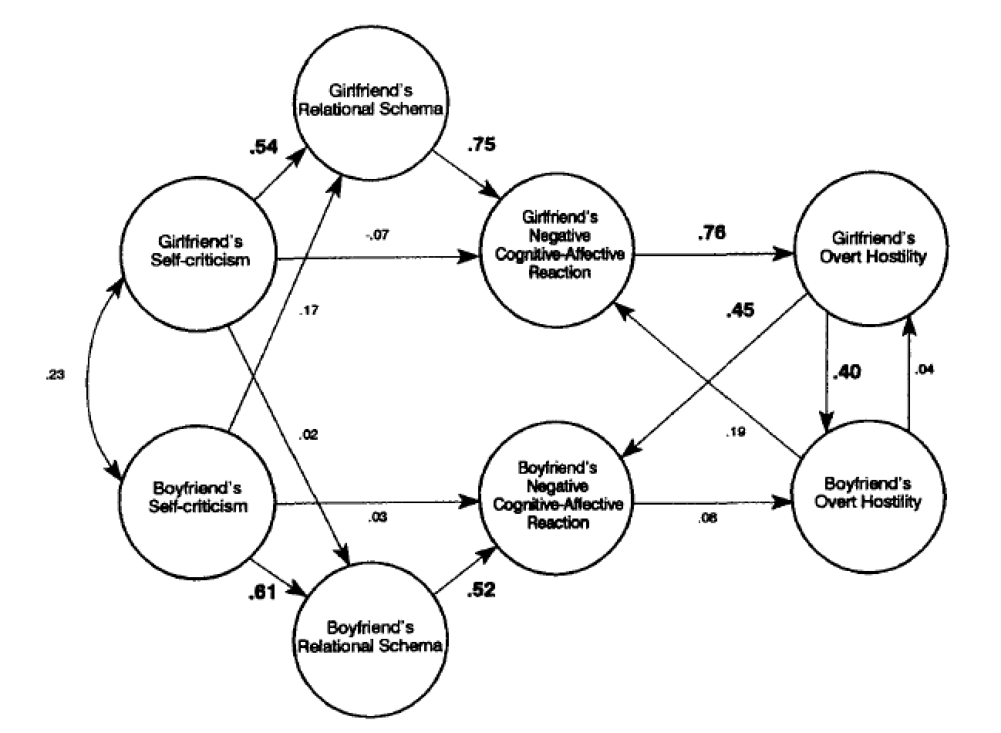

Figure 2
Moderated mediation analysis from Study 1
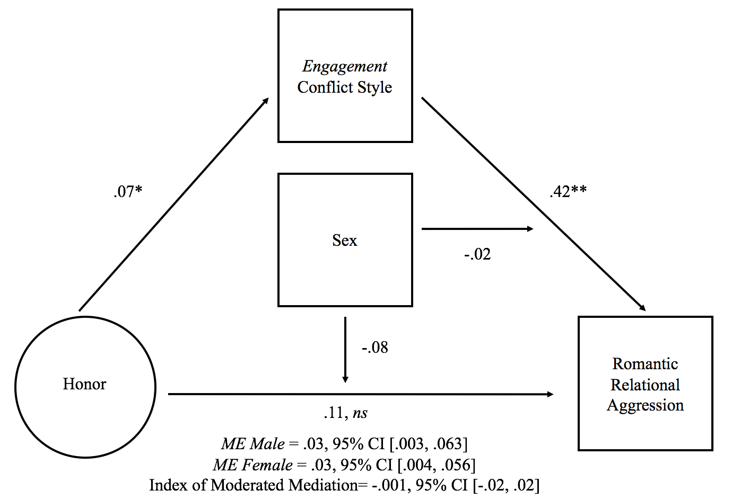

Note: N = 812. * p < .05; ** p < .01. 95% CI = 95% Confidence Interval.

Figure 3
Moderated mediation analysis from Study 2
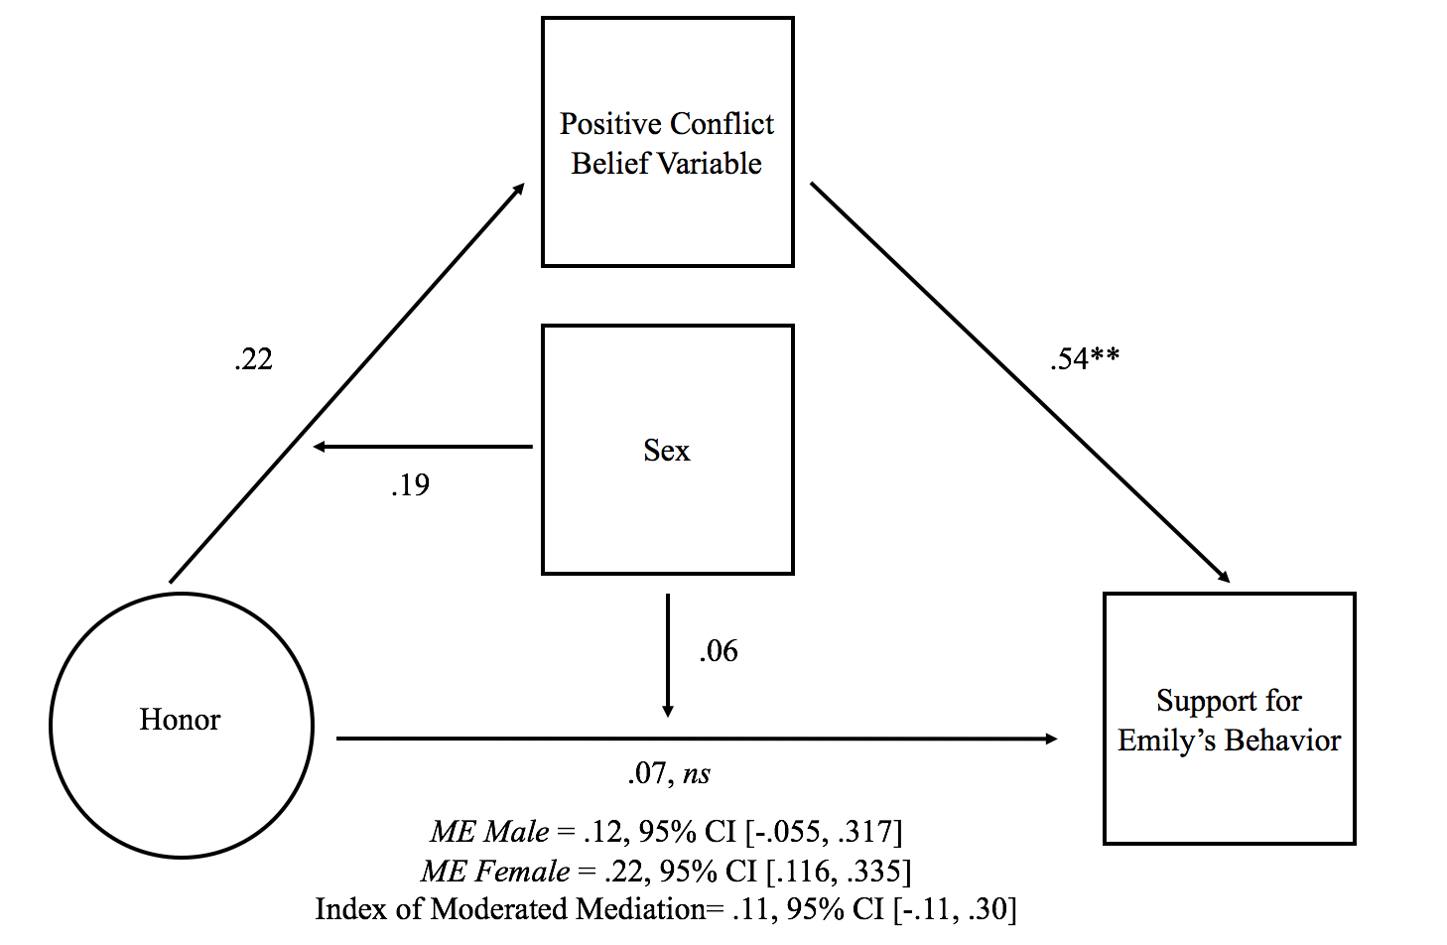
Note: N = 295. * p < .05; ** p < .01. 95% CI = 95% Confidence Interval.

Figure 4
Moderated mediation analysis from Study 3
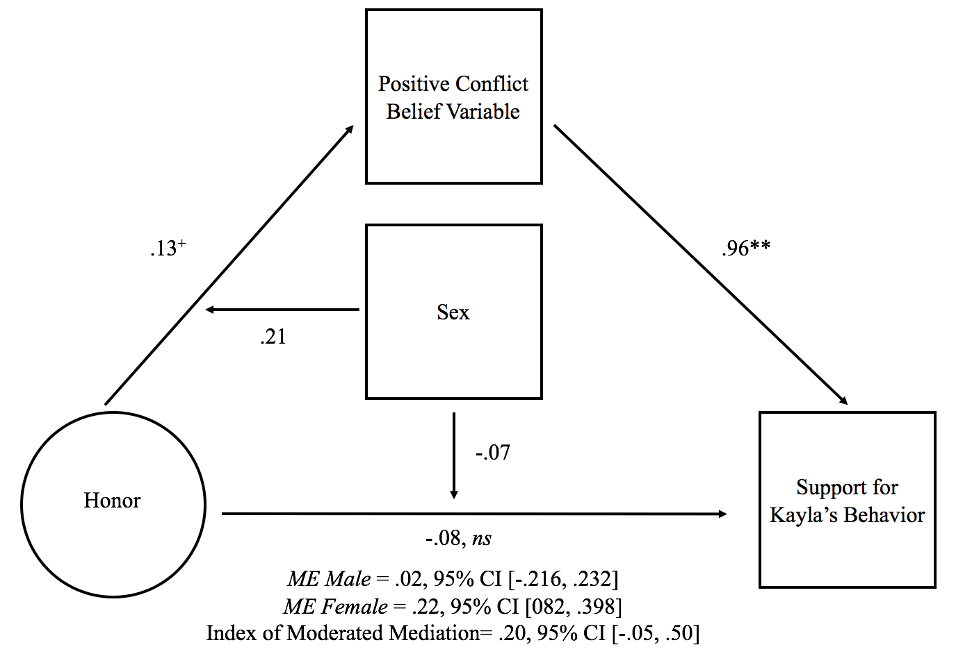
Note: N = 200. ⁺ p < .10. * p < .05; ** p < .01. 95% CI = 95% Confidence Interval.

Appendix A
Emily and Ray Conflict Vignette
Ray and Emily are currently in a romantic relationship and very recently they had a serious fight. Ray have had a long day at work and that night it was his time to cook dinner. The conflict started after they finished dinner. Ray told Emily that he was upset that she left some dishes out on the living room table after dinner two days in a row, and that he didn't think she was doing her part in keeping the house clean. Emily, who was upset by his comments, told Ray that if he wasn't going out to drink with his friends all the time, he would realize just how much she did around the house. After exchanging a few insults, he angrily swung the dish around, yelling at her about how he just wanted to come home from work and not have to clean up after her. Emily was terrible upset and felt completely disrespected by Ray. In no way was she willing to defuse the situation- after yelling that he was a "low-life" that doesn't think about anyone but himself, she stormed out of the room, and ended up not talking to him for the rest of the day.

Appendix B
Kayla and Matt Conflict Vignette
Kayla and Matt have been in a romantic relationship for approximately 1 year. One day, Kayla happens to leave her cell phone on the table, and Matt notices messages popping up on the screen from another man he has seen her texting multiple times before. In the messages, the man asks Kayla for some extra help at work that night with some work-related tasks. Matt becomes jealous that Kayla appears to be repeatedly chatting with another man via text, so later that day he asks her about the messages. When Kayla tells Matt that the texts were from a male coworker and that he has no reason to be upset, Matt replies “I just can’t believe my girlfriend is flirting with a bunch of guys at work behind my back”. Kayla, clearly offended at the claim that she has not been loyal to Matt, angrily yells back at him that he is an “idiot for thinking that”. As the argument progresses, she becomes even more angry at him, and starts insulting Matt’s physical appearance and personality, such as calling him a “fat slob” and “insecure”. The argument ends with Kayla screaming a profanity at him and storming out of the room.

