University of Oklahoma

Graduate College

A new approach to form error determination in sculptured surface metrology

A thesis

submitted to the Graduate Faculty

in partial fulfillment of the requirements for the

Degree of

Master of Science

By

vasanth arulprakasam
Norman, Oklahoma
2018

A new approach to form error determination in sculptured surface metrology

A thesis approved for the
School of Industrial and Systems Engineering

By

______________________________
Dr. Shivakumar Raman, Chair

______________________________
Dr. Randa Shehab

______________________________
Dr. Theodore Trafalis

© Copyright by vasanth arulprakasam 2018
All Rights Reserved.

Acknowledgements
I would like to appreciate my professor Dr. Shivakumar Raman for his guidance, patience throughout the period of my research work. His constructive feedback during each stage of my thesis work kindle me to do critical thinking on my thesis work and fulfill the project well before the deadline. He has allotted time each week to review the progress of my thesis work which backed me in accomplishing my work promptly.
I would also like to thank Dr. Randa Shehab and Dr. Theodore Trafalis for their guidance by being served as a committee member. Also, I would like to express my gratitude to all ISE and AME faculties and staffs for their academic support throughout my tenure of graduate life.
I would like to appreciate the assistance provided by my friend and graduate student Thillaiarasu Venugopal from Industrial and Systems Engineering department. He worked shoulder to shoulder with me in this research work by lending his support in machining the sculptured surface samples in machine shop and rendering help in taking CMM measurements. It helped me in finishing the research work on time. Finally, I would like to thank all my friends and colleagues who inspired and backed me during critical moments of my life.
Last but foremost living soul, my appa and amma encouraged me throughout my life in all stages of life. Their sacrifices and hard work for me in their life is boundless. Also, I would like to appreciate my beloved sister for providing constructive opinions throughout my life.

Table of Contents

Acknowledgements iv
List of Tables vii
List of Figures viii
Abstract ix
Chapter 1: Introduction 1
1.1 Sculptured surface background 1
1.2 Problem statement 2
Chapter 2: Literature review 4
2.2 Measurement errors 5
2.3 Surface fitting 6
2.4 Sampling points 7
2.5 Cyber physical system – Future work 8
Chapter 3: Effect of manufacturing process error 11
3.1 Introduction 11
3.2 Methodology 12
3.2.1 Manufacturing error 12
3.2.2 Methodology-form tolerance 13
3.2.2 Methodology - Position tolerance 15
Chapter 4: Modelling and Analysis 16
4.1 Localization 16
4.2 Parametric representation 17
4.3 Algorithm explanation 18
4.3.1 Form tolerance 20
4.3.2 Position tolerance 22
Chapter 5: Experiments and Results 25
5.1 Preliminary experimental conditions 25
Chapter 6: Summary, Conclusions and Future work 34
6.1 Summary and Conclusions 34
6.2 Future work 35
References 38
APPENDICES 40
Appendix A: MATLAB® coding to calculate sampling point location 40
Appendix B: Free from surface-type1-sample1-measurement points 48
Appendix C: Free from surface-type2-sample1-measurement points 60

List of Tables

Table 1. Machining Parameters 32
Table 2. Form error difference on all samples 34
Table 3. Maximum error location of all 3 samples in surface 1 35

List of Figures

Figure 1. Structure of Cyber-physical system (Literature (Lee, Bagheri, and Kao 2014) ) 9
Figure 2. Dimensional error on Bell shaped part (Obeidat 2008) 12
Figure 3. Cubic splines at selected ‘v’ point 14
Figure 4. Sculptured surface-type1 (shallow) 19
Figure 5. Sculptured surface-type2 (deep) 20
Figure 6. Form tolerance algorithm 21
Figure 7. Cubic spline interpolation using CL data points 22
Figure 8. Position tolerance algorithm 23
Figure 9. Entire inspection process algorithm 24
Figure 10. Total measurement points distribution using algorithm (surface 1) 30
Figure 11. Final distribution of points after reduction (Surface 1) 31
Figure 12. Total measurement points distribution using algorithm (surface 2) 32
Figure 13. Final distribution of points after reduction (Surface 2) 33
Figure 14. CUSUM chart for maximum error location for 3 samples 37

Abstract
This thesis presents a new approach to the determination of sampling points for CMM inspection of sculptured surfaces, for when the surface equations are not available. It is an implementation-based methodology that relies on commercial CAD/CAM software to determine the Cutter Location (CL) points. Using these CL points, cubic splines are formed, and the maximum curvatures points are found out. These maximum curvature points are inspected using CMM. After performing measurement, suitable localization of coordinate data is performed. These measured points are then compared with the original designed surface and the deviation between the surfaces are calculated. These are termed as profile form tolerances. Further, using the sign convention of the curvatures and the transition of signs, inflection points are determined. These are used to determine profile position tolerances. Sample parts are machined, and the methods developed in this work are validated. These investigations are preliminary and must be studied in further detail through experimentation and analysis for creating formal methodology for verifying sculptured surfaces. Determination of the sampling points is quite important for the newer generation of cyber physical systems whereby suitable control can be provided to manufacturing and inspection equipment. This is again suggested for further research.

Chapter 1: Introduction

1.1 Sculptured surface background
Sculptured surface products are ubiquitous in almost all extent of application mainly to improve the design functionality and to increase the aesthetic of the product. There are many technological advancements in skillful manufacturing of such products and their inspection. Sculptured surface measurement strategies and time utilization is key to improving productivity and product quality.
There are key measurements associated with sculptured surface measurement that include form, size, position and orientation. Upper and lower boundary of the profile surface are the important elements to measure and the deviation between is called the form tolerance. It can be a unilateral or bilateral tolerance based on the functionality of the product. Unique inspection plan as per the complexity of the part is the key factor that needs to be planned prior to the measurement of the free-form part. Typically, the coordinate measuring machine (CMM) or non-contact scanning measuring instruments are used to measure the data points on the surface to determine the profile tolerance of the part. Instruction codes for the CMM program requires the determination of the probe path, measuring points, and the probe angle.
Research exists, in literature, on how to choose the measurement location and how to distribute the sampling points on the surface to minimize the number of points to reduce the computation time. Currently discrete points on the sculptured surfaces are measured using the coordinate measuring machine (CMM), that measures the geometry of complex surfaces. Literature review on sculptured surface measurement strategy, sampling distributions are described in detail in chapter 2.

1.2 Problem statement
In this approach, main goal is to locate the measurement points on the sculptured surface to measure the part in reduced time with high precision. Parametric surface equation of the sculptured surface has been used to locate the measurement point is used in prior researches, but in mass production the parametric equation for sculptured surface derivation is always not known to locate the measurement point. In this thesis, data points are directly taken from the CL (cutter location) points generated from the CAM software for the machining. As surface finishing path of the cutter tends to follow the straight line with constant u or v direction, data points can be collected directly from the CL points generated from CAM software. In this way we can collect massive amount of data points and individual splines on the surface are generated at v point throughout the free-form surface with chosen interval in v direction.
Sample point selection on the free-form surface should be well distributed to cover the entire free-from surface to generate substitute geometry. From the cubic spline generated from the cloud of CL data points, location of maximum curvature point is computed to locate the sample point as maximum curvature point prone to maximum manufacturing error on the sculptured surface. Thus, form tolerance is determined. Along with form tolerance, position tolerance is also equally important parameter to consider in many applications. And so, a method to determine the position tolerance through inflection point on the free-form surface is derived.
Experiments were carried out on 3 samples of 2 different free-form surfaces to analyze the manufacturing error location difference under constant other machining parameters. Based on preliminary analysis conducted with the data obtained from the pilot tests, a reduction of time while measuring free-form surfaces is proposed by reducing the number of sampled points.

Chapter 2: Literature review
2.1 Manufacturing errors
Form error deviations on the part are mainly correlated with machining process and cutter deflection during machining process. In-order to meet the exact functional requirements of the part geometry, cutting force deflection based on the speed and feed rate of the cutting tool, tolerance requirement of the part, geometric relation of the part are the notable parameters to be considered for the deterministic analysis. (Jerard et al. 1989) presented about the major types of cutting error associated with the sculptured surface, i.e gouging and excess material. In their presented work, a methodology to adjust the cutter location (CL) data points based on the curvature analysis of the sculptured surfaces was carried out. Also, conducted research on the 3-axis milling machine to automate the CL data from the CAD geometry based on curvature analysis to represents the cutting error as more manufacturing error are likely to happen on the maximum surface curvature. In this thesis work, intention is to distribute the CMM measurement points over the free-form surface in such a way to minimize the number of points but at the same time define the accuracy of machined part
(Kim, Kim, and Chu 2003) presented the form error associated with the cutter deflection in ball-end milling processes. It was mentioned that the cutting force generated in the finishing operations causes the form errors on the surface. Cutting deflections from calculated cutting forces are empirically determined and the same was compared with the cylindrical surface form error. It was mentioned that cutter deflection is more with high inclination angle on the surface. Also, (Obeidat 2008) conducted the experimental work using the bell shaped part and distributed errors against the nominal CAD surface on the surface gradient is shown in figure 2 in chapter 3. It was confirmed that maximum errors are more likely to occur in the maximum gradient on the surface. So, distributing the CMM measurement points along the maximum surface gradient area reduces the number of point requirement on the surface area and consequently reduces time consumption in measuring free-form surfaces.

2.2 Measurement errors
Coordinate measuring machine is the reliable method to measure the preciseness of free-form surface geometry. CMM has a switching touch probe usually made of ruby ball actuated to touch the physical geometry of the part. (Aguirre Cruz 2007) presented two main types of error associated with CMM. 1. Measurement errors which includes probe compensation error, probe pretravel distance error. 2. Analysis errors which includes localization error and surface fitting error. The latter error mainly takes place during the fitting of measured data points with the nominal surface boundary of the CAD model.
(Y. Shen and S. Moon 1996) presented probe pretravel error associated with the measurement. Probe pretravel is defined as the distance travel between probe touch point and probe trigger point. This is mainly caused by the different orientation of the probe during surface measurement. Always orient the probe normal to the surface of the work piece eliminates the probe pretravel distance error. As CAD model of the surface are known in our case, calculation of normal vector on the free-form surface is feasible to orient the probe. Practically surface normal orientation is not attainable always because it always needs to satisfy the principle of probe collision avoidance. As per the complex geometry of the part, most of the complex features are not measured with surface normal probe direction. (Ristic, Ainsworth, and Brujic 2001) also presented work about the contact probe compensation error by generating the offset profile surface to match the probe error compensation. Surface fitting and data smoothing was done on the probe error compensated data points to alleviate the measurement error.

2.3 Surface fitting
(Liu, Zhang, and Wang 2001) presented work on the effect of measurement error on form tolerance verification and Least Square algorithm on the substituted geometry. Among all the other algorithms, LS is the most widely used because of its simplicity and its consistency in results. (Obeidat 2008) also used the Least square algorithm for fitting the distributed non-uniform measurement points. As in our case, we are dealing with the NURBS surface measurement, surface fitting over the measured points should be smooth and it should be fitted locally to reduce the complexity of computation. (Jacoby 2000) in their work presented that structure of the data points of the surface measured are non-uniformly distributed and its exact function is unknown on most of the cases. In that case, simple use of least square fitting for the NURBS curve misrepresents the data and the real inference from the data points are not well observed.
(Jacoby 2000) further mentioned that the non-parametric fitting addresses the problem without the need of the functional relationship of the data points. As seen before only relation present in the data points of free form surfaces are cutting deflection error that associate the data point on the maximum inclination angle of the surface. So, based on the original geometry of the work piece, location of maximum surface gradient can be linked as an error term to its respective data points to build the substitute geometry. Locally weighted regression algorithm was used in his paper to generate the substitute geometry.

2.4 Sampling points
Sampling points distribution on the free-form surface should be unique to the complexity of the work piece. As mentioned in (Obeidat 2008), general sampling algorithms like simple random sampling, stratified random sampling and systematic sampling are not effective to represent the free-from surface with minimum number of points. There are two important characteristics that needs to be considered, i.e. 1. Distribution of sample points and 2. Number of sample points selection. (Obeidat 2008) addressed this need in his research work on adaptive sampling for free-form surface measurement to measure the profile tolerance. In his work, totally three different iterative algorithms are defined to locate the critical measurement points by separating the free-form surface into sub-regions. As mentioned in (Kim et al. 2003), location point is selected on the region that has more surface gradient based on the surface parametric equation.
In (Elkott and Veldhuis 2005) dealt with the free-form surface inspection based on iso-parametric lines. Free-form surface is divided by the individual lines and iteratively sample points are calculated and distributed based on the maximum surface curvature point. In-order to collect the iso-parametric lines points, continuous scanning probe heads are used. Curvature change based sampling had been done to locate the sample points.

2.5 Cyber physical system – Future work
Determination of individual critical points are useful to analyze the successive production parts in mass production setting. In this thesis work, implementation of cyber physical system is presented in the future work to predict the production performance. Literature review on cyber physical system is presented in this section. Cyber physical manufacturing metrology model is presented in (Majstorovic et al. 2017) which includes the intelligent inspection planning of sculptured parts by using physical geometric features/information from the CAD/GD&T parameters excavated from the engineering drawings from the product lifecycle environment. Cloud technology was used to generate the coordinate measuring machine reports and compute the analysis of product using the design information in product lifecycle. Inspection sequence in CMM for free form surfaces were planned to use the NURBS information of the surface, collision avoidance principle, rationale B-spline entity.
(Lee, Bagheri, and Kao 2014) presented 5c cyber physical system architecture to implement industry 4.0. Figure 1 described the detail view of the guidelines to implement cyber physical manufacturing system to enhance product quality. In the future work presented in this thesis work, framework of cyber physical system implementation in manufacturing quality is presented with a typical example of sculptured surface form tolerance measurement and trend analysis. Trend of the chart provides information from cyber space to physical space and mainly it provides product quality reasoning to implement corrective and preventive actions plan to improve the operating efficiency and quality. The main source of CPMS is to generate necessary information and communicate the action plan requirement through networks to physical equipment or informed decision to human beings. The upper level of the hierarchy triangle in figure 1 comprises of data management and analytics process. Information of the product could be fetched directly from the product lifecycle management (PLM) software. The lower level of the hierarchy triangle deals with the field level data acquirement and virtual response about the on-going process.


Figure 1. Structure of Cyber-physical system (Literature (Lee et al. 2014) )
(Bauernhansl et al. 2016) presented the literature survey on cyber-physical systems increasing trend in the recent years and its growing demand is inevitable in the highly competitive market. The main characteristics of cyber physical manufacturing systems are intelligence, connectedness and responsiveness. In detail, raw information from individual sub-systems are acquired through sensors at full length, provide information to the different subsystem including human beings about the internal and external changes of the machine. In this thesis, raw information is collected form the form error measurement of sculptured surface.
(Lee 2014) cited about the requirement and design challenges present in the implementation of cyber physical systems. It stressed about the importance of robustness in the CPS to counter the unforeseen sub-system failures. A major technical design challenges mentioned lies on the safety-critical systems and timing issues of existing object-oriented programming when coupled with the semantic software systems to engage the physical system with high accuracy to tackle the unanticipated circumstances.
Overall literature review on cyber physical system talked about the absolute influence of cyber-physical system in the manufacturing setting and current challenges in implementation. Future work presented in this thesis work discusses about the application of cyber-physical production systems in the field of inspection by applying Cumulative SUM chart on the manufactured part through the application of sculptured surface profile tolerance measurement.
In the following chapters, methodology, algorithms and experimental works for determining form errors of sculptured surface are explained in detail.

Chapter 3: Effect of manufacturing process error

3.1 Introduction
Physical geometry of the machined surface is the primary feature that needs to be inspected first and validated to approve the product for its designated applications. Even though machining errors on the machine are mathematically calculated in some previous research to anticipate the error pattern on the complexity of the surface, in most of the applications machining process is followed by finishing processes such as form grinding polishing or shot peening. So, the error pattern calculated by the mathematical simulations are slightly deviated from the actual error due to the subsequent process of machining. Hence, actual measurement and verification of parts are done after the set of machining and finishing operations.
Two common types of dimensional verification are often performed after manufacturing: contact and non-contact. In this research direct probe touch (contact) inspection is used to measure the sculptured surface. The steps included in inspection of the sculptured surface involves, 1. Sampling of inspection points, 2. Localization of measured points according to the CAD geometry, 3. Surface fitting of the measured points, 4. Measurement of maximum error (e_{max}) to qualify the part.
Inspection process is considered a non-value-added activity. Hence, inspection should be designed in such a way to reduce the non-value-added time. A simple inspection process design is presented in this thesis.

3.2 Methodology

3.2.1 Manufacturing error
As discussed in (Kim et al. 2003) maximum error on the non-uniform surface occurs on the location of maximum curvature on the surface. (Obeidat and Raman 2009) conducted experiments on the bell-shaped part to determine the deviation of actual surface from the nominal cylindrical surface. Red line shown in figure 2 represents the nominal design of the bell part. Blue dotted points are the inspected points on the machined bell part. It was observed from the figure that, form error on the surface increases whenever the inclination angle on the surface increase. So, it was concluded that, the main base to find the critical points on the sculptured surface is to locate the maximum curvature point on the surface. 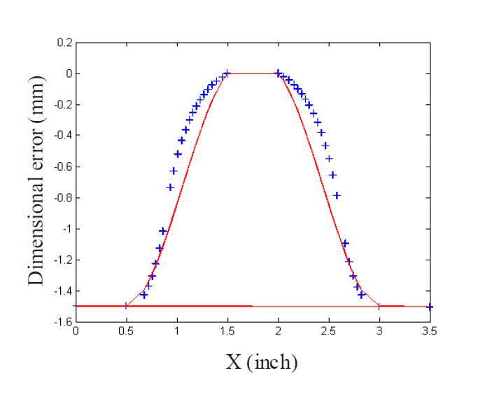
Figure 2. Dimensional error on Bell shaped part (Obeidat 2008)

3.2.2 Methodology-form tolerance
In this thesis, a completely different approach of using CL points to determine the critical points is carried out. The methodology to determine critical points without using the parametric surface equations are proposed.
Cloud of data points representing the surface finish of the sculptured surfaces generated by the CAMWorks® is used mainly in this work to determine the location of critical points. Generated toolpath follows the algorithm of constant stepover, zig-zag direction of sliced pattern which offsets inwards along the surface. As tool path follows the constant stepover during its surface finishing operation in all algorithms, data points generated in CAMWorks® are sequential and can be handled easily with less prior data processing to start the computation. X, Y, Z data points are collected directly from the cutter location points and analysis is carried out further on the collected data points to compute the sampling points. Cubic spline interpolant is generated from the collected data points using the piecewise polynomial structure. At constant ‘v’ point, varying ‘u’ and Z points are taken to generate the splines. Surface finishing tool diameter is taken to choose the ‘v’ points on the surface. Then corresponding splines are generated using the ‘u’ and Z points.
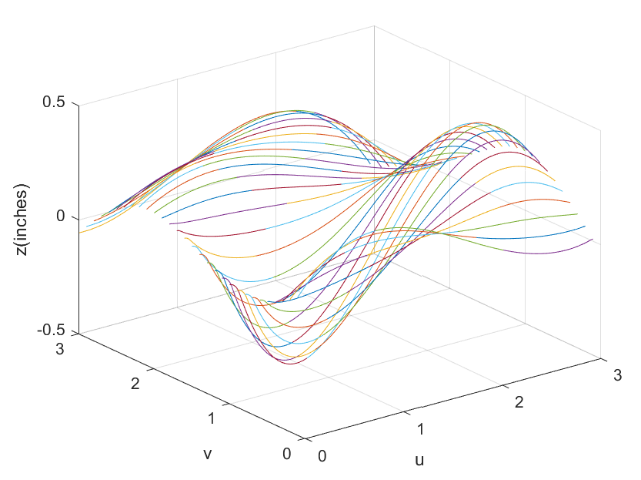
Figure 3. Cubic splines at selected ‘v’ point

Figure 3 shows the generated cubic splines at chosen ‘v’ interval. Piecewise polynomial structure of cubic splines is created at chosen interval using MATLAB® software. MATLAB® codes are mentioned in the appendices. Maximum curvature points on each spline are determined using the SLM (Shape Language Modelling) tool box in MATLAB®. In detail, explanation of algorithm modelling and distribution of sampling points are presented in the chapter 4.
The strategy used in this thesis is summarized thus:
- A sculptured surface model is created using SOLIDWORKS®
- Machining sequence for the part is created using CAMWorks®
- Part is manufactured using 3-axis HAAS® milling machine
- CL data points are processed using Excel® and MATLAB® to analyze the surface gradient of the part
- Localization of data points is done to match nominal CL points
- Inspection is done using Brown & Sharpe® CMM

3.2.2 Methodology - Position tolerance
To find the position tolerance and to better distribute the points on surface with selection of curves on surface, inflection point is computed. Inflection point is defined as the point on the curve at which the sign of curvature changes. Free-from surface workpiece in most of the applications fit with other mating part to perform the functionality of the design. So, location feature of the machined free-from surface is most important to be within the designed tolerance. For instance, if the change of curvature plays a major role in assembly of the component, along with form tolerance, location tolerance should also be within the specification. So, Inflection point on the surface assists in distributing the sample points along the surface and helps in finding the location tolerance on the free-form surface
To determine inflection points at the selected location, cubic splines are generated at the chosen area. Then, spline function is differentiated twice on the spline and determined the point where second derivative crosses zero. Calculated point is added to measurement point to inspect the surface along with the maximum curvature location points. Slmsolve tool box in MATLAB® is used to determine the inflection point.

Chapter 4: Modelling and Analysis

4.1 Localization
Sculptured part is modelled in SOLIDWORKS®, and the CL points are generated using CAMWorks®. Inspection points on the CMM are not typically oriented in the same coordinate system as the CAD/CAM model. So, first step involved in this analysis is to localize and work on same coordinates. In this work, design coordinates are used as a reference and coordinate system of CL points and CMM coordinate system are transformed to match the design coordinate system. As mentioned in (Cho and Seo 1999), a localization process is done to match the alignment of nominal surface with the actual part surface. Transformation of CL points and measurement points are carried out by,
$${\{M}_{ti}\}=\left[T_{l}\right]\{M_{i}\}$$

Where, [T_{l}] is the transformation matrix that needs to be determined, {M_{i}} are the measurement points and {M_{ti}} are the transformed measurement points. CL points can also be transformed in the same way. Translation and rotation matrix provided in (Chang 2015) are,
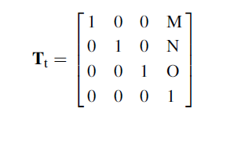

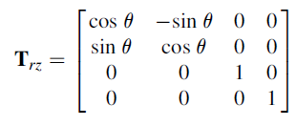
In the same way, transformation of X, Y and Z axis are found out. Transformation of CL points and CMM points are accomplished to match with the alignment of design coordinate system.

4.2 Parametric representation
Sculptured surface is usually represented using parametric equation. Parametric curve equation can be given in the CAD software to create a quadratic or cubic curve. In this work, 2 sculptured surfaces are represented through parametric surface equation. ‘u’ and ‘v’ are the parametric coordinates of surface normally between 0 and 1. As mentioned in (Chang 2015), sculptured surface equation is created using cubic curves at certain ‘v’ interval and ‘lofted’ to frame a surface equation. All the curves derived mathematically are used to create a curve in SOLIDWORKS® parametric curve option at certain ‘v’ intervals to create a surface through loft option. Parametric surface equation is usually represented as,

$S\left(u,v\right)={\left[Sx\left(u, v\right), Sy\left(u, v\right), Sz\left(u, v\right)\right]}_{1X3}, \left(u,v\right)∈\left[0,1\right]X[0,1]$

In this thesis, ‘u’ and ‘v’ values are created in the range between 0 and 3 for convenience. $S(u, v)$ is computed through lofting all parametric curves in ‘v’ direction. All the equations and methods to create parametric equation are computed as mentioned in (Chang 2015). Parametric curves at v =0, 1, 2 3 are P(u), Q(u), R(u), T(u) respectively. All four parametric curve equations are put together to construct the surface equation using following equation,

$$S\left(u, v\right)=\left[v^{3} v^{2} v 1\right] \left[\left[\begin{matrix}-1/6 & 1/2 & -1/2 & -1/6 \\ 1 & -15/6 & 2 & -1/2 \\ -11/6 & 3 & -3/2 & 1/3 \\ 1 & 0 & 0 & 0\end{matrix}\right]\right]\left[\begin{matrix}P(u) \\ Q(u) \\ R(u) \\ T(u)\end{matrix}\right]$$

4.3 Algorithm explanation
Sculptured surfaces are created using SOLIDWORKS®. Cutter Location (CL) points used for machining are used to find the sample data points to measure the sculptured surfaces using the algorithm described below. In this proposed method, CL points on surface finishing operations are used to determine the optimum sample points. In the surface finishing operation, cutter will be moving according to the step over distance specified. Based on the complexity of the part and precision required on the part, selection of sample points on the sculptured surface will be determined. Here, it is a user-oriented algorithm which determines the optimum sample points on the machined surface to measure the part. Tool diameter set on tool head for the machining process is directly proportional to the manufacturing error on the machined surface. Form tolerance and position tolerance algorithm are explained in detail in the following sections. Two sculptured samples are used for demonstration and the experiments. To find the effect of variations, two sculptured surfaces of different complexity with same machining settings are selected (Figures 4 and 5).
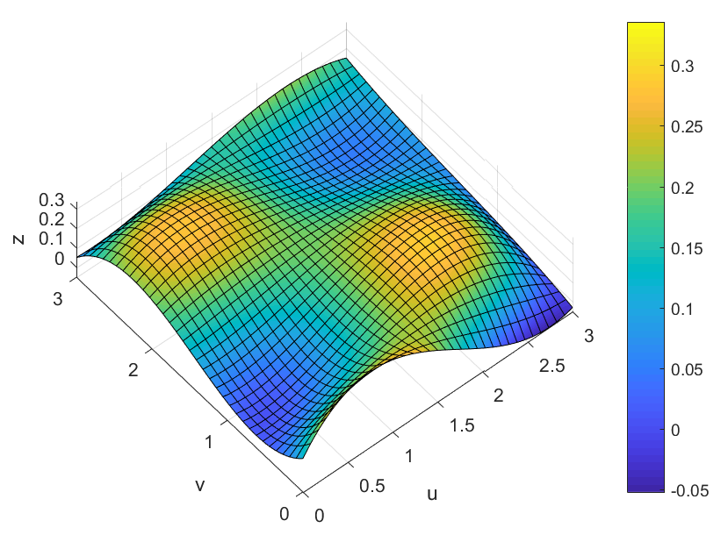
Figure 4. Sculptured surface-type1 (shallow)

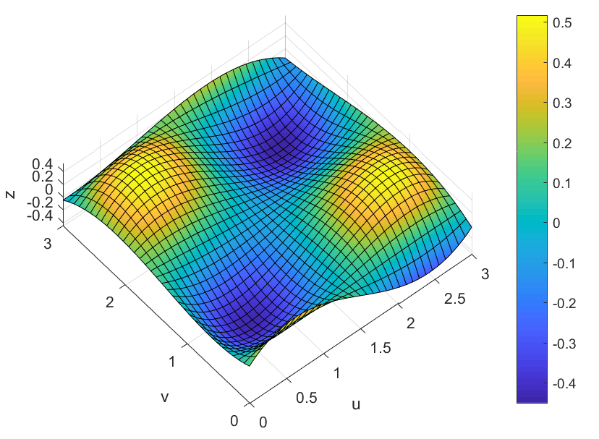
Figure 5. Sculptured surface-type2 (deep)

4.3.1 Form tolerance
As mentioned in literature review, the main goal is to find out the location of maximum surface curvature point to locate the difference between nominal and machined surface. In the proposed algorithm to measure the form tolerance of the part, maximum surface curvature values along the ‘v’ direction is computed using the MATLAB® code. Dense data points of CL points are evenly spaced, and cubic spline interpolant are created using piecewise polynomial structure along the entire ‘v’ direction. As we are finding out the maximum curvature value along the created spline, only one maximum curvature value can be found out for each created spline. By doing so, there is a high chance that all maximum curvature falls in the same area of the surface and calculated points may not represent the whole surface. In-order to address this issue, curve is split into three to four segments based on the complexity of the part to determine the maximum curvature value at each segment of the curve. Based on the complexity of the part, spline is split at various locations and maximum surface curvature value location in ‘v’ direction is computed. In the same way, maximum curvature values for all ‘v’ points are calculated by creating the separate spline. In this way, sample points calculated falls all over the surface and well define the surface. Cubic spline is shown in figure 7. In the same way, maximum curvature value over the surface is calculated using CL points. All the steps involved in this algorithm is clearly mentioned in the MATLAB® code. Steps involved in form tolerance verification of the sculptured surface is,
- Create a spline along ‘v’ direction at the selected ‘v’ point
- Split the cubic spline based on the complexity
- Find the maximum curvature values of the cubic spline
- Find the error between the nominal surface and machined surface at the computed points
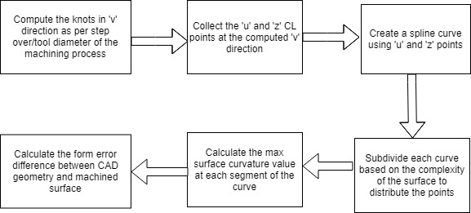
Figure 6. Form tolerance algorithm

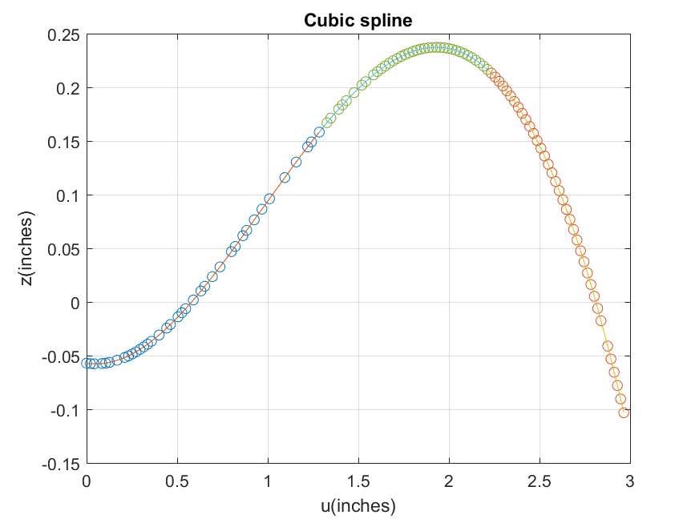
Figure 7. Cubic spline interpolation using CL data points

4.3.2 Position tolerance
Position tolerance inspection is as important as form tolerance verification. Mainly in the assembly of sculptured surface parts, position tolerance of the machined part plays a vital role. Position tolerance verification of sculptured surface is demonstrated in detail in Figure 8. This is a user-oriented algorithm as the desired surface area to verify position tolerance on the sculptured part needs must be selected by the user based on the application criticality.
As both position and form tolerance are verified through the single inspection, computed location for position tolerance is combined with the distributed data points of form tolerance to combine the inspection into one and provide the different results for position and form tolerance. Also, the procedure to determine the inflection point is also similar. In the proposed algorithm to measure the position tolerance of the part, inflection points along the desired ‘v’ direction is computed using the MATLAB® code. From the cubic spline created for finding surface curvature values for form tolerance, inflection point is calculated at the desired location.
Steps involved in position tolerance verification of the sculptured surface is,

- Create a cubic spline curve along ‘v’ direction at the selected ‘v’ point
- Find the inflection point on the cubic spline at the desired ‘u’ points
- Find the error between the nominal surface and machined surface at the computed points
The main advantage of this algorithm is to compute the desired points using the accessible CL points generated for machining and there is no need of parametric surface equation for the sculptured surface.
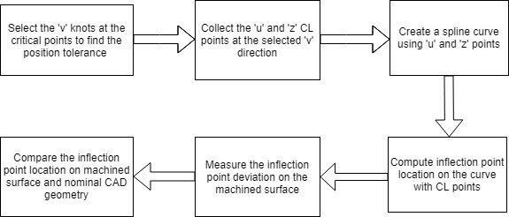
Figure 8. Position tolerance algorithm

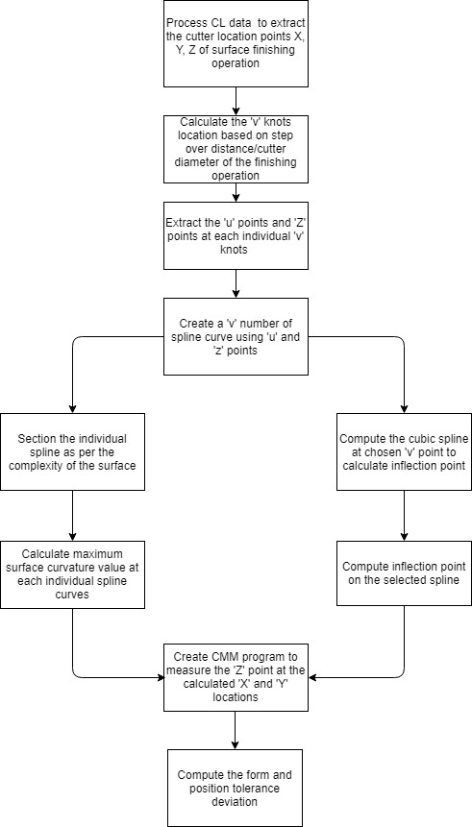
Figure 9. Entire inspection process algorithm

Chapter 5: Experiments and Results

5.1 Preliminary experimental conditions
Two sculptured surface parts were manufactured using 3-axis CNC vertical milling machine. Machining parameters used for machining the sculptured part are shown in Table 11. Ball nose cutter was used for the entire process. There are 2 different sculptured surfaces with 3 samples in each set used in the pilot study. Same Ball nose cutter was used for the surface finishing operation for the entire process to measure the actual error in the part. Sculptured surface parts were modelled using SOLIDWORKS® software and machining codes are generated using CAMWorks® software. 3-axis HAAS® milling machine was used for the entire part manufacturing and Cutter Location (CL) points generated from the CAMWorks® were post processed to generate a G-code for the machine.

Table 1. Machining Parameters

Parameters | Sample 1 | Sample 2 | Sample 3
Speed(RPM) | 2000 | 2000 | 2000
Feed rate(IPM) | 30 | 30 | 50
Pattern | Slice | Slice | Slice
Stepover | 0.005 | 0.005 | 0.005
Allowance | 0 | 0 | 0
Z allowance | 0 | 0 | 0
Directional | Zigzag | Zigzag | Zigzag

A BROWN & SHARPE® CMM PFX 454 System was used for the inspection processes. A 4 mm ruby ball probe of 30 mm length was used for all the experiments to keep the measurement error constant. In-order to find the location of X and Y points on the sculptured surface, CL points generated from CAMWorks® were processed and sampling points computed at the maximum surface curvature values. Sampling points calculation algorithm was coded using MATLAB® for both surfaces. Cutter Location (CL) data points file generated by the CAMWorks® is processed using the Excel® macros.
PC-DMIS software was used to generate the CMM program to inspect the points at calculated locations. All three samples of same surface were run through the same program and measured values noted. Actual measured values through the inspection are processed using Excel® macros to get the actual X, Y, Z values.
X and Y locations were determined using MATLAB®. X and Y locations for each of the two different surfaces are computed separately. Maximum error difference in all 3 samples are presented in Table 2. In comparing maximum error difference on both positive and negative sides of all three samples, it was observed that all maximum error differences were at the same locations in all the samples.

Table 2. Form error difference on all samples

Surface | Sample | Tolerance Zone(inch)
Surface 1 | Sample 1 | 0.09
Surface 1 | Sample 2 | -0.13
Surface 1 | Sample 3 | -0.13
Surface 2 | Sample 1 | 0.25
Surface 2 | Sample 2 | 0.32
Surface 2 | Sample 3 | 0.34

Error difference of three samples in each surface are sorted based on the maximum error in each side of nominal surface. After the critical points are sorted down, it was observed that form error locations are same for all sorted data with moderate increase of errors at the same location. In Table 3 maximum error location on all the three samples manufactured are mentioned with two maximum error points on positive tolerance and two maximum error points on negative tolerance. Total measurement points calculated initially are plotted in the figure 10
In the mass production industry, it is often useful to analyze the first inspection report and based on the result of the first part further parts are inspected to reduce the inspection time. In this case, maximum error locations are taken out since those locations are more prone to go out of specifications. Based on the desired level of allowable tolerance limit and application, maximum error values locations could be segregated and carry out the inspection to reduce the time.
Table 3. Maximum error location of all 3 samples in surface 1

Sample | X | Y | Z | Z_eqn | diff_Z
Sample 1 | 2.7165 | 0.2985 | -0.0019 | 0.085066565 | -0.086966565
Sample 1 | 1.9007 | 0.1987 | 0.1063 | 0.183187151 | -0.076887151
Sample 1 | 0.2721 | 0.2984 | 0.1748 | 0.089078861 | 0.085721139
Sample 1 | 0.435 | 0.4984 | 0.1451 | 0.050825781 | 0.094274219
Sample 2 | 2.7164 | 0.2982 | 1.1286 | 0.084990947 | -0.135390947
Sample 2 | 1.9004 | 0.1982 | 1.2395 | 0.183047783 | -0.122547783
Sample 2 | 0.2727 | 0.2984 | 1.3092 | 0.089185154 | 0.041014846
Sample 2 | 0.4355 | 0.4984 | 1.2802 | 0.050891622 | 0.050308378
Sample 3 | 2.7162 | 0.2984 | 1.1298 | 0.085112443 | -0.134312443
Sample 3 | 1.9004 | 0.1984 | 1.2411 | 0.183118293 | -0.121018293
Sample 3 | 0.273 | 0.2983 | 1.3136 | 0.089276633 | 0.045323367
Sample 3 | 0.4353 | 0.4984 | 1.2844 | 0.05086528 | 0.05453472

.
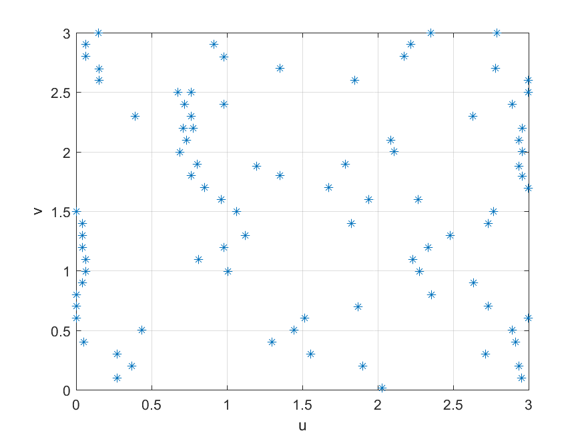
Figure 10. Total measurement points distribution using algorithm (surface 1)

As, form error location were similar in all the three samples for each surface, this observation could be used further to reduce the number of measurement points saving time in future measurements. This way, the CMM program can be instructed to probe the area which reflects the maximum error. All errors are sorted, and maximum error locations above 0.015 inches are selected for sampling future plates, as shown in Figure 11. Similarly Figures 12 and 13 illustrate sampling location for surface 2.
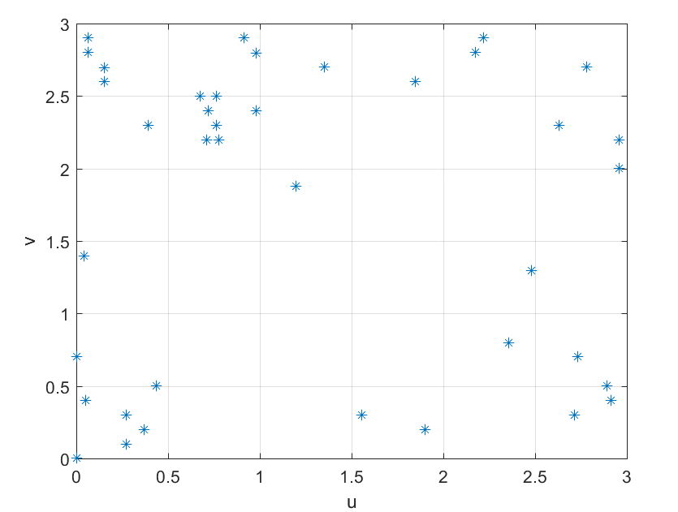
Figure 11. Final distribution of points after reduction (Surface 1)
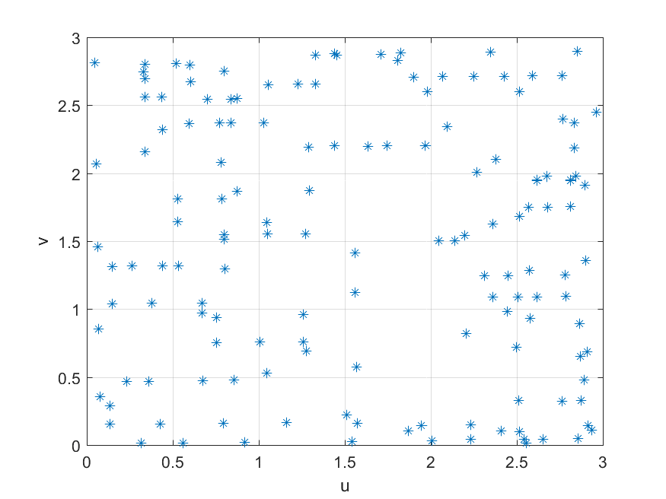
Figure 12. Total measurement points distribution using algorithm (surface 2)
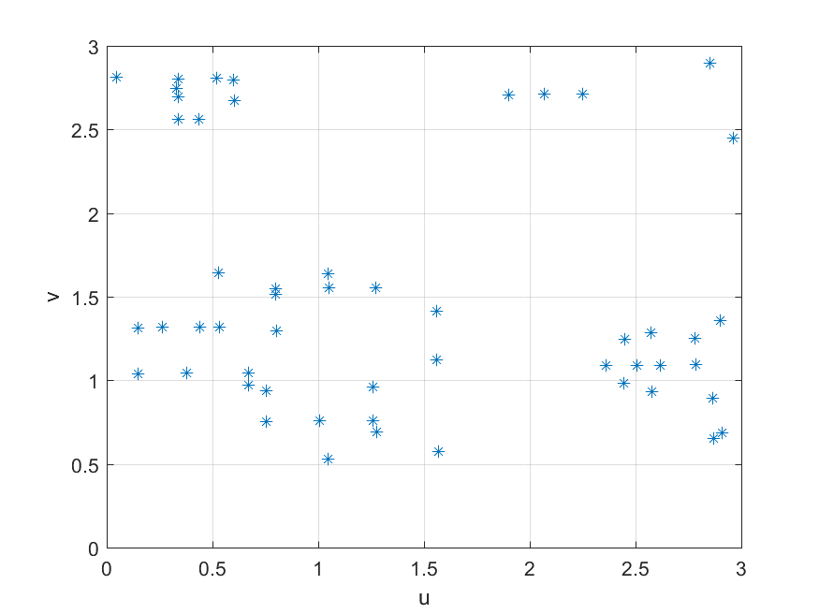
Figure 13. Final distribution of points after reduction (Surface 2)

For instance, should there be any process changes such as tool change or machine parameter change, CMM could take measurements for all sampling points and update the error values. Hence a reduction in measurement could be achieved on successive parts.

Chapter 6: Summary, Conclusions and Future work

6.1 Summary and Conclusions
Some newer ideas are proposed to effect sampling of sculptured surfaces, in this thesis. A methodology was developed to measure profiles of sculptured surfaces that relied on commercial software SOLIDWORKS® and CAMWorks®. This software allowed the determination of the CL points that was used to determine sampling locations. These were used to create a curve along the surface. The curvature at each of these locations was determined mathematically. The calculated points were measured using the CMM. The error was calculated as the difference between measured points and the nominal surface. This is termed as form tolerances in this thesis. For determining the position tolerance, inflection points are calculated mathematically. Minimization of number of measurement points on sculptured surface in the mass production environment is also discussed.
Preliminary observations were made in the validation of the models through actual experimentation. The observations suggest that the new ideas have some merit. It is noted that detailed experimental design and analysis must be undertaken for making concrete conclusions. All the same, this thesis presents for the first time an approach to the determination of form tolerances of standard sculptured surfaces.

6.2 Future work
1. An adaptive curve selection points could be applied on the sculptured surface using the Cutter location points. In this way, number of curves needed to perform the calculation can be reduced.
2. The performance of the algorithm presented in this thesis should be compared with different sampling algorithms and strategies to determine the consistency of algorithm.
3. Number of measurement points chosen for the successive parts could be made adaptive based on the allowable tolerance and complexity of part
4. The algorithm proposed in this thesis could be used to develop an application to determine the sampling points through Cutter location data collected from CAM data in Product Lifecycle Management (PLM). In the same way, standard algorithms for shapes like spherical, conical, conical frustum, torus could also be implemented to standardize all the sampling algorithms.
5. As mentioned in figure 1 architecture of implementation of cyber-physical system in (Lee et al. 2014), the information collected from raw data of workpiece could be used to analyze the variation of trends in the workpiece geometry, and infer the quality performance of the machine. Also, these can be articulated to production operator to take the necessary action on the machine to mitigate the impact before it takes place. (Majstorovic et al. 2017) worked on the sculptured surface measurement planning using cloud technology to implement cyber-physical system in manufacturing environment. In the same way, Cyber-Physical system could be implemented for form error deviations of sculptured surfaces. CMM measurement could be used to provide informed decision on what correction needs to be taken on the next part during manufacturing based on the deviation of the current part. CUmulative SUM(CUSUM) is a moving average chart to detect the small shifts in the process to provide constructive and predictive outcome of the process. Its statistic integrates the variation of the measurements of the previous parts to expose the small shift in the process.
In determining CUSUM, location of the nominal Z value is taken as mean (µ_{o}) and corresponding observed values on actual machined surface is taken as (X_{i}). Individual plot in the Cumulative sum chart is the integration of all previous values with some weights associated to it.
$$C_{i}= \sum_{i=1}^{n}{(x_{i}-μ_{o})}$$

C_{i} is the cumulative sum of all data points. Since it accounts all the previous values in a current plot, it predicts the deviation of process in less average run length value (ARL). Average run length is defined as the number of values plotted to detect the out of control signal. Two parameters are most important in designing ARL, i.e., 1. Reference value K, 2. Decision interval. As mentioned in (Montgomery 2009), H is defined as hσ and K is defined as kσ, where σ is the standard deviation. Usually h =4 or 5 and k = ½. These values are often given according to the criticality of the process. CUSUM chart is mainly desired to detect the small shift in the process, so standard deviation of 0.5 can also be given to detect the shift within 2 or 3 samples.
The CUSUM chart could be constructed for the maximum deviation values of all the three samples. This predicts the process performance and gives trigger point before process fallout happens with the CNC machine used to manufacture the surfaces. Accordingly, the standard deviation for the measured points can be set to concentrate only on the potential locations of maximum error. The main ideology is to detect the maximum error point and construct the CUSUM chart for the maximum error location to identify the error before it shifts out of the set control limit.

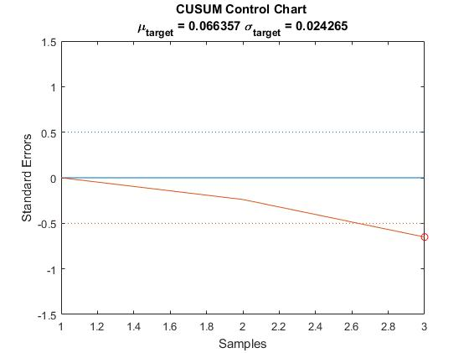
Figure 14. CUSUM chart for maximum error location for 3 samples

Here, maximum tolerance deviation location is noted for all three samples and CUSUM is plotted in figure 14. Based on the application, multiple such charts could be plotted to monitor the process better.

References
1. Aguirre Cruz, J. A. 2007. “Decision Support System for Form Verification of Manufactured Parts.” PhD Dissertation, University of oklahoma,Norman, OK.

2. Bauernhansl, T., S. Kondoh, S. Kumara, L. Monostori, and B. Ka. 2016. “Cyber-Physical Systems in Manufacturing.” CIRP Annals - Manufacturing Technology 65:621–41.

3. Chang, Kuang-Hua. 2015. E-Design Computer-Aided Engineering Design.

4. Cho, M. W. and T. Seo. 1999. “Sculptured Surface Recognition and Localization Strategy in the CMM Process.” KSME International Journal 13(10):701–13.

5. Elkott, D. F. and S. C. Veldhuis. 2005. “Isoparametric Line Sampling for the Inspection Planning of Sculptured Surfaces.” Computer-Aided Design 37:189–200.

6.Jacoby, W. G. 2000. “Loess : A Nonparametric , Graphical Tool for Depicting Relationships between Variables.” Electoral Studies 19:577–613.

7. Jerard, R. B., R. L. Drysdale, K. Hauck, B. Schaudt, and J. Magewick. 1989. “Sculptured Surfaces Methods for Detecting Errors in Numerically Controlled Machining of Sculptured Surfaces.”

8. Kim, G. M., B. H. Kim, and C. N. Chu. 2003. “Estimation of Cutter Deflection and Form Error in Ball-End Milling Processes.” International Journal of Machine Tools & Manufacture 43:917–24.

9. Lee, E. A. 2014. “Cyber Physical Systems : Design Challenges.” IEEE Xplore (June 2008).

10. Lee, J., B. Bagheri, and H. Kao. 2014. “A Cyber-Physical Systems Architecture for Industry 4 . 0-Based Manufacturing Systems.” Society of Manufacturing Engineers (SME) 3:18–23.

11. Liu, Q., C. C. Zhang, and H. B. Wang. 2001. “On the Effects of CMM Measurement Error on Form Tolerance Estimation.” Measurement 30:33–47.

12. Majstorovic, V., S. Stojadinovic, S. Zivkovic, and D. Djurdjanovic. 2017. “Cyber-Physical Manufacturing Metrology Model ( CPM 3 ) for Sculptured Surfaces – Turbine Blade Application.” Procedia CIRP 63:658–63.

13. Montgomery, D. C. 2009. Statistical Quality Control, A Modern Introduction, Seventh Edition. WILEY.

14. Obeidat, S. M. 2008. “Adaptive Methods for Form Error Determination in Discrete Point Metrology.” PhD Dissertation, University of oklahoma, Norman, OK.

15. Obeidat, S. M. and S. Raman. 2009. “An Intelligent Sampling Method for Inspecting Free-Form Surfaces.” International Journal of Advanced Manufacturing Technology 40:1125–36.

16. Ristic, M., I. Ainsworth, and D. Brujic. 2001. “Contact Probe Radius Compensation Using Computer Aided Design Models.” IMechE (December 1999):819–34.

17. Y. Shen and S. Moon. 1996. “Error Compensation of Coordinate Measurements in Computer-Integrated Manufacturing Using Neural Networks.” Journal of Materials Processing Technology 61:12–17.

APPENDICES

Appendix A: MATLAB® coding to calculate sampling point location
- Calculating Free form surface equation and plot

% Free form surface equation calculation using curve equation
syms u;
b = [-1/6 1/2 -1/2 -1/6; 1 -15/6 2 -1/2; -11/6 3 -3/2 1/3; 1 0 0 0];
% Curve equation at 4 different v locations
c = [u (1/10)*u^3-(21/40)*u^2+(5/8)*u+0.12 0;
u (-2/25)*u^3+(7/25)*u^2-(3/25)*u+0.04 1;
u (1/25)*u^3-(1/5)*u^2+(1/5)*u+0.2 2;
u (-1/30)*u^3+(1/8)*u^2-(1/24)*u+0.05 3];

syms w;
a = [w^3 w^2 w 1];
first = a*b;
surface_eqn = first*c;
N = 100;
u = linspace(0,3,N);
w = linspace(0,3,N);

px = [0 1 2 3]; % u and Z points at v = 0
pz = [0.12 0.32 0.07 -0.03];
py = [0 0 0 0];
qx = [0 1 2 3]; % u and Z points at v = 1
qz = [0.04 0.12 0.28 0.04];
qy = [1 1 1 1];
rx = [0 1 2 3]; % u and Z points at v = 2
rz = [0.2 0.24 0.12 0.08];
ry = [2 2 2 2];
tx = [0 1 2 3]; % u and Z points at v = 3
tz = [0.05 0.1 0.2 0.15];
ty = [3 3 3 3];

for i = 1:1:N
Sx = u(i)*(w.^3/2 - (5*w.^2)/2 + 3*w) - u(i)*(w.^3/2 - 2*w.^2 + (3*w)/2) + u(i)*((w.^3)/6 - (w.^2)/2 + w/3) - u(i)*(w.^3/6 - w.^2 + (11*w)/6 - 1);
Sz = -(w.^3/2 - 2*w.^2 + (3*w)/2)*(u(i)^3/25 - u(i)^2/5 + u(i)/5 + 1/5) - (w.^3/6 - w.^2/2 + w/3)*(u(i)^3/30 - u(i)^2/8 + u(i)/24 - 1/20) - (w.^3/2 - (5*w.^2)/2 + 3*w)*((2*u(i)^3)/25 - (7*u(i)^2)/25 + (3*u(i))/25 - 1/25) - (u(i)^3/10 - (21*u(i)^2)/40 + (5*u(i))/8 + 3/25)*(w.^3/6 - w.^2 + (11*w)/6 - 1);
Sy = w.*ones(1,N);
plot3(Sx,Sy,Sz)
hold on
end

for i = 1:1:N
Sx = u*(w(i)^3/2 - (5*w(i)^2)/2 + 3*w(i)) - u*(w(i)^3/2 - 2*w(i)^2 + (3*w(i))/2) + u*(w(i)^3/6 - w(i)^2/2 + w(i)/3) - u*(w(i)^3/6 - w(i)^2 + (11*w(i))/6 - 1);
Sz = -(w(i)^3/2 - 2*w(i)^2 + (3*w(i))/2)*(u.^3/25 - u.^2/5 + u/5 + 1/5) - (w(i)^3/6 - w(i)^2/2 + w(i)/3)*(u.^3/30 - u.^2/8 + u/24 - 1/20) - (w(i)^3/2 - (5*w(i)^2)/2 + 3*w(i))*((2*u.^3)/25 - (7*u.^2)/25 + (3*u)/25 - 1/25) - (u.^3/10 - (21*u.^2)/40 + (5*u)/8 + 3/25)*(w(i)^3/6 - w(i)^2 + (11*w(i))/6 - 1);
Sy = w(i).*ones(1,N);
plot3(Sx,Sy,Sz)
hold on
end

plot3(px,py,pz,'--')
hold on
plot3(qx,qy,qz,'--')
hold on
plot3(rx,ry,rz,'--')
hold on
plot3(tx,ty,tz,'--')

xlabel('x'),ylabel('y'),zlabel('z')
title('loft surface');
view(-33, 65)

- Transformation

% Tranformation of CL data according to design coordinate system
% read the CL data

CL_data = csvread('eqn_freeform_shallow.csv', 1, 0);
CL_data;

%transpose the CL data to transform
CLdata = CL_data';
CLdata = [CLdata; ones(1,46119)];

%Step 1 translate +0.321 along Z axis to the origin of equation
trans1 = [1 0 0 0;
0 1 0 0;
0 0 1 0.321;
0 0 0 1];
ytrans = trans1 * CLdata;

final_CLdata = ytrans';

CL_X = final_CLdata( :,1);
CL_Y = final_CLdata( :,2);
CL_Z = final_CLdata( :,3);

min_CLX = min(CL_X); % minimum value in X
max_CLX = max(CL_X); % maximum value in X
min_CLY = min(CL_Y);
max_CLY = max(CL_Y);
proj_CLX = linspace(min_CLX, max_CLX,100);
proj_CLY = linspace(min_CLY, max_CLY, 100);

[PROJ_CLX, PROJ_CLY] = meshgrid(proj_CLX, proj_CLY); %creation of meshgrid with min, max X and Y
PROJ_CLZ = griddata(CL_X,CL_Y,CL_Z,PROJ_CLX, PROJ_CLY,'cubic');

CL_Sur = surf(PROJ_CLX,PROJ_CLY,PROJ_CLZ);
mesh(PROJ_CLX,PROJ_CLY,PROJ_CLZ);
axis tight;
hold on;

- Gaussian curvature count

CL_data_shallow = csvread('eqn_freeform_shallow.csv', 1, 0);

% Y_value based on step over distance of tool cutter or it can be user
% defined

Y_value = [2.9975,2.8975,2.7975,2.6975,2.5975,2.4975,2.3975,2.2975,2.1975,2.0975,1.9975,...
1.8975,1.7975,1.6975,1.5975,1.4975,1.3975,1.2975,1.1975,1.0975,0.9975,0.8975,0.7975,...
0.6975,0.5975,0.4975,0.3975,0.2975,0.1975,0.0975];

num = numel(Y_value);

X1_loc = [];
X2_loc = [];
Y_loc = [];
max_cur = [];
min_cur = [];
l = 1;
m = 1;

for i = 1:1:num
Y_total = sum(CL_data_shallow( :,2)==Y_value(i));
Y_range = find(CL_data_shallow( :,2)==Y_value(i));

min_Y = min(Y_range);
max_Y = max(Y_range);

split = linspace(min_Y,max_Y, 4);
split = round(split);

% first loop
X = [];
Y = [];
Z = [];
k = 1;

for j = split(1):1:split(2)

X(k,1) = CL_data_shallow(j,1);

Z(k,1) = CL_data_shallow(j,3);

Y(k,1) = CL_data_shallow(j,2);

k = k+1;
end

plot(X,Z,'o'),grid on
hold on;
curve_1 = spline(X,Z);
[curmax,Xmax_loc] = slmpar(curve_1,'maxfpp');

[curmin,Xmin_loc] = slmpar(curve_1,'minfpp');

X1_loc(l,1) = Xmax_loc;
X2_loc(l,1) = Xmin_loc;
Y_loc(l,1) = Y_value(i);
max_cur(l,1) = curmax;
min_cur(l,1) = curmin;
l = l+1;

% 2nd loop

X = [];
Y = [];
Z = [];
k = 1;
for j = split(2):1:split(3)

X(k,1) = CL_data_shallow(j,1);

Z(k,1) = CL_data_shallow(j,3);

Y(k,1) = CL_data_shallow(j,2);

k = k+1;
end

plot(X,Z,'o'),grid on
hold on;
curve_1 = spline(X,Z);
[curmax,Xmax_loc] = slmpar(curve_1,'maxfpp');

[curmin,Xmin_loc] = slmpar(curve_1,'minfpp');

X1_loc(l,1) = Xmax_loc;
X2_loc(l,1) = Xmin_loc;
Y_loc(l,1) = Y_value(i);
max_cur(l,1) = curmax;
min_cur(l,1) = curmin;
l = l+1;

% 3rd loop

X = [];
Y = [];
Z = [];
k = 1;
for j = split(3):1:split(4)

X(k,1) = CL_data_shallow(j,1);

Z(k,1) = CL_data_shallow(j,3);

Y(k,1) = CL_data_shallow(j,2);

k = k+1;
end

plot(X,Z,'o'),grid on
hold on;
curve_1 = spline(X,Z);
[curmax,Xmax_loc] = slmpar(curve_1,'maxfpp');

[curmin,Xmin_loc] = slmpar(curve_1,'minfpp');

X1_loc(l,1) = Xmax_loc;
X2_loc(l,1) = Xmin_loc;
Y_loc(l,1) = Y_value(i);
max_cur(l,1) = curmax;
min_cur(l,1) = curmin;
l = l+1;

%% Find inflection points at selected location
inflection_points = [0.9975, 1.9975];
if Y_value(i) == inflection_points(m)
X = [];
Y = [];
Z = [];

min_Y = min(Y_range);
max_Y = max(Y_range);

for j = min_Y:1:max_Y

X(k,1) = CL_data_shallow(j,1);

Z(k,1) = CL_data_shallow(j,3);

Y(k,1) = CL_data_shallow(j,2);

k = k+1;
end
pp = slmengine(X(1:end),Z(1:end),'plot','on','decreasing','on','knots',8,'result','pp');
ppd2 = fnder(pp,2);
fnplt(ppd2)
d2zerolocs = slmsolve(ppd2,0)
m=m+1;

else
end

end

%% Export max, min curvature location to Excel file
T = table(X1_loc, X2_loc, Y_loc, max_cur, min_cur);
Excel = 'curvature_points_shallow.xlsx';
writetable(T, Excel ,'sheet',1,'Range','A1');

- Z_difference calculation between CMM measured point and Theoretical equation

transformed_data = csvread('transformed_shallow1.csv', 1, 0); %Import CSV file

n = numel(transformed_data( :,1)); % total number of transformed data
Z_eqn = []; % nominal value of Z at given X and Y values
diff_Z = [];
% Find the maximum error between CMM point and nominal surface
for i =1:1:n
syms u w;

Sz = -(w^3/2 - 2*w^2 + (3*w)/2)*(u^3/25 - u^2/5 + u/5 + 1/5) -...
(w^3/6 - w^2/2 + w/3)*(u^3/30 - u^2/8 + u/24 - 1/20) -...
(w^3/2 - (5*w^2)/2 + 3*w)*((2*u^3)/25 - (7*u^2)/25 + (3*u)/25 - 1/25)-...
(u^3/10 - (21*u^2)/40 + (5*u)/8 + 3/25)*(w^3/6 - w^2 + (11*w)/6 - 1);

u1 = transformed_data(i,1);
w1 = transformed_data(i,2);
c = subs(Sz, [u, w], [u1, w1]);
Z_eqn(i,1) = double(c);

diff_Z(i,1) = transformed_data(i,3) - Z_eqn(i,1);

end

%% export X Y Z data to Excel file

T = table(Z_eqn, diff_Z);
Excel = 'transformed_shallow1.xlsx';
writetable(T, Excel ,'sheet',1,'Range','D1');

%% find the location of maximum error values on either side

sorted_error = sort(diff_Z); % sort the error in ascending order

max_error_values = [sorted_error(1),sorted_error(2),sorted_error(n-1),sorted_error(n)]

find(diff_Z==max_error_values(1));
find(diff_Z==max_error_values(2));
find(diff_Z==max_error_values(3));
find(diff_Z==max_error_values(4));

Appendix B: Free from surface-type1-sample1-measurement points

CMM Measurements |  |  | Calculated X and Y points  from CL data
X-actual  (inch) | Y-actual  (inch) | Z-actual  (inch) | Ideal-X  (inch) | Ideal-Y  (Inch) | Ideal-Z  (inch)
2.3519 | 2.9971 | 1.3829 | 2.35 | 2.9975 | 1.45
2.7915 | 3 | 1.3568 | 2.7918 | 2.9975 | 1.4523
0.1499 | 2.9956 | 1.2203 | 0.1499 | 2.9975 | 1.4595
2.2186 | 2.8998 | 1.3795 | 2.2192 | 2.8975 | 1.4521
0.9138 | 2.8999 | 1.2824 | 0.9139 | 2.8975 | 1.4523
0.0653 | 2.8999 | 1.2462 | 0.0652 | 2.8975 | 1.45
2.1745 | 2.7995 | 1.3707 | 2.1752 | 2.7975 | 1.45
0.9796 | 2.7983 | 1.3085 | 0.9789 | 2.7975 | 1.4526
0.0657 | 2.7999 | 1.2739 | 0.0652 | 2.7975 | 1.4506
2.7829 | 2.6997 | 1.3253 | 2.7833 | 2.6975 | 1.4518
1.3503 | 2.6998 | 1.3432 | 1.3482 | 2.6975 | 1.436
0.1526 | 2.6979 | 1.3015 | 0.1522 | 2.6975 | 1.448
2.9992 | 2.5998 | 1.2939 | 3 | 2.5975 | 1.4314
1.8472 | 2.5994 | 1.3479 | 1.8478 | 2.5975 | 1.4326
0.1525 | 2.5997 | 1.3273 | 0.1521 | 2.5975 | 1.4322
2.9995 | 2.4997 | 1.2864 | 3 | 2.4975 | 1.4371
0.7614 | 2.4985 | 1.3695 | 0.7608 | 2.4975 | 1.4327
0.6739 | 2.4972 | 1.3694 | 0.6739 | 2.4975 | 1.4324
2.8905 | 2.396 | 1.2772 | 2.8913 | 2.3975 | 1.4387
0.9785 | 2.3975 | 1.3842 | 0.9782 | 2.3975 | 1.4326
0.7176 | 2.3972 | 1.3912 | 0.7173 | 2.3975 | 1.4328
2.6298 | 2.2959 | 1.2645 | 2.6304 | 2.2975 | 1.4305
0.7619 | 2.297 | 1.4075 | 0.7608 | 2.2975 | 1.4324
0.3925 | 2.296 | 1.4045 | 0.3913 | 2.2975 | 1.4322
2.9561 | 2.1957 | 1.2627 | 2.9565 | 2.1975 | 1.4302
0.7748 | 2.196 | 1.4188 | 0.7737 | 2.1975 | 1.4326
0.7096 | 2.196 | 1.4208 | 0.7092 | 2.1975 | 1.4327
2.934 | 2.0956 | 1.2549 | 2.9347 | 2.0975 | 1.4307
2.0862 | 2.0956 | 1.2795 | 2.0869 | 2.0975 | 1.4316
0.7313 | 2.0956 | 1.4259 | 0.7312 | 2.0975 | 1.433
2.956 | 1.9999 | 1.2522 | 2.9565 | 1.9975 | 1.4309
2.108 | 1.9998 | 1.2797 | 2.1086 | 1.9975 | 1.4312
0.6892 | 1.9971 | 1.4244 | 0.6883 | 1.9975 | 1.4326
2.9338 | 1.8779 | 1.2481 | 2.9347 | 1.8795 | 1.431
1.1979 | 1.8791 | 1.3867 | 1.1956 | 1.8795 | 1.4314
0.8048 | 1.8973 | 1.4115 | 0.8043 | 1.8975 | 1.4318
2.9561 | 1.796 | 1.2473 | 2.9566 | 1.7975 | 1.4312
1.3501 | 1.7973 | 1.3724 | 1.3478 | 1.7975 | 1.431
0.7617 | 1.7971 | 1.3959 | 0.7608 | 1.7975 | 1.4316
2.9992 | 1.6958 | 1.243 | 3 | 1.6975 | 1.4318
1.6764 | 1.6971 | 1.3589 | 1.6768 | 1.6975 | 1.4305
0.8501 | 1.6999 | 1.3759 | 0.8493 | 1.6975 | 1.4314
2.2681 | 1.5998 | 1.3473 | 2.2687 | 1.5975 | 1.4369
1.9408 | 1.5997 | 1.3664 | 1.9416 | 1.5975 | 1.4359
0.9609 | 1.5988 | 1.3577 | 0.9598 | 1.5975 | 1.4328
2.7683 | 1.4995 | 1.2989 | 2.7689 | 1.4975 | 1.4313
1.0629 | 1.4985 | 1.346 | 1.0614 | 1.4975 | 1.4315
0.0001 | 1.4996 | 1.2891 | 0 | 1.4975 | 1.4352
2.7309 | 1.3985 | 1.3234 | 2.7313 | 1.3975 | 1.4325
1.8235 | 1.3986 | 1.4062 | 1.8245 | 1.3975 | 1.42
0.0435 | 1.3972 | 1.2695 | 0.0432 | 1.3975 | 1.423
2.4819 | 1.2968 | 1.3981 | 2.4822 | 1.2975 | 1.4232
1.1209 | 1.2973 | 1.3279 | 1.1189 | 1.2975 | 1.4219
0.0434 | 1.297 | 1.2482 | 0.043 | 1.2975 | 1.422
2.3354 | 1.1962 | 1.4347 | 2.3363 | 1.1975 | 1.424
0.9807 | 1.1975 | 1.2945 | 0.9789 | 1.1975 | 1.4213
0.043 | 1.1959 | 1.2288 | 0.0421 | 1.1975 | 1.4265
2.2313 | 1.0957 | 1.4516 | 2.2314 | 1.0975 | 1.4232
0.813 | 1.0965 | 1.2565 | 0.8121 | 1.0975 | 1.4214
0.0647 | 1.0958 | 1.2107 | 0.0641 | 1.0975 | 1.4209
2.2751 | 0.9956 | 1.4466 | 2.2756 | 0.9975 | 1.4238
1.0059 | 0.9958 | 1.2941 | 1.0045 | 0.9975 | 1.4218
0.0646 | 0.9959 | 1.1999 | 0.0641 | 0.9975 | 1.4243
2.6359 | 0.8998 | 1.3651 | 2.6366 | 0.8975 | 1.4229
1.7865 | 1.897 | 1.3262 | 1.788 | 1.8975 | 1.4212
0.0431 | 0.8997 | 1.1971 | 0.0425 | 0.8975 | 1.4208
2.3541 | 0.7996 | 1.4017 | 2.3546 | 0.7975 | 1.4241
2.354 | 0.7997 | 1.4017 | 2.3546 | 0.7975 | 1.424
0.0011 | 0.7998 | 1.1972 | 0 | 0.7975 | 1.4298
2.7308 | 0.6998 | 1.2914 | 2.7317 | 0.6975 | 1.4291
1.8695 | 0.6985 | 1.4021 | 1.8702 | 0.6976 | 1.424
0.0008 | 0.6998 | 1.1993 | 0 | 0.6975 | 1.42
2.9989 | 0.5997 | 1.1972 | 3 | 0.5975 | 1.4225
1.5152 | 0.5985 | 1.384 | 1.5176 | 0.5975 | 1.4214
0.0008 | 0.599 | 1.206 | 0 | 0.5975 | 1.4269
2.8923 | 0.4987 | 1.2043 | 2.8928 | 0.4975 | 1.4224
1.4462 | 0.4986 | 1.3831 | 1.4485 | 0.4975 | 1.4214
0.435 | 0.4984 | 1.3241 | 0.435 | 0.4975 | 1.4202
2.9123 | 0.3985 | 1.1844 | 2.913 | 0.3975 | 1.4213
1.2965 | 0.3985 | 1.3974 | 1.2943 | 0.3975 | 1.4216
0.0523 | 0.3982 | 1.2502 | 0.0515 | 0.3975 | 1.4205
2.7165 | 0.2985 | 1.1771 | 2.7173 | 0.2975 | 1.4213
1.556 | 0.2983 | 1.3678 | 1.5585 | 0.2975 | 1.4216
0.2721 | 0.2984 | 1.3538 | 0.2718 | 0.2975 | 1.4206
2.9341 | 0.1983 | 1.1569 | 2.9347 | 0.1975 | 1.4204
1.9007 | 0.1987 | 1.2853 | 1.9019 | 0.1975 | 1.4213
0.3686 | 0.1986 | 1.4117 | 0.3678 | 0.1975 | 1.4214
2.9557 | 0.0986 | 1.1491 | 2.9567 | 0.0975 | 1.42
2.0289 | 0.0107 | 1.235 | 2.0307 | 0.0098 | 1.4276
0.2705 | 0.0986 | 1.408 | 0.2694 | 0.0975 | 1.42

Free form surface-type 1-sample 2- Measurement Points
CMM Measurements |  |  | Calculated X and Y points  from CL data
X-actual  (inch) | Y-actual  (inch) | Z-actual  (inch) | Ideal-X  (inch) | Ideal-Y  (Inch) | Ideal-Z  (inch)
2.3522 | 2.9973 | 1.3377 | 2.35 | 2.9975 | 1.45
2.7915 | 2.9996 | 1.3099 | 2.7918 | 2.9975 | 1.4523
0.1508 | 2.9957 | 1.1802 | 0.1499 | 2.9975 | 1.4595
2.2184 | 2.8997 | 1.3342 | 2.2192 | 2.8975 | 1.4521
0.915 | 2.8994 | 1.2389 | 0.9139 | 2.8975 | 1.4523
0.0656 | 2.8996 | 1.2065 | 0.0652 | 2.8975 | 1.45
2.1747 | 2.7988 | 1.325 | 2.1752 | 2.7975 | 1.45
0.9792 | 2.7983 | 1.2649 | 0.9789 | 2.7975 | 1.4526
0.0656 | 2.7996 | 1.2338 | 0.0652 | 2.7975 | 1.4506
2.7827 | 2.6994 | 1.2787 | 2.7833 | 2.6975 | 1.4518
1.3501 | 2.6998 | 1.2994 | 1.3482 | 2.6975 | 1.436
0.1528 | 2.6979 | 1.2609 | 0.1522 | 2.6975 | 1.448
2.9997 | 2.5997 | 1.2424 | 3 | 2.5975 | 1.4314
1.8474 | 2.5985 | 1.3031 | 1.8478 | 2.5975 | 1.4326
0.1527 | 2.5998 | 1.2857 | 0.1521 | 2.5975 | 1.4322
2.9992 | 2.4998 | 1.2332 | 3 | 2.4975 | 1.4371
0.7615 | 2.4985 | 1.3266 | 0.7608 | 2.4975 | 1.4327
0.6746 | 2.4973 | 1.3266 | 0.6739 | 2.4975 | 1.4324
2.8907 | 2.3961 | 1.2295 | 2.8913 | 2.3975 | 1.4387
0.979 | 2.3972 | 1.3415 | 0.9782 | 2.3975 | 1.4326
0.7188 | 2.3973 | 1.3485 | 0.7173 | 2.3975 | 1.4328
2.6296 | 2.2964 | 1.2175 | 2.6304 | 2.2975 | 1.4305
0.7624 | 2.2974 | 1.3649 | 0.7608 | 2.2975 | 1.4324
0.3917 | 2.2972 | 1.3617 | 0.3913 | 2.2975 | 1.4322
2.9556 | 2.1959 | 1.2138 | 2.9565 | 2.1975 | 1.4302
0.7748 | 2.1967 | 1.3762 | 0.7737 | 2.1975 | 1.4326
0.7097 | 2.1968 | 1.3783 | 0.7092 | 2.1975 | 1.4327
2.9336 | 2.0958 | 1.2059 | 2.9347 | 2.0975 | 1.4307
2.086 | 2.0958 | 1.2345 | 2.0869 | 2.0975 | 1.4316
0.7321 | 2.0959 | 1.3833 | 0.7312 | 2.0975 | 1.433
2.9557 | 1.9998 | 1.2033 | 2.9565 | 1.9975 | 1.4309
2.1078 | 1.9998 | 1.2344 | 2.1086 | 1.9975 | 1.4312
0.6884 | 1.9974 | 1.3819 | 0.6883 | 1.9975 | 1.4326
2.9342 | 1.8787 | 1.2 | 2.9347 | 1.8795 | 1.431
1.1976 | 1.8793 | 1.3433 | 1.1956 | 1.8795 | 1.4314
0.8053 | 1.8972 | 1.3683 | 0.8043 | 1.8975 | 1.4318
2.956 | 1.7966 | 1.1993 | 2.9566 | 1.7975 | 1.4312
1.3502 | 1.7974 | 1.3282 | 1.3478 | 1.7975 | 1.431
0.7617 | 1.7973 | 1.3522 | 0.7608 | 1.7975 | 1.4316
2.9986 | 1.696 | 1.1923 | 3 | 1.6975 | 1.4318
1.6748 | 1.6972 | 1.3139 | 1.6768 | 1.6975 | 1.4305
0.8504 | 1.6997 | 1.3315 | 0.8493 | 1.6975 | 1.4314
2.2678 | 1.5994 | 1.3007 | 2.2687 | 1.5975 | 1.4369
1.9411 | 1.5987 | 1.3202 | 1.9416 | 1.5975 | 1.4359
0.9606 | 1.5984 | 1.3127 | 0.9598 | 1.5975 | 1.4328
2.7682 | 1.4994 | 1.252 | 2.7689 | 1.4975 | 1.4313
1.0633 | 1.4984 | 1.3006 | 1.0614 | 1.4975 | 1.4315
0.0002 | 1.4997 | 1.2504 | 0 | 1.4975 | 1.4352
2.7308 | 1.3985 | 1.2772 | 2.7313 | 1.3975 | 1.4325
1.8236 | 1.3983 | 1.3596 | 1.8245 | 1.3975 | 1.42
0.0438 | 1.3972 | 1.2272 | 0.0432 | 1.3975 | 1.423
2.4822 | 1.2973 | 1.3511 | 2.4822 | 1.2975 | 1.4232
1.121 | 1.2973 | 1.2817 | 1.1189 | 1.2975 | 1.4219
0.0432 | 1.2971 | 1.206 | 0.043 | 1.2975 | 1.422
2.3352 | 1.1965 | 1.3879 | 2.3363 | 1.1975 | 1.424
0.9798 | 1.1974 | 1.2479 | 0.9789 | 1.1975 | 1.4213
0.0428 | 1.1964 | 1.187 | 0.0421 | 1.1975 | 1.4265
2.2311 | 1.0961 | 1.4051 | 2.2314 | 1.0975 | 1.4232
0.8126 | 1.0974 | 1.2108 | 0.8121 | 1.0975 | 1.4214
0.0646 | 1.096 | 1.1687 | 0.0641 | 1.0975 | 1.4209
2.275 | 0.9959 | 1.4 | 2.2756 | 0.9975 | 1.4238
1.0052 | 0.9959 | 1.2474 | 1.0045 | 0.9975 | 1.4218
0.065 | 0.9959 | 1.1582 | 0.0641 | 0.9975 | 1.4243
2.6359 | 0.8997 | 1.3195 | 2.6366 | 0.8975 | 1.4229
1.7859 | 1.8973 | 1.2816 | 1.788 | 1.8975 | 1.4212
0.0431 | 0.8998 | 1.1553 | 0.0425 | 0.8975 | 1.4208
2.3536 | 0.7996 | 1.3552 | 2.3546 | 0.7975 | 1.4241
2.3536 | 0.7993 | 1.3552 | 2.3546 | 0.7975 | 1.424
0.0005 | 0.7997 | 1.1553 | 0 | 0.7975 | 1.4298
2.7312 | 0.699 | 1.2452 | 2.7317 | 0.6975 | 1.4291
1.8692 | 0.6983 | 1.3551 | 1.8702 | 0.6976 | 1.424
0.0008 | 0.6997 | 1.157 | 0 | 0.6975 | 1.42
2.9997 | 0.5988 | 1.1458 | 3 | 0.5975 | 1.4225
1.5152 | 0.5982 | 1.3382 | 1.5176 | 0.5975 | 1.4214
0.0004 | 0.5984 | 1.1636 | 0 | 0.5975 | 1.4269
2.8924 | 0.4983 | 1.1559 | 2.8928 | 0.4975 | 1.4224
1.4463 | 0.4981 | 1.3379 | 1.4485 | 0.4975 | 1.4214
0.4355 | 0.4984 | 1.2802 | 0.435 | 0.4975 | 1.4202
2.9117 | 0.3985 | 1.1352 | 2.913 | 0.3975 | 1.4213
1.2965 | 0.3982 | 1.3527 | 1.2943 | 0.3975 | 1.4216
0.0519 | 0.3982 | 1.2056 | 0.0515 | 0.3975 | 1.4205
2.7164 | 0.2982 | 1.1286 | 2.7173 | 0.2975 | 1.4213
1.5564 | 0.2982 | 1.3226 | 1.5585 | 0.2975 | 1.4216
0.2727 | 0.2984 | 1.3092 | 0.2718 | 0.2975 | 1.4206
2.9204 | 0.1997 | 1.1562 | 2.9347 | 0.1975 | 1.4204
1.9004 | 0.1982 | 1.2395 | 1.9019 | 0.1975 | 1.4213
0.3684 | 0.1984 | 1.3669 | 0.3678 | 0.1975 | 1.4214
2.942 | 0.1 | 1.1485 | 2.9567 | 0.0975 | 1.42
2.0296 | 0.0104 | 1.1891 | 2.0307 | 0.0098 | 1.4276
0.2708 | 0.0985 | 1.3629 | 0.2694 | 0.0975 | 1.42

Free form surface-type 1-sample 3- Measurement Points
CMM Measurements |  |  | Calculated X and Y points  from CL data
X-actual  (inch) | Y-actual  (inch) | Z-actual  (inch) | Ideal-X  (inch) | Ideal-Y  (Inch) | Ideal-Z  (inch)
2.352 | 2.9972 | 1.3412 | 2.35 | 2.9975 | 1.45
2.7913 | 2.9987 | 1.3142 | 2.7918 | 2.9975 | 1.4523
0.1498 | 2.9956 | 1.1847 | 0.1499 | 2.9975 | 1.4595
2.2186 | 2.8996 | 1.3377 | 2.2192 | 2.8975 | 1.4521
0.9144 | 2.8993 | 1.2435 | 0.9139 | 2.8975 | 1.4523
0.0658 | 2.8997 | 1.2109 | 0.0652 | 2.8975 | 1.45
2.1742 | 2.7986 | 1.3283 | 2.1752 | 2.7975 | 1.45
0.9795 | 2.7982 | 1.2693 | 0.9789 | 2.7975 | 1.4526
0.0653 | 2.7997 | 1.2386 | 0.0652 | 2.7975 | 1.4506
2.7826 | 2.6995 | 1.2814 | 2.7833 | 2.6975 | 1.4518
1.3501 | 2.6996 | 1.3034 | 1.3482 | 2.6975 | 1.436
0.1525 | 2.6998 | 1.2647 | 0.1522 | 2.6975 | 1.448
2.9993 | 2.5998 | 1.2488 | 3 | 2.5975 | 1.4314
1.847 | 2.5989 | 1.3066 | 1.8478 | 2.5975 | 1.4326
0.1528 | 2.5996 | 1.2903 | 0.1521 | 2.5975 | 1.4322
2.9991 | 2.4997 | 1.2409 | 3 | 2.4975 | 1.4371
0.7613 | 2.4984 | 1.3308 | 0.7608 | 2.4975 | 1.4327
0.6747 | 2.4973 | 1.3309 | 0.6739 | 2.4975 | 1.4324
2.8905 | 2.396 | 1.2321 | 2.8913 | 2.3975 | 1.4387
0.9789 | 2.3974 | 1.3452 | 0.9782 | 2.3975 | 1.4326
0.7182 | 2.3973 | 1.3526 | 0.7173 | 2.3975 | 1.4328
2.6293 | 2.2961 | 1.2202 | 2.6304 | 2.2975 | 1.4305
0.7616 | 2.2972 | 1.3688 | 0.7608 | 2.2975 | 1.4324
0.3919 | 2.2969 | 1.3662 | 0.3913 | 2.2975 | 1.4322
2.9561 | 2.1958 | 1.2166 | 2.9565 | 2.1975 | 1.4302
0.7743 | 2.1962 | 1.3801 | 0.7737 | 2.1975 | 1.4326
0.7103 | 2.1964 | 1.3822 | 0.7092 | 2.1975 | 1.4327
2.9345 | 2.0957 | 1.2087 | 2.9347 | 2.0975 | 1.4307
2.086 | 2.0959 | 1.2374 | 2.0869 | 2.0975 | 1.4316
0.7317 | 2.0957 | 1.387 | 0.7312 | 2.0975 | 1.433
2.9559 | 2 | 1.206 | 2.9565 | 1.9975 | 1.4309
2.1074 | 1.9998 | 1.2371 | 2.1086 | 1.9975 | 1.4312
0.689 | 1.9972 | 1.3856 | 0.6883 | 1.9975 | 1.4326
2.9344 | 1.8785 | 1.2024 | 2.9347 | 1.8795 | 1.431
1.1976 | 1.8792 | 1.3465 | 1.1956 | 1.8795 | 1.4314
0.8043 | 1.8972 | 1.3718 | 0.8043 | 1.8975 | 1.4318
2.9563 | 1.7962 | 1.2015 | 2.9566 | 1.7975 | 1.4312
1.3501 | 1.7972 | 1.3315 | 1.3478 | 1.7975 | 1.431
0.7616 | 1.7971 | 1.3557 | 0.7608 | 1.7975 | 1.4316
2.9991 | 1.6958 | 1.1966 | 3 | 1.6975 | 1.4318
1.6751 | 1.6972 | 1.3169 | 1.6768 | 1.6975 | 1.4305
0.8499 | 1.6996 | 1.335 | 0.8493 | 1.6975 | 1.4314
2.2682 | 1.5992 | 1.3036 | 2.2687 | 1.5975 | 1.4369
1.941 | 1.5985 | 1.3234 | 1.9416 | 1.5975 | 1.4359
0.9606 | 1.5982 | 1.3163 | 0.9598 | 1.5975 | 1.4328
2.7681 | 1.4993 | 1.2537 | 2.7689 | 1.4975 | 1.4313
1.0629 | 1.4982 | 1.3043 | 1.0614 | 1.4975 | 1.4315
0.0005 | 1.4995 | 1.254 | 0 | 1.4975 | 1.4352
2.7314 | 1.3987 | 1.2786 | 2.7313 | 1.3975 | 1.4325
1.823 | 1.3983 | 1.3627 | 1.8245 | 1.3975 | 1.42
0.0433 | 1.3972 | 1.2307 | 0.0432 | 1.3975 | 1.423
2.482 | 1.2971 | 1.3532 | 2.4822 | 1.2975 | 1.4232
1.1209 | 1.2974 | 1.2857 | 1.1189 | 1.2975 | 1.4219
0.0436 | 1.2972 | 1.2094 | 0.043 | 1.2975 | 1.422
2.3353 | 1.1962 | 1.3901 | 2.3363 | 1.1975 | 1.424
0.9798 | 1.1973 | 1.2518 | 0.9789 | 1.1975 | 1.4213
0.0424 | 1.1961 | 1.1903 | 0.0421 | 1.1975 | 1.4265
2.2309 | 1.0959 | 1.4074 | 2.2314 | 1.0975 | 1.4232
0.8127 | 1.0971 | 1.2145 | 0.8121 | 1.0975 | 1.4214
0.0649 | 1.0958 | 1.1718 | 0.0641 | 1.0975 | 1.4209
2.2752 | 0.9958 | 1.4019 | 2.2756 | 0.9975 | 1.4238
1.0052 | 0.9958 | 1.2513 | 1.0045 | 0.9975 | 1.4218
0.0645 | 0.9959 | 1.1616 | 0.0641 | 0.9975 | 1.4243
2.636 | 0.8997 | 1.3205 | 2.6366 | 0.8975 | 1.4229
1.7862 | 1.8972 | 1.2844 | 1.788 | 1.8975 | 1.4212
0.0429 | 0.8998 | 1.1587 | 0.0425 | 0.8975 | 1.4208
2.354 | 0.7996 | 1.3566 | 2.3546 | 0.7975 | 1.4241
2.3536 | 0.7993 | 1.3566 | 2.3546 | 0.7975 | 1.424
0.0007 | 0.7998 | 1.1585 | 0 | 0.7975 | 1.4298
2.7306 | 0.6992 | 1.2461 | 2.7317 | 0.6975 | 1.4291
1.8697 | 0.6983 | 1.3573 | 1.8702 | 0.6976 | 1.424
0.0006 | 0.6997 | 1.1603 | 0 | 0.6975 | 1.42
2.9992 | 0.5996 | 1.1501 | 3 | 0.5975 | 1.4225
1.5155 | 0.5982 | 1.3408 | 1.5176 | 0.5975 | 1.4214
0.0005 | 0.5988 | 1.1667 | 0 | 0.5975 | 1.4269
2.892 | 0.4984 | 1.1569 | 2.8928 | 0.4975 | 1.4224
1.4459 | 0.4983 | 1.3406 | 1.4485 | 0.4975 | 1.4214
0.4353 | 0.4984 | 1.2844 | 0.435 | 0.4975 | 1.4202
2.9122 | 0.3986 | 1.1365 | 2.913 | 0.3975 | 1.4213
1.2964 | 0.3982 | 1.3551 | 1.2943 | 0.3975 | 1.4216
0.0519 | 0.3982 | 1.21 | 0.0515 | 0.3975 | 1.4205
2.7162 | 0.2984 | 1.1298 | 2.7173 | 0.2975 | 1.4213
1.5564 | 0.2984 | 1.3246 | 1.5585 | 0.2975 | 1.4216
0.273 | 0.2983 | 1.3136 | 0.2718 | 0.2975 | 1.4206
2.934 | 0.1983 | 1.108 | 2.9347 | 0.1975 | 1.4204
1.9004 | 0.1984 | 1.2411 | 1.9019 | 0.1975 | 1.4213
0.3681 | 0.1985 | 1.3707 | 0.3678 | 0.1975 | 1.4214
2.9559 | 0.0983 | 1.1 | 2.9567 | 0.0975 | 1.42
2.0285 | 0.0108 | 1.1904 | 2.0307 | 0.0098 | 1.4276
0.2703 | 0.0984 | 1.3671 | 0.2694 | 0.0975 | 1.42

Appendix C: Free from surface-type2-sample1-measurement points

CMM Measurements |  |  | Calculated X and Y points  from CL data
X-actual  (inch) | Y-actual  (inch) | Z-actual  (inch) | Ideal-X  (inch) | Ideal-Y  (Inch) | Ideal-Z  (inch)
2.8372 | 2.9971 | 0.99 | 2.8394 | 2.9975 | 0.9901
2.2144 | 2.9974 | 1.2264 | 2.2124 | 2.9975 | 1.2264
0.1056 | 2.9955 | 0.9484 | 0.1052 | 2.9975 | 0.9482
2.357 | 2.8999 | 1.2131 | 2.358 | 2.8975 | 1.213
1.5154 | 2.897 | 1.2356 | 1.5162 | 2.8975 | 1.23
0.1088 | 2.8955 | 0.9896 | 0.1067 | 2.8975 | 0.98
2.3313 | 2.7973 | 1.2216 | 2.3293 | 2.7975 | 1.22
1.5252 | 2.7972 | 1.2563 | 1.5275 | 2.7975 | 1.2551
0.2802 | 2.7999 | 1.0492 | 0.2796 | 2.7975 | 1.0614
2.4622 | 2.6972 | 1.1747 | 2.4647 | 2.6975 | 1.1763
1.5386 | 2.6955 | 1.2676 | 1.5392 | 2.6975 | 1.26
0.0661 | 2.6971 | 1.07 | 0.0637 | 2.6975 | 1.0795
2.5549 | 2.5957 | 1.1286 | 2.5559 | 2.5975 | 1.1354
1.2828 | 2.5961 | 1.2628 | 1.2848 | 2.5975 | 1.26
0.0013 | 2.5971 | 1.0965 | 0 | 2.5975 | 1.221
2.6888 | 2.4968 | 1.0703 | 2.6901 | 2.4975 | 1.071
1.062 | 2.4971 | 1.2685 | 1.0596 | 2.4975 | 1.2683
0.6079 | 2.4972 | 1.2321 | 0.6055 | 2.4975 | 1.2389
2.9976 | 2.3971 | 0.9882 | 3 | 2.3975 | 0.9874
1.5466 | 2.397 | 1.2554 | 1.5455 | 2.3975 | 1.255
0.9132 | 2.3998 | 1.2803 | 0.9142 | 2.3975 | 1.28
2.9975 | 2.2981 | 1.007 | 3 | 2.2975 | 1.0477
1.2379 | 2.2957 | 1.2733 | 1.2369 | 2.2975 | 1.2436
0.1829 | 2.2957 | 1.2154 | 0.1855 | 2.2975 | 1.216
2.9324 | 2.1958 | 1.0287 | 2.9347 | 2.1975 | 1.0243
1.1689 | 2.1971 | 1.2682 | 1.1684 | 2.1975 | 1.2625
0.5191 | 2.1972 | 1.2783 | 0.5193 | 2.1975 | 1.2737
2.9102 | 2.0971 | 1.0457 | 2.913 | 2.0975 | 1.0744
1.9806 | 2.0968 | 1.1236 | 1.9816 | 2.0975 | 1.1552
0.5805 | 2.0972 | 1.2721 | 0.5815 | 2.0975 | 1.2998
2.933 | 1.9955 | 1.0687 | 2.934 | 1.9975 | 1.087
2.0416 | 1.996 | 1.1028 | 2.043 | 1.9975 | 1.1212
0.8383 | 1.9968 | 1.2372 | 0.8389 | 1.9975 | 1.2565
2.999 | 1.8777 | 1.1008 | 3 | 1.8795 | 1.1009
1.3486 | 1.8775 | 1.142 | 1.3478 | 1.8795 | 1.1418
0.1542 | 1.8985 | 1.1849 | 0.1522 | 1.8975 | 1.1849
2.847 | 1.7998 | 1.1244 | 2.8478 | 1.7975 | 1.1245
1.3919 | 1.7997 | 1.1049 | 1.391 | 1.7975 | 1.1049
0.0455 | 1.7984 | 1.1618 | 0.0434 | 1.7975 | 1.1619
2.6942 | 1.6956 | 1.1754 | 2.6969 | 1.6975 | 1.1754
1.2065 | 1.7 | 1.046 | 1.206 | 1.6975 | 1.046
0.0598 | 1.6988 | 1.1351 | 0.0574 | 1.6975 | 1.1355
2.9989 | 1.5999 | 1.1686 | 3 | 1.5975 | 1.1687
1.0084 | 1.6001 | 0.9589 | 1.008 | 1.5975 | 0.9588
0.0731 | 1.5985 | 1.1027 | 0.0708 | 1.5975 | 1.1028
2.9363 | 1.4995 | 1.2126 | 2.9391 | 1.4975 | 1.2127
1.9306 | 1.4987 | 1.1547 | 1.9329 | 1.4975 | 1.154
0.0943 | 1.5002 | 1.0599 | 0.0936 | 1.4975 | 1.0521
2.9207 | 1.3971 | 1.2483 | 2.9215 | 1.3975 | 1.2484
1.1067 | 1.3958 | 0.8272 | 1.1046 | 1.3975 | 0.8269
0.1673 | 1.3993 | 0.9666 | 0.1644 | 1.3975 | 0.9673
2.2453 | 1.3 | 1.3226 | 2.2459 | 1.2975 | 1.3241
1.9206 | 1.3 | 1.19 | 1.9215 | 1.2975 | 1.189
0.1607 | 1.2996 | 0.9319 | 0.1584 | 1.2975 | 0.932
2.4666 | 1.1986 | 1.399 | 2.466 | 1.1975 | 1.3988
1.7906 | 1.1999 | 1.1322 | 1.7929 | 1.1975 | 1.1318
0.1182 | 1.2 | 0.9468 | 0.1159 | 1.1975 | 0.9465
2.8875 | 1.1 | 1.3236 | 2.8897 | 1.0975 | 1.3236
1.7822 | 1.0999 | 1.1365 | 1.7816 | 1.0975 | 1.1376
0.1315 | 1.1 | 0.9096 | 0.1293 | 1.0975 | 0.9093
2.2347 | 0.9999 | 1.3759 | 2.2359 | 0.9975 | 1.376
1.8466 | 0.996 | 1.1852 | 1.8474 | 0.9975 | 1.1842
0.1199 | 0.9954 | 0.9121 | 0.1175 | 0.9975 | 0.9143
2.9248 | 0.8985 | 1.2936 | 2.9268 | 0.8975 | 1.2934
1.8363 | 1.8974 | 1.1152 | 1.8389 | 1.8975 | 1.115
0.1225 | 0.8999 | 0.9085 | 0.1202 | 0.8975 | 0.908
2.9991 | 0.7999 | 1.2405 | 3 | 0.7975 | 1.2405
0.8369 | 0.7957 | 0.7344 | 0.8364 | 0.7975 | 0.734
0.11 | 0.7971 | 0.9298 | 0.1076 | 0.7975 | 0.9298
2.8218 | 0.6955 | 1.2905 | 2.8222 | 0.6975 | 1.2908
0.7638 | 0.6956 | 0.814 | 0.7627 | 0.6976 | 0.814
0.0979 | 0.6973 | 0.9549 | 0.0959 | 0.6975 | 0.9552
2.8163 | 0.5957 | 1.2502 | 2.8167 | 0.5975 | 1.2505
1.7264 | 0.5962 | 1.1448 | 1.7289 | 0.5975 | 1.1446
0.1204 | 0.5958 | 0.9686 | 0.1196 | 0.5975 | 0.9688
2.4021 | 0.4958 | 1.236 | 2.4002 | 0.4975 | 1.2359
1.6492 | 0.4959 | 1.1393 | 1.647 | 0.4975 | 1.1393
0.0437 | 0.4958 | 1.0167 | 0.0428 | 0.4975 | 1.0165
2.9564 | 0.4001 | 1.1304 | 2.9572 | 0.3975 | 1.1303
1.6996 | 0.3969 | 1.1564 | 1.6978 | 0.3975 | 1.1563
0.1471 | 0.3958 | 1.0482 | 0.1465 | 0.3975 | 1.0482
2.2194 | 0.2958 | 1.1268 | 2.2174 | 0.2975 | 1.1266
1.6762 | 0.2974 | 1.1635 | 1.674 | 0.2975 | 1.1635
0.0002 | 0.2959 | 1.0553 | 0 | 0.2975 | 1.0552
2.956 | 0.1957 | 1.0439 | 2.9566 | 0.1975 | 1.0438
1.8918 | 0.1988 | 1.1305 | 1.8937 | 0.1975 | 1.1306
0.1651 | 0.1982 | 1.1419 | 0.1643 | 0.1975 | 1.1415
2.9565 | 0.0999 | 1.0005 | 2.9566 | 0.0975 | 1.0004
1.1793 | 0.0121 | 1.2757 | 1.179 | 0.0098 | 1.2757
0.409 | 0.0999 | 1.2571 | 0.4085 | 0.0975 | 1.2572

Free form surface-type 2-sample 2- Measurement Points
CMM Measurements |  |  | Calculated X and Y points  from CL data
X-actual  (inch) | Y-actual  (inch) | Z-actual  (inch) | Ideal-X  (inch) | Ideal-Y  (Inch) | Ideal-Z  (inch)
2.8372 | 2.9971 | 0.9591 | 2.8394 | 2.9975 | 0.9901
2.2144 | 2.9972 | 1.2047 | 2.2124 | 2.9975 | 1.2264
0.1063 | 2.9958 | 0.9335 | 0.1052 | 2.9975 | 0.9482
2.3574 | 2.8997 | 1.1897 | 2.358 | 2.8975 | 1.213
1.514 | 2.8968 | 1.2168 | 1.5162 | 2.8975 | 1.23
0.1089 | 2.8957 | 0.974 | 0.1067 | 2.8975 | 0.98
2.3313 | 2.7972 | 1.1992 | 2.3293 | 2.7975 | 1.22
1.5256 | 2.7972 | 1.2378 | 1.5275 | 2.7975 | 1.2551
0.2799 | 2.7997 | 1.0341 | 0.2796 | 2.7975 | 1.0614
2.4627 | 2.6971 | 1.152 | 2.4647 | 2.6975 | 1.1763
1.5383 | 2.6958 | 1.2493 | 1.5392 | 2.6975 | 1.26
0.0657 | 2.6974 | 1.0554 | 0.0637 | 2.6975 | 1.0795
2.5548 | 2.5958 | 1.1059 | 2.5559 | 2.5975 | 1.1354
1.2821 | 2.5957 | 1.2451 | 1.2848 | 2.5975 | 1.26
0.0014 | 2.5971 | 1.0823 | 0 | 2.5975 | 1.221
2.6896 | 2.4962 | 1.0468 | 2.6901 | 2.4975 | 1.071
1.0617 | 2.4973 | 1.2513 | 1.0596 | 2.4975 | 1.2683
0.6076 | 2.4973 | 1.2163 | 0.6055 | 2.4975 | 1.2389
2.9977 | 2.3972 | 0.9647 | 3 | 2.3975 | 0.9874
1.5463 | 2.3973 | 1.2371 | 1.5455 | 2.3975 | 1.255
0.9136 | 2.3997 | 1.2637 | 0.9142 | 2.3975 | 1.28
2.9977 | 2.2983 | 0.9837 | 3 | 2.2975 | 1.0477
1.2376 | 2.296 | 1.2558 | 1.2369 | 2.2975 | 1.2436
0.184 | 2.2959 | 1.2031 | 0.1855 | 2.2975 | 1.216
2.9324 | 2.1959 | 1.0061 | 2.9347 | 2.1975 | 1.0243
1.1696 | 2.1972 | 1.2513 | 1.1684 | 2.1975 | 1.2625
0.5186 | 2.1972 | 1.2642 | 0.5193 | 2.1975 | 1.2737
2.9107 | 2.0968 | 1.0235 | 2.913 | 2.0975 | 1.0744
1.9813 | 2.0963 | 1.1045 | 1.9816 | 2.0975 | 1.1552
0.5804 | 2.0973 | 1.258 | 0.5815 | 2.0975 | 1.2998
2.9331 | 1.9957 | 1.0466 | 2.934 | 1.9975 | 1.087
2.0419 | 1.996 | 1.0829 | 2.043 | 1.9975 | 1.1212
0.8378 | 1.9968 | 1.2226 | 0.8389 | 1.9975 | 1.2565
2.9997 | 1.8779 | 1.0783 | 3 | 1.8795 | 1.1009
1.3482 | 1.8778 | 1.1262 | 1.3478 | 1.8795 | 1.1418
0.1542 | 1.8983 | 1.1726 | 0.1522 | 1.8975 | 1.1849
2.847 | 1.7996 | 1.1017 | 2.8478 | 1.7975 | 1.1245
1.3913 | 1.7995 | 1.0906 | 1.391 | 1.7975 | 1.1049
0.0454 | 1.7984 | 1.1483 | 0.0434 | 1.7975 | 1.1619
2.6944 | 1.6958 | 1.1524 | 2.6969 | 1.6975 | 1.1754
1.2065 | 1.6997 | 1.0325 | 1.206 | 1.6975 | 1.046
0.0598 | 1.6993 | 1.1204 | 0.0574 | 1.6975 | 1.1355
2.9992 | 1.5997 | 1.1455 | 3 | 1.5975 | 1.1687
1.0087 | 1.5997 | 0.9472 | 1.008 | 1.5975 | 0.9588
0.0727 | 1.5982 | 1.0865 | 0.0708 | 1.5975 | 1.1028
2.9362 | 1.4998 | 1.1874 | 2.9391 | 1.4975 | 1.2127
1.931 | 1.4985 | 1.1389 | 1.9329 | 1.4975 | 1.154
0.0942 | 1.4999 | 1.0421 | 0.0936 | 1.4975 | 1.0521
2.9202 | 1.397 | 1.2228 | 2.9215 | 1.3975 | 1.2484
1.1065 | 1.3959 | 0.8168 | 1.1046 | 1.3975 | 0.8269
0.1663 | 1.3992 | 0.9491 | 0.1644 | 1.3975 | 0.9673
2.2451 | 1.2998 | 1.3049 | 2.2459 | 1.2975 | 1.3241
1.9196 | 1.2997 | 1.1752 | 1.9215 | 1.2975 | 1.189
0.1601 | 1.2995 | 0.9125 | 0.1584 | 1.2975 | 0.932
2.4669 | 1.1986 | 1.3794 | 2.466 | 1.1975 | 1.3988
1.7908 | 1.1997 | 1.12 | 1.7929 | 1.1975 | 1.1318
0.1182 | 1.1999 | 0.9246 | 0.1159 | 1.1975 | 0.9465
2.8877 | 1.0997 | 1.2982 | 2.8897 | 1.0975 | 1.3236
1.7823 | 1.0998 | 1.1247 | 1.7816 | 1.0975 | 1.1376
0.1313 | 1.0998 | 0.8875 | 0.1293 | 1.0975 | 0.9093
2.2348 | 0.9999 | 1.3604 | 2.2359 | 0.9975 | 1.376
1.8471 | 0.996 | 1.1736 | 1.8474 | 0.9975 | 1.1842
0.1198 | 0.9957 | 0.889 | 0.1175 | 0.9975 | 0.9143
2.9247 | 0.899 | 1.2692 | 2.9268 | 0.8975 | 1.2934
1.8369 | 1.8972 | 1.0968 | 1.8389 | 1.8975 | 1.115
0.1221 | 0.8998 | 0.8865 | 0.1202 | 0.8975 | 0.908
2.9989 | 0.7997 | 1.2207 | 3 | 0.7975 | 1.2405
0.8372 | 0.7959 | 0.7192 | 0.8364 | 0.7975 | 0.734
0.1096 | 0.7972 | 0.9094 | 0.1076 | 0.7975 | 0.9298
2.8214 | 0.6959 | 1.2699 | 2.8222 | 0.6975 | 1.2908
0.7636 | 0.6958 | 0.7978 | 0.7627 | 0.6976 | 0.814
0.0984 | 0.6973 | 0.9356 | 0.0959 | 0.6975 | 0.9552
2.8156 | 0.5958 | 1.2309 | 2.8167 | 0.5975 | 1.2505
1.7268 | 0.596 | 1.131 | 1.7289 | 0.5975 | 1.1446
0.1205 | 0.5959 | 0.9525 | 0.1196 | 0.5975 | 0.9688
2.4023 | 0.4959 | 1.2211 | 2.4002 | 0.4975 | 1.2359
1.649 | 0.496 | 1.1241 | 1.647 | 0.4975 | 1.1393
0.0437 | 0.4959 | 1.003 | 0.0428 | 0.4975 | 1.0165
2.9564 | 0.3999 | 1.1109 | 2.9572 | 0.3975 | 1.1303
1.6997 | 0.3972 | 1.1404 | 1.6978 | 0.3975 | 1.1563
0.1471 | 0.3959 | 1.0363 | 0.1465 | 0.3975 | 1.0482
2.2194 | 0.2959 | 1.1114 | 2.2174 | 0.2975 | 1.1266
1.6764 | 0.2973 | 1.1467 | 1.674 | 0.2975 | 1.1635
0.0001 | 0.2959 | 1.0442 | 0 | 0.2975 | 1.0552
2.9564 | 0.1959 | 1.0278 | 2.9566 | 0.1975 | 1.0438
1.8917 | 0.1985 | 1.1131 | 1.8937 | 0.1975 | 1.1306
0.1655 | 0.1984 | 1.1329 | 0.1643 | 0.1975 | 1.1415
2.9566 | 0.0997 | 0.9853 | 2.9566 | 0.0975 | 1.0004
1.1795 | 0.012 | 1.2597 | 1.179 | 0.0098 | 1.2757
0.4091 | 0.0998 | 1.2463 | 0.4085 | 0.0975 | 1.2572

Free form surface-type 2-sample 3- Measurement Points
CMM Measurements |  |  | Calculated X and Y points  from CL data
X-actual  (inch) | Y-actual  (inch) | Z-actual  (inch) | Ideal-X  (inch) | Ideal-Y  (Inch) | Ideal-Z  (inch)
2.8375 | 2.9972 | 0.9723 | 2.8394 | 2.9975 | 0.9901
2.2143 | 2.9973 | 1.2104 | 2.2124 | 2.9975 | 1.2264
0.1056 | 2.9958 | 0.9363 | 0.1052 | 2.9975 | 0.9482
2.3578 | 2.8997 | 1.197 | 2.358 | 2.8975 | 1.213
1.5157 | 2.8971 | 1.2175 | 1.5162 | 2.8975 | 1.23
0.1082 | 2.8959 | 0.9758 | 0.1067 | 2.8975 | 0.98
2.3316 | 2.7972 | 1.2065 | 2.3293 | 2.7975 | 1.22
1.5255 | 2.7973 | 1.2393 | 1.5275 | 2.7975 | 1.2551
0.2811 | 2.7998 | 1.0347 | 0.2796 | 2.7975 | 1.0614
2.4625 | 2.6973 | 1.1608 | 2.4647 | 2.6975 | 1.1763
1.5388 | 2.6959 | 1.2517 | 1.5392 | 2.6975 | 1.26
0.0657 | 2.6973 | 1.0564 | 0.0637 | 2.6975 | 1.0795
2.5549 | 2.5958 | 1.1148 | 2.5559 | 2.5975 | 1.1354
1.2826 | 2.5964 | 1.2474 | 1.2848 | 2.5975 | 1.26
0.0016 | 2.5973 | 1.0847 | 0 | 2.5975 | 1.221
2.6893 | 2.4972 | 1.0564 | 2.6901 | 2.4975 | 1.071
1.0616 | 2.4974 | 1.2538 | 1.0596 | 2.4975 | 1.2683
0.6077 | 2.4973 | 1.2171 | 0.6055 | 2.4975 | 1.2389
2.9978 | 2.3973 | 0.9698 | 3 | 2.3975 | 0.9874
1.5456 | 2.3972 | 1.2424 | 1.5455 | 2.3975 | 1.255
0.9141 | 2.3995 | 1.2665 | 0.9142 | 2.3975 | 1.28
2.9978 | 2.2982 | 0.9884 | 3 | 2.2975 | 1.0477
1.2372 | 2.2959 | 1.2609 | 1.2369 | 2.2975 | 1.2436
0.1836 | 2.2957 | 1.2023 | 0.1855 | 2.2975 | 1.216
2.9325 | 2.1959 | 1.01 | 2.9347 | 2.1975 | 1.0243
1.1696 | 2.1973 | 1.2566 | 1.1684 | 2.1975 | 1.2625
0.5177 | 2.1973 | 1.2661 | 0.5193 | 2.1975 | 1.2737
2.9107 | 2.0972 | 1.0265 | 2.913 | 2.0975 | 1.0744
1.981 | 2.0971 | 1.1107 | 1.9816 | 2.0975 | 1.1552
0.5805 | 2.0974 | 1.261 | 0.5815 | 2.0975 | 1.2998
2.9336 | 1.9958 | 1.0493 | 2.934 | 1.9975 | 1.087
2.0421 | 1.996 | 1.0886 | 2.043 | 1.9975 | 1.1212
0.8379 | 1.997 | 1.2277 | 0.8389 | 1.9975 | 1.2565
2.9994 | 1.8779 | 1.0817 | 3 | 1.8795 | 1.1009
1.3481 | 1.8776 | 1.1317 | 1.3478 | 1.8795 | 1.1418
0.1543 | 1.8982 | 1.1761 | 0.1522 | 1.8975 | 1.1849
2.847 | 1.7997 | 1.1056 | 2.8478 | 1.7975 | 1.1245
1.391 | 1.7992 | 1.0945 | 1.391 | 1.7975 | 1.1049
0.0441 | 1.7983 | 1.1542 | 0.0434 | 1.7975 | 1.1619
2.6952 | 1.696 | 1.1561 | 2.6969 | 1.6975 | 1.1754
1.2068 | 1.6997 | 1.0364 | 1.206 | 1.6975 | 1.046
0.0596 | 1.6984 | 1.1288 | 0.0574 | 1.6975 | 1.1355
2.9995 | 1.5995 | 1.1507 | 3 | 1.5975 | 1.1687
1.0086 | 1.5998 | 0.9507 | 1.008 | 1.5975 | 0.9588
0.0726 | 1.5982 | 1.0986 | 0.0708 | 1.5975 | 1.1028
2.9364 | 1.4995 | 1.1967 | 2.9391 | 1.4975 | 1.2127
1.9304 | 1.4986 | 1.137 | 1.9329 | 1.4975 | 1.154
0.0941 | 1.4999 | 1.057 | 0.0936 | 1.4975 | 1.0521
2.9202 | 1.397 | 1.2336 | 2.9215 | 1.3975 | 1.2484
1.1063 | 1.3958 | 0.8168 | 1.1046 | 1.3975 | 0.8269
0.1662 | 1.3992 | 0.9654 | 0.1644 | 1.3975 | 0.9673
2.2452 | 1.2999 | 1.3038 | 2.2459 | 1.2975 | 1.3241
1.9198 | 1.2998 | 1.1719 | 1.9215 | 1.2975 | 1.189
0.1602 | 1.2996 | 0.9313 | 0.1584 | 1.2975 | 0.932
2.4664 | 1.1985 | 1.3818 | 2.466 | 1.1975 | 1.3988
1.7906 | 1.1997 | 1.1142 | 1.7929 | 1.1975 | 1.1318
0.1181 | 1.1999 | 0.9472 | 0.1159 | 1.1975 | 0.9465
2.8876 | 1.0997 | 1.3113 | 2.8897 | 1.0975 | 1.3236
1.7824 | 1.0997 | 1.1186 | 1.7816 | 1.0975 | 1.1376
0.1313 | 1.0999 | 0.9104 | 0.1293 | 1.0975 | 0.9093
2.2345 | 0.9999 | 1.3592 | 2.2359 | 0.9975 | 1.376
1.8463 | 0.9959 | 1.1675 | 1.8474 | 0.9975 | 1.1842
0.1194 | 0.9958 | 0.9128 | 0.1175 | 0.9975 | 0.9143
2.9247 | 0.8984 | 1.2837 | 2.9268 | 0.8975 | 1.2934
1.8369 | 1.8972 | 1.1018 | 1.8389 | 1.8975 | 1.115
0.1221 | 0.8997 | 0.9076 | 0.1202 | 0.8975 | 0.908
2.9993 | 0.7997 | 1.2264 | 3 | 0.7975 | 1.2405
0.8372 | 0.7958 | 0.7191 | 0.8364 | 0.7975 | 0.734
0.1098 | 0.7973 | 0.9273 | 0.1076 | 0.7975 | 0.9298
2.8212 | 0.6958 | 1.2806 | 2.8222 | 0.6975 | 1.2908
0.7635 | 0.696 | 0.7986 | 0.7627 | 0.6976 | 0.814
0.0984 | 0.6974 | 0.9506 | 0.0959 | 0.6975 | 0.9552
2.816 | 0.5959 | 1.2405 | 2.8167 | 0.5975 | 1.2505
1.7262 | 0.5964 | 1.1304 | 1.7289 | 0.5975 | 1.1446
0.1202 | 0.5959 | 0.962 | 0.1196 | 0.5975 | 0.9688
2.4024 | 0.4959 | 1.2261 | 2.4002 | 0.4975 | 1.2359
1.6494 | 0.496 | 1.1256 | 1.647 | 0.4975 | 1.1393
0.044 | 0.4959 | 1.0098 | 0.0428 | 0.4975 | 1.0165
2.9565 | 0.4 | 1.119 | 2.9572 | 0.3975 | 1.1303
1.6998 | 0.3972 | 1.144 | 1.6978 | 0.3975 | 1.1563
0.1473 | 0.3959 | 1.0384 | 0.1465 | 0.3975 | 1.0482
2.2194 | 0.2958 | 1.1177 | 2.2174 | 0.2975 | 1.1266
1.6763 | 0.2976 | 1.1522 | 1.674 | 0.2975 | 1.1635
0.0002 | 0.2959 | 1.0477 | 0 | 0.2975 | 1.0552
2.956 | 0.1959 | 1.0322 | 2.9566 | 0.1975 | 1.0438
1.8912 | 0.1984 | 1.1204 | 1.8937 | 0.1975 | 1.1306
0.1649 | 0.1982 | 1.1306 | 0.1643 | 0.1975 | 1.1415
2.9558 | 0.0998 | 0.9885 | 2.9566 | 0.0975 | 1.0004
1.1797 | 0.0121 | 1.2671 | 1.179 | 0.0098 | 1.2757
0.4095 | 0.0998 | 1.2466 | 0.4085 | 0.0975 | 1.2572

