University of Oklahoma

Graduate College

THE EFFECTS OF TRANSCUTANEOUS ELECTRICAL NERVE STIMULATION AND ISOMETRIC EXERCISE ON PAIN PERCEPTION PRIOR TO AND FOLLOWING AN ACUTE BOUT OF EXERCISE

A thesis

submitted to the graduate faculty

in partial fulfillment of the requirements for the

Degree of

Master of Science

By

ALWYN QUARSHIE
Norman, Oklahoma
2018

THE EFFECTS OF TRANSCUTANEOUS ELECTRICAL NERVE STIMULATION AND ISOMETRIC EXERCISE ON PAIN PERCEPTION PRIOR TO AND FOLLOWING AN ACUTE BOUT OF EXERCISE

A thesis approved for the
Department of Health and Exercise Science

By

______________________________
Dr. Christopher Black, Chair

______________________________
Dr. Michael Bemben

______________________________
Dr. Rebecca Larson

© Copyright by alwyn Quarshie 2018
All Rights Reserved.

ACKNOWLEDGEMENTS
Dr. Black, thank you for accepting me into your lab and introducing me to the research process. It has truly been an honor and joy to work with a mentor as knowledgeable and passionate as you. Thank you for pushing me to strive for excellence every day, and for allowing me to figure things out on my own at times, it has provided excellent learning experiences. Working with you has made me a better student and person.

Dr. Larson and Dr. Mike, thank you for being wonderful and encouraging faculty members. Dr. Mike, thank you for always reminding us to have a “back-up to our back-up plan.” If not for your wise words, I would not have pursued this enriching experience. Dr. Larson, thank you for always being available and willing to offer a sound advice and direction concerning our research projects.

Mom, Dad, Elsie, Shirley, I can’t thank you all enough for putting up with me during this stressful time. I would not be where I am today without the amazing support you all have given me during this experience. I hope that I have made all of you proud!

To my lab mates: Robby, Jess, Cameron, Dar, Angelina, Danielle. It has been a blast sharing a lab with all of you. We have learned a lot together and also had some amazing experiences. I am so grateful to have been influence by all of you and I will miss you all!

My participants, this study would not have been completed without your cooperation. Thank you for your commitment and effort especially during uncomfortable treatments. Thank you for your participation.

Finally, Ashley I want to thank you for your constant support and encouragement. Thank you for always leaving me encouraging and thoughtful notes to remind me of what is important. You have been there reminding me that I can do this, during the most trying time of this experience. I can’t wait to see what the future brings for us; I know we can accomplish anything. I love you.

TABLE OF CONTENTS
LIST OF FIGURES viii
ABSTRACT ix
Chapter 1 – Introduction 1
1.1 Introduction………………………………………………………………………………1
1.2 Purpose…………………………………………………………………………………....7
1.3 Research Questions…………………………………………………………………..…..7
1.4 Research Hypotheses 8
1.5 Significance 8
1.6 Limitation 9
1.7 Delimitations 9
1.8 Assumptions 9
1.9 Operational Definitions…………………………………………………………………10
Chapter 2 – Literature Review 11
2.1 Mechanisms of Pain Perception 11
2.2 Transcutaneous Electrical Nerve Stimulation………………………………………...15
2.3 Exercise Induced Hypoagesia 20
Chapter 3 – Methodology 25
3.1 Introduction 25
3.2 Inclusion Criteria 25
3.3 Exclusion Criteria 26
3.4 Experimental Overview 26
3.5 Experimental Procedures 29
3.6 Statistical Analysis 32
Chapter 4 – Results& Discussion 34
4.1 Assessment of PPT Responses to Each Treatment 34
4.2 Comparison of Percent Change in PPT Among Treatments and Locations 40
4.3 Voluntary Isometric Exercise 42
4.4 Electrically Evoked Isometric Task 44
4.5 TENS 45
4.6 Voluntary Isometric Exercise + TENS 46
4.7 %Hypoalgesia Experienced Among Treatments 48
Chapter 5 – Conclusions 49
WORKS CITED 51
APPENDIX A: IRB APPROVAL LETTER 56
APPENDIX B: INFORMED CONSENT FORM 57
APPENDIX C: HIPAA 61
APPENDIX D: INTERNATIONAL PHYSICAL ACTIVITY QUESTIONNAIRE 64
APPENDIX E: PHYSICAL ACTIVITY READINESS QUESTIONNAIRE 75
APPENDIX F: MENSTRUAL HISTORY QUESTIONNAIRE 76
APPENDIX G: EMAIL RECRUITMENT SCRIPT 78
APPENDIX H: DIRECT CONTACT RECRUITMENT SCRIPT 79

LIST OF FIGURES
Figure 1: Experimental protocol…………...…………………………..…………….33
Figure 2: PPT response to voluntary isometric task……………………...………...35
Figure 3: PPT response to electrically evoked isometric task…………...………....36
Figure 4: PPT response to voluntary isometric task + TENS……………..……….37
Figure 5: PPT response to TENS (20 minutes)………………………………….…..38
Figure 6: PPT response to TENS (time matched)…………...……………………...39
Figure 7: Hypoalgesic response observed across time points for all treatments for each muscle……………………………………...……………………………………..41
Figure 8: Overall hypoalgesic response to treatments in all muscles across time points………………………..…………………………………………………………42

ABSTRACT
Pain is defined as an unpleasant sensory or emotional experience. The experience of acute or chronic pain has produced adverse societal implications. The use of exercise and TENS have been established for their ability to modulate pain. PURPOSE: The purposes of this study were to investigate the effect of TENS and isometric exercise in concert or individually on responses to pressure pain; and explore the differences in pain responses when exercise is voluntary or involuntary. METHODS: Sixteen female participants completed familiarization and 5 experimental visits. Pressure pain thresholds (PPT) were assessed prior to each treatment and immediately post (iPost), 10 minutes (10-min Post) and 20 minutes (20-min Post) post treatment. The first experimental visit required completion of a voluntary isometric task. The second visit evoked a similar isometric task using neuromuscular stimulation. The third visit combined TENS and the same voluntary isometric task. Visits four and five involved application of TENS for 20 minutes and a time matched duration respectively. All testing visits were randomized with the exception of the first experimental visit. One-way repeated measures ANOVAS were conducted to assess differences in pain sensitivity following each treatment followed by post-hoc testing using Fisher’s LSD. Multi-factorial ANOVA was conducted to examine treatment interactions across treatments, muscle groups, and time points followed by Fisher’s LSD to examine differences in significant one-way ANOVA. RESULTS: Participants pressure pain thresholds (PPT) increased following the voluntary isometric task in the contracting vastus lateralis (VL), iPost (p = 0.01) and 10-min Post (p= 0.047) and brachioradialis iPost (p = 0.002). PPTs were significantly increased following neuromuscular stimulation in the contracting VL iPost (p<0.001) and 10-min Post (p = 0.042) and only iPost (p = 0.016) in the brachioradialis. PPTs were significantly increased following voluntary isometric exercise + TENS in the contracting VL iPost (p = 0.001) and 10-min Post (p = 0.013); in the contralateral VL iPost (p = 0.002), 10-min Post (p = 0.012), and 20-min Post (p = 0.003); in the brachioradialis iPost (p = 0.005), 10-min Post (p = 0.033), and 20-min Post (p= 0.017). Following TENS for 20 minutes PPTs were significantly higher in the contralateral VL iPost (p = 0.045) and 10-min Post (p = 0.046). Following time matched TENS PPTs were significantly higher in the contralateral VL iPost (p < 0.001), 10-min Post (p = 0.018), and 20-min Post (p = 0.005); in the brachioradialis iPost (p = 0.002), 10P (p = 0.001), and 20-min Post (p = 0.009). The magnitude of the hypoalgesic response from all treatments showed a significant decrease in pain sensitivity in the contracting VL iPost (p < 0.001) treatment compared to 10-min Post and 20-min Post treatment. CONCLUSIONS: No single treatment seemed to elicit a higher hypoalgesic response than another. Additionally, the magnitude of response to any treatment was most robust iPost treatment in the contracting VL and was not sustained. Further studies should combine high frequency TENS applied at multiple sites. A larger sample size would also be beneficial.
Chapter I: Introduction
1.1 Introduction
Pain is defined by the International Association for the study of Pain (IASP) as an unpleasant sensory or emotional experience caused by tissue damage or the potential for tissue damage. Pain has major societal implications in terms of health care cost, lifestyle, and workforce productivity. According to the NIH the cost of persistent pain impacts approximately 100 million adults and costs between 560 and 635 billion annually (Gaskin & Richard, 2012). Americans suffering from chronic pain are also more likely to miss work compared to healthy individuals. According to Gaskin and Richards, people with joint pain and arthritis worked 220 and 384 fewer hours annually compared to their healthy counterparts, respectively. The cost of lost work productivity due to pain ranged from $299-334 billion in 2008 (Gaskin & Richard, 2012). The use of prescription opioid drugs has also become an epidemic in the United States. The National Survey on Drug Use and Health reported 12.5 million Americans had used prescription pain relievers for non-medical purposes in 2007, compared to 11 million in 2002 (Aldworth, 2009). Furthermore, the 2007 Treatment Episodes Data Set reported that the number of admitted patients for non-heroin opioid abuse treatment had more than tripled from 23,000 in 1999 to over 90,000 in 2007(Substance Abuse and Mental Health Services Administration, 2013) The issue of opioid abuse has significant health care implications and is responsible for approximately 25.0 billion in health care costs (Birnbaum et al., 2010). These statistics illustrate the adverse societal implications of pain and the need for research in the area of pain modulation through methods that do not involve synthetic opioids.
The experience of “pain” begins with nociception, the process whereby signals are transmitted and sensed by specialized sensory receptors located within peripheral and central tissues such as skeletal muscle and the spinal cord (Black, 2012). These specialized cells are termed nociceptors. Type III and IV afferent nerve fibers are primarily responsible for transmitting sensory information related to pain to the brain. Type III fibers or A-delta fibers (Aδ), are thinly myelinated, located within skeletal muscle and primarily respond to mechanical pressure stimulation (Black, 2012). Type IV nociceptors are referred to as C-type sensory neurons. These neurons are small diameter fibers and are the most plentiful in the body (Abraira & Ginty, 2013). C-fibers are unmyelinated and inherently have slower conduction velocities, and respond primarily to chemical stimuli which result in burning or aching type pain (Black, 2012). The perception of pain involves more than just the activation of peripheral nociceptors. Complex processing of the nociceptive inputs occur in various regions of the brain such as the periaqueductal grey (PAG) and the anterior cingulate cortex (ACC) before the input is interpreted as “painful” (Ohara, Vit, & Jasmin, 2005). Changes in the sensitivity of neurons in multiple locations within the CNS and periphery help to determine the amount of stimuli needed to evoke a pain response. When the pain response to a noxious stimulus is higher than normal this is referred to as hyperalgesia, inversely a lower pain response to a noxious stimulus would be hypoalgesia (Black, 2012). The complexity involved in the perception of pain as well as the magnitude of societal impacts, fuel the need for exploration of non-opioid methods of modulating pain. Some of the most widely studied methods include transcutaneous electrical nerve stimulation (TENS) and exercise induced hypoalgesia (EIH) (Astokorki & Mauger, 2016; Bement, Dicapo, Rasiarmos, & Hunter, 2008; Chesterton et al., 2002; Claydon, Chesterton, Barlas, & Sim, 2011; Dean, Bowsher, & Johnson, 2006; K F Koltyn, Trine, Stegner, & Tobar, 2001). TENS and EIH have consistently been shown to acutely reduce pain sensitivity. However, further research is still needed to fully understand the mechanism(s) through which these modalities work.
TENS has become a widely used noninvasive clinical modality for managing pain over the last three decades (Lazarou, Kitsios, Sikaras, & Trampas, 2009). TENS involves the use of electrical stimulation applied using surface electrodes to the skin for the purpose of pain control (Claydon et al., 2011). TENS is often applied at high intensities at varying frequencies in order to elicit the largest response (Claydon et al., 2011). Although TENS has been used for decades as a modality to limit the perception of pain it is unclear exactly how TENS functions to decrease pain because the physiological processes that are involved in the perception of pain are complex and involve multiple systems. These systems include, but are not limited to, the central and peripheral nervous system, the cardiovascular system as well as attention and emotion (Villemure & Bushnell, 2002). Hypoalgesia from TENS has been suggested to be related, at least partially, to the “gate control theory.” This theory suggests that signals from afferent sensory fibers interact with interneurons within the spinal cord leading to an inhibitory effect on projection neurons (Melzack & Wall, 1965). These projection neurons have axons that extend from cell bodies within the spinal cord to distant regions in the CNS such as the periaqueductal grey (PAG) which may exert a modulatory effect on neurons in specific regions of the brain related to pain processing (Nusbaum, 2009). This signaling pattern would function to limit perception of peripheral stimuli transmitted to the CNS through afferent nociceptors (Astokorki & Mauger, 2017). TENS may activate Aβ fibers (Ohara et al., 2005). These are large diameter peripheral nerve fibers that are responsible for transmitting electrical signals evoked by non-painful stimuli to interneurons within the brainstem. Activation of Aβ fibers could then function to limit the transmission of other potentially painful stimuli to the brain (Melzack & Wall, 1965) suggestive of the gate control theory. TENS could also stimulate the release of endogenous substances such as endorphins which can have an analgesic effect (Moore & Shurman, 1997). A study conducted by Cheng and Pomeranz (1979) using various frequencies of TENS applied to mice found that analgesia produced by low frequency TENS (4 Hz) could be reversed by the use of the opioid receptor antagonist naloxone.This illustrates the potential endogenous response that can be stimulated by TENS. To date it remains somewhat unclear as to the optimal stimulation parameters (i.e. stimulation intensity and stimulation frequency) and stimulation duration required to evoke hypoalgesia.
Another widely studied method of evoking hypoalgesia is exercise. The concept of EIH was first discussed by Beecher in 1945 (1945); he described it as a stress-induced analagesia experienced by soldiers who had sustained serious injuries. It has since been defined as a reduction in pain sensitivity following an acute bout of exercise (Cook & Ellingson, 2014). EIH has been shown to both increase pain thresholds and reduce pain perception during or following a bout of exercise (Goldfarb & Jamurtas, 1997; Bement, Dicapo, Rasiarmos, & Hunter, 2008). Previous studies have varied greatly in the duration, intensity and mode of exercise, in an attempt to better understand EIH and the conditions that produce the greatest and longest lasting hypoalgesic effect (Bement et al., 2008; K F Koltyn et al., 2001; Kelli F. Koltyn, Brellenthin, Cook, Sehgal, & Hillard, 2014; Lemley, Drewek, Hunter, & Hoeger Bement, 2014; Misra, Paris, Archer, & Coombes, 2014; Thorén, Floras, Hoffmann, & Seals, 1990). Studies have shown that high intensity or long duration (until failure) isometric exercise seems to evoke the largest effect (Bement et al., 2008; K F Koltyn et al., 2001; Kelli F. Koltyn & Umeda, 2007; Kosek & Lundberg, 2003). Despite its consistent occurrence following exercise, there is still uncertainty regarding the mechanism of EIH on pain perception. It has been suggested that exercise stimulates the release of endogenous opioids which may act to modulate pain (Koltyn, Brellenthin, Cook, Sehgal, & Hillard, 2014). Muscle contractions can stimulate the release of these opioids (Thorén et al., 1990). Non-opioid systems may be involved in the attenuation of pain during or following exercise (Koltyn, Brellenthin, Cook, Sehgal, & Hillard, 2014). An alternative to the opioid mechanism that has received some recognition is the endocannabinoid-mediated mechanism (Kelli F. Koltyn et al., 2014). Endogenous levels of cannabinoids may rise during exercise and through interaction with cannabinoid receptors in the pain processing areas of the brain, they can produce a hypoalgesic effect (Kelli F. Koltyn et al., 2014). Another proposed mechanism of EIH is termed conditioned pain modulation (CPM) or the “pain inhibits pain” hypothesis. CPM involves the use of a painful secondary or conditioning stimulus applied to a remote region of the body which functions to decrease the participants’ perception of pain to the orginal noxious stimulus. The magnitude of pain attenuation occurring with CPM has been shown to be positively correlated with the magnitude of pain attenuation via EIH (Lemley, Hunter, & Bement, 2015).This suggests that similar mechanisms may underlie CPM and EIH. A final proposed mechanism of EIH is that efferent motor output to the contracting muscles as well as activation of afferent Aδ and C-fibers in contracting muscles may inhibit pain perception via the gate-control theory (in a manner similar to that proposed from TENS) (Naugle et al.,Fillingim, & Riley, 2012).
Testing multiple mechanisms that induce hypoalgesia simultaneously has not been widely studied. In a recent study conducted by Astokorki and Mauger the application of TENS over the quadriceps during cycling reduced pain perception and improved muscle endurance and performance. While this study did not specifically test whether TENS and exercise would work synergistically to alter pain perception after exercise, it does raise intriguing possibilities concerning the use of multiple modalities to modulate pain. Previous work from Black et al. ( 2016) demonstrates the magnitude of EIH is larger in the exercising muscle/limb than at a more distant site—perhaps due to the activation of multiple neural mechanisms specific to the exercising limb (e.g. efferent signals from the motor cortex, activation of Aδ and C-fibers from contractions) occurring in combination with more generalized responses from mechanisms such as CPM and release of opioids and/or endocannabinoids (Chung, Fang, Hori, Lee, & Willis, 1984; Chung, Lee, Hori, Endo, & Willis, 1984; Hagbarth, & Kerr, 1953; Lemley, Hunter, & Bement, 2015). If TENS is used along with traditional exercise to enhance the activation of multiple pain attenuating pathways, it may lead to a greater magnitude of EIH.
Isometric exercise can also be evoked through the use of neuromuscular stimulation (NMES). NMES makes use of surface level stimulation to evoke whole muscle contraction through activation of intramuscular nerve branches (Hultman et al.,1983). There is a lack of evidence concerning the effect of stimulated muscular contractions and perception of pain. However, it is possible that TENS might stimulate muscle afferents at the periphery that interfere with pain perception. NMES could also lead to activation of diffuse noxious inhibitory control (DNIC) through the CPM mechanism. This is due to the fact that it is often uncomfortable to use this type of stimulation to evoke sustained muscle contractions (Maffiuletti, 2010).
1.2 Purpose
The purpose of this study was to investigate the effect of transcutaneous electrical nerve stimulation (TENS) alone or combined with voluntary isometric exercise on pain perception following an acute bout of exercise. Additionally, we explored the effect of electrically evoked isometric exercise compared to voluntary isometric exercise of a similar torque on pain perception following exercise.
1.2 Research Questions
- Will TENS combined with voluntary isometric exercise cause an increase in pain thresholds in the dominant vastus lateralis, contralateral vastus lateralis or, brachioradialis than TENS or isometric exercise alone?
- Will Exercise and TENS cause an increase in pain thresholds when applied independently?
- Will there be a difference in EIH following a voluntary isometric leg extension task and an involuntary isometric leg extension task?
- Will there be a difference in the pain response when TENS and voluntary exercise are applied together?
1.3 Research Hypotheses
- The application of TENS in combination with voluntary exercise will cause an increase in pressure pain thresholds in the dominant vastus laterlis, contralateral vastus lateralis or, brachioradialis.
- Exercise and TENS when applied independently will increase pressure pain thresholds
- Exercise and TENS when applied independently will show an increased pressure pain threshold to a lesser extent than when applied together.
- There will be a higher EIH response in the voluntary exercise condition compared to the involuntary exercise conditions.
1.5 Significance
Pain is widely regarded as one of the largest barriers to exercise in populations that experience it either intermittently or chronically. A recent study found that 10% of visits to medical practitioners were due to some form of musculoskeletal pain (Black, 2012). The mechanisms that serve to modulate pain are not fully understood, and therefore cannot be fully utilized in populations of people that experience chronic or acute pain. A better understanding of how to modulate pain would be useful in encouraging better adherence to exercise programs which would lead to better health in the population and less strain on our healthcare system. The findings of this study could be useful in developing exercise practices that employ specific modalities at specific intensities in order to maximize the inhibitory effects that isometric exercise and TENS could have on pain. Understanding EIH, the gate control theory and CPM could provide direction toward non-pharmaceutical pain management practices in chronic pain and other clinical populations. Chronic pain populations experience a worsening quality of life and a reduced ability to complete activities of daily living. Knowing what exercises and/or non-pharmacological treatment methods are effective to manage painful extremities could not only improve pain symptoms but also lead to increased mobility and improved quality of life.
1.6 Limitations
- Results of this study will not apply to the entire population.
- Results of this study will not apply to males.
- Results of this study will not apply to other modes of exercise.
- Results of this study will not apply to other forms of induced pain.
1.7 Delimitations
- Healthy females free of any musculoskeletal injury.
- Health females who are moderately active.
- Participants who are normotensive.
1.8 Assumptions
- Participants gave maximal effort during all bouts of exercise.
- Participants gave accurate readings of perceived pain.
- Participants followed all guidelines before and after experimental visits.

1.9 Operational Definitions
- Transcutaneous electrical nerve stimulation: Passage of electrical currents across the intact surface of the skin to activate nerves (Dean et al., 2006)
- Exercise induced hypoalgesia: Reduction in sensitivity to painful stimuli following or during an acute bout of exercise. (Misra et al., 2014)
- Pain threshold: Amount of stimuli required to elicit a sensation of pain, different from just discomfort. (Chesterton et al., 2002)
- Hypoalgesia/Analgesia: Increase in the amount of noxious stimulus needed to elicit a painful response. (Black, 2012)
- Noxious stimuli: Any stimuli capable of activating specialized sensory receptors (nociceptors) located in peripheral or central tissues. These specialized receptors are responsible to transmitting electrical signals to the CNS to be perceived by specific regions of the brain. (Black, 2012)

Chapter II: Review of Literature
As previously stated, the purpose of this study was to investigate the effect of TENS combined with voluntary or involuntary isometric exercise on pain perception during and following an acute bout of exercise. Another aim of this study was to see how EIH might change depending on exercise type (voluntary or involuntary). Therefore this chapter will aim to provide a history of the literature published on TENS and EIH and how they affect perception of pain. It will also include a discussion of the physiological mechanisms related to perception of pain.
2.1 Mechanisms of Pain Perception
The perception of pain involves the transduction of afferent electrical signals from peripheral tissue to the central nervous system through specialized nerves, such electrical signals are generated in response to a peripheral stimulus (Black, 2012). This phenomenon is referred to as nociception and it depends on specialized nerves called nociceptors which can be found within skeletal muscle, these specialized nerves are responsible for transmitting electrical signals to the central nervous system to be interpreted (Black, 2012). Thus any stimulus that has the potential to damage peripheral tissue can be referred to as noxious stimuli, examples include thermal, pressure, and electrical pain. Within the skeletal muscle there are two main types of afferent nociceptors. A noxious stimulus when applied to such afferent fibers will cause depolarization of the nerve. If the stimulus is large enough the electrical signal will reach threshold and an action potential will be transmitted to the dorsal horn of the spinal cord and eventually reach the brain. Type III afferent fibers, also referred to as A-delta (Aδ) fibers and type IV afferent fibers which are referred to as cutaneous C fibers are responsible for transmitting these signals to the central nervous system. Aδ fibers are commonly associated with mechanical pressure and type IV fibers are activated by chemical stimuli (Black, 2012). These afferent nerves synapse directly on cell bodies within the spinal cord, specifically the dorsal root ganglia within the dorsal horn (Black, 2012). Once these afferent nerves synapse within the dorsal horn, nerve impulses can then travel through a variety of dorsal column tracts to reach various areas of the brain. For example, Aδ fibers send signals through the neospinothalmic tract and C fibers send impulses through the paleospinothalmic tract. Both of these pathways can lead to various regions of the brain such as the reticular formation in the brain stem, periaqueductal grey, hypothalamus, and thalamus (Black, 2012). The complex nature of transmission of noxious stimuli to the central nervous system is a result of the integration of multiple areas of the brain and spinal tracts. This also means that modulation of pain is multifaceted and involves a great deal of processing in various regions of the brain (Melzack & Wall, 1965). Modulation of these pain signals can happen through a variety of mechanisms, for example certain stimuli have the potential to lower the threshold potential of a nociceptor, meaning less input is needed to activate the nociceptor which will transmit the signal to the brain for interpretation. This concept is known as sensitization and is a way to change how a noxious stimulus is perceived by the central nervous system. Many other theories have been proposed to illustrate how pain can be modulated by affecting these neural pathways.
Melzack and Wall propose multiple theories concerning perception of pain, one such theory is the “gate control theory.” This theory is based on the notion that when individuals perceive a peripheral stimulus, electrical nerve pulses carry information to the spinal cord. There is a particular portion of the spinal cord called the substantia gelatinosa, which functions as a gate that modulates afferent impulses before they can activate specialized cells in the spinal cord called T-cells. T-cells are responsible for activation of the action system, this system allows for the perception and response to peripheral stimuli. Thus, inhibiting the action of T-cells would lead to a decrease in the processing of stimuli that might be perceived as painful.
Villemure and Bushnell published a review on cognitive modulation of pain through attention and emotional state. In this review the authors suggest that many mechanisms for cognitive modulation of pain exist in the nervous system and that these mechanisms can be triggered through the use of cognitive manipulation. The authors go on to examine attentional state as a method for modulating pain, furthermore, they assert that distraction has the potential to cause painful stimuli to be perceived as less painful when experienced in conjunction with a distracting task. One such method for providing distraction is through the use of conditioned pain modulation. Conditioned pain modulation involves the use of a secondary painful stimulus applied to a remote region of the body (Lewis, Rice, & McNair, 2012).Often times this involves submerging an extremity in an ice bath prior to or during the application of an experimental pain modality such as pressure. In a properly functioning nervous system, the response to pain from the primary stimulus should be reduced due to the introduction of the secondary stimulus (Lewis et al., 2012).In a study conducted by Vaegter et al. to explore similarities between CPM and EIH they found that CPM produced significant increases in pressure pain thresholds in participants. Participants were asked to submerge the hand or foot in a cold water solution and pressure pain thresholds (PPT) were measured in the quadriceps and trapezius during the CPM, immediately following and 15 post treatment. This phenomena is a result of activation of the diffuse noxious inhibitory control system (DNIC), however, as stated previously the perception of pain is very complex and involves processing from multiple systems. DNIC is elicited by the stimulation of wide dynamic range neurons in the spinal cord from a “conditioning’ stimulus applied to a remote region of the body, usually the hand or foot (Fidanza et al., 2017). These neurons project into the subnucleus reticularis dorsalis of the medulla which is involved in descending inhibition of nociceptive neurons (Fidanza et al., 2017). This phenomena allows a secondary (conditioning) stimulus to blunt the pain response to the original painful stimulus. Villemore and Bushell propose that neural pathways may play a role in this but it is poorly understood. Fields (2000) suggests that cognitive modulation through attention may act through an opiate-sensitive descending neural pathway from the frontal cortex to the amygdala, periacquaductal gray matter (PAG), rostral ventral medulla and dorsal horn of the spinal cord. This is just one of many proposed neural pathways that are thought to be involved in conditioned pain modulation. Another study conducted by Tracey et al., made use of MRI and showed that activation in the PAG was enhanced in a condition where participants were asked to distract themselves by thinking of something other than the thermal stimulus being applied to their hand compared to a condition where participants were instructed to focus on the painful stimulus. Still, it is important to recognize that pain is a complex sensation and much more research is need in order to fully delineate the role of the brain and neural pathways in pain modulation.
The perception of pain can be assessed in a variety of ways, however, it depends on an understanding of the concept of pain tolerance, pain threshold, and pain intensity. Measuring the perception of pain is a challenging task because of the subjective nature of this sensation. However, reliable methods have been developed to assess pain objectively using pain threshold and pain tolerance. Pain can be induced experimentally through a variety of modalities using pressure, thermal, and electrical stimuli. When a painful stimulus is applied, the minimum amount of said stimulus needed to elicit a rating of “painful” from a participant would be defined as a pain threshold (Black, 2012). Pressure pain thresholds (PPTs) with the use of some sort of pressure algometer have become an effective and reliable method of assessing pain thresholds. Pain tolerance represents the largest amount of a painful stimulus that a participant can withstand (Black, 2012). Ratings of pain can also be used to determine the intensity of a painful stimulus, especially is applied over an extended period of time. In this case, it is necessary to examine the pain response throughout the painful task. This usually involves the use of visual analog scales or magnitude estimation scales. These scales allow participants to rate pain in a linear fashion throughout a painful experience.
2.2 Transcutaneous Electrical Nerve Stimulation
TENS has become an established form of therapy for the treatment of chronic and acute pain (Astokorki & Mauger, 2016; Chesterton et al., 2002). Multiple studies have been conducted in order to further explore and understand the efficacy of TENS. The research conducted in this area has not only sought to explain how TENS works mechanistically. Determining the best application parameters to elicit the largest hypoalgesic effect has also been of interest (Lazarou, Kitsios, Sikaras, & Trampas, 2009). Variations in parameter settings often involve modifying frequency, intensity, and electrode size and placement (Lazarou, Kitsios, Sikaras, & Trampas, 2009). Different parameters for TENS are thought to activate different types of nerve fibers, for example, “conventional TENS” without evoking muscle contraction at high frequencies (10-200 pps) may activate Aβ fibers (Claydon et al., 2011). This type of stimulation has been shown to influence pain at a spinal level in accordance with the “Gate Control Theory” (Claydon et al., 2011). “Acupuncture-like TENS” and “intense TENS” are both delivered at high intensities and often cause some muscle contraction, however “intense TENS” is often applied at high frequencies (10-200 pps) and “acupuncture-like TENS” is applied at low frequencies (below 5 pps) (Claydon et al., 2011). Both of these types of TENS are believed to act on Aδ fibers and possibly inhibit nociceptive pathways or descending inhibitory pain pathways (Claydon et al., 2011). Determining the proper dose for the most effective application of TENS has been the subject of many studies and many researchers point to stimulation frequency and intensity as key determinants of the efficacy of TENS (Lazarou, Kitsios, Sikaras, & Trampas, 2009).
Chesterton et al. conducted an important study evaluating the effect of different combinations of parameters when applying TENS (Chesterton et al., 2002). They did this by varying application site, stimulation intensity, frequency and pulse duration (Chesterton et al., 2002). There were 6 experimental groups in an attempt to compare the different parameters to determine which worked best. The stimulation was applied for 30 minutes while continuous pain rating measurements were taken. The Pain measurements were taken for a duration of 60 minutes so that there would be a thirty minute period following cessation of the TENS in order to see how long lasting the effects might be. The authors found that virtually every combination of TENS that was applied elicited a hypoalgesic effect. Furthermore, TENS applied at the following parameters had the most drastic and sustained analgesic effect. The parameters were as follows, the application site was extrasegmental to the site of PPT measurements. The stimulation frequency, pulse duration, and intensity were 4Hz, 200 µs, and to tolerance (high intensity) respectively. These results also indicate TENS has the potential to elicit a systemic hypoalgesic response (Chesterton et al., 2002). A similar study conducted by Chesterton et al., found that TENS applied at a stimulation frequency, pulse duration, site, and intensity of 110 pps, 200 µs, segmental, and to tolerance showed the most drastic and sustained increase in pain threshold (Chesterton, Foster, Wright, Baxter, & Barlas, 2003). These findings indicate that stimulation intensity is an important determinant for the efficacy of a TENS treatment however, the authors point out that a synergistic relationship likely exists between stimulation frequency and intensity (Chesterton et al., 2002).
Other studies have combined TENS with exercise in order to determine whether it has an effect on exercise induced pain as well as performance. Although not fully understood, it has been theorized that TENS may exhibit an effect on the endogenous opioid system which plays a role in pain inhibition (Sjolund, Terenius, & Eriksson, 1977). The endogenous opioid mechanism is thought to act on perception of pain through the release of endogenous peptides. These peptides are divided into three major families of opioids each with their own precursor and various levels of distribution throughout the CNS (Basbaum & Fields, 1984). Endorphins, enkephalins, and dynorphins make up the three major families of endogenous opioids and within the endorphin family, β-endorphin has emerged for its role in the regulation of blood pressure, pain, and body temperature (Thorén et al., 1990). This specific member of the endorphin family is synthesized in the anterior pituitary from which it is released into circulation (Goldfarb & Jamurtas, 1997). Once released into circulation these opioids act on specific regions of the brain such as the Periaqueductal Grey and Rostral ventral medulla (Basbaum & Fields, 1984).
There seems to be some uncertainty on how exactly TENS effects the release of endogenous opioids. Sjolund and Eriksson propose that conventional TENS (50-100Hz, low intensity) and acupuncture like TENS (2 Hz, high intensity) act through different mechanisms (Sjolund et al., 1977). In their study they applied both types of TENS to 10 participants at the site of reported pain. They found that 6 out of the 10 participants who received acupuncture like TENS experienced inhibition of the induced pain relief from injections of naloxone; a drug that reverses the effects of opioids. These results showed that low frequency TENS to be acting through endogenous opioid mechanisms. However none of the 10 participants who experienced conventional TENS experienced this naloxone mediated inhibition of pain relief (Sjolund et al., 1977). Further, another study conducted by Han et al. applied low frequency (2 Hz) TENS and High frequency (100 Hz) TENS to participants and measured the effect on CSF content of Met-enkephalin-Arg-Phe (MEAP) and dynorphin A (DynA); endogenous opioid precursors (Han et al., 1991). The results of this study found that low frequency TENS produced a 367% increase in spinal fluid levels of MEAP and a 29% increase in DynA, in contrast high frequency TENS produced a slight non-significant decrease in MEAP and a 49% increase in DynA. The authors point out that their results are in parallel with an animal study conducted by Fei et al. (Han et al., 1991). This study found that rats stimulated with low frequency TENS caused a marked release in met-enkephalin and high frequency stimulated the release of DynA. The hypoalgesia induced by low frequency TENS during this animal study was readily reversible through the use of naloxone. Based on this Han et al. conclude that peptides released in response to low-frequency TENS are acting through the endogenous opioid system.
In a study conducted by Astokorki and Mauger, TENS was applied in a two part study in order to examine the effects of TENS on exercise induced pain (EIP) and to see how that would affect performance (Astokorki & Mauger, 2017). The study found that pain ratings were decreased when TENS was applied continuously at a stimulation frequency of 100 Hz and a pulse width of 300µs for the duration of a cycling task. It also showed that performance could be positively affected because time to exhaustion and force outputs were increased when TENS was applied compared to control conditions.
Another study published by Dean et al. evaluated the possible bilateral effect of TENS when applied unilaterally to the median nerve (Dean et al., 2006). This study also made use of the application of multiple types of painful stimuli ranging from thermal to pressure. In this study the researchers applied TENS prior to and following the application of the various painful stimuli. The study aimed to evaluate the body’s perception of tactile, sharp, and thermal stimuli, some painful and some not. The sensory perception thresholds were taken before the TENS was applied, during a 10 min stimulation period and then 10 mins and 30 mins following cessation of TENS. The threshold measurements were taken on the ipsilateral and contralateral thenar eminences of each participant. The warm-cold limen, von frey (tactile), and sharpness sensory thresholds were all elevated during and after stimulation. However, the effects were not long lasting. These findings are important because it shows that TENS can elevate perception thresholds from a variety of stimuli, however the effects tend to be short lived depending on the parameters of TENS as well as the type of painful stimulus applied.
Exercise Induced Hypoalgesia
Aside from the application of electrical stimulation in order to stimulate reductions in pain perceptions, exercise has also been accepted as a modulator of pain. The published literature regarding exercise and pain has looked at a variety of modes of exercise such as aerobic, isometric, and exercise that involves dynamic muscle contractions.
Goldfarb and Jamurtas published a study evaluating the β-Endorphin response to different types of exercise (Goldfarb & Jamurtas, 1997). They assert in their study that the mechanism for stimulating the release of these endorphins could be related to the modulation of pain. This study evaluated multiple types of exercise in order to determine how the response might change depending on the nature of the exercise. For Resistance exercise they cited a study conducted by Pierce et al. that involved 6 trained male athletes and found no significant increase in circulating endorphin levels following 3 sets of 8 repetitions at 80% of their respective 1 repetition maximum (1RM). Another study cited by Goldfarb and Jamurtas carried out by Kraemer et al. involving 28 elite male athletes, however this group experienced a significant increase in circulating levels following moderate-to-high intensity resistance exercise. The results of these two studies show the complex nature of the relationship between exercise and the release of these endorphins. Aerobic exercise at high enough intensities has been shown to increase circulating levels of β-endorphins (Goldfarb & Jamurtas, 1997). In a study that involved 16 males completing a cycling task at 85 and 100% of their respective anaerobic thresholds, a significant increase in endorphins was found in 8 of the participants but only in the 100% of threshold sample. There was an observed increase in the 85% group, however it was much less drastic. In a similar study blood samples were taken from 16 trained marathon runners, endorphin levels increased at 60 minutes, 120 minutes, and by the end of the run. This supports the notion that the duration of exercise is related to increases in β-endorphin levels as Goldfarb et al. asserts. There certainly seems to be a link between exercise and endorphin release however further research is needed to fully understand the relationship to pain modulation.
Another study conducted by Naugle et al. examined the intensity threshold for EIH of aerobic exercise (Naugle et al., 2014). They included 12 healthy males and 15 females in their study, each participant participated in 3 experimental visits. Each visit included an aerobic activity that was determined to be moderate (MAE) or vigorous (VAE) or control. The moderate exercise task was a 25 minute cycle at 50% of heart rate reserve (HRR), the vigorous was at 70% of HRR and the control involved no exercise at all. Pressure and thermal pain ratings and thresholds were taken prior to, during and immediately following each condition. The results indicated that both VAE and MAE reduced pain ratings during static heat stimulation and repetitive heat pulses however; there was a dose response present because the VAE produced larger responses. VAE also increased pressure pain thresholds. This study indicates that aerobic exercise even at moderate intensities can produce a hypoalgesic effect but there is a dose response that shows that high intensity aerobic work may produce a stronger effect.
In a study conducted by Lemley et al. participants were recruited in order to determine whether the effects of EIH differed based on age or gender (Lemley et al., 2014). This study included 24 men and women between the ages of 66 and 78. Pain perceptions were measure in the right index finger of each participant, prior to and immediately following a variety of isometric task. The isometric tasks included three brief maximal voluntary contractions (MVCs), 25% of MVC held for 2 mins, and 25% of MVC held until failure. The results indicated that there was an increase in pain thresholds across all variations of the task, and pain ratings were decreased following exercise. It is important to note that there were gender differences with women experiencing higher pain thresholds and pain ratings. This study is particularly important because Lemeley points out that we have a progressively aging population and that pain is a persistent issue in populations over 65. Almost all of the research that has been done regarding EIH has been done in young populations, so it is important to evaluate how these responses might change in the elderly especially since their capacity for exercise is often reduced with age.
Another study conducted by Hoeger et al., to determine the dose response to isometric exercise on pain perception in healthy men and women (Bement et al., 2008). This study consisted of 40 men and women between the ages of 18-42. These patients received pain perception measurements applied to the contralateral finger before and after variations of an isometric task. The variations of isometric exercises were as follows, three brief MVCs, a contraction at 25% held until task failure, 25% of MVC for 2 mins, and 80% MVC held until task failure. The results indicated that low intensity long duration isometric contractions produced the most marked analgesic effect when the painful stimulus was applied during exercise. These findings indicate that activation of high threshold motor units ay be involved in the attenuation of pain during exercise.
A study conducted by Misra et al., (2014) aimed to evaluate the effect of increasing the amplitude of acute isometric force on the hypoalgesic effect that would be elicited from an acute bout of exercise (Misra et al., 2014). This study involved applying thermal stimulation to the non-working hand, while participants completed pinch grip force contractions in multiple trials that varied in the amount of force that was required. The force requirement was either 5%, 25%, or 50% of MVC with either HOT, warm, or threshold thermal stimulation. The HOT stimulus was intended to be the most pain eliciting. The results showed that even though participants didn’t perceive the 50% of MVC task as more difficult than the 5% task the effect on pain perception was clearly increased. These point to increased functional changes in the muscle, brain, and spinal cord that a task at 50% of MVC would require even though it is not perceived as more difficult than a contraction at a lower percentage of MVC.
The literature presented provides a picture of the complexity that is associated with the perception of pain. This section shows the effects of TENS and EIH on pain perception, however none of the literature reviewed has evaluated the effect of both in combination and how the effects might change depending on the type of stimulation. Mechanistically pain seems to be affected by attention, and neural input, with the central gate theory proposed as one of the most prominent theories of pain modulation.

Chapter III: Methodology
3.1 Introduction
Participants were recruited through a convenience sample from the University of Oklahoma Norman campus, city of Norman, Oklahoma City and surrounding areas. Participants were informed about the study through word of mouth, emails, and fliers distributed around the department of Health and Exercise Science and the surrounding departments at the University of Oklahoma. The target sample population for this study was college aged females between the ages of 18-30 years. Subjects were free from any musculoskeletal injuries to the anterior compartment of the thigh and participants were at least moderately active as determined by the International Physical Activity Questionnaire (IPAQ). Determination of moderate activity level was consistent with 3 or more days of vigorous activity of at least 20 minutes per day or 5 or more days of moderate intensity activity or walking of at least 30 minutes per day or 5 or more days of any combination of walking, moderate-intensity or vigorous intensity activities achieving a minimum of at least 600 MET-min/week (IPAQ scoring protocol). Participants were also free from hypertension with blood pressure not exceeding 140mmHg/90mmHg. This study was approved by the University of Oklahoma Institutional Review Board and was also conducted in agreement with the Declaration of Helsinki.
3.2 Inclusion criteria
- Participants within the ages of 18-30 years.
- Determined to be moderately active by the IPAQ.
- Blood pressure not exceeding 140/90mmHG.
- All female participants not using contraceptives were tested during the luteal phase of their menstrual cycle.
3.3 Exclusion criteria
Participants were excluded based on the following criteria:
- Participant who were male.
- Participants outside the specified age range.
- Participants less than moderately active as determined by the IPAQ.
- Participants with current injuries to the anterior thigh.
- Participants taking any prescribed psychiatric drugs.
- Participants taking any prescription or over the counter pain medication.
- Participants experiencing amenorrhea.

Most of the literature examining the effect of exercise on pain perception has included patients who were free from the any disease or musculoskeletal injuries and were not in the elderly population. For example Bement et al. (2008), used a healthy sample, free from disease or injury between the ages of 18-42. Therefore we strived to recruit participants who are within the specified age group who are free from any disease or musculoskeletal injury.
3.4 Experimental Overview
During the initial visit the participants were instructed to complete the following documentation: informed consent, HIPPA, menstrual history, IPAQ, and PAR-Q. Participants were required to participate in both voluntary and involuntary isometric tasks, so the use of an electrical stimulator was necessary to elicit muscular contractions in the vastus lateralis (VL) muscle of the thigh. The Digitimer Constant Current Stimulator (Digitimer Ltd., DS7AH, Welwyn Garden City, England) was used in combination with Biopac software in order to apply stimulation current at an appropriate intensity to evoke involuntary muscle contractions at the desired force. Leg extension force was recorded using a load cell connected to a Biopac system that displayed the applied force on an LCD screen. This experiment also required the use of experimentally induced pain in order to measure pain perception. The Medoc Algomed Pressure Algometer (Medoc Ltd., FPIX, Ramat Yishai Isreal.) was used in order to obtain PPT. The validity of IPAQ has been established in a meta-analysis done by Kim et al. (Kim, Park, & Kang, 2013). The reliability of the PPT protocol has previously been established by Black & Pickowitz (2015).
All data collection took place in the sensory and muscle functions lab at the University of Oklahoma. All of the paperwork and questionnaires were stored under lock and key. Participant IDs were generated in order to maintain the privacy of the participants. Data related to the exercise tasks were collected using various data acquisition software such as Biopac AcqKnowled 4.3 and Medoc systems. Data files were saved using participant IDs in order to further protect the privacy of the participants. This study utilized a mixed factorial repeated measures design conducted over the course of 5 testing visits and 1 familiarization visit separated by no less than 12 hours.
Following completion of relevant paperwork participants began familiarization. Familiarization consisted of participants performing maximal voluntary contractions (MVCs) of the dominant VL during a leg extension exercise. Participants also practiced the PPT protocol (Black & Pickowitz, 2015). Participants then practiced the voluntary isometric task at 25% of their MVC and then experienced the current determination protocol to evoke a leg extension at 20-25% of MVC without voluntary contribution from the CNS.
During the second experimental visit participants were asked to perform a voluntary isometric task at 25% of MVC until failure (cannot maintain for more than 3 seconds) or volitional termination. PPT were measured in the VL of both legs and in the dominant brachioradialis before and after the isometric task.
The third visit required participants to perform an involuntary isometric leg extension task at 20-25% of their MVC for a duration matched to the voluntary exercise task or until volitional termination. The same PPT protocol was used to obtain measurements preceding and following the involuntary isometric task.
The fourth visit involved participants performing another voluntary isometric task at 25% of their MVC for the same duration as the voluntary isometric exercise task. During this visit participants also received TENS applied to quadriceps muscle. The same PPT protocol was used to obtain measurements preceding and following the voluntary isometric task combined with TENS.
The fifth visit consisted of participants receiving only TENS applied to the dominant quadriceps for 20 minutes. PPT were collected prior to and following the TENS treatment using the same procedure as all other testing visits. The sixth experimental visit consisted of participants receiving only TENS for a duration matched to the voluntary isometric exercise task.
In order to eliminate any testing bias the order of testing visits was randomized for all participants, with the exception of the second visit which was always the voluntary isometric exercise treatment.
3.5 Experimental Procedures
MVCs
Three maximal voluntary contractions (MVC) were measured in the quadriceps muscle during a leg extension task. Each MVC was separated by 2 minutes of rest and the MVC generating the highest force was used to determine what force output was used during the voluntary (25% of MVC) or the involuntary (20-25% of MVC) isometric tasks. The MVC’s were measured each visit to account for variation between sessions. Leg extension force was recorded using a force transducer connected to a Biopac MP150 data collection module. The system displayed the applied force on an LCD screen through the use of Biopac data Acquisition software (Biopac AcqKnowled version 4.3).
TENS
Transcutaneous electrical nerve stimulation was applied to the muscle belly of the vastus medialis, and lateralis in the dominant leg during all experimental visits that require TENS. Participants were seated in an upright position with their knees at 90 degrees and their legs hanging in a neutral position. TENS was applied using the TENS 7000 portable TENS unit connected to two 3”X 4” surface electrodes at the specified sites with the following parameters: stimulation frequency of 4Hz, pulse duration of 200µs, at a high intensity characterized by slight muscle twitch. During the TENS only treatment, TENS was applied for either 20 minutes or duration matched to the voluntary exercise task. During the Voluntary Isometric exercise task TENS was applied for the duration of the task.
Experimental Application of TENS
Depending on the experimental testing visit, participants received TENS applied to the vastus medialis and lateralis of the dominant thigh for the duration of the exercise bout. During the voluntary exercise condition, participants received TENS on the vastus medialis and lateralis while performing an isometric leg extension task. During the TENS only treatment, participants received TENS on the vastus medialis and lateralis while the participant sat in the same upright position.
Pressure Pain Thresholds
Pressure Pain Thresholds were obtained from each participant before and after each experimental visit. PPT’s were measured using the Medoc Algomed Pressure Algometer in combination with Medoc software. PPTs were taken at two marked sites on the VL of each leg and the brachioradialis muscle of the dominant arm. The sites were marked approximately 2cm apart from each other at the distal portion of the VL. The sites were marked approximately 1 cm apart from each other in the proximal portion of the muscle belly of the brachioradialis. Pressure was applied to each experimental site by the investigator at a constant increasing rate of approximately 50 kPa/s. PPTs were obtained from each site prior to each experimental treatment, each treatment was followed by a measurement immediately following treatment (iPost) and then 10 minutes post (10-min Post) and 20 minutes post (20-min Post) treatment.
Voluntary Isometric Exercise
The voluntary isometric task was performed at 25% of the highest recorded MVC until task failure (could not maintain for more than 3 seconds) or volitional termination. Biofeedback was provided to each participant by displaying a threshold marker that indicated the desired amount of force production required from the participant on an LCD screen positioned in front of the participant. This biofeedback marker was preset for each participant using the Biopac AcqKnowled 4.4 data acquisition software.
Involuntary Isometric Exercise
The involuntary isometric task required the use of the Digitimer constant current stimulator linked to Biopac AcqKnowled 4.3 data acquisition software. During this visit participants performed an electrically evoked isometric task between 20 and 25% of their highest MVC. Stimulation was applied at 100Hz using a continuous stimulation pattern for the same duration as the voluntary isometric exercise task. Stimulation was applied using 3”x4” neuro-stimulation electrodes applied to the muscle belly of the vastus medialis and the proximal lateral border of the vastus lateralis. To determine the current that would elicit 20-25% of MVC, a current determination protocol was used through Biopac acquisition software. Intensity was adjusted through the Digitimer constant current stimulator and was increased in approximately 10mA increments until 20-25% of the MVC is reached or until the participant could not tolerate further increases. Once the stimulation current was determined, the stimulation was applied for the same duration as the voluntary isometric exercise task determined by each individual.
During all of the testing visits participants were strongly encouraged to give maximal effort during all voluntary muscular tasks. Participants were instructed not to take part in strenuous exercise that involves the quadriceps muscles 24 hours before testing visits. Participants were also instructed not to consume any caffeine or analgesics at least 3 hours before each testing visit. Participants were properly familiarized with the voluntary isometric tasks and the PPT protocol to account for any learning effects that might be present, and all measurements were taken by a single investigator who was properly trained in the testing protocol. Subjects served as their own control which accounted for any group assignment bias.
3.6 Statistical Analysis
All statistical analyses were performed using SPSS version 24. Separate one-way repeated measures analyses of variance (ANOVA) were conducted in order to test differences in absolute PPT in each tested muscle/location (Dominant/Exercising VL, Contralateral VL, and Brachioradialis) over time (Pre, immediately post, 10-min Post, and 20-min Post) for each treatment modality (Voluntary isometric exercise, Neuromuscular stimulation exercise, Voluntary isometric exercise plus TENS, 20 minutes of TENS, and TENS application matched to voluntary exercise time). Follow-up post-hoc testing using Fisher’s LSD was performed to examine differences among the individual testing time points. In order to examine the potential differences in the change in PPT among the 5 treatment modalities, a 3 factor ANOVA was performed (5 treatment conditions x 3 time point x 3 testing site). The 3-way interaction was initially examined, followed by analysis of the individual 2-way interactions (with data collapsed over the third factor). If two way interactions were found to be significant the follow-up analysis using one-way ANOVA’s and then Fisher’s LSD were used to examine individual differences. Statistical significance was set apriopri at an alpha level of <0.05. All data are shown as mean ± SD unless otherwise specified.

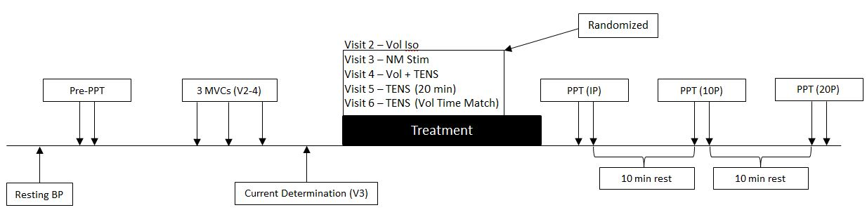
Figure 1: Shows order of procedure during each training visit.

Chapter IV: Results & Discussion
After consent was obtained a total of 16 females (age = 22.1 ± 1.2 yrs, height = 165.1 ± 8.7 cm, and weight = 61.7 ± 6.9 kg; values are mean ± SD) completed this study. Consent was obtained from a total of 24 females, however only 16 have completed all the requirements of the testing protocol at this point in time.

4.1 Assessment of PPT Responses to Each Treatment
Voluntary Isometric Task
Knee extensor MVC was found to be 65.9 ± 11.3 lbs on average with a time-to-task failure of 173.6 ± 46.9 seconds when 25% of MVC was held. Figure 2 shows absolute PPT’s following the voluntary isometric leg extension task. A repeated measures ANOVA was conducted to assess differences in pain sensitivity in each muscle group prior to (Pre), immediately post (iPost), ten minutes (10-min Post), and twenty minutes post (20-min Post) treatment. In the exercising VL a significant change in PPT was found (p = 0.026). Post-hoc tests revealed a significant increase in PPT iPost (p = 0.010) and 10-min Post treatment (p = 0.047), but not 20-min Post (p = 0.08) compared to Pre measurements. The ANOVA conducted for the contralateral VL was not significant (p = 0.107) indicating PPT was not altered following exercise. The ANOVA conducted for the Brachioradialis was significant (p = 0.015). Post-hoc testing revealed a significant increase in PPT iPost (p = 0.002), but not at 10-min Post (p > 0.05) or 20-min Post (p > 0.05) compared to pre-treatment values.
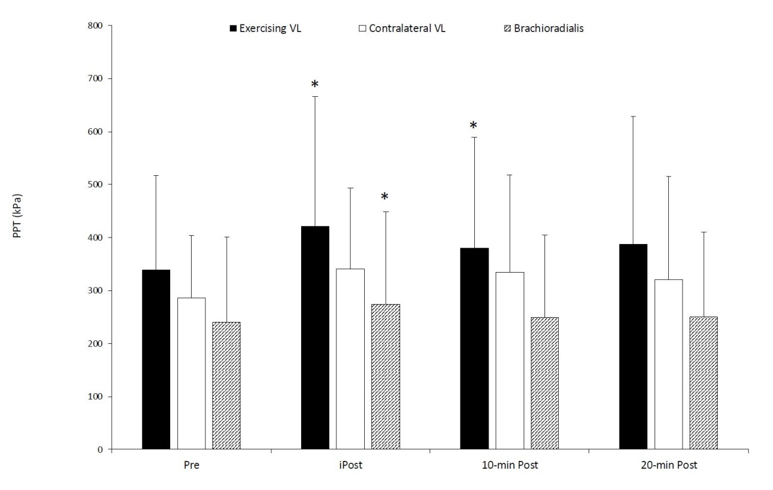
Figure 2: Pain sensitivity following voluntary isometric task. PPT was higher iPost and 10-min Post in contracting VL and only iPost in contralateral VL (p<0.05). * indicates a significant difference from pre-PPT. Values are mean ± SD.

Electrically Evoked Isometric Task
Figure 3 shows changes in absolute PPT following an electrically evoked isometric leg extension task. Participants performed this task for an average of 173.6 ± 46.9 seconds; which did not differ from the time-to-exhaustion during the voluntary. Each participant had an initial torque at 25% of MVC of 21.6 ± 8.1 lbs on average and experienced an average percent decline in force of 80.3 ± 10.4% by the end of the bout. The repeated measures ANOVA conducted in the exercising VL revealed a significant change in PPT following exercise (p < 0.001). Post-hoc tests revealed a significant increase in PPT iPost (p < 0.001) and 10-min Post (p = 0.042), but not 20-min Post (p = 0.08) compared to pre-treatment measurements. The ANOVA conducted for the contralateral VL was not significant (p = 0.073). The ANOVA conducted on the Brachioradialis showed significant change in PPT (p = 0.026). Post-hoc tests revealed a significant increase in PPT iPost treatment (p = 0.016), but not 10-min Post (p = 0.445) or 20-min Post (p = 0.265) treatment compared to pre-treatment values.
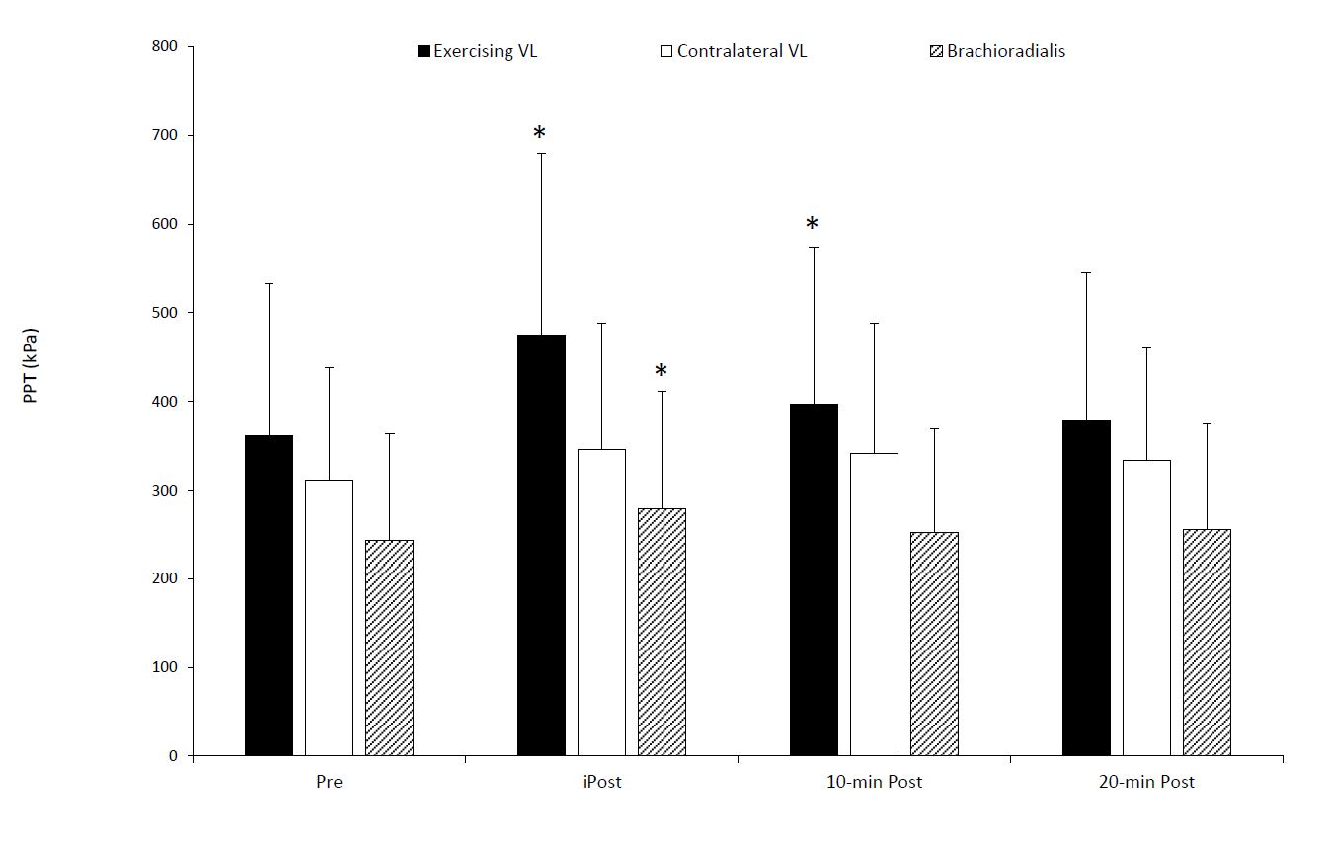
Figure 3: Pain sensitivity following electrically evoked isometric task. PPT was higher iPost and 10-min Post in contracting VL and only iPost in contralateral VL (p<0.05). * indicates a significant difference from pre-PPT. Values are mean ± SD.

Voluntary Isometric Task + TENS

MVC of the dominant knee extensors was 65.9 ± 13.1 lbs and 25% of MVC was held for 171.8 ± 48.8 seconds which did not differ from the voluntary only exercise condition (p = 0.34). Figure 4 shows changes in absolute PPT following voluntary isometric exercise combined with TENS in all three muscle groups. The repeated measures ANOVA conducted for the contracting VL revealed significant change in PPT (p = 0.001). Post-hoc tests revealed a significant increase in PPT iPost (p = 0.001), 10-min Post (p = 0.013), but not 20-min Post treatment (p = 0.11) compared to pre-treatment values. The ANOVA conducted in the contralateral VL was also significant (p = 0.015). Post-hoc tests revealed a significant increase in PPT iPost (p = 0.005), 10-min Post (p = 0.01), and 20-min Post treatment (p = 0.003). The ANOVA conducted for the Brachioradialis also showed significant change in PPT (p = 0.01). Post-hoc tests revealed a significant increase in PPT iPost (p = 0.005), 10-min Post (p = 0.03), and 20-min Post treatment (p = 0.02).
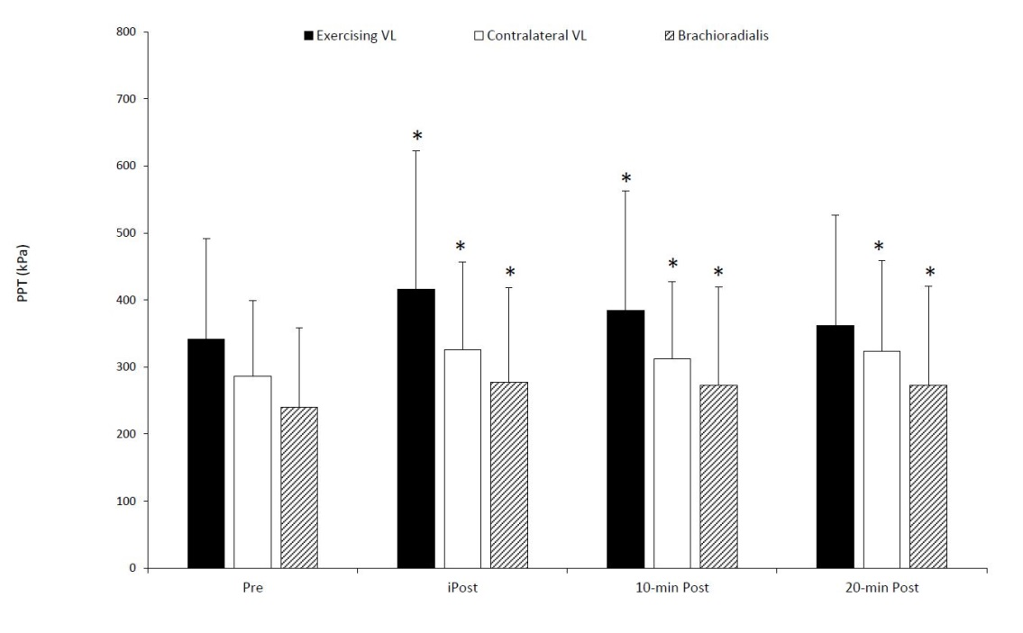
Figure 4: Pain sensitivity following voluntary isometric task combined with TENS. PPT was higher iPost and 10-min Post in contracting VL; iPost, 10-min Post and 20-min Post in the contralateral VL (p<0.05); 10-min Post and 20-min Post in the Brachioradialis. * indicates a significant difference from pre-PPT. Values are mean ± SD.

TENS
Figure 5 shows changes in absolute PPT following the application of TENS for 20 minutes in three muscles groups. The ANOVA conducted in the exercising VL was not significant (p = 0.072). The repeated measures ANOVA conducted for the contralateral VL revealed significant changes in PPT (p = 0.046). Post-hoc tests revealed a significant increase in PPT iPost (p = 0.045), 10-min Post (p = 0.046), but not 20-min Post treatment (p = 0.516). The ANOVA conducted in the Brachioradialis following 20 minutes of TENS showed no significant changes occurred in PPT
(p = 0.084).
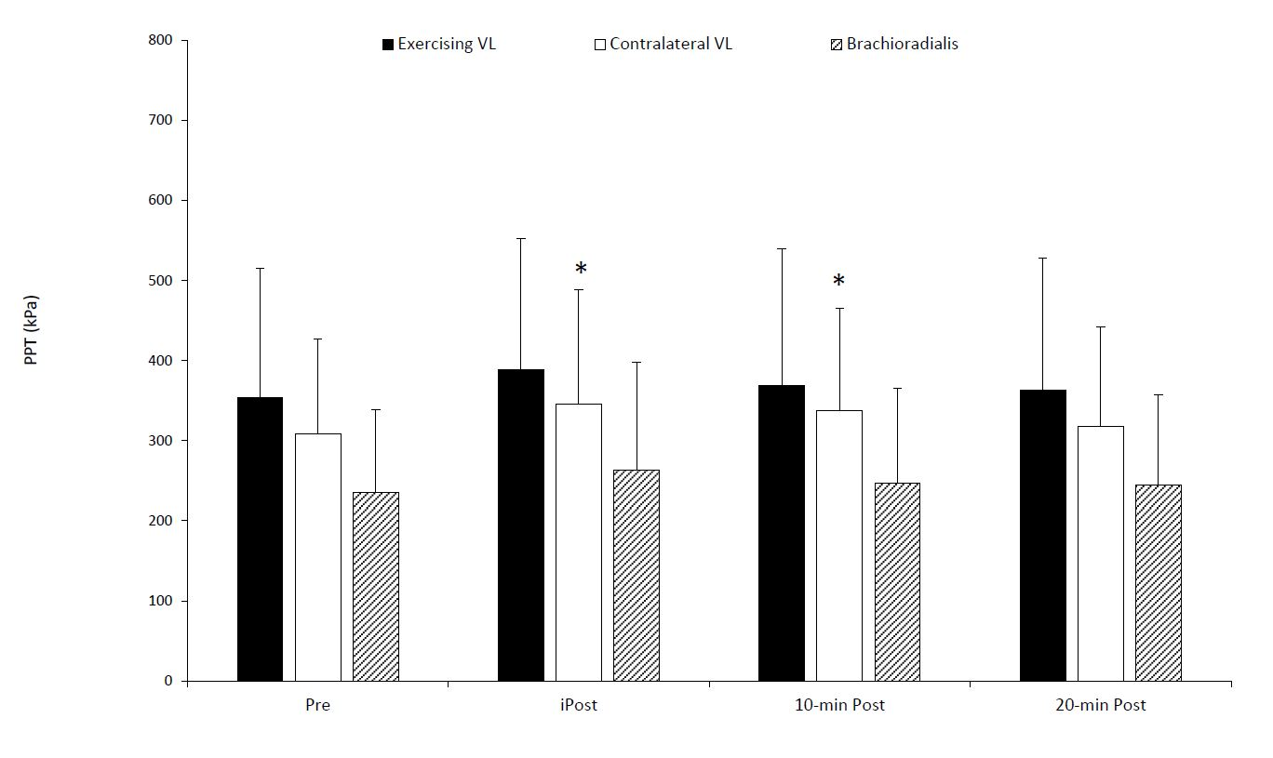
Figure 5: Pain sensitivity following 20 minutes of TENS. PPT was higher iPost and 10-min Post in the contralateral VL (p<0.05). * indicates a significant difference from pre-PPT. Values are mean ± SD.

Figure 6 shows changes in pain sensitivity following the application of TENS for duration matched to the time-to-fatigue from the voluntary isometric task (approximately 171 ± 43 seconds). The ANOVA conducted in the exercising VL showed no significant changes occurred in PPT (p = 0.083). The ANOVA for the contralateral VL following revealed significant change in PPT (p = 0.02). Post-hoc tests revealed a significant decrease in pain perception iPost (p < 0.001), 10-min Post (p = 0.018), and 20-min Post treatment (p = 0.005). The ANOVA conducted in the Brachioradialis also showed significant change in PPT (p = 0.009). Post-hoc tests showed a significant increase in PPT iPost (p = 0.002), 10-min Post (p = 0.001), and 20-min Post treatment (p = 0.009).
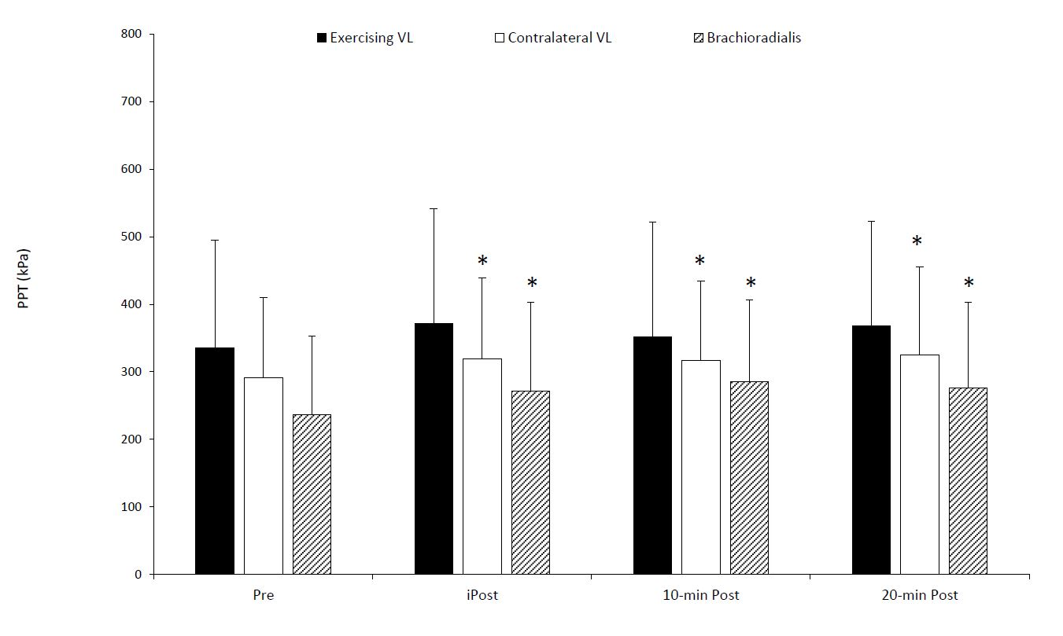
Figure 6: Pain sensitivity following time matched TENS. PPT was higher iPost,10-min Post, 20-min Post in contralateral VL; iPost, 10-min Post, and 20-min Post in Briachioradialis (p<0.05). * indicates a significant difference from pre-PPT. Values are mean ± SD.
4.2 Comparison of Percent Change in PPT Among Treatments and Locations
Figure 7 displays the hypoalgesic response for all treatments across all time points. The treatment/exercise condition x muscle tested x time interaction examining the percent change in PPT ([(Post-Pre)/Pre *100] termed %EIH from here forward) was not significant (p = 0.36). There was a significant muscle tested x time interaction (p = 0.045), but no condition x time (p = 0.15), or condition x muscle (p = 0.34) interaction. Nor was there a main effect for muscle tested (p = 0.65) or treatment/exercise condition (p = 0.40). Data from all conditions, muscles, and time points can be found in Table 1.
To examine the muscle tested x time interaction, data from all treatment/exercise conditions were collapsed and averaged. Collapsed data are shown in Figure 8. One-way repeated measures ANOVA’s for muscle tested over time, and time point across the muscle tested were run. The one-way ANOVA over time for the dominant VL revealed significant differences in %EIH (p < 0.001) with post hoc analysis indicating a significantly larger %EIH was experienced iPost treatment, compared to 10-min Post and 20-min Post treatment (p < 0.001 for each). There were no significant differences observed in %EIH between the 10-min Post and 20-min Post values (p = 0.92). The one-way ANOVAS over time for the contralateral VL and Brachioradialis were not significant, indicating no differences in %EIH across time points (p ≥ 0.07). Additionally, one-way ANOVA’s comparing the mean values for %EIH among the 3 tested muscles at each assessment time point were not significant (p = 0.053, p = 0.86, and p = 0.87 for the iPost, 10-min Post, and 20-min Post time points, respectively).
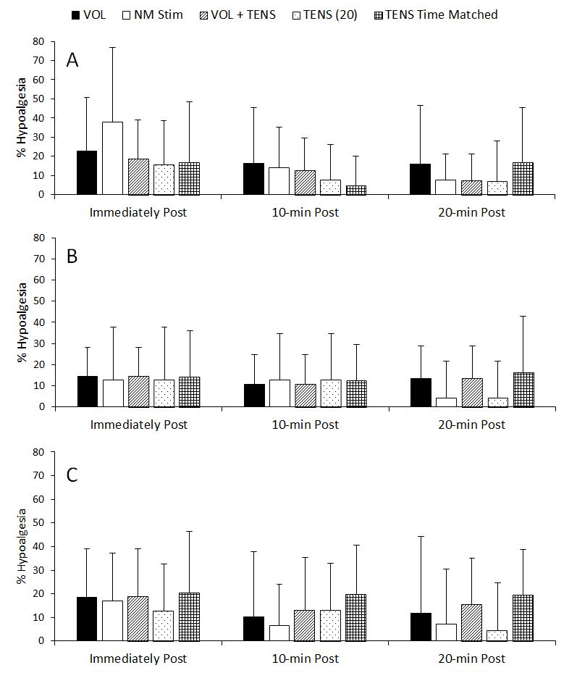
Figure 7: Hypoalgesic response for all treatments across all time points. Panel A represents hypoalgesic response observed in dominant VL. Panel B represents hypoalgesic response observed in contralateral VL. Panel C represents hypoalgesic response observed in Brachioradialis. No significant differences were observed in any of the muscles across time points for any treatment (p = 0.358).

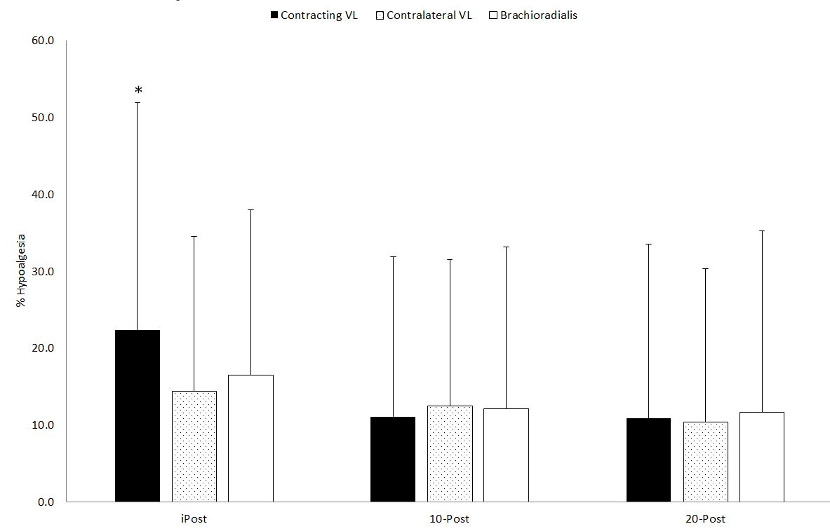
Figure 8: %Hypoalgesia assessed in dominant VL, contralateral VL, and Brachioradialis at three time points. Percent represents change in PPT from pre-treatment measurements. %EIH was highest iPost (p<0.001). * indicates a significant difference from 10-Post and 20-Post time points. Values are mean ± SD.
Discussion
4.3 Voluntary Isometric Exercise
This study utilized a fatiguing task conducted using the dominant quadriceps. PPTs were measured in the VL of the exercising and contralateral leg as well as the dominant brachioradialis. Previous research has clearly established that isometric exercise performed to task failure leads to acute decreases in pain sensitivity manifested as an increase in PPT (Bement et al., 2008; K F Koltyn, 2000; K F Koltyn et al., 2001; O’Connor, P. J., Cook, 2014.). Our results indicated that pain sensitivity measured in the contracting VL was significantly lower (i.e. PPT’s increased) immediately following exercise, with the effects lasting up to 10 minutes following exercise. This finding is in agreement with the majority of the literature in this area (see Naugle et al. 2012 for review) including several studies from our laboratory (Black et al., 2017; Black et al., 2016, Gonglach et al., 2013).
Interestingly, we did not observe changes in PPT in the contralateral VL following exercise, but an increase in PPT was observed in the Brachioradialis muscle immediately post exercise, though it did not persist to the 10-min Post time point. While inconsistent, these findings do indicate the voluntary exercise bout resulted in not just a change in pain sensitivity “local” to the exercising muscle, but also evoked a “systemic” response leading to the changes in sensitivity in a muscle distal to the exercise. The observation of a “systemic” change in pain sensitivity has also been shown in multiple previous studies. For example, in a study conducted by Bement et al. (2008), a decrease in pain sensitivity following an isometric handgrip task at 25% of MVC was observed in the hand contralateral to the exercising muscle. Similarly, results from Kosek & Lundberg (2003) showed a significant increase in PPT immediately following the muscular task in the contracting quadriceps muscle, the contralateral quadriceps muscle, and a distant shoulder. Similar to our findings, these responses returned to baseline when measured 30 minutes post exercise. Proposed mechanisms for changes in PPT locally and systemically are related to activation of endogenous pain modulatory effects as suggested by Kosek & Lundberg (2003). They propose that the endogenous effects likely stem from activation of the DNIC system (Kosek & Lundberg, 2003)which exerts its effects when wide dynamic range neurons are activated. Activation of these neurons typically results from nociceptive stimulation via secondary painful or conditioning stimuli. Once activated, these inhibitory neurons lead to decreased pain sensitivity (Fidanza et al., 2017). Participants in our study were asked to perform an isometric fatiguing task which could have produced the nociceptive input necessary to activate DNIC leading to systemic decreases in pain sensitivity. Furthermore, our findings are in agreement with Bement et al. (2008), who suggested that high-threshold motor units, which are recruited during a submaximal fatiguing task, need to be recruited order to evoke a hypoalgesic effect.
4.4 Electrically Evoked Isometric Task
Neuromuscular electrical stimulation (NMES) was used to evoke a sustained submaximal isometric leg extension for the purpose of comparing the potential hypoalgesic effects to those following voluntary exercise. The PPT response following NMES was relatively similar to the voluntary bout. There was a decline in pain sensitivity following exercise in the contracting limb, and the effects were also observed at a site distant to the working muscle, the brachioradialis muscle, indicating some level of a systemic response. Despite this finding, the contralateral VL showed no changes. Similar to voluntary exercise, the hypoalgesic effects were short lived compared to the effect in the working muscle. Since there was no CNS contribution to force/exercise in this condition, it seems clear that voluntary motor-drive is not necessary to evoke EIH—suggesting that afferent signaling from the stimulated muscle (e.g. proprioception, sense of force, pain, etc.) led to a decrease in pain sensitivity. These results are consistent with the CPM response, whereby an initial painful stimulus (the NMES exercise) is used to modulate the effects of a second stimulus (the applied pressure) (Nir & Yarnitsky, 2015). Although ratings of pain/discomfort during and following the NMES protocol were not assessed in this study, NMES has been suggested to evoke strong discomfort at the stimulation site (Maffiuletti, 2010).
4.5 TENS
We observed changes in pain sensitivity distant to the application site following the use of TENS and the hypoalgesic response was more wide spread and sustained following a short, compared to long duration. These findings are in partial agreement with the current literature. However, there are few studies that have compared the effects of varying duration of TENS. One study conducted by Brown et al. (2007), showed no hypoalgesic response when TENS was applied for 5 mins. This time was comparable to the amount of time TENS was applied in our study. However, differences in results might be attributed to the high frequency TENS used in their study. They also induced ischemic pain experimentally; our study used pressure pain to assess perception. A study conducted by Chesterton et al. (2003),which used similar stimulation parameters to our protocol, produced a sustained systemic response when TENS was applied for 20 minutes. Claydon et al. (2008) showed a sustained hypoalgesic effect when high and low frequency TENS was applied at a high intensity at sites segmental and extra segmental to the site of induced pain. These results highlight the complex nature of pain perception and the variability in response between high and low frequency TENS. DeSantana et al. (2008) proposed that TENS at high and low frequencies may act on areas of the brain such as the PAG exerts its effects on the spinal cord via the RVM. Additionally, small diameter afferent inhibition may be involved in the segmental responses observed following application of high-intensity TENS, which may activate DNIC via A-delta and C fibers (Claydon et al.,2008). It has also been proposed that TENS may act through the central gate theory, as described by Melzack & Wall (1965), in which activation of non-nociceptive large diameter Aβ fibers exert an inhibitory effect in the CNS. It is important to note that they utilized higher TENS frequencies (100 Hz vs. 4 Hz) than those used in the present study. However, it is plausible that our stimulation intensity was sufficient to activate these non-nociceptive neurons.
4.6 Voluntary Isometric Exercise + TENS
We observed wide-spread and sustained hypoalgesia when voluntary isometric exercise was combined with concurrent TENS. Sensitivity to pain was decreased in the contracting muscle as well as the contralateral muscle and a distal muscle. These results indicate a robust local and systemic response that was sustained for 10-minutes following exercise in all testing sites and for 20 minutes following exercise in the contralateral VL and brachioradialis. To our knowledge, this was the first study to assess the combined effects of voluntary exercise and TENS on PPT. Astokori et al. (2017) demonstrated that application of TENS during cycling exercise decreased ratings of pain intensity and increased exercise time to exhaustion, demonstrating the potential of this treatment to alter pain sensitivity. The application of TENS might help to explain the wider and more sustained decrease in pain sensitivity experienced in this treatment group.
Kosek & Ekholm (1995) observed a significant decrease in pain sensitivity in the exercising limb that persisted up to 5 minutes post exercise and demonstrated a similar hypoalgesic response in the working limb following a submaximal isometric leg extension task (1995, 1996). It is likely that inhibition of pain perception via sensory afferents that are activated by A-delta and C fibers (Bement, 2008) as well as high-threshold motor units (Kosek and Ekholm, 1995) are involved as multiple studies have demonstrated their importance in the hypoalgesic response following a voluntary isometric task.
The more widespread results of this treatment might be influenced by the use of TENS. Chesterton et al. (2002), observed a significant and sustained decrease in pain sensitivity after the use of TENS applied at a distant site. However, there is some conflict regarding the parameters that elicit the largest hypoalgesic response. Lazarou et al. (2009) concluded that the use of high-intensity, low-frequency TENS was related to decreases in pain sensitivity in the stimulated limb as well as a distal site. A later study conducted by Chesterton et al. (2003), found that TENS applied at a high frequency at a segmental site was necessary to produce a sustained hypoalgesic response. These findings are in agreement with Claydon et al., who also observed an increase in PPTs following segmental application of TENS at high frequency and intensity. It is widely agreed upon that high-intensity, rather than low-intensity TENS produces hypoalgesic responses more consistently (Claydon et al., 2011) though low frequency TENS may elicit a systemic response in line with the endogenous opioid response (Chesterton et al., 2003). Both low- and high-frequency TENS in rat muscle stimulated the release of endorphin precursors that modulate pain through interaction with specific opioid receptors (Han Ji-Sheng, 2003). These results were in line their previous work (Han 1991), which showed a substantially higher increase in met-enkaphalin in response to low frequency TENS. Activation of A-delta and C fibers has also been proposed as a mechanism through which low-frequency TENS works to modulate decreases in pain sensitivity.
4.7 %Hypoalgesia Experienced Among Treatments
Results of this study found no differences in the magnitude of the hypoalgesic response from different treatment modalities. We were able to produce some type of hypoalgesic response in every condition. The degree of response was most drastic in the contracting VL. These results could be explained by the fact that the contracting VL was the site that all treatments were applied to. This demonstrates the importance of stimulating localized nociceptive inputs in the perception or inhibition of pain. The application of TENS may have stimulated Aβ fibers, which in turn inhibited nociception as decribed by the Central Gate theory (Astokorki & Mauger, 2017). Furthermore, the pain associated with sustained muscle tasks could provide the conditioning stimulus needed for activation of the DNIC system to inhibit pain sensitivity. Finally, as Black et al.(2016)suggests, efferent motor activity and activation of afferent A-delta and C-fibers within the contracting muscle likely were involved in the hypoalgesic response. The magnitude of the hypoalgesic response we demonstrated was not as pronounced in sites distant to the site of induced pain. This may have been due to a weak systemic response to the experimental treatments, which highlights the importance of localized stimulation.

Chapter V: Conclusions
We observed a hypoalgesic response in response to each treatment. However, we did not observe any differences in the effect of different treatment modalities. Our research question concerning the effect of combining TENS and Isometric exercise was answered. Our results led us to reject our hypothesis that combining these modalities would augment the hypoalgesic response. The use of TENS and exercise individually led to an increase in raw PPT. This led us to accept our hypothesis that TENS and exercise would lead to an increase in PPT. When comparing the effects of voluntary and involuntary isometric exercise on pain thresholds we saw no difference in the response to these treatments. This led us to reject our hypothesis that voluntary exercise would cause a large hypoalgesic effect than involuntary exercise. Although there was no interaction effect of treatment on the magnitude of response, it is important to consider the raw PPT results. We observed a more systemic response when TENS was applied in addition to isometric exercise, a novel finding. TENS in combination with voluntary exercise resulted in an increase in PPT, though it was not magnified. Consequently, our hypothesis that voluntary isometric exercise would elicit a more drastic hypoalgesic response than electrically evoked isometric exercise was not upheld. Again, both treatments brought about a change in PPT, however one treatment was not more effective than the other. This demonstrates the importance local factors (ie. intramuscular nociceptors, non-nociceptive afferents) in relation to the transmission and interpretation of painful stimuli. A major limitation of this study was that we did not control for the time of day when treatments were applied. Future research should explore how these responses might differ in a sedentary population with a larger sample size. It would also be interesting to explore the effects of combining a voluntary isometric task with dual site stimulation as well as how different modalities of experimental pain (ie. electrical, thermal) would be affected by the protocols employed in this study. Finally, it would be useful to make more accurate blood pressure measurements with equipment that can assess beat to beat changes in blood pressure which may reveal cardiovascular contributions to pain modulation.

WORKS CITED
Abraira, V., & Ginty, D. (2013). The sensory neurons of touch. Neuron, 79(4), 618–639. https://doi.org/10.1016/j.neuron.2013.07.051
Aldworth, J. (2009). Results from the 2007 National Survey on Drug Use and Health: National Findings. Office of Applied Studies, NSDUH Series H-34, DHHS Publication No. SMA 08-4343.
Allan Goldfarb and Athanasios Z. Jamurtas. (1997). p-Endorphin Response to Exercise, 24(1), 8–16.
Astokorki, A. H. Y., & Mauger, A. R. (2017). Transcutaneous electrical nerve stimulation reduces exercise-induced perceived pain and improves endurance exercise performance. European Journal of Applied Physiology, 117(3), 483–492. https://doi.org/10.1007/s00421-016-3532-6
Basbaum, A. I., & Fields, H. L. (1984). Endogenous Pain Control Systems: Brainstem Spinal Pathways and Endorphin Circuitry. Annual Review of Neuroscience, 7(1), 309–338. https://doi.org/10.1146/annurev.ne.07.030184.001521
Beecher, H. K. (1945). PAIN IN MEN WOUNDED IN BATTLE. Pain, 123(1), 96–105. https://doi.org/10.1213/00000539-194701000-00005
Bement, M. K. H., Dicapo, J., Rasiarmos, R., & Hunter, S. K. (2008). Dose response of isometric contractions on pain perception in healthy adults. Medicine and Science in Sports and Exercise, 40(11), 1880–1889. https://doi.org/10.1249/MSS.0b013e31817eeecc
Birnbaum, H. G., White, A. G., Schiller, M., Waldman, T., Cleveland, J. J. M., Setnik, B., … Roland, C. L. C. (2010). Societal Costs of Opioid Abuse, Dependence and Misuse in The United States. Value in Health, 13(3), A111. https://doi.org/10.1016/S1098-3015(10)72532-8
Black, C. D. (2012). Muscle Pain During and Following Exercise. In The Oxford Handbook of Exercise Psychology. https://doi.org/10.1093/oxfordhb/9780195394313.013.0009
Black, C. D., & Pickowitz, K. E. (2015). Day-to-day reliability of pressure pain threshold and pain ratings in college-aged men. International Journal of Rehabilitation Research, 38(3), 213–218. https://doi.org/10.1097/MRR.0000000000000111
Black, C. D., Tynes, B. K., Gonglach, A. R., & Waddell, D. E. (2016). Local and Generalized Endogenous Pain Modulation in Healthy Men: Effects of Exercise and Exercise-Induced Muscle Damage. Pain Medicine, 17(12), 2422–2433. https://doi.org/10.1093/pm/pnw077
Brown, L., Tabasam, G., Bjordal, J. M., & Johnson, M. I. (2007). An Investigation Into the Effect of Electrode Placement of Transcutaneous Electrical Nerve Stimulation (TENS) on Experimentally Induced Ischemic Pain in Healthy Human Participants. The Clinical Journal of Pain, 23(9), 735–743. https://doi.org/10.1097/AJP.0b013e31814b86a9
Cheng, R. S. S., & Pomeranz, B. (1979). Electroacupuncture analgesia could be mediated by at least two pain-relieving mechanisms; endorphin and non-endorphin systems. Life Sciences, 25(23), 1957–1962. https://doi.org/10.1016/0024-3205(79)90598-8
Chesterton, L. S., Barlas, P., Foster, N. E., Lundeberg, T., Wright, C. C., & Baxter, G. D. (2002). Sensory stimulation (TENS): Effects of parameter manipulation on mechanical pain thresholds in healthy human subjects. Pain, 99(1–2), 253–262. https://doi.org/10.1016/S0304-3959(02)00118-5
Chesterton, L. S., Foster, N. E., Wright, C. C., Baxter, G. D., & Barlas, P. (2003). Effects of TENS frequency, intensity and stimulation site parameter manipulation on pressure pain thresholds in healthy human subjects. Pain, 106(1–2), 73–80. https://doi.org/10.1016/S0304-3959(03)00292-6
Chung, J. M., Fang, Z. R., Hori, Y., Lee, K. H., & Willis, W. D. (1984). Prolonged inhibition of primate spinothalamic tract cells by peripheral nerve stimulation. Pain, 19(3), 259–275. https://doi.org/10.1016/0304-3959(84)90004-6
Chung, J. M., Lee, K. H., Hori, Y., Endo, K., & Willis, W. D. (1984). Factors influencing peripheral nerve stimulation produced inhibition of primate spinothalamic tract cells. Pain, 19(3), 277–293. https://doi.org/10.1016/0304-3959(84)90005-8
Claydon, L. S., Chesterton, L. S., Barlas, P., & Sim, J. (2011). Dose-specific effects of transcutaneous electrical nerve stimulation (TENS) on experimental pain: a systematic review. Clin J Pain, 27(7), 635–647. https://doi.org/10.1097/AJP.0b013e31821962b4
Cook, D. B., & Ellingson, L. D. (2014). The Hypoalgesic Effects of Exercise: Characteristics, Mechanisms, and Implications for Chronic Pain. In: Musculoskeletal Pain – Basic Mechanisms and Implications. Thomas Graven-Nielsen & Lars Arendt-Nielsen (Eds.). IASP Press.
Dean, J., Bowsher, D., & Johnson, M. I. (2006). The effects of unilateral transcutaneous electrical nerve stimulation of the median nerve on bilateral somatosensory thresholds. Clinical Physiology and Functional Imaging, 26(5), 314–318. https://doi.org/10.1111/j.1475-097X.2006.00689.x
Fidanza, F., Varanini, M., Ciaramella, A., Carli, G., & Santarcangelo, E. L. (2017). Pain modulation as a function of hypnotizability: Diffuse noxious inhibitory control induced by cold pressor test vs explicit suggestions of analgesia. Physiology and Behavior, 171, 135–141. https://doi.org/10.1016/j.physbeh.2017.01.013
Fields, H. L. (2000). Pain modulation: expectation, opioid analgesia and virtual pain. Progress in Brain Research, 122, 245–53. https://doi.org/10.1016/S0079-6123(08)62143-3
Gaskin, D. J., & Richard, P. (2012). The economic costs of pain in the United States. Journal of Pain, 13(8), 715–724. https://doi.org/10.1016/j.jpain.2012.03.009
Gonglach, A. R., Tynes, B. K., Waddell, D. E., Loftin, M., & Black, C. D. (2013, May). The Effect of Submaximal Isometric Exercise to Fatigue on Pressure Pain Threshold in the Finger. In MEDICINE AND SCIENCE IN SPORTS AND EXERCISE (Vol. 45, No. 5, pp. 278-278). 530 WALNUT ST, PHILADELPHIA, PA 19106-3621 USA: LIPPINCOTT WILLIAMS & WILKINS.
Han, J. S., Chen, X. H., Sun, S. L., Xu, X. J., Yuan, Y., Yan, S. C., … Terenius, L. (1991). Effect of low- and high-frequency TENS on Met-enkephalin-Arg-Phe and dynorphin A immunoreactivity in human lumbar CSF. Pain, 47(3), 295–298. https://doi.org/10.1016/0304-3959(91)90218-M
Han Ji-Sheng. (2003). Acupuncture:neuropeptide release produced by electrical stimulation of different frequencis. TRENDS in Neurosciences, 26(1), 17,18,19,20,21. Retrieved from http://www.dol.inf.br/HtmL/Repensando/PDFs/RepensandoAcupuntura2.pdf
Hultman, E., Sjöholm, H., Jäderholm-Ek, I., & Krynicki, J. (1983). Evaluation of methods for electrical stimulation of human skeletal muscle in situ. Pflügers Archiv European Journal of Physiology, 398(2), 139–141. https://doi.org/10.1007/BF00581062
K. Hagbarth, D. K. (1953). Central Influences on Spinal Afferent Conduction. Journal of Neurophysiology, 17(3), 295–307.
Kim, Y., Park, I., & Kang, M. (2013). Convergent validity of the International Physical Activity Questionnaire (IPAQ): meta-analysis. Public Health Nutrition, 16(3), 440–452. https://doi.org/Doi 10.1017/S1368980012002996
Koltyn, K. F. (2000). Analgesia following exercise: a review. Sports Medicine (Auckland, N.Z.), 29(2), 85–98. https://doi.org/10.1097/SPV.0b013e3181907870
Koltyn, K. F., Brellenthin, A. G., Cook, D. B., Sehgal, N., & Hillard, C. (2014). Mechanisms of exercise-induced hypoalgesia. Journal of Pain, 15(12), 1294–1304. https://doi.org/10.1016/j.jpain.2014.09.006
Koltyn, K. F., Trine, M. R., Stegner, a J., & Tobar, D. a. (2001). Effect of isometric exercise on pain perception and blood pressure in men and women. Medicine and Science in Sports and Exercise, 33(2), 282–90. https://doi.org/10.1097/00005768-200102000-00018
Koltyn, K. F., & Umeda, M. (2007). Contralateral Attenuation of Pain After Short-Duration Submaximal Isometric Exercise. Journal of Pain, 8(11), 887–892. https://doi.org/10.1016/j.jpain.2007.06.003
Kosek, E., & Ekholm, J. (1995). Modulation of pressure pain thresholds during and following isometric contraction. Pain, 61(3), 481–486. https://doi.org/10.1016/0304-3959(94)00217-3
Kosek, E., & Lundberg, L. (2003). Segmental and plurisegmental modulation of pressure pain thresholds during static muscle contractions in healthy individuals. European Journal of Pain, 7(3), 251–258. https://doi.org/10.1016/S1090-3801(02)00124-6
Lazarou, L., Kitsios, A., Lazarou, I., Sikaras, E., & Trampas, A. (2009). Effects of Intensity of Transcutaneous Electrical Nerve Stimulation ( TENS ) on Pressure Pain Threshold and Blood Pressure in Healthy Humans. Clin J Pain, 25(9), 773–780.
Lemley, K. J., Drewek, B., Hunter, S. K., & Hoeger Bement, M. K. (2014). Pain relief after isometric exercise is not task-dependent in older men and women. Medicine and Science in Sports and Exercise, 46(1), 185–191. https://doi.org/10.1249/MSS.0b013e3182a05de8
Lemley, K. J., Hunter, S. K., & Bement, M. K. H. (2015). Conditioned pain modulation predicts exercise-induced hypoalgesia in healthy adults. Medicine and Science in Sports and Exercise, 47(1), 176–184. https://doi.org/10.1249/MSS.0000000000000381
Lewis, G. N., Rice, D. A., & McNair, P. J. (2012). Conditioned pain modulation in populations with chronic pain: A systematic review and meta-analysis. Journal of Pain, 13(10), 936–944. https://doi.org/10.1016/j.jpain.2012.07.005
M. Nusbaum. (2009). Modulatory Projection Neurons. In Encyclopedia of Neuroscience (pp. 2509–2512). https://doi.org/10.1007/978-3-540-29678-2_3678
Maffiuletti, N. A. (2010). Physiological and methodological considerations for the use of neuromuscular electrical stimulation. European Journal of Applied Physiology, 110(2), 223–234. https://doi.org/10.1007/s00421-010-1502-y
Melzack, R., & Wall, P. (1965). Pain mechanisms: a new theory. Science, 150(3699), 971–979. https://doi.org/10.1126/science.150.3699.971
Misra, G., Paris, T. A., Archer, D. B., & Coombes, S. A. (2014). Dose-response effect of isometric force production on the perception of pain. PLoS ONE, 9(2). https://doi.org/10.1371/journal.pone.0088105
Moore, S. R., & Shurman, J. (1997). Combined neuromuscular electrical stimulation and transcutaneous electrical nerve stimulation for treatment of chronic back pain: a double-blind, repeated measures comparison. Archives of Physical Medicine and Rehabilitation, 78(January), 55–60.

Naugle, K. M., Naugle, K. E., Fillingim, R. B., Samuels, B., Joseph, L., & Iii, R. (2014). Intensity Thresholds for Aerobic Exercise – Induced Hypoalgesia. Med Sci Sports Exerc., 46(4), 817–825. https://doi.org/10.1249/MSS.0000000000000143.Intensity
Nir, R. R., & Yarnitsky, D. (2015). Conditioned pain modulation. Current Opinion in Supportive and Palliative Care, 9(2), 131–137. https://doi.org/10.1097/SPC.0000000000000126
O’Connor, P. J., Cook, D. B. (1999). Exercise and Pain The Neurobiology.
Ohara, P. T., Vit, J. P., & Jasmin, L. (2005). Cortical modulation of pain. Cellular and Molecular Life Sciences, 62(1), 44–52. https://doi.org/10.1007/s00018-004-4283-9
Sjolund, B., Terenius, L., & Eriksson, M. (1977). Increased crebrospinal fluid levels of endorphins after elcetroacupuncture. Acta Physiolog Scand, 100, 372–382.
Substance Abuse and Mental Health Services Administration, C. for B. H. S. and Q. (2013). Treatment Episode Data Set (TEDS). 2001-2011. National Admissions to Substance Abuse Treatment Services. HHS Publication No. (SMA) 13-4772. Rockville, MD: Substance Abuse and Mental Health Services Administration (Vol. BHSIS Seri).
Thorén, P., Floras, J. S., Hoffmann, P., & Seals, D. R. (1990). Endorphins and exercise: physiological mechanisms and clinical implications. Medicine and Science in Sports and Exercise, 22(4), 417–428.
Villemure, C., & Bushnell, M. C. (2002). Cognitive modulation of pain: How do attention and emotion influence pain processing? Pain, 95(3), 195–199. https://doi.org/10.1016/S0304-3959(02)00007-6

APPENDIX A: IRB APPROVAL LETTER
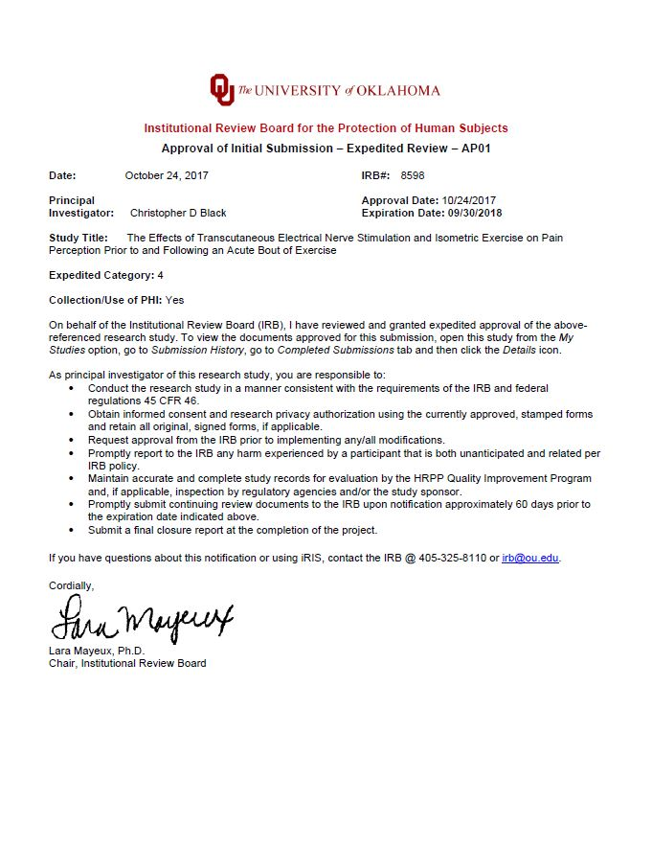

APPENDIX B: INFORMED CONSENT
Signed Consent to Participate in Research

Would you like to be involved in research at the University of Oklahoma?
I am Alwyn Quarshie I am a student in Dr. Chris Black’s Sensory and Muscle Function Lab in the Health and Exercise Department. We invite you to participate in our research project entitled “The Effects of Transcutaneous Electrical Nerve Stimulation and Isometric Exercise on Pain Perception Prior to and Following an Acute Bout of Exercise.” This research is being conducted at University of Oklahoma Norman Campus. You were selected as a possible participant because you are a healthy female between the ages of 18 – 30 with no known cardiovascular or neurological diseases and you are free from any lower body injuries. You must be at least 18 years of age to participate in this study.
Please read this document and contact me to ask any questions that you may have BEFORE agreeing to take part in my research.
What is the purpose of this research? The purpose of this research is to explore the effects of electrical stimulation and isometric exercise on perception of pain.
How many participants will be in this research? About 30 people will take part in this research.
What will I be asked to do? If you agree to be in this research, you will be asked to visit the sensory and muscle function lab at the University of Oklahoma Norman campus on 6 separate occasions separated by at least 12 hours.
Visit 1
During familiarization you will practice doing isometric leg extension exercises using maximal effort (MVC). Isometric leg extension involves kicking as hard as you can against an immovable object. You will also experience a pressure pain protocol which involves using a device that applies pressure to your thigh. You will then practice an isometric leg extension task at 25% of your MVC held for duration of 3 minutes. You will then experience a current determination protocol intended to determine the amount of electrical stimulation needed to cause a leg extension at 20-25% of your highest maximal force without voluntary contribution from the brain. During this visit, resting blood pressure measurements will be taken in order to establish a baseline.

Visit 2
During the second experimental visit you will perform a voluntary isometric leg extension task at 25% of your highest leg extension force (cannot maintain for more than 3 seconds). Blood pressure measurements will be taken prior to the exercise bout. During the exercise bout blood pressure measurements will be taken every minute for the duration of the exercise task. Pressure pain thresholds (PPT) will be measured at specific site on the thigh of both of your legs and the forearm of your dominant muscle. This will be done prior to and following the leg extension task.

In order to eliminate testing bias the order of the following testing visits will be randomized—all visits will be performed, but the order will vary.

Visit 3
During the third experimental visit you will perform an involuntary isometric leg extension task at 20-25% of your MVC for a duration matched to the voluntary exercise task or until you decide to stop. Baseline blood pressure measurements will be taken prior to the exercise bout. During the exercise bout blood pressure measurements will be taken every minute for the duration of the exercise task. The same PPT protocol will be used to obtain measurements preceding and following the involuntary isometric leg extension task.

Visit 4
During the fourth experimental visit you will perform another voluntary isometric task at 25% of your highest leg extension force for the same duration as the voluntary isometric exercise task. During this task you will also receive mild electrical stimulation applied to the thigh for the duration of the task. Baseline blood pressure measurements will be taken prior to the exercise bout. During the exercise bout blood pressure measurements will be taken every minute for the duration of the task. The same PPT protocol will be used prior to and following the voluntary isometric task combined with TENS.

Visit 5
During the fifth experimental visit you will only receive TENS applied to the quadriceps muscle for 20 minutes. Baseline blood pressure measurements will be taken prior to the experimental treatment. During the application of TENS, blood pressure measurements will be taken continuously, separated by 5 minutes, for the duration of the treatment. PPTs will be collected prior to and following the TENS treatment using the same procedure as all other testing visits.

Visit 6
During the sixth experimental visit you will receive TENS for a duration matched to the voluntary isometric leg exercise task. Baseline blood pressure measurements will be taken prior to the TENS treatment. During the application of TENS blood pressure measurements will be taken every minute for the duration of the treatment. PPTs will be collected prior to and following the TENS treatment using the same procedure as all other testing visits.

How long will this take? Your participation will take approximately 45 minutes per visit, approximately 6 hours total.
What are the risks and/or benefits if I participate? Performing maximal voluntary contractions of the quadriceps may cause some discomfort and the effort required to produce maximal force may be uncomfortable. You may experience some lightheadedness or nausea. There is also the risk for cardiovascular events when performing maximal contractions. There may also be some discomfort during the pressure pain stimulation which may cause some discomfort and possible reddening of the skin. The use of electrical stimulation to cause a muscle contraction may also be uncomfortable and cause some reddening of the skin. You will be closely monitored for any issues.
What do I do if I am injured? If you are injured during your participation, report this to a researcher immediately. Emergency medical treatment is available. However, you or your insurance company will be expected to pay the usual charge from this treatment. The University of Oklahoma Norman Campus has set aside no funds to compensate you in the event of injury.
Will I be compensated for participating? You will be compensated with a $15 gift card for
your time and participation in this research.
Who will see my information? In research reports, there will be no information that will make it possible to identify you. Research records will be stored securely and only approved researchers and the OU Institution Review Board will have access to the records.
You have the right to access the research data that has been collected about you as a part of this research. However, you may not have access to this information until the entire research has completely finished and you consent to this temporary restriction.
Do I have to participate? No. If you do not participate, you will not be penalized or lose benefits or services unrelated to the research. If you decide to participate, you don’t have to answer any question and can stop participating at any time.
Will I be contacted again? The researcher would like to contact you again to recruit you into this research or to gather additional information.
_____ I give my permission for the researcher to contact me in the future.
_____ I do not wish to be contacted by the researcher again.
Who do I contact with questions, concerns or complaints? If you have questions, concerns or complaints about the research or have experienced a research-related injury, contact me at Alwyn Quarshie, B.S., 405-628-8727, a.quarshie@ou.edu, Christopher Black, PhD, 706-255-3750 cblack@ou.edu
You can also contact the University of Oklahoma – Norman Campus Institutional Review Board (OU-NC IRB) at 405-325-8110 or irb@ou.edu if you have questions about your rights as a research participant, concerns, or complaints about the research and wish to talk to someone other than the researcher(s) or if you cannot reach the researcher(s).
You will be given a copy of this document for your records. By providing information to the researcher(s), I am agreeing to participate in this research.
Participant Signature | Print Name | Date
Signature of Researcher Obtaining Consent | Print Name | Date

APPENDIX C: HIPPA

AUTHORIZATION TO USE or SHARE
HEALTH INFORMATION THAT IDENTIFIES YOU FOR RESEARCH
An Informed Consent Document for Research Participation may also be required.

Title of Research Project: The Effects of Transcutaneous Electrical Nerve Stimulation and Isometric Exercise on Pain Perception Prior to and Following an Acute Bout of Exercise
IRB Number:
Leader of Research Team: Christopher D. Black
Address: 1401 Asp Ave., #110 HHC, Norman, OK 73019
Phone Number: 405-325-7668 (office); 405-628-8727 (cell)
If you decide to sign this document, University of Oklahoma (OU) researchers may use or share information that identifies you (protected health information) for their research. Protected health information will be called PHI in this document.

PHI To Be Used or Shared. Federal law requires that researchers get your permission (authorization) to use or share your PHI. If you give permission, the researchers may use or share with the people identified in this Authorization any PHI related to this research from your medical records and from any test results. Information used or shared may include all information relating to any tests, procedures, surveys, or interviews as outlined in the consent form; medical records and charts; name, address, telephone number, date of birth, race, and government-issued identification numbers.
Purposes for Using or Sharing PHI. If you give permission, the researchers may use your PHI to determine if it is safe for you to participate in the exercise used in this study.
Other Use and Sharing of PHI. If you give permission, the researchers may also use your PHI to develop new procedures or commercial products. They may share your PHI with other researchers, the research sponsor and its agents, the OU Institutional Review Board, auditors and inspectors who check the research, and government agencies such as the Department of Health and Human Services (HHS), and when required by law. The researchers may also share your PHI with your physician and/or a University of Oklahoma physician in the event of a serious health risk or adverse event that occurs during the study.
Confidentiality. Although the researchers may report their findings in scientific journals or meetings, they will not identify you in their reports. The researchers will try to keep your information confidential, but confidentiality is not guaranteed. The law does not require everyone receiving the information covered by this document to keep it confidential, so they could release it to others, and federal law may no longer protect it.
You understand that your Protected Health Information may include information regarding a communicable or noncommunicable disease.
Voluntary Choice. The choice to give OU researchers permission to use or share your PHI for their research is voluntary. It is completely up to you. No one can force you to give permission. However, you must give permission for OU researchers to use or share your PHI if you want to participate in the research and, if you cancel your authorization, you can no longer participate in this study.
Refusing to give permission will not affect your ability to get routine treatment or health care unrelated to this study from OU.
Canceling Permission. If you give the OU researchers permission to use or share your PHI, you have a right to cancel your permission whenever you want. However, canceling your permission will not apply to information that the researchers have already used, relied on, or shared or to information necessary to maintain the reliability or integrity of this research.
End of Permission. Unless you cancel it, permission for OU researchers to use or share your PHI for their research will never end.
Contacting OU: You may find out if your PHI has been shared, get a copy of your PHI, or cancel your permission at any time by writing to:
Privacy Official or Privacy Board
University of Oklahoma University of Oklahoma
PO Box 26901 201 Stephenson Pkwy, Suite 4300A
Oklahoma City, OK 73190 Norman, OK 73019

If you have questions, call: (405) 271-2511 or (405) 325-8110

Access to Information. You have the right to access the medical information that has been collected about you as a part of this research study. However, you may not have access to this medical information until the entire research study is completely finished. You consent to this temporary restriction.
Giving Permission. By signing this form, you give OU and OU’s researchers led by the Research Team Leader permission to share your PHI for the research project listed at the top of this form.

Participant Name (Print): _________________________

__________________________________________ _______________
Signature of Participant Date
or Parent if Participant is a minor

Or

__________________________________________ _______________
Signature of Legal Representative** Date

**If signed by a Legal Representative of the Participant, provide a description of the relationship to the Participant and the authority to act as Legal Representative:

_______________________________________________________________________
OU may ask you to produce evidence of your relationship.

A signed copy of this form must be given to the Participant or the Legal Representative at the time this signed form is provided to the researcher or his representative.

APPENDIX D: INTERNATIONAL PHYSICAL ACTIVITY QUESTIONNAIRE
INTERNATIONAL PHYSICAL ACTIVITY QUESTIONNAIRE
(October 2002)

LONG LAST 7 DAYS SELF-ADMINISTERED FORMAT

FOR USE WITH YOUNG AND MIDDLE-AGED ADULTS (15-69 years)

The International Physical Activity Questionnaires (IPAQ) comprises a set of 4 questionnaires. Long (5 activity domains asked independently) and short (4 generic items) versions for use by either telephone or self-administered methods are available. The purpose of the questionnaires is to provide common instruments that can be used to obtain internationally comparable data on health–related physical activity.

Background on IPAQ
The development of an international measure for physical activity commenced in Geneva in 1998 and was followed by extensive reliability and validity testing undertaken across 12 countries (14 sites) during 2000. The final results suggest that these measures have acceptable measurement properties for use in many settings and in different languages, and are suitable for national population-based prevalence studies of participation in physical activity.

Using IPAQ
Use of the IPAQ instruments for monitoring and research purposes is encouraged. It is recommended that no changes be made to the order or wording of the questions as this will affect the psychometric properties of the instruments.

Translation from English and Cultural Adaptation
Translation from English is encouraged to facilitate worldwide use of IPAQ. Information on the availability of IPAQ in different languages can be obtained at www.ipaq.ki.se. If a new translation is undertaken we highly recommend using the prescribed back translation methods available on the IPAQ website. If possible please consider making your translated version of IPAQ available to others by contributing it to the IPAQ website. Further details on translation and cultural adaptation can be downloaded from the website.

Further Developments of IPAQ
International collaboration on IPAQ is on-going and an International Physical Activity Prevalence Study is in progress. For further information see the IPAQ website.

More Information
More detailed information on the IPAQ process and the research methods used in the development of IPAQ instruments is available at www.ipaq.ki.se and Booth, M.L. (2000). Assessment of Physical Activity: An International Perspective. Research Quarterly for Exercise and Sport, 71 (2): s114-20. Other scientific publications and presentations on the use of IPAQ are summarized on the website.
INTERNATIONAL PHYSICAL ACTIVITY QUESTIONNAIRE

We are interested in finding out about the kinds of physical activities that people do as part of their everyday lives. The questions will ask you about the time you spent being physically active in the last 7 days. Please answer each question even if you do not consider yourself to be an active person. Please think about the activities you do at work, as part of your house and yard work, to get from place to place, and in your spare time for recreation, exercise or sport.

Think about all the vigorous and moderate activities that you did in the last 7 days. Vigorous physical activities refer to activities that take hard physical effort and make you breathe much harder than normal. Moderate activities refer to activities that take moderate physical effort and make you breathe somewhat harder than normal.

PART 1: JOB-RELATED PHYSICAL ACTIVITY

The first section is about your work. This includes paid jobs, farming, volunteer work, course work, and any other unpaid work that you did outside your home. Do not include unpaid work you might do around your home, like housework, yard work, general maintenance, and caring for your family. These are asked in Part 3.

1. Do you currently have a job or do any unpaid work outside your home?

Yes

No Skip to PART 2: TRANSPORTATION

The next questions are about all the physical activity you did in the last 7 days as part of your paid or unpaid work. This does not include traveling to and from work.

2. During the last 7 days, on how many days did you do vigorous physical activities like heavy lifting, digging, heavy construction, or climbing up stairs as part of your work? Think about only those physical activities that you did for at least 10 minutes at a time.

_____ days per week

No vigorous job-related physical activity Skip to question 4

3. How much time did you usually spend on one of those days doing vigorous physical activities as part of your work?

_____ hours per day
_____ minutes per day

4. Again, think about only those physical activities that you did for at least 10 minutes at a time. During the last 7 days, on how many days did you do moderate physical activities like carrying light loads as part of your work? Please do not include walking.

_____ days per week

No moderate job-related physical activity Skip to question 6
5. How much time did you usually spend on one of those days doing moderate physical activities as part of your work?

_____ hours per day
_____ minutes per day

6. During the last 7 days, on how many days did you walk for at least 10 minutes at a time as part of your work? Please do not count any walking you did to travel to or from work.

_____ days per week

No job-related walking Skip to PART 2: TRANSPORTATION

7. How much time did you usually spend on one of those days walking as part of your work?

_____ hours per day
_____ minutes per day

PART 2: TRANSPORTATION PHYSICAL ACTIVITY

These questions are about how you traveled from place to place, including to places like work, stores, movies, and so on.

8. During the last 7 days, on how many days did you travel in a motor vehicle like a train, bus, car, or tram?

_____ days per week

No traveling in a motor vehicle Skip to question 10

9. How much time did you usually spend on one of those days traveling in a train, bus, car, tram, or other kind of motor vehicle?

_____ hours per day
_____ minutes per day

Now think only about the bicycling and walking you might have done to travel to and from work, to do errands, or to go from place to place.

10. During the last 7 days, on how many days did you bicycle for at least 10 minutes at a time to go from place to place?

_____ days per week

No bicycling from place to place Skip to question 12
11. How much time did you usually spend on one of those days to bicycle from place to place?

_____ hours per day
_____ minutes per day

12. During the last 7 days, on how many days did you walk for at least 10 minutes at a time to go from place to place?

_____ days per week

No walking from place to place Skip to PART 3: HOUSEWORK, HOUSE MAINTENANCE, AND CARING FOR FAMILY

13. How much time did you usually spend on one of those days walking from place to place?

_____ hours per day
_____ minutes per day

PART 3: HOUSEWORK, HOUSE MAINTENANCE, AND CARING FOR FAMILY

This section is about some of the physical activities you might have done in the last 7 days in and around your home, like housework, gardening, yard work, general maintenance work, and caring for your family.

14. Think about only those physical activities that you did for at least 10 minutes at a time. During the last 7 days, on how many days did you do vigorous physical activities like heavy lifting, chopping wood, shoveling snow, or digging in the garden or yard?

_____ days per week

No vigorous activity in garden or yard Skip to question 16

15. How much time did you usually spend on one of those days doing vigorous physical activities in the garden or yard?

_____ hours per day
_____ minutes per day

16. Again, think about only those physical activities that you did for at least 10 minutes at a time. During the last 7 days, on how many days did you do moderate activities like carrying light loads, sweeping, washing windows, and raking in the garden or yard?

_____ days per week

No moderate activity in garden or yard Skip to question 18
17. How much time did you usually spend on one of those days doing moderate physical activities in the garden or yard?

_____ hours per day
_____ minutes per day

18. Once again, think about only those physical activities that you did for at least 10 minutes at a time. During the last 7 days, on how many days did you do moderate activities like carrying light loads, washing windows, scrubbing floors and sweeping inside your home?

_____ days per week

No moderate activity inside home Skip to PART 4: RECREATION, SPORT AND LEISURE-TIME PHYSICAL ACTIVITY

19. How much time did you usually spend on one of those days doing moderate physical activities inside your home?

_____ hours per day
_____ minutes per day

PART 4: RECREATION, SPORT, AND LEISURE-TIME PHYSICAL ACTIVITY

This section is about all the physical activities that you did in the last 7 days solely for recreation, sport, exercise or leisure. Please do not include any activities you have already mentioned.

20. Not counting any walking you have already mentioned, during the last 7 days, on how many days did you walk for at least 10 minutes at a time in your leisure time?

_____ days per week

No walking in leisure time Skip to question 22

21. How much time did you usually spend on one of those days walking in your leisure time?

_____ hours per day
_____ minutes per day

22. Think about only those physical activities that you did for at least 10 minutes at a time. During the last 7 days, on how many days did you do vigorous physical activities like aerobics, running, fast bicycling, or fast swimming in your leisure time?

_____ days per week

No vigorous activity in leisure time Skip to question 24

23. How much time did you usually spend on one of those days doing vigorous physical activities in your leisure time?

_____ hours per day
_____ minutes per day

24. Again, think about only those physical activities that you did for at least 10 minutes at a time. During the last 7 days, on how many days did you do moderate physical activities like bicycling at a regular pace, swimming at a regular pace, and doubles tennis in your leisure time?

_____ days per week

No moderate activity in leisure time Skip to PART 5: TIME SPENT SITTING

25. How much time did you usually spend on one of those days doing moderate physical activities in your leisure time?
_____ hours per day
_____ minutes per day

PART 5: TIME SPENT SITTING

The last questions are about the time you spend sitting while at work, at home, while doing course work and during leisure time. This may include time spent sitting at a desk, visiting friends, reading or sitting or lying down to watch television. Do not include any time spent sitting in a motor vehicle that you have already told me about.

26. During the last 7 days, how much time did you usually spend sitting on a weekday?

_____ hours per day
_____ minutes per day

27. During the last 7 days, how much time did you usually spend sitting on a weekend day?

_____ hours per day
_____ minutes per day

This is the end of the questionnaire, thank you for participating.

APPENDIX E: PHYSICAL ACITVITY READINESS QUESTIONNAIRE


APPENDIX F: MENSTRUAL HISTORY QUESTIONNAIRE
Department of Health and Exercise Science
University of Oklahoma

MENSTRUAL HISTORY QUESTIONNAIRE

Participant ID:______________Date:___________________

We are asking you to give us as complete a menstrual history as possible. All information is strictly confidential.

Are you pregnant (circle your response)
YES- Do not complete the rest of this form
NO- Continue to section A.

SECTION A: CURRENT MENSTRUAL STATUS
- Approximately how many menstrual periods have you had during the past 12 months?
(please circle what months you have had a period. This means from this time last year to the present month)
Jan Feb Mar Apr May Jun Jul Aug Sep Oct Nov Dec

- What is the usual length of your menstrual cycle (first day of your period to the next onset of your period)?

____________days. Today is day ___________ of your present menstrual cycle.

- When was the date of the onset of your last period?

- When do you expect you next period?

- What is the average length (number of days) of your menstrual flow? _______________ days

How many of these days do you consider “heavy”?_________________days

- Do you take oral contraceptives or any other medication that includes estrogen and/or progesterone?
If yes, how long have you been taking this medication?_________________________
What is the brand name and dosage of this mediation?_________________________
Has this medication affected your menstrual cycle (regularity, length and amount of flow)? If yes, indicate changes.

APPENDIX G: EMAIL RECRUITMENT SCRIPT
Email Recruitment

To whom it may concern,
Hello, Alwyn Quarshie and Dr. Chris Black are looking for research participants. We are conducting research regarding perception of pain in response to isometric exercise and transcutaneous electrical nerve stimulation (TENS). If you are a female between the ages of 18-30 we would like to invite you to participate.

Participation in this research includes completing the Physical Activity readiness Questionnaire (PAR-Q), the International Physical Activity Questionnaire (IPAQ), and an informed consent, which will take approximately 45 minutes. You will then be required to return to the lab on 5 separate occasions to test your response to experimentally induced pressure pain prior to and following isometric exercise and/or transcutaneous electrical nerve stimulation (TENS). Each visit will take approximately 45 minutes. If you participate in the entire study, your total time commitment will be approximately 5 hours. You will be compensated for your participation at the conclusion of the study. If you have any questions or would like to participate in the research, I can be reached at 405-628-8227 or a.quarshie@ou.edu or Dr. Chris Black at 705-255-3750 or cblack@ou.edu.

Best,
Alwyn Quarshie

The University of Oklahoma is an equal opportunity institution
APPENDIX H: VERBAL RECRUITMENT

Verbal Recruiting Script

Hello, my name is Alwyn Quarshie. I am a graduate student in Dr. Chris Black’s Sensory and Muscle Function Lab at The University of Oklahoma in the Health and Exercise Department. We are conducting research regarding perception of pain in response to isometric exercise and transcutaneous electrical nerve stimulation, I am inviting you to participate because you are a female between the ages of 18-30.

Participation in this research includes completing the Physical Activity readiness Questionnaire (PAR-Q), the International Physical Activity Questionnaire (IPAQ), and an informed consent, which will take approximately 45 minutes. You will then be required to return to the lab on 5 separate occasions to test your response to experimentally induced pressure pain prior to and following isometric exercise and/or transcutaneous electrical nerve stimulation (TENS). Each visit will take approximately 45 minutes. If you participate in the entire study, your total time commitment will be approximately 5 hours. You will be compensated for your time at the conclusion of the study.

If you have any questions or would like to participate in the research, I can contact me at 405-628-8227 or a.quarshie@ou.edu or Dr. Chris Black at 705-255-3750 or cblack@ou.edu

The University of Oklahoma is an equal opportunity institution

Protected Health Information includes all identifiable information relating to any aspect of an individual’s health whether past, present or future, created or maintained by a Covered Entity.

