UNIVERSITY OF OKLAHOMA
GRADUATE COLLEGE

STUDY OF EFFECTS OF LIGHTING ON SOCIAL INTERACTIONS WITHIN CAFES

A THESIS SUBMITTED TO THE GRADUATE FACULTY
in partial fulfillment of the requirements for the
Degree of
MASTER OF SCIENCE IN INTERIOR DESIGN

By
MADISON DENISON
Norman, Oklahoma
2021

STUDY OF EFFECTS OF LIGHTING ON SOCIAL INTERACTIONS WITHIN CAFES

A THESIS APPROVED FOR THE

CHRISTOPHER C. GIBBS COLLEGE OF ARCHITECTURE

BY THE COMMITTEE CONSISTING OF

Negar Matin, Ph.D., Chair
Mia Kile
Elizabeth Pober

© Copyright by MADISON DENISON 2021
All Rights Reserved.

Table of Contents
List of Figures VI
Abstract IX
Introduction 1
Statement of Problem 1
Literature Review 1
Third Place 1
Coffee Shops as Places for Socialization 3
Third Place Lighting and Socialization 4
Research Question and Hypothesis 9
Research Question 9
Hypothesis 9
Research Method 10
Research Design 10
Independent and Dependent Variable 10
Research Procedure 10
Institutional Review Board Protocols and Approval 10
Questionnaire 10
Participants 11
Questions 11
Locations 12
Stella Nova 14
Grey Owl 19
Beanstalk Coffee and Snow 26
Data Analysis 34
Findings 35
Demographics 35
Coffee Shop Selections 40
Frequency 41
Socialization 43
Visit Information 45
Participant Feedback Towards Lighting Characteristics and Socialization 48
Conclusion 68
Limitations of Research 77
Sample Size 78
Physical Factors 78
Lack of Accurate Lighting Data 78
Covid-19 78
Time of Day or Time of Year 79
Weather Conditions 80
Future Study 80
Recommendations 81
Shielding 81
Choice of Materials 81
Light Sensing Dimmers 81
Lighting in Zones 82
References 83
Appendix 89
Appendix A: Institutional Review Board Exemption Letter 89
Appendix B: Survey Questionnaire 90

List of Figures
Figure 1: IESNA Lighting Handbook 9th Edition estimate of how age and vision are related as cited in (Age and Vision Research). 8
Figure 2: Age Demographics of Residents of Norman, Oklahoma 13
Figure 3: Stella Nova Interior 15
Figure 4: Stella Nova at Dusk 16
Figure 5: Stella Nova Seating Area 16
Figure 6: Stella Nova Entry Area 17
Figure 7: Stella Nova Reflected Ceiling Plan 18
Figure 8: Stella Nova Floor Plan 19
Figure 9: Grey Owl Interior 21
Figure 10: Grey Owl Interior Facing South 21
Figure 11: Grey Owl at Night 22
Figure 12: Grey Owl Interior from Front Counter 23
Figure 13: Grey Owl Façade from Interior 24
Figure 14: Grey Owl Reflected Ceiling Plan 25
Figure 15: Grey Owl Floor Plan 25
Figure 16: Beanstalk Coffee and Snow Interior and Front Counter 27
Figure 17: Beanstalk Coffee and Snow Back of House 28
Figure 18: Beanstalk Coffee and Snow North Wall 29
Figure 19: Beanstalk Coffee and Snow Seating Area with View of East and North Walls 30
Figure 20: Beanstalk Coffee and Snow Hallway to Back of House and Restrooms 31
Figure 21: Beanstalk Coffee and Snow Meeting Room 32
Figure 22: Beanstalk Coffee and Snow Reflected Ceiling Plan 33
Figure 23: Beanstalk and Coffee and Snow Floor Plan 33
Figure 24: Comparison of Ages of Participants 36
Figure 25: Comparison of Marital Status of Participants 36
Figure 26: Comparison of Participant Qualities After Self Identification 40
Figure 27: Comparison of Participation by Coffee Shop 41
Figure 28: Comparison of Participant Coffee Consumption Per Week by Coffee Shop 42
Figure 29: Comparison of Participant Coffee Shop Visit Frequency Per Month 42
Figure 30: Participant Use of Coffee Shop for Socialization 44
Figure 31: Frequency of Use of Coffee Shop for Socialization 44

Figure 32: Comparison of Activities Participants Participated in While Visiting Coffee Shop 45
Figure 33: Comparison of How Participants Intend to Socialize 47
Figure 34: Rating of Overall Environment of Coffee Shops for Group Meetings 49
Figure 35: Rating Feedback of Overall Influence of the Lighting on Participant Behavior 50
Figure 36: Rating Feedback of Likelihood of Participants Willingness to Socialize at the Coffee Shop 51
Figure 37: Feedback to the Statement ‘Overall the Lighting is Comfortable’ 52
Figure 38: Feedback to the Statement ‘The lighting is uncomfortably bright for the goal of socializing I am trying to perform’ 53
Figure 39: Feedback to the Statement ‘The lighting is uncomfortably dim for the goal of socializing I am trying to perform’ 54
Figure 40: Feedback to the Statement ‘The lighting in this coffee shop is uncomfortably bright/high for socializing with strangers’ 56
Figure 41: Feedback to the Statement ‘The lighting in this environment influences how long I stay in this environment’ 57
Figure 42: Feedback to the Statement ‘The lighting in this environment influences my desire to socialize, which is defined by Merriam-Webster Dictionary as “social interaction with others”’ 58
Figure 43: Feedback to the Statement ‘The high light intensity in this coffee shop encourages you to interact/speak/socialize more with other people here’ 60
Figure 44: Feedback to the Statement ‘The low light intensity in this coffee shop led you to interact/speak/socialize more with strangers’ 61
Figure 45: Feedback to the Statement ‘The uncomfortable glare (shine with strong dazzling light) in this coffee shop urges you to leave without socializing with anyone’ 62
Figure 46: Comparison of Rating of the Quality of Light Inside the Coffee Shop Deemed Pleasant 65
Figure 47: Comparison of Rating of the Quality of Light Inside the Coffee Shop Deemed Bright 65
Figure 48: Comparison of Rating of the Quality of Light Inside the Coffee Shop Deemed Comfortable 66
Figure 49: Comparison of Rating of the Quality of Light Inside the Coffee Shop Deemed Warm 66
Figure 50: Comparison of Rating of the Quality of Light Inside the Coffee Shop Deemed Visually Clear 67
Figure 51: Comparison of Rating of the Quality of Light Inside the Coffee Shop Deemed Relaxed 67
Figure 52: Indirect Diffuse Pendants at Stella Nova 69
Figure 53: Location Where Glare Was Observed at Grey Owl 71
Figure 54: Interior Lighting in Beanstalk Coffee and Snow 72
Figure 55: Percentages of Age Demographics from Participating Coffee Shops 75
Figure 56: Have You Used This Place for Socializing? 76
Figure 57: How Frequently Do You Use This Place for Socialization? 76
Figure 58: The Low Intensity of Light in This Coffee Shop Led You to Socialize More with Strangers 77

Abstract
There is currently a lack of research surrounding the topic of how lighting can affect socialization in environments where socialization is a key function. This study aims to identify how lighting parameters influence socialization within third place cafes. Specifically, it investigates how the lighting parameters of glare, lighting intensity and uniformity impacts the desire, ability, and intention to socialize when visiting coffee shops. To test the hypothesis that Increased daylight utilization combined with appropriate artificial lighting levels for conversation, working, and relaxing and appropriate fixtures will create an environment that will support and encourage social interaction, an online survey was distributed at three coffee shops in Norman, Oklahoma. Participants were recruited voluntarily from the coffee shops that agreed to participate in the study and were asked to answer questions that related to their subjective experience of the lighting in the environment and how that effects their socialization. Responses to the survey were analyzed using a combination of Chi-squared test and Fischer’s Exact Test. The result showed that the hypothesis was proven correct through the findings that the coffee shops with a more uniform lighting environment and higher light intensity had more socialization taking place than those with dim or harsh lighting environments and discomfort glare had a significant influence on coffee shops that did not have adequate lighting environments for socialization or controls to improve the lighting conditions.
These results suggest that coffee shops that utilize a mixture of daylight and appropriate artificial lighting for the activities taking place (socialization, conversation, meetings, etc) in combination with lighting control mechanisms coffee shops will better be able to meet the needs of an environment that is meant for social interaction and in turn create a successful third place environment for their communities.
Introduction
Third places are designated to be the places outside of home and work where people can gather and socialize (Oldenburg, 1989). There are many variables that can affect third place's ability to foster and encourage social interaction amongst patrons and members of the community including light levels, glare, illuminance, luminance, and more (Evensen, 2014). Previous studies show lighting parameters can affect various aspects of human behaviors such as mood, productivity, circadian rhythms, depression, and cognitive performance (Boyce, 2014; Karlen, Et. Al., 2017; Knez, 1995; Nasrollahi & Shokri, 2016). The purpose of this study was to examine the impact of lighting parameters including light intensity and glare on increasing social interactions within third places. This study explored how lighting parameters including disturbance glare and light intensity in coffee shops around Norman, OK affect the users' social interactions.
Statement of Problem
Most studies in the field of lighting have only focused on the impact of light on individuals' activities. However, the influence of lighting parameters on social interactions of users has not been widely explored adequately.
Literature Review
Third Place
The idea of third place, a concept and term coined by sociologist Ray Oldenburg, was first thought of as a response to his studies on the importance of “an informal public life” or informal public gathering places for society (Oldenburg, 1989). A key factor that led to the creation of “third places” was industrialization. Industrialization separated first (home) and second (work) places which up until this point operated at the same place. The origin of the term third place stems from Oldenburg’s recognition that the United States, because of new urban development, has not allowed for the fostering of an informal public life. (Oldenburg, 1989; Oldenburg & Brissett, 1982). Third places, as described by Oldenburg in his book A Great Good Place is “a generic designation for a great variety of places that host the regular, voluntary, informal, and happily anticipated gatherings of individuals beyond the realms of home and work” (1989). Third places are meant to provide a place to socialize with others, socialization that cannot be received in the home or at work. In the second chapter of Oldenburg’s The Great Good Place titled The Character of Third Places he begins to describe what are attributes of third places and what the experience of third places could be (Oldenburg, 1989).
First, they are on neutral ground and are accessible. They are located close in proximity to home and work, and they are easy to get to. Second, all are welcome. There is no membership requirement or criteria for entry, and no one plays “host”. They are a leveler, allowing people with different economic statues or views be equally treated. Third, they are a home away from home. Fourth, there are “regulars”. People find the atmosphere comfortable enough to regularly visit. Fifth, the mood is playful, laughter is often heard, and wit is prized. Lastly, conversation is the main activity (Oldenburg, 1989).
According to various studies, the main purpose of third places is socialization and communication amongst the people there (Hickman, 2013; Jeffres, et. al, 2009; Lukito & Xenia, 2017; Oldenburg, 1989, Oldenburg & Brissett, 1982; Rosenbaum, 2006; Rosenbaum, et. al., 2007). “Third places function as unique public spaces for social interaction, providing a context for sociability, spontaneity, community building and emotional expressiveness” (Jeffres, et al, 2009). An opportunity for learning about the community, the creation of new friendships, promotion of social life is a direct result of conversation being the primary activity of third places (Dudek, 2019; Oldenburg & Brissett, 1982). As indicated in Oldenburg’s eight characteristics of third places, conversation is the main activity, it helps bring clarity to what the intention of these spaces are. According to Oldenburg, the clearest indication that you are in a third place is that the talk happening there is good, lively, and engaging (1989). Oldenburg states “Nothing more clearly indicates a third place than the talk there is good; that it is lively, scintillating, colorful, and engaging” (1989).
The activities of third places are dependent of the designated function, for example in the case of the present study, third place is a coffee shop, and the main activities would be conversation, social interactions, coffee consumption, etc. When at these places, food and drink are an excuse to talk (Dudek, 2019; Mehta & Bosson, 2010). There are many different typologies of third place. Third places can be bars, coffee shops, churches, community centers, parks, hair salons, or any other establishment that meets most, if not all, of the characteristics set up by Oldenburg. In an article titled The Third Place by Ramon Oldenburg and Dennis Brisset they state
“a third place is a public setting accessible to its inhabitants and appropriated by them as their own. The dominant activity is not special in the eyes of its inhabitants, it is a taken for granted part of their social existence... it is simply there, providing opportunities for experiences and relationships that are otherwise unavailable” (1982).
Coffee Shops as Places for Socialization
In a study titled Coffee Shops: Exploring Urban Sociability and Social Class in the intersection of Public and Private Space, it is stated that “Meeting up with friends is probably the second most common use of the coffee shop, depending on location” (Pozos-Brewer, 2015). Coffee shops are located between private and public space, a perfect blend of informal atmosphere that allows for casual and friendly conversation but is more formal than one's home. (Pozos-Brewer, 2015). In the same study by Pozos-Brewer, it was found that groups of 2 or 3 friends and sometimes more will come to the coffee shop together. They gravitate towards areas that are more conductive to conversation and secluded from others. The only occasions where people were seen sitting alone was when they were waiting to meet someone or the person they were with had just left. In places like Starbucks that do not have obvious places for private conversation, people visiting tend to self-segregate between people who are there conversing and those who are alone, using devices, studying, etc. (Pozos-Brewer, 2015).
Sofia Bookman found in her research that there are various ways in which people are social in third place coffee shops, stating that
“Patrons performed dialogic interchanges with the café staff and conversed with friends or business clients… consumers engaged in an exchange of glances with other patrons and passersby. While some consumers made brief appearances during a coffee break at work, others spent a significant amount of time in the café or sitting on the patio just ‘watching the world go by’” (Bookman, 2014, p. 92).
It has also been established by researchers that even when people visit coffee shops to be isolated or alone, they view it as social because they are surrounded by others who are socializing (Bookman, 2014; Waxman, 2004 as cited in Kibler, 2015).
Third Place Lighting and Socialization
Existing research on the effects of lighting in different environments such as workplace, home, retail, food service and more has shown that lighting quality and conditions can have a significant impact on occupant and user comfort and behavior. Previous research on lighting in third places and the impact of the built environment on social interaction were examined to look at how other research studies have explored the topic. Lighting conditions can greatly influence the ability for a coffee shop to support socialization. There are many elements of the lighting environment and the built environment that all factor into how patrons are affected by light and as a result impacts patrons’ ability to socialize, desire to stay in the environment, and age group that the environment attracts.
In the article, The Coffee Shop: Social and Physical Factors Influencing Place Attachment, adequate lighting was found to be the third most desirable factor in the ideal coffee shop environment (Waxman, 2006). The desire to have adequate lighting in coffee shops is necessitated by the activities that predominantly take place there such as reading, working, eating, drinking, and communicating with others. It was also found that access to natural light through fenestration ranked higher as a preference in third places by its users (Waxman, 2006). The architecture, layout, style, purpose, and location of the third place will dictate how the space is illuminated (Herbert, 2020). Starbucks, which was one of the first coffee shops to market themselves to consumers as a “third place”, emphasize natural light in their establishments in combination with artificial light that is comforting and home like (Starbucks Stories, 2014 as cited in Herbert, 2020). In a separate study titled More than Coffee: An Examination of People, Place, and Community with Implications for Design conducted by Waxman, Deasy was cited stating “the opportunity to make friends, and the concept of personal worthiness are directly affected by the design of the environment” (Deasy & Lasswell, 1985; Waxman, 2004). Communication should be a factor of human behavior that is considered when designing places that are meant for socialization, design has the ability to promote communication through ambient conditions that are supporting of interaction (Deasy & Lasswell, 1985; Waxman, 2004).
The study Effects of Interior Colors, Lighting and Decors and Perceived Sociability, Emotion and Behavior Related to Social Dining by Wardono, Hibino, and Koyama was conducted to determine the effects of interior colors, lighting, and decors on perceived sociability, emotion, and behavior related to social dining and implemented experimental methods of research to determine how changes in these variables affect the user's experience. In this study it was realized that sociability in the context of place and consumerism, up until this study, was scarce. This scarcity led to a need for more research and exploration of findings surrounding sociability (Wardono, Et. Al., 2012). A study titled Development of a Psychological Pathway Model Linking Lighting Quality to Well-being in Indoor Café Environments that was published in 2018 aimed at investigating if indoor lighting quality would have any impact on the psychological well-being of people who are working in a café setting (Kim, 2018). Another study conducted in 2018, looked at how the ‘ambiance’ of cafes affects potential of patron revisiting. The study conducted by AbuThahir and Krishnapillai found, after collecting 250 questionnaires in Ipoh Perak, that “all the five factors of café ambience namely lighting, music, decoration, cleanliness and layouts were significantly influencing the patrons’ revisit intention. Of these five factors, lighting was most influential” (AbuThahir & Krishnapillai, 2018). It was stated that “In certain conditions, the choice of dim lighting which creates the pleasant and amusing environment demonstrate the quality of the café in providing services” which means that lighting highly influences the likelihood of revisitation to the establishment and pleasant lighting environments influences the patron's willingness to revisit in a positive way (AbuThahir & Krishnapillai, 2018). A study conducted in 2016 titled A cross-cultural study on perceived lighting quality and occupants’ well-being between UK and South Korea sought to determine "the path leading from lighting quality through preference and mood to human health and well-being, defined as the appraisal path by Veitch et al, in both daylit and non-daylit cafes (Kim & Mansfield, 2016; Veitch et al, 2008). In this study it was found that daylighting has a distinct influence on the perceived lighting quality and its effect on occupant well-being and health. Based on the findings of this study, it is suggested that by “providing brighter indoor environments is likely to result in better moods, appearance and ultimately occupant well-being in non-daylit environments whereas the same approach might not be so effective in daylit environments” (Kim & Mansfield, 2016, p. 18).
In a study titled A Study on the Effects of Lighting on Social Interaction, three different light settings taking place in a living room environment were analyzed and compared to evaluate how light effects social interaction (Evensen, 2014). It was hypothesized that people are less active and less communicative in dimmer environments, they are less cheerful and interact with others and their surroundings less in down-lit environments, and people interact with each other more and have increased interest in their surroundings when objects with social connotations are highlighted (Evensen, 2014). The results of the study show that the hypothesis was not supported due to the findings that people interact with other people in low light levels and they interact more with the environment they are in and their surroundings when there are high light ratios and focal points on objects with social connotations. The goal of this research was to build a base for understanding the ways that humans are affected by light and to inspire further research that will help designers build schemes that enhance social interaction (Evensen, 2014).
The Illuminating Engineering Society has established that light effects people differently based on the age of the person. As people age, changes in the structure and capabilities of the eye occur (DiLaura, 2011). These changes include “loss of focusing power, reduction in lens transparency, lens yellowing, and decrease in maximum pupil size (DiLaura, 2011). The feeling of discomfort is also amplified when exposed to a light source in people who have experienced age-related changes in their eyes. In the Illuminating Engineering Society 10th Edition Handbook, it was stated that “it is important to note that while a 20-year-old person might find a light source of 3,000 cd/m² acceptable, the average 50-year-old would judge the light source as producing excessive discomfort” and can be seen illustrated in Figure 1 (DiLaura, 2011). Figure NUMBER shows that a person that is 20 years old requires 30-foot candles for reading where a person who is 50 years old requires 60 foot candles (Age and Vision Research). Third places attract many different age demographics based on their function and attributes of the environment. With a general understand of lightings influence of these demographics researchers and designers can implement different lighting schemes based on the function of the environment and target demographic/main demographic of users.
Figure 1
IESNA Lighting Handbook 9th Edition estimate of how age and vision are related as cited in (Age and Vision Research).
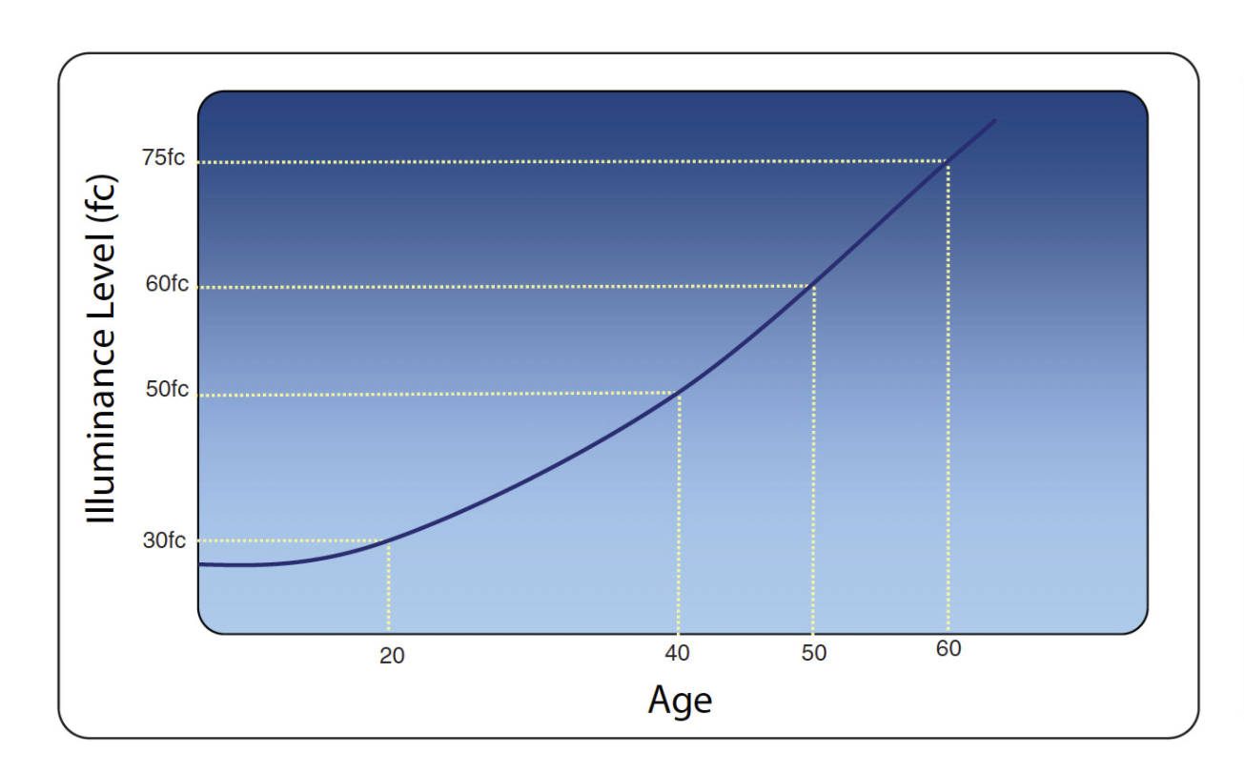
(Age and Vision Research).
Research Questions and Hypotheses
Research Question
How do lighting parameters from artificial lighting and daylighting impact café's ability to support social interaction?
Hypothesis
Increased daylight utilization combined with appropriate artificial lighting levels for conversation, working, and relaxing and appropriate fixtures will create an environment that will support and encourage social interaction.
H1: Discomfort glare impacts social interaction in cafes negatively.
H01: Discomfort glare does not impact social interaction in cafes negatively.
H2: Lighting uniformity impacts social interaction in cafes
H02: Lighting uniformity does not impact social interaction in cafes
H3: High lighting intensity impacts social interaction in cafes positively. ​
H03: High lighting intensity impacts social interaction in cafes negatively. ​
​Research Method
Research design
To answer the question of “How do lighting parameters impact cafe's ability to support social interaction?” A quantitative method was applied. The quantitative method included a questionnaire that was given to patrons of the selected coffee shops to gauge how the lighting in the coffee shop effects their desire or willingness to socialize.
Dependent and Independent Variables
Dependent Variable: Socialization
Independent Variable: lighting parameters including glare, and lighting intensity and uniformity.
Research Procedure
Institutional Review Board Protocols and Approval
To obtain approval from the Institutional Review Board, the survey used in this study, the research methods, and research procedures were submitted to the IRB. Approval by the IRB is required due to the study involving humans and their participation in a survey. The study information was reviewed and returned with an exempt status. The IRB number for this study is #13849 and the approval was given on 10/08/2021.
Questionnaire
Cafe visitors were given an opportunity to fill out a questionnaire when they were visiting one of the three coffee shops that are included in the study. To recruit people to participate in the study flyers were placed throughout the coffee shops on bulletin boards, at the counters where coffee is ordered/picked up, and on tables throughout the café with information pertaining to the study and a QR code that, when scanned by their mobile device, took them to the Qualtrics survey. All of the answers provided by participants were recorded in Qualtrics. All responses and data collected were anonymous. To prevent the same person from completing the survey multiple times and corrupting the study results, a setting within the Qualtrics survey distribution software called “Prevent multiple submissions” was turned on. Once 50 participants completed the survey, data was be collected from Qualtrics and analyzed.
The questions asked on the questionnaire were a combination of multiple choice, short answers and Likert scale questions used.
I. Participants
People over 18 years of age were asked to participate in a questionnaire and were asked to answer questions based on their experience in the coffee shop they are visiting. The participants were selected based on their willingness to participate in the questionnaire and their being at the coffee shop at the time of the study. Participants were recruited voluntarily. The survey was distributed through flyers and QR codes throughout the coffee shops and patrons were able to decide while visiting if they want to participate in the study. 50 participants are the target sample group.
II. Questions
The questionnaire was designed to analyze the experience that patrons of selected coffee shops have had and how the lighting in their current environment affects their ability and desire to socialize while there or in the future. The questions that were included in the questionnaire gauged the demographics of the users, psychological qualities of the user, the frequency in which people visit, their intention for visiting and how the lighting effects their socialization when visiting. The demographic questions gave insight into the ages of the people participating and their marital status to inform the background characteristics of the people that are visiting the coffee shops and participating in the survey. The psychological quality questions offered information about how the people taking the study self-describe their qualities that could make them more willing to socialize or less likely to socialize. Questions about how often the participant visits coffee shops provided information on their likelihood of visiting a coffee shop. There are questions designed to answer why the participant was there or the reason why they typically visit coffee shop to see if socialization is something that they go into the coffee shop to accomplish. Lastly, there are a series of questions that ask participants to rate how the lighting affects their visit on a scale of 1 to 5.
People over the age of 18 are allowed and encouraged to participate in the study. The only other requirement to completing the study is to be in the coffee shop that is participating in the study while completing the survey.
III. Locations
Three coffee shops were selected to participate in the study. The criteria for being selected was that they had to be located in Norman, Oklahoma, allow patrons to sit inside, and have a reputation for being a gathering place. Norman was selected as the research city due to its proximity to the University of Oklahoma and because they have many locally owned coffee shops with strong identities.
Norman is a city centrally located in the state of Oklahoma. It is home to The University of Oklahoma. The population of Norman as of 2016 is 120,866. As of 2012, 16% of the population is people under the age of 15, 25.1% of the population is age 15 to 24, 25.2% of the population is age 25-44, 22.1% of the population is 45 to 64, and 10.3% of the population is 65 and over (Demographics and Characteristics, 2016). 50% of the population consists of females and 49.7% of the population is male. (Demographics and Characteristics, 2016). 93.1% of the population are high school graduates over the age of 18. 43.4% are college graduates (Demographics and Characteristics, 2016). According to the 2019 Census reporter, 46% of people living in Norman are married and 54% are single and have never been married. 3% of the population is widowed and 9.5% of the population is divorced (Census Reporter, 2019)
Figure 2
Age Demographics of Residents of Norman, Oklahoma
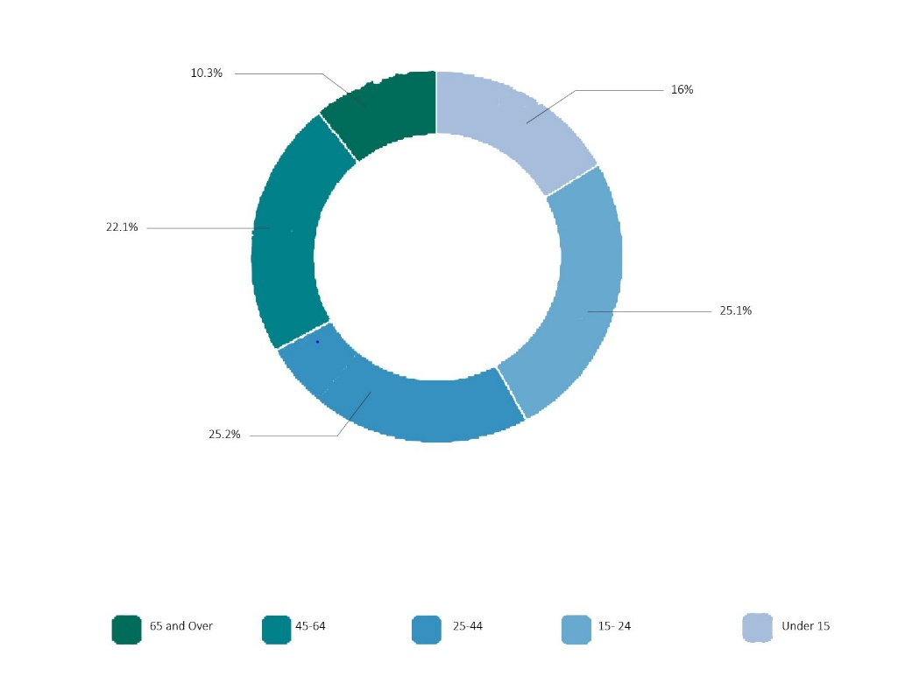
III.I Stella Nova
The first coffee shop that was selected was Stella Nova. Stella Nova is located at 1415 W Main St, Norman, OK and is centrally located in the city of Norman. They have a strong social identity and state on their website, “We are a gathering place for our communities where rich ideas and conversation brew just as strong as our coffee, where diverse experiences are embraced and relationships are forged” (ABOUT | StellaNova | United States, 2015).
There is floor to ceiling windows located on the south and east sides of the building. These windows feature shades that allow users in the coffee shop to control when and how light enters the space. The light was observed to the brightest in the mornings due to sun rising in the east, entering through the windows on the east side of the building. The shades were observed to be pulled down when visiting in the morning hours, to block direct light from entering and causing glare in the eyes of those facing the windows and form causing glare on computer screens of the people whose computer screen faces the window (Figure 5). During the day when the sun is at its peak in the sky, natural light enters the coffee shop without causing direct glare which allows for the shades to be no longer needed. When the sun has set, and there is no natural light entering through the windows, artificial light is used to illuminate Stella Nova. The artificial light consists of indirect diffuse light and direct light. The indirect diffuse light can be seen in Figures 3 through 5, as the stella nova decorative light fixtures and the direct lighting comes from the can lights located throughout the building.
There is a large assortment of different materials used throughout Stella Nova. All these materials impact the lighting environment of the space. The furnishings that are used combine hard surfaces in the form of flooring, painted walls, tables, counters, and soft surface couches, lounge chairs, upholstered dining chairs, draperies, and roller shades.
Figure 3
Stella Nova Interior
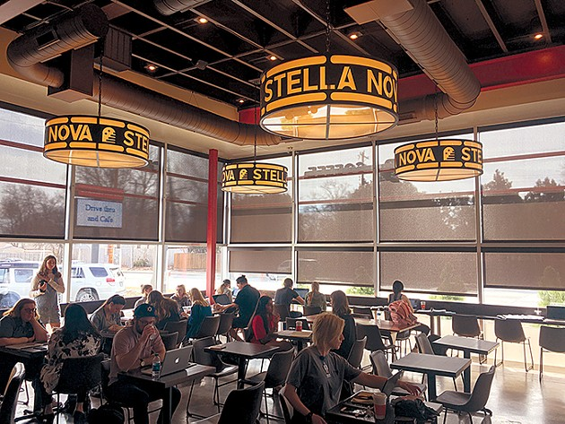
(Threadgill, 2018)
Figure 4
Stella Nova at Dusk
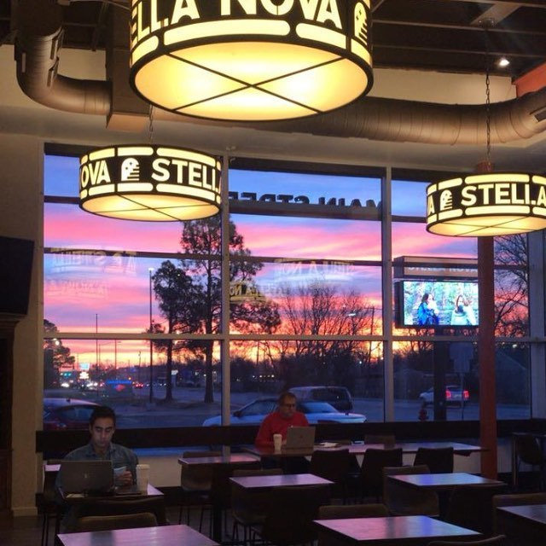
(Stella Nova Coffee)
Figure 5
Stella Nova Seating Area
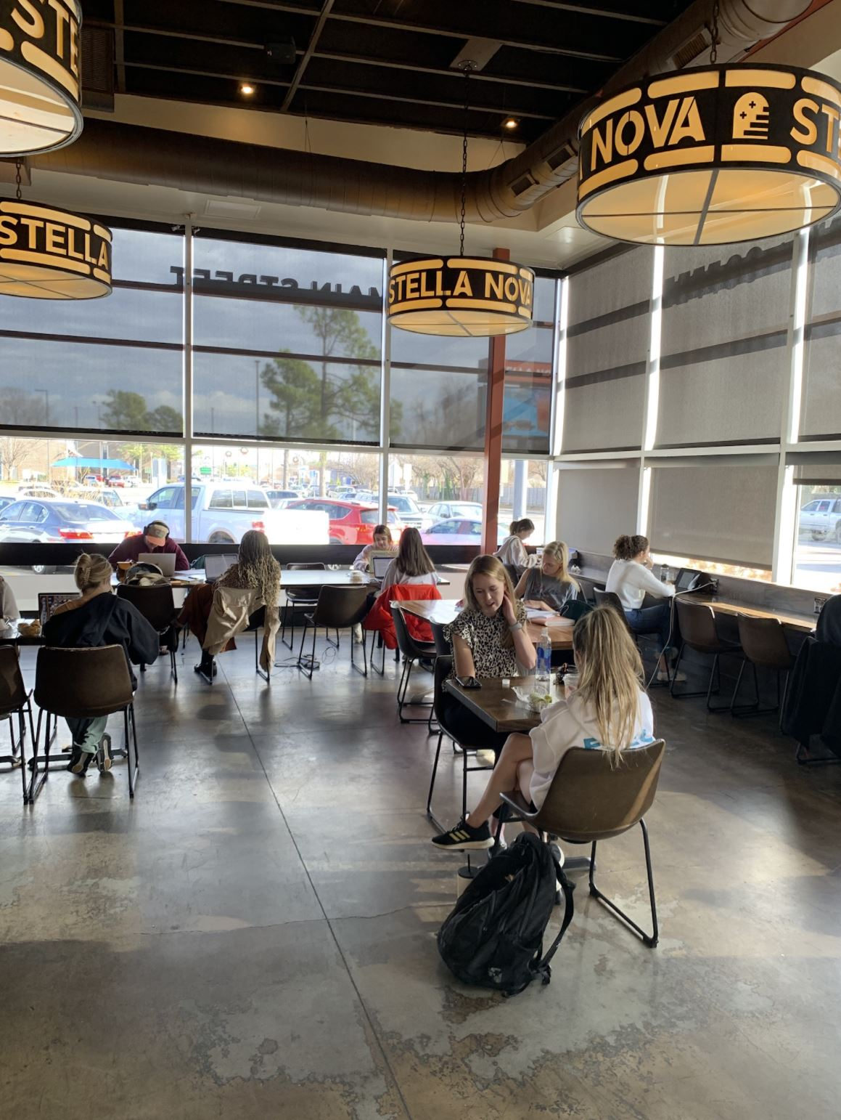
Figure 6
Stella Nova Entry Area
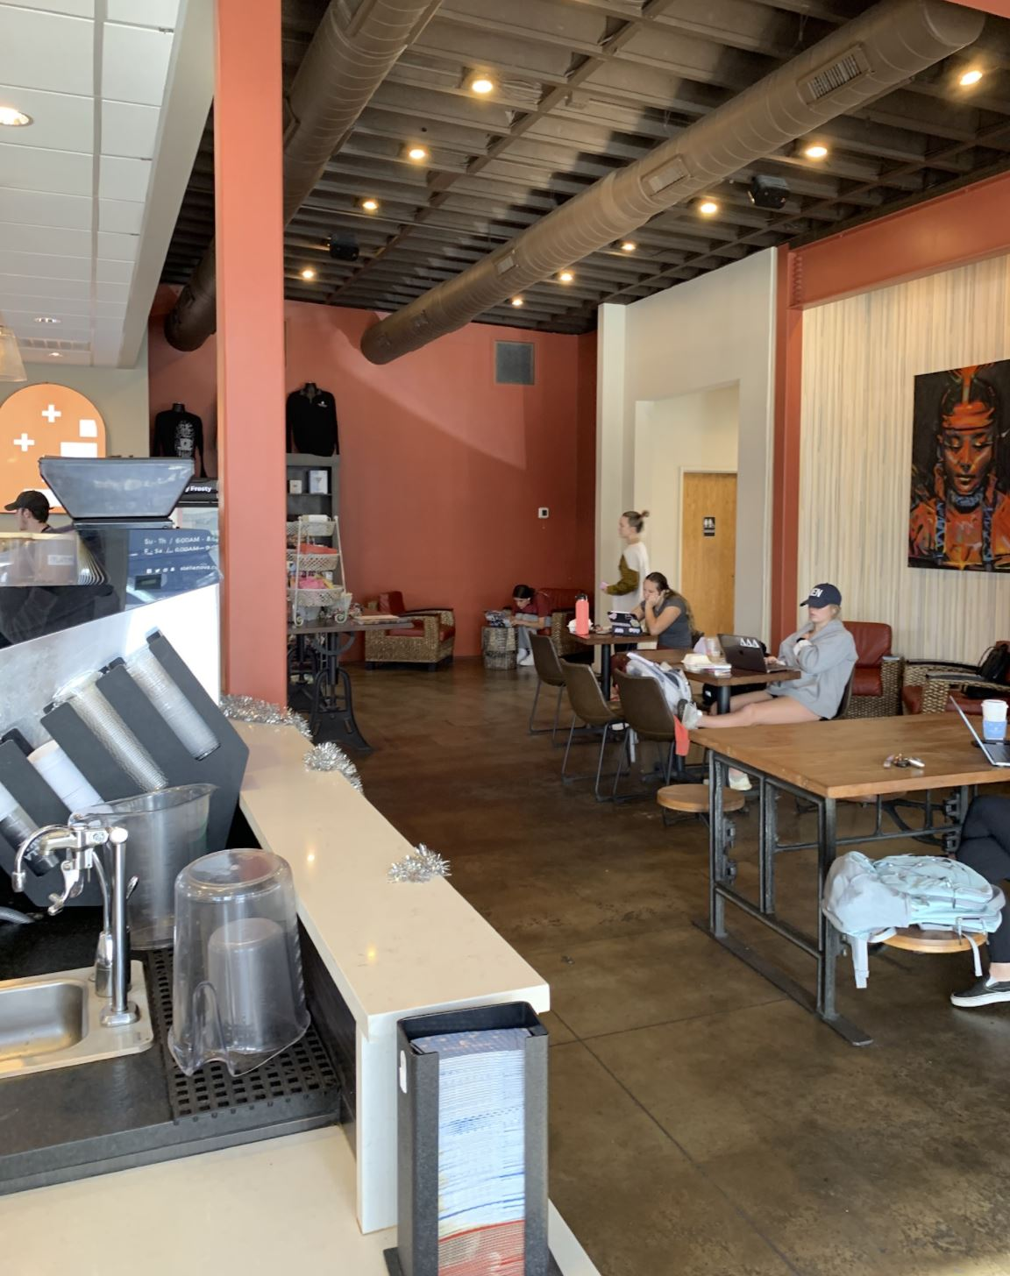
Figure 7
Stella Nova Reflected Ceiling Plan
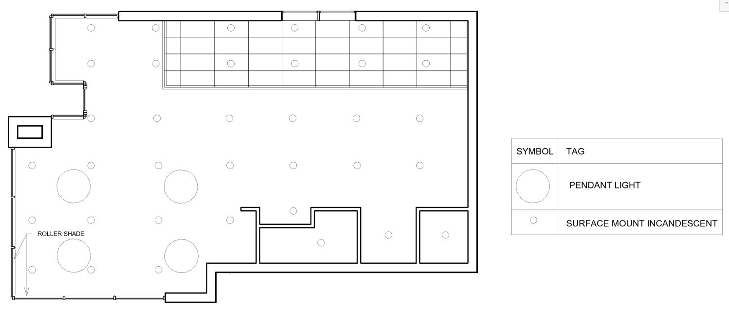
Figure 8
Stella Nova Floor Plan
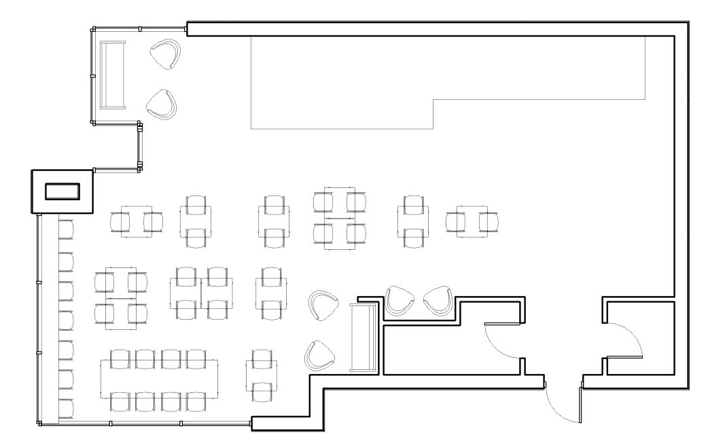
III.II Grey Owl
The second coffee shop that was selected to participate in the study was Grey Owl Coffee. Grey Owl Coffee is located at 223 E Gray St #7205, Norman, OK is very close to downtown Norman and the University of Oklahoma. Grey Owl Coffee has an eclectic and laid-back atmosphere that caters to people of all demographics. In an article written about Grey Owl’s change of operation to employee owned in 2021, Emily Soreghan, one of the six employee owners stated that, “Gray Owl and places like it are neutral spaces where people can come just to buy a coffee, see an old classmate or distant neighbor, and they help communities knit themselves together” (Elkins, 2021). It was designed to be a space for the community, and they make great strides to maintain that core value by holding events and encouraging patrons to stay and socialize.
The front façade of Grey Owl features floor to ceiling windows and is the only point that natural light enters the building. It is sandwiched in between other businesses along Grey Street and faces south-east. There are no window coverings to block natural light from entering the space (Figure 13). Grey Owl is narrow and deep, the windows and access to natural light illuminate the building and provide natural light all the way to the back of the public areas. Grey Owl was observed during multiple times of day. Glare was observed to be present when sitting on the west wall of the building when the sun is rising and directly streaming in. There is limited artificial lighting in the space. The artificial lighting is present in the form of flush mounted incandescent lights (Figure 9 through Figure 12).
The furniture that is used in grey owl is an assortment of different of unique pieces. They have filled the space with a mixture of tables and chairs that are composed of wood or metal and lounge chairs and couches that are made of soft materials (Figure 10 and Figure 12). The tables and chairs that are made of wood as well as the bar area where coffee/ other items for sale are ordered, prepared, and picked up absorb light that enters the building instead of reflecting it. The upholstered furniture also serves as a light absorber. The hard surfaces on the floor and concrete flooring are specular or matte in finish which can reduce glare from being reflected and soften surface appearance (DiLaura, 2011).
Figure 9
Grey Owl Interior
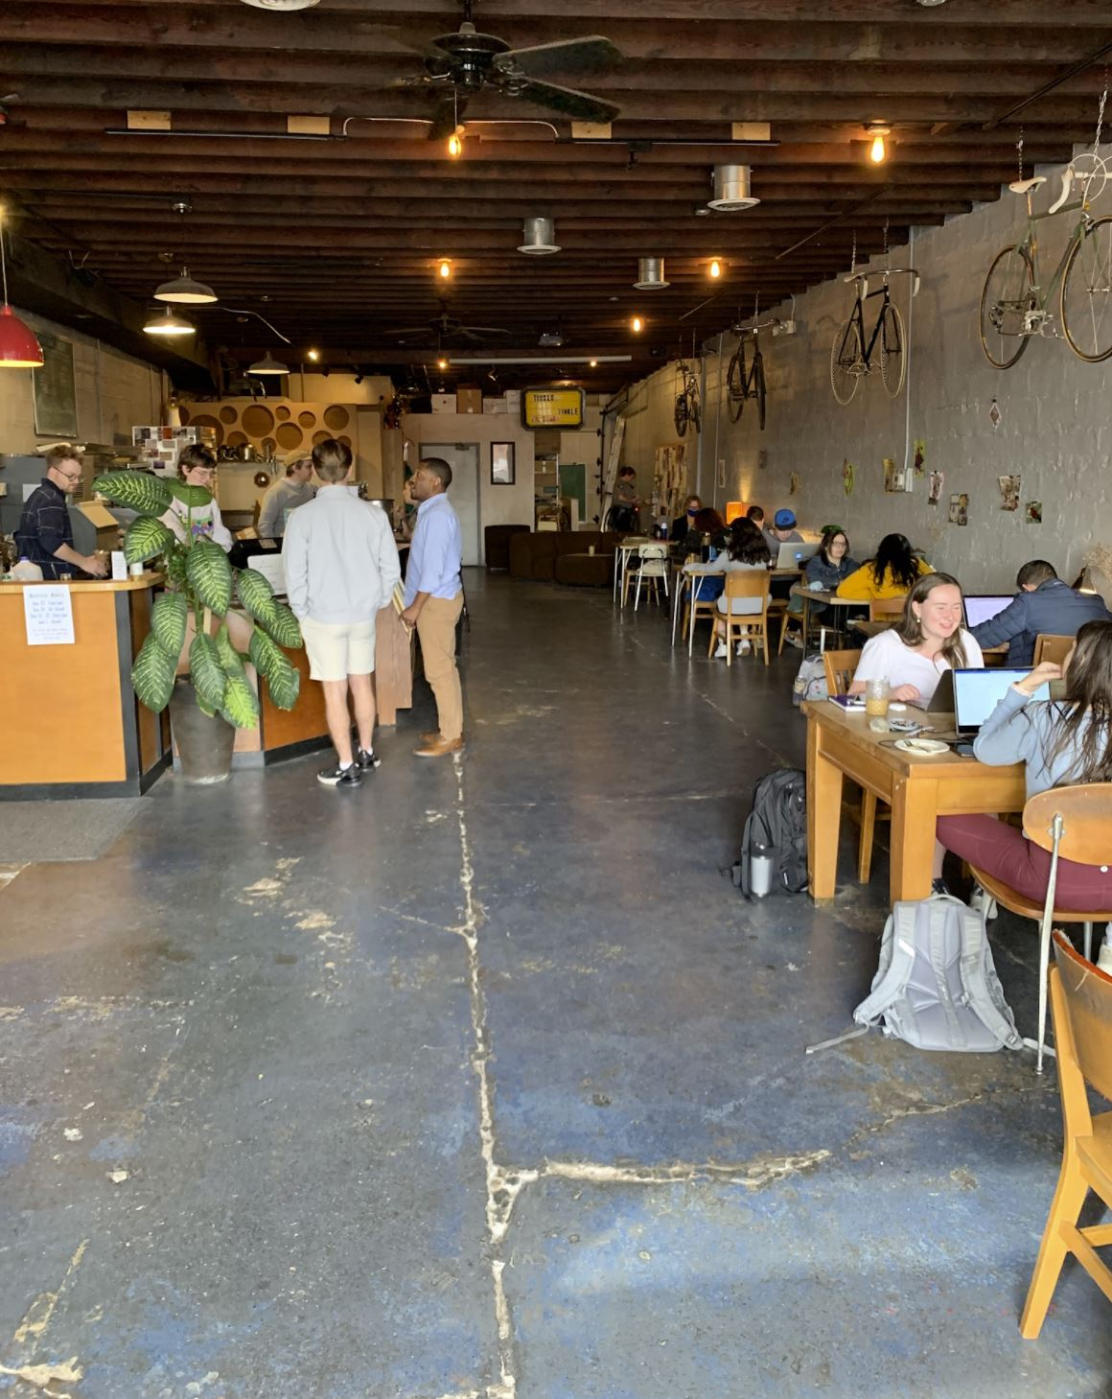
Figure 10
Grey Owl Interior Facing South
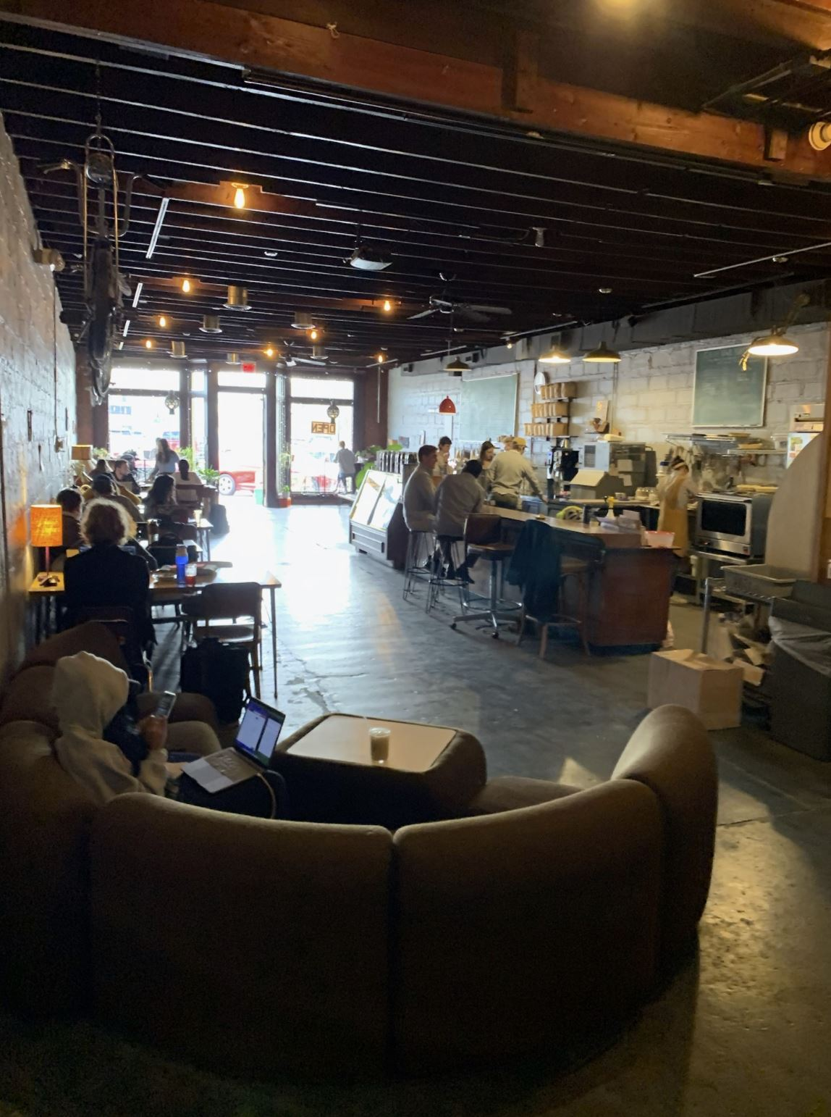
Figure 11
Grey Owl at Night
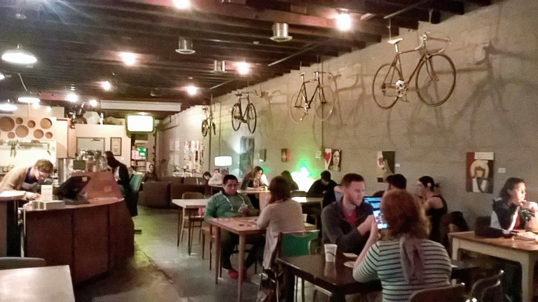
(Brooks, 2018)
Figure 12
Grey Owl Interior from Front Counter
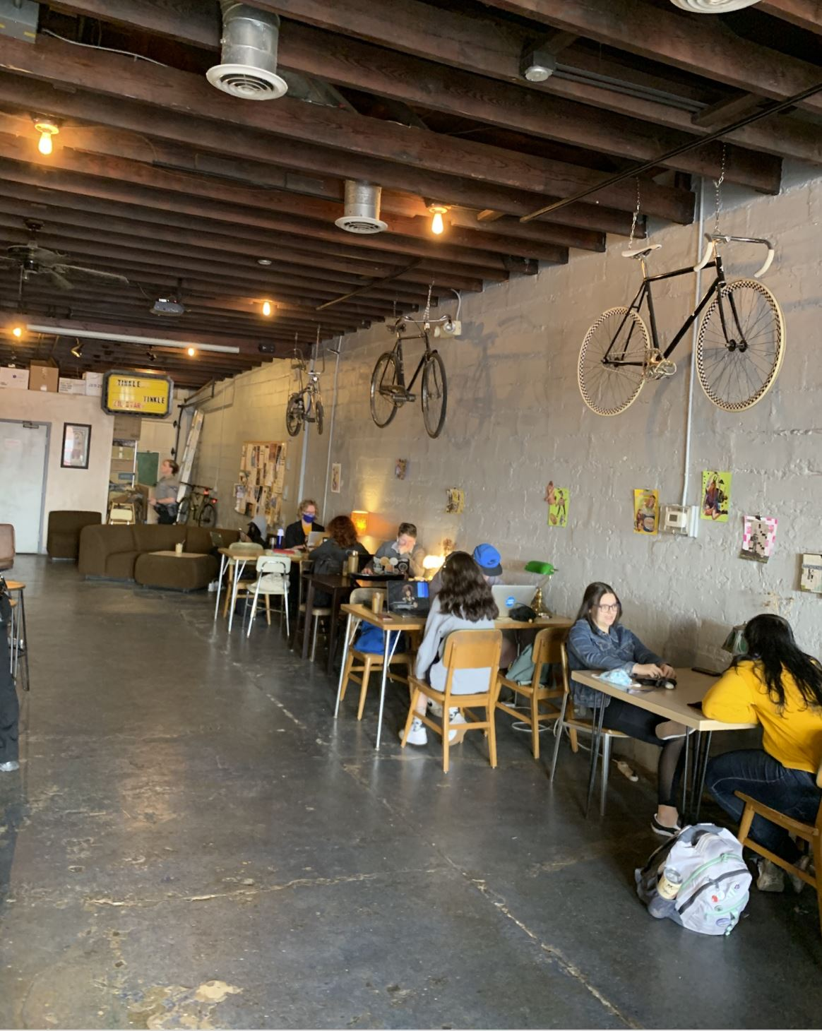
Figure 13
Grey Owl Façade from Interior
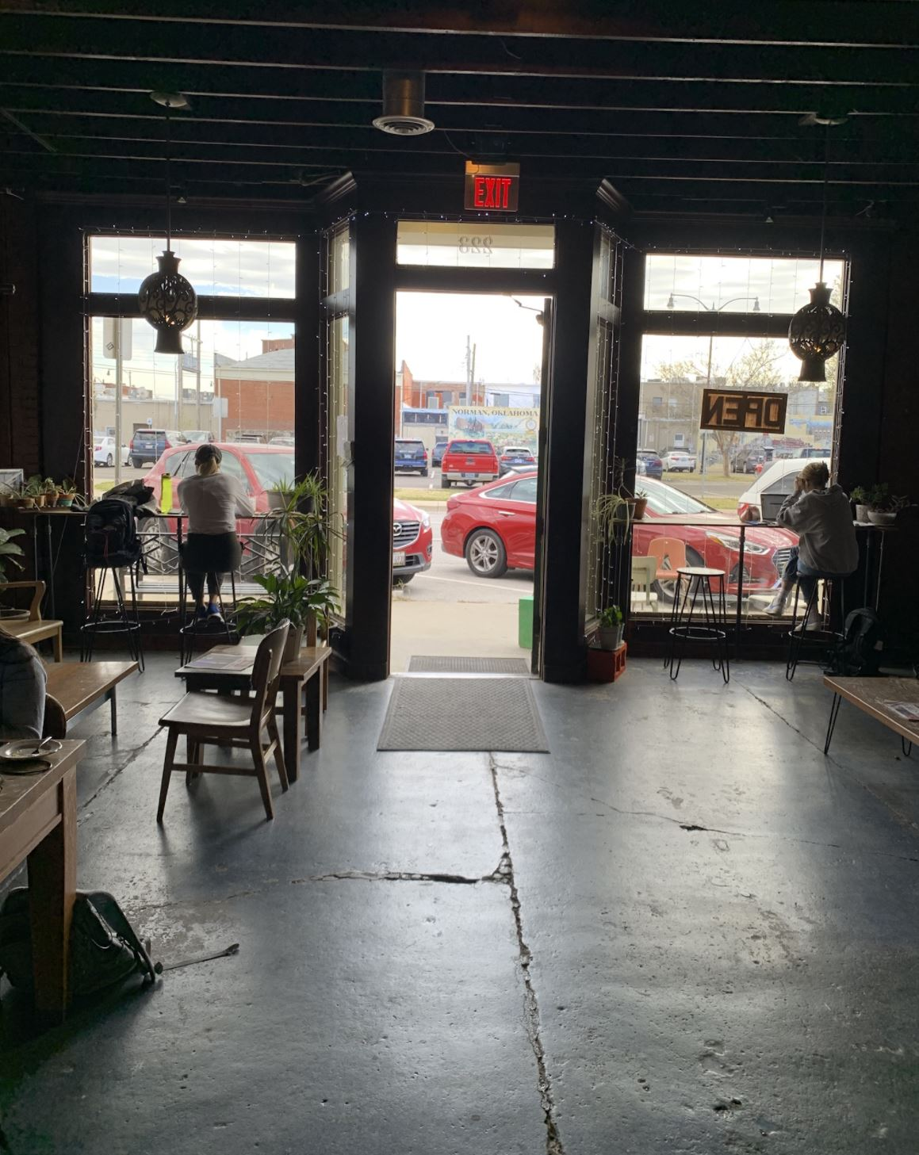
Figure 14
Grey Owl Reflected Ceiling Plan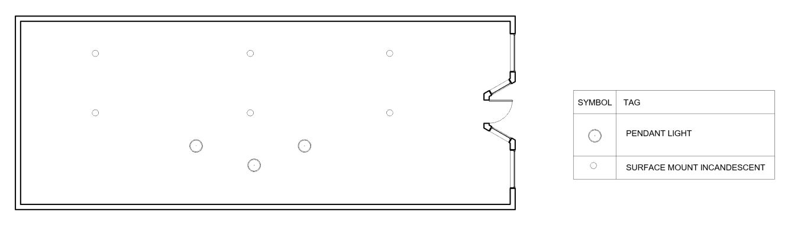
Figure 15
Grey Owl Floor Plan
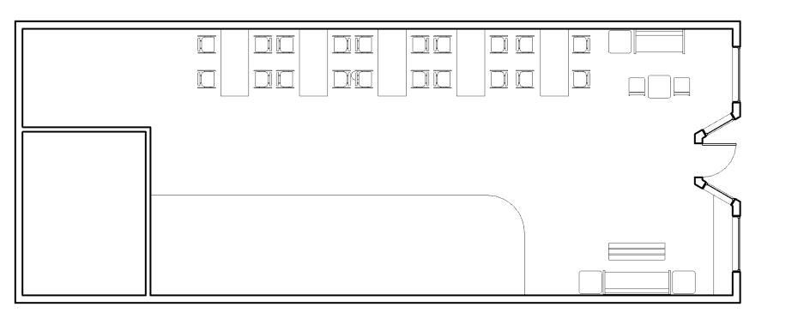
III.III Beanstalk Coffee and Snow
The third coffee shop that was selected to participate in the study is Beanstalk Coffee and Snow. Beanstalk Coffee and Snow is located at 3408 36th Ave NW Suite 124, Norman, OK. It is located near the border of Norman and Moore and is close in proximity to many elementary schools and residential neighborhoods. Because of the mixed business of coffee and snow cones, the owners modeled their establishment to cater to both children and adults and allow for family gatherings as well as meetings with friends and offer a smaller area separate from the main area that is quieter and built for study groups or intimate gatherings. The owner of Beanstalk Coffee and Snow stated in an interview “I think most coffee shops cater to adults or students, and they want it to be very trendy, like a chill, relaxed environment, and while we want that too, we also want those moms that have young children to have a place to come and meet up together. We want families to come here and feel comfortable. ... So, for our coffee shop here we have students that come and study, we have adults that have their meetup, but we welcome families from all walks of life. We welcome everybody to come here to be able to enjoy.” (Young, 2020).
Beanstalk Coffee and Snow features floor to ceiling windows on the north and east sides of the building. There are no shade mechanisms in place, when the sun enters the building there are no ways to block glare from also entering (Figure 18 and Figure 19). When inside, there is a small room on the west side that is popular and conducive for group meetings. In this room there are no windows and only a door for entrance making this space dim and lacking natural light when the artificial lighting is not in use and harsh when the artificial light is used, as pictured in Figure 21. The artificial light implemented throughout the building is 2x4 fluorescent lights. The interior lighting was observed to be harsh and direct. The use of 2x4flourescent light is illustrated in Figure 22 and can be seen in Figures 16 through 21.
The materials and furniture seen implanted in Beanstalk Coffee and Snow include polished concrete, subway tile, metal, glass, and faux greenery (Figure 16). Most surfaces and furniture that have been installed in Beanstalk Coffee and Snow have reflective properties and have the potential to emphasize any unwanted penetrating light or harsh light from the artificial lighting (Figure 19).
Figure 16
Beanstalk Coffee and Snow Interior and Front Counter
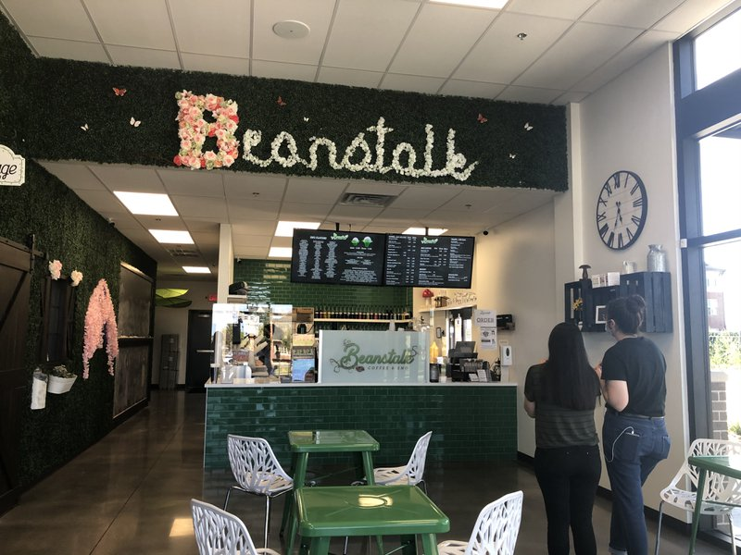
Beanstalk Coffee and Snow interior features overhead artificial lighting and natural light from the floor to ceiling windows located on the north and east sides of the building. (Beanstalk Coffee & Sno | TravelOK.com - Oklahoma’s Official Travel & Tourism Site, 2021)
Figure 17
Beanstalk Coffee and Snow Back of House
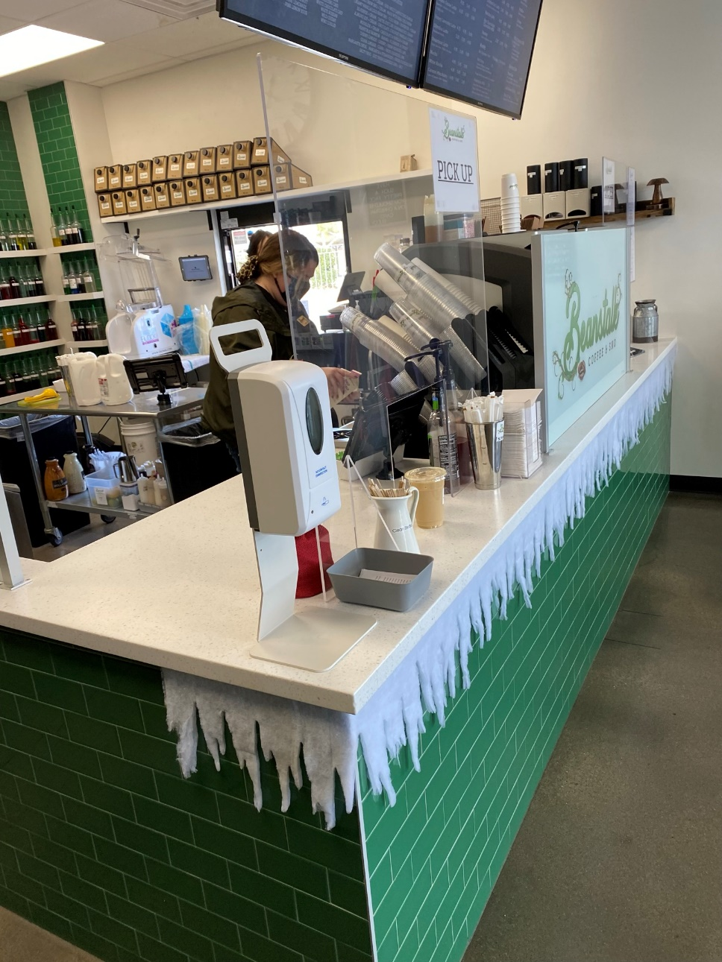

Figure 18
Beanstalk Coffee and Snow North Wall
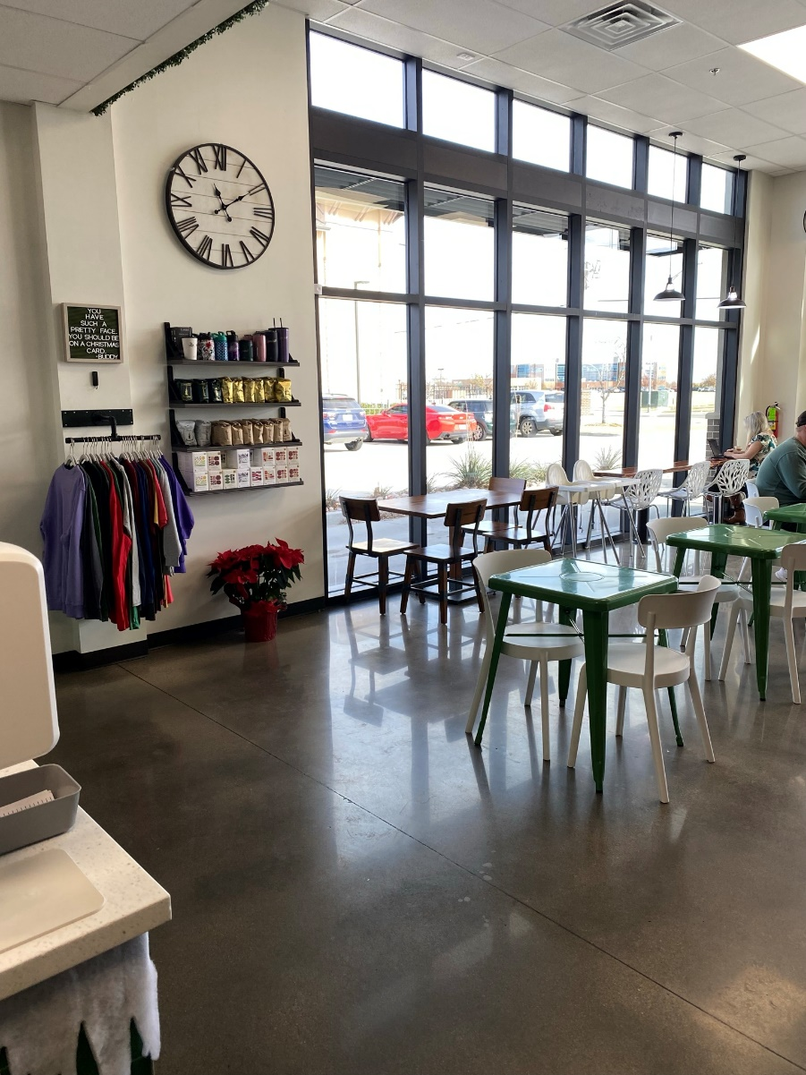
Figure 19
Beanstalk Coffee and Snow Seating Area with View of East and North Wall
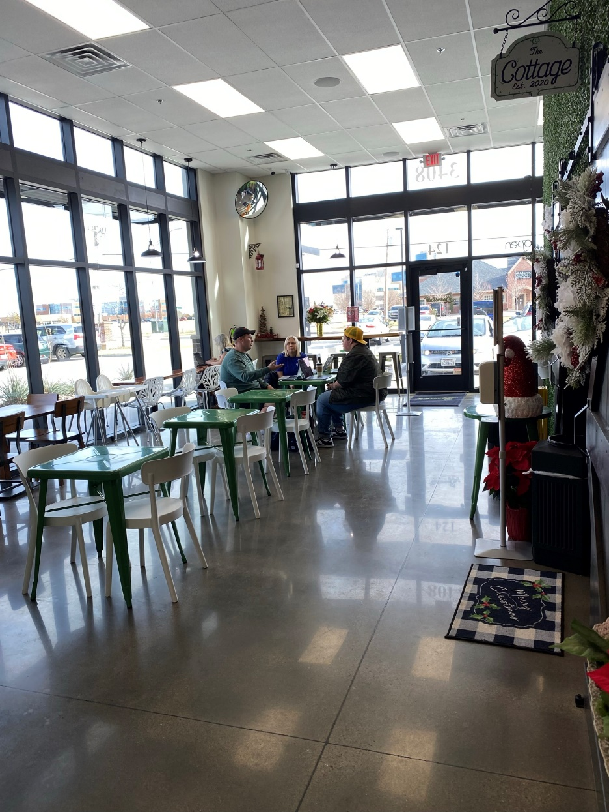
Figure 20
Beanstalk Coffee and Snow Hallway to Back of House and Restrooms
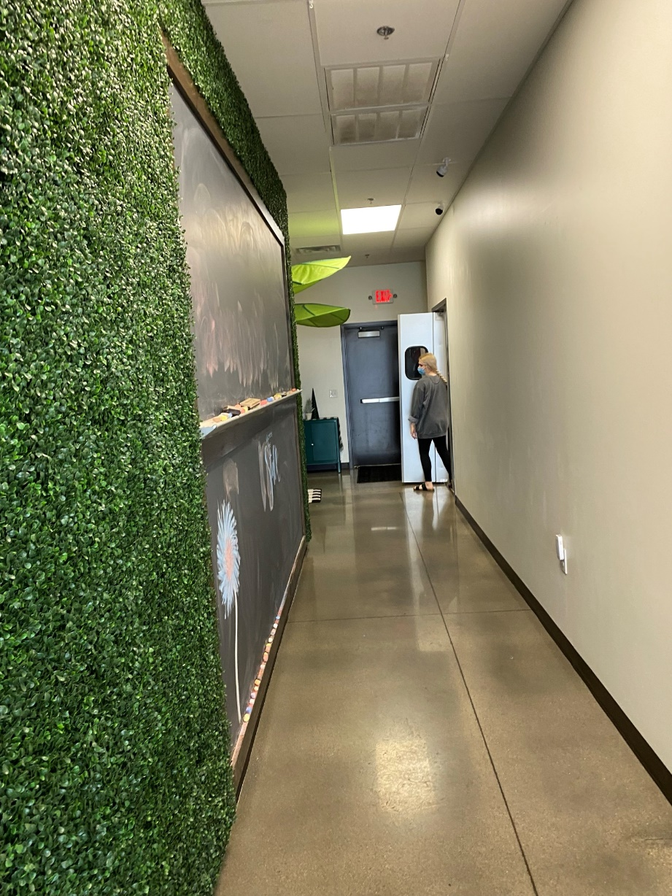
Figure 21
Beanstalk Coffee and Snow Meeting Room
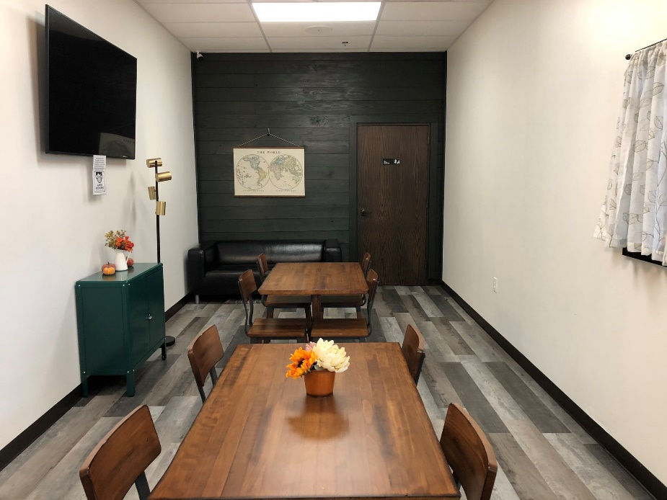
The backroom of Beanstalk Coffee and Snow is illuminated with artificial lighting and has no access to natural light. (Spielman, 2020)
Figure 22
Beanstalk Coffee and Snow Reflected Ceiling Plan 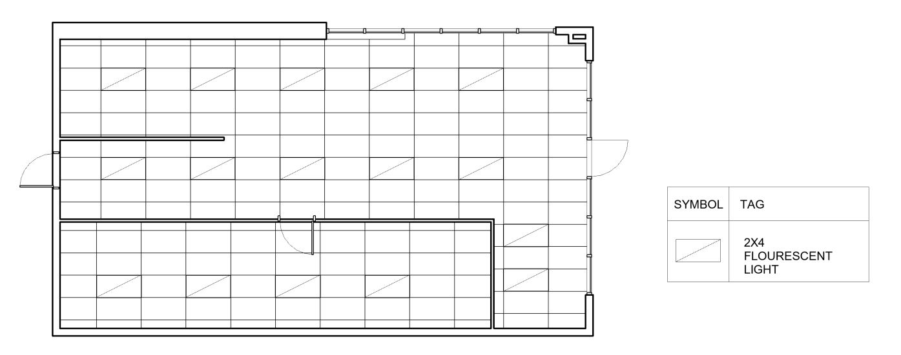
Figure 23
Beanstalk Coffee and Snow Floor Plan
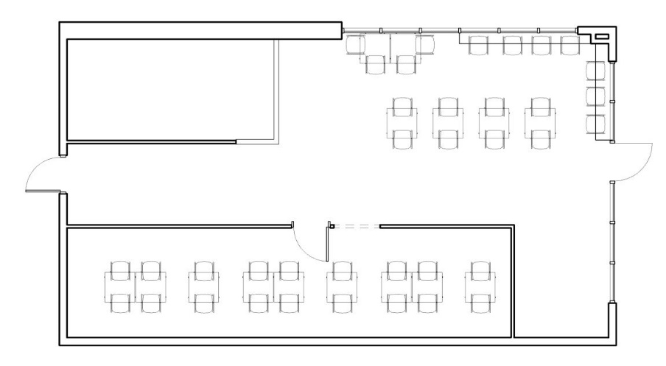
Data Analysis
To begin analyzing the study data, the research question of “How do lighting parameters from artificial lighting and daylighting impact café's ability to support social interaction?” was looked at and questions from the survey that directly seek to answer this question were reviewed. The quantitative data that resulted from the survey questions gave percentages and statistical data of how the lighting effects or doesn’t affect socialization in coffee shops. Cross tabulation, which is understood as “data tables that present the results of the entire group of respondents, as well as results from subgroups of survey respondents. With them, researchers can examine relationships within the data that might not be readily apparent when only looking at total survey responses” (Qualtrics, 2018). Cross tabulation was used to help find relationships between user demographics, user psychological characteristics, desire to socialize/visit coffee shop and their opinions on the effect of the lighting environment on socialization. Cross tabulation helped to eliminate data from respondents that do not go to coffee shops to socialize or ever intend to socialize in coffee shops answers because the lighting would not affect socialization if socialization would never occur.
Data from the survey was collected through the survey distribution software, Qualtrics, and analyzed within the Qualtrics, Stats IQ software. Statistical analysis including ANOVA, Chi Squared Test, and Fischer’s Exact Test were implemented. An Anova Test helps to find if the differences between sets of data are statistically significant. It is done by analyzing the levels of variance within the sets of data through samples of each the data sets (Qualtrics, 2020). A Chi Squared Test “is a statistical test used to compare the observed results with expected results. The purpose of this test is to determine if a difference between observed data and expected data due to chance, or if it due to a relationship between variables” (University of Southampton). A Fischer’s Exact Test is “a statistical test used to determine if there are nonrandom associations between two categorical variables” (Fisher’s Exact Test, 2021).
Findings
Demographics
The survey recruitment flyers were placed in Stella Nova, Grey Owl, and Beanstalk Coffee and Snow for a total of 42 days. During the 42 days that the survey recruitment flyers were located in the cafes, 50 people chose to scan the QR code located on the flyer that would take them to the survey. Of those 50, 42 people agreed to participate in the survey and fully completed it. 9 people that scanned the QR code chose that they did not want to participate which immediately ended the survey for them. The ages of participants ranged from 18 to 39 and older. 60% of the people that participated in the survey were between the ages of 18 and 24. 17.5% of participants were between the ages of 25 and 31. 2.5% of participants were between the ages of 32-38 and 20% of participants were 39 and older. Of people who chose to participate, the majority were single totaling 65.85% with 34.15% of participants being married and 0% of participants being divorced or widowed.
Figure 24
Comparison of Ages of Participants
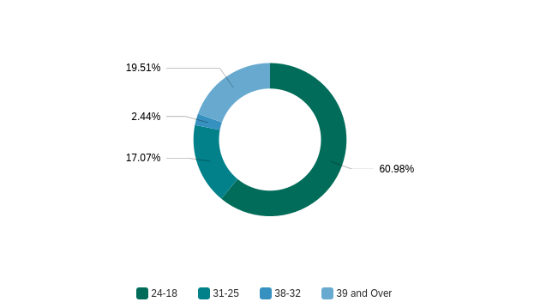
Figure 25
Comparison of Marital Status of Participants
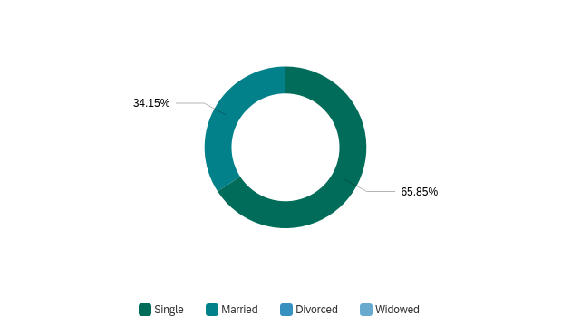
I. Qualities of Participants as Determinants of Socialization
Participants were asked to self-identify qualities that they felt accurately described them from a list of 14 qualities. They were able to choose as many as they felt appropriate. The qualities outlined that could be chosen from: talkative, quiet, sociable, reserved, outgoing, shy, optimist, passive, touchy, reliable, active, calm, assertive, and/or rigid. These qualities were selected as potential qualities that could determine a predisposition to likelihood to socialize versus an unlikelihood to socialize in the coffee shops.
The quality that participants related to the most was reliable, with 14.86% people selecting this option. The least related to quality was rigid, with only 0.80% of participants picking it. 7.23% of participants selected talkative, 7.23% of participants selected quiet, 10.44% of participants selected sociable, 8.03% of participants selected reserved, 7.23% of participants selected outgoing, 6.43% of participants selected shy, 11.65% of participants selected optimist, 1.20% of participants selected passive, 4.42% of participants selected touchy, 8.43% of participants selected active, 9.24% of participants selected calm, and 2.81% of participants selected assertive.
I. Talkative
A statistically significant relationship between participants who identified with ‘talkative’ and participants who go to coffee shops to socialize was found. A Fisher’s Exact Test was conducted, P < 0.05, P = 0.00422.
II. Quiet
There is no statistically significant relationship between participants who identified with ‘quiet’ and participants who go to coffee shops to socialize. A Fisher’s Exact Test was conducted, P = 0.261.
III. Sociable
A strong statistically significant relationship between participants who identified with ‘sociable’ and participants who go to coffee shops to socialize was found. A Fisher’s Exact Test was conducted, P < 0.05, P < 0.00001.
IV. Reserved
There is no statistically significant relationship between participants who identified with ‘reserved’ and participants who go to coffee shops to socialize. A Fisher’s Exact Test was conducted, P = 0.100.
V. Outgoing
A statistically significant relationship between participants who identified with ‘outgoing’ and participants who go to coffee shops to socialize was found. A Fisher’s Exact Test was conducted, P < 0.05, P = 0.00422.
VI. Shy
There is no statistically significant relationship between participants who identified with ‘shy’ and participants who go to coffee shops to socialize. A Fisher’s Exact Test was conducted, P = 0.079.
VII. Optimist
A strong statistically significant relationship between participants who identified with ‘optimist’ and participants who go to coffee shops to socialize was found. A Fisher’s Exact Test was conducted, P < 0.05, P < 0.00001.
VIII. Passive
There is no statistically significant relationship between participants who identified with ‘passive’ and participants who go to coffee shops to socialize. A Fisher’s Exact Test was conducted, P = 0.600.
IX. Touchy
A statistically significant relationship between participants who identified with ‘touchy’ and participants who go to coffee shops to socialize was found. P < 0.05, P = 0.0183, effect size 0.322.
X. Reliable
A strong statistically significant relationship between participants who identified with ‘reliable’ and participants who go to coffee shops to socialize was found. P < 0.05, P < 0.00001, effect size 0.700.
XI. Active
A statistically significant relationship between participants who identified with ‘active’ and participants who go to coffee shops to socialize was found. A Fisher’s Exact Test was conducted, P < 0.05, P = 0.000322.
XII. Calm
A statistically significant relationship between participants who identified with ‘calm’ and participants who go to coffee shops to socialize was found. A Fisher’s Exact Test was conducted, P < 0.05, P = 0.00928.
XIII. Assertive
A statistically significant relationship between participants who identified with ‘assertive’ and participants who go to coffee shops to socialize was found. A Fisher’s Exact Test was conducted, P < 0.05, P = 0.00358.
XIV. Rigid
There is no statistically significant relationship between participants who identified with ‘rigid’ and participants who go to coffee shops to socialize. A Fisher’s Exact Test was conducted, P = 0.222.
Figure 26
Comparison of Participant Qualities After Self Identification
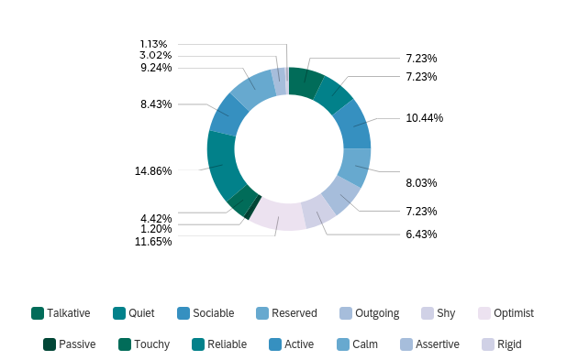
Coffee Shop Selection
The participants were asked to select which coffee shop they were currently visiting to inform the results gathered later in the survey regarding specific lighting conditions. The three coffee shops that were involved in the study were Stella Nova, Grey Owl, and Beanstalk Coffee and Snow. 43.90% of participants in the study were currently visiting Stella Nova, 31.71% of participants were visiting Grey Owl during the survey and 24.39% of participants were visiting Beanstalk Coffee and Snow.
Figure 27
Comparison of Participation by Coffee Shop
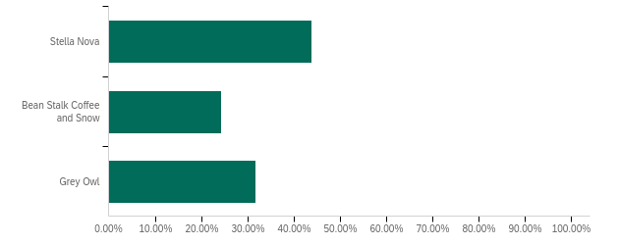
Frequency
I. How Many Days a Week Do You Typically Drink At Least One Cup Of Coffee?
A question regarding how many days of the week coffee is consumed was asked. The options were ‘one day a week’, ‘two days a week’, ‘three days a week’, ‘four days a week’, ‘five days a week’, ‘six days a week’, and ‘seven days a week’. The majority of participants disclosed that they consume coffee 7 days a week, with 47.37% selecting this answer. 10.53% of participants drink coffee one day a week, 5.26% of participants drink coffee two days a week, 7.89% of participants drink coffee three days a week, 10.53% of participants drink coffee four days a week, 13.16% drink coffee five days a week, and 5.26% of participants drink coffee 6 days a week.
II. On Average, How Many Times a MONTH Do You Visit a Coffee Shop/Café?
A question regarding how often participants visit a coffee shop per month was also asked. The options were ‘never’, ‘1 to 5 times a month’, ‘5-15 times a month’, ‘15-30 times a month’, and ‘more than 30 times a month’. 0% of participants selected that they never visit a coffee shop. The highest selection was ‘5-15 times a month’ with 41.46%. The second highest selection was ‘1-5 times a month’ with 36.59%. 17.07% of participants selected that they visited a coffee shop ‘15-30 times a month’ and 4.88% of participants selected they visited a coffee shop ‘more than 30 times a month’.
Figure 28
Comparison of Participant Coffee Consumption Per Week by Coffee Shop
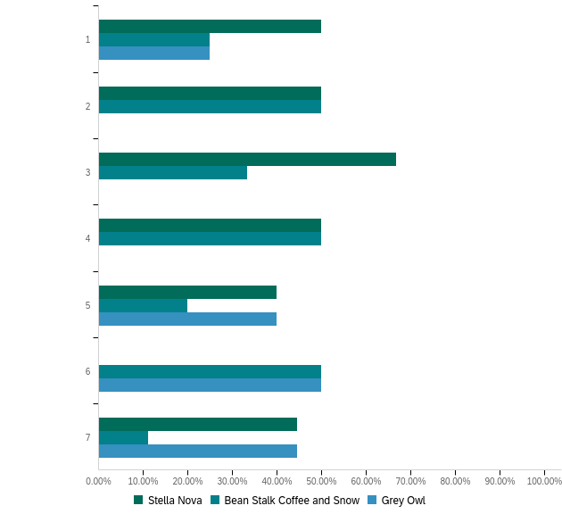
Figure 29
Comparison of Participant Coffee Shop Visit Frequency Per Month

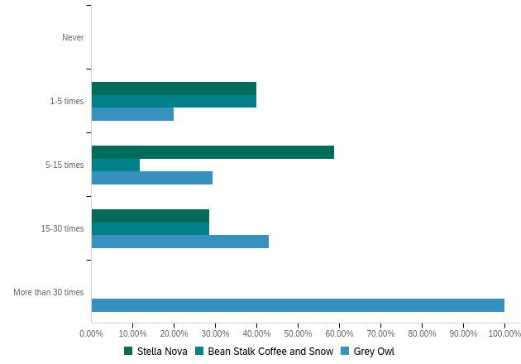
Socialization
I. Have You Used This Place for Socializing?
Participants were asked if they had ever used the coffee shop they are currently visiting for socialization. 80.0% of participants selected that they had used the coffee shop they are visiting for socialization and 20.0% of participants selected that they had not used the coffee shop they are visiting for socialization. Of the 80% of participants that answered that they had used the coffee shop they are visiting for socialization, 50% were at Stella Nova, 34.38% were at Grey Owl, and 15.63% were at Beanstalk Coffee and Snow. Of the 80% of participants that answered that they had not used the coffee shop they are visiting for socialization, 12.50% were at Stella Nova, 25.0% were at Grey Owl, and 62.50% were at Beanstalk Coffee and Snow.
Figure 30
Participant Use of Coffee Shop for Socialization
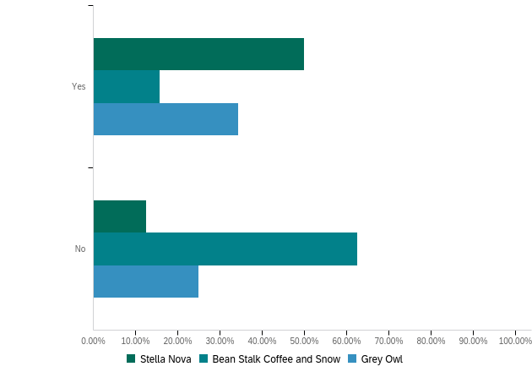
II. How Frequently Do You Use This Location For Socialization?
A question of frequency of use for socialization at their current coffee shop was asked. The choices given were ‘daily’, ‘weekly’, ‘monthly’, ‘yearly’, and ‘never’. The majority answer was ‘monthly’, with 46.34%. 2.44% of participants selected ‘daily’, 21.95% of participants selected ‘weekly’, 14.63% of participants selected ‘yearly’, 14.63% of participants selected ‘never’.
Figure 31
Frequency of Use of Coffee Shop for Socialization
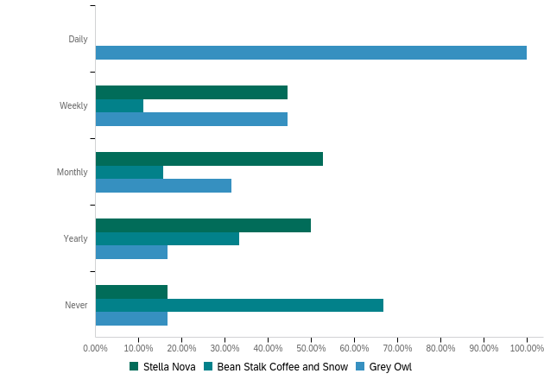
Visit Information
I. What Are the Main Activities You Will Be Participating in When You Visit This Location?
Participants were asked ‘what are the main activities you will be participating in when you visit this location?’ and were given five options to choose from: ‘get food or beverage’, ‘work’, ‘meetings’, ‘socialization’, and ‘other’. Participants were allowed to choose multiple answers. The activity that received the highest selection was ‘get food or beverage’, with 41.30% of participants choosing this option. The second highest selection was ‘socialization’, with 31.52% of participants choosing this option. 11.96% of participants selected ‘work’ and 15.22% of participants selected ‘meetings’ as one of the main activities they participated in when visiting. 0% of participants selected the option ‘other’ which would allow them to enter a short answer with the main activity they participated in while visiting the coffee shop.
Figure 32
Comparison of Activities Participants Participated in While Visiting Coffee Shop
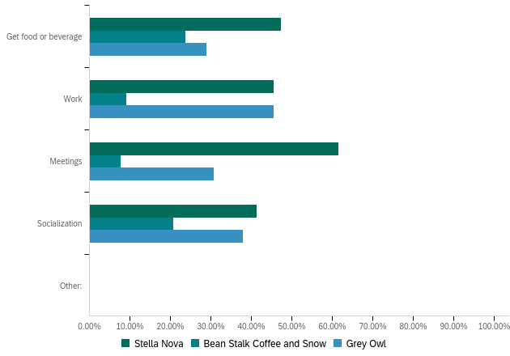
II. When You Visit This Location Do You..?
A question of how the participants typically engage with others was asked with choices of ‘come alone’, ‘come with other people’, ‘come to meet with people you already know’, ‘come to meet new people’, and ‘other’. There was an equal number of participants who selected ‘come with other people’ and ‘come to meet with people you already know’ with 43.90% participants selecting one of these answers. 9.76% of participants come alone to coffee shops, 2.44% of participants come to meet new people, and 0% of participants selected the ‘other’ option.
I.I. Come with Other People
A strong statistically significant relationship between participants who visit coffee shops to socialize and people who come to the coffee shops with other people was found. A Chi-Squared Test was conducted, P < 0.05, P = 0.00939.
I.II. Come to Meet with People You Already Know
A strong statistically significant relationship between participants who visit coffee shops to socialize and people who come to the coffee shops to meet with other people you already know was found. A Chi-Squared Test was conducted, P < 0.05, P = 0.00939.
I.III. Come to Meet New People
A strong statistically significant relationship between participants who visit coffee shops to socialize and people who come to the coffee shops to meet new people was found. A Chi-Squared Test was conducted, P < 0.05, P = 0.00939.
I.IV. Come Alone
A strong statistically significant relationship between participants who do not visit coffee shops to socialize and people who come to coffee shops alone was found. A Chi-Squared Test was conducted, P < 0.05, P = 0.00939.
Figure 33
Comparison of How Participants Intend to Socialize

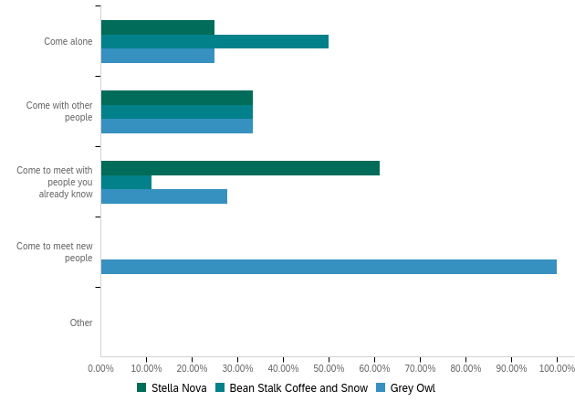
Participant Feedback Towards Lighting Characteristics and Socialization
I. On a Scale of 1 (worst) to 5 (best), how would you rate the following?
Participants were asked to rate certain aspects of the coffee shop they were visiting on a scale of 1 to 5, 1 being the worst and 5 being the best. The questions were as follows: ‘overall environment for group meetings?’, ‘overall influence of the lighting on your behavior?’, and ‘likelihood of your willingness to socialize here?’.
20 people rated the ‘overall environment for group meetings’ 5, 11 people rated it 4, 8 people rated it 3, 1 person rated it 2, and 1 person rated it 1. The average rating given by participants for ‘overall environment for group meetings?’ was 4.17. Figure 17 shows a comparison of how participants from each coffee shop rated the overall environment for group meetings. After concluding a ranked t-test it was established that when asked “on a scale of 1 (worst) to 5 (best), how would you rate the overall environment for group meetings, people who went to coffee shops to socialize tended to give the coffee shop they were visiting higher values than the people who were not there to socialize.
Zero people rated the ‘overall influence of the lighting on your behavior?’ 5, 12 people rated it 4, 19 people rated it 3, 7 people rated it 2, and 1 person rated it zero. The average rating given by participants for the coffee shops ‘overall influence of the lighting on your behavior?’ was 2.95. Figure 18 shows a comparison of how participants from each coffee shop rated the overall influence of the lighting on their behavior.
27 people rated the ‘likelihood of your willingness to socialize here?’ 5, 5 people rated it 4, 4 people rated it 3, 3 people rated it 2 and 2 people rated it one. The average rating given by participants for ‘likelihood of your willingness to socialize here?’ was 4.27. Figure 19 shows a comparison of how participants from each coffee shop rated the likelihood of their willingness to socialize there. After concluding a ranked t-test it was established that when asked “on a scale of 1 (worst) to 5 (best), how would you rate the likelihood of their willingness to socialize here?”, people who went to coffee shops to socialize tended to give the coffee shop they were visiting higher values than the people who were not there to socialize.
Figure 34
Rating Feedback of Overall Environment of Coffee Shops for Group Meetings
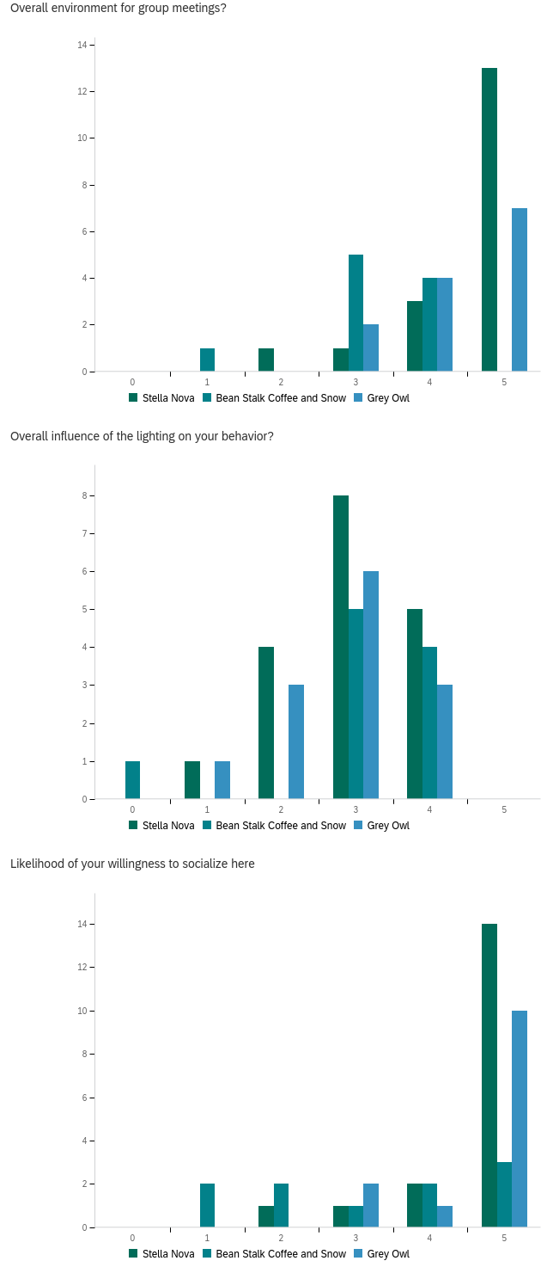
Figure 35
Rating Feedback of Overall Influence of the Lighting on Participant Behavior

Figure 36
Rating Feedback of Likelihood of Participants Willingness to Socialize at the Coffee Shop
Participants were asked a series of questions regarding the lighting conditions of the coffee shop they are visiting as well as how it effects their willingness and desire to socialize with people they know and/or strangers. They were asked to respond by selecting from a Likert scale, the choices are as follows: ‘strongly disagree’, ‘somewhat disagree’, ‘neither agree nor disagree’, ‘somewhat agree’, or ‘strongly agree’.
II. Overall, the Lighting is Comfortable
The first question that participants were asked regarding the lighting was “overall, the lighting is comfortable”. The highest selection made was ‘strongly agree’, with 78.05%. Of the participants that selected ‘strongly agree’, 46.88% of participants were visiting Stella Nova, 34.38% of participants were visiting Grey Owl, and 18.75% of participants were visiting Beanstalk Coffee and Snow. The second highest selection were ‘somewhat agree’, with 17.07%. Of the participants that selected ‘somewhat agree’, 42.86% of participants were visiting Stella Nova, 28.57% of participants were visiting Grey Owl, and 28.57% of participants were visiting Beanstalk Coffee and Snow. 2.44% of participants selected ‘neither agree not disagree’ and 2.44% of participants selected ‘somewhat disagree’. Both participants that selected ‘neither agree not disagree’ and ‘somewhat disagree’ were visiting Beanstalk Coffee and Snow.
When a Chi-squared test was conducted between the dependent variable of socialization and the independent variable ‘Overall the Lighting is Comfortable’ a significant relationship between the two variables was established. The P value was found to be 0.0221, because the p-value is less than 0.05, it can be assumed that there is strong evidence that the null hypothesis ‘no relationship exists’ should be rejected.
Figure 37
Feedback to the Statement ‘Overall the Lighting is Comfortable’
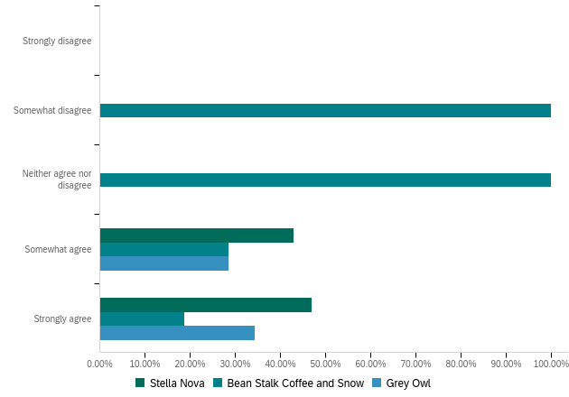
III. The lighting is uncomfortably bright for the goal of socializing I am trying to perform
A statement of “The lighting is uncomfortably bright for the goal of socializing I am trying to perform” was proposed. ‘Somewhat disagree’ was the highest selection, with 43.90%. Of that 43.90% that answered, ‘somewhat disagree’, 44.44% of participants were visiting Stella Nova, 50.00% of participants were visiting Grey Owl, and 5.56% of participants were visiting Beanstalk Coffee and Snow. 24.39% of participants answered ‘neither agree nor disagree’ with 50.0% of participants visiting Stella Nova, 0% of participants visiting Grey Owl, and 50.0% of participants visiting Beanstalk Coffee and Snow. 19.51% of participants selected ‘strongly disagree’ with 25.0% of participants visiting Stella Nova, 50.0% of participants visiting Grey Owl and 25.0% of participants visiting Beanstalk Coffee and Snow. 9.76% of participants selected ‘somewhat agree’ with 75.0% of participants visiting Stella Nova, 0% visiting Grey Owl, and 25.0% visiting Beanstalk Coffee and Snow. 2.44% of participants selected ‘strongly agree’ and they were visiting Beanstalk Coffee and Snow.
Figure 38
Feedback to the Statement ‘The lighting is uncomfortably bright for the goal of socializing I am trying to perform’
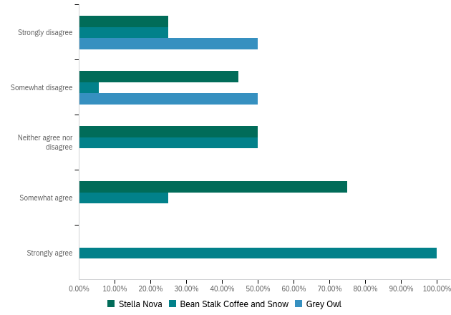
IV. The lighting is uncomfortably dim for the goal of socializing I am trying to perform
A statement of “The lighting is uncomfortably dim for the goal of socializing I am trying to perform” was proposed. ‘Strongly disagree’ and ‘somewhat agree’ were both equally selected with each choice getting 34.15%. Of the participants who selected ‘strongly disagree’, 42.86% were visiting Stella Nova, 28.57% were visiting Grey Owl, 28.57% were visiting Beanstalk Coffee and Snow. 78.57% of participants that selected ‘somewhat agree’ were visiting Stella Nova, 28.57% were visiting Grey Owl, and 28.57% were visiting Beanstalk Coffee and Snow. 19.51% of participants selected ‘somewhat agree’, with 12.50% of participants visiting Stella Nova, 50.0% of participants visiting Grey Owl, 37.50% of participants visiting Beanstalk Coffee and Snow. 12.20% of participants selected ‘neither agree nor disagree’, with 0% of participants visiting Stella Nova, 40.0% of participants visiting Grey Owl, and 60.0% of participants visiting Beanstalk Coffee and Snow.
Figure 39
Feedback to the Statement ‘The lighting is uncomfortably dim for the goal of socializing I am trying to perform’
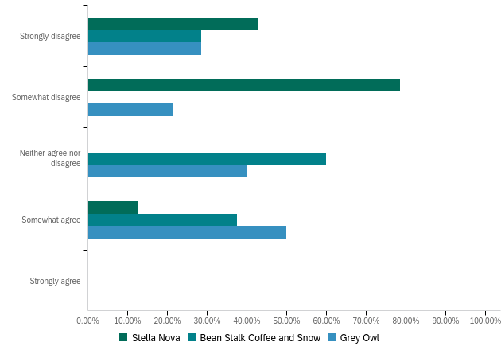
V. The lighting in this coffee shop is uncomfortably bright/high for socializing with strangers
A statement of “The lighting in this coffee shop is uncomfortably bright/high for socializing with strangers” was proposed. The highest selection was ‘somewhat disagree’ with 39.02%. Of the 39.02% that selected ‘somewhat disagree’, 37.50% were visiting Stella Nova, 50.0% were visiting Grey Owl, and 12.50% were visiting Beanstalk Coffee and Snow. 21.95% of participants selected ‘neither agree nor disagree’, with 55.56% of participants visiting Stella Nova, 0% of participants visiting Grey Owl, and 44.44% of participants visiting Beanstalk Coffee and Snow. ‘Strongly disagree’ and ‘somewhat agree’ were each selected by 19.51% of participants. 37.50% of participants that selected ‘strongly disagree’ were visiting Stella Nova, 50% of participants were visiting Grey Owl, and 12.50% of participants were visiting Beanstalk Coffee and Snow. Of the participants that selected ‘somewhat agree’, 50.0% of participants were visiting Stella Nova, 12.50% of participants were visiting Grey Owl, and 27.50% of participants were visiting Beanstalk Coffee and Snow. Zero participants selected ‘strongly agree’.
Figure 40
Feedback to the Statement ‘The lighting in this coffee shop is uncomfortably bright/high for socializing with strangers’
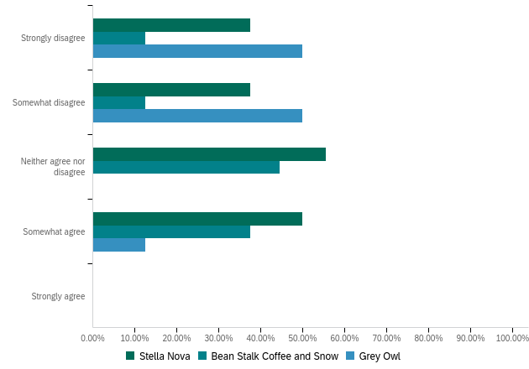
VI. The lighting in this environment influences how long I stay in this environment
To the statement “the lighting in this environment influences how long I stay in this environment”, 65.85% of participants ‘somewhat agree’. Of the participants that selected ‘somewhat agree’, 44.44% of participants were visiting Stella Nova, 33.33% of participants were visiting Grey Owl, and 22.22% were visiting Beanstalk Coffee and Snow. 19.51% of participants selected ‘strongly agree’, with 62.50% of participants visiting Stella Nova, 25.0% were visiting Grey Owl, and 12.50% were visiting Beanstalk Coffee and Snow. 7.32% of participants selected ‘neither agree nor disagree’, with 0% of participants visiting Stella Nova, 33.33% of participants visiting Grey Owl, and 66.67% of participants visiting Beanstalk Coffee and Snow. 4.88% of participants selected ‘somewhat disagree’, with 0% of participants visiting Stella Nova, 50.0% of participants visiting Grey Owl, and 50.0% of participants visiting Beanstalk Coffee and Snow. 2.44% of participants selected ‘strongly disagree’, with 100% of participants visiting Stella Nova.
Figure 41
Feedback to the Statement ‘The lighting in this environment influences how long I stay in this environment’
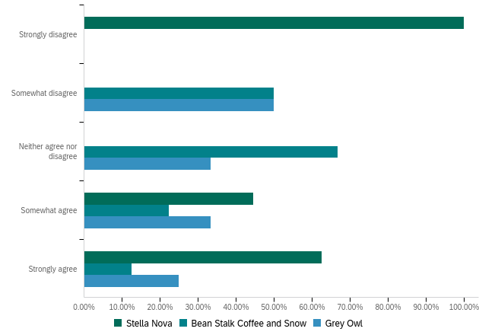
VII. The lighting in this environment influences my desire to socialize, which is defined by Merriam-Webster Dictionary as "social interaction with others
When asked to respond to the statement “The lighting in this environment influences my desire to socialize, which is defined by Merriam-Webster Dictionary as "social interaction with others"”, 75.61% of participants selected ‘somewhat agree’. Of the participants that selected ‘somewhat agree’, 48.39% of participants were visiting Stella Nova, 32.26% of participants were visiting Grey Owl, and 19.35% of participants were visiting Beanstalk Coffee and Snow. 14.63% of participants selected ‘strongly agree’, with 50.0% of participants visiting Stella Nova, 33.33% of participants visiting Grey Owl, and 16.67% of participants visiting Beanstalk Coffee and Snow. 7.32% of participants selected ‘neither agree nor disagree’, with 0% of those participants visiting stella nova, 33.33% of participants visiting Grey Owl, and 66.67% of participants visiting Beanstalk Coffee and Snow. 2.44% of participants selected ‘somewhat disagree’ and all were visiting Beanstalk Coffee and Snow. Zero participants selected ‘strongly disagree’.
When a Chi-squared test was conducted between the dependent variable of socialization and the independent variable ‘The lighting in this environment influences my desire to socialize, which is defined by Merriam-Webster Dictionary as "social interaction with others’ a significant relationship between the two variables was established. The P value was found to be 0.00437, because the p-value is less than 0.05 it can be assumed that there is strong evidence that the null hypothesis ‘no relationship exists’ should be rejected.
Figure 42
Feedback to the Statement ‘The lighting in this environment influences my desire to socialize, which is defined by Merriam-Webster Dictionary as "social interaction with others”’
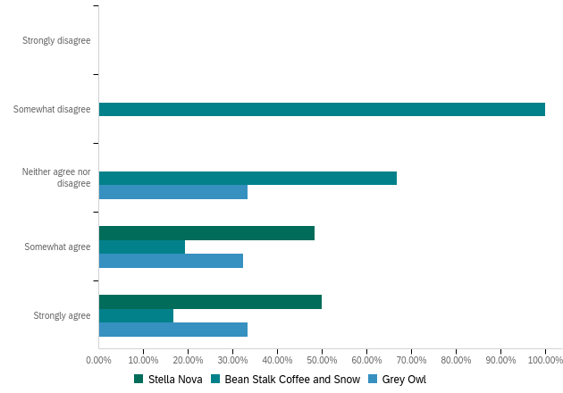
VIII. The high light intensity in this coffee shop encourages you to interact/speak/socialize more with other people here
A statement of “The high light intensity in this coffee shop encourages you to interact/speak/socialize more with other people here” was proposed. The highest selection was ‘somewhat agree’ with 41.46%. Of the people that selected ‘somewhat agree’, 76.47% of participants were visiting Stella Nova, 17.65% of participants were visiting Grey Owl, and 5.88% of participants were visiting Beanstalk Coffee and Snow. 26.83% of participants selected ‘somewhat disagree’, with 9.09% of participants visiting Stella Nova, 54.55% of participants visiting Grey Owl, and 36.36% of participants visiting Beanstalk Coffee and Snow. 17.07% of participants selected ‘strongly agree’, with 57.14% of participants visiting Stella Nova, 42.86% of participants visiting Grey Owl, and 0% visiting Beanstalk Coffee and Snow. 12.20% of participants selected ‘neither agree nor disagree’, with 100% of participants visiting Beanstalk Coffee and Snow. 2.44% of participants selected ‘strongly disagree’, with 100% of participants visiting Grey Owl.
Figure 43
Feedback to the Statement ‘The high light intensity in this coffee shop encourages you to interact/speak/socialize more with other people here’
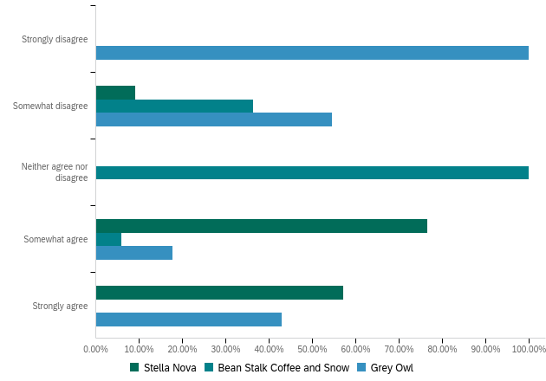
IX. The low light intensity in this coffee shop led you to interact/speak/socialize more with strangers
A statement of “The low light intensity in this coffee shop led you to interact/speak/socialize more with strangers” was proposed. The highest response was ‘somewhat disagree’, with 39.02%. Of the participants that selected ‘somewhat disagree’, 75.0% of participants were visiting Stella Nova, 0% of participants were visiting Grey Owl, and 25.0% of participants were visiting Beanstalk Coffee and Snow. The second highest response was ‘somewhat agree’, with 26.83%. Of the participants that selected ‘somewhat agree’, 18.18% of participants were visiting Stella Nova, 63.64% of participants were visiting Grey Owl, and 18.18% of participants were visiting Beanstalk Coffee and Snow. ‘Strongly disagree’ and ‘strongly agree’ were each selected the same amount, each with 12.20%. 60.0% of participants that selected ‘strongly disagree’ were visiting Stella Nova, 0% of participants were visiting Grey Owl, and 40.0% of participants were visiting Beanstalk Coffee and Snow. 100% of participants that selected ‘strongly agree’ were visiting Grey Owl. 9.76% of participants selected ‘neither agree nor disagree’, with 25.0% of participants visiting Stella Nova, 25.0% of participants visiting Grey Owl, and 50.0% of participants visiting Beanstalk Coffee and Snow.
Figure 44
Feedback to the Statement ‘The low light intensity in this coffee shop led you to interact/speak/socialize more with strangers’
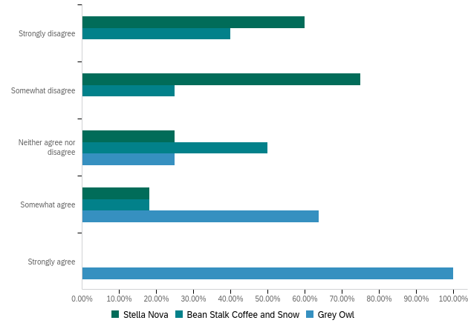
X. The uncomfortable glare (shine with strong dazzling light) in this coffee shop urges you to leave without socializing with anyone
When asked to respond to “The uncomfortable glare (shine with strong dazzling light) in this coffee shop urges you to leave without socializing with anyone”, 34.15% of participants selected ‘neither agree nor disagree’. Of the participants that selected ‘neither agree nor disagree’, 64.29% of participants were visiting Stella Nova, 21.43% of participants were visiting Grey Owl, and 14.29% of participants were visiting Beanstalk Coffee and Snow. 31.71% of participants selected ‘somewhat agree’, with 53.85% of participants visiting Stella Nova, 15.38% of participants visiting Grey Owl, and 30.77% of participants visiting Beanstalk Coffee and Snow. 19.51% of participants selected ‘somewhat disagree’, with 0% of participants visiting Stella Nova, 87.50% of participants visiting Grey Owl, and 12.50% of participants visiting Beanstalk Coffee and Snow. ‘Strongly agree’ and ‘strongly disagree’ both had the same percentage of participant selection, 7.32%. Of the people that selected ‘strongly agree’, 33.33% of participants were visiting Stella Nova, 0% were visiting Grey Owl, and 66.67% of participants were visiting Beanstalk Coffee and Snow. Of the participants that selected ‘strongly disagree’, 33.33% of participants were Stella Nova, 33.33% of participants were visiting Grey Owl, and 33.33% of participants were visiting Beanstalk Coffee and Snow.
Figure 45
Feedback to the Statement ‘The uncomfortable glare (shine with strong dazzling light) in this coffee shop urges you to leave without socializing with anyone’
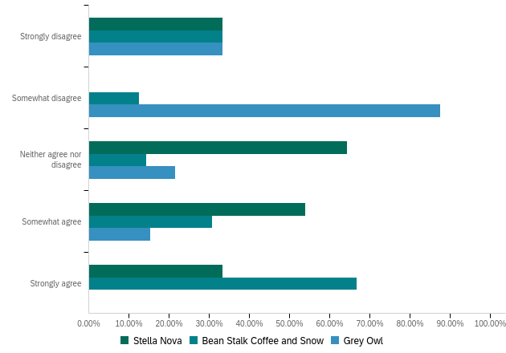
XI. On a scale of 1 (worst) to 5 (best), how would you rate the quality of light inside the coffee shop?
The final question of the survey asked participants to rate the quality of light inside the coffee shop they are visiting on a scale of 1(worst) to 5(best). The qualities that participants were asked to rate were: ‘pleasant’, ‘bright’, ‘comfortable’, ‘warm’, ‘visually clear’, and ‘relaxed’. When asked about the quality of light ‘pleasant’, Stella Nova had 15 participants give it a 5, 3 participants giving it a 4, and 0 participants giving it a 3,2, or 1. Grey Owl had 12 participants give it a 5, 1 participant giving it a 4, and 0 participants giving it a 3,2, or 1. Beanstalk Coffee and Snow had 5 participants give it a 5, 3 participants giving it a 4, 2 participants give it 3 and 0 participants giving it a 2 or 1. When asked about the quality of light ‘bright’, Stella Nova had 15 participants give it a 5, 1 participant giving it a 4, 1 participant give it a 3, 1 participant give it a 2 and 0 participants give it a 1. Grey Owl had 1 participant give it a 5, 2 participants giving it a 4, 8 participants give it a 3, 2 participants give it a 2, and 0 participants gave it a 1. Beanstalk Coffee and Snow had 3 participants give it a 5, 3 participants giving it a 4, 4 participants give it 3 and 0 participants giving it a 2 or 1. When asked about the quality of light ‘comfortable’, Stella Nova had 5 participants give it a 5, 13 participants giving it a 4, and 0 participants giving it a 3,2, or 1. Grey Owl had 11 participants give it a 5, 2 participants giving it a 4, and 0 participants giving it a 3,2, or 1. Beanstalk Coffee and Snow had 3 participants give it a 5, 5 participants giving it a 4, 2 participants give it 3 and 0 participants giving it a 2 or 1. When asked about the quality of light ‘warm’, Stella Nova had 8 participants give it a 5, 8 participants giving it a 4, 2 participants give it a 3 and 0 participants giving it a 2 or 1. Grey Owl had 11 participants give it a 5, 2 participants giving it a 4, and 0 participants giving it a 3,2, or 1. Beanstalk Coffee and Snow had 1 participant give it a 5, 5 participants giving it a 4, 3 participants give it 3, 1 participant gave it a 2 and 0 participants gave it a 1. When asked about the quality of light ‘visually clear’, Stella Nova had 11 participants give it a 5, 7 participants giving it a 4, and 0 participants giving it a 3,2, or 1. Grey Owl had 7 participants give it a 5, 4 participants giving it a 4, 2 participants giving it a 3 and 0 participants giving it a 2 or 1. Beanstalk Coffee and Snow had 4 participants give it a 5, 3 participants giving it a 4, 3 participants give it 3 and 0 participants giving it a 2 or 1.
Of the qualities of light that participants were asked to rank on a scale of 1 to 5, the qualities bright, comfortable, and warm has strong statistically significant relationships between the coffee shop they were visiting and the light qualities. An Anova test was conducted to find whether there was a relationship. The P value for bright was calculated to be 0.000230. The P value for comfortable was calculated to be 0.00190. The P value for warm was calculated to be 0.000654. The qualities that had no statistically significant relationship were pleasant, visually clear, and relaxed, the P value for pleasant was calculated to be 0.100. The P value for visually clear was calculated to be 0.234, and the P value for relaxed was calculated to be 0.367.
Figure 46
Comparison of Rating of the Quality of Light Inside the Coffee Shop Deemed Pleasant
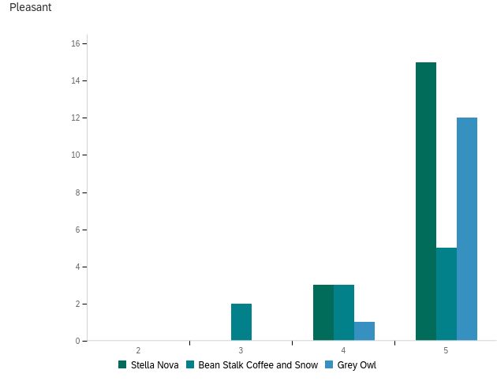
Figure 47
Comparison of Rating of the Quality of Light Inside the Coffee Shop Deemed Bright
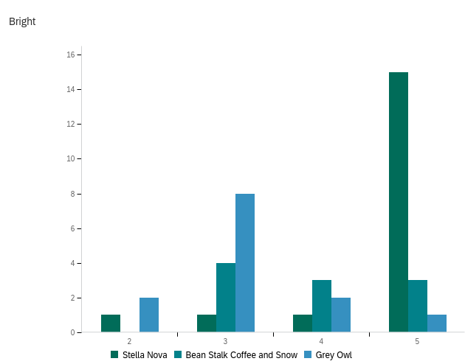
Figure 48
Comparison of Rating of the Quality of Light Inside the Coffee Shop Deemed Comfortable
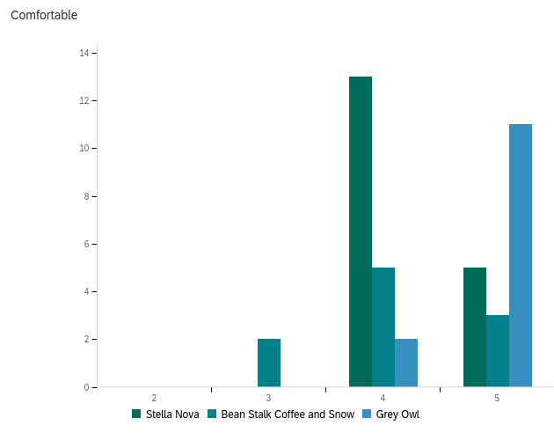
Figure 49
Comparison of Rating of the Quality of Light Inside the Coffee Shop Deemed Warm
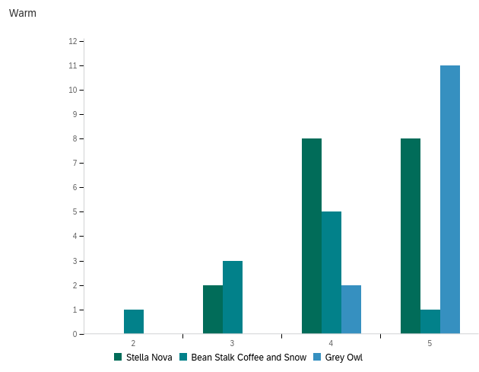
Figure 50
Comparison of Rating of the Quality of Light Inside the Coffee Shop Deemed Visually Clear
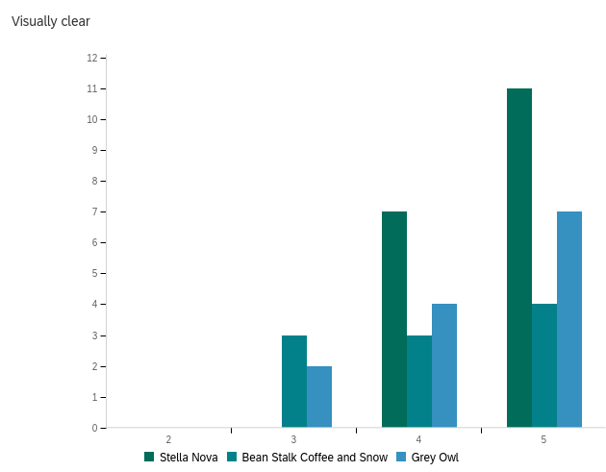
Figure 51
Comparison of Rating of the Quality of Light Inside the Coffee Shop Deemed Relaxed
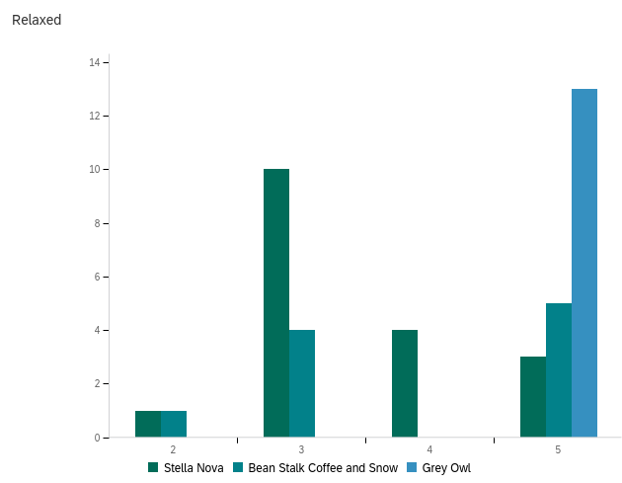
Conclusion
This research aimed to identify how lighting parameters from artificial lighting and daylighting impact a coffee shops ability to support social interaction. Due to the results of the quantitative study of how the lighting in three coffee shops in Norman effects patrons desire or willingness to socialize, it can be concluded that lighting conditions are important factors that can influence socialization by either supporting or discouraging socialization. The results signify that hypothesis’ H1 ‘discomfort glare impacts social interaction in cafes negatively’, H2 ‘lighting uniformity does impact social interaction in cafes’, and H3 ‘high light intensity impacts social interaction in cafes positively’ were proven correct.
The coffee shops located in Norman, Oklahoma that were included in the study were Stella Nova, Grey Owl, and Beanstalk Coffee and Snow. Each of these coffee shops were chosen due to their location in Norman, their strong individual identities, and the unique lighting features that could produce pertinent data on how those lighting characteristics can influence socialization.
Stella Nova was observed to have the best lighting conditions, of the coffee shops that participated in this study. Stella Nova has achieved adequate lighting uniformity through their integration of both natural and artificial light. There are controls in place that allow for café visitors to maintain the uniform lighting environment, regardless of time of day. Within Stella Nova there are floor to ceiling windows located on the south and east sides of the building. The window walls have adjustable shades that give café visitors the ability to control the light that enters. Through observation, the light was the brightest in the mornings due to sun rising in the east and entering through the windows on the east side of the building. The shades were lowered when visiting in the morning hours, to block direct light from entering and causing glare in the eyes of those facing the windows and from causing glare on computer screens of the people whose computer screen faces the window. During the day when the sun is at its peak in the sky, natural light enters the coffee shop without causing direct glare, alleviating the need for the shades to be lowered. When the sun has set, and there is no natural light entering through the windows, artificial light is used to illuminate Stella Nova. The artificial light consists of indirect diffuse light and direct light. The indirect diffuse light can be seen in Figure 52, as the Stella Nova decorative light fixtures and the direct lighting comes from the can lights located throughout the building. The lighting characteristics observed at Stella Nova including application of Lighting controls through lighting shades, integration of artificial and natural light and a combination of indirect diffuse light and direct light collectively made the environment more appealing to patrons and were conducive to socialization. Stella Nova, in combination with the appropriate lighting conditions, branding, and culture, has created an environment that encourages socialization.
Figure 52
Indirect Diffuse Pendants at Stella Nova
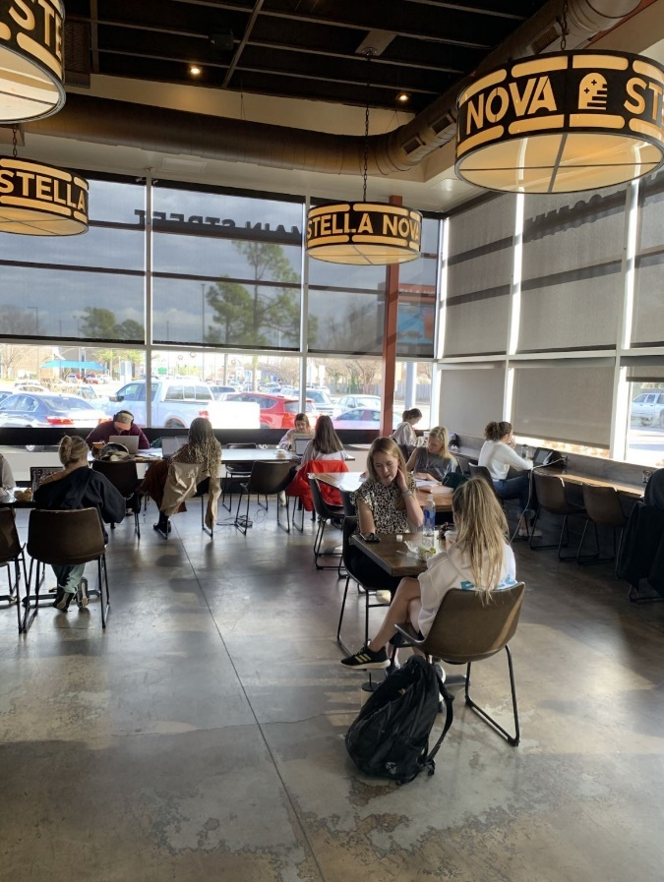
Grey Owl has been observed to have the second-best lighting conditions of the coffee shops participating in this study. The front façade of Grey Owl features floor to ceiling windows and is the only point that natural light enters the building. It is sandwiched in between other businesses along Grey Street and faces south-east. There are no window coverings to block natural light from entering the space. Grey Owl is narrow and deep, the windows and access to natural light illuminate the building and provide natural light all the way to the back of the public areas. Grey Owl was observed during multiple times of day. Glare was observed to be present when sitting on the west wall of the building when the sun is rising and directly streaming in. The glare that was observed was located along a wall where there were no seating options offered, as pictured in Figure 53. Grey Owl implements natural light and artificial light. The artificial lighting is present in the form of direct, can lighting. Grey Owl’s integration of artificial and natural light and appropriate light levels achieved through the can lighting in combination with natural light created an environment that was uniformly lit, calming, and favorable for socializing.
Figure 53
Location Where Glare Was Observed at Grey Owl
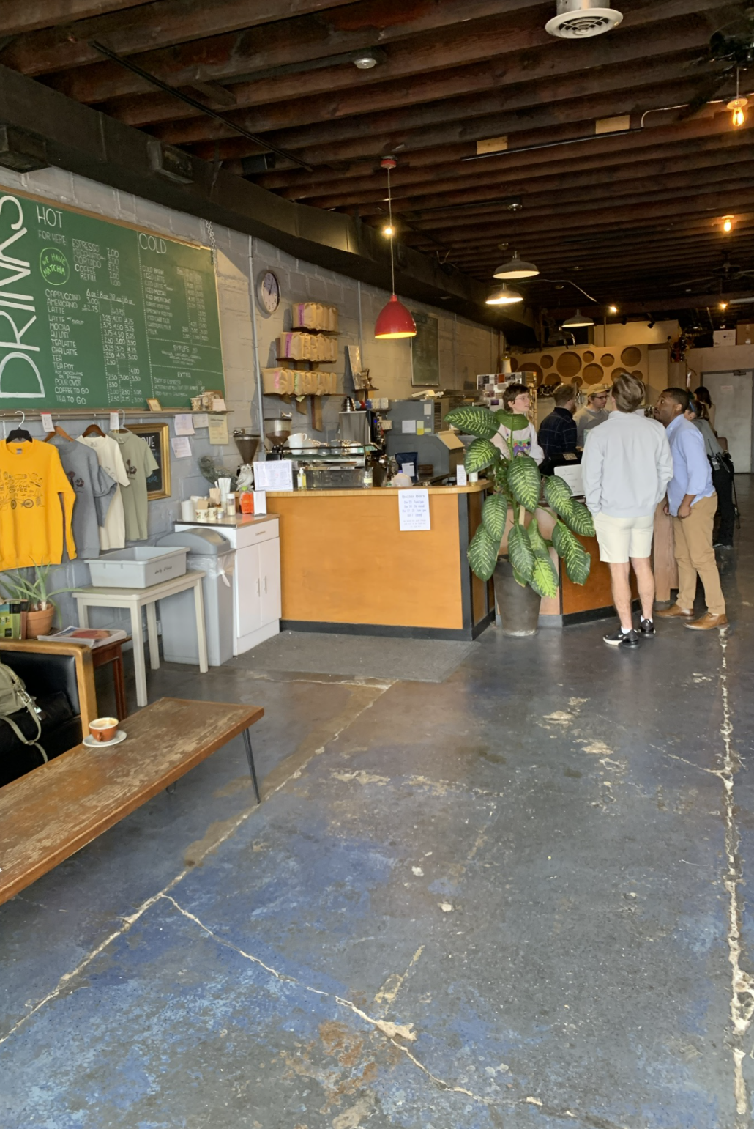
Beanstalk Coffee and Snow was observed to have the worst lighting conditions of the coffee shops participating in this study. Beanstalk Coffee and Snow features floor to ceiling windows on the north and east sides of the building. There are no shade mechanisms in place. When the sun enters the building there are no ways to block glare from also entering. When inside, there is a small room on the west side that is popular and conducive for group meetings. In this room there are no windows and only a door for entrance making this space dim and lacking natural light when the artificial lighting is not in use and harsh when the artificial light is used. The artificial light implemented throughout the building is 2x4 fluorescent lights. The interior lighting was observed to be harsh and direct, as pictured in Figure 54. Their lighting conditions were observed and recorded through the survey findings to have many negative implications on patron’s desire to socialize.
Figure 54
Interior Lighting in Beanstalk Coffee and Snow
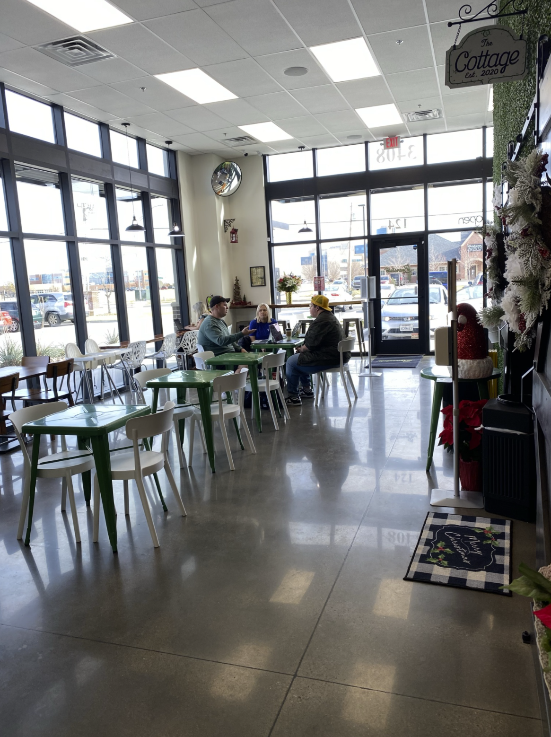
The results of the survey found that hypothesis H1 ‘discomfort glare impacts social interaction negatively’ was proven correct. The majority of participants that were visiting Stella Nova answered that they neither agreed nor disagreed with the statement that the uncomfortable glare (shine with strong dazzling light) in the coffee shop urges them to leave without socializing with anyone. This finding can be assumed to be correlated to the glare control mechanisms that Stella Nova has in place. A greater number of participants that were visiting Grey Owl answered that they disagreed with the statement that the uncomfortable glare (shine with strong dazzling light) in the coffee shop urges them to leave without socializing with anyone. Grey owl had minimal glare observed entering the space and the glare that was seen was located where drinks were ordered and picked up and where there was no seating offered, limiting the affect that glare could have on café visitors socializing in the space. A large number of participants from Beanstalk Coffee and Snow reported that they strongly agree that the uncomfortable glare (shine with strong dazzling light) in the coffee shop urges them to leave without socializing with anyone. This finding can be assumed to be a result of the window walls that have no glare control mechanism in place and are located in close proximity to the seating areas of the coffee shop increasing the likelihood that café visitors would be affected by the natural light in a negative way.
H2 ‘light uniformity does impact social interaction was proven by the findings of the study. The results of the study reveal that the majority of participants at Stella Nova and Grey Owl agreed that the overall the lighting in the environment is comfortable, which can be interpreted as having a more uniform lighting environment through those results and through the observations of the lighting in each coffee shop. A larger number of participants at Beanstalk Coffee and Snow disagreed with the statement that overall, the lighting is comfortable. The lighting at Beanstalk Coffee and Snow was observed to lack uniformity through the division of space that blocks natural light and the harsh fluorescent light that is utilized throughout the coffee shop. These results, in combination with the findings that more participants answered that they have used Stella Nova and Grey Owl for socialization than participants at Beanstalk Coffee and Snow, illustrate that light uniformity impacts social interaction.
A strong correlation was found between high light intensity and socialization. This finding supported H3 ‘high light intensity impacts social interaction in cafes positively’. In locations where high light intensity was observed, Stella Nova and Grey Owl, there was a larger number of participants who answered ‘strongly agree’ or ‘somewhat agree’ when asked if the bright light encouraged them to interact or socialize more with other people who are at the coffee shop. The survey findings found bright light or high light intensity had a greater effect on participants engagement in socialization with people they already knew as well as strangers and led to more socialization. H03 “high light intensity impacts social interaction in cafes negatively’ was disproven by the results of the study which found that low light or dim light did not encourage participants to socialize with strangers and an equal percentage of participants stated that the lighting was either too dim to socialize or it is not too dim to socialize.
The lighting in the three coffee shop environments attracted different age groups of visitors. Stella Nova and Grey Owl both attracted younger visitors while Beanstalk Coffee and Snow had the most participants that were over the between the ages 32 and 38 and 39 and older. !00% of the participants that answered they were between the ages of 32 and 38 were visiting Beanstalk Coffee and Snow. 50% of the participants that answered they were 39 or older were visiting Beanstalk Coffee and Snow, 25% were visiting Stella Nova, and 25% were visiting Grey Owl (Figure 55) The results of these findings in combination with the effects that age has on the requirements for lighting for older adults and the effect that lighting conditions have on different aged eyes it can be assumed that the brighter lighting environment of Beanstalk Coffee and Snow attracts people of an older age demographic because it is easier for them to see. They would also be more susceptible to the effects of harsh glare that can occur in Beanstalk.
Figure 55
Percentages of Age Demographics from Participating Coffee Shops
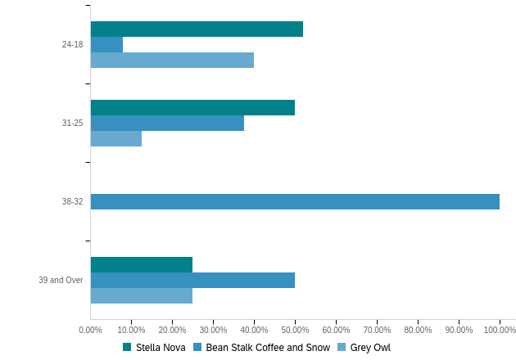
A key finding that emerged from the study was that most participants (80%) have previously used one of these locations for socializing prior to the study taking place and approximately 70% of participants use the location they are visiting for socializing either once a month or weekly which indicates that these places are viewed and used as places for social interaction in the community fulling the third place need that Ray Oldenburg declares as necessary (Oldenburg, 1989) as illustrated in Figure 56 and Figure 57. This result directly correlates to the findings of Pozos- Brewer who stated in the study Coffee Shops: Exploring Urban Sociability and Social Class in the intersection of Public and Private Space that “Meeting up with friends is probably the second most common use of the coffee shop, depending on location” (Pozos-Brewer, 2015).
Figure 56
“Have You Used This Place for Socialization”
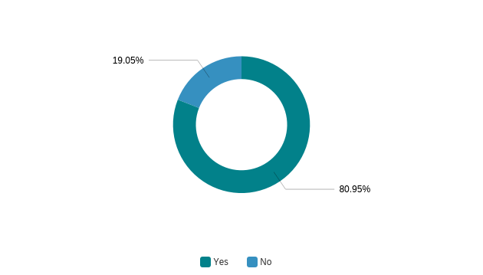
Figure 57
“How Frequently Do You Use This Location for Socializing”
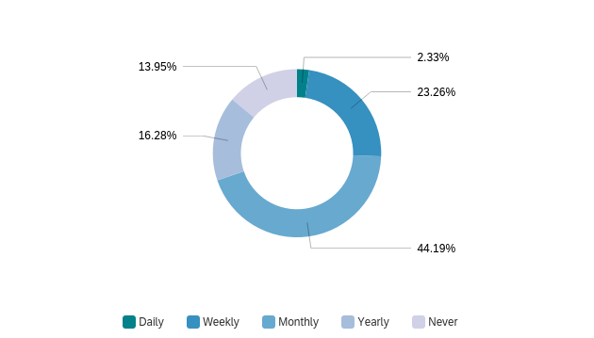
In regard to the research question of “How do lighting parameters from artificial lighting and daylighting impact café's ability to support social interaction?”, the results from the data collected suggest that the lighting parameters from artificial and daylighting affect patrons' ability or desire to socialize with people they already know but does not encourage or deter patrons from engaging in social interactions with strangers. It also found that high light intensity or bright light encourages the act of socializing where dim or low light did not have as much impact on the encouragement of socialization, as illustrated in Figure 58. This finding is contradictory to the findings of Evenson in his study titled A Study of Effects of Lighting on Social Interaction. His findings stated that people interact with other people in low light levels, and they interact more with the environment they are in and their surroundings when there are high light ratios and focal points on objects with social connotations.
Figure 58
“The low light intensity of light in this coffee shop led you to socialize more with strangers”
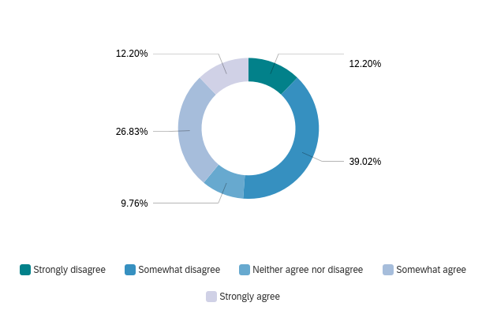
Limitations of Research
By choosing to focus on the effect that lighting parameters has on socialization within coffee shops, several factors that could limit the findings of this study arose.
Sample Size
Sample size of participants could have a significant impact on the results of the current study. Due to the short length that the survey was active at the coffee shop locations, only 50 café visitors chose to participate. Opening the survey for more than 42 days could have allowed for the potential of more participants and more precise results.
Physical Factors
As noted in the ‘locations’ section of the study, the location of the participant in the coffee shop could have a major influence of how they answer questions regarding the influence of the lighting conditions on their socialization. For instance, in Beanstalk Coffee and Snow there is a portion of the café that has no access to natural light, someone sitting in this area has the potential to answer the survey questions differently than someone in a different section of the coffee shop with access to natural light. To account for this, questions on the location of participant in the coffee shop in relation to a diagram provided by the researcher would be helpful in determining how their location could influence their responses.
Lack of Accurate Lighting Data
To get more accurate information on the lighting conditions that is separated from the subjective opinions of patrons of the coffee shops a lighting analysis of the interior environment could give more accurate insight on the lighting conditions such as light levels, glare, illuminance, luminance, and more.
Covid-19
When beginning this study, Covid-19 was heavily prevalent in the world. Due to this prevalence, many third places were impacted and forced to change their typical business practices by either not allowing indoor seating, limiting seating when it is allowed inside, creating ample space for social distancing, or closing all together for periods of time when the pandemic and Covid-19 spread was at an all time high. The coffee shops that were chosen as study sites were selected partially due to their allowance of patrons to gather inside. When design the study, finding coffee shops that met this requirement was extremely difficult and required waiting to see if and when any coffee shops in Norman would allow indoor gathering to take place. Waiting to see which coffee shops opened to allow for indoor gathering and finding enough coffee shops that could be studied shortened the amount of time that the study could be active in the environments. Covid-19 also limited the number of patrons that were allowed to gather in these coffee shop environments which could have a direct impact on the amount of socializing that could take place. Comparing socializing before social distancing and after the implementation of social distancing could alter the results of this study due to the cause-and-effect relationship of allowance of patrons to socialization.
Time of Day or Time of Year
When conducting this study, no survey questions were created to establish the time of day that the participant was taking the survey or the time of year in which the survey was completed. The time of day and time of year could have a direct influence on the interior light conditions and could influence how participants answer questions on their experience and how that experience influences their socialization. By having participants answer a question on what time of day they are taking the survey and the month and season they are taking the survey it would help to obtain accurate lighting data.
Weather Conditions
The weather events that are occurring outside of the participating coffee shops could affect the natural light and its penetration into the interior. Similar to the time of day or year, the weather could influence how participants answer questions on their experience and how that experience influences their socialization. If there is a thunderstorm that obstructs the sun from the sky, the interior would be darker on that day than on a sunny day with no clouds. By having participants answer a question that related to the current weather and sun condition the study could gather more accurate natural light data.
Future Study
After conducting this study, analyzing the findings, and realizing the limitations there are several directions that future parties could use this study for future research. The first way this study could be used for future research would be to solve the limitations that were created through this study, small sample size and lack of accurate location of participant while taking survey and see how those changes influence the results. Another way this survey could be used for future research would be to change the context of the coffee shops that were selected. To do this, future studies could include different coffee shops located in Norman, Oklahoma, coffee shops in different cities or states, or chose coffee shops in places with significantly different cultural norms like different countries. It would be interesting to compare results from different coffee shops in Norman Oklahoma as well as coffee shops from different cities and states and see how locational variants could impact the lighting conditions and the predisposition to socialize. The last way that this study could be used to further this research could be to explore how Covid-19 and social distancing has impacted socialization in coffee shops. This would be the most challenging to complete due to lack of data in this area of study before the occurrence of Covid-19 but by comparing coffee shops that are not socially distanced and do not require face masks with coffee shops that are socially distanced and require the wearing of face masks could produce interesting insight into the social impacts that the Covid-19 pandemic could impose on people.
Recommendations
To improve the lighting of environments of the participating coffee shops, based on the results of the study, recommendations have been proposed.
Shielding
Louvers or Baffles would be beneficial to all coffee shops that participated in this study. These shielding devices are installed on the exterior of the building above or in front of windows to regulate the light penetration.
Choice of Materials
As stated in the locations section of the study, material choices could impact the lighting environment and contribute to its ability to support socialization or its inability to support socialization. Stella Nova has done an adequate job in using both hard and soft surfaces that will absorb lighting and not reflect glare or emphasize harsh lighting conditions. Grey Owl should implement more upholstered options as well as draperies that could control light entering and absorb some light. Beanstalk Coffee and Snow should switch their tables and chairs from the highly reflective metal pieces to tables with a more specular surface and chairs that have some upholstery.
Light Sensing Dimmers
Light sensing dimmers would be implemented to measure the amount of illumination in the coffee shop and adjust the artificial lighting to create an overall comfortable lighting environment. The environments of Stella Nova, Grey Owl, and Beanstalk Coffee and Snow would all benefit from the implementation of light sensing dimmers.
Lighting in Zones
By implementing lighting in different zones would allow the coffee shops to control the amount of artificial light in the building by choosing which parts of the building are lit and aren’t depending on the needs of the environment. This would be valuable in all coffee shops due to their large window walls that let in sufficient amounts of natural light during certain times of day. When natural light is providing sufficient illumination into the building, if zone lighting was implemented the artificial lights near the windows could be turned off when no longer needed which still using the artificial lights in other areas.

References
About: Stellanova. Stella Nova. (n.d.). Retrieved November 5, 2021, from https://www.stellanova.com/about.
AbuThahir, S. B. S., & Krishnapillai, G. (2018). How does the ambience of café affect the revisit intention among its patrons? AS on the cafes in Ipoh, Perak. In MATEC Web of Conferences (Vol. 150, p. 05074). EDP Sciences.
Age and Vision Research. Finelite. (n.d.). Retrieved December 11, 2021, from https://www.finelite.com/about-us/news-media/age-and-vision-research.
Baldanzi, E. (2015). Physiological and Psychological Effect of Light. In Sustainable Indoor Lighting (pp. 285-301). Springer, London.
Beanstalk Coffee & Sno. TravelOK.com - Oklahoma's Official Travel & Tourism Site. (n.d.). Retrieved November 5, 2021, from https://www.travelok.com/listings/view.profile/id.29814.
Bookman, S. (2014). Brands and Urban Life: Specialty Coffee, Consumers, and the Co-creation
of Urban Café Sociality. Space and Culture, 17(1), pp. 85-99.
Boyce, P. R. (2014). Human factors in lighting. Crc Press.
Brooks, K. (2018, . Gray Owl Coffee. Architecture for Non Majors. Retrieved November 21, 2021, from https://archgened.oucreate.com/uncategorized/gray-owl-coffee/.
Butler, S. M., & Diaz, C. (2016). Third places” as community builders. Retrieved from Brookings: https://www. brookings. edu/blog/up-front/2016/09/14/third-places-as-community-builders.
Census Reporter. (2019). Census Reporter. https://censusreporter.org/profiles/16000US4052500-norman-ok/
‌Deasy, C. M., & Lasswell, T. E. (1985). Designing places for people: A handbook on human behavior for architects, designers, and facility managers. Whitney Library of Design.
Demographics and Characteristics. (2016). City of Norman, OK. https://www.normanok.gov/about-norman/demographics-and-characteristics
DiLaura, D. L. (2011). The Lighting Handbook: Reference and Application (10th ed.). Illuminating Engineering Society of North America.
Elkins, J. (2021, January 24). Gray Owl Coffee to become worker-owned in 2021. Norman Transcript. https://www.normantranscript.com/news/gray-owl-coffee-to-become-worker-owned-in-2021/article_6f6a5cdc-5ce9-11eb-8699-635a64ad3b35.html?fbclid=IwAR1pD7U7oKB6d9O9ERAl1_5w48Qq6h2eZ1t4IhRuO0PksEG0Z2hZ7L_tzi
Evensen, Ida. (2014). A study on the effects of lighting on social interaction. 10.13140/2.1.3722.1769.
Fisher's exact test. Wolfram MathWorld. (n.d.). Retrieved November 30, 2021, from https://mathworld.wolfram.com/FishersExactTest.html#:~:text=Fisher's%20exact%20test%20is%20a,associations%20between%20two%20categorical%20variables.
Hebert, J. (2020). Effects of lighting towards productivity and creativity in coffee shops (Order No. 27963055). Available from ProQuest Dissertations & Theses Global. (2415327971). Retrieved from https://login.ezproxy.lib.ou.edu/login?url=https://www-proquest-com.ezproxy.lib.ou.edu/dissertations-theses/effects-lighting-towards-productivity-creativity/docview/2415327971/se-2?accountid=12964
Hickman, P. (2013). “Third places” and social interaction in deprived neighbourhoods in Great Britain. Journal of Housing and the Built Environment, 28(2), 221-236.
Jeffres, L. W., Bracken, C. C., Jian, G., & Casey, M. F. (2009). The impact of third places on community quality of life. Applied research in quality of life, 4(4), 333.
Karlen, M., Spangler, C., & Benya, J. R. (2017). Lighting design basics. John Wiley & Sons.
Kibler, S. P. (2015). The impact of branded environments on user preferences in coffee shops and cafés (Doctoral dissertation, The Florida State University).
Kim, D. H. (2018). Development of a psychological pathway model linking lighting quality to well-being in indoor café environments. Indoor and Built Environment, 27(3), 390-401.
Kim, Dong Hyun, & Mansfield, Kevin P. (2016). A cross-cultural study on perceived lighting quality and occupants’ well-being between UK and South Korea. Energy and Buildings, 119, 211-217.
Knez, I. (1995). Effects of indoor lighting on mood and cognition. Journal of environmental psychology, 15(1), 39-51.
Lukito, Y. N., & Xenia, A. P. (2017, December). Café as third place and the creation of a unique space of interaction in UI Campus. In IOP Conference Series: Earth and Environmental Science (Vol. 99, No. 1, p. 012028). IOP Publishing.
Merriam-Webster Dictionary. (2021). Merriam-Webster.com. https://www.merriam-webster.com/dictionary/socialization
Nasrollahi, N., & Shokri, E. (2016). Daylight illuminance in urban environments for visual comfort and energy performance. Renewable and sustainable energy reviews, 66, 861-874.
Oldenburg, R. (1989). The great good place: Cafés, coffee shops, community centers, beauty parlors, general stores, bars, hangouts, and how they get you through the day. New York: Marlowe.
Oldenburg, R., & Brissett, D. (1982). The third place. Qualitative sociology, 5(4), 265-284.
Pozos-Brewer, R. (2015). Coffee shops: Exploring urban sociability and social class in the intersection of public and private space. Unpublished Dissertation.
Qualtrics. (2020, September 22). Complete Guide to ANOVA (Analysis of Variance) // Qualtrics. Qualtrics. https://www.qualtrics.com/experience-management/research/anova/#:~:text=Like%20the%20t%2Dtest%2C%20ANOVA,taken%20from%20each%20of%20them.
Qualtrics. (2018, March 29). How to Use Cross-Tabulation Analysis on Your Survey Results. Qualtrics. https://www.qualtrics.com/experience-management/research/cross-tabulation/#:~:text=For%20reference%2C%20a%20cross%2Dtabulation,the%20relationship%20between%20the%20variables.
Raveard, E. (2015, December 6). Gray Owl Coffee. Caffeine Encounters. Retrieved November 5, 2021, from https://caffeinencounters.wordpress.com/2015/12/06/gray-owl-coffee-norman-ok/.
Rosenbaum, M. S. (2006). Exploring the social supportive role of third places in consumers' lives. Journal of Service Research, 9(1), 59-72.
Rosenbaum, M. S., Ward, J., Walker, B. A., & Ostrom, A. L. (2007). A cup of coffee with a dash of love: An investigation of commercial social support and third-place attachment. Journal of Service research, 10(1), 43-59.
Spielman, D. (2020). Twitter. photograph, Uncovering Oklahoma. Retrieved from https://mobile.twitter.com/uncoveringok/status/1305866327425515522/photo/3.
Stella Nova Coffee. Visit Norman. (n.d.). Retrieved November 21, 2021, from https://www.visitnorman.com/eat/stella-nova-coffee.
Threadgill, J. (2018, February 22). Stella Nova aims to be the chain coffee store that thinks local first. Oklahoma Gazette. Retrieved November 28, 2021, from https://www.okgazette.com/oklahoma/stella-nova-aims-to-be-the-chain-coffee-store-that-thinks-local-first/Content?oid=2993457.
University of Southampton. (n.d.). Chi Square. Chi Square | Practical Applications of Statistics in the Social Sciences . Retrieved November 30, 2021, from https://www.southampton.ac.uk/passs/full_time_education/bivariate_analysis/chi_square.page.
Veitch, J. A., Newsham, G. R., Boyce, P. R., & Jones, C. C. (2008). Lighting appraisal, well-being and performance in open-plan offices: A linked mechanisms approach. Lighting Research & Technology, 40(2), 133-151.
Wardono, P., Hibino, H., & Koyama, S. (2012). Effects of interior colors, lighting and decors on perceived sociability, emotion and behavior related to social dining. Procedia-Social and Behavioral Sciences, 38, 362-372.
Waxman, L. K. (2004). More than coffee: an examination of people, place, and community with implications for design.
Waxman, L. (2006). The coffee shop: Social and physical factors influencing place attachment. Journal of Interior Design, 31(3), 35-53.
Young, M. (2020, July 21). Eskimo Sno to rebrand as Beanstalk Coffee and Sno amid racial tensions surrounding former name. OU Daily. https://www.oudaily.com/news/eskimo-sno-to-rebrand-as-beanstalk-coffee-and-sno-amid-racial-tensions-surrounding-former-name/article_6da5f486-cba0-11ea-b6a0-4380972cb25b.html
‌

Appendix
Appendix A: Institutional Review Board Exemption Letter
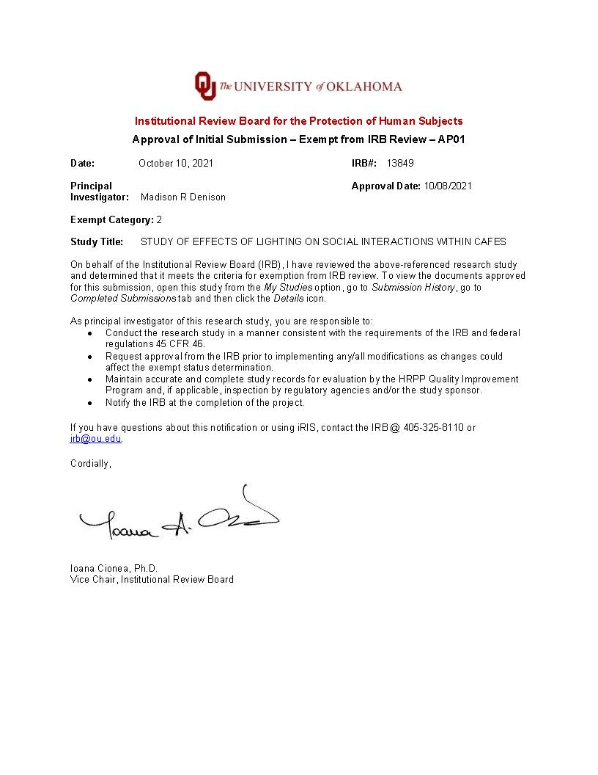
Appendix B: Survey Questionnaire
Informed Consent
You are invited to participate in research about how lighting in coffee shops can influence socialization.
If you agree to be in this research, you will answer questions about yourself and your experience at the coffee shop you are visiting. Your participation will take roughly 15 minutes.
There are no risks and no benefits from being in this research. You will not be reimbursed for your time and participation in this research.
In research reports, there will be no information that will make it possible to identify you. Research records will be stored securely and only approved researchers and the OU Institutional Review Board will have access to the records.
Data are collected via an online survey system that has its own privacy and security policies for keeping your information confidential. Please note no assurance can be made as to the use of the data you provide for purposes other than this research.
After removing all identifiers, we might share your data with other researchers or use it in future research without obtaining additional consent from you.
If you do not participate, you will not be penalized or lose benefits or services unrelated to the research. If you decide to participate, you don’t have to answer any question and can stop participating at any time.
If you have questions, concerns or complaints about the research or have experienced a research-related injury, you can contact:
Madison Denison
Graduate Student
Interior Design College of Architecture
Email: madisondenison@ou.edu
Cell Phone: (405) 971-4920
Negar Matin
Assistant Professor Interior Design
College of Architecture
Email: negar.matin@ou.edu
You can also contact the University of Oklahoma – Norman Campus Institutional Review Board (OU-NC IRB) at 405-325-8110 or irb@ou.edu if you have questions about your rights as a research participant, concerns, or complaints about the research and wish to talk to someone other than the researcher(s) or if you cannot reach the researcher(s).

Q1 Please print this document for your records. By providing information to the researcher(s), I am agreeing to participate in this research.
- I agree to participate.
- I do not want to participate.

Skip To: Q2 If Please print this document for your records. By providing information to the researcher(s), I am... = I agree to participate.
Skip To: End of Survey If Please print this document for your records. By providing information to the researcher(s), I am... = I do not want to participate.

Page Break

Q2 Please select your age
- 24-18
- 31-25
- 38-32
- 39 and Over

Q3 Please select your marital status
- Single
- Married
- Divorced
- Widowed

Q4 Please select the qualities that you feel accurately describe you. Select all that apply.
- Talkative
- Quiet
- Sociable
- Reserved
- Outgoing
- Shy
- Optimist
- Passive
- Touchy
- Reliable
- Active
- Calm
- Assertive
- Rigid

Q5 What coffee shop are you currently visiting?
- Stella Nova
- Bean Stalk Coffee and Snow
- Grey Owl

Q6 How many days a week do you typically drink at least one cup of coffee?
- 1
- 2
- 3
- 4
- 5
- 6
- 7

Q7 On average, how many times a MONTH do you visit a coffee shop/cafe?
- Never
- 1-5 times
- 5-15 times
- 15-30 times
- More than 30 times

Q8 Have you used this place for socializing?
- Yes
- No

Q9 How frequently do you use this location for socializing?
- Daily
- Weekly
- Monthly
- Yearly
- Never

Q10 What are the main activities that you will be participating in while visiting this location?
- Get food or beverage
- Work
- Meetings
- Socialization
- Other: ________________________________________________

Q11 When you visit this location do you
- Come alone
- Come with other people
- Come to meet with people you already know
- Come to meet new people
- Other ________________________________________________

Q12 On a scale of 1 (worst) to 5(best), how would you rate the following?
 | 0 | 1 | 2 | 3 | 4 | 5

Overall environment for group meetings? | 
Overall influence of the lighting on your behavior?
Likelihood of your willingness to socialize here

Q13 Overall, the lighting is comfortable
 | Strongly disagree (1) | Somewhat disagree (2) | Neither agree nor disagree (3) | Somewhat agree (4) | Strongly agree (5)
Overall, the lighting is comfortable

Q14 The lighting is uncomfortably bright for the goal of socializing I am trying to perform
 | Strongly disagree (1) | Somewhat disagree (2) | Neither agree nor disagree (3) | Somewhat agree (4) | Strongly agree (5)
The lighting is uncomfortably bright for the goal of socializing I am trying to perform

Q15 The lighting in this coffee shop is uncomfortably dim/low for socializing with strangers.
 | Strongly disagree (1) | Somewhat disagree (2) | Neither agree nor disagree (3) | Somewhat agree (4) | Strongly agree (5)
The lighting in this coffee shop is uncomfortably dim/low for socializing with strangers

Q16 The lighting in this coffee shop is uncomfortably bright/high for socializing with strangers.
 | Strongly disagree (1) | Somewhat disagree (2) | Neither agree nor disagree (3) | Somewhat agree (4) | Strongly agree (5)
The lighting in this coffee shop is uncomfortably bright/high for socializing with strangers.

Q17 The lighting in this environment influences how long I stay in this environment
 | Strongly disagree (1) | Somewhat disagree (2) | Neither agree nor disagree (3) | Somewhat agree (4) | Strongly agree (5)
The lighting in this environment influences how long I stay in this environment

Q18 The lighting in this environment influences my desire to socialize, which is defined by Merriam-Webster Dictionary as "social interaction with others"
 | Strongly disagree (1) | Somewhat disagree (2) | Neither agree nor disagree (3) | Somewhat agree (4) | Strongly agree (5)
The lighting in this environment influences my desire to socialize, which is defined by Merriam-Webster Dictionary as "social interaction with others"

Q19 The high light intensity in this coffee shop encourages you to interact/speak/socialize more with other people here.
 | Strongly disagree (1) | Somewhat disagree (2) | Neither agree nor disagree (3) | Somewhat agree (4) | Strongly agree (5)
The high light intensity in this coffee shop encourages you to interact/speak/socialize more with other people here.

Q20 The low intensity of light in this coffee shop led you to socialize more with strangers.
 | Strongly disagree (1) | Somewhat disagree (2) | Neither agree nor disagree (3) | Somewhat agree (4) | Strongly agree (5)
The low intensity of light in this coffee shop led you to socialize more with strangers.

Q21 The uncomfortable glare (shine with strong dazzling light) in this coffee shop urges you to leave without socializing with anyone.
 | Strongly disagree (1) | Somewhat disagree (2) | Neither agree nor disagree (3) | Somewhat agree (4) | Strongly agree (5)
The uncomfortable glare (shine with strong dazzling light) in this coffee shop urges you to leave without socializing with anyone.

Q22 On a scale of 1 (worst) to 5 (best), how would you rate the quality of light inside the coffee shop?
Pleasant
Bright
Comfortable
Warm
Visually clear
Relaxed

