University of Oklahoma

Graduate College

DEvelopment of Cholesteatoma Model, Surgical Treatment, and Criteria for disease severity

A thesis

submitted to the Graduate Faculty

in partial fulfillment of the requirements for the

Degree of

Master of Science

By

Kyle Daniel Smith
Norman, Oklahoma
2018

DEvelopment of Cholesteatoma model, surgical treatment, and criteria for disease severity

A thesis approved for the
School of Aerospace and Mechanical Engineering

By

______________________________
Dr. Rong Z. Gan, Chair

______________________________
Dr. Harold Stalford

______________________________
Dr. Vassilios Sikavitsas

© Copyright by Kyle Daniel Smith 2018
All Rights Reserved.
To Mark and Connie Smith, the most supportive, loving, and generous people I could be privileged to call dad and mom.

Acknowledgements
There are several individuals critical to the success of this research and the future directions we will pursue. To name a few and a footnote of their help:
Dr. Rong Z. Gan for serving as my chair, advisor, and mentor for the past 3 years.
Dr. Harold Stalford for serving on my thesis committee and providing advice on improving this publication.
Dr. Vassilios Sikavitsas for serving on my thesis committee and providing advice on improving this publication.
Dr. Betty Tsai for her clinical expertise and knowledge of cholesteatoma, helping us understand the disease, the desired outcomes in patients, and the areas in critical need of improvement.
Dr. Robert Jyung for his clinical expertise and knowledge of cholesteatoma, critical in designing our surgical approach, and training lab members to perform the survival surgery.
Dr. Alisha Preno for her veterinarian expertise and assistance in animal care and
surgery.
Tao Chen for his considerable contribution to building the disease model, experimentation, surgical training, and knowledge of the disease.
Shangyuan Jiang for his work in histology and micro computed tomography.
Zach Yokell for his contributions in building the disease model, experimentation, and vital source of knowledge.
Stryker for the contribution of providing vital equipment in this study.

Table of Contents
Acknowledgements iv
List of Tables vii
List of Figures viii
Abstract xi
Chapter 1: Cholesteatoma – A Middle Ear Disease 1
Theories of Causes 2
Progression of the Disease 6
Bone Erosion, Ossicular Damage, Hearing Loss 7
Evaluation of Severity 9
Clinical Treatment 10
Recent Research and Animal Models 13
Significance and Aims of Study 18
Chapter 2: Experiment Design – Creating the Disease 20
Animal Model – Chinchilla 20
Propylene Glycol Inoculation 20
Inoculation Parameters – Time, Concentration, Location 21
Inoculation Time Course – Endoscopic Observation 23
Hearing Function Tests 24
Surgery 25
Post-Surgery Observation 26
Micro-Computed Tomography 26
Histology 26
Chapter 3: Results – Success and Failures 27
Post-Experiment Overview 27
Disease Development 27
Surgery and Post-Surgery Observations 30
Micro-Computed Tomography 39
Histology 43
Hearing Function Tests 45
Chapter 4: Discussion – Developing a Criteria for Severity and Surgical Improvement 50
Overview of Study 50
Surgical Procedures 50
Middle Ear Damage – Micro-Computed Tomographic and Histological Observations 51
Proposed Levels of Severity – Rationale and Suggestions 53
Chapter 5: Future Studies 56
Fine-Tuned Cholesteatoma Development 56
Middle Ear Prosthesis – Criteria, Design, Assessment 57
Middle Ear Post-Surgery Assessment 57
References 58

List of Tables
Table 1. Experimental summary of animals and their surgical outcomes. 30
Table 2. Suggested cholesteatoma classification for surgical intervention. 55

List of Figures
Figure 1. Left ear with cholesteatoma growing in the attic of the middle ear behind the TM (from www.betterhealth.vic.gov) 2
Figure 2. Visualization of the four prominent cholesteatoma theory pathways: 1) Invagination/retraction pocket theory, B) Epithelial migration theory, C) Squamous metaplasia theory, and D) Basal cell hyperplasia theory. (Kuo, 2015) 4
Figure 3. Experiment schematic with the endoscope observing a single intratympanic-inferior insult with PG injection. Note that the pinna was intact in all injections, not reflected in the schematic. 22
Figure 4. Endoscope photograph of the injection method. Endoscope is equipped with a 30° lens. 23
Figure 5. Healthy chinchilla tympanic membrane from Group 2 captured immediately before inoculation. 28
Figure 6. TM of the same chinchilla as in Fig. 3 from Group 2. Photo was taken 1 week after the first inoculation. 29
Figure 7. Ear canal of animal shown in Fig. 3. Ear canal has filled with keratin debris. The photo was taken two weeks from the first inoculation. 29
Figure 8. Dorsal bulla bone flap lifted from the remaining bulla bony shell. The large white space is the capsule of the cholesteatoma matrix. 31
Figure 9. Exposure of mastoid and dorsal bulla sections the partition separating the two has been removed to further access the bulla. 32
Figure 10. Bony partition separating the dorsal part of the bulla from the medial part of the bulla, near the ossicles. 33
Figure 11. Partition separating the dorsal part of the bulla from the medial part of the bulla has been drilled out. The cochlea can be seen on the right. 34
Figure 12. Transmeatel view of TM and bulla. The transmeatal flap has already been cut (the blood marks the outline). 35
Figure 13. Transmeatal view of TM and bulla. The transmeatal flap has been lifted and part of the bony partition has been cut away using a curette. 36
Figure 14. Fascia graft from transmeatal view. 37
Figure 15. Sutured incision of dorsal bulla skin using buried technique. 38
Figure 16. Comparative images of a health bulla (left) and the disease case (right) in the superior region of the bulla. External ear canal (EEC), the middle ear cavity (MEC), plastic film (for imaging purposes) can all be clearly seen. The MEC of the diseased bulla was filled with a biogel prior to imaging. 40
Figure 17. Comparative images of a health bulla (left) and the disease case (right) in the middle region of the bulla. 41
Figure 18. Comparative images of a health bulla (left) and the disease case (right) in the superior region of the bulla. 42
Figure 19. Histological image of cholesteatoma animal after one week. Bony wall (BW); epithelium (EP); keratin (K); middle ear cavity (MEC). The degree of damage and proliferation corresponds to a mild cholesteatoma level. 43
Figure 20. Histological image of a cholesteatoma animal inoculated with 0.6 mL of 90% PG for four weeks. The degree of damage and proliferation corresponds to a moderate cholesteatoma level. 44
Figure 21. Histological image of a cholesteatoma animal inoculated with 0.6 mL of 70% PG for six weeks. The degree of damage and proliferation corresponds to a severe cholesteatoma level. 45
Figure 22. Wideband tympanometry response of a healthy chinchilla, prior to inoculation. Frequency-absorbance (left) and pressure-absorbance (right) responses are typical of healthy chinchillas. 46
Figure 23. Wideband tympanometry response of a post-inoculated animal, with 0.4 mL of 90% PG after two weeks. Both the frequency-absorbance response and pressure-absorbance responses suggest a failed middle ear transfer function. 47
Figure 24. Wideband tympanometry post recovery in chinchillas, two weeks after surgical intervention. Frequency-absorbance and pressure-absorbance response suggest some recovery. 48
Figure 25. ABR threshold response for pre-inoculation, pre-surgical, and post-recovery. 49

Abstract
Chapter 1:
Cholesteatoma is a middle ear disease characterized by a cystic lesion that grows from the tympanic membrane. There are several theories as to the cause of the disease, though the most prominent cause is eustachian tube dysfunction. Using an animal model to characterize the disease and develop a method for surgical eradication is a novel research area as most often animal models are used to describe the disease and the damage caused to the middle ear by the disease. Medical intervention is solely surgical, so an animal model to explore intervention and reconstruction techniques would be a valuable resource, which is the focus of this study.
Chapter 2:
A cholesteatoma anima was developed in chinchillas by injecting propylene glycol through the tympanic membrane and into the middle ear cavity, at concentrations of 70 and 90%. The disease developed for 2-6 weeks to achieve different levels of severity. Hearing function tests were used to compare hearing levels before and after inoculation. At the end of the inoculation time course, the cholesteatoma was eradicated surgically. Animals that survived surgery recovered for two weeks, and final hearing levels were measured. One animals that survived surgery was imaged with micro-CT. Also, three animals were euthanized early in the study at one, two, and four weeks for three different cholesteatoma levels.
Chapter 3:
In this pilot study, a primary outcome is the method for building the disease model in chinchillas. Also, a method for surgical intervention and reconstruction has been developed for chinchillas. Hearing measurements including wideband tympanometry and auditory brainstem response were taken before inoculation, after the disease time course, and after surgical intervention, though only one animal had measurable results for each measurement point; some hearing recovery after reconstruction was measured. Histology images show the results of different inoculation time frames, providing a basis for a classification of this animal model’s disease states. Finally, micro-CT images taken after recovery show the damage in the middle ear due to cholesteatoma.
Chapter 4:
Based on endoscopic photographs, histology sections, and micro-CT scans, a characterization of cholesteatoma growth has been developed with three levels of severity: mild, moderate, and severe. Hearing function recovery in chinchillas has been demonstrated, though significant improvement in surgical reconstruction is required for future studies.
Chapter 5:
Preliminary results suggest a that these methods will results in cholesteatoma models at different levels by controlling time, propylene glycol concentration, and inoculation volume, though the greatest factor is time. This should be later verified with larger studies for statistical analysis. Cholesteatomas can be surgically removed from chinchillas and hearing function can be regained after reconstruction. Future studies should include disease specific prosthesis to enhance hear recovery.

Chapter 1: Cholesteatoma – A Middle Ear Disease
Cholesteatoma is a middle ear disease characterized by a keratinizing cystic lesion of the tympanic membrane and can be found in patients young and old. A diagram of the ear with a cholesteatoma is shown in Fig. 1. Generally, reoccurring middle ear infection and eustachian tube dysfunction have been attributed to be a main cause of the disease and has been studied in some animal models. The disease has been an interest of study and therapy since the 19th Century. Only recent advances in imaging, biochemistry, and physiology have enabled better understanding of the disease’s pathogenesis. In this study, a cholesteatoma animal model was developed in chinchillas to determine factors that influence disease severity and to develop a method for surgical eradication and reconstruction.
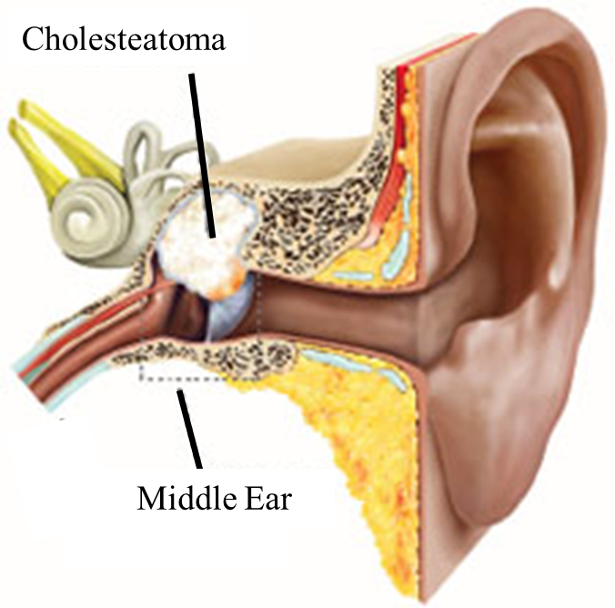
Figure 1. Left ear with cholesteatoma growing in the attic of the middle ear behind the TM (from www.betterhealth.vic.gov)

This work is divided into five chapters: Chapter 1 details past research of the disease including origin theories, disease growth and complications, clinical treatment, and recent animal models with the purpose of the current research to conclude. Chapter 2 describes how propylene glycol injections were used to create the used animal model; Chapter 3 reports the results of the research; Chapter 4 discusses the results with commentary; Chapter 5 is the future direction of the research to be explored.

Theories of Causes
To clarify, cholesteatoma has two types of origins: acquired and congenital. We only consider acquired in this research and will not elaborate extensively on the latter. To note the key difference, congenital cholesteatomas are developed pre-natal, likely during the ear’s formation. However, it may be difficult to diagnose patients with congenital cholesteatoma due to a lack of diagnostic criteria (Lee and Park, 2011). Congenital cholesteatoma may be easier to treat with a lower reoccurrence rate (Ching et al 2016). H.-G. Choi et al. suggested the need for acquired and congenital to be treated differently and called for rapid treatment upon discovery of congenital cholesteatoma to limit life-long damage (Choi et al 2010). Acquired, on the other hand, develops due to disease, infection, tympanic membrane (TM) damage, or other means, which will be discussed here.
Etiopathogenesis of acquired cholesteatoma has four prominent theories in literature, though it is generally accepted that reoccurring middle ear infections and eustachian tube dysfunction are the main causes of the disease. Four theories have been used to describe in detail how cholesteatomas form: invagination, epithelial migration, squamous metaplasia, and basal cell hyperplasia. Figure 2 is a useful diagram for visualizing these theories. For a broad overview of etiopathogenesis, both Kuo (2015) and Olszewska et al (2003) provide detailed reviews of the state of research and knowledge of the disease.
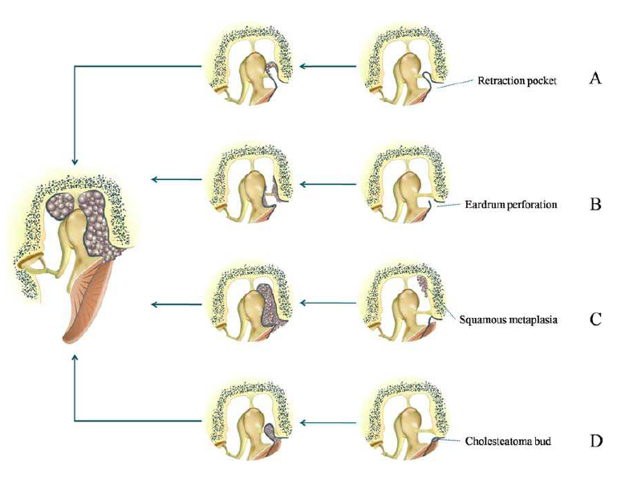
Figure 2. Visualization of the four prominent cholesteatoma theory pathways: 1) Invagination/retraction pocket theory, B) Epithelial migration theory, C) Squamous metaplasia theory, and D) Basal cell hyperplasia theory. (Kuo, 2015)

Invagination/retraction pocket theory is widely accepted and was proposed in 1933 (Wittmaack 1933). The pars flaccida is gradually pulled into the middle ear due to negative pressure (Fig. 1A), which can be caused in several ways. The pocket deepens, begins accumulating desquamated keratin and eventually an inward growing cholesteatoma. To test this theory, cholesteatoma patients who habitually sniffed were compared to cholesteatoma patients who did not (Takizawa et al 2013). Of patients with cholesteatomas, those who were habitual sniffers had higher occurrence and reoccurrence rates compared to those with normal sniffing patterns. Sniffing pulls in the TM due to negative pressure caused by frequent opening and closing of the eustachian tube and could produce the disease readily.
Epithelial migration theory is a second possible method of etiopathogenesis (Habermann 1888; Bezold 1890). The theory suggests that cholesteatoma may occur when a TM has been injured (Fig. 1B). Keratinizing squamous epithelium migrates from the ear canal through the TM. The migration causes an inward tumor-like growth, thus creating a cholesteatoma.
A third theory is the squamous metaplasia theory (Wendt 1873). This theory contradicts the previous in that cholesteatoma growth originates in the middle ear mucosa rather than the external TM (Fig. 1C). Inflammation and growth in the middle ear could cause TM perforation as seen in otoscopic examination. However, this theory has been mostly shown to be inaccurate by many animal models and studies.
The last theory is the basal cell hyperplasia theory (Lange 1925). Subepithelial tissue could be invaded by cholesteatoma microcysts within pars flaccida (Fig. 1C). Keratin-filled microcysts are formed in the basal layer of the epithelium. Given enough time, cholesteatoma sacs will form in these conditions. This theory does not necessarily contradict the retraction pocket or migration theory, but proposes that cholesteatoma formation may be possible without the insults observed in the latter two.
Though many animal models test individual theories, it seems that each theory has shown validity at some level. Early cholesteatoma is dependent on TM retraction in most cases, though this does not limit the necessity of other factors (Rosito et al 2017). This would suggest a plurality of causes of the disease rather than a single underlying mechanism. If this is the case, the disease may prove more difficult to cure and prevent than if a single theory was shown to dominate. There could be four methods that will cause the disease or even a mix of more than one. Developing a robust treatment or preventative diagnosis would thus be increasingly complex.
Some examination into cholesteatoma’s heritability determined that the genetics is not a primary contributor to the disease onset (Jennings et al 2017). In their synthesis, there were some cases of primary relatives showing similar disease onset and occurrence. Overall, though, there was not a strong genetic correlation. It could be that genetic ear development factors may contribute to congenital cholesteatoma growth, but a more refined review would be required.

Progression of the Disease
A model used to study the development of the disease in vivo, though out of the ear, was developed by Bretlau et al (1979). In nude mice, transplanted cholesteatomas were placed beneath hind epithelial and allowed to grow. Compared to jaw keratocyst, they developed cystic lesions lined by stratified keratinizing epithelium with weak connective tissue reaction. They believed their method would be useful for studying regulatory factors over differentiation and growth. Compared to cholesteatoma found in the middle ear, their growths were histologically comparable.
External ear canal cholesteatomas are another form of the cholesteatoma disease. Rather than originating in the middle ear cavity, the disease develops in the external ear canal, and can extend inward, backward, or forward, damaging similar features as middle ear cholesteatoma (Chen et al. 2007). External ear canal cholesteatoma can damage periosteum bones near the ear canal, or push inward to the middle ear cavity, damaging the ossicles and, if left untreated for long durations, the cochlea.
In the natural setting of the middle ear cavity, cholesteatomas may grow slowly and unnoticed. In one case, a 52-year-old did not seek treatment for his ear problem even after a year of noticing it, describing it as a fullness (House and Sheehy, 1980). Others in the study by House and Sheehy claimed that symptoms were present for more than five years before seeking treatment, suggesting that the disease began developing much sooner. They also suggest that in the case of the intact TMs, the disease may be congenital rather than acquired, with some patients experiencing the disease for 20 years.

Bone Erosion, Ossicular Damage, Hearing Loss
If left untreated, cholesteatoma can cause extensive and irreparable damage to the ear, effecting hearing, overall health, and the quality of life in patients. Serious complications include facial palsy, vestibular disorder, meningitis, intracranial abscesses, and sigmoid sinus thrombis (Cosgarea et al 2011). The disease is known to cause damage to the middle ear by disjoining the ossicular bones and eroding them, eroding the middle ear walls including the cochlea, destroying the tympanic membrane, and in conjunction with other diseases can damage the eustachian tube. A concern is the time it can take for patients to notice a problem and acting on thereupon will take longer.
Erosion (or resorption) of the bony walls has been studied extensively. Theories as to the cause of erosion included: 1) pressure necrosis, 2) chronic osteomyelitis,
3) osteoclastic osteolysis, 4) ostocytic osteolysis, 5) mocyte-mediated resorption, 6) enzyme-mediated resorption, 7) local pH change, and 8) vascular proliferation.
In an extensive review, Abramson and Huang explored bone resorption and destruction due from cholesteatoma due to collagenase (1973). Their key discussions showed that collagenase, which makes up 90% of the protein in bone, is found in cholesteatoma, canal wall skin, and middle ear granulation tissue; collagenase was found in subepithelial connective tissue and dermis but not epithelial debris; collagenase originates from macrophages, epithelial-appearing fibroblasts, and endothelial cells of capillary buds; collagenase is specifically localized to initiate collagen degradation in connective tissue and bone. Their point was to study the interaction of events and determine the cause of bone resorption in the presence of cholesteatoma. However, due to the complex interaction, they could only determine the presence of some conditions (collagenase within cholesteatoma) and the outcomes (extensive bone resorption), but they could not determine the specific mechanism behind cholesteatoma caused bone destruction.
Marci et al tested whether pressure of the cholesteatoma bulge was enough to cause erosion or if contact between the sac and the bony wall was necessary (Marci et al 1983). Barriers placed between a cholesteatoma and the bony wall does not prevent erosion. Furthermore, they described the bone erosion mechanism as a local release of lymphokine, osteoclast-activating factors due to pressure. They suggested that halting the pressure of the disease may prevent bone erosion. Other research in signaling pathways has specified TRM-2 modulating the TLR4 signal pathway enhances inflammatory response, promoting matrix metalloproteinases secretion and osteoclast activation (Jiang et al 2016). This could provide a target of treatment, limiting the bone destruction.
However, more than halting pressure is needed to limit bone erosion. Kaneko et al found that the contents within the cholesteatoma sac, when divulged, could cause erosion. The subepithelial layers contained in the sac fixated to the bony walls and an eroding process had begun. As such, there are more factors that affect bone erosion than just pressure. Xie et al provide an updated review of the current knowledge of bone resorption and its role in the etiopathogenesis of cholesteatoma (2017).

Evaluation of Severity
Perhaps the greatest frustration apart from treating the disease is implementing a widely accepted classification and staging system to the disease. Even consistently using the same vernacular has been slow to be accepted when a 1964 Committee of Conservation of Hearing published a detailed classification (1965). Modern literature has perhaps progressed in consistency with the diction used, though classifications have become numerous.
A classification system was attempted by Meyerhoff and Truelson (1986). They realized that even with thorough surgical reports on numerous cases, not describing the conditions and rationale behind surgical choices would inhibit other otologists. Their system was a table that could describe the type, location, function of eustachian tube, ossicular chain integrity, and complications that unfolded. The goal was to encourage literature reporting that could be interpreted easily and to standardize the nomenclature. Saleh and Mills developed a staging system based off a previous classification system by Tos (Tos et al 1988; Saleh and Mills 1999). Their staging system was based on origination, degree of the disease spread, complications and, state of the ossicular chain. A cholesteatoma originating in the attic, spreading to 2 other locations, with an eroded incus, and no complication would be labeled as (A S2 O1 C0). Their goal would be to provide a simple and fast description of the disease for literature to correlate cholesteatoma severity and the surgery used to cure it.
The Japanese Otological Society proposed a staging system for types of cholesteatoma based on the acquired location, either pars flaccida or pars tensa (Matsuda et al 2018). Their staging system informs on the disease involvement with three stages: Stage I indicates the disease resides at the primary site; Stage II, the cholesteatoma involves two or more sites; Stage III involves sites of any number with complications. There are several complications, all abbreviated with letters, and includes operative procedures depending on the stapes involvement. Their staging system should help surgeons readily understand the disease severity along with the surgery process used to clear it. Furthermore, patients can be better informed about their condition and operation procedures.

Clinical Treatment
Currently, surgery is the only option for removing the disease. The surgery is often mildly invasive, depending on the level of disease severity. Surgeons must lift and circumvent the tympanic membrane to reach the middle ear cavity. The disease is then excavated through suction and scraping. The bony walls are likely littered with the proliferating squamous epithelial cells, so the bony middle ear cavity (MEC) is thoroughly scraped to increase the chances of the disease not returning. The main purpose of surgery is to eradicate the disease to avoid further complications and to restore hearing if possible. In review of surgical reports, only 58% of patients showed improved hearing conditions and no improvement in 23% (Cosgarea et al 2011). Furthermore, 28% of those patients required a second intervention due to recurrence of the disease. Improved imaging, planning, surgical techniques, and treatments are needed on an individual patient level to improve the outcomes of the populace effected by the disease.
Surgical planning has been advanced with the use of different spectroscopes. Using coherent anti-Stokes Raman spectroscopy microendoscope, cholesteatoma was differentiated from inflammatory tissue (Zou et al 2016). The visualization could enable better surgical planning prior to the surgery, a critical component to eradication success. Tools such as CT scans have assisted physicians in assessing cholesteatoma and performing surgeries (Razek et al. 2015, Chen et al 2017). Razek et al. showed the location, size, and severity of the disease can be determined using the imaging, after which appropriate surgical procedures can be carried out. Chen et al. also used CT scans to diagnose external ear canal cholesteatomas. Imaging techniques have shown to be useful, enhancing the rate of surgical success and accurately assessing the disease before surgery takes place.
There are three main approaches used for surgical eradication: tympanoplasty, canal wall-down mastoidectomy, and canal wall-up mastoidectomy (Shohet and Jong 2002). Radical mastoidectomy, where the TM and ossicles are not reconstructed and the eustachian tube is sealed is rare, especially in the pediatric population. The different surgery approaches are decided by the extent of the disease. For TM residing cholesteatoma, tympanoplasty is an excellent option. Canal wall-up is used for less extensive cholesteatomas than canal wall-down and provides flexibility for different hearing aid inserts if necessary. Canal wall-down provides a greater visual area and is used for more extensive operations. All operations are accompanied by a 6 month follow-up and possible reentry to clear the disease.
Often some level of ossicular reconstruction is required. As mentioned, the disease is accompanied by high amount of erosion. The malleus and incus are generally damaged or destroyed in the disease progression; the stapes has been found to be damaged, though this occurs less often. Its tolerance to the disease is likely due to both its location and its density. Furthest from the tympanic membrane and, as far as the middle ear ossicles are concerned, the stapes would be the last to be affected by the diseases progression. Both cases have been seen, though, and are handled only slightly differently.
Two primary types of prosthesis are used: partial ossicular replacement prosthesis (PORP) and total ossicular replacement prosthesis (TORP). There is a large number of more specific designs that will not be discussed. In general, a large disk connected to the TM or facia replacement will have a fixed strut that can connect to the stapes head or footplate. The main difference between PORPs and TORPs is the length of the strut. PORPs will fix to the stapes head while TORPs may fix to the footplate of the stapes.
In hope of determining a non-surgical cure for the disease, the disease pathway has been studied extensively. Research on the proliferation signal pathways of acquired cholesteatoma were reviewed by Xie et al (Xie et al 2016). Their review consolidates and describes the collectively understood etiopathogenesis. However, the state of the art research has not progressed therapies of the disease yet, even with detailed knowledge of the proliferation pathways. As well, intercellular communication between keratinocytes and fibroblasts was determined to be an important function of differentiation and osteoclast in cholesteatoma, directly tied to bone destruction (Iwamoto et al 2015). Exploiting this communication could provide a means for preventing bone destruction, though not necessarily in the growth of the disease.

Recent Research and Animal Models
Animal models using various methods have been used to create and study cholesteatoma. Guinea pigs, chinchillas, rats, Meriones unguiculatus, and Mongolian gerbils have all been used. As mentioned, nude mice were used to grow cholesteatomas outside the middle ear to study the differentiation and growth factors of the disease (Bretlau et al 1981). Yamamoto-Fukunda et al provide a recent and thorough review of cholesteatoma animal models (Yamamoto-Fukunda et al 2011). Their review mostly discusses animal models that have been used to test theories of cholesteatoma genesis. They usefully categorize the methods used to produce cholesteatoma and detail which theory is tested, which species the method has been used in, difficulty of surgery, rate of success, and the advantages of the model.
An early animal model using chinchillas was developed using topical otic preparations, a cortisporin otic suspension (Wright et al 1984). The animals were studied between four days and five months, with most animals past two month developing cholesteatomas. Extensive erosion was observed, further likening it that of the human disease. Most of the cholesteatomas were observed as a result of tympanic membrane and external ear canal damage, a form of epidermal migration. This study using chemical methods of producing the disease has been critical to future studies, especially with the identification of propylene glycol heavily contributing to inflammation of the middle ear.
Exploring the migration theory of cholesteatoma, Hueb et al inserted chemically modified gelatins through perforated TMs in chinchillas (1993). The staged the animals at 8, 10, and 12 weeks, used histology to assess the cellular composition and assess the extent of cholesteatoma. Their procedure was most successful in the 8 and 10 weeks, with a 60% and 80% success respectively. However, the 12 weeks animals had absorbed the gelatin packs and there was a 20% success. For their model, they found these parameters to be critical to cholesteatoma formation: TM perforation, middle ear inflammation, stimulation of epithelial cell migration, and a bridge connecting the TM and the inflammatory process. They believe that the cells forming the cholesteatoma originated from the ear canal rather than the tympanic membrane, supporting the migration theory.
Drugs to inhibit cholesteatoma formation and encourage tympanic membrane healing have been studied in animals. As an established animal model, chinchillas were used to study the effects of hyaluronic acid after propylene glycol inoculations (White et al 1995). Limiting the proliferation of epithelial of the TM after PG injection could prevent cholesteatoma formation. However, the several factors that contribute to its formation proved that treating a symptom would not prevent the disease, and the hypothesis was disproven. There was no significant effect of the drug on the TM. However, in the study, the authors do not report perforating or damaging the TM nor was the ear canal a main contributor to the disease. Their method of disease growth would cause cholesteatoma formation in a way similar to that of congenital rather than acquired, which occurs under different conditions.
Gerbilline were used to determine main contributors to spontaneous cholesteatoma after otitis media with effusion (Omura et al 1995). With cauterized eustachian tubes, their experiment simulated dysfunction of the eustachian tube, linked to causing cholesteatoma. Epidermal growth factors were present at high levels in the disease cases, present in biochemical changes in the TM, mucous layer, and lamina propria. Likely epidermal growth factors contribute significantly to the proliferation and progression of the disease in clinical cases.
Stiffness changes of the TM were measured post-mortem in gerbils (Unge et al 1999). With time, stiffness of the TM decreased, though the thickness of the TM increased. The cholesteatoma was formed alongside otitis media, so the nature of the increased thickness may be due to either (Guan and Gan, 2013). However, because the TM plays an important role in cholesteatoma, studying physiological and mechanical changes may assist in understanding the disease progression.
In looking at what they called bone remodeling, mice were used to study the effects of keratin and PMMA particles placed on the calvariae (Chole et al 2000). Though cholesteatoma was not developed using this method, there were similar reactions of the bone due to their methods. The osteoclasts began significantly altering the bony geometry, though the inoculants were no longer on the surface. This delivered a method to study the bone destruction without the disease build, possibly coexistent but separable.
Tinling and Chole published a series of papers studying cholesteatoma in Gerbils (Tinlgling and Chole 2006a, 2006b, 2006c). First, they documented the migration pattern and rate in gerbils compared to that of humans and guinea pigs (2006a). Guinea pigs’ TM migration patterns had been studied due to their comparative size. However, after staining their TMs with ink blots, Tinling and Chole found the migration pattern of gerbils more closely resembled that of humans than guinea pigs. As such, their following papers are primarily focused on the gerbil.
As well as a similar TM migration patter, gerbils are known to spontaneously develop cholesteatomas. Cholesteatoma development and middle ear changes were thus studied in gerbils to determine the similarities and differences (Tinling and Chole 2006b). Because of the rapid rate of development, cholesteatomas were noted to form within 24 hours of their insult to create the disease. In monitoring the animals, they noted the need for complete occlusion of the ear canal to form cholesteatomas. Though otitis media could form immediately, without complete separation, the animals were likely to recover rather than produce cholesteatomas. They believed that an alternate migration pattern or rate resulted in ear canal debris accumulation. If the canal was not able to clear, cholesteatomas were very likely to form.
In their final paper in the series, Tinling and Chole investigated keratinizing epithelium hyperproliferation to cholesteatoma formation (2006c). They induced cholesteatoma using ligation, eustachian tube cautery, or a combination of the two. One ear of the animals was left untreated to act as a control and the animals were graded for severity based on their Stage 1-5 system.
Even by 2010, the pathogenesis of cholesteatoma has not been satisfactorily answered. To address aspects of its origin, male Mongolian gerbils with transplanted TMs from females were ligated (Yamamoto-Fukuda 2010). Their results showed that in the hybrid (transplanted) cases, proteins from the transplanted TM were found in the cholesteatomas. Their results strengthened arguments of a tympanic origin of cholesteatoma rather than a mucosal origin. However, their results may be model specific, though they were able to definitively show that the origin was from the tympanic membrane.
Sole cholesteatomas have been the focus thus far, though some work has been done to study infected cholesteatomas, which are more aggressive though rarer. Gerbils infected with P. aeruginosa developed severe cholesteatomas (Jung et al 2011). The cholesteatomas in these cases grew faster and showed a greater degree of destruction compared to classic cholesteatomas. Their research supports treating infection in cholesteatomas, though the cholesteatoma itself will not be affected. Preventing infection will prevent much greater bone destruction, leading to severe and irreparable complications.
In a study that tested the retraction pocket theory, continuous negative pressure was applied to the middle ear of rats (Akyama 2014). With an understanding that middle ear pressure influences the structure and function of the TM, continuous negative pressure was applied in attempt to understand the effect on the pars flaccida. The results indicated thickening of the epithelium of the pars flaccida, which might accelerate epithelial proliferation and differentiation, a precursor to cholesteatoma. The study then supports the retraction pocket theory as a possible mechanism of cholesteatoma formation, though no cholesteatomas were observed in this study.
Choufani et al. ligated the external auditory duct of Mongolian gerbils to develop the disease (2017). Their method was surgically easy with high rates of success in creating the disease and used histochemistry to show the similarities and differences between their animal model and cholesteatomas found in humans. Their research emphasized the need for reliable animal models that replicate the humans, due to the lack of treatment apart from surgery.

Significance and Aims of Study
Only a partial overview has been provided here. In the literature search, most research has studied the pathogenesis of the disease, the bone destruction, and different methods for creating animal models. As well, several classification and staging criteria have been developed, though widespread use of any single system has been limited in success.
Work has progressed in cholesteatoma imaging as discussed. As well, pre-operative surgical planning is discussed throughout medical reports and literature. However, even comprehensive reports may leave out significant details of why surgery choices were made or even specifics of surgeries. There have been no animal models found that detail plans of pre-operative surgeries and the plans for intervention based on knowledge of the disease progression. A method for detailing surgical intervention plans based on disease severity and growth could be useful in translation to the clinical case.
To my knowledge, there is no animal model that studies pre/post-operative hearing functions of the animals with cholesteatoma. After surgery, the middle ear is filled with a biocompatible pack to hold surgical reconstructions in place until fully healed. The hearing function cannot be assessed in the patient for six months. At this point secondary surgical invasion might be needed, either to clear out residual disease or to correct reconstruction errors. A method for post-operative surgical assessment is needed.
In this report, chinchillas were used to create a cholesteatoma animal model with varying levels of severity. Our animal model was used to establish pre-surgical assessment and planning, surgical techniques, and post-surgical analysis. This work provides a foundation for future research, explored in Chapter 5.

Chapter 2: Experiment Design – Creating the Disease

Animal Model – Chinchilla
Chinchilla lanigera were chosen for this study. The study protocol was approved by the Institutional Animal Care and Use Committee of the University of Oklahoma and met the guidelines of the National Institutes of Health (NIH) and the US Department of Agriculture (USDA). Young chinchillas were obtained from Moulton Chinchilla Ranch (Chatfield, MN), all 2-3 years old.
Chinchillas were used specifically because of their unique ears. The bulla (middle ear cavity) sits on top of the animal head, providing immediate access for surgery. As well, the large and complex geometry of the bulla should give insight to how the disease progresses with time, including which structures are eroded and which are left behind. The size allows time to observe the changes in the disease over periods of time.

Propylene Glycol Inoculation
Cholesteatoma was established in chinchillas through administration of propylene glycol (PG) (Sigma Aldrich 99.9% PG) as reported by Vassalli et al. (1988), Huang et al. (1988), Masaki et al. (1988), Meyerhoff et al. (1990), Wright et al. (1991), and Schmidt and Hellstrom (1994). In these published papers, different PG concentrations of 10%, 50%, 60%, and 90% were used to examine the degree of cholesteatoma severity in damaging middle ear ossicular chain and TM and the success rate for cholesteatoma formation. 70% and 90% PG concentrations were chosen to build the cholesteatoma model and investigate the relation between the PG concentration and the degree of cholesteatoma severity (severe or very severe level). Hearing levels were tested prior to inoculation, after the inoculation time course, and after surgical intervention.

Inoculation Parameters – Time, Concentration, Location
Animals were divided into two groups based on PG concentration: 70% (N=9) and 90% (N=8). Of those, two animals from each concentration were inoculated for two weeks, and the remaining were inoculated for six weeks (N=7 (70%) and N=6 (90%)). Prior to inoculation, animals were heavily sedated with a ketamine/xylazine cocktail (35 mg/kg ketamine and 7 mg/kg xylazine). Injections were given intratympanic and monitored endoscopically. Figure 2 is an experimental schematic for the inoculation. Single insults were made to the inferior of the tympanic membrane. Injections were administered slowly to prevent rapid pressure build up and further damage the tympanic membrane. Animals inoculated for two weeks were given two 0.2 mL injections with a week between injections. Animals inoculated for 6 weeks were given three 0.2 mL injections with two days between injections.
Group 2 (n=4) were given two weeks to develop cholesteatoma, two at 70% and two at 90%. Animals were again heavily sedated with a ketamine/xylazine cocktail (35 mg/kg ketamine and 7 mg/kg xylazine). Injections were administered intratympanic at the inferior of the tympanic membrane, similar to Group 1 (Figure 1). Two injections of 1 mL each were given, with a week between injections. Figure 2 shows an endoscopic photograph of an injection.
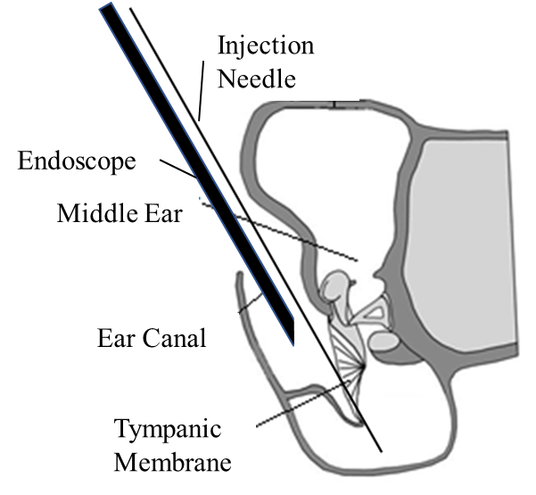
Figure 3. Experiment schematic with the endoscope observing a single intratympanic-inferior insult with PG injection. Note that the pinna was intact in all injections, not reflected in the schematic.

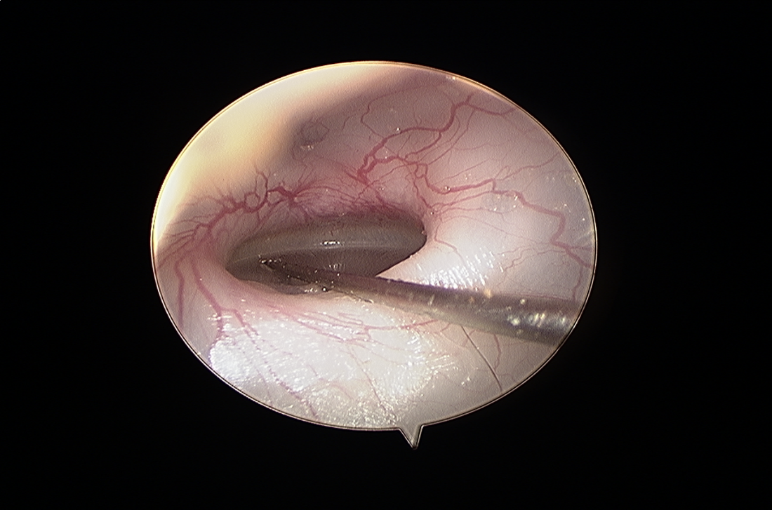
Figure 4. Endoscope photograph of the injection method. Endoscope is equipped with a 30° lens.
In all injections, only one ear of the animals was inoculated and the other left as a control. Comparison of the disease state was then directly compared to the healthy ear of the animal at all stages in the disease growth.

Inoculation Time Course – Endoscopic Observation
Direct visual confirmation of cholesteatoma formation was obtained with endoscopic photography following PG injections using a Styker® endoscope system (Stryker® HD 3-Chip Camera; Stryker® X8000 Light Source; Stryker® SDC Ultra). Endoscopic pictures were taken biweekly to assess growth of the disease, tympanic membrane damage, and state of the animal overall. Images of the healthy and diseased case were taken.

Hearing Function Tests
In cholesteatoma ears, wideband tympanometry (WBT) was used to measure middle ear transfer function. Auditory brainstem response (ABR) was used to determine the hearing threshold.
Middle ear energy absorbance (EA) describes the sound power transmitted into the middle ear over a broad range of frequency. The EA data were used as a check of the TM integrity and normal function of the middle ear before inoculation, after the inoculation time course, and after recovery of the animal. The EA was measured with a WBT with Reflwin PC software. The ear canal entrance was sealed by inserting and holding the probe with tip by hand and pressing against the bony rim ear canal entrance. The EA was measured across 60 frequencies between 0.25 Hz and 8 kHz. For all frequencies, the applied ear canal air pressure swept from 200 to -300 daPA. The peak EA and its corresponding middle ear pressure (MEP) were recorded from the sweeps.
ABR measurements were conducted before inoculation, after the inoculation time course, and after recovery using a TDT system III (Tucker-Davis Technologies, Alachua, FL). Briefly, under anesthesia, stainless steel needle electrodes were positioned subcutaneously at the vertex of the skull and ventrolateral surfaces of the ear, with a ground electrode placed in the rear leg. Tone burst stimuli of 1 ms rise/fall time at frequencies of 0.5, 1, 2, 4, 6, and 8 kHz were generated. The ABR waveforms were recorded in descending 5 dB SPL intervals from the maximum amplitude until no waveform could be visualized.

Surgery
Surgery was performed in a designated surgical suite in our lab to eradicate cholesteatoma. Animals were heavily sedated with a ketamine/xylazine cocktail (35 mg/kg ketamine and 7 mg/kg xylazine) and booster doses as needed. Post hearing function tests, the surgical site was sterilized and surgery began. The purpose of the procedure is clean out the cholesteatoma from the middle ear cavity, assess the extent of damage, and repair the middle ear, if possible. A 3D printed prosthesis with TM graft was used to reconstruct the middle ear, though details of the prosthesis are not included. Future studies will focus on the prosthesis reconstruction.
Two primary directions in surgery were taken: transbullar and transmeatal. In the transbullar approach, the dorsal-superior of the bulla was breached to expose the superior growth of the cholesteatoma. Proceeding inferiorly, cholesteatoma was removed via scraping and suction. Several bony partitions were destroyed to access the disease. The surgery proceeded to the inferior of the bulla until there was clear visual of the eustachian tube.
The transmeatal approach accessed the middle ear through the ear canal. The ear canal was cleared of debris and disease until the location of the TM was reached. Often the TM could not be found, likely destroyed in the disease time course. To view the malleus-incus complex, stapes, and round window, the tympanomeatal flap was raised and the bony over hang excised with a curette. The malleus-incus complex was removed if found and the stapes and round window cleaned. A middle ear prosthesis can now be inserted. The TM was replaced with a facia graft and the tympanomeatal flap was lowered over it. The animal was then sutured and allowed to recover.

Post-Surgery Observation
After surgery, animals were allowed to recover. Animals were then monitored for two weeks, checking for complications and reoccurrence. At the end of the two-week period, hearing function tests are conducted and animals euthanized under heavy sedation.

Micro-Computed Tomography
Micro-computed tomography (micro-CT) imaging was used post-recovery to determine the extent of structural damage and geometric changes in the bulla. Micro-CT images were taken at Southern Methodist University in Dallas, Texas with a resolution of 13.27 μm. Micro-CT images were captured after 2 weeks of recovery post-surgery.

Histology
The histologic images of chinchilla temporal bones/bullae will document the tissue and structural damages caused by the cholesteatoma. Procedures followed previously published methods (Jiang et al, 2016). Three animals were taken at mid time course at one week, four weeks, and six weeks for different severity level analysis based on time course. Two of the animals were taken from the 70% concentration group for the short and long durations, and one animal was taken from the 90% PG concentration for the medium length duration.

Chapter 3: Results – Success and Failures

Post-Experiment Overview
Prior to inoculation, hearing function tests were administered to assess baseline hearing prior to disease onset. Chinchillas were inoculated PG concentrations of 70% (N=7) and 90% (N=6). Four animals, two at 70% and two at 90%, were inoculated for two weeks. These were injected twice with 0.2 mL PG with a week between injections. Two were euthanized early and used to develop surgical methods for mild and moderate disease cases. Nine animals were inoculated for six weeks. These were injected three times with 0.2 mL PG with two days between injections. Of the six-week animals, three were euthanized early after one week, two weeks, and four weeks for histology, and four were euthanized early and used to develop surgical methods for severe disease cases. Four animals were used for survival surgery: two after two weeks and two after six, with both groups made up of half 70% PG and 90% PG.

Disease Development
Cholesteatoma formation was monitored endoscopically biweekly. Photographs of the disease were taken and the health of the animal was cataloged. Figures 3-5 show the disease progression. Figure 4 is a pretreatment photograph, taken immediately before injection. Figure54 is a photograph of disease progression one week after inoculation. The TM has discolored to a yellow near the annulus, and the TM has lost integrity in it structure, displaying several wrinkles in the surface. Yellow fluid can also be seen behind the TM. Figure 6 is a photograph typical of the cholesteatoma animals in this study. After two weeks, keratinizing debris fills the ear canal and the TM is no longer observable. To not disturb the disease progression, the debris was left in the ear canal of animals until surgery.
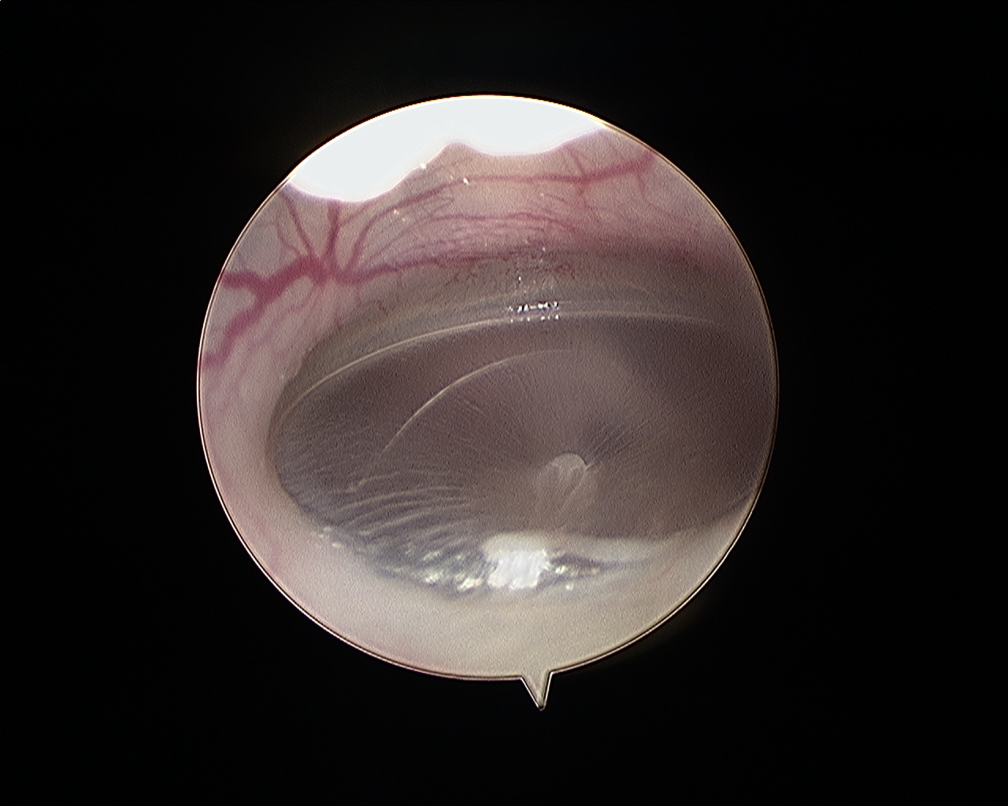
Figure 5. Healthy chinchilla tympanic membrane from Group 2 captured immediately before inoculation.
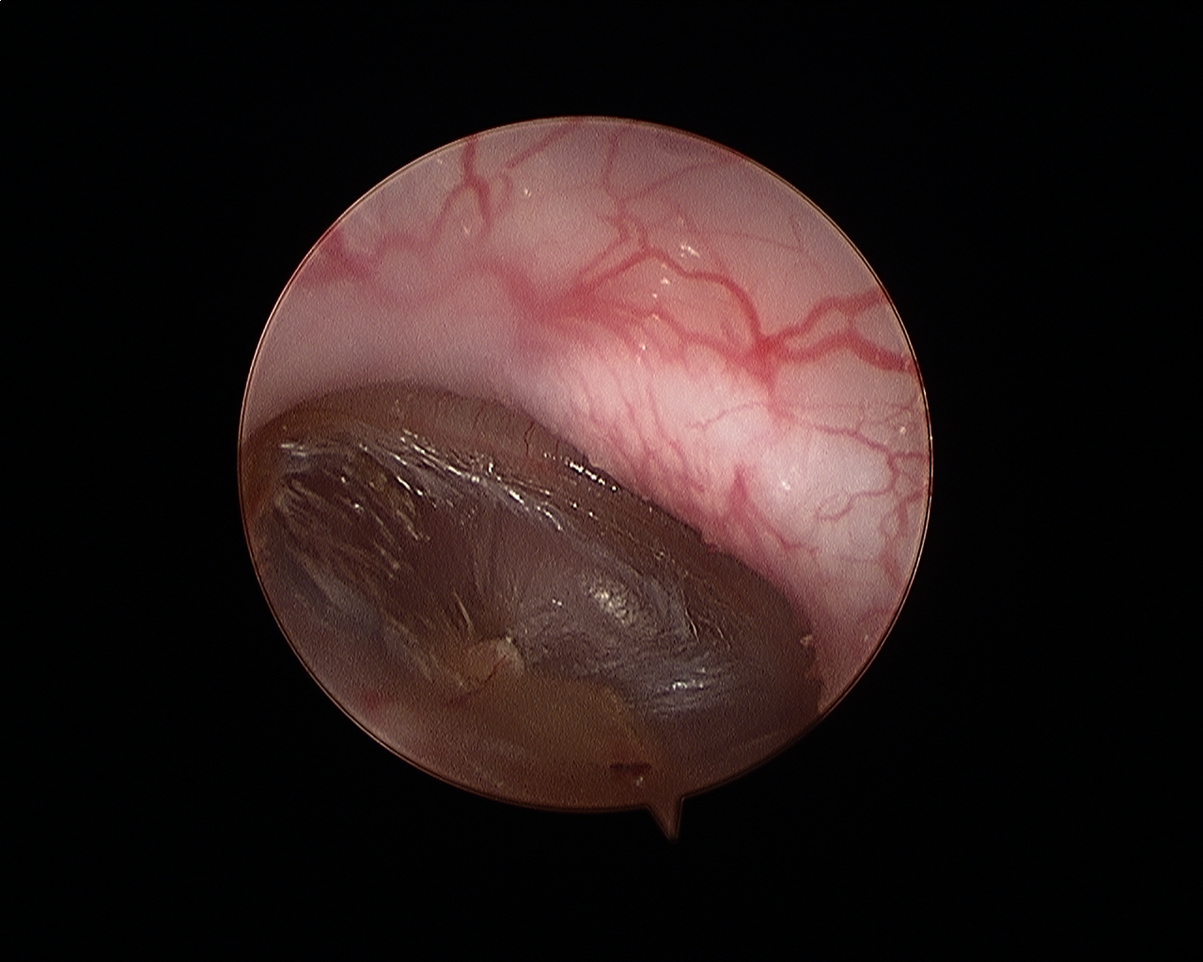
Figure 6. TM of the same chinchilla as in Fig. 3 from Group 2. Photo was taken 1 week after the first inoculation.
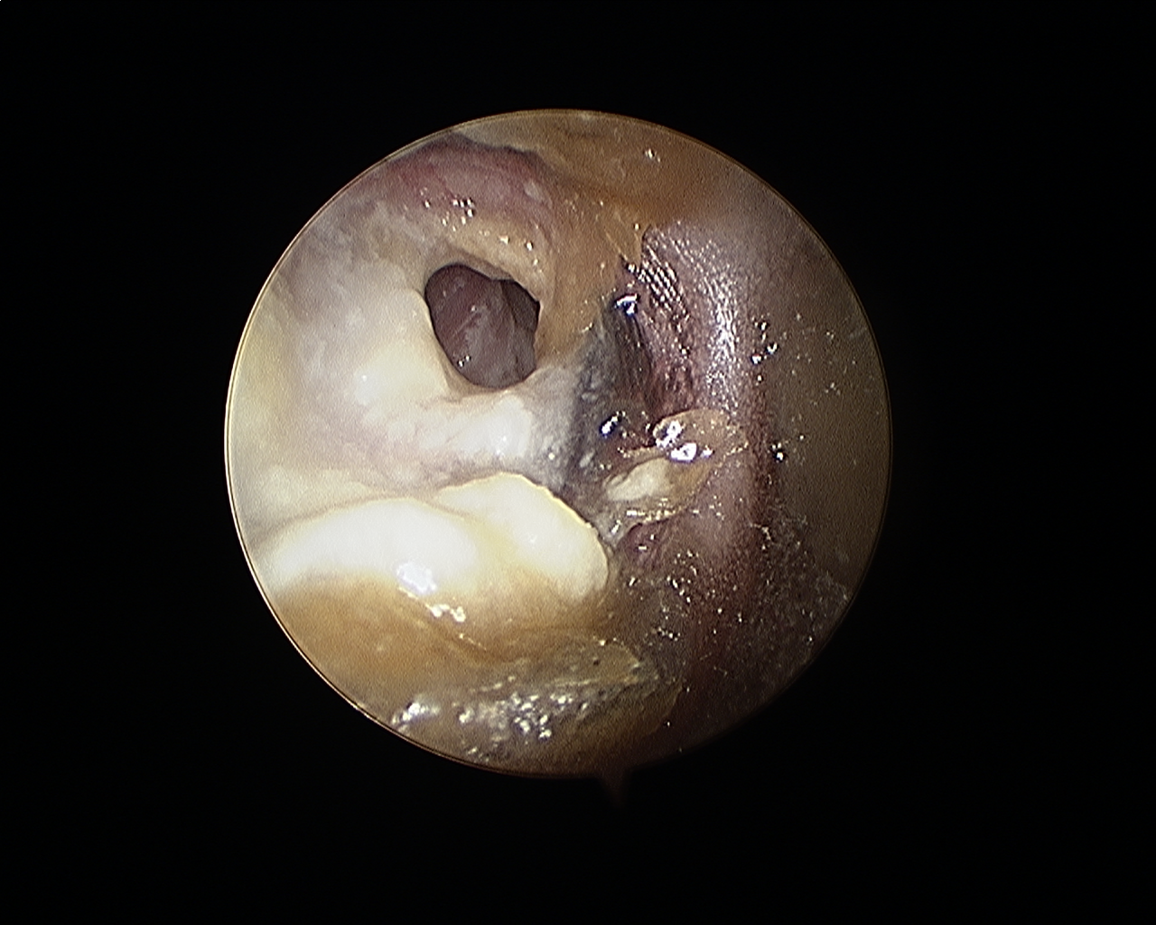
Figure 7. Ear canal of animal shown in Fig. 3. Ear canal has filled with keratin debris. The photo was taken two weeks from the first inoculation.

Surgery and Post-Surgery Observations
Four animals underwent endoscopic surgery. Two animals were inoculated for six weeks, with PG concentration levels of 70 and 90%. Two animals were inoculated for two weeks, with PG concentrations at 90%. Table 1 summarizes the experiment and surgical outcomes.

Table 1. Experimental summary of animals and their surgical outcomes.
Animal Number | PG Concentration | Total Volume Injected (mL) | Time from First Inoculation | Severity of Disease | Experiment Endpoint
17-3-6 | 70% | 0.6 | 5 | Severe | Recovery
17-3-12 | 90% | 0.6 | 5 | Severe | 48 hours post-surgery
17-4-9 | 90% | 0.4 | 2 | Moderate | 2 weeks
17-4-10 | 90% | 0.4 | 2 | Mild/Moderate | Died during surgery

Animal 17-4-9 was the most successful surgically. Figures 7 through 14 are endoscopic photographs of the cholesteatoma growth throughout the bulla and how the disease was eradicated as discussed in Chapter 2.
A post-auricular incision centered over the prominence of dorsal bulla was made using a 10 scalpel blade. the incision was approximately 2 cm long and made superficially to preserve the facia layer. A small amount of facia was harvested for a TM graft later. The periosteum was the incised and peeled back with a surgical “hoe” instrument to reveal the bony wall of the bulla. A bur hold was then made into the lateral and inferior quadrant of the bony plate over the dorsal bulla; penetration was minimized to preserve the bone. Iris scissors were used to cut the bone anteriorly and medially from the bur hole. The cut bone was then lifted as a flap (Fig. 7). The revealed white mass is the cholesteatoma immediately beneath the bony wall of the bulla.

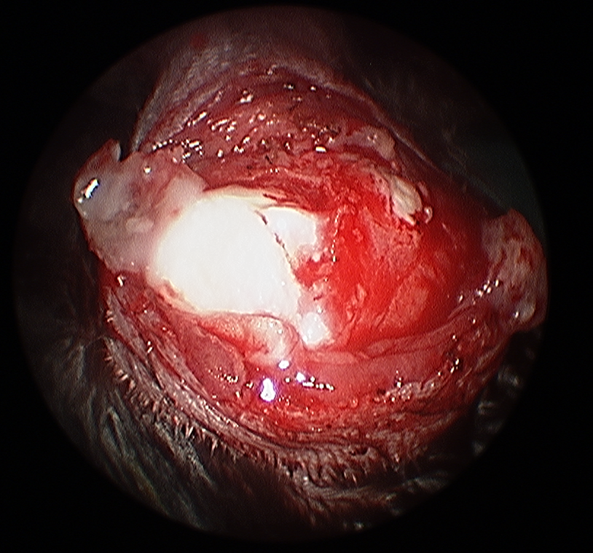
Figure 8. Dorsal bulla bone flap lifted from the remaining bulla bony shell. The large white space is the capsule of the cholesteatoma matrix.

What was possible to remove from here was suctioned out. Then, second hole was made over the mastoid portion of the bulla, just inferior to the bony buttress which partitions the dorsal form the mastoid bulla. Cuts were made extending inferiorly and medially from the second bur hole to remove the bone flap. the bony buttress was then resected with scissors (though drilling may be better) to create a wider opening for the endoscope (Fig. 8).
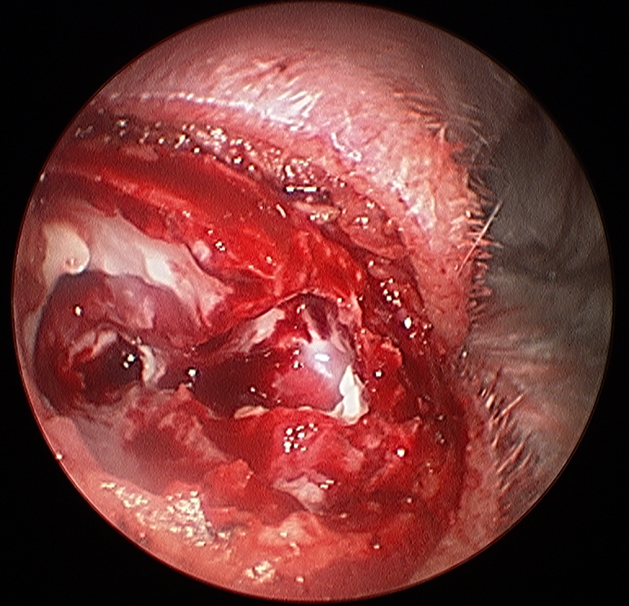
Figure 9. Exposure of mastoid and dorsal bulla sections the partition separating the two has been removed to further access the bulla.
The capsule of the cholesteatoma can now be fenestrated and the keratin contents evacuated. The cholesteatoma matrix must be dissected and peeled from the inner surfaces of the bulla, down to the level of the ossicles. Figure 9 shows an intact bony buttress immediately superior to the ossicular chain. This partition must be drilled through and outward to create a pathway to the anterior of the bulla. Care was taken not to interact with the tympanic segment of the facial nerve, immediately medial to the partition.
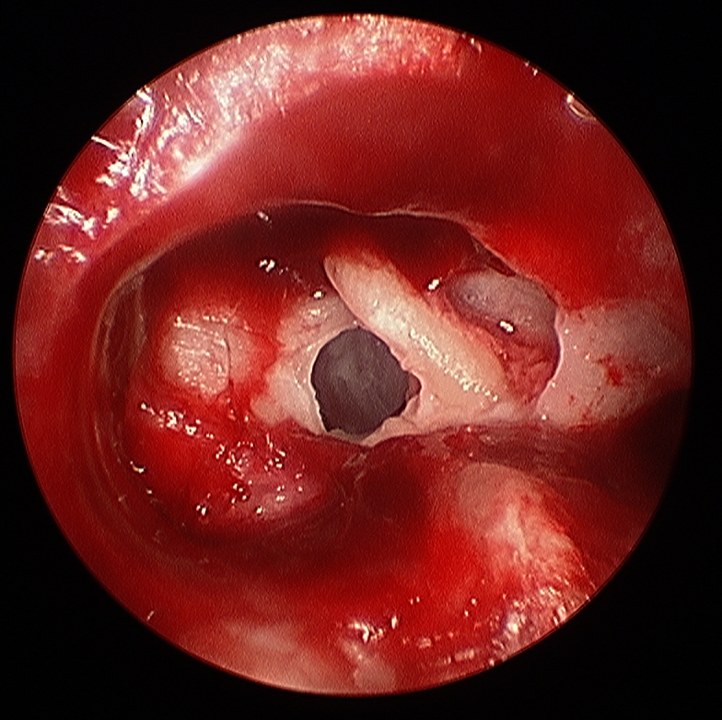
Figure 10. Bony partition separating the dorsal part of the bulla from the medial part of the bulla, near the ossicles.
The malleus-incus complex integrity may now be assessed. If hypermobile, erosion is suggested to have occurred. Inspect the anterior bulla and locate the apex of the cochlea and the cochlear strut which extends anteriorly to the eustachian tube orifice (Fig. 10). If cholesteatoma extends to this region, a suction tube may reach most of its extent. Dissect any matrix from anterior to posterior. Cholesteatoma was cleared from the middle ear as much as possible while identifying the facial nerve, stapes, and using a 30° endoscope to inspect the medial surface of the tympanic membrane to confirm damage.
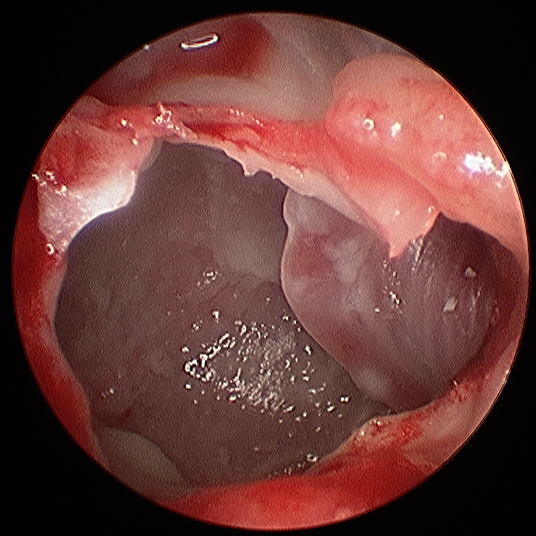
Figure 11. Partition separating the dorsal part of the bulla from the medial part of the bulla has been drilled out. The cochlea can be seen on the right.
The transmeatal view was now taken and keratin debris was cleared from the ear canal. The transmeatal flap, attached to the posterior annulus of the TM/posterior TM remnant, was incised to lift with a Rosen blade (Fig. 11). Once incised, the flap was lifted with any TM remnants to the inferior (Fig. 12).
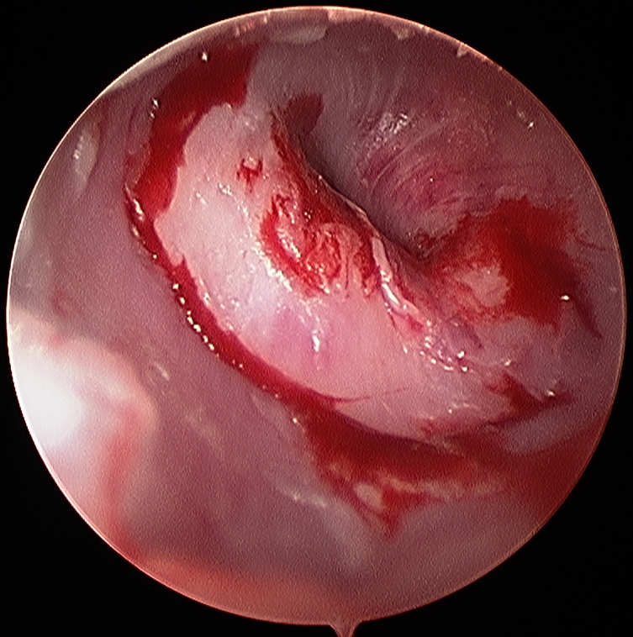
Figure 12. Transmeatel view of TM and bulla. The transmeatal flap has already been cut (the blood marks the outline).

The stapes was not visible with the lifted flap, so posterior bony canal was partially removed using a curette (Fig. 12).
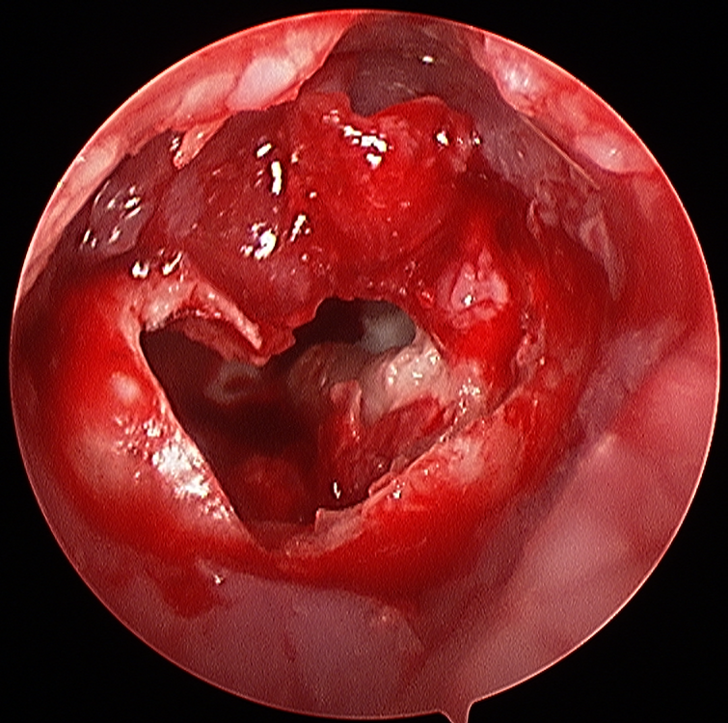
Figure 13. Transmeatal view of TM and bulla. The transmeatal flap has been lifted and part of the bony partition has been cut away using a curette.
With the stapes location revealed, clear out any remaining cholesteatoma matrix. Attach strut of prosthesis (not shown) to stapes head, and fix TM graft to facia tissue and TM remnants (Fig. 13). The facia tissue was placed such that the ear canal was sealed form the middle ear.
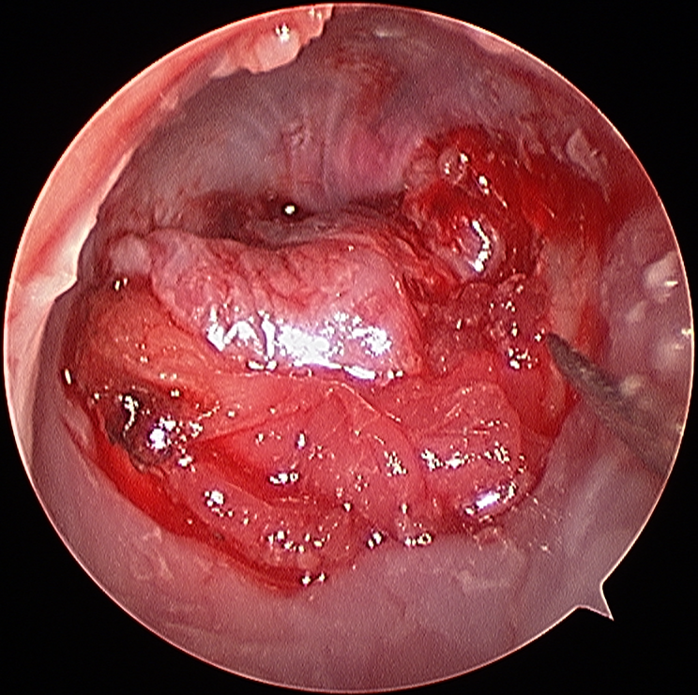
Figure 14. Fascia graft from transmeatal view.

With the TM graft and prosthesis now in place, the animal was sutured (Fig. 14) and then allowed to wake up.
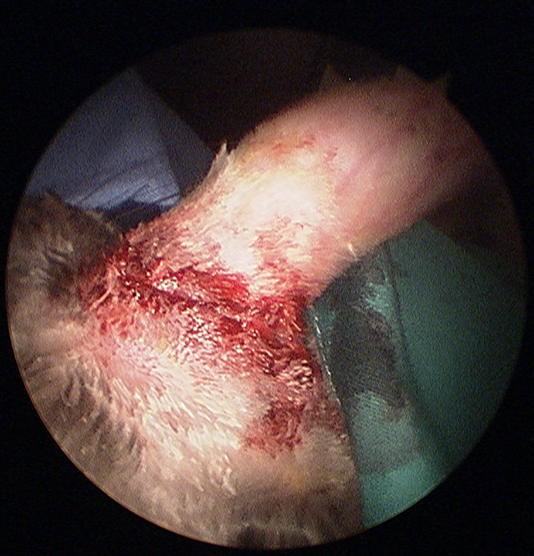
Figure 15. Sutured incision of dorsal bulla skin using buried technique.

Micro-Computed Tomography
Micro-CT scans of one chinchilla (17-4-9) were taken post recovery. Figures 14, 15, and 16 are micro-CT scans of the healthy bulla (left) and the diseased bulla (right). Figure 14 scans are located in the superior region of the bulla, above the ossicles. Heavy corrosion is visible in all areas of the diseased bulla (right). As well, the bulla has become slightly misshapen, due to the softening of the bulla bony wall. There also appears to be a near breach of the cranial wall.
Figure 15 shows scans located near the vertical middle of the bulla. Again, heavy corrosion is visible in the diseased bulla (right). The TM is missing, confirmed by surgery conducted previously. The stapes, however, is present in this image. During surgery, the stapes was unable to be located. This reflects the need for improved surgical handling of the diseased ears. The cochlea appears to have been breached by the disease. As such, even removing the disease and reconstructing the ear would have negligible effects on the hearing of this animal. Early intervention is key to saving and recovering lost hearing.
Figure 16 shows scans located in the inferior of the bulla. The scans show some carrion and bone resorption. However, it is worthwhile to note that in most surgeries, actual cholesteatoma was not found in the inferior region. The disease resided in the ear canal and the superior of the bulla. In none of the animals did the disease progress inferiorly. Yet, from micro-CT scans, there is obvious corrosion. Cholesteatoma must therefore not necessarily need contact with the bony wall to induce bone resorption.

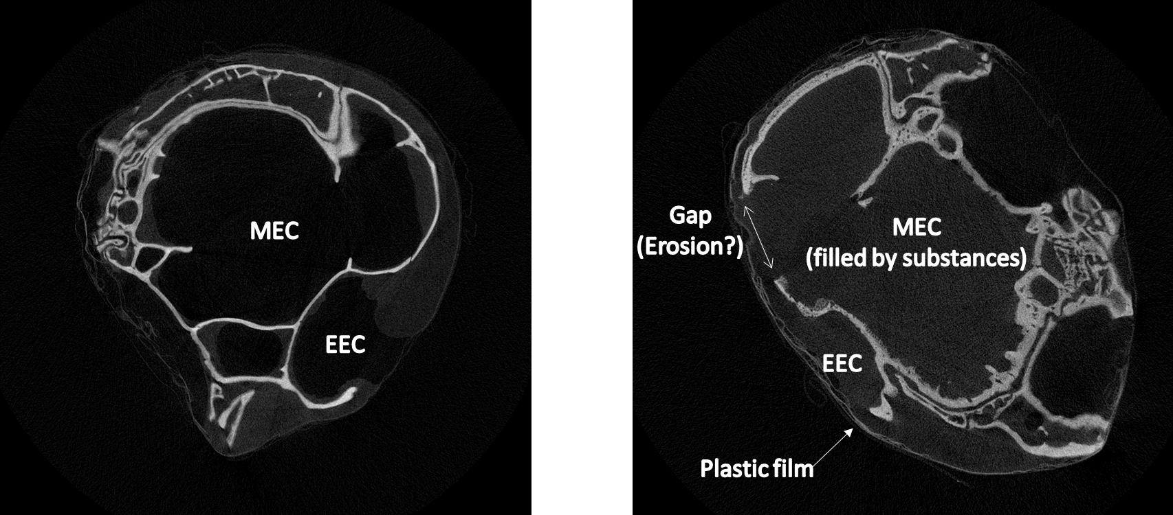 | Figure 16. Comparative images of a health bulla (left) and the disease case (right) in the superior region of the bulla. External ear canal (EEC), the middle ear cavity (MEC), plastic film (for imaging purposes) can all be clearly seen. The MEC of the diseased bulla was filled with a biogel prior to imaging.

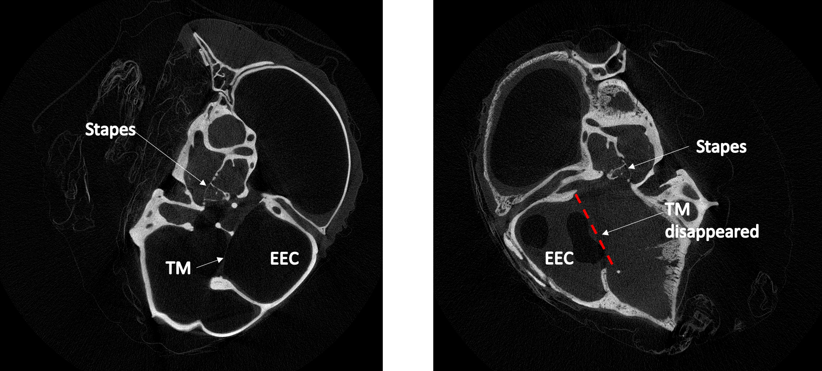 | Figure 17. Comparative images of a health bulla (left) and the disease case (right) in the middle region of the bulla.

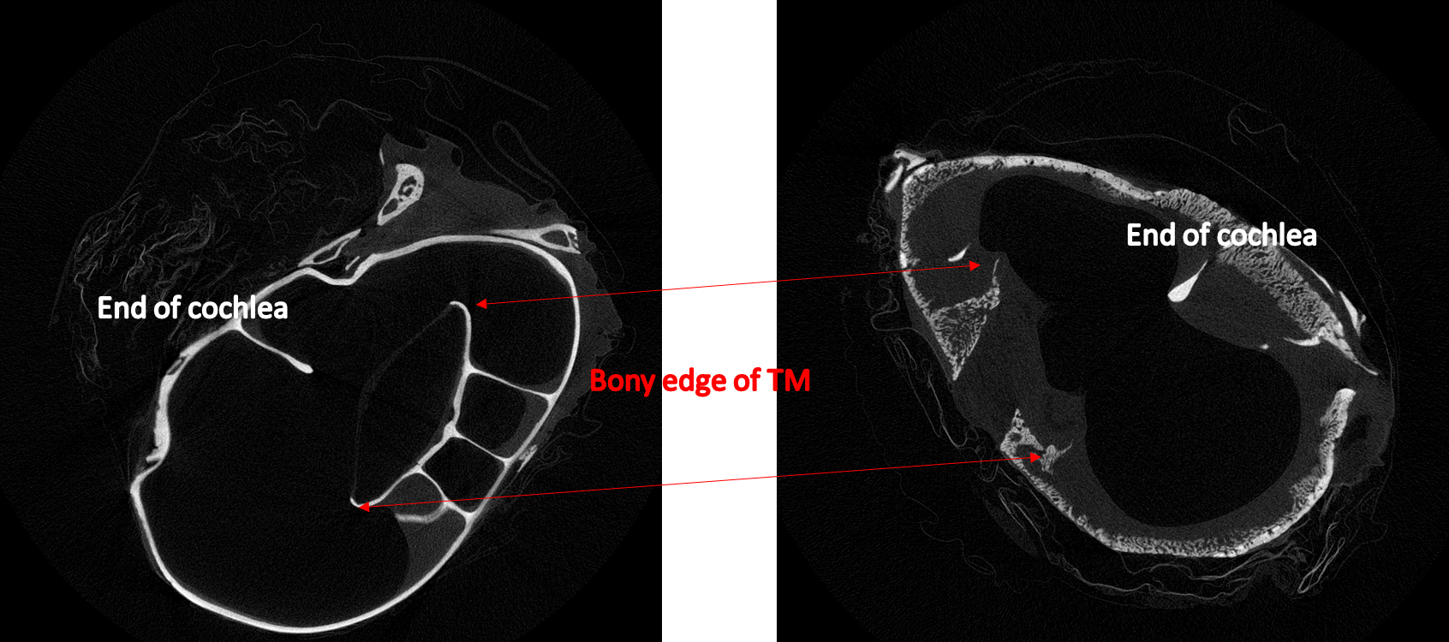 | Figure 18. Comparative images of a health bulla (left) and the disease case (right) in the superior region of the bulla.

Histology
Histology sections were made and imaged for three animals. Based on the time course, the animals correlate to mild, moderate, and severe cholesteatoma cases. Figure 17 is a histological image an animal inoculated with 0.6 mL of 70% PG, after one week (Group 1). The bony wall (BW) is intact without destruction. The epithelium (EP) appears normal, though there does exist cholesteatoma. Keratin debris (K) has begun proliferating and has begun lining the bony wall. The middle ear cavity (MEC) remains mostly clear.
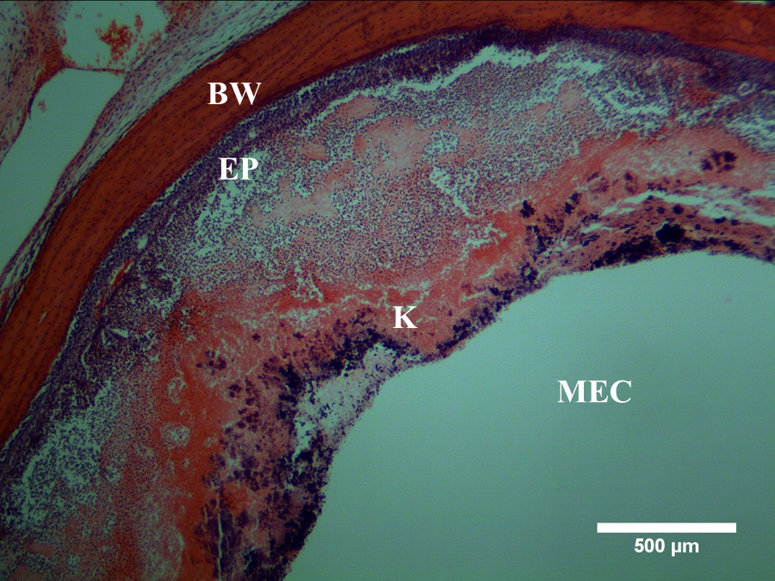
Figure 19. Histological image of cholesteatoma animal after one week. Bony wall (BW); epithelium (EP); keratin (K); middle ear cavity (MEC). The degree of damage and proliferation corresponds to a mild cholesteatoma level.
Figure 18 is a histological image made after four weeks from inoculation (90% PG, 0.6 mL). The bony wall has begun eroding, with protrusions into the bony layer and the surface of the bony wall resorbing into the epithelium. In this location keratin is not visible, though the epithelial layer has increased in thickness compared to Figure 17.
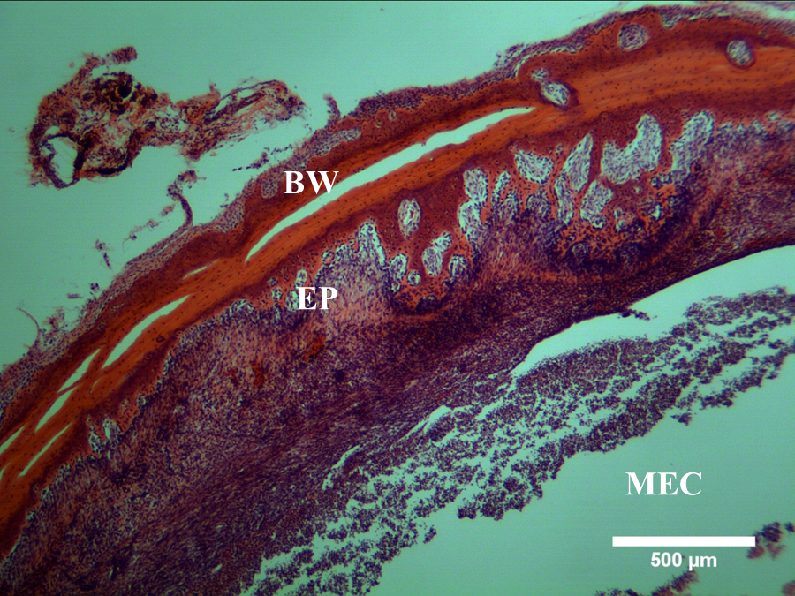
Figure 20. Histological image of a cholesteatoma animal inoculated with 0.6 mL of 90% PG for four weeks. The degree of damage and proliferation corresponds to a moderate cholesteatoma level.
Figure 19 is a histological image taken after six weeks from inoculation (70% PG, 0.6 mL). The bony wall has been severely degraded with full penetrations as many locations. Keratin separates from the bony wall by a thin epithelial layer. The middle ear cavity has been largely filled with keratin within the cholesteatoma sack.
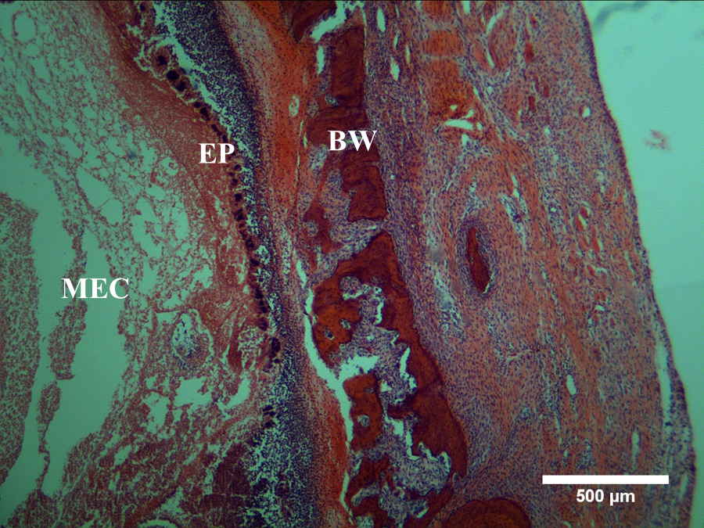
Figure 21. Histological image of a cholesteatoma animal inoculated with 0.6 mL of 70% PG for six weeks. The degree of damage and proliferation corresponds to a severe cholesteatoma level.

Hearing Function Tests

WBT and ABR were conducted at all stages at only one animal, 17-4-9, having received 0.4 mL of 90% PG and inoculated for two weeks. This preliminary recovery response is primarily due to the undeveloped reconstruction technique, though the eradication was successful.
Figure 20 is the WBT response pre-inoculation. There is a clear frequency-absorbance response across all frequencies and there is a single pressure-energy absorbance response, corresponding to a normal TM and middle ear in chinchillas.
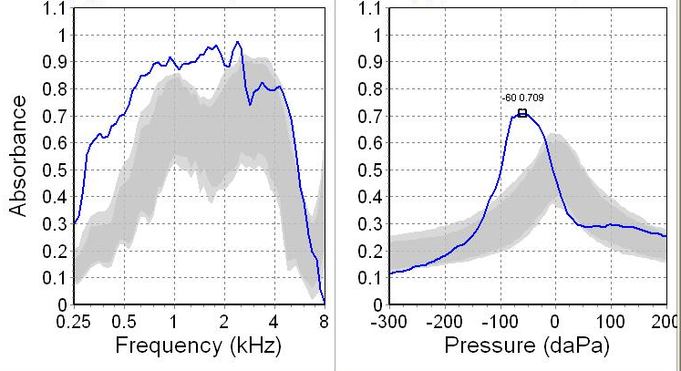
Figure 22. Wideband tympanometry response of a healthy chinchilla, prior to inoculation. Frequency-absorbance (left) and pressure-absorbance (right) responses are typical of healthy chinchillas.
Figure 21 is the WBT measurements after inoculation. Prior to tests, the middle ear was cleared of obvious keratin debris to improve transmission. However, the TM, as observed later by endoscope, was completed destroyed, correlating to the poor response recorded. The middle ear transmission must therefore be considered largely dysfunctional.
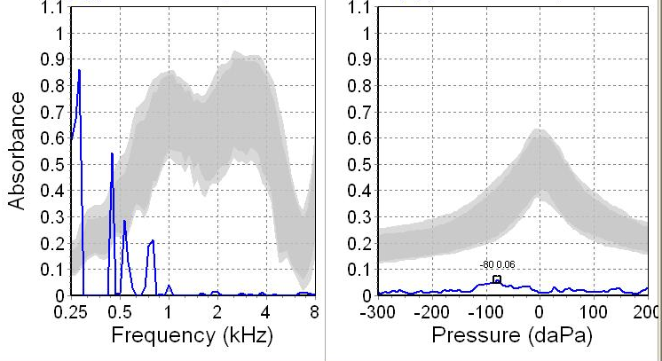
Figure 23. Wideband tympanometry response of a post-inoculated animal, with 0.4 mL of 90% PG after two weeks. Both the frequency-absorbance response and pressure-absorbance responses suggest a failed middle ear transfer function.

Figure 22 is the WBT response post operation, measured after two weeks of recovery from surgery. Still largely dysfunctional, there is some improvement from the pre-operational measurements. The frequency-absorbance curve shows reasonable response from 2-6 kHz and some response at .5 kHz. The pressure-absorbance curve does not appear to provide the single peak appreciated in Figure 20, though there is a non-response, suggesting a middle ear transfer with imperfect sealing. The reconstructed TM must not have fully been taken by the ear canal.
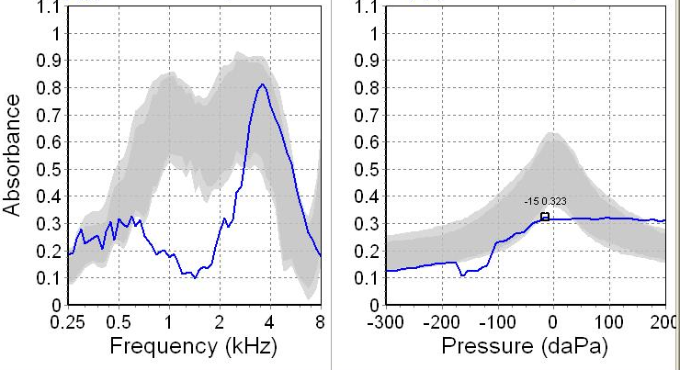
Figure 24. Wideband tympanometry post recovery in chinchillas, two weeks after surgical intervention. Frequency-absorbance and pressure-absorbance response suggest some recovery.
Figure 23 is the summary of ABR response measured before inoculation (red), after two weeks of inoculation (blue), and two weeks after surgical intervention (green). The pre-inoculation response is a reasonable response from a healthy chinchilla the pre-surgery response shows increases of the ABR threshold at all frequencies, especially at the lower levels. The average threshold increase is 23 dB. After surgery and recovery hearing functions were tested again. There was an improvement at 2, 4, and 6 kHz of 5 dB, correlating to the improved WBT response shown between Figs 21 and 22. Overall, the ABR threshold did not improve considerably.
Figure 25. ABR threshold response for pre-inoculation, pre-surgical, and post-recovery.

Chapter 4: Discussion – Developing a Criteria for Severity and Surgical Improvement

Overview of Study
PG inoculation in chinchillas is a highly effective method for producing cholesteatoma. In high concentrations and volume, the PG can produce severe cholesteatoma growth in short periods of time. Part of the difficulty in this study was readjusting the time frame to accompany the rapid onset. Most animals rapidly developed complications in Group 1 including head tilts, ocular conjunctivitis, and in some cases seizures. Any animal that degraded to the point of extreme lethargy or developed any level of seizures was euthanized immediately, assessed by attending veterinarian. Group 2 developed complications but were limited and full studies were possible.
All animals developed cholesteatomas in Group 1 and Group 2. There were no observable differences between 70% and 90% animals from endoscopic, histological, or micro-CT observations. The greatest contribution to the cholesteatoma development was the time factor and the deposited volume of PG. By controlling these two factors, cholesteatomas can be predictably and repeatedly induced in chinchillas.

Surgical Procedures
In Chapter 2, detailed methods for surgical eradication of cholesteatoma were provided. Chapter 3 discussed and documented the actual procedure in an animal surgery. The surgical approach for chinchillas vastly differs from the human approach with the reasons obvious. However, the large volume of the chinchilla middle ear provides a unique view into progressive growth and destruction of the middle ear.
During the surgical procedures, it was apparent the cholesteatoma primarily progressed to the superior of the bulla. Septa of the bulla were necessarily removed to access pockets of cholesteatoma, especially in the severe cases. Because of the labyrinth middle ear cavity in chinchillas, removing all cholesteatoma is difficult. The odd geometry and many cavities enables the cholesteatoma to grow into pockets that are difficult to surgical reach. However, using endoscopic techniques, the methods outlined did prove to be successful without reoccurrence in the animal which recovered from surgery for two weeks. Extended studies on recovery will be necessary in future studies with reasons discussed in Chapter 5.

Middle Ear Damage – Micro-Computed Tomographic and Histological Observations
Both micro-CT and histology provided unique observations of the integrity of the middle ear cavity. In the case of histology, direct comparison of proliferation and damage was possible. Micro-CT showed extensive damage to the bony wall and destruction of middle ear constructions in all section (Figs. 14, 15, and 16). The damage found in the superior region was typical and observable endoscopically. The thinning of the cranial bone separating the middle ear from the brain was a frequent complication in the diseased animals. A few severe cases from Group 1 had such extensive cholesteatomas and damage, only the dura remained to separate the brain and the middle ear. These animals had developed other serious complications and their studies were terminated premature. However, in these animals, the ossicles were frequently undamaged as was the inferior of the bulla. The cholesteatomas are more likely to progress through the superior of the bulla than to advance upon the cochlea until late into the disease progression.
In the medial micro-CT section, many structures were found to be damaged and destroyed. Some of these structures, such as the bone of the ear canal, were destroyed during surgical intervention and reconstruction Surprising form the scans was the presence of the stapes. Thick mucosal lining in the middle ear, prevalent in most of the middle ear, made cleaning the cochlea difficult, due to sensitive and fragile structures needing to be left intact including the oval window and the round window membrane. As well, to not damage the cochlea shell, scraping had to be performed gently. The malleus-incus complex was removed during surgery, though they appeared intact.
In the inferior of the bulla, there was apparent damage observed in the scans, though the cholesteatoma sack was not found in any location below the TM. The mucosa had likely thickened as mentioned was found in other sections, though not obtrusively so. The bony degradation, therefore, could not be directly attributed to the cholesteatoma, corresponding to previous research suggesting that bone resorption does not need direct contact with cholesteatoma.
The graded destruction of the middle ear bony wall was determined primarily by the time course rather than the concentration (Figs 17-19). The histological images indicate that there is a time factor separating bone destruction and cholesteatoma contact/presence. After one week, cholesteatomas were produced. The rapid onset suggests the potency of the chemical inoculation. After four weeks, bone corrosion seems to have just begun, though this may not be typical. Some animals appear to have a greater accelerated cholesteatoma growth and this case could have been relatively mild. Surgical intervention in the cases of these two cases is recommended with higher chance in hearing recovery.
The six weeks case was typical, though. Apparent from the softened bulla, most animals by week six had developed extensive and highly destructive cholesteatomas. Surgical intervention in these cases would not restore hearing as the cochlea has been severely damaged; rather, only mitigating further destruction of the disease would be the goal.

Proposed Levels of Severity – Rationale and Suggestions
Though there are several methods for classifying cholesteatoma severity, our own method was developed for a few reasons. As will be discussed in Chapter 5, the primary purpose for this model is to maximize hearing recovery with complete disease eradication. The methods describe the extent of the disease growth in humans and the degree of proliferation to multiple section. Here, we expect the disease to growth and progress beyond its origin, though intervention success is still necessary to predict. Later, our classification may converge with published literature, but as our animal model develops, we have initiated with this current three-tier classification of its growth, based on histology, micro-CT, and endoscopic imaging. Table 2 illustrates the three-tier classification with endoscopic images.
Mild cholesteatoma growth: This is the lowest classification for our animal model. Lower cases may be used, though future research will explore maximizing recovery under different damage levels. The matrix has covered the tympanic membrane or destroyed it. The matrix has begun growing toward the superior-dorsal space of the bulla. Adhering tissue is likely to be found covering the basal region of the cochlea. The tympanic membrane and malleus incus complex must be replaced, though all the remaining structures should be able to remain. Reconstruction should be possible with significant hearing function regained.
Moderate cholesteatoma growth: The matrix has filled the dorsal part of the bulla and the mastoid part of the bulla. The tympanic membrane has likely been destroyed. The malleus-incus complex has been dislodged from the stapes. The stapes may or may not remain attached to the oval window. The bulla cavity has been filled with keratin due to the cholesteatoma matrix. The bulla shell has likely begun to soften due to the erosion of the matrix. The matrix must be cleared from the bulla. Reconstruction is possible, thought regained hearing function will be limited to destruction.
Severe cholesteatoma growth: Cholesteatoma matrix has filled the superior part of the bulla and eroded the septa. The bony wall between the bulla and the brain may have partially eroded. The labyrinthine of the bulla has partially been covered by the cholesteatoma matrix. The cochlea has begun to erode or has eroded in part. The incus-malleus complex is likely dislodged and the tympanic membrane gone. The stapes may be dislodged if the basal part of the bulla remains intact. Most The bony wall protecting the facial nerve (N. VII) is partially or totally destroyed. The semicircular canals have mostly been eroded. Reconstruction is no longer possible aside from sealing the middle ear cavity from the atmosphere. Hearing function will not likely be regained.

Table 2. Suggested cholesteatoma classification for surgical intervention. | Severe | 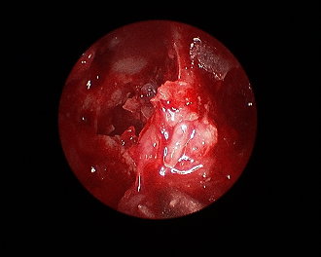 | 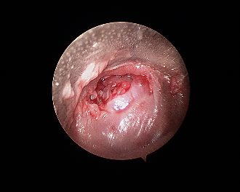
 | Moderate | 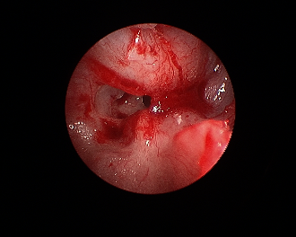 | 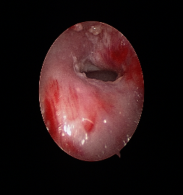
 | Mild | 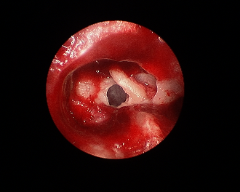 | 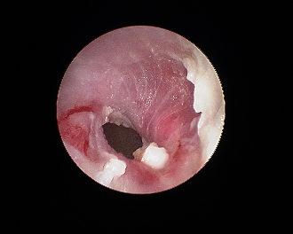
 | Location | Superior bulla region | Ear canal

Chapter 5: Future Studies
A cholesteatoma animal model has been created using chemical injection of PG at varying concentration, time courses, and injection volumes. This model follows previous animal models though the research direction is vastly different. Using a three-tiered classification based on endoscopic, histological, and micro-CT images, a surgical intervention assessment has been developed. Furthermore, surgical techniques for eradicating cholesteatoma from chinchillas has been described. Mild, moderate, and severe animal models have been shown and are repeatable depending on the aforementioned parameters. Though limited in use in the present study, this research has laid the foundation for future research in prosthetic design of clinical relevance.

Fine-Tuned Cholesteatoma Development
Based on our three-tier classification, this pilot study demonstrates that cholesteatoma may be produced in chinchillas both repeatedly and predictably. This is accomplished by varying time, injected PG volume, and PG concentration. The most critical of these parameters is time, as our method induces cholesteatomas rapidly, causing severe destruction the middle ear cavity. An interesting difference of our method is the lack of significant damage to the ossicles. In only the most severe cases was damage to the malleus-incus complex observed. The stapes appeared to be intact in all cases. However, the progression and damage to the bony wall is a useful parameter for reconstruction of the middle ear. As well, the TM was always irreparable except in the mild cases. As such, for TM reparation, intervention in this animal model must occur early in the cholesteatoma onset.

Middle Ear Prosthesis – Criteria, Design, Assessment
Not mentioned was the methods used to reconstruct the middle ear in the chinchillas. The study has been preliminary in this regard, but this is a major and primary direction for future work. 3D printed middle ear prostheses will be used to study and maximize the hearing function in chinchillas. Normal materials cannot be 3D printed for biological use due to compatibility issues in long term studies. However, using finite element analysis, 3D printing technology for mold design or bio printed materials, and cellular seeding, reconstruction a patient specific ossicular replacement with tympanic membrane is possible.

Middle Ear Post-Surgery Assessment
Post-surgery assessment of middle ear reconstruction is made difficult by surgical techniques, fragility of the reconstruction, and time needed for surgery site to heal. In clinical settings, reconstruction is concluded by filling the middle ear with a biocompatible and degrading biogel. The biogel is inserted to stabilize the reconstruction of the ossicles until they have properly healed. Even when biogel is not needed, the reconstruction site is fragile. The implant and TM graft needs time to be accepted by the body and over stimulation may cause a disruption at some level, rendering the reconstruction ineffective. Methods for assessment and stabilizing will be further explored.

References
Abramson, M., Huang, C. 1976. Localization of collagenase in human middle ear
cholesteatoma. Am Laryngol Rhinol Otol, 771-791.

Akiyama, N., Yamamoto-Fukuda, T., Takahashi, H., 2014, Influence of continuous
negative pressure in the rat middle ear. Laryngoscope 124, 2404-2410.

Bezold, F. 1890. Cholesteatom, Perforation der Membrana flaccida und TubenvershluB.
Z Hals Nasen Ohrenheilk. 20, 5-29.

Bretlau, P., Dabelsteen, E., Holmstrup, P., 1979. A method for studying cholesteatomas
in vivo, with special attention to epithelial-mesenchymal interaction. Clin. Otolayrngol. 6, 81-85

Chen, Y., Li, P., 2017. Application of high resolution computer tomography in external
ear canal cholesteatoma diagnosis. J Otol 13, 25-28.

Ching, H. H., Spinner, A. G., Ng, M., 2017, Pediatric tympanic membrane
cholesteatoma: systematic review and meta-analysis. Int J Ped Otorhinolaryngol 102, 21-27.

Choi, H., Park, K. H., Park, S. N., Jun, B. C., Lee, D. H., Park, Y., Chang, K. H., Park,
S., Noh, H., Yeo, S. W., 2010. Clinical experience of 71 cases of congenital
middle ear cholesteatoma. Acta oto-Laryngologica 130, 62-67.

Chole, R. A., Hughes, R. M., Faddis, B. T., 2001. Kearatin Particle-induced osteolysis:
a mouse model of inflammatory bone remodeling related to cholesteatoma. JARO 2, 65-71.

Choufani, G., Roper, N., Delbrouck, C., Hassid, S., Gabius, H., 2007. Animal model for
cholesteatoma induced in the gerbil: will the profiles of differentiation/growth-regulatory markers be similar to the clinical situation? Laryngoscope 117, 706-711.

The Committee of Conservation of Hearing of the American Academy of
Ophthalmology and Otolaryngology. 1965. Standard calssificaation for surgery of chronic ear disease. Arch Otolaryngol. 81, 204-205.

Cosgarea, M., Maniu, A., Necula, V., 2011. Middle ear cholesteatoma and its
complications. Otology/Neurotology 145.

Guan, X., Gan, R. Z., 2013. Mechanisms of Tympanic Membrane and Incus Mobility
Loss in Acute Otitis Media Model of Guinea Pig. JARO. 14, 295-307.

Habermann, J. 1888. Zur Entstehung des Cholesteatomas des Mittelohres. Arch
Ohrenheild 27, 43-51.

House, J. W., Sheehy, J. L., 1979. Choleseteatoma with intact tympanic membrane: a
report of 41 cases. Laryngoscope 90, 70-76

Huang, C. C., Yi, Z. X., Chao, W. Y. 1988. Effects of granulation tissue conditioned
medium on the in-vitro differentiation of keratinocytes. Arch Otorhinolaryngol. 245, 325-329.

Hueb, M. M., goycolea, M. V., Muchow, D., Duvall, A. J., Paparella, M. M., Sheridan,
C., 1993. In search of missing links in otology III. Development of a new animal model for cholesteatoma. Laryngoscope 103, 774-784.

Iwamoto, Y., Nishikawa, K., Imai, R., Furuya, M., Uenaka, M., Ohta, Y., Morihana, T.,
Itoi-Ochi, S., Penninger, J. M., Katayama, I., Inohara, H., Ishii, M. 2016. Intercellular communication between keratinocytes an dfibroblasts induces local osteosclast differentiation: a mechanism underlying cholesteatoma-induced bone destruction. Mol Cell Biol 36, 1610-1620.

Jennings, B. A., Prinsley, P., Philpott, C., Willis, G., Bhutta, M. F., 2017. he genetics of
cholesteatoma. A systematic review using narrative synthesis. Clin Otolaryngol 201, 55-67.

Jiang, H., Li, Z., Huang, X., Chen, S., Zheng, Y., Xu, G., Chen., X., Chen, Y., Liu, Y.,
Xiong, H., Huang, Q., Liang, M., Zhang, Z., 2016. TREM-2 promotes acquired cholesteatoma-induced bone destruction by modulating TLR4 signaling pathway and osteoclasts activation. Nature 6, 1-15.

Jiang, S., Seale, T. W., Gan, R. Z., 2016. Morphological changes in the round window
membrane associated with Haemophilus influezae-induced acute otitis media in the chinchilla. Int J Ped Otorhinolaryn. 88, 74-81.

Jung, J. Y., Lee, D. H., Wang. E. W., Nason, R., Sinnwell, T. M., Vogel, J. P., Chole R.
A., 2011. P. Aeruginosa infection increases morbidity in experimental cholesteatomas. Laryngoscope 121, 2449-2454.

Kaneko, Y., Yuasa, R., Ise, I., Iino, Y., Shinkawa, H., Rokeugo, M., Tomioka, S.,
Shibahara, Y., 1980. Bone destruction due to the rupture of a cholesteatoma sac: a pathogenesis of bone destruction in aural cholesteatoma. Laryngoscope 90, 1865-1871

Kuo, C., 2014. Etiopathogenesis of acquired cholesteatoma: prominent theories and
recent advances in biomolecular research. Laryngoscope 125, 234-240.

Lee, B. D., Park, M. K., 2011. Congenital cholesteatoma of the tympanic membrane.
ENT J 90, E36-E37.

Macri, J. R., Chole, R. A., 1985. Bone erosion in experimental cholesteatoma – the
effects of implanted barriers. Otolaryngol Head Neck Surg 93, 3-17.

Matsuda, K., Tono, T., Kojima, H., Yamamot, Y., Sakagami, M., Mishiro, Y., Hinohira,
Y., Okuno, T., 2018. Practicality analysis of the staging system proposed by the Japan Otological Society for acquired middle ear cholesteatoma: a multicenter study of 446 surgical cases in Japan. Auris Nasus Larynx 45, 45-50.

Meyerhoff, W. L., Trueslson, J., 1986. Chlesteatoma staging. Laryngoscope 96, 935-
939

Meyerhoff, W. L., Wright, C. G., Gerken, G. M. 1990. Effects of middle ear ventilation
on cholesteatoma development in experimental animals. J Acta Oto-Laryngol. 110, 279-285.

Olszewska, E., Wagner, M., Bernal-Sprekelsen, M., Ebmeyer, J., Dazert, S., Hildmann,
H., Sudhoff, H., 2004. Etiopathogenesis of cholesteatoma. Eur Arch otorhinolaryngol 261, 6-24.

Omura, F., Makino, K., Amatsu, M., Itoh, H., 1995. The role of middle ear effusions
and epidermal growth factor in cholesteatoma formation in the gerbilline temporal bone. Eur Arch Otorhinolaryngol 252, 428-432.

Razek, A. A. K. A., Ghonim, M. R., Ashraf, B., 2015. Computed tomography staging of
middle ear cholesteatoma. Pol J Radiol 80, 328-333.

Rosito, L. P. S., Sperling, N., Teixeira, A. R., Selaimen, F. A., Costa, S. S., 2018. The
role of tympanic membrane retractions in cholesteatoma pathogenesis. BioMed Res Int 2018, 1-5.

Sade, J., 1979. Pathogenesis of attic cholesteatoma. J Royal Soc Med 72, 230-231.

Schmidt, S. H., Hellstrom, S. 1993. Experimental cholesteatoma in the rat. J Acta
Otolaryngol. 114, 430-434.

Saleh, H. A., Mills, R. P., 1999. Classification and staging of cholesteatoma. Clin
Otoloaryngol 24, 355-359.

Shohet, J. A., Jong, A. L., 2002. The management of pediatric cholesteaoma.
Otolaryngol Clin N Am 25, 841-851.

Takizawa, Y., Mizuta, K., Hamada, N., Yamatodani, T., Nakanishi, H., Hosokawa, K.,
Takahashi, G., Sugiyama, K., Mineta, H., 2013. Relationship between tympanic membrane retraction and habitual sniffing in patients with cholesteatoma. Acta Oto-Laryngologica 133, 1030-1034.

Tinling, S. P., Chole, R. A., 2006. Gerbilline cholesteatoma development Part I:
epithelial migration pattern and rate on the gerbil tympanic membrane: comparisons with human and guinea pig. Otolaryngol Head Neck Surg 134, 788-793.

Tinling, S. P., Chole, R. A., 2006. Gerbilline cholesteatoma development Part III.
Increased proliferation index of basal keratinocytes of the tympanic membrane and external ear canal. Otolaryngol Head Neck Surg 135, 116-123.

Tinling, S. P., Chole, R. A., 2006. Gerbilline cholesteatoma development. Part II:
temporal histopathologic changes in the tympanic membrane and middle ear. Otolaryngol Head Neck Surg 134, 953-960.

Tos, M., Stangerup S-E., Larsen, P. Siim, C., Andreassen, U. 1988. the relationship
between secretory otitis and cholesteatoma. In: tos, M., Thomsan, J., Peiteresen, E. (eds). Proceedings of the 3rd international conference on cholesteatoma and mastoid surgery. Kugler Ghedini, Amsterdam. 325-330.

Unge, M., Decraemer, W. F., Dirckx, J. J., Bagger-Sjoback, D., 1998, Tympanic
membrane displacement patterns in experimental cholesteatoma. Hear Res 128, 1-15.

Vassalli, L., Harris, D. M., Gradini, R., Applebaum, E. L. 1988. Propylene glycol-
induced cholesteatoma in chinchilla middle ear. Am J Otolaryngol. 9, 180-188.

Wendt, H. 1873. Desquamative Entsundung des Mittelohres (“Chlesteatoma des
Felsenbeins”). Arch Ohr Nasen Kehlkopfheilk. 14, 428-446.

White, S. J., Wright, C. G., Robinson, K. S., Meyerhoff, W. L., 1995. Effect of topical
hyaluronic acid on experimental cholesteatoma. Am J Otolaryngol 16, 312-318.

Wright, C. G., Bird L. L., Meyerhoff, W. L., Burns, D. D., 1985. Middle ear
cholesteatoma: an animal model. Am J Otolaryngol. 6, 327-341.

Wittmaack K 1933. Wie entsteht ein genuines Cholesteatoma? Arch Otorhinolaryngol
137, 306.

Xie, S., Wang, X., Ren, J., Liu, W., 2017. The role of bone resorption in the
etiopathogenesis of acquired middle ear cholesteatoma. Eur Arch Otorhinolarynogl 274, 2071-2078.

Xie, S., Xiang, Y., Wang, X., Ren, H., Yin, T., Ren, J., Liu, W., 2016. Acquired
cholesteatoma epithelial hyperproliferation: roles of cell proliferation signal pathways. Laryngoscope 126, 1923-1930.

Yamamoto-Fukuda, T., Hishikawa, Y., Shibata, Y., Kobayashi, T., Takahashi, H., Koji,
T., 2010, Pathogenesis of middle ear cholesteatoma A new model of experimentally induced cholesteatoma in Mongolian gerbils. A J Pathol 176, 2602-2606.

Yamamoto-Fukuda, T., Takahashi, H., Koji, T., 2011. Review article: Animal models
of middle ear cholesteatoma. J Biomed Biotech 2011, 1-11.

Zou, J., Isomaki, An., Hirvonen, T., Aarnisalo, A., Jero, J., Pyykko, I., 2016, Label-free
visualization of cholesteatoma in the mastoid and tympanic membrane using CARS microscopy. J Otology 11, 127-133. Wright, C. G., Meyerhoff, W. L., Burns, D. K., 1983. Middle ear cholesteatoma: an animal model. Am J Otolaryngol 6, 327-341.

