University of Oklahoma

Graduate College

FORMULATIONS AND CHARACTERISTICS OF
vegetable oil-based MICROEMULSION BIOFUELs

A Dissertation

submitted to the Graduate Faculty

in partial fulfillment of the requirements for the

Degree of

Doctor of Philosophy

By

CHODCHANOK ATTAPHONG
Norman, Oklahoma
2014

FORMULATIONS AND CHARACTERISTICS OF
vegetable oil-based MICROEMULSION BIOFUELs

A Dissertation approved for the
School of Civil Engineering and Environmental Science

By

______________________________
Dr. David A. Sabatini, Chair

______________________________
Dr. Elizabeth C. Butler

______________________________
Dr. Lance L. Lobban

______________________________
Dr. Subramanyam R. Gollahalli

______________________________
Dr. Tohren C. Kibbey

© Copyright by CHODCHANOK ATTAPHONG 2014
All Rights Reserved.

Dedication
This dissertation is dedicated to my mother Patida Attaphong, my father Wittaya Attaphong, my brother Padon Attaphong, my grandmothers and my entire family.

Acknowledgements
My completion of this dissertation would not have been accomplished without the support of many people. I would like to express my very great appreciation to those who have given me the assistance with their kindness through my graduate years and who have made my graduate student life become one of the most gratifying and memorable experiences that I will cherish forever.
My deepest gratitude is to my advisor, Dr. David A. Sabatini, who has granted an incredible opportunity to me as one of his students. I am very grateful for his faith in me and my abilities to make me more assured and become who I am today. From being a modest person, he has trained me to be more assertive by allowing me to show my attitudes and present my works in a number of conferences. Not only does he support with everlasting time and supervision in academic life, but he also encourages me when my personal life falters. My special thanks are extended to his wife, Frances Sabatini for her generosity and support. They have fulfilled my life with their warm hearts as a second family during my years in the United States. Their thoughtful kindness will always remain imprinted in my memory.
I am really grateful to Dr. Lance Lobban, Dr. Subramanyam Gollahalli, Dr. Tohren Kibbey, and Dr. Elizabeth Butler for serving as my committee members. They have provided me their support, helpful advice, and discussion with their valuable time from the beginning to the completion of my dissertation. Besides, I would like to particularly thank Dr. Kibbey for his kind permission to use his laboratory device, a particle sizer for dynamic light scattering measurements, and Dr. Brian Grady for providing me the small-angle X-ray scattering results.
Assistance provided by people in Combustion and Flame Dynamics Laboratory and Machine shop at University of Oklahoma was greatly appreciated. I would like to offer my special thanks to Dr. Gollahalli and Dr. Ramkumar Parthasarathy for their permission to use the equipment in the lab. Also, they have given me their guidance and supervision on flame and combustion characteristics as a part of this dissertation. Moreover, I am thankful to Dr. Vinay Singh and Arun Balakrishnan, graduate students in the lab, who have facilitated my work with their expertise and knowledge.
Apart from my efforts, none of this would have been possible without the love, encouragement, and hope from my family, boyfriend, and friends. My family, to whom this dissertation is dedicated to, they give me their unconditional love and support to move every step in my life. Special thanks should be given to my boyfriend, Piampoom Sarikprueck for his love, patience, humor, and taking good care of me as always. I also need to thank my dear friends including Satriwithaya group, Thritima (Joy), Surapas (Kyu), Sunya (Tong) to walk along the way beside me.
I am indebted to my past and present colleagues at University of Oklahoma for their friendship and technical discussion. I would like to acknowledge Dr. Tri Phan and Dr. Linh Do for their initiation and guidance for my work. I am thankful to Dr. Nguyen (Thu), Laura, Hayley, Chris, Damon, and Sezin who make my graduate studies enjoyable and my undergraduate research assistants: Megan, Tessa, and Ethan. Also, I would like to thank Dr. Tawan Sooknoi, Dr. Witthayapanyanon (Oat), Dr. Lohateeraparp (Him) for all supports, and friends at Thai society for their hospitality and friendship.
I would like to take this opportunity to thank Dr. Sutha Khaodhiar, Dr. Ampira Charoensaeng, Noulkamol (Aom), Ramnaree (Mam), and all Thai companions at Chulalongkorn University for their fellowship and collaboration.
I would also like to thank to the staff members from the Department of Civil Engineering and Environmental Science at University of Oklahoma for their kind assistance and the administrative work.
Finally, I would like to acknowledge the financial supports for the research in this dissertation from the sponsors of the Institute for Applied Surfactant Research (IASR) at University of Oklahoma, Oklahoma Center for Advancement of Science and Technology (OCAST), Oklahoma Department of Energy (DOE), and Oklahoma Bioenergy Center.

Table of Contents
Acknowledgements iv
Table of Contents vii
List of Tables x
List of Figures xi
Abstract xiv
Chapter 1: Introduction 1
References 6
Chapter 2: Vegetable Oil-Based Microemulsions Using Carboxylate Based Extended Surfactants and Their Potential as An Alternative Renewable Biofuel 8
Abstract 8
2.1 Introduction 9
2.2 Materials and methods 12
2.2.1 Materials 12
2.2.2 Methods 13
2.3 Results and discussion 15
2.3.1 Effects of surfactants 15
2.3.2 Effects of surfactant/cosurfactant ratios 18
2.3.3 Effects of canola oil/diesel ratios 21
2.3.4 Effects of additives 24
2.3.5 Effects of temperature 26
2.4 Conclusions 28
2.5 Acknowledgements 29
References 29
Chapter 3: Phase Behaviors of Vegetable Oil-Based Microemulsion Fuels: The Effects of Temperatures, Surfactants, Oils, and Water in Ethanol 33
Abstract 33
3.1 Introduction 34
3.2 Materials and methods 38
3.2.1 Materials 38
3.2.2 Methods 40
3.3 Results and discussion 41
3.3.1 Phase Behavior Comparisons of the Systems with Renewable, Carboxylate-Based Extended, and Fatty Alcohol Surfactants 41
3.3.2 Phase Behavior Comparisons of the Systems with Different Additives 47
3.3.3 Phase Behavior Comparisons of the Systems with Canola, Algae, and Castor Oils 49
3.3.4 Phase Behavior Comparisons of the Systems with Ethanol and the Systems with Bioethanol 51
3.3.5 Other Fuel Properties and Cost Assessment 53
3.4 Conclusions 56
3.5 Acknowledgements 58
References 58
Chapter 4: Phase Behaviors, Fuel Properties, and Combustion………... Characteristics of Alcohol-Vegetable Oil-Diesel Microemulsion Fuels 61
Abstract 61
Nomenclature 62
4.1 Introduction 63
4.2 Materials and methods 67
4.2.1 Materials 67
4.2.2 Methods 70
4.3 Results and discussion 77
4.3.1 Effect of vegetable oils on emission characteristics 78
4.3.2 Effect of surfactants and additives on emission characteristics 80
4.3.3 Microemulsion fuels with different alcohol systems 82
4.4 Conclusions 94
References 95
Chapter 5: Conclusions 100
Appendix A: Supplemental materials for Chapter 2 104
Appendix B: Supplemental materials for Chapter 3 106
Appendix C: Supplemental materials for Chapter 4 112
Appendix D: Supplemental materials for additional results and future…….. research 127

List of Tables
Table 2 - 1: Properties of studied surfactants and cosurfactants 13
Table 3 - 1: Fatty acid compositions of canola, castor, and algae oils. 37
Table 3 - 2: Properties of studied surfactants and cosurfactant. 39
Table 3 - 3: Comparisons of minimum total surfactant concentration to achieve a single phase microemulsion for all single surfactant systems at 10ºC. 44
Table 3 - 4: Kinematic viscosity comparisons of selected microemulsion fuels at temperature 0º to 40ºC. 55
Table 3 - 5: Cost estimation of the selected microemulsion fuel. 56
Table 4 - 1: Properties of studied alcohols. 68
Table 4 - 2: Properties of studied surfactants. 69
Table 4 - 3: Fatty acid compositions of canola, castor, and algae oils. 70
Table 4 - 4: Comparison of minimum total surfactant concentration to achieve a single phase microemulsion at temperature -5º to 25ºC for the microemulsion systems of oleyl alcohol (OA) with methanol, ethanol, bioethanol, 1-propanol, and 2-propanol in canola oil. 84
Table 4 - 5: Fuel properties of selected microemulsion fuels of oleyl alcohol at surfactant/EHOH ratio of 1–16 with different alcohol systems in canola oil/diesel blend, canola biodiesel, and No.2 diesel. 86
Table 4 - 6: Fuel properties of selected microemulsion fuels of oleyl alcohol at surfactant/EHOH ratio of 1–16 with different alcohol systems in canola oil/diesel blend, canola biodiesel, and No.2 diesel. 90
Table 4 - 7: Sauter mean diameter and mean velocity for spray and spray flame of selected microemulsion fuels of oleyl alcohol at surfactant/EHOH ratio of 1–16 with different alcohol systems in canola oil/diesel blend, canola biodiesel, and No.2 diesel at an equivalence ratio of 0.8 at 1cm. and 2cm. above the nozzle. 93

List of Figures
Figure 2 - 1: Comparison of the systems of C16–17 4PO-2EO-carboxylate (Branched), C16–17 4PO-5EO-carboxylate (Branched), C16–18 4PO-2EO- carboxylate (Linear), and C16–18 4PO-5EO-carboxylate (Linear) at surfactant/1- Octanol ratio of 1–8 and at 25○C with canola oil. 17
Figure 2 - 2: The kinematic viscosity of the systems of C16–17 4PO-2EO-carboxylate (Branched), C16–17 4PO-5EO-carboxylate (Branched), C16–18 4PO-2EO-carboxylate (Linear), and C16–18 4PO-5EO-carboxylate (Linear) with canola oil/diesel ratio at 50–50 at 0○C, 10○C, 25○C, and 40○C at 1 M. surfactant/EHOH concentration and surfactant/EHOH ratio of 1–16. 18
Figure 2 - 3: Comparison of the systems of C16–18 4PO-2EO-carboxylate at surfactant/1-Octanol ratio of 1–8, C16–18 4PO-2EO-carboxylate at surfactant/1- Octanol ratio of 1–16, and C16–18 4PO-2EO-carboxylate at surfactant/1-Octanol ratio of 1–32 at 25○C with canola oil. 19
Figure 2 - 4: The kinematic viscosity of the systems of C16–18 4PO-2EO-carboxylate at surfactant /EHOH ratio of 1–8, C16–18 4PO-2EO-carboxylate at surfactant/EHOH ratio of 1–16, and C16–18 4PO-2EO-carboxylate at surfactant/EHOH ratio of 1–32 with canola oil/diesel ratio at 50–50 at 0○C, 10○C, 25○C, and 40○C at 1M. surfactant/EHOH concentration. 21
Figure 2 - 5: Comparison of the systems of C16–18 4PO-2EO-carboxylate at surfactant/1-Octanol ratio of 1–16 at 25○C where the oil is canola oil/diesel ratio at 0–100, 25–75, 50–50, 75–25, and 100–0. 22
Figure 2 - 6: The kinematic viscosity of the systems of C16–18 4PO-2EO-carboxylate with canola oil/diesel ratio at 0–100, 25–75, 50–50, 75–25, and 100–0 of the oil phase at 40○C at 1 M. surfactant/EHOH concentration and surfactant/EHOH ratio of 1–16. 23
Figure 2 - 7: Comparison of the systems of C16–18 4PO-2EO-carboxylate surfactant at 25○C with canola oil/diesel ratio at 50–50 with cosurfactants of 1-Octanol, EHOH, EHOH/DTBP, and EHOH/EGBE/DTBP. 25
Figure 2 - 8: The kinematic viscosity of the systems of C16–18 4PO-2EO-carboxylate surfactant at 1 M. surfactant/EHOH concentration with canola oil/diesel ratio at 50–50 with cosurfactants of 1-Octanol, EHOH, EHOH/DTBP, and EHOH/EGBE/DTBP at 0○C, 10○C, 25○C, and 40○C. 26
Figure 2 - 9: Comparison of the systems of C16–18 4PO-2EO-carboxylate surfactant at surfactant/EHOH ratio of 1–16 with canola oil/diesel ratio at 50–50 at 0○C, 10○C, 25○C, and 40○C. 27
Figure 3 - 1: Minimum surfactant concentration to achieve single phase microemulsion versus temperature: comparison of the systems of carboxylate-based extended surfactant (Linear C16-18 4PO 2EO carboxylate, L168-42C), linear alcohol ethoxylate surfactants (Linear C₁₂₋₁₆ 1EO OH, L16-1), sugar-based surfactants (Sorbitan monooleate, SMO), and fatty alcohol surfactant (Oleyl alcohol, OA) with ethanol and canola oil/diesel blend at ratio of 50-50 at different temperatures. 43
Figure 3 - 2: Minimum surfactant concentration to achieve single phase microemulsion versus temperature: comparison of the mixed surfactant systems of SMO/L16-1, SMO/OA, OA/L16-1 at ratio of 1-8 and single surfactant system of OA with ethanol and canola oil/diesel blend at ratio of 50-50 at different temperatures. 46
Figure 3 - 3: Minimum surfactant/cosurfactant concentration to achieve single phase microemulsion versus temperature: comparison of the surfactant systems of OA, OA/EHOH, OA/EHOH/DTBP, and OA/EHOH/DTBP/EGBE at surfactant/EHOH ratio of 1–16 with ethanol and canola oil/diesel blend at ratio of 50-50 at different temperatures. 48
Figure 3 - 4: Minimum surfactant/cosurfactant concentration to achieve single phase microemulsion versus temperature: comparison of the surfactant systems of OA at surfactant/EHOH ratio of 1–16 with ethanol in different four vegetable oil/diesel blends at ratio of 50-50 at different temperatures. 50
Figure 3 - 5: Minimum surfactant/cosurfactant concentration to achieve single phase microemulsion versus temperature: comparison of the surfactant systems of OA at surfactant/EHOH ratio of 1–16 with ethanol in canola oil/diesel and bioethanol in canola oil/diesel, castor oil/diesel, and algae and castor oils/diesel blends at ratio of 50-50 at different temperatures. 53
Figure 4 - 1: Schematic diagram of the experimental setup used to measure the combustion characteristics. 72
Figure 4 - 2: Schematic diagram of spray flame burner setup for drop size measurement. 76
Figure 4 - 3: Schematic diagram of Phase Doppler Particle Analyzer (PDPA) setup. 77
Figure 4 - 4: Emission characteristics of the microemulsion systems of oleyl alcohol at surfactant/EHOH ratio of 1–16 with ethanol in different four vegetable oil/diesel blends at ratio of 50-50 at equivalence ratio of 7; a) radiative heat fraction (soot emission); b) CO emission index; c) NO_{x} emission index. 79

Figure 4 - 5: Emission characteristics of the microemulsion systems of oleyl alcohol (OA), linear C16-18 4PO 2EO carboxylate (L168-42C), linear C12-16 1EO OH (L16-1), and sorbitan monooleate (SMO) with ethanol and canola oil/diesel blend at ratio of 50-50 at equivalence ratio of 7; a) radiative heat fraction (soot emission); b) CO emission index; c) NO_{x} emission index. 81
Figure 4 - 6: Comparisons of flame images of different microemulsion fuels, canola oil biodiesel, and No.2 diesel at equivalence ratios (ɸ) of a) ɸ = 7, b) ɸ = 3 and c) ɸ = 2. See Table 4-4 for fuel acronyms. 88
Figure 4 - 7: Emission characteristics of the microemulsion systems of oleyl alcohol at surfactant/EHOH ratio of 1–16 with different alcohol systems in canola oil/diesel blend at ratio of 50-50 compared with those of canola biodiesel and No.2 diesel at equivalence ratios of 7 (black color) and 2 (gray color); a) radiative heat fraction (soot emission); b) CO emission index; c) NO_{x} emission index. See Table 4-4 for fuel acronyms. 91

Abstract
Biofuels have been increasingly explored as alternative renewable fuel sources due to the growing global energy demand, petroleum-based fuel depletion, and the negative effects of global exhaust emissions from fossil fuels. There has been a large amount of research on biofuel technologies and development in recent years. Among all types of liquid biofuels, vegetable oils and bio-alcohols have become of special interest since they can be utilized in engines with and/or without modification. Nonetheless, the limitations of their use are the long-term operation problems from high viscosity of vegetable oils and low energy content of bio-alcohols. Transesterification is the most common method to reduce the viscosity of vegetable oils through the chemical reactions with methanol and/or ethanol. Although biodiesel, the product from this process which is also considered as a biofuel, has comparable fuel properties to No.2 diesel, it has cold weather limitations, generates high nitrogen oxide levels in the exhaust gases of some engines, and produces unpurified glycerol as co-product causing disposal problems. Therefore, vegetable oil-based microemulsification has been proposed as a method to reduce the vegetable oil viscosity using low viscous alcohols while eliminating the chemical reaction and avoiding the unpurified glycerol. In addition, vegetable oil-based microemulsion can overcome the immiscibility between alcohol and oil phases. Microemulsions are thermodynamically stable mixtures of water and oil stabilized by surfactant and/or cosurfactants. Owing to their ultralow interfacial tension and high solubilization capacity, microemulsions are enviable for various applications such as food, cosmetic and pharmaceutical, enhanced oil recovery, and biofuel applications. Microemulsion fuels are transparent, single-phase, and thermodynamically stable mixtures where the polar phase is solubilized in reverse micelles occurring in the non-polar phase stabilized by surfactants. In this dissertation, vegetable oil-based microemulsion fuels have been developed and the effects of ambient temperature, surfactants, cosurfactants, alcohols, vegetable oils, and additives on phase behavior have been evaluated. Next, pollutant emission characteristics of products generated by their combustion (soot, CO, and NO_{x}) and fuel properties (i.e., viscosities, and cold flow properties) of selected microemulsion fuel systems on have been evaluated. This work showed that various formulations of vegetable oil-based microemulsion fuels have comparable fuel properties to canola biodiesel, achieve the ASTM standards of No.2 diesel, and produce more favorable pollutant emissions than canola biodiesel and No.2 diesel. Moreover, the ability to achieve temperature robustness was demonstrated for particular cases depending on user considerations (e.g., sustainable, environment-benign, and/or cost-effective considerations). Most importantly, this dissertation provides useful results for further design and development of microemulsion fuels as potential alternatives with the ultimate goal of environmental sustainability.
Chapter 1: Introduction

Over the past few decades, biofuels have received increased attention and shown to be technologically and practically viable as alternatives to replace petroleum-based fuels. Their properties (i.e., renewability, biodegradability, and sustainability) are attractive in light of current concerns about depletion of non-renewable fossil fuel sources and deterioration of environment. Biofuels can be classified by their processing form (processed or unprocessed form), sources (forest, agriculture, or municipal waste), and phases (solid, liquid, or gaseous). Among all classes of biofuels, the processed liquid biofuels (e.g., bio-alcohols, biodiesel, and bio-oils) have been increasingly evaluated since they can be directly utilized in several types of engines such as spark- ignition (SI) and compression-ignition (CI or diesel) engines [1].
Vegetable oils are liquid biofuels which can be directly and indirectly used in existing engines. The use of vegetable oil in diesel engine has been robustly evaluated even prior to other alternative fuel research [2]. Sunflower, safflower, soybean, cottonseed, rapeseed and peanut oils have been identified as potential alternatives fuels for direct use in diesel engines including its blends [3, 4, 5]. Apart from neat vegetable oils and their blends with petroleum fuels, they can be transformed by transesterification process to become biodiesel and also used in diesel engines [2]. Triglycerides, glycerol combined with three fatty acids, are the primary content in vegetable oil. While there are more than a thousand natural fatty acids, commercial fatty acids are limited to about twenty including palmitic, oleic, and linoleic acids which are sometimes accompanied by stearic and linolenic acid [6, 7]. Different oil properties result from different structures and compositions of fatty acids in the oils. From a strength-weakness-opportunities-threat (SWOT) analysis of vegetable oil in a review, the main advantages of vegetable oil are stated to be renewability, biodegradability, and comparable properties (e.g., heating value, and cetane number) to diesel. However, high viscosity, a major flaw from triglyceride composition, has never been disregarded because it causes durability problems occurring in long-term diesel engine operation of unmodified vegetable oils as follows: injector coking, piston ring sticking, carbon deposition, and thickening of the engine lubricant [2, 8]. As a result, vegetable oil should be modified to reduce the high viscosity before use in engines.
Bioalcohols are considered as biofuel since they are derived from renewable resources such as biomass and waste products [9]. As well as n-butanol, ethanol has the greatest potential to be used in engines and vehicles. Nevertheless, there is much more vigorous research on ethanol because the yeast-fermented ethanol production rate is higher than production rate of n-butanol [10]. Ethanol is commonly produced from plants such as corn, wheat, sugar beet, straw, and wood. Although it has less lower heating value (LHV) than fossil fuels, it can reduce pollutant emissions due to the oxygen content and its low viscosity is suitable to reduce viscosity of vegetable oil [9]. Many works refer to four technologies to reduce the high viscosity of vegetable oils: (1) pyrolysis, (2) blending, (3) vegetable oil transesterification to fatty alkyl esters or biodiesel, and (4) vegetable oil-based microemulsification [7]. Therefore, ethanol is an appropriate solvent to be used for last three techniques to modify vegetable oil viscosity in preparation for use as a fuel.
Microemulsification is a promising method for reducing viscosity of vegetable oil since it can overcome oil-ethanol immiscibility and enhance stability of blends while avoid chemical reaction and unpurified glycerol co-products from transesterification process [11, 12, 13]. In addition, to reduce emissions in combustion chamber of diesel engines, there are three different ways to introduce water and/or alcohols in fuels: (1) fumigation or spraying water into the air inlet; (2) concurrent water and diesel injection; and (3) microemulsions and/or emulsions. Nonetheless, fumigation results in oil contamination, and water injection needs complex design of engine and the amount of water. For these reasons, from a combustion perspective, microemulsion or emulsion fuels are also the most effective technique to reduce emissions from diesel engines [14, 15, 16]. Microemulsions are thermodynamically stable mixtures of water and oil stabilized by surfactant and/or cosurfactants and they are classified into four Winsor-Type microemulsions: Winsor Type I (oil-in-water or O/W) microemulsions contain oil solubilized in micellar solution coexisting with an excess oil phase; Winsor Type II (water-in-oil or W/O) microemulsions contain water solubilized in reverse-micellar solution coexisting with an excess water phase; Winsor Type III (middle phase) microemulsions exhibit three phases where bicontinuous phase containing oil, water and surfactant coexists with excess oil and water phases; and Winsor Type IV microemulsions where the volume of the middle phase of Winsor Type III microemulsion become larger and convert to single phase microemulsion with increasing surfactant concentration [17]. Microemulsion-based biofuels are transparent single phase Winsor Type II microemulsions where the polar ethanol phase is solubilized in reverse micelles occurring in the non-polar phase. In microemulsion-based biofuel, ethanol rather than water is solubilized in the reverse micelles [11, 12].
The overall goal of this dissertation is to formulate vegetable oil-based microemulsion fuels which can be used as an alternative fuel to diesel. This dissertation studies the effects of temperatures, surfactants, cosurfactants, alcohols, vegetable oils, and additives on phase behaviors and fuel properties. Flame and emission characteristics have also been investigated in order to understand the effect of fuel chemistry on the combustion properties compared to No.2 diesel and canola biodiesel.
Chapter 2 proposes the concept of vegetable oil-based reverse micelle microemulsion using extended surfactants as an alternative fuel. The anionic carboxylate-based extended surfactants are introduced in formulating Winsor Type II microemulsion to replace sulfate-based extended surfactants because of toxicity from sulfur content, high salt requirement, and low stability of microemulsion fuels from sulfate-based extended surfactants [18]. Since these carboxylate-based extended surfactants are more oil-soluble than sulfate-based extended surfactants, it was expected that they would require less or no salt to form microemulsion fuels as compared to sulfate-based extended surfactants. Ternary phase diagram is used to demonstrate phase behavior and miscibility comparisons of microemulsion fuels in Chapter 2. The effects of surfactants, surfactant/cosurfactant ratios, vegetable oil/diesel ratios, and temperature on phase behavior and viscosity are evaluated in order to design optimized microemulsion systems with kinematic viscosity values comparable to neat diesel fuel.
Chapter 3 focuses on the temperature effect on phase behavior of vegetable oil-based reverse micelle microemulsion fuels. It has been noted that microemulsion phase behavior and fuel properties are temperature dependent [11, 12]. Thus, to formulate microemulsion fuels stabilized over a wide range of temperatures (especially at low temperatures), it is important to study the effect of temperature on phase behaviors of microemulsion fuels in different formulations. Chapter 3 also investigates the uses of alternative materials such as renewable surfactants and hydrous alcohol as well as nonedible vegetable oils owing to a competition with edible oil and food products. In addition, temperature effect of mixed surfactant systems of renewable surfactants (alcohol ethoxylate, and sugar-based surfactants) and conventional nonionic surfactant were determined to explore the possibility to achieve low temperature (below 0ºC) with high stability. The kinematic viscosity, energy content, and cost estimation of the selected systems are also presented. Various systems have been studied to obtain the optimum temperature-robust formulations of vegetable oil-based microemulsion fuels with sustainable, environment-benign, and cost-effective considerations.
Chapter 4 attempts to formulate vegetable oil-based microemulsion fuels using different alcohol systems. Since alcohols are oxygenated compounds leading to more complete combustion, they can reduce pollutant emissions such as carbon monoxide (CO), and soot formation [19]. They can also lessen nitrogen oxide (NO_{x}) formation by decreasing the peak combustion temperature in the chamber [9]. It was found that the structure, functional group and carbon chain length of alcohols in alcohol/diesel blends related to the fuel properties such as viscosity, lubricity and stability, and emissions [19, 20]. However, there is limited research on the effect of alcohol structures on emissions and fuel properties of microemulsion fuels. Consequently, phase behaviors, flame and combustion characteristics of microemulsion fuels with different alcohol systems are discussed. Furthermore, Chapter 4 includes emission characteristic and spray droplet size of some evaluated systems in Chapter 3.
Finally, Chapter 5 summarizes the findings, discussions, and recommendations from remarks of this dissertation to provide useful information for further design and development of microemulsion fuels as potential alternatives.

References
[1] Savaliya ML, Dhorajiya BD, Dholakiya BZ. Recent advancement in production of liquid biofuels from renewable resources: a review. Research on Chemical Intermediates 2013:DOI:10.1007/s11164–013–1231–z.
[2] Misra RD, Murthy MS. Straight vegetable oils usage in a compression ignition engine—a review. Renewable and Sustainable Energy Reviews 2010;14:3005–13.
[3] Goering CE, Schwab AW, Daugherty J, Pryde H, Heakin J. Fuel properties of eleven vegetable oils. Transactions of the American Society of Agricultural Engineers 1982;25:1472–83.
[4] Pryor RW, Hanna MA, Schinstock JL, Bashford L. Soybean oil fuel in a small diesel engine. Transactions of the American Society of Agricultural Engineers 1982;26:333–8.
[5] Ziejewski M, Kaufman KR, Schwab a. W, Pryde EH. Diesel engine evaluation of a nonionic sunflower oil-aqueous ethanol microemulsion. Journal of the American Oil Chemists Society 1984;61:1620–6.
[6] Reaney MJT, Hertz PB, McCalley WW. Chapter 6: Vegetable oils as biodiesel, Bailey’s industrial oil and fat products. 6th ed. John Wiley & Sons: Hoboken, N.J.; 2005.
[7] Balat M. Modeling vegetable oil viscosity. Energy Sources Part A 2008;30:1856–69.
[8] Demirbaş A. Biodiesel fuels from vegetable oils via catalytic and non-catalytic supercritical alcohol transesterifications and other methods: a survey. Energy Conversion and Management 2003;44:2093–109.
[9] Agarwal AK. Biofuels (alcohols and biodiesel) applications as fuels for internal combustion engines. Progress in Energy and Combustion Science 2007;33:233–71.
[10] Giakoumis EG, Rakopoulos CD, Dimaratos AM, Rakopoulos DC. Exhaust emissions with ethanol or n-butanol diesel fuel blends during transient operation: a review. Renewable and Sustainable Energy Reviews 2013;17:170–90.
[11] Do LD, Singh V, Chen L, Kibbey TCG, Gollahalli SR, Sabatini DA. Algae , canola , or palm oils — diesel microemulsion fuels: phase behaviors, viscosity, and combustion properties. International Journal of Green Energy 2011;8:748–67.
[12] Attaphong C, Do L, Sabatini DA. Vegetable oil-based microemulsions using carboxylate-based extended surfactants and their potential as an alternative renewable biofuel. Fuel 2012;94:606–13.
[13] Nguyen T, Abraham J, Ramallo M, Wagner D, McLennan J. Formulation of canola-diesel microemulsion fuels and their selective diesel engine performance. Journal of the American Oil Chemists’ Society 2012;89:1905–12.
[14] Tran XT, Ghojel JI. Impact of introducing water into the combustion chamber of diesel engines on emissions – an overview. 5th Asia-Pacific Conference on Combustion, The University of Adelaide, Adelaide, Australia 2005:233–6.
[15] Kumar MS, Bellettre J, Tazerout M. The use of biofuel emulsions ss fuel for diesel engines : a review. Proceedings of The Institution of Mechanical Engineers, Part A: Journal of Power and Energy 2009;223:729–42.
[16] Hagos FY, Aziz a. R a., Tan IM. Water-in-diesel emulsion and its micro-explosion phenomenon-review. 2011 IEEE 3rd International Conference on Communication Software and Networks 2011:314–8.
[17] Rosen MJ. Surfactants and interfacial phenomena. 2nd ed. New York: Wiley InterScience; 1989.
[18] Do LD, Nguyen T, Sabatini DA. Reduction of viscosity and low temperature property of microemulsions fuel using extended-surfactants as an alternative diesel. The 99th AOCS Annual Meeting & Expo Seattle, WA; May 18–21, 2008.
[19] Lapuerta M, García-Contreras R, Campos-Fernández J, Dorado MP. Stability, lubricity, viscosity, and cold-flow properties of alcohol−diesel blends. Energy & Fuels 2010;24:4497–502.
[20] Laza T, Bereczky Á. Basic fuel properties of rapeseed oil-higher alcohols blends. Fuel 2011;90:803–10.
Chapter 2: Vegetable Oil-Based Microemulsions Using Carboxylate Based Extended Surfactants and Their Potential as An Alternative Renewable Biofuel

Abstract
Recently, vegetable oils have received increased attention as a source of renewable fuels. However, the high viscosity of vegetable oils makes them problematic for long-term use in diesel engines. Therefore, vegetable oil reverse micelle microemulsions have been evaluated as an alternative method of reducing vegetable oil viscosity while eliminating the trans-esterification reaction and avoiding the unpurified glycerol and its environmental problems. Since extended-surfactants can form microemulsions with a high solubilization capacity and with a wide range of oils, extended-surfactant-based reverse micelle microemulsion systems were evaluated in this research. The objective of this research is to study the phase behavior of carboxylate-based extended surfactant microemulsion systems with the goal of formulating optimized systems for biofuel. It was found that carboxylate-based extended surfactants were able to form reverse micelle microemulsions without salt addition, thereby eliminating the phase separation and precipitation which had been observed with sulfate-based extended surfactants. In addition, fuel properties such as viscosity and temperature dependence were favorable and thus support the continued development of these surfactant-based fuel systems for use in diesel engines.
Key words: microemulsion, phase behavior, fuel, ethanol, hybrid fuel

2.1 Introduction
The depletion of petroleum energy resources as well as their inherent environmental concerns have led to the pursuit of renewable biofuels. Vegetable oils are being considered as such an alternative fuel source. For example, during World War II, it was shown that several different vegetable oils could be used in diesel engine under normal operating conditions [1]. Research has evaluated the use of sunflower, safflower, soybean, cottonseed, rapeseed and peanut oils as potential renewable fuel sources [2, 3, 4].
Several characteristics of vegetable oils make them attractive for use as biofuel, including their renewable and non-toxic nature. Moreover, upon combustion vegetable oils emit less green house gases and other harmful emissions than fossil fuels [5, 6]. Triglycerides are the primary components of vegetable oils causing the high viscosity of vegetable oils. Owing to the high viscosity, long-term use of neat vegetable oils in direct-injection diesel engines causes engine durability problems. For instance, fuel droplet size increases with viscosity which results in poor fuel atomization during the injection process. Furthermore, the long term operation of an engine with a viscous fuel results in deposit formation, piston ring sticking, and fuel dilution from excessive lubricant oils [4, 7, 8, 9, 10]. Therefore, four technologies have been evaluated to reduce the high viscosity of vegetable oils in order to overcome these problems: (1) vegetable oil/diesel blends, (2) pyrolysis, (3) vegetable oil transesterification to fatty alkyl esters or biodiesel, and (4) vegetable oil-based microemulsifications [11].
Transesterification to produce biodiesel is the most common method to reduce the viscosity of vegetable oils because fuels from this process have properties comparable to No. 2 diesel (e.g. kinematic viscosity, specific gravity, cetane number and gross heat of combustion). However, biodiesel also has many drawbacks including cold weather limitations due to relatively higher cloud point and pour point, and increasing nitrogen oxides (NO_{x}) in the exhaust emissions of some engines [12, 13]. In addition, biodiesel is formed by the transesterification reaction of triglycerides with alcohols in the presence of a catalyst and produces glycerol as a co-product. Since glycerol is expensive to purify or convert to a value-added product, it causes problems of disposal and environmental concern [14, 15].
As an alternate approach, when produced from agricultural feedstocks, ethanol is a renewable energy source. For example, it can be made from very common crops such as sugar cane and corn. Therefore, ethanol–diesel blends, or E-diesel, can be used in diesel engines. However, ethanol–diesel blends are limited by the fact that they are immiscible over a wide range of temperatures [1, 2, 16, 17, 18]. Surface active agents, or surfactants, can be used as emulsifiers to stabilize the miscibility of ethanol and diesel.
Due to the disadvantages of the tranesterification process, microemulsification of vegetable oils can be considered as an alternative method to avoid the production of unpurified glycerol. In addition, the microemulsification approach helps to overcome the immiscibility of ethanol and diesel. Microemulsion-based biofuels, or hybrid fuels, are transparent and thermodynamically stable Winsor Type II microemulsions which the polar ethanol phase is solubilized in reverse micelles occurring in the non-polar phase. Therefore, in microemuslion-based biofuel, ethanol is used in place of water as the polar phase which disperses in the vegetable oil as non-polar phase stabilized by surfactants or amphiphilic molecules under appropriate conditions [10, 19, 20, 21].
Extended-surfactants, which have the intermediate polar groups inserted between the head and the tail of the surfactant molecule, are of special interest in forming microemulsions. Different from the structure of conventional surfactants, extended-surfactants have ethylene oxide and propylene oxide groups inserted between the hydrophilic head and hydrophobic tail to enhance polar phase and non-polar phase interaction, respectively. However, the sulfur content in the sulfate head group causes environmental concerns in a fuel. In addition, in our previous study, sulfate-based extended surfactants required high salt addition to formulate Winsor Type II microemulsion systems and phase separation was observed at low temperature [22]. Therefore, the anionic carboxylate-based extended surfactants will be utilized to formulate Winsor Type II microemulsions in this study. Since these carboxylate-based extended surfactants are more oil-soluble than sulfate-based extended surfactants, we expect that they will require less or no salt to form microemulsion fuels as compared to sulfate-based extended surfactants.
The overall goal of this study is to formulate carboxylate-based extended surfactant microemulsion biofuels which can be used as an alternative fuel. The specific objectives are as follows:
1. To determine the phase behavior of carboxylate-based extended surfactant reverse micellar microemulsions with ethanol and vegetable oil/diesel blends;
2. To study the effects of temperature on the phase behavior; and
3. To design systems with kinematic viscosity values comparable to neat diesel fuel.

2.2 Materials and methods

2.2.1 Materials
Four anionic carboxylate-based extended surfactants associated with sodium as the cationic species were used in this work. The linear alkyl propoxylated ethoxylated carboxylate surfactants (C16–18 4PO-2EO-carboxylate and C16–18 4PO-5EO- carboxylate surfactants) and the branched alkyl propoxylated ethoxylated carboxylate surfactants (C16–17 4PO-2EO-carboxylate and C16–17 4PO-5EO-carboxylate surfactants) were provided by Sasol North American Inc (Lake Charles, LA).
Ethanol, ACS reagent with P99.5% purity (200 proof), was used as the polar liquid phase. 1-Octanol (99% purity) and 2-ethyl-1-hexanol (P99.6% purity) were used as cosurfactants. 2-ethyl-1-hexanol or isooctanol is an isomer of octanol which is a branched eight-carbon alcohol. In this study, 1-Octanol and EHOH refer to octanol and isooctanol, respectively. Ethylene glycol butyl ether or EGBE (99% purity) and di-tert-butyl peroxide (Luperox®DI) or DTBP (98% purity) were used as anti-freezing agent and cetane enhancer (or autoignition enhancer), respectively. All of these chemicals were purchased from Sigma Aldrich. Properties of the surfactants and cosurfactants are shown in Table 2-1.
Pure canola oil (Crisco®, the J.M Smucker Company, Orrville, OH) was purchased from Walmart and No. 2 diesel fuel was purchased from a local gas station (Norman, OK).
Table 2 - 1: Properties of studied surfactants and cosurfactantsª.
Materials | Type of alkyl chain length | Molecular weight  (g/mole) | Density  (g/mL)
C16-17 4PO-2EO-carboxylate surfactant | Branched | 624 | 0.96
C16-17 4PO-5EO-carboxylate surfactant | Branched | 756 | 0.96
C16-18 4PO-2EO-carboxylate surfactant | Linear | 624 | 0.96
C16-18 4PO-5EO-carboxylate surfactant | Linear | 756 | 0.96
2-ethyl-hexanol, isooctanol | Branched | 130.2 | 0.833
n-octanol | Linear | 130.2 | 0.827
ª Data provided by the manufacturer

2.2.2 Methods
Microemulsion preparation
Microemulsions were prepared on a weight basis for the surfactants and on a volumetric basis for the cosurfactants. The titration method was conducted by mixing surfactant and cosurfactant at fixed surfactant/cosurfactant molar ratio (1-8, 1-16 and 1-32) in a 15 mL glass vial. Different amounts (0.5, 1, 2, 3, 4 and 5 mL) of ethanol with 5 mL of canola oil/diesel blend were added into surfactant–cosurfactant mixture to formulate reverse micellar microemulsions (the fraction of canola oil/diesel blend to ethanol is higher than one) [21]. The surfactant–ethanol–oil mixtures were hand-shaken gently and placed into the constant temperature bath to allow the systems to reach equilibrium at the temperatures in the range of 0–40○C. The temperature was varied in order to study the effects of temperature on the microemulsion stability. Samples far from a phase boundary (Type II–III) equilibrated very quickly, but samples near a phase boundary took a few days to reach equilibration. Subsequently, phase behavior was determined by visual inspection with polarized light [17, 23, 24].
Ternary phase diagram
In order to study phase behavior and miscibility of the microemulsion, the principles of ternary phase diagram representing three-component system were used. A ternary phase diagram is an equilateral triangle which consists of three vertices of three components [17]. Two vertices at the bottom of triangle represent vegetable oil/diesel and ethanol mixtures at the left side and the right side, respectively, while the upper vertex represents the surfactant/cosurfactant mixture at a constant ratio for a given experiment and a given temperature [9, 25]. The composition at each point in a ternary phase diagram demonstrates the volume percent of the three components (A, B, C) as follows [26]:
$x\%A + y\%B +z\%C=100\%$ Equation 2.1
The miscibility curve is plotted as the boundary between two phase and single phase microemulsions. The regions above the curve are single phase systems where sufficient surfactant has been added to solubilize all of components – this is a thermodynamically stable and transparent microemulsions. Below the curve, two visibly separate phases occur which in our case is a Winsor Type II [10, 27].

Viscosity measurement
A Brookfield LV III + viscometer adapted with a Brookfield small sample adapter consisting of a chamber-spindle set (Brookfield, SC4-18/13R) was used to measure the dynamic viscosity of microemulsion fuels. Microemulsion fuel samples at 1 M. surfactant/cosurfactant concentration with 2 mL of ethanol and 5 mL of canola oil/diesel blend were prepared as described above [21]. This 6.7 mL of microemulsion fuel sample (recommended by the manufacturer) was then transferred into a viscometer chamber connected with a circulating temperature bath (MGW LAUDIA, model S – 1) to achieve a desired temperature. The spindle rate was set at 30 rpm. The dynamic viscosity was observed at temperatures ranging from 0○C to 40○C. The kinematic viscosity was calculated by dividing the dynamic viscosity by the microemulsion fuel density. In this study, the fuel density was measured by weighing the syringe before and after filling with the 50 µL microemulsion fuel sample at constant temperature. In addition, it was found that the temperature effect on the density was negligible [21].

2.3 Results and discussion

2.3.1 Effects of surfactants
Phase behavior study
The miscibility curves of four different carboxylate-based extended surfactant systems are plotted in Figure 2-1. Figure 2-1 is a comparison of the systems of C16–17 4PO-2EO-carboxylate (Branched), C16–17 4PO-5EO-carboxylate (Branched), C16–18 4PO-2EO-carboxylate (Linear), and C16–18 4PO-5EO-carboxylate (Linear) at surfactant/1-Octanol ratio of 1–8 and at 25○C with canola oil. These results were used to identify the surfactant which has the maximum solubilization of in the oil phase. As expected, in contrast to our previous work with sulfate-based extended surfactants [21], all carboxylate-based extended surfactant systems formed reverse micellar microemulsions without salt addition because the hydrophilic–lipophilic balance (HLB) value of carboxylate surfactant is lower than HLB value of sulfate surfactant [28] (the surfactants are more oil soluble).
The results in Figure 2-1 demonstrate that the linear extended surfactants (shown as the solid lines and open symbols) are required 3–5% less surfactant than branched extended surfactants (shown as the dash lines and filled symbols) for reverse micellar microemulsions to solubilize all components and produce a single phase microemulsion. In addition, decreasing the number of EO groups from 5 to 3 in the extended surfactants leads to a 3–4% reduction in of the amount of surfactant needed to obtain single phase microemulsions. These results show that branching and the number of EO groups moderately affect the hydrophobicity of the systems because branching of surfactants increases the water solubility [29] and EO groups increase the polarity of surfactants. Therefore, among the four surfactants, the C16–18 4PO-2EO-carboxylate, the linear surfactant which has the least number of EO groups, was identified as the preferred surfactant because it required the least amount of surfactant to achieve the single phase microemulsion. Moreover, when water was added to determine water tolerance at low temperature, phase separation was not observed with the C16–18 4PO-2EO-carboxylate surfactant system at -10○F or -23.3○C which is the temperature observed in the previous study [21]. Thus, the C16–18 4PO-2EO-carboxylate surfactant also has the highest water tolerance among these four surfactants.
Figure 2 - 1: Comparison of the systems of C16–17 4PO-2EO-carboxylate (Branched), C16–17 4PO-5EO-carboxylate (Branched), C16–18 4PO-2EO- carboxylate (Linear), and C16–18 4PO-5EO-carboxylate (Linear) at surfactant/1- Octanol ratio of 1–8 and at 25○C with canola oil.

Viscosity study
The kinematic viscosity of the systems of C16–17 4PO-2EO-carboxylate (Branched), C16–17 4PO-5EO-carboxylate (Branched), C16–18 4PO-2EO-carboxylate (Linear), and C16–18 4PO-5EO-carboxylate (Linear) with canola oil/diesel ratio at 50–50 at 0○C, 10○C, 25○C, and 40○C at 1 M. surfactant/EHOH concentration and surfactant/EHOH ratio of 1–16 is shown in Figure 2-2. The results show that the kinematic viscosities of all surfactant systems are similar. The viscosity of C16–18 4PO-2EO-carboxylate surfactant system at 40○C is 4.0 cSt which is acceptable for the standard viscosity (No. 2 diesel fuels, the standard viscosity at 40○C is 1.9–4.1 cSt [30]). As above, for phase behavior studies, the C16–18 4PO-2EO-carboxylate surfactant proved to have the most favorable kinematic viscosity behavior.
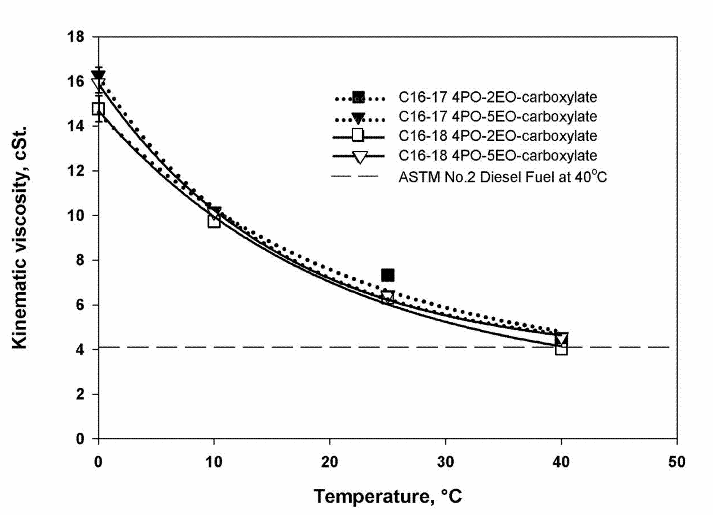
Figure 2 - 2: The kinematic viscosity of the systems of C16–17 4PO-2EO-carboxylate (Branched), C16–17 4PO-5EO-carboxylate (Branched), C16–18 4PO-2EO-carboxylate (Linear), and C16–18 4PO-5EO-carboxylate (Linear) with canola oil/diesel ratio at 50–50 at 0○C, 10○C, 25○C, and 40○C at 1 M. surfactant/EHOH concentration and surfactant/EHOH ratio of 1–16.

2.3.2 Effects of surfactant/cosurfactant ratios
Phase behavior study
Figure 2-3 represents the effect of surfactant/cosurfactant ratio of the systems of C16–18 4PO-2EO-carboxylate with canola oil at 25○C. The system of C16–18 4PO-2EO-carboxylate surfactant chosen above is evaluated at surfactant/1-Octanol ratios of 1–8, 1–16, and 1–32.
Figure 2 - 3: Comparison of the systems of C16–18 4PO-2EO-carboxylate at surfactant/1-Octanol ratio of 1–8, C16–18 4PO-2EO-carboxylate at surfactant/1- Octanol ratio of 1–16, and C16–18 4PO-2EO-carboxylate at surfactant/1-Octanol ratio of 1–32 at 25○C with canola oil.

The results show that the phase behaviors for all surfactant/ cosurfactant ratios are virtually the same. In this case, the concentration of cosurfactant is constant while the concentration of surfactant is changed for each ratio. The results show that although the concentration of surfactant is varied by a factor of 2, the amount of surfactant is varied by only 1–2% of total volume which does not change the miscibility of the microemulsion systems. Moreover, the effects of the amount of cosurfactant are able to overcome the effects of the amount of surfactant. Therefore, it is concluded that the phase behavior of microemulsion is not significantly affected by changing the ratio of surfactant to cosurfactant.
Since the surfactant/cosurfactant ratio of 1–32 is very difficult to prepare because of the small amount of surfactant in this system, the surfactant/cosurfactant ratio of 1–16 was chosen for further studies here due to cost-effective consideration and the limitation of surfactant preparation in our studies.
Viscosity study
Figure 2-4 shows the kinematic viscosity of the systems of C16–18 4PO-2EO-carboxylate at surfactant /EHOH ratio of 1–8, C16–18 4PO-2EO-carboxylate at surfactant/EHOH ratio of 1–16, and C16–18 4PO-2EO-carboxylate at surfactant/EHOH ratio of 1–32 with canola oil/diesel ratio at 50–50 at 0○C, 10○C, 25○C, and 40○C at 1M.surfactant/EHOH concentration. From Fig. 2-4, the kinematic viscosities of all four surfactant/cosurfactant systems are similar over the temperature range of at 0–40○C and at 40○C approach the standard viscosity of No. 2 diesel fuels. Therefore, these viscosity results support the conclusion above that the desirable ratio of surfactant/cosurfactant is the ratio of 1–16.

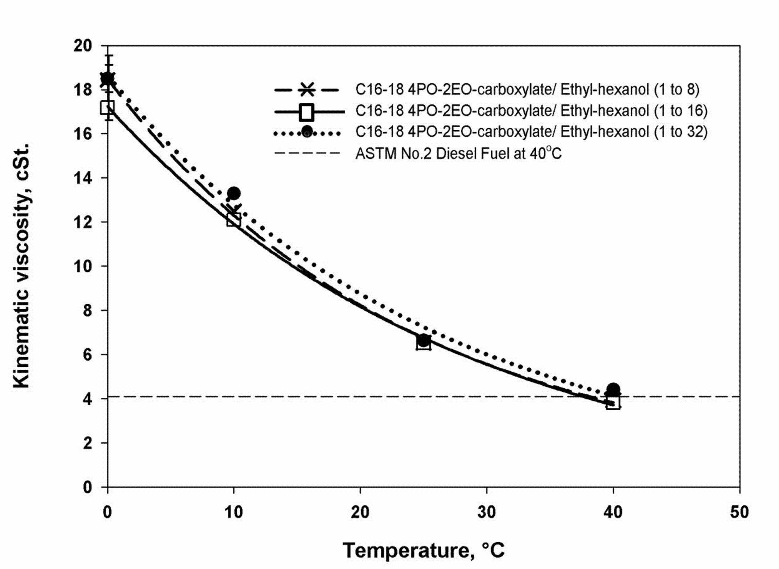
Figure 2 - 4: The kinematic viscosity of the systems of C16–18 4PO-2EO-carboxylate at surfactant /EHOH ratio of 1–8, C16–18 4PO-2EO-carboxylate at surfactant/EHOH ratio of 1–16, and C16–18 4PO-2EO-carboxylate at surfactant/EHOH ratio of 1–32 with canola oil/diesel ratio at 50–50 at 0○C, 10○C, 25○C, and 40○C at 1M. surfactant/EHOH concentration.

2.3.3 Effects of canola oil/diesel ratios
Phase behavior study
To study the effect of the canola oil/diesel ratio at 25○C, the C16–18 4PO–2EO-carboxylate at surfactant/1-Octanol ratio of 1–16 was selected as discussed above. In this study we adjusted the canola oil/diesel ratio to be as follows: 0–100, 25–75, 50–50, 75–25, and 100–0 as shown in Figure 2-5. From Figure 2-5, it can be seen that no surfactant was required to solubilize ethanol in 100% diesel since ethanol is completely miscible with diesel at 25○C. However, with increasing fraction of canola oil in the diesel, the amount of surfactant required to form a single phase microemulsion increased. This is because canola oil is immiscible with ethanol and requires a surfactant microemulsion system to achieve miscibility. This is consistent with the literature results which state that vegetable oils containing triglycerides are highly hydrophobic due to long and bulky alkyl chains of triglyceride structure [31, 32]. Further, micellar solubilization of triglycerides has been shown to be less efficient than other organic phases [33], again explaining the need for more surfactant.
Figure 2 - 5: Comparison of the systems of C16–18 4PO-2EO-carboxylate at surfactant/1-Octanol ratio of 1–16 at 25○C where the oil is canola oil/diesel ratio at 0–100, 25–75, 50–50, 75–25, and 100–0.
Viscosity study
The kinematic viscosity curve is plotted for the C16–18 4PO-2EO-carboxylate surfactant system at surfactant/EHOH ratio of 1–16 by varying canola oil/diesel fraction for 40○C is shown in Figure 2-6. With increasing diesel fraction, the kinematic viscosity is observed to decrease. In addition, the kinematic viscosity with diesel fraction over 50% of the oil phase meets the ASTM No. 2 diesel fuel criterion. Therefore, among all canola oil/diesel ratios, the system with ratio at 50–50 was the preferred system and it was chosen for further study.
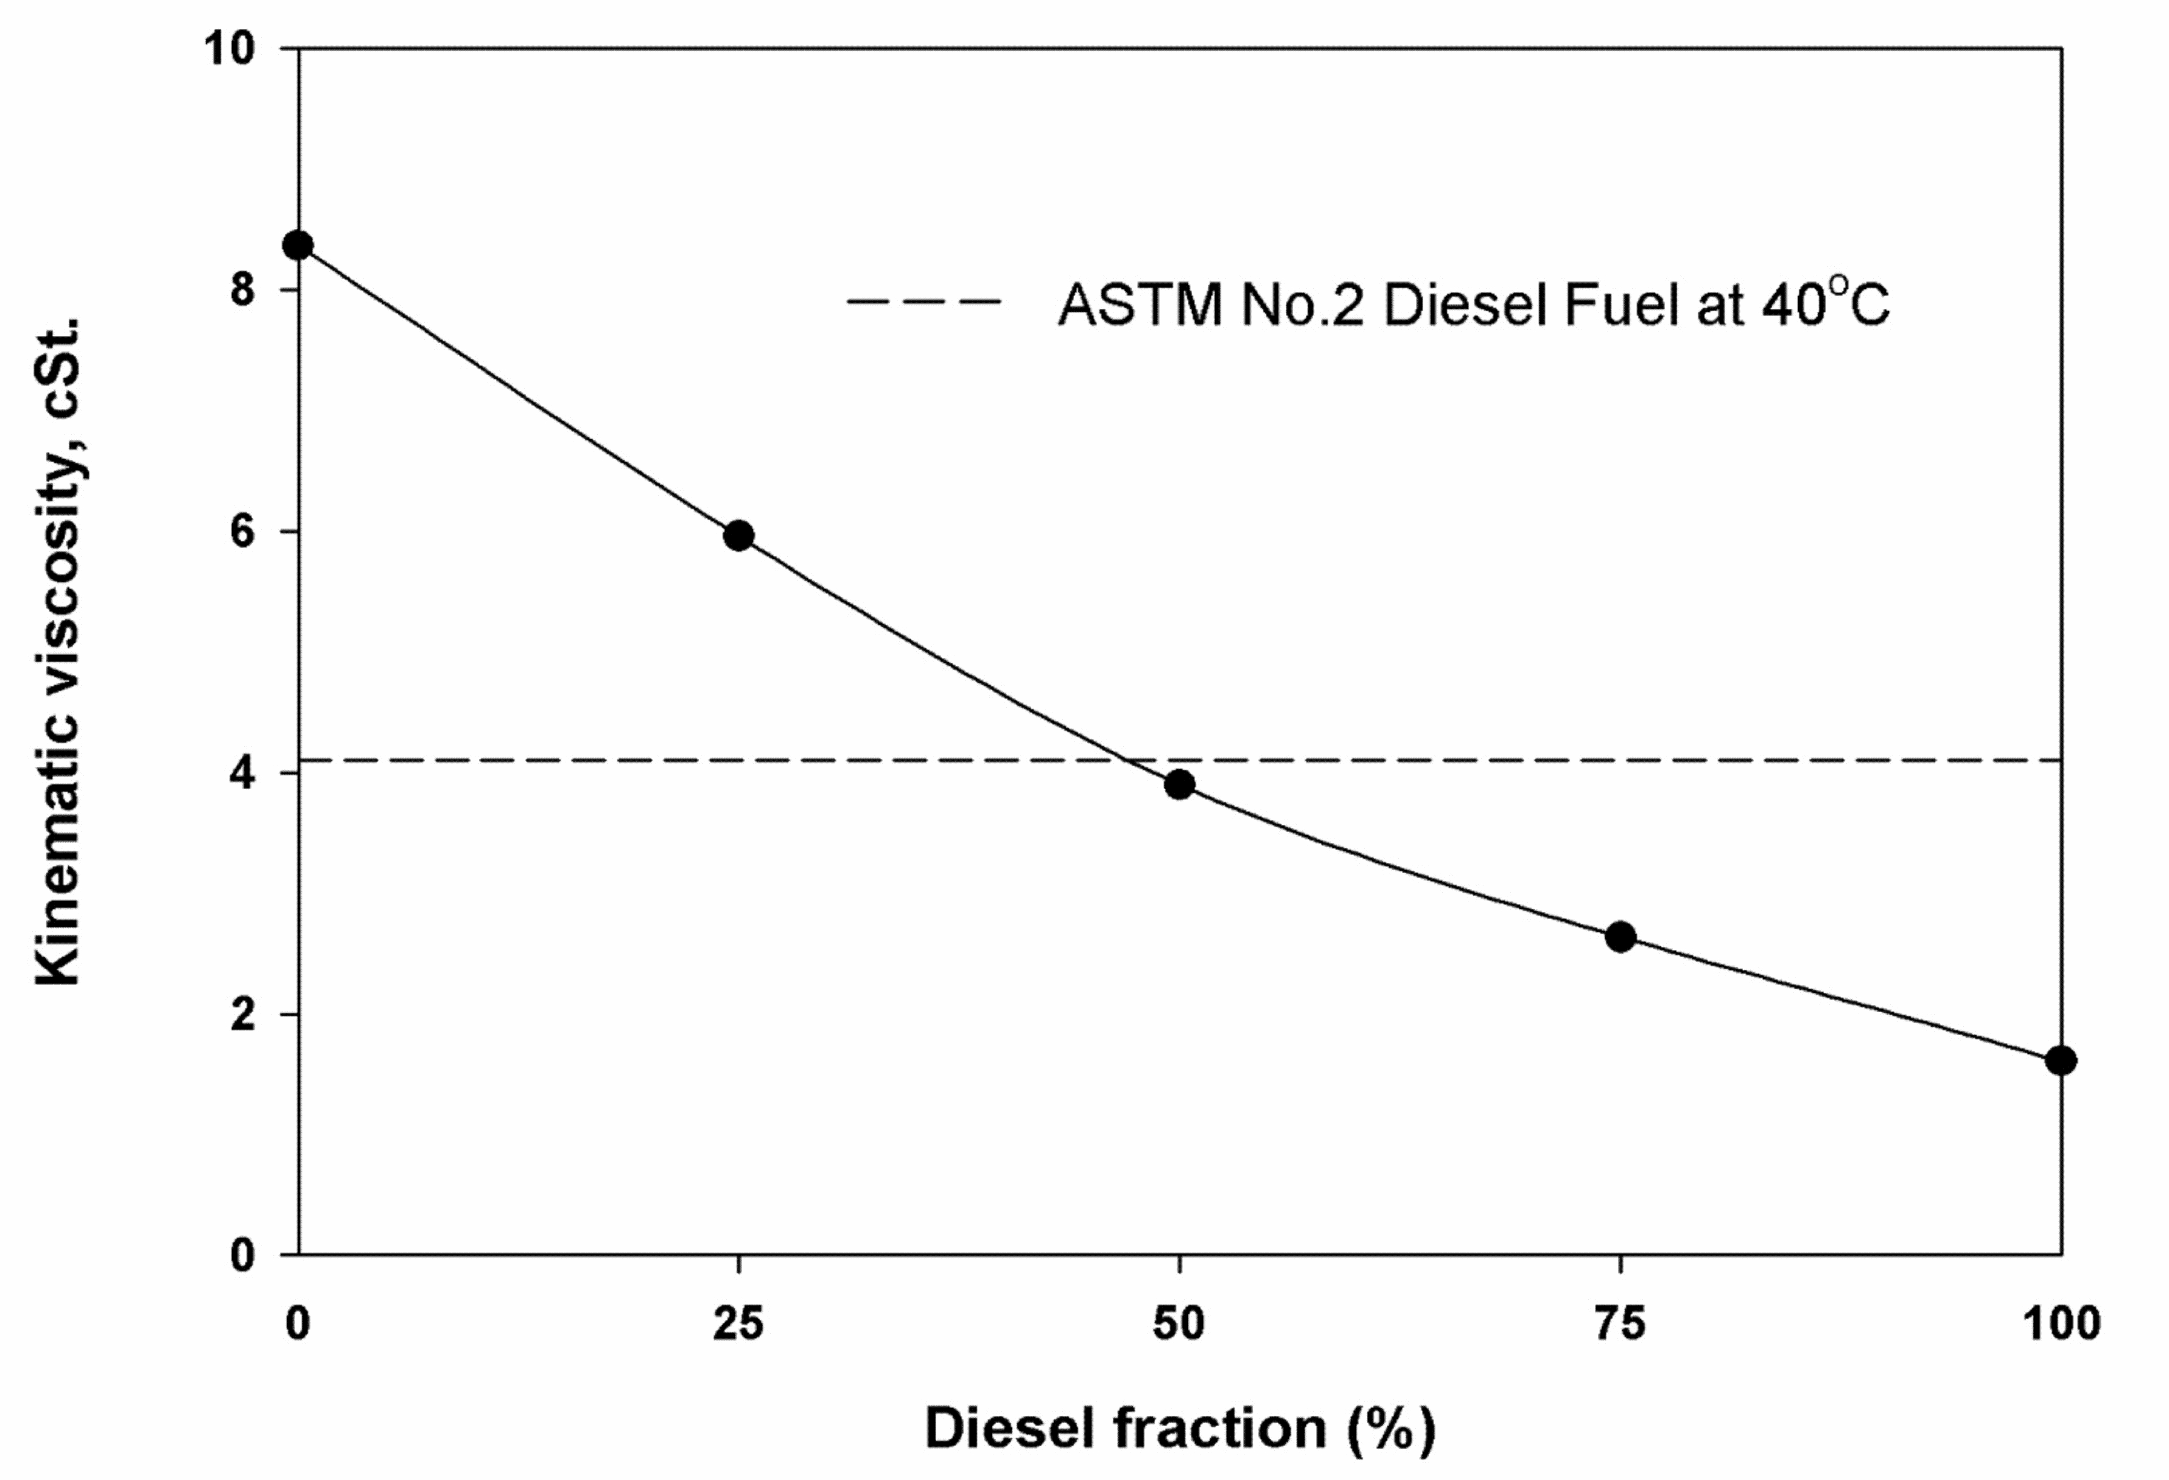
Figure 2 - 6: The kinematic viscosity of the systems of C16–18 4PO-2EO-carboxylate with canola oil/diesel ratio at 0–100, 25–75, 50–50, 75–25, and 100–0 of the oil phase at 40○C at 1 M. surfactant/EHOH concentration and surfactant/EHOH ratio of 1–16.

2.3.4 Effects of additives
Phase behavior study
Figure 2-7 shows a comparison of the systems of C16–18 4PO-2EO-carboxylate surfactant at 25○C with canola oil/diesel ratio at 50–50 with cosurfactants of 1-Octanol, EHOH, EHOH/ DTBP, and EHOH/ EGBE/ DTBP. Since the surfactant/cosurfactant ratio had negligible effect, the systems with EHOH/DTBP and EHOH/EGBE/DTBP were conducted at surfactant/cosurfactant ratio in the range between 1 to 32 and 1 to 16 to achieve DTBP at 1% of total fuel, which is the effective fraction for cetane enhancer [34]. In addition, EGBE was added with the EHOH/EGBE ratio at 8–1; at this ratio, the microemulsion fuel will not freeze at -23.3○C.
The results in Figure 2-7 show that the amount of surfactant required to form a single phase microemulsion is similar for all systems at low fractions of ethanol (up to 40%). The result of the system with ethyl-hexanol is not different from that of the system with 1-Octanol because ethyl-hexanol is the branching isomer of octanol and the number of carbon chain length of cosurfactant has more influence on the phase behavior than the branching of cosurfactant. Moreover, the results of the systems with DTBP and EGBE are similar to the systems without DTBP and EGBE due to the small amount of addition. However, DTBP and EGBE were added as anti-freezing agents and DTBP can also be used as cetane enhancer.
Viscosity study
The kinematic viscosity of the systems of C16–18 4PO-2EO-carboxylate surfactant at 1 M. surfactant/EHOH concentration with canola oil/diesel ratio at 50–50 with cosurfactants of 1-Octanol, EHOH, EHOH/ DTBP, and EHOH/EGBE/DTBP at 0○C, 10○C, 25○C, and 40○C is shown in Figure 2-8. The results indicates that the kinematic viscosities of all systems are quite similar except the system with EGBE. However, the kinematic viscosity of the system with EGBE is different only up to 10% from the other systems and is within ASTM No. 2 diesel fuel 40○C. Therefore, it can be concluded that the phase behavior and kinematic viscosity did not change with small amount of cetane enhancer or the anti-freezing agent addition.
Figure 2 - 7: Comparison of the systems of C16–18 4PO-2EO-carboxylate surfactant at 25○C with canola oil/diesel ratio at 50–50 with cosurfactants of 1-Octanol, EHOH, EHOH/DTBP, and EHOH/EGBE/DTBP.
Figure 2 - 8: The kinematic viscosity of the systems of C16–18 4PO-2EO-carboxylate surfactant at 1 M. surfactant/EHOH concentration with canola oil/diesel ratio at 50–50 with cosurfactants of 1-Octanol, EHOH, EHOH/DTBP, and EHOH/EGBE/DTBP at 0○C, 10○C, 25○C, and 40○C.

2.3.5 Effects of temperature
Phase behavior study
Figure 2-9 is a comparison of the systems of C16–18 4PO-2EO-carboxylate surfactant at surfactant/EHOH ratio of 1–16 with canola oil/diesel ratio at 50–50 at 0○C, 10○C, 25○C, and 40○C. The results in Figure 2-9 show that increasing temperature decreases the minimum amount of surfactant required to achieve single phase microemulsions. This is attributed to the fact that increasing temperature dehydrates ethylene oxide group causing the surfactant to become more hydrophobic, which is more miscible with oil phase and better able to ‘‘solubilize’’ the ethanol [35]. Moreover, ethanol becomes less hydrophilic and tends to solubilize more readily in the oil phase with increasing temperature [16]. Therefore, the systems at higher temperature required less surfactant than the system at lower temperature to achieve the single phase microemulsion.
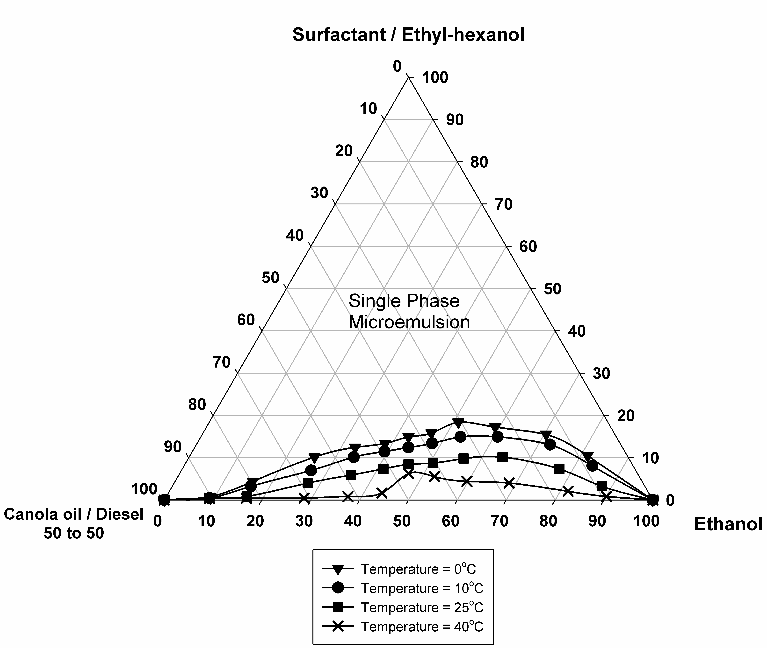
Figure 2 - 9: Comparison of the systems of C16–18 4PO-2EO-carboxylate surfactant at surfactant/EHOH ratio of 1–16 with canola oil/diesel ratio at 50–50 at 0○C, 10○C, 25○C, and 40○C.

Viscosity study
In Figures 2-2, 2-4 and 2-8, the kinematic viscosities were plotted as a function of temperature to illustrate the effects of surfactants, surfactant/cosurfactant ratios, and additives, respectively. The results also show that the kinematic viscosity decreases with increasing temperature for all systems as expected. These results are consistent with temperature dependency of viscosity. The Arrhenius model explains that viscosity has reverse proportion with temperature [36]. This is because increasing temperature increases energy to break down the adhesion forces between molecules, and thereby the viscosity of the fuels decreases as temperature increases [37].

2.4 Conclusions
This study has extended our previous work by exploring ways to further improve on the sulfate-based extended surfactant work from before [22]. First, unlike the sulfate-based extended surfactant case, no salt is required to formulate the reverse micellar microemulsion fuel of the carboxylate-based extended surfactants. In addition to salt-free formulation, microemulsion fuel of the carboxylate-based extended surfactants is an environmentally desirable fuel; since there is no sulfur content in the head group of surfactant, this formulation can prevent sulfur oxide (SOx) emissions. Furthermore, phase separation and precipitation were not observed for any of the systems studied. The optimum system from this study is the system of the carboxylate-based extended surfactant at surfactant/cosurfactant ratio of 1–16 with canola oil/diesel ratio of 50–50 and approximately 24% volume of ethanol. This fuel system is stable for a temperature range of 0–40○C and has a kinematic viscosity that meets the ASTM standard for No. 2 diesel (4.1 cSt) at 40○C. Moreover, for the ranges studied here varying the surfactant/cosurfactant ratio, cetane enhancers and anti-freezing agents did not affect the phase behavior and kinematic viscosity of microemulsion fuel. These results are thus useful information for the design of surfactant systems for further combustion study and use in diesel engines.

2.5 Acknowledgements
I would like to thank Charles Hammond, Sasol North America (Lake Charles, LA) for providing extended surfactant samples. In addition, I would like to acknowledge the undergraduate research assistant at the University of Oklahoma, Megan Salisbury. Financial support for this research was provided by Oklahoma Center for Advancement of Science and Technology (OCAST) and sponsors of the Institute for Applied Surfactant Research (IASR) at the University of Oklahoma.

References
[1] Seddon RH. Vegetable oils in commercial vehicles. Gas Oil Power 1942;37:136–41.
[2] Goering CE, Schwab AW, Daugherty J, Pryde H, Heakin J. Fuel properties of eleven vegetable oils. Trans ASAE 1982;25:1472–83.
[3] Pryor RW, Hanna MA, Schinstock JL, Bashford L. Soybean oil fuel in a small diesel engine. Trans ASAE 1982;26:333–8.
[4] Demirbas A, Kara H. New options for conversion of vegetable oils to alternative fuels. Energy Sources 2006;28:619–26.
[5] Dunn RO, Bagby MO. Low-temperature phase behavior of vegetable oil/cosolvent blends as alternative diesel fuel. JAOCS 2000;77(12):1315–23.
[6] Mondal P, Basu M, Balasubramanian N. Direct use of vegetable oil and animal fat as alternative fuel in internal combustion engine. Biofuels, Bioprod Bioref 2008;2:155–74.
[7] Avella F, Galtieri A, Fiumara A. Characteristics and utilization of vegetable derivatives as diesel fuels. La Rivista dei Combustibili 1992;46(6):181–8.
[8] Ma F, Hanna MA. Biodiesel production: a review. Bioresour Technol 1999;70:1–15.
[9] Neuma de Castro Dantas T, da Silva AC, Neto AAD. New microemulsion systems using diesel and vegetable oils. Fuel 2001;80:75–81.
[10] Singh P, Khurma J, Singh A. Coconut oil based hybrid fuels as alternative fuel for diesel engines. Am J Environ Sci 2010;6(1):69–75.
[11] Balat M. Modeling vegetable oil viscosity. Energy Souurces Part A 2008;30:1856–69.
[12] Ali Y, Hanna MA. Alternative diesel fuels from vegetable oils. Bioresource Technol 1994;50:153–63.
[13] Chang DYZ, Van Gerpen JH, Lee I, Johnson LA, Hammond EG, Marley SJ. Fuel properties and emissions of soybean oil esters as diesel fuel. JAOCS 1996;73:1549–55.
[14] Galan M, Bonet J, Sire R, Reneaume J, Ples_u AE. From residual to useful oil: revalorization of glycerine from the biodiesel synthesis. Bioresour Technol 2009;100:3775–8.
[15] Pagliaro M, Ciriminna R, Kimura H, Rossi M, Della Pina C. From glycerol to value-added products. Angew Chem Int Ed 2007;46:4434–40.
[16] Fernando S, Hanna M. Development of a novel biofuel blend using ethanol– biodiesel–diesel microemulsions: EB–diesel. Energy Fuels 2004;18:1695–703.
[17] Fernando S, Hanna M. Phase behavior of the ethanol–biodiesel–diesel microemulsion system. Trans ASAE 2005;48(3):903–8.
[18] Reddy MCS. HYBRID FUEL – FUEL OF THE FUTURE. Advances in energy research (AER – 2006). In: Proceedings of the 1st national conference on advances in energy research; 2006. p. 432–441.
[19] Pryde EH. Vegetable oils as fuel alternatives – symposium overview. JAOCS 1984;61(10):1609–10.
[20] Knothe G, Jurgen K, Van GJ. The biodiesel handbook. AOCS Press; 2005. p. 245– 258.
[21] Do LD, Singh V, Kibbey T, Gollahalli SR, Sabatini DA. Algae, canola, or palm oils– diesel microemulsion fuels: phase behaviors, viscosity and combustion properties. Int J Green Energy 2011;8:748–67.
[22] Do LD, Nguyen T, Sabatini DA. Reduction of viscosity and low temperature property of microemulsions fuel using extended-surfactants as an alternative diesel. In: The 99th AOCS annual meeting & expo. Seattle, WA; May 18–21, 2008.
[23] Schwab AW, Nielsen HC, Brooks DD, Pryde EH. Triglyceride/aqueous ethanol/1-butanol microemulsions. J Dispers Sci Technol 1983;4(1):1–17.
[24] Martino A, Kaler EW. Phase behavior and microstructure of nonaqueous microemuisions. J Phys Chem 1990;94:1627–31.
[25] Ploysrimongkol J, Tongcumpou C. Optimising palm oil-ethanol microemulsion for use as biofuel. J Sci Res Chula Unit 2009;34:29–35.
[26] Dorfler HD, Swaboda C. Some select problems of nonaqueous microemulsions–phase diagrams and variation of the composition in the quaternary and ternary systems. Colloid Polym Sci 1993;271:586–99.
[27] Schwab AW, Pryde EH. Triglyceride methanol microemulsions. J Dispers Sci Technol 1985;6(5):563–74.
[28] Sabatini DA. Emulsions and microemulsions. Short course in applied surfactant science and technology. 2006 [chapter II.A].
[29] Graciaa A. HLB, CMC, and phase behavior as related to hydrophobe branching. JCIS 1982;89:209–16.
[30] No. 2 Diesel Fuel MSDS. Tosco Refining Company [accessed October 2010]. <http://www.petrocard.com/Products/MSDS-ULS.pdf>.
[31] Witthayapanyanon A, Acosta EJ, Harwell JH, Sabatini DA. Formulation of ultralow interfacial tension systems using extended surfactants. JSD 2006;9:331–9.
[32] Do LD, Witthayapanyanon A, Harwell JH, Sabatini DA. Environmentally friendly vegetable oil microemulsions using extended surfactants and linkers. JSD 2009;12:91–9.
[33] Joubran RF, Cornell DG, Parris N. Microemulsions of triglyceride and non-ionic surfactant: effect of temperature and aqueous phase composition. Colloids Surf A 1993;80:153–60.
[34] Chen W, Shuai S, Wang J. Effect of the cetane number on the combustion and emissions of diesel engines by chemical kinetics modeling. Energy Fuels 2010;24:856–62.
[35] Velasquez J, Scorzza C, Vejar F, Forgiarini AM, Anton RE, Salager JL. Effect of temperature and other variables on the optimum formulation of anionic extended surfactant–alkane–brine systems. JSD 2010;13:69–73.
[36] Kerschbaum S, Rinke G. Measurement of the temperature dependent viscosity of biodiesel fuels. Fuel 2003;83:287–91.
[37] Bansal RK. Fluid mechanics and hydraulic machines. Laxmi publications; 2005. p. 1–6.
Chapter 3: Phase Behaviors of Vegetable Oil-Based Microemulsion Fuels: The Effects of Temperatures, Surfactants, Oils, and Water in Ethanol

Abstract
Vegetable oil-based microemulsification not only reduces the high viscosity of vegetable oils but also enhances the miscibility of polar and oil phases. In addition, vegetable oil-based microemulsion fuels produce lower pollutant emissions (e.g., soot, CO, and NO_{x}) compared to neat No.2 diesel. Since the stability of microemulsion fuels is temperature sensitive, the effect of temperature on the microemulsion phase behavior should be evaluated. The overall goal of this study is to formulate temperature-robust microemulsion fuels by studying the effect of temperature on phase behaviors of different systems of vegetable oil-based reverse micelle microemulsions. Our results demonstrate that, when using an alcohol ethoxylate surfactant as a renewable surfactant, it is possible to formulate microemulsion fuels with comparable properties to nonionic surfactant evaluated in previous studies. Further, mixtures of nonedible oil (algae mixed with castor) were found to have comparable properties to edible oil (canola) used to produce microemulsion fuels. Moreover, microemulsion fuels can be obtained using bioethanol although the bioethanol systems required a higher amount of surfactant than anhydrous ethanol. All microemulsion fuel systems were able to function at low temperature without phase separation. Thus, this study provides useful information and alternatives of optimum microemulsion fuel formulations based on surfactants and oils not evaluated in previous research and thus demonstrates the robustness of this microemulsion-based biofuel.

3.1 Introduction
Vegetable oils have been widely regarded as alternative fuel sources due to their nontoxic and renewable nature [1, 2, 3]. However, due to their high viscosity, vegetable oil-based biofuels require modification prior to use in diesel engines [1, 4, 5]. Vegetable oil-based microemulsification has been established as one method to reduce the high viscosity of vegetable oils. In addition, microemulsification can overcome immiscibility of polar and oil phases, enhance solubilization, and reduce pollutant emissions generated from fuels (e.g., enhancing soot and CO oxidation) [6].
Microemulsions are thermodynamically stable emulsions that contain water and oil domains separated by surfactant films [7]. Microemulsions can exist in four Winsor-Type microemulsion phases. Winsor Type I (oil-in-water or O/W) microemulsions are normal micelles in equilibrium with an excess oil phase, while Winsor Type II (water-in-oil or W/O) microemulsions are reverse micelles in equilibrium with an excess water phase. Winsor Type III microemulsions exhibit three phases, excess oil and water phases in equilibrium with a middle phase containing oil, water, and surfactant [8]. In a middle phase microemulsion, increasing surfactant concentration causes the volume of the middle phase to increase until all of the oil and water coexists in a Winsor Type IV single phase microemulsion [7]. In this study, microemulsion fuels are transparent and thermodynamically stable Winsor Type II single phase microemulsions; where the polar phase is solubilized in reverse micelles occurring in the oil (vegetable oil/diesel blended) phase [9].
It has been shown in the literature that microemulsion phase behavior and fuel properties can be temperature sensitive [6, 9]. Thus, to formulate microemulsion fuels stabilized over a wide range of temperatures (especially at low temperatures), it is important to study the effect of temperature on phase behaviors of microemulsion fuels in different systems.
Addition of ethoxylated (EO)/propoxylated (PO) groups to surfactants has been shown to enhance the solubilization capacity of microemulsions. For example, alcohol ethoxylate surfactants improve solubilization capacity of mixed surfactant systems [10] and alcohol ethoxylate linkers increase surfactant efficiency [11]. In fuel applications, oil soluble surfactants (such as nonionic surfactants) have been used to formulate reverse micelle microemulsions. Due to dehydration of ethylene oxide groups with increasing temperature, temperature dependence is an important consideration relative to stability of ethoxylated/propoxylated surfactant-based microemulsion fuels [6, 9]. In terms of renewable and sustainable materials, alcohol ethoxylate and sugar-based surfactants are of interest in microemulsion fuels because they are derived from renewable resources and do not have sulfur content which can be an air quality concern (a potential concern for sulfate- or sulfonate-based anionic surfactants). Since sugar-based surfactants do not contain ethyoxylate groups, it is expected that their solubility will be less temperature sensitive [12, 13]. From our previous study, salt-free microemulsion-fuel systems can be formulated by using oleyl alcohol and carboxylate-based extended surfactants [6, 9]. However, the temperature effect on phase behavior has been studied with only these specific systems. Moreover, there is limited research on the temperature sensitivity of microemulsion fuels using alcohol ethoxylate and sugar-based surfactants.
Among edible vegetable oils, canola oil has been studied for use in biofuel applications. For example, canola oil was found to have fatty composition which is more appropriate for biodiesel than the other vegetable oils because canola oil-based biodiesel has desirable combustion and flow properties, with a high cetane number [14]. Although canola oil has been shown to be viable for fuel applications, doing so provides a competition with edible oil products and food products. Therefore, nonedible oils, such as jatropha, rubber seed, and soapnut oils, have received increased interest due to their favorable fuel properties and fatty acid composition as compared to edible oils [15, 16]. This study focuses on castor and algae oils due to their promising properties for fuel applications. While castor oil has favorable fuel properties, including high flash point and lubricity, its high viscosity, associated with the high level of hydroxyl group in ricinoleic fatty acid, has limited its use to be a lubricant enhancer [17, 18]; lowering the viscosity of castor oil will improve its potential use in biofuel. Among algae species, microalgae is considered the preferred algae because it grows easily and rapidly while also providing high oil yield, high heating value, and high polyunsaturated fatty acids as compared to macroalage [19, 20]. However, due to the difficulty in obtaining microalgae oil, macroalgae oil is used in this study; it is assumed that results generated with macroalgae will provide insights that will be helpful to future work with microalgae. Table 3-1 shows the fatty acid compositions of canola [6], castor [18], and algae oils [6].
Table 3 - 1: Fatty acid compositions of canola, castor, and algae oils.
Fatty acid composition  (in %) | Canola oil | Castor oil | Algae oil
capric acid (C10:0) | - | - | 0.12
lauric acid (C12:0) | - | - | 0.25
myristic acid (C14:0) | 0.05 | - | 5.25
palmitic acid (C16:0) | 4.00 | 2.00 | 16.3
stearic acid (C18:0) | 2.65 | 2.00 | 0.59
oleic acid (C18:1) | 56.0 | 6.00 | 7.90
linoleic acid (C18:2) | 26.0 | 4.00 | 5.35
linolenic acid (C18:3) | 10.0 | - | 6.62
ricinoleic acid (C18:1(OH)) | - | 86.0 | -
othersª | 1.13 | - | 52.7
ª Polyunsaturated fatty acids with C ≥ 20

From recent studies, ethanol used as a polar phase to formulate microemulsion fuels is anhydrous ethanol that water content has been removed from the purification process [6, 9]. On the other hand, bioethanol (called hydrous ethanol), which is commonly derived from plants such as corn, wheat, sugar beet, straw, and wood, has about 2−10% water content [21]. Therefore, bioethanol has been proposed to be compared to ethanol for the effect of water content in this study. Ethanol and bioethanol can be used as a blend with petrol (e.g., gasoline and diesel) and/or an additive to diesel in engine both with and without modification as ethanol-diesel blends, or E-diesel [22, 23]. However, research on microemulsion fuels from bioethanol has not been conducted.
The overall goal of this study is to formulate temperature-robust microemulsion fuels by studying the effect of temperature on phase behaviors of different systems of vegetable oil-based reverse micelle microemulsions. The specific objectives are as follows:
1. To study the temperature effect on phase behavior of microemulsion fuels using single and mixed surfactant systems of renewable surfactants (alcohol ethoxylate, and sugar-based surfactants) compared to surfactants used in a previous study (fatty alcohol and carboxylate-based extended surfactants);
2. To compare the phase behaviors of microemulsion fuels from nonedible (algae and castor) oils to those from canola oil; and
3. To compare the phase behaviors of microemulsion fuels from ethanol and bioethanol.

3.2 Materials and methods

3.2.1 Materials
Three types of nonionic surfactants and one anionic carboxylate-based extended surfactant were used in this study. The anionic carboxylate-based extended surfactant studied (linear C16−18 4PO 2EO carboxylate surfactant) was provided by Sasol North American Inc. (Lake Charles, LA). The nonionic linear alkyl alcohol ethoxylate surfactants (linear C10−12 3EO OH, linear C12−16 1EO OH, and linear C12−16 3EO OH) were provided by Huntsman Corporation. Three sugar-based surfactants (Sorbitan monolaurate, Sorbitan monooleate, and Sorbitan trioleate) and oleyl alcohol were purchased from Sigma Aldrich.
Ethanol, ACS reagent grade with ≥99.5% purity (200 proof), was used as the polar liquid phase. 2-Ethyl-1-hexanol (≥99.6% purity) was used as the cosurfactant. Ethylene glycol butyl ether or EGBE (99% purity) and di-tert-butyl peroxide (Luperox®DI) or DTBP (98% purity) were used as an anti-freezing agent and a cetane enhancer, respectively. All of these chemicals were purchased from Sigma Aldrich. Bioethanol, hydrous ethanol which has 5% water content, was also considered as a polar liquid phase (obtained from Co-zfire company). A list of the surfactants and cosurfactants is shown in Table 3-2.
Table 3 - 2: Properties of studied surfactants and cosurfactantª.
Materials | Abbreviation | Commercial name | Molecular weight  (g/mole) | Density  (g/mL) | % active
Linear C₁₆₋₁₈ 4PO 2EO carboxylate | L168-42C | ALFOTERRA® 168-42C | 624 | 0.96 | 90.0
Linear C₁₀₋₁₂ 3EO OH | L12-3 | SURFONIC® L12-3 | 295 | 0.93 | ≥99.5
Linear C₁₂₋₁₆ 1EO OH | L16-1 | SURFONIC® L24-1 | 241 | 0.87 | ≥99.5
Linear C₁₂₋₁₆ 3EO OH | L16-3 | SURFONIC® L24-3 | 330 | 0.97 | ≥99.5
Sorbitan monolaurate | SML | Span® 20 | 347 | 1.03 | ≥99.5
Sorbitan monooleate | SMO | Span® 80 | 429 | 0.99 | ≥99.5
Sorbitan trioleate | STO | Span® 85 | 958 | 0.95 | ≥99.5
Oleyl alcohol | OA | Oleyl alcohol | 268 | 0.86 | 85.0
2-ethyl-hexanol | EHOH | Isooctanol | 130.2 | 0.833 | ≥99.6
ª Data provided by the manufacturer

Pure canola oil (Crisco, the J. M. Smucker Company, Orrville, OH) was purchased from Walmart. For nonedible oils, pure castor (NOW Solutions, NOW Foods, Bloomingdale, IL) and algae (Spa PANTRY, Universal Companies, Inc., Abingdon, VA) oils were obtained via online purchases. No.2 diesel fuel was purchased from a local gasoline station (Norman, OK).
The ratio of a vegetable oil/diesel blend was maintained at 50−50 in this research consistent with previous research that generated microemulsion fuels having comparable viscosity with diesel and biodiesel [9].

3.2.2 Methods
Microemulsions were prepared on a volumetric basis for the surfactants and the cosurfactant by mixing surfactant and cosurfactant at a fixed surfactant/cosurfactant molar ratio in a 15 mL glass vial. Two mL of the polar liquid phase and 5 mL of a vegetable oil/diesel blend were added into the surfactant−cosurfactant mixture to formulate reverse micelle microemulsions (the fraction of vegetable oil to diesel is 50 to 50). The surfactant−polar phase−oil mixtures were hand-shaken gently and placed into the constant temperature bath to allow the systems to reach equilibrium at the temperatures −5 to 40 °C. Samples required a few days to reach equilibration. Subsequently, phase behavior was determined by visual inspection with polarized light [24, 25, 26]. Microemulsion phases were confirmed by a red laser beam [27]. The minimum total concentration of surfactant and cosurfactant required to achieve transparent single phase microemulsions was recorded.

3.3 Results and discussion
Before presenting results of phase behavior studies, we will provide evidence to support the presence of microemulsion structures in our systems. Since all samples scattered (but not diffuse) a red laser beam, they have been confirmed that microemulsion phases have occurred. Moreover, the dynamic light scattering measurements were conducted in our previous research supporting that the reverse microemulsions were formed in similar systems, confirming the red laser beam method [6].
For phase behavior study, reverse micelle microemulsion fuels were formulated by solubilizing the polar liquid phase (ethanol or bioethanol) in reverse micelles (surfactant and cosurfactant) dispersed in the oil (vegetable oil/diesel blended) phase.

3.3.1 Phase Behavior Comparisons of the Systems with Renewable, Carboxylate-Based Extended, and Fatty Alcohol Surfactants
This section will consider the effects of surfactant type, ratio of mixed surfactant, and temperature on phase behavior and solubilization capacity of single and mixed surfactant systems.
Single Surfactant Systems
Figure 3-1 shows a graph of minimum total surfactant concentration to achieve a single phase microemulsion (minimum surfactant required to form a single phase microemulsion, S_{min}) plotted against temperature (°C) for the four single surfactant systems. This figure compares the systems of the carboxylate-based extended surfactant (L168-42C), linear alcohol ethoxylate surfactants (L16-1), sugar-based surfactants (SMO), and the fatty alcohol surfactant (OA) with ethanol and a canola oil/diesel blend at a ratio of 50−50. The results were observed that L12-3 and L16-3 had similar trends to L16-1 as well as SML and STO had similar trends to SMO. Thus, L12-3, L16-3, SML, and STO were not included in Figure 3-1. However, the results of all eight surfactants at 10 °C were summarized in Table 3-3 in order to show the comparisons for each category of surfactants.
The results from Figure 3-1 demonstrate that salt-free single phase microemulsion fuels can be formulated with all the surfactants used in this study even at low temperatures (minimum at 0 °C). This is in contrast to previous research which required 1 to 12.5% salt [28]. However, phase separation was observed at temperatures below 0 °C. This is because microemulsion fuels in this section were formulated without cosurfactants in order to clearly see the effect of surfactant type.
Table 3-3 summarizes the minimum total surfactant concentration to achieve a single phase microemulsion (Smin) for all eight single surfactant systems at 10 °C. The results in Figure 3-1 and Table 3-3 show that all sugar-based surfactants, except sorbitan monooleate (SMO), required higher concentrations than carboxylate-based extended, alcohol ethoxylate, and fatty alcohol surfactants to solubilize all components and produce a single phase microemulsion. This is probably because the molecular structure of the surfactant affects the surfactant packing density and molecular interaction [29]. More bulky structures of sugar-based surfactants lead to larger areas per headgroup and lower solubilization enhancement and thus a higher amount of surfactant required to solubilize the polar phase in the oil phase. As a result, sugar-based surfactants required a higher concentration than the other surfactants. Likewise, among three sugar-based surfactants, since a three branched oleyl group of sorbitan trioleate (STO) is more bulky than one oleyl group of SMO and one lauryl group of sorbitan monolaurate (SML), STO required the highest concentration to achieve a single phase microemulsion. Nonetheless, SMO was required in a lower amount than linear C16−18 4PO 2EO carboxylate (L168-42C), carboxylate-based extended surfactant, possibly due to the coiling effect of EO and PO groups in the extended surfactant. This is probably the explanation of significant increase of required surfactant with decreasing temperature from 25 to 10 °C (more temperature sensitive) due to lower solubilization capacity of the surfactant system at lower temperature.
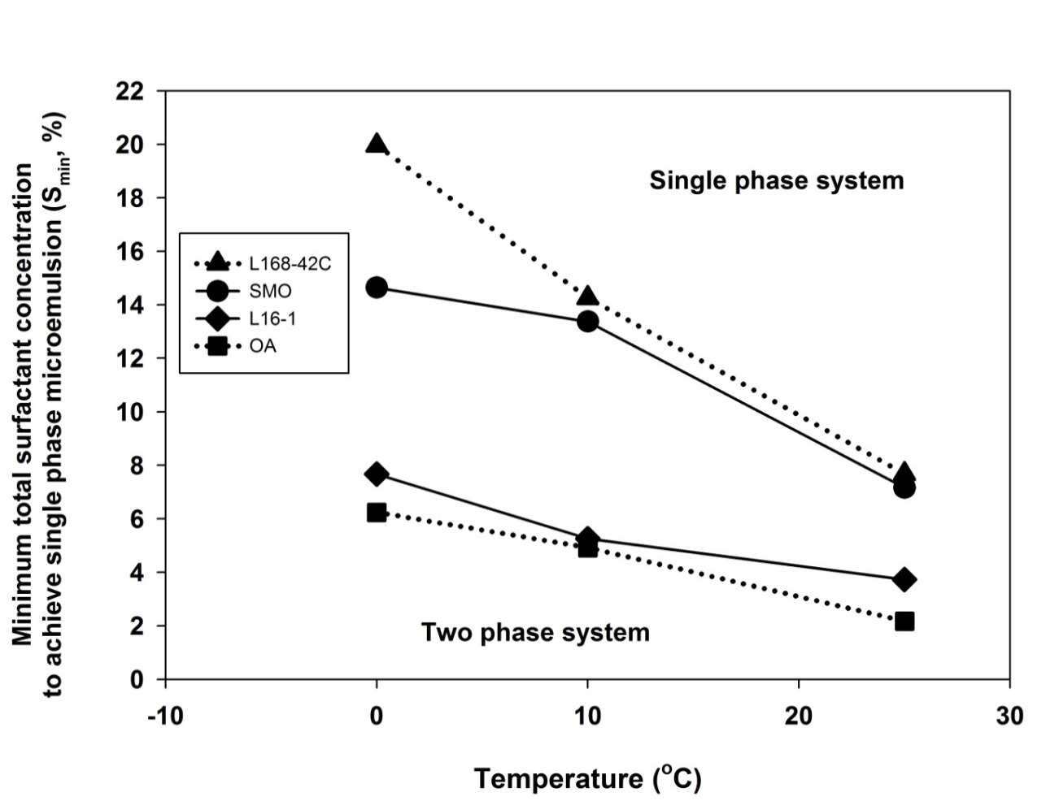
Figure 3 - 1: Minimum surfactant concentration to achieve single phase microemulsion versus temperature: comparison of the systems of carboxylate-based extended surfactant (Linear C16-18 4PO 2EO carboxylate, L168-42C), linear alcohol ethoxylate surfactants (Linear C₁₂₋₁₆ 1EO OH, L16-1), sugar-based surfactants (Sorbitan monooleate, SMO), and fatty alcohol surfactant (Oleyl alcohol, OA) with ethanol and canola oil/diesel blend at ratio of 50-50 at different temperatures.

Table 3 - 3: Comparisons of minimum total surfactant concentration to achieve a single phase microemulsion for all single surfactant systems at 10ºC.
Surfactant systems | Minimum total surfactant concentration to achieve single phase microemulsion at 10ºC (S_{min}, %)
Sorbitan trioleate (STO) | 25.1
Sorbitan monolaurate (SML) | 23.8
Linear C16,18-4PO-2EO-carboxylate | 14.3
Sorbitan monooleate (SMO) | 13.4
Linear C16,18-3EO (L16-3) | 8.1
Linear C12,16-3EO (L12-3) | 7.6
Linear C16,18-1EO (L16-1) | 5.3
Oleyl alcohol (OA) | 4.9

For alcohol ethoxylate surfactants, linear C12−16 1EO OH (L16-1) required the lowest concentration of surfactant because L16-1 has a longer alkyl group than linear C10−12 3EO OH (L12-3) and less EO groups than linear C12−16 3EO OH (L16-3). This is due to the fact that increasing alkyl groups and decreasing EO groups increase hydrophobicity of surfactants which can assist the polar phase to solubilize in the oil phase. Moreover, L16-1 has comparable solubilization capacity (1−2% different) to the fatty alcohol surfactant (OA) which is a nonionic surfactant used in the previous study. From these results, the next step will be to formulate mixed surfactant systems to reduce the amount of fatty alcohol surfactants by mixing with renewable surfactants and to determine whether sugar-based surfactants can reduce temperature sensitivity of mixed surfactant systems. SMO and L16-1 were selected as the maximum solubilization surfactants of sugar-based and alcohol ethoxylate surfactants, respectively, to study mixed surfactant systems with L168-42C and OA.
Mixed Surfactant Systems
a) Ratio of Surfactant Effect
This section was conducted to identify the optimum ratio of higher molecular weight (MW) surfactant to lower MW surfactant. The systems studied are the systems of SMO (MW = 429)/L16-1(MW = 241), SMO (MW = 429)/OA(MW = 268), L168−42C (MW = 624)/OA (MW = 268), and OA(MW = 268)/L16-1(MW = 241), with ethanol and a canola oil/diesel blend at a ratio of 50−50.
Evaluating the minimum total surfactant concentration at a ratio of the higher MW surfactant to the lower MW surfactant of 1−1, it was found that the OA/L16-1 system required the lowest total surfactant concentration to achieve a single phase microemulsion followed by SMO/OA, SMO/L16-1, and L168−42C/OA. All mixed surfactant systems show that as the lower MW surfactant portion increases, the total surfactant concentration needed for a single phase microemulsion decreases. However, when the ratio of the higher MW surfactant to the lower MW surfactant was changed from 1−8 to 1−12, the reduction of total surfactant concentration was not altered significantly. Therefore, the optimum ratio at 1−8 of the higher MW surfactant to the lower MW surfactant was chosen for the temperature effect.
b) Temperature Effect
Figure 3-2 shows a plot of Smin versus temperature for the following mixed surfactant systems: SMO/L16-1, SMO/OA, OA/L16-1, at a ratio of higher molecular weight (MW) surfactant to lower MW surfactant of 1−8 compared to single surfactant systems of OA. The reason that L168-42C/OA was not included in Figure 3-2 is because this section emphasized temperature sensitivity of mixed systems of sugar-based (SMO) and alcohol ethoxylate (L16-1) surfactants which also had comparable solubilization to OA.
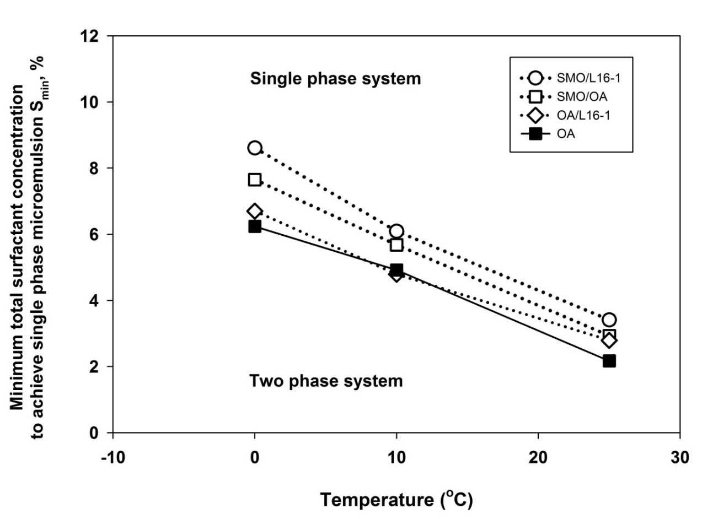
Figure 3 - 2: Minimum surfactant concentration to achieve single phase microemulsion versus temperature: comparison of the mixed surfactant systems of SMO/L16-1, SMO/OA, OA/L16-1 at ratio of 1-8 and single surfactant system of OA with ethanol and canola oil/diesel blend at ratio of 50-50 at different temperatures.

For the temperature effect, both Figures 3-1 and 3-2 show that increasing temperature required less total surfactant concentration for all systems to form a single phase microemulsion. This is attributed to the fact that since the EO groups dehydrate at higher temperature, and because of the lower hydrophilicity of ethanol with increasing temperature [9], it requires less amount of surfactant to solubilize ethanol in the oil phase. In addition, a single phase microemulsion at a certain amount of surfactant and specific temperature still remains single phase at higher temperatures for all formulations.
The results from Figure 3-1 show that SMO alone should not be used to replace OA to formulate microemulsion fuels since this system required the highest (7−15% at temperature 0°−25°C) total surfactant concentration to obtain a single phase microemulsion. Figure 3-2 shows mixed surfactant systems with SMO results in more than a 4% total surfactant concentration reduction versus SMO alone in Figure 3-1. From Figures 3-1 and 3-2, it also was found that between sugar-based (SMO) and alcohol ethoxylate (L16-1) surfactants, L16-1 single system and its mixed systems required comparable amounts of surfactant to OA single systems (1−2% different) while SMO systems did not. Furthermore, although sugar-based surfactants can slightly reduce temperature sensitivity as expected, it cannot assist the microemulsion fuels to achieve the temperature below 0 °C due to the bulky structure.

3.3.2 Phase Behavior Comparisons of the Systems with Different Additives
As mentioned above, to see the effect of surfactants clearly, cosurfactants were not used in a previous section. Therefore, cosurfactant and additives are introduced in this section in order to determine whether the formulations can achieve single phase microemulsions at the temperature below 0 °C.
In this section, ethyl-hexanol (EHOH) is considered as cosurfactant. Di-tert-butyl peroxide (DTBP) and ethylene glycol butyl ether (EGBE) are selected as additional additives because DTBP and EGBE were used as cetane-enhancer and anti-freezing agent in the previous study [9], respectively. Figure 3-3 shows the S_{min} versus temperature for the systems OA, OA/EHOH, OA/EHOH/DTBP, and OA/EHOH/DTBP/EGBE at a surfactant/EHOH ratio of 1−16. From Figure 3-3, the results show that when cosurfactant and additives are added into formulations, microemulsion fuels can achieve at temperatures below 0 °C, and the minimum temperature is −5 °C for all systems. However, although there are some differences (1−2% difference) of minimum total surfactant/cosurfactant concentration among the systems with cosurfactant and additives at below 0 °C, the effect was relatively small; it was thus observed that cetane enhancer and anti-freezing agent can both improve fuel properties and allow microemulsion fuels to achieve temperature below 0 °C.
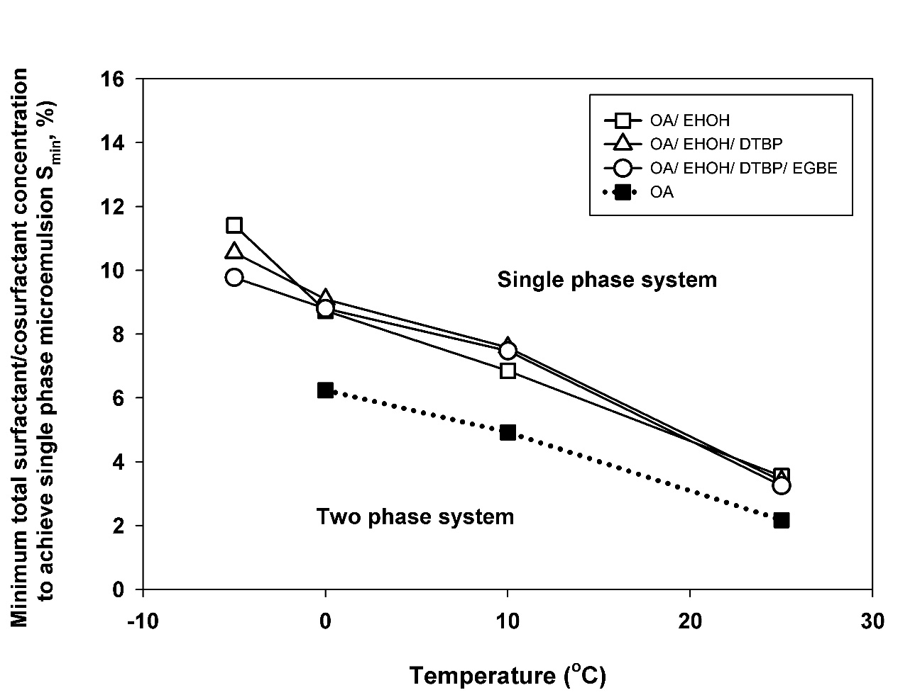
Figure 3 - 3: Minimum surfactant/cosurfactant concentration to achieve single phase microemulsion versus temperature: comparison of the surfactant systems of OA, OA/EHOH, OA/EHOH/DTBP, and OA/EHOH/DTBP/EGBE at surfactant/EHOH ratio of 1–16 with ethanol and canola oil/diesel blend at ratio of 50-50 at different temperatures.

3.3.3 Phase Behavior Comparisons of the Systems with Canola, Algae, and Castor Oils
From the previous study [6], it was noted that microemulsion fuels can be formulated with edible vegetable oils such as canola and palm oils. Although phase behavior of an algae oil system has been studied, to our knowledge castor oil has not yet been used as a nonedible vegetable oil to formulate microemulsion fuels. This section focuses on the microemulsion fuel systems using nonedible vegetable (algae, castor, and algae/castor) oils compared to edible (canola) oil.
Figure 3-4 shows plots of minimum total surfactant/cosurfactant concentration to achieve a single phase microemulsion versus temperature with the surfactant systems of OA at a surfactant/EHOH ratio of 1−16 with ethanol in canola oil/diesel, algae oil/diesel, castor oil/diesel, and algae and castor oils/diesel blends at a ratio of 50−50 at different temperatures. As shown in Figure 3-4, ethanol is completely miscible in a castor oil/diesel (50−50) blend at a temperature of 0 °C and above, so surfactant was not required to formulate microemulsion fuels. However, the systems of castor oil mixed with algae oil required surfactants to form a single phase microemulsion. It was found that the highest surfactant levels were required for systems with an algae oil/diesel blend. Due to the distribution of fatty acid compositions of these oils (see Table 3-1), with increasing proportion of polyunsaturated fatty acids in algae oil than in the other oils, algae oil has more hydrophobicity, and it should be more difficult to solubilize ethanol in algae oil [30]. As a result, more surfactant was used in the algae oil/diesel blend than in the other oil blends to achieve a single phase microemulsion. In addition, it was interesting to find that phase behaviors of OA systems in an algae and castor (1−1) oils/diesel blend are quite similar to those in a canola oil/diesel blend.
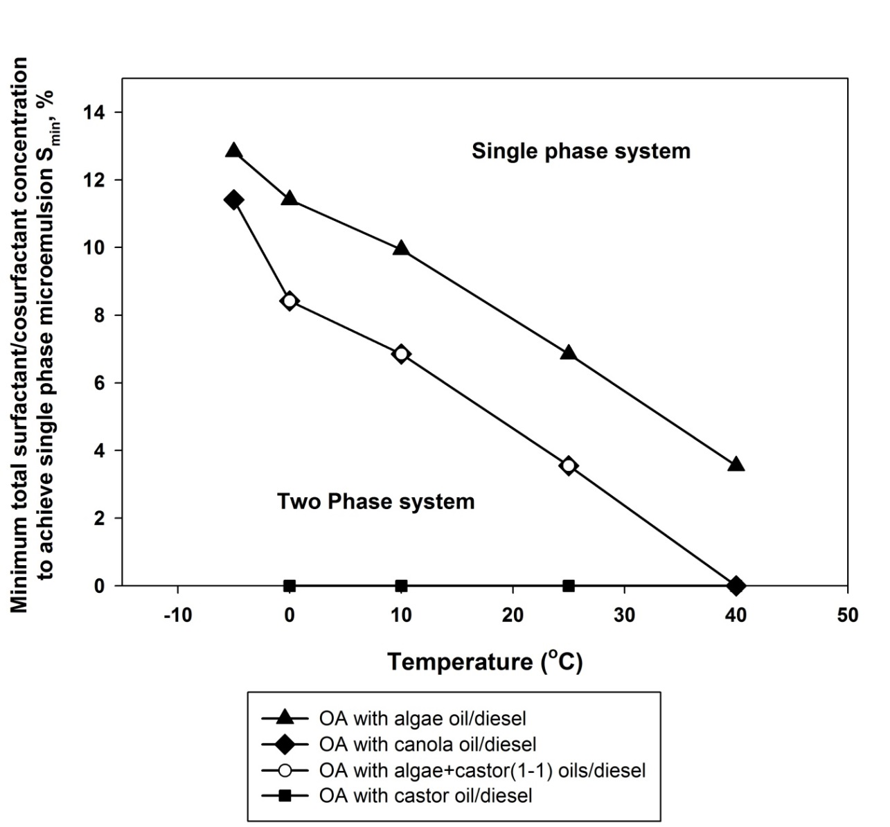
Figure 3 - 4: Minimum surfactant/cosurfactant concentration to achieve single phase microemulsion versus temperature: comparison of the surfactant systems of OA at surfactant/EHOH ratio of 1–16 with ethanol in different four vegetable oil/diesel blends at ratio of 50-50 at different temperatures.

Relative to the temperature effect, decreasing temperature required more surfactant to produce a single phase microemulsion as expected and explained in the Temperature Effect section. Moreover, the results show that the OA systems were able to achieve a single phase microemulsion below 0 °C (minimum at −5 °C) in a canola oil/diesel blend (consistent with the result in section 3.3.2) and an algae oil/diesel blend without phase separation. Although phase behaviors of the systems in a canola oil/diesel blend and the systems in an algae and castor (1−1) oils/diesel blend are quite similar, the systems in a canola oil/diesel blend can achieve a lower temperature than that in an algae and castor oils/diesel blend. This may result from the fatty acid compositions of oils. The major fatty acid composition of canola oil is oleic acid which has alkyl groups similar to those in oley alcohol (OA); consequently, they do not tend to separate from each other when the temperature decreases. For algae oil, microemulsion fuels can also achieve the temperature below 0 °C in an algae oil/diesel blend. As expected, a higher unsaturated fatty acid composition leads to a lower melting point of vegetable oils [30].
From this section, it was observed that microemulsion fuels from nonedible (algae and castor/diesel) oils are comparable to those from edible (canola) oil at the temperature of 0 °C and above. In addition, fatty acid compositions in different oils appear to have a significant influence on phase behavior and solubilization capacity.

3.3.4 Phase Behavior Comparisons of the Systems with Ethanol and the Systems with Bioethanol
Since the ethanol used was anhydrous ethanol with more than 99.5% purity (200 proof), it was not considered a sustainable material to produce biofuels because it came from petroleum sources and/or required abundant energy to purify. Subsequently, bioethanol, with 5% water content (assuming that it is average water content in ethanol derived from nature), was introduced to formulate microemulsion fuels. This section compared phase behaviors of microemulsion fuels from bioethanol to those from ethanol.
Phase behavior comparisons between microemulsion fuels from bioethanol and from ethanol are shown in Figure 3-5. Figure 3-5 shows plots of S_{min} versus temperature for the surfactant systems of OA at a surfactant/EHOH ratio of 1−16 with ethanol in canola oil/diesel and bioethanol in canola oil/diesel, castor oil/diesel, and algae and castor oils/diesel blends at a ratio of 50−50 at different temperatures. The systems with bioethanol in algae oil/diesel were not included in Figure 3-5 because it required more than 25% total surfactant/cosurfactant concentration to achieve a single phase microemulsion.
Although microemulsion fuel had not been formulated with ethanol in castor oil/diesel as mentioned in section 3.3.3, they were able to be formulated with bioethanol as shown in Figure 3-5. The results from Figure 3-4 and Figure 3-5 display that the systems with bioethanol required a higher total surfactant/cosurfactant concentration than the systems with ethanol required; which is a 2% difference for castor oil/diesel, 8% difference for algae and castor oils/diesel, and 12% difference for canola oil/diesel at 25 °C. This indicated that the bioethanol addition had more influences on the systems without castor oil than the systems with castor oil. In addition, the minimum temperatures that microemulsion fuels can be formulated with bioethanol without phase separation are 0 °C in castor oil/diesel, 10 °C in algae and castor oils/diesel, and 25°C in canola oil/diesel. This result observed that a more castor oil fraction in the blend, lower minimum temperature to produce single phase microemulsion fuels. These trends probably result from the major fatty acid composition in castor oil, ricinoleic acid, which has hydroxyl as a functional group. Thus, castor oil is more compatible with bioethanol (has more interaction between the hydrogen bond of water and hydroxyl group) than with ethanol, and water in bioethanol was also solubilized in the oil phase.
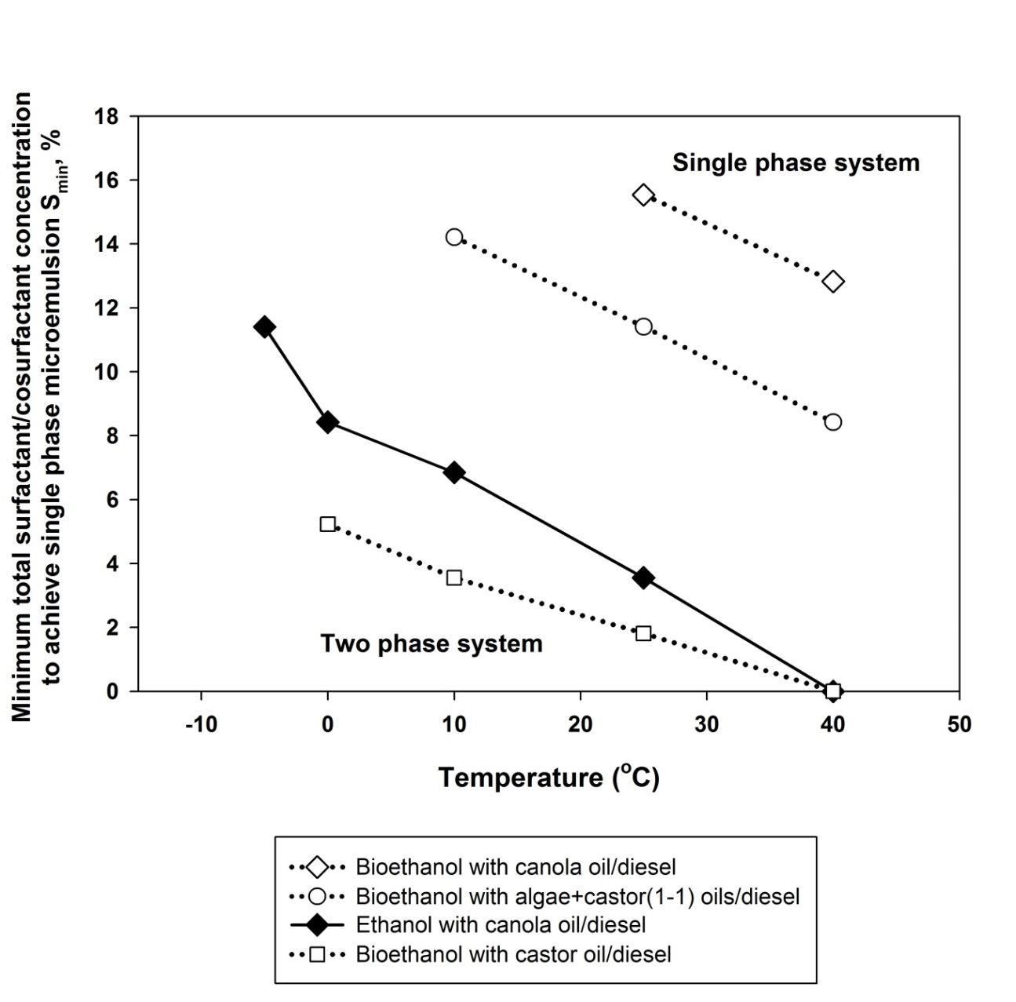
Figure 3 - 5: Minimum surfactant/cosurfactant concentration to achieve single phase microemulsion versus temperature: comparison of the surfactant systems of OA at surfactant/EHOH ratio of 1–16 with ethanol in canola oil/diesel and bioethanol in canola oil/diesel, castor oil/diesel, and algae and castor oils/diesel blends at ratio of 50-50 at different temperatures.

3.3.5 Other Fuel Properties and Cost Assessment
Apart from phase study of microemulsion fuels, the kinematic viscosity, energy density, and cost estimation of selected formulations have been reported.
The dynamic viscosity was measured by A Brookfield LV III + viscometer at the desired temperature. Then, the kinematic viscosity was calculated by dividing the dynamic viscosity with microemulsion fuel density. Table 3-4 shows the kinematic viscosity comparisons of the systems of OA/EHOH, OA/EHOH/DTBP, and OA/EHOH/DTBP/EGBE with ethanol and a canola oil/diesel blend at a ratio of 50−50 and OA/EHOH with ethanol and algae and castor oils/diesel blend compared with those of No.2 diesel and canola oil biodiesel at temperatures 0° to 40 °C. The first three systems were selected since they retained the microemulsion phase at temperatures below 0 °C. Considering these three systems, it was found that cetane number and anti-freezing agent addition resulted in the 5% increasing of kinematic viscosity. Although the kinematic viscosities of all these systems are higher than that of No.2 diesel, they are lower than that of canola biodiesel, and they can meet the standard specification for diesel fuel (ASTM D 445) at 40 °C (1.9−4.1 mm²/s). Furthermore, the system with algae and castor oil/diesel blend was chosen in case of using nonedible vegetable oils to replace edible vegetable oils; although its viscosity is higher than ASTM No.2 diesel, it is similar to canola biodiesel and only slightly higher than the above referenced standard.
The lower heating value was estimated as the energy density of microemulsion fuels by using Mendeleyev’s formula. It was found that the lower heating values of all microemulsion fuels were not significantly different, which were in a range of 35−38 MJ/kg, similar to that of canola biodiesel (37.4 MJ/kg), and slightly less than that of No.2 diesel (42.6 MJ/kg) [6].

Table 3 - 4: Kinematic viscosity comparisons of selected microemulsion fuels at temperature 0º to 40ºC.
Surfactant systems | Polar phase | Oil phase | Kinematic viscosity (mm²/s)
Surfactant systems | Polar phase | Oil phase | 0ºC |  |  | 10ºC | 25ºC |  |  | 40ºC
OA/EHOH | ethanol | canola oil/diesel | 14.2±0.1 | 9.1±0.2 |  |  |  | 6.2±0.1 |  | 3.9±0.1
OA/EHOH/DTBP | ethanol | canola oil/diesel | 14.4±0.2 | 9.7±0.1 |  |  |  | 6.4±0.1 |  | 4.1±0.1
OA/EHOH/DTBP/EGBE | ethanol | canola oil/diesel | 14.4±0.2 | 9.6±0.1 |  |  |  | 6.4±0.1 |  | 4.1±0.1
OA/EHOH | ethanol | algae and castor oils/diesel | 16.7±0.2 |  | 11.8±0.2 |  |  |  | 7.2±0.1 | 4.6±0.1
No.2 diesel | - | - | 7.0±0.1 |  | 4.8±0.1 |  |  |  | 3.6±0.2 | 2.5±0.1
Canola biodiesel | - | - | 14.6±0.1 |  | 10.1±0.1 |  |  |  | 6.8±0.2 | 4.5±0.1

The example of microemulsion fuel cost estimation calculated from the current price of raw material cost (September 2013) is shown in Table 3-5. The estimated cost of selected microemulsion fuel is 4.58 USD per gallon. At the equivalent heating value to No.2 diesel, the price of microemulsion fuel is 5.13 USD per gallon, while the local price of No.2 diesel is 3.98 USD per gallon. From Table 3-5, the major raw material cost of microemulsion fuel is the price of canola oil which increases from 3.05 USD per gallon in 2010 to 4.26 USD per gallon in 2013 due to the competitive price of canola oil in the food market. Future research should look for ways to further reduce the cost of these microemulsion fuels.
Table 3 - 5: Cost estimation of the selected microemulsion fuel.
Materials | Composition in 1 L (vol%) | USD/gal | USD/L | Breakdown cost in 1 L of microemulsion fuel (USD)
Canolaª | 29.8 | 4.26 | 1.13 | 0.34
No.2 diesel^{b} | 29.8 | 3.98 | 1.05 | 0.31
Ethanol^{c} | 23.9 | 1.78 | 0.47 | 0.11
OA^{c} | 2.10 | 2.86 | 0.76 | 0.16
EHOH^{c} | 14.4 | 7.63 | 2.02 | 0.29
 | MF1 cost per liter (USD) |  |  | 1.21
 | MF1 cost per gallon (USD) |  |  | 4.58
ª Canola Council of Canada (http://www.canolacouncil.org/canolaprices.aspx);
^{b} Oklahoma local price;
^{c} Alibaba global trade market for bulk quantities (http://www.alibaba.com).

3.4 Conclusions
In this study, various systems of vegetable oil-based microemulsion fuels have been studied to obtain the optimum formulations which can achieve a low temperature (below 0°C) with sustainable, environment-benign, and cost-effective considerations. From all findings in this study, they can be summarized as follows:
• Salt-free microemulsion fuels can be formulated by using single and mixed surfactants even without cosurfactants. However, the systems with cosurfactants can avoid phase separation at lower temperatures (below 0 °C).
• Among all surfactants in this study, oleyl alcohol (nonionic surfactant) has the highest solubilization capacity (required the lowest surfactant concentration to achieve single phase microemulsion fuels).
• Linear alcohol ethoxylate surfactant (L16-1) can be used as a renewable surfactant in both single and mixed systems to formulate microemulsion fuels which are comparable to microemulsion fuels using oleyl alcohol.
• Castor oil/diesel and algae oil/diesel cannot be used to formulated microemulsion fuels with ethanol and bioethanol, resepectively. However, microemulsion fuels can be obtained with both ethanol and bioethanol in algae and castor oils/diesel.
• Nonedible (algae mixed with castor) oil systems are comparable to edible (canola) oil systems at 0 °C and above with ethanol and are even better at 25 °C with bioethanol.
• Decreasing temperature required higher amounts of surfactants and/or cosurfactants. The lowest temperatures reached in this study are −5 and 0 °C in the cases of with and without cosurfactants, respectively.
• Cetane enhancer and anti-freezing agent can improve both fuel properties and allow microemulsion fuels to achieve temperature below 0 °C.
• From all evaluated formulations, the systems formulated from OA/EHOH with ethanol in a canola oil/diesel blend with and without additives can achieve a temperature below 0 °C, meet the kinematic viscosity standard of No.2 diesel, and have the energy density comparable to No.2 diesel.
The results of this study thus show that microemulsion fuels require optimum formulation for each oil-based system. For example, at ambient temperature, renewable surfactants and bioethanol should be taken into account to produce sustainable microemulsion fuels. Surfactants and vegetable oils with low melting points should be taken into consideration to produce microemulsion fuels in cold region countries. In addition, if the competition of price with the food market is considered, the formulations with nonedible vegetable oils should be developed and used as alternatives.

3.5 Acknowledgements
I would like to thank Sasol North America (Lake Charles, LA) for providing the extended surfactant sample and Huntsman Corporation for providing the alcohol ethoxylate surfactant sample. In addition, I would like to acknowledge the undergraduate research assistant at the University of Oklahoma, Ethan Rice. Financial support for this research was provided by Oklahoma Center for Advancement of Science and Technology (OCAST) and sponsors of the Institute for Applied Surfactant Research (IASR) at the University of Oklahoma.

References
[1] Goering CE, Schwab AW, Daugherty J, Pryde H, Heakin J. Fuel properties of eleven vegetable oils. Trans Am Soc Agric Eng 1982;25:1472–83.
[2] Pryor RW, Hanna MA, Schinstock JL, Bashford L. Soybean oil fuel in a small diesel engine. Trans Am Soc Agric Eng 1982;26:333–8.
[3] Demirbaş A, Kara H. New options for conversion of vegetable oils to alternative fuels. Energy Sources, Part A Recover Util Environ Eff 2006;28:619–26.
[4] Dunn RO, Bagby MO. Low-temperature phase behavior of vegetable oill co-solvent blends as alternative diesel fuel. J Am Oil Chem Soc 2000;77:1315–23.
[5] Mondal P, Basu M, Balasubramanian N. Direct use of vegetable oil and animal fat as alternative fuel in internal combustion engine. biofuels, Bioprod Biorefining 2008;2:155–74.
[6] Do LD, Singh V, Chen L, Kibbey TCG, Gollahalli SR, Sabatini DA. Algae , canola , or palm oils — diesel microemulsion fuels: phase behaviors, viscosity, and combustion properties. Int J Green Energy 2011;8:748–67.
[7] Rosen MJ. Surfactants and interfacial phenomena. 2nd ed. New York: Wiley InterScience; 1989.
[8] Bourrel M, Schechter RS. Microemulsions and related systems: formulation, solvency, and physical properties. New York: Marcel Dekker; 1988.
[9] Attaphong C, Do L, Sabatini DA. Vegetable oil-based microemulsions using carboxylate-based extended surfactants and their potential as an alternative renewable biofuel. Fuel 2012;94:606–13.
[10] Marangoni DG, Kwak JCT. Solubilization of alcohols and ethoxylated alcohols in anionic and cationic micelles. Langmuir 1991;7:2083–8.
[11] Frank C, Frielinghaus H, Allgaier J, Richter D. Hydrophilic alcohol ethoxylates as efficiency boosters for microemulsions. Langmuir 2008;24:6036–43.
[12] Pes MA, Aramaki K, Nakamura N, Kunieda H. Temperature-insensitive microemulsions in a sucrose monoalkanoate system. J Colloid Interface Sci 1996;178:666–72.
[13] Fanun M. Microemulsions formation on water/nonionic surfactant/peppermint oil mixtures. J Dispers Sci Technol 2009;30:399–405.
[14] Przybylski R, Mag T, Eskin N, McDonald B. Canola oil. In: Shahidi F, editor. Bailey’s Ind. Oil Fat Prod., A John Wiley & Sons, Inc.; 2005, p. 61–5.
[15] Azócar L, Ciudad G, Heipieper HJ, Navia R. Biotechnological processes for biodiesel production using alternative oils. Appl Microbiol Biotechnol 2010;88:621–36.
[16] Kafuku G, Mbarawa M. Effects of biodiesel blending with fossil fuel on flow properties of biodiesel produced from non-edible oils. Int J Green Energy 2010;7:434–44.
[17] Goodrum JW, Geller DP. Influence of fatty acid methyl esters from hydroxylated vegetable oils on diesel fuel lubricity. Bioresour Technol 2005;96:851–5.
[18] Mannekote JK, Kailas S V. Influence of chemical structure on the boundary lubrication properties of vegetable oils. Proc ASME 2010 10th Bienn Conf Eng Syst Des Anal 2010;1:633–7.
[19] Hossain ABMS, Salleh A. Biodiesel fuel production from algae as renewable energy. Am J Biochem Biotechnol 2008;4:250–4.
[20] Demirbaş A. Production of biodiesel from algae oils. Energy Sources, Part A Recover Util Environ Eff 2009;31:163–8.
[21] Zuurbier P, van de Vooren J. Sugarcane Ethanol: Contributions to climate change mitigation and the enviroment. Wageningen Academic; 2008.
[22] Demirbas A. Producing and using bioethanol as an automotive fuel. Energy Sources, Part B Econ Planning, Policy 2007;2:391–401.
[23] Demirbas A. The Importance of bioethanol and biodiesel from biomass. Energy Sources, Part B Econ Planning, Policy 2008;3:177–85.
[24] Schwab AW, Nielsen HC, Brooks DD, Pryde EH. Triglyceride / aqueous ethanol / 1-butanol microemulsions. J Dispers Sci Technol 1983;4:37–41.
[25] Martino A, Kaler EW. Phase behavior and microstructure of nonaqueous microemuisions. J Phys Chem 1990;94:1627–31.
[26] Fernando S, Hanna M. Phase behavior of the ethanol-biodiesel-diesel microemulsion system. Trans Am Soc Agric Eng 2005;48:903–908.
[27] Xuan X-Y, Cheng Y-L, Acosta E. Lecithin-linker microemulsion gelatin gels for extended drug delivery. Pharmaceutics 2012;4:104–29.
[28] Do LD, Nguyen T, Sabatini DA. Reduction of viscosity and low temperature property of microemulsions fuel using extended-surfactants as an alternative diesel. 99th AOCS Annu Meet Expo Seattle, WA; May 18–21, 2008.
[29] Patrick HN, Warr GG. Self-assembly structures of nonionic surfactants at graphite – solution interfaces . 2 . effect of polydispersity and alkyl chain branching. Colloids Surfaces A Physicochem Eng Asp 2000;162:149–57.
[30] Phan TT, Harwell JH, Sabatini D a. Effects of triglyceride molecular structure on optimum formulation of surfactant-oil-water systems. J Surfactants Deterg 2009;13:189–94.

Chapter 4: Phase Behaviors, Fuel Properties, and Combustion Characteristics of Alcohol-Vegetable Oil-Diesel Microemulsion Fuels

Abstract
Biofuels are being considered as alternates to fossil-based fuels due to depletion of petroleum-based reserves and pollutant emission concerns. Vegetable oils and bioalcohols have proven to be viable as fuels with and without engine modification. However, high viscosity and low energy content are long term-operational problems with vegetable oils and bioalcohols, respectively. Therefore, vegetable oil-based microemulsification is being evaluated as a method to reduce the high viscosity of vegetable oils and enhance the miscibility between alcohol and oil phases. Studies have shown that microemulsification with different alcohols led to different fuel properties depending on their structure. The overall goal of this study was to formulate microemulsion fuels with different single and mixed alcohol systems by determining the effects of water content, alcohol branching structure and carbon chain length on phase behaviors, fuel properties, and emission characteristics. It was found that microemulsion fuels using certain alcohols displayed favorable stability, properties, and emission characteristics. Flames of fuels with linear short chain length alcohols had larger near-burner blue regions and lower CO and soot emissions indicating the occurrence of more complete combustion. In addition to alcohol effects, the effects of the vegetable oils, surfactants, and additives on emission characteristics provided useful results to obtain the appropriate microemulsion formulation for fuel as alternatives which burn cleaner than both No.2 diesel and canola biodiesel.

Nomenclature
CME = Canola methyl ester.
CP = Cloud point (ºC).
C_{polar} = Polar phase molar concentration.
C_{surfactant} = Surfactant molar concentration.
EI_{i} = Emission index of species i.
EI_{CO} = Emission index of CO.
EI_{NOx} = Emission index of NO_{x}.
F = Radiative fraction of heat release.
L = Pyrheliometer distance from flame (m).
LHV = Lower heating value of combustion (MJ/kg).
$\dot{m}$ = Fuel flow rate (kg/s).
MW_{f} = Molecular weight of fuel.
MW_{i} = Molecular weight of species i.
PP = Pour point (ºC).
R = Radiative flux.
SMD = Sauter mean diameter.
V_{mean} = Mean velocity.
W_{polar} = Polar phase solubilization capacity.
X_{i} = Mole fraction of species i.
X_{CO} = Mole fraction of species CO.
X_{CO2} = Mole fraction of species CO₂.
x = No. of carbon atoms in the mixture.
Φ = Equivalence ratio.
ρ = Density (g/cm³).
υ = Kinematic viscosity (mm²/s).

4.1 Introduction
Biofuel utilization is gaining attention from many sectors associated with energy production and consumption in both industrialized and developing countries. Due to the depletion of petroleum-based energy resources and environmental concerns, alternative fuels are being developed. Biofuels are attractive candidates to replace petroleum fuels because they can be derived from renewable resources or biomass, they are sustainable and close to carbon-neutral, and they have been shown to reduce some pollutant emissions. Generally, these biofuels include vegetable oils, biodiesel, biogas, bioalcohols, and bio-oil, etc. [1].
Bioalcohols are alcohols produced from biological resources [2]. In addition to having properties similar to fossil-based fuels, alcohols burn cleaner since they are oxygenated compounds and thus lead to more complete combustion. The hydroxyl group in alcohols helps in reducing pollutant emissions by reacting with the carbon content in fuels thereby limiting carbon monoxide (CO) and soot formation [3]. Moreover, alcohols limit nitrogen oxide (NO_{x}) production by reducing the peak temperature in the combustion chamber [4]. Ethanol is a well-known alternative fuel which can be used in both spark- ignition (SI) and compression-ignition (CI) engines [1]. Ethanol is typically produced from crops such as corn, wheat, sugar beet, straw, and wood. This biologically-based ethanol contains water (2-5% by volume) and is thus hydrous, while water-free ethanol is called anhydrous ethanol [1,4,5]. In order to avoid confusion in this study, anhydrous and hydrous ethanols are referred to as ethanol and bioethanol, respectively. Ethanol and/or bioethanol can be used as a blend with diesel up to 20% in engine without engine modification; this mixture is known as ethanol-diesel blends, or E-diesel [6-8]. Methanol is also an attractive alternative fuel because it can be produced from waste biomass or conversion of carbon dioxide (CO₂) gas [3,9]. Although methanol and ethanol have similar physical properties, ethanol is more expensive to produce, while also being toxic and corrosive [4]. Propanol and butanol, the longer-chain alcohols produced in biorefineries, are not only renewable alternatives, but also can improve solubility in diesel. However, there are some disadvantages to these alcohols; for example, they are not yet as economically viable and their blends are not compatible with some fuel systems [10].
Lapuerta et al. [3] showed that the addition of alcohols (both short- and long-chain) can improve fuel properties of diesel blends. Blends of diesel with methanol, ethanol, propanol, butanol, and pentanol were analyzed. It was found that while the alcohols could be blended with diesel under low and high concentrations, the properties of those blends were different. At low alcohol concentrations, the viscosity and lubricity of blends increased with molecular weight. However, at intermediate and high alcohol concentrations, the viscosities of butanol and pentanol blends showed reverse trends and the lubricity of all blends also decreased with increasing molecular weight [3]. To improve blend stability, additives (e.g., emulsifiers, surfactants) were necessary to improve the stability of ethanol– and methanol-diesel blends over a wide range of temperatures [3,11,12]. Microemulsification is an approach to improve the blend stability by enhancing the miscibility of ethanol and diesel [13-14].
Microemulsion-based biofuels, or hybrid fuels, are transparent, thermodynamically stable, and single-phase Winsor Type II microemulsions, i.e., they are mixtures in which the polar phase is solubilized in reverse micelles occurring in the non-polar phase stabilized by surfactants. In microemulsion-based biofuel, ethanol rather than water is solubilized in the reverse micelles dispersed in oil (vegetable oil/diesel blended) phase. In addition to overcoming the immiscibility of ethanol and oil phases, microemulsions can reduce the high viscosity of vegetable oil to a value comparable with that of diesel fuel [13-14]. Studies indicate that the alcohol structure, functional group and carbon chain length, can be related to the fuel properties such as viscosity, lubricity, stability, and emission characteristics [3,15]. Furthermore, limited research has evaluated the possibility of using glycerol and its derivatives as automotive fuels [16]. Therefore, it is possible that other low molecular weight alcohols (e.g., methanol, propanol, and butanol) and glycerol can be used to produce microemulsion fuels.
Although the diesel engine is a highly efficient power source [17], the potential for high levels of pollutant emissions, such as NO_{x}, carbon monoxide (CO), carbon dioxide (CO₂), and particulate matter from the engine, are of major environmental concern. These emissions can be lowered by introducing alcohol or water into the fuel, depending on the emission formation and its reaction. For example, one mechanism of NO_{x} formation is dependent on the high combustion temperature. Thus, increasing the water content in emulsified fuel helps reduce the combustion temperature and thus decrease the NO_{x} emission [18-19]. Soot (or smoke, or unburned carbon) formation is also suppressed by water addition due to smoke dilution, and the availability of excess oxygen from water. A final factor involves the oxidation process of soot where unburned carbon is oxidized to exhaust gas. CO and hydrocarbon (HC) emissions are also lower because of the excess oxygen from water in the oxidation process. Nevertheless, CO and HC emissions rely on the type of fuel and fuel accumulation in the combustion chamber [18-20]. Studies on emission characteristics of water- or alcohol-in-diesel emulsion and alcohol-diesel blends have been widely conducted. Water-emulsified fuel has been suggested to improve the engine performance of internal combustion engines and produce NO_{x} and soot emissions which can meet the regulations [17,21]. For alcohol-diesel-blends, different alcohols including ethanol and butanol mixed with diesel with and without additives have been examined for their emission properties [22-25]. Moreover, the emission characteristics of different alcohol-in-diesel emulsion or microemulsion systems have been evaluated. Atmanli et al. (2013) found that CO and CO₂ emisisons from a diesel engine operated with diesel-cotton oil-n-butanol microemulsions were lower compared to those obtained with neat diesel fuel, but NO_{x} and HC emissions were increased [26]. On the other hand, microemulsion with ethanol addition can lead to reduction of CO, NO_{x}, and particulate matters [13,27]. All studies show that the emissions are reduced by alcohol addition. However, the effects of the structure of alcohol on the emission characteristics have not been studied in detail.
In this study, the effect of surfactants, oils, and additives on emission characteristics are presented in order to evaluate the environmental footprint of microemulsion fuel system as alternative renewable fuels. Consequently, different alcohol systems are proposed as a polar phase in the selected promising formulation and studied for their effects on phase behaviors. Fuel properties (i.e. viscosity, cloud point, pour point) and emission characteristics of microemulsion fuels using different alcohol systems are determined to compare with canola biodiesel and diesel fuel. The specific objectives of this study are as follows:

- To determine the effects of vegetable oils, surfactants, and additives on emission characteristics:
- To formulate microemulsion fuels using various alcohols (methanol, ethanol, bioethanol, propanol, butanol, ethylene glycol, propylene glycol, glycerol and mixed alcohols) as a polar phase in the selected formulation:
- To study the effect of alcohol systems on microemulsion phase behaviors, fuel properties and emission characteristics: and
- To compare fuel properties and emission characteristics of microemulsion fuels with canola biodiesel and neat diesel.

4.2 Materials and methods

4.2.1 Materials
In this study, different alcohols were used as the polar liquid phase in microemulsions. Methanol, HPLC grade with 100% purity, was obtained from EMD Chemicals Inc. Ethanol (ACS reagent with ≥99.5% purity or 200 proof), 1-propanol (anhydrous with 99.7% purity), 2-propanol (anhydrous with 99.5% purity), 1-butanol (ACS reagent with ≥99.4% purity), 2-butanol (anhydrous with 99.5% purity), ethylene glycol (anhydrous with 99.8% purity), propylene glycol (≥99.5% purity), and glycerol (≥99.4% purity) were purchased from Sigma Aldrich. Bioethanol, hydrous ethanol with 5% water content, was obtained from Co-zfire company. A list of alcohols studied is shown in Table 4-1.

Table 4 - 1: Properties of studied alcoholsª.
Materials | Molecular structure | Molecular weight  (g/mole) | Density  (g/ml) |  | Water content (% by volume)
Methanol | 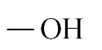 | 32.04 | 0.792 | <0.05%
Ethanol | 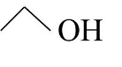 | 46.07 | 0.789 | -
Bioethanol |  | 46.07 | 0.797 | 5
1-propanol | 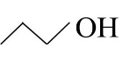 | 60.10 | 0.804 | <0.005%
2-propanol | 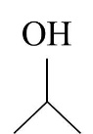 | 60.10 | 0.785 | <0.003%
1-butanol | 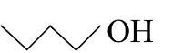 | 74.12 | 0.810 | N/A^{b}
2-butanol | 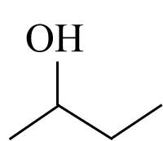 | 74.12 | 0.808 | <0.005%
Ethylene glycol | 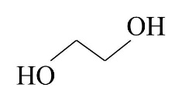 | 62.07 | 1.113 | <0.003%
Propylene glycol | 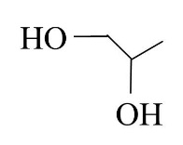 | 76.09 | 1.036 | N/A^{b}
Glycerol | 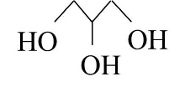 | 92.09 | 1.250 | ≤0.10
ª Data provided by the manufacturer
^{b} N/A – not applicable
The four surfactants studied were selected based on a previous study [28]. The linear alkyl propoxylated ethoxylated carboxylate surfactant associated with sodium as the counterion (linear C16-18 4PO 2EO carboxylate surfactant with 90% purity) was provided by Sasol North American Inc (Lake Charles, LA). The linear alkyl alcohol ethoxylate surfactant (linear C12-16 1EO OH with ≥99.5% purity) was provided by Huntsman Corporation. Sorbitan monooleate (≥99.5% purity) and oleyl alcohol (85% purity) were purchased from Sigma Aldrich. A list of the surfactants is shown in Table 4-2.
Table 4 - 2: Properties of studied surfactantsª.
Materials | Abbreviation | Type of surfactant | Molecular weight  (g/mole) | Density  (g/ml)
Linear C16-18 4PO 2EO carboxylate | L168-42C | carboxylate extended | 624 | 0.96
Linear C12-16 1EO OH | L16-1 | alcohol ethoxylate | 241 | 0.87
Sorbitan monooleate | SMO | sugar-based | 429 | 0.99
Oleyl alcohol | OA | fatty alcohol | 268 | 0.86
ª Data provided by the manufacturer

Pure canola oil (Crisco®, the J.M Smucker Company, Orrville, OH) was purchased from Walmart. For non-edible oils, pure castor (NOW® Solutions, NOW Foods, Bloomingdale, IL) and algae (Spa PANTRY, Universal Companies, Inc., Abingdon, VA) oils were obtained via on-line purchases. Table 3-3 shows the fatty acid compositions of canola [13], castor [29], and algae [13] oils. No.2 diesel fuel was purchased from a local gasoline station (Norman, OK) and canola biodiesel was provided by Combustion and Flame Dynamics Laboratory (The University of Oklahoma, Norman, OK).
Table 4 - 3: Fatty acid compositions of canola, castor, and algae oils.
Fatty acid composition  (in %) | Canola oil | Castor oil | Algae oil
capric acid (C10:0) | - | - | 0.12
lauric acid (C12:0) | - | - | 0.25
myristic acid (C14:0) | 0.05 | - | 5.25
palmitic acid (C16:0) | 4.00 | 2.00 | 16.3
stearic acid (C18:0) | 2.65 | 2.00 | 0.59
oleic acid (C18:1) | 56.0 | 6.00 | 7.90
linoleic acid (C18:2) | 26.0 | 4.00 | 5.35
linolenic acid (C18:3) | 10.0 | - | 6.62
ricinoleic acid (C18:1(OH)) | - | 86.0 | -
othersª | 1.13 | - | 52.7
ª Polyunsaturated fatty acids with C ≥ 20

2-ethyl-1-hexanol (EHOH with ≥99.6% purity) was used as the cosurfactant. Ethylene glycol butyl ether or EGBE (99% purity) and di-tert-Butyl peroxide (Luperox®DI) or DTBP (98% purity) were used as an anti-freezing agent and a cetane enhancer, respectively. All of these chemicals were purchased from Sigma Aldrich.

4.2.2 Methods
Microemulsion preparation
Mixtures of surfactant and cosurfactant at a certain molar ratio were added in a 15 mL glass vial. The surfactant and cosurfactant were prepared on a volumetric basis. The systems with cosurfactant were formulated at the surfactant/cosurfactant ratio of 1-16 which was found to be the optimum ratio from the previous study [14]. The polar liquid phase and vegetable oil/diesel blend were added into the surfactant–cosurfactant mixture to formulate microemulsions. The volume fraction of vegetable oil/diesel blend to ethanol was always kept higher than one in order to formulate Winsor Type II microemulsions. The surfactant–polar phase–oil mixtures were gently hand-shaken and placed in a constant temperature bath for a few days to allow the systems to reach equilibrium at the desired temperatures in a range of -5ºC to 25ºC. Phase behavior was determined by visual inspection with polarized light [12,30,31] and the microemulsion phases were confirmed by a red laser beam [32]. The minimum total concentration of surfactant and co-surfactant required to achieve transparent single phase microemulsions was recorded.
Flame and emission characteristics
- Experimental setup
The laminar partially-premixed flame setup is adapted from that developed by Love et al. [33-34] to rapidly characterize the combustion properties of liquid fuels utilizing small amounts. Figure 4-1 illustrates the schematic diagram of the experimental setup. Air from a cylinder was preheated to 350ºC using high-temperature heating tape. The air flow rate was monitored using a calibrated rotameter. Subsequently, the microemulsion fuels were injected into the preheated air using a 50 cm³ syringe at a constant rate of 1.6 mL/min. The length of the heated tube was sufficient for the fuel to vaporize and mix with the hot air. The air temperature in the pipe and fuel-air temperature at the burner exit were monitored by K-type thermocouples and controlled by a temperature controller. A cylindrical tube with ̇̇̇9.5 mm inner diameter served as the burner. A propane pilot flame was used to ignite the fuel/air mixture at the exit of the burner and was removed after ignition. A laminar partially-premixed flame with a constant equivalence ratio of 7 was obtained at the burner exit.
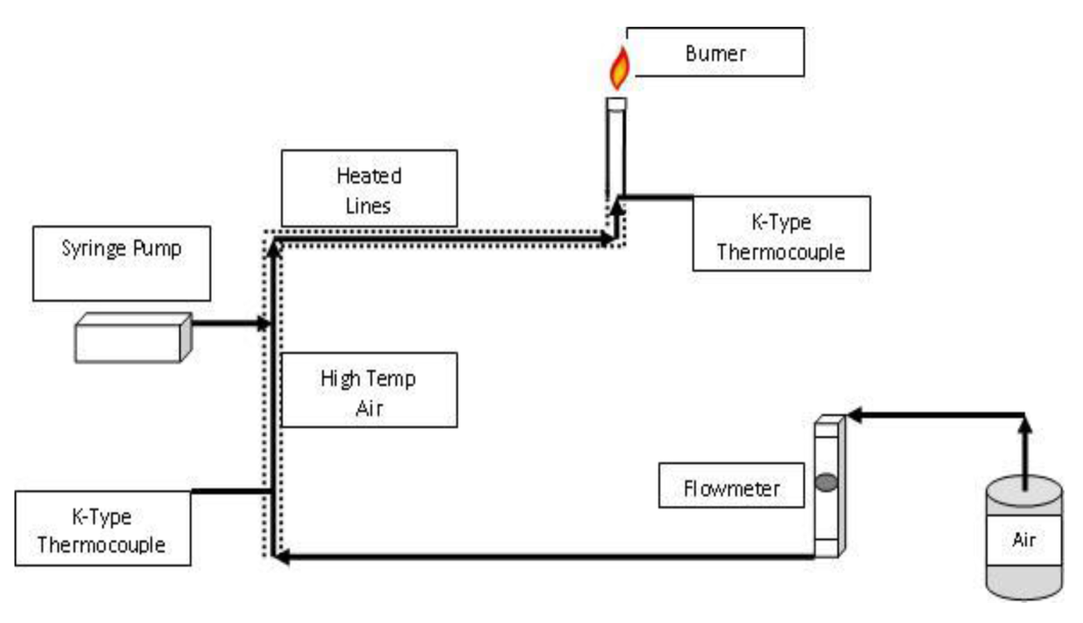
Figure 4 - 1: Schematic diagram of the experimental setup used to measure the combustion characteristics.

- Flame visualization
In this study, an eight mega pixel digital AF SLR Canon camera (EOS Digital Rebel XT/EOS 350D) was used to obtain flame images with an exposure time of 1/25 second under similar lighting conditions with a dark background. The camera was located about 0.5 m away from the flame. The flame length was calculated from the number of image pixels using appropriate software [35].

- Global Flame Radiation
Global flame radiation is a measure of the soot content in the flame. The flame radiation measured with a radiometer was averaged, corrected for background radiation, and recorded. The radiative heat fraction, F, was estimated by the following equation [35];
$F= \frac{4πL^{2}R}{\dot{m}LHV}$ Equation 4.1
where R is radiative flux, L is the distance between the flame and the radiometer, $\dot{m}$ is the mass flow rate of fuel, and LHV is the lower heating value of the fuel (LHV was estimated by using Mendeleyev’s formula [13] and is presented in Table 4-5). The radiative heat fraction is the fraction of the input energy that is lost by the flame to radiation. This parameter provides a convenient comparison of the soot content in the various flames.
- Global pollutant emissions
A flue gas collector and sampling system with an uncooled quartz probe were used to determine the global emission of CO, NO_{x}, and carbon dioxide (CO₂). Before passing through the analyzer, the moisture and particulate matter in the sample were removed using an ice condenser and a fiber filter, respectively. The CO and NO_{x} concentrations were detected by electrochemical sensors, while the CO₂ concentration was measured by a non-dispersive infrared detector. The emission index of species i was calculated using equation [35];
${EI}_{i}= \left(\frac{X_{i}}{X_{CO}+X_{CO2}}\right)·(\frac{ x{MW}_{i}}{{MW}_{F}})$ ${EI}_{i}= \left(\frac{X_{i}}{X_{CO}+X_{CO2}}\right)·(\frac{ x{MW}_{i}}{{MW}_{F}})$ Equation 4.2
where X_{i} is the mole fraction of the species i, X_{CO} and X_{CO2} are the mole fractions of CO and CO₂ in the exhaust, x is the number of moles of carbon in a mole of fuel, and MW_{i} and MW_{F} are the molecular weights of species i and the fuel, respectively It was assumed that the soot content was negligible in these flames. The emission index provides the amount of pollutant species i produced in g/kg of fuel.
- Fuel properties
The kinematic viscosity of microemulsion fuels was calculated using Equation 4.3.
$Kinematic viscosity$ = $\frac{Dynamic viscosity }{Density}$ Equation 4.3
The dynamic viscosity of microemulsion fuels was measured by A Brookfield LV III + viscometer (Brookfield, SC4-18/13R) and the fuel density was measured by weighing the syringe before and after filling with the 25 µL microemulsion fuel sample [14]. The dynamic viscosity and density were observed at temperatures 25º and 40ºC.
The cloud point (CP) is the temperature at which a solution becomes cloudy and pour point (PP) is the lowest temperature at which solution movement is observed. The selected stable microemulsion fuels were tested for their cloud points (ASTM method D 2500) by cooling at 1ºC intervals and pour points (ASTM method D 97) by cooling at 3ºC intervals [13].
The solubilization capacity (W_{polar}) of microemulsion systems was estimated using Equation 4.4.
$W_{polar}$ = $\frac{C_{polar}}{C_{surfactant}}$ Equation 4.4
where C_{polar} is polar phase molar concentration and C_{surfactant} is surfactant molar concentration.
6) Spray Droplet Size Measurement
A schematic diagram of the spray flame burner setup is presented in Figure 4-2. The setup was designed to produce spray flames of microemulsion fuels. The experiments were conducted in vertical stainless steel chamber of 76 x 76 cm cross section and 143 cm height to isolate the experiment from the ambient environment. The flame chamber was made of stainless steel with a square cross section of 10.2 cm in width and a height of 51.8 cm. Vycor glass windows were used in the chamber in order to facilitate visual access to the flame. A K-type thermocouple was placed at the bottom of the flame chamber to measure the actual temperature of the co-flow air [36].
The liquid fuel and atomization air were conveyed under pressure from nitrogen-pressurized and air-pressurized cylinders, respectively. Both fuel and air flow rates were separately measured using two calibrated rotameters. The fuel and air were injected through a 0.165 inch diameter exit orifice of an air-blast atomizer to produce the spray. The droplet size in the spray was measured using a Phase Doppler Particle Analyzer (PDPA) [36], as shown in Figure 4-3.

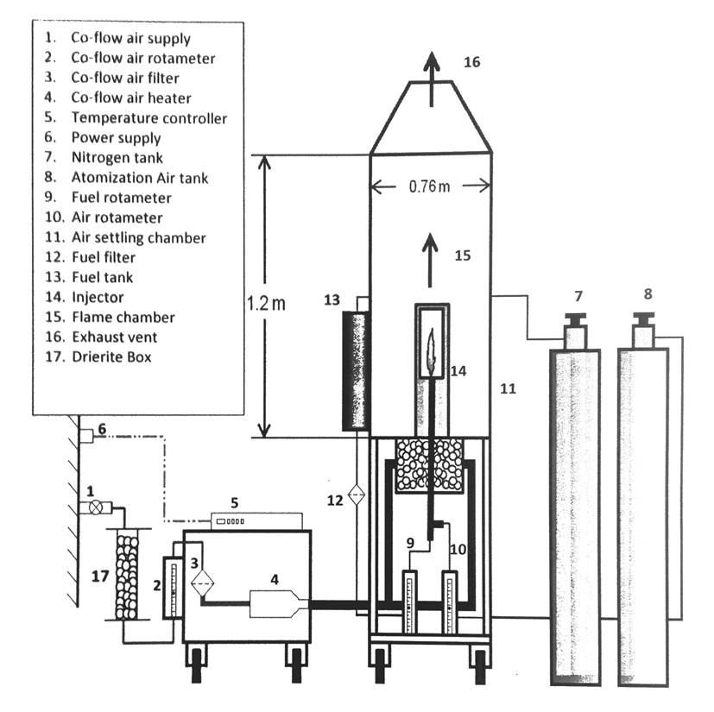
Figure 4 - 2: Schematic diagram of spray flame burner setup for drop size measurement.

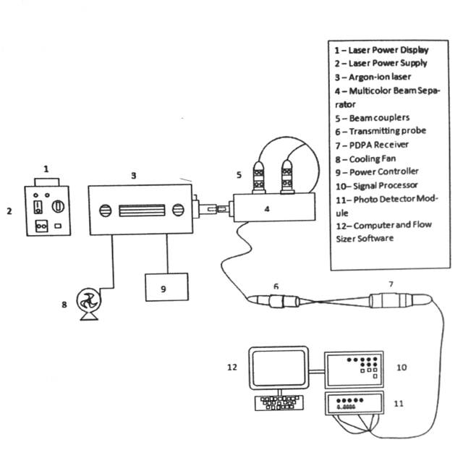
Figure 4 - 3: Schematic diagram of Phase Doppler Particle Analyzer (PDPA) setup.

4.3 Results and discussion
In a previous study, the emission characteristics of microemulsion fuels with different vegetable oils were studied [13], and the phase behavior comparison of microemulsion fuels with different surfactants, additives, non-edible and edible vegetable oils was conducted [28]. Therefore, this study focused on the emission characteristics of microemulsion fuel systems using non-edible (algae, castor, and algae/castor) and edible (canola) vegetable oils; the effects of surfactants and additives on emission characteristics are also discussed. All emission results of microemulsion fuels were compared to those obtained with canola biodiesel and neat diesel.

4.3.1 Effect of vegetable oils on emission characteristics
Figure 4-4 shows graphs of a) radiative heat fraction (soot emission), b) CO emission index, and c) NO_{x} emission index as a function of the different microemulsion fuels which include the systems of oleyl alcohol at surfactant/EHOH ratio of 1–16 with ethanol in canola oil/diesel, algae and castor (1-1) oils/diesel, algae oil/diesel, and castor oil/diesel blends at a ratio of 50-50. The corresponding measurements in flames of pure diesel/CME are also shown for comparison. It was found that the radiative fraction of heat release of the flame of the fuel with castor oil was higher than that of the flames of other fuels. This indicates that the castor oil flame had a higher soot content, which could be due to high unsaturated fatty acid producing more CH radicals [37]. Moreover, the CO emissions from the flames of microemulsion fuels with algae/diesel, castor/diesel, and mixture of algae and castor/diesel blends were slightly higher than those obtained in flames of microemulsion fuel with canola/diesel, implying that more complete combustion occurred for the fuel with canola oil than others. This is attributed to the presence of a high level of shorter-chain unsaturated fatty acid (62% of oleic acid) in canola oil which can be burned easier and has longer time of premixed combustion [38-39]. The fuel with canola oil generated the same level of NO_{x} emission as the microemulsion fuel with castor oil, but slightly higher than the microemulsion fuel with algae/diesel and mixture of algae and castor/diesel blends. Higher levels of NO_{x} emission of fuels with canola and castor oils can be attributed to higher compositions of unsaturated fatty acid in canola and castor oils because the carbon- carbon bonds break more readily than the carbon-hydrogen bonds resulting in CH radical formation leading to higher NO_{x} production [37].
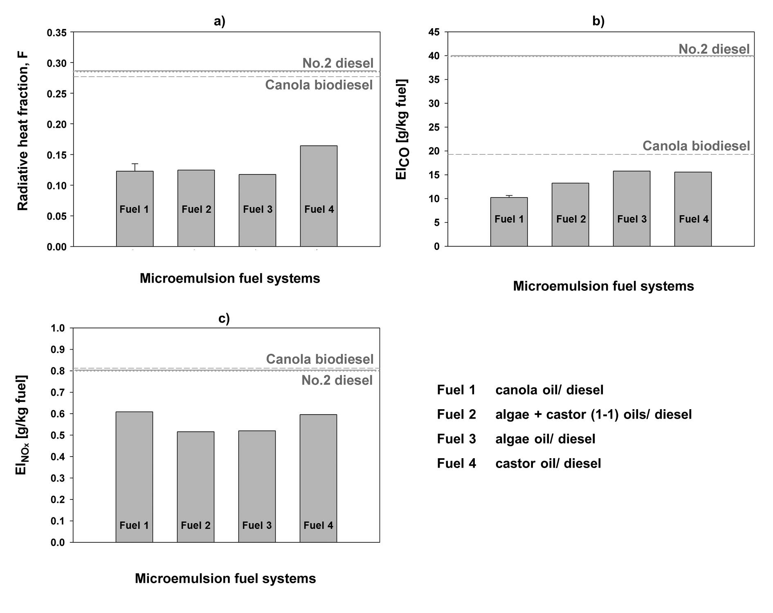
Figure 4 - 4: Emission characteristics of the microemulsion systems of oleyl alcohol at surfactant/EHOH ratio of 1–16 with ethanol in different four vegetable oil/diesel blends at ratio of 50-50 at equivalence ratio of 7; a) radiative heat fraction (soot emission); b) CO emission index; c) NO_{x} emission index.

Additionally, these results are probably associated with the flash point of vegetable oil; flash points of canola, castor, and algae oils are 275º to 290ºC [40], 210ºC [41], and 115ºC (assuming that it is approximately similar to microalgae oil biodiesel) [42], respectively. Canola and castor oils have higher flash points which lead to higher temperature and longer residence time of combustion, which can also result in higher NO_{x} emissions [43-44]. However, all emissions in the flames of microemulsion fuels were less than those from the flames of No.2 diesel and canola biodiesel.

4.3.2 Effect of surfactants and additives on emission characteristics
As mentioned above, the effect of surfactants on phase behaviors have already been studied renewable surfactants (alcohol ethoxylate surfactants and sugar-based surfactants) were used to formulate microemulsion fuels compared to oleyl alcohol and carboxylate-based extended surfactants [28]. Thus, the emission characteristics of microemulsion fuels using four surfactants are discussed in this section; i.e., oleyl alcohol (OA), linear C16-18 4PO 2EO carboxylate (L168-42C), linear C12-16 1EO OH (L16-1), and sorbitan monooleate (SMO).
The radiative heat fraction (soot emission), CO emission index, and NO_{x} emission index of the flames of the microemulsion systems of oleyl alcohol (OA), linear C16-18 4PO 2EO carboxylate (L168-42C), linear C12-16 1EO OH (L16-1), and sorbitan monooleate (SMO) with ethanol and canola oil/diesel blend (50-50) are presented in Figure 4-5. The results in Figure 4-5 show that the radiative fraction of heat release (and therefore the soot content) and CO emission index of the flames of microemulsion fuels were significantly lower than the corresponding values of the flames of canola biodiesel and No.2 diesel. In contrast, the NO_{x} emissions of the SMO and L168-42C systems were higher than those of canola biodiesel and No.2 diesel corresponding to high oxygen content in these two surfactants (discussed below). From these results, it is seen that the microemulsion fuels with OA and L16-1 had more favorable emission characteristics than the other two surfactants. The previous study also indicated that microemulsion fuels with OA and L16-1 required lower amount of surfactant than the other two. Therefore, OA and L16-1 are seen to be viable alternative surfactants used for microemulsion fuel formulations with desirable fuel properties, emissions, and phase behaviors.
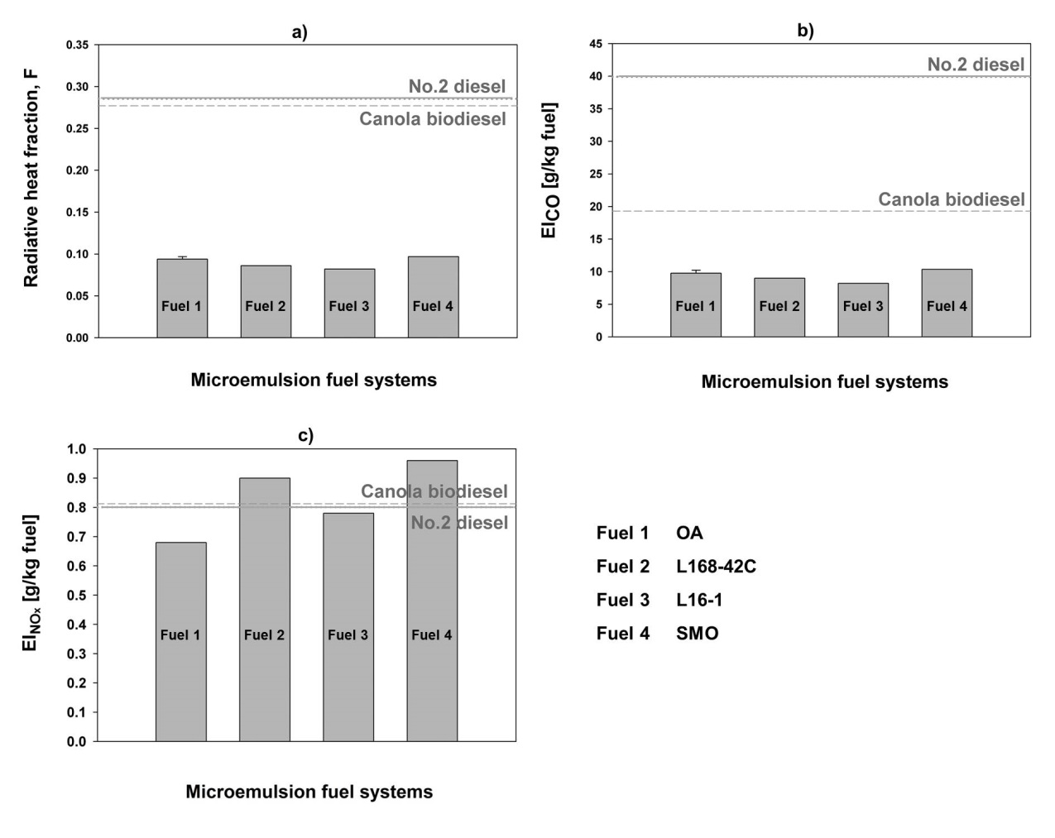
Figure 4 - 5: Emission characteristics of the microemulsion systems of oleyl alcohol (OA), linear C16-18 4PO 2EO carboxylate (L168-42C), linear C12-16 1EO OH (L16-1), and sorbitan monooleate (SMO) with ethanol and canola oil/diesel blend at ratio of 50-50 at equivalence ratio of 7; a) radiative heat fraction (soot emission); b) CO emission index; c) NO_{x} emission index.

It has been noted that cosurfactant, cetane enhancer and anti-freezing agents can both improve fuel properties and allow microemulsion fuels to achieve temperature below 0ºC without impacting phase behavior [14,28]. However, it is important to determine whether they affect the emission characteristics. As mentioned above, EHOH, DTBP and EGBE were considered as cosurfactant, cetane enhancer and anti-freezing agent, respectively. The results obtained indicated that cosurfactant, cetane enhancer and freezing agent additions did not significantly influence the emission characteristics of microemulsion fuels and emissions of microemulsion fuels with additives were lower than those of No.2 diesel and canola biodiesel.

4.3.3 Microemulsion fuels with different alcohol systems
Phase behavior comparisons
Ten different alcohols were used in this section in order to study the effect of polar phase on phase behavior of microemulsions over the temperature range evaluated. Methanol, ethanol, 1-propanol, and 1-butanol were studied for the carbon chain length effect. 1-propanol and 1-butanol were compared with 2-propanol and 2-butanol for the branching effect. The effect of number of hydroxyl groups was evaluated by comparing the systems of ethanol, propanol, ethylene glycol, propylene glycol, and glycerol. Bioethanol was also used to study the effect of water content in ethanol. The results indicate that alcohols with more than one hydroxyl groups (i.e., ethylene glycol, propylene glycol, and glycerol) can not be used to formulate single-phase microemulsion fuel. Although more than 25% of surfactant concentration was added to the mixtures, phase separation occurred with these systems. Due to the very high polarity and strong hydrogen bonding of hydroxyl groups in these alcohols, they cannot solubilize in the oil phase. Besides, 1- and 2-butanol were completely miscible in canola oil even at temperatures lower than 25ºC; therefore, surfactant was not required to formulate microemulsion fuels. However, microemulsion fuels could be formulated by mixing butanol with methanol, ethanol, and bioethanol at the ratio 50-50. In this study, 1-butanol was used for the mixed alcohol systems because it was considered as a renewable alcohol [10] and improved the solubility of polar phase in the oil phase as mentioned above.
Table 4-4 summarizes the minimum surfactant concentration to achieve a single phase microemulsion (S_{min}, %) at temperature -5º to 25ºC for the microemulsion systems of oleyl alcohol with methanol, ethanol, bioethanol, 1-propanol, 2-propanol, methanol/1-butanol, ethanol/1-butanol, and bioethanol/1-butanol in canola oil. From the results shown in Table 4-4, phase separation was observed at temperatures below 0ºC for all single alcohol systems. Methanol and bioethanol could be used to formulate microemulsion fuels at only 25ºC and phase separation occurred at temperatures below this point. 1-propanol was completely soluble in canola oil at this temperature; however, at 0º to 10ºC, it could be used to formulate microemulsion fuels. The results showed that, at 25ºC, the ethanol system required about 15% lower surfactant concentrations than the methanol system required to achieve single phase microemulsion. Likewise, the 1-propanol system required about 13% and 14.5% lower surfactant concentration than the ethanol system required at 10º and 0ºC, respectively. Thus, increasing carbon chain length reduced the surfactant concentration required to achieve single-phase microemulsion. When 1-propanol and 2-propanol systems were considered for the branching effect, it was found that branching resulted in about 4% to 6.5% higher surfactant concentrations required to achieve single phase microemulsion at 0º to 10ºC. This is attributed to the lower hydrophobicity of shorter carbon-chain length [45] and steric effect of branching [46] in alcohols decreases the interaction between polar phase and oil phase. Thus, higher surfactant concentrations were required to achieve single-phase microemulsion.
Table 4 - 4: Comparison of minimum total surfactant concentration to achieve a single phase microemulsion at temperature -5º to 25ºC for the microemulsion systems of oleyl alcohol (OA) with methanol, ethanol, bioethanol, 1-propanol, and 2-propanol in canola oil.
Alcohols | Acronyms | Minimum surfactant concentration to achieve single phase microemulsion  (S_{min}, %)
Alcohols | Acronyms | -5ºC | 0ºC | 10ºC | 25ºC
Methanol | Mt | X | X | X | 26.2
Bioethanol | BioEt | X | X | X | 24.4
Ethanol | Et | X | 15.8 | 13.4 | 10.9
1-Propanol | 1-Pro | X | 1.3 | 0.6 | CM
2-Propanol | 2-Pro | X | 7.8 | 4.9 | 0.6
Methanol/butanol | Mt/Bu | 16.7 | 15.8 | 14.9 | 11.5
Bioethanol/butanol | BioEt/Bu | 12.9 | 11.5 | 9.4 | 5.5
Ethanol/butanol | Et/Bu | 6.1 | 5.5 | 3.7 | CM
X is phase separation.
CM is complete miscibility.

Evaluating the mixed alcohol systems, it was found that the methanol/butanol system required a similar amount of surfactant to the ethanol system and even less for the bioethanol/butanol system. Moreover, the ethanol/butanol system required the intermediate amount of surfactant between the 1-propanol and 2-propanol systems. However, it was interesting that all mixed alcohol systems can achieve the temperature below 0ºC. The explanation is possibly that butanol increases the molecular interactions between polar phase and oil phase resulting in increasing solubilization capacity; consequently, the polar phase does not tend to separate from the oil phase at very low temperature.
Fuel properties
Microemulsion fuels with 1 molar of oleyl alcohol at surfactant/EHOH ratio of 1–16 with different alcohol systems in canola oil/diesel from phase behavior studies were selected to be determined for fuel properties. Physical properties and energy content of the selected microemulsion fuels, No.2 diesel, canola biodiesel, and canola oil are presented in Table 4-5. It is seen that microemulsion fuels were able to effectively reduce the kinematic viscosity of neat canola oil (e.g., from 37.6 to 3.2-4.4 mm²/s at 40ºC). The physical properties (i.e., kinematic viscosities, cloud points, and pour points) of all microemulsion fuels except the systems of bioethanol, 1-propanol, and 2-propanol were more favorable than those of canola biodiesel and could meet the standard diesel specification for kinematic viscosity (1.9-4.1 mm²/s at 40ºC), cloud point (−10◦C max. for November–February and −4◦C max for March–October), and pour point (−17.8◦C max. for November–February and −9.4◦C max. for March–October) [13]. The data in Table 4-5 also shows that although the lower heating values of microemulsion fuels (which are in a range of 37-38 MJ/kg) were slightly lower than that of No.2 diesel (42.6 MJ/kg), they were comparable to the lower heating value of canola biodiesel. Furthermore, the density of all selected microemulsion fuels was comparable to that of canola biodiesel and No.2 diesel.
Flame appearance and emission characteristics
The flame appearance and emission characteristics of microemulsion fuels with different alcohol systems are discussed in this section. Apart from alcohol effects, the effect of equivalence ratio was also studied. The equivalence ratio (ɸ) is the ratio of the actual fuel-to-oxidizer (F/A)_{actual} to the stoichiometric fuel-to-oxidizer (F/A)_{stoi}. The experiments were conducted at equivalence ratios of 7, 3, and 2 in order to understand the combustion properties of partially-premixed laminar flames of microemulsion fuels [35]. These equivalence ratios were adjusted by varying the air flow rates with the same fuel flow rate (1.6 mL/min).
Table 4 - 5: Fuel properties of selected microemulsion fuels of oleyl alcohol at surfactant/EHOH ratio of 1–16 with different alcohol systems in canola oil/diesel blend, canola biodiesel, and No.2 diesel.
Fuel systemsª | Properties
Fuel systemsª | ρ (25ºC)  (g/cm³)^{b} | υ (25ºC)  (mm²/s)^{c} | υ (40ºC)  (mm²/s)^{c} | CP  (ºC) | PP  (ºC) | LHV  (MJ/kg)
Et | 0.846 | 6.3 | 3.8 | -10 | < -23 | 37.4
BioEt | 0.847 | 6.7 | 4.4 | 13 | < -23 | 37.0
1-Pro | 0.874 | 7.1 | 4.3 | -12 | < -23 | 38.2
2-Pro | 0.852 | 7.2 | 4.2 | -12 | < -23 | 38.2
Mt/Bu | 0.841 | 5.9 | 3.2 | -11 | < -23 | 37.3
Et/Bu | 0.844 | 6.3 | 3.5 | -10 | < -23 | 38.0
BioEt/Bu | 0.848 | 6.6 | 3.6 | -11 | < -23 | 37.9
Canola biodiesel (CBD) | 0.886 | 6.8 | 4.5 | 0 | -9 | 37.4
No.2 diesel | 0.834 | 3.6 | 1.9 to 4.1^{d} | -10 to -4e | -17.8 to -9.4^{f} | 42.6
Canola oil | 0.920 | 68.4 | 37.6 | N/A^{g} | N/A^{g} | 37.1
ª See Table 4-4 for fuel acronyms.
^{b}
^{c} All values are the kinematic viscosities ±0.1 mm²/s.
^{d} The standard kinematic viscosity of No.2 diesel at 40ºC.
^{e} CP (cloud point) standard for No. 2 diesel fuel is −10◦C max (November–February) and −4◦C max (March–October).
^{f} PP (pour point) standard for No. 2 diesel fuel is −17.8◦C max (November–February) and −9.4◦C max (March–October).
^{g} N/A is not available.

a) Flame appearance
The flame images of seven microemulsion fuels (Table 4-5), canola oil biodiesel, and No.2 diesel at equivalence ratios of 7, 3, and 2 are presented in Figure 4-6 to delineate the effect of alcohol systems on flame color, structure, and length. For the equivalence ratio of 7, the flame of No.2 diesel appeared luminous yellow color in most of flame region with a very small region of blue color at the injector exit, whereas the flames of microemulsion fuels and canola biodiesel showed a larger near-burner blue region surrounded by smaller luminous yellow region in downstream. Similar results were observed in the flame appearance at equivalence ratios of 3 and 2. The blue region is the primary gas-phase oxidation reaction zone in which oxidation of carbon monoxide and nitrogen occurs. The luminous yellow region represents radiation emitted from remaining unburned carbon that continues to burn downstream with ambient oxygen [35]. The No.2 diesel flame had the most luminous yellow region indicating the most soot content, whereas flames of microemulsion fuels and canola biodiesel showed larger blue regions, corresponding to higher degree of oxidation reaction due to the oxygen content in the fuel molecule.
Among the microemulsion fuels, the flames of the systems with lower carbon chain length alcohols (ethanol and bioethanol) had smaller yellow region than the other systems with higher carbon chain length alcohols (1-propanol, 2-propanol, and mixed alcohol systems with butanol). These results indicate that the remaining unburned carbon slightly increased with carbon chain length in alcohol molecule. However, the water content and branching showed no significant effect on the flame length and the extent of yellow region in flames. The flame length increased with equivalence ratio for all fuels, due to the decrease in air flow rate; i.e., the flame lengths at equivalence ratios of 2, 3, and 7 were in the range of 12-17cm, 15-19 cm, and 16-20 cm, respectively. This is because as the equivalence ratio was increased, less air was supplied; consequently, higher flame length was required to obtain the necessary air from the surrounding.
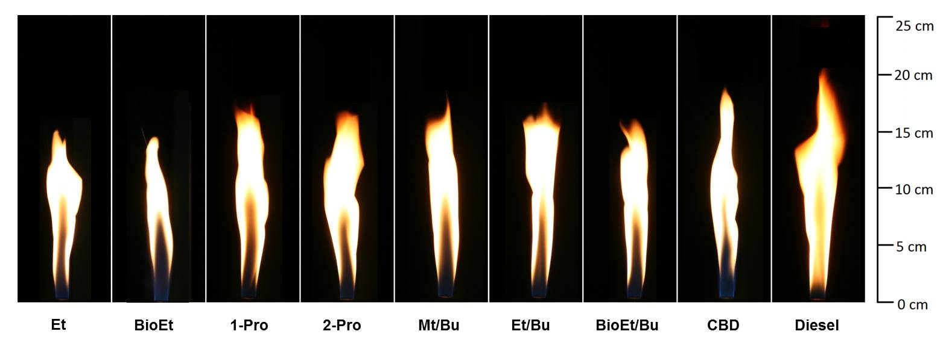
- ɸ = 7
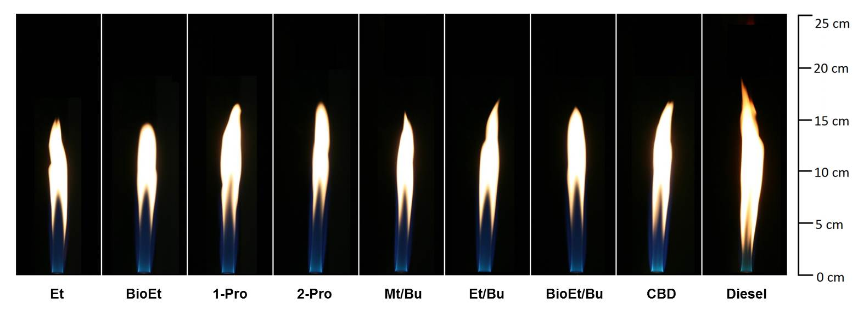
- ɸ = 3
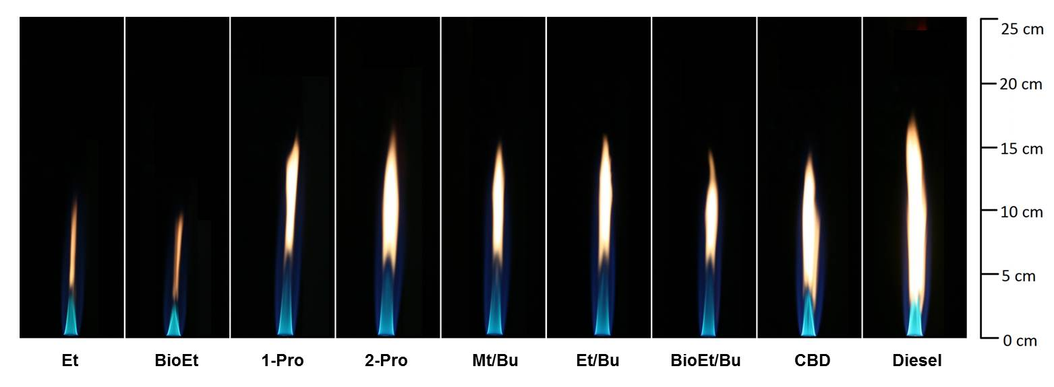
- ɸ = 2
Figure 4 - 6: Comparisons of flame images of different microemulsion fuels, canola oil biodiesel, and No.2 diesel at equivalence ratios (ɸ) of a) ɸ = 7, b) ɸ = 3 and c) ɸ = 2. See Table 4-4 for fuel acronyms.

b) Emission characteristics
Table 4-6 shows the average values of the radiative heat fraction (F levels), CO emission index (EI_{CO}), and NO_{x} emission index (EI_{NOx}) of the seven microemulsion fuels (Table 4-5) compared to those of canola biodiesel and No.2 diesel.
From Table 4-6, it is observed that soot and CO emissions decreased with equivalence ratios for all fuels due to an increase in air supply for the oxidation reaction; on the other hand, NO_{x} emission decreased with an increase in equivalence ratios because the reduction of air supply diminished NO_{x} formation. Moreover, the results showed that emissions of the flames of microemulsion fuel were lower than those of No.2 diesel flame (about F_{(MF)} = 0.44F_{(diesel)}, EI_{CO(MF)} = 0.24EI_{CO(diesel)}, and EI_{NOx(MF)} = 0.66EI_{NOx(diesel)}) and canola biodiesel (about F_{(MF)} = 0.95F_{(CBD)}, EI_{CO(MF)} = 0.73EI_{CO(CBD)}, and EI_{NOx(MF)} = 0.66EI_{NOx(CBD)}). These emission results are consistent with the flame appearances in the previous section which indicates that microemulsion fuels burn cleaner than canola biodiesel and No.2 diesel. It was also observed that the average F levels (soot emissions) of the microemulsion fuel flames at equivalence ratio of 3 were slightly higher than those at equivalence ratio of 2 and they were not significantly different for the CO and NO_{x} emission indices.

Table 4 - 6: Fuel properties of selected microemulsion fuels of oleyl alcohol at surfactant/EHOH ratio of 1–16 with different alcohol systems in canola oil/diesel blend, canola biodiesel, and No.2 diesel.
Fuels |  | Emissions
Fuels | F levelsª |  |  |  |  |  |  | EI_{CO}^{b} |  |  |  |  |  |  | EI_{NOx}^{c}
Fuels | ɸ = 7 |  | ɸ = 3 | ɸ = 2 |  |  | ɸ = 7 |  | ɸ = 3 | ɸ = 2 |  |  | ɸ = 7 |  |  |  | ɸ = 3 | ɸ = 2
Microemulsion fuel^{d} | 0.091  (±0.006) |  | 0.047  (±0.004) | 0.034  (±0.001) |  |  | 5.85  (±0..95) |  | 2.67  (±0.18) |  | 2.49  (±0.25) |  |  | 0.76  (±0.10) |  | 1.19  (±0.35) |  |  | 1.76  (±0.51)
Canola biodiesel (CBD) | 0.096  (N/A^{e}) |  | 0.054  (N/A^{e}) | 0.036  (N/A^{e}) |  |  | 8.00  (N/A^{e}) |  | 3.70  (N/A^{e}) |  | 3.24  (N/A^{e}) |  |  | 1.39  (N/A^{e}) |  | 1.48  (N/A^{e}) |  |  | 2.83  (N/A^{e})
No.2 diesel | 0.206  (±0.003) |  | 0.098  (±0.003) | 0.041  (±0.003) |  |  | 24.0  (±0.53) |  | 4.31  (±0.10) |  | 3.70  (±0.07) |  |  | 1.16  (±0.06) |  | 2.57  (±0.10) |  |  | 3.13  (±0.08)
ª F is radiative heat fraction indicating soot emissions.
^{b} EIco is emission index of CO.
^{c} EI_{NOx} is emission index of NO_{x}.
^{d} Emissions of microemulsion fuel are the average emissions of seven microemulsion fuels in Table 4-5.
^{e} N/A is not available.

To delineate the effect of alcohol systems on emission characteristics, the graphs of a) radiative heat fraction (soot emission), b) CO emission index, and c) NO_{x} emission index were plotted at equivalence ratios of 7 and 2 in Figure 4-7. The results show that the soot and CO emissions in the flames of microemulsion fuels were comparable to those of the flames of No.2 diesel and canola biodiesel at the equivalence ratio of 2 due to the sufficient oxygen content from air supply; however, the flames of microemulsion fuels had much lower soot and CO emissions than the flames of No.2 diesel at the equivalence ratio of 7.
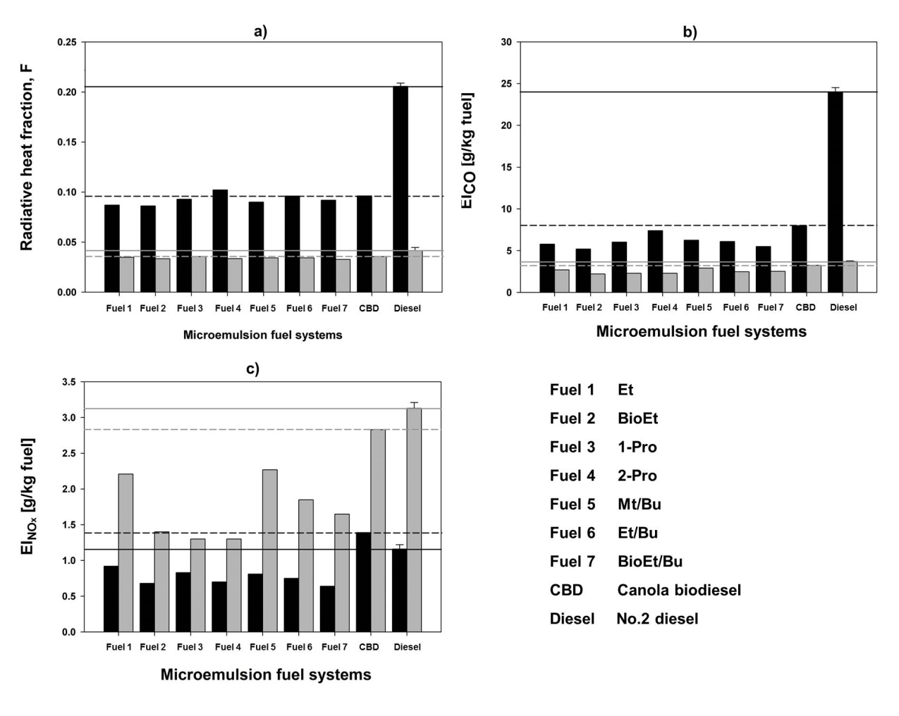
Figure 4 - 7: Emission characteristics of the microemulsion systems of oleyl alcohol at surfactant/EHOH ratio of 1–16 with different alcohol systems in canola oil/diesel blend at ratio of 50-50 compared with those of canola biodiesel and No.2 diesel at equivalence ratios of 7 (black color) and 2 (gray color); a) radiative heat fraction (soot emission); b) CO emission index; c) NO_{x} emission index. See Table 4-4 for fuel acronyms.

Considering the effect of alcohol systems for the flames at equivalence ratio of 7, the branching structure in alcohol had the most effect on soot (11% increase) and CO (23% increase) emissions, while there was no significant effect of water content and carbon chain length on soot and CO emissions (less than 10% decrease for water content effect and less than 6% increase for carbon chain length effect). This branching structure effect is consistent with literature which results report that the low reactivity of branching structure in fuels increases soot volume fraction [47]. It has also been noted that the flames of microemulsion fuels with mixed alcohol systems (Fuels 5-7) produced comparable soot and CO emissions to those with single alcohol systems (Fuels 1-4). For NO_{x} emission, the alcohol systems had no significant effect on NO_{x} emission at the equivalence ratio of 7; however, at the equivalence ratio of 2, the results showed that water content and an increase of carbon chain length in alcohols contributed to a decrease of NO_{x} emission for Fuels 1-4. Since the thermal NO_{x} formation depends on flame temperature and oxygen content in the reaction [48], the proposed explanation is that water content in alcohol can reduce the flame temperature; thus NO_{x} emission decreases. This explanation can be used for the results of mixed alcohol systems (Fuels 5-7). However, although NO_{x} emissions from microemulsion fuels were slightly different depending on their compositions, they were lower than NO_{x} emission from No.2 diesel.
From this section, the correlation among luminosity of flame, soot, CO, and NO_{x} emissions can be seen and it is concluded that the production of lower amount of soot indicating lower heat radiation and higher flame temperature leads to more complete combustion, larger blue color region in flame, lower CO emission, and higher NO_{x} emissions. Moreover, it is interesting that microemulsion fuels with mixed alcohol systems can improve fuel properties and enhance fuel stability at low temperature while have no negligible effect on emission characteristics.
Droplet size and mean velocity of spray and spray flame
Table 4-7 shows the Sauter mean diameter (SMD) and mean velocity (V_{mean}) for spray and spray flame of selected microemulsion fuels of oleyl alcohol at surfactant/EHOH ratio of 1–16 with ethanol, methanol/butanol, ethanol/butanol, and bioethanol/butanol in canola oil/diesel blend compared with those of canola biodiesel and No.2 diesel at an equivalence ratio of 0.8 at 1cm. and 2cm. above the nozzle. Sauter mean diameter (D₃₂) is the ratio of the volume of the drops to the surface-area of the drops.
Table 4 - 7: Sauter mean diameter and mean velocity for spray and spray flame of selected microemulsion fuels of oleyl alcohol at surfactant/EHOH ratio of 1–16 with different alcohol systems in canola oil/diesel blend, canola biodiesel, and No.2 diesel at an equivalence ratio of 0.8 at 1cm. and 2cm. above the nozzle.
Fuelsª | Spray |  |  |  |  |  | Spray flame |  |  |  |  | W_{polar}^{f} | υ  (mm²/s)^{g}
Fuelsª | SMD  (µm)^{b} |  |  | V_{mean}  (m/s)^{c} |  |  | SMD  (µm)^{b} |  |  | V_{mean}  (m/s)^{c} |  | W_{polar}^{f} | υ  (mm²/s)^{g}
Fuelsª | 1 cm.^{d} | 2 cm.^{d} |  | 1 cm.^{d} | 2 cm.^{d} |  | 1 cm.^{d} | 2 cm.^{d} |  | 1 cm.^{d} | 2 cm.^{d} | W_{polar}^{f} | υ  (mm²/s)^{g}
Et | 380  (±21) | 360  (±24) |  | 8.2  (±1.5) | 5.9  (±1.3) |  | 409  (±5) | 412  (±7) |  | 9.5  (±1.6) | 9.0  (±1.1) | 11.6 | 3.8
Mt/Bu | 393  (±11) | 371  (±39) |  | 7.7  (±1.3) | 5.4  (±0.9) |  | 390  (±11) | 398  (±11) |  | 9.0  (±1.6) | 8.4  (±0.9) | 9.0 | 3.2
Et/Bu | 355  (±40) | 351  (±42) |  | 7.8  (±1.5) | 5.7  (±1.0) |  | 393  (±10) | 389  (±17) |  | 9.1  (±1.4) | 9.3  (±1.0) | 40.0 | 3.5
BioEt/Bu | 366  (±8) | 365  (±39) |  | 8.1  (±1.2) | 5.1  (±0.9) |  | 403  (±1) | 405  (±8) |  | 9.1  (±2.1) | 8.7  (±0.6) | 18.2 | 3.6
CBD | 382  (±15) | 368  (±23) |  | 8.3  (±1.5) | 5.2  (±1.2) |  | N/A^{e} | N/A^{e} |  | N/A^{e} | N/A^{e} | N/A^{e} | 4.5
Diesel | 359  (±3) | 359  (±44) |  | 8.4  (±1.1) | 5.0  (±1.2) |  | 374  (±14) | 388  (±29) |  | 10  (±1.0) | 8.4  (±0.9) | N/A^{e} | 2.5
ª See Table 4-4 for fuel acronyms.
^{b} SMD is Sauter mean diameter.
^{c} V_{mean} is mean velocity.
^{d} An axial height above the nozzle.
^{e} N/A is not available.
^{f} W_{polar} is polar phase solubilization capacity at 10ºC.
^{g} υ is the kinematic viscosity.

From Table 4-7, it is observed that the SMD of all microemulsion fuels, canola biodiesel, and No.2 diesel spray with and without flame were not statistically different, which were in the range of 350-425 µm. The SMD of the spray flames was slightly higher because more large drops remained in the flame. Table 4-7 also allows consideration of the correlation of solubilization capacity, kinematic viscosity, and spray droplet size of microemulsion fuels. Surprisingly, it was observed that although the ethanol/butanol system had 2.5-4 times higher solubilizatoin capacity than the other systems, the kinematic viscosity and spray droplet size of all microemulsion fuels were comparable. The possible explanation is that spray droplet size depends on many factors such as liquid properties (i.e. viscosity and surface tension), the nozzle type, and air pressure [50]. From these results, the direct correlation between spray droplet size, viscosity, and solubilization capacity was not observed.

4.4 Conclusions
This study focused on formulations, fuel properties, and flame and emission characteristics of vegetable oil-based microemulsion fuels with different alcohol systems as the polar phase. Additionally, the effects of equivalence ratios, vegetable oils, surfactants, and additives on emission characteristics were included. The significant conclusions can be summarized as follows;
- Castor oil, non-edible vegetable oil with high unsaturated fatty acid, high viscosity, and high flash point, should not be used to formulate microemulsion fuel alone due to its high NO_{x}, CO, and soot emissions. However, fuel with mixed algae/castor oils can produce comparable emissions to fuel with canola oil as edible vegetable oil, apart from similar phase behavior mentioned in previous study [28].
- From our results, oley alcohol (OA) and linear C16-18 4PO 2EO carboxylate (L16-1) show promise as surfactants for microemulsion fuel formulations with desirable fuel properties, emissions, and phase behaviors.
- Low molecular weight (MW) alcohols (i.e., methanol, ethanol, bioethanol, 1-propanol, 2-propanol) can be used to formulate microemulsion fuels at various temperatures, whereas higher MW alcohol (1-butanol, 2-butanol) are completely soluble in canola oil and no amount of surfactant is required to formulate microemulsion fuels. However, microemulsion fuels using low MW alcohols mixed with butanol systems are more stable at low temperatures, and have comparable fuel properties to No.2 diesel and canola biodiesel and no negligible effect on emission characteristics.
- Linear and shorter chain length alcohols are favorable polar phases used for microemulsion fuel formulations due to less CO and soot emissions. Although the presence of water in alcohol can slightly suppress NO_{x} formation, it causes some unfavorable properties such as higher viscosity, and cold-flow properties.
- As the equivalence ratios decrease, flame length, CO and soot emissions decrease while NO_{x} increases.
- No direct correlation was observed between solubilization capacity, viscosity, and spray droplet size.
- Overall, microemulsion fuels burn cleaner than both No. 2 diesel fuel and canola biodiesel.

References
[1] Demirbas A. Emission Characteristics of Gasohol and Diesohol. Energy Sources, Part A Recover Util Environ Eff 2009;31:1099–104.
[2] Demirbas A. Global Biofuel Strategies. Energy Educ Sci Technol 2006;17:27–63.
[3] Lapuerta M, García-Contreras R, Campos-Fernández J, Dorado MP. Stability, lubricity, viscosity, and cold-flow properties of alcohol−diesel blends. Energy & Fuels 2010;24:4497–502.
[4] Agarwal AK. Biofuels (alcohols and biodiesel) applications as fuels for internal combustion engines. Prog Energy Combust Sci 2007;33:233–71.
[5] Zuurbier P, van de Vooren J. Sugarcane Ethanol: Contributions to Climate Change Mitigation and The Enviroment. Wageningen Academic; 2008.
[6] Hansen AC, Zhang Q, Lyne PWL. Ethanol-Diesel Fuel Blends - A Review. Bioresour Technol 2005;96:277–85.
[7] Demirbas A. Producing and Using Bioethanol as an Automotive Fuel. Energy Sources, Part B Econ Planning, Policy 2007;2:391–401.
[8] Demirbas A. The Importance of Bioethanol and Biodiesel from Biomass. Energy Sources, Part B Econ Planning, Policy 2008;3:177–85.
[9] Jiang Z, Wu H, Xu S, Huang S. Enzymatic Conversion of Carbon Dioxide to Methanol by Dehydrogenases Encapsulated in Sol-Gel Matrix. Fuel Chem Div Prepr 2002;47:306.
[10] Jin C, Yao M, Liu H, Lee CF, Ji J. Progress in The Production and Application of N-Butanol As A Biofuel. Renew Sustain Energy Rev 2011;15:4080–106.
[11] Fernando S, Hanna M. Development of a Novel Biofuel Blend Using Ethanol-Biodiesel-Diesel Microemulsions : EB-Diesel. Energy & Fuels 2004;18:1695–703.
[12] Fernando S, Hanna M. Phase Behavior of The Ethanol-Biodiesel-Diesel Microemulsion System. Trans Am Soc Agric Eng 2005;48:903–908.
[13] Do LD, Singh V, Chen L, Kibbey TCG, Gollahalli SR, Sabatini DA. Algae , canola , or palm oils — diesel microemulsion fuels: phase behaviors, viscosity, and combustion properties. Int J Green Energy 2011;8:748–67.
[14] Attaphong C, Do L, Sabatini DA. Vegetable oil-based microemulsions using carboxylate-based extended surfactants and their potential as an alternative renewable biofuel. Fuel 2012;94:606–13.
[15] Laza T, Bereczky Á. Basic fuel properties of rapeseed oil-higher alcohols blends. Fuel 2011;90:803–10.
[16] Fernando S, Adhikari S, Kota K, Bandi R. Glycerol Based Automotive Fuels from Future Biorefineries. Fuel 2007;86:2806–9.
[17] Tran XT, Ghojel JI. Impact of introducing water into the combustion chamber of diesel engines on emissions – an overview. 5th Asia-Pacific Conf Combust Univ Adelaide, Adelaide, Aust 2005:233–6.
[18] Yoshimoto Y, Onodera M, Tamaki H. Reduction of NOx, Smoke, and BSFC in a Diesel Engine Fueled by Biodiesel Emulsion with Used Frying Oil. SAE Tech Pap No1999-01-3598 1999.
[19] Kumar MS, Bellettre J, Tazerout M. The use of biofuel emulsions ss fuel for diesel engines : a review. Proc Inst Mech Eng Part A J Power Energy 2009;223:729–42.
[20] Lif A, Holmberg K. Water-in-Diesel Emulsions and Related Systems. Adv Colloid Interface Sci 2006;123-126:231–9.
[21] Armas O, Ballesteros R, Martos F, Agudelo J. Characterization of Light Duty Diesel Engine Pollutant Emissions Using Water-Emulsified Fuel. Fuel 2005;84:1011–8.
[22] Caro D, Mouloungui Z, Vaitilingom G, Berge JC. Interest of Combining An Additive with Diesel – Ethanol Blends for Use in Diesel Engines. Fuel 2001;80:565–74.
[23] Lapuerta M, Armas O, Herreros JM. Emissions from A Diesel–Bioethanol Blend in An Automotive Diesel Engine. Fuel 2008;87:25–31.
[24] Karabektas M, Hosoz M. Performance and Emission Characteristics of A Diesel Engine Using Isobutanol–Diesel Fuel Blends. Renew Energy 2009;34:1554–9.
[25] Siwale L, Kristóf L, Adam T, Bereczky A, Mbarawa M, Penninger A, et al. Combustion and Emission Characteristics of N-Butanol/Diesel Fuel Blend in A Turbo-Charged Compression Ignition Engine. Fuel 2013;107:409–18.
[26] Atmanlı A, Yüksel B, İleri E. Experimental Investigation of The Effect of Diesel–Cotton Oil–N-Butanol Ternary Blends on Phase Stability, Engine Performance and Exhaust Emission Parameters in A Diesel Engine. Fuel 2013;109:503–11.
[27] Nguyen T, Abraham J, Ramallo M, Wagner D, McLennan J. Formulation of canola-diesel microemulsion fuels and their selective diesel engine performance. J Am Oil Chem Soc 2012;89:1905–12.
[28] Attaphong C, Sabatini DA. Phase Behaviors of Vegetable Oil-Based Microemulsion Fuels : The Effects of Temperatures, Surfactants, Oils, and Water in Ethanol. Energy & Fuels 2013;27:6773–80.
[29] Mannekote JK, Kailas S V. Influence of Chemical Structure on the Boundary Lubrication Properties of Vegetable Oils. Proc ASME 2010 10th Bienn Conf Eng Syst Des Anal 2010;1:633–7.
[30] Martino A, Kaler EW. Phase Behavior and Microstructure of Nonaqueous Microemuisions. J Phys Chem 1990;94:1627–31.
[31] Do LD, Nguyen T, Sabatini DA. Reduction of viscosity and low temperature property of microemulsions fuel using extended-surfactants as an alternative diesel. 99th AOCS Annu Meet Expo Seattle, WA; May 18–21, 2008.
[32] Xuan X-Y, Cheng Y-L, Acosta E. Lecithin-Linker Microemulsion Gelatin Gels for Extended Drug Delivery. Pharmaceutics 2012;4:104–29.
[33] Love ND, Parthasarathy RN, Gollahalli SR. Effect of Iodine Number on NOx Formation in Laminar Flames of Oxygenated Biofuels. Int J Green Energy 2009;6:323–32.
[34] Love ND, Parthasarathy RN, Gollahalli SR. Rapid Characterization of Radiation and Pollutant Emissions of Biodiesel and Hydrocarbon Liquid Fuels. J Energy Resour Technol 2009;131:012202–9.
[35] Singh VN, Parthasarathy RN, Gollahalli SR. Radiation and Emission Characteristics of Laminar Partially - Premixed Flames of Petroleum Diesel - Canola Methyl Ester Blends. J Pet Sci Res 2013;2:97–103.
[36] Ratul TH. Combustion Characteristics of Spray Flames of Jet-A/Butanol Blends. 2012.
[37] Love ND, Parthasarathy RN, Gollahalli SR. Effect of Degree of Unsaturation on NOx Formation in Partially Premixed Flames of Biofuels. Proc ASME 2009 Int Mech Eng Congr Expo 2009;3:43–8.
[38] Pinzi S, Rounce P, Herreros JM, Tsolakis A, Pilar Dorado M. The Effect of Biodiesel Fatty Acid Composition on Combustion and Diesel Engine Exhaust Emissions. Fuel 2013;104:170–82.
[39] Gopinath A, Puhan S, Nagarajan G. Effect of Unsaturated Fatty Acid Esters of Biodiesel Fuels on Combustion, Performance and Emission Characteristics of a DI Diesel Engine. Int J Energy Environ 2010;1:411–30.
[40] Przybylski R. Canola Oil: Physical and Chemical Properties. Canola Counc Canada 2011:1–6.
[41] Chinchkar DS, Satpute ST, Kumbhar NR. Castor Oil as Green Lubricant : A Review. Int J Eng Res Technol 2012;1:2009–11.
[42] Alcaine AA. Biodiesel from Microalgae. Royal School of Technology Kungliga Tekniska Högskolan, 2010.
[43] Barajas PE, Parthasarathy RN, Gollahalli SR, Vafai K. Combustion Characteristics of Biofuels in Porous-Media Burners. Am Inst Phys Conf Proc 2010;163:163–8.
[44] Attaphong C, Parthasarathy RN, Gollahalli SR. Combustion Properties of Jet A / Ethanol Blends in a Porous Media Burner. Am Inst Aeronaut Astronaut 2013;3677:1–11.
[45] Uchiyama H, Acosta E, Tran S, Sabatini D a., Harwell JH. Supersolubilization in Chlorinated Hydrocarbon Microemulsions: Solubilization Enhancement by Lipophilic and Hydrophilic Linkers. Ind Eng Chem Res 2000;39:2704–8.
[46] Varadaraj R, Bock J, Zushma S, Brons N, Colletti T. Effect of Hydrocarbon Chain Branching on Interfacial Properties of Monodisperse Ethoxylated Alcohol Surfactants. J Colloid Interface Sci 1991;147:387–95.
[47] Ji C, Sarathy SM, Veloo PS, Westbrook CK, Egolfopoulos FN. Effects of Fuel Branching on The Propagation of Octane Isomers Flames. Combust Flame 2012;159:1426–36.
[48] Turns SR. An Introduction to Combustion: Concepts and Applications. 2nd ed. McGraw-Hill Higher Education; 2000.
[49] Schick RJ. Spray technology reference guide: Understanding drop size. 2006.

Chapter 5: Conclusions
The purpose of this chapter is to summarize significant findings and knowledge obtained from the individual chapters of this dissertation. Major conclusions from each chapter are enumerated and future recommendations are provided at the end. The overall goal of this dissertation is to formulate salt-free vegetable oil-based microemulsion fuels which can be used as an alternative fuel to No.2 diesel. A series of surfactants, alcohols, and vegetable oils were used to formulate the temperature-robust microemulsion fuels which have fuel properties comparable to No.2 diesel and meet the ASTM standard. This dissertation studied the effects of temperatures, surfactants, cosurfactants, alcohols, vegetable oils, and additives on the phase behaviors and the viscosities of micromuslion fuels. Fuel properties (i.e., viscosity, cloud point, pour point, and lower heating value) and combustion properties (including flame and emission characteristics) of selected microemulsion fuels have also been investigated to compare with those of No.2 diesel and canola biodiesel.
In Chapter 2, salt-free vegetable oil-based reverse micelle microemulsion fuels were formulated using a series of anionic carboxylate-based extended surfactants taking the place of sulfate-based extended surfactants and phase separation and precipitation were not observed for any systems studied. The effects of surfactants, surfactant/cosurfactant ratios, vegetable oil/diesel ratios, additives, and temperatures on phase behaviors and viscosities are evaluated. The optimum system obtained based-on these considerations is the system of the carboxylate-based extended surfactant at surfactant/cosurfactant ratio of 1–16 with ethanol in canola oil/diesel ratio of 50–50 which is stable at temperature 0-40ºC and has a kinematic viscosity that meets the ASTM standard for No. 2 diesel. This formulation is a prototype used for the design of microemulsion fuel systems with kinematic viscosity values comparable to neat diesel fuel.
The study in Chapter 3 further investigated the temperature effect on the phase behavior of vegetable oil-based reverse micelle microemulsion fuels using different formulations. The use of alternative materials, such as renewable surfactants and hydrous alcohol as well as nonedible vegetable oils owing to a competition with edible oil and food products, were explored. It was found that linear alcohol ethoxylate surfactant (L16-1) could be used in both single and mixed systems as a renewable surfactant to formulate microemulsion fuels which were comparable to microemulsion fuels using oleyl alcohol (the maximum solubilization surfactant in this study). Another significant finding was that microemulsion fuels with nonedible (algae mixed with castor) oil systems were comparable to edible (canola) oil systems at 0°C and above with ethanol and were even better at 25°C with bioethanol. It was noted that fatty acid compositions of different vegetable oils significantly influenced the phase behavior of microemulsion fuels. In addition, among all evaluated formulations, the systems formulated from OA/EHOH with ethanol in a canola oil/diesel blend with and without additives were able to operate at a temperature below 0 °C with high stability, meet the kinematic viscosity standard of No.2 diesel, have the energy content and cost estimation comparable to No.2 diesel. From the various systems studied, Chapter 3 show a protocol for obtaining the optimum temperature-robust formulations of vegetable oil-based microemulsion fuels with sustainable, environment-benign, and cost-effective considerations.
Chapter 4 demonstrates the feasibility on formulating vegetable oil-based microemulsion fuels using different alcohol systems as a polar phase. The effects of alcohol structures and water content in alcohol on phase behaviors, fuel properties, and combustion (flame and emission) characteristics were studied. It was found that all low MW alcohols except butanol could be used as a single polar phase to formulate microemulsion fuels. Nevertheless, microemulsion fuels using butanol mixed with other low MW alcohols appeared to be stable at low temperatures without an increase in global emissions, and had fuel properties comparable to No.2 diesel and canola biodiesel. It was observed that linear and shorter chain length alcohols were applicable polar phases used for microemulsion fuel formulations due to less CO and soot emissions, whereas the presence of water in alcohol caused higher viscosity, and lower stability at low temperature which were undesirable fuel properties. In addition to the effects of surfactants and vegetable oils on phase behaviors, the effects on emission characteristics were included in Chapter 4 in order to obtain the appropriate formulations for the microemulsion fuels. Similar to the phase behaviors as mentioned in Chapter 3, microemulsion fuels with mixed algae/castor oils produced emissions comparable to those with canola oil and microemulsion fuels using oleyl alcohol and L16-1 produced more favorable emissions than the others. A remarkable finding in Chapter 4 was that although emissions characteristics of microemulsion fuels were variable depending on the formulations, they were still lower than those of canola biodiesel and No.2 diesel.
Finally, from these significant findings and knowledge, future recommendations and potential applications have been proposed as follows;
- Since the composition of microemulsion fuels is the key factor influencing their cost and emissions, the optimum formulations with cheaper and renewable raw materials (including mixed alcohol systems with butanol) should be explored as cost-effective and environmentally-friendly microemulsion fuels.
- Complete Life Cycle Assessment (LCA) of microemulsion fuels needs to be analyzed as compared to those of No.2 diesel and canola biodiesel.
- The laminar flames with co-flow air, diffusion flames, and engine test of microemulsion fuels should be studied in addition to the partially-premixed laminar flames in this study to investigate the results in practical perspective.
- Future research should focus on engine test of microemulsion fuels and their emissions. To prevent vapor lock problems as observed with alcohol/diesel blends, the evaporation of microemulsion fuels needs to be characterized before conducting engine test.

Appendix A: Supplemental materials for Chapter 2
A.1 The kinematic viscosity and raw data for the kinematic viscosity calculations
Table A.1.1: The density and viscosity values of the four surfactant systems with canola oil/diesel ratio at 50–50 at 1 M. surfactant/EHOH concentration and surfactant/EHOH ratio of 1–16.
Systems | Density  (g/mL) | Dynamic Viscosity  (mPa⋅s) |  |  |  | Kinematic Viscosity  (mm²/s)
Systems | Density  (g/mL) | 0ºC | 10ºC | 25ºC | 40ºC | 0ºC | 10ºC | 25ºC | 40ºC
C16-17 4PO-2EO-carboxylate | 0.873 | 12.9 | 8.5 | 6.4 | 3.9 | 14.8 | 9.7 | 7.3 | 4.5
C16-17 4PO-5EO-carboxylate | 0.853 | 13.9 | 8.7 | 5.5 | 3.9 | 16.3 | 10.2 | 6.4 | 4.6
C16-18 4PO-2EO-carboxylate | 0.874 | 12.9 | 8.5 | 5.5 | 3.5 | 14.8 | 9.7 | 6.3 | 4.0
C16-18 4PO-5EO-carboxylate | 0.860 | 13.7 | 8.7 | 5.5 | 3.9 | 15.9 | 10.1 | 6.4 | 4.5

Table A.1.2: The density and viscosity values of the systems of C16–18 4PO-2EO-carboxylate at surfactant/EHOH ratio of 1–8, 1–16, and 1–32 with canola oil/diesel ratio at 50–50 at 1M. surfactant/EHOH concentration.
Surfactant - EHOH  ratios | Density  (g/mL) | Dynamic Viscosity  (mPa⋅s) |  |  |  | Kinematic Viscosity  (mm²/s)
Surfactant - EHOH  ratios | Density  (g/mL) | 0ºC | 10ºC | 25ºC | 40ºC | 0ºC | 10ºC | 25ºC | 40ºC
1 - 8 | 0.873 | 15.6 | 10.9 | 5.7 | 3.3 | 18.4 | 12.5 | 6.5 | 3.9
1 - 16 | 0.853 | 14.5 | 10.2 | 5.7 | 3.2 | 17.2 | 11.7 | 6.5 | 3.8
1 - 32 | 0.860 | 15.7 | 11.6 | 5.8 | 3.7 | 18.5 | 13.3 | 6.6 | 4.4

Table A.1.3: The density and viscosity values of the systems of C16–18 4PO-2EO-carboxylate with canola oil/diesel ratio at 0–100, 25–75, 50–50, 75–25, and 100–0 of the oil phase at 1 M. surfactant/EHOH concentration and surfactant/EHOH ratio of 1–16.
Canola oil - diesel  ratios | Density  (g/mL) | Dynamic Viscosity  at 40ºC  (mPa⋅s) | Kinematic Viscosity  at 40ºC  (mm²/s)
0 - 100 | 0.873 | 1.4 | 1.6
25 - 75 | 0.873 | 2.3 | 2.6
50 - 50 | 0.873 | 3.4 | 3.9
75 - 25 | 0.873 | 5.2 | 6.0
0 - 100 | 0.873 | 7.3 | 8.4

Table A.1.4: The density and viscosity values of the systems of C16–18 4PO-2EO-carboxylate surfactant at 1 M. surfactant/EHOH concentration with canola oil/diesel ratio at 50–50 with cosurfactants of 1-Octanol, EHOH, EHOH/DTBP, and EHOH/EGBE/DTBP.
Additives | Density  (g/mL) | Dynamic Viscosity  (mPa⋅s) |  |  |  | Kinematic Viscosity  (mm²/s)
Additives | Density  (g/mL) | 0ºC | 10ºC | 25ºC | 40ºC | 0ºC | 10ºC | 25ºC | 40ºC
1- Octanol | 0.870 | 12.6 | 9.8 | 6.3 | 3.5 | 14.5 | 11.3 | 7.2 | 4.0
EHOH | 0.862 | 12.3 | 9.3 | 5.8 | 3.4 | 14.3 | 10.8 | 6.7 | 3.9
EHOH/ DTBP | 0.864 | 11.8 | 9.8 | 5.5 | 3.5 | 13.7 | 11.3 | 6.4 | 4.1
EHOH/ EGBE/ DTBP | 0.866 | 11.6 | 8.7 | 5.5 | 3.6 | 13.4 | 10.1 | 6.4 | 4.1

Appendix B: Supplemental materials for Chapter 3
B.1 The additional results of phase behavior for Chapter 3
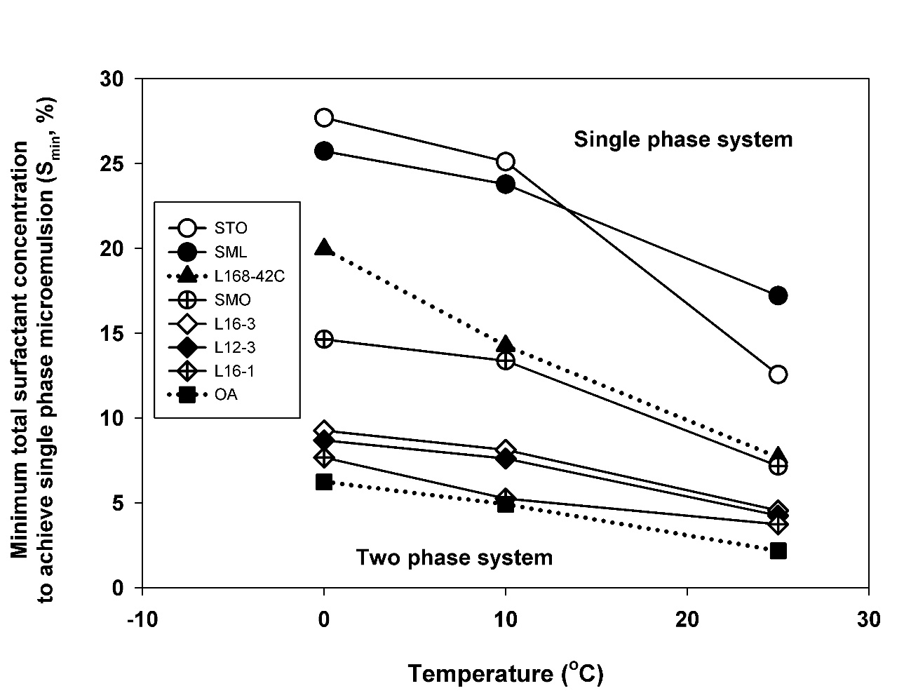
Figure B.1.1: Minimum surfactant concentration to achieve single phase microemulsion versus temperature: comparison of the systems of carboxylate-based extended surfactant (L168-42C), linear alcohol ethoxylate surfactants (L12-3, L16-1, and L16-3), sugar-based surfactants (SML, SMO, and STO), and fatty alcohol surfactant (OA) with ethanol and canola oil/diesel blend at ratio of 50-50 at different temperatures.

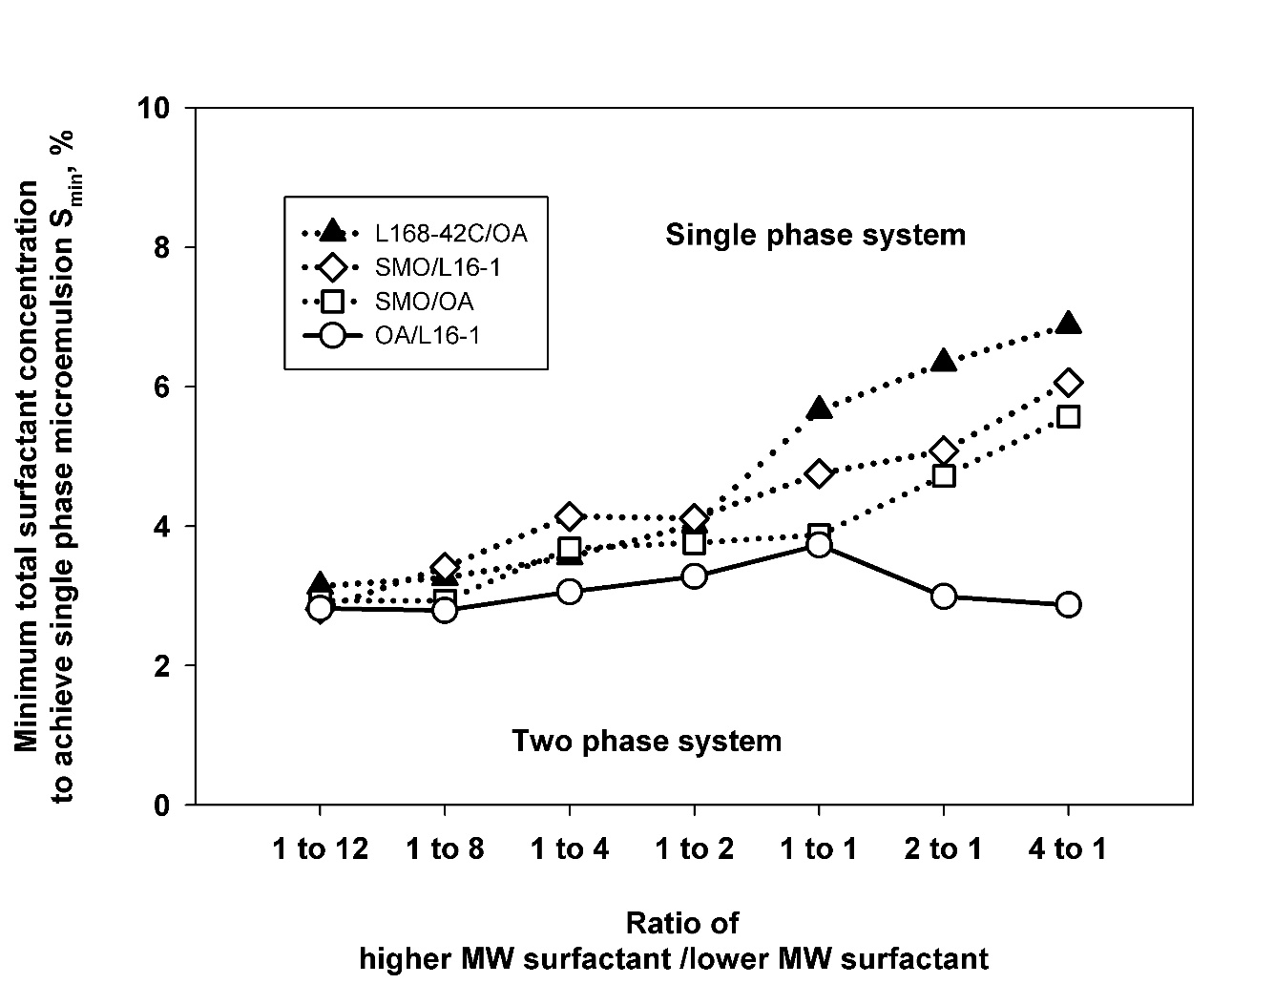
Figure B.1.2: Minimum surfactant concentration to achieve single phase microemulsion versus ratio of higher MW surfactant/ lower MW surfactant: comparison of the ratio mixed surfactant systems of sorbitan monooleate (SMO), linear C12-16 1EO OH (L16-1), linear C16-18 4PO 2EO carboxylate (L168-42C), and oleyl alcohol (OA) with ethanol and canola oil/diesel blend at ratio of 50-50 at 25ºC.

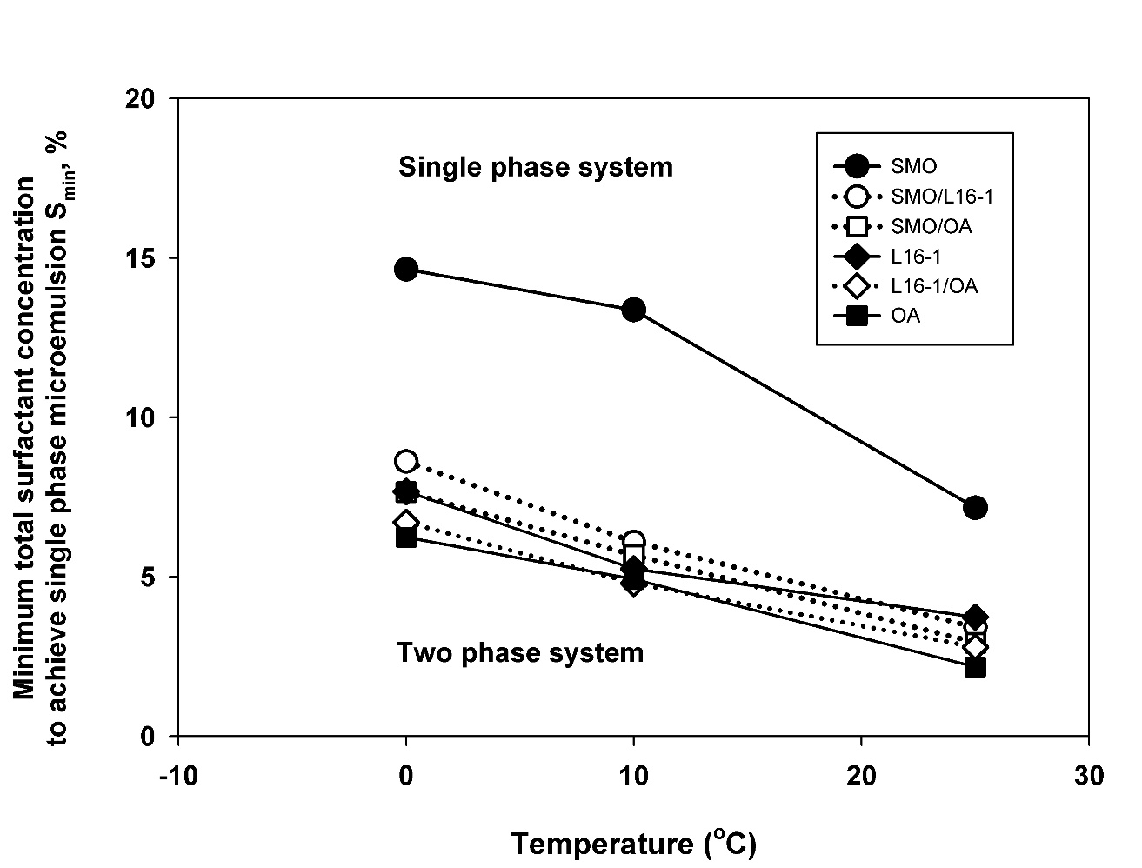
Figure B.1.3: Minimum surfactant concentration to achieve single phase microemulsion versus temperature: comparison of the mixed surfactant systems of SMO/L16-1, SMO/OA, L16-1/OA at ratio of 1-8 and single surfactant system of SMO, L16-1, and OA with ethanol and canola oil/diesel blend at ratio of 50-50 at different temperatures.

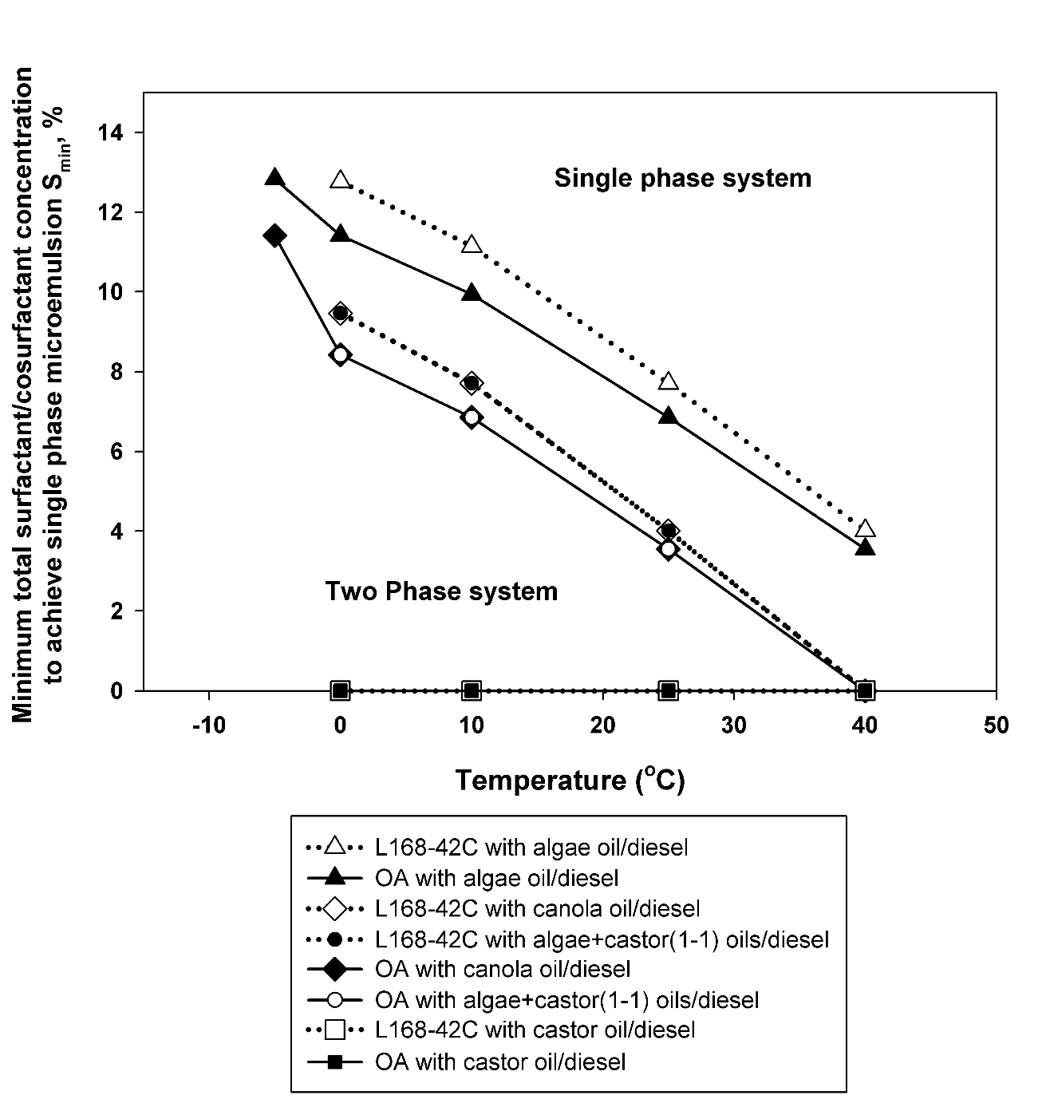
Figure B.1.4: Minimum surfactant/cosurfactant concentration to achieve single phase microemulsion versus temperature: comparison of the surfactant systems of linear C16-18 4PO 2EO carboxylate (L168-42C) and oleyl alcohol at surfactant/EHOH ratio of 1–16 with ethanol in different four vegetable oil/diesel blends at ratio of 50-50 at different temperatures.

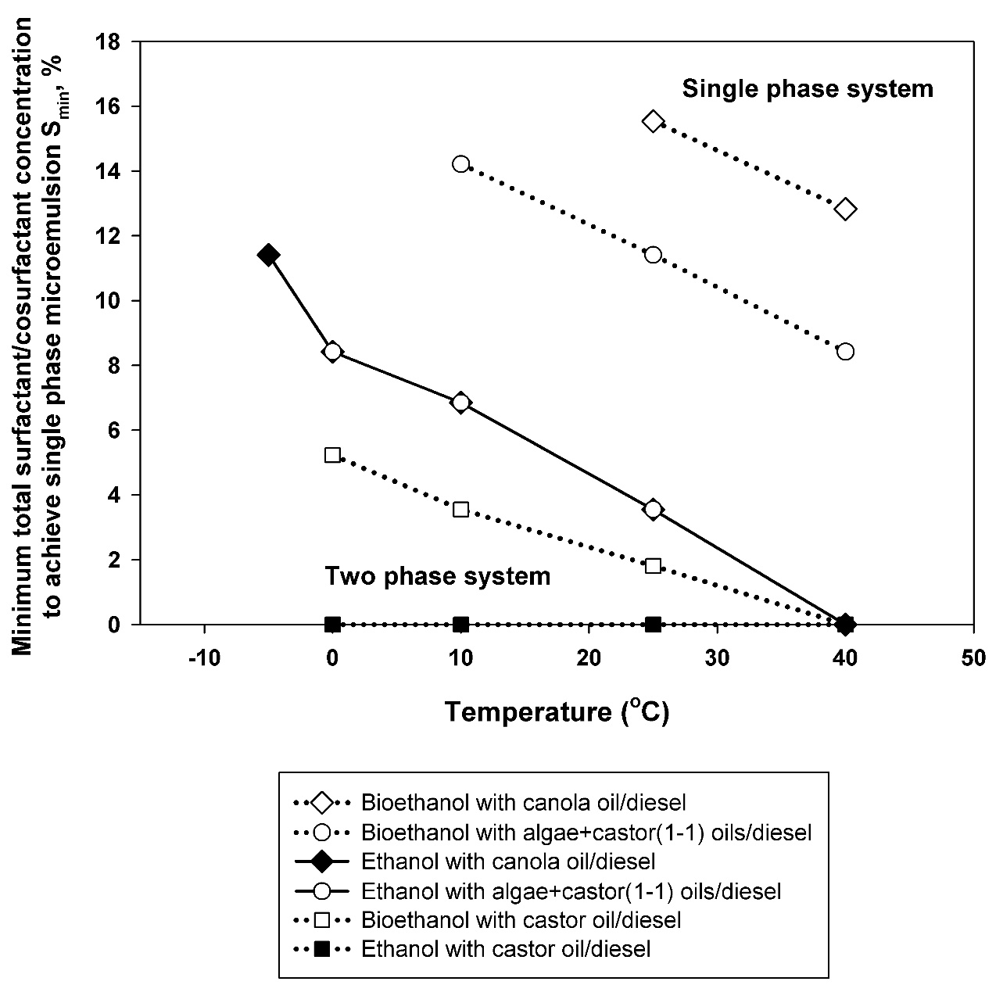
Figure B.1.5: Minimum surfactant/cosurfactant concentration to achieve single phase microemulsion versus temperature: comparison of the surfactant systems of oleyl alcohol at surfactant/EHOH ratio of 1–16 with ethanol and bioethanol in three vegetable oil/diesel blends at ratio of 50-50 at different temperatures.

B.2 The kinematic viscosity and raw data for the kinematic viscosity calculations
Table B.2.1: The density and viscosity values of the four surfactant systems 1 M. surfactant/EHOH concentration and surfactant/EHOH ratio of 1–16 with ethanol in vegetable oil/diesel blend.
Systems | Oil phase | Density  (g/mL) | Dynamic Viscosity  (mPa⋅s) |  |  |  |  | Kinematic Viscosity  (mm²/s)
Systems | Oil phase | Density  (g/mL) | 0ºC |  | 10ºC | 25ºC | 40ºC | 0ºC | 10ºC | 25ºC | 40ºC
OA/EHOH | canola oil/diesel | 0.846 | 12.0 | 7.7 |  | 5.3 | 3.3 | 14.2 | 9.1 | 6.2 | 3.9
OA/EHOH/DTBP | canola oil/diesel | 0.856 | 12.3 | 8.3 |  | 5.5 | 3.5 | 14.4 | 9.7 | 6.4 | 4.1
OA/EHOH/DTBP/EGBE | canola oil/diesel | 0.856 | 12.4 | 8.2 |  | 5.5 | 3.5 | 14.4 | 9.6 | 6.4 | 4.1
OA/EHOH | algae and castor oils/diesel | 0.850 | 14.2 | 10.1 |  | 6.1 | 3.9 | 16.7 | 11.8 | 7.2 | 4.6
No.2 diesel | - | 0.834 | 6.0 | 4.1 |  | 3.1 | 2.2 | 7.0 | 4.8 | 3.6 | 2.5
Canola biodiesel | - | 0.830 | 12.4 | 8.6 |  | 5.8 | 3.8 | 14.6 | 10.1 | 6.8 | 4.5

Appendix C: Supplemental materials for Chapter 4
C.1 The kinematic viscosity and raw data for the kinematic viscosity calculations
Table C.1.1: The density and viscosity values of the four surfactant systems with canola oil/diesel ratio at 50–50 at 1 M. surfactant/EHOH concentration and surfactant/EHOH ratio of 1–16.
Systems | Density  (g/mL) | Dynamic Viscosity  (mPa⋅s) |  | Kinematic Viscosity  (mm²/s)
Systems | Density  (g/mL) | 25ºC | 40ºC | 25ºC | 40ºC
Et | 0.846 | 5.3 | 3.2 | 6.3 | 3.8
BioEt | 0.847 | 5.7 | 3.7 | 6.7 | 4.4
1-Pro | 0.874 | 6.2 | 3.8 | 7.1 | 4.3
2-Pro | 0.852 | 6.1 | 3.6 | 7.2 | 4.2
Mt/Bu | 0.841 | 5.0 | 2.7 | 5.9 | 3.2
Et/Bu | 0.844 | 5.3 | 2.9 | 6.3 | 3.5
BioEt/Bu | 0.848 | 5.6 | 3.0 | 6.6 | 3.6
Canola biodiesel | 0.886 | 5.9 | 4.0 | 6.8 | 4.5
No.2 diesel | 0.834 | 3.0 | N/Aª | 3.6 | N/Aª
ª N/A – not applicable

C.2 Lower heating value (LHV) calculation for microemulsion fuels
Table C.2.1: Compositions and properties of raw materials in the selected microemulsion fuel.
Materials | Molecular formula | Molecular weight, MW_{i} (g/mole) | Density, ρ_{i}  (g/mL) | Composition (vol %) | Mole fraction, X_{i}
Canola | C_{56.8}H_{101.3}O₆ | 879.99 | 0.94 | 29.8 | 0.049
No.2 diesel | C₁₆H₃₄ | 226.27 | 0.85 | 29.8 | 0.172
Ethanol | C₂H₆O | 46.05 | 0.79 | 23.9 | 0.627
OA | C₁₈H₃₆O | 268.48 | 0.86 | 2.10 | 0.010
EHOH | C₈H₁₈O | 130.23 | 0.83 | 14.4 | 0.142

The lower heating value of the microemulsion fuel blend (LHVMF) was calculated using Mendeleev’s formula as shown in Equation C.2.1:
${{LHV}_{MF}=34.013c}_{MF}^{'}+125.6h_{MF}^{'}-10.9o_{MF}^{'} -2.512\left(9h_{MF}^{'}+w_{MF}^{'}\right)$Equation C.2.1
where $c_{MF}^{'}, h_{MF}^{'}, o_{MF}^{'}, w_{MF}^{'}$ are the amounts in unit mass of separate elements in the microemulsion fuel which are calculated as below:
$c_{MF}^{'}=\frac{12.01 ×{ C}_{MF} }{{MW}_{MF}}$ Equation C.2.2
$h_{MF}^{'}=\frac{1.01 × H_{MF} }{{MW}_{MF}}$ Equation C.2.3
$o_{MF}^{'}=\frac{16.01 × O_{MF} }{{MW}_{MF}}$ Equation C.2.4
where is ${MW}_{MF}$ the molecular weight of the microemulsion fuel. ${C_{MF}, { H}_{MF}, and O}_{MF}$ are the number of carbon, hydrogen, and oxygen atoms in the microemulsion fuel, respectively, and $W_{MF}$= 0 since it is assumed that there is no water content in the fuel. ${C_{MF}, { H}_{MF}, and O}_{MF}$ are calculated as below:
${MW}_{MF}= \sum{X_{i}{MW}_{i}}$ Equation C.2.5
$C_{MF}= \sum{X_{i}C_{i}}$ Equation C.2.5
$H_{MF}= \sum{X_{i}H_{i}}$ Equation C.2.6
$O_{MF}= \sum{X_{i}O_{i}}$ Equation C.2.7
where ${{{MW}_{i}, C}_{i}, { H}_{i}, and O}_{i}$ are the molecular weight and the number of carbon, hydrogen, and oxygen atoms in the component i, respectively.
The sample calculation of microemulsion fuel in Table C.2.1 can be shown as follows:
- ${MW}_{MF}, {C_{MF}, { H}_{MF}, and O}_{MF} calculation$
$${ MW}_{MF}= \left(0.049×879.99\right)+\left(0.172×226.27\right)+\left(0.627×46.05\right)+\left(0.010×268.48\right)+\left(0.142×130.23\right)$$
$= 132.08$
$${ C}_{MF} = \left(0.049×56.8\right)+\left(0.172×16\right)+\left(0.627×2\right)+\left(0.010×18\right)+\left(0.142×8\right)$$
$= 8.105$
$${ H}_{MF} = \left(0.049×101.3\right)+\left(0.172×34\right)+\left(0.627×6\right)+\left(0.010×36\right)+\left(0.142×18\right)$$
$$= 17.49$$
$${ O}_{MF}= \left(0.049×6\right)+\left(0.172×0\right)+\left(0.627×1\right)+\left(0.010×1\right)+\left(0.142×1\right)$$
$$= 1.073$$
- $c_{MF}^{'}, h_{MF}^{'}, o_{MF}^{'}, {and w}_{MF }^{'}calculation$
From Equation C.2.2, C.2.3, and C.2.4,
$c_{MF}^{'}=\frac{12.01 ×8.105 }{132.08} =$ 0.74
$h_{MF}^{'}=\frac{1.01 × 17.49 }{132.08} =0.13$
$o_{MF}^{'}=\frac{16.01 × 1.073 }{132.08}=0.13$
- ${LHV}_{MF} calculation$
From Equation C.2.1,
$${ LHV}_{MF}= \left(34.013×0.74\right)+\left(125.6×0.13\right)-\left(10.9×0.13\right)-\left(2.512×9×0.13\right)$$
$$=37.14 \frac{MJ}{kg}$$

C.3 Emission index calculation of microemulsion fuel
For the sample calculation, CO and NO_{x} emission indices of the selected microemulsion fuel in Table C.2.1 at equivalence ratio of 7 are presented.
Table C.3.1: Global emission results.
Emissions | Molecular weight, MW_{i} (g/mole) | Level recorded
O₂ | 32 | 18.9%
CO₂ | 44 | 0.8%
CO | 28 | 27 ppm
NO_{x} | 30 | 4 ppm

From equation 4.2 and the results in Table C.3.1,
$${EI}_{CO}= \left(\frac{X_{CO}}{X_{CO}+X_{CO2}}\right)·(\frac{ c_{MF}^{'} {MW}_{CO}}{{MW}_{MF}})$$
$${EI}_{CO}= \left(\frac{27×{10}^{-6}}{\left(27×{10}^{-6} \right)+\left(0.8×{10}^{-2}\right)}\right)·\left(\frac{ 8.105×28}{132.08}\right) = 5.78×{10}^{-3} \frac{{kg}_{CO}}{{ kg}_{MF}}$$
$$= 5.78 \frac{g_{CO}}{{ kg}_{MF}}$$
and;
$${EI}_{{NO}_{x}}= \left(\frac{X_{{NO}_{x}}}{X_{CO}+X_{CO2}}\right)·(\frac{ c_{MF}^{'} {MW}_{{NO}_{x}}}{{MW}_{MF}})$$
$${EI}_{{NO}_{x}}= \left(\frac{4×{10}^{-6}}{\left(27×{10}^{-6} \right)+\left(0.8×{10}^{-2}\right)}\right)·\left(\frac{ 8.105×30}{132.08}\right)$$
$$= 9.17×{10}^{-4} \frac{{ kg}_{{NO}_{x}}}{{ kg}_{MF}} = 0.92 \frac{{ g}_{{NO}_{x}}}{{ kg}_{MF}}$$
C.4 Radiative heat fraction calculation
For the sample calculation, radiative heat fraction of the selected microemulsion fuel in Table C.2.1 at equivalence ratio of 7 is also presented.
Table C.4.1: The parameters for radiative heat fraction sample calculation.
Parameters | Values | Unit
L | 0.5 | m
$$\dot{m}$$ | 1.6 | mL/min
$${LHV}_{MF}$$ | 37.5 | MJ/kg
ρ_{MF} | 0.846 | g/mL
$$R_{total}$$ | 26.96 | W/m²
$$R_{before ignition}$$ | 3.29 | W/m²
$$R_{after extinction}$$ | 2.97 | W/m²

From $R_{actual}= R_{total}-\left[\frac{ R_{before ignition}+R_{after extinction}}{2}\right]$
$R_{actual}= 26.96-\left[\frac{ 3.29+2.97}{2}\right]$
$$=23.83 \frac{W}{{ m}^{2}}$$
From Equation 4.1, $F= \frac{4¶L^{2}R_{actual}}{\dot{m}{LHV}_{MF}}$
$$F= \frac{4{×3.142×0.5}^{2}×23.83}{\left(\frac{1.6×0.846×{10}^{-3}}{60}\right)\left(37.5×{10}^{6}\right)}$$
$= 0.089$
C.5 The additional results of emission characteristics for Chapter 4
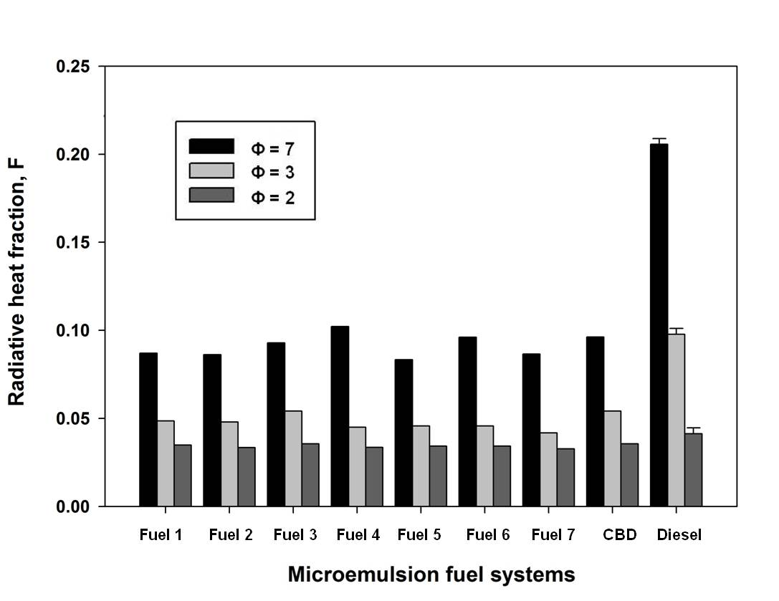
Figure C.5.1: Radiative heat fraction comparisons of different microemulsion fuels, canola oil biodiesel, and No.2 diesel at equivalence ratios (ɸ) of a) ɸ = 7, b) ɸ = 3 and c) ɸ = 2.
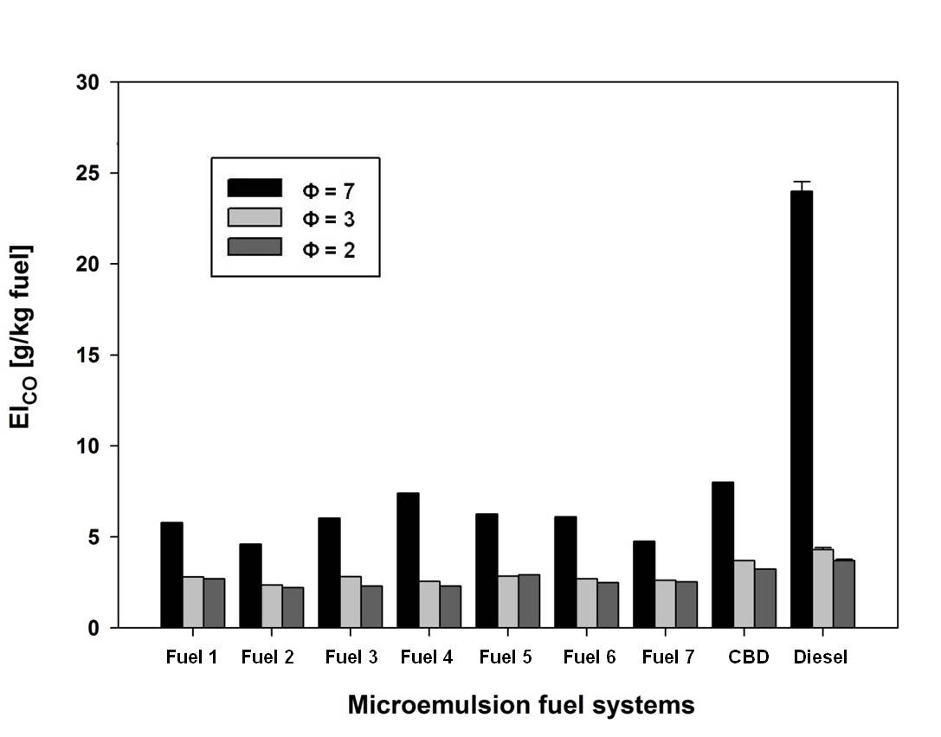
Figure C.5.2: CO emission index comparisons of different microemulsion fuels, canola oil biodiesel, and No.2 diesel at equivalence ratios (ɸ) of a) ɸ = 7, b) ɸ = 3 and c) ɸ = 2 (See Table 4-5 for assigned microemulsion fuel numbers).

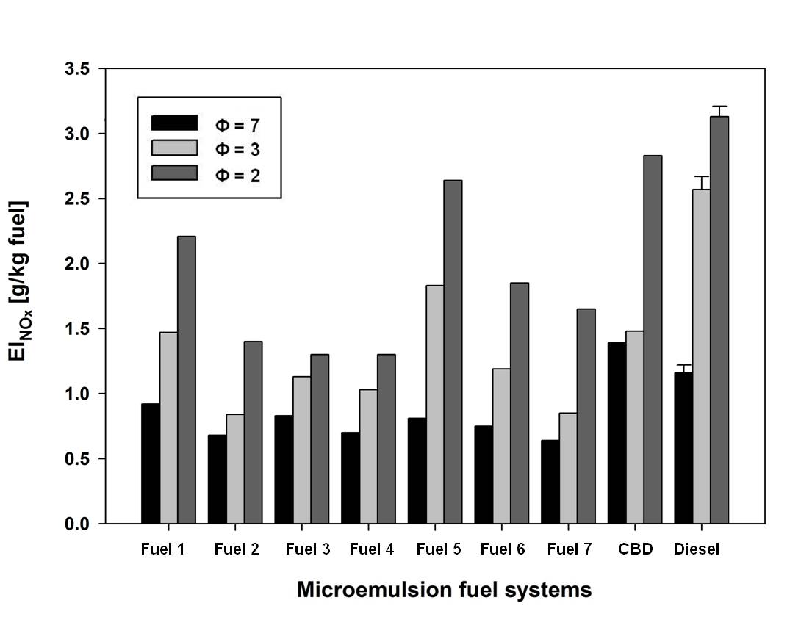
Figure C.5.3: NO_{x} emission index comparisons of different microemulsion fuels, canola oil biodiesel, and No.2 diesel at equivalence ratios (ɸ) of a) ɸ = 7, b) ɸ = 3 and c) ɸ = 2 (See Table 4-5 for assigned microemulsion fuel numbers).

C.6 The additional results of spray droplet size measurement for Chapter 4
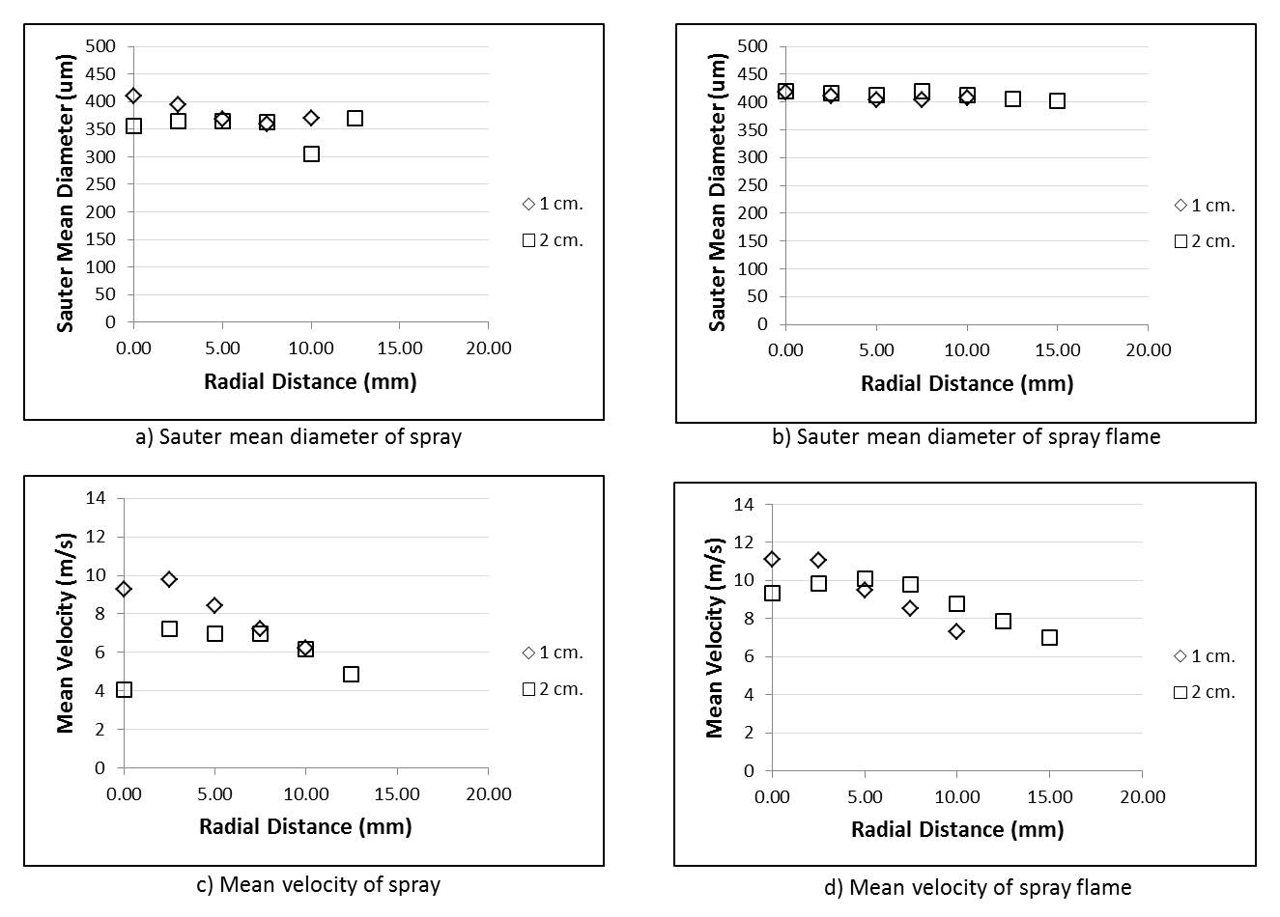
Figure C.6.1: Sauter mean diameter and mean velocity profiles for microemulsion fuel with ethanol (Et) spray and spray flame at an equivalence ratio of 0.8 at 1cm. and 2cm. above the nozzle.
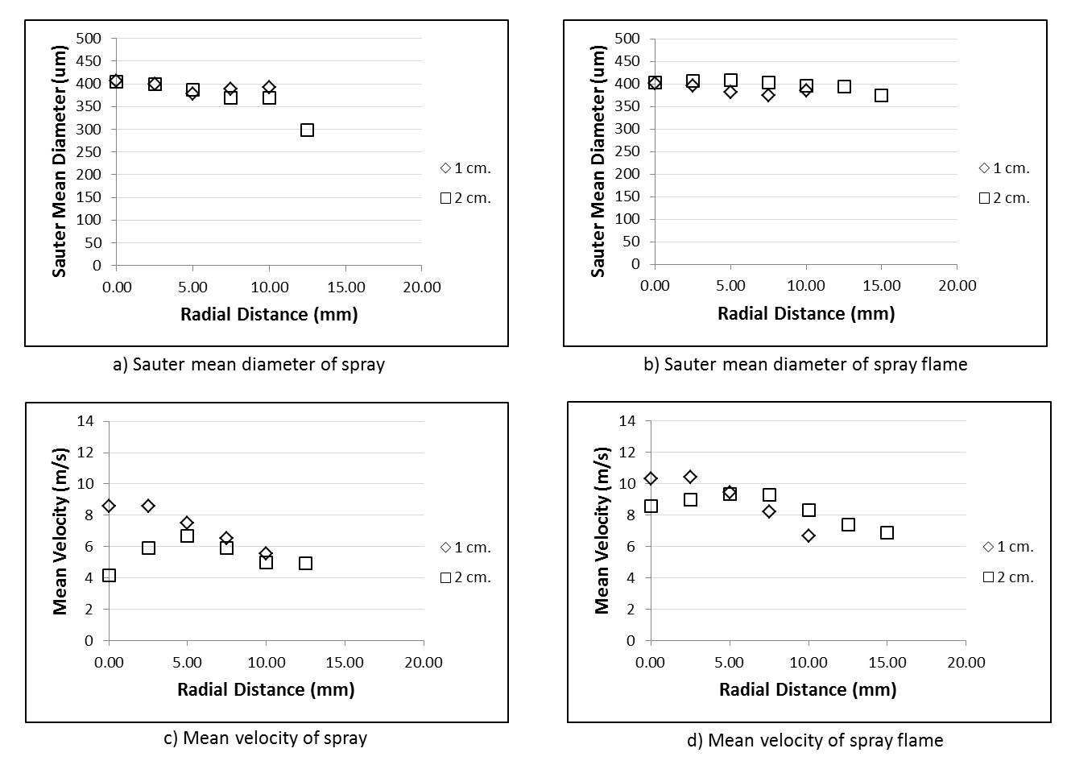
Figure C.6.2: Sauter mean diameter and mean velocity profiles for microemulsion fuel with methanol/butanol (Mt/Bu) spray and spray flame at an equivalence ratio of 0.8 at 1cm. and 2cm. above the nozzle.
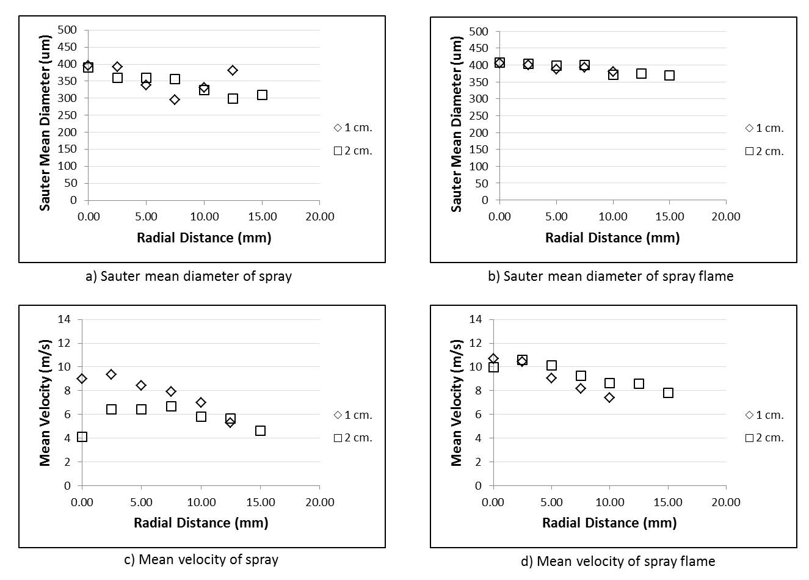
Figure C.6.3: Sauter mean diameter and mean velocity profiles for microemulsion fuel with ethanol/butanol (Et/Bu) spray and spray flame at an equivalence ratio of 0.8 at 1cm. and 2cm. above the nozzle.
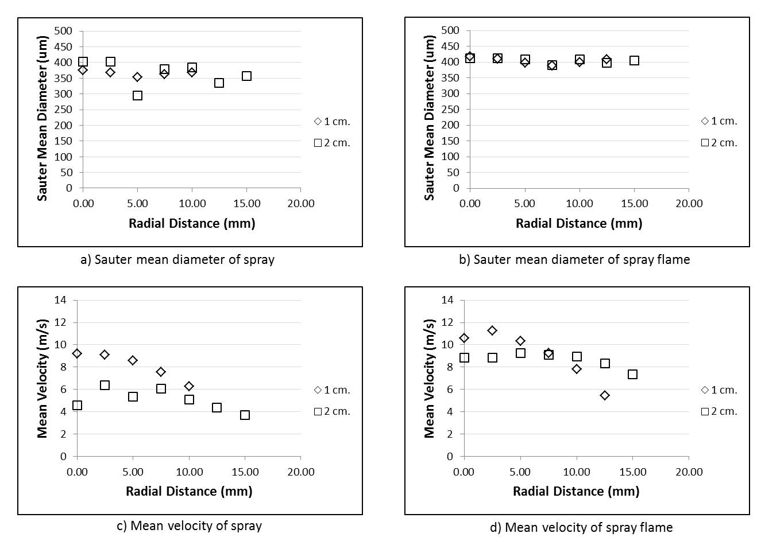
Figure C.6.4: Sauter mean diameter and mean velocity profiles for microemulsion fuel with bioethanol/butanol (BioEt/Bu) spray and spray flame at an equivalence ratio of 0.8 at 1cm. and 2cm. above the nozzle.
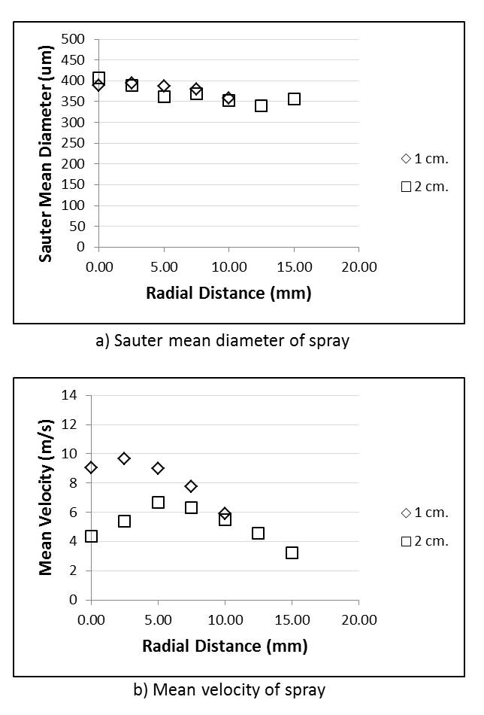
Figure C.6.5: Sauter mean diameter and mean velocity profiles for canola biodiesel (CBD) spray at an equivalence ratio of 0.8 at 1cm. and 2cm. above the nozzle.

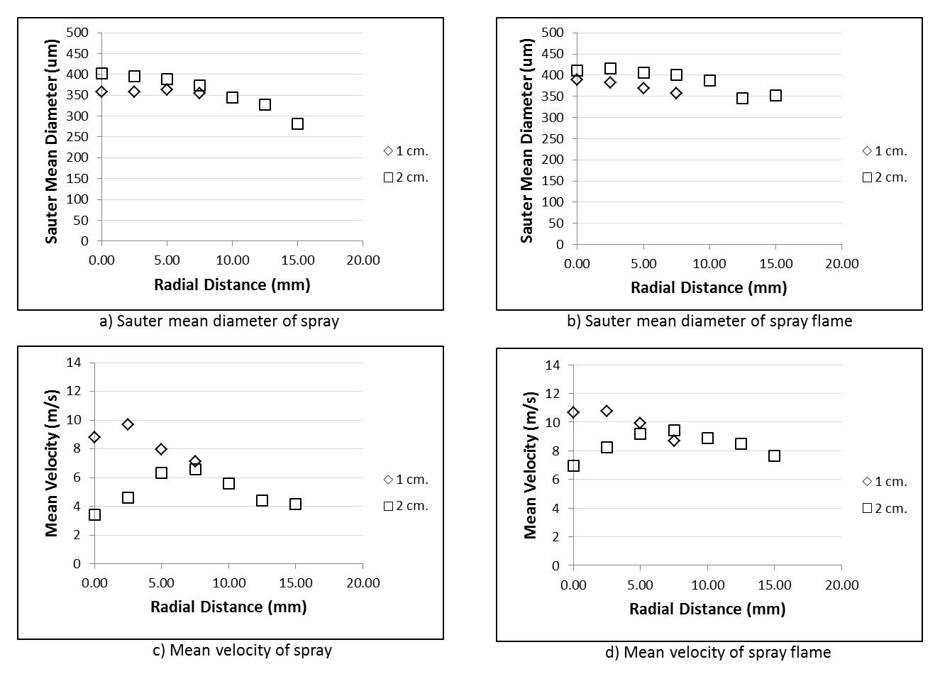
Figure C.6.6: Sauter mean diameter and mean velocity profiles for No.2 diesel spray and spray flame at an equivalence ratio of 0.8 at 1cm. and 2cm. above the nozzle.

Appendix D: Supplemental materials for additional results and future research
D.1 Confirmation of aggregate formation using dynamic light scattering (DLS) and small-angle X-ray scattering (SAXS) measurements
In addition to a red laser beam method, the dynamic light scattering and small-angle X-ray scattering measurements were conducted to support the confirmation of microemulsion structure and aggregation formation of surfactant molecules (micelles or reverse micelles). Dynamic light scattering measurements were conducted using particle sizer (PSS-NICOMPTM ZLS 380, Santa Barbara, CA). The results were found that particle sizes of formulated fuels were in the range of 1-5 nm. Additionally, small-angle X-ray scattering result in Figure D.1.1 showed that surfactant aggregation occurred in microemulsion fuel but it could not be identified whether they were micelles or reverse micelles. The size of aggregation was approximately 2 nm which were consistent with the results of DLS and the results in the previous study. Therefore, it can be confirmed that surfactant aggregation and microemulsion structure are present in the microemulsion fuel.
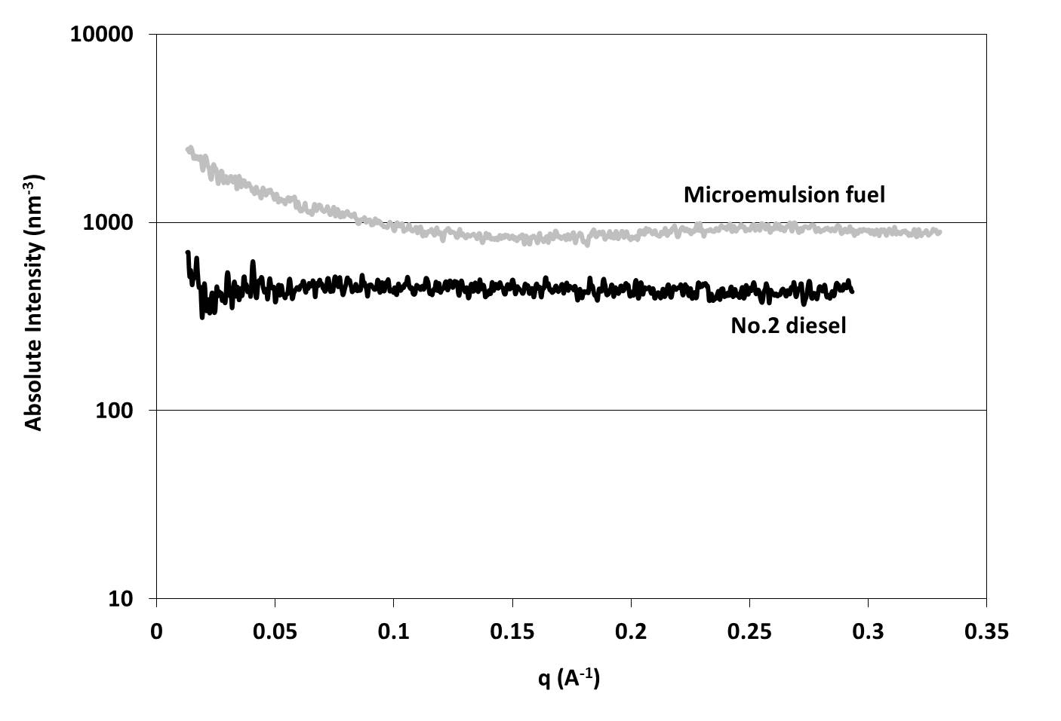
Figure D.1.1: Small-angle X-ray scattering results of the microemulsion fuel with the systems of 0.3 M OA with ethanol in canola oil/diesel blend and No.2 diesel.

D.2 Global warming potential impact assessment
This section demonstrated the sample calculation of global warming potential of microemulsion fuel compared to those of No.2 diesel and canola biodiesel as preliminary results for life-cycle impact assessment in production and consumption stages. The amount of GHGs emission was estimated to perform the global warming potential in the unit of kg CO₂ equivalent per ton of fuel (kg CO₂ e/ton fuel) using the product carbon footprint method (PAS 2050:2008) shown below:
$Carbon footprint = Activity Data × Emission Factor$
$\left(\frac{{CO}_{2}e}{ton fuel}\right) \left( \frac{volume or mass}{ton fuel}\right) \left(\frac{{CO}_{2}e}{volume or mass}\right)$ Equation D.2.1
Table D.2.1 showed the inventory data (raw materials and energy consumption) in production stage and combustion test of microemulsion fuel and canola biodiesel compared to those of No.2 diesel. Table D.2.2 displayed the GHGs emissions from both stages of microemulsion fuel compared to those of canola biodiesel, and No.2 diesel. To obtain these data and calculate GHGs emission, the assumptions established here were as follows:
- The input data including raw materials and energy consumption in microemulsion production stage were obtained from laboratory experiment as primary data
- The secondary data and emission factors were obtained from literatures and data sources, i.e., Ecoinvent database version 2.2, IPCC 2007 and GWP 100a in SimaPro v. 7.1 (LCA software).
- GHGs emission was considered from indirect and direct sources. Indirect emission was calculated from input and output in production stage and direct emission was measured directly from combustion test in laboratory.
- According to considering in production stage, microemulsion fuel and canola biodiesel were produced from the same source of canola oil and No.2 diesel was obtained from local storage; thus, the average distances were assumed to be the same and GHGs emission from transportation was negligible.
- For microemulsion production stage, the energy was consumed only in the process of mixing as electricity consumption of 7.46 kWh/ton of fuel and the reaction time was 2 hours to allow the system to reach the equilibrium.
- Microemulsion fuel was produced without waste generation.
- CO₂, CO, CH₄, and NO_{x} were converted into units of CO₂ equivalent (CO₂ e) by using their GWP values (CO = 1.6, CH₄ = 21, NO_{x} = 68) over 100 years.
- Glycerol and wastewater from canola biodiesel production stage were not treated.
- For direct emission from combustion test, all carbon in fuel was converted as CO and CO₂ in the flame exhaust.

Table D.2.1: Life-cycle inventory for production of 1 ton.
Activities | Amount |  |  | Unit  (per ton fuel)
Activities | Microemulsion fuel | Canola biodiesel | No.2 Diesel | Unit  (per ton fuel)
Input
(a) Raw materials used
Canola oil | 323 | 996 | - | kg
Methanol | - | 110 | - | kg
Ethanol | 221 | - | - | kg
Surfactant | 19 | - | - | kg
Cosurfactant | 128 | - | - | kg
No. 2 diesel | 292 | - | 1000 | kg
Catalyst | - | 10 | - | kg
Acid | - | 10 | - | kg
Water | - | 200 | - | kg
(b) Energy used
Electricity | 3.7 | 48.3 | - | kwh
Natural gas | - | 448.3 | - | kwh
Output
(a) Products and waste
Microemulsion fuel | - | - | - | kg
Canola biodiesel | - | - | - | kg
No.2 diesel | - | - | 1000 | kg
Unpurified glycerol | - | 320 | - | kg
Wastewater (COD) | - | 1595 | - | kg
Direct emission from combustion
Carbon monoxide | 10 | 20 | 40 | kg CO
Carbon dioxide | 2702 | 2900 | 3079 | kg CO₂
Nitrogen oxide | 0.4 | 0.6 | 0.8 | kg NO_{x}

Table D.2.2: GHGs emissions from fuels in production and combustion test using carbon footprint method (PAS 2050:2008).
Activities | Emission factor  (kg CO₂e/kg) |  | Emissions (kg/ton fuel)
Activities |  |  | Microemulsion fuel |  |  |  |  | Canola biodiesel |  |  |  |  |  |  |  |  | No.2 diesel
Activities |  |  | CO₂e |  | % |  |  | CO₂e |  |  |  | % |  |  |  |  | CO₂e |  |  |  |  |  | %
Indirect emission from input and output in production stage
(a) Raw materials used
Canola oil |  | 1.40 | 452 | 43.8 |  |  |  |  | 1394 |  | 41.1 |  |  |  |  |  |  | - |  |  |  |  | -
Methanol |  | 1.25 | - | - |  |  |  |  | 138 |  | 4.1 |  |  |  |  |  |  | - |  |  |  |  | -
Ethanol |  | 0.37 | 82 | 8.0 |  |  |  |  | - |  | - |  |  |  |  |  |  | - |  |  |  |  | -
Surfactant |  | 2.02 | 39 | 3.8 |  |  |  |  | - |  | - |  |  |  |  |  |  | - |  |  |  |  | -
Cosurfactant |  | 2.35 | 302 | 29.3 |  |  |  |  | - |  | - |  |  |  |  |  |  | - |  |  |  |  | -
No.2 diesel |  | 0.52 | 153 | 14.8 |  |  |  |  | - |  | - |  |  |  |  |  |  | - |  |  |  |  | -
Catalyst |  | 1.90 | - | - |  |  |  |  | 20 |  | 0.6 |  |  |  |  |  |  | - |  |  |  |  | -
Acid |  | 0.12 | - | - |  |  |  |  | 1 |  | 0.04 |  |  |  |  |  |  | - |  |  |  |  | -
Water |  | 0.0003 | - | - |  |  |  |  | 0 |  | 0.002 |  |  |  |  |  |  | - |  |  |  |  | -
(b) Energy used
Electricity |  | 0.78 | 2.9 | 0.3 |  |  |  |  | 38 |  | 1.1 |  |  |  |  |  |  | - |  |  |  |  | -
Natural gas |  | 0.64 | - | - |  |  |  |  | 287 |  | 8.5 |  |  |  |  |  |  | - |  |  |  |  | -
(c) Output
Microemulsion fuel |  | - | - | - |  |  |  |  | - |  | - |  |  |  |  |  |  | - |  |  |  |  | -
Canola biodiesel |  | - | - | - |  |  |  |  | - |  | - |  |  |  |  |  |  | - |  |  |  |  | -
No.2 diesel |  | 3.79 | - | - |  |  |  |  | - |  | - |  |  |  |  |  |  | 524 |  |  |  |  | 100
Unpurified glycerol |  | 1.15 | - | - |  |  |  |  | 367 |  | 10.8 |  |  |  |  |  |  | - |  |  |  |  | -
Wastewater (COD) |  | 0.72 | - | - |  |  |  |  | 1148 |  | 33.8 |  |  |  |  |  |  | - |  |  |  |  | -
Subtotal of indirect emission |  |  | 1,031 | 100.0 |  |  |  |  | 3,393 |  | 100.0 |  |  |  |  |  |  | 524 |  |  |  |  | 100.0
Direct emission from combustion test
Carbon monoxide |  | 1.6 | 16.4 | 0.6 |  |  |  |  | 32.0 |  |  | 1.1 |  |  |  |  |  |  | 64 |  |  |  |  | 2.0
Carbon dioxide |  | 1 | 2,702 | 98.4 |  |  |  |  | 2,900 |  |  | 97.6 |  |  |  |  |  |  | 3,079 |  |  |  |  | 96.3
Nitrogen oxide |  | 68 | 28 | 1.0 |  |  |  |  | 41 |  |  | 1.4 |  |  |  |  |  |  | 54 |  |  |  |  | 1.7
Subtotal of direct emission |  |  | 2,746 | 100.0 |  |  |  |  | 2,973 |  | 100.0 |  |  |  |  |  |  |  |  | 3,197 |  |  | 100.0
Grand Total |  |  | 3,777 |  |  |  |  |  |  | 6,366 |  |  |  |  |  |  |  |  |  |  | 3,721

Table D.2.2 showed that microemulsion fuel generated higher GHGs emission than No.2 diesel corresponding to raw materials and their compositions in microemulsion fuel; however, it produced lower GHGs emission than canola biodiesel since it consumed very small amount of electricity without waste and wastewater generation. On the other hand, it was obvious that microemulsion fuel generated lower direct GHGs emission than canola biodiesel and No.2 diesel when all fuels were burned at the same condition. Then, when both indirect and direct sources were taken into account, microemulsion fuel generated comparable GHGs emission (3,777 kg CO₂e/ton of fuel) to No.2 diesel (3,721 kg CO₂e/ton of fuel). From these preliminary results, it can be concluded that microemulsion fuel burns cleaner than the others (considering from direct GHGs emission), and since only raw materials and their compositions in microemulsion fuel production stage had a major effect on global warming potential (considering from indirect GHGs emission), it is the key factor to reduce environmental impact of global warming category for life-cycle impact assessment.

This chapter or portions thereof has been published previously in Fuel in collaboration with Linh Do and David A. Sabatini under the title “Vegetable Oil-Based Microemulsions Using Carboxylate Based Extended Surfactants and Their Potential as An Alternative Renewable Biofuel”, Fuel, 2012, 94, 606 – 613. The current version has been reformatted for this dissertation.
This chapter or portions thereof has been published previously in Energy Fuels in collaboration with David A. Sabatini under the title “Phase Behaviors of Vegetable Oil-Based Microemulsion Fuels: The Effects of Temperatures, Surfactants, Oils, and Water in Ethanol”, Energy Fuels, 2013, 27, 6773 – 6780. The current version has been reformatted for this dissertation.
This chapter or portions of thereof is the collaborative work with Vinay Singh, Arun Balakrishnan, Linh D. Do, Noulkamol Arpornpong, Ramkumar N. Parthasarathy, Sub. R. Gollahalli, Sutha Khaodhiar, and David A. Sabatini and will be submitted to International Journal of Green Energy.

