UNIVERSITY OF OKLAHOMA

GRADUATE COLLEGE

PERFORMANCE, ANALYSIS AND INTERPRETATION IN THE SOLO DOUBLE BASS WORKS OF JOHANNA MAGDALENA BEYER AND VIVIAN FINE

A DOCUMENT

SUBMITTED TO THE GRADUATE FACULTY
in partial fulfillment of the requirements for the
Degree of
DOCTOR OF MUSICAL ARTS

By
MARY CHRISTINE CRADDOCK
Norman, Oklahoma
2015

PERFORMANCE, ANALYSIS AND INTERPRETATION IN THE SOLO DOUBLE BASS WORKS OF JOHANNA MAGDALENA BEYER AND VIVIAN FINE

A DOCUMENT APPROVED FOR THE
SCHOOL OF MUSIC

BY

______________________________
Dr. Anthony Stoops, Chair

______________________________
Dr. Judith Lewis

______________________________
Dr. Rachel Lumsden

______________________________
Dr. Jonathan Ruck

______________________________
Dr. Jennifer Saltzstein

© Copyright by MARY CHRISTINE CRADDOCK 2015
All Rights Reserved.
Acknowledgements

First and foremost, I would like to thank Dr. Anthony Stoops, who has been an invaluable mentor over the last five years. I would also like to thank Dr. Judith Lewis, Dr. Rachel Lumsden, Dr. Jonathan Ruck, and Dr. Jennifer Saltzstein for their time and effort in serving on my doctoral committee. Thanks go especially to Dr. Lumsden, who introduced me to the music of Johanna Beyer and Vivian Fine. Finally, though I know they don’t rightly understand exactly what I do or why, I must thank my family for their unwavering support over the years. I could not have done this without them.
Table of Contents

Chapter One: Introduction 1
Statement of Purpose 1
Need for the Study 2
Methodology 3

Chapter Two: Biographical and Contextual Information 8
Johanna Magdalena Beyer (1888-1943) 9
Vivian Fine (1913-2000) 13

Chapter Three: Register and Performance in Vivian Fine’s Melos 18
Registral Construction 20
Structural Markers 21
Melodic Construction 25
Counterpoint 27
The Ossia Line 30
Conclusions 30

Chapter Four: Range, Process and Performance in Johanna Beyer’s Movement for Double Bass and Piano 32
Performance and Range 33
Range and Structure 36
Motivic Development 37
The Piano 42
Conclusions 43

Chapter Five: Practical Approaches, Performance Considerations, Interpretations 46
Johanna Beyer’s Movement for Double Bass and Piano 48
Vivian Fine’s Melos 54
Conclusions 60

Chapter Six: Conclusions 61

Bibliography 64
List of Tables

Chapter 4
Table 4.1 Melodic and octave expansion in Beyer, Movement 41

List of Musical Examples

Chapter Two
Example 2.1a Sydeman, For Double Bass Alone 16
Example 2.1b Fine, Melos, mm. 47-49; 51-52 16

Chapter Three
Example 3.1 Registers in Vivian Fine’s Melos 20
Example 3.2 Fine, Melos, mm. 13-19 22
Example 3.3 Fine, Melos, mm. 34-39 23
Example 3.4 Fine, Melos, mm. 47-52 24
Example 3.5 Fine, Melos, mm. 57-64 24
Example 3.6 Fine, Melos, mm. 2-8 27
Example 3.7 Fine, Melos, mm. 16-19 28
Example 3.8 Fine, Melos, mm. 47-49; 51-52 29

Chapter Four
Example 4.1 Beyer, Movement, mm. 3-6 39
Example 4.2 Beyer, Movement, mm. 9-12 39
Example 4.3 Beyer, Movement, mm. 21-26 40
Example 4.4 Beyer, Movement, bass range by section 41
Example 4.5 Beyer, Movement, mm. 2-4 44
Example 4.6a Beyer, Movement, mm. 35-36 44
Example 4.6b Beyer, Movement, mm. 79-84 44
Example 4.6c Beyer, Movement, mm. 93-99 45

Chapter Five
Example 5.1 Beyer, Movement, mm. 47-48 49
Example 5.2 Beyer, Movement, mm. 76-77 50
Example 5.3 Beyer, Movement, m. 88 50
Example 5.4 Beyer, Movement, mm. 83-84 51
Example 5.5 Beyer, Movement, mm. 18-20 51
Example 5.6 Beyer, Movement, mm. 59-60 52
Example 5.7 Fine, Melos, mm. 23-24 55
Example 5.8 Fine, Melos, mm. 47-49 56

Abstract

Though musical works worthy of study and performance, Johanna Magdalena Beyer’s 1936 Movement for Double Bass and Piano and Vivian Fine’s 1964 Melos for solo double bass have been neglected by both performers and scholars. Research on these composers by Beal, Cody, Kennedy and Polanksy, and Von Gunden briefly mentions these pieces, but primarily in the context of complete works lists or short superficial descriptions. These works have been performed and recorded a handful of times over the years, most notably by bassists Black, Kohn and Synot, but an in-depth discussion of these pieces by double bassists themselves remains to be done. This document will expand practical and academic inquiry into these worthy but overlooked works by examining the surrounding contexts and content of each from the perspective of performance studies. By focusing theoretical and practical analysis around performance, this document will provide a thorough discussion of both pieces from a useful and unusual perspective. It will demonstrate that these works enrich the solo double bass repertoire by making unique aspects of the double bass cornerstones of the work. In the case of Beyer’s Movement, this cornerstone is the bass’s range; in the case of Fine’s Melos, it is the possibilities of register. The discussion of Movement will consider Beyer’s biographical circumstances at the time of its composition, how this relates to an exploration of range on the double bass, and the determinative influence of range on structure and melody. In Melos, the influence of double bassist Bertram Turetzky on technical and stylistic aspects of the work lead to a reading of the piece in terms of register and the left hand. Three distinct layers of register operate in Melos that play a decisive role in structure and melodic construction. Examining these works by focusing specifically on range and register will reveal that both pieces expand the double bass’s solo repertoire into a new aesthetic space that highlights the bass’s distinctive and idiosyncratic qualities.
Chapter One: Introduction

Statement of Purpose

Over the course of the twentieth century, the solo double bass repertoire underwent a period of unprecedented growth. Scholarship has not kept pace with the rapid expansion of this repertoire, and many excellent but forgotten works await rediscovery by the wider double bass community. Two such works are Johanna Magdalena Beyer’s 1936 Movement for Double Bass and Piano and Vivian Fine’s 1964 Melos for solo double bass. Each of these pieces feature idiomatic aspects of the double bass as fundamental elements of the composition. Beyer’s Movement explores the double bass’s range, while Fine’s Melos makes use of three distinct registers throughout. In this document I will examine the role each of these elements plays using methods developed in the relatively new field of performance studies. These methods will consist primarily of developing analytical frameworks founded in embodied performance experiences. I will also include a discussion of biographical concerns relevant to understanding why embodied experience operates as it does in each work.
The remainder of this chapter will provide a brief overview of the current state of research on Beyer and Fine’s double bass works and then discuss the methodologies used in this document, paying particular attention to methodologies of performance studies.
Need for the Study
While the music and careers of both Beyer and Fine have received increasing attention in recent years, academic inquiry into the solo double bass works remains extremely limited. Beyer’s Movement appears in a complete works catalogue in Kennedy and Polansky’s article “‘Total Eclipse’: The Music of Johanna Magdalena Beyer: An Introduction and Preliminary Annotated Checklist.” It also appears in Amy Beal’s newly published book Johanna Beyer with more context than has previously been available, but only one paragraph is devoted to the work. Both Movement and Melos received mention in Andrew Kohn’s five-page catalogue of works for the double bass by female composers. Melos appears in Heidi von Gunden’s book The Music of Vivian Fine, but the appearance is limited to a short, one-paragraph description of the music.
The dearth of research on these pieces carries over into the double bass community, where solo music of the twentieth century, though more plentiful, is frequently passed over in favor of limited but more analytically approachable repertoire of earlier centuries. Though of course the study of these two works alone will not completely clarify the relationship between the solo double bass and the twentieth century, it will perhaps provide a point of entry through which twentieth-century double bass repertoire can be studied from a performance perspective. This approach has been conspicuously absent in academic discourse on the double bass to date.
Methodology
The musical and biographical circumstances to be considered include the ultramodern movement of the 1930s in New York, especially the musical endeavors of Henry Cowell and Ruth Crawford, who strongly influenced Beyer, and Vivian Fine’s move to the faculty of Bennington College in 1964, the transitional time during which she composed Melos. Other considerations relevant to compositional origins (such as the involvement of double bassist Bertram Turetzky, in the case of Melos) will also be included.

Performance Studies
Recent decades have seen a sharp rise in scholarly writing on musical performance. This trend of seeking an academic understanding of music based first in performance rather than in theory or musicology has produced an abundance of new approaches to music scholarship, ranging from embodied theory to analysis of recordings. Results have varied as widely as methodologies, with differing levels of applicability to other projects.
Much of the literature on performance studies concerns tonally conceived music, but many of the principles underlying this research translate well when applied to twentieth century music. The 1995 book The Practice of Performance: Studies in Musical Interpretation, edited by John Rink, includes twelve essays that address the relationship between musical performance and academic discourse, especially as regards psychology, semantics, and analysis. Of particular importance to this project are the essays by Joel Lester, John Rink and William Rothstein, which consider how the established relationship between performance and analysis might be improved. In these examinations of works by Brahms, Chopin, and Mozart, strategies include integration of recorded performances into the pool of analytical resources, giving greater attention to the impact technical execution itself can have on analysis, and reversing traditional analytical concerns by preceding score analysis with substantial study of a work at the instrument.
Rink also utilizes this last strategy in the chapter “Authentic Chopin: History, Analysis, and Intuition in Performance” from the book Chopin Studies 2. Here Rink seeks to suss out the relationships between performance, analysis and a performer’s intuition in three works by Chopin. His analytic work on these three pieces intentionally postdates extensive experiences performing the pieces privately and publicly. Each section takes aspects of the work perceived as especially critical in performance (for reasons of technique or expression) and centers them at the heart of the discussion. Rink then applies more traditional analysis and musicological research to his findings in order to articulate a clearer relationship between these three disciplines.
The first chapter of Elisabeth LeGuin’s book Boccherini’s Body: An Essay in Carnal Musicology considers how Boccherini’s virtuosic career as a cellist might have affected his compositions, and how LeGuin traces this connection through her own performance of his music. LeGuin crafts an understanding of Boccherini’s solo cello works based on the physical motions necessary for performance and how they might (consciously or unconsciously) inform the composer’s writing. Later chapters explore the question of how this same experience could have shaped Boccherini’s writing for other instruments.
Carl Schachter’s discussion of Chopin’s Prelude Op. 38 no. 5 in the Journal of Music Theory Pedagogy involves a more practical step-by-step breakdown of analytical elements, including large form, phrasing, harmony, and rhythm, and ends with a very detailed guide to suggested performance notes. Less lofty in its aims than some of the other projects mentioned here, it nevertheless posits a practical working relationship between performance and analysis, one easy to emulate in other analytic endeavors.
For the present project, I used a blend of different approaches. With Melos, I took as a model John Rink’s analysis from his chapter “Authentic Chopin.” Following the approach Rink describes in his research, I learned the music, performed and recorded it multiple times, and then approached the score from a more theoretical perspective. I also researched the writings of Bertram Turetzky, the double bassist for whom Fine wrote Melos. His apparently deep level of influence allowed me to apply a more fundamentally embodied approach, as in LeGuin’s work on the cello music of Boccherini. While Fine was not a double bassist, Turetzky’s apparent influence on the compositional process allows his experience as a bass player to be substituted for that of the composer’s in the analysis. The resulting analysis is therefore very performance-oriented. Though traditional elements of analysis come into play, they originate from the fundamental role that left hand shape plays in the technical execution of the piece.
For Beyer’s Movement, my initial approach resembled that taken at the outset of the Fine project: I learned the music, played and recorded it a few times over several months, and made notes about initial impressions regarding the physical performance experience as well as phrasing and expression before bringing these findings to the score itself. However, a few crucial differences exist between Movement and Melos. First, where Melos requires no additional musicians to perform, I lacked the aid of a pianist in the initial stages of this research and so largely left a consideration of the piano part for later stages. Given the bass-oriented nature of the piece and this particular approach to it, I do not believe this had any negative effect on the end results. Second, as will be discussed in Chapter 2, Beyer crafted Movement apparently without the input of a double bass performer, so a slightly different type of embodied approach is used. Here, a performer’s experience is actively (and retroactively) shaping an understanding of the piece that the composer did not necessarily intend or foresee. My analysis of Movement originates in the physical experience of playing the bass part, but also provides more standard types of evidence to support its claims.
Lastly, I took my cues for the general format of Chapter 5 from the performance guide at the end of Schachter’s article. Though not as detail-oriented as Schachter’s chart of measures, choices and techniques, I seek a balance between questions of interpretation and questions of technical execution of that interpretation.

Chapter Two: Biographical and Contextual Information

Historically the double bass has not been a favored solo instrument among composers, and certainly not among composers without some vested interest in the instrument itself. Composers writing for the double bass have generally been bassists themselves or else have had a close connection to a double bassist at some point. A corollary to this phenomenon is that those composers who did write for the bass often composed multiple pieces for the instrument. What, then, prompted Johanna Beyer and Vivian Fine each to write a single work for solo bass? A brief comparison of the biographies of these two composers reveals points of similarity and divergence.
Beyer and Fine both had strong ties to the ultramodern movement. Both composers studied with Ruth Crawford, and their works from the 1930s show the specific influences of Crawford as well as Henry Cowell and Charles Seeger, especially in the use of dissonant counterpoint and the principle of nonrepetition. Vivian Fine’s time with the ultramoderns would prove to be only the first of several stages in her long compositional life, while Beyer’s life would be sadly cut short by a degenerative illness. Although both composers remain relative outsiders to the Western musical canon, Fine achieved a degree of recognition during her lifetime that eluded Beyer. Fine managed to have many of her compositions performed, often more than once. With her appointment to the faculty of Bennington College in 1964, Fine also achieved a degree of legitimacy within the musical establishment that Beyer never did. Though both composers had similar musical training and interests during the 1930s (in addition to shared mentors), Fine’s eventual successes would lead her to a position where she would write music specifically for other musicians, while Beyer remained marginalized her entire life. Fine wrote Melos at the behest of double bassist Bertram Turetzky, but the ultimate motivation for Beyer’s work for double bass may only have been a musical or experimental ideal.
Johanna Magdalena Beyer (1888-1944)
The little we know about the life of Johanna Magdalena Beyer draws a portrait of a woman who frequently occupied the position of an outsider. Beyer was a German-American composer born in Leipzig in 1888, but little is known of her life before she moved to the United States in 1924. Upon her arrival she quickly immersed herself in American musical life. Shortly after immigrating she completed two degrees at the Mannes College of Music. During this time Beyer took composition lessons from Ruth Crawford, Charles Seeger, and Henry Cowell. She associated with composers and musicians of American ultramodernism and the New Music Society. Within that circle, Beyer had particularly close ties with Henry Cowell, with whom she frequently corresponded, and for whom she served as advocate and agent during his four years of imprisonment in San Quentin. Beyer’s public exposure as a composer was relatively limited and included only one published work during her lifetime. In the late 1930s she took part in the WPA’s New York Composers’ Forum Concerts, where her music received performances in two different concerts in 1936 and 1937. During this time John Cage also programmed some of her percussion music on his tours and concerts in the Northwest United States. In spite of these limited instances of success, the greater portion of Beyer’s output remained unperformed during her lifetime. She died in 1944 at age fifty-six of Amyotrophic Lateral Sclerosis (Lou Gehrig’s disease), which increasingly affected her from 1938 to the end of her life. From the time of her death until the 1990s, Beyer’s life and works remained largely unknown and unexamined.
Movement for Double Bass and Piano (1936)
The decade of the 1930s would prove the most fruitful for Beyer as a composer. Her music from the first half of the decade reveals a strong connection to the music of Ruth Crawford, Henry Cowell, and Charles Seeger. This is especially apparent in her use of dissonant counterpoint, a compositional approach developed principally by Cowell and Seeger that privileged dissonant intervals over consonant ones and inverted the traditional rules governing tonal counterpoint. Though Beyer’s continued to use dissonant counterpoint along with other strategies championed by her mentors (including nonrepetition, clusters and serial techniques), music of the latter half of the decade shows an expansion of her compositional toolbox. This included a relaxation (but not abandonment) of previously strict adherence to dissonant counterpoint and rhythmic complexity in exchange for what Kirsten Reese calls “a simplification of her musical language.” Beyer’s 1936 Movement for Double Bass and Piano shows the clear influence of her composition teachers as well as the fingerprints of her own unique and evolving style. It makes use of dissonant counterpoint, but the germinal interval of the piece (a descending D-B motive that recurs throughout) is not particularly dissonant. Very little direct repetition of longer phrases occurs, but Beyer nevertheless manages to harvest a great deal of music from a very minimal amount of material.
The chosen instrumentation (double bass and piano) also appropriately reflects Beyer’s unusual life: chamber music scored for a string instrument and piano is a centuries-old practice, but the double bass is almost never featured as the solo string instrument. It is an even bolder and more imaginative compositional choice in light of the fact that Beyer apparently had no bassist friends or acquaintances to play the piece or inspire her to write it. Some element of the bass itself must have intrigued her enough to see the project through to its conclusion, or perhaps it was simply an extension of Beyer’s unabated commitment to experimentalism. Solo bass writing was completely unprecedented for Beyer, and solo bass writing that features so much of the low end of the instrument would be unusual by most standards in 1936. Movement, then, can be understood as Beyer’s exploration of the double bass itself. Beyer uses no compositional techniques that stand out as particularly unusual for her, nor does she experiment with extended techniques on the instrument. Instead, she simply lets the double bass reveal what it has to offer.

Vivian Fine (1913-2000)
Vivian Fine was an American composer born in Chicago. She began piano lessons at the Chicago Musical College at age 5 and began music theory and composition lessons with Ruth Crawford by age 12. Early in her career Fine allied herself closely with ultramodernists in Chicago, including Crawford, but from the 1940s on expanded her horizons beyond the aesthetic realms of ultramodernism. Professionally, Fine had a long association with modern dance, working with noted choreographers such as Martha Graham, Doris Humphrey, and Charles Weidman. In 1964 she took up a position teaching composition at Bennington College in Vermont, where she stayed until the late 1980s. She retired from teaching in order to focus more on composing, and continued to do so prolifically well into the 1990s. Fine died in 2000 following an automobile accident.
Melos (1964)
Over the course of her career, Fine had generally garnered wider recognition than Beyer ever managed, but Fine’s time at Bennington College would prove a boon for her creativity. As a member of the faculty, Fine had access to greater performance forces and skilled musicians willing to play her music immediately. Many of Fine’s best-known works were composed at Bennington, including her Meeting for Equal Rights 1866 and Women in the Garden, which Judith Cody describes as Fine’s “first candid feminist themes.”
Melos was composed early on in Fine’s time at Bennington. Indeed, though she wrote it to be premiered at Bennington College, she was not yet a full faculty member when she composed Melos. Nevertheless, it is included here among the Bennington compositions since it owes its origins to the same conditions that gave rise to much of her work during that time, namely the opportunity to write for a specific performer: the double bassist Bertram Turetzky, who visited Bennington in the spring of 1964.
By 1964, Turetzky was well known as a double bassist, composer, and advocate for new music. Turetzky had a particular interest in encouraging non-bassist composers to write new works for his instrument. This interest would eventually lead him to write the book The Contemporary Contrabass, published in 1974 and released in a second edition in 1989:
In the early 1950’s, long before militant activists were au courant [sic], I committed myself to work towards changing the professional and public image of the contrabass. In order to do this, I realized that concertizing was the key, which in the 1950’s was almost impossible mainly because of the lack of literature available. I attacked this problem in two ways: by locating original contrabass music from the eighteenth and nineteenth centuries, and by commissioning twentieth- century music.

Originally written a decade after Melos, this book nevertheless provides crucial clues to understanding how and why Fine wrote it the way she did. The Contemporary Contrabass catalogues extended and traditional double bass techniques as well as features of idiomatic writing for the double bass, but Turetzky also has a clear agenda regarding the type of compositions he prefers to commission and perform. Much of the first chapter discusses what he views as the shortcomings of earlier solo bass writing, namely the tendency to write music that exhibits “cello-envy.” In the subsection titled “Why the Contrabass Doesn’t Sound Like a Cello,” Turetzky examines the practical and acoustic problems inherent in those pieces for the bass that principally utilize the upper two strings of the instrument and attempt to imitate a style intended for the tessitura of the cello rather than the bass. Relevant to Melos are the suggestions for better bass writing that Turetzky proffers, which can be summed up as “us[ing] the entire instrument… and the low register in a unique manner.”
Several of the specific techniques of performance and composition in Melos owe an obvious debt to Turetzky. The passages of simultaneous pizzicato and arco in mm. 47-52, the left hand pizzicato indications in m. 61, and the ossia lines scattered throughout the piece are all techniques Turetzky suggests to composers in The Contemporary Contrabass. But this influence extends beyond merely utilizing standard bass techniques. Many of the pieces Turetzky draws examples from in his book were written around the same time as Melos, often also for Turetzky himself. Several of these examples are even from the same year as Melos, including Peter Phillips Sonata for Double Bass and Turetzky’s recording of William Sydeman’s For Double Bass Alone. The examples from Phillips include what Turetzky calls “humane” use of ossia as well as clearly separate upper and lower lines written into the bass part. The examples drawn from Sydeman are intended to illustrate the technique of simultaneous pizzicato and arco playing and includes thumb pizzicato of open strings underneath a bowed melody on the G string, exactly as in Melos mm. 47-49 and mm. 51-52. Example 2.1 shows the Sydeman excerpt from The Contemporary Contrabass along with the similar passages from Melos.
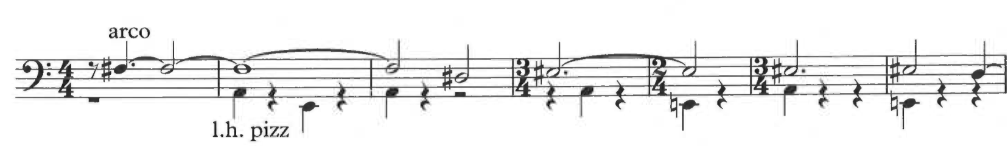
Ex. 2.1a Sydeman, For Double Bass Alone
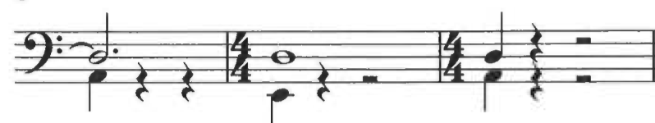
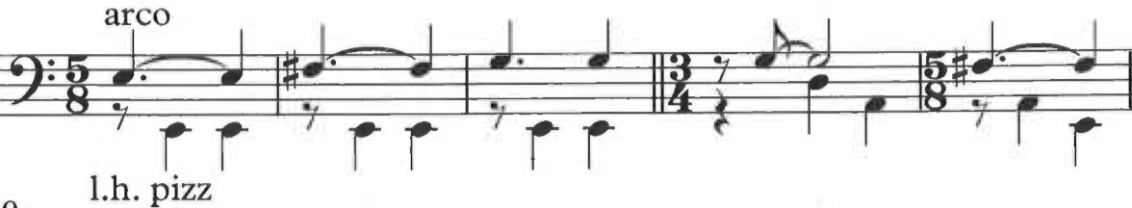
Ex. 2.1b Fine, Melos, mm. 47-49 and mm. 51-52

All of these techniques—simultaneous pizzicato and arco, writing across registers, and use of ossia—come into play in Melos. Turetzky also suggests possible compositional techniques for double bass works, including the idea of writing multiple lines into music for a single bass, as in several of the contrapuntal passages in Melos. Obviously this idea is not unique to Turetzky, but his suggestions on how to implement it, including use of open strings and contrasting registers, clearly influenced Melos.
In light of so many specific examples of technical and idiomatic correlation between Melos and Turetzky’s Contemporary Contrabass, it becomes undeniable that Fine wrote Melos not just for Turetzky, but with a considerable amount of input from the bassist himself. Melos is clearly written in a way that reflects the experience of double bass playing much more deeply than if she had simply chosen to write for the bass without outside influence. Chapter 3 will discuss in detail ways in which this manifests itself throughout the piece.
Melos and Movement both show an unusual inclination to feature the double bass’s low range in a soloistic way. The paths taken by each composer to reach the point of writing for the double bass were almost completely opposite: one stems from collaboration with a double bassist, the other is seemingly drawn solely from the depths of the composer’s imagination and inclination for experimentation. But the resulting pieces are so uniquely suited to the double bass that it is possible to understand each using a framework based first and foremost on double bass performance itself. The following chapters investigate this premise. Vivian Fine’s Melos will be examined first, since the parameters for performance study in Melos have more readily apparent, less abstract origins than those of Movement.
Chapter Three: Register and Performance in Vivian Fine’s Melos

Only six minutes long, Vivian Fine’s Melos nevertheless manages to paint a dark and dramatic portrait of the double bass. The piece unfolds in long strands of melody that wander across the fingerboard of the bass, punctuated (and occasionally interrupted) by brief bursts of declamatory pomp and moments of tense silence. This unhurried exploration of the various registers of the instrument sharply juxtaposes the warm resonance of its low end with the more taut tones of its upper reaches, all within a single melodic line. Fine does not explicitly repeat material in Melos, but rather introduces whispers of recall through permutations of short motives. The most audibly obvious of these is the four-note gesture on a single pitch that opens the piece. This gesture reappears on different pitches, sometimes with slightly altered rhythm, at various points in Melos. Though the dynamics swell and recede throughout the piece, the piano markings of the opening and closing measures frame the work in an intimate atmosphere.
Melos offers many unusual opportunities for the double bassist wishing to play it. Chief among these is the opportunity to perform solo repertoire that occupies a low register, a full octave of which is unique to the double bass among the violin family. Melos also reflects Fine’s particular gift for fluent melodies. This chapter will investigate the ways in which Fine’s register choices operate melodically and contrapuntally, and how these choices create a composition both idiomatic for the double bass performer and reflective of the unique qualities of the instrument itself. Three distinct layers of register, determined by pitch and hand positions, act as a fundamental structural elements of the piece on a micro and macro level, influencing melodic construction at the note and phrase levels, and playing a definitive role in harmonic and contrapuntal choices.
The analytic framework I am using in this chapter combines the performance studies methodologies of Rink and LeGuin discussed in the introductory chapter of this document. In brief, I used Rink’s methods, including repeated performance and recording prior to score analysis, and applied LeGuin’s concepts of embodied analysis to those experiences. While Fine herself was not a double bassist and therefore not acting as a composer-performer in Melos (the composer-performer being an important element of LeGuin’s theorizations), the extensive influence of Turetzky on the compositional process of this piece allows his experience as a bassist to be substituted for that of the composer’s. The following analysis is therefore highly performance-oriented, since first impressions of the piece came from learning to play it, and also because I discovered a great deal about Turetzky’s musical projects of the 1960s. Knowing this corroborated my initial instincts regarding which elements of the piece were most important, chiefly register, and in particular registral layers. From here, I proceeded into an investigation of the function of these layers, and how they related to the construction and performance of Melos.

Register Construction
In determining the range of each register for this piece, I have considered not only actual pitch but also the shape of the left hand as it executes notes in each of these ranges. The three registers in Melos span from the open E string on the double bass (E2) to a D# almost three octaves higher (D# 5). These registers are outlined and labeled on a bass clef staff in Example 3.1. These pitches are notated an octave higher than they sound (as they would be in a double bass part).
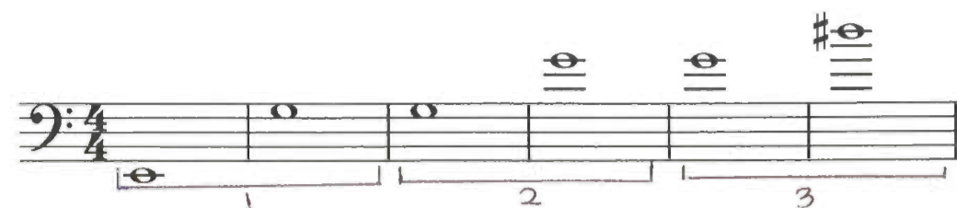
Ex. 3.1 Registers in Vivian Fine’s Melos

In the lowest register (labeled as register 1; from the E2 to the G3 (open G string) 15 semitones higher), the left hand maintains a traditional, pedagogically sound hand shape on the neck of the instrument. The middle register (register 2) extends from the G3 up an octave to G4; in this register, the double bassist’s left hand uses what I call “transitional shaping,” meaning that the relative placement of the thumb on the back of the neck as well as the angle of the other fingers are in constant flux to accommodate the neck block, around which most of these notes are played. While it would be possible to play many of these notes on the G string (and therefore maintain a more standard hand shape), the fact that most of the notes in this register frequently shift to notes in the higher and lower registers means that they must usually be executed in the neck block area. This allows for maximum efficiency in shifting to and from the lower and higher registers on the bass. Lastly, the upper register (register 3) extends from the G4 harmonic to the D#5 eight semitones above. In this register, the left hand maintains a normal “thumb position” shape, in which the hand once again maintains a more or less standard and unchanged shape.
Not all of the pitches indicated in the following analysis adhere precisely to the registers as outlined in Example 3.1. Since hand shape also plays a crucial role in register construction, it occasionally overrides the pitch boundaries set out above. Generally this does not alter the range by more than two semitones. The pitches that extend the range of a register generally do so in a downward direction. Several examples of this register extension will be used throughout this chapter, and will be clearly identified as such.
Structural Markers
Though Melos has no readily identifiable traditional form, it does have several clear points of momentary closure followed by almost fanfare-like phrase openings. Though the methods of closure vary, each new section opens with a declamatory climb through all three registers, generally involving large open intervals to make the transition. The primary intervals of these brief passages are usually a fourth or larger. Example 3.2 includes mm. 14-15, in which one phrase comes to a close by leaping down to register 1 from register 3. An F# is then articulated in all three registers successively, ending in the third register where the new melody will begin. This example demonstrates a case where the pitches indicated do not necessarily conform to the prescribed registral domains.
Ex. 3.2 Fine, Melos, mm. 13-19, transitional figure
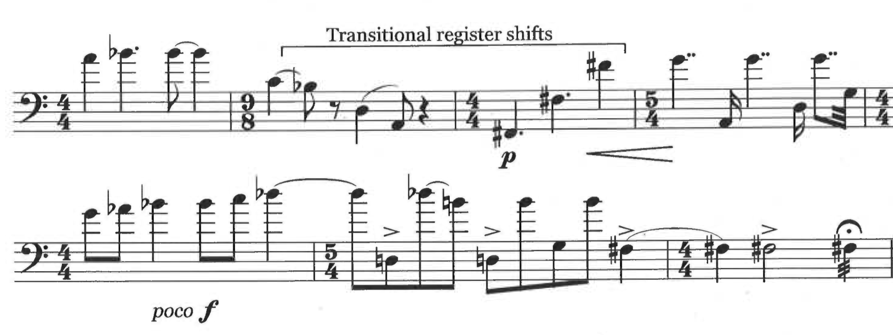
If one were to use pitch alone to determine registers, both the second and third F#s would technically belong to the register below the one with which I have identified them; however, since the hand must use a “transitional” shape to for the second F# in order to most efficiently play the passage, I have included it in register 2. The final F# would also be a member of the second register, but the pitch boundary for register 3 is here bent down because the left hand must already be in thumb position on this note in order to continue the melody in m. 16. Measures 37-38 (found in Example 3.3) provide an example of a more extended but still introductory (rather than melodic) linear segment. Pitches sounding on a beat are often either a fourth or a fifth apart from the pitch on the next beat, and the range of the entire segment extends a semitone short of two octaves, reaching from C3 to B4 before returning down to C3.

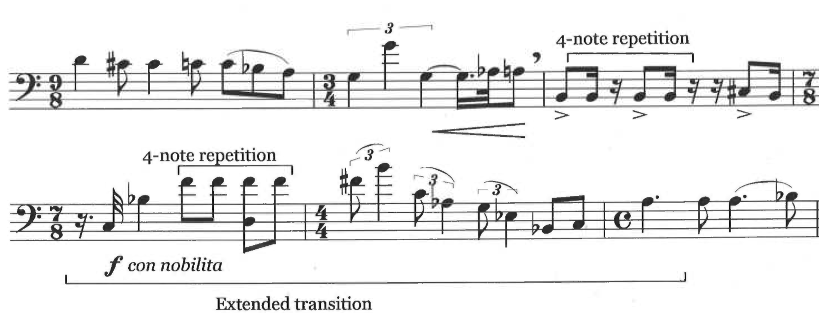
Ex. 3.3 Fine, Melos, mm. 34-39, extended introductory/transitional figure

These register leaps, it should be noted, often operate in conjunction with a single pitch played four times, and occur either immediately before, immediately following, or even simultaneously with these repetitions (as marked in Example 3.3). For examples of this last type, see especially m. 50 and m. 61. Measures 50 and 61 (shown in Examples 3.4 and 3.5) represent a much less drastic example of structural register function. In these measures the four repeated notes act as the primary signal of transition. A brief dip down a register in m. 50 on the third beat, and register 1 (open string) left hand pizzicato against bowed notes in register 3 in m. 61 offer support to the four note gesture.

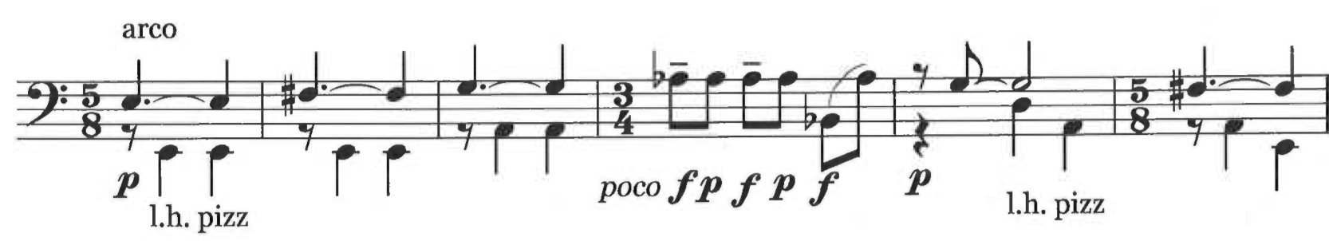
Example 3.4 Fine, Melos, mm. 47-52

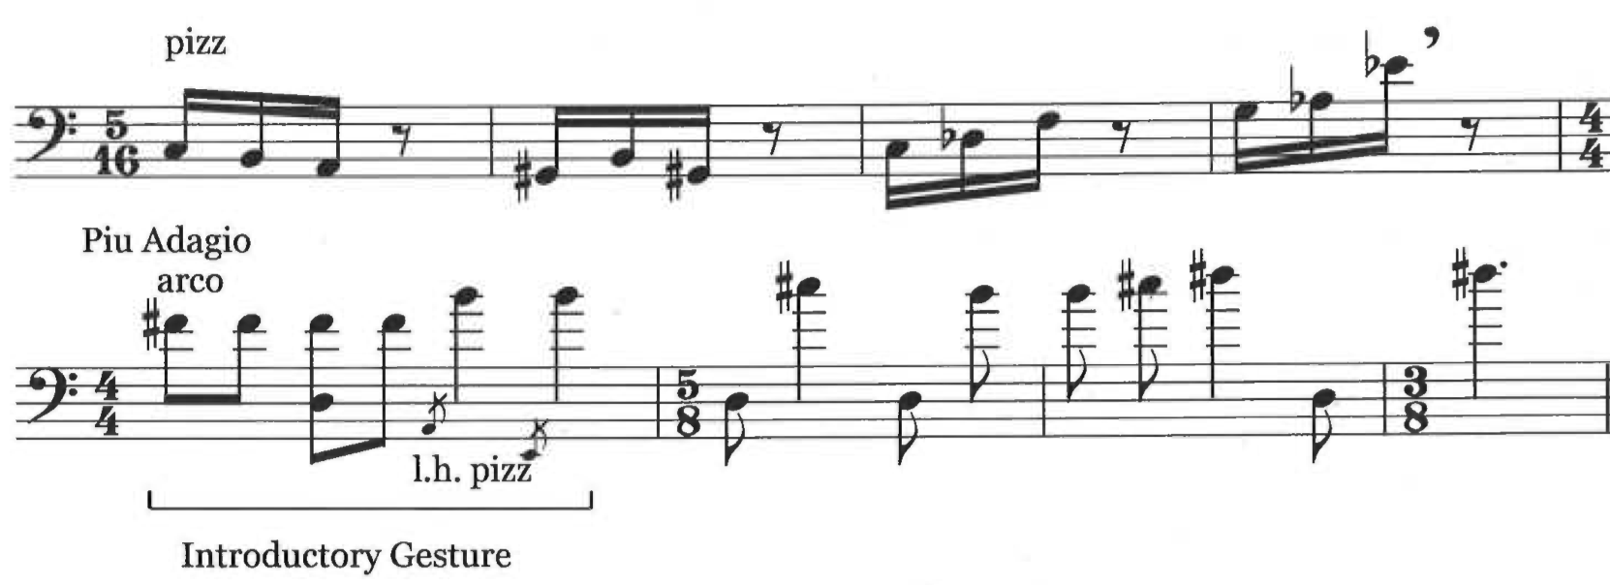
Example 3.5 Fine, Melos, mm. 57-64

The strength of each of these gestures as a mark of structural importance varies depending on the confluence of several additional elements. Chief among these are moments of silence, shifts of tempo, and changes of technique (such as pizzicato to arco). Measures 36-38 in Example 3.3 offer a very strong structural moment, since they include the four note gesture (twice), combined with an extended transitional gesture across all three registers, a shift in tempo (to quarter note = 46 at m. 36), and a brief breath mark indication in between mm. 35 and 36. Similarly, m. 61 begins after a short rest and a switch from pizzicato to arco, and includes contrast between the two outer registers. By contrast, m. 50 represents a moment of less importance, since it is surrounded on either side by technically similar material, and includes movement between adjacent registers. This moment, like m. 15, serves as a structural subdivision on the way to a stronger structural point (in this case, m. 61). An application of these reference points to the entire work yields the following structure:
A (mm. 1-35)
a (mm. 1-15)
b (mm. 16-35)
B (mm. 36-60)
c (mm. 36-50)
d (mm. 50-60)
C (mm.61-66)

This reflects the evolutionary (rather than formulaically dictated) nature of Melos, serving more to highlight moments of particular importance than to act as an overarching peremptory guide.
Melodic Construction
As noted in the introduction to this chapter, fluent melody is one of the hallmarks of Fine’s compositional style, and one of the few that remained consistent throughout her career. Here I want to closely examine the role that register in particular plays in the melody of this piece. Strings of melody consisting primarily of perfect fourths (but not augmented or diminished fourths) in conjunction with both major and minor seconds form the bulk of the connective tissue of these melodic lines. These lines tend to proceed smoothly from one note to the next without any aurally jarring transitions, despite the fact that large leaps greater than an octave occur frequently in these segments. The reason for this apparent contradiction lies in the fact that these large leaps are actually register shifts, and if the three registers were collapsed into a single octave span there would be no leap at all, merely a continuation of the melody by tone or semitone. Where the fourths create overarching motivic continuity throughout the piece, the seconds create continuity within phrases.
This also aids the player in creating a smooth performance. Large leaps such as these would normally lead a player to create brief natural pauses between notes to allow the hand time to move up or down the fingerboard. This is part of the reason why certain of Fine’s register shifts work so well as formal markers (as discussed previously). However, in this case, the pitch class proximity allows the bassist to hear and execute smoother transitions between the registers. Example 3.4 shows mm. 2-6. Measure 3 and m. 5 in this example both offer instances of this type of register shift. In m. 3, a B in register 2 “ascends” to a C in register 1, while in m. 5 a G in register 1 ascends to an A in register 2.

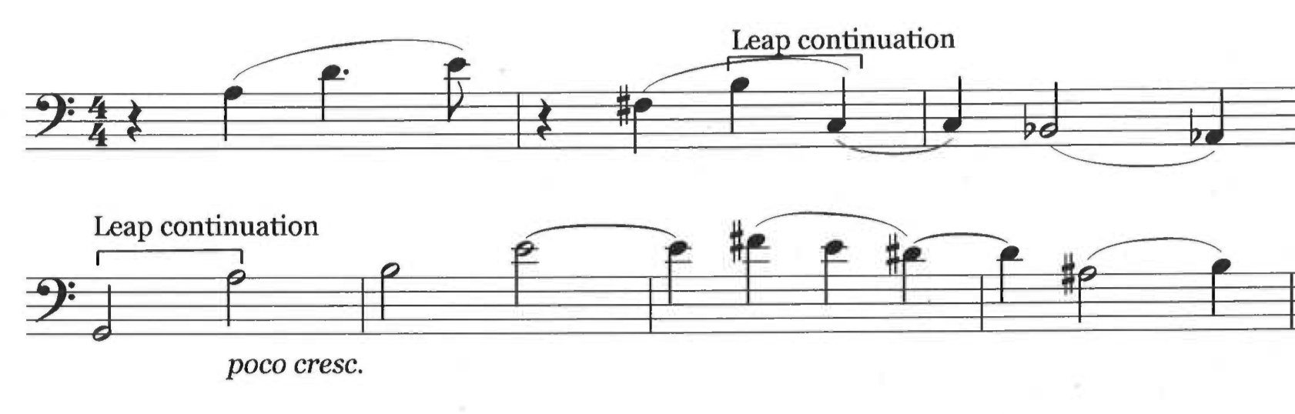
Ex. 3.6 Fine, Melos, mm. 2-6, melodic leap continuation

In particular, the B to C in m. 2 provides an excellent example of a clearly continuous line that would normally be broken up because of the large shift occurring in the left hand. This type of register shift occurs frequently. Chief examples include: m.3, mm. 9-12, mm. 14-15, m. 21, mm. 43-44, and mm.54-55.
Counterpoint
One of the more intriguing aspects of this work is the way in which Fine manages to weave harmonic and contrapuntal elements into a work with only one instrument. This perhaps reflects Fine’s training as a pianist from an early age. In Melos, the harmonic content is based on a counterpoint between the upper melodic voice and motion in fourths in the lowest register. As I noted in the previous section, Fine’s use of perfect fourths in the melody act as a kind of overarching motif, drawing the listener’s ear throughout the piece. By using the perfect fourth as a chief element of the “bass line” of her counterpoint, Fine creates a kinship between the two lines. In addition to connecting the counterpoint with the intervallic content of the melody, these fourths reflect a fundamental element of the double bass itself: its open strings. By utilizing the open strings, Fine allows the double bass to engage in a registrally significant counterpoint not normally possible without great struggle on the part of the bassist. Example 3.5 (mm. 16-19) demonstrates an example of counterpoint between registers 1 and 3.

Ex. 3.7 Fine, Melos, mm. 16-19, registral counterpoint
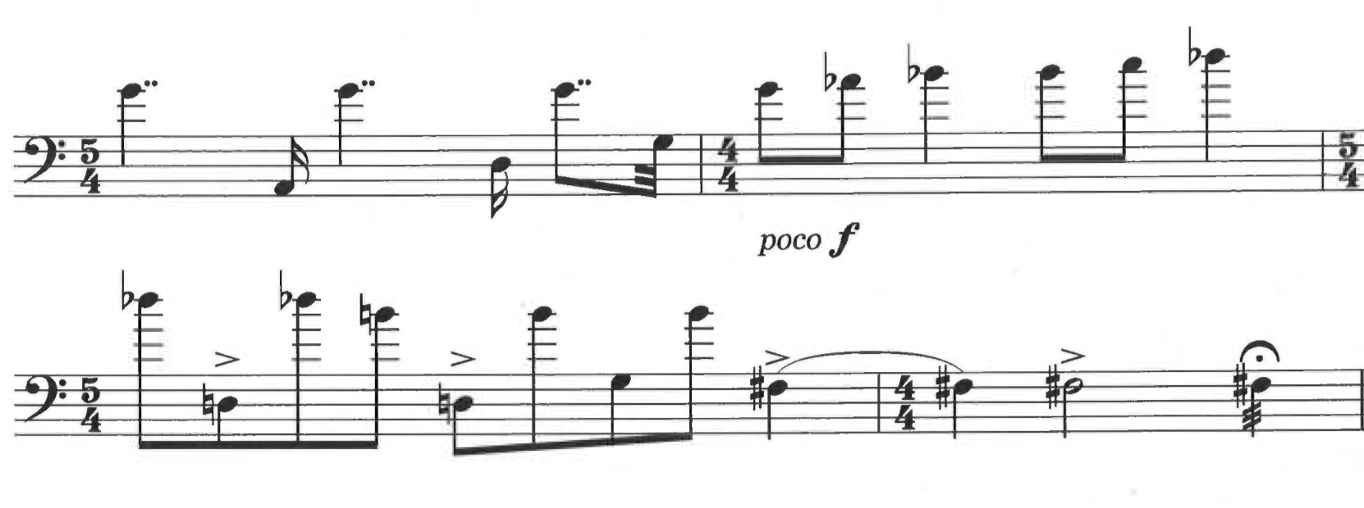
Example 3.5 is an example of counterpoint occurring within alternating temporal space: the open strings sound in between pitches of a continuous melodic segment. Other instances of this include mm. 23-23 and mm. 61-66. Fine also creates a simultaneously sounding counterpoint between registers on the bass by having the left hand both hold down a note to be played by the bow and pluck an open string with a free finger. Example 3.6 shows mm. 47-49 and mm. 51-52, which include simultaneously sounding counterpoint as well as another example of fluid registral boundaries. In order to most securely execute the bowed and plucked notes, the left hand should secure the closed notes in the neck block area on the A string instead of lower on the D string. This results in the use of transitional hand shaping.

Ex. 3.8 Fine, Melos, mm. 47-49; mm. 51-52, simultaneously sounding counterpoint of registers

The real genius of this method of harmonizing a one-instrument melody is that it generates aural and theoretical interest from the nature of the instrument itself. By making the open string fourths the bass line in the bottom register and then forming the melody around the linear execution of fourths in the melody, Fine has inextricably interwoven both the fundamental setup of the double bass (tuning in fourths) as well as practical performance technique (the ability to sound an open string together with a closed pitch) into the fabric of the composition. Fine’s choice to write harmony in a clearly contrapuntal rather than vertically stacked way also reflects the melodic preoccupations of Melos. In essence, Fine creates a countermelody, enabling the double bass (not normally thought of as a melodically inclined instrument) to explore the rich linear possibilities of its normal setup and lower ranges.
The Ossia Line
The ossia parts indicated in m. 9, mm. 16-19, mm. 23-25, and mm. 61-66 do not alter pitch content, although they do alter range of performance. For this reason I would like to briefly address these sections. While it is not unusual for a double bass part to have an ossia for players inexperienced in thumb position, normally it only occurs in pedagogical repertoire or pedagogical editions of standard repertoire and not in a piece specifically written for a single performer. Fine’s alternative ossia lines suggest the importance of preserving register distinctions in in the piece. For example, the last three measures of the piece indicate a possible ossia in the melodic line that preserves the register shift between the D# in m. 64 and the final D# in m. 66. This choice eliminates the register disparity between the open strings in m. 65 and the final melodic note in m. 66 but maintains the integrity of register shifts in the primary melodic line, hinting at the importance of register to Fine’s conception of the piece.
Conclusions
This analysis has by no means exhausted the possible meanings to be discovered in Melos, but it has made a start to the project of shedding light on this intriguing and little-studied work. In creating an organized understanding of register in Melos, we might come closer to understanding how this melodically flowing piece navigates the familiar territory of the double bass in new ways. By approaching this work in a way that considers the fundamental elements and mechanics of double bass performance as well as the original circumstances of its composition and performance, this chapter offers a flexible paradigm of understanding for the performer to apply according to his or her own performance experiences, rather than demanding compliance with a prescriptive set of instructions.
Chapter Four: Range, Process, and Performance in Beyer’s Movement for Double Bass and Piano

Johanna Beyer’s four-minute Movement for Double Bass and Piano is an austere and restless exploration of extremes. The bass play the opening motive and then begins chromatically developing it (sempre forte), and is joined by the piano in m. 10. Together the two instruments continue expanding the initial musical material with increasing rhythmic complexity and progressively denser dissonant harmonies. This relentless additive process is brought to a halt by a bass cadenza that reduces the music back to a single line. Unlike the previous material, the cadenza includes many dynamic indications, but the stark dissonance and austerity of expression from the previous sections continue unabated. Finally, the piano rejoins the bass for a brief, less densely textured recap of pre-cadenza material. The overall uniformity of pace and lack of expressive indications combined with intervallic extremes in both parts lend this piece an unusual and unyielding intensity.
Beyer’s music from the first half of the 1930s make extensive use of certain ultramodern techniques and principles (such as dissonant counterpoint and the principle of nonrepetition) cultivated by her major compositional mentors, especially Henry Cowell and Ruth Crawford Seeger. By the latter half of the decade, Beyer’s commitment to these ideas had jelled with her own unique compositional aesthetic, not so stringently enforced as earlier, but nevertheless strongly implicated.
It has been noted before that Beyer’s 1936 Movement for Double Bass and Piano exhibits characteristics of dissonant counterpoint, but this work also shows signs of her stylistic expansion beyond these stylistic traits. Elements of this work that exhibit this expansion include the consonant nature of the D-B motive that permeates the piece, and a lesser degree of overall rhythmic complexity than can be found in her earlier works. Movement also clearly shows Beyer’s predilection for the use of extreme ranges within a single part. The following discussion is derived from a combination of the methodological apparatus outlined in Chapter 1 and a consideration of more traditional analytic approaches. When viewed from the perspective of performance studies, Movement becomes an exploration of the range of the double bass in a way that also helps clarify the role of elements such as dissonant counterpoint and nonrepetition.
Performance and Range
In playing the double bass part of Movement, it quickly becomes obvious that the most striking moments of the piece occur when the range of the bass line expands rapidly, and when the bass holds long notes (a half note or more) at either extreme end of the instrument’s range. Possibly owing to Beyer’s lack of familiarity with the instrument, much of the double bass part that unfolds within the same octave is, if not difficult, then at least not conducive to idiomatic fingering patterns on the double bass. This partly reflects the chromatic nature of Beyer’s compositional style, but also has the unusual result that the bass part actually becomes slightly easier for the left hand to execute at those moments when the range begins to expand. Additionally, as the range becomes wider, the bow must cross greater distances. This naturally increases the amount of bow used, leading to a natural crescendo and increasing momentum during these passages.
An approach to this piece that begins with these performance considerations yields an understanding of Movement that places range at the heart of the compositional processes unfolding over the course of the piece. A clear road map of the piece, including individual phrases as well as an overall structure, can be drawn utilizing the range of the double bass as its principal determinant. The beginning of each successive section in this piece is recognizable not only by the return of the descending D-B motive, but also by the return to a narrower melodic range and subsequent outward expansion.
Other elements of this piece that suggest the overriding importance of the bass part and its range include the limitations of the piano part and the moments at which very extremes of the bass range are emphasized. Of the ninety-eight measures in this piece, only fifty of them include music for the piano. In spite of this work’s somewhat pointedly egalitarian title (Movement for Double Bass and Piano), the piano remains tacet for nearly half the piece and tends to support and develop ideas first formulated in the bass part rather than to contribute new material. The double bass part, on the other hand, has only four measures of silence. The importance of the extremes of the bass’s range, especially the lower extreme, can also be seen in the number of times Beyer employs the highest and lowest notes of the piece and comparative duration of these notes. The highest note, D5, recurs four times and is never held for less than a quarter note. These notes appear in mm. 35-36, m. 55, and m. 94. Apart from a section of trills tied across bars in mm. 50-52, the longest duration any note is held for in the bass part is two measures, and the vast majority of notes in the bass part have a much shorter rhythmic value. The appearance of a dotted half note D5 in m. 36, therefore, is very striking and the fact that this note never appears with a rhythmic value shorter than a quarter note is significant. In addition, the lowest standard note on the bass, the open E string (E2) occupies an even larger and more prominent portion of the piece. Seven full measures of this work are devoted to a sustained open E string: mm. 68-70, mm. 79-81, and m. 83. The piano is tacet during these measures, and though ornamentation of these notes occurs, including grace notes and trills, these ornamentations serve to highlight the low register of the principal pitch rather than distract from it. In a piece otherwise dedicated to a full exploration of the double bass fingerboard, this attention to it upper and lower edges warrants consideration.
The importance of expanding range in the double bass part goes beyond merely drawing to ear to the outer reaches of the bass or functioning as a byproduct of some other element. Rather, by tracing the progress of the bass’s range throughout the course of the piece, it becomes clear that a fundamental aspect of the instrument—its unique registral space in the violin family—plays a determinative role in the development of the composition.
Finally, although they share some superficially similar traits, range here operates differently from register in Fine’s Melos. Each work involves melodic lines that expand out to cover multiple octaves, but where register creates distinctive layers in Melos, Beyer’s use of range integrates an otherwise disparate landscape of melodic leaps into overarching expansive gestures.
Range and Structure
Initial observation of intervallic expansion in the bass part yields one obvious and repeated trend: growth from a small interval (the D-B minor third motive) into larger and larger intervals over the course of several measures, only to return abruptly to that initial smaller interval. These moments of sudden contraction are most important when they coincide with moments of rest (either of the bass part alone or in conjunction with the piano) rather than points at which the line continues chromatically in smaller intervals but does not reset the overall range. Significant moments of such intervallic resetting include: m. 8; m. 18 (rather than m. 17, where the descending minor third occurs before the air has cleared in the piano part); m. 38, where the range of the bass part is reset following dramatic expansion in m. 35; m. 55 following a fermata over a barline; and m. 91, which follows on the heels of a transitional gesture in m. 90. Each of these moments represent a point of dramatic contraction in the range, but also a point after which the range begins expanding again rather than remaining stable. Measures 62-63 are excluded for this reason: although this gesture does follow a six measure expansion of range across two and a half octaves and a substantial silence, the melody in the measures it precedes do not exceed an octave in range.
Cross-referencing the results of this observation with the points at which the germinal descending D-B motive appears throughout the piece yields a convincing suggestion for structural divisions. Given the frequency with which this motive recurs throughout the piece, using it alone as a guide for structure or phrasing would at best be mired in confusion, with too many points of reference to make a clear picture. By coordinating appearance of that motive with a gradual expansion of the range (range between individual notes as well as overall range across one or more measures), the following sections appear:
Section 1: mm. 1-7
Section 2: mm. 8-17
Section 3: mm. 18-37
Section 4: mm. 38-54
Section 5: mm. 55- 90 (Cadenza- only 4 measures of piano)
Section 6: mm. 91-98 (Tag/codetta)

Though not phrases in any traditional theoretical sense, these sections draw resonance with one another, but do not rely on any longer direct repetition for that resonance.
Motivic development
As noted in the introduction to this chapter, “Movement” makes use of dissonant counterpoint throughout. In his treatise Manual of Dissonant Counterpoint, Charles Seeger (husband of Ruth Crawford and one of the principal advocates for dissonant counterpoint), advocates the idea that dissonant rather than consonant intervals should be considered the most desirable and therefore most frequently employed in melodic writing. In order to avoid strong sonic reference to major or minor triads, any consonant intervals ought to be counterbalanced or interrupted by dissonant intervals. In his writings, Seeger defines consonant and dissonant intervals according to common-practice theory— that is, major and minor thirds and sixths, as well as perfect fourths and fifths are consonant, while seconds, sevenths, and tritones are dissonant (and thus more desirable for Seeger). The D-B motivic germ from which the entire composition slowly emerges, develops in accordance with the principles of dissonant counterpoint. It favors chromatic and dissonant melodic growth and avoids frequent consonance.
In order to develop the motive, Beyer transforms it in two principal ways, with two principal results. First, she transforms it by altering individual pitches by small intervals (often half or whole steps), which gradually pull the listener’s ear away from the initial interval and opens the motive up to the possibility of undisrupted horizontal expansion. By altering the pitches by a second rather than a larger interval, Beyer also ensures greater melodic dissonance. These alterations often restart or take place several times over the course of one melodic statement or phrase. Example 4.1 shows mm. 1-6, where Beyer expands the motive within an octave, gradually inching its range outward from a minor third (D-B in m. 3) to a perfect fourth (D#-A# in m. 5) and then chromatically filling in the newly opened space.

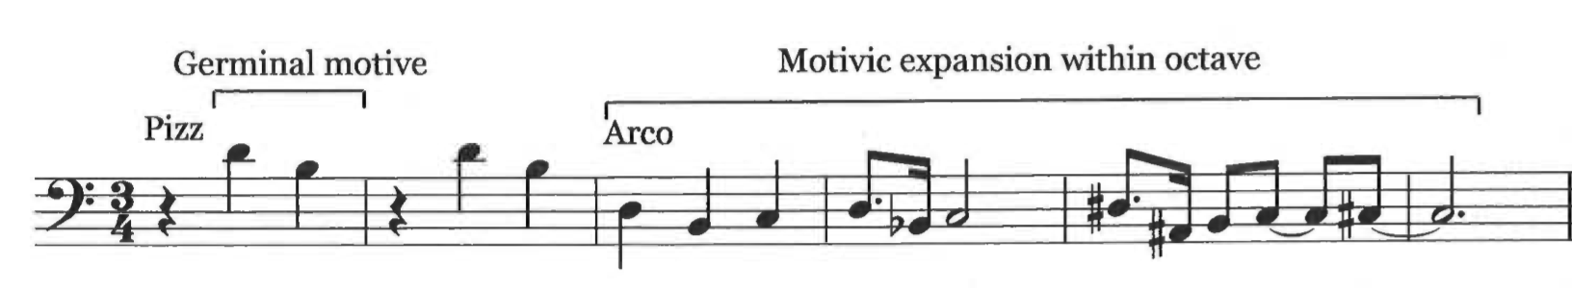
Ex. 4.1 Beyer, Movement, mm. 1-6, motivic expansion within an octave

Secondly, Beyer transposes this motive and its offshoots at octave intervals. Initially, she applies this transposition to entire melodic chunks (as in Example 4.2, where the melody occurs an octave below the opening motivic statement), but as the piece progresses she does this to individual notes with increasing frequency. Example 4.2 shows mm. 9-12. Here the melody continues expanding in the same way as above (reaching a semitone lower than the preceding section, down to the open A in m. 12), but also opens up space by stretching across an additional octave within a single melodic segment.

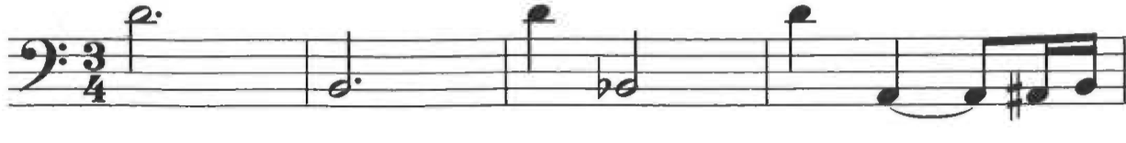
Ex. 4.2 Beyer, Movement, mm. 9-12, motivic expansion by octave intervals

The result here is a vertical expansion of the motive. Both of these processes are evident as early as m. 3, and mm. 4-6 (in Example 4.2) demonstrate how the first of these processes results in an expanded dissonant melody. Once these transformations have occurred, transformations and expansions in later sections draw on both the original motive and the material it produces. As an automatic result of these processes, each successive section grows longer, more dissonant, and more vertically expansive than its predecessors. Example 4.3 shows an excerpt from section 3 in which the melody gradually grows to cover a range of greater than an octave even without the aid of expansion by octave.

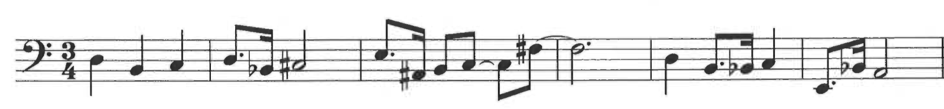
Ex. 4.3 Beyer, Movement, mm. 21-26, dissonant/chromatic expansion of the melody

Table 4.1 shows a summary of the points at which melodic expansion and octave expansion appear in the bass part up to the cadenza. Often both types of expansion work in conjunction with one another (see especially mm. 33-35). Rather than being a breakdown in systematic development, the eventual confluence of these two types of melodic construction represents the fullest realization of instrumental range as a cornerstone of melodic development.

Table 4.1 Melodic and octave expansion in the bass part, mm. 1-50
Structural section | Melodic expansion | Octave Expansion
1 | mm. 2-6 | mm. 2-3
2 | mm. 11-16 | mm. 8-12
3 | mm. 19-35 | mm. 18-20; mm. 32-37
4 | mm. 39-46 | mm. 47-48

While the D-B motive itself is a consonant interval, it rapidly evolves into almost entirely dissonant lines each time it recurs. In addition to growing more dissonant, each new section utilizes ever-widening intervallic distances, so that the first incarnation of this melody spans an octave and a diminished fourth, but by the end of the third melodic iteration in m. 35, the melody spans two octaves and a minor seventh. Example 4.5 shows the range of the bass part by section.

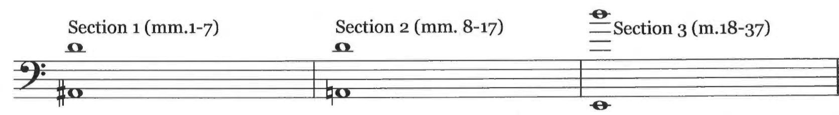
Ex. 4.4 Beyer, Movement, bass range by section
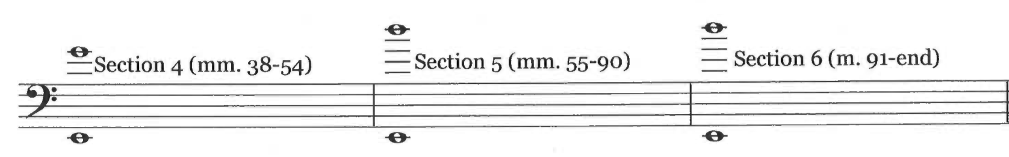
From the third section on, the melodic lines consistently cover nearly three octaves, and individual intervals of greater than an octave recur frequently, providing not only an interesting sonic experience for the listener, but also a challenge for the double bassist.
The Piano
The piano part largely represents an outgrowth of the bass melody. Here the music does not become as organically complex as the bass part (although the rhythm is a great deal more exciting). It does not exhibit the same level of motivic evolution, but with one major exception, it does reinforce the main goals of the bass part— namely to expand the registral space of the piece and promote dissonance in the melody. The right hand of the piano takes up the D-B motive from the double bass and, in addition to making small melodic expansions, its key contribution is covering ever-larger simultaneous intervals in each successive structural section. When the piano enters in m. 10 (during section 2), the right hand performs only the germinal motive and a single one-note expansion of it. Section 3 begins with simultaneous minor seconds. By m. 31, these intervals have gradually grown from seconds to cover intervals of diminished and augmented (but not perfect) octaves. In section 4 (mm. 38-51), the right hand covers intervals of greater than a fifth horizontally and vertically in alternation. While the piano is tacet for much of the later sections of the piece (most notably the cadenza), its reappearance in m. 82 is again marked by simultaneities of at least a diminished octave in the right hand.
The left hand contains the most interesting material in the piano part because it fails almost entirely to conform to either of the two principal features of the music discussed here. It consists entirely of pitches played at octaves, which is as far from dissonance as possible (apart from the unison). Between mm. 38-51 (section 4), which constitutes the longest and most dissonant section in which the piano plays a major role, the left hand plays only a repeated D-B pattern at octaves. Thus, at the peak of dissonance in the double bass and treble piano parts, the bass staff of the piano (the dissonant registral duties of which are being discharged by the double bass) both prevents the dissonance from taking total control and also serves as a constant reminder of the origins of that dissonance. While the piano part is indeed an outgrowth of the music begun and ended by the double bass, it serves in this key instance to subvert the ostensible musical goals of the whole work.
Conclusions
By featuring intervallic expansion as a key component of musical processes in this work, Beyer makes range a cornerstone of the composition. The overall range of this work stretches from the open E string at the bottom of the instrument, to the second D on the G string, less than three octaves in total. Taken by itself, this is not particularly remarkable. However, taken in context with the instrumentation of the work, it points to something new.
The double bass as a solo instrument, while not unprecedented, was certainly seldom seen prior to recent decades, and in 1936 was a fairly anomalous phenomenon. Indeed, historical reaction to technical competence on the part of double bassist was, in the words of double bass historian Paul Brun, shock, not unlike witnessing “a fat man who, deceptively, turns out to be light on his feet.” Thus extensive solo material was, and in some quarters still is, considered incongruous with the double bass. Music for the solo double bass that did exist prior to the middle decades of the twentieth century inevitably sought to feature the bassist’s ability to play high notes like its smaller string relatives rather than its unique low range, which is a part of the instrument Beyer uses extensively. Indeed, Beyer’s first move when initially expanding the motive is to drop an octave and stay there, as in Example 4.5:

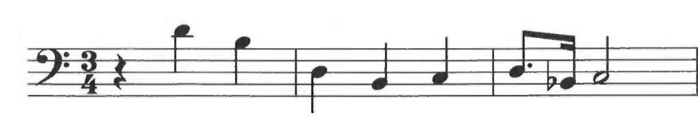
Ex. 4.5 Beyer, Movement, mm. 2-4

When the melody is at its most intervalically expansive (m. 35, mm. 79-89, mm. 92-95), it is the very lowest notes on the bass that Beyer uses as her lower frame and reference point:
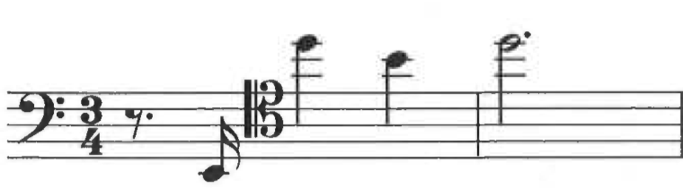
Ex. 4.6a Beyer, Movement, mm. 35-36, extreme registral frames

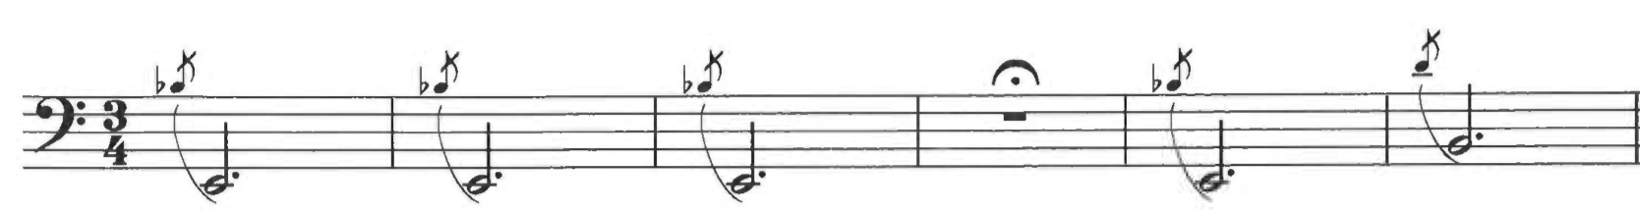
Ex. 4.6b Beyer, Movement, mm. 79-84
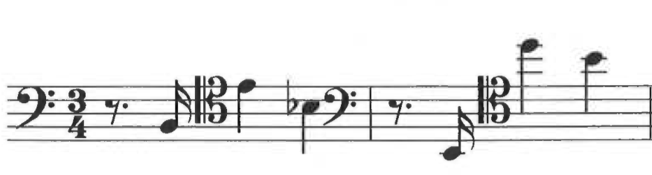
Ex. 4.6c Beyer, Movement, mm. 93-99

This piece as a whole, then, presents a new type of bass solo, one that draws on the bass’s unique qualities rather than its commonalities with more traditionally soloistic instruments. In this sense, Movement foreshadows later developments in the solo bass repertoire, including Bertram Turetzky’s projects of the 1960s and 1970s as well as Fine’s Melos.
Chapter Five: Practical Approaches, Performance Considerations, Interpretations

Performance of little known or unknown works always presents unusual challenges. Players must accordingly look to unusual resources to solve them, since conventional resources such as performance and recording traditions are unavailable. Neither Beyer’s Movement nor Fine’s Melos has a substantial performance tradition. Indeed, though Beyer wrote her Movement in 1936, it would have to wait nearly sixty years for its premiere. Fine did write Melos for a specific musician and performance, but the work itself has since slipped into relative obscurity. Any comments the composers themselves might have made on either piece have gone unrecorded. Since Beyer and Fine only wrote one solo double bass work each, these pieces also lack a collective performance style that would normally be accrued over the study of several works.
For the modern double bassist, Beyer’s Movement exists in a very limited performance context. In the absence of any associated bassist contemporary of Beyer’s, or even other solo bass works by the same composer, the bassist must take the instrument’s parameters and the general style of the work as principal guides.
Melos, on the other hand, has a handful of resources available, albeit indirect ones. It has the advantage of being composed for a performer who wrote in detail on the subject of double bass performance. As noted in previous chapters, Bertram Turetzky wrote about the modern double bass repertoire on several occasions and devoted particular attention to technical issues that crop up in playing such music. Similarly, Fine occasionally spoke about musicians’ interpretations of her work, although these comments were usually directed to pianists in broad terms. An overview of some of her relevant comments will be made later in this chapter.
Recordings, which often provide direction and inspiration for musicians learning unfamiliar works, also provide limited input in this case. Somewhat surprisingly, there exist two recordings of Beyer’s Movement to one of Fine’s Melos. The CD recordings of Beyer’s work by Robert Black and Nicholas Synot offer similar interpretations with minor variations in pacing and articulation choices. Andrew Kohn’s MP3 recording of Melos, on the other hand, makes a handful of deviations from the score. A brief discussion of the recordings of each piece and their possible importance for interpretation will be included in subsequent sections.
To fashion a performance of these works, a combination of practical and interpretive decisions must be made that also take into account the extant information and recorded performances available for each. The remainder of this chapter will examine each piece in turn. It will first address issues of purely technical execution and special techniques where necessary. It will then turn to broader questions of interpretation.
Johanna Beyer’s Movement for Double Bass and Piano
Technical considerations
The primary technical challenges when playing this piece concern bowed string crossings, specifically those moments that require quickly crossing two or more strings between consecutive notes. These crossings are a natural and unavoidable result of the expanding range that lies at the heart of this piece, but certain bowing choices together with right hand awareness will allow the player to reduce excess noise associated with string crossings.
These crossings are most problematic when paired with the pervasive dotted eighth-sixteenth rhythmic motive. This has two primary causes. First, by its very nature this rhythmic pattern requires uneven bow usage, an imbalance that becomes exacerbated when the rhythm is repeated. Second, unless the bow is reset entirely, moving it across several strings changes the bow’s contact point considerably. Usual solutions to these problems include hooked bowing patterns (so that the length of bow used is the same in each direction) and retaking at key points, either between the dotted eighth note and the sixteenth note, or at strategic points throughout the phrase. The hooked bowing becomes impractical and full of excess noise when crossing more than one string, as in m. 30 and mm. 47-48, but it is not always possible or advisable to retake for the upbow. The final solution for bow mapping must be determined by individual players and will likely involve a mix of both hooked bows and retakes as determined by fingering preferences. However, a few sections seem to have one clearly preferable solution.
The expanding leaps in dotted rhythms mm. 47-48 ought not to be hooked, and the bow should be retaken for a clean (rather than hooked) second downbow in the last beat of m. 48. Though slightly awkward, this will prevent the held E-flat from losing momentum before the diminuendo leading into the cadenza.

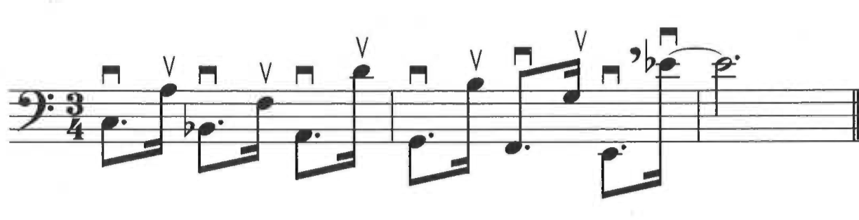
Ex. 5.1 Beyer, Movement, mm. 47-48

Likewise, the rhythm in m. 77 necessitates careful consideration of bow mapping. In order to facilitate dynamic growth over these measures, the F# in m. 77 should be played upbow. By bowing the preceding measure as it comes in the upper half (starting downbow), the downbeat of m. 78 will be downbow near the center of the bow. This will allow the F# to begin upbow in the upper third of the bow.

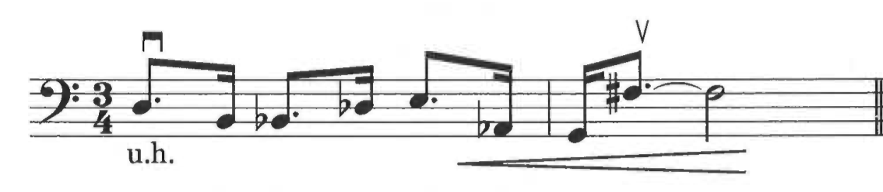
Ex. 5.2 Beyer, Movement, mm. 76-77

Finally, in m. 88 the fourth and fifth notes ought to be played as hooked upbows. Since at least two strings must be crossed between the F on the second beat and the subsequent G, the G upbow should fall naturally at a point that will allow the open E to be played upbow at the frog.

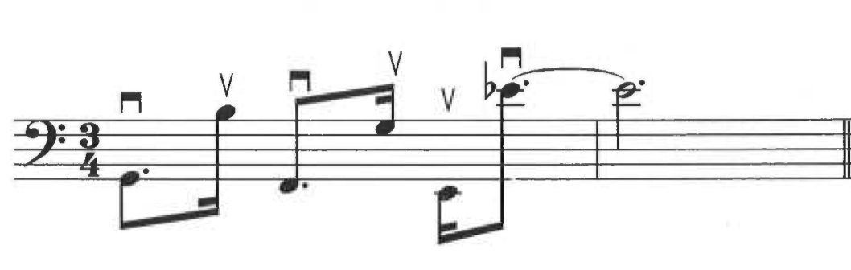
Ex. 5.3 Beyer, Movement, m. 88

Some of the more striking moments in this piece involve grace notes followed by dotted half notes more than an octave below them. The difficulty of these moments comes not from string crossing, since all of the grace notes can be played just one string over from the bottom note, but rather from the difference in the string length being bowed. All instances of these long-distance grace notes occur between m. 79 and m. 87. In order to ensure a clear sound on both the upper and lower notes, the player should perform the grace notes almost as sixteenth notes and start with flat hair on the upper string. In m. 84 and m. 87 the D should be played as a harmonic on the D string. The bow should be retaken at the beginning of each measure.

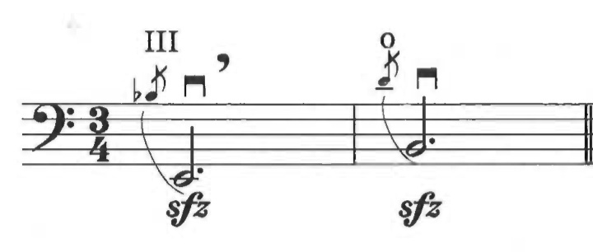
Ex. 5.4 Beyer, Movement, mm. 83-84

Even though it has no sforzando marking, the grace note gesture of m. 20 should also be executed downbow; the easiest way to manage this is to begin the phrase in m. 18 upbow.

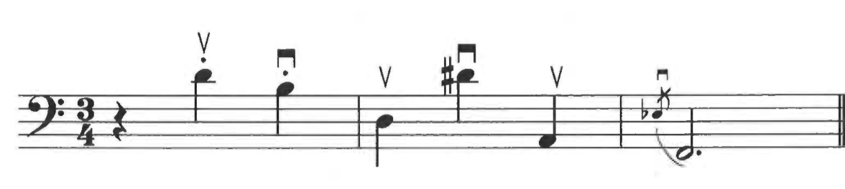
Ex. 5.5 Beyer, Movement, mm. 18-20

The remaining grace note passages (m. 59, mm. 74-75) do not necessarily need to begin downbow and can be performed to the player’s preference.
Measure 60 appears at first glance to prove problematic for the left hand, but the problem is easily solved if the F is played with second finger on the A string, the D is played as an open string, and the B as first finger on the E string:

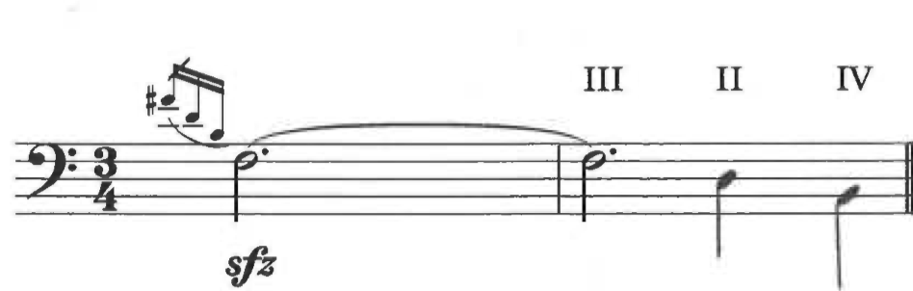
Ex. 5.6 Beyer, Movement, mm. 59-60

As a matter of practicality, the stringendo in m. 72 should start slightly under tempo in order to prevent the end of the measure becoming too frantic or covered by bow noise, as in Robert Black’s recording of this piece.
Lastly, there is one minor inconsistency between the piano score and double bass part in the 1995 Frog Peak edition of Movement for Double Bass and Piano. The bass part is missing a crescendo across mm. 76-77 that appears in the full score.
Interpretive Considerations
Two recordings of Beyer’s Movement for Double Bass and Piano exist, one played by bassist Robert Black on a CD of modern American bass music, and the other played by bassist Robert Synot on a CD of Johanna Beyer’s music. Both have several features consistent between them, including tempo (quarter note = 88, as indicated in the Frog Peak edition) and general articulations (smooth connections between individual notes, with just a hair of space between notes in the dotted eighth-sixteenth rhythms. Synot maintains a steady tempo throughout the entire piece except during m. 72, where the stringendo marking appears. By contrast, Black stretches the tempo slightly in some places, including m. 64 and mm. 84-87. The only major difference between these two recordings occurs in m. 60. Synot chooses to play the D-B motive in this measure pizzicato, necessitating the early release of the bowed F on the second beat. The motivation for this choice is unclear, since there is no pizzicato marking. Black plays this measure arco as written. Perhaps Synot intended to reference the opening and closing measures of the piece, where this motive appears pizzicato. In any case, it introduces an intriguing option for future performers.
Consistency in executing gestures of similar type is key to a successful performance of Movement. Part of the startling intensity of this work comes from a uniformity of expression throughout. The score also gives very little indication that nuance of expression is being called for: the only expressive marking of any kind before m. 50 is a sempre forte at the very opening. Thereafter, markings include dynamics, crescendos, decrescendos, and six sforzandi. Rather than attempting to differentiate phrases by playing each in a slightly different way (a matter already seen to by the non-repetitive nature of the phrases, gestures, and oscillating range), the player ought to seek unity among the diverse elements of the piece by a consistency of bow stroke and tempo. A bow stroke that is slightly heavy and slightly detached (not to say detaché) similar to the ones heard in both Black and Synot’s recordings will best serve the character of the piece. Likewise, though the occasional temptation to play with the tempo appears, particularly at mm. 64-65 in the cadenza, a single consistent tempo should be maintained throughout. Excepting the stringendo of m. 72, the acceleration and deceleration of momentum throughout the piece occurs naturally via shifting rhythmic ratios and fermatas.
In considering the final important element of this piece—its range—it is difficult to extricate interpretive choices from purely technical ones. The bowing issues discussed above stem directly from the juxtaposition of extremes in range. These extremes draw sufficient attention to themselves by virtue of their repeated expansion throughout the bass part. Of primary importance to the bassist, then, is ensuring that no one register of the instrument stands out as being inappropriately different in dynamic or articulation. Depending on the instrument, this may mean playing with slightly less volume in the upper registers of the piece and playing with slightly more at the lower end of the instrument.
Vivian Fine’s Melos
Technical Considerations
In spite of its seemingly difficult melodic lines, Melos is a highly approachable piece for the double bassist. Doubtless this owes a great deal to Bertram Turetzky’s influence on the project. As Von Gunden notes, no strictly non-traditional techniques of bass playing are called for in this piece, but a few aspects of execution merit brief consideration.
Several sections alternate between pizzicato in the lowest register and arco in a higher register. For the most part, the best method of playing these passages will be self-evident to the bass player. However, mm. 23-24 could prove troublesome to bassists not utilizing the ossia line. Normally the player would switch quickly between pizzicato and arco in the right hand, but in this instance the pizzicato notes can be played by the left hand (specifically the left thumb) with very little trouble. This method of playing the passage will eliminate unnecessary movement in the right hand and make it easier to maintain optimal bow placement.

Ex. 5.7 Fine, Melos, mm. 23-24
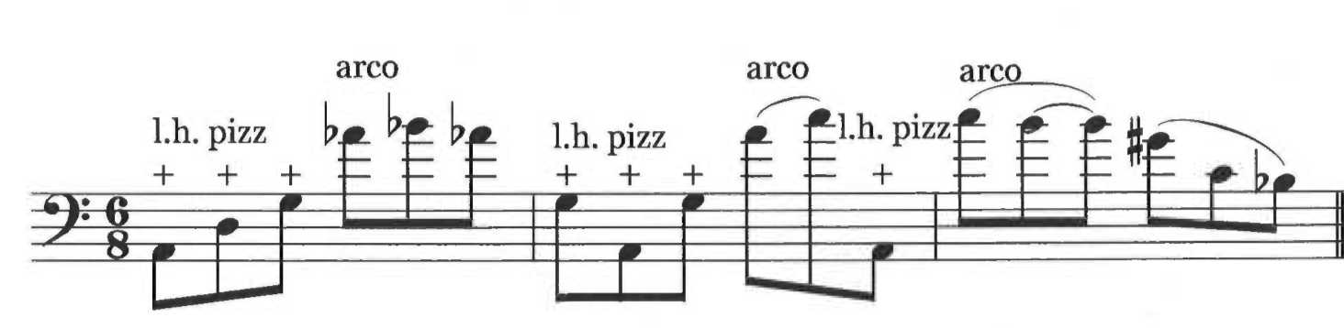
Fine does not explicitly call for left hand pizzicato here as she does in several places later on, where left hand pizzicato is clearly necessary. This should not prevent the player from utilizing it at other points where it eases performance.
Rather unusually, Fine asks the player to bow and pluck separate pitches simultaneously in mm. 47-49 and mm. 51-52. This is one of the techniques that Turetzky suggests to composers in The Contemporary Contrabass. Indeed, the example he includes in his book (by William Sydeman) was recorded by Turetzky in 1964, the same year that Fine wrote, and Turetzky premiered, Melos. Many combinations of left hand fingering are possible here, but in order to produce the strongest sound on both the bowed and plucked notes, the second finger ought to be used for pizzicato. For a darker sound, the player should close the arco note on the lowest available string. (Note however the necessity of playing the G in m. 51 as an open string.) Example 5.8 shows one possible fingering pattern for mm. 47-49.

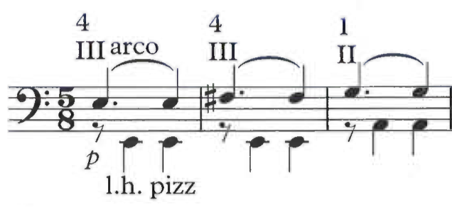
Ex 5.8 Fine, Melos, mm. 47-49

The final left hand pizzicato moment of this piece occurs in m. 61. Since the left hand must already be in thumb position for the high notes, using the left thumb for pizzicato will produce the biggest sound while enabling the bassist to play the top note without fumbling or pausing.
The ossia line that appears occasionally throughout Melos was doubtless originally intended as a kindness to bassists wishing to play the piece with limited thumb position experience. However, technical standards in bass playing have sufficiently advanced in the intervening half-century such that bassists should be encouraged to attempt the piece in its original form. In any case, players should use either all or none of the ossia alternatives, but not a mixture of original and ossia lines.

Interpretive Considerations
Fine herself was an accomplished pianist and seems to have applied a performer’s ear to discussions of her own works. Though she rarely spoke publicly about performances of her music, her comments generally indicate a preference for technical and interpretive flexibility in the service of drama. In an interview given to cellist Christine Kim, Fine’s daughter, Margaret Karp, said:
We spoke of my mother’s lyricism— indeed she herself at one point characterized her writing as “post-romantic lyricism” — but also central to her work is the sense of drama that is at the core of almost every piece that she wrote…. If I could give you one piece of advice it would be to immerse yourself in the drama of the pieces and to be bold in conveying that.

These directives would seem to suit Melos eminently. With its exploration of the low end of the double bass and sweeping leaps across registers, Melos is a highly dramatic work.
Andrew Kohn is the only person to have recorded Melos to date. Kohn’s tempos of choice are noticeably faster than those marked the score. Changes of tempo are marked in four times over the course of the sixty-six-measure piece. While it is not necessary to follow the exact (admittedly slow) tempo markings of the score, Kohn’s tempos reduce the piece from six minutes to less than four and a half. This creates a drastic change in such a short work and causes the crawling melodic lines to seem overly hurried. More surprisingly, Kohn chooses to ignore the directives in mm. 23-24 to alternate between pizzicato on the open strings and arco on the closed notes (a particularly notable example of register alternation). Given the recurrence of alternation between pizzicato and arco later on in the work, especially m. 41, mm. 47-52, and m. 64, this choice seems to limit rather than enhance interpretive possibilities. It would also slightly underplay the register-based analysis proposed in this document by removing an element of contrast between the registers. Finally, there is one rhythmic error in m. 16, where a thirty-second note is played as a sixteenth note at the end of the bar.
The clear overriding interpretive concern in Melos is that of melody, as the title itself suggests. However, Fine’s style of melodic writing does not lend itself to intuitive performance on the double bass. Therefore a carefully considered approach to this piece is necessary. The work in Chapter 3 of this document represents one attempt to craft a systematic approach to melodic lines in this music. The usual instinct of double bassists, especially in unfamiliar music, is to parse out phrases that allow for moments of relaxation or pause between large leaps in the left hand. However, if players instead use the proposed system of analysis to work out phrases that continue across leaps of register, a more compelling performance becomes possible. By framing fingerings around these registers, the player is essentially creating three categories of approximate string length. The extraordinary total string length of the double bass means that tone and color changes happen relatively quickly when shifting around the instrument. Constructing melodic lines that cross several registers will thus allow bassists to craft a melody with an additional dimension of expression. The player can draw attention to these changes in tone and color by altering vibrato speed in advance of register shifts, slowing or accelerating the pace of left hand shifts and bow usage, and choosing a fingering that will highlight the contrasts between one register and the next. This will not only allow the melodic lines to come across in a more nuanced way, it will also aid double bassists in securing better intonation across registers. By recognizing that much of the melody would continue by step if the registers were collapsed into a single octave, the bassist can more easily mentally hear pitches across large leaps before playing them. The result of this approach is an intense lyricism not normally possible in such a leap-prone piece.
Other elements that will contribute to a dramatic performance include the use of a truly adagio tempo and attention to the many expressive markings throughout the piece. Exact adherence to tempo markings is not necessary, but tempos should generally be the same each time they recur. Five tempo markings appear throughout the piece (one as a courtesy marking following a fermata), but only three different tempos are indicated: the quarter note is marked variously as 40, 46, and 56. Each time a tempo returns, the associated music has clear connections to previous material at that tempo. The music will therefore have a stronger audible coherence when the spirit of the markings is observed, if not the exact metronomic meaning.
The expressive markings in Melos would be difficult to overplay. Dynamics and dynamic shifts should be performed with as much attention as possible, since they are crucial to conveying the drama at the heart of this work. The unusual expressive markings piu intenso in m. 32, con nobilita in m. 37, and con sollenita in m. 47 also merit consideration. No standard musical interpretations for these terms exist. Possible performance interpretations include playing the piu intenso section with a slightly increasing vibrato speed, playing con nobilita with a hair of space between each note, and playing con sollenita on lower strings for a darker sound (as suggested above in Ex. 5.8).
Conclusions
New and unknown works pose such challenges to players that the task of performing them usually falls to those who specialize in such repertoire. To be sure, the amount of independent and creative thought that has to be put in to such an endeavor requires dedication and energy, but that need not cause worthy compositions to be marginalized or forgotten. These two pieces in particular show great promise as future standards of the solo double bass repertoire and want only for greater awareness among double bassists. In contrast to much twentieth-century double bass repertoire, both pieces use standard instrumentation and notation. Neither is excessively difficult, and indeed either one would make an excellent introduction into sounds and styles of twentieth century bass playing at the collegiate level. Neither work is tonal, but neither calls for extended techniques useful only in specialized repertoire. The technical and interpretive suggestions in this chapter represent only one set of possibilities for these works. The future will hopefully see many more bassists add their own interpretations of these pieces to the collective knowledge of the double bass repertoire.
Chapter Six: Conclusions

The solo bass works of Johanna Beyer and Vivian Fine represent a new type of aesthetic that utilizes the double bass’s distinctive properties to forge a solo idiom in which the double bass flourishes and even excels. This takes place on a level more fundamental than simply ensuring that the piece is suitable for performance on the double bass. These pieces do of course take advantage of characteristic techniques, including left-hand pizzicato and double stops, but these are not necessarily fundamental aspects of the composition. Rather, musical features such as register, range and the open strings of the instrument are made to be cornerstones of a process that unfolds over the course of the piece. In each of these pieces process trumps form in structural importance (indeed, it would be difficult to assign a standard form to either of these works), so that these building blocks of the double bass can become building blocks of the music itself. This approach to writing for the double bass has opened up new musical possibilities that allow the instrument to fulfill its unique potential.
This is not meant to suggest that double bass music written in other ways is somehow lacking or bad, or that we should stop performing standards of earlier centuries (or more standard works from the twentieth century). Rather, works such as these have extended the previously limited space in which the double bass existed as a solo instrument. This approach to writing for solo bass has renewed the potential for composers and performers interested in the double bass, opening up new avenues for future exploration.
The use of performance studies in this document has enabled an understanding of these works distinct from what more traditional methods of musicology or music theory would normally produce. Focus on physical properties of the instrument and performance has yielded attention to details (such as subtle changes in timbre across the full range of the double bass) often overlooked in traditional scholarship. The analyses of Chapters 3 and 4 offer unusual insights into the expressive possibilities of each piece. The register analysis of Melos brings into sharper relief the differences in sound produced on the bass at the outer ends of its range. Awareness of these differences allows the performer to highlight them (by means such as modulating vibrato and shifting speeds) and create a richer tapestry of tone colors in this highly expressive piece. The analysis of Movement, on the other hand, yields almost the opposite result. By recognizing the unifying role range plays in this work, the performer can avoid highlighting the natural timbral differences at the extremes of the instrument and thereby strengthen the austere intensity of the piece.
Although published scholarship in performance studies tends to focus on tonal music, many of its concepts and approaches might also be usefully applied to twentieth century music. The widespread splintering and specialization of compositional and performance techniques in the twentieth century make it very difficult for any one person to have a complete grasp of all analytical approaches. A traditional analytic study of the music of Beyer and Fine, for instance, would require specialized knowledge of techniques such as dissonant counterpoint. The average bassist interested in performing Melos or Movement very likely does not have that knowledge.
This document represents a first foray into double bass performance studies, and it is my hope that the work done here will inspire further research of this kind among bassists. Double bassists have long proved ourselves to be an adaptive group, and I have no doubt that we have the ability to contribute work valuable not only to ourselves, but also to the wider musical community.

Bibliography

Books

Beal, Amy C. Johanna Beyer. Urbana: University of Illinois Press, 2015.

Brun, Paul. A New History of the Double Bass. New York: Paul Brun Productions, 2000.

Cody, Judith. Vivian Fine: A Bio-Bibliography. Westport: Greenwood Press, 2002.

Cook, Nicholas, ed. Taking it to the Bridge: Music as Performance. Ann Arbor: University of Michigan Press, 2013.

LeGuin, Elizabeth. Bochherini’s Body: An Essay in Carnal Musicology. Berkeley: University of California Press, 2005.

Planyavsky, Alfred. Geschichte des Kontrabasses. 2nd ed. Tutzig: Schneiderer, 1984.

Rink, John, ed. The Practice of Performance: Studies in Musical Interpretation. New York: Cambridge University Press, 1995.

Seeger, Charles. Studies in Musicology II: 1929, ed. Ann M. Pescatello. Berkeley: University of California Press, 1994.

Straus, Joseph. The Music of Ruth Crawford Seeger. New York: Cambridge University Press, 1995.

Turetzky, Bertram. The Contemporary Contrabass. 2nd ed. Berkeley: University of California Press, 1989.

Von Gunden, Heidi. The Music of Vivian Fine. Lanham: Scarecrow Press, 1999.

Chapters from a Book

Rink, John. “Authentic Chopin: History, Analysis and Intuition in Performance.” Chopin Studies 2, ed. John Rink and Jim Samson: 214-244. Cambridge: Cambridge University Press, 1994.

Schmalfeldt, Janet. “On Performance, Analysis, and Schubert.” In the Process of Becoming, 113-131. New York: Oxford University Press, 2011.

Journal Articles

De Graaf, Melissa. “ ‘Never Call Us Lady Composers’: Gendered Receptions in the New York Composers’ Forum, 1935-1940.” American Music, Vol. 26, No. 3 (Fall 2008), 277-308.

Gilbert, Steven E. “ ‘The Ultra-Modern Idiom': A Survey of New Music," Perspectives of New Music 12, nos. 1-2 (Fall-Winter 1973, Spring-Summer 1974): 282-314.
Jones, Leslie. “Seventy Years of Composing: An Interview with Vivian Fine.” Contemporary Music Review 16 (1997): 21-26.

Kennedy, John and Larry Polansky. “ ‘Total Eclipse’: The Music of Johanna Magdalena Beyer: An Introduction and Preliminary Annotated Checklist.” The Musical Quarterly, Vol. 80 No. 4 (Winter 1996): 719-778.

Kohn, Andrew. “A list of compositions by women for the double bass.” Bass World:The Journal of the International Society of Double Bassists 27, no. 1 (Fall 2003): 23-28.

Reese, Kirsten. “Ruhelos: Annäherung an Johanna Magdalena Beyer.” MusikTexte 81 (December 1999): 6-14.

Schachter, Carl. “Chopin’s Prelude in D major, Op. 28 No. 5: Analysis and Performance.” Journal of Music Theory Pedagogy Vol 8 (1994): 27-45.

Schmalfeldt, Janet. “On the Relation of Analysis to Performance: Beethoven’s ‘Bagatelles’ Op. 126, Nos. 2 and 5.” Journal of Music Theory 29, no. 1 (Spring 1985): 1-31.

Seeger, Charles. “On Dissonant Counterpoint.” Modern Music 7/4 (1930): 25-31

Spilker, John D. “The Origins of ‘Dissonant Counterpoint’: Henry Cowell’s Unpublished Notebook.” Journal of the Society for American Music 5, No. 4 (November 2011): 481-533.

Online Resources

Beal, Amy C. “How Johanna Beyer Spent Her Days,” web-published essay draft (2007; rev. 2011): 1-46. http://music.ucsc.edu/faculty/amy-beal

“The Official Vivian Fine Website.” www.vivianfine.org (Accessed November 7, 2014).

Dissertations

Kim, Christine. “Vivian Fine’s Works for Violoncello and Piano.” D.M.A. diss., Rice University, 2010.

Lumsden, Rachel. “Beyond modernism’s edge: Johanna Beyer’s String Quartet No. 2 (1936) and Vivian Fine’s ‘The Race of Life’ (1937).” Ph.D. diss., The City University of New York, 2012.

Spilker, John D. “ ‘Substituting a New Order’: Dissonant Counterpoint, Henry Cowell, and the Network of Ultra-modern Composers.” D.M.A. diss., Florida State University, 2010.

Scores

Beyer, J. M. Movement for Double Bass and Piano. Lebanon: Frog Peak Music Collective, 1995.

Fine, Vivian. Melos. Score, 1964.

Recordings

Bastin, Kim and Nicholas Synot. “Movement for Double Bass and Piano.” Johanna Beyer: Sticky Melodies. Released January 1, 2008. New World Records. CD.

Black, Robert and John McDonald. “Movement for Double Bass and Piano.” Modern American Bass. Released November 1, 2011. New World Records. CD.

Kohn, Andrew. “Melos.” http://imslp.org/wiki/Melos_(Fine,_Vivian). MP3.

Paul Brun, A New History of the Double Bass (New York: Paul Brun Productions, 2000), 97.
For ease of reading, the Movement for Double Bass and Piano will largely be referred to as Movement throughout the body of this document. Following the scholarship on Beyer by Amy Beal as well as Kennedy and Polansky, this title will not be set off with quotation marks or italics.
John Kennedy and Larry Polansky, “ ‘Total Eclipse’: The Music of Johanna Magdalena Beyer: An Introduction and Preliminary Annotated Checklist,” The Musical Quarterly 30 no. 4 (Winter 1996): 719-778.
Amy C. Beal, Johanna Beyer. (Urbana: University of Illinois Press, 2015), 58.
Andrew Kohn, “A list of compositions by women for the double bass,” Bass World: The Journal of the International Society of Double Bassist 27 no. 1 (Fall 2003): 23-28.
Heidi Von Gunden, The Music of Vivian Fine (Lanham: Scarecrow Press, 1999), 69-70. Both pieces have also been recorded at least once, and the sheet music for Beyer’s Movement is available through the Frog Peak Music Collective.
The two major books on double bass history, Alfred Planyavsky’s 1984 Geschichte des Kontrabasses and Paul Brun’s 2000 A New History of the Double Bass, both include a comprehensive stylistic overview of pre-twentieth century solo bass repertoire but shy away from general statements on twentieth century repertoire. Only Bertram Turetzky in his 1989 The Contemporary Contrabass provides any kind of large-scale analysis of stylistic trends in twentieth century solo repertoire.
Kennedy and Polansky, 719-725. The term “ultramodern” refers to a specific musical trend, primarily in 1930s Chicago and New York, focused on a cultivation of distinctly American experimental art music. Scholarship of the 1990s typically referred to this movement as “ultra-modern,” but in recent years standard orthographic practice has eliminated the hyphen.
Judith Cody, Vivian Fine: A Bio-Bibliography (Westport: Greenwood Press, 2002), 20.
Von Gunden, 68.
Key recent volumes in the broader field of performance studies include: Nicholas Cook, Beyond the Score (New York: Oxford University Press, 2013) John Rink, ed., Musical Performance: A Guide to Understanding (New York: Cambridge University Press, 2002).
John Rink, ed., The Practice of Performance: Studies in Musical Interpretation, (New York: Cambridge University Press, 1995), 113 ff.
John Rink, “Authentic Chopin: History, Analysis and Intuition in Performance,” in Chopin Studies 2, ed. John Rink and Jim Samson (Cambridge: Cambridge University Press, 1994), 214-244.
Elisabeth LeGuin, Boccherini’s Body: An Essay in Carnal Musicology (Berkeley: University of California Press, 2005), 14-37.
Carl Schachter, “Chopin’s Prelude in D major, Opus 28, No. 5: Analysis and Performance,” Journal of Music Theory Pedagogy 8 (1994): 27-45.
Brun, 95-111. Composer-bassists such as Giovanni Bottesini and J.M. Sperger count among the most prolific composers for the double bass, while such works as the famous Vanhal and Dittersdorf concertos for bass quite probably owe a lot to the so-called Viennese “Golden Age of Virtuosity” among bassists.
John D. Spilker, “The Origins of ‘Dissonant Counterpoint’: Henry Cowell’s Unpublished Notebook,” Journal of the Society for American Music 5, no. 4 (November 2011): 485.
Cody, 23. Indeed, in January 1983 the San Francisco Symphony not only commissioned a work for orchestra from Fine, but premiered it as the central attraction of Vivian Fine Week, a festival retrospective of Fine’s music.
In her 2015 book Johanna Beyer, Amy C. Beal has laboriously reconstructed a more thorough biography of Beyer from letters, diaries, and public documents. This book also includes an overviews of Beyer’s music by genre, including piano works, choral works, chamber works, works for large ensemble, and surviving excerpts from her sole (unrealized) opera.
Kennedy and Polaksy, 719-725.
Amy C. Beal “How Johanna Beyer Spent Her Days,” web-published essay draft (2007; rev. 2011): 19-29. http://music.ucsc.edu/faculty/amy-beal. Henry Cowell’s imprisonment lasted from 1936-1940.
Kennedy and Polansky, 720. The only work published while Beyer was still alive was the percussion piece IV, written in 1936 and published in Henry Cowell’s New Music Edition.
Ibid., 723. The Composers’ Forum concerts took place May 20, 1936 and May 19, 1937. These concerts occured during her most prolific compositional period and also with the years in which she wrote both of her chamber works that call for double bass (1936 and 1938).
Kirsten Reese, “Ruhelos: Annäherung an Johanna Magdalena Beyer,” MusikTexte 81/82 (1999): 6. Charles Seeger has long been the face of dissonant counterpoint in music theory and musicology, although recent research has uncovered evidence that Henry Cowell’s involvement in the development of dissonant counterpoint was much more extensive than previously assumed. For more on this, see especially: John Spilker, “The Origins of ‘Dissonant Counterpoint’: Henry Cowell’s Unpublished Notebook.”
Beal 2015, 5-6.
Reese, 9. “Auch bei Beyer läßt sich eine Vereinfachung ihrer musikalischen Sprache beobachten.”
Beal 2015, 58. Movement is one of the many works that went unperformed in Beyer’s lifetime. Though there is presently no specific evidence to support the idea, it is possible Beyer was influenced by her correspondence with Serge Koussevitzky and his nephew Fabien Sevitzky, both double bassists as well as conductors of major American orchestras (Beal 26-30). Extant epistolary exchanges chiefly concerned Beyer’s attempts to secure performances her music (as well as the music of Henry Cowell); however, in light of Beal’s suggestion that Beyer might have known of Koussevitzky’s 1906 Chanson Triste (one of several short works he wrote for double bass and piano), it is not beyond reason to believe she might have had these people in mind when choosing to write Movement. If she did, it can only have been in an optative way. Beyer’s habit of writing and dedicating pieces to specific performers would seem to support this theory. Notable examples of this include her clarinet pieces, which might have been written owing to Beyer’s acquaintance with the clarinetist Rosario Mazzeo. Beyer also wrote several orchestra pieces with dedications to famous conductors with the apparent hope of garnering a performance. (For more on dedications, see Beal 2015, Chapter 8).
For more on this, see the following section on Turetzky and The Contemporary Contrabass.
Cody, 7-8.
Christine Ammer, Unsung: A History of Women in American Music (Oregon: Greenwood Press, 2001), 297-299.
Cody, 19-20.
Cody, 212-213. Fine wrote Melos in February 1964, Turetzky premiered it April 8, and Fine began her tenure as professor in the fall.
Bertram Turetzky, The Contemporary Contrabass, 2nd ed. (Berkeley: University of California Press, 1989), x.
Ibid., 2.
Ibid., 10-11.
Ibid., 2.
Ibid., 3.
Ibid., 28-29.
Leslie Jones, “Seventy Years of Composing: An Interview with Vivian Fine,” Contemporary Music Review 16 (1997): 21.
A more detailed overview of these works can be found on pp. 4-7 of this document.
Chapter 2 catalogues some of the specific and technical ways in which Turetzky may have helped shape Melos.
Charles Seeger, Studies in Musicology II: 1929, ed. Ann M. Pescatello (Berkeley: University of California Press, 1994); Joseph Straus, The Music of Ruth Crawford Seeger (New York: Cambridge University Press, 1995). Though Fine’s style evolved throughout her career, many stylistic traits from her early experiences with ultramodernism remained with her. Aspects of dissonant counterpoint and structured dissonance in melody were particularly important. For more on dissonant counterpoint and melody in ultramodernism, see especially Charles Seeger’s treatise Manual of Dissonant Counterpoint and Joseph Straus’s book The Music of Ruth Crawford Seeger.
Fine’s lifelong relationship with counterpoint also retained the fingerprints of her ultramodern origins. See note 41 for further resources.
There is an optional ossia line in mm. 17-19 that has been omitted from the example since it changes the octave of the upper line but does not affect the alternation of registers. If the ossia line were taken, it would simply be alternation between registers 1 and 2 instead of registers 1 and 3.
This excerpt is an excellent example of Turetzky’s influence on techniques in this piece, as discussed in Chapter 2. Here, Fine uses a technique exemplified in The Contemporary Contrabass on p. 29 in an example from Willian Sydeman’s 1959 For Double Bass Alone, recorded by Turetzky in 1964.
Given Turetzky’s advocacy of ossia lines in the first chapter of The Contemporary Contrabass, the inclusion of these ossia line was likely at his urging.
Straus, 216.
Reese, 8-9.
Spilker, 516. Spilker’s article on Henry Cowell’s dissonant counterpoint notebook includes a list of compositions by Cowell’s students that utilize dissonant counterpoint. Beyer’s Movement is listed among them.
Reese, 9. Reese’s discussion of Beyer’s “Vorliebe für extreme Register” (fondness for extreme registers) mainly centers around Beyer’s clarinet music from the early part of the 1930s. These observations apply equally well to the double bass part of Movement. For more on the role of registral expansion in ultramodern music, see Charles Seeger, Manual of Dissonant Counterpoint and especially Straus The Music of Ruth Crawford Seeger.
See especially Rink 1994 as well as pp. 4-7 of this document.
The double bass part in Movement utilizes a rather narrow range of rhythmic durations. Outside of the cadenza and surrounding transitional material (mm. 49-89), only fifteen notes have a duration of a half note or greater.
Double bass tuning has fluctuated over the centuries of the instrument’s existence; in recent years, C-extensions allowing for pitches as low as C2 on double basses have become more common, but the standard tuning of twentieth century double bass is E-A-D-G.
The sole exception to the avoidance of direct repetition is section 6, where the bass part in mm. 91-94 is almost identical to the bass part in mm. 32-25.
See Seeger 1994 and Charles Seeger, “On Dissonant Counterpoint,” Modern Music 7/4 (1930): 25-31.
For a theoretical discussion of Crawford’s similar use of registral expansion, see Straus, 48-53.
For all musical examples in this chapter, accidentals do not carry through the bar and affect only those notes that they immediately precede.
Brun, 91.
Beal 2015, 115 n9. The double bassist Robert Black (noted advocate of new music for the bass) premiered this work in New York on December 14, 1995 with Anthony de Mare as pianist.
Beyer’s other chamber work with double bass, the 1938 Movement for String Quartet, does not utilize the bass in a solo capacity. Though there exists a published edition of this quartet through Frog Peak, to the best of current knowledge it has never been performed.
Kim, 92. Kim’s dissertation also includes short transcripts from phone and email interviews with Peggy (Margaret) and Nina Karp, the daughters of Vivian Fine. Though not directly related to the project at hand, Kim’s dissertation is a good resource for researchers interested in the chamber music of Vivian Fine.
The general format of this chapter owes much to the performance guide at the end of Carl Schachter’s article “Chopin’s Prelude in D major, Opus 28, No 5: Analysis and Performance” in the Journal of Music Theory Pedagogy Volume 8 (1994). Schachter’s article gives a measure-by-measure account of how to interpret the Chopin Prelude, which is not the aim of this chapter; however, the symbiotic relationship between practical considerations and interpretive decisions cultivated in Schachter’s article proved helpful in structuring the present guide.
As in the previous chapter, accidentals in excerpts from Beyer’s Movement apply only to the notes they immediately precede and do not carry through the measure.
Beal describes these moments as “one-and-a-half octave descending glissandi” in her one paragraph discussion of this piece in Johanna Beyer (58). In the Frog Peak edition of Movement, these are clearly marked as grace notes rather than glissandi. The grace note interpretation of these passages seems more in keeping with the angular melody and rhythmic precision called for throughout the rest of the piece. Neither recording of this piece employs a glissando in place of the grace notes.
Robert Black’s CD Modern American Bass was released November 2011 on the New World Records label; Nicholas Synot’s recording of Movement can be found on the CD Johanna Beyer: Sticky Melodies, recorded for the same label and released January 2008.
Von Gunden, 70. She writes, “There are no double stops, unusual bowings, percussive or speech sounds, and only one harmonic.” Most of this is true; however, it is unclear what harmonic Von Gunden might be referring to. It is possible that she means the G in m. 40, which can be played with a harmonic, but lacks a harmonic indication.
Turetzky, 28-29.
Kim, 92.
Quoted in Kim, 93-94.
Kohn’s MP3 recording of Melos can be found on the IMSLP page for Melos at the following web address: http://imslp.org/wiki/Melos_(Fine,_Vivian).

