UNIVERSITY OF OKLAHOMA
GRADUATE COLLEGE

THE IMPACT OF POLARIZATION, EMPATHY AND TOPIC SALIENCE IN TWITTER FEEDS ON ETHICAL DECISION-MAKING

A THESIS
SUBMITTED TO THE GRADUATE FACULTY
in partial fulfillment of the requirements for the
Degree of
MASTER OF SCIENCE

By
MARINA MERY
Norman, Oklahoma
2020
THE IMPACT OF POLARIZATION, EMPATHY AND TOPIC SALIENCE IN TWITTER FEEDS ON ETHICAL DECISION-MAKING

A THESIS APPROVED FOR THE
DEPARTMENT OF PSYCHOLOGY

BY THE COMMITTEE CONSISTING OF

Dr. Shane Connelly, Chair
Dr. Eric Day
Dr. Michael Mumford

©Copyright MARINA MERY, 2020
All Rights Reserved.
Table of Contents
List of Tables……………………………………………………………………………………...v
List of Figures……………………………………………………………………………………vi
Abstract………………………………………………………………………………………….vii
The Nature of Social Media……………………………………………………………………….1
Moral Disengagement……………………………………………………………………………..4
Polarization and Moral Disengagement…………………………………………………………...6
Ethical Sensemaking………………………………………………………………………………8
Empathy and Ethical Sensemaking………………………………………………………………10
Judgements and Behaviors Inside and Outside of Twitter……………………………………….11
Twitter Topic and Identity Salience……………………………………………………………...13
Method…………………………………………………………………………………………...14
Design……………………………………………………………………………………14
Participants……………………………………………………………………………….14
Procedure………………………………………………………………………………...14
Manipulations……………………………………………………………………………15
Dependent Variables……………………………………………………………………..16
Covariates………………………………………………………………………………..22
Results…………………………………………………………………………………………....24
Discussion………………………………………………………………………………………..27
References………………………………………………………………………………………..37
Appendix A: High Polarization, Low Empathy Study 1 (Confederate Statue) Twitter Feed……66
Appendix B: High Polarization, High Empathy Study 1 (Confederate Statue) Feed……………67
Appendix C: Low Polarization, High Empathy Study 2 (Gun Control) Twitter Feed…………..68
Appendix D: Benchmark Rating Scale for Ask for Help for Twitter Feed Response…………...69
Appendix E: Benchmark Rating Scale for Moral Justification for Twitter Feed Response……..70
Appendix F: Benchmark Rating Scale for Disregard and Denial of Injurious Effects for Ethical
Decision-Making Task…………………………………………………………………...71
Appendix G: Benchmark Rating Scale for Recognize Circumstances for Ethical Decision-
Making Task……………………………………………………………………………..72
Appendix H: Benchmark Rating Scale for Criticality of Causes for Ethical Decision-Making
Task………………………………………………………………………………………74
Appendix I: InnoMark Case……………………………………………………………………...75
Appendix J: Ethical Decision-Making Task……………………………………………………..78

List of Tables
Table 1. Study 1 Correlations, Means and Standard Deviations of Dependent Variables and
Covariates for Meta-Cognitive Strategies in Twitter feed response……………………..43
Table 2. Study 1 Correlations, Means and Standard Deviations of Dependent Variables and
Covariates for Moral Disengagement Mechanisms in Twitter feed response…………….44
Table 3. Study 1 Means, Standard Deviations and Correlations for Meta-Cognitive Strategies in
Ethical Decision-Making………………………………………………………………...45
Table 4. Study 1 Means, Standard Deviations and Correlations for Moral Disengagement
Mechanisms in Ethical Decision-Making Task……………………………………………….46
Table 5. Table 5. Study 1 Means, Standard Deviations and Correlations for Sensemaking in
Ethical Decision-Making Task…………………………………………………………………..47
Table 6. Study 2 Means, Standard Deviations and Correlations of Dependent Variables and
Covariates for Meta-Cognitive Strategies in Twitter feed response………………………..48
Table 7. Study 2 Means, Standard Deviations and Correlations of Dependent Variables and
Covariates for Moral Disengagement Mechanisms in Twitter feed response…………….49
Table 8. Study 2 Means, Standard Deviations and Correlations for Meta-Cognitive Strategies in
Ethical Decision-Making………………………………………………………………………...50
Table 9. Study 2 Means, Standard Deviations and Correlations for Moral Disengagement
Mechanisms in Ethical Decision-Making Task……………………………………………….51
Table 10. Study 2 Means, Standard Deviations and Correlations for Sensemaking in Ethical
Decision-Making Task……………………………………………………………………………52
Table 11. Study 1 Significant ANCOVA Results of Polarization and Empathy on Moral
Disengagement Mechanisms in Twitter feed response……………………………………….53
Table 12. Study 1 Significant ANCOVA Results of Polarization and Empathy on Meta-Cognitive
Strategies in Ethical Decision-Making Task…………………………………………………..54
Table 13. Study 1Significant ANCOVA Results of Polarization and Empathy on Moral
Disengagement Mechanisms in Ethical Decision-Making Task…………………………….55
Table 14. Study 1 Significant ANCOVA Results of Polarization and Empathy on Sensemaking in
Ethical Decision-Making Task…………………………………………………………………..56
List of Figures
Figure 1. Mean interaction effect of polarization and empathy on recognizing circumstances in
Study 1 ethical decision-making task……………………………………………………57
Figure 2. Mean interaction effect of polarization and empathy on asking for help in Study 1
ethical decision-making task…………………………………………………………….58
Figure 3. Mean interaction effect of polarization and empathy on moral justification in Study 1
ethical decision-making task…………………………………………………………….59
Figure 4. Mean interaction effect of polarization and empathy on disregard and denial of
injurious effects in Study 1 ethical decision-making task……………………………….60
Figure 5. Mean interaction effect of polarization and empathy on euphemistic labeling in Study 1
ethical decision-making task……………………………………………………………..61
Figure 6. Mean interaction effect of polarization and empathy on average moral disengagement
in Study 1 ethical decision-making task…………………………………………………62
Figure 7. Mean interaction effect of polarization and empathy on average problem recognition in
Study 1 ethical decision-making task……………………………………………………63
Figure 8. Mean interaction effect of polarization and empathy on overall ethicality in Study 1
ethical decision-making task……………………………………………………………..64
Figure 9. Mean interaction effect of polarization and empathy on negativity of outcomes in
Study 2 ethical decision-making task……………………………………………………65

Abstract
Given the potential reach and influence of social media, this research seeks to explore the causal impact of limited character social media on ethical perceptions and decisions within and outside of social media. These two studies explore whether and how different features of social media exchanges impact moral disengagement, meta-cognitive strategies, ethical sensemaking and ethical decisions. Participants in study one were exposed to differing levels of polarization (low, high) and empathy (low, high) regarding a low salience contentious topic via a Twitter feed, while participants in study two viewed a high salience contentious topic via a Twitter feed in which polarization and empathy were also manipulated. After exposure to the feed, participants were asked how they would respond to the feed and then responded to an ethical decision making (EDM) scenario unrelated to the Twitter feed topics. Low polarization for the low salience topic led to greater use of moral disengagement mechanisms in response to that feed. The high polarization, low empathy feed had the greatest effect on meta-cognitive strategies and overall ethicality for the EDM scenario. Use of moral disengagement mechanisms in the EDM scenario for the low salience topic, on the other hand, was most impacted by the high polarization, high empathy feed. These patterns didn’t hold for the high salience topic, where meta-cognitive strategies in response to the feed were most prominent in the low polarization condition. Moral disengagement in response to the EDM scenario was not impacted by levels of polarization and empathy, and only one aspect of ethical sensemaking showed group differences. Participants responded to the highly salient topic with more transparency, leading to less use of moral disengagement to mask perspective and less meta-cognitive strategies to make sense of a situation that wasn’t ambiguous.
Keywords: ethical decision-making, polarization, empathy, moral disengagement, meta-cognitive strategies, ethical sensemaking

The Impact of Polarization, Empathy and Topic Salience in Twitter Feeds on Ethical Decision-Making
Social media is an integral part of many Americans’ lives. According to the Pew Research Center, 69% of the public uses some form of social media, and 75% of these users view these sites at least once daily. There are various reasons that users engage with social media and its use is associated with a variety of outcomes. On the one hand, using social media potentially contributes to a sense of belonging (Reich, Subrahmanyam, & Espinoza, 2012). On the other, high rates of use can enhance feelings of depression and conduct disorder for young users (Galica, Vannucci, Flannery, & Ohannessian, 2017). Largely, the effect of social media use on perceptions, decisions, and behavioral intentions within and outside of social media has remain unexplored.
The purpose of the present study is to delve deeper into the impact of social media use on ethical reasoning and decision making. Platforms such as Twitter and Facebook have the potential to showcase high levels of polarization and empathy through users’ feeds, and these characteristics may prime for moral disengagement or ethical sensemaking. Understanding how social media use impacts users’ information processing and decision making is imperative given the pervasiveness of these sites. It is also important for consumers of social media to be aware that, outside of their conscious understanding, their behavior may change or be affected by use of these sites.
The Nature of Social Media
For many, joining a social media site is an attempt to connect with the world around them. Subrahmanyam and Greenfield (2008) found that technology is most consistently used for communication with peers among young people. This communication is meant to foster intimacy and aid in the development of relationships. One study found that those who had disclosed personal information through an online messaging forum had stronger friendships one year later with those they had disclosed to (Valkenburg & Peter, 2009). In this way, social media can have many beneficial qualities. Providing a universal platform where users can seek social support contributes to a sense of belonging and social connectedness (Allen, Ryan, Gray, McInerney, & Waters, 2014). However, the paradox of social media is that it also creates a perfect opportunity for alienation, contributing to depression and other mental health ailments (Allen et al., 2014).
Overuse of social media sites can pose several problems for users’ mental health. Pantic et al. (2012) found a positive relationship between time spent on social media sites and depression symptoms from the Beck inventory. The researchers believe this may be due to the quality of online interactions, which lack several features of face-to-face communication. Aside from being associated with depression symptoms, social media interactions can also have the potential to be highly polarized about the topic being discussed (Del Vicario et al., 2016). Online polarization can lead to divisions between groups of people and potentially unethical or aggressive behavior. On the other hand, viewing online material which showcases empathy has been associated with understanding and perspective taking. Gruzd and Roy (2014) found that while people tend to cluster around similar political views when engaging in Twitter discussions, there is still open dialogue and information exchange between people with opposing views. While 40% of messages between people of opposing political views are negative, it is still essential that people are exposed to different viewpoints for the potential of understanding to even exist. In this light, social media holds the potential for both divisiveness and understanding.
Different social media sites feature different formats and content. Because of this, the types of interactions individuals have through these platforms differ depending on which platform they are using. While someone may use Facebook to keep up with friends and family members across the country or world, that same person may use Instagram to peek at beautiful mountains from their favorite national park. The difference in social media platform structure also affects the nature of interactions users have with these sites. For the questions currently explored, it is most relevant to use a social media platform which restricts expression from users because these restrictions force users to communicate in direct, concise ways when making a point or argument. The most popular platform to do so is Twitter, which allows users 280 characters per post. Thus, the content of tweets can lack context and be laden with emotional content so the user can express their viewpoint while adhering to limited space. Oftentimes, public tweets lead to active debates and discussions, usually surrounding ideological topics such as religious or political differences. This format also encourages polarization, as users simply do not have the space to broach topics delicately, especially when sensitive topics are involved. Alternatively, debates can foster connection by showing an understanding of opposing viewpoints. This expression of empathy has the potential to steer the tone of online dialogue in a new direction. Yardi and Boyd (2010) found that Twitter users were more likely to interact with others who share the same views as them, but there was still exposure to and interaction with users who had opposing views. Given the opportunity to engage with both like-minded and diverse individuals on Twitter, it is a suitable platform to examine the differential effects of both. How does the expression of polarization and empathy in public debates and discussions influence users who are viewing and responding to these discussions?
Two prominent theories surrounding ethical decision making, sensemaking and moral disengagement, are closely related to empathy and polarization. Because of this, this study explores whether viewing polarized and empathic content on Twitter can differentially encourage the use of moral disengagement or ethical sensemaking in response to the feed and subsequent ethical decision making. While moral disengagement involves the removal of self-sanctions for unethical behavior, ethical sensemaking emphasizes one’s role and responsibility in ethical decisions.
Moral Disengagement
Moral disengagement is the gradual process by which a person becomes de-sensitized to acting inhumanely (Bandura, 1999). Moral disengagement occurs when the self-regulation processes that normally inhibit unethical behavior are deactivated (Detert, Trevino, & Sweitzer, 2008). Understanding how this de-activation occurs is critical to the study of moral disengagement. In the development of moral reasoning, moral agents interact with their environment to reach an understanding of proper ethical conduct. They monitor actions, judge consequences of these actions and generally try to behave in self-satisfying ways. Through this process, a person develops moral standards which can be used to guide future actions. Generally, if one violates the moral code they have established, it leads to a harsh evaluation of the self and people will try to avoid this sort of evaluation (Bandura, 1999). Theoretically, this process would lead to a highly moral population. However, people do not act on moral standards unless those standards are activated. Moral standards are simply not present in every interaction. It is through the disengagement of moral standards and self-critique that unethical behavior occurs. Moral disengagement theory proposes several pathways through which unethical behavior occurs.
Bandura breaks the mechanisms of moral disengagement down according to which feature of an ethical behavior they impact. Reconstruing the behavior itself involves moral justification, euphemistic labeling and advantageous comparison. Minimizing the harm caused by an action involves displacement of responsibility and disregarding injurious effects. Finally, placing blame on the recipient of an unethical behavior involves dehumanization and attribution of blame.
Moral justification occurs when a person who may ordinarily make ethical decisions justifies unethical behavior through changing perceptions about the reality of the situation. For instance, some parents rationalize low-level physical violence against children in order to “teach an important lesson”. Generally, violence against children is not acceptable but some parents see this as a necessary means to an end, such as obedience and discipline, rather than an unethical act. Euphemistic labeling occurs when activities are labeled as more humane than they actually are. The person using euphemistic labeling is distancing themselves from responsibility for harmful or aggressive behavior. For example, referring to embezzlement as a “short term loan” makes the behavior seem more normal and allowable. Advantageous comparison uses contrasts to make otherwise unethical behavior seem more righteous. Those who engage in verbal abuse may highlight the fact that they have not laid a finger on the other person or engaged in physical harm.
Displacement of responsibility is another pathway to behaving unethically. When displacement of responsibility occurs, a moral agent refuses to take responsibility for their role in the unethical decision or action. If a person can simply blame someone or something else for causing them to behave a certain way, they feel less agentic in behaving unethically. Along similar lines, one can disregard injurious effects to lessen the activation of self-sanctions. Assuming injurious effects are inconsequential or minimal because a person cannot see or hear the harm they have inflicted, it is easy to pretend one didn’t inflict harm at all. This may be especially relevant to online interactions, as internet users rarely have firsthand knowledge of the impact of their online interactions on other users. Insulting or bullying a picture associated with a username is an entirely different experience than doing so to a live human whose reaction the bully can see firsthand.
To make it appear that the recipient of an unethical behavior deserved it, dehumanization is another pathway in moral disengagement. Mistreating another human is much more difficult than mistreating that which is less than human. For instance, a person may justify harming others they refer to as dirt bags or scum because these labels imply non-human status. Along the same lines, attribution of blame is when one blames the recipient of unethical behavior for bringing suffering upon themselves. For example, if protestors are harmed during a rally, political entities may argue that they were inciting violence or being disloyal to their country.
Polarization and Moral Disengagement
These pathways to moral disengagement are illuminated to illustrate how engaging with polarizing material may encourage moral disengagement. Authors of tweets do not have to adhere to any set of guidelines, outside of avoiding overt profanity, that monitor the truthfulness or objective reality of a tweet. Therefore, tweets can contain content that is inflammatory and not necessarily truthful, but nonetheless engages the viewer of the tweet in potentially injurious ways.
Since the length of a tweet is restricted, a person posting on Twitter must communicate their point with fewer words that hold more salience. This can oftentimes lead to the polarizing content posted on Twitter. Tesser (1976) proposed that polarization results when thoughts change cognitions to be more consistent with one’s beliefs, especially when reality constraints do not exist. Following this finding, Tesser (1978) found that people generally maintain or enhance their beliefs about an object by ignoring inconsistent information or re-interpreting inconsistent information to make it more consistent with previously held beliefs. This may play out on social media because users tend to restrict themselves to interacting with like-minded people on the sites (Garimella, 2018). If a Twitter user encounters content that doesn’t align with their personal views, they may unknowingly engage in moral justification to protect those views. Algorithms also tailor content to users’ preferences, so it is not uncommon for users to repeatedly view content which confirms their viewpoint. When an opposing viewpoint does arise, it is usually met with strong opposition, thus reinforcing the polarization. Karlsen, Steen-Johnsen and Wollebaek (2017) found that both confirming and contradicting arguments in online debates impact attitude reinforcement in the same way. They found that one-sided confirming or contradicting arguments had stronger effects on reinforcement than two-sided, neutral arguments. A polarized member of a group has a strong need to protect in-group membership and will attack the out-group if necessary (Stenstrom, Denson, & Miller, 2008). This is where euphemistic labeling and dehumanization may play a role in online interactions. Name calling is a frequent means of disagreeing with others online, and one may feel especially compelled to name call if their ideologies are threatened and they view those with opposing beliefs as less than equal.
Hogg, Turner, and Davidson (1990) explore the self-categorization explanation of group polarization. Social influence occurs from the process of identifying with a group, and only valuing the opinion of other relevant members of the group. When an ingroup membership is made especially salient, people conform to the norm of the ingroup more readily. If one disagrees with the opinions you hold as part of group membership, you can challenge that disagreement by undermining the others’ opinion (Abrams, Wetherell, Cochrane, Hogg, & Turner 1990). This could have implications for the way people interact with Twitter. If someone is exposed to a feed that differs from their attitudes about a topic, they may be motivated to ignore or deconstruct that information to remain consistent in their own beliefs. To minimize the harm of this type of behavior, one may displace responsibility or disregard injurious effects. If someone opposes your strongly held views, they are fair game for attack because they voiced those opinions in the first place.
Group polarization has also been studied in relation to moral disengagement (Traclet, Moret, Ohl, & Clemence, 2015). Operating on the premise that members of a group share attitudes and norms which create a polarization of behavior, Traclet et. al (2015) sought to understand how this may impact the acceptance and performance of aggressive behavior amongst athletes on a team. They found that a mutual, strong team norm regarding aggression influenced team members’ judgments toward aggression. Those team members who believed aggression was a legitimate means to gain a competitive edge also had higher levels of individual moral disengagement, with the sense of a shared culture normalizing these views. It seems that polarization increases moral disengagement, which impacts subsequent behavior. Knowing this, does the nature of the social media content a user is viewing have differing impacts on behavior? If a tweet was not polarized, but rather showed empathy, would ethical sensemaking arise instead of moral disengagement?
Ethical Sensemaking
Ethical sensemaking is a process by which individuals engage with complex and high- risk ethical situations to formulate a solution (Theil, Bagdasarov, Harkrider, Johnson, & Mumford, 2012). If one understands an ethical dilemma as an ill-defined problem, sensemaking is used to give the problem more definition. A person faced with an ambiguous event must call upon their own or others’ prior experience to navigate through the ethical problem. Once an appropriate prior event or series of events has been recalled, a person can evaluate potential paths forward that would result in a desirable end.
Both internal and external factors are incorporated into acting upon this issue (Mumford et al., 2008). After a person recognizes they are facing a complex ethical dilemma, they form mental models around the situation which directly influence how the dilemma is addressed. Information gathering, evaluation and contingency planning all follow the formation of the mental model (Thiel et al., 2012). Given that everyone will respond to ambiguous stimuli differently, ethical sensemaking accounts for the fact that variation is inherent in the interpretation of novel problems.
Environmental cues play a crucial role in ethical sensemaking by influencing the mental models that are formed about the situation. In the Twitter environment, the content of feeds may act as an environmental cue which affects the way Twitter users think about the issues being debated or discussed. This may be through the potential impact of Twitter feeds on activating or suppressing meta-cognitive reasoning strategies, as these strategies underlie differences in the effectiveness of sensemaking (Brock et al, 2008).
Seven meta-cognitive strategies help with the ethical sensemaking process – recognizing circumstances, seeking outside help, questioning your own and others’ judgments, dealing with emotions, anticipating consequences of actions, analyzing personal motivations, and considering the effects of actions on others (Mumford et al., 2008). Recognizing circumstances involves thinking about the people involved in a problem and the goals and values that underlie the situation. When seeking outside help, individuals defer to authorities, peers or resources that may provide helpful insight on what others have done in similar situations in the past. Questioning one’s own and others’ judgment involves taking an honest appraisal of errors possible in the given situation and trying to adjust for those. Dealing with emotions is when a person tries to address any underlying emotions that may be influencing their decision making. Anticipating consequences of actions is when a person thinks through the implications of their actions, should they decide to behave in a given manner. Looking within by analyzing personal motivations is when one considers their own biases and considers the effect their personal values may be having on their ability to make an ethical decision. Finally, when one is mindful of others’ viewpoints, they are considering others’ perspectives (Brock et. al, 2008). Given that individual characteristics impact ethical decision making through use of meta-cognitive strategies, we believe exposure to empathetic Tweets would encourage the use of meta-cognitive strategies.
Empathy and Ethical Sensemaking
Empathy is the ability to take another’s perspective, which allows for the growth of mutual respect between parties (Decety & Jackson, 2004). Empathy is understood to have both affective and cognitive components (Main, Walle, Kho, & Halpern, 2017). The affective component involves feeling what someone else is feeling, while the cognitive component involves perspective taking. Not only is empathy an important feature in close relationships and interactions between people, but it also underpins various facets of social behavior.
Prosocial motivation and aggression inhibition are thought to be closely related to levels of empathy within an individual (Maibom, 2012). Prosocial motivation is understood as a motivation to help that is not motivated by the way a person is viewed by others, but rather by a pure desire to help. Even if it may not benefit you to help others, as could be the case in a highly contentious debate on Twitter where you choose to acknowledge the perspective of the other side, a person with prosocial motivation will choose to do so anyway. This approach to a contentious Twitter environment mirrors the meta cognitive strategies of considering others’ perspectives and questioning one’s own judgment.
Not only can empathy encourage prosocial motivation, but it may also inhibit aggression (Maibom, 2012). Seeing others in distress may decrease a desire to harm in those witnessing the distress. Miller and Eisenberg (1987) found that empathy was negatively related to aggression, externalizing and antisocial behaviors. If higher levels of empathy can protect against aggression, showing empathy in the context of a heated online discussion may cause others reading the discussion to perspective take more and consider the impact of aggressive exchanges on the users they are directed at. This consideration would utilize the metacognitive strategy of anticipating consequences of actions, as doing so would make it apparent that responding with aggression to a Tweet you don’t agree with has the potential to harm others.
Tweets that contain empathy may also lessen the moral disengagement encouraged by highly polarized and polarizing tweets. Decety & Jackson (2004) understand empathy as consisting of three primary components: feeling what someone else is feeling, knowing what another person is feeling, and having the intention to act compassionately in the face of another’s distress. Empathy enables a person to make more considerate decisions and act less selfishly (Kligyte et al., 2008). If a Twitter user views content that showcases empathy, it may encourage them to engage in perspective taking and think more deeply about their position in relation to others.
RQ1) How do levels of polarization and empathy in a Twitter feed impact subsequent meta-cognitive strategies and moral disengagement in response to that feed?
Judgements and Behaviors Inside and Outside of Twitter
Herr (1986) explores the impact of priming a social category on judgment and behavior. Operating on the premise that people hold expectations about those they are interacting with, and behave accordingly, Herr explores how activation of a general category impacts these expectations. The nature of priming influences whether one shows a contrast effect in subsequent judgments and assimilations. Those primed with exemplars of moderate hostility or extreme non-hostility perceived an ambiguous target to be more hostile than those who were primed with exemplars of extreme hostility and moderate non-hostility. To examine behavior following this effect, Herr had subjects interact with the person they evaluated and found that behavior matched with the judgments made about the ambiguous target person. The target person also treated the subjects in a manner which matched the subject’s evaluation of them, perceiving hostility in those who judged them as hostile. In the Twitter realm, priming could easily impact both judgments and behaviors. Verplanken and Holland (2002) found that priming values enhances attention and weight of information related to those values, if those values are central to one’s self-concept. We are interested in how these dynamics play out both within and outside of Twitter.
Given the preceding discussion of the potential influences of empathy and polarization in Twitter feeds, we expect different responses to these features. Participants will be asked to respond with one Tweet to whatever feed they have been randomized to. Since the Twitter users in the feeds will be unknown to participants, they represent ambiguous targets. In context, priming would support the effect of the nature of the feed on the responses participants volunteer.
Further, participants will be asked to respond to an ethical decision-making dilemma following exposure and response to the Twitter feed. Given that Herr (1986) demonstrated that judgements impacted subsequent behavior, we believe that responses to the ethical dilemma will show sensitivity to the nature of the feed participants were exposed to. Does viewing a highly polarized feed impact behavior differently than viewing a highly empathic feed? We hope to answer this question.
RQ2) How do levels of polarization and empathy in a Twitter feed impact meta-cognitive strategies, moral disengagement and sensemaking in an unrelated ethical decision-making task?
Twitter Topic and Identity Salience
Identity salience is a concept in social psychology that describes an interaction between a perceiver and a situation (Hogg, 2003; Hogg & Turner, 1987). If a person enters a crowded elevator with only members of their race already present on the elevator, the person’s racial identity would not be especially salient. However, if a person enters a crowded elevator where they are the minority, their race may become more salient to them for the duration of that elevator ride. Similarly, individuals can perceive situations such as online discourse differently depending on what aspects of their identity are made salient (Han & Wackman, 2017). Oakes (1987, 2002) suggests that aspects of a situation can highlight the importance of particular identity facets, making these more salient to a person. If, for example, a person’s political preference (i.e. conservative vs. liberal) is made more salient or less salient, how does this influence responses to polarization and empathy in a Twitter feed? Accordingly, two studies were conducted with different topics for the Twitter feeds to explore how topic salience can interact with the influence of polarization and empathy. Study one uses a Twitter feed about Confederate statue removal, which may be lower in identity salience to college age participants because this topic is less politically charged and less important than the topic of study two, which is gun control.
RQ3) Does the salience of the Twitter feed topic impact the pattern of relationships seen with polarization and empathy on meta-cognitive strategies, moral disengagement and ethical sensemaking?
Method
Design
Two experiments were conducted, where Twitter feed content was manipulated to measure differential impact on response to feed and subsequent ethical decision making. There were four different conditions, manipulating level of empathy (low, high) and level of polarization (low, high), and the Twitter feed topic was changed in study two.
Participants
Study one involved 129 undergraduate students (63.6% female) from the University of Oklahoma who participated for class credit in a general education psychology course required for all majors. Study two involved 126 undergraduates (60.9% female). These participants were recruited through SONA, the online database for research being performed at the University of Oklahoma. As is standard for undergraduate participation, students received credit toward their final grade for completing the study. In order to psychologically separate the response to the Twitter feed and the response to the ethical scenario, participants were told that these were separate short studies, one on attitudes towards social media and one on organizational problem solving.
Procedure
After a student agreed to participate, he or she was randomly assigned to one of four conditions. Subjects were told they signed up to complete two short studies. Due to the short length of each study, the nature of the recruitment statement in SONA and description in person was mildly deceptive. Participants were told that the first study was on attitudes toward social media and the second was an unrelated study on organizational problem solving. They first completed a personality inventory and a social dominance inventory. Before viewing the Twitter feed, participants were given a questionnaire on social media use. They were then given a Twitter feed matching one of the four conditions based on random group assignment. After reading the Twitter feed, participants were asked to volunteer a response to the feed as if they were participating in the discussion themselves. They were then told that the first study ended and were given a 5-minute break before beginning the second study. The second study began with an open-ended ethical decision-making task, which was later coded for the three categories of dependent variables – moral disengagement mechanisms, meta-cognitive reasoning strategies and overall ethicality of decision making. After completing the ethical decision-making task, participants took a measure on empathy, moral disengagement, Machiavellianism and demographics. Before leaving the laboratory, participants were fully debriefed and were informed that the Twitter feed and ethical scenario were actually parts of the same study. These procedures were also followed for the gun control topic in study two.
Manipulations
Twitter feeds. There were four Twitter feeds conditions being manipulated in each study. These feeds were modeled from actual Twitter interactions surrounding controversial topics, with manipulations of polarization and empathy. The less salient controversial Twitter feeds in study one were about Confederate statue removal and the more salient controversial Twitter feeds in study two were about gun control. Complete versions of the Twitter feeds by condition for significant interactions are shown in Appendices A, B and C.
Polarization. The level of polarization per Twitter feed per study was manipulated to be high or low. One example of a high polarization tweet reads, “Confederate statues are nothing but a racist attempt at keeping old white men from acknowledging they are no longer relevant.” Alternatively, the low polarization version of this Tweet reads, “Confederate statues are racist.”
Empathy. The level of empathy per Twitter feed per study was either high or low. One example of a high empathy tweet reads, “I understand where you’re coming from, but the statues represent history for some Southerners. My ancestors fought and died for the South.” The low empathy version of this Tweet reads, “We shouldn’t try to change history just because it makes us uncomfortable.”
Dependent Variables
All participant responses to the Twitter feed and unrelated ethical scenario presented outside of the Twitter feed were rated by three trained raters. Benchmark rating scales were developed for moral disengagement mechanism and meta-cognitive reasoning strategies to evaluate the Twitter feeds were rated responses. Each meta-cognitive strategy and moral disengagement mechanism was rated on a scale of 1-5 with benchmarks provided for levels 1, 3, and 5. Example Twitter benchmark rating scales for asking others for help and moral justification are shown in Appendices D and E. Ethical decision-making responses were rated on a scale of 1-5 for levels of each meta-cognitive strategy, moral disengagement mechanism, and four components of sensemaking. Example benchmark rating scales for recognizing circumstances, disregard and denial of injurious effects and criticality of causes are shown in Appendices F, G, and H. Raters were trained and consensus meetings were held to establish consistency between raters. At the end of the rating process, scores were averaged across raters and these averages were used to calculate final construct scores.
Twitter feed response
The participants were asked to read the Twitter feed and to write a Tweet reflecting their view on the topic. The prompt asked, “Please read all of the tweets in this feed and respond by writing a tweet that reflects what you would add to the feed.” The tweet was rated on levels of meta-cognitive strategies from Mumford et al. (2008) and moral disengagement mechanisms (Bandura, 1999).
Meta-Cognitive Strategies. For meta-cognitive strategies, the participants’ response to the feed was rated on a scale of 1 (does not consider) to 5 (considers to a great extent) for recognizing circumstances (r*_{wg} = .73), asking for help (r*_{wg} = .84), questioning judgment (r*_{wg} = .71), anticipating consequences (r*_{wg} = .76), dealing with emotions (r*_{wg} = .73), looking within (r*_{wg} = .83) and considering others’ perspectives (r*_{wg} = .75).
Moral Disengagement. For moral disengagement, the response to the feed was rated on a scale of 1 (very low) to 5 (very high) for moral justification (r*_{wg} = .83), euphemistic labeling (r*_{wg} = .83), advantageous comparison (r*_{wg} = .72), displacement of responsibility (r*_{wg} = .77), disregard and denial of injurious effects (r*_{wg} = .75) and dehumanization (r*_{wg} = .80).
Ethical decision-making measures (EDMs)
The participants were all given the same open ended ethical decision-making task, called the Innovation Marketing, Inc. Case (InnoMark). In the InnoMark case, participants are assigned a role in a marketing company and given a scenario in which due diligence was not performed on a set of data and certain results that looked promising may have been misleading. The case involves multiple stakeholders, heavy stakes, and consequences for both the individual and the company involved. Following the description of the ethical dilemma, participants were asked to respond to eight questions such as, “What is the dilemma in this situation? What are the key factors and challenges of this dilemma?” These questions are drawn from ethical sensemaking tasks in prior literature (Thiel et al, 2012). The entire case with the questions that followed can be found in Appendices I and J.
Meta-cognitive reasoning and moral disengagement in ethical decision-making task
The open-ended responses to the InnoMark case were coded for moral disengagement, meta-cognitive reasoning strategies, ethical sensemaking and overall ethicality according to benchmark scales. Participants responded to eight questions about the InnoMark case, and these eight questions were altogether for meta-cognitive strategies and moral disengagement. For the ethicality ratings, sets of questions were rated for different outcomes.
Meta-Cognitive Strategies. The entire set of responses to these 8 questions was rated for each meta-cognitive strategy. The ratings were from 1 (does not consider) to 5 (considers to a great extent) for recognizing circumstances (r*_{wg} = .84), asking for help (r*_{wg} = .83), questioning one’s judgment (r*_{wg} = .82), anticipating consequences (r*_{wg} = .82), dealing with emotions (r*_{wg} = .81), looking within (r*_{wg} = .80), and considering others’ perspectives (r*_{wg} = .81).
Moral disengagement. Again, the entire set of responses to these 8 questions was rated for each moral disengagement mechanism. The ratings were from 1 (very low) to 5 (very high) for levels of moral justification (r*_{wg} = .78), euphemistic labeling (r*_{wg} = .77), advantageous comparison (r*_{wg} = .78), displacement of responsibility (r*_{wg} = .76), disregard and denial of injurious effects (r*_{wg} = .74) and dehumanization (r*_{wg} = .84).
Ethical Sensemaking
Sensemaking is a cognitive process by which a person develops an understanding of a complex, ambiguous set of circumstances (Caughron et al., 2011). Prior research has established three primary components of sensemaking – problem recognition, information gathering and information integration (Weick, 1995). These components can further be understood through the following variables: problem recognition (question 1), number of causes identified (question 2), criticality of causes (question 2), breadth of constraints (questions 3 and 4), criticality of constraints (questions 3 and 4), short term timeframe considered (questions 5 and 6), long term timeframe considered (questions 5 and 6), positivity of forecasted outcomes (questions 5 and 6), negativity of forecasted outcomes (questions 5 and 6), quality of forecasted outcomes (questions 5 and 6) and overall ethicality (question 7).
Problem recognition. Problem recognition is defined as the extent to which the participant identified the critical aspects of the ethical dilemma. Rated on a scale of 1 (very poor) to 5 (very strong), question one was coded for problem recognition. The question asked, “What is the dilemma in this situation?” The r*_{wg} was .83.
Number of causes identified. The number of causes identified is defined as a numerical count of the distinct causes listed. Rated on a scale of 1 (one distinct cause) to 5 (five or more distinct causes), question 2 was rated for this outcome. Question 2 prompted, “List and describe the causes of the problem.” The r*_{wg} was .83.
Criticality of causes. Criticality of causes was defined as the importance or relevance of the causes identified to the ethical dilemma. Rated on a scale of 1 (none to very little criticality in causes identified) to 5 (extensive criticality in causes identified), question 2 was rated for this outcome. The r*_{wg} was .77.
Breadth of constraints. Breadth of constraints was defined as the extent to which the constraints listed cover a large number of factors (personal and situational) and elements (people, tasks, groups, etc.). Rated on a scale of 1 (very narrow) to 5 (very broad), questions 3 and 4 were rated for this outcome and the scores were averaged to compute overall breadth of constraints. Question 3 asked, “What are the key factors and challenges of this dilemma?” while question 4 asked, “What should you consider in solving this problem?” The r*_{wg} for question 3 was .86, while the r*_{wg} for question 4 was .84.
Criticality of constraints. Criticality of constraints it defined as the importance or relevance of the constraints identified to the ethical dilemma. Rated on a scale of 1 (none to very little criticality) to 5 (extensive criticality), questions 3 and 4 were rated for this and the scores were averaged to compute overall criticality of constraints. The r*_{wg} for question 3 was .81, while the r*_{wg} for question 4 was also .81.
Short-term timeframe considered. This outcome is defined as the level of short-term timeframe considered in the forecast. Rated on a scale of 1 (not at all short-term) to 5 (highly short-term), questions 5 and 6 were rated for this and the scores were averaged to compute overall short-term timeframe considered. Question 5 asked, “What are some possible outcomes of this dilemma?”, while question 6 asked, “What approaches and strategies do you think might help you reach your decision?” The r*_{wg} for question 5 was .78, while the r*_{wg} for question 6 was .80.
Long-term timeframe considered. This outcome is defined as the level of long-term timeframe considered in the forecast. Rated on a scale of 1 (not at all long-term) to 5 (highly long-term), questions 5 and 6 were rated for this outcome and the scores were averaged to compute overall long-term time frame considered. The r*_{wg} for question 5 was .81, while the r*_{wg} for question 6 was .81.
Positivity. Positivity of forecasted outcomes is defined as the positive affective frame of the outcomes predicted in the forecast. Rated on a scale of 1 (no positivity) to 5 (very positive), questions 5 and 6 were rated for this outcome and the scores were averaged to compute overall positivity of forecasted outcomes. The r*_{wg} for question 5 was .89, while the r*_{wg} for question 6 was .84.
Negativity. Negativity of forecasted outcomes is defined as the negative affective frame of the outcomes predicted in the forecast. Rated on a scale of 1 (no negativity) to 5 (very negative), questions 5 and 6 were rated for this outcome and the scores were averaged to compute overall negativity. The r*_{wg} for question 5 was .83, while the r*_{wg} for question 6 was .89.
Quality. Quality of forecasted outcomes is defined as the extent to which the forecasted outcomes display detail, relevance to the scenario, consider critical aspects of the scenario, and are realistic. Rated on a scale of 1 (poor quality) to 5 (very good quality), questions 5 and 6 were rated for this outcome and the scores were averaged to compute overall quality. The r*_{wg} for question 5 was .87, while the r*_{wg} for question 6 was also .87.
Ethicality. Ethicality was a combination of ratings for overall ethicality, regard for welfare of others, attending to personal responsibilities and adherence to/awareness of social obligations (Ness & Connelly, 2017; Caughron et al., 2013). Overall ethicality is the extent to which the decision and actions taken represent ethical principles and norms. Regard for welfare of others measures to what extent the decision reflects attention and care for the welfare of others. Attending to personal responsibilities measures to what extent the decision reflects attention to one’s personal responsibilities. Finally, adherence to/awareness of social obligations measures to what extent the decision reflects adherence to social obligations (the social entity may be group, organization, field, or society at large). Each of these outcomes was rated on a scale of 1 (very low) to 5 (very high). Question 7 was rated for these outcomes and the scores were averaged to produce an overall ethicality score. Question 7 says, “Explain in detail what you would actually do to solve the problem.” The r*_{wg} for overall ethicality was .86, for regard for the welfare of others was .82, for attending to personal responsibilities was .86 and for adherence to/awareness of social obligations was .83.
Covariates
Pre-existing empathy. Because individual levels of baseline empathy varied between participants, pre-existing empathy was measured before exposure to the manipulation. To measure this, participants responded to the Questionnaire of Cognitive and Affective Empathy (QCAE), a 31-item measure with a 4-point forced choice scale. It measures perspective taking, online simulation, emotion contagion, proximal responsivity, and peripheral responsivity. While the first two subscales are measuring cognitive empathy, the last three measure affective empathy (Boyle, Saklofske, & Matthews, 2014).
Personality. Personality was measured using the Big Five Inventory (BFI), a 44-item inventory that measures a person on the five factors of personality - extraversion, agreeableness, conscientiousness, neuroticism and openness (John, Donahue, & Kentle, 1991). Measured to account for individual differences that have previously been established to impact ethical decision making (Pohling, Bzdok, Eigenstetter, Stumpf, & Strobel, 2016).
Social media use. Participants filled out the Media and Technology Usage and Attitudes Scale (Rosen, Whaling, Carrier, Cheever, & Rokkum, 2013) which measures various facets of social media use, including attitudes towards social media use. Participants were asked to indicate which sites they are a member of, how frequently they use these sites, and their attitudes about social media use.
Pre-existing moral disengagement. Moral disengagement was measured through the Moral Disengagement Measure (MDM) (Moore, Detert, Trevino, Baker, & Mayer, 2012). The MDM measures eight components of moral disengagement using a 7-point Likert scale response to stimuli. This was administered as a co-variate because large variations in pre-existing moral disengagement could account for group differences observed. However, the moral disengagement measure was not included in analyses because in both study one and study two, there were not significant mean differences in scores on the measure. The mean for the Confederate statue group was 1.97, with a standard deviation of .40. The mean for the gun control group was 2.06, with a standard deviation of .39.
Social dominance. Social dominance was measured using the Social Dominance Orientation Scale (Pratto, Sidanius, Stallworth, & Malle, 1994). This scale measures social and political attitudes, specifically investigating one’s degree of preference for inequality among social groups. Social dominance was included as a covariate because people high in social dominance endorse nationalism and conservative values more and tend to value egalitarianism less than others (Hing, Zanna, & McBride, 2007). In addition, social dominance has been shown to correlate with attitudes that involve self-enhancement above considerations of morality (Saucier, 2000). Therefore, those high in social dominance may showcase less ethicality regardless of study manipulation.
Machiavellianism. Machiavellianism was measured using the Mach V Attitude Inventory (Christie & Geis, 1970). The items include beliefs about human nature, human relation tactics and morality. The willingness to manipulate, deceive or exploit others could potentially influence how polarization is viewed, along with ethical responses. However, the measure is difficult to fill out and had to be excluded from analyses as a result of the number of participants who incorrectly completed the Mach V. In study one, 39 participants did not fill out the measure correctly. In study two, 35 participants did not fill out the measure correctly.
Demographics. Fourteen demographic items were administered to participants. These items included information about participant age, gender, ethnicity and year in school. Additionally, participants answered questions about their overall GPA, major GPA and what they believed the study was about. None of the participants correctly identified the purpose of the research.
Results
Descriptive Statistics and Correlations for Study One and Study Two
Means, standard deviation, and correlations for the covariates and dependent variables were computed (see Tables 1-10). A number of covariates showed non-significant relationships with the Twitter feed and ethical scenario dependent variables, including extraversion, Facebook usage, and gender. However, others showed significant positive relationships with moral disengagement, metacognitive strategies, and ethical sensemaking scores. The initial round of ANCOVAs were run with all the covariates listed, to ensure significant covariates were not excluded from analysis. Only those that were significant were included in subsequent analyses. If a covariate was included, it is listed in the results tables.
Research Questions
Research questions were explored for both studies. Results below present findings from the low salience confederate statue Twitter topic first, then from the high salience gun control topic in study two. Research question one asked how levels of polarization and empathy in a Twitter feed impact subsequent meta-cognitive strategies and moral disengagement in a response to these feeds. To understand this relationship, a series of ANCOVAs was conducted for each meta-cognitive strategy and moral disengagement mechanism ratings of participants’ Twitter response. For the Confederate statues condition, there was no effect of levels polarization on meta-cognitive reasoning strategies in Twitter feed responses. However, three mechanisms of moral disengagement were significantly impacted by polarization levels in the feed (see Table 11). These were moral justification (M_{LP} = 2.25 , SE =.09; M_{HP} = 1.84, SE = .09), (F(1,127) = 8.712, p = .004), advantageous comparison (M_{LP} = 1.94 , SE = .08; M_{HP} = 1.60, SE = .08), (F(1, 129) = 7.449, p = .007) and euphemistic labeling (M_{LP} = 2.06, SE = .09; M_{HP} = 1.71, SE = .09), (F(1,129) = 7.685, p = .006). Levels of empathy did not impact meta-cognitive strategies or moral disengagement in Twitter feed responses. There were also no interaction effects for the Twitter feed in the Confederate statue condition.
Research question two asks how levels of polarization and empathy in a Twitter feed impact meta-cognitive strategies, moral disengagement and sensemaking in the unrelated ethical decision-making task participants did in each study. Another series of ANCOVAs was run to explore the relationships in study one. There were no main effects of polarization or empathy on the meta-cognitive strategies. However, polarization and empathy significantly interacted to influence recognize circumstances (M_{HPLE} = 3.45, SD = .88), (F(1,128) = 6.537), p = .012) and ask for help (M_{HPLE} = 2.30, SD = .95), (F(1,128) = 8.637, p = .004) in the ethical decision-making task. For each of these strategies, high polarization and low empathy led to the highest means (see Table 12 and Figures 1-2). In terms of moral disengagement mechanisms, moral justification, advantageous comparison, disregard and denial of injurious effects, and euphemistic labeling showed group differences (see Table 13 and Figures 3-6). Higher levels of empathy led to greater means for moral justification, (M_{HE} = 2.18, SE = .084; M_{LE} = 1.87, SE = .08), (F(1,128) = 6.776, p = .010). The interaction between high polarization and high empathy led to the highest means for moral justification, (M_{HPHE} = 2.29, SD = .94), (F(1,128) = 4.544, p = .035). For advantageous comparison, there is a main effect of polarization, with the low polarization condition having higher means, (M_{LP} = 2.26, SE = .07, M_{HP} = 2.02, SE =.07), (F(1,128) = 5.314, p = .023). High levels of empathy in the feed led to greater means for disregard and denial of injurious effects, (M_{HE} = 2.25, SE = .09, M_{LE} = 1.98, SE = .09), (F(1,128) = 4.300, p = .040). High polarization and high empathy led to the highest means for disregard and denial of injurious effects, (M_{HPHE} = 2.33, SE = .13), (F(1,128) = 4.993, p = .027). For euphemistic labeling, there is an interaction effect, such that high polarization, high empathy led to the highest means (M_{HPHE} = 2.31, SD = .74), (F(1,126) = 4.734, p = .032). Additionally, there is a main effect of empathy (M_{HE} = 2.15, SE = .05, M_{LE} = 1.95, SE = .05), (F(1,128) = 6.444, p = .012) and an interaction effect (M_{HPHE} = 2.16, SD = .48), (F(1,128) = 6.501, p = .012) on average moral disengagement in the ethical decision-making task. The high empathy condition had the highest means of average moral disengagement, while the interaction between high levels of polarization and high levels of empathy produced the highest means for average moral disengagement. In terms of sensemaking, problem recognition (M_{HPLE} = 3.00, SD = .82), (F(1,128) = 6.530, p = .012) and overall ethicality (M_{HPLE} = 3.18, SD = 2.95), (F(1,128) = 6.083, p = .015) showed interaction effects (see Table 14 and Figures 7-8). For both outcomes, high polarization and low empathy produced the highest means.
Study Two Findings
The last research question asks whether the relationships found for the first topic, Confederate statues, would be consistent across a different topic. The second Twitter feed topic concerned gun control. While both Confederate statues and gun control are sensitive topics, it is possible that the effects of polarization and empathy vary the more salient a sensitive topic is. Indeed, the findings for the gun control feed varied from those for the Confederate statue feed. Whereas moral disengagement mechanisms were significant for the Twitter feed responses in the Confederate statue study, only meta-cognitive strategies were significant for the Twitter feed responses in the gun control study. Polarization significantly impacted asking for help. For ask for help, lower levels of polarization led to means, (M_{LP} = 1.62, SE = .06, M_{HP} = 1.44, SE = .06), (F(1,126) = 4.436, p = .037). There were no significant effects of polarization and empathy on moral disengagement in the feed responses.
Differences between the topics can be seen in the ethical decision-making responses as well. For those in the gun control condition, the only meta-cognitive strategy impacted was recognize circumstances. High empathy led to higher means for recognize circumstances, (M_{LE} = 2.81, SE = .10, M_{HE} = 3.2, SE = .11), (F(1,126) = 7.581, p = .007). Moral disengagement was not impacted by levels of polarization and empathy in the Twitter feed. Sensemaking was also not impacted by levels of polarization and empathy in the Twitter feed.
Discussion

The nature of ethical thinking after viewing controversial debates on Twitter appears to depend on the salience of the topic being discussed, as well as levels of polarization and empathy in the Twitter feed. Furthermore, patterns of findings differed for brief Twitter responses compared to lengthier responses to an ethical scenario that had nothing to do with the Twitter topic. Potential limitations are considered first, then key findings are summarized. Theoretical and practical implications are then considered.
Limitations
These studies are not without limitations. To begin, participants did not complete manipulation checks. This was due to the design of the studies. Participants in both study one and study two were told they were completing two different studies – one on attitudes toward social media and one on decision-making in organizations. Asking about the polarization and empathy in the Twitter feeds right after viewing and responding to them would interfere with the research question of how the content of the feeds influenced ethical sensemaking in the next task. Further, if participants were asked to rate the manipulations at the end of the study, they would be alerted to the fact that the studies were connected and it would be long after viewing the feed so ratings at that point may not have been accurate. Despite this, the manipulations clearly influenced responses to both the Twitter feed and subsequent EDM task.
In addition, these studies were not high fidelity in the sense that it was not conducted in real time within Twitter. Though the feeds were based on actual Twitter feed exchanges, requiring that participants respond to a feed they are forced to read is quite different than observing the feeds they are naturally drawn to. Being able to naturalistically observe the feeds users interact with would also account for the issue of salience, as users would simply interact with the topics they considered most salient. However, that type of observational study would not allow for the manipulation of polarization and empathy, which was central to our research questions.
Taking these limitations into consideration, these studies reveal some interesting implications regarding moral disengagement and ethical reasoning behavior stemming from reading and responding to controversial debates in microblog social media spaces such as Twitter.
Several interesting findings emerged for the low salience topic (Confederate statues). First, several moral disengagement mechanisms were affected in Twitter responses and in responses to an unrelated ethical problem. Low polarization led to higher levels of moral justification, advantageous comparison, and euphemistic labeling in the participants’ brief Twitter responses. Low polarization may make it more difficult to clearly distinguish the alternative views on a topic which could have led participants to justify their position more strongly and highlight their perspective in a positive light through comparisons and relabeling.
Patterns were somewhat different in the lengthier ethical scenario response. Moral justification and denial of injurious effects occurred most in the high polarization, high empathy condition, while advantageous comparison was highest in the low polarization condition (as was seen in the Twitter response). When participants viewed a polarized debate where both sides showed empathy, their responses to an unrelated ethical problem contained more justifications of their position and denials that their actions would be harmful. Polarization and empathy also jointly influenced metacognitive reasoning, problem recognition, and ethical decision-making. High polarization combined with low empathy helped participants to better recognize the circumstances of the ethical problem, identify what the nature of the problem was, and make better ethical decisions. Thus, the presence of empathy in a controversial debate appears to increase moral disengagement, to lessen some aspects of ethical reasoning, and to reduce the overall ethicality of decisions regarding an ethical topic unrelated to the Twitter debate.
Study two involved a more salient topic that was potentially more threatening to participants’ liberal/conservative political identity and polarization and empathy had fewer effects overall. There were no effects of these manipulations on moral disengagement for Twitter responses or unrelated ethical scenario responses. Participants in the low polarization conditions showed greater ability to ask for help about the gun control topic. However, the effects of polarization and empathy in the highly salient gun control feed did not have much impact on responses to an unrelated ethical problem, aside from improving recognition of circumstances for those in the high empathy condition.
Theoretical Implications
While some communities have faced many issues surrounding Confederate statues, others have not had to address the problem because they didn’t have Confederate statues prominent to begin with. Gun control, on the other hand, affects every member of society since guns are a part of every community. This salience may signal to Twitter users that strong emotions are likely to ensue and they may not want to engage. This could have been one explanation for why empathy and polarization of the feed mattered less. When participating in a debate about a lower salience topic, however, Twitter users may engage more fully with the discussion.
Research on the salience hypothesis argues that an individual’s’ response to a situation varies depending on how salient certain identities are to the person (Oakes, 1987). For these studies, Confederate statues represented a topic of moderate salience while gun control represented high salience. The high salience of the gun control topic forced people to choose a side rather than crafting arguments with moral disengagement. It seems that with highly salient topics, people have less of a motivation to morally disengage and instead are transparent about their stances. This is consistent with the meta-cognitive strategies used in the Twitter feed response. For asking for help, question judgment, and look within lower polarization led to higher means. Perhaps the low polarization condition created more ambiguity around the topic of gun control than the high polarization condition. This ambiguity, in turn, allowed for greater use of meta-cognitive strategies in responding to the feed. In terms of ethical decision-making, only one meta-cognitive strategy and one aspect of sensemaking was impacted by differing levels of polarization and empathy.
Overall, the feed for the high salience topic, whether low or high polarization, influenced participants to transparently pick a side rather than trying to craft arguments, through moral disengagement, for why their opinion was correct. With highly salient topics, there is less of a need to mask your perspective. This lack of interaction with highly salient topics leads to less sensemaking and moral disengagement, perhaps because participants are not spending as much time reflecting on the topic at hand.
Moral disengagement mechanisms exist as a means of protection (Detert, Trevino, & Sweitzer, 2008). Specifically, moral disengagement mechanisms protect the self from acknowledging moral violations. Bandura (1999) describes moral disengagement as the process by which a person becomes de-sensitized to acting inhumanely. This process is not something individuals are necessarily conscious of. Rather, self-regulation processes meant to promote ethicality are simply de-activated in response to environmental cues. In the Confederate statue condition, low polarization was associated with the greatest amounts of several moral disengagement mechanisms in the Twitter feed responses. The subtlety of the low polarization condition may have acted as an environmental cue that participants should justify their own positions. One participant in the low polarization, high empathy Confederate statue condition wrote, “We cannot disrespect those who fought for us. We must honor and respect them.” This Tweet shows both moral justification and euphemistic labeling, as the participant is arguing that Confederate statues should remain publicly displayed lest it be disrespectful to those who fought for the Confederacy. There is no acknowledgement of what the Confederacy stands for, or the changes that have taken place in modern society. On the other hand, a participant in the high polarization, low empathy condition wrote, “Confederate status do not represent heroes. They symbolize the despicable institution of slavery. Why would we keep them up as a constant reminder of the darkest era in U.S. history?” There is little euphemistic labeling in this response, and no attempts at justifying why honoring Confederate soldiers is a good idea.
In addition to justifying their stance, those in the low polarization condition may have also used moral disengagement mechanisms to blend into the more civilized conversation around this topic. In the high polarization condition, there is little ambiguity as to what arguments are being made. Thus, responses to the feed are either in favor of Confederate statues or against. In contrast, the low polarization feed is not as explicit and those responding to the feed may have inadvertently used moral disengagement mechanisms to mask their opinion or adapt it to be more in sync with the tone of the feed. One participant in the low polarization, low empathy condition wrote, “We can't rid of history just because it enrages one group. They were fighting for something they believed to be right, and there are plenty of moments in history that Christians did things to other groups that enraged them.” This participant is not only disregarding and denying the injurious effects of Confederate statues, but also using advantageous comparison to illustrate that Christians are also a group that has committed atrocious acts, though this is irrelevant to the issue of Confederate statues. In contrast, a participant in the high polarization, low empathy condition wrote, “Do the statues have a place in remembering history: Yes. Should they be on public property: No. Is a museum with an educated staff to describe exactly why each piece is racist to an uneducated public a possible answer: Absolutely.” This response is very straightforward and showcases little moral disengagement. The unambiguous nature of the high polarization feeds did not encourage the use of moral disengagement, because there was no need to deactivate self-sanctions or attempt to remain neutral while masking the nature of their opinion.
Perhaps one of the most important findings in these studies is that reading and engaging with a debate in Twitter influences ethical reasoning on unrelated ethical problems that people encounter outside of social media. For those in the Confederate statues condition, the interaction between polarization and empathy in the Twitter feed significantly impacted recognizing circumstances, asking for help, and dealing with emotions. High polarization and low empathy were associated with higher levels of each of these meta-cognitive strategies in response to an ethical decision-making task. Kligyte et al. (2008) note alternative actions in response to an ethical situation are considered based on the values and goals of an individual as well as considerations of the social implications of a situation. When participants viewed highly polarized feeds, they likely became more aware of the social implications of these feeds and this may have caused them to use more meta-cognitive strategies when responding to an ethical decision-making task later. One participant in the high polarization, low empathy condition wrote in response to the feed, “I understand everyone has opinions but social media is really not the place to bash down on others. Share your opinion but think wisely about the words you choose.”
For moral disengagement in the ethical decision-making task, those who viewed high empathy feeds had the highest levels of several moral disengagement mechanisms. This is consistent with the notion that moral disengagement is meant as a protection from feeling bad about violating ethical standards (Bandura, 1999). Ribeaud and Eisner (2010) discuss how moral disengagement mechanisms are employed in the face of moral transgressions as part of a process to reduce cognitive dissonance and threats to self-concept in people who are normally rule-abiding and compliant with moral standards. Perhaps viewing high empathy feeds created a sense of dissonance for those who may have felt themselves in agreement with some of the more polarized points being made in the feed. This notion is supported by the interaction effects seen in the Confederate statue condition. For both moral justification and disregard and denial of injurious effects, high polarization, high empathy feeds produced the highest levels of these mechanisms. Reading both the highly polarized views on Confederate statues but also seeing expressions of empathy may have contributed to the cognitive dissonance that normally underlies moral disengagement. In addition, participants in the high empathy conditions may have felt especially motivated to present their views as more ethically sound than those they observed.
The only anomaly in terms of moral disengagement was seen in advantageous comparison, where those exposed to the low polarization feeds showed the highest amounts of advantageous comparison in their responses to the ethical decision-making task. This may be because of the nature of the ethical dilemma presented to them. Participants were asked to assume the role of a stakeholder in a company where multiple peers and superiors are behaving in an ethically ambiguous fashion. Some of the questions prod participants on what exactly is at stake, which necessitates comparisons of some kind between characters in the vignette. Perhaps because the ethical decision-making prompt implicitly asked for comparisons to be made, levels of polarization and empathy in the feeds had a different effect on this mechanism of moral disengagement.
Finally, problem recognition and overall ethicality showed significant interaction effects. Those who viewed and responded to feeds with high levels of polarization and low levels of empathy had the highest means for both problem recognition and overall ethicality. Sensemaking can be understood through three main processes – problem recognition, information gathering and information integration (Caughron et al., 2011). The problem recognition stage involves an individual recognizing that the existing state of affairs is off-kilter and attention should be paid to the situation at hand. It is not surprising, then, that viewing highly polarized, low empathy feeds would alert participants to pay closer attention to what is happening when they are pondering an ethical dilemma later. Perhaps the nature of the feed led participants to be on higher alert for problems when faced with the ethical dilemma. This state of higher alert may also be responsible for the higher levels of ethicality from these participants, which included greater regard for the welfare of others and higher levels of attending to personal responsibilities. The study design may also support this idea. Right after viewing the feeds, participants had a five-minute break where they were not allowed to check their phones or engage in any other activity. This break was part of the deception that there were two separate studies being conducted, but it also allowed for a period of reflection right after viewing the feeds and right before responding to the ethical decision-making task. This period of reflection may have allowed participants to think more about the welfare of others and their own responsibilities, as the high levels of polarization in the feed communicated a general disregard for others. One participant in the high polarization, low empathy condition wrote, “There is a way to conserve history and not be offensive. Racism is still alive today, and the statues should not be honored. They should go to a museum to conserve the history they represent but only as a reminder.” This response shows a regard for the welfare of those who are hurt by the Confederate statues, but also a sense that you cannot ignore the problem altogether.
Practical Implications
This research is important because it contributes to our understanding of how interactions online impact realms outside of the websites users engage with. Given how pervasive social media use it, any knowledge about its impact is useful. Especially in an organizational setting, both employees and employers should be aware that online activities do not exist in a vacuum. The prevalence of ethical infractions in organizations necessitates remediation wherever possible. Perhaps limiting time spent on social media at work is a good place to start.
In addition, this research begins to uncover the dynamic nature of the impact of social media content on users. While a feed may be meaningless to some Twitter users, others may unknowingly become much more engaged with the content. This engagement, whether conscious or not, can affect the way a person thinks and behaves in situations outside of Twitter. Understanding which processes are at play, and factors that can influence these processes, is an important step in using social media responsibly.
Future directions
Given the preliminary nature of these studies and results, future studies could expand to include other social media websites and a more diverse sample. In addition, measuring political party affiliation or participant stances on the topics in the Twitter feed can offer additional insight into why polarization and empathy have different impacts for different topics. While it seems likely this has to do with topic salience, there is no definitive way to explore this without measuring just how salient these topics are to participants at the time of the study.

References:
Abrams, D., Wetherell, M., Cochrane, S., Hogg, M. A., & Turner, J. C. (1990). Knowing what to
think by knowing who you are: Self‐categorization and the nature of norm formation,
conformity and group polarization. British Journal of Social Psychology, 29(2), 97-119.
Allen, K. A., Ryan, T., Gray, D. L., McInerney, D. M., & Waters, L. (2014). Social media use
and social connectedness in adolescents: The positives and the potential pitfalls. The
Australian Educational and Developmental Psychologist, 31(1), 18-31.
doi:http://dx.doi.org.ezproxy.lib.ou.edu/10.1017/edp.2014.2
Bandura, A. (1999). Moral disengagement in the perpetration of inhumanities. Personality and
social psychology review, 3(3), 193-209.
Boyle, G. J., Saklofske, D. H., & Matthews, G. (Eds.). (2014). Measures of personality and
social psychological constructs. Academic Press
Brock, M. E., Vert, A., Kligyte, V., Waples, E. P., Sevier, S. T., & Mumford, M. D. (2008).
Mental models: An alternative evaluation of a sensemaking approach to ethics
instruction. Science and engineering ethics, 14(3), 449-472.
Caughron, Jay J., Alison L. Antes, Cheryl K. Stenmark, Chase E. Thiel, Xiaoqian Wang, and
Michael D. Mumford. "Sensemaking strategies for ethical decision making." Ethics & behavior 21, no. 5 (2011): 351-366.
Caughron, J. J., Antes, A. L., Stenmark, C. K., Thiel, C. E., Wang, X., & Mumford, M. D.
(2013). Competition and sensemaking in ethical situations. Journal of applied social psychology, 43(7), 1491-1507.
Christie, R., & Geis, F. (1970). Scale construction. Studies in machiavellianism, 34(4), 10-34.
Han, J., & Wackman, D. B. (2017). Partisan self-stereotyping: Testing the salience hypothesis in
a prediction of political polarization. International Journal of Communication, 11, 23.
Decety, J., & Jackson, P. L. (2004). The functional architecture of human empathy. Behavioral
and cognitive neuroscience reviews, 3(2), 71-100.
Del Vicario, M., Vivaldo, G., Bessi, A., Zollo, F., Scala, A., Caldarelli, G., & Quattrociocchi, W.
(2016). Echo chambers: Emotional contagion and group polarization on
facebook. Scientific reports, 6, 37825.
Detert, J. R., Treviño, L. K., & Sweitzer, V. L. (2008). Moral disengagement in ethical decision
making: a study of antecedents and outcomes. Journal of Applied Psychology, 93(2), 374.
Galica, V. L., Vannucci, A., Flannery, K. M., & Ohannessian, C. M. (2017). Social media use
and conduct problems in emerging adults. Cyberpsychology, Behavior, and Social
Networking, 20(7), 448-452. doi:http://dx.doi.org.ezproxy.lib.ou.edu/10.1089/cyber.2017.0068
Garimella, K. (2018). Polarization on Social Media.
Gruzd, A., & Roy, J. (2014). Investigating political polarization on Twitter: A Canadian
perspective. Policy & Internet, 6(1), 28-45.
Hing, S., Leanne, S., Bobocel, D. R., Zanna, M. P., & McBride, M. V. (2007). Authoritarian
dynamics and unethical decision making: High social dominance orientation leaders and high right-wing authoritarianism followers. Journal of personality and social psychology, 92(1), 67.
Hogg, M. A. (2003). Social identity.
Herr, P. M. (1986). Consequences of priming: Judgment and behavior. Journal of Personality
and Social Psychology, 51(6), 1106.
Hogg, M. A., & Turner, J. C. (1987). Intergroup behaviour, self‐stereotyping and the salience of
social categories. British Journal of Social Psychology, 26(4), 325-340.
Hogg, M. A., Turner, J. C., & Davidson, B. (1990). Polarized norms and social frames of
reference: A test of the self-categorization theory of group polarization. Basic and Applied Social Psychology, 11(1), 77-100.
John, O. P., Donahue, E. M., & Kentle, R. L. (1991). The big five inventory—
versions 4a and 54. Berkeley, CA: University of California Berkeley,
Institute of Personality and Social Research.
Karlsen, R., Steen-Johnsen, K., Wollebæk, D., & Enjolras, B. (2017). Echo chamber and trench
warfare dynamics in online debates. European Journal of Communication, 32(3), 257-273.
Keen, S. (2006). A theory of narrative empathy. Narrative, 14(3), 207-236.
Kligyte, V., Marcy, R. T., Waples, E. P., Sevier, S. T., Godfrey, E. S., Mumford, M. D., &
Hougen, D. F. (2008). Application of a sensemaking approach to ethics training in the
physical sciences and engineering. Science and engineering ethics, 14(2), 251-278.
Maibom, H. (2012). The many faces of empathy and their relation to prosocial action and
aggression inhibition. Wiley Interdisciplinary Reviews., 3(2), 253.
Main, A., Walle, E. A., Kho, C., & Halpern, J. (2017). The interpersonal functions of empathy: ‘
A relational perspective. Emotion Review, 9(4), 358-366.
Miller, P. A., & Eisenberg, N. (1988). The relation of empathy to aggressive and
externalizing/antisocial behavior. Psychological bulletin, 103(3), 324.
Moore, C., Detert, J.R., Trevino, L.K., Baker, V.L., & Mayer, D.M. (2012). Why employees do
bad things: Moral disengagement and unethical organizational behavior. Personnel Psychology, 65, 1-48.
Mumford, M. D., Connelly, S., Brown, R. P., Murphy, S. T., Hill, J. H., Antes, A. L., &
Devenport, L. D. (2008). A sensemaking approach to ethics training for scientists:
Preliminary evidence of training effectiveness. Ethics & behavior, 18(4), 315-339.
Ness, A. M., & Connelly, S. (2017). Situational influences on ethical sensemaking: Performance
pressure, interpersonal conflict, and the recipient of consequences. Human Performance, 30(2-3), 57-78.
Oakes, P. (2002). Psychological groups and political psychology: A response to Huddy’s
“critical examination of social identity theory”. Political Psychology, 23(4), 809-824.
Oakes, P. J. (1987). The salience of social categories. Rediscovering the social group: A self-
categorization theory, 117-141.
Pantic, I., Damjanovic, A., Todorovic, J., Topalovic, D., Bojovic-Jovic, D., Ristic, S., & Pantic,
S. (2012). Association between online social networking and depression in high school
students: behavioral physiology viewpoint. Psychiatria Danubina, 24(1.), 90-93.
Pratto, F., Sidanius, J., Stallworth, L. M., & Malle, B. F. (1994). Social dominance orientation: A
personality variable predicting social and political attitudes. Journal of personality and social psychology, 67(4), 741.
Reich, S. M., Subrahmanyam, K., & Espinoza, G. (2012). Friending, IMing, and hanging out
face-to-face: Overlap in adolescents' online and offline social networks. Developmental
Psychology, 48(2), 356-368. doi:http://dx.doi.org/10.1037/a0026980
Ribeaud, D., & Eisner, M. (2010). Are moral disengagement, neutralization techniques, and self-
serving cognitive distortions the same? Developing a unified scale of moral neutralization of aggression. International Journal of Conflict and Violence (IJCV), 4(2), 298-315.
Rosen, L. D., Whaling, K., Carrier, L. M., Cheever, N. A., & Rokkum, J. (2013). The media and
technology usage and attitudes scale: An empirical investigation. Computers in human behavior, 29(6), 2501-2511.
Saucier, G. (2000). Isms and the structure of social attitudes. Journal of personality and social
psychology, 78(2), 366.
Stenstrom, D. M., Lickel, B., Denson, T. F., & Miller, N. (2008). The roles of ingroup
identification and outgroup entitativity in intergroup retribution. Personality and Social
Psychology Bulletin, 34(11), 1570-1582.
Subrahmanyam, K., & Greenfield, P. M. (2008). Communicating online: Adolescents
relationships and the media. The future of children. Children and Media Technology, 19,
119-146.
Tesser, A. (1976). Attitude polarization as a function of thought and reality constraints. Journal
of Research in Personality, 10(2), 183-194.
Thiel, C.E., Bagdasarov, Z., Harkrider, L., Johnson, J. F., & Mumford, M.D. (2012). Leader
ethical decision-making in organizations: Strategies for sensemaking. Journal of Business
Ethics 107(1), 49-64.
Traclet, A., Moret, O., Ohl, F., & Clémence, A. (2015). Moral disengagement in the legitimation
and realization of aggressive behavior in soccer and ice hockey. Aggressive
behavior, 41(2), 123-133.
Valkenburg, P., & Peter, J. (2009a). The effects of instant messaging on the
quality of adolescents’ existing friendships: A longitudinal study. Journal
of Communication, 59, 79 –97. doi:10.1111/j.1460-2466
.2008.01405.x
Verplanken, Bas, and Rob W. Holland. "Motivated decision making: effects of activation and
self-centrality of values on choices and behavior." Journal of personality and social psychology 82, no. 3 (2002): 434.
Weick, K. E. (1995). Sensemaking in organizations (Vol. 3). Sage.
Yardi, S., & Boyd, D. (2010). Dynamic debates: An analysis of group polarization over time on
twitter. Bulletin of Science, Technology & Society, 30(5), 316-327.

Tables and Figures
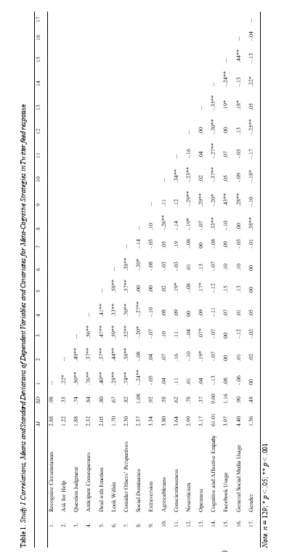
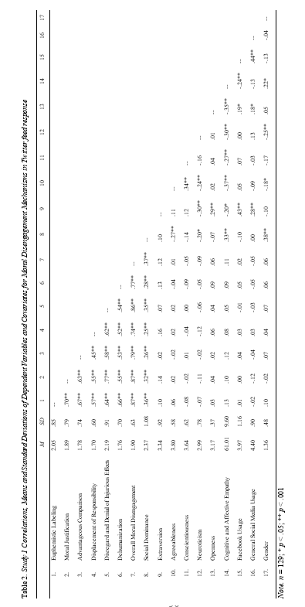

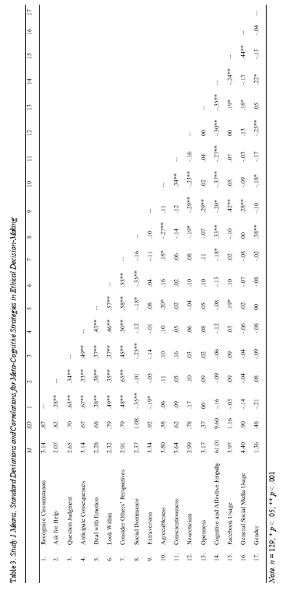

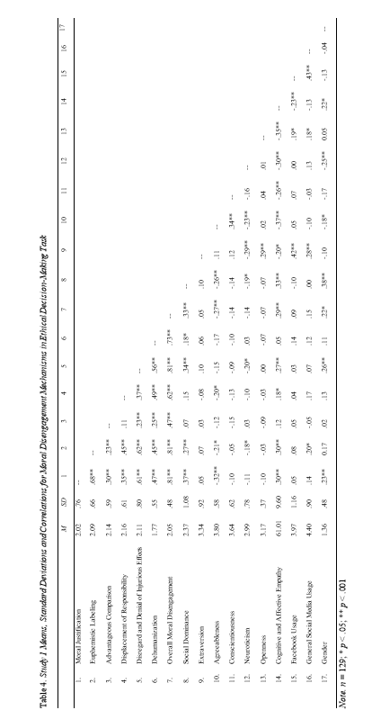

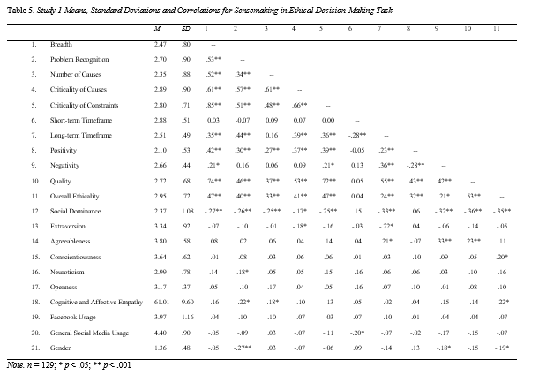

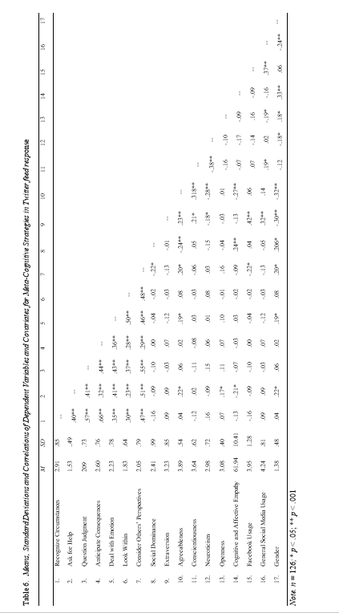

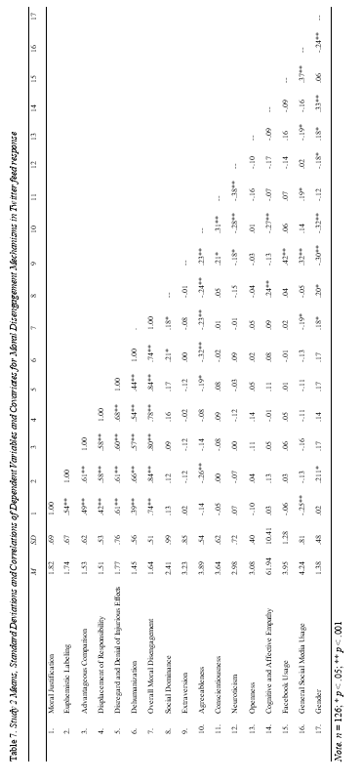

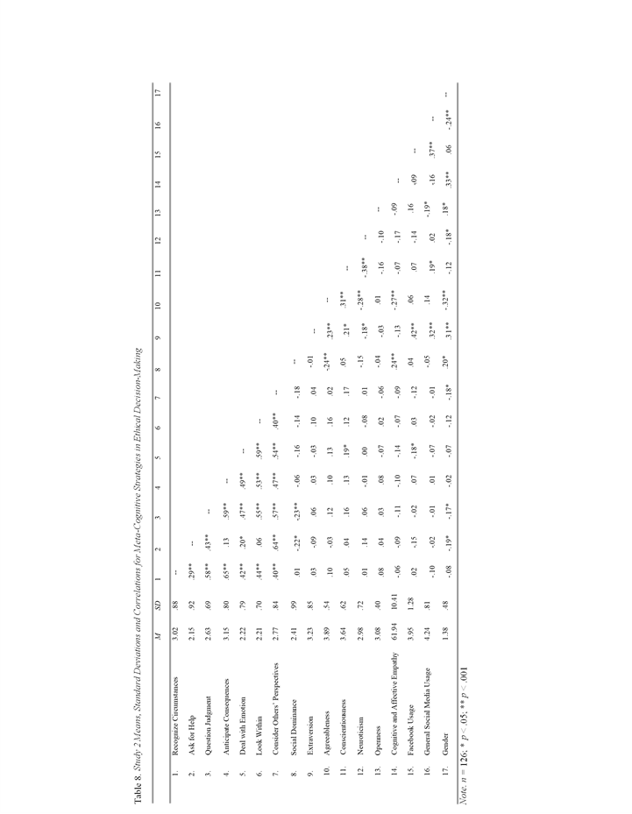

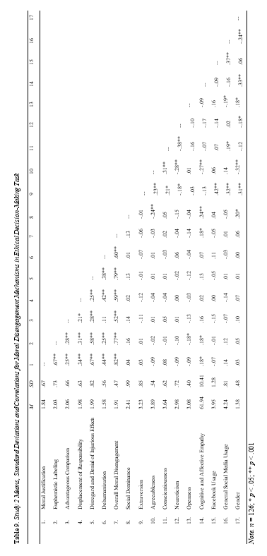

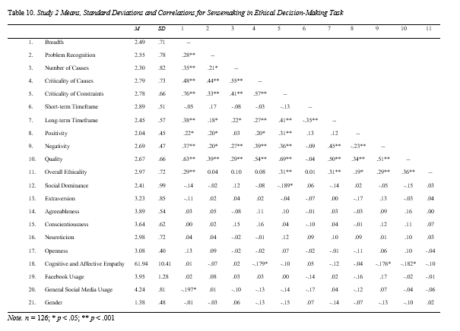

Table 11. Study 1 Significant ANCOVA Results of Polarization and Empathy on Moral Disengagement Mechanisms in Twitter feed response
 | Moral Justification |  |  | Advantageous Comparison |  |  | Euphemistic Labeling
 | F | p | η_{p}² | F | p | η_{p}² | F | p | η_{p}²
Mean social dominance | 15.19 | .00 | .11 | 9.48 | .00 | .07 | 17.38 | .00 | .12
Social media usage | 3.45 | .06 | .02 | -- | -- | -- | -- | -- | --
Agreeableness | -- | -- | -- | -- | -- | -- | 4.07 | .04 | .03
Trait empathy | -- | -- | -- | -- | -- | -- | 1.36 | .24 | .01
Corrected model | 5.71 | .00 | .19 | 4.91 | .00 | .13 | 5.71 | .00 | .21
Polarization | 8.71 | .00 | .06 | 7.44 | .00 | .05 | 7.68 | .00 | .05
Empathy | 1.23 | .26 | .01 | 1.71 | .19 | .01 | 1.68 | .19 | .01
Polarization*Empathy | .19 | .65 | .00 | .47 | .49 | .00 | .18 | .66 | .00
Note. n = 129. Significant effects are highlighted in bold. Trait empathy = cognitive and affective empathy.

 | Recognize Circumstances |  |  | Ask for Help
 | F | p | η_{p}² | F | p | η_{p}²
Mean social dominance | 21.14 | .00 | .14 | -- | -- | --
Corrected model | 6.46 | .00 | .17 | 2.94 | .03 | .06
Polarization | .76 | .38 | .00 | .03 | .86 | .00
Empathy | .58 | .44 | .00 | .22 | .64 | .00
Polarization*Empathy | 6.53 | .01 | .05 | 8.63 | .00 | .06
Table 12. Study 1 Significant ANCOVA Results of Polarization and Empathy on Meta-Cognitive Strategies in Ethical Decision-Making Task

Note. n = 129. Significant effects are highlighted in bold.

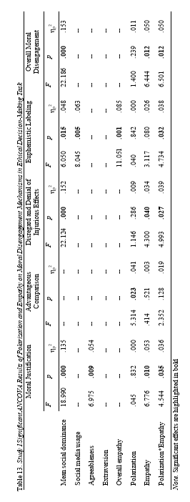

Table 14. Study 1 Significant ANCOVA Results of Polarization and Empathy on Sensemaking in Ethical Decision-Making Task
 | Problem Recognition |  |  | Overall ethicality
 | F | p | η_{p}² | F | p | η_{p}²
Mean social dominance | 7.49 | .00 | .05 | 18.99 | .00 | .13
Cognitive and affective empathy | 3.66 | .05 | .02 | -- | -- | --
Corrected model | 4.16 | .00 | .14 | 6.30 | .00 | .17
Polarization | -- | -- | -- | -- | -- | --
Empathy | -- | -- | -- | -- | -- | --
Polarization*Empathy | 6.53 | .01 | .05 | 6.08 | .01 | .04

Note. n = 129. Significant effects are highlighted in bold.

Figure 1. Mean interaction effect of polarization and empathy on recognizing circumstances in Study 1 ethical decision-making task.

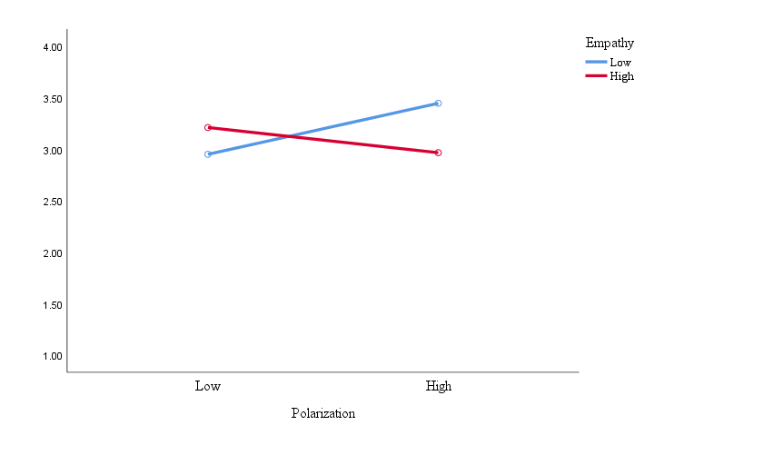

Figure 2. Mean interaction effect of polarization and empathy on asking for help in Study 1 ethical decision-making task.

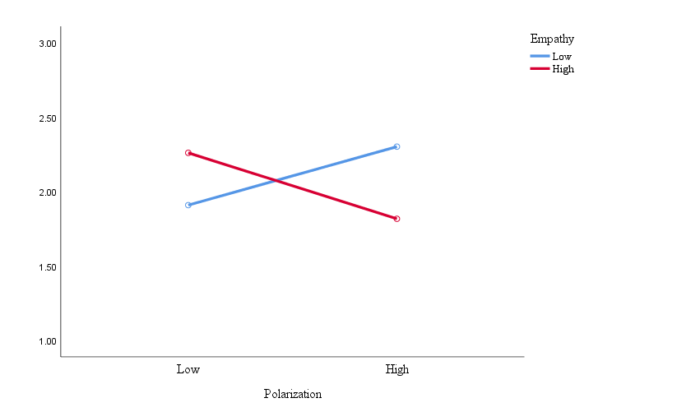

Figure 3. Mean interaction effect of polarization and empathy on moral justification in Study 1 ethical decision-making task.

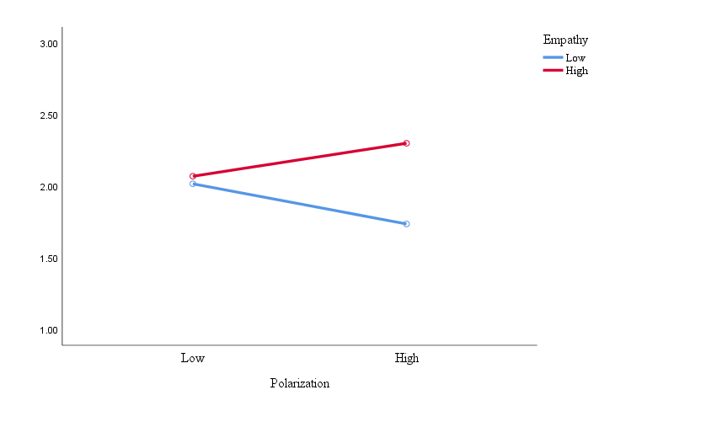

Figure 4. Mean interaction effect of polarization and empathy on disregard and denial of injurious effects in Study 1 ethical decision-making task.

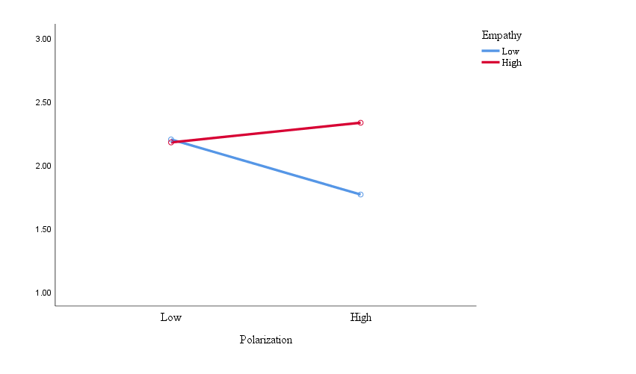

Figure 5. Mean interaction effect of polarization and empathy on euphemistic labeling in Study 1 ethical decision-making task.
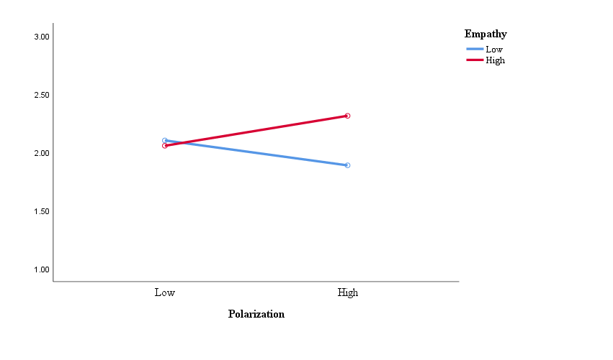

Figure 6. Mean interaction effect of polarization and empathy on average moral disengagement in Study 1 ethical decision-making task.

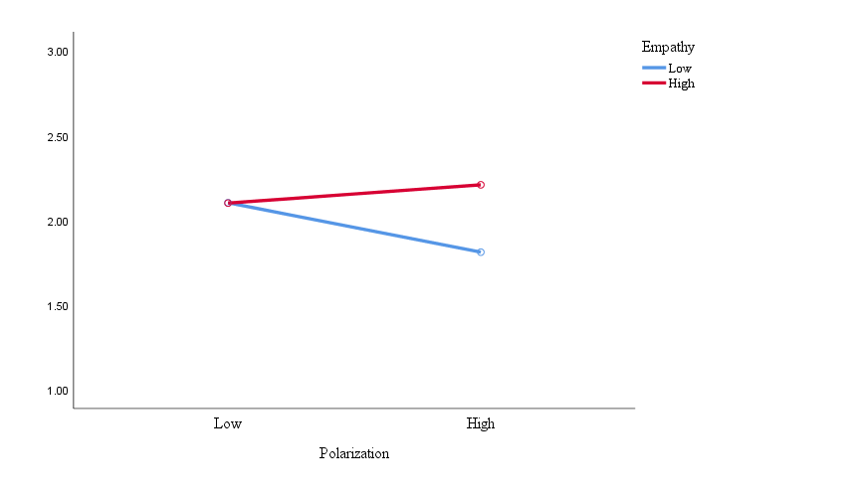

Figure 7. Mean interaction effect of polarization and empathy on average problem recognition in Study 1 ethical decision-making task.

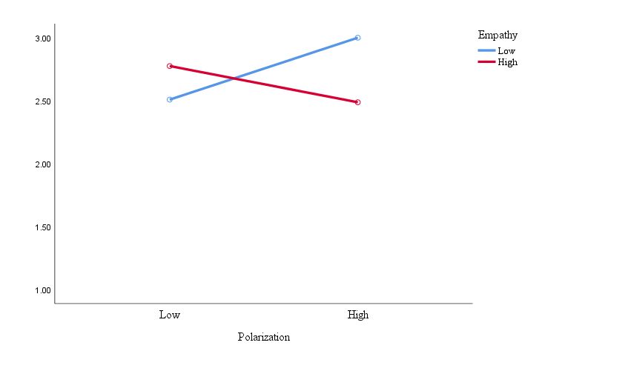

Figure 8. Mean interaction effect of polarization and empathy on overall ethicality in Study 1 ethical decision-making task.

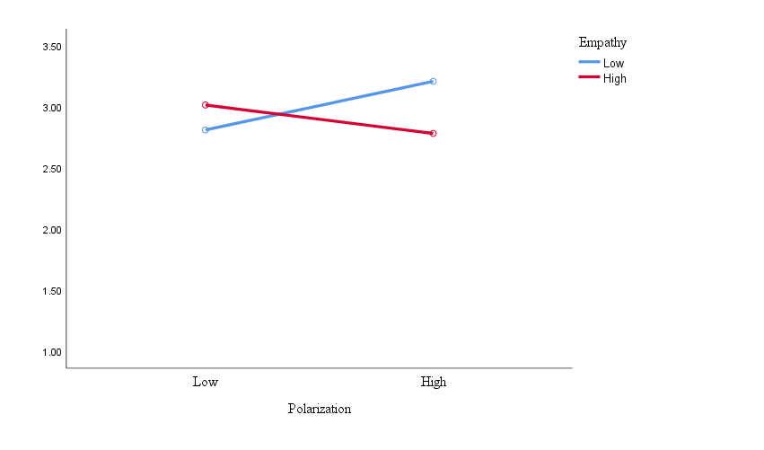

Figure 9. Mean interaction effect of polarization and empathy on negativity of outcomes in Study 2 ethical decision-making task.

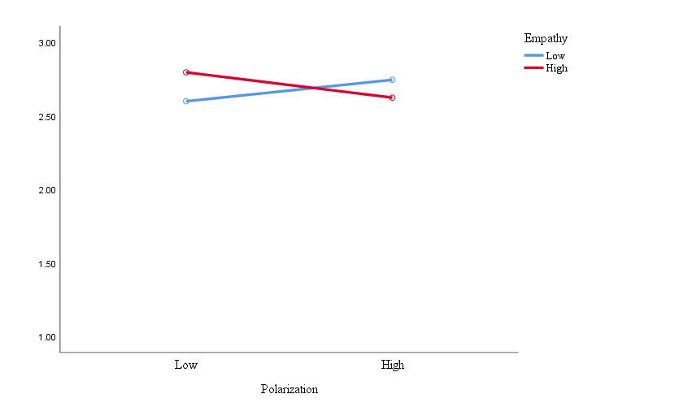

Appendix A: High Polarization, Low Empathy Study 1 (Confederate Statue) Twitter Feed

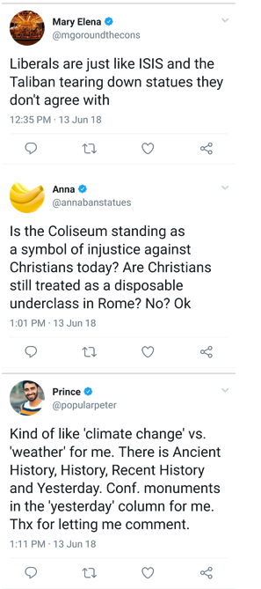
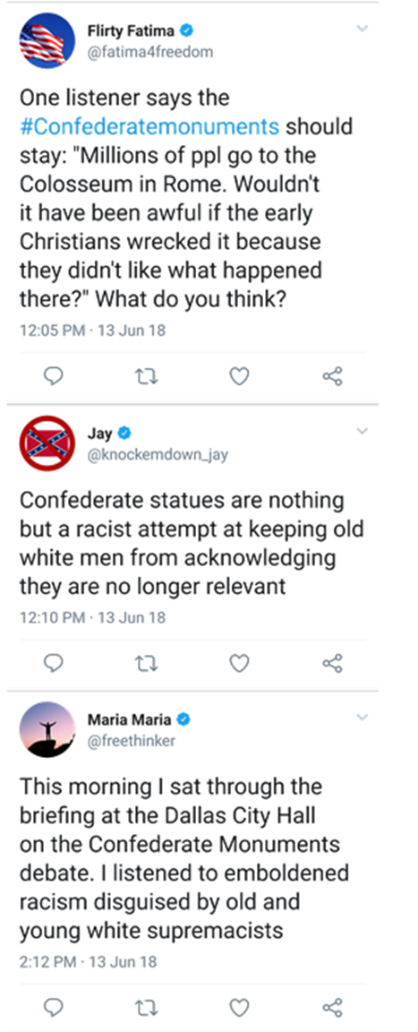


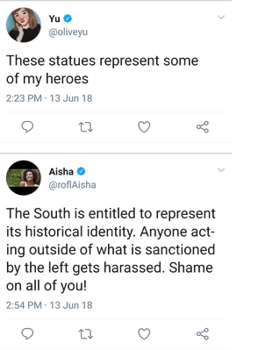
Appendix B: High Polarization, High Empathy Study 1 (Confederate Statue) Twitter Feed

Appendix B: High Polarization, High Empathy Study 1 (Confederate Statue) Feed

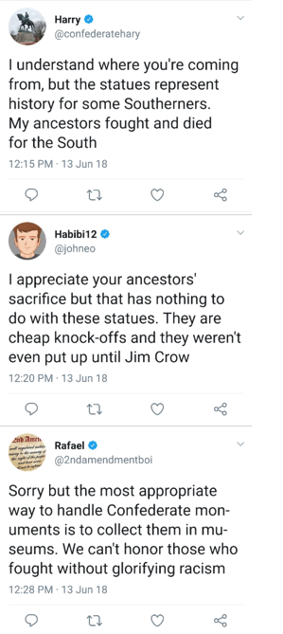
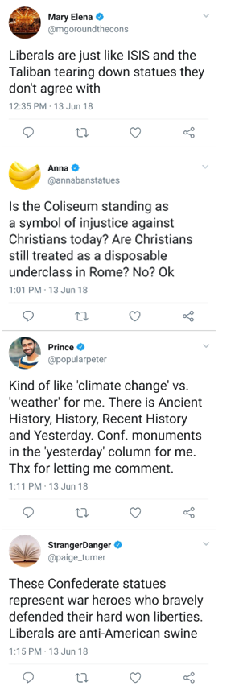
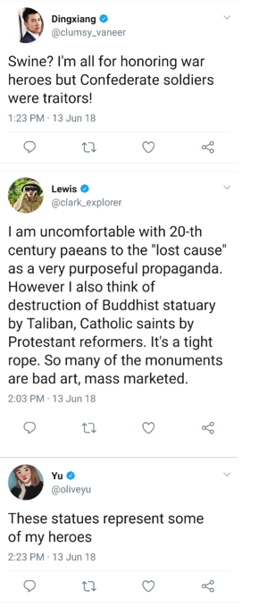
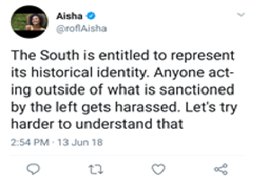
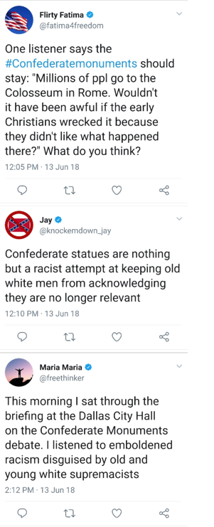

Appendix C: Low Polarization, High Empathy Study 2 (Gun Control) Twitter Feed
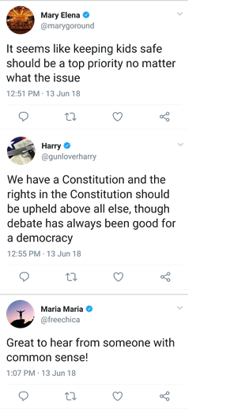
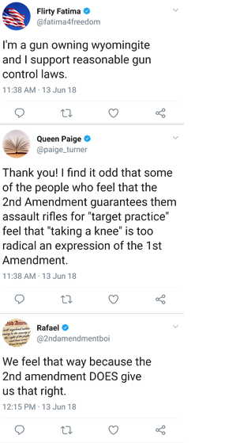
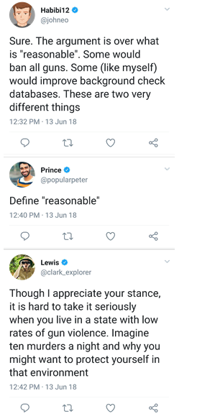
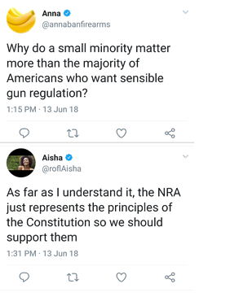
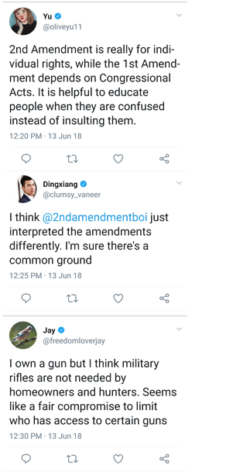
Appendix D: Benchmark Rating Scale for Ask for Help for Twitter Feed Response

Ask for help:

Definition: When solving an ethical dilemma, people often do not have sufficient knowledge, information, or expertise to make a decision.

Markers of Usage:
- Talking to advisor, peers, trusted colleague, representatives from other institutions, spouse, friend for advice
- Reading guidelines of ethical conduct
- Rereading contract or grant proposal rules
- Researching what others have done in similar situations to learn from others' behaviors
- Requesting outside information

To what extent did the participant consider asking for help when responding to the feed?

1– Participant does not consider asking for help when responding to the feed.
“Quit trying to take away rights to people who are law-abiding citizens. If I want to own an assault rifle then I am going to own an assault rifle. I don't care what anyone else thinks.”

2–

3– Participant somewhat considers asking for help when responding to the feed.

4–

5– Participant considers asking for help to a great extent when responding to the feed.
“There needs to be a mutual agreement on both sides on what to with the gun laws in this country and until both sides can understand where the opposing side is coming from, there will not be an agreement.”

Appendix E: Benchmark Rating Scale for Moral Justification for Twitter Feed Response

Moral justification:

Definition: Portraying inhumane behavior as more socially acceptable because it serves a moral purpose.

Example: To obtain necessary information for public safety, torture may be presented as an acceptable act.

To what extent does the participant use moral justification in their responses?
1 – Very low moral justification
“yea, the monuments should stay up, as they are American history, however, I can see where you're coming from if you want them taken down due to what the statue of the person represents. if they were to be taken down I think they should be memorialized(i.e photographed and archived) that way if someone did want to see them again they could look them up.”
2 –
3 – Moderate moral justification
4 –
5 – Very high moral justification
“@roflAisha I agree for the most part. The South should be allowed to represent its historical identity. I think the statues are intended to represent heroes, not racists. I mean no offense, but they're just statues.”

Appendix F: Benchmark Rating Scale for Disregard and Denial of Injurious Effects for Ethical Decision-Making Task

Disregard and denial of injurious effects:

Definition: When one disregards or misrepresents consequences of actions.

Example: A person controlling an explosive device from afar feels less responsible for the damage caused by that device.

To what extent does the participant use disregard and denial of injurious effects in their responses?
1 – Very low disregard and denial of injurious effects
“Law suits, guilt, job loss, and depending on how serious the risk is, harm to individuals who simply were unaware of the medications risks.”
2 –
3 – Moderate disregard and denial of injurious effects
“Loss of job and reputation. Loss of funding. Loss of the project”
4 –
5 – Very high disregard and denial of injurious effects
“Her colleagues would get mad at her, or if it was truly an accident, Jason might be grateful to her.

Appendix G: Benchmark Rating Scale for Recognize Circumstances for Ethical Decision-Making Task
Recognize your circumstances:
Definition: When solving an ethical problem, it is important that people think about how their position in their group, organization, and society relate to the origins of the problem, individuals involved, and relevant principles, goals & values.

Markers of Usage:
- Defining their job role and responsibilities
- Defining how their personal life fits with their job role
- Demonstrating knowledge of the current organizational, political and social climate
- Demonstrating knowledge of social and organizational expectation with regard to the given situation
- Knowing what threats and opportunities the situation poses to them and others
- Knowing the causes of the situation
- Knowing how much control they have in the situation
- Demonstrating knowledge of the conflicts between people and goals
- Demonstrating the anticipation of personal and/or organizational outcomes

To what extent did the participant consider recognizing their circumstances making their decision?

1 – Participant does not consider recognizing their circumstances when making their decision.
“Make sure to look over the report before submitting and having someone double check it for error.”

2

3 – Participant somewhat considers recognizing their circumstances when making their decision.
“If you include the risk in advertisements for the drug, it may not sell as much as was projected. But if you don't, and it is discovered later that you didn't, then it could mean a stop in the marketing campaign for that drug, keeping it from reaching the people who need it.”

4

5 – Participant considers recognizing their circumstances to a great extent when making their decision.
“The company is focused on results, the team doesn't want to lose money or get the project given to a different team. A critical risk was left out of the list of studies, this risk may affect how the drug advertising is received, the team could lose a lot of money or there's a chance that nothing will happen. The advertising could have a drastic result depending on if the risk is included or not.”

Appendix H: Benchmark Rating Scale for Criticality of Causes for Ethical Decision-Making Task
Criticality of causes identified:

Definition: The importance or relevance of the causes identified to the ethical dilemma.

Markers of Usage:
- To what extent are the causes identified related to the ethical dilemma?
- To what extent did these issues cause the ethical dilemma?

Benchmark Rating Scale

1 – None to very little criticality in causes identified
“Jason says that he did this because the industry is more concerned about getting results than accuracy.”

2

3 – Some criticality in causes identified
“Jason tried to do his job too quickly and just skimmed over the research. As a result he missed some information. Jason also prioritizes making a profit over transparency, even if the profit is dishonest.”

4

5 – Extensive criticality in causes identified
“Jason was tasked with reviewing Davis's reports in order to create a summary of all the drug's risks and side effects. Jason skimmed over Davis's report without reading it all the way through which is a huge cause of the problem. Another problem is when Jason is approached about the problem he caused, he just brushes it off and acts like it is no big deal, when in reality this is a huge issue that needs to be resolved because it is a make it or break it deal with the company.”

Or

“In an effort to help the group get the work done quicker, Jason was not thorough enough in his summary of Davis's report which led him to leave off an important detail.
Also, the prospect of getting more money because of the mistake makes admitting the mistake more difficult for Jason and myself. Additionally, Jason seems to think that results are the most important in this scenario, not fixing the problem.”

Appendix I: InnoMark Case
Organizational Background
You work for InnoMark Inc., a nation-wide organization based in Houston, Texas that specializes in marketing and advertising research. Within InnoMark, there are a number of market research departments, each focusing on different types of industries such as automobiles, telecommunications, travel, and pharmaceuticals.
Your job is an entry-level position within one of the pharmaceutical market research groups. This position involves tasks such as collecting and analyzing data on customers’ buying habits and product needs and on competitors’ use of sales and marketing approaches. In addition, your job involves using this information and other data to determine the potential success of a marketing campaign and to measure the effectiveness of advertising campaigns once they are launched. You have been in this position with InnoMark for a little less than a year.
The two main individuals you work with in your research group are Jason and Davis. Jason is in his second year at InnoMark, and you have a good working relationship with him. Davis is the manager of your market research group. Both you and Jason have generous salaries and commission opportunities thanks mostly to your manager’s connections with the pharmaceutical industry.
You recently found yourself in the following situation.
Davis, the group’s market research manager, generates reports on drugs’ safety and side effects to be included in any marketing research endeavors, and the work requires review and approval by industry scientists before it can be submitted for advertising consideration. InnoMark objects to this and has offered to negotiate with the drug companies for better terms. So far, Davis has refused on the grounds that he has no problem with the policy and does not want to compromise his reputation with the industry. Plus, it provides funding for his team of first-rate marketing staff and researchers, including you.
You and Jason are assigned with gathering data to determine the potential success of a marketing campaign for a new drug through focus groups and competitor evaluations in a local market. You know that tests of this drug have shown it could be groundbreaking in saving cancer patients’ lives - plus, the entire group stands to profit greatly from this project. Before developing the marketing analysis materials, Jason was tasked with reviewing Davis’s approved report, which is usually long and technical, to create a summary of the drug’s risks for you and Jason to include when developing your research materials. Although this usually takes several days, Jason has done this numerous times in the past, so Jason skimmed the report quickly to generate the shortened document to allow the group to move forward quickly on the marketing research.
A few months later, the data from the market analyses are presented to Davis and representatives of the pharmaceutical company who developed the drug. Everyone is thrilled with the results. The positive reactions to the upcoming availability of the drug, in addition to the drug being a first of its kind in the market, position the drug to be a highly successful, well-received product. Based on this information, the pharmaceutical company decides to develop and launch a nation-wide campaign within the next several months. As you are writing up the final reports of the marketing analyses, you realize that one of the most critical risks was left off the list that Jason generated when developing the original focus group studies. You cannot believe that Jason did this and realize that the focus groups and competitor comparisons could be successful at least partly due to his mistake leaving off an important piece of information. Any actual advertising campaigns would have to include this risk, greatly impacting the potential reception to and success of the drug. In short, the marketing analyses you and Jason did may be highly flawed Jason is obviously accountable for this oversight.
You confide in your friend about this issue, and Jason replies candidly about what he learned in his first year—that the industry’s emphasis is on getting results. He points out that if the Davis group does not produce, the project will be turned over to another team that will, and the jobs will follow the money. Plus, he reiterates that Davis has said in the past that marketing research is just as much an art as it is a science, especially in pharmaceuticals, when risks are usually made to sound much more serious by drug companies than they actually are.
You walk away from the conversation unsure how to proceed. Inclusion of the risk in the advertisements may or may not result in a different outcome than the analyses suggest. However, you are not sure about moving forward with a highly inaccurate market analysis that, if discovered, could result in halting the marketing campaign, stopping the sales of the beneficial drug and losing millions in revenue.

Appendix J: Ethical Decision-Making Task

Please answer the following questions regarding the above scenario, in as much detail as
possible.
- What is the dilemma in this situation?
- List and describe the causes of the problems.
- What are the key factors and challenges of this dilemma?
- What should you consider in solving this problem?
- What are some possible outcomes of this dilemma?
- What approaches and strategies do you think might help you reach your decision?
- Explain in detail what you would actually do to solve the problem.
- What was your rationale for making this decision?

