UNIVERSITY OF OKLAHOMA
GRADUATE COLLEGE

THE IMPORTANCE OF EDHF IN FUNCTIONAL SYMPATHOLYSIS IN HEALTHY YOUNG ADULTS

A THESIS
SUBMITTED TO THE GRADUATE FACULTY
in partial fulfillment of the requirements for the
Degree of
MASTER OF SCIENCE

By
ALEXANDER BUELOW
Norman, Oklahoma
2022

THE IMPORTANCE OF EDHF IN FUNCTIONAL SYMPATHOLYSIS IN HEALTHY YOUNG ADULTS

A THESIS APPROVED FOR THE
DEPARTMENT OF HEALTH AND EXERCISE SCIENCE

BY THE COMMITTEE CONSISTING OF

Dr. J. Mikhail Kellawan, Chair

Dr. Debra A. Bemben

Dr. Daniel J. Larson

© Copyright by ALEXANDER BUELOW 2022
All Rights Reserved.
Table of Contents
ABSTRACT……………………………………………………………………..….……...……vii
ACKNOWLDGEMENTS …………………………………………………..………………....viii
CHAPTER I: INTRODUCTION ………………………………………………………...……….1
Introduction to the problem……………………………………………………………………….2
Purpose/Research Questions/Alternative Hypotheses…………………………………………3
Significance………………………………………………………………………………………….4
Delimitations/Limitations/Assumptions………………………………………………………….5
Operational Definitions……………………………………………………………………………6
CHAPTER II: LITERATURE REVIEW…….…………………………………………………...7
Introduction………………………………………………………………………………………….8
Cardiorespiratory responses to exercise …………………...…………………………………..9
Exercise Hyperemia………………………………………………………………………………10
The autonomic nervous system & arterial pressure regulation……………………………11
Local Vasodilation ……………………………………………………………………………….12
ATP Exercise Vasodilation……………………………………………………………………..13
Nitric Oxide, Prostaglandins and Exercise Vasodilation……………………………………14
EDHF and Exercise Vasodilation………………………………………………………………15
Functional Sympatholysis ……………………………………………………………………….16
Functional Sympatholysis and aging / CVD…………………………………………………..17
Methodological considerations …………………………………………………………………18
Fluconazole and EDHF………………………………………………………………………….19
Sex differences and local vasodilation…………………………………………………………20
Conclusion ………………………………………………………………………………………...21
CHAPTER III: METHODOLOGY ……………………………………………………………..22
Participants………………………………………………………………………………………..23
Ethical Approval………………………………………………………………………………..…24
Inclusion Criteria ………………………………………………………………………………...25
Exclusion Criteria ………………………………………………………………………………..26
Instrumentation……………………………………………………………………………………27
Study Design……………………………………………………………………………………….28
Experimental Protocol……………………………………………………………………………29
Threats to Validity……………………………………………………………………….………..30
Instrumentation……………………………………………………………………………………31
Data Processing…………..………………………………………………………………………32
Data Analyses…………………………………..…………………………………………………33
CHAPTER IV: RESULTS…………………………………………...…………………………..34
Subject Characteristics ………………………………………………………………………….35
Central Cardiovascular Variables…..………………………………………………………….36
Forearm vascular hemodynamics. ……………………………………….…………………….37
∆%Forearm Muscle Blood Flow responses . ……………………………….………..………38
∆%Forearm Vascular Conductance responses . ……………….………………………...…39
Forearm muscle oxygenation responses . …………………………………………………….40
Sex differences………………………………………………………..……………………….….41
CHAPTER V: DISCUSSION……………………………………………………………………42
Resting Hemodynamics………………..………………………...………………………………43
% changes at Rest during sympathetic stress ……..…………………………...…………….44
% changes during Exercise………………..…… ……………………….……………………..45
%changes during Exercise and LBNP…………….……………..…………………..………..46
Forearm muscle Oxygenation……………………………………….…………….….…………47
Sex differences………………………………………………………….…..……….….…………48
Limitations and experimental considerations………………………………..……….………49
CHAPTER VII: CONCLUSION………………………………………………………………..50
REFERENCES…………………………………………………………………………………..51
APPENDIX………………………………………………………………………………………52
Study Documents………………………………………………………………………………….53
Forearm Muscle ROI……….…………………………………………………………………….54
Raw Data…………………………………………………………………………………………..55

List of Tables
- Participant Characteristics………………………………………….…..………………..35
- Central Cardiovascular Responses………………………………………………………36
- Forearm hemodynamics at rest…………………………………………………………..37
- Forearm hemodynamics during exercise…………….…………………………………..38
- Sex differences…………………..……………………………………………………....41
List of Figures
- Protocol Outline…………………………………………………………………………28
- Δ% in FBF at Rest………………………………………….………………………………..38
- Δ% in FBF during Exercise………………………………………………………………..…38
- Δ% in FBF during Exercise with LBNP……………………………………...…………..…38
- Δ% in FVC at Rest…………………………………………………...……………..…………39
- Δ% in FVC during Exercise……………………………………..............………………39
- Δ% in FVC during Exercise with LBNP……………………….………………………..39
- Forearm muscle oxygenation…………………………………………………………….40
- Mb+HbO2 (%TLS) during PLA…………….…………………………………………...40
- Mb+HbO2 (%TLS) during FLZ………….……………………………………………...40
- Sex Differences………………………………………………………………………….41

ABSTRACT
Functional Sympatholysis allows for the matching of increased demands in skeletal muscle oxygenation by increasing exercise hyperemia despite elevated sympathetic outflow. Endothelial-Derived Hyperpolarizing Factor (EDHF) may be involved in functional sympatholysis although its role is not clear. PURPOSE: The purpose of the present study was to determine the importance of EDHF in functional sympatholysis in healthy young adults. METHODS: 14 participants (8 Females) participated in three study visits (2 experimental visits). Experimental visits were identical with the exception of ingestion of a placebo (PLA) (250 mg microcrystalline cellulose) or 150 mg of fluconazole (FLZ) 120 minutes before testing (randomized and counter-balanced). Forearm blood flow, (FBF, doppler and echo ultrasound), mean arterial pressure (MAP, finger photoplethysmography), vascular conductance (FVC, FBF/MAP × 100mmHg), and muscle oxygenation (near-infrared spectroscopy) were compared during rest, -20mmHg of lower body negative pressure (LBNP), rhythmic forearm exercise at 20% maximum voluntary contraction (MVC) for 5 minutes, and forearm exercise with LBNP for 2 minutes RESULTS: Data are percent change (Δ%) ± SD. FVC declined from rest to LBNP but did not differ between PLA and FLZ (Δ -32.02 ± 18.99% vs Δ -38.16 ± 15.97, p=0.35). During exercise, FVC was unaltered in PLA with the addition of LBNP (Δ 2.92 ± 12.69%, p=0.81), however, declined in FLZ (Δ –11.58 ± 15.06%, p=0.01). exercise within FLZ, exercise + LBNP between PLA vs FLZ, (p = 0.0003). CONCLUSION: Our results indicate that young, healthy adults were able to maintain FVC with the addition of LBNP induced sympathetic stress during exercise in the PLA, however, when EDHF was inhibited with FLZ, FVC declined. Therefore, EDHF may have an important role in functional sympatholysis.

ACKNOWLEDGMENTS
I would like to acknowledge and express my sense of gratitude to my supervisor Dr. J. Mikhail Kellawan. His advice, guidance, and persistence helped me tremendously in my academic and professional career. It has been a pleasure to work under him as a master’s student and am looking forward to future work under his guidance.
I would also like to express my gratitude to Dr. Debra Bemben and Dr. Daniel Larson for their continuous support in my academic journey, inside and outside of the classroom.
I want to give thanks to all my lab members who have supported me tremendously throughout my academic journey. All members of the Human Circulation Research Laboratory have played a vital part in the completion of this project and have worked tirelessly to support each other.
I would like to give a special thanks to my wife, Kaity, for her continuous support and understanding of my academic journey. She has pushed me further then I could have ever imagined and continuous to do so. Without her, I would have truly not gotten this far in my academic journey.
I would also like to thank my parents for their continuous support from Germany. I know that seeing their son leave to a country far away from home was not an easy task, and I would like to express my gratitude for their support.

CHAPTER I: INTRODUCTION
Introduction to the problem

Exercise intolerance and poor cardiorespiratory fitness are well established to elevate risk of CVD and predict all-cause mortality (Kodama et al., 2009). Further, poor fitness and exercise tolerance are often linked to an inadequacy to match blood flow to the metabolic demand of active tissues (Joyner & Casey, 2015). During exercise, there is an increased demand for skeletal muscle oxygenation and removal of metabolites. Therefore, to sustain exercise, blood vessels in active muscle need to vasodilate to increase blood flow, such that, oxygen delivery is paired muscle metabolic demand and mean arterial pressure (MAP) is regulated (Joyner & Casey, 2015). To achieve the balance of increased arterial outflow directed to active muscle blood flow and control of MAP, increases in exercise intensity are coupled with increases in muscle sympathetic nervous system activity (MSNA) and norepinephrine (NE) release causing systemic α-adrenergic vasoconstriction limiting blood flow to inactive tissues (Tschakowsky & Pyke, 2008). The ability to locally vasodilate in exercising skeletal muscle despite increases in α-adrenergic vasoconstriction via MSNA is called functional sympatholysis (Hearon et al., 2016; Dinenno et al., 2003). Functional sympatholysis plays an important role in vasodilator and vasoconstrictor responses, and thus the matching of blood flow to the increased metabolic demands during exercise and stands in direct competition with blood pressure control (Mortensesn et al., 2014).
The mechanisms of functional sympatholysis are not well understood. Early studies investigating functional sympatholysis have established that muscle blood flow stays consistent apart from additional sympathetic stress added to an exercise modality in healthy humans. For example, local arterial infusion of tyramine, which causes NE release from nerve terminals, mimicking increases in MSNA, did not change muscle blood flow during leg extensor exercise. Therefore, there is a consistent dilation despite high amounts of NE/MSNA, indicating the existence of mechanisms local to the active muscle that have the ability of blunt sympathetic vasoconstriction (Saltin & Mortensen, 2012). Evidence suggests that vasodilatory metabolites can overrule sympathetic vasoconstriction via blunting the effectiveness of norepinephrine and epinephrine. The importance of each potential metabolite involved in functional sympatholysis, and mechanisms of these specific vasodilators involved are not well understood (Hearon et al., 2016, Petterson et al., 2021). Most studies to date focused on the involvement of Nitric Oxide (NO) and Prostaglandins (PG) as local vasodilators involved in the mechanisms of functional sympatholysis (Thomas & Victor, 1998, Hearon et al., 2016). However, the evidence suggests little involvement in of these vasodilators in functional sympatholysis (Crecelius et al., 2011; Hearon et al., 2016). Specifically, Hearon et al (2016) tried to determine if NO or PGs contributes to the ability to override sympathetic vasoconstriction during exercise (functional sympatholysis). The data in the study showed that NO/PG did not change ability to blunt sympathetic vasoconstriction, indicating NO/PG independent sympatholysis. Further, the infusion of the NO donor sodium nitroprusside (acting endothelium independent) did not blunt sympathetic vasoconstriction at rest or in addition to forearm muscle exercise at 5% MVC. However, the vasodilatory stimulus via an acetylcholine infusion as well as low dose infusion of the endothelium dependent vasodilator adenosine triphosphate (ATP), did blunt sympathetic vasoconstriction during mild (non-sympatholytic) intensity exercise to a similar magnitude as moderate exercise (15%) (sympatholytic), thereby indicating endothelial factors that are independent of NO and PG must be responsible.
A possible contributor to the sympatholytic mechanism is a yet to be identified factor downstream of cytochrome P450 (CYP450), termed Endothelium derived hyperpolarizing factor (EDHF). EDHFs potentially cause vasodilation by opening Ca²⁺ activated K channels, leading to vascular smooth muscle relaxation (Trinity et al., 2021). The potential involvement of EDHF in functional sympatholysis has been vastly overlooked in recent literature. While recent evidence suggests that EDHF may be important in control of vascular tone at rest (Petterson et al., 2021), data on the importance of EDHF to vascular tone during exercise are limited. The investigation of the potential metabolites involved in functional sympatholysis, including EDHF, is essential to further understand cardiovascular function and etiology of exercise intolerance.
The aim of the present study was to investigate the importance of EDHF in functional sympatholysis. This will be accomplished by measuring muscle blood flow and oxygenation responses to the blocking of EDHF pathways during forearm exercise and additional sympathetic stress. We hypothesized EDHF blockade significantly impairs functional sympatholysis in healthy, young adults. We also hypothesis that EDHF blockade does decrease forearm muscle blood flow, at exercise with sympathetic stress in healthy, young adults and that forearm muscle oxygenation does decrease after EDHF blockade during rest, sympathetic stress, exercise, and exercise with sympathetic stress
Purpose
Therefore, the purpose of the present study was to determine if inhibition of EDHF attenuates functional sympatholysis in healthy young adults.
Research Questions
- Does the blockade of EDHF significantly impair functional sympatholysis in healthy, young adults?
- Does EDHF blockade alter forearm blood flow & vascular conductance during rest, sympathetic stress, exercise, and exercise with sympathetic stress in healthy, young adults.
- Does forearm muscle oxygenation decrease after EDHF blockade during rest, sympathetic stress, exercise, and exercise with sympathetic stress in healthy, young adults?
Hypotheses
- EDHF blockade significantly impairs functional sympatholysis in healthy, young adults.
- EDHF blockade does decrease forearm muscle blood flow & decrease vascular conductance during rest, sympathetic stress, exercise, and exercise with sympathetic stress in healthy, young adults.
- Forearm muscle oxygenation does decrease after EDHF blockade during rest, sympathetic stress, exercise, and exercise with sympathetic stress in healthy, young adults.
Significance of the research problem
In healthy adults, studies indicated that the ability to blunt sympathetic vasoconstriction is necessary to match the increased demand for perfusion in exercising muscle. Locally formed metabolites like NO and ATP have the ability blunt sympathetic vasoconstriction. Though, the role of other metabolites like EDHF remains unclear. It is of clinical interest to discover the underlying mechanisms behind functional sympatholysis in healthy adults to build the basis for potential therapeutic approaches in individuals with damaged neural control, leading to an inability to effectively match the blood flow demands required during exercise.

Delimitations
- Only males and females between the ages of 18 and 30 years were included.
- Individuals diagnosed with an autonomic dysfunction (e.g. orthostatic hypotension, multiple system atrophy, autonomic neuropathy causing dizziness, urinary issue. Sexual difficulties, exercise intolerance) or cardiovascular disease (CVD) were excluded.
- Only normotensive individuals (systolic blood pressure below 130 mmHg and or diastolic blood pressure below 85 mmHg) were included.
- Individuals with a BMI over 30 kg/m ² were excluded.
- Smokers and tobacco users were excluded.
- Individuals who are taking any prescription medication (except birth control) were excluded.
- Females were tested in the first five days of the early follicular phase.
Limitations
- The results of the study are only representative of college aged males and females in the Norman area.
- The study design entailed the determination of forearm oxygenation measures through a near-infrared spectroscopy (NIRS) device. A 1 second contraction to 2 second relaxation ratio was utilized. If results transfer to whole body exercise remains not fully discovered.
- Near-infrared spectroscopy (NIRS) does not directly measure vessel diameter and thus is an indirect measure of changes in dilation and constriction.
- Fluconazole was not locally infused.

Assumptions
- Participants adhered to all pre-testing protocols and answered all questionaries truthfully​
- Participants performed maximal effort during initial testing session (isometric handgrip testing). ​
- Fluconazole inhibition of CYP450 enzymes prevents EDHF dilation (Petterson et al., 2021)​
- CYP450 enzyme blocking through 150mg of fluconazole is not influenced by bodyweight (Petterson et al., 2021)​
- The systemic peak concentration of fluconazole is reached 120 minutes after ingestion of a 150mg pill (Petterson et al., 2021, Debruynev& Ryckelynck, 1993). ​
- – 20 mmHg of Lower Body Negative Pressure (LBNP) significantly increases MSNA (Vongpatanasin at al., 2011)​
- 72 hours between visit 2 and visit 3 (counter balanced) is an adequate time to dispute the half-life of 26.8 ± 3.9 hours of fluconazole – (Hollier & Cox, 1996)​
- Female hormonal levels are similar between trial and all trials are performed within days 1-5 of the early follicular phase (Williams et al., 2020)​
- Subjects were blinded to experimental conditions (PLA vs. FLZ)

Operational definitions
- Functional sympatholysis: The ability to blunt sympathetic vasoconstriction of in active skeletal muscle.
- Endothelium Derived Hyperpolarizing Factor (EDHF): Proposed endothelial-derived substance which is responsible for hyperpolarization and relaxation of the smooth muscle around a vessel and independent of nitric oxide and prostaglandins. For the purposes of this study, we will define EDHF as the downstream metabolites of cytochrome P450 epoxygenases, most likely 11,12 epoxyeicosatrienoic acid (EETs) (Fitzgerald et al, 2005).
- FinaPres NOVA: Non-Invasive system to measure continuous arterial blood pressure displayed in waveform. Adjustments are made through infrared light and pressure signaling through the fleshy part of the digitorum (Silke & McAuley,1998).
- OxiplexTS NIRS: Device which can determine levels of oxygenated and deoxygenated hemoglobin levels in active tissue through near-infrared spectroscopy within the skeletal muscle (Lipcsey et al, 2012).
- Ultrasonography: Non-invasive device for the imaging of veins and arteries through soundwaves as well as determining blood velocity via the doppler effect.
- Sympathetic Nervous System (SNS): Division of the autonomic nervous system responsible for control of functions to prepare body for activity (fight or flight) (Hearon et al, 2016)
- Hand grip dynamometer: Used on the nondominant arm in a slightly abducted position for the purpose of forearm exercise (Hamilton, 1992)
- HbO₂ : Oxygenated hemoglobin.
- HHb: Deoxygenated hemoglobin
- tHb: Total hemoglobin
- Heart Rate (HR): Number of heart beats per minute (BPM) based on ventricular contractions in.
- Mean Arterial Pressure (MAP): Average arterial blood pressure during one cardiac cycle, which includes the systole and diastole (mmHg).
- Cardiac Output (CO); Amount of blood ejected by each ventricle per minute (L/min).
- Stroke Volume (SV): Amount of blood ejected by the left ventricle per systolic contraction (ml/beat).
- Total Peripheral Resistance (TPR): Total resistance to blood flow within the systemic circulation.
- Forearm Muscle Blood Flow (FBF): The volume of blood moving through the brachial artery to the forearm per minute. Calculated via (mean blood velocity x 60 x π x (brachial diameter/2)²) (ml/min).
- Forearm Vascular Conductance (FVC): The amount of FBF relative to 100 mmHg of arterial pressure. Use as an assessment of dilation vs constriction in the forearm circulation. Calculated via (FBF/MAP) × 100mmHg (ml/min/100mmHg).
- Placebo (PLA): 250 mg microcrystalline cellulose ingested as a single dose.
- Fluconazole (FLZ): 150 mg pill ingested as a single dose to block CYP450.

CHAPTER II: LITERATURE REVIEW
The purpose of this study was to investigate the importance of EDHF in functional sympatholysis in healthy young adults. The research question was whether the blocking of EDHF increases α-adrenergic vasoconstriction and thus decreases forearm muscle blood flow and oxygenation during handgrip exercise. To our knowledge, this was the first study to investigate the effects of blocking EDHF pathways in forearm muscle blood flow in healthy young adults during exercise. Therefore, this chapter does discuss the potential mechanisms behind functional sympatholysis and sympathetic restraint, the use of methods to block EDHF, and different methods to induce a sympathetic response.
Cardiorespiratory responses to exercise
The cardiovascular system responds to exercise in a unique way when compared to other stressors. A rapid increase in HR and CO can be expected to redistribute oxygenated blood to active tissues. Additionally, ventilation (VE), oxygen consumption (VO₂), ventilation of carbon dioxide (VCO₂) and the respiratory exchange ratio (RER) are increasing (Chambers & Wisley, 2019, Lewis et al., 1983). HR, systolic BP (SBP), A-VO₂ difference and VE all increase linearly with the increase in absolute work intensity. Total peripheral resistance (TPR) is typically characterized by an initial drop followed by an increase, typically above baseline values. Norepinephrine spillover increases with exercise intensity as it relates to BP regulation (Lewis et al., 1983).
Exercise Hyperemia
Exercise hyperemia is the increase in skeletal muscle blood flow during an increase in muscular activity. The demand of skeletal muscle blood flow is strongly dependent on exercise intensity and is closely related to metabolism. As exercise intensity gradually increases, so does the demand of blood flow to match metabolic demands. The average oxygen consumption for a healthy male is a round 3.5 ml/kg/min at rest and around 50-60 ml/kg/min at maximal exercise in men, while it is around 40-50 ml*kg*min for women. Maximal oxygen consumption, or VO₂max, is highly dependent on CO and total hemoglobin levels. As skeletal muscle blood flow increases so should the amount of oxyhemoglobin to the active musculature (Joyner & Casey, 2015). The primary reason for the increased oxygen consumption is the increased demand in skeletal muscle oxygenation to maintain ATP production needed to match ATP demands. While brain blood flow remains mostly unchanged and the demands of flow to organs slightly increase, muscle blood flow demands increase by up to a 20-fold (Joyner & Casey, 2015).
The increase in oxygen uptake requires an increase in muscle perfusion, ultimately leading to a shift in arterio-venous oxygen content difference ((A-V)O₂). This difference occurs not only through in increased demand on oxygenation in skeletal muscle but also through vasoconstriction via baroreflexes towards peripheral organs to maintain blood flow and pressure to active muscle. This overall increase in oxygen demands is due to the increased overall oxygen extraction from 30-40% to 70-80% (Korthuis, 2011).
The function of almost all tissues in the human body depends on the adequate supply of oxygen through red blood cells. To match the demand of oxygenated blood, vessels need to be able to properly vasodilate and constrict. The largest vessels found in the body are arteries and veins. Within these vessels, blood supply is largely controlled by endothelial cells. Anatomically, the center of a blood vessel is the lumen of an artery, surrounded by the basal lumen and endothelial lining. The outer parts of vessels are smooth muscle, surrounded by loose connective tissue. The signaling from the endothelium as well as the surrounding smooth muscle is essential for regulation of vascular tone and thus the oxygenation of surrounding tissue including the skeletal musculature (Alberts et al., 2002).
Saltin & Andersen (1985) found a strong correlation between limb blood flow and workload increases indicating that exercise intensity is closely related to muscle oxygen demands. Increases in exercise intensity cause an increased demand for muscle perfusion, leading to a linear increase in local muscle blood flow. The hypothesis has been tested using knee extensor exercise as well as handgrip exercise. Both exercise modalities, despite differences in overall muscle mass, showed comparable results when looking at percent changes. Additionally, the data indicated that maximal perfusion of skeletal muscle based on increased muscle blood flow and oxygenation is dependent on physical fitness. It is estimated that in untrained subjects' maximal perfusion is 2.5 L/kg/min, while trained aerobic subjects can reach 3.8 L/kg/min. The increase in flow and perfusion may be due to increased endothelial function and ability to properly control vascular tone (Saltin & Andersen, 1985).
The hemodynamic responses to exercise are unique when compared to other sympathetic stressors, specifically when looking at muscle blood flow. As discussed, the increase in blood flow occurs to match increased metabolic demands during exercise. This increase in flow is characterized by biphasic rapid vasodilation. The increase in dilation and exercise hyperemia at the onset of exercise is characterized by a rapid increase in flow over approximately 45-60 second (Phase I), followed by a steady state (phase II). In terms of cardiovascular responses, a rapid increase in HR occurs followed by a drop to a steady state, controlled by the central command (Tschakowksy & Pyke, 2008).
At the onset of exercise, a rapid drop in MAP, followed by an increase to a steady state in pressure can be observed. The rapid drop is characterized by a point of time at which arterial outflow exceed inflow due to increased perfusion, leading to the increased metabolic demands and need to match blood flow. Simultaneously, heart rate shows a rapid increase followed by a slight decrease to a steady state above resting level. This occurs shortly after a drop in MAP due to signaling of the central command to the autonomic pathways involved in regulating arterial blood pressure. (Tschakovsky & Pyke, 2008). The potential mechanisms behind rapid dilation have not been fully explored although evidence suggests that the blocking of Potassium (1+) (K)- stimulated hyperpolarization and well as the blocking of NO and PG lead to a rapid reduction in hyperemia and vasodilation at the onset of exercise. These findings suggest that K, NO and PG are primary mediators in rapid vasodilation. The involvement of other mediators, including EDHF remains unclear (Crecelius et al,, 2013).
The role of the autonomic nervous system in arterial pressure regulation and vasoconstriction
The autonomic nervous system is responsible for regulating secretory glands, cardiac and smooth muscle and is responsible for the control of involuntary processes including heart rate, blood pressure and the control of circulation. Control of blood vessels is vastly dependent on functions of the sympathetic nervous system. More specifically, postganglionic nerves are responsible for the release of neurotransmitters epinephrine and norepinephrine, which bind to α1- and α2-adrenergic receptors. While α1 receptors (located at arterioles and veins) are primarily responsible for smooth muscle contraction and vasoconstriction to limit blood flow to inactive tissue, the function of α 2 receptors (located at parasympathetic nerve terminals) is inhibition of transmitter release. This inhibition leads to a decrease in sympathetic outflow.
Evidence suggests that the hyperpolarization of smooth muscle results in vasodilation and a blunting of the Ca2+ influx. Simultaneously, K+ channel opening leads to a K+ flux and hyperpolarization. Reversely, α1-recptor activation causes vasoconstriction and the control of pressure by K+ channel closing and a simultaneous Ca2+ flux into the sarcoplasm, leading to smooth muscle contraction (Thomas & Segal, 2004).
Another factor playing into the control of blood flow is the role of the arterial baroreflex and chemoreceptors. Generally, blood pressure is controlled and maintained through chemo and baroreceptors in a negative feedback loop and are located in the carotid sinus and aortic arch. Baroreflexes are activated by increases or decreases in pressure in the carotid sinus wall (Wehrwein & Joyner, 2013).
Muscle mechanoreflexes are reflexes activated by mechanoreceptor stimulation. They play in key role blood pressure regulation as evidence suggests that the stimulation leads to a reset of baroreflexes, and thus are important to arterial pressure regulation. Through a negative feedback loop the arterial baroreflex can detect pressure changes and send signals to the medulla oblongata, located in the brain stem, and central nervous system to adjust peripheral resistance (Thomas, 2011). If BP decreases, HR increases and if BP increases, HR decreases with the purpose of adjusting arterial pressure changes caused to an increased arterial outflow due to muscle perfusion. The metaboreflex is also through to be a key factor in increasing blood pressure through cardiac output increases. SNS activity is regulated up by muscle contraction, metabolite accumulation and metaboreflex activation (Nobrega et al., 2014). The neurofeedback involving the integration of the mechanoreflex and metaboreflex is also known as the exercise pressor reflex and is responsible for upregulating sympathetic tone and downregulating vagal tone to increase arterial pressure and HR. In summary, the Exercise pressor reflex modulates HR, contractability, preload and afterload to adapt blood pressure responses (Nobrega et al., 2014).
It is hypothesized that these responses are primarily driven by central commend, also known as the feedforward theory. The motor cortex and hypothalamus are potentially responsible for the neural signals to the feedforward controller leading to adjustments in the autonomic pathways to regulate BP through baroreceptors (Tschakowsky & Pyke, 2008). Central command is ultimately responsible for the somamotor activation leading to cardiovascular adjustments during specific stressors including exercise situated in the medulla (Nobrega et al., 2014).
In summary, the purpose of the sympathetic nervous system is to restrain blood flow to active muscle with the goal to regulate blood pressure during various stressors including exercise. Reasonable MAP is generally considered 100 mmHg and needs to be maintained to prevent syncope and to maintain adequate blood flow to active and inactive tissue (Casey & Joyner, 2015).
Local Vasodilation
Local vasodilation can be seen as competition to sympathetic vasoconstriction and is largely responsible for local control of blood flow. Smooth muscle contractions are highly dependent on calcium (Ca²⁺) concentration. An increase in Ca²⁺ released by the sarcoplasmic reticulum leads to activation of myosin. The contraction of vascular smooth muscle is important to maintain a partially constricted state to support basal vascular tone due to its prevalence in vascular walls. The increase in vasoconstriction through a flux in Ca²⁺ leads to an increase in blood pressure.
In opposition, early evidence suggests that local vasodilation primarily occurs though the opening of potassium (K⁺) channels, which induces vasodilation through the hyperpolarization and thus relaxation of smooth muscle. Through this opening, an increase in potassium conductance can occur leading to a potassium flux, and thus, hyperpolarization. This leads to calcium channel closure and local vasodilation through the decrease in Ca²⁺ concentration (Korthuis et al., 2011 & Brozovich et al., 2016). More specifically, calcium activated potassium channels play a major role in the hyperpolarization of the cell membrane and cause a closure of voltage sensitive dependent calcium channels, leading to muscle relaxation and increased dilation. Evidence suggests that ATP-sensitive potassium channels are responsible for this closure of voltage sensitive dependent calcium channel (Korthuis et al., 2011). Jackson et al (1993), found that prostacyclin, a type of PG, is an important mediator in vascular tone through the opening of ATP-sensitive potassium channels in rabbit hearts. This hypothesis has been tested through inhibiting coronary vasodilation by blocking ATP-sensitive potassium channels. Whether we can make the same assumptions in humans remains mostly unclear.
Proper vascular control is regulated by an integrated redundant system that relies on the proper function of many localized cells. The endothelium, which is the inner membrane of a blood vessels, main function is the vascular control of relaxation and contraction. Additionally, erythrocytes, whose primary function is the transport of O₂, also have important vascular control responsibilities. Evidence suggests responsible sites for the release of vasodilatory metabolites predominantly include erythrocytes (which release ATP and NO) and endothelial cells (which release NO, ATP, PG, as well as EDHF) into the vessel towards the smooth musculature. Further, the surrounding smooth muscle responsible for the release to ATP and NO (Clifford & Hellsten, 2004).
Endothelial cells can detect mechanical signals, more specifically through shear stress, and thus can detect changes in blood and is able to convert changes in this mechanical stress into intracellular signals. Detection of increased mechanical stress on the endothelium activates the enzyme nitric oxide synthase (NOS) producing NO (Bellien et al., 2006). Additionally, Ellsworth et al (2009) found that vasodilation may be due to the release of NO and ATP from erythrocytes during blood flow through capillaries. ATP is released from erythrocytes and bind to P2Y purinergic receptors on the endothelium cell Intravascular ATP has the ability to stimulate production and release of NO and prostacyclin in the endothelium towards the smooth muscle, causing potassium channel opening (Mortensen & Saltin, 2014).
ATP and Exercise Vasodilation
Local vasodilation is strongly signaled by ATP, especially during exercise. Evidence suggests that plasma ATP increases during exercise. Similarly, to NO, ATP is offloaded by O₂ from hemoglobin, and binds to P2Y receptors on the endothelial cell. Though, the main source of arterial ATP seems to be through shear stress, while O₂ may be the main source for venous ATP, as the half-life is very low. Additionally, evidence suggests that ATP can be released from the endothelium cell through mechanical stress including shear stress and hypoxia (Mortensen et al., 2011). In terms of O₂ offloading being a potential source of venous ATP, Ellsworth et al (1995) found that erythrocytes release ATP. Based on these findings, it was proposed that O₂ offloading of ATP plays a major role in the control of vascular tone as it binds to P2Y receptors, which increased NO and PG production (Ellsworth et al., 1995). ATP under PO₂ as well as low pH conditions. Regarding sympatholytic mechanisms, ATP has been suggested to play in important role in flow mediated dilation via the activation of P2Y receptors causing an increase in Ca²⁺, causing a K⁺ outflow toward the surrounding smooth muscle and hyperpolarization. (González-Alonso, 2012, Hearon et al., 2016).
As stated, arterial ATP is mainly released through shear stress, while venous ATP is primarily associated with offloading due to its small half-life of under 1 second (Mortensen & Saltin, 2014). Despite its short half-life, plasma ATP levels can be measured through the use of intravascular microdialysis probes, specifically targeting the vasculature responsible for the supply and drainage of working muscles. Evidence suggests that plasma ATP sources are erythrocytes and endothelial cells. Results from a 2011 study indicated that exercise causes a release of ATP into local vasculature, while the levels are reduced during acetylcholine infusion despite increases in leg blood flow. Interestingly, resting leg blood flow and plasma ATP levels did not change, supporting the hypothesis that ATP plays a major role local vasodilation during exercise and may play a significant role in functional sympatholysis (Mortensen et al., 2011). In an early study, Jagger et al (2001) used CO with the intention of blocking venous plasma ATP in rats in an attempt to explain the importance of ATP derived through offloading from erythrocytes. The data suggests that the inhibition of ATP efflux through CO did not lower plasma ATP, but plasma ATP levels were increased during exercise and the simulations increase in skeletal muscle blood flow (exercise hyperemia).
Nitric Oxide, Prostaglandins and Exercise Vasodilation
Current theories suggest that NO is formed as a local vasodilator in multiple ways. Mainly, it is formed by converting O₂ and L-arginine into NO through nitric oxide synthase (NOS) enzymes and cofactors of tetrahydrobiopterin, flavins, iron protoporphyrin-IX and phosphate hydrogens (Tejero et al., 2019). Additionally, endothelial NOS (eNOS) and neuronal NOS (nNOS), which are two isoforms of NOS, can be found in the endothelium and skeletal muscle. eNOS is activated through the offloading of ATP and through shear stress from erythrocytes and the interaction of ATP with P2Y receptors, which are located on the endothelial cell. nNOS primarily occurs on the plasma membrane, the caveolae and sarcoplasmic reticulum, while eNOS primarily occurs in the plasma membrane, lipid rafts and caveolae. Due to the close relationship between eNOS and nNOS, study design which aim at NO blockage are particularly challenging to design (Tejero et al., 2019, Hearon & Dinneno, 2016). Another NO source, less studied is nNOS. NNOS is primarily found in the cytosol as opposed to eNOS, which is primarily found in the membrane itself. Evidence suggests that nNOS id highly Ca2+ dependent and thus may play an important role in blunting sympathetic vasoconstriction (Hansen et al., 2000, Mortensen & Saltin, 2014, Mortensen et al., 2014).
Similar to NO, PG is formed through ATP offloading though shear stress and is converted into PG through the enzyme cyclo-oxygenase (COX). PG is strongly related to NO in local vasodilation as they are produced through COX-1 and COX-2 pathways along with terminal PG synthesis (Zarghi & Arfaei, 2011). Specifically, PGI2 is involved in local vasodilation along with bronchodilation and bronchoconstriction. (Zarghi & Arfaei, 2011). Dinenno & Joyner (2004) found that PG itself has little effect as a vasodilator, but rather the combination of NO and PG are responsible for significant contributions to exercise hyperemia. For future studies, it has been well established that non-steroidal anti-inflammatory drugs (NSAIDs) can block COX-2 pathways and thus the effects of PGI2s (Zarghi & Arfaei, 2011).
Endothelium Dependent hyperpolarization factor and Exercise Vasodilation
EDHF is a proposed metabolite which may play a larger role in local vasodilation then initially assumed in recent literature. Although the pathways of EDHF are not fully explored, the vasodilator is thought to be synthesized in the endothelial cell. As opposed to NO, PG as well as ATP, it has been vastly ignored in recent studies (Petterson et al., 2020).
It has been well established that the release of NO and PG through the endothelium plays a major role in vascular tone. EDHF has been proposed as the primary factor in smooth muscle relaxation around vessels. Results of a 2018 study, date collected by Goto et al. indicated that Endothelium-dependent hyperpolarization is impaired in individuals with hypertension due to endothelial ion channel changes with prolonged development. The study found that in hypertensive patients, a reduction of endothelium dependent hyperpolarization seems to occur through reduced activation of small and intermediate conductance Ca2+-activated K+ channels as well as a downregulation of vanilloid type 4 channel (TRPV4). TRPV4 is known as a protein involved in the function of calcium channels. To determine the mechanisms of EDHF and vasodilatory responses are of clinical interest to determine underlying causes of CVD as well as reasons for exercise intolerance in diabetic individuals (Goto, 2018).
Early evidence suggests that EDHFs are primarily responsible for the acting on calcium-ion channels within the endothelium. The same pathways may release NO as a primary vasodilator as well. Other data suggests that EDHF may lead to muscle relaxation through potassium channels. EDHF activation may be a mechanism to back up NO in the case of rapid NO-level drops to maintain sufficient vasodilation. Thus, discovering the effect and underlying mechanisms of both, NO-KO and EDHF-KO is of clinical interest. The same study also found that EDHF is less reactive than NO, which creates specific difficulties in determining the impact of EDHF on sympatholysis. (Garland et al., 1995).
Later evidence suggests that EDHF may be activated by an increase in calcium, while calcium activated potassium channels are activated leading to the hyperpolarization of smooth muscle. This mechanism seems to be independent of NO and PG since it does not interfere with eNOS or COX pathways despite their potential close relationship in vasodilation (Goto et al., 2018). Crane et al (2003) found that small conductance and intermediate conductance calcium activated potassium channels are of importance in smooth muscle hyperpolarization. Additionally, the data suggests that the stimulation of the endothelial cell through acetylcholine evoked endothelial hyperpolarization and is mediated by the opening of small conductance calcium activated channels.
Further evidence supports the idea that that vascular endothelium responses may be driven by EDHF to a higher extent then researchers initially thought. Data indicated that blocking the vasodilatory effects of EDHF using fluconazole significantly reduced popliteal and brachial artery blood flow. Healthy individuals showed a significant increase in flow mediated constriction after the blockade of EDHF in the brachial artery (Petterson et al., 2021). Additionally, flow mediated dilation seemed to not be significantly changed. These results as well as future discoveries in the pathophysiology of EDHF are of importance because of its possible role in individuals with low fitness levels linked to CVD. Evidence suggests that people with cardiovascular disease are blunted in flow mediated vasoconstrictor responses. Pre-exiting diseases cause an overall increase in sympathetic nervous system activity (Vongpatanasin, 2011)​. Results which suggest that EDHF-KO may reduce muscle blood flow indicates downstream actions of EDHF may be altered in these populations (Petterson et al., 2021). These findings add to the pool of knowledge surrounding flow mediated vasodilation as well as functional sympatholysis since data suggests that sedentary older individuals are less efficient in lactate buffering as well as impaired in functional sympatholysis compared to active older adults (Saltin et al., 2012).
Previous studies which attempted to explain the importance of EDHF during functional sympatholysis used EDHF and well as ACh knock out methods during local vasoconstrictor responses through phenylephrine (PE), while K+-mediated vasodilatation as well as endothelium independent vasodilators like PG and NO are playing a significantly smaller role in sympatholysis then originally assumed. PE is a drug used to increase blood pressure in hypotensive individuals through α-adrenoreceptor stimulation and thus shows similar effects on vasoconstrictor responses as NE. Data revealed that forearm blood flow and vasodilation was significantly blunted during forearm exercise in addition to local vasoconstriction. To isolate endothelium-like hyperpolarization through ACh, NO and PG were blocked during exercise and baseline data. The results indicated no significant differences between the NO-PG blockage trial during exercise and ACh stimulation when compared to the control data during PE infusion. These data support the data surrounding the hypothesis that NO-PG is not involved in functional sympatholysis in humans. Although PE has been well established as a local sympathetic α -adrenergic vasoconstrictor, it remains unclear whether systemic sympathetic vasoconstriction through the use of LBNP would show similar results (Hearon et al., 2016).
Recent evidence focusing on hyperemia induced by passive leg movement, which is a widely accepted measurement to determine endothelial function, showed that although NO is the primary mediator in vasodilation, EDHF may play a different role then initially assumed. The data suggests that EDHF plays an important role in local vasodilation, and it seems to act independently from NOS since it does not work through COX pathways. This hypothesis was tested through infusion of N-monomethyl-L-arginine, a NOS inhibitor. To inhibit EDHF, Fluconazole was used to inhibit the cytochrome P-450 (CYP-450). CYP450 is known as an enzyme responsible to produce cholesterol and prostacyclin, which is an effective vasodilator (Trinity et al. 2021).
During exercise, Mortensen at al. (2007) found that EDHF does not seem to be a backup for NO and PG, as originally assumed. Rather, EDHF is an independent vasodilator from NO and PG. Additionally, the data found that the blocking of EDHF with tetraethylammonium chloride (TEA) did not change flow mediated dilation during exercise. These findings contradict with data from Petterson et al (2021). In the study CYP450 receptors were blocked using fluconazole, suggesting that TEA may not be ideal to block all EDHFs during exercise. Hilig et al (2003) found that the blocking cytochrome P450 2C9, which is a EDHF synthase, in addition to blocking of NOS resulted in a significant reduction of blood flow and vascular conductance during exercise. Interestingly, CYP450 2C9 blockage alone did not significantly alter, which does supports to original idea of EDHF being a backup system for NOS. In the study, sulfaphenazole was used to block to effects of CYP450 2C9. In summary, the pathways of EDHF remain not fully understood and the literature discussing EDHF and its relationship to NO/PG as well as its involvement in functional sympatholysis is limited.
Functional Sympatholysis
As discussed, functional sympatholysis is a mechanism which causes reduced vasoconstriction despite increased sympathetic nervous system activity (SNA) during exercise. It is well established that whole body exercise causes an increase in SNA due to its necessity in controlling hemodynamics. The increase in efferent outflow leads to α -adrenergic receptor stimulation which ultimately leads to norepinephrine release and vasoconstriction in the absence of the ability to blunt sympathetic vasoconstriction (Remensnyder et al., 1962). As SNA increases, so does cardiac output (CO), heart rate (HR), and stroke volume (SV) to redistribute blood to guarantee proper muscle oxygenation of working muscle and is of importance to maintain mean arterial (MAP) during exercise as arterial outflow briefly exceeds arterial inflow, leading to a decrease in compartmental blood volume at the onset of exercise (Saltin at al., 2012, Tschakovsky & Pyke, 2008).
Strange (1999) was among the first who attempted to explain the phenomenon of functional sympatholysis in healthy young individuals itself. In the study, subjects performed three bouts of resistance training. One bout of maximum isometric handgrip exercise was added in addition to forearm ischemia to induce a sympathetic stress. Results indicated that there was no significant reduction in muscle blood flow despite the increase in factors involved in sympathetic vasoconstriction. Though, MAP, CO, and forearm vascular conductance increased indicating that the stress was increased enough to induce blood flow responses. Muscle sympathetic nervous system activity (MSNA) was measured using microneurography, a method used to visualize nerve impulses, and indicated that SNA was significantly increased in the experimental trials. These findings were first indicators of the existence of functional sympatholysis and raised questions about the mechanisms behind the phenomenon.
Moore et al, (2010) found that the activation of α-adrenoreceptors causes a blunting in local vasodilation in mice. A series of experiments tested whether α-adrenoreceptor activation impacts rapid onset vasodilation, which occurs within 1-2 seconds within an initial contraction. Results indicated that the activation of α-adrenoreceptors caused a reduction in vasodilation, while the blocking of α-adrenoreceptors with phentolamine caused and enhancement of rapid onset vasodilation in the gluteal muscle of mice. Resting diameters showed no significant difference, indicating that the amount of diameter change in rapid onset vasodilation is highly dependent on SNS activity.
The primary mediators involved in functional sympatholysis still remain unclear. Though, Dinenno et al, (2004) discovered that nitric oxide (NO) and prostaglandins (PG) may be primary vasodilators during exercise. Results indicated that the inhibition of NO and PG increases α -adrenergic vasoconstriction in the forearm musculature during forearm exercise. The data collected showed a local response through inducing tyramine. Additional data collected within the parameters of the same study indicated that neither NO nor PG alone have the ability of override sympathetic vasoconstriction by themselves. Rather, only the combination of both metabolites was effective as a mediator in sympathetic restraint. Whether systemic stressors including the cold pressure test (CPT) and or lower body negative pressure (LBNP) as opposed to local constriction induced by tyramine ingestion show different results remain to be determined.
On the other hand, Crecelius et al, (2015) found that sympathetic vasoconstriction was not able to be blunted when blocking inwardly rectifying potassium Na⁺/K⁺-ATPase. Additionally, data published in an additional study indicates that NO and PG are likely not the key pathways involved in modulating sympathetic tone (Crecelius et al et al., 2011). In the study, NO and PG combination did not significantly contribute to forearm blood flow and vascular conductance after ATP infusion, which was used at a P2Y agonist and N-monomethyl-l-arginine was used to block NO. Other locally formed vasodilators include carbon-dioxide, potassium, adenosine, ATP, acetylcholine, lactate as well as EDHFs. The balance of local these local vasodilators is the traditional way of attempting to explain the mechanisms behind local vascular conductance. The potential mechanisms behind functional sympatholysis are not fully explained either although we do know that they blunt the effects of norepinephrine rather than reducing norepinephrine. Other studies conducted on animals proposed that NO is the primary vasodilator in functional sympatholysis although in humans the combination of metabolites involved remain mostly unclear (Mortensen et al., 2014 & saltine et al., 2012, Just et al., 2016).
Functional Sympatholysis – effects of aging and CVD
It has been well established that aging as well as the development of cardiovascular disease are linked to reduced exercise hyperemia as well as a decreased ability to blunt α-adrenergic vasoconstriction. (Mortensen et al., 2012). Taddei et al (1995) found that the aging process is correlated with a reduction in endothelial function, in both, normotensive and hypertensive individuals. This theory has been tested through inducing acetylcholine to test weather endothelial-dependent vasodilation may be impaired. Evidence suggests that the contribution of NO in exercise hyperemia is blunted in older adults, resulting in reduced ability to vasodilate (Casey & Joyner, 2015).
CVD is often characterized by abnormal sympathoexcitatory responses during exercise due to damages to neural control of muscle blood flow. Evidence suggests that exercise intolerance in hypertensive and pre-diabetic individuals is due to the inability to match the metabolic demands of muscle oxygenation (Vongpatanasin et al., 2011). In the study SNS activation was increased using LBNP in addition to handgrip exercise. The results shows that hypertensive subjects had significantly decreased forearm muscle oxygenation and decreased blood flow in the forearm musculature when compared to the control group. Additionally, SNS activity increased at a higher rate during exercise alone when compared to the control group. This is of no surprise as it is well established that individuals with CVD have increased SNS activity levels than, healthy individuals. It remains unclear what the exact cause for the decreased ability of hypertensive individuals to sufficiently blunt sympathetic vasoconstriction is (Vongpatanasin et al., 2011).
Price et al (2013) found that functional sympatholysis is impaired in both hypertensive as well as normotensive elderly adults. If sympathetic restraint is further inhibited, for example through older generation β-blockers, exercise intolerance may increase. In the study, SNS activity was evoked using LBNP and handgrip exercise while forearm muscle oxygenation was determined to determine the effects of different β-blockers on functional sympatholysis in hypertensive individuals.
Mortensen et al (2012) found that regular exercise improves the ability to blunt sympathetic vasoconstriction in healthy older adults. Due to an improvement in endothelium function, exercise may restore functional sympatholysis and thus O₂ delivery as well as exercise tolerance. Additionally, previous studies indicated that both, hypertension, and the aging process cause increased resting norepinephrine levels, which could lead to increased sympathetic vasoconstriction. (Mortensen et al., 2014, Mortensen et al., 2012). Understanding the mechanisms behind the ability to blunt sympathetic vasoconstriction during exercise helps us understand the underlying causes for exercise intolerance in individuals with CVD and in older adults.
Methodology considerations – Lower body negative pressure
Lower body negative pressure (LBNP) is a commonly used method to assess cardiovascular function. The technique causes a redistribution of blood from the upper body to lower body causing a shift in central blood volume. This mechanism causes a decrease in central flow pressure, left ventricle and end diastolic volume and an increase in stroke volume (SV) and CO. This causes a sympathetic stimulation leading to sympathetic vasoconstriction through vagal withdrawal (Goswami, 2019).
Sundlöf & Walling (1978) were among the first who discovered that the main mechanism behind SNA increases during LBNP correlate with decreases in central blood volume. He discovered that arterial baroreflexes seem to be the underlying mechanism which elevate SNA as well as CO and SV. Arterial baroreflexes make up receptors which are responsible for recognizing changes in arterial pressure and flow to prevent rapid drops in peripheral flow, located in the aortic arch. The findings of the study also suggest that the amount of SNA is dependent on the levels of LBNP. Higher levels of LBNP exposure showed increased SNA. These findings are unique to the use of LBNP when compared to other stressors causing SNA changes including the use of the cold pressor test (CPT).
Methodological considerations - measuring vasodilation and endothelial function
Endothelial function can be assessed using high-frequency ultrasound and is often tested using cuff occlusion followed by reactive hyperemia. Endothelial dysfunction is indicated by reduced ability to vasodilate following the release of the occlusion cuff. Other assessments include the monitoring of flow mediated dilation using acetylcholine, an endothelium dependent agonist (Vogel, 2001).
Another method to assess flow mediated dilation is through measuring muscle oxygenation with Near-Infrared spectroscopy (NIRS). McLay et al (2016) found that muscle oxygenation is strongly correlated with flow mediated dilation, assessed through an ultrasound assessment. The use of NIRS is advantageous due to its ease of use and high reproducibility. G ́omez et al.(2008) found that the device is highly reliable and valid. Thus, the technique is ideal for an accurate measure of micro vessel reactivity and is superior to other techniques with rely on estimates.
Two indicators of vascular tone are vascular conductance (VC), or vascular resistance (VR), which can indicate the ease (VC) or hindrance (VR) of flow at certain pressure differences. VC is the flow measured divided by pressure, while vascular resistance is pressure divided by flow (Joyner & Casey, 2015, Joyce at al., 2019). Thus, mathematically, VC has an inverse relationship to vascular resistance, which leads to the common misconception that the two variables can be used interchangeably. Joyce et al (2019) explained the difference between the two variable and made the case to VC being the more accurate measure of blood flow. VC is in a linear relationship with blood flow, while resistance presents a non-linear relationship. The reason for the difference is due to variability of temperatures, directly impacting local blood flow. (Joyce et al., 2019). These data indicate that the use of VC may be superior to reporting vascular resistance for functional sympatholysis, although both variables should be considered.
Fluconazole/inhibition of EDHF
Fluconazole is a drug which has originally been developed to treat fungal infections. It is typically prescribed in either 150, or 200 mg doses depending on the condition. It is sold as a solid crystalline which is highly water soluble. Studies have shown that Fluconazole acts as an inhibitor of vascular K_{Ca} channels a well as CYP peroxygenase 2C, the same channels through which EDHF has been proposed to be released to induce smooth muscle relaxation (Bellien et al., 2006). Ding et al (2002) found that cytochrome P450 monooxygenase (CYP450) significantly contributes to the pathways involved in control of vascular tone in wild type mice. The blocking of these pathways through miconazole significantly reduced endothelium dependent vasodilation. The blocking occurs through acting on K-ATP channels, which are proposed pathways of EDHF. Gill et al (1996) found that fluconazole can block P450-mediated bioactivation better than other proposed substances which could contribute to P450 inhibition including ketoconazole. Yang et al (2017) found that the ingestion of fluconazole significantly blunts bradykinin-induced vasodilation in COPD patients. Bradykinin is a known vasodilator which works through the release of PG and NO, while EDHF functions independently from these local vasodilators. Fluconazole blunts Epoxyeicosatrienoic acid (EET) synthesis, which is a key component of vascular function as it supports vasodilation as it is a type of EDHF (Sudhahar et al., 2010).
The absorption time of fluconazole is between one and three hours with a bioavailability of over 90%. It has also been established that food consumption does not affect the bioavailability. While the bioavailability is high, the rate of plasma protein binding is low at 11-12%, meaning the risk of toxic consequences of consequences is very low (Debruyne & Ryckelynck, 1993).

Sex differences in local vasodilation
Sex differences and genetic differences are crucial factors to consider when it comes to the ability to uptake oxygen. Males have a significantly higher VO₂ max on average when compared to Females with similar fitness levels (Sharma, 2016). These findings have been well established even though data indicates that females are able to blunt sympathetic vasoconstriction (sympatholysis) better than males (Just & DeLorey ,2017). In the study, different amounts of sympathetic stimulus were used in combination with NOS blockage in Sprague-Dawley rats. The data indicated that blunting of sympathetic vasoconstriction was reduced in females at high amounts of SNS stimulation. This indicates that female vascular control is more NOS dependent along with the finding that females are more efficient in the mechanisms behind functional sympatholysis. In humans, Bunsawat et al (2018) found that males may have higher basal sympathetic vasoconstriction them females and show a larger increase in leg blood flow after blocking α-adrenergic receptors.
Hogarth et al (2007) found that women have a lower muscle sympathetic nervous system activity then men largely due to arterial baroreflex inhibition. This is true for both, single units and multi-unit bursts. Simultaneously, resting blood flow was not significantly different in men and women and correlated with sympathetic nervous system activity. These results suggest that this may contribute to the lower occurrence of cardiovascular events in women then in men.

Conclusion
Functional sympatholysis is described as the ability to blunt sympathetic vasoconstriction during exercise to match the increased demands of muscle blood flow. The mechanisms behind functional sympatholysis remain not fully understood. Most studies to date focused on NO and PG as primary dilators and sympatholytic factors. EDHF may be an important contributor to the blunting of sympathetic vasoconstriction during exercise. However, to our knowledge has not been directly investigated. More recent studies used alterations of the sympathetic nervous system with LBNP to measure the changes in vascular conductance during exercise.

CHAPTER III: METHODOLOGY
The aim of this study was to investigate the importance of EDHF in functional sympatholysis. We tested the hypothesis that functional sympatholysis as determined by muscle forearm muscle blood flow/vascular conductance and oxygenation responses would be blunted if EDHF pathways are inhibited during forearm exercise. To our knowledge this was the first study testing the effects of EDHF blocking during exercise in addition to systemic sympathetic nervous systemic elevation. This chapter covers subject recruiting, a description of instrumentation utilized, description of the experimental protocol as well as data analysis/ data management procedures.
Participants
This study includes the results of 14 participants, 6 Males and 8 Females. Recruiting methods included the use of flyers as well as mass emails within the University of Oklahoma, Norman Campus and the greater area of Norman Oklahoma. Individuals interested in participating contacted the primary investigator (PI) and/or sub-investigators.
The study used a young, healthy, adult population to test all hypotheses. For enrollment into the study, all participants were required to fit the described inclusion criteria and none of the exclusion criteria.
Ethical approval
All procedures had ethical approval from the Institutional Review Board at the University of Oklahoma Health Sciences Center (IRB# 14056). Participants were given a verbal description of all procedures, purposes, and risks involved before providing their informed, written consent. The study conformed to the standards set by the Declaration of Helsinki and was registered with ClincalTrials.gov (NCT05176379).
Inclusion criteria:
- Males and Females between the ages of 18-30 years
- Normotensive (systolic blood pressure < 130 mmHg and/or diastolic blood pressure < 85 mmHg) individuals
- Individuals free of cardiovascular disease and metabolic disease
- Individuals free of any form of autonomic dysfunction
- Individuals with a BMI under 30 kg/m²
Exclusion criteria:
- Individuals with a history of autonomic dysfunction
- Individuals with CVD and or diabetes.
- Smokers, tobacco users (or former tobacco users who have not quit within the last 6 months).
- Individuals with a blood pressure ≥ 130/85
- Unable to secure an adequate ultrasound signal/image
- Subjects who use any prescription medication (except birth control)
Out of 14 participants, one subject was excluded in data analyses to determine changes in FVC and FBF due to a brachial artery bifurcation occurring above the antecubital fossa, making determination of FBF with ultrasound techniques via the brachial artery uninterpretable. Therefore, a total of 13 subjects for FVC and FBF were analyzed.

Study design
The study design was a single blind, randomized, placebo controlled, repeated measures, counterbalance design (true experiment). Participants completed three laboratory visits. Visit 1 was informed consent, determination of eligibility, anthropometric and demographic data collection, and experimental procedure familiarization. Visits 2 and 3 experimental visits, which were identical with the exception of ingestion of fluconazole or a placebo 120 min prior to experimentation. To investigate the contribution of EDHF pathways to functional sympatholysis, oral fluconazole was used as an inhibitor of cytochrome P450 as it is an effective way of blocking EDHF pathways (Dinneno, 2003, Petterson, 2021).
Experimental protocol
Visit 1
The purpose of the first study visit was to determine eligibility of a participant, provide informed consent and participants were familiarized with the study protocol.
An IRB approved informed consent document was provided along with a health history questionnaire to determine if the subject met inclusion and exclusion criteria, the international physical activity questionnaire (IPAQ) to determine the subject’s physical activity level as well as a Health Insurance Portability and Accountability Act (HIPPA) authorization form were provided.
Anthropometric measurements were recorded including height, weight waist circumference, hip circumference along with arm dominance (right vs. left) as well as grip strength of non-dominate hand.
Once eligibly was established, body composition via a Dual-energy X-ray absorptiometry (DEXA) scan was measured. A pregnancy test (females only) was completed before the scan.
Subject were then familiarized with the experimental protocol, including fitting of the LBNP device, and a brief recording of the brief recording of the brachial artery diameter and velocity to screen for a potential brachial artery bifurcation.
Visits 2 & 3
During both experimental trials (counter balanced), participants ingested either 150 mg of fluconazole (FLZ) (Petterson at al, 2021) or a placebo (PLA, 250mg tablet of microcrystalline cellulose, Zeebo Effect, Burlington, VT). Before the PLA or FLZ ingestion and instrumentation, female participants were tested for pregnancy. All subjects gave verbal confirmation that they adhered to all pre-testing guidelines (abstaining from vigorous exercise and NSAIDS for 24 hours, caffeine for 12 hours and eating for 8 hours) and if they have been diagnosed with a new medical condition since the last visit. Once, confirmation of pre-testing guideline adherence and the pregnancy test result was negative, the participant ingested the pill. Before the instrumentation, subjects were instructed to stay in a relaxed supine position. Roughly 90 minutes after the ingestion, participants were instrumented and placed in a supine position on the examination table. After the instrumentation, a 5-minute baseline was initiated. Next, 5 minutes of LBNP exposure at -20mmHg was used as a baseline measure for SNA elevation. A 5-minute rest period as well as a 5-minute baseline period followed. Next, subjects began 7 minutes of continuous rhythmic handgrip exercise (20 contractions/min) at an intensity of 20% of their maximal voluntary contraction. During the last 2 minutes of exercise, -20mmHg of LBNP was added until exercise completion. A 10-minute rest period followed. Finally, 5 minutes of reactive hyperemia occlusion (RH OCC) followed to determine the nadir of near-infrared spectroscopy (NIRS) signals, such that the total liable signal (TLS) could be determined. After RH OCC, the participant was given an additional 5 minutes of rest. The subject was de-instrumented at the end of the protocol.

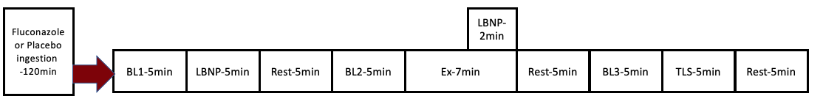
Figure 1. Protocol outline. BL = Baseline, LBNP = Lower Body Negative Pressure stimulus at -20mmHg, Ex = forearm muscle exercise at 20% MVC, TLS = total liable signal via occlusion.
Threats to validity
Threats to internal validity included equipment failure and practitioner error. In terms of practitioner error, the most common threat to internal validity was imprecise calibration of the NIRS. The NIRS used for all trials is calibrated through a calibration as well as a check block. All calibrations needed to be performed in a dark room after a 30-minute warm up period of the equipment. If any of the steps are taken improperly, measurement error and inconsistency can occur. Additionally, placement of the equipment of the appropriate muscle is necessary for inter/ intra-rater reliability and consistency. The second most common threat to internal validity was inconsistency in research protocols. It was of importance to keep track of exact timepoints during the experimental phase to have consistent measurements. A threat to external validity was population validity. The study population is specific to healthy young adults. Results may not be applicable to special and older populations. Evidence suggests that people with increased risk of cardiovascular disease are at increased risk for neurological damage (Firoz et al, 2015). Damage to the central nervous system may alter sympathetic outflow and generally increases sympathetic nervous system activity. Functional sympatholysis may be dysfunctional in these specific populations and our results may not apply beyond the study population.
To control for internal validity, it was of importance to follow all standard operating procedures for all the equipment to create consistent measurements. Each laboratory member was required to be trained on the standard operating procedures within the laboratory. Checklists were created for each lab member operating equipment.
Instrumentation
- Dual Energy X-Ray Absorptiometry (DEXA): Total body composition as well as forearm fat free mass (FFFM) was measured with a GE Lunar Prodigy bone densitometer (GE Lunar, Madison, WI). FFFM was measured with a custom region of interest (ROI) analysis. FFFM of the non-dominant forearm was determined with a custom region of interest analysis with the anatomical landmarks being the articular surface of the ulna and the medial epicondyle of the humerus.
- Near - Infrared Spectroscopy (NIRS) - Forearm muscle oxygenation was measured using a near infrared spectroscopy oximeter (Oxiplex TS, ISS Inc., Illinois USA) while being placed on the on the Flexor Digitorum Profundis muscle.
- Equivital Life Monitoring System - Heart rate and breathing rate were measured with a 2-lead electrocardiogram (ECG) from Equivital Life Monitoring Systems (ADinstraments, Denver, CO, USA).
- Doppler Ultrasound - Forearm muscle blood flow was measured using a Logiq S8 Doppler Ultrasound in B-mode to measure brachial artery diameter and blood velocity (GE Healthcare, Madison, WI, USA).
- Finapres : Mean Arterial Blood Pressure (MAP), Cardiac Output (CO), Stroke Volume (SV), Total Peripheral Resistance (TPR) were measured with a NOVA Finapres finger photoplethysmography device with a Finapres NANO CORE (Enschede, Netherlands).
- Hokanson cuff: forearm muscle oxygenation was measured during a forearm muscle occlusion with a Hokinson cuff (Hokanson, Bellevue, WA). Pressure was decreased to 230mmHg.
- Lower Body Negative Pressure (LBNP): Sympathetic stimulus at -20 mmHg was evoked with the subject being sealed with their lower body into an air sealed chamber connected to a vacuum (Techavance, Inc, Austin, TX, USA). Subjects were paces into the chamber up to the iliac crest. Pressure was decreased to -20mmHg at two different time points for 2 and 5 minutes.
Data processing
All data were stored and recorded in LabChart software (ADInstruments, Colorado, USA) at a 1 KHz sampling rate. All data collected was numerical and continuous data. Central cardiovascular variables, LBNP pressure, forearm muscle oxygenation data and pulse velocity were collected through Power Lab (ADInstruments, Colorado, USA). Blood velocity waveforms were collected continuously in Power Lab with a qDAT audio converter (Herr at al, 2010), Central Cardiovascular variables and forearm muscle oxygenation data reported were averaged over beat-to-beat averages and then processed in 3 second bins for simplicity of data analysis.
Hemodynamic data was averaged in the last 30 seconds of each stage except for the Rest+LBNP, which was averaged during minute 1:30-2:00 (Rosenberry et al 2018).
Brachial Artery velocity data was averaged in LabChart directly to avoid the inclusion of data without proper doppler ultrasound signal and was extracted out of data pad. Only blood velocity envelopes that were clear and fully captured within the duty cycles (1s contraction and 2s relaxation) were reported.
Brachial Artery Diameter was collected via a capture card and processed with a Brachial Analyzer Software during the appropriate stages (MIA LLC, IA, USA).
The aim of the primary analysis was to determine whether FLZ ingestion will blunt FBF/FVC and muscle oxygenation responses. FBF was calculated as FBF calculated with the following equation: FBF = mean blood velocity x 60 x π x (brachial diameter/2)². FVC was calculated as FVC = FBF/MAP x 100mmHg.
∆HbO₂ (%TLS) at rest was calculated as ((∆HbO₂(rest)- ∆HbO₂(rest+LBNP))/(∆HbO₂(max)- ∆HbO₂(nadir)) x 100.
∆HbO₂ (%TLS) at exercise was calculated as ((∆HbO₂(exercise)- ∆HbO₂(Exercise+LBNP))/( ∆HbO₂(max)- ∆HbO₂(nadir)) x100.
Functional sympatholysis (%FS) (exercise induced attenuation of oxyhemoglobin reduction) was calculated as ((∆HbO₂ (rest) (%TLS)- ∆HbO₂ (exercise) (%TLS))/ (∆HbO₂ (rest) (%TLS)) x 100.

Data analyses
Data were analyzed using SPSS Statistics for Windows, Version 28.0 (IBM SPSS Statistics for Windows, Version 28.0. Armonk, NY: IBM Corp). Level of significance was set at p<0.05.
Paired sample t-tests were used to compare the main differences in central cardiovascular variables between the conditions (FLZ vs. PLA) within each experimental event stage (rest, LBNP, exercise, exercise + LBNP). Paired sample t-tests were also used to compare the main differences in raw forearm vascular hemodynamic values and delta values between the conditions (FLZ vs. PLA) within each experimental event stages (rest, LBNP, exercise, exercise + LBNP). A repeated measures analysis of variance (ANOVA) was used to determine differences and observed power of ∆% FBF, ∆% FVC and %FS between the conditions (FLZ vs. PLA). A Spilt Plot ANOVA was used to determine sex differences in ∆% FBF (sex x condition). To determine sex differences within the ∆% FBF data, t-tests were used.
Normality was tested for all variables with the Shapiro Wilk test. The Wilcoxon and Friedman tests were used as non-parametric alternatives to t-tests and the repeated measures ANOVA if assumptions were violated. Cohen's d effect size was calculated as d = M₁ - M₂ / σ_{pooled} $with$ M being the mean of the compared values and σ being the pooled SD reported. Post Hoc Observed power was performed for ∆% FBF, ∆% FVC and %FS, based on the effect size, sample size, and α error probability. Data is reported as mean ± standard deviation (SD) unless otherwise stated.

CHAPTER IV: RESULTS
Subject characteristics
A total of 14 participants (6 Males, 8 Females) completed all three study visits (Table 1). A total of 4 Subjects either did not return to the lab after visit 1 or visit 2 or were diagnosed with a new medical condition between the visits, making them ineligible to participate. All subjects were healthy, young (<30 years), non-obese (BMI<30), nonsmokers who were not currently taking any prescription medication. All subjects declared to be right hand dominant, which resulted in all subjects performing rhythmic forearm muscle exercise with the left arm.

Table 1. Participant Characteristics (14 right hand dominant and 0 left hand dominant subjects)
 | Whole Sample  (n=14) | Males  (n=6) | Females  (n=8)
Age (years) | 23.64 ± 3.31 | 25.33 ± 2.65 | 22.37 ± 3.35
Height (cm) | 170.50 ± 10.82 | 178.66 ± 10.27* | 164.37 ± 6.50*
Bodyweight (kg) | 70.52 ± 12.84 | 79.28 ± 13.71* | 63.95 ± 7.54*
BMI (kg/m²) | 24.14 ± 2.92 | 24.69 ± 2.44 | 23.72 ± 2.34
SBP (mmHg) | 113.07 ± 10.21 | 122.83 ± 5.94* | 105.75 ± 5.06*
DBP (mmHg) | 70.29 ± 5.46 | 69.83 ± 6.70 | 70.62 ± 4.80
MVC (kg) | 32.33 ± 13.95 | 48.73 ± 9.55* | 25.12 ± 4.79*
20% MVC (kg) | 6.54 ± 2.79 | 9.75 ± 1.91* | 5.02 ± 0.95*
IPAQ (Met/min/wk) | 4062.90 ± 3669.93 | 5524.5 ± 4530.59 | 2810.129 ± 2421.63
HC (cm) | 93.05 ± 27.39 | 100.97 ± 6.99 | 57.54 ± 35.49
WC (cm) | 80.12 ± 10.01 | 81.78 ± 6.89 | 77.92 ± 12.11
TB-FFM (g) | 48840.60 ± 14421.50 | 61365.14 ± 10320.84* | 37881.63 ± 5525.96*
FFFM (g) | 791.43 ± 355.58 | 1046.83 ± 275.8* | 599.87 ± 287.88*
Values are displayed as mean ± SD
*Indicates significant differences between Males and Females p<0.05
BMI = Body Mass Index, SBP = Systolic Blood Pressure, DBP = Diastolic Blood Pressure, MVC = Maximum Voluntary Contraction, IPAQ = International Physical Activity Questionnaire, HC = Hip Circumference, WC = Waist Circumference, TB- FFM = Total Body Fat Free Mass, FFFM = Forearm Fat Free Mass

Central cardiovascular variables
As shown in Table 2, stroke volume was significantly different between the PLA and the FLZ conditions during exercise only (p= 0.046) but not during rest (p= 0.42), LBNP at rest (p=0.17) and Exercise + LBNP (p = 0.052)
TPR was significantly different between the conditions at rest (p = 0.04), LBNP (p = 0.04), Exercise + LBNP (p: 0.007) but not Exercise alone (p = 0.056).
Heart rate was not significantly different between the conditions at rest (p: 0.44), LBNP (p: 0.34), Exercise (p: 0.49) or Exercise + LBNP (p: 0.99).

Table 2 : Central cardiovascular variables (n=14, 6 Males, 8 Females)
 | Rest | LBNP | Exercise | Exercise + LBNP
SV, ml  PLA  FLZ | 86.51 ± 1.12  83.52 ± 19.58 | 75.66 ± 8.91  71.46 ± 16.16 | 83.25 ± 16.56*  75.97 ± 16.15* | 71.21 ± 15.47  65.04 ± 16.818
TPR  PLA  FLZ | 110.80 ± 26.07*  126.96 ± 38.45* | 122.14 ± 8.91 *  141.89 ± 42.45* | 117.56 ± 31.86  133.35 ± 28.83 | 131.76 ± 30.99*  151.04 ± 31. 73*
HR, BPM  PLA  FLZ | 63.25 ± 7.25  62.21 ± 5.42 | 62.85 ± 8.91  64.84 ± 9.57 | 74.20 ± 9.10  72.42 ± 8.75 | 76.31 ± 20.11  76.37 ±11.22

Values are displayed as mean ± SD
FLZ= Fluconazole, PLA= placebo, LBNP = Lower Body Negative Pressure at -20mmHg during rest, RHG Exercise, rhythmic handgrip exercise, RHG Exercise + LBNP , rhythmic handgrip exercise during Lower Body Negative Pressure stimulus, BPM = beats per minute
*Represents significant differences between FLZ and PLA trial p<0.05

Forearm vascular hemodynamics; comparison of raw and delta values
Responses to Sympathetic stress at rest (Table 3)
As shown in Table 3, at rest, LBNP at -20 mmHg evoked a significant reduction in brachial artery velocity, in both the PLA (p = 0.01) as well as the FLZ condition (p=0.003). There was no significant difference between the conditions in when comparing Δ Rest-LBNP velocity (p= 0.24).
LBNP evoked a significant change in brachial artery diameter, in both the PLA (p=0.002) as well as the FLZ condition (p=0.04). There was no significant difference between the conditions in when comparing Δ Rest-LBNP diameter (p=0.21).
LBNP evoked a significant reduction in FBF, in both the PLA (p<0.001) as well as the FLZ condition (p<0.001). There was no significant difference between the conditions in when comparing Δ Rest-LBNP FBF (p=0.21).
LBNP did not significantly change in MAP, in both the PLA (p=0.98) as well as the FLZ condition (p= 0.90). There was no significant difference between the conditions in when comparing Δ Rest-LBNP MAP (p=0.17).
LBNP evoked a significant reduction in FVC, in both the PLA (p<0.001) as well as the FLZ condition (p<0.001). There was no significant difference between the conditions in when comparing Δ Rest-LBNP FVC (p=0.21)

Table 3: Raw forearm vascular hemodynamic values and Δ changes during rest (n=13, 6 Males, 7 Females)
 | Rest | LBNP | Δ Rest-LBNP
Velocity, cm/s  PLA  FLZ | 3.95 ± 2.02  4.97 ± 1.62 | 2.68 ± 1.38  3.17 ± 1.35 | -1.27 ± 1.16  -1.80 ± 1.00
Diameter, mm  PLA  FLZ | 3.49 ± 0.59  3.46 ± 0.57 | 3.39 ± 0.59  3.41 ± 0.57 | -0.09 ± 0.08  -0.05 ±0.08
FBF, ml/min  PLA  FLZ  MAP, mmHg  PLA  FLZ | 23.78 ± 17.82  28.62 ± 15.26  99.91 ± 7.02  100.30 ± 8.35 | 15.19 ± 10.76  17.25 ± 8.42  99.95 ± 8.67  100.42 ± 7.70 | -8.59 ± 9.03  -11.37 ±8.79  0.03 ± 3.65  0.12 ± 3.17
FVC, ml/min/100mmHg  PLA  FLZ | 23.86 ± 18.19  28.91 ± 17.13 | 15.23 ± 11.09  17.54 ±10.02 | -8.62 ± 8.87  -11.36 ± 9.00

Values are displayed as mean ± SD
FLZ= Fluconazole, PLA= placebo, LBNP = Lower Body Negative Pressure at -20 mmHg during rest, RHG Exercise, rhythmic handgrip exercise, RHG Exercise + LBNP, rhythmic handgrip exercise during Lower Body Negative Pressure stimulus.
*Represents significant differences between FLZ and PLA trial p<0.05

Exercise Responses (Table 4)
As shown in Table 4, when looking at the raw values, paired sample t-tests revealed that rhythmic forearm exercise at 20% MVC evoked a significant increase in brachial artery velocity, in both the PLA (p<0.001) as well as the FLZ (p<0.001) condition when compared to resting values. There was no significant difference in brachial artery velocities between the conditions (p=0.15) during rhythmic handgrip (RHG) exercise without sympathetic stimulus. There was also no significant difference between the conditions during RHG Exercise + LBNP (p=0.59). There was, however, a significant difference between the PLA and the FLZ condition when looking at Δ Ex-Ex/LBNP (p=0.02).
Rhythmic forearm exercise alone evoked a significant increase in brachial artery diameter, in both the PLA condition (p=0.02) but a not in the FLZ condition (p= 0.25) when compared to resting values. There was no significant difference is brachial artery diameters between the conditions (p=0.26) during RHG exercise without sympathetic stimulus. There was no significant difference between the conditions during RHG Exercise + LBNP (p=0.15). There was no significant difference between the conditions when looking at Δ Ex-Ex/LBNP (p=0.15).
Rhythmic forearm exercise alone evoked a significant increase in FBF, in both the PLA
condition (p<0.001) as well as the FLZ condition (p<0.001) when compared to resting values.
There was no significant difference in FBF between the conditions (p= 0.54) during RHG exercise without sympathetic stimulus. There was also no significant difference between the conditions during RHG Exercise + LBNP (p=0.46). There was, however, a significant difference between the PLA and the FLZ condition when looking at Δ Ex-Ex/LBNP (p=0.009).
When looking at MAP, rhythmic forearm exercise alone evoked a significant increase, in both the PLA condition (p<0.001) as well as the FLZ condition (p<0.001) when compared to resting values. There were no significant differences in MAP between the conditions (p=0.20) during RHG exercise without sympathetic stimulus. There was also no significant difference between the conditions during RHG Exercise + LBNP (p= 0.44). There was no significant difference between the conditions when looking at Δ Ex-Ex/LBNP (p= 0.21).
Rhythmic forearm exercise alone also evoked a significant increase in FVC, in both the PLA condition (p<0.001) as well as the FLZ condition (p<0.001) when compared to resting values. There was no significant difference in FBF between the conditions (p= 0.46) during RHG exercise without sympathetic stimulus. There was also no significant difference between the conditions during RHG Exercise + LBNP (p= 0.73). There was, however, a significant difference between the conditions when looking at Δ Ex-Ex/LBNP (p=0.007).

Table 4: Raw forearm vascular hemodynamic values and Δ changes during Exercise (n=6 Males, 7 Females)
 | RHG Exercise | RHG Exercise + LBNP | Δ Change  Ex-Ex/LBNP
Velocity, cm/s  PLA  FLZ | 31.58 ± 8.95  36.94 ± 10.57 | 33.68.38 ± 9.06  35.10 ± 9.06 | 2.10 ± 3.62*  -1.83 ± 4.2*
Diameter, mm  PLA  FLZ | 3.66 ± 0.59  3.56 ± 0.67 | 3.61 ± 0.63  3.46 ± 0.69 | -0.04 ± 0.09  -0.11 ± 0.15
FBF, ml/min  PLA  FLZ  MAP, mmHg  PLA  FLZ | 206.14 ± 85.30  219.22 ± 92.90  118.76 ± 12.59  115.02 ± 8.79 | 208.61 ± 76.16  195.03 ± 82.06  119.90 ± 13.18  117.36 ± 7.73 | 2.47 ± 19.97*  -24.19±30.74*  1.14 ± 3.06  2.33 ± 2.98
FVC, ml/min/100mmHg  PLA  FLZ | 176.96 ± 77.45  194.56 ± 82.37 | 175.41 ± 61.61  169.15 ± 68.65 | 3.55 ± 21.96*  -25.42 ± 30.23 *

Values are displayed as mean ± SD
FLZ= Fluconazole, PLA= placebo, LBNP = Lower Body Negative Pressure at -20 mmHg during rest, RHG Exercise = rhythmic handgrip exercise, RHG Exercise + LBNP = steady state rhythmic handgrip exercise during Lower Body Negative Pressure stimulus.
*Represents significant differences between FLZ and PLA trial p<0.05

Forearm muscle blood flow responses as ∆%changes
When looking at ∆%changes at rest, FBF decreased similarly in the FLZ and PLA condition (PLA: 31.65 ± 19.79% vs FLZ: 37.81 ± 16.29%) in response to LBNP stimulus at -20mmHg. A repeated measures ANOVA revealed a non-significant difference between the conditions (p= 0.335, observed power= 0.152, d= 0.34) (Figure 2).
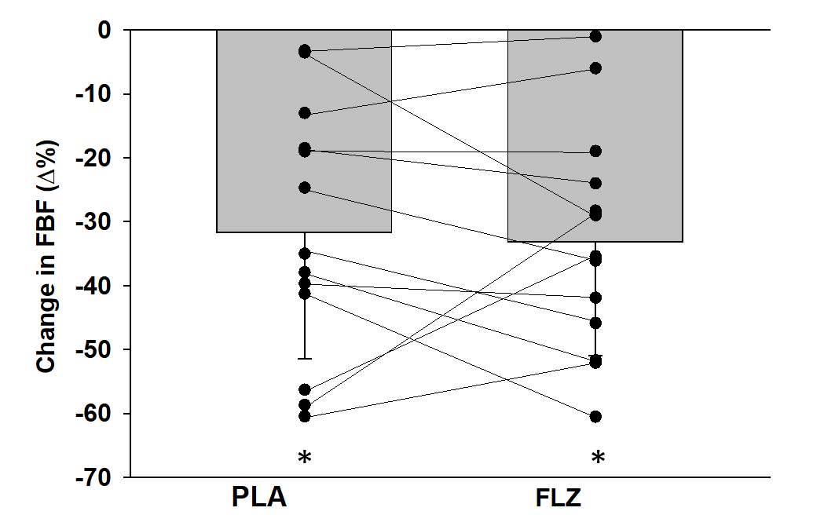
Figure 2. Individual data and group mean %changes in forearm muscle blood flow in the FLZ and PLA condition in response to LBNP at -20 mmHg induced reduction in forearm muscle blood flow at rest. P >0.05 between conditions.
*Indicates significant difference between rest and rest+LBNP

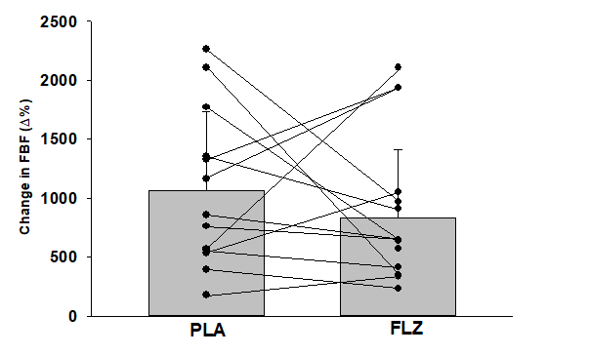
When looking at ∆%changes during exercise without sympathetic stress, FBF increased similarly in the FLZ and PLA condition from Rest (PLA: 1064.13 ± 666.58% vs FLZ: 818.30 ± 589.86%). There was no significant difference between the conditions (p= 0.40, observed power= 0.156, d = 0.39) (Figure 3).
*
*

Figure 3. Individual data and group mean %changes in forearm muscle blood flow in the FLZ and PLA condition in response to exercise induced responses in forearm muscle blood flow. P >0.05 between conditions.
*Indicates significant difference from baseline.

When looking at ∆%changes in response to LBNP induced sympathetic stimulus during forearm muscle exercise, FBF decreased significantly by -9.86. ± 15.90% (p= 0.02) in the FLZ condition but did not significantly change from exercise alone in the PLA condition (3.92 ± 11.03%, p= 0.66). There was a significant difference between the conditions (p=0.004, observed power= 0.906, d= 1.0) (Figure 4).
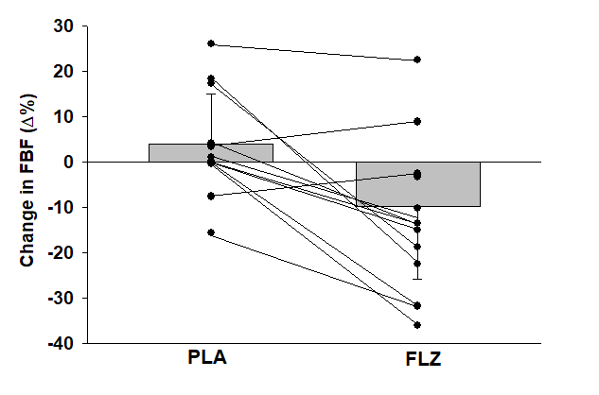
*
§

Forearm Vascular Conductance responses
When looking at ∆%changes at rest, FVC decreased similarly in the FLZ and PLA condition (PLA: -32.02 ± 18.99% vs FLZ: -38.16 ± 15.97%, p: 0.308, Observed Power = 0.165, d = 0.35).
Figure 5: Individual and group changes in FVC (Δ%) (n=13) in response to LBNP stimulus at rest (p>0.05).

Figure 4. Individual data and group mean %changes in forearm muscle blood flow in the FLZ and PLA condition in response to LBNP induced responses in forearm muscle blood flow during rhythmic forearm muscle exercise at 20% MVC. P <0.05 between conditions.
*Indicates significant difference from baseline.
§ indicates differences between the PLA and FLZ condition

Forearm vascular conductance responses as ∆%changes
When looking at ∆%changes at rest, FVC decreased similarly in the FLZ and PLA condition (PLA: -32.02 ± 18.99% vs FLZ: -38.16 ± 15.97%) in response to LBNP stimulus at -20mmHg. There was no significant difference between the conditions (p= 0.308, observed power= 0.165 d= 0.35) (Figure 5).
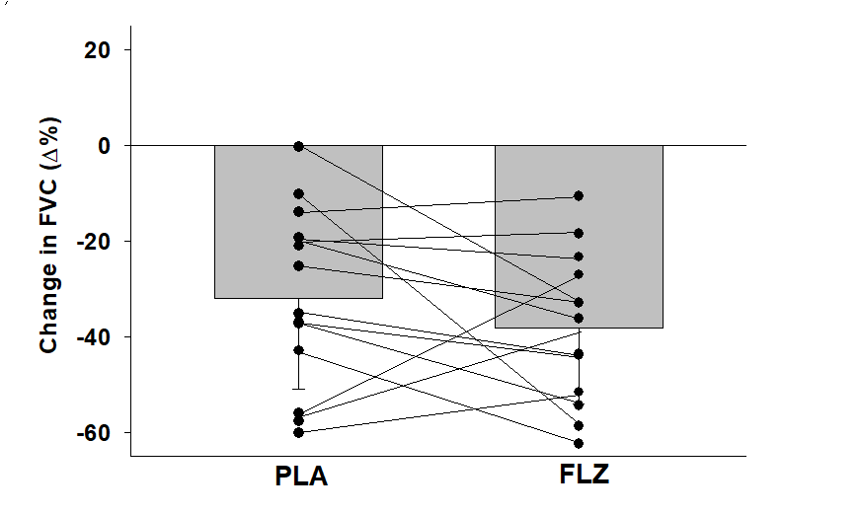

*
*

When looking at ∆%changes during exercise without LBNP induced sympathetic stimulus, FVC increased similarly in the FLZ and PLA condition (PLA: 873.96 ± 529.99% vs FLZ: 706.47 ± 484.20%, p=0.166, observed power = 0.124, d = 0.32).

Figure 5. Individual data and group mean %changes in forearm vascular conductance in the FLZ and PLA condition in response to LBNP induced reduction in forearm muscle blood flow at rest. P <0.05 between conditions.
*Indicates significant difference from baseline.
When looking at ∆%changes during exercise without LBNP induced sympathetic stimulus, FVC increased similarly in the FLZ and PLA condition (PLA: 873.96 ± 529.99% vs FLZ: 706.47 ± 484.20%), meaning there was no significant difference between the conditions (p= 0.166, observed power= 0.124, d= 0.3) (Figure 6).
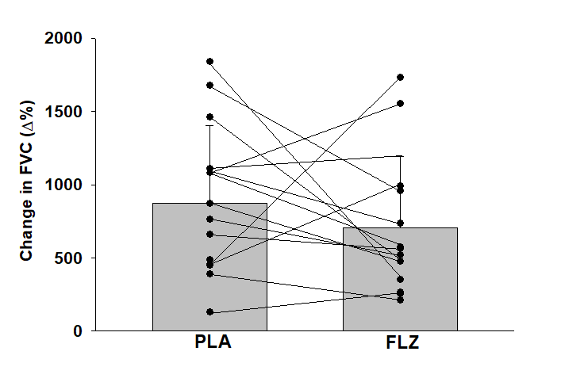
*
*

Figure 6. Individual data and group mean %changes in forearm vascular conductance in the FLZ and PLA condition in response to exercise induced responses. P >0.05 between conditions.
*Indicates significant difference from baseline.

When looking at ∆%changes FVC in response to LBNP induced sympathetic stimulus during forearm muscle exercise, FVC decreased significantly by –11.58 ± 15.06% (p= 0.011) in the FLZ condition but did not significantly change in the PLA (2.92 ± 12.69%, p=0.81)). There was a significant difference between the conditions (p= 0.003, observed power= 0.933, d= 1.1) (Figure 7).
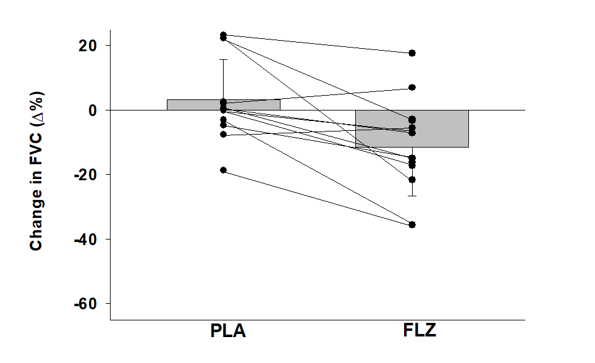
*
§

Figure 7. Individual data and group mean %changes in forearm vascular conductance in the FLZ and PLA condition in response to LBNP induced responses during rhythmic forearm muscle exercise at 20% MVC. P <0.05 between conditions.
*Indicates significant difference from resting measurements.
§ indicates differences between the PLA and FLZ condition
Forearm muscle oxygenation responses
A repeated measures ANOVA revealed a no significant difference in exercise-induced attenuation of the oxyhemoglobin reduction (p=0.122, observed power=0.335, d= 0.36) between the PLA and the FLZ condition (Figure 8).
There was no significant difference in ΔHbO2 at rest when LBNP was added (normalized to the total liable signal) (PLA: 15.07 ± 8.28 vs FLZ: 17.06±12.51, p=1.0) (Figure 9 and 10).
There was also no significant difference in ΔhbO2 at rest when LBNP was added (normalized to the total liable signal) (PLA: 5.60 ± 5.87 vs FLZ: 8.11 ± 7.01 p= 0.14) (Figure 9 and 10).

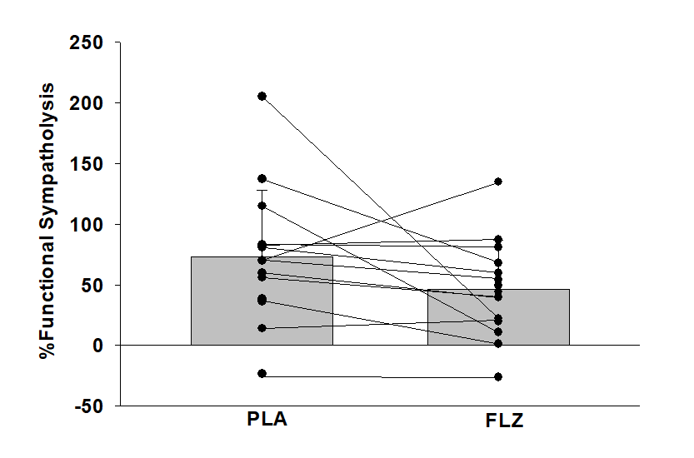
Figure 8. Individual and group differences in %functional sympatholysis as in exercise-induced attenuation of the oxyhemoglobin reduction. P > 0.05 between the conditions.
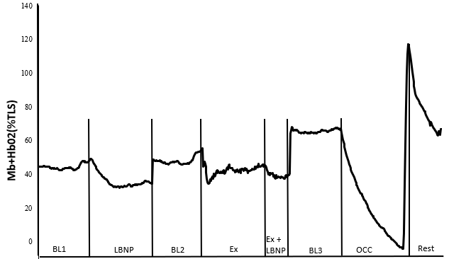
Figure 9. Functional sympatholysis protocol tracing HbO₂ in the forearm musculature during PLA. Data tracing of Myoglobin and Oxyhemoglobin responses during LBNP (-20mmHg) exposure, followed by forearm muscle exercise at 20%MVC and Exercise with LNBP exposure. Followed were 5 minutes of reactive hyperemia occlusion at 230mmHG to determine the nadir to determine % total labile signal (TLS).

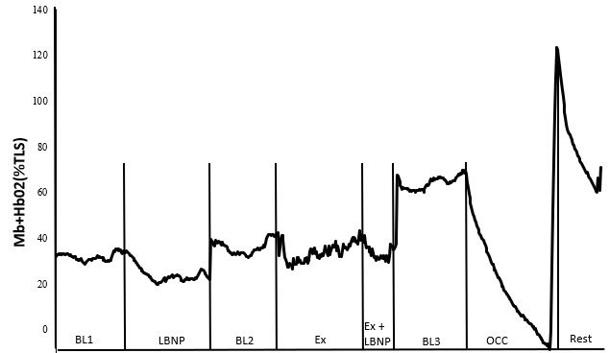
Figure 10. Functional sympatholysis protocol tracing HbO₂ in the forearm musculature during FLZ. Data tracing of Myoglobin and Oxyhemoglobin responses during LBNP (-20mmHG) exposure, followed by forearm muscle exercise at 20%MVC and Exercise with LNBP exposure. Followed were 5 minutes of reactive hyperemia occlusion at 230mmHG to determine the nadir to determine % total labile signal (TLS).

Sex differences
A Split Plot ANOVA revealed a significant main effect between the two conditions (p=0.041, Observed Power= 0.899) but a non-significant interaction effect (sex x condition) (p= 0.225, Observed Power: 0.217) (Table 5).
Paired Sample t-tests did reveal a significant sex difference in ∆% FBF Exercise – Exercise with LBNP at -20 mmHg during the placebo condition (p= 0.007) but no significant difference in the FLZ condition (p=0.84) (Figure 10).
Table 5: Sex differences in ∆%FBF Exercise – Exercise with LBNP
 | ∆%FBF PLA | ∆%FBF FLZ
Males (n=6) | -3.05 ± 3.92* | -11.62 ± 13.94
Females (n=7) | 9.90 ± 10.47* | -8.35 ± 18.39

Values are displayed as mean ± SD
*Indicates sex differences

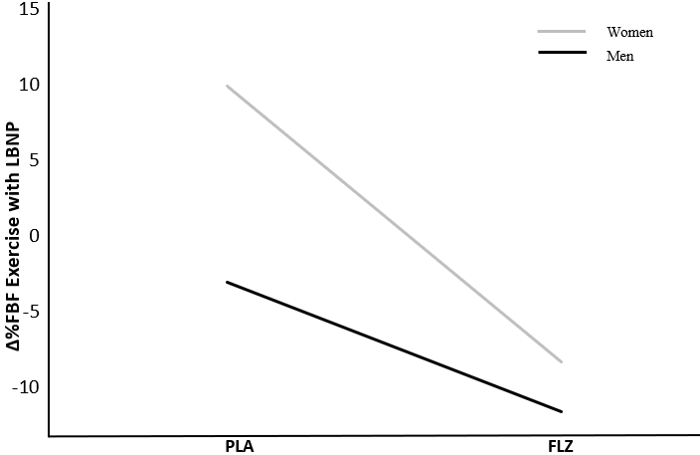
Figure 10: Sex differences in ∆%FBF Exercise – Exercise with LBNP at -20 mmHg responses
CHAPTER V: DISCUSSION
The purpose of the present study was to determine the importance of EDHF in functional sympatholysis in healthy young adults. To our knowledge, this was the first study to investigate the effects of an EDHF blockade via fluconazole during forearm muscle exercise in addition to sympathetic stress via LBNP. The main finding of this study is that the blockade of EDHF blunts the ability of skeletal muscle to override sympathetic vasoconstriction during exercise during sympathetic stress. In direct contrast, EDHF does not seem to influence the modulating of human skeletal muscle vasculature during sympathetic stress alone.
Resting hemodynamics
In resting conditions, we found no significant differences between the PLA and the FLZ conditions when comparing absolute brachial artery FVC, FBF, mean blood velocity and diameter (Table 3). These findings contradict findings by Petterson et al (2021), who found significant differences between control and Fluconazole ingestion in mean blood velocity, blood flow, shear stress, but not brachial artery diameter at rest.
In contrast, other studies investigating functional sympatholysis in clinical populations, as opposed to the investigation of local vasodilator including EDHF, reported in their baseline data that younger and older individuals did not significantly differ in baseline FBF and baseline FVC. Yet, functional sympatholysis, based on FVC and FBF, was impaired in the study groups (type 2 diabetes) (Bock et al, 2020). For example, Bock et al (2020) found no significant difference in resting FBF or FBF between healthy adults and subjects with type 2 diabetes despite impaired attenuated hyperemic and vasodilatory responses to exercise.
Contrary to our results, Ozkor et al (2011) found that the local infusion of FLZ significantly decreased resting FBF significantly in heathy adults. This indicates that that EDHF significantly contributes to resting vasodilatory tone. A NO blockade via N-Methylarginine in addition to FLZ infusion reduced FBF even further, indicating that NO may also play an important role in resting vasodilatory tone. However, it is important to mention that, in this particular study, FBF was measured after intra-arterial infusion given at 0.4 μmol/min for 5 minutes, as opposed to a systematic EDHF inhibition via a FLZ pill, which may explain the discrepancies in results.
In contrast to Petterson at al (2021) and Ozkar et al (2011), our findings suggest that EDHF is not a modulator of skeletal muscle blood flow in resting conditions alone, keeping in mind the methodological differences.
% FBF/ FVC changes at Rest + LBNP Stimulus
In response to increased sympathetic nervous system stimulus via the use of LBNP reduced FBF in both FLZ and PLA with no difference between the conditions (Figure 2). LBNP stimulus causes sympathetic vasoconstriction via offloading of baroreceptors (Rickards et al. 2015), acting on the cardiovascular control center, ultimately leading to increased sympathetic vasomotor outflow. Baroreceptor offloading ultimately leads to increased sympathetic vasoconstriction and a decrease in FVC/FBF (Tschakowksy & Pyke, 2008). A LBNP stimulus of -20 mmHg causes an increase in sympathetic vasoconstriction, while MAP and HR are mostly maintained (Rickards et al., 2015). In both conditions, we found that LBNP created a robust sympathetic vasoconstriction without any difference between the PLA and the FLZ conditions, indicating that EDHF does not play a role in overriding sympathetic vasoconstriction at rest during sympathetic stimulation alone. This does match with our findings at rest without sympathetic stimulus. Similar to our findings in terms of FBF responses, we found a significant decrease in Δ% in FVC in both, the PLA as well as the FLZ trial when comparing resting to rest+LBNP values without a significance between the conditions (Figure 5).
Our FBF findings match with previous studies using a similar study design but in different populations. Vongpatanasin, et al (2011) found that Hypertensive and Normotensive individuals showed similar FBF and FVC values during the increase of sympathetic stress via -20 mmHg LBNP stimulus. Our data indicates that EDHF may not be a key modulator in vascular tone during sympathetic stress in resting conditions.
% FBF/FVC changes - Exercise Without LBNP Stimulus
Unsurprisingly, we observed a significant increase in FBF during rhythmic forearm muscle exercise at 20% MVC from resting baseline in both conditions. However, similar to LBNP responses at rest, there was no significant difference in Δ% changes in FBF between conditions (Figure 3). Similar to our FBF data, we found a significant increase in Δ% FVC from resting values without significant difference between the conditions (Figure 6) .Our findings indicate that EDHF did not play a significant role in the ability to increase forearm muscle blood flow itself. However, exercise alone without added sympathetic stress is not sufficient to determine changes in functional sympatholysis (Bunsawat et al., 2019). Previous investigations in hypertensive individuals indicated that FBF and FVC was not statistically significant between normotensive and hypertensive subjects at steady state handgrip exercise. However, like our results, the same investigation indicated significant differences between the groups after LBNP was added to forearm muscle exercise (Vongpatanasin et al, 2011).
When taking our data and previous findings into consideration, we find that exercise responses itself may not be indicative of functional sympatholysis due to the lack to sympathetic stimulus. Due to the nature of functional sympatholysis, being the ability to blunt sympathetic vasoconstriction, additional sympathetic stress needs to be added to exercise hyperemia to determine podetial mechanisms in the phenomenon.
% FBF/FVC changes Exercise + LBNP
In contrast to our exercising data without sympathetic stimulus, we found a significant difference between FLZ and PLA when comparing FBF and FVC responses to exercise during LBNP stimulus (Figure 4, Figure 7). We found a nonsignificant change in FBF and FVC when LBNP was added to forearm muscle exercise in the PLA condition, suggesting intact sympatholysis. On the other hand, in FLZ, FBF and FVC where compromised (Figure 4, Figure 7).
Our data adds to the knowledge gained from Hearon et al (2016). As stated before, the study found that the stimulation of the Endothelium Derived Hyperpolarization-like vasodilator acetylcholine as well as low dose infusion of the endothelium dependent vasodilator ATP blunts sympathetic vasoconstriction in exercising skeletal muscle during mild (non-sympatholytic) intensity RHG similar when compared to moderate intensity RHG at 15%MVC (sympatholytic) based on changes in ∆FVC. On the contrary, the NO donor sodium nitroprusside does not attenuate sympathetic vasoconstriction at rest or combined with mild exercise at 5% MVC. Overall, our and previous data indicates that EDHF may play an important role in blunting α1-adrenergic vasoconstriction (functional sympatholysis) when looking at changes on FBF and FVC.
Additionally, Crecelius et al. (2011)​ tried to determine the independent as well as the interactive roles of NO/PG in ATP-dependent vasodilation. Both, the individual and combined NO/PG inhibition via N-Methylarginine (blockade of NO) and Ketorolac (blockade of PG) brachial infusion indicated no effect on forearm vascular conductance.
Since EDHF acts independently of NO/PGs, endothelium derived hyperpolarization may play a more important role in exercise hyperemia then previously assumed. Our data, as indicated in Figure 4 and Figure 7, shows an important role of EDHF in our ability to blunt sympathetic constriction during exercise.
Forearm muscle oxygenation
We found no significant difference in %functional sympatholysis (∆% HbO₂+MbO₂) when comparing the FLZ and well and the PLA condition (Figure 8). Our findings contradict with findings in terms of ∆FVC and ∆FBF changes. Our data also contradict our knowledge of the relationship between forearm muscle oxygenation and muscle blood flow during exercise.
Previous studies have shown that the exercise induced redistribution of blood flow during exercise and the increase in sympathetic vasoconstriction based on baroreceptor offloading will lead to a reduction of oxygenated hemoglobin (Volianitis et al, 2003). Muscle tissue oxygenation and muscle blood flow are strongly correlated, which makes both valid and reliable tools to assess functional sympatholysis (Fadel et al, 2004).
The primary difference in our assessment of functional sympatholysis based on vascular conductance vs. oxygenation changes is the observed power we discovered. Our %∆ in FVC in response to Exercise with LBNP has indicated an observed power of 0.933 and d=1.1. On the other hand, our oxygenation data indicated an observed power was 0.335 with a d of 0.36. We can only speculate at the current progress of our data collection that a higher power due to an increased sample size may reveal potential differences between the conditions in terms of muscle oxygenation.

Sex differences.
Our data indicates no overall significant differences in functional sympatholysis responses (Figure 10) to an EDHF blockade but showed that the ∆%FBF Exercise – Exercise with LBNP was significantly lower in men in the PLA condition (Table 5). This may indicate that females are more dependent on EHDF more during functional sympatholysis then males. However, a major limitation of this analysis is the low observed power of the group differences. We can only speculate that an increased sample size may change our overall results.
Just & DeLorey (2017) were among the first who explore sex differences in functional sympatholysis and found that Female rodents are better at overriding sympathetic vasoconstriction the Males. Females were also more dependent on NO then males. Whether this applies to humans, and what role EDHF may play in not fully understood and needs to be explored further. Our findings can potentially add to our limited knowledge about sex differences in vasoconstrictor responses.
Limitations and experimental considerations
Our experimental design has a multitude of limitation in the experimental design.
First, we asked all participants to abstain from alcohol, NSAIDs, and vigorous exercise for 24 hours, from caffeine for 12 hours and from eating for 8 hours leading up to the study visit. Additionally, we required all female participants to be tested in day 1-5 of the early follicular phase. We had to rely on the answers to be truthful as we were not able to control the pre-study requirements.
We tested sympatholytic responses in small muscle mass only. Whether our findings are applicable to large muscle mass in not fully clear. However, previous data indicated that differences in muscle mass do not have an effect on the ability to inhibit sympathetic vasoconstriction (Wray et al., 2004).
A further limitation of our study design was that FLZ was given in a single dose as a 150mg pill. Previous studies investigating the effects of EDHF on skeletal muscle blood flow have utilized inter-arterial infusion of FLZ over a 5-minute time frame (Ozkor et al, 2011). This could be a potential cause for our resting data discrepancies when compared to the data to Ozkor et al (2011) and could have caused a blunted overall effect of a CYP450 blockade in our data, as our use of FLZ was systemically as opposed to local stimulation.
We were not able to measure sympathetic nervous system activity over the course of the LBNP stimulus. Previous data measuring functional sympatholysis also found differences in MSNA activity, giving further insight into vasoconstrictor responses (Vongpatanasin et al., 2011).
A potential critique point of our study analysis is the presentation of our FBF and FVC data as Δ% changes as opposed to absolute values. Data expression when investigating sympathetic vasomotion has been extensively debated in the previous literature by Tschakowsky et al (2001) Thomas et al (1997) & Buckwalter and Clifford (2001). In essence, percent changes in FBF and FVC are more appropriate to distinguish between vasoconstrictor responses as it will be more indicative of a percent reduction in vessel radius during differing flow conditions (e.g. high flow during exercise vs low flow during rest) within an individual (Tschakowsky et al, 2011). Therefore, interpreting percent changes allows us to quantify the relative vasoconstriction (e.g. change in vessel radius) caused by the sympathetic stimulus within each individual in each condition.

CHAPTER VI: CONCLUSION
The purpose of the present study was to determine the importance of EDHF in functional sympatholysis in healthy young adults.
Main findings
      - We accept the first hypothesis of the study indicating that EDHF blockade does significantly impair functional sympatholysis in healthy, young adults (Figures 4 and 7).
      - We also accept that the blockade of EDHF does decrease forearm muscle blood flow & decrease vascular conductance during exercise with sympathetic stress in healthy, young adults. However, we did not find significant differences between the conditions in terms of vascular conductance and muscle blood flow during rest and exercise alone (Figure 2 – Figure 7).
      - We reject the hypothesis that forearm muscle oxygenation does decrease after EDHF blockade during rest, sympathetic stress, exercise, and exercise with sympathetic stress in healthy, young adults, keeping in mind the low observed power compared to our vascular conductance data (Figure 8).
In conclusion, we found that EDHF potentially plays an important role blunting sympathetic vasoconstriction in healthy, young adults. Future direction should include the application of testing the blockade of EDHF in individuals with cardiovascular and cardiometabolic disease. Additionally, previous research indicates the importance of exercise training on functional sympatholysis. The importance of EDHF in these implications remains unknown. The importance of EDHF signaling in during exercise similarities and sex differences needs to be further explored as well.
References
Alberts B., Johnson A, Lewis J., (2002) Molecular Biology of the Cell. 4th edition. New York Garland Science; Blood Vessels and Endothelial Cells.
Andersen, P., & Saltin, B. (1985). Maximal perfusion of skeletal muscle in man. The Journal of physiology, 366, 233–249. https://doi.org/10.1113/jphysiol.1985.sp015794
Barbosa, T. C., Young, B. E., Stephens, B. Y., Nandadeva, D., Kaur, J., Keller, D. M., & Fadel, P. J. (2020). Functional sympatholysis is preserved in healthy young Black men during rhythmic handgrip exercise. American journal of physiology. Regulatory, integrative and comparative physiology, 319(3), R323–R328.
Bellien, J., Iacob M, Gutierrez, L., Isabelle M, Lahary, A., Thuillez, C, Joannides, R. (2006) Crucial role of NO and endothelium-derived hyperpolarizing factor in human sustained conduit artery flow-mediated dilatation. Hypertension. Dec; 48(6):1088-94
Bock J. M., Hughes W. E., Ueda K, Feider A. J., Hanada, S., Kruse, N. T., Iwamoto E., Casey, D.P, (2020) Greater α 1-adrenergic-mediated vasoconstriction in contracting skeletal muscle of patients with type 2 diabetes American Journal of Physiology-Heart and Circulatory Physiology, 319; 4; H797-H807
Brozovich, F. V., Nicholson, C. J., Degen, C. V., Gao, Y. Z., Aggarwal, M., & Morgan, K. G. (2016). Mechanisms of vascular smooth muscle contraction and the basis for pharmacologic treatment of smooth muscle disorders. Pharmacological Reviews, 68(2), 476–532. https://doi.org/10.1124/pr.115.010652
Buckwalter, J. B., Clifford, P. S., (2001) The Paradox of Sympathetic Vasoconstriction in Exercising Skeletal Muscle. Exercise Sport Sci R 29: 159–163, 2001. doi: 10.1097/00003677-c200110000-00005
Buckwalter, J. B., Taylor, J. C., Hamann, J. J., Clifford, P. S., (1985) Role of nitric oxide in exercise ympatholysis. J Appl Physiol 97: 417–423; discussion 416, 2004.
Bunsawat, K., Ratchford, S.M., Clifton, H.L., Theisen, J.K., Barrett-O'Keefe, Z., Broxterman, R.M., Gifford, J.R., Hydren, J., Rossman, M.J., Ives, S.J., Trinity, J.D., Witman, M.A., Garten, R.S., Morgan, D.E., Nelson, A.D., Richardson, R.S. and Wray, D.W. (2018), Sex Differences in the Sympathetic Restraint of Skeletal Muscle Blood Flow in the Human Leg Vasculature. The FASEB Journal, 32: 594.4-594.4. https://doi.org/10.1096/fasebj.2018.32.1_supplement.594.4
Chavoshan, B., Sander. M., Sybert, TE., Hansen, J., Victor, R. G., Thomas, G. D., (2002) Nitric oxide- dependent modulation of sympathetic neural control of oxygenation in exercising human skeletal muscle. J Physiol 540: 377–386, 2002.
Chambers, D. J., & Wisely, N. A. (2019). Cardiopulmonary exercise testing—a beginner’s guide to the nine-panel plot. BJA Education, 19(5), 158–164. https://doi.org/10.1016/j.bjae.2019.01.009
Clifford, P. S., & Hellsten, Y. (2004). Vasodilatory mechanisms in contracting skeletal muscle. Journal of applied physiology (Bethesda, Md. : 1985), 97(1), 393–403. https://doi.org/10.1152/japplphysiol.00179.2004
Clausen J. P. (1976). Circulatory adjustments to dynamic exercise and effect of physical training in normal subjects and in patients with coronary artery disease. Progress in cardiovascular diseases, 18(6), 459–495. https://doi.org/10.1016/0033-0620(76)90012-8
Crane, G.J.; Gallagher, N.; Dora, K.A.; Garland, C.J. (2003) Small- and intermediate-conductance calcium-activatedK+channels provide different facets of endothelium-dependent hyperpolarization in rat mesenteric artery.J. Physiol.2003,553, 183–189
Crecelius, A. R., Kirby, B. S., Hearon, C. M., Jr, Luckasen, G. J., Larson, D. G., & Dinenno, F. A. (2015). Contracting human skeletal muscle maintains the ability to blunt α1 -adrenergic vasoconstriction during KIR channel and Na(+) /K(+) -ATPase inhibition. The Journal of physiology, 593(12), 2735–2751. https://doi.org/10.1113/JP270461
Crecelius, A. R., Kirby, B. S., Luckasen, G. J., Larson, D. G., & Dinenno, F. A. (2013). Mechanisms of rapid vasodilation after a brief contraction in human skeletal muscle. American journal of physiology. Heart and circulatory physiology, 305(1), H29–H40. https://doi.org/10.1152/ajpheart.00298.2013
Crecelius, A. R., Kirby, B. S., Richards, J. C., Garcia, L. J., Voyles, W. F., Larson, D. G., Luckasen, G. J., & Dinenno, F. A. (2011). Mechanisms of ATP-mediated vasodilation in humans: modest role for nitric oxide and vasodilating prostaglandins. American journal of physiology. Heart and circulatory physiology, 301(4), H1302–H1310. https://doi.org/10.1152/ajpheart.00469.2011
Debruyne, D., & Ryckelynck, J. P. (1993). Clinical Pharmacokinetics of Fluconazole. Clinical Pharmacokinetics, 24(1), 10–27. https://doi.org/10.2165/00003088-199324010-00002
Dinenno, F. A., & Joyner, M. J. (2004). Combined NO and PG inhibition augments alpha- adrenergic vasoconstriction in contracting human skeletal muscle. American journal of physiology. Heart and circulatory physiology, 287(6), H2576–H2584. https://doi.org/10.1152/ajpheart.00621.2004
Dinenno, F. A., Joyner, M. J., & Halliwill, J. R. (2003). Failure of systemic hypoxia to blunt α-adrenergic vasoconstriction in the human forearm. Journal of Physiology, 549(3), 985–994. https://doi.org/10.1113/jphysiol.2003.042507
Dinenno, F. A., Masuki, S., & Joyner, M. J. (2005). Impaired modulation of sympathetic alpha- adrenergic vasoconstriction in contracting forearm muscle of ageing men. The Journal of physiology, 567(Pt 1), 311–321. https://doi.org/10.1113/jphysiol.2005.087668
Ding, X., & Kaminsky, L. S. (2003). Human extrahepatic cytochromes P450: function in xenobiotic metabolism and tissue-selective chemical toxicity in the respiratory and gastrointestinal tracts. Annual review of pharmacology and toxicology, 43, 149–173. https://doi.org/10.1146/annurev.pharmtox.43.100901.140251
Ellsworth, M. L., Ellis, C. G., Goldman, D., Stephenson, A. H., Dietrich, H. H., & Sprague, R. S. (2009). Erythrocytes: oxygen sensors and modulators of vascular tone. Physiology (Bethesda, Md.), 24, 107–116. https://doi.org/10.1152/physiol.00038.2008
Ellsworth, M. L., Forrester, T., Ellis, C. G., & Dietrich, H. H. (1995). The erythrocyte as a regulator of vascular tone. American Journal of Physiology - Heart and Circulatory Physiology, 269(6 38-6). https://doi.org/10.1152/ajpheart.1995.269.6.h2155
Fadel, P. J., Farias Iii, M., Gallagher, K. M., Wang, Z., & Thomas, G. D. (2012). Oxidative stress and enhanced sympathetic vasoconstriction in contracting muscles of nitrate-tolerant rats and humans. The Journal of physiology, 590(2), 395–407. https://doi.org/10.1113/jphysiol.2011.218917

Fadel, P. J., Keller, D. M., Watanabe, H., Raven, P. B., & Thomas, G. D. (2004). Noninvasive assessment of sympathetic vasoconstriction in human and rodent skeletal muscle using near-infrared spectroscopy and Doppler ultrasound. Journal of applied physiology (Bethesda, Md. : 1985), 96(4), 1323–1330
Félétou, M., Vanhoutte, P. M., (1988)Endothelium-dependent hyperpolarization of canine coronary smooth muscle. Br J Pharmacol. 1988;93:515–524.
Firoz, C. K., Jabir, N. R., Khan, M. S., Mahmoud, M., Shakil, S., Damanhouri, G. A., Zaidi, S. K., Tabrez, S., & Kamal, M. A. (2015). An overview on the correlation of neurological disorders with cardiovascular disease. Saudi journal of biological sciences, 22(1), 19–23. https://doi.org/10.1016/j.sjbs.2014.09.003
Fitzgerald, S. M., Kemp-Harper, B. K., Tare, M., & Parkington, H. C. (2005). Role of endothelium-derived hyperpolarizing factor in endothelial dysfunction during diabetes. Clinical and experimental pharmacology & physiology, 32(5-6), 482–487. https://doi.or g/10.1111/j.1440-1681.2005.04216.x
Garland, C. J., Plane, F., Kemp, B. K., & Cocks, T. M. (1995). Endothelium-dependent hyperpolarization: a role in the control of vascular tone. Trends in Pharmacological Sciences, 16(1), 23–30. https://doi.org/10.1016/S0165-6147(00)88969- 5
Gill, H. J., Maggs, J. L., Madden, S., Pirmohamed, M., & Park, B. K. (1996). The effect of fluconazole and ketoconazole on the metabolism of sulphamethoxazole. British journal of clinical pharmacology, 42(3), 347–353. https://doi.org/10.1046/j.1365 - 2125.1996.40110.x
Gómez, H., Torres, A., Polanco, P., Kim, H. K., Zenker, S., Puyana, J. C., & Pinsky, M. R. (2008). Use of non-invasive NIRS during a vascular occlusion test to assess dynamic tissue O(2) saturation response. Intensive care medicine, 34(9), 1600–1607. https://doi.org/10.1007/s00134-008-1145-1
González-Alonso, J. (2012). ATP as a mediator of erythrocyte-dependent regulation of skeletal muscle blood flow and oxygen delivery in humans. Journal of Physiology, 590(20), 5001–5013. https://doi.org/10.1113/jphysiol.2012.235002
Goswami, N., Blaber, A. P., Hinghofer-Szalkay, H., & Convertino, V. A. (2019). Lower Body Negative Pressure: Physiological Effects, Applications, and Implementation. Physiological reviews, 99(1), 807–851. https://doi.org/10.1152/physrev.00006.2018
Goto, K., Ohtsubo, T., & Kitazono, T. (2018). Endothelium-dependent hyperpolarization (EDH) in hypertension: The role of endothelial ion channels. International Journal of MolecularSciences, 19(1), 1–20. https://doi.org/10.3390/ijms19010315
Hamilton, G. F., McDonald, C., & Chenier, T. C. (1992). Measurement of grip strength: validity and reliability of the sphygmomanometer and jamar grip dynamometer. The Journal oforthopaedic and sports physical therapy, 16(5), 215–219. https://doi.org/10.2519￼jospt.1992.16.5.215
Hansen, J., Sander, M., Hald, C. F., Victor, R. G., & Thomas, G. D. (2000). Metabolic modulation of sympathetic vasoconstriction in human skeletal muscle: Role of tissue hypoxia. Journal of Physiology, 527(2), 387–396. https://doi.org/10.1111/j.1469-7793.2000.00387.x
Harms C. A. (2000). Effect of skeletal muscle demand on cardiovascular function. Medicine and science in sports and exercise, 32(1), 94–99. https://doi.org/10.1097/00005768- 200001000-00015
Hearon, C. M., Kirby, B. S., Luckasen, G. J., Larson, D. G., & Dinenno, F. A. (2016). Endothelium-dependent vasodilatory signalling modulates α1-adrenergic vasoconstriction in contracting skeletal muscle of humans. Journal of Physiology, 594(24), 7435–7453. https://doi.org/10.1113/JP272829
Herr, M. D. , Hogeman, C. S. , Koch, D. W. , Krishnan, A. , Momen, A. , & Leuenberger, U. A. (2010). A real‐time device for converting Doppler ultrasound audio signals into fluid flow velocity. American Journal of Physiology ‐ Heart and Circulatory Physiology, 298, H1626 10.1152/ajpheart.00713.2009
Hillig, T., Krustrup, P., Fleming, I., Osada, T., Saltin, B., & Hellsten, Y. (2003). Cytochrome P450 2C9 plays an important role in the regulation of exercise-induced skeletal muscle blood flow and oxygen uptake in humans. Journal of Physiology, 546(1), 307–314. https://doi.org/10.1113/jphysiol.2002.030833
Hogarth, A. J., Mackintosh, A. F., & Mary, D. A. S. G. (2007). Gender-related differences in the sympathetic vasoconstrictor drive of normal subjects. Clinical Science, 112(5–6), 353–361. https://doi.org/10.1042/CS20060288
Horiuchi, M., & Okita, K. (2012). Blood flow restricted exercise and vascular function. International journal of vascular medicine, 2012, 543218. https://doi.org/10.1155/2012/543218
Jackson, W. F., König, A., Dambacher, T., & Busse, R. (1993). Prostacyclin-induced vasodilation in rabbit heart is mediated by ATP-sensitive potassium channels. The American journal of physiology, 264(1 Pt 2), H238–H243. https://doi.org/10.1152/ajpheart.1993.264.1.H238
Jagger, J. E., Bateman, R. M., Ellsworth, M. L., & Ellis, C. G. (2001). Role of erythrocyte in regulating local O2 delivery mediated by hemoglobin oxygenation. American Journal of Physiology - Heart and Circulatory Physiology, 280(6 49-6), 2833–2839. https://doi.org/10.1152/ajpheart.2001.280.6.h2833
Joyce, W., White, D. W., Raven, P. B., & Wang, T. (2019). Weighing the evidence for using vascular conductance, not resistance, in comparative cardiovascular physiology. The Journal of experimental biology, 222(Pt 6), jeb197426. https://doi.org/10.1242/jeb.197426
Joyner, M. J., & Casey, D. P. (2015). Regulation of increased blood flow (Hyperemia) to muscles during exercise: A hierarchy of competing physiological needs. Physiological Reviews, 95(2), 549–601. https://doi.org/10.1152/physrev.00035.2013
Just, T. P., Cooper, I. R., & DeLorey, D. S. (2016). Sympathetic Vasoconstriction in Skeletal Muscle: Adaptations to Exercise Training. Exercise and sport sciences reviews, 44(4), 137–143. https://doi.org/10.1249/JES.0000000000000085
Just, T. P., & DeLorey, D. S. (2017). Sex differences in sympathetic vasoconstrictor responsiveness and sympatholysis. Journal of applied physiology (Bethesda, Md. : 1985), 123(1), 128–135. https://doi.org/10.1152/japplphysiol.00139.2017
Kitzman D. W. (2005). Exercise intolerance. Progress in cardiovascular diseases, 47(6), 367–379. https://doi.org/10.1016/j.pcad.2005.02.002
Kodama, S., Saito, K., Tanaka, S., Maki, M., Yachi, Y., Asumi, M., Sugawara, A., Totsuka, K., Shimano, H., Ohashi, Y., Yamada, N., & Sone, H. (2009). Cardiorespiratory fitness as a quantitative predictor of all-cause mortality and cardiovascular events in healthy men and women: a meta-analysis. JAMA, 301(19), 2024–2035. https://doi.org/10.1001/jama.2009.681
Korthuis, R. J., (2011) Skeletal Muscle Circulation. San Rafael (CA): Morgan & Claypool Life Sciences; 2011. Chapter 4, Exercise Hyperemia and Regulation of Tissue Oxygenation During Muscular Activity.
Lewis, S. F., Taylor, W. F., Graham, R. M., Pettinger, W. A., Schutte, J. E., & Blomqvist, C. G. (1983). Cardiovascular responses to exercise as functions of absolute and relative work load. Journal of Applied Physiology Respiratory Environmental and Exercise Physiology, 54(5), 1314–1323. https://doi.org/10.1152/jappl.1983.54.5.1314
Lipcsey, M., Woinarski, N. C., & Bellomo, R. (2012). Near infrared spectroscopy (NIRS) of the thenar eminence in anesthesia and intensive care. Annals of intensive care, 2(1), 11. https://doi.org/10.1186/2110-5820-2-11
Luksha, L., Nisell, H., & Kublickiene, K. (2004). The mechanism of EDHF-mediated responses in subcutaneous small arteries from healthy pregnant women. American journal of physiology. Regulatory, integrative and comparative physiology, 286(6), R1102–R1109. https://doi.org/10.1152/ajpregu.00550.2003
Mark, A. L., Victor, R. G., Nerhed, C. & Wallin, B. G. (1985).Microneurographic studies of the mechanisms of sympathetic nerve responses to static exercise in humans. Circulation Research 57,461—469
McLay, K.M., Fontana, F.Y., Nederveen, J.P., Guida, F.F., Paterson, D.H., Pogliaghi, S. and Murias, J.M. (2016), Vascular responsiveness determined by near-infrared spectroscopy measures of oxygen saturation. Exp Physiol, 101: 34-40. https://doi.org/10.1113/EP085406
Lewis, N., Gelinas, J., Ainslie, P. N., Smirl, J. D., Agar, G., Melzer, B., Rolf, J. D., & Eves, N. D. (2019). Cerebrovascular function in patients with chronic obstructive pulmonary disease: the impact of exercise training. American journal of physiology. Heart and circulatory physiology, 316(2), H380–H391. https://doi.org/10.1152/ajpheart.00348.2018
Michelini, L. C., O'Leary, D. S., Raven, P. B., & Nóbrega, A. C. (2015). Neural control of circulation and exercise: a translational approach disclosing interactions between central command, arterial baroreflex, and muscle metaboreflex. American journal of physiology. Heart and circulatory physiology, 309(3), H381–H392. https://doi.org/10.1152/ajpheart.00077.2015
Moore, A. W., Bearden, S. E., & Segal, S. S. (2010). Regional activation of rapid onset vasodilatation in mouse skeletal muscle: Regulation through α-adrenoreceptors. Journal of Physiology, 588(17), 3321–3331. https://doi.org/10.1113/jphysiol.2010.193672
Mortensen, S. P., González-Alonso, J., Damsgaard, R., Saltin, B., & Hellsten, Y. (2007). Inhibition of nitric oxide and prostaglandins, but not endothelial-derived hyperpolarizing factors, reduces blood flow and aerobic energy turnover in the exercising human leg. Journal of Physiology, 581(2), 853–861. https://doi.org/10.1113/jphysiol.2006.127423
Mortensen, S. P., Nyberg, M., Gliemann, L., Thaning, P., Saltin, B., & Hellsten, Y. (2014). Exercise training modulates functional sympatholysis and α-adrenergic vasoconstrictor responsiveness in hypertensive and normotensive individuals. The Journal of physiology, 592(14), 3063–3073. https://doi.org/10.1113/jphysiol.2014.273722
Mortensen, S. P., Nyberg, M., Winding, K., & Saltin, B. (2012). Lifelong physical activity preserves functional sympatholysis and purinergic signalling in the ageing human leg. The Journal of physiology, 590(23), 62276236.https://doi.org/10.1113/jphysiol.2012.240093
Mortensen, S. P., & Saltin, B. (2014). Regulation of the skeletal muscle blood flow in humans . Experimental Physiology, 99(12), 1552–1558. https://doi.org/10.1113/expphysiol.2014.081620
Mortensen, S. P., Thaning, P., Nyberg, M., Saltin, B., & Hellsten, Y. (2011). Local release of ATP into the arterial inflow and venous drainage of human skeletal muscle: Insight from ATP determination with the intravascular microdialysis technique. Journal of Physiology, 589(7), 1847–1857. https://doi.org/10.1113/jphysiol.2010.203034
Nobrega, A. C., O'Leary, D., Silva, B. M., Marongiu, E., Piepoli, M. F., & Crisafulli, A. (2014). Neural regulation of cardiovascular response to exercise: role of central command and peripheral afferents. BioMed research international, 2014, 478965. https://doi.org/10.1155/2014/478965
Ozkor, M. A., Murrow, J.R., Rahman, A. M., Kavtaradze, N., Lin, J., Manatunga, A., Quyyumi, A. A., (2011) Endothelium-Derived Hyperpolarizing Factor Determines Resting and Stimulated Forearm Vasodilator Tone in Health and in Disease. Circulation 123: 2244–2253, 2011. doi: 10.1161/circulationaha.110.990317.
Petterson, J. L., O’Brien, M. W., Johns, J. A., Chiasson, J., & Kimmerly, D. S. (2021). Influence of prostaglandins and endothelial-derived hyperpolarizing factors on brachial and popliteal endothelial-dependent function in young adults. Journal of Applied Physiology (Bethesda, Md. : 1985), 130(1), 17–25. https://doi.org/10.1152/japplphysiol.00698.2020
Price, A., Raheja, P., Wang, Z., Arbique, D., Adams-Huet, B., Mitchell, J. H., Victor, R. G., Thomas, G. D., & Vongpatanasin, W. (2013). Differential effects of nebivolol versus metoprolol on functional sympatholysis in hypertensive humans. Hypertension (Dallas, Tex. : 1979), 61(6), 1263–1269. https://doi.org/10.1161/HYPERTENSIONAHA.113.01302
Remennsnyder, J. P., Mitchell, J. H., & Sarnoff, S. J. (1962). Functional sympatholysis during muscular activity. Observations on influence of carotid sinus on oxygen uptake. Circulation research, 11, 370–380. https://doi.org/10.1161/01.res.11.3.370\
Rickards, C. A., Johnson, B. D., Harvey, R. E., Convertino, V. A., Joyner, M. J., & Barnes, J. N. (2015). Cerebral blood velocity regulation during progressive blood loss compared with lower body negative pressure in humans. Journal of Applied Physiology, 119(6), 677–685.
Rosenberry R, Chung S, Nelson MD. Skeletal Muscle Neurovascular Coupling, Oxidative Capacity, and Microvascular Function with “One Stop Shop” Near-infrared Spectroscopy. J Vis Exp , 2018. doi: 10.3791/57317.
Rosenberry, R., Munson, M., Chung, S., Samuel, T. J., Patik, J., Tucker, W. J., Haykowsky, M. J., & Nelson, M. D. (2018). Age-related microvascular dysfunction: novel insight from near-infrared spectroscopy. Experimental physiology, 103(2), 190–200. https://doi.org/10.1113/EP086639
Saltin, B. & Andersen, P. (1985). Maximal perfusion of skeletal muscle in man. The Journal of physiology, 366, 233–249. https://doi.org/10.1113/jphysiol.1985.sp015794
Saltin, B., & Mortensen, S. P. (2012). Inefficient functional sympatholysis is an overlooked cause of malperfusion in contracting skeletal muscle. The Journal of physiology, 590(24), 6269–6275. https://doi.org/10.1113/jphysiol.2012.241026
Saunders, N. R., & Tschakovsky, M. E. (2004). Evidence for a rapid vasodilatory contribution to immediate hyperemia in rest-to-mild and mild-to-moderate forearm exercise transitions in humans. Journal of applied physiology (Bethesda, Md. : 1985), 97(3), 1143–1151. https://doi.org/10.1152/japplphysiol.01284.2003
Sharma, A., Reddy, M. H., Sharma, K., Dogra, S., & Vijayvergiya, R. (2016). Study of endothelial dysfunction in patients of psoriatic arthritis by flow mediated and nitroglycerine mediated dilatation of brachial artery. International journal of rheumatic diseases, 19(3), 300–304.
Sudhahar, V., Shaw, S., & Imig, J. D. (2010). Epoxyeicosatrienoic acid analogs and vascular function. Current medicinal chemistry, 17(12), 1181–1190. https://doi.org/10.217 4/092986710790827843
Silke, B., & McAuley, D. (1998). Accuracy and precision of blood pressure determination with the Finapres: an overview using re-sampling statistics. Journal of human hypertension, 12(6), 403–409. https://doi.org/10.1038/sj.jhh.1000600
Strange S. (1999). Cardiovascular control during concomitant dynamic leg exercise and static arm exercise in humans. The Journal of physiology, 514 ( Pt 1)(Pt 1), 283–291. https://doi.org/10.1111/j.1469-7793.1999.283af.x
Sundlöf, G., & Wallin, B. G. (1978). Effect of lower body negative pressure on human muscle nerve sympathetic activity. The Journal of Physiology, 278(1), 525–532. https://doi.org /10.1113/jphysiol.1978.sp012322
Taddei, S., Virdis, A., Mattei, P., Ghiadoni, L., Gennari, A., Fasolo, C. B., Sudano, I., & Salvetti, A. (1995). Aging and endothelial function in normotensive subjects and patients with essential hypertension. Circulation, 91(7), 1981–1987. https://doi.org/10.1161/01.cir.91.7.1981
Thomas G. D. (2015). Functional sympatholysis in hypertension. Autonomic neuroscience : basic & clinical, 188, 64–68. https://doi.org/10.1016/j.autneu.2014.10.019
Thomas, G. D., Hansen, J., & Victor, R. G. (1994). Inhibition of alpha 2-adrenergic vasoconstriction during contraction of glycolytic, not oxidative, rat hindlimb muscle. The American journal of physiology, 266(3 Pt 2), H920–H929. https://doi.org/10.1152/ajpheart.1994.266.3.H920
Thomas G. D. (2011). Neural control of the circulation. Advances in physiology education, 35(1), 28–32. https://doi.org/10.1152/advan.00114.2010
Thomas, G. D., Hansen J., Victor, R. G., (1997) ATP-sensitive potassium channels mediate contraction-induced attenuation of sympathetic vasoconstriction in rat skeletal muscle. J Clin Invest. 1997 Jun 1;99(11):2602-9. doi: 10.1172/JCI119448. PMID: 9169489; PMCID: PMC508105.
Thomas, G. D., & Segal, S. S. (2004). Neural control of muscle blood flow during exercise. Journal of applied physiology (Bethesda, Md. : 1985), 97(2), 731–738. https://doi.org/10.1152/japplphysiol.00076.2004
Tejero, J., Shiva, S., & Gladwin, M. T. (2019). Sources of Vascular Nitric Oxide and Reactive Oxygen Species and Their Regulation. Physiological reviews, 99(1), 311–379. https://doi.org/10.1152/physrev.00036.2017
Thomas, G. D., & Victor, R. G. (1998). Nitric oxide mediates contraction-induced attenuation of sympathetic vasoconstriction in rat skeletal muscle. The Journal of physiology, 506 ( Pt 3)(Pt 3), 817–826. https://doi.org/10.1111/j.1469-7793.1998.817bv.x
Trinity, J. D., Kwon, O. S., Broxterman, R. M., Gifford, J. R., Kithas, A. C., Hydren, J. R., Jarrett, C. L., Shields, K. L., Bisconti, A. v., Park, S. H., Craig, J. C., Nelson, A. D., Morgan, D. E., Jessop, J. E., Bledsoe, A. D., & Richardson, R. S. (2021). The role of the endothelium in the hyperemic response to passive leg movement: Looking beyond nitric oxide. American Journal of Physiology – Heart and Circulatory Physiology, 320(2), H668–H678. https://doi.org/10.1152/AJPHEART.00784.2020

Tschakovsky, M. E., & Pyke, K. E. (2008). Cardiovascular responses to exercise and limitations to human performance. Physiological Basis of Human Performance During Work and Exercise, 5–27.
Tschakovsky, M. E., Sujirattanawimol, K., Ruble, S. B., Valic, Z., & Joyner, M. J. (2002). Is sympathetic neural vasoconstriction blunted in the vascular bed of exercising human muscle?. The Journal of physiology, 541(Pt 2), 623–635. https://doi.org/10.1113/jphysiol.2001.014431
Van Booven, D., Marsh, S., McLeod, H., Carrillo, M. W., Sangkuhl, K., Klein, T. E., & Altman, R. B. (2010). Cytochrome P450 2C9-CYP2C9. Pharmacogenetics and genomics, 20(4), 277–281. https://doi.org/10.1097/FPC.0b013e3283349e84
Vogel R. A. (2001). Measurement of endothelial function by brachial artery flow-mediated vasodilation. The American journal of cardiology, 88(2A), 31E–34E. https://doi.org/10.1016/s0002-9149(01)01764-7
Vongpatanasin, W., Wang, Z., Arbique, D., Arbique, G., Adams-Huet, B., Mitchell, J. H., Victor, R. G., & Thomas, G. D. (2011). Functional sympatholysis is impaired in hypertensive humans. The Journal of physiology, 589(Pt 5), 1209–1220. https://doi.org/10.1113/jphysiol.2010.203026
Volianitis, S., Krustrup, P., Dawson, E., & Secher, N. H. (2003). Arm blood flow and oxygenation on the transition from arm to combined arm and leg exercise in humans. The Journal of physiology, 547(Pt 2), 641–648. https://doi.org/10.1113/jphysiol.2002.034496
Waldron, M., David Patterson, S., & Jeffries, O. (2017). Inter-Day Reliability of Finapres ® Cardiovascular Measurements During Rest and Exercise. Sportsmedicine international open, 2(1), E9–E15. https://doi.org/10.1055
Wehrwein, E. A., & Joyner, M. J. (2013). Regulation of blood pressure by the arterial baroreflex and autonomic nervous system. Handbook of clinical neurology, 117, 89–102. https://doi.org/10.1016/B978-0-444-53491-0.00008-0
Wilkinson, I. B., Mäki-Petäjä, K. M., & Mitchell, G. F. (2020). Uses of Arterial Stiffness in Clinical Practice. Arteriosclerosis, thrombosis, and vascular biology, 40(5), 1063–1067. https://doi.org/10.1161/ATVBAHA.120.313130
Wray, D. W., Fadel, P. J., Smith, M. L., Raven, P., & Sander, M. (2004). Inhibition of alpha- adrenergic vasoconstriction in exercising human thigh muscles. The Journal of physiology, 555(Pt 2), 545–563. https://doi.org/10.1113/jphysiol.2003.054650
Yang, L., Cheriyan, J., Gutterman, D. D., Mayer, R. J., Ament, Z., Griffin, J. L., Lazaar, A. L., Newby, D. E., Tal-Singer, R., & Wilkinson, I. B. (2017). Mechanisms of Vascular Dysfunction in COPD and Effects of a Novel Soluble Epoxide Hydrolase Inhibitor in Smokers. Chest, 151(3), 555–563. https://doi.org/10.1016/j.chest.2016.10.058
Yu, Y., Zhang, K., Zhang, L., Zong, H., Meng, L., & Han, R. (2018). Cerebral near-infrared spectroscopy (NIRS) for perioperative monitoring of brain oxygenation in children and adults. The Cochrane database of systematic reviews, 1(1), CD010947. https://doi.or g/10.1002
Zarghi, A., & Arfaei, S. (2011). Selective COX-2 Inhibitors: A Review of Their Structure- Activity Relationships. Iranian journal of pharmaceutical research : IJPR, 10(4), 655– 683.

Appendix A
IRB approved documents

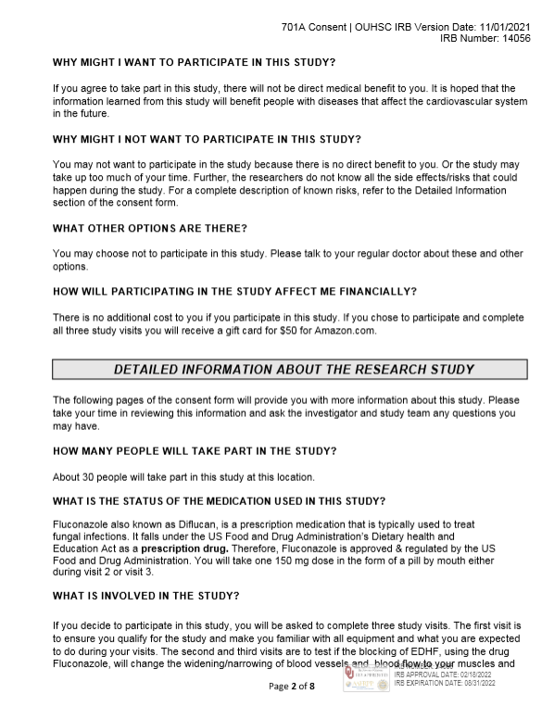
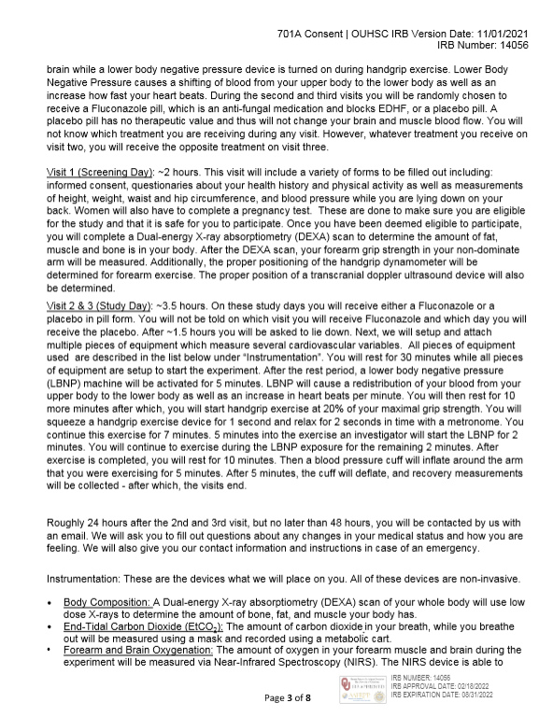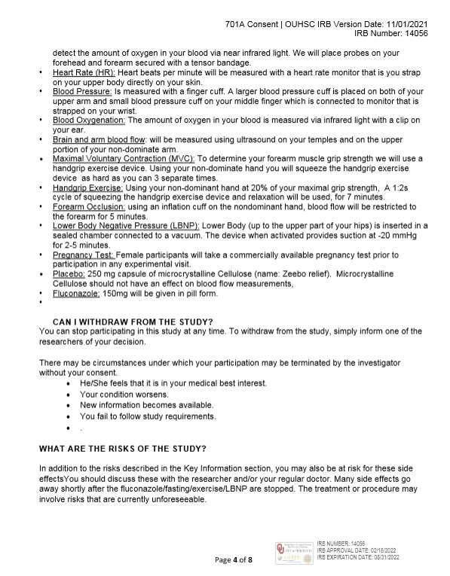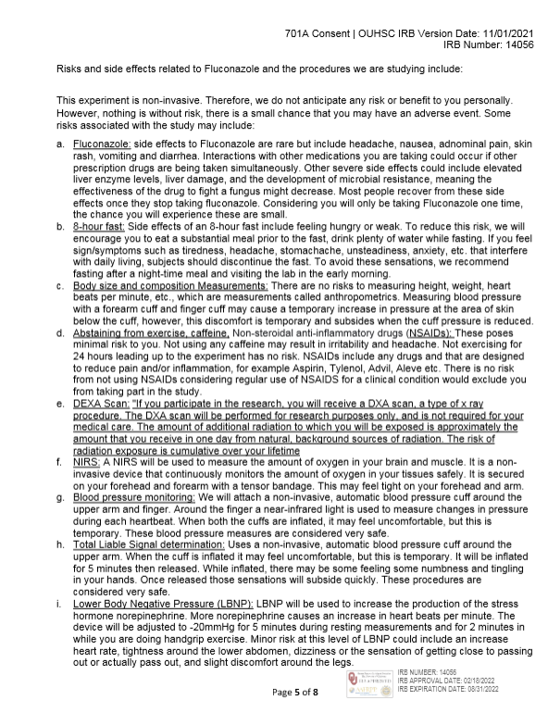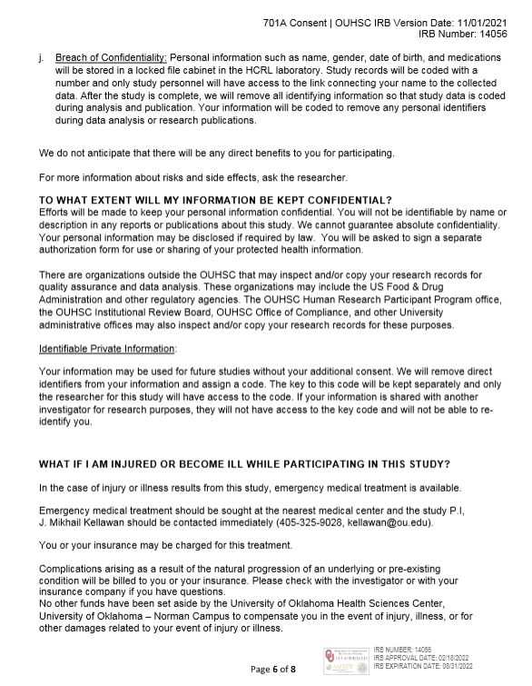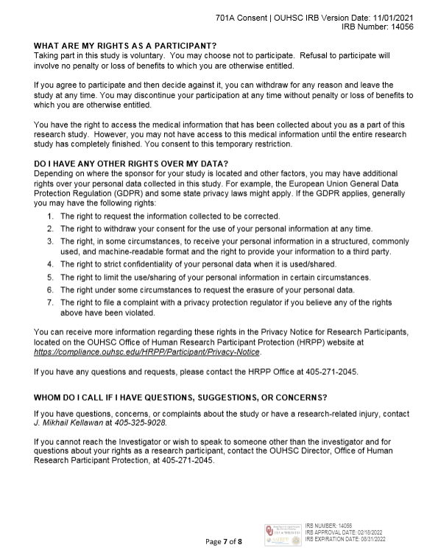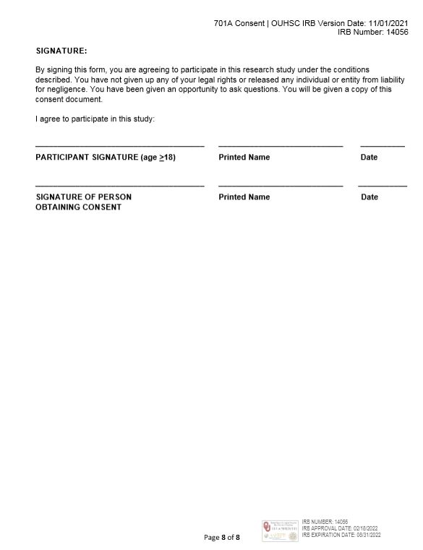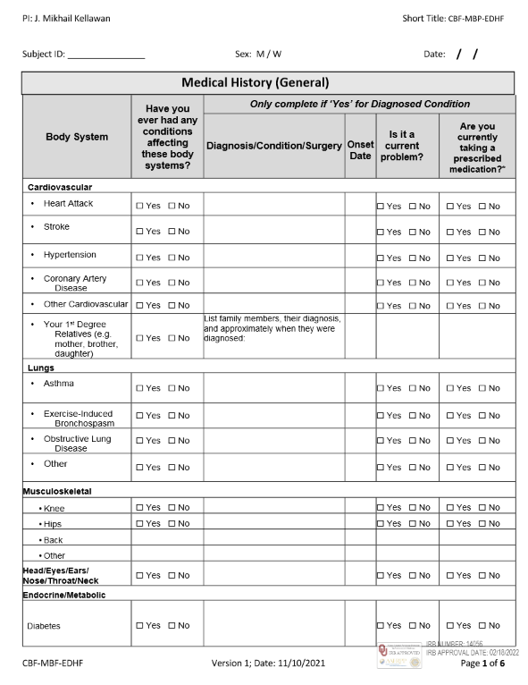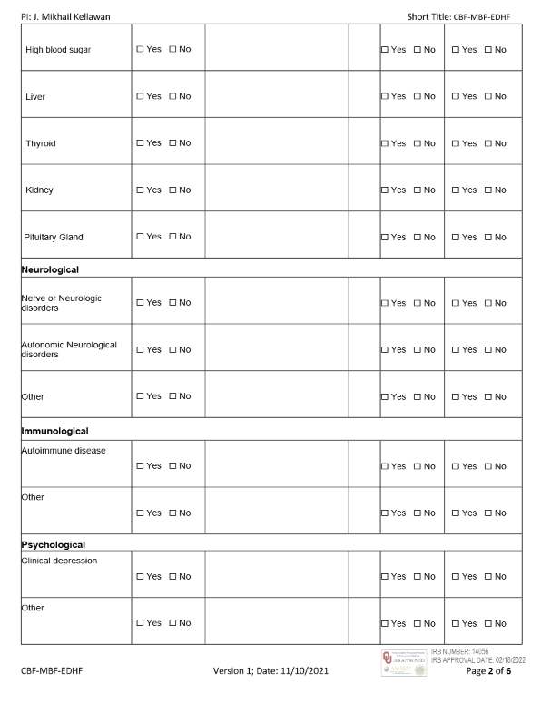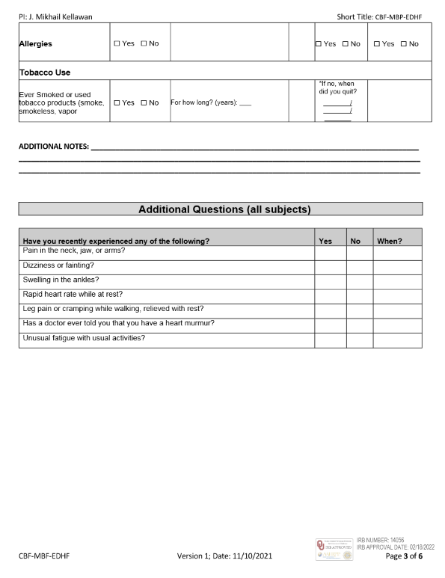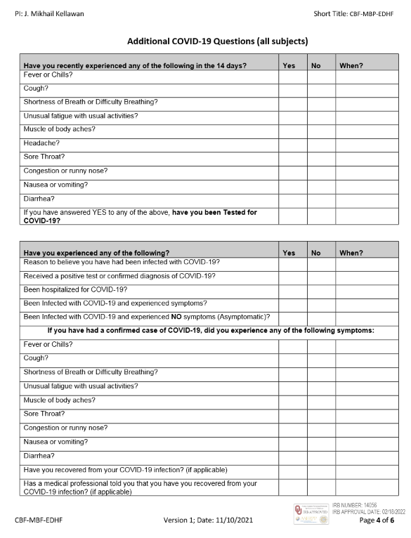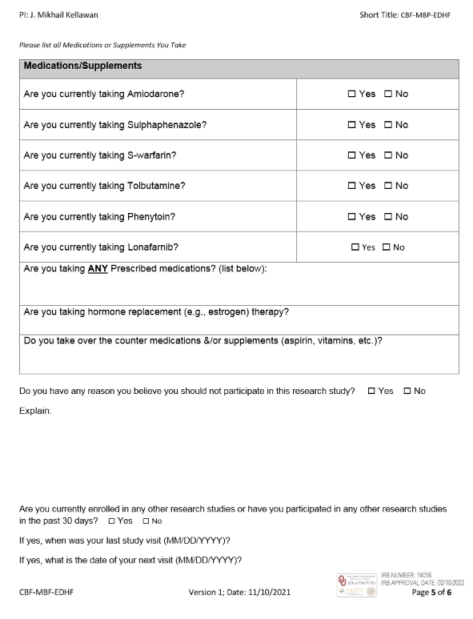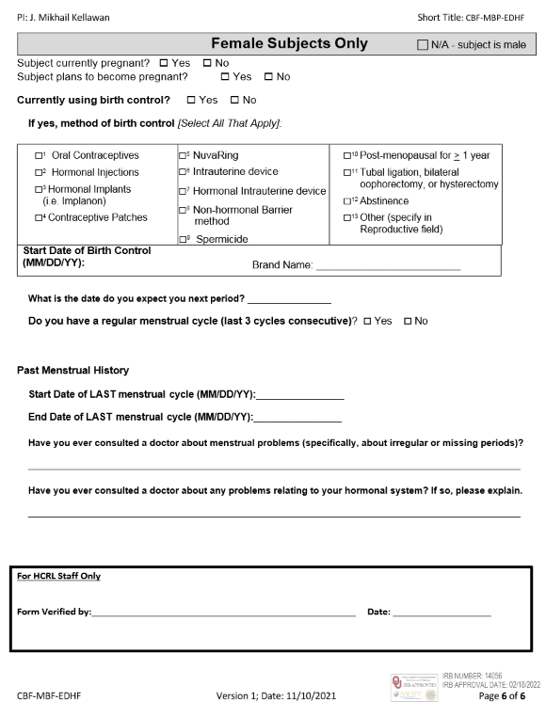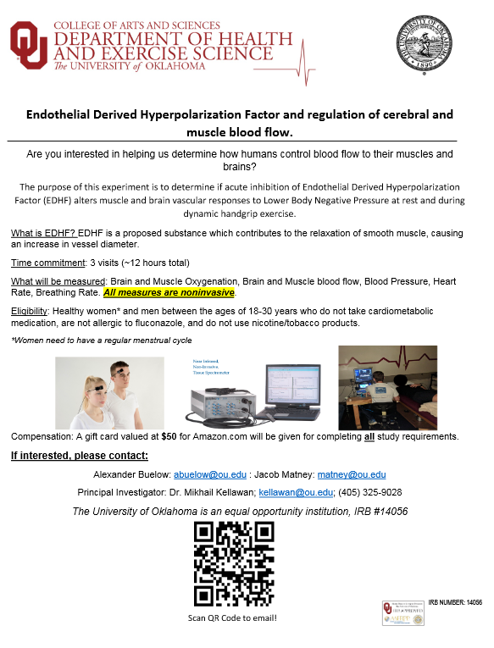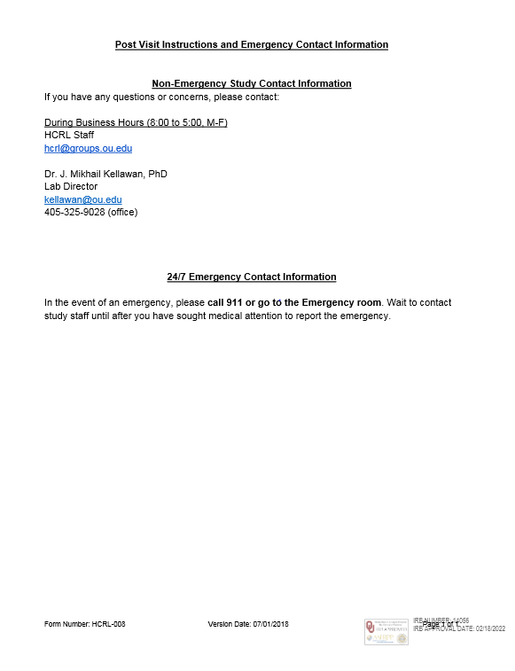

Anatomical Landmarks – Forearm ROI

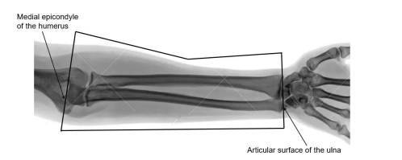

Raw Data
