University of Oklahoma

Graduate College

FORWARD SEISMIC MODEL OF PERMIAN GUADALUPIAN SHELF-TO-BASIN SEDIMENTATION THROUGH NOVEL INTEGRATION OF LIDAR AND SCHMIDT HAMMER, MCKITTRICK CANYON, WEST TEXAS

A thesis

submitted to the Graduate Faculty

in partial fulfillment of the requirements for the

Degree of

Master of Science

By

ZHUOBO WANG
Norman, Oklahoma
2018

FORWARD SEISMIC MODEL OF PERMIAN GUADALUPIAN SHELF-TO-BASIN SEDIMENTATION THROUGH NOVEL INTEGRATION OF LIDAR AND SCHMIDT HAMMER, MCKITTRICK CANYON, WEST TEXAS

A thesis approved for the
ConocoPhillips School of Geology and Geophysics

By

______________________________
Dr. John D. Pigott, Chair

______________________________
Dr. Kurt J. Marfurt

______________________________
Dr. Kulwadee L. Pigott

© Copyright by ZHUOBO WANG 2018
All Rights Reserved.

Acknowledgements

I would like to thank my advisor, Dr. Pigott, first for his advising on this thesis and on my whole master program. Academically, you taught me a lot about what is profession and what is right, which guided me to grow as a geologist. I am grateful for learning a lot from you about careers and life. I would also like to thank Dr. Kurt Marfurt for his precious advice on geophysical insight. And Dr. Kulwadee Pigott for her diligent editorial assistance.
I would like to thank my father Zhaoliang Wang and my mother Siqin who gave me their all to support me. They were always with me, encouraging me and supporting me during the master program even though we have a thirteen-hour time difference and the long distance between U.S. and China. Without their support, I would not be able to finish my thesis.
Additionally, I would like to thank Chenxi Xu and Jianjun Li who help me out not only on academic problems but also on problems of life at Norman. Thanks, especially, Chenxi Xu for his help upon the hard field work and countless discussion about research problems which provided me many inspirations. Also, I would like to thank Travis Moreland and Sofia Caylor who helped me in the field. Finally, I would like to express my special gratitude to my fiancée, Bing Yan, who was always by my side and took care of my life.
Table of Contents
Acknowledgements iv
List of Tables vii
List of Figures viii
Abstract xiii
Chapter 1: Introduction 1
Study Location 2
Problem definition 3
Previous work 4
Chapter 2: Geological Background 7
Tectonics 7
Stratigraphy 8
Sequence Stratigraphy 10
Chapter 3: Method 13
LiDAR 13
Introduction 13
Acquisition in McKittrick Canyon 15
Processing 18
Schmidt Hammer 22
Introduction 22
Acquisition in McKittrick Canyon 24
Data Set 27
Chapter 4: Result 31
LiDAR assisted stratigraphy model 31
Impedance model 35
Data set analysis 35
Depth and velocity model 40
Impedance Model 41
Seismic Model 45
Forward 2D model generation, 250 Hz Nyquist 46
Forward 2D model generation, 125 Hz Nyquist 51
Comparation with subsurface data 56
Chapter 5: Conclusions 58
References 60
Appendices 65
Appendix I—Data set of Schmidt hammer readings and rock sample 65
Appendix II—Matlab Code for AI and Seismic Modeling 71
Example of stratigraphic surface extraction with coordinate rotation 71
Impedance model building and reflection coefficient arrays generation 72
wavelet generation 85
Synthetic traces generation 88

List of Tables

Table 1: Acquisition parameters of 12 full-angle scans with 11 high resolution fine scans. Theta represents the vertical range of beam and Phi represents the horizontal ranges of the beam. Resolution implies a rotation interval of vertical and horizontal plane in degrees. 17

List of Figures

Figure 1: Simplified map of Geologic Provinces within the greater Permain Basin. 2
Figure 2: McKittrick Canyon 3D view from Google Earth. Study area is in yellow shadow, and Permian Reef Geology trail is marked by yellow solid line. 3
Figure 3: Detailed Late Gaudalupian rock-stratigraphic framework of the Delaware Mountain Group. Stratigraphy units developed on the north wall of McKittrick Canyon are boxed in red rectangular. Modified from Rush and Kerans (2010) and Kerans et al. (2011) 10
Figure 4: Illustration of hierarchy of cyclicity. Modified from Tinker (1998). 12
Figure 5: Simplified depositional profile of Upper Guadalupain. Three Composite Sequences (CS) are bounded by heavy line. Correlation of HFSs and Bell Canyon basinal equivalent is illustrated through the HFS boundaries. HFSs across the north wall of McKittrick Canyon are marked with a red polygon. Modified from Tinker (1998). 12
Figure 6: Scanner beam path at horizontal and vertical plane. 15
Figure 7: LiDAR scan position on Google Earth looking straight down into the canyon. Scans positions are marked in yellow. 18
Figure 8:Comparation of point cloud data shown in true color and in reflectance with an applied filter gate. A) Point cloud data of north wall of McKittrick Canyon painted by the camera. B) Point cloud data of north wall of McKittrick Canyon displayed by reflectance with empirical set filter gate (-3.5 dB to 3.5 dB where positive values exhibited in warm colors and negative values are in cold color). Cropped out strata are easily differentiated in reflectance. 21
Figure 9: Work flow of estimating P-wave velocity by velocity ration Q obtained by Silver Schmidt hammer. By two steps, P-wave velocity can be estimated from velocity ratio Q. 24
Figure 10: Schmidt hammer and rock specimens sampling position at north wall of south wall of McKittrick Canyon. 26
Figure 11: Ohaus Adventure Balance with density measurement kit. 29
Figure 12: McKittrick Canyon photograph painted point cloud which ties 12 full-angle scans. 30
Figure 13: True color painted point cloud of McKittrick Canyon north wall. Detail of unit stacking can be viewed in enlarging box A) high frequency cycles in Lamar Member B) interbedding of siliciclastic onlapping wedge and HST carbonate members. 33
Figure 14: Stratigraphic frame of north wall of McKittrick Canyon on LiDAR data. Eroded surfaces and units of Capitan reef and shelfal deposit are reconstructed, presenting a mixing carbonate-siliciclastic depositional system where four HST carbonate members interfinger with three bypassed LST siltstone and sandstone wedge. 34
Figure 15: Data set collected at McKittrick Canyon compared to Gardner’s relationship with data plotted in logarithm. Unit of P-wave velocity is in ft/s while unit of density is in g/cm³. Graph is after Gardner (1974). 36
Figure 16: Cross plotting of scaled along-slope distance with acoustic impedance(A) and velocity(B) of Lamar unit 2. 37
Figure 17: Cross plotting of acoustic impedance(A) and velocity(B) with scaled along-slope distance of Lamar unit 3. 38
Figure 18: Cross plotting of acoustic impedance(A) and velocity(B) with scaled along-slope distance of Lamar unit 4. 38
Figure 19: Cross plotting of acoustic impedance(A) and velocity(B) with scaled along-slope distance of Lamar unit 6. 39
Figure 20: Cross plotting of acoustic impedance(A) and velocity(B) with scaled along-slope distance of McComb Member. 39
Figure 21: Cross plotting of acoustic impedance(A) and velocity(B) with scaled along-slope distance of McKittrick Canyon Member. 39
Figure 22: Cross plotting of acoustic impedance(A) and velocity(B) with scaled along-slope distance of PostLamar (Reef Trail Member). 40
Figure 23: Cross plotting of acoustic impedance (A) and velocity (B) with scaled along-slope distance of Rader Limestone. 40
Figure 24: 2D stratigraphy frame with projected sample positions. Note that the sampling positions cover the study area 42
Figure 25: Velocity model of study area. Note that the average velocity of Lamar HFCs is higher than overlying and underlying strata and velocity of carbonate unit is inconsistent along the slope. 43
Figure 26: Calculated acoustic impedance model built upon the stratigraphic depth model of Figure 23. Note that those carbonate units documented in this clinoform perform higher impedance than siliciclastic units do. The gradual changing of impedance of one single unit is implied by lateral color shifting. 44
Figure 27: Wiggle plot of model with an Ormsby band pass of 2, 8, 80, 250 Hz. Peaks that represents positive amplitude are filled while unfilled troughs represent negative amplitude. 48
Figure 28: Synthetic seismic profile of the north wall with Ormsby band pass of 2, 8, 80, 250 Hz displayed in Petrel. 49
Figure 29: Synthetic seismic profile of the north wall with Ormsby band pass of 2, 8, 80, 250 Hz with stratigraphy frame and insets are marked by the white rectangles. Detailed stratigraphy architectures are displayed by A) High frequency cycles of Lamar Limestone. Featured termination is marked by yellow arrows; B) Polarity switching of base of Y6 HFS. C) Amplitude strength changing of base of Y6 and Y5 HFS at toe of slope. 50
Figure 30: Wiggle plots of model with Ormsby band pass of 2, 8, 80, 125 Hz. Peaks that represents positive amplitude are filled while unfilled troughs represent negative amplitude. 52
Figure 31: Synthetic seismic profile of the north wall with Ormsby band pass of 2, 8, 80, 125 Hz displayed in Petrel. 53
Figure 32: Wiggle plot of model with Ormsby band pass of 2, 8, 62.5, 80 Hz and 5% random noise. Peaks that represents positive amplitude are filled while unfilled troughs represent negative amplitude. 54
Figure 33: Wiggle plot of model with Ormsby band pass of 2, 8, 62.5, 80 Hz without noise. Peaks that represents positive amplitude are filled while unfilled troughs represent negative amplitude. 55
Figure 34: Uninterpreted contemporary 3D seismic line of Guadalupian strata from somewhere on the Northwest Shelf, Permian Basin, New Mexico. Black rectangle is enlarged to compare with synthetic model. 56
Figure 35: Comparation between the synthetic model and similar section of subsurface seismic data. 57

Abstract

As a result of the challenges occurring with the subsurface seismic interpretation of images of the complicated depositional systems of the Guadalupian of the Permian Basin, forward seismic model is built to guide the subsurface interpretation of a steep-rimmed shelf margin setting and toe-of-slope profile of a prograding reef-rimmed shelf and clinoform exposed on the north wall of McKittrick Canyon of Guadalupe Mountains. This study integrates Light Detection and Ranging (LiDAR), Schmidt hammer and density measurements to craft a seismic analogue.
The stratigraphic frame is established using high-resolution point cloud scanned by RIEGL VZ-400i, containing upper Yates Formation and lower Tansill Formation at the shelf and their equivalent members of Bell Canyon Formation at slope-to-basin section. Three high frequency Late Guadalupian sequences (HFSs) (Tinker, 1998), including Y5, Y6 and T1 are defined in the frame. Slope equivalents of these HFSs are characterized by HST carbonate members with underlying LST bypass siliciclastics, which correlate to the Y5, Y6 and T1 with the McComb Limestone, the McKittrick Canyon Limestone and the Lamar Limestone, respectively. The indirect estimation of P-wave velocity is completed through an empirical relationship between P-wave velocity and Schmidt hammer rebound number (R) and, subsequently, relationship between R and velocity ratio Q (velocity ratio: geomechanical ratio of impact velocity to rebound velocity) which is collected by electric Schmidt hammer applied in this study. Data analysis reveals the heterogeneity of acoustic impedance of each stratum from proximal to distal slope. Deposit-position based trend of impedance variation is discovered by fitting impedance against normalized along-slope distance, which contributes to the impedance model establishment.
A vertical incidence synthetic seismogram is computed upon the geologic model built with LiDAR assisted stratigraphic frame and situ petrophysical information. A zero-phase wavelet of 250 Hz Nyquist are used in the convolution with the reflection coefficient matrix to simulate a seismic profile at study area under ideal conditions. Two additional models are simulated by wavelets of lower band width (125Hz Nyquist) with and without random noise added to establish a comparable profile to general quality seismic data. The first two synthetic seismic profiles show comparable stratigraphic architectures to stratigraphy interpretation on LiDAR while the model simulated by wavelet with band pass of 2, 8, 62.5, 80 Hz exhibits poor resolution and model-induced artifacts.
This investigation shows the potential value of extrapolating an outcrop-based forward seismic model of complicated carbonate in order to provide insight into the subsurface.

Chapter 1: Introduction

Reflection seismology is widely utilized in hydrocarbon exploration to help investigate subsurface geology features of a potential petroleum target area. Among the techniques of seismic interpretation, the employment of seismic stratigraphic analysis, a step to extract stratigraphic information, predict reservoir, seal and source rock geometries, and therefore, to approach a better understanding of subsurface petroleum system through geological time scale. Although many studies of carbonate slope depositional systems have been published (Saller et al., 1999; Tinker, 1996; Ward et al.,1996), difficulties of interpreting the seismic stratigraphy at the shelf margin through slope to basin remain owing to complicated depositional systems and poorly-understood seismic responses (Palaz and Marfurt, 1997). Therefore, an outcrop-constrained forward seismic modeling technique could potentially be a powerful tool for a stratigraphic interpretation of a referred analogue. This work proposes such an approach with a novel integration of LiDAR with the Schmidt hammer in order to craft just such an outcrop-constrained forward seismic model.
This study integrates the Light Detection and Ranging (LiDAR) instrument, the Schmidt hammer and density measurements for providing petrophysical insight into the Middle to Late Guadalupian slope profile at McKittrick Canyon, based on the stratigraphic frame and impedance model, the synthetic seismic model presents complicated architectural elements with seismic response at a subseismic scale. This work not only conducts the first outcrop based seismic model of McKittrick Canyon, but also is the first to apply LiDAR and Schmidt hammer together to assist field work.

Study Location

Located at west Texas, the Delaware basin is bounded by the Northwest Shelf at Guadalupe Mountains (Figure 1). Among several major dip-oriented canyons of the Guadalupe Mountains, the transect of prograding reef-rimmed shelf and clinoform deposition of Late Guadalupain can be observed on the south and north walls of McKittrick Canyon (Figure 2) (King, 1948; Newell et al., 1953; Hayes, 1964).
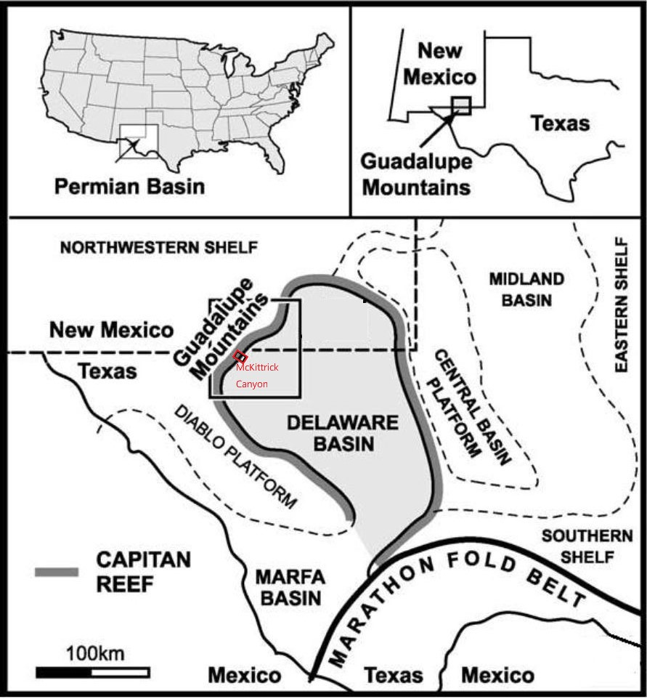
Figure 1: Simplified map of Geologic Provinces within the greater Permain Basin.
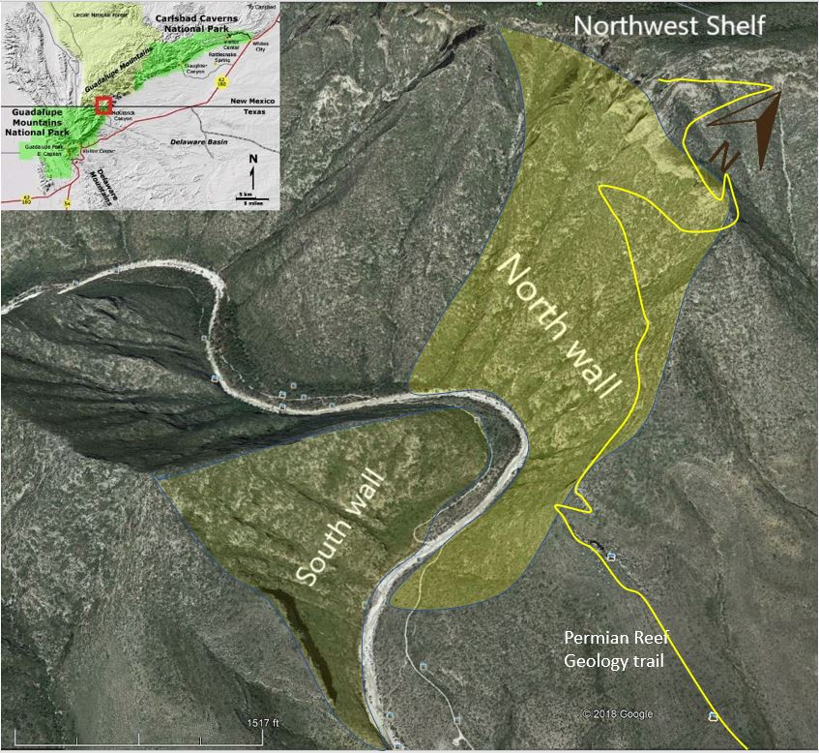
Figure 2: McKittrick Canyon 3D view from Google Earth. Study area is in yellow shadow, and Permian Reef Geology trail is marked by yellow solid line.

Problem definition

Shelf-to-basin stratigraphic interpretation on subsurface seismic profiles is challenging owing to complicated depositional systems caused by frequent sea level change, especially on a steep reef-rimmed siliciclastic-carbonate mixing slope profile (Garrett and Pigott, 2015, Garrett et al., 2016). Remaining uncertainties exist in key boundary tracing, clinoform stacking pattern description and sequence stratigraphy from well-bedded shelf and shelf crest strata, through reef and fore-reef complex, slope clinoform, into bedded toe-of-slope and basinal units. A high resolution forward seismic model of shelf-to-basin is needed to guide seismic interpretation of analogues in the subsurface.
The objectives are to 1) conduct Light Detection and Ranging(LiDAR) scanning for the outcrop exposed at the mouth of McKittrick Canyon; 2) build a stratigraphic model of shelf-to-basin deposition on LiDAR point cloud data; 3) collect velocity ratio Q of Schmidt Hammer, contributing to estimation of P-wave velocity on exposed outcrop for each deposit unit; 4) conduct an accurate impedance model from a massive data set upon a stratigraphic frame; 5) generate a forward seismic model by convolution of input wavelets of contemporary industry and supraindustry frequency band width with defined stratigraphic impedance model; 6) and describe the observed geometric results of the synthetic model.
These results will potentially contribute to the accurate stratigraphic interpretation of seismic data at shelf, slope and toe-of-slope basinal area under similar conditions in the petroleum industry.

Previous work

Forward seismic modeling has greatly developed in the last three decades from convolution based 1-D methods, to finite-difference (FD) and finite-element (FE) modeling of 2-D and 3-D models. With increasing demand of more accurate subsurface interpretation of seismic in complicated exploration areas, geophysical methods in stratigraphically complex areas can be improved as combining stratigraphic architecture and lithologic distributions observed in outcrop to petrophysical properties obtained from core measurements, density, and velocity logs in order to provide a more accurate seismic interpretation. A short-cut to cores is to simple utilize outcrop data.
One of the first examples comparing synthetic seismic data with real seismic is a model built to study the genesis of the depositional geometries and accompanying facies of the Permain strata in the Guadalupe Mountain by Sarg (1987) who built a one-dimensional borehole seismic trace and two-dimensional forward model in this study area based upon data from wells, which only included basic structure-stratigraphic schemes. Following Sarg’s model of a large-scale carbonate basin profile was Biddle et al. (1992) who modeled the progradational carbonate platform at Picco Vallandro which assigned the acoustic measurements from core plugs to each depositional environment (Biddle et al., 1992).
Utilizing the increased detail potentially provided in outcrop, Stafleu and Sonnenfeld (1994) conducted a forward seismic model of the Permain San Andres Formation in Last Chance Canyon which is a mixed siliciclastic-carbonate shelf-margin depositional system. Two models were built based on limited velocity data measured from core plugs of dominant lithofacies: one had contract at bedding planes and the other had at facies boundaries. They compared both models with a real seismic line located 50 km northwest of Last Chance Canyon acquired by Exxon, which indicated that the importance of facies changes.
Sullivan et al. (2000) have seismically forward modelled the Lower Permian Skoorstennberg Formation in the Tanqua Karoo Basin of South Africa and the Lower Carboniferous Ross Formation of the Clare Basin in western Ireland and compared the seismic characteristics of these to the Diana field in the western Gulf of Mexico.
To fulfill the requirement of exploration in different geological complexes, research on seismic modeling of specific depositional architectures were published in the past decade. Schwab et al. (2007) built a resultant synthetic seismic model based upon constant deterministic petrophysical properties with a binary sand-shale scheme to compare one seismic line from offset-stacked channels from the Elazig Basin (Turkey). Bakke et al. (2008) approached the seismic modeling of a turbidite system by using interpolated petrophysical properties from a well in Dalia field Spain, which was compared with subsurface seismic data of a Miocene turbidite complex of offshore Angola.
Gartner et al. (2001) built a synthetic seismic model of an Early Cretaceous slope of a carbonate platform with the aid of photo mosaics with an impedance model based upon velocity, density and porosity from spot samples. Falivenen et al. (2010) proposed a seismic model for the Eocene Ainsa Turbidite system, based on an outcrop-derived three-dimensional facies model. Janson and Fomel (2011) proposed an outcrop-based 3-D geocellular model to help the interpretation of steep slope carbonate deposition from Lower Permian deep-water carbonate gravity flow. While the results of these studies approach increasingly refined structural continuity of stratal reflectors, without an accompanying petrophysical samplings resolution, the models are limited in their ability to resolve stratigraphic complexities which after occuring at smaller scales than structural variations.

Chapter 2: Geological Background

Tectonics

Originating as the Tobosa Basin, the Delaware Basin experienced periodic tectonism-active events from Early Paleozoic to Early Cenozoic (Williams, 2013). As the result of cooling of underlying rifted crust and mantle early in the Ordovician, the subsidence created a flattened coastal plain, defined as the Tobosa Basin (Galley, 1958), where sedimentation occurred and continued under a period of tectonic quiescence (Adams, 1965). In the middle of the Ordovician when the crustal warping ended, the Tobosa Basin developed into a 350-mile-wide basin which was bounded on the east by the Texas arch and the west by the Diablo arch (Adams, 1965).
Followed by Marathon-Ouachita orogeny, the tectonic quiescence time ended in Middle Mississippian when the Tobosa Basin was subjected to intense deformation caused by the collision between Laurasia with Gondwana. Under the southwest-to-northeast compression of the Ouichita-Marathon fold belt, the Tobosa basin was divided into two separate sub-basins, the Midland Basin and Delaware Basin, by the uplifted Central Platform, resulting the generation of Diablo Platform, Northwest Shelf and Eastern Shelf in the meantime (Hoark, 1985; Yang and Dorobek, 1995; Miall, 2008) but with the complication of lithospheric flexure (Pigott, 2016). From the middle to late Pennsylvanian, structural activity increased throughout the region due to the Variscan Orogeny, causing dramatically uplifting of Central Platform and more subsidence of Delaware Basin (Hills, 1984; Yang and Dorobek, 1995, Williams, 2013).
The tectonism of the Delaware Basin ceased after sporadic tectonic activities led by the final pulses of the Marathon orogeny in the Early Permain (Hills, 1984). Eventually, the slight movement along the zone of weakness on the east of Delaware Basin induced the subsidence of the basin floor, a 1000-foot falling below the surrounding carbonate shelves (Hills, 1984). The Delaware Basin accumulated massive sedimentation in tectonic stability throughout from Wolfcampian to Ochoan when the basin was filled with Castile evaporates.
Following Permo-Triassic burial, the compresional regime associated with the Laramide Orogeny partially exhumed the western side of the Guadalupe Mountains. Later, during extension of the Basin and Range Province in the Oligocene-Pliocene, the Northwest Shelf and Capitan Reef complex were partially exhumed along the Capitan Reef Escarpment, which represent the most eastern expression of NNW – SSE oriented Basin and Range high-angle normal faults (Hayes, 1964; Garber et al 1989).
The tectonic history of Delaware Basin stated above is also revealed by basin modeling, summarizing four episodes of tectonism which corresponds major tectonic activities mentioned above : 1) A Tobasa Rifting Phase (488-320 Ma), 2) A Permian Basin Phase (320-250 Ma), 3) A Stable Platform Phase (250-80 Ma), and 4) A Cenozoic Tectonic Uplift Phase (70-0 Ma) (Lew et al., 2013, Micheal et al., 2014, Pigott et al., 2014, Pigott et al., 2015, Pigott et al., 2016).

Stratigraphy

The exhumed Guadalupe Mountains, as the result of Early Cenozoic tectonic activity as stated above, exposed sedimentation which accumulated from the Middle to Late Guadalupian, representing the complete system which includes the sequences of shelf, carbonate-rimmed shelf edge, slope and basin (Ward et al., 1986). Stratigraphically, the outcrop exposure in the McKittrick Canyon constitute the Capitan Depositional System, representing the Capitan Formation, the stratigraphic age equivalents on the shelf (Seven Rivers, Yates and Tansill formations), and the equivalents in the basin, known as the Bell Canyon Formation (Figure 3) (Newell et al., 1953; Saller et al., 1999).
The Capitan Formation (Figure 3) is comprised of the massive Capitan Reef with fore-slope reef talus complex which has 100-150 m of massive reef facies and 500-600 m for the total thickness (King, 1948). Characterized by thick carbonate intervals alternating with siliciclastic, the Seven Rivers Formation is bounded at its base by the Shattuck Sandstone member and at its top by the Yates Formation (Tait et al., 1962). The Yates Formation represents a mixed siliciclastic-carbonate evaporite shelf system which passes into the Capitan Formation (Ward, et al., 1986). Similar to the Yates Formation, the Tansill Formation is characterized by carbonate-evaporite shelf system while there is no siliciclastic dominated interval deposit. As the basin equivalent to Capitan reef complex, the Bell Canyon accumulated massive siliciclastic interbedded with distinctive carbonate members which comprise the toe-of-slope and proximal basin floor equivalent (Bosellini, 1984).

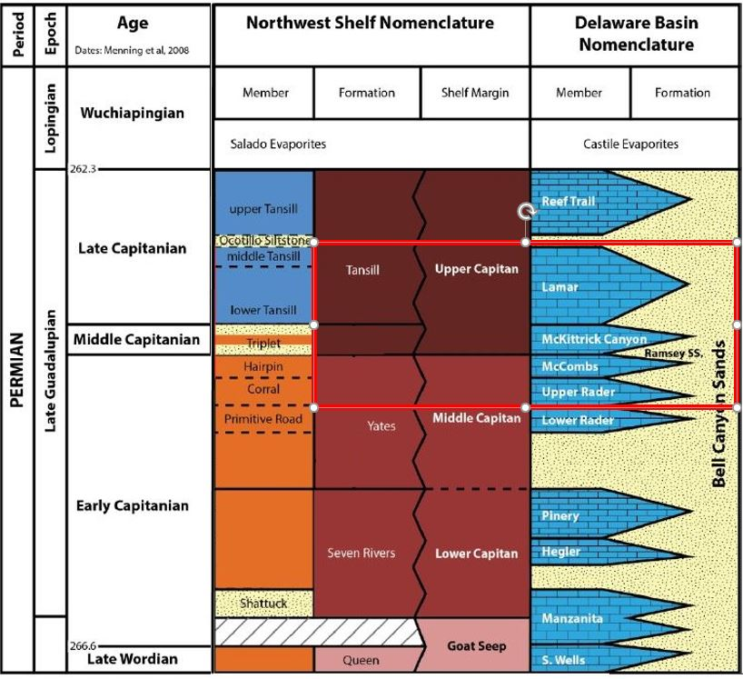
Figure 3: Detailed Late Gaudalupian rock-stratigraphic framework of the Delaware Mountain Group. Stratigraphy units developed on the north wall of McKittrick Canyon are boxed in red rectangular. Modified from Rush and Kerans (2010) and Kerans et al. (2011)

Sequence Stratigraphy

A global climatic transition, from Carboniferous icehouse to Mesozoic greenhouse conditions, is well expressed in the stratigraphic record of the Late Permian deposit profile where cyclicity dominates the shelf-to-basin sedimentation owing to 4th- and 5th-order glacio-eustatic fluctuations (Read, 1995). The widely accepted reciprocal sedimentation components of the cycles are 1) siliciclastic bases, represented by lowstand systems tract (LST) exposure, bypassed or incised siliciclastics of the platform, and early transgressive system tract (TST) reworking; 2) shallowing upward carbonate vertical succession, indicating TST resurgence of carbonate factories at platform and highstand systems tract (HST) compensation of accommodation (Kerans and Harris, 1993; Tinker, 1998; Osleger and Tinker, 1999). Recent work by Xu (thesis in progress) also reveals regressive systems tract (RST) between the HST and LST.
A high-frequency sequence framework was proposed by Tinker (1998) for the Yates and Seven Rivers formation in McKittrick Canyon. In terms of his work, high frequency cycles which are regarded as fundamental stratigraphic building blocks are analogous to siliciclastic parasequence but contain both a deepening and shallowing component. The hierarchal framework consists of, from higher order to low, high frequency cycle, cycle set, high frequency sequence (HFS) and composite sequence (CS), which is analogous in scale to fifth-order cycles, fourth-order cycles, intermediate order cycle and third-order cycles respectively (Figure 4). The Seven Rivers, Lower Yates, and Upper Yates-Tansill Formations represent third-order CSs, respectively, and each contains four fourth-order HFSs (SR1-4 HFSs, Y1-4 HFSs, and Y5-6/T1-2 HFSs, respectively (Figure 5). According to Tinker (1996, 1998) and Kerans and Tinker (1999), the three CSs are correlated with the basin equivalents: Manzanita, Hegler and Pinery carbonate members of Cherry Canyon and Bell Canyon formations are identified within SR1, SR2 and SR4 HFSs respectively; Rader is identified within Y3-Y4 HFSs; McCombs, McKittrick and Lamar is identified within Y5, Y6 and T1 respectively.

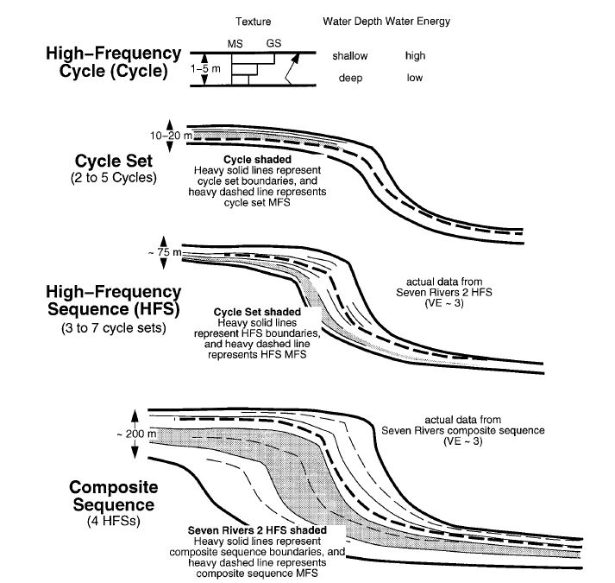
Figure 4: Illustration of hierarchy of cyclicity. Modified from Tinker (1998).
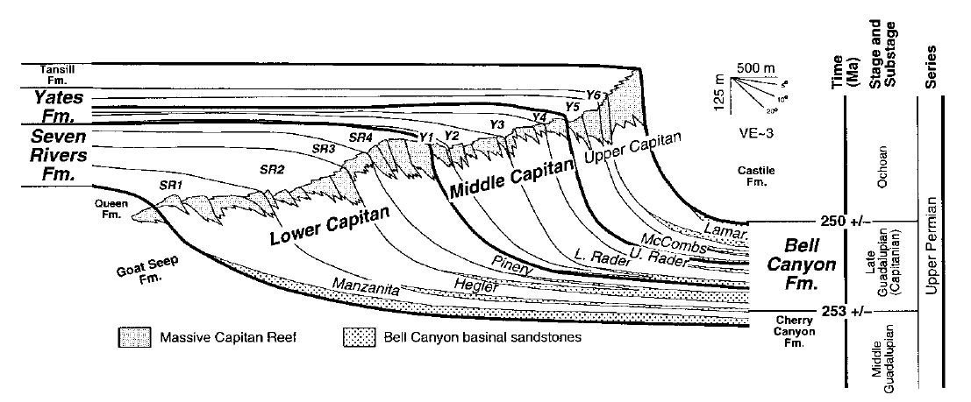Figure 5: Simplified depositional profile of Upper Guadalupain. Three Composite Sequences (CS) are bounded by heavy line. Correlation of HFSs and Bell Canyon basinal equivalent is illustrated through the HFS boundaries. HFSs across the north wall of McKittrick Canyon are marked with a red polygon. Modified from Tinker (1998).

Chapter 3: Method

LiDAR

Introduction

Light Detection and Ranging (LiDAR), as a relatively novel technique, has been developed to be utilized in geoscience research, especially in outcrop study topics, for only decade since several revolutionary advances had been made by Bellian and Pringle (Bellian et al., 2005; Pringle et al., 2006 and in thesis by Garrett, 2015, Giddens, Hornbuckle, 2017) who applied LiDAR systematically in the studies of outcrop stratigraphy, lithofacies and mineralogic identification and reservoir characterization. In this forward seismic model investigation, LiDAR is used as a powerful tool to accurately capture the complexity of the stacking patterns of shelf-to-basin deposits, the depositional dip and strike continuity of target outcrop unit, and the 3-D geometry of the outcrop exposed in the study area, which further provide a digitalized stratigraphic model and a 3-D virtual realistic outcrop model as an aid to model construction.
The LiDAR data for this study was collected by a RIEGL VZ-400i 3D terrestrial laser scanner with a collaborative Nikon D810. This scanner can collect millions of points in one scan task with the range of up to 800 m and the resolution of up to 3 mm, forming a “cloud” of points that approximate the target space (RIEGL, 2012). A measure of single point commences with a laser pulse emitting from the scanner which travels to a remote object. The off-bounced pulse returns to the detector with the precise two-way travel time and other attributes recorded. Multiplied by the speed of light in air corrected for humidity and barometric pressure, one half of recorded travel time with angle of emission can be used to calculate the distance and coordinate of the point where the pulse bounced, the x, y, z location relative to the referred coordinate system. Numerous points that record the coordinate and attributes will generate a point cloud of target area which covered the surrounding space. A high-resolution point cloud can characterize well the geometry of the target surface while the resolution depends on the density of the point data collected in a partigular area. The RIEGL VZ-400i terrestrial laser scanner samples a gridded point distribution, whereby a scan line is collected on one horizontal angle setting before the beam is deflected to the next line, which builds up the grid. The laser pulse emitter is set in a dedicated two-axial rotation system which can make the emitter rotate 360 degrees in horizontal plane and 30-130 degree in vertical plane (Figure 6). The RIEGL VZ-400i can also collect intensity returns, the power of the laser pulse returned divided by the emitted power, which is related to the geometry of the targeted surface and the reflective character of the object at the wavelength laser (Burton et al., 2011). The points in data volume can be painted with the true color of the object when photos are acquired by the camera that is working collaboratively at the same time with the scanner which generates a 3-D virtual realistic model of the target. The 3-D point cloud data and virtual realistic model that results helps guide the stratigraphic and depositional facies interpretations and constrain a digitalized stratigraphic frame of the outcrop for the forward seismic model.
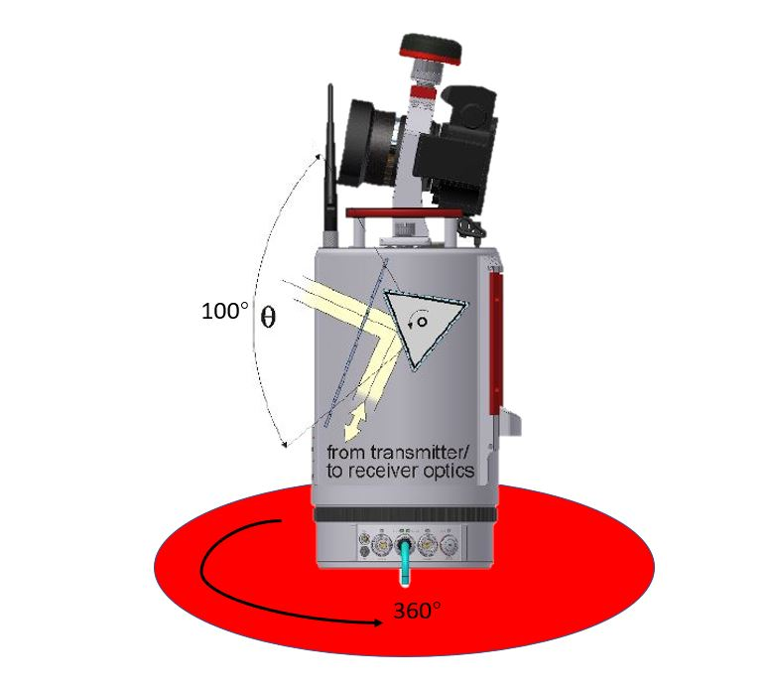
Figure 6: Scanner beam path at horizontal and vertical plane.

Acquisition in McKittrick Canyon

Since LiDAR data acquisition in the field, especially in the remote area, has a high demand on time and physical work of the operators as a result of over 80 pounds of equipment including scanner, tripod, computers, reflective targets and vehicle battery which needs to be carried into each acquisition location, the LiDAR data acquisition is especially challenging in McKittrick Canyon owing to the topography, canyon walls, and need to minimize acquisition shadow. Therefore, the planning of locations is substantial both before and during acquisition.
For example, under the consideration of efficiency, the resolution of this study is to conduct multi-station scans which can be tied with each other. In order to ensure the best quality of combined data from limited scans, one single station should be placed relatively close and maintain normal to one part of the target area to optimize the quality of certain outcrop unit. To have the different scan position effectively tie together with minimum error, at least three common tie points, represented by either reflectors or reflective cylinders, are placed in the operation area before each scan (RIEGL, 2012). More than three is ideal. Therefore, designing a survey that is fit for our purpose is a key part of the workflow. In this study, 17 scans were taken while only 12 scans are valid for further processing. Besides the 360-degree scans, fine scans with higher resolution were taken after the full-angle scans, which targeted a selected area. Acquisition parameters of each scans are listed below (Table 2). To decrease the vertical shadow of the south and north canyon walls as much as possible, scan 12 and scan 16 were taken on the slope of the south wall and north wall respectively (Figure 7).

Scan Position | Theta | Phi | Program | Resolution (Degree)
Scan position 2 | 30° —130° | 360° | 100kHz | 0.025
Fine scan | 75° —118° | 127° —254° | 100kHz | 0.015
Scan position 3 | 30° —130° | 360° | 100kHz | 0.015
Scan position 5 | 30° —130° | 360° | 100kHz | 0.02
Fine scan | 67° —95° | 1° —148° | 100kHz | 0.01
Scan position 6 | 30° —130° | 360° | 100kHz | 0.02
Fine scan | 65° —96° | 243° —321° | 100kHz | 0.01
Scan position 7 | 30° —130° | 360° | 100kHz | 0.02
Fine scan | 68° —91° | 68° —128° | 100kHz | 0.005
Scan position 8 | 30° —130° | 360° | 100kHz | 0.02
Fine scan | 70° —90° | 54° —83° | 100kHz | 0.003
Scan position 10 | 30° —130° | 360° | 100kHz | 0.02
Fine scan | 61° —94° | 132° —248° | 100kHz | 0.005
Scan position 12 | 30° —130° | 360° | 100kHz | 0.02
Fine scan | 62° —104° | 12° —180° | 100kHz | 0.005
Scan position 13 | 30° —130° | 360° | 100kHz | 0.03
Fine scan | 57° —94° | 90° —257° | 100kHz | 0.01
Scan position 15 | 30° —130° | 360° | 100kHz | 0.02
Fine scan | 76° —96° | 258° —322° | 100kHz | 0.004
Scan position 16 | 30° —130° | 360° | 100kHz | 0.02
Fine scan | 78° —102° | 190° —282° | 100kHz | 0.004
Scan position 17 | 30° —130° | 360° | 100kHz | 0.02
Fine scan | 71° —89° | 3° —130° | 100kHz | 0.004
Table 1: Acquisition parameters of 12 full-angle scans with 11 high resolution fine scans. Theta represents the vertical range of beam and Phi represents the horizontal ranges of the beam. Resolution implies a rotation interval of vertical and horizontal plane in degrees.

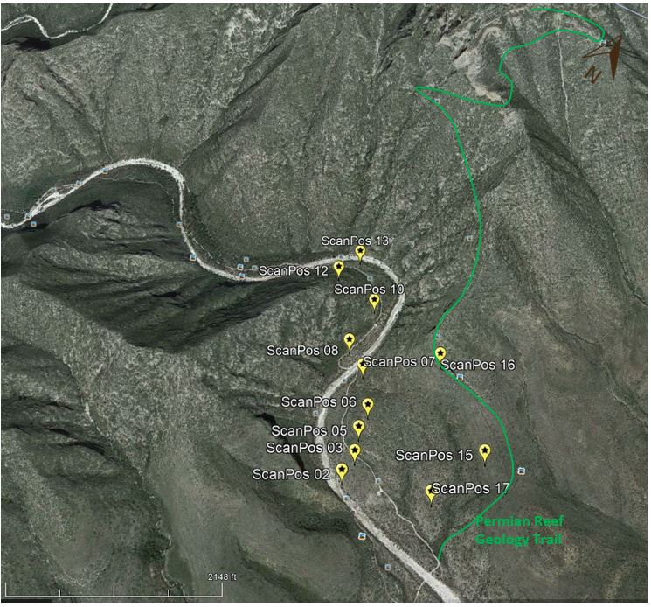
Figure 7: LiDAR scan position on Google Earth looking straight down into the canyon. Scans positions are marked in yellow.

Processing

The data collected in the field were registered (input into the project and tied with project coordinate system by tie point) and then exhibited in a 3-D view in Riscan Pro, the software of RIEGL where all the processing of the raw data was then conducted. Although the merged final point cloud data of 13 360-degree scans provided the high accuracy with substantial level of detail, difficulties still remained with 1) The huge amount of the data (18.8GB) included points of undesired areas and massively overlapped features of interest and 2) Point cloud data in area obscured with vegetation. Accordingly, the processing of the data for cleaning and decimation was needed. The detail of filter application is now discussed.
- Octree Filter
Because of the large range of the study area, the size of the combined data is larger than required. This study applied the Octree Filter which is a build-in algorithm to optimize the amount of point data by choosing the center of gravity point to represent the primary cube. After generation of the octree filtered data, the points at the center of gravity represent the other point in one primary cube which is then set manually.
- Terrain Filter
Manual decimation of the off-terrain points from the on-terrain points can also be time consuming, especially when the target surface is covered by irregularly distributed vegetation. The terrain filter was applied in this study for decimating the widely distributed vegetation on the canyon walls. In the work flow of the filter process, an analysis of the distance of the point from an estimated ground surface is used as the criteria to classify the “terrain” point or “off-terrain” point. This filter can be applied on other plane which is specified as reference ground surface as well.
- Reflectance Gate
The reflectance is one of the additional attributes that the RIEGL VZ-400i provide as scanning by online waveform processing which is a target property and refers to the fraction of incident optical power (RIEGL, 2012). Given in decibels, the reflectance reading is a ratio of the amplitude of the target to the amplitude of a white flat target at the same distance, orientated orthonormal to the beam axis, and with a size in excess of the laser footprint, where negative values indicate diffusely reflecting targets and positive values are retro-reflecting targets (RIEGL, 2012). Some study about LiDAR reflectance demonstrates the relationship of reflectance and target material: Wehr and Lohr’s experiment showed a larger value of the laser returned from bare rock surfaces (Wehr and Lohr, 1999); A stronger relationship between reflectance and rock texture was demonstrated by Burton (2011) and has been demonstrated to be able to specific minerology by Gidden and others (2016). In other words, the value of reflectance is qualitatively related with the target material and can be quantitatively related with the lithofacies after data processing. Given the idea stated above, a reflectance gate was applied in this study to better illustrate the exposed rock bodies. During the processing of the raw data, a narrow reflectance gate (-3 dB to 3 dB) was found for the best illustration of the outcrop in McKittrick Canyon from area of high vegetation or high weathering with a warm-cold color bar, in which the bare outcrop is best revealed in cold color and the diffusely reflected vegetation shows in warm color (Figure 8). As showed in this figure, the continuity of strata can be clearly differentiated from the vegetation.
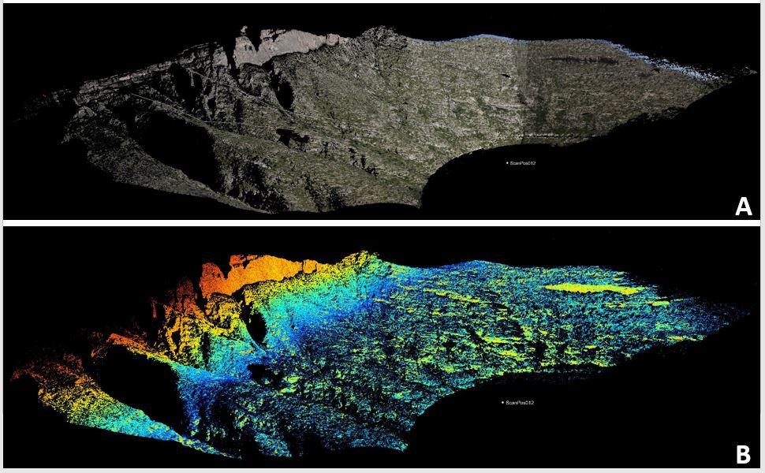
Figure 8:Comparation of point cloud data shown in true color and in reflectance with an applied filter gate. A) Point cloud data of north wall of McKittrick Canyon painted by the camera. B) Point cloud data of north wall of McKittrick Canyon displayed by reflectance with empirical set filter gate (-3.5 dB to 3.5 dB where positive values exhibited in warm colors and negative values are in cold color). Cropped out strata are easily differentiated in reflectance.

Schmidt Hammer

Introduction

Invented by Ernst Schmidt in early 1950s, the Schmidt hammer was originally developed for non-destructive testing of concrete hardness (Schmidt E, 1951). This rebound hammer has been applied in a similar manner to measure the uniaxial compressive strength of rocks from surface hardness data obtained from outcrop (Poole and Farmer, 1980). With its portability, simplification of operation and affordability, the Schmidt hammer allows the efficient estimate of the mechanical properties of rock without having to sample the rock and bring it back to lab. Despite the high accuracy of laboratory testing, the data from Schmidt hammer is acceptable in consistency and repeatability (Poole and Farmer, 1980).
The Proceq Silver Schmidt hammer is used as an indirect method to obtain P-wave velocity from the outcrop exposed in the McKittrick Canyon walls. Differing from the traditional mechanical Schmidt hammer which measured rebound number “R” and which required an impact direction correction (Impact Test Equipment, 2018), the electronic Silver Schmidt records the velocity ratio of impact to rebound number (Q) instead of the Schmidt Rebound Number (R). Winkler and Matthews (2014) explored the possibility to establishing a numerical conversion factor for Q and R by comparing the performance of Silver Schmidt and traditional mechanical Schmidt hammer and empirically derived:

where Q represents velocity ratio of Silver Schmidt and R represents the rebound number of mechanical Schmidt hammer.
$${R=1.0182Q-9.7625 (R^{2}=0.9996)}_{(Winkler and Matthews, 2014)} (1)$$

As a result of the strong relationship between Schmidt Rebound Number (R), also called as Schmidt hardness, and mechanical properties of tested rock, many studies have been published on the quantitative definition of a series of relation which contributed to better estimation of mechanical attributes by this tool. Katz proposed correlations between rebound readings and lab-measured Young’s modulus, uniaxial compressive strength and density of seven types of rock (Katz et al., 2000). A relationship between the Schmidt hardness and elastic modulus, uniaxial compressive strength and index properties of nine types of rock was introduced by Saffet Yagiz (Yagiz, 2009). Comparison between different types of Schmidt hammers and the quantitative classification of weathering grades by rebound number was made by Aydin and Basu (Aydin and Basu, 2005). The empirical equations for predicting P-wave velocity by Schmidt hammer rebound number was developed by Sharma and Singh (2011) who analyzed the rebound number of Schmidt hammer on different type of rocks. A high reliable correlation of the predicted P-wave velocity and the lab-measured velocity was found when applying this empirical equation.
${V_{p-wave}(m/s)=966.22e^{0.0262R} (R^{2}=0.9584)}_{(Sharma and Singh, 2011)}$ (2)
where R represents the Schmidt rebound number while $V_{p-wave}$ represents P-wave velocity. Combining the Sharma and Singh relationship of equation (1) and Winkler and Matthews’s equation (2), a relation between $V_{p-wave}$ and Q is:
$$V_{p-wave}=966.22e^{0.02667684Q-0.2557775} (3)$$
This equation is applied in this study for estimate the P-wave velocity of outcrop. A work flow for indirectly predicting P-wave velocity by Silver Schmidt reading Q is showed below (Figure 9).
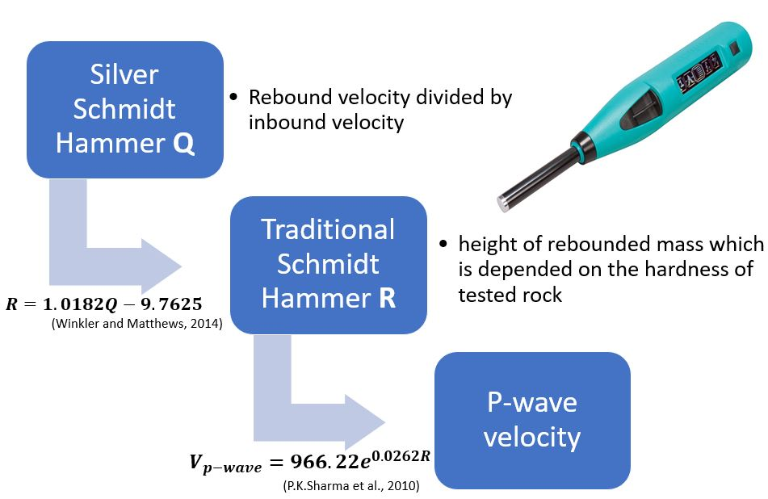
Figure 9: Work flow of estimating P-wave velocity by velocity ration Q obtained by Silver Schmidt hammer. By two steps, P-wave velocity can be estimated from velocity ratio Q.

Acquisition in McKittrick Canyon

To make the estimated velocity data set full and adequate for velocity analysis across the whole section of the study area from shelf to the most distal slope deposit, the acquisition survey of Schmidt hammer with sample collection was designed to obtain the data from all accessible area for investigator of both side of the canyon. A total of 125 data sets, including Schmidt hammer readings and rock samples collected for subsequent density analysis, were obtained with 37 samples from the south wall and 88 samples from the north wall (Figure 10). For the south wall, 17 readings were taken at strata that can be distinguished by lithofacies and 20 were taken along the ridge from creek to south wall top with a 10-meter interval. The data took from north wall includes 33 data sets from the ramp close to the mouth of canyon and 55 data sets from Permian Reef Geology Trail (Figure 10).
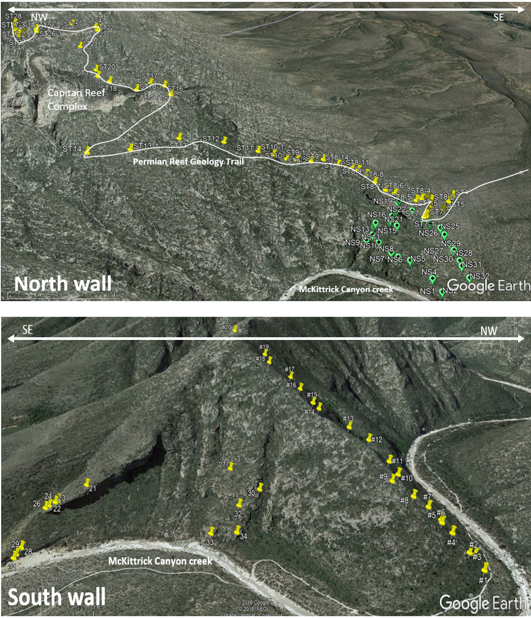
Figure 10: Schmidt hammer and rock specimens sampling position at north wall of south wall of McKittrick Canyon.
The Proceq Silver electronic Schmidt hammer records the data in its built-in memory unit. Five optional settings are provided by Proceq Silver Schmidt hammer which are listed below:
- Units:
Q, kg/cm², N/mm², psi and MPa is available while Q is selected for all acquisition
- Statistics
Regional, Median, Mean and User preset is available while Mean was selected for all acquisitions which required 10 impacts from which a mean is calculated. The series is invalid if more than 20% of the values differ from the mean by more than 6.5 Q.
- Conversion curve
10th percentile, Reference, Custom curve is available while 10th percentile was set for all acquisition in this workaaaa
- Form factor
Cylinder, Standard cube, User defined is available while Standard cube was selected for all acquisition.
- Carbonation correction factor can vary from 0 to 1.00
0.5 was set for all acquisition in this work
In order to avoid effects of weathering, all readings were taken on either a fresh surface or on an unweathered zone of the outcrop.

Data Set

12 full-angle LiDAR scans with 11 high resolution fine scans were taken at McKittrick Canyon, which characterizing the whole canyon with photograph painted point cloud (Figure 12).
125 sets of Q values were taken by Silver Schmidt hammer, which are represented by the mean value of readings from 10 impacts. Standard deviation of each data sets ranges from 0.5 to 5, implying the validity of all data. Most value range from 50 to 70 which is taken from carbonate or unweathered siliciclastic units while readings below 50 were usually taken from weathered zone and shale, whose readings are even lower down to 20. More details of data analysis are discussed at Result chapter.
120 rock samples were collected at the same locations where the corresponding Schmidt hammer readings were obtained. The Ohaus Adventure Balance with density measurement kit is utilized in this study for efficient measuring of rock sample densities (Figure 11). The density determination is performed by the Archimedes’ Principle that every solid body immersed in a fluid apparently loses weight by an amount equal to that of the fluid it displaces. By measuring the weight of each sample in air and in water, bulk density of samples is calculated through built-in density measuring program of Ohaus Adventure Balance and displayed directly on the screen.
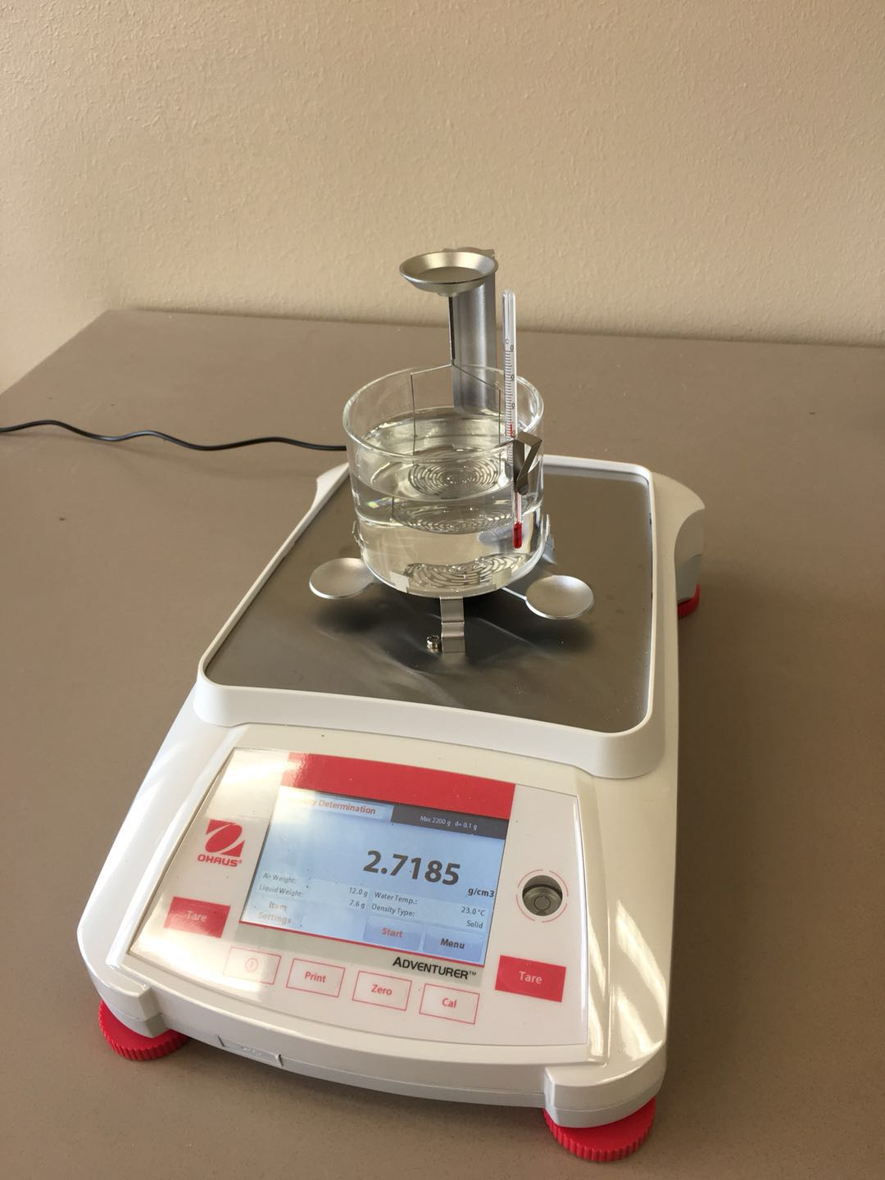
Figure 11: Ohaus Adventure Balance with density measurement kit.
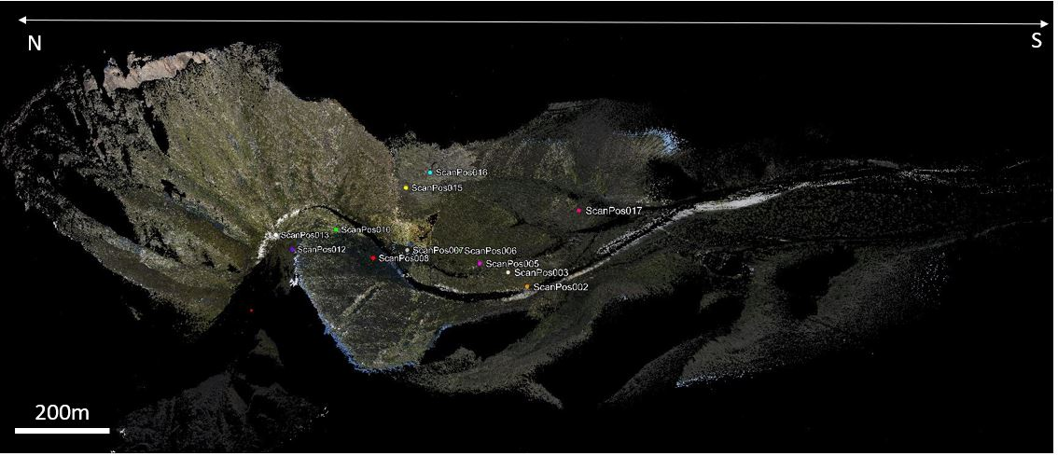
Figure 12: McKittrick Canyon photograph painted point cloud which ties 12 full-angle scans.

Chapter 4: Result

LiDAR assisted stratigraphy model

Stratigraphy frame of the shelf-to-basin deposit at the north wall of McKittrick Canyon is interpreted on Riscan Pro based on the processed LiDAR point cloud. Based on the stratigraphic background which is discussed in the introduction chapter and the understanding from field reconnaissance, the Late Guadalupian shelf to toe of slope at north wall of McKittrick Canyon represents a mixing carbonate-siliciclastic depositional system where four HST carbonate members interfinger with three bypassed LST siltstone and sandstone wedge. More detail of stacking pattern of these units can be viewed from post processing results of point cloud data.
As the youngest unit which is visible at McKittrick Canyon, the mostly eroded Reef Trail Limestone members only displays 4m thickness above the Lamar Limestone, overlying the youngest Lamar member concordantly. The Lamar Limestone member is visible from both wall of the canyon, cropping out as enormous bare cliff at the south and wedge-shaped exposures at the north, which provides a reference unit for interpretation. Lamar limestone is slope equivalent member of T1 HFS which is divided into six higher order cycles by surfaces which show a systematic pattern of bed termination (Figure 13 A). From bottom to top, the six units are name with Lamar unit 1 to Lamar unit 6 respectively. Lamar unit 1 appear only at distal part of slope, pinching out towards up-dip, which terminates as onlap against underlying LST Sand C. Downlapping occurs in Lamar unit 2 against underlying Lamar unit 1. Lamar unit 3 represents conformity with overlying and underlying strata and slightly thickening towards basin. Similar to unit 1, Lamar unit 4 is absent at upper and lower slope, representing on-lap against underlying Lamar unit 3 at toe-of-slope. Downlap occurs in Lamar unit 5 against Lamar unit 4, pinching out basinward. Lamar unit 6, as the youngest unit in Lamar member, represents conformity with underlying units. Higher frequency cycles cannot be identified from LiDAR for the rest of HFSs, the McKittrick Canyon, McComb and Rader member, all of which shows the tendency of basinward thinning. Onlapping occurs at all three siltstone wedges against underlying unit, which is interpreted as bypassed siliciclastic from the shelf of LST (Figure 13 B). The stratigraphic frame of McKittrick Canyon north wall is displayed in Figure 14, where eroded reef and HFS boundaries traced to shelf is reconstructed.
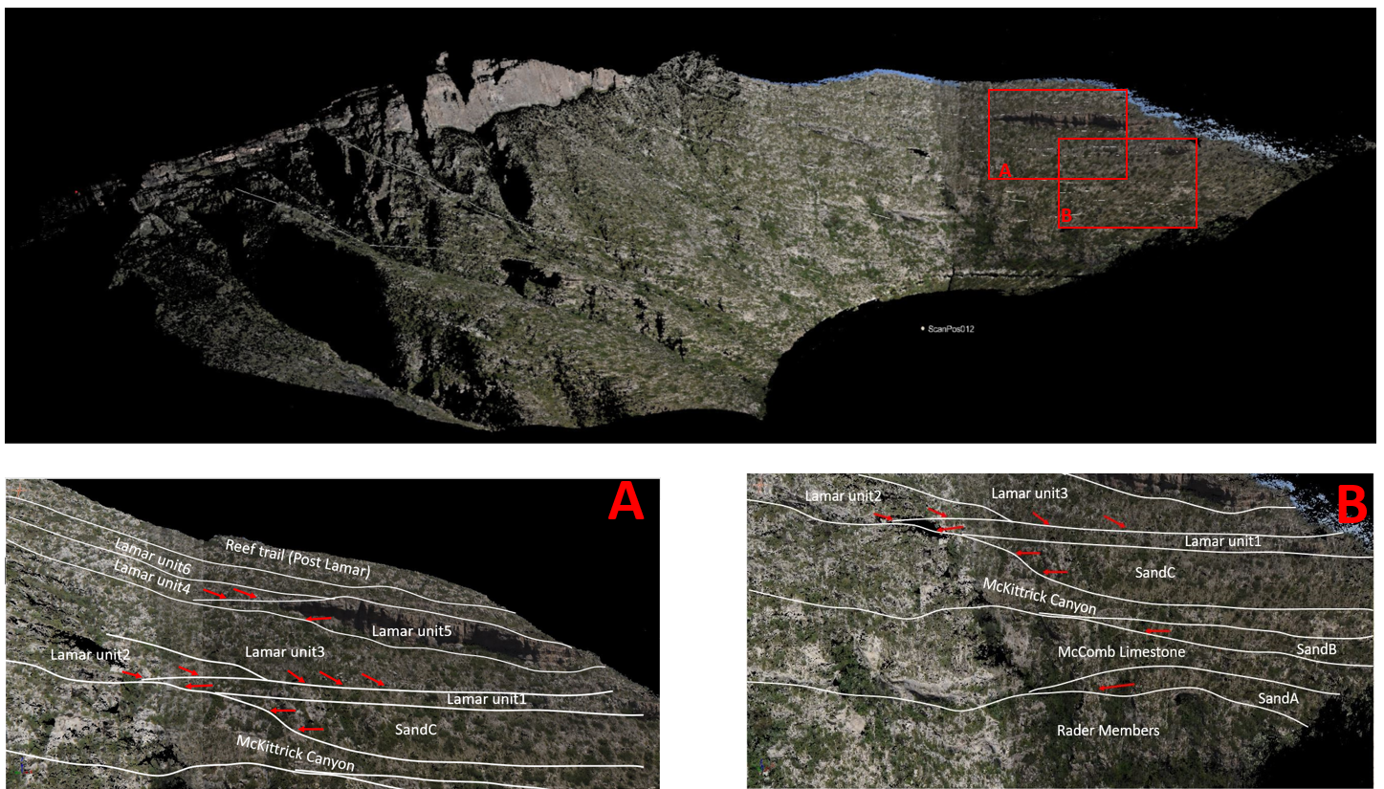
Figure 13: True color painted point cloud of McKittrick Canyon north wall. Detail of unit stacking can be viewed in enlarging box A) high frequency cycles in Lamar Member B) interbedding of siliciclastic onlapping wedge and HST carbonate members.
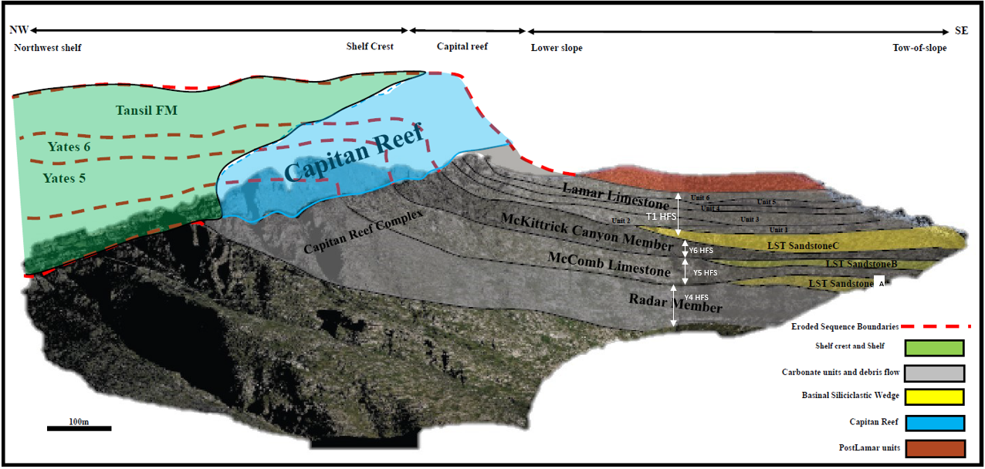
Figure 14: Stratigraphic frame of north wall of McKittrick Canyon on LiDAR data. Eroded surfaces and units of Capitan reef and shelfal deposit are reconstructed, presenting a mixing carbonate-siliciclastic depositional system where four HST carbonate members interfinger with three bypassed LST siltstone and sandstone wedge.

Impedance model

Data set analysis

The acoustic impedance applied in this work is from the product of P-wave velocity and dry bulk density. 125 groups of data, including Schmidt hammer reading Q and corresponding bulk density measured by rock sample, were collected at the both wall of McKittrick Canyon. The Gardner Equation, proposed by Gardner and others at 1974, built a relationship of rock’s bulk density and P-wave velocity with data from a wide range of basins, geological ages and depth, providing a general link for estimating one value from another. Compared to the Gardner relations (Figure 15), these data clearly demonstrate the variability of carbonate from a simple density-velocity empirical relationship owing most likely to change in the elastic model caused by change in the limestone carbonate/clastic fraction. Xu (unpublished thesis) shows from XRF elemental analysis the heterogeneity in carbonate composition.
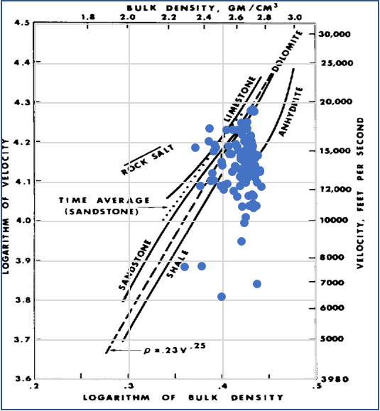
Figure 15: Data set collected at McKittrick Canyon compared to Gardner’s relationship with data plotted in logarithm. Unit of P-wave velocity is in ft/s while unit of density is in g/cm³. Graph is after Gardner (1974).
For each group of data, the GPS location is used for matching of the sample location with its corresponding position on LiDAR point cloud. Based on the stratigraphic model of the slope profile, each group of data is interpreted by the stratal unit where the data is positioned. The strata units with multiple sampling at different positions indicate the heterogeneity of the velocity and impedance distributions along the profile. The projected distance from the most distal point of shelf, can be used as an index to characterize the relative position of sediment. The along-slope distance of every sample calculated by corresponding GPS location is rescaled into 0 to 100, when the zero represents the most proximal location and the larger number indicates the more distal location along the slope.
P-wave velocity and acoustic impedance of units with wide lateral extension are analyzed by cross plotting impedance versus the rescaled along-slope distance. Note that the trend of velocity changing along the slope is high correlated with the impedance variation trend in every unit, which indicates that velocity has a dominant impact on the calculation of acoustic impedance when multiplied by corresponding density. Both velocity and acoustic impedance shows a weak increase towards the basin at Rader Limestone, McComb Limestone and Lamar unit 3 (Figure 17, 20, 23) while impedance and velocity of McKittrick Canyon member, Lamar unit 2, Lamar unit 4, Lamar unit 6 and Post Lamar member tend to decrease from proximal distal slope. (Figure 16, 18, 19, 21, 22).
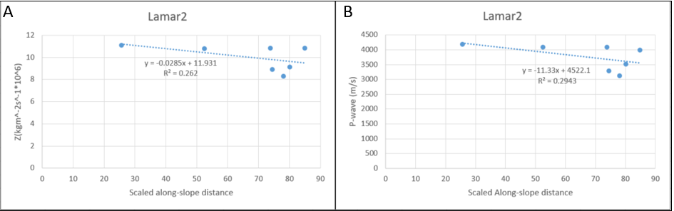
Figure 16: Cross plotting of scaled along-slope distance with acoustic impedance(A) and velocity(B) of Lamar unit 2.
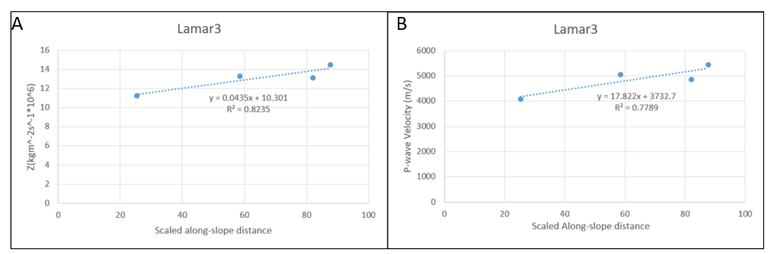
Figure 17: Cross plotting of acoustic impedance(A) and velocity(B) with scaled along-slope distance of Lamar unit 3.

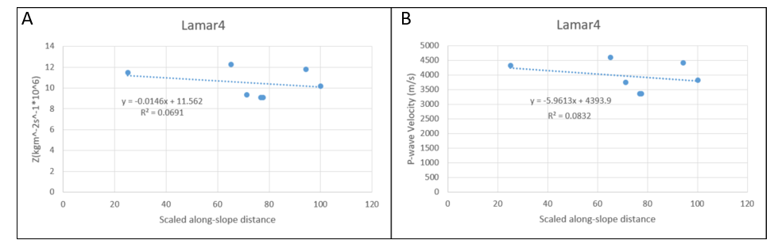
Figure 18: Cross plotting of acoustic impedance(A) and velocity(B) with scaled along-slope distance of Lamar unit 4.

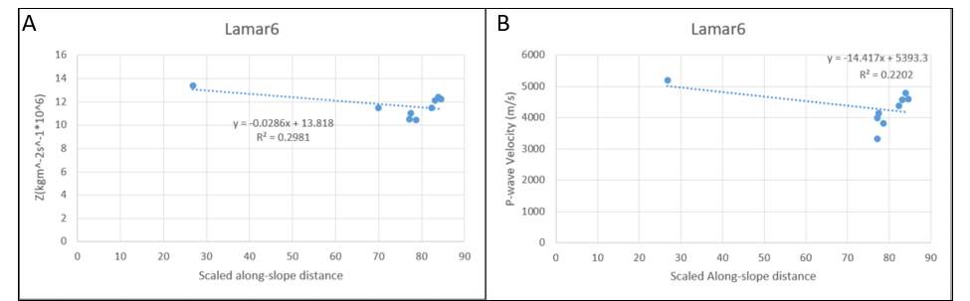
Figure 19: Cross plotting of acoustic impedance(A) and velocity(B) with scaled along-slope distance of Lamar unit 6.

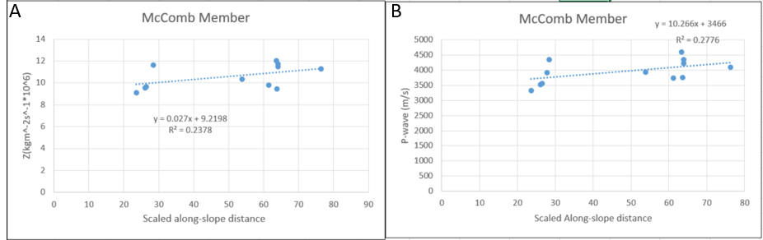
Figure 20: Cross plotting of acoustic impedance(A) and velocity(B) with scaled along-slope distance of McComb Member.

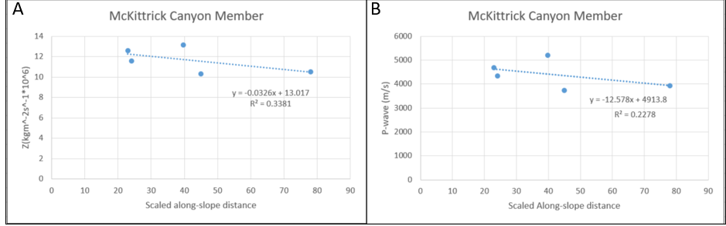
Figure 21: Cross plotting of acoustic impedance(A) and velocity(B) with scaled along-slope distance of McKittrick Canyon Member.

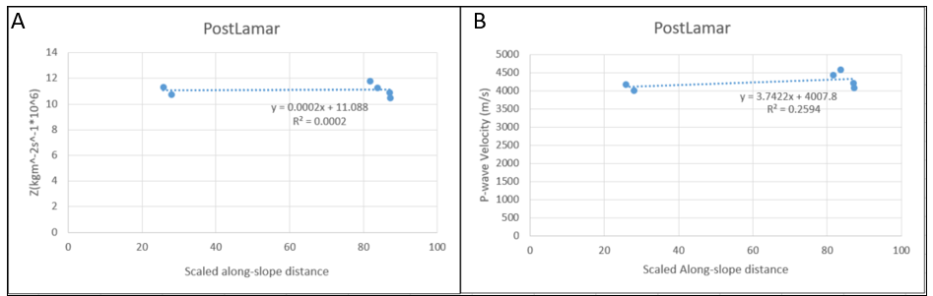
Figure 22: Cross plotting of acoustic impedance(A) and velocity(B) with scaled along-slope distance of PostLamar (Reef Trail Member).

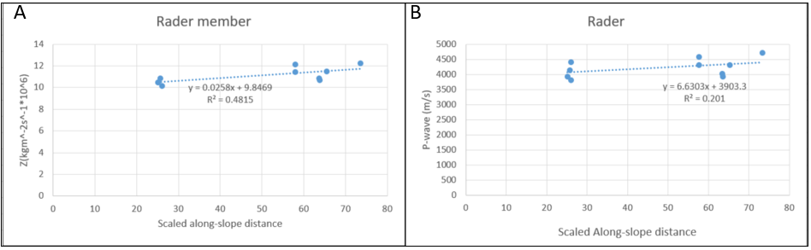
Figure 23: Cross plotting of acoustic impedance (A) and velocity (B) with scaled along-slope distance of Rader Limestone.

Depth and velocity model

To conduct the forward model, first a depth model is constructed and then an impedance model is built from the stratigraphic model which was interpreted in Riscan Pro and exported as a dxf file with recording of the location coordinate of every node on the stratigraphic polyline. The projected positions of all sampling point on 2D stratigraphy frame are showed in Figure 24 where red stars represent data position sampled along Permain Reef Geology Trail and green triangles represent data collected at south wall which are projected on north based on along-slope distance interpretation (Figure 23). According to the stratigraphy frame, velocity is assigned to each stratum based on analysis of velocity distribution (Figure 25).

Impedance Model

Based on the stratigraphy interpretation, the acoustic impedance is assigned to each stratum in accordance with trend line equations while Sand A, Sand B, Sand C, Capitan reef, and shelfal strata are filled with constant impedance. The resulting impedance model is subsequently configured, resulting in a mesh of rectangular constant impedance cells. (Figure 26).
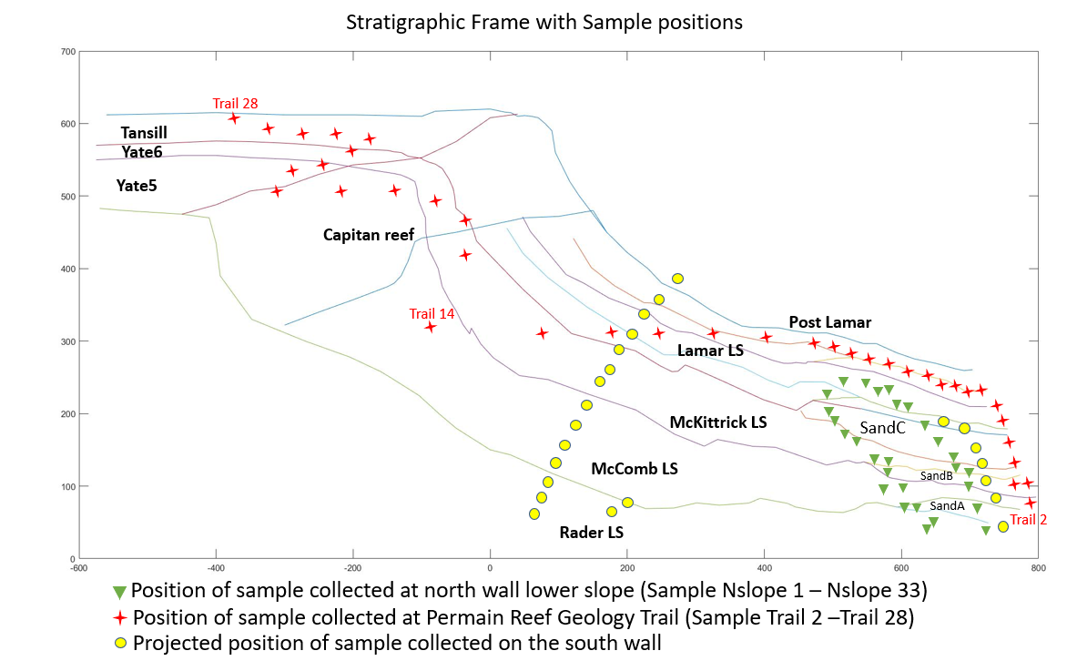
Figure 24: 2D stratigraphy frame with projected sample positions. Note that the sampling positions cover the study area
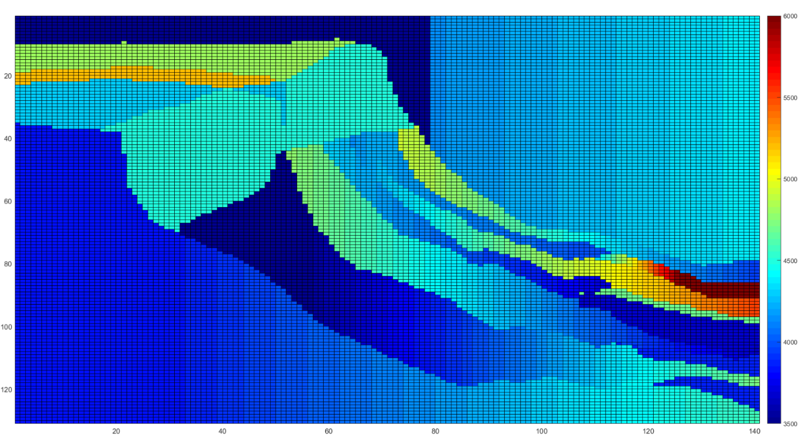
Figure 25: Velocity model of study area. Note that the average velocity of Lamar HFCs is higher than overlying and underlying strata and velocity of carbonate unit is inconsistent along the slope.
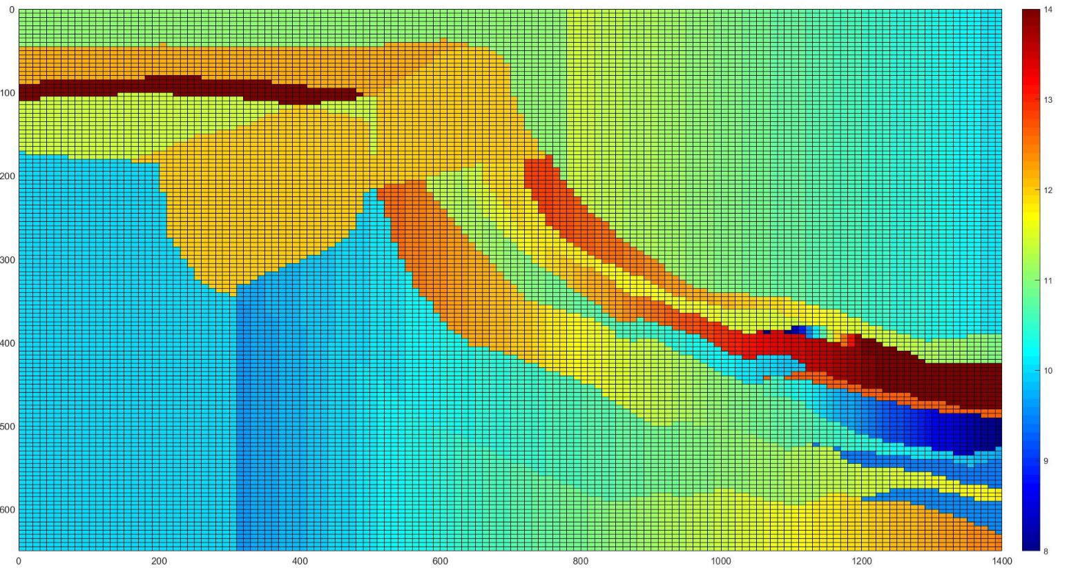
Figure 26: Calculated acoustic impedance model built upon the stratigraphic depth model of Figure 23. Note that those carbonate units documented in this clinoform perform higher impedance than siliciclastic units do. The gradual changing of impedance of one single unit is implied by lateral color shifting.

Seismic Model

The vertical-incidence method that uses a Matlab written program (see Appendix II) is utilized to convolve the reflection coefficients with a band limited Ormsby wavelet (Equation 4).
$RC*W_{input}+N_{gaus}=S+N_{gaus}$ (4)
where RC represents the normal incidence reflection coefficient, W is the Ormsby filtered zero-phase input wavelet, N the Gaussian noise and S the forward modeled seismic line. The reflection coefficient is calculated by the ratio of the difference to the sum of acoustic impedances between the units on either side of a boundary (Equation 5).
${RC}_{i}=\frac{ρ_{i+1}∙V_{i+1}-ρ_{i}∙V_{i}}{ρ_{i+1}∙V_{i+1}+ρ_{i}∙V_{i}}$ (5)
where $ρ_{i}$ and $ρ_{i+1}$ are densities of the layers above and below the$i$th interface, respectively, and $V_{i}$ and $V_{i+1}$ are the calculated velocities from Q (Equation 3) of the layers above and below the $i$th interface, respectively. RC is the reflection coefficient at the $i$th interface.
This method generates a seismogram at each trace, in which the reflectors are in the true vertical two-way time and horizontal position with respect to the interpreted bedding plane reflectors. Traces with a 10-meter interval were placed along the 1400m-length 2D synthetic seismic line. This means every trace in the seismic model works as one-dimensional seismogram of an imaginary borehole at the location of each traces. Thus, this vertical-incidence profile in this work reveals the stratigraphic relationships and amplitude features that would be resolved under ideal, migrated, relative amplitude balanced and gather trace balanced conditions. Although this method neglects problems and impact of propagation of seismic waves, it can also work well with insignificant difference in terms of simple defined model. In this study, a Ormsby trapezoid filter with three different frequency band widths and tapers are used to investigate the seismic response of stratigraphic architecture occurring in the study area under different acquisition conditions.

Forward 2D model generation, 250 Hz Nyquist

The first models using a zero-phase wavelet with the 2 8 120 250 Hz Ormsby frequencies (lowcut, lowpass, high pass, high cut respectively) are to simulate the seismic profiles whose resolution is comparable to a 2ms sample rate and 250 Hz Nyquist acquired and processed seismic under idea noise-free conditions. Contemporary seismic in the Delaware Basin commonly has a 4ms sample rate Therefore, this model well preserved the high frequency information where reflections have good correlation with stratigraphic surface and boundaries of litho-unit. By plotting in wiggle regime, this model clearly displays the waveform of every traces (Figure 27). Note that the variation of reflector strength and polarity occurs in the base of T1 HFS, Y6 HFS and Y5 HFS, implying the AI heterogeneity in each HFS and litho-unit which is the result of AI changing along the slope.
By writing the data into SEGY format with headers (Appendix II), the synthetic data was input into Petrel as a 2D seismic line and displayed where red represents positive amplitudes and blue shows negative amplitude (Figure 27, Figure 28). Figure 29 shows the interpreted profile where modeled stratigraphy frame is marked by solid
black lines ——thick and thin solid line represent HFS boundaries and HFCs in Lamar Limestone respectively. Pseudo Capitan reef boundaries are marked by a dash line. Under this band, the high frequency cycles of Lamar Limestone can be resolved as well (Figure 29 A). Eustacy-caused cyclic stacking allowed unit 1 and unit 5 to terminate with onlapping on the proximal side and unit 2 and unit 6 terminating with downlapping on the downdip distal side. The variation of impedance between six Lamar high frequency cycles units contribute to the differentiation.
Note that the base of T1, Y6 and Y5 HFSs, marked by thick black lines, correspond to those reflectors whose amplitude and polarity is directly controlled by the impedance contrast between the upper and lower units (Figure 29 B and C). The base of the T1 HFS performs positive reflectivity with medium amplitude. The base of the Y6 HFS performs negative reflectivity with strong amplitude which attenuate basinward, presenting a polarity shift from negative to positive at toe of slope. The base of Y5 HFS exibites stronger amplitude with positive reflectivity at lower slope and toe of slope than it does at upper slope. Note that the variation of polarity and strength of reflectivity is mostly controlled by lithofacies changes on the both sides of the boundaries: stronger positive reflectivity takes over when base of Y5 is overlying by Sand A while the amplitude of base of T1 is slightly diminishing where Sand C onlaps against it. However, similar changes also occur at boundaries between the Capitan Reef and adjacent units resulting in variations of impedance contrasts.
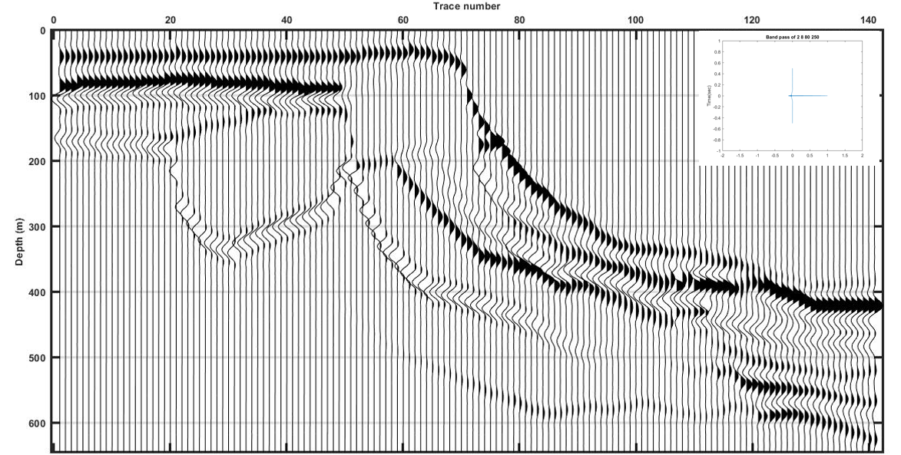
Figure 27: Wiggle plot of model with an Ormsby band pass of 2, 8, 80, 250 Hz. Peaks that represents positive amplitude are filled while unfilled troughs represent negative amplitude.
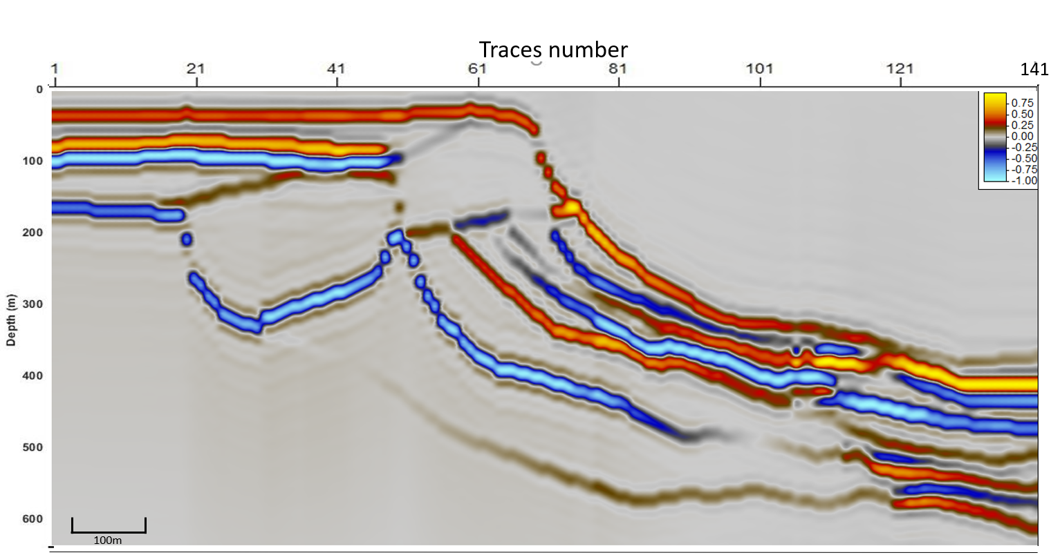
Figure 28: Synthetic seismic profile of the north wall with Ormsby band pass of 2, 8, 80, 250 Hz displayed in Petrel.
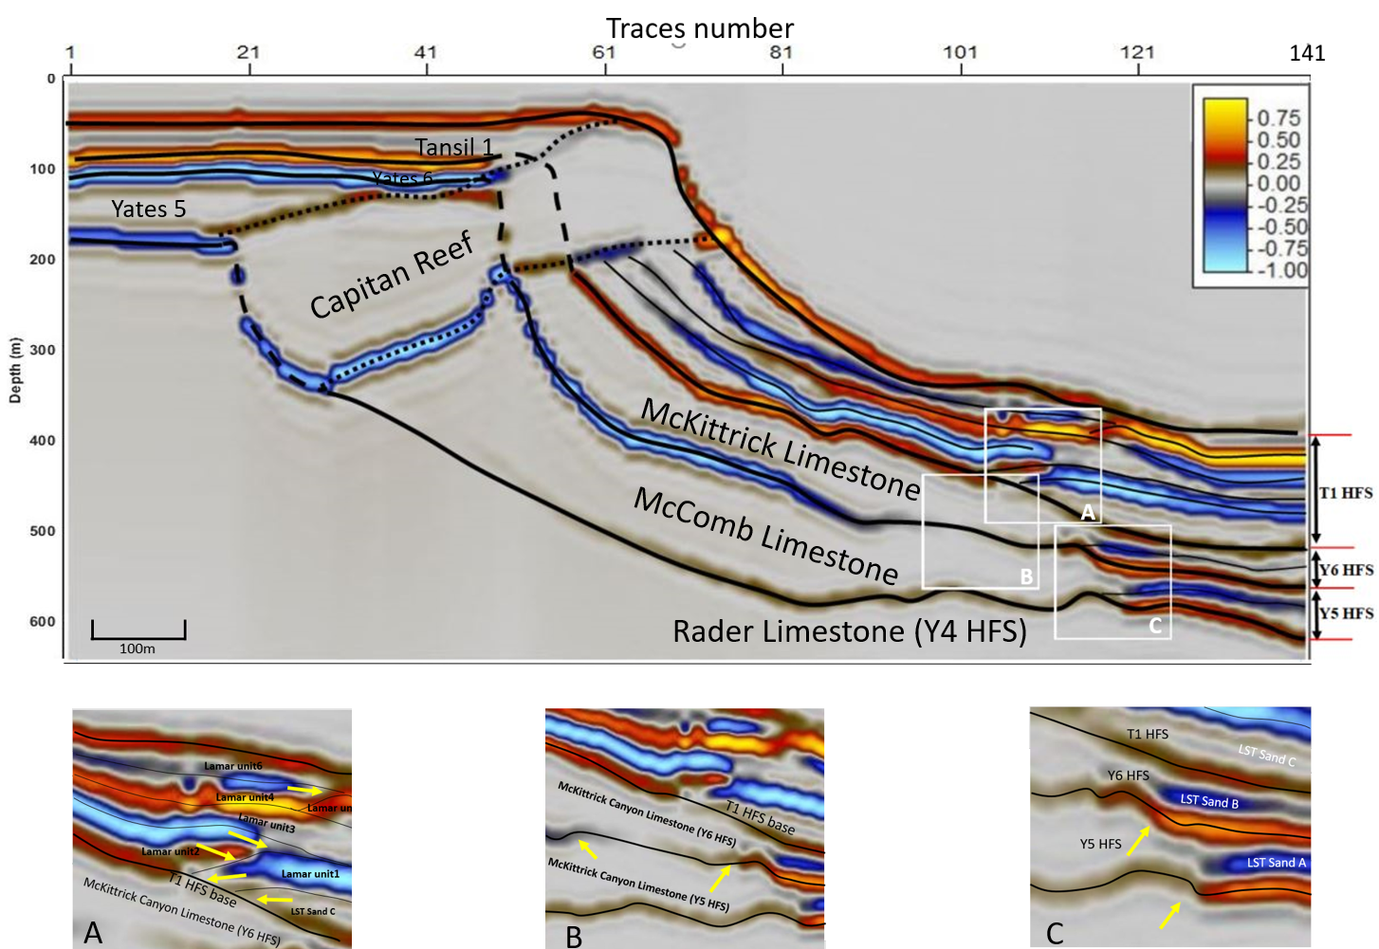
Figure 29: Synthetic seismic profile of the north wall with Ormsby band pass of 2, 8, 80, 250 Hz with stratigraphy frame and insets are marked by the white rectangles. Detailed stratigraphy architectures are displayed by A) High frequency cycles of Lamar Limestone. Featured termination is marked by yellow arrows; B) Polarity switching of base of Y6 HFS. C) Amplitude strength changing of base of Y6 and Y5 HFS at toe of slope.

Forward 2D model generation, 125 Hz Nyquist

Two more synthesizing practices are modeling by narrow Ormsby band width wavelet, one at 2, 8, 80, 125 while the other at 2 8 62.5 80. The model using wavelet at Ormsby band pass of 2, 8, 80, 125 is to investigate the ideal seismic response of this profile recorded with a 4ms sample interval (Figure 30 and Figure 31). The model that uses wavelet at 2 8 62.5 80Hz Ormsby band pass with added 5% random noise is to simulate more natural conditions (Figure 32 and Figure 33).
As to the models under the lower band width, difficulties exist for interpretation of exact position of sequence boundaries although HFS can be interpreted by distinctive reflectors. In this model, simulated thin beds are unrecognizable owing to aliasing and HFS boundaries are not well correlated with reflections. Note that the reflectors in the model synthesized by 2 8 62.5 80 Ormsby wavelet express the litho-units instead of surfaces while HFSs, therefore, are identified by litho-units instead of sequence boundaries. Reflectors of basinward thinning carbonate members such as McKittrick Canyon limestone and McComb limestone pinch out at toe of slope where their thickness dropped dramatically and the basinward thickening siliciclastic turbidites occur.
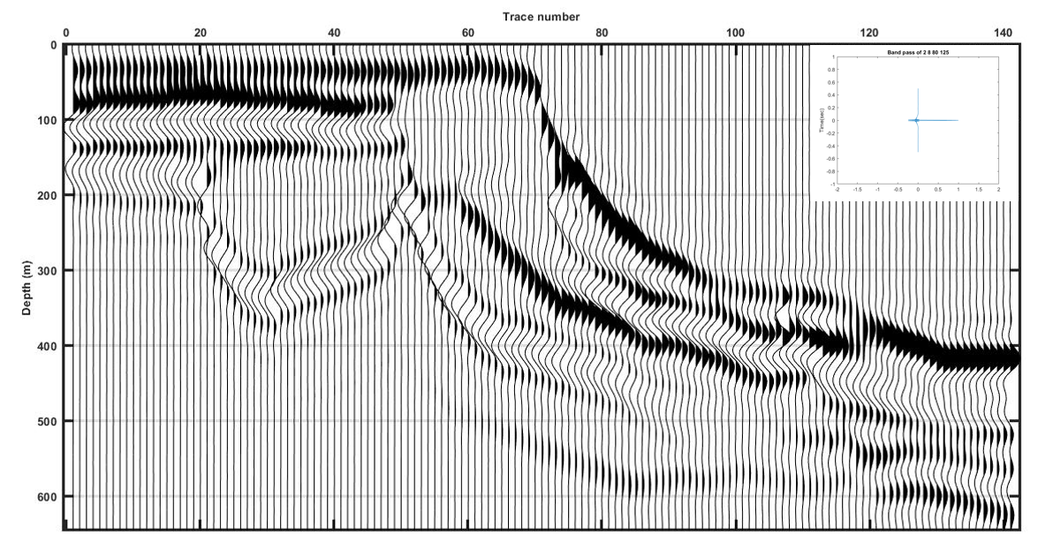
Figure 30: Wiggle plots of model with Ormsby band pass of 2, 8, 80, 125 Hz. Peaks that represents positive amplitude are filled while unfilled troughs represent negative amplitude.
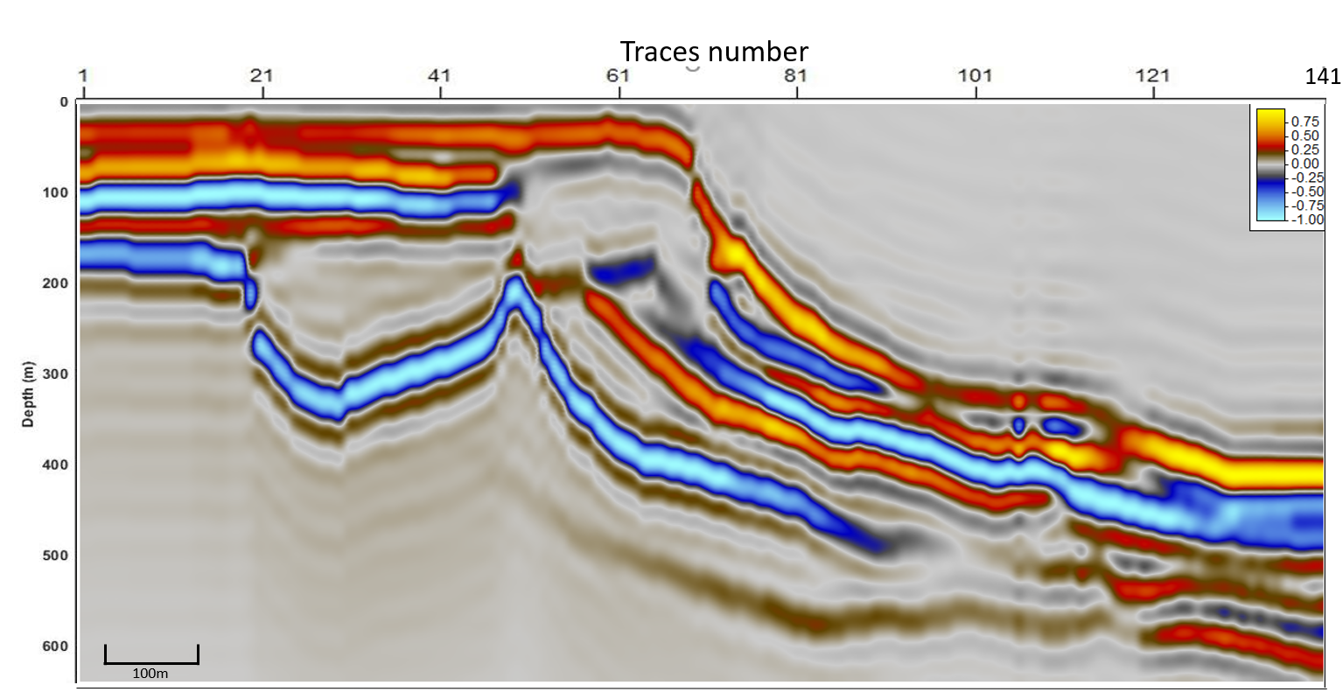
Figure 31: Synthetic seismic profile of the north wall with Ormsby band pass of 2, 8, 80, 125 Hz displayed in Petrel.
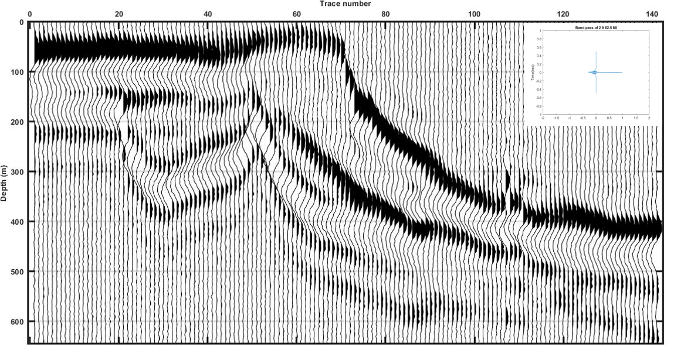
Figure 32: Wiggle plot of model with Ormsby band pass of 2, 8, 62.5, 80 Hz and 5% random noise. Peaks that represents positive amplitude are filled while unfilled troughs represent negative amplitude.
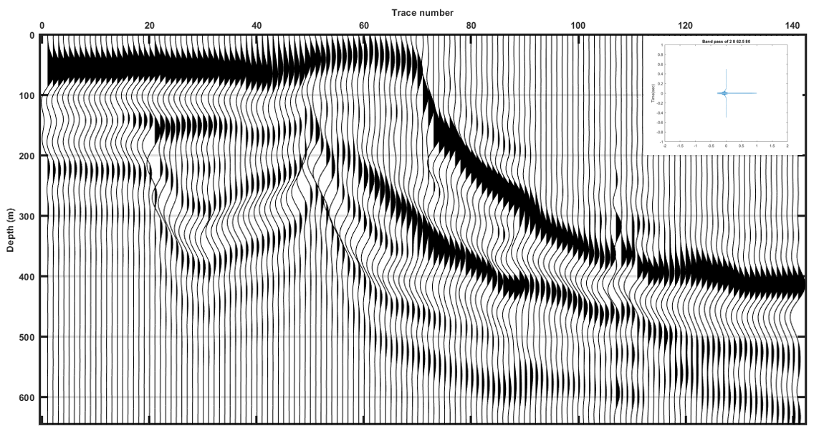
Figure 33: Wiggle plot of model with Ormsby band pass of 2, 8, 62.5, 80 Hz without noise. Peaks that represents positive amplitude are filled while unfilled troughs represent negative amplitude.

Comparation with subsurface data

A comparation is made between the subsurface data from Northwest Shelf margin (Figure 34) and the synthetic seismic data conducted by Omsby wavelet at 2 8 80 125 Hz (Figure 35). Note that the enlarged section of subsurface data exhibits similar features and stratigraphic architecture with synthetic model such as changes of polarity and strength of some reflectors along the slope and reciprocal onlap and downlap of strata on the slope which is expressed by Lamar HFCs in synthetic model.
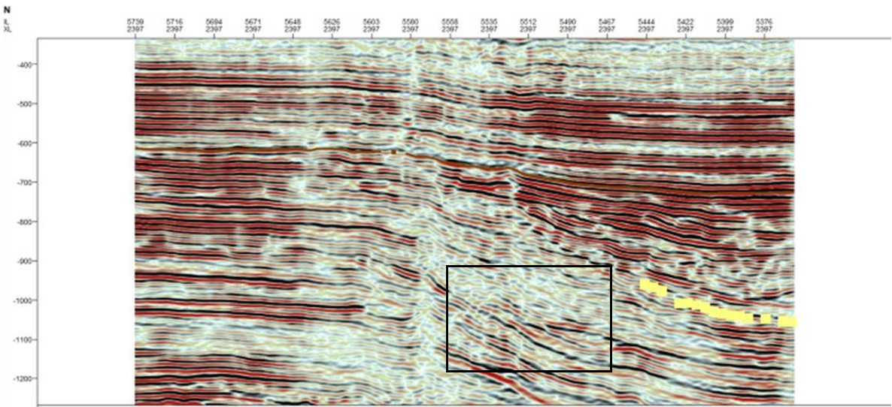
Figure 34: Uninterpreted contemporary 3D seismic line of Guadalupian strata from somewhere on the Northwest Shelf, Permian Basin, New Mexico. Black rectangle is enlarged to compare with synthetic model.
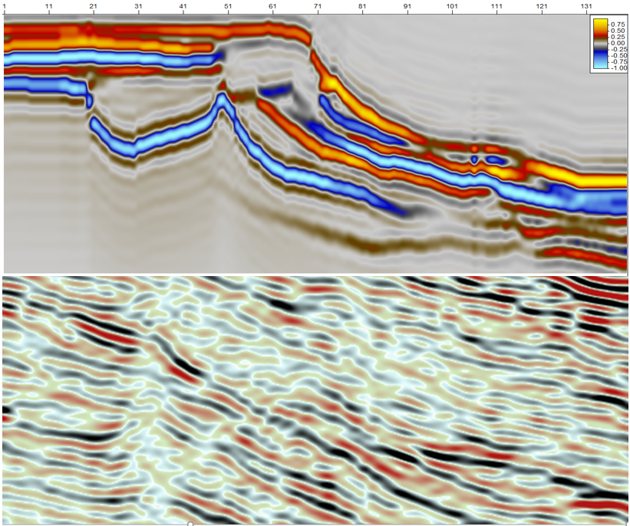
Figure 35: Comparation between the synthetic model and similar section of subsurface seismic data.

Chapter 5: Conclusions

- The practice of LiDAR employment is valuable for outcrop characterization and interpretation. LiDAR possesses multiple advantages over the traditional photomosaic method as in comparison: 1) the 3D spatial geometry of a target can be better described; 2) the digital nature of the data set allows interpretations to be easily exported to MatLab for further modeling; 3) the high resolution of the data allows strata to be traced across the study area with a higher degree of accuracy.
- The application of the Schmidt hammer provides an efficient way to estimate P-wave velocity directly from the outcrop. Compared with a lab-based approach, the operation of a Schmidt hammer in the field is simple and non-destructive and allows the computed compressional velocity data of outcrop to be collected from hundreds of locations across a large study area and provides an impedance estimate of heterogeneity.
- Using the high-resolution point cloud data, detailed stratigraphic architecture is resolved, showing a siliciclastic-carbonate mixing clinoform profile. Specifically the Rader Limestone, McComb Limestone, McKittrick Limestone and Lamar Limestone are found to interfinger three LST sandstone wedges respectively which pinch out on the lower slope, onlapping against underlying carbonate units. The Lamar member is divided into six higher order cycles units where unit 1 and unit 5 are onlapping against unit 2 and unit 4, respectively.
- Variation of velocity and density occurs not only between different strata, but also within a single stratum. Impedance analysis based on along-slope distance of strata deposited across the study area indicates that impedance of the Rader member, McComb member and Lamar unit 3 decreases basinward while the Mckittrick Canyon Limestone, Lamar unit 2, 4, and 6 and Reef trail shows an impedance increase basinward.
- Three Capitan system HFSs of Late Guadalupian documented in the outcrop can be characterized by sequence boundary in the high frequency band pass model and by litho-units in the model with a low frequency band pass wavelet (80 Hz). In the model synthesized with a 2 8 120 250 Hz wavelet, the detailed stratigraphic architectures of Lamar high frequency cycles are well expressed.
- For this reef-rimmed clinoform profile in outcrop, the identification of surfaces and litho-units in vertical incidence model is greatly influenced by the impedance contrast of upper and lower units and wavelet frequency band pass. Stratigraphic surfaces are better revealed in a high-frequency wavelet modeled seismogram while a mid-to-low frequency band pass produced model characterizes the litho-units.

References

Adams, John Emery. "Stratigraphic-tectonic development of Delaware Basin." AAPG Bulletin 49, no. 11 (1965): 2140-2148.
Aydin, A., and A. Basu. "The Schmidt hammer in rock material characterization." Engineering Geology 81, no. 1 (2005): 1-14.
Bakke, Kristina, John Gjelberg, and Steen Agerlin Petersen. "Compound seismic modelling of the Ainsa II turbidite system, Spain: Application to deep-water channel systems offshore Angola." Marine and Petroleum Geology 25, no. 10 (2008): 1058-1073.
Bellian, Jerome A., Charles Kerans, and David C. Jennette. "Digital outcrop models: applications of terrestrial scanning lidar technology in stratigraphic modeling." Journal of sedimentary research 75, no. 2 (2005): 166-176.
Bellian, Jerome A., Charles Kerans, and David C. Jennette. "Digital outcrop models: applications of terrestrial scanning lidar technology in stratigraphic modeling." Journal of sedimentary research 75, no. 2 (2005): 166-176.
Biddle, Kevin T., Wolfgang Schlager, Kurt W. Rudolph, and Terry L. Bush. "Seismic model of a progradational carbonate platform, Picco di Vallandro, the Dolomites, northern Italy (1)." AAPG Bulletin 76, no. 1 (1992): 14-30.
Bosellini, Alfonso. "Progradation geometries of carbonate platforms: examples from the Triassic of the Dolomites, northern Italy." Sedimentology 31, no. 1 (1984): 1-24.
Burton, Darrin, Dallas B. Dunlap, Lesli J. Wood, and Peter P. Flaig. "Lidar intensity as a remote sensor of rock properties." Journal of Sedimentary Research 81, no. 5 (2011): 339-347.
Falivene, O., P. Arbués, J. Ledo, B. Benjumea, J. A. Muñoz, O. Fernández, and S. Martínez. "Synthetic seismic models from outcrop-derived reservoir-scale three-dimensional facies models: The Eocene Ainsa turbidite system (southern Pyrenees)." AAPG bulletin 94, no. 3 (2010): 317-343.
Galley, John E. "Oil and geology in the Permian basin of Texas and New Mexico: North America." (1958): 395-446.
Garber, R. A., P. M. Harris, and J. M. Borer. "Occurrence and Significance of Magnesite in Upper Permian (Guadalupian) Tansill and Yates Formations, Delaware Basin, New Mexico (1)." AAPG Bulletin 74, no. 2 (1990): 119-134.
Garber, Raymond A., George A. Grover, and Paul M. Harris. "Geology of the Capitan shelf margin-subsurface data from the northern Delaware Basin." (1989).
Gardner, G. H. F., L. W. Gardner, and A. R. Gregory. "Formation velocity and density—The diagnostic basics for stratigraphic traps." Geophysics 39, no. 6 (1974): 770-780.
Garrett, Kathryn N., John D. Pigott, and Kulwadee L. Pigott, 2016, High Resolution Basin Modeling Insight Into Syndepositional Permian Reef Architecture Through Integrated Lidar-XRF Analysis, Slaughter Canyon, New Mexico, AAPG Annual Convention and Exhibition, Calgary, Alberta, Canada.
Garrett, Kathryn N., Pigott, John D., and Pigott, Kulwadee L., 2015, High resolution basin modeling of the Permian Capitan reef, New Mexico: new insight from integrated outcrop lidar-xrf-sgr analysis into reef architecture, Geological Society of America Annual Meeting, Baltimore, Maryland, USA , No. 228-401.
Giddens, Emma, John D. Pigott, and Kulwadee L. Pigott. "Pleistocene Coral Reef Destruction in the Florida Keys: Paleotempestite Evidence from a High-Resolution LIDAR XRF Analysis of Windley Key Quarry." Sea 100 (2016): 120.
Hayes, Philip Thayer. Geology of the Guadalupe Mountains, New Mexico. No. 446. US Geological Survey, 1964.
Hayes, Philip Thayer. Geology of the Guadalupe Mountains, New Mexico. No. 446. US Geological Survey, 1964.
Hills, John M. "Sedimentation, tectonism, and hydrocarbon generation in Delaware basin, west Texas and southeastern New Mexico." AAPG Bulletin 68, no. 3 (1984): 250-267.
Horak, R. L. "Tectonic and hydrocarbon maturation history in the Permian Basin." Oil & Gas Journal 83, no. 21 (1985): 124-129.
Janson, X. A. V. I. E. R., S. E. R. G. E. Y. Fomel, O. J. Martinsen, A. J. Pulham, P. D. W. Haughton, and M. D. Sullivan. "3-D forward seismic model of an outcrop-based geocellular model." Concepts in Sedimentology and Paleontology 10 (2011): 87-106.
Katz, O., Z. Reches, and J-C. Roegiers. "Evaluation of mechanical rock properties using a Schmidt Hammer." International Journal of Rock Mechanics and Mining Sciences37, no. 4 (2000): 723-728.
Kenter, J. A. M., GL Bracco Gartner, and W. Schlager. "Seismic models of a mixed carbonate-siliciclastic shelf margin: Permian upper San Andres Formation, Last Chance Canyon, New Mexico." Geophysics 66, no. 6 (2001): 1744-1748.
Kerans, C., P. M. Harris, and D. G. Bebout. "Outer shelf and shelf crest." Guide to the Permian Reef Geology Trail, McKittrick Canyon, Guadalupe Mountains National Park, West Texas: University of Texas, Bureau of Economic Geology, Guidebook 26 (1993): 32-43.
King, Philip Burke. Geology of the southern Guadalupe Mountains, Texas. Vol. 215. US Government Printing Office, 1948.
Lew, C.L., Baharuddin, S.B., and Pigott, John D., 2013, Deepwater Basin Model for the Permian: Delaware Basin Example, China IPTC 16962,17pp.
Miall, Andrew D., and Ronald C. Blakey. "The Phanerozoic tectonic and sedimentary evolution of North America." Sedimentary basins of the world 5 (2008): 1-29.
Newell, Gordon F., and Elliott W. Montroll. "On the theory of the Ising model of ferromagnetism." Reviews of Modern Physics 25, no. 2 (1953): 353.
Osleger, David A., and Scott W. Tinker. "Three-dimensional architecture of Upper Permian high-frequency sequences, Yates-Capitan shelf margin, Permian Basin, USA." (1999).
Palaz, Ibrahim, and Kurt J. Marfurt. "Carbonate seismology: An overview." Carbonate seismology: Society of Exploration Geophysicists Geophysical Developments Series 6 (1997): 1-7.
Pigott, John D., Esra Yalcin, Kulwadee L. Pigott, and Michael Williams, 2015, 3D Delaware basin model: Insight into its heterogeneous petroleum system evolution as a guide to new exploration, West Texas Geological Society Convention, Midland, Tx.
Pigott, John D., Kulwadee L. Pigott, Esra Yalcin, and Michael Williams, 2016, 3D Delaware Basin Petroleum System Evolution: Solution of the Basin Inverse Boundary Value Problem, Hedberg Conference: The Future of Basin and Petroleum Systems Modeling, 3-8 April 2016, Santa Barbara , CA, USA.
Pigott, John D., Michael T. Williams, Mohamed Abdel-Fattah, and Kulwadee L. Pigott, 2014, The Messinian Mediterranean Crisis: A Model for the Permian Delaware Basin? AAPG International Conference & Exhibition, 14-17 September, 2014, Istanbul.
Poole, R. W., and I. W. Farmer. "Consistency and repeatability of Schmidt hammer rebound data during field testing." International Journal of Rock Mechanics and Mining Science17, no. 3 (1980).
Pringle, J. K., J. A. Howell, D. Hodgetts, A. R. Westerman, and D. M. Hodgson. "Virtual outcrop models of petroleum reservoir analogues: a review of the current state-of-the-art." First break 24, no. 3 (2006): 33-42.
Read, J. F. "Overview of carbonate platform sequences, cycle stratigraphy and reservoirs in greenhouse and icehouse worlds." (1995).
Rush, Jason, and Charles Kerans. "Stratigraphic response across a structurally dynamic shelf: the latest Guadalupian composite sequence at Walnut Canyon, New Mexico, USA." Journal of Sedimentary Research 80, no. 9 (2010): 808-828.
Saller, Arthur H., J. A. D. Dickson, and Fumiaki Matsuda. "Evolution and distribution of porosity associated with subaerial exposure in upper Paleozoic platform limestones, west Texas." AAPG bulletin 83, no. 11 (1999): 1835-1854.
Saller, Arthur H., Paul M. Mitch Harris, Brenda L. Kirkland, and S. J. Mazzullo. "Geologic Framework of the Capitan Depositional System Previous Studies, Controversies, and Contents of this Special Publication." (1999).
Sarg, J. F. "Foredeep: Middle-Late Permian Depositional Sequences, Permian Basin, West Texas and New Mexico." (1987): 140-154.
Schwab, A. M., B. T. Cronin, and H. Ferreira. "Seismic expression of channel outcrops: Offset stacked versus amalgamated channel systems." Marine and Petroleum Geology 24, no. 6-9 (2007): 504-514.
Sharma, P. K., Manoj Khandelwal, and T. N. Singh. "A correlation between Schmidt hammer rebound numbers with impact strength index, slake durability index and P-wave velocity." International Journal of Earth Sciences 100, no. 1 (2011): 189-195.
Stafleu, Jan, and Mark D. Sonnenfeld. "Seismic models of a shelf-margin depositional sequence: upper San Andres formation, Last Chance Canyon, New Mexico." Journal of Sedimentary Research 64, no. 4 (1994).
Sullivan, Morgan, Gerrick Jensen, Frank Goulding, David Jennette, Lincoln Foreman, and David Stern. "Architectural analysis of deep-water outcrops: Implications for exploration and development of the Diana sub-basin, western Gulf of Mexico." In Deep-water reservoirs of the world: Gulf Coast Section SEPM Foundation 20th Annual Research Conference, pp. 1010-1032. 2000.
Tinker, Scott W. "Shelf-to-basin facies distributions and sequence stratigraphy of a steep-rimmed carbonate margin: Capitan depositional system, McKittrick Canyon, New Mexico and Texas." Journal of Sedimentary Research 68, no. 6 (1998).
Tinker, Scott Wheeler. "Reservoir-scale sequence stratigraphy: McKittrick Canyon, and three-dimensional subsurface examples, west Texas and New Mexico." (1997): 6141-6141.
Ward, Robert F., Christopher G. St C. Kendall, and Paul M. Harris. "Upper Permian (Guadalupian) facies and their association with hydrocarbons--Permian basin, west Texas and New Mexico." AAPG Bulletin 70, no. 3 (1986): 239-262.
Ward, Robert F., Christopher G. St C. Kendall, and Paul M. Harris. "Upper Permian (Guadalupian) facies and their association with hydrocarbons--Permian basin, west Texas and New Mexico." AAPG Bulletin 70, no. 3 (1986): 239-262.
Wehr, Aloysius, and Uwe Lohr. "Airborne laser scanning—an introduction and overview." ISPRS Journal of photogrammetry and remote sensing 54, no. 2-3 (1999): 68-82.
Williams, Michael T., John D. Pigott, and Kulwadee L. Pigott, 2014, Delaware Basin Evolution: Preliminary Integrated 1D,2D, And 3D Basin Model for Petroleum System Analysis, 2014, AAPG Annual Convention & Exhibition, Houston, Tx.
Williams, Michael Thomas. "Evolution of the Delaware Basin, West Texas and Southeast New Mexico." PhD diss., University of Oklahoma, 2013.
Winkler, Stefan, and John A. Matthews. "Comparison of electronic and mechanical Schmidt hammers in the context of exposure‐age dating: are Q‐and R‐values interconvertible?." Earth Surface Processes and Landforms 39, no. 8 (2014): 1128-1136.
Yagiz, Saffet. "Predicting uniaxial compressive strength, modulus of elasticity and index properties of rocks using the Schmidt hammer." Bulletin of Engineering Geology and the Environment 68, no. 1 (2009): 55-63.
Yang, Kenn-Ming, and Stephen L. Dorobek. "The Permian basin of west Texas and New Mexico: tectonic history of a" composite" foreland basin and its effects on stratigraphic development." Stratigraphic evolution of foreland basins: SEPM Special Publication 52 (1995): 149-174.
Yang, Kenn-Ming, and Stephen L. Dorobek. "The Permian basin of west Texas and New Mexico: tectonic history of a" composite" foreland basin and its effects on stratigraphic development." Stratigraphic evolution of foreland basins: SEPM Special Publication 52 (1995): 149-174.

Appendices

Appendix I—Data set of Schmidt hammer readings and rock samples

Sample | GPS(Long) |  |  | GPS(Lat) |  | Q | R |  |  |  | Density (g/cm^3) |  | AI
 |  |  |  |  |  |  |  |  | Vp |  |  |  | (kg·m⁻²·s⁻¹·10^6)
 |  |  |  |  |  |  |  |  | (m/s)
South1 | -104.758148 |  |  | 31.97992215 |  | 62.8 | 54.18046 |  | 3995.5 |  | 2.72 |  | 10.868
South2 | -104.7579382 |  |  | 31.97943538 |  | 69.3 | 60.79876 |  | 4752 |  | 2.69 |  | 12.783
South3 | -104.7579382 |  |  | 31.97943538 |  | 68.1 | 59.57692 |  | 4602.3 |  | 2.68 |  | 12.334
South4 | -104.7579382 |  |  | 31.97943538 |  | 69.4 | 60.90058 |  | 4764.7 |  | 2.7 |  | 12.865
South5 |  |  |  |  |  | 69.5 | 61.0024 |  | 4777.4
South6 | -104.7579382 |  |  | 31.97943538 |  | 59.7 | 51.02404 |  | 3678.4 |  | 2.52 |  | 9.269
South7 | -104.7605925 |  |  | 31.98196064 |  | 69.5 | 61.0024 |  | 4777.4 |  | 2.46 |  | 11.752
South8 | -104.7568244 |  |  | 31.97983549 |  | 73 | 64.5661 |  | 5245 |  | 2.43 |  | 12.745
South9 | -104.7567332 |  |  | 31.97985918 |  | 71.3 | 62.83516 |  | 5012.4 |  | 2.69 |  | 13.483
South10 | -104.7605925 |  |  | 31.98196064 |  | 62.4 | 53.77318 |  | 3953.1 |  | 2.62 |  | 10.357
South11 | -104.7567332 |  |  | 31.97985918 |  | 68.8 | 60.28966 |  | 4689 |  | 2.35 |  | 11.019
South12 | -104.7605925 |  |  | 31.98196064 |  | 65 | 56.4205 |  | 4237 |  | 2.51 |  | 10.635
South13 | -104.7598914 |  |  | 31.98269146 |  | 68 | 59.4751 |  | 4590 |  | 2.65 |  | 12.164
South14 | -104.7598914 |  |  | 31.98269146 |  | 65.7 | 57.13324 |  | 4316.9 |  | 2.65 |  | 11.44
South15 | -104.7598914 |  |  | 31.98269146 |  | 69.4 | 60.90058 |  | 4764.7 |  | 2.67 |  | 12.722
South16 | -104.7598914 |  |  | 31.98269146 |  | 67.2 | 58.66054 |  | 4493.1 |  | 2.74 |  | 12.311
South17 |  |  |  |  |  | 78 | 69.6571 |  | 5993.4
South18 | -104.7613056 |  |  | 31.98733333 |  | 58.2 | 49.49674 |  | 3534.1 |  | 2.677 |  | 9.462
South19 | -104.7615278 |  |  | 31.98713889 |  | 62.3 | 53.67136 |  | 3942.5 |  | 2.659 |  | 10.482
South20 | -104.7614722 |  |  | 31.98705556 |  | 61.2 | 52.55134 |  | 3828.5 |  | 2.659 |  | 10.179
South21 | -104.7616389 |  |  | 31.98672222 |  | 64.2 | 55.60594 |  | 4147.5 |  | 2.617 |  | 10.855

South22 | -104.7616944 | 31.9865 | 66.5 | 57.9478 | 4410 | 2.721 | 12
South23 | -104.7616389 | 31.98652778 | 61.9 | 53.26408 | 3900.7 | 2.639 | 10.295
South24 | -104.76175 | 31.98625 | 58.6 | 49.90402 | 3572 | 2.703 | 9.654
South25 | -104.7617222 | 31.98597222 | 62.2 | 53.56954 | 3932
South26 | -104.7618333 | 31.98552778 | 66.1 | 57.54052 | 4363.2 | 2.674 | 11.665
South27 | -104.7620556 | 31.98558333 | 58.2 | 49.49674 | 3534.1 | 2.708 | 9.57
South28 | -104.7624167 | 31.98530556 | 56.1 | 47.35852 | 3341.5 | 2.728 | 9.114
South29 | -104.7626944 | 31.98477778 | 68.9 | 60.39148 | 4701.6 | 2.679 | 12.594
South30 | -104.7627778 | 31.98430556 | 66 | 57.4387 | 4351.5 | 2.671 | 11.622
South31 | -104.7629167 | 31.98352778 | 64.6 | 56.01322 | 4192 | 2.657 | 11.138
South32 | -104.7630278 | 31.98333333 | 63.6 | 54.99502 | 4081.7 | 2.753 | 11.236
South33 | -104.7632222 | 31.98291667 | 65.9 | 57.33688 | 4339.9 | 2.657 | 11.531
South34 | -104.7633889 | 31.98258333 | 63.5 | 54.8932 | 4070.8
South35 | -104.7634167 | 31.98197222 | 72.7 | 64.26064 | 5203.2 | 2.578 | 13.411
South36 | -104.7636111 | 31.98175 | 64.4 | 55.80958 | 4169.7 | 2.714 | 11.317
South37 | -104.7637778 | 31.98075 | 63 | 54.3841 | 4016.9 | 2.686 | 10.788
Trail2 | -104.7560359 | 31.98575355 | 76.9 | 68.53708 | 5820 | 2.692 | 15.666
Trail3 | -104.7560359 | 31.98575355 | 66.3 | 57.74416 | 4386.5 | 2.633 | 11.548

Trail4 | -104.754562 | 31.98493208 | 61.3 | 52.65316 | 3838.8 | 2.658 | 10.202
Trail5 | -104.7551478 | 31.98498368 | 66.6 | 58.04962 | 4421.8 | 2.678 | 11.843
Trail6 | -104.7558083 | 31.98505578 | 74.4 | 65.99158 | 5444.6 | 2.667 | 14.521
Trail7 | -104.7558436 | 31.98643666 | 70.2 | 61.71514 | 4867.5 | 2.697 | 13.129
Trail7-1 | -104.7564598 | 31.98543956 | 71.5 | 63.0388 | 5039.2 | 2.693 | 13.572
Trail7-2 | -104.7564072 | 31.98542501 | 76.7 | 68.33344 | 5789.1 | 2.714 | 15.709
Trail7-3 | -104.7563545 | 31.98540664 | 77.2 | 68.84254 | 5866.8 | 2.704 | 15.866
Trail7-4 | -104.7562904 | 31.98539743 | 73.1 | 64.66792 | 5259 | 2.669 | 14.038
Trail7-5 | -104.7562339 | 31.98540658 | 66.3 | 57.74416 | 4386.5 | 2.628 | 11.528
Trail7-6 | -104.7561432 | 31.98541676 | 67.9 | 59.37328 | 4577.8 | 2.651 | 12.137
Trail7-7 | -104.7560612 | 31.98542592 | 69.6 | 61.10422 | 4790.2 | 2.595 | 12.43
Trail8 | -104.7559888 | 31.98542457 | 68.1 | 59.57692 | 4602.3 | 2.667 | 12.272
Trail8-2 | -104.7557288 | 31.98543624 | 64.8 | 56.21686 | 4214.4 | 2.592 | 10.923
Trail8-3 | -104.7556545 | 31.98556271 | 63.6 | 54.99502 | 4081.7 | 2.572 | 10.497
Trail8-4 | -104.7559589 | 31.98569158 | 68 | 59.4751 | 4590 | 2.457 | 11.277
Trail8-5 | -104.7561327 | 31.98580998 | 66.8 | 58.25326 | 4445.4 | 2.658 | 11.817
Trail8-6 | -104.7562062 | 31.9864406 | 61.3 | 52.65316 | 3838.8 | 2.733 | 10.492
Trail8-7 | -104.7562128 | 31.98672086 | 64.2 | 55.60594 | 4147.5 | 2.666 | 11.056
Trail8-8 | -104.7561065 | 31.98708957 | 56 | 47.2567 | 3332.6 | 2.635 | 8.782
Trail8-9 | -104.7559876 | 31.98740039 | 62.8 | 54.18046 | 3995.5 | 2.636 | 10.534
Trail8-11 | -104.7559439 | 31.98767277 | 59.4 | 50.71858 | 3649 | 2.58 | 9.415
Trail8-12 | -104.7559756 | 31.98786794 | 72.8 | 64.36246 | 5217.1 | 2.657 | 13.861
Trail8-13 | -104.7559908 | 31.98809665 | 60.9 | 52.24588 | 3798 | 2.542 | 9.656

Trail8-14 | -104.7560633 | 31.98830653 | 56.1 | 47.35852 | 3341.5 | 2.68 | 8.956
Trail9 | -104.756198 | 31.988753 | 67.4 | 58.86418 | 4517.1 | 2.556 | 11.544
Trail9-1 | -104.756864 | 31.989405 | 72.1 | 63.64972 | 5120.5 |  | 0
Trail9-2 | -104.7565883 | 31.98902524 | 68.2 | 59.67874 | 4614.6 | 2.658 | 12.263
Trail10 | -104.757025 | 31.989685 | 71.6 | 63.14062 | 5052.7 | 2.637 | 13.326
Trail10-1 | -104.7571046 | 31.99011368 |  | -9.7625 | 748.2 | 2.72 | 2.035
Trail11 | -104.757309 | 31.990556 | 63.8 | 55.19866 | 4103.5 | 2.642 | 10.84
Trail12 | -104.757691 | 31.991591 | 60.3 | 51.63496 | 3737.7 | 2.762 | 10.323
Trail13 | -104.758637 | 31.99268594 | 69.1 | 60.59512 | 4726.7 | 2.705 | 12.786
Trail13-1 | -104.7603857 | 31.99322884 | 63.3 | 54.68956 | 4049.1 | 2.45 | 9.921
Trail14 | -104.7614724 | 31.99388699 | 74.2 | 65.78794 | 5415.6 | 2.63 | 14.245
Trail15 | -104.7573703 | 31.99376086 | 72.7 | 64.26064 | 5203.2 | 2.535 | 13.189
Trail16 | -104.7572079 | 31.99410389 | 67.2 | 58.66054 | 4493.1 | 2.63 | 11.815
Trail17 | -104.7574491 | 31.99449904 | 62.2 | 53.56954 | 3932 | 2.669 | 10.493
Trail18 | -104.758523 | 31.995345 | 67.6 | 59.06782 | 4541.3 | 2.665 | 12.1
Trail18-1 | -104.758247 | 31.994467 | 66.5 | 57.9478 | 4410 | 2.703 | 11.92
Trail19 | -104.7589204 | 31.99543965 | 69.6 | 61.10422 | 4790.2 | 2.695 | 12.91
Trail20 | -104.7585104 | 31.99587395 | 67.4 | 58.86418 | 4517.1 | 2.568 | 11.598
Trail21 | -104.757303 | 31.997653 | 68.4 | 59.88238 | 4639.3 | 2.702 | 12.535
Trail22 | -104.7559254 | 31.99800061 | 67.3 | 58.76236 | 4505.1 | 2.725 | 12.275
Trail23 | -104.7557524 | 31.99800756 | 64.5 | 55.9114 | 4180.9 | 2.658 | 11.114
Trail24 | -104.7558722 | 31.99812352 | 65.1 | 56.52232 | 4248.3 | 2.696 | 11.454

Trail25 | -104.7567737 | 31.9983872 | 67 | 58.4569 | 4469.2 | 2.624 | 11.728
Trail26 | -104.7587606 | 31.99803498 | 72.7 | 64.26064 | 5203.2 | 2.606 | 13.558
Trail26-1 | -104.7594411 | 31.9978911 | 70.3 | 61.81696 | 4880.5 | 2.427 | 11.842
Trail26-3 | -104.7588914 | 31.9978801 | 68.9 | 60.39148 | 4701.6 | 2.472 | 11.62
Trail27 | -104.7598195 | 31.99766476 | 70.3 | 61.81696 | 4880.5 | 2.649 | 12.93
Trail27-2 | -104.7595383 | 31.99810126 | 73.3 | 64.87156 | 5287.1 | 2.641 | 13.963
Trail27-3 | -104.7598789 | 31.99774537 | 66.6 | 58.04962 | 4421.8 | 2.698 | 11.931
Trail28 | -104.7593804 | 31.99828032 | 70.9 | 62.42788 | 4959.2 | 2.657 | 13.176
NSlope1 | -104.75862 | 31.984437 | 52.4 | 43.59118 | 3027.5 | 2.65 | 8.023
NSlope2 | -104.758594 | 31.984442 | 63.1 | 54.48592 | 4027.6 | 2.695 | 10.856
NSlope3 | -104.758584 | 31.984441 | 62.3 | 53.67136 | 3942.5 | 2.719 | 10.718
NSlope4 | -104.758281 | 31.984754 | 65.7 | 57.13324 | 4316.9 | 2.664 | 11.502
NSlope5 | -104.758006 | 31.98542 | 61.7 | 53.06044 | 3879.9 | 2.457 | 9.534
NSlope6 | -104.758028 | 31.985744 | 65 | 56.4205 | 4237 | 2.718 | 11.516
NSlope7 | -104.757979 | 31.985953 | 60.6 | 51.94042 | 3767.7 | 2.517 | 9.483
NSlope8 | -104.757838 | 31.986357 | 68.2 | 59.67874 | 4614.6 | 2.613 | 12.056
NSlope9 | -104.757937 | 31.986694 | 60.4 | 51.73678 | 3747.7 | 2.624 | 9.832
NSlope10 | -104.7577 | 31.986583 | 66 | 57.4387 | 4351.5 | 2.704 | 11.766
NSlope11 | -104.757433 | 31.986634 | 69.2 | 60.69694 | 4739.3 | 2.549 | 12.082
NSlope12 | -104.757377 | 31.986638 | 61.5 | 52.8568 | 3859.3 | 2.441 | 9.421
NSlope13 | -104.757321 | 31.986617 | 31.6 | 22.41262 | 1738.2 | 2.408 | 4.185
NSlope14 | -104.757141 | 31.986249 | 36.3 | 27.19816 | 1970.4 | 2.504 | 4.933
NSlope15 | -104.757044 | 31.986264 | 65.7 | 57.13324 | 4316.9 | 2.504 | 10.807
NSlope16 | -104.756914 | 31.986247 | 39 | 29.9473 | 2117.5 | 2.733 | 5.786

NSlope17 | -104.756819 | 31.986179 | 63.8 | 55.19866 | 4103.5 | 2.651 | 10.879
NSlope18 | -104.756747 | 31.986176 | 55.6 | 46.84942 | 3297.3 | 2.712 | 8.942
NSlope19 | -104.756494 | 31.986201 | 56.5 | 47.7658 | 3377.4 | 2.705 | 9.136
NSlope20 | -104.756428 | 31.986187 | 27.1 | 17.83072 | 1541.6 | 2.511 | 3.87
NSlope21 | -104.75714 | 31.986039 | 60.5 | 51.8386 | 3757.7 | 2.501 | 9.397
NSlope22 | -104.756587 | 31.985764 | 56.4 | 47.66398 | 3368.4 | 2.708 | 9.122
NSlope23 | -104.756673 | 31.985425 | 53.6 | 44.81302 | 3125.9 | 2.658 | 8.309
NSlope24 | -104.756688 | 31.985205 | 29.1 | 19.86712 | 1626.1 | 2.682 | 4.361
NSlope25 | -104.756574 | 31.984926 | 48.3 | 39.41656 | 2713.8 | 2.633 | 7.144
NSlope26 | -104.756719 | 31.984773 | 58.1 | 49.39492 | 3524.7 | 2.604 | 9.178
NSlope27 | -104.756956 | 31.984568 | 42.8 | 33.81646 | 2343.5 | 2.29 | 5.365
NSlope28 | -104.757117 | 31.984456 | 60.5 | 51.8386 | 3757.7 | 2.378 | 8.936
NSlope29 | -104.757072 | 31.984429 | 62.3 | 53.67136 | 3942.5 | 2.671 | 10.532
NSlope30 | -104.757343 | 31.984226 | 63.8 | 55.19866 | 4103.5 | 2.752 | 11.293
NSlope31 | -104.757343 | 31.984226 | 49 | 40.1293 | 2765 | 2.746 | 7.594
NSlope32 | -104.757483 | 31.984144 | 42.9 | 33.91828 | 2349.7 | 2.386 | 5.606
NSlope33 | -104.757772 | 31.983897 | 69 | 60.4933 | 4714.1 | 2.605 | 12.278

Appendix II—Matlab Code for AI and Seismic Modeling

This chapter is including the code for editing of stratigraphy frame exported from Riscan Pro and impedance model building.

Example of stratigraphic surface extraction with coordinate rotation

% Surface location read out from polygon dxf file exported from LiDAR
%
% Written by Zhuobo Wang Dec 2017
% Input
% N_Lamar1.xlsx etc. : xlsx file of base of unit Lamar1 transfered from
% original dxf file
% RotM1/RotM2: Rotation matrix which rotate the coordinated of node in
% surface to desired coordinate system (consistent with stratigraphy frame)
%Output
% Lamar1_x/Lamar1_z: Rotated coordinate of node on Lamar1 surface

% read out the coordinate of surface polygon
[num,txt,raw]=xlsread('N_Lamar1.xlsx');

C=num;
m=1;
for n=1:length(C)
if C(n)==10
Lamar1(1,m)=C(n+1);
Lamar1(2,m)=C(n+3);
Lamar1(3,m)=C(n+5);
m=m+1;
end
end

RotM1=[cos(pi/6),0,-sin(pi/6);0,1,0;sin(pi/6),0,cos(pi/6)];

RotM2=[1,0,0;0,cos(pi/12),sin(pi/12);0,-sin(pi/12),cos(pi/12)];

Lamar1_tran=RotM1*Lamar1;
Lamar1_tran=RotM2*Lamar1_tran;

Lamar1_x=Lamar1_tran(1,:);
Lamar1_y=Lamar1_tran(2,:);
Lamar1_z=Lamar1_tran(3,:);
% stratigraphy adjustment and plot
Lamar1_x(1)=[];
Lamar1_y(1)=[];
Lamar1_z(1)=[];
Lamar1_x=Lamar1_x-1100;
Lamar1_z=Lamar1_z-100;
Lamar1_x=-Lamar1_x;
plot(Lamar1_x,Lamar1_z,'*');

Impedance model building and reflection coefficient arrays generation

% Impedance Model for McKittrick Canyon north wall
% Based on stacking pattern, assign AI to every sample to every traces.
%
% Written by: Zhuobo Wang Dec 2017
% Input
% Min_x/Max_x: range of traces location at horizontal direction
% Trace_inter: interval of traces placing
% PostLamar_x/PostLamar_z ect. : horizontal and vertical coordinate of base of PostLamar unit
% Imp_Postlamar ect. : Acoustic Impedance array of unit
% i: traces number
% nsamp: number of sample in every trace
% Output
% Z1: Acoustic Impedance matrix of study area
% RC_M1: Reflection coefficient matrix of all traces
Min_x=600;
Max_x=800;
Trace_inter=10;
Hori=[-600:10:800];
nsamp=131;
for i=1:16 % assign impedance to trace 1-16 where stacking pattern is same

SurLoc=[0,0,0,0];
% calculate location of stratigraphy surfaces which represent
% surface of impedance change
SurLoc(1)=nsamp-fix((interp1(PostLamar_x,PostLamar_z,Hori(i),'liner','extrap'))/5);
SurLoc(2)=nsamp-fix((interp1(Lamar2B_x,Lamar2B_z,Hori(i),'liner','extrap'))/5);
SurLoc(3)=nsamp-fix((interp1(SandB_x,SandB_z,Hori(i),'liner','extrap'))/5);
SurLoc(4)=nsamp-fix((interp1(Mck_x,Mck_z,Hori(i),'liner','extrap'))/5);

for j=1:SurLoc(1)
Z1(j,i)=11;
end
for j=SurLoc(1)+1:SurLoc(2)
Z1(j,i)=Imp_Tansil(i);
end
for j=SurLoc(2)+1:SurLoc(3)
Z1(j,i)=Imp_Yates6(i);
end
for j=SurLoc(3)+1:SurLoc(4)
Z1(j,i)=Imp_Yates5(i);
end
for j=SurLoc(4)+1:nsamp
Z1(j,i)=Imp_Mc(i);
end

end
for i=17:31

SurLoc=[0,0,0,0,0];
SurLoc(1)=nsamp-fix((interp1(PostLamar_x,PostLamar_z,Hori(i),'liner','extrap'))/5);
SurLoc(2)=nsamp-fix((interp1(Lamar2B_x,Lamar2B_z,Hori(i),'liner','extrap'))/5);
SurLoc(3)=nsamp-fix((interp1(SandB_x,SandB_z,Hori(i),'liner','extrap'))/5);
SurLoc(4)=nsamp-fix((interp1(ReefT_x,ReefT_z,Hori(i),'liner','extrap'))/5);
SurLoc(5)=nsamp-fix((interp1(Mck_x,Mck_z,Hori(i),'liner','extrap'))/5);

for j=1:SurLoc(1)
Z1(j,i)=11;
end
for j=SurLoc(1)+1:SurLoc(2)
Z1(j,i)=Imp_Tansil(i);
end
for j=SurLoc(2)+1:SurLoc(3)
Z1(j,i)=Imp_Yates6(i);
end
for j=SurLoc(3)+1:SurLoc(4)
Z1(j,i)=Imp_Yates5(i);
end
for j=SurLoc(4)+1:SurLoc(5)
Z1(j,i)=Imp_Reef(i);
end
for j=SurLoc(5)+1:nsamp
Z1(j,i)=Imp_Mc(i);
end
end

for i=32:41

SurLoc=[0,0,0,0,0,0];
SurLoc(1)=nsamp-fix((interp1(PostLamar_x,PostLamar_z,Hori(i),'liner','extrap'))/5);
SurLoc(2)=nsamp-fix((interp1(Lamar2B_x,Lamar2B_z,Hori(i),'liner','extrap'))/5);
SurLoc(3)=nsamp-fix((interp1(SandB_x,SandB_z,Hori(i),'liner','extrap'))/5);
SurLoc(4)=nsamp-fix((interp1(ReefT_x,ReefT_z,Hori(i),'liner','extrap'))/5);
SurLoc(5)=nsamp-fix((interp1(ReefB_x,ReefB_z,Hori(i),'liner','extrap'))/5);
SurLoc(6)=nsamp-fix((interp1(Mck_x,Mck_z,Hori(i),'liner','extrap'))/5);

for j=1:SurLoc(1)
Z1(j,i)=11;
end
for j=SurLoc(1)+1:SurLoc(2)
Z1(j,i)=Imp_Tansil(i);
end
for j=SurLoc(2)+1:SurLoc(3)
Z1(j,i)=Imp_Yates6(i);
end
for j=SurLoc(3)+1:SurLoc(4)
Z1(j,i)=Imp_Yates5(i);
end
for j=SurLoc(4)+1:SurLoc(5)
Z1(j,i)=Imp_Reef(i);
end
for j=SurLoc(5)+1:SurLoc(6)
Z1(j,i)=Imp_Mck(i);
end
for j=SurLoc(6)+1:nsamp
Z1(j,i)=Imp_Mc(i);
end

end

for i=42:51

SurLoc=[0,0,0,0,0,0,0];
SurLoc(1)=nsamp-fix((interp1(PostLamar_x,PostLamar_z,Hori(i),'liner','extrap'))/5);
SurLoc(2)=nsamp-fix((interp1(Lamar2B_x,Lamar2B_z,Hori(i),'liner','extrap'))/5);
SurLoc(3)=nsamp-fix((interp1(ReefT_x,ReefT_z,Hori(i),'liner','extrap'))/5);
SurLoc(4)=nsamp-fix((interp1(SandB_x,SandB_z,Hori(i),'liner','extrap'))/5);
SurLoc(5)=nsamp-fix((interp1(ReefB_x,ReefB_z,Hori(i),'liner','extrap'))/5);
SurLoc(6)=nsamp-fix((interp1(Mck_x,Mck_z,Hori(i),'liner','extrap'))/5);

for j=1:SurLoc(1)
Z1(j,i)=11;
end
for j=SurLoc(1)+1:SurLoc(2)
Z1(j,i)=Imp_Tansil(i);
end
for j=SurLoc(2)+1:SurLoc(3)
Z1(j,i)=Imp_Yates6(i);
end
for j=SurLoc(3)+1:SurLoc(4)
Z1(j,i)=Imp_Yates5(i);
end
for j=SurLoc(4)+1:SurLoc(5)
Z1(j,i)=Imp_Reef(i);
end
for j=SurLoc(5)+1:SurLoc(6)
Z1(j,i)=Imp_Mck(i);
end
for j=SurLoc(6)+1:nsamp
Z1(j,i)=Imp_Mc(i);
end

end

for i=52:58

SurLoc=[0,0,0,0,0,0,0];
SurLoc(1)=nsamp-fix((interp1(PostLamar_x,PostLamar_z,Hori(i),'liner','extrap'))/5);
SurLoc(2)=nsamp-fix((interp1(ReefT_x,ReefT_z,Hori(i),'liner','extrap'))/5);
SurLoc(3)=nsamp-fix((interp1(ReefB_x,ReefB_z,Hori(i),'liner','extrap'))/5);
SurLoc(4)=nsamp-fix((interp1(SandB_x,SandB_z,Hori(i),'liner','extrap'))/5);
SurLoc(5)=nsamp-fix((interp1(Mck_x,Mck_z,Hori(i),'liner','extrap'))/5);

for j=1:SurLoc(1)
Z1(j,i)=11;
end
for j=SurLoc(1)+1:SurLoc(2)
Z1(j,i)=Imp_Tansil(i);
end
for j=SurLoc(2)+1:SurLoc(3)
Z1(j,i)=Imp_Reef(i);
end
for j=SurLoc(3)+1:SurLoc(4)
Z1(j,i)=Imp_Unk(i);
end
for j=SurLoc(4)+1:SurLoc(5)
Z1(j,i)=Imp_Mck(i);
end
for j=SurLoc(5)+1:nsamp
Z1(j,i)=Imp_Mc(i);
end

end

for i=59:63

SurLoc=[0,0,0,0,0,0,0];
SurLoc(1)=nsamp-fix((interp1(PostLamar_x,PostLamar_z,Hori(i),'liner','extrap'))/5);
SurLoc(2)=nsamp-fix((interp1(ReefT_x,ReefT_z,Hori(i),'liner','extrap'))/5);
SurLoc(3)=nsamp-fix((interp1(ReefB_x,ReefB_z,Hori(i),'liner','extrap'))/5);
SurLoc(4)=nsamp-fix((interp1(Lamar2B_x,Lamar2B_z,Hori(i),'liner','extrap'))/5);
SurLoc(5)=nsamp-fix((interp1(SandB_x,SandB_z,Hori(i),'liner','extrap'))/5);
SurLoc(6)=nsamp-fix((interp1(Mck_x,Mck_z,Hori(i),'liner','extrap'))/5);

for j=1:SurLoc(1)
Z1(j,i)=11;
end
for j=SurLoc(1)+1:SurLoc(2)
Z1(j,i)=Imp_Tansil(i);
end
for j=SurLoc(2)+1:SurLoc(3)
Z1(j,i)=Imp_Reef(i);
end
for j=SurLoc(3)+1:SurLoc(4)
Z1(j,i)=Imp_Lamar2(i);
end
for j=SurLoc(4)+1:SurLoc(5)
Z1(j,i)=Imp_Unk(i);
end
for j=SurLoc(5)+1:SurLoc(6)
Z1(j,i)=Imp_Mck(i);
end
for j=SurLoc(6)+1:nsamp
Z1(j,i)=Imp_Mc(i);
end

end

for i=64:66

SurLoc=[0,0,0,0,0,0,0,0];
SurLoc(1)=nsamp-fix((interp1(PostLamar_x,PostLamar_z,Hori(i),'liner','extrap'))/5);
SurLoc(2)=nsamp-fix((interp1(ReefT_x,ReefT_z,Hori(i),'liner','extrap'))/5);
SurLoc(3)=nsamp-fix((interp1(ReefB_x,ReefB_z,Hori(i),'liner','extrap'))/5);
SurLoc(4)=nsamp-fix((interp1(Lamar2_x,Lamar2_z,Hori(i),'liner','extrap'))/5);
SurLoc(5)=nsamp-fix((interp1(Lamar2B_x,Lamar2B_z,Hori(i),'liner','extrap'))/5);
SurLoc(6)=nsamp-fix((interp1(SandB_x,SandB_z,Hori(i),'liner','extrap'))/5);
SurLoc(7)=nsamp-fix((interp1(Mck_x,Mck_z,Hori(i),'liner','extrap'))/5);

for j=1:SurLoc(1)
Z1(j,i)=11;
end
for j=SurLoc(1)+1:SurLoc(2)
Z1(j,i)=Imp_Tansil(i);
end
for j=SurLoc(2)+1:SurLoc(3)
Z1(j,i)=Imp_Reef(i);
end
for j=SurLoc(3)+1:SurLoc(4)
Z1(j,i)=Imp_Lamar3(i);
end
for j=SurLoc(4)+1:SurLoc(5)
Z1(j,i)=Imp_Lamar2(i);
end
for j=SurLoc(5)+1:SurLoc(6)
Z1(j,i)=Imp_Unk(i);
end
for j=SurLoc(6)+1:SurLoc(7)
Z1(j,i)=Imp_Mck(i);
end
for j=SurLoc(7)+1:nsamp
Z1(j,i)=Imp_Mc(i);
end
end

for i=67:72

SurLoc=[0,0,0,0,0,0,0,0];
SurLoc(1)=nsamp-fix((interp1(PostLamar_x,PostLamar_z,Hori(i),'liner','extrap'))/5);
SurLoc(2)=nsamp-fix((interp1(ReefB_x,ReefB_z,Hori(i),'liner','extrap'))/5);
SurLoc(3)=nsamp-fix((interp1(Lamar4_x,Lamar4_z,Hori(i),'liner','extrap'))/5);
SurLoc(4)=nsamp-fix((interp1(Lamar2_x,Lamar2_z,Hori(i),'liner','extrap'))/5);
SurLoc(5)=nsamp-fix((interp1(Lamar2B_x,Lamar2B_z,Hori(i),'liner','extrap'))/5);
SurLoc(6)=nsamp-fix((interp1(SandB_x,SandB_z,Hori(i),'liner','extrap'))/5);
SurLoc(7)=nsamp-fix((interp1(Mck_x,Mck_z,Hori(i),'liner','extrap'))/5);

for j=1:SurLoc(1)
Z1(j,i)=11;
end
for j=SurLoc(1)+1:SurLoc(2)
Z1(j,i)=Imp_Reef(i);
end
for j=SurLoc(2)+1:SurLoc(3)
Z1(j,i)=Imp_Lamar4(i);
end
for j=SurLoc(3)+1:SurLoc(4)
Z1(j,i)=Imp_Lamar3(i);
end
for j=SurLoc(4)+1:SurLoc(5)
Z1(j,i)=Imp_Lamar2(i);
end
for j=SurLoc(5)+1:SurLoc(6)
Z1(j,i)=Imp_Unk(i);
end
for j=SurLoc(6)+1:SurLoc(7)
Z1(j,i)=Imp_Mck(i);
end
for j=SurLoc(7)+1:nsamp
Z1(j,i)=Imp_Mc(i);
end
end

for i=73:78

SurLoc=[0,0,0,0,0,0,0,0];
SurLoc(1)=nsamp-fix((interp1(PostLamar_x,PostLamar_z,Hori(i),'liner','extrap'))/5);
SurLoc(2)=nsamp-fix((interp1(ReefB_x,ReefB_z,Hori(i),'liner','extrap'))/5);
SurLoc(3)=nsamp-fix((interp1(Lamar6_x,Lamar6_z,Hori(i),'liner','extrap'))/5);
SurLoc(4)=nsamp-fix((interp1(Lamar4_x,Lamar4_z,Hori(i),'liner','extrap'))/5);
SurLoc(5)=nsamp-fix((interp1(Lamar2_x,Lamar2_z,Hori(i),'liner','extrap'))/5);
SurLoc(6)=nsamp-fix((interp1(Lamar2B_x,Lamar2B_z,Hori(i),'liner','extrap'))/5);
SurLoc(7)=nsamp-fix((interp1(SandB_x,SandB_z,Hori(i),'liner','extrap'))/5);
SurLoc(8)=nsamp-fix((interp1(Mck_x,Mck_z,Hori(i),'liner','extrap'))/5);

for j=1:SurLoc(1)
Z1(j,i)=11;
end
for j=SurLoc(1)+1:SurLoc(2)
Z1(j,i)=Imp_Reef(i);
end
for j=SurLoc(2)+1:SurLoc(3)
Z1(j,i)=Imp_Lamar6(i);
end
for j=SurLoc(3)+1:SurLoc(4)
Z1(j,i)=Imp_Lamar4(i);
end
for j=SurLoc(4)+1:SurLoc(5)
Z1(j,i)=Imp_Lamar3(i);
end
for j=SurLoc(5)+1:SurLoc(6)
Z1(j,i)=Imp_Lamar2(i);
end
for j=SurLoc(6)+1:SurLoc(7)
Z1(j,i)=Imp_Unk(i);
end
for j=SurLoc(7)+1:SurLoc(8)
Z1(j,i)=Imp_Mck(i);
end
for j=SurLoc(8)+1:nsamp
Z1(j,i)=Imp_Mc(i);
end
end

for i=79:106

SurLoc=[0,0,0,0,0,0,0,0,0];
SurLoc(1)=nsamp-fix((interp1(PostLamar_x,PostLamar_z,Hori(i),'liner','extrap'))/5);
SurLoc(2)=nsamp-fix((interp1(Lamar6_x,Lamar6_z,Hori(i),'liner','extrap'))/5);
SurLoc(3)=nsamp-fix((interp1(Lamar4_x,Lamar4_z,Hori(i),'liner','extrap'))/5);
SurLoc(4)=nsamp-fix((interp1(Lamar2_x,Lamar2_z,Hori(i),'liner','extrap'))/5);
SurLoc(5)=nsamp-fix((interp1(Lamar2B_x,Lamar2B_z,Hori(i),'liner','extrap'))/5);
SurLoc(6)=nsamp-fix((interp1(SandB_x,SandB_z,Hori(i),'liner','extrap'))/5);
SurLoc(7)=nsamp-fix((interp1(Mck_x,Mck_z,Hori(i),'liner','extrap'))/5);

for j=1:SurLoc(1)
Z1(j,i)=Imp_PostLamar(i);
end
for j=SurLoc(1)+1:SurLoc(2)
Z1(j,i)=Imp_Lamar6(i);
end
for j=SurLoc(2)+1:SurLoc(3)
Z1(j,i)=Imp_Lamar4(i);
end
for j=SurLoc(3)+1:SurLoc(4)
Z1(j,i)=Imp_Lamar3(i);
end
for j=SurLoc(4)+1:SurLoc(5)
Z1(j,i)=Imp_Lamar2(i);
end
for j=SurLoc(5)+1:SurLoc(6)
Z1(j,i)=Imp_Unk(i);
end
for j=SurLoc(6)+1:SurLoc(7)
Z1(j,i)=Imp_Mck(i);
end
for j=SurLoc(7)+1:nsamp
Z1(j,i)=Imp_Mc(i);
end
end

for i=107:112

SurLoc=[0,0,0,0,0,0,0,0,0,0];
SurLoc(1)=nsamp-fix((interp1(PostLamar_x,PostLamar_z,Hori(i),'liner','extrap'))/5);
SurLoc(2)=nsamp-fix((interp1(Lamar6_x,Lamar6_z,Hori(i),'liner','extrap'))/5);
SurLoc(3)=nsamp-fix((interp1(Lamar5_x,Lamar5_z,Hori(i),'liner','extrap'))/5);
SurLoc(4)=nsamp-fix((interp1(Lamar4_x,Lamar4_z,Hori(i),'liner','extrap'))/5);
SurLoc(5)=nsamp-fix((interp1(Lamar2_x,Lamar2_z,Hori(i),'liner','extrap'))/5);
SurLoc(6)=nsamp-fix((interp1(Lamar3_x,Lamar3_z,Hori(i),'liner','extrap'))/5);
SurLoc(7)=nsamp-fix((interp1(Lamar2B_x,Lamar2B_z,Hori(i),'liner','extrap'))/5);
SurLoc(8)=nsamp-fix((interp1(SandC_x,SandC_z,Hori(i),'liner','extrap'))/5);
SurLoc(9)=nsamp-fix((interp1(SandB_x,SandB_z,Hori(i),'liner','extrap'))/5);
SurLoc(10)=nsamp-fix((interp1(Mck_x,Mck_z,Hori(i),'liner','extrap'))/5);

for j=1:SurLoc(1)
Z1(j,i)=Imp_PostLamar(i);
end
for j=SurLoc(1)+1:SurLoc(2)
Z1(j,i)=Imp_Lamar6(i);
end
for j=SurLoc(2)+1:SurLoc(3)
Z1(j,i)=Imp_Lamar4(i);
end
for j=SurLoc(3)+1:SurLoc(4)
Z1(j,i)=Imp_Lamar5(i);
end
for j=SurLoc(4)+1:SurLoc(5)
Z1(j,i)=Imp_Lamar3(i);
end
for j=SurLoc(5)+1:SurLoc(6)
Z1(j,i)=Imp_Lamar2(i);
end
for j=SurLoc(6)+1:SurLoc(7)
Z1(j,i)=Imp_Lamar1(i);
end
for j=SurLoc(7)+1:SurLoc(8)
Z1(j,i)=Imp_SandC(i);
end
for j=SurLoc(8)+1:SurLoc(9)
Z1(j,i)=Imp_Unk(i);
end
for j=SurLoc(9)+1:SurLoc(10)
Z1(j,i)=Imp_Mck(i);
end
for j=SurLoc(10)+1:nsamp
Z1(j,i)=Imp_Mc(i);
end

end

for i=113:120

SurLoc=[0,0,0,0,0,0,0,0,0,0];
SurLoc(1)=nsamp-fix((interp1(PostLamar_x,PostLamar_z,Hori(i),'liner','extrap'))/5);
SurLoc(2)=nsamp-fix((interp1(Lamar5_x,Lamar5_z,Hori(i),'liner','extrap'))/5);
SurLoc(3)=nsamp-fix((interp1(Lamar4_x,Lamar4_z,Hori(i),'liner','extrap'))/5);
SurLoc(4)=nsamp-fix((interp1(Lamar3_x,Lamar3_z,Hori(i),'liner','extrap'))/5);
SurLoc(5)=nsamp-fix((interp1(Lamar1_x,Lamar1_z,Hori(i),'liner','extrap'))/5);
SurLoc(6)=nsamp-fix((interp1(SandC_x,SandC_z,Hori(i),'liner','extrap'))/5);
SurLoc(7)=nsamp-fix((interp1(Unk_x,Unk_z,Hori(i),'liner','extrap'))/5);
SurLoc(8)=nsamp-fix((interp1(SandB_x,SandB_z,Hori(i),'liner','extrap'))/5);
SurLoc(9)=nsamp-fix((interp1(Mck_x,Mck_z,Hori(i),'liner','extrap'))/5);

for j=1:SurLoc(1)
Z1(j,i)=Imp_PostLamar(i);
end
for j=SurLoc(1)+1:SurLoc(2)
Z1(j,i)=Imp_Lamar6(i);
end
for j=SurLoc(2)+1:SurLoc(3)
Z1(j,i)=Imp_Lamar5(i);
end
for j=SurLoc(3)+1:SurLoc(4)
Z1(j,i)=Imp_Lamar3(i);
end
for j=SurLoc(4)+1:SurLoc(5)
Z1(j,i)=Imp_Lamar1(i);
end
for j=SurLoc(5)+1:SurLoc(6)
Z1(j,i)=Imp_SandC(i);
end
for j=SurLoc(6)+1:SurLoc(7)
Z1(j,i)=Imp_Unk(i);
end
for j=SurLoc(7)+1:SurLoc(8)
Z1(j,i)=Imp_SandB(i);
end
for j=SurLoc(8)+1:SurLoc(9)
Z1(j,i)=Imp_Mck(i);
end
for j=SurLoc(9)+1:nsamp
Z1(j,i)=Imp_Mc(i);
end

end

for i=121:141

SurLoc=[0,0,0,0,0,0,0,0,0,0];
SurLoc(1)=nsamp-fix((interp1(PostLamar_x,PostLamar_z,Hori(i),'liner','extrap'))/5);
SurLoc(2)=nsamp-fix((interp1(Lamar5_x,Lamar5_z,Hori(i),'liner','extrap'))/5);
SurLoc(3)=nsamp-fix((interp1(Lamar4_x,Lamar4_z,Hori(i),'liner','extrap'))/5);
SurLoc(4)=nsamp-fix((interp1(Lamar3_x,Lamar3_z,Hori(i),'liner','extrap'))/5);
SurLoc(5)=nsamp-fix((interp1(Lamar1_x,Lamar1_z,Hori(i),'liner','extrap'))/5);
SurLoc(6)=nsamp-fix((interp1(SandC_x,SandC_z,Hori(i),'liner','extrap'))/5);
SurLoc(7)=nsamp-fix((interp1(Unk_x,Unk_z,Hori(i),'liner','extrap'))/5);
SurLoc(8)=nsamp-fix((interp1(SandB_x,SandB_z,Hori(i),'liner','extrap'))/5);
SurLoc(9)=nsamp-fix((interp1(Mck_x,Mck_z,Hori(i),'liner','extrap'))/5);
SurLoc(10)=nsamp-fix((interp1(SandA_x,SandA_z,Hori(i),'liner','extrap'))/5);

for j=1:SurLoc(1)
Z1(j,i)=Imp_PostLamar(i);
end
for j=SurLoc(1)+1:SurLoc(2)
Z1(j,i)=Imp_Lamar6(i);
end
for j=SurLoc(2)+1:SurLoc(3)
Z1(j,i)=Imp_Lamar5(i);
end
for j=SurLoc(3)+1:SurLoc(4)
Z1(j,i)=Imp_Lamar3(i);
end
for j=SurLoc(4)+1:SurLoc(5)
Z1(j,i)=Imp_Lamar1(i);
end
for j=SurLoc(5)+1:SurLoc(6)
Z1(j,i)=Imp_SandC(i);
end
for j=SurLoc(6)+1:SurLoc(7)
Z1(j,i)=Imp_Unk(i);
end
for j=SurLoc(7)+1:SurLoc(8)
Z1(j,i)=Imp_SandB(i);
end
for j=SurLoc(8)+1:SurLoc(9)
Z1(j,i)=Imp_Mck(i);
end
for j=SurLoc(9)+1:SurLoc(10)
Z1(j,i)=Imp_SandA(i);
end
for j=SurLoc(10)+1:nsamp
Z1(j,i)=Imp_Mc(i);
end

end

% Impedance Model plot
pcolor(Z1)
caxis([9,14])
set(gca,'ydir','reverse')

%Reflection Coefficient
for i=1:141
for j=1:130
RC_M1(j,i)=(Z1(j+1,i)-Z1(j,i))/(Z1(j+1,i)+Z1(j,i));
end
end

wavelet generation

%Trapgen
% trapgen.m; by DRP; REVISED 30 JAN 2017
% This routine was modified from the trigen pass using hp2
% Matlab routine for generating Ormsby time domain trapezoidal bandpass wavelet
% with inputted lowcut, lowpass, highp2ass, and highcut bandpass frequencies,
% as well as phase, and with ramped amplitude, showing freq in both percent
% amplitude and power in dB, including phase in radians, and stopping at the nyquist
% NOTE: there is NO duplication of amplitudes at endpoints!
% NOTE: lc,lp1,lp2,hp1,hp2,and hc are the segment endpoints

disp (' ')
disp ('DR Ps ORMSBY TIME-DOMAIN TRAPEZOIDAL BANDPASS GENERATION MODULE')
disp (' ')
sr = 0.001;
nyq = (1/(2*sr));
ol = 0.5;
% note that this is effectively twice the operator length in reality
t=-ol:sr:ol;
lc = 2;
lp1 =8;
hp2= 62.5;
%by subtracting one sr from hp2, this prohibits using hp2 for two exact calculations
hc = 80;
phi =0;
%or one could input the phaseangle in degrees as above where
phi = phi*pi;
%implicitly includes pi in the radians
%phi = phaseangle*180/pi and
%phi is the phase in radians
%these next two lines are more explanatory than concise as they
%represent the increments
lp2 = lp1 + (sr/(hp2-lp1))*(hp2-lp1);
hp21 = hp2 - (sr/(hp2-lp1))*(hp2-lp1);
%sets endpoints that will not be duplicated at lp and hp2
alc = 0;
alp = 1;
alp1 = alp;
ahp2 = 1;
ahc = 0;
%a.. indicate amplitudes for incremental frequencies
x1 =1;
x2 = 1;
x3 = 1;
% these x values are initial settings required for the next lines
mf1 = (lp1-lc)/(max(x1));
mf2 = (hp2-lp2)/(max(x2));
bf2 = lp2;
% f represents frequencies for slopes and intercepts
ba2 = alp1;
ahp2 = (ahp2-alp1)/(max(x2))*(1-sr) + ba2;
alp2 = (ahp2-alp1)/(max(x2))*sr + ba2;
ma2 = (ahp2-alp2)/(max(x2));
ma3 = (ahc-ahp2)/(max(x3));
mf3 = (hc-hp2)/(max(x3));
bf1 = lc;
ba1 = alc;
bf3 = hp2;
ba3 = ahp2;
ma1 = (alp1-alc)/(max(x1));

incr1 = sr/(lp1-lc);
incr2 = sr/(hp21-lp2);
incr3 = sr/(hc-hp2);

y1 =0;
y2 = 0;
y3= 0;
%these y's are initial settings for the following loops

for x1 = 0:incr1:1
y1 = y1 + ((x1*ma1)+ba1).*cos(2*pi*((x1*mf1)+bf1)*t + phi);
end

for x2 = 0:incr2:1
y2 = y2 + ((x2*ma2)+ba2).*cos(2*pi*((x2*mf2)+bf2)*t+phi);
end

for x3 = 0:incr3:1
y3 = y3 + ((x3*ma3)+ba3).*cos(2*pi*((x3*mf3)+bf3)*t + phi);
end

y = y1 + y2 + y3;
F = length (y);
y = y/(F);
% normalizes the amplitudes which accumulate for
% the amplitude plots by dividing
% by the number of discrete summed functions
% ytrap = y;
ytrap = y;
%temporarially saves ytrap for later use
Y = fft(y);
%Ytrap = Y;
%n=length (Y);
%power = abs (Y(1:n/2)).^2;
%freq = (1:n/2)/(n/2)*nyq;
ctr=0;
N = length(t);
Ntrap = N;
k = 0:(N-1);
ampY = Y.*conj(Y);
%obtains the real amplitudes
ampY = sqrt(ampY);
%converts power back to amplitude
fracampY = ampY/ (max(ampY));
percentampY = fracampY * 100;
hertz = k*(1/(N*sr));
fracampy = y/(max(y));
%normalizes amplitude to 100% for plotting
subplot (2,2,1), plot (fracampy,-t,ctr,-t)
ylabel('Time(sec)'), title('Band pass of 2 8 80 125')
axis ([-2 2 -1 1])
g = unwrap (angle (Y));
%unwrap is an equivalent phase command
%which eliminates the 180 degree jumps
subplot(2,2,2), plot (hertz, g)
%axis ([0 nyq -360 360])
%ylabel ('Degrees'), title ('PHASE')
axis ([0 nyq -5 5])
ylabel ('Pi Radians'), title ('PHASE')
subplot(2,2,3), area (hertz, percentampY)
%subplot (2,2,3), area (hertz, ampY)
axis ([0 nyq 0 200])
ylabel ('Per Cent'), xlabel ('Hertz'), title ('AMPLITUDE')
subplot (2,2,4), area (hertz, 10*log10(abs(ampY.^2)))
title ('POWER')
axis ([0 nyq 0 100])
ylabel ('dB'), xlabel ('Hertz')
figure %allows the additional figure page to be printed
plot (fracampy,-t,ctr,-t)
ylabel('Time(sec)'), title('Band pass of 2 8 62.5 80')
axis ([-2 2 -1 1])

Synthetic traces generation

%SynGen
% syngen; created by Dr. P. REVISED 30 JAN 2017.
% usese subroutine for convolving two previously generated signals
% demonstrating frequency in amplitude, but stopping at the nyquist
% NOTE THAT FIRST SIGNAL SETS PRIORITY FOR STARTING TIME!

disp (' ')
disp ('SYNTHETIC GENERATION MODULE')
disp ('MUST HAVE PREVIOUSLY GENERATED A RC SERIES, e.g. yrc, AND A FILTER, e.g. ytrap')
disp ('AT SIMILAR SAMPLE RATES.')
disp (' ')
sig1 = RC_M2;
sig2 = ytrap;
sr = 0.001;
nyq = 1/(2*sr);
N1 = length (sig1(:,1));
N2 = length (sig2);
t1 = 0:(N1-1);
t2 = 0:(N2-1);
%allows input signals to generate t functions of correct lengths
%sig1 = sig1./max(abs(sig1));
%sig2 = sig2/max(abs(sig2));
sig1(isnan(sig1)) = 0;
for i=1:141
%normalizes the two signal amplitudes (11/08/99)
yraw1(:,i) = conv (sig1(:,i), sig2);
N3 = length (yraw1(:,i));
%QUESTION: NEED TO FIX THE SHIFT OF THE TIME AFTER CONVOLUTION:
midyraw = (N3 + 1)/2;
%midyraw = (N3)/2;
midsig1 = (N1 + 1)/2;
%midsig1 = (N1)/2;
Lindex = midyraw - midsig1 + 1;
%%Lindex = midyraw - midsig1 -2 ;
Hindex = midyraw + midsig1 - 1;
%%Hindex = midyraw + midsig1 - 2;
%y(:,i) = yraw(Lindex:Hindex,i);
yraw1(:,i) = yraw1(:,i)./(max(abs(yraw1(:,i))));
fracnoise =0.05;
noise = fracnoise*randn(size(yraw1(:,i)));
%adds user input of noise
%yraw1(:,i) = yraw1(:,i) + noise;
end
ysyn = yraw1(Lindex:Hindex,:);
%temporarially saves y for later use
Y= fft (ysyn);
ctr=0;
%freq = (1:n/2)/(n/2)*nyq;
N = (N1);
%t = 0:sr:((Nsum-2)/100);
%t = 0:sr:(Nsum);
t = 0:(N1-1);
k = 0:(N1-1);
ampY = Y.*conj(Y);
ampY = sqrt(ampY);
%converts power back to amplitude
fracampY = ampY./ (max(ampY));
percentampY = fracampY * (100);
hertz = k*(1/(N*sr));
%fracampy = y/(max(y));
subplot (2,2,1), plot (sig1,-t1,ctr,-t1)
ylabel('Time (ms)'), title('REFLECTIVITY')
%axis ([-2 2 -1 0])
%g = unwrap (angle(Y));
subplot(2,2,2), plot (sig2, -t2, ctr, -t2)
%axis ([0 nyq -360 360])
%ylabel ('Degrees'), title ('PHASE')
%axis ([0 nyq -5 5])
ylabel ('Time (ms)'), title ('INPUT WAVLET')
%%subplot (2,2,3), plot (y, -t, ctr, -t)
subplot (2,2,3), plot (ysyn, -t, ctr, -t)
ylabel ('Time (ms)'), title ('SYNTHETIC')
%%axis ([-2 2 -length(y) 0])
%subplot(2,2,4), area (hertz, percentampY)
axis ([0 nyq 0 100])
ylabel ('Per Cent'), xlabel ('Hertz'), title ('SYNTHETIC AMP.SPEC.')

for i=1:141
ysyn_tran1(:,i)=ysyn(:,i)+i;
end
plot (ysyn_tran1, -t, ctr, -t,'b')

