UNIVERSITY OF OKLAHOMA

GRADUATE COLLEGE

RESURRECTION

A DOCUMENT

SUBMITTED TO THE GRADUATE FACULTY

IN PARTIAL FULFILLMENT OF THE REQUIREMENTS FOR THE

DEGREE OF

DOCTOR OF MUSICAL ARTS

By

SHAWN GARMON
Norman, Oklahoma
2014

RESURRECTION

A DOCUMENT APPROVED FOR
THE SCHOOL OF MUSIC

BY

____________________________
Dr. Marvin Lamb, Chair

____________________________
Dr. Konstantinos Karathanasis

____________________________
Dr. Roland Barrett

____________________________
Dr. Sanna Pederson

____________________________
Dr. George Henderson

© Copyright by SHAWN GARMON 2014
All Rights Reserved
Acknowledgements

I would like to thank Dr. Marvin Lamb for his instruction, guidance, and mentoring. Appreciation is extended to my committee, Drs. Lamb, Karathanasis, Barrett, Pederson, and Henderson. Their support, counsel, and sharing of wisdom and knowledge have been invaluable throughout this degree program and dissertation process. I also thank Dr. Helen S. Walker-Hill for her indispensible guidance, wisdom, support, and friendship during the completion of this degree. She is loved, missed, and appreciated beyond words. And to my family and friends, I offer unlimited love. There are no words for the depth of my gratitude for their love and support.
This dissertation composition is dedicated to my beloved maternal grandfather, James E. Garmon Sr. Had he not given me a clarinet in the third grade I would not be here today. I thank him for giving me the magnificent gift of music, and I love and miss him immensely.

Table of Contents

List of Tables……………………………………………………………………………vi
List of Figures………………………………………………………………………….vi
List of Tables

Table 1: Formal Design of Resurrection 8
Table 2: Interrelationships of Pitch Content Within Movements 10
Table 3: Movement I Formal Design 13
Table 4: Movement II Formal Design 18
Table 5: Movement III Formal Design 23
Table 6: Twelve-note Tone Row Matrix 27
Table 7: Tone Row Pitch and Harmonic Design 29

List of Figures

Figure 1: B-flat/E Pitch Interval Tone Row 14
Figure 2: Polyphonic Sound Mass Example ms. 68- 70 15
Figure 3: Musical Example of Tone Row and Ending 17
Figure 4: Introductory Measures of Movement II 20
Figure 5: Measures 128-138, Transition from Movement II to Movement III 22
Figure 6: Twelve-note Tone Row, "Acceptance" Row 26
Figure 7: Transition into “Death of ego” Dirge in Strings 28
Figure 8: "Love" Theme (piano reduction and solo cello) 32

Abstract

This D. M. A. dissertation, Resurrection, is an Expressionistic and Romantic work written in three movements for full orchestra. The first movement consists of a focus on sound mass textures centered on the B-flat/E tritone pitch interval. This pitch choice results from the lowest note on the contrabassoon being B-flat and the musical reference to the “diabolus in musica.” In this composition, the tritone references the notion of one being (thinking, speaking, acting) in ignorance or darkness. The second movement is quieter, with less dense textures offering more space within the structural context. The orchestra speaks in whispers, sighs, and fragmented lines as well as polyphonic textures. Unlike the first movement, conjunct melodic statements are heard, and klangfarbenmelodie is utilized in this movement and in the third movement. The third movement combines elements from the two previous movements, and includes a twelve-note tone row and matrix. The final movement also quotes from the first eight measures of movement III of Brahms’s Piano Concerto No. 2 in Bb Major, Op. 83, and from the hymns “I Surrender All,” text by Judson W. Van DeVenter and music by Winfield S. Weeden, and “My Faith Looks up to Thee,” text by Ray Palmer and music composed by Lowell Mason. The length of this composition is approximately 45 minutes.

Chapter 1: Introduction and Background Information

This document will examine Resurrection, a through composed, Expressionistic and Romantic composition driven by the “inner necessity” of the external narrative. Expressionism is evident through densely textured sound masses, bursts of unexpected, dissonant sonorities simulating screams, and fragments of disjunct linear lines. The subconscious is associated with Expressionism as a result of Sigmund Freud’s early twentieth-century work in the field of psychology. Therefore, the psychological state of the composer while writing, consciously and subconsciously, and the musical attributes of this work warrant it being stylistically categorized as such. Intense emotional expression and lyricism, lush extended chromatic harmonies, colorful orchestrations, the length of the work, and the size of the orchestra are all aspects of Romanticism that are present in this composition.
Written for full orchestra, this work is approximately 45 minutes in length and is comprised of three movements. The pitch and overarching harmonic content are focused on the B-flat/E tritone interval and a twelve-note tone row. The density of the harmonic palette, which fluctuates between sound masses, rich and varied extended harmonies, and the use of monophonic klangfarbenmelodie, unify the texture. Timbres are representative
of the external narrative and are also explored based on their resonance, particularly those of the lower woodwinds and contrabasses.
Resurrection was initially conceived as a sonic representation of the tornado that struck Moore, OK, on May 20, 2013, and the recovery that followed. Unexpected circumstances redirected the course of the composition as the composer and two other persons had divergent awakenings and as a result, resurrections, during the summer of 2013. Originally, the first movement was to emulate the storm, the second movement would represent the emotional response and the calmness that followed, and the third movement was to convey resiliency and hope. As a result of the change in the compositional direction, the first movement now represents the psychological hell one is in when his or her ego, also known as the false self, is controlling their life. The second movement is contemplative in that it reflects on the detrimental effects of the ego and recognition of the need to relinquish it. The centerpiece of the second movement is the awakening of a loved one, which also contains an undercurrent of the composer’s shift in psychological awareness. The third movement begins with an elegy for the transition, or second awakening, of mentor, Dr. Walker-Hill. This is followed by material articulating the composer’s choice to live from a place of unconditional love, which culminates in her own resurrection. Because the original concept of the composition and what it organically became were ironically similar, the composer used the obliteration of the tornado to metaphorically symbolize the inner destruction she was experiencing as a result of her false self and its damage to those around her.
The texturally dense and cacophonous sonorities found in the music of Krzyzstof Penderecki and Iannis Xenakis influenced the first movement. The second movement was inspired by the sparse, thinly textured music of Morton Feldman. The final movement melds musical elements from the previous two movements and utilizes a twelve-note tone row and its matrix.
Although Resurrection is an Expressionistic work, the spiritual philosophies of specific artists of the Abstract Expressionistic movement reflect the inner necessity of creative activity, detachment, humility, silence, spirituality, and “egoless abstraction.” The ideologies of Zen Buddhism and Theosophy influenced these artists and informed both their spiritual endeavors and their art as the emphasis within their work rests on the fact that “it is not just the product that is the artwork, but the working of the mind – the slow time of viewing and thinking as working.” Historically, in the arts, music was widely seen to be the ideal in its seemingly pure abstraction, and there was a determination to find equivalents between the visual arts and music. Catherine de Zegher says of them:
This is a significantly different attitude from many contemporary artists for whom abstract art has been purged of the spiritual and the ideal, and become purely formal and materialistic. The work here allows for fragility and reflection, and promotes subliminal expression and intelligible coherence in non-representation: “Beauty is not in the eye, it is in the mind,” says Agnes Martin.

Resurrection falls into this category, as not only the inner necessity of the composer propelled this composition, but also her need to work through the psychological anguish that shaped the creative process. The composer’s main intent was to transform her interior landscape and initiate the development of the characteristics of the Abstract Expressionists in her own life and work.
The term “inner necessity” was coined by Russian Expressionist painter and art theorist, Wassily Kandinsky, and became synonymous with Expressionism and Abstract Expressionism in drawing and painting, as well as Expressionism in music due to his friendship with painter and composer, Arnold Schönberg. The “inner necessity” is the inner urge, the compulsion, to create. Both men attributed high value to the irrational, the unconscious, theosophy, intuition, and the inner nature of things in regards to their artwork. These values permeate their creative endeavors, uphold their artistic philosophies, and define Expressionism.
In Concerning the Spiritual in Art (1911), Kandinsky states “all means [in painting] are sacred when they are dictated by inner necessity, and that the artist’s eyes must be directed to his inner life and his ears must be constantly attuned to the voice of inner necessity.” This composer believes that all creative endeavors are sacred, and like the Abstract Expressionistic painters, artists need to get away from the ‘I’ in artwork. The composer further believes that we are co-creators with Source and not the sole creator of a work. Without egoless emptiness, there is no room for our Creator to come in.
The artist is co-working within the cosmos toward life or death, construction or destruction, chaos or cosmos, the shining-forth and the further unfolding of new forms of consciousness or an apocalyptic dissolving of self and world, a death-dance of melting-away in entropy and the catastrophe of self and world.
Abstract art, whether visual or musical, can be a laboratory for the refinement and growth of the soul, an opportunity for contemplation, or a mode of apprehending and engaging reality at its deepest level. Abstract Expressionists, specifically Kandinsky, Kunz, Af Klint and Martin, were not just adhering to an inner necessity to create, but they were surrendering to spiritual consciousness through their art and self-relinquishment. The spirit within the process and work of Kunz, Af Klint, and Martin is considered healing to themselves and the world as symptoms of sickness, such as ego/separation, confounded humankind. Their artistic therapy consisted of a new artistic vision that reminds viewers of their spiritual oneness. As the above artists aspired to wholeness through cosmic consciousness by way of lines, colors, and geometric grids, so did this composer through melody (lines), harmony (color), and rhythm (grids). This composition contains all of the above attributes, and the fountainhead of inner necessity for this composer stems from giving expression to the healing process of awakening the mind and returning to loving, Source consciousness.
Hegel’s philosophy surrounding creative endeavors is similar to that of the Expressionists in that he also believes that the inception of art occurs in the mind and spirit. He further states that the “inner life” is music’s content and form, and that makes it uniquely suited to expressing the ideality of conscious life. Like the art of the Abstract Expressionists, Hegel believes that music is neither an irrational accident nor an act of self-indulgent entertainment, but a “meaning-laden spiritual activity…a vehicle for human growth and self-realization.” More so, he believed that music evolved not solely from images of external things, but from fields of unfettered, abstract inwardness where felt patterns of tension and repose illuminate and nurture the soul’s dialectical ascent to the freedom idea. It is by going inward and exploring the mind and spirit that Hegel and the Abstract Expressionists converge on common ground. The self-conquest through art to return to what Hegel considered the Absolute Idea, and what the “women-artists” of the Abstract Expressionistic movement refer to as the light or the void, is what binds the the two philosophies, and links them to the objective of this composer.
While music can represent external realities, it is from the inner fount that this piece is derived. In attempting to psychologically deconstruct and comprehend certain events, the inward gaze was absolutely necessary for this composer. Perception occurs in the mind and the spirit whether one is artistically expressing what is within or without. The composer is aware that this composition is not an egoless work, but is instead a process through which she uses to eradicate her false self and return to the loving awareness. The intent, the searching, the questioning to relinquish self was the inner motive for this composer, and, thus, is the adhesive between the spiritual philosophy of the Abstract Expressionists and Hegel. Searching for Truth, light, or the “no-thing-ness” of the void through one’s craft implies the hope or wish for a particular outcome – which happens to be the definition of ‘pray’. This being said, the Abstract Expressionistic definition of the creative process, thinking as working could be taken a step further to say that thinking as working (creating, searching) is, then, praying. In this regard, Resurrection is indeed this composer’s prayer.

Chapter 2: Formal Design and Exposition

This chapter will examine and discuss the formal design of Resurrection. The first movement contains 129 measures. The second movement is divided into two ‘Parts’ and spans ms. 1-136. The final movement, also divided into two ‘Parts’, begins in m. 136 and continues through m. 478. Because the second and third movements share m. 136, the composer chose to fuse the two movements.

Table 1: Formal Design of Resurrection

Movement I

Movement I

Sections | A B  m. 1 50
Subsections | 1 2 1 2
Measures | 1 31 53 82
 | Movement II
Part I | A B
Measures | 1 39
Part II | C
Measures | 73
 | Movement III
Part I | A¹ B¹ C B² A² D¹  139 223 272 326 374
Subsections | 1 2 1 2
Measures | 136 178 198 259 272 326 374 387
Part II | E D²
Measures | 395 428

In the above table, macro divisions are denoted with roman numerals and capital letters. The roman numerals are referenced as ‘Parts’ within each movement, and each ‘Part’ is further subdivided by capital letters, which are referenced as ‘Sections’. Micro divisions are indicated by the numeric below the capital letters, and are referenced as ‘subsections’. The return of material is noted by the repetition of a capital letter with a superscript. Corresponding with each numerical subsection are the measures numbers of each section. The analysis in the following chapters will elucidate Table 1 in a more detailed manner.
The overarching pitch and implied harmonic design of this composition are centered on the tritone pitch interval of B-flat/E, particularly in the first and second movements. Horizontally, the tritone pitches are heard unaccompanied, they speak first and last in a melodic statement, and they are linear climactic points. Vertically, the tritone interval pitches can be seen as the outlining notes of several dissonant sound masses, and as the composition proceeds towards a more tonal harmonic construction in the third movement, the harmonies become more consonant and key related. In the first movement there are no diatonic chords, but by Part II of the second movement, the E of the tritone interval expands into the key center of E major, representing an awakening and shift in consciousness. The tritone interval pitches enclose the third movement. As a result of the arrangement of the tone row pitches, the last note in the tone row is identical to the final tonal center of the composition, B-flat.

Table 2: Interrelationships of Pitch Content Within Movements

 | Beginning Pitch | Ending Pitch
Movement I | B-flat | E
Movement II | E | E
Movement III | E | B-flat

As well as governing the formal design of the composition on a macro level, the external narrative shapes the fundamental components of the music on the micro level. The melodic development imitates the psychological transformation of the composer as the work progresses. Disjunct, fragmented melodic lines are heard in the first movement representing the insane persona created by the illusion of the false self. As awareness arises, conjunct, fragmented melodic lines develop in the second movement, which further evolve into full, lyrical melodic statements by the third movement.
The harmonic expansion within the composition also follows that of the external narrative. The inner darkness of the composer in the first movement sounds as dense, discordant blocks of sound. In the second movement, triadic and augmented fifth chords and diatonic and non-diatonic extended chords appear, signifying a shift in the composer’s interior landscape. Part II of the second movement employs tonal harmony during the awakening to demonstrate an inner illumination. Chromatic mediant chords are employed symbolizing the Trinity and to create a sense of motion. In advancing toward unconditional love in the third movement, a varied harmonic vocabulary emerges from within the pitches of the twelve-note tone row to demonstrate this shift. Lush extended and chromatic chords sound as well as harmonies from the musical quotes and coloristic chord successions. Hegel states that there is a strong link between music’s harmonious character and the soul’s attunement. The composer agrees as the harmonic progression in Resurrection moves from dissonant to consonant following her inner journey. Sufi mystic, Hazrat Inayat Khan, is aligned with Hegel as he writes that nafs, the ego of an individual, causes all disharmony with the self as well as with others, and that man’s tendency towards harmony depends on the evolution of his nafs. Harmony, or lack of, is a vital component of this work, and this diverse terrain will be discussed within each chapter.
Rhythmic construction stems from the extra musical narrative as well. The agitated rhythms and jagged linear lines in the first movement symbolize the psychological frustration of living in ego hell. As the work navigates toward the final movement the rhythms become less erratic reflecting a balanced psychological state.
The external narrative directs the tempo as the first movement has more rapid tempos to accentuate the unstable mindset caused by the ego. In the first movement tempos reach allegro at 144 beats per minute. The second and third movements are primarily more calm and reflective with tempos below andante at 88 beats per minute.
The external narrative dictates timbre as the lower woodwinds and contrabass symbolize lower states of existence. The solo cello personifies the voice of the composer. The bassoons typify the darkness of ego. The oboe represents the higher self in the third movement. The upper winds, strings, and harp symbolize a higher realm of existence. The composer established these personal distinctions in the course of writing the piece.
The composer knows of the healing power music and has utilized orchestral gestures such as those mentioned above to inform this work. In ancient times, music of the East was created and used for spiritual attainment and healing, not entertainment. The Aborigines of Australia have been healing through sound for at least 40,000 years, and as far back as 4000 BC the Egyptians used chant and instruments to heal. Although the external narrative navigates this work, the formal design is structurally sound, and the musical specifics will be discussed in further detail in later chapters.

Chapter 3: Movement I

Table 3: Movement I Formal Design

Introduction | ms. 1-10
Section | A | B
Subsection | 1 2 | 1 2
Measures | 10-30 31-52 | 53-81 82-121
Closing | 122-127

The first movement of Resurrection consists of two Sections, A and B, which
are enclosed by introductory and closing material. Section A is divided into two subsections, ms. 10-30 and ms. 31-49. The percussion section sets the tone of the piece with a foreboding introduction of sound effects in the first six measures. The second violins, violas, and cellos join the percussion with definite and indefinite pitched rhythmic gestures in ms. 7-9. The contrabassoon speaks by itself on its lowest note, B-flat, beginning in m. 10. Chosen because it is the lowest note on any orchestral instrument, the composer wanted to sonically represent the lowest vibrational state through timbre. This sonic choice associates the timbre with the external narrative. Hence, it is the initial pitch of the B-flat/E tritone interval that is recalled within different timbres and registers for the remainder of the composition. The composer exposes the timbral resonance of the lower woodwinds as much as possible throughout the composition. The dark sonority of the contrabassoon, bassoon, and bass clarinet, and the hollowness of the bass flute, are associated with the inner state of the composer.
A twelve-note tone row begins the second subsection of A on the last beat of ms. 31. The tone row is bordered by the B-flat/E tritone pitch interval, respectively. This row foreshadows the twelve-note row that will end this movement, as well as the tone row in the third movement, and reinforces the fundamental tritone interval.

Figure 1: B-flat/E Pitch Interval Tone Row

Within this initial tone row are four sets of minor second pitch intervals, which further portend the use of multiple consecutive minor second clusters as building blocks of the upcoming sound masses of Section B.
In subsection one of Section B, ms. 53-81, the strings carry the sonic weight of the sound masses. The first subsection differs from the second in that there is notated polyphony among the winds, brass, and first and second violins. Tone clusters are found within all groups, and sound effects and rhythmic gestures in the string section sound over the sound masses in the string section. The percussion family is just as active having measured improvisation involving mixed meters and multiple definite and indefinite pitched instruments.
Figure 2: Polyphonic Sound Mass Example ms. 68- 70

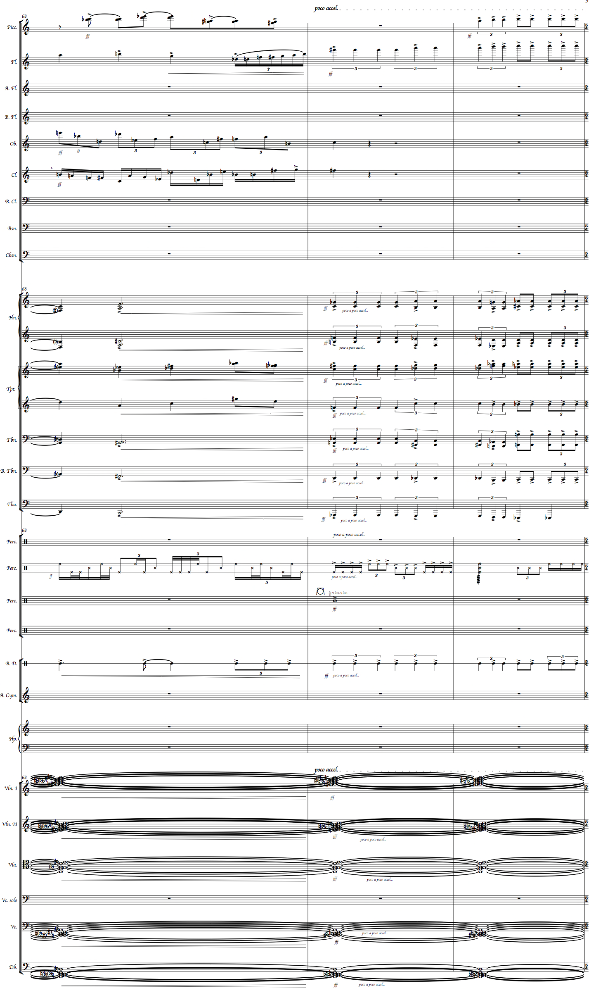
The second subsection of Section B, ms. 82-117, consists only of the string section playing different permutations of sound masses. As the section draws to a close, the strings dynamically meld into each other in gradual layers from the basses up to the first violins producing a wall of sound. The movement ends with an unaccompanied, gradual, layered ascent in the first violins to E7 sounding by a soloist. All sonic ascensions symbolize psychological progress towards wholeness, and this gesture will be heard again in the second and third movement. The string section ascent is a unifying gesture that is seen in the second and third movement, and the notes that ascend are those of the tritone, B-flat and E.
Within the first movement there are significant pitch and intervallic examples that substantiate the overarching pitch and implied harmonic design of the B-flat/E tritone interval. Closing the movement in the highest register of the violins compared to the opening pitch of a low B-flat in the contrabassoon strengthens the importance of timbre and register in the composition. The ending pitch of E7 prepares the listeners for the same beginning pitch in the second movement, the upper register pedal on E in the strings in the second part of the second movement, and the harmonic development in the tonal key center of E major at the end of the second movement.

Figure 3: Musical Example of Tone Row and Ending

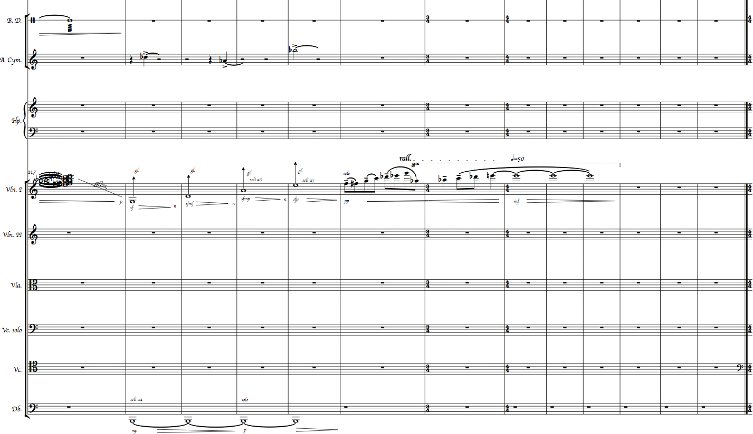
17

Chapter 4: Movement II

Table 4: Movement II Formal Design

 | Part I | Part II
Section | A B | C
Measures | 1-39 39-72 | 73-136

The second movement is comprised of two larger Parts, I and II. Part I is divided into two sections, A and B, and Part II is one large section, C. This movement is opposite of the first movement in that the texture is thinner, melody is present, and the harmonic language is varied and key centric in certain sections. The B-flat/E tritone pitch interval and the minor second melodic interval are further explored in this movement, as well as low woodwind resonance. The alto and bass flute are featured in this movement as the sparse texture exposes their deep, rich sonorities. The dynamics are primarily muted signaling the calm following the inner storm of the first movement, and the monophonic lines and thin texture allow for reflection through spatial constructs.
As an extension of the closing gesture of the first movement, silence opens the second movement and is interrupted by the bass drum. Section A, ms. 1-39, contain fragmented, monophonic lines in the lower woodwinds, percussion, and string sections. When harmonic material is present the tonality is free, meaning that there is no tonal center. The harmonic language includes diminished seventh chords, augmented fifth triads, major seventh chords with a raised fifth, and major chords. The augmented fifth triads represent a feeling of instability that supports the external narrative. Reflecting back to the first movement, sound masses are briefly heard in the violas as they lead into a climactic interjection in ms. 35-38.
Figure 4: Introductory Measures of Movement II
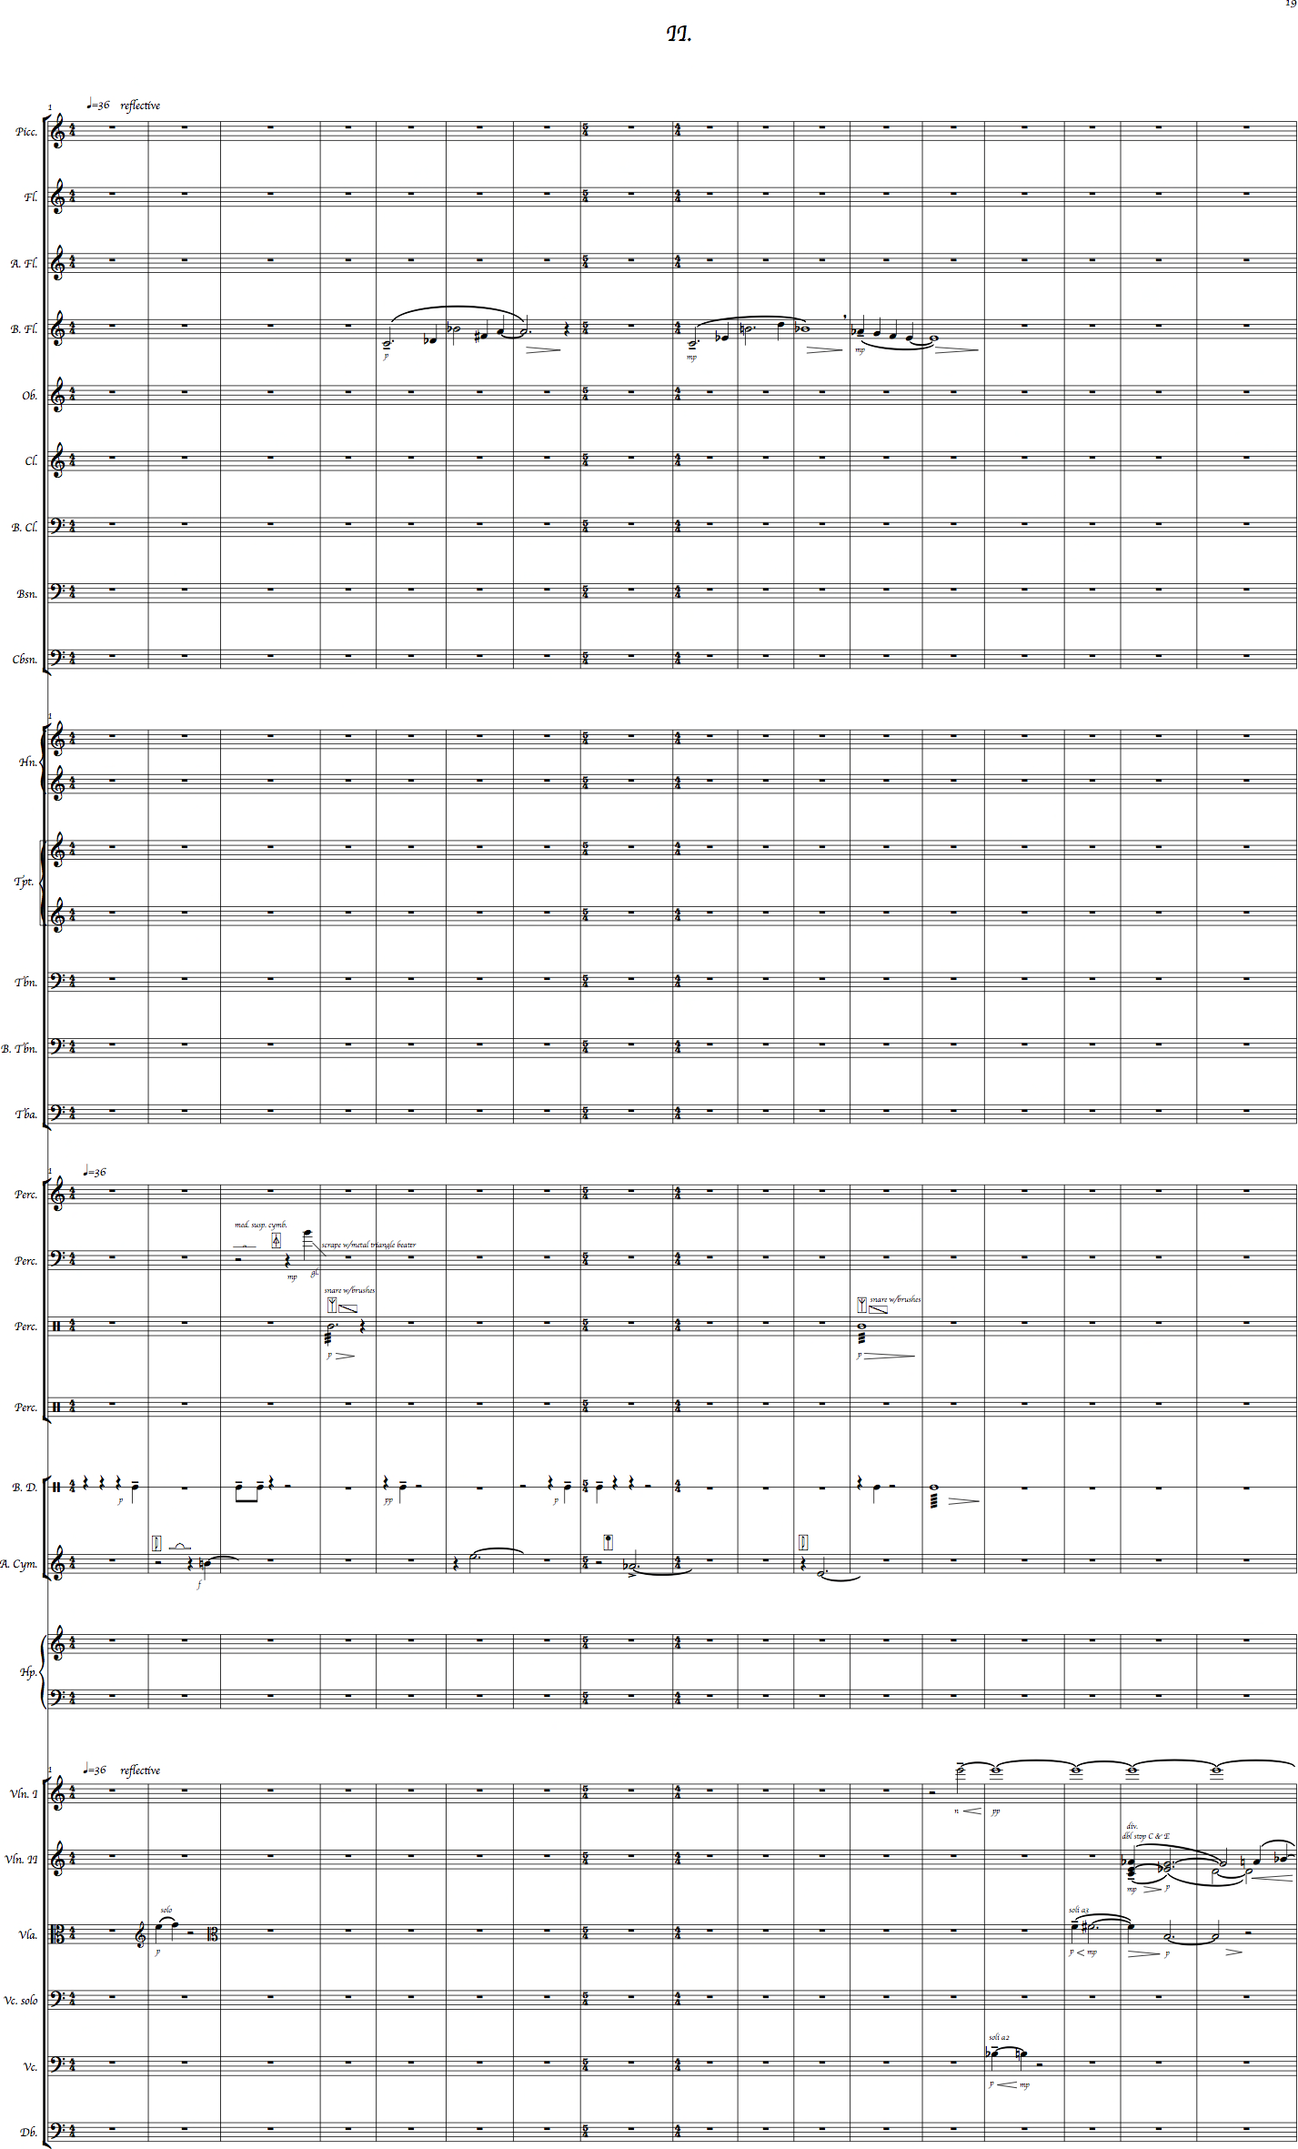
Section B spans ms. 39-72, and the strings are again the primary family heard. In ms. 39-58 the strings sound by themselves in a homophonic texture with the violas singing the melody above tonal extended harmonies centered on G major seventh chords with minor thirds. In ms. 58-67, the alto flute doubles the first violins as they sound the melody, and the horns add weight and color to the harmony.
Part II, Section C, begins immediately in m. 73 with an introductory lament in the strings with the melodic line doubled by the bass flute. Tonality leans toward an E centricity that eventually unfolds in the awakening section. Chromatic mediants are heard in the introductory and closing portions of this section representing the Trinity. The harmonic language is aligned with that of Section A in its diversity. Supporting the spatial construct, klangfarbenmelodie is utilized in ms. 88-119 to represent the birthing of divergent conscious states, which will peak in the awakening theme in ms. 120-130. The klangfarbenmelodie also foreshadows its usage in the exposition of the twelve-note tone row of the third movement. The solo cello, which speaks for the first time in ms. 105-111, references the B-flat/B and F-sharp/F minor second melodic interval from the first movement. The basses lead the string section from a niento into a second gradual, layered ascent back up to E6 in the first violins that leads into the first awakening.
The awakening theme, ms. 120-130, was written for a loved one, yet, also represents a shift in the consciousness of the composer. The theme is E centric, but like the introductory material in ms. 73-84, there are chromatic mediants present as well as lush extended harmonies of seventh and ninth chords. Closing material sounds in ms. 131-136, and the second movement comes to a close in the same measure that the third movement begins, m. 136.
The harmonic shift between the second and third movements in ms. 135-136 from a first inversion E major chord to root position A minor chord by the whole step motion of a major second melodic interval in the violas. This motion deemphasizes the importance of the minor second melodic interval throughout the remainder of the composition. Prior to two other pivotal moments, the major second melodic pitch interval is used instead of the minor second. This subtle shift in the intervallic language illustrates a psychological shift within the external narrative.

Figure 5: Measures 128-138, Transition from Movement II to Movement III

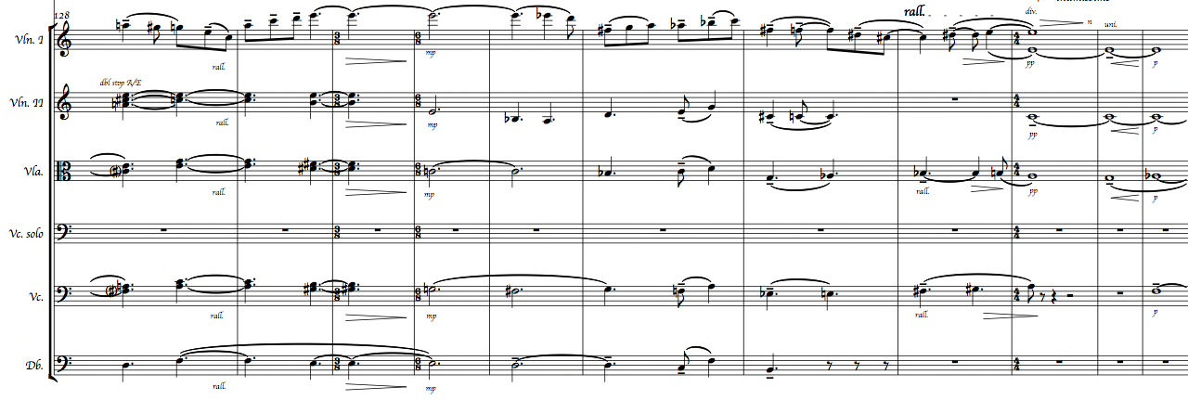

Chapter 5: Movement III

Table 5: Movement III Formal Design

Part I
Section | A¹ B¹ C B² A² D¹
Subsection | 1 2 1 2
Measures | 136 178 198 259 272 326 374 387
Part II
Section | E D²
Measures | 395 428

Movement III is also divided into two Parts, I and II. Part I is in arch form plus a transition that acts as a coda, ABCBAD¹. Section D¹, the coda, is developed into the final thematic material, D², in Part II. Part II consists of two sections, Sections E and D².
The unifying components of the arch form continue to follow that of the external narrative. Sections A¹ and A² are related as they memorialize the composer’s dear mentor, Dr. Helen S. Walker-Hill. An elegy for Dr. Walker-Hill begins the third movement, and the eight measure introductory quote from the third movement of Brahms’s Piano Concerto No. 2 in B-flat Major Op. 83 sounds in A². Dr. Walker-Hill was an exceptionally sensitive pianist who loved this work. She dreamed about the piece before she transitioned, so it seemed appropriate to honor both she and Brahms with this reference. Sections B¹ and B² are linked by klangfarbenmelodie, the twelve-note tone row, and a sonic representation of the composer’s conscious choice to psychologically surrender. Inclusive of B² are eight measures of the chorus to the hymn, “I Surrender All” by Van DeVenter and Weeden. Section C is the summit because it contains the “death of ego” dirge.
The formal design of Part II consists of Sections E and D². Section E is the composer imploring for stronger faith through the brass playing Palmer and Mason’s hymn, “My Faith Looks Up to Thee,” and a personal inquiry made by the cello and the oboe, which symbolizes the higher self. Section D² contains the supreme theme of “Love” and this section has a micro level ternary form of ABA.
Expansive as a result of the external narrative, the final movement uses spatial and lyrical melodic material, and there are triadic, extended, chromatic, quartal, quintal, tone cluster, and sound mass harmonies employed. Tonality is functional and free, additional klangfarbenmelodie is present, and a twelve-note tone row and its matrix are present. Sound masses from the first movement are restated, and from the second movement come the structural components of space and silence.
Section A¹ is divided into two subsections that are joined by transitional material. As mentioned earlier, because the second and third movements share m. 136, the measure numbers are continuous. The third movement opens with a string section elegy for Dr. Walker-Hill that spans ms. 136-168. The harmonic language of the elegy is A minor centric, but the tonality is free. Section A¹ closes on an A pedal held in the basses that foreshadows the drone in Section C.
The second subsection of Section A¹ encompasses ms. 178-197, and is a recapitulation of the sound masses of the first movement with a short transition. All instrumental families speak during this restatement of sound mass material in ms. 178-190. Significant here is that the notational choices for the minor second melodic interval clusters are derived from words associated with ego-based living, for example, ‘greed’, spelled G/E/E-flat/D. This concept introduces the forthcoming concept of the twelve-note tone row as it is also based on words. There is an eight-measure transition into Section B.
Section B¹ is comprised of two subsections and encompasses ms. 198-271. Subsection one consists of the twelve-note tone row, its matrix, and subsection two contains the death “rally” and transition in Section C. The tone row is drawn from the words ‘accept’, ‘forgive’, ‘grow’, and ‘heal’: A/C/C-sharp/E/F/G/E-flat/F-sharp/B/A-flat/D/B-flat. Only letters that are congruent with the twelve-note chromatic scale are used in the row. In German, the letter S is E-flat and H is B natural, but otherwise there are no other alphabetical substitutions. The A/C/C-sharp/E emerges from the word ‘accept’. The first time a letter that correlates with a musical note is used, it is in as a natural. For example, the first C in the word ‘accept’ is used as a C natural, but the second C in the word is raised a half step to C-sharp. The composer uses raised or lowered notes that are most common in music notation; thus, in regards to the second C in the word ‘accept’, it is most musically common to raise the C to C-sharp instead of lowering the pitch to C-flat. However, if C-sharp/D-flat had already been used and C-flat/B natural had not, then the composer would have lowered the C to C-flat. But, in this set of words there is a B, so the C was raised. The F/G/E-flat were derived from the word ‘forgive’. Because the first E was a natural, the second E was lowered a half step to E-flat. F-sharp is enharmonically used instead of G-flat for the only letter available in the word ‘grow’. In the word ‘heal’, B/A-flat are used. The A is lowered a half step because its natural has already been used and A-flat is more commonly used than A-sharp. The letter E could be used as E-sharp, but its enharmonic of F natural has already been used as well. The choice to use the D and B-flat in the order chosen was related to the composer wanting to hear the A-flat/D tritone, and wanting to end the work in the tonality of B-flat. The final section, being centered on B-flat, balances the overarching pitch material and implied harmony of the B-flat/E tritone throughout the composition. The choice to use B-flat as the final pitch in the tone row also correlated with the Brahms quote and the tonal keys of the two hymns, B-flat and E-flat, respectively.

Figure 6: Twelve-note Tone Row, "Acceptance" Row

In working towards acceptance, the four-note row, A/C/C-sharp/E, is timbrally explored as klangfarbenmelodie. Following a transition, each note of the twelve-tone row matrix is employed through the respective rows: original, inversion, retrograde, and retrograde inversion. The original tone row, also referred to as the ‘acceptance’ row, is P-0. The musical representation of the composer eradicating her ego is the klangfarbenmelodie sounding from the farthest region of the matrix, RI-11, one row at a time until it reaches row P-3 in ms. 225-258.

Table 6: Twelve-note Tone Row Matrix

P-0 | A | C | C# | E | F | G | Eb | F# | B | Ab | D | Bb
P-9 | F# | A | Bb | C# | D | E | C | Eb | Ab | F | B | G
P-8 | F | Ab | A | C | C# | Eb | B | D | G | E | Bb | F#
P-5 | D | F | F# | A | Bb | C | Ab | B | E | C# | G | Eb
P-4 | C# | E | F | Ab | A | B | G | Bb | Eb | C | F# | D
P-2 | B | D | Eb | F# | G | A | F | Ab | C# | Bb | E | C
P-6 | Eb | F# | G | Bb | B | C# | A | C | F | D | Ab | E
P-3 | C | Eb | E | G | Ab | Bb | F# | A | D | B | F | C#
P-10 | G | Bb | B | D | Eb | F | C# | E | A | F# | C | Ab
P-1 | Bb | C# | D | F | F# | Ab | E | G | C | A | Eb | B
P-7 | E | G | Ab | B | C | D | Bb | C# | F# | Eb | A | F
P-11 | Ab | BB | C | Eb | E | F# | D | F | Bb | G | C# | A

Before leaving this realm of existence, some may experience what is called a ‘rally’ or a surge of energy before the physical departure. Subsection two spans ms. 259-270, and it is here that the composer notates a ‘rally’ of her ego before its death in Section C. The ‘rally’ begins on row RI-2 in the basses, and as the ego gains momentum, so does the instrumentation. Measures 264-266 are the apex of the ‘rally’, and by the second half of m. 266 the rhythm is becoming simpler, and the ensemble is beginning a decrescendo. The instrumentation diminishes, and the ‘rally’ closes with the bass clarinet fading first in m. 269, and the bassoon fading last on its lowest B-flat in m. 270.
The pitch material for the ‘rally’ subsequent to RI-2 is as follows: R-2, I-2, O-2, RI-5, R-5 (four notes), RI-4 (four notes), RI-1 (two notes), and the two remaining pitches are notated as F-sharp and B-flat. The high point during the ‘rally’ is RI-5 and R-5. Wanting to musically show a burst of energy, the rally starts at RI-2 and moves up the matrix to RI-5 to demonstrate this increase in ego energy. However, as energy wanes, the row descends closer to the original ‘acceptance’ row of P-0. By the bassoon closing the ‘rally’, the lighter timbre sounds a weaker ego from that of the first movement where the contrabassoon sounded. Section B¹ closes in ms. 270-272 as Section C, the “death of ego,” begins in m. 272.
Section C, the actual “death of ego” dirge, sounds in ms. 272-327, and is sonically defined by the D drone in the basses. Within Section C the solo cello speaks, but the material is considered all one large section as it speaks over the drone. The dirge is of mixed meter and once again contorts time. The structural connection of space and the sparse texture recall the contemplation and reflection of the second movement. The harmonic language contains triadic, quartal, and quintal harmonies that utilize parallelism at certain points to emphasize the minor second melodic interval.

Figure 7: Transition into “Death of ego” Dirge in Strings

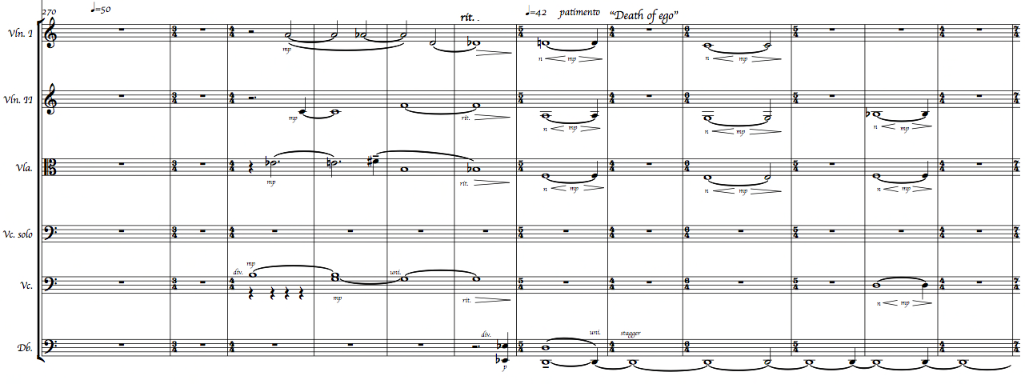

Section B² encompasses ms. 326-373, and opens with the bass flute playing
I-1 while the marimba plays harmonic accompaniment of tone clusters of the row. The composer chose not to play row O-2 as it sounds too much like the original ‘acceptance’ row being only a half step above in pitch. The ‘acceptance’ row is finally heard in its first statement in the solo bassoon in ms. 331-339. The solo cello comes in on the last B-flat of the tone row, in m. 339, and descends a minor second to the beginning pitch of the row, A, and repeats the tone row through m. 347. A third restatement by a full orchestral tutti plays the ‘acceptance’ row in ms. 349-357. The harmonic language of the row is: A minor, A major, A augmented fifth, A dominant seventh, A major flatted fifth, A major sixth with the flatted fifth, B major, A-flat dominant seventh, D minor, and B-flat major.

Table 7: Tone Row Pitch and Harmonic Design

Pitch | A-C-C#-E-F-G-Eb-F# | B | Ab | D | Bb
Harmony | A Centric | B Major | Ab Dom 7 | D Minor | Bb Major
External Narrative Association | Part I, A¹ Elegy (Am) |  |  | “Death of ego”  Dirge | “Love”  Theme

Prior to the tutti, the third usage of the major second melodic interval is used. Acceptance, being synonymous with surrender, is defined by some people as a form of death. In conjunction with the external narrative, the solo cello plays the eight-measure chorus of the hymn, “I Surrender All,” by Van DeVenter and Weeden, in ms. 358-365.
The closing material in B², ms. 366-373, is played by all strings except the bass, and contains tone rows I-1 and R-1. The return of material from the tone row matrix shows the inability to psychologically stay in a state of acceptance and surrender. This is represented by harmonies constructed from the two rows altered polyphonically in the upper strings. This material ends on, and begins to establish, B-flat as the tonal center for
the remainder of the composition.
Section A², ms. 374-386, is succinct and begins with the first eight measures of the third movement from Brahms’s Piano Concerto No. 2 in Bb Major Op. 83. The instrumentation of both the quote and the following material in this section sounds in the string family. The solo cello in the concerto is analogous to the solo cello in this composition by way of the external narrative. The final five measures of this terse section, ms. 382-386, are reflective and the harmonic language marries the chords from the ‘acceptance’ tone row to that of the “Love” theme in Part II, Section D².
Transitional material begins Section D¹ in ms. 387-394. The strings sound without the basses as they oscillate between B-flat major ninth and B-flat minor ninth in their upper registers with the upper divisi first violins and flute I playing the melody. This pendular motion between the major and minor modes of B-flat is a harmonic expansion of the major and minor second intervals heard throughout the piece. The first horn, accompanied by the cellos and violas, plays the ‘acceptance’ tone row over the final “Love” theme harmony for the first time. The “Love” theme harmony consists of: B-flat major seventh, B-flat minor seventh, E-flat minor in second inversion, and G-flat enharmonically spelled as F-sharp major ninth in first inversion. The marrying of the acceptance tone row with the “Love” theme harmony demonstrates a psychological movement toward unconditional love in the external narrative. But, there are shadows, dark thoughts, which trigger a lack of faith.
Part II begins with the query for deepened faith in Section E. Beginning with a single transitional measure, m. 395, the second hymn, “My Faith Looks Up to Thee,” by Palmer and Mason, is played by a brass chorale in ms. 396-409. As the brass fade the oboe doubles the solo cello two octaves above and they are accompanied by the woodwinds sounding the harmonic language of the “Love” theme. Measures 412-428 constitute the transition into Section D². Significant here is that the solo cello speaks for the first time over the harmonic design of the “Love” theme.
Section D² only contains the “Love” theme material in ABA form. The introductory and closing material, A¹ and A², are sound effects played by the percussion. Section B is a micro arch form as it consists of an introduction, main thematic material, and closing material. As the transition from Section E is ending in m. 428, the wind machine begins. Whereas in the first movement the wind represented a destructive force of nature, here, in ms. 428-440, the wind represents the Holy Spirit breathing renewed life into the composer. The annunciation of change is symbolized by the ringing of the tubular bells three times on the pitch of B-flat. The last two measures include birdcalls symbolizing freedom and inner transformation, and the basses begin a drone on B-flat to prepare for the main theme. As the final measure ends, the solo cello returns stating the “Love” theme first with lower woodwinds.
Section B, the absolute zenith of the entire composition, begins with a four-measure introduction of the main theme by the solo cello accompanied by the bassoon and bass clarinet in ms. 440-444. The main theme is heard a second time with the brass, strings, and bass drum in ms. 444-448. The basses become more rhythmic and sound an ostinato eighth note pattern on B-flat that gives the section more momentum as it moves towards the final tutti sounding of the theme. The woodwinds join the ensemble to make a third and final declaration in ms. 448-455. There is no countermelody to distract from the main theme, and there is no development of this “Love” theme. The logic behind both is that a basic statement of the thematic material only represents an inceptive psychological shift.

Figure 8: "Love" Theme (piano reduction and solo cello)

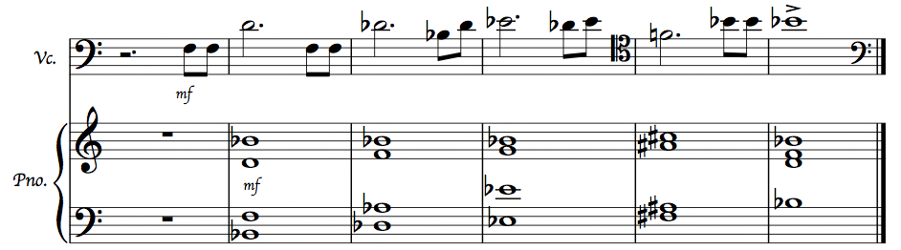

In the closing material of ms. 456-466, recalling Brahms, the upper strings accompany the solo cello and oboe as they play contrapuntal material. The harmonic design for this closing section is the “Love” theme in ascending inversions. The strings decrescendo as if to end the piece in m. 467, but then gradually crescendo into one final thematic statement. The lower strings fade as the first violins sound an upper register pedal on B-flat7 that requires three measures to dissipate. The wind machine returns from m. 472 to the end, m. 478, and as the ancient cymbals sound a B-flat on the third beat in m. 472 and the strings fade. Coming full circle, the composition ends as it began, and the wind vanishes into the silence of eternity from which it mysteriously came.

Chapter 6: Conclusion

This work was an attempt to create a coherent, expressive work over a sustained period of time. Pitch and textural attributes appear in new timbres and variations throughout the piece to achieve this effect. In quoting Brahms my intent was to give homage to my mentor, Dr. Helen S. Walker-Hill, for whom it was chosen, and Brahms himself. The document explains how the work is interrelated musically, as well as extra musically. It is my most sincere hope that listeners of Resurrection will not only experience musical coherence within the work, but also will be internally stirred and drawn into the piece so that they might experience an inner personal journey. I also hope that this work, along with that of other fellow Black Women Composers, will one day be incorporated into the orchestral literature of early twenty-first century music.

Bibliography

Alvarez, Ginger. The Hospice Walk. USA: Ginger Alvarez, 2003.

Ashby, Muata. Kemetic Diet. Miami: Cruzian Mystic Books, 2002.

Benjamin, Thomas, Michael Horvit, and Robert Nelson. Techniques and Materials of Tonal Music. Belmont, CA: Wadsworth Publishing Company, 1992.

Bowman, Wayne D. Philosophical Perspectives on Music. Oxford: Oxford University Press, 1998.

Carpenter, Alexander. “Schoenberg’s Vienna, Freud’s Vienna: Re-Examining the Connections between the Monodrama Erwartung and the Early History Psychoanalysis,” The Musical Quarterly 93 no.1 (March, 2010).

Dallin, Leon. Techniques of Twentieth Century Composition. 3rd ed. Dubuque, IA: Wm. C. Brown Company Publishers, 1974.

Ettinger, Brach L. 3 X Abstraction. Edited by Catherine de Zegher and Hendel TeicherNY: The Drawing Center, 2005.

Gardner, Kay. Sounding the Inner Landscape: Music as Medicine. Rockport, ME: Element Books, Inc., 1990.

Goldsmith, Joel S. Practicing the Presence. San Francisco: HarperCollins Publishers, 1958.

Hahl-Koch, Jelena A. Arnold Schönberg-Wassily Kandinsky: Letters, Pictures, and Documents. Translated by John C. Crawford. London: Faber and Faber, 1984.

Harley, James. Xenakis: His Life in Music. New York: Routledge, 2004.

Kandinsky, Wassily. Concerning the Spiritual in Art. Translated by W. T. H. Sadler. New York: Dover, 1977.

Khan, Hazrat Inayat. The Mysticism of Sound and Music. Boston: Shambhala Publications, Inc., 1991.

Kostka, Stefan and Dorothy Payne. Tonal Harmony: An Introduction of Twentieth-Century Music. 4th ed. Boston: McGraw-Hill Companies, Inc., 2000.

Morrison, Lesley. The Healing Wisdom of Birds. Woodbury, MN: Llewellyn Publications, 2011.

Schwinger, Wolfram. Krzysztof Penderecki: His Life and Works. (London: Schott & Co. Ltd., 1989.

Tilghman, Joshua. “The Spirit of the Scripture.com.” Joshua Tilghman. http://www.spiritofthescripture.com/id1901-the-baptism-of-the-holy-spirit.html (accessed 1.7.14).

Tolle, Ekhart. The Power of Now. Novato, CA: New World Library, 1999.

Visser, Rick. “Kandinsky and the Spiritual Task of the Artist Today.” Alastair McIntosh. http://www.alastairmcintosh.com/kandinsky/Rick-Visser-Kandinsky-in-Govan-Keynote.pdf (accessed 1.3.14).

Music

Palmer, Ray (words) and Lowell Mason (music). “My Faith Looks Up to Thee.” Nashville: The African Methodist Episcopal Church, 1830.

Penderecki, Krzysztof. Threnody for the Victims of Hiroshima. Van Nuys, CA: Alfred Music, 1985.

Van DeVenter, Judson W. (words) and Winfield S. Weeden (music). ”I Surrender All.” Nashville: The African Methodist Episcopal Church, 1896.

Xenakis, Iannis. Metastaseis. London: Boosey & Hawkes, 1954.

Appendix 1: Instrumentation

Piccolo
2 C Flutes
Alto Flute in G
Bass Flute
2 Oboes
2 Clarinets in A
Bass Clarinet
Bassoon
Contrabassoon

4 Horns in F
3 Trumpets in C
2 Tenor Trombones
Bass Trombone
Tuba

Harp

Percussion 1 (Wind Machine, Marimba, Vibraphone)
Percussion 2 (Thundersheet, Suspended Cymbals (small, medium, large) Tubular Bells)
Percussion 3 (Cowbell, Snare Drum, Triangle, Tam-tam (large), Hanging Nipple Gongs, Maracas, Bird Whistles (2), Large Rainsticks (2))
Percussion 4 (Chimes (metal and bamboo), Siren, Tom-toms (12 in. – 16 in.), Sandblocks, Crash Cymbal, Woodblocks (small, medium, large), Orchestra Bells, Timpani)
Percussion 5 (Bass Drum)
Percussion 6 (Ancient Cymbals)

Strings 12/12/12/8/8

Alexander Carpenter, “Schoenberg’s Vienna, Freud’s Vienna: Re-Examining the Connections between the Monodrama Erwartung and the Early History Psychoanalysis,” The Musical Quarterly 93 no.1 (March, 2010): 150.
Eckhart Tolle, The Power of Now (Novato, CA: New World Library, 1999), 18.
3 X Abstraction, eds. Catherine de Zegher and Hendel Teicher (New York: The Drawing Center, 2005), 37.
Ibid., 37.
Ibid., 35.
Ibid., 37.
Rick Visser, “Kandinsky and the Spiritual Task of the Artist Today,” Alastair McIntosh, http://www.alastairmcintosh.com/kandinsky/Rick-Visser-Kandinsky-in-Govan-Keynote.pdf (accessed on January 3, 2014).
Jelena A Hahl-Koch, Arnold Schönberg-Wassily Kandinsky: Letters, Pictures, and Documents trans. John C. Crawford (London: Faber and Faber, 1984), 144-145.
Wassily Kandinsky, Concerning the Spiritual in Art trans. W. T. H. Sadler (New York: Dover, 1977), 35.
de Zegher and Teicher, 3 X Abstraction, 37.
Joel S. Goldsmith, Practicing the Presence (San Francisco, CA: HarperCollins Publishers, 1958), 100.
Rick Visser, “Kandinsky and the Spiritual Task of the Artist Today” (accessed January 3, 2014).
Ibid., (accessed December 30, 2013).
Bracha L. Ettinger, 3 X Abstraction, eds. Catherine de Zegher and Hendel Teicher (New York: The Drawing Center, 2005), 206-208.
Ibid., 200.
Ibid., 208.
Wayne D. Bowman, Philosophical Perspectives in Music (Oxford: Oxford University Press, 1998), 104.
Ibid., 104.
Ibid., 103.
Ettinger, 3 X Abstraction, 215, 221.
Webster’s Third New International Dictionary, 13th ed., s.v. “Pray.”
Stefan Kostka and Dorothy Payne, Tonal Harmony: An Introduction of Twentieth-Century Music, 4th ed. (Boston: McGraw-Hill Companies, Inc., 2000), 459.
Bowman, Philosophical Perspectives, 104.
Hazrat Inayat Khan, The Mysticism of Sound and Music (Boston: Shambhala Publications, Inc., 1991), 133-134.
Kay Gardner, Sounding the Inner Landscape: Music as Medicine (Rockport, ME: Element Books Limited, 1990), 76.
Khan, The Mysticism of Sound and Music, 106.
Leon Dallin, Techniques of Twentieth-Century Composition, 3rd ed. (Dubuque, IA: W. C. Brown Company Publishers, 1974), 95.
Thomas Benjamin, Michael Horvit, and Robert Nelson, Techniques and Materials of Tonal Music (Belmont, CA: Wadsworth Publishing Company, 1992), 9.
Ginger Alvares, The Hospice Walk, 2nd ed. (USA: Ginger Alvarez), 59.
Tolle, The Power of Now, 185-187.
Joshua Tilghman, “The Spirit of the Scripture.com,” Joshua Tilghman, http://www.spiritofthescripture.com/id1901-the-baptism-of-the-holy-spirit.html (accessed January 17, 2014).
Leslie Morrison, The Healing Wisdom of Birds (Woodbury, MN: Llewellyn Publishing, 2011), 38.

