UNIVERSITY OF OKLAHOMA

GRADUATE COLLEGE

INVESTIGATING THE RELATIONSHIP BETWEEN AEROSOL PROPERTIES AND

SEVERE WEATHER PARAMETERS

A THESIS

SUBMITTED TO THE GRADUATE FACULTY

in partial fulfillment of the requirements for the

Degree of

MASTER OF SCIENCE IN METEOROLOGY

By

Sean Spratley
Norman, Oklahoma
2022
INVESTIGATING THE RELATIONSHIP BETWEEN AEROSOL PROPERTIES AND SEVERE WEATHER PARAMETERS

A THESIS APPROVED FOR THE
SCHOOL OF METEOROLOGY

BY THE COMMITTEE CONSISTING OF

Dr. Jens Redemann, Chair

Dr. Marcela Loria-Salazar

Dr. Harold Brooks

© Copyright by Sean Spratley 2022
All Rights Reserved.

Table of Contents
Acknowledgements v
List of Tables vi
List of Figures vii
Abstract viii
1 Introduction 1
1.1 Severe Weather Background 1
1.2 Aerosol background 3
1.3 Previous Studies 3
1.4 Purpose of Research 7
2 Data/Methods 9
2.1.1 Severe Weather Balloon Soundings 9
2.1.2 Moderate Resolution Imaging Spectroradiometer on Aqua Satellite 10
2.2 How parameters were calculated 11
2.2.1 Severe Weather 11
2.2.2 Aerosol Optical Depth data 12
2.2.3 Data Colocation 12
3 Results 15
3.1 Year-Round Comparisons 16
3.2 Seasonal Comparisons 20
4 Discussion 26
4.1 Compare/Contrast Results of different parameters 26
4.1.1 Year-Round data 26
4.1.2 Warm-season data 27
4.1.3 Cool-season data 28
4.2 Scientific Implications of Results 29
5 Conclusion 34
References 37

Acknowledgements
First of all, I would like to thank my committee members for helping me throughout this experience. I would like to thank my advisor, Dr. Jens Redemann, for providing me with this opportunity and guiding me throughout it. I would like to thank Dr. Marcela Loria-Salazar for all the help with coding and knowledge about aerosols. I would like to thank Dr. Harold Brooks for giving me guidance on the severe weather aspect of this research.
Additionally, I would like to thank all my family and friends for supporting me throughout this. It has been difficult at times but your support has helped make things much more manageable.

List of Tables
1 Raw IQR values of severe weather parameters for clean vs polluted atmosphere using data from all year round 18
2 Raw IQR values of severe weather parameters for clean vs polluted atmosphere using warm season data 21
3 Raw IQR values of severe weather parameters for clean vs polluted atmosphere using cool season data 24
4 Comparisons of severe weather parameters for clean vs polluted atmosphere using data from all year round 25
5 Comparisons of severe weather parameters for clean vs polluted atmosphere using warm season data 26
6 Comparisons of severe weather parameters for clean vs polluted atmosphere using cool season data 27

List of Figures
1 Map of locations of all soundings used in this study 8
2 Distributions of different methods of AOD retrieval 12
3 Scatterplots of colocations of sounding data with AOD retrieval data 15
4 Histograms of severe weather parameter distributions for clean vs polluted atmosphere using data from all year round 16
5 Boxplots of severe weather parameters for clean vs polluted atmosphere using year-round data 17
6 Histograms of severe weather parameter distributions for clean vs polluted atmosphere using warm season data 19
7 Boxplots of severe weather parameters for clean vs polluted atmosphere using warm-season data 20
8 Histograms of severe weather parameter distributions for clean vs polluted atmosphere using cool season data 22
9 Boxplots of severe weather parameters for clean vs polluted atmosphere using cool-season data 23

Abstract
Severe Weather is a common, yet dangerous aspect of weather and climate in the central Great Plains region of the United States. Finding ways to improve the quality of forecasting this phenomenon is important for improving public safety and prepare for its economic impacts. Given that aerosols can have many microphysical impacts on clouds and precipitation and can also impact radiation in the atmosphere, there is potential for aerosols to affect severe weather events in this region. This study involved pairing measurements of certain commonly used severe weather parameters across various sites in this region with measurements of aerosol optical depth in the same locations. The goal was to determine whether there were any significant associations between aerosol optical depth and the severe weather parameters, and how these associations may have differed by season. It was also to determine whether retrievals of aerosol optical depth could be a useful tool for severe weather forecasting in this region.
Aerosol optical depth was found to have an association with each of the severe weather parameters tested. However, these associations did not show up when only looking at data during the warm season. Furthermore, although, there were associations when looking at cool-season data, some of them differed from the ones found in data from all year round. This experiment on its own would appear to be inconclusive in determining whether aerosol optical depth could be a useful forecasting tool for severe weather in the Great Plains region of the United States. However, it could pave the way for additional studies for other parts of the country or more specific aerosol measurements.

1 Introduction
Severe weather can pose a major problem in the United States, particularly in the Southern Great Plains Region. Between property damage and loss of life, the dangers posed are high. Therefore, accurate forecasting of severe weather is essential. Parameters such as Convective Available Potential Energy (CAPE) and wind shear can be very useful for such forecasting (Gilleland et al.). However, relying on these parameters alone can sometimes lead to significant forecasting errors. For example, on May 20th, 2019, the CAPE and shear in the Southern Great Plains (along with several other commonly used parameters) indicated that conditions were favorable for a potentially historic tornado outbreak in this area. However, the outbreak that occurred that day was fairly modest. Since multiple other studies have shown evidence that aerosols can influence severe weather outbreaks, it is important to understand whether they may have had an impact on the 2019 outbreak so they could be accounted for in future situations that appear favorable for high-end events. One way they could have an impact on an event like this would be causing the CAPE and or shear levels to be different than what was forecasted. Therefore, an important area of research is looking for statistical associations between aerosol parameters and severe weather parameters.

1.1 Severe Weather Background
A severe thunderstorm is defined by the National Weather Service (NWS) as a thunderstorm containing hail of at least one inch in diameter, winds of at least 58 miles per hour, or producing a tornado. Additionally, the NWS defines a significant severe thunderstorm as a thunderstorm containing hail of at least two inches in diameter, winds of at least 75 miles per hour, or producing a tornado that is at least EF-2 strength (Storm Prediction Center 2022). These severe thunderstorms are most likely to develop in areas containing high levels of Convective Available Potential Energy (CAPE) and deep-layer wind shear (bulk shear). Since some parts of United States, such as the Great Plains region, are disproportionately likely to have high values of both of these parameters, severe thunderstorms are a relatively common occurrence in this area.
CAPE is a measure of energy in the atmosphere that is available to a parcel for updraft development (Blanchard 1998). Higher values are generally considered to be more favorable for severe weather. It is determined by a combination of low-level moisture and instability throughout the troposphere. Higher low-level moisture causes a rising parcel of air to become saturated more quickly and therefore start cooling more slowly due to latent heat release. Higher instability (or a sharper decrease in temperature with height) allows a rising parcel of air to remain warmer than its surroundings.
Wind shear is defined as a change in speed and/or direction of wind with height (Markowski and Richardson 2006). In this experiment, bulk shear is determined by the difference between the speed and direction of the wind 6 kilometers above the surface and the speed and direction of the wind at the surface. Higher bulk shear values are favorable for severe weather, because having greater changes of speed and direction of wind between the surface and higher levels helps to keep storms tilted and separate the updrafts from the downdrafts, preventing the downdrafts from smothering the updrafts. It also can cause storms to develop rotation, an important feature for severe hail and tornado development (Weisman and Rotunno 2000).
Severe thunderstorms can have an enormous impact on our way of life in the United States. They cause an average of over 5 billion dollars of damage and almost 100 fatalities every year, and some years (or even some individual events) can have losses much higher than that (Gensini and Brooks 2018; Baggett et al. 2018). In order to minimize and prepare for these losses, people rely on forecasting of these severe thunderstorms. Given the impacts that parameters such as CAPE and bulk shear can have on favorability for these storms, many such forecasts will take these parameters into account. However, one complicating factor for forecasters is how these parameters may be affected by aerosols.

1.2 Aerosol background
An aerosol consists of a collection of liquid or solid particles suspended within a gas (Ghan et al. 1993). Aerosols can have many effects on human health, and they can also affect the weather and climate. The size, shape, chemical composition, and type of the aerosol can greatly influence what its effects are. For example, an aerosol with a high single scattering albedo (light-colored) will reflect mostly sunlight away, which could result in cooler-than expected temperatures, while an aerosol with a low single scattering albedo (dark-colored) could have the reverse effect. Also, a naturally occurring aerosol such as dust could have differing effects from an anthropogenic one. The differences and complexities of these effects can make it difficult to account for them in weather forecasting.
Aerosol optical depth is a measurement of the scattering of visible light in the atmosphere, which determines the total amount of aerosol material contained within a vertical column of the atmosphere (Kiehl and Briegleb 1993; Center for Satellite Applications and Research 2022). This measurement does not account for all of the specific characteristics of different aerosols nor does it specify what heights of the atmosphere contain more or less aerosols. However, it can be useful for determining overall aerosol abundance and, when combined with surface aerosol measurements, whether there are aerosols just near the surface or at higher altitudes as well.

1.3 Previous Studies
Previous research on the impacts of aerosols on severe weather events has sometimes produced contradictory findings. For example, Fan et al. (2009) found that the strength of convective cells that developed in the presence of strong vertical wind shear was reduced as the concentration of aerosols increased. This would suggest that the presence of aerosols in an area would reduce the likelihood of severe weather in that same area, since strong vertical wind shear is an important ingredient for the development of severe thunderstorms. Additionally, Toll and Männik (2015) found that wildfire smoke present in an area with severe thunderstorms reduced the amount of solar radiation reaching the ground. This led to reduced instability and slightly weaker convection and storm dynamics.
However, Wang et al. (2009) found that the presence of smoke aerosols in regions of convective development enhanced hail and lightning activity by increasing the number and decreasing the size of cloud droplets, which reduced the warm rain process and increased the ice crystal process. This suggested an increase in the strength of the convective cells. This raises the possibility that an increase in concentration of these aerosols could lead to an increase in severe weather activity.
In some cases, different studies have shown aerosols having similar effects but for different reasons. Abbott and Cronin (2021) found that aerosols tended to increase thunderstorm intensity in the tropics. As was the case in Wang et al. (2009), it found that aerosols led to more, smaller cloud droplets reducing warm rain. However, this study showed that rather than being caused by an increase in ice crystals, the increase in thunderstorm intensity was due to lack of warm rain leading to an increase in relative humidity, which reduced the effect of entrainment and increased updraft strength.
Some studies have found that different types of aerosols could have differing effects on convection. Jiang et al. (2018), for example, found that smoke tends to enhance convective activity while human-generated aerosols tend to weaken it. Meanwhile, the impact of dust was more variable depending on region. This would imply that certain characteristics of the aerosols, such as size and albedo, have an influence on the overall effects.
Another area of interest has been whether different size distributions of aerosols could alter the effects they have on convection. Van den Heever and Cotton (2007) found that aerosol areas containing giant cloud condensation nuclei tended to cause storms to develop stronger updrafts earlier but also not last as long due to downdrafts smothering them more quickly. The reverse was true for aerosol areas not containing giant cloud condensation nuclei, as their storm updrafts took longer to develop but also lasted for longer periods of time. This would suggest that different size distributions of aerosols could have differing effects on the evolution of convection. This study also noted that in areas of increased aerosol concentrations caused by urban effects, storm development was affected mostly by factors other than the aerosol concentrations themselves (van den Heever and Cotton 2007). The effects of aerosols began to take place after the storms had already developed. This would indicate that aerosols may effect how storms evolve and how severe they become, but they may have little effect on whether they develop in the first place.
Other studies that looked more specifically at aerosol impacts on storm dynamics have shown more definitive results. For example, Saide et al. (2015) found that smoke aerosols from wildfires in Central America increased the severity of the April 27, 2011 tornado outbreak. This appeared to be due to the smoke geometrically thickening low-level clouds already present, which caused them and the storm clouds which subsequently developed to have lower bases. It was also due to the aerosols absorbing radiation just above the surface and causing a temperature inversion. This caused the winds at the surface to decrease, leading to an increase in low-level wind shear. Another study analyzed this outbreak along with several others. In doing so, they found that the smoke-driven aerosols only have these effects if the smoke is at low levels (Saide et al. 2016). Additionally, Rosenfeld and Bell (2011) found that there was a weekly cycle in the concentrations of aerosols and a similar weekly cycle in the number of hail and tornado events. However, this was only present during the summer (not spring) and only applied to the eastern half of the US. On top of that, another study found that these findings had many flaws and could not be effectively backed up (Yuter et al. 2013). Furthermore, Lerach and Cotton (2018) found in conditions already favorable for severe weather and supercells, dust from the desert southwest led to fewer supercells developing but also having stronger mesocyclones.
Storer et al. (2010) further found that increasing the concentrations of aerosols in storm-friendly environments tended to result in a larger number of cloud droplets that were smaller in size in the storms that developed. This also led to clouds having larger ice crystals. These two factors combined resulted in less precipitation that was composed of larger droplets, resulting in less evaporative cooling than what occurred in clean environments. This would favor an increase in tornado frequency and severity, as evaporative cooling tends to weaken the updrafts in storms and reduce tornado favorability (Lerach et al. 2008).
Additional studies have found that aerosols can affect convection in ways that are quite complex. Carrió and Cotton (2011) found that there was a concentration of aerosols at which convective cells would be the most efficient at producing precipitation. In other words, precipitation efficiency would be reduced if the aerosol concentration was higher or lower than this precipitation-favorable level. This same study also found that this level of greatest precipitation efficiency increases as instability increases. Therefore, higher aerosol levels would be more favorable for heavy precipitation rates in a more unstable environment. However, these heavier precipitation rates could tend to weaken the storms’ updrafts, which could reduce the potential for hail and tornadoes. Since higher instability is more favorable for severe weather, this would indicate that higher aerosol loadings could reduce the potential for tornadoes in convection already occurring.
Looking at hail specifically, Loftus and Cotton (2014) showed that an increase in cloud condensation nuclei (CCN) would lead to an increase in hail sizes. This was due to the greater CCN concentrations leading to larger numbers of smaller cloud droplets, which in turn led to fewer but smaller raindrops which led to larger hailstones. This would suggest that an increase in aerosol concentrations would lead to an increase in severe hail cases.
However, the data on how aerosols might affect hail is also not very conclusive. Heikenfeld et al. (2019) showed that convection associated with a high concentration of aerosols led to higher freezing levels within the clouds. It also showed that in the areas where freezing processes did occur, there were more numerous small ice crystals and fewer hailstones when aerosol concentrations were high. These would both indicate that a higher aerosol concentration would lead to a decrease in hail size.

1.4 Purpose of Research
All studies mentioned above were at least partially based on data taken from model output. So far, very little research has been done on how aerosols might affect severe weather using observational data. Since models cannot account for all the aspects and changes of the atmosphere, using them will not give a fully realistic answer to how aerosols affect severe weather. Therefore, there is a need to use observational data to investigate these effects. Specifically, we plan to address the following questions.
Were there any significant associations between AOD and Convective Available Potential Energy, bulk shear, Severe Weather Parameter, and Significant Severe Weather Parameter between 25 and 45 degrees North and 90 and 105 degrees West (the Central Plains Region of the US) during the 2015-2019 timeframe?
Could knowing the level of AOD in the Central Plains Region be a useful tool for forecasting severe weather in this region?

2 Data/Methods

2.1.1 Severe Weather Balloon Soundings
Figure 1: Map containing locations of all sounding sites used in this study experiment

The severe weather data in this experiment involved data taken from balloon soundings (University of Wyoming 2022). These soundings are based on balloons carrying sensors that gather data about temperature, dew point, wind speed, wind direction, pressure, and a few others at various levels of the atmosphere. These balloons do not have a fixed vertical resolution but will take readings every 50-300 meters or so.
These soundings are usually launched at 00Z and 12Z at around 65 sites across the United States. However, special soundings at other times of day can also be launched if there is an increased interest in the weather (such as a risk of a severe weather outbreak). For this experiment, sounding data from all 19 sites between 25-45 degrees North and 90-105 degrees West during the 2015-2019 timeframe was used as shown in Figure 1.

2.1.2 Moderate Resolution Imaging Spectroradiometer on Aqua Satellite
The aerosol optical depth (AOD) data in this experiment came from the Moderate Resolution Imaging Spectroradiometer (MODIS) instrument on the Aqua Satellite (MODIS web 2022; Wang et al. 2019). MODIS measures radiances in 36 different spectral bands which vary in wavelength between 0.4 and 14.4 micrometers and vary in ground resolution between 250m, 500m, and 1000m. The Aqua satellite (containing one of two MODIS instruments currently in space) passes over the equator moving north during the afternoon. In doing so, because of the MODIS instrument’s wide swath, it is able to gather data around the entire Earth every one to two days .
The AOD data were retrieved using both the dark target and deep blue methods (Fan and Liu 2016). The dark target method estimates the level of visible reflectance of the surface underneath the aerosols using infrared radiation measurements. This method is quite effective when the surface is fairly dark, but is more problematic over a surface with higher albedo, since the error in visible reflectance tends to become much larger (Misra et al. 2015). Therefore, using it in conjunction with the deep blue method, which extends retrieval capabilities to brighter surfaces, can be useful. The deep blue method only measures surface reflectance of the blue portion of the light spectrum, since the reflectance of higher-albedo surfaces is much lower for this portion than it is for the red portion of the spectrum (Misra et al. 2015). Both methods also filter out cloud-covered areas. However, even using both methods combined leaves some room for error. Neither method works well when the surface albedo is higher than 0.4. There is also uncertainty in the shape and vertical profile of the aerosols (Misra et al. 2015).

2.2 How parameters were calculated

2.2.1 Severe Weather
Convective Available Potential Energy (CAPE) was calculated using the following formula (Doswell et. al 1994):
$$CAPE=g\int_{Z_{LFC}}^{Z_{EL}}{\frac{δT_{V}}{T_{V}}dz}$$
T_{V} is the virtual temperature at a level of the atmosphere in a sounding. Z_{LFC} (level of free convection) is the level at which a rising air parcel becomes warmer than the surrounding air. Z_{EL} (equilibrium level) is the level at which a parcel which had been warmer than the surrounding air once again becomes cooler than it. This formula was used to calculate the potential energy in each level of the atmosphere where the parcel temperature was greater than the environmental temperature and therefore the potential energy was positive. All of these values were then integrated vertically to get the CAPE value for a particular sounding.
Bulk shear was calculated by taking the difference between the winds at the surface and the winds at 6 kilometers above the surface. If no sounding measurement was taken exactly 6 kilometers above the surface, the measurement closest to this height was used instead. This calculation was done by breaking the wind measurement at each of these levels into east-west and north-south components, calculating the difference between each of the components, and taking the overall magnitude of the differences.
Severe Weather Parameter (SWP) is the product of CAPE and bulk shear. This is a simple parameter that can be useful for determining overall favorability for severe weather. Since higher levels of both CAPE and bulk shear are considered more favorable for severe weather, having a higher value of SWP is indicative that the environment is more favorable for severe weather.
Significant Severe Weather Parameter (SSWP) is a logarithmic formula involving both CAPE and bulk shear:
$$SSWP=2.86\log\left(bulk shear\right)+1.79log⁡(CAPE)$$
In this equation (Brooks et al. 2003), a higher total value on the left means a greater likelihood for severe weather. Having a value over 8.36 indicates an environment favorable for significant severe weather. This means the environment is favorable for hail at least 2 inches in diameter, winds of at least 65 knots, or a tornado rated at least EF-2.

2.2.2 Aerosol Optical Depth data
All AOD retrievals using the dark target deep blue method within 25 kilometers of each sounding site were used. This method was chosen because as shown in figure 2 below, the distributions using both dark target and deep blue were smoother than the ones just using deep blue. The 25km radius was chosen because the distributions were similar regardless of radius and therefore it was better to use a smaller one since it would be more precisely collocated with the sounding data. The average for each of these sounding launch site areas was taken for every day within the 2015-2019 timeframe. These averages were then correlated each of the severe weather parameters.

2.2.3 Data Colocation
Each of the severe weather parameters mentioned above was colocated with the AOD data described earlier. The comparison was done by pairing severe parameters calculated from the sounding for the day with the AOD data calculated for the same location for the same day. Only soundings launched between 18Z and 5Z were used since the Aqua satellite took AOD data during the afternoon. If more than one sounding was launched during this timeframe on a day, the parameters from both soundings were matched with the AOD data for that day and each one counted as a different datapoint.
Once all of the data were paired, the pairings were split up into two groups. One group involved all the datapoints with AOD being less than 0.4, and the other group involved datapoints with AOD being greater than 0.4. This threshold was chosen because a level of 0.4 or higher is generally thought of as polluted. The two groups were then contrasted to see if there
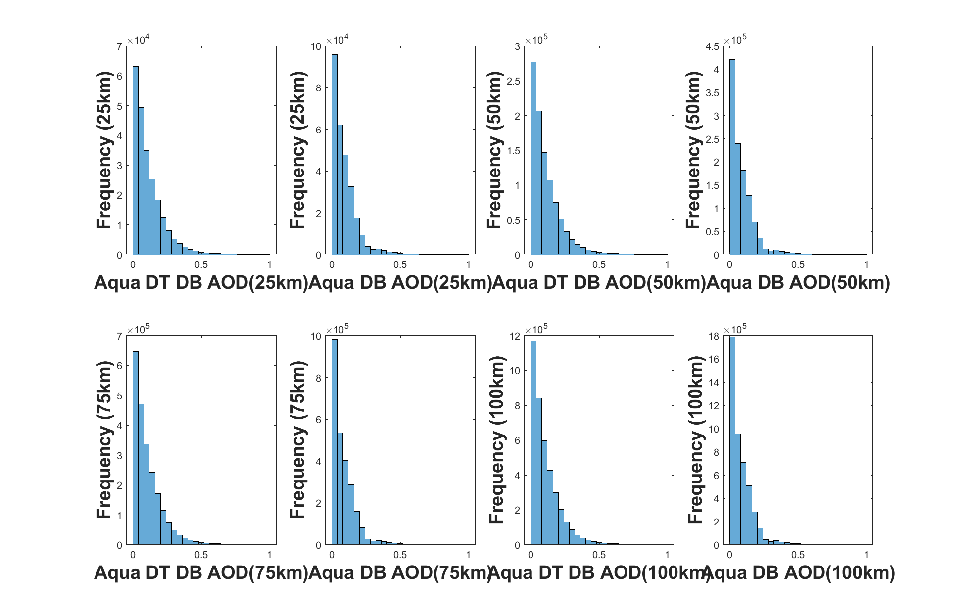
Figure 2: Distributions of each individual AOD retrieval within 25, 50, 75, and 100 km of each sounding site. Includes retrieval value using both dark target/deep blue method and just deep blue method
were any significant differences in each of the severe weather parameters. This comparison was done for three different timeframes. The first involved data from all months of the year from 2015-2019, which produced 14139 pairings where AOD<0.4 and 610 pairings where AOD>0.4. The second only involved warm season data, which was defined as the months of June, July, August, and September. This produced 5957 pairings where AOD<0.4 and 479 pairings where AOD>0.4. The third only involved cold season data, which was defined as the months of December, January, February, and March. This produced 3733 pairings where AOD<0.4 and 45 pairings where AOD>0.4.

3 Results
This section analyses the results of this experiment. The first figure contains scatterplots of the data pairings from all of the sounding sites for all months of the year from 2015-2019. The second section, containing figures 4 and 5, discusses the distributions and boxplots of the data separated into groups with one group containing all datapoints where AOD<0.4 and the group containing all datapoints where AOD>0.4. The third section, containing figures 6 and 7, is the same as the second one except it only contains datapoints from the warm season. The fourth section, containing figures 8 and 9, is the same as the second one except in only contains datapoints from the cool season. For this section, all datapoints where AOD<0.4 will be referred to as clean while datapoints where AOD>0.4 will be referred to as polluted.
Throughout this section and the next one, association means that an increase in pollution level corresponds with an increase or decrease in one of the severe weather parameters. If that increase or decrease is greater than 20%, it is referred to as a strong association. If the increase or decrease is greater than 10% but less than 20%, it is referred to as a weak association. If the increase or decrease is less than 10%, it will not be considered an association.

3.1 Year-Round Comparisons
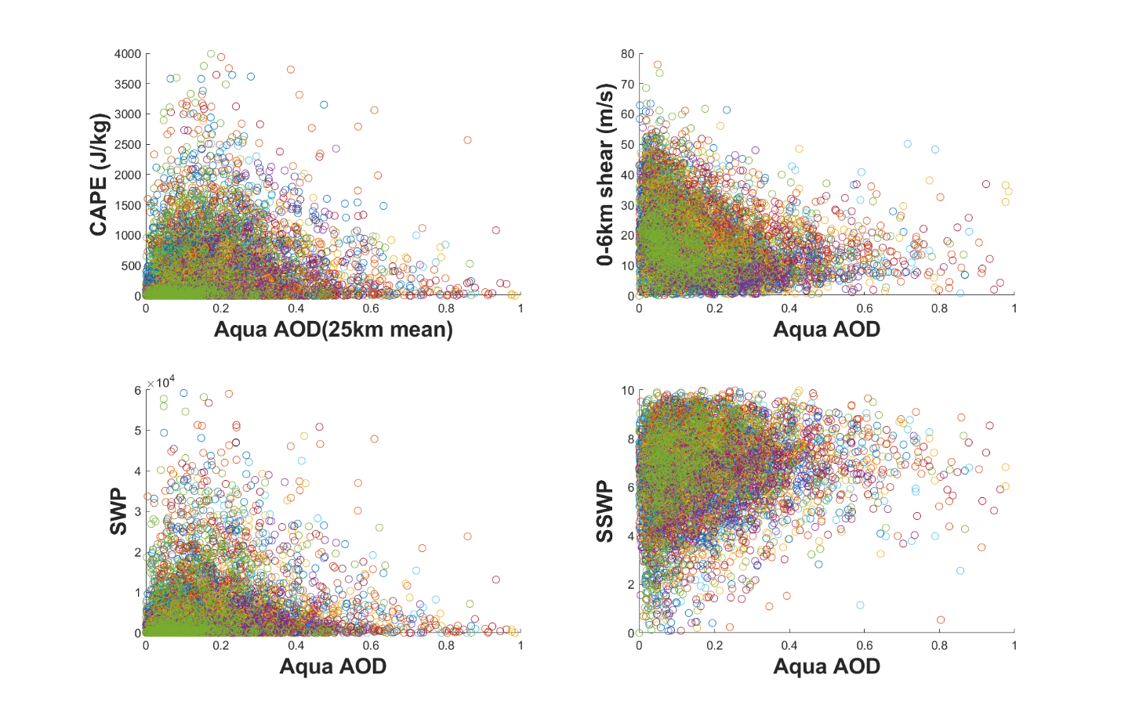
Figure 3: Scatterplots showing the collocations of the sounding datapoints with the AOD datapoints for each of the severe weather parameters. Each color represents a different city.
Figure 3 indicates that for the data used in this study, CAPE increases as AOD increases up until AOD reaches around 0.15, after which CAPE begins to decrease as AOD increases further. Bulk shear tends to decrease as AOD increases. SWP also tends to increase as AOD increases until AOD reaches 0.15 or so. After that, SWP decreases as AOD increases. SSWP does show some tendency to increase as AOD increases. However, none of the parameters appear to have a smooth, linear relationship with AOD. Therefore, this approach is not used any further and the remaining results focus on splitting the data into two groups for higher and lower AOD.
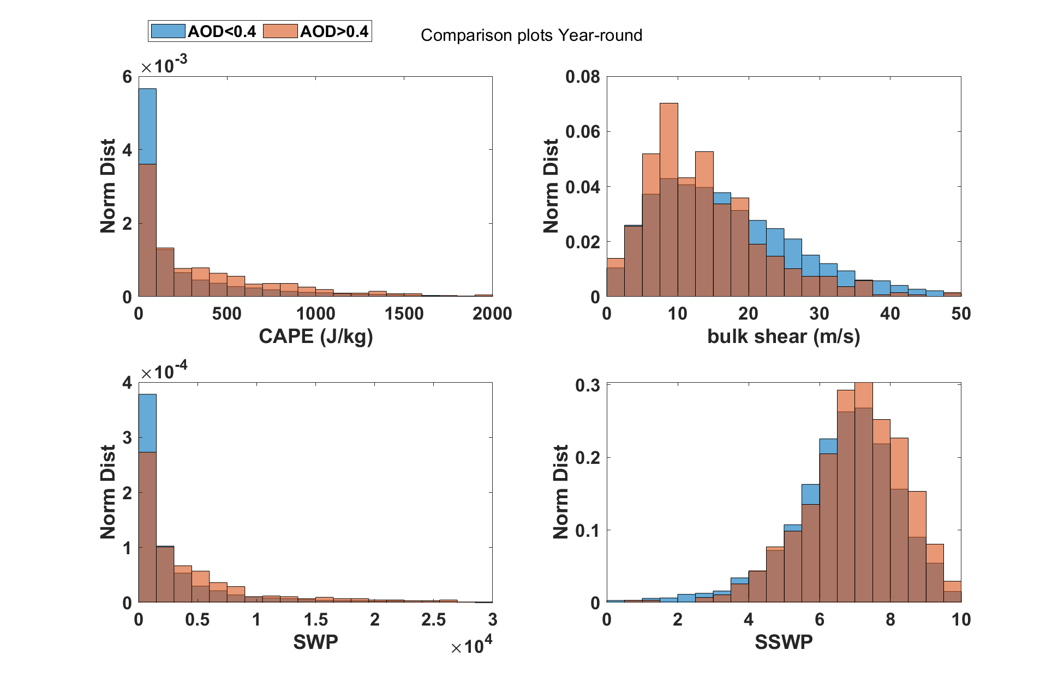
Figure 4: Histogram charts of the normalized distributions of each severe weather parameter for all months during the 2015-2019 timeframe when AOD<0.4 (blue) and AOD>0.4 (orange)

Figure 4 shows that for data from all months of the year, CAPE values are more likely to be higher in a polluted atmosphere and lower in a clean atmosphere. CAPE values greater than 100J/kg tend to be more likely when AOD is higher, while CAPE values less than 100J/kg tend to be associated with lower AOD. Bulk shear values are disproportionately higher when the atmosphere is clean and lower when the atmosphere is polluted. Bulk shear values greater than 20m/s are more likely when AOD is lower, while bulk shear values less than that are more likely when AOD is higher. SWP tends to be higher in a polluted atmosphere and lower in a clean atmosphere. SWP values greater than 2500 are more likely with a higher AOD, while values less than 2500 are more likely with a lower AOD. SSWP tends to be higher when the atmosphere is polluted and lower when it is clean. SSWP values greater than 6.25 tend to be associated with higher AOD levels while values less than 6.25 tend to be associated with lower AOD levels.
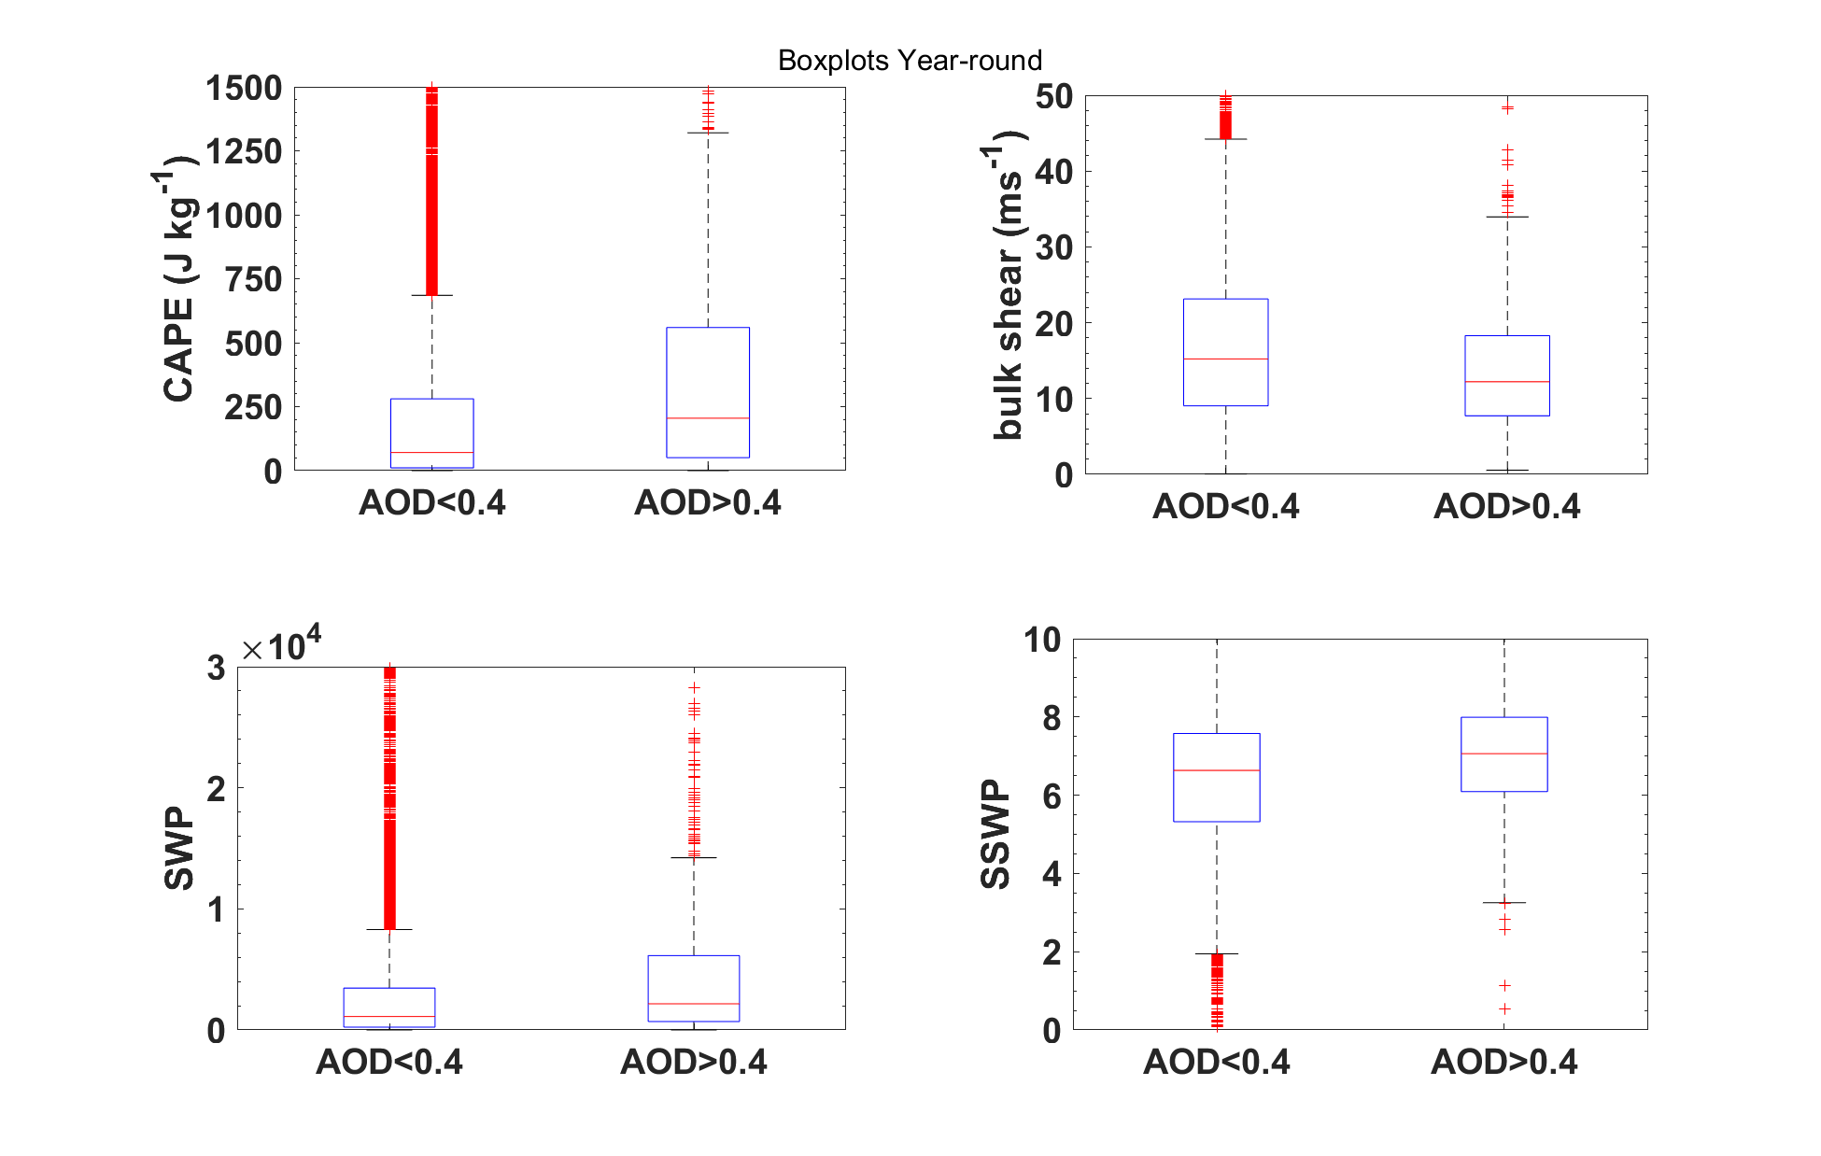
Figure 5: Box plots of distributions each of the severe weather parameters. The red line in the middle represents the median, the box represents the IQR, and the red markers represent values outside the 95% confidence interval.

 | CAPE  clean  (J/kg) | CAPE polluted  (J/kg) | Shear clean  (m/s) | Shear polluted  (m/s) | SWP clean | SWP polluted | SSWP clean | SSWP polluted
25% | 10.74 | 50.73 | 9.039 | 7.719 | 232.2 | 693.2 | 5.323 | 6.093
50% | 70.83 | 205.0 | 15.22 | 12.21 | 1109 | 2158 | 6.633 | 7.061
75% | 280.4 | 559.2 | 23.13 | 18.29 | 3457 | 6141 | 7.578 | 7.992
Table 1: Table indicating raw values for the median (50%), 25th percentile (25%), and 75th percentile (75%) of each severe weather parameter in a clean or polluted atmosphere using data from all year round

Figure 5 and Table 1 indicate that for data from all year round, a polluted atmosphere is found to be strongly associated with an increase in CAPE. The 75th percentile has the smallest difference between a clean and polluted atmosphere, while the 25th percentile has the largest difference. Looking at bulk shear, a polluted atmosphere is found to be weakly associated with a decrease in bulk shear. This time, the 75th percentile has the largest difference and the 25th percentile has the smallest one. For SWP, a polluted atmosphere is found to be strongly associated with an increase in this parameter. The 25th percentile has the largest difference, but the differences in the median and 75th percentiles are still substantial. For SSWP, the difference in medians is small enough that a polluted atmosphere does not have any association with an increase or decrease in this parameter.

3.2 Seasonal Comparisons
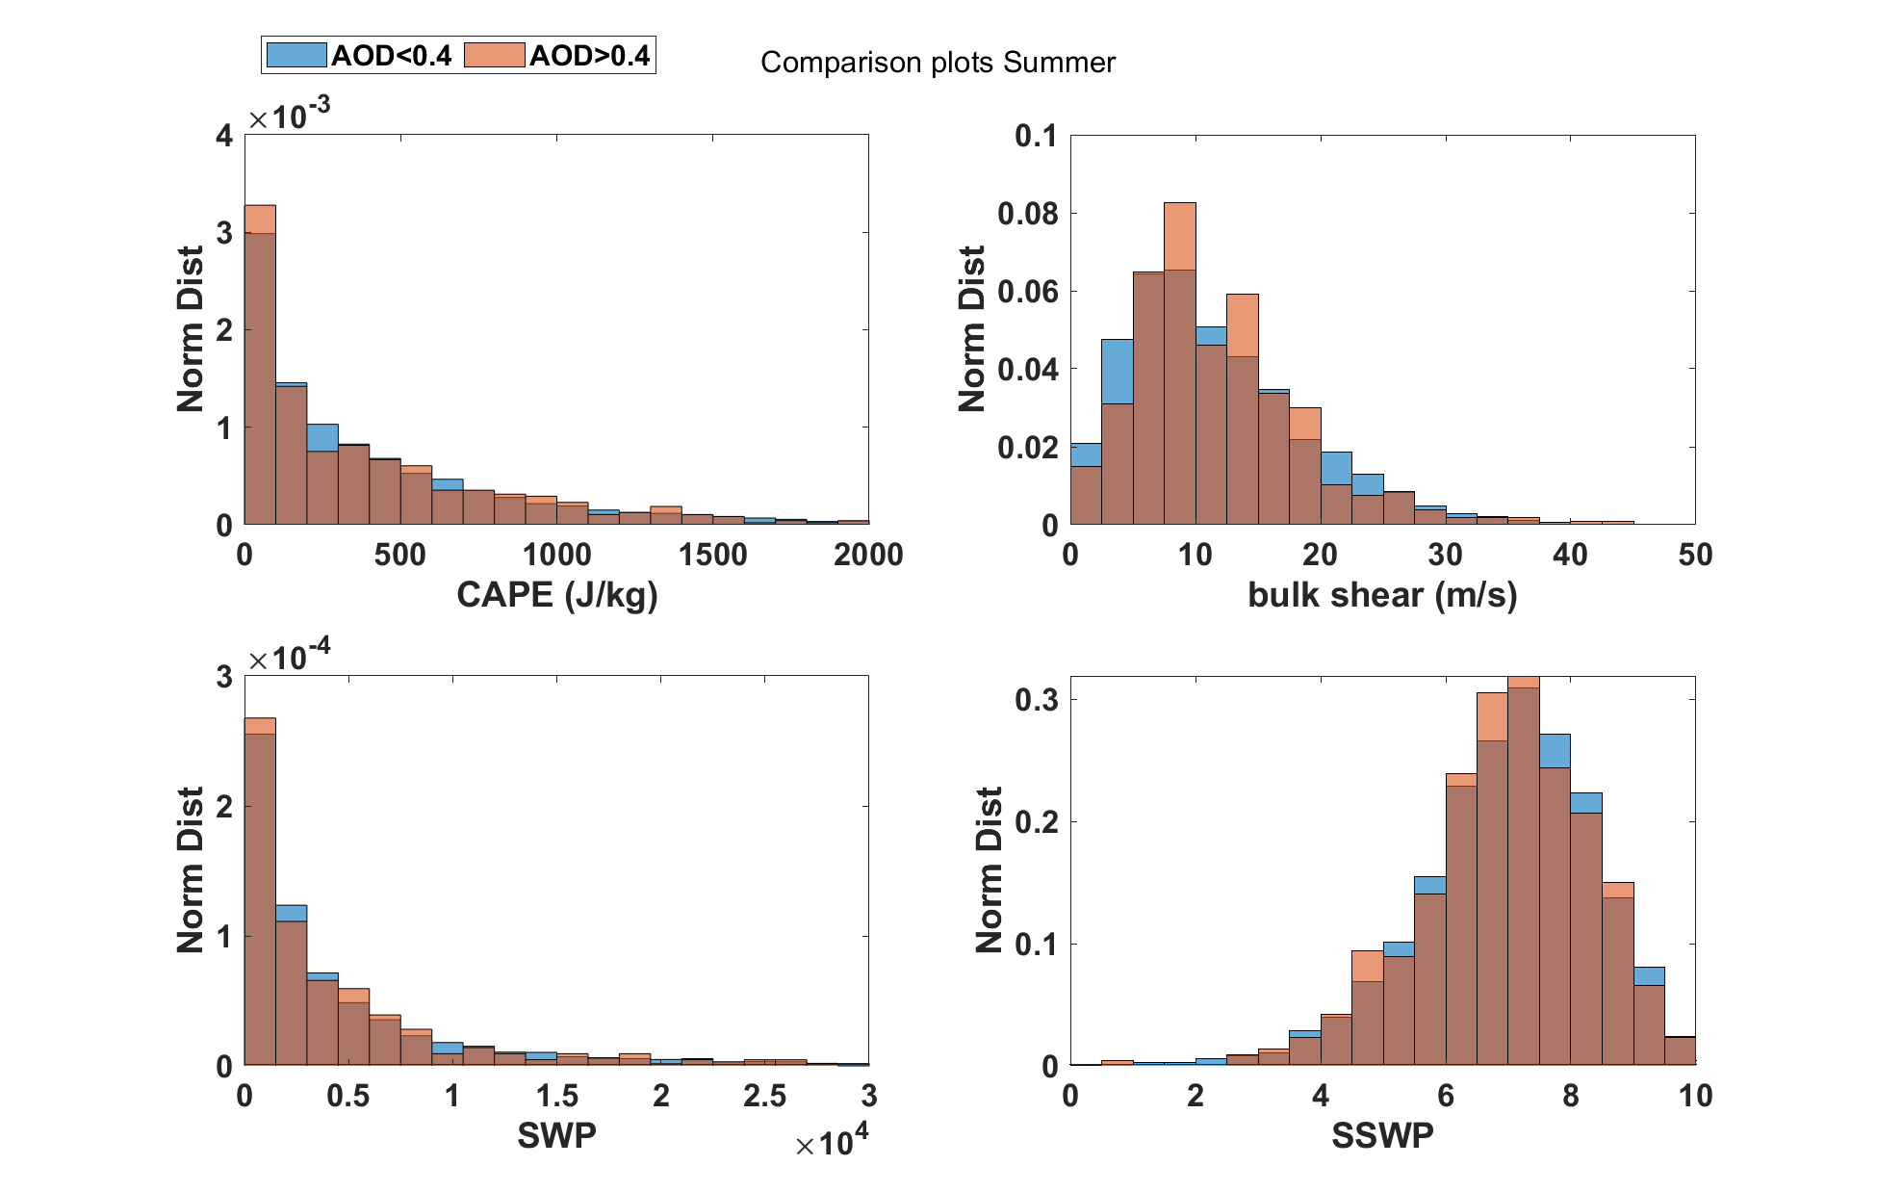
Figure 6: Histogram charts of the normalized distributions of each severe weather parameter for the months of June, July, August, and September during the 2015-2019 timeframe when AOD<0.4 (blue) and AOD>0.4 (orange)

Looking at the parameter distributions only using warm-season data as shown above in Figure 6, there does is no apparent trend for any of the parameters being associated a clean or polluted atmosphere. Instead, there appear to be certain ranges of values of each parameter (e.g. CAPE values between 500-1000) that are more common in a clean atmosphere and certain ranges of values more common in a polluted atmosphere. However, there are no discernable patterns as to when these ranges occur. For example, bulk shear values between 7.5-10m/s, 12.5-15m/s, and 17.5-20m/s are more likely associated with a polluted atmosphere, while most of the other ranges of bulk shear are more likely associated with a clean atmosphere. There are also some ranges of values of the parameters where the proportions of values in a clean or polluted atmosphere are roughly the same.
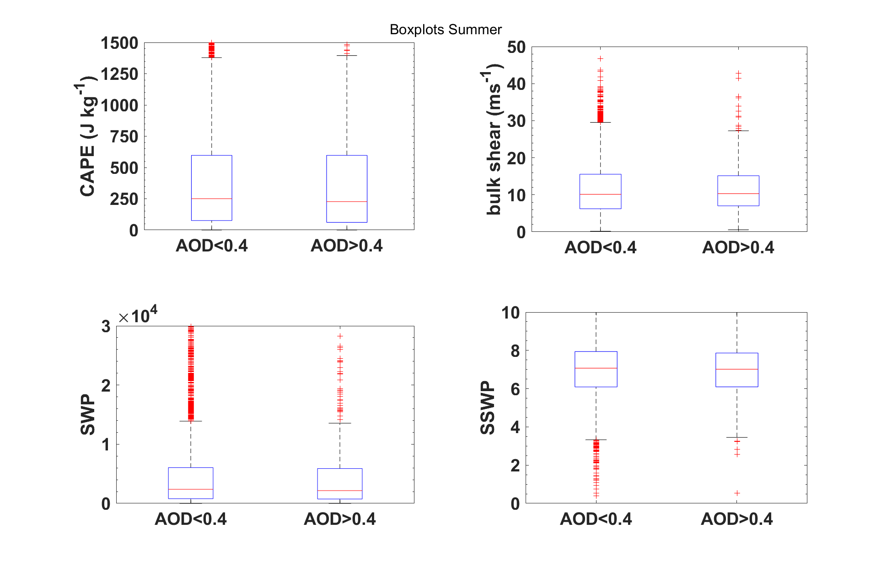
Figure 7: Box plots of distributions each of the severe weather parameters for June, July, August, and September. The red line in the middle represents the median, the box represents the IQR, and the red markers represent values outside the 95% confidence interval.

 | CAPE  clean  (J/kg) | CAPE polluted  (J/kg) | Shear clean  (m/s) | Shear polluted  (m/s) | SWP clean | SWP polluted | SSWP clean | SSWP polluted
25% | 75.77 | 60.97 | 6.215 | 7.023 | 787.4 | 745.2 | 6.089 | 6.093
50% | 250.4 | 227.2 | 10.11 | 10.30 | 2381 | 2162 | 7.072 | 7.015
75% | 597.2 | 597.0 | 15.55 | 15.15 | 6047 | 5888 | 7.940 | 7.863
Table 2: Table indicating raw values for the median (50%), 25th percentile (25%), and 75th percentile (75%) of each severe weather parameter in a clean or polluted atmosphere using warm season data

Looking at the boxplots of the parameters as well as the raw inner-quartile range values using warm-season data shown in Figure 7 and Table 2 above, there do not appear to be any associations between a polluted atmosphere and an increase or decrease in any of the parameters when comparing clean atmosphere cases to polluted atmosphere cases. The only differences in the plots appear to be the number of outlier cases being greater when the atmosphere is clean, likely due to there being more total data points where this is the case.

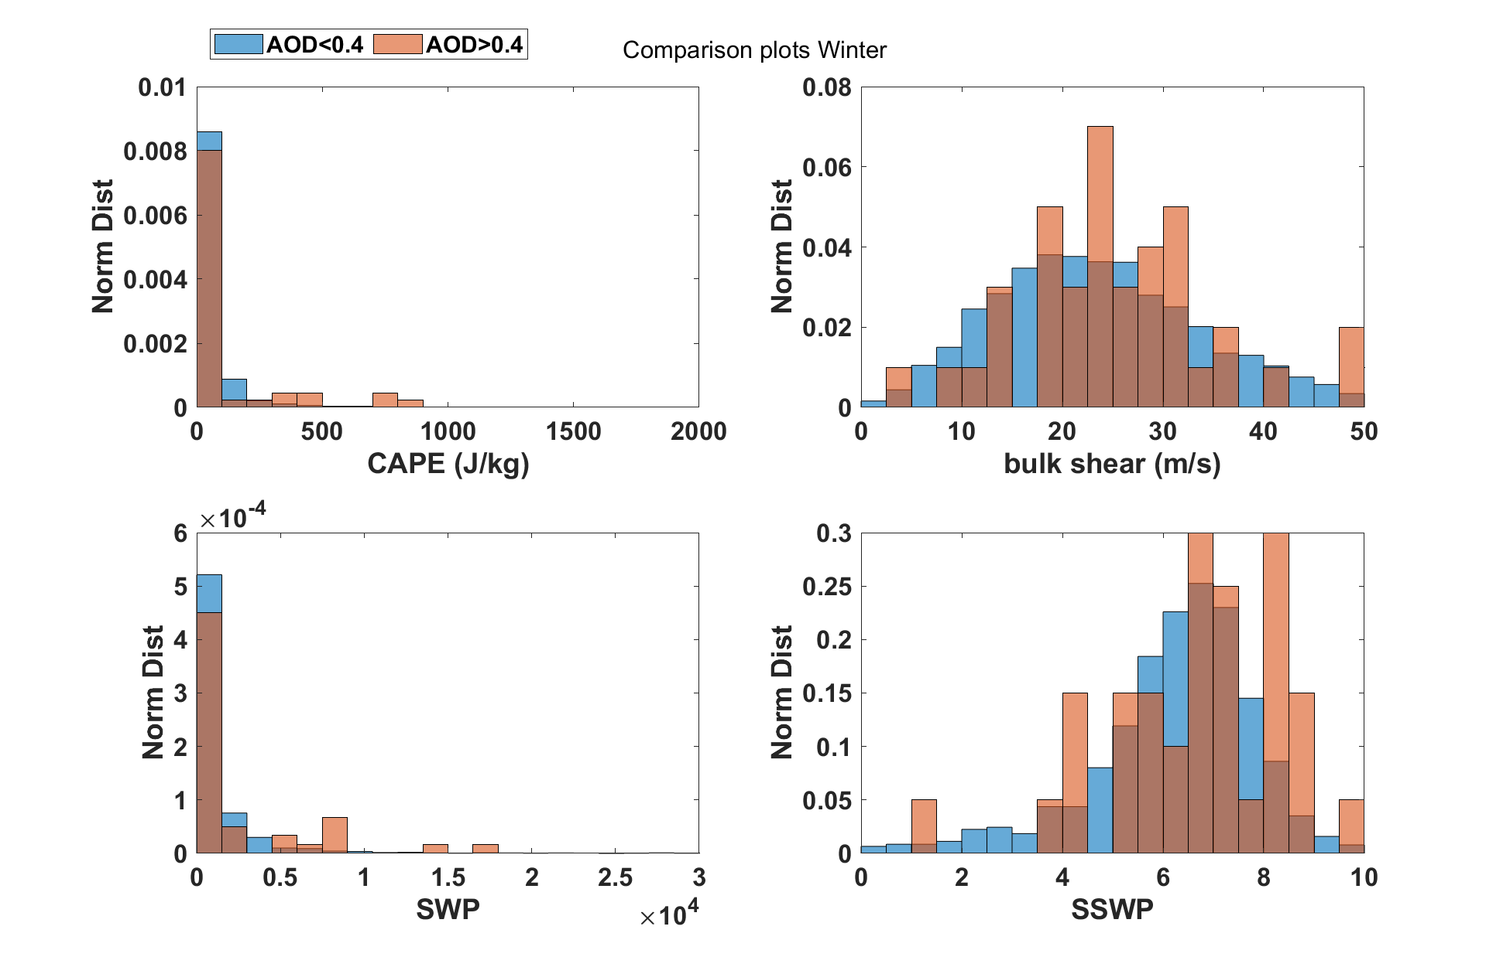
Figure 8: Histogram charts of the normalized distributions of each severe weather parameter for the months of December, January, February, and March during the 2015-2019 timeframe when AOD<0.4 (blue) and AOD>0.4 (orange)

Looking in Figure 8 at data from the cold-season months, higher CAPE values are more likely in a polluted atmosphere while lower CAPE values are more likely in a clean atmosphere. CAPE values greater than 300J/kg tend to be associated with higher AOD, while CAPE values less than 200J/kg tend to be associated with lower AOD. CAPE values from 200-300J/kg tend to be equally associated with higher or lower AOD. Bulk shear does not have any clear trends with higher or lower values being associated with a clean or polluted atmosphere. The main difference in the distributions is that the distribution of values in a clean atmosphere is somewhat smoother, which may be due to the very small sample size of cases in a clean atmosphere. Higher SWP values are more likely in a polluted atmosphere, while lower SWP values are more likely in a clean atmosphere. SWP values greater than 3000 tend to be associated with higher AOD, while SWP values less than 3000 tend to be associated with lower AOD. SSWP does not have any clear trends with higher or lower values being associated with a clean or polluted atmosphere. The distribution of cases for a clean atmosphere once again appears smoother and more continuous.

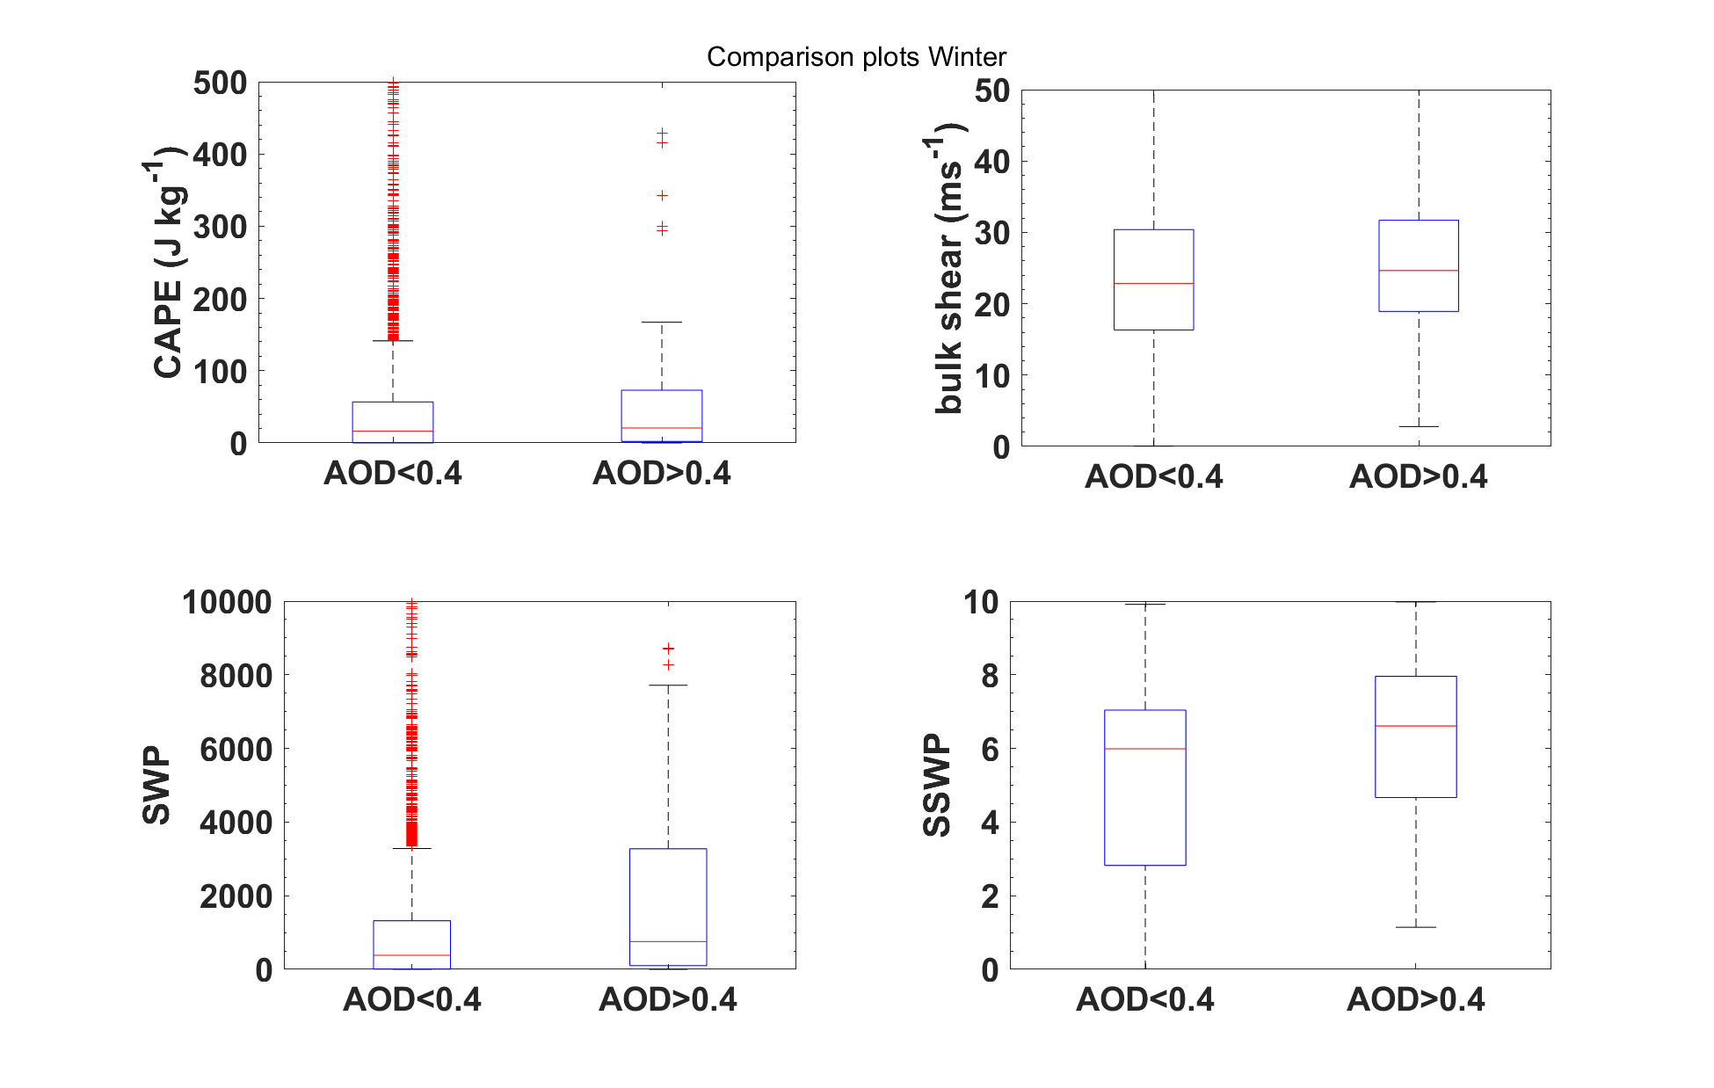
Figure 9: Box plots of distributions each of the severe weather parameters for December, January, February, and March. The red line in the middle represents the median, the box represents the IQR, and the red markers represent values outside the 95% confidence interval.

 | CAPE  clean  (J/kg) | CAPE polluted  (J/kg) | Shear clean  (m/s) | Shear polluted  (m/s) | SWP clean | SWP polluted | SSWP clean | SSWP polluted
25% | 0.020 | 2.027 | 16.32 | 18.92 | 6.529 | 101.1 | 2.823 | 4.667
50% | 16.28 | 20.68 | 22.83 | 24.65 | 381.6 | 754.4 | 5.990 | 6.609
75% | 56.70 | 73.00 | 30.39 | 31.70 | 1321 | 3274 | 7.041 | 7.958
Table 3: Table indicating raw values for the median (50%), 25th percentile (25%), and 75th percentile (75%) of each severe weather parameter in a clean or polluted atmosphere using cool season data

Looking in Figure 9 at the boxplots only containing cold-season data as well as the raw values in Table 1, a polluted atmosphere is weakly associated with an increase in CAPE. The 25th percentile has the largest relative difference, but there are still differences in the median and 75th percentile. For bulk shear, the difference in medians is small enough that a polluted atmosphere is not associated with an increase or decrease in this parameter. For SWP, a polluted atmosphere is found to be strongly associated with an increase in this parameter. The 25th and 75th percentiles have larger relative increases than the median. For SSWP, a polluted atmosphere is weakly associated with an increase in this parameter. The 25th percentile has the largest relative increase, and the 25th and 75th percentiles both have larger relative increases than the median.

4 Discussion

4.1 Compare/Contrast Results of different parameters

4.1.1 Year-Round data
Table 4: Associations found between atmospheric pollution and severe weather parameters for year-round data; up arrow indicates higher severe weather parameter in that atmospheric pollution level, down arrow indicates lower parameter in that level, equals sign indicates same parameter regardless of level
Year-Round
CAPE↓↓ Shear↑ SWP↓↓ SSWP= | CAPE↑↑ Shear↓ SWP↑↑ SSWP=
Clean | Polluted

Overall, each of the parameters except for SSWP show some association with AOD. For CAPE and SWP, a polluted atmosphere is strongly associated with an increase in these parameters. A polluted atmosphere does not have any association with SSWP. For bulk shear, on the other hand, a polluted atmosphere is weakly associated with a decrease in this parameter. One observation of interest is that for bulk shear, the difference in the 75th percentile between the two groups is larger than the lower percentiles. This would indicate that AOD may have more of an influence on bulk shear when the environment is more favorable for higher shear to begin with. This shows that AOD could be a useful indicator of severe weather favorability using this parameter even though the association is weaker for this parameter than it is for the other parameters.

4.1.2 Warm-season data

Warm season (June, July, August, September)
CAPE= Shear= SWP= SSWP= | CAPE= Shear= SWP= SSWP=
Clean | Polluted
Table 5: Associations found between atmospheric pollution and severe weather parameters for warm-season data; up arrow indicates higher severe weather parameter in that atmospheric pollution level, down arrow indicates lower parameter in that level, equals sign indicates same parameter regardless of level

The picture becomes murkier when only looking at warm-season or cool-season data. Data from these time periods is examined since they reduce the impacts of seasonal transitions. For the warm-season data, shown in Table 2, there does not appear to be any meaningful association between any of the severe weather parameters and AOD. The median, 25th percentile, and 75th percentile of each of the parameters are very similar regardless of whether the atmosphere was clean or polluted. Additionally, the distributions of each of the parameters are similar for both groups. This could indicate that the associations showing up in the data from all year round may be due to seasonal cycles of the parameters instead of one potentially affecting the other. For example, it could be a case of AOD and CAPE both tending to be higher in the warm season with bulk shear being higher in the cool season.

4.1.3 Cool-season data

Cool season (December, January, February, March)
CAPE↓ Shear= SWP↓↓ SSWP↓ | CAPE↑ Shear= SWP↑↑ SSWP↑
Clean | Polluted
Table 6: Associations found between atmospheric pollution and severe weather parameters for cool-season data; up arrow indicates higher severe weather parameter in that atmospheric pollution level, down arrow indicates lower parameter in that level, equals sign indicates same parameter regardless of level

Looking at cool-season data shown in Table 3, there was a tendency for a polluted atmosphere to be weakly associated with an increase in CAPE. This is confirmed by the distributions, which show CAPE values associated with a polluted atmosphere being disproportionately higher than the ones associated with a clean atmosphere. A similar pattern showed up in the IQR levels for bulk shear, with the values for a polluted atmosphere being slightly higher. However, this relative difference is small enough that pollution level is not found to have any association with bulk shear. Also, unlike CAPE, this difference is not reflected in the distributions. Also of note was that this is the reverse of what is found for bulk shear using data from all-year round. This could indicate idea that the trends found in the year-round data (especially for bulk shear) are due to seasonal cycles of the AOD and the parameters. Looking at SWP, there was a somewhat larger difference in the medians for the two groups than there was for CAPE or bulk shear. This difference is enough for pollution level to have a strong association with this parameter. Also, the distributions are similar to the ones shown for CAPE. Furthermore, the relative difference in the 75th percentile of SWP is greater than the relative difference of the median. This could indicate that the magnitude of AOD signifies a difference in whether severe weather potential is realized, since it seems to make more of a difference in environments that have higher SWP to begin with. Finally, looking at SSWP, there is some difference in the medians. This difference is enough to indicate that a polluted atmosphere is weakly associated with an increase in this parameter. Also, as was the case for bulk shear, the distributions were fairly messy and did not have any noticeable trends. All of this would indicate that although there was some difference, it is difficult to tell how significant or meaningful it is. One caveat with all of the cool-season data was that there are only 45 cases total where the atmosphere is considered polluted. This is in contrast to the warm-season data, which has 479 such cases. This makes it difficult to determine how conclusive the results using this data are.

4.2 Scientific Implications of Results
This section discusses possible physical reasons for the associations found throughout this experiment. These should not be interpreted as definitive conclusions because this study was not designed to show causation.
The tendency of higher CAPE values when the atmosphere is polluted goes against what was found in Toll and Männik (2015). This result could be due in part due to seasonal cycles of both parameters. It could mean that there tend to be higher CAPE values as well as higher AOD values during the summer. This would explain why there is a more noticeable difference between the two AOD groups overall than the differences present using only warm-season or cool-season data. The difference present during the cool-season could be due light-absorbing aerosols having a greater presence over the Central Plains region during the winter. These aerosols could be caused by local wildfires since this region tends to be at its driest during the winter. The lack of any significant difference in the two groups during the warm season could very well be due to aerosols not having any effect on CAPE during this time period. However, it could also be due to different effects negating each other. For example, smoke from local wildfires might increase CAPE if it is present at low levels of the troposphere. However, smoke could also be brought into the upper levels of the troposphere by long-range transport from wildfires in other regions. This could have the result of increasing absorption of solar energy at the upper levels of the atmosphere causing warming at these levels and reducing overall instability. This is especially possible since wildfires tend to be more common in places such as the west coast during this time of year. Since AOD measures the presence of aerosols throughout an entire column of air, it would be difficult to differentiate between these different causes.
Similar to CAPE, the trend of higher bulk shear values being present when the atmosphere is clean does not support what was found in Saide et al. (2015). This discrepancy could be caused by seasonal cycles of both bulk shear and AOD. Since bulk shear tends to be higher during the winter and AOD tends to be higher during the summer, there could be many winter days with high AOD and low bulk shear values and many summer days with high bulk shear and low AOD values. This would lead to a polluted atmosphere being associated with lower bulk shear values, which is what the data shows. However, it could also be due to higher bulk shear values leading to greater mixing of the troposphere. This could lead to lower AOD values near the sounding sites, since most of the sounding sites are near cities, which would usually have higher AOD. The lack of a difference in the bulk shear values for the two AOD groups during the warm-season months could be due to neither variable physically affecting the other during this time. However, there were some small differences in the bulk shear distributions for the two AOD groups. These could simply not be statistically significant. There could also be some other effects going on. Having higher levels of bulk shear could mix out locally generated aerosols. However, it could also bring in aerosols by means of long-range transport, especially at the upper levels of the troposphere. These two effects could negate each other and lead to the lack of a difference in bulk shear for a clean or polluted atmosphere. The lack of an association between AOD and bulk shear during the cool season could mean that AOD does not have any effect on bulk shear. It could also be caused by varying effects canceling each other out. For example, aerosol particles could be leading to an increase in the number of cloud droplets present, thickening low-level cloud layers and reducing mixing at the surface, leading to weaker surface wind speeds. This was an effect mentioned in one of the previous studies (Saide et al. 2015) and could be a case where increasing the AOD leads to an increased risk for severe weather. However, this would only occur if the surface winds were in the same direction as the winds aloft. Otherwise, this effect could actually decrease the bulk shear. Therefore, increasing the AOD level could lead to an increase or decrease in bulk shear depending on the circumstances.
The distributions of SWP for both a clean atmosphere and a polluted atmosphere look similar to the distributions for CAPE. This was true for year-round, warm-season, and cool-season data. This would indicate that differences in this parameter between clean and polluted atmosphere cases were primarily determined by differences in the CAPE values. This could be caused by CAPE having much larger standard deviations. It could also be caused by AOD having more of a direct association with CAPE than it has on bulk shear. The tendency for higher SWP values to be more frequent when the atmosphere is polluted could once again be partially due to seasonal cycles of both variables. SWP and AOD are more likely to be higher during the summer and lower during the winter, so that could be a lurking variable. It could also be due to setups that are favorable for higher SWP values to also contain higher levels of AOD. A couple of studies mentioned earlier described how the strong winds aloft that are often associated with favorable setups for severe weather in the Central US can also transport smoke from wildfires in Central America to the United States (Wang et al. 2009; Saide et al. 2015). Since these setups tend to be favorable for severe weather, they would tend to have both higher CAPE and bulk shear values to begin with, resulting in higher SWP values. This could also explain why a polluted atmosphere was associated with higher SWP values during the cool season but there was no difference during the warm season. This season-dependent association could be due to wildfires in Central America being more common during the US winter resulting in this effect being more in play during the cool season. It could also be due to large-scale systems that would bring smoke up from this area being more common during the cool season.
Since both SWP and SSWP use CAPE and shear in their calculations, one might expect there to be similar patterns between SSWP and AOD as there were between SWP and AOD. Looking at the boxplot charts in Figures 5, 7, and 9, this would appear to be the case. The median SSWP value was higher in the polluted atmosphere group than in the clean atmosphere group looking at data from all year round, but there was no noticeable difference between the two when only looking at data from the warm season or the cool season. This would indicate that the scientific implications for these correlations are similar to those for the correlations between AOD and SWP. The distributions of SSWP for the two AOD groups do look quite different from the distributions of SWP for the two groups. However, this could be due to a reshaping of the distribution since this variable involves taking the logarithms of CAPE and shear.
One caveat with all of these findings is they were simply comparing differences in the raw statistics of the severe weather parameters. In order to determine if the differences were statistically significant, further analysis would need to be done. One way to do this would be to conduct a t-test between the lower and higher AOD groups for each parameter. This test would involve taking a sample from each of the parameter groups and calculating t, a measure of the ratio of the difference in the averages of the two groups to the standard deviations of the two groups, using the number of datapoints in each sample and the variance of the entire population (Aktas and Yilmaz 2016). However, there are some pre-existing conditions that would need to be met. Each population (in this case, the datapoints for each parameter when AOD<0.4 vs AOD>0.4) needs to be normally distributed. Also, the variances in the two groups need to be roughly the same (Aktas and Yilmaz 2016). Another condition is that the sample size needs to be a fairly small percentage of the population. That would not be possible with the cool-season data since there were only 45 cases in the higher AOD group. All of these would make conducting a t-test very difficult for this data.

5 Conclusion
Much of the previous research regarding what effects aerosols have on severe weather has focused on case studies of individual events. It has also tended to look at the microphysical effects aerosols had on these events. This study, on the other hand, was looking for associations that could be applied to severe weather favorability in an overall sense, rather than looking at case studies. It also was looking more at how aerosols could make an environment more or less favorable for severe weather before any storms developed, so microphysical properties were not considered here. Therefore, it is difficult to make direct comparisons between this study and many of the previous studies on this topic.
Overall, the results of this study indicated that there was a tendency for higher AOD to be associated with higher levels of CAPE and SWP. Meanwhile, higher AOD levels tended to be associated with lower levels of bulk shear. No association could be determined between AOD and SSWP. When considering data from the warm season only, there did not appear to be any significant association between AOD and any of the severe weather parameters. When considering data from the cool season only, higher levels of AOD tended to be associated with higher levels of CAPE, SWP, and SSWP. The data appeared to be inconclusive in determining whether there was any association between AOD and bulk shear during the cool season.
This study can be compared to at least a couple of findings in published literature. A couple of previous studies (Toll and Männik 2015) mentioned above indicated that aerosols tended to decrease environmental instability. The results of this study appear to contradict those findings, especially during the cool season, because this study showed that higher levels of AOD tended to be associated with higher CAPE during that time of year, and instability is one of the determining factors of CAPE. However, other factors could play a role. For example, one of the studies was specifically looking at smoke from wildfires, while this study was simply looking at AOD in general. Since AOD does not differentiate types and characteristics of aerosols, the effects on instability could vary.
The first science question in this study required determining whether there were any significant associations between AOD and Convective Available Potential Energy, bulk shear, Severe Weather Parameter, and Significant Severe Weather Parameter. Looking at the data, the answer would appear to be affirmative, since there were noticeable differences between clean and polluted conditions in distributions and medians, 25th percentiles, and 75th percentiles of each of the severe weather parameters. The second science question in this study was whether measurements of AOD in the Central Plains could be useful as inputs for forecasting severe weather in this region. Although there were noticeable differences in the parameters for the two groups in the overall data, these differences did not extend to the warm season months. There were still differences in the cool season months, but the small number of polluted atmosphere cases during the cool season makes it difficult to determine how significant those differences actually were. Also, severe weather is relatively uncommon during this time of year. Therefore, the results from this study alone would be inconclusive at best in determining whether AOD measurements in the Central Plains would be a useful forecasting tool for severe weather in this region.
Some potential future work for this area of research could involve how relative humidity affects AOD measurements. Since AOD is affected by relative humidity and relative humidity can affect some of the parameters used, it would be important to filter out these effects and ensure that the correlations found are actually caused by the aerosols and not the relative humidity. Another area would involve looking at how different species of aerosols may have different effects on severe weather favorability. This could be important since different species tend to have different albedos, which could determine what effects they may have on instability. An additional area of future research could involve looking at how differing vertical distributions of aerosols could have differing effects. One way to tackle many of these areas of interest would be to use modeling data. Modeling data can be useful because it can show whether there is causation instead of just showing correlation. However, the usefulness of such a simulation would need to be assessed under a wide variety of atmospheric conditions.

References
Abbott, T. H., and T. W. Cronin, 2021: Aerosol invigoration of atmospheric convection through increases in humidity. Science, 371, 83–85, https://doi.org/10.1126/science.abc5181.
Aktas, S., and A. E. Yilmaz, 2016: Autocorrelation Corrected Standard Error for Two Sample t-test Under Serial Dependence. HJMS, 46, 1–1, https://doi.org/10.15672/HJMS.201611515847.
Baggett, C. F., K. M. Nardi, S. J. Childs, S. N. Zito, E. A. Barnes, and E. D. Maloney, 2018: Skillful Subseasonal Forecasts of Weekly Tornado and Hail Activity Using the Madden-Julian Oscillation. Journal of Geophysical Research: Atmospheres, 123, 12,661-12,675, https://doi.org/10.1029/2018JD029059.
Blanchard, D. O., 1998: Assessing the Vertical Distribution of Convective Available Potential Energy. Weather and Forecasting, 13, 870–877, https://doi.org/10.1175/1520-0434(1998)013<0870:ATVDOC>2.0.CO;2.
Brooks, H. E., J. W. Lee, and J. P. Craven, 2003: The spatial distribution of severe thunderstorm and tornado environments from global reanalysis data. Atmospheric Research, 67–68, 73–94, https://doi.org/10.1016/S0169-8095(03)00045-0.
Carrió, G. G., and W. R. Cotton, 2011: Urban growth and aerosol effects on convection over Houston. Part II: Dependence of aerosol effects on instability. Atmospheric Research, 102, 167–174, https://doi.org/10.1016/j.atmosres.2011.06.022.
Fan, J., and Coauthors, 2009: Dominant role by vertical wind shear in regulating aerosol effects on deep convective clouds. J. Geophys. Res., 114, D22206, https://doi.org/10.1029/2009JD012352.
Fan, X., and Y. Liu, 2016: Exploiting TERRA-AQUA MODIS Relationship in the Reflective Solar Bands for Aerosol Retrieval. Remote Sensing, 8, 996, https://doi.org/10.3390/rs8120996.
Gensini, V. A., and H. E. Brooks, 2018: Spatial trends in United States tornado frequency. npj Clim Atmos Sci, 1, 1–5, https://doi.org/10.1038/s41612-018-0048-2.
Ghan, S. J., C. C. Chung, and J. E. Penner, 1993: A parameterization of cloud droplet nucleation part I: single aerosol type. Atmospheric Research, 30, 198–221, https://doi.org/10.1016/0169-8095(93)90024-I.
Gilleland, E., M. Pocernich, H. E. Brooks, P. Marsh, and B. G. Brown, Large-scale Indicators for Severe Weather. 17.
van den Heever, S. C., and W. R. Cotton, 2007: Urban Aerosol Impacts on Downwind Convective Storms. Journal of Applied Meteorology and Climatology, 46, 828–850, https://doi.org/10.1175/JAM2492.1.
Heikenfeld, M., B. White, L. Labbouz, and P. Stier, 2019: Aerosol effects on deep convection: the propagation of aerosol perturbations through convective cloud microphysics. Atmos. Chem. Phys., 19, 2601–2627, https://doi.org/10.5194/acp-19-2601-2019.
Jiang, J. H., H. Su, L. Huang, Y. Wang, S. Massie, B. Zhao, A. Omar, and Z. Wang, 2018: Contrasting effects on deep convective clouds by different types of aerosols. Nat Commun, 9, 3874, https://doi.org/10.1038/s41467-018-06280-4.
Lerach, D. G., and W. R. Cotton, 2018: Simulating southwestern U.S. desert dust influences on supercell thunderstorms. Atmospheric Research, 204, 78–93, https://doi.org/10.1016/j.atmosres.2017.12.005.
——, B. J. Gaudet, and W. R. Cotton, 2008: Idealized simulations of aerosol influences on tornadogenesis. Geophys. Res. Lett., 35, L23806, https://doi.org/10.1029/2008GL035617.
Loftus, A. M., and W. R. Cotton, 2014: Examination of CCN impacts on hail in a simulated supercell storm with triple-moment hail bulk microphysics. Atmospheric Research, 147–148, 183–204, https://doi.org/10.1016/j.atmosres.2014.04.017.
Markowski, P., and Y. Richardson, 2006: On the Classification of Vertical Wind Shear as Directional Shear versus Speed Shear. Weather and Forecasting, 21, 242–247, https://doi.org/10.1175/WAF897.1.
Misra, A., A. Jayaraman, and D. Ganguly, 2015: Validation of Version 5.1 MODIS Aerosol Optical Depth (Deep Blue Algorithm and Dark Target Approach) over a Semi-Arid Location in Western India. Aerosol Air Qual. Res., 15, 252–262, https://doi.org/10.4209/aaqr.2014.01.0004.
Rosenfeld, D., and T. L. Bell, 2011: Why do tornados and hailstorms rest on weekends? J. Geophys. Res., 116, D20211, https://doi.org/10.1029/2011JD016214.
Saide, P. E., and Coauthors, 2015: Central American biomass burning smoke can increase tornado severity in the U.S. Geophysical Research Letters, 42, 956–965, https://doi.org/10.1002/2014GL062826.
Saide, P. E., G. Thompson, T. Eidhammer, A. M. Silva, R. B. Pierce, and G. R. Carmichael, 2016: Assessment of biomass burning smoke influence on environmental conditions for multiyear tornado outbreaks by combining aerosol‐aware microphysics and fire emission constraints. J. Geophys. Res. Atmos., 121, https://doi.org/10.1002/2016JD025056.
Storer, R. L., S. C. van den Heever, and G. L. Stephens, 2010: Modeling Aerosol Impacts on Convective Storms in Different Environments. Journal of the Atmospheric Sciences, 67, 3904–3915, https://doi.org/10.1175/2010JAS3363.1.
Toll, V., and A. Männik, 2015: The direct radiative effect of wildfire smoke on a severe thunderstorm event in the Baltic Sea region. Atmospheric Research, 155, 87–101, https://doi.org/10.1016/j.atmosres.2014.11.018.
Wang, J., S. C. van den Heever, and J. S. Reid, 2009: A conceptual model for the link between Central American biomass burning aerosols and severe weather over the south central United States. Environ. Res. Lett., 4, 015003, https://doi.org/10.1088/1748-9326/4/1/015003.
Wang, Y., Q. Yuan, T. Li, H. Shen, L. Zheng, and L. Zhang, 2019: Large-scale MODIS AOD products recovery: Spatial-temporal hybrid fusion considering aerosol variation mitigation. ISPRS Journal of Photogrammetry and Remote Sensing, 157, 1–12, https://doi.org/10.1016/j.isprsjprs.2019.08.017.
Weisman, M. L., and R. Rotunno, 2000: The Use of Vertical Wind Shear versus Helicity in Interpreting Supercell Dynamics. Journal of the Atmospheric Sciences, 57, 1452–1472, https://doi.org/10.1175/1520-0469(2000)057<1452:TUOVWS>2.0.CO;2.
Yuter, S. E., M. A. Miller, M. D. Parker, P. M. Markowski, Y. Richardson, H. Brooks, and J. M. Straka, 2013: Comment on “Why do tornados and hailstorms rest on weekends?” by D. Rosenfeld and T. Bell. J. Geophys. Res. Atmos., 118, 7332–7338, https://doi.org/10.1002/jgrd.50526.
SPC Products. https://www.spc.noaa.gov/misc/about.html (Accessed March 8, 2022a).
The Relative Roles of Sulfate Aerosols and Greenhouse Gases in Climate Forcing. https://doi.org/10.1126/science.260.5106.311.
Center for Satellite Applications and Research - NOAA / NESDIS / STAR. NOAA / NESDIS / STAR website,. https://www.star.nesdis.noaa.gov/star/index.php (Accessed March 23, 2022c).
Atmospheric Soundings. https://weather.uwyo.edu/upperair/sounding.html (Accessed May 3, 2022d).
MODIS Web. https://modis.gsfc.nasa.gov/about/components.php (Accessed March 9, 2022e).

