University of Oklahoma

Graduate College

VEGETATION COMMUNITIES AND LAND COVER IN THE MIXEDGRASS PRAIRIE: AN ANALYSIS OF CONTEMPORARY AND HISTORIC DATA SOURCES

A dissertation

submitted to the graduate faculty

in partial fulfillment of the requirements for the

Degree of

DOCTOR OF PHILOSOPHY

By

SHANNON HALL
Norman, Oklahoma
2015

VEGETATION COMMUNITIES AND LAND COVER IN THE MIXEDGRASS PRAIRIE: AN ANALYSIS OF CONTEMPORARY AND HISTORIC DATA SOURCES

A dissertation approved for the
department of geography and environmental sustainability

By

______________________________
Dr. Bruce Hoagland, Chair

______________________________
Dr. Jeff Kelly

______________________________
Dr. Scott Greene

______________________________
Dr. Aondover Tarhule

______________________________
Dr. Lara Souza

© Copyright by shannon hall 2015
All Rights Reserved.

Acknowledgments

I would like to begin by thanking the Oklahoma Department of Wildlife Conservation, and the Oklahoma Biological Survey for funding this project. I would also like to thank the University of Oklahoma Department of Geography and Environmental Sustainability for providing me with a Graduate Teaching Assistantship and an Alumni Fellowship. I would like to thank my graduate advisor, Dr. Bruce Hoagland, for offering this project to me, believing in me, helping me along the way, and providing me with his knowledge and expertise. I also greatly appreciate the patience, advice, recommendations, and references that Bruce has given me over the years. I would also like to thank my other committee members – Jeff Kelly, Aondover Tarhule, Scott Greene, and Lara Souza – for their expertise and help. I would also like to thank the many other graduate students, colleagues, and staff, who lent me their expertise and guidance – Todd Fagin, Iyla Griffin, Rick Thomas, Matthew Collier, Jen Shurley, Justin Goldstein, Brad Watkins, Chris Cook, Catherine Blaha, Deborah Marsh, Ranell Madding, and Trina Steil.
Finally, I would like to thank my field assistants and all around confidants – my husband, Greg Cornett Sr., and my friend Lacy Isom.
Lacy – you not only provided field assistance, but also companionship, laughter, and counseling. You have been a ray of sunlight during the stormy periods throughout this process. Thank you so very much, I love you!
Greg – what to say? This never would have been possible without you. You have been a constant ray of sunlight throughout this ordeal. You helped me maintain my sanity, and remained a voice of reason every time I wanted to quit along the way. You’ve always known that quitting would never have set well with me, so you’ve played every role that I needed to keep me going – cheerleader, supporter, mentor, counselor, and even drill sergeant at times. Since this wouldn’t have been possible without you, I can honestly say that ‘we’ are finally finished with this dissertation. Thank you for being you; I love you!

Table of Contents

Acknowledgements iv

Table of Contents vi
List of Tables ix

List of Figures x

Abstract xii

Preface 1

Literature Cited 6

Chapter 1: Effects of woody plant composition on herbaceous grassland communities; an analysis from sand sage (Artemisia filifolia), shinnery oak (Quercus havardii), and honey mesquite (Prosopis glandulosa) shrublands in western Oklahoma, USA 8
Abstract 8

Introduction 9

Study Areas 12

Methods 15

Data Collection 15

Data Analysis 19

Results 23

Species Richness 24

Diversity and Evenness 27

Discussion 31

Conclusion 40

Literature Cited 59

Chapter 2: Reconstructing the mixedgrass prairie landscape; an analysis of the plats and notes of the General Land Office Survey (1873-1875) in western Oklahoma 66

Abstract 66

Introduction 66

Study Area 72

Methods 76

Results 77

Bearing Tree Data 84

Land Cover 84

Discussion 86

Bearing Tree Data 89

Land Cover 92

Conclusion 94

Literature Cited 113

Chapter 3: Land cover change in the mixedgrass prairie; an analysis of repeat aerial photography (1937-2005) 119

Abstract 119

Introduction 119

Study Area 127

Methods 130

Results 131

Discussion 133

Conclusion 135

Literature Cited 143

Chapter 4: Conclusion 147

Literature Cited 152

List of Tables

Chapter 1

Table 1 – Frequency and relative frequency for the 1000m², 100m², and 10m² plots. 49

Table 2 – Mean cover, frequency, relative frequency for 1m² plots.
55

Table 3 – Sorensen Similarity data for individual study areas, and comparisons between study areas. 58

Chapter 2

Table 1 – Woody plant species data, recorded during the 1873-1875 General Land Office surveys. 106

Table 2 – Landscape metrics for land cover types mapped from the 1873-1875 GLO land survey plats for western Oklahoma. 111

Table 3 – Landscape metrics for land cover types mapped by Duck and Fletcher (1943) for the study area of this project. 112

Chapter 3

Table 1 – Vegetation types identified in each study area. 142

List of Figures

Chapter 1

Figure 1 – Study areas from north to south. 41

Figure 2 – (a) Modified Whittaker Plot; (b) Extensive Plot. 42

Figure 3 – Mean species richness per scale. 43

Figure 4 – Mean similarity within and between study areas at the 1000m², 100m², and 10m² scales. 44

Figure 5 – Scatterplot created from the ordination for 1m² plots.
45

Figure 6a – Correlation between Schizachyrium scoparium percent cover and Axis 1 scores from the ordination for 1m² plots. 46

Figure 6b – Correlation between Bouteloua gracilis percent cover and Axis 1 scores from the ordination for 1m² plots. 46

Figure 6c – Correlation between Ambrosia psilostachya) percent cover and Axis 1 scores from the ordination for 1m² plots. 47

Figure 6d – Correlation between Plantago heterophylla) percent cover and Axis 1 scores from the ordination for 1m² plots 47

Figure 7a – Correlation between Artemisia filifolia percent cover and Axis 1 scores from the ordination for 1m² plots. 48

Figure 7b – Correlation between Quercus havardii percent cover and Axis 1 scores from the ordination for 1m² plots. 48

Figure 7c – Correlation between Prosopis glandulosa percent cover and Axis 1 scores from the ordination for 1m² plots. 48

Chapter 2

Figure 1. Example of a plat, as mapped by the General Land Office in 1873. 96

Figure 2. Study area, which incorporates the western Oklahoma counties of Harper, Woodward, Ellis, Roger Mills and northern Beckham. 97

Figure 3 – Surveyors responsible for conducting Public Land Surveys of western Oklahoma in the 1870s. 98

Figure 4 – Point-to-Plant distance classes for all trees, and cottonwoods only, derived from the 1870s bearing tree data. 99

Figure 5 – Land cover of the western tier Oklahoma counties, north of the North Fork of the Red River, as mapped by Duck and Fletcher (1943). 100

Figure 6 – Land cover of the western tier Oklahoma counties, north of the North Fork of the Red River, complied from General Land Office plats from 1873-1875. 101

Figure 7a – Map depicting all bearing trees recorded by surveyors from 1873-1875. 102

Figure 7b – Map depicting cottonwood bearing trees recorded by surveyors from 1873-1875. 103

Figure 7c – Map depicting elm bearing trees recorded by surveyors from 1873-1875. 104

Figure 7d – Map depicting hackberry bearing trees recorded by surveyors from 1873-1875. 105

Chapter 3

Figure 1 – Historic aerial photograph. 137

Figure 2 – Study areas from north to south. 138

Figures 3a (left) and 3b (right) – Vegetation cover at Packsaddle Wildlife Management Area 1941 (left) and 2005 (right). 139

Figures 4a (left) and 4b (right) – Vegetation cover at Cooper Wildlife Management Area 1941 (left) and 2005 (right). 140

Figures 5a (left) and 5b (right) – Vegetation cover at Sandy Sanders Wildlife Management Area 1937 (left) and 2005 (right). 141

Abstract

This dissertation used both quantitative and qualitative applications to ascertain historic and contemporary vegetation cover, and determine if and to what extent vegetation change has occurred. In Chapter 1, I examined the effects of woody vegetation on the herbaceous plant community in three woody plant associations in the mixedgrass prairie; sand sage shrublands (Artemisia filifolia/Sporobolus cryptandrus - Schizachyrium scoparium shrubland association), shinnery oak shrublands (Quercus havardii /Sporobolus cryptandrus - Schizachyrium scoparium shrubland association), and honey mesquite shrublands (Prosopis glandulosa/Bouteloua gracilis-Buchloe dactyloides shrubland association). Although it was believed that increasing woody plant cover would be inversely related to herbaceous plant species richness and cover, I found that this wasn’t the case for all three of the woody plants.
In Chapter 2, I examined General Land Office Public Land Survey records from 1873-1875 to determine composition and extent of woody and grassland communities in pre-settlement western Oklahoma. These records helped me determine the most common trees encountered by the land surveyors (usually marked as bearing trees), as well as the most common trees encountered along water courses, general descriptions of each township surveyed, and a mapped plat image that depicts the land cover mentioned in the surveyor notes. Through this, I was able to determine an approximate depiction of land cover prior to significant European settlement.
In Chapter 3, I compared aerial photographs from either 1937 or 1941 (depending on the study area) and 2005, and created land cover maps from both periods, to determine if and to what extent four woody plant species (Artemisia filifolia, Juniperus pinchotii, Prosopis glandulosa, and Quercus havardii) have changed in abundance in the mixedgrass prairie. I found that the woody vegetation wasn’t expanding as was initially believed, and in some cases had actually decreased. In fact, mixed grasses and riparian vegetation had experienced the greatest increase over the 64-68 year period.
This dissertation project used historic and contemporary data sources to determine pre-Euro-settlement land cover, followed by an examination of land cover change over the last 64-68 years, and an analysis of contemporary vegetation patterns and associations. This project used quantitative and qualitative data sources, and applied concepts from the fields of biogeography, plant ecology, landscape ecology, historical ecology, and geographic information science. Knowledge gained from this dissertation will help land use managers monitor vegetation on their properties.

Preface

The mixedgrass prairies of the central North American grasslands are diverse, heterogenous plant communities that contain a variety of vegetation types. While grasses and forbs dominate the landscape, woody plants also occur in patches interspersed within the mixedgrass prairie matrix. Grasslands worldwide have experienced an increase in abundance and density of various woody plants (Archer et al., 1988; Archer, 1989; 1994; Dye et al., 1995; Van Auken, 2000), at the expense of native herbaceous vegetation. This phenomenon is referred to as woody plant encroachment. The increase in woody vegetation is a result of land settlement patterns, livestock grazing, fire suppression, and climate change (Bahre and Shelton, 1993; Van Auken, 2000; Van Auken, 2009). It can cause a shift in the vegetation dynamics across a landscape, including a change in dominant vegetation, and a decrease in heterogeneity. The potential effects that woody plant encroachment can have on existing plant communities are numerous. As woody plant abundance increases, the amount of ground available for native grasses and forbs decreases, and the herbaceous plants are forced to compete with each other as well as with the woody plant. The brushy growth form of many woody plants allows individuals to spread out and cover a larger area. As they grow in size, abundance, and density, the robust woody plants occupy more ground, leaving less for native grasses and forbs. Over time, woody plant encroachment will cause a decrease in land area covered by native mixed grasses, which can then cause a decrease in species richness and diversity (VanAuken, 2000). This is of particular concern for land managers who allow grazing on their properties, as cattle prefer to graze on grasses and forbs, so they will graze around woody plants, clearing away more native herbaceous vegetation, ultimately creating more space for the woody vegetation to expand.
This study will examine species composition in three areas of the mixedgrass prairie matrix in western Oklahoma, where land use has been dominated by grazing since it was first occupied by Euro-American settlers in the late 1890’s and early 1900’s. At a broad scale, each of these areas has experienced an increase in a different woody plant species, so this research will attempt to reveal whether the woody plant species are encroaching on the mixed grasses and forbs that dominate the prairie landscape. This dissertation project began with the broad question are woody plant populations, that are known to occur in western Oklahoma, expanding and encroaching upon the mixedgrass prairies that dominate this region? Three woody species that occur in western Oklahoma, and are known to have increased in abundance and/or encroached upon the surrounding native mixedgrass prairies throughout areas of their known ranges (Harrell et al., 2001; Boyd and Bidwell, 2002; Tyrl, et al., 2002; Leis and Engle, 2003; Thacker et al., 2006; Hoagland, et al., 2015), are being examined in this study: shinnery oak (Quercus havardii), a broadleaf deciduous shrub/small tree, sand sage (Artemisia filifolia), a microphyllous sub-shrub, and honey mesquite (Prosopis glandulosa), a deciduous tree. Shinnery oak and sand sage are sympatric in the western tier counties, although sand sage occupies a greater geographic extent then shinnery oak. Honey mesquite occurs mostly in the southwestern counties.
As mentioned above, the initial question that prompted this study was are the woody plant populations of shinnery oak, sand sage, and honey mesquite expanding and encroaching upon the native mixed grasses and forbs that dominate the mixedgrass prairie matrix of western Oklahoma? To answer this broad-scale question, more specific questions need to be explored at finer scales. This research seeks to answer three more specific questions as follows: 1.) What are the most common plants occurring within the study areas, and are they primarily herbaceous or woody, or is there an even distribution? Increasing woody plant cover should be inversely related to herbaceous plant species richness and cover. To determine this, species richness, frequency, and percent cover (where applicable) will be recorded and analyzed. 2.) If woody plant abundance has increased within the mixedgrass prairie matrix, how has the increase affected species composition and abundance in terms of richness, evenness, diversity, and distribution across the landscape? To answer this question, species richness, evenness, diversity, and percent cover will be compared between plots with and without woody species. 3.) Are there any definitive plant associations existing within the overall mixedgrass prairie matrix? To answer this question, an ordination will be completed to reveal vegetation composition patterns, from which associations, if applicable, can be determined. These data will then be compared to the findings of other vegetation studies in the mixedgrass prairies.
Chapter 1 will examine species composition in three areas of the mixedgrass prairie matrix in western Oklahoma where land use has been dominated by grazing since it was first occupied by Euro-American settlers in the late 1890’s and early 1900’s. At a broad scale, each of these areas has experienced an increase in a different woody plant species. The abundance of each of these woody species will be studied, along with the mixedgrass vegetation within which the woody patches occur. This chapter will determine the extent of species richness, and document overall species diversity and evenness in the mixedgrass prairie matrix of western Oklahoma. These analyses will not only reveal the most abundant vegetation species in the mixedgrass prairie, but also if there are measurable differences among the associated herbaceous species existing with or without the woody species. This chapter was written with the intention of publishing in Plant Ecology.
Chapter 2 will use General Land Office Public Land Survey records from 1873-1875 to determine composition and extent of woody and grassland communities in early settlement western Oklahoma. Qualitative data, such as written section line descriptions detailing land cover and surface structure, and quantitative data, such as bearing tree records (e.g. diameter-at-breast height, point-to-plant distance) and plats (e.g. land cover types, extent), will be used for this analysis. Township plats depict topography, land cover, water courses, and anthropogenic features, all of which can be used to create digitized maps of the individual townships, that can be combined into a larger map depicting land cover over a larger area. This will be useful in determining the pre-Euro-settlement portion of woody versus herbaceous communities, which is relevant to an understanding of woody plant encroachment, and the effects it has on herbaceous communities in the mixedgrass prairies. This chapter was written with the intention of publishing in American Midland Naturalist.
Chapter 3 uses contemporary and historic aerial photographs to examine vegetation/land cover and change in three vegetation subtypes in the mixedgrass prairies of western Oklahoma; Quercus havardii shrublands, Artemisia filifolia shrublands, and Prosopis glandulosa - Juniperus pinchotii shrublands. Comparing photographs from 1937 (or 1941) and 2005 will reveal changes in land cover, as well as the areal extent at which the four species of woody plants, Artemisia filifolia, Juniperus pinchotii, Prosopis glandulosa, and Quercus havardii, have expanded. Historic and contemporary land cover will be digitized and classified per land cover class type, so changes in areal cover can be determined and interpreted.
Chapter 4 concludes this research by summarizing the learned outcomes of the study, addressing potential shortcomings, and offering suggestions for further research.
Literature Cited

Archer, S. 1989. Have southern Texas savannas been converted to
woodlands in recent history? American Naturalist 134:545-561.

Archer, S. 1994. Tree-grass dynamics in a Prosopis-thornscrub savanna
parkland: Reconstructing the past and predicting the future. Ecoscience 2:83-98.

Archer, S., C.J. Scifres, C.R. Bassham and R. Maggio, 1988. Autogenic
succession in a subtropical savanna: Conversion of grassland to thorn woodland. Ecological Monographs 58:111-127.

Bahre, C.J. and M.L. Shelton, 1993. Historic vegetation change, mesquite
increases,and climate in southeastern Arizona, Journal of Biogeography 20:489-504.

Boyd, C.S. and T.G. Bidwell, 2002. Effects of Prescribed Fire on Shinnery
Oak (Quercus havardii) Plant Communities in Western Oklahoma. Restoration Ecology 10:324-333.

Dye, K.I., D.N. Ueckert and S.G. Whisenant. 1995. Redberry juniper-
herbaceous understory interactions. Journal of Range Management, 48:100-107.

Harrell, W.C., S.D. Fuhlendorf, and T.G. Bidwell. 2001. Effects of prescribed
fire on Shinnery Oak communities. Journal of Range Management. 54:685-690.

Hoagland, B.W, Buthod A, Butler I, Callahan-Crawford P, Elisens W, Udasi
A, and Tyrl R. 2015. Oklahoma Vascular Plants Database. [online]. Available: http://www.biosurvey.ou.edu. (Accessed on March 1, 2015).

Leis, S.A. and D.M. Engle, 2003. Comparison of Vegetation Sampling
Procedures in a Disturbed Mixed-Grass Prairie. Proceedings of the Oklahoma Academy of Science 83:7-15.

Thacker, E., D. Elmore, B. Reavis, and T. Bidwell. 2006. Mangement of
Sandsage Brush Rangelands. Oklahoma Cooperative Extension Services.

Tyrl, R.J., T. Bidwell and R. Masters. 2002. Field Guide to Oklahoma
Plants. Oklahoma State Univeristy, Stillwater, Oklahoma.

Van Auken, O.W. 2000. Shrub Invasions of North American Semiarid
Grasslands. Annual Review of Ecological Systems. 31:197-215.

Van Auken, O.W. 2009. Causes and consequences of woody plant
encroachment into western North American grasslands. Journal of Environmental Management. 90:2931-2942.

Chapter 1

Effects of woody plant composition on herbaceous grassland communities: an analysis from sand sage (Artemisia filifolia), shinnery oak (Quercus havardii), and honey mesquite (Prosopis glandulosa) shrublands in western Oklahoma, USA

Abstract

The objective of this study was to ascertain the effects of woody vegetation on the herbaceous plant community in three woody plant associations in the mixedgrass prairie; sand sage shrublands (Artemisia filifolia/Sporobolus cryptandrus - Schizachyrium scoparium shrubland association), shinnery oak shrublands (Quercus havardii /Sporobolus cryptandrus - Schizachyrium scoparium shrubland association), and honey mesquite shrublands (Prosopis glandulosa/Bouteloua gracilis-Buchloe dactyloides shrubland association). Species richness, diversity, evenness, frequency, and total cover were calculated to reveal the most common species, and to the extent that woody vegetation was affecting these measures. I found that species richness was actually higher in plots containing woody species, revealing that the presence of woody species could be promoting increased heterogeneity within the mixedgrass prairie ecosystem.

Introduction
Biodiversity, as defined by Magurran (2004), “is the variety and abundance of species in a defined unit of study”. Therefore, examining species composition (e.g. the variety and abundance of species in a study area) is essential to determining the level of biodiversity in a particular community. Species richness, or the number of species present in an ecological community, is often used when assessing a landscape; higher species richness promotes higher diversity, and a healthier ecosystem (Magurran, 2004), so compiling an accurate estimate of species richness is essential if a true measure of diversity is to be determined (Magurran, 2011). Field surveys employing randomized sampling are necessary to document species richness at a given site. The more samples taken, the better, although this can be logistically challenging (Stohlgren et al., 1995; Barnett and Stohlgren, 2003; Leis and Engle, 2003; Stohlgren, 2007). Species richness (e.g. alpha diversity) tends to increase as area sampled increases, while beta diversity, which is a measure of turnover or dissimilarity between sites, tends to decrease as area sampled increases (Magurran, 2004).
Woody plant encroachment into grasslands is a recognized global phenomenon resulting from land settlement patterns, livestock grazing, fire suppression, and climate change (Bahre and Shelton, 1993; Van Auken, 2009). Several studies have examined the impact of woody plant encroachment in the mixedgrass prairie region of North America, which includes much of western Oklahoma (Archer, 1989, 1994; VanAuken, 2000; Asner et al, 2003). In this study, we examine the effect of three woody plant species on patterns of species richness, diversity and evenness: shinnery oak (Quercus havardii), a broadleaf deciduous shrub/small tree; sand sage (Artemisia filifolia), a microphyllous sub-shrub; and honey mesquite (Prosopis glandulosa), a deciduous shrub with compound leaves possessing narrow leaflets. A. filifolia occupies a greater geographic extent then Q. havardii, although the two are sympatric in the western tier counties. P. glandulosa occurs mostly in the southwestern counties.
Quercus havardii is a rhizomatous deciduous shrub that grows to an average height of 1.0m and reproduces both vegetative and sexual (Wiedeman and Penfound, 1960, Pettit, 1986, Dhillion et al., 1999). It occurs in continental, semiarid climates with hot summers and moderate winters, with annual precipitation ranging from 35-76 cm where approximately 80% of precipitation falls between April and October (Wiedeman and Penfound, 1960, Dhillon and Mills, 1999). Although the height of shinnery stems is typically less than 0.5 meters, those individuals that have hybridized with post oaks (Quercus stellata) form mottes with stems of three to four meters in height (Pettit, 1986).
Quercus havardii is a problem for land managers when it grows in dense stands. It is an aggressive species that successfully competes with grasses and forbs for water and nutrients and displaces herbaceous vegetation by shading (Wiedeman and Penfound, 1960, Petit, 1986). Fire is often employed to reduce Q. havardii cover and promote growth of herbaceous vegetation, and although a hot fire will destroy above ground stems, it also stimulated the production of new shoots from the rhizomes (Wiedeman and Penfound, 1960).
Artemisia filifolia (Asteraceae) is a small stature shrub that attains an average height of 1m, with filiform, aromatic, gray-green leaves. Stems tend to be erect or slightly ascending (Tyrl, 2002). Like Q. havardii, it grows on deep sandy soils and stabilized dunes in the western plains (Ramalay, 1939, McWilliams, 2003, Goodrich, 2005). Although the density of individuals increases following fire, a steady burn regime of 3-5 years usually decreases A. filifolia cover (Tyrl et al., 2002, McWilliams, 2003).
Prosopis glandulosa (Fabaceae) is a shrub that grows to 6-7m in height. It can grow in a variety of soil types, but prefers fine to medium textured soils (Steinberg, 2001), and ranges from New Mexico and Arizona into western Oklahoma, Texas and northern Mexico (Archer, 1994). P. glandulosa has been studied more than any of the other three woody species being examined in this research. The increase in P. glandulosa cover has caused a subsequent decrease in herbaceous vegetation (Archer, 1989; Bahre and Shelton, 1993; Archer, 1994; Martin, et al., 2003). Land settlement, domestic livestock grazing, and fire suppression have been the primary causes for this change in vegetation patterns (Bahre and Shelton, 1993; Archer, 1994).
The objective of this study is to ascertain the effects of woody vegetation on the herbaceous plant community in three woody plant associations in the mixedgrass prairie; sand sage shrublands (Artemisia filifolia/Sporobolus cryptandrus - Schizachyrium scoparium shrubland association), shinnery oak shrublands (Quercus havardii /Sporobolus cryptandrus - Schizachyrium scoparium shrubland association), and honey mesquite shrublands (Prosopis glandulosa/Bouteloua gracilis-Buchloe dactyloides shrubland association) (Hoagland, 2000). Increasing woody plant cover should be inversely related to herbaceous plant species richness and cover.

Study Areas

Three study areas were selected, each representing one of the woody plant associations listed above (Figure 1). The three study areas experience comparable climatic conditions; an average annual temperature of 13°C; average growing season temperature (March – August) of 19°C, average annual precipitation of approximately 63.5 cm, and average growing season precipitation of 42.5 cm (OCS, 2014).

Both the Packsaddle Wildlife Management Area (PWMA) and the Cooper Wildlife Management Area (CWMA) contain a mixture of rolling sand hills and wooded bottomlands on the Canadian River. The potential natural vegetation of PWMA is sand shinnery oak and mixed grass eroded plains (Duck and Fletcher, 1943). In Oklahoma, shinnery oak is typically associated with the mixed grass species of sand dropseed (Sporobolus cryptandrus) and little bluestem (Schizachyrium scoparium) (Hoagland, 2000). This association is evident in PWMA as little bluestem and sand dropseed are two of the dominant grasses. The potential natural vegetation of CWMA is the sand sage and mixed grass shrubland association, Artemisia filifolia / Sporobolus cryptandrus - Schizachyrium scoparium (Duck and Fletcher, 1943). Sandy Sanders Wildlife Management Area (SSWAM) contains rugged terrain, extending along the Elm Fork of the Red River. The potential natural vegetation consists of the redberry juniper and mixed grass woodland association, Juniperus pinchotii/Bouteloua (curtipendula, hirsute), and the honey mesquite and mixed grass shrubland association Prosopis glandulosa / Bouteloua gracilis - Buchloe dactyloides (Hoagland, 2000).

Upland vegetation at the PWMA (66.4 km²; 35°53’N, 99°40’W) in Ellis County, Oklahoma, consists primarily of Quercus havardii; at the Hal and Fern Cooper Wildlife Management Area (CWMA; 62.9 km²; 36°34’N, 99°31’W) of Artemisia filifolia, and at Sandy Sanders Wildlife Management Area (SSWMA; 74.5 km²; 35°01’N, 99°50’W) for Prosopis glandulosa. The Oklahoma Department of Wildlife Conservation manages the three locations.

Both the PWMA and CWMA are located in the Osage Plains Physiographic Province (Hunt, 1974). The topography ranges from hummocky to gently rolling and the surface geology consists of Tertiary age sand, clay and gravel deposited by ancient rivers flowing from the Rocky Mountains (Branson and Johnson, 1979). Upland soils are primarily of the Brownfield, Nobscot and Pratt Series. The Pratt Association is loamy fine sand, and the Brownfield and Nobscot Associations consists of deep, fine sand (Cole et al., 1966). Although these soils can be severely eroded, they generally exhibit a well-defined drainage pattern (Cole et al., 1966).

The surface geology is Permian sandstone and shale in the uplands and Quaternary sand, silt, clay and gravel deposited on the Canadian River floodplain (Branson and Johnson, 1979). Upland soils are primarily of the Pratt, Tivoli, Yahola, Woodward and Quinlan Associations. The Pratt Associations consist of fine sandy loam and loamy fine sand, the Tivoli Association consists of fine sand, the Yahola Association consists of fine sand loam and the Woodward and Quinlan Associations is a loam (Nance et al., 1960). The hummocky or rolling soils tend to be deep, can be severely eroded and generally exhibit a well-defined drainage pattern (Nance et al., 1960).
The SSWMA is located in the Mangum Gypsum Hills (Curtis and Ham, 1972) of the Osage Plains Physiographic Province (Hunt, 1974). The surface geology is comprised of Permian sandstone and shale in the uplands and Quaternary sand, silt, clay and gravel deposits on the Canadian River floodplain (Branson and Johnson, 1979). Uplands soils predominate at SSWMA, consisting primarily of the Cornick-Vinson, Quanah-Talpa, Spur, Tillman, Cottonwood (loamy) and Vernon (clayey) Series (Ford et al., 1980; Frie et al., 1967). The soils tend to be rolling, moderate to deep, and generally exhibit a well-defined drainage pattern (Ford et al., 1980; Frie et al., 1967). The topography/geomorphology at SSWMA consists of rugged terrain, extending along the Elm Fork of the Red River.

Honey mesquite and mixed grasses dominate this area. The central third of the area contains dense stands of redberry juniper and mesquite shrublands, and mixedgrass prairie extending outward from the center. Although the Elm Fork River flows year round, riparian vegetation is limited to dense stands of salt cedar. Creek bottoms are vegetated with taller, denser grasses and scattered trees, including cottonwood, hackberry and American elm.

Sampling at each study site was restricted to upland vegetation, and although separated by 200 km, the three sites share similar herbaceous plant associates typical of mixedgrass prairie vegetation. For example, little bluestem (Schizachyrium scoparium), Indiangrass (Sorghastrum nutans), sideoats grama (Bouteloua curtipendula), and sand dropseed (Sporobolus cryptandrus) are the predominant herbaceous species and Chickasaw plum (Prunus angustifolia) and skunkbush sumac (Rhus trilobata) are the common woody plant associates.

Methods
Data Collection
Vegetation data were collected using the Modified Whittaker Plot design proposed by Stohlgren et al. (1995). The quantitative analysis of species richness has been a core component of biogeographic and ecologic research since the late 19th century (Pound and Clements 1898a, 1898b; Drude 1896). Pound and Clements (1898) recognized that spatial scale of the observation affected the results. Naveh and Whittaker (1979) addressed this issue by introducing a nested sampling design (described in Shmida [1984]) for multi-scale analysis of species richness and diversity. The Whittaker plot is a primary, 20m x 50m plot with a 10m x 10m subplot at the center. Nested within the 100m² subplot is a 10m transect of ten 1m x 1m continuous plots that extend the length of the subplot, and two adjacent 1m x 10m plots that extend along the center of both the 100m² and 1000m² plots (Whittaker, 1977; Shmida, 1984). Species richness is recorded within each individual plot, allowing evenness, abundance, and diversity to be calculated, then compared at multiple scales.
Stohlgren et al. (1995) identified three shortcomings to the Whittaker approach. First, the Whittaker plot type incorporates square plots (1m² and 100m² scales) and rectangular plots (10m² and 1000m² scales), rather than maintaining a consistent plot shape. Square plots have a lower perimeter to surface area ratio than rectangular plots, so comparisons of species richness at the multiple scales will be affected by the differences in surface to area ratio between the two plot shapes. In heterogeneous environments, rectangular plots provide a more complete census of species richness than square plots (Bormann, 1953). Second, plot size and shape interactions could influence species richness (Pielou, 1977). Third, Whittaker’s approach places all of the nested subplots in the center of the main 20m x 50m plot, rather than arranging them consistently throughout the larger plot. This results in high spatial autocorrelation between the plot sizes. Stohlgren (et al., 1995) proposed the Modified-Whittaker plot (MWP), which redistributed the subplots to resolve these issues (Figure 2). The MWP is more effective for the census of species richness because of a greater perimeter to area ratio of the rectangular subplots (Stohlgren et al., 1995).
Stohlgren et al., (1995) compared the original Whittaker configuration and the MWP in forest and prairie vegetation, and recorded more species in the MWP, particularly in the subplots, than in the original Whittaker design. Linear regressions, based on the cumulative species richness recorded from the subplot data, revealed that both techniques underestimated total species richness at a site, although the MWP only had a 9% underestimation error versus 34% for the Whittaker plot (Stohlgren et al., 1995). The efficacy of the MWP has also been compared to other techniques, and in all cases, the total number of species recorded has been highest using the MWP.
The MWP, however, is not without shortcomings; it is both time and labor intensive. For situations in which both commodities are limited, Barnett and Stohlgren (2003) proposed combining the MWP with two additional plot types referred to as an Extensive Plot (EXP) and Intensive Plot (INP). Both the INP and EXP are rectangular plots measuring 5m x 20m. They differ in that the INP has subplots and the EXP does not. The configuration of subplots in the INP consist of a centrally located 2m x 5m subplot and four 0.5m x 2m subplots arranged randomly along the border of the main plot (Barnett and Stohlgren 2003).
A test of this approach was conducted in the aspen (Populus tremuloides) woodlands of the Sangre de Cristo Mountains of south-central Colorado (Barnett and Stohlgren, 2003). The design consisted of eight MW plots, ten INPs and 28 EXPs. Despite differences in the number of plot types sampled and the difference in total area between the MWP and the INP and EXP, the number of species recorded were similar for all three plot-types. The total unique species (i.e., those not shared between plots), however, was highest in the MWPs (Barnett and Stohlgren, 2003). Regarding time saved in sampling, the use of 15 INPs and 28 EXPs were required to obtain similar values in species richness to that of the larger MWPs, which took the longest amount of time to sample (Barnett and Stohlgren, 2003). It was concluded that although sampling time was much lower when using only INPs and EXPs, the additional travel time required to sample the additional plots resulted in a similar amount of total time involved (Barnett and Stohlgren, 2003). Therefore the most time and cost effective design method is the MWP approach.
For this research, vegetation data were collected using eight Modified-Whittaker Plots (MWPs) at each Wildlife Management Area. Eight EXPs were also used to insure the greatest number of species were recorded. Following Stohlgren, et al. (1995), the type of data collected varies with plot type. First, species presence is recorded from all plot types. Then percent cover is visually estimated and recorded for each species found in the 0.5m x 2m subplots. Data were collected at the CWMA during May-September, 2006 and at the PWMA and SSWMA during May-September, 2007. Each MWP and EXP locations were recorded using a Garmin 76 global positioning system (GPS) unit, and coordinates were in Universal Transverse Mercator (UTM) system. Nomenclature follows that of the United States Department of Agriculture plants database (2014).

Data Analysis
Species richness, diversity, evenness, and abundance were calculated for comparisons within and among WMAs. Species richness is defined as the number of species present in a plot. Species diversity was calculated using the Shannon-Weaver Diversity index (Shannon and Weaver, 1949):
_{s}
H’ = - ∑ (p_{i}) (log₂ p_{i})
I=1

where H’ is Diversity; p_{i} is the relative abundance of each species (i) calculated as the proportion of individuals of that species divided by the total number of species present; S is species richness.
The Sorenson Similarity Index (QS) (Sorenson, 1948) is a ratio between the total number of species at two sites compared to the number of species that are common to both sites:
QS = 2c
S₁ + S₂

where c is the number of species in common with both sites, S₁ is the total number of species recorded in the first site and S₂ is the total number of species recorded in the second site. The QS is a value between 0 and 1, where 0 equals complete dissimilarity and 1, complete similarity between sites. The Sorenson Similarity Index was used to determine the similarity between the 1000m², 100m², and 10m² plots.
Species evenness is a measure of the relative abundance of the different species in a plot. It explains the ecological influence, expressed as abundance, of the species present. A high evenness score indicates that species are evenly distributed; whereas a low evenness score indicates that a few species are disproportionately abundant. Because both evenness and richness factor into the calculation of diversity values, an increase in either will result in an increase in diversity. Evenness was calculated using the Pielou Evenness Index (Pielou, 1969):
J’ = H’
H’max

where J’ is a number between 0 and 1 to indicate greater variation (closer to 0) or less variation (closer to 1) within plots; H’ is derived from the Shannon-Weaver diversity index; H’max is the maximum value of H’.
The percent cover data collected from the 1m² MWPs were compiled into a matrix and analyzed using Nonmetric multidimensional scaling (NMDS) for between plot and between site comparisons, as well as identification of vegetation associations common between the two sites. This ordination technique takes ecologically meaningful community characteristics and determines the similarities between multiple samples (Clarke, 1993). By avoiding the assumptions of linear relationships among variables, NMDS uses rank order information to create a dissimilarity matrix, in which as dissimilarities increase, distances in ordination space increases as well (Prentice, 1977, Whittaker, 1987). NMDS uses the ranks of the distances between samples, rather than the distances themselves (James and MuCulloch, 1990). Minchin (1987) determined that NMDS was a beneficial choice for examining floristic gradients because of its robustness and increasingly widespread use. Clarke (1993) postulated that NMDS was the best ordination method for vegetation data because it doesn’t rely on precise data, it handles large data sets that exhibit long gradients with ease, and it interprets the data with clarity.
NMDS has become the most effective ordination method for ecological community data, and has been used more frequently in plant ecology studies during the last decade. Along with the NMDS ordination method, the Sorensen Similarity Index is often used in ecological studies to determine the similarity between study sites. Isom (2008) incorporated plant abundance data into a NMDS ordination to identify vegetation associations in the Four Canyon Preserve in western Oklahoma. She also used the Sorensen Similarity Index, set to perform 40 runs with real data creating a three-dimensional solution, and 50 randomized runs, each with 400 iterations, to determine similarity among different plots in her study area. This data helped her to identify three distinct plant associations, while also identifying similarity values among individual plots. Nascimbene et al. (2009) also used NMDS to quantify species composition in lichen communities on stone artworks before and after the monuments underwent restoration. Nascimbene et al. (2009) chose the NMDS ordination because it doesn’t assume normally distributed data, and the ranked distances allow for an iterative analysis. They also used the Sorensen similarity index to determine similarities between lichen communities on different monuments (Nascimbene et al., 2009). Like Isom (2008), they performed 40 runs with real data and a three-dimensional solution, and 50 randomized runs, each with 400 iterations. Barnhan et al. (2012) used NMDS to determine species composition of tropical forests in Bangladesh, following habitat loss, fragmentation, and deforestation, in an effort to implement conservation measures in other, less fragmented, tropical forests. They also used the Sorensen Similarity Index, incorporating 50 runs with real data, each with 250 iterations, and two dimensions in the final solution. More recently, Magiera et al. (2013) used plant abundance data to complete a NMDS ordination to determine species composition and similarity among sub-alpine grassland communities that have experienced increased erosion as a result of several decades of overgrazing by cattle and sheep. Following the recommendations of McCune and Grace (2002), and other plant ecology studies (Isom, 2008; Nascimbene et al., 2009; Barnhan et al., 2012; Magiera, 2013), this study employed 40 runs using real data for the Sorensen Similarity Index, creating a 3-dimensional solution. In addition, 50 randomized runs, each with 400 iterations, were completed for each of the 1m² plots.

Results
A total of 100 species of vascular plants from 31 families and 84 genera were identified from the three study areas. Based on presence-absence data derived from the 24 MWPs (eight at each WMA), the plant families with the most species were Asteraceae (n = 27) and Poaceae (n = 23). The most frequently encountered herbaceous species in the 1000m² plots were Ambrosia psilostachya and Plantago heterophylla (both with Relative Frequency [RF] = 95.8%), Opuntia macrohiza (RF = 87.5%), Schizachyrium scoparium (RF = 83.3%), and Bouteloua gracilis and Gaillardia pulchella (both with RF = 79.2%) (Table 1). When reporting RF values for the woody species, (Artemisia filifolia, Prosopis glandulosa, Quercus havardii), it is important to recall that each of them only occurred in either one or two of the study areas. The RF were A. filifolia = 66.7%, P. glandulosa = 29.2%, Q. havardii = 25.0%.
The three most commonly recorded herbaceous species in the 100m² and 10m² plots were A. psilostachya, P. heterophylla, and S. scoparium, though the actual RF values differed between plot sizes (Table 1). In the 100m² plots, A. psilostachya had an RF value of 91.7%, S. scoparium 79.2% and P. heterophylla 70.8%. In the 10m² plots, A. psilostachya had an RF of 83.3%, S. scoparium 66.7% and P. heterophylla 62.5%.
All three woody species – A. filifolia, Q. havardii, and P. glandulosa – were present in the 1000m², 100m², and 10m² plots. A. filifolia was the most common at each scale (1000m² – RF = 66.7%, 100m² – RF = 60.4%, 10m² – RF = 58.3%), followed by Q. havardii (1000m² – RF = 25.0%,100m² – RF = 12.5%, 10m² – RF = 16.7%) and P. glandulosa (1000m² – RF = 29.2%, 100m² – RF = 27.1%, 10m² – RF = 20.8%).
The herbaceous species mentioned above, with high RF values, also exhibited high abundance, and percent cover in the 288 1m² nested plots. Again, S. scoparium (RF = 67.4%, mean cover = 16.83%, range = 0 to 92.5%), A. psilostachya (RF = 68.8%, mean cover = 7.68%, range = 0 to 55%), P. heterophylla (RF = 45.8%, mean cover = 0.81%, range = 0 to 16%), and B. gracilis (RF = 40.9%, mean cover = 5.07%, range = 0 to 70%) (Table 2). Of the woody species, A. filifolia (RF = 43.4%, mean cover = 8.79%, range = 0 to 67.5%), Q. havardii (RF = 14.2%, mean cover = 4.42%, range = 0 to 82.5%), and P. glandulosa (RF = 5.9%, mean cover = 0.37%, range = 0 to 32.5%) (Table 2).
Bromus catharticus (RF = 4.2% in the 1000m², RF = 6.3% in the 100m², and RF = 2.1% in the 10m² plots), and Bromus tectorum (RF = 70.8% in the 1000m², RF = 58.3% in the 100m², and RF = 37.5% in the 10m² plots), were the only non-native species encountered in the plots. In the 1m² plots, B. catharticus had an RF = 2.1%, and mean cover = 0.14%. B. tectorum had an RF = 33.3%, and mean cover = 3.52%.

Species Richness
As anticipated, species richness decreased with decreasing plot size (Figure 3). Within the multi-scaled MWPs, mean species richness was 27.4 (range = 10 to 36) in the 1000m² plots, 17.7 species (range = 6 to 25) in the 100m² plots, 12.2 species (range = 3 to 18) in the 10m² plots, and 7.5 species (range = 1 to 15) in the 1m² plots. Mean species richness in the 100m² extensive plots was 15.3 species (range = 9 to 22). When combined with the 100m² plots, nested within the 1000m² MWPs, species richness at the 100m² scale is 16.5 species (range = 6 to 25).
A total of 80 species were identified in the 288 1m² plots (range = 1 to 15 species). Only two plots contained a single species, Schizachyrium scoparium, which had percent cover values of 4% and 60%. It should also be noted that the MWPs containing these plots were sparsely vegetated with pockets of bare ground, so all of the 1m² nested plots within them contained one to five species. In addition, of the 80 species identified in the 1m² plots, only 9 species (11.3%) – Dimorphocarpa candicans, Helianthus petiolaris, Indigofera miniata, Lepidium densiflorum, Liatris punctata, Mentzelia nuda, Physalis hispida, Rhus aromatica, and Salvia azurea – were recorded only once.
The Sorenson Similarity index (QS) was used to determine similarity among plots at the 1000m², 100m², and 10m² scales. QS values range from 0 to 1, and the higher the value, the greater the similarity. Overall mean similarity among the 24 1000m² scale plots was 0.63 (range = 0.33, median = 0.63, mode = 0.56, variance = 0.10), 0.51 among the 48 100m² scale plots (range = 0.62, median = 0.51, mode = 0.47, variance = 0.02), and 0.45 among the 48 10m² scale plots (range = 0.73, median = 0.46, mode = 0.49, variance = 0.02). This indicates that similarity was higher among the larger scaled plots. The high degree of similarity is a product of sample size, that is, since the greatest number of species occur in the largest plot size (1000m²), there is a higher probability of a greater number of shared species in those plots.
When the results are considered for individual sampling sites, mean similarity at CWMA was highest at the 1000m² scale (0.64), but was lowest at the 100m² scale (0.55), with the 10m² scale having a slightly higher mean similarity (0.57) than the 100m² scale. At PWMA and SSWMA, mean similarity decreased with decreasing plot size (1000m² scale – PWMA = 0.67; SSWMA = 0.57), (100m² scale – PWMA = 0.49; SSWMA = 0.48), (10m² scale – PWMA = 0.43; SSWMA = 0.37).
Mean similarity between individual study areas was greatest between CWMA and PWMA, but decreased with decreasing plot size between all three study areas. Mean similarity between CMWA and PWMA was 0.49 at the 1000m² scale, 0.39 at the 100m² scale, and 0.35 at the 10m² scale. Mean similarity between CMWA and SSWMA was 0.31 at the 1000m² scale, 0.25 at the 100m² scale, and 0.22 at the 10m² scale; between PMWA and SSWMA it was 0.37 at the 1000m² scale, 0.28 at the 100m² scale, and 0.20 at the 10m² scale (Figure 4, Table 3).
Artemisia filifolia was the most abundant woody species in the 1m² plots (Freq. = 125), followed by Quercus havardii (Freq. = 41), then Prosopis glandulosa (Freq. = 17). No woody species were recorded in 127 plots. Species richness was higher in plots containing at least one woody species (mean = 8.1, range = 4 to 15) than without woody species (mean = 6.5, range = 1 to 15). In addition, species richness was higher in plots containing each individual woody species (A. filifolia – mean = 8.5, range = 4 to 15; Q. havardii – mean = 8.5, range = 4 to 15; P. glandulosa – mean = 8.2, range = 4 to 12) than in plots without them (A. filifolia – mean = 6.7, range = 1 to 14; Q. havardii – mean = 7.3, range = 1 to 14; P. glandulosa – mean = 7.5, range = 1 to 15).
Prescribed burns had been performed at PWMA 3 – 4 years before field sampling for this research began. Mean species richness didn’t vary much between burned and unburned plots, although it was slightly higher in plots that had been burned at the 1000m², 100m², and 1m² scales (1000m² = 29.25, 100m² = 17.0, 10m² = 12.88, 1m² = 8.02), compared to the unburned plots (1000m² = 26.5, 100m² = 14.0, 10m² = 14.5, 1m² = 6.38). However, mean species richness was lower in the burned plots at the 10m² scale.

Diversity and Evenness
Total vegetation cover in the 1m² plots ranged from 4% to 100% and averaged 66%. The most abundant species was Schizachyrium scoparium (cover = 16.8%, range = 0% to 92.5%, frequency = 194, RF = 67.4%). Other abundant herbaceous species were Ambrosia psilostachya (cover = 7.7%, frequency = 198, RF = 68.8%), Bouteloua gracilis (cover = 5.1%, frequency = 118, RF = 41.0%) and Plantago heterophylla (cover = 0.81%, frequency = 132, RF = 45.8%) (Figure 5). Other common species included Andropogon hallii (cover = 1.7%, frequency = 71, RF = 24.7%) and Bromus tectorum (cover = 3.5%, frequency = 96, RF = 33.3%). In comparing cover and frequency values, B. tectorum exhibited high percentages of cover, but occurred in fewer plots, while P. heterophylla exhibited the opposite trend. Of the woody species, A. filifolia and Q. havardii were also prevalent in the 1m² plots. A. filifolia (cover = 8.8%, frequency = 125, RF = 43.4%) was more abundant than Q. havardii (cover = 4.4%, frequency = 41, RF = 14.2%). Prosopis glandulosa was the least abundant of the woody species (cover = 0.37%, frequency = 17, RF = 5.9%).
Mean Shannon-Weaver diversity scores for the 1m² plots were 1.18 (range = 0.00 to 2.06), and mean evenness values were 0.59 (range = 0.00 to 0.99). The diversity and evenness values of 0.00 resulted from two plots that only contained one species – Schizachyrium scoparium. S. scoparium covered 60% of one of the plots and 4% of the other plot, with the remaining 40% / 96% consisting of bare ground. Diversity and evenness were higher among plots containing one or more of the woody species compared to plots only containing herbaceous species. Mean Shannon-Weaver diversity scores for the 1m² plots that contained at least one woody species were 1.25 (range = 0.21 to 2.06), while the mean scores for the 1m² plots that didn’t contain at least one woody species were 1.08 (range = 0 to 2.06). Evenness values for the 1m² plots containing at least one woody species were slightly higher (mean = 0.596, range = 0.15 to 0.93) than those that didn’t contain woody species (mean = 0.587, range = 0 to 0.99).
Shannon-Weaver Diversity scores for the 1m² plots that contained A. filifolia were higher (mean = 1.25, range = 0.21 to 2.03) than those of plots that didn’t contain A. filifolia (mean = 1.12, range = 0 to 2.06). Evenness values were very close among all plots, but were slightly higher among the plots that didn’t contain A. filifolia (mean = 0.60, range = 0.00 to 0.99) than among the plots that did contain A. filifolia (mean = 0.59, range = 0.15 to 0.93). Both diversity and evenness scores for the 1m² plots containing Q. havardii were higher (mean diversity = 1.28, range = 0.78 to 1.87; evenness = 0.61, range = 0.45 to 0.78) than those of plots lacking Q. havardii (mean diversity = 1.16, range = 0.00 to 2.06; evenness = 0.59, range = 0.00 to 0.99). Both diversity and evenness scores for the 1m² plots that contained P. glandulosa were also higher (mean diversity = 1.36, range = 0.66 to 2.06; evenness = 0.66, range = 0.30 to 0.86) than of those that didn’t contain P. glandulosa (mean diversity = 1.17, range = 0.00 to 2.06; evenness = 0.59, range = 0.00 to 0.99) (the 0.00 values resulting from two plots containing only S. scoparium). Overall, diversity was highest among plots containing P. glandulosa (1.36), than Q. havardii (1.28), and A. fiifolia (1.25).
Ordination axis scores were examined to determine if correlations exist between them and species richness, diversity, or evenness among all plots, and among plots with and without woody species. No significant correlations exist between axis scores and overall species richness (0.02) or evenness (-0.04), although there is a significant positive correlation between axis 1 scores and overall diversity (0.05). In addition, there are significant negative correlations between axis 1 scores and woody vegetation richness (-0.16) and diversity (-0.07), although there is not a significant correlation between axis 1 scores and evenness (0.03). No significant correlations exist for axis 1 scores and herbaceous species richness (0.01), diversity (0.04), or evenness (-0.02).
Regarding the woody species, there is a significant positive correlation between axis 1 scores and plots containing at least one stem of A. filifolia (diversity = 0.07, evenness = 0.14), and a significant negative correlation between axis 1 scores and species richness (-0.07) in plots containing A. filifolia. The only significant correlation between axis 1 scores and plots not containing at least one stem of A. filifolia is with species richness (-0.05). There are significant negative correlations between axis 1 scores and plots containing at least one stem of Q. havardii (species richness = -0.48, diversity = -0.48, evenness = -0.23), while there is a significant positive correlation between axis 1 scores and diversity (0.05) in plots not containing at least one stem of Q. havardii. There are significant positive correlations between axis 1 scores and diversity and evenness in plots containing at least one stem of P. glandulosa (diversity = 0.18, evenness = 0.25), and significant positive correlations between axis 1 scores and species richness and diversity in plots not containing at least one stem of P. glandulosa (species richness = 0.05, diversity = 0.08).
Ordination axis scores were also examined to determine if there are any correlations with vegetation cover. Among the herbaceous species, significant positive correlations exist between axis 1 scores and percent cover for A. psilostachya (0.45), P. heterophylla (0.08), and S. scoparium (0.21), while a negative correlation exists between axis 1 scores and B. gracilis cover (-0.46) (Figure 6). Among the woody species, significant positive correlations exist between axis 1 scores and percent cover for A. filifolia (0.17) and Q. havardii (0.36), while a significant negative correlation exists between axis 1 scores and P. glandulosa (-.06) (Figure 7).

Discussion
The multi-scaled approach of the Modified-Whittaker Plot sampling technique revealed that alpha diversity (species richness) and similarity were higher at the largest 1000m² scale than at the smaller scales. This result was expected, and compares to other studies in the mixedgrass prairies and grasslands that have employed the MWP technique (Stohlgren et al., 1995; Stohlgren et al., 1998; Barnett and Stohlgren, 2003; Leis and Engle, 2003; Isom, 2008; Ghorbani et al., 2011) because the multi-scale design allows for a more efficient analysis, while also capturing the greatest range of species richness values.
While several of the aforementioned studies also reported decreasing species richness with decreasing plot size (Stohlgren et al., 1995; Stohlgren et al., 1998; Leis and Engle, 2003, Ghorbani et al., 2011), because those studies were focused on comparing different vegetation sampling methods, they didn’t report specific species richness values for the multiple scales nested within each individual MWP. Therefore, comparisons of species richness differences at each scale between those studies and this study cannot be made. That said, Stohlgren et al. (1998), did report mean species richness values for the 1000m² and 1m² scales (42.9 and 28.0 respectively), indicating that the smaller scaled plots captured 35% less species than the larger plots. This study revealed a much greater difference in species richness between the largest and smallest scaled plots (1000m² = 27.4, 1m² = 7.5), with the smaller plots capturing 73% less species than the larger plots. However, it should be noted that Stohlgren et al. (1998), worked in all three prairie types (mixedgrass, shortgrass, and tallgrass), and didn’t report species richness values for each scale nested within the MWP for each individual prairie type, so an accurate comparison of mean species richness values at multiple scales within the mixedgrass prairies cannot be drawn.
Barnett and Stohlgren (2003) reported mean species richness for each scale nested within the MWP (1000m² = 56.0, 100m² = 29.0, 10m² = 26.0, 1m² = 25.8), revealing that the smallest 1m² scale captured 54% less species than the largest 1000m² scale. Although Barnett and Stohlgren (2003) captured a closer percentage of species in the smallest scale to that of the largest scale, there was a much smaller difference in mean species richness values between the 100m², 10m², and 1m² scales in their study than in this study, which exhibited a much more linear trend in mean species richness from the smallest to the largest plot size. Isom (2008) examined diversity and composition of mixedgrass prairie in western Oklahoma, and also reported mean species richness for each scale nested within the MWP (1000m² = 53.2, 100m² = 31.6, 10m² = 19.9, 1m² = 10.0), revealing that the smallest 1m² scale captured 81% less species than the largest 1000m² scale. While Isom (2008) captured an even smaller percentage of species in the smallest scale plots than this research, she captured a greater number of species at the 1000m² and 100m² scales than this research. Overall, the percentage of increase in species richness with increasing plot size was most similar between this research and that of Isom (2008), both studies having been conducted in the mixedgrass prairies of western Oklahoma.
The positive correlation between plot size and species richness was expected, as both species richness and similarity are scale dependent (Magurran, 2004; Stohlgren, 2007). These data illustrate that species turnover (beta diversity) is higher at smaller scales (10m² and 100m²) than at a larger 1000m² scale, which also corresponds with Magurran’s assessment (2004, 2011) that turnover is higher in smaller size plots.
The site-level species composition revealed that the most abundant species in the study areas are some of the most common grasses and forbs known to occur in the North American mixedgrass prairie matrix. They are listed in order of dominance as follows: little bluestem (Schizachyrium scoparium) (cover = 16.8%, RF = 67.4%), Cuman ragweed (Ambrosia psilostachya) (cover = 7.7%, RF = 68.8%), blue grama (Bouteloua gracilis) (cover = 5.1%, RF = 41.0%), slender plantain (Plantago heterophylla) (cover = 0.81%, RF = 45.8%), and sand bluestem (Andropogon hallii) (cover = 1.7%, RF = 24.7%). In addition, the introduced grass, cheatgrass (Bromus tectorum) was also abundant (cover = 3.5%, RF = 33.3%). These findings also agree with those of several other studies from the mixedgrass prairies in western Oklahoma (Smith, 1940; Crockett, 1964; Collins, 1985; Boyd and Bidwell, 2002; Hoagland and Buthod, 2007; Isom, 2008) that have documented the same common species.
Smith (1940) examined the effects of overgrazing on mixedgrass prairie in western Oklahoma, and described normal mixedgrass prairie to be dominated by little bluestem, sideoats grama, blue grama, and hairy grama. Crockett (1964) examined the influence of parent material and soils on grasslands in the Wichita Mountains Wildlife Refuge in western Oklahoma, and documented the most abundant grasses as little bluestem, Indiangrass, hairy grama, and blue grama, and the most common forbs as Cuman ragweed, Indian blanket, golden tickseed, stiff greenthread, and sneezeweed. Collins and Barber (1985) examined the effects of disturbances on mixedgrass prairies in the Wichita Mountains Wildlife Refuge and the Ft. Sill Military Reserve in western Oklahoma, and documented big bluestem, little bluestem, and various grama species as being the most dominant grasses.
More recently, Boyd and Bidwell (2002) examined the effects of prescribed fire on shinnery oak communities in Black Kettle National Grassland and Packsaddle Wildlife Management Area, and documented the most common grasses and forbs as little bluestem, Indiangrass, switch grass, sand bluestem, sand lovegrass, sideoats grama, Cuman ragweed, erect dayflower, and sundrop. Finally, two studies of the Four Canyons Preserve in Ellis County, Oklahoma (Hoagland and Buthod, 2007; Isom, 2008) documented dominant mixedgrass species to be little bluestem, sideoats grama, plantain, hairy grama, blue grama, and Indian blanket. The fact that this research documented the same dominant grasses and forbs that other studies conducted in the mixedgrass prairies of western Oklahoma indicates that the mixedgrass prairie matrix in western Oklahoma has continued to maintain heterogeneity despite land use change, including grazing and increases in woody vegetation.
The NMDS ordination analysis oriented the 1m² scale plots based on similarity among them, creating clusters within the resulting scatter plot figure of plots containing the same species. Plots with unique or less common species were forced outward, away from the dominant clusters because of low frequency values, diversity and/or species richness. Other outliers occurred on gypsum soils, rather than the more dominant sandy and clayey soils, or along bare patches of ground.
Although overall woody plant cover was higher than that of most herbaceous species, the woody species, especially shinnery oak (Quercus havardii) and honey mesquite (Prosopis glandulosa), were also absent from many plots resulting in lower frequency values than initially expected. Sand sage (Artemisia filifolia) was present in two study areas (CWMA and PWMA), yet shinnery oak (PWMA) and honey mesquite (SSWMA) were each only present in one study area, so lower frequency values than sand sage were expected for them.
The most unexpected discovery through this research was the finding that species richness, diversity, and evenness were all higher in plots that contained woody plants than in plots that only contained herbaceous species. Although these results were initially surprising, they actually correspond with the intermediate disturbance hypothesis, which states that disturbances can cause physical and biological changes, and spatial heterogeneity that can favor species that otherwise might not survive in a stable, undisturbed environment (Grimes, 1973; Connell, 1978). Connell (1978) argued that communities are seldom in an equilibrium state, and that they will maintain higher diversity when disturbances in frequency and intensity are intermediate. Given that all three study areas experience grazing, road and public access maintenance, and the presence of one or more woody plants, it’s understandable that these various disturbances to the natural mixedgrass prairie landscape could be successfully generating increased species richness, evenness, and diversity, as well as creating increased heterogeneity that has resulted in a healthy, diverse ecosystem.
The highest diversity was found in plots that contained honey mesquite (1.36), followed by plots containing shinnery oak (1.28), then sand sage (1.25). While all three woody plants are small shrubs, their physical structures differ. Honey mesquite grows vertically from one stem and is much taller than the other two woody plants, which are shorter and bushier with branches extending across the ground. Honey mesquite’s growth form creates open ground for other species to establish themselves next to and beneath it. In addition, sunlight penetrates through the open branches to understory species below. Conversely, shinnery oak’s rhizomatous structure allows for multiple stems to develop right next to each other, leaving less ground available for other species to become established. In a similar fashion, sand sage’s bushy, lateral structure also covers more ground, leaving less space for other species to co-exist.
Sand sage was largely abundant in the CWMA study area, but was also present to a lesser degree in the PWMA study area. Overall, it was present in 16 of the 24 1000m² plots (RF = 66.7%), 29 of the 48 100m² plots (RF = 60.4%), 28 of the 48 10m² plots (RF = 58.3%), and 125 of the 288 1m² plots (RF = 43.4%; cover = 8.8%). Cover values were at least 50% in 10 of the 125 plots where it was present (RF = 8.0%). Only one of those plots was located at the PWMA study area. Although overall frequency of sand sage was high (43.4%), cover values were only over 65% in three plots (2.4%), all of which were located in the CWMA study area.
Shinnery oak was only present in the PWMA study area. Overall, it was present in six of the 24 1000m² plots (RF = 25.0%), six of the 48 100m² plots (RF = 12.5%), eight of the 48 10m² plots (RF = 16.7%), and 41 of the 288 1m² plots (RF = 14.2%; cover = 4.4%). Of the 41 plots in which shinnery oak was present, cover values were at least 50% in six (14.6%) plots and at least 65% in two (4.9%) plots. Shinnery oak exhibited high percentages of cover, but was less frequent, occurring in fewer plots than sand sage. Shinnery oak dominated cover in many of the plots where it was found, but its low frequency and abundance indicates that it is not encroaching on the mixedgrass prairie matrix in which it occurs.
There are a few reasons why shinnery oak was not as abundant as initially expected. Shinnery oak is not a preferred forage species for cattle so land managers conduct prescribed burns to minimize its spread. Prescribed burns had been conducted throughout different sections of the study area in the three to ten years leading up to this study (Boyd and Bidwell, 2002). Shinnery oak typically responds well to prescribed burns, and can actually return to pre-burn composition in a shorter amount of time, oftentimes with an increase in density (Boyd and Bidwell, 2002). Post-burn composition was observed during site visits in 2005, 1-2 years after prescribed burns were conducted at the PWMA (depending on the particular section of WMA), two years before the data collection period in 2007. Of the six 1000m² scale plots that contained shinnery oak, four had been burned 1 or 2 years prior to field sampling. Species richness was slightly higher in the burned plots at the 1000m² (burned = 29.25; unburned = 26.5), 100m² (burned = 17.0; unburned = 14.0) and 1m² (burned = 8.02; unburned = 6.38) scales, but slightly lower in the burned plots at the at the 10m² (burned = 2.88; unburned = 14.5) scale, so a conclusion as to what effects, if any, prescribed burns had on species composition could not be determined. However, it would be interesting to re-sample those same plots, now (8 years later), to examine longer-term effects of burning on species composition. Finally, the PWMA also has several roads that traverse the property and fragment the vegetation. The roads themselves, along with the well-maintained shoulders, act as physical barriers that deter the spread of shinnery oak.
Honey mesquite was the least abundant woody species, and was only present in SSWMA. Overall, it occurred in seven of the 24 1000m² plots (RF = 29.2%), 13 of the 48 100m² plots (RF = 27.1%), 10 of the 48 10m² plots (RF = 20.8%), and 17 of the 288 1m² plots (RF = 5.9%; cover = 0.37%). Even when present, cover values were low with only five plots registering honey mesquite cover of at least 10%; only one plot registered a cover value over 30%. The low cover values are partially a result of mesquite’s single stem structure and overstory canopy that results in herbaceous vegetation covering more ground. Not only did honey mesquite encourage greater species richness, evenness, and diversity, it also did not dominate cover in any plots and only occurred sporadically, indicating that it is not encroaching on the herbaceous vegetation that dominates the study area. This result contradicts other studies examining the effects of honey mesquite encroachment on grasslands (Archer, 1989; Bahre and Shelton, 1993; Archer, 1994; Van Auken, 2000; Martin, et al., 2003; Van Auken, 2009), all of which concluded that honey mesquite abundance and cover were increasing, resulting in a decrease in herbaceous abundance and cover.
Cheatgrass (Bromus tectorum) and rescuegrass (Bromus catharticus) were the only exotic species encountered in the study area. Cheatgrass is a species that has become quite prevalent in western Oklahoma, and was found in 96 of the 288 plots. Although it had a relatively high frequency (33.3%), its cover was less than 20% in 80 of those plots, and only six plots contained at least 30% cover. Rescuegrass is not as prevalent in western Oklahoma, and was only found in six of the 288 plots (RF = 2.1%). In addition, its highest cover recorded was only 12.5% with three plots exhibiting cover of at least 10%. It should also be noted that all six plots containing rescuegrass occurred within a single 1000m² MWP.

Conclusion
This study has documented that although sand sage, shinnery oak and honey mesquite shrublands are present in the mixedgrass prairie, their dominance does suppress abundance of herbaceous species, but does not alter composition. Sand sage is the only woody species to occur in two of the three study areas, and was the most prevalent woody species encountered, however, it did not occur in all plots sampled. Shinnery oak and honey mesquite were each restricted to one, but not the same, study area. Although shinnery oak was not as prevalent as sand sage, it was more abundant where it occurred. Honey mesquite was the least prevalent woody species in the study.

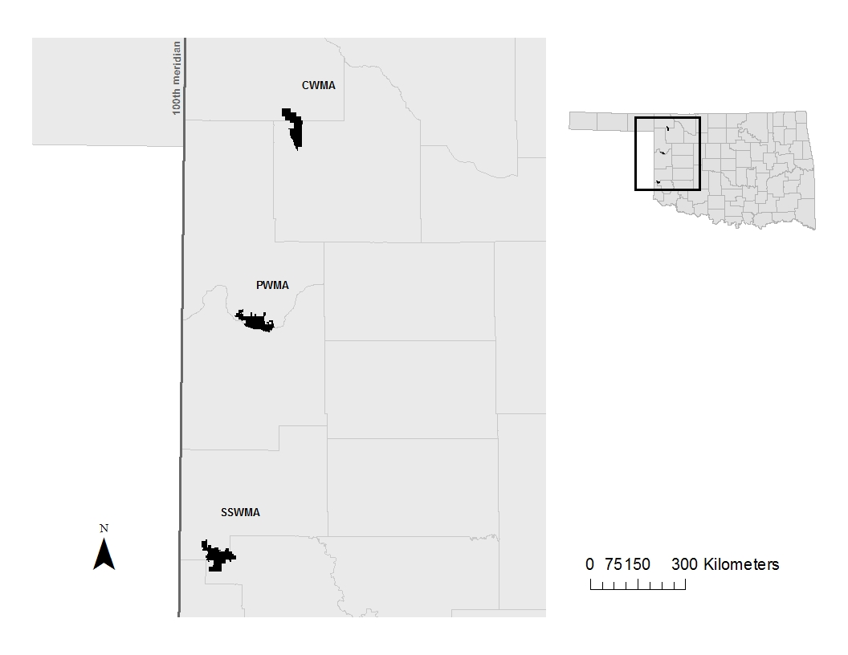

Figure 1 – Study areas from north to south – Cooper Wildlife Management Area (CWMA), Packsaddle Wildlife Management Area (PWMA), and Sandy Sanders Wildlife Management Area (SSWMA).

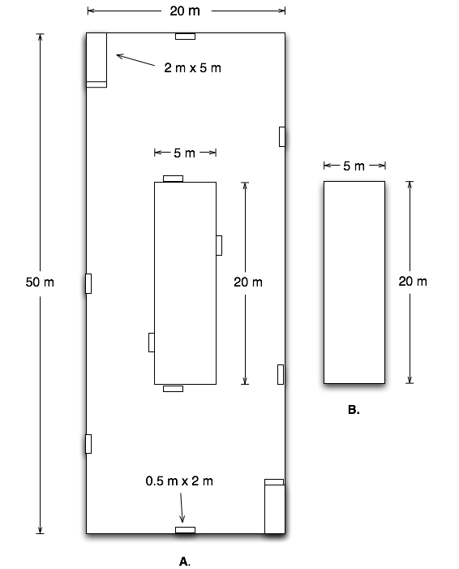

Figure 2 – (a) Modified Whittaker Plot; (b) Extensive Plot (modified from Barnett and Stohlgren [2003]).

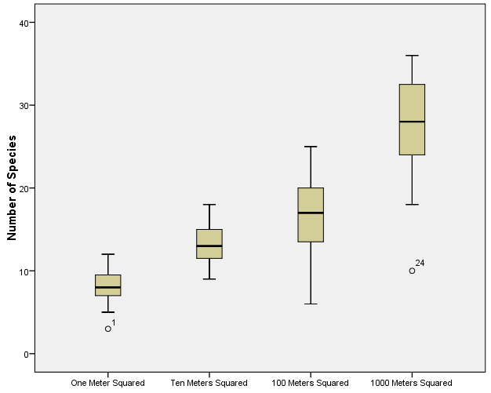

Area

Figure 3 – Overall mean species richness from all three study areas per scale, indicating a greater number of species at larger scales.

Similarity Values

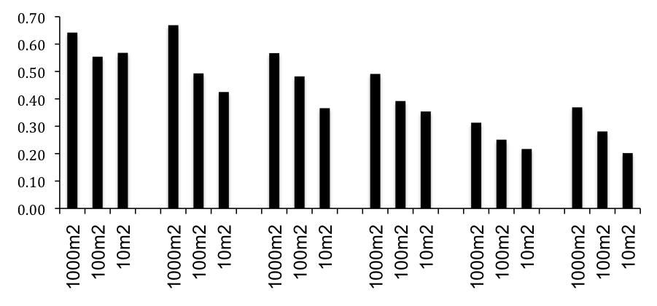

CO PA SS CO/PA CO/SS PA/SS

Study Areas

Figure 4 – Mean similarity within and between study areas at the 1000m², 100m², and 10m² scales. CO = Cooper Wildlife Management Area, PA = Packsaddle Wildlife Management Area, SS = Sandy Sanders Wildlife Management Area.

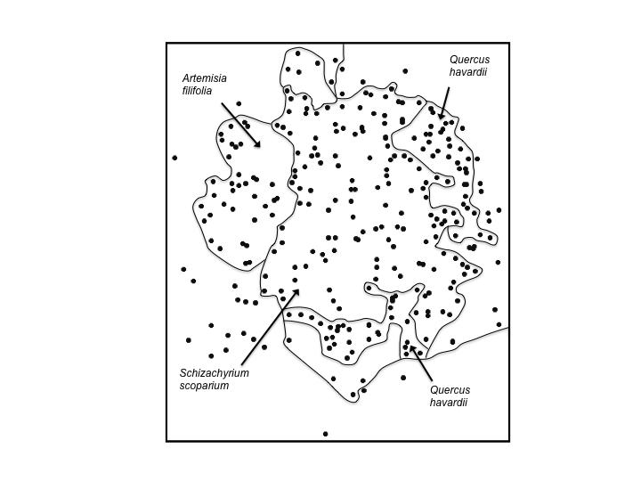

Quercus havardii
Artemisia filifolia
Quercus havardii

Axis 2

Schizachyrium scoparium

Axis 1

Figure 5 – Scatterplot created from the NMDS Ordination for 1m² plots, detailing clusters of the two most abundant woody species, and the most abundant herbaceous species.

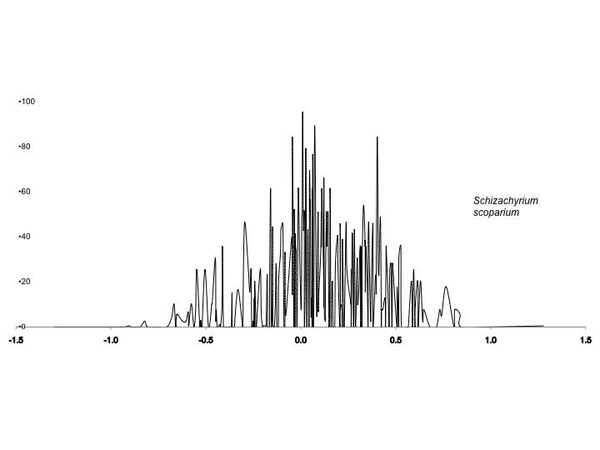
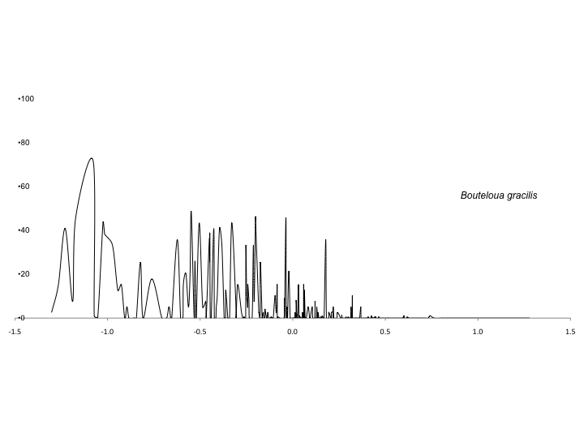
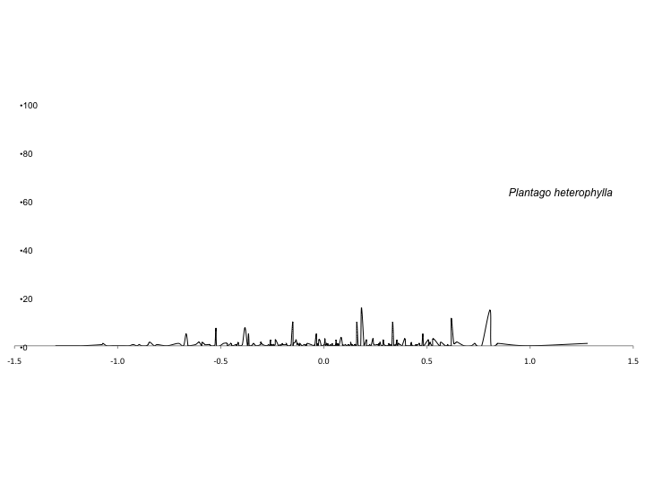
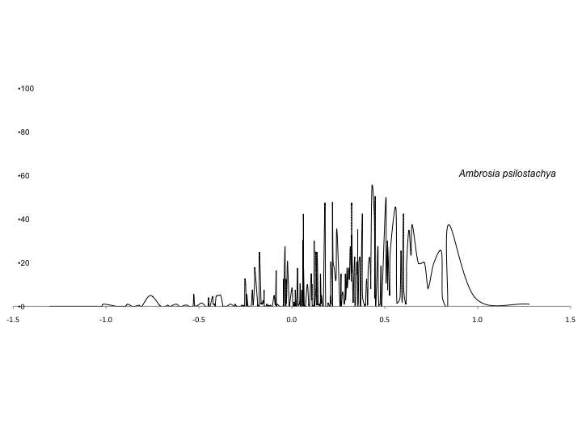
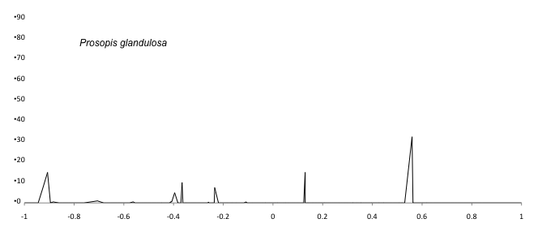
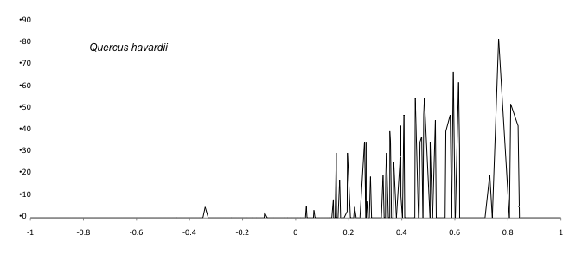
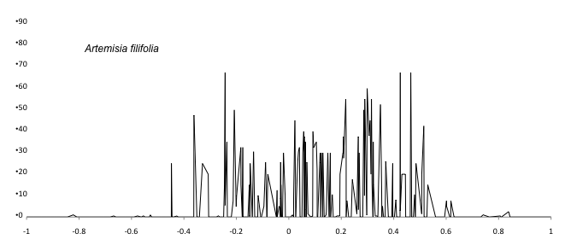
Figure 6 (a – Schizachyrium scoparium) and (b – Bouteloua gracilis) – Correlations between dominant herbaceous species percent cover and Axis 1 scores from NMDS Ordination for 1m² plots.

Schizachyrium scoparium
Bouteloua gracilis
Ambrosia psilostachya
Plantago heterophylla
Figure 6 (c – Ambrosia psilostachya) and (d – Plantago heterophylla) – Correlations between dominant herbaceous species percent cover and Axis 1 scores from NMDS Ordination for 1m² plots.

Prosopis glandulosa
Artemisia filifoia
Quercus havardii
Figure 7 (a – Artemisia filifolia), (b – Quercus havardii), and (c – Prosopis glandulosa) – Correlations between woody species percent cover and Axis 1 scores from NMDS Ordination for 1m² plots.

Table 1 – Relative frequency data for the 1000m², 100m², and 10m² plots.

Plant Name | 1000m² | 100m² | 10m²
Ambrosia psilostachya | 0.96 | 0.92 | 0.83
Amphiachyris dracunculoides | 0.54 | 0.42 | 0.33
Andropogon hallii | 0.54 | 0.29 | 0.29
Aphanostephus skirrhobasis | 0.08 | 0.04 | 0.08
Arabis holboellii | 0.17 | 0.06 | 0.00
Aristida purpurea | 0.38 | 0.25 | 0.19
Artemisia filifolia | 0.67 | 0.60 | 0.58
Artemisia ludoviciana | 0.75 | 0.58 | 0.44
Astragalus missouriensis | 0.21 | 0.10 | 0.02
Bothriochloa ischaemum | 0.08 | 0.02 | 0.00
Bothriochloa saccharoides | 0.46 | 0.29 | 0.06
Bouteloua curtipendula | 0.71 | 0.46 | 0.48
Bouteloua dactyloides | 0.13 | 0.02 | 0.06
Bouteloua gracilis | 0.79 | 0.50 | 0.56
Bouteloua hirsuta | 0.08 | 0.00 | 0.00
Bromus catharticus | 0.04 | 0.06 | 0.02
Bromus tectorum | 0.71 | 0.58 | 0.38
Callirhoe involucrata | 0.38 | 0.23 | 0.06
Celtis laevigata | 0.08 | 0.00 | 0.00
Cenchrus echinatus | 0.38 | 0.38 | 0.15
Centaurea americana | 0.29 | 0.27 | 0.00
Chamaesyce missurica | 0.08 | 0.02 | 0.02
Chloris virgata | 0.38 | 0.19 | 0.08
Cirsium undlatum | 0.63 | 0.33 | 0.10
Cirsium texanum | 0.00 | 0.02 | 0.00
Commelina erecta | 0.67 | 0.44 | 0.31
Conyza canadensis | 0.58 | 0.40 | 0.21
Croptilon divaricatum | 0.00 | 0.04 | 0.00
Croton texensis | 0.67 | 0.44 | 0.27
Cucurbita foetidissima | 0.17 | 0.08 | 0.00
Cylindropuntia tunicata | 0.08 | 0.02 | 0.04
Cyperus schweinitz | 0.46 | 0.17 | 0.08
Dalea enneandra | 0.08 | 0.04 | 0.06
Dichanthelium oligosanthes | 0.04 | 0.02 | 0.00
Digitaria sanguinalis | 0.17 | 0.08 | 0.08
Dimorphocarpa candicans | 0.04 | 0.04 | 0.00
Echinocereus pectinatus | 0.17 | 0.02 | 0.00
Elymus ciliaris | 0.17 | 0.13 | 0.10
Eragrostis secundiflora | 0.21 | 0.06 | 0.06
Eriogonum annuum | 0.33 | 0.27 | 0.17
Euphorbia dentata | 0.21 | 0.10 | 0.04
Evolvulus nuttallianus | 0.04 | 0.00 | 0.02
Gaillardia pulchella | 0.79 | 0.52 | 0.44
Gaillardia suavis | 0.04 | 0.04 | 0.00
Gaura coccinca | 0.25 | 0.06 | 0.06
Grindelia papposa | 0.42 | 0.31 | 0.17
Helenium autumnale | 0.04 | 0.04 | 0.02
Helianthus angustifolius | 0.21 | 0.06 | 0.00
Helianthus petiolaris | 0.17 | 0.06 | 0.00
Heterotheca subaxillaris | 0.50 | 0.27 | 0.17
Hordeum pusillum | 0.04 | 0.00 | 0.00
Hymenopappus flavescens | 0.04 | 0.00 | 0.00
Indigofera miniata | 0.04 | 0.02 | 0.04
Juniperus pinchotii | 0.29 | 0.08 | 0.04
Juniperus virginiana | 0.04 | 0.00 | 0.00
Lepidium densiflorum | 0.04 | 0.00 | 0.00
Leucanthemum vulgare | 0.08 | 0.06 | 0.04
Liatris punctata | 0.42 | 0.44 | 0.31
Linum perenne | 0.21 | 0.13 | 0.06
Linum rigidum | 0.04 | 0.02 | 0.04
Lithospermum canescens | 0.04 | 0.00 | 0.02
Mentzelia nuda | 0.13 | 0.02 | 0.00
Mirabilis linearis | 0.04 | 0.00 | 0.00
Mollugo verticillata | 0.13 | 0.06 | 0.06
Monarda punctata | 0.29 | 0.25 | 0.19
Opuntia macrohiza | 0.88 | 0.23 | 0.17
Oxalis stricta | 0.13 | 0.00 | 0.00
Panicum virgatum | 0.33 | 0.19 | 0.19
Penstemon albidus | 0.13 | 0.00 | 0.00
Penstemon cobaea | 0.13 | 0.19 | 0.10
Physalis hispida | 0.17 | 0.13 | 0.06
Plantago heterophylla | 0.96 | 0.71 | 0.63
Plantago patagonica | 0.13 | 0.04 | 0.02
Plantago rhodosperma | 0.21 | 0.13 | 0.10
Poa arachnifera | 0.42 | 0.21 | 0.19
Polanisia dodecandra | 0.04 | 0.00 | 0.00
Pomaria jamesii | 0.13 | 0.00 | 0.00
Prosopis glandulosa | 0.29 | 0.27 | 0.21
Prunus angustifolia | 0.29 | 0.10 | 0.08
Quercus havardii | 0.25 | 0.13 | 0.17
Ratibida columifera | 0.25 | 0.08 | 0.04
Rhus aromatica | 0.04 | 0.06 | 0.00
Rhus trilobata | 0.13 | 0.04 | 0.02
Robinia pseudoacacia | 0.04 | 0.04 | 0.02
Salvia azurea | 0.13 | 0.00 | 0.02
Schizachyrium scorparium | 0.83 | 0.79 | 0.67
Solanum elaeagnifolium | 0.71 | 0.52 | 0.35
Solidago gigantea | 0.25 | 0.13 | 0.08
Solidago missouriensis | 0.13 | 0.04 | 0.06
Sorghastrum nutans | 0.21 | 0.19 | 0.08
Sporobolus cryptandrus | 0.25 | 0.15 | 0.10
Symphyotrichum ericoides | 0.04 | 0.00 | 0.00
Thelesperma megapotamicum | 0.25 | 0.08 | 0.06
Tradescantia occidentalis | 0.25 | 0.06 | 0.04
Tragia ramosa | 0.38 | 0.19 | 0.13
Tridens flavus | 0.58 | 0.21 | 0.31
Triteleia hyacinthina | 0.04 | 0.02 | 0.04
Vernonia baldwinii | 0.08 | 0.02 | 0.02
Xanthium strumarium | 0.04 | 0.00 | 0.00
Yucca glauca | 0.42 | 0.15 | 0.04
Table 2 – Mean cover, frequency, and relative frequency for plants encountered in the 1m² plots.

Species | Mean Cover | Frequency | Relative Freq
Schizachyrium scorparium | 16.83 | 194 | 0.67
Artemisia filifolia | 8.79 | 125 | 0.43
Ambrosia psilostachya | 7.68 | 198 | 0.69
Bouteloua gracilis | 5.07 | 118 | 0.41
Quercus havardii | 4.42 | 41 | 0.14
Bromus tectorum | 3.52 | 96 | 0.33
Bouteloua curtipendula | 1.87 | 74 | 0.26
Amphiachyris dracunculoides | 1.81 | 67 | 0.23
Andropogon hallii | 1.69 | 71 | 0.25
Aristida purpurea | 1.59 | 42 | 0.15
Bouteloua dactyloides | 1.14 | 15 | 0.05
Artemisia ludoviciana | 0.98 | 61 | 0.21
Gaillardia pulchella | 0.97 | 50 | 0.17
Centaurea americana | 0.93 | 48 | 0.17
Plantago heterophylla | 0.81 | 132 | 0.46
Elymus ciliaris | 0.78 | 25 | 0.09
Heterotheca subaxillaris | 0.68 | 23 | 0.08
Grindelia papposa | 0.55 | 36 | 0.13
Opuntia macrohiza | 0.38 | 19 | 0.07
Sporobolus cryptandrus | 0.38 | 17 | 0.06
Prosopis glandulosa | 0.37 | 17 | 0.06
Panicum virgatum | 0.35 | 33 | 0.12
Sorghastrum nutans | 0.34 | 15 | 0.05
Bothriochloa saccharoides | 0.32 | 9 | 0.03
Bothriochloa ischaemum | 0.31 | 4 | 0.01
Solanum elaeagnifolium | 0.29 | 70 | 0.24
Prunus angustifolia | 0.27 | 16 | 0.06
Plantago rhodosperma | 0.22 | 20 | 0.07
Yucca glauca | 0.21 | 10 | 0.04
Euphorbia dentata | 0.19 | 5 | 0.02
Rhus trilobata | 0.19 | 4 | 0.01
Tridens flavus | 0.19 | 35 | 0.12
Liatris punctata | 0.17 | 36 | 0.13
Bromus catharticus | 0.14 | 6 | 0.02
Commelina erecta | 0.14 | 51 | 0.18
Mollugo verticillata | 0.14 | 8 | 0.03
Solidago missouriensis | 0.14 | 11 | 0.04
Croton texensis | 0.13 | 35 | 0.12
Cenchrus echinatus | 0.11 | 23 | 0.08
Chloris virgata | 0.11 | 18 | 0.06
Digitaria sanguinalis | 0.11 | 11 | 0.04
Callirhoe involucrata | 0.1 | 9 | 0.03
Conyza canadensis | 0.09 | 27 | 0.09
Dalea enneandra | 0.08 | 12 | 0.04
Penstemon cobaea | 0.08 | 19 | 0.07
Tragia ramosa | 0.08 | 26 | 0.09
Linum perenne | 0.06 | 12 | 0.04
Ratibida columifera | 0.05 | 11 | 0.04
Cirsium undulatum | 0.04 | 19 | 0.07
Eragrostis secundiflora | 0.04 | 11 | 0.04
Eriogonum annuum | 0.04 | 20 | 0.07
Linum rigidum | 0.04 | 8 | 0.03
Monarda punctata | 0.04 | 16 | 0.06
Poa arachnifera | 0.04 | 9 | 0.03
Aphanostephus skirrhobasis | 0.03 | 8 | 0.03
Cyperus schweinitz | 0.03 | 16 | 0.06
Plantago patagonica | 0.02 | 7 | 0.02
Solidago gigantea | 0.02 | 9 | 0.03
Astragalus missouriensis | 0.01 | 7 | 0.02
Chamaesyce missurica | 0.01 | 3 | 0.01
Gaura coccinea | 0.01 | 4 | 0.01
Oxalis stricta | 0.01 | 5 | 0.02
Thelesperma megapotamicum | 0.01 | 3 | 0.01
Tradescantia occidentalis | 0.01 | 4 | 0.01
Table 3 – Sorensen Similarity data for individual study areas, and comparisons between study areas. CO = Cooper Wildlife Management Area, PA = Packsaddle Wildlife Management Area, SS = Sandy Sanders Wildlife Management Area.

1000m² | CO | PA | SS | CO/PA | CO/SS | PA/SS
Mean | 0.64 | 0.67 | 0.57 | 0.49 | 0.31 | 0.37
Median | 0.64 | 0.66 | 0.60 | 0.51 | 0.33 | 0.38
Mode | 0.53 | 0.57 | 0.58 | 0.49 | 0.39 | 0.39
Variance | 0.01 | 0.01 | 0.02 | 0.01 | 0.01 | 0.01
Range | 0.27 | 0.26 | 0.47 | 0.42 | 0.30 | 0.45
100m²
Mean | 0.55 | 0.49 | 0.48 | 0.39 | 0.25 | 0.28
Median | 0.54 | 0.52 | 0.48 | 0.39 | 0.26 | 0.29
Mode | 0.52 | 0.44 | 0.44 | 0.35 | 0.24 | 0.33
Variance | 0.01 | 0.02 | 0.03 | 0.01 | 0.01 | 0.01
Range | 0.52 | 0.62 | 0.73 | 0.63 | 0.52 | 0.56
10m² | CO | PA | SS | CO/PA | CO/SS | PA/SS
Mean | 0.57 | 0.43 | 0.37 | 0.35 | 0.22 | 0.20
Median | 0.56 | 0.44 | 0.37 | 0.36 | 0.23 | 0.22
Mode | 0.64 | 0.44 | 0.40 | 0.40 | 0.18 | 0.00
Variance | 0.01 | 0.02 | 0.03 | 0.01 | 0.01 | 0.02
Range | 0.57 | 0.88 | 0.75 | 0.70 | 0.48 | 0.53
Literature Cited

Archer, S. 1989. Have southern Texas savannas been converted to
woodlands in recent history? American Naturalist 134:545-561.

Archer, S., C.J. Scifres, C.R. Bassham and R. Maggio, 1988. Autogenic
succession in a subtropical savanna: Conversion of grassland to thorn woodland. Ecological Monographs 58:111-127.

Archer, S., T.W. Boutton and C.R. McMurtry, 2004. Carbon and Nitrogen
Accumulation in a Savanna Landscape: Field and Modeling Perspectives. Global Environmental Change in the Ocean and on Land. Eds. M. Shiyomi et al. pp. 359-373.

Asner, G.P., S. Archer, R.F. Hughes, R.J. Ansley and C.A. Wessman, 2003.
Net changes in regional woody vegetation cover and carbon storage in Texas rangelands, 1937-1999. Global Change Biology 9:316-335.

Bahre, C.J. and M.L. Shelton, 1993. Historic vegetation change, mesquite
increases, and climate in southeastern Arizona, Journal of Biogeography 20: 489-504.

Barkley, T.M., L. Brouillet and J. Strother. 2006. In: Flora of North America
Editorial Committee, eds. 1993+. Flora of North America North of Mexico. 16+ vols. New York and Oxford. Vols. 19-21.

Barnett, D.T. and T.J. Stohlgren, 2003. A Nested-Intensity Design for
Surveying Plant Diversity. Biodiversity and Conservation 12:255-278.

Barnhan, S., S. Jose, S. Biswas, K. Kabir, and W. Rogers. 2012.
Homegarden agroforestry systems: an intermediary for biodiversity conservation in Bangladesh. Agroforestry Systems 85: 29-34.

Borchert, J.R. 1950. The Climate of the central North American grassland.
Annals of the Association of American Geographers 40:1-39.

Boyd, C.S. and T.G. Bidwell, 2002. Effects of Prescribed Fire on Shinnery
Oak (Quercus havardii) Plant Communities in Western Oklahoma. Restoration Ecology 10:324-333.

Bragg, T.B. and L.C. Hulbert, 1976. Woody Plant Invasion of Unburned
Kansas Bluestem Prairie, Journal of Range Management 29:19-24.

Brown, J.R. and S. Archer, 1989. Woody plant invasion of grasslands:
establishment of honey mesquite (Prosopis glandulosa var. glandulosa) on sites differing in herbaceous biomass and grazing history. Oecologia 80: 19-26.

Bruner, W.E. 1931. The Vegetation of Oklahoma. Ecological Monographs.
1: 100-188.

Buffington, L.C. and C.H. Herbel. 1965. Vegetational Changes on a
Semidesert Grassland Range from 1858 to 1963. Ecological Monographs 35(2): 139-164.

Burcham, L.T. 1961. Cattle and Range Forage in California: 1770-1880.
Agricultural History 35: 140-149.

Callaway, R.M. and F. W. Davis, 1993. Vegetation dynamics, fire, and the
physical environment in coastal central California. Ecology 74:1567-1578.

Carpenter, J.R. 1940. The Grassland Biome. Ecological Monographs 10:
617-684.

Clarke, K.R. 1993. Non-parametric multivariate analyses of changes in
community structure. Australian Journal of Ecology 18:117-143.

Collins, S.L. and S.C. Barber. 1981. Effects of disturbance on diversity in
mixed-grass prairie. Vegetatio 64: 87-94.

Connell, J.H. 1978. Diversity in Tropical Rainforests and Coral Reefs.
Science 199:1302-1310.

Crockett, J.J. 1964. Influences of Soils and Parent Materials on Grasslands
of the Wichita Mountains Wildlife Refuge, Oklahoma. Ecology. 45: 326-335.

Dhillion, S.S. and M.H. Mills, 1999. The Sand Shinnery Oak (Quercus
havardii) Communities of the Llano Estacada in Savannas, Barrens, and Rock Outcrop Plant Communities of North America, Cambridge University Press.

Duck, L. G., and J. B. Fletcher. 1943. A game type map of Oklahoma. A
Survey of the Game and Furbearing Animals of Oklahoma. Oklahoma Department of Wildlife Conservation, Oklahoma City, Oklahoma.

Dye, K.I., D.N. Ueckert and S.G. Whisenant. 1995. Redberry juniper-
herbaceous understory interactions. Journal of Range Management, 48: 100-107.

Foreman, G. 1937. Adventure of the Red River; Report on the exploration of
the Red River by Captain Randolph B. Marcy and Captain G. B. McClellan. University of Oklahoma Press, Norman, Oklahoma, USA.

Fuhlendorf, S.D. and D.M.Endle. 2001. Restoring Heterogeneity on
Rangelands: Ecosystem Management Based on Evolutionary Grazing Patterns. BioScience 51(8): 625-632.

Ghorbani, J., A. Taya, M. Shorkri, and H.R. Naseri. 2011. Comparison of
Whittaker and Modified-Whittaker plots to estimate species richness in semi-arid grassland and shrubland. Desert 16: 17-11.

Goodrich, S. 2005. Classification and Capabilities of Woody Sagebrush
Communities of Western North America With Emphasis on Sage-Grouse Habitat. USDA Forest Service Proceedings RMRS-P-38 Sage-grouse habitat restoration symposium proceedings; 2001 June 4–7; Boise, ID. Department of Agriculture, Forest Service, Rocky Mountain Research Station.

Gould, F.W. and R.B. Shaw. Grass Systematics. Texas A&M University
Press, College Station, TX.

Grimes, J.P. 1973. Competitive exclusion in herbaceous vegetation.
Nature. 242: 344-347.

Harrell, W.C., S.D. Fuhlendorf, and T.G. Bidwell. 2001. Effects of prescribed
fire on Shinnery Oak communities. Journal of Range Management. 54: 685-690.

Hoagland BW. 2000. The Vegetation of Oklahoma: A Classification for
Landscape Mapping and Conservation Planning. The Southwestern Naturalist 45:385-420.

Hoagland, B.W. and A.K. Buthod. 2007. Vascular Flora of the Four
Canyons Preserve, Ellis County, Oklahoma. Journal of the Botanical Research Institute of Texas 1: 655-664.

Hoagland, B.W, Buthod A, Butler I, Callahan-Crawford P, Elisens W, Udasi
A, and Tyrl R. 2015. Oklahoma Vascular Plants Database. [online]. Available: http://www.biosurvey.ou.edu. (Accessed on March 1, 2015).

Isom, L.D. 2008. Species Diversity in a Mixedgrass Prairie in Ellis County,
Oklahoma. Masters Thesis, University of Oklahoma.

Johnston, M.C. 1963. Past and present grasslands of southern Texas and
northeastern Mexico. Ecology 44:456-466.

Kuchler, A.W. 1964. Potential Natural Vegetation of the conterminous
United States. American Geographical Society, New York.

Leis, S.A. and D.M. Engle, 2003. Comparison of Vegetation Sampling
Procedures in a Disturbed Mixed-Grass Prairie. Proceedings of the Oklahoma Academy of Science 83:7-15.

Magiera, A., H. Feilhauer, A. Otte, R. Waldhardt, and D. Simmering. 2013.
Relating canopy reflectance to the vegetation composition of mountainous grasslands in the Greater Caucasus. Agriculture, Ecosystems, and the Environment 177: 101-112.

Magurran, A., 2004. Measuring Biological Diversity. Blackwell Publishing,
MA.

Magurran, A. 2011. Biological Diversity: Frontiers in Measurement and
Assessment. Oxford University Press, Inc., N.Y.

Malanson, G.P., J.P. Rose, P.J. Schroeder, D.B. Fagre. 2011. Contexts for Change in Alpine Tundra. Physical Geography, 32: 97-113.

Marcy, R.B. 1866. Thirty years of army life on the border. Harper and Brothers Publishers, New York.

Martin, R.E., G.P. Asner, R.J. Ansley and A.R. Mosier. 2003. Effects of
Woody Vegetation Encroachment on Soil Nitrogen Oxide Emissions in a Temperate Savanna. Ecological Applications 13:897-910.

McCune, B. and J. Grace. 2002. Analysis of Ecological Communities. Mjm
Software Design, Gleneden Beach, Oregon, USA.

McCune, B. and M.J. Mefford. 1999. PC-ORD. Multivariate Analysis of
Ecological Data, Version 4. Mjm Software Design, Gleneden Beach, Oregon, USA.

McGarigal, K., and B.J. Marks, 1995. FRAGSTATS: spatial pattern analysis
program for quantifying landscape structure. USDA Forest Service - Pacific Northwest Research Station.

McWilliams, J. 2003. Artemisia filifolia In: Fire Effects Information System,
[Online]. U.S. Department of Agriculture, Forest Service, Rocky Mountain Research Station, Fire Sciences Laboratory (Producer). (http://www.fs.fed.us/database/feis).

Nascimbene, J., O. Salvadori, and P.L. Nimis. 2009. Monitoring lichen
recolonization on a restored calcareous statue. Science of the Total Environment. 407: 2420-2426.

Nixon, K. 1997. Fagaceae. In: Flora of North America Editorial Committee,
eds. 1993+. Flora of North America North of Mexico. 16+ vols. New York and Oxford. Vol. 3, pp. 356-357.

Oklahoma Department of Wildlife Conservation. 2013. Cooper Wildlife
Management Area (www.wildlifedepartment.com/facts_maps/wma/cooper.htm).

Oklahoma Department of Wildlife Conservation. 2013. Packsaddle Wildlife
Management Area (www.wildlifedepartment.com/facts_maps/wma/packsaddle.htm).

Osborn, B. 1942. Prairie Dogs in Shinnery (Oak Scrub) Savannah. Ecology
23:110-115.

Pielou, E.C. 1969. An Introduction of Mathematical Ecology. New York:
John Wiley and Sons.

Pettit, R.D. 1986. Sand Shinnery Oak: Control and Management.
Management Note No. 8, Contribution No. T-9-431, College of Agricultural Sciences, Texas Tech Univeristy, Lubbok, Texas.

Rappole, J.H., C.E. Russell and T.E. Fulbright. 1986. Anthropogenic
pressures and impacts on marginal, neotropical, semiarid ecosystems: The case of south Texas. Science of the Total Environment 55:91-99.

Risser, P.G. 1985. Grasslands. In. Physiological Ecology of North
American Plant Communities. Edited by B.F. Chabot and H.A. Mooney.

Shannon, C.E. and W. Weaver. 1949. The Mathematical Theory of
Communication. Urbana: University of Illinois Press.

Shantz, H.L. 1954. The Place of Grasslands in the Earth’s Cover of
Vegetation. Ecology 35(2): 143-145.

Sims, P.L. and P.G. Risser. 2000. Grasslands. Pgs. 324-356 in M.G
Barbour and W.D. Billings ed. North American Terrestrial Vegetation. Cambridge University Press, Cambridge, United Kingdom.

Smith, C.C. 1940. The Effect of Overgrazing and Erosion upon the Biota of
the Mixed-grass Prairie of Oklahoma. Ecology. 21: 381-397.

Sorenson, T. 1948. A Method of Establishing Groups of Amplitude in Plant
Sociology based on Similarity of Species Content and its Application to Analyses of Vegetation on Danish Commons. Biol Skr (K. Danske Vidensk. Selsk. NS) 5:1-34.

Stoddart, L.A. 1941. The Palouse Grassland Association in Northern Utah.
Ecology 22(2):158-163.

Stohlgren, T.J., 1994. Planning long-term vegetation studies at landscape
scales. In: Ecological Time Series, Powell, T.M. & Steele, J.H. (eds) Chapman and Hall, New York. Pgs. 209-241.

Stohlgren T.J., M.B. Falkner and L.D. Schell, 1995. A Modified-Whittaker
nested vegetation sampling method. Vegetatio 117:113-121.

Stohlgren, T.J., G.W. Chong, M.A. Kalkhan and L.D. Schell, 1997. Multiscale
Sampling of Plant Diversity: Effects of Minimum Mapping Unit Size. Ecological Applications 7:1064-1074.

Stohlgren, T.J., K.A. Bull and Y. Otsuki, 1998. Comparison of rangeland
vegetation sampling techniques in the Central Grasslands. Journal of Range Management 51:164-172.

Stohlgren, T.J., D. Binkley, G.W. Chong, M.A. Kalkhan, L.D. Schell, K.A. Bull,
Y. Otsuki, G. Newman, M. Bashkin and Y. Son, 1999. Exotic Plant Species invade Hot Spots of Native Plant Diversity. Ecological Monographs 69:25-46.

Stohlgren, T.J. 2007. Measuring Plant Diversity. Oxford University Press,
Inc. New York.

Stone, K.H., 1964. A Guide to the Interpretation and Analysis of Aerial
Photos. Annals of the Association of American Geographers 54:318-328.

Tate, R. C. 1928. Some observations on the spread of mesquite to the north
in Cimarron County, Oklahoma. Proceedings of the Oklahoma Academy of Science 8:58

Thacker, E., D. Elmore, B. Reavis, and T. Bidwell. 2006. Mangement of
Sandsage Brush Rangelands. Oklahoma Cooperative Extension Services.

Tyrl, R.J., T. Bidwell and R. Masters. 2002. Field Guide to Oklahoma
Plants. Oklahoma State Univeristy, Stillwater, Oklahoma.

Van Auken, O.W. 2000. Shrub Invasions of North American Semiarid
Grasslands. Annual Review of Ecological Systems. 31:197-215.

Van Auken, O.W. 2009. Causes and consequences of woody plant
encroachment into western North American grasslands. Journal of Environmental Management. 90:2931-2942.

Wiedeman, V. E. and Wm. T. Penfound, 1960. A Preliminary Study of the
Shinnery in Oklahoma, The Southwestern Naturalist 5:117-122.

Chapter 2

Reconstructing the mixedgrass prairie landscape; an analysis of the plats and notes of the General Land Office Survey (1873-1875) in western Oklahoma

Abstract

General Land Office Public Land Survey records were used to interpret the composition and extent of woody and grassland communities in early Euro-settlement western Oklahoma. Land cover and vegetation patterns, including bearing/witness trees were examined. Qualitative data from the township summaries and section line notes detailing the surface structure and land cover, and quantitative data from the township plats and bearing tree records were examined to create a mapped representation as to what the landscape looked like in the 1870’s. These data identified specific trees and shrubs occurring along the uplands and bottomlands, as well as references to topography, soils, and anthropogenic activity.

Introduction

The utility of reconstructing historic land cover for the analysis of landscape dynamics and natural resource management has been well documented (Galatowitsch, 1990; Whitney and DeCant, 2001; Schulte and Mladenoff, 2002; Thomas and Hoagland, 2011; Hoagland et al., 2013; Fagin and Hoagland, 2014). Such studies rely upon establishing a baseline dataset that attempts to represent the pre-settlement landscape. Data sources for landscape reconstruction include travel accounts, government reports and land surveys. Although each source has particular limitations, none were collected expressly for ecological analysis. For example, in travel accounts, the writer features only those aspects of the landscape that catch his or her attention, such as common or abundant species of plants and animals. Few provide quantitative data that allow for the comparison of species abundance or landscape patterns with modern data. Indeed, few include the scientific binomial of the taxa encountered.
The Public Land Survey (PLS) conducted by the United States General Land Office (GLO) are a set of historic documents that provide quantitative data for the analysis of land cover and species composition. The PLS was established by the Land Ordinance Act of 1785, which proscribed procedures for data collection, which underwent several modifications in subsequent years. The PLS replaced the metes and bounds system of land survey and was intended to facilitate the orderly settlement of land acquired by the United States government west of the Allegheny Mountains.
The Congressional Township, a square measuring 6 miles x 6 miles that was subdivided into 36 one square-mile sections, is the fundamental unit of the PLS (Stewart, 1935; Brothers, 1991). Townships were marked in relation to an Initial Point (more might exist for a state or territory), from which a north-south meridian (township) and east-west baseline (range) lines extended. The process of delineating townships required surveyors to first mark the exterior lines of the township, followed by interior or section lines. At 0.5 mile intervals, surveyors placed a monument to indicate the intersection of lines demarcating either the township, sections, or quarter sections. To relocate these monuments, bearing or witness trees were marked. A tree was identified in each section and the bearing, distance, diameter, and taxa of the tree noted. From these surveys, ecologists and biogeographers have utilized the township plats and bearing or witness tree data for analysis of past landscapes.
Township plats (Figure 1) were drawn after the field surveys based on measurements made along the survey lines. Features mapped on a plat include vegetation, topography, watercourses, and anthropogenic features such as sawmills, coalmines, quarries, limekilns, roads, and cattle trails (Stewart, 1935; Brothers, 1991). Surveyors also wrote entries that briefly summarized features encountered along the survey lines and of the entire Township. These summary notes complement the quantitative data provided in the township records.
The plats, the first of three data sources that can be utilized from GLO records, provide a spatial or planar dataset for the analysis of past landscape patterns. The earliest application of GLO PLS data to address ecological questions was Gleason (1913), when mapping the location of oak groves in eight counties in central Illinois. He concluded that fire had “separated” (i.e., fragmented) the groves from a larger forest matrix. He concluded that fire had reduced the width of forest on eastern versus western sides of streams, due to prevailing winds, and that prior to settlement, the forest was broadly lobed, as opposed to the “the narrow tongues” of the contemporary vegetation (Gleason, 1913).
The second dataset that is commonly analyzed from GLO data is bearing or witness tree data, which are typically used to determine the composition of woody plant communities or the spatial distribution of woody plant species (Whitney and DeCant, 2001). Community metrics such as species density, dominance, and frequency are calculated from the diameter and distance data.
A third source of information is Information provided in the survey line notes and township summaries. Although intended to inform economic and agricultural interests, the information recorded is often of ecological interest. Descriptions of the physical environment included dominant vegetation (e.g., prairie, brush prairie, grove, or forest/woodland), surface type (e.g., rolling, level, or hard), and a rating of soils on a scale from one to four, with one being the best soils and four being the worst. Other physical features, such as ravines and bluffs, and water courses, such as rivers, creeks, sloughs, washes, runs, dry creeks, and dry runs were also documented. These descriptions have proven useful, in conjunction with bearing tree data, in providing a more detailed narrative of species composition (Hoagland et al. 2013).
It is evident through the township summaries, though, that economic and agricultural interests were the primary purpose of the land surveys. Examples of summary records from two surveyors that illustrate this are as follows: Surveyor Morrill – T7N, R21W "The township is best adapted to grazing"; T9N, R22W "Sandstone abounds in all parts of the township, which is better adapted to grazing then to cultivation"; T10N, R21W "Gypsum and sandstone of an inferior quality are found in abundance. The township is well adapted both to grazing and to cultivation"; T10N R24W, North Fork of the Red River "The water in the river, as well as in the creeks, are strongly alkali”; T17N R25W "Rock is chiefly of gypsum and limestone, is found in abundance, it is of a very good quality and suitable for building purposes." Surveyor Darling – T22N R22W "This township is entirely destitute of water"; T16N R26W "The only stone found in the township is a few sandstone of poor quality."
Occasionally, information of historic interest was recorded. For example, surveyor Hackbusch noted in Township 13 North, Range 24 West (in present-day Roger Mills County) that “General Custer's battleground of Nov. 27, 1868 is situated on the Washita bottom in Section 12. Some evidence of this action still remains on the ground, such as the bones of mules and ponies, and skulls of men” (BLM, 2015).
For this research, the GLO records will be used to determine composition and extent of woody and grassland communities in early Euro-settlement western Oklahoma. The pre-Euro-settlement portion of woody versus herbaceous communities is relevant to an understanding of woody plant encroachment, a global phenomenon that has reduced the extent of tropical, temperate and desert grasslands (Archer, 1995; Van Auken, 2009). Woody plant encroachment is a product of changing land use patterns, including livestock grazing, conversion to row crop production, fire suppression, and climate change (Bragg and Hulbert, 1976; Archer, 1989; Bahre and Shelton, 1993; Asner et al., 2003).
Although mixedgrass prairie vegetation predominates in western Oklahoma, five species of native woody plants (sand sage [Artemisia filifoila], shinnery oak [Quercus havardii], honey mesquite [Prosopis glandulosa], redberry juniper [Juniperus pinchotii], and eastern red cedar [J. virginiana]) have increased in aerial extent and abundance since Euro-settlement of the region in the late 19th century (Snook, 1985; Engle et al., 1996; Thacker, 2006). In bottomland forests of the western United States, Tamarisk, an invasive riparian shrub that alters ecosystem functions, occurs (Stabler and Still, 2011). Four species of Tamarisk (Chinensis, gallica, parviflora and ramosissima) have been documented in the study area (Hoagland et al., 2015). Since T. ramosissima was introduced to the United States in 1823, it is possible that the surveyors would have encountered this species, though the rate of spread is uncertain.
The five species of woody plants listed above, although native to the mixedgrass prairie, have increased in abundance since Euro-American settlement. Although two of these species, sand sage and shinnery oak, are shrubs and would not be identified as bearing trees, land surveyors may have mentioned them in the section line descriptions. Mesquite and cedar trees, however, have been recorded as bearing trees and mentioned in the section line descriptions documented in other PLS studies of western Oklahoma (Hoagland et al, 2013; Powell, 2014).
For this research, GLO PLS data from 1873-1875 were examined to document land cover and vegetation patterns, including bearing/witness trees. Both qualitative and quantitative components of the PLS data were interpreted and analyzed from the surveys. Qualitative data consisted of written section line descriptions detailing land cover and surface structure. Quantitative data consisted of bearing tree records (diameter-at-breast height, point-to-plant distance) and plats (e.g. land cover types, extent). The bearing tree data will provide insight regarding the species composition and vegetation structure (e.g. basal area and stem density). The plats will be used to create vegetation/land cover maps of pre-settlement western Oklahoma.

Study Area
The study area includes five counties (Beckham, Ellis, Harper, Roger Mills, and Woodward) in western Oklahoma, from the 100th meridian, north of the North Fork of the Red River to the Kansas border (Figure 2). The Panhandle was excluded because it was not surveyed until the 1890s. Average annual temperature in this region is 13°C, and average annual precipitation is approximately 63.5 cm (25 inches) (OCS, 2015). The study area is located in the Osage Plains Physiographic Province (Hunt, 1974) and the topography ranges from gently rolling hills to deeply dissected badlands. Permian age deposits predominate the surface geology and include sandstone and shale, and deep beds of gypsum (Branson and Johnson, 1979). Tertiary sand, clay and gravel deposited during the Laramide Orogeny also occur in the study area. Broad deposits of quaternary alluvium occur along major streams, and massive sand dunes, mostly stabilized have formed on the north side of these streams (Johnson, 2006).
Upland soils consist of Pratt Association loamy fine sand, Brownfield and Nobscot Association deep, fine sand, Tivoli Association fine sand, Yahola Association fine sand loam, and Woodward and Quinlan Association loam (Cole et al., 1966, Nance et al., 1960). In addition, these soils generally exhibit a well-defined drainage pattern (Cole et al., 1966, Nance et al., 1960).
The Game Type Map of Oklahoma, prepared by Duck and Fletcher (1943), is the first comprehensive vegetation analysis of the state, and can arguably serve as a Potential Natural Vegetation map. Fifteen vegetation types were discerned based on dominant species, physiognomy, land use, and wildlife habitat characteristics. Six vegetation types were mapped for the region currently under study: mixedgrass eroded plains, shortgrass high plains, tallgrass prairies, and the woody plant types, sand sage grasslands, shinnery oak, and mesquite grasslands (Figure 5).
Three grassland types/units were mapped in the study area of this project, with a combined occupancy of 57.3% of the study area (Table 3). The mixedgrass eroded plains are the most extensive, occupying 509,648.9 hectares (38%) of the study area. The shortgrass highplains unit, which is more common in the Oklahoma Panhandle, constitutes only 17.4 percent of the grassland vegetation. Characteristic grass species of the mixedgrass eroded plains are sideoats grama (Bouteloua curtipendula), hairy grama (B. hirsuta), little bluestem (Schizachyrium scoparium), Indiangrass (Sorghastrum nutans), and sand dropseed (Sporobolus cryptandrus) (Duck and Fletcher, 1945; Hoagland, 2000). Characteristic grass species of the shortgrass highplains are buffalograss (Bouteloua dactyloides), and blue grama (B. gracilis). Though an important vegetation type in central and eastern Oklahoma, tallgrass prairie constitutes less than 2% of grasslands.
The six remaining vegetation types are characterized by the predominance of one or more taxa of woody plants. Associated herbaceous species are similar to those of adjacent grassland types, except in heavily shaded conditions. Of these woody vegetation types, shinnery oak (18%) and sand sage grasslands (16.9%) are the most pervasive (Table 3). Although both woody vegetation types are associated with sandy soils and share many associated species found in the mixedgrass eroded plains, the predominant woody species have uniquely different growth habits. Sand sage is a low stature shrub that varies greatly from site-to-site in stem density. Shinnery oak is a low stature rhizomatous shrub that forms dense stands. Interspersed among the low growing root suckers are stems up to four meters in height that are hybrids with post oak (Q. stellata) or chinkapin oak (Q. muehlenbergii) that grow in distinct mottes. Associated species in both vegetation types include Chickasaw plum (Prunus angustifolia), fragrant sumac (Rhus aromatica), and the grasses sand bluestem (Andropogon hallii) and giant sand reed (Calamovilfa gigantea) (Duck and Fletcher, 1945; Wiedeman and Penfound, 1960; Thacker et al., 2006).
The remaining woody vegetation types constitute <10% of the study area. Of these, honey mesquite shrublands have expanded in extent and are now considered a nuisance species. As mapped by Duck and Fletcher (1943), however, the extent is limited to the vicinity of the North Fork of the Red River, which is consistent with other studies employing GLO data and (Powell, 2014; Hoagland et al., 2015) and historic travel accounts (Harlan, 1957; Marcy, 1866; Havard, 1884). Duck and Fletcher (1943) did not map vegetation units in which Juniper species predominated nor were Junipers mentioned as a nuisance species in the Game Type descriptions (Duck and Fletcher 1945).
Statewide, Duck and Fletcher (1943) also mapped approximately 880,596 hectares of bottomland forest along all of the major rivers and streams in Oklahoma. Because precipitation decreases generally westward in Oklahoma, species composition and structure of bottomland forests varies from east to west. The dominant trees occurring in the bottomlands of western Oklahoma were cottonwood (Populus deltoides), willow (Salix spp.), hackberry (Celtis spp.), and elm (Ulmus spp.) (Bruner, 1931; Duck and Fletcher, 1945). Because the land surveyors were consistently crossing water courses during the section line surveys, they mentioned bottomland vegetation in the section line notes, and recorded some bearing trees in the bottomlands (Thomas, 2010; Hoagland et al., 2013; Powell, 2014).

Methods
Three data sources were utilized for the GLO records: bearing tree data, line and township summaries, and plats. One hundred and fifty-nine townships were analyzed for this study (Figures 2 and 3). The GLO records for the 159 townships studied were acquired from the Bureau of Land Management (http://www.glorecords.blm.gov). The line and township summaries were transcribed verbatim into spreadsheet. These data provide an important supplement for the narrative description of the physical environment, habitats, and vegetation.
Bearing tree identification, compass bearing and distance from the survey point, and diameter-at-breast height (DBH) were recorded. Surveyors recorded data for at least four trees at the intersection of section lines and two trees at the quarter section (Hutchison 1988). Each bearing tree was attributed to the appropriate line intersection. The point-to-plant distance and compass bearing were used to place the tree.
Since GLO surveyors in Indian Territory provided only a taxon’s common name, a scientific binomial was attributed. Nomenclature follows the Integrated Taxonomic Information System (2016). These data were also used to calculate the community structure metrics of basal area and stem density. The DBH values were used to calculate the basal area (BA= πr2) for each taxon as a measure of dominance. Stem density was reported by taxon as the average point-to-plant distance of all stems recorded.
Township plats were georeferenced, and mapped features were digitized and assigned to one of the following land cover classes – forest/woodland, grassland (e.g., non-wooded vegetation including pasture land, cultivated areas, and wetlands), hydrology, and, if present, transportation (e.g., wagon roads, cattle trails, and railroads) and anthropogenic structures. These data were then compiled into seamless geographic information system (GIS) layers for the study area. Landscape structure was then determined: class area (measure of total area occupied by a particular land cover type), number of patches (measure of individual occurrences of a given land cover type), and mean patch size (average area occupied by each land cover type; Rempel 2008).

Results
The PLS in the study area was conducted from 6 March 1873 through 16 March 1875 by four Deputy Surveyors: Theodore H. Barrett, Ehud N. Darling, Henry C.F. Hackbusch, and Orrin T. Morrill (Figure 3). Surveyors recorded a total of 11,132 section line descriptions from the 159 townships surveyed. Of those, 2,281 referenced vegetation, often in sufficient detail to determine predominant species and habitat (e.g., upland or bottomland). Examples of upland vegetation descriptions include “scattering black jack on brush prairie”, “scrubby blackjack oak”, “scattering timber”, and “scattering timber along line.”
Concatenating the common name reported by a surveyor with modern taxonomy present challenges, as exemplified by Surveyor Hackbusch’s report of spruce and birch along one survey line (15N 24W). In this case, there are no native populations of spruce (Picea sp.) in Oklahoma and if the identification of birch is interpreted strictly, then only river birch (Betula nigra) occurs in the state, but is restricted to the eastern half of the state. Assigning a scientific binomial was relatively simple for some trees because the common name corresponded with woody plant species known to occur in the area; for example, post oak and osage orange. In some cases, only one species of a genus occurs in the state, such as cottonwood and redbud. Although both white and red mulberry occur in the modern flora, it could be argued that only one species occurred at the time of the survey, since white mulberry is an introduced species.
When a genus is reported with multiple species in the region, habitat and/or taxonomic criteria can be employed to determine the species designation. Although successful in some studies (Thomas and Hoagland, 2011; Hoagland et al., 2013; Fagin and Hoagland 2014), the results were mixed in the present study. Take for example trees reported as elm, walnut, cedar, or locust. In each case there is at least one congener in the study area and their habitat requirements overlap. American elm (Ulmus americana) and red elm (U. rubra) both occur in western Oklahoma and occupy riparian habitats, as does black willow (Salix nigra) and sandbar/narrowleaf willow (S. exigua). Although redberry juniper (J. pinchotti) exhibits a preference for gypsum derived soils, eastern red cedar (Juniperus virginiana) can occur in close proximity at the base of narrow canyons and floodplains.
There are also difficulties in reconciling the identification taxa reported by surveyors with their modern distributions. For example, there are no modern records of blue ash (Fraxinus quadrangulata), black oak (Q. velutina), pin oak (Q. palustris), Spanish oak, white oak (Q. alba), and hawthorn (Crataegus sp.) from the study area (Hoagland et al. 2015). White oak, however, could be chinkapin oak (Quercus muehlenbergii) or post oak (Q. stellata), both of which have been documented in the study area (Rice and Penfound, 1959; Hoagland et al., 2015).
Black oak was reported as a bearing tree 23 times in the PLS records. All of these references were from one surveyor (Barrett). However, there are no modern records of black oak occurring in western Oklahoma counties (Rice and Penfound, 1959; Hoagland et al., 2015). Since blackjack oak does occur in western Oklahoma, it is possible that black oak is a shorthand reference to blackjack oak. A PLS study from central Oklahoma concluded that surveyors often recorded blackjack oak as black oak (Thomas and Hoagland, 2011).
Reference to locust, whether honeylocust (Gleditsia triacanthos) or black locust (Robinia pseudoacacia), is a bit more complicated. Neither species is considered to have been a component of the pre-Euro-settlement flora of the Great Plains, but both species were planted as part of the Great Plains Shelterbelt project that began in 1934. Whether black locust occurred in Oklahoma prior to settlement is also open to question, though some have suggested it was present and restricted to the Ouachita Mountains of eastern Oklahoma (Little 1998).
We were also confronted with synonymous common names. For example, surveyors used both jack oak and blackjack to denote Quercus marilandica, Bois d’arc and osage orange for Maclura pomifera, and multiple common names were reported for Chittamwood (Sideroxylon lanuginosum) and soapberry (Sapindus saponaria). Chittamwood was recorded as chittim, chillum chitam, ironwood and shittam. Soapberry was recorded as chinaberry, wild china, and chaney. The use of chaney or chaney ball tree as a common name for soapberry was reported by Payne (1908).
In most of the GLO notes from Indian Territory, reference is only made to woody species, but a unique reference was made to “short buffalograss”. “Buffalograss,” possibly Bouteloua dactyloides, was recorded in fifteen townships, and mentioned in 20 line descriptions. Associated habitat was listed as “rolling/gently rolling, hard-pan prairie”. “Bunch grass,” which could refer to multiple grass species in the mixedgrass prairie, was reported in one township (26N 26W) that also included occurrences of buffalograss, although the two grasses were not listed as co-occurring. In the same township, bunch grass was also reported in 11 line descriptions as occurring with sage brush on “rolling, sandy prairie”. One of those line descriptions (59th mile) also included plum brush.
Upland and bottomland vegetation is often referenced in the same section line description, such as “bunch grass and sage brush on the uplands, plum and willow brush and scattering cottonwood and willow timbers in bottom”, or vegetation and geomorphology, such as “elm, cedar and hackberry along creek bottom, gypsum on bluffs”, and “scattering elm, hackberry and oak in ravines; oak, elm and cottonwood along creek”. A single reference was to a “small grove of cottonwood trees” (15N 25W). Other references to surface/geomorphology include “cedar, cottonwood, elm, burr and post oak, and hackberry in ravines and canyons”, “cedar in canyons and ravines”, “cedar along ravines”.
Bottomland vegetation was referenced in 1,441 line descriptions. In most cases, the same descriptive phrase was repeated for multiple line descriptions; “scattering cottonwood and elm along banks” (n= 590), “scattering timber along banks” (n= 332), “scattering timber on banks” (n= 325), “scattering cottonwood along banks” (n= 106), and “scattering cottonwood, elm and hackberry along banks” (n= 88). Other examples of bottomlands include “scattering cottonwood, elm and walnut along banks” (n= 28), “scattering elm along banks” (n= 15), “scattering elm and hackberry along banks” (n= 8), “scattering elm and cedar along banks” (n= 6), “few scattering cottonwood and elm along banks” (n= 4), and “elm and cottonwood along water courses” (n= 3).
The dominant trees mentioned in the section line descriptions are cottonwood (n= 1,227), elm (n=1,229), and hackberry (n=273). Although vegetation occurrences were documented along uplands and bottomlands, the majority of vegetation references occurred along bottomland water courses (cottonwood= 1107, 90%; elm= 1016, 84%; hackberry= 207, 76%), such as river and/or creek banks, runs, washes, sloughs, etc. Surveyors used the following terms to distinguish riparian habitats: banks, creek banks, runs, sloughs, and or simply water courses. In addition, 50 references were made to “dry creek” and/or “dry run.” Cedar was mentioned in 138 line descriptions, with 72 (52%) of the occurrences being along watercourses.
Although trees were predominantly mentioned in the line descriptions, shrubland vegetation was also frequently mentioned. Sand sage is mentioned specifically as a dominant species in six townships (6N 26W, 16N 23W, 17N 23W, 26N 26W, 27N 26W, 29N 26W) and 14 line descriptions. Plum was mentioned in ten line descriptions, willow was mentioned in 33, and they were listed as co-occurring in five. Bunch grass (species unknown) was listed as co-dominant with plum and willow on one occasion. References were made in 14 township summaries to “scrub oak”, “scrubby oak”, “running oak”, “scrub oak brush” or “dwarf oak”, which could possibly be shinnery oak. In one instance, the oak in question was described as “1 to 3 feet high”, which is consistent in stature with shinnery oak (Wiedemen and Penfound, 1960).
Several trees were mentioned as co-occurring in the surveyors’ line descriptions. Cottonwood and elm were the most frequently listed species pair (n= 706), in phrases such as “cottonwood and elm”, “scattering cottonwood and elm”, or “a few scattering cottonwood and elm”. Elm was listed first in 25 descriptions. The majority of these descriptions (n=633, 90%) indicate riparian habitats; for example “cottonwood and elm along banks”, “scattering cottonwood and elm along banks”, “scattering cottonwood and elm along creeks”, “scattering cottonwood and elm along dry creeks”, and “scattering cottonwood and elm along water courses”. The remaining 73 co-occurrences (10%) are upland references. In 366 entries (300 noting riparian habitats), hackberry, cedar, willow, walnut, post oak, blackjack oak, and burr oak were reported as occurring with cottonwood and elm. Elm and hackberry were reported as co-occurring (n=19, nine in riparian areas) less frequently than cottonwood and elm.
Cedar was mentioned 138 times, usually co-occurring with elm and/or cottonwood; seventy-two of those references were along riparian areas, usually along creek banks. Willow was mentioned 36 times, with 30 of them being along riparian areas. Blackjack oak was mentioned 81 times, with only one reference being along a watercourse (dry run).
Osage orange (Maclura pomifera) was mentioned in 14 section line descriptions, and recorded 17 times as a bearing tree. Although this tree has several current records from western counties in the Oklahoma Vascular Plants Database (Hoagland et al., 2015), there is dispute whether it was an original member of the western Oklahoma flora. Most authorities have mapped the pre-settlement distribution east of the 95th meridian, and note the introduction of osage orange to western Oklahoma occurred between 1850 and 1875, to create natural fences (Burton, 1973; Smith and Perino, 1981).

Bearing Tree Data
The GLO surveyors marked 1,930 bearing trees in the study area (Figure 7a) consisting of 26 taxa (Table 1). The most frequently encountered trees, and those with the highest basal area, were cottonwood (Figure 7b) (626 stems, relative frequency (RF) = 32.4%, basal area (BA) = 56.9m²), elm (Figure 7c) (535 stems, RF = 27.7%, BA = 24.3m²), and hackberry (Figure 7d) (230 stems, RF = 11.9%, BA = 4.9m²). The highest basal area for an individual tree was also scored by cottonwood at 1.17m². Although not a bearing tree, it is interesting to note that surveyors mapped an occurrence of a petrified log (22N, 20W).
Point-to-plant distances ranged from >0.5m to 98.2m (mean = 23.3m, median = 20.1m, mode = 3.6m). The majority of bearing trees recorded were between 0.1 and 45 meters from the survey point, with the 5-10m class containing the most bearing trees (n = 270 for all; 87 for cottonwood) (Figure 3). Mean distance for cottonwood only was 37.4m (median = 36m, mode = 66m).

Land cover
Ten land cover types were mapped on plats for the study area (Figure 6, Table 2). The preponderance of the study area was occupied by grasslands (1.27 million ha, 94.8%), thus it can be considered the matrix land cover type. Of the three woody vegetation types, riparian forest (27,470 ha, 2%) was the most prevalent. All woody vegetation types occupied a limited extent of the study area. In comparison with Duck and Fletcher’s (1943) “Game Type map,” the upland forests as mapped by the GLO plats correspond to post oak-blackjack oak forest. There were only nine occurrences of wetlands occupying 88.9 ha. Only two anthropogenic features were mapped; two cultivated fields (total of 4.3 ha) and a corral (<1.0 ha).
Although there were a total of 1,212 patches for all land cover types, 959 were of woody vegetation types, and 217 were grassland. Though high in number, patches of woody vegetation had low patch size. For example, riparian forest, represented by the highest number of patches (n= 783) had the lowest mean (35.1 ha) and median (12.3 ha) patch sizes. Forest/woodland accounted for 153 patches, with a mean patch size of 136.8 ha and a median patch size of 17.0 ha. The highest mean patch size was for grassland (5,868.5 ha), as would be expected for a matrix cover type.

Discussion
Cottonwood, elm, and hackberry were the most frequently encountered species by surveyors. Powell (2014) also reported these same three species as being the most frequently encountered by the surveyors in southwestern Oklahoma. Riparian occurrences of cottonwood (86.7%), elm (83.5%), and hackberry (75.8%) were much higher than their occurrences situated away from riparian habitats. The prevalence of these species in riparian areas isn’t surprising given that the surveyors were consistently traveling along water courses. In addition, these three species, along with willow, tend to occur along riparian corridors, as they prefer moist conditions for germination (Naiman et al., 1993; Kindsher and Holah, 1998; Amlin and Rood, 2002). Low-lying riparian areas contain more moisture than the adjacent uplands. While it wasn’t encountered nearly as often as the dominant trees, willow was referenced 36 times in the section line notes, with 30 (83.3%) references occurring along water courses. Both cottonwood and willow require abundant moisture and exposed mineral soils for seed germination, and their clonal nature allows them to disperse quickly in grove and/or clump expansion (Krasny et al. 1988; Van Haverbeke, 1990; Amlin and Rood, 2002).
Although the Duck and Fletcher (1943) bottomland timber cover type, as mapped, spans the length of the state, geographic differences in species composition were recognized in the 1945 report. Duck and Fletcher (1945) reported that bottomland woody vegetation in western Oklahoma was predominantly cottonwood, willow, and hackberry, with elm mostly occurring in the eastern part of western Oklahoma, becoming more dominant in the bottomlands of central Oklahoma. This research also found that cottonwood, elm, and hackberry were dominants in the bottomlands, along with some willow. Duck and Fletcher (1945) determined that post oak, blackjack oak, chinkapin oak, and chittam occur, along with cottonwood, elm, and hackberry in the bottomlands of central Oklahoma. This research also found that post oak and blackjack oak were listed as bearing trees in the northeast corner of the study area, which coincides with the western edge of the post oak-blackjack oak forest vegetation type that Duck and Fletcher (1943) mapped in central Oklahoma.
Of the woody plants known to be encroaching in western Oklahoma, Juniperus species were the most prevalent in the PLS data. Cedar was mentioned in 138 line descriptions in 12 townships. This information is useful because it indicates that cedar was already established in western Oklahoma, north of the North Fork of the Red River, in the late 1870s. However, it was mentioned much less often (6.0%) than cottonwood, elm (both 53.8%), or hackberry (12.0%), indicating that it wasn’t dominating the uplands or bottomlands at that time. This information could form a baseline from which to document cedar encroachment throughout western Oklahoma, post-settlement. While mesquite has been documented in the GLO PLS data throughout southwestern Oklahoma (Hoagland et al., 2013; Powell, 2014), it wasn’t mentioned in any of the 159 townships surveyed in this study. Based on this finding, it can be concluded that mesquite didn’t begin to expand north of the North Fork of the Red River until after 1875. Although this study didn’t examine PLS data west of the 100th meridian, mesquite was documented in the Oklahoma panhandle in 1928 (Tate, 1928). In addition, sixty-eight years after the public land surveys were completed in western Oklahoma, Duck and Fletcher (1943) documented mesquite just north of the North Fork of the Red River. Since then, it has expanded further north into parts of Roger Mills, Harper, and Woodward Counties (Hoagland et al., 2015).
The shrubby species, sand sage and shinnery oak, weren’t specifically mentioned in the PLS data, but references to ‘sage brush’ and ‘running oak’, ‘scrubby oak brush’ and ‘dwarf oak’ indicate there is a strong possibility these references were describing sand sage and shinnery oak. While there are several species of sage occurring in western Oklahoma, sand sage is the most robust, and the one most likely to be described as ‘sage brush’. Marcy (1853) documented shinnery oak before the public land surveys were even completed, strengthening the possibility that surveyors would have encountered shinnery oak. It is also the only oak species known to western Oklahoma that fits the description of “scrubby oak brush about 18 inches high” (BLM, 2015). Finally, shinnery oak was also documented in western Oklahoma several times during the first half of the 20th century (Bruner, 1931; Osborn, 1942; Duck and Fletcher 1943). The fact that shinnery oak was that well established by 1943 indicates that it must have been present in western Oklahoma much earlier.

Bearing Tree Data
Regarding bearing tree data, total basal area was 104.8m² (mean = 0.054m²), with the highest basal area values occurring among the five most abundant species (cottonwood = 56.9m², 54.3%; elm = 24.3m², 23.3%; hackberry = 4.9m², 4.7%; cedar = 3.9m², 3.7%; blackjack oak = 2.9m², 2.8%). The high basal area values for these species were not surprising because these five species dominated the bearing trees identified by the surveyors (1653 of 1930 trees; 86%). The dominant bearing trees recorded could be a result of a bias by the surveyors towards documenting large, long-living trees in hopes the trees would still be alive if/when the townships were surveyed again (Whitney and DeCant, 2001; Liu et al., 2011). However, these findings agree with those of Powell (2014), who determined that cottonwood, elm, and hackberry were the three most dominant bearing trees in southwestern Oklahoma, south of the North Fork of the Red River, and that basal area was highest among cottonwood (62%), elm (16%) and hackberry (10%). Mean basal area was also similar between this study (0.054m²), and Powell (0.049m²) (2014). Finally, five of the six largest trees in this study were cottonwood, including the largest individual at 1.17m². Further east in the Wichita Mountains Wildlife Refuge (WMWR), Hoagland et al. (2013) recorded white oak (BA = 32.19%) and post oak (BA = 25.65%) as the most common bearing trees, with only two cottonwoods recorded as bearing trees (BA = 1.13%). Their study was situated within the cross timbers forest and woodland vegetation type, where oak species dominate. Further east in the Arbuckle Mountains, Fagin and Hoagland (2014) recorded post oak (BA = 46.37%), black oak (BA = 15.44%), and elm (BA = 29.3%) as the three most common bearing trees, and 19 records of cottonwood as a bearing tree.
The point-to-plant distance measures revealed that there was a great range in a tree’s distance from the survey line. The majority of bearing trees recorded were between 0.1 and 45 meters from the survey point, and the 5-10m class contained the most trees. These findings are very similar to those of Powell (2014), who examined composition and structure of southwestern Oklahoma. Point-to-plant distance measures exhibited a greater range in Powell’s study (2014), though (>0.5m to 169.58m), compared to >0.5m to 98.2m in this study, indicating a more open canopy. This differs from GLO studies in central Oklahoma in the cross timber forests (Thomas and Hoagland, 2011; Hoagland et al., 2013; Fagin and Hoagland, 2014). Hoagland et al. (2013) reported point-to-plant distances ranging from 0.6m to 58.2m (mean = 17.8m) in 1874. Fagin and Hoagland (2014) reported only mean distance from the survey line; 16.07m in the 1870s, and 21.16m in the 1890s. Mean distance from the survey line in this research was 23.3m, higher than the mean distance reported in the studies located further east. The difference in point-to-point values is a product of vegetation type and geographic location; both were in the post oak-blackjack oak forest in an area of higher precipitation (Duck and Fletcher, 1943).
There are few studies of woody bottomland vegetation from western Oklahoma. Collins et al. (1981) reported cottonwood, elm, and hackberry in bottomland forests of north central Oklahoma. Black walnut, black willow, and soapberry were also prevalent in the bottomland forests of the western region of north central Oklahoma (Collins et al., 1981). Rice (1965) also found elm to be dominant in the north central Oklahoma bottomlands, along with hackberry, soapberry, and black walnut to a lesser degree. Elm and hackberry were also dominant bottomland trees in this research, although cottonwood was the most dominant. Hefley (1937) reported willow as the dominant bottomland tree along the Canadian River floodplain in central Oklahoma, with cottonwood co-occurring. This study found the most dominant bottomland trees to be cottonwood, elm, and hackberry, with willow and cedar being prevalent as well.
Although post oak-blackjack oak forest is the most common forest-woodland cover type in the state, it was restricted to the northeast corner of the study area. Rice and Penfound (1955, 1959) documented post oak and blackjack oak extensively as the dominant trees throughout the central forests of Oklahoma, although their abundance declines westward. Hoagland et al. (2013) also determined that post oak and blackjack oak were the dominant trees in the Wichita Mountains of southwestern Oklahoma. In this study, post oak and blackjack oak dominated the area in the northeast corner where they occurred. Blackjack oak was recorded 7.1% more often as a bearing tree (n= 193) than post oak (n= 27). However, blackjack oak wasn’t recorded once beyond the northeast corner of the study area, and post oak was only recorded six times beyond the northeast corner – once in the southern part of the study area (9N 21W), and six times in two adjacent townships in the central part of the study area (18N 21W, 19N 21W), with three of those records occurring along the boundary of the two townships. Although black hickory (Carya texana) is an important associated species in the cross timbers elsewhere, it does not occur west of the 98the meridian, thus was not recorded in this study area.

Land Cover
The present-day dominant land cover in the study area is mixedgrass prairie, interspersed with patches of woody vegetation, predominantly sand sage and shinnery oak in the northwestern and west-central tier counties, and mesquite and juniper species in southwestern Oklahoma. The GLO map presents a more simplified landscape than the Duck and Fletcher map, as GLO surveyors reported fewer land cover types dominated by woody vegetation than Duck and Fletcher (1943). This could be because the GLO surveyors weren’t specifically documenting ecological data, as Duck and Fletcher did, or it could be that woody vegetation was not prevalent enough to be classified as a separate land cover type.
In addition, the GLO PLS records indicate a similar mosaic with the predominant land cover depicted from the plats being grassland, interspersed with patches of brush prairie, forest woodland, and riparian forest. Other studies using GLO PLS data to determine pre-settlement vegetation composition and structure in western Oklahoma also found grassland to be the dominant land cover type (Hoagland et al., 2013; Powell, 2014). Further east in central Oklahoma, the cross timber forest was the most dominant land cover type (Thomas and Hoagland, 2011; Fagin and Hoagland, 2013).
This study and Powell’s (2014) reported ten land cover types, six of them occurring in both study areas – grassland, forest/woodland, riparian forest, brush prairie, wetland, pond. Unique to Powell’s (2014) study were sand dunes, washes, mountains, and two groves. Unique to this study were a corral, a petrified log, two patches of cultivation, and portions of the Canadian River. The most abundant land cover types in this study were grassland (94.8%), riparian forest (2.0%), and forest/woodland (1.6%). Powell (2014) also reported grassland (85.0%) as the most dominant land cover type, followed by brush prairie (12.1%), and riparian forest (1.9%). The higher percentage of brush prairie in Powell’s (2014) study is attributed to the presence of honey mesquite in southwestern Oklahoma, as Powell mentions that surveyor DuBois reported honey mesquite in 18 townships. No mesquite was reported in this study north of the North Fork of the Red River. The higher percentage of forest/woodland in this study compared to Powell (2014) results from the presence of post oak and blackjack oak in the northeastern corner of the study area, which is part of the cross timbers of central Oklahoma (Rice and Penfound, 1959; Hoagland, 2000; Thomas and Hoagland, 2011; Hoagland et al., 2013). Although Powell (2014) reported higher percentages of brush prairie, including honey mesquite, forest/woodland only occupied 0.04% of the total land cover in southwestern Oklahoma. This can be attributed to the low percentages of post oak and blackjack oak. Only 4.0% of the bearing trees reported by Powell (2014) were post oak and blackjack oak, while 11.9% of the bearing trees reported in this study were of these cross timber species. Although riparian forest comprised the second largest land cover area in this study, and the most patches in the 1870s (64.6%), it only encompassed 2% of the total land cover area. This isn’t surprising given the plethora of small, fragmented riparian patches recorded by the surveyors. Powell (2014) reported similar riparian forest data (1.9% of total land cover area, 52.2% of land cover patches).

Conclusion
GLO PLS records from 1873-1875 were used to determine the vegetation and landscape structure of the western tier counties of Oklahoma north of the North Fork of the Red River, a period prior to Euro-American settlement. The result was the creation of a pre-settlement land cover map with bearing trees locations. The GLO PLS section line descriptions, plats, and bearing tree records provided data for woody plant species composition, descriptions of land cover and surface features. Occasional references to herbaceous vegetation, geomorphic references of sand hills, gypsum hills, bluffs, canyons, and ravines, and soil ratings were also obtained from the historic records. There were a few identification discrepancies, particularly with the bearing trees, but detailed section line notes and plat images provide a solid representation of the 1870s landscape. Although researchers will never have a complete reconstruction of historic landscapes, the various qualitative and quantitative data that is available in the GLO PLS records provides an accurate depiction of overall land cover in pre-settlement western Oklahoma.
Figure 1. An example of a plat, as mapped by the General Land Office in 1873. The township is 22 north, 17 west, and is located in Woodward County, Oklahoma. Bureau of Land Management, General Land Office record, 2015. (www.glorecords.blm.gov).

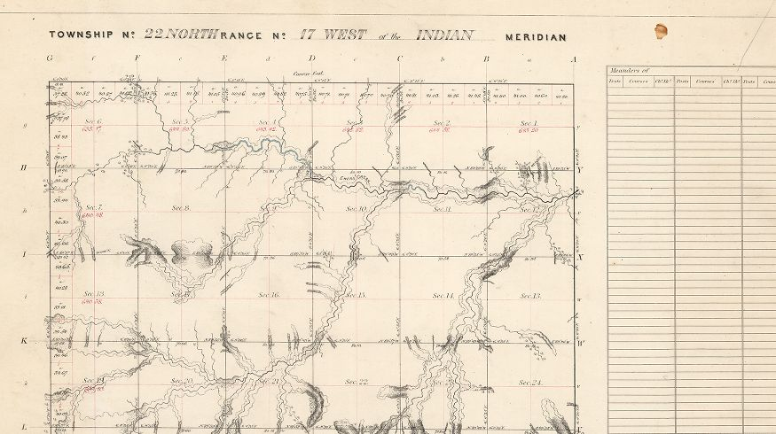

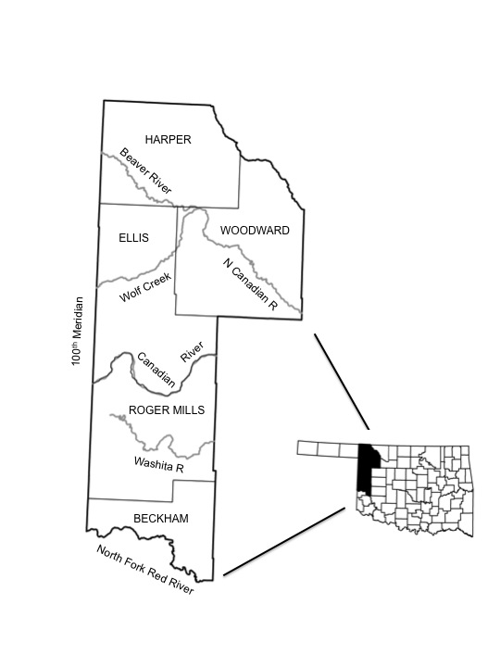

Figure 2. Study area, which incorporates the western Oklahoma counties of Harper, Woodward, Ellis, Roger Mills and northern Beckham.

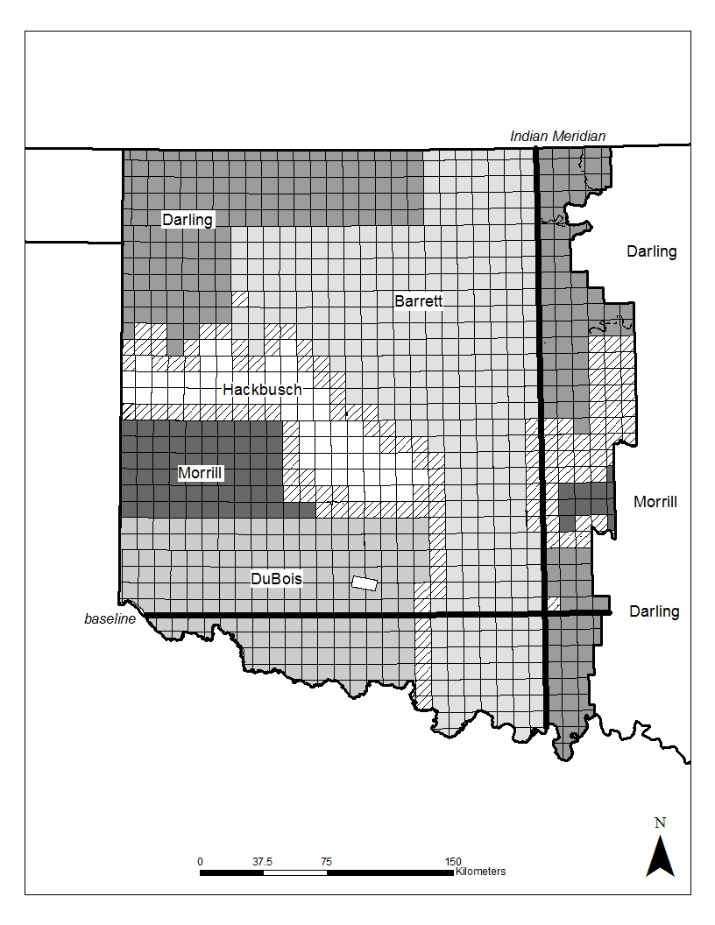

Figure 3 – Surveyors responsible for conducting Public Land Surveys of western Oklahoma in the 1870s. The majority of western Oklahoma was surveyed between 1873 and 1875 (figure from Powell, 2014).

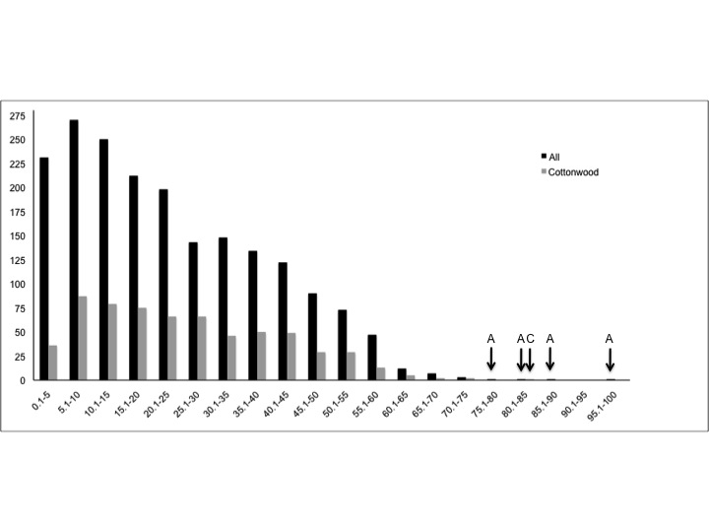
Number of Measurements

Distance Class

Figure 4 – Point-to-Plant distance classes for all trees, and for cottonwoods only, derived from the 1870s bearing tree data. The arrows indicate number of measurements as one. ‘A’ indicates all trees, and ‘C’ indicates cottonwoods.

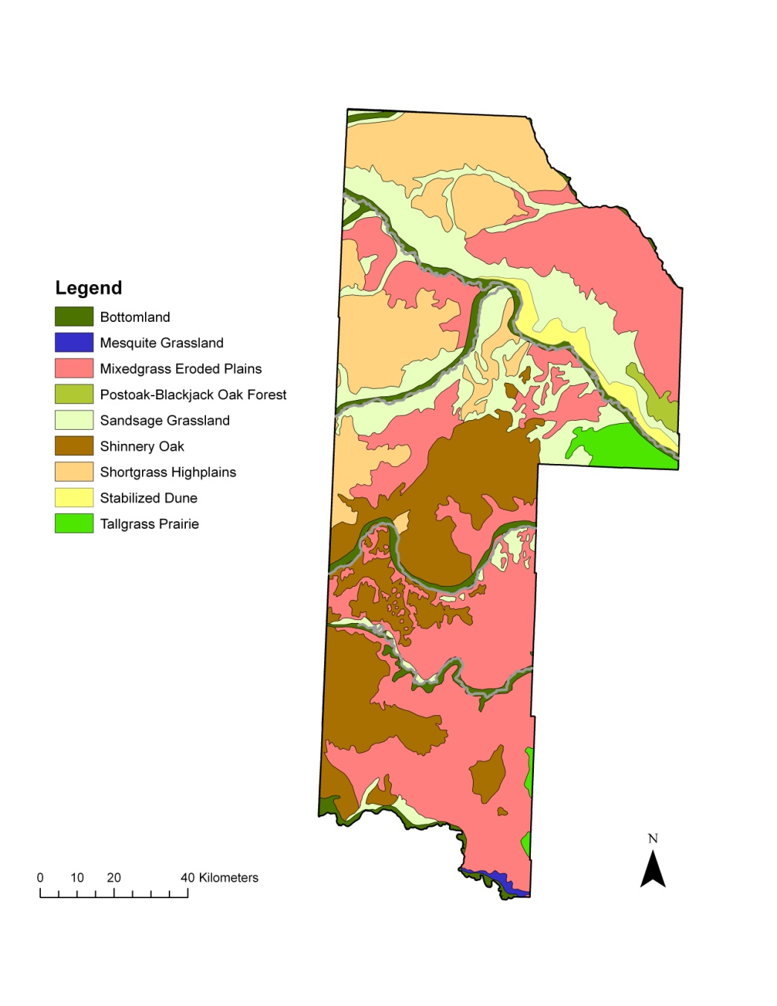

Figure 5 – Land cover of the western tier Oklahoma counties, north of the North Fork of the Red River, as mapped by Duck and Fletcher (1943).

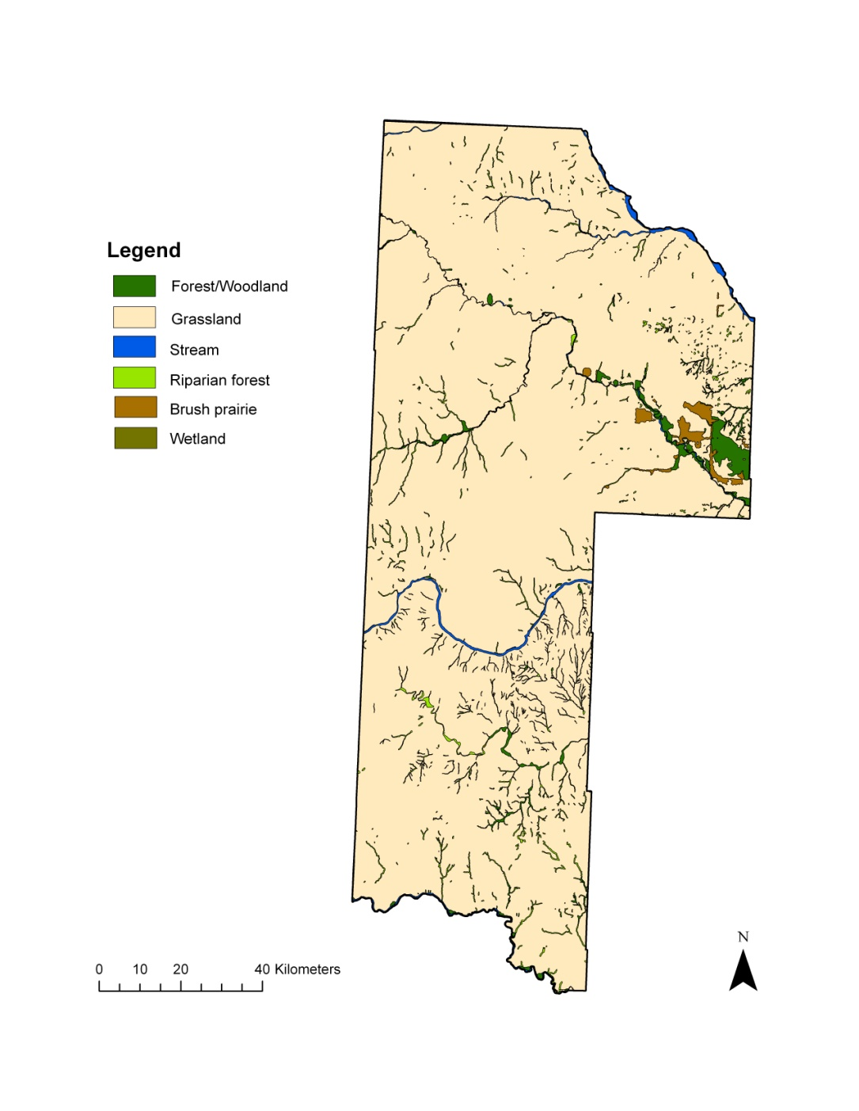

Figure 6 – Land cover of the western tier Oklahoma counties, north of the North Fork of the Red River complied General Land Office plats from 1873-1875.

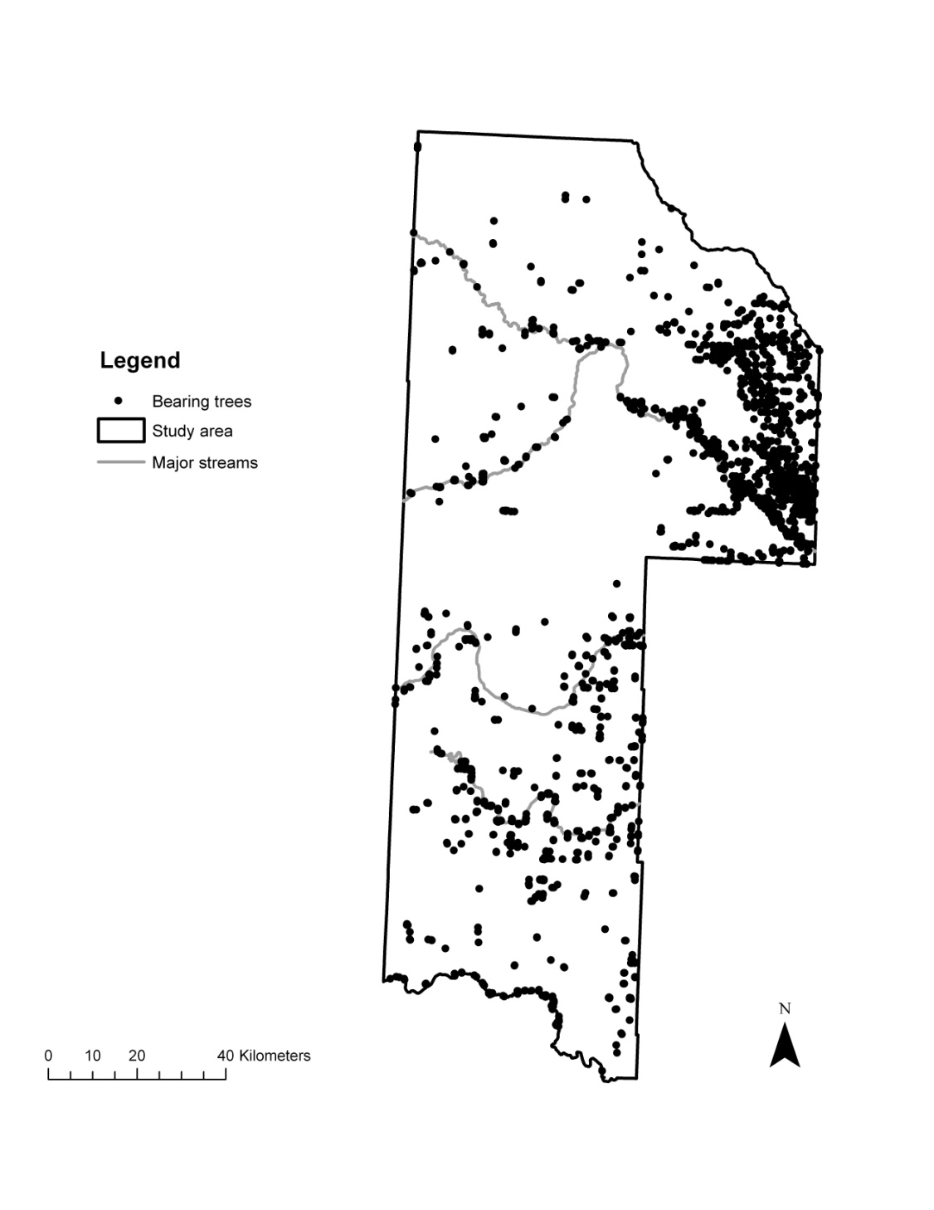
Figure 7a – All bearing trees records by surveyors from 1873-1875.

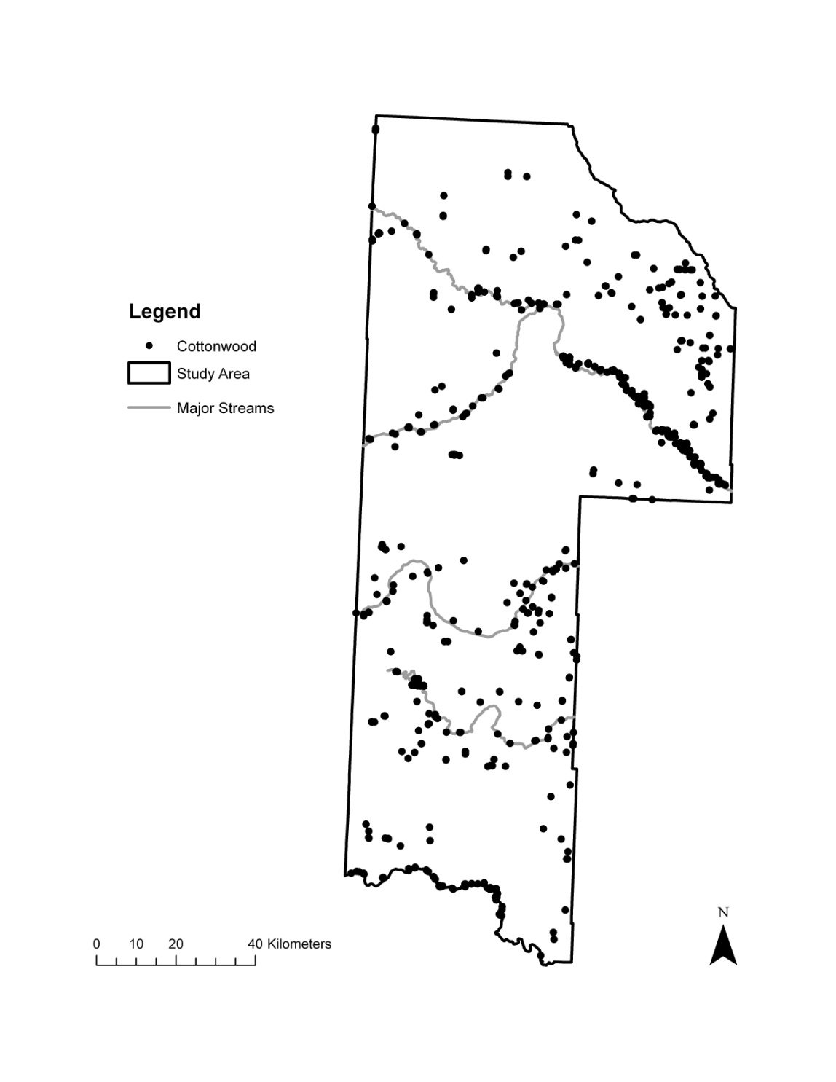
Figure 7b – Cottonwood bearing trees records by surveyors from 1873-1875.
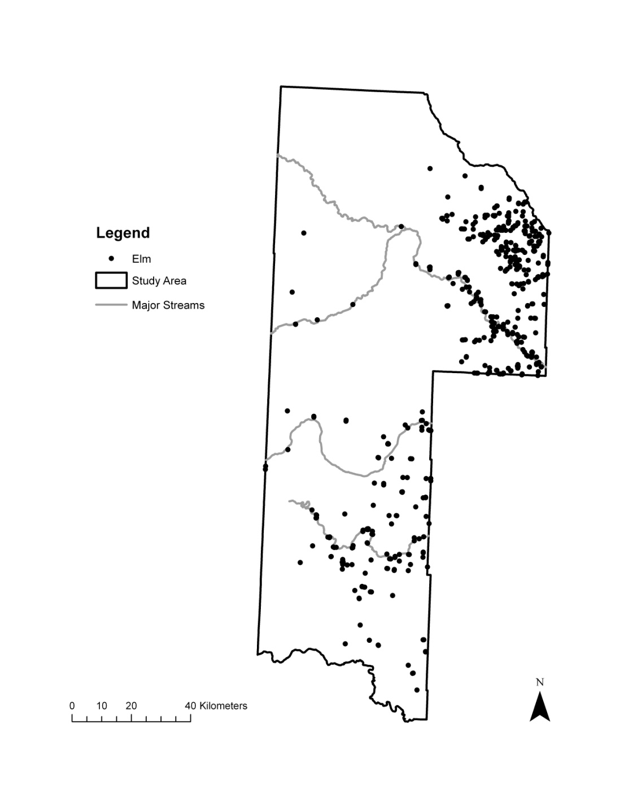
Figure 7c. Elm bearing trees records by surveyors from 1873-1875.

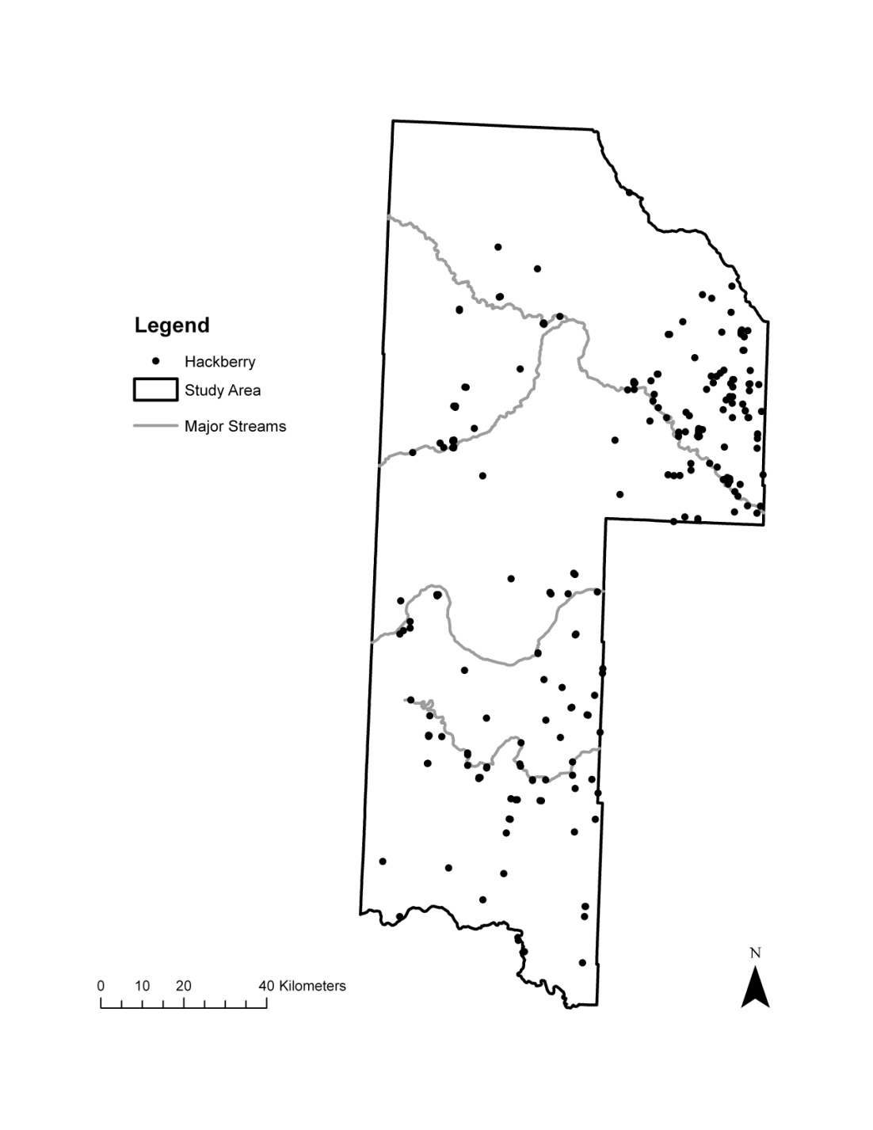
Figure 7d. Hackberry bearing trees records by surveyors from 1873-1875.
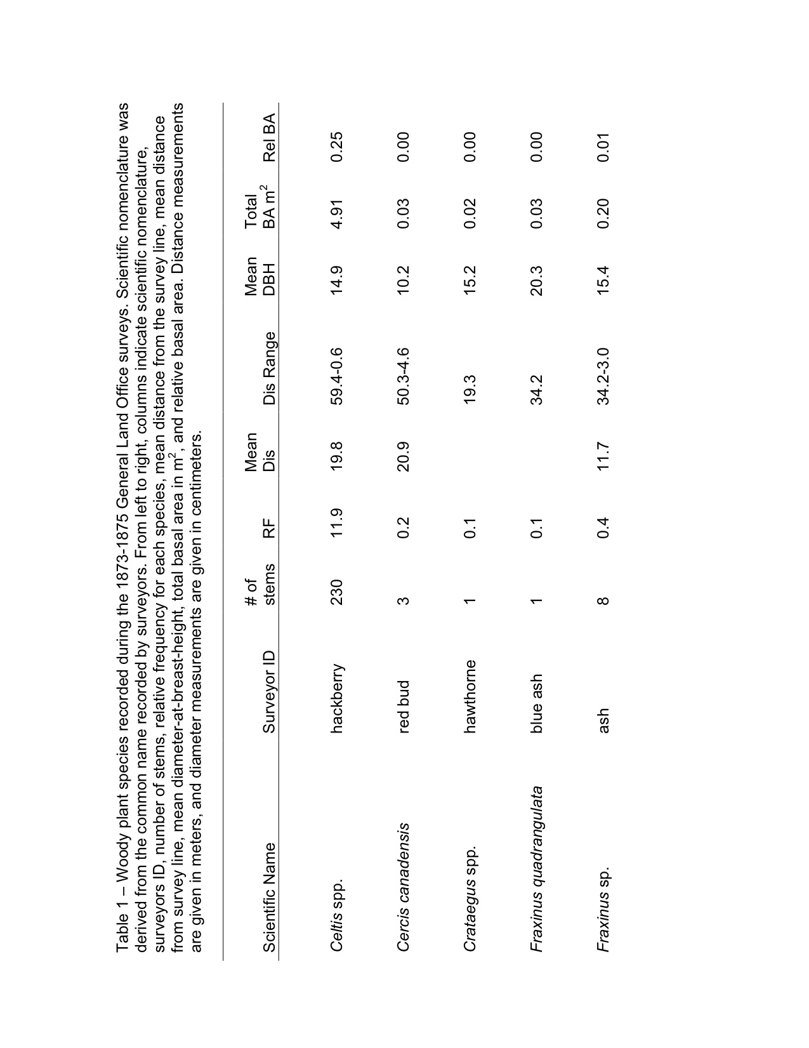

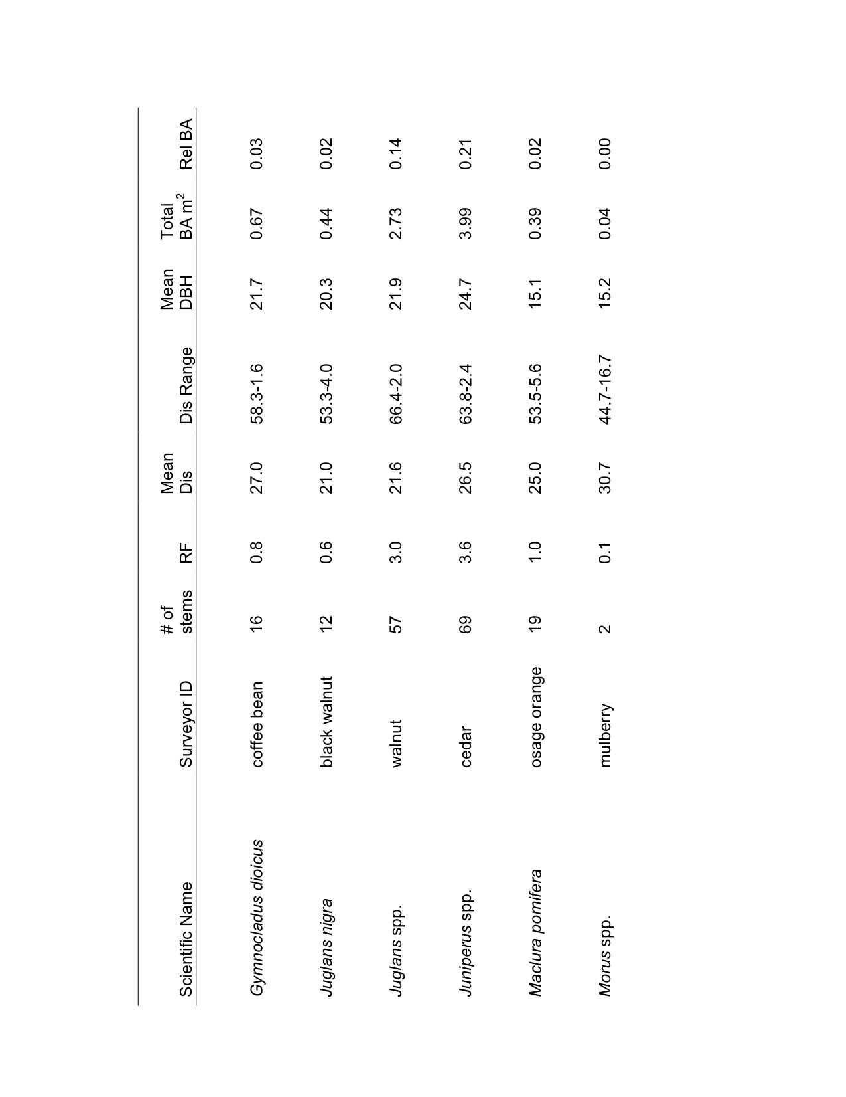

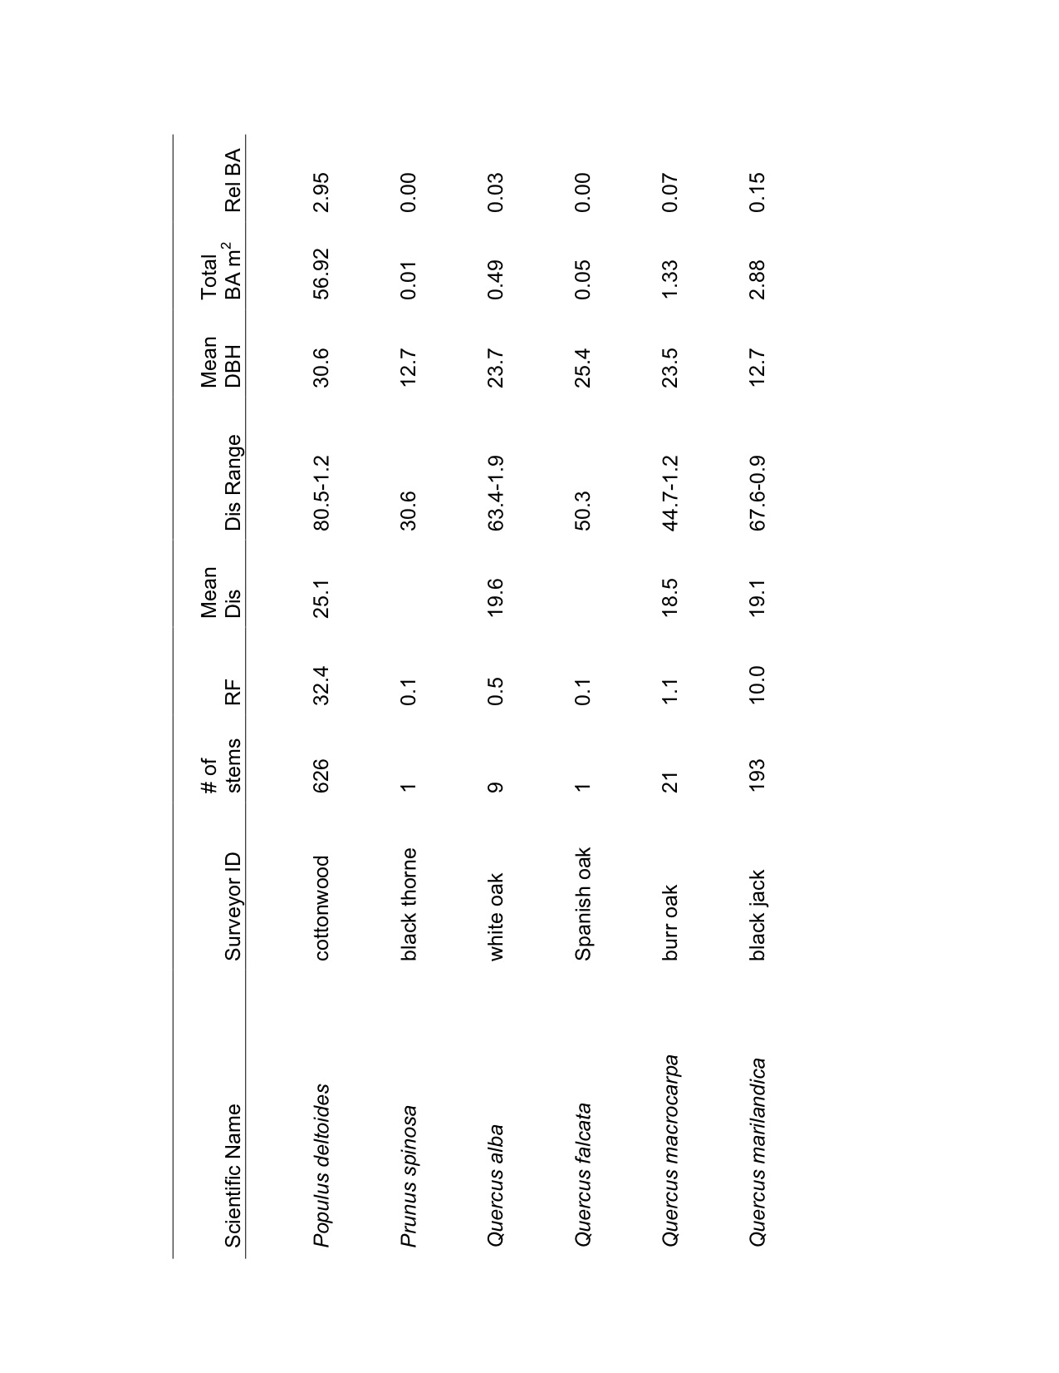
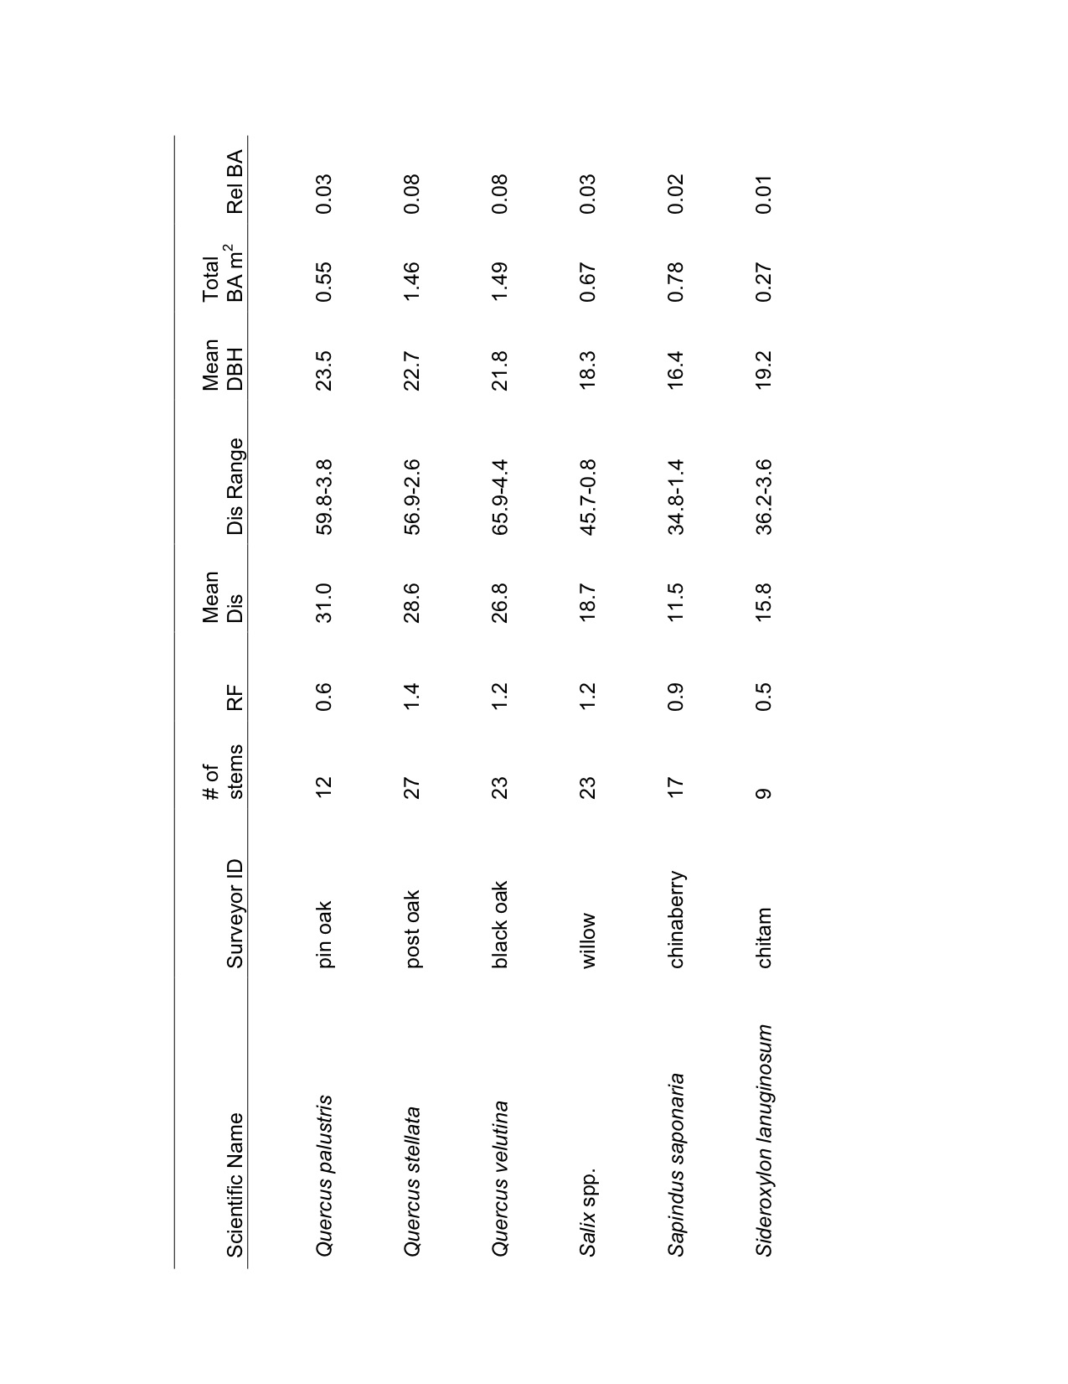

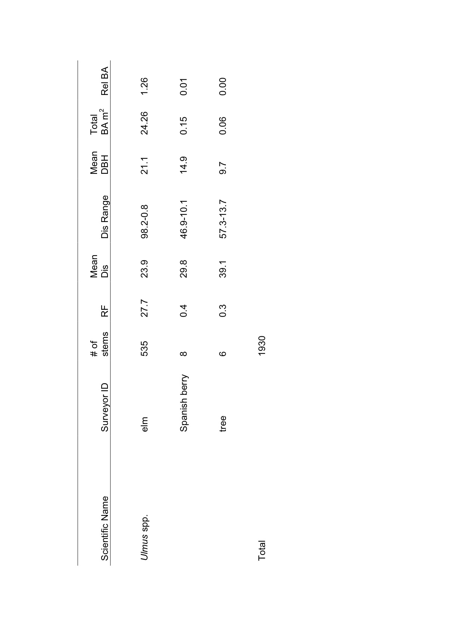
Table 2 – Landscape metrics for land cover types mapped from the 1873-1875 General Land Office land survey plats for western Oklahoma. Patch size and class area are given in hectares.

Cover Class | Number of Patches | Mean Patch Size | Median Patch Size | Patch Size Std Deviation | Class Area | Percent Cover
Forest/  Woodland | 153.0 | 136.8 | 17.0 | 695.8 | 20929.3 | 1.6
Grassland | 217.0 | 5868.5 | 0.1 | 49555.6 | 1273458.9 | 94.8
Brush prairie | 23.0 | 384.1 | 24.7 | 1263.8 | 8833.3 | 0.7
Riparian Forest | 783.0 | 35.1 | 12.3 | 63.9 | 27470.1 | 2.0
River | 20.0 | 602.5 | 64.7 | 998.6 | 12049.8 | 0.9
Wetland | 9.0 | 9.9 | 2.2 | 16.3 | 88.9 | 0.0
Pond | 3.0 | 2.3 | 1.4 | 2.2 | 7.0 | 0.0
Cultivation | 2.0 | 2.1 | 2.1 | 0.6 | 4.3 | 0.0
Corral | 1.0 | 1.0 | 1.0 | 0.0 | 1.0 | 0.0
Total | 1212 | 7043 |  |  | 1342843
Table 3 – Landscape metrics for land cover types mapped by Duck and Fletcher (1943) for the study area of this project. Class area is given in hectares.

Cover Class | Class Area | Percent Cover
Mixedgrass Eroded Plains | 509,648.9 | 38.0
Shortgrass Highplains | 233,310.5 | 17.4
Tallgrass Prairie | 25,779.4 | 1.9
Shinnery Oak | 241,603.0 | 18.0
Sand sage Grassland | 226,728.3 | 16.9
Bottomland | 69,063.3 | 5.1
Postoak-Blackjack Oak Forest | 8,761.8 | 0.7
Mesquite Grassland | 2,944.2 | 0.2
Stabilized Dune | 24,603.1 | 1.8
Total Area | 1,342,442.6
Literature Cited

Amlin, N.M. and S.B. Rood. 2002. Comparative tolerances of riparian

willows and cottonwoods to water-table decline. Wetlands. 22:338-346.

Barkley, T.M., L. Brouillet and J. Strother. 2006. In: Flora of North America
Editorial Committee, eds. 1993+. Flora of North America North of Mexico. 16+ vols. New York and Oxford. Vols. 19-21.

Boyd, C.S. and T.G. Bidwell, 2002. Effects of Prescribed Fire on Shinnery
Oak (Quercus havardii) Plant Communities in Western Oklahoma. Restoration Ecology 10:324-333.

Burton, J.D. 1973. Osage Orange. United States Department of Agriculture. 0101-00315.

Burton, J.D. 1990. In Silvics of North America, Vol. 2. Edited by R.M. Burns and B.H. Honkala. Agriculture Handbook 654, U.S. Dept. of Agriculture, Forest Service, Washington, D.C.

Callahan, P.H. 2002. Progress from grassland to shrubland: woody encroachment into North American grasslands. Masters Thesis, University of Oklahoma.

Cazier, L. 1976. Surveys and surveyors of the public domain 1785-1975. U.S. Department of the Interior Bureau of Land Management. Washington, D.C.

Dhillion, S.S. and M.H. Mills, 1999. The Sand Shinnery Oak (Quercus
havardii) Communities of the Llano Estacada in Savannas, Barrens, and Rock Outcrop Plant Communities of North America, Cambridge University Press.

Drake, B. and P. Todd. 2002. A Strategy for Control and Utilization of
Invasive Juniper Species in Oklahoma. Oklahoma Redcedar Association, Oklahoma City, OK.

Duck, L. G., and J. B. Fletcher. 1943. A game type map of Oklahoma. A
Survey of the Game and Furbearing Animals of Oklahoma. Oklahoma Department of Wildlife Conservation, Oklahoma City, Oklahoma.

Duck, L. G., and J. B. Fletcher. 1945. The game types of Oklahoma:
Introduction. In: State Bulletin No. 3, A Survey of the Game and Furbearing Animals of Oklahoma. Oklahoma Dept. of Wildlife Conservation, Oklahoma City.

Engle, D.M., T.G. Bidwell, and M. Moseley. 1996. Invasion of Oklahoma
Rangelands and Forests by Eastern Redcedar and Ashe Juniper. Oklahoma Cooperative Extension Service, Oklahoma State University. E-947.

Fagin, T. and B.W. Hoagland. 2014. A landscape in transition: the Arbuckle
Mountains,1870 to 1898. Professional Geography 66:456-467.

Foreman, G. 1937. Adventure of the Red River; Report on the exploration of
the Red River by Captain Randolph B. Marcy and Captain G. B. McClellan. University of Oklahoma Press, Norman, Oklahoma, USA.

Galatowitsch, S.M. 1990. Using the original land survey notes to reconstruct presettlement landscapes in the American west. Great Basin Naturalist. 50: 181-191.

Gleason, H. A. 1913. The relation of forest distribution and prairie fires in the middle west. Torreya 13: 173-181.

Harlan, J.R. 1957. Grasslands of Oklahoma. Oklahoma State University, Stillwater, Oklahoma.

Harrell, W.C., S.D. Fuhlendorf, and T.G. Bidwell. 2001. Effects of prescribed
fire on Shinnery Oak communities. Journal of Range Management. 54:685-690.

Havard, V. 1884. The mezquit. American Naturalist 18: 29-459.

Hoagland B.W. 2000. The Vegetation of Oklahoma: A Classification for
Landscape Mapping and Conservation Planning. The Southwestern Naturalist 45:385-420.

Hoagland, B.W. 2006. Township and range survey system. In: Goins, C.R. and D. Goble. Historical atlas of Oklahoma, 4th edition. University of Oklahoma Press.

Hoagland, B.W, Buthod A, Butler I, Callahan-Crawford P, Elisens W, Udasi
A, and Tyrl R. 2015. Oklahoma Vascular Plants Database. [online]. Available: http://www.biosurvey.ou.edu. (Accessed on March 1, 2015).

Hoagland, B.W., J. Messick, M. Rahman and T. Fagin. 2013. Vegetation
patterns in Wichita Mountains National Wildlife Refuge, Oklahoma; an analysis of General Land Office Survey records from 1874 and 1905. Publications of the Oklahoma Biological Survey, 12:1-14.

Integrated Taxonomic Information System. 2016. Integrated Taxonomic
Information System on-line database, http://www.itis.gov. (Accessed on 1 July 2015).

Johnson, K. S. 2006. Geologic formations. In: Goins, C.R. and D. Goble. Historical atlas of Oklahoma, 4th edition. University of Oklahoma Press.

Kindsher, K. and J. Holah. 1998. An Old-Growth Definition for Western
Hardwood Gallery Forests. USDA Technical Report SRS-22.

Krasny, M. E., K. A. Vogt, and J. C. Zasada. 1988. Establishment of four
Salicaceae species on river bars in interior Alaska. Holarctic Ecology 11:210–219.

Little, E.L. 1998. Forest trees of Oklahoma: How to know them. State Department of Agriculture, Oklahoma Forestry Services.

Liu, F., D.J. Mladenoff, N.S. Keuler, and L.S. Moore. 2011. Broadscale
variability in tree data of the historical Public Land Survey and its consequences for ecological studies. Ecological Monographs 81:259-275.

Marcy, R.B. 1853. Exploration of the Red River of Louisiana. 32nd.
Congress. U.S. Senate Executive Document Number 54.

Naiman, R.J., H. Decamps, and M. Pollock. 1993. The Role of Riparian
Corridors in maintaining Regional Biodiversity. Ecological Applications. 3:209-212.

Nixon, K. 1997. Fagaceae. In: Flora of North America Editorial Committee,
eds. 1993+. Flora of North America North of Mexico. 16+ vols. New York and Oxford. Vol. 3, pp. 356-357.

Owensby, C.E., K.R. Blan, B.J. Easton, and O.G. Russ. 1973. Evaluation of
eastern red cedar infestations in the northern Flint Hills. Journal of Rangeland Management. 26:256-260.

Payne, L. W. 1908. A word-list from Alabama. Dialect Notes. 2: 278-328,
342-391.

Powell, H.E. 2014. An Analysis of the 1870s General Land Office Records:

The Distribution of the Black-Tailed Prairie Dog and Vegetation Patterns of Old Greer County. Masters Thesis, University of Oklahoma.

Rempel, R. 2008. Patch Analyst for ArcGIS. Thunder Bay, ON, Canada: Centre for Northern Forest Ecosystem Re- search, Ontario Ministry of Natural Resources.
Rice, E.L. and W.T. Penfound. 1959. The Upland Forests of Oklahoma.
Ecology. 40:593-608.

Schulte, L.A. and D.J. Mladenoff. 2002. The original U.S. Public Land Survey records: Their use and limitations in reconstructing presettlement vegetation. Journal of Forestry 99: 5-10.

Smith, J.L. and J.V. Perino. 1981. Osage Orange (Maclura pomifera):
History and Economic Uses. Economic Botany. 35:24-41.

Snook, E.C. 1985. Distribution of eastern red cedar on Oklahoma
Rangelands. In: R.F. Wittwer and D.M. Engle (eds.), p. 45-52. Conference Proceedings Eastern Redcedar in Oklahoma Cooperative Extension Service, Oklahoma State University. E-349.

Stabler, L.B. and S.M. Still. 2011. Density and biomass of salt cedar
(Tamarix spp.) along a northwest to southeast transect in Oklahoma. Proceedings of the Oklahoma Academy of Sciences. 91:1-10.

Stewart, L.O. 1935. Public land surveys: history, instructions, methods.
Ames (IA): Collegiate Press.

Thacker, E., D. Elmore, B. Reavis, and T. Bidwell. 2006. Mangement of
Sandsage Brush Rangelands. Oklahoma Cooperative Extension Services.

Thomas, R. 2010. The cross timbers in central Oklahoma prior to Euro-

American settlement : using the General Land Office Public Land surveys as a tool for vegetation analysis. Masters Thesis, University of Oklahoma.

Thomas, R.E. and B.W. Hoagland. 2011. The changing forests of central Oklahoma: A look at the composition of the Cross Timbers prior to Euro-American settlement, the 1950s, and today. Oklahoma Native Plant Record 11:61-74.

United States Department of the Interior, Bureau of Land Management (BLM). 1851. Instructions to the surveyor general of Oregon: Being a manual for field operations. Gideon and Co. Printers, Washington, D.C.

United States Department of the Interior, Bureau of Land Management (BLM). 2002. Surveying our public lands since 1785. Washington, D.C.

United States Department of the Interior, Bureau of Land Management (BLM). General Land Office Records. 2015. (http://www.glorecords.blm.gov/, May 20, 2015). University of Oklahoma, Norman, Oklahoma.

Van Auken, O.W. 2000. Shrub Invasions of North American Semiarid
Grasslands. Annual Review of Ecological Systems. 31:197-215.

Van Auken, O.W. 2008. Western North American Juniperus Communities: A

Dynamic Vegetation Type. Springer Hill, NYC.

Van Auken, O.W. 2009. Causes and consequences of woody plant
encroachment into western North American grasslands. Journal of Environmental Management. 90:2931-2942.

Van Haverbeke, D.F. 1990. In Silvics of North America, Vol. 2. Edited by R.M. Burns and B.H. Honkala. Agriculture Handbook 654, U.S. Dept. of Agriculture, Forest Service, Washington, D.C.

Wang, Y. 2005. Pre-settlement land survey records of vegetation: Geographic characteristics, quality and modes of analysis. Progress in Physical Geography 29: 568-598.

Webb, W.P. 1931. The Great Plains. Grosset and Dunlap, New York.

White, C.A. 1983. A history of the rectangular survey system. U.S. Department of the Interior, Bureau of Land Management. Washington, D.C.

Whitney, G.G. and J.P. DeCant. 2001. Government land office surveys and other early land surveys. In: Dave Egan and Evelyn A. Howell, Historical ecology handbook: A restorationist’s guide to reference ecosystems. Island Press, Washington, D.C.

Wiedeman, V. E. and Wm. T. Penfound, 1960. A Preliminary Study of the
Shinnery in Oklahoma, The Southwestern Naturalist 5:117-122.

Williams, M.A. and W.L. Baker. 2011. Testing the accuracy of new methods for reconstructing historical structure of forest landscapes using GLO survey data. Ecological Monographs 81: 63-88.

Chapter 3

Land cover change in the mixedgrass prairie; an analysis of repeat aerial photography (1937-2005)

Abstract

Historic (1937, 1941) and contemporary (2005) aerial photographs were used to determine land cover change, specifically examining whether woody plants were encroaching upon the native herbaceous vegetation of the mixedgrass prairies. The mixedgrass prairie land cover type actually experienced the greatest increase in area (84%) over the 64 – 68 year period, followed by the riparian vegetation land cover type (mean increase = 14%). Three of the four woody plants experienced a decrease in cover during the 64 – 68 year period. However, two patches of Juniperus pinchotti shrubland developed in the southernmost part of the study area during the 64 – 68 time period.

Introduction

The expansion of woody vegetation to the detriment of grasslands is a well-documented, global phenomenon that has been attributed to changing land use patterns, livestock grazing, fire suppression, and climate change (Archer, 1989; Van Auken, 2000, 2009). Although numerous studies have examined woody plant encroachment in the mixedgrass prairie region of North America (Bragg and Hulbert, 1976; Brown and Archer, 1989; McPherson et al.1990; Archer, S. 1994; Asner et al, 2003), the use of historic aerial photographs to examine vegetation change is a relatively recent phenomenon.
The vertical nature of aerial photography (Figure 1) makes its use beneficial in quantitative studies, and its use has increased substantially in the last two decades. In most cases, aerial photography has been used to compare current vegetation patterns to historic vegetation patterns over several decades. As such, aerial photographs have been employed to study woody plant expansion in savannah and prairie landscapes (Bragg and Hulbert, 1976; Brown and Archer, 1989; Bahre and Shelton, 1993; Archer, 1993, 1994; Asner et al., 2003; Archer, 2004). High quality aerial photographs can be found for the last 50-60 years for many parts of the world, which is adequate for studies of medium – long-term vegetation change (Callaway and Davis, 1993; Frelich and Reich, 1995; Carmel and Kadmon, 1998). In the southwestern United States, including western Oklahoma, the earliest available aerial photographs were produced for the United States Department of Agriculture during the 1930s and 1940s, and can be obtained through the United States National Archives. These historic photographs can be compared to contemporary ones to determine vegetation and land cover change over time.
One of the earliest studies that employs the use of aerial photography to document vegetation change in North American mixedgrass prairies was conducted by Bragg and Hulbert (1976), who examined post-settlement woody plant invasion in the bluestem prairie in Geary County, Kansas using aerial photographs from 1937-1969 in conjunction with General Land Office survey records from 1856. Their objective was to determine the rate of woody plant invasion and how patterns of invasion might differ in relation to soil type in burned and unburned bluestem prairies. They determined that woody vegetation had expanded in unburned grasslands, but the rate of expansion was a function of soil and topography, as deeper and permeable soil had greater increases in woody vegetation (Bragg and Hulbert, 1976). Overall, tree cover had increased by 8% from 1856-1969, but woody plant vegetation increased by 34% on unburned areas while maintaining pre-settlement levels on burned areas (Bragg and Hulbert, 1976). Ultimately, Bragg and Hulbert (1976) concluded that fire was of primary importance while soils and topography were secondary.
Bahre and Shelton (1993) combined aerial photographs with repeat ground photographs, to analyze vegetation change in southeastern Arizona, with a particular focus on velvet mesquite (Prosopis velutina), a common species in Arizona, southern California, and New Mexico. They compared historical aerial photographs from 1935-1937 and 1983-1984 to determine if there had been an upward displacement of plant ranges and/or an increase in woody plants (Bahre and Shelton, 1993). They also examined average annual precipitation at eight stations from southeastern Arizona during the period from 1898-1989. In general, precipitation was higher during the period from 1898-1943 and lower during the period from 1944-1989, with the driest year being 1956 (Bahre and Shelton, 1993). Finally, they examined the relationship between cattle grazing and the increase in mesquite, but since mesquite had already been increasing in density before the first aerial or repeat photographs were taken, this examination was inconclusive (Bahre and Shelton, 1993). Ultimately, they concluded that no single cause accounted for the increase in woody vegetation, rather oscillations in precipitation, along with livestock grazing and/or fire exclusion contributed to the increase in woody vegetation (Bahre and Shelton, 1993).
Steven Archer has used aerial photography to conduct several studies in southern Texas examining woody plant encroachment, particularly honey mesquite (Prosopis glandulosa). Aerial photographs from 1941-1990 were used to examine the emergence and survival of honey mesquite in grazed areas by documenting changes in honey mesquite cluster size, total woody canopy cover, and the movement of woodland boundaries in savannas in southern Texas (Archer et al., 1988; Archer, 1989; Archer, 1994). A pronounced drought that affected the southern plains in the 1950s accounted for a slight decrease in woody vegetation from 1941-1960, but the period from 1960-1983 saw a 3 to 8 fold increase in the woody vegetation due to normal to above-normal annual rainfall (Archer 1994).
More recently, Archer et al. (2004) employed aerial photography from 1950, 1976 and 1990 to quantify the proliferation of woody plants in a savanna parkland in southeastern, TX in the southern Great Plains. Historically the landscape was comprised of grassland vegetation in the uplands, with woody vegetation, predominantly honey mesquite, in the lowlands. Archer et al. (2004) determined that woody plant cover increased by 39% during the 40-year period, with abundance increasing first in the lowlands, followed by expansion upslope into the adjacent grasslands.
Browning et al. (2008) used aerial photography from 1936, 1966, and 1996 to determine landscape-scale changes in stand structure, cover, and patch dynamics of velvet mesquite in desert grasslands of southeastern Arizona. They were also interested in how woody plant cover changed with changes in seasonal precipitation, particularly winter precipitation, where they posited that woody cover would increase following years of high winter precipitation. They also examined the rate and extent of woody plant encroachment on course-textured and fine-textured soils, hypothesizing that encroachment would be higher on course-textured soils and lowest on fine-textured soils (Browning et al., 2008). They found that woody plant encroachment increased as woody plants colonized bare ground, but then stabilized as encroachment rates became offset by decreases in woody cover in some patches as a result of below-average precipitation (Browning et al., 2008).
This study will employ the use of historic (1937 or 1941) and contemporary (2005) aerial photographs to examine land cover change in the mixedgrass prairies of western Oklahoma. The objective of this research was to determine if woody plant encroachment occurred between 1937 (or 1941) and 2005. Contemporary aerial photographs were obtained through the Center for Spatial Analysis website (www.csa.ou.edu) at the University of Oklahoma to compare current vegetation distribution to historic patterns. Historic aerial photographs from 1937 or 1941 were obtained through an independent distributor in conjunction with the National Archives in Washington, DC. Scanned images of the historic aerial photographs were georeferenced to the contemporary ones. It can be difficult to georeference and reconcile historic images to contemporary ones, and residual error does occur in the placement of control points on the two images (Ormsby et al 2004). Every effort will be made to keep residual errors below 10.
Dominant vegetation/land cover types based on those employed by Hoagland et al. (unpublished data) will be identified for each WMA and digitized using ArcGIS on both the historic and contemporary aerial photographs. Land cover layers will be created for both the historic and contemporary land cover patterns for each WMA. Separate layers will be created for each of the dominant vegetation types (ie. mixed grass, riparian, disturbed areas, etc.), upon which all vegetation of the specified vegetation type will be digitized. Creating individual layers for each vegetation type will allow for more ease in identifying and interpreting vegetation patterns and in calculating land cover totals. In addition to vegetation, roads and hydrologic features will be digitized.
Aerial photographs from 1937 (or 1941) and 2005 were used to determine if and to what extent four woody plant species (Artemisia filifolia, Juniperus pinchotii, Prosopis glandulosa, and Quercus havardii) have changed in abundance in the mixedgrass prairie. These species were chosen because of explicit differences in habitat preference and growth form. Artemisia filifolia and Quercus havardii grow on coarse, arenaceous soils, whereas J. pinchotii occurs on clay soils over gypsum substrates and P. glandulosa can be found in a variety of habitats. In addition, Artemisia filifolia (subgenus Drancunculus of the Asteraceae [Barkley et al., 2006]) is a shrub of small stature that averages 1m in height. The crown consists of sparse, narrow, filiform, aromatic, gray-green leaves (Tyrl, 2002). It grows on deep sandy soils and stabilized dunes, hills and other deep, well-drained soils in the western Great Plains from eastern Wyoming and South Dakota southward to Arizona and New Mexico and extending into Texas, Oklahoma and Mexico (Ramalay, 1939, McWilliams, 2003, Goodrich, 2005). Artemisia filifolia shrublands (mapped as sand sage grassland by Duck and Fletcher, 1943) occur on arenaceous soils throughout western Oklahoma. There are current no studies available regarding the change of abundance of this species in western Oklahoma.
Juniperus pinchotii (Cupressoideae subfamily of the Cupressaceae [Watson and Eckenwalder, 1997]) is a drought tolerant, evergreen, coniferous shrub/small tree that averages 3m in height. The geographic range includes portions of New Mexico, Arizona, Oklahoma, Texas and Mexico where it is often found growing on gypsum derived soils (Hauser, 2007). The dense, clumped growth form, produced by multiple stems arising at the base, easily distinguish it from other juniper species (Hauser, 2007).
Unlike Artemisia filifolia, an increase in the abundance of Juniperus pinchotii since the late nineteenth century has been documented and is attributed to overgrazing, reduced frequency and intensity of fire, periodic droughts and climate conditions that are more favorable to woody vegetation. Dye et al (1995) examined the effects of increased J. pinchotii coverage on adjacent vegetation, the relationship between J. pinchotii basal cover, density, and biomass and understory species richness. Dye et al., (1995) concluded that competition for soil nutrients and moisture between J. pinchotii and the surrounding herbaceous vegetation was evident with junipers benefiting at the expense of the herbaceous material because juniper roots can typically extend further down into the soil than herbaceous plant roots.
Prosopis glandulosa (Fabaceae, McGregor, 1977) is a shrub that grows to an average height of 6-7m. It can grow in a variety of soil types, but prefers fine to medium textured soils (Steinberg, 2001) from New Mexico and Arizona into western Oklahoma, Texas and northern Mexico (Archer, 1994). Prosopis glandulosa shrublands (mapped as mesquite grasslands by Duck and Fletcher, 1943) occur throughout southwestern. The expansion of both the range and increase in abundance have been well documented in Oklahoma (Hoagland 2000).
The geographic range of Quercus havardii (subfamily Lepidobalanus of the Fagaceae [Nixon, 1997]) extends from eastern New Mexico across the Texas high plains and into western Oklahoma (Pettit, 1986, Dhillion et al., 1999). Quercus havardii is a rhizomatous deciduous shrub that grows to an average height of 1.0m, and reproduces both vegetatively and sexually (Wiedeman and Penfound, 1960, Pettit, 1986, Dhillion et al., 1999). True Q. havardii is typically “shin high”, but hybrids with post oaks (Quercus stellata) can grow to heights of 6-8m, which grow in mottes (Pettit, 1986). Stem densities tend to increase with sand content and decrease with increasing clay content (Petit, 1986).

Study Area
Three study sites were located in western Oklahoma (Figure 2), each possessing one or more of the species under consideration. The primary vegetation association at the Cooper Wildlife Management Area (CWMA, area = 66.4 km²) is Artemisia filifolia / Sporobolus cryptandrus - Schizachyrium scoparium shrubland (Hoagland 2000). The Quercus havardii/Sporobolus cryptandrus-Schizachyrium scoparium shrubland association predominates in the uplands at Packsaddle Wildlife Management (PWMA, area = 62.9 km²). The Sandy Sanders Wildlife Management (SSWMA, area = 74.5 km²) contains extents stands of Juniperus pinchotii/Bouteloua (curtipendula, hirsuta) woodland association and Prosopis glandulosa/Bouteloua gracilis-Buchloe dactyloides shrubland association. Riparian vegetation is similar at the three site; open woody overstories with primarily herbaceous understories. The primary woody species include Celtis laevigata var. reticulata, Populus deltoides, and Ulmus americana. Shrub communities consisting of Baccharis salicina,Salix exigua and Tamarix ramosissima. The Oklahoma Department of Wildlife Conservation (ODWC) administers the sites.

Both the CWMA and the PWMA occur on moderate to deep sandy soils and share many of the same associated species: Andropogon hallii, Bouteloua curtipendula, B. gracilis, Calamovilfa gigantea, Calylophus serrulatus, Cyperus schweinitzii, Eriogonum anuum, Prunus angustifolia, Rhus aromatic, and Sorghastrum nutans. Both WMAs reside in the Osage Plains Physiographic Province (Hunt, 1974), but at the state level, the CWMA is within the Western Sand Dune Belts and the Western Sandstone Hills (Curtis and Ham, 1972) and the PWMA in the High Plains and Western Redbud Plains (Curtis and Ham, 1972). This difference is reflected in surface geology. The CWMA resides on Permian sandstone and shale in the uplands whereas Tertiary sand, clay and gravel deposited from the Laramide orogeny (Branson and Johnson, 1979). The Pratt soil association, consisting of fine sandy loam and loamy fine sand, occurs in the uplands at both CWMA and PWMA. The Tivoli, Yahola, Woodward and Quinlan Associations are found only at CWMA and the Brownfield and Nobscot at PWMS. At CWMA the soils range from fine sand (Tivoli), to a fine-sandy loam (Yahola) to loam (Woodward and Quinlan, Nance et al., 1960). These soils tend to be deep, hummocky or rolling, and can be severely eroded, but generally exhibit a well defined drainage pattern (Nance et al., 1960). The Brownfield and Nobscot Associations at PWMA are fine sand soils that tend to be deep and are hummocky or rolling. Although these soils can be severely eroded, they generally exhibit a well-defined drainage pattern (Cole et al., 1966).
Although also in the Osage Plains Physiographic Province (Hunt, 1974), the SSWMA is located in the Mangum Gypsum Hills (Curtis and Ham, 1972). The surface geology is Permian sandstone and shale in the uplands (Branson and Johnson, 1979), where the Cornick-Vinson, Quanah-Talpa, Spur, Tillman, Cottonwood (loamy) and Vernon (clayey) Series (Ford et al., 1980; Frie et al., 1967) predominate. The soils tend to be rolling, moderate to deep, and generally exhibit a well-defined drainage pattern (Ford et al., 1980; Frie et al., 1967).
Climatic conditions are also similar. Average annual temperature at the sites is 13°C and average temperature during the growing season (March – August) is 19°C (OCS, 2014). Precipitation is also the same; average annual is 63.5 cm and 42.5 cm during the growing season (OCS, 2014). There is a notable difference in climatic conditions between CWMA-PWMA and SSWMA. Average annual temperature at the SSWMA is 14°C and 20°C during the growing season (OCS, 2014). Average annual precipitation for SSWMA is approximately 42.6 cm (OCS, 2014).
Land use at all three of the WMA’s consists primarily of cattle grazing with regulated hunting during various times of year. Primitive camping is allowed in specific areas within the WMA’s that are consistently mowed and maintained. In addition, a few small agricultural plots occur at each WMA.

Methods
The earliest available aerial photographs for the study areas were 1937 (CWMA and PWMA) and 1941 (SSWMA). Photographs were obtained from the National Archives in Washington, D.C and photographs from 2005 were obtained through the Center for Spatial Analysis at the University of Oklahoma. The historic aerial photographs were georeferenced to correspond with the contemporary aerial images. Road intersections, stream confluences, rock outcrops, and other features were selected as control points. Residual error is the measure of the fit between the true locations and the transformed locations of the output control points (Ormsby et al 2004). Residual errors were kept below 10%, and in most cases, the error was below 5%. The higher residual errors occurred for images with few discernible features that were suitable as control points, such as photos on which pasture was the predominant land cover type. For example, some of the CWMA photographs consisted of homogenous stands of Artemisia filifolia.
Once georefererenced and joined, the dominant vegetation and land cover types were identified for each time period. Individual maps were created for both the historic and contemporary vegetation/land cover patterns for each study area, comprising a total of six maps (Figures 4-9). Linear features, such as prominent roads and hydrologic features that appeared on the images were also digitized for each site. All spatial data were digitized at a scale of 1:10,000 to maintain the same level of detail.

Results
Land cover did not change substantially in the study areas during the two periods examined. The predominant land cover types at PWMA were Quercus havardii, mixedgrass prairie, riparian vegetation, and disturbed areas (i.e., plowed field and/or agricultural plots; Table 1; Figure 4). The predominant land cover at PWMA in 1937 was mixedgrass prairie (3503 ha) in one large patch, more than twice the extent of Q. havardii shrublands (1421 ha; 7 patches; range = 65 to 813 ha; mean = 213 ha; median = 121 ha). In 2005, mixedgrass prairie covered 3565 ha (1 patch) and Q. havardii shrublands covered 1251 ha (9 patches; range = 13 to 579 ha; mean = 151 ha; median = 105). Mixedgrass prairie increased by 0.02% (62 ha), while Q. havardii decreased by 12% (170 ha), difference offset by an increase in disturbed areas form 419 ha (24 patches; range = 0.7 to 52 ha; mean = 17 ha; median = 12 ha) in 1937 to 458 ha (51 patches; range = 0.3 to 145 ha; mean = 9 ha; median = .8 ha) in 2005 (9% or 39 ha). Riparian vegetation increased from 188 ha (43 patches; range = 0.01 to 36 ha; mean = 4 ha; median = 2 ha) in 1937 to 241 ha (60 patches; range = .02 to 50 ha; mean = 4 ha; median = 1 ha) in 2005 (28% or 53 ha), and the Canadian River riparian vegetation increased from 763 ha in 1937 to 779 ha in 2005 (2% or 16 ha).
At CWMA, Artemisia filifolia shrublands and mixedgrass prairie could not be segregated into distinct land cover types and may account for the limited degree of change found between 1937 (A. filifolia - mixedgrass = 6318 ha, 1 patch) and 2005 (5972 ha, 1 patch) (Figure 5). No discernible disturbed land surfaces were found in 1937, but disturbed areas (primarily parking/camping areas, and oil pads) increased by 59 ha in 2005. Thus the A. filifolia - mixedgrass prairie type decreased by 5% or 338 ha, whereas disturbed areas increased by 100% at 59 hectares (36 patches; range = 0.2 to 23 ha; mean = 2 ha; median = 0.6 ha).
As with the PWMA, riparian vegetation increased by 88% (287 ha), from 325 ha in 1937 to 612 ha in 2005. The number of riparian patches decreased, however from 133 patches in 1937 (range = 0.01 to 108 ha, mean = 2 ha; median = 0.08 ha) to 38 patches in 2005 (range = 0.14 to 117 ha; mean = 16 ha; median = 7 ha), overall patch area increased as numerous smaller patches merged into larger patches.
The dominant vegetation types identified in the SSWMA were mixed-grass, Juniperus pinchotti - Prosopis glandulosa mixed shrubland, J. pinchotti shrubland, 4.) riparian and 5.) disturbed. In 1941, mixedgrass covered 375 ha (30 patches, range = 0.09 to 128 ha; mean = 13 ha; median = 5 ha), and J. pinchotti - P. glandulosa mixed shrubland 5983 ha (1 patch), riparian 936 ha (2 patches; 388 and 548 ha), and disturbed areas 257 ha (25 patches; range = .09 to 37 ha; mean = 10 ha: median = 4 ha). In 2005, mixedgrass had increased to 689 ha (68 patches; range = 0.4 to 149 ha; mean = 10 ha; median = 3 ha), J. pinchotti - P. glandulosa mixed shrubland decreased to 4358 ha (1 patch), riparian increased to 1279 ha (2 patches; 592 and 687 ha), and disturbed areas decreased to 120 ha (11 patches; range = 0.6 to 37 ha; mean = 11 ha; median = 4 ha). In addition, J. pinchotti density had increased substantially in one section of the SSWMA, establishing 1105 ha (2 patches; 100 and 1005 ha) of the J. pinchotti land cover type. Between 1941 and 2005, mixedgrass prairie had increased by 84% (314 ha), but the J. pinchotti - P. glandulosa mixed shrubland decreased by 27% (1625 ha). As with the other WMAs, riparian areas experienced an increase of 27% (343 ha).

Discussion
Although other studies examining woody plant encroachment in the mixedgrass prairies have revealed increases in woody plants at the expense of the surrounding herbaceous vegetation (Bragg and Hulbert, 1976; Brown and Archer, 1989; Bahre and Shelton, 1993; Archer, 1993, 1994; Asner et al., 2003; Archer, 2004), this research revealed a different outcome. There are a couple of potential reasons for this discrepancy. First, the aforementioned studies were examining honey mesquite and redberry juniper encroachment, two plants that are visually easier to depict on historic aerial photographs because of their taller, single-stem structure. Conversely, shinnery oak and sand sage are low-lying shrubs that blend in with surrounding mixedgrasses in black and white aerial photographs. Second, this research examined multiple plants over larger areas than the aforementioned studies, so the methodology differed. This research examined broader scale land cover change, while other studies focused specifically on the effects of individual woody species on herbaceous vegetation and/or soil.
Regarding land cover change in this research, the decrease of Q. havardii at PWMA is most likely the result of a fire management plan. In 2004 and 2005, 1735 hectares of the PWMA were burned, of which 1073 hectares contained Q. havardii shrubland. The total increase of disturbed areas (9% or 39 ha) is attributable to recreational activities, primarily camping and hunting, as well as areas that are plowed and/or cultivated for ranching and agriculture. Riparian areas experienced the greatest increase at 40% (126 ha).
At CWMA, riparian areas experienced the greatest increase (88%) and disturbed patches the least. Disturbed areas were small patches (median patch size = 0.6ha) that had been cleared for recreational activities and oil and gas production. The riparian areas increased the most with many smaller patches (133, mean = 2 ha) merging together into much larger patches (38, mean = 16 ha). Consequently, the A. filifolia - mixedgrass areas decreased by 5%.
The mixedgrass prairie cover type experienced the greatest increase (84%) at SSWMA. The two riparian patches also expanded, with an average increase of 14%. As Juniper pinchotti established itself as a distinct vegetation type, the Juniper pinchotti - Prosopis glandulosa mixed shrubland decreased by 27%.
The most consistent change in land cover type at the three sites was an increase in riparian vegetation. Because the 1930’s were a particularly dry decade (OCS, 2014), and the historic photographs were taken towards the end of that dry period (1937 and 1941), it is understandable that riparian areas were more sparsely vegetated in the earlier period, as less moisture was available. In addition, the marked increase in riparian areas by 2005 could be attributed to the consistently above average precipitation that Oklahoma experienced during the 1980-90’s (OCS, 2014).

Conclusion
While land cover changed in western Oklahoma over the 64-68 year period examined for this research, the degree of change varies among vegetation type. Riparian areas experienced the greatest change with an increase in all of the study areas. In addition, mixed grasses have increased into areas that were once disturbed. Juniperus pinchotii is the only woody species that has experienced an increase, with the other woody species actually experiencing a decrease. Finally, the fact that all three of the study areas are currently managed and maintained contributes to the minimal changes in vegetation cover.

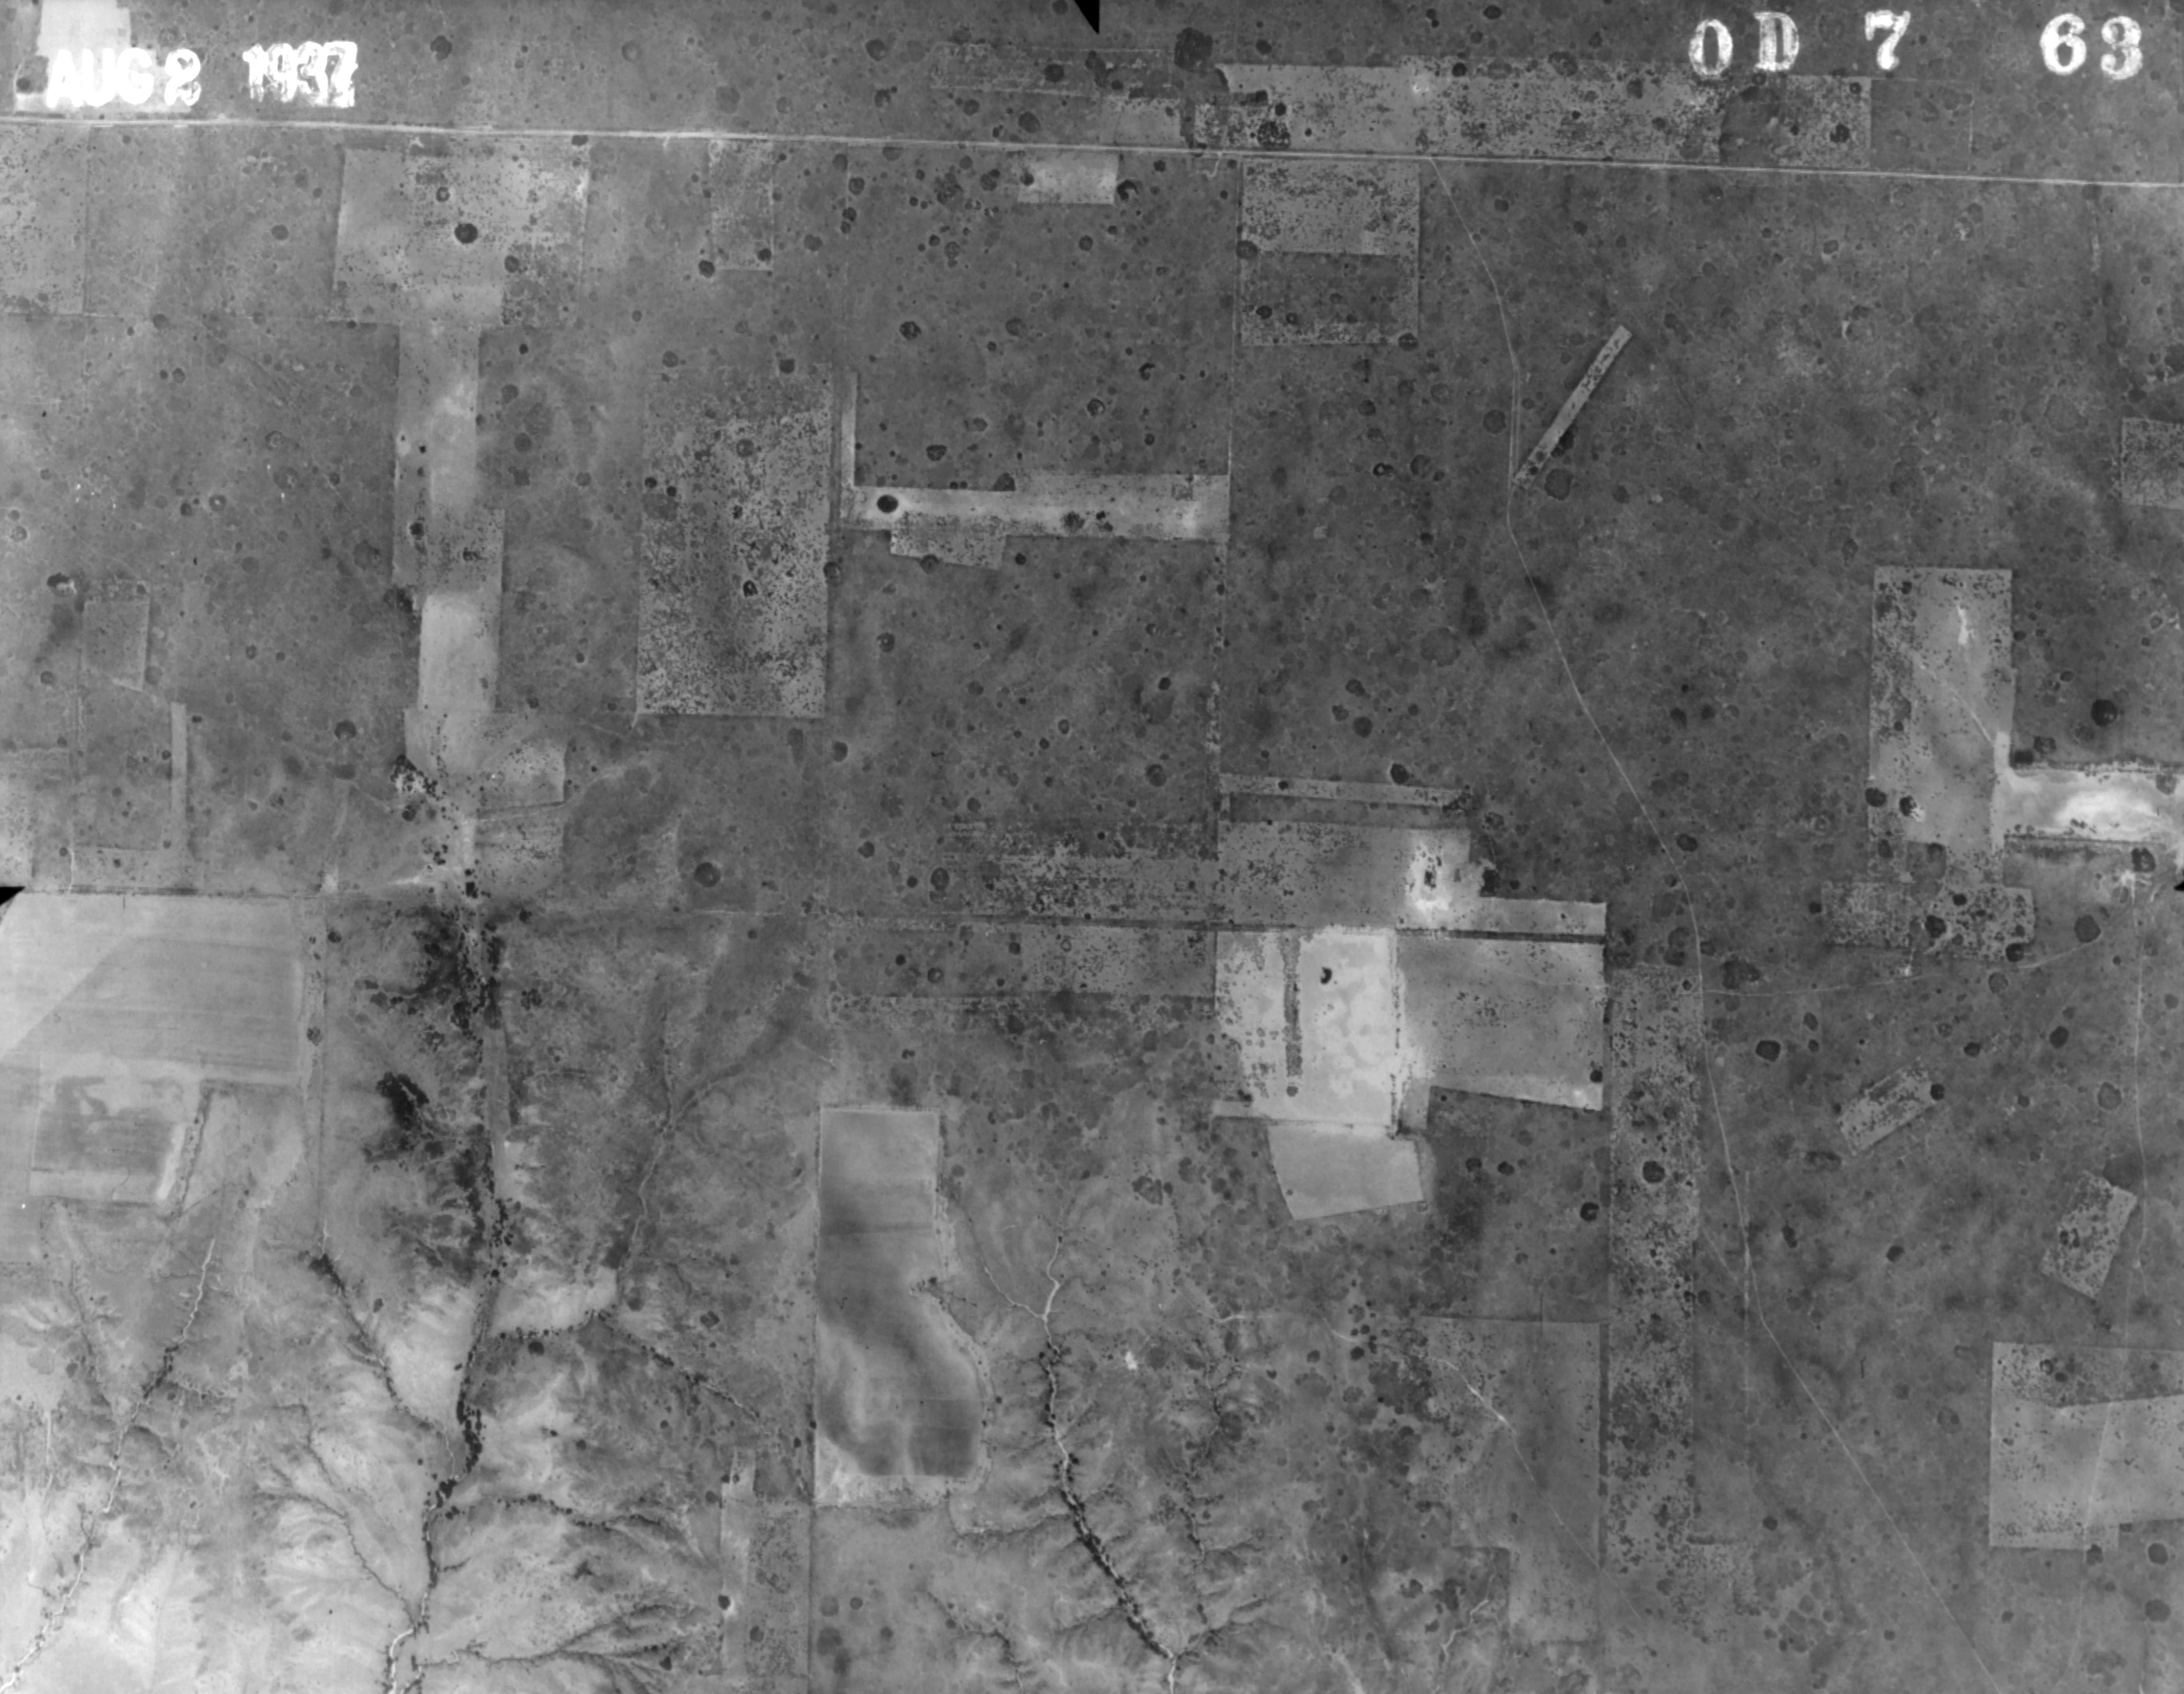

Figure 1 – Historic photograph from 1937, Ellis County, Oklahoma.

Figure 2 – Study areas from north to south – Cooper Wildlife Management Area (CWMA), Packsaddle Wildlife Management Area (PWMA), and Sandy Sanders Wildlife Management Area (SSWMA).

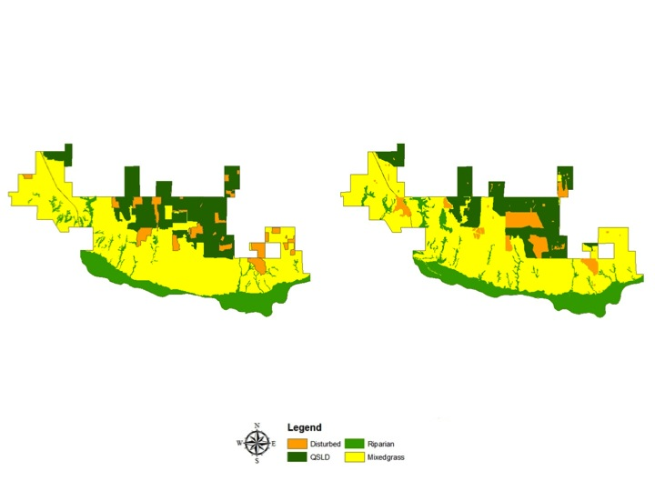

Figures 3a (left) and 3b (right) – Vegetation cover at Packsaddle Wildlife Management Area 1941 (left) and 2005 (right). QSLD is Quercus havardii shrublands.

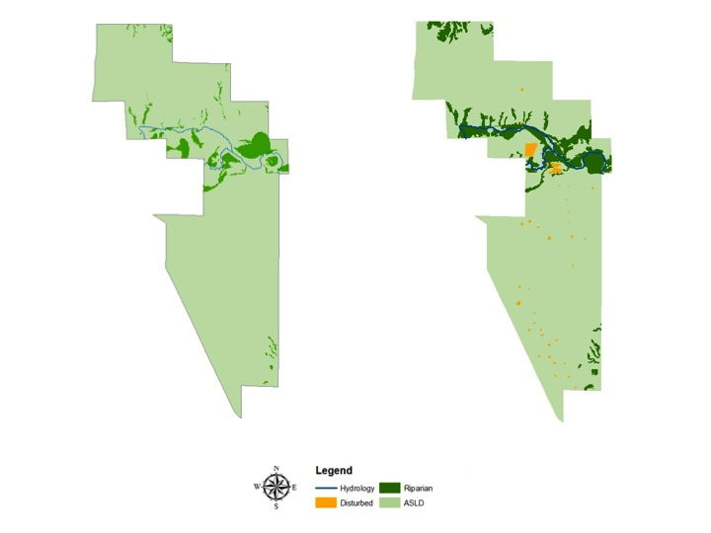

Figures 4a (left) and 4b (right) – Vegetation cover at Cooper Wildlife Management Area 1941 (left) and 2005 (right). ASLD is the Artemisia filifolia shrublands

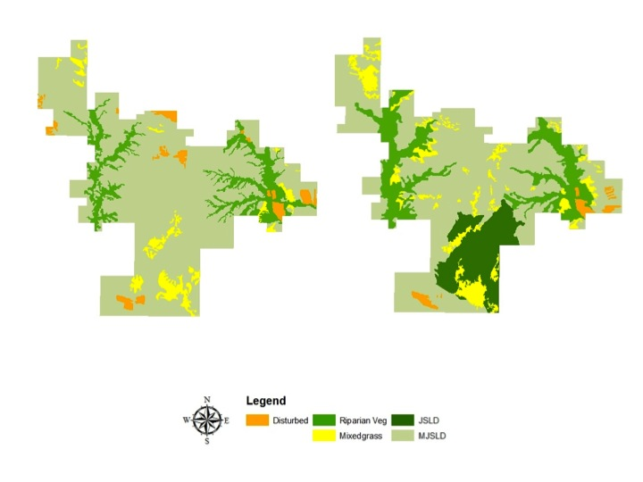

Figures 5a (left) and 5b (right) – Vegetation cover at Sandy Sanders Wildlife Management Area 1937 (left) and 2005 (right). PJSLD is Prosopis glandulosa-Juniper pinchotti shrublands, JSLD is Juniper pinchotti shrublands.

Table 1 – Vegetation types identified in each study area, including total area (in hectares), and number of patches (in parentheses). ASLD – Artemisia filifolia shrublands, PJSLD – Prosopis glandulosa-Juniper pinchotti shrublands, JSLD – Juniper pinchotti shrublands, QSLD – Quercus havardii shrublands.

 | CWMA |  | PWMA |  | SSWMA
 | 1937 | 2005 | 1937 | 2005 | 1941 | 2005
ASLD | 6318 (1) | 5972 (1)
PJSLD |  |  |  |  | 5983 (1) | 4358 (1)
JSLD |  |  |  |  |  | 1105 (2)
QSLD |  |  | 1421 (7) | 1251 (9)
Mixedgrass |  |  | 3503 (1) | 3565 (1) | 375 (30) | 689 (68)
Disturbed |  | 59 (36) | 419 (24) | 458 (51) | 257 (25) | 120 (11)
Riparian | 325 (133) | 612 (38) | 188 (43) | 241 (60) | 936 (2) | 1279 (2)

Literature Cited

Archer, S. 1989. Have southern Texas savannas been converted to
woodlands in recent history? American Naturalist 134:545-561.

Archer, S. 1994. Tree-grass dynamics in a Prosopis-thornscrub savanna
parkland: Reconstructing the past and predicting the future. Ecoscience 2:83-98.

Bahre, C.J. and M.L. Shelton, 1993. Historic vegetation change, mesquite
increases, and climate in southeastern Arizona, Journal of Biogeography 20:489-504.

Barnett, D.T. and T.J. Stohlgren, 2003. A Nested-Intensity Design for
Surveying Plant Diversity. Biodiversity and Conservation 12:255-278.

Bragg, T.B. and L.C. Hulbert, 1976. Woody Plant Invasion of Unburned
Kansas Bluestem Prairie, Journal of Range Management 29:19-24.

Branson, C.C. and K.S. Johnson. 1979. Generalized Geologic Map of
Oklahoma. In: K.S. Johnson et al., (eds) Geology and Earth Resources of Oklahoma. Oklahoma Geological Survey, Norman.

Brown, J.R. and S. Archer, 1989. Woody plant invasion of grasslands:
establishment of honey mesquite (Prosopis glandulosa var. glandulosa) on sites differing in herbaceous biomass and grazing history. Oecologia 80:19-26.

Browning, D.M, S.R. Archer, G.P. Asner, M.P. McClaran, and C.A. Wessman. 2008. Woody Plants in Grasslands: Post-Encroachment Stand Dynamics. Ecological Applications 18:928-944.

Carmel, Y, and R. Kadmon. 1998. Computerized classification of Mediterranean vegetation using panchromatic aerial photographs. Journal of Vegetation Science 9:445-454.

Callaway, R.M. and F.W. Davis. 1993. Vegetation dynamics, fire, and the physical environment in coastal central California. Ecology 74:1567-1578.

Cole, E.L., A.J. Conradi and C.E. Rhoads. 1961. Soil Survey of Ellis County, Oklahoma. Washington, DC: United States Department of Agriculture. 81 pp.

Curtis, N.M. and W.E. Ham. 1972. Geology and Earth Resources of

Oklahoma: An Atlas of Maps and Cross Sections. Oklahoma Geological Survey, Norman.

Dhillion, S.S. and M.H. Mills, 1999. The Sand Shinnery Oak (Quercus
havardii) Communities of the Llano Estacada in Savannas, Barrens, and Rock Outcrop Plant Communities of North America, Cambridge University Press.

Dye, K.I. 1995. Redberry juniper-herbaceous understory interactions.
Journal of Range Management 48:100-107.

Duck, L. G., and J. B. Fletcher. 1943. A game type map of Oklahoma. A
Survey of the Game and Furbearing Animals of Oklahoma. Oklahoma Department of Wildlife Conservation, Oklahoma City, Oklahoma.

Engle, D.M., J.F. Stritzke and P.J. Claypool. 1987. Herbage standing crop
around eastern redcedar trees. Journal of Range Management 40:237-239.

Ford, J.G., G.F. Scott and J.W. Frie. 1980. Soil Survey of Beckham County,
Oklahoma. Washington, DC: United States Department of Agriculture. 182 pp.

Foreman, G. 1937. Adventure of the Red River; Report on the exploration of
the Red River by Captain Randolph B. Marcy and Captain G. B. McClellan. University of Oklahoma Press, Norman, Oklahoma, USA.

Frelich, L.E. and P.B. Reich. 1995. Spatial patterns and succession in a
Minnesota Southern-Boreal Forest. Ecological Monographs 65:325-346.

Frie, J.W., R.C. Brinlee and R.D. Graft. 1967. Soil Survey of Greer County,
Oklahoma. Washington, DC: United States Department of Agriculture. 72 pp.

Goodrich, S. 2005. Classification and Capabilities of Woody Sagebrush
Communities of Western North America With Emphasis on Sage-Grouse Habitat. USDA Forest Service Proceedings RMRS-P-38 Sage-grouse habitat restoration symposium proceedings; 2001 June 4–7; Boise, ID. Department of Agriculture, Forest Service, Rocky Mountain Research Station.

Hoagland, B.W. 2000. The Vegetation of Oklahoma: A Classification for
Landscape Mapping and Conservation Planning. The Southwestern Naturalist 45(4):385-420.

Hoagland B.W., Buthod A, Butler I, Callahan-Crawford P, Elisens W, Udasi
A, and Tyrl R. 2006. Oklahoma Vascular Plants Database. [online]. Available: http://www.biosurvey.ou.edu. (Accessed on 1 March 2014).

Johnston, M.C. 1963. Past and present grasslands of southern Texas and
northeastern Mexico. Ecology, 44: 456-466.

Leis, S.A. and D.M. Engle, 2003. Comparison of Vegetation Sampling
Procedures in a Disturbed Mixed-Grass Prairie. Proceedings of the Oklahoma Academy of Science 83:7-15.

Martin, R.E., G.P. Asner, R.J. Ansley and A.R. Mosier. 2003. Effects of
Woody Vegetation Encroachment on Soil Nitrogen Oxide Emissions in a Temperate Savanna. Ecological Applications, 13: 897-910.

McPherson, G.R. and H.A. Wright. 1990. Effects of cattle grazing and
Juniperus pinchotii canopy cover on herb cover and production in western Texas. The American Midland Naturalist, 123: 141-151.

Nance, E.C., J.D. Nichols, H.L. Kollmorgen, R.E. Daniell, H.L. Costilow and
K.T. Lofton. 1960. Soil Survey of Harper County, Oklahoma. Washington, DC: United States Department of Agriculture. 59 pp.

Oklahoma Climatological Survey. 2014. Oklahoma Climatological Data
(www.ocs.ou.edu). University of Oklahoma, Norman.

Ormsby, T., E. Napoleon, R. Burke, C. Groessl and L. Feaster. 2004.
Getting to Know ArcGIS desktop. ESRI Press, Redlands, CA.

Pettit, R.D., 1986. Sand Shinnery Oak: Control and Management.
Manement Note No. 8, Contribution No. T-9-431, College of Agricultural Sciences, Texas Tech Univeristy, Lubbok, Texas.

Rea, A. and C.J. Baker. 1997. Digital atlas of Oklahoma. In U.S. Geological
Survey Open-File Report 97-23.

Schott, M.R. and R.D. Piper. 1985. Influence of canopy characteristics of
one-seed juniper on understory grasses. Journal of Range Management, 38: 328-331.

Stohlgren T.J., M.B. Falkner and L.D. Schell, 1995. A Modified-Whittaker
nested vegetation sampling method. Vegetatio 117: 113-121.

Stohlgren, T.J., G.W. Chong, M.A. Kalkhan and L.D. Schell, 1997. Multiscale
Sampling of Plant Diversity: Effects of Minimum Mapping Unit Size. Ecological Applications 7(3): 1064-1074.

Stohlgren, T.J., K.A. Bull and Y. Otsuki, 1998. Comparison of rangeland
vegetation sampling techniques in the Central Grasslands. Journal of Range Management 51(2): 164-172.

Stohlgren, T.J., D. Binkley, G.W. Chong, M.A. Kalkhan, L.D. Schell, K.A. Bull,
Y. Otsuki, G. Newman, M. Bashkin and Y. Son, 1999. Exotic Plant Species invade Hot Spots of Native Plant Diversity. Ecological Monographs 69(1): 25-46.

Tate, R. C. 1928. Some observations on the spread of mesquite to the north
in Cimarron County, Oklahoma. Proceedings of the Oklahoma Academy of Science 8:58.

Turner, M.G., Gardner, R.H. and R.V. O’Neill. 2001. Landscape ecology in
theory andpractice pattern and process. Springer-Verlag, New York, NY.

Van Auken, O.W. 2000. Shrub Invasions of North American Semiarid
Grasslands. Annual Review of Ecological Systems. 31:197-215.

Van Auken, O.W. 2009. Causes and consequences of woody plant
encroachment into western North American grasslands. Journal of Environmental Management. 90:2931-2942.

Chapter 4

Conclusion

My initial interest in the mixedgrass prairie biome began as a child. Having grown up in the eastern forests of the United States, I was intrigued by the open prairies of the continental interior. When the opportunity arose to work in this biome, I eagerly accepted it. The mixedgrass prairie biome has been everything I had anticipated, and more. This research has taught me about the complex heterogeneous mosaic of the mixedgrass prairie landscape, and the importance of maintaining it.
I began this research project with a hypothesis that woody vegetation was expanding into and encroaching upon existing herbaceous vegetation. However, I discovered that the woody vegetation was not encroaching upon the herbaceous vegetation after all. As mentioned in Chapter 1, this is most likely because each of the study areas are actively managed and maintained. It would be interesting to study these woody plants in areas that aren’t actively maintained and compare species composition, richness, diversity, abundance, and total cover.
Upon completion of this dissertation, I have determined two things I would have completed differently, and one thing I may have completed differently. Unfortunately, logistical and budgetary constraints didn’t allow for soil analyses to be completed. However, an examination of the soil would have revealed soil structure, chemistry, and moisture content, which could have been correlated with species richness, diversity, evenness, and cover. If I were to conduct similar research in the future, I would definitely allow for soil analyses in the project budget.
Of the woody plants, I found shinnery oak to be the most interesting. Perhaps it’s the fact that shinnery oak is the only oak species I know of that’s actually shorter than me, or perhaps it’s the ‘running’ nature of its growth form, but I have found myself much more intrigued by this plant than any of the others. For this reason, I would like to continue studying the shinnery oak shrublands. While I appreciate the hardiness of the plant, I also recognize that shinnery oak has the ability to encroach upon, and replace mixed grasses, if not managed. I’m curious as to at what point shinnery oak will start growing taller if not allowed to proliferate laterally. Or will it? If shinnery oak were to be contained within a fenced area, around which is actively mowed, will shinnery stems begin increasing in height, or will the roots continue to spread laterally in a greater radius?
Additionally, one comparison was made in this research that could have been further examined was the comparison made between burned and unburned sites containing shinnery oak. Although it appeared as though there were no significant changes in total species richness between unburned plots and plots that had been burned 3-4 years earlier, a t-Test was not performed on the data. In retrospect, t-Tests should have been completed to reveal an accurate comparison. At this point, further research could be conducted to reveal the longer-term (10 years) effects of prescribed burns on species richness, as well as shinnery oak abundance.
The use of historic aerial photography was beneficial, but not as much as I would have hoped. Because the historic photographs are black and white images (ie. shades of grey), and of a much poorer quality than contemporary aerial photographs, it can be difficult to discern between some vegetation types. This made the land cover comparisons very tedious. The most difficult vegetation types to differentiate between were sand sage and mixedgrass. Because sand sage is light in color, it blends in well with the mixed grasses on the historic photographs. This made it hard to decipher the difference between it and mixed grasses on the historic photos. The other vegetation types were easier to identify on both the historic and contemporary photographs, allowing for a more accurate representation of those vegetation types in the late 1930s and early 1940s.
The most conspicuous land cover type that experienced an increase in cover was the Riparian forest. The comparison between the historic and contemporary photographs illustrated a marked increase in riparian cover/extent. Based on this, and the bottomland forest data gathered from the PLS records, I think it would be interesting to study the bottomland/riparian forests in western Oklahoma to determine if cottonwood has experienced the greatest increase in abundance, as expected. In addition, it will be interesting to determine if cottonwood, hackberry, elm, cedar, and willow are still the most common bottomland species in western Oklahoma. It would also be interesting to determine how fast these bottomland habitats have expanded. Dendrochronology would be a useful tool in determining this, as tree cores will indicate individual tree age. An examination of annual tree rings can also reveal changes in growth patterns over time.
I also think dendrochronology could be used for a more detailed analysis of mesquite and cedar encroachment among upland areas. Assessing individual tree age can be used to help determine encroachment rates of these species. Although the field surveys conducted for this research didn’t reveal increasing rates of mesquite and cedar, both are known to be expanding in mixedgrass prairies, so determining the rates of spread can be a useful endeavor for management practices, particularly since many areas where these trees occur are also active rangelands.
The Modified-Whitaker plot type selected for this research was the optimal choice, although I’m not sure the additional 100m² plots were necessary. While other studies did conclude that additional 100m² plots captured greater species richness (Stohlgren, 1995; Stohlgren et al., 1997, 1998; Isom, 2008), this research did not. The 100m² plots may be suitable for the reconnoitering phase and/or study site selection phase of a vegetation study to capture preliminary species data, rather than being implemented into the in-depth data analyses. Instead, a few additional Modified-Whitaker plots could be implemented, if necessary.
The aerial photograph analyses revealed that land cover changed in western Oklahoma over the 64-68 year period examined for this research. However, the degree of change varies among vegetation type. Riparian areas experienced the greatest change with an increase in all of the study areas. In addition, mixed grasses have increased into areas that were once disturbed. All three woody species experienced a decrease in cover. The aerial photography analyses revealed an increase in Juniperus species in sections of the southwestern-most study area. Finally, the fact that all three of the study areas are currently managed and maintained contributes to the minimal changes in vegetation cover.
The research from this dissertation will add to the existing literature on woody plant encroachment. This study is unique from most because it found that woody vegetation was not encroaching upon the native mixedgrass prairies, or causing a decrease in herbaceous species. Because the woody plants examined for this research have not been found to be expanding on the native herbaceous mixed grasses, the research from this dissertation could be beneficial to land managers experiencing woody vegetation on their landscape.

Literature Cited

Isom, L.D. 2008. Species Diversity in a Mixedgrass Prairie in Ellis County,
Oklahoma. Masters Thesis, University of Oklahoma.

Stohlgren T.J., M.B. Falkner and L.D. Schell, 1995. A Modified-Whittaker
nested vegetation sampling method. Vegetatio 117: 113-121.

Stohlgren, T.J., G.W. Chong, M.A. Kalkhan and L.D. Schell, 1997. Multiscale
Sampling of Plant Diversity: Effects of Minimum Mapping Unit Size. Ecological Applications 7(3): 1064-1074.

Stohlgren, T.J., K.A. Bull and Y. Otsuki, 1998. Comparison of rangeland
vegetation sampling techniques in the Central Grasslands. Journal of Range Management 51(2): 164-172.

