University of Oklahoma

Graduate College

More than a key: an analysis of Shostakovich’s symphony no. 8, op. 65

A thesis

submitted to the Graduate Faculty

in partial fulfillment of the requirements for the

Degree of

Master of Music

By

Blake Ritchie
Norman, Oklahoma
2016

More than a key: an analysis of Shostakovich’s symphony no. 8, op. 65

A thesis approved for the
School of Music

By

______________________________
Dr. Sarah Ellis, Chair

______________________________
Dr. Michael Lee

______________________________
Dr. Jeffrey Swinkin

© Copyright by Blake ritchie 2016
All Rights Reserved.

Table of Contents

List of Tables v
List of Figures vi
Introduction 1
Complications of Form 4
Expressive Genre and Pastoral Signifiers 13
Narrative Interpretation and Narrative Expectations 24
Conclusion 35
References 36

List of Tables

Table 1. Type 4 Sonata Rotations 4
Table 2. Symphony No. 8 Rotations 5
Table 3: Formal Structure of Shostakovich's Eighth Symphony 7

List of Figures

Figure 1: Shostakovich, Symphony No. 8, Op. 65, v, mm. 9-37. Refrain (P^{rf}). 9
Figure 2: Shostakovich, Symphony No. 8, Op. 65, v, mm. 434-438. 10
Figure 3: Shostakovich, Symphony No. 8, Op. 65, v, mm. 42-87 20
Figure 4: Shostakovich, Symphony No. 8, Op. 65, v, mm. 87-142 22
Figure 5: Shostakovich, Symphony No. 8, Op. 65, v, mm. 416-419. 30
Figure 6: Shostakovich, Symphony No. 8, Op. 65, i, mm. 1-9. Fate Motive. 31
Figure 7: Shostakovich, Symphony No. 8, Op. 65, v, mm. 561-594. Coda. 32

Introduction
Dmitri Shostakovich, arguably one of the greatest symphonic composers of the 20th century, composed in a variety of genres, including symphonic works, string quartets, film scores, and incidental theater music. By 1943, the year Symphony no. 8, op. 65, premiered in Moscow, Shostakovich had established himself as a prominent composer both in Russia and abroad. He spent 1939 and part of 1941 teaching composition at the Leningrad Conservatory. But the German invasion of Russia led to a 900-day siege of Leningrad, forcing Shostakovich to stop teaching and evacuate to Moscow by air, then by train to Kuybïshev. During that time, he composed Symphony No. 7, op. 60, the “Leningrad” symphony, Piano Sonata No. 2, op. 61, and an orchestral suite. Symphony No. 7 premiered in Moscow in March 1942, only two months after the Red Army won the long-running Battle of Moscow.
Symphony No. 8 premiered less than a year later, in late 1943. In the summer of 1943, about the same time that Shostakovich began working on the first movement of the Eighth Symphony, the German army faced a devastating defeat in Kursk, a city close to the present border of Russia and Ukraine. This was the beginning of the end for the German offensive in Russia. The score was finished in September, coinciding with Italy’s surrender to Allied forces. As German forces faced a growing number of defeats in Russia, the Red Army retook many captured cities in Western Russia, successfully broke the siege of Leningrad in January of 1944, and went on the offensive in the Summer of 1944. Faced with the advance of both Allied and Soviet forces, the German army was stretched thin, and in early April Soviet forces entered Germany. At the same time, the Eighth Symphony received its Western premiere on April 1st, 1944, performed by the New York Philharmonic Orchestra. By the end of the month, Berlin was surrounded, and on April 30th Hitler committed suicide in the Chancellery. Karl Dönitz, Hitler’s successor, surrendered to the Red Army, bringing the war in the European theater to a close.
Shostakovich chose to write the Eighth Symphony in C minor, and there exists an expectation for a symphony in C minor to follow a specific narrative; such a work should be a heroic tragedy-to-triumph achieved over the course of the work. This is rooted in both the establishment of the C minor symphony trope that was cemented in Beethoven’s Fifth Symphony, Op. 67, and promulgated by Brahms’ Symphony No. 1, Op. 68, Bruckner’s Symphony No. 8, WAB 108, and Scriabin’s Symphony No. 2, Op. 29. In a sense, C minor symphonies are expected to be, to use Umberto Eco’s term, a “closed work”; there may be deviations from Beethoven’s archetype, but the overall narrative remains unchanged. The hero, despite his trials and tribulations, emerges during the final movement triumphant. For all intents and purposes, this is the story Shostakovich is expected to tell; the hero, in this case Russia, emerges victorious from the German invasion. The Eighth Symphony following quickly on the heels of Symphony No. 7 and breaking of the siege of Stalingrad. Yet the initial reception of Symphony No. 8 was ambivalent at best, and current perceptions of the work are still largely influenced by the initial reception. Similar to expectations that Symphony No. 8 perpetuate the narrative of Beethoven’s fifth, it was also expected to act as a sequel to Symphony no. 7. Instead, without a triumphant conclusion, David Haas states that “the hero who announced himself with cor anglais and bassoon has not clearly triumphed, merely survived.”
I argue that Shostakovich’s symphony, while undeniably linked to Beethoven’s, adapts Beethoven’s narrative in a way that acknowledges it as a predecessor to his own work, but alters the perspective from the “grand past” to the uncertain future. As Haas states earlier in his chapter, “Shostakovich wrote a new song, and in Beethoven’s own key.” While the key of Shostakovich’s Eighth Symphony certainly provides a link between it and Beethoven’s Fifth Symphony, and therefore its tragic-to-triumphant expressive genre, the expressive genre of the pastoral is more significant to an understanding of Shostakovich’s finale. Thus, Shostakovich’s finale should be interpreted not through the lense of Beethoven’s Fifth Symphony, but through that of his Sixth. Shostakovich may have written a symphony in Beethoven’s key, but more substantially his work tells a story that Beethoven’s symphony could not.

Complications of Form
Although no in-depth, formal analysis of the final movement of the symphony has been published, all discussions of the form of the final movement describe it as either a rondo or sonata-rondo. This comes from the reappearance of the primary theme, which functions like a rondo’s refrain. Because of the extended developmental section, sonata-rondo seems the most accurate, although even this description is imperfect. The deviations in this movement center around three factors; the disappearance of the refrain from the recapitulation, the inclusion of a tertiary theme, and the key centers used in the work.
James Hepokoski and Warren Darcy’s Sonata Theory provides an analytical approach to the form, and a means of discussing how Shostakovich’s form deviates from their normative Type 4, or sonata-rondo, structure. Hepokoski and Darcy classify the sonata-rondo as a Type 4 sonata, which contains a regular rotational structure:

Table 1. Type 4 Sonata Rotations
Rotation | Sonata Episode
Rotation 1: P^{rf} TR ‘ S / CRT | Exposition
Rotation 2: P^{rf} development or episode RT | Development
Rotation 3: P^{rf} TR ‘ S / CRT | Recapitulation
Rotation 4: P^{rf} + optional coda | Final Refrain +Coda

The exposition presents rotation 1, as can be seen in Table 1, establishing the rotational structure of the sonata-rondo. A new rotation begins with a new statement of the refrain, P^{rf}. Like a rondo, sonata-rondo forms establish an expectation of return; rotation 1 establishes a model that is expected to be repeated in the recapitulation, rotation 3. The development should also be analyzed with respect to how the rhetorical rotation returns in Rotation 2. Rotation 4 is generally a truncated version of previous rotations, providing the final refrain that rounds out the rondo structure.
Shostakovich’s symphony, while generally following the rotational structure of a sonata-rondo, includes a tertiary theme (indicated in Tables 2 and 3 as ‘T’), which necessitates an additional rotation during the exposition. Therefore, rotational structure of the Eighth Symphony’s finale is as follows:

Table 2. Symphony No. 8 Rotations
Rotation | Sonata Episode
Rotation 1: P^{rf} Interruption TR ‘ SRT | Exposition
Rotation 2: P^{rf} TR ‘ TRT | Exposition
Rotation 3: P^{rf} development | Development
Rotation 4: T TR ‘ SRT | Recapitulation
Rotation 5: P^{rf} + coda | Final Refrain + Coda

A more detailed version of Shostakovich’s rotational structure appears in Table 3. The inclusion of this fifth rotation causes a minor deformation. The tri-part sonata division is largely the same, for Hepokoski and Darcy’s model rotation 1 serves as the exposition, rotation 2 as the development, and rotation 3 as the recapitulation. Shostakovich simply adds an additional rotation to the exposition, so that rotations 1–2 are expositional, rotation 3 is the development, and rotation 4 serves as the recapitulation. Because Hepokoski and Darcy argue that in “rondos and Type 4 sonatas each rotation is initated by P^{rf},” a second expositional rotation is necessary. Following that model––beginning each rotation with a statement of the refrain––means that the refrain in m. 142, which begins what I label ‘rotation 2,’ which does not function developmentally, is still part of the exposition. The non-developmental function of the tertiary theme is supported by its key area; like the secondary theme, the tertiary theme is A major, the parallel of the key of the secondary theme.
The inclusion of a tertiary theme in the exposition might be interpreted as the exposition containing a trimodular block making the exposition simply one elongated rotation. Trimodular blocks describe the inclusion of an additional secondary theme, frequently used by Schubert in his three-stage expositions. Yet, Shostakoivch includes P^{rf} between the secondary and tertiary themes, problematizing the finale’s interpretation of using a trimodular block. In trimodular blocks the additional secondary theme does not need to be related to the first secondary theme, however it always follows the secondary theme instead of allowing the secondary theme to lead to the development. In the finale to the Eighth, the two themes are in parallel keys; the secondary theme is in A-minor, and the tertiary theme in A-major. This relates to the idea of the second tertiary theme acting to correct a “flaw” within the initial secondary theme––in this instance the secondary theme modulating to the submediant instead of the dominant. However, the tertiary theme does not correct this modulation, but in fact further distances the tonal center from the C-major. Furthermore, the inclusion of P^{rf} between the two themes disqualifies them from truly being considered a trimodular block. Thus instead, by inserting P^{rf} between the two themes, Shostakovich creates an additional expositional rotation instead of a trimodular block.

Table 3: Formal Structure of Shostakovich's Eighth Symphony
Sonata Structure | Measure | Key Area | Section | Rotation
 | 1 | C | Introduction
Exposition | 9 | C | P^{rf} | 1
 | 37 | C/c | TR
 | 92 | A | S
 | 133 |  | RT
 | 142 | C | P^{rf} | 2
 | 164 | C/c A | TR
 | 186 | A | T
 | 212 |  | RT
Development | 228 | D-flat | P^{rf} and RT material | 3
 | 311 |  | Fragmentation
 | 334 | C + G | P^{rf} material
 | 407 |  | Fate motive
 | 425 |  | RT
Recapitulation | 439 | A | T | 4
 | 455 |  | TR
 | 473 | A | S
 | 487 |  | RT
 | 496 | C/c | P^{rf} | 5
 | 520 | C | TR
Coda | 561 | C | Coda

As shown in Table 3, the beginning of the recapitulation, Shostakovich’s produces a more severe deviation from the typical Type 4 sonata than the insertion of a fifth rotation. By presenting a rotation without P^{rf}, the recapitulation undermines the rotational structure established by the exposition. The delay of P^{rf} in the recapitulation is not unprecedented; Haydn utilizes the technique in rondo finales, although it is not common as referencing an incomplete P^{rf}. Instead of the recapitulation serving as a restatement of the exposition, Shostakovich’s recapitulation delays the return of P^{rf}, which served as both the beginning structure of each rotation, as well as established the sonata-rondo form in the exposition. Delaying P^{rf} in the recapitulation removes the thematic anchor that defines the rondo form. The delay of P^{rf} also prevents a fulfillment of the exposition’s “structure of promise”: the tertiary theme fails to modulate, appearing in the same key in which it was originally presented, instead of the tonic key; and the fourth rotation fails to provide a statement of P^{rf}. It is not until P^{rf} returns in m. 498 that the movement returns to C, although it is predominantly C minor, not C major, with some modal mixture.
The delay of P^{rf} could be explained by the motivic development that occurs during the third rotation. The development focuses primarily on the material from P^{rf} and the retransition theme, largely ignoring both the secondary and tertiary themes. Instead, the “development” of the secondary and tertiary themes is delayed until the recapitulation, and while, motivically, the two themes are not developed in any meaningful way, the narrative significance of the two themes, as discussed later, becomes much more substantial. This allows the retransition theme, which until the development served only to return the music to P^{rf} to take on a more thematic role. Following the developmental fugal section in m. 228–310, the melodic material from P^{rf} is shortened to only the first motivic idea––$\hat{1}$–$\hat{2}$–$\hat{1}$. Here, the retransition theme is developed, and serves as the driving motivic material until the brass section restates P^{rf}, although even this occurs with overlapping entrances of the retransition theme.

Figure 1: Shostakovich, Symphony No. 8, Op. 65, v, mm. 9-37. Refrain (P^{rf}).
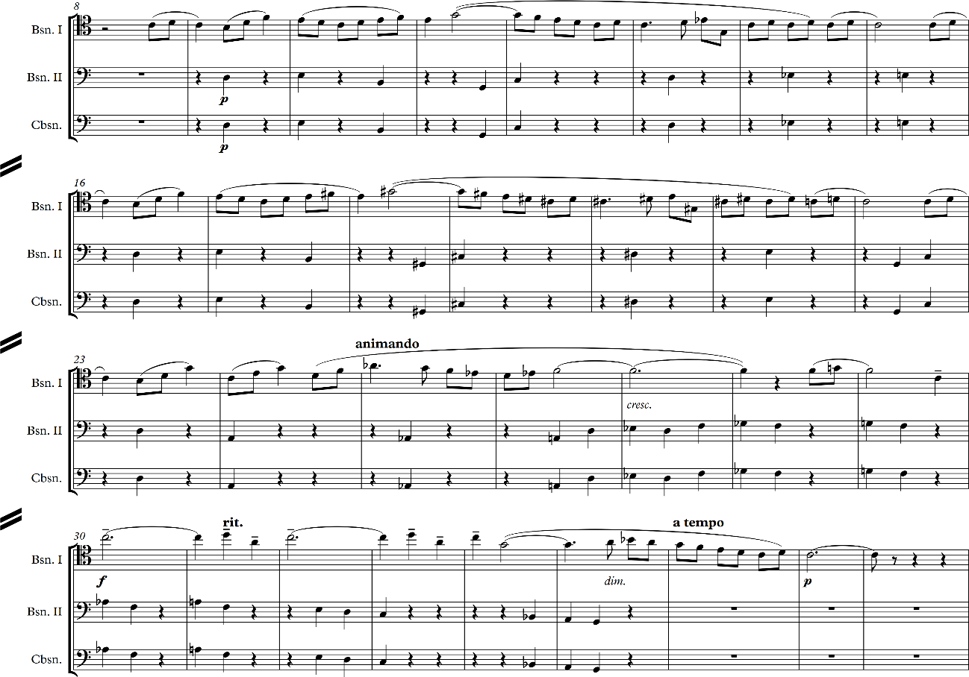

A section of music functioning as a retransition moves the music from the end of the exposition to the start of the development. Yet this is the first instance in which the retransition theme proper (RT), the melodic material from m. 133–142, is not used as a transition. Instead, the retransition theme (RT) becomes the countersubject for the fugal development of the P^{rf} material that begins the development. This undermines the role of the material from P^{rf} functioning as a proper return of the refrain for two reasons: only the first phrase of the refrain is used, and phrase is restated in D-flat, not C major.
Figure 2: Shostakovich, Symphony No. 8, Op. 65, v, mm. 434-438.
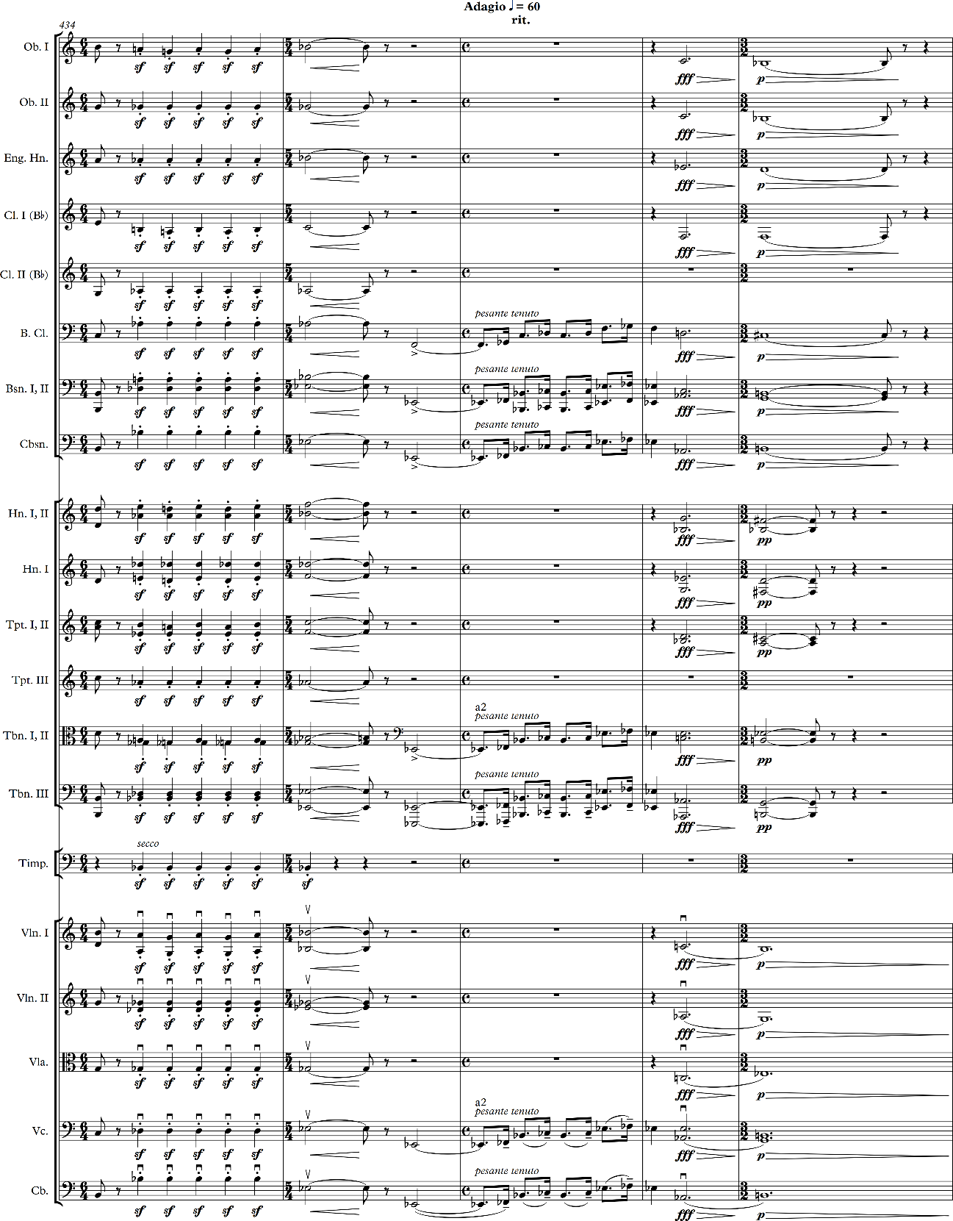

The overlapping of the RT material with P^{rf} at the beginning of the development in m. 228–236, masks the strong feeling of a return expected from a refrain.
The end of the development serves as a final rupture of the “storm” that plays a central role in the movement’s narrative structure. Although the exact pitch material is not repeated, the rhythmic aspect of the symphony’s opening motive returns towards the end of the development, from m. 407–424, played in the brass section instead of the strings. While this would imply a sense of closure, the end of the development is anything but assuring; the final chord is a very subdued, augmented E-flat. The final two measures of the development, m. 427–438, imply a half-cadence in A-flat, but by raising the B-flat, established in m. 433–436, to B-natural the cadence is undermined because the E-flat major chord that should have appeared instead becomes augmented. The conflict between B-flat and B-natural stems from the conflict between C major, which is established at the beginning of the movement, and C minor, established at the beginning of the symphony.
A constant tension between the major and minor mode pervades the work which comes to a head in the cadence at m. 437-438. The basses and cellos utilizes flat $\hat{3}$, flat $\hat{6}$, and flat $\hat{7}$, giving the impression of a return to C minor. However the final chord resolves to an E-flat augmented chord, with the B-natural in the bass. This prevents a cadence in any key, as well as sets the C major and C minor mode in direct opposition. The B-natural in m. 438 should function as a leading tone back into P^{rf}, but instead the music simply dissolves and instead moves to the tertiary phrase. Large-scale issues arise when considering the key relationships of the movement as a whole. Although the symphony is in C minor, the final movement is clearly established in C major. This in itself is not unusual, however, within the final movement, key becomes more complicated. Because the finale is in C major, the expectation is that the movement, at some point, will modulate to the dominant. Instead, the only brief occurrence of G major, as seen in Table 3, is during the development, where the first phrase of P^{rf} is stated in the horns. This occurs during a stretto episode, where the trumpet plays a similar figure in C major, which undermines the stability of the dominant. Instead, Shostakovich moves to the submediant, in a similar fashion to how the mediant is used in minor key works; instead of modulating from minor to major, as would happen with a minor key work, the movement moves from major to minor. As seen in Table 3, five clear key areas are explored throughout the movement: C major, C minor, A major, A minor, and D-flat major. The use of the submediant in place of the dominant may reflect from the tension between C major and C minor. Essentially, Shostakovich has replaced the dominant with a series of mediant chords. This harkens to Beethoven’s “insistence on A-flat major as the harmonic element of surprise…” which Michael Tusa argues “could be interpreted as a higher-level reflection of the tension between $\hat{5}$ and $\hat{6}$” within the themes of many of his C-minor works. The tension in Shostakovich’s work is not quite as pronounced, partially because of the use of A instead of A-flat, partially because of the lack of a tonic G. However, the use of A minor in particular facilitates the shift to minor, and supports the “storminess” that occurs during the development. A minor also undercuts the strong sense of forward motion by denying a modulation to the dominant.

Expressive Genre and Pastoral Signifiers
As mentioned earlier, I argue that the Finale of the Eighth Symphony historically has been interpreted through the wrong expressive genre. As a C minor symphony, it is easy to assume that the Eighth Symphony will be in the same tragic-to-triumphant genre as Beethoven’s Fifth Symphony. Robert Hatten defines expressive genres as categories of “musical works based on their implementation of a change-of-state schema…or their organization of expressive states in terms of an overarching topical field,” allow for categorization of works outside of classification based on formal structure. Hatten classifies Beethoven’s Fifth Symphony as a heroic tragic-to-triumphant as the “tragic first movement is answered by a triumphant last movement…,” clearly demarcated by the shift from C minor to C major. Both Beethoven’s and Shostakovich’s symphonies follow similar tonal schemes, beginning in the tragic C minor and ending in C major, however the finales of the two works take on different meaning with the inclusion of the pastoral in Shostakovich’s finale.
In reference to the tragic-to-triumphant expressive genre, Hatten discusses the different affects that the triumphant and pastoral genres impart on a work: “if the pastoral is interpreted for [Beethoven’s Op. 101] in the context of the spiritual…, then the victory will be understood as an inward, spiritual one––a somewhat different perspective from the outward, heroic triumph of the Fifth Symphony’s Finale.” Like the finale of Beethoven’s Op. 101, I argue the pastoral becomes the dominant expressive genre of the Eighth Symphony. Although, for both Beethoven’s Piano Sonata in A Major and Shostakovich’s Eighth Symphony, the pastoral is not initially the dominant expressive genre of the work; other expressive genres appear in earlier movements. For Shostakovich’s symphony, the early movements fall within the tragic-to-triumphant genre, however, by altering the expressive genre of the finale to a pastoral in the narrative trajectory and aesthetic affect of the work is affected. A key difference between the pastoral of Beethoven’s Op. 101 and the finale of Shostakovich’s Eighth Symphony is Beethoven’s use of the pastoral in a high stylistic register in the A major sonata as opposed to Shostakovich’s use of, what I will call, a “novelized pastoral.” The “novelized pastoral” acts as a commentary on both the tragic-to-triumphant genre and the tragedy of the earlier movements of the symphony. Hatten argues Beethoven’s Fifth Symphony falls within the middle stylistic register because its “dramatic progression tragic-to-triumphant” as opposed to the high stylistic register which would have a tragic-to-transcendent progression that moves beyond a public hero to an inward spiritual victory, although both works are considered “heroic epics”. This allows for a later discussion of the distinction between the Bakhtinian discussion of the “epic” and “novel”. Dawing on the work of Mikhail Bakhtin, I find the use of expressive genre further distinguished Beethoven’s “epic” narrative in the Fifth Symphony and Shostakovich’s “novel” Eighth Symphony as two works in the same key but with drastically different narrative arcs.
Both Robert Hatten and Raymond Monelle outline typical signifiers of the
classical pastoral. In his discussion of the pastoral, Monelle initially provides a
list of pastoral signifiers from Montiverdi’s Orfeo:
- the range of the vocal line seldom exceeds a fifth,
- the melody proceeds stepwise, seldom in leaps,
- periodically framed songlike phrasing and melody are preferred,
- the rhythm is limited to constantly repeated stress-patterns and dance-like schemes, often in triple time with characteristic dotted effects,
- the harmony is not expressive, distant scale-degrees are entirely missing,
- in the instrumental and vocal dance numbers, the tonality operates principally in the major area.

When discussing Beethoven’s Pastoral Symphony, Hatten’s signifiers remain largely the same: “there are copious pedal points; a drone…, there are several affections of traditional dance tunes…”; “the instruments move into rippling sixteenth notes, imitating the purling brook.” ⁻ The largest shift from Montiverdi to Beethoven is how Classical pastorals represent the past. Baroque pastorals reflected on the Golden Age, often in reference to Greek mythology, while Classical pastorals instead romanticize the landscape. Both of these concepts are static; the Baroque pastoral is backwards-looking, idealizing what once was, and the Classical pastoral exists in the Classical present, like a painting capturing a single moment in time.
Hatten’s signifiers are similar to Monelle’s, although Hatten’s list is more extensive. For the sake of brevity, I have paraphrased them below:
1. six-eight meter, 2. pedal points, generally on $\hat{5}$,
3. harmonic stasis, 4. simple melodic contour,
5. a ‘wedge’ shape, 6. rocking accompaniment,
7. parallel thirds, 8. consonant appoggiatura,
9. elaborated resolution of dissonance, 10. major mode.
Both scholars also acknowledge the importance of reed instruments as indicative of the pastoral. Although not listed as an explicit signifier of the pastoral, Hatten also discusses the concept of undercutting: “expressively appropriate to the pastoral genre, undercutting may be understood initially as creating a graceful, continuous flow across boundaries and past implied climaxes.” One major difference between Hatten and Monelle’s discussion of the pastoral, which plays a significant role in interpreting Shostakovich’s symphony, is the role of the “storm” that frequently occurs in the middle of pastoral works. Monelle states that “the ‘storm,’ an entirely traditional feature, is not a pastoral signifier because it cannot be interpreted without a text or title; you cannot find storms in untitled works because there is no definable musical trait that means ‘storm,’ except for general storminess.” Hatten, on the other hand, asserts that, while not necessarily a signifier, the storm is a central pastoral topic––“the pastoral as a topic suggests no clear dramatic pattern, with the exception of disruptive storms that soon pass…” The storm, or in the Eighth Symphony’s case, perhaps war, is an essential part of the narrative development in the final movement.
The inclusion of the pastoral finale plays an instrumental role in the interpretation of the expressive genre of the Eighth Symphony, and its relationship with other C minor symphonies, discussed later. Before exploring narrative aspects of the finale, I will discuss the pastoral signifiers that appear in Shostakovich’s symphony, which place it within the pastoral genre. Shostakovich clearly thought of this movement as a pastoral. In a letter to Ivan Sollertinsky, Shostakovich provides an outline of the movements: “1) Adagio; 2) March; 3) March; 4) Mournful March; 5) Pastoral.” Although Shostakovich does not employ each pastoral signifier, a significant number of them occur throughout the movement with such frequency that it is sufficient to consider the finale a pastoral. Primarily, the use of simple melodies that contain few leaps or chromatic embellishment, prominent use of woodwinds, frequent pedal-points, and static harmonies. Both 6/8 meter and parallel sixths occur, however these signifiers are somewhat obscured.
The three themes that occur in the finale, all contain characteristics of the pastoral. The scoring of P^{rf} in bassoon is the first marker; throughout the pastoral tradition, the double reeds are an instrumental signifier of the pastoral: Raymond Monelle states that “The shepherd with his pipe is the classic image of pastoral music. And indeed, the classical authors spoke constantly of the shepherd’s pipe, using the Greek word aulós…”. According to Monelle, the aulós was “a double-reed instrument of great power,” similar to the oboe. Additionally, looking at figure 1, the melodic contour of P^{rf} is fairly simple, although not entirely devoid of chromaticism, borne out of the tension between the major and minor mode. The first phrase, m. 9-15, undergoes a chromatic variation, temporarily tonicizing C-sharp minor, before resolving to a cadence in C major. Looking at the first cadence of the phrase, the V$\begin{matrix}6 \\ 4\end{matrix}$ in m. 13 initially resolves to the minor tonic, drawn from the flat-$\hat{3}$ that occurs as an appoggiatura in m. 13, before resolving to the major tonic. The modal tension becomes even more apparent in the third phrase, use of flat-$\hat{6}$ and flat-$\hat{7}$. By ending on a V⁷, the cadence becomes less stable than the previous phrases. The final phrase serves only to reinforce the modal ambiguity of P^{rf}; the second bassoon and contrabassoon alternate between raised and lowered versions of $\hat{6}$, before settling on a G minor chord in m. 34-35, where a cadence should have occurred. Although P^{rf} ends with the same melodic motive that it began with, implying a cadence in C major, a harmonically functional cadence does not occur as a result of the minor dominant, and the lack of harmonic support from the second-bassoon and contrabassoon.
The transition itself is somewhat problematic, as it removes the pastoral signifiers of P^{rf} while also acting as a variation of P^{rf}. The interruption is bookended by what is most likely a continuation of the primary transition, which contains a similar texture to the initial transition, and presents a tonally ambiguous second theme. The primary transition (m. 37-62, 88-92) acts as a variation of P^{rf}. The initial figure of P^{rf} appears at the beginning of the transition, but it quickly evolves into a more embellished melodic line than the refrain, which strips away the pastoral affect. Instead the harmony becomes much more complex, although not necessarily more functional. The movement modulates to the parallel minor, temporarily suspending the conflict between major and minor, and contains much more chromatic embellishment. The second phrase, m. 49-62, elides the consequent phrases from P^{rf}, however the final cadence before the secondary transition implies an unfulfilled return to P^{rf}, as well as a true return to the mixed modes with the secondary transition.
The secondary transition brings back aspects of the pastoral through melodic simplicity and the use of parallel thirds in the accompaniment from m. 76-87, although the parallel consonances are obscured by the linear chromaticism. As seen in figure 3, the melody is incredibly simple, mostly outlining triadic arpeggiations for the first half of the transition. Again, there is no clearly functional harmonic motion, but instead an ascending sequence that is repeated in the strings. The sequence is, at first very simple, moving from tonic to the dominant, however the second iteration becomes chromatic upon reaching the dominant, ending on an unresolved leading tone in the bass. Arguably, the first iteration could be explained as a half cadence in C major, as the melodic line indicates the end of a phrase, and the chords all appear to be moving functionally. However, in the second iteration of the pattern the chords following the dominant chord are certainly not functioning harmonically, returning to the harmonic stasis of the refrain.
The secondary theme alludes to another pastoral signifier, although in altered form, via the hypermetric implication of 6/8 meter. The movement itself is in 3/4, and the theme itself implies a compound meter through the use of hypermetric groupings. Although not exactly 6/8, it retains the dance-like effect of the siciliana from which the musical pastoral is derived. Monelle describes modern sicilianas as a “slower type,
Figure 3: Shostakovich, Symphony No. 8, Op. 65, v, mm. 42-87
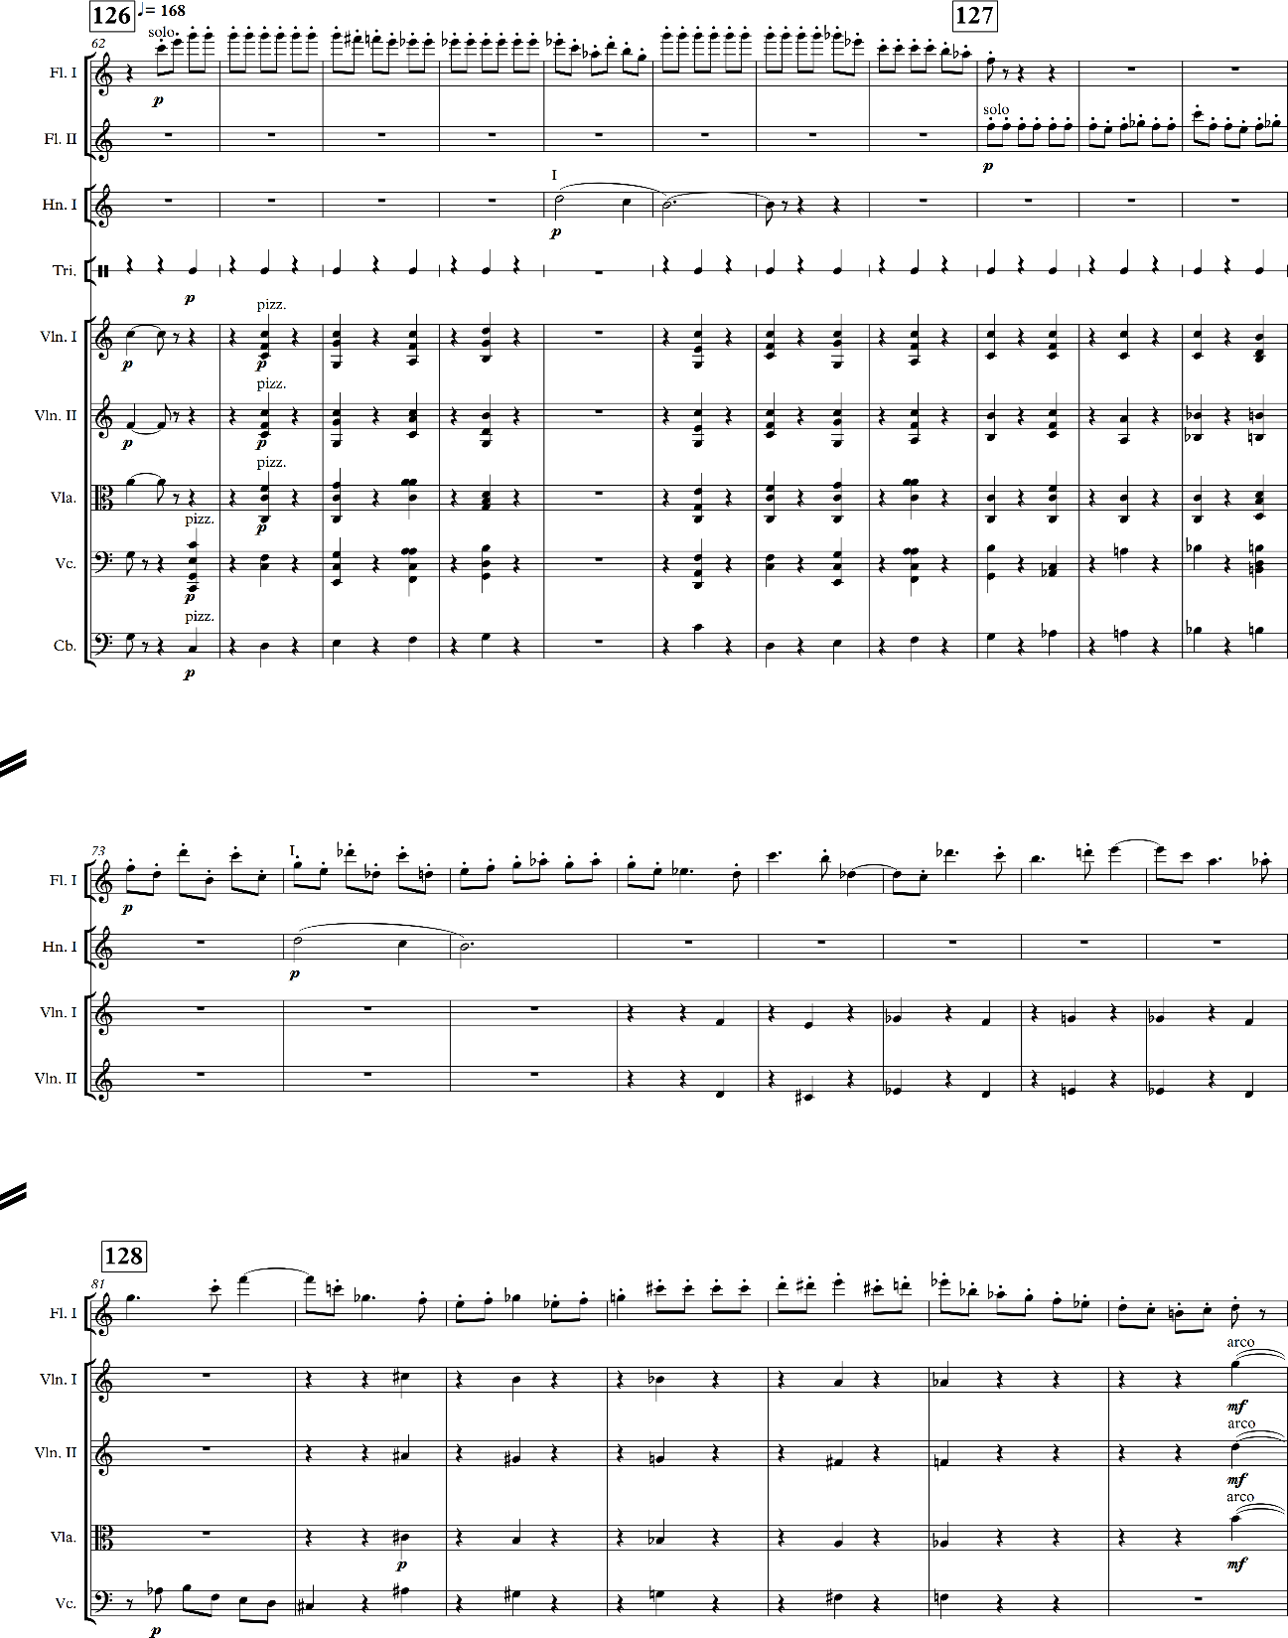

which has ‘a certain seriousness,’ suited to ‘tender and moving subjects.’” A true siciliana would be written in 6/8 or 12/8, contain dotted figures, and when written with a text, would be “emotional, lamenting, or melancholy,” and it “must be played very simply and almost without trills…, few embellishments are permitted.” Although the section is not a siciliana in its own right, it does embody the mood of the dance. The accompanimental figures reinforce the secondary theme as a dance through the constant repetitive pattern, although there are breaks from the repetition that coincide with extensions of the two-bar groupings. Figure 4 shows that the accompaniment repeats at the same rate as the hypermetric groupings. Additionally, the breaks from the hypermetric phrasing often coincides with increased melodic complexity. It also gives the melody a sense of momentum by leading into the second hypermetric beat. In doing so, the accompaniment clarifies the second beat, which is frequently elided in the melody.
Harmonically, the secondary theme is much more ambiguous than P^{rf}, but Shostakovich establishes A minor, through the use of a tonic pedal in the contrabassoon, an important signifier of the pastoral. The transition into the secondary theme indicates a modulation to A minor, although the tonality of the secondary theme is much more ambiguous than that of the refrain. It appears that, despite the lack of a leading tone in the cadence in m. 91-92. This is reinforced by the contribution of the
Figure 4: Shostakovich, Symphony No. 8, Op. 65, v, mm. 87-142
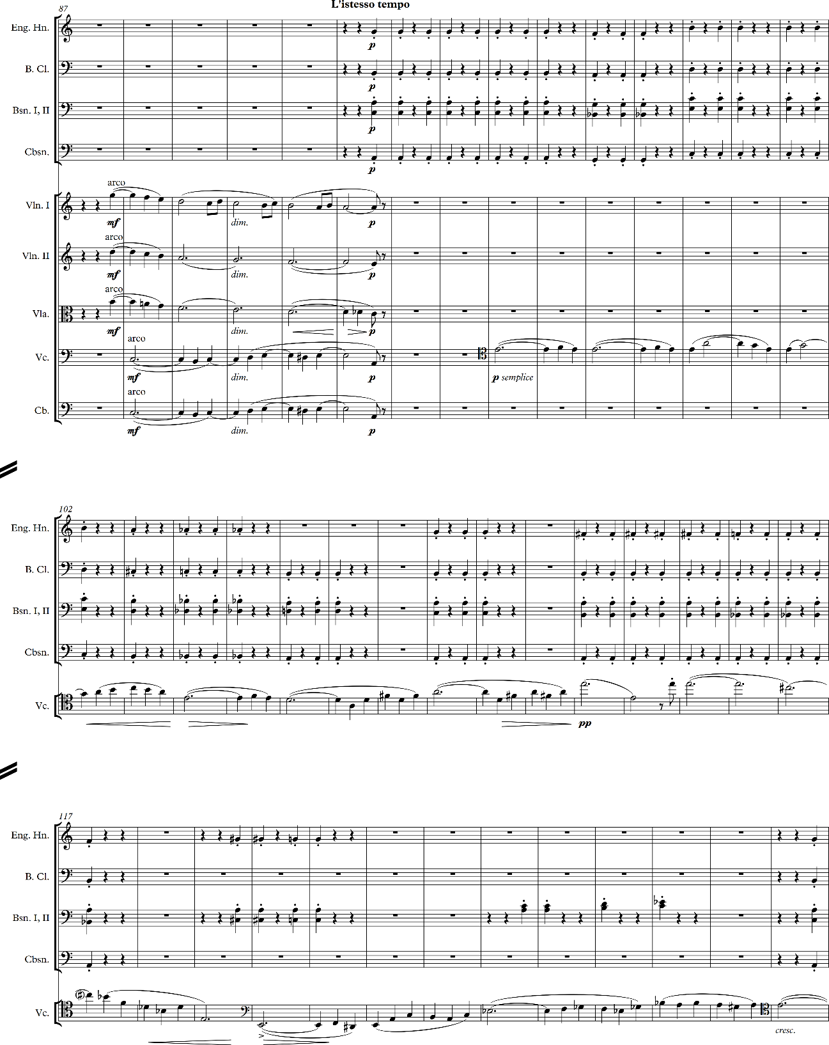

pedal to the relative harmonic stasis that characterizes both this movement and the pastoral in general. The primary issue in establishing the tonal center of the secondary theme lies in the harmonic implications of the contrabassoon contrasted with the melodic content of the melodic line. Although the contrabassoon establishes A as a central tone, the chromatic descent in m. 99-106 seems more indicative of a descent in C, highlighting the chromatic alterations of the minor mode. This is reinforced by the leap from G-natural, not G-sharp, to C between m. 98-99, establishing a dominant-tonic relationship, however it is not supported by the melody in the cello, or the other woodwinds. It is not until m. 108 that a true clarification of tonal center occurs, which is achieved by the harmonic implications of the solo cello, not the accompaniment. The appearance of G-sharp, particularly as part of a cadential figure as opposed to the sequential motion seen in m. 103, finally establishes A as the tonal center. The cadence, at first, is undercut by the disconnect between the accompaniment and the solo cello, with the break in the accompaniment ending on the predominant. The lack of a cadence in the accompaniment also coincides with a break from the hypermetric groupings that establish the dance implications. Regardless, the solo cello proceeds to outline an authentic cadence in m. 108-111.
Although Shostakovich’s finale does not contain every pastoral signifier laid out by Hatten and Monelle, the amount of signifiers present places the finale well within the pastoral expressive genre. Because the finale utilizes the pastoral expressive genre, the Eighth Symphony as a whole becomes defined by the change from tragic-to-triumphant to pastoral expressive genre. As a result, I argue that this necessitates a change in the narrative interpretation of the work.

Narrative Interpretation and Narrative Expectations
Critical reception, and the implications of Shostakovich’s Eighth Symphony as a successor to both Beethoven’s Fifth Symphony and Shostakovich’s own Seventh Symphony have influenced the work’s interpretation: Shostakovich’s Eighth and Beethoven’s Fifth are related by key; his Seventh and Eighth Symphonies related by World War II. What appears to be missing, certainly from Haas’ placement of the Eighth Symphony in the family of C minor symphonies, is a discussion of the finale as a pastoral, as I have provided. This changes the expressive genre of the work, which in turn changes how the work may be interpreted, and what relationships are drawn between the Eighth Symphony and other works. As established by Haas, Shostakovich fails to repeat this narrative, although I argue that it is not because Shostakovich’s narrative is a failure to realize the tragic-to-triumphant genre, but instead that Shostakovich’s narrative is not within the tragic-to-triumphant genre. Instead, Shostakovich presents a new narrative that looks towards a post-war future. This narrative would be necessary, as the past would be colored too much by the war and thus cannot look utilized in the same way that Baroque and Classical pastorals romanticize both the past and idyllic landscapes, whereas the future offers the potential for healing.
The first issue that colors the reception is the differing narrative structures of Shostakovich’s Eighth Symphony and Beethoven’s Fifth Symphony. Beethoven’s Fifth is more in line with Mikhail Bakhtin’s description of the narrative structure of an epic poem; “[the epic] is as closed as a circle; inside it everything is finished, already over. There is no place in the epic world for any openendedness, indecision, indeterminancy. There are no loopholes in it through which we glimpse the future; it suffices unto itself, neither supposing any continuation nor requiring it.” In Beethoven’s symphony, the hero is presented with an adventure, faces trials that test their resolve, and emerge victorious. The narrative structure has a clear beginning, middle, and end. Shostakovich’s work, on the other hand, does not end with a clear victory; the major pastoral is disrupted by the storminess of the development. As a result, the ending is not as definitive as Beethoven’s, leaving the listener to expect something more, although the music itself has ended. This disconnect between the musical closure and the lack of narrative closure prevents Shostakovich’s symphony from falling within the same narrative genre as Beethoven’s, instead placing it within the realm of what Bakhtin describes a novel.
In The Dialogic Imagination, Bakhtin discusses about the idea of a novel in comparison to an epic, as pertaining to literature. Similarities arise between these literary forms, and the narrative forms used by Beethoven and Shostakovich in their C minor symphonies, particularly where the final movement of the Shostakovich symphony is concerned. Arguably, Beethoven’s symphony is structured in much the same way as an epic: Beethoven establishes a form to be followed and expanded upon by other composers in their C minor symphonies. A fundamental difference between the two literary styles is the treatment of the hero. In the epic, as in Beethoven’s narrative, the hero is already established as a heroic figure; there is no growth into their heroicness, nor any character flaws to problematize the hero’s journey. In contrast, Shostakovich’s hero, even at the end of the symphony, still has a journey ahead of them. The symphony accomplishes this in two ways: the perfect fifths provide an open soundscape, achieving an almost transcendent quality which provides the base for the optimistic nature of the coda; and the opening bassoon motif, this time in the flute, refers back to the pastoral nature of the movement. In contrast the relative dissonance of the duet between the bass clarinet and violin that precedes the coda, the open fifths are more stabilizing, anchoring the movement although it somewhat undermines the shift from minor to major achieved by the end of the symphony. Like the inconclusive nature of the narrative, the inconclusive nature of the open fifths leaves the ending to the listeners’ imagination. It could easily be implied that, because the movement began in C major it would also end in C major, and the perfect interval lends itself more to a major interpretation, however Shostakovich leaves the ending unresolved, just as the future is yet to be resolved, the war is yet to be won.
The lack of narrative closure is important in understanding the consideration of the Eighth Symphony-as-novel’s role in distancing Shostakovich’s symphony from Beethoven’s. Sarah Ellis discusses a similar occurrence in Shostakovich’s Eighth String Quartet: “in a sense, the quartet documents an almost apocalyptic destruction of its musical universe. But, the qualifier of ‘almost’ is necessary; history is not closed with the Eighth. The close of the finale may be hollow, but it is not nonexistent–something has survived the near destruction of the quartet’s musical subject.” The Eighth Symphony does not deal with destruction in the same way that the quartet does, but like the quartet the music concludes before the narrative. The lack of finality may seem subversive, but never the less the narrative leaves the possibility for optimism open. The lack of finality additionally distinguishes between Beethoven’s “epic” Fifth Symphony and Shostakovich’s “novel” Eighth Symphony. Beethoven’s hero is already heroic, and the symphony merely recounts his deeds, but they are so far removed from the “present” that the hero’s actions offer little room for self-reflection or for criticism. Bakhtin argues that a major distinction of the epic is that it existed and was perfected as a form before written language. By contrast, the novel is much younger, having only existed for a few hundred years. It also lacks the strict codification of other “high” forms of literature. In this way, Shostakovich’s symphony takes on the narrative form of the novel, which Bakhtin acknowledges is a rather poorly defined genre, but which is distinct from older literary forms partly in its flexibility and its different relationship with time. Although Beethoven’s symphony came much later than that of the epic, in terms of musical compositions, Beethoven’s works are considered the foundation of the musical canon in the same way that literary epics are the cornerstone of the literary canon. Thus, the novel finds itself in opposition to the epic acting as the “criticism of other literary genres (in particular, a criticism of epic heroization).” Instead of offering the same tragic-to-triumphant epic of Beethoven, the Eighth Symphony offers commentary on the present, as well as a vision of the future that is not possible within the closed structure of an epic.
In returning to a discussion of the pastoral, Hatten, more so than Monelle, establishes that the storm is a defining feature of the pastoral. In the Eighth Symphony, the development carries the embodiment of the storm. As mentioned previously, although the storm is difficult to be defined without being expressly marked, in the Eighth Symphony it is clearly distinguished from the exposition and recapitulation by the thicker texture, increased use of brass instruments, and frequent chromatic passages in the woodwinds and upper strings. Although in lieu of a storm, the development becomes a manifestation of the ongoing war. In the lineage of Shostakovich symphonies, the development of the Eighth Symphony follows the overtly militaristic Seventh Symphony, and it does not make an attempt to distance itself from the military theme.
The placement of the finale within the pastoral expressive genre puts the symphony in dialogue with Beethoven’s Sixth Symphony, in addition to the Fifth Symphony. While the relationship between Beethoven’s Fifth Symphony and Shostakovich’s Eighth Symphony is undoubtedly significant within the canon of other C minor works, the relationship to other works have been largely ignored, possibly as the result of the work being composed in such a marked key. The only other work outside of C minor discussed in relation to the Eighth Symphony is Shostkovich’s Seventh Symphony, although here too the Eighth is viewed as a failure of realization. Laurel Fay provides some insight into the issue of reception that appears to color readings of the work:
a central problem in the contemporary reception of Shostakovich’s Eighth Symphony was pinpointed by N. A. Timofeyev: ‘what is the reason for the somewhat chilly reception of the Eighth Symphony? I think it is because these tremendous experiences, these sufferings brought about by evil are not overcome, are not vanquished, instead they are, as it were, replaced by a passacaglia and a pastorale. Evidently, listeners sensed that the weakness of this work is in the transition to its last movements.

Following the Seventh Symphony, the Eighth “was a letdown to those inclined to read the symphony, like its predecessor, as an authentic wartime documentary.” Fay’s discussion of the reception illuminates the historical issues surrounding Shostakovich’s work, which appear to have held over into modern understandings, as was seen in Haas’ discussion of Shostakovich’s hero’s failure to live up to the expectations set by Beethoven’s hero. Additionally, Shostakovich’s hero fails to follow in the footsteps of the Seventh Symphony’s protagonist, although this can be amended in modern readings by looking at the work not as a tragic-to-triumphant work, but as a pastoral.
The storm that manifests in the development can be understood as the driving force behind the alteration of the rotations. As seen in “Complications of Form,” the recapitulation begins not with a restatement of the refrain, but instead with the tertiary theme. Additionally, the texture is much thinner, presenting a much more timid entrance than the initial statement. I argue this is a result of the replacement of the ‘storm’ with war. The war itself appears in several ways: the heightened chromatic passages in the woodwinds and upper strings; increased motivic fragmentation; and the return of the
Figure 5: Shostakovich, Symphony No. 8, Op. 65, v, mm. 416-419.
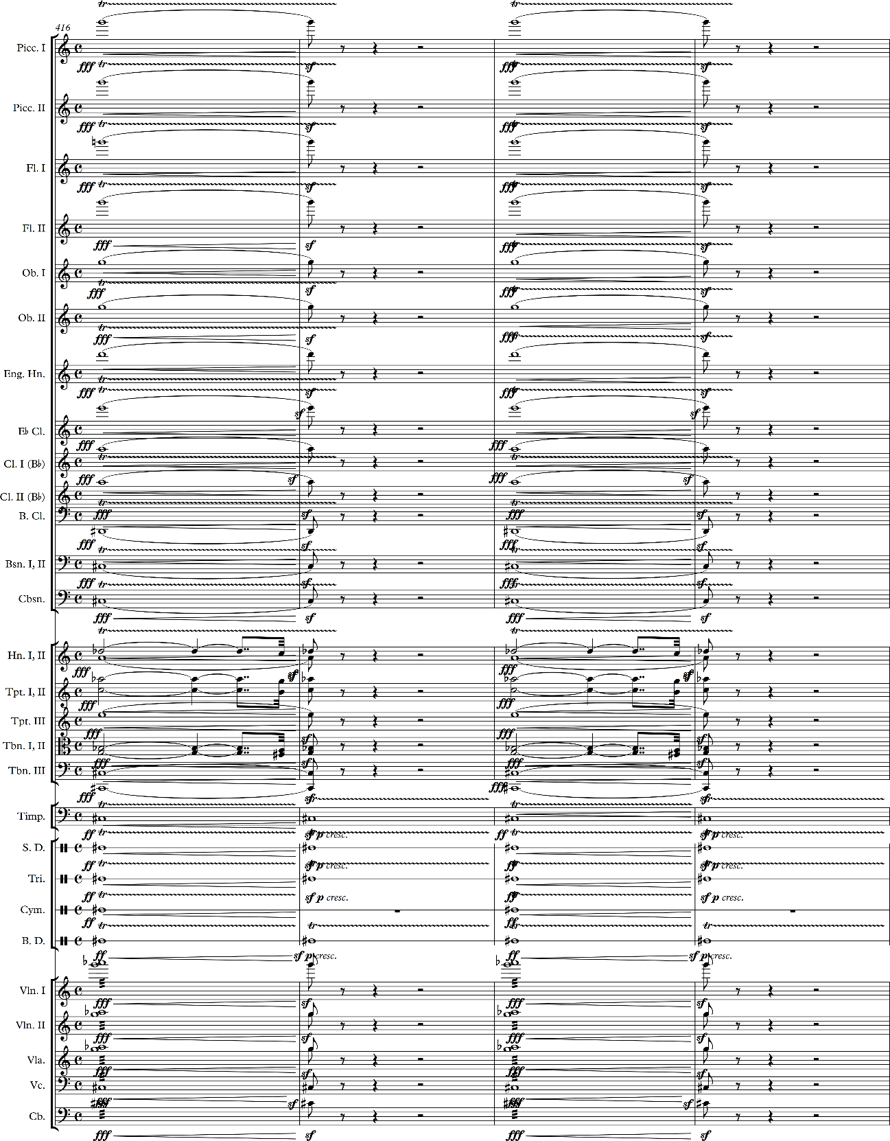

opening theme of the first movement in m. 416-419 and m.422-425, which Haas describes as a modeling of the “fate motive” of Beethoven’s Fifth Symphony. The development itself focuses only on the thematic development of the refrain and the retransition theme, although in the development the refrain is scored in the brass, removing the double-reed pastoral signifier. The pastoral signifier is replaced with a more militaristic signifier, as the refrain adopts the air of a military fanfare.

Figure 6: Shostakovich, Symphony No. 8, Op. 65, i, mm. 1-9. Fate Motive.
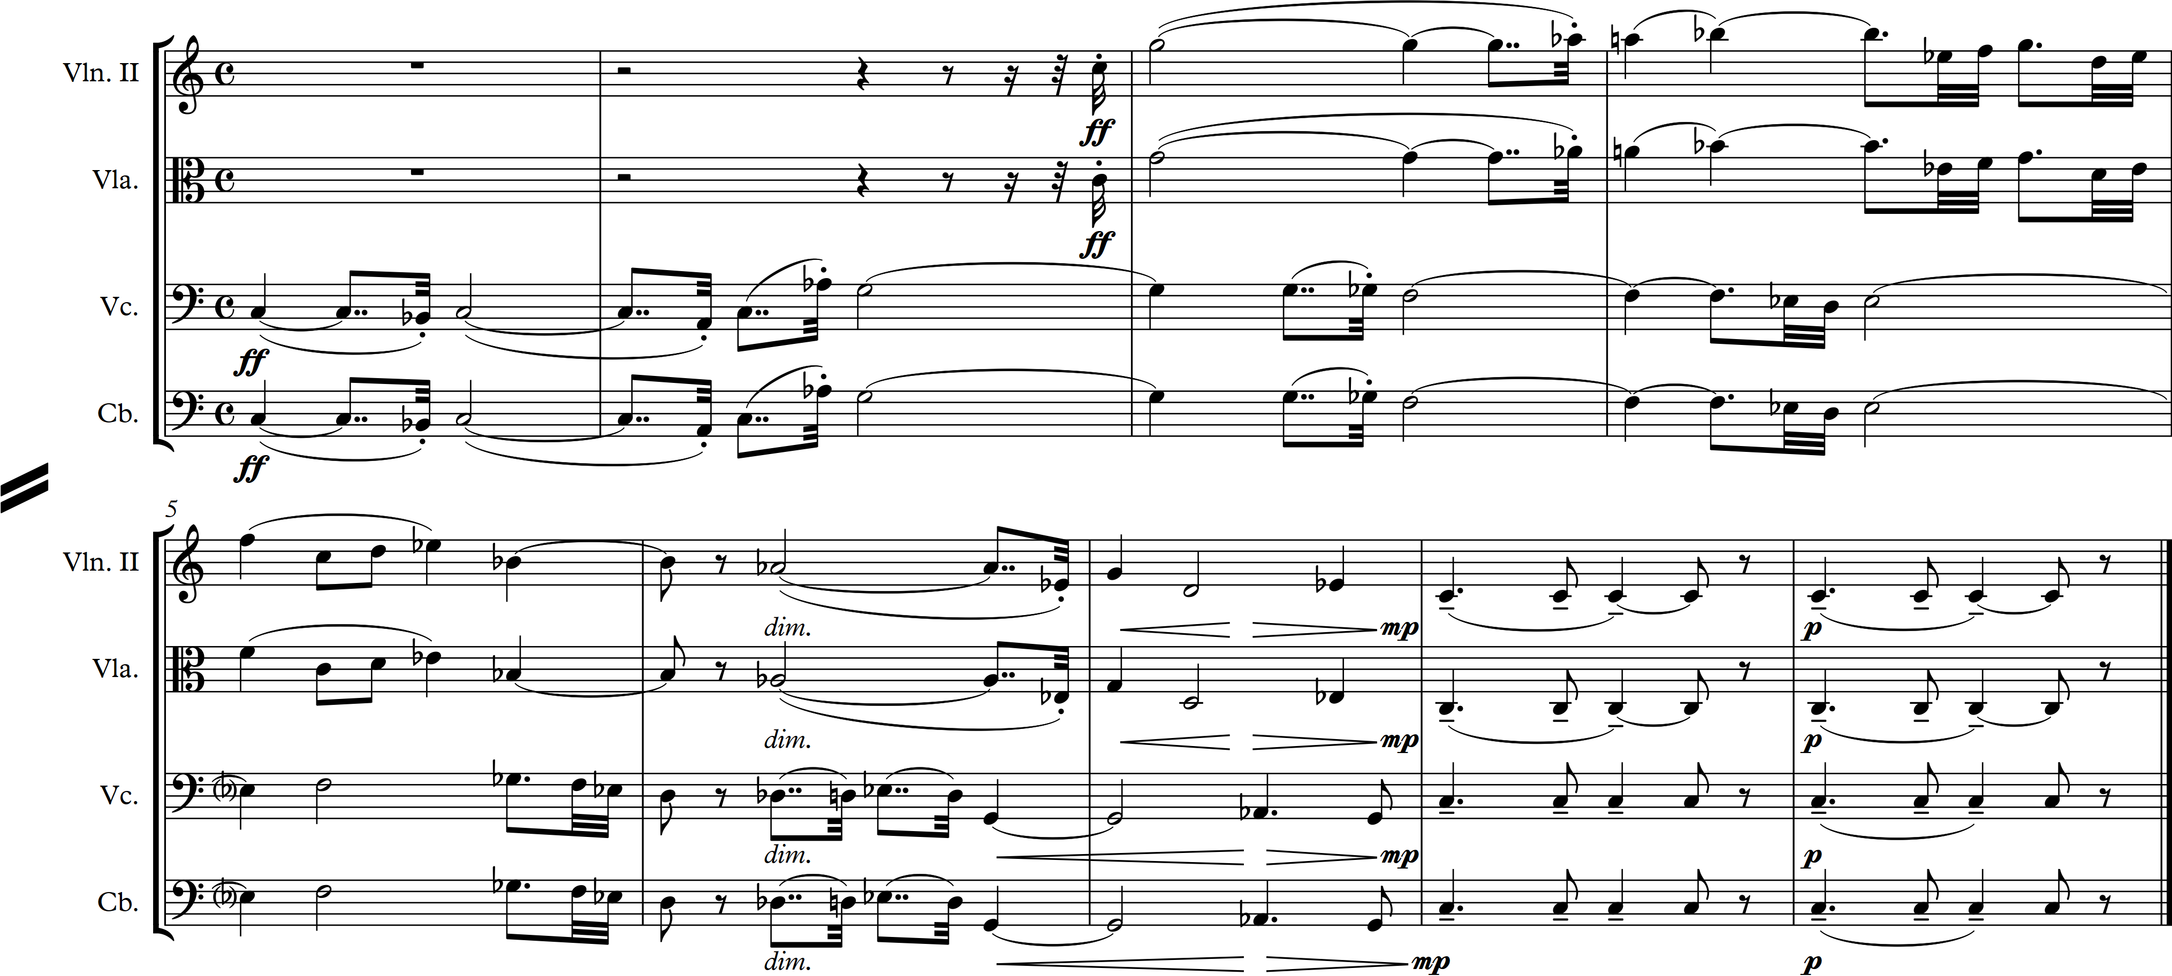

The brass also resurrects the opening motive, or “fate theme,” of the first movement; in terms of the tragic-to-triumphant expressive genre, this means that the tragedy characterizing the first movement lingers, and is not overcome before the closure of the work. Comparing figure 6 to the brass part in figure 7, the rhythmic gesture is an obvious reference to the fate theme. Yet, instead of following the “fate
Figure 7: Shostakovich, Symphony No. 8, Op. 65, v, mm. 561-594. Coda.
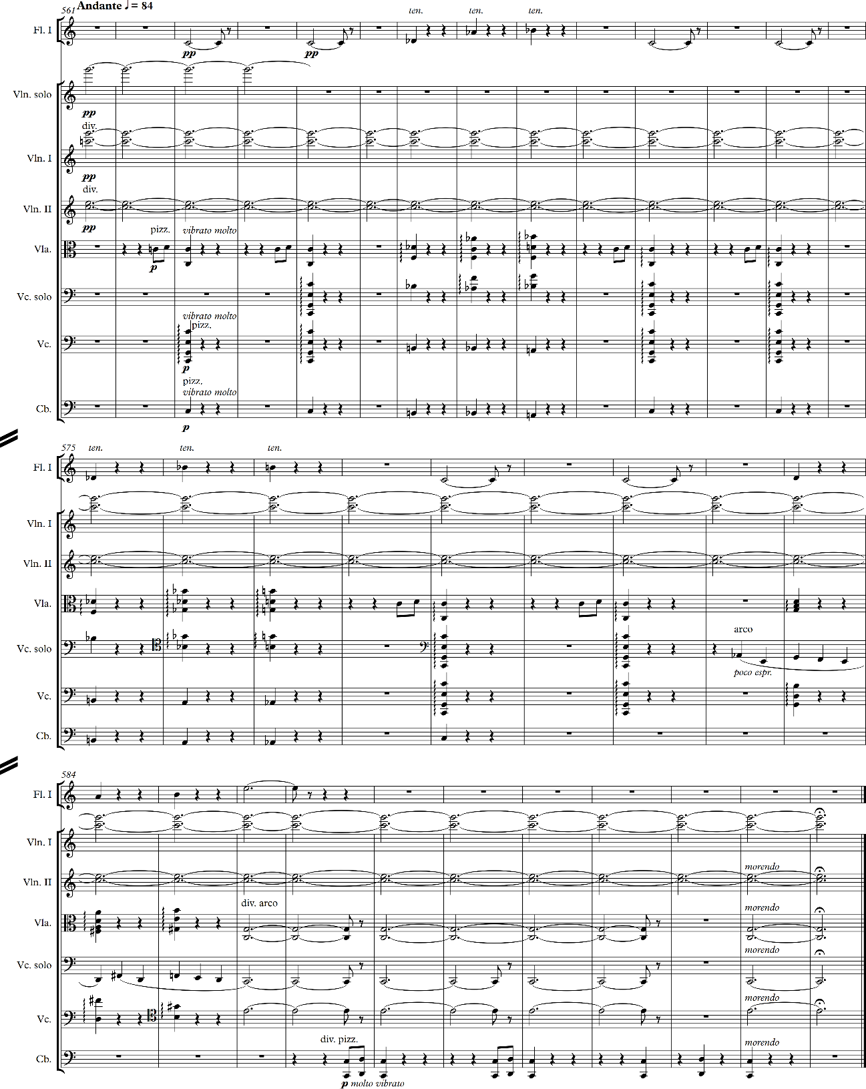

theme” with an affirmative refrain to signal the conquering of tragedy, the music instead falters to a close in A-flat. In figure 2, m. 435-437 imply a half cadence in A-flat, however the final chord is altered to an E-flat augmented triad. The extreme dynamic reduction between m. 437-438, and the textural reduction in m. 438 heighten the uncertainty of the development’s conclusion.
The uncertainty carries over into the recapitulation, which a similar textural and dynamic reduction of the tertiary theme, as compared to its original statement in 186. At the coda, figure 7, the first violins sustain a perfect fifth through the entirety of the coda, in the highest scored register of the coda. This is reinforced by the cello, as well as the perfect octave between the bass and cello. The final appearance of the retransition theme appears in the coda, which finally brings the retransition theme to a tonic resolution, in m. 582-588, emerging it with the primary motivic figure of the refrain, $\hat{1}$–$\hat{2}$–$\hat{1}$. Throughout the movement, the retransition theme preceded entrances of the P^{rf}, implying that there would be a final statement of P^{rf} in the coda. However, the final statement has already occurred, and while the return of the primary motivic feature may be sufficient it seems to be denying the refrain theme from fulfilling its purpose of bringing back P^{rf}.
The coda also, finally, resolves the tension between major and minor that occurs throughout the Finale, manifesting itself in P^{rf}. The flute, viola, and low strings sound a progression of flat-$\hat{2}$, flat-$\hat{6}$, flat-$\hat{7}$, $\hat{1}$ twice, before resolving to the major mode $\hat{2}$, $\hat{6}$, and $\hat{7}$, although the final resolution of $\hat{7}$ to $\hat{1}$ is replaced with $\hat{7}$ to $\hat{3}$. It is this avoidance of the leading-tone resolution that I posit generates the lack of finality, despite taking place over a sustained tonic chord. While this brings a peacefulness to the conclusion of the symphony, there is no sense of victory. The resolution dies, with the morendo marking for the final two measures, leaving both a sense of relief but also an uncertainty as to how long that relief might last.

Conclusion
Shostakovich’s Eighth Symphony embodies a similar dramatization that Hatten finds in Beethoven’s works: the “creativity in Beethoven’s late style may be understood as a further dramatization and elaboration of what was already present in Bach’s own dramatic and rhetorical invention….” Like Beethoven’s late works, Shostakovich takes what was latent in Beethoven and expounds upon it––in this instance taking the dramatic expressivity of the tragic-to-triumphant expressive genre, and altering it to encompass the ongoing experience of the twentieth century that serves to inform our understanding of Shostakovich’s Eighth Symphony.
By disconnecting the ending of the music from the ending of the narrative, Shostakovich creates a work that offers a new reading of the pastoral expressive genre. Understanding the finale as a pastoral informs our understanding of the Symphony beyond the formal ruptures, and allows for a discussion of the Eighth Symphony as a work both inside the canon of C minor symphonies, as well as a symphony in dialogue with other works outside of C minor.
References
Bakhtin, Mikhail. “Epic and Novel.” In The Dialogic Imagination: Four Essays, 3-40. Edited by Michael Holquist, translated by Caryl Emerson and Michael Holquist. Austin: University of Texas Press, 1981. http://quod.lib.umich.edu/cgi/t/text/text-idx?c=acls;idno=heb09354.
Eco, Umberto. The Open Work. Translated by Anna Cancogni. Cambridge: Harvard University Press, 1989.
Fanning, David, and Laurel Fay. "Shostakovich, Dmitry." Grove Music Online. Oxford Music Online. Oxford University Press, accessed April 17, 2016, http://www.oxfordmusiconline.com/subscriber/article/grove/music/52560pg3.
Fay, Laurel. Shostakovich: A Life. Oxford: Oxford University Press, 2000.
Haas, David. “Shostakovich’s Eighth: C minor Symphony against the Grain.” In Shostakovich in Context, 99-122. Oxford: Oxford University Press, 2000.
Hatten, Robert. Musical Meaning in Beethoven: Markedness, Correlation and Interpretation. Bloomington: Indiana University Press, 2004.
–––––. Interpreting Musical Gestures, Topics, and Tropes: Mozart, Beethoven, Schubert. Bloomington: Indiana University Press, 2004.
Hepokoski, James, and Warren Darcy. Elements of Sonata Form: Norms, Types, and Deformations in the Late-Eighteenth-Century Sonata. Oxford: Oxford University Press, 2004.
Iakubov, Manashir. “Dmitri Shostakovich’s Eighth Symphony: How it was Composed and its Premiere.” In Shostakovich, Dmitri. Symphony no. 8. Moscow: DSCH, 2009.
Monelle, Raymond. The Musical Topic: Hunt, Military and Pastoral. Bloomington: Indiana University Press, 2006.
Reichardt, Sarah. “The Indivisible Remainder: Novelization in the Ninth String Quartet, Op. 117 (1964).” In Composing the Modern Subject: Four String Quartets by Dmitri Shostakovich, 99-115. Burlington: Ashgate, 2008.
Tusa, Michael. “Beethoven’s ‘C-Minor Mood’: Some Thoughts on the Structural Implications of Key Choice” in Beethoven Forum 2, 1-27. Lincoln: University of Nebraska, 1993.
Shostakovich, Dmitri. Symphony No. 8, Op. 65. Moscow: DSCH, 2009.

Laurel Fay, Shostakovich: A Life (Oxford: Oxford University Press, 2000), 124-127.
David Haas, “Shostakovich’s Eighth: C Minor Symphony Against the Grain,” Shostakovich in Context, ed. Rosamund Bartlett (Oxford: Oxford University Press, 2000) 125.
Umberto Eco, The Open Work, trans. Anna Cancogni (Cambridge: Harvard University Press, 1989), 19.
David Haas, “Shostakovich’s Eighth: C minor Symphony against the Grain,” in Shostakovich in Context, ed. Rosamund Bartlett (Oxford: Oxford University Press, 2000), 134.
Ibid, 125.
James Hepokoski and Warren Darcy, Elements of Sonata Theory: Norms, Types, and Deformations in the Late-Eighteenth-Century Sonata (Oxford: Oxford University Press, 2006).
James Hepokoski and Warren Darcy, Elements of Sonata Theory: Norms, Types, and Deformations in the Late-Eighteenth-Century Sonata (Oxford: Oxford University Press, 2006), 405.
James Hepokoski and Warren Darcy, Elements of Sonata Theory: Norms, Types and Deformations in the Late-Eighteenth-Century Sonata (Oxford: Oxford University Press, 2006), 417.
James Hepokoski and Warren Darcy, Elements of Sonata Theory: Norms, Types and Deformations in the Late-Eighteenth-Century Sonata (Oxford: Oxford University Press, 2006), 171.
James Hepokoski and Warren Darcy, Elements of Sonata Theory: Norms, Types, and Deformations of Late-Eighteenth-Century Sonatas (Oxford: Oxford University Press, 2006), 417.
Michael Tusa, “Beethoven’s ‘C-Minor Mood’: Some Thoughts on the Structural Implications of Key Choice” in Beethoven Forum 2 (Lincoln: University of Nebraska, 1993), 12.
Robert Hatten, Musical Meaning in Beethoven: Markedness, Correlation, and Interpretation (Bloomigton: Indiana University Press, 2004), 290.
Ibid, 86.
Ibid, 171.
Robert Hatten, Musical Meaning in Beethoven: Markedness, Correlation, and Interpretation (Bloomigton: Indiana University Press, 2004), 170.
Ibid, 79.
Raymond Monelle, The Musical Topic: Hunt, Military and Pastoral (Bloomington: Indiana University Press, 2006), 220-221.
Ibid,243.
Ibid, 244.
Ibid, 186-187.
Robert Hatten, Musical Meaning in Beethoven: Markedness, Correlation, and Interpretation (Bloomington: Indiana University Press, 2004), 97-99.
Ibid, 99.
Raymond Monelle, The Musical Topic: Hunt, Military and Pastoral (Bloomington: Indiana University Press, 2006), 243
Robert Hatten, Musical Meaning in Beethoven: Markedness, Correlation, and Interpretation (Bloomington: Indiana University Press, 2004), 92.
Dmitri Shostakovich, Letters to Ivan Sollertinsky, (St. Petersburg, 2006) p. 258. Quoted in Manashir Iakubov, “Dmitri Shostakovich’s Eighth Symphony: How it was Composed and its Premiere,” Symphony no. 8, (Moscow: DSCH, 2009), 210.
Raymond Monelle, The Musical Topic: Hunt, Military and Pastoral (Bloomington: Indiana University Press, 2006), 207.
Ibid.
Raymond Monelle, The Musical Topic: Hunt, Military and Pastoral (Bloomington: Indiana University Press, 2006), 219.
Ibid, 219. Specifically, Monelle is describing the sicilianas of Alessandro Scarlatti, although it appears that it is quite typical of all sicilianas. Herman Jung, Die Pastorale: Studieren zur Geshichte eines musikalischen Topos, quoted in Raymond Monelle’s The Musical Topic: Hunt, Military and Pastoral (Bloomington: Indiana University Press, 2006), 219.
Mikhail Bakhtin, “Epic and Novel” in The Dialogic Imagination: Four Essays, ed. Michael Holquist, trans. Caryl Emerson and Michael Holquist (Austin: Unversity of Texas Press, 1981), 16. http://quod.lib.umich.edu/cgi/t/text/text-idx?c=acls;idno=heb09354.
Mikhail Bakhtin, “Epic and Novel” in The Dialogic Imagination: Four Essays, ed. Michael Holquist, trans. Caryl Emerson and Michael Holquist (Austin: Unversity of Texas Press, 1981): 3-40. http://quod.lib.umich.edu/cgi/t/text/text-idx?c=acls;idno=heb09354.
Ibid, 10.
Sarah Reichardt, Composing the Modern Subject: Four String Quartets by Dmitri Shostakovich (Burlington, VT: Ashgate, 2008), 100.
Mikhail Bakhtin, “Epic and Novel” in The Dialogic Imagination: Four Essays, ed. Michael Holquist, trans. Caryl Emerson and Michael Holquist (Austin: Unversity of Texas Press, 1981), 11. http://quod.lib.umich.edu/cgi/t/text/text-idx?c=acls;idno=heb09354.
N. A. Timofeyev, Soyuz sovetskikh kompozitorov SSSR: Informatsionnïy 7-8 (1945): 15, quoted in Laurel Fay, Shostakovich: A Life (Oxford: Oxford University Press, 2000), 138.
Laurel Fay, Shostakovich: A Life (Oxford: Oxford University Press, 2000), 138.
David Haas, “Shostakovich’s Eighth: C Minor Symphony Against the Grain,” in Shostakovich in Context, ed. Rosamund Bartlett (Oxford: Oxford University Press, 2000), 128.
Hatten, Interpreting Musical Gestures, Topics, and Tropes (Bloomington: Indiana University Press, 2004), 266.

