University of Oklahoma

Graduate College

PHYSICAL AND CHEMICAL WEATHERING OF ALLUVIAL SYSTEMS OF THE MCMURDO DRy VALLEYS, ANTARCTICA

A Dissertation

submitted to the Graduate Faculty

in partial fulfillment of the requirements for the

Degree of

Doctor of Philosophy

By

KRISTEN RACHELE MARRA
Norman, Oklahoma
2015

PHYSICAL AND CHEMICAL WEATHERING OF ALLUVIAL SYSTEMS OF THE MCMURDO DRy VALLEYS, ANTARCTICA

A Dissertation approved for the
ConocoPhillips School of Geology and Geophysics

By

______________________________
Dr. Gerilyn Soreghan, Chair

______________________________
Dr. Megan Elwood Madden, Co-Chair

______________________________
Dr. Andrew Elwood Madden

______________________________
Dr. Susan Postawko

______________________________
Dr. Brenda Hall

© Copyright by KRISTEN RACHELE MARRA 2015
All Rights Reserved.

For M.E.J and J.E.M
Acknowledgements

“And, when you want something, all the universe conspires in helping you to achieve it.”
– Paulo Coelho, The Alchemist

This dissertation represents a culmination of many inspiring thoughts, insights, and gentle (but tough) nudges towards the finish line. Firstly, I would like to thank my hardworking committee for enabling me to finish this work under non-traditional circumstances: G.S. Soreghan, for initially inspiring me to invest many years in the field of geology and for many amazing field and research opportunities; M.E. Elwood-Madden for continually suggesting new ways of looking at data and supporting my often misdirected attempts at analyzing and understanding geochemical data; A. Madden, S. Postawko, and B. Hall, for agreeing to serve on my committee and continually supporting my efforts through this process. All of your insights and recommendations have enabled my growth throughout my many (many) years as a “professional” student.
Secondly, I would like to thank the many OU students who spent many hours in the lab assisting with sample processing and data analysis, including J. Miller, J. DiGiulio, M. Irwinsky, R. Funderburg, and Y. Joo. I would also like to thank A. Stumpf for great field fun with L. Soreghan and B. Hall in Antarctica while collecting our research samples and L.J. Keiser for countless mindful (and mindless) discussions, laughs, and general merriment during our research endeavors and beyond. I would also like to thank the continued support and encouragement provided by M. and P. Marra, C.J. Williams, E.A. Marra, and M.E. Jensen, as well as by my colleagues at the USGS: K.J. Whidden, S.B. Gaswirth, C.J. Schenk, J. Pitman, and A. Boehlke. In addition, I would like to thank my Geology 111 students at RRCC for challenging me and providing great humor and kind encouragement, despite their own struggles, during this process.
Of course, I would like to thank the many faculty and staff of the ConocoPhillips School of Geology and Geophysics who have provided immeasurable support and guidance throughout my many years as a geology student in the college, including R.D. Elmore, N. Leonard, D.S. Mullins, T. Hackney, J. Cook, R. Turner, and R. Fay.
Last but not least, I would like to thank K. Miller (and Roxy, Sam, Oliver, and Khan) for enduring my final push to the end of this process and for providing the unconditional love and support to keep me going.

Boomer Sooner.

Table of Contents
Acknowledgements iv
List of Tables ix
List of Figures x
Abstract xii
Chapter 1: Introduction 1
Chapter 2………………………………………………………………………...2
Chapter 3………………………………………………………………………...2
Chapter 4………………………………………………………………………...3
References……………………………………………………………………….5
Chapter 2: Trends in Grain Size and BET Surface Area in Cold-Arid Versus Warm Semi-Arid Fluvial Systems………………………………………………………………7
Introduction……………………………………………………………………...7
Study Area and Geologic Setting………………………………………………..8
Wright Valley, Antarctica………………………………………………..8
Wichita Mountains, Oklahoma…………………………………………11
Methods………………………………………………………………………...12
Sample Collection………………………………………………………12
Analytical Methods……………………………………………………..13
Statistical Analyses……………………………………………………..14
Results………………………………………………………………………….14
Grain Size………………………………………………………………14
BET Surface Area………………………………………………………16
XRD Analyses…………………………………………………………..16
Discussion………………………………………………………………………17
Conclusions…………………………………………………………………….22
Acknowledgements…………………………………………………………….23
References……………………………………………………………………...47
Chapter 3: BET Surface Area Distributions in Polar Stream Sediments: Implications for Silicate Weathering in a Cold-Arid Environment……………………………………..51
Introduction…………………………………………………………………….51
Study Area……………………………………………………………………...53
Methods………………………………………………………………………...55
Results………………………………………………………………………….57
Discussion……………………………………………………………………...60
Dry Valley Drift………………………………………………………...61
Eolian Processes……………………………………………………….63
Stream Discharge and Hyporheic Zone Processes…………………….64
Organic Acids…………………………………………………………..68
Comparison to Temperate Proglacial and Non-glacial Streams………69
Application to Weathering Rate Calculations………………………….70
Conclusions…………………………………………………………………….71
Acknowledgements…………………………………………………………….73
References……………………………………………………………………...93
Chapter 4: Physical and Chemical Weathering in Fine-Grained Stream Sediments of the McMurdo Dry Valleys, Antarctica……………………………………………………100
Introduction…………………………………………………………………...100
Background……………………………………………………………………103
Geologic Setting………………………………………………………103
Weathering Studies in the McMurdo Dry Valleys…………………….106
Methods……………………………………………………………………….109
Results and Discussion………………………………………………………..111
Clark Glacier Stream (Wright Valley)………………………………..112
Delta Stream and Goldman Glacier Channel (Taylor Valley)……….114
Weathering Indices…………………………………………………....117
Comparison of Wright and Taylor Valley Streams…………………...122
Conclusions…………………………………………………………………...131
Acknowledgements…………………………………………………………...133
References…………………………………………………………………….166
Chapter 5: Summary………………………………………………………………......174
Recommendations…………………………………………………………….176
References…………………………………………………………………….178
Appendix A……………………………………………………………………….......180
Appendix B………………………………………………………………………........181
Appendix C……………………………………………………………………….…...182

List of Tables
Table 2.1: Sample site characteristics for Wright Valley and Wichita Mountains…….25
Table 2.2: Statistical data for nitrogen adsorption BET analyses……………………...27
Table 3.1: Sample site characteristics for Antarctica and the Wichita Mountains…….74
Table 3.2: BET values for temperate glacier samples and assorted drift deposits……..76
Table 3.3: Weathering rates as determined by the CRC model………………………..78
Table 4.1: Compilation of meltwater stream weathering studies……………………..135
Table 4.2: Whole-rock geochemistry for Antarctic sample sites……………………..137

List of Figures

Figure 2.1: Sample site locations for Clark Glacier and Blue Beaver Creek…………..29

Figure 2.2: Images of sample site characteristics ……………………………………...31

Figure 2.3: Particle size distributions………………………………………………..…33

Figure 2.4: Laser particle size (LPSA) histograms……………………………….……35

Figure 2.5: Volume percentage of clay and silt along transect………………………...37

Figure 2.6: Boxplot of volume percentage of clay content…………………………….39

Figure 2.7: Nitrogen adsorption BET data along transect……………………………...41

Figure 2.8: Boxplot of nitrogen adsorption BET values……………………………….43

Figure 2.9: Stream water pH measurements along transect……………………………45

Figure 3.1: Sample locations in Wright and Taylor Valleys, Antarctica………………80

Figure 3.2: Surface area distributions for locations in Wright and Taylor Valleys……83

Figure 3.3: Boxplot of BET surface area values for Antarctic stream transects………85

Figure 3.4: BET surface area distributions for 6 size fractions………………………...87

Figure 3.5: Variations in the volume percentage of clay content………………………89

Figure 3.6: Discharge rates for the 2009-2010 and 2012-2013 melt seasons………….91

Figure 4.1: Location map of meltwater stream weathering studies in the MDV……..140

Figure 4.2: Location map of sample sites in Wright and Taylor Valleys……………..143

Figure 4.3: XRD data along transect for Wright and Taylor Valleys………………...146
Figure 4.4: Whole-rock geochemistry along transect…………………………………148
Figure 4.5: Percentages of mud and percentages of silt and clay……………………..150
Figure 4.6: Whole-rock geochemistry versus BET surface area……………………...152
Figure 4.7: Weathering indices along transect……………………………………..…154
Figure 4.8: Weathering indices versus BET surface area…………………………….156
Figure 4.9: MFW ternary diagram……………………………………………………158
Figure 4.10: A-CN-K ternary diagram………………………………………………..160
Figure 4.11: Stream pH measurements for Clark Glacier and Delta Streams………...162
Figure 4.12: Mineral dissolution rates………………………………………………...164

Abstract
Chemical weathering of sediments derived from wet-based glaciation is typically correlated to water discharge rates, wherein glacially produced fines are susceptible to chemical alteration due to abraded mineral textures and high reactive surface area. Chemical weathering processes affecting sediments in cold-based glacial systems are less well constrained due to a presumed lack of sediment production via glacial grinding. This dissertation investigates chemical weathering trends within the fine-grained (<63 µm; silt and clay) fraction of sediments collected from meltwater streams emanating from cold-based glaciers in the McMurdo Dry Valleys (MDV; Wright and Taylor Valleys) by integrating grain size, BET surface area, and whole-rock geochemistry. In Wright Valley (Clark Glacier stream), the silt and clay (mud) fraction is typically coarser grained (higher silt content) and consists primarily of pyroxenes, quartz, and feldspars, with the percentages of pyroxenes and quartz systematically increasing downstream. The percentage of phyllosilicates is relatively low (4-18%) and decreases with downstream distance. In contrast, fine-grained Taylor Valley sediments (Delta Stream) exhibit lower percentages of both pyroxene and quartz and a higher percentage of phyllosilicates (30-43%), and concentrations of both primary minerals and phyllosilicates remain consistent in abundance down the stream transect. BET surface areas in Clark Glacier stream range from 2.0-29.0 m²/g and from 19.9-70.6 m²/g in Delta Stream. Standard chemical weathering indices, such as the Chemical Index of Alteration (CIA), indicate that chemical weathering is occurring within the silt and clay fractions of Antarctic stream sediments and is particularly pronounced in Delta Stream where surface area is > 40 m²/g. Utilization of MFW and A-CN-K plots, however, are more effective in discerning the extent and nature of chemical weathering in these stream systems. At the highest measured surface areas in Delta Stream, loss of Ca and Na is evident in the fine-grained sediments, suggesting pitting and/or incongruent dissolution of pyroxenes and feldspars as well as development of amorphous mineral phases via the initiation of chemical weathering, resulting in higher measured BET surface areas. Clark Glacier stream sediments do not exhibit comparable leaching trends in the fine-grained sediment fraction, which may indicate that weathered material is accumulating on the glacier surface and has not yet been transported into the hyporheic zone and/or complete dissolution of fine-grained material is occurring in the transect. In both stream systems, the nature of the underlying drift, eolian dispersal patterns, and variable stream discharge rates play a critical role in the distribution of fine-grained, potentially weathered sediment in the MDV. Recognizing chemical weathering trends in polar stream sediments may provide a means to refine climatic inferences from proximal fluvial strata in glacial systems and further constrain the influence of chemical weathering on both modern and ancient global carbon cycles.

Chapter 1: Introduction

Weathering in polar climates is considered to be dominated by physical processes (Hall et al., 2002; Huh, 2003; Sepala, 2004; Putkonen et al., 2014). Chemical weathering in cold regions has previously been assumed to be minimal due to limited availability of liquid water and low temperatures slowing reaction rates (Velbel, 1993; Lasaga et al., 1994; White and Blum, 1995; Anderson et al., 1997; Anderson, 2007; Hall et al., 2002; Goudie and Viles, 2012). However, in wet-based (temperate) glacial regimes, mechanical grinding of sediments by glacial erosion can produce large volumes of unsorted sediment including fresh rock flour with high surface area susceptible to significant chemical weathering due to formation of chemically reactive sites on mineral grains (Anbeek 1992; 1993; Anderson, 2005; 2007; Goudie and Viles, 2012). In regions where cold-based glacial activity is prominent, such as in the McMurdo Dry Valleys (MDV) of Antarctica, only minor production of glacially derived fines is expected. Cold-based glaciers are defined as those frozen to the underlying rock substrate, suggesting minimal erosive impact on subjacent bedrock and sediment (Chinn 1994; Atkins et al., 2002; Atkins, 2014). This dissertation investigates the physical and chemical weathering characteristics of the mud (< 63 µm; silt and clay) fraction of sediments collected from the McMurdo Dry Valleys and compares observed trends to sediments collected from a temperate-arid climate (Blue Beaver Creek, Wichita Mountains, OK) and from various temperate glacial systems. This dissertation is divided into three chapters which constitute three stand-alone journal articles.

Chapter 2
In Chapter 2, grain size and reactive surface area of sediments along granitoid-sourced fluvial transects between a cold-arid, glacial (Wright Valley, Antarctica) and a warm semi-arid, non-glacial (Wichita Mountains, Oklahoma) environment is compared. Results indicate opposing trends downstream within the silt and clay (< 63 µm) fraction. In the polar glacial transect, the silt and clay fraction coarsens and exhibits a corresponding decrease in mineral surface area with fluvial transport. This is inferred to reflect rapid dissolution of fine-grained eolian material trapped on a glacier surface and released during summer melting. Fluvial sediments from the warm, non-glacial system exhibit the opposite trend, wherein a downstream decrease in grain size and increase in surface area suggest incongruent chemical weathering resulting in clay-sized secondary weathering phases. The observed trends highlight the important roles of reactive surface area and solute chemistry, which are closely linked to climate, in determining chemical weathering rates.
Chapter 3
In Chapter 3, BET surface area values of fine-grained (< 63 µm; silt and clay) sediment is measured and compared from the hyporheic zone of polar glacial streams in the McMurdo Dry Valleys, Antarctica (Wright and Taylor Valleys). BET surface area values exhibit a wide range (2.5-70.6 m²/g). Samples from one (Delta Stream, Taylor Valley) of the four sampled stream transects exhibit high values (up to 70.6 m²/g), which greatly exceed surface area values from three temperate proglacial streams (0.3-12.1 m²/g). Only Clark stream in Wright Valley exhibits a robust trend with distance, wherein surface area systematically decreases (and particle size increases) in the mud fraction downstream, interpreted to reflect rapid dissolution processes in the weathering environment. The remaining transects exhibit a range in variability in surface area distributions along the length of the channel, likely related to variations in eolian input to exposed channel beds, adjacent snow drifts, and to glacier surfaces, where dust is trapped and subsequently liberated during summer melting. Additionally, variations in stream discharge rate, which mobilizes sediment in pulses and influences water:rock ratios, the origin and nature of the underlying drift material, and the contribution of organic acids may play significant roles in the production and mobilization of high surface area sediment.
Chapter 4
In Chapter 4, chemical weathering trends are investigated within the fine-grained (<63 µm; silt and clay) fraction of sediments collected from meltwater streams emanating from cold-based glaciers in the McMurdo Dry Valleys (MDV; Wright and Taylor Valleys) by integrating grain size, BET surface area, and whole-rock geochemistry. The weathering signals determined in this study among Wright and Taylor Valleys indicate that chemical weathering is occurring in the fine-grained fraction of stream sediments in the MDV, which is particularly evident via ternary analyses (A-CN-K and MFW plots) in comparison to commonly used weathering indices. In Clark Glacier stream, chemical weathering is minimally detected in fine-grained (<63 µm) stream sediments despite high solute fluxes observed in the stream water, suggesting that relatively fresh, felsic-rich sediment is being concentrated into the proximal reaches of the stream transect via transport from surficial glacier melt and/or complete dissolution of any high surface area material or secondary phases is occurring throughout the stream channel. In Delta Stream, the overall finer-grained nature of the analyzed sediments likely reflects in part initial sediment derivation from partially wet-based Ross Sea drift, combined with mixing of marine muds from this unit. The higher measured BET surface area (> 40 m²/g) for Delta Stream sediments may reflect accumulation of weathered material in the hyporheic zone due to low flow conditions, which preserved the fine-grained sediment in the channel and may have enhanced the degradation of not only primary minerals, but also phyllosilicate phases. In addition, the initial production of neoformed minerals is apparent based on observation of significant amorphous material present, which likely contributed to the high BET surface area measurements.

References
Anbeek, C., 1992, Surface roughness for minerals and implications for dissolution studies: Geochimica et Cosmochimica Acta, v.56, p.1461-1469.
Anbeek, C., 1993, The effect of natural weathering on dissolution rates: Geochimica et Cosmochimica Acta, v.57, p.4963-4975.
Anderson, S.P., Drever, J.I.,and Humphrey, N.F., 1997, Chemical weathering in glacial environments: Geology, v.25, no.5, p.399-402.

Anderson, S.P., 2005, Glaciers show direct linkage between rate and chemical weathering fluxes: Geomorphology, v.67, no.1-2, p.147-157.

Anderson, S.P., 2007, Biogeochemistry of glacial landscape systems: Annual Review of Earth and Planetary Sciences, v. 35, p. 375-399.

Atkins, C.B., 2014, Geomorphological evidence of cold-based glacier activity in South Victoria Land, Antarctica: Geological Society, London, Special Publications, v.381, p. 299-318.

Atkins, C.B., Barrett, P.J., and Hicock, S.R., 2002, Cold glaciers erode and deposit: evidence from Allan Hills, Antarctica: Geology, v.30, p.659-662.

Chinn, T.J., 1994, Glacier disequilibrium in the Convoy Range, Transantarctic Mountains, Antarctica: Annals of Glaciology, v.20, p.269-276.

Goudie, A.S., and Viles, H.A., 2012, Weathering and the global carbon cycle: geomorphological perspectives: Earth Science Reviews, v.113, p.59-71.

Hall, K., Thorn, C.E., Matsuoka, N., and Prick, A., 2002, Weathering in cold regions: some thoughts and perspectives: Progress in Physical Geography, v.26, no.4, p.577-603.

Huh, Y., 2003, Chemical weathering and climate – a global experiment: a review: Geosciences Journal, v. 7, no.3, p.277-288.

Lasaga, A.C., Soler, J.M., Ganor, J., Burch, T.E., and Nagy, K.L., 1994, Chemical weathering rate laws and global geochemical cycles: Geochimica et Cosmochimica Acta, v.58, no.10, p.2361-2386.

Putkonen, J., Moran, D., and Balco, G., 2014, Boulder weathering in McMurdo Dry Valleys, Antarctica: Geomorphology, v.219, p.192-199.

Sepala, M., 2004, Wind as a geomorphic agent in cold climates: Cambridge University Press, Cambridge, 358 pp.
Velbel, M.A., 1993, Temperature dependence of silicate weathering in nature: how strong a negative feedback on long-term accumulation of atmospheric CO₂ and global greenhouse warming?: Geology, v.21, p.1059-1062.

White, A.F., and Blum, A.E., 1995, Effects of climate on chemical weathering in watersheds: Geochimica et Cosmochimica Acta, v.59, no.9, p.1729-1747.

Chapter 2: Trends in grain size and BET surface area in cold-arid

versus warm semi-arid fluvial systems

Introduction
Intensity of chemical weathering generally correlates with temperature and precipitation, such that warmer and wetter climates should exhibit higher weathering rates (White and Blum, 1995; Riebe et al., 2004; Van de Kamp, 2010). Sediment surface area is critical to determining mineral-water reaction rates and cation exchange capacities during natural weathering processes. However, sediment surface area is not commonly reported for natural systems and most weathering studies focus on trends in solutes rather than sediments (Anderson et al., 1997; Nezat et al., 2001; Maurice et al., 2002; Lyons et al., 2003; Rawlins et al., 2010). Chemical fluxes from temperate glacial systems are larger than previously assumed owing to the production of freshly abraded, fine-grained mineral particles with high surface areas resulting from glacial grinding (Anderson et al., 1997; Anderson, 2005; Anderson, 2007). Additionally, significant chemical weathering has been established in polar glacial streams (Dry Valleys, Antarctica), where increases in multiple cations (specifically Ca, Na, K, and Mg) occur along the stream channel during the summer melt season as a result of hyporheic zone exchange with underlying unconsolidated sediments (Gooseff et al., 2011; Stumpf et al., 2012). In contrast to temperate glacial systems, however, the role of surface area in cold-based, polar systems remains relatively unexplored and considered negligible due to a lack of physical grinding to create strained mineral textures and enhanced surface roughness (Anbeek, 1992; Hallet et al., 1996; Anderson, 1997; Anderson, 2007).
Fine-grained sediments have particularly high surface areas due to small particle sizes, which increase the proportion of mineral surfaces readily available for chemical weathering. High-surface-area sediments also enhance partitioning between the more labile mineral phases (ie, hornblende, anorthite, and K-feldspar) and more resistant phases (ie, quartz), even over relatively short exposure times to the weathering environment. The importance of surface area in chemical weathering and the link between surface area production and climate implies that the production and fate of fine-grained sediment may be diagnostic of climate. Here we quantify sediment size distributions and corresponding BET (Brunauer et al., 1938) surface area within the finest (<63 µm; silt and clay), and thus potentially most reactive, sediment fraction along proximal fluvial transects in cold-arid glacial and warm, semi-arid non-glacial systems of similar drainage basin size, relief, and bedrock lithology to explore possible climate-related controls on chemical weathering.
Study Area and Geologic Setting
Wright Valley, Antarctica
The McMurdo Dry Valleys (MDV) of southern Victoria Land, Antarctica (Fig. 1) comprise the largest ice-free region of the continent (4800 km²) (Wagner et al., 2006; Gooseff et al., 2011; Sabacka et al., 2012). The main valleys (Wright, Taylor, and Victoria) trend east to west and are bordered to the east by McMurdo Sound and to the west by the Transantarctic Mountains (Gooseff et al., 2011). The region is classified as a polar desert due to cold temperatures (-14.8 to -30 °C mean annual air temperature) and low precipitation (<100 mm per year), attributable to the rain shadow effect of the adjacent Transantarctic Mountains (Monaghan et al., 2005; Doran et al., 2008; Fountain et al., 2010). Winds flow both easterly from the Ross Sea and westerly off the polar plateau through the valleys at an average speed of 4.1 m/s; additionally, katabatic winds from the Eastern Antarctic Ice Sheet (EAIS) can reach speeds of 40 m/s during the winter months, stimulating eolian flux and resulting in rapid warming of MDV temperatures (Clow et al., 1988; Doran et al., 2008; Gooseff et al., 2011).
The hydrologic system of the MDVs consists of glaciers, lakes, ephemeral streams and adjacent hyporheic zones, permafrost, and atmospheric moisture (Gooseff et al., 2011; Levy et al., 2011). Valley glaciers are considered polar, as they are frozen to their rock substrate and maintain temperatures below freezing (Atkins and Dickinson, 2007). Increased solar radiation, in conjunction with air temperature, wind, and snowfall patterns, cause melting of glacier surfaces and resultant ephemeral stream flow for approximately 8-12 weeks during the austral summer. Stream flow varies both daily and annually and provides the critical hydrologic link between valley glaciers and lakes. The inception of stream flow enables liquid water to exchange with underlying unconsolidated sediments of the valley floor and facilitates chemical weathering within the hyporheic zone of the stream channel (Lyons et al, 1997; Nezat et al., 2001; Maurice et al., 2002; Gooseff et al, 2011; Stumpf et al., 2012). In addition, melting permafrost, recognized as surficial water tracks, may contribute to flow of the temporally connected hydrologic system and enhance the transport of weathering-derived solutes to ice-covered lakes (Levy et al., 2011).
A proglacial stream (henceforth referred to as Clark Glacier stream) originates from surficial melting of Clark Glacier in Wright Valley and terminates at a confluence with the Onyx River, the longest stream in Antarctica (Fig. 1). The stream flows intermittently during the brief austral summer over coarse-grained granite and quartz monzonite of the underlying Brownworth Pluton and drift sediments recording Pliocene-Quaternary cold-based glacial advances from the Ross Sea Embayment and the local Wilson Piedmont Glacier (Hall and Denton, 2005; Peterson and Marsh, 2008). Specifically, Clark Glacier stream flows over Brownworth, Trilogy, and Loke drifts, as defined by Hall and Denton (2005). The oldest, Trilogy drift, is of Early-Mid Quaternary age and comprises a sandy diamicton with clasts of Ferrar Dolerite, Olympus Granite gneiss, Vida Granite, and microgranite. Loke drift overlies Trilogy drift and is a sandy diamicton of mid-Quaternary age. Primary clast components consist of Ferrar Dolerite, Olympus Granite gneiss, and microdiorite. Brownworth drift overlies both units and is a sandy diamicton with clasts of Ferrar Dolerite, Olympus Granite gneiss, Vida Granite, and microgranite. All three drifts contain stained and ventifacted clasts. Relict deltas overlie Brownworth drift and occur adjacent to Clark Glacier stream (Hall and Denton, 2005).
Eolian processes are critical within the polar desert of the MDVs to distribute fine-grained sediments, nutrients, and organic matter (Lancaster, 2002; Fortner et al., 2011; Sabacka et al., 2012). Data from eolian traps within Wright Valley and neighboring Taylor Valley indicate significant fluxes of silt- and sand-sized particles (Lancaster, 2002; Deuerling, 2010). Analysis of eolian sediments from a sediment trap at Lake Brownworth (Fig. 1), located near the distal section of Clark Glacier stream, indicate a net deposition rate of 0.19 g m⁻² yr⁻¹ for the silt and clay fraction and 441.62 g m⁻² yr⁻¹ for the sand fraction (Lancaster, 2002). No analysis of sediment fluxes taken on or near the terminus of Clark Glacier is currently available in the literature. Geochemical analysis of eolian sediments from multiple trap locations in neighboring Taylor Valley indicate a predominantly local source for the eolian material, with the established geochemical signature for both the silts and sands to be a mixture of major MDV rock types (McMurdo Volcanics basanites, Ferrar Dolerite, metasedimentary Basement Complex, and Beacon Sandstone). The primary difference is an enhanced mafic composition for the silt fraction and a more siliceous composition for the sand fraction (Deuerling, 2010).
Wichita Mountains, Oklahoma
The Wichita Mountains of southwestern Oklahoma represent Pennsylvanian uplifts composed of Cambrian to Proterozoic-aged igneous rock and are overlain by Permian-aged units of the Post Oak Conglomerate and Garber Sandstone near the study area (Fig. 1) (Gilbert, 1982; Mast et al., 1999; Stanley and Miller, 2005). Groundwater is primarily sourced from the Cambrian-Ordovician Arbuckle Group, comprising primarily carbonate strata, and sandstone of the Permian Rush Springs Formation (Havens, 1983). Groundwater flow through these units is influenced by the structural complexity of the region (Havens, 1983). Blue Beaver Creek, a major drainage near Fort Sill, Oklahoma, originates in the Cambrian intrusives of the Wichita Mountains and flows over bedrock of the Mount Scott Granite, and recent Quaternary alluvium, through the Wichita Mountains Wildlife Refuge (Stanley and Miller, 2005). Mean monthly discharge averages 1.1 m³/s during the month of May; however, gauging stations typically record no flow during the summer months (July-October; Mast et al., 1999).
The region is classified as warm, semi-arid with a mean annual precipitation of 770 mm/year and mean annual temperature of 16 °C (Mast et al., 1999). Average wind speeds are approximately 4.1 m/s (Mast et al., 1999). Thunderstorms and tornadic activity are also characteristic during late spring and early summer, which influence precipitation and wind patterns (Bluestein and Parks, 1983).
Methods
Sample Collection
Sampling sites in both Antarctica and Oklahoma were selected based on similarities in drainage site characteristics, including underlying bedrock lithology, drainage basin size, and relief (Table 1). Sediment samples were collected at 400-500 m intervals along 2-6 km transects along Clark Glacier stream in Wright Valley, Antarctica and Blue Beaver Creek, Wichita Mountains, Oklahoma. Antarctic stream sediments were collected during the Austral summer (January, 2010), when glacial meltwater was flowing from Clark Glacier. Two tributaries of Blue Beaver Creek extending 2 km (Transect A) and 3.5 km (Transect B) and flowing over exposed basement rock were sampled for this study during early Spring (February, 2010; Figs. 1, 2).
Sediments were preferentially sampled in fine-grained (ie, channel slackwater) deposits adjacent to the section of each stream where water was flowing (Fig. 2b) Approximately 500-1000 g of surficial sediment was sampled with a trowel within the active portion of the depositional system. Each sample was taken approximately 400-500 m apart. Sampling locations, elevation, and time were recorded with a GPS unit. Water temperature and pH of the stream site were also measured with a Hanna hand-held pH meter. The Antarctic sediments were frozen upon return from the field at Crary Lab in McMurdo Station, Antarctica and were kept frozen upon transport to laboratory facilities at the University of Oklahoma. Sediment fractions from both Antarctica and Oklahoma were kept in frozen storage to prevent chemical reactions from occurring following sample collection.
Analytical Methods
Sediment samples were thawed until moist, split to obtain a representative 300-500 g subset and wet sieved to separate the gravel, sand, and silt and clay (<63 µm) fractions. The silt and clay fraction was treated with buffered acetic acid for 24 hours to remove carbonate coatings and with 30% hydrogen peroxide for 30 minutes to remove organic material. The silt and clay samples were subsequently freeze dried for both BET and laser particle-size (LPSA) analyses. Approximately 1 g of sample was placed in a vial of distilled water, treated with 2-3 drops of sodium hexametaphosphate to reduce flocculation, and sonicated for 5 minutes prior to LPSA analysis. LPSA analysis was conducted in distilled water with a Beckman Coulter Laser Particle Size Analyzer to obtain size distributions of the silt and clay fraction.
Nitrogen adsorption BET (Brunauer et al., 1938) was conducted with a Beckman Coulter SA3100 analyzer on 0.2-0.7 grams of the remaining silt and clay sample. Nitrogen adsorption BET is an extension of the original Langmuir kinetic theory for monolayer nitrogen adsorption where the external surface area is measured by multilayer adsorption of N₂ gas onto a mineral surface, following initial outgassing to remove water or other contaminants. Some limitations of BET theory include assumptions of energetically homogenous adsorption sites and potential lateral adsorbate interactions. In addition, the use of nitrogen as an adsorbate may complicate surface area measurements of expandable clays, such as montmorillonite, since nitrogen adsorbate layers do not penetrate the interlayer sites of the mineral (Lowell and Shields, 1991; Sparks, 2003). The reader is directed to Lowell and Shields (1991) for a more thorough discussion of BET theory and analysis. For this study, samples were outgassed for 12 hours prior to running analyses at a maximum temperature of 50°C to limit possible phase changes.
Bulk quantitative x-ray diffraction analyses (XRD) were conducted on the sand (2 mm-63 µm) and silt and clay (<63 µm) fractions utilizing a Rigaku Ultima IV. Oriented clay mounts were prepared on glass slides for clay identification of the <2 µm fraction and run on a Siemens D-500, utilizing a fixed-slit assembly, Bragg-Brentano geometry, and graphite monochromator. The maximum voltage and current were set at 40kV and 30 mA, respectively. Resulting XRD patterns were interpreted using JADE software.
Statistical Analyses
One-way analysis of variance (ANOVA) tests were performed on the BET surface area and volume percentage of clay data for each stream transect utilizing SAS® Enterprise Guide 4.3 to determine if mean values were statistically different among sample site locations.
Results
Grain Size
In Clark Stream (Antarctica), sediment proportions range between 0-7% gravel, 85-98% sand, and 0.01-2.4% silt and clay (Fig. 3). The percentage of silt and clay (<63 µm) exhibits an overall decrease from the base of the glacier to the stream terminus (~5.5 km downstream), whereas the sand and gravel fractions vary minimally with downstream distance. Particle-size histograms of the silt and clay fraction indicate a systematic coarsening of this fraction down transect (Fig. 4); i.e., the percentage of silt-sized material progressively increases relative to clay-sized material, and composes the majority (64-92 volume %) of the silt and clay distribution (Fig. 5). Variations within the sand-fraction size distributions also indicate a downstream increase in the medium and coarse-sized particle ranges.
In Blue Beaver Creek (Oklahoma), sediment proportions range between 34-60% gravel, 38-65% sand, and 1.2-2.7% silt and clay in Transect A and 8-66% gravel, 30-90% sand, and 1.4-12.6% silt and clay in Transect B (Fig. 3). Although the relative proportions of sand and gravel in each transect vary, the silt and clay fractions decrease downstream in both transects. Additionally, in contrast to the Antarctic stream, LPSA analysis shows that the particle-size within the silt and clay fraction systematically decreases along both Blue Beaver Creek transects and the range of particle size diameters increases downstream (Fig. 4). With downstream distance, the percentage of clay-sized material increases relative to silt-sized material and comprises up to 37% of the silt and clay fraction in both transects (Fig. 5). One-way ANOVA analysis and the Tukey (HSD) test at the α=0.05 level of the volume percentage of clay in the silt and clay fraction reveals a statistically significant difference in clay content between Clark Glacier Stream and Blue Beaver Creek Transect B (p-value=0.0055), where no apparent difference in clay content occurs in the two sampled transects of Blue Beaver Creek (p-value=0.1275) (Fig. 6).
BET Surface Area
Nitrogen adsorption BET analysis yielded surface areas ranging between 2.4-29.0 m²/g for the silt and clay fraction of Clark Glacier stream sediments, which decrease systematically with downstream distance (Fig. 7). The first sample point (BET value = 15.0) was collected in a tributary to the main stream channel and may not be representative of the overall decreasing trend (Fig. 2a). In contrast, BET analysis of Blue Beaver Creek stream sediment shows an overall increase in surface area with distance downstream, with values ranging from 5.7-13.3 m²/g in Transect A and 7.1-16.1 m²/g in Transect B, which corresponds to the observed grain-size patterns for the silt and clay fraction. Levene’s test for homogeneity of variance (α=0.05) of the mean BET values for each stream transect indicates there is no significant difference in the mean surface area between sampling sites (p-value=0.1084) (Table 2; Fig. 8).
XRD Analyses
Bulk quantitative XRD analyses of the sand and bulk mud (silt and clay) fractions of both the temperate and polar systems indicate heterogeneous mixtures of quartz, feldspar, pyroxenes, and amphiboles, with varying amounts of biotite, chlorite and common clay phases. In Blue Beaver Creek, OK, the mud fraction is dominated by quartz, potassium feldspar (k-feldspar), plagioclase, amphibole, and pyroxene, with ferrihydrite, kaolinite, and chlorite present. Samples averaged 60% primary minerals and 35% clay minerals. No distinct compositional changes within the mud fraction occur with downstream distance. Oriented clay mounts of four samples distributed across both Blue Beaver transects (A and B) indicate the presence of illite, smectite (possibly with interlayered chlorite), and kaolinite. No differences in clay mineralogy were evident with downstream distance.
In Clark Glacier stream, the mud fraction consists of a similar mineralogy, with relative proportions of primary constituents occurring as pyroxene > k-feldspar > plagioclase > quartz > chlorite > amphibole > biotite. Primary minerals comprise >90% of the sample, although amorphous weathering products may be present. No distinct compositional changes occur within the mud fraction with downstream distance. Oriented clay mounts of four samples along Clark Glacier stream indicate the presence of chlorite, illite, smectite, and likely kaolinite, with no observable changes in clay types along transect. These results are consistent with XRD analyses conducted on drift samples from Green and Huey Creeks in nearby Taylor Valley by Gooseff et al. (2002). Although the composition, age, and origin of the drift material in Taylor Valley is distinct from that underlying Clark Glacier stream in Wright Valley, clay analyses of the <2 µm fraction indicate the presence of muscovite, illite, and smectite, with lesser amounts of biotite, chlorite, and disordered kaolinite. Amorphous weathering products constitute 40-65% of this size fraction (Gooseff et al., 2002).
Discussion
These results document opposing coarsening and fining trends within the silt and clay fraction between streams in a cold-arid (polar) glacial environment and a warm, semi-arid environment (Mast et al., 1999; Nylen et al., 2004). Both systems contain low silt and clay fractions overall (<5%; excepting 12.6% in one sample from Blue Beaver Creek Transect B) with varying amounts of sand and gravel. In the warm-arid system, the overall trend toward finer particle sizes with transport distance within the silt and clay fraction is interpreted to reflect the precipitation of secondary weathering phases downstream. This interpretation is supported by the observed downstream increase in volume percent of clay-sized particles, as weathering in temperate and hot-humid systems leads to liberation of abundant soluble ions and resultant formation of chemical weathering products (White and Blum, 1995; Anderson, 1997; Nezat et al., 2001; Riebe et al., 2004; West et al., 2004; Van de Kamp, 2010). Blue Beaver Creek pH measurements of water at each sediment sampling location range between 7.38-7.78, indicating neutral to slightly basic conditions conducive to clay mineral formation (Fig. 9; Opfergelt et al., 2013). The observed clays in Blue Beaver Creek consist of illite, smectite, and kaolinite, which are being formed in the weathering environment and concentrated with downstream distance. Eolian additions to the stream system cannot explain the observed pattern, as fine-grained material would be distributed across the entire drainage throughout the year in this climate system.
In contrast, the downstream loss of clay-sized material within the silt and clay fraction of the cold-arid system is interpreted to reflect dissolution of the finest (clay) fraction downstream owing to low solute concentrations in the glacial melt water and consequent minimal generation of clay-sized secondary weathering products (Holdren and Berner, 1979; Anderson, 2007). pH measurements on Clark Stream water samples decrease down transect and range between 7.68-9.0. These values are more alkaline than those observed in either Blue Beaver Creek transect and are consistent with observed higher pH values in temperate glacial river waters (versus non-glacial, direct runoff rivers) in Iceland where limited secondary mineral formation occurs (Fig. 9; Opfergelt et al., 2013). XRD analyses indicate chlorite, illite, smectite, and kaolinite compose the clay fraction, which likely does not survive extended transport or is not being formed at comparative rates downstream. The origin of the silt and clay fraction in the proximal part of the stream could potentially reflect 1) eolian additions to the stream channel through the winter months when flowing water is absent, 2) contributions from the underlying drift material, or 3) release of eolian sediment trapped on the surface of Clark Glacier.
The data do not support the first two options. Eolian additions through the winter months would likely be distributed across the entire stream system, analogous to eolian additions in the Wichita (warm semi-arid) system, and would thus fail to produce the observed pattern. Significant contribution of fines from the underlying drift material is also unlikely, as any fine-grained material initially present would have been rapidly flushed from the surface, since the stream does not substantially downcut Brownworth Drift to continually expose fresh sediment (Hall and Denton, 2005).
Accordingly, owing to the spatial pattern wherein the greatest concentration of fines occurs proximally, we favor the third option, i.e., the fine fraction represents locally derived eolian material captured by the glacier throughout much of the year, and subsequently concentrated and released in summer runoff emanating from the glacier surface. Such seasonal release of fine-grained sediment during glacial melting has significant effects on supraglacial and proglacial stream chemistry (Lyons et al., 2003; Fortner et al., 2011; Stumpf et al. 2012). The finest (clay-sized) fraction undergoes rapid chemical weathering as it is transported downstream owing to its large surface area, despite the low temperatures. Whereas silt and clay (i.e., material <50 µm) eolian fluxes are relatively low in Wright Valley (0.19 gm m-² yr-¹ recorded at Lake Brownworth; elevation of 279 m), studies in neighboring Taylor Valley suggest eolian dust fluxes vary within the MDV, ranging between 0.28 gm m⁻² yr⁻¹ on Howard Glacier to 0.89 gm m⁻² yr⁻¹ at Lake Fryxell (Lancaster, 2002). No published reports are available for eolian dust trapped on Clark Glacier; however, field observations, in addition to analysis of sediment obtained from a melted ice core retrieved from the central portion of Clark Glacier (provided by K. Kruetz, University of Maine) indicates this sediment consists of fine sand- to silt- and clay-sized particles (fine sand, 58.8%; very fine sand, 31.7%, silt and clay, 9.5%). Eolian sediment trap data indicates that coarser particles are preferentially transported within 20 cm of the ground surface, whereas finer (silt and clay-sized) particles are more prevalent at higher altitudes. Accordingly, eolian dust that becomes trapped atop glacier surfaces tends to be relatively fine grained (and with correspondingly high surface areas), whereas minimal eolian dust is trapped within the drift sediments at ground level (Lancaster, 2002; Sabacka et al., 2012).
BET surface area measurements provide quantitative constraints on the mineral surface area available for chemical reactions (Anbeek, 1992; Gooseff et al., 2002; Maurice et al., 2002; White and Brantley, 2003; Anderson, 2005). Although geometric equations can be used to estimate the amount of surface area present (ie, area= 4πr², assuming spherical grains), the natural occurrence of etch pits and steps created from physical (i.e., glacial grinding) and chemical processes increases mineral surface roughness not inherently predicted (Anderson, 2005); therefore, we utilized nitrogen adsorption BET to obtain a closer approximation of actual reactive surface area for each stream transect (Anbeek, 1992; Rawlins, 2010). Clark Stream and Blue Beaver Creek yield statistically comparable ranges in BET surface areas of the silt and clay fraction and are consistent with the demonstrated relationship that finer grain sizes correspond to higher surface areas (White and Blum, 1995). However, the trends in each system are antithetic to one another and indicate that even streams derived from polar-based glaciers contain abundant material characterized by a high surface area, particularly in the proximal reaches of the stream transect. Although effective production of strained mineral textures produced by glacial grinding is not likely in polar glacial systems, strong and variable wind patterns within the MDV are effective at transporting local drift sediments and causing significant abrasion of surrounding rock, as evidenced by abundant polished rock surfaces (ie, ventifacts; Campbell and Claridge, 1987; Deuerling, 2010).
Gooseff et al. (2002) conducted nitrogen adsorption BET on the <1 mm sized (coarse sand and finer) material of sediments collected from Huey Creek (Taylor Valley), which dominates the sediment fraction in this system. Measured BET surface area was extrapolated to the bulk sediment sample and produced a value of 1.23 m²/g. Computation of the corresponding geometric surface area based on spherical particles yielded a value of 0.00379 m²/g for the same bulk sample. Extrapolation of our measured BET surface area for the <63µm fraction to the bulk sediment samples collected within Blue Beaver Creek, OK yield the following ranges: 0.09-0.56 m²/g for Blue Beaver Creek Transect A and 0.23-0.90 m²/g for Blue Beaver Creek Transect B. For Clark Glacier stream, BET analysis of 5 sand fractions (very coarse, coarse, medium, fine, and very fine) combined with the BET measurement of the silt and clay fraction of a proximal sample (CG-2) and a distal sample (CG-8) along transect yielded bulk surface area values of 2.51 m²/g and 0.57 m²/g, respectively. Anderson (2005) concluded that the total surface area resulting from consideration of coarser grain sizes is insignificant relative to the contribution from the finest-grained material when considering the total surface area available in chemical weathering studies of a temperate glacial basin; however, Anderson (2005) reported no measurements of sediment surface areas for temperate glacial systems. Our results suggest that quantification of the finest fraction is critical to assessing weathering potential in polar glacial systems, and highlights the importance of assessing the fine fraction of stream sediments.
Conclusions
Our results indicate that fluvial transects in cold-arid glacial and warm, semi-arid non-glacial systems exhibit distinct but opposite systematic variations in fine-grained particle-size distributions and BET surface area. Within the silt and clay fraction, cold-based glacial systems show a general increase in grain size along transect and a corresponding decrease in BET surface area. Although glacial grinding to produce abundant surface area is well known for temperate glacial systems, our data reveal remarkably high surface area available for and conducive to chemical weathering in proglacial stream sediments of polar systems. We hypothesize that this material reflects eolian dust trapped on the (higher-elevation) glacier surfaces in this polar desert environment, and thus effectively concentrated and seasonally released upon initiation of the summer melt season. The high surface area then promotes rapid dissolution in the proglacial stream, under low-temperature and neutral to basic pH conditions. In contrast, the warm, semi-arid fluvial system exhibits a downstream fining in the silt and clay fraction reflecting precipitation of secondary weathering products evinced by increasing clay content in the silt and clay fraction. We hypothesize that the production of secondary phases here reflects the higher temperatures and more neutral pH conditions.
Our BET data for these systems quantify values for fine-grained sediment surface area that have not been widely reported for natural systems. These data highlight the important role of surface area of the fine-grained fraction on chemical weathering. In addition, these data indicate that grain size and BET surface area trends within the fine fraction of fluvial sediments may be diagnostic indicators of climate, thus providing the potential to develop such metrics as a means to refine climatic interpretations from proximal fluvial sediments in the sedimentary record. Analysis of similarly sourced systems in other end-member climate systems (i.e., hot-arid and temperate glacial) will expand and refine our understanding of the relationships among sediment surface area, weathering, and climate.

Acknowledgements
Financial support is from NSF # ANT-0842639. Any opinions, findings, and conclusions or recommendations expressed in this material are those of the authors and do not necessarily reflect the view of the National Science Foundation. The authors would like to thank A. Stumpf for field assistance, and M. Irwinsky, J. DiGiulio, V. Priegnitz, J. Westrop, and J. Miller (University of Oklahoma) for assistance with chemical processing and BET analyses. In addition, the authors would like to thank A. Boehlke, B. Benzell, and B. Betterton (USGS) for assistance with clay XRD analyses and interpretation.

Table 2.1: Sample site characteristics for Wright Valley, Antarctica and the Wichita Mountains, Oklahoma.

Location | Depo-System | Region | MAT  °C | MAP  (mm/y) | Relief (m) | Drainage Area (km²) | Mean annual wind speed (m/s)
Clark Stream (Antarctica) | Glacial, fluvial | Cold, arid | -18 | 100 | 465 | 40 | 3.1
Blue Beaver Creek (Oklahoma) | Non-glacial, fluvial | Semi-arid | 16 | 770 | 360 | 42 | 4.1

Table 2.2: Statistical data for nitrogen adsorption BET analyses. The r² value for Clark Glacier Stream reflects removal of the first data point (distance = 0 km) due to its position outside of the main stream channel.

 | N | Mean | Median | St Dev | St Error Mean | Max | Min | r²
CLARK | 10 | 12.4986 | 10.369 | 8.2736 | 2.6163 | 29.025 | 2.481 | 0.83
BBC A | 5 | 9.182 | 9.408 | 2.9565 | 1.3222 | 13.36 | 5.703 | 0.17
BBC B | 8 | 12.74925 | 12.5885 | 3.7757 | 1.3349 | 17.4 | 7.121 | 0.55

Figure 2.1: Sample site locations. (A) Location of Clark Stream sediment samples, Wright Valley, Antarctica. Hatched pattern represents exposed bedrock; white space represents drift sediments. Sample CG-11 was excluded from LPSA and BET analyses due to insufficient silt and clay content. Modified from Hall and Denton (2005). (B) Location of Blue Beaver Creek sediment samples. Transect A comprises samples BBC-1 through BBC-5; Transect B comprises samples BBC-6 through BBC-13. Blue Beaver Creek flows over Mt. Scott Granite (indicated in parentheses).

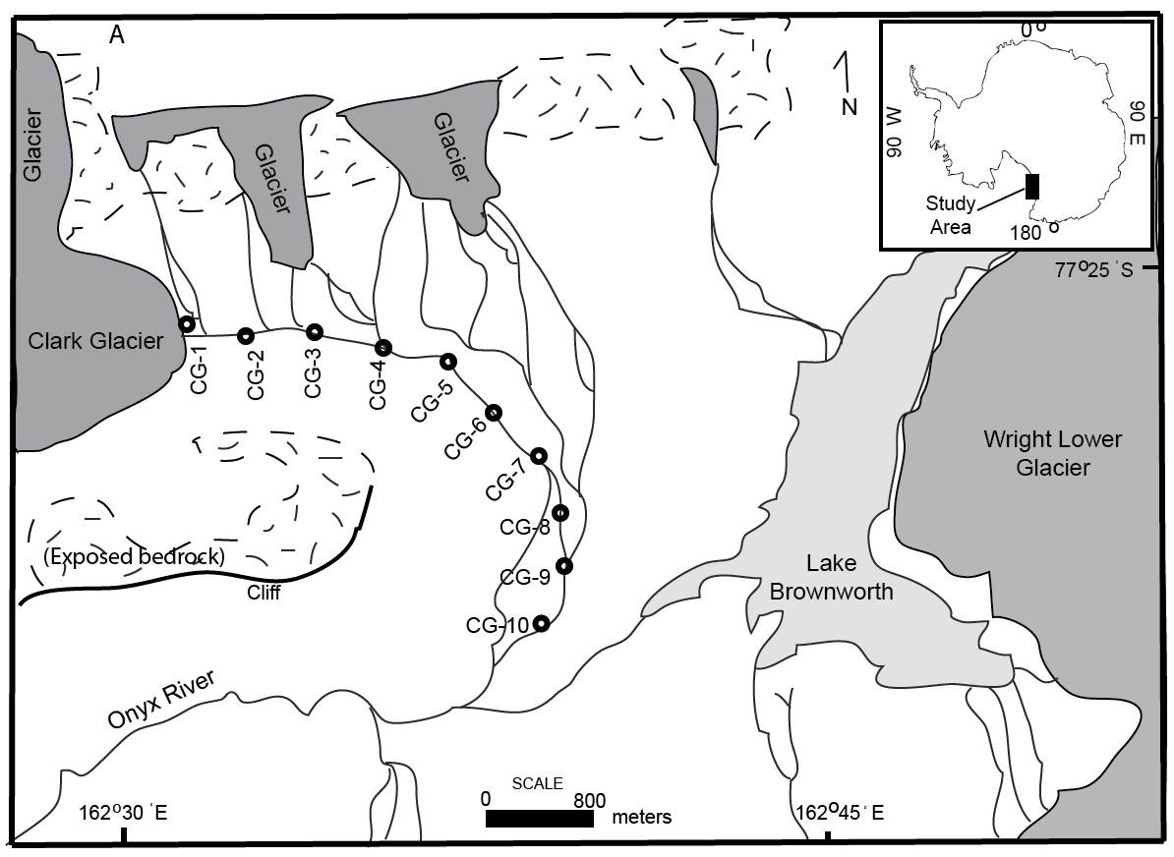

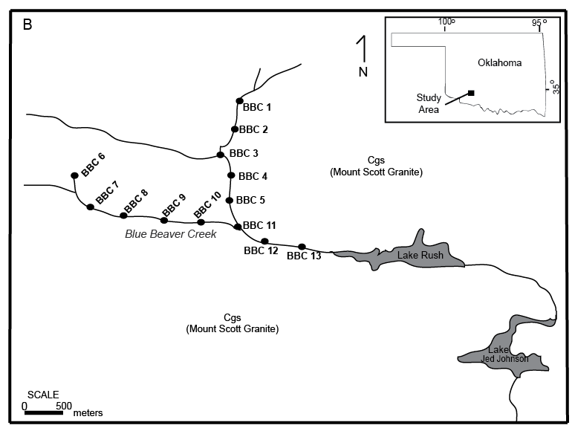

Figure 2.2: Images of sample site characteristics. (A) Terminus of Clark Glacier, Wright Valley, Antarctica. Sample CG-1 was collected within a tributary channel of the glacial meltwater stream. Note dust accumulations on the surface of Clark Glacier. (B) Image of sample site from Clark Glacier stream transect. (C) Blue Beaver Creek flowing over exposed bedrock. Photo taken near sample BBC-12.

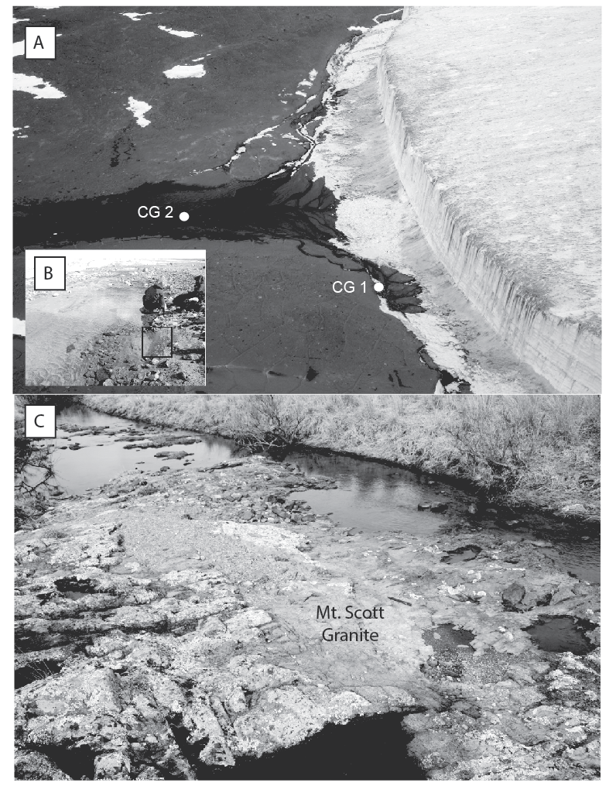

Figure 2.3: Particle size distributions. (A) Distribution of the % gravel along transect. (B) Distribution of the % sand along transect. (C) Distribution of the % silt and clay along transect.

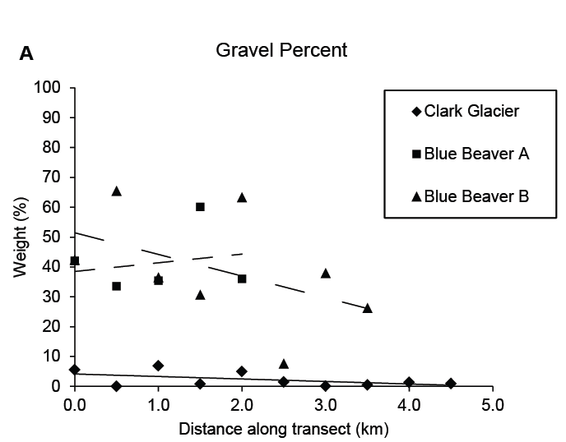

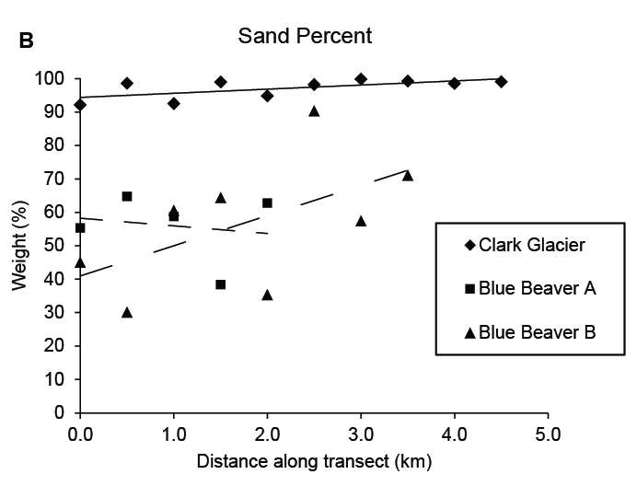

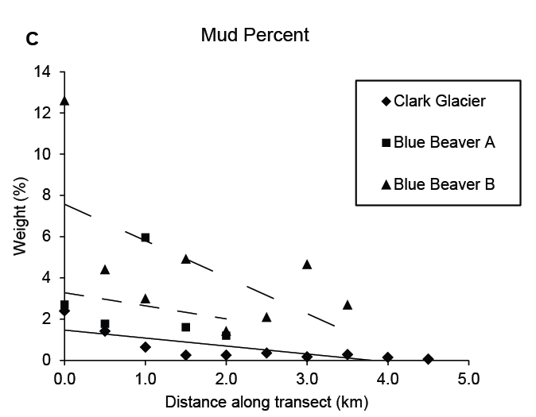

Figure 2.4: Laser particle size (LPSA) histograms. Particle sizes are in µm. (A) Only 3 samples from Blue Beaver Creek Transect A are shown. (B) Only 3 samples from Blue Beaver Creek Transect B are shown.

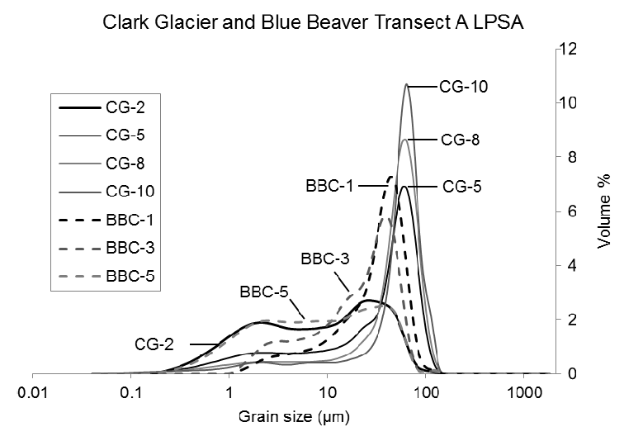

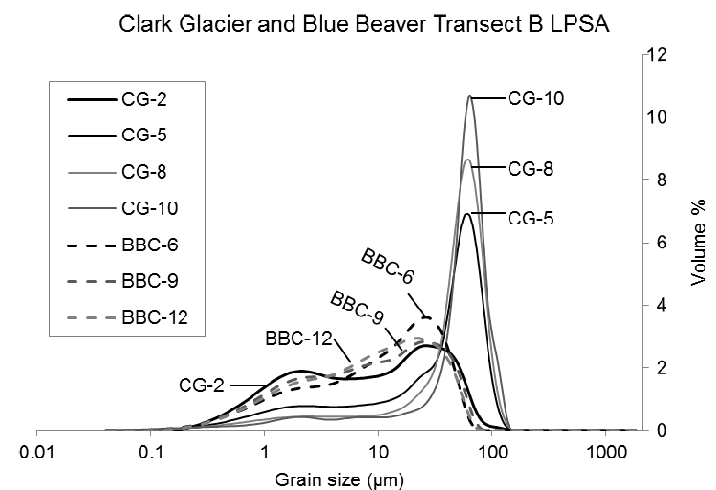

Figure 2.5: Volume percentage of clay and silt along transect.

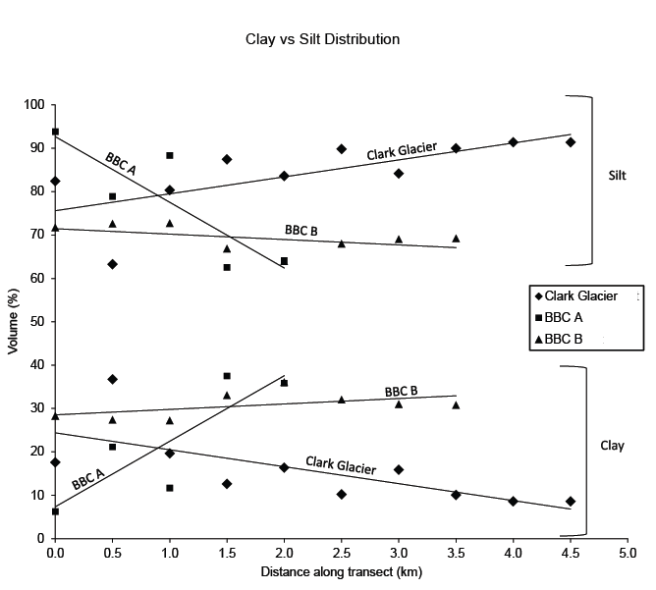

Figure 2.6: Boxplot of volume percentage of clay content.

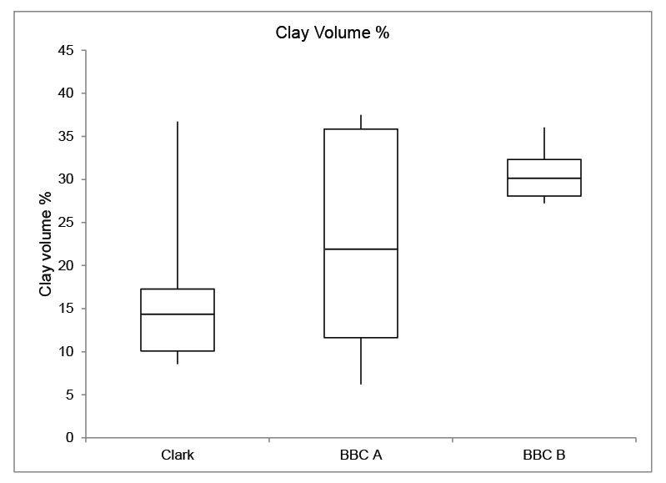

Figure 2.7: Nitrogen adsorption BET data along transect. Values are reported in m²/g.

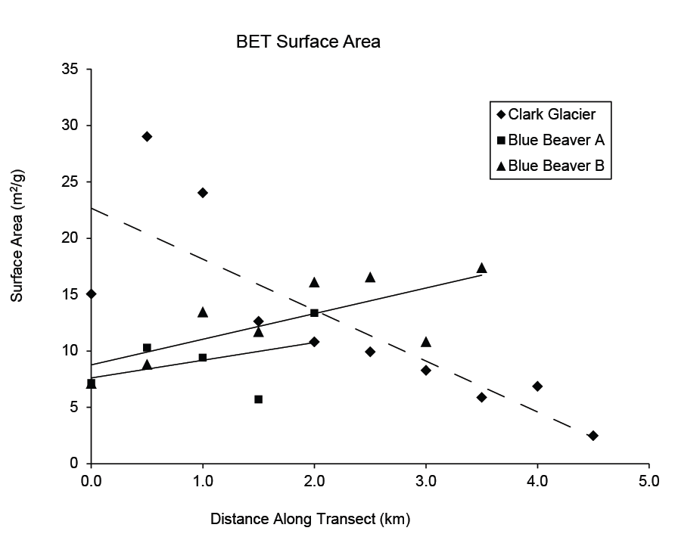

Figure 2.8: Boxplot of nitrogen adsorption BET values. Values are reported in m²/g.

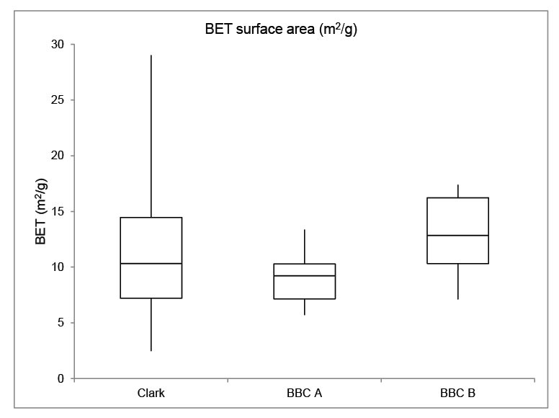

Figure 2.9: Stream water pH measurements along transect.

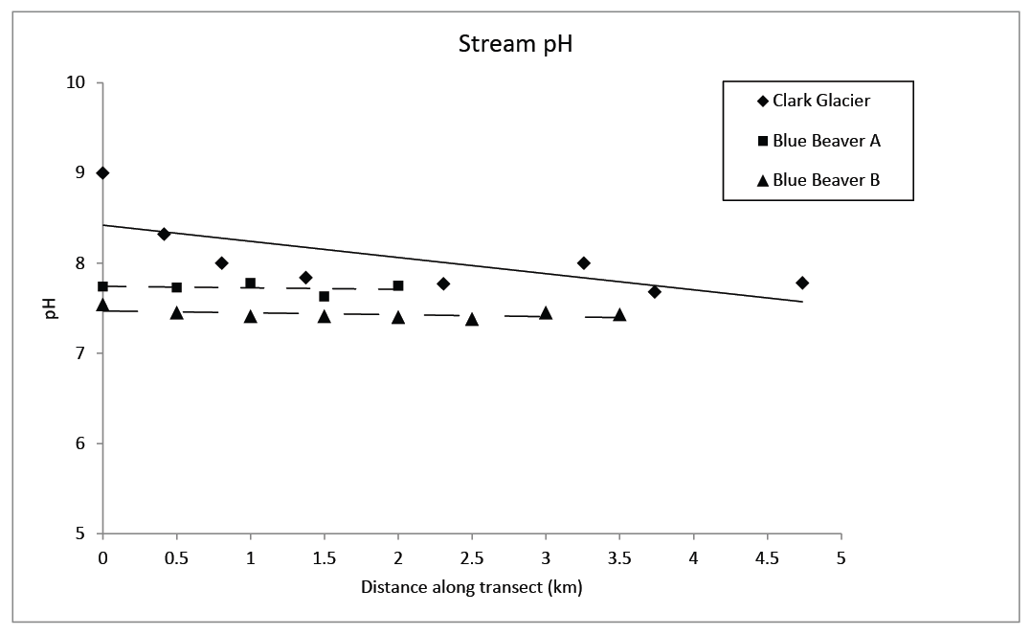

References

Anbeek, C., 1992. Surface roughness for minerals and implications for dissolution studies. Geochimica et Cosmochimica Acta 56, 1461-1469.

Anderson, S.P., Drever, J.I., Humphrey, N.F., 1997. Chemical weathering in glacial environments. Geology 25 (5), 399-402.

Anderson, S.P., 2005. Glaciers show direct linkage between rate and chemical weathering fluxes. Geomorphology 67 (1-2), 147-157.

Anderson, S.P., 2007. Biogeochemistry of glacial landscape systems. Annual Review of Earth and Planetary Sciences 35, 375-399.

Atkins, C.B., Dickinson, W.W., 2007. Landscape modification by meltwater channels at margins of cold-based glaciers, Dry Valleys, Antarctica. Boreas 36, p.47-55.

Bluestein, H.B., Parks, C.R. A synoptic and photographic climatology of low-precipitation severe thunderstorms in the Southern Plains. Monthly Weather Review 111, 2034-2046.

Brunauer, S., Emmett, P.H., Teller, E., 1938. Adsorption of gases in multimolecular layers: Journal of the American Chemical Society 60, 309-319.

Campbell, I.B., Claridge, G.G.C., 1987. Antarctica: Soils, Weathering Processes, and Environment. Elsevier, Amsterdam.

Clow, G.D., McKay, C.P, Simmons, G.M., Wharton Jr, R.A., 1988. Climatological observations and predicted sublimation rates at Lake Hoare, Antarctica. Journal of Climate 1, 715-728.

Deuerling, K.M., 2010. Aeolian Sediments of the McMurdo Dry Valleys, Antarctica. M.S. Thesis, Ohio State University.

Doran, P.T., McKay, C.P., Fountain, A.G., Nylen, T., McKnight, D.M., Jaros, C., Barrett, J.E., 2008. Hydrologic response to extreme warm and cold summers in the McMurdo Dry Valleys, East Antarctica. Antarctic Science, 1-11. doi: 10.1017/S0954102008001272.

Fortner, S.K., Lyons, W.B., Olesik, J.W., 2011. Eolian deposition of trace elements onto Taylor Valley Antarctic glaciers. Applied Geochemistry 26, 1897-1904.

Fountain, A.G, et. al, 2010. Snow in the McMurdo Dry Valleys, Antarctica. International Journal of Climatology 30, 633-642.

Gilbert, M.C., 1982. Geologic setting of the eastern Wichita Mountains with a brief discussion of unresolved problems, in Gilbert, M.C., and Donovan, R.N., eds., Geology of the eastern Wichita Mountains, southwestern Oklahoma. Oklahoma Geological Survey Guidebook 21, 1-30.

Gooseff, M.N., McKnight, D.M., Lyons, W.B., Blum, A.E., 2002. Weathering reactions and hyporheic exchange controls on stream water chemistry in a glacial meltwater stream in the McMurdo Dry Valleys. Water Resources Research 38, 1279.

Gooseff, M.N., McKnight, D.M., Doran, P., Fountain, A.G., Lyons, W.B., 2011. Hydrologic connectivity of the landscape of the McMurdo Dry Valleys, Antarctica. Geography Compass 5/9, 666-681.

Hall, B.L., Denton, G.H., 2005. Surficial geology and geomorphology of eastern and central Wright Valley, Antarctica. Geomorphology 64 (1-2), 25-65.

Hallet, B., Hunter, L., Bogen, J.,1996. Rates of erosion and sedimentation evacuation by glaciers: A review of field data and their implications. Global and Planetary Change 12, 213-235.

Havens, J.S., 1983. Reconnaissance of ground water in vicinity of Wichita Mountains, Southwestern Oklahoma. Oklahoma Geological Survey Circular 85, 18 p.

Holdren, G.R., Berner, R.A., 1979. Mechanism of feldspar weathering I: Experimental studies. Geochimica et Cosmochimica Acta 43 (8), 1161-1172.

Lancaster, N., 2002, Flux of eolian sediment in the McMurdo Dry Valleys, Antarctica: a preliminary assessment. Arctic, Antarctic, and Alpine Research 34 (3), 318-323

Levy, J.S., Fountain, A.G., Gooseff, M.N, Welch, K.A., Lyons, W.B., 2011. Water tracks and permafrost in Taylor Valley, Antarctica: Extensive and shallow groundwater connectivity in a cold desert ecosystem. GSA Bulletin 23 (11/12), 2295-2311.

Lowell, S., Shields, J.E., 1991. Powder Surface Area and Porosity. Chapman and Hall, New York.

Lyons, W.B., et al., 1997. Chemical weathering rates and reactions in the Lake Fryxell Basin, Taylor Valley: comparison to temperate river basins. In: Lyons, W.B., Howard-Williams, C., and Hawes, I. (eds) Ecosystem processes in Antarctic ice-free landscapes. Leiden, The Netherlands. Balkema Press, 147-154.

Lyons, W.B., Welch, K.A., Fountain, A.G., Dana, G.L., Vaughn, B.H., McKnight, D.M., 2003. Surface glaciochemistry of Taylor Valley, southern Victoria Land, Antarctica and its relationship to stream chemistry. Hydrological Processes 17, 115-130.

Mast, M.A., Turk, J.T., 1999. Environmental characteristics and water quality of Hydrologic Benchmark Network stations in the West-Central United States, 1963-95. U.S. Geological Survey Circular 1173-B, 130 p.

Maurice, P.A., McKnight, D.M., Leff, L., Fulghum, J.E., Gooseff, M., 2002. Direct observations of aluminosilicate weathering in the hyporheic zone of an Antarctic Dry Valley stream. Geochimica et Cosmochimica Acta 66, 1335-1347.

Monaghan, A.J., Bromwich, D.H., Powers, J.G., Manning, K.W., 2005. The climate of the McMurdo, Antarctica, region as represented by one year of forecasts from the Antarctic Mesoscale Prediction System. Journal of Climate 18, 1174-1189.

Nezat, C.A., Lyons, W.B., Welch, K.A., 2001. Chemical weathering in streams of a polar desert (Taylor Valley, Antarctica). Geology 113 (11), 1401-1408.

Nylen, T.H., Fountain, A.G., and Doran, P.T., 2004. Climatology of katabatic winds in the McMurdo Dry Valleys, Southern Victoria Land, Antarctica. Journal of Geophysical Research – Atmospheres 109 (D3), D03114.

Opfergelt, S., Burton, K.W., Pogge von Strandmann, P.A.E., Gislason, S.R., and Halliday, A.N., 2013. Riverine silicon isotope variations in glaciated basaltic terrains: Implications for the Si delivery to the ocean over glacial-interglacial intervals. Earth and Planetary Science Letters (369-370), 211-219.

Peterson, D.M., Marsh, B.D., 2008. Bedrock Geologic Map of the McMurdo Dry Valleys, Southern Victoria Land, Antarctica, University of Minnesota Duluth Natural Resources Research Institute.

Rawlins, B.G., Turner, G., Mounteney, I., Wildman,G., 2010. Estimating specific surface area of fine stream bed sediments from geochemistry. Applied Geochemistry 25 (9), 1291-1300.

Riebe, C.S., Kirchner, J.W., Finkel, R.C., 2004. Linkages between physical erosion and chemical weathering, measured by cosmogenic nuclides and geochemical mass balance. Eos, Transactions, American Geophysical Union 85 (47), H41H-01.

Sabacka, M., Priscu, J.C., Basagic, H.J., Fountain, A.G., Wall, D.H., Virginia, R.A., Greenwood, M.C., 2012. Aeolian flux of biotic and abiotic material in Taylor Valley, Antarctica. Geomorphology (155-156), 102-111.

Sparks, D.L., 2003. Environmental Soil Chemistry. Elsevier Science, San Diego, California.

Stanley, T.M., Miller, G.W., 2005. Geologic map of the Lawton 30' X 60' quadrangle, Caddo, Comanche, Cotton, Grady, Kiowa, Stephens, and Tillman Counties, Oklahoma.

Stumpf, A.R., Elwood Madden, M.E., Soreghan, G.S., Hall, B.L., Keiser, L.J., and Marra, K.R., 2012. Glacier meltwater stream chemistry in Wright and Taylor Valleys, Antarctica: Significant roles of drift, dust and biological processes in chemical weathering in a polar climate. Chemical Geology (322-323), 79-90.

Wagner, B., Melles, M., Doran, P.T., Kenig, F., Forman, S.L., Pierau, R., Allen P., 2006. Glacial and postglacial sedimentation in the Fryxell basin, Taylor Valley, southern Victoria Land, Antarctica. Palaeogeography, Palaeoclimatology, Palaeocology (241), 320-337.

West, J., Galy, A., Bickle, M.J., 2004. Tectonic and climate controls on silicate weathering. Eos, Transactions, American Geophysical Union 85 (47), H41H-07.

White, A.F., Blum, A.E., 1995. Effects of climate on chemical weathering in watersheds. Geochimica et Cosmochimica Acta 59 (9), 1729-1747.

White, A.F., Brantley, S.L., 2003. The effect of time on the weathering of silicate minerals: why do weathering rates differ in the laboratory and field? Chemical Geology 202 (3-4), 479-506.

Van de Kamp, P.C., 2010. Arkose, subarkose, quartz sand, and associated muds derived from felsic plutonic rocks in glacial to tropical humid climates. Journal of Sedimentary Research, 80 (10), 895-918.

Chapter 3: BET surface area distributions in polar stream sediments: Implications for silicate weathering in a cold-arid environment

Introduction

Quantifying specific surface area of sediments is essential in determining potential mineral dissolution and/or precipitation rates and, ultimately, silicate weathering fluxes in various geomorphic and climatic regimes (Gautier et al., 2001; Anderson, 2007). However, limited data on the distribution of mineral surface areas in natural stream sediments, especially in cold-humid or cold-arid glacial climates, is provided in the literature (Welch and Ullman, 1992; Brantley and Mellott, 2000; Gooseff et al., 2002; Anderson, 2005; Rawlins et al., 2010; Marra et al., 2014). The production of fresh mineral surfaces via physical weathering processes can greatly enhance silicate dissolution rates by increasing the availability of surfaces subject to ligand and ion interactions, which ultimately influences the drawdown of atmospheric carbon dioxide and biogeochemical cycles (Anderson et al., 1997; Anderson, 2007). Surface area is especially high in fine-grained sediments and is influenced by the concentration of specific mineral phases, such as Fe and Mn oxides, and clay minerals. Such phases may be rich in trace elements due to adsorption and higher concentrations of accessory minerals (Horowitz and Elrick, 1987; Rawlins et al., 2010).
Temperate (cold-humid) glacial systems are effective in producing high sediment yields by grinding and abrasion during ice advance and retreat (Hallet et al., 1996; Anderson et al., 1997; Owen, 2003; Anderson, 2007). The abrasive action of glacial movement primes sediment for chemical weathering because of the production of fine-grained material with large reactive surface area, which facilitates etch-pit development on grains and increases surface roughness during weathering processes (Anbeek, 1992; Anbeek, 1993; Anderson, 2005; Anderson, 2007). In contrast, cold-based (polar) glaciers, including Antarctic alpine glaciers in the McMurdo Dry Valleys, remain at temperatures below the melting point throughout their mass and are thus frozen to the underlying rock substrate (Chinn, 1994; Atkins, 2014). Such glacial systems are typically considered ineffective at basal erosion and sediment production, although some active basal sliding has been documented (Chinn, 1994; Hodson and Ferguson, 1999; Cuffey et al., 2000; Waller, 2001; Atkins et al., 2002; Atkins and Dickinson, 2007; Atkins, 2014). Thus, based on this potential difference in basal grinding, polar glaciers are expected to have little influence on the production of fresh, fine-grained material available for silicate weathering. However, solute chemistry trends of meltwater streams emanating from Antarctic alpine glaciers reveal significant chemical weathering in polar climates, suggesting reactive, high-surface area sediments are present to produce high weathering fluxes (Anderson et al., 1997; Nezat et al., 2001; Gooseff et al., 2002; Maurice et al., 2002; Lyons et al., 2003; McKnight et al., 2007; Stumpf et al., 2012; Fortner et al., 2013, Deuerling et al., 2014).
In order to evaluate the controls on the origin and distribution of potentially reactive sediment in polar glacial systems, we present quantitative data on surface area in fine-grained (< 62.5 µm; silt and clay) fractions collected from glacial stream transects utilizing the Brunauer, Emmett, Teller (BET) method (Brunauer et al., 1938). We also present provisional comparative data from temperate proglacial systems. As weathering is an archive of climate change, establishing quantitative constraints on the amount of material available for chemical weathering provides insight into the nature of weathering processes in glacial and non-glacial environments and their influence on the global carbon cycle.
Study Area
The McMurdo Dry Valleys (MDV) of Antarctica constitute a polar desert situated between the Transantarctic Mountains to the west and McMurdo Sound to the east (Fountain et. al, 1999). Mean annual temperatures range from -14.8 ºC to -30.0 ºC and mean annual precipitation is typically below 10 mm/yr (Doran et al., 2008). The high-elevation ranges of the Transantarctic Mountains inhibit air flow and moisture from the East Antarctic Ice Sheet into the valleys and ablation typically exceeds precipitation during the winter and summer months (Bromley, 1985; Fountain et al., 1999; Doran et al., 2008). Wind speeds average around 4.1 m/s, with maximum wind speeds, typically the result of foehn events, in excess of 40 m/s (Doran et al., 2008; Steinhoff et al., 2014).
The main east-west trending valleys (Wright, Taylor, and Victoria) are not covered at present by Antarctica’s primary ice sheets; instead, polar alpine valley glaciers extend from surrounding ranges into ice-free valleys that contain exposed crystalline basement rock and assorted, coarse- to medium-grained unconsolidated drift sediments. These exposed drifts record previous glacial advances of large ice sheets into the valleys, including expansion from East Antarctic Ice Sheet outlet glaciers such as Taylor Glacier in Taylor Valley, and the Ross Sea ice expansion from the east (Hall and Denton, 2005). As precipitation is limited, the main hydrologic components consist of ephemeral streams originating from valley glacier and snowpack melt during the austral summer. These streams flow at highly variable seasonal and annual rates for approximately 4-12 weeks into perennially ice-covered lakes or other stream systems (Conovitz et al., 1998; McKnight et al., 2007). In addition, snow melt and seasonally active layer thaw creates an interconnected system of water tracks at shallow depths beneath the soil surface, which enhances solute contributions to reactivated stream channels (Conovitz et al., 1998; Fountain et al., 1999; McKnight et al., 2007; Levy et al., 2011). Stream recharge is primarily via surficial glacial and limited shallow subsurface melt as connected groundwater systems do not exist due to the presence of continuous permafrost underlying valley drift (Runkel et al., 1998; Nezat et al., 2001; Gooseff et al., 2013). The magnitude of glacier melting is strongly controlled by the elevation of glacier ice, the incident solar radiation based on the Sun’s position, as well as heightened temperature gradients related to strong summer down-valley winds (Doran et al., 2008; Steinhoff et al., 2014). Variable wind patterns occur throughout the year and serve to entrain and redistribute sediment and organic particulate matter throughout the valleys, some of which becomes trapped upon glacier surfaces, liberated during summer melting, and subsequently reincorporated into meltwater channels (Sabacka et al., 2012; Fortner et al., 2013; Marra et al., 2014). The MDV are essentially devoid of higher-order vegetation, although solute fluxes and nutrient exchanges within the hyporheic zone of meltwater streams support algae and moss growth, which is particularly abundant in Taylor Valley streams (Alger et al., 1997; Fountain et al., 1999; Nezat et al., 2001; McKnight et al., 2007).
This study specifically focuses on ephemeral Antarctic stream transects originating from Clark and Denton Glaciers in Wright Valley and Goldman and Howard Glaciers in Taylor Valley, which minimally incise valley drift (Fig. 1). Quaternary drift sediments in Wright Valley are underlain by the Brownworth (coarse-grained granite and quartz monzonite) and Denton (foliated granodiorite) plutons, as well as biotite orthogneiss, and reflect cold-based glacial advance and retreat from the Wilson Piedmont Glacier and Ross Sea Embayment (Hall and Denton, 2005). In Taylor Valley, the basement rock primarily consists of biotite orthogneiss overlain by undifferentiated and Ross Sea drift deposits. Ross Sea drift is the product of grounded Ross Sea ice expansion during the Last Glacial Maximum, which was partially wet-based in nature (Hall et al., 2001; Fig. 1).
Methods
Sediment samples were collected in January 2010 from the surface within near-channel slackwater deposits at 400-500 m intervals along meltwater stream transects in Wright and Taylor Valleys. The streams all drain alpine glaciers (Clark Glacier and Denton Glacier in Wright Valley and Goldman Glacier and Howard Glacier in Taylor Valley). In addition, various drift sediments (9) were collected near the sampled channel transects outside the main hyporheic zone and analyzed in conjunction with archive drift samples (collected by B.Hall during previous field excursions) from both Wright and Taylor Valleys. The selected samples were chosen to represent each type of drift deposit through which the sampled stream flows or adjacent drifts for comparison (Fig.1). Sediment samples were also collected from Delta Stream during the January 2013 melt season to supplement original data (Fig. 1). Only Clark Glacier stream and Delta Stream (sourced from Howard Glacier) contained flowing water within their channels during sampling. Four samples collected in proximal fluvial slackwater deposits of three temperate (wet-based) alpine glaciers (Franz Josef Glacier, New Zealand; Athabasca Glacier, Canada; Damma Glacier, Switzerland [2 samples]) were also analyzed for comparison.
All sediment samples were split to obtain a representative 300-500 g sample subset and sieved for the gravel, sand, and mud (<62.5 μm) fractions. The mud fraction was chemically processed with buffered acetic acid for 24 hours to remove carbonate coatings. Following rinsing with distilled water, samples were treated with 30% hydrogen peroxide for 30 minutes on a hot plate (set to ~50 °C) to remove organics. The treated mud fractions were then freeze-dried prior to grain size and surface area analyses. Silt and clay grain-size distributions were obtained with a Beckman Coulter Laser Particle Size Analyzer (LPSA) in distilled water, following initial treatment with sodium hexametaphosphate to inhibit particle flocculation. In addition to the mud fraction, 20 sand fractions from four samples (split as very coarse, coarse, medium, fine, and very fine fractions) were also processed with acetic acid and hydrogen peroxide in an identical manner for BET surface analysis only.
Sediment surface areas of the sand and mud fractions were obtained via the nitrogen adsorption BET method utilizing either a Beckman Coulter SA3100 or a Quantachrome NOVA 2000e gas sorption analyzer. BET theory calculates external surface area (expressed as m²/g) based on multilayer adsorption of N₂ gas onto mineral surfaces and provides an enhanced measure of natural particle surface area in contrast to geometric equations based on measured grain diameter and modeled shape and roughness. Inaccuracies in the latter (geometric estimate) stem from the presence of etch-pits and surface roughness produced during weathering processes that may not be accurately accounted for (Brunauer et al., 1938; Anbeek, 1993; Brantley and Mellott, 2000; Anderson, 2005). All samples were outgassed for 6-12 hours and heated to a maximum temperature of 50 °C to remove surface moisture. Select samples were run multiple times on the gas sorption analyzer to gauge instrument precision (Appendix A).
Results
BET surface area measurements for the four stream transects analyzed in Wright and Taylor Valley, Antarctica are plotted in Fig. 2 and listed in Table 1. The highest overall surface area occurs in Taylor Valley, with values ranging from 20.3 to 70.6 m²/g in Delta Stream (Howard Glacier) during the 2010 sampling season and ranging from 11.1 to 40.9 m²/g in the Goldman Glacier stream channel. The range of surface area values (13.6 to 30.5 m²/g) decreased during the 2013 partial re-sampling of Delta Stream. Two drift samples in Taylor Valley (one near Delta Stream and one near the Goldman Glacier transect) range in value from 22.1 to 29.3 m²/g (Table 2). In Wright Valley, Clark Glacier stream exhibits values ranging from 2.5 to 29.0 m²/g, and Denton Glacier stream channel contains values ranging between 6.3 to 18.9 m²/g. Seven samples from various Wright Valley drift deposits underlying the Clark and Denton stream channels (collected beyond the channel hyporheic zones) exhibit a wide range in values, from 9.7 to 23.8 m²/g. Without exception, BET values from drift samples are less than the maximum values obtained from stream channel sediments, and no spatial trend occurs in relation to distance from the channel transect (Fig. 1; Table 2). In contrast, four samples from various temperate glaciers have much lower BET surface areas, ranging from 0.3 to 0.6 m²/g at Franz Josef (New Zealand) and Damma (Switzerland) glaciers, respectively, to 12.1 m²/g at the Athabasca Glacier (western Canada; Table 2). Antarctic BET values exceed by nearly 6-200 times those measurements from temperate glacier samples (Fig. 2).
The general distributions of BET surface area along proximal-to-distal transects exhibit erratic patterns in the Taylor Valley stream channels. Regression analysis indicates low r² values (0.03-0.05) and therefore, no apparent trend with distance. Clark Glacier stream in Wright Valley exhibits the most robust trend in surface area, wherein surface area decreases systematically with distance from the glacier terminus. Removing the first sample point from Clark Glacier stream analysis, which was taken at the base of Clark Glacier and outside the main flowing channel, increases the r² value to 0.8 (Fig.1; Table 1). Samples from Denton Glacier (Wright Valley) transect also exhibits a general decrease in surface area along transect, although the nature of the pattern is slightly erratic, producing an r² = 0.2. A one-way analysis of variance test (ANOVA) indicates there is a statistically significant difference in the BET values obtained in Wright Valley versus Taylor Valley (i.e., p = <0.001 when comparing the samples collected in 2010 from Clark and Delta streams; α=0.05). However, there is no statistically significant difference in BET values obtained from the 2010 samples when comparing transects within the same valley or comparing drift sediments to channel sediments within the same valley. The distribution in values among sample transects are shown in the boxplot in Fig. 3.
The BET values reported herein were all conducted on the mud fraction (<62.5 µm) to facilitate comparison among sample sites. However, the mud fraction commonly composes a small fraction of the entire sample (as little as 0.05%). Therefore, two composite proximal and distal samples were analyzed from both Clark Glacier stream and Delta Stream for BET distributions among 5 sand fractions (very coarse, coarse, medium, fine, and very fine) in addition to the mud (silt and clay) fraction (Fig. 4). Gravel content was negligible in the selected samples (<0.5%) and therefore not included. Average BET values normalized to size-fraction percentages for the composite collected sediment sample ranged from 0.57 to 3.22 m²/g. These values are similar to the 1.23 m²/g bulk sediment value (using a < 3.2 cm cutoff) calculated by Gooseff et al. (2002) for a sample collected near Huey Creek in Taylor Valley. However, the largest surface area contribution for these samples (67-81% of the total BET surface area) is attributed to the silt and clay fraction. Therefore, variations in surface area of the mud-sized fractions are expected to have a significant impact on the total surface area available for weathering in the field. The temperate glacier samples utilized for this study were all fine-grained and lacked appropriate sand-sized material to conduct a similar comparison.
MDV soils contain significant salts and carbonates (Claridge and Campbell, 1977; Keys and Williams, 1981; Campbell and Claridge, 1987; Doran et al., 1994; Bockheim, 2002; Witherow et al., 2006), which may influence the available surface area of silicate minerals in the field. Our sample processing methodology included acetic acid and hydrogen peroxide treatments to remove any surficial carbonate coatings, salts, and/or organics that may be present to directly assess silicate weathering processes in polar climates. In order to evaluate the impact of sample processing on collected drift material, we conducted BET surface area measurements on unprocessed sand and silt and clay material (4 fine-grained sand, 4 very fine-grained sand, and 2 silt and clay samples) from the proximal and distal samples analyzed from Clark Glacier and Delta streams (Appendix B). Measurements on the sand fractions were slightly variable, with a difference in measurement value ranging from 0.6 to 1.7 m²/g for the very fine sand fraction and 0.1 to 0.6 m²/g for the fine-sand fraction. The difference in BET surface area obtained for replicate sand analyses (Appendix A) ranged from 0.2-2.4 m²/g, indicating the difference in measurements obtained for the processed and unprocessed sand fractions are within instrument measurement variability and not wholly attributed to the impact of surficial grain coatings. In comparison, replicate measurements on the unprocessed silt and clay fraction resulted in surface areas that were slightly less than the treated sample for Clark Stream (10-CG-2) and approximately one-half the surface area of the treated Delta Stream sample (10-HOW-4) (Appendix B). This suggests that carbonates may be cementing some fine-grained material, leading to lower available surface area. Stumpf et al. (2012) demonstrated that carbonates are readily dissolving in the streams (particularly in Delta Stream), thus releasing this higher surface area material to the weathering environment. The Delta Stream sample is near Lake Fryxell, where previous lake fluctuations may have contributed to a higher amount of carbonate in the drift at this location. Therefore, in order to make comparisons across sites and climates, this study aims to compare the available silicate surface area, thus requiring carbonate and organic removal protocols for all sediment samples.
Discussion
BET surface area distributions of the fine-grained (silt and clay) fraction in Antarctic stream and drift sediments are variable in magnitude, range to remarkably high values, and in Taylor Valley exhibit erratic patterns with stream transport distance that indicate complex spatial variability within this cold-arid climate regime. Although minimal basal erosion and grinding has been documented in Antarctic alpine glaciers, the polar nature of the alpine glaciers in the MDV implies that fresh, fine-grained sediment is not common and readily available (Atkins and Dickinson, 2007; Anderson, 2007). Therefore, the fine fraction observed in Wright and Taylor Valleys likely originates from different sources and processes, including: 1) eolian sediment derived from surrounding drift, which becomes trapped on the surface of the valley glaciers and then released during summer melting, eolian accumulations in the stream channel, and/or eolian accumulations in adjacent snow drifts (Lancaster, 2002; Lyons et al., 2003; Fortner et al., 2011; Sabacka et al., 2012; Fortner et al., 2013; Deuerling et al., 2014), 2) high variability in stream discharge rates, which influences hyporheic zone weathering rates and remobilization of channel sediments (McKnight et al., 2007), and 3) fine sediments sourced from underlying drift deposits that were deposited by partially wet-based glaciers (Hall et al., 2000, 2005). These contributions are discussed below.
Dry Valley Drift
The underlying drift material contributes fine sediments to the stream channel and is the primary source of entrained and redistributed eolian dust in the MDV (Deuerling, 2010; Deuerling et al., 2014). In Wright Valley, Clark Glacier stream flows over Brownworth drift (underlain by Trilogy and Loke drifts) which contain approximately 2% mud, whereas the Denton Glacier transect flows primarily over undifferentiated colluvium and Trilogy drift, containing up to 5% mud. In contrast, Delta Stream in Taylor Valley flows over Ross Sea drift which has up to a 25% mud fraction, as determined by wet sieving. The low mud contents in Wright Valley likely result from drift deposition by cold-based ice advance, as evidenced by a relative lack of silt, rare striated clasts, and no wet-based landforms (Hall et al., 2005). In contrast, the higher mud content in Taylor Valley drifts may reflect the advance of partially wet-based ice from the Ross Sea which contained glacially ground material from East Antarctic tributaries and was subsequently deposited into Taylor Valley (Hall et. al, 2000; Hall and Denton, 2005). Derivation from wet-based ice would produce glacially ground fines with high surface area (Anderson, 2005).
In addition, physical weathering processes occurring under conditions of the MDV landscape, including frost shattering, wind abrasion, chipping of desert varnish, and weathering of proximal sandstones, likely produce fine-grained sediment (Gibson et al., 1983; Campbell and Claridge, 1987; Matsuoka, 1998). Development of large polygons (patterned ground) within valley drift due to thermal contraction sorts sediment within polygons and polygon troughs. This process may preferentially accumulate eolian material which is subsequently incorporated into stream flow (Pewe, 1959; Berg and Black, 1966; Sletten et al., 2003; Levy et al., 2008; Schiller et al., 2014). The small percentage of fine sediments underlying the courses of the stream channels, however, would be quickly washed downstream during initial melting events. Sediment may be added to the stream system due to channel erosion during high-flow events, or the development of thermokarst features (Healy, 1975; Gooseff et al., 2013; Levy et al., 2014); however, we observed minimal downcutting within our sampled stream transects (due to sampling during low-flow years), suggesting little exposure of fresh drift material. Also, no sampled transects traverse multiple distinct drift deposits (e.g., Clark Glacier stream crosses Brownworth drift and Delta Stream crosses Ross Sea drift), indicating that BET variations within each stream transect is unlikely solely related to variations in the underlying drift. This indicates that additional sources of fine material are necessary to explain the distribution of fine-grained, high surface-area sediments within the stream channels.
Eolian Processes
Wind patterns vary between valleys due to geomorphic constraints and circulation patterns from the polar plateau and adjacent Ross Sea, which ultimately influence sediment fluxes (Fountain et al., 1999; Doran et al., 2008). Foehn winds dominate during the winter months, reaching speeds in excess of 37 m/s and are countered by easterly coastal breezes from the Ross Sea during the summer months, which bring additional moisture and aerosols into the region (Doran et al., 2002; Bertler et al., 2004; Witherow et al., 2006; Deuerling et al., 2014; Steinhoff et al., 2014). Glaciers in the MDV contain large concentrations of particulate (dust and organic) matter, with the highest concentrations occurring at lowest elevations (Lyons et al., 2003). Studies of eolian sediments in the MDV indicate that dust, defined as silt and smaller (< 62.5 µm) sediment particles (Lancaster, 2002; Duerling, 2010), is sourced from locally exposed bedrock and glacial drifts and soils (Mayewski et al., 1995; Fountain et al., 1999; Lancaster, 2002; Lyons et al., 2003; Fortner et al., 2011). Distribution of this particulate matter is highly contingent upon valley wind patterns and stream discharge rates (Nylen et al., 2004; Doran et al., 2008; Fortner et al., 2013).
According to Lancaster (2002), net deposition of dust in a sediment trap at Lake Brownworth (Wright Valley) was <0.1% of the total sediment flux, whereas net deposition for sample stations at Lake Fryxell and Howard Glacier (Taylor Valley) were 89.5 and 59.6% dust respectively, indicating higher dust fluxes within Taylor Valley potentially attributable to the more fine-grained nature of the drift sediment. Fortner et al. (2013) noted that Andersen Creek, on the western side of Canada Glacier in Taylor Valley, received higher eolian contributions than eastern-flowing Canada Stream, indicating high eolian-flux variability into stream channels within limited spatial constraints, even when meltwater is sourced from the same glacier. In addition, snow patches derived from strong down-valley winds blowing snow off the polar plateau into the valleys may become concentrated in the topographic depressions created by the stream channel and serve as an additional source of trapped eolian material (Gooseff et al., 2003). This suggests that spatial variation in the deposition of eolian material is critical to influencing the concentration of fine-grained material in glacial-derived stream channels, whether flowing or not, and in the weathering environment of the hyporheic zone.
Stream Discharge and Hyporheic Zone Processes
Meltwater production is ultimately influenced by temperature and solar radiation variations on glacier surfaces during the austral summer (Nylen et al., 2004; Doran et al., 2008; Fortner et al., 2013; Hoffman et al., 2014). Discharge rates vary annually, as well as daily, during the melt season, which controls the amount of flow and the movement of solutes and particulates downstream (Conovitz et. al, 1998; Fountain et al., 1999; Lyons et al., 2003; McKnight et al., 2007). However, in terms of our sampled transects, stream flow gauge data are currently continuously available only for Delta Stream (Clark Glacier stream has flow records for 1982-1985 only; www.mcmlter.org). Sampling of Delta Stream during the 2009-2010 melt season occurred during relatively low-flow conditions, when average seasonal discharge rates were 3.7 liters/second (l/sec) (1.6 l/sec on January 18, 2010, Delta Stream sample day). By contrast, average discharge was 70.0 l/sec for the previous (2008-2009) melt season and 51.4 l/sec for the following year (2010-2011; McKnight, 2014). Flow was also low during the 2013 re-sampling of Delta Stream, with an average seasonal discharge rate of 6.51 l/sec (McKnight, 2014). Clark Glacier stream exhibited variable flow during 2010 sampling, whereas no flow was observed in either stream channel emanating from Goldman or Denton Glaciers and no published source indicates meltwater has recently existed in these channels.
We attribute the variable patterns in BET surface area distributions for the Taylor Valley streams to fluctuating quantities of dust being entrained on valley glaciers and subsequently released during summer melting, in conjunction with variable eolian dispersal into stream channels, particularly during the winter months when winds are highest and flow is absent (Fountain et al., 1999; Steinhoff et al., 2014). Surficial glacier melt and incipient flow during the melt season then concentrates fine sediments into the stream channel, where episodic movement and deposition of fine material then commences based on variations in flow. Melting of channel-adjacent snowbanks may also introduce fines into the channel system in a spatially episodic manner. This is analogous to observations made by McKnight et al. (2007), where variable increases in solute concentrations within the hyporheic (weathering) zone of Taylor Valley channels are most pronounced in the initial time period following channel reactivation, due to rapid dissolution of accumulated weathering products. This process is also similar to the fluvial transport of arsenic observed by Kim et al. (2012) in semi-arid climates, where events of strong and episodic precipitation serve to preferentially mobilize fine-grained sediments (enriched in arsenic) downstream in discrete pulses of ephemeral fluvial systems. In Antarctica, the entrainment of fine-grained eolian material ultimately reflects an annual “resetting” of the stream system, wherein particulates are reintroduced to glacier surfaces and exposed channel beds during windy winter months and concentrated along the channel length according to variations in stream flow during the brief melt season.
This episodic movement of solutes and particulates is highlighted by surface area differences between channel sediments and nearby drift material. For example, a drift sample taken adjacent to a Delta Stream sample (collected in 2010) had a surface area of 22.1 m²/g, which is less than half of the measured surface area of a sample collected within the channel (51.0 m²/ g). If eolian contributions across the landscape predominate, then we would assume similar values for samples so close in proximity. In addition, two samples (T10-GOLD-4 and T10-GOLD-5) were taken equidistant from Goldman Glacier, but within two different relict channels. Sample T10-GOLD-4 had a surface area of 38.3 m²/g, whereas T10-GOLD-5 had a surface area of 15.0 m²/g, indicating differing flow conditions to concentrate fine sediments within each tributary. It is important to reiterate the ephemeral nature of these stream systems, as no water flow was observed in Goldman channel segments during our sampling season, suggesting stream flow and associated processes vary on seasonal and decadal (or longer) time scales.
Samples from the Clark Glacier stream transect exhibit an overall coarsening pattern downstream within the fine fraction. As BET surface area is inversely related to grain size, surface area values systematically decrease downstream, suggesting dissolution of the fine fraction within the weathering environment. Samples from Denton Glacier transect also exhibit a general decrease in surface area downstream with an erratic overprint, likely attributable to a lower availability of fine-grained material in Wright Valley. The fine-grained material that becomes trapped on Denton and Clark Glacier surfaces serve as point sources for eolian material, which becomes episodically released to the channel during glacier melt. However, due to the lack of observable recent flow in the channel emanating from Denton Glacier, it is suggested that this material has been episodically concentrated and transported down the channel system, without substantial fine-grained eolian input to the exposed channel during the winter months. As both Clark Glacier stream and Delta Stream were flowing during sampling and typically contain annual flow, we would expect Delta Stream samples to exhibit a similar coarsening pattern downstream. The erratic distribution of silt and clay in Delta Stream likely reflects differing eolian contributions to glacier surfaces, and ultimately to the stream channel, in addition to pulses in stream flow.
The differences in magnitude between surface area distributions of these two transects may be a function of overall clay (< 3.9 µm size fraction) content within the mud fraction, where Clark Glacier stream mud samples have <20% clay and Delta Stream mud samples have 28-50% clay content (Fig. 5). However, clay content is similar among samples collected in 2010 and 2013 in Delta Stream, although surface-area magnitude is generally lower for all 2013 samples. This likely relates to the initial high-discharge rates noted at the beginning of the 2012-2013 melt season, resulting in rapid flushing (and/or dissolution) of the finest material within the hyporheic zone (Fig. 6; Maurice et al., 2002; McKnight et al., 2007; McKnight, 2014). As both Denton and Goldman Glacier stream transects were dry when sampled, their non-uniform distributions likely reflect variable movement of silt and clay during earlier flow events and/or random eolian particulate distributions.
Organic Acids
An additional consideration to the distribution of fine sediments, and ultimately surface area production, would be the role of organic acids in the weathering environment. Organic ligands are capable of chelating and mobilizing heavy metals which can attach to mineral surfaces and facilitate the dissolution or precipitation of inorganic minerals (Bennett, 1991). Batch reactor dissolution experiments indicate that the interaction of organic ligands with silicate surfaces may enhance the dissolution of quartz by increasing its solubility at near-neutral pH and low temperatures (Bennett, 1991). Gooseff et al. (2002) suggested that dissolved organic concentrations that may be capable of influencing weathering rates are low in Dry Valley streams. However, McKnight et al. (2007) indicated cyanobacterial mats in Taylor Valley streams have high rates of productivity and nitrogen fixation, even after extensive durations of no flow activity, where rapid growth may be influenced by heightened solute concentrations. Rapid nutrient uptake by algal mats has been further demonstrated to influence stream chemistry (McKnight et al., 2004; McKnight et al., 2007). We observed significant algal mat growth in Delta Stream, which was not apparent in the other sampling transects, suggesting a possible biologic influence on silicate weathering in this stream system, resulting in high-magnitude values obtained for the fine-grained sediment. However, we did not quantify organic matter concentrations during our sampling scheme and cannot establish a direct correlation based on our current dataset.
Comparison to Temperate Proglacial and Non-glacial Streams
To date, published BET analyses of fine-grained streambed sediment are limited to temperate climates, where surface area values do not exceed some of the higher-magnitude values documented in this study. For instance, Wang et al. (1997) analyzed the fine (<62.5 µm), surficial sediment from 11 major rivers in China and obtained surface area measurements ranging between 6.9 to 16.0 m²/g utilizing the N₂ BET method. Rawlins et al. (2010) analyzed fine-sediment (<150 µm) BET surface areas for multiple streambed sediments across central England and obtained values ranging from 5.98 to 46.04 m²/g. Surface area values in these systems are considered to reflect variations in grain size as well as the concentration of particular geochemical phases (Horowitz and Elrick, 1987). While the surface area data reported in these other studies can provide a quantitative comparison of sediment surface areas, they do not provide the spatial context to evaluate downstream patterns in sediment surface areas in temperate streams.
Recently, Marra et al. (2014) analyzed two stream transects of Blue Beaver Creek (Wichita Mountains, Oklahoma) which yielded BET surface area values ranging from 5.7 to 16.6 m²/g for the fine-grained (< 62.5µm) size sediment fraction (Table 1). Values from both transects exhibit an increase in surface area down transect, attributed to a downstream decrease in grain size related to precipitation of secondary weathering phases (i.e., clays). These data exhibit a direct opposite trend to the surface area (and grain size) pattern noted in Clark Glacier stream.
Glaciers in wet-based (temperate) systems are capable of producing large volumes of fine-grained sediment with high and reactive mineral surface area values due to glacier grinding and erosion, leading to subsequently higher chemical denudation rates (Anderson, 2005). In contrast, the nature of polar glaciers should inhibit significant erosion of underlying rock, suggesting sediment surface areas in polar regimes should be lower than those observed in temperate systems. However, of the three temperate sediment samples analyzed in this study, only one (Athabasca Glacier, Canada) exhibited a surface area value (12.2 m²/g) in the range of values obtained from multiple transects emanating from alpine glaciers in Antarctica, suggesting surface area is actually as high or higher in polar glacial systems. Samples from Franz Josef Glacier (New Zealand) and Damma Glacier (Switzerland) were anomalously low (0.3 and 0.6 m²/g, respectively). All samples were subject to the same treatment methods, suggesting additional processes are occurring in the weathering environment to produce different values. However, these data are based only on single samples from each temperate system. A more comprehensive collection strategy with a sampling protocol analogous to the Antarctic dataset is needed to more fully evaluate this surprising result.
Application to Weathering Rate Calculations
As sediment surface areas exert an important control on silicate weathering fluxes, we applied the surface area values obtained in this study to the constant weathering rate contribution (CRC) model of Gooseff et al. (2002) for sediment within the hyporheic zones of Clark Glacier stream and the Onyx River in Wright Valley and for Delta Stream (Howard Glacier) in Taylor Valley. The table presented herein (Table 3) is a recalculation of weathering rates for Si and K presented in Stumpf et al. (2012), with a minor correction for the application of the minimum and maximum cross sectional areas of the hyporheic zone within the CRC equation. All other variables (i.e., cross sectional area, flow rates, solid density, and porosity) were retained for direct comparison. The BET surface areas utilized herein represent a weighted average of all size fractions within the channel sediment, and are not solely based on the silt and clay (mud) portion.
As noted in Stumpf et al. (2012), the net rate of solutes from weathering reactions in the hyporheic zone is faster in Wright Valley (Clark and Onyx) where surface area is lower as compared to Taylor Valley (Delta Stream). This was attributed to a combination of the higher concentration of solutes measured in Clark Glacier stream, and the relative magnitude of surface area, resulting in a higher apparent rates when normalized to the surface area. The revised CRC values presented here decreased by a factor of 15.4 for Clark Glacier stream and decreased by a factor of 8.9 for the Onyx River due to an increase in the value used for the measured BET surface area. The net rate of solute release increased by a factor of 1.3 for Delta Stream due to a slight decrease in the measured BET surface area, demonstrating that measured BET surface areas are required to determine field weathering rates.
Conclusions
BET surface area values from fine-grained fractions in MDV streams indicate that weathering in Antarctic stream transects is strongly influenced by the annual addition of locally derived fine material due to eolian trapping on glacier surfaces, which is then liberated and effectively concentrated into the proglacial stream during the summer months. In addition, variable eolian dispersal to exposed stream channels and adjacent snowbanks may influence the concentration of this fine-grained material along the length of the channel. These processes control the distribution of reactive material in contact with liquid water during the brief austral summer (Lyons et al., 2003).
Nitrogen adsorption BET surface areas measured on fine-grained proglacial stream sediments in the MDV are high relative to both proglacial stream sediment from temperate glaciers and assorted temperate river sediments, with values ranging between 2.5 to 70.6 m²/g. The origin of the fine (< 62.5 µm) fraction, which contributes the greatest magnitude of overall sediment surface area, likely contains contributions of locally sourced drift and soil material. Drift deposits within neighboring Wright and Taylor Valleys record differing formation and deposition processes by cold-based ice and partially wet-based ice, respectively, which may explain the differences in both the origin and quantities of fine sediments, and ultimately variations in surface area values, apparent in each system. Analysis of surface area distributions in proximal-distal transects indicates high variability among stream channels in Wright and Taylor Valleys, with the highest surface areas prominent in Taylor Valley transects. This likely reflects differing wind patterns and melting rates among valleys, which affect the amount and rate of episodic movement of particulates and solutes downstream. Biologic processes may also play a role in facilitating dissolution of material in the hyporheic zone.
This study represents the first attempt to systematically quantify sediment surface area in differing glacial systems, which highlights the variability within an alpine polar environment and begins to address differences between cold-based and wet-based glacial regimes. The high- magnitude values obtained in the polar system appear surprising for non-eroding glaciers, but may reflect inheritance from partially wet-based ice deposition. As sediment surface area is a key parameter in determining chemical weathering fluxes, and ultimately biogeochemical carbon cycling, additional characterization of sediment surface area variations in polar versus temperate glacier systems is warranted to further expand understanding of the impact of glacial versus non-glacial environments on the global carbon cycle.

Acknowledgements
Financial support for this work is from NSF # ANT-0842639 and # EAR-12252162. Any opinions, findings, and conclusions or recommendations expressed in this material are those of the authors and do not necessarily reflect the view of the National Science Foundation. Any use of trade, firm, or product names is for descriptive purposes only and does not imply endorsement by the U.S. Government. The authors would like to thank A. Stumpf for Antarctic field assistance, and M. Irwinsky, J. DiGiulio, V. Priegnitz, J. Westrop, J. Miller, and Y. Joo (University of Oklahoma) for assistance with sample processing and BET analyses. In addition, the authors would like to thank S. Braddock (University of Maine) for collecting additional samples from Delta Stream (Taylor Valley, Antarctica) during the 2012-2013 field season. Detailed reviews by M. Kersten, J. Levy, S. Fortner, C. Schenk, D. Ferderer, K. Lucey, and an anonymous reviewer significantly improved earlier versions of this manuscript.

Table 3.1: Sample site and sample characteristics for transects in Wright and Taylor Valleys, Antarctica and Wichita Mountains, OK.

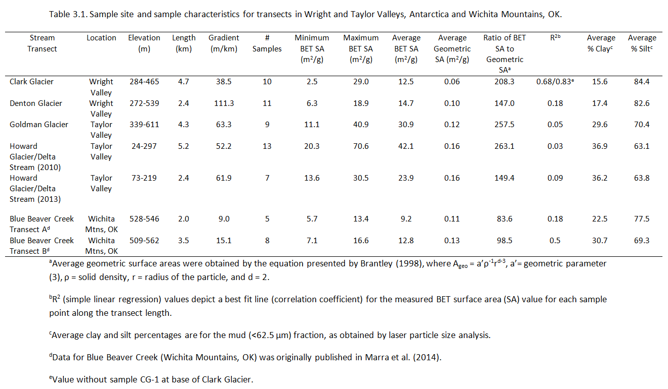

Table 3.2: BET values for temperate glacier samples (Franz Josef, Athabasca Trail, and Damma Glaciers) and assorted drift deposits in Wright and Taylor Valleys, Antarctica.

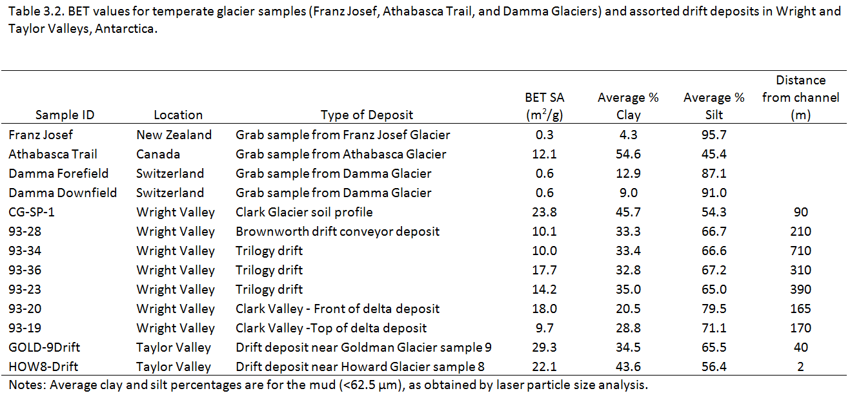

Table 3.3: Weathering rates as determined by the constant rate contribution (CRC) model described in Gooseff et al. (2002).

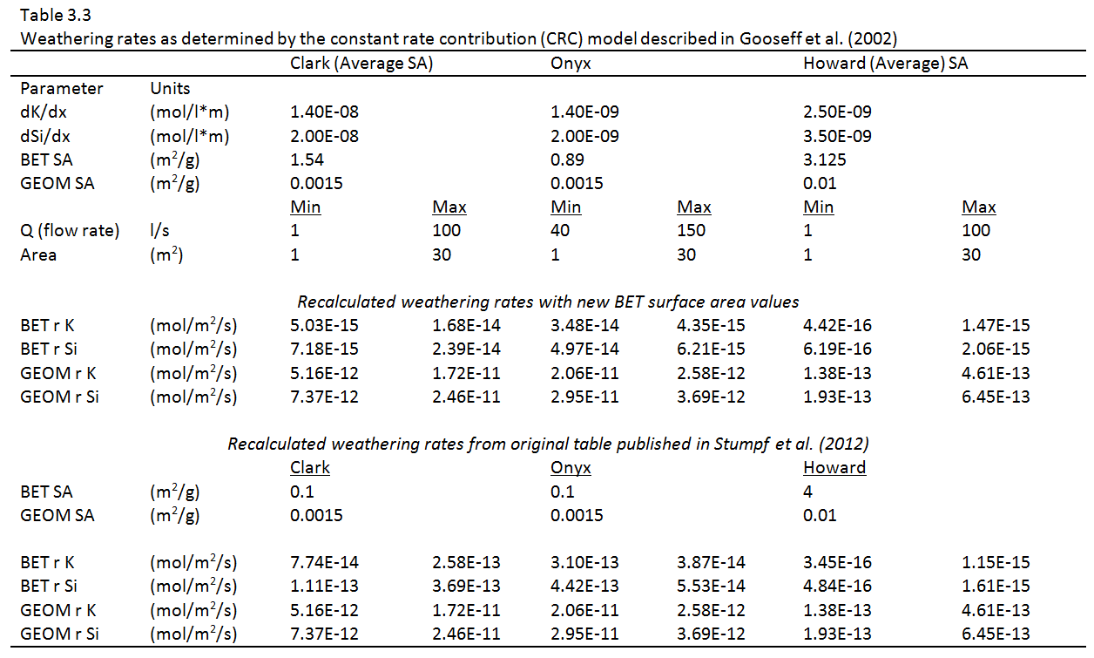

Figure 3.1: (a) Sample locations in Wright Valley, Antarctica for Clark and Denton Glaciers. BET surface area values are depicted in the bar graph in relation to distance along transect (km) from the glacier terminus (i.e., the first sample point corresponds to 0.0 km). (b) Sample locations in Taylor Valley, Antarctica for Goldman and Howard Glaciers. BET surface area values are depicted in the bar graph in relation to distance along transect (km) from the glacier terminus. For Howard Glacier (Delta Stream), samples collected in 2010 are depicted by white bars and samples collected in 2013 are depicted by gray bars.

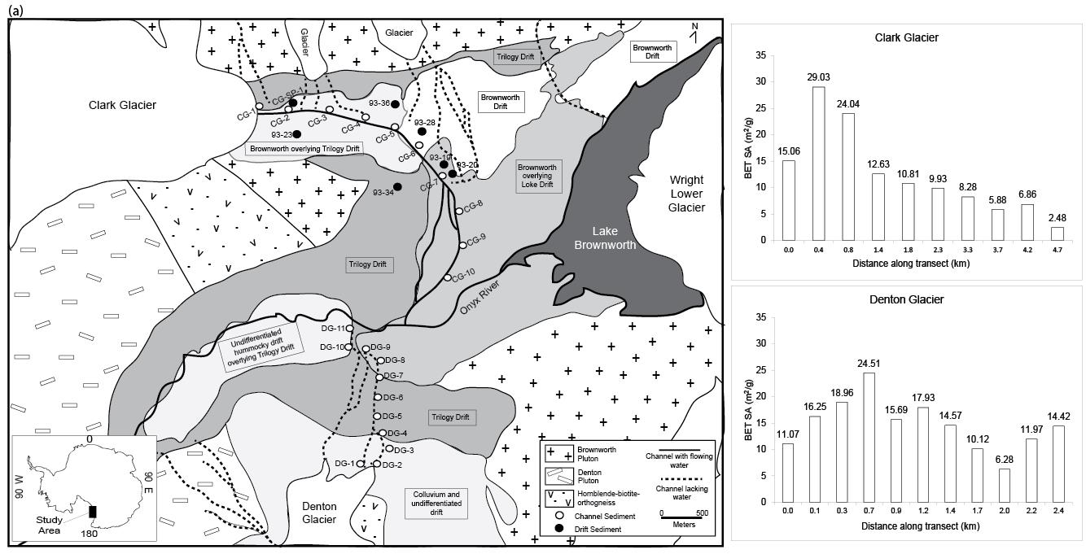

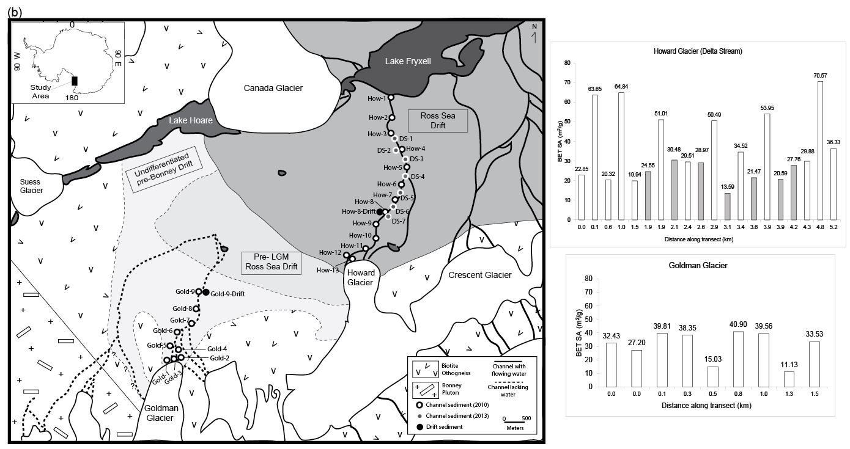

Figure 3.2: (a) Surface area (m²/g) distributions for stream transects emanating from Clark Glacier and Denton Glacier in Wright Valley. Temperate glacier samples and Wright Valley drift samples are plotted for comparison. (b) Surface area (m²/g) distributions for Delta Stream (emanating from Howard Glacier) and a stream transect emanating from Goldman Glacier in Taylor Valley. Temperate glacier samples and Taylor Valley drift samples are plotted for comparison.

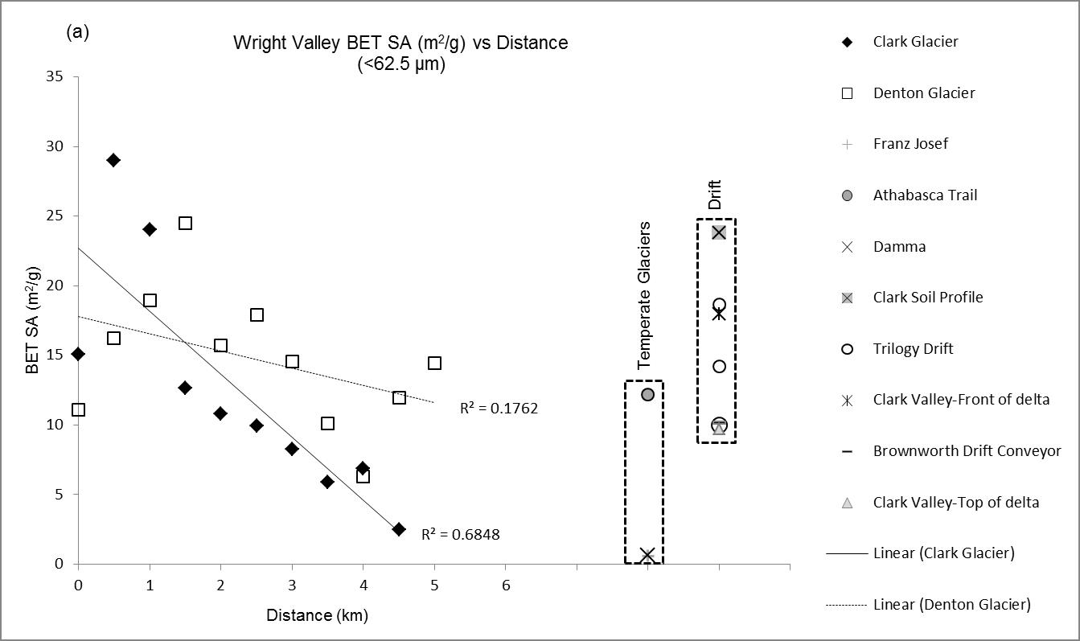
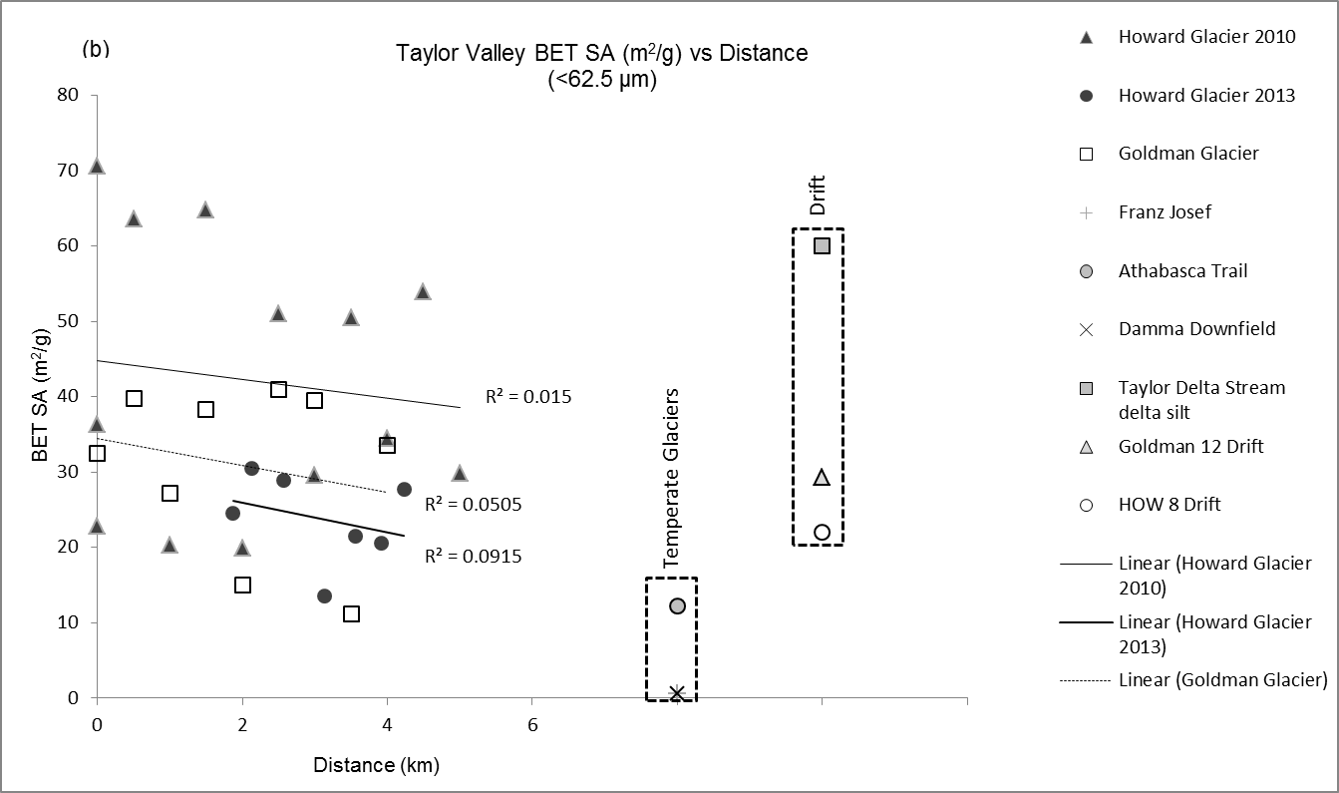

Figure 3.3: Boxplot of BET surface area values (m²/g) for the Antarctic stream transects. How 2010 and How 2013 refer to samples collected in Delta Stream (emanating from Howard Glacier) during the 2009-2010 and 2012-2013 field seasons, respectively.

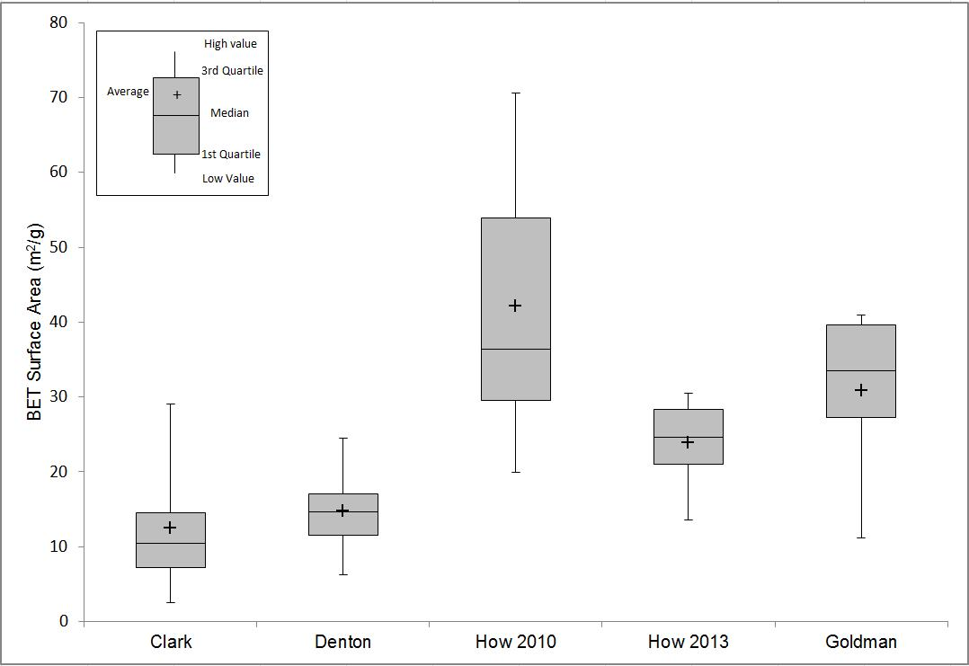

Figure 3.4: BET surface area distributions for 6 size fractions (very coarse, coarse, medium, fine, very fine, and mud) from 2 composite samples in Clark Glacier stream (CG-2 and CG-8) and 2 composite samples in Delta Stream (HOW-11 and HOW-3). Samples CG-2 and HOW-11 represent proximal sediments, whereas CG-8 and HOW-3 represent distal channel sediments.

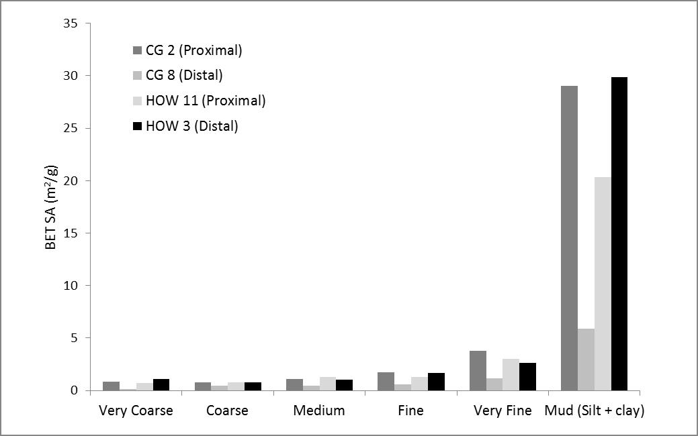

Figure 3.5: Variations in the volume percentage of clay content (out of the mud fraction) along sample transects as obtained by laser particle size analysis.

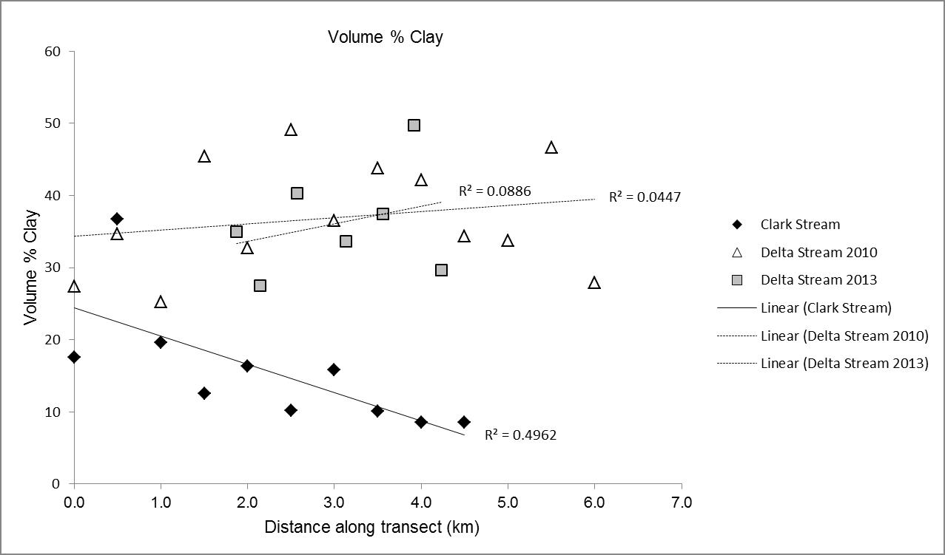

Figure 3.6: Discharge in liters per second (l/sec) for the 2009-2010 and 2012-2013 melt seasons based on equivalent dates. Sampling for the 2009-2010 season was on January 18, 2010, and sampling for the 2012-2013 season was on January 20, 2013. Initial higher flow is noted for the 2012-2013 melt season, although flow was not recorded until late December. Data was obtained from the McMurdo Dry Valleys Long Term Ecological Research project (McKnight, 2014).

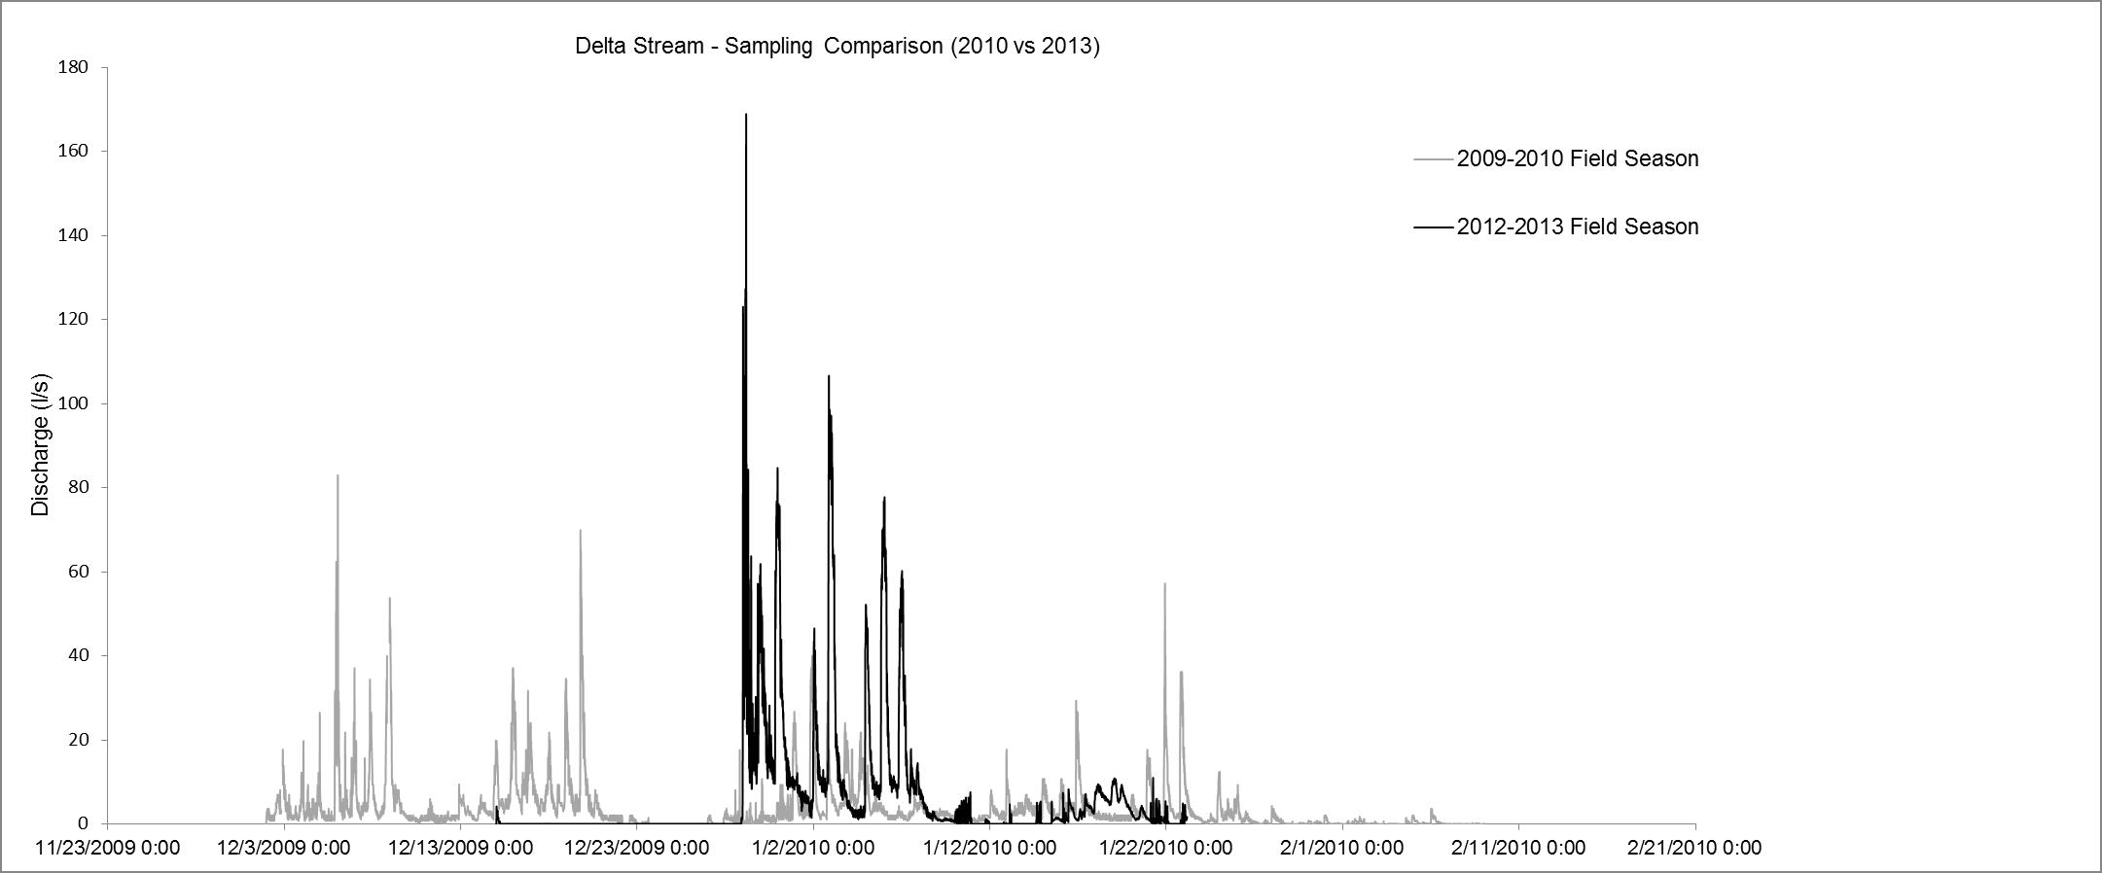

References
Alger, A.S., McKnight, D.M., Spaulding, S.A., Tate, C.M., Shupe, G.H., Welch, K.A., Andrews, E.D., and House, H.R., 1997, Ecological processes in cold desert ecosystems: the abundance and species distribution of algal mats in glacial meltwater streams in Taylor Valley, Antarctica: Occasional Paper – Institute of Arctic and Alpine Research, University of Colorado, v.51, 108 p.

Anbeek, C., 1992, Surface roughness for minerals and implications for dissolution studies: Geochimica et Cosmochimica Acta, v.56, p.1461-1469.

Anbeek, C., 1993, The effect of natural weathering on dissolution rates: Geochimica et Cosmochimica Acta, v.57, p.4963-4975.

Anderson, S.P., Drever, J.I., and Humphrey, N.F., 1997, Chemical weathering in glacial environments: Geology, v.25, no.5, p.399-402.

Anderson, S.P., 2005, Glaciers show direct linkage between rate and chemical weathering fluxes: Geomorphology, v.67, no.1-2, p.147-157.

Anderson, S.P., 2007, Biogeochemistry of glacial landscape systems: Annual Review of Earth and Planetary Sciences, v.35, p. 375-399.

Atkins, C.B., 2014, Geomorphological evidence of cold-based glacier activity in South Victoria Land, Antarctica: Geological Society, London, Special Publications, v.381, p. 299-318.

Atkins, C.B., Barrett, P.J., and Hicock, S.R., 2002, Cold glaciers erode and deposit: evidence from Allan Hills, Antarctica: Geology, v.30, p. 659-662.

Atkins, C.B., and Dickinson, W.W, 2007, Landscape modification by meltwater channels at the margins of cold-based glaciers, Dry Valleys, Antarctica: Boreas, v.36, no.1, p. 47-55.

Bennett, P.C., 1991, Quartz dissolution in organic-rich aqueous systems: Geochimica et Cosmochimica Acta, v.55, no.7, p.1781-1797.

Berg, T.E., and Black, R.F., 1966, Preliminary Measurements of Growth of Nonsorted Polygons, Victoria Land, Antarctica (J. C. F. Tedrow, Ed.): Antarctic soils and soil forming processes, v. Antarctic Research Series 8, p. 61–108.

Bertler, A.N., Mayewski, P.A., Barrett, P.J., Sneed, S.B., and Handley, M.J., 2004, Monsoonal circulation of the McMurdo Dry Valleys, Ross Sea Region, Antarctica: signal from snow chemistry: Annals of Glaciology, v.39, p. 139-145.
Bockheim, J.G., 2002, Landform and soil development in the McMurdo Dry Valleys, Antarctica: a regional synthesis: Arctic, Antarctic, and Alpine Research, v.34, no.3, p.308-317.

Brantley, S.L, 1998, Surface area and porosity of primary silicate minerals: Mineralogical Magazine, v. 62, p. 229-230.

Brantley, S.L., and Mellot, N.P., 2000, Surface area and porosity of primary silicate minerals: American Mineralogist, v. 85, p.1767-1783.

Bromley, A.M., 1985, Weather observations, Wright Valley, Antarctica: Information Publication 11, Wellington, New Zealand: New Zealand Meteorological Service.

Brunauer, S., Emmett, P.H., and Teller, E., 1938, Adsorption of gases in multimolecular layers: Journal of the American Chemical Society: v.60, p.309-319.

Campbell, I.B., and Claridge, G., 1987, Antarctica: soils, weathering processes and environment: Elsevier Science Publishers, Amsterdam & New York. Chinn, T.J., 1994, Glacier disequilibrium in the Convoy Range, Transantarctic Mountains, Antarctica: Annals of Glaciology, v.20, p.269-27.

Claridge, G.G.C., and Campbell, I.B., 1977, The salts in Antarctic soils, their distribution and relationship to soil processes: Soil Science, v.123, p.377-384.

Conovitz, P.A., McKnight, D.M., MacDonald, L.H., Fountain, A.G., and House, H.R., 1998, Hydrologic processes influencing streamflow variation in Fryxell Basin, Antarctica: In Ecosystem Dynamics in a Polar Desert, The McMurdo Dry Valleys, Antarctica (ed. J.C. Priscu), American Geophysical Union, p.93-108.

Cuffey, K.M., Conway, H., Gades, A.M., Hallet, B., Lorrain, R., Severinghaus, J.P., Steig, E.J., Vaughn, B., and White, J.W.C, 2000, Entrainment at cold glacier beds: Geology, v.28, no.4, p.351-354.

Doran, P.T., Wharton, R.A., and Lyons, W.B., 1994, Paleolimnology of the McMurdo Dry Valleys, Antarctica: Journal of Paleolimnology, v.10, no.2, p.85-114.

Doran, P.T., McKay, C.P., Clow, G.D., Dana, G.L., Fountain, A.G., Nylen, T., and Lyons, W.B., 2002, Valley floor climate observations from the McMurdo dry valleys, Antarctica, 1986-2000: Journal of Geophysical Research, v.107, no.D24, p. ACL13-1 – ACL 13-12.

Doran, P.T., McKay, C.P., Fountain, A.G., Nylen,T., McKnight, D.M., Jaros, C., and Barrett, J.E., 2008, Hydrologic response to extreme warm and cold summers in the McMurdo Dry Valleys, East Antarctica, Antarctic Science, v.20, p.499-509.
Deuerling, K.M, 2010, Aeolian sediments of the McMurdo Dry Valleys, Antarctica: M.S. Thesis, Ohio State University.

Deuerling, K.M., Lyons, W.B., Welch, S.A., and Welch, K.A., 2014, The characterization and role of aeolian deposition on water quality, McMurdo Dry Valleys, Antarctica: Aeolian Research, v.13, p.7-17.

Fortner, S.K., Lyons, W.B., and Olesik, J.W., 2011, Eolian deposition of trace elements onto Taylor Valley Antarctic glaciers: Applied Geochemistry, v.26, p.1897-1904.

Fortner, S.K., Lyons, W.B., Munk, L., 2013, Diel stream geochemistry, Taylor Valley, Antarctica: Hydrological Processes, v. 27, p. 394-404.

Fountain, A.G., Lyons, W.B., Burkins, M.B., Dana, G.L., Doran, P.T., Lewis, K.J., McKnight, D.M., Moorehead, D.L, Parsons, A.N., Priscu, J.C., Wall, D.H., Wharton, R.A, Virginia, R.A., 1999, Physical controls on the Taylor Valley ecosystem, Antarctica: BioScience, v.49, p.961-971.

Gautier, J.M., Oelkers, E.H., and Schott, J., 2001, Are quartz dissolution rates proportional to B.E.T. surface areas?: Geochimica et Cosmochimica Acta, v.65, no.7, p.1059-1070.

Gibson, E.K., Wentworth, S.J., McKay, D.S., 1983, Chemical weathering and diagenesis of a cold desert soil from Wright Valley, Antarctica: an analog of martian weathering processes: Journal of Geophysical Research, v.88, p. A912-A928.

Gooseff, M.N., McKnight, D.M., Lyons, W.B., and Blum, A.E., 2002, Weathering reactions and hyporheic exchange controls on stream water chemistry in a glacial meltwater stream in the McMurdo Dry Valleys: Water Resources Research, v.38, p.1279.

Gooseff, M.N., Barrett, J.E., Doran, P.T., Fountain, A.G., Lyons, W.B., Parsons, A.N., Porazinska, D.L., Virginia, R.A., and Wall, D.H., 2003, Snow-patch influence on soil biogeochemical processes and invertebrate distribution in the McMurdo Dry Valleys, Antarctica: Arctic, Antarctic, and Alpine Research, v. 35, no.1, p. 91-99.

Gooseff, M.N., Barrett, J.E., and Levy, J.S., 2013, Shallow groundwater systems in a polar desert, McMurdo Dry Valleys, Antarctica: Hydrogeology Journal, v. 21, no. 1, p. 171–183, doi: 10.1007/s10040-012-0926-3.

Hall, B.L., Denton, G.H., and Hendy, C.H., 2000, Evidence from Taylor Valley for a grounded ice sheet in the Ross Sea, Antarctica: Geogr. Ann., v.82A, no.2-3, p.275-303.
Hall, B.L., and Denton, G.H., 2005, Surficial geology and geomorphology of eastern and central Wright Valley, Antarctica: Geomorphology, v.64, no.1-2, p.25-65.

Hallet, B., Hunter, L., and Bogen, J., 1996, Rates of erosion and sedimentation evacuation by glaciers: A review of field data and their implications: Global and Planetary Change, v.12, p.213-235.

Healy, T.R., 1975, Thermokarst—a mechanism of de‐icing ice‐cored moraines: Boreas, v. 4, no. 1, p. 19–23.

Hodson, A.J., and Ferguson, R.I., 1999, Fluvial suspended sediment transport from cold and warm-based glaciers in Svalbard: Earth Surface Processes and Landforms: v.24, p.957-974.

Hoffman, M.J., Fountain, A.G., and Liston, G.E., 2014, Near-surface internal melting: a substantial mass loss on Antarctic Dry Valley glaciers: Journal of Glaciology, v.60, no.220, p.361-374.

Horowitz, A.J., and Elrick, K.A., 1987, The relation of stream sediment surface area, grain size, and composition to trace element chemistry: Applied Geochemistry, v.2, p.437-451.

Keys, J.R. and Williams, K., 1981, Origin of crystalline, cold desert soils in the McMurdo region, Antarctica: Geochimica et Cosmochimica Acta, v.45, p.2299-2309.

Kim, C.S., Stack, D.H., and Rytuba, J.J., 2012, Fluvial transport and surface enrichment of arsenic in semi-arid mining regions: examples from the Mojave Desert, California: Journal of Environmental Monitoring, v. 14, p.1798-1813.

Lancaster, N., 2002, Flux of eolian sediment in the McMurdo Dry Valleys, Antarctica: a preliminary assessment: Arctic, Antarctic, and Alpine Research, v.34, no.3, p.318-323.

Levy, J.S., Head, J.W., and Marchant, D.R., 2008, The role of thermal contraction crack polygons in cold-desert fluvial systems: Antarctic Science, v. 20, no.6, p. 565-579, doi: 10.1017/S0954102008001375.Levy, J.S., Fountain, A.G., Gooseff, M.N., Welch, K.A., and Lyons, W.B., 2011, Water tracks and permafrost in Taylor Valley, Antarctica: Extensive and shallow groundwater connectivity in a cold desert ecosystem: Geological Society of America Bulletin, v.123, no. 11-12, p.2295-2311.

Levy, J.S., 2014, A hydrological continuum in permafrost environments: the morphological signatures of melt-driven hydrology on Earth and Mars: Geomorphology, in press.
Lyons, W.B., Welch, K.A., Fountain, A.G., Dana, G.L., Vaughn, B.H., and McKnight, D.M., 2003, Surface glaciochemistry of Taylor Valley, southern Victoria Land, Antarctica and its relationship to stream chemistry: Hydrological Processes, v.17, p.115-130.

Marra, K.R., Soreghan, G.S., Elwood Madden, M.E., Keiser, L.J., and Hall, B.L., 2014, Trends in grain size and BET surface area in cold-arid versus warm semi-arid fluvial systems: Geomorphology, v.206, p.483-491.

Matsuoka, N., Moriwaki, K., and Hirakawa, K., 1998, Field experiments on physical weathering and wind erosion in an Antarctic cold desert: Earth Surface Processes and Landforms, v.21, no.8, p. 687-699.

Mayewski, P.A., Lyons, W.B., Zielinski, G., Twickler, M., Whitlow, S., Dibb, J., Grootes, P., Taylor, K., Whung, P.Y., Fosberry, L., Wake, C., and Welch, K., 1995, An ice-core based , Late Holocene history for Transantarctic Mountains, Antarctica: In Elliot, D.H., and G.L. Blaisdell, eds. Contribution to Antarctic Research IV, Washington DC, American Geophysical Union, Antarctic Research Series 67, p.33-45.

Maurice, P.A., McKnight, D.M., Leff, L., Fulghum, J.E., and Gooseff, M., 2002, Direct observations of aluminosilicate weathering in the hyporheic zone of an Antarctic Dry Valley stream: Geochimica et Cosmochimica Acta, v.66, p.1335-1347.

McKnight, D.M., 2014, McMurdo Dry Valleys Delta Stream gauge measurements: Long Term Ecological Research Network. http://dx.doi.org/10.6073/pasta/9f247ee16c26cf9bbc715d53356d6629

McKnight, D.M., Tate, C.M., Andrews, E.D., Niyogi, D.K., Cozzetto, K., Welch, K., Lyons, W.B., and Capone, D.G., 2007, Reactivation of a cryptobiotic stream ecosystem in the McMurdo Dry Valleys, Antarctica: A long-term geomorphological experiment: Geomorphology, v. 89, p.186-204.

McKnight, D.M., Runkel, R.L., Tate, C.M., Duff, J.H., Moorhead, D.L., 2004, Inorganic N and P dynamics of Antarctic glacial meltwater streams as controlled by hyporheic exchange and benthic autotrophic communities: Journal of North American Benthological Society, v. 23, p. 171-188.

Nezat, C.A., Lyons, W.B., and Welch, K.A., 2001, Chemical weathering in streams of a polar desert (Taylor Valley, Antarctica): Geology, v.113, no.11, p.1401-1408.

Nylen, T.H., Fountain, A.G., Doran, P.T., 2004, Climatology of katabatic winds in the McMurdo Dry Valleys, southern Victoria Land, Antarctica: Journal of Geophysical Research, v.109, no.9, doi: 10.1029/2003JD003937.

Owen, L.A., 2003, Contemporary sediment production and transfer in high-altitude glaciers: Sedimentary Geology, v.155, p.13-36.

Pewe, T.L., 1959, Sand-wedge polygons (tesselations) in the McMurdo Sound region, Antarctica; a progress report: American Journal of Science, v. 257, no. 8, p. 545–552.

Rawlins, B.G., Turner, G., Mounteney, I., Wildman, G., 2010, Estimating specific surface area of fine streambed sediments from geochemistry: Applied Geochemistry, v.25, no.9, p.1291-1300.

Runkel, R.L., McKnight, D.M., and Andrews, E.D., 1998, Analysis of transient storage subject to unsteady flow: diel flow variation in an Antarctic stream: Journal of the North American Benthological Society, v.17, p.143-154.

Sabacka, M., Priscu, J.C., Basagic, H., Fountain, A.G., Wall, D.H., Virginia, R.A., Greenwood, M.C., 2012, Aeolian flux of biotic and abiotic material in Taylor Valley, Antarctica: Geomorphology, v.155-156, p.102-111.

Schiller, M., Dickinson, W., Zondervan, A., Ditchburn, R., and Wang, N., 2014, Rapid soil accumulation in a frozen landscape: Geochimica et Cosmochimica Acta, Goldschmidt Conference Proceedings.

Sletten, R.S., Hallet, B., and Fletcher, R.C., 2003, Resurfacing time of terrestrial surfaces by the formation and maturation of polygonal patterned ground: Journal of Geophysical Research, v. 108, no. E4, p. doi:10.1029–2002JE001914, doi: 10.1029/2002JE001914.

Steinhoff, D.F., Bromwich, D.H., Speirs, J.C., McGowan, H.A., and Monaghan, A.J., 2014, Austral summer foehn winds over the McMurdo Dry Valleys of Antarctica from polar WRF: Quarterly Journal of the Royal Meteorological Society, doi:10.1002/qj.2278.

Stumpf, A.R., Elwood-Madden, M.E., Soreghan, G.S., Hall, B.L., Keiser, L.J., and Marra, K.R., 2012, Glacier meltwater stream chemistry in Wright and Taylor Valleys, Antarctica: Significant roles of drift, dust, and biological processes in chemical weathering in a polar climate: Chemical Geology, v.322-323, p. 79-90.

Waller, R.I., 2001, The influence of basal processes on the dynamic behavior of cold-based glaciers: Quaternary International, v.86, p.117-128.

Wang, F., Chen, J., Chen, J., and Forsling, W., 1997, Surface properties of natural aquatic sediments: Water Research, v. 31, no. 7, p.1796-1800.

Welch, S.A., and Ullman, W.J., 1992, The effect of soluble organic acids on feldspar dissolution rates and stoichiometry: Geochimica et Cosmochimica Acta, v.57, p.2725-2736.

Witherow, R., Lyons, W.B., Bertler, N.A.N., Welch, K.A., Mayewski, P.A., Sneed, S.B., Nylen, T., Handley, M.J., and Fountain, A., 2006, The aeolian flux of calcium, chloride, and nitrate to the McMurdo Dry Valleys landscape: evidence from snow pit analysis: Antarctic Science, v.18, no.4, p.497-505.

Chapter 4: Physical and Chemical Weathering in Fine-Grained Stream Sediments of the McMurdo Dry Valleys, Antarctica
Introduction
Weathering in polar climates is considered to be dominated by physical processes, including rock fragmentation due to thermal processes, and wind abrasion that produces ventifacts (Hall et al., 2002; Huh, 2003; Sepala, 2004; Putkonen et al., 2014). Chemical weathering in cold regions has previously been assumed to be minimal due to limited availability of liquid water and low temperatures slowing reaction rates (Velbel, 1993; Lasaga et al., 1994; White and Blum, 1995; Anderson et al., 1997; Anderson, 2007; Hall et al., 2002; Goudie and Viles, 2012). However, in wet-based glacial regimes, mechanical grinding of sediments by glacial erosion can produce large volumes of unsorted sediment including fresh rock flour with high surface area susceptible to significant chemical weathering due to formation of chemically reactive sites on mineral grains (Anbeek 1992; 1993; Anderson, 2005; 2007; Goudie and Viles, 2012). For instance, high fluxes of Ca²⁺ and K⁺ prevalent in temperate proglacial waters may reflect ready dissolution of soluble carbonate phases, as well as significant cation leaching from biotite attributable to abraded mineral textures (Anderson et al., 1997). However, the effects of chemical weathering in cold-based glacial regimes, defined as glaciers frozen to the underlying rock substrate which suggests minimal erosive impact on subjacent bedrock and sediment, remain less well constrained.
Chemical erosion rates in glacial systems are typically correlated with water discharge rates (Anderson et al., 1997; Nezat et al., 2001). However, a recent long-term meltwater chemistry study within the temperate proglacial system of Austre Broggerbreen (Norway; Nowak and Hodson, 2014) revealed enhanced silicate mineral weathering owing to exposure of fine-grained, chemically reactive sediments during glacial retreat associated with a transition from wet-based to cold-based conditions. These results suggest that exposed mineral surface area may be even more important than water flux in controlling ion yields in wet-based glacial systems. In regions where cold-based glacial activity prevails, such as in the McMurdo Dry Valleys (MDV) of Antarctica, only minor production of glacially derived fines is expected, although some active basal sliding may occur, resulting in geomorphic features such as boulder-top abrasion, grooves, and thin drift deposits (Chinn 1994; Cuffey et al., 2000; Atkins et al., 2002; Atkins, 2014). Recent work (Marra et al., 2014, 2015) has highlighted the presence of variable and high-magnitude surface area within fine-grained (<63 µm) sediment analyzed from stream transects emanating from cold-based glaciers in the McMurdo Dry Valleys. This potentially chemically reactive, high surface-area, fine-grained material is likely distributed via eolian and/or fluvial dispersal of valley drift sediments (Witherow et al., 2006; Sabacka et al., 2012; Fortner et al., 2013). Variable wind regimes within the hyper-arid climate circulate fine-grained material from the valley drifts onto glacier surfaces and into exposed stream channel beds, where it subsequently becomes concentrated into meltwater runoff during the limited Austral summer, and transported downstream within the weathering environment of the hyporheic zone. In addition, fine-grained material may also be added to the hyporheic zone from eolian deposition within channel snow drifts, as well as from the underlying drift material. Thus, incorporation of fine-grained sediment into the active stream channel may facilitate dissolution and ultimately influence the composition and concentration of meltwater stream solutes (Stumpf et al., 2012; Sabacka et al., 2012; Fortner et al., 2013; Deuerling et al., 2014).
Previous work on the magnitude and nature of chemical weathering in Antarctic streams has focused on assessing variations in solute concentrations within stream waters sourced from cold-based glaciers and their transport into ice-covered lakes (Green et al., 1988; Lyons et al., 1998; Nezat et al., 2001; Gooseff et al., 2002; Lyons et al., 2002; Lyons et al., 2003; Gooseff et al., 2004; Green et al., 2005; Fortner et al., 2005; Welch et al., 2010; Stumpf et al., 2012; Fortner et al., 2013). These solutes are attributed to dissolution of salts and carbonates and weathering of silicate minerals within channel and soil sediments (Lyons et al., 1998; Gooseff et al., 2002; Stumpf et al., 2012). Based on observed solute trends, chemical weathering in MDV streams can occur at rates per unit area equivalent to wet-based glacial systems, despite prevailing low temperatures, seasonally restricted moisture availability, and minimal organic content (Nezat et al., 2001; Lyons et al., 2002; Gooseff et al., 2002; Welch et al., 2010; Stumpf et al., 2012). However, few studies directly assess the impact of silicate weathering on sediments within the hyporheic zone and/or identify potential weathering products (i.e., clays; Lyons et al., 1998; Gooseff et al., 2002; Maurice et al., 2002). In addition, most Antarctic solute weathering studies are focused in Taylor Valley, particularly within the Fryxell Basin drainage area, despite geographic variations in the composition and origin of valley glacial drift sediments, the presence and distribution of biota, and the nature of eolian dispersal patterns throughout the MDV (Figure 1; Table 1). Here, we present geochemical data on fine-grained (<63 µm) hyporheic zone sediments from stream channels in both Wright and Taylor Valleys to investigate the characteristics and potential variability of chemical weathering in ephemeral proglacial streams within a cold-based glacial environment.
Background
Geologic Setting
The McMurdo Dry Valleys are a series of east-west trending, nearly ice-free valleys situated between the Transantarctic Mountains and the Ross Sea of Antarctica. These valleys were subject to wet-based glaciation during the Oligocene, followed by development of cold-based glaciation during the Miocene (~13.6 Ma). The MDV have maintained cold, hyper-arid conditions since this time (Marchant et al., 1993; Denton and Sugden, 2005; Sugden et al., 2005; Bockheim, 2013). The valleys currently contain numerous cold-based alpine glaciers, which extend variable distances from valley walls, and terminate on bedrock or extensive glacial drift deposits (Atkins, 2014). These drift deposits record multiple episodes of glacial ice advance and retreat from the adjacent Ross Sea and East Antarctic ice sheet (Hall and Denton, 2005).
This study focuses specifically on sample sites in eastern Wright (Clark Glacier stream) and Taylor (Delta Stream and Goldman Glacier channel) Valleys, which are characterized by multiple distinct drift deposits reflecting differing glacial histories (Figure 2). Wright Valley is underlain by the Brownworth (granite and quartz monzonite) and Denton (foliated granodiorite) plutons near the eastern end of the valley and adjacent to Wright Lower Glacier. Drift types in this region date to at least the Miocene and were largely emplaced prior to the Last Glacial Maximum (LGM). These drift deposits are generally composed of a coarse-grained, heterogeneous mix of igneous and metamorphic rock types and were sourced from multiple cold-based glacial ice advances and retreats from the adjacent Wilson Piedmont Glacier and Ross Sea Embayment (Hall and Denton, 2005). The stream emanating from Clark Glacier (henceforth referred to as Clark Glacier stream) in Wright Valley crosses Brownworth drift, which is underlain by Trilogy drift near the glacier terminus and Loke drift near Lake Brownworth (Figure 2). Brownworth drift is dominated by sand-size material and consists of two facies: 1) coarse sand diamicton, and 2) horizontally stratified sandy glaciolacustrine facies. The drift exhibits limited soil development and consists of a variety of basement clast types, including Ferrar Dolerite, Olympus granite gneiss, Vida granite, and microdiorite (Hall and Denton, 2005).
Eastern Taylor Valley is primarily underlain by biotite orthogneiss and filled by undifferentiated and Ross Sea drift sediments. The stream emanating from Howard Glacier (formally named Delta Stream) crosses Ross Sea drift exclusively, which was emplaced during the LGM and reflects deposition by partially wet-based ice that encroached from the Ross Sea (Hall et al., 2000). Ross Sea drift consists of five distinct facies (till, waterlain diamicton, glaciolacustrine silt, stratified sand, and stratified silt-sand-gravel), is notably finer grained compared to Wright Valley drift deposits, and, in addition to granite and metamorphic basement clasts, has a distinct lithology of kenyte, basalt, sandstone, and dolerite erratics from sources beyond eastern Taylor Valley (Hall et al., 2000). The Goldman Glacier stream channel flows over undifferentiated pre-Bonney drift, which has not been extensively discussed in the literature (Hall et al., 2000).
The MDV region is classified as a hyper-arid, polar desert where mean annual temperatures range between -14.8 °C and -30.0 °C, and precipitation, typically in the form of snowfall, is <10 cm/yr (Clow et al., 1998; Fountain et al., 1999; Doran et al., 2002; Doran et al., 2008). The hydrologic elements of the MDV consist of glaciers, ephemeral streams, lakes, and shallow groundwater. Continuous permafrost occurs at shallow depths throughout the MDV, spatially restricting subsurface flow (Gooseff et al., 2011). Active hydrodynamics are limited to the austral summer (approximately 6-12 weeks), when solar insolation warms the surfaces of valley glaciers and generates meltwater runoff, which flows off the glaciers and across valley drift to closed-basin lakes. Streamflow rates exhibit diel variation, and can fluctuate 5-10 fold within a single summer day (McKnight et al., 1999; Gooseff et al., 2011; McKnight, 2014). Meltwater exchange with drift sediments primarily occurs within the hyporheic zone of reactivated stream channels, defined as the saturated area underlying and adjacent to the streambed where water can flow before encountering true permafrost (McKnight et al., 1999; Gooseff et al., 2002; Gooseff et al., 2013). The active layer of seasonally thawed permafrost typically extends to <1 m in depth, with increasing thaw occurring under regions of flowing water owing to thermal transport (Campbell and Claridge, 2006; Conovitz et al., 2006; Cozzetto et al., 2006; Gooseff et al., 2013). Additional shallow groundwater features include melt from localized snow patches, water tracks, and margins of streams and lakes, which, in conjunction with the hyporheic zone, mobilize solutes and provide suitable conditions for biotic growth and biogeochemical cycling (Barrett et al., 2009; Levy et al., 2011; Gooseff et al., 2013; Langford et al., 2014; Mikucki et al., 2015). Biotas in the MDV are generally restricted to cyanobacteria, algae, and mosses. Perennial algae typically grow within streams as mats that can endure long periods of desiccation and are common within Taylor Valley streams (McKnight et al., 1999; McKnight et al., 2007).
Eolian processes in the MDV are critical to distributing nutrients, organic matter, and sediments onto glacier surfaces and into the hyporheic zones of the ephemeral stream channels, where these particulates may become entrained in meltwater runoff and into stream flow (Fortner et al., 2011; Sabacka et al., 2012; Deuerling et al., 2014). Winds blow up-valley from McMurdo Sound during the summer months, whereas strong down-valley winds sourced from the polar plateau prevail during the winter and can reach speeds up to 40 m/s (Doran et al., 2008). Summer foehn wind events can also result in adiabatic warming of the MDV region, leading to heightened temperatures and increased meltwater generation (Steinhoff et al., 2014). Wind-blown aerosols are typically either marine or locally sourced terrestrial material, and particulate concentrations are commonly higher on the western sides of glaciers due to the prevailing wind direction (Lyons et al., 2003; Bertler et al., 2004; Ayling and McGowan, 2006; Witherow et al., 2006; Williamson et al., 2007; Sabacka et al., 2012; Fortner et al., 2013; Deuerling et al., 2014).
Weathering Studies in the McMurdo Dry Valleys
Early studies on soils in the MDV by Kelly and Zumberge (1961) suggested that chemical weathering processes were not actively occurring in the Antarctic environment. However, subsequent work confirmed the presence of authigenic clay minerals within soils, in addition to evidence for ion migration, and abundant development of oxidation rims on exposed surfaces (Ugolini and Anderson, 1973; Gibson et al., 1983). Clay minerals make up a small fraction of the soils and primarily consist of smectites, illites, and vermiculites (Campbell and Claridge, 1982; Lyons et al., 1998). Soil development on Ross Sea and Brownworth drift sediments is classified within the subgroups of Typic Anhyorthels and Typic Haploturbels, reflecting sublimation of ice and accumulation of salts (Bockheim, 2013). Within Taylor Valley, soluble salt accumulations derived from marine aerosol deposition and chemical weathering are highest within western (inland) soils due to minimal leaching and a longer period of soil development. In contrast, eastern valley soils are closer to coastal moisture sources and influenced by paleolake development. Here, higher soil moisture content results in higher rates of calcite dissolution and cation exchange reactions, subsequently leading to extensive leaching and lower salt content within younger soils (Bockheim et al., 2008; Toner et al., 2013).
Beyond soils, weathering studies in the MDV have been highly focused on stream solute trends, where heightened ion concentrations suggest that salt and carbonate dissolution, as well as silicate hydrolysis, are occurring within the hyporheic zone despite low temperatures (Lyons et al., 1998; Nezat et al., 2001; Huh, 2003; Stumpf et al., 2012). Previous work has been primarily concentrated in Taylor Valley accompanying the establishment of the McMurdo Dry Valleys Long Term Ecological Research Project (Fountain et al., 1999). Figure 1 and Table 1 highlight studies that focus primarily on stream solute variations attributed to weathering reactions within the seasonally active hyporheic zone of meltwater channels. Only a single study by Maurice et al. (2002) focused exclusively on characterizing observable short-term silicate mineral weathering as opposed to monitoring stream solute trends. In their study, fresh mica chips buried in the hyporheic zone of Green Creek (Taylor Valley) developed significant etch pits and biofilms over the course of a single melt season (~6 weeks) as a result of chemical weathering and microbial processes (Maurice et al., 2012).
Weathering reactions in Antarctic streams are facilitated by the rapid interaction of dilute water with unconsolidated and porous sediment within the hyporheic zone, resulting in dissolution and abundant transport of solutes into the stream system (Gooseff et al., 2002). The primary trends include downstream increases in H₄SiO₄, Mg²⁺, Ca²⁺, Na⁺, K⁺, HCO₃⁻, and Cl⁻, although cation exchange and adsorption reactions can modulate ion fluxes, leading to variability within and among stream systems (Nezat et al., 2001; Gooseff et al., 2002; Gooseff et al., 2004; Green et al., 2005; Stumpf et al., 2012). In general, the nature of the underlying drift, the incorporation of eolian dust into glacial meltwater, and the addition of marine aerosols control the ion concentrations of observed solute fluxes into valley lakes (Green et al., 1988; Nezat et al., 2001; Gooseff et al., 2002; Maurice et al., 2002; Lyons et al., 2003; Stumpf et al., 2012). Eolian deposition onto glacier surfaces also creates highly variable surficial glacier geochemistry, where dissolution on the glacier surfaces and in cryoconites can strongly influence initial meltwater chemistry (Bagshaw et al., 2007; Welch et al., 2010). Stumpf et al. (2012) focused on contrasting solute trends between adjacent valleys, where differing concentrations of Na, Ca, and Fe between two meltwater streams (Clark Glacier stream and Delta Stream) suggest contributions related to differing drift origins and compositions, variations in eolian input, and rates of biologic activity.
Chemical denudation rates are also highly dependent on discharge rates, particularly where stream gradients are low (Nezat et al., 2001). Solute concentrations are typically highest at the onset of seasonal flow, where accumulated material and weathering products are rapidly flushed from the hyporheic zone (Lyons et al., 1998; Green et al., 2005; McKnight et al., 2007). Recent investigations of water-track development have highlighted the potential for additional significant solute transport into valley lakes. Water tracks are defined as linear regions (~1-3 m in width and up to hundreds of m in length) of high soil moisture, derived from melting of snow patches or ground ice, in which water and solutes flow downslope within the seasonally active permafrost layer. Although discharge within water tracks may be two orders of magnitude less than within glacial meltwater streams, solute concentrations may be more than 100 times greater and enriched in Ca²⁺, Mg²⁺, and Cl⁻ (Levy et al., 2011; Levy et al., 2012; Gooseff et al., 2014; Langford et al., 2014).
Methods
Sediment samples (~500-1,000g/site) were collected from surficial deposits within Clark Glacier stream (originating from Clark Glacier in Wright Valley and terminating at the Onyx River) and Delta Stream (originating from Howard Glacier, Taylor Valley and terminating into Lake Fryxell) during the 2009-2010 austral summer field season (Figure 2). Both stream channels contained actively flowing water, and stream sediments were sampled at 400-500 m intervals within areas of active deposition (i.e., marginal bars) and flow of the stream channel. The water temperature and pH at each sample site were recorded with a Hanna handheld pH meter. Sample collection occurred during a comparatively low-flow year, where seasonal average discharge for Delta Stream was 3.7 l/sec (1.6 l/sec on the day of sampling; McKnight, 2014). The average seasonal discharge for the previous (2008-2009) and subsequent (2010-2011) austral summers was 70.01 l/sec and 51.4 l/sec, respectively. No stream gauge data are available for Clark Glacier stream during our sampling season or recent years. However, flow within Clark Glacier stream was greater than in Delta Stream during sampling (1/9/2010 and 1/18/2010, respectively). Two representative drift samples were collected near (within 2-210 m) each main flowing stream transect, and sediment samples were also collected from a dry stream channel emanating from Goldman Glacier in Taylor Valley. Additional sediment samples along Delta Stream were collected during the 2012-2013 field season (average seasonal discharge of 6.5 l/s; McKnight, 2014) for temporal comparison. All sediments were kept frozen following field collection until they were processed for grain size, surface area, and geochemical analyses in laboratories at the University of Oklahoma.
Samples were processed as outlined in Marra et al. (2014, 2015). Briefly, sediments were wet sieved to split the gravel, sand, and mud (silt and clay; <63 µm) fractions. As finer-grained material generally has higher sediment surface area, and is thus considered to be more chemically reactive by mass or volume, our analyses focus primarily on the silt and clay fraction (<63 µm grain size, referred to subsequently as mud). The mud fraction was treated for 24 hours with buffered acetic acid to remove carbonate, and with hydrogen peroxide (30% grade for 30 minutes) to remove organic material. The mud samples were freeze-dried and analyzed for grain size to determine the relative percentages of silt and clay with a Beckman Coulter Laser Particle Size Analyzer (LPSA), and N₂ adsorption BET surface area (Brunauer et al., 1938) with a Beckman Coulter SA3100 analyzer (Marra et al., 2014, 2015).
A subset of the mud fraction was analyzed for whole-rock geochemistry utilizing lithium borate fusion and ICP-AES, as well as ICP-MS to obtain rare-earth element (REE) geochemistry by a commercial laboratory (ALS Chemex). Whole-rock geochemical data were reported as weight percent oxides, whereas rare-earth element concentrations were reported as ppm. All values of CaO were corrected to account for Ca bound in apatite via the equation (Girty et al., 2013):
CaO* = CaO-(3.33*P₂O₅)
Bulk quantitative x-ray diffraction (XRD) analyses of the processed muds were run on a Rigaku Ultima IV at the University of Oklahoma. Oriented clay mounts of the <2 µm clay fraction were analyzed with a Siemens D-500 (fixed-slit assembly and Bragg-Brentano geometry) at the USGS in Denver, CO. XRD patterns were interpreted with JADE and ClaySim software packages.
Results and Discussion
Whole-rock geochemical data for Antarctic drift and channel sediments analyzed in this study appear in Table 2. Carbonates and salts are pervasive in MDV soils, related to the development of paleolakes and common pedogenic processes (Keys and Williams, 1981; Bockheim, 2013; Toner et al., 2013). In addition, the deposition of marine-sourced aerosol salts into the MDV region from the Ross Sea commonly occurs during varying wind regimes in the summer months (Bertler et al., 2004; Witherow et al., 2006; Williamson et al. 2007; Sabacka et al., 2012; Fortner et al., 2013). Our sample processing protocol, however, included wet sieving and an acetic acid treatment to remove any surficial salts and carbonate coatings. In addition, treatment with hydrogen peroxide ensured removal of organic matter. Therefore, the geochemical trends observed in the sediments analyzed for this study should reflect only the aluminosilicate mineralogy. A corresponding study by Stumpf et al. (2012) addressed stream solute trends within the sampled transects discussed here, and results from that study are summarized in section 4.4. However, the solute trends reflect the original mineralogy present in the surrounding drift sediments, and therefore measured solute concentrations include contributions from dissolution of carbonates and salts which have been removed from the sediments via wet sieving and acetic acid treatment prior to geochemical analysis.
Clark Glacier Stream Sediments (Wright Valley)
In Clark Glacier stream, the overall elemental abundances in the mud fraction are: Si > Al > Fe > Ca $≥$ Mg > Na > K (Table 2). Bulk quantitative XRD analyses indicate that the mud fraction is composed dominantly of primary minerals (i.e., quartz, feldspars, and pyroxenes), where the percentages of quartz and pyroxenes both systematically increase downstream and the percentage of feldspars decreases (Figure 3). Among the feldspars, plagioclase > alkali feldspar, although the range of feldspar phases present was difficult to distinguish with the XRD data. The percentage of phyllosilicates (4-18%), consisting primarily of biotite and chlorite, with minor illite, kaolinite, and smectite, in the mud fraction correspondingly decreases downstream along the transect (Figure 3). Accordingly, concentrations of Ca, Mg, and Fe (likely associated with the high pyroxene content) increase downstream, whereas Na, K, and Al associated with feldspar and phyllosilicate phases (i.e., biotite and chlorite) decrease downstream (Figure 4).
Grain size trends within the mud (silt and clay) fraction show that silt is the dominant size fraction (63-91%), which increases in abundance down the Clark Glacier stream transect (Figure 5). BET surface area may serve as a general proxy for grain size, wherein smaller particles typically have larger specific surface areas. However, BET surface area of sediments is also strongly influenced by particle surface roughness. In addition, the chemistry of sediments may also correlate with the specific surface area (Horowitz and Elrick, 1987; Rawlins et al., 2010). BET surface areas for the mud fraction within Clark Glacier stream range from 2.0-29.0 m²/g and systematically decrease along the stream transect in accordance with the increase in grain-size within the mud fraction (Appendix A; Marra et al., 2015). Whole-rock geochemistry trends relative to BET surface area are shown in Figure 6. In general, Si, Al, Na, and K tend to increase with increasing surface area whereas Mg, Ca, and Fe tend to decrease with increasing surface area within the Clark Glacier stream mud. This is consistent with the observed increase in concentrations of Mg, Ca, and Fe (associated with pyroxene) down the stream transect, suggesting that mafic phases, in addition to chemically resistant minerals such as quartz (Figure 3), are becoming increasingly concentrated in the silt-size fraction, which has an overall lower BET surface area. Increasing Al, Na, and K concentrations (associated with feldspars and phyllosilicates) with increasing BET surface area are consistent with the downstream decrease in the percentage of phyllosilicates and feldspars (and a subsequent increase in silt content). Therefore, the proximal muds contain more clay-sized grains with higher BET surface area, as well as higher percentages of phyllosilicates and feldspars leading to Al, Na, and K enrichment, whereas distal muds contain more silt-sized grains with lower BET surface area, and appear to contain more pyroxene and quartz, leading to increasing Ca, Mg, and Fe concentrations in the muds moving downstream.
Clark Glacier stream traverses a single drift type (Brownworth Drift; Figure 2), which is underlain by two distinct drift deposits (Loke and Trilogy Drifts) along the course of the stream channel. However, we observed minimal flow and no downcutting in the stream channel during sampling, which implies that substantial contributions from underlying drift deposits are unlikely within the active hyporheic zone of Clark stream and therefore differences in drift lithologies are not a major factor controlling the pronounced downstream increase in pyroxenes and quartz and decrease in phyllosilicates and feldspars. This implies that feldspars and the finest-grained phases (i.e., phyllosilicates) are being introduced via eolian deposition onto the Clark Glacier surface, entrained within the surficial glacier meltwater, and subsequently concentrated within the proximal reaches of the stream transect during incipient flow (Marra et al., 2015).
Delta Stream and Goldman Glacier Channel Sediments (Taylor Valley)
In Taylor Valley (Delta Stream and Goldman channel transect), the relative elemental abundances in the mud fraction are: Si > Al > Fe > Mg > Ca $≥$ Na $≥$ K (Table 2). XRD analyses of the mud fraction of Delta Stream sediments collected in 2010 show feldspars > phyllosilicates > pyroxene > quartz, with phyllosilicates comprising 30-43% of the mud fraction (Figure 3). Quartz remains relatively consistent in abundance downstream, whereas the percentage of feldspars increases and the percentage of pyroxenes decreases slightly along transect. Among the feldspars, potassium feldspars > plagioclase feldspars, although individual feldspar phases were also difficult to distinguish with the XRD data in this stream system. Phyllosilicate phases primarily consist of biotite, chlorite, and illite, with minor kaolinite, smectite, and vermiculite. In addition, amorphous phases that could not be resolved by XRD analysis were also present. This is consistent with XRD analyses conducted by Gooseff et al. (2002) on the fine fraction of sediments from nearby Huey and Green Creeks, where abundant amorphous weathering products were recognized within the <2 µm fraction.
Elemental abundances for Si, Al, Fe, Mg, and K remain relatively consistent within the mud fraction down the stream transect in accordance with the consistent downstream abundance of both primary and phyllosilicate minerals (Figure 4). Only Ca and Na exhibit a slight decrease in abundance downstream, although this is not a robust trend and both elements exhibit a fairly erratic pattern along the stream transect (Figure 4). Whole-rock geochemistry for additional Delta Stream samples collected in 2013 correlate well with the elemental abundances obtained for 2010 samples (Figure 4). Mud within a drift sample (Ross Sea drift) collected adjacent to Delta Stream also exhibits a similar geochemical signature to mud collected within Delta Stream.
Grain size data for Delta Stream shows that the clay-size fraction within the total mud fraction ranges from 14-50% (Figure 5). BET surface areas for the mud fraction range from 19.9-70.6 m²/g, with no observable downstream pattern (Appendix A; Marra et al., 2015). Whole-rock geochemistry as compared to BET surface area indicate that the elemental concentrations of Si and Mg remain relatively consistent whereas Fe and K increase slightly and Al, Na, and Ca decrease with surface area over the range of BET surface areas (and subsequently range of grain sizes within the mud fraction) observed. These patterns are relatively consistent with the observed minerals within the mud fraction, where the percentages of primary and phyllosilicate minerals remain relatively uniform with downstream distance (Figure 6). The lowest concentrations of Ca and Na generally occur where BET surface area is > 40 m²/g, suggesting loss of these elements may be associated with weathering of plagioclase feldspars and mafic phases such as pyroxene. The slight increases in K and Fe with increasing BET surface area (and decreasing grain-size) are likely associated with an increase in phyllosilicate phases in the finest grain-size fraction.
Delta Stream sediments collected in 2013 have elemental concentrations similar to those collected in 2010 (Figure 4). A drift sample (Ross Sea drift) collected adjacent to sample How-8 also exhibits elemental abundances comparable to those in Delta Stream sediments, with Mg and Ca exhibiting slightly elevated concentrations relative to the stream sediment (Figure 4). In addition, sediment samples collected from the non-flowing channel emanating from Goldman Glacier in Taylor Valley also have generally similar elemental abundances to Delta Stream sediments, but also exhibit slightly higher concentrations of Mg and Ca compared to sediments collected within Delta Stream (Figure 4). Delta Stream only flows over the Ross Sea drift whereas the Goldman Glacier transect traverses undifferentiated local drift and pre-LGM Ross Sea drift, suggesting that differences in elemental concentrations could be influenced by drift compositions (Figure 2). However, the relatively consistent elemental signatures that occur within our Taylor Valley sample sites indicate that eolian contributions predominate in redistributing locally sourced fine-grained material, which concurs with geochemical analyses of eolian material collected within elevated sediment traps throughout Taylor Valley by Deuerling et al. (2014). The slightly elevated concentrations of Mg and Ca within samples collected outside the Delta Stream channel suggests that elemental loss from weathering or sorting of Mg and Ca-bearing minerals, such as pyroxene, is not proceeding to a similar extent outside of the active hyporheic zone, likely due to reduced contact with moisture. In addition, eolian contributions introduced into the stream channel from the glacier surface may have low concentrations of such mafic minerals.
Weathering Indices
Intensity of chemical weathering is commonly assessed via the application of weathering indices which evaluate the mobility of major elements (see Price and Velbel, 2003, for a review of these various indices). We utilized four common indices to determine if chemical weathering is occurring within and beyond the hyporheic zone of the studied Antarctic stream sediments: Chemical Index of Alteration (CIA) (Nesbitt and Young, 1982), Chemical Index of Weathering (CIW) (Harnois, 1988), Plagioclase Index of Alteration (PIA) (Fedo et al., 1995), and Weathering Index of Parker (WIP) (Parker, 1970) (Figure 7). Optimum weathered values for the CIA, CIW, and PIA are typically over 50, with values increasing with increasing degree of weathering. The WIP differs from the other indices presented here by incorporating aluminum mobility (Parker, 1970; Price and Velbel, 2003) and producing values that decrease as weathering increases, with weathered values falling below 100.
As higher surface area typically correlates to a higher density of reactive sites on mineral grains for chemical weathering to occur and/or abundance of fine-grained weathering products such as clay minerals, we also compared weathering index with BET surface area (Figure 8). All weathering indices exhibit a predictable positive correlation with BET surface area, wherein increasingly weathered values are associated with increased surface area for both Wright and Taylor Valley samples. The most pronounced evidence of chemical weathering preserved within the mud fraction occurs in Delta Stream sediments collected in 2010, where high surface area values (approximately >40 m²/g) correlate with weathering indices beyond the optimum fresh values (Price and Velbel, 2003). The WIP indicates some degree of weathering for all analyzed sediments, although Delta Stream samples also exhibit the strongest degree of weathering based on WIP calculations. However, the sediment samples should be compared to representative “unweathered” parent rock to fully ascertain the extent of weathering. The MDV consist of a range of basement rock types; however, the source of the fine-grained material analyzed in this study is from the mixed lithology glacial drift deposits which cover crystalline basement rock. Therefore, we compared the stream mud samples to representative drift samples collected beyond the extent of the hyporheic zone (Figure 2). Drift samples from both Wright (Brownworth drift) and Taylor (Ross Sea drift) Valleys plot within the suggested “fresh” sample range for the CIA, CIW, PIA, and WIP (Figure 7).
Whereas CIA, CIW, PIA, and WIP weathering indices were originally designed for application to felsic-intermediate lithologic types and derivative shales, Ohta and Arai (2007) devised a statistical empirical index of chemical weathering that is independent of the composition of the fresh parent rock and thus applicable to felsic, intermediate, and mafic igneous rock types. As the stream sediments collected consist of a range of mixed lithology drift material, we utilized Ohta and Arai’s (2007) method to assess differences in weathering within the mud fraction among channel sediments and representative drift samples. In addition, we plotted four samples collected from a modern stream (Blue Beaver Creek) in the Wichita Mountains of Oklahoma to compare weathering in a temperate-arid climate to our Antarctic dataset. All Wichita samples represent the same size sediment fraction (<63 µm) and were subjected to identical collection and processing methods as utilized in this study (Keiser, 2013; Marra et al., 2014). The range in mafic to felsic compositions plot along the mafic (M) to felsic (F) poles, and increasingly weathered samples extend toward the weathered (W) pole. Antarctic channel sediments plot closer to the mafic range and are similar in composition to their associated drift samples (Figure 9). The channel sediments collected from Delta Stream exhibit the highest degree of weathering and a slight divergence from the Ross Sea drift sample. The Clark stream channel sediments exhibit a lesser degree of weathering, but are typically more weathered than the associated Brownworth drift sample. By comparison, sediments from the Wichita Mountains show a higher degree of weathering and the strongest divergence from their associated bedrock sample (Mt Scott Granite). All sediment, drift, and basement rock samples are also plotted on an A-CN-K diagram (Nesbitt and Young, 1984) in Figure 10 for comparison with other studies of chemical weathering in sediments.
Based on these commonly utilized weathering indices, chemical weathering is occurring in all three streams to variable extents but may be minimally detectable in sediments of Antarctic streams and in associated drift samples, suggesting mechanical erosion may have produced a significant portion of the fine particles observed, while secondary mineral precipitation plays a lesser role. In particular, only chemical weathering indices calculated from Delta Stream sediments collected in 2010 show pronounced chemical weathering signatures, where the highest weathering index values correlate to the highest measured BET surface areas. Only chemical weathering indices from the highest surface area sample (CG-2) from Clark Stream suggest a small degree of weathering when applying these indices. In addition, the first two samples from the Goldman Glacier channel transect (which contained no flowing water) show a small degree of weathering, suggesting fine-grained, potentially weathered material has accumulated near the base of the glacier due to lack of flow and/or that enough moisture has been present previously in the proximal portion of the channel to induce chemical alteration. Associated drift samples from both valleys (Brownworth drift in Wright Valley and Ross Sea drift in Taylor Valley) exhibit relatively “fresh” weathering index values, suggesting that sufficient moisture is not present outside the stream hyporheic zone to promote chemical weathering near the surface at these locations and/or that chemical alteration of fine-grained sediment may be occurring within supraglacial meltwater or cryoconite holes on the glacier surface prior to transfer into the stream channel via meltwater flow.
By comparison, a recent study by Bishop et al. (2014) indicated that surficial sediments collected in and around Lake Brownworth (Wright Valley) and Lake Fryxell (Taylor Valley) exhibit low CIA values for the <125 µm fraction and plot within the range of relatively “fresh” source rock material. In addition, soil sediment samples collected from the glacial outwash plain of a wet-based glacier (Damma Glacier, Switzerland) also exhibit a limited degree of weathering (CIA= 55-65), which is within the range of our high surface area Delta Stream samples (Bernasconi et al., 2011). Surprisingly, CIA values for the <63 µm fraction of sediments collected from Blue Beaver Creek (Wichita Mountains, OK) range between 59.5-63.9, which is also within the range of our highest surface area samples for Delta Stream where CIA = 49.4-60.2. However, examining the geochemical data in ternary space (Figures 9 and 10) reveals clear differences in the extent and nature of chemical weathering in each stream system, wherein all analyzed samples suggest some degree of chemical alteration. In particular, the mud fraction from Delta Stream sediments exhibits the strongest degree of weathering. Therefore, when examining fluvial sediments, ternary weathering diagrams may be more effective in discerning the degree of chemical weathering rather than using standard weathering index calculations, as even fine-grained sediments contain a mixture of both primary and weathered phases. In addition, plotting in ternary space also enables visualization of the effect of differences in starting compositions.
The predictable positive correlation between BET surface area and weathering index for all analyzed stream mud samples indicates that either the finer-grained material is experiencing higher and/or faster rates of weathering attributable to higher reactive surface area, and/or that increasingly weathered sediments have higher surface area due to pitting, alteration of grains, and/or production of clay minerals and amorphous weathering products. Gooseff et al. (2002) suggested that amphiboles and plagioclase in the fine fraction of Green Creek (Taylor Valley) stream sediments have a tendency to form etch pits, leading to subsequent disaggregation of particles and resulting in higher surface area. Only the high surface area sediments in Delta Stream exhibit discernible weathering via chemical weathering indices, which occur when surface area exceeds values of approximately 40-50 m²/g, suggesting a critical surface area threshold.
Comparison of Wright and Taylor Valley Streams
In general, the relative abundance of major elements for the mud fraction (<63 µm) of sediments is similar for both Wright and Taylor Valleys, despite the varied nature of the underlying drift and bedrock for the study sites. Between the Clark Glacier and Delta stream sample sites, statistically significant differences occur only for elemental concentrations of Ca, Mg, and K (p<0.05), which may be attributed to differences in the percentages of pyroxenes and phyllosilicates within each stream (Figure 3). Overall, sediments collected within Clark Glacier stream contain more pyroxene and a lower percentage of phyllosilicates, whereas Delta Stream sediments contain significantly fewer mafics and a high percentage of phyllosilicates that varies little in abundance along the length of the stream channel.
Within the mud (<63 µm) fraction of the analyzed sediments, relative concentrations of silt and clay-sized material vary considerably between the streams in Wright and Taylor Valleys, and fluctuate along sampled transects (Figure 5). Wright Valley sediments are generally coarser, with silt composing 63-91% of the total mud fraction. Silt increases (and clay correspondingly decreases) down the Clark Glacier stream transect, with a higher percentage of clay-sized material (~33%) noted in the Brownworth drift sample compared to the stream sediments (Marra et al., 2014, 2015). In Taylor Valley, the overall percentages of clay-sized sediment in the mud fraction are higher than in Wright Valley (Figure 5b). Sediments from Delta Stream have the highest percentage of clay-sized material in the mud fraction (14-50%), whereas clay-sized percentages in the Goldman Glacier dry channel transect are slightly lower (14-29%; Figure 5b).The differences in clay and silt content may be attributable to differing origins of the underlying valley drift sediments (Hall and Denton, 2005; Marra et al., 2015). Brownworth drift (Wright Valley) was deposited via cold-based glaciation, which suggests that derivation of glacially ground fines would be minimal in this system and could explain the overall relative paucity of fine-grained material in this valley (Hall and Denton, 2005). In contrast, Ross Sea Drift (Taylor Valley) was deposited by partially wet-based ice advancing from the Ross Sea, which likely contained significant fine-grained, glacially ground sediment (rock flour) derived from East Antarctic tributaries (Hall et al., 2000). In addition, fine-grained marine sediments from the Ross Sea would have also been incorporated into deposits during wet-based ice incursion into Taylor Valley. Partial wet-based glacial conditions beneath the Ross Sea Ice sheet may have led to finer grain sizes and potentially higher surface areas observed in the Ross Sea drift compared with Wright Valley drift deposits which were formed from cold-based ice advance (Hall et al., 2000; Hall and Denton, 2005). Overall, Delta Stream sediments collected in 2010 had the highest measured BET surface areas. Clark Glacier stream and the Goldman Glacier dry channel samples had similar ranges in BET surface area, but both were lower than those observed in Delta Stream in sediments collected in 2010 and 2013 (Figure 6; Appendix C; Marra et al., 2015). Delta Stream samples collected in 2013 had generally lower measured surface areas than the 2010 samples and are more similar to values observed in the Goldman Glacier transect. Previous analysis of the BET surface area values reported here (Marra et al., 2015) indicate that differences in surface area distributions within and among the analyzed stream transects relate to varying eolian contributions from locally sourced, fine-grained material, which accumulates on glacier surfaces and is subsequently transported by seasonal surficial melting into the active hyporheic zone of the stream channel. Weathering reactions can proceed within the supraglacial meltwater (i.e., cryoconite holes) and/or within the hyporheic zone during the Austral summer (Gooseff et al., 2002; Fortner et al., 2005; McKnight et al., 2007; Bagshaw et al., 2007; Welch et al., 2010). In addition, eolian material is deposited along the length of the stream channels and may become additionally entrained in the streamflow depending on discharge conditions (Marra et al., 2015).Therefore, eolian processes play a critical role in the distribution of fine-grained sediment into the active reaches of the hyporheic zone throughout the MDV (Fortner et al., 2013; Deuerling et al., 2014; Marra et al., 2015).
In addition to sediment grinding via wet-based glacial advance, freeze-thaw cycles may also contribute to increased mineral surface area on annual time scales (Gooseff et al., 2002). Experimental freeze-thaw leaching experiments by Deuerling et al. (2014) show an increase in H₄SiO₄ related to silicate mineral weathering during subsequent extractions of MDV eolian material, suggesting particle fracturing by freeze-thaw processes may be critical to enhancing water contact with unaltered mineral surfaces. However, total dissolved solute concentrations from these leachates only represent <1% of the mineral mass, indicating elemental loss may not be discernible in sediments over the course of a single melt season (Deuerling et al., 2014). The high range in surface area values obtained for the mud fraction collected in 2010 in Delta Stream may reflect the accumulation of fine-grained sediment that had experienced prolonged grain breakdown prior to our initial Delta Stream sampling. As that season was generally colder, with lower overall streamflow conditions (McKnight et al., 2014; Marra et al., 2015), finer particles with high surface area could have collected within the stream hyporheic zone due to a lack of flushing from high discharge, and thus experienced longer-term in situ weathering. In contrast, Delta Stream sediment samples collected in 2013 exhibit BET surface areas within the lowest range of the 2010 samples, likely related to high discharge rates in Delta Stream early in the melt season, which would have flushed high surface area (and potentially weathered) material from the system earlier in the flow period (Marra et al., 2015).
Analysis of weathering indices for the mud fraction indicates that chemical weathering is the most prominent in Delta Stream sediments, particularly where sediment surface area is high. Solute trends analyzed from both Clark and Delta streams during our 2010 sampling indicate that chemical weathering is proceeding in both streams based on observed overall downstream increases in Na, Ca, Mg, K, Fe, and Si (Stumpf et al., 2012). In Clark Glacier stream, water solute trends exhibit increasingly heightened concentrations of Na and Ca cations downstream attributed to dissolution of soluble salts and carbonates in the hyporheic zone, which should not be reflected in the sediments analyzed here based on the sediment processing protocol utilized to remove surficial salts and carbonates in this study. The relative concentrations of Si, Mg, Fe, and K are lower than Na and Ca but also increase downstream, suggesting additional ion contributions from dissolution of silicate minerals (Stumpf et al., 2012).
The high pyroxene content of Clark Glacier stream sediments would be expected to dominate chemical weathering signals in this stream due to the higher weathering potential of mafic minerals compared to more felsic phases (Goldich, 1938). To examine the projected rates of mineral dissolution, we compared experimental dissolution rates for albite, anorthite, potassium feldspar, diopside, and biotite from the literature (Knauss et al., 1993; Brantley and Chen, 1995; Palandri and Kharaka, 2004; Gudbrandsson et al., 2014) and computed the mineral dissolution (in terms of mol/m²/s) expected at observed pH conditions in the analyzed stream transects. The pH values measured for Clark stream during sampling range from 7.8-8.3 and decrease distally (Figure 11). Dissolution rates for the measured pH are approximately equivalent to dissolution rates for neutral pH conditions, where anorthite and diopside are expected to dissolve faster than K-feldspar, albite, and biotite (Figure 12). However, elemental concentrations of Ca and Mg increase within the fine-grained sediment fraction with downstream distance (in accordance with the increase in silt-sized material and pyroxene content) in Clark Glacier stream, indicating dissolution of pyroxene is not dominant within the fine-grained sediment fraction in this system.
Na decreases in the fine-grained sediment with downstream distance, suggesting loss of Na-rich feldspar phases, although experimental rates predict slower dissolution rates for albite. However, the highest surface areas for the fine-grained fraction in Clark Glacier stream occur within the proximal reaches of the stream transect, suggesting Na (as well as Ca, Mg, and K) loss should be most pronounced in the higher surface area fraction. Based on the lack of pronounced weathering observed in the fine-grained fraction in Clark Glacier stream, we suggest that as surficial glacier melt commences, significant volumes of more felsic-rich sediment are being funneled off the glacier surface and concentrated into the proximal reaches of the stream transect. Lower density felsic minerals, such as feldspars and quartz, are more likely to be entrained within the varying wind regimes of the MDV and transported onto glacier surfaces, whereas higher density grains, such as pyroxenes, would remain within the drift sediments and create a residuum of mafic minerals (Speirs et al., 2008). This is similar to processes occur in neighboring Victoria Valley, where preferential entrainment of quartz and feldspars was documented from eolian dune sands, producing a visible lag of mafic minerals (Speirs et al., 2008). Therefore, the pronounced increase in the percentage of feldspars in proximal reaches of Clark Glacier stream may reflect introduction of feldspar-rich fine-grained sediment during incipient meltwater flow, whereas the increase in pyroxene content down the stream transect may reflect concentration of mafic-rich material which has remained within the drift due to its higher density leading to minimal transport (Figure 3).
However, sediment on the glacier surface would likely be subject to aqueous alteration as insolation melting occurs before stream flow initiates (Bagshaw et al., 2007; Fountain et al., 2008). Therefore, the apparent lack of weathering observed in the fine-grained fraction may also suggest that complete dissolution of very fine-grained, potentially weathered material may be occurring in the dilute meltwaters and therefore leached primary minerals and/or secondary weathering products are not observed within the fine-grained proximal muds. In addition, it is possible that potentially weathered material had not yet been transported from the glacier surface and into the active hyporheic zone due to timing of sampling. However, we did not have a representative sample of surficial sediment from near the terminus of the glacier surface to test this hypothesis. Alternatively, if any secondary minerals are forming in the system, they could be transported as colloidal material out of Clark Glacier stream and into the Onyx River due to rapid water exchange within the coarse-grained sediments of the hyporheic zone in this transect.
Water solute trends for Delta Stream also exhibit high concentrations of Ca and Na, similar to Clark Glacier stream, where Ca>Na due to dissolution of abundant salts and carbonate phases in Ross Sea drift. In addition, Si, Mg, and K concentrations in the meltwater systematically increase downstream, suggesting chemical weathering and dissolution of silicate minerals such as phyllosilicates, feldspars, and pyroxenes (Stumpf et al., 2012). The pH measurements for Delta Stream remain fairly consistent along the length of the stream (8.1-8.4; Figure 11), indicating buffering of the stream waters by carbonate dissolution and similar projected dissolution rates for primary minerals (Figure 12). However, overall ion concentrations of Mg, K, and Si in water samples from Delta Stream are lower than those in Clark Glacier stream, suggesting silicate mineral weathering is occurring at a lower rate in Delta Stream and/or that secondary precipitation of minerals is occurring to consume these ions. Increasing ion concentrations in the solute load suggest secondary mineral phases should be concentrated downstream but the percentage of phyllosilicate phases remains relatively consistent along the transect; therefore, variable stream discharge rates are likely critical to transport and concentrate phyllosilicate phases along the length of the stream channel. Alternatively, the higher solute concentrations measured in Clark Glacier stream may also be due to timing of water collection, as Clark Glacier stream water samples were collected on one of the first days of consistent stream flow, when concentrated solutes may have been flushed from the hyporheic zone (Stumpf et al., 2012). Fe concentrations are also notably low in Delta Stream in comparison to Clark stream water samples, attributable to differences in biologic activity, where Fe is readily consumed in Delta Stream due to the abundance of algal mats present (Stumpf et al., 2012).
In Delta Stream sediments, a pronounced deficit of Na and Ca, attributed to elemental loss from feldspars and pyroxenes, occurs wherever surface area is high (>40-50 m²/g; Figure 6). This corresponds to the predicted dissolution rates (Figure 12), where elemental loss of Ca and Mg would be expected from pyroxene and Ca-rich feldspars. The significant occurrence of amorphous clay mineral phases in Delta Stream mud samples likely signals the onset of chemical alteration (i.e., incongruent dissolution of primary minerals) of stream sediment. Incipient production of poorly crystalline (or “neoformed”) clays and other amorphous weathering products, which can be common in glacial regimes (Tranter, 2006), likely contributed to the high BET surface areas measured in this system. In addition, the higher surface area of 2010 Delta Stream sediments may also reflect accumulation of degraded biotite, chlorite, and illite, similar to conditions observed by short-term analysis of weathering of muscovite in the hyporheic zone of Green Creek (Maurice et al., 2002). For example, Macht et al. (2011) reported BET surface area values of approximately 41 m²/g for illite, suggesting progressive weathering (resulting in etch pitting) could enhance the measured surface area of phyllosilicate minerals observed in Delta Stream, in addition to the formation of poorly crystalline clays.
Na exhibits an opposite trend for BET surface area versus elemental concentrations between Clark and Delta stream systems, wherein Na increases with increasing surface area in Clark Stream and decreases with increasing surface area in Delta Stream (Figure 6). However, the elemental abundance for each element is approximately equivalent in concentration for a given surface area, where the upper limit of BET surface area values for Clark stream (20-30 m²/g) overlaps with the lower limit of surface area values for Delta Stream (Figure 6). Therefore, the overall trend is a decrease in Na at high surface areas, where a slower dissolution rate for Na-rich plagioclase as compared to Ca-rich plagioclase may eventually result in pitting of Na-rich feldspar grains and thus increased surface area. As sediments analyzed from Clark Glacier stream did not exhibit a comparable loss in Na and Ca at high surface area despite having a similar abundance of feldspars and a higher mafic content, the differences in elemental abundances between Clark Glacier stream and Delta Stream could be interpreted as reflecting differing weathering processes, where complete dissolution of fine-grained material is occurring in Clark Glacier stream but chemical alteration of the fine-grained fraction is preserved in Delta Stream, where pitting of feldspar and pyroxene grains enhance BET surface area. However, the lack of significant accumulation of weathered material in the Clark Glacier stream channel may also reflect the relatively coarser-grained nature of the system or a lack of input of weathered material from the glacier surface due to timing of sampling. Therefore, in both stream systems, the nature of the origin of the drift material (wet versus cold-based), mineral content, eolian dispersal patterns, and stream discharge rates are variable but important factors controlling the distribution of fine-grained, potentially chemically reactive material into the weathering environment of the hyporheic zone.
Conclusions
Recent weathering studies in polar climates suggest that chemical denudation is controlled primarily by interactions in the hyporheic zone based on exposure of fresh surfaces to the weathering environment (Huh et al., 2003; Deuerling et al., 2014; Nowak and Hodson, 2014), rather than low temperatures and precipitation. In Antarctic polar streams, chemical weathering proceeds during the brief Austral summer, when liquid water interacts with fine-grained, potentially chemically reactive material on the surface of glaciers and within the active reaches of the hyporheic zone. The origin of this fine-grained material is attributed to eolian dispersal of surrounding drift sediments onto glacier surfaces and into the channel system, which may be sourced from cold and/or wet-based glaciation associated with the complex and variable glacial history within the MDV region.
Contrasting the nature of weathering between Wright (Clark Glacier stream) and Taylor (Delta Stream and Goldman Glacier channel transect) Valley streams indicates that significant differences occur within and among valleys. In Clark Glacier stream, chemical weathering is minimally detected in fine-grained (<63 µm) stream sediments despite high solute fluxes observed in the stream water, suggesting that relatively fresh, felsic-rich sediment is being concentrated into the proximal reaches of the stream transect via transport from surficial glacier melt and/or complete dissolution of any high surface area material or secondary phases is occurring throughout the stream channel and is not being preserved in the fine-grained fraction.
In Delta Stream, the overall finer-grained nature of the analyzed sediments likely reflects in part initial sediment derivation from partially wet-based Ross Sea drift, combined with mixing of marine muds from this unit. Pronounced chemical weathering in the stream sediments was observed during our 2010 sampling season, where elemental loss of Na and Ca is attributed to weathering of feldspars and pyroxenes. The higher measured BET surface area (>40 m²/g) for Delta Stream sediments collected in 2010 may reflect accumulation of weathered material in the hyporheic zone due to low flow conditions, which preserved the fine-grained sediment in the channel and may have enhanced the degradation of not only primary minerals, but also phyllosilicate phases (i.e., biotite, chlorite, and illite). In addition, the initial production of neoformed minerals is apparent based on observation of significant amorphous material present, which likely contributed to the high BET surface area measurements. The lower surface area values obtained for a subsequent sampling year (2013) indicate that eolian dispersal patterns, which vary seasonally within and among valleys, and water discharge rates are also critical factors promoting distribution of potentially chemically reactive sediment into the weathering environment of the hyporheic zone, where high discharge rates may flush fine-grained, high surface area material from the stream and promote variable solute loads.
Therefore, significant differences in the weathering signals determined in this study among Wright and Taylor Valleys confirm the occurrence of chemical weathering in the fine-grained fraction of stream sediments in the MDV, which is particularly evident via ternary analyses (A-CN-K and MFW plots) rather than commonly used weathering indices. Due to the observed differences in preserved weathering signatures between Wright and Taylor Valleys, longer-term analysis of chemical weathering in stream sediments of polar climates is warranted, particularly to evaluate the links among variable stream discharge, sediment composition, sediment grain sizes, and sediment surface areas in cold-based glacial systems to compare to weathering processes in wet-based glacial systems and to evaluate the potential influence on the global carbon cycle. In addition, the unique nature of Ross Sea drift deposition in Taylor Valley (i.e., wet and cold-based deposition with marine input) suggests that weathering studies conducted on streams crossing this drift, which have been historically concentrated in the Fryxell Basin drainage area, may not be representative of chemical weathering processes occurring in other valleys.

Acknowledgements
Financial support for this work was provided by NSF # ANT-0842639 and # EAR-12252162. Any opinions, findings, and conclusions or recommendations expressed in this material are those of the authors and do not necessarily reflect the view of the National Science Foundation. The authors thank A. Stumpf (University of Oklahoma) for sampling assistance during the 2009-2010 Antarctic field season and S. Braddock (University of Maine) for collecting supplementary samples in Taylor Valley during the 2012-2013 field season. Additionally, the authors thank M. Irwinsky, J. DiGiulio, V. Priegnitz, J. Westrop, J. Miller, and R. Funderberg (University of Oklahoma) for assistance with sample processing and analyses, and A. Boehlke, B. Benzell, and B. Betterton (USGS) for assistance with clay XRD preparation and analyses. Lastly, the authors thank A. Elwood Madden for helpful discussions pertaining to clay mineralogy and BET surface area measurements.

Table 4.1: Compilation of meltwater stream weathering studies in the McMurdo Dry Valleys (1984-2013).

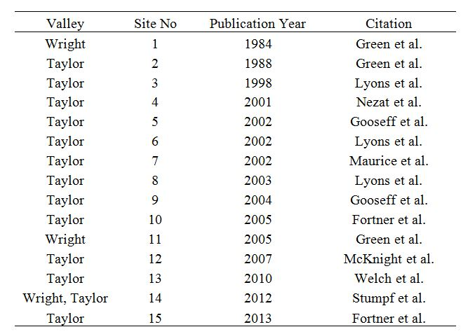

Table 4.2: Whole-rock geochemistry for sample sites in Wright and Taylor Valleys, Antarctica. Four samples collected within Blue Beaver Creek (RBB) in the Wichita Mountains, Oklahoma are included for comparison. CaO* refers to calcium corrected measurements based on the formula CaO* = CaO – (3.33*P₂O₅) to account for calcium bound in apatite (Girty et al., 2013).

 |  | Whole rock geochemistry (wt %)
Sample ID | Distance (km) | SiO₂ | Al₂O₃ | Fe₂O₃ | MgO | CaO | CaO* | Na₂O | K₂O | TiO₂ | P₂O₅
Wright Valley
CG-1 | 0 | 54.0 | 15.4 | 7.8 | 4.4 | 6.6 | 5.5 | 2.8 | 2.1 | 1.3 | 0.3
CG-2 | 0.4 | 55.2 | 16.2 | 8.4 | 3.9 | 5.4 | 4.3 | 2.9 | 2.6 | 1.4 | 0.3
CG-3 | 0.8 | 52.8 | 14.9 | 8.5 | 4.4 | 5.9 | 4.8 | 2.6 | 2.2 | 1.5 | 0.3
CG-4 | 1.4 | 51.9 | 12.5 | 11.6 | 6.4 | 7.8 | 6.2 | 2.2 | 1.5 | 2.8 | 0.5
CG-5 | 1.8 | 54.1 | 14.8 | 8.8 | 5.1 | 7.1 | 5.8 | 2.6 | 2.0 | 1.6 | 0.4
CG-6 | 2.3 | 53.1 | 14.4 | 8.8 | 5.0 | 7.0 | 5.7 | 2.6 | 1.9 | 1.7 | 0.4
CG-7 | 3.3 | 51.8 | 12.9 | 9.7 | 5.7 | 7.5 | 6.0 | 2.3 | 1.6 | 1.9 | 0.5
CG-8 | 3.7 | 53.7 | 13.7 | 8.8 | 5.5 | 7.5 | 6.3 | 2.4 | 1.7 | 1.5 | 0.4
CG-9 | 4.2 | 53.7 | 13.6 | 10.0 | 5.7 | 7.5 | 6.2 | 2.4 | 1.7 | 2.0 | 0.4
CG-10 | 4.7 | 53.5 | 13.0 | 10.1 | 6.4 | 8.4 | 6.8 | 2.3 | 1.5 | 1.9 | 0.5
CG Average |  | 53.4 | 14.1 | 9.2 | 5.3 | 7.1 | 5.8 | 2.5 | 1.9 | 1.8 | 0.4
Brownworth drift | 0.2 | 58.0 | 15.4 | 7.0 | 4.1 | 6.8 | 6.1 | 2.7 | 2.3 | 0.9 | 0.2
Taylor Valley
How-13 | 0.0 | 51.9 | 14.5 | 9.3 | 4.6 | 5.5 | 4.4 | 2.6 | 2.4 | 1.6 | 0.3
How-12 | 0.1 | 51.7 | 14.0 | 9.9 | 4.0 | 3.7 | 2.9 | 2.0 | 2.7 | 1.7 | 0.3
How-11 | 0.6 | 52.2 | 14.5 | 9.4 | 4.5 | 5.4 | 4.3 | 2.8 | 2.3 | 1.6 | 0.3
How-10 | 1.0 | 49.2 | 14.7 | 11.4 | 4.4 | 2.9 | 2.0 | 1.7 | 3.0 | 1.8 | 0.3
How-9 | 1.5 | 51.9 | 14.7 | 8.5 | 4.0 | 4.5 | 3.4 | 2.9 | 2.5 | 1.3 | 0.3
How-8 | 1.9 | 47.9 | 13.8 | 10.1 | 4.0 | 3.2 | 2.1 | 1.8 | 2.7 | 1.6 | 0.4
How-7 | 2.4 | 51.9 | 15.0 | 9.4 | 4.2 | 4.3 | 3.3 | 2.7 | 2.6 | 1.5 | 0.3
How-6 | 2.9 | 52.2 | 14.0 | 9.8 | 4.2 | 3.8 | 2.8 | 1.9 | 2.6 | 1.6 | 0.3
How-5 | 3.4 | 51.1 | 15.0 | 9.7 | 4.5 | 4.5 | 3.5 | 2.8 | 2.3 | 1.5 | 0.3
How-4 | 3.9 | 53.9 | 12.8 | 8.9 | 4.2 | 4.2 | 3.4 | 1.9 | 2.2 | 1.5 | 0.2
How-3 | 4.3 | 47.6 | 14.5 | 11.4 | 4.8 | 3.2 | 2.3 | 2.7 | 2.3 | 1.8 | 0.3
How-2 | 4.8 | 53.3 | 14.1 | 9.8 | 4.0 | 3.7 | 2.7 | 1.8 | 2.5 | 1.8 | 0.3
How Average |  | 51.2 | 14.3 | 9.8 | 4.3 | 4.1 | 3.1 | 2.3 | 2.5 | 1.6 | 0.3
DS-7 | 1.9 | 51.0 | 14.6 | 10.3 | 4.6 | 4.0 | 2.9 | 2.3 | 2.6 | 1.6 | 0.3
DS-4 | 3.1 | 43.5 | 12.1 | 8.8 | 4.3 | 5.8 | 4.3 | 1.8 | 2.3 | 1.4 | 0.5
DS-2 | 3.9 | 47.7 | 12.9 | 9.9 | 4.9 | 5.8 | 4.3 | 2.3 | 2.2 | 1.5 | 0.4
DS Average |  | 47.4 | 13.2 | 9.6 | 4.6 | 5.2 | 3.9 | 2.1 | 2.4 | 1.5 | 0.4
Ross Sea drift | 0.002 | 55.8 | 13.5 | 8.8 | 5.5 | 6.4 | 5.2 | 2.3 | 2.1 | 1.4 | 0.4
Gold-1 | 0.0 | 47.7 | 15.4 | 11.4 | 5.3 | 4.8 | 3.6 | 2.2 | 2.5 | 1.8 | 0.4
Gold-5 | 0.5 | 50.2 | 14.3 | 10.0 | 5.1 | 5.6 | 4.2 | 2.2 | 2.3 | 1.6 | 0.4
Gold-8 | 1.3 | 54.1 | 13.7 | 9.1 | 5.7 | 7.0 | 5.6 | 2.3 | 1.9 | 1.5 | 0.4
Gold Average |  | 50.7 | 14.5 | 10.2 | 5.4 | 5.8 | 4.5 | 2.3 | 2.2 | 1.7 | 0.4
Wichita Mountains
RBB 6 | 0 | 70.4 | 10.1 | 2.81 | 0.48 | 0.35 | 0.12 | 1.52 | 2.77 | 0.98 | 0.07
RBB 9 | 1.5 | 68.3 | 9.89 | 3.29 | 0.39 | 0.32 | 0.05 | 1.73 | 3.04 | 0.93 | 0.08
RBB 12 | 3 | 68.3 | 9.7 | 3.5 | 0.4 | 0.5 | 0.25 | 1.8 | 2.9 | 1.0 | 0.1
RBB 13 | 3.5 | 65.1 | 10.6 | 5.68 | 0.51 | 0.46 | 0.06 | 1.85 | 3.01 | 1.31 | 0.12
Wichita Avg |  | 68.0 | 10.1 | 3.8 | 0.4 | 0.4 | 0.1 | 1.7 | 2.9 | 1.1 | 0.1

Figure 4.1a and 4.1b: Location map of meltwater stream weathering studies in the McMurdo Dry Valleys (MDV). Numbered circles represent weathering studies (listed by corresponding number in Table 1), almost exclusively in the form of analyzed stream solute trends, that have been conducted within the stream transect. The positions of the numbered circles do not reflect actual sampling points but refer generally to the analyzed stream of interest. Additional studies involving the geochemical evolution of MDV lakes are not included. In Wright Valley, previous weathering studies are restricted to the Onyx River and the stream emanating from Clark Glacier. In Taylor Valley, previous weathering studies are concentrated within the Fryxell Basin drainage area, although multiple studies have been conducted throughout the valley, particularly in stream channels where flow is consistent during the Austral summer.

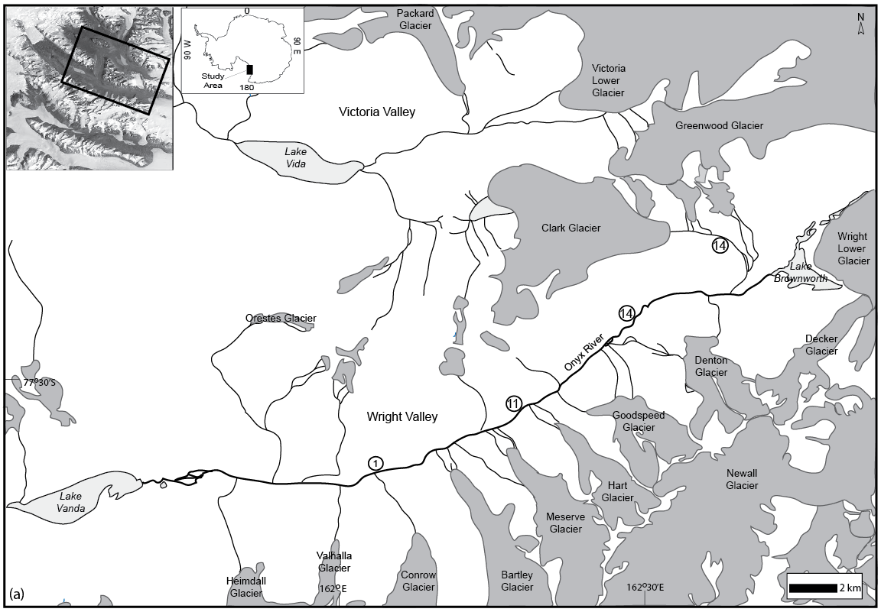

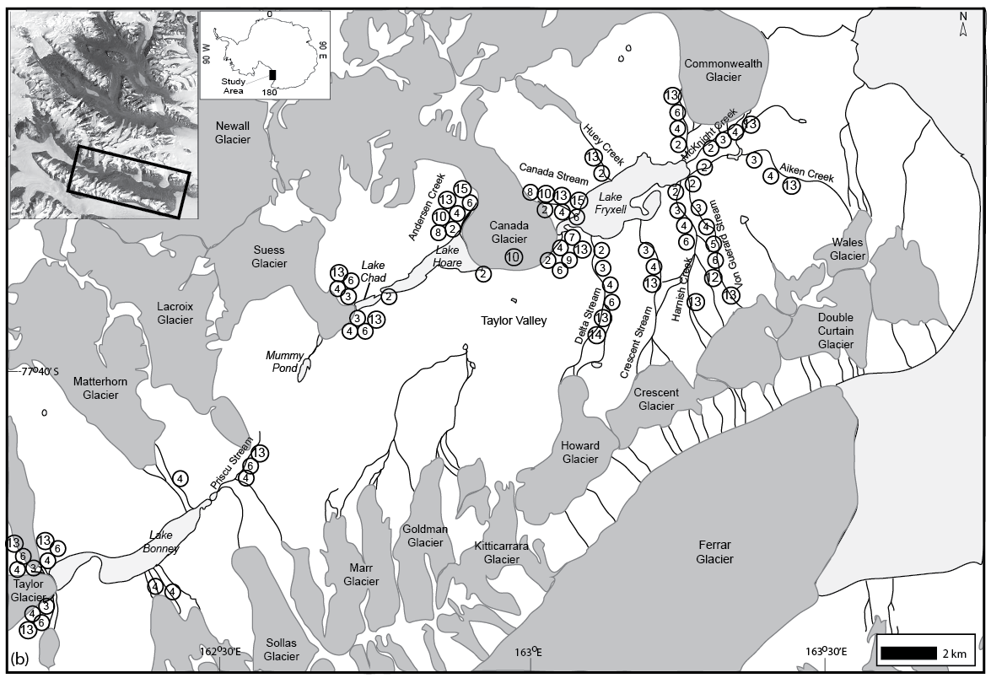

Figure 4.2: (a) Location map of sampling sites for this study in Wright Valley. “CG” refers to samples collected from the meltwater stream emanating from Clark Glacier. “Brown drift” refers to the representative sample collected from Brownworth drift. The underlying bedrock for the Clark Glacier stream is the Brownworth Pluton. Shaded polygons represent the mapped drift deposits (Hall and Denton, 2005) in the vicinity of Clark Glacier stream, which is directly underlain by Brownworth drift. (b) Location map of sampling sites for this study in Taylor Valley. “How” refers to samples collected from the meltwater stream emanating from Howard Glacier (formally named Delta Stream) during the 2009-2010 field season. “DS” refers to samples collected from Delta Stream during the 2012-2013 field season. These samples are underlain by bedrock composed of biotite orthogneiss and directly by Ross Sea drift (Hall et al., 2000). “Gold” refers to samples collected from the channel transect emanating from Goldman Glacier, which are underlain by undifferentiated pre-Bonney drift (Hall et al., 2000). No stream flow was observed in the Goldman Glacier stream transect.

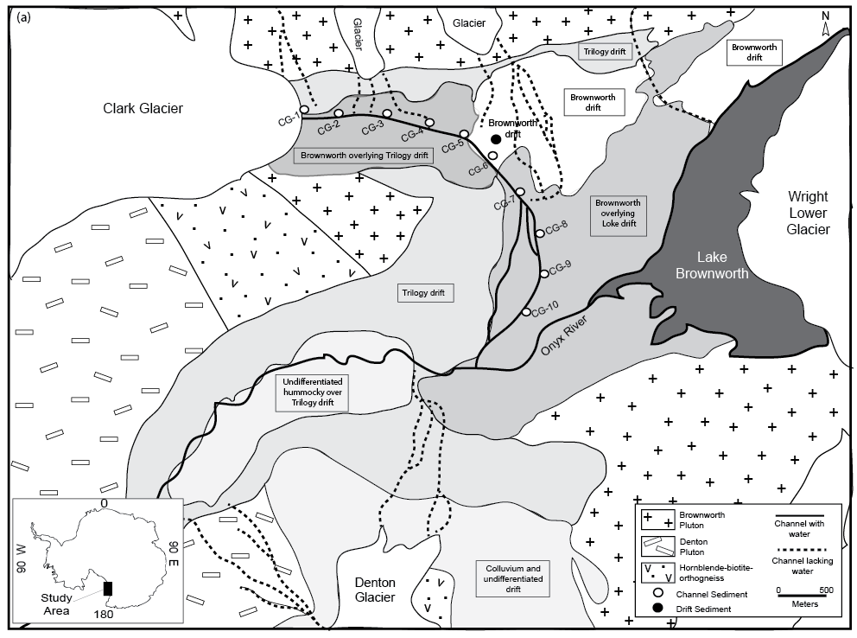

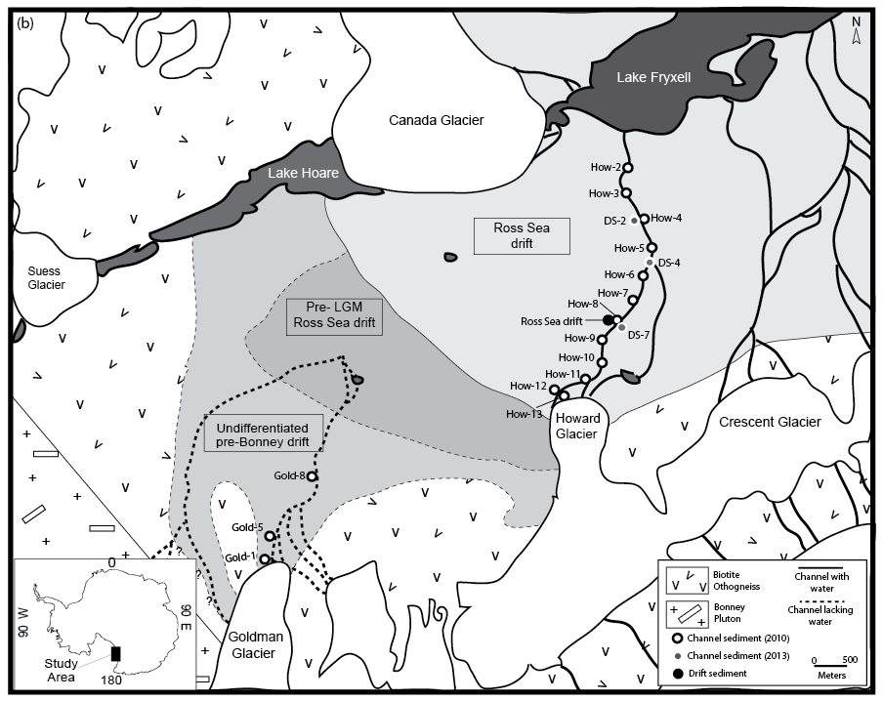

Figure 4.3: (a) Percentage of primary minerals versus phyllosilicates for Clark Glacier stream (diamonds) and Howard Glacier (Delta Stream, shown as squares) samples collected in 2010 as obtained via bulk quantitative XRD analysis. The percentages of primary minerals increase downstream in Clark stream and are greater in abundance compared to Delta Stream. Conversely, the percentage of phyllosilicates decreases in Clark stream with downstream distance and are lower in abundance than the phyllosilicates in Delta Stream. (b) Percentage of quartz in Clark Glacier and Delta stream samples along transect. The percentage of quartz increases downstream Clark but remains uniform in abundance in Delta Stream. (c) Percentage of feldspars (plagioclase and K-feldspar) in Clark Glacier and Delta stream samples along transect. The total percentage of feldspars decreases slightly downstream in Clark stream and increases slightly in Delta Stream with downstream distance. The relative percentage of feldspars in both stream transects is approximately equal. (d) Percentage of pyroxenes in Clark Glacier and Delta Stream samples along transect. The percentage of pyroxenes notably increases in Clark Glacier stream transect with downstream distance and is greater in abundance compared to Delta Stream. The percentage of pyroxenes slightly decreases in Delta Stream downstream.

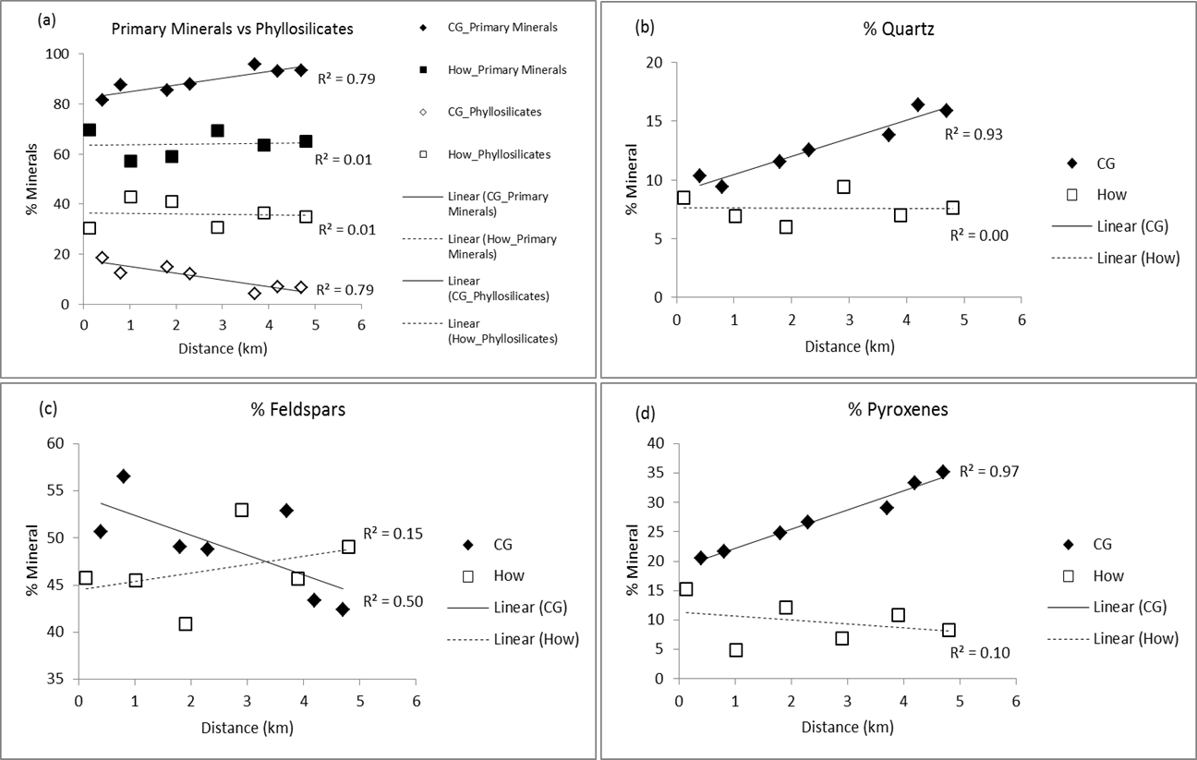

Figure 4.4a-g: Whole-rock geochemistry (in weight percent) of mud samples along transect. Drift samples are plotted to the right in each graph for comparison. In Clark stream, concentrations of Al, Na, and K decrease whereas Mg and Ca increase with downstream distance. In Delta Stream, Ca,Na, and K show a slight decrease in abundance downstream, although both Ca and Na exhibit a fairly erratic pattern along the stream transect.

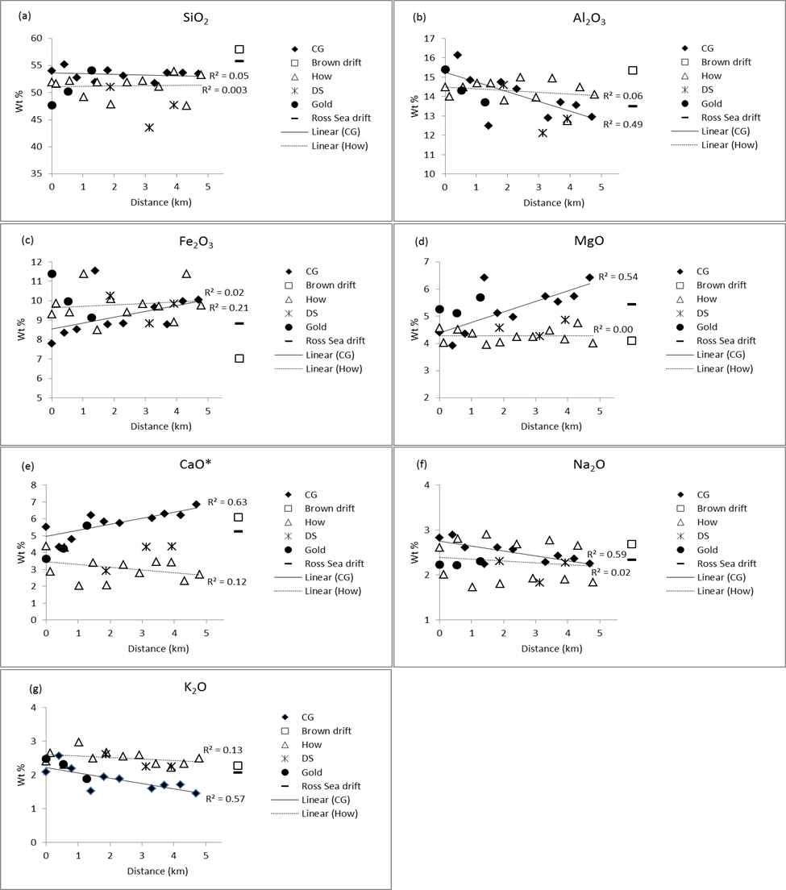

Figure 4.5: (a) The total percentage of the mud fraction (< 63µm) for each channel and drift sample as obtained by wet-sieving. Taylor Valley samples are generally finer-grained overall with a higher percentage of mud as compared to Wright Valley samples. (b) The percentage of silt and clay-sized material within the mud fraction as obtained by laser particle size analysis. Taylor Valley samples have a higher percentage of clay-size material within the mud fraction as compared to Wright Valley samples.

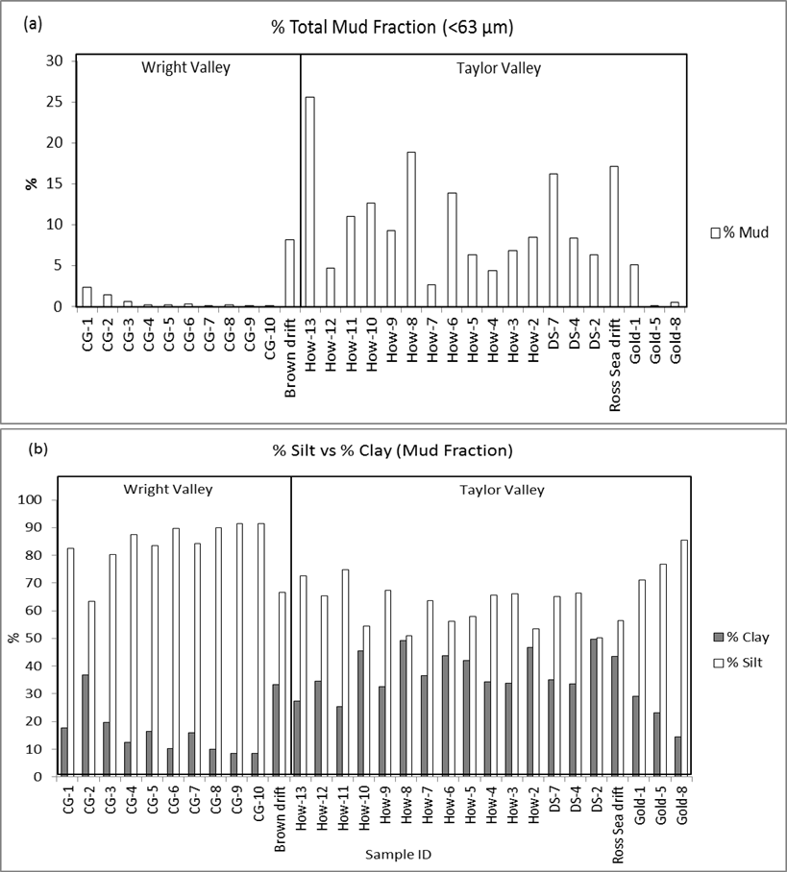

Figure 4.6a-g: Whole-rock geochemistry (in weight percent) versus BET surface area for each sample. R² values are shown for Clark Glacier and Delta stream samples collected in 2010. Concentrations of Mg and Ca decrease with increasing BET surface area in both Clark and Delta streams (d,e). Concentrations of Ca and Na exhibit the most pronounced loss with increasing BET surface area, particularly within Delta Stream where BET surface area is > 40 m²/g (e, f).

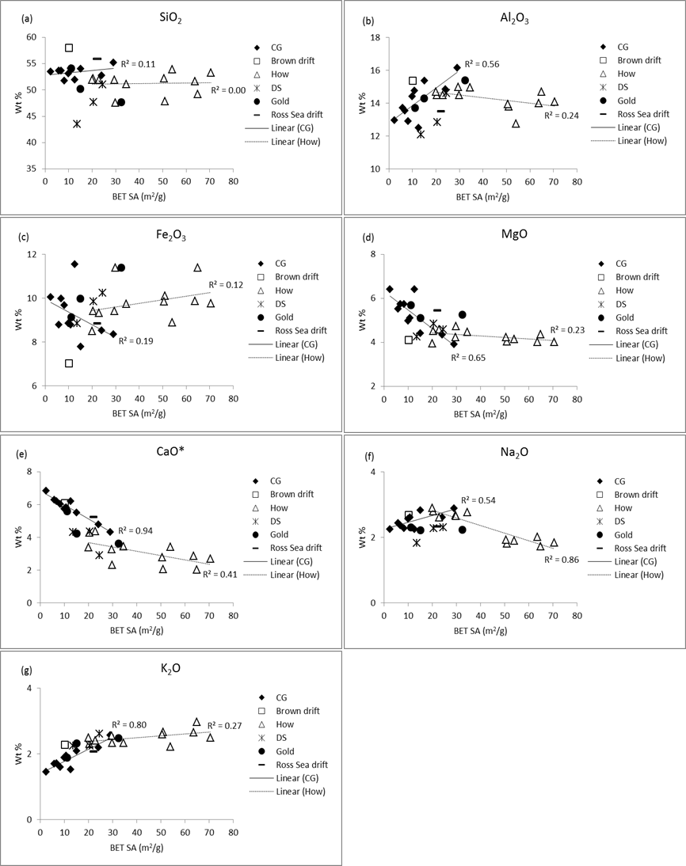

Figure 4.7: Weathering indices along transect. Drift samples are plotted to the right in each graph for comparison. Samples exhibiting some degree of weathering typically plot above a value of 50 (indicated by the dashed line) for the CIA, CIW, and PIA, whereas “weathered” samples plot below 100 for the WIP. (a) Chemical Index of Alteration (CIA = 100[Al₂O₃/(Al₂O₃ + CaO + Na₂O + K₂O)]). (b) Chemical Index of Weathering (CIW = 100[Al₂O₃/Al₂O₃ + CaO + Na₂O]). (c) Plagioclase Index of Alteration (PIA = 100[(Al₂O₃-K₂O)/(Al₂O₃ + CaO + Na₂O – K₂O)]). (d) Weathering Index of Parker (WIP = 100[(2Na₂O/0.35) + (MgO/0.9) + (2K₂O/0.25) + (CaO/0.7)]).

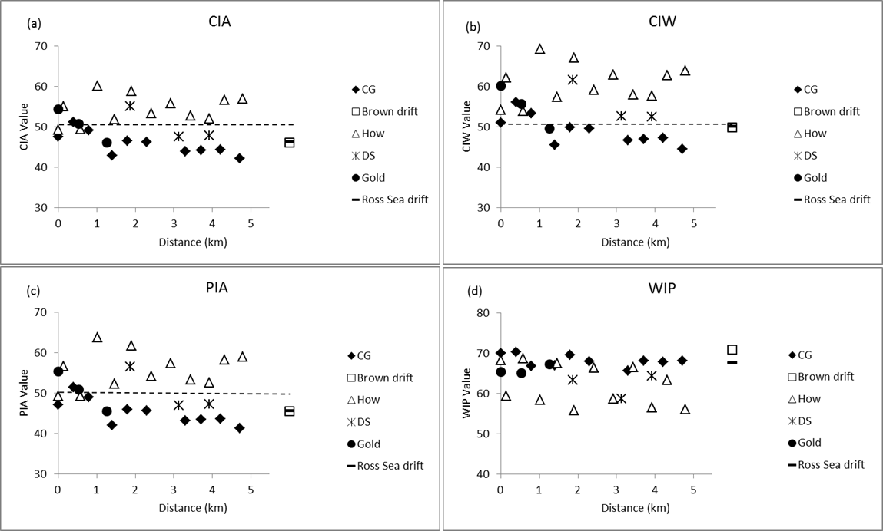

Figure 4.8: Weathering indices versus BET surface area for each sample. (a) Chemical Index of Alteration. (b) Chemical Index of Weathering. (c) Plagioclase Index of Alteration. (d) Weathering Index of Parker. All plots indicate that samples with higher BET surface area exhibit higher degrees of chemical weathering.

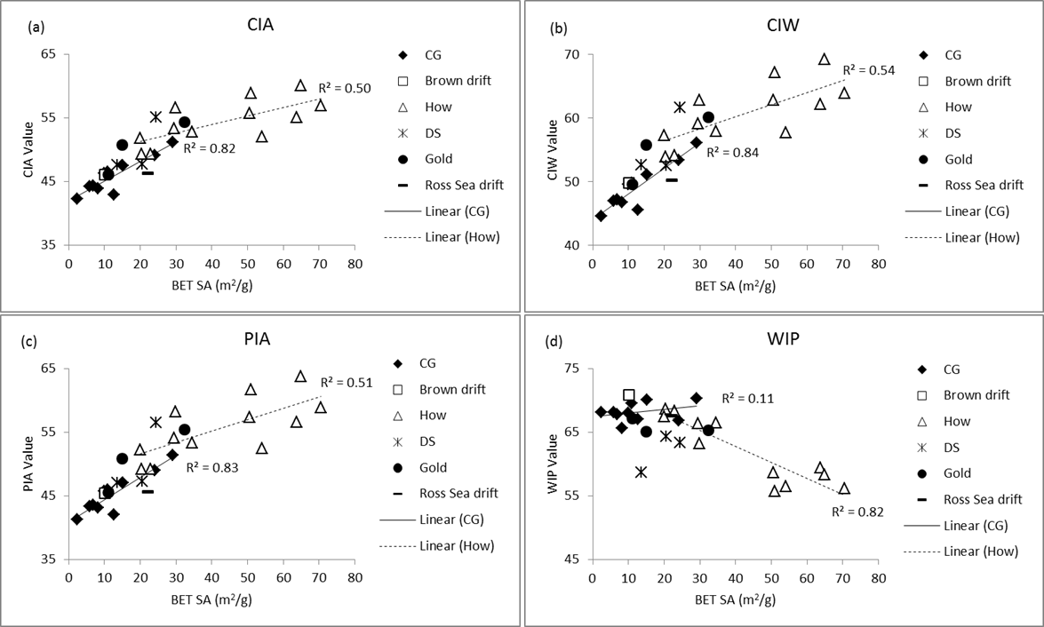

Figure 4.9: (a) MFW ternary plot of sediment, drift, and basement rock samples from Antarctica and the Wichita Mountains (Blue Beaver Creek) based on the method of Ohta and Arai (2007). Increasingly weathered samples plot toward the “W” apex. Samples from Delta Stream exhibit a stronger divergence toward the W pole in comparison to Wright Valley samples and their associated drift sample (Ross Sea drift), indicating a greater degree of chemical weathering in this system. Stream samples from Blue Beaver Creek exhibit a higher degree of weathering and the greatest deviation from their associated bedrock sample. (b) Close-up of MFW plot to highlight Antarctic stream and drift samples.

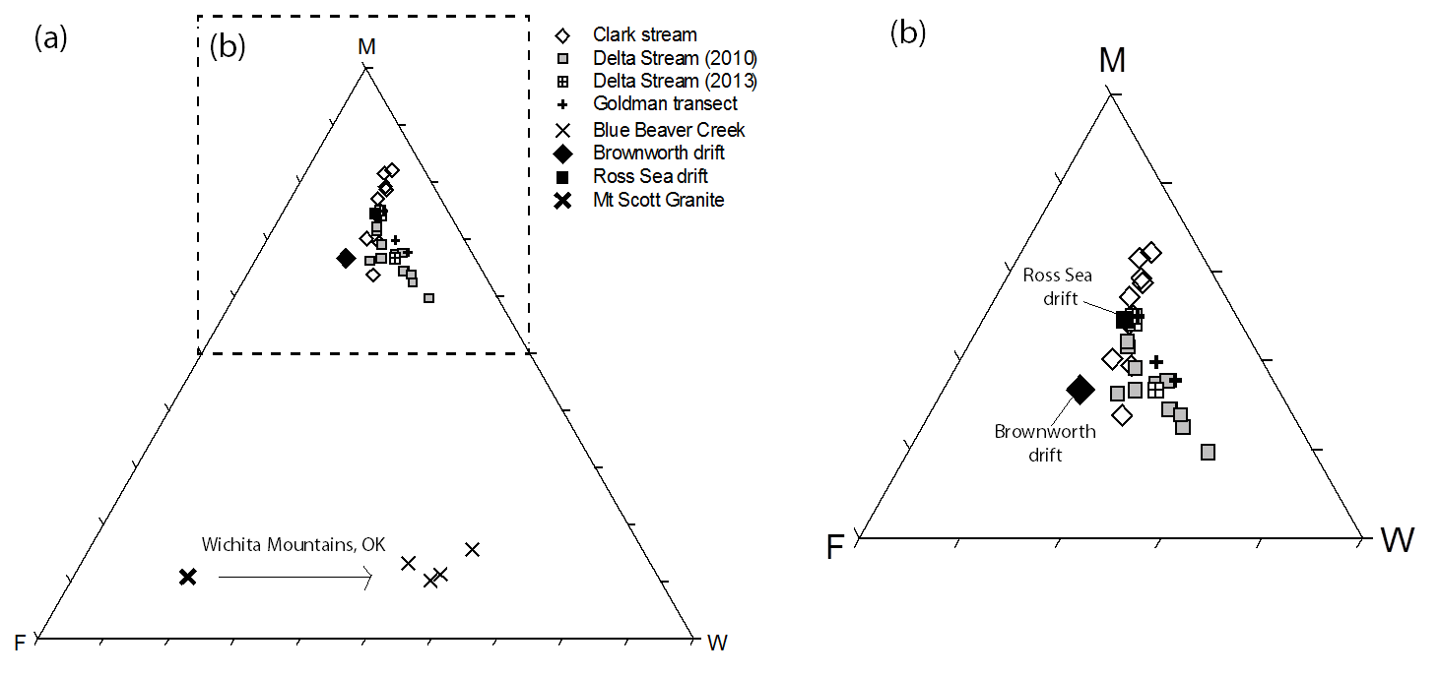

Figure 4.10: A-CN-K ternary diagram of sediment, drift, and basement rock samples from Antarctic and the Wichita Mountains (Blue Beaver Creek) in comparison to the Chemical Index of Alteration. Sediments from Delta Stream and Blue Beaver Creek exhibit a weak degree of weathering as compared to associated drift and bedrock samples, as well as Clark Glacier stream samples.

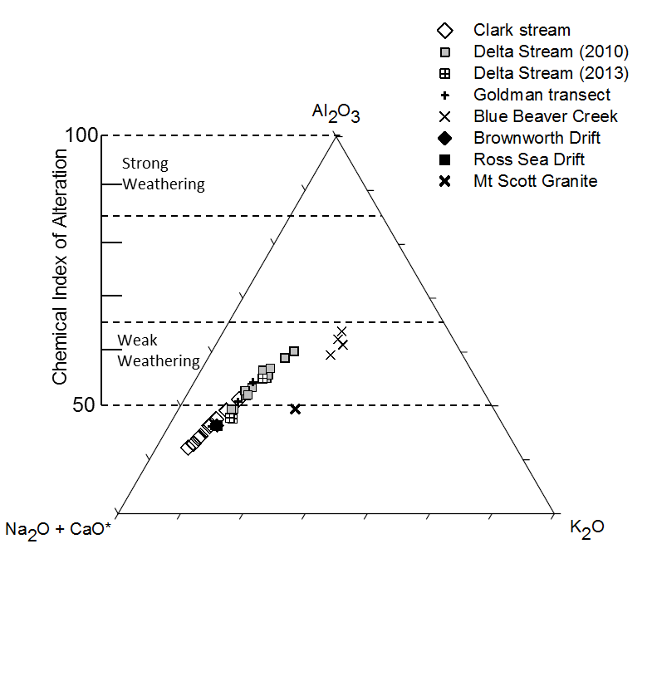

Figure 4.11: Stream pH measurements for Clark Glacier and Delta streams (2009-2010 field season). In Clark Glacier stream, pH ranges from 7.7-8.3 and decreases with downstream distance. In Delta Stream, pH ranges from 8.1-8.4 with no observable trend with downstream distance. Clark Glacier stream pH measurements were originally reported in Marra et al. (2014).

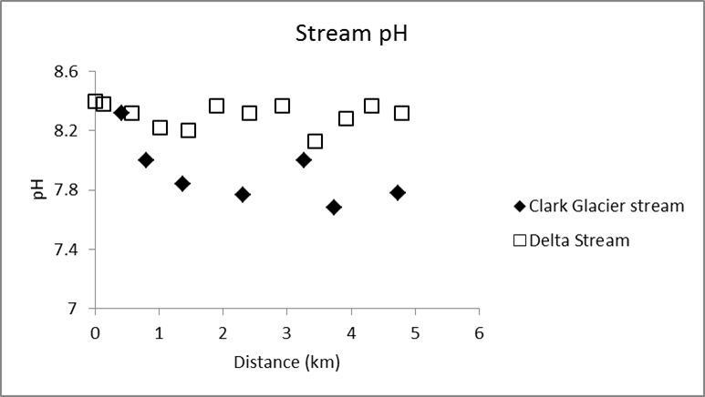

Figure 4.12: Mineral dissolution rates in mol/m²/second for albite, anorthite, potassium feldspar, diopside, and biotite at neutral and basic pH, which reflect the pH measured in the stream waters of Clark Glacier and Delta streams. Experimental rates compiled from Knauss et al. (1993), Brantley and Chen (1995), Palandri and Kharaka (2004), and Gudbrandsson et al. (2014). At neutral pH, dissolution proceeds at a higher rate for Ca-rich plagioclase (anorthite) and pyroxene (diopside).

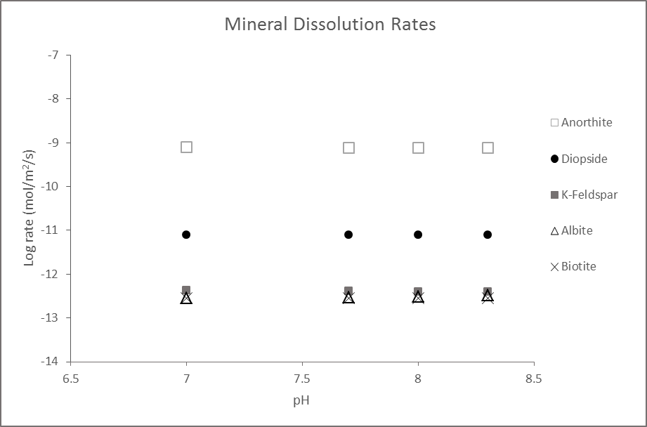

References
Anbeek, C., 1992, Surface roughness for minerals and implications for dissolution studies: Geochimica et Cosmochimica Acta, v.56, p.1461-1469.
Anbeek, C., 1993, The effect of natural weathering on dissolution rates: Geochimica et Cosmochimica Acta, v.57, p.4963-4975.
Anderson, S.P., Drever, J.I.,and Humphrey, N.F., 1997, Chemical weathering in glacial environments: Geology, v.25, no.5, p.399-402.
Anderson, S.P., 2005, Glaciers show direct linkage between rate and chemical weathering fluxes: Geomorphology, v.67, no.1-2, p.147-157.
Anderson, S.P., 2007, Biogeochemistry of glacial landscape systems: Annual Review of Earth and Planetary Sciences, v. 35, p. 375-399.
Atkins, C.B., 2014, Geomorphological evidence of cold-based glacier activity in South Victoria Land, Antarctica: Geological Society, London, Special Publications, v.381, p. 299-318.
Atkins, C.B., Barrett, P.J., and Hicock, S.R., 2002, Cold glaciers erode and deposit: evidence from Allan Hills, Antarctica: Geology, v.30, p.659-662.
Ayling, B.F., and McGowan, H.A., 2006, Niveo-eolian sediment deposits in Coastal South Victoria Land, Antarctica: Indicators of regional variability in weather and climate: Arctic, Antarctic, and Alpine Research: v.38, no.3, p.313-324.
Bagshaw, E.A., Tranter, M., Fountain, A.G., Welch, K.A., Basagic, H., and Lyons, W.B., 2007, Biogeochemical evolution of cryoconite holes on Canada Glacier, Taylor Valley, Antarctica: Journal of Geophysical Research, v.112, G04S35, doi: 10.1029/2007JG000442.
Barrett, J.E., Gooseff, M.N., and Takacs-Vesbach, C., 2009, Spatial variation in soil active-layer geochemistry across hydrologic margins in polar desert ecosystems: Hydrol. Earth Syst. Sci, v.13, p.2349-2358.
Bernasconi, S.M., Bauder, A., Bourdon, B., Brunner, I., Bunemann, E., et al., 2011, Chemical and biological gradients along the Damma Glacier soil chronosequence, Switzerland: Vadose Zone Journal, v.10, p.867-883.
Bertler, A.N., Mayewski, P.A., Barrett, P.J., Sneed, S.B., Handley, M.J., 2004, Monsoonal circulation of the McMurdo Dry Valleys, Ross Sea Region, Antarctica: signal from the snow chemistry: Annals of Glaciology, v.39, p.139-145.
Bishop, J.L., Engler, P.A.J., Patel, S., Tirsch, D., Roy, A.J., Koeberl, C., Bottger, U., Hanke, F., and Jaumann, R., 2014, Mineralogical analyses of surface sediments in the Antarctic Dry Valleys: coordinated analyses of Raman spectra, reflectance spectra and elemental abundances: Philosophical Transactions of the Royal Society A, v.372, http://dx.doi.org/10.1098/rsta.2014.0198.
Bockheim, J.G., Prentice, M.L., and McLeod, M., 2008, Distribution of glacial deposits, soils, and permafrost in Taylor Valley, Antarctica: Arctic, Antarctic, and Alpine Research, v.40, no.2, p.279-286.
Bockheim, J.G., 2013, Soil formation in the Transantarctic Mountains from the Middle Paleozoic to the Anthropocene: Palaeogeography, Palaeoclimatology, Palaeoecology, v.381-382, p.98-109.
Brantley, S.L., and Chen, Y., 1995, Chemical weathering rates of pyroxenes and amphiboles: Reviews in Mineralogy and Geochemistry, v.31, p.119-172.
Brunauer, S., Emmett, P.H., and Teller, E., 1938, Adsorption of gases in multimolecular layers: Journal of the American Chemical Society: v.60, p.309-319.
Campbell, I.B., and Claridge, G.C.C., 1982, The influence of moisture on the development of soils of the cold deserts of Antarctica: Geoderma, v.28, p.221-238.
Campbell, I.B., and Claridge, G.G.C., 2006, Permafrost properties, patterns, and processes in the Transantarctic Mountains region: Permafrost and Periglacial Processes, v.17, p.215-232.
Cardenas, A.A., Girty, G.H., Hanson, A.D., Lahren, M.M., Knaack, C., Johnson, D., 1996, Assessing differences in composition between low metamorphic grade mudstones and high-grade schists using logratio techniques: Journal of Geology, v.104, p.279-293.
Chinn, T.J., 1994, Glacier disequilibrium in the Convoy Range, Transantarctic Mountains, Antarctica: Annals of Glaciology, v.20, p.269-276.
Clow, G.D., McKay, C.P., Simmons, G.M., Wharton, R.A., 1988, Climatological observations and predicted sublimation rates at Lake Hoare, Antarctica: Journal of Climate, v. 1, p.715-728.
Conovitz, P.A., MacDonald, L.H., and McKnight, D.M., 2006, Spatial and temporal active layer dynamics along three glacial meltwater streams in the McMurdo Dry Valleys, Antarctica: Arctic, Antarctic, and Alpine Research, v. 38, no. 1, p. 42-53.
Cozzetto, K., McKnight, D., Nylen, T., and Fountain, A., 2006, Experimental investigations into the processes controlling stream and hyporheic temperatures, Fryxell Basin, Antarctica: Advances in Water Resources, v.29, p.130-153.
Cuffey, K.M., Conway, H., Gades, A.M., Hallet, B., Lorrain, R., Severinghaus, J.P., Steig, E.J., Vaughn, B., White, J.W.C., 2000, Entrainment at cold glacier beds: Geology, v.28, no.4, p.351-354.
Denton, G.H., and Sugden, D.E., 2005, Meltwater features that suggest Miocene ice-sheet overriding of the Transantarctic Mountains in Victoria Land, Antarctica: Geografiska Annaler Series A, v.87, no.1, p. 67-85.
Doran, P.T., McKay, C.P., Clow, G.D., Dana, G.L., Fountain, A.G., Nylen, T., Lyons, W.B., 2002, Valley floor climate observations from the McMurdo Dry valleys, Antarctica, 1986-2000: Journal of Geophysical Research, v.107, no.D24, doi: 10.1029/2001JD002045.
Doran, P.T., McKay, C.P., Fountain, A.G., Nylen, T., McKnight, D.M., Jaros, C., and Barrett, J.E., 2008, Hydrologic response to extreme warm and cold summers in the McMurdo Dry Valleys, East Antarctica: Antarctic Science, v.20, no.5, p.499-509.
Deuerling, K.M., Lyons, W.B., Welch, S.A., and Welch, K.A., 2014, The characterization and role of aeolian deposition on water quality, McMurdo Dry Valleys, Antarctica: Aeolian Research, v.13, p.7-17.
Fedo, C.M., Nesbitt, H.W., Young, G.M., 1995, Unraveling the effects of potassium metasomatism in sedimentary rocks and paleosols, with implications for paleoweathering conditions and provenance: Geology, v. 23, p. 921-924.
Fortner, S.K., Tranter, M., Fountain, A., Lyons, W.B., and Welch, K.A., 2005, The geochemistry of supraglacial streams of Canada Glacier, Taylor Valley (Antarctica), and their evolution into proglacial waters: Aquatic Geochemistry, v.11, p.391-412.
Fortner, S.K., Lyons, W.B., and Olesik, J.W., 2011, Eolian deposition of trace elements onto Taylor Valley Antarctic glaciers: Applied Geochemistry, v.26, p.1897-1904.
Fortner, S.K., Lyons, W.B., and Munk, L., 2013, Diel stream geochemistry, Taylor Valley, Antarctica: Hydrological Processes, v. 27, p. 394-404.
Fountain, A.G., Lyons, W.B., Burkins, M.B., Dana, G.L., Doran, P.T., Lewis, K.J. McKnight, D.M., Moorhead, D.L., Parsons, A.N., Priscu, J.C., Wall, D.H., Wharton Jr., R.A., Virginia, R.A., 1999, Physical controls on the Taylor Valley ecosystem: BioScience, v.49, no.12, p.961-971.
Fountain, A.G., Nylen, T.H., Tranter, M., and Bagshaw, E., 2008, Temporal variations in physical and chemical features of cryoconite holes on Canada Glacier, McMurdo Dry Valleys, Antarctica: Journal of Geophysical Research, v.113, G01S92, doi:10.1029/2007JG000430.
Gibson, E.K., Wentworth, S.J., and McKay, D.S., 1983, Chemical weathering and diagenesis of a cold desert soil from Wright Valley, Antarctica: an analog of martian weathering processes: Journal of Geophysical Research, v.88, p.A912-A928.
Girty, G.H., Colby,T.A., Rayburn, J.Z., Parizek, J.R., and Voyles, E.M., 2013, Biotite-controlled linear compositional weathering trends in tonalitic to quartz dioritic saprock, Santa Margarita Ecological Reserve, Southern California, USA: Catena, v.105, p.40-51.
Goldich, S.S., 1938, A study in rock weathering: Journal of Geology, v.46, p.17-58.
Gooseff, M.N., McKnight, D.M., Lyons, W.B., and Blum, A.E., 2002, Weathering reactions and hyporheic exchange controls on stream water chemistry in a glacial meltwater stream in the McMurdo Dry Valleys: Water Resources Research, v.38, p.1279.
Gooseff, M.N., Barrett, J.E., Doran, P.T., Fountain, A.G., Lyons, W.B., Parsons, A.N., Porazinska, D.L., Virginia, R.A., and Wall, D.H., 2003, Snow-patch influence on soil biogeochemical processes and invertebrate distribution in the McMurdo Dry Valleys, Antarctica: Arctic, Antarctic, and Alpine Research, v.35, no.1, p.91-99.
Gooseff, M.N., McKnight, D.M., Runkel, R.L., 2004, Reach-scale cation exchange controls on major ion chemistry of an Antarctic glacial meltwater stream: Aquatic Geochemistry, v.10, p.221-238.
Gooseff, M.N., McKnight, D.M., Doran, P., Fountain, A.G., and Lyons, W.B., 2011, Hydrological connectivity of the landscape of the McMurdo Dry Valleys, Antarctica: Geography Compass, v.5/9, p.666-681.
Gooseff, M.N., Barrett, J.E., and Levy, J.S., 2013, Shallow groundwater systems in a polar desert, McMurdo Dry Valleys, Antarctica: Hydrogeology Journal, v. 21, p.171-183.
Goudie, A.S., and Viles, H.A., 2012, Weathering and the global carbon cycle: geomorphological perspectives: Earth Science Reviews, v.113, p.59-71.
Green, W.J., Angle, M.P., and Chave, K.E., 1988, The geochemistry of Antarctic streams and their role in the evolution of four lakes of the McMurdo Dry Valleys: Geochimica et Cosmochimica Acta, v.52, p.1265-1274.
Green, W.J., Stage, B.R., Preston, A., Wagers, S., Schacat, J., and Newell, S., 2005, Geochemical processes in the Onyx River, Wright Valley, Antarctica: major ions, nutrients, trace metals: Geochimica et Cosmochimica Acta, v.69, no.4, p.839-850.
Gudbrandsson, S., Wolff-Boenisch, D., Gislason, S.R., and Oelkers, E.H., 2014, Experimental determination of plagioclase dissolution rates as a function of its composition and pH at 22 ºC: Geochimica et Cosmochimica Acta, v.139, p.154-172.
Hall, K., Thorn, C.E., Matsuoka, N., and Prick, A., 2002, Weathering in cold regions: some thoughts and perspectives: Progress in Physical Geography, v.26, no.4, p.577-603.
Hall, B.L., Denton, G.H., Hendy, C.H., 2000, Evidence from Taylor Valley for a grounded ice sheet in the Ross Sea, Antarctica: Geografiska Annaler, v.82A, no.2-3, p.275-303.
Hall, B.L., and Denton, G.H., 2005, Surficial geology and geomorphology of eastern and central Wright Valley, Antarctica: Geomorphology, v.64, p.25-65.
Harnois, L., 1988, The CIW index: a new Chemical Index of Weathering: Sedimentary Geology, v. 55, p. 319-322.
Horowitz, A.J., and Elrick, K.A., 1987, The relation of stream sediment surface area, grain size and composition to trace element chemistry: Applied Geochemistry, v.2, p.437-451.
Huh, Y., 2003, Chemical weathering and climate – a global experiment: a review: Geosciences Journal, v. 7, no.3, p.277-288.
Keiser, L.J., 2013, Physical and chemical weathering in modern and Permian proximal fluvial systems: PhD dissertation, University of Oklahoma, 155 pp.
Kelly, W.C., and Zumberge, J.H., 1961, Weathering of a quartz diorite at Marble Point, McMurdo Sound, Antarctica: Journal of Geology, v.69, p.433-446.
Keys, J.R., and Williams, K., 1981, Origin of crystalline, cold desert salts in the McMurdo region, Antarctica: Geochimica et Cosmochimica Acta, v.45, p.2299-2309.
Knauss, K.G., Nguyen, S.N., and Weed, H.C., 1993, Diopside dissolution kinetics as a function of pH, CO2, temperature, and time: Geochimica et Cosmochimica Acta, v.57, no.2, p.285-294.
Langford, Z.L., Gooseff, M.N., and Lampkin, D.J., 2014, Spatiotemporal dynamics of wetted soils across a polar desert landscape: Antarctic Science, doi:10.1017/S095410201400601.
Lasaga, A.C., Soler, J.M., Ganor, J., Burch, T.E., and Nagy, K.L., 1994, Chemical weathering rate laws and global geochemical cycles: Geochimica et Cosmochimica Acta, v.58, no.10, p.2361-2386.
Levy, J.S., Fountain, A.G., Gooseff, M.N., Welch, K.A., Lyons, W.B., 2011, Water tracks and permafrost in Taylor Valley, Antarctica: extensive and shallow groundwater connectivity in a cold desert ecosystem: Geological Society of America Bulletin, v.123, p.2295-2311.
Levy, J.S., Fountain, A.G., Welch, K.A., and Lyons, W.B., 2012, Hypersaline “wet patches” in Taylor Valley, Antarctica: Geophysical Research Letters, v.39, doi:10.1029/2012GL050898.
Lyons, W.B., Welch, K.A., Neumann, K., Toxey, J.K., McArthur, R., and Williams, C., 1998, Geochemical linkages among glaciers, streams, and lakes within the Taylor Valley, Antarctica: American Geophysical Union, doi:10.1029/AR072p0077.
Lyons,W.B., Nezat, C.A., Benson, L.V., Bullen, T.D., Graham, E.Y., Kidd, J., Welch, K.A., and Thomas, J.M., 2002, Strontium isotopic signatures of the streams and lakes of Taylor Valley, Southern Victoria Land, Antarctica: Chemical weathering in a polar climate: Aquatic Geochemistry, v. 8, p.75-95.
Lyons, W.B., Welch, K.A., Fountain, A.G., Dana, G.L., Vaughn, B.H., and McKnight, D.M., 2003, Surface glaciochemistry of Taylor Valley, southern Victoria Land, Antarctica and its relationship to stream chemistry: Hydrological Processes, v.17, p.115-130.
Macht, F., Eusterhues, K., Pronk, G.J., and Totsche, K.U., 2011, Specific surface area of clay minerals: Comparison between atomic force microscopy measurements and bulk-gas (N₂) and –liquid (EGME) adsorption methods: Applied Clay Science, v.53, p.20-26.
Marchant, D.R., Denton, G.H., Sugden, D.E., Swisher, C.C., 1993, Miocene glacial stratigraphy and landscape evolution of the Western Asgard Range, Antarctica: Geografiska Annaler Series A, v.75, no.4, p.303-330.
Marra, K.R., Soreghan, G.S., Elwood Madden, M.E., Keiser, L.J., and Hall, B.L., 2014, Trends in grain size and BET surface area in cold-arid versus warm semi-arid fluvial systems: Geomorphology, v.206, p.483-491.
Marra, K.R., Elwood Madden, M.E., Soreghan, G.S., and Hall, B.L., 2015, BET surface area distributions in polar stream sediments: implications for silicate weathering in a cold-arid environment: Applied Geochemistry, v.52, p.31-42.
Maurice, P.A., McKnight, D.M., Leff, L., Fulghum, J.E., and Gooseff, M., 2002, Direct observations of aluminosilicate weathering in the hyporheic zone of an Antarctic Dry Valley stream: Geochimica et Cosmochimica Acta, v.66, p.1335-1347.
McKnight, D.M., Niyogi, D.K., Alger, A.S., Bomblies, A., Conovitz, P.A., Tate, C.M., 1999, Dry Valley streams in Antarctica: ecosystems waiting from water: BioScience, v.49, no.12, p.985-995.
McKnight, D.M., Tate, C.M., Andrews, E.D., Niyogi, D.K., Cozzetto, K., Welch, K., Lyons, W.B., and Capone, D.G., 2007, Reactivation of a cryptobiotic stream ecosystem in the McMurdo Dry Valleys, Antarctica: a long-term geomorphological experiment: Geomorphology, v.89, no.1-2, p.186-204.
McKnight, D.M., 2014, McMurdo Dry Valleys Delta Stream gauge measurements: Long Term Ecological Research Network. http://dx.doi.org/10.6073/pasta/9f247ee16c26cf9bbc715d53356d6629
Mikucki, J.A., Auken, E., Tulaczyk, S., Virginia, R.A., Schamper, C., Sorensen, K.I., Doran, P.T., Dugan, H., and Foley, N., 2015, Deep groundwater and potential subsurface habitats beneath an Antarctic dry valley: Nature Communications, doi: 0.1038/ncomms7831.
Nesbitt, H.W., and Young, G.M., 1982, Early Proterozoic climates and plate motions inferred from major element chemistry of lutites: Nature, v. 299, p.715-717.
Nesbitt, H.W., and Young, G.M., 1984, Prediction of some weathering trends of plutonic and volcanic rocks based on thermodynamic and kinetic considerations: Geochimica et Cosmochimica Acta, v.48, p.1523-1534.
Nezat, C.A., Lyons, W.B., and Welch, K.A., 2001, Chemical weathering in streams of a polar desert (Taylor Valley, Antarctica): Geology, v.113, no.11, p.1401-1408.
Nowak, A., and Hodson, A., 2014, Changes in meltwater chemistry over a 20-year period following a thermal regime switch from polythermal to cold-based glaciation at Austre Broggerbreen, Svalbard: Polar Research, v. 33, http://dx.doi.org/10.3402/polar.v33.22779.
Ohta, T., and Arai, H., 2007, Statistical empirical index of chemical weathering in igneous rocks: a new tool for evaluating the degree of weathering: Chemical Geology, v. 240, p. 280-297.
Palandri, J.L., and Kharaka, Y.K., 2004, A compilation of rate parameters of water-mineral interaction kinetics for application to geochemical modeling: U.S. Geological Survey OF 2004-1068, 64 pp.
Parker, A., 1970, An index of weathering for silicate rocks: Geological Magazine, v.107, p.501-504.
Price, J.A., and Velbel, M.A., 2003, Chemical weathering indices applied to weathering profiles developed on heterogeneous felsic metamorphic rocks: Chemical Geology, v. 202, p. 397-416.
Putkonen, J., Moran, D., and Balco, G., 2014, Boulder weathering in McMurdo Dry Valleys, Antarctica: Geomorphology, v.219, p.192-199.
Rawlins, B.G., Turner, I.G., and Mountenay, G.W., 2010, Estimating specific surface area of fine stream bed sediments from geochemistry: Applied Geochemistry, v. 25, p. 1291-1300.
Sabacka, M., Priscu, J.C., Basagic, H.J., Fountain, A.G., Wall, D.H., Virginia, R.A., Greenwood, M.C., 2012, Aeolian flux of biotic and abiotic material in Taylor Valley, Antarctica: Geomorphology, v.155-156, p. 102-111.
Sepala, M., 2004, Wind as a geomorphic agent in cold climates: Cambridge University Press, Cambridge, 358 pp.
Speirs, J.C., McGowan, H.A., and Neil, D.T., 2008, Polar eolian sand transport: Grain characteristics determined by an automated scanning electron microscope (QEMSCAN®): Arctic, Antarctic, and Alpine Research, v.40, no.4, p.731-743.
Steinhoff, D.F., Bromwich, D.H., Speirs, J.C., McGowan, H.A., Monaghan, A.J., 2014, Austral summer foehn winds over the McMurdo dry valleys of Antarctica from Polar WRF: Quarterly Journal of the Royal Meteorological Society, doi: 10.1002/qj.2278.
Stumpf, A.R., Elwood-Madden, M.E., Soreghan, G.S., Hall, B.L., Keiser, L.J., and Marra, K.R., 2012, Glacier meltwater stream chemistry in Wright and Taylor Valleys, Antarctica: Significant roles of drift, dust, and biological processes in chemical weathering in a polar climate: Chemical Geology, v.322-323, p. 79-90.
Sugden, D.E., Bentley, M.J., and Cofaigh, C.O., 2006, Geological and geomorphological insights into Antarctic ice sheet evolution: Phil. Trans. R. Soc. A., v.364, p.1607-1625.
Toner, J.D., Sletten, R.S., Prentice, M.L., 2013, Soluble salt accumulations in Taylor Valley, Antarctica: implications for paleolakes and Ross Sea Ice Sheet dynamics: Journal of Geophysical Research, v.118, p.198-215.
Tranter, M., 2006, Sediment and solute transport in glacial meltwater streams: Encyclopedia of Hydrological Sciences, 169 p.
Ugolini, F.C., and Anderson, D.M., 1973, Ionic migration and weathering in frozen Antarctic soils: Soil Science, v.115, p.461-470.
Velbel, M.A., 1993, Temperature dependence of silicate weathering in nature: how strong a negative feedback on long-term accumulation of atmospheric CO₂ and global greenhouse warming?: Geology, v.21, p.1059-1062.
Welch, K.A., Lyons, W.B., Whisner, C., Gardner, C.B., Gooseff, M.N., McKnight, D.M., Priscu, J.C., 2010, Spatial variations in the geochemistry of glacial meltwater streams in the Taylor Valley: Antarctic Science, v.22, no.6, p.662-672.
Williamson, B.R., Kreutz, K.J., Mayewski, P.A., Bertler, N.A.N., Sneed, S., Handley, M., and Introne, D., 2007, A coastal transect of McMurdo Dry Valleys (Antarctica) snow and firn: marine and terrestrial influences on glaciochemistry: Journal of Glaciology, v.53, no.183, p.681-693.
Witherow, R.A., Lyons, W.B., Bertler, N.A., Welch, K.A., Mayewski, P.A., Sneed, S.B., Nylen, T., Handley, M.J., Fountain, A., 2006, The aeolian flux of calcium, chloride, and nitrate to the McMurdo Dry Valleys landscape: evidence from snow pit analysis: Antarctic Science, v.18, p.497-505.
White, A.F., and Blum, A.E., 1995, Effects of climate on chemical weathering in watersheds: Geochimica et Cosmochimica Acta, v.59, no.9, p.1729-1747.

Chapter 5: Summary
This study integrated grain-size, BET surface area, and whole-rock geochemistry of the fine-grained (<63 µm; mud) sediment fraction of polar stream sediments in the McMurdo Dry Valleys (MDV), Antarctica to evaluate the controls on chemical weathering in a cold-based glacial environment. Chemical weathering rates are typically dominantly influenced by temperature and precipitation (i.e., climate), though recent work has demonstrated that sediment surface area may be a key control on chemical weathering rates, particularly in wet-based glacial systems (Huh, 2003; Nowak and Hodson, 2014). However, the nature of chemical weathering in sediments derived from cold-based glacial systems has remained relatively unexplored. The results from this study demonstrated key differences in the nature of chemical weathering between multiple sites in the MDV related to varying glacial drift lithology, glacial drift origin, wind regimes, and stream-flow rates between Wright and Taylor Valleys.
In Wright Valley (Clark Glacier stream), drift sediments were typically coarser-grained, with minimal mud content, likely related to the cold-based nature of drift deposition in this valley. BET surface area values of the fine-grained sediment fraction ranged between 2.0-29.0 m²/g. Mineralogy consisted primarily of pyroxenes, quartz, and feldspars, where the percentages of quartz and pyroxenes increased with downstream distance and percentage of feldspars decreased. This pattern is attributed to eolian processes, where lighter, more felsic minerals (such as feldspars) are likely concentrated on the surface of the glacier and released into the active hyporheic zone during summer meltwater flow. Chemical weathering was minimally detectable in these sediments, further suggesting that chemically weathered sediment may remain concentrated on the surface of the glacier based on timing of incipient meltwater flow and/or that the fine-grained fraction is experiencing complete dissolution in this system.
In Taylor Valley, fine-grained sediments collected from Delta Stream in 2010 were much finer (i.e., a higher overall clay-sized sediment content within the mud fraction), with high but variable BET surface areas that ranged from 19.9-70.6 m²/g. The finer-grained nature of the drift (Ross Sea drift) in this valley is likely related to partial wet-based deposition, where additional incorporation of marine muds occurred during Ross Sea ice incursion. The mineralogy of the fine-grained sediment was relatively uniform over the course of the stream transect, but this system had a higher percentage of phyllosilicates (30-43%) as compared to sediments collected from Clark Glacier stream (4-18%). Chemical weathering was more pronounced in these sediments, particularly where elemental concentrations of Na and Ca were low, suggesting alteration and pitting of feldspars and pyroxenes. In addition to etch pitting, the development of amorphous and clay mineral phases is also occurring and may be a factor contributing to the high surface area in this system. Additional Delta Stream samples collected during 2013 had lower BET surface area values (13.6-30.5 m²/g), suggesting that flushing of fine-grained, high surface area material occurred in the hyporheic zone during higher discharge rates and demonstrates the critical control of variable stream discharge, as well as eolian dispersal patterns, on the distribution of fine-grained sediment in the MDV.

Recommendations
Overall, this study demonstrates that chemical weathering is occurring in fine-grained stream sediments in the McMurdo Dry Valleys, as evidenced by both stream ion concentrations and elemental variations in fine-grained stream sediments (Green et al., 1988; Lyons et al., 1998; Nezat et al., 2001; Gooseff et al., 2002; Lyons et al., 2002; Lyons et al., 2003; Gooseff et al., 2004; Green et al., 2005; Fortner et al., 2005; Welch et al., 2010; Stumpf et al., 2012; Fortner et al., 2013; Marra et al., 2014; Marra et al., 2015). Despite the prevalent use of common weathering indices, ternary analyses (i.e., A-CN-K and MFW plots) may be better suited to demonstrate the nature of weathering in glacial systems. However, the extent of chemical weathering in the MDV appears variable among the sampling sites utilized in this study; therefore, the following recommendations are provided to bolster understanding of chemical weathering in cold-based glacial systems:
- Analyze additional sediment fractions beyond the fine-grained (<63 µm) fraction to determine differences in weathering among various sediment grain sizes;
- Analyze eolian sediment from both the glacier surface and from elevated sediment traps from within the hyporheic zone to determine the influence of eolian dispersal patterns and the nature of chemical weathering prior to sediment inclusion into the active reaches of the hyporheic zone;
- Analyze sediment from channel transects in western valley stream systems to further compare differences in climate variations (i.e., aridity), as well as drift compositions, along the length of each valley;
- Analyze sediment over a greater temporal range in order to gain a clearer understanding of the links among variable stream discharge rates, eolian dispersal patterns, and drift compositions on chemical weathering in MDV sediments.

References
Fortner, S.K., Tranter, M., Fountain, A., Lyons, W.B., and Welch, K.A., 2005, The geochemistry of supraglacial streams of Canada Glacier, Taylor Valley (Antarctica), and their evolution into proglacial waters: Aquatic Geochemistry, v.11, p.391-412.

Fortner, S.K., Lyons, W.B., and Munk, L., 2013, Diel stream geochemistry, Taylor Valley, Antarctica: Hydrological Processes, v. 27, p. 394-404.

Gooseff, M.N., McKnight, D.M., Lyons, W.B., and Blum, A.E., 2002, Weathering reactions and hyporheic exchange controls on stream water chemistry in a glacial meltwater stream in the McMurdo Dry Valleys: Water Resources Research, v.38, p.1279.

Gooseff, M.N., McKnight, D.M., Runkel, R.L., 2004, Reach-scale cation exchange controls on major ion chemistry of an Antarctic glacial meltwater stream: Aquatic Geochemistry, v.10, p.221-238.

Green, W.J., Angle, M.P., and Chave, K.E., 1988, The geochemistry of Antarctic streams and their role in the evolution of four lakes of the McMurdo Dry Valleys: Geochimica et Cosmochimica Acta, v.52, p.1265-1274.

Green, W.J., Stage, B.R., Preston, A., Wagers, S., Schacat, J., and Newell, S., 2005, Geochemical processes in the Onyx River, Wright Valley, Antarctica: major ions, nutrients, trace metals: Geochimica et Cosmochimica Acta, v.69, no.4, p.839-850.

Huh, Y., 2003, Chemical weathering and climate – a global experiment: a review: Geosciences Journal, v. 7, no.3, p.277-288.

Lyons, W.B., Welch, K.A., Neumann, K., Toxey, J.K., McArthur, R., and Williams, C., 1998, Geochemical linkages among glaciers, streams, and lakes within the Taylor Valley, Antarctica: American Geophysical Union, doi:10.1029/AR072p0077.

Lyons,W.B., Nezat, C.A., Benson, L.V., Bullen, T.D., Graham, E.Y., Kidd, J., Welch, K.A., and Thomas, J.M., 2002, Strontium isotopic signatures of the streams and lakes of Taylor Valley, Southern Victoria Land, Antarctica: Chemical weathering in a polar climate: Aquatic Geochemistry, v. 8, p.75-95.

Lyons, W.B., Welch, K.A., Fountain, A.G., Dana, G.L., Vaughn, B.H., and McKnight, D.M., 2003, Surface glaciochemistry of Taylor Valley, southern Victoria Land, Antarctica and its relationship to stream chemistry: Hydrological Processes, v.17, p.115-130.
Marra, K.R., Soreghan, G.S., Elwood Madden, M.E., Keiser, L.J., and Hall, B.L., 2014, Trends in grain size and BET surface area in cold-arid versus warm semi-arid fluvial systems: Geomorphology, v.206, p.483-491.

Marra, K.R., Elwood Madden, M.E., Soreghan, G.S., and Hall, B.L., 2015, BET surface area distributions in polar stream sediments: implications for silicate weathering in a cold-arid environment: Applied Geochemistry, v.52, p.31-42.

Nowak, A., and Hodson, A., 2014, Changes in meltwater chemistry over a 20-year period following a thermal regime switch from polythermal to cold-based glaciation at Austre Broggerbreen, Svalbard: Polar Research, v. 33, http://dx.doi.org/10.3402/polar.v33.22779.

Stumpf, A.R., Elwood-Madden, M.E., Soreghan, G.S., Hall, B.L., Keiser, L.J., and Marra, K.R., 2012, Glacier meltwater stream chemistry in Wright and Taylor Valleys, Antarctica: Significant roles of drift, dust, and biological processes in chemical weathering in a polar climate: Chemical Geology, v.322-323, p. 79-90.

Welch, K.A., Lyons, W.B., Whisner, C., Gardner, C.B., Gooseff, M.N., McKnight, D.M., Priscu, J.C., 2010, Spatial variations in the geochemistry of glacial meltwater streams in the Taylor Valley: Antarctic Science, v.22, no.6, p.662-672.

Appendix A: Replicate BET runs for select samples

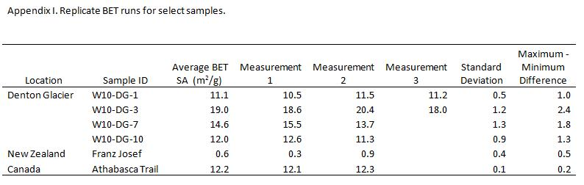

Appendix B: BET measurements for processed and non-processed sediment

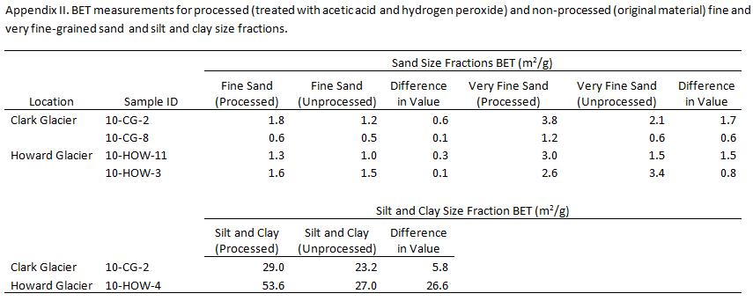

Appendix C: BET surface area measurements and weathering index values for Wright and Taylor Valley sample sites
Sample ID | Distance (km) | BET SA (m²/g) | CIA | CIW | PIA | WIP
Wright Valley
CG-1 | 0.0 | 15.1 | 47.5 | 51.1 | 47.1 | 70.1
CG-2 | 0.4 | 29.0 | 51.2 | 56.1 | 51.4 | 70.3
CG-3 | 0.8 | 24.0 | 49.1 | 53.3 | 49.0 | 66.9
CG-4 | 1.4 | 12.6 | 43.0 | 45.6 | 42.1 | 67.0
CG-5 | 1.8 | 10.8 | 46.5 | 49.8 | 46.0 | 69.5
CG-6 | 2.3 | 9.9 | 46.3 | 49.5 | 45.7 | 68.0
CG-7 | 3.3 | 8.3 | 44.0 | 46.7 | 43.2 | 65.7
CG-8 | 3.7 | 5.9 | 44.2 | 47.0 | 43.4 | 68.1
CG-9 | 4.2 | 6.9 | 44.4 | 47.2 | 43.6 | 67.9
CG-10 | 4.7 | 2.5 | 42.2 | 44.5 | 41.4 | 68.2
Brown Drift | 0.2 | 10.1 | 46.1 | 49.8 | 45.5 | 70.9
Taylor Valley
How-13 | 0.0 | 22.9 | 49.4 | 54.2 | 49.2 | 68.3
How-12 | 0.1 | 63.6 | 55.1 | 62.1 | 56.6 | 59.5
How-11 | 0.6 | 20.3 | 49.4 | 53.9 | 49.2 | 68.7
How-10 | 1.0 | 64.8 | 60.2 | 69.3 | 63.8 | 58.4
How-9 | 1.5 | 19.9 | 51.9 | 57.3 | 52.3 | 67.5
How-8 | 1.9 | 51.0 | 58.9 | 67.2 | 61.8 | 55.8
How-7 | 2.4 | 29.5 | 53.4 | 59.2 | 54.2 | 66.4
How-6 | 2.9 | 50.5 | 55.8 | 62.8 | 57.4 | 58.7
How-5 | 3.4 | 34.5 | 52.8 | 58.0 | 53.4 | 66.6
How-4 | 3.9 | 54.0 | 52.0 | 57.7 | 52.5 | 56.5
How-3 | 4.3 | 29.9 | 56.6 | 62.8 | 58.2 | 63.3
How-2 | 4.8 | 70.6 | 57.0 | 64.0 | 58.9 | 56.2
DS-7 | 1.9 | 24.5 | 55.1 | 61.7 | 56.5 | 63.4
DS-4 | 3.1 | 13.6 | 47.6 | 52.6 | 47.0 | 58.8
DS-2 | 3.9 | 20.6 | 47.8 | 52.5 | 47.3 | 64.4
HOW8-Drift | 0.002 | 22.1 | 46.3 | 50.2 | 45.7 | 67.6
Gold-1 | 0.0 | 32.4 | 54.4 | 60.1 | 55.4 | 65.3
Gold-5 | 0.5 | 15.0 | 50.8 | 55.7 | 50.9 | 65.1
Gold-8 | 1.3 | 11.1 | 46.1 | 49.5 | 45.5 | 67.2

