University of Oklahoma

Graduate College

exploratory analyses of patterns of depressive symptomatology and heart-healthy behaviors in cardiac patients

A thesis

submitted to the graduate faculty

in partial fulfillment of the requirements for the

Degree of

Master of Science

By

CHRISTOPHER WHITE
Norman, Oklahoma
2022

Exploratory analyses of patterns of depressive symptomatology and heart-healthy behaviors in cardiac patients

A thesis approved for the
department of health and exercise science

by the committee consisting of

Dr. Julie Ober-Allen, Chair

Dr. Hugo Pereira

Dr. Yu Lu

© Copyright by CHRISTOPHER WHITE 2022
All Rights Reserved.

Table of Contents

Abstract…………………………………………………………………………………………vi
Chapter 1: Introduction…………………………………………………………………………1
Introduction to the Problem…………………………………………………………….1
Purpose of Study………………………………………………………………………. 3
Research Questions……………………………………………………………………. 3
Significance……………………………………………………………………………. 4
Delimitations……………………………………………………………………………5
Limitations……………………………………………………………………………...5
Assumptions…………………………………………………………………………….5
Operational Definitions…………………………………………………………………5
Chapter 2: Literature Review…………………………………………………………………...7
Introduction……………………………………………………………………………..7
Cardiac Rehabilitation: Structure, Benefits, Utilization………………………………..7
Depression, Cardiac Patients, and Cardiac Rehabilitation………………………….…..9
Heart-Healthy Behaviors & Their Relationships to Mental Health…………………….10
Physical Activity………………………………………………………………………..11
Less Healthy Diet……………………………………………………………………….12
Excess Alcohol Use…………………………………………………………………….12
Sex Differences…………………………………………………………………………13
Research Gap…………………………………………………………………………...13
Chapter 3: Methodology………………………………………………………………………..15
Introduction……………………………………………………………………………..15
Data Source……………………………………………………………………………..15
Data Collection………………………………………………………………………….16
Sample…………………………………………………………………………………..16
Instrumentation………………………………………………………………………….17
Measures………………………………………………………………………………...17
Data Analysis…………………………………………………………………………....20
Chapter 4: Results……………………………………………………………………………….23
Introduction………………………………………………………………………….......23
Chapter 5: Discussion…………………………………………………………………………...47
Introduction……………………………………………………………………………...47
Results Summary………………………………………………………………………..47
Implications and Recommendations for Practice………………………………………..48
Limitations……………………………………………………………………………….51
Summary…………………………………………………………………………………51
References……………………………………………………………….……………………….53
Appendix A: Patient Health Questionnaire-9…………………………………………………....65
Appendix B: Heart-Healthy Behavior Questions………………………………………………..66
Appendix C: Depressive Symptomatology Variable…………………………………………….68
Appendix D: Less Healthy Diet Variable (Scale)……………………………………….……….72

List of Tables and Figures
Table 1: Key Variables Tables…………………………………………………………………22
Table 2: Baseline Participant Characteristics…………………………………………………..24
Table 3: Baseline Participant Characteristics by Sex…………………………………………..26

Figure 1: Baseline Participant Health Outcomes……………………………………………….25
Figure 2: Patterns of Depressive Symptomatology Over Time………………………………...27
Figure 3: Patterns of Physical Activity Over Time……………………………………………..28
Figure 4: Patterns of Less Healthy Diet Over Time…………………………………………….29
Figure 5: Patterns of Excess Alcohol Use Over Time…………………………………………..30
Figure 6: Patterns of Within Wave Depressive Symptomatology by Physical Activity………..31
Figure 7: Patterns of Within Wave Depressive Symptomatology by Less Healthy Diet……….32
Figure 8: Patterns of Within Wave Depressive Symptomatology By Excess Alcohol Use…….33
Figure 9: Patterns of Depressive Symptomatology for Men Over Time………………………..34
Figure 10: Patterns of Depressive Symptomatology for Women Over Time…………………...35
Figure 11: Patterns of Physical Activity for Men Over Time………………...…………………36
Figure 12: Pattern of Physical Activity for Women Over Time…………………………………36
Figure 13: Pattern of Men Eating a Less Healthy Diet Over Time………………………….…..38
Figure 14: Patterns of Women Eating a Less Healthy Diet Over Time………………………….38
Figure 15: Patterns of Excess Alcohol Use for Men Over Time………………………………...39
Figure 16: Patterns of Excess Alcohol Use for Women Over Time……………………………..40
Figure 17: Patterns of Within Wave Depressive Symptomatology by Physical Activity for Men…………………………………………………………………………………..41
Figure 18: Patterns of Within Wave Depressive Symptomatology by Physical Activity for Women…………………………………………………………………………….…42
Figure 19: Patterns of Within Wave Depressive Symptomatology by Less Healthy Diet for
Men…………………………………………………………………………………...43
Figure 20: Patterns of Within Wave Depressive Symptomatology by Less Healthy Diet for Women….……………………………………………………………………………44
Figure 21: Patterns of Within Wave Depressive Symptomatology by Excess Alcohol Use for Men………………………………………………………………………………….45
Figure 22: Patterns of Within Wave Depressive Symptomatology by Excess Alcohol Use for Women……………………………………………………………………………....45

Abstract
This study explored how depressive symptoms in cardiac patients changed in relation to their performance of health behaviors in the year following completion of cardiac rehabilitation. Extensive graphing and nonparametric tests were used on a longitudinal dataset collected from a cohort of cardiac rehabilitation patients to analyze how patterns of depressive symptomatology trended in relation to patterns of physical activity, diet, and alcohol use over time. An exploratory focus of this study assessed possible sex-based differences in these patterns. Results showed that depressive symptomatology decreased in the year following cardiac rehabilitation independently of diet or alcohol use. Patients who reported higher depressive symptomatology consistently reported lower frequencies of physical activity. Women reported higher depressive symptomatology than men over time. Further studies are warranted to elucidate how male and female cardiac patients differ in their manifestations of depressive symptomatology and the relationships between depression and health behaviors promoted in cardiac rehabilitation.

Chapter 1
Introduction
Introduction to the Problem
Depression is prevalent in those with cardiovascular conditions such as acute coronary syndrome and coronary artery disease (Dhar & Barton, 2016; Murphy et al., 2020), but is also common following major cardiac events, such as heart attacks and cardiac surgeries (Centers for Disease Control and Prevention, 2021; Murphy et al., 2016). For example, as many as 40% of patients experience depression following a heart attack (Celano & Huffman, 2011). Depression is associated with an increased risk of mortality, reduced quality of life, and increased risk of developing coronary heart disease, if not already present (Dhar & Barton, 2016; Kachur et al., 2016).
As a standard part of treatment following a major cardiac event, cardiac rehabilitation provides an opportune context for addressing ongoing issues with depression among cardiac patients. While screening and treating depression are not standard components of cardiac rehabilitation programs (Cahill et al., 2015), these programs do promote the adoption of many heart-healthy lifestyle and behavior changes, such as physical activity and eating a healthy (low in sugar and fat) diet, known to benefit mental health (Dutheil, 2015). Questions remain, however, about whether heart-healthy behaviors are associated with lower levels of depression among cardiac rehabilitation patients, especially in the months following the intensive portion of cardiac rehabilitation programs when participation in heart-healthy behaviors may wane.
Cardiovascular disease is one of the most common types of illness. In 2016, roughly 120 million U.S. adults were reported having cardiovascular disease in the form of coronary heart disease, heart failure, stroke, and hypertension (Benjamin et al., 2020). Individuals with these conditions often require medical intervention (e.g., surgery, medication, etc.) combined with education and support to facilitate heart-healthy lifestyle changes. Recommended heart-healthy lifestyle changes include improvements in diet, physical activity levels, stress management and cessation of tobacco and excess alcohol use. Many cardiac patients are referred to cardiac rehabilitation (rehab) programs for assistance with making these types of changes. Cardiac rehab programs are covered by health insurance and typically involve multiple outpatient visits each week for 12 weeks (Centers for Disease Control and Prevention, 2021). These programs feature regimens for enhancing physical function through intensive exercise and weight loss programs, reducing risk of future cardiac events, and reducing stress (Agency for Healthcare and Research Benefits, 2019; American Heart Association, 2016.; Centers for Disease Control and Prevention, 2020a; Milani & Lavi, 2007). These programs have been effective at reducing mortality following a major heart event and the likelihood of hospital readmission as well as improving quality of life (Balady et al., 2011; American Heart Association, 2016).
While depression is a common problem following a serious heart event (Centers for Disease Control and Prevention, 2021; Murphy et al., 2016; Murphy et al., 2020) and a risk factor for future adverse cardiac outcomes (Kachur et al., 2016), it is not a major emphasis in cardiac rehab programs. Perhaps reflective of this, there is a dearth of literature documenting patterns of patient depressive symptomatology during and after the conclusion of cardiac rehab. Additionally, while the heart-healthy behaviors promoted during cardiac rehab may plausibly have protective effects on mood, this has not been clearly established, particularly following the completion of cardiac rehabilitation if patients do not maintain these health behaviors once outside of a supervised, intensive cardiac rehab program (Pinto et al., 2013; Laursen et al., 2021). The current exploratory study sought to address these gaps.
Purpose of Study
The purpose of this study was to investigate the relationship between patterns of patient depressive symptomatology and maintenance of heart-healthy behaviors in the 12 months after individuals completed cardiac rehabilitation. This research entailed secondary analysis of detailed data collected from 77 participants in a longitudinal panel study called the Cardiac Rehabilitation And The Experience (CREATE).
Research Questions
The research questions being explored in this study are as follows:
RQ1: What are patterns of depressive symptomatology in the 12 months following completion of cardiac rehabilitation?
H1: Patterns in depressive symptomatology will increase over time following completion of cardiac rehabilitation.
RQ2: What are patterns of heart-healthy behaviors (physical activity, healthy diet, avoidance of excess alcohol use) in the 12 months following completion of cardiac rehabilitation?
H1: Frequency of physical activity will decrease over time following completion of cardiac rehabilitation.
H2: Consumption of an unhealthy (high fat/high sugar) diet will increase over time following completion of cardiac rehabilitation.
H3: Excess alcohol use will become increasingly common over time following completion of cardiac rehabilitation.
RQ3: How do patterns of depressive symptomatology in the 12 months following the completion of cardiac rehabilitation relate to patterns of heart-healthy behaviors?
H1: Higher depressive symptomatology will be linked to less frequent physical activity.
H2: Higher depressive symptomatology will be linked to greater consumption of an unhealthy (high fat/high sugar) diet.
H3: Higher depressive symptomatology will be linked to excess alcohol use.
RQ4 (Exploratory): Do patterns of depressive symptomatology, patterns of heart healthy behaviors, and their relationships with one another vary as a function of sex in the 12 months following completion of cardiac rehabilitation?
H1: There will be a difference in patterns of depressive symptomatology in the 12 months following completion of cardiac rehabilitation by sex, such that women will report more depression at all time points than men.
H2: There will be a difference in patterns of heart-healthy behaviors over time by sex, such that women will have greater decreases in physical activity over time than men and men will have greater increases in unhealthy (high fat/high sugar diet) and excess alcohol use than women.
Significance
By investigating the relationship between heart-healthy behaviors and patterns of patient depressive symptoms after completing cardiac rehabilitation, this study can contribute to literature on how health behaviors affect mental health following a major cardiac event. While depression is not a major emphasis in cardiac rehab programs, we will investigate the extent to which core components of cardiac rehab, namely heart-healthy behaviors, have unanticipated benefits in improving the emotional well-being of cardiac patients. Further, the nature of associations between patterns of behavior and patterns of depression post-rehab may be used to justify and inform the addition of depression screening and treatment to cardiac rehabilitation and post-rehabilitation checkups.
Delimitations
Eligibility criteria for the study included being 18 years old or older, not under the care of a legal guardian and having been referred to cardiac rehabilitation in the University of Michigan Healthcare System. Due to this study using secondary data analysis, these delimitations are derived from the original CREATE study.
Limitations
Limitations of the study include the use of a predominantly White and male convenience sample (though this is consistent with the characteristics of cardiac rehab patients across the US; Fang et al, 2017; Ritchey et al., 2020), modest sample size, and attrition over the six waves of data collection. Another limitation includes a lack of access to the specific protocol used at the cardiac rehabilitation facility.
Assumptions
Assumptions include that all participants answered honestly in interviews and that the number of participants is sufficient for drawing conclusions.
Operational Definitions
Depressive symptomatology: Depressive symptoms as indicated by the 9-item Patient Health Questionnaire (PHQ-9; Kroenke et al., 2001).
Heart-Healthy Behaviors: Behaviors promoted in cardiac rehabilitation that are conducive to improved cardiac health. This includes physical activity, a healthy diet (diet low in sugar and fat), and avoidance of excess alcohol use.
Patterns of Depressive Symptomatology: The trends of depressive symptomatology scores in the 12 months following completion of cardiac rehabilitation.
Patterns of Heart-Healthy Behavior: The frequency that a patient performs a behavior to improve their heart health/reduce cardiac risk in the 12 months following completion of cardiac rehabilitation.

Chapter 2
Literature Review
Introduction
The purpose of this study was to investigate the relationship between cardiac patients’ patterns of depressive symptomatology in the 12 months after completing cardiac rehabilitation and heart-healthy behaviors, namely physical activity, healthy diet, and avoidance of excess alcohol use. Previous studies have analyzed depression and anxiety in cardiac patients over the course of outpatient cardiac rehab programs to assess if symptoms had improved or worsened (Milani & Lavi, 2007; Rao et al., 2019). Studies have also compared depression and anxiety symptoms between male and female patients and assessed sex differences in completion of outpatient programs in relation to those symptoms (Yohannes et al., 2010). Few studies have assessed changes in depressive symptomatology post cardiac rehabilitation. Further, questions remain regarding how the maintenance of heart-healthy behaviors promoted in rehabilitation, or lack thereof, relate to patterns of depressive symptomatology following cardiac rehabilitation. The first section of this literature review explains the structure and use of cardiac rehabilitation. The second section summarizes the literature on relationships between depression, cardiac patients, and cardiac rehabilitation. The third section details how the health behaviors of interest relate to depressive symptomatology. The final section reviews sex differences related to these issues.
Cardiac Rehabilitation: Structure, Benefits, Utilization
Cardiac rehabilitation is a multiphase intervention program for treating patients who have incurred a major cardiac event or procedure. An event that regularly qualifies patients for rehabilitation is acute myocardial infarction (heart attack), but others include percutaneous coronary intervention (coronary angioplasty), coronary bypass grafting, coronary heart disease, heart failure, angina, cardiac transplantation, and valvular heart disease (Bethell et al., 2008; American Heart Association, 2016). Rehabilitation consists of three phases: hospitalization after the acute event, the use of an intensive outpatient program, and post-rehabilitation in which the patient monitors and independently manages their condition (Bethell et al., 2008; Tessler & Bordoni, 2021). This post-rehab phase is the primary focus of the current study.
Cardiac rehab programs in the United States commonly include an initial patient assessment, active management of risk factors (e.g., smoking, weight, diabetes), nutritional counseling, mental health counseling, vocational counseling, and regular physical exercise with the assistance of a personal trainer or rehab specialist. The Centers for Disease Control and Prevention identifies several health benefits to rehabilitation including strengthening the body after a heart event, improving adherence to medication, and stress reduction (2021). Although rehabilitation programs can reduce mortality by over 50%, utilization rates remain low as only 24.4% of eligible beneficiaries participate in outpatient programs (American Heart Association, 2016; Ritchey et al., 2020). Similarly, Fang et al. (2017) found that no state in the U.S. had utilization rates over 61% and that women, Blacks, Hispanics, and adults with no health insurance were less likely to use cardiac rehabilitation. Common barriers to utilization include lack of patient knowledge and awareness, lack of insurance coverage, limited referral of services, distance between patient home and facility, lack of perceived need, and conflicts with other patient responsibilities (Fang et al., 2017; American Heart Association, 2016). In total, roughly 6.5% of eligible patients both attend and complete the recommended amount of rehabilitation sessions (Ritchey et al., 2020).

Depression, Cardiac Patients, and Cardiac Rehabilitation
Depression is a mood disorder that affects how a person thinks, feels, and acts and is the result of abnormalities in the neurochemical systems of the brain. Noradrenaline, dopamine, and serotonin are of particular interest in depression research as these chemicals are directly involved with energy, pleasure, and feelings of well-being (Kaltenboeck & Harmer, 2018). There are different forms of the disorder, but common symptoms include persistent sadness, anxiousness, loss of interest in hobbies and daily activities, and reduced energy (National Institute of Mental Health, 2018). Much of the published literature on this topic and referenced in this review use the term depression. Depression is often used as a broad term referencing the mood-related changes characterized above. It is, however, important to identify distinctions between a major depressive disorder and depressive symptomatology. Major depressive disorder refers to a clinically diagnosable disorder according to the Diagnostic and Statistical Manual of Mental Disorders, Fifth Edition (DSM-5). Depressive symptomatology refers to common symptoms associated with depression that may range in severity and include levels either above or below the threshold required for a clinical diagnosis of major depressive disorder (Bains & Abdijadid, 2021). While the remainder of this literature review reflects the more general use of the term depression, subsequent chapters will attend to these definitional distinctions.
Among mental health conditions, depression is particularly severe in its implications for cardiac patients. Notably, depression is a strong predictor of death in patients who have coronary heart disease and doubles mortality when compared to patients without depression (May et al., 2017). In relation to patients who have had a serious cardiac event, the prevalence of depression is roughly three times higher than in the general population (Huffman et al., 2013). When compared to nondepressed patients, cardiac patients with depression are more likely to smoke, eat unhealthy foods, and be less physically active (Murphy et al., 2016; Pajak et al., 2012).
Earlier studies have found that patients with depression were less likely to adhere to treatment and attend cardiac rehabilitation programs (Blumenthal et al. 1999; Kronish et al. 2006). These studies have also found that patients who do attend are more likely to discontinue cardiac rehab if depression is present (Blumenthal et al. 1999; Kronish et al. 2006; Pardaens et al. 2017. Similarly, Rao and colleagues (2019) found that 1 in 5 cardiac patients had moderate to extreme depression. Roughly half of the patients with moderate depression did not improve by the end of their programs (Rao et al., 2019). These studies seem to suggest that those who would benefit most from attending cardiac rehabilitation may drop out before rehabilitation can be effective, but the literature is rather nuanced. Other studies have found that when depression and/or anxiety were present, it resulted in greater patient participation in cardiac rehabilitation, not less (Pederson et al., 2018; Krishnamurthi et al., 2019). When patients attend programs to completion, improvements in quality of life, physical activity status, anxiety, and depression can be expected; however, if depression is still present after completing rehabilitation, it may be accompanied by other forms of psychological stress and greater mortality (Kachur et al., 2016; Yohannes et al., 2017).
Heart-Healthy Behaviors & Their Relationships to Mental Health
While a variety of heart healthy behaviors are promoted in cardiac rehab, this literature review focuses on three of the most prominent behaviors, which are also directly related to the current study: physical activity, consumption of a healthy diet, and avoidance of excess alcohol use.

Physical Activity
The World Health Organization (2020b) defines physical activity as any bodily movement that requires energy expenditure and includes activities like walking, cycling, sports, and exercise. It is recommended that adults aged 18-64 years remain physically active anywhere from 150 to 300 minutes a week to prevent and manage heart disease (Centers for Disease Control and Prevention, 2020b; World Health Organization, 2020b). Because of this, physical activity is the linchpin of most cardiac rehabilitation programs with aerobic exercise as a common method for improving patient heart conditions (Pinto et al., 2011). Physical activity in the form of exercise also poses multiple psychological benefits, namely an increase in dopamine synthesis which promotes maintenance of exercise habits and reductions in depression (Matta Mello Portugal et al., 2013). However, depression can also be a barrier to physical activity, and this can make long-term maintenance challenging. Depression has been found to negatively affect one’s physical functioning (Wierenga et al., 2019) and roughly 50% to 75% of cardiac patients fail to maintain their prescribed exercise program the year following cardiac rehab (Pinto et al., 2013). In fact, there has been research suggesting that this decline in maintenance occurs as soon as 6 months after completing rehabilitation for patients with fewer environmental resources for exercise (Perez et al., 2016).
Less Healthy Diet
An unhealthy diet is a risk factor for a host of cardiac diseases. Diets high in sugar, salt, and saturated fat can cause cholesterol to build in the arteries and obstruct blood flow, which can lead to atherosclerosis, stroke, and myocardial infarction (U.S. National Library of Medicine, 2020). For that reason, cardiac rehabilitation facilities focus heavily on modifying patient dietary habits through education, counseling, and the prescription of diet plans relevant to the patient’s condition and possible comorbidities (Balady et al., 2007). Successful changes to a patient’s diet can dramatically improve physical health and possibly mental health. Consumption of a high-fat, high-calorie diet is associated with poor mental health outcomes (Dutheil, 2015). Foods that do not provide adequate amounts of vitamins, fatty acids, and dietary oxidants may lead to the onset or worsening of depression as these organic compounds are needed for the upregulation of dopamine and serotonin (Huang et al., 2019). Because of this, poor eating patterns may be more causal to depression than one would assume.
Excess Alcohol Use
Excessive alcohol use is a well-known contributor to the progression of heart disease. According to the Centers for Disease Control and Prevention (2020c), excessive alcohol use is synonymous with heavy drinking which is categorized as more than 7 drinks per week for a woman and 14 drinks per week for a man (Centers for Disease Control and Prevention (CDC), 2020c; National Institute on Alcohol Abuse and Alcoholism, 2020). While excessive alcohol use can lead to the development of noncommunicable diseases like cardiomyopathy, numerous studies throughout the years have found that drinking in moderation (i.e., less than 2 drinks for men and 1 for women) can be cardioprotective (Klatsky, 1999; Collins, 2009; Ding et al., 2021). Because of this precarious threshold for alcohol consumption, teaching patients to drink in moderation as a lifestyle intervention is a core component of cardiac rehabilitation (Balady et al., 2007). Excessive alcohol use is known to co-occur with depression and is more likely in women with cardiovascular conditions and comorbid depression (Boden & Ferguson, 2011; Cramer et al., 2018; McHugh & Weiss, 2019). Further, long-term consumption of alcohol can affect serotonin levels and potentially lead to the onset of or exacerbate depression (Banerjee, 2014).

Sex Differences
There is previous research that has investigated differences between men and women in heart conditions, depressive symptomatology, and heart-healthy behaviors. Clinical evidence has found that men are more likely to experience adverse heart conditions such as heart attacks or coronary heart disease, but women are more likely to die following an acute cardiovascular event (Gao et al., 2019). Women also generally develop coronary heart disease at older ages than men and with higher fatality rates when compared to men of the same age (Maas & Appelman, 2010; Gao et al., 2019).
Women tend to have higher rates of depression than men in general and in post-cardiac event populations (Salk et al., 2017). Previous studies have found that women with coronary heart disease can experience more depressive symptomatology than men after a cardiac event and continue to experience this up to two years afterwards (Buckland et al., 2019).
In terms of heart-healthy behaviors, women have healthier eating habits as they eat more fruits, vegetables, and whole food when compared to men, but they are also more likely to eat sweets and cakes than men (Masella & Malorni, 2017). Men are, however, more likely to eat foods with greater fat and protein content and drink more wine, beers, and spirits (Celyan-Isik, 2010; Masella & Malorni, 2017). Men also report greater alcohol consumption than women, but this gap may be shrinking as alcohol consumption has declined in men but increased in women in recent years (White, 2020).
Research Gap
The main gap in the research findings is that a large portion of the literature only analyzes patterns of depressive symptomatology through the duration of the intensive cardiac rehab outpatient phase. These studies focus on whether patients utilize cardiac rehabilitation and the benefits associated with doing so. Less is known about depressive symptomatology post-rehabilitation and how maintenance, or lack thereof, of heart-health behaviors emphasized within rehab may relate to depressive symptomatology post-rehabilitation.

Chapter 3
Methodology
Introduction
The purpose of this study was to investigate the relationship between patterns of patient depressive symptomatology and the maintenance of heart-healthy behaviors in the 12 months after individuals completed cardiac rehabilitation. This study entailed secondary analysis of data collected from 77 participants in the longitudinal CREATE panel study. Secondary data analysis is a cost-efficient method for using previously collected data to address new research questions or to provide a more detailed analysis of the primary results from the original study (Cheng 2014).
Data Source
Cardiac Rehabilitation And The Experience (CREATE) is a cohort panel study with longitudinal data on depressive symptomatology and heart-healthy behaviors, making it suitable for secondary analysis to address the research questions in this study. The study was directed by James S. Jackson at the University of Michigan and aimed to explore relationships between stress and coping, health behavior and health behavior change, and mental and physical health outcomes in older adults who recently experienced an acute heart problem. The study was designed to test Jackson’s Environmental Affordances Framework (Jackson et al., 2010; Mezuk et al., 2013), which sought to understand inconsistencies in patterns of health when comparing Blacks and Whites. Despite Blacks having higher rates of poor physical health outcomes when compared to Whites, the same trend has not been found for common mental health outcomes. Because historically marginalized groups are exposed to more chronic stressors, they may be more likely to adopt coping behaviors based on available resources, which may include consumption of unhealthy comfort foods, smoking, or alcohol use. These behaviors are hypothesized to mitigate the development of mental health disorders while simultaneously increasing the risk of cardiometabolic disease.
Data Collection
CREATE enrolled participants who were referred to cardiac rehabilitation at the University of Michigan Health System following a major cardiovascular event (e.g., myocardial infarction, heart surgery). Participants were recruited at the cardiac rehabilitation facility and through telephone calls to patients who were referred to cardiac rehabilitation but did not participate. Participants were enrolled on a rolling basis between May 2011 and January 2013 as a convenience sample. Six waves of data were collected in three-month intervals over the course of 15 months. Data collection included abstraction of electronic medical records, interview surveys examining psychosocial and health topics, physiological measurements, and collection of blood and saliva samples. Waves 1 and 2 designate the beginning and end of the cardiac rehabilitation program, respectively, while waves 3 to 6 cover the maintenance phase post rehabilitation. Eligibility criteria for the study included being 18 years old or older, not being under the care of a legal guardian, being fluent in English, and not diagnosed with a serious health condition unrelated to heart disease. The final sample consisted of 102 older adults ranging from 39 to 91 years old.
Sample
The analytic sample for our study consisted of 77 older adults in the CREATE sample who provided one or more waves of post-rehab (wave 2-6) data on depressive symptomatology and heart-healthy behaviors.

Instrumentation
All measures were assessed during waves 2-6, which are the focus of the current study. Items asked were identical in all waves apart from differences in referenced time period (e.g., “in the past 12 months” at baseline, “in the last 3 months” at subsequent data collection points). Individual items for all primary measures of interest in the current study are included in Appendices A and B.
Measures
Depressive Symptomatology
The Patient Health Questionnaire-9 (PHQ-9) was used to assess and track levels of depressive symptomatology in this study. The Patient Health Questionnaire (PHQ) is a series of questions derived from the PRIME-MD diagnostic instrument used for common mental health disorders (Kroenke et al., 2001). It assesses 8 diagnoses divided into disorders that correspond to DSM-5 diagnoses such as major depressive disorder, panic disorder, anxiety, and bulimia nervosa. The specific measure used in this study, the PHQ-9, is a 9-item depression module derived from the PHQ. Scores for the PHQ-9 range from 0 to 27, as response options for each of the 9 items are scored from 0 to 3 (not at all, several days, more than half the days, nearly every day) based on their reported frequency in the previous two weeks. Patient responses to items in the PHQ-9 were reported at each wave. The items were summed to give an indexed score for each participant at each wave. Scores for participants with missing data for less than two items in the PHQ-9 were calculated by imputing missing values with participant mean scores on other items.
For the purposes of the current study, we will assess changes in the overall scaled scores. Because elevated depressive symptoms worsen prognosis for cardiac patients (U.S. Department of Health and Human Services, 2017) and are frequently underdiagnosed in this population (Pragle & Salashor, 2018), we chose to use the entirety of the PHQ-9 to capture incremental changes and patterns in depressive symptomatology. Although we are not using them in the current study, the PHQ-9 does have established thresholds for indicating probable risk of clinical depression. Scores of 5 to 9 are identified as mild depression; 10-14 as moderate depression; 15-19 as moderately severe depression; greater than 20 as severe depression (Spitzer et al., 2014). The PHQ-9 has been shown to be reliable and valid in assessing depressive symptomatology. For example, when using the Hopkins Symptoms Checklist Depression Scale (SCL-20) as a criterion standard, the PHQ-9 was found to have comparable results in assessing responsiveness to depression treatment (Lowe et al., 2004). The PHQ-9 also demonstrated high test-retest reliability (Lowe et al., 2004). The PHQ-9 has also demonstrated convergent validity, reliability, and responsiveness to change when compared with the Hospital Anxiety and Depression Scale (HADS) (Cameron et al., 2008). Furthermore, the PHQ-9 has been shown to be more precise at identifying depression in patients with cardiovascular disease than the HADS (Haddad et al., 2013).
Physical Activity
Patients were asked how many times in an average week they performed moderate or vigorous exercise such as brisk walking, jogging, use of aerobic equipment, or competitive sports. Response options were “4 or more times a week” (coded as 1), “1-3 times a week” (2), and “rarely or never” (3) and recoded to “4 or more times a week” (2), “1-3 times a week” (1), and “rarely or never” (0). This was done to so that higher scores would reflect more frequent physical activity for each wave of data collection post cardiac rehabilitation.

Less Healthy Diet
Patients were asked 5 questions assessing how many times in an average week they ate potato chips, French fries, fried meats, ice cream, and baked goods with answers of “4 or more times a week” (1), “1-3 times a week” (2), and “rarely or never” (3). These answers were recoded as “4 or more times a week” (2), “1-3 times a week” (1), and “rarely or never” (0). Based on these categories, a composite diet index score was created to score a participant’s diet by summing responses to all five items at each wave of data collection. The range of possible scores was 0-10. Lower scores on the less healthy diet index indicated less frequent consumption of high fat/high sugar foods and higher scores indicated more frequent consumption of high fat/high sugar foods. We elected to dichotomize this variable following preliminary analyses of its distribution and relationships with the depressive symptom outcome variable (See Appendix D for more information). This dichotomous less healthy diet variable was established using a threshold based on the average diet index score at baseline (M=1.54, SD= 1.40). Participants scoring 1 or greater were coded as eating a less healthy diet, while those not scoring 1 or greater were coded as eating a healthier diet.
Excess Alcohol Use
Excess alcohol use reflected consumption of alcohol above levels recommended for cardiac patients, which comprise more than one drink per day for females or two drinks per day for men. Patients were asked the number of drinks they had in a typical day in which they drank alcohol (a drink defined as a glass of wine, can or bottle of beer, or shot of liquor either alone or in a mixed drink). They were also asked for the greatest number of alcoholic drinks they had had in a single day in the past month. Those who reported more than the recommended levels of alcohol on either item were coded for excess alcohol use, while those who reported not exceeding the recommended levels of alcohol on both items were coded as without excess alcohol use.
Data Analysis
Data analysis was conducted using IBM SPSS Statistics (Version 27). Baseline (wave 2) characteristics of men and women were assessed and compared using two-tailed dependent t, χ2, Kruskal-Wallis, and Mann-Whitney tests as appropriate. Subsequent analyses were based on waves 2 (end of cardiac rehabilitation) through wave 6 (12 months post cardiac rehabilitation) of data collection. For relational analyses, our dependent variable was depressive symptomatology, and our independent variables were physical activity, less healthy diet, and excess alcohol use. Patterns for depressive symptomatology and heart-healthy behaviors were analyzed using extensive graphing of variables across waves using multiple bar charts. In these charts, we opted to report means and 95% confidence intervals as they provide a more nuanced representation of our sample data and allow for greater communicability. For our formal statistical analyses examining differences in depressive symptomatology, both in isolation and in bivariate analyses, we performed nonparametric tests because depressive symptomology scores were not normally distributed within the sample (See Appendix C). Differences in depressive symptoms over time when comparing waves were analyzed using a series of Wilcoxon matched-pair signed-rank tests. These tests serve as a nonparametric alternative to dependent t-tests. For our formal statistical analyses examining differences in the three health behaviors of interest over time, we performed a series of dependent sample two-tailed t-tests (physical activity) and chi-squared tests (healthier diet, excess alcohol). Next, we analyzed differences in depressive symptomology based on participants' engagement in health behaviors. A series of Kruskal-Wallis tests, another nonparametric test, were used to analyze within wave differences in depressive symptomatology by frequency of physical activity. A series of Mann-Whitney tests, a nonparametric test, were used to analyze within wave differences in depressive symptomatology by healthier diet. Mann-Whitney tests were also used to analyze within wave differences in depressive symptomatology by excess alcohol. Finally, the tests described above were repeated in sex-stratified analyses. Due to the very large number of tests conducted to identify differences, only those achieving statistical significance (p ≤ 0.05) will be reported in the results.

Table 1.Key variables table
Variable | Definition | Type | Coding | Mean | Min | Max | Waves Collected
Depressive symptomatology | Scores for depressive symptoms as measured by the PHQ-9 | Continuous | Potential range of scores is 0 to 27 | 2.81 | 0 | 19 | All
Physical Activity | Frequency of self-reported physical activity | Continuous (when analyzed alone)  Categorical  (When analyzed in bivariate analyses) | 0 = Rarely/Never Exercise  1= Exercise 1-3 times a week  2= Exercise 4 or more times a week | 1.63 | 0 | 2 | All
Less Healthy Diet  (Dichotomous) | Presence of less healthy diet versus healthier diet | Categorical | 0= Healthier Diet  1= Less Healthy Diet | 0.43 | 0 | 1 | All
Excess Alcohol Use  (Dichotomous) | Presence of excess alcohol use versus no excess alcohol use | Categorical | 0= No Excess Alcohol Use  1= Excess Alcohol Use | 0.44 | 0 | 1 | All

Chapter 4
Results
Introduction
Table 2 and Figure 1 report baseline demographic, health, and health behavior data for study participants. The data collected shows a mostly male sample (80.5%) with an average age of 63.58 years (SD= 9.81) (Table 1). Most participants also identified as non-Hispanic White (87%) and married (76.3%). The sample was largely college educated (62.8%) and employed (61%) with a median household income ranging from $75,000 to $84,999 a year. All participants had health insurance and 7.8% were using antidepressants at baseline.
As indicated in the Table 2, the average reported depressive symptomatology score for the sample at baseline was 2.81 (SD= 3.71). The sample was frequently physically active at baseline with 70.1% of participants reporting exercising at least 4 or more times a week; this was anticipated given that baseline data for the current study coincided with the end of cardiac rehab, when participants were engaged in supervised exercise in rehab several days a week. Less than half of the sample reported a less healthy diet (42.9%) or excess alcohol use (44.2%).
Figure 1 illustrates the diagnosed cardiac conditions of participants. The sample included participants who had experienced more than one major heart event and entered rehabilitation with coexisting conditions, which is why the percentage do not add to 100. Over half of the participants entered cardiac rehabilitation after receiving an angioplasty, stent, or atherectomy (69.7%) or reported angina (59.2%). Approximately 50% had experienced a heart attack, followed by 27.6% who received a coronary artery bypass graft.

Table 2. Baseline participant characteristics

 | M(SD) or %
Age (in years) | 63.58 (9.81)
Sex  Male  Female | 80.5  19.5
Race  Black, non-Hispanic  White, non-Hispanic  Other | 9.1  87.0  3.9
Education  High School or GED  Bachelor’s Degree  Graduate Degree | 37.1  37.1  25.7
Marital Status  Single  Married  Divorced  Widowed | 7.9  76.3  10.5  5.3
Employed | 61.0
Median Household Income Range | $75-$84,999
Health Insurance | 100.0
Using Antidepressants | 7.8
Depressive Symptomatology (0-27) | 2.81 (3.71)
Cardiac Rehab Health Behaviors  Physical Activity (0-2)  Rarely/Never (0)  1-3 times per week (1)  4+ times per week (2)  Less Healthy Diet  Excess Alcohol Use | 6.5  23.4  70.1  42.9  44.2
N | 77

Figure 1. Baseline Participant health outcomes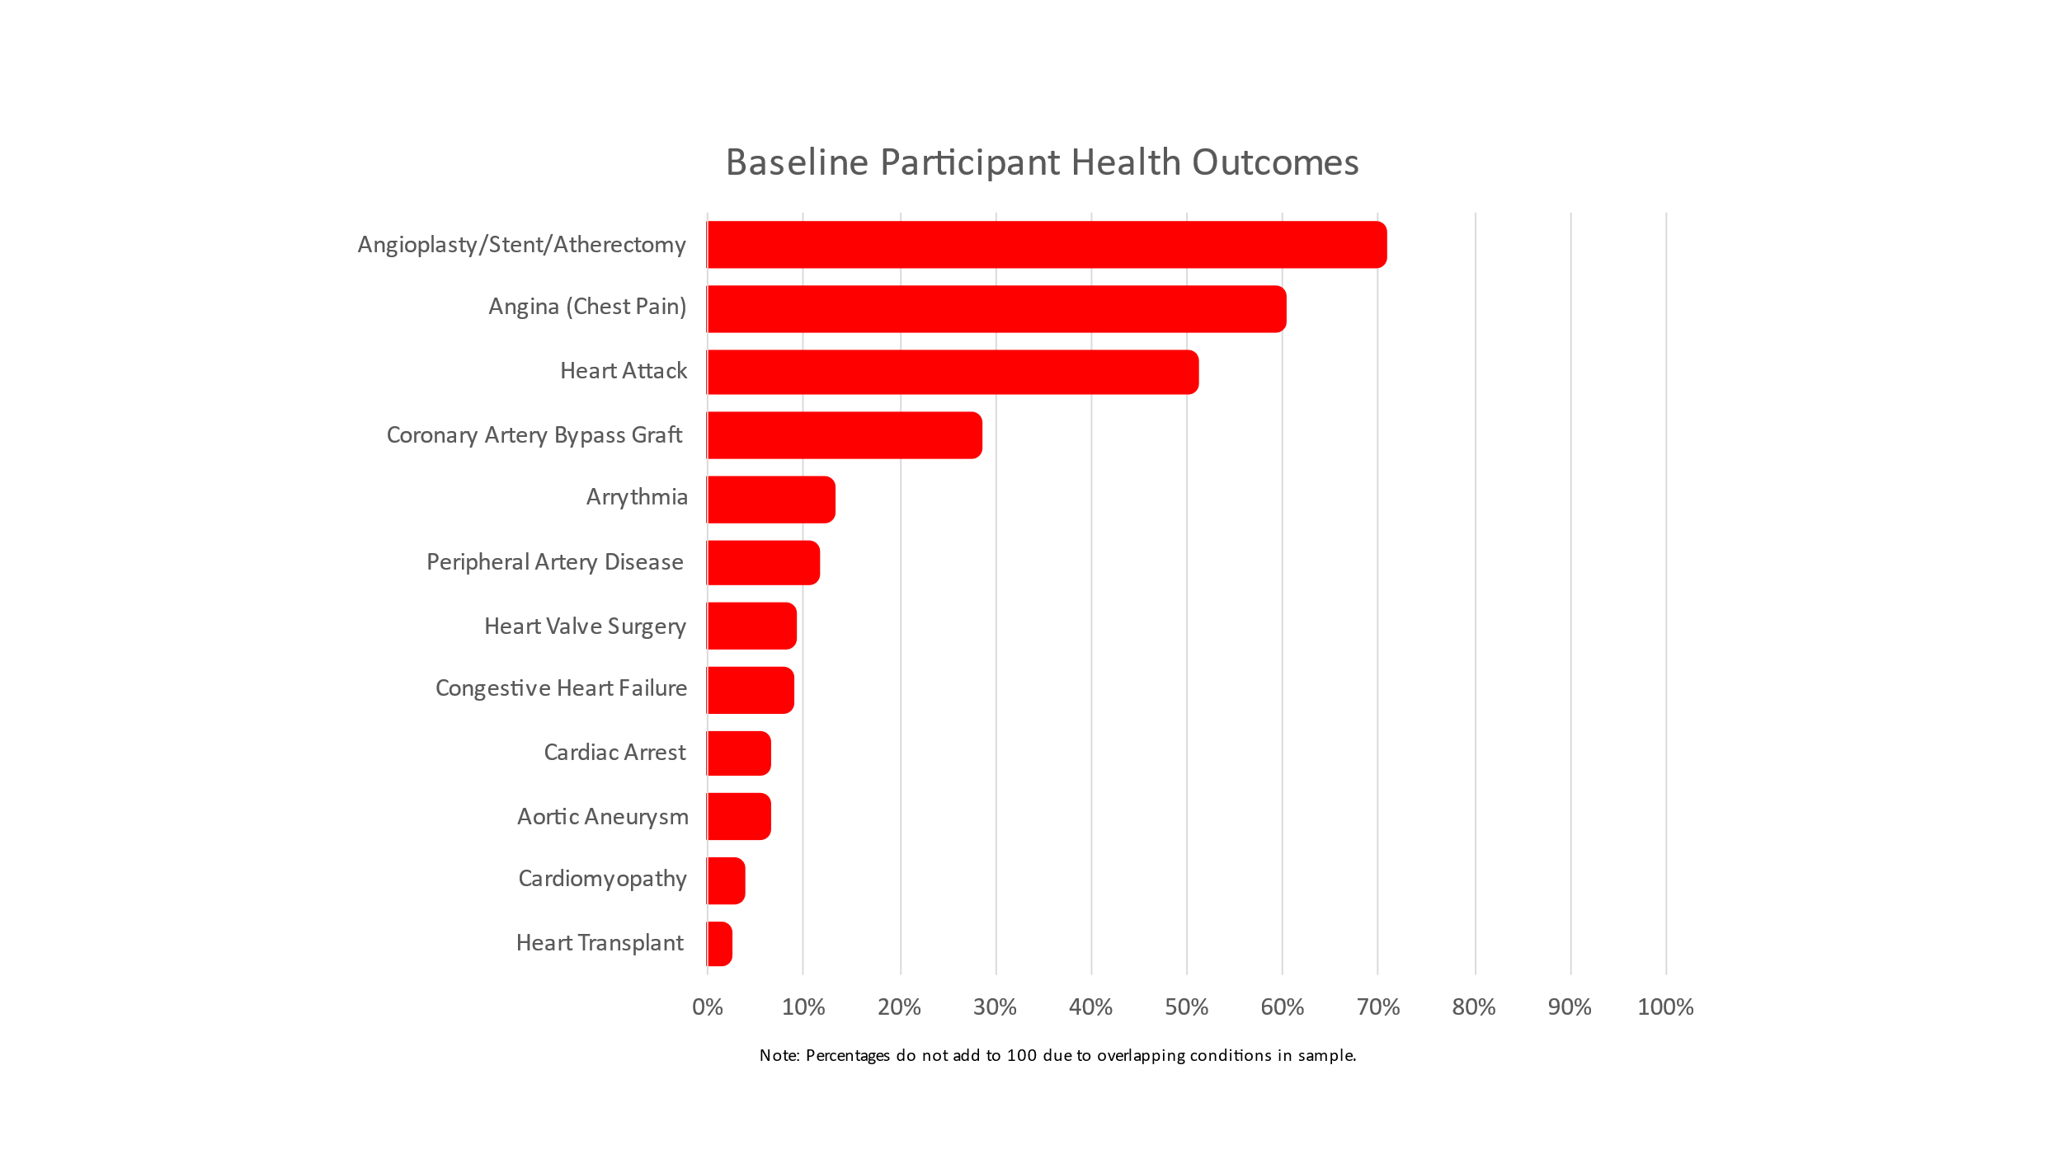
Participant characteristics stratifying by sex are shown in Table 3. Demographic characteristics did not differ statistically. Average depressive symptomatology scores at baseline were marginally lower among men (2.71, SD= 0.51) than among women (3.20, SD= 0.57; p=.070). At baseline, exercise between men and women did not differ statistically (p=.237). 74.2% of men and 53.3% of women reported exercising 4 or more times a week. A total of 54.8% of men reported a less healthy diet compared to 33.3% of women. However, women were more likely to report excess alcohol use (53.3% versus 42% of men). None of these sex differences in health behaviors achieved statistical significance.

Table 3. Baseline participant characteristics by sex

 | Male  M(SD) or % | Female  M(SD) or % | Differences  p
Age (mean, in years) | 64.42 (9.31) | 60.11(11.36) | .185
Race  Black, non-Hispanic  White, non-Hispanic  Other | 8.1  87.1  4.8 | 13.3  86.7  0.0 | .578
Education  High School or GED  Bachelor’s Degree  Graduate Degree | 35.7  39.3  25.0 | 42.9  28.6  28.6 | .757
Marital Status  Single  Married  Divorced  Widowed | 9.8  78.7  6.6  4.9 | 0.0  66.7  26.7  6.7 | .094
Employed | 61.3 | 60.0 | .927
Median Household Income Range | $60-$74,999 | $75-$84,999 | .206
Health Insurance | 100.0 | 100.0 | 1.00
Using Antidepressants | 8.1 | 6.7 | .856
Depressive Symptomatology (0-27) | 2.71 (0.51) | 3.20 (0.57) | .070
Cardiac Rehab Health Behaviors  Physical Activity (0-2)  Rarely/Never (0)  1-3 times per week (1)  4+ times per week (2)  Less Healthy Diet  Excess Alcohol Use | 4.8  21.0  74.2  54.8  42.0 | 13.3  33.3  53.3  33.3  53.3 | .237  .406  .425
N | 62 | 15

RQ1: What are patterns of depressive symptomatology in the 12 months following completion of cardiac rehabilitation?
Figure 2. Patterns of Depressive symptomatology over time, with 95% CI 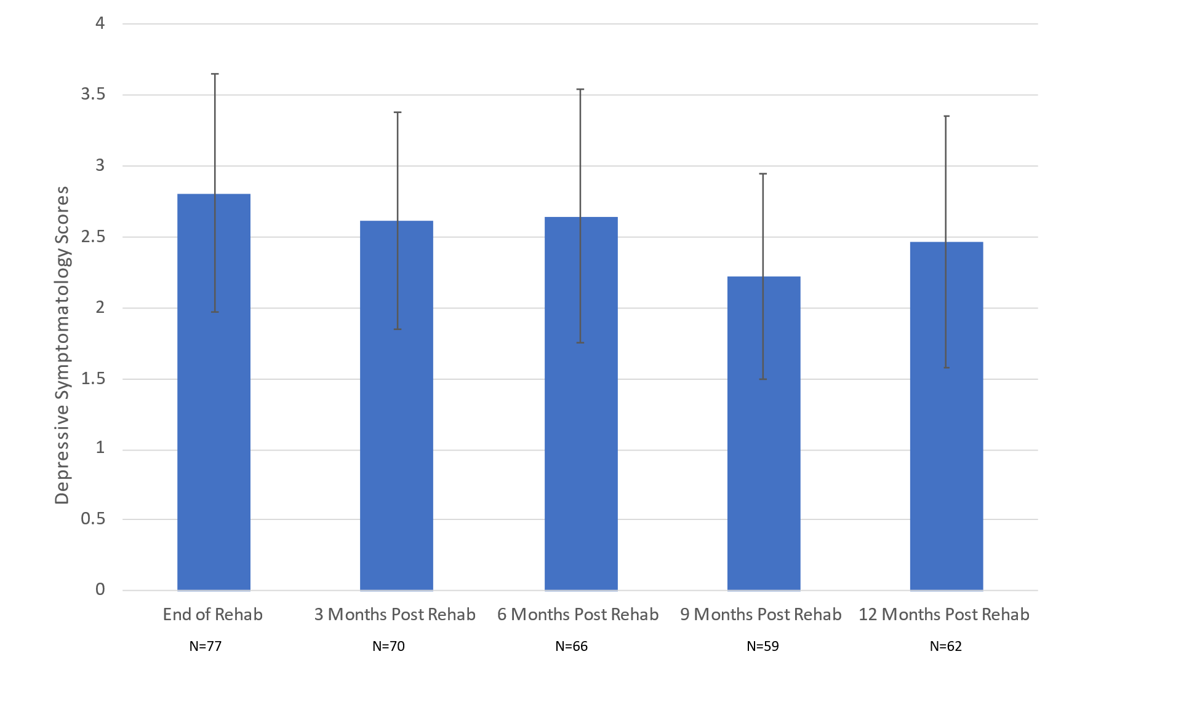
As shown in Figure 2, depressive symptomatology appears to decrease, albeit not appreciably, from the end of cardiac rehabilitation to 9 months post rehabilitation, with an uptick at 12 months post rehab. Depressive symptomatology is greatest at the end of cardiac rehabilitation (M= 2.81, SD= 3.71) when compared to other time points, however, there is no clear linear trend. Subsequent depressive symptomatology from 3 to 12 months ranged from 2.22 to 2.65. This evidence appears to be contrary to our hypothesis that depressive symptomatology would increase the further removed one was from the end of rehabilitation, however, no statistically significant differences were found in symptomatology in our comparison of waves.

RQ2: What are patterns of heart-healthy behaviors (physical activity, healthy diet, avoidance of excess alcohol use) in the 12 months following completion of cardiac rehabilitation?

Figure 3. Patterns of Physical Activity over time, with 95% Ci
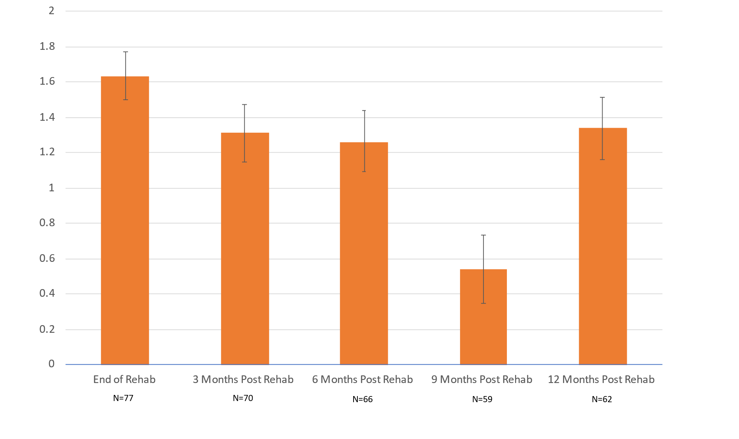
There appears to be a downward trend in physical activity from the end of rehabilitation to 9 months post cardiac rehabilitation as visualized in Figure 3. This is partially consistent with the hypothesis that physical activity would decrease over time post rehabilitation. The exception to this pattern was a marked increase in physical activity from 9 months to 12 months post cardiac rehabilitation. Because 95% CIs from 6 months [1.0958, 1.4416] to 9 months [0.346, 0.739] and 9 months to 12 months [1.161, 1.5165] do not overlap, this suggests there is a significant difference in mean physical activity levels between these specific waves. Further analyses found significant differences between levels of physical activity at the end of rehabilitation and all subsequent waves (p < .001). Significant statistical differences were also found when comparing levels of physical activity at 3 months post rehab and 9 months rehab, 6 months post rehab and 9 months post rehab, and 9 months post rehab and 12 months post rehab (all p <.001)

Figure 4. Patterns of Less healthy diet over time
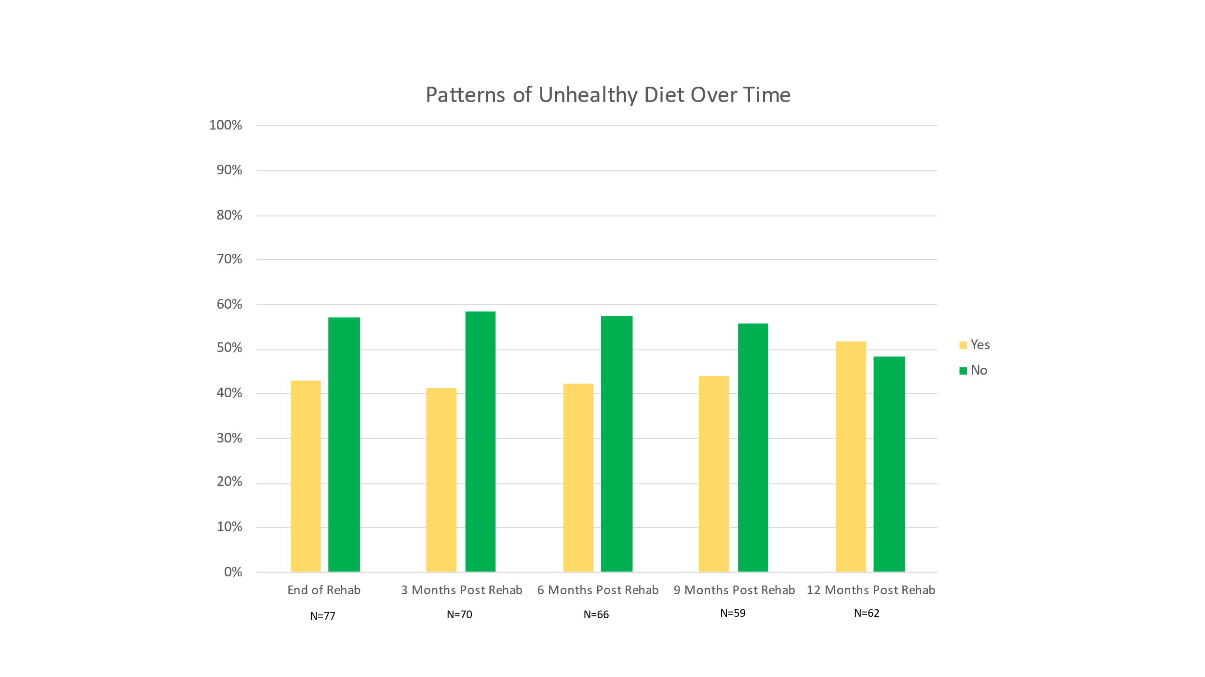
As shown by the yellow bars in Figure 4, less than half of the sample reported the presence of a less healthy diet between the end of rehab (42.9%) and 9 months post rehab (44.1%), demonstrating little variation. The one exception was 12 months post rehab when 51.6% of the sample reported less healthy eating. All pairwise comparisons of the percentage of participants reporting consumption of a less healthy diet at each wave, using two-tailed chi-squared tests, showed statistically significant differences (all p <.004). Of these comparisons, only one (9 months post rehab compared with 12 months post rehab) was unable to be compared using chi-squared tests due to a cell size with less than 5 observations during analyses.

Figure 5. Patterns of excess Alcohol Use Over Time
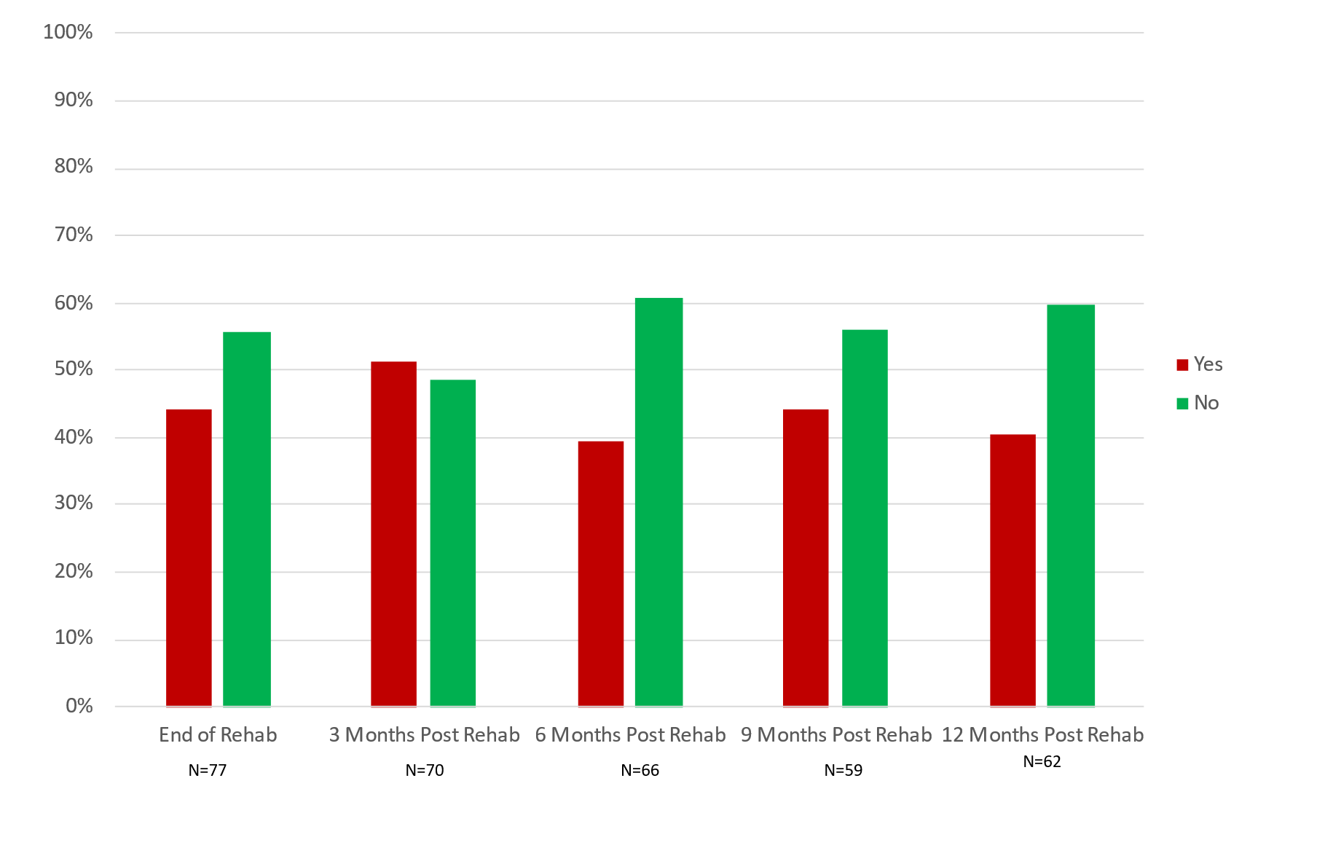
As shown in Figure 5, there was no clearly observable trend in excess alcohol use across waves of data collection. Excess alcohol use does not seem to increase over time post cardiac rehabilitation, which contradicts our hypothesis that excess alcohol use would increase over time. The percentage of the sample reporting excess alcohol use oscillated between waves with the largest report of excess alcohol use being 3 months post rehabilitation at 51.4% of the sample and the lowest at 6 months post rehab at 39.4%. Of the 10 pairwise comparisons of the percentage of participants reporting excess alcohol use at each wave using two-tailed chi-squared tests, only two comparisons (end of rehab and 6 months post rehab, 6 months post rehab and 12 months post rehab) met the assumption that all cell sizes have greater than 5 observations.
Both of these comparisons reported p<.001.

RQ3: How do patterns of depressive symptomatology in the 12 months following the completion of cardiac rehabilitation relate to patterns of health behaviors?
Figure 6. Patterns of within wave Depressive Symptomatology by Physical Activity, with 95% Ci
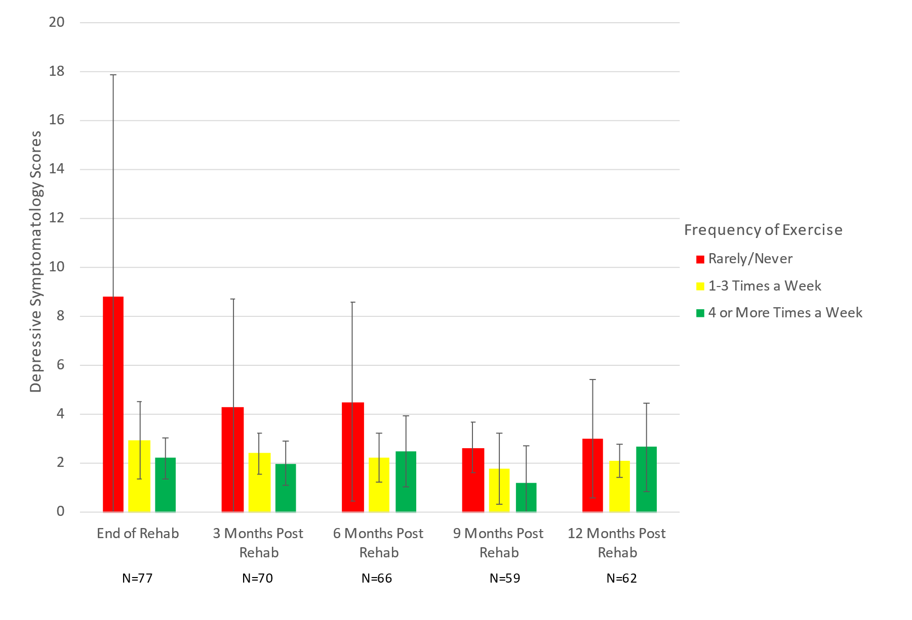
As shown in Figure 6, when analyzing the relationship between depressive symptomatology and frequency of physical activity after the end of cardiac rehabilitation, there appears to be no significant differences in scores between the end of rehabilitation and 12 months post rehabilitation as indicated by the overlapping 95% CI. No statistically significant differences were achieved using a Kruskal-Wallis test. There is a downward trend in depressive symptomatology for those who rarely or never exercise, although these data have large and overlapping 95% CIs, in part due to the small number reporting rare or no exercise at baseline. A similar, yet less dramatic, trend is shown for those exercising 1-3 times a week. For those who exercised 4 or more times a week, there does not appear to be any recognizable trend in depressive symptomatology. Depressive symptomatology scores appeared to be much higher in those that rarely or never exercise across all waves compared to 1-3 times and 4 or more times a week, but this difference seems to lessen with increasing time elapsed since rehabilitation. Given that those who rarely or never exercised generally reported the highest depressive symptomatology of all physical activity levels across all waves, this may be consistent with our hypothesis that higher depressive symptomatology would be linked with less frequent physical activity.

Figure 7. Patterns of within wave depressive symptomatology by less healthy diet, with 95% ci
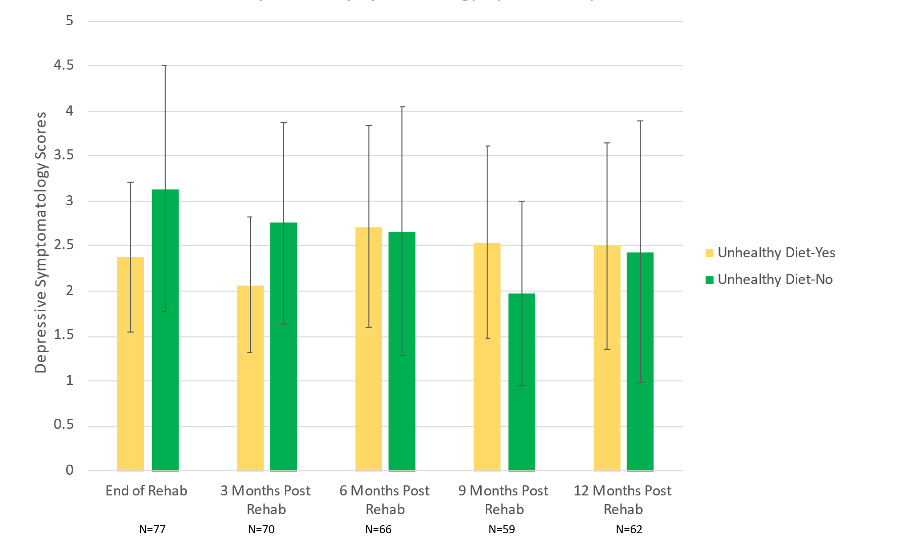
When observing the relationship between depressive symptomatology and the presence of a less healthy diet, there was some variation between waves. As shown in Figure 7, participants reporting less healthy diets at the end of rehabilitation (yellow bars, M= 2.38) and 3 months post rehabilitation (M= 2.07) showed the lowest scores for depressive symptomatology across waves; however, this trend does not persist to later waves. Inversely, patients who reported healthier diets (green bars) reported the highest depressive symptomatology scores at the end of rehabilitation (M= 3.14) and 3 months post rehabilitation (M= 2.76). This does not support our hypothesis that higher depressive symptomatology would be linked to a less healthy diet. In comparison to those who reported eating a less healthy diet, depressive symptomatology in those who reported eating a healthier diet began to decrease at 6 months post rehabilitation, albeit not dramatically. The difference in symptomatology scores between both cells is largest at 9 months post rehabilitation but becomes less apparent again at 12 months post rehabilitation. No statistically significant differences were achieved within waves using Mann-Whitney tests.
Figure 8. patterns of within wave depressive symptomatology by excess alcohol use, with 95% ci
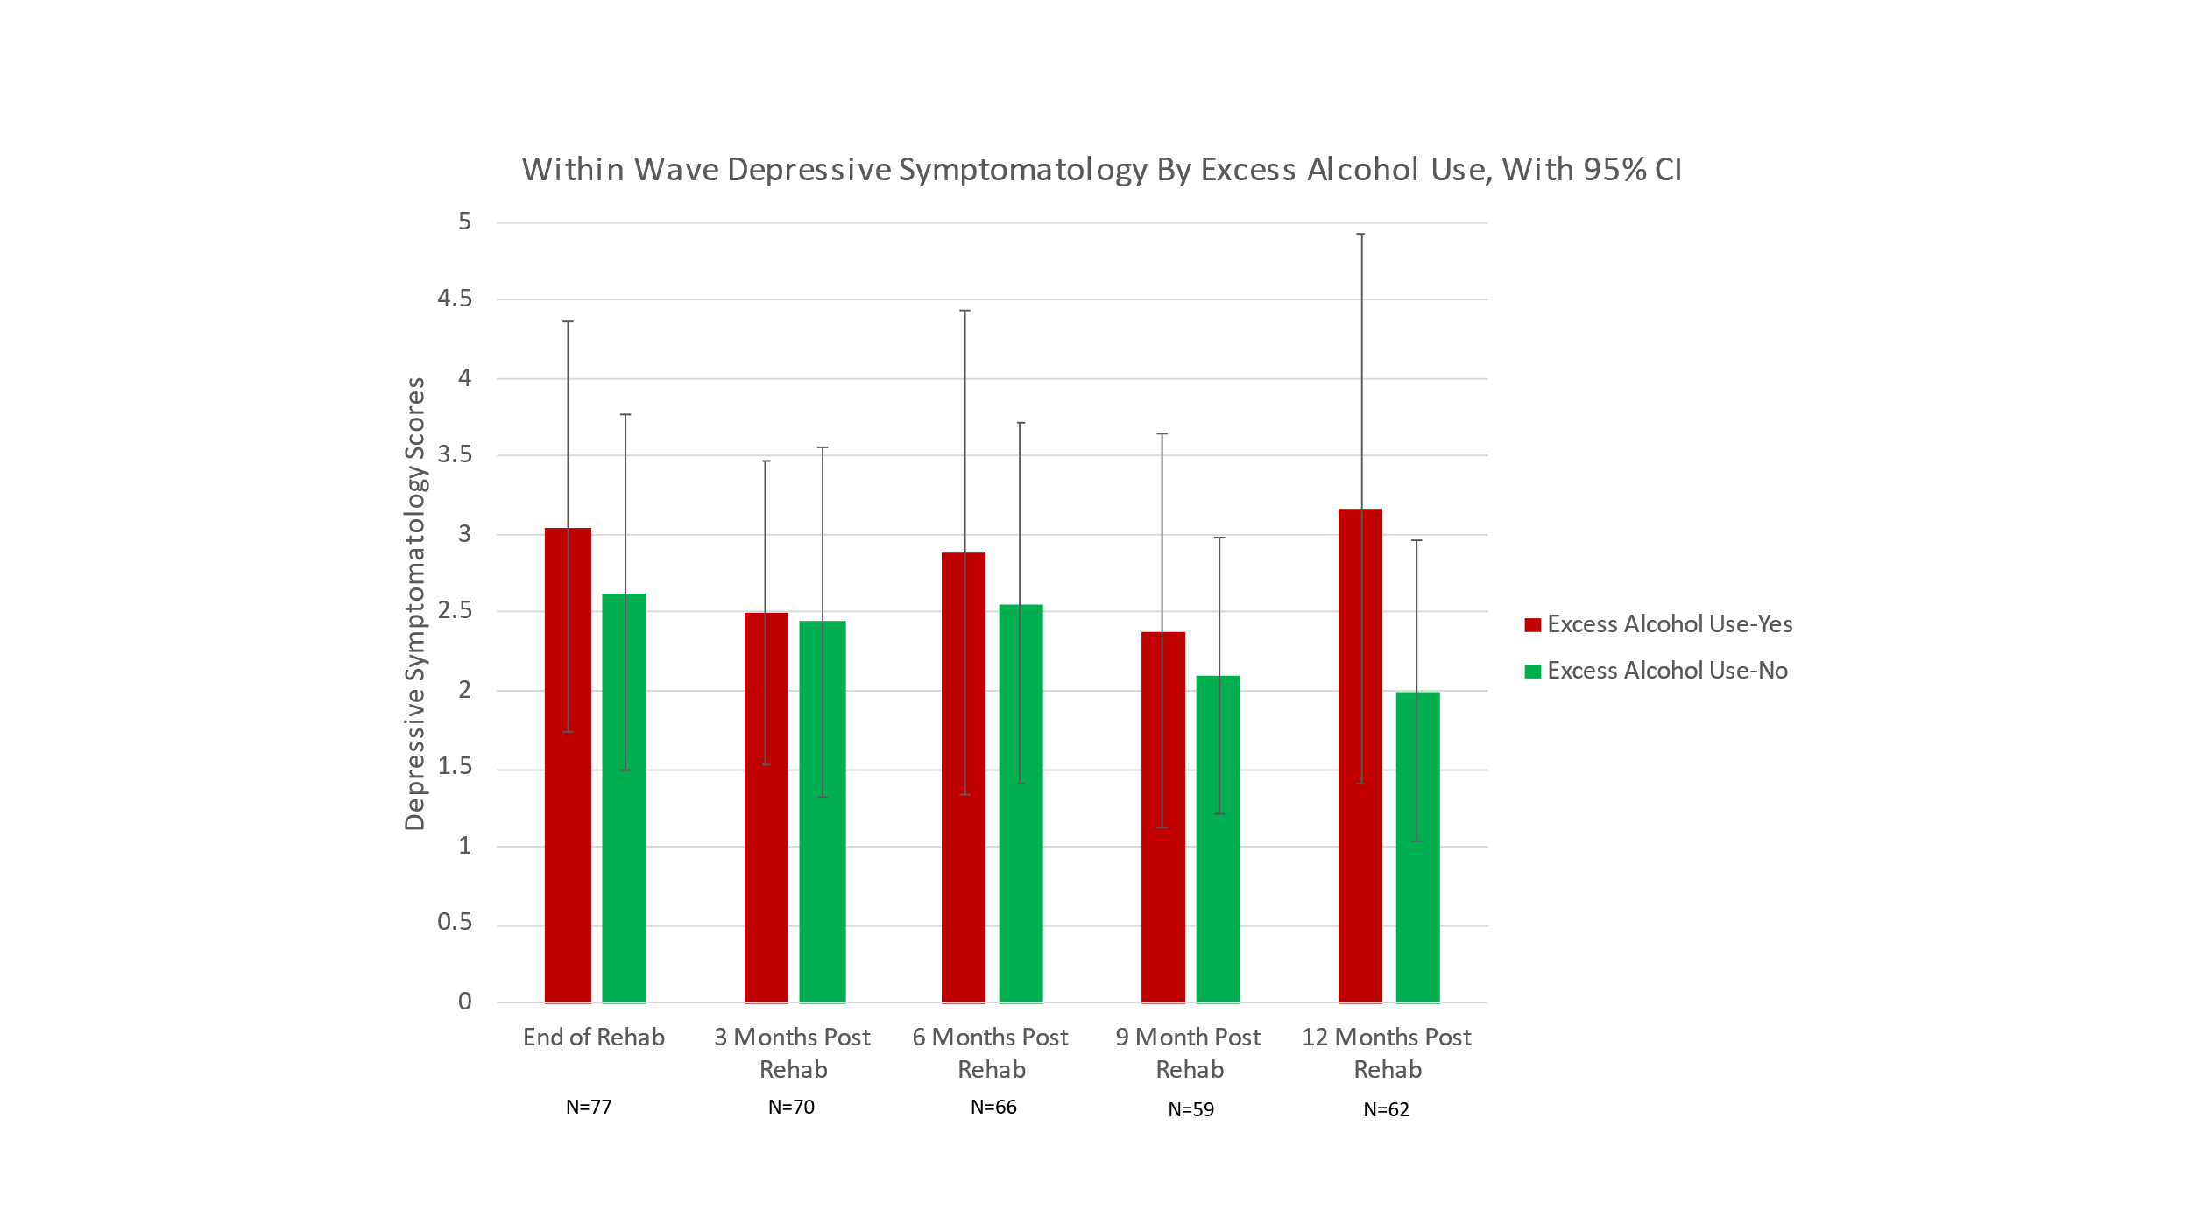
As shown in Figure 10, those with excess alcohol use consistently reported higher depressive symptomatology scores than those without, though 95% CIs overlap; this aligns with our hypothesis that higher depressive symptomatology would be linked with greater excess alcohol use. However, there was no obvious trend over time. Depressive symptomatology for those with excess alcohol use was lowest at 9 months post rehabilitation (M=2.40) and highest 12 months post rehabilitation (M=3.16). For those without excess alcohol use, depressive symptomatology was highest at the end of rehabilitation (M=2.63) and lowest at 12 months post rehabilitation (M=2.0). No statistically significant differences were achieved within waves using Mann-Whitney tests.
RQ4 (Exploratory): Do patterns of depressive symptomatology, patterns of heart healthy behaviors, and their relationships with one another vary as a function of sex in the 12 months following completion of cardiac rehabilitation?

Figure 9. patterns of depressive symptomatology for men over time, with 95% ci
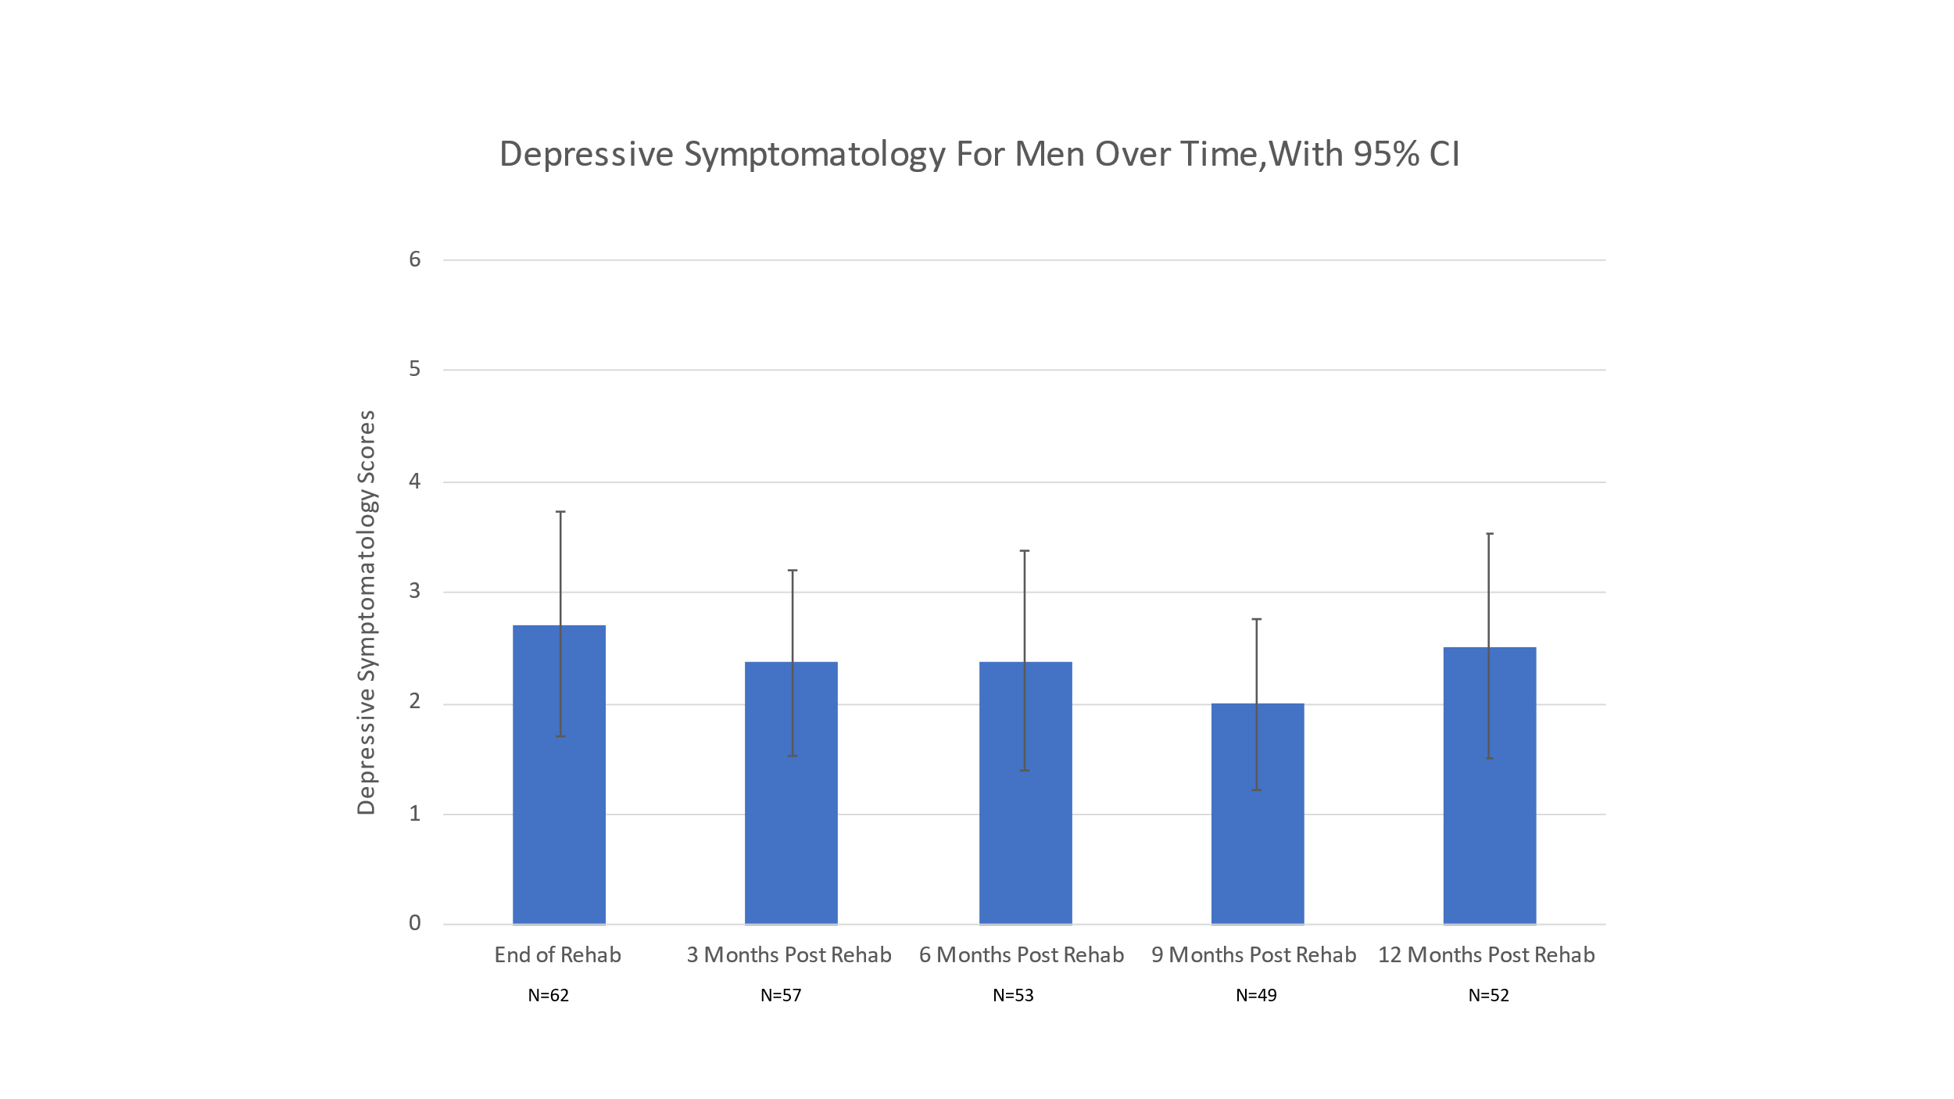
Figure 10. Patterns of depressive symptomatology For women over time, with 95% ci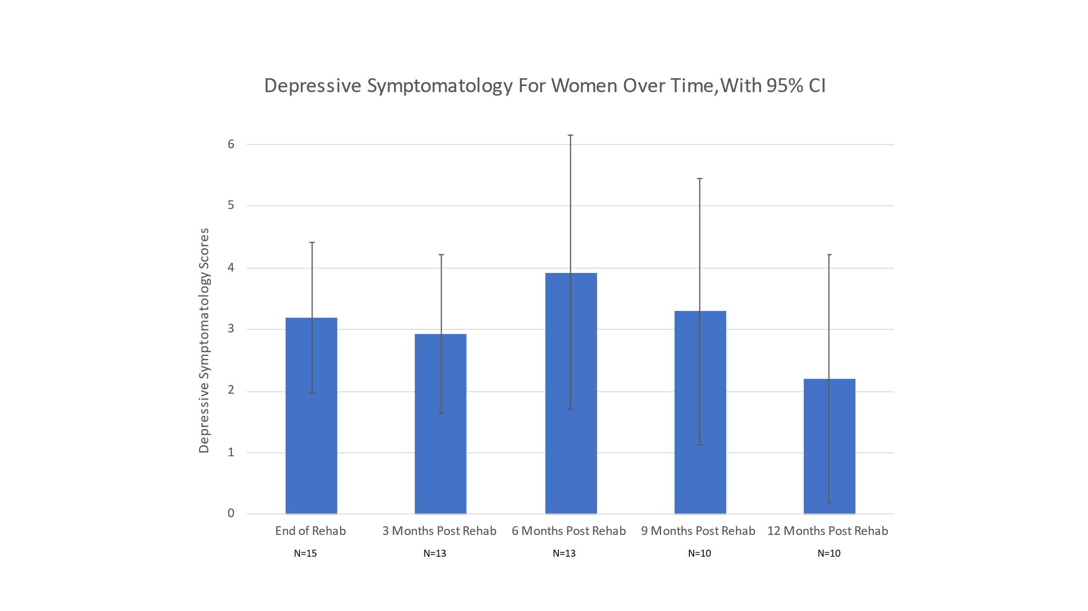
Patterns of depressive symptomatology appear to differ between men and women with no observable trend in patterns for either sex. Men reported their highest depressive symptomatology scores at the end of rehabilitation (M= 2.72) and the lowest at 9 months post rehabilitation (M= 2.0) as indicated in Figure 9. Further analyses in men using Mann-Whitley tests found a significant difference in depressive symptomatology between the end of cardiac rehabilitation and 12 months post rehabilitation (p= .031). Women reported their highest depressive symptomatology scores at 6 months post rehabilitation (M= 3.92) and their lowest at 9 months (M= 2.2) as indicated in Figure 10. No significant statistical differences were found in women when analyzing depressive symptomatology. When graphing variables, women frequently reported higher depressive symptomatology scores than men in all waves of data collection with the exception of 12 months post rehabilitation where men reported scores of 2.5 on average compared to women who reported scores of 2.2 on average. Barring differences in scores at 12 months post rehabilitation, this appears to be consistent with our hypothesis that women would show patterns of higher depressive symptomatology over time than men.
Figure 11. Patterns of Physical activity for men over time, with 95% ci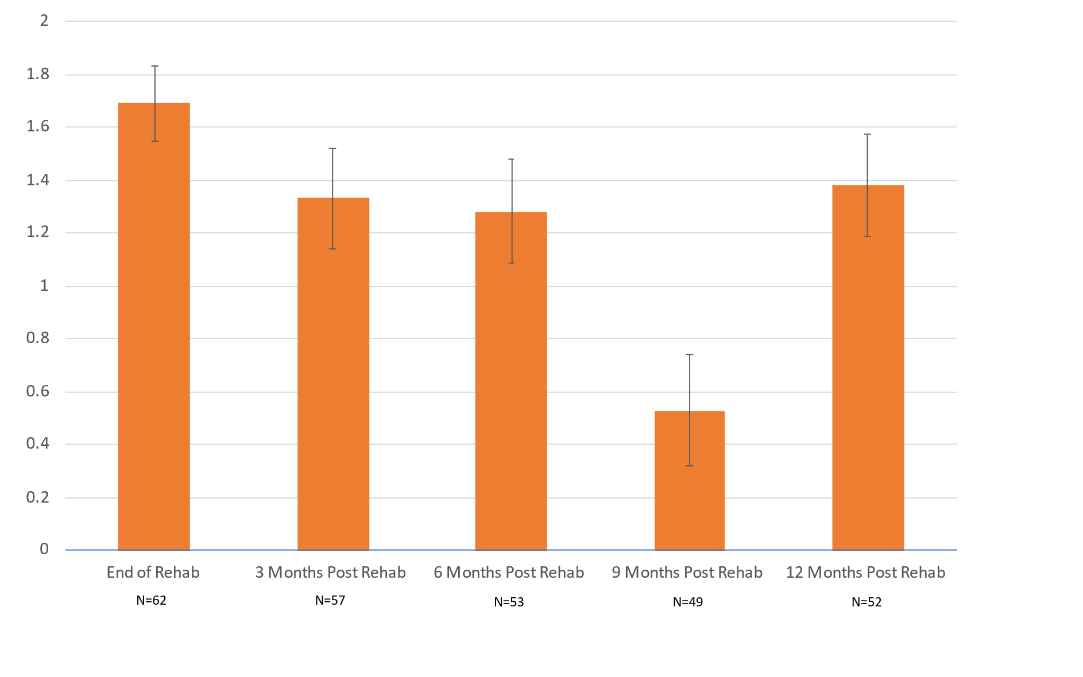

Figure 12. PATTERNS OF PHYSICAL ACTIVITY FOR WOMEN OVER TIME, WITH 95% CI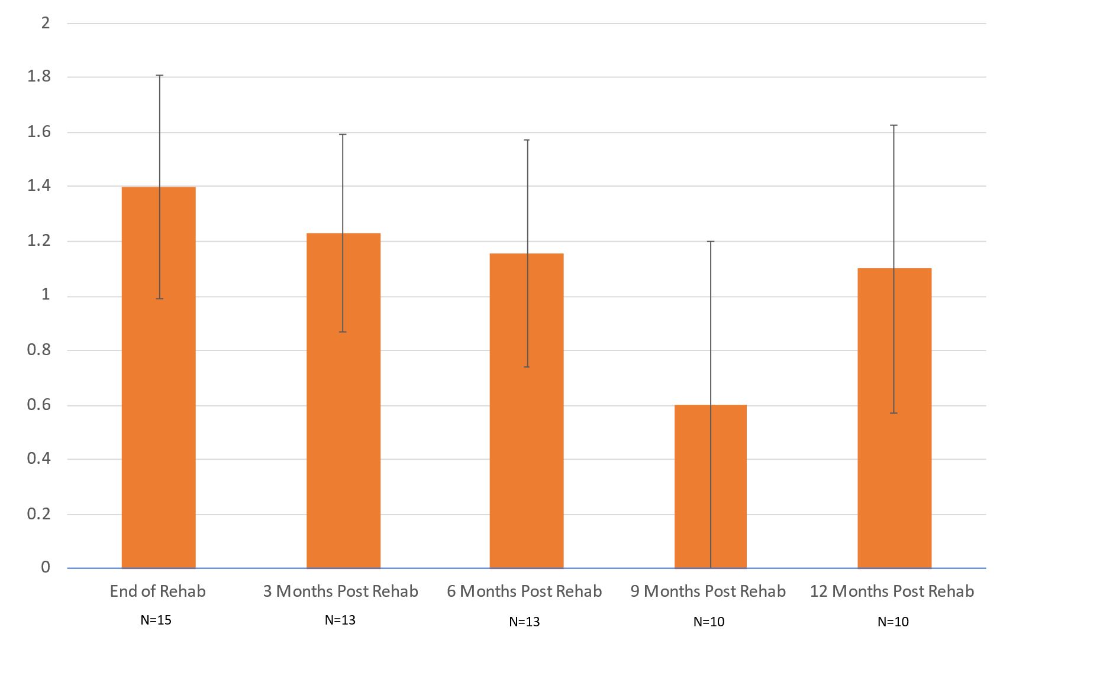
Patterns of physical activity over time seemed to decrease from the end of rehabilitation to 9 months post rehabilitation followed by a sharp increase at 12 months post rehab for both men and women. As visualized in Figure 11, men reported their highest frequencies of physical exercise at the end of rehabilitation (M= 1.7) and their lowest frequencies at 9 months post rehabilitation (M= 0.530). Two-tailed dependent t tests of men alone found significant differences between levels of physical activity at the end of rehabilitation and all subsequent waves (p < .001). Significant statistical differences were also found when comparing levels of physical activity at 3 months post rehab and 9 months rehab, 6 months post rehab and 9 months post rehab, and 9 months post rehab and 12 months post rehab (all p <.001). Similarly, women also reported their highest frequency of physical activity at the end of rehabilitation (M= 1.4) and their lowest frequency at 9 months post rehabilitation (M= 0.060) as indicated in Figure 12. However, no statistically significant differences in physical activity were achieved when using two-tailed dependent t tests on women alone. When graphed, both men and women seem to report a sizeable increase of physical activity at 12 months post rehabilitation to 1.4 and 1.1 respectively. This similarity in apparent patterns of physical activity post cardiac rehabilitation between sexes was contrary to our hypothesis that women would show greater decreases in patterns of physical activity over time than men.

Figure 13. patterns of men eating a less healthy diet over time
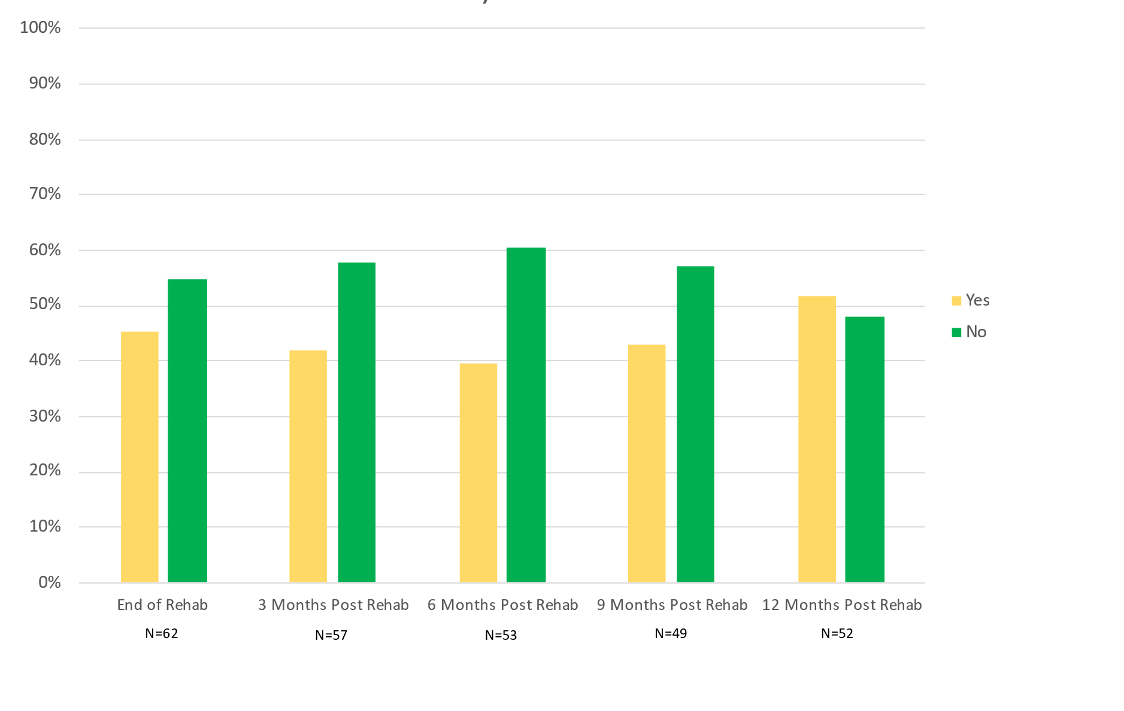

Figure 14. patterns of women eating a less healthy diet over time
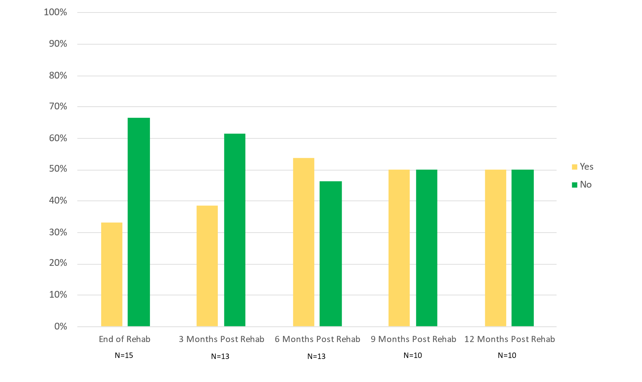

As shown in Figure 13, the percentage of men eating a less healthy diet began to increase from 39.6% at 6 months post rehabilitation to 51.9% at 12 months post rehabilitation, which may be consistent with our hypothesis that men would consume less healthy diets over time. All pairwise comparisons of the percentage of men reporting consumption of a less healthy diet at each wave showed statistically significant differences (all p <.004) with the exception of 3 months post rehab when compared with 6 months post rehab due to a cell size with less than 5 observations during analyses. The percentage of women eating a less healthy diet gradually increased from the end of rehabilitation (45.2%) to a peak at 6 months post rehabilitation (53.6%), as shown in Figure 14. Due to multiple cell sizes having less than 5 observations during analyses of less healthy eating in women, no chi-squared tests could be performed.

Figure 15. patterns of excess alcohol use for men over time
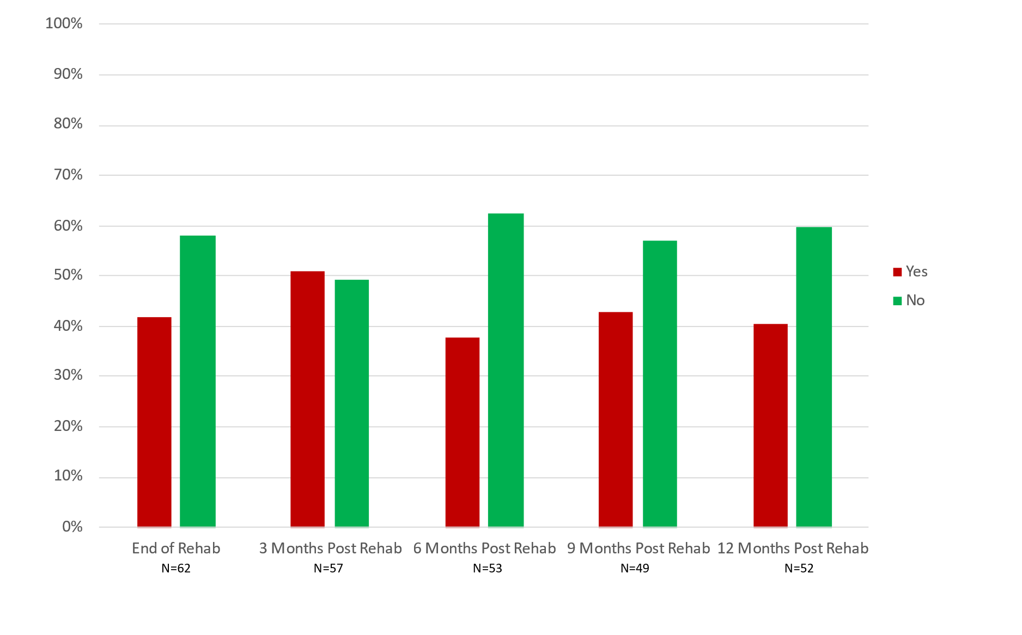

Figure 16. patterns of excess alcohol use for women over time
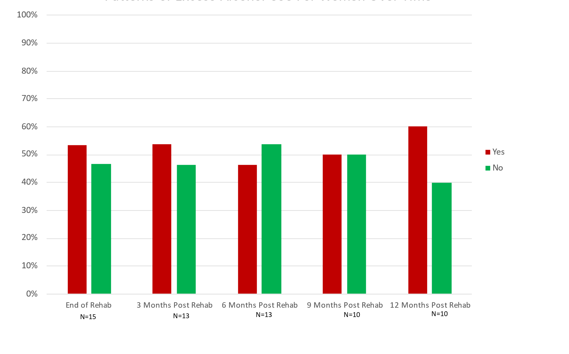
While there does not seem to be any observable trends in excess alcohol use between men and women, it appears that women drank above recommended consumption more frequently than men did, contrary to our hypothesis that men would have more frequent consumption. As shown in Figure 16, more than 50% of women reported excess alcohol use at each wave of data collection except for 6 months post rehabilitation where 46.2% of women reported excess alcohol use. By comparison, less than 50% of men reported excess alcohol use at each wave apart from 3 months post rehabilitation (50.9%), as reflected in Figure 15. Due to multiple cell sizes being <5 during analyses of excess alcohol use in both men and women, no chi-squared tests could be performed to assess potential statistical differences between waves.

Figure 17. patterns of within wave depressive symptomatology by physical activity for men, with 95% ci
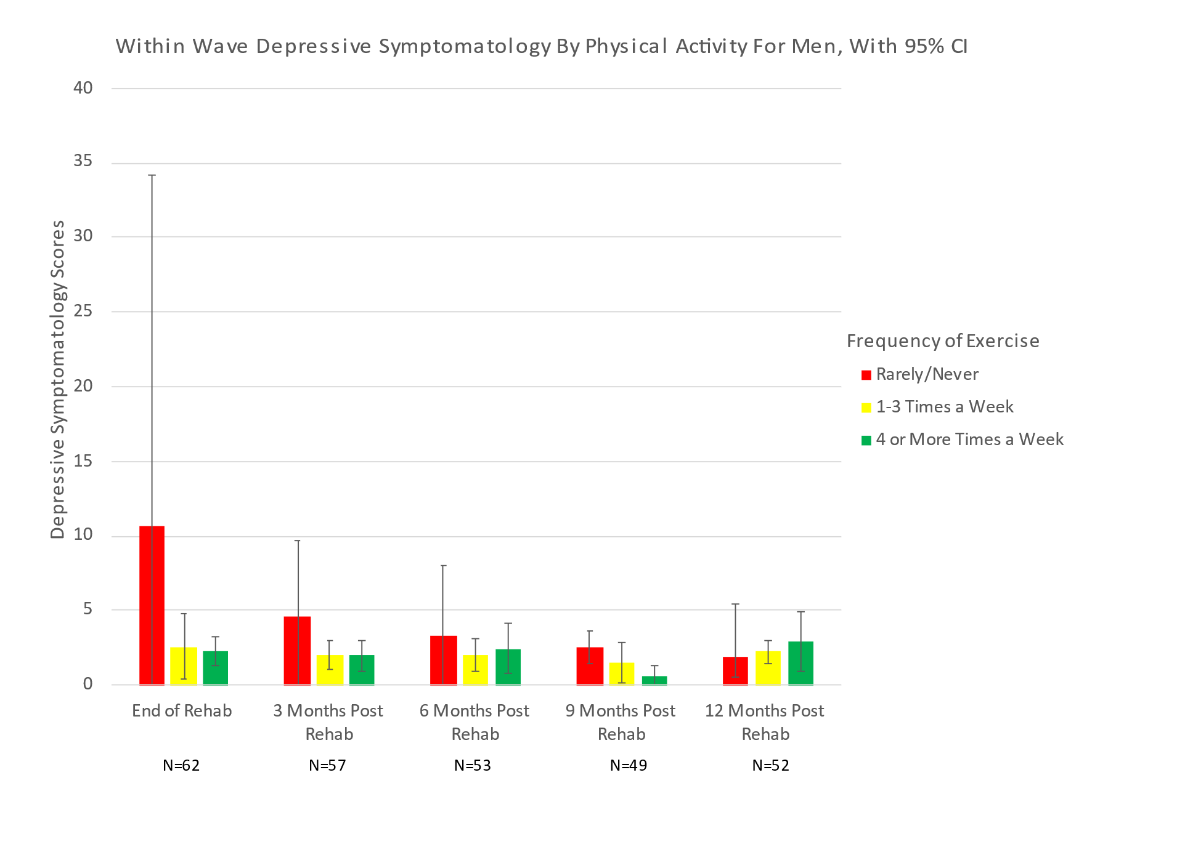
Figure 18. patterns of within wave symptomatology by physical activity for women, with 95% ci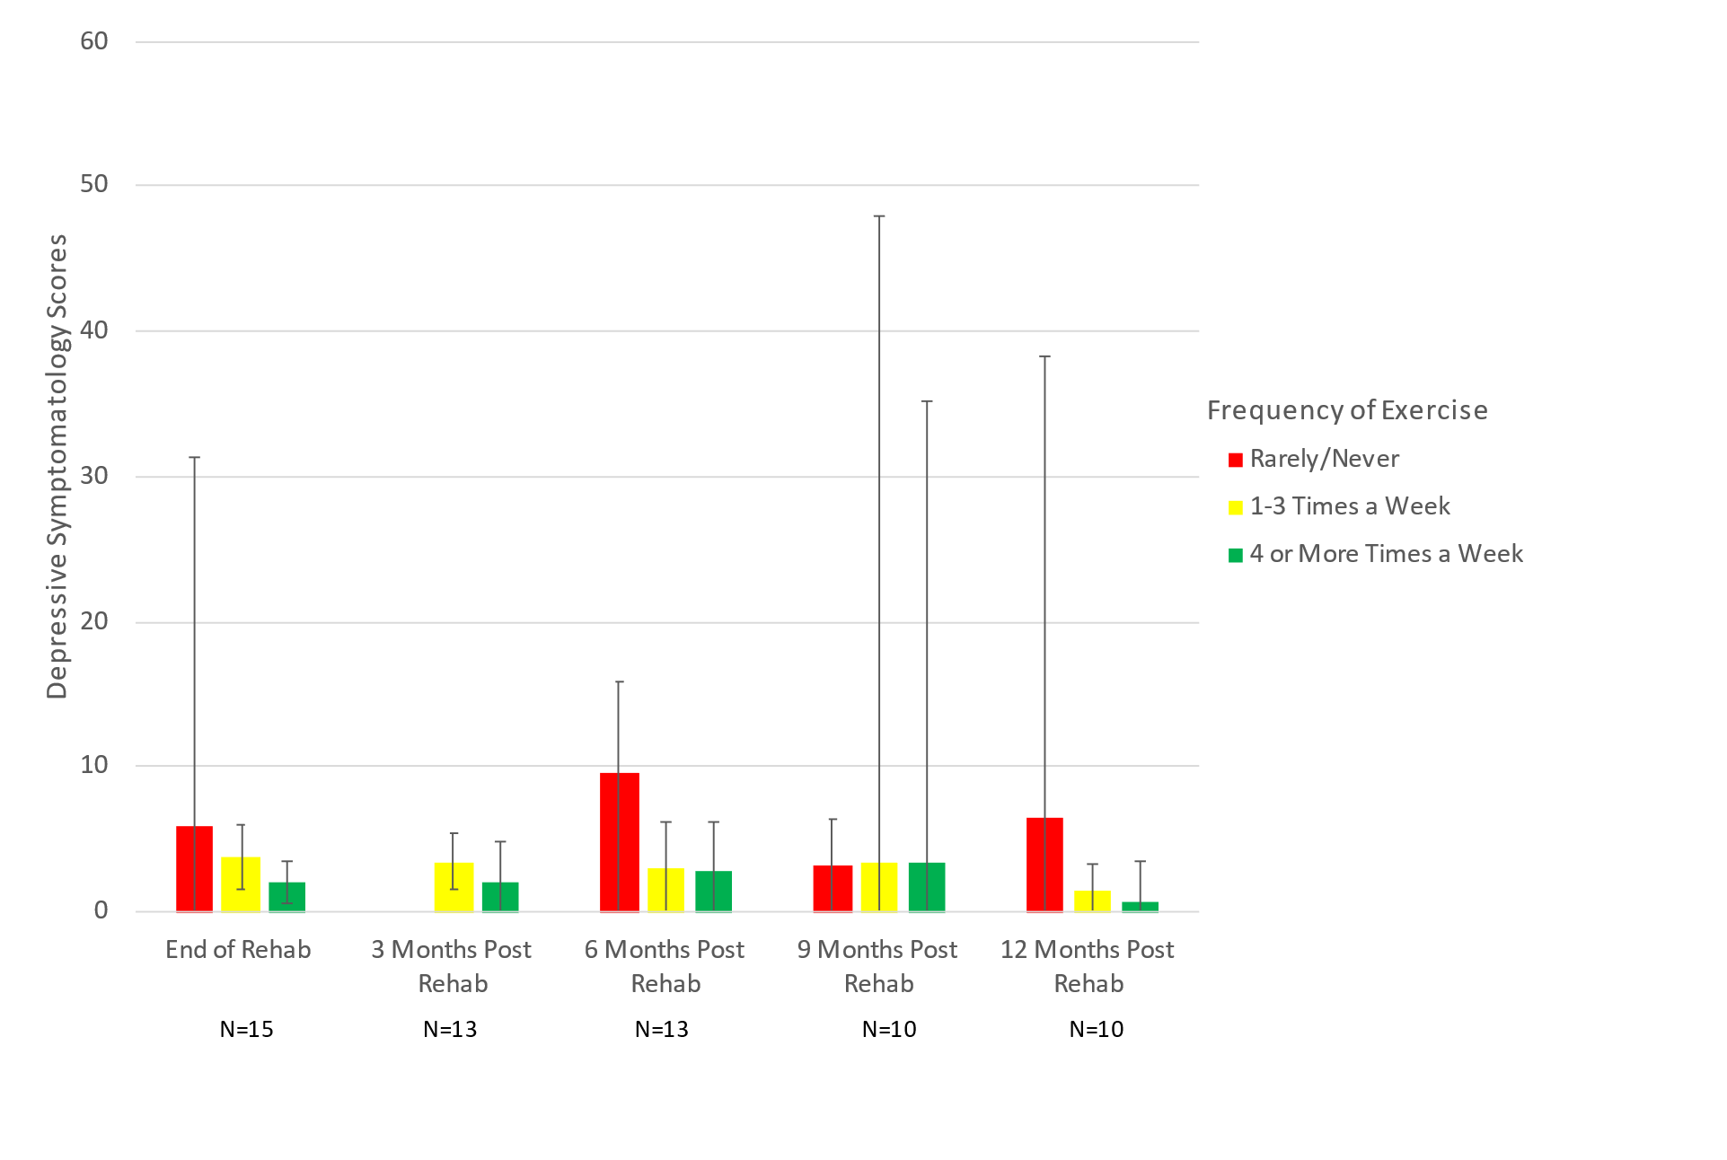
As shown in Figure 17, depressive symptomatology appears to decrease over time for each cell. Men who rarely or never exercise reported their highest depressive symptomatology scores at the end of rehabilitation (M=10.6). By comparison, men who exercise 1-3 times a week and 4 or more times a week reported consistently lower levels of depressive symptomatology across all waves ranging from 2.24 to 2.88. Although there appeared to be a downward trend in depressive symptomatology for men the further removed they were from the end of rehabilitation, no comparable trend could be identified in women. As seen in Figure 18, depressive symptomatology for women varied between cells, but women who rarely or never exercised consistently reported higher symptomatology at the end of rehabilitation (M=6.0), 6 months post rehabilitation (M=9.5), and 12 months post rehabilitation (M=3.16). No statistically significant differences were found in depressive symptomatology within waves of physical activity for either sex.
Figure 19. patterns of within wave depressive symptomatology by less healthy diet for men, with 95% ci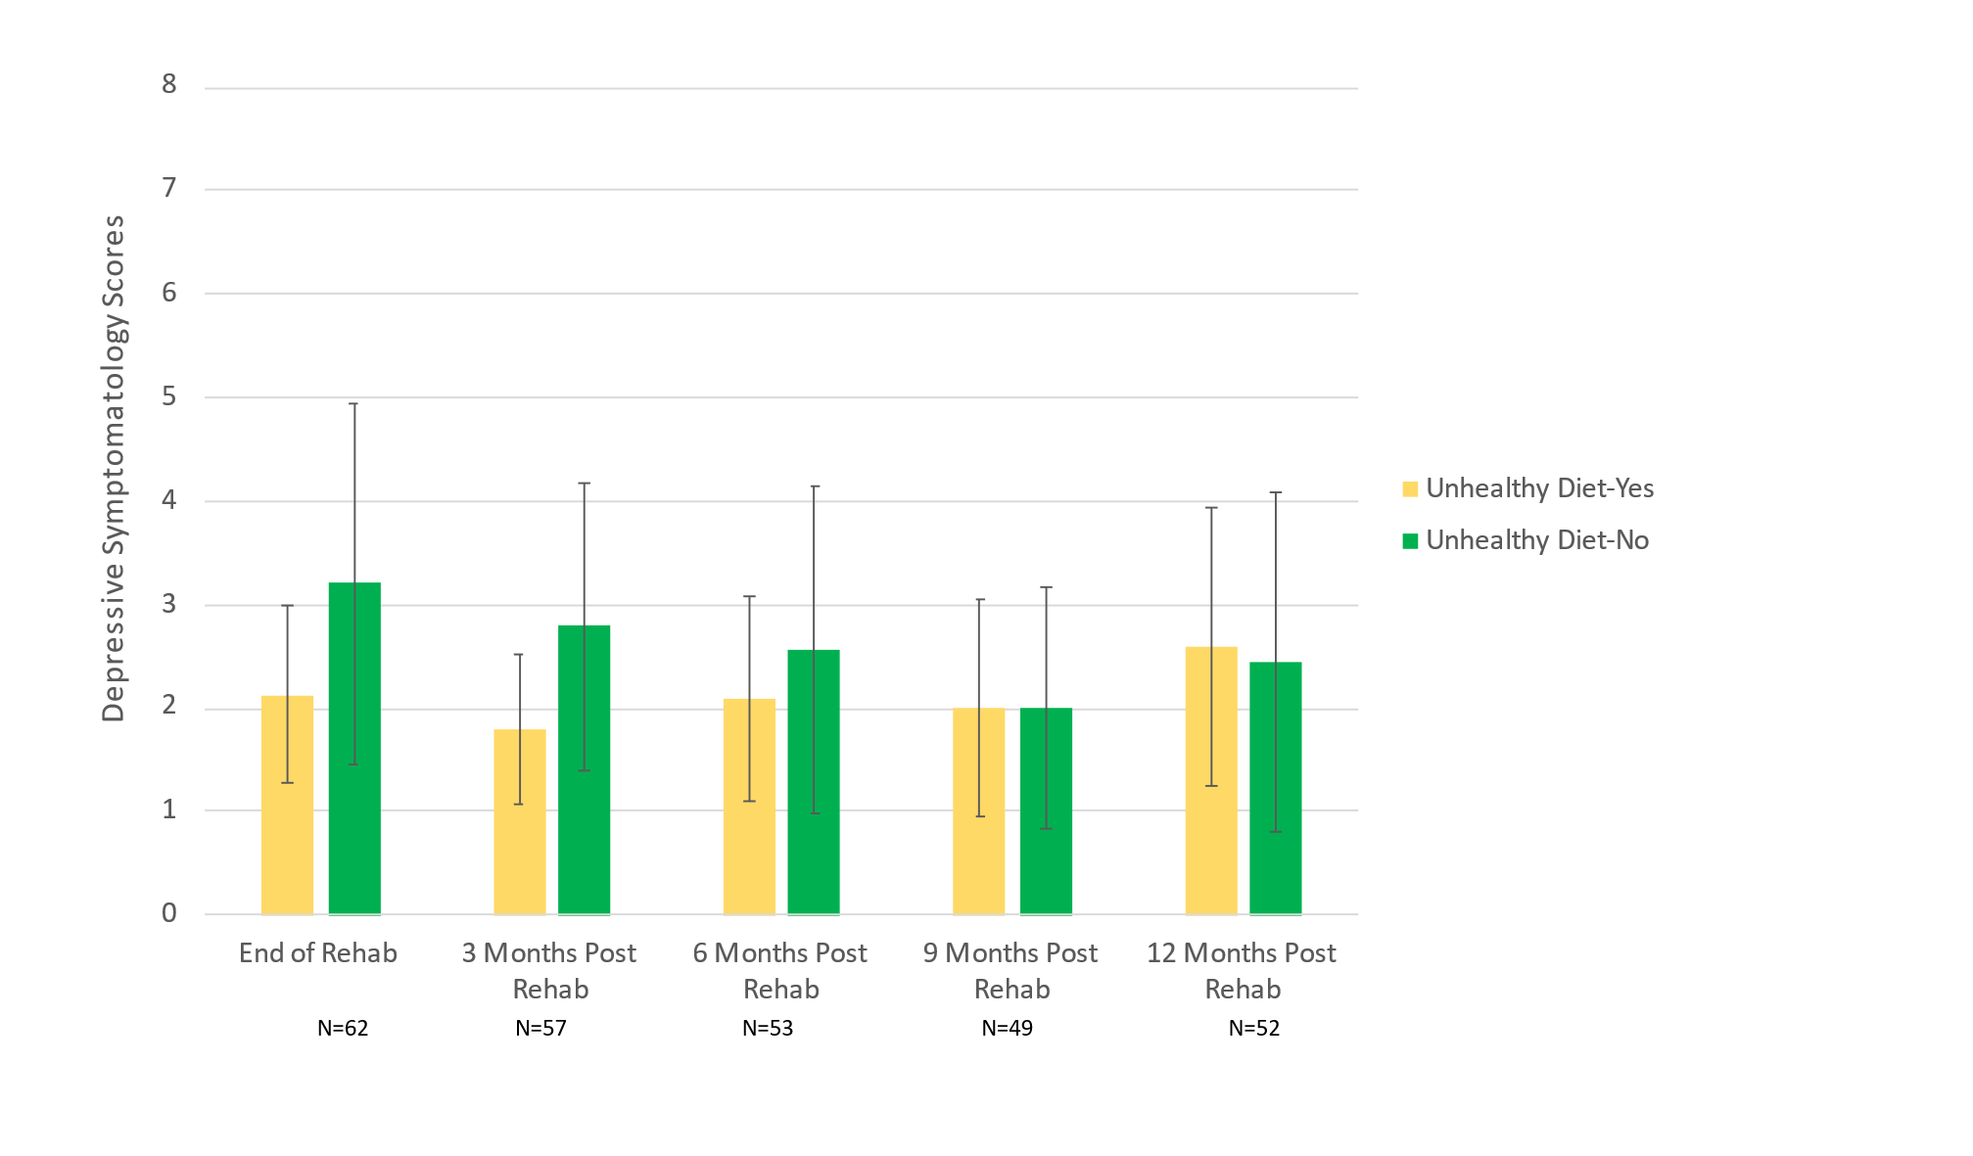

Figure 20. patterns of within wave depressive symptomatology by less healthy diet for women, with 95% ci
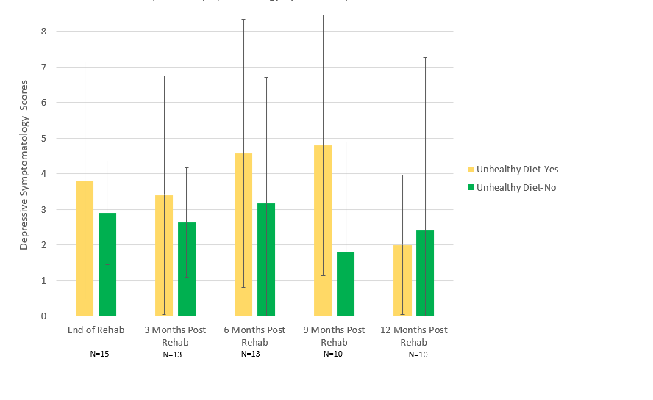
As displayed in Figure 19, men who ate a less healthy diet reported less depressive symptomatology over time when compared to men who did not. The highest depressive symptomatology for men was instead a score of 3.20 for men who reported eating a healthier diet. This trend was not mirrored in women. As shown in Figure 20, women who reported eating a less healthy diet reported higher depressive symptomatology than women who did not across all waves barring 12 months post rehabilitation where they reported their lowest (M= 2.0). Depressive symptomatology for women eating a less healthy diet was highest 9 months post rehabilitation (M= 4.8). No statistically significant differences were found in depressive symptomatology within waves of diet for either sex.

Figure 21. patterns of within wave depressive symptomatology by excess alcohol use for men, with 95% ci
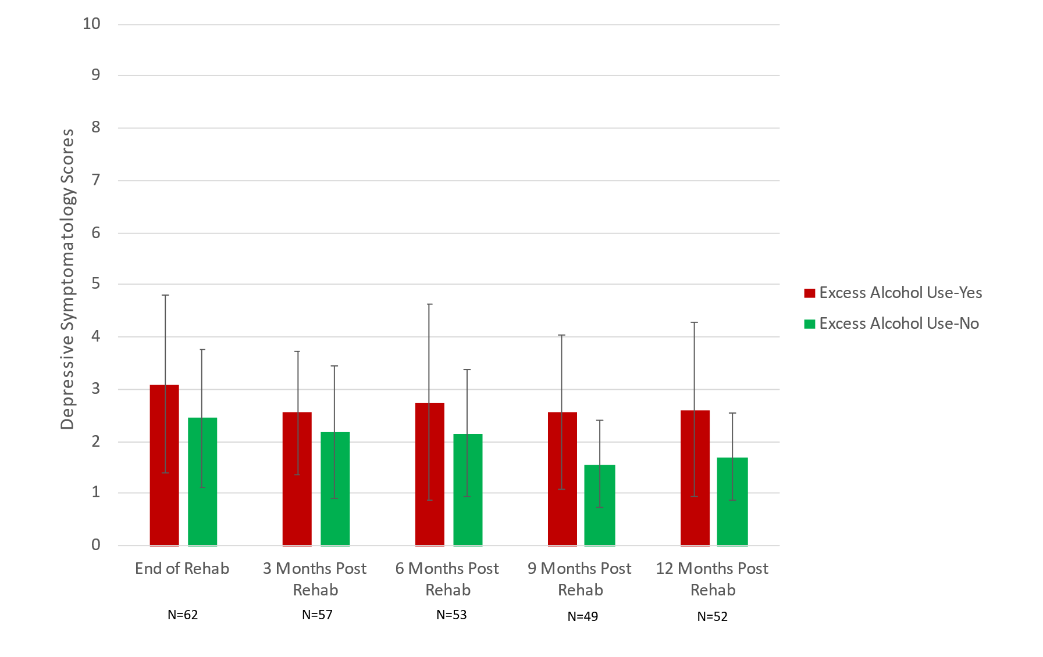
Figure 22. patterns of within wave depressive symptomatology by excess alcohol use for women, with 95% ci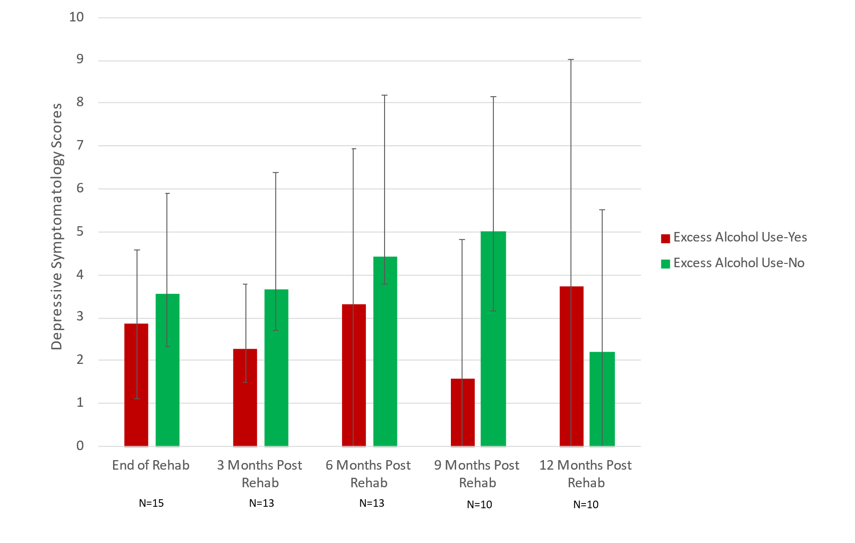
Men with excess alcohol use reported consistently higher depressive symptomatology compared to men without excess alcohol use, as indicated in Figure 21. Depressive symptomatology for men with excess alcohol use was highest at the end of rehabilitation (M= 3.09) and fell by 12 months post rehabilitation (M= 2.61). For men without excess alcohol use, depressive symptomatology was highest at the end of rehabilitation (M= 2.44) and lowest at 9 months post rehabilitation (M=1.57). Women with excess alcohol use reported less depressive symptomatology compared to women without excess alcohol use at every wave barring 12 months post rehabilitation (M= 3.71). In contrast, women without excess alcohol use reported the highest depressive symptomatology of both sexes at 9 months post rehabilitation (M= 4.42). No statistically significant differences were found in depressive symptomatology within waves of excess alcohol use for either sex.

Chapter 5
Discussion
Introduction
This chapter will summarize the results of the study and discuss implications and recommendations for practice and future research.
Results Summary
- Depressive symptomatology was greatest at the end of rehab and decreased with more time elapsed since end of rehab. It was also higher in women than in men at most waves of data collection post rehab.
- Frequency of physical activity decreased with more time elapsed since end of rehab. Patterns were similar for men and women.
- The percentage of participants reporting a less healthy diet was consistently low until an uptick 12 months post rehab. This trend was replicated in analyses among men, while the percent of the subsample of women reporting a less healthy diet appeared to increase earlier, at 6 months post rehab.
- There was no observable trend in patterns of excess alcohol use over time in mixed sex models. Women had more excess alcohol use than men at each wave except at 6 months post rehab.
- Depressive symptomatology was consistently higher among both men and women who rarely or never exercised, though this relationship appeared strongest among men who rarely or never exercised.
- While there was no clear relationship between depressive symptomatology and a less healthy diet in the mixed sex sample. Sex stratified analyses revealed differing patterns such that men who ate a less healthy diet reported lower depressive symptomatology than those who did not while the opposite relationship was true for women.
- Depressive symptomatology was highest in those reporting excess alcohol use. This was especially true among men in general and at the end of rehabilitation specifically. The reverse relationship appeared true among women, such that those with excess alcohol use generally reported less depressive symptomatology than those without excess alcohol use.
Implications and Recommendations for Practice
Contrary to our hypothesis, depressive symptomatology did not seem to increase over time. In fact, it appeared to gradually decrease despite concurrent reductions in some, but not all, heart-healthy behaviors emphasized and promoted in cardiac rehab. This may suggest that cardiac rehabilitation patients improve in symptomatology as time elapses from the end of rehabilitation rather than worsen, though the mechanism behind this is unclear. It may be that maintenance or lack thereof of heart-healthy behaviors plays little or no role in changes of depressive symptomatology over time. Additionally, women appeared to report higher depressive symptomatology over time when compared to men, which was consistent with our hypothesis. Though this finding should be taken with consideration of our small sample size, it is also consistent with previous literature detailing higher rates of depression among women than men in cardiac populations (Buckland et al., 2019). Given these sex-based differences in combination with the finding that depressive symptomatology was highest at the end of rehab followed by gradual reductions over time, clinicians may benefit from more concerted efforts at screening for mental health ailments upon exit from cardiac rehabilitation, especially in female patients. While levels of depressive symptomatology may naturally decrease post rehab, timely treatment may hasten this process while potentially generating additional health benefits associated with lowered levels of depression (e.g., greater maintenance of recommended heart healthy behaviors, adherence to medication and other healthcare provider recommendations, improved quality of life; Pinto et al., 2013; Rao et al., 2019; Dhar & Barton, 2016).
While depressive symptomatology appeared to decrease over time for participants in all levels of physical activity, it seemed to be consistently higher in those who rarely or never exercised regardless of sex when compared to those who reported exercising 1-3 times or 4 or more times a week. This may suggest that cardiac patients derive psychological benefits from any level of exercise. It should also be noted that patterns of depressive symptomatology for the sample appeared to trend in a similar pattern as patterns of frequency of physical activity when graphed. Further, an uptick in physical activity was observed at 12 months post rehab, but this may have been due to attrition at 9 months post rehab followed by the return of more physically active participants at 12 months post rehab. While these findings may highlight the importance of physical activity in maintaining psychological health and aligns with previous literature detailing this phenomenon (Matta Mello Portugal et al., 2013), we cannot confirm the strengths or direction of this relationship. As depressive symptomatology may be a barrier to physical activity (Wierenga et al., 2019), it is possible that those who had higher depressive symptomatology were less likely to exercise to begin with, rather than having higher symptomatology as a consequence of not exercising. Nevertheless, these findings may suggest that physical activity plays some, albeit small, role in emotional well-being post rehab.
Our observations of patterns of depressive symptomatology in relation to patterns of dietary behavior yielded mixed results. Men who reported a less healthy diet seemed to report lower depressive symptomatology over time, while women who reported a less healthy diet seemed to report higher depressive symptomatology over time. Accordingly, this may suggest that the relationship between depressive symptomatology and diet is particularly nuanced and sex specific. Because women generally have healthier eating habits than men, as well as expected gender norms that circumscribe those habits (Masella & Malorni, 2017), it is possible that less healthy eating habits are more indicative of depressive symptomatology in women than in men. Collectively, these findings may present a case for modifying depression screening measures with more sensitivity to sex differences in diagnosing manifestations of depressive symptomatology, while also suggesting that clinicians consider cardiac rehab women who consume a less healthy diet at increased risk for depressive symptomatology.
Depressive symptomatology appeared to be consistently higher in those reporting excess alcohol use, which is congruent with previous literature describing the relationship between alcohol and depression (Boden & Ferguson, 2011). However, gender stratified analyses showed that this was generally true among men but not women. One possible interpretation is that excess alcohol use may be more of an indicator of depressive symptomatology in male cardiac patients than in female cardiac patients. Previous research has found that men were more likely to develop alcohol use disorders before depression, whereas women were more likely to develop depression before developing an alcohol use disorder (McHugh & Weiss, 2019). While there is a distinction between alcohol use disorder and excess alcohol use, the measure in the current study, this may partially explain why men with excess alcohol use reported higher depressive symptomatology than men without excess alcohol use and why this was generally not the case among women. However, this difference in symptomatology may also be due to differences in drinking patterns between sexes. Because women, on average, consume less alcohol than men (White, 2020), they may be more likely to report depressive symptomatology before reporting excess alcohol use. Further research is needed to delineate the relationship between depressive symptomatology, excess alcohol use, and sex differences in relationships between these.
Further research is needed to understand the potential mechanisms underlying the observed declines in depressive symptomatology for cardiac patients following the end of cardiac rehabilitation. As this study only analyzes 12 months of follow-up data, future research could include assessing patterns of depressive symptomatology over 24 months. In addition, because women tend to be underrepresented in cardiac rehab programs, as they are in our sample, more research focused on patterns of depressive symptomatology and heart-healthy behaviors using a larger subsample of females could elucidate these relationships to greater accuracy and precision than was possible in this study.
Limitations
This study was limited by a modest sample size, which reduced our statistical power to identify associations between the variables of interest. We were also limited in our ability to assess physical activity due to a lack of more complex items We were unable to draw strong conclusions related to sex or other characteristics such as race/ethnicity due to imbalanced distributions of these characteristics within our sample. Further, the use of a convenience sample in the original study limits generalizability. However, our sample was consistent with characteristics of cardiac rehab patients across the U.S. (Fang et al, 2017; Ritchey et al., 2020). Studies with larger and more diverse samples will be needed to further explore our findings.
Summary
The current study provides insight from an exploratory study on how health behaviors may affect mental health by leveraging longitudinal data collected on heart-heathy behaviors and mental health outcomes among a cohort of cardiac rehab patients. Given our findings, it is recommended that cardiac patients are screened for depression at exit of rehabilitation as this is when symptomatology is highest in the 12 months immediately post rehab. Although depressive symptomatology decreases after completion of cardiac rehabilitation independent of any observable trends in less healthy diet or excess alcohol use, there appears to be a potential link between patterns of depressive symptomatology and frequency of physical activity. Physical activity may be more beneficial to a patient’s psychological well-being than diet or alcohol use, but further research is needed to establish this relationship more firmly and to explore causality. These data also indicate that women are more likely to report depressive symptomatology than men following cardiac rehabilitation, but further studies are warranted to determine how manifestations of depressive symptomatology and relationships between depression and health behaviors may differ between male and female cardiac patients.

References
Agency for Healthcare and Research Benefits. (2019). The benefits of cardiac rehab. AHRQ TAKEheart. https://takeheart.ahrq.gov/case-cardiac-rehabilitation/benefits.
American Heart Association. (2016). Facts cardiac rehabilitation putting more patients on the road to recovery. American Heart Association. https://www.heart.org/idc/groups/ahaecc-public/@wcm/@adv/documents/downloadable/ucm_473083.pdf.
Balady, G. J., Williams, M. A., Ades, P. A., Bittner, V., Comoss, P., Foody, J. A., Franklin, B., Sanderson, B., & Southard, D. (2007). Core components of cardiac rehabilitation/secondary prevention programs: 2007 update. Journal of Cardiopulmonary Rehabilitation and Prevention, 27(3), 121–129. https://doi.org/10.1097/01.hcr.0000270696.01635.aa
Balady, G. J., Ades, P. A., Bittner, V. A., Franklin, B. A., Gordon, N. F., Thomas, R. J., Tomaselli, G. F., & Yancy, C. W. (2011). Referral, enrollment, and delivery of cardiac rehabilitation/secondary prevention programs at clinical centers and beyond. Circulation, 124(25), 2951–2960. https://doi.org/10.1161/cir.0b013e31823b21e2
Banerjee N. (2014). Neurotransmitters in alcoholism: A review of neurobiological and genetic studies. Indian Journal of Human Genetics, 20(1), 20–31. https://doi.org/10.4103/0971-6866.132750
Bains, N., & Abdijadid, S. (2021). Major Depressive Disorder. In StatPearls. StatPearls Publishing.
Benjamin, E. J., Muntner, P., Alonso, A., Bittencourt, M. S., Callaway, C. W., Carson, A. P., ... Verani, S. S. (2020). Correction to: Heart disease and stroke statistics—2019 update: A report from the American Heart Association. Circulation, 141(2). https://doi.org/10.1161/cir.0000000000000746
Bethell, H. J., Lewin, R. J., & Dalal, H. M. (2008). Cardiac rehabilitation: it works so why isn't it done?. The British Journal of General Practice: The Journal of the Royal College of General Practitioners, 58(555), 677–679. https://doi.org/10.3399/bjgp08X342219
Blumenthal, J. A., Babyak, M. A., Moore, K. A., Craighead, W. E., Herman, S., Khatri, P., ... Krishnan, K. R. (1999). Effects of exercise training on older patients with major depression. Archives of Internal Medicine, 159(19), 2349–2356.
Blumenthal, J. A., Wang, J. T., Babyak, M., Watkins, L., Kraus, W., Miller, P., Hinderliter, A., & Sherwood, A. (2010). Enhancing standard cardiac rehabilitation with stress management training. Journal of Cardiopulmonary Rehabilitation and Prevention, 30(2), 77–84. https://doi.org/10.1097/hcr.0b013e3181d0c1d3
Boden, J. M., & Fergusson, D. M. (2011). Alcohol and depression. Addiction, 106(5), 906–914. https://doi.org/10.1111/j.1360-0443.2010.03351.x
Buckland, S. A., Pozehl, B., & Yates, B. (2019). Depressive symptoms in women with coronary heart disease. Journal of Cardiovascular Nursing, 34(1), 52–59. https://doi.org/10.1097/jcn.0000000000000533
Cahill, M. C., Bilanovic, A., Kelly, S., Bacon, S., & Grace, S. L. (2015). Screening for depression in cardiac rehabilitation. Journal of Cardiopulmonary Rehabilitation and Prevention, 35(4), 225–230. https://doi.org/10.1097/hcr.0000000000000101
Cameron, I. M., Crawford, J. R., Lawton, K., & Reid, I. C. (2008). Psychometric comparison of PHQ-9 and HADS for measuring depression severity in primary care. British Journal of General Practice, 58(546), 32–36. https://doi.org/10.3399/bjgp08x263794
Celano, C. M., & Huffman, J. C. (2011). Depression and cardiac disease. Cardiology in Review, 19(3), 130–142. https://doi.org/10.1097/crd.0b013e31820e8106
Centers for Disease Control and Prevention. (2020a). Heart Disease Facts. Centers for Disease Control and Prevention. https://www.cdc.gov/heartdisease/facts.htm.
Centers for Disease Control and Prevention. (2020b). How much physical activity do adults need? Centers for Disease Control and Prevention. https://www.cdc.gov/physicalactivity/basics/adults/index.htm.
Centers for Disease Control and Prevention. (2020c). Excessive alcohol use. Centers for Disease Control and Prevention. https://www.cdc.gov/chronicdisease/resources/publications/factsheets/alcohol.htm.
Centers for Disease Control and Prevention. (2021). How Cardiac Rehabilitation Can Help Heal Your Heart. Centers for Disease Control and Prevention. https://www.cdc.gov/heartdisease/cardiac_rehabilitation.htm.
Ceylan-Isik, A. F., McBride, S. M., & Ren, J. (2010). Sex difference in alcoholism: Who is at a greater risk for development of alcoholic complication? Life Sciences, 87(5-6), 133–138. https://doi.org/10.1016/j.lfs.2010.06.002
Cheng, H. G., & Phillips, M. R. (2014). Secondary analysis of existing data: opportunities and implementation. Shanghai Archives of Psychiatry, 26(6), 371–375. https://doi.org/10.11919/j.issn.1002-0829.214171
Collins, M. A., Neafsey, E. J., Mukamal, K. J., Gray, M. O., Parks, D. A., Das, D. K., & Korthuis, R. J. (2009). Alcohol in moderation, cardioprotection, and neuroprotection: epidemiological considerations and mechanistic studies. Alcoholism, Clinical and Experimental Research, 33(2), 206–219. https://doi.org/10.1111/j.1530-0277.2008.00828.x
Cramer, H., Lauche, R., Adams, J., Frawley, J., Broom, A., & Sibbritt, D. (2020). Is depression associated with unhealthy behaviors among middle-aged and older women with hypertension or heart disease? Women's Health Issues, 30(1), 35–40. https://doi.org/10.1016/j.whi.2019.09.003
Dhar, A. K., & Barton, D. A. (2016). Depression and the link with cardiovascular disease. Frontiers in Psychiatry, 7. https://doi.org/10.3389/fpsyt.2016.00033
Dutheil, S., Ota, K. T., Wohleb, E. S., Rasmussen, K., & Duman, R. S. (2015). High-fat diet induced anxiety and anhedonia: Impact on brain homeostasis and inflammation. Neuropsychopharmacology, 41(7), 1874–1887. https://doi.org/10.1038/npp.2015.357
Fang, J., Ayala, C., Luncheon, C., Ritchey, M., & Loustalot, F. (2017). Use of outpatient cardiac rehabilitation among heart attack survivors — 20 states and the District of Columbia, 2013 and four states, 2015. MMWR. Morbidity and Mortality Weekly Report, 66(33), 869–873. https://doi.org/10.15585/mmwr.mm6633a1
Gao, Z., Chen, Z., Sun, A., & Deng, X. (2019). Gender differences in cardiovascular disease. Medicine in Novel Technology and Devices, 4, 100025. https://doi.org/10.1016/j.medntd.2019.100025
Haddad, M., Walters, P., Phillips, R., Tsakok, J., Williams, P., Mann, A., & Tylee, A. (2013). Detecting depression in patients with coronary heart disease: a diagnostic evaluation of the PHQ-9 and HADS-D in primary care, findings from the UPBEAT-UK study. PloS one, 8(10), e78493. https://doi.org/10.1371/journal.pone.0078493
Huffman, J. C., Celano, C. M., Beach, S. R., Motiwala, S. R., &amp; Januzzi, J. L. (2013). Depression and cardiac disease: Epidemiology, mechanisms, and diagnosis. Cardiovascular Psychiatry and Neurology, 2013, 1–14. https://doi.org/10.1155/2013/695925
Huang, Q., Liu, H., Suzuki, K., Ma, S., & Liu, C. (2019). Linking what we eat to our mood: A review of diet, dietary antioxidants, and depression. Antioxidants (Basel, Switzerland), 8(9), 376. https://doi.org/10.3390/antiox8090376
Jackson, J.S., Knight, K.M., & Rafferty, J.A. (2010). Race and unhealthy behaviors: Chronic stress, the HPA axis, and physical and mental health disparities over the life course. American Journal of Public Health, 100, 933-9. https://doi.org/10.2105/AJPH.2008.143446
Kachur, S., Menezes, A. R., De Schutter, A., Milani, R. V., & Lavie, C. J. (2016). Significance of comorbid psychological stress and depression on outcomes after cardiac rehabilitation. The American Journal of Medicine, 129(12), 1316–1321. https://doi.org/10.1016/j.amjmed.2016.07.006
Kaltenboeck, A., & Harmer, C. (2018). The neuroscience of depressive disorders: A brief review of the past and some considerations about the future. Brain and Neuroscience Advances. https://doi.org/10.1177/2398212818799269
Klatsky A. L. (1999). Moderate drinking and reduced risk of heart disease. Alcohol Research & Health: The Journal of the National Institute on Alcohol Abuse and Alcoholism, 23(1), 15–23.
Krishnamurthi, N., Schopfer, D. W., Shen, H., & Whooley, M. A. (2019). Association of mental health conditions with participation in cardiac rehabilitation. Journal of the American Heart Association, 8(11). https://doi.org/10.1161/jaha.118.011639
Kroenke, K., Spitzer, R. L., & Williams, J. B. (2001). The PHQ-9: validity of a brief depression severity measure. Journal of General Internal Medicine, 16(9), 606–613. https://doi.org/10.1046/j.1525-1497.2001.016009606.x
Kronish, I. M., Rieckmann, N., Halm, E. A., Shimbo, D., Vorchheimer, D., Haas, D. C., & Davidson, K. W. (2006). Persistent depression affects adherence to secondary prevention behaviors after acute coronary syndromes. Journal of General Internal Medicine, 21(11), 1178–1183.
Laursen, U. B., Joensen, A. M., Johansen, M. N., Overvad, K., & Larsen, M. L. (2021). Heart-healthy dietary intake improved and maintained 6 months after participation in a cardiac rehabilitation program. Topics in Clinical Nutrition, 36(2), 100–111. https://doi.org/10.1097/tin.0000000000000243.
Lowe, B., Unutzer, J., Callahan, C. M., Perkins, A. J., & Kroenke, K. (2004). Monitoring depression treatment outcomes with the Patient Health Questionnaire-9. Medical Care, 42(12), 1194–1201. https://doi.org/10.1097/00005650-200412000-00006
Maas, A. H., & Appelman, Y. E. (2010). Gender differences in coronary heart disease. Netherlands Heart Journal, 18(12), 598–603. https://doi.org/10.1007/s12471-010-0841-y
Masella, R., & Malorni, W. (2017). Gender-related differences in dietary habits. Clinical Management Issues, 11(2). https://doi.org/10.7175/cmi.v11i2.1313
Matta Mello Portugal, E., Cevada, T., Sobral Monteiro-Junior, R., Teixeira Guimarães, T., da Cruz Rubini, E., Lattari, E., Blois, C., & Camaz Deslandes, A. (2013). Neuroscience of exercise: From neurobiology mechanisms to mental health. Neuropsychobiology, 68(1), 1–14. https://doi.org/10.1159/000350946
May, H. T., Horne, B. D., Knight, S., Knowlton, K. U., Bair, T. L., Lappé, D. L., … Muhlestein, J. B. (2017). The association of depression at any time to the risk of death following coronary artery disease diagnosis. European Heart Journal - Quality of Care and Clinical Outcomes, 3(4), 296–302. https://doi.org/10.1093/ehjqcco/qcx017
Mezuk, B., Abdou, C.M., Hudson, D., Kershaw, K.N., Rafferty, J.A., Lee, H., & Jackson, J.S. (2013). “White box” epidemiology and the social neuroscience of health behaviors: The Environmental Affordances Model. Society and Mental Health, 3, 79-95. https://doi.org/10.1177/2156869313480892
McHugh, R. K., & Weiss, R. D. (2019). Alcohol use disorder and depressive disorders. Alcohol Research: Current Reviews, 40(1). https://doi.org/10.35946/arcr.v40.1.01
Milani, R. V., & Lavie, C. J. (2007). Impact of cardiac rehabilitation on depression and its associated mortality. The American Journal of Medicine, 120(9), 799–806. https://doi.org/10.1016/j.amjmed.2007.03.026
Murphy, B. M., Higgins, R. O., & Jackson, A. C. (2016). Anxiety, depression, and psychological adjustment after an acute cardiac event. Handbook of Psychocardiology, 511–531. https://doi.org/10.1007/978-981-287-206-7_57
Murphy, B., Le Grande, M., Alvarenga, M., Worcester, M., & Jackson, A. (2020). Anxiety and depression after a cardiac event: Prevalence and predictors. Frontiers in Psychology, 10. https://doi.org/10.3389/fpsyg.2019.03010
National Institute on Alcohol Abuse and Alcoholism. (2020). Drinking levels defined. National Institute on Alcohol Abuse and Alcoholism. https://www.niaaa.nih.gov/alcohol-health/overview-alcohol-consumption/moderate-binge-drinking.
National Institute of Mental Health. (2018). Depression. National Institute of Mental Health. https://www.nimh.nih.gov/health/topics/depression/index.shtml.
Pająk, A., Jankowski, P., Kotseva, K., Heidrich, J., de Smedt, D., & De Bacquer, D. (2012). Depression, anxiety, and risk factor control in patients after hospitalization for coronary heart disease: The Euroaspire iii study. European Journal of Preventive Cardiology, 20(2), 331–340. https://doi.org/10.1177/2047487312441724
Perez, A., Fleury, J., & Belyea, M. (2016). Environmental resources in maintenance of physical activity 6 months following cardiac rehabilitation. Clinical Nursing Research, 25 (4), 391-409. doi: 10.1177/1054773815627277.
Pardaens, S., De Smedt, D., De Bacquer, D., Willems, A.-M., Verstreken, S., & De Sutter, J. (2017). Comorbidities and Psychosocial Characteristics as Determinants of Dropout in Outpatient Cardiac Rehabilitation. Journal of Cardiovascular Nursing, 32(1), 14–21. https://doi.org/10.1097/jcn.0000000000000296
Pedersen, M., Egerod, I., Overgaard, D., Baastrup, M., & Andersen, I. (2017). Social inequality in phase II cardiac rehabilitation attendance: The impact of potential mediators. European Journal of Cardiovascular Nursing, 17(4), 345–355. https://doi.org/10.1177/1474515117746011
Pinto, B. M., Goldstein, M. G., Papandonatos, G. D., Farrell, N., Tilkemeier, P., Marcus, B. H., & Todaro, J. F. (2011). Maintenance of exercise after phase II cardiac rehabilitation: a randomized controlled trial. American Journal of Preventive Medicine, 41(3), 274–283. https://doi.org/10.1016/j.amepre.2011.04.015
Pinto, B. M., Dunsiger, S. I., Farrell, N., Marcus, B. H., & Todaro, J. F. (2013). Psychosocial outcomes of an exercise maintenance intervention after phase II cardiac rehabilitation. Journal of Cardiopulmonary Rehabilitation and Prevention, 33(2), 91–98. https://doi.org/10.1097/HCR.0b013e3182825531
Pragle, A. S., & Salahshor, S. (2018). Identifying and managing depression in patients with coronary artery disease. Journal of the American Academy of Physician Assistants, 31(5), 12–18. https://doi.org/10.1097/01.jaa.0000532111.83132.8b
Rao, A., Zecchin, R., Newton, P. J., Phillips, J. L., DiGiacomo, M., Denniss, A. R., & Hickman, L. D. (2019). The prevalence and impact of depression and anxiety in cardiac rehabilitation: A longitudinal cohort study. European Journal of Preventive Cardiology, 27(5), 478–489. https://doi.org/10.1177/2047487319871716
Ritchey, M. D., Maresh, S., McNeely, J., Shaffer, T., Jackson, S. L., Keteyian, S. J., … Wright, J. (2020). Tracking cardiac rehabilitation participation and completion among Medicare beneficiaries to inform the efforts of a national initiative. Circulation: Cardiovascular Quality and Outcomes, 13(1). https://doi.org/10.1161/circoutcomes.119.005902
Salk, R. H., Hyde, J. S., & Abramson, L. Y. (2017). Gender differences in depression in representative national samples: Meta-analyses of diagnoses and symptoms. Psychological Bulletin, 143(8), 783–822. https://doi.org/10.1037/bul0000102
Spitzer, R. L., Williams, J. B., & Kroenke, K. (2014). Test review: Patient health questionnaire–9 (PHQ-9). Rehabilitation Counseling Bulletin, 57(4), 246–248. https://doi.org/10.1177/0034355213515305
Tessler, J., & Bordoni, B. (2021). Cardiac Rehabilitation. In StatPearls. StatPearls Publishing.
U.S. Department of Health and Human Services. (2017). Heart disease and depression: A two-way relationship. National Heart Lung and Blood Institute. https://www.nhlbi.nih.gov/news/2017/heart-disease-and-depression-two-way-relationship#:~:text=Researchers%20have%20discovered%20that%20depression,from%2020%20to%2030%20percent.
U.S. National Library of Medicine. (2020). Heart disease and diet. MedlinePlus. https://medlineplus.gov/ency/article/002436.htm.
Wells, A., Reeves, D., Capobianco, L., Heal, C., Davies, L., Heagerty, A., Doherty, P., & Fisher, P. (2021). Improving the effectiveness of psychological interventions for depression and anxiety in cardiac rehabilitation: Pathway—a single-blind, parallel, randomized, controlled trial of group metacognitive therapy. Circulation, 144(1), 23–33. https://doi.org/10.1161/circulationaha.120.052428
White, A. (2020). Gender differences in the epidemiology of alcohol use and related harms in the United States. Alcohol Research: Current Reviews, 40(2). https://doi.org/10.35946/arcr.v40.2.01
Wierenga, K. L., Moore, S. M., Liu, J., & Sattar, A. (2019). Factors influencing the impact of depressive symptoms on physical functional capacity after cardiac rehabilitation. Rehabilitation Nursing, 45(6), 348–357. https://doi.org/10.1097/rnj.0000000000000227
World Health Organization. (2020a). Cardiovascular diseases. World Health Organization. https://www.who.int/health-topics/cardiovascular-diseases#tab=tab_1.
World Health Organization. (2020b). Physical activity. World Health Organization. Retrieved from https://www.who.int/health-topics/physical-activity#tab=tab_1.
Yohannes, A. M., Doherty, P., Bundy, C., & Yalfani, A. (2010). The long-term benefits of cardiac rehabilitation on depression, anxiety, physical activity and quality of life. Journal of Clinical Nursing, 19(19-20), 2806–2813. https://doi.org/10.1111/j.1365-2702.2010.03313.x

Appendix A: Patient Health Questionnaire-9
Traditional PHQ-9 for Depression

Over the last 2 weeks, how often have you been bothered by any of the following problems? Would you say not at all, several days, more than half the days, or nearly every day?
 | Not at all  (0) | Several days  (1) | More than half the days  (2) | Nearly every day  (3)
a. Having little interest or pleasure in doing things (Not at all, several days, more than half the days, or nearly every day?) | 0 | 1 | 2 | 3
b. Feeling down, depressed, or hopeless | 0 | 1 | 2 | 3
c. Trouble falling asleep, staying asleep or sleeping too much | 0 | 1 | 2 | 3
d. Feeling tired or having little energy | 0 | 1 | 2 | 3
e. Poor appetite or overeating | 0 | 1 | 2 | 3
f. Feeling bad about yourself – or that you are a failure or have let yourself or your family down | 0 | 1 | 2 | 3
g. Trouble concentrating on things, such as reading the newspaper or watching television | 0 | 1 | 2 | 3
h. Moving or speaking so slowly that other people could have noticed. Or the opposite – being so fidgety or restless that you have been moving around a lot more than usual | 0 | 1 | 2 | 3
i. Thoughts that you would be better off dead or of hurting yourself in some way | 0 | 1 | 2 | 3
Total = | ____ + | _____ + | _____ + | _____ +

Appendix B: Heart-Healthy Behavior Questions

Physical Activity
Before your recent heart problems, in an average week, how much did you do moderate or vigorous exercise like brisk walking, jogging, using aerobic equipment, or competitive recreational sports? Would you say you exercised 4 or more times per week, 1-3 times per week, or rarely or never?

1 – 4 or more times
2 – 1-3 times
3 – Rarely or never

Less Healthy diet
In an average week, how often did you eat potato chips? Would you say you ate potato chips 4 or more times per week, 1-3 times per week, or rarely or never?

1 – 4 or more times
2 – 1-3 times
3 – Rarely or never

In an average week, how often did you eat french fries? Would you say you ate french fries 4 or more times per week, 1-3 times per week, or rarely or never?

1 – 4 or more times
2 – 1-3 times
3 – Rarely or never

In an average week, how often did you eat fried meats, such as fried chicken? Would you say you ate fried meats 4 or more times per week, 1-3 times per week, or rarely or never?

1 – 4 or more times
2 – 1-3 times
3 – Rarely or never

In an average week, how often did you eat ice cream? Would you say you ate ice cream 4 or more times per week, 1-3 times per week, or rarely or never?

1 – 4 or more times
2 – 1-3 times
3 – Rarely or never

In an average week, how often did you eat baked goods such as cookies, cakes or donuts? Would you say you ate baked goods 4 or more times per week, 1-3 times per week, or rarely or never?

1 – 4 or more times
2 – 1-3 times
3 – Rarely or

Excess Alcohol Use
In the 12 months before your heart problems, about how many drinks did you usually have per day on the days that you drank?

_________ NUMBER OF DRINKS PER DAY

What is the largest number of drinks you had at any one time in the 12 months before your heart problems?

_________ NUMBER OF DRINKS

Appendix C: Depressive Symptomatology Variable

Tukey's 5 Numbers
Statistics
 |  | Depression Scores EOR | Depression Scores 3 Months Out | Depression Scores 6 Months Out | Depression Scores 9 Months Out | Depression Scores 12 Months Out
N | Valid | 77 | 70 | 66 | 59 | 62
N | Missing | 0 | 7 | 11 | 18 | 15
Median |  | 2.0000 | 2.0000 | 1.0000 | 1.0000 | 2.0000
Skewness |  | 2.560 | 2.397 | 2.239 | 1.779 | 3.181
Std. Error of Skewness |  | .274 | .287 | .295 | .311 | .304
Range |  | 19.00 | 17.00 | 17.00 | 14.00 | 20.00
Minimum |  | .00 | .00 | .00 | .00 | .00
Maximum |  | 19.00 | 17.00 | 17.00 | 14.00 | 20.00
Percentiles | 25 | .0000 | .0000 | .0000 | .0000 | .0000
Percentiles | 50 | 2.0000 | 2.0000 | 1.0000 | 1.0000 | 2.0000
Percentiles | 75 | 4.0000 | 3.0000 | 4.0000 | 4.0000 | 3.0000

Wave By wave Histograms of depressive symptomatology
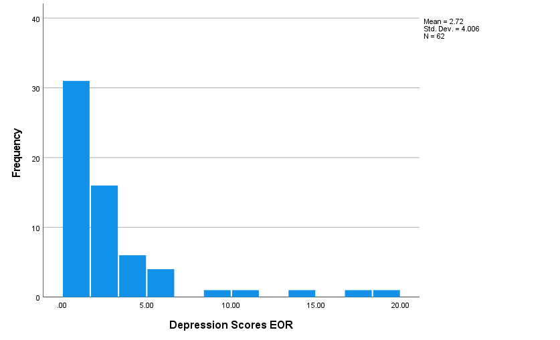

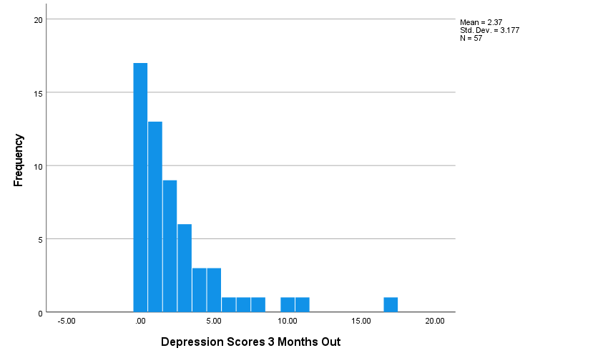
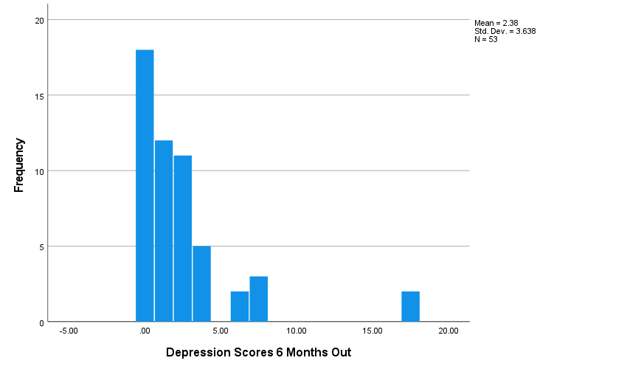

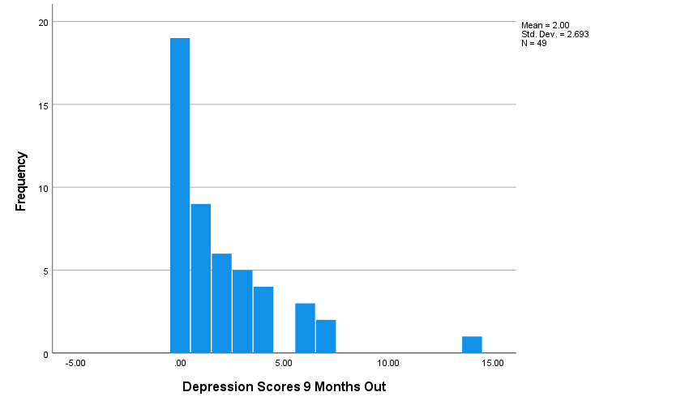
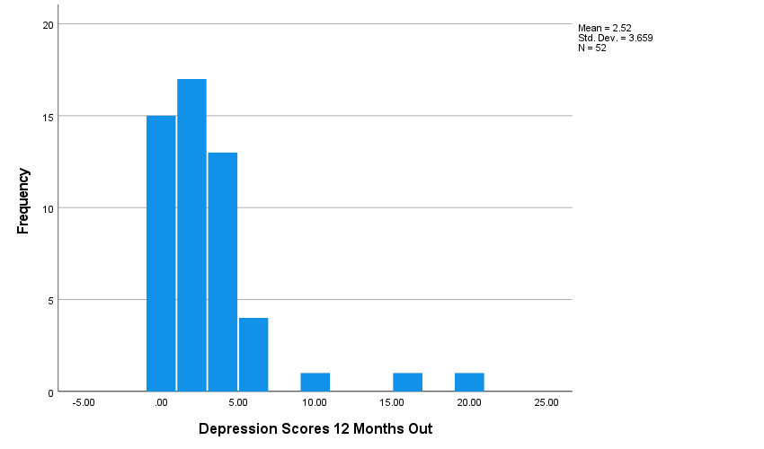

In our exploratory analyses of data distributions, we determined that the scores for depressive symptomatology were skewed across all five waves of data collection. Each wave was found to have a positive skew. Due to the lack of normality in data and small sample size (n=77), our data did not meet the assumptions necessary for parametric tests.

Appendix D: Less Healthy Diet Variable (Scale)

Patterns of less healthy diet Indices over time, with 95% Ci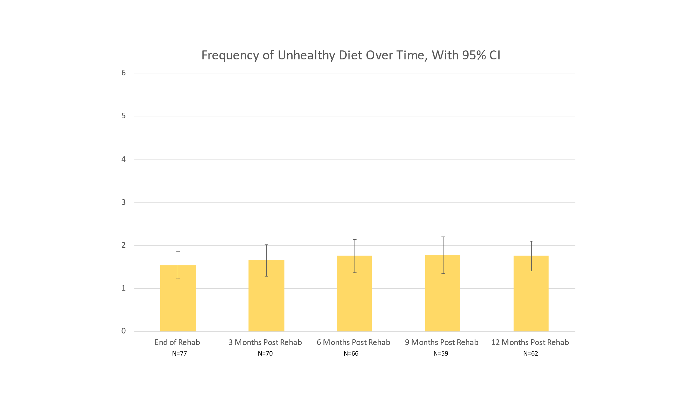

Less healthy diet Indices by depressive symptomatology Scatterplots
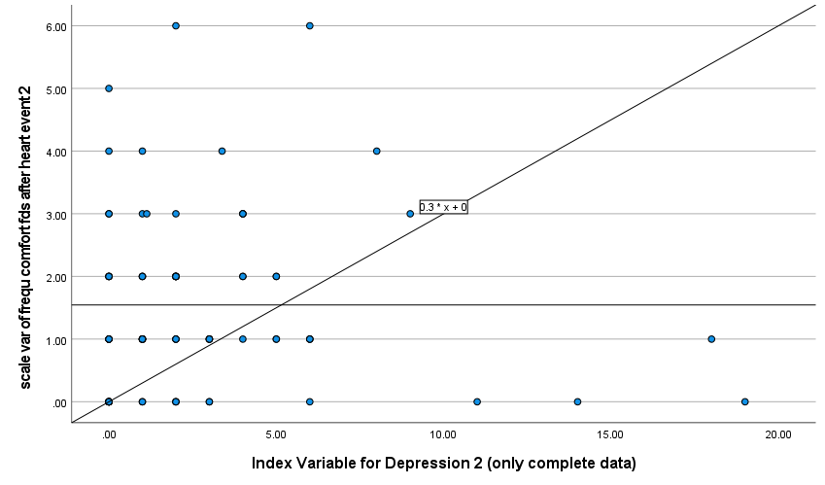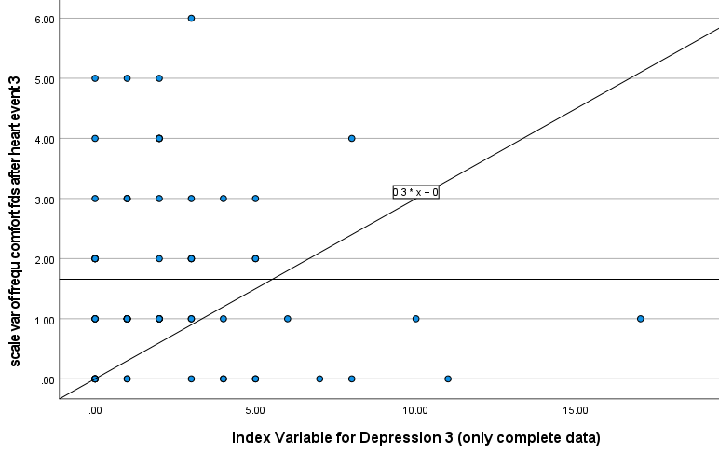

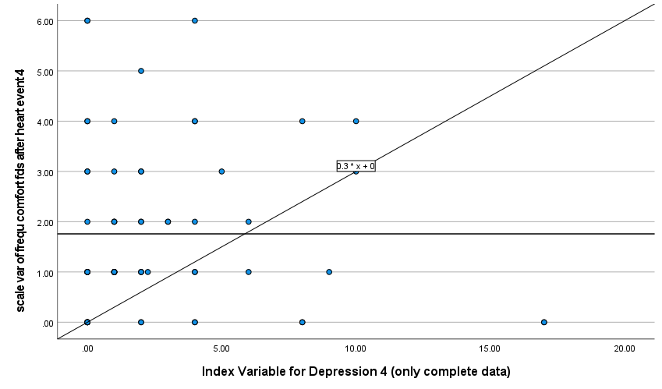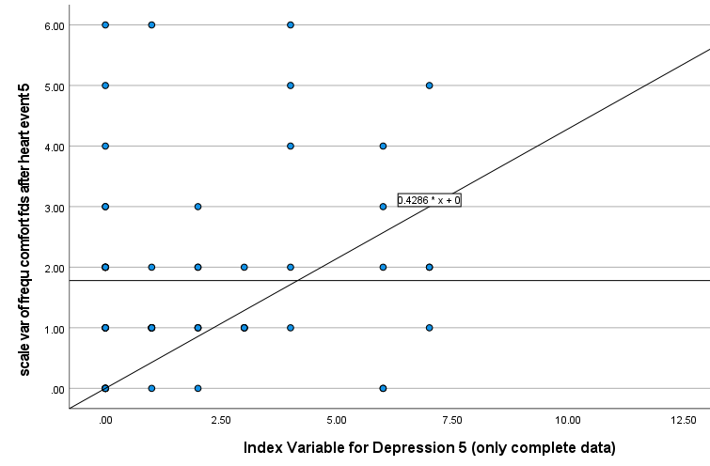

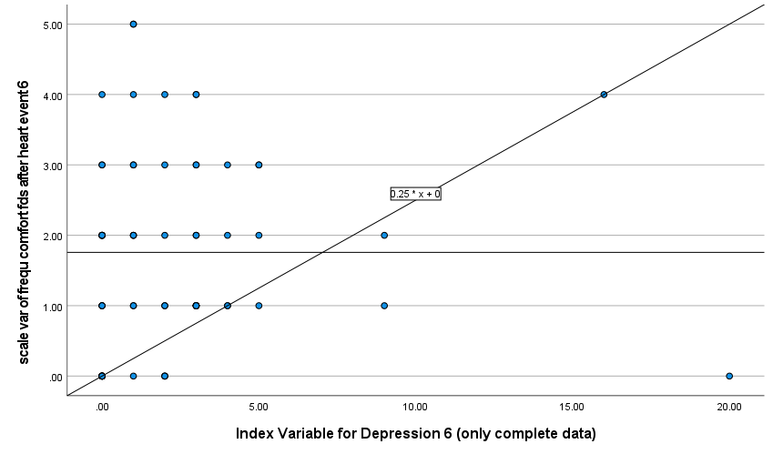

Bivariate scatterplots were used to identify a possible linear relationship between depressive symptomatology and less healthy diet scores. There was no clear linear relationship between the two variables. This lack of linearity led us to create the dichotomous less healthy diet variable based on the percent of the sample who reported less healthy diet index scores greater than 1. This also facilitated the use of graphing consistent with those used for the other categorical health behaviors.

