University of Oklahoma

Graduate College

Differentiation in the Secondary English classroom

A thesis

submitted to the Graduate Faculty

in partial fulfillment of the requirements for the

Degree of

Master of Education

By

Leslie odom
Norman, Oklahoma
2017

Differentiation in the Secondary English classroom

A thesis approved for the
Department of Instructional Leadership and Academic Curriculum

By

______________________________
Dr. Lawrence Baines, Chair

______________________________
Dr. Crag Hill

______________________________
Dr. Julianna Kershen

© Copyright by Leslie Odom 2017
All Rights Reserved.

Table of Contents

List of Tables vi
List of Figures vii
Abstract ix
Chapter 1: Introduction 1
August 2016 6
Research Problem 14
Research Question 14
Chapter 2: Review of Literature 15
Chapter 3: Methods 20
Chapter 4: Results 25
Dante 25
The Poetry Assignment 30
The Odyssey 43
Romeo and Juliet 51
Summary 62
Melina 62
The Poetry Assignment 66
The Odyssey 70
Romeo and Juliet 73
Summary 80
Laura 80
The Poetry Assignment 83
The Odyssey 85
Romeo and Juliet 88
Summary 93
Chapter 5: Conclusions 94
Research Problem 94
Research Question 94
Limitations 97
Teacher Workload 98
Grading 99
Students' Individual Needs More Likely to Be Met 99
Is Differentiated Education Beneficial for Student Learning and Improvement? 101
References 104

List of Tables

Table 1. Heisenberg’s 2010 U.S. Census Information 19
Table 2. U.S. News Heisenberg High Demographics 19
Table 3. My Heisenberg High Schedule 20

List of Figures

Figure 1: Dante’s Standardized Test Scores. 27
Figure 2: Mandated Poetry Explication Lined Outline 36
Figure 3: Excerpt from Dante's Poetry Explication Essay: 38
Figure 4: Differentiated Odyssey Comprehension Questions 46
Figure 5: Odyssey Graphic Organizer 47
Figure 6: Differentiated Odyssey Assignment Instructions 49
Figure 7: Dante's Finished Differentiated Odyssey Assignment 50
Figure 8: Dante's Differentiated Paragraph Handout 53
Figure 9: Romeo and Juliet Mandated Timed Writing 1 Prompts 54
Figure 10: Dante's Timed Writing 1 Response 56
Figure 11: Romeo and Juliet Mandated Timed Writing 2 Prompts 58
Figure 12: Dante's Timed Writing 2 Response 58
Figure 13: Romeo and Juliet Mandated Timed Writing 3 Prompts 60
Figure 14: Dante's Timed Writing 3 Response 61
Figure 15: Melina's Standardized Test Scores 63
Figure 16: Excerpt from Melina's Poetry Explication Essay 69
Figure 17: Excerpt from Melina's Odyssey Essay 72
Figure 18: Romeo and Juliet Mandated Timed Writing 1 Prompts 76
Figure 19: Melina's Timed Writing 1 Response 76
Figure 20: Romeo and Juliet Mandated Timed Writing 2 Prompts 77
Figure 21: Melina's Timed Writing 2 Response 78
Figure 22: Romeo and Juliet Mandated Timed Writing 3 Prompts 79
Figure 23: Melina's Timed Writing 3 Response 79
Figure 24: Laura's Standardized Test Scores 82
Figure 25: Differentiated Odyssey Boxed Outline 85
Figure 26: Mandatory Counter Argument Handout 86
Figure 27: Laura's Differentiated Counter Argument Outline 87
Figure 28: Laura's Mandated Odyssey Essay Outline After Using Differentiation 87
Figure 29: Laura's Differentiated Timed Writing Handout 90
Figure 30: Romeo and Juliet Mandated Timed Writing 2 Prompts 90
Figure 31: Laura's Timed Writing 2 Response 91
Figure 32: Romeo and Juliet Mandated Timed Writing 3 Prompts 92
Figure 33: Laura's Timed Writing 3 Response 92
Figure 34: Laura's Timed Writing 3 Response Continued 93
Abstract
This study seeks to show the possible positive learning outcomes gained by the use of differentiated instruction. My methods of differentiation included specializing content using the different levels of Bloom’s Taxonomy, diversifying assignments and assessments, and creating a one-on-one learning environment. I used previous test scores and recent student work to establish each student’s learning level. Assignments were differentiated to meet student needs. Results show that students became more aware of strengths and needs, performed better, and developed positive attitudes toward English.

Chapter 1: Introduction
I am a twenty-eight-year-old student with a Bachelor’s degree in Multidisciplinary Studies. Immediately after graduation I entered into the Instructional Leadership and Academic Curriculum graduate program at the University of Oklahoma. My emphasis is in English Education. I am from the small town of Dewey, Oklahoma, population 3,490 (2013 Census), where the average graduating class is 72 students. My mother’s side of the family has been born and bred in Dewey for uncountable generations. Our genealogy has been traced as far back as my great-great-great-great grandmother, but that is as far as anyone has gotten in their family history endeavors. My father’s side of the family is from Wann, Oklahoma, population 126 (2013 Census). In this part of the state, a town’s class is summed up by their grocery store: if the town has got a Walmart, then it is high-end. The nearest Walmart to either Wann or Dewey is in Bartlesville, Oklahoma, which is roughly a twenty-minute drive, depending on which rural route you live near. While Bartlesville is considered a bigger town than those that surround it, it is by no means a major city. The closest city that distinction could belong to is Tulsa, Oklahoma-- an hour’s drive away.
When I graduated from high school and decided to get my education at the University of Oklahoma in Norman, a lengthy three hours away, I was the only one in my graduating class to do so. Several other grads went to Oklahoma State University, located in Stillwater, Oklahoma, but the truth is Stillwater is just a bigger version of Dewey, only it has a Division 1 college located in the heart of it. I was the first one in my family to go to college, and am still the only one in my family to have ever left Dewey.
My interest in differentiated education was piqued before I ever had a name for it. My first graduate class was Young Adult Literature. My professor doubled as a high school teacher who taught Reading for Pleasure, and she often talked to us about the importance of student choice. She said that students needed to have a voice in their own education; they needed to be able to find their passion, their pleasure, and their perspective, all of which could be found within the right book. She would say that too many students hate school because of the work they find uninteresting and the work they are forced to do—giving students a choice changed all of that. I did not know it at the time, but that was the first time I had been inspired by differentiated instruction. A year later, I was teaching full time and in an Educational Research course when my professor assigned the class an article that discussed differentiated education at length. Frustrated by what was going on in my classroom, I met with my professor to discuss the possibilities of differentiation and, together, my differentiated research was born.
In my small-town mindset, I figured a big high school would not be all that different from a small high school, just with more people. When I took the job at Heisenberg High School, I did not really think much about what the differences might be between my small town high school and this big city one. My entire high school had 347 students, and was linked by a hall to the middle school, with the elementary school sitting across the street. All grades K-12 shared the cafeteria at meal times. Heisenberg High School had 2,800 students alone and was housed in a town that had another high school, and is now contemplating opening a third. This town also has four middle schools and seventeen elementary schools.
Still, I did not think about what the differences would be. In my town, you knew who was poor, rich, or middle of the road; knew a family’s whole history by their last name. If there were different clans of the same name, you simply figured out which clan that person belonged to and you knew their life story. I completed my student internship at Heisenberg High School West, where the population was much the same as Heisenberg High. However, my mentor teacher had worked at that high school for over twenty years and could rattle off what student came from which family, how many of their siblings she had taught, who the town’s celebrities kids were. This insider information made it feel as if I was back in my hometown, where everybody knew, or knew something, about everyone. During my internship, I taught eleventh grade English. There were no curriculum meetings or planning for me to go to. Instead, because my mentor teacher had been teaching for so long, she would simply run down each new unit for me, let me look over it, and told me to let her know if I had any ideas or questions. Sometimes I did, but sometimes I didn’t. The atmosphere was laid back and laissez-faire, a sharp contrast from Heisenberg High School, which, I would soon find out, was not like that in any way. There were students from all walks of life and no way to tell who, what, or where they came from. At the end of the day, it was a guessing game as to what kind of life each student led-- you did your best to assess the situation, but, unless the student told you or someone flat out knew, what you saw was what you got. This was new territory for me. I was used to knowing a name and getting a feel for another person’s home life, knowing what they went through on a daily basis. Not at Heisenberg High.
Another difference was the diversity of Heisenberg. At Dewey, there was a high population of white students, a very minor population of Hispanics, and an even more minute (3-4) number of African American students. At Heisenberg, the diversity was everywhere. There were white, Hispanic, African-American, and Asian just to name a few. There were even foreign exchange students. I was excited to get a glimpse at and hopefully learn about other cultures at Heisenberg.
I felt it my duty to learn as much about my students as possible to better understand them and help them learn. The job of an educator is not to thrust information at students and expect them to learn. The job of an educator is to learn what makes students tick, to adapt, and use all information to plan student learning. While the main job of an educator is to educate students, the educator also serves as a mentor and counselor, to help students grow. Part of that job description means sometimes students will need someone to talk to, will need advice, will need someone to make them feel like their problems, big or small, are worth listening to. I consider helping students learn to cope as well as understand and accept the differences surrounding them as an essential part of my job.
My childhood was filled with books and reading, transporting me to worlds and people I had never dreamed of. I began reading at the age of 2 and it became my immediate source of entertainment. Sure, I watched Barney, as every child of the ’90s did, but it was never as entertaining as rereading The Puppy in the Snow, a book I read so often, that I had it memorized and could rattle off the entire book verbatim whenever asked. Reading was my escape, my coping mechanism, my favorite pastime. Everything could be improved with a good book. Most children spend their birthdays wishing for toys and wanting to play with their friends. I always asked for books and, after eating cake and opening presents, spent the evening putting my books in the order I wanted to read them in. This love of reading never left me. In school, I always had a book to read, that way when I finished assignments early, I could move on to my book. If there was a particularly boring assignment, my book was my motivation to get through it because as soon as I finished the lackluster assignment, I could read. In high school, teachers often asked me what I was reading, and it was not uncommon to see them reading the same book shortly after I told them.
Going into my first year at Heisenberg High School, I had several goals for each student. The first goal was for those students who hated reading. My goal for them was to instill a love, or at the bare minimum a tolerance, of reading. For most students, the love of reading comes at a young age and you either like it or you do not. I wanted to change that. The second goal was for those who had a hard time with English. If they did not know the basic mechanisms of grammar or literary devices or writing, I wanted them to know them by the end of the year and be able to apply them. My third goal was for those students who skated by, who knew enough about English to make good enough grades and be fine with their efforts. I wanted to push them to do better, to be better, to give more effort. I never wanted to let them let good enough be good enough. My fourth goal was for the high achieving students: those that understood and applied English concepts as good as, if not better, than me. I wanted to see what they saw and then ask them to see a different side-- to offer counter arguments against themselves, to think outside of their own boxes. My last goal was for myself. I never wanted to rope a student into a certain category. Yes, I had goals for each level of student, but I never wanted those level goals to overshadow what a student was truly capable of. I wanted to push each student to the next level, to encourage them, to let them know they were smart enough.
In college, a professor told us that if we did nothing else but impact or change one student’s life each year, we could consider ourselves successful.
I wanted to impact them all.
That was my hope, my dream, but my first year at Heisenberg High School ended up being nothing like what I planned.
August 2016

Today was the day. All the English I teachers were meeting to discuss what we were going to teach the upcoming year. I was so excited that this meeting was happening (months late, in my opinion). I was smiling to myself as I briskly walked up the steps to a fellow teacher’s house. Inside my head were visions of all the wonderful texts I would introduce to my students during the upcoming year: Fahrenheit 451, Romeo and Juliet, “The Lady or the Tiger”, and works from Edgar Allan Poe. That was only the tip-top of my list. I expected to inspire students to read and learn in my classroom. I wanted to use my wit and humor to make things fun. The most boring of tasks can be made fun with a good joke, and for those students who did not enjoy learning, I planned to pique their interest with humor.
My smile grew bigger as I knocked on the door.
In fifth grade, I had a teacher named Mrs. Spencer. The summer before fifth grade had been a struggle for me. My sister died and I spent the summer learning what it was like to live in a house without her. The house was silent. The silence was only ever broken by my mother’s sobs, and I never knew which one was worse to listen to: the silence, or the crying. So I spent the summer in my room, watching endless hours of television with the volume on high. I did not even read one book. I lived in a small town, and went to an even smaller private school on the west side of town. It sat on a hill, overlooking three soccer fields and a wasteland of dead trees. There were twenty-three students in my entire class, including me. Everyone knew that my sister had died, and I was terribly nervous about how I would be treated. I had had enough of pity and tears. I wanted normal. Mrs. Spenser did not just treat me normal. She treated me like everyone. She transported me to a different world while I learned and absorbed everything she said. We had a set routine every day. Subjects were broken up by certain hours. We would spend the first half of each subject learning something new, and the next half hour playing learning games and putting our newfound knowledge to practice. For the first time, I thrived in every subject, taking the number one spot in the class. Each day was new and exciting and refreshing. For the first time, I found myself wanting to stay at school rather than wanting to go home. At the end of the year, I wrote Mrs. Spencer a card, telling her I could not wait to be a teacher just like her. It was that fifth grade year that showed me my path in life and brought me to this doorstep. I could barely contain my excitement.
The Heisenberg High School teachers’ meeting was a potluck and we were all supposed to bring a dish. After eating, we pulled out our pens, pencils, paper and books and got down to business. It being my first year teaching, I was not sure what to expect or what each unit was to consist of. I assumed this meeting was an introduction to what texts we would be able to choose from with feedback from seasoned teachers--an opportunity for us to get to know each other and the different teaching styles we each presented.
I was wrong.
The seasoned teachers began talking about last year’s curriculum and what they liked and did not like. We three newbies at the table sat back and listened and sent signals of alarm to each other with our eyes. From the sound of the conversation, the department head, whose house we were at, had already planned out her year. She knew exactly what books and stories she was teaching and exactly what units she wanted. A fellow teacher across the table was trying to challenge her on what she was teaching and suggest different stories and units, but the department head did not budge and dismissed her ideas by ignoring them.
I did not understand what was going on. Could not this other teacher could just teach what she wanted, instead of trying to get the department head to change her plan?
A silent alarm began to go off in my head. I now knew that I was devastatingly behind in my planning and, as cold fear spread down my to my fingertips, I was considering, based on the conversation happening at the table, that maybe I did not know how to plan. My heart was hammering and I was beginning to sweat when I heard the words:
“So that will be our curriculum this year.”
The alarm stopped and the fear ceased.
Wait, what?
I raised my hand. The table immediately became silent and all eyes were on me.
“Um, I guess I’m a teacher so I don’t have to raise my hand, do I?” No one laughed. “I just have a question, maybe two. Did you just say that this,” I pointed at the paper in front of the department head, “will be our curriculum this year?”
“Yes.”
“So we don’t get to pick what we teach? We all teach the same stuff, I mean, material?”
“We are picking what we teach. Right now.”
“What I’m saying is, I’ve heard that teachers get a list of works to choose from and they each get to pick the works that they want to teach. I mean, not every teacher teaches the same things or at the same time.”
The Head went on to explain that everyone would teach the same works at the same time and use the same instruction. That everything would be the same for everyone. When asked what the motive was for this, I was told, “So that every student gets the same educational experience. That on any given day an administrator can walk into the classroom and see the same thing being taught across the board.”
Content would be the same for everyone. Lessons, assignments, rubrics, all the same. Everything would be identical.
I sat back in my chair, utterly appalled. What had I gotten myself into? This take on education was wrong. It swept the rug out from under creativity and individualization. It murdered passion and diversity.
Most importantly, the basis of this approach suggested that every freshman student was the same. We were supposed to prepare students for the real world, the outside world where nothing is the same and everything constantly changes. We were not supposed to teach them to conform. We were supposed to stick to our guns, to fight for our students’ rights to be unique. Creativity ignites passion. Passion sparks learning. To teach without these things, to expect students to learn without these things, was to stomp on an already dying flame.
I managed to make it silently through the rest of the meeting. I wrote down the curriculum I was given and was told that I would be receiving the assignments through my work email via a shared folder shortly. I remember leaving totally disheartened and crushed. All excitement, hope, and happiness was replaced by shock, disbelief, and that same cold tingle of fear.
Even better, most of our assignments were geared toward the students in the middle. This meant that our higher-end students would be bored with tasks, middle students would skate by, and low students would struggle endlessly.
What was I going to do? I could not ignore the school’s and district’s wishes. That was career suicide. When I left at the end of the year, who would hire a known rebel?
I made it until the end of the semester doing everything I was told. I was asked to teach stories and poems that I had never read, heard of, or been introduced to. Some days, when the department head was behind in her planning, I did not know what I was teaching until eight a.m. that same morning. School started at nine.
When students asked me their very favorite questions, I was vague in my response to them.
Students: Why do we have to learn this?
Me: Why don’t YOU tell ME that when we are done reading.
Honest answer: It was an obvious skirted question, but I had no answer. I did not know the answer to the question myself.

Students: Why did we have to read this specific story?
Me: Because we are going to use this story to learn about [theme, symbolism, etc.]
Honest answer: Because I was told to.

Students: What are we going to learn from this story?
Me: Oh, all kinds of things. You just wait!
Honest answer: I have not yet been told.

Students: What am I supposed to get out of this?
Me: Just wait and see!
Honest answer: I DO NOT KNOW.

That first semester I was a servant to the cause. I performed every task, unit, and assignment I was asked to, all while inwardly screaming. I felt myself become miserable, thwarted by the reality that the career I had been dreaming of for fifteen years, that I had spent thousands of dollars on, was nothing that I wanted anything to do with.
To make matter worse, my fears about teaching to the middle level of my students were coming true. Higher-level students were bored in class, often finishing assignments much too early for my liking (and theirs). Middle-level students had just enough struggle but found assignments more tedious than helpful. Lower-level students struggled to the point that many would not turn in assignments, or, if they did, it was only halfway done.
One thing all levels shared was a lack of motivation, and how could I blame them? I was positive that more than half of this motivational problem was seeded by me. I was supposed to be the leader of the classroom, the motivator, the inspirer, the connoisseur of all things learning, and I was helpless.
I was also surprised by the gaps that high-, middle-, and low- level students exhibited. Gaps were across the board in grammar, writing, and reading comprehension. No one student was on the same level as any other student.
Grammar gaps were extreme. For example, one student in the class might know and be able to pick out a gerund phrase in a sentence, and another student in the same class was barely able to pick out the subject. This presented a problem because every teacher was supposed to give the same grammar lesson every day, but what about those students who already knew the material? What about those students who did not have the knowledge necessary for the lesson to be of use? What was I supposed to do about the gaps?
I had students who could write academically and could finish writing assignments in minutes, while other students, those who had trouble writing academically, needed at least four days to complete them. Obviously, students who could write academically needed more of a challenge, and I needed to find a way to give that challenge to them.
As for reading comprehension, I had students who could read for an entire class period and not know what they had just read, not be able to comprehend anything about the story, but then I also had students who could tell me the color of a minor character’s shirt and discuss subtle themes as if they were college professors.
So the questions became, How do I challenge each student? How do I make each assignment a learning opportunity for every level of student, while still maintaining a rigorous curriculum? And finally, How do I challenge individual students without changing their whole curriculum and bringing unwanted attention to them?
At first, these questions seem easily answered: tweak the assignments, alter lessons, break students into groups, offer students a choice of differentiated assignments. However, these answers presented another challenge: the assignments and lessons I needed to be tweaking were not my own. Therefore, new questions arose in response to the initial set of answers: How do I tweak assignments and lessons that are not my own, that I had no hand in creating? How do I differentiate in a classroom where everything is supposed to be the same?
I felt like I was not able to achieve or even have my own goals because my work, assessments, and criterion were dictated. I was told that every student must do the same, must be the same, so that every student received the same education. There were students who needed more basic assignments and there were students who needed higher level assignments. There were students who would achieve more if they were assessed orally or more creatively, but my hands were tied and I was not allowed to give my students the education they deserved. It is one thing to have a common curriculum, where teachers teach the same works and have similar assessments. It is a whole different ball game to have a common curriculum where teachers cannot even adjust their lessons to help their students. Truly, my first semester at Heisenberg was a learning experience. If I had not felt so confined in my teaching, I might not have been so quick to see, to learn about, the benefits of differentiated education.

Research Problem
The problem is that many schools are going to a one-size-fits-all curriculum where outcomes are predetermined, fixed, and formulated irrespective of individual student strengths and needs. According to Barnes and Slate (2013), this is causing students to “not graduate from high school” or to “graduate, but not [be] academically prepared or college ready” (p. 1).

Research Question
The research question is, “What effect, if any, will differentiated instruction have on the academic performance and attitudes of three randomly-selected students?”

Chapter 2: Literature Review
The argument for standards-based curriculums in secondary schools around the United States began in the early 1960s (Alexander, 1961). Some might attribute this argument to the rise of colleges in the United States and desire for higher education and better paying jobs. In truth, this is only one of the many factors, but it is the most important. With colleges and universities requiring entrance exams for acceptance and enrollment, state education agencies were forced to question how to best prepare their students for these exams. States chose a committee to set up state education standards. Thus, the standardized test was born and the shift from teaching for the sake of learning to teaching to the test was created.
With the implementation of standards-based curriculum, the emphasis became the standardized tests, which is why in today’s curricula every student is expected to learn the same things and be on the same level as everyone else. Standardized tests do not ask what a student has learned or what a student can prove; instead, standardized tests only acknowledge a student’s ability to be able to find what the test deems the correct answer. All this does is create one-track learning by asking students to only think about one possible outcome or interpretation of a text versus allowing them to think about the possibility of multiple outcomes or interpretations. This switch from teaching for the sake of learning to teaching to the test is not the fault of teachers but the fault of the state mandated standardized test.
Differentiated education fixes the one-track by “allow[ing] all students to access the same classroom curriculum by providing entry points, learning tasks, and outcomes tailored to students’ needs” (Watts-Taffe et al., 2012, p. 304). It is not a single-approach style of teaching, but is “responsive to students’ varying readiness levels, varying interests, and varying learning profiles” (Lawrence-Brown, 2004, p. 37) and “can occur by focusing on the process by which students learn, the products or demonstrations of their learning, the environment in which they learn, or the content they are learning” (Watts-Taffe et al., 2012, p. 304). Differentiated instruction put the emphasis back on the learner rather than putting the emphasis on the standardized test.
The last few years have seen the United States call for more diversity. On July 1, 2016, U.S. Education Secretary John King called for more diversity among public schools, stating, “Like math and reading, like science, social studies, and the arts, diversity is no longer a luxury… It’s essential for helping our students get ready for the world they will encounter after high school and, increasingly, throughout their lives” (Deruy, 2016). Differentiated education honors nothing if not diversity. There are many ways students can be diverse and all students fall into more than one category. According to Watts-Taffe et al. (2012), “Gender, ethnicity, language, race, socioeconomic status, and exceptionalities” (p. 305) are just a few examples of diversities among students and “… an important way to honor [the diversities of students] is to offer appropriately differentiated instruction” (p. 305).
The idea of differentiated instruction is hardly new to the field of education. Articles discussing ideas on differentiated instruction can be found dating back to 1945. However, according to Figurel (1952) the “applied research [in differentiated education was] almost non-existent” (p. 27) in the mid-20th century. The “modern approach [was] to adjust instruction to the learning levels of children” (p. 27) using one or more of the four documented techniques for differentiated instruction:

“(1) grouping of children for various reasons or purposes,
(2) individualized activities,
(3) individualized instruction, and
(4) class activities in problem solving units” (Figurel,1952, p. 27).

While these techniques were found to be useful in the classroom, research on differentiated instruction fell in the coming years until “2004, when reauthorization of the Individuals with Disabilities Education Act (IDEA) introduced RTI” (Watts-Taffe et al., 2012, p. 305). RTI stands for Response to Intervention and is a tiered approach to helping students with disabilities. This tiered approach “assumes that literacy teachers differentiate...within both the context of the general classroom (sometimes called Tier 1) and within the context of more specialized and targeted instruction/intervention (sometimes called Tier 2 and 3)” (Watts-Taffe et al., 2012, p. 305). Watts-Taffe, et al. (2012), newly defined differentiated instruction as “responsive instruction designed to meet unique individual student needs” (p. 305).
Lawrence-Brown’s (2004) article breaks down exactly what differentiated instruction is and what it needs to be for the strategy to be successful. Lawrence-Brown (2004) found that “[d]ifferentiated instruction is as important for students who find school easy as it is for those who find school difficult” (p. 37) especially in inclusive classrooms, aruging that “[d]ifferentiated instruction serves two broad goals… first is to maximize attainment of the grade-level curriculum standards for all students...second… is to provide adapted curricula for those who need it” (p. 38).
Lawrence-Brown’s (2004) Model of Differentiation helps to understand what differentiated instruction means for each level of student:

Additional Supports
For students who fall under this category, “grade level standards are appropriate, but very challenging. Without Additional Supports, many of these students will fail” (p. 39). It is still incredibly important to maintain high standards for these students, but modification will need to be made in order for them to succeed. Students who fall into this category are most likely to be English Language Learners, those with an underdeveloped skill set, or those with disabilities or behavioral problems (Lawrence-Brown, 2004).
Enriched Curriculum
Students found in this category have a higher learning ability and are often in need of being pushed harder by the general curriculum. The benefit of differentiating with an enriched curriculum is that this curriculum can also be expanded to include students’ talents and not just those who value their education. (Lawrence-Brown, 2004)
Prioritized Curriculum
These students are often those on IEPs and/or have “severe disabilities” (p. 47); “the goal [is for these students to] reap the benefits of general class placement while addressing individual needs [allowing the student to] ‘[accomplish different] content or curriculum goals’” (Lawrence-Brown, 2004, p 47-48).

Lawrence Brown’s three types of students are apt descriptors for those students found in a general education classroom. There will always be students who need to be given more high-level assignments because of their higher cognitive abilities, students who find the curriculum to be at a suitable difficulty level, and students who need additional supports (whether that be extra help with assignments or the implementation of an IEP).
A one-size-fits-all education does not actually fit all. It assumes that every child thinks, learns, and reacts the same. It assumes that every child’s home and academic environment is the same. It assumes that every student has the same strengths and weaknesses.

Chapter 3: Methods
The research took place in the town of Heisenberg. The most recent U.S. Census population results are from 2010.
Total Population | 110,925
White | 79.7%
Hispanic | 6.4%
American Indian | 4.7%
African American | 4.3%
Two Races | 5.5%
Asian | 3.8%
Table 1: Heisenberg’s 2010 U.S. Census Information
Heisenberg High’s demographics are only slightly different than the whole of Heisenberg town.
Total Students | 1,890
White | 62%
Hispanic | 10%
Two Races | 8.0%
African American | 9.0 %
American Indian | 8.0%
Asian | 3.0%
Table 2: U.S. News Heisenberg High Demographics
At Heisenberg High, I taught all Pre-AP English 1 with small breaks for lunch and plan.
Period | Subject | Class Size
1st 9:00-10:00 AM | PRE-AP ENGLISH 1 | 13
2nd 10:08-11:04 AM | PRE-AP ENGLISH 1 | 22
3rd 11:04-11:59 AM | LUNCH
4th 11:59- 12:54 PM | PRE-AP ENGLISH 1 | 24
5th 1:02-1:58 PM | PLAN
6th 2:06-3:02 | PRE-AP ENGLISH 1 | 26
7th 3:10-4:05 | PRE-AP ENGLISH 1 | 20
Table 3: My Heisenberg High Schedule
This research was designed as an autobiographical study researching the potential benefits of differentiated instruction in a standards-based curriculum. I chose to do an autobiographical study after reading about the benefits that it presents to the reader. Delamont states that “[a]utobiographical writings about how a particular project is carried out are enormously useful for readers who are themselves trying to do qualitative research, especially novices” (546). Bullough states that, “[a]utobiography, like fiction, reveals to the reader a ‘pattern in experience’ and allows a reinterpretation of the lives and experience of both the writer and the reader. To be powerful this pattern must be portrayed in a way that engages readers in a genuine act of seeing the essential wholeness of life, the connection of nodal moments. In seeing, the reader is enabled to see self and others more fully” (5). This methodology also allowed me to be natural and unforced.
As a new teacher in a new school, I felt as generalized as the work I was giving my students, and this only made me want to rebel against all the constraints I felt from the controlled and aligned curriculum. I recognized the need for alignment in students’ education, but the extent of control I was dealing with was overwhelming. I wanted to be ME. I wanted to feel like an individual. The expectation that every teacher should teach the same materials the same way burned me in the same way as the expectation that every student should be taught the same burned me. Thus, the fire was lit for differentiated instruction.
I chose three freshman students in my English 1 class to participate in the study. A fellow teacher came into my room to give and collect the consent documents. I did not know who chose to participate until after the research period was over, which is when the consent forms were released to me. During the research period, I kept copies of all student work and gave the originals back to students, just like I would do if there was no research going on. I also kept my eye on the six students who I felt could benefit the most from differentiated education in hopes that they had consented to the research. When the consent documents were released to me I was lucky in that almost the entire class had consented to be in the research, including the six I had specifically hoped for. From those six, I chose students who needed different methods of differentiation. The purpose of this was to highlight the fact that differentiation does not have to academic support and can be emotional support as well. I also chose a student who needed to learn a new, yet specific, skill to show how easily underdeveloped skills can be honed using differentiated instruction.
The students chosen were also from the high, medium and low learning levels: roughly the equivalent to the categories explained by Lawrence-Brown. However, instead of choosing a student from “prioritized curriculum”, I decided to choose an “average” student. The reason for this was that those students who are a part of the “prioritized curriculum” are already receiving accommodations from their IEP or 504. I wanted to differentiate for students who were not receiving any different curricular content than that I was putting forth. Data on my choices was obtained through student work, the grade book, interactions, and observations. To ensure confidentiality, names of all persons and places have been given pseudonyms. All conversations were replicated as accurately as possible from copious notes to ensure proper documentation for student files. IRB approval was given before the commencement of this study.
The study began in the second semester of school, after I had spent the first semester strictly adhering to the aligned curriculum set forth by the school and the department head. During the second semester, I continued to keep the aligned curriculum plans put forth, but tried to differentiate as much as possible. The goal of this study was to launch a differentiated curriculum for students within a standards-based curriculum. I wanted to see if differentiated instruction would make any difference in student achievement and learning.
These assignments were moderately differentiated for each student, meaning that each student was given the same assignment, but with minor alterations tailored to each student’s needs and personality. The assignments discussed in this study are:
- The Poetry Essay: After students were taught how to annotate a poem, students were given a list of poems to choose from to complete an in-depth study over. After choosing a poem, the students would be given a set amount of time to complete their research and then given a layout of an outline that they were to complete for their poem. They would use this outline to write their essay.
- The Odyssey Essay: This essay was designed for students to argue whether Odysseus was truly a hero. Students were taught Joseph Campbell’s Hero’s Journey and common traits of heroes were discussed. After finishing The Odyssey, students were asked to write an outline of their argument before writing their essay.
- Timed Writings: These took place during the Romeo and Juliet unit. After every two Acts, students were given three prompts to choose from and were given the entire hour to write a paragraph over their chosen prompt.

Chapter 4: Results
Dante
Dante is a fifteen-year-old African-American student in my English 1 course. He stands about five-foot and six-inches. He plays basketball for an Amateur Athletic Union (AAU) team, runs track for the school, and is an all-star football player at Norman High, running for over 1,000 yards on the junior varsity football team during the 2014 season. On a typical day, Dante is reserved and quiet. He walks into class and sits directly in his seat, which is closest to the door, and patiently waits for class to start. He usually wears his favorite bright orange hoodie and athletic pants. He is well-behaved and does not talk when he is not supposed to. He turns in his work on time. Even though I have given students permission to call me “Miss G” because my last name is hard to say, he always addresses me as “Miss Gordineer”, insisting that “Miss G” makes him feel disrespectful. He also never fails to use “ma’am”, “please”, and “thank you” when addressing anyone in authority. He is my most polite student—never has he said or done anything in my class that could be deemed disrespectful.
One of Dante’s best traits is that he is one of the most hard-working students I have ever met. He tries so hard that you can see the concentration and, more often than I would like to see, the confusion on his face. He wants to understand, but he struggles when it comes to English; this was a struggle he voiced on the very first day of class. We had just spent the hour going over the syllabus and what would be expected of each student and the classroom rules that I set forth. The bell rang and all of the students began to filter out, except Dante. He gathered up his stuff and came walking up to me, sticking his hand out. I was so taken aback that I stared at it for a second before realizing that he wanted me to shake his hand. In all the scenarios that had crossed my mind for the first day of school on my very first year of teaching, a student shaking my hand was not one of them. I reached out my hand and shook his.

Dante: Hi, I’m Dante.
Me: Hi, Dante, I’m Miss Gordineer.
Dante: I just wanted to introduce myself and I just wanted to tell you that, um, English is really hard for me, but I wanna get better and I just wanted to warn you that I’ll probably need extra help and that I’ll do whatever it takes to get better grades, extra work, anything.
Me: Okay, Dante. We can do that. I’ll make sure, okay?
Dante: Okay. Thank you. It was nice to meet you.
Me: It was nice to meet you, too. I’ll see you tomorrow, okay?
Dante: Okay. Thank you. Bye, Miss Gordineer.

He was the only student to get my name right on the first try that day, and he is still the only student to tell me bye every single day. Immediately after that conversation, I was overcome by his sense of determination and desire to “warn” me that he was the kid who needed more help than some other kids.
I decided right then and there that I would make sure Dante was successful. Maybe he did fall on the low end of the spectrum, maybe he would need more help, but any student with the guts to walk up to his English teacher the first day of school and say what he said also had the gumption to overcome his weaknesses. Where there is a will, there is a way and I was going to be that way.
After school that day, I looked at his test scores. The school kept all available test scores and information for each student on their grading website, InfiniteCampus, so it was easy to find them: all I had to do was type in his name.
The Oklahoma Core Curriculum Test (OCCT) for English involves tests in both reading and writing. These scores help determine a student’s knowledge level in the subject area. These scores are then used to help judge classroom and, in some cases, remediation placement.
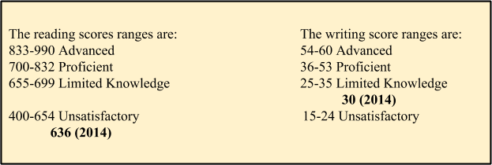
Figure 1: Dante’s Standardized Test Scores
So, in a way, Dante was right about himself. He struggled with English. I just needed to watch and pinpoint what exactly he struggled with so that I would know how to help him.
Dante was smart, that was not what was heartbreaking. What was heartbreaking was that he had gaps in his education that hindered him from being able to truly succeed in my English class. His reading comprehension was abysmal and listening carefully to class discussion didn't seem to help. His struggle manifested when the class began to read Animal Farm. He could read a whole chapter, immediately take a quiz, and bomb it. His highest reading comprehension quiz for the first month was a three out of ten. I remember thinking: Maybe he isn’t really reading, only to see him reading the book at lunch, his eyes focused on the page and his forehead wrinkled in concentration. I felt he was trying hard, but comprehension was eluding him.
One of Dante’s most mature traits is that he knows his strengths and weaknesses and is not afraid to admit them; a trait that he showed on the very first day of school when he introduced himself to me after class. He articulated his thought process to me after class one day. “You strengthen your weaknesses by saying them out loud,” he said. “They lose power. Then you can work on making them less weak.” He demonstrated this willingness to confront his weaknesses when he took it upon himself to approach Mrs. Riley, the Literacy Foundations teacher. Literacy Foundations is a remediation class offered to students in need of learning the basics of the English language, who struggle to keep pace. The student takes this course in conjunction with his or her regular English class. This was Mrs. Riley’s first year teaching Literacy Foundations, although she had been an English 1 teacher for the past four years. The previous Literacy Foundations teacher left for an administrative position at a local middle school. I do know that teacher left Mrs. Riley copies of her previous curriculums, and encouraged her to collaborate with the core English teacher to help differentiate for the student, which Mrs. Riley did every week. I had previously spoken to Dante about the Literacy Foundation course before he approached Mrs. Riley.

Me: Dante, there’s a course offered here called Literacy Foundations. A teacher has to recommend a student for it, and I would like to recommend you. I know sometimes it’s hard for me to help everyone, and I think you would really benefit from the extra help. You would still be in class with me, but you would take this class too. Is that something you might be interested in?
Dante: Yeah. I want the extra help. And I would still get to stay in your class, right? [I nodded]. Then, yeah. Who teaches it?
Me: Mrs. Riley does.

I told him where Mrs. Riley’s classroom was. She approached me the next day after school to tell me that Dante had stopped by and introduced himself, telling her that he would be interested in taking her class.
Mrs. Riley: He is the most endearing boy. He even shook my hand. I thought, oh you poor thing, let me help you!
Me: I know! He is one of the most respectful kids I have ever met and he needs your class. I promised to help him and I think your class will really make a difference for him.
Before the beginning of the next school semester, I talked to Mrs. Riley about Dante and what I had noticed about his demeanor during the previous semester. I confided in her that I had a feeling his home life was bad, as he had mentioned moving a lot the last few of years and having to go to several different schools. I mentioned that while he was always respectful, at times he could have dark moods where he was very down and could hardly keep his eyes open in class. She asked me if I had talked to him about it and I told her that I always offered to be someone he could talk to, but that he had never told me anything. Mrs. Riley mentioned that she would keep an eye on him during the semester, and if we both felt he needed a counselor we could go to the school counselor together. I also asked her to see what she thought about the possibility of him needing an IEP.

Me: I’m not sure what constitutes one, except that I know there is a test, but something tells me he should be on one.
Mrs. Riley: What have you noticed?
Me: Well he really struggles with reading comprehension, but I’ve noticed that he does better when he is able to listen. I tested it out once, and made the class listen to Animal Farm on audiobook. He made a 70% on the chapter quiz, when he usually makes 40’s or 50’s. And I’ve noticed that during class discussion, he doesn’t want to participate but listens very intently. He can tell me what was discussed, but has a hard time telling me what we read, if that makes any sense.
Mrs. Riley: It does. Hmmm. That’s interesting. He’s not on an IEP or 504? [I shook my head]. Alright, I’m gonna keep an eye out. Let me try some things and see what I find. The IEP process is SLOWWWW. If we get on this together, it might speed it up.

The information I had gathered about the possibility of Dante’s home life being bad came from observations made during the first semester. I never asked him about it because I did not want to embarrass him. There are days where Dante comes into my class and is down. He sits in his seat, shoulders slumped, eyes cast down, looking like he is about to vomit. I always ask if he is okay and he always answers with an honest, “No.” I will ask him if he wants to talk and, when he replies “No” to that too, I will put my hand on his shoulder and let him know that if he changes his mind, I am here. Unfortunately, he has not changed his mind. Mrs. Riley and I have talked about his sad demeanor several times and have asked his counselor to talk to him on days that seem particularly bad. Sadly, our attempts seem to have had little effect.
The only things I know about his home life come from a phone call I made to his mother after Dante had been in a fight. During lunch, the students are allowed in the gym to play basketball, a luxury many take part in. Dante and some other freshmen were playing some half-court five-on-five. Dante had the ball and crossed over his over-six-foot defender and pulled up for a jumper right after blowing past him. The defender picked up the ball and hurled it at Dante, hitting him in the back when he was not looking. When Dante turned around to see what happened, the other boy began running after him, chasing him around the gym. Dante ran, but the defender caught him, hitting and punching him, while Dante did everything he could to defend himself. The teacher on duty saw what was happening and ran to get in between them, but could not. She tried pulling them apart, but to no avail. Students quickly jumped in to help, but no one could get the two boys away from each other. The teacher on duty yelled for a principal to help. Two principals came, one male and one female, with a security guard not far behind. It still took over ten minutes to pry the boys apart. I was thoroughly shocked when I had heard about Dante getting into a fight.
After school I pulled up Dante’s home phone number from InfiniteCampus and called his mother. I was incredibly worried about him and wanted to talk to his mom to see if he was okay. She answered after a few rings.

Dante’s Mom: Hello?
A television blared loudly in the background and several voices talked and yelled over each other all at once.
Me: Hello, I’m Dante’s English teacher, Miss Gordineer. I heard about the fight today and I’m calling to see if he is okay.
Dante’s Mom: Who?
I repeated myself.
Dante’s Mom: Oh [there was a long pause in which I felt she was annoyed]. Here. You can just talk to him. [She yelled for Dante several times. When I heard him ask who it was, she replied, “Some teacher from school”].
Dante: Hello?
Me: Dante! Hi! It’s Miss G. I just wanted to see how you were. I heard about the fight today.
Dante: Oh, hi, Miss Gordineer. Yeah, I’m all right. It was crazy. How’d you hear?
Me: Well, I heard that you got into a fight from my sixth hour class, but another teacher told me the details. Are you in any trouble?
Dante: Umm… I don’t know yet. They said I’d probably be suspended for, like, a coupla days for fighting, but not as long as the other guy.
Me: Okay, well good. Well, I just wanted to see if you were okay. Make sure you didn’t break your face or anything.
Dante: [laughing] No, I’m good, Miss Gordineer. Thanks for calling.
Me: Sure! We’ll see you at school. Hopefully soon.

This phone call felt like something out of a movie and gave me a little more understanding of what Dante might go through on a daily basis. I would love for him to change his mind and come talk to me some time, but for now I’ve settled with paying close attention to how he seems to be doing emotionally and doing my best to keep my promise to help him.

The Poetry Assignment
After Winter Break, the English 1 classes began their poetry unit. I had never heard of the TPCASTT method before it came time to collaborate and plan the poetry unit with the other teachers. Or, if I’m being more honest, until it came time for the department head to tell us all what we were teaching and how we were teaching it. We were told we would use the TPCASTT method, which I had never before heard of. Three of the eight English teachers had never heard of it. She told us to learn it quickly. All aspects of the poetry assignment were handed down to the rest of us by the department head. The classes opened with vocabulary terms and a brief introduction on the various types of poetry. Then, we taught our kids the TPCASTT poetry annotation method. Each student would be given a copy of a poem and allowed to write on the paper and poem to TPCASTT it. TPCASTT stands for:
T- Title: Before reading the poem, speculate on what the poem might be about based upon the title.
Write this down at the top of the paper.
P- Paraphrase: Before thinking about the deeper meaning of them poem, first try to understand its literal meaning. Write exactly what happens in each line of the poem.
C- Connotation: This part of the TPCASTT is where the student will look for both poetic devices and literary devices and explain how these devices lead to a deeper understanding of the poem.
A- Attitude: Look at the author’s use of diction, images, and details. Use these to help determine the tone of the poem.
S- Shift: Look for key shifts throughout the poem. [The students knew what a shift was from their vocabulary. A shift can occur through various means including tone, and punctuation, revelations brought forth within the poem, stanza form, and rhyme as well as through transition words like “but” or “yet”]
T- Title: Look at the title again and see if it the meaning of the title has changed.
T- Theme: Decide what the theme of the poem is based upon the findings.
Students spent time TPCASTTing “I Wandered Lonely As A Cloud” by William Wordsworth, “Oranges” by Gary Soto, and “Ballad of Birmingham” by Dudley Randall. After students were well versed in the art of the TPCASTT, we introduced the Poetry Project. Each student was given a list of thirty-five poems to choose from. Once they chose their poem they were given the assignments. First, they had to TPCASTT their poem and write a summary of what the poem was about. Second, they had to interview another person, preferably an adult, about their poem. They were given a list of ten questions to choose from in which they had to choose three and then make two questions of their own about the poem. Lastly, students were given a research packet about their poem. Each research packet was taken from Poetry for Students series which we found in our school’s Gale Virtual Library. The poetry research was broken up into three categories: Historical/Biographical background, Analysis, and Literary Criticism. Students had to find five facts from each section and put them on notecards to use for their upcoming essay. Their essay would be an in-depth analysis of the poem using their TPCASTT and either their interview or the facts from their notecards. Once students were given the proper time to find their facts, they were given an outline to begin writing and working on. Students received three days to type their essays into Google Docs and share them with me.
Dante chose the poem “Do Not Go Gentle Into That Good Night” by Dylan Marlais Thomas. I was a little caught off guard by his choice of poem because there were much easier ones to choose from, but delighted by his decision not to go for an easy poem. I asked Dante why he chose this particular poem.
Dante: I liked the way it sounded in my head when I read it.
That answer was good enough for me. I kept a close eye on Dante as he TPCASTT-ed his poem, making sure that he was able to pick out the literary devices on his own as well as helping him with theme. He struggled with the poem. It was very hard for him to pick out literary devices, especially metaphors, and, while he knew the theme was about dying (or not dying), that was about all that he could put together for himself.
He and I worked on it together, as did he and Mrs. Riley in her literacy foundations class. I would work with him on literary devices and theme, and she worked with him on how to put his thoughts together on paper for his outline.
The outline that the department head decided to give to each student was a line-by-line outline. Basically, all students had to do was fill in the blank with their findings. Looking at it, the outline seemed easy to me, however, the English team had tried this before with the Animal Farm essay and it did not prove much help. Instead, the outline confused students. Someone well-versed in what needed to be in an essay line-by-line would see this outline and fill it out in a matter of minutes. However, students of every level found this line-by-line outline to be confusing. The lower students saw this outline and had no idea what was going on. As one student said, “Why are there lines everywhere?” The medium students looked at the outline and had an idea of what the outline wanted, but were confused with why every line was given a description. The high students looked at the outline, and were confused because, “Why couldn’t they write their own?” Each defined line limited the possibilities for voiced and styled writing- for them, it was too formulaic. I did not have one high or low student turn in the outline, nor did I have one medium student who turned in the outline completed. I was not the only teacher to have this problem. Most of the ninth grade teachers had less than 15%-20% of their students turn in the outline. We all asked the classes why they did not do it. The general consensus was that they would rather take the 10% cut and get a high B than try to figure out that outline. The only teacher who had students turn in the outline at a 90% rate was the department head. The whole team was frustrated with the lined outline. To me, this was proof that the outline did not work, but the English Team was told to try it again with the poetry essay and I had no choice but to abide. This time the department head decided that the outline would, again, be 10% of the final grade. The outline was, again, a failure. The turn-in results for the poetry outline were nearly identical to the Animal Farm essay for every teacher. I had ten students out of 111 turn in the completed outline, even though it was part of their essay grade.

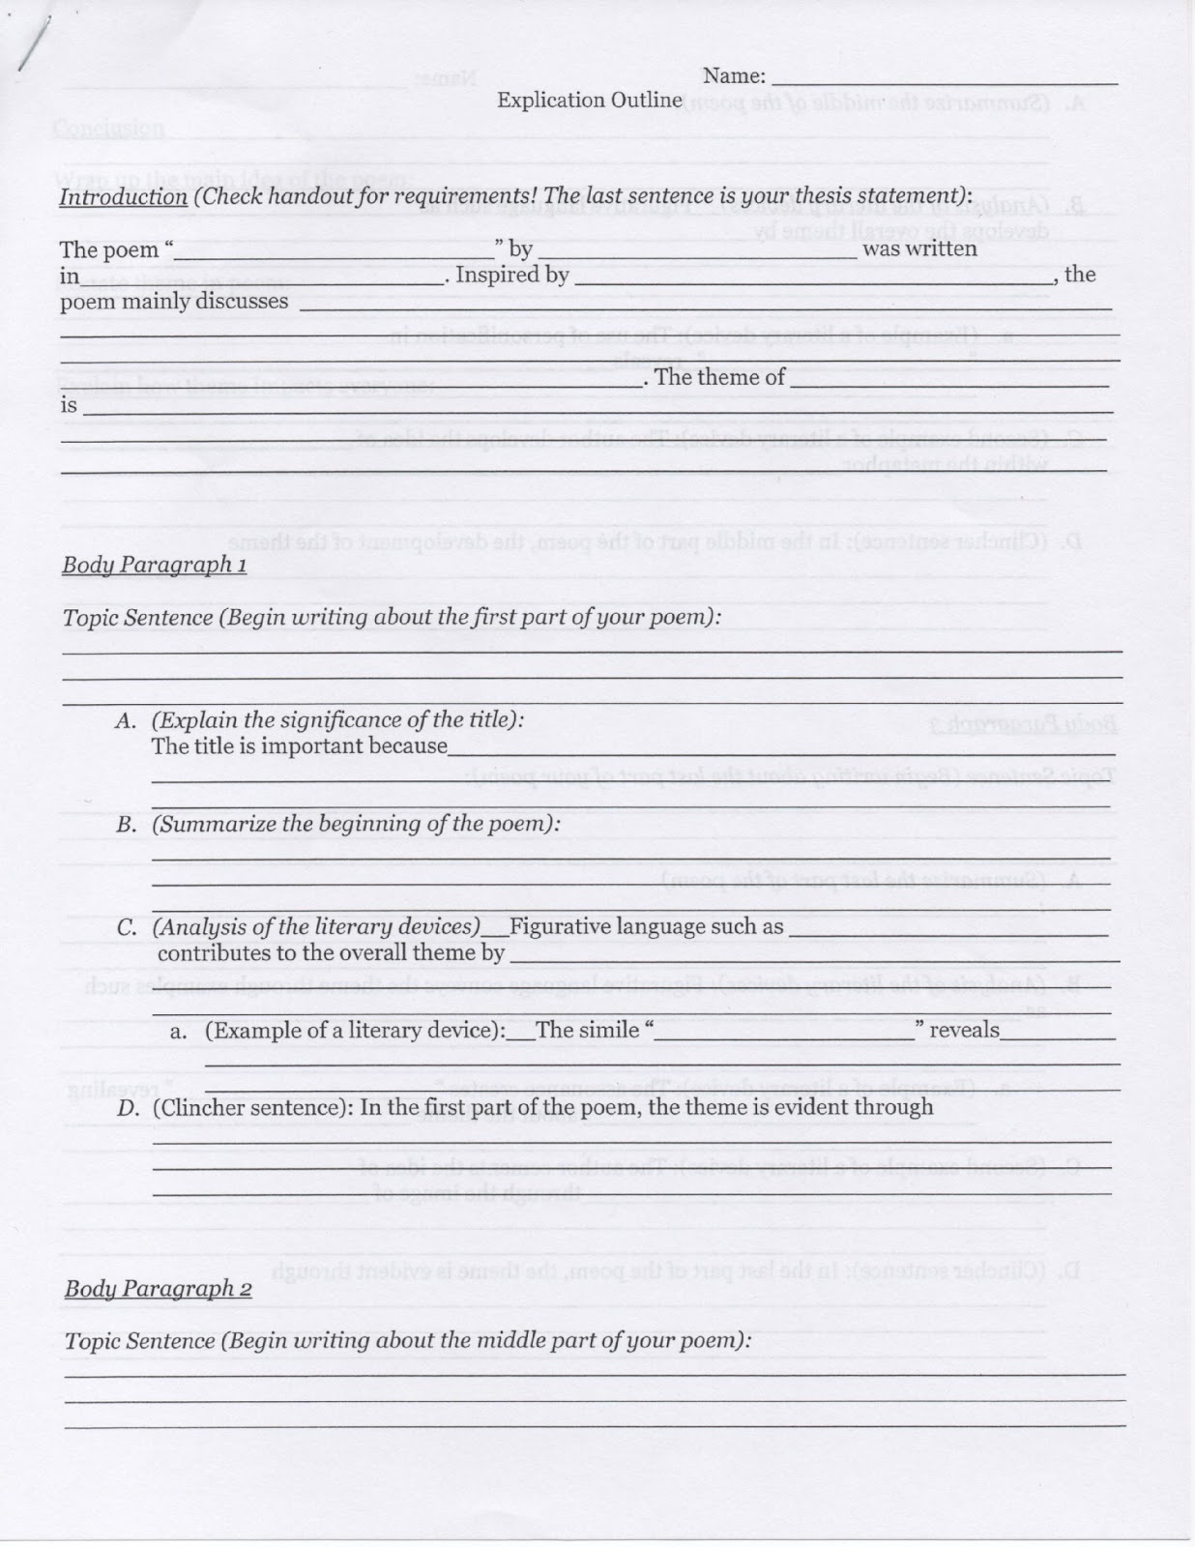
Figure 2: Mandated Poetry Explication Lined Outline
Dante, still learning everything that needed to be in an essay, looked at the outline and his eyes crossed in confusion. He looked at it for a very long time and I saw him struggling to fill it out. His brows were pushed together in concentration, as if he was working and focusing very hard, but his pencil barely moved. I walked by his desk at the beginning of the hour. He was on the second line. I walked by his desk at the end of the hour. He was on the fifth line. Improvement, yes, but the average student was done with the first page by the end of the hour. I kept him after class to talk about his poem. I asked him to go over it with me and tell me what he thought it was about. He told me he thought it was about “dying” and about “how we don’t want to lose those we love.” I was impressed. We went over the poem line by line. He could tell me what was going on; sometimes on a superficial level and sometimes on a deeper one. Since Dante had Literacy Foundations second hour, I emailed Mrs. Riley to tell her how Dante had performed. Her average Literacy Foundations class was between 12-20 students, Dante’s hour being on the smaller end. My classes were between 29-33. I knew that she would have more time to help him and push him in the right direction. By the end of her hour, Dante had the second page of his outline done. Mrs. Riley emailed me to tell me that, while it was not perfect, they had had time to edit what he had and add what he did not. The essay was due in three days and the classes were given computer time to work on them for those three days. I knew I would have time to help Dante in class while other students typed, but when Dante walked in the next day, he was done with his essay and ready to type.
When I graded Dante’s essay, I wished that I had checked the outline again before he started typing. The essay was horribly written. Grammar errors were everywhere. Sentences ran together. Names were not capitalized. I had failed him by not paying closer attention. These errors were my errors as a teacher. Then, in the third paragraph of his essay, there was a very wonderfully worded and insightful line of text. It was also not cited. I Googled the line, and the exact wording came from an essay on Answers.com. I was shocked. He was such an honest kid! I did not understand.

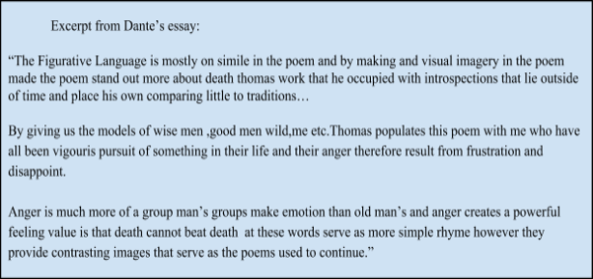
Figure 3: Excerpt from Dante’s Poetry Explication Essay:
The following school day, I asked him to come to my desk and read his essay. After he was done, I asked him to point out anything from his essay that stood out to him. He pointed out his thesis and a line or two from each paragraph, including the one that was plagiarized. I also pointed at the one that was plagiarized.

Me: Tell me about this line.
Dante was quiet and just looked at the screen.
Me: Dante, this is really good writing here. I’m just wondering what was going on when you wrote it. You were on to something.
Dante: I didn’t write that, Miss Gordineer. I- I didn’t know how to do whatever to it, so I just left it.
Me: You know that’s plagiarizing.
Dante hung his head: Yeah, I know.
Me: Dante, you know I was in that room with you. I was helping everyone. All you had to do was raise your hand and ask me. I would have helped you.
Dante: You were just so busy helping everyone. And you’ve helped me a bunch already. I didn’t wanna be a burden.

I did not understand this logic. Why would he think himself a burden because he needed my help? That was what I got paid for. I did not view it as a burden, but as a privilege.

Me: Dante, you asking for help could NEVER be a burden. That’s what I’m here for. Next time just ask. [He nodded.] I’m going to give you two options here. You can take a 50% or you can re-do this assignment for a max credit of 70%. The rule is that you would get an automatic zero, and the option to re-do for 70%, and I agree with that rule, but for first time offenders, I cut them a 50% break. [Dante smiled a little.] It’s your choice.
Dante: I think I’ll just take the 50%. I know that’s not the right option. I know that. But I don’t have time to do it over again.

I looked at him for a long while, trying to assess what was going on in his head. Eventually I just said, “Okay”. He moved off to his seat and continued his work. I returned to grading. I did not know what to think. I expected a better reaction, I wanted a better reaction, but something in his voice told me there was more going on. Maybe something going on at home. Something at school, I did not know, but I quickly found out.
Two days later, Dante was not at school. This was unusual and made me wonder whether he was okay. The next day at school he was very down. His shoulders were slumped, his head was down, and he would not meet anyone’s eyes. He just sat at his desk and looked down, not even attempting to do his work. This had happened on occasion. I chose to let it go and see what the next day brought. At lunch, Mrs. Riley came to my room.

Mrs. Riley: Did you notice Dante today?
Me: Yeah, he seemed a little off. What did you notice?
Mrs. Riley: Well… he yelled at me today. [I sat up, shocked.] Yeah. He wasn’t working on anything and he was just sitting there, not saying or doing much of anything and I walked by him a couple of times and encouraged him to work. When he didn't, I stopped at his desk and said, ‘Dante, you really need to work. This is for a grade. It’s important. You’ve got to work on something.’ He shoved his paper off of his desk and said, ‘I don’t care. This is stupid. This work is fucking stupid and I don’t wanna do it so I’m not going to.’
Me: Dante said that? DANTE dropped the F-bomb and yelled at you?
Mrs. Riley: Yes! I just let it go. It was so unlike him! Which is why I thought, something must have happened at home or somewhere here at school. Something BAD for him to have acted like that. Probably I should have reported it, but I just don’t think I will.
Me: No, I agree with you completely. Something had to have happened. I wouldn’t have reported that either, especially since he has been so great all year.

The next day, Mrs. Riley took Dante to the side and talked to him. He apologized to her for acting like he did and swearing at her, but he would not tell her what happened. I waited an extra day before I talked to him as well. I took him outside before class started and asked him what was going on. He shrugged and just said, “Stuff”. Knowing that he did not want to talk, I told him that I was here for him any time that he wanted to talk, even if I had a class, I would stop what I was doing if he walked in and wanted to talk. By the end of the week, he had not come in. Every morning when he walked in the room I held up my thumb in a thumbs-up or thumbs-down position to subtly check on him. He always either gave me a thumbs-down or a shaking hand, meaning that he was okay. Finally, after almost a week, I could not take it anymore. Nothing about his demeanor had changed, he was not doing his work, he was just there, not even a participant. The times he was down on himself usually only lasted a day maybe two, but this one had lasted a week. On instinct, I decided to make an appointment with Mr. Schumacher, an assistant principal at the high school, for 1:25 that afternoon. Mr. Schumacher was a likable, understanding type of man. He was the type that always smiled and was always positive and wanted to be there for the students. I had seen him talking in a friendly way to Dante in the hallways a time or two and so I felt confident confiding in him because I felt he had better chances of getting Dante to talk. They obviously had some sort of camaraderie. Going to Mr. Schumacher, Dante could talk man-to-man, and maybe that would make a difference. I was not sure if it would, but I hoped. I went to Mrs. Riley’s room and asked if she wanted to go talk to his principal with me, especially since the outburst had happened to her.

In Mr. Schumacher’s office I began by saying what I had noticed about Dante and his behavior and demeanor. Then Mrs. Riley described her altercation.
Me: We want to be clear that we do NOT want Dante in trouble, but want your help in figuring out what’s wrong.
Mr. Schumacher: I understand. Let me check some things here. [He pulled up Dante’s attendance.] Now that’s odd. He has barely missed any classes, which is normal. What’s not normal is that he’s been missing his seventh hour, track, almost every day for the last week, and has several absences before that. Track is his ticket out of here, and he’s missing it. Something is definitely wrong here. [He pulled out a yellow slip of paper.] I’m going to send for him down here and see if he will talk to me.
Me: You’ll let us know what you find out? Or, at least, what we can do for him?
Mr. Schumacher smiled. Yes, absolutely, I will.

I did not hear anything from Mr. Schumacher for the rest of the week. I wondered if Dante had asked him not to tell, or if Dante had even shown up. Then, over the weekend, as I was lying on the couch watching television, I received this email:

“[Mr. Schumacher] brought a really great young man to see me late yesterday
afternoon. Despite incredibly daunting circumstances, this freshman
is absolutely keeping it together at school... Good grades, even
better drive and behavior. There is great personal need, though, and
that's where you may be able to help.

Our student has two sets of clothes, the one he had on and one other.
Before he left yesterday, we had gathered backpack, school supplies,
toiletries, groceries, a jacket, and two shirts. I want to see what
needs can be filled internally before we start purchasing items.

Specific needs:

Pants, size 32x34
Shirts, size medium
Shoes, size 10 1/2
Black athletic socks
Underwear
Basketball shorts
Basketball practice shirts

If you are able to help, it would be great to have the items at school
by the weekend if at all possible.

Thanks so much.”

I instantly cried. I knew that this student in need was Dante. I had noticed that he wore the same orange hoodie and black athletic pants incredibly often, but it had never occurred to me that those were all he had. And then I thought about the essay and how he chose not to re-do it. His decision no longer surprised me. I immediately got up from the couch and went shopping, buying as much as I could afford.
We were to take these items to the student’s counselor. I was incredibly happy when I walked into his counselor’s room and saw that a few other people had brought things for him as well. I asked his counselor what she knew about his food situation and she told me that he had mentioned that there was not much food for him or his siblings at their residence. After school that day, I went and bought food that could be kept in the closet in my room. I bought Pop Tarts, a big bag of snack sized chips, fruit cups, Goldfish, and fruit snacks. The next day, I arrived extra early to put all the food in my room and, when Dante walked in early to class, I took him aside and opened my closet door.
Me: Dante, it has come to my attention that things are rough at home. No one has told me what is going on, and no one is going to tell me unless you decide to. But I wanted you to know that there is food in here for any time that you are hungry. You can come in any time to get food. Are these types of food okay?
Dante looked at the food for a long time: Yeah, these are great. Can I grab some now?
Me: Of course! Whatever you want.
Dante grabbed a bag of Lay’s Salt and Vinegar chips.
I smiled: You like salt and vinegar chips too?
Dante nodded. He held on to the bag with both hands. His eyes kept flicking between his feet and my face. Then he said: Uhhh… Thank you, Miss Gordineer. I, um [he scratched his head], um, thank you.
Me: I’ll refill it when it gets low. You take whatever you want. And if you need to talk, you know I’m here.
He hugged me.
I hugged him back.
He went to his seat and opened his chips.

The Odyssey
During this unit, it was decided that The Odyssey was strictly read out loud or listened to from an audio version. Students were asked to keep a journal that would be checked at the end of every week. They were to log personality traits of Odysseus and decide whether these traits made him heroic or not heroic. They were also to cite from the text as proof for their findings. This was given as in-class work. Students were also given an outside reading assignment. They were to choose from a list of books and to log in their journals just like with The Odyssey. This was the mass assignment given out by the English 1 team. The ending result was to understand the hero’s journey and be able to write about it. The ending assignment was an essay arguing whether Odysseus was heroic or not.
Knowing about Dante’s reading troubles, his reading comprehension was severely lacking, I decided that extra measures would need to be taken to help him stay on track and help him be able to complete the essay. Dante was given comprehension questions that he was to complete in my class or take to Mrs. Riley’s class and complete. He was also given a graphic organizer to help him keep track of the characters and their importance. I did not ask him to turn these in for a grade, but they were notes that he could use on any assignment that he felt he needed to. These handouts proved to be completely beneficial to him. At the beginning of every class, before we would begin a new journey in The Odyssey, I would ask questions about what happened in the previous journeys. This had been a routine for all the works we had read throughout the year. However, for the first time Dante was raising his hand to answer the questions.
Noting the change in Dante, I went to Mrs. Riley to ask if she had noticed a change in Dante’s comprehension. She said she had been very impressed with Dante and that he really seemed to understand The Odyssey. I mulled over that for a second. She looked at me, wondering what I was thinking about.
Me: Well, it’s just that I don’t get it. I mean, he had trouble with Animal Farm, which is pretty straightforward. But he has no trouble with The Odyssey? You’d think it would be the other way around.
Mrs. Riley: Are you guys listening to it?
Me: Yeah.
Mrs. Riley: Well, maybe that’s it. You said he did better when he listened to stuff, yeah? This is the first time we’ve had them listen to anything all year. Maybe that’s it.
A lightbulb went off. How stupid I had been! Of course!
Me: Yes! That’s got to be it! He needs accommodations of some sort. Isn’t this proof?
Mrs. Riley: Yes, sort of. There has to be repeated documentation. I’ll document this. I’ll document his scores and grades in here for The Odyssey. Have you documented when you’ve listened? [I nodded]. Perfect. Look up the scores for each time and document that as well. Let’s get everything together and finish up this Odyssey unit. And then we’ll take what we found to Schumacher and see what he can do.
I was beyond excited. I had noticed something that could, would, help one of my students. Maybe change enough of everything for school to be better or to be less of a challenge. At the very least, I hoped to make him feel better about himself and hoped he would understand that different did not mean stupid.
By the end of the unit, Mrs. Riley and I had taken our documentation to Mr. Schumacher who said he would instantly begin the process for accommodation.
Mr. Schumacher: I’m not gonna lie. It’s a lengthy process. Mrs. Riley, you know that. Miss Gordineer, this will be new to you. To be honest, I’ll start this paperwork as soon as I can, but I can’t guarantee anything. First, I have to get state approval for him to be tested. Then, I have to get parental approval. If the state approves, but the parent does not, there’s not much I can do.
My initial elation combusted and my face fell.
Mr. Schumacher: It’s not that I’m not going to try! I’m gonna try like hell for this kid. I’m just saying, stay positive, but without parental cooperation… [he put up his hands, as if to say, what can I do?] Given his home life, I don’t know what the reaction will be. But let’s stay positive. Keep doing what you’re doing to help him. Keep documenting everything and giving it to me. That way we build up a steady case for testing. There are ways to help him whether he has accommodations or not.
I left feeling a little better and a whole lot disheartened, but Mr. Schumacher was right. I needed to keep doing what I was doing, we needed to communicate to other teachers what we had found, and make sure he got the help he needed.
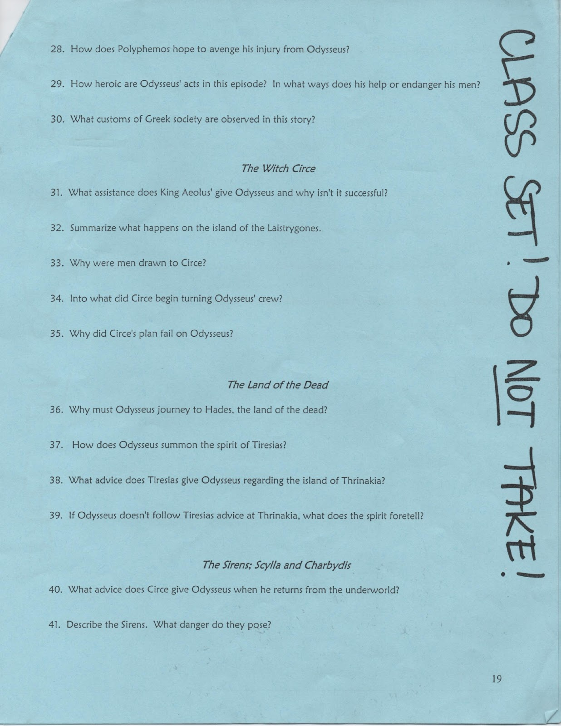
Figure 4: Differentiated Odyssey Comprehension Questions

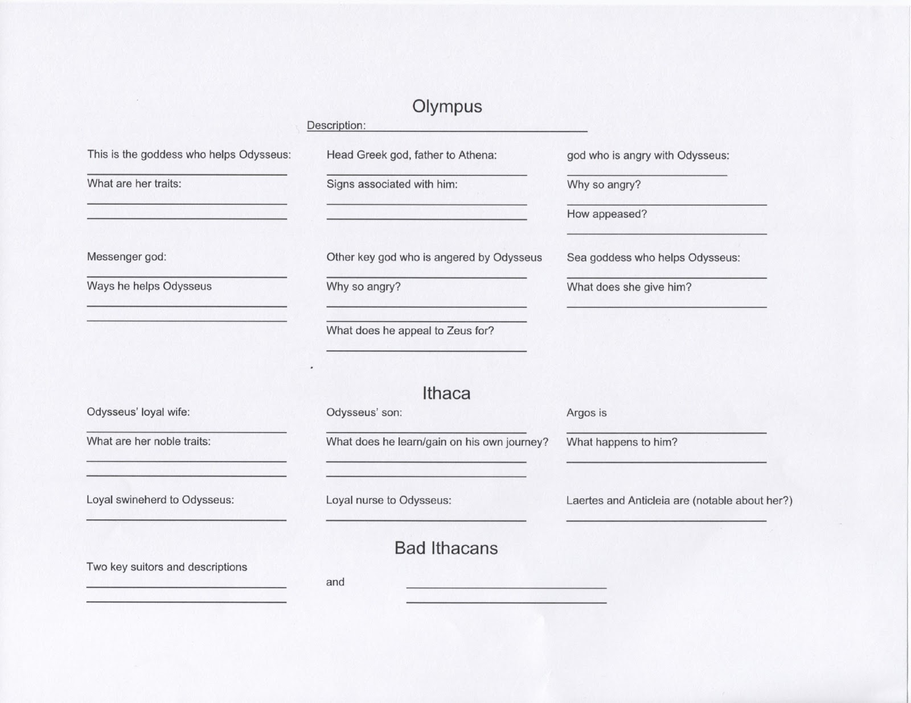
Figure 5: Differentiated Odyssey Graphic Organizer

After Dante’s successes with The Odyssey, I had high hopes for the essay assignment. He had participated in group discussions about whether Odysseus was heroic and I was interested to see how his essay would pan out. Sadly, the week we were to work on our essays and turn them in, Dante was absent. When he returned to school, computer time was over and the English 1 teachers needed to move on to Romeo and Juliet, as we were already hard pressed for time to complete the Romeo and Juliet unit. I knew that if Dante fell behind in Romeo and Juliet from the beginning, he might never catch up. This was a problem because he would already be rushing his “Odyssey” essay and then to try to catch up with the rest of the class might end up being the end of his passing grade. Even with Mrs. Riley’s help, I knew that the task would be too much. I also did not want to run the risk of him not turning in the essay at all, like he decided with the Poetry essay. I decided to come up with an alternate assignment for Dante. It would be much easier and would not be an essay, but it was better than him not receiving a grade. After all, my job was to help students learn, and if the assignment I gave Dante could prove that he learned something, then it was a differentiated assessment.
When Dante chose his outside reading book, he picked Monster by Walter Dean Myers. Instead of asking him to label Odysseus as heroic or not heroic, I wanted him to apply his knowledge of heroes to his outside reading character, Steve. I called the assignment “Anatomy of a Hero”. Dante would be given an outline of a man and each part of the man would correlate to a trait of a hero. He would have to fill out each part and give textual evidence.
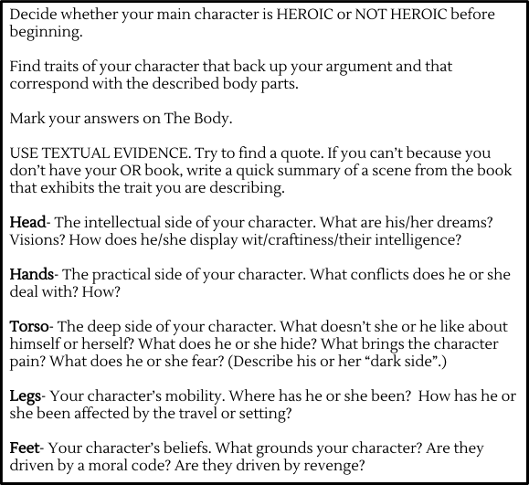
Figure 6: Differentiated Odyssey Assignment Instructions
Dante received three days to work on the assignment in Mrs. Riley’s class. This way he could keep up with Romeo and Juliet but still be able to finish his final assignment for The Odyssey unit. Dante gave me his assignment within two days.

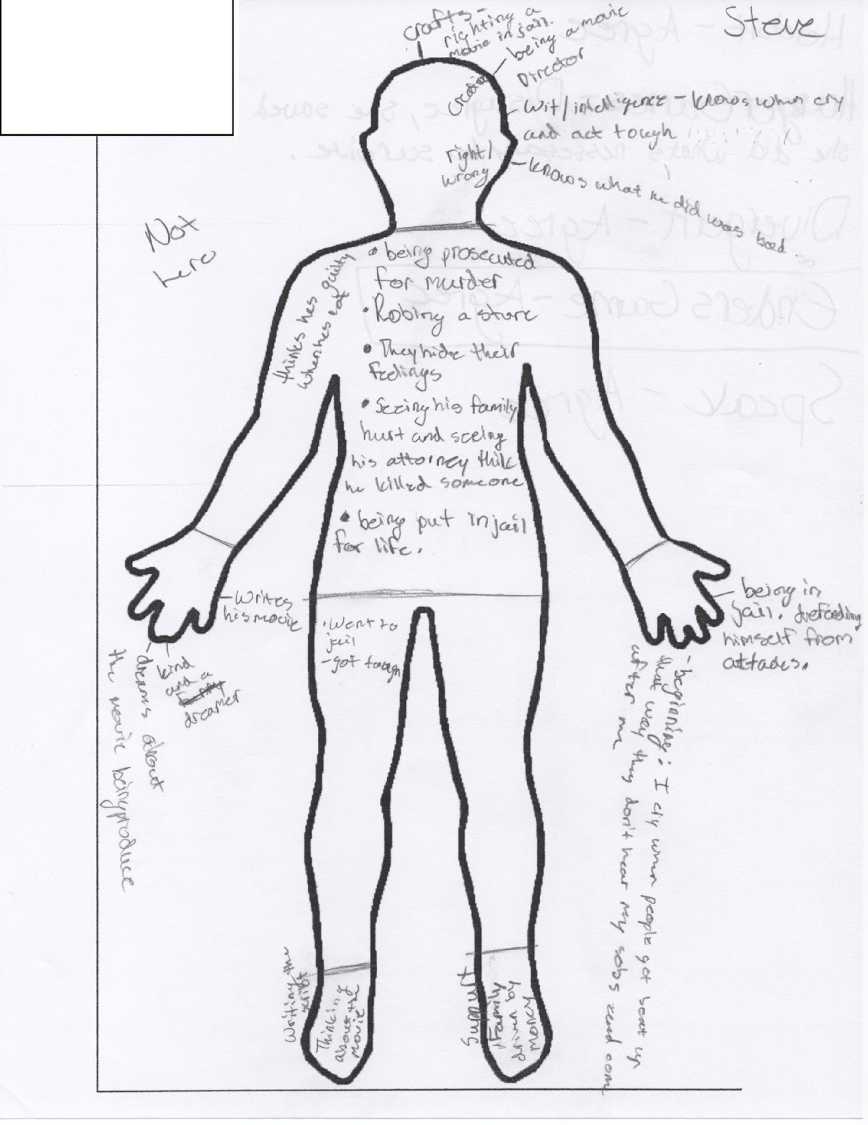
Figure 7: Dante’s Finished Differentiated Odyssey Assignment

The assignment went better than I had hoped. While he only gave traits for some of the labeled parts, he gave more than one example for each part. To me, this showed his understanding of the Heroic Journey and of the book’s main character, Steve. I gave him a high B on this assignment. He was ecstatic with his grade and I congratulated him for putting so much effort into the assignment. He thanked me and turned back to go to his desk, but stopped short and turned around to come back.
He shuffled his feet a little bit and scratched his head.
Dante: I just wanna say thank you, again. He nodded at the papers and held them up. It means a lot, what you did for me. He scratched his head again and smiled. Uh… thanks.
Me: That’s fine, Dante. You did good. Really good. I’m very proud of you.
Dante, smiling: Uh, okay. Thanks… again.
I smiled and he moved off to his desk.
Romeo and Juliet
Romeo and Juliet was the last unit for the school year. The assessments for Romeo and Juliet were timed writings. There were three timed writing assessments which required various lengths. Each timed writing had three writing prompts of which students must choose one. They were given the entire hour to write and could use their notes as well as the book to find quotes for textual evidence for their argument. The first was given after Acts I and II and the second was given after Acts III and IV. For each of these timed writings, students had to write just one paragraph over one of the given prompts and the paragraph had to contain two textual supports for their argument. The final timed writing was after Act V. For this, the students would have to give three examples/reasons for their argument and give textual evidence for each.
For the Romeo and Juliet unit we read the play out loud as a class. I read Act I to the class, stopping to explain the language and help them understand the wording as we went along. During Act II, I would ask for volunteers as well as read out loud. During this Act, if I read out loud I would stop and ask students to explain the text to me to check their understanding. Sometimes this involved group work assignments, an individual exit slip, or on the spot questioning. My plan for Act III was to have the students begin to read the text out loud and I wanted to make sure no one would be left in the dust before the students embarked on their own Shakespearean journey.
Just as Dante pleasantly surprised me with The Odyssey, he surprised me with Romeo and Juliet. During the first Act he was not very confident in his ability to interpret Shakespeare. He came to my desk after reading or after class to double check his understanding, and almost always he was spot on with what was going on in the story. During the second Act, he was actually answering questions out loud in class and raising his hand to be called on, just like with The Odyssey. I documented everything and gave the documents to Mr. Schumacher at the end of each week. The true test of Dante’s comprehension came with the timed writings. Mrs. Riley and I had worked together to plan out the first timed writing. Our goal for Dante was to be able to write a good, solid paragraph. Dante’s writing was not bad, but the structure was horrid. If we could get him to write a good paragraph by the end of the year, then he was five steps closer to being able to write academically.
Our plan was that Dante would have my class to plan his response and find everything he needed to write. Then, he would write in Mrs. Riley’s class. We agreed that this would be the easiest and best option both for us and for Dante. I had bigger class sizes, it would be easier for me to point him in the right direction for citations and examples. She had smaller class sizes, it would be better for him to have more individual help during writing. We both agreed that he should be given notes with the detailed parts of a paragraph for the first two timed writings. This way he could check and hopefully remember everything a good paragraph needed. Mrs. Riley told him about these plans in her class, and made sure that he was okay with them. He was.
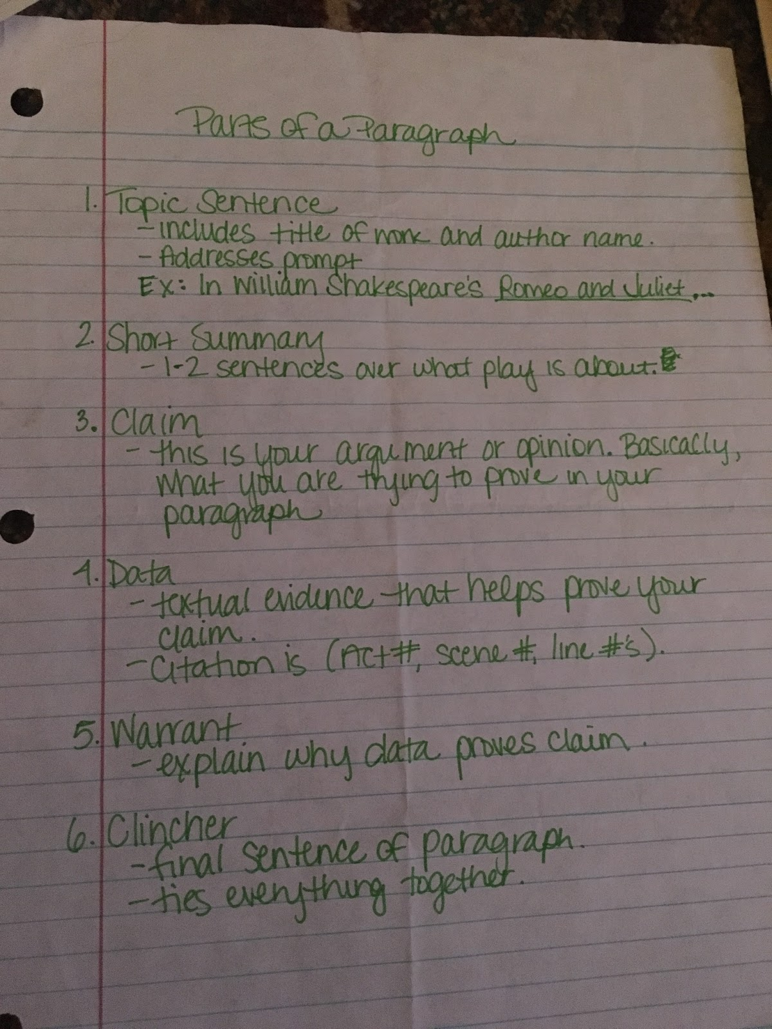
Figure 8: Dante’s Differentiated Paragraph Handout

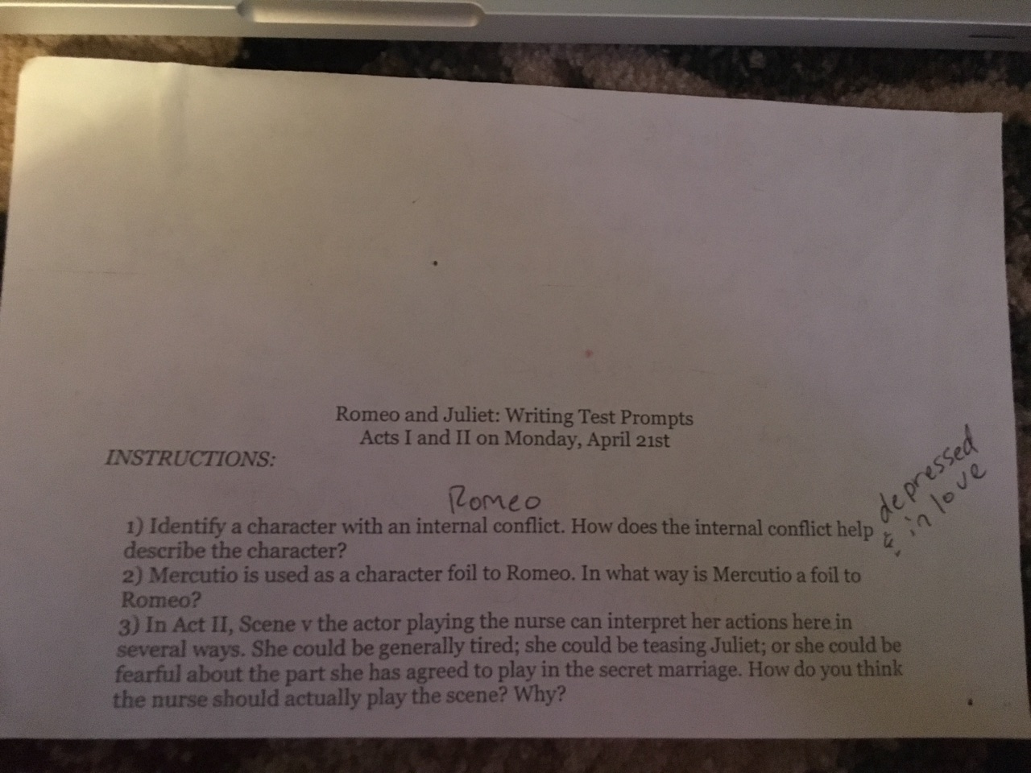
Figure 9: Romeo and Juliet Mandated Timed Writing 1 Prompts
The day of the first timed writing, I handed him the paragraph notes and told him that he could use them for every timed writing and not to lose them. When he was handed the prompt, he looked at it for a long time before raising his hand. He told me that he didn’t really understand the questions. I asked him which question he understood the most and he pointed to question 1. We had spent precious class time the week before going over external vs. internal conflict. He understood that completely, but he was having trouble nailing down what he thought Romeo’s internal conflict was. I reminded him of Romeo’s predicament in the beginning of the play. I asked Dante, “Did Romeo love Juliet at the beginning?” He shook his head. “Who did he love?” He answered, “Rosaline.” I asked him if Romeo was happy about his love, what did love make Romeo feel? He answered both. “So,” I asked him finally, “what two words would you use to describe Romeo?” He was quiet, then looked up and said, “Well, he’s in love, and he’s… depressed?” I smiled. “Now, all you need to do is look for quotes that support that he’s depressed or sad and that he’s in love.” He nodded. “Okay, okay, I got this,” he said.
He used the rest of class time wisely, flipping through the book and jotting down notes and cited passages to use for his argument. After Mrs. Riley’s class, she brought me his paragraph, telling me she helped him a lot with structure and word choice, but that she felt the help was necessary and hoped her help meant that he would understand much faster. I agreed completely with her, and as I sat down to grade his paper, I noticed that it was the longest and best paragraph he had written all year. This is not to say it was perfect. Far from it, but it was an improvement. His citations were wrong, the wording was choppy, but he had tried and he had improved. I realized that he had had extra help, but extra help in her class had been available to him all year and I hoped he would build on this level of work for the remainder of the year.
The day I handed back the timed writings, I let students have a few minutes to look over their grade and the comments I made and ask questions. I stopped by Dante’s desk. He was happy with his grade, but I let him know what needed to be improved and what was done wrong. He listened intently and even took out a piece of paper to take notes over what I said. I asked him to have Mrs. Riley look over it as well and see if she caught anything I did not or had anything to add to his notes.

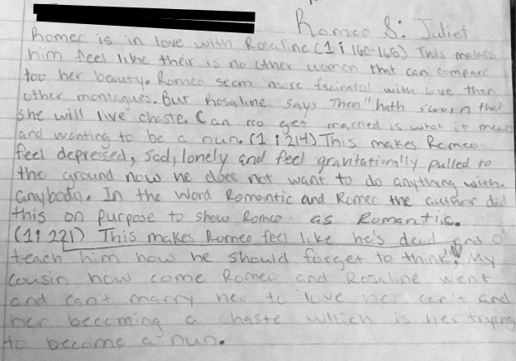
Figure 10: Dante’s Timed Writing 1 Response
By now, the students had gotten used to the language and they needed to be able to make sense of Shakespeare on their own. However, I did always remind them at the beginning, middle, and end of class to speak up if something went completely over their head. I told them there was nothing to be ashamed about, and to NEVER be afraid to ask a question. If they did not want to ask in front of other students, I asked them to see me before or after class, write me a note and leave it on my desk, anything they needed to do to ask their question. Recently, I have put a question jar at the back of the room by the door. Students can ask questions about anything we cover in class, no name necessary, and I will address it openly with the class. Some students will always be afraid to speak up, afraid to ask the teacher, afraid of looking stupid, but I try to always leave no room for that. There is ALWAYS a way for students to ask a question and not feel pressured or scared.
I expected a bit more trouble for Act III and IV of Romeo and Juliet because I was not solely reading the play out loud or stopping constantly to explain wording. However, Dante was right along with the rest of the class. When it came time for the second timed writing, Mrs. Riley and I gave Dante the same helpful material as before, but we decided that we would hover a bit less. He received the paragraph structure help, and I helped point him in the right direction for his argument and quotations, but this time around he wanted less of my help. He took his time finding what he needed, but he did not ask me to lay everything out for him. Instead, he found what he needed and began drafting in my class. It was obvious that he was more confident with himself and with his writing. He did not finish his draft in my class, but later Mrs. Riley told me that he finished his draft in her class, she helped him edit his draft, and he worked the remainder of class.
As I was grading his draft, I noticed that the word choice was not quite as good as the last timed writing, but I expected that. Mrs. Riley had told me she was a little more hands off this time, and that Dante had seemed fine with that. While his sentence structure was still lacking, I was impressed with his paragraph structure and observations. His citations were done wrong again, he did not put the quote into the paragraph, and instead just put the citation. His writing needed major grammatical help, but his structure was getting there and was so much better than when we had started. The paragraph was by no means perfect, but his improvements over the last two months were substantial. At the beginning of the year, he would not have been able to do an assignment like this even with help. He would have been totally and completely out of his element. Now, because of this extra help and more individualized instruction, he was able to complete a medium-level assignment.
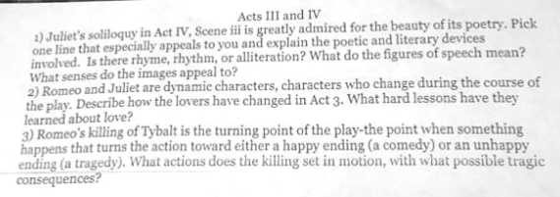
Figure 11: Romeo and Juliet Mandated Timed Writing 2 Prompts
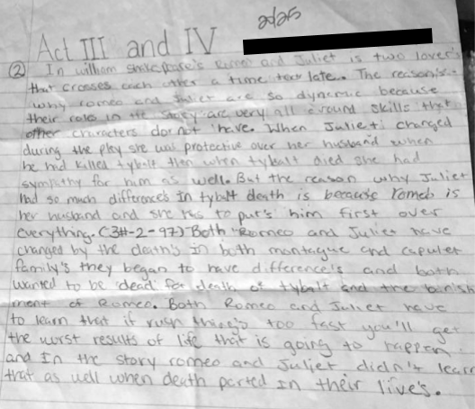
Figure 12: Dante’s Timed Writing 2 Response
By the time Act V was over, I did not fear for Dante on the timed writing assignment. He had improved over the last two months and had proved that he could do it almost completely on his own. The last timed writing came around and I told him to do as much of it on his own as he could. I reminded him that he could ask me questions just like anyone else, but I really wanted him to push himself to work as much on his own as possible. I asked him to try his best to finish his paragraph in my class and only edit in Mrs. Riley’s class. He was still able to use the paragraph structure handout, but I noticed that he did not pull use it until the very end of the hour, where he seemed to be double checking that he had everything in the paragraph that he needed. I was excited to see him double checking his work rather than using the handout from the beginning. The first timed writing he had relied heavily upon the paragraph structure handout. Now, he was simply using it to double check his work. That was a great improvement and I hoped this paragraph would prove to be the best of all.
Dante still had a lot of the same errors when it came to citations even though Mrs. Riley and I had both addressed these with him. He did not use quotes, but he cited everything that he took from the story, which showed his knowledge of needing to know when to cite, but he obviously still lacked the knowledge of inserting quotes, something that Mrs. Riley and I had hoped to help him learn. The sentence structure and word choice still needed to be helped, but his reasoning and arguments were getting better with each paragraph. I wondered if we should have started with the basics first, such as sentence structure, but reasoned that this late in the year, we needed to improve where we could. He would need to be able to write good paragraphs and essays next year. To send him to tenth grade without those skills would be detrimental. Sentence structure and word choice could and would be taught throughout the rest of his high school career, paragraph and essay structure was expected to be learned in ninth grade. He HAD to learn this first and could improve on the smaller elements throughout the rest of high school career.
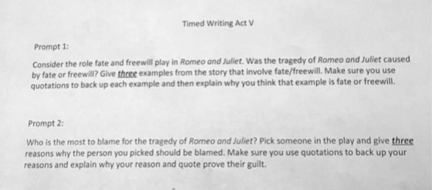
Figure 13: Romeo and Juliet Mandated Timed Writing 3 Prompts

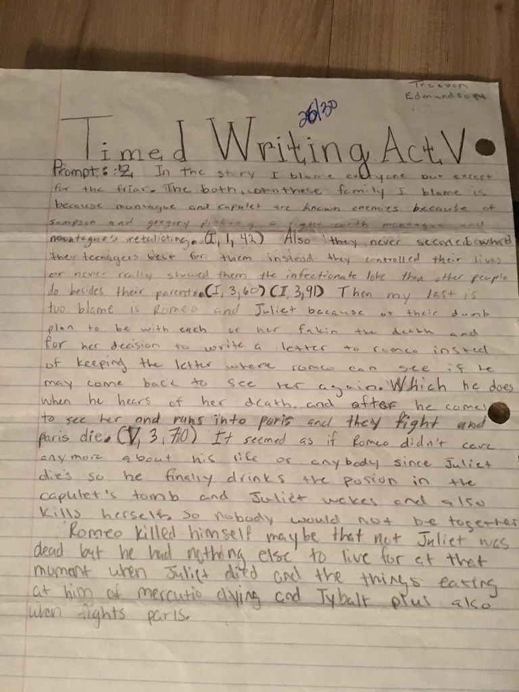
Figure 14: Dante’s Timed Writing 3 Response
The third timed writing was the last assignment for the semester before the final. The last week in class was spent reviewing for the final. Dante received extra review time in Mrs. Riley’s class as well and was told he would be given extra time to take the test in her class if he needed it. He ended up finishing it in my class, and I gave his test to Mrs. Riley and asked her to have him go back over the answers he chose and make sure he did not have any questions or needed any more help. When her class time was over, she gave the final to me and told me that he had gone over his answers during her class and only asked a handful of questions.

Summary
Dante began the school year without the ability to write a complete paragraph. By the end of the year, Dante was not only writing full paragraphs, but citing his sources. While writing a paragraph is a very basic skill, it is one that Dante did not have and struggled to understand. Giving Dante more individualized instruction, more time to complete assignments, and additional supports, i.e. The Parts of a Paragraph handout, gave him the ability and the confidence to complete his assignments. For these reasons, differentiated instruction worked for Dante. He was given the means and the confidence that he lacked in his instruction. He left my classroom having grown and advanced as a student. Without differentiation it is likely that he would have been left in the dust because of his learning gaps. Differentiation helped fill in the gaps in his learning so that he could succeed in my classroom.
Melina
Melina is a fourteen-year-old freshman in English 1. She is of mixed descent, her father is black and her mother is white, and she stands about five-foot-four. She has black-rimmed, square-cut glasses and always wears her straight black hair in a ponytail. She wears the same Oklahoma City Thunder jacket every day, even in warm weather. The jacket is light blue and trimmed in orange around the cuffs and bottom, with an orange collar that pops up around the neck. Melina’s personality is odd. She is funny, happy, effortlessly quirky, and hopelessly blunt. She does NOT share food, and she definitely does NOT share her drinks. She has a goofy sense of humor, once screaming “STD’s! SYPHILLUS! AIDS!” when someone tried to snatch a sip of her drink at the lunch table. She lifts her eyebrows and opens her eyes wide when she talks, giving her a look of perpetual shock. She has a bit of a stutter when she gets excited and tends to play with her hands and move jerkily when she is nervous. It is hard for Melina to sit still unless she is focused on an assignment. She also does not like to make eye contact unless she feels confident with the person she is with or in the setting that she is in.
Melina falls into the middle when it comes to academics. Her GPA for the first semester was a 2.33. The Oklahoma Core Curriculum Test (OCCT) for English involves tests in both reading and writing.
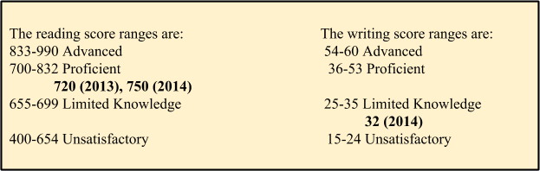
Figure 15: Melina’s Standardized Test Scores
Her hiccup in English came with a basic understanding of grammar and literary terms, but she had trouble applying her knowledge. Instead of focusing on obtaining the answer, she becomes anxious and just wants to get the assignment over with as quickly as possible. To me, this behavior mirrored her lack of eye contact and jerky movements when she was unsure of the people or situation around her. She was not sure of herself academically, so her response was to not look at it any longer than she had to and to quickly get any assignment over with.
Melina and I developed a quick relationship the first month of school. She always came into my room quietly, but happily, with a grin that crinkled her button-like nose and brown eyes. On that day, she came into my room, put her stuff down and laid her head on her desk. She sat in the middle of the room, so I went and poked her in the shoulder and asked her to come into the hall with me. She followed and I asked her what was wrong. She told me that some of the girls she was friends with in middle school had started ignoring her and told her they did not want to be friends with her anymore because she was “too weird”. Throughout the whole conversation, she was moving from foot-to-foot, rubbing her hands together, and would only look at the floor. After she admitted to me that her friends had labeled her “too weird” for their lunch table, she began to cry and say that she did not know what was wrong. They had liked her just fine in middle school and she had not changed and she did not understand and that now she did not have any friends and what was she going to do? I gave her a hug, and while I do not quite remember the advice I offered, I remember telling her the cliché statement: “If that’s how your friends are acting, then they weren’t your friends to begin with” and then I told her that she would find friends, friends that were there for her and would not hurt her, unlike her old friends. I told her that high school was a metropolis of human beings and that friends would come to her when she least expected it.
That was how Melina came to eat lunch with me every day. She claimed that she did not like the cafeteria, which is referred to as the “commons” in this school, because it was too loud and she did not like anyone, but I knew she was terrified of being seen as The Girl That Ate Alone or as The Girl Who Had No Friends. I remember being that girl in high school, the one who ate alone and did not have any friends, only it never bothered me. I was happy to spend time reading rather than socializing and I often preferred to be left alone.
Each day, Melina came in and ate her lunch. We talked about our day, and joked and laughed. She came in every day without fail. This began to change after I started an Outside Reading for Critical Advancement (ORCA) group for the freshman class. I developed ORCA for those students who needed more of a challenge in their Pre-Ap English I class. The idea was to help students who felt bored in class or who just wanted a challenge to understand and read high-level text. The first books we started off with were Pride and Prejudice, and The Sound and the Fury. ORCA would come to my classroom on Tuesdays or Thursdays, depending on the book they were reading, and we would discuss the book. When the group first started, at the beginning of the second semester, I told Melina that two days a week students would be coming in for ORCA. At first, she was a little upset, not wanting to share her lunch hour with anyone else, and saying that she would find somewhere else to eat lunch those days. She did not say this is out of anger, but as a solution to a problem. I told her that she was welcome to come in those days, even though we would be discussing literature. She grumbled at first, but on the first day of ORCA she was sitting in her usual seat, complaining that she would have to listen to talk about stories, but that she would rather listen to that than the roar of the commons. I do not think she or I had any idea that ORCA would be the answer to her problem.
Melina particularly liked the Pride and Prejudice group. It was all girls, and Melina found that these girls were funny and nice, what she labeled “not so bad” as she stuffed a Cheeto in her mouth. She did not like The Sound and the Fury group, labeling them “boring” and the book “disturbing… because of all the incest”. I tried to correct her here:

Me: Melina, there is NO INCEST
Melina: There’s enough of it to be disturbing!
Me: Melina, there isn’t any incest, only the mention of it because of some crazy brother.
Melina: Exactly. DISTURBING.
I could not really argue with her there.

I soon found that Melina was not coming into my room as often at lunch. When I asked her what she was doing for lunch, she told me she had been sitting with a few of the girls from the Pride and Prejudice group. I told her I missed her coming into my room, to which she replied, “Yeah, I like them better,” then laughed nervously at her bluntness. I pretended to be hurt, but was secretly ecstatic that she had found some friends to sit with. Girls that liked her as much as she liked them. I knew her knew friends liked her because they bragged to me, telling me how funny her quirky sense of humor was, telling me about her shouting “STD’s! SYPHILLUS! AIDS!” Melina never fails to make it to lunch on the days that ORCA is happening, even though she refuses to participate in the group because she claims that “extra reading is NOT fun and that the people in [ORCA] are CRAZY”, but I do not see her during the other lunches of the week. Instead, when I make the stroll through the cafeteria to get my lunch, I see her with the girls, all of them laughing and joking and eating their crustless sandwiches—a group of girls happy in their place among the endless tables.

The Poetry Assignment
Melina chose the poem “Tonight I Can Write” by Pablo Neruda. Melina was very worried and stressed out with this essay. She did not understand what the essay was asking of her. Melina was not the only student who felt this way. Many of the students did, not just in my class, but, I found out from other teachers as we discussed our worries one day after school, in most of the English 1 classes at this school. It felt good to find validation that I was not the only one having issues and that I was not the only one who saw issues with the assignment. However, Melina differed from some of the other struggling students because when she became stressed, in this case I think she felt inferior, she would clam up and shut down. As she was working on the outline, I would see her staring at the page but doing no work. She would sit back in her chair, fiddling with her hands, and looking very upset. After class, I asked her what was wrong and she let it all spill out to me. She was worried that she was going to fail the essay, she did not have anything done, she did not understand the poem or the assignment, she was going to be grounded, she needed help but did not know how to ask for it because she did not understand the assignment enough to begin it.

Me: Melina, take a breath. I am not going to let you fail this class or this assignment. Just relax. I’ve got your back and I can help you.

She nodded and took a breath. I told her to meet me after school while she waited for the bus and to bring her poem. I came up with a plan. Melina would do a very similar assignment to what the rest of the class was doing, except her options regarding her research would be narrowed down. I wanted her to prove the theme of her poem using only literary devices and nothing else. She would disregard the notes about historical background and criticism. Instead she could use her TPCASTT and her notes over analysis. Melina needed simplification and direction. The array of information at her fingertips was too much and left her feeling overwhelmed and unmotivated.
When I presented Melina with her simplified assignment, she breathed a sigh of utter relief, and then stopped short.

Melina: Wait, this isn’t because I’m dumb, is it?
Me: What? No! This is because I think the assignment is too complicated.
Melina: Then why did you give it to us?
Me: Because sometimes we have to do things we don’t want to do.
My answer, while terrible, seemed to satisfy her. She took a deep breath and held herself a little higher as she left my room.

A week later, when it came time to grade her essay, I opened it up with hope. Melina was not a strong writer, but I had every confidence that she had given her updated assignment her best. The writing was somewhat jumbled, but strong in parts. She made errors such as using first person, capitalizing words like “imagery” and “metaphor”, and forgetting citations. However, she was insightful with her observations about the poem’s theme and the contributions figurative language made toward that theme. I also noticed that she’d used the outline that she was given and was glad to see that it had helped her and that she had understood it.
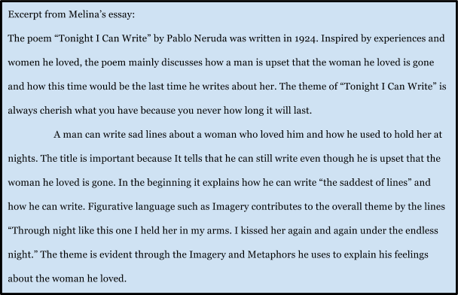
Figure 16: Excerpt from Melina’s Poetry Explication Essay
Upon seeing that she received a “C” on her essay, Melina, while happy she did not fail, was absolutely disappointed. During class, she came up to my desk to ask me about her grade. She was sure that she had done better. I assured her that her essay was a “B” essay, but I had to take off points every time she did not cite her sources appropriately. I had pointed out the places that should have been cited and written the proper citation next to them. I explained to her that, in college, a lack of citation could be seen as plagiarism and major points could be deducted. I reassured her that her essay was great and that, if she would have cited properly, she would have received a much better grade. She seemed less disappointed, but was still down. I decided to ask her how she felt about her updated assignment. I pulled her close and whispered,

Me: How did you feel about your assignment after we changed it up a bit?
Melina: MUCH BETTER. That’s why I came to ask you about my grade. I felt really good about my essay and was hoping I got a better grade. She looked at her feet, she was leaning from one foot to the other as we talked, and shrugged her shoulders.

I instantly felt terrible. I felt as if I’d given Melina the means and confidence to do her work and then ripped these out from under her with her grade. I was completely torn: on the one hand, I had given Melina an assignment that she was confident completing and had tried hard at, on the other, I felt as if I had negated these positives with my grading. I offered her the chance to go back and do proper citations for extra points.

Melina: Uh… will I get an A? she asked, eyes bulging.
Me: I’ll boot you up to a B.
Melina: Like, a high B? She stood very still.
Me, giving her the “pushing it” eye: Probably a mid-level B. She had made a high C, and a mid-level B seemed fair to me.
Melina: Uh, thanks, but ain’t nobody got time for that.
She walked back to her desk and flopped into it.
Well, I thought, I tried.

The Odyssey
When the classes were given this assignment there was an immediate uproar--students felt that the outside reading assignment they had been asked to do for the last month was pointless and a waste of time because they were going to be unable to use their outside reading book in the end of unit essay. Students were upset and felt slighted. Many of them had loved their outside reading book and were hoping to write over the character they had come to know and love, but because of the aligned curriculum, I did not feel this was possible. Word spread quickly and I knew if I decided to turn my back on the team assignment, there would be a team meeting discussing why we all needed to stick to the same curriculum.
Melina was one student in particular who was VERY upset about this debacle. While a sweet girl, Melina was very open about the fact that she did not like extra work. When I told the class about the assignment and how they would not be to use their outside reading book, she very loudly exclaimed, “SERIOUSLY? Why did we have to do it then?” A sentiment that the other students in the class readily agreed on. Being very angry about this, Melina approached my desk.

Melina: I like you, but you gave me a lot of extra work that was pointless.
Me: It wasn’t pointless! It was to help you understand the hero’s journey!
Melina: Which, might I add, we aren’t even doing our paper over.
I sat there silently. She had me, and she knew it. I could not openly state that, had the assignment been my choice, it would have been completely different. That would have been unprofessional and unhelpful as well.
Melina: I’m gonna do the assignment, obviously, because I don’t want a zero. But this is dumb, and that assignment was stupid and pointless, and I’m not happy with you.

She laughed as she said the last little bit, but it was a frustrated laugh, as if she was trying to be honest but hoping not to be disrespectful at the same time. I did not take the frustration or tiny outburst personally, but it did weigh heavily on me. I wanted too badly to do something else, to make the assignments and learning fun, at least part of the time, for these students and I could not. I was stuck and, to top it off, I had several students who were very unhappy with me, judging from the looks on their faces.
The truth was, the assignment was incredibly easy. Every student already had all of the information he or she needed with the journals. All a student had to do was decide whether he or she thought Odysseus was a hero or not, and use his or her journals to complete the outline given to them. The team wanted to give another lined outline, but because of the success I had with Laura’s outline, I decided to give this same outline to Melina as a pre-assignment to the line by line outline. Melina had had success with the lined outline before, and using the boxed outline would help her get organized and be able to quickly fill in the lined outline.
When I tried to give Melina the boxed outline, she asked me why no one else was receiving the same thing.
Me: Because I think this will help you with the lined outline, and it will help you remember to cite.
Melina: Yeah, I’ve already done enough pointless work. I don’t want to do that. I’ll just do what everyone else is doing.

Shocked, I took the boxed outline back to my desk. She was obviously still mad and had an attitude, but I honestly did not think that she would turn away help. I spent the rest of the hour helping students, and found her waiting at the end of the line toward the end of the hour.
Melina: I’m sorry if I was rude, but I’m really mad about this outside reading book thing. So, sorry. That’s all I came up here to say. Oh, I still don’t want to do that worksheet.
And she walked away. I let it go.

I could not make her want to do it, no matter how badly I wanted to help her.
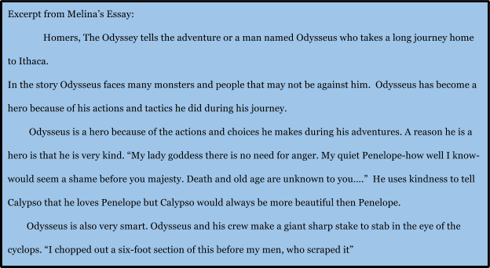
Figure 17: Excerpt from Melina’s Odyssey Essay
In the end, her essay suffered for it. Ideas were not put together or linked, again there were no citations, her paragraphs were not written in the form that we had been practicing all year: not once did she include a clincher sentence or explain why her data proved her claim. It was as if she was so mad about pointless work that she decided she did not care. It hurt me to grade it because her essay could have been so much better had she not been upset and been willing to take the extra help.
Romeo and Juliet
I knew I would have to grab students’ attention from the beginning. My feeling was that students needed to pay extra attention from the beginning of the play or risk not being able to understand the language on their own. If I grabbed their attention instantly, they were more likely to give Shakespeare a fair shot. Most of the girls were excited to read Romeo and Juliet, although a few complained. Almost all of the boys complained about having to read it. Of the boys and girls who complained said they knew the story, knew what to expect, so they did not really care about reading it. I needed to give those students something from Shakespeare that they did not expect. Maybe they knew the story, but they did not know how to read the language. They definitely did not know that Shakespeare made a lot of sex jokes, and after some deliberation I decided to tell them. To be perfectly honest, I was not sure this was the most appropriate thing to point out about Shakespeare, but I pointed it out anyway for two reasons:
1. It was a fact about all of Shakespeare’s plays.
2. I knew it would get their attention.
Getting students’ attention was my main concern here, and on the day we began to read Act 1, before we started I made the announcement about the sex jokes.
“Okay, so there’s something we need to talk about with Shakespeare. What I’m going to tell you is a FACT about ALL of Shakespeare’s plays. I’m not being gross or inappropriate, but the fact is Shakespeare makes a LOT of sex jokes. [The room went really quiet, and several students sat up straight in their chairs.] I’m not going to point them out, but if you find them, well, you’re welcome to laugh. Just do us all a favor and if someone wants to know why you’re laughing, explain to them outside of class.”
One of my students raised their hand, “Do we get extra credit if we point them out to you?”
I rolled my eyes. “No.” Then we began reading.
Melina complained about Romeo and Juliet from the very beginning. She complained about the wording, the sex jokes, called Shakespeare a pervert, repeatedly called the play “stupid” and said that Romeo and Juliet were “WAY over-dramatic, like, SERIOUSLY” and “if this was what people were like back then, why did [she] need to read this?” I understood her complaints, expected them from everyone actually, but she complained every day. When I talked to the class about what was expected from their timed writing assignments, she complained loudest of all. She was aghast at having to write a whole paragraph in one class period. Finally, I took her aside after class.
Me: Okay, we need to talk.
Melina shifted awkwardly: Okay. Am I in trouble? Are you gonna call my parents?
Me: What? No. But you’re complaining an awful lot in class. Is it the play or do you feel like you can’t do the assignment?
Melina: I can do the assignment, but you’re asking a lot. But this play is stupid, I mean, come ON. She rolled her eyes.
Me: Look, you may feel that way, but you don’t need to voice it every day. You’re gonna find lots of things in life are “stupid”, but you can either get through it and be positive, or you can make the worst of it, which is what you’re doing right now.
Melina: Well, I’m not a very positive person.
Me: Positivity is a choice, Melina. Try being optimistic.
Melina: What if I’m not very good at it?
Me: It takes time to be good at it. But at the very least, you can stop complaining.
Melina: But complaining is fun!
Me: Complaining at lunch is fun. Interrupting class time to complain is not. It’s disrespectful.
Melina was quiet for a minute: Okay. Sorry. I wasn’t trying to be.
Me: It’s okay. Now you know. We have a deal?
Melina: Yeah, yeah. She flipped her hand as is brushing something off and walked out of the room.

The next day before school she brought me a Snickers bar with a Post-It note attached that said, “Sorry.” I took it and thanked her and jokingly told her next that time she complained in class she owed me two Snickers bars. Her eyes went huge.
Melina: That cost me a whole dollar!
Me: Well, next time you complain it’ll cost you two whole dollars.
Melina: What if I don’t want to buy you Snickers?
Me: I take cash, too. I smiled. She looked slightly stressed. Melina, I’m joking.
Melina looked weary: About the cash or the Snickers?
Me: Both.
Melina looked relieved: You’re mean. She laughed. Mean, mean, mean. But she was smiling as she left the room.

When it was time for the timed writing assignment, Melina did not complain, but after looking over the prompts, she did raise her hand. I went over to her. She very, very quietly whispered, “What if I don’t finish this in one class? How much will it be off my grade? Will I get a zero?” She was very obviously stressed. She was fidgeting with her hands, tapping her feet, and looked like she was breaking out into a sweat. I told her to calm down. “If you don’t finish it in class, it is OKAY. Do the best you can. I won’t take off points if you need more time. We can figure out a way for you to get extra time. Lunch, before or after school, next class period, whatever. Just do your best.” She relaxed slightly, then looked at me, “Promise?” I nodded, and patted her hand, then pointed to her paper to tell her to get to work. She finished in one class period.
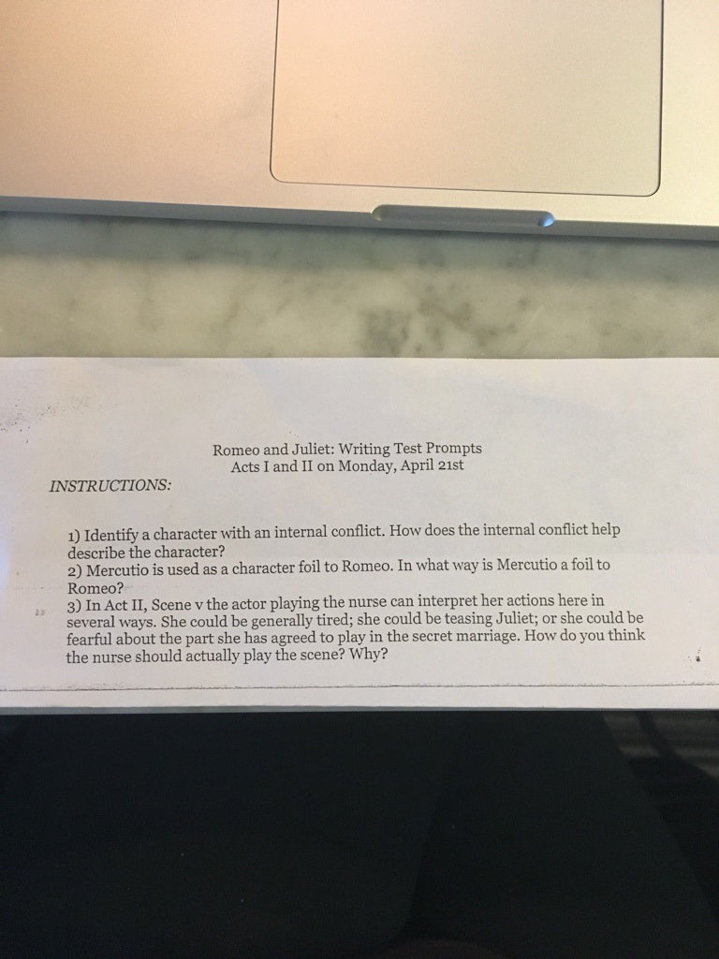
Figure 18: Romeo and Juliet Mandated Timed Writing 1 Prompts
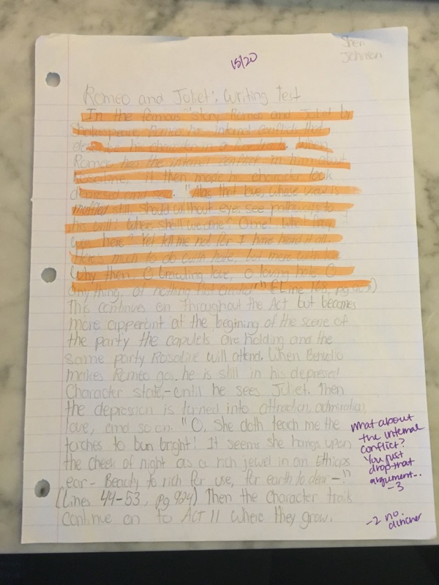
Figure 19: Melina’s Timed Writing 1 Response
Melina’s first timed writing missed some basic elements, like a clincher sentence and the fact that she dropped her internal conflict argument halfway through her paragraph. Melina knew better, but I think she was so stressed out that she would not be done in time that she just tried to get an answer down on paper. When I handed back the timed writings, Melina saw the comments and said, “Of course I forgot something!” and rolled her eyes. I went over to her and reassured her that she was not the only one and to give herself a break: it was just her first timed writing.
When it came time for the second timed writing, Melina was nervous. I could see her ticking off the parts of a paragraph onto her fingers making sure that she would not forget anything. When I dropped off her paper, she was moving her torso back and forth. Not enough to be noticed by everyone, but enough to be noticed by those looking at her. I leaned down and whispered “Breathe” into her ear. She stopped moving back and forth, let out a long breath, and grabbed her pencil. Again, she finished within the time constraints of the class period.
Figure 20: Romeo and Juliet Mandated Timed Writing 2 Prompts

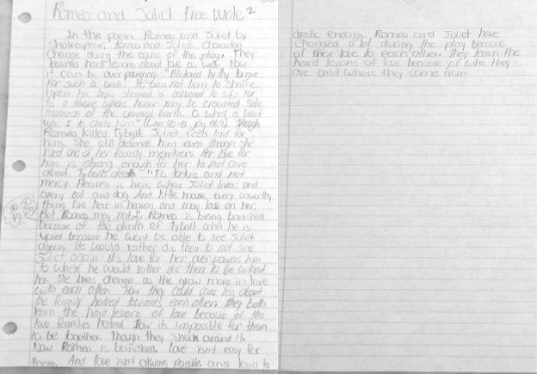
Figure 21: Melina’s Timed Writing 2 Response
By the third timed writing, Melina was a normal sort of nervous; the kind of nervous all students are before they are tested. She was not rocking back and forth, but she was still ticking off the parts of a paragraph. I handed her the prompt page and looked at her. She gave me a low thumbs up. I tapped her desk, a move to both let her know I was here and to let me know if she needed anything.

Figure 22: Romeo and Juliet Mandated Timed Writing 3 Prompts
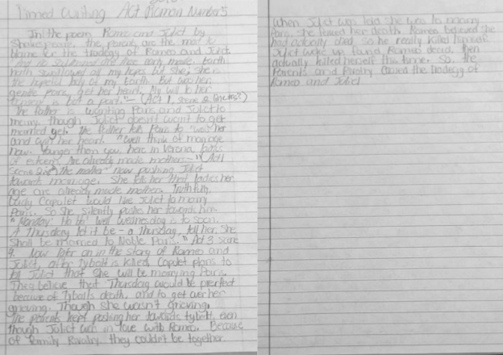
Figure 23: Melina’s Timed Writing 3 Response
For all of the timed writing assignments, the differentiation for Melina came in the form of emotional support. She was very easily stressed and seemed to have low confidence. Her writing was good enough that she did not need any differentiation on that front, but what she needed was support when she was being hard on herself or felt like she could not do it. The absolute worst thing I could have done for her was to give her the exact same time constraints as every other student. If another student needed more time I would absolutely have given it to them, but I did not offer it freely like I did with Melina. With Melina, the less stress she felt, the better she worked. If she became too stressed then she shut down and would not work. My job was to ease her mind and give her the encouragement she so badly needed.
Summary
Melina was a special kind of differentiation. She was more in need of emotional support instead of academic support. At the beginning of the year she had started as an insecure outcast. By the end of the year, she still had her insecurities, but she needed me to tell her that I had her back. That if she needed something more then she would have it. The thing is that she very rarely needed the additional supports, but it eased her mind to know that they were there. Differentiation is a unique educational strategy because it allows for individualization on levels other than academics, which is exactly what Melina needed in order to succeed.
Laura
Laura is a fifteen-year-old freshman in my English 1 class. She is Caucasian with long brown wavy hair. She is tall, standing close to five-foot-eight, and skinny. On the average day she wears her hair down with her bangs pulled back, jeans, and a t-shirt. She has handmade, multi-colored bracelets around her wrist that she never takes off. At lunch, Laura always eats healthy, natural foods and snacks on fruits and nuts. She is organized in class, having a different binder and notebook for every one of her classes. She always has a book with her and can be seen reading before class and, should she get done with an assignment early, she will read after the assignment. Laura almost always asks questions to clarify assignments. She rarely ever gets a question wrong, and I frequently compare my key to her answers just to double check that my answers are correct. She is also very humble. She knows that she is incredibly smart, but does not brag or boast. When I put kids into groups I always pair her with a lower achieving student because I know that she will be patient and help that person by explaining how she arrived at her answers. I have two students who always ask to be paired with her because they feel that she helps them understand assignments and content better.
Laura is religious, part of the cross country and track team at this high school, and a little naive. She participates in my ORCA group, and one day the subject of sex came up in our discussion of The Sound and the Fury. She very confidently stated that the idea of Caddy having sex so young was a little silly because “who is having sex at our age?” Her best friend looked at her as if to say, “Seriously?” and Laura quickly added that anyone who was having sex shouldn’t be because “no one our age is mature enough for that. Seniors aren’t mature enough for that”.
Academically, Laura sets a high standard. She has never turned in an assignment late and works tediously to make sure that each assignment is completed to perfection. She rarely ever misses a question on any of her assignments. Her only struggle comes from writing. She is a solid writer with great ideas, but has trouble transitioning and linking different ideas.
Laura’s GPA stands at a 4.0. The Oklahoma Core Curriculum Test (OCCT) for English involves tests in both reading and writing.
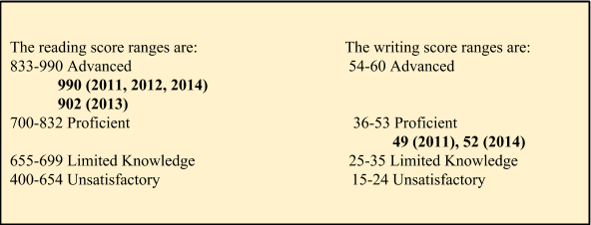
Figure 24: Laura’s Standardized Test Scores
I knew then that my goal would be to get her writing to an Advanced level. I was not surprised at Laura’s test scores. During any exam, Laura takes her time, checks her answers two and three times, and is often the last one to turn in the exam. She is extremely thorough and does her best to get the correct answer.
Shortly after I had decided how to proceed with her on further writing assignments, she mentioned in an ORCA meeting that she was confident when it came to English, but that her writing could use help.

Me: I’ve noticed that. Not that your writing isn’t great, it is. But I’ve noticed that it’s something that you can improve upon, mostly with your outlines, and I’ve just recently been thinking of ways to help you with that.

At first I was worried that she would take offense or be upset that I said something about her need to improve her writing, but instead she was flattered. She looked at me with a big, hopeful smile and said:

Really? Thank you, Miss G! You’re so sweet and in tune with your students’ needs. Thank you so much for noticing and being willing to help me.
Me: Of course! We can confer together and get your writing where it needs to be.
This produced an even bigger smile.
Laura’s biggest issue was not her writing, it was her lack of outlining. Essays would take her forever to write because her thoughts were organized in her head, but not on paper. Once, during class, she had expressed to me that her she often scored lower on the essay portion of class and standardized tests because they took her too long to write—she often ran out of time. Given this information, I felt that outlining would be a very necessary skill that she would need for her future. I later asked her what other elements of writing she felt she had trouble with. She told me that she became very stressed out during timed, written exams. I told her that outlining would help with this--it had helped me through numerous essays in college-- but that I would also try to incorporate some timed writings into class work.

The Poetry Assignment
Because Laura had no problem writing, my focus was to try and get her to outline. In other assignments that required outlining, Laura had always gotten by on the outline, but never gave it her best and often times her outline did not mirror her essay like it should have. For the poetry assignment I gave her the written-out outline and asked her to complete it first before moving on to writing her essay. She spent the first work day outlining her essay, but the second work day she came up to my desk explaining that she could not do it. She apologized, but told me that she did not think outlining was in her, “Or, at least, not this way of outlining.” She said that the lined outline did not give her room to write like she wanted to. It was immediately apparent that this lined outline was too structured and Laura needed freedom to let her mind roam. I told her to use what she could or wanted from what she had done on the lined outline, but told her that we would take a different approach. I wanted her to try her own hand at outlining. I confirmed that she knew the basic structure for a paragraph, and told her to use the paragraph structure as her outline. I asked her to write out her topic sentence, claim, data, warrant, and clincher sentence and label them. She seemed unsure, but agreed to try it and I told her to come to me with any questions. I left her to outlining, checking on her throughout the class. In two days’ time, the outlines would need to be done and put to use on a computer in the computer lab. When this day came, I checked Laura’s outline. What I saw was not an outline, but a completed essay written out on paper before being typed. I asked her where her outline was and she said that she was sorry but that she tried, only when she went to write her outline, she ended up writing the entire essay and did not need to outline. She did not say this in an arrogant way, but was completely and totally apologetic, as if she had failed me. I told her that what she did was okay and that we would try again on the next essay. She smiled beatifically at me, let out a cleansing breath, and said okay.
I was disappointed that the outlining had not worked out but the fault was mine. I gave her too much structure and then not enough. The fault was not hers, but mine, and I inwardly vowed to do better and to come up with a way of outlining that would help Laura, not hinder her.

The Odyssey
I spent the previous month thinking of ways to help Laura outline, and eventually a fellow teacher and I worked to create a semi-structured outline (see figure #). I gave Laura the new outline and told her to try it first and let me check it before she moved on. I saw her studying the outline and begin to write. She worked all hour and had no questions. Toward the end of class, I called her to my desk.

Me: How is this outline going?
Laura: So much better! This actually makes sense.
Me: Has it helped you at all?
Laura: Yes. It’s like… I’ve got everything organized before I start instead of organizing it as I go. It’s really easy, but really helpful, too.

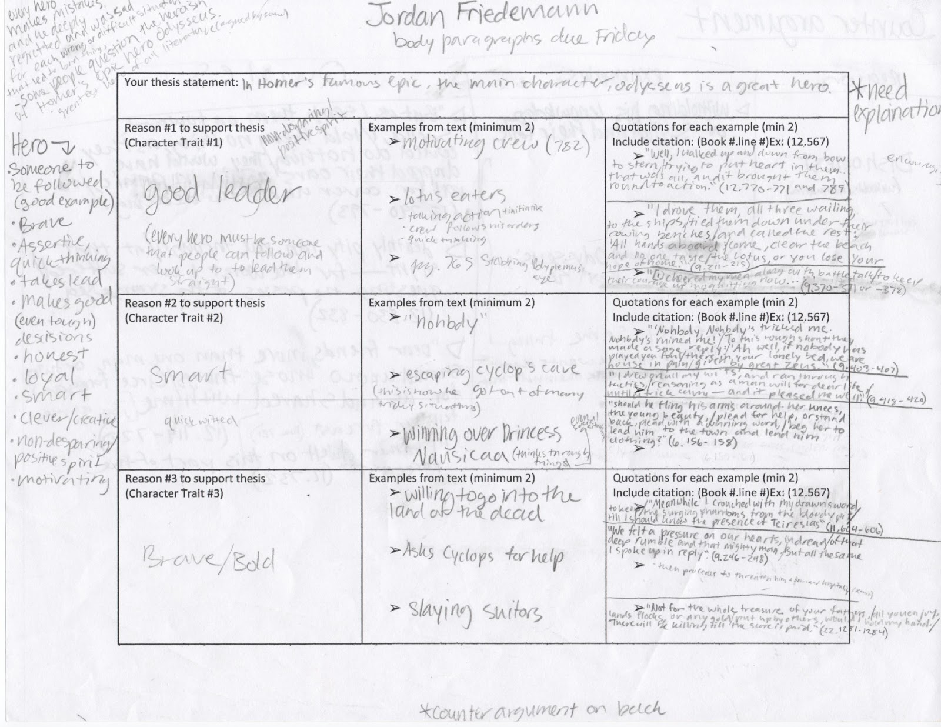
I immediately felt better. I had done it! I figured out a way for Laura to understand outlining without making it too complicated or not giving her enough structure.

Figure 25: Differentiated Odyssey Boxed Outline
In addition to the new outline, I also asked Laura to include a counter argument in her essay. I felt that this would up her writing level and be something she could use on upcoming tests. I gave her a handout detailing what a counter argument needed to be successful, which I had been given from the department head. She included her counter argument outline on the back of the page.
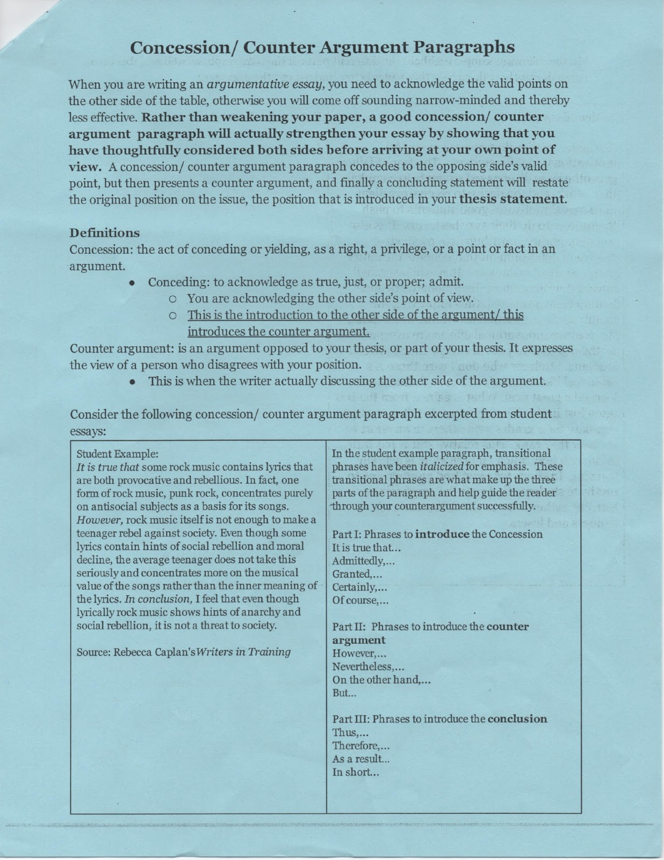
Figure 26: Mandated Counter Argument Handout
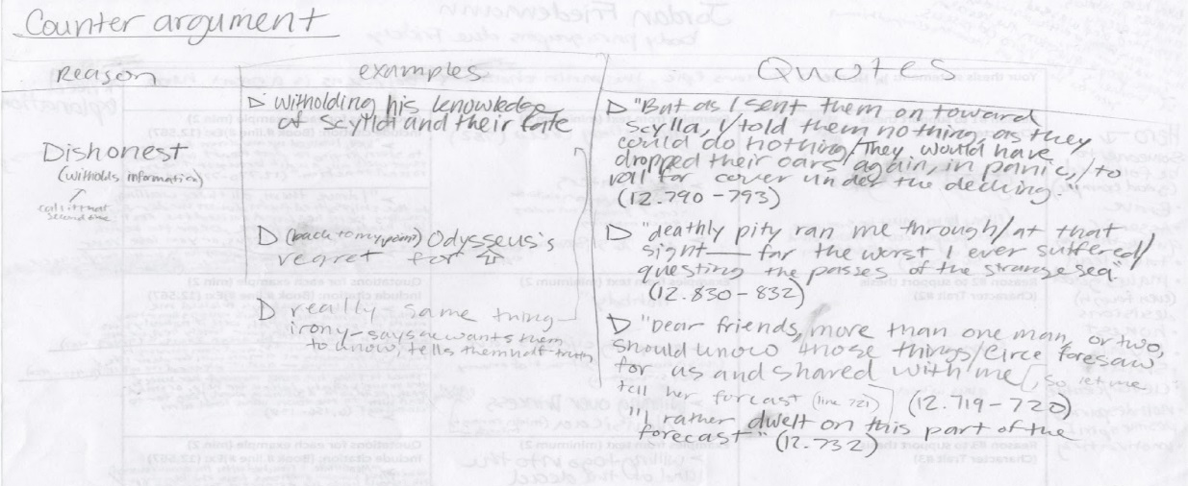
Figure 27: Laura’s Differentiated Counter Argument Outline
Laura had done a wonderful job completing the outline. When she came in to class the next day, she handed me four sheets of paper stapled together. She had completed an outline like the example I had given the rest of the class!
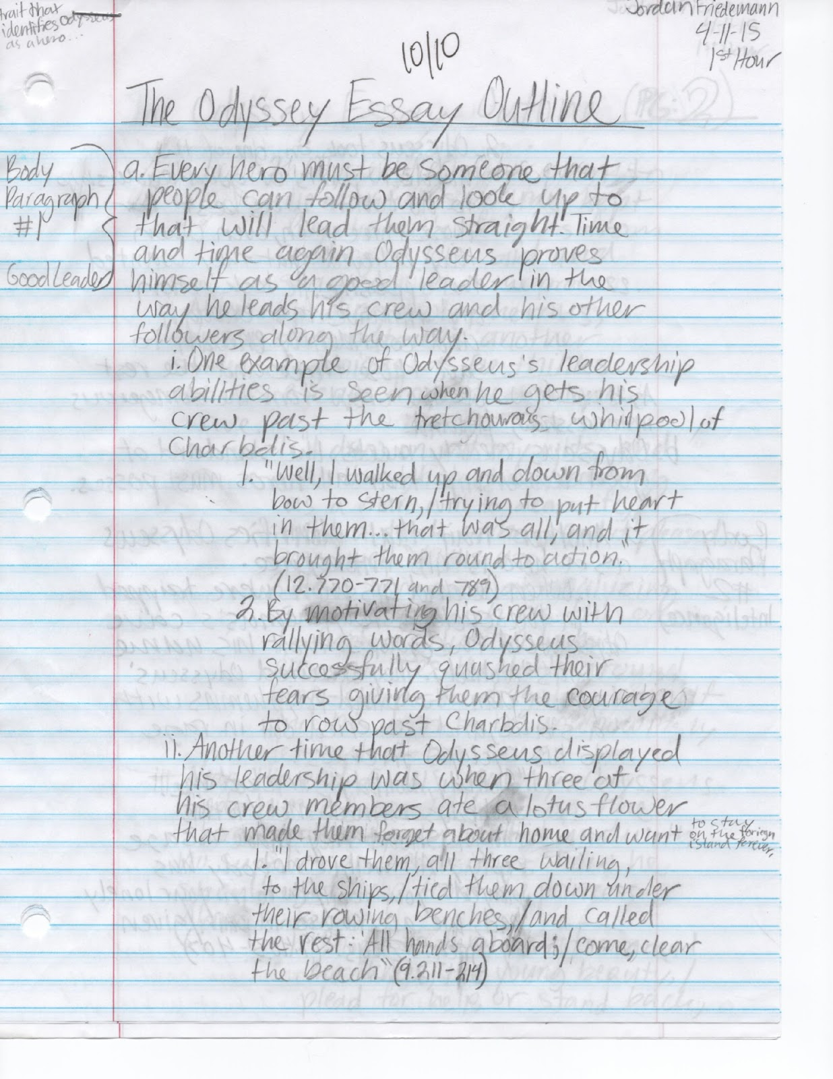
Figure 28: Laura’s Mandated Odyssey Essay Outline After Using Differentiation

I felt as if I had finally challenged Laura to the level she needed to be challenged and, even better, she had succeeded beyond anything I could have imagined. I expected high quality work from her, but I expected it to come with time—not the very next day. Laura had mastered outlining and now it was time for her to move on to practicing timed writing.
Romeo and Juliet
Laura was very excited about reading Shakespeare, but she was also leery and afraid that she would not understand the language. I assured her that I would not let her fall behind and that I thought she would grasp the language quite easily. During the scenes of Act I she struggled a little bit. As we were reading she would raise her hand and ask questions and I could see her trying to make sense of the text. However, by the end of Act I she was following along like a pro and even said she had bought a copy for home to reread it on her own.
I did not differentiate the first timed writing for Laura. I wanted to see her in action so that I could assess what her needs were before differentiating. It took her all hour to complete the paragraph, and she even stayed into the next hour to finish. I could not understand what was taking her so long, but did not push her to move more quickly. When she handed her paper in, she thanked me for the extra time and went to her next class, for which I had written her an excused tardy slip. I looked over her timed writing. It was perfect. Paragraph and sentence structure were solid, word choice was excellent, citations were done perfectly. There was nothing wrong with her writing, but there was something wrong with how long this took her. I had seen her frantically flipping back and forth several times looking for what she needed. She lacked the prewriting thought organization. She did not take those few minutes to compose her thoughts and instead took the paragraph one step at a time.
The day before the second timed writing, I took Laura aside and asked her what she felt her biggest problems were when she was given a set amount of time to write. Laura was very mature and understood her strengths and weaknesses and I felt that I could ask her what her issues were and she would give me as straight an answer as possible. I was also curious to see if she felt what I saw: a lack of organization which was produced by the stress of time constraints.
Laura: Well, Miss G, I’m always the last one to finish when it comes to tests and quizzes. And when it comes to writing, it always takes me too long to finish and I have to turn in an incomplete assignment.
Me: Okay. So do you get stressed out?
Laura: Only towards the end when I know I’m not going to finish.
Me: I’ve got an idea. I’m going to give you a handout with a checklist so that you can get all your thoughts together before you write. Once you get started and know what you’re going to say, you’ll get done with plenty of time.

Initially, I had planned to have Laura do an outline for her timed writings, but if she already felt constrained by time, I did not want to add to it. And she was right: she was always the last one done when it came to quizzes and tests. She went over every detail of a question before choosing an answer, and then went back over her answers when she was finished. She was nothing if not thorough. I chose the structure of the handout based on the success Laura had had with the Odyssey outline. She needed help organizing her thoughts before writing. Simplicity had worked for her, and I wanted to keep the handout as simple as possible. She was able to use the handout on the last two timed writings.

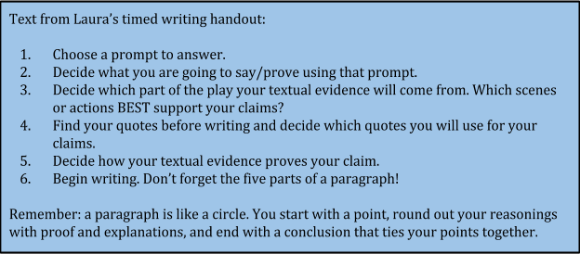
Figure 29: Laura’s Differentiated Timed Writing Handout
For the second timed writing, Laura was able to finish during class time. She still took the whole hour and went almost to the bell, but she finished without extra time. She came into the the third Timed Writing confident and opted to try not to use her handout. She said that she had asked other teachers if she could use the handout on timed writings and they had agreed. I noticed that she had had the handout laminated.
Figure 30: Romeo and Juliet Mandated Timed Writing 2 Prompts

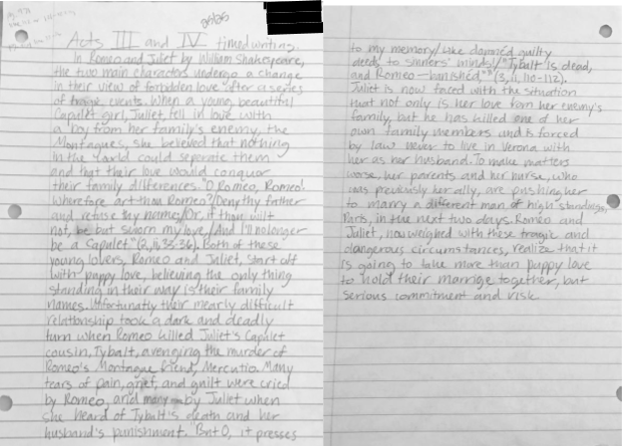
Figure 31: Laura’s Timed Writing 2 Response
Before the third timed writing I challenged her to do more than a paragraph. I asked her to treat this writing as a state test where students are expected to write a short essay. I told her it was up to her whether she broke up the paragraphs or not, but that I wanted as much explanation and as many quotes as she felt necessary. “You can do this,” I told her. She nodded. It took her the entire class period, but her work was twice as long-- a perfect example of a short essay. When she handed in her assignment, all four pages of it, she asked if she could keep the handout. I asked if she wanted my copy as well, for a backup just in case. She laughed, took it, and pledged to laminate it as well.

Figure 32: Romeo and Juliet Mandated Timed Writing 3 Prompts
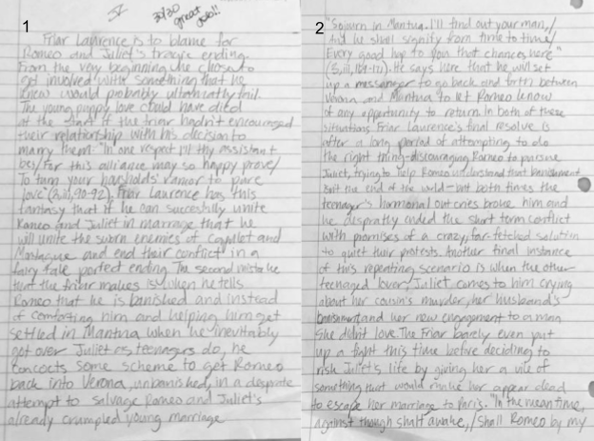
Figure 33: Laura’s Timed Writing 3 Response

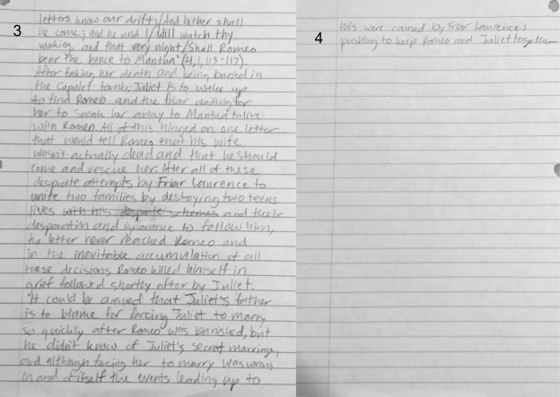
Figure 34: Laura’s Timed Writing 3 Response Continued
Summary
Laura did not lack ability or confidence in her work. What she needed help with was time management. Learning to write an outline helped that time management because it allowed her to get her thoughts in order before writing. Putting time constraints on assignments forced her to push herself to be done and not stress about being done on time. She was more than capable of being done on time, but she needed to learn to push herself and use time effectively when it came to being tested both in class and on standardized tests. Differentiation allowed her to gain a necessary skill, practice and hone her time management skills, and prove to herself that she was capable of finishing on time with an exemplary product.
Chapter 5: Conclusions

Research Problem
There is only one basis for schools’ thinking that a one-size-fits-all curriculum is the most effective: the standardized test. These state-mandated tests do not ask students for their interpretation, but ask students to choose their interpretation. These tests assume that every student learns and interprets in the exact same way. This is a fallacy. The problem is that schools are judged based on their standardized test scores. These scores even determine government funding; the lower the scores, the fewer funds are given. And the truth is this:
- the standardized test is the problem, and
- it is NOT going away.
It is implausible to expect adolescent brains to work the same—to expect any two brains to work the same. Cognitive processes are as unique as personality. No two people are physiologically identical. How can the expectation be that learning is identical?
Research Question
The research question was, “What effect, if any, will differentiated instruction have on the academic performance and attitudes of three randomly-selected students?”
All three students who received differentiated instruction using the simple technique of Lawrence-Brown’s (2004) “additional supports”, which states, in brief, that those students who fall into the “additional supports” category are capable of the given curriculum, but would better perform if given supporting materials to foster and individualize learning. Using only one piece of differentiated instruction, Dante, Melina, and Laura all had increased academic performances and they all had educational gaps that were filled. This study did not hypothesize improved attitudes and outlooks toward learning, but all three students had improved attitudes toward English at the conclusion of the study.
For Dante, his performance increased most with his writing skills. He began the year unable to write a paragraph or understand what he was reading. By the end of the year, he was able to write analytical paragraphs about Shakespeare. He had come to school with a hard-working attitude, but because of this increased academic performance, his confidence levels soared. He was no longer afraid to work on his own or do something wrong. Instead, he pushed himself to complete written work independently. Thus, Dante’s attitude towards English had grown from fear and loathing to actually enjoying English.
For Melina, her academic performance increased because of her change in attitude. Melina was constantly anxious about her ability to complete the work and her ability to obtain a decent grade. At the beginning of the year, she would give up because of her anxiety instead of calming down and allowing herself to be able to complete her assignments. In response to a little additional emotional support she became better able to get out of her head and focus on the task at hand. This ability to focus increased her academic performance because she was no longer as likely to give up on an assignment. By the end of the year, Melina completed assignments on time and started asking for help instead of sulking.
Laura was always able to write a neat, concise essay, but she was still far from her full potential. However, by identifying her weak area as organization and teaching her a method of organizing her thoughts (an outline), her writing process became more efficient and her writings became more coherent, more detailed, and longer. While she always had a determined and positive attitude, she gained confidence and efficiency. At the beginning of the year, Laura responded with anxiety and panic to writing essays, but by the end of the year, she almost relished the challenge.
Lawrence-Brown (2004) asserted that “[d]ifferentiated instruction is as important for students who find school easy as it is for those who find school difficult” (p. 37). Dante, Melina, and Laura all came from these categories of students. Laura found school easy. Dante and Melina found school to be hard. Every one of them benefited from the differentiated curriculum. Lawrence-Brown (2004) further argues that “[d]ifferentiated instruction serves two broad goals… first is to maximize attainment of the grade-level curriculum standards for all students...second… is to provide adapted curricula for those who need it” (p. 38) Dante, Melina, and Laura all reaped the benefits of a maximized and adapted curriculum:
- Dante’s reading comprehension questions that were not given in the curriculum,
- Handouts detailing supporting and supplemental material so that students could better perform on assignments (i.e., Dante’s Parts of a Paragraph handout and Laura’s Odyssey Boxed Outline)
- Simplified assignments that asked student to complete the same skill in a new way (i.e. Dante’s Finished Differentiated Odyssey Assignment and Melina’s simplified poetry explication)
Because these assignments asked students to complete the same skill, but in a way that was tailored to them, their confidence, both socially and academically, boosted significantly. Dante wrote and comprehended significantly more than he had at the beginning of the year. Melina, although she did not complete all differentiated assignments, was able to control her anxiety in class through the supplemental material and emotional supports given to her. She even began to make friends. Laura, although brilliant, could not begin to write an outline at the beginning of the year, but, by the end of the year had written a four-page outline because of a simple boxed differentiated assignment.
These differentiated assignments were built using Lawrence-Brown’s additional support system, but they were created using the Watts-Taffe (2012) belief that “allow[ing] all students to access the same classroom curriculum” improves student learning and engagement “by providing entry points, learning tasks, and outcomes tailored to students’ needs” (p. 304).

Limitations
The study was limited in scope and scale. Only one class period had differentiation implemented into their classroom, and, of that class, only three students were chosen to participate in this study. More quantitative data would be useful in describing the benefits and setbacks of differentiated instruction because it could be taken on both a teacher a grade level versus a single class period within that teacher’s day.
Another limitation could be that there are unwilling students who refuse to participate. From what I found within my research students were excited to have assignments specifically for them, but I could see some student personalities taking it as a slight or as an indication that they are dumb, much like Melina when she asked if her new assignment was because I thought she was dumb. When this happens, I feel one of two strategies work best:
- Be honest with them and tell them that you created this assignment for them and for a specific reason, be that because it plays to their strengths, helps them work on their weaknesses, or both.
- Strictly tell them that this is their assignment that they are expected to complete. That everyone’s assignments are a little bit different-- it is not just them that these altered assignments are happening to.
There is a third option, and that is not to tell them anything, but in my experience students lose respect for teachers who they think keep things from them or who are dishonest with them directly or by evasion. I would rather a student be upset with me over an individualized assignment rather than them lose respect for me because they feel I am being sneaky with them and their education.

Teacher Workload
Differentiated Instruction takes A LOT more planning, and this is daunting at first.. Differentiating for every student in an entire class takes a considerable amount of time and preparation. However, teachers can begin differentiating in small ways at first. The right classroom set up helps because it inhibits the probability of distraction and helps students focus on the content at hand. This may mean that classroom desk set ups change between hours, which does not leave much time to switch the room around, but if it helps prevent distractions and creates better focus then it is worth it. Learning to give lectures and introduce content and assignments using the auditory, visual, and kinesthetic (VAK) method leads to quicker student understanding. Giving assessment options using the VAK method also gives each student the opportunity to show their content knowledge while still being able to play to their strengths.
Once distractions have been eliminated, a teacher knows their students’ learning styles, and a teacher sees where their students are still struggling, differentiating individual assignments can become a daily part of the classroom. While the workload would go in waves, sometimes harder, the same, or easier, grading becomes a task of improvement instead of correction.

Grading
What I wanted from my students was improvement, not perfection. Sometimes it is easy to get caught up on wanting every student to be at the same level and grading them accordingly, but the truth is every student is different and no student will write or choose words the same, especially students at different academic levels. I found that I stopped focusing my assignments and grading on strictly right or wrong answers or on “can they do it or not do it” and instead started focusing on cognitive improvement and giving my students more tools to be able to do assignments they found difficult. For example, Dante’s timed writings would not have gone as well without the use of the Paragraph Help Handout. Does that mean that I take off points because he needed extra help? No! It just means that he was given something to help him remember and be more capable. Laura, even though advanced, could not write an outline. Does that mean I take off points because she has a learning gap? No! That means I give her the means and modes of improving herself. Differentiation is about improvement. It is only standards-based curricula that is strictly about being right or wrong; student improvement through differentiation leads to better cognitive abilities on the mandated standardized tests.

Students’ Individual Needs Are More Likely to Be Met
If time spent planning can be seen as a disadvantage, it is the only one. The best advantage that I recognized was that differentiation helped with student motivation. Being able to ask students to show what they learned and how they learned it versus expecting them to be robotic and learn the same things in the same way was another major advantage. Giving a student an assignment they feel assured about bettered student confidence, motivation, and led them to turn in a more detailed and intuitive assignment. For example, Dante’s alternative Odyssey assignment. He would have only needed to identify and describe three heroic traits with the original assignment. However, with the alternative assignment he had to correlate heroic traits with body parts and describe why-- a level he would not have reached with the original assignment. He was also motivated to do this assignment because he felt like he could do it. The original assignment would have left him daunted and disgusted because he knew that he was not a very good writer and was not good with grammar.
Advantages with differentiated instruction also pertain to the mental needs of students. Melina was capable of doing the assignments but her insecurity and anxiety led her to believe that she could not, and this created a lack of motivation to do her work to the best of her ability. Being able to recognize and have the means to help offset the insecurity and anxiety she felt helped her to feel more confident and capable in her school work.
Differentiation also allows for filling in instructional and educational gaps while still continuing core instruction and assessments. For example, Laura could write a nearly perfect essay, but could not write an outline. Differentiating for her helped to fill in this gap by giving her a skill she will use for the rest of her educational career.
My push to get Dante tested and on an IEP was caused by differentiated instruction. At the time, I second-guessed myself. Should I be so bold as to think a student should be on an IEP or 504? What will people think if I push for this? What will people think if I am wrong? What might the parent’s response be? These were all questions I asked myself, and they were all the questions that I should not have been asking. The moment Mrs. Riley and I noticed the correspondence to Dante listening to a work and then being able to complete it, the moment I saw that he could write a paragraph as good, or better, than others in the class if given supplemental materials, the only question that mattered was How do I get these accommodations to be a part of his learning in every class? The job is to help students, children, succeed by whatever means necessary.

Is Differentiated Education Beneficial for Student Learning and Improvement?
Yes. Differentiation gives the educator the opportunity to provide individuality in an educational setting. It allows the classroom to truly be diverse in learning styles and approaches by embracing the differences among students. Implementing differentiation in a school-wide setting would need full cooperation from administrators and curriculum developers because they would have to be understanding in the need to edit assignments per each student. Administrators expect differentiation in the classroom and want to see it used effectively; their issue would not be the implementation but whether they find your interpretation of differentiation effective. Curriculum developers would also need to be understanding in the use of differentiation. The common rule seems to be that a teacher can add to the curriculum, but they cannot take anything out of the curriculum. Editing assignments created by curriculum developers blurs the line between addition and subtraction of content. However, an understanding curriculum developer would agree and even help scaffold assignments for differentiation. The most important piece for everyone when intending to use differentiation is patience. A teacher’s differentiation is not innate and will not be perfect the second, third, or fourth time, but with patience a teacher can hone their differential skills.
The truth is that the U.S. educational system is constantly criticized for being mediocre. According to the 2015 PISA results, a study that included 70 countries,
we rank 25th overall in education. Our scores are below average in math, reading, and science, the three major categories measured in the results. Perhaps this low ranking is due to student apathy and perhaps this apathy is a direct result of standardized curricula being unable to meet real, individualistic, human needs.
If the United States were able to let go of the standardized curricula ideology, perhaps teachers would feel as if they have the ability to give more attention to individualized student needs and build better personal and positive rapport with students. If the teacher were able to address student problems through immediate, direct, and individualized interventions, then perhaps there would be more student engagement, higher scores, and more positive attitudes toward learning.
My response was a sharp contrast to the passive environment and this response changed my career. Now, at a different school in a different state, I still use differentiated instruction and cannot imagine teaching another way. The gaps these students at Heisenberg High had could, and would, not have been filled using the one-size-fits-all mentality. While the circumstances were nothing I had imagined and it was frustrating, shocking, to be handed an assignment and made to make students complete it, it is something that the job often requires no matter how increasingly obvious it is that that outlook is not beneficial for students. For example, the mandated outlines were the expectation, but could not be complete by anyone who was a struggling, average, or highly intellectual student.
This is why one-size-does-not-fit-all: because one skill, one support, can enhance a child’s quality of life and quality of education.

References
Alexander, W. M. (1961, January). Uniformity vs. Diversity in the Senior High
School. Educational Leadership. http://www.ascd.org/ASCD/pdf/journals/ed_lead/el_196101_alexander.pdf

Barnes, W. B., & Slate, J. R. (2012). College-readiness is not one-size-fits-all. Current
Issues in Education, 16(1). https://cie.asu.edu/ojs/index.php/cieatasu/article/view/1070

Bullough Jr, R. V., & Pinnegar, S. (2001). Guidelines for quality in autobiographical
forms of self-study research. Educational Researcher, 30(3), 13-21.

Delamont, S. (Ed.). (2012). Handbook of qualitative research in education. New
York: Edward Elgar Publishing.

DeRuy, E. (2016, July & August) "A New Argument For More Diverse Classrooms."
The Atlantic. https://www.theatlantic.com/education/archive/2016/07/a-new-argument-for-more-diverse-classrooms/489707/

Figurel, J. (1952). What Recent Research Tells Us about Differentiated Instruction
in Reading. The Reading Teacher, 6(1), 27-44.

Lawrence-Brown, D. (2004). Differentiated instruction: Inclusive strategies for
standards-based learning that benefit the whole class. American Secondary Education, 32(3), 34-62.

Tomlinson, C., & Kalbfleisch. M. (1998, November). Teach me, teach my brain: A
call for differentiated classrooms." Educational Leadership 56(3), 52-55.

United States Census Bureau. (2010). U.S. Census Bureau Norman, Oklahoma.
https://factfinder.census.gov/faces/tableservices/jsf/pages/productview.xhtml?src=CF.

US News. (2014). Best High Schools U.S. News: Norman High School. Retrieved from
https://www.usnews.com/education/best-high-schools/oklahoma/districts/norman/norman-high-school-147589/student-body.

Watts-Taffe, S., Laster, B., Broach, L., Marinak, B., Connor, C. M., & Walker-
Dalhouse, D. (2012). Differentiated instruction: Making informed teacher decisions. The Reading Teacher, 66(4), 303-314.

