UNIVERSITY OF OKLAHOMA
GRADUATE COLLEGE

THE EFFECTS OF HYDROLYZED COLLAGEN ON PERFORMANCE, SORENESS
AND COLLAGEN BIOMARKERS FOLLOWING EXERCISE IN RESISTANCE TRAINED MALES

A THESIS
SUBMITTED TO THE GRADUATE FACULTY
in partial fulfillment of the requirements for the
Degree of
MASTER OF SCIENCE

By
JOEL LANDAN PROWTING
Norman, Oklahoma
2019

THE EFFECTS OF HYDROLYZED COLLAGEN ON PERFORMANCE, SORENESS
AND COLLAGEN BIOMARKERS FOLLOWING EXERCISE IN RESISTANCE TRAINED MALES

A THESIS APPROVED FOR THE
DEPARTMENT OF HEALTH AND EXERCISE SCIENCE

BY

Dr. Jason Campbell, Chair

Dr. Christopher Black

Dr. Debra Bemben

Dr. Eric Day

© Copyright by Joel Prowting 2019
All Rights Reserved.

Acknowledgements
First and foremost, I would like to take this opportunity to thank my mentor (and Doctore) Dr. Jay Campbell for the guidance, support and friendship provided throughout the last 2-years. Without him, I wouldn’t even be in this country, let alone at OU! It’s no easy thing to move across the world and to be away from everybody you know and love. Not only did Jay provide excellent supervision of my academic studies, but he also made me feel at home here in Oklahoma (of course helped by his sidekicks Rocky and Elle!). I would also like to thank the other members of my Thesis committee, Dr. Chris Black, Dr. Debra Bemben and Dr. Eric Day for helping me develop and produce a piece of work that I am supremely proud of, as well as for providing help whenever necessary (special thanks to the Bone Lab for sharing their space, resources and expertise with me!).
Secondly, I would like to thank my family, friends and of course my spectacular fiancé. I would not be the man I am today without their love and support through rain or shine. Although they were not always literally by my side, I could feel them with me figuratively every step of the way. Katrine has simultaneously been my biggest supporter and inspiration throughout these last two years, and if I can produce even half of the compassion, kindness and pure energy that she does, I will count myself extremely lucky. I also need to thank my friends, both old and new for filling my life with happiness and fun. I have made lifelong friends at OU, and will remember the game days, get togethers, and all round entertainment with much fondness.
Finally, to you, the reader of this document, thank you for spending your valuable time and energy listening to my words. Countless hours have been spent on this project and I hope my thoughts and ideas inspire you to remain ever curious about this wonderful existence of ours.
Per Aspera ad Astra! – Joel
Table of Contents
Acknowledgements iv
List of Tables vii
List of Figures viii
Abstract ix
Chapter 1 – Introduction 1
Research Questions 5
Alternate Hypotheses 6
Significance of the Study 7
Delimitations 8
Limitations 8
Assumptions 9
Operational Definitions 9
Chapter 2 – Literature Review 11
Exercise Related Injury Epidemiology 12
Exercise Induced Muscle Damage 14
Nutritional Recovery Strategies 15
Collagen Overview 16
Response of Tissue Collagens to Exercise 18
Collagen Supplementation Overview 20
Collagen Supplementation in Animal Models 22
Collagen Supplementation in Clinical Populations 22
Collagen Supplementation in Athletes 25
Conclusion 27
Chapter 3 - Methodology 29
Participants 29
Experimental Design 30
Muscle Damage Protocol 34
Recovery – Performance-based Measures 35
Recovery – Pain and Soreness Measures 35
Recovery – Biomarker Measures 36
Data Analysis 38
Chapter 4 – Results & Discussion 40
Baseline Characteristics 40
Maximal Voluntary Isometric Contraction 41
Countermovement and Drop Jump Performance 45
Muscle Soreness and Pain Pressure Threshold 49
Collagen Biomarkers – PICP and ICTP 53
Discussion 57
Muscle Performance (CMJ and MVIC) 57
Muscle Soreness 62
Biomarker Response 63
Limitations 67
Chapter 5 – Conclusion 69
Practical Significance and Applications 69
Future Study Recommendations 70
References 73
Appendix 1: IRB Approval Letter 93
Appendix 2: Informed Consent Form 95
Appendix 3: HIPAA 101
Appendix 4: Health History Screen 104
Appendix 5: International Physical Activity Questionnaire (IPAQ) 107
Appendix 6: Physical Activity Readiness Questionnaire 113

List of Tables
Table 1: Baseline characteristics of participants.……………………………………………… 40
Table 2: Additional metrics collected during CMJ trials across PRE, 24h, 48h and 120h time points.…………………………………………………………………...……………………… 48

List of Figures
Figure 1: Micrograph of the collagenous endomysial network surrounding muscle fibers…… 18
Figure 2: Molecular structure of collagen and schematic of collagen to gelatin conversion….. 21
Figure 3: Visual Representation of Experimental Study Design………………………………. 33
Figure 4: Mean Quadricep MVIC for both legs across the “PRE” and “IP” time points…….... 41
Figure 5: Mean Quadricep MVIC for the left leg across PRE, 24h, 48h and 120h time points.. 42
Figure 6: Mean Quadricep MVIC for the right leg across PRE, 24h, 48h and 120h time points 43
Figure 7: Mean CMJ height across PRE, 24h, 48h and 120h time points…………….……….. 45
Figure 8: Individual CMJ height across PRE, 24h, 48h and 120h time points…….…….…….. 47
Figure 9: Mean subjective muscle soreness (VAS) for overall lower body across PRE, 24h, 48h and 120h time points……………………………………………………………………………. 49
Figure 10: Mean subjective muscle soreness (VAS) for Quadricep, Gluteal and Calf regions across PRE, 24h, 48h and 120h time points…………………………………………………….. 50
Figure 11: Mean left leg pain pressure threshold (PPT) across PRE, 24h, 48h and 120h time points……………………………………………………………………………………………. 51
Figure 12: Mean right leg pain pressure threshold (PPT) across PRE, 24h, 48h and 120h time points……………………………………………………………………………………………. 52
Figure 13: Mean PICP concentrations across the “F3” and “PRE” time points……………….. 53
Figure 14: Mean ICTP concentrations across the “F3” and “PRE” time points……………….. 53
Figure 15: Mean serum PICP concentrations across PRE, 24h, 48h and 120h time points….... 54
Figure 16: Mean serum ICTP concentrations across PRE, 24h, 48h and 120h time points…… 55
Figure 17: Mean serum PICP/ICTP ratio across PRE, 24h, 48h and 120h time points…....….. 56

Abstract
Hydrolyzed Collagen (HCOL) is a nutritional supplement that has recently been suggested to enhance musculoskeletal (MSK) resilience and recovery from damaging exercise. Despite some promising evidence in clinical and in vitro models, there is a paucity of data in regards to its efficacy in healthy, exercising humans. PURPOSE: The purpose of this study was to determine whether consuming a HCOL supplement could be beneficial for well-trained individuals by examining the effect on acute recovery from high-force eccentric exercise. METHODS: Resistance trained males consumed 15g per day of either HCOL or a cornstarch placebo (PLA) for 12-days. After 7-days, they had a number of outcome variables measured, including: maximal voluntary isometric contraction (MVIC), countermovement jump performance (CMJ), lower body soreness, pain pressure threshold (PPT) tests and collagen turnover biomarkers (PICP and ICTP). After collection of baseline measures, participants performed a muscle damage protocol (5 sets of 20 drop jumps from 60cm box) before having every variable measured again at the following time points: immediately post (IP), 24h post (24h), 48h post (48h) and 120h post (120h). RESULTS: In both groups, lower body muscle soreness assessed via VAS was significantly higher than PRE at 24h (p=0.001) and 48h (p=0.018), but had returned to baseline by 120h (p>0.05). MVIC in both legs showed a significant time effect (Left: p=0.007; Right: p=0.010) over the 5-day post damage period. These finding indicate that the participants were sufficiently damaged using the drop jump protocol. Compared to baseline (HCOL = 38.2±9.2cm vs. PLA = 38.7±7.8cm), CMJ height performance was maintained in the HCOL group at 24h, whereas the PLA group experienced a significant decline (24h: HCOL = 37.0±8.4cm vs. PLA = 33.7±7.6cm; p<0.001). Neither the collagen synthesis (PICP) or collagen breakdown (ICTP) biomarkers changed significantly. CONCLUSION: In summary, at the 24 h time point, HCOL attenuated the performance decline that is typically associated with muscle damage. This finding suggests that short term consumption of HCOL either enhanced tissue repair/recovery rate or reduced the magnitude of damage incurred by the drop jump protocol.
Key Words: Hydrolyzed Collagen, Recovery, Exercise Induced Muscle Damage, Connective Tissue

Chapter 1 – Introduction
Following an acute bout of intense exercise, it is common to incur some degree of musculoskeletal (MSK) tissue damage. It is well known that exercise induced muscle damage (EIMD) can transiently inhibit performance by disrupting ultrastructural myofibres, leading to a reduction in force production capacity, an increase in muscle soreness and an efflux of myocellular proteins into the circulation (Peake et al., 2016; Twist & Highton, 2013; Clarkson & Hubal, 2002). Whilst a certain degree of metabolic and mechanical stress is required to initiate tissue remodeling and repair (Hyldahl & Hubal, 2014), accelerating the recovery from this damage may be favorable for improving consecutive athletic performances. In addition to the well-researched effects on muscle tissue, there is evidence that eccentric exercise also damages connective tissues (Brown et al.,1997), including the extracellular matrix (ECM) which surrounds muscle fibers (Mackey et al., 2004). Traditionally thought to act as a simple scaffold network, recent technological advances have shown that the ECM is not only responsible for biological mechanotransduction, but that it is a complex dynamic tissue involved in signaling and regulatory processes within muscle (Gillies & Lieber, 2011). Recent data has demonstrated an association between ECM remodeling and the repeated bout effect (RBE) phenomenon (a protective adaptation in which an individual exposed to an initial bout of damaging exercise, will incur substantially less tissue damage during a subsequent bout of similar exercise) (Hyldahl et al., 2015). If the remodeling process of the ECM can be accelerated or improved, there is the possibility that a direct performance benefit could manifest due to enhanced mechanotransduction and passive force generation. Another intriguing possibility is whether augmenting the recovery capacity or resilience of the ECM could result in better protection against subsequent tissue damage (by enhancing the effectiveness of the RBE), and thus reducing transient performance decrements as well as reducing the risk of MSK injury. Indeed, several hormone and drug treatments appear to be able to modulate this connective tissue adaptation (Mackey & Kjaer, 2016), however it is not yet clear if this process can be enhanced through more readily available interventions, such as nutritional manipulation or supplementation.
From a practical perspective, recovery has been defined as the ability to meet or exceed previous performance in a particular activity (Bishop et al., 2008). Optimizing recovery rate from muscle damage or injury is important for consecutive athletic performances as well as for accumulating training volume and thus adaptation (Raysmith & Drew, 2016). Upon return to a resting state, the body will initiate metabolic (restoration of fuel levels) and mechanical recovery processes (reparation of musculoskeletal (MSK) system damage) (Heaton et al., 2017), and both nutrition and rest can significantly influence these processes (Heaton et al., 2017). Nutritional strategies used to enhance acute recovery may target a variety of areas, such as the restoration of muscle glycogen (Beelen et al., 2010), reparation of muscle tissue (Phillips & Van Loon, 2011), reduction of inflammation (Urso & Sawka, 2013) and/or support of the immune system (Gleeson et al., 2004). Furthermore, it has been suggested that nutritional supplements could modulate acute recovery following EIMD. Specific examples include protein/amino acids, dietary polyphenols and vitamins D, C & E (Owens et al., 2019), and results have generally been mixed in regards to their efficacy.
In addition to the direct performance decrements that can occur following insufficient recovery, when chronic training/performing is not properly matched with recovery, underperformance syndrome (UPS; also known as overtraining syndrome) can develop (Kreher, 2016). Underperformance syndrome can result in dysregulated performance for months and can significantly increase the risk of an MSK injury developing (Soligard et al., 2016). MSK injuries make up a significant percentage of injuries to athletic populations, with ligamentous sprains and muscular strains accounting for approximately 46-60% of all acute injuries (Kerr et al., 2010). Chronic injuries such as tendinopathies are usually overuse-related and constitute around 30% of all resistance training injuries (Raske & Norlin, 2002). Becoming injured leads to time away from training to heal the tissue itself, as well as concomitant detraining effects of various organs and bodily systems (Mujika & Padilla, 2000). Developing strategies to reduce the occurrence of, or ameliorate the symptoms of these adverse events should be prioritized.
Within the human body, collagen is the most abundant protein and plays an integral role in the structure and function of many different tissues. Type I collagen predominately makes up ligament, tendon, fascia and the organic matrix of bone tissue. The Type 1 collagen in tendon and fascia provides tensile stiffness, and within bone it defines various biomechanical properties (Gelse et al., 2003). Additionally, collagen makes up a significant proportion of the aforementioned ECM (Velleman, 1999). Considering the ubiquity of collagens throughout the MSK system, ensuring that the body has sufficient quantities of its precursor amino acids has been hypothesized to provide a physiological benefit by supporting connective tissue reparation (Baar, 2015). Individuals who are regularly incurring damage to their MSK system may require greater quantities of these amino acids in order to sufficiently support growth and repair of skeletal muscle ECM, tendon, cartilage and bone tissue.
Hydrolyzed Collagen (HCOL) is a nutritional supplement suggested to be beneficial for enhancing MSK and connective tissue repair/resilience (Heaton et al., 2017). The proposed mechanism is that an increased concentration of collagen precursor amino acids may support a proliferation in collagen synthesis within target tissues (Baar, 2015). Results from animal models have shown that HCOL can stimulate production of Type II collagen in the ECM of cartilage tissue (Oesser et al., 1999), as well as improve resistance of the Achilles tendon to rupture by promoting more rapid tissue remodeling (Vieira et al., 2014). A recent in vitro model utilizing human ligamentous tissue has indicated that HCOL supplementation can enhance collagen synthesis in response to gelatin (precursor to HCOL) supplementation within human connective tissue (Shaw et al., 2017). Engineered ligaments were found to have greater tensile strength and increased collagen content following 3 days of gelatin consumption, which has implications for injury prevention and recovery. Most recently, Clifford et al. (2019) determined that supplemental HCOL benefitted the recovery of countermovement jump (CMJ) performance and muscle soreness following a damaging drop jump exercise protocol.
At present, there is a paucity of data in terms of the practical application and efficacy of HCOL supplementation in healthy populations. Additionally, there are reports of Sport Nutrition professionals recommending HCOL supplementation for athletes suffering from tendon or ligament injuries (Alcock et al., 2018). Further investigations are required before these supplementation recommendations can be considered effective. There is currently little to no research assessing whether 1) HCOL supplementation might improve acute recovery from exercise, 2) HCOL supplementation can decrease injury incidence or accelerate healing rate of injured MSK tissues, and/or 3) HCOL might be able to influence chronic adaptations associated with training. Also of interest would be the elucidation of the optimal dose and frequency of HCOL supplementation required to maximize efficacy.
The purpose of this study was to take the first step into determining whether consuming a HCOL supplement may be beneficial for well-trained individuals. A double-blind randomized control trial was performed, with one group consuming HCOL and the other group consuming an inert placebo (PLA). Comparing changes between groups in markers of acute recovery and indices of connective tissue remodeling following a bout of high-force eccentric exercise will mark the initial attempt to determine whether consuming HCOL can provide a benefit within a highly resistance trained population.

Research Questions
- Does taking a Hydrolyzed Collagen supplement improve acute recovery from a bout of high-force eccentric exercise in highly resistance trained individuals?
  - Do soreness levels return to baseline more rapidly with 12-days of HCOL supplementation compared to a placebo?
  - Does strength return to baseline more rapidly with 12-days of HCOL supplementation compared to a placebo?
  - Does jump performance (CMJ) return to baseline more rapidly with 12-days of HCOL supplementation compared to a placebo?
- Does taking a Hydrolyzed Collagen supplement for 12-days provide a protective effect to the MSK system (i.e. reduced magnitude of performance decrements/physiological dysregulation) following a bout of high-force eccentric exercise in highly resistance trained individuals?
  - Is soreness lower following 7-days of HCOL supplementation compared to a placebo?
  - Does muscle function (MVC) decrease by a lower magnitude following 7-days of HCOL supplementation compared to a placebo?
  - Does jump performance (CMJ) decrease by a lower magnitude following 7-days of HCOL supplementation compared to a placebo?
- Are serum markers of connective tissue breakdown (carboxy-terminal telopeptide of type I collagen, ICTP) or synthesis (carboxy-terminal propeptide of type I procollagen, PICP) affected by 12-days of HCOL supplementation or high-force eccentric exercise?
  - Are serum markers of connective tissue breakdown (ICTP) or synthesis (PICP) affected by the muscle damage protocol?
  - If serum biomarkers (ICTP or PICP) are affected by the muscle damage protocol, does 12-days of HCOL supplementation modulate this effect?

Alternate Hypotheses
- Hydrolyzed Collagen supplementation will allow participants to recover from acute bouts of EIMD more rapidly due to faster repair of connective tissues (i.e. endomysium, tendons) associated with transferring forces within the muscle
  - There will be a faster return to baseline levels of soreness following an eccentric bout of exercise in the HCOL group compared to placebo.
  - There will be a faster return to baseline of muscle function (indicating restoration of force producing capacity) at the 24h and 48h time points in the HCOL group compared to the placebo.
  - There will be a faster return to baseline of jump performance (indicating restoration of force producing capacity) at the 24h and 48h time points in the HCOL group compared to the placebo.
- 7-days of Hydrolyzed Collagen supplementation will provide a protective effect to the MSK system, resulting in a decreased physiological dysregulation of outcome measures
  - Soreness will be lower in the HCOL vs the PLA groups in the 24h and 48h time period following eccentric exercise
  - Muscle function will decrease by less in the HCOL vs the PLA group in the 24h and 48h period following eccentric exercise
  - Jump performance will decrease by less in the HCOL vs the PLA group in the 24h and 48h time period following eccentric exercise
- Serum markers of connective tissue synthesis and breakdown will be significantly different at either the 24h, 48h, or 120h time period following the muscle damage protocol
  - Serum markers of collagen synthesis and breakdown will be elevated compared to baseline at either the 24h, 48h, or 120h time points
  - HCOL supplementation will enhance the increase of collagen synthesis biomarkers and cause a decrease in collagen breakdown biomarkers following the muscle damage protocol

Significance of the Study
Optimizing recovery is important for consecutive athletic performances. If HCOL supplementation can be shown to enhance recovery following an acute bout of damaging exercise, it may provide performance benefits to consecutive exercise bouts or afford protection against the development of UPS, leading to a reduction in the incidence of MSK injury.
Recent data suggests that connective tissue is more adaptive to exercise stress than previously thought. Given this, if HCOL supplementation is shown to be effective at enhancing the resiliency of the ECM, it may work synergistically with underlying mechanisms of the RBE to provide higher levels of protection during exercise and/or competition. Furthermore, ensuring the robustness of the skeletal muscle scaffold (i.e. ECM) may improve force transmission and passive force generation and thus provide a direct benefit to total force output and physical performance.
Since ingestion of supplemental collagen has previously been shown to increase collagen synthesis within human tissue, a better understanding of how this increased synthesis may physiologically promote recovery in resistance trained individuals following intense exercise is warranted. We believe that this is an important first step towards determining whether this supplement should be recommended to athletes.

Delimitations
- Participants will be males aged between 18-35 years of age
- Participants will be recruited from the University of Oklahoma and greater Cleveland county area
- Participants will be highly resistance trained: resistance training at least 3 days per week for the last 2 years (including lower body training at least once per week)
- Participants will be injury free and will not have suffered any significant lower body injuries 1 year prior to the study start date (unless they have been cleared to return to full activity/high intensity exercise by their physician for at least the same time period)
- Participants will not be currently taking any collagen supplementation (or have taken any in the 6 months prior to the start of the study period)

Limitations
- Participants will be young, resistance trained males and so observations/conclusions will be restricted to this population.
- Participants will not be sequestered and thus must be relied upon to take supplement daily whilst in free living conditions.
- Paucity of data in literature means it is unclear whether the duration of the study will be long enough for the supplements to exert a significant effect on the connective tissue and/or skeletal muscle.
- Concurrent exercise activity and diet during the supplementation period will not be controlled beyond asking the participants to maintain their usual diet and activity levels
- Markers of muscle and connective tissue damage will not be directly assessed

Assumptions
- Participants have not lied about training status/previous resistance training experience
- Participants will maintain usual dietary/supplement and daily routines throughout duration of the study
- Participants will follow all directions, including taking the prescribed supplement daily at the same time and in the same manner.
- Participants will provide a maximal effort during performance measure testing and the muscle damaging protocol
- Sufficient muscle and/or connective tissue damage will be incurred using this exercise protocol
- Biomarkers are sufficient proxies for muscle and/or connective tissue damage

Operational Definitions
- Hydrolyzed Collagen (HCOL) - Collagen is extracted from the connective tissue of animal sources before being subjected to processes’ including enzymatic hydrolysis, purification, and sterilization. Can be further hydrolyzed into gelatin, and then into a Hydrolyzed Collagen (also known as collagen peptides) powder for human consumption
- Extracellular matrix (ECM) – collection of extracellular molecules that biochemically and structurally support surrounding cells. Ensures a functional link between skeletal muscle and bone. Includes the interstitial matrix and basement membrane (Kjaer, 2004)
- Exercise Induced Muscle Damage (EIMD) – cellular damage to muscle fibers usually caused by eccentric exercise. Characterized by reduced force production, soreness and inflammation (Clarkson & Hubal, 2002)
- Underperformance syndrome (UPS - condition of maladapted physiology caused by excessive volume or intensity of exercise without adequate rest/recovery. Can result in performance decrements and mood disturbances lasting months (Kreher, 2016)
- Carboxyterminal Propeptide of Type I Collagen (PICP) – biomarker that reflects type I collagen synthesis (Langberg et al., 2000)
- Carboxyterminal Telopeptide Region of Type I Collagen (ICTP) – biomarker that reflects type I collagen degradation (Langberg et al., 2000)
- Countermovement Jump (CMJ) – jumping technique that involves an individual squatting down to approximately a 90° knee bend and then immediately jumping vertically as high as possible (can be performed with either hands on the hips or using an arm swing) (Hori et al., 2009)
- Maximal Voluntary Isometric Contraction (MVIC) – standardized, objective assessment of maximal isometric muscle strength (Meldrum et al., 2003)
- Visual Analog Scale (VAS) - A scale from 0-100 allowing individuals to subjectively estimate the degree of soreness experienced. A score of 0 indicates “no soreness at all” and 100 indicates the “most intense pain they can imagine” (Heller et al., 2016)

Chapter 2 – Literature Review
Millions of individuals around the globe regularly participate in exercise to enhance their health, well-being or athletic ability. To continue developing beneficial physiological adaptations, the magnitude of stress placed upon the body must be gradually increased (termed progressive overload), and thus greater volumes and/or intensities of exercise are required (Kraemer et al., 2002). High intensity exercise, especially involving a significant eccentric component can cause tissue damage which may inhibit subsequent exercise performance over the following days (Byrne et al., 2001). To optimize physical performance, it is important to maximize recovery from these acute bouts of intense exercise. Upon return to a resting state, the body will immediately begin both mechanical and metabolic recovery processes (Heaton et al., 2017). If recovery can be accelerated and injury avoided, individuals can train harder, longer and more frequently. Accumulating training volume is directly related to adaptation (Raysmith & Drew, 2016) and can result in better competitive or physical performance over time. Nutrition and rest have a substantial impact on recovery rate (Heaton et al., 2017), and so strategies to enhance these processes are of interest to researchers.
In addition to recovering faster from an acute training bout, avoiding musculoskeletal injuries is a high priority for regular exercisers. Intense exercise can result in acute, as well as chronic injuries. Raysmith and Drew (2016) found that athletes able to complete greater than 80% of their planned training weeks (i.e. not modified due to injury or illness) had a 7-fold greater likelihood of achieving their performance goals. If an athlete becomes injured, not only are they losing time away from training to heal the injury itself, but they may also experience detraining effects to their metabolic, muscular and cardiorespiratory systems (Mujika & Padilla, 2000). Additionally, they may now be more susceptible to suffering a repeat injury of the same tissue, or a contralateral injury due to compensatory patterns (Rauh et al., 2007; Paterno et al., 2014). Therefore, the fewer injuries that an athlete can sustain over their career, the greater their athletic or physical potential could be.
Within the human body, collagen is the most abundant and plays an important role in the structure and function of different tissues. Hydrolyzed Collagen (HCOL) is a nutritional supplement that has recently become popular for individuals engaged in regular exercise. It has been theorized that providing the body with an adequate supply of collagen specific amino acids may enhance recovery or resilience of collagenous tissues within the body (Baar, 2015). Whilst there is a good amount of literature exploring the effectiveness of HCOL supplementation in clinical populations, there is very little data concerning its efficacy in healthy, exercising populations.
Therefore, the purpose of this literature review is to explore factors related to MSK injury and recovery, discuss current nutritional recommendations purported to improve acute recovery, evaluate the role of collagen within the human body and finally determine current gaps in the literature in regards to HCOL supplementation.

Exercise Related Injury Epidemiology
An injury can develop acutely (rapid onset secondary to traumatic event) or chronically (repetitive stress placed on a tissue that has insufficient recuperative ability) (Lavallee & Balam, 2010). In terms of MSK injuries, ligamentous sprains and muscular strains account for approximately 46-60% of all acute injuries (Kerr et al., 2010). Chronic injuries such as tendinopathies are usually overuse type injuries and make up around 30% of strength training related injuries (Raske & Norlin, 2002).
There are approximately 16.4 million cases of ligament and tendon injuries reported yearly in the US, with around 100,000 cases involving the Achilles tendon (Järvinen et al., 2005). Tanaka et al. (2001) evaluated reports of tendinitis in US workers throughout 1988, concluding that there were around 520, 000 total cases. Diabetics have a significantly higher risk of suffering a tendon injury compared to healthy populations (Abate et al., 2013) and it has been reported that that around 80% of individuals in their 80’s who were assessed had experienced tendon damage (rotator cuff lesion) to some degree, implicating aging as a significant risk factor for connective tissue injury (Milgrom et al., 1995).
Both endurance and resistance exercise can result in injury. Data from distance runners has shown injury incidence rates ranging from 19.4 to 79.3% (van Gent et al., 2007). During routine training, 43.3% of powerlifters (0.3 injuries per lifter per year) and 45.1% of bodybuilders (0.12 injuries per bodybuilder per year) reported suffering from symptoms whilst exercising (Siewe et al., 2011; Siewe et al., 2014). A recent investigation into injury rates of CrossFit athletes determined the 6-month injury rate was approximately 20%, with the shoulders, knees and lower back becoming injured most frequently (Weisenthal et al., 2014).
In elite athletes, soft tissue injury incidence has been shown to be 60% in the Premier league for professional soccer players (Hawkins et al., 2001) and almost 70% during National Football League training camps (Feeley et al., 2008). Jacobsson et al. (2012) assessed data from Swedish elite track athletes and found that the 1-year prevalence of MSK injury lasting for more than 3 weeks was 43%, with approximately 90% of the recorded injuries affecting the lower extremities. More specifically, there is a high incidence of Achilles tendon injury that seems to have significantly increased over the last few decades. Some estimates have stated that Achilles tendon injuries may comprise as much as 30–50% of the total number of injuries related to sport activities (Järvinen et al., 2005). Furthermore, the incidence of developing a tendinopathy in elite athletes at some point in their career has been shown to reach 45%, with symptoms (and potentially performance reduction) occasionally lasting for years (Lian et al., 2005). Athletes involved in high-volume, high-intensity training are susceptible to developing tissue damage (Close et al., 2019), which can lead to the development of overuse injuries if recovery is not sufficient (Lavallee & Balam, 2010).

Exercise Induced Muscle Damage
Following high force eccentric muscle contractions, a number of physiological responses can occur. These include increases in circulating intramuscular proteins, swelling of the affected limb, ultrastructural muscular disruption (fiber degradation and Z-line streaming), delayed onset of muscle soreness (DOMS), reduced range of motion and impaired capacity to produce muscular force (Owens et al., 2019). The foremost mechanism of primary muscle damage during eccentric exercise is considered to be mechanical loading. The lower motor unit recruitment associated with eccentric contractions results in a greater amount of stress being placed upon a smaller amount of fibers (Enoka, 1996). In addition, it has been observed that sarcomeres lengthen in a non-uniform way which can result in “sarcomere popping”, causing an increase in tension on passive structures and a subsequent deformation of non-contractile proteins within a muscle (Proske & Morgan, 2001). The secondary damage phase is characterized by an uncontrolled movement of calcium into the cell cytoplasm (Ebbeling & Clarkson, 1989) as well as an inflammatory cascade of immune cells moving in to stimulate apoptosis and clear damaged tissue (Chazaud, 2016). It is important to note that this immune response is necessary for tissues to recover and adapt in a normal fashion (Butterfield et al., 2006). Following a bout of eccentric exercise, it has been shown that muscles exhibit a reduced susceptibility to damage during the next exercise bout. This phenomenon is known as the repeated bout effect (RBE), with proposed mechanisms including ECM remodeling, neural adaptations, alterations to mechanical properties and biochemical signaling (Hyldahl et al., 2017). To evaluate the magnitude of muscle damage incurred, a combination of force production capacity, soreness and serum concentrations of muscle-specific proteins (i.e. creatine kinase, myoglobin) must be assessed. Generally, the faster these variables return to baseline values, the better the recovery capacity of an individual. Several nutritional strategies have been suggested to enhance recovery following acute EIMD (Owens et al., 2019).

Nutritional Recovery Strategies
In recent decades, a substantial body of research has emerged with the goal of evaluating the efficacy of nutritional manipulation and supplementation on acute recovery from exercise. Whey protein has been recognized to augment acute recovery from damaging exercise in a variety of populations and scenarios (Buckley et al., 2010; Cooke et al., 2010; Brown et al., 2017). There is less clarity with other supplements such as amino acids (Ratamess et al., 2003; Howatson et al., 2012), tart cherry juice (Howatson et al., 2010) and curcumin (Nicol et al., 2015) due to a paucity of studies or contrasting findings. A recent review by Heaton et al. (2017) assessed different nutritional modalities for enhancing recovery in team sport athletes. Presently, there is “good” evidence to suggest that consuming sufficiently high protein, carbohydrate, fluids (both post workout and total daily) and creatine monohydrate can positively affect recovery rate in athletes. Supplements with “fair” evidence include omega-3 fatty acids, vitamin D, antioxidants and collagen + vitamin C.
Hydrolyzed collagen peptide supplementation (HCOL) is a relatively new area of study in terms of athletic recovery/injury prevention augmentation. A recent in-vitro model provided initial evidence that HCOL supplementation can enhance collagen synthesis in response to loading, which has implications for injury prevention and recovery (Shaw et al., 2017). The recent study by Clifford et al. (2019) is the first to show a performance benefit for short term HCOL supplementation. Despite this, there is currently not enough data to categorically state whether HCOL is a useful supplement for young, healthy individuals to consume.

Collagen Overview
Collagen is the most abundant protein within the human body (approximately one third of total protein stores) and plays an integral role in the structure and function of an array of different tissues (Hashim et al., 2015). There are at least 28 different types of collagen, with type I being the most abundant in humans (Magnusson et al., 2016). Type I collagen predominately makes up ligament, tendon, myofibril endomysium and the organic matrix of bone tissue. Other collagens of note include Type II, III & IV collagen. Type II forms the articular and hyaline cartilage, Type III is incorporated into aortic and dermic tissue and Type IV makes up the basement membrane of cells (Bächinger et al., 2010). Collagen Types I through III are fibrillar in nature and contain a single triple-helical domain consisting of three different peptide chains which wrap around each other forming an alpha helix linked together by disulphide bonds (Velleman, 1999). The Type 1 collagen in tendon and fascia provides tensile stiffness, and within bone it defines biomechanical properties such as load bearing, tensile strength and torsional stiffness (particularly after calcification) (Gelse et al., 2003). Depending on fibril arrangement, tissues made up of collagen can exhibit anisotropic or nearly isotropic mechanical properties (Fratzl, 2008).

In addition to providing the biomechanical properties that allow functioning of the aforementioned tissues, collagen (Type I & III) makes up a significant proportion of the extracellular matrix (ECM) surrounding skeletal muscle (Velleman, 1999). The ECM acts as a biological mechanotransducer to prevent premature mechanical failure by storing and transmitting energy derived from deformation of muscle, as well as aiding in heat dissipation from muscular contractions (Silver & Landis, 2008). Figure 1 below provides an excellent visual representation of how the collagenous endomysium houses and supports muscle fibers (Trotter & Purslow, 1992). In recent years, the ECM has been shown to be more than a simple scaffold. Recent advances in technology have demonstrated that the ECM acts dynamically to regulate cell behavior (Welsh et al., 2014) via cell-ECM signal transduction pathways, ECM molecule interactions and growth factor interactions (Velleman, 1999). Furthermore, there are specific receptors that mediate the interaction with collagens, including integrins, discoidin-domain receptors, glycoprotein VI and specialized proteoglycan receptors (Vogel, 2001; Levine & Nishiyama, 1996). Signaling from these receptors can influence differentiation, adhesion, growth, cellular reactivities and cell survival (Gelse et al., 2003). In addition to this, collagens are involved in the entrapment, local storage and delivery of cytokines and growth factors (Yamaguchi et al., 1990) and thus may play a role in wound healing and tissue repair.

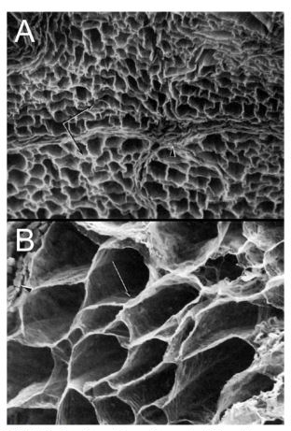

Figure 1. Scanning electron micrograph of the collagenous endomysial network around muscle fibers observed after digesting fibers with. This image suggests that muscle fibers are embedded in a complex connective tissue matrix and are intimately associated with ECM (Trotter & Purslow, 1992).

Response of Tissue Collagens to Exercise
There is evidence that performing exercise results not only in the breakdown of muscle tissue, but of connective tissue as well. Brown et al. (1997) found that urinary indices of collagen breakdown were elevated following a single bout of 50 eccentric contractions of the knee extensor musculature. In addition, Mackey et al. (2004) found that a single bout of high force eccentric contractions resulted in remodeling of the ECM; and more specifically a breakdown of endomysial type IV collagen (primary collagen found in the muscle basement membrane (Gillies & Lieber, 2011)) via the Matrix Metalloproteinase (MMP) pathway. Forces generated by the myofiber are transmitted to the ECM and then onwards to the tendon, which allows force transfer to occur laterally over the perimeter of each myofiber (Grounds et al., 2005). As well as enabling this lateral force transmission, the ECM is important for structural integrity and the relay of mechanical signals within the muscle, in addition to regulating satellite cell self-renewal capability (Urciuolo et al., 2013). Eccentric exercise has been shown to cause greater damage to connective tissue compared to concentric exercise (Nogueira et al., 2011) and techniques such as downhill running (Welsh et al., 2014), eccentric isokinetic contractions (Brown et al., 1997) and plyometric exercise (Tofas et al., 2008) have all been shown to increase markers of collagen degradation. The time course of skeletal muscle collagen synthesis has been shown to mirror that of myofibrillar and sarcoplasmic proteins, expressing an elevation 6h post exercise, peaking 24h post exercise and remaining elevated at 48h post exercise (Miller et al., 2005). This finding supports the idea of coordinated musculotendinous adaptation.
To further support this concept, exercise can modulate connective tissue size, structure and function in response to training. Research has shown that endurance training is associated with an increased cross-sectional area of the Achilles tendon (Kongsgaard et al., 2005). Couppe et al. (2008) found that fencers and badminton players had a 20-30% larger patellar tendon in their lead leg vs their trail leg. Other studies have shown no alterations in tendon thickness following endurance (Hansen et al., 2003) or resistance exercise (Kubo et al., 2006), but instead an altered modulus which indicates that the composition of the tendon structure itself may be subject to change (Couppe et al., 2008). In addition to these findings, Farup et al. (2014a) determined that consuming whey protein whilst performing strength training for 12 weeks caused patellar tendon hypertrophy in young males. It has yet to be fully elucidated how exercise may affect connective tissue adaptations, however it is clear that connective tissues are dynamic and able to adapt to certain stimuli.
Considering the ubiquity of collagens within the MSK system, ensuring that the body has sufficient quantities of its precursor amino acids may be of benefit. The amino acids proline and glycine have been shown to be essential for the synthesis of new collagen (Li & Wu, 2018). Individuals who are regularly incurring greater damage and/or stress to their MSK system may require greater quantities of these amino acids in order to support growth and repair of the skeletal muscle ECM, tendons, cartilage and bone. Therefore, it would be of value to assess whether collagen supplementation could benefit athletes/well trained individuals.

Collagen Supplementation Overview
Collagen is extracted from the connective tissue of bovine, porcine or marine sources before being subjected to a number of processes that include: extraction, enzymatic hydrolysis, purification, concentration, sterilization, and drying (Wang et al., 2017). The core amino acids that compose its polypeptide chain are glycine, proline and hydroxyproline (Yamazaki et al., 2010), of which relative proportions may vary depending on the original animal source (Mahmood et al., 2016). The proteins that constitute collagen range in size from 0.5 to 13.5 kilodaltons (kDa), with a mean size of 3.3 kDa (Clark et al., 2008). Collagen is a non-gelling substance that dissolves in cold water. Gelatin is a compound derived from collagen, produced via partial hydrolysis of collagen (Figure 2 below). When dissolved in hot water, it will set to a gel upon cooling. Gelatin can be further hydrolyzed into collagen peptides (HCOL), which are sometimes referred to in the literature as: “collagen hydrolysate”, “hydrolyzed collagen”, “collagen peptides”, “gelatin hydrolysate” or “hydrolyzed gelatin”. Clinical trials have confirmed that collagen is a safe and generally well tolerated therapy (Zhang et al., 2008) and the Food and Drug Administration (FDA) center for food safety and nutrition recognize HCOL as a product safe for human consumption. Alcock et al. (2018) compared different food and supplements to determine whether collagen specific amino acid concentration varied between sources. They found that there was a large degree of variability between sources, and that neither commercial nor self-prepared beef broth provided a reliable source of collagen specific amino acids. Interestingly, it seems that amino acid concentrations between commercial gelatin powder (Dr. Oetker, Mentone,VIC, Australia) and specifically formulated hydrolyzed collagen powder (Professional Whey, NSW, Australia; Tendeforte, Gelita, Eberbach, Germany) provided a similar quantity and proportion of amino acids per serving (Alcock et al., 2018).
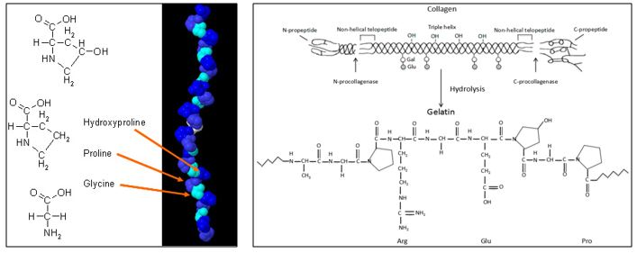

Figure 2. Molecular structure of collagen (Left) (Yama et al., 2017) and schematic description of conversion of collagen to gelatin (Right) (Yamazaki et al., 2010)

Initial preclinical trials showed that HCOL was able to pass across the mucosal barrier in the small intestine and remain as a polypeptide without being enzymatically cleaved into its constituent amino acids (Oesser et al., 1999). Following absorption, it has been shown to accumulate in the extracellular matrix of cartilage tissue and stimulate production of type II collagen (Oesser et al., 1999). Findings such as this led to research exploring the effects of HCOL supplementation within animal models, as well as within humans suffering from compromised articular cartilage (i.e. osteoarthritis (OA)).

Collagen Supplementation in Animal Models
Oesser, Raabe & Schunk (2007) assessed the effect of HCOL in mice bred to develop OA. After a 3-month period, they found a significant reduction in knee cartilage degeneration in the animals that had been fed HCOL. They concluded that HCOL may delay or even halt destruction of knee cartilage in mice with OA. The same research group then performed a study to determine the effect of HCOL in mice that had yet to develop OA, finding that prophylactic treatment with HCOL retarded the progression of OA by reducing cartilage degeneration in the knee (Oesser, Proksch & Schunck, 2008).
Glycine is one of the primary amino acids that makes up collagen and has been shown to perform a variety of different biological activities, such as modulating the systemic inflammatory cascade, improving microcirculation and assisting in the inhibition of Tumor Necrosis Factor α (TNF-α) and Interleukin-1β (IL-1β) (Hartog et al., 2007). Vieira et al. (2014) investigated the effect of a 5% glycine diet in rats as a treatment for the inflammation of the Achilles tendon. They discovered that after following the higher glycine diet, Achilles tendons were more resistant when being loaded until rupture point. They posited that glycine had induced synthesis of vital components of the tendon, promoting a more rapid remodeling of the tissue. The authors determined that glycine may be a beneficial supplement for humans with an inflamed Achilles tendon. However, until this result is replicated within a human population, caution must be taken before this conclusion can be reached.

Collagen Supplementation in Clinical Populations
Several clinical studies performed in OA populations have indicated that HCOL is a useful modality for reducing joint pain, decreasing dependency on analgesics, and improving leg strength (Zuckley et al., 2004). During a randomized, double-blind and placebo-controlled study, Moskowitz (2000) determined that HCOL may have potential utility in the treatment of OA. A review by Bello & Oesser (2006) assessed data from four open-label and three double blind studies related to the effect of HCOL on subjects with OA. Kumar et al. (2015) concluded that collagen peptides may be a useful therapeutic intervention for managing OA and joint health. Despite the variability between studies, it seems that HCOL can provide symptomatic relief to individuals suffering from OA. In a more recent study, McAlindon et al. (2011) found that individuals suffering from mild knee OA increased their proteoglycan (proxy indicator of cartilage health) content following 24-weeks of HCOL supplementation. Furthermore, there is evidence that supplementation with Type II collagen can be a safe and effective modality for the treatment of rheumatoid arthritis (Zhang et al., 2008). It was proposed that the collagen may have caused a down-regulation of pro-inflammatory cytokines (IL-1 & TNF-α) and upregulation of suppressive cytokines (Transforming Growth Factor β & IL-4). In summary, administration of 7-10g of HCOL every day for 12 weeks has typically led to improvements in outcome measures within an OA population.
The following studies have assessed the effectiveness of HCOL supplementation for a number of different applications. Many of these studies have never been replicated or have been produced from the same research group, so should be viewed more critically until independently confirmed. Firstly, it has been reported that HCOL can accelerate the repair of damaged tissues, with Lee et al. (2006) reporting that individuals suffering from pressure ulcers had an almost doubled healing rate compared to the placebo group. Secondly, a recent study by König et al. (2018) provided HCOL to 66 postmenopausal women for 12 months to determine the effect on bone mineral density (BMD). They found significantly higher T-scores for the spine and femoral neck, as well as significantly higher levels of N-terminal peptide of pro-collagen I (PINP) (serum biomarker of bone formation) in the experimental group, suggesting supplementation had a clinically beneficial effect. A study by the same group (Zdzieblik et al., 2015) assessed the effect of HCOL supplementation on strength and muscle mass in elderly sarcopenic males. This was the first study to investigate the effect of HCOL on body composition and muscular performance. They found that those supplementing with HCOL saw greater gains in fat free mass (FFM) and quadriceps muscle strength compared to controls. More recent evidence has shown that the collagen dipeptide Hydroxyprolyl-Glycine can induce myogenic differentiation and myotube hypertrophy via the PI3K/Akt/mTOR pathway (Kitakaze et al., 2016), so perhaps HCOL supplementation could influence FFM through this mechanism. However, caution must be taken when interpreting the results of this study due to the extraordinarily high concomitant increases in FFM and reductions in fat mass (FFM increased by 4.2kg; FM decreased by 5.4kg) achieved by an elderly population. As highlighted by the rebuttal submitted to the journal by Phillips et al. (2016), the validity of these results should be questioned.
Finally, HCOL has recently been reported to exert modulatory effects on the human circulatory system. Kouguchi et al. (2013) assessed the effect of HCOL supplementation on 58 individuals with either mild hypertension or high-normal blood pressure levels. They found that arterial stiffness (a marker of vascular damage) was significantly lower in the experimental group vs the control group. In addition, the blood pressure of the experimental group was significantly lower than that of the placebo group. They attributed these findings to a reduction in inflammatory markers within the microcirculation induced by the bioactive peptides Pro-Hyp and Hyp-Gly (originating from the HCOL). It has become apparent that collagens are involved in more sophisticated and subtle functions throughout the human body. Some data suggests it may even stimulate angiogenesis and tumorigenesis which has attracted interest for pharmaceutical application (O’Reilly et al., 1997).

Collagen Supplementation in Athletes
With data available showing the effectiveness of supplementing with HCOL in animal models and clinical populations, interest has turned toward whether athletic individuals may derive a benefit. An observational study performed by Flechsenhar & Alf (2005) provided 100 elite German athletes with 10g/day of HCOL for 12 weeks and found that 78% of subjects reported reductions in joint pain or improved movement following the trial. The design of this study was a “postmarketing surveillance study” that did not incorporate a control group, so the implications of these results are unclear. A study by Clark et al. (2008) sought to replicate the findings of the German study in a more controlled manner (i.e. as an RCT). They provided 10g of HCOL to 147 student athletes who had previously complained of joint discomfort due to joint stress, injury, surgical outcome, or trauma. After a 24-week period, statistically significant reductions in pain were observed, with an even greater improvement when looking at a subgroup analysis of knee arthralgia. Recently, Gonçalves (2017) performed a case series evaluating the effect of HCOL on middle aged athletes with osteochondral lesions. MRI images showed restoration of articular surfaces following HCOL supplementation combined with physiotherapy in all 3 cases. Although the results seem positive, case studies have some significant methodological limitations, so these results must be viewed with caution. In addition, another recent study by Dressler et al. (2018) found an improvement in subjectively perceived ankle stability in athletes with chronic ankle instability, as well as a reduction in re-injury rate of ankle sprains after a 3 month follow up period. The findings of this study were attributed to enhanced ligament and tendon firmness due to increased ECM molecule expression induced by the supplement. However, it must be noted that mechanical ankle stability as determined using an ankle arthrometer (to determine anterior talar drawer) did not show any difference between groups.
A recent study by Shaw et al. (2017) assessed the effect of vitamin C enriched gelatin supplementation combined with rope skipping on tendon collagen synthesis. Vitamin C was added because it functions as a cofactor during the tendon cross-linking process and is necessary for the hydroxylation of lysine and proline on procollagen. Individuals consumed either 5g or 15g of Vitamin C enriched gelatin or a placebo control before performing rope skipping 1 hour later for 3 days. Engineered ligaments showed increased collagen content and improved mechanics after being treated with serum from the gelatin supplementation group. In addition, PINP levels were doubled in those who consumed 15g of gelatin, indicating increased collagen synthesis within the body. This is the first study to demonstrate that a nutritional intervention can directly augment collagen synthesis of human ligamentous tissue following exercise. This has implications for injury prevention and tissue repair by making connective tissue more resilient to failure from loading. The limitations of this study are that the tendons used to test tensile strength mimic developing sinews as opposed to mature adult tissue. Developing ligaments have more cells and less matrix, their rate of collagen synthesis is significantly higher, they express more developmental collagen isoforms, and they are much weaker than adult sinews (Baar, 2017). Furthermore, the sinews were bathed in serum extracted from the individuals who consumed the supplement, allowing them to be fully exposed to the amino acids/growth factors. Within humans, it is unclear whether enough of the ingested HCOL can reach tendon/ligaments to exert a modulatory effect. Regardless, this study is the first to provide in vitro, mechanistic evidence for the beneficial effect of supplementing with collagen specific amino acids on injury prevention/sinew resilience in human tissue. Lopez et al. (2015) showed promising preliminary data in regards to HCOL supplementation on acute exercise performance. After 6 weeks of HCOL supplementation, their untrained participants were better protected during a secondary exercise bout, indicating that the supplement may have augmented the RBE. Recently, Clifford et al. (2019) showed the first evidence that short term (7-day) HCOL supplementation was able to improve recovery from high-force eccentric exercise (125 drop jumps from 60cm box). They speculated that the augmented recovery of CMJ performance was related to either increased collagen synthesis in connective tissues surrounding the lower limb muscles or a modulation of the inflammatory response during early stage tissue remodeling. There remains a paucity of data in terms of the practical application/efficacy of HCOL supplementation in healthy and athletic populations. Questions that still need to be answered include: (1) What are the minimal and/or optimal doses and frequency of HCOL ingestion required? (2) Does supplementation decrease injury risk or accelerate the return to play after injury? (3) Can supplementation with HCOL improve performance? (Heaton et al., 2017).

Conclusion
In summary, HCOL supplementation has been shown to have potentially beneficial effects on tendon and ligament strength, ECM resilience, articular surface quality, tendon inflammation, bone mineral density, wound healing, microvascular inflammation and muscular strength/size. At present, very little research has been performed to evaluate the practical applications/efficacy of HCOL supplementation in young and/or athletic individuals related to performance and acute recovery from damage.
If the ECM and/or tendon tissue that is intimately linked with skeletal muscle can recover and be returned to optimal strength following damaging exercise, then this could be of practical benefit to athletes. Furthermore, if HCOL can enhance the effectiveness of ECM during processes involved with the RBE, then MSK tissues may be better protected against subsequent bouts of damaging exercise. Further investigations need to be performed to assess the effectiveness of HCOL supplementation before it can be considered beneficial for healthy or athletic populations. Thus, research investigating the ability of HCOL supplementation to enhance recovery following muscle damage appears to be a logical and important next step.

Chapter 3 - Methodology
The purpose of this study was to assess the effect of HCOL supplementation on acute recovery following a damaging exercise bout in resistance trained males. The hypothesis was that 12-days of HCOL supplementation would be beneficial for resistance trained individuals subjected to an intense bout of eccentric exercise, due to enhanced connective tissue and ECM repair.

Participants
Participants were recruited from the University of Oklahoma and the greater Cleveland County (Oklahoma) area and included males who have been consistently resistance training (≥3 days per week; trained lower body at least once per week) for at least 2 years. Only male participants were selected because it has been shown that females respond less to increases in collagen synthesis after exercise compared to males, as well as possessing lower basal synthesis levels (Miller et al., 2007).
Additionally, participants were between 18-35 years of age, injury free for the previous 12 months, resistance trained and not currently (or within 6 months of the study start date) taking a collagen supplement. If injury/illness occurred during the study period, or the protocol was not adhered to (i.e. not consistently taking the prescribed supplement, or inability to attend testing sessions more than ±1 day from the scheduled date) then the participant was excluded. Vegetarian/vegan individuals were excluded due to the origin of the HCOL supplement.
Due to the similarity in research design, data from Farup et al. (2014b) was used to perform an a priori power analysis using G*Power software version 3.1.9.3 (Heinrich Heine, University of Dusseldorf, DE) (Faul et al., 2007). The analysis considered the main performance outcome measure (MVIC) and was based upon a desired statistical power (1 – β) of 0.80 and a moderate (Cohen’s d) effect size of 0.5 (Cohen, 1988). The analysis revealed that 16 subjects (8 per group) were required for this study to be sufficiently powered.

Experimental Design
Fifteen resistance trained males were recruited to participate in a randomized, double blind, placebo controlled trial using a parallel experimental design.
To begin with, participants performed a “Familiarization 1” (F1) session, which involved a full explanation of the protocol and the administration of the Physical Activity Readiness Questionnaire (PARQ), International Physical Activity Questionnaire (IPAQ) short form, health history questionnaire, HIPAA authorization and informed consent documents (requiring signature). Height, weight and body fat percentage using bioelectrical impedance spectroscopy (BIS) (ImpediMed, Queensland, Australia) was recorded. Participants were then familiarized with the VAS scale, the pain pressure threshold (PPT) algometer test, the maximal voluntary isometric contraction (MVIC) test and the countermovement jump (CMJ) test in order to reduce the influence of the learning effect. Following this, participants were familiarized with the muscle damage protocol by performing one practice set of 10 drop jump repetitions. Participants waited 1-2 days before returning for a second familiarization (F2) session, where all the previously mentioned tests were practiced again (with the exception of the muscle damage protocol repetitions). A third and final familiarization session (F3) was performed 1-2 days after F2, where all of the tests were practiced for the final time. During the F3 session, a blood draw was taken to assess pre supplement biomarker measures at the start.
Participants were provided with a randomly assigned supplement to consume daily for the following 12-day period (7-days until muscle damaging protocol + 5 days over the 24h, 48h and 120h post exercise period). They were instructed to consume it at the same time of day during the 7-day “run in” period, and after completing any testing sessions during the 5-day recovery period. The supplement kit given to participants included 12 individual bags of either 15g (per bag) of Hydrolyzed Collagen peptides (HCOL) (Vital Proteins Collagen Peptides, Chicago, IL, USA) or 15g (per bag) of a cornstarch placebo (PLA) (Argo, ACH Foodservice, IL, USA) as well as a plastic sports bottle to allow the powders to be mixed with 500ml of water as directed. The supplement being provided was blinded to both the researcher administering it, and the participant receiving it. An individual not associated with the current investigation assigned treatments a unique code for future de-identification of its true nature. The coding key related to the treatments, was placed in a sealed envelope until all data was collected and analyzed. All attempts were made to provide highly comparable supplements from a taste and consistency standpoint to reduce the chance of participants being able to “unblind” the supplement. Participants were instructed to consume the supplement once per day, at the same time of day for the 12-day duration of the study. They were instructed to follow their usual dietary and exercise routines, as well as to refrain from taking any new nutritional supplements during this 12-day period. Participants were instructed to perform no lower body exercise in the three days before each testing session and to attend each testing session in an overnight fasted state.
After a 7-day period of supplementation, participants returned to the laboratory for the first testing session (T1). During this session, blood draws, soreness measures, muscular function and jump performance measures were taken before the muscle damaging protocol was performed (PRE) to act as a baseline. The muscle damage protocol was then carried out (Figure 3 below), before all measurements were repeated immediately post (IP), and then 24-hours (24h), 48-hours (48h) and 120-hours (120h) post exercise. The supplement was continually consumed in the post damaging exercise protocol period (i.e. the following 5-days, for 12-days total).
This experimental design allowed us to determine how recovery (muscle and jump performance, soreness and biomarkers) from an acute bout of high-force eccentric exercise would be affected by consuming HCOL. An inert cornstarch placebo was used to account for the placebo effect, as well as to mitigate the impact of variability in free-living habits of participants (i.e. exercise and nutritional habits) during the uncontrolled 7-day supplementation period. To avoid the threat of instrumentation, locations for soreness testing using the algometer were marked, and standardized verbal direction/encouragement was used during the muscle damage protocol and performance measure testing. Furthermore, all efforts were made to test participants before 10:00am, and in most cases at the same time of day each time they returned to the lab. This precaution was taken in order to reduce the influence that circadian rhythm could have on biomarkers and performance measures.
Upon ingestion, plasma levels of Hydroxyproline (a collagen specific amino acid) reach maximum levels after 2 hours, and collagen derivatives have been found in both the free form (amino acid) and peptide form within the blood during a previous investigation by Ohara et al. (2007). Shaw et al. (2017) found an increase in engineered ligament strength after participants consumed gelatin for as little as 3 days. In addition, Clifford et al. (2019) found an improvement in CMJ recovery following ingestion of HCOL whilst using an extremely similar experimental protocol. Thus we feel that the short supplementation period should allow the nutrients sufficient time to interact with intramuscular connective tissues at the least (due to low blood flow and slower metabolic rate of many connective tissues, longer supplementation periods may be required to see changes in these tissues. The inclusion of 24h, 48h and 120h (post baseline) follow up visits allowed us to compare differences in recovery kinetics and indices of physiological damage over the transient acute recovery period.
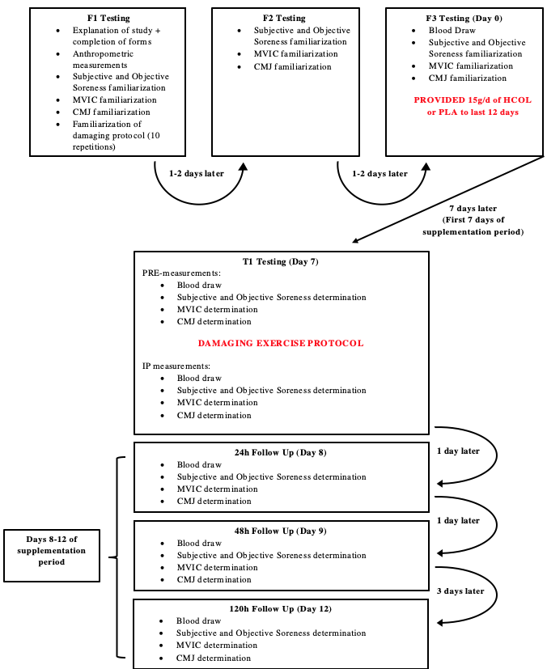

Figure 3. – Visual Representation of Experimental Study Design

Experimental Procedures

Muscle Damage Protocol
Greater levels of muscle damage have been shown to occur using exercise involving an eccentric contraction (Dolezal et al., 2000). In agreement with this, protocols using forced resistive eccentric contractions (Brown et al., 1999), downhill running (Welsh et al., 2014) and plyometric exercise (Tofas et al., 2008) have all been shown to induce acute muscle and connective tissue damage. In order to improve relevance for athletic individuals, a ballistic depth jump protocol utilized during previous investigations was followed (Miyama & Nosaka, 2004; Tofas et al., 2008; Clifford et al., 2019).
An initial warm up was carried out involving light jogging for 5 minutes on a treadmill followed by 20 bodyweight squats. Although a familiarization was performed for the muscle damage protocol during F1, 3 practice repetitions were allowed prior to the performance of the full 100 jump protocol in order to remind participants of correct technique. The complete damaging exercise protocol required participants to perform 5 sets of 20 drop jumps (100 total) with a 2-minute rest in between each set (Miyama & Nosaka, 2004). Participants were required to step from a height of 60cm and land on the floor with both feet whilst keeping their hands on their hips and descending to approximately 90 degrees of knee flexion to emphasize the lower body contribution to landing. They were instructed to counter this landing by performing a maximal vertical jump immediately after reaching the nadir of their initial landing (whilst maintaining hands on hips) in order to better damage tissues involved within the stretch shortening cycle. Participants then used a 30cm step to return to the 60cm drop height ready for the next repetition, where they stepped off with their alternate foot. The participants were instructed to perform this protocol using the same footwear for each measurement session in order to mitigate differences in jumping and landing mechanics/kinetics between sessions. Recovery from this damage protocol was assessed by comparing a combination of performance measures, pain/soreness measures, and biomarkers.

Recovery – Performance-based Measures
To assess performance, 3 maximal counter movement jumps (CMJ) (Brown et al., 2017) were measured using a calibrated dual force plate (ForceDecks, NMP Technologies, London, UK). Participants were instructed to keep their legs straight, and their hands on their hips whilst in the air (Young et al., 1995). Each maximal CMJ was separated by 30s of rest. Of the 3 CMJs, the jump in which the greatest jump height was achieved was used for data analysis. In addition, quadriceps muscle force was determined using a maximal voluntary isometric contraction (MVIC) for both legs. Whilst seated, participants had inelastic straps wrapped immediately superiorly to their malleoli’s and attached securely to a force transducer (model SB-500; Transducer Techniques, Temecula, CA) on a purpose-built chair at the same height. The knee joint angle was fixed at 70°, and checked using a goniometer before each MVIC attempt. Participants received a verbal countdown of 3s before extending their knee “as fast and as hard as possible” (Sahaly et al., 2001), maintaining the contraction for approximately 3s. Verbal encouragement was provided throughout the contraction period. Participants performed 2 isometric MVICs with 120s rest between each effort and the peak force obtained between both trials was used for analysis (Buckley et al., 2010).

Recovery – Pain and Soreness Measures
To evaluate subjective pain/soreness, a 100-mm visual analogue scale (VAS) was used for the total lower body (VAStlbs), as well as specific muscle groups including the quadriceps (VASq), the gluteals (VASg) and the calf (VASc) muscle regions whilst in a resting state. Participants were instructed to draw a line on the VAS scale that described their current level of muscle soreness between the reference points of “worst imaginable pain” and “no pain”. To determine pressure pain threshold (PPT), an analog algometer (Force Dial FDK, Wagner Instruments, Greenwich, Connecticut, USA) was placed at the center of the Vastus Lateralis muscle belly. Participants were placed in a seated position and asked to provide an audible confirmation when the sensation of pressure being applied to the muscle (at an approximate rate of 5 N/s) went from feeling “uncomfortable” to “painful”. Measurements were marked with permanent marker to ensure accuracy on consecutive days (Vatine et al., 1993), and two measurements were taken for each leg (30s rest period between consecutive measurements) with the average of the two being used for analysis.

Recovery – Biomarker Measures
Type I Collagen makes up a significant component of the ECM of a number of connective tissues including joints, ligaments and bony structures. To evaluate the response of these tissues to exercise, validated biomarkers have been developed to analyze type I collagen turnover within the body (Kuiper et al., 2005). Procollagen (a precursor molecule to collagen) contains extension peptides at both the amino and carboxy termini, and these Carboxy-terminal Propeptides of Type I Collagen (PICP) are cleaved from the collagen molecule by proteases prior to incorporation into a developing collagen fibril. Increased circulation of PICP represents increased Type 1 collagen synthesis within the body. Degradation of Type I collagen is mediated by two types of proteinases: cysteine proteinases and Matrix Metalloproteinases (MMPs). Carboxy-terminal Telopeptide Region of Type I Collagen (ICTP) is the product of collagen I degradation by MMPs. Although these markers cannot be used to differentiate which tissue the Type I Collagen fragments originated from (i.e. bone/tendon/ECM), these biomarkers have been used previously to assess connective tissue turnover rates in healthy individuals (Kuiper et al., 2005; Paleckis et al., 2015). In addition, measuring both simultaneously and analyzing the ratio of these biomarkers can provide a more representative estimate of global Type I Collagen metabolism than either in isolation.
Blood samples (7.5mL) were taken from the antecubital vein into evacuated serum separator tubes (SST) for collection. Participants were instructed to fast for 8 hours before the blood draw, and all efforts were made to complete the draws in the morning (07:00-9:30) and at the same time of day for each participant during subsequent testing sessions. Blood was allowed to clot at room temperature for 30 minutes, before being centrifuged (Centra CL3R Refrigerated Centrifuge, Thermo Electron Corporation, Waltham, MA) to separate the serum from the cells. Samples were then aliquoted into 0.5 ml vials and frozen at −80 °C until assays were performed.
On the day of the assay, samples were removed from the freezer one hour prior to the start of the assay to allow for adequate thawing of the serum (all serum analyzed came from samples that had never been thawed before to reduce the chance of protein denaturing from occurring). Commercially available ELISA test kits were used to measure serum concentrations of PICP (CICP/PICP MicroVue, Quidel Corporation, San Diego, CA, USA) and ICTP (ICTP ELISA Kit, Abexxa, Cambridge, UK). All steps detailed in the ELISA kit instruction manuals were followed. For each specified above, two assays were performed (96 wells per kit) and each sample was measured in duplicate. Kit range was determined by calculations defined in the assay instruction manuals because control and ranges were dependent on the type of kit used. In order to test the assay precision, low and high control samples were included in the PICP assay (unfortunately they were not available for the ICTP kit). All control samples were within the reference ranges provided by the manufacturers. For PICP, intra assay %CV’s were 3.7-4.3% and the inter assay %CV was 5.1%. For ICTP, intra assay %CV’s were 4.1-5.6%, however inter assay was unable to be calculated due to lack of control samples.

Data Analysis
All data are presented as mean ± SD, with an alpha level of p ≤ 0.05 indicating statistical significance. Normality was determined using a Shapiro-Wilk test. Effect sizes were calculated (Cohen's d = M₁ - M₂ / σ_{pooled} where σ_{pooled} =√[(σ ₁²+ σ ₂²) / 2]) for any statistically significant result and interpreted according to Cohen (1988), where 0.2 = a small effect, 0.5 = a moderate effect and 0.8 = a large effect. IBM SPSS Statistical Software Version 24 (Armonk, NY, IBM, 2015) was used for all analyses.
An independent samples t-test was performed on all normally distributed baseline measures to ensure homogeneity between groups. A Mann Whitney U test was used for non-normally distributed data (Overall Lower Body Soreness VAS and Left Leg Pain Pressure Threshold at baseline). All biomarkers, VAS soreness, PPT, MVIC and CMJ metrics were analyzed using a mixed model analysis of variance ANOVA with 2 groups (PLA vs COL) and 4 repeated measures time points (PRE, 24h, 48h, 120h). When a significant interaction effect was detected, a post-hoc analysis of the simple effects using a LSD adjustment was used to discover the location of any differences. In the absence of a significant interaction effect, main effects for time and/or group (if found to be statistically significant) were examined using a post-hoc analysis with a LSD adjustment to locate where differences existed. A Levene’s test of equal variances was performed to support that the samples for each group were drawn from the same population. A Mauchly’s test of Sphericity was used to test that the variances of the differences between all possible pairs of within-subject conditions (i.e. levels of the independent variable) were equal and a Greenhouse-Geisser correction was applied whenever this assumption was found to be violated. A paired sample T-test was used to compare MVIC between the Pre and IP time point in order to determine whether the intensity of the jump protocol was sufficient to attenuate performance via fatigue. A paired sample T-test was also used to compare PICP and ICTP between the F3 and Pre time points to assess whether changes occurred during the free living supplementation period. Prior to statistical analysis, CMJ metrics and biomarkers with a CV of >15% and outlying data points (>2 SD’s outside of the mean) were removed (varied depending on outcome measure, n values for each were reported within figures) .

Chapter 4 – Results & Discussion

Baseline Characteristics
In total, fifteen participants completed the entire study and their physical characteristics at baseline are shown in Table 1. An independent samples t-test determined no significant differences between normally distributed baseline characteristics, however the Mann Whitney U test determined that left leg pain pressure threshold (not normally distributed) was significantly lower in the HCOL group (p=0.029; ES = 0.57).
Table 1. Baseline characteristics of the placebo (PLA; n=8) and collagen (HCOL; n=7) groups reported as mean±SD

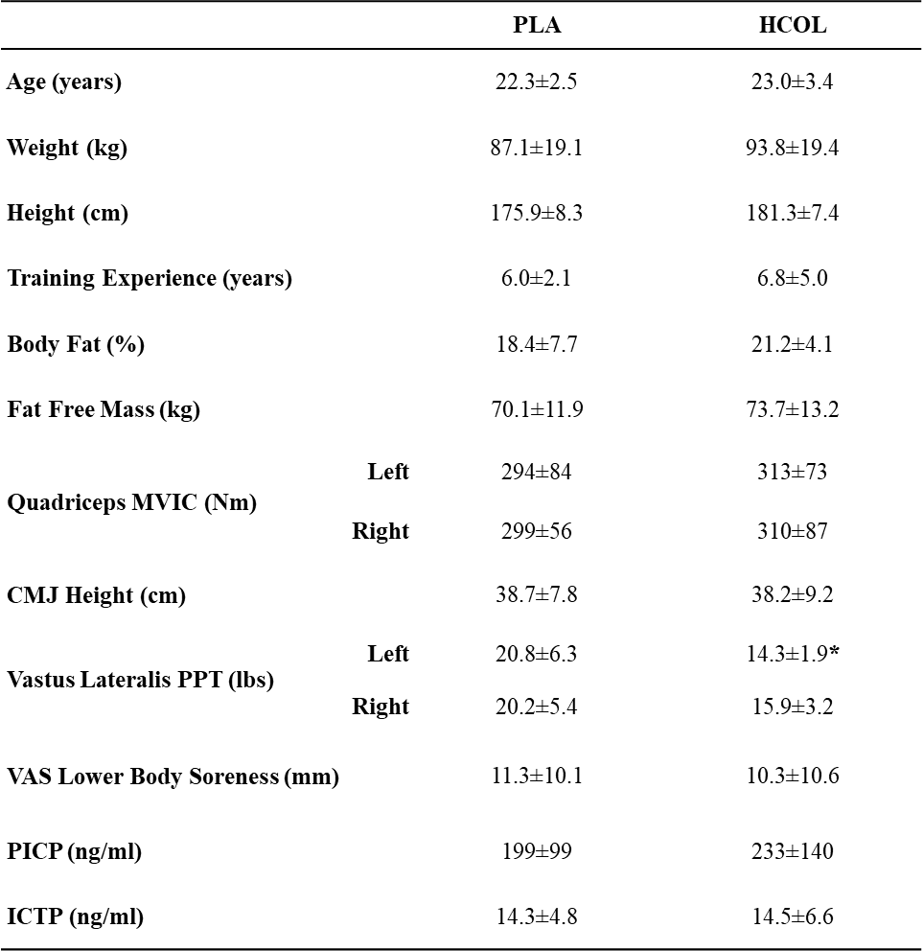

* = denotes statistically significant difference between groups (p≤0.05)

Maximal Voluntary Isometric Contraction
Changes in MVIC immediately following the muscle damage protocol were analyzed using a paired samples t-test for each leg and each condition to assess the magnitude of fatigue imposed by the protocol. In the left leg, a significant decline was seen for both the HCOL group (p=0.029; ES=0.32) and PLA group (p=0.013; ES=0.23) (Figure 4). In the right leg, a significant decline was seen for the PLA group (p=0.020; ES=0.22) but not the HCOL group (p=0.091) (Figure 4).
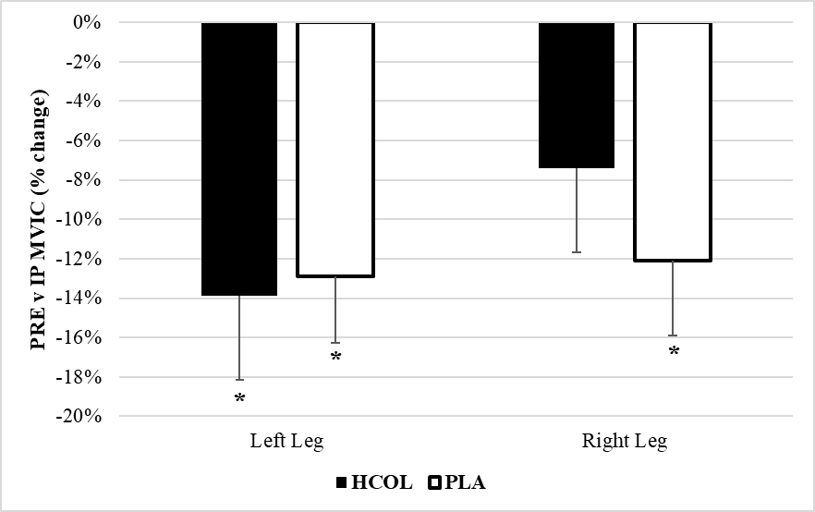

Figure 4. – Percentage differences (mean±SE) in Quadricep MVIC immediately following completion of the muscle damage protocol for the left and right legs in the collagen supplementation group (HCOL; n=7) and the placebo group (PLA; n=8) presente
* = denotes statistically significant difference between PRE and IP time points (p≤0.05)

For the raw values, there were no significant group (Left: p=0.614) (Right: p=0.847) or group x time interactions for either leg (Left: p=0.629) (Right: p=0.129), however there was a significant effect for time in both the left (p=0.007) and right (p=0.010) legs over the experimental period. The post-hoc analysis for the left leg MVIC showed that force was significantly lower at the 24h time point (MVIC = 108.7±28.8lbs) compared to the PRE time point (MVIC = 119.4±30.3lbs; p=0.029; ES=0.18) and 120h time point (MVIC = 119.6±32.5lbs; p=0.029; ES=0.17) (Figure 5i). For the right leg, force was significantly lower at the 24h time point (MVIC = 112.0±26.9lbs) compared to the 120h time point (MVIC = 121.3±29.8; p=0.013; ES=0.16) but not significantly different to PRE (MVIC = 118.9±28.3; p=0.0503 (Figure 6i).
For the left leg percentage change values, post-hoc analysis revealed that the 24h time point (Change v baseline = -8.5±10.5%; p=0.002; ES=0.46) and 48h time point (Change v baseline = -4.5±7.8%; p=0.013; ES=0.34) were significantly different compared to the 120h time point (Change v baseline = 0.1±6.9), as well as a significantly difference between each other (p=0.026; ES=0.21) %) (Figure 5ii). For the right leg percentage change values, the 24h time point (Change v baseline = -4.6±11.7%; p=0.011; ES=0.34) and 48h time point (Change v baseline = -4.1±7.9%; p=0.001; ES=0.40) were also significantly different compared to the 120h time point (Change v baseline = 2.8±8.1%), but not to each other (p=0.932) (Figure 6ii).
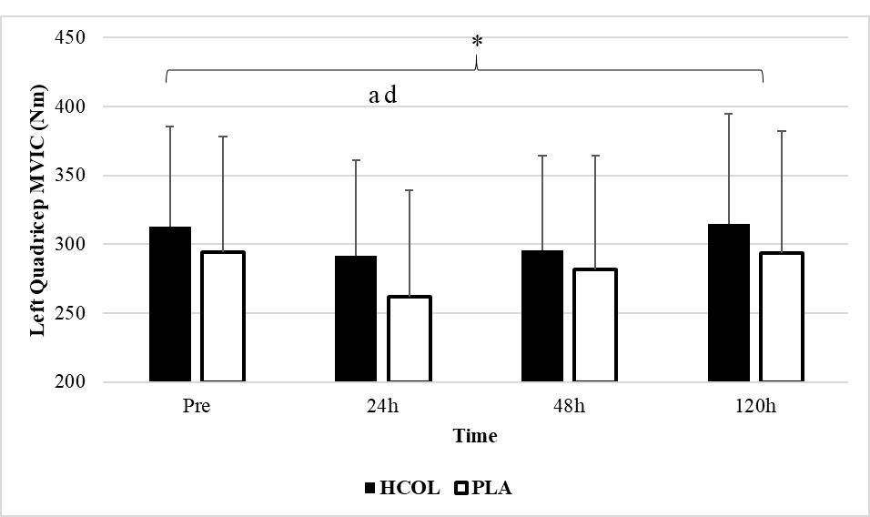
i)

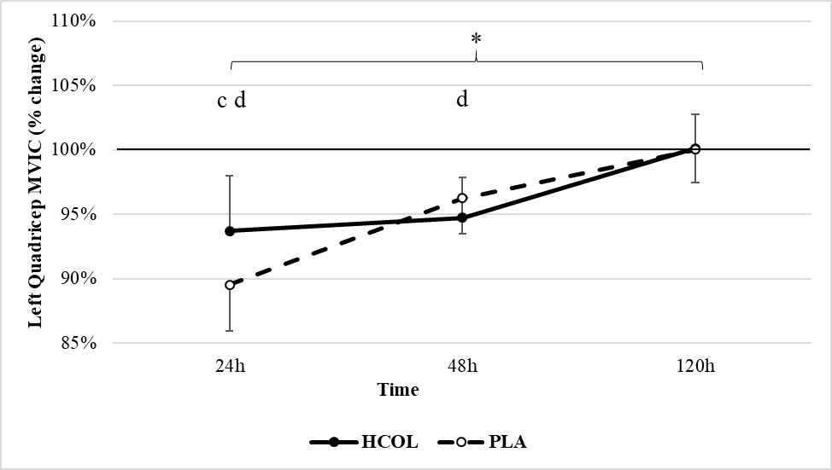
ii)

Figure 5. – Differences in Quadricep MVIC for the left leg between the collagen supplementation group (HCOL; n=7) and the placebo group (PLA; n=8) were assessed across four different time points (Pre muscle damage, 24h post muscle damage, 48h post muscle damage and 120h post muscle damage). i) shows raw MVIC (lbs) scores as mean±SE, ii) shows % change compared to the Pre muscle damage time point (mean±SE)
* = denotes significant time effect (p≤0.05)
a = significantly different from the PRE post muscle damage time point (p≤0.05).
c = significantly different from the 48h post muscle damage time point (p≤0.05).
d = significantly different from the 120h post muscle damage time point (p≤0.05).

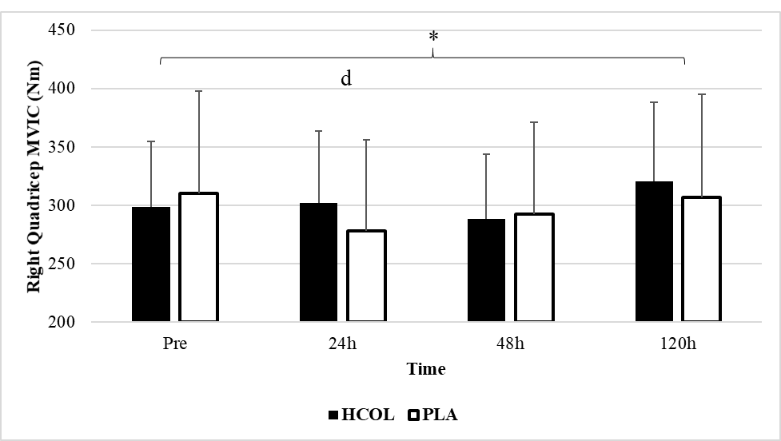
i)

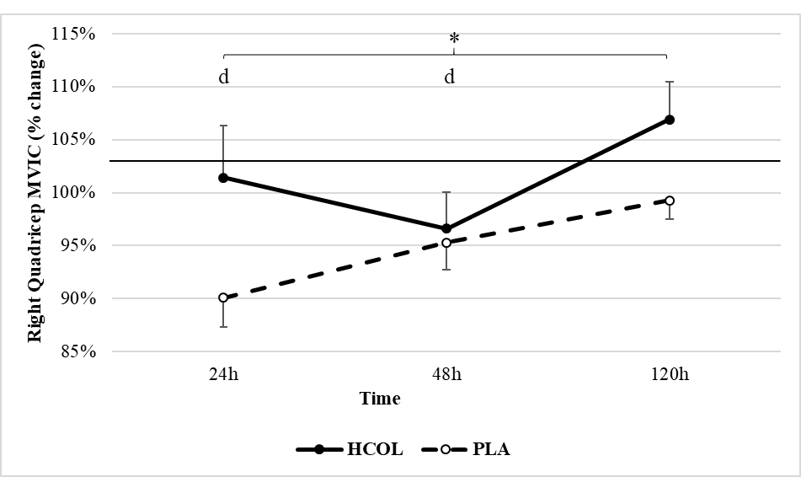
ii)

Figure 6. – Differences in Quadricep MVIC for the right leg between the collagen supplementation group (HCOL; n=7) and the placebo group (PLA; n=8) were assessed across four different time points (Pre muscle damage, 24h post muscle damage, 48h post muscle damage and 120h post muscle damage). i) shows raw MVIC (lbs) scores as mean±SE, ii) shows % change compared to the Pre muscle damage time point (mean±SE)
* = denotes significant time effect (p≤0.05)
d = significantly different from the 120h post muscle damage time point (p≤0.05).

Countermovement and Drop Jump Performance
For raw CMJ height values, there was a significant interaction effect (p<0.001). A post-hoc assessment analyzing the simple time effects revealed that CMJ height was significantly lower than baseline (PRE CMJh = 40.42±7.88cm) for the PLA group at the 24h time point (CMJh = 35.53±6.41cm; p=0.005; ES=0.32), but was not significantly different at the 48h (CMJh = 40.77±7.57cm; p>0.05) and 120h (CMJh = 39.97±7.84cm; p>0.05) time points (Figure 7i). The same post-hoc assessment for the HCOL group found that CMJ height was not significantly different from the baseline score (PRE CMJh = 39.93±8.78cm) at any time point (24h CMJh = 37.85±8.87cm; p=0.451) (48h CMJh = 37.10±8.97cm; p=0.102) (120h CMJh = 38.85±7.52cm; p>0.05) (Figure 7i).
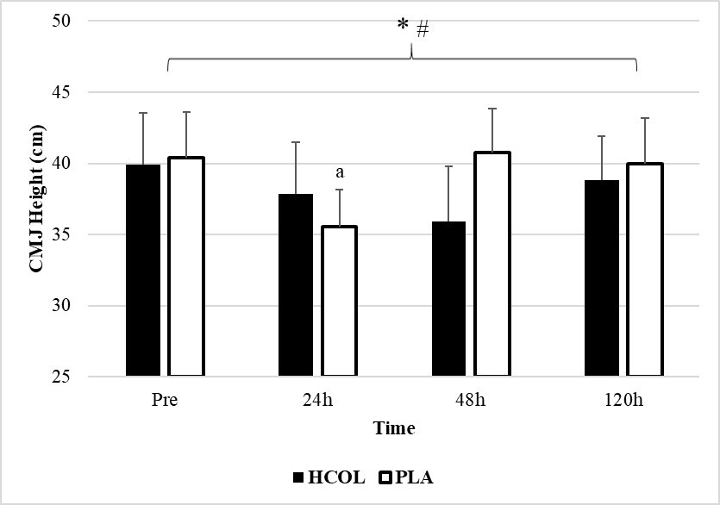
i)

For CMJh percentage change values, the simple effects post-hoc analysis for time revealed that the 24h time point (Change v baseline = -13.8±2.4%; p<0.001; ES=0.18) and 48h time point (Change v baseline = -1.0±3.7%; p=0.001; ES=0.52) were significantly different compared to the 120h time point (Change v baseline = -2.3±3.5%) in the PLA group (Figure 7ii). The same test in the HCOL group found that percentage change of CMJ height was only significantly different between the 24h (Change v baseline = -5.4±6.4%; p=0.017; ES=0.16) and 48h time point (Change v baseline = -7.4±6.3%). The simple group effect analysis revealed a significant difference between the HCOL (Change v baseline = -5.4±6.4%) and PLA (Change v baseline = -13.8±2.4%; p=0.023; ES=0.66) at the 24h time point only.
ii)
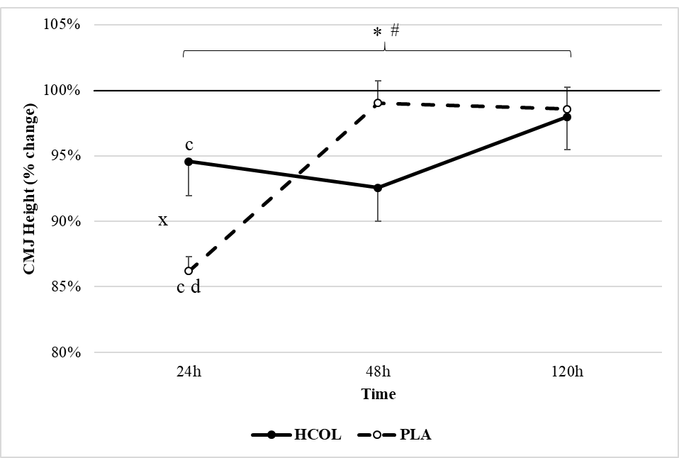
ii)

Figure 7. – Differences in counter movement jump (CMJ) height between the collagen supplementation group (HCOL; n=6) and the placebo group (PLA; n=6) were assessed across four different time points (Pre muscle damage, 24h post muscle damage, 48h post muscle damage and 120h post muscle damage). i) shows raw CMJ height (cm) as mean±SE, ii) shows % change compared to the Pre muscle damage time point (mean±SE)
* = denotes significant time effect (p≤0.05)
# = denotes significant interaction effect (p≤0.05)
a = significantly different
from the PRE time point (p≤0.05).
c = significantly different from 48h (p≤0.05)
d = significantly different from 120h (p≤0.05)
x = significantly different from PLA group (p≤0.05)

Individual data points for CMJ performance across the recovery period are presented to demonstrate the variability between responses (Figure 8). Incomplete participant data was removed (i.e. if data was missing for a single time point, the whole line was removed).

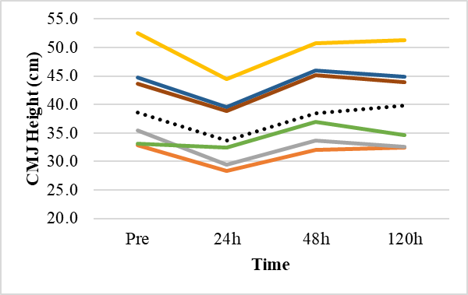

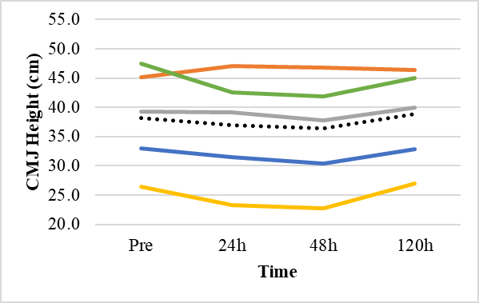
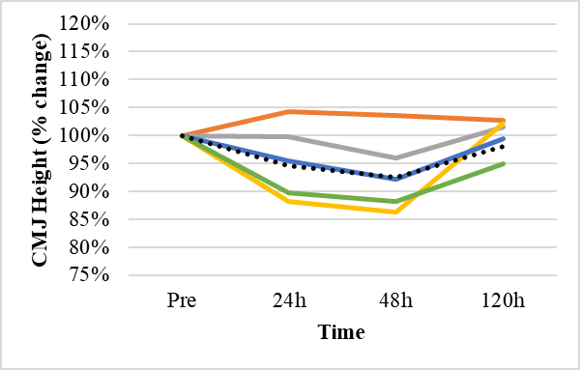
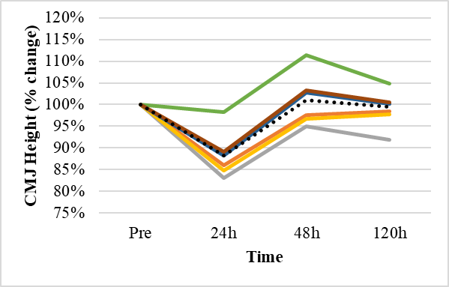
PLA (n=6)
HCOL (n=5)
i)

ii)

Figure 8. – Individual data points for changes in counter movement jump (CMJ) height across four different time points (Pre muscle damage, 24h post muscle damage, 48h post muscle damage and 120h post muscle damage). Graphs on the left show data for PLA group and graphs on the right show data for HCOL group. i) shows raw CMJ height (cm) changes, ii) shows % change compared to the Pre muscle damage time point

No significant interactions were found for any of the other CMJ variables analyzed (p>0.05), however there was a significant time effect for CMJ RSI-mod (p=0.019) and CMJ stiffness (p=0.050). A post-hoc analysis determined that at both the 24h (p=0.047; ES=0.16) and 48h (p=0.014; ES=0.17) time point, scores were significantly lower compared to the 120h time point (Table 2). The post-hoc analysis also revealed that CMJ lower body stiffness was significantly lower at the 24h time point compared to the 120h time point (p=0.016; ES=0.22) (Table 2).
Table 2. A number of metrics analyzed during the CMJ trials of the placebo (PLA; n=6) and collagen (HCOL; n=6) groups reported as mean±SD. * = significant time effect (p≤0.05)

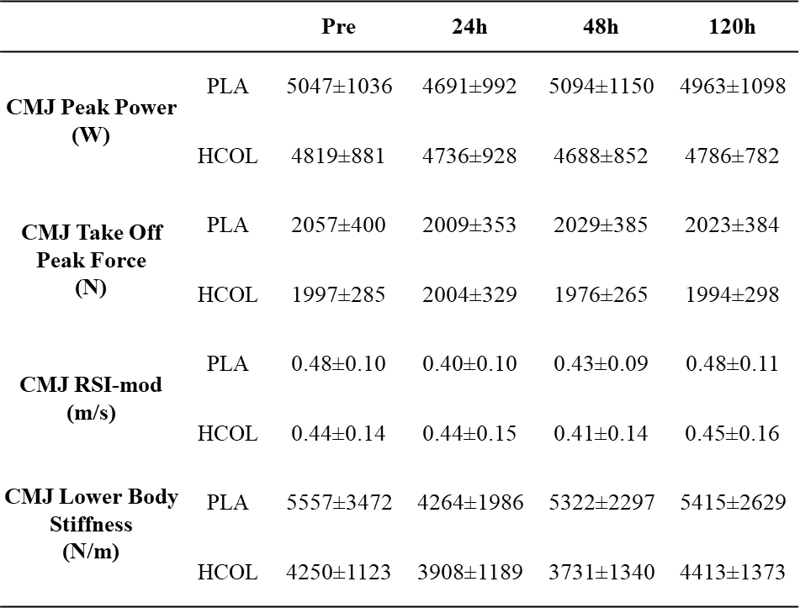
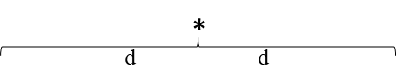

d = significantly different from the 120h time point (p≤0.05).

Muscle Soreness and Pain Pressure Threshold
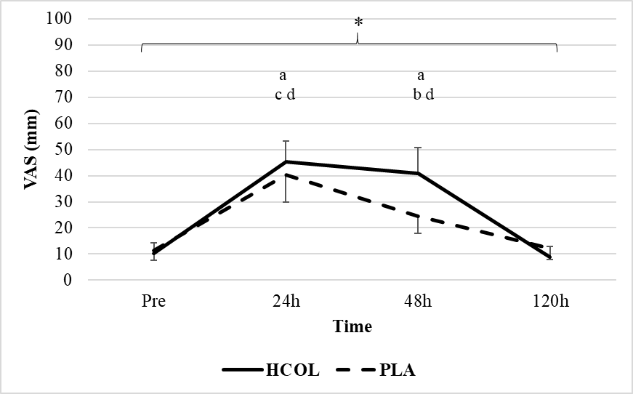
There was no group x time interaction (p=0.525) for overall lower body muscle soreness determined using a 100mm VAS, however a significant time effect was discovered (p<0.001) (Figure 9). The same findings were seen with the VAS scores for individual lower body muscle groups, including the Quadriceps region (Interaction: p=0.575; Time: p=0.006), the Gluteal region (Interaction: p=0.236; Time: p<0.001) and the Calf region (Interaction: p=0.941; Time: p<0.001) (Fig 10). The post-hoc analysis of the time effect revealed that overall lower body muscle soreness was significantly higher than PRE (11 ± 10mm) at both the 24h (43 ± 25mm; p<0.001; ES=0.64) and 48h (32 ± 23mm; p=0.003; ES=0.51) time points, but that it returned to baseline by 120h (11 ± 11mm; p=0.955). A similar pattern was seen in the VAS results for the individual muscle groups, with significant time effects indicated on Figure 10.

Figure 9. – Differences in subjective muscle soreness for the overall lower body between the collagen supplementation group (HCOL; n=7) and the placebo group (PLA; n=8). Soreness was assessed using a 100mm VAS across four different time points (Pre muscle damage, 24h post muscle damage, 48h post muscle damage and 120h post muscle damage) and reported as mean±SD.
* = denotes significant time effect (p≤0.05).
a = significantly different from the PRE muscle damage time point (p≤0.05).
b = significantly different from the 24h post muscle damage time point (p≤0.05).
c = significantly different from the 48h post muscle damage time point (p≤0.05).
d = significantly different from the 120h post muscle damage time point (p≤0.05).

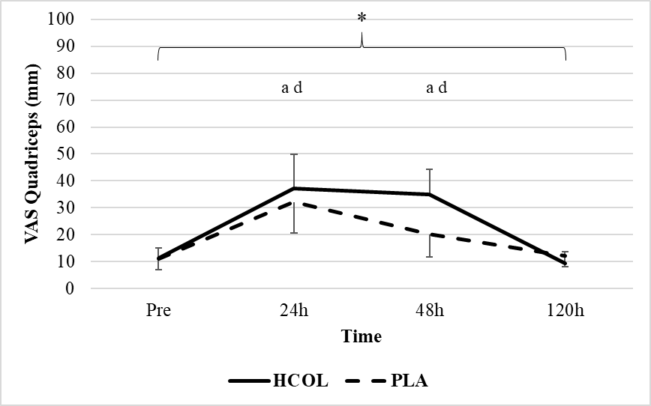
i)

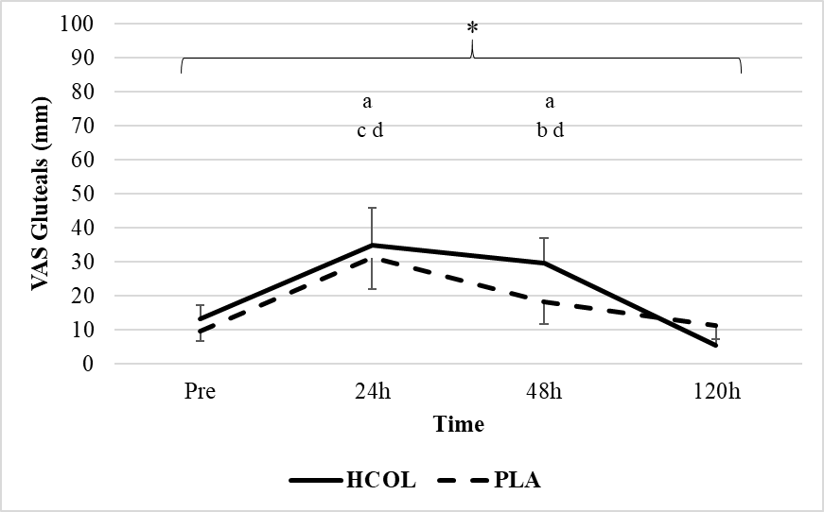
ii)

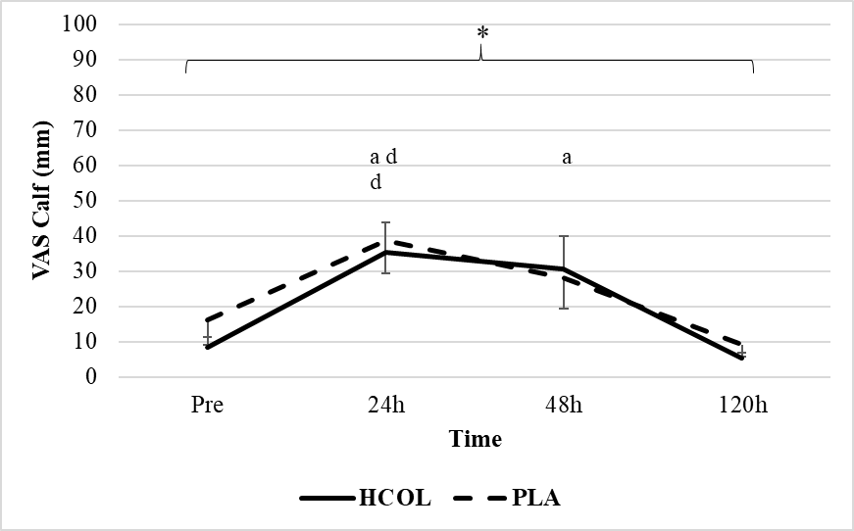
iii)

Figure 10. – Differences in subjective muscle soreness for the i) Quadricep region, ii) Gluteal region, and iii) Calf region between the collagen supplementation group (HCOL; n=7) and the placebo group (PLA; n=8). Soreness was assessed using a 100mm VAS across four different time points (Pre muscle damage, 24h post muscle damage, 48h post muscle damage and 120h post muscle damage) and reported as mean±SE.
* = denotes significant time effect (p≤0.05).
a = significantly different from the PRE muscle damage time point (p≤0.05).
b = significantly different from the 24h post muscle damage time point (p≤0.05).
c = significantly different from the 48h post muscle damage time point (p≤0.05).
d = significantly different from the 120h post muscle damage time point (p≤0.05).

For the pain pressure threshold measurements taken at the Vastus Lateralis, neither a significant time (Left: p=0.280; Right: p=0.321), group (Left: p=0.064; Right: p=0.114) or group x time interaction (Left: p=0.960; Right: p=0.736) was seen (Figures 11 & 12).
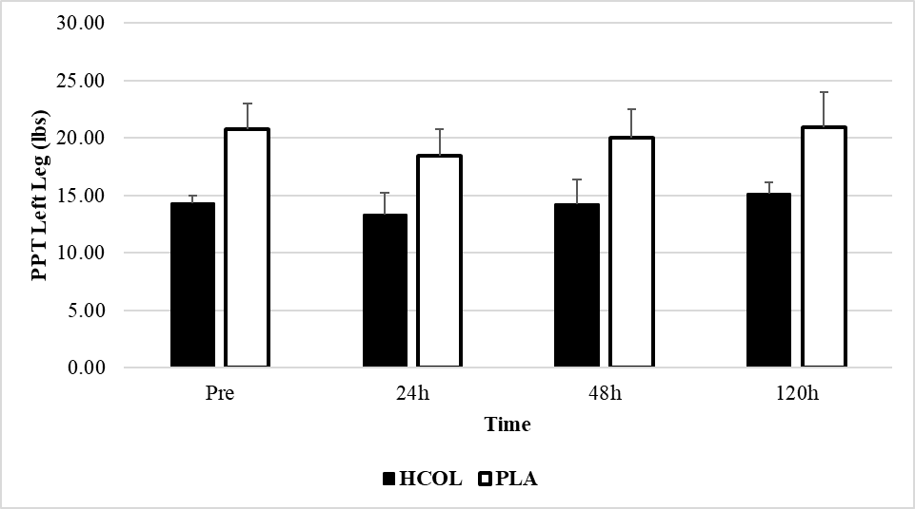
i)

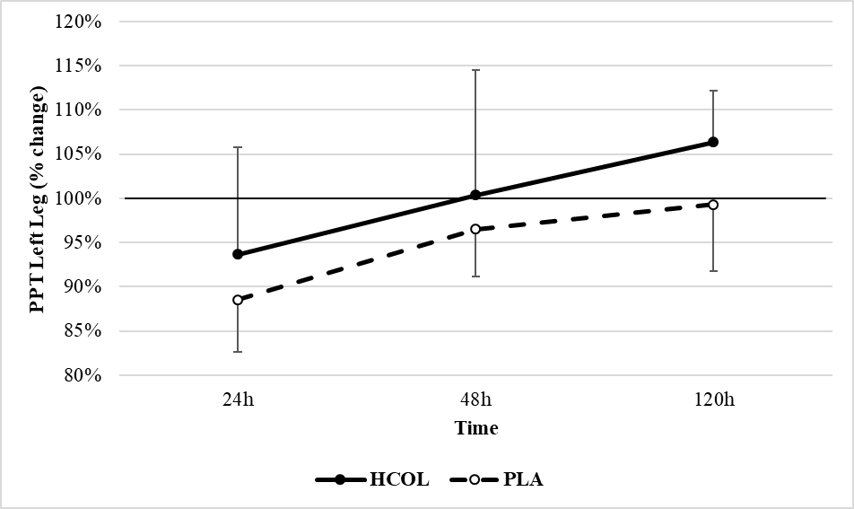
ii)

Figure 11. – Differences in left leg pain pressure threshold (PPT) between the collagen supplementation group (HCOL; n=7) and the placebo group (PLA; n=8) were assessed across four different time points (Pre muscle damage, 24h post muscle damage, 48h post muscle damage and 120h post muscle damage). i) shows raw PPT values (lbs) as mean±SE, ii) shows % change compared to the Pre muscle damage time point (mean±SE)
No significant differences p>0.05

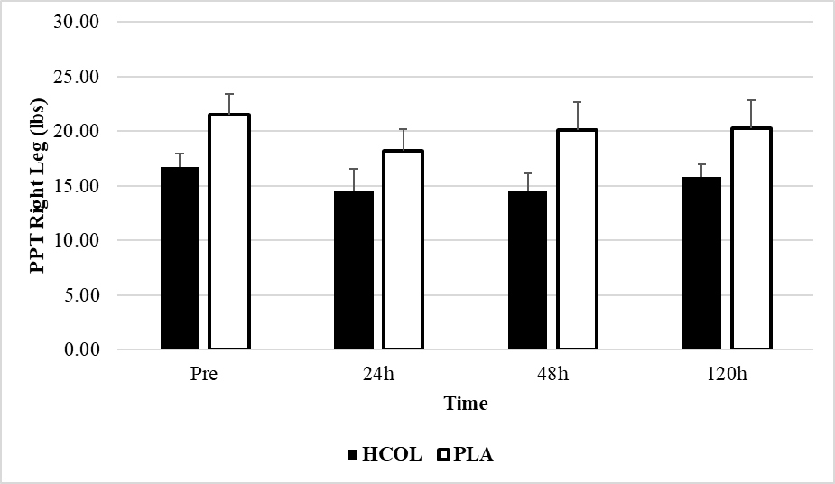
i)

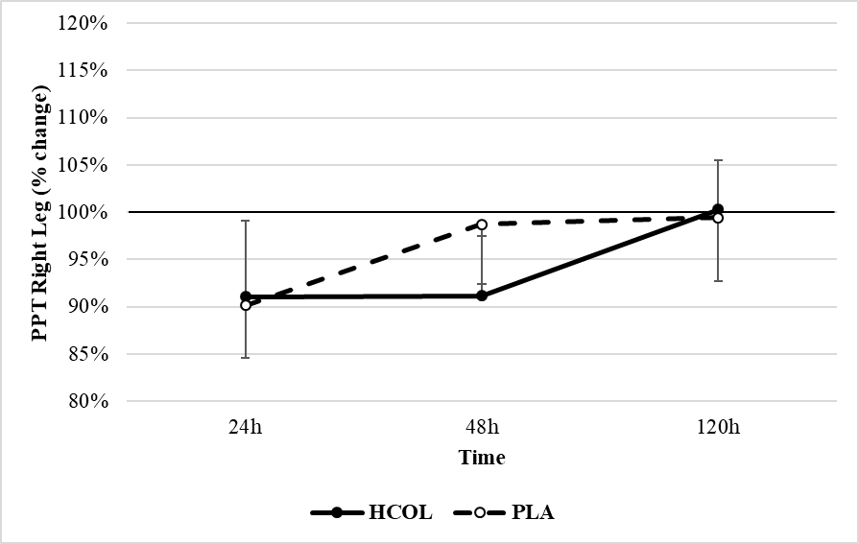
ii)

Figure 12. – Differences in right leg pain pressure threshold (PPT) between the collagen supplementation group (HCOL; n=7) and the placebo group (PLA; n=8) were assessed across four different time points (Pre muscle damage, 24h post muscle damage, 48h post muscle damage and 120h post muscle damage). i) shows raw PPT values (lbs) as mean±SE, ii) shows % change compared to the Pre muscle damage time point (mean±SE)
No significant differences p>0.05

Collagen Biomarkers – PICP and ICTP
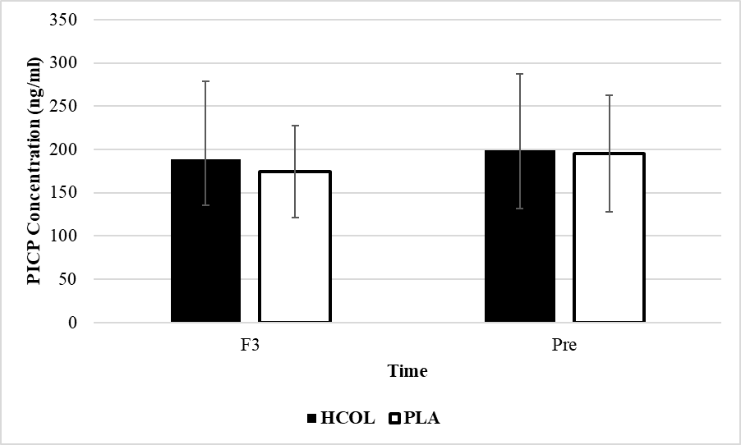
For PICP, a paired samples t-test found no significant differences in the HCOL (p=0.704) or PLA groups (p=0.138) between the “Familiarization 3” and “Pre” time points (Figure 13). For ICTP, a paired samples t-test also found no significant differences in the HCOL (p=0.224) group between the “Familiarization 3” and “Pre” time points (Figure 14). Due to a lack of assay wells available, PLA concentrations between F3 and Pre were unable to be measured.

Figure 13. Differences in PICP concentrations (ng/ml) expressed as mean±SD between the Familiarization 3 and Pre time points in the collagen supplementation group (HCOL; n=6) and the placebo group (PLA; n=6).
No significant differences (p>0.05)

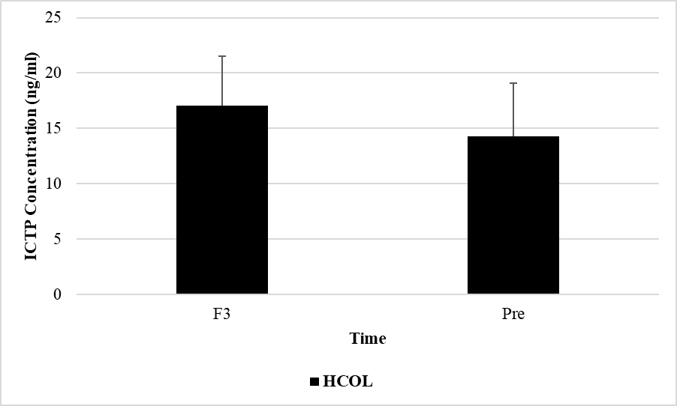

Figure 14. Difference in ICTP concentrations (ng/ml) expressed as mean±SD between the Familiarization 3 and Pre time points in the collagen supplementation group (HCOL; n=6) (Insufficient assay wells available at Familiarization 3-time point to assess PLA group)
No significant differences (p>0.05)

A mixed model ANOVA comparing raw PICP concentrations between the PLA and HCOL group across the 4 time points did not detect a significant time (p=0.684), group (p=0.813) or interaction effect (p=0.246) (Figure 15i).
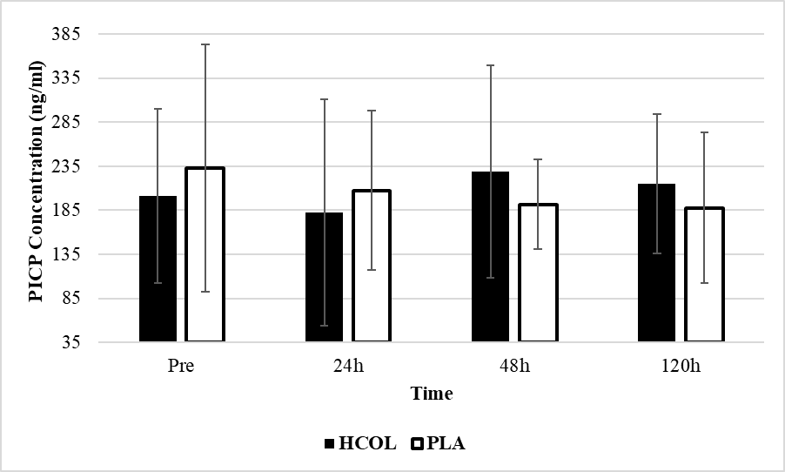
In addition, there were no significant time (p=0.215), group (p=0.484), or interaction (p=0.119) effects when PICP was expressed as a percentage change (Figure 15ii).
i)

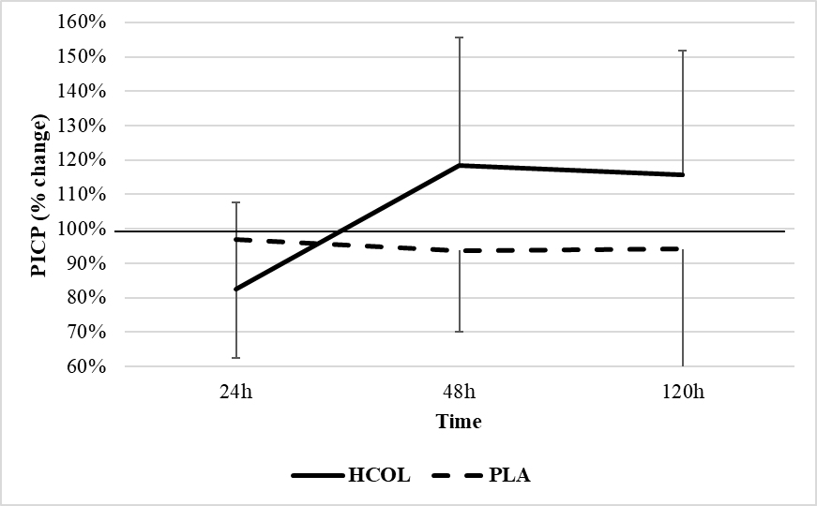
ii)

Figure 15. Differences in serum PICP concentrations between the collagen supplementation group (HCOL; n=5) and the placebo group (PLA; n=8) assessed across four time points (Pre muscle damage, 24h post muscle damage, 48h post muscle damage and 120h post muscle damage). i) shows raw PICP concentrations (ng/ml) as mean±SD, ii) shows % change compared to PRE (mean±SD)
No significant differences detected (p>0.05)

A mixed model ANOVA comparing ICTP concentrations between the PLA and HCOL group across the 4 time points did not detect a significant time (p=0.449), group (p=0.930) or interaction effect (p=0.879) (Figure 16i).
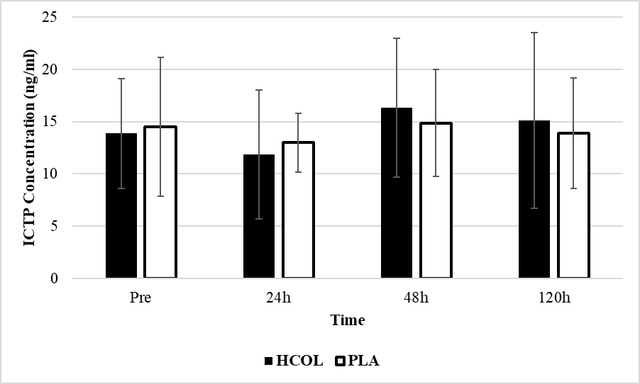
In addition, there were no significant time (p=0.330), group (p=0.797), or interaction (p=0.493) effects when ICTP was expressed as a percentage change (Figure 16ii).
i)

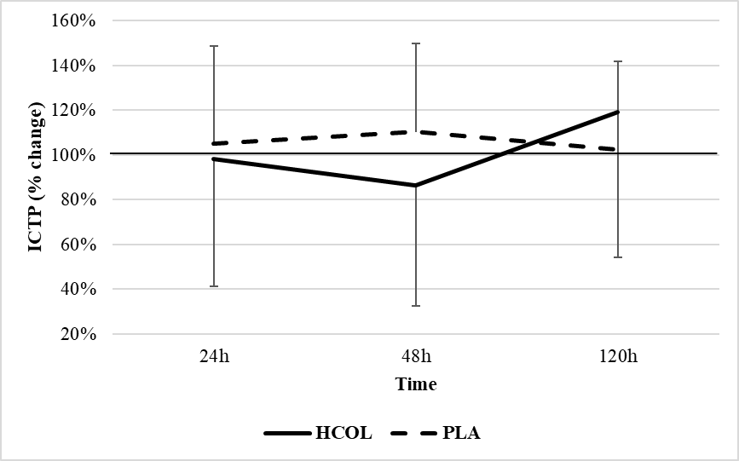
ii)

Figure 16. Differences in serum ICTP concentrations between the collagen supplementation group (HCOL; n=6) and the placebo group (PLA; n=5) assessed across four time points (Pre muscle damage, 24h post muscle damage, 48h post muscle damage and 120h post muscle damage). i) shows raw ICTP concentrations (ng/ml) as mean±SD, ii) shows % change compared to PRE (mean±SD)
No significant differences detected (p>0.05)

A mixed model ANOVA comparing serum PICP/ICTP ratio between the PLA and HCOL group across the 4 time points did not detect a significant time (p=0.773), group (p=0.920) or interaction effect (p=0.730) (Figure 17i).
In addition, there were no significant time (p=0.630), group (p=0.274), or interaction (p=0.844) effects when PICP/ICTP was expressed as a percentage change (Figure 17ii).
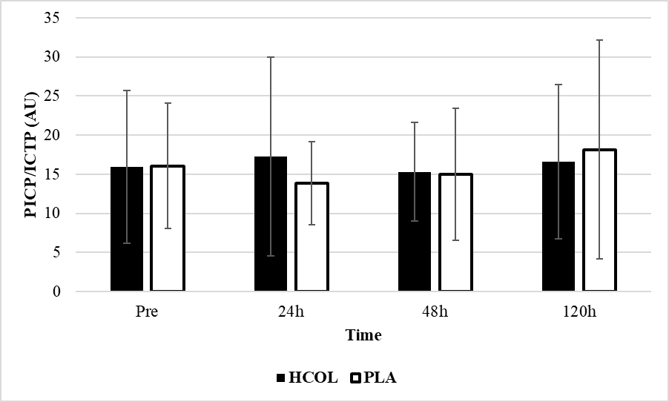
i)

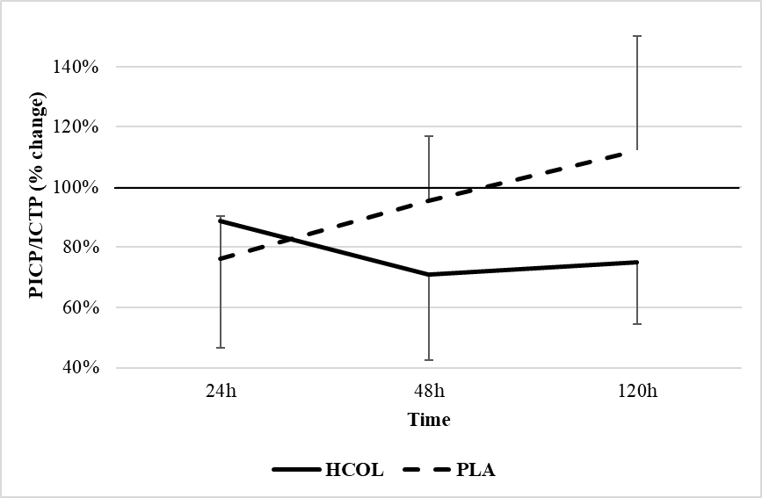
ii)

Figure 17. Differences in serum PICP/ICTP ratio between the collagen supplementation group (HCOL; n=4) and the placebo group (PLA; n=6) were assessed across four time points (Pre muscle damage, 24h post muscle damage, 48h post muscle damage and 120h post muscle damage). i) shows serum PICP/ICTP ratio expressed as mean±SD, ii) shows % change compared to the PRE (mean±SD)
No significant differences detected (p>0.05)

Discussion
The purpose of this study was to determine whether consuming a HCOL supplement could provide any meaningful physiological benefits for resistance trained individuals. The experiment was primarily designed to test whether HCOL supplementation could alter the recovery rate of physiological variables (muscular performance, soreness, serum biomarkers) that are typically dysregulated following a bout of damaging exercise. The main findings were: 1) CMJ height performance was significantly decreased at the 24h time point for the PLA group, but not for the HCOL group. 2) The return to baseline (indicating recovery) of every other variable was not significantly different between the HCOL and PLA groups during the 5-day recovery period. 3) Serum PICP and ICTP biomarkers were not significantly altered at any time point in either group.

Muscle Performance (CMJ and MVIC)
The salient finding of this study was that the jumping performance decline that transiently follows a bout of high-force eccentric exercise was attenuated in the HCOL group. At the 24h time point, jump height was significantly decreased in the PLA group but not in the HCOL group. Although some variability is present, Figure 12 seems to show a clear difference in the pattern between individuals in each group in response to muscle damage. The PLA group declined significantly at 24h post but returned to baseline by 48h post and remained there until the 120h time point. In contrast, mean jump height in the HCOL group was not significantly decreased at any time point.
Remodeling and strengthening of the ECM occurs in response to mechanical loading, specifically by increasing tissue collagen content (Mackey et al., 2004) as well as upregulating matricellular de-adhesion proteins and growth factors (Heinemeier et al., 2007; Flück et al., 2008). Furthermore, it has recently been established that the ECM is associated with the protective adaptations that manifest following a bout of damaging exercise (RBE) (Hyldahl et al., 2015). With novel high-force eccentric contractions, initial muscle fiber damage is followed by a de-adhesive and disassembly response which causes a disorganization of ECM tissue (Mackey et al., 2011). A positive consequence of this initial exposure is a subsequent elevation in ECM anabolic growth factors, collagen synthesis and satellite cell content. Upon re-exposure to the previously novel exercise, a markedly reduced disorganization of the ECM occurs (Mackey et al., 2011).
It seems plausible that consuming HCOL can enhance collagen synthesis within the ECM which may in turn reduce the structural disruption or enhance the effectiveness of the subsequent organizational response. The findings by Lopez et al. (2015) support the hypothesis that HCOL supplementation may confer a protective effect against damage. They provided participants with 3g per day of HCOL or placebo for 6 weeks before having them perform a bench press test (8 sets at 75% of 1RM, 90s rest between sets, repetitions to failure on each set) on day 43, and then again on day 46. Participants in the HCOL group were able to perform more repetitions to failure compared to the PLA group on both day 43 and day 46 (Day 43: HCOL = 57.9% reduction v PLA 72.2% reduction; Day 46: HCOL = 57.8% reduction v PLA = 65.0% reduction). The author’s concluded that the HCOL group demonstrated a more robust RBE response and that the supplement may have enhanced the ECM integrity within skeletal muscle. Although the Lopez et al. (2015) investigation employed a longer supplementation period versus the current protocol, the overall quantity of HCOL consumed was similar (125 g total vs. 124 g at 24h). This may point to a total dosage-based relationship versus a duration of supplementation effect on ECM protection.
The difference at the 24h time point could have been the result of HCOL enhancing the repair rate of the intramuscular connective tissues compared to the PLA, or because HCOL attenuated the damage experienced from the eccentric contractions. To test this, a future investigation should perform a follow up testing session at the 8h or 12h post damage period to assess whether jump height performance is attenuated after acute fatigue has dissipated. Regardless of the exact mechanism for this improved performance at 24h, considering the short supplementation period it is most likely that the connective tissues experiencing a positive effect are intramuscular. Connective tissues such as tendons play an important role in transmitting force between the contractile tissue and skeleton, but these tissues receive much less blood flow and have a slower metabolic rate compared to muscle (Baar et al., 2017). Farup et al. (2014b) found that whey protein enhanced patellar tendon thickness when combined with resistance training over a 12-week period. To determine whether HCOL could produce similar effects to whey protein in tendon tissue, using study periods of at least 12-weeks would be prudent.
Clifford et al. (2019) used a similar experimental protocol to us (published concurrently with the manuscript preparation phase of the current study) where they provided 20g per day of HCOL for 9-days and had untrained participants complete 125 drop jumps (6 sets of 25 reps from a 60cm box). They tracked similar outcome measures (VAS soreness, CMJ height, MVIC, biomarkers) 24h and 48h after completion of the muscle damaging protocol but did not observe the same effect that we did at the 24h time point. In our study, participants were resistance trained, so perhaps they were able to absorb or utilize the HCOL more effectively compared with an untrained population. It has long been established that resistance training can increase connective tissue strength (Stone, 1988), so it could also be the case that trained tissues are more readily able to be remodeled/enhanced. Additional research assessing HCOL supplementation within trained populations is required to confirm this hypothesis. Ideally, a muscle biopsy would be performed to evaluate the local response of different connective tissues, such as intramuscular ECM or tendons.
The pattern of changes in the MVIC results did not seem to match those of the CMJ height results. There was a significant time effect between 24h and 120h but no interaction effect for these measures and Figures 8 and 9 seem to show a different pattern between the groups, mainly at the 24h time point and especially in the right leg. It has been previously suggested that the high individual variability commonly associated with acute recovery studies (Mclester et al., 2003) can be problematic, leading to an inability to detect a significant interaction effect. Another possibility is that due to nature of the exercise, the protective effects of HCOL were not as pronounced. A CMJ involves lengthening (eccentric) and then shortening (concentric) muscle actions, whereas the MVIC involved an isometric contraction, characterized by unchanging muscle length. It has been demonstrated that passive/elastic tissues (e.g. tendons, ECM, titin, actin myosin cross-bridges) within and around the muscle have the potential to store and recover energy, resulting in a profound enhancement of force output (residual force output; RFE) and power production (Roberts, 2016). Acting like a parallel spring, the ECM has been shown to be inherently stiffer than muscle fibers and to substantially contribute towards passive force generation within muscle (Gillies & Lieber, 2011). It is well established that purely isometric contractions generate less force than eccentric contractions, potentially due to reinforcement by titin or other structural proteins within a muscle (Herzog et al., 2016). Therefore, the positive contribution to performance by the series/parallel elastic components may be lower during an MVIC compared to a CMJ. Some data suggests that isometric contractions involve stretching of the associated tendon (Byrne & Eston, 2002), but it is currently unknown how connective tissue within the muscle itself responds to these contractions. If enhancement of the ECM is the primary mechanism in which HCOL improves performance, then perhaps performance benefits only manifest during movements involving the stretch-shortening cycle to some degree, such as jumping, sprinting or eccentrically biased resistance exercise. It would be interesting to assess whether the protective effect of consuming HCOL manifests itself during different contraction types (isometric v concentric v eccentric) as well as movements with differing ballistic demands (squat jump, sprinting, jumping rope). It is interesting that there were no interaction effects in the other CMJ metrics assessed and it is currently unclear whether other metrics available through the force plate may have showed a better association. Flight time to contraction time has been suggested to better portray recovery/readiness in athletes compared to jump height (Cormack et al., 2008), so analyzing the effect of HCOL on this metric may have value.
We expected to see an improvement in acute recovery of performance measures at 24h or 48h in the HCOL group compared to the PLA group, which was not the case. This was the primary finding in the Clifford et al. (2019) study which utilized a similar design. If consuming HCOL enhance protection and reduced damage incurred by the drop jump protocol, then this may have obscured our ability to detect changes in recovery rate because performance did not decline in the first place. Clinical (Zhang et al., 2008; Kouguchi et al., 2013) and animal models (Vieira et al., 2014; Dar et al., 2017) have shown evidence that consuming HCOL can modulate inflammatory responses. It has been previously suggested that HCOL may enhance acute recovery by altering the inflammatory state within the muscle (Clifford et al., 2019). Other supplements such as tart Montmorency cherry juice seem to enhance recovery from EIMD by interacting with the secondary damage phase (inflammation and reactive oxygen species production) (Owens et al., 2018). We did not evaluate any pro- or anti-inflammatory markers in this study, thus no conclusions regarding the impact of this mechanism can be confidently made. Further work is required to determine if HCOL can affect any pro- or anti-inflammatory responses that occur in healthy humans following strenuous exercise.

Muscle Soreness
As expected, the drop jump protocol resulted in significant increases in perceived lower body muscle soreness assessed using a VAS scale. Following 100 drop jumps, soreness was elevated at the 24h and 48h time points but had returned to baseline by the 120h time point (termed delayed onset muscle soreness, or DOMS). This seems to be a typical response following high-force eccentric exercise, with DOMS peaking between 1-3 days regardless of the training status of the individuals (Newton et al., 2008; Carvalho et al., 2015). No significant changes occurred over the 5-day time course for soreness assessed using the PPT method. This discrepancy also occurred in the Clifford et al. (2019) experiment and has been previously examined by Lau et al. (2013). They determined that VAS and PPT actually represent different aspects of pain, and that VAS provides a better indication of time course changes for DOMS.
Although the underlying mechanisms of DOMS have yet to be fully elucidated, ultrastructural damage to myofiber filaments and connective tissues, as well as inflammatory processes within the muscle are associated with the phenomenon (Lau et al., 2013). The magnitude of muscle damage that occurs is greater if an exercise bout is eccentric in nature or the individual is unaccustomed to it (Howatson & Van Someren, 2008). We chose to use a drop jump protocol because it achieved both criteria, as well has having greater applicability to real world athletic populations (e.g. soccer, basketball, American football) where landings and/or changes of direction are common.
HCOL supplementation has been shown to reduce joint pain in both OA populations (Kumar et al., 2015), as well as in athletic individuals (Flechsenhar & Alf, 2005; Clark et al., 2008). It is not yet clear whether it can modulate sensations of pain or soreness within the muscle. Similarly, Clifford et al. (2019) found no significant interaction or group effect in VAS scores in the 24h and 48h following the exercise bout, although their magnitude based inference (MBI) analysis suggested that there may have been a “possibly beneficial” and a “likely beneficial” effect at 24h and 48h respectively. Lopez et al. (2015) did not report any effect of HCOL on DOMS, although they only provided 3g per day of HCOL to participants and assessed upper body soreness.

Biomarker Response
We did not find a significant group, time or interaction effect for PICP or ICTP in this study. PICP is a protein that is cleaved from a collagen molecule prior to incorporation into a collagen fibril, and is suggested to represent collagen formation within the body. It is similar to PINP (Amino-terminal Propeptides of Type I Collagen), differing only by which end of the Procollagen Type I it is cleaved from (i.e. Carboxyl or Amino terminal ends) (Burtis et al., 2012). ICTP is the product of collagen I degradation by MMPs and represents Type I collagen breakdown throughout the body. These biomarkers have typically been used to assess bone formation/resorption since approximately 90% of the bone matrix is made up of Type I collagen (Burtis et al., 2012). However, serum levels are not sensitive enough to distinguish between the origin of these collagen fragments and have previously been used to evaluate connective tissue status (Kuiper et al., 2005; Langberg et al., 2001). Interestingly, MMPs have been shown to be regulators of the ECM, and to participate in skeletal muscle adaptive modifications caused by exercise (Presti et al., 2017).
Seminal research by Langberg et al. (1999) analyzed PICP and ICTP in both the serum as well as in the peritendinous region of the Achilles tendon (assessed via microdialysis) following completion of a marathon in well trained runners. Compared to resting levels, both serum and tissue PICP concentrations were significantly decreased during the acute recovery period, but significantly increased by 72h (higher magnitude in tissue; Serum = 24% increase vs. Tissue = 192% increase). They speculated that intensive mechanical loading caused a temporary decrease in collagen synthesis, but that over the following days a positive state of collagen formation was achieved (elevated tissue PICP and unchanged ICTP) (Langberg et al., 1999). Olesen et al. (2007) found a comparable result after participants ran 36km, but cautioned that insertion of the microdialysis probe itself could influence tissue biomarker concentrations. In general, it seems that both acute (Heinemeier et al., 2003; Langberg et al., 2000; Olesen et al., 2007) and chronic (Kuiper et al., 2005) physical activity results in increased PICP concentrations. This biomarker has never been assessed in highly resistance trained populations, so it is unclear how it might respond acutely and chronically to exercise in this population. The mean concentrations we observed were between 189-233ng/ml, which is higher than the reference range concentrations stated in the ELISA instruction manual (69-163ng/ml; based on 279 adults >25 years of age). This suggests that basal collagen synthesis rates are higher in individuals regularly performing resistance training, which may have made it more difficult to detect changes in this group.
Despite being a regularly used biomarker of collagen degradation, the effect of exercise on ICTP is much less consistent. It has been shown to increase (Langberg et al., 2000), decrease (Langberg et al., 1999) and not change (Heinemeier et al., 2003; Langberg et al., 2007; Moerch et al., 2013) in both tissue and serum measurements. Paleckis et al. (2015) had young men perform daily drop jumps (increasing in volume, drop height and squat amplitude every 3 days) but did not see any changes in serum ICTP levels. Thus, ICTP’s value as a diagnostic tool for observing changes in collagen metabolism requires further investigation. To our knowledge, this is the first time ICTP has been measured in a population of young, highly resistance trained males, again making it unclear on how it might respond acutely and chronically to exercise in this population. The mean concentrations we observed were between 10.97-17.04ng/ml, which is higher than mean concentrations typically seen in the literature (usually 2-8ng/ml; no reference range provided in ELISA instruction manual) and suggests that basal collagen degradation rates are also higher in individuals regularly performing resistance training.
We computed the ratio between collagen synthesis/breakdown in order to gain a more complete understanding of collagen metabolism during this experiment. An increased ratio would indicate a potentially beneficial increase in collagen turnover, with implications for connective tissue health and injury prevention/repair. Our data did not show any significant differences despite the pattern seen across time points in Figure 17. It seems that the high inter-individual variability present with both the synthesis (PICP) and degradation (ICTP) biomarkers used to produce the collagen turnover ratio may have obscured the ability to detect any potential changes resulting from the intervention. Kuiper et al. (2005) experienced similar variability during their experiment, so it would be prudent to investigate either methods of reducing this variability, or developing more stable biomarkers for connective tissue assessment.
There is very little data in regard to how HCOL may affect collagen synthesis biomarkers in the body. Shaw et al. (2017) found that providing participants with 15g of gelatin per day for 6 days resulted in a doubling of serum PINP concentrations. They also discovered that engineered ligaments treated with serum from those consuming 15g per day of gelatin had an increased collagen content and tensile strength. In contrast, PINP levels were mostly unaffected by HCOL supplementation in the study by Clifford et al. (2019). The authors suggested that a longer supplementation period may be required for biomarker changes to manifest. This proposal is further supported by the findings of Konig et al., (2018), where an increase in serum PINP was observed following 12-months of HCOL supplementation in post-menopausal women.
Overall, our data does not support the hypothesis that acute HCOL supplementation influences serum collagen biomarker concentrations. Despite the high-force eccentric contractions, neither collagen synthesis or degradation biomarkers seem to have been altered. It seems likely that the large variabilities we observed were related to sources of biological (circadian, fasting status, prior exercise) or technical (pipetting volume errors, ELISA protocol mistakes, blood sampling procedures) error during serum collection or analysis. Participants were instructed to refrain from eating or exercising before testing sessions, however we cannot be certain that they followed these instructions exactly. PICP concentrations can differ by up to 20% between the peak at 01:30-04:30 and nadir at 11:00-15:00 (Wheater et al., 2013). ICTP has been shown to vary by up to 75% between the peak at 06:00 and nadir at 18:00 (Herrman et al., 2008). Although efforts were made to measure participants between 07:00-09:30, even this 150-minute range could have been affected by circadian rhythm (ICTP in particular). In theory, assessing both collagen synthesis and degradation concentrations would be more useful than either in isolation, thus we feel this approach was warranted. Due to the high variability and loss of power (removal of data points) experienced when analyzing these biomarkers, we were unable to draw conclusions regarding collagen metabolism. Due to technical and financial constraints, it was not possible for us to assess direct markers of collagen synthesis/degradation. Future studies should endeavor to perform peritendinous microdialysis (Miller et al., 2011) or muscle biopsies to assess direct markers of damage and collagen balance within tissues during HCOL supplementation.

Limitations
The primary limitation of this study was that we were unable to assess direct markers of connective tissue synthesis and breakdown. Even if increases in PICP or ICTP had been present, we would have been unable to determine if this was related to the ECM/connective tissue or bone. Due to the occurrence of high inter- and intra-individual variability in biomarker responses (in particular ICTP), some data points from the sample cohort were removed which may have obscured our ability to detect statistically significant differences. To better mitigate this variability, stricter efforts should be made to collect serum at the same time of day for everybody and great sample sizes should be utilized to increase power (especially considering the loss of data that can occur when performing assays).
There is also a possibility that the drop jump protocol did not sufficiently damage the participants. However, considering that we observed a significant reduction in MVIC at both the IP and 24h time points, coupled with a significant increase in muscle soreness in the days following, we believe that sufficient damage was imposed.
Another limitation was that we were unable to control activity or nutrition during the supplementation period. Furthermore, we were unable to get good compliance with food diaries. Despite reminders, the majority of participants never returned their food diaries and the few that were returned were only partially complete. It is possible that diet or protein intake between groups could have influenced the results, although the double-blind randomized nature of the study should have mitigated this effect.
Finally, future studies should attempt to also categorize jumping experience in their participants. Whilst our population contained highly resistance trained individuals, there was some variability in regards to additional exercise bouts that individuals were performing. Although the majority of participants were following a powerlifting style training program, some were also participating in weekly team sport (i.e. basketball and soccer) or aerobic exercise (i.e. jogging).

Chapter 5 – Conclusion
The purpose of this study was to determine whether consuming a HCOL supplement could be beneficial for well-trained individuals. The three main hypotheses presented were:
- HCOL supplementation will allow participants to recover from acute bouts of EIMD more rapidly
The return to baseline (indicating recovery) of soreness and performance measures were not significantly different between the HCOL and PLA groups during the 5-day recovery period.
- 7-days of Hydrolyzed Collagen supplementation will provide a protective effect to the MSK system
CMJ height was significantly decreased at the 24h time point for the PLA group, but not for the HCOL group suggesting that the HCOL may have conferred a protective effect against performance decrements.
- Serum markers of connective tissue synthesis and breakdown will be significantly and favorably different compared to placebo at either the 24h, 48h, or 120h time period following the muscle damage protocol.
Serum PICP and ICTP biomarkers were not significantly altered at any time point in either group.

Practical Significance and Applications
To our knowledge, this is the first study to suggest that a practical benefit of supplementing with hydrolyzed collagen peptides exists in highly resistance trained individuals. The implications of our findings are that these individuals may be able to reduce the tissue damage and subsequent transient performance decline following a bout of high-force eccentric exercise by employing a preemptive short term period of HCOL supplementation. In athletes, this may be useful for maintaining the ability to perform during situations in which there is a short time duration between games or during competitions/events spanning several days (i.e. strongman or crossfit competitions, NCAA basketball tournaments). If less damage is performed during the first day of a competition, then physical performance during the following days may be greater. Based on the results of this study, resistance trained individuals who are expecting to experience consecutive days of high-force eccentric exercise may benefit from consuming 15g per day of HCOL in the short term period (7-days) prior to the initial exercise bout.

Future Study Recommendations
Due to the paucity of literature assessing the physiological effects of HCOL supplementation in healthy and/or exercising individuals, future investigations are warranted.
It has been hypothesized that HCOL may interact with connective tissues such as tendons or the ECM. In order to test this hypothesis, future investigations should seek to measure direct markers of tissue damage by utilizing microdialysis or muscle biopsies. The indirect serum markers of connective tissue turnover currently being used during HCOL investigations do not seem to be sensitive or specific enough for researchers to draw valid conclusions regarding the effect that HCOL may have on connective tissues. Observations within animal and clinical populations have suggested that supplemental HCOL may modulate inflammatory pathways. At present, these findings have yet to be observed in healthy/exercising individuals that consume HCOL, however due to the current lack of data, this hypothesis cannot yet be discarded. Thus, future studies should continue to assess changes in pro- and anti-inflammatory biomarkers that may accompany HCOL consumption.
Secondly, to confirm the novel findings of this study, future experiments should expose participants to a secondary bout of damaging exercise in order to elucidate the effect of HCOL on the RBE. In addition, re-testing jump performance at the 8h or 12h post damage period is recommended to assess whether CMJ height is attenuated after acute fatigue has dissipated in the HCOL group. It may also be of value to assess whether the protective effect of consuming HCOL would still manifest itself during different muscle contraction types as well as exercises involving different ballistic demands.
Thirdly, our findings can only be applied to highly resistance trained males at this time. Future studies should investigate the efficacy of this supplement in alternate populations (females, older individuals, different ethnicities) and ideally in groups with a more homogenous exercise history and/or routine. Specifically, we suggest studying athlete or tactical populations. Not only would we expect these cohorts to exhibit greater homogeneity, but an enhanced protective effect of the MSK system could be of most practical value in such groups.
It has not yet been established how chronic supplementation with HCOL may affect adaptations to training or connective tissue injury prevention/healing rates. Due to the reduced blood flow available to many connective tissues, long term supplementation may be required before benefits can be detected. Investigations of HCOL efficacy within clinical populations have noted benefits with supplementation periods of 12-52 weeks. Future studies should be performed using similar time scales to assess the long term effects of HCOL supplementation on performance/recovery measures.
Finally, our study was developed to test the practical benefits that HCOL could have in exercising individuals. Investigations into the underlying physiological mechanisms that cause these changes are required. Until that information is available, investigators will be forced to speculate on the origin of their findings. A future study employing the measurement techniques and methodology of Hyldahl et al. (2015), but modified to compare HCOL v PLA conditions would significantly enhance our understanding of how and why HCOL works in humans.

References
Abate, M., Schiavone, C., Salini, V., & Andia, I. (2013). Occurrence of tendon pathologies in metabolic disorders. Rheumatology, 52(4), 599-608.

Alcock, R. D., Shaw, G. C., & Burke, L. M. (2018). Bone Broth Unlikely to Provide Reliable Concentrations of Collagen Precursors Compared to Supplemental Sources of Collagen Used in Collagen Research. International Journal of Sport Nutrition and Exercise Metabolism, 1-24.

Baar, K. (2015). Training and nutrition to prevent soft tissue injuries and accelerate return to
play. Sports Science Exchange, 28(142), 1-6.

Baar, K. (2017). Minimizing injury and maximizing return to play: Lessons from engineered ligaments. Sports Medicine, 47(1), 5-11.

Bächinger, H. P., Mizuno, K., Vranka, J. A., & Boudko, S. P. (2010). Collagen formation and structure. Comprehensive Natural Products II: Chemistry and Biology. Elsevier: Amsterdam.

Beelen, M., Burke, L. M., Gibala, M. J., & Van Loon, L. J. (2010). Nutritional strategies to promote postexercise recovery. International Journal of Sport Nutrition and Exercise Metabolism, 20(6), 515-532.

Bello, A. E., & Oesser, S. (2006). Collagen hydrolysate for the treatment of osteoarthritis and other joint disorders: a review of the literature. Current Medical Research and Opinion, 22(11), 2221-2232.

Bishop, P. A., Jones, E., & Woods, A. K. (2008). Recovery from training: a brief review: brief review. The Journal of Strength & Conditioning Research, 22(3), 1015-1024.

Brown, S. J., Child, R. B., Day, S. H., & Donnelly, A. E. (1997). Indices of skeletal muscle damage and connective tissue breakdown following eccentric muscle contractions. European Journal of Applied Physiology and Occupational Physiology, 75(4), 369-374.

Brown, S., Day, S., & Donnelly, A. (1999). Indirect evidence of human skeletal muscle damage and collagen breakdown after eccentric muscle actions. Journal of Sports Sciences, 17(5), 397-402.

Brown, M. A., Stevenson, E. J., & Howatson, G. (2017). Whey protein hydrolysate supplementation accelerates recovery from exercise-induced muscle damage in females. Applied Physiology, Nutrition, and Metabolism, 43(4), 324-330.

Buckley, J. D., Thomson, R. L., Coates, A. M., Howe, P. R., DeNichilo, M. O., & Rowney, M. K. (2010). Supplementation with a whey protein hydrolysate enhances recovery of muscle force-generating capacity following eccentric exercise. Journal of Science and Medicine in Sport, 13(1), 178-181.

Burtis, C. A., Ashwood, E. R., & Bruns, D. E. (2012). Tietz textbook of clinical chemistry and molecular diagnostics-e-book. Elsevier Health Sciences.

Butterfield, T. A., Best, T. M., & Merrick, M. A. (2006). The dual roles of neutrophils and macrophages in inflammation: a critical balance between tissue damage and repair. Journal of Athletic Training, 41(4), 457.

Byrne, C., Eston, R. G., & Edwards, R. H. T. (2001). Characteristics of isometric and dynamic strength loss following eccentric exercise‐induced muscle damage. Scandinavian Journal of Medicine & Science in Sports, 11(3), 134-140.

Byrne, C., & Eston, R. (2002). The effect of exercise-induced muscle damage on isometric and dynamic knee extensor strength and vertical jump performance. Journal of Sports Sciences, 20(5), 417-425.
Carvalho, T., Crisp, A., Lopes, C., Crepaldi, M., Calixto, R., Pereira, A., ... & Verlengia, R. (2015). Effect of eccentric velocity on muscle damage markers after bench press exercise in resistance-trained men. Gazzetta Medica Italiana, 174, 1-2.

Chazaud, B. (2016). Inflammation during skeletal muscle regeneration and tissue remodeling: application to exercise‐induced muscle damage management. Immunology and Cell Biology, 94(2), 140-145.

Clark, K. L., Sebastianelli, W., Flechsenhar, K. R., Aukermann, D. F., Meza, F., Millard, R. L., & Albert, A. (2008). 24-Week study on the use of collagen hydrolysate as a dietary supplement in athletes with activity-related joint pain. Current Medical Research and Opinion, 24(5), 1485-1496.

Clarkson, P. M., & Hubal, M. J. (2002). Exercise-induced muscle damage in humans. American Journal of Physical Medicine & Rehabilitation, 81(11), S52-S69.

Clifford, T., Ventress, M., Allerton, D. M., Stansfield, S., Tang, J. C., Fraser, W. D., ... & Stevenson, E. (2019). The effects of collagen peptides on muscle damage, inflammation and bone turnover following exercise: a randomized, controlled trial. Amino Acids, 1-14.

Close, G. L., Sale, C., Baar, K., & Bermon, S. (2019). Nutrition for the prevention and treatment of injuries in track and field athletes. International Journal of Sport Nutrition and Exercise Metabolism, (00), 1-9.

Cohen, J. (1988). Statistical power analysis for the behavioral sciences (2nd ed.). Hillsdale, NJ: Erlbaum.

Cooke, M. B., Rybalka, E., Stathis, C. G., Cribb, P. J., & Hayes, A. (2010). Whey protein isolate attenuates strength decline after eccentrically-induced muscle damage in healthy individuals. Journal of the International Society of Sports Nutrition, 7(1), 30.

Couppe, C., Kongsgaard, M., Aagaard, P., Hansen, P., Bojsen-Moller, J., Kjaer, M., & Magnusson, S. P. (2008). Habitual loading results in tendon hypertrophy and increased stiffness of the human patellar tendon. Journal of Applied Physiology, 105(3), 805-810.

Cormack, S. J., Newton, R. U., McGuigan, M. R., & Cormie, P. (2008). Neuromuscular and endocrine responses of elite players during an Australian rules football season. International Journal of Sports Physiology and Performance, 3(4), 439-453.

Dar, Q. A., Schott, E. M., Catheline, S. E., Maynard, R. D., Liu, Z., Kamal, F., ... & Jonason, J. H. (2017). Daily oral consumption of hydrolyzed type 1 collagen is chondroprotective and anti-inflammatory in murine posttraumatic osteoarthritis. PloS one, 12(4), e0174705.

Dolezal, B. A., Potteiger, J. A., Jacobsen, D. J., & Benedict, S. H. (2000). Muscle damage and resting metabolic rate after acute resistance exercise with an eccentric overload. Medicine & Science in Sports & Exercise, 32(7), 1202-1207.

Dressler, P., Gehring, D., Zdzieblik, D., Oesser, S., Gollhofer, A., & König, D. (2018). Improvement of Functional Ankle Properties Following Supplementation with Specific Collagen Peptides in Athletes with Chronic Ankle Instability. Journal of Sports Science & Medicine, 17(2), 298.

Ebbeling, C. B., & Clarkson, P. M. (1989). Exercise-induced muscle damage and adaptation. Sports Medicine, 7(4), 207-234.

Enoka, R. M. (1996). Eccentric contractions require unique activation strategies by the nervous system. Journal of Applied Physiology, 81(6), 2339-2346.

Farup, J., Rahbek, S. K., Vendelbo, M. H., Matzon, A., Hindhede, J., Bejder, A., & Vissing, K. (2014a). Whey protein hydrolysate augments tendon and muscle hypertrophy independent of resistance exercise contraction mode. Scandinavian Journal of Medicine & Science in Sports, 24(5), 788-798.

Farup, J., Rahbek, S. K., Knudsen, I. S., de Paoli, F., Mackey, A. L., & Vissing, K. (2014b). Whey protein supplementation accelerates satellite cell proliferation during recovery from eccentric exercise. Amino Acids, 46(11), 2503-2516.

Faul, F., Erdfelder, E., Lang, A. G., & Buchner, A. (2007). G* Power 3: A flexible statistical power analysis program for the social, behavioral, and biomedical sciences. Behavior Research Methods, 39(2), 175-191.

Feeley, B. T., Kennelly, S., Barnes, R. P., Muller, M. S., Kelly, B. T., Rodeo, S. A., & Warren, R. F. (2008). Epidemiology of National Football League training camp injuries from 1998 to 2007. The American Journal of Sports Medicine, 36(8), 1597-1603.

Flechsenhar, K., & Alf, D. (2005). Results of a postmarketing surveillance study of collagen hydrolysate CH-alpha. Orthopedic Practices, 9, 486-494.

Flück, M., Mund, S. I., Schittny, J. C., Klossner, S., Durieux, A. C., & Giraud, M. N. (2008). Mechano-regulated tenascin-C orchestrates muscle repair. Proceedings of the National Academy of Sciences, 105(36), 13662-13667.

Fratzl, P. (2008). Collagen: structure and mechanics, an introduction. In Collagen (pp. 1-13). Springer: Boston, MA.

Gelse, K., Pöschl, E., & Aigner, T. (2003). Collagens—structure, function, and biosynthesis. Advanced Drug Delivery Reviews, 55(12), 1531-1546.

Gillies, A. R., & Lieber, R. L. (2011). Structure and function of the skeletal muscle extracellular matrix. Muscle & Nerve, 44(3), 318-331.

Gleeson, M., Nieman, D. C., & Pedersen, B. K. (2004). Exercise, nutrition and immune function. Journal of Sports Sciences, 22(1), 115-125.

Gonçalves, F. K. (2017). Impact of collagen hydrolysate in middle-aged athletes with knee and ankle osteochondral lesions: A case series. International Journal of Case Reports and Images, 8(6), 364-369.

Grounds, M. D., Sorokin, L., & White, J. (2005). Strength at the extracellular matrix–muscle interface. Scandinavian Journal of Medicine & Science in Sports, 15(6), 381-391.

Hansen, P., Aagaard, P., Kjaer, M., Larsson, B., & Magnusson, S. P. (2003). Effect of habitual running on human Achilles tendon load-deformation properties and cross-sectional area. Journal of Applied Physiology, 95(6), 2375-2380.

Hartog, A., Leenders, I., van der Kraan, P. M., & Garssen, J. (2007). Anti-inflammatory effects of orally ingested lactoferrin and glycine in different zymosan-induced inflammation models: evidence for synergistic activity. International Immunopharmacology, 7(13), 1784-1792.

Hashim, P., Ridzwan, M. M., Bakar, J., & Hashim, M. D. (2015). Collagen in food and beverage industries. International Food Research Journal, 22(1), 1.

Hawkins, R. D., Hulse, M. A., Wilkinson, C., Hodson, A., & Gibson, M. (2001). The association football medical research programme: an audit of injuries in professional football. British Journal of Sports Medicine, 35(1), 43-47.

Heaton, L. E., Davis, J. K., Rawson, E. S., Nuccio, R. P., Witard, O. C., Stein, K. W., & Baker, L. B. (2017). Selected in-season nutritional strategies to enhance recovery for team sport athletes: A practical overview. Sports Medicine, 47(11), 2201-2218.

Heinemeier, K., Langberg, H., Olesen, J. L., & Kjaer, M. (2003). Role of TGF-β1 in relation to exercise-induced type I collagen synthesis in human tendinous tissue. Journal of Applied Physiology, 95(6), 2390-2397.

Heinemeier, K. M., Olesen, J. L., Haddad, F., Langberg, H., Kjær, M., Baldwin, K. M., & Schjerling, P. (2007). Expression of collagen and related growth factors in rat tendon and skeletal muscle in response to specific contraction types. The Journal of Physiology, 582(3), 1303-1316.

Heller, G. Z., Manuguerra, M., & Chow, R. (2016). How to analyze the visual analogue scale: myths, truths and clinical relevance. Scandinavian Journal of Pain, 13(1), 67-75.

Herrmann, M., & Seibel, M. (2008). The amino-and carboxyterminal cross-linked telopeptides of collagen type I, NTX-I and CTX-I: a comparative review. Clinica Chimica Acta, 393(2), 57-75.

Herzog, W., Schappacher, G., DuVall, M., Leonard, T. R., & Herzog, J. A. (2016). Residual force enhancement following eccentric contractions: a new mechanism involving titin. Physiology, 31(4), 300-312.

Hoffman, J. R., Ratamess, N. A., Tranchina, C. P., Rashti, S. L., Kang, J., & Faigenbaum, A. D. (2010). Effect of a proprietary protein supplement on recovery indices following resistance exercise in strength/power athletes. Amino Acids, 38(3), 771-778.

Hori, N., Newton, R. U., Kawamori, N., McGuigan, M. R., Kraemer, W. J., & Nosaka, K. (2009). Reliability of performance measurements derived from ground reaction force data during countermovement jump and the influence of sampling frequency. The Journal of Strength & Conditioning Research, 23(3), 874-882.

Howatson, G., & Van Someren, K. A. (2008). The prevention and treatment of exercise-induced muscle damage. Sports Medicine, 38(6), 483-503.

Howatson, G., McHugh, M. P., Hill, J. A., Brouner, J., Jewell, A. P., Van Someren, K. A., & Howatson, S. A. (2010). Influence of tart cherry juice on indices of recovery following marathon running. Scandinavian Journal of Medicine & Science in Sports, 20(6), 843-852.

Howatson, G., Hoad, M., Goodall, S., Tallent, J., Bell, P. G., & French, D. N. (2012). Exercise-induced muscle damage is reduced in resistance-trained males by branched chain amino acids: a randomized, double-blind, placebo controlled study. Journal of the International Society of Sports Nutrition, 9(1), 20.

Hyldahl, R. D., & Hubal, M. J. (2014). Lengthening our perspective: morphological, cellular, and molecular responses to eccentric exercise. Muscle & Nerve, 49(2), 155-170.

Hyldahl, R. D., Nelson, B., Xin, L., Welling, T., Groscost, L., Hubal, M. J., & Parcell, A. C. (2015). Extracellular matrix remodeling and its contribution to protective adaptation following lengthening contractions in human muscle. The FASEB Journal, 29(7), 2894-2904.

Hyldahl, R. D., Chen, T. C., & Nosaka, K. (2017). Mechanisms and mediators of the skeletal muscle repeated bout effect. Exercise and Sport Sciences Reviews, 45(1), 24-33.

Jacobsson, J., Timpka, T., Kowalski, J., Nilsson, S., Ekberg, J., & Renström, P. (2012). Prevalence of musculoskeletal injuries in Swedish elite track and field athletes. The American Journal of Sports Medicine, 40(1), 163-169.

Järvinen, T. A., Kannus, P., Maffulli, N., & Khan, K. M. (2005). Achilles tendon disorders: etiology and epidemiology. Foot and Ankle Clinics, 10(2), 255-266.

Kerr, Z. Y., Collins, C. L., & Dawn Comstock, R. (2010). Epidemiology of weight training-related injuries presenting to United States emergency departments, 1990 to 2007. The American Journal of Sports Medicine, 38(4), 765-771.

Kitakaze, T., Sakamoto, T., Kitano, T., Inoue, N., Sugihara, F., Harada, N., & Yamaji, R. (2016). The collagen derived dipeptide hydroxyprolyl-glycine promotes C2C12 myoblast differentiation and myotube hypertrophy. Biochemical and Biophysical Research Communications, 478(3), 1292-1297.

Kjaer, M. (2004). Role of extracellular matrix in adaptation of tendon and skeletal muscle to mechanical loading. Physiological Reviews, 84(2), 649-698.

Kouguchi, T., Ohmori, T., Shimizu, M., Takahata, Y., Maeyama, Y., Suzuki, T., & Tanabe, S. (2013). Effects of a chicken collagen hydrolysate on the circulation system in subjects with mild hypertension or high-normal blood pressure. Bioscience, Biotechnology, and Biochemistry, 77(4), 691-696.

Kongsgaard, M., Aagaard, P., Kjaer, M., & Magnusson, S. P. (2005). Structural Achilles tendon properties in athletes subjected to different exercise modes and in Achilles tendon rupture patients. Journal of Applied Physiology, 99(5), 1965-1971.

König, D., Oesser, S., Scharla, S., Zdzieblik, D., & Gollhofer, A. (2018). Specific Collagen Peptides Improve Bone Mineral Density and Bone Markers in Postmenopausal Women—A Randomized Controlled Study. Nutrients, 10(1), 97.

Kraemer, W. J., Ratamess, N. A., & French, D. N. (2002). Resistance training for health and performance. Current Sports Medicine Reports, 1(3), 165-171.

Kreher, J. B. (2016). Diagnosis and prevention of overtraining syndrome: an opinion on education strategies. Open Access Journal of Sports Medicine, 7, 115.

Kubo, K., Yata, H., Kanehisa, H., & Fukunaga, T. (2006). Effects of isometric squat training on the tendon stiffness and jump performance. European Journal of Applied Physiology, 96(3), 305-314.

Kumar, S., Sugihara, F., Suzuki, K., Inoue, N., & Venkateswarathirukumara, S. (2015). A double‐blind, placebo‐controlled, randomised, clinical study on the effectiveness of collagen peptide on osteoarthritis. Journal of the Science of Food and Agriculture, 95(4), 702-707.

Kuiper, J. I., Verbeek, J. H. A. M., Everts, V., Straub, J. P., & Frings-Dresen, M. H. W. (2005). Serum markers of collagen metabolism: construction workers compared to sedentary workers. Occupational and Environmental Medicine, 62(6), 363-367.

Langberg, H., Skovgaard, D., Petersen, L. J., Bülow, J., & Kjær, M. (1999). Type I collagen synthesis and degradation in peritendinous tissue after exercise determined by microdialysis in humans. The Journal of Physiology, 521(1), 299-306.

Langberg, H., Skovgaard, D., Asp, S., & Kjaer, M. (2000). Time pattern of exercise-induced changes in type I collagen turnover after prolonged endurance exercise in humans. Calcified Tissue International, 67(1), 41-44.

Langberg, H., Ellingsgaard, H., Madsen, T., Jansson, J., Magnusson, S. P., Aagaard, P., & Kjær, M. (2007). Eccentric rehabilitation exercise increases peritendinous type I collagen synthesis in humans with Achilles tendinosis. Scandinavian Journal of Medicine & Science in Sports, 17(1), 61-66.

Lau, W. Y., Muthalib, M., & Nosaka, K. (2013). Visual analog scale and pressure pain threshold for delayed onset muscle soreness assessment. Journal of Musculoskeletal Pain, 21(4), 320-326.

Lavallee, M. E., & Balam, T. (2010). An overview of strength training injuries: acute and chronic. Current Sports Medicine Reports, 9(5), 307-313.

Lee, S. K., Posthauer, M. E., Dorner, B., Redovian, V., & Maloney, M. J. (2006). Pressure ulcer healing with a concentrated, fortified, collagen protein hydrolysate supplement: a randomized controlled trial. Advances in Skin & Wound Care, 19(2), 92-96.

Levine, J. M., & Nishiyama, A. (1996). The NG2 chondroitin sulfate proteoglycan: a multifunctional proteoglycan associated with immature cells. Perspectives on Developmental Neurobiology, 3(4), 245-259.

Li, P., & Wu, G. (2018). Roles of dietary glycine, proline, and hydroxyproline in collagen synthesis and animal growth. Amino Acids, 50(1), 29-38.

Lian, Ø. B., Engebretsen, L., & Bahr, R. (2005). Prevalence of jumper's knee among elite athletes from different sports: a cross-sectional study. The American Journal of Sports Medicine, 33(4), 561-567.

Lopez, H. L., Ziegenfuss, T. N., & Park, J. (2015). Evaluation of the effects of biocell collagen, a novel cartilage extract, on connective tissue support and functional recovery from exercise. Integrative Medicine: A Clinician's Journal, 14(3), 30.

Mackey, A. L., Donnelly, A. E., Turpeenniemi-Hujanen, T., & Roper, H. P. (2004). Skeletal muscle collagen content in humans after high-force eccentric contractions. Journal of Applied Physiology, 97(1), 197-203.

Mackey, A. L., Brandstetter, S., Schjerling, P., Bojsen-Moller, J., Qvortrup, K., Pedersen, M. M., & Langberg, H. (2011). Sequenced response of extracellular matrix deadhesion and fibrotic regulators after muscle damage is involved in protection against future injury in human skeletal muscle. The FASEB Journal, 25(6), 1943-1959.

Mackey, A. L., & Kjaer, M. (2016). Connective tissue regeneration in skeletal muscle after eccentric contraction-induced injury. Journal of Applied Physiology, 122(3), 533-540.

Magnusson, S. P., Heinemeier, K. M., & Kjaer, M. (2016). Collagen homeostasis and metabolism. Metabolic Influences on Risk for Tendon Disorders (pp. 11-25). Springer, Cham.

Mahmood, K., Muhammad, K. M. L., Ariffin, F., Razak, H. K. B. A., & Sulaiman, P. D. S. (2016) Review of Fish Gelatin Extraction, Properties and Packaging Applications. Food Science and Quality Management, 56(1), 47-59.

McAlindon, T. E., Nuite, M., Krishnan, N., Ruthazer, R., Price, L. L., Burstein, D., & Flechsenhar, K. (2011). Change in knee osteoarthritis cartilage detected by delayed gadolinium enhanced magnetic resonance imaging following treatment with collagen hydrolysate: a pilot randomized controlled trial. Osteoarthritis and Cartilage, 19(4), 399-405.

Mclester, J. R., Bishop, P. A., Smith, J., Wyers, L., Dale, B., Kozusko, J., & Lomax, R. (2003). A series of studies---a practical protocol for testing muscular endurance recovery. The Journal of Strength & Conditioning Research, 17(2), 259-273.

Meldrum, D., Cahalane, E., Keogan, F., & Hardiman, O. (2003). Maximum voluntary isometric contraction: investigation of reliability and learning effect. Amyotrophic Lateral Sclerosis and Other Motor Neuron Disorders, 4(1), 36-44.

Milgrom, C., Schaffler, M., Gilbert, S., & Van Holsbeeck, M. (1995). Rotator-cuff changes in asymptomatic adults. The effect of age, hand dominance and gender. Bone & Joint Journal, 77(2), 296-298.

Miller, B. F., Olesen, J. L., Hansen, M., Døssing, S., Crameri, R. M., Welling, R. J., ... & Smith, K. (2005). Coordinated collagen and muscle protein synthesis in human patella tendon and quadriceps muscle after exercise. The Journal of Physiology, 567(3), 1021-1033.

Miller, B. F., Hansen, M., Olesen, J. L., Schwarz, P., Babraj, J. A., Smith, K., & Kjaer, M. (2007). Tendon collagen synthesis at rest and after exercise in women. Journal of Applied Physiology, 102(2), 541-546.

Miller, B. F., Ellis, D., Robinson, M. M., Rivera, J. D., Kjaer, M., & Langberg, H. (2011). Measurement of skeletal muscle collagen breakdown by microdialysis. Scandinavian Journal of Medicine & Science in Sports, 21(6), e1-e8.

Miyama, M., & Nosaka, K. (2004). Influence of surface on muscle damage and soreness induced by consecutive drop jumps. Journal of Strength and Conditioning Research, 18(2), 206-211.

Moerch, L., Pingel, J., Boesen, M., Kjær, M., & Langberg, H. (2013). The effect of acute exercise on collagen turnover in human tendons: influence of prior immobilization period. European Journal of Applied Physiology, 113(2), 449-455.

Moskowitz, R. W. (2000). Role of collagen hydrolysate in bone and joint disease. Seminars in Arthritis and Rheumatism, 30(2), 87-99.

Mujika, I., & Padilla, S. (2000). Detraining: loss of training-induced physiological and performance adaptations: Part II. Sports Medicine, 30(3), 145-154.

Newton, M. J., Morgan, G. T., Sacco, P., Chapman, D. W., & Nosaka, K. (2008). Comparison of responses to strenuous eccentric exercise of the elbow flexors between resistance-trained and untrained men. The Journal of Strength & Conditioning Research, 22(2), 597-607.

Nicol, L. M., Rowlands, D. S., Fazakerly, R., & Kellett, J. (2015). Curcumin supplementation likely attenuates delayed onset muscle soreness (DOMS). European Journal of Applied Physiology, 115(8), 1769-1777.

Nogueira, A. D. C., Vale, R. G., Gomes, A. L., & Dantas, E. H. (2011). The effect of muscle actions on the level of connective tissue damage. Research in Sports Medicine, 19(4), 259-270.

Oesser, S., Adam, M., Babel, W., & Seifert, J. (1999). Oral administration of 14C labeled gelatin hydrolysate leads to an accumulation of radioactivity in cartilage of mice (C57/BL). The Journal of Nutrition, 129(10), 1891-1895.

Oesser, S., Raabe, A., & Schunck, M. (2007). Orally administered collagen hydrolysate halts the progression of osteorathritis in STR/ort mice. Osteoarthritis and Cartilage, 15, C61-C62.

Oesser, S., Proksch, E., & Schunck, M. (2008). Prophylactic treatment with a special collagen hydrolysate decreases cartilage tissue degeneration in the knee joints. Osteoarthritis and Cartilage, 16, S45.

Ohara, H., Matsumoto, H., Ito, K., Iwai, K., & Sato, K. (2007). Comparison of quantity and structures of hydroxyproline-containing peptides in human blood after oral ingestion of gelatin hydrolysates from different sources. Journal of Agricultural and Food Chemistry, 55(4), 1532-1535.

Olesen, J. L., Heinemeier, K. M., Gemmer, C., Kjær, M., Flyvbjerg, A., & Langberg, H. (2007). Exercise-dependent IGF-I, IGFBPs, and type I collagen changes in human peritendinous connective tissue determined by microdialysis. Journal of Applied Physiology, 102(1), 214-220.

O'Reilly, M. S., Boehm, T., Shing, Y., Fukai, N., Vasios, G., Lane, W. S., & Folkman, J. (1997). Endostatin: an endogenous inhibitor of angiogenesis and tumor growth. Cell, 88(2), 277-285.

Owens, D. J., Twist, C., Cobley, J. N., Howatson, G., & Close, G. L. (2019). Exercise-induced muscle damage: What is it, what causes it and what are the nutritional solutions?. European Journal of Sport Science, 19(1), 71-85.

Paterno, M. V., Rauh, M. J., Schmitt, L. C., Ford, K. R., & Hewett, T. E. (2014). Incidence of second ACL injuries 2 years after primary ACL reconstruction and return to sport. The American Journal of Sports Medicine, 42(7), 1567-1573.

Paleckis, V., Mickevičius, M., Snieckus, A., Streckis, V., Pääsuke, M., Rutkauskas, S., & Kamandulis, S. (2015). Changes in indirect markers of muscle damage and tendons after daily drop jumping exercise with rapid load increase. Journal of Sports Science & Medicine, 14(4), 825.

Peake, J. M., Neubauer, O., Della Gatta, P. A., & Nosaka, K. (2016). Muscle damage and inflammation during recovery from exercise. Journal of Applied Physiology, 122(3), 559-570.

Phillips, S. M., & Van Loon, L. J. (2011). Dietary protein for athletes: from requirements to optimum adaptation. Journal of Sports Sciences, 29(sup1), S29-S38.

Phillips, S. M., Tipton, K. D., Van Loon, L. J., Verdijk, L. B., Paddon-Jones, D., & Close, G. L. (2016). Exceptional body composition changes attributed to collagen peptide supplementation and resistance training in older sarcopenic men. British Journal of Nutrition, 116(3), 569-570.

Presti, R. L., Hopps, E., & Caimi, G. (2017). Gelatinases and physical exercise: a systematic review of evidence from human studies. Medicine, 96(37).

Proske, U., & Morgan, D. L. (2001). Muscle damage from eccentric exercise: mechanism, mechanical signs, adaptation and clinical applications. The Journal of Physiology, 537(2), 333-345.

Raske, Å., & Norlin, R. (2002). Injury incidence and prevalence among elite weight and power lifters. The American Journal of Sports Medicine, 30(2), 248-256.

Ratamess, N. A., Kraemer, W. J., Volek, J. S., Rubin, M. R., Gomez, A. L., French, D. N., & Newton, R. U. (2003). The effects of amino acid supplementation on muscular performance during resistance training overreaching. The Journal of Strength & Conditioning Research, 17(2), 250-258.

Rauh, M. J., Macera, C. A., Ji, M., & Wiksten, D. L. (2007). Subsequent injury patterns in girls' Scandinavian Journal of Immunology, 76high school sports. Journal of Athletic Training, 42(4), 486.

Raysmith, B. P., & Drew, M. K. (2016). Performance success or failure is influenced by weeks lost to injury and illness in elite Australian track and field athletes: a 5-year prospective study. Journal of Science and Medicine in Sport, 19(10), 778-783.

Roberts, T. J. (2016). Contribution of elastic tissues to the mechanics and energetics of muscle function during movement. Journal of Experimental Biology, 219(2), 266-275.

Sahaly, R., Vandewalle, H., Driss, T., & Monod, H. (2001). Maximal voluntary force and rate of force development in humans–importance of instruction. European Journal of Applied Physiology, 85(3-4), 345-350.

Shaw, G., Lee-Barthel, A., Ross, M. L., Wang, B., & Baar, K. (2017). Vitamin C–enriched gelatin supplementation before intermittent activity augments collagen synthesis. The American Journal of Clinical Nutrition, 105(1), 136-143.

Siewe, J., Rudat, J., Röllinghoff, M., Schlegel, U. J., Eysel, P., & Michael, J. P. (2011). Injuries and overuse syndromes in powerlifting. International Journal of Sports Medicine, 32(09), 703-711.

Siewe, J., Marx, G., Knöll, P., Eysel, P., Zarghooni, K., Graf, M., ... & Michael, J. (2014). Injuries and overuse syndromes in competitive and elite bodybuilding. International Journal of Sports Medicine, 35(11), 943-948.

Silver, F. H., & Landis, W. J. (2008). Viscoelasticity, energy storage and transmission and dissipation by extracellular matrices in vertebrates. In Collagen (pp. 133-154). Springer, Boston, MA.

Soligard, T., Schwellnus, M., Alonso, J. M., Bahr, R., Clarsen, B., Dijkstra, H. P., & van Rensburg, C. J. (2016). How much is too much?(Part 1) International Olympic Committee consensus statement on load in sport and risk of injury. British Journal of Sports Medicine, 50(17), 1030-1041.

Stone, M. H. (1988). Implications for connective tissue and bone alterations resulting from resistance exercise training. Medicine and Science in Sports and Exercise, 20(5 Suppl), S162-8.

Tanaka, S., Petersen, M., & Cameron, L. (2001). Prevalence and risk factors of tendinitis and related disorders of the distal upper extremity among US workers: comparison to carpal tunnel syndrome. American Journal of Industrial Medicine, 39(3), 328-335.

Tofas, T., Jamurtas, A. Z., Fatouros, I., Nikolaidis, M. G., Koutedakis, Y., Sinouris, E. A., ... & Theocharis, D. A. (2008). Plyometric exercise increases serum indices of muscle damage and collagen breakdown. The Journal of Strength & Conditioning Research, 22(2), 490-496.

Trotter, J. A., & Purslow, P. P. (1992). Functional morphology of the endomysium in series fibered muscles. Journal of Morphology, 212(2), 109-122.

Twist, C., & Highton, J. (2013). Monitoring fatigue and recovery in rugby league players. International Journal of Sports Physiology and Performance, 8(5), 467-474.

Urciuolo, A., Quarta, M., Morbidoni, V., Gattazzo, F., Molon, S., Grumati, P., ... & Vozzi, G. (2013). Collagen VI regulates satellite cell self-renewal and muscle regeneration. Nature Communications, 4, 1964.

Urso, M. L., & Sawka, M. N. (2013). Inflammation: sustaining the balance to optimize recovery of skeletal muscle, connective tissue, and exertional injuries. Journal of Applied Physiology, 115(6), 877.

van Gent, R. N., Siem, D., van Middelkoop, M., van Os, A. G., Bierma-Zeinstra, S. M. A., & Koes, B. W. (2007). Incidence and determinants of lower extremity running injuries in long distance runners: a systematic review. British Journal of Sports Medicine, 41, 469-480.

Vatine, J. J., Shapira, S. C., Magora, F., Adler, D., & Magora, A. (1993). Electronic pressure algometry of deep pain in healthy volunteers. Archives of Physical Medicine and Rehabilitation, 74(5), 526-530.

Velleman, S. G. (1999). The role of the extracellular matrix in skeletal muscle development. Poultry Science, 78(5), 778-784.

Vieira, C. P., Oliveira, L. P. D., Guerra, F. D. R., Almeida, M. D. S. D., Marcondes, M. C. C. G., & Pimentel, E. R. (2015). Glycine improves biochemical and biomechanical properties following inflammation of the achilles tendon. The Anatomical Record, 298(3), 538-545.

Vogel, W. F. (2001). Collagen-receptor signaling in health and disease. European Journal of Dermatology, 11(6), 506-514.

Wang, X., Ao, Q., Tian, X., Fan, J., Tong, H., Hou, W., & Bai, S. (2017). Gelatin-Based Hydrogels for Organ 3D Bioprinting. Polymers, 9(9), 401.

Weisenthal, B. M., Beck, C. A., Maloney, M. D., DeHaven, K. E., & Giordano, B. D. (2014). Injury rate and patterns among CrossFit athletes. Orthopaedic Journal of Sports Medicine, 2(4), 2325967114531177.

Welsh, M. C., Allen, D. L., & Byrnes, W. C. (2014). Plasma matrix metalloproteinase-9 response to downhill running in humans. International Journal of Sports Medicine, 35(05), 363-370.

Wheater, G., Elshahaly, M., Tuck, S. P., Datta, H. K., & van Laar, J. M. (2013). The clinical utility of bone marker measurements in osteoporosis. Journal of Translational Medicine, 11(1), 201.

Yamaguchi, Y., Mann, D. M., & Ruoslahti, E. (1990). Negative regulation of transforming growth factor-β by the proteoglycan decorin. Nature, 346(6281), 281.

Yamazaki, C. M., Kadoya, Y., Hozumi, K., Okano-Kosugi, H., Asada, S., Kitagawa, K., & Koide, T. (2010). A collagen-mimetic triple helical supramolecule that evokes integrin-dependent cell responses. Biomaterials, 31(7), 1925-1934.

Young, W. B., Pryor, J. F., & Wilson, G. J. (1995). Countermovement and Drop Jump Performance. Journal of Strength and Conditioning Research, 9(4), 232-236.

Zdzieblik, D., Oesser, S., Baumstark, M. W., Gollhofer, A., & König, D. (2015). Collagen peptide supplementation in combination with resistance training improves body composition and increases muscle strength in elderly sarcopenic men: a randomised controlled trial. British Journal of Nutrition, 114(8), 1237-1245.

Zhang, L. L., Wei, W., Xiao, F., Xu, J. H., Bao, C. D., Ni, L. Q., & Li, X. F. (2008). A randomized, double‐blind, multicenter, controlled clinical trial of chicken type II collagen in patients with rheumatoid arthritis. Arthritis Care & Research: Official Journal of the American College of Rheumatology, 59(7), 905-910.

Zuckley, L., Angelopoulou, K., Carpenter, M. R., Meredith, B. A., Kline, G., & Rowinski, M. (2004). Collagen hydrolysate improves joint function in adults with mild symptoms of osteoarthritis of the knee. Medicine and Science in Sports & Exercise, 36(1), S153-S154.

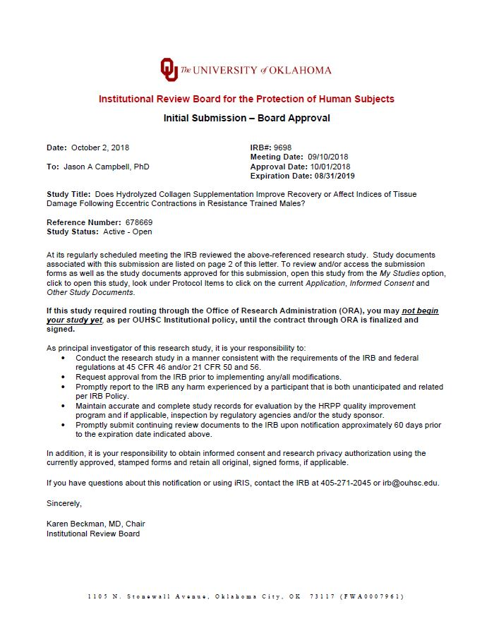
Appendix 1: IRB Approval Letter

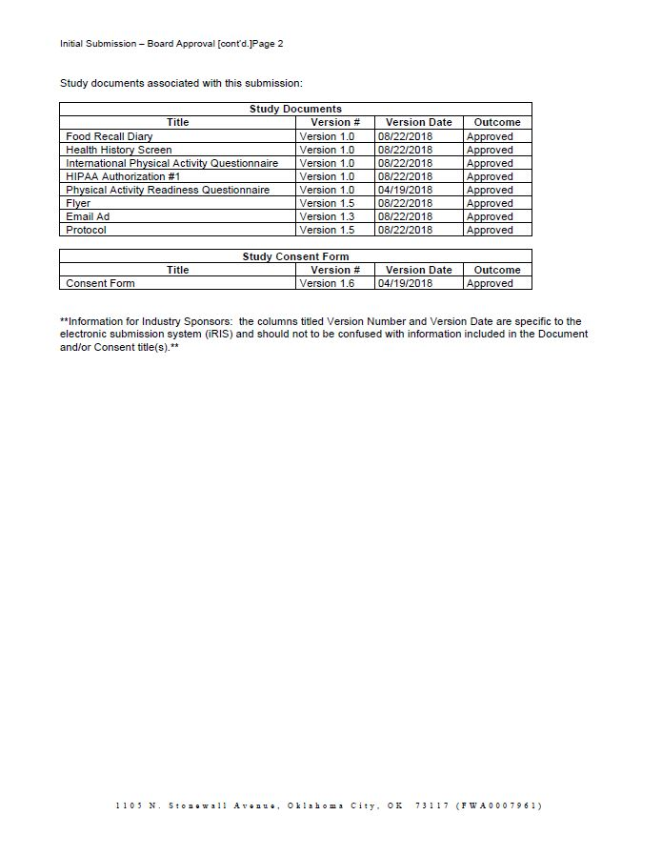

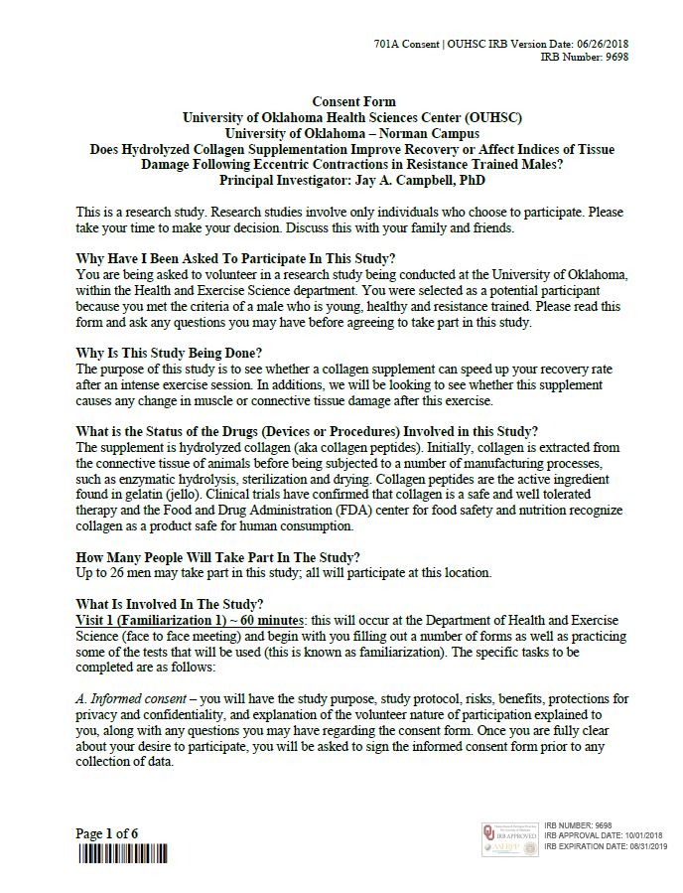
Appendix 2: Informed Consent Form

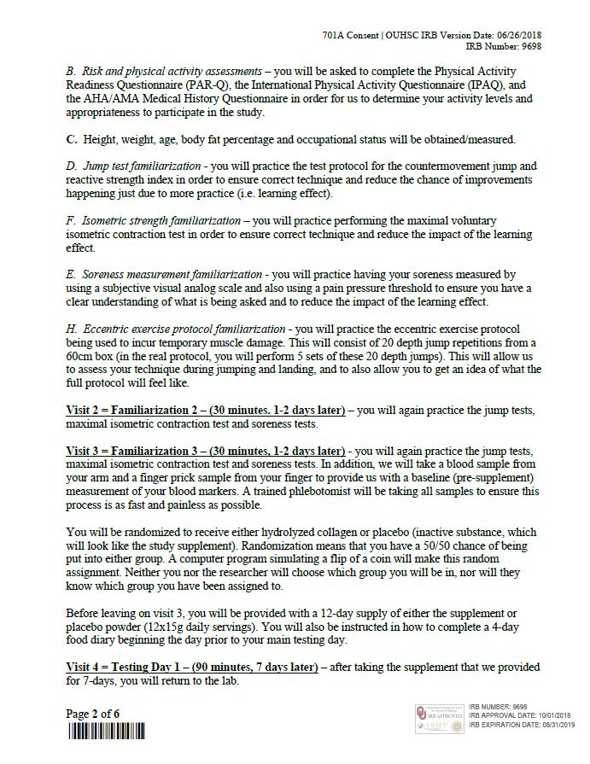

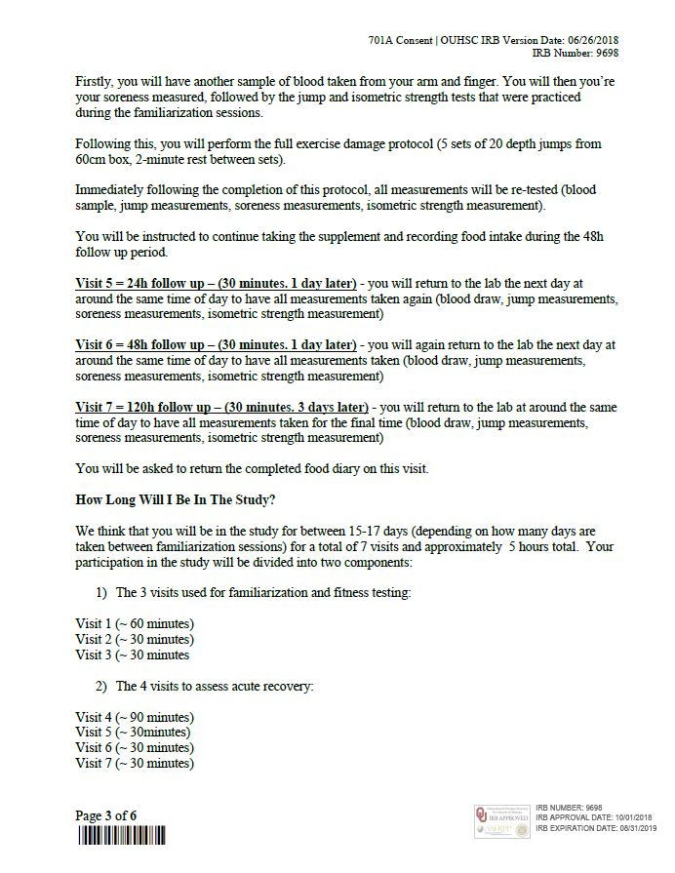

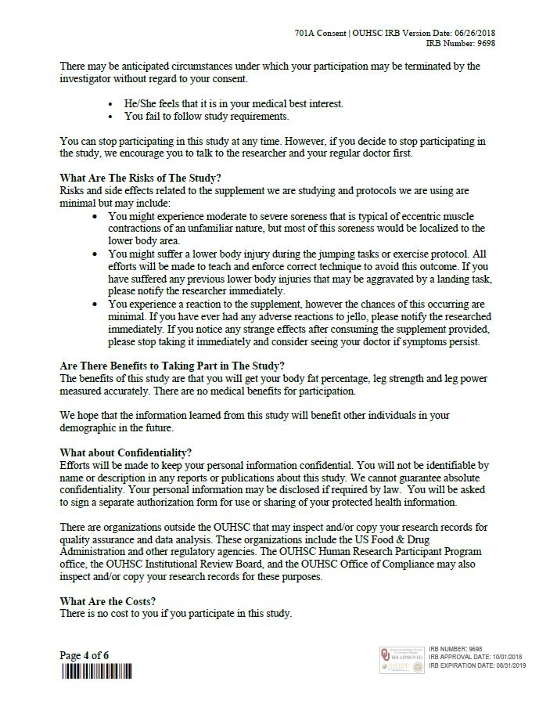

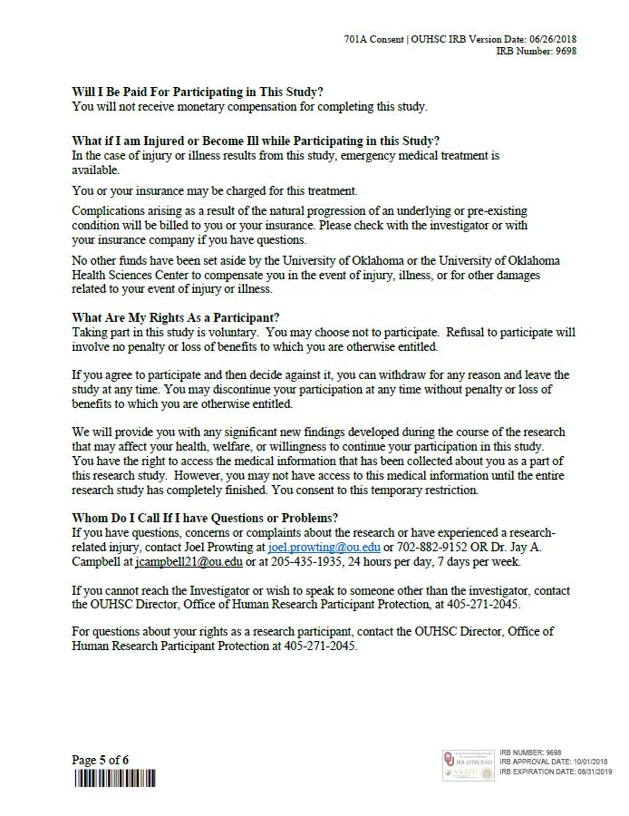

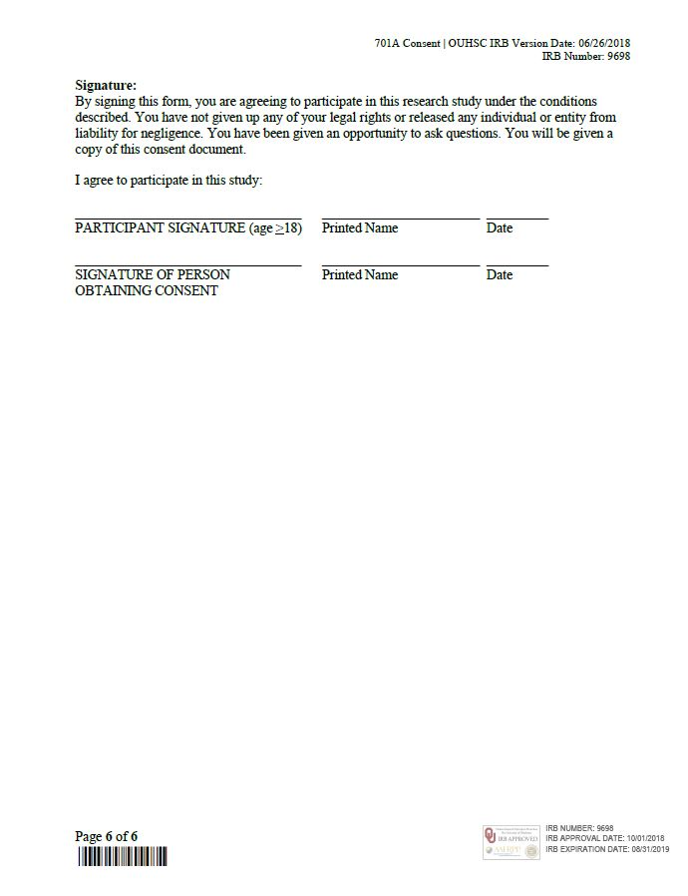

Appendix 3: HIPAA
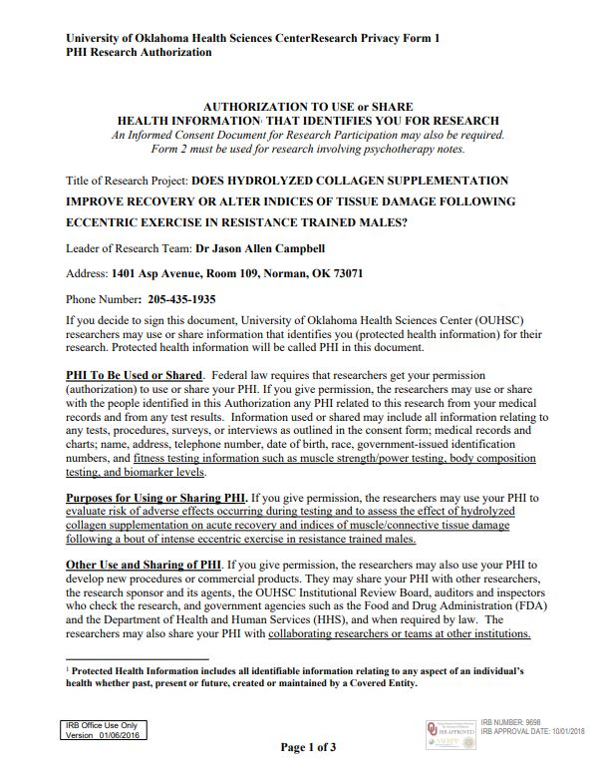

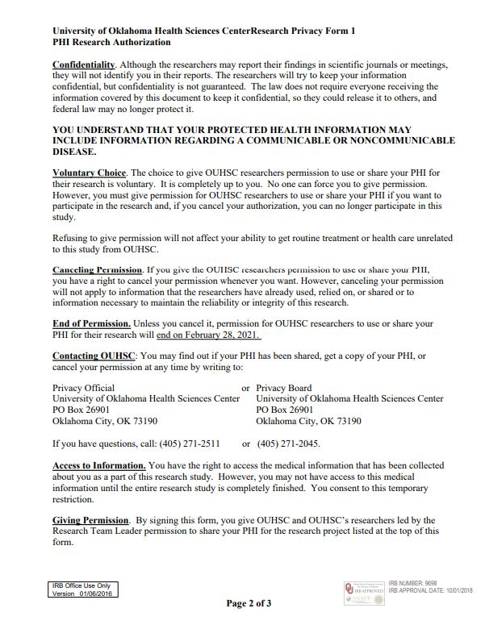

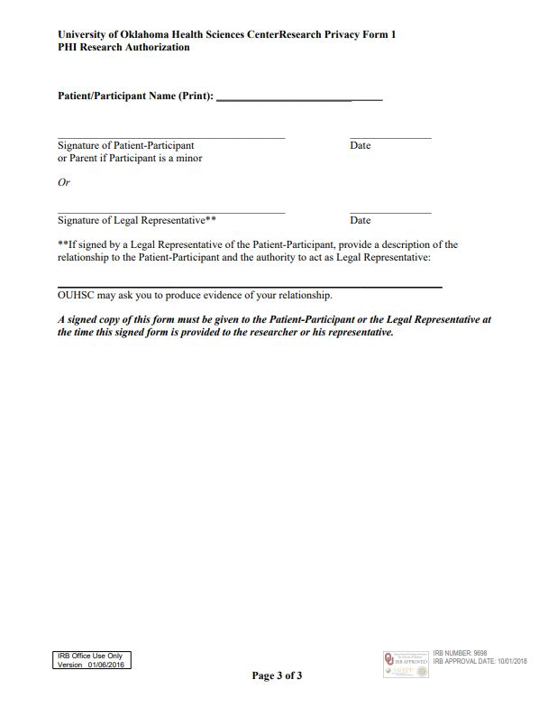

Appendix 4: Health History Screen

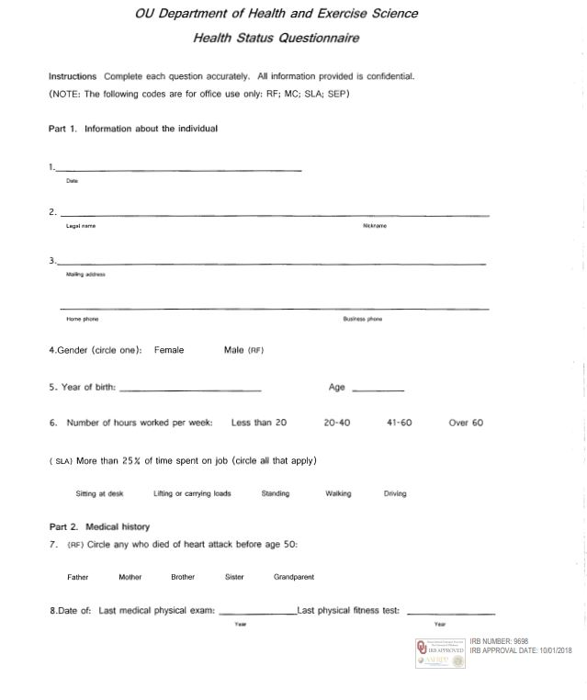

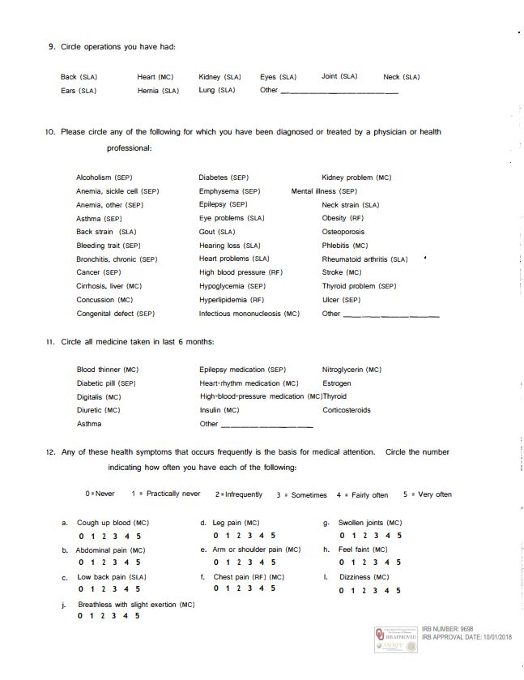

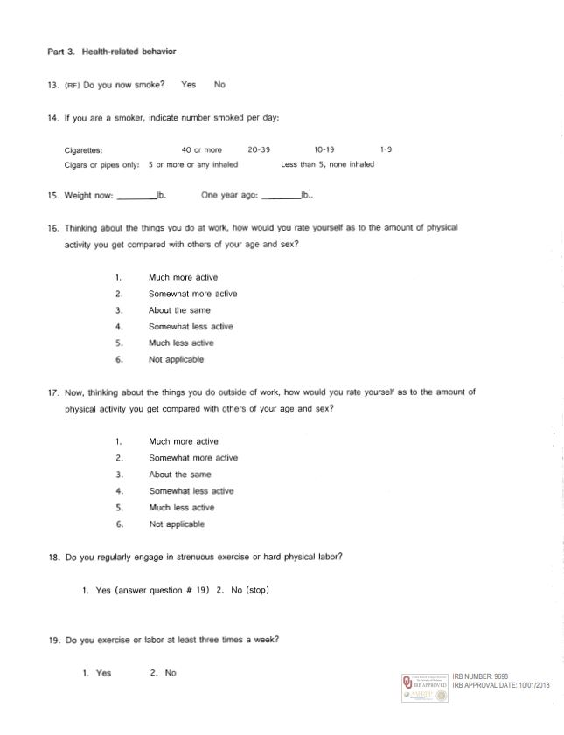

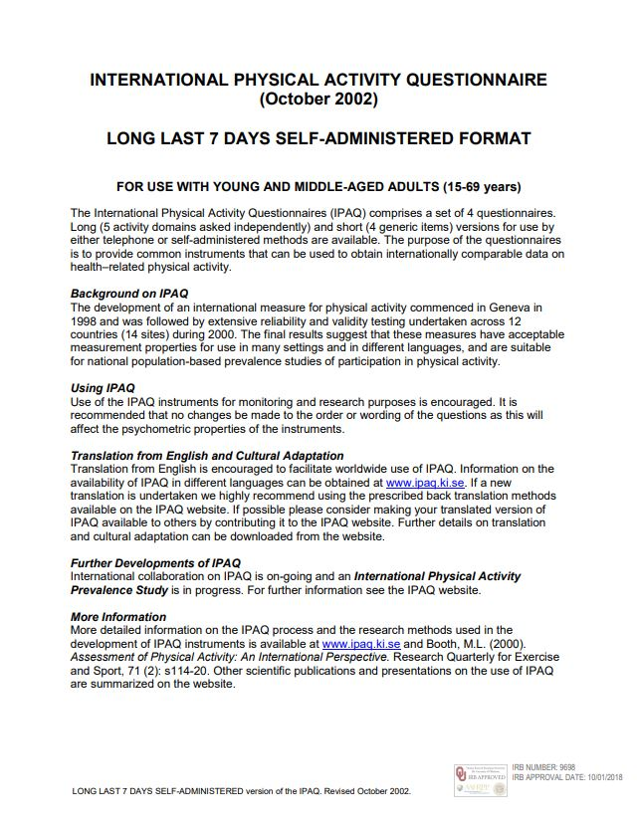
Appendix 5: International Physical Activity Questionnaire (IPAQ)

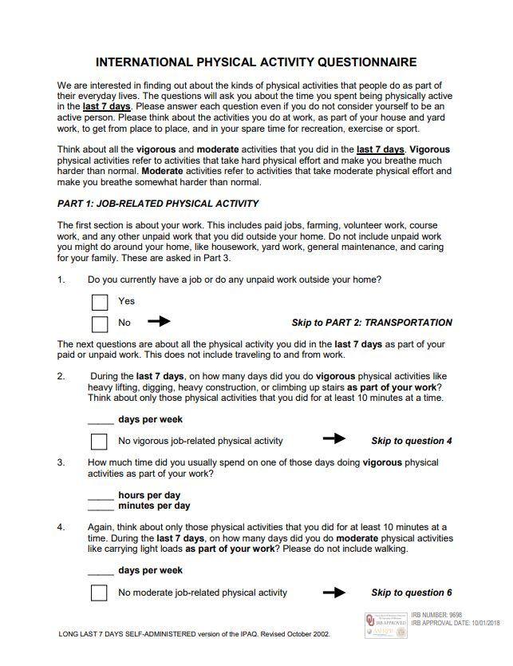

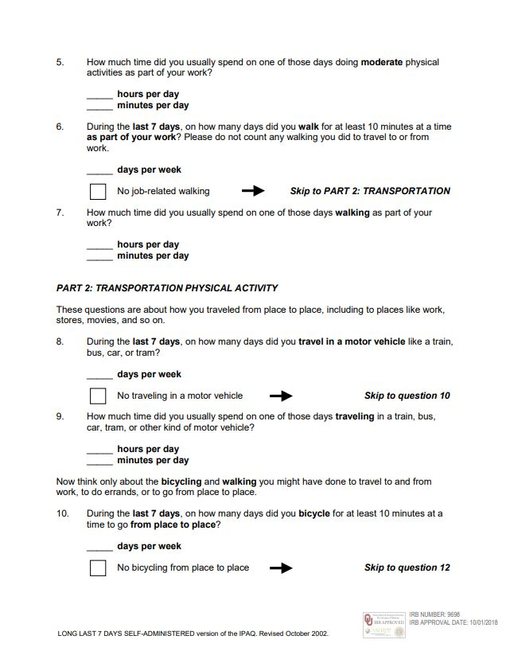

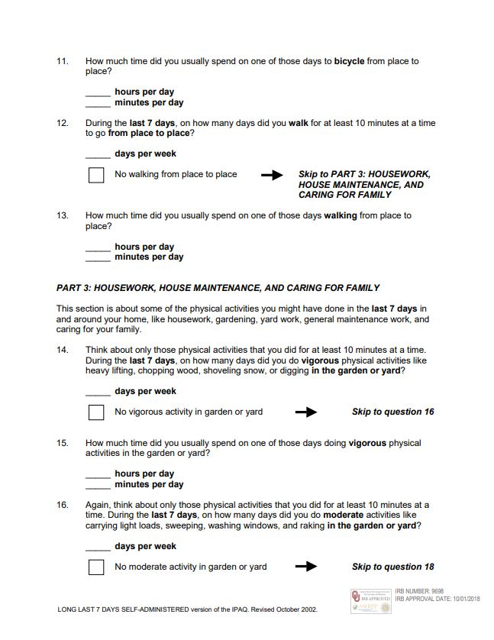

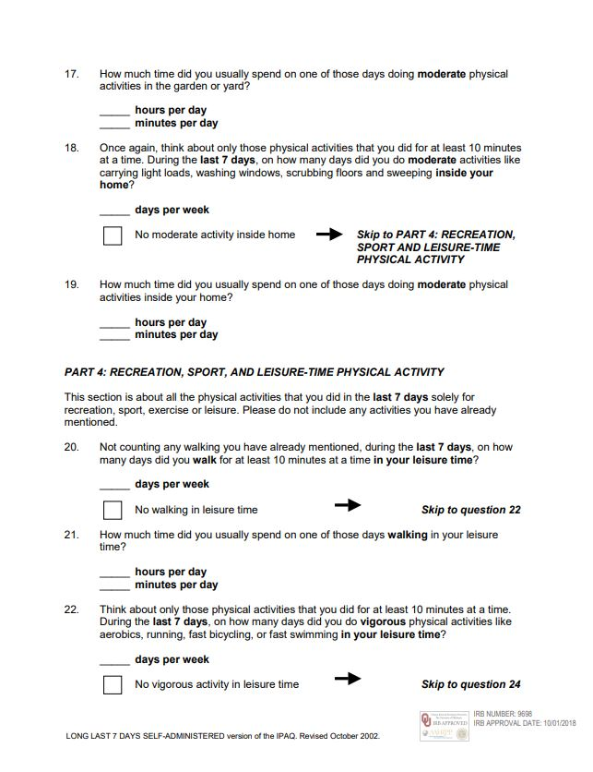

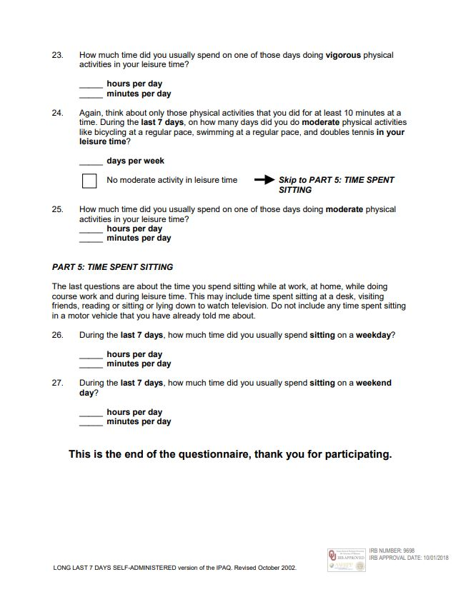

Appendix 6: Physical Activity Readiness Questionnaire


