UNIVERSITY OF OKLAHOMA
GRADUATE COLLEGE

AN EXAMINATION OF SKILL ACQUISITION, ADAPTIVE FUNCTIONING, AND EARLY INTENSIVE BEHAVIORAL INTERVENTION EFFECTIVENESS FOR CHILDREN AT-RISK FOR AUTISM AT EARLY FOUNDATIONS PROJECT DATA

A DISSERTATION
SUBMITTED TO THE GRADUATE FACULTY
in partial fulfillment of the requirements for the
Degree of
DOCTOR OF PHILOSOPHY

By
KAREN E. THURSTON
Norman, Oklahoma
2014

AN EXAMINATION OF SKILL ACQUISITION, ADAPTIVE FUNCTIONING, AND EARLY INTENSIVE BEHAVIORAL INTERVENTION EFFECTIVENESS FOR CHILDREN AT-RISK FOR AUTISM AT EARLY FOUNDATIONS PROJECT DATA

A DISSERTATION APPROVED FOR THE
DEPARTMENT OF PSYCHOLOGY

BY

Dr. Joseph Rodgers

Dr. David Bard

Dr. Kermyt Anderson

Dr. Lara Mayeux

Dr. Hairong Song

Dr. Robert Terry

© Copyright by KAREN E. THURSTON 2014
All Rights Reserved.
Dedication

I dedicate this to my children, Gehrig and Ellie, who supported me through it all. You saw my highs and my lows, and I felt your love every moment. You are my inspiration, my perseverance, my meaning, my joy, and my love. You only have one life; fill each day with what and who you love. That is the true meaning of everything.
Acknowledgements
I would like to thank my committee for their support through the years, especially my co-chair David for his guidance. I would also like to thank my co-chair Joe Rodgers who has been my mentor for over 20 years. He has not only taught me quantitative methods, poetry, and puns, but also how to do all the good I can for as long as ever I can. Thank you for being an amazing teacher, researcher, and friend.

Table of Contents
Acknowledgements ……………………………………………………………………………. iv
List of Tables ……………………………………………………………………………………….. vi
List of Figures ……………………………………………………………………………………….. vii
Abstract ………. ……………………………………………………………………………………….. xi
Introduction ……………………………………………………………………………………….. 1
Method ……………………………………………………………………………………………….. 13
Results …………………………………………………………………………………………………. 23
Aim 1 ………………………………………………………………………………………………… 24
ARIMA Summary ……………………………………………………………………………. 40
Aim 2 …………………………………………………………………………………………………. 41
Discussion .…………………………………………………………………………………………….. 47
Summary of Results …………………………………………………………………………… 47
Interpretations ……………………………………………………………………………….…. 51
Limitations …………………………………………………………………………………….….. 55
Future Directions …………………………………………………………………………….... 58
Conclusion …………………………………………………………………………………………. 59
References …………………………………………………………………………………………….. 61
[Appendix A: Tables ……………………………………………………………………………… 68
[Appendix B: Figures …………………………………………………………………………….. 89
[Appendix C: Programs at Early Foundations] ……………………………………….. 178

List of Tables
Table 1. Total Days Spent in the Five Basic Therapy Programs at Early……………….. 69
Foundations
Table 2. Total Sessions in the Five Basic Therapy Programs at Early ...................... 70
Foundations
Table 3. Measure of Intensity of Therapy for the Five Basic Programs ……………….. 71
at Early Foundations
Table 4. Total Days, Total Sessions, and Intensity For Five Basic ………………………… 72
Programs By Student Enrolled at Early Foundations
Table 5. ARIMA Models for Student Trajectories Through the Time Series ………….73
for Each Program at EF
Table 6. ARIMA Model Frequency by the Five Beginning Programs at …………………75
Early Foundations
Table 7. Dependent t-test Results Between Pre- and Post-Mullen ………………………76
Subscale Scores
Table 8. Correlations Between Mullen Subscale Pre- and Post-scores …………………77
Table 9. Pre-Mullen Subscale Scores Predicted by Post-Mullen …………………………..78
Subscale Scores Controlling for Years Between Measurements
Table 10. Effect Sizes (ES) for the Subscale Gain Scores ……………………………………….79
Table 11. Variables Measuring Age of Student Predicting Post-score Gains …………80
Table 12. Variables Measuring Intensity Predicting Post-score Gains …………………..81
Table 13. Correlations Between Total Number of Discrete Trials and Post-scores.. 82
Table 14. Joint Attention, as Measured by Days Spent in Set One of ………………….. 83
the Matching Program, Predicting Post-score Gains
Table 15. CII and Time Spent in Set 1 of Matching Predicting Post-score Gains …...84
Table 16. Gain Scores Predicted by Time Spent Mastering Set1 of Programs …….…85
Table 17. Bivariate Predictions With One or More Significant Variables ……………...86
Table 18. Mullen Subscale Pre-scores Predicting EF Program Characteristics ……...87
Table 19. Correlations Between Time Spent in Set One of Basic Programs at EF .…88

List of Figures

Figure 1. Loess curve fit through the Pointing program scores for all students……..…90
at EF
Figure 2. Loess curve fit through the Object Imitation program scores for all……..…..91
students at EF
Figure 3. Loess curve fit through the Gross Motor Imitation program scores…………..92
for all students at EF
Figure 4. Loess curve fit through the Waiting program scores for all students at EF…93
Figure 5. Loess curve fit through the One-step Directions program scores for…………94
all students at EF
Figure 6. Individual student trajectories through the Pointing program at Early………95
Foundations
Figure 7. Individual student trajectories through the Object Imitation program………96
at Early Foundations
Figure 8 Individual student trajectories through the Gross Motor program at Early…97
Foundations
Figure 9. Individual student trajectories through the Waiting program at Early……….98
Foundations
Figure 10. Individual student trajectories through the One-step Directions……………..99
program at Early Foundations
Figure 11. Student 100’s trajectories through basic skill acquisition programs…….…100
at Early Foundations
Figure 12. Student 100’s session observation data and ARIMA autocorrelation………101
information for Object Imitation
Figure 13. Student 100’s session observation data and ARIMA autocorrelation………102
information for Gross Motor
Figure 14. Student 100’s session observation data and ARIMA autocorrelation……...103
information for Waiting
Figure 15. Student 100’s session observation data and ARIMA autocorrelation……...104
information for One-step Directions
Figure 16. Student 100’s residual data and ARIMA autocorrelation information……..105
for One-step Directions ARIMA(1,1,0)
Figure 17. Student 101’s trajectories through basic skill acquisition programs………..106
at Early Foundations
Figure 18. Student 101’s session observation data and ARIMA autocorrelation……...107
information for Object Imitation
Figure 19. Student 101’s session observation data and ARIMA autocorrelation……...108
information for Gross Motor
Figure 20. Student 102’s trajectories through basic skill acquisition programs…….....109
at Early Foundations
Figure 21. Student 102’s session observation data and ARIMA autocorrelation………110
information for Object Imitation

Figure 22. Student 102’s session observation data and ARIMA autocorrelation………111
information for Gross Motor Imitation
Figure 23. Student 102’s session observation data and ARIMA autocorrelation………112
information for One-step Directions
Figure 24. Student 102’s differenced data and ARIMA autocorrelation…………………..113
information for One-step Directions ARIMA(1,1,0)
Figure 25. Student 103’s trajectories through basic skill acquisition programs………..114
at Early Foundations
Figure 26. Student 103’s session observation data and ARIMA autocorrelation………115
information for Object Imitation
Figure 27. Student 103’s session observation data and ARIMA autocorrelation………116
information for Gross Motor Imitation
Figure 28. Student 103’s session observation data and ARIMA autocorrelation………117
information for One-step Directions
Figure 29. Student 104’s trajectories through basic skill acquisition programs………..118
at Early Foundations
Figure 30. Student 104’s session observation data and ARIMA autocorrelation………119
information for Pointing
Figure 31. Student 104’s session observation data and ARIMA autocorrelation………120
information for Object Imitation
Figure 32. Student 104’s session observation data and ARIMA autocorrelation………121
information for Gross Motor Imitation
Figure 33. Student 104’s session observation data and ARIMA autocorrelation………122
information for Waiting
Figure 34. Student 104’s session observation data and ARIMA autocorrelation………123
information for One-step Directions
Figure 35. Student 105’s trajectories through basic skill acquisition programs………..124
at Early Foundations
Figure 36. Student 105’s session observation data and ARIMA autocorrelation………125
information for Object Imitation
Figure 37. Student 105’s session observation data and ARIMA autocorrelation………126
information for Gross Motor Imitation
Figure 38. Student 105’s session observation data and ARIMA autocorrelation………127
information for Waiting
Figure 39. Student 105’s session observation data and ARIMA autocorrelation………128
information for One-step Directions
Figure 40. Student 106’s trajectories through basic skill acquisition programs………..129
at Early Foundations
Figure 41. Student 106’s session observation data and ARIMA autocorrelation………130
information for Object Imitation
Figure 42. Student 106’s session observation data and ARIMA autocorrelation………131
information for Gross Motor Imitation
Figure 43. Student 106’s session observation data and ARIMA autocorrelation………132
information for One-step Directions
Figure 44. Student 107’s trajectories through basic skill acquisition programs………..133
at Early Foundations
Figure 45. Student 107’s session observation data and ARIMA autocorrelation………134
information for Object Imitation
Figure 46. Student 107’s session observation data and ARIMA autocorrelation………135
information for Gross Motor Imitation
Figure 47. Student 107’s session observation data and ARIMA autocorrelation………136
information for One-step Directions
Figure 48. Student 108’s trajectories through basic skill acquisition programs………..137
at Early Foundations
Figure 49. Student 108’s session observation data and ARIMA autocorrelation………138
information for Pointing
Figure 50. Student 108’s session observation data and ARIMA autocorrelation………139
information for Object Imitation
Figure 51. Student 108’s session observation data and ARIMA autocorrelation………140
information for Gross Motor Imitation
Figure 52. Student 108’s session observation data and ARIMA autocorrelation………141
information for Waiting
Figure 53. Student 108’s session observation data and ARIMA autocorrelation………142
information for One-step Directions
Figure 54. Student 108’s residual data and ARIMA autocorrelation information……..143
for Gross Motor Imitation ARIMA(0,1,0)
Figure 55. Student 108’s residual data and ARIMA autocorrelation information……..144
for Gross Motor Imitation ARIMA(1,1,0)
Figure 56. Student 109’s trajectories through basic skill acquisition programs………..145
at Early Foundations
Figure 57. Student 109’s session observation data and ARIMA autocorrelation………146
information for Pointing
Figure 58. Student 109’s session observation data and ARIMA autocorrelation………147
information for Object Imitation
Figure 59. Student 109’s session observation data and ARIMA autocorrelation………148
information for Gross Motor Imitation
Figure 60. Student 109’s session observation data and ARIMA autocorrelation………149
information for Waiting
Figure 61. Student 109’s session observation data and ARIMA autocorrelation………150
information for One-step Directions
Figure 62. Student 110’s trajectories through basic skill acquisition programs………..151
at Early Foundations
Figure 63. Student 110’s session observation data and ARIMA autocorrelation………152
information for Object Imitation
Figure 64. Student 110’s session observation data and ARIMA autocorrelation………153
information for Gross Motor Imitation
Figure 65. Student 110’s session observation data and ARIMA autocorrelation………154
information for Waiting
Figure 66. Student 110’s session observation data and ARIMA autocorrelation………155
information for One-step Directions
Figure 67. Student 111’s trajectories through basic skill acquisition programs………..156
at Early Foundations
Figure 68. Student 111’s session observation data and ARIMA autocorrelation………157
information for Waiting
Figure 69. Student 111’s session observation data and ARIMA autocorrelation………158
information for One-step Directions
Figure 70. Student 112’s trajectories through basic skill acquisition programs………..159
at Early Foundations
Figure 71. Student 112’s session observation data and ARIMA autocorrelation………160
information for Waiting
Figure 72. Student 113’s trajectories through basic skill acquisition programs………..161
at Early Foundations
Figure 73. Student 113’s session observation data and ARIMA autocorrelation………162
information for Object Imitation
Figure 74. Student 113’s session observation data and ARIMA autocorrelation………163
information for Gross Motor Imitation
Figure 75. Student 113’s session observation data and ARIMA autocorrelation………164
information for Waiting
Figure 76. Student 113’s session observation data and ARIMA autocorrelation………165
information for One-step Directions
Figure 77. Student 113’s residual data and ARIMA autocorrelation information……..166
for One-step Directions ARIMA(1,1,0)
Figure 78. Student 118’s trajectories through basic skill acquisition programs………..167
at Early Foundations
Figure 79. Student 118’s session observation data and ARIMA autocorrelation………168
information for Object Imitation
Figure 80. Student 118’s session observation data and ARIMA autocorrelation………169
information for Object Imitation ARIMA(1,1,0)
Figure 81. Student 118’s session observation data and ARIMA autocorrelation………170
information for Gross Motor Imitation
Figure 82. Student 118’s session observation data and ARIMA autocorrelation………171
information for Waiting
Figure 83. Student 118’s session observation data and ARIMA autocorrelation………172
information for One-step Directions
Figure 84. Gross Motor pre-Mullen by post-Mullen subscale scores……………………….173
Figure 85. Visual Reception pre-Mullen by post-Mullen subscale scores…………………174
Figure 86. Fine Motor pre-Mullen by post-Mullen subscale scores………………………….175
Figure 87. Receptive Language pre-Mullen by post-Mullen subscale scores……………176
Figure 88. Expressive Language pre-Mullen by post-Mullen subscale scores…………..177

Abstract
Autism spectrum disorder is characterized by communication and/or social deficits with restricted and repetitive behaviors. Treating autism is very costly, both financially and emotionally. Early Intensive Behavioral Intervention (EIBI) has been shown to decrease the symptomology for those with ASD; although, we cannot predict who will benefit from EIBI at this time. Discrete trial data were used for 15 students enrolled in EIBI in addition to developmentally appropriate social training. Individual student trajectories through time spent in therapy were analyzed using ARIMA modeling, and predictor variables of post-treatment gains were also explored. Time spent mastering basic skill programs significantly predicted post-Mullen subscale gains. Joint Attention is also a significant predictor. Also, error variance in the most complex of the five basic skill programs, One-step Directions, was a significant predictor of post-therapy gains. These potential tailoring variables to assess non-responders early in therapy will hopefully prove useful in individualizing treatment for children with ASD.

Autism, autism spectrum disorder (ASD), or Asperger syndrome are labels describing a condition defined by the DSM V that encompasses aspects of communication and/or social development along with restrictive and repetitive behaviors (American Psychiatric Association, 2013). One in 88 children suffer from one of these conditions, according to the Centers for Disease Control and Prevention’s Autism and Developmental Disabilities Monitoring Network (Centers for Disease Control and Prevention, 2012). Currently, all who suffer from deficits in social interaction and communication and exhibit restrictive and repetitive behavior (RRB) are now under one label, namely autism spectrum disorder (ASD), including pervasive developmental disorder not otherwise specified or PDD-NOS (American Psychiatric Association, 2013). All on the autism spectrum suffer from communication and/or social impairments with varying degrees of severity and could potentially see a decrease in symptomology if given the opportunity for early intervention. It is on intensive early intervention, student progression through therapy, and the predictors of success that this paper will focus.
Before understanding effective intervention, one must understand the deficits that characterize the diagnosis. As previously discussed, what is defined as autism is multifaceted and has been modified (American Psychiatric Association, 2013; American Psychiatric Association, 2000). Diagnosing autism and its many components is challenging; part of the reason lies in the varying causes of this condition and in the varying severity in symptomology. The cause of deficits that define autism and its increased prevalence is still illusive. It is generally understood that these deficits have a genetic component with 10-15% of cases being a single-gene condition, chromosomal abnormality, or having a known medical cause (Balasubramanian, Bhatt, & Goyel, 2009). These syndromic cases have special names like Rett Syndrome (MECP2 mutation), Fragile X Syndrome (X chromosome breakage), or Angelman Syndrome (maternal chromosome deletion) (Caglayan, 2010) and have specific homogeneous causes within syndrome. Other cases of ASD are due to de novo gene mutations at varying loci (Veenstra-VanderWeele & Cook, 2004; Caglayan, 2010). Although a hereditary component exists, behavior genetics also points to gene/environment interactions (Edelson & Saudino, 2009). For example, pregnant mothers under severe stress during certain times of fetal development are much more likely to have a child with autism than the normal population of mothers (Mehler & Purpura, 2009). Another environmental predictor of increased risk is pollution (Bertand et al, 2001). Whatever the cause or the situation the family is experiencing, the diagnosis of autism in a child is often complex and devastating.
The emotional toll aside, the financial costs are catastrophic. The CDC (2012) estimates the annual costs to be $40,000-$60,000; whereas, the costs over the lifetime of a child with autism without cognitive disabilities has been estimated to be $1.4 million and $2.3 million for those with cognitive disabilities (“New Research Finds”, 2012). With such a high prevalence rate and soaring costs, ASD has a major impact on individuals, families, schools, and communities.
In order to understand, model, and ameliorate these effects, researchers have increasingly focused on the study of autism. One important finding is that early intensive behavioral intervention (EIBI) has significantly decreased the debilitating effects for many with disabilities (Lovaas, 1987; Bryant & Maxwell, 1997; Shonkoff & Hauser-Cram, 1987; Barratt, 1992; Eikeseth, Smith, Jahr, & Eldevik, 2007; Warren, Stone, & Humberd, 2009; Allen, 2011). According to Reichow (2012), of the five meta-analyses studying the treatment of children with autism, four reported marked improvement with effect sizes for mean IQ from .69-1.19 and for mean adaptive behavior from .42-1.09 (Eldevik et al., 2009; Reichow & Wolery, 2009; Virues-Ortega, 2010; Makrygianni & Reed, 2010). The exception study reported effect sizes for mean IQ = .38 and mean adaptive behavior = .30 (Spreckley & Boyd, 2009). It has been noted methodological concerns exist in prior research, namely the lack of randomization, the use of standardized assessments, consistent use of assessments pre- and post-treatment, and small sample sizes (McBride & Bard, 2012). However, Warren et al. (2011) stated not enough evidence exists to know the most effective intervention for individual children with ASD nor how to predict subgroups of responders.
Many of these intervention methods are based on applied behavioral analysis (ABA) that looks at how learning takes place (Virues-Ortega, Rodriguez, & Yu, 2013). The use of positive reinforcement to reward desired behavior makes the behavior more likely to be repeated (AutismSpeaks.org, 2013). EIBI based on ABA is one of the first treatments for children with autism (Reichow, 2012), and has been extensively researched and tested empirically (Virues-Ortega, Rodriguez, & Yu, 2013). There are various methods to execute this type of training. Two of the most widely used are the Early Start Denver Model (ESDM) and IBI based on the UCLA Model (Lovaas, 1987; Dawson et al, 2010; Virues-Ortega, Rodriguez, & Yu, 2013). Often referred to as the Lovaas method, the UCLA model utilizes 1:1 discrete trial training in a home-based setting for up to 40 hours/week lasting typically 2 or more years (Lovaas, 1987). Discrete trial training includes individual teaching attempts of a complex skill broken down into basic components. These trials are well-defined with scripted instructions that must be followed (Cosgrave, 2014). ESDM was developed for infants to preschool-aged children with ASD to meet the needs of toddlers as young as 12 months; it expands ABA with “developmental and relationship-based approaches” (Dawson et al, 2010). Both of these methods have led to significant gains for children with ASD (Lovaas, 1987; Zachor & Itzchak, 2009; Dawson et al, 2010; Virues-Ortega, 2010; Virues-Ortega, Rodriguez, & Yu, 2013); however, not every child shows significant gains (Zachor & Itzchak, 2009; Ozonoff & Cathcart, 1998; Reichow, 2012; Virues-Ortega, Rodriguez, & Yu, 2013). Some important issues are how to reliably diagnose autistic children at a very early age, how to define success, how to define intensity, how to time therapy initiation, and how to predict who will benefit from intervention.
Previously, DSM IV-TR required symptoms to occur prior to three years of age; however, the DSM V states that symptoms must be present in the developmental stages of childhood, although they may not manifest completely until the child enters a situation like preschool or kindergarten that tests abilities necessary for social interaction with others (Compart, 2012). In addition, not every family member nor pediatrician recognizes the early signs of autism. Although ASD can be reliably detected as early as 14 months (Tek & Landa, 2012), researchers investigating how to better train physicians have found that many physicians do not feel adequately knowledgeable to make a diagnosis (Gillis, 2009). In addition, a delay in diagnosis may occur due to cultural differences, ethnicity, or screening practices (Tek & Landa, 2012; Mandell et al, 2009). If the child is one of the few referred for assessment, s/he may start to receive services at a beneficial early age although it is reported that only 15% of children eligible for special education received early intervention (Bailey et al, 1999). As autism becomes more widely known, it is the hope that parents and their physicians will improve their ability to recognize warning signs in very young children and work toward early assessment and intervention.
With improved ability to detect children at risk and with early intense intervention, success is more likely. But how is success defined? Some define it as more children being able to enter typical classrooms (Compart, 2012; Terry-Cobo, 2013), others define it as increased IQ scores (Lovaas, 1987; Eikeseth et al, 2007), whereas others use measures of adaptive functioning (Dawson et al, 2010; Reichow, 2012). How one defines success has varied from study to study, creating difficulty in comparing results and interpreting findings.
Another term inconsistently defined in the literature is intensity (Eldevik et al, 2006; Warren, Fey, & Yoder, 2007; Reichow, 2012). Recently Warren, Fey, & Yoder (2007) addressed this issue and called for increased awareness in the research community. They stated that there exists no widely accepted definition of treatment intensity, nor is there a measurement that incorporates the multiple variables that go into therapy interactions: how often the child sees the instructor, how long the child works with the teacher when they are together, the quality of instruction, the type of intervention, and how long overall a child is in therapy. Following a medical model, Warren et al. defined key terms that are necessary to get a more precise terminology for researchers. Dose is defined as “the number of properly administered teaching episodes during a single intervention session”, dose form is defined as the activity that occurs during the session, dose frequency is defined as “the number of times a dose is provided per day and per week”, and total treatment duration is defined as length of the overall treatment (Warren, Fey, & Yoder, 2007). To include a multifaceted measurement of intensity, they also defined Cumulative Intervention Intensity (CII) as a combination of dose, dose frequency, and total duration of intervention as follows:
CII = (dose) x (dose frequency) x (total treatment duration)
Researchers have since applied these new definitions based on the extension of the medical model to behavioral interventions in many fields (Baumann, 2009; Hoffman, 2009; Ukrainetz, Ross, & Harm, 2009; Allen, 2011; Edeal & Gildersleeve-Neumann, 2011; McGinty et al, 2011; Reichle, 2011). Allen (2011) studied communication disorders and found significant improvement for the intense treatment group receiving therapy 3x per week with no significant difference for the low intensity group (1x per week) nor the active control. Functional communication in children with spoken language impairment, also a deficit in those with ASD, was shown to improve with increased number of treatment units; however, the baseline level of language ability correlated with the need for more units of treatment to show improvement (Bellon-Harn, 2012). Furthermore, high dose frequency was more effective than low dose frequency, but it is important to note that dose is a mitigating factor (McGinty et al, 2011; Bellon-Harn, 2011). It has been shown that as long as the number of interactions per session, or dose, is high, outcomes are almost identical in a low frequency of sessions per week as in a high frequency of sessions per week (McGinty et al, 2011; Bellon-Harn, 2011). In other words, perhaps it is not how often the child works with a therapist or instructor, but the length of time of the sessions. This type of effect is common with learning any new skill. For the same reason a piano teacher would rather have her pupil practicing a new song three times a week for 20-30 minutes rather than ten minutes every day, perhaps a child needs focused repetition to learn social, communication, and cognitive tasks.
Intensity of treatment is important, but so is the timing of intervention initiation. One of the hypothesized reasons for the increased outcomes for those in early intervention is the brain's plasticity (Zachor & Itzchak, 2009; Kolb & Whishaw, 2011). As the brain develops, networks of neurons and mirror neurons develop connections and neuronal specificity in childhood based on experiential exposure (Carr et al, 2003; Corradini & Antonietti, 2013). As with any language development, early exposure is key to the development of the ability to perceive nuances of linguistic sounds and interpret their meaning (Newport, 2002). The same seems to be true for social development, as well as interpreting nonverbal communication and social prompting (Smith, Groen, & Wynn, 2000). With early repetitive exposure in areas of disability, namely communication, imitation, cognition, and social skills, children with ASD develop the ability to understand language, use cause-and-effect reasoning, and carry on a socially interactive conversation with others.
These outcomes are not achieved simply by being in therapy. The quantity and quality of therapy (necessary as a means to help define the intensity of therapy) and the characteristics of the child will determine whether the outcome will be deemed successful. Not every child with autism sees significant improvement (Bailey et al, 1999; Prior, 2004). Currently, it is not known how to predict who will benefit from EIBI (Prior, 2004); if we had the ability to predict the children who would not benefit, families of these children could be spared great expense in continuing traditional EIBI.
A promising approach to understanding non-responders of treatment is in the use of the Sequential Multiple Assignment Randomized Trial (SMART) (Lei, Nahum-Shani, Lynch, Oslin, & Murphy, 2012; Murphy, 2005). The goal of SMART designs is to understand the most efficient and effective treatment for each individual based on his or her own previous data, not the previous probabilities of other individuals in prior studies, as is the case with traditional randomized trials (Murphy, 2005). These adaptive interventions are characterized by a series of critical decisions about the type and timing of initial treatment, treatment options (dose, duration, etc.), the use of tailoring variables to help define how to define treatment to optimize outcomes for each individual, and the adaptability of treatment based on each individual’s performance characteristics (Lei, Nahum-Shani, Lynch, Oslin, & Murphy, 2012). According to Lei et al. (2012), SMART designs are especially useful if the individual exhibits comorbidity which is very likely in children with autism. A child that suffers from Obsessive Compulsive Disorder or Attention Deficit Disorder will need treatment tailored to the needs of working within the confines of the comorbid disorder in order to see progress. The ability to predict who will improve requires the ability to understand individual trajectories, to classify characteristics common to those with similar trajectories, to measure outcome transitions, and to use appropriate measures of skill mastery and success, all major goals of this research.
Appropriate measures of success in therapy should be derived from the purpose and goals of the therapy. For autistic children lacking in communication skills (verbal and nonverbal), social skills, imitative skills (object and motor imitation), and cognitive skills, using IQ to measure success may not be appropriate. Although past research has used IQ as the outcome measure to define improvement (Lovaas, 1987; Eaves & Ho, 2004; Dietz et al, 2007; Eikeseth, Smith, Jahr, & Eldevik, 2007), the DSM V has moved away from IQ and uses measures of adaptive functioning to determine intervention success (Swedo, 2012).
Two widely used tools to assess young children’s abilities and therapy effectiveness are the Vineland Adaptive Behavior Scales and the Mullen Scales of Early Learning. The Vineland Adaptive Behavior Scales (VABS) measure personal and social skills (Sparrow, Cicchetti, & Balla, 2005). VABS contains several subscales to measure communication, socialization, daily living, and motor skills (motor skill subscale is only applicable for children under 6). Eldevik, Eikeseth, Jahr, & Smith (2006) reported that EIBI children showed significant improvement in VABS Communication scale scores, improving in both language comprehension and expressive language skills, after EIBI. In addition to the VABS, important measures of cognitive and motor ability can be assessed using the subscales of the Mullen Scales of Early Learning (MSEL); MSEL subscales are gross motor (large movements), visual reception (ability to process information using memory, patterns, and sequencing), fine motor (manipulation of objects using hands), expressive language (using language productively), and receptive language (ability to follow directions and understand concepts and sequencing) (Mullen, 1995). Children with autism are reported to have lower scores than typical children on all subscales of the MSEL (Akshoomoff, 2006). The combined use of both the VABS and the MSEL in children on the autism spectrum moves toward a more complete assessment of a child’s abilities, functioning, and overall outcome of EIBI success. Pre- and post-scores from standardized, validated measures like the VABS and the MSEL should be taken to assess skill acquisition during intervention therapy. As children move through behavioral intervention training in autism therapy centers, they are hopefully gaining the abilities they need to become well-adapted children who can enter the typical classroom and see a better quality of life, although we know not every child sees the same level of improvement.
Both intra-individual and inter-individual trajectories for the specific skills training programs will be examined. I hypothesize that there will be variability in the way children master skills, but that children will show clustering in the patterning of progressions. Perhaps this will be due to severity of diagnosis, the level of motivation in the child (or lack of motivation), or mediation by joint attention ability. Joint attention is the ability for two people to share focus on an object together (Krstovska-Guerrero & Jones, 2013). Joint attention is expressed through communication skills and various interactions with others, and ASD children show diminished joint attention abilities (Loveland & Landry, 1986; Krstovska-Guerrero & Jones, 2013). I also hypothesize that children who score higher on the adaptive behavior measurements (MSEL) at intake (pre score) will progress more rapidly through the skill programs (Dawson et al, 2010; Virues-Ortega, Rodriguez, & Yu, 2013), which I believe will be especially true after the basic level of the skill is mastered.
Virues-Ortega, Rodriguez, & Yu (2013) reported the trend for children with higher VABS and MSEL scores at intake to show better outcomes; however, intake scores were not always the best predictor of outcomes. Total intervention time, a measure of duration and intensity calculated by multiplying hours/week in training by the weeks of therapy, was the single best predictor of outcome. Other reported predictors included age and scores at intake. Results showed the best outcomes for longer intervention time, lower age at intake, and higher scores at intake. Having stated their contribution was methodological, Virues-Ortega, Rodriguez, & Yu (2013) called for future studies to provide practical contributions to “evidence-informed clinical decision-making”. Informing the therapy process is a major goal of this research. Both the therapist and parent(s) want to know if the child will be able to attend school in a regular classroom and what areas of deficit will show improvement (Virues-Ortega, Rodriguez, & Yu, 2013).
Predictors of improvement include mastery vs. non-mastery of individual skill programs and the overall length to mastery for each skill program. This research focuses on the beginning programs given to children upon entering Early Foundations (EF) Project DATA (for developmentally appropriate treatment for autism) as predictors of post-score measurements on the MSEL (VABS was not initiated until more recently at EF). The scope of this project allows the prediction of post-Mullen scores based on their progression through the basic skills needed to communicate, imitate, and understand how to relate to others.
The basic skills needed to progress to more complex skill acquisition can be referred to as behavioral cusps; these cusps are behavioral changes that influence other aspects of life perhaps allowing access to new abilities and behaviors (Bosch & Fuqua, 2001; Hixson, 2004). For example, the ability to use a finger to point to and touch an object allows access to the use of a telephone or touchpad screens on electronic devices. Perhaps the behavioral cusp of attention allows students to improve standardized measures simply by being able to sit through the process and attend to the items being asked; therefore, the published increase in IQ scores of children in EIBI could be a factor of gaining the ability to attend rather than an increase in intrinsic intelligence. This also might explain the variability in EIBI outcomes reported in the literature (Schreibman et al, 2009). It could be possible that an increase in MSEL scores could be partially attributed to an acquired basic skill such as attention; however, using the varied subscales of the MSEL provides a more complete measurement of true ability or mastery of adaptive functioning as measured by these standardized assessments.
Weiss (1999) reported that ASD children show great variability in total days to mastery on very basic skills during EIBI. Furthermore, the higher total days to mastery predicts lower post-therapy scores and the difference between pre-and post-scores. She suggested that children not be excluded from therapy, but the goals of therapy may need to be altered to better individualize treatment (Weiss, 1999).
Research Aims
Aim 1: Program mastery
The five basic skill programs of Project DATA will be examined using ARIMA modeling to describe student trajectories through skill acquisition. The variability in trajectories will be examined between-and within-students.
Aim 2: The prediction of treatment response
The response to therapy will be examined with linear and multiple regression using the following predictors of outcome: baseline measurements prior to therapy, how fast the student masters programs, and features of program trajectories. Also included in the prediction of treatment response is the ability of a measure of intensity to predict outcome and the length of time to program mastery.
Aim 3: Examination of underlying factors
An extension of this project is to use dynamic factor analysis to look at underlying factors that might explain trajectory variability and variability in treatment response.

Method
Participants
Participants were children enrolled in Sooner Start, Oklahoma's early intervention (EI) program designed to meet the needs of young children, who had disabilities and developmental delays (Sooner Start, 2013). These participants, identified as at-risk for autism spectrum disorder (ASD) or exhibiting autistic tendencies, were referred to the Autism Model and Outreach Project at Early Foundations (EF). These referrals have occurred for children as young as 15 months, but the typical referral age is 20-24 months. Since 2007, 20 students have been trained at Early Foundations; however, one student was removed from these analyses a priori due to comorbid severe medical conditions, and four were withdrawn by their families early in treatment (not enough data existing for these four, so they were not considered further in any analyses below). The student sample of size 15 is 60% male and 40% female, ages 15 months to five years. Due to the high ratio of males to females (4:1) in the ASD population, a male majority is expected (Muhle et al, 2004). Most children are in therapy at EF for approximately 24 months. Based on age restrictions (children cannot be enrolled in pre-K if their fifth birthday is before September 1), most children leave the therapy program at age four. It is important to note that most of these children do graduate the therapy program with the goal of entering a regular classroom setting.

Materials and Procedure
The therapy at Early Foundations, known as Project DATA, is characterized by intensive weekly one-on-one training in the classroom with an instructor, free-play time, home visits by knowledgeable staff to extend classroom interaction and training into the home environment, and playgroup exposure to neurotypical children of the same age group. The therapy program is defined as “intensive” due to the child being in the classroom 15 hours with 5 hours of at-home training for a total of 20 therapy hours per week. The at-home training includes discrete trial sessions with an instructor, instructor-aided outings with the parent(s), and parent training to deliver instruction after the staff member leaves the home. Both instructors and parents are involved in working with the child to ensure progress and to help each child reach typical developmental markers. Following Warren, Fey, & Yoder’s (2007) terminology, students at Early Foundations receive intensive therapy in each EF program based on repeated discrete trials in a session (dose); program skill sets in the classroom, at home, and in playgroup (dose form); a documented number of discrete trials each session, week, and over their time at EF (dose frequency); and total treatment duration (how long the student was in the program). Most students mastered the programs in which they participated, but a few did not.
During classroom one-on-one training with an instructor, programs are utilized to better understand the child’s current abilities, along with documenting daily progress of the student. The five basic programs that each student is typically given at the onset of training consist of Pointing, Object Imitation, Gross Motor Imitation, Waiting, and One-step Directions. These skills are deemed necessary to master prior to introducing more complex topics such as matching, asking questions, and emotions. These five programs are categorized under four major factors: communication, cognition, social, and imitation, common areas showing diminished ability in children with ASD. Joint attention is measured with the Matching program. There is a separate program at EF called Joint Attention, but it was not introduced into the curriculum until recently; therefore, only recent graduates received this program.
A complete list of programs is available in the Appendix.
Although each program varies in its focus or intended result, the programs follow a common format and rules for progression. Depending on the type of program, sets/subsets are defined such that a child is introduced to a skill on a very basic level and then proceeds with increased complexity until all the sets/subsets are mastered. A student is said to have mastered a particular set if on two consecutive sessions the student responds correctly and independently to at least 90% of the discrete trials in each session. A session is defined as a child’s interaction with a particular instructor on a particular day using a specified program. Some sessions have 10, 20, or even 30+ discrete trials, and it is possible to have more than one session of a particular program on a given date. Repeated sessions are usually the result of the student being evaluated by both the classroom instructional assistant (IA) and an EF program administrator to check inter-rater reliability and the student’s progression. Repeated program sessions on a single date can also be the result of a student’s involvement in both the morning and afternoon training sessions, which usually occurs only in older students about to graduate from EF. It is important to note that several sessions from differing programs are worked on each day that the child is in the classroom, depending on how many current skill programs the student is in the process of mastering. As stated, a session can have varying number of discrete trials. A discrete trial is operationalized as an instructor’s prompting a student at either the P1 (instructor-executed response), P2 (instructor-aided response), or PInd or Independent (student-executed response) level. For example, an IA may show the student three cards each with a differing colored circle and ask the student to point to the blue circle. At the P1 prompt level, the IA would take the child’s finger and move it to the blue circle card and praise them for the correct answer. This level of prompting is structured so that praise, positive reinforcement, and success are guaranteed. At the P2 prompt level, the IA themselves might point at the card with the blue circle or move that card in the child’s direction before the student points to it herself. If, however, the IA is using the PInd prompt level, the IA would ask the student to point to the blue circle and not give any direction or help completing the request. Each student is positively reinforced using a method based on the child’s taste preferences when treats are used or desired objects when play is used. The goal of every program set, whether it is a beginning set or the final difficult set in the program, is for a student to correctly respond to a request independently and consistently at the 90% or greater level. Once this goal is reached, either the subsequent set is used in the future sessions or the student is finished with that program if the final set was mastered. When this occurs, an additional program or several programs are added to the student’s current training. These are assigned by the director based on the child’s apparent needs, resulting in a unique order for each student.
During the past six years, IAs have collected data using an assigned binder for each child. These binders contain the program data sheets where session data are recorded, typically three sessions per sheet. Ideally, each session includes the IA’s name, date of session, set number, and up to 35 discrete trials listing the prompt level (i.e., P1, P2, P3, or PInd) and response (+ or -) for each trial. Also included in a student’s file are his outcome assessments, namely the Mullen (test of cognitive and motor ability assessing school readiness) (Mullen, 1995) and, when available, the Vineland II Adaptive Behavior Scales (measuring personal and social skills) (Sparrow, Cicchetti, & Balla, 2005). Some students have pre- and post-therapy outcome assessments while others have only a pre- or a post-assessment. When a child graduates, file folders are created from all the program sheets and outcome assessments and are stored at the data collection site. To allow for modeling of student progression through the autism program, this project has converted the paper files into an electronic Access database stored on a secure server in the Department of Pediatrics at the University of Oklahoma Health Sciences Center. Analyses were completed using a de-identified table of data and SAS software Version 9.2, and graphs were generated using SAS/GRAPH software Version 9.2.
To create the electronic database, instructional assistants having knowledge of program information and understanding of program documentation were utilized to safeguard accuracy and consistency of data entry. Their entries were periodically sampled and compared with the original data to ensure the validity of the data entry process. Fidelity of the program was also checked periodically by the directors’ personal assessment of students to compare progress documentation with the IA’s documentation.
Measures
The Mullen Scales of Early Learning (Mullen, 1995) were used to assess at-risk ASD children referred to Early Foundations Project DATA. The MSEL measures cognitive functioning and is given to infants and children up to 68 months of age. The five subscales (Gross Motor, Visual Reception, Fine Motor, Receptive Language, and Expressive Language) measure nonverbal problem solving and are scored with raw scores and T scores (M = 50, SD = 10) with the raw scores being analyzed for this project (Stone, McMahon, Yoder, & Walden, 2007).
Given that children attend class on a consistent basis, the time metric will be the “session”. Sessions are days spent in training at EF; however, not every program was taught every session. The session outcome measure is being defined in two ways, the proportion of correctly answered independently prompted trials (proportion of “successes”) and a quantified measure to include set difficulty. This second measure is calculated based on set mastery. At set one, the measure is the proportion of successes as described above. At set two, set one has been mastered. This knowledge is then “added” to the proportion correct measure to create a value of 1+the proportion correct of set two. At set three, both set one and set two have been mastered; therefore, the outcome measure is 2+ the proportion correct. The calculation of the outcome measure using this algorithm continues until all the sets in the program are mastered. The lag times between the students’ starting Project DATA and the students’ mastery of skills will also be assessed for between-student and within-student variability. What is unknown is if skill mastery in the communication (pointing), imitation (object and gross motor), social (waiting), and cognitive (one-step directions) domains are independent of each other or if there is overlap in the mastery of these skill sets. An exploration into trajectories of longitudinal data of intensive therapy trials and their assessment outcomes will provide insight into what defines effective therapy.
Statistical Analyses
The data are longitudinal over typically several years while the student is enrolled at EF. The auto-regressive integrated moving average (ARIMA) model is used to analyze longitudinal data and takes into account autocorrelations (similarity between observations as a function of the time lag between them), trends in the data, and a random component (called a shock) (Tabachnick & Fidell, 2006). Time series analyses using ARIMA modeling will be utilized to explore whether the student trajectories in the five basic skill programs follow similar patterns or if students differ in their progressions. It is also possible that a student could progress through certain skill programs in sync as other programs follow a different pattern. Trajectory variability was explored at the individual and group level.
Each student’s individual trajectory through each of the five beginning programs at Early Foundations was analyzed using Autoregressive Integrated Moving Average (ARIMA) modeling. It is thought (Chatfield, 1996) that a minimum of 50 observations are required to give reliable t-tests and error estimates. For this exploratory project, the procedure was also employed for programs with 20-49 observations if the graph of raw data and the ACF panels supported the suspected relatedness in the lags. ARIMA(p,d,q) models account for observations’ dependency upon previous observations (the ‘AR’ portion denoted by p), the number of times scores must be differenced to remove trends (the ‘I’ portion denoted by d), and the dependency in previous random shocks (the ‘MA’ portion denoted by q) (Tabachnick & Fidell, 2006). ARIMA models that account for the correlations in the residuals, or autocorrelations, are deemed adequately complex to fully model the time series. Some common ARIMA designations are (0,1,0) described by
Y_{t} = µ + Y_{t-1} + a_{t}
where µ is the mean of the first differenced scores and a_{t} is the random shock at that time period.
Y_{t} = φ₁ (Y_{t – 1}) + a_{t}
describes a simple auto-regressive model (1,0,0) where φ₁ is the correlation coefficient that indicates the magnitude of the relationship between observations at lag 1 (Tabachnick & Fidell, 2006). Simple moving average components, denoted (0,0,1) are represented by
Y_{t} = a_{t} – θ₁a_{t – 1}
where θ₁ represents the magnitude of the relationship between the current score, Y_{t}, and the random shock at lag 1.
There are two main steps to ARIMA modeling and beginning parameter selection, identification and estimation and diagnostic checking (SAS Institute Inc.). In the identification phase, the graphs of the raw scores were examined and analyzed to identify if the data in each series were stationary, meaning that they varied around a constant mean level over time (Tabachnick & Fidell, 2006). Differencing will usually transform any non-stationary data into stationary data. A visual examination of the autocorrelation function graphs and the use of the white noise test (an approximate significance test of no autocorrelations in the series to a certain designated number of lags) discerned if any significant autocorrelations existed. Only autocorrelations to lag six will be given unless otherwise noted. When a series had significant autocorrelations, a forward stepwise approach was utilized to begin model selection focusing on the ideas of parsimony and fit. The simplest model that accounted for the autocorrelations in the data was identified as the best model for the series. During model testing, if the white noise test on the residuals was significant, additional information existed and was accounted for by using a more complex model.
The results of these exploratory analyses will help inform if current therapy practices or if the development of individualized therapy would lead to more successful skill acquisition for children exhibiting deficits in areas that characterize ASD. These exploratory results can shape future project aims as well as the implementation of treatment at EF. If certain characteristics are found to predict student progression, therapy could be tailored to the individual child. It is also important to know if there is independence or dependence in the mastery of basic skills. For example, it might be true that other skills cannot be mastered unless pointing, a basic way of communicating, is first understood and demonstrated by the child. Perhaps this is the reason why some children are instructed on the first set of a program for over a year with no progression. In these cases, both the instructor and child become frustrated when mastery is not understood or obtained. Understanding why this occurs would mean valuable resources, human and financial, would no longer be expended during a period of ineffective training. Knowledge of what makes EIBI successful will have far-reaching effects. Knowing how to predict who will benefit, knowing how to make therapy more effective, and knowing how to lessen the impact on families and communities are the aims of this research project.
Results
Descriptive statistics including overall and programmatic measures of central tendency and variability for each of the five programs were computed. Each program’s length (see Table 1), sessions (see Table 2), and intensity (see Table 3) were included. Days, sessions, and intensity data were also calculated for each student (see Table 4). Overall, the average length of a program was 278.10 days with a standard deviation of 220.36. Loess curves were added to program data to aid seeing a pattern in the noise (see Figures 1-5). These trend lines appear to show periods of group growth and regression in the skill programs with Object Imitation showing the most consistent growth. There was great variability both between- and within-programs. To better understand skill acquisition past basic summaries, time-series modeling was used to examine individual trajectories.
Aim 1:
An examination of the student trajectories (see Figures 6-10) showed both intra-individual and inter-individual variability in skill acquisition for the five programs. It seemed as if some students began progressing through the sets of a program almost immediately as others showed no progress for many sessions. Some students never progressed; others eventually showed a steep slope of progression. Similarities and differences are discussed throughout the individual student results assessments.
Student OKMA100 (see Figure 11)
Student 100 (arbitrary names in order to refer to specific trajectories) received all five programs, but progressed very slowly through most except for Waiting. Object Imitation and Gross Motor Imitation showed more parallel progression than did One-step Directions; this student only received 11 sessions of Pointing, not enough to track a reliable trend in progression over time. Because of the few observations in program 1, Pointing was excluded from ARIMA modeling for this student (see Figures 12-15).
Object Imitation (N = 87): There was a very significant level of autocorrelation (χ₆² = 335.47, p <.0001). The increasing trend in the data and the slowly declining ACF also indicated definite autocorrelation (see Figure 12). The data were differenced, and the test of autocorrelation was no longer significant (χ₆² = 6.23, p = .40). ARIMA (0,1,0) adequately modeled the information in this time series (see Table 5). Even though µ was not quite significant (.05, p = .08), the AIC fit statistic was smaller indicating better fit than the model without the constant.
Gross Motor Imitation (N = 114): This program also showed a slowly declining ACF (see Figure 8), indicating significant autocorrelation (χ₆² = 470.03, p <.0001). After taking the first difference, the autocorrelations were not significant (χ₆² = 7.70, p = .26). The data were well-fit by ARIMA (0,1,0) with µ (see Table 5).
Waiting (N = 44): Initially, the check for white noise was significant (χ₆² = 125.93, p <.0001); however, after differencing, the significant autocorrelations were eliminated (χ₆² = 6.60, p =.36). Again, ARIMA(0,1,0) explained this series.
One-step Directions: Very significant autocorrelations (χ₆² = 1083.69, p <.0001) were not removed after differencing (χ₆² = 12.68, p =.048), especially showing significance in later lags to lag 12 (χ₁₂² = 25.86, p = .01). A significant autoregressive component was added (AR₁ = -.14, t = -2.02, p = .04), but significant autocorrelations persisted (χ₅² = 13.28, p = .02) along with residuals still showing decay (see Figure 16). A moving average component was added, and ARIMA (1,1,1) (µ = .02, t = 4.21, p <.0001; AR₁ = .56, t = 5.09, p <.0001; MA₁ = .84, t = 11.55, p <.0001) was judged the best fitting model, as autocorrelations were no longer significant (χ₄² = 1.63, p = .80).
Student OKMA101 (see Figures 17-19)
This student only received three programs, Object Imitation, Gross Motor Imitation, and One-step Directions. Initially, this student did not show progress through many sessions; however, around session 35, the student started gaining in both the imitation programs. One-step Directions did not show any gains until around session 85 (see Figure 17).
Object Imitation and Gross Motor Imitation: Both imitation programs were well-fit by an ARIMA(0,1,0) model (see Table 5). Object and Gross Motor had significant autocorrelations (χ₆² = 203.24, p <.0001 and χ₆² = 197.27, p <.0001, respectively). After differencing, both were adequately fit and showed no signs of significance in the residuals (OI: χ₆² = 6.76, p = .34 and GMI: χ₆² = 4.63, p = .59).
One-step Directions: This program was not particularly well fit by the ARIMA procedure. The student showed no signs of progress until session 85 and then had a steep-sloped trend of progression. Due to the lack of fit by differencing, by adding an auto-regressive component, and by adding a moving average component, I chose not to model this program. The particular pattern of skill acquisition could be broken down into sections of trend, or perhaps one could only model the period of progression. For this project, this was not attempted.
Student 102 (see Figures 20-23)
Student 102 received four programs: Pointing, Object Imitation, Gross Motor Imitation, and One-step Directions. The imitation programs slowly showed improvement until a period of large gain to be followed by an extended period of stagnation. There was another period of growth which, too, was followed by lack of skill acquisition (see Figure 20). The Pointing and One-step Directions programs showed very little to no progress throughout the therapy at EF. This student’s intra-individual variability was represented by the differing ARIMA models that fit each program (see Table 5).
Pointing (N = 20): Due to the small sample size and the lack of growth, this program was not modeled.
Object Imitation (N = 95): Significant autocorrelation (χ₆² = 493.96, p <.0001) was eliminated by differencing (χ₆² = 5.14, p = .53). ARIMA(0,1,0) with µ (t = 14.26, p <.0001) was determined to be adequate.
Gross Motor Imitation (N = 156): Significant autocorrelation (χ₆² = 742.49, p <.0001) was not able to be removed simply by differencing (χ₆² = 18.63, p = .005). Because µ did not add to the model (t = 1.65, p = .10), ARIMA(1,1,0) without a constant was deemed best-fitting (AR₁ = -.31, p <.0001 and χ₅² = 1.27, p = .94).
One-step Directions (N = 144): Again, simple differencing did not eliminate autocorrelation (χ₆² = 22.14, p = .001). Due to the nature of the slow decline of the ACF and the partial autocorrelation function (PACF), an auto-regressive component was added. Still autocorrelation persisted (χ₅² = 15.45, p = .009). A moving average component was added based on the pattern of the residuals (see Figure 24). All three parameters were not significant (µ = .003, t = 1.02, p = .31) so the constant was removed from the model. The AR and MA parameters of ARIMA(1,1,1) were significant (AR₁ = .24, t = 2.10, p = .04 and MA₁ = .82, t = 11.79, p <.0001) while very successfully eliminating further autocorrelation (χ₄² = .98, p = .91).
Student 103 (see Figures 25-28)
Student 103 received Pointing, Object Imitation, Gross Motor Imitation, and One-step Directions. Only eight sessions of Pointing were received so that program was not modeled. It is very interesting to see how closely paralleled the trajectories for both imitation programs were (see Figure 25); they did not follow the slow-to-progress start of One-step Directions before a steep improvement.
Object Imitation (N = 37): Even though the sample size was low, the raw data showed a trend (see Figure 26). Originally, significant autocorrelations existed (χ₆² = 134.45, p <.0001), but were eliminated after differencing the scores (χ₆² = 6.22, p = .40). µ added significantly to the model (t = 2.27, p = .03); therefore, ARIMA(0,1,0) with constant was accepted.
Gross Motor Imitation (N = 39): This, too, had a low number of observations but followed the same reasoning as described in the Object Imitation section. The original autocorrelations (χ₆² = 114.94, p <.0001) were removed after differencing (χ₆² = 6.65, p = .35) using ARIMA(0,1,0) with a significant µ (t = 2.89, = .007).
One-step Directions (N = 59): The complexity of this program was evident in the modeling process, as was the same for most previous students. Significant autocorrelations (χ₆² = 192.84, p <.0001) could not be explained through differencing (χ₆² = 18.08, p = .006). Both an auto-regressive component and a moving average component existed in the data. The final model had all three significant parameters: µ (t = 2.67, p = .0098), AR₁ = -.84 (t = -4.44, p <.0001), and MA₁ = -.63 (t = -2.38, p = .02), eliminating residual relationship (χ₄² = 6.79, p = .15).
Student 104 (see Figures 29-34)
Student 104’s overall trends looked very flat. There was a period of progress in the Waiting program, but none of the others had a very steep slope (see Figure 29). By removing the function of time and looking at the patterns by observations, the trends were flat with a stair-step characteristic (see Figures 30-34). This student did slowly master lower-level sets of the programs which were fit by differing ARIMA models for the various skills.
Pointing (N = 24): Although there were only 24 observations, the linear trend was removed from the data. In addition, the ACF panel suggested differencing was needed (see Figure 30). The significant autocorrelations (χ₆² = 50.51, p <.0001) were removed with the ARIMA(0,1,0) model (χ₆² = 6.18, p = .40). The mean of the series was retained (t = 2.04, p = .05).
Object Imitation (N = 198): Very significant autocorrelations (χ₆² = 984.72, p <.0001) were attempted to be removed through differencing. This was not successful (χ₆² = 34.29, p <.0001). Based on the slow decline of both the ACF and the PACF, a moving average component was added. The significant parameter (MA₁ = .54, t = 9.07, p <.0001) eliminated the autocorrelation (χ₆² = 3.79, p = .58) successfully. A more complex model was not warranted.
Gross Motor Imitation (N = 292): Extremely significant autocorrelations (χ₆² = 1473.11, p <.0001) were persistent after differencing (χ₆² = 37.73, p <.0001). The very slow decline of the ACF but immediate decline of the PACF indicated that an auto-regressive component needed to be added (see Figure 32). The additional AR₁ = -.34 (t = -6.16, p <.0001) parameter was sufficient in eliminating autocorrelation (χ₅² = 1.49, p = .91), making the final model ARIMA(1,1,0).
Waiting (N = 77): Differencing did eliminate the significant autocorrelations in the data. The white noise test went from χ₆² = 333.33, p <.0001 to χ₆² = 6.24, p = .40 using ARIMA(0,1,0) to explain the time series.
One-step Directions (N = 186): The very slow decline of the ACF (see Figure 34) along with the very significant level of autocorrelations (χ₆² = 949.40, p <.0001) pointed to a more complex model than simple differencing. Differencing did reduce the level of autocorrelatedness (χ₆² = 18.51, p = .005), but adding an auto-regressive factor, AR₁ = -.27 (t = -3.79, p = .0002) was sufficient (χ₅² = 5.42, p = .37).
Student 105 (see Figures 35-39)
For the five programs received, this student showed almost immediate skill acquisition for Object Imitation, Gross Motor Imitation, and Waiting, but no improvement over the time at EF in One-step Directions. Student 105 only had 11 sessions of Pointing which would not support ARIMA modeling, but in addition to the few sessions, the autocorrelations showed no significance (χ₆² = 6.83, p = .34).
Object Imitation (N = 48) and Gross Motor Imitation (N = 145): Both programs showed similar trajectories (see Figure 35) which was corroborated with both programs having differencing eliminate the autocorrelations. Object Imitation’s white noise test went from χ₆² = 157.28, p <.0001 to χ₆² = 4.05, p = .67 while Gross Motor’s white noise test went from χ₆² = 730.57, p <.0001 to χ₆² = 4.53, p = .61. The difference in the two time series was that µ did not add significant information to Gross Motor’s model (t = 1.41, p = .16) but did for Object Imitation (t = 2.18, p = .03).
Waiting (N = 53): The best-fitting model for this program was a little more complex than a random walk with growth (0,1,0) model. Differencing was not sufficient to eliminate the magnitude of autocorrelations (χ₆² = 202.94, p <.0001 reduced to χ₆² = 16.85, p = .0098). When the significant AR₁ parameter was added to the model (AR₁ = -.52, t = -4.09, p = .0002), autocorrelations were no longer significant (χ₅² = 3.57, p = .61) leaving ARIMA(1,1,0) to be designated.
One-step Directions (N = 174): Originally, the ACF and the PACF both showed moderate level of decline indicating that differencing would not be enough to account for autocorrelations (see Figure 39) (χ₆² = 113.15, p <.0001). Autocorrelations decreased after differencing (χ₆² = 45.76, p <.0001), after adding a significant auto-regressive component (t = -7.08, p <.0001), but did not become non-significant until a moving average component was also added (χ₄² = 8.77, p = .07). It was not sufficient to use either AR₁ (χ₅² = 14.35, p = .01) or MA₁ (χ₅² = 14.23, p = .01). The ARIMA(1,1,1) model that fit the best had two parameters (AR₁ = .21, t = 2.24, p = .03 and MA₁ = .85, t = 16.87, p <.0001) as µ was not significant (t = .3, p = .77).
Student 106 (see Figures 40-43)
Because the Pointing program only consisted of four sessions, it was removed from the modeling process. Although the imitation programs’ trajectories were somewhat similar, they did not precisely parallel each other (see Figure 40); however this student, as others have shown, displayed very slight progress in the One-step Directions program. The student did not receive Waiting.
Object Imitation (N = 53): Significant autocorrelations (χ₆² = 242.86, p <.0001) were explained by differencing the scores (χ₆² = 1.76, p = .94) while µ was retained in the ARIMA(0,1,0) model (t = 2.36, p = .02).
Gross Motor Imitation (N = 128): Significant autocorrelations (χ₆² = 584.26, p <.0001) were not completely explained by differencing (χ₆² = 12.34, p = .05). Adding an AR₁ parameter (AR₁ = -.3, t = -3.51, p = .0006) seemed more appropriate than a moving average component based on the slow decline of ACF but rapid decline of PACF (see Figure 42). The ARIMA(1,1,0) eliminated significant autocorrelations (χ₅² = 4.18, p = .52).
One-step Directions (N = 286): Very slow decay of ACF and slow decay of PACF hinted at a moving average model (see Figure 43). Very significant autocorrelations (χ₆² = 1428.65, p <.0001) were not removed by simple differencing (χ₆² = 75.19, p <.0001). Because of the slow decline in PACF, a moving average parameter was added (MA₁ = .63, t = 13.81, p <.0001) which eliminated the need for any more complexity in the model (χ₅² = 3.59, p = .61).
Student 107 (see Figures 44-47)
This student showed nice skill acquisition in three of the four programs received (Object Imitation, Gross Motor Imitation, and One-step Directions) but surprisingly did not seem to show improvement in Waiting until later sessions (see Figure 44); however, it seems the lack of progress was due to an early introduction to the program without reintroducing it until later. Once the lag in exposure was removed, this student progressed quickly through Waiting. In fact, it only took this student 17 sessions to master the Waiting program. All of the programs contained fewer than 50 sessions, making the ARIMA results come into question for this rapidly advancing student.
Object Imitation (N = 31): Significant autocorrelations (χ₆² = 67.84, p <.0001) were controlled by differencing (χ₆² = 4.04, p = .67) using ARIMA(0,1,0) with µ (t = 2026, p = .03).
Gross Motor Imitation (N = 42): The ARIMA(0,1,0) model’s differencing eliminated the significant autocorrelations (χ₆² = 3.26, p = .78) that existed in the original scores (χ₆² = 149.70, p <.0001).
One-step Directions (N = 43): The slow decline of the significant ACF (χ₆² = 1148.42, p <.0001) (see Figure 47) suggested more than differencing would be necessary to adequately explain this time series. After differencing, significant autocorrelations persisted to lag 12 (χ₆² = 29.16, p = .004). A significant auto-regressive component was added to the model (AR₁ = -.40, t = -2.75, p = .0097) to eliminate autocorrelations (χ₅² = 4.31, p = .51); ARIMA(1,1,0) was the best-fitting model for this series.
Student 108 (see Figures 48-53)
Although growth was seen in all five programs, slower growth patterns initially for Gross Motor Imitation, Waiting, and One-step Directions (see Figure 48). Skill acquisition occurred in all five programs, with the longest program using only 83 sessions.
Pointing (N = 30): A slow decline in the ACF but no issues with PACF indicated that differencing would adequately model this series (see Figure 49). Significant autocorrelations (χ₆² = 106.65, p <.0001) were removed with the ARIMA(0,1,0) model (χ₆² = 10.22, p = .12).
Object Imitation (N = 58): Differencing quickly removed the correlations in the residuals with the results of the original white noise test (χ₆² = 273.75, p <.0001) reducing to χ₆² = 2.86, p = .83 after applying the ARIMA(0,1,0) model.
Gross Motor Imitation (N = 76): This time series was more difficult to understand. Initial examination revealed significant autocorrelations (χ₆² = 287.8,0 p <.0001) but no slowly declining PACF to indicate a moving average component (see Figure 51). Differencing reduced the severity of the relationship; however, the ACF was still significant (χ₆² = 26.62, p = .002) and the PACF now had visual significance to two lags (see Figure 54). Because the original examination of the PACF did not reveal the need for a moving average component, an auto-regressive component was tried. The parameter was significant (AR₁ = -.24, t = -2.09, p = .04), but significant autocorrelations persisted (χ₅² = 18.70, p = .002), now including visual significance in the ACF and PACF residual panels to lag two (see Figure 55). A moving average component was added to control for the relationship in the residuals. All three parameters were significant in this model (µ = .08, t = 3.26, p = .002; AR₁ = -.92, t = -6.29, p <.0001; MA₁ = -.70, t = -3.36, p = .001), but autocorrelations remained (χ₄² = 12.81, p = .01). Because of the significance in the residuals to lag two and the notion that mixing components (both AR and MA) sometimes leads to overfitting the data (Introduction to ARIMA), the AR₁ component was dropped and a second MA component was added to try to eliminate autocorrelations. All three parameters in the ARIMA(0,1,2) were significant (µ = .08, t = 2.63, p = .01; MA₁ = .26, t = 2.38, p = .02; MA₂ = -.40, t = -3.61, p = .001), and the model finally controlled the correlations in the residuals (χ₄² = 6.97, p = .14).
Waiting (N = 61): The autocorrelations in this series were much easier to eliminate than for the Gross Motor Imitation program. The significance shown in the white noise test for the original scores (χ₆² = 285.89, p <.0001) became non-significant after differencing (χ₆² = 5.95, p = .43). A simple ARIMA(0,1,0) was accepted.
One-step Directions (N = 83): Like every program for this student except Waiting, significant autocorrelations (χ₆² = 352.24, p <.0001) were eliminated through differencing (χ₆² = 4.85, p = .56), leading to the ARIMA(0,1,0) model.
Student 109 (see Figures 56-61)
This student received all 5 programs and showed nice skill acquisition with One-step Directions a little slower to progress (see Figure 56). This was supported by the outcome of the modeling procedure. Object Imitation appeared to show a prolonged stagnation in the final set; however, upon collapsing the sessions removing time, the trend could be explained by the instructor re-introducing the previous set with the student’s quick return to mastery as a few prescribed “maintenance” sessions.
Pointing (N = 38): The white noise test and a visual inspection of the ACF showed significant autocorrelations (χ₆² = 144.13, p <.0001). I felt justified in continuing the modeling procedure even though only 38 observations existed. An ARIMA(0,1,0) model adequately fit the data (χ₆² = 8.17, p = .23).
Object Imitation (N = 53), Gross Motor Imitation (N = 48), and Waiting (N = 52): All three programs exhibited significant levels of autocorrelation (χ₆² = 212.51, p <.0001; χ₆² = 147.13, p <.0001; and χ₆² = 230.71, p <.0001, respectively). ARIMA(0,1,0) was deemed adequate to control autocorrelations for all three programs (χ₆² = 5.13, p = .53; χ₆² = 8.62, p = .20; and χ₆² = 2.48, p = .87, respectively).
One-step Directions (N = 152): Very significant autocorrelations existed in this time series (χ₆² = 775.20, p <.0001). Differencing the scores did not eliminate the significance (χ₆² = 16.80, p = .01); adding a significant auto-regressive component (AR₁ = -.3, t = -3.86, p = .0002) did (χ₅² = 7.57, p = .18) resulting in the best model being ARIMA(1,1,0).
Student 110 (see Figures 62-66)
This student showed quick progression through all five programs, resulting in every program but one having fewer than 50 observations. Pointing was excluded with only 13 sessions. Object Imitation, having only 21 sessions, was differenced but ACF significance remained (χ₆² = 13.16, p = .04). After examining the plots, I did not feel comfortable trying a more complex model on the lack of trend (see Figure 63). Object Imitation was, therefore, eliminated from modeling. Gross Motor Imitation’s autocorrelations also remained significant after differencing (χ₆² = 15.24, p = .02). With only 26 observations and the PACF panel (see Figure 64) not supporting more complex modeling, this program was also not modeled.
Waiting (N = 63): Significant autocorrelations existed in the 63 observations (χ₆² = 246.98, p <.0001). Applying ARIMA(0,1,0) removed the significance (χ₆² = 9.72, p = .14).
One-step Directions (N = 48): ARIMA(0,1,0) was also adequate for this program to eliminate autocorrelations from χ₆² = 146.80, p <.0001 to χ₆² = 10.39, p = .11.
Student 111 (see Figures 67-69)
Student 111 exhibited very fast skill acquisition in all five programs. Because of the extremely quick progression, Pointing (N = 8), Object Imitation (N = 13), and Gross Motor Imitation (N = 20) were not modeled using ARIMA.
Waiting (N = 26) and One-step Directions (N = 31): Both programs showed significant autocorrelations (χ₆² = 70.62, p <.0001 and χ₆² = 95.04, p <.0001, respectively) that were removed after differencing with the ARIMA(0,1,0) model (χ₆² = 7.12, p = .31 and χ₆² = 5.13, p = .53, respectively).
Student 112 (see Figures 70-71)
This student showed incredibly fast skill acquisition in all five programs, with the longest number of sessions being 23 in the Waiting program. Pointing (N = 9), Object Imitation (N = 12), Gross Motor Imitation (N = 10), and One-step Directions (N = 14) were not modeled. Waiting trends were visually examined and modeled as exploratory.
Waiting (N = 23): The scores were differenced to make them stationary and to remove autocorrelations (χ₆² = 55.28, p <.0001). ARIMA(0,1,0) was adequate (χ₆² = 9.47, p = .15).
Student 113 (see Figures 72-76)
An examination of the trajectories showed “maintenance” sessions as prescribed by EF for Object Imitation, Gross Motor Imitation, and One-step Directions. Pointing was excluded from modeling (N = 17).
Object Imitation (N = 33): Even with fewer than 50 observations, the ACF trend (see Figure 73) showed significant autocorrelations (χ₆² = 100.69, p <.0001). Based on the visual inspection, an ARIMA(0,1,0) model was used that controlled the significant relationships (χ₆² = 10.33, p = .11).
Gross Motor Imitation (N = 32): Significant autocorrelations (χ₆² = 95.87, p < .0001) were eliminated by differencing the scores (χ₆² = 8.45, p = .21). A simple ARIMA(0,1,0) model was adequate.
Waiting (N = 53): Strong significant autocorrelations existed (χ₆² = 253.13, p < .0001) that could not be controlled through differencing (χ₆² = 21.72, p = .001). A very slow decay of the ACF suggested an auto-regressive component (see Figure 75). An ARIMA(1,1,0) with significant parameter values µ (.11, t = 3.52, p = .0009) and AR₁ (-.37, t = -2.85, p = .0064) eliminated the significant autocorrelations (χ₅² = 4.70, p = .45).
One-step Directions (N = 73): This program was also characterized by strong significant autocorrelations in the time series (χ₆² = 353.03, p <.0001) that could not be eliminated through differencing (χ₆² = 17.33, p = .008). A very slow decline in the ACF also suggested an auto-regressive component should be added to the model (see Figure 76). The AR₁ parameter was significant (t = -2.05, p = .04); however, the significant autocorrelations persisted (χ₅² = 12.82, p = .03). The residual correlations continued to show lagged effect (see Figure 77) so a moving average component was added. µ was not significant in the ARIMA(1,1,1) model (t = 1.88, p = .07) so the model with no constant was assessed. The model containing an AR₁ parameter (-.80, t = -3.82, p = .0003) and an MA₁ parameter (-.64, t = -2.35, p = .02) with no constant eliminated the autocorrelations for this time series (χ₄² = 4.71, p = .32).
Student 118 (see Figures 78-83)
This student showed immediate growth in all five programs with Pointing and the two imitation programs showing very quick skill acquisition (see Figure 78). Pointing only consisted of 13 sessions so it was not modeled. Modeling Object Imitation was attempted even though it had only 24 sessions, but a reliable model could not be determined. Based on the ACF panel (see Figure 79), I predicted that an ARIMA(0,1,0) model would eliminate the significant autocorrelations that existed (χ₆² = 67.44, p <.0001). Differencing was tried, but significant autocorrelations remained (χ₆² = 33.44, p <.0001). Additionally, an auto-regressive component was added, but autocorrelations continued (χ₅² = 18.72, p = .002). Examination of the PACF revealed significance in the residual correlation in future lags so a moving average component was tried in place of the AR₁ parameter (see Figure 79). The MA₁ parameter was significant (t = 3.07, p = .006); however, the MA₁ model also did not account for the significance in the autocorrelations (χ₅² = 13.65, p = .02). I tried keeping both parameters in the model, but neither were significant (AR₁ = -.26, t = -.7, p = .50; MA₁ = .4, t = 1.13, p .27). I did not feel that 24 observations could support a more complex model so modeling Object Imitation was terminated.
Gross Motor Imitation (N = 22): The white noise test for Gross Motor Imitation showed significant autocorrelations (χ₆² = 56.88, p <.0001). Examination of the ACF and PACF showed a slow decline in the ACF with a lagged significance (without slow decay) in the PACF (see Figure 81). Differencing did not remove the autocorrelations for this time series (χ₆² = 18.88, p = .004). Because the trend in the PACF, an auto-regressive factor was added but not a moving average factor. The ARIMA(1,1,0) model with significant µ (.29, t = 6.05, p <.0001) and AR₁ (-.58, t = -3.00, p = .007) eliminated the autocorrelations adequately (χ₅² = 1.00, p = .96).
Waiting (N = 59): Strong significant autocorrelations were not eliminated through differencing of the scores (χ₆² = 15.03, p = .02). An auto-regressive component was added, and the ARIMA(1,1,0) model with µ = .10 (t = 3.15, p = .003) and AR₁ = -.32 (t = -2.53, p = .01) controlled autocorrelations (χ₅² = 6.12, p = .29).
One-step Directions (N = 43): The significant autocorrelations (χ₆² = 151.13, p <.0001) were eliminated through differencing the scores (χ₆² = 7.57, p = .27) and no higher-order model was necessary for this student for this program.
ARIMA Summary
The most common model for the trajectories was the ARIMA(0,1,0) model with 32 trajectories well-fit by differencing (see Table 6). An auto-regressive component was necessary to control autocorrelations in 11 of the trajectories with only five fit by an ARIMA(1,1,1) model. What is interesting is the only program that required an ARIMA(1,1,1) model was the most complex of the five beginning programs, One-step Directions. The AR models included information from the lagged terms of the time series (due to correlations between observations). For example, this could be the result of a therapy carry-over effect on many subsequent session outcomes. Whereas, the MA models included the lagged terms of the residuals (due to correlations between observations and previous residuals) (Tabachnick & Fiddell, 2006). This occured when a shock had an effect on the subsequent session. The ARMA models included both.
Some students’ trajectories displayed stability in the type of model needed to fit all programs, while some showed much variability (see Table 5). In addition, some students’ trajectories displayed regularity with positive auto-regressive and/or moving average parameter coefficients while other students’ trajectories showed irregularity with negative coefficients. Based on the information gained through analyzing individual trajectories, it was the goal of this project to be able to gain predictive knowledge of who will benefit from EIBI. The following results addressed this aim.
Aim 2:
The first step in analyzing pre-Mullen and post-Mullen scores was to examine if there was a significant difference between the subscale scores between intake and exiting therapy. The five subscales are Gross Motor (GM), Visual Reception (VR), Fine Motor (FM), Receptive Language (RL), and Expressive Language (EL). Each subscale showed significant growth post-therapy (see Table 7). The correlations between pre- and their corresponding post-subscales revealed no significant correlation for all subscales except receptive language (see Table 8 & Figures 84-88). Controlling for the years between measurements, pre-scores had no predictive value, again, except for receptive language (see Table 9). The gross motor subscale was not analyzed for predictive value and was not included in further analyses due to the subscale having a ceiling measurement age of 33 months (Mullen, 1995), younger than most students for post-therapy assessment at EF when exiting the program.
Because pre-scores surprisingly did not predict post-scores and would not be included in the predictive equations, gain score analysis was used to analyze the difference between pre-and post-therapy measurements. Effect sizes were very large, with the smallest being 1.21 (see Table 10). To predict post-score outcomes, it was hypothesized that age and intensity of therapy would be significant predictors based on previous findings (Lovaas, 1987; Virues-Ortega, Rodriguez, & Yu, 2013). Two different variables related to measuring the child’s age, age at intake and years between pre- and post-measurement, were assessed for predictive ability. Again, surprisingly, age at intake was not a significant predictor of post-score gain; neither was the years between measurements (see Table 11). Two measures of intensity were also calculated. First, a simple measure of intensity was measured for each student as the total number of sessions per days spent in each program, averaged across all five programs. This measure of intensity was not a significant predictor for any of the four subscale scores (see Table 12). Based on Warren, Fey, & Yoder’s (2007) definition of Cumulative Intervention Intensity (CII) combining dose, dose frequency, and total duration of intervention, another measure of intensity was assessed. Their formula of CII = (dose) x (dose frequency) x (total treatment duration) resulted in multiplying (the # of discrete trials/session) x (the number of sessions/week) x (the total number of weeks/therapy) to obtain the total number of discrete trials per therapy. This required consistency across programs. At Early Foundations, the number of discrete trials per session and the number of sessions per week varies between and within programs. Because of this, the total number of discrete trials were added together across all of the first five programs each student received. This second measure of intensity was found to be significant (see Table 12); however, not in the way it was hypothesized. Early Foundations prescribes program exposure with increasingly difficult sets until mastery. Once mastery is obtained, training in the program ceases. Mastery of a set is defined as two sessions in a row at 90% for independent prompts and mastery of a program as mastering the final set. Students who quickly master these basic skills result in a fewer total number of discrete trials. Instead of more intensity (as measured by CII) predicting better outcomes, this data revealed a strong inverse relationship at EF (see Table 13).
Another variable hypothesized to predict outcomes was joint attention ability. The ability for two people to attend to the same object or person was measured at Early Foundations with the Matching program. At EF the sets of programs are sometimes individualized for a specific student. Matching is one of the programs that is not standardized across students. Because set one is consistent across students and a good measure of how quickly a student understands instructions and is able to demonstrate knowledge, time spent in set one of Matching was used to predict post-score outcomes. Joint attention was a significant predictor of all subscales of the Mullen (VR: t = -3.85, p = .002; FM: t = -3.75, p = .002; RL: t = -2.66, p = .02; EL: t = -2.80, p = .015) (see Table 14). Even though both individual variables were significant predictors of gain, including both Matching and CII in the prediction equation led to non-significant parameter estimates, except for CII predicting Expressive Language (t = -4.00, p = .002) (see Table 15).
Based on some students getting individualized advanced sets in skill acquisition programs, the time spent in set one of each of the basic programs was examined for predictive ability of post-score outcomes. Time in set one is a good measure of how quickly a student adapts to a new program and can master the desired outcome. Each of the five programs were assessed individually as predictors of subscale scores.
See Table 16 for the results of the univariate tests. Pointing, one of the most basic methods of communication, significantly predicted VR and FM, but did not significantly predict RL or EL. This lack of predictive ability could have been the result of a further reduction in power given that only 13 students received the pointing program out of the 15 total subjects. Object Imitation, intentionally acting on objects for their intended and unintended purposes, significantly predicted post-score outcomes for VR, FM, and EL; however, it only approached marginal significance for RL. Gross Motor Imitation, intentionally replicating body movements, significantly predicted all four subscales; however, the ability to wait a specific length of time, as measured in the Waiting program, was not a significant predictor of any subscale score. In contrast, the most complex of the basic programs, following one-step directions, was a significant predictor of post-score outcomes for all four areas of the Mullen.
The combined predictive ability of days spent in set one of the basic programs was explored in bivariate predictive models (see Table 17). Due to the lack of significance in predicting post-scores, the Waiting program was not included in these analyses. In addition, Pointing was not added because of the inability to predict all subscales. Object Imitation was included even though it predicted RL marginally with p = .06, resulting in six bivariate models tested. The combined predictive ability for the two imitation programs was only significant for Gross Motor Imitation predicting EL, but not for Object Imitation. One-step Directions only significantly predicted VR, but Gross Motor Imitation did not add to the predictive ability. Gross Motor Imitation and Matching were also tested; however, the only significant prediction was for Gross Motor Imitation predicting EL while Matching was not a significant predictor. Both Matching and One-step Directions and Matching and Object Imitation were only joint significant predictors of VR. Additionally, Matching was significant for FM, but Object Imitation was not. Object Imitation and One-step Directions resulted in Object Imitation not significant for any subscale while controlling for One-step Directions; however, controlling for Object Imitation, One-step Directions was significant for VR, RL, and EL.
In addition to the speed of skill acquisition in the five basic programs, other variables were examined as predictors of post-score outcomes. The ability to master the joint attention program (Matching) in its entirety, and not just the time spent mastering the first set of the program, was thought to be predictive. Contrary to the prediction, it does not seem that mastering the more advanced sets is predictive of post-score outcome (VR: t = 1.02, p = .33; FM: t = 1.32, p = .21; RL: t = .79, p = .45; EL: t = 1.28, p = .22). Moreover, the point at which growth appeared in skill acquisition was also explored. The two more advanced programs, One-step Directions and Matching, were used as a representation of the more complex skills necessary for children with autism to acquire. The exact session number of the individual program that first showed growth past the first set was used to predict outcomes. The moment of growth in Matching significantly predicted post-therapy gain scores for all four subscales (VR: t = -2.85, p = .01; FM: t = -2.64, p = .02; RL: t = -2.15, p = .05; EL: t = -2.30, p = .039). The moment of growth in One-step Directions was another significant predictor of all four subscales (VR: t = -3.44, p = .004; FM: t = -2.71, p = .018; RL: t = -3.39, p = .005; EL: t = -4.30, p .0009).
In addition to the moment of growth in One-Step Directions, this program’s trajectories were previously evaluated using ARIMA modeling. It was thought the auto-regressive coefficient might be a predictor as well for the 13 students who received more than 20 sessions of this program; however, the AR₁ parameter was not a significant predictor of post-score outcomes in the four subscales of the Mullen (VR: t = -1.65, p = .13; FM: t = -1.12, p = .29; RL: t = -1.61, p = .14; EL: t = -1.39, p = .19). However, the intra-individual variability, or the error variance of the residual series, was a significant predictor for all four subscales (VR: t = 3.57, p = .004; FM: t = 2.94, p = .01; RL: t = 5.78, p = .0001; EL: t = 4.43, p = .001).
The ability of pre-scores to predict the length of time it takes to master set one of skill programs at EF was explored. Surprisingly, pre-scores in all five subscales of the Mullen (Gross Motor, Visual Reception, Fine Motor, Receptive Language, and Expressive Language) did not significantly predict student skill acquisition rates for days spent in set one of Matching or set one of One-step Directions, nor did they predict the moment of growth in either of these important programs (see Table 18).
Discussion
Summary of Results
Although only a small number of students had data that were available due to the nature of the Autism Outreach Program at Early Foundations (only a few students have graduated each year since opening in 2007), these results will help shape the continued treatment of children with autism. It is clear from individual student trajectories that variability exists both between and within individuals. Loess curves using various smoothing parameters revealed patterns for the five basic programs (see Figures 1-5). The Pointing data show a pattern of growth, a regression, and then continued growth. The two imitation programs that teach children how to use their bodies and other objects for specific uses, whether intended or unintended by design, typically showed similar trajectories in skill acquisition when plotted by student. The Loess curves also revealed that both imitation programs showed similar growth until around session 100 with Object Imitation leveling out as Gross Motor Imitation regressed and then continued growth. Whether moderate or fast growth was exhibited, it was rare that children showed complete lack of growth in these programs. In contrast, the more complex One-step Directions program showed little or no growth for a period of time (or throughout). The Loess curve also revealed a lack of overall progress in the data for the first 200 sessions and then gradual growth occurred. Interestingly, the Waiting program often showed periods of stagnation or regression and an overall erratic pattern (see Figure 4). This may be a result of young children’s natural impatience more than an autistic trait. In fact, patience may not be a necessary trait for highly successful adults. The ability to know what action is to be taken and then impeding the action may not be what is truly missing in reciprocating dialogue in social settings, the impetus for the Waiting program at EF.
Of the 15 total students, nine students showed moderate to very quick progress through all of the five programs, three students showed a mix of moderate growth in all without growth in One-step Directions, two students were mostly slow to progress, and one student was mostly slow to progress until around the 90th day of therapy sessions after which very quick learning occurred in all programs. This pattern resembled a child who had not reached a behavioral cusp necessary for learning more complex concepts (Bosch & Fuqua, 2001; Hixson, 2004); however once the cusp was reached, the child rapidly gained necessary skills in all areas being taught.
The analyses of the time series trajectories resulted in most basic programs predominantly being described by an ARIMA (0,1,0) model with differencing removing the significant autocorrelations in the series. However, simple differencing was not enough to model all program trajectories. An autoregressive component was necessary in 11 of the program time series. In addition, both an autoregressive feature and a moving average component often existed in the most complex of the five basic programs, One-step Directions.
The results were variable for post-score predictions. Correlations between pre-Mullen subscale scores and post-Mullen subscale scores were not significant except for the Receptive Language subscale. Because of this, simple linear equations to predict post-scores from pre-scores were not possible for this sample. Other variables were tested for their predictive ability of gain scores. Although age variables (age at intake and years between assessments) were not significant predictors, the Cumulative Intensity Index (CII) had a significant inverse relationship. This inverse relationship was due to the way Early Foundations administers treatment, and not due to therapy adversely affecting outcome measures. This project examined training in the five basic programs at EF; it did not include the extra socialization time spent after the day’s sessions were completed, nor did it assess more complex programs prescribed after basic program mastery.
In addition to therapy characteristics, the individual skill acquisition programs showed predictive ability of gains. Pointing predicted VR and FM; Object Imitation predicted VR, FM, and EL, with marginal significance for RL; Gross Motor Imitation and One-step Directions both individually predicted all four subscales; but Waiting was not a significant predictor of any subscale. Matching, as a measure of joint attention, also significantly predicted all four subscale gains. When two programs were added to the prediction equation, the predictive ability often became non-significant. When controlling for Object Imitation (OI), Gross Motor Imitation (GMI) was still a significant predictor of EL, and One-step Directions predicted VR, RL, and EL while controlling for OI. Object Imitation and Matching both significantly predicted VR; however, only Matching predicted FM. While controlling for Gross Motor Imitation, One-step Directions predicted VR and Matching predicted EL. Although the combined predictive ability of One-step Directions and Matching was not significant for the other subscales, they both significantly predicted VR.
The correlations between these skill programs were very high (see Table 19). The weakest correlations were between Object Imitation and Matching (r = .49, p = .06) and Matching and One-step Directions (r = .50, p = .06). This would contribute to the individual significant predictors no longer being significant when controlling for the other programs.
The mastery of the Matching program, as a measurement of joint attention, was not predictive even though the time spent mastering the most basic component during set one was predictive. How long it took the child to master set one was more important than if the child mastered the advanced portions of the program. The time spent mastering set one in each program was the measurement for the predictors of gain scores. This measure incorporated time in sessions at EF that were spent completing other programs as well as the program of measurement between the time of program initiation and mastery of set one. In addition to this time metric, the moment of growth was also examined. This measure only used the sessions of training related to that individual skill program when a student moved past the most basic component of a skill. The moments of growth for Matching and for One-step Directions were also significant predictors of gains.
Coefficients from ARIMA modeling were also examined as potential predictors of gain scores. The models from the most complex of the five basic programs, One-step Directions, were explored. Although the autoregressive component was not a significant predictor, the error variance of the residuals was significant. The variability in the residual series after the trend in the data was removed through ARIMA, the innovation variance, was a highly significant predictor of gains in subscale scores.
Even though pre-scores did not predict post-scores, they were examined as possible predictors for significantly predictive skill programs. Pre-scores were assessed as predictors of time spent in set one for One-step Directions and for Matching; however, pre-scores did not predict either variable.
Interpretations
Early Intensive Behavioral Intervention (EIBI) works (Lovaas, 1987; Bryant & Maxwell, 1997; Shonkoff & Hauser-Cram, 1987; Barratt, 1992; Eikeseth, Smith, Jahr, & Eldevik, 2007; Warren, Stone, & Humberd, 2009; Allen, 2011), but not for all. The purpose of this study was to identify predictors of post-therapy gains and to help early identification of a child who might be designated as a “non-responder”. The fact that pre-scores did not predict post-scores except for Receptive Language was intriguing, although this could be a result of a lack of power. Although power is an issue with a sample size of 15 (even more of an issue with Pointing having only 13), the effect sizes were large, allowing for the detection of differences. The lack of pre-scores predicting post-scores could also have resulted from characteristics of the intake assessment. Akshoomoff (2006) found that assessors rush through the Mullen when working with very young children with ASD because of their belief that the child will not be able to sit through a long process. Due to this, it was questioned whether the intake assessments are thorough and that they measure the same construct as the post-therapy assessment when the child is much older. Even though pre-scores did not predict post-scores, most children showed significant gains. Instead of this being disheartening, I believe this should excite researchers. If this is the case, cognitive and motor development as measured by the Mullen Scales of Early Learning are teachable and significantly influenced by experiences other than at the level one begins. Even though age at intake is an important factor in therapy success (Smith, Groen, & Wynn, 2000), the restricted range of intake age at Early Foundations did not provide enough variability to show significance. EF is a toddler and preschool program; it does not admit a broad range of children ages 12 months to late elementary-school age. Due to the design of this therapy program, this variable may not be easily assessed. Also a reason that age was not seen as significant for students at EF, was that perhaps every child at EF could be seen as entering therapy “early” compared to previous studies (Smith, Groen, & Wynn, 2000).
As hypothesized, the ability to jointly attend to an object along with another person, known as joint attention, was able to predict gains in all subscale scores. The five basic programs were also predictive of post-score outcomes. The challenging issue was no predictor of basic mastery (time spent in set one) in these predictive programs was found.
Predicting who will benefit from therapy is complex. Even though pre-scores did not result in significant predictive ability in this sample, the time spent mastering the basic skills of these early complex programs (One-step Directions and Matching) did predict post-therapy gains. This supports Weiss’s (1999) idea that it is not that children should be excluded from therapy, but that therapy should be tailored to fit the needs of each child. If instructors could predict therapy success through either the time it takes to master the basic skill level or the moment of growth in a basic skill, the prediction of therapy success could occur quite early in the course of typical therapy. This does not mean we should cease therapy for those children predicted not to succeed based on their lack of growth. Therapists should assess the impediment to learning, address it at a fundamental level, and then reintroduce the program skill once other more fundamental skills (behavioral cusps) are acquired.
Based on individual trajectory patterns characterized by extremely fast learning or long periods of absence of learning, it seems that an individualized approach may be necessary. A child’s continued lack of mastering the most basic level of the basic programs suggested that very fundamental skills were lacking. Instead of continuing to run unsuccessful discrete trials for over 100 sessions, it might be more beneficial to assess what cusp has not been reached or what difficulties like sensory processing issues a child might be experiencing that would impede progress. Periodic assessment sessions by the director of EF could become a prescribed part of therapy, as in the case of the SMART design. Advantages of the SMART design include learning what effects prior and simultaneous interventions have on other interventions, the ability to find tailoring variables to effectively adapt treatment to the individual, and the reduction of a cohort effect as decisions would be made based on the exact individual’s outcome characteristics (Lei, Nahum-Shani, Lynch, Oslin, & Murphy, 2012). The assessments could be conducted either at a designated date post-initiation or once set one is mastered in a skill program, whichever comes first. Based on these assessments, not only would the decision be made as to additional skill programs to add to the training, as currently being decided by the director, but if traditional EIBI should continue.
As any family with a child with autism knows, treating ASD is expensive in time, money, and emotional energy. If some children do not need the total 40 hours/week that traditional ABA requires to produce post-therapy gains or if some do not benefit from the traditional ABA treatments, it would be wise to consider therapy as a dynamic process, one that uses resources, both financial and human, effectively and efficiently. According to the National Conference of State Legislatures (2012), only 31 states require health care costs of autism to be covered, while 13 states have no laws regarding the costly coverage. Adapting therapy early to more effectively treat non-responders of traditional therapy would provide a more optimal use of expensive resources.
In addition to being able to predict a successful outcome, important issues to the treatment of autism are early diagnosis, the age to initiate therapy, and the definition of success. Early diagnosing is affected by parents’ familiarity with the symptoms of ASD and physicians’ familiarity with and ability to make the diagnosis. Research projects such as this contribute to that discussion and exposure through informing the administrators of treatment at EF who then educate parents of children with autism. Even though, for reasons previously discussed, the results of this project did not find age at intake significant, it is important to note that the director of this program stated that most of the young students who have graduated EF moved into traditional classroom settings. This is how previous studies (Compart, 2012; Terry-Cobo, 2013) have defined success. Training children in a classroom setting during the formative toddler/preschool years may be an important component of preparing students with autism for typical classrooms once school-age is reached. The effect between entering late-toddlerhood or early-preschool age may not have a large enough effect size to measure the differences in such a small setting as EF.
Limitations
The design limitations of this project included programming limitations of timing of individual program initiation. Students did not start programs at standardized times; they typically did not receive the more advanced programs (Waiting and One-step Directions) until mastery of one of the more basic of the five programs. Additional design limitations were having a small sample size that limited power and the lack of having Vineland scores for half of the students. This latter issue has been addressed at EF. In addition to the Mullen, pre- and post-Vineland assessments are now standard at Early Foundations for a more wholistic approach to pre- and post-assessments of adaptive learning, including more measures of socialization and daily living. Even though this project did not benefit from the additional assessment data, planned future projects will. Additionally, for the same reasons that make the therapy at EF adaptable to the child, they create challenges when doing a parallel comparison to other programs. The individual programs are revised to meet the needs of individual students. Also, the teachers working individually with each child do not use a consistent number of discrete trials in each training session. Even though these characteristics make statistical analyses challenging, they can be seen as a positive aspect of EIBI as conducted through EF, but improvements could be made.
Statistically, using differing number of discrete trials to calculate a 90% mastery rate can be unreliable. For the same reason a student wants as many questions as possible on an exam to dilute the effect on the overall grade of missing an item, IAs should want to have a large sample of discrete trials to get a better picture of a child’s behavior on a given day. For example, if a student only “fails” one discrete trial in a session, but the IA only gave the child four discrete trials that day, the “success” rate is only 75% for that session. If another day sees 30 trials with one “failure”, then the “success” rate jumps to 97%. Based on preliminary findings of this project, EF has instituted the policy that sessions must contain at least 10 discrete trials. Expanding this policy to standardize the number of trials in a session would benefit the research endeavors without interfering with the treatment agenda. In addition, the project’s measurement of session outcome was a measurement including proportion of successful trials, as used by Early Foundations, and the crude addition of set difficulty. Exploring alternative definitions of session outcomes could enhance future studies.
An additional research agenda implementation would be to standardize sets in programs. Perhaps additional sets could be added to a student’s program without the removal of the prescribed sets. Interim sets could be added to allow a child to gain an additional skill or behavioral cusp before moving to the next prescribed set instead of changing the entire program sets to try to meet the needs of a child. In the case of highly advanced students, additional complex sets could be added once the basic program sets were mastered. This would allow students to be compared past the basic time spent in set one if the standardized program sets were utilized within individualized therapy.
In addition, as in any clinical setting, the issue of reactive measurement should be addressed. The child’s behavior could alter just because the child’s actions are being measured. To control for this, EF does spend time acclimating the child to the classroom setting, to the IAs, and to the routines prior to beginning officially-measured discrete trial training. Toddlers and preschoolers might alter their natural behavior for a short time (hours, days, or weeks), but typically a toddler or preschooler could not consistently alter behavior over the years of training at EF. The length of therapy also helps guard against IAs (or raters) artificially enhancing a child’s success rate, as do the validity checks already in place at EF. One issue that might be of concern is the inter-rater variability in scoring; however, even though a student typically works with a single IA for a majority of sessions, the IAs do rotate and observe each other’s sessions with other children to enhance the understanding of operationalized decisions.
An additional challenge is how to quantify the social training with other children during EF classroom therapy. EF incorporates peer group play and exposure to and play time with neurotypical children as part of their EIBI training (not including this is partly responsible for this project’s lack of measuring intensity as previous studies have). Future studies should include a measurement of this aspect of therapy. Often the best teacher of social interaction is repetitive guided exposure to natural social situations. As Landa et al. (2011) found, adding socially synchronous behavior training to traditional EIBI therapy for toddlers with autism greatly enhanced EIBI outcomes. The effect of adding sharing of emotions, joint attention, and socially engaged imitation significantly improved social, language, and cognitive gains without increasing cost of therapy. This part of training at EF should be quantified and added as part of the CII to measure intensity of therapy for children who quickly complete the session’s discrete trials and move to engaged social play.
Future Directions
In the future, autism and the treatment of autism will continue to be a topic of study. Presently, a randomized trial design is being conducted at EF. The level of control in such a design will afford the ability to answer questions that could not be addressed in this exploratory study. However, the present results will be tested with future data including using dynamic factor analysis to describe a small number of uncorrelated factors that represent the components of the time series, incorporating the auto-regressive component of the factors (Molenaar, De Gooijer, & Schmitz, 1992; Bolla, 2009).
The future holds many possibilities in the treatment of autism. With the gain in technology, interactions with objects (a skill almost all children with autism mastered) could be used to further the traditional difficult social interactions that are currently taught face-to-face which is extremely uncomfortable for children with autism. As the director noted, “All kids seem to know how to use an iPad.” When face-to-face interactions are enhanced with the aid of touch screens, electronic voice output and robotics, children with autism may find their voice in the ability to communicate. The goal of therapy is to provide a better quality of life for the child and family; future projects will help further this goal.
Conclusion
Students with autism exhibit inter- and intra-individual variability in skill acquisition during EIBI training. ARIMA modeling found that most autocorrelations in the programs’ time series were accounted for with an ARIMA(0,1,0) model; however, One-step Directions, the most complex of the five basic skill programs, often had an autoregressive and moving average component. The residual error variance in this more complex program was a significant predictor of post-therapy gains. Small samples such as this make predicting who will benefit from therapy challenging. The students’ time spent mastering the basic components of the five skill programs (Pointing, Object Imitation, Gross Motor Imitation, One-step Directions, and Matching) was predictive of post-therapy gains in Mullen subscale scores, with Gross Motor Imitation, One-step Directions, and Matching (as a measure of joint attention) predicting all four subscales (Visual Reception, Fine Motor, Receptive Language, and Expressive Language). Implications in these findings suggest that individualized therapy to meet the needs of students, standardized EIBI discrete trial training, and social engagement training could minimize the number of children deemed “nonresponders” and keep therapy optimized, both financially and effectively.

References

Akshoomoff, N. (2006). Use of the Mullen Scales of Early Learning for the assessment of young children with autism spectrum disorders. Child Neuropsychology: A Journal on Normal And Abnormal Development in Childhood and Adolescence 12(4-5), 269-277.

Allen, M. (2011). The impact of treatment intensity on a phonological intervention [pdf]. Retrieved from www.uyo.edu.

American Psychiatric Association. (2000). Diagnostic and statistical manual of mental disorders (4th ed., text rev.). Arlington, VA: American Psychiatric Publishing.

American Psychiatric Association (2012). DSM-5 video series: What will be the impact of changes of DSM-5 changes to autism spectrum disorder? [video webcast]. In DSM-5 Video Series Impact of Changes to Autism Spectrum Disorder. Retrieved from http://www.psychiatry.org/practice/dsm/dsm5/dsm-5-video-series-impact-of-changes-to-autism-spectrum-disorder

American Psychiatric Association. (2013). Diagnostic and statistical manual of mental disorders (5th ed.). Arlington, VA: American Psychiatric Publishing.

AutismSpeaks.org (2013). Retrieved from http://www.autismspeaks.org/?utm_source=autismspeaks.org&utm_medium=web&utm_campaign=primarymenu

Bailey, D., Aytch, L., Odom, S., Symons, F., & Wolery, M. (1999). Early intervention as we know it. Mental Retardation and Developmental Disabilities Research Reviews 5, 11-20.

Balasubramanian, B., Bhatt, C., & Goyel, N. (2009). Genetic studies in children with intellectual disability and autistic spectrum of disorders. Indian Journal of Human Genetics, 15(3), 103-107.

Barratt, J., Littlejohns, P., & Thompson, J. (1992). Trial of intensive compared with weekly speech therapy in preschool children. Archives of Disease in Childhood, 67, 106-108.

Baumann, J. (2009). Intensity in vocabulary instruction and effects on reading comprehension. Topics in Language Disorders, 29(4), 312-328.

Bellon-Harn, M. (2012). Dose frequency: Comparison of language outcomes in preschool children with language impairment. Child Language Teaching and Therapy, 28, 225-240.
Bertand, J., Mars, A., Boyle, C., Bove, F., Yeargin-Allsopp, M., & Decoufle, P. (2001). Prevalence of autism in a United States population: The brick township, New Jersey, investigation. Pediatrics, 108(5), 1155-1161.

Bolla, M. (2009). Dynamic factor analysis [pdf]. Presentation retrieved from
www.math.bme.hu/~marib/prezentacio/bollaciprus.pdf

Bosch, S. & Fuqua, R.W. (2001). Behavioral cusps: A model for selecting target behaviors. Journal of Applied Behavior Analysis, 34 (1), 123-125.

Bryant D & Maxwell K. (1997). The effectiveness of early intervention for disadvantaged children. In: Guralnick MJ, editor. The Effectiveness of Early Intervention. Baltimore: Paul Brookes, 23–46.

Caglayan, A. (2010). Genetic causes of syndromic and non-syndromic autism. Developmental Medicine & Child Neurology, 52(2), 130-138.

Carr, L., Iacoboni, M., Dubeau, M. C., Mazziotta, J. C., & Lenzi, G. L. (2003). Neural mechanisms of empathy in humans: A rely from neural systems for imitation to limbic area. Proceedings of the National Academy of Sciences United States of America, 100, 5497–5502.

Centers for Disease Control and Prevention Media Release, (2012). Office of the Associative Director for Communication, Division of News and Electronic Media. Retrieved from www.cdc.gov/media/releases/2012/p0329_autism_disorder.html

Chatfield, C. (1996). The Analysis of Time Series: An Introduction, 5th ed. Chapman& Hall, London, UK.

Compart, P. (2012). Diagnosis matters. Autism Research Institute podcast. Podcast retrieved from http://www.autism.com/index.php/news_dsmv

Corradini, A. & Antonietti, A. (2013). Mirror neurons and their function in cognitively
understood empathy. Consciousness and Cognition, 22, 1152-1161.

Dawson, G., Rogers, S., Munson, J., Smith, M., Winter, J., Greenson, J., Donaldson, A., & Varley, J. (2010). Randomized, controlled trial of an intervention for toddlers with autism: The Early Start Denver Model. Pediatrics, 125 (1), e17-e23.

Dietz, C., Swinkels, S., Buitelaar, J., van Daalen, E., & van Engeland, H. (2007). Stability and change of IQ scores in preschool children diagnosed with autistic spectrum disorder. European Child & Adolescent Psychiatry, 16, 405-410.

Eaves, L. & Ho, H. (2004). The very early identification of autism: Outcome to age 4 ½-5. Journal of Autism and Developmental Disorders, 34(4), 367-378.

Edeal, D. & Gildersleeve-Neumann, C. (2011). The importance of production frequency in therapy for childhood apraxia of speech. American Journal of Speech-Language Pathology, 20, 95-110.

Edelson, L. & Saudino, K. (2009). Genetic and environmental influences on autistic-like
behaviors in 2-year-old twins. Behavior Genetics, 39, 255–264.

Eikeseth, S., Smith, T., Jahr, E., & Eldevik, S. (2007). Outcome for children with autism who began intensive behavioral treatment between ages 4 and 7: A comparison controlled study. Behavior Modification, 31, 264-278.

Eldevik, S., Eikeseth, S., Jahr, E., & Smith, T. (2006). Effects of low-intensity behavioral
treatment for children with autism and mental retardation. Journal of Autism and
Developmental Disorders, 36(2), 211-224.

Eldevik, S., Hastings, R. P., Hughes, J. C., Jahr, E., Eikeseth, S., & Cross, S. (2009). Meta-analysis of early intensive behavioral intervention for children with autism. Journal of Clinical Child & Adolescent Psychology, 38(3), 439-450.

Gillis, J. (2009). Screening practices of family physicians and pediatricians in 2 southern states. Infants & Young Children, 22(4), 321-331.

Hixson, M. (2004). Behavioral cusps, basic behavioral repertoires, and cumulative-hierarchical learning. The Psychological Record, 54, 387-403.

Hoffman, L. (2009). Narrative language intervention intensity and dosage: Telling the whole story. Topics in Language Disorders, 29(4), 329-343.

Introduction to ARIMA: Nonseasonal Models (no date). Retrieved from
http://people.duke.edu/~rnau/411arim.htm

Kolb, B. & Whishaw, I. (2011). An Introduction to Brain and Behavior (3rd Ed). New York, NY: Worth Publishers.

Krstovska-Guerrero, I. & Jones, E. (2013). Joint attention in autism: Teaching smiling
coordinated with gaze to respond to joint attention bids. Research in Autism Spectrum
Disorders, 7, 93-108.

Landa, R., Holman, K., O’Neill, A. & Stuart, E. (2011). Intervention targeting development of socially synchronous engagement in toddlers with autism spectrum disorder: A randomized controlled trial. The Journal of Child Psychology and Psychiatry, 52 (1), 13- 21.

Lovaas, O. (1987). Behavioral treatment and normal educational and intellectual functioning in young autistic children. Journal of Consulting and Clinical Psychology, 55(1), 3-9.

Loveland, K. & Landry, S. (1986). Joint attention and language in autism and developmental language delay. Journal of Autism and Developmental Disorders, 16(3), 335-349.

Makrygianni, M. K., & Reed, P. (2010). A meta-analytic review of the effectiveness of behavioural early intervention programs for children with Autistic Spectrum Disorders. Research in Autism Spectrum Disorders, 4(4), 577-593.

Mandell, D., Wiggins, L., Carpenter, L., Daniels, J., DiGuiseppi, C., Durkin, M., Giarelli, E., Morrier, M., Nicholas, J., Pinto-Martin, J., Shattuck, P., Thomas, K., Yeargin-Allsopp, M., & Kirby, R. (2009). Racial/ethnic disparities in the identification of children with autism spectrum disorders. American Journal of Public Health, 99 (3), 493-498.

McBride, B. & Bard, D. (2012). Effectiveness research on comprehensive interventions for children with autism [Powerpoint Slides]. Presented at the 5th Annual Pediatric Interdisciplinary Conference: University of Oklahoma HSC.

McGinty, A., Breit-Smith, A., Fan, X., Justice, L., & Kaderavek, J. (2011). Does intensity matter? Preschoolers’ print knowledge development within a classroom-based intervention. Early Childhood Research Quarterly, 26, 255-267.

Mehler, M. & Purpura, D. (2009). Autism, fever, epigenetics and the locus coeruleus. Brain Research Reviews, 59(2), 388-392.

Molenaar, P., De Gooijer, J., & Schmitz, B. (1992). Dynamic factor analysis of nonstationary multivariate time series. Psychometrika, 57(3), 333-349.

Moran, M. (2013). DSM-5 provides new take on neurodevelopmental disorders. Psychiatric News, 48(2), 6-23. doi: 10.1176/appi.pn.2013.1b11.

Muhle, R., Trentacoste, S., & Rapin, I. (2004). The genetics of autism. Pediatrics, 113(5), 472-486.

Mullen, E. (1995). Mullen Scales of Early Learning. Circle Pines, MN: American Guidance Services, Inc.

National Conference of State Legislatures (2012). Insurance coverage for autism. Retrieved from http://www.ncsl.org/research/health/autism-and-insurance-coverage-state-
laws.aspx.

New research finds annual cost of autism has more than tripled to $126 billion in the U.S. and reached £34 billion in the U.K.. (2012). Retrieved December 4, 2013 from
http://www.autismspeaks.org/about-us/press-releases/annual-cost-of-autism-triples

Newport, E. (2002). Critical periods in language development. In L. Nadel (Ed.), Encyclopedia of Cognitive Science. London: Macmillan Publishers Ltd./Nature Publishing Group.

Ozonoff, S., & Cathcart, K. (1998). Effectiveness of a home program intervention for young children with autism. Journal of Autism & Developmental Disorders, 28, 25-32.

Prior, M. (2004). Intensive behavioural intervention in autism. Journal of Paediatric & Child Health, 40, 506-507.

Reichle, J. (2011). Evaluating assistive technology in the education of persons with severe disabilities. Journal of Behavior & Education, 20, doi: 10.1007/s10864-011-9121-1, 77-85.

Reichow, B. (2012). Overview of meta-analyses on early intensive behavioral intervention for young children with autism spectrum disorders. Journal of Autism & Developmental Disorders, 42, 512-520.

Reichow, B., & Wolery, M. (2009). Comprehensive synthesis of early intensive behavioral interventions for young children with autism based on the UCLA young autism project model. Journal of autism and developmental disorders,39 (1), 23-41.

SAS Institute Inc., SAS 9.2 Help and Documentation, Cary, NC: SAS Institute Inc., 2006-2014.

Schreibman, L., Stahmer, A., Barlett, V., & Dufek, S. (2009). Brief report: Toward refinement of a predictive behavioral profile for treatment outcome in children with autism. Research in Autism Spectrum Disorders, 3, 163-172.
Shonkoff, J., Hauser-Cram, P. (1987). Early intervention for disabled infants and their families: A quantitative analysis. Pediatrics, 80, 650–658.

Smith, T., Groen, A., & Wynn, J. (2000). Randomized trial of intensive intervention for children with pervasive developmental disorder. American Journal on Mental Retardation, 105(4), 269-285.

Sooner Start (2013). Retrieved from http://www.ok.gov/health/Child_and_Family_Health/SoonerStart/

Sparrow, S., Cicchetti, D., & Balla, D. (2005). Vineland Adaptive Behavior Scales. 2nd ed.
American Guidance Service; Circle Pines, MN.

Spreckley, M., & Boyd, R. (2009). Efficacy of applied behavioral intervention in preschool children with autism for improving cognitive, language, and adaptive behavior: a systematic review and meta-analysis. The Journal of pediatrics,154(3), 338-344.

Stone, W. L., McMahon, C. R., Yoder, P. J., & Walden, T. A. (2007). Early social-communicative and cognitive development of younger siblings of children with autism spectrum disorders. Archives of pediatrics & adolescent medicine,161(4), 384-390.

Swedo, S. (2012). Impact of changes to autism spectrum disorder [video webcast]. In DSM-5 Video Series. Retrieved from http://www.psychiatry.org/practice/dsm/dsm5/dsm-5-video-serires-impact-of-changes-to-autism-spectrum-disorder

Tabachnick, B. & Fidell, L. (2006). Using Multivariate Statistics (5th Ed). Needham Heights, MA: Allyn & Bacon, Inc.

Tek, S. & Landa, R. (2012). Differences in autism symptoms between minority and non-minority toddlers. Journal of Autism & Developmental Disorders, 42(9), 1967-1973.

Terry-Cobo, S. (2013). Losing ground for children in need: Autism spectrum disorder project at risk due to budget cuts. The Journal Record as retrieved from http://journalrecord.com/2013/10/09/losing-ground-for-children-in-need-autism-spectrum-disorder-project-at-risk-due-to-budget-cuts-health-care/

Ukrainetz, T., Ross, C., & Harm, H. (2009). An investigation of treatment scheduling for
phonemic awareness with kindergartners who are at risk for reading difficulties.
Language, Speech, and Hearing Services in Schools, 40, 86-100.

Veenstra-VanderWeele, J. & Cook, E. (2004). Molecular genetics of autism spectrum disorder. Molecular Psychiatry, 9(9), 819-832.

Virués-Ortega, J. (2010). Applied behavior analytic intervention for autism in early childhood: Meta-analysis, meta-regression and dose–response meta-analysis of multiple outcomes. Clinical psychology review, 30(4), 387-399.

Virues-Ortega, J., Rodriguez, V., & Yu, C.T. (2013). Prediction of treatment outcomes and longitudinal analysis in children with autism undergoing intensive behavioral intervention. International Journal of Clinical and Health Psychology, 13, 91-100.

Warren, S., Fey, M., & Yoder, P. (2007). Differential treatment intensity research: A missing link to creating optimally effective communication interventions. Mental Retardation and Developmental Disabilities Research Reviews, 13, 70-77.

Warren, Z., Stone, W., & Humberd, Q. (2009). A training model for the diagnosis of autism in community pediatric practice. Journal of Developmental and Behavioral Pediatrics, 30(5), 442-446.

Warren, Z., McPheeters, M. L., Sathe, N., Foss-Feig, J. H., Glasser, A., & Veenstra-VanderWeele, J. (2011). A systematic review of early intensive intervention for autism spectrum disorders. Pediatrics, 127(5), e1303-e1311.

Weiss, M. (1999). Differential rates of skill acquisition and outcomes of early intensive
behavioral intervention for autism. Behavioral Interventions, 14, 3-22.

Zachor, D. & Itzchak, E. (2010). Treatment approach, autism severity and intervention
outcomes in young children. Research in Autism Spectrum Disorders, 4, 425-432.

[Appendix A: Tables]

Table 1

Total Days Spent in the Five Basic Therapy Programs at Early Foundations*
Stats Overall Pointing Obj Imit Gr Motor Imit Waiting 1-Step Dir
N 69 13 15 15 11 15
Mean 278.10 70.38 275.67 308 321.82 398.6
Median 218 45 226 231 342 368
Mode 24 24 -- -- -- --
SD 220.36 64.45 173.35 241.37 142.45 267.22
Range 918 220 570 894 472 818
Min 20 20 70 44 120 41
Max 938 240 640 938 592 859

* Variable sample sizes are due to some students not receiving every program

Table 2

Total Sessions in the Five Basic Therapy Programs at Early Foundations*
Stats Overall Pointing Obj Imit Gr Motor Imit Waiting 1-Step Dir
N 69 13 15 15 11 15
Mean 63.90 15.92 54.4 81.4 48.09 109.07
Median 44 13 48 48 53 83
Mode 53 8 53 -- 53 43
SD 62.97 9.83 46.48 75.45 18.81 78.27
Range 288 34 186 282 60 272
Min 4 4 12 10 17 14
Max 292 38 198 292 77 286

*Variable sample sizes are due to some students not receiving every program

Table 3

Measure of Intensity of Therapy for the Five Basic Programs at Early Foundations* **
Stats Overall Pointing Obj Imit Gr Motor Imit Waiting 1-Step Dir
N 69 13 15 15 11 15
Mean .238 .278 .196 .252 .171 .280
Median .248 .289 .190 .263 .163 .269
SD .080 .093 .068 .060 .070 .052
Range .391 .332 .216 .216 .256 .187
Min .029 .086 .093 .113 .029 .220
Max .419 .419 .309 .329 .285 .407

* Variable sample sizes are due to some students not receiving every program
**Intensity is a result of total number of sessions divided by the total # days in each program

Table 5 (continued)
Table 6

ARIMA Model Frequency by the Five Beginning Programs at Early Foundations

EF Program Best-fitting ARIMA Model
(0,1,0) (1,1,0) (0,1,1) (1,1,1) (0,1,2)

Pointing 4 -- -- -- --

Object Imitation 10 -- 1 -- --

Gross Motor Imitation 7 5 -- -- 1

Waiting 7 3 -- -- --

1-step Directions 4 3 1 5 --

Total 32 11 2 5 1

Table 7

Dependent t-test Results Between Pre- and Post-Mullen Subscale Scores

Subscale N Mean diff SD t p-value
Gross Motor 11 12 3.41 11.69 <.0001
Visual Reception 15 21.4 10.74 7.72 <.0001
Fine Motor 15 19.4 8.92 8.42 <.0001
Receptive Language 15 20.27 11.90 6.60 <.0001
Expressive Language 15 17.13 12.96 512 .0002

Table 8
Correlations Between Mullen Subscale Pre- and Post-scores
Values in bold are the correlations between a subscale’s pre-score and the corresponding post-score

Table 9

Pre-Mullen Subscale Scores Predicted by Post-Mullen Subscale Scores Controlling for Years Between Measurements

Subscale Variable Parameter t p-value
Visual Reception Pre .45 .84 .41
Years 1.20 .16 .88
Fine Motor Pre .39 .80 .44
Years -1.08 -.18 .86
Receptive Language Pre 1.08 2.54 .03*
Years 4.47 .52 .61
Expressive Language Pre 2.02 1.91 .08
Years 5.46 .58 .57

*Significant

Table 10
Effect Sizes (ES)* for the Subscale Gain Scores
Mullen Subscale ES**
Visual Reception 2.03
Fine Motor 2.25
Receptive Language 1.72
Expressive Language 1.66

*Effect Size = (Post – Pre) / SD_{Pre}
**Typically, 0.8 is considered “large”

Table 11

Variables Measuring Age of Student Predicting Post-score Gains

Age At Intake
Subscale Parameter R² t p-value
Visual Reception -.638 .155 -1.55 .15
Fine Motor -.422 .099 -1.19 .25
Receptive Language -.373 .043 -.77 .46
Expressive Language -.332 .029 -.62 .55

Years Between Measurements
Subscale Parameter R² t p-value
Visual Reception 2.30 .007 .31 .76
Fine Motor -.748 .001 -.12 .91
Receptive Language 4.21 .019 .51 .62
Expressive Language 3.07 .009 .34 .74

Table 12

Variables Measuring Intensity Predicting Post-score Gains

Average total # of sessions/days spent in programs
Subscale Parameter R² t p-value
Visual Reception 16.61 .004 .22 .83
Fine Motor -7.15 .001 -.11 .91
Receptive Language -31.90 .011 -.37 .71
Expressive Language -32.39 .009 -.35 .73

Total number of discrete trials in beginning programs throughout therapy
Subscale Parameter R² t p-value
Visual Reception -.002 .533 -3.85 .002
Fine Motor -.001 .504 -3.63 .003
Receptive Language -.002 .525 -3.79 .002
Expressive Language -.002 .723 -5.82 <.0001

Table 13

Correlations Between Total Number of Discrete Trials and Post-scores

Post VR Post FM Post RL Post EL

Total Trials -.859 -.864 --.847 -.887
<.0001 <.0001 <.0001 <.0001

Table 14

Joint Attention, as Measured by Days Spent in Set One of the Matching Program, Predicting Post-score Gains

Subscale Parameter R² t p-value
Visual Reception -.058 .533 -3.85 .002
Fine Motor -.047 .520 -3.75 .002
Receptive Language -.052 .353 -2.66 .02
Expressive Language -.058 .376 -2.80 .015

Table 15

CII and Time Spent in Set 1 of Matching Predicting Post-score Gains

Subscale Variable Parameter t p-value
Visual Reception Matching -.03 -1.36 .199
CII -.001 -1.35 .201

Fine Motor Matching -.028 -1.38 .192
CII -.0007 -1.21 .251

Receptive Language Matching -.005 -.17 .864
CII -.002 -2.09 .06

Expressive Language Matching .015 .65 .527
CII -.003 -4.00 .002*

*Significant

Table 16

Gain Scores Predicted by Time Spent Mastering Set1 of Programs

Program VR FM RL EL
Pointing t = -3.46 t = -2.88 t = -1.94 t = -2.02
p = .005 p = .015 p = .078 p = .07
Obj Imit t = -3.53 t = -2.90 t = -2.03 t = -2.97
p = .004 p = .01 p = .06 p = .01
Gross Motor t = -3.41 t = -3.02 t = -2.98 t = -4.28
p = .005 p = .0098 p = .01 p = .0009
Waiting t = .32 t = .34 t = -.11 t = .27
p = .75 p = .74 p = .91 p = .79
1-step t = -4.58 t = -2.44 t = -3.60 t = -4.38
p = .0005 p = .03 p = .003 p = .0007
Matching t = -3.85 t = -3.75 t = -2.66 t = -2.80
p = .002 p = .002 p = .02 p = .015

Table 17

Bivariate Predictions With One or More Significant Variables

Two-variable significance
Programs Subscale Predicted t p
Matching VR -2.82 .015
+ 1-step -3.51 .004

Matching VR -2.73 .02
+ Obj Imit -2.41 .03

One-variable significance
Programs Subscale Predicted t p
Obj Imit EL -.03 .98
+ Gross Motor -2.29 .04

Obj Imit FM -1.75 .11
+ Matching 2.65 .02

Obj Imit not significant
+ 1-step VR -2.57 .02
RL -2.49 .03
EL -2.62 .02

Gross Motor EL -2.55 .03
+ Matching -.52 .61

Gross Motor VR -1.17 .26
+ 1-step -2.54 .03

Table 18

Mullen Subscale Pre-scores Predicting EF Program Characteristics
Days Spent in Set 1
Program Pre-score Subscale
GM VR FM RL EL
One-step Directions t= .08 t= .02 t= .26 t= -1.45 t= -1.37
p= .94 p= .99 p= .80 p= .17 p= .19

Matching t= -1.27 t= .35 t= -.04 t= -.44 t= .07
p=.23 p=.73 p=.97 p=.67 p= .95

Table 19

Correlations Between Time Spent in Set One of Basic Programs at EF

OBJSET1DAYS GRSMOT1DAYS STEP1DAYS MATCH1DAYS

OBJSET1DAYS 1.00000 0.82665 0.67179 0.49378
0.0001 0.0061 0.0614

GRSMOT1DAYS 0.82665 1.00000 0.69277 0.71292
0.0001 0.0042 0.0029

STEP1DAYS 0.67179 0.69277 1.00000 0.49795
0.0061 0.0042 0.0589

MATCH1DAYS 0.49378 0.71292 0.49795 1.00000
0.0614 0.0029 0.0589

[Appendix B: Figures]
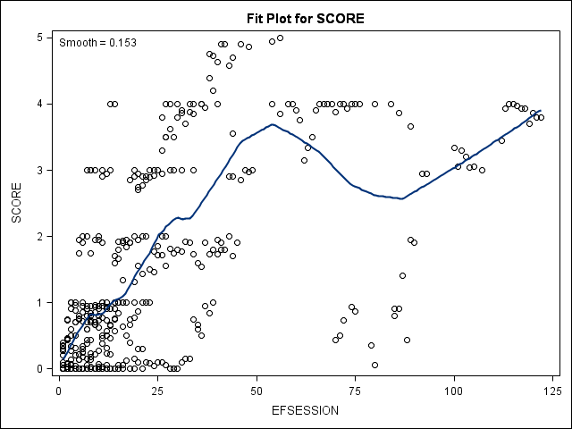

Figure 1. Loess curve fit through the Pointing program scores for all students at EF.

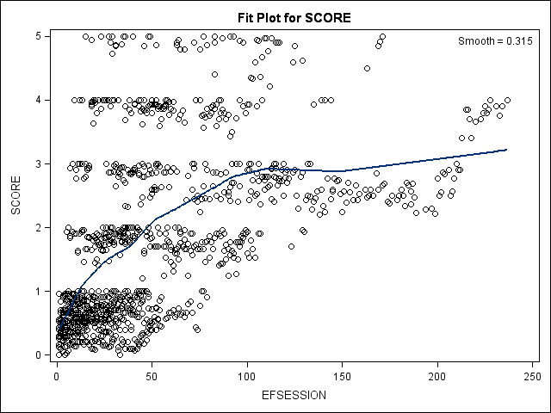

Figure 2. Loess curve fit through the Object Imitation program scores for all students at EF.

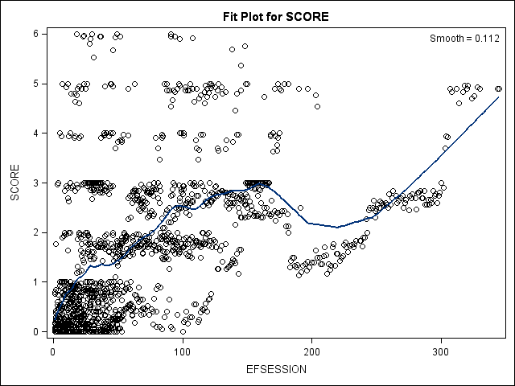

Figure 3. Loess curve fit through the Gross Motor Imitation program scores for all students at EF.

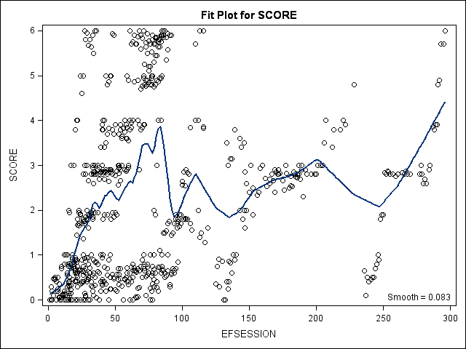

Figure 4. Loess curve fit through the Waiting program scores for all students at EF.
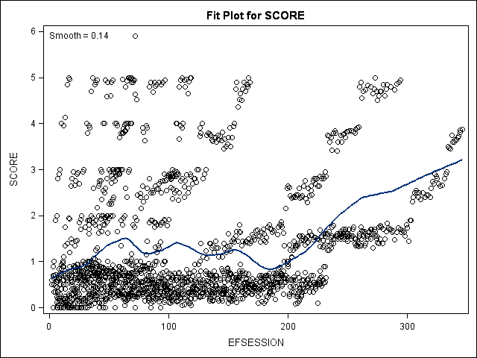

Figure 5. Loess curve fit through the One-step Directions program scores for all students at EF.

Figure 6. Individual student trajectories through the Pointing program at Early Foundations.

Figure 7. Individual student trajectories through the Object Imitation program at Early Foundations.

Figure 8. Individual student trajectories through the Gross Motor program at Early Foundations.

Figure 9. Individual student trajectories through the Waiting program at Early Foundations.

Figure 10. Individual student trajectories through the One-step Directions program at Early Foundations.

Figure 11. Student 100’s trajectories through basic skill acquisition programs at Early Foundations.

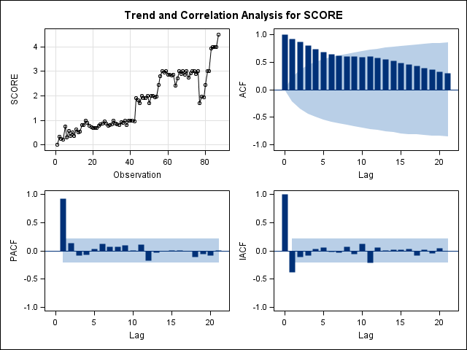
Figure 12. Student 100’s session observation data and ARIMA autocorrelation information for Object Imitation.

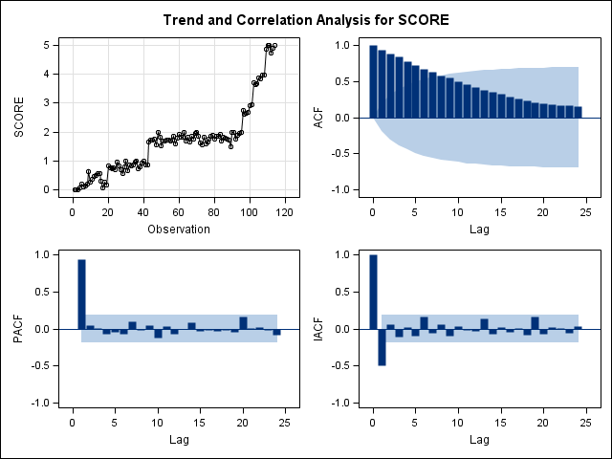
Figure 13. Student 100’s session observation data and ARIMA autocorrelation information for Gross Motor.

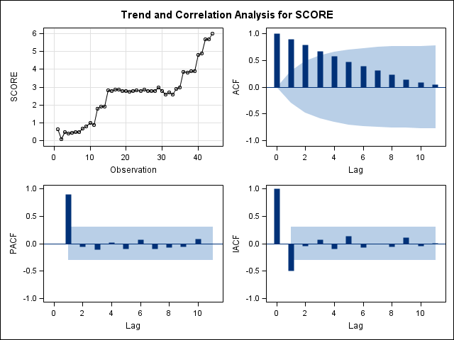
Figure 14. Student 100’s session observation data and ARIMA autocorrelation information for Waiting.

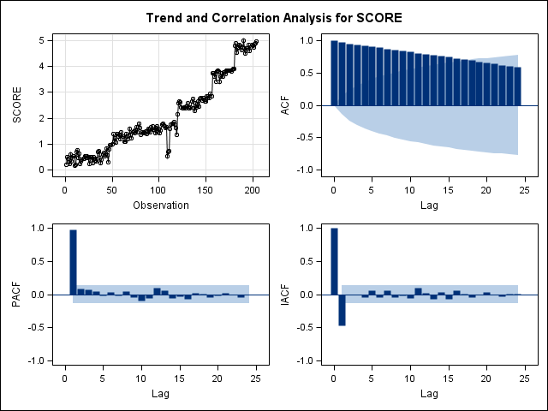
Figure 15. Student 100’s session observation data and ARIMA autocorrelation information for One-step Directions.

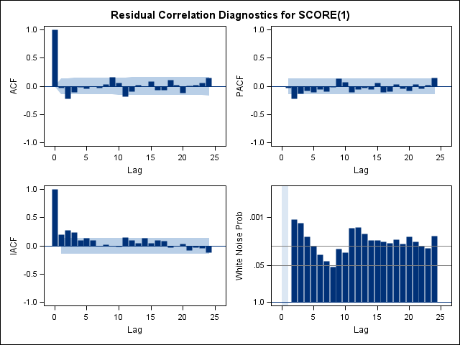
Figure 16. Student 100’s residual data and ARIMA autocorrelation information for One-step Directions ARIMA(1,1,0).

Figure 17. Student 101’s trajectories through basic skill acquisition programs at Early Foundations.

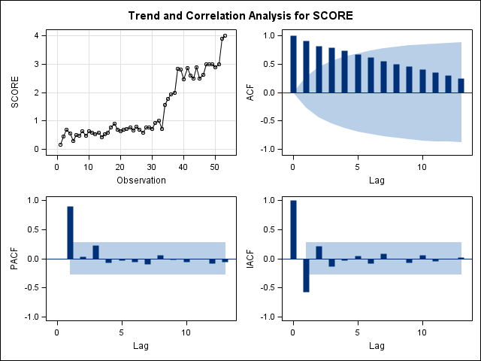
Figure 18. Student 101’s session observation data and ARIMA autocorrelation information for Object Imitation.

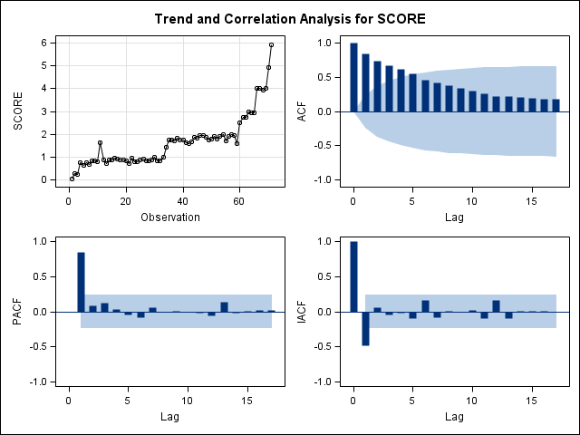
Figure 19. Student 101’s session observation data and ARIMA autocorrelation information for Gross Motor.

Figure 20. Student 102’s trajectories through basic skill acquisition programs at Early Foundations.

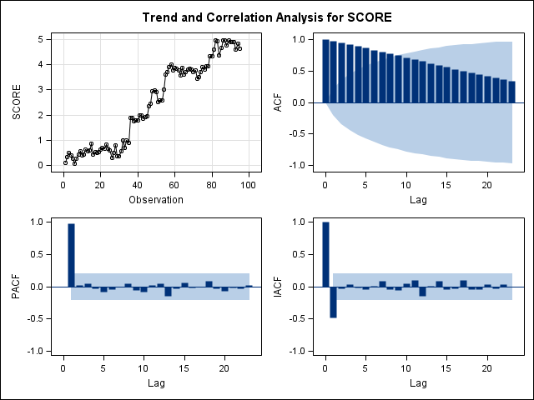
Figure 21. Student 102’s session observation data and ARIMA autocorrelation information for Object Imitation.

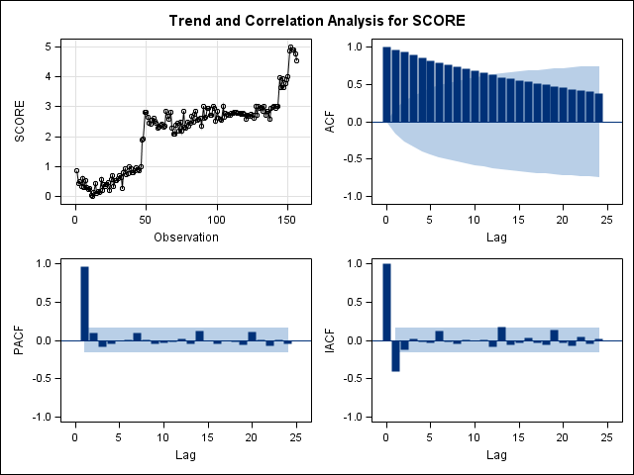
Figure 22. Student 102’s session observation data and ARIMA autocorrelation information for Gross Motor Imitation.

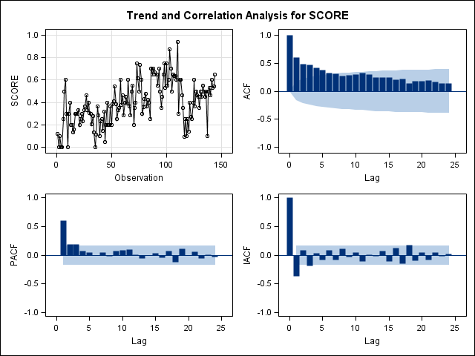
Figure 23. Student 102’s session observation data and ARIMA autocorrelation information for One-step Directions.

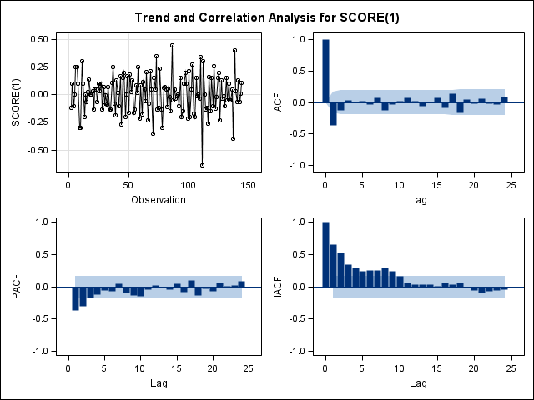
Figure 24. Student 102’s differenced data and ARIMA autocorrelation information for One-step Directions ARIMA(1,1,0).
Figure 25. Student 103’s trajectories through basic skill acquisition programs at Early Foundations.

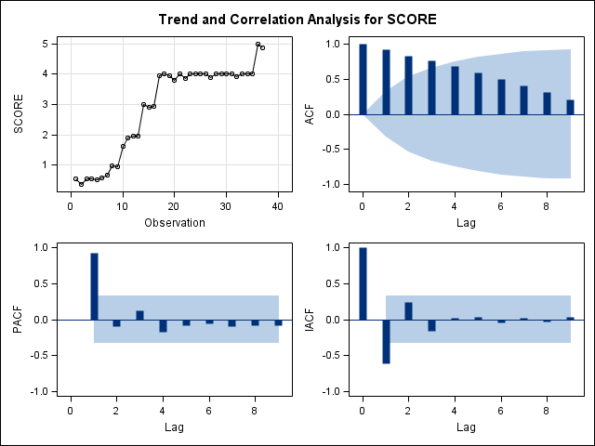
Figure 26. Student 103’s session observation data and ARIMA autocorrelation information for Object Imitation.

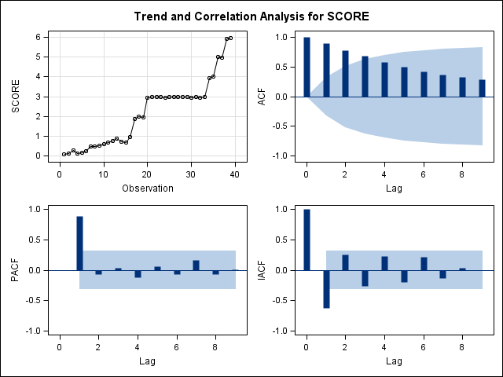
Figure 27. Student 103’s session observation data and ARIMA autocorrelation information for Gross Motor Imitation.

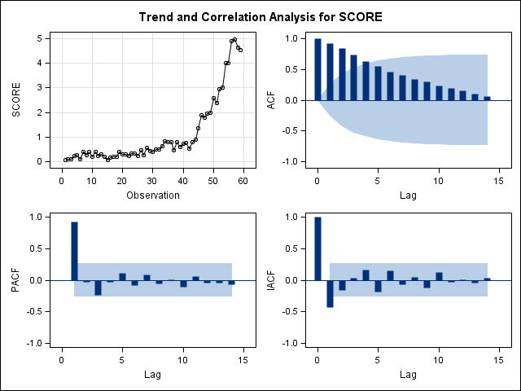
Figure 28. Student 103’s session observation data and ARIMA autocorrelation information for One-step Directions.

Figure 29. Student 104’s trajectories through basic skill acquisition programs at Early Foundations.

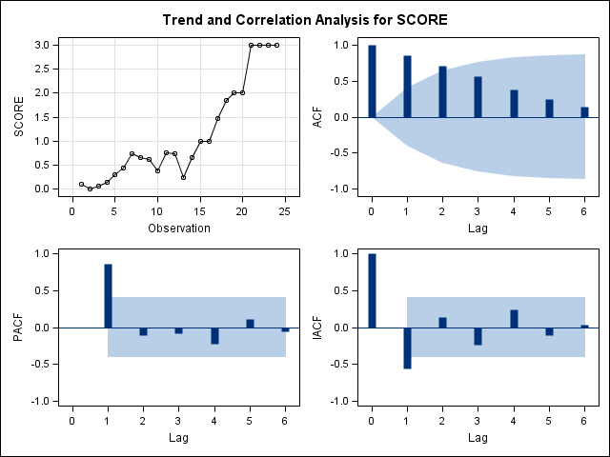
Figure 30. Student 104’s session observation data and ARIMA autocorrelation information for Pointing.

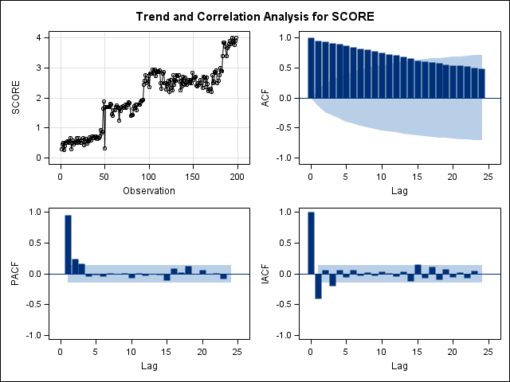
Figure 31. Student 104’s session observation data and ARIMA autocorrelation information for Object Imitation.

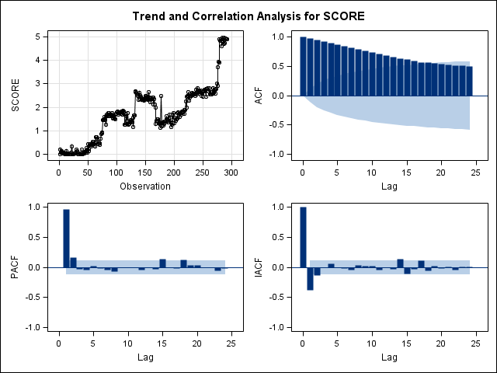
Figure 32. Student 104’s session observation data and ARIMA autocorrelation information for Gross Motor Imitation.

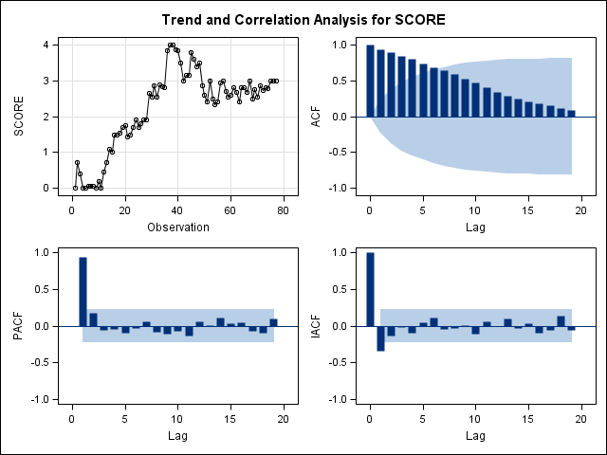
Figure 33. Student 104’s session observation data and ARIMA autocorrelation information for Waiting.

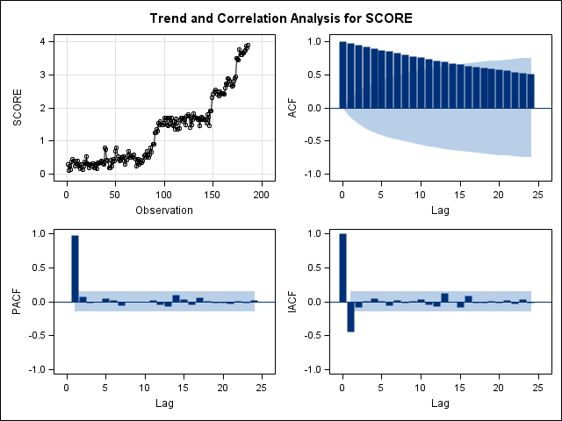
Figure 34. Student 104’s session observation data and ARIMA autocorrelation information for One-step Directions.

Figure 35. Student 105’s trajectories through basic skill acquisition programs at Early Foundations.

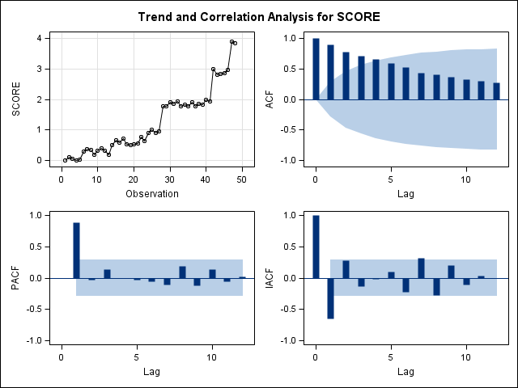
Figure 36. Student 105’s session observation data and ARIMA autocorrelation information for Object Imitation.

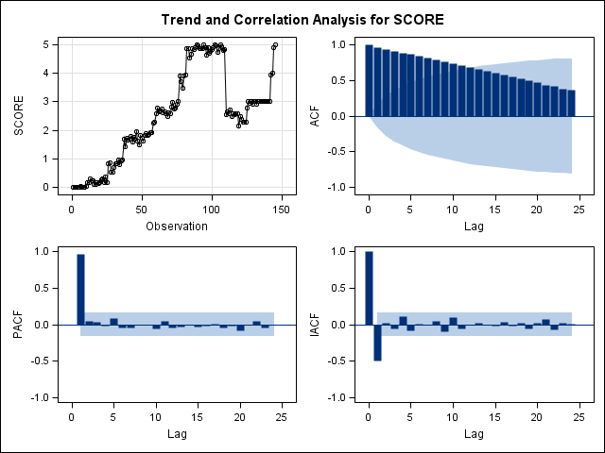
Figure 37. Student 105’s session observation data and ARIMA autocorrelation information for Gross Motor Imitation.

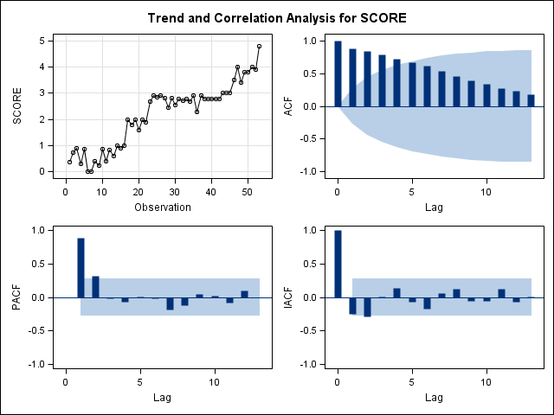
Figure 38. Student 105’s session observation data and ARIMA autocorrelation information for Waiting.

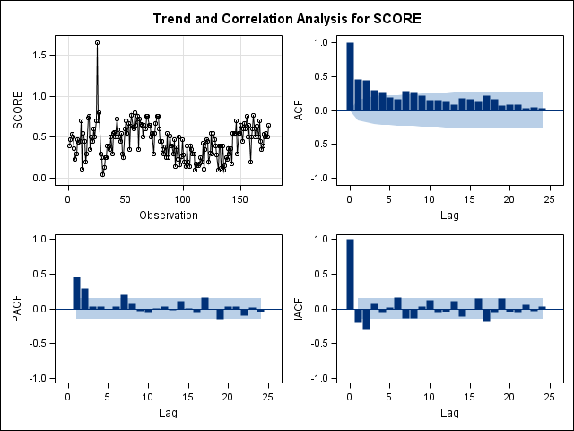
Figure 39. Student 105’s session observation data and ARIMA autocorrelation information for One-step Directions.

Figure 40. Student 106’s trajectories through basic skill acquisition programs at Early Foundations.

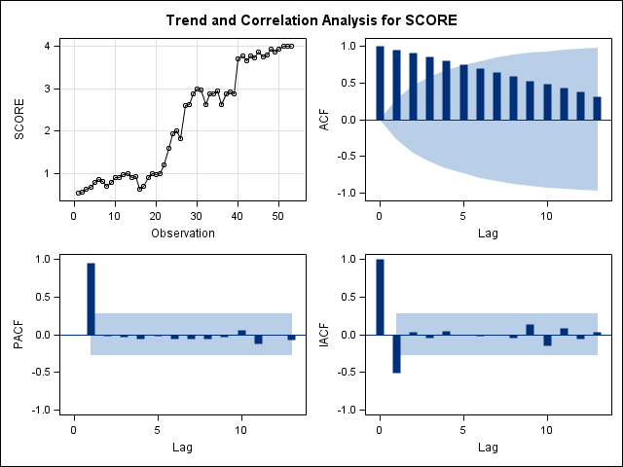
Figure 41. Student 106’s session observation data and ARIMA autocorrelation information for Object Imitation.

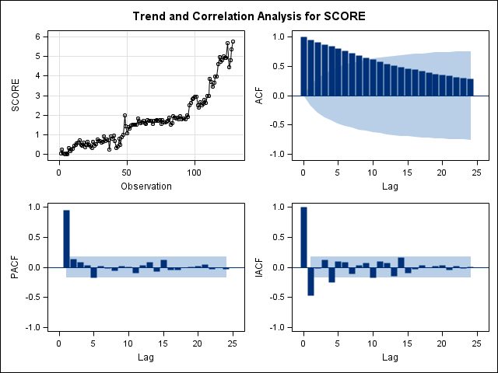
Figure 42. Student 106’s session observation data and ARIMA autocorrelation information for Gross Motor Imitation.

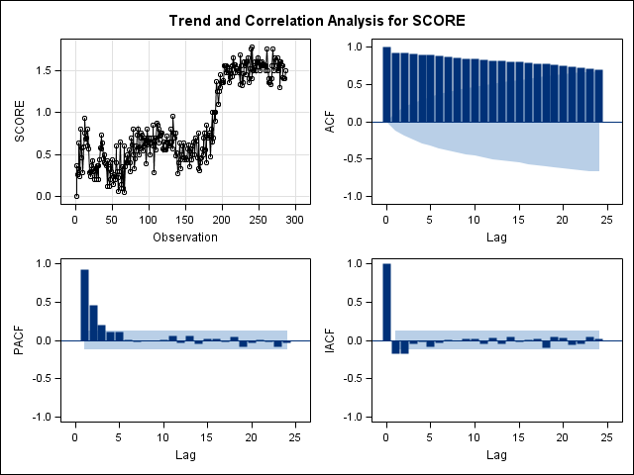
Figure 43. Student 106’s session observation data and ARIMA autocorrelation information for One-step Directions.

Figure 44. Student 107’s trajectories through basic skill acquisition programs at Early Foundations.

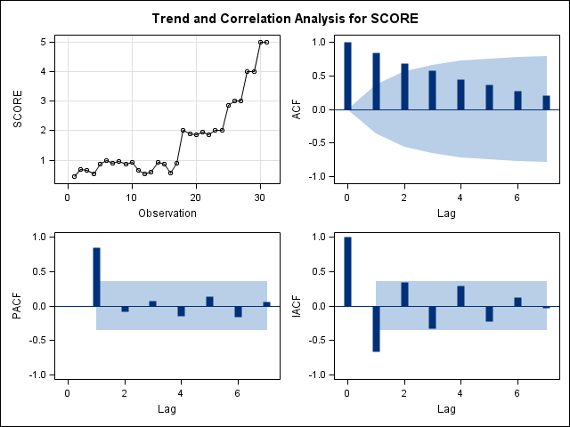
Figure 45. Student 107’s session observation data and ARIMA autocorrelation information for Object Imitation.

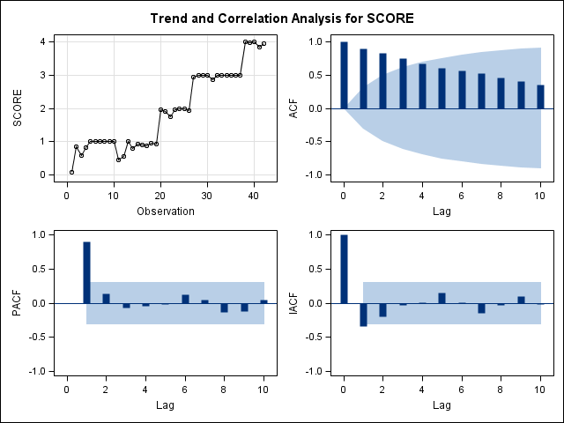
Figure 46. Student 107’s session observation data and ARIMA autocorrelation information for Gross Motor Imitation.

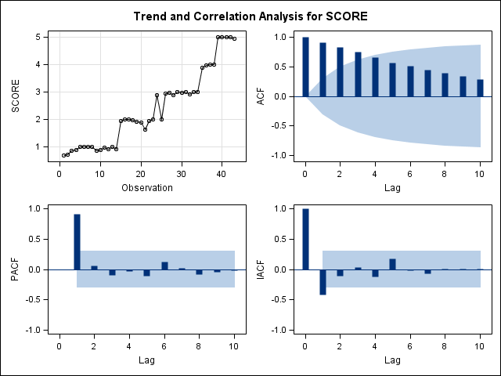
Figure 47. Student 107’s session observation data and ARIMA autocorrelation information for One-step Directions.

Figure 48. Student 108’s trajectories through basic skill acquisition programs at Early Foundations.

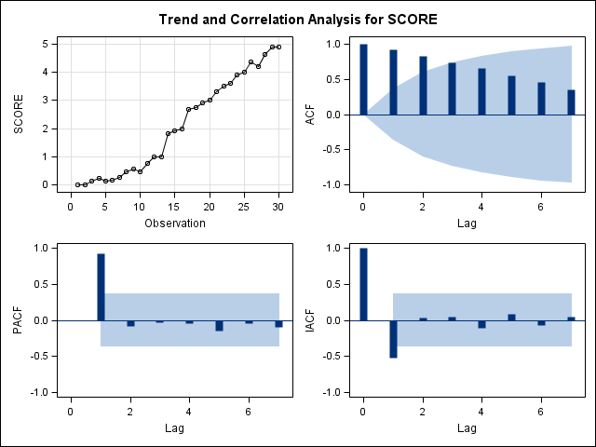
Figure 49. Student 108’s session observation data and ARIMA autocorrelation information for Pointing.

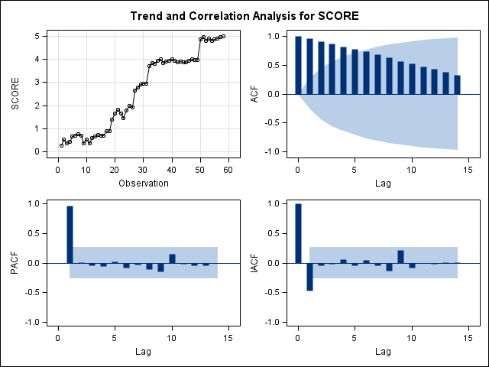
Figure 50. Student 108’s session observation data and ARIMA autocorrelation information for Object Imitation.

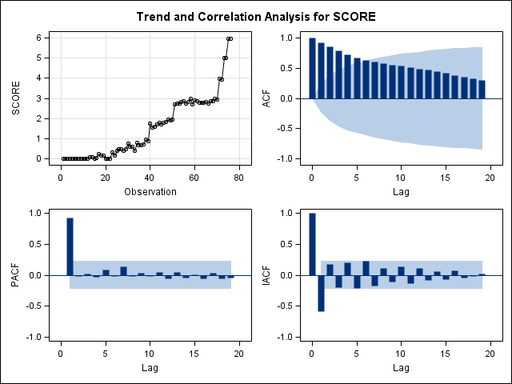
Figure 51. Student 108’s session observation data and ARIMA autocorrelation information for Gross Motor Imitation.

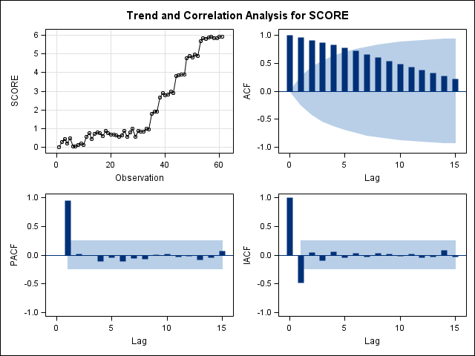
Figure 52. Student 108’s session observation data and ARIMA autocorrelation information for Waiting.

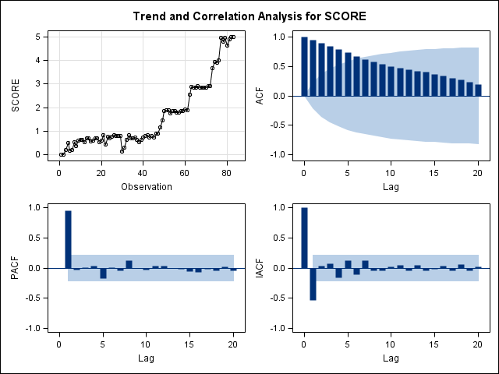
Figure 53. Student 108’s session observation data and ARIMA autocorrelation information for One-step Directions.

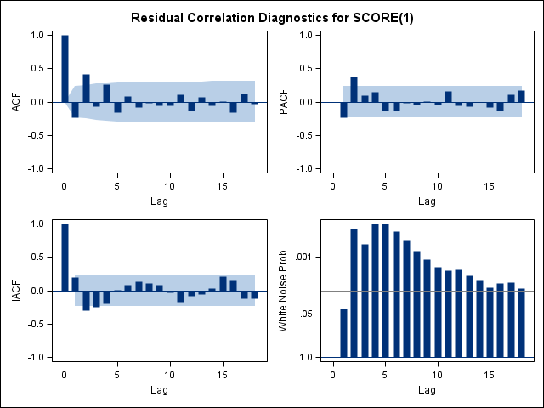
Figure 54. Student 108’s residual data and ARIMA autocorrelation information for Gross Motor Imitation ARIMA(0,1,0).

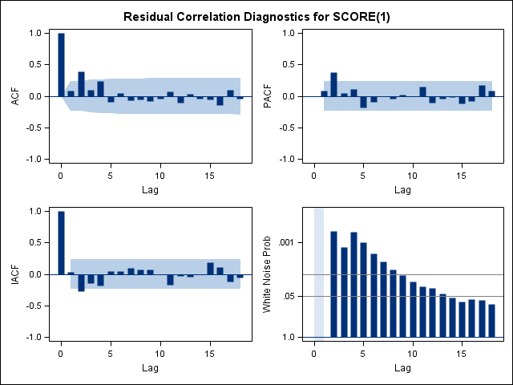
Figure 55. Student 108’s residual data and ARIMA autocorrelation information for Gross Motor Imitation ARIMA(1,1,0).

Figure 56. Student 109’s trajectories through basic skill acquisition programs at Early Foundations.

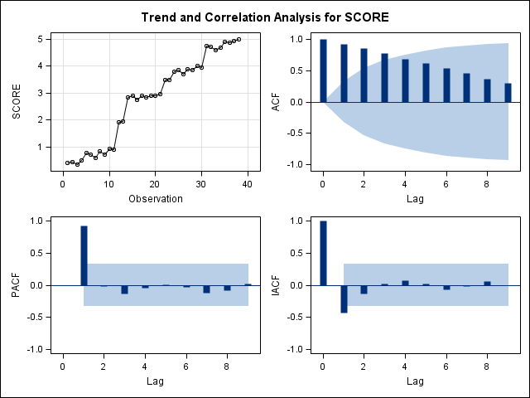
Figure 57. Student 109’s session observation data and ARIMA autocorrelation information for Pointing.

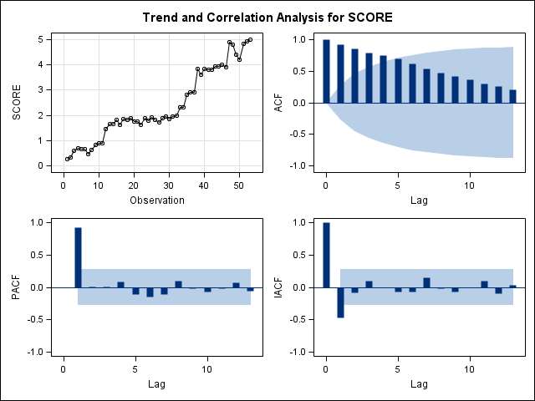
Figure 58. Student 109’s session observation data and ARIMA autocorrelation information for Object Imitation.

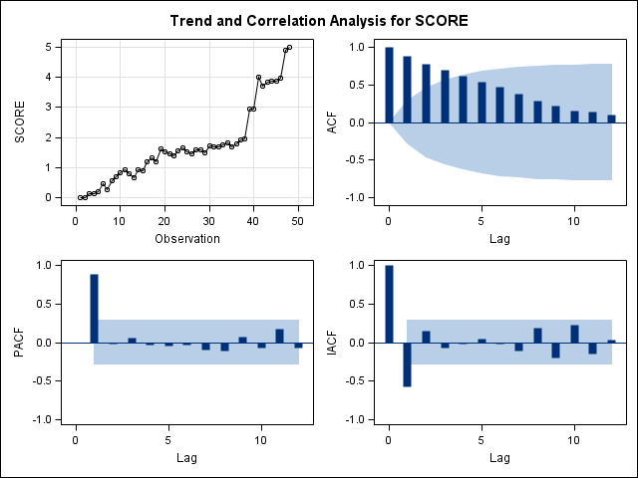
Figure 59. Student 109’s session observation data and ARIMA autocorrelation information for Gross Motor Imitation.

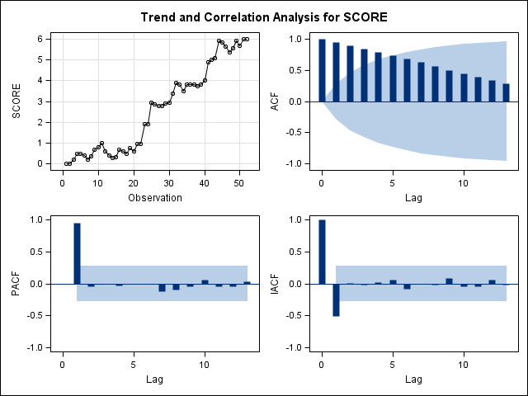
Figure 60. Student 109’s session observation data and ARIMA autocorrelation information for Waiting.

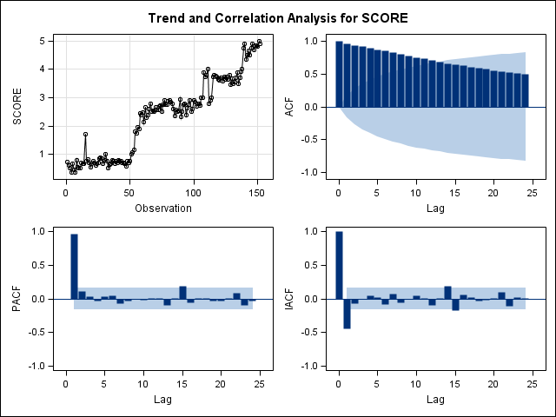
Figure 61. Student 109’s session observation data and ARIMA autocorrelation information for One-step Directions.

Figure 62. Student 110’s trajectories through basic skill acquisition programs at Early Foundations.

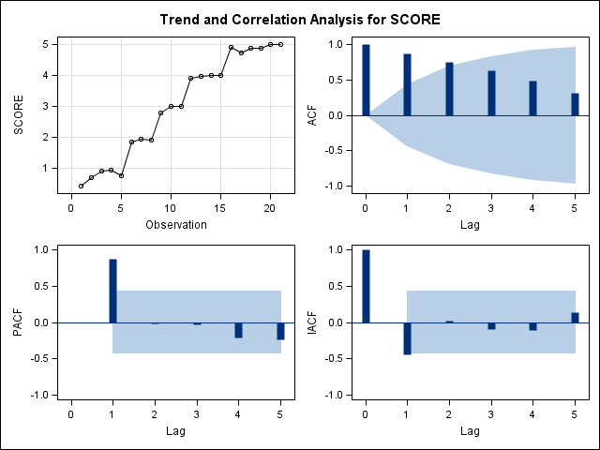
Figure 63. Student 110’s session observation data and ARIMA autocorrelation information for Object Imitation.

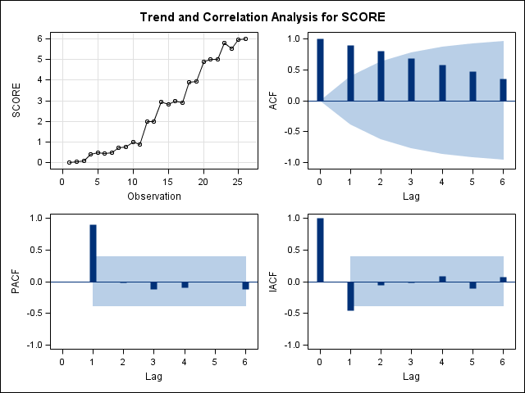
Figure 64. Student 110’s session observation data and ARIMA autocorrelation information for Gross Motor Imitation.

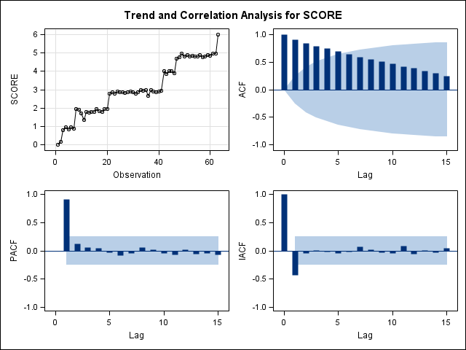
Figure 65. Student 110’s session observation data and ARIMA autocorrelation information for Waiting.

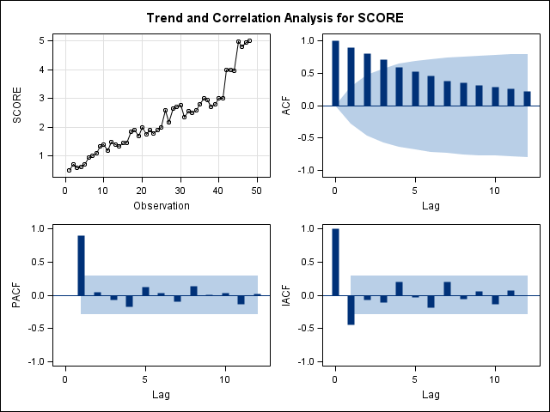
Figure 66. Student 110’s session observation data and ARIMA autocorrelation information for One-step Directions.

Figure 67. Student 111’s trajectories through basic skill acquisition programs at Early Foundations.

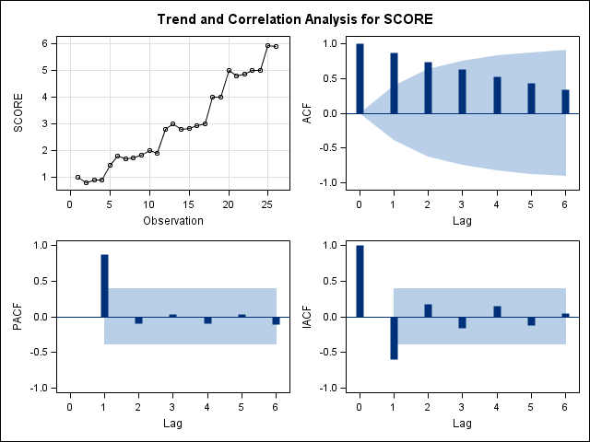
Figure 68. Student 111’s session observation data and ARIMA autocorrelation information for Waiting.

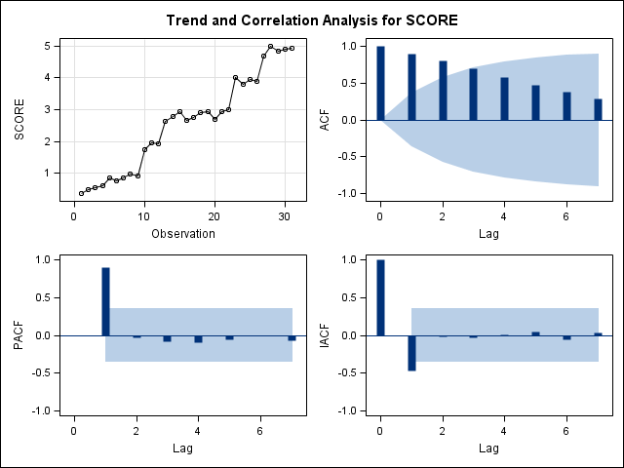
Figure 69. Student 111’s session observation data and ARIMA autocorrelation information for One-step Directions.

Figure 70. Student 112’s trajectories through basic skill acquisition programs at Early Foundations.

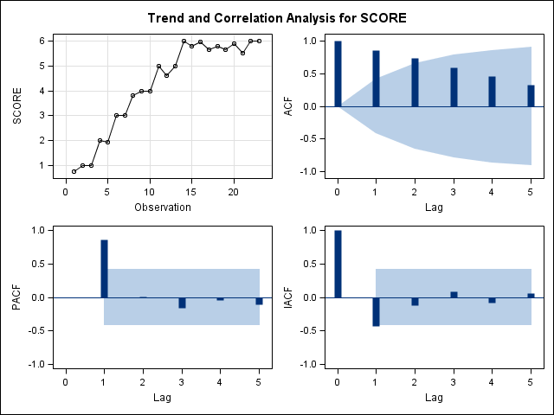
Figure 71. Student 112’s session observation data and ARIMA autocorrelation information for Waiting.

Figure 72. Student 113’s trajectories through basic skill acquisition programs at Early Foundations.

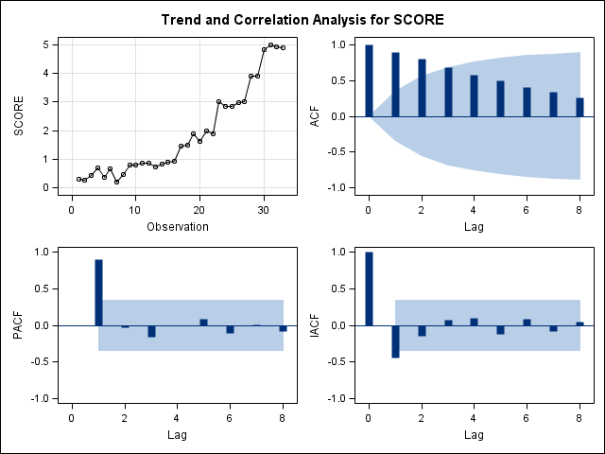
Figure 73. Student 113’s session observation data and ARIMA autocorrelation information for Object Imitation.

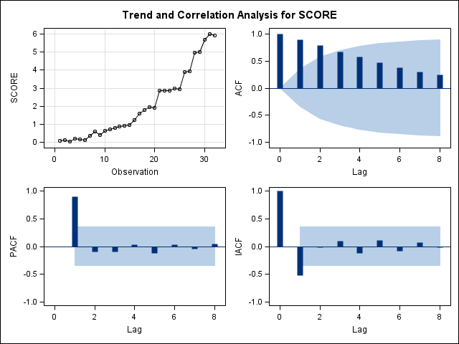
Figure 74. Student 113’s session observation data and ARIMA autocorrelation information for Gross Motor Imitation.

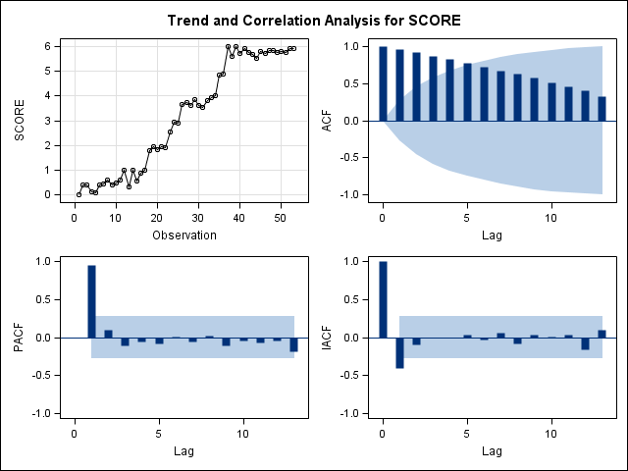
Figure 75. Student 113’s session observation data and ARIMA autocorrelation information for Waiting.

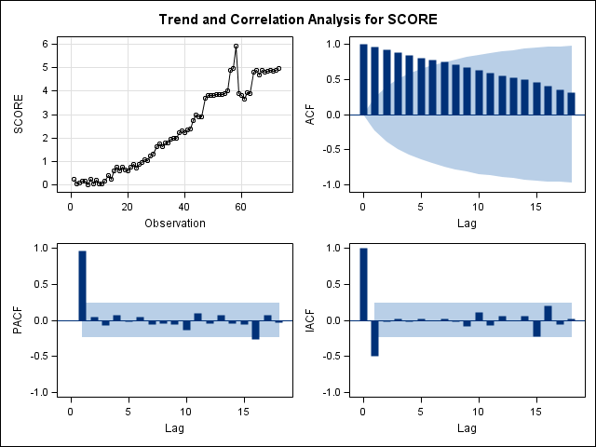
Figure 76. Student 113’s session observation data and ARIMA autocorrelation information for One-step Directions.
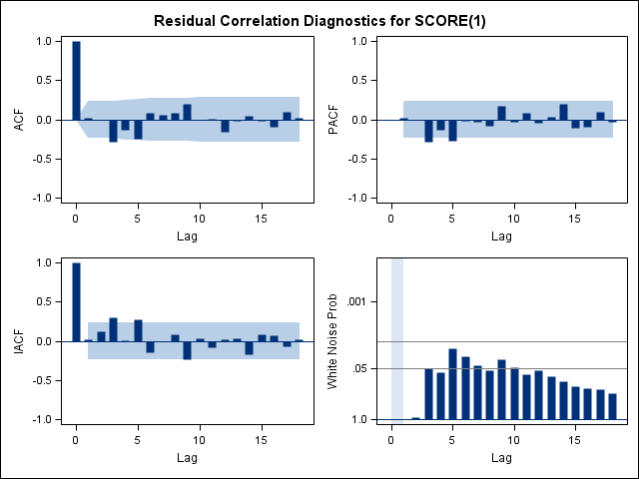
Figure 77. Student 113’s residual data and ARIMA autocorrelation information for One-step Directions ARIMA(1,1,0).

Figure 78. Student 118’s trajectories through basic skill acquisition programs at Early Foundations.

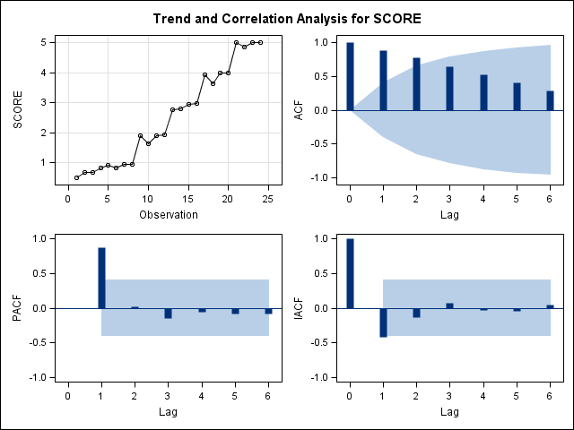
Figure 79. Student 118’s session observation data and ARIMA autocorrelation information for Object Imitation.

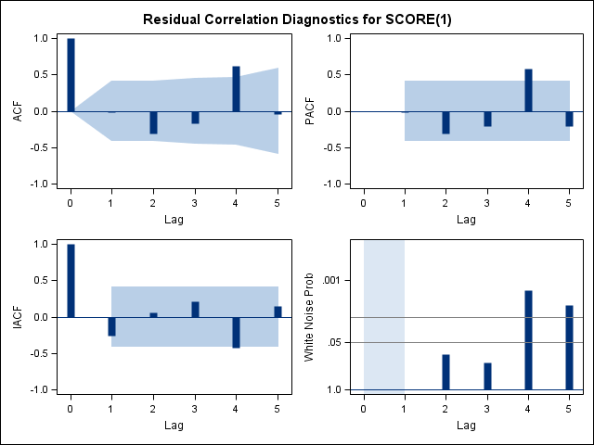
Figure 80. Student 118’s session observation data and ARIMA autocorrelation information for Object Imitation ARIMA(1,1,0).

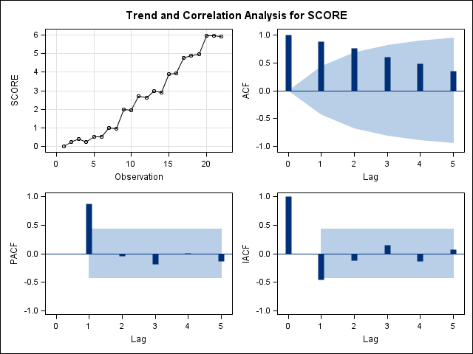
Figure 81. Student 118’s session observation data and ARIMA autocorrelation information for Gross Motor Imitation.

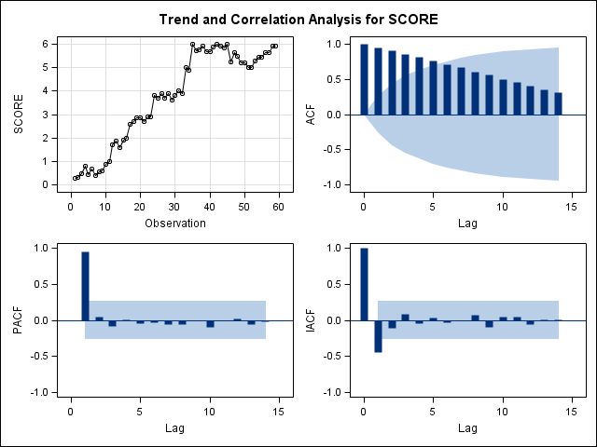
Figure 82. Student 118’s session observation data and ARIMA autocorrelation information for Waiting.

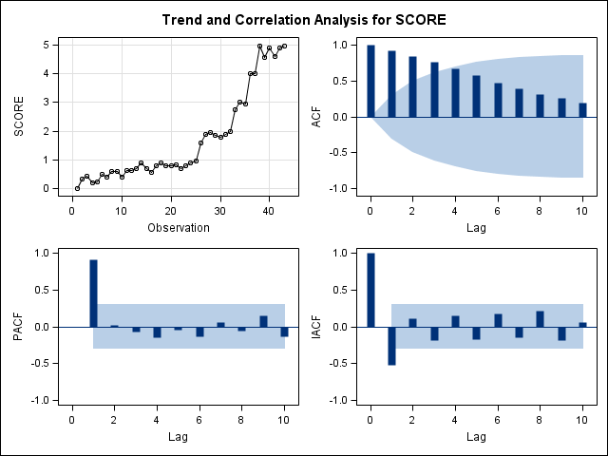
Figure 83. Student 118’s session observation data and ARIMA autocorrelation information for One-step Directions.
Figure 84. Gross Motor pre-Mullen by post-Mullen subscale scores.

Figure 85. Visual Reception pre-Mullen by post-Mullen subscale scores.

Figure 86. Fine Motor pre-Mullen by post-Mullen subscale scores.

Figure 87. Receptive Language pre-Mullen by post-Mullen subscale scores.

Figure 88. Expressive Language pre-Mullen by post-Mullen subscale scores.

[Appendix C: Programs at Early Foundations]

Cognitive Programs
Categories
Cause and effect
Comprehension I
General knowledge and reasoning
Intermediate conversation
Letter identification
Matching
Following one-step directions
Personal information
Positional concepts
Quantitative concepts
Reading
Retell story
Same vs. different
Sequencing
Word classification

Communication Programs

Advanced fine motor—handwriting
Answering yes/no
Asking for help
Asking questions
Expanding language
Expressive ID
Following one-step directions
Following advanced directions
Manding
Pointing
Pronouns
Receptive ID
Receptive ID—actions
Receptive ID—body parts
Receptive ID—features
Receptive ID—functions
Reciprocal statements
Receptive and expressive ID

Imitation Programs

Advanced fine motor—drawing
Advanced imitation
Block imitation
Fine motor imitation
Gross motor imitation
Imitation with objects
Oral motor imitation
Out of seat imitation
Verbal imitation

Social Programs

Asking questions
Emotions
Eye power and social skills
Gestures
Independent work and play
Joint attention
Play
Respond to name
Trading and sharing
Waiting

