University of Oklahoma

Graduate College

AT Home In The Lows: an ethnography of Meaning-Making in
Intimate Spaces

A Dissertation

submitted to the graduate faculty

in partial fulfillment of the requirements for the

Degree of

Doctor of Philosophy

By

elisha r. oliver
Norman, Oklahoma
2018

At Home In The Lows: An Ethnography of meaning-making in intimate spaces

A Dissertation approved for the
Department of Anthropology

By

______________________________

Dr. Betty Harris, Chair

______________________________

Dr. Sean O’Neil

______________________________

Dr. Lesley Rankin-Hill

______________________________

Dr. Kermyt Anderson

______________________________

Dr. Lupe Davidson

© Copyright by elisha r. oliver 2018
All Rights Reserved.

This dissertation is dedicated to those that believed in me.
In the Spirit of Zora Neale Hurston
In Memory of Annie Pearl Franklin Banks,
and
Chief Moses Gerald Starr Jr.

Acknowledgements
There are many people that I would like to thank for contributing abundantly towards my research and dissertation. First, I would like to thank my children, whose unconditional love and understanding of my many absences at family events was remarkable and heartfelt. I love you both with all of me. I would like to thank my family, whose continuous support carried me through the entirety of graduate school. I want to thank my research participants who have become friends over the years. The shared stories, seats at the table during your family gatherings, and words of safe-keeping have been, and remain priceless.
To my wonderful and supportive doctoral committee at the University of Oklahoma, Dr. Betty Harris, Dr. Sean O’Neil, Dr. Lesley Rankin-Hill, Dr. K.G. Anderson, and Dr. Lupe Davidson, I would like to extend my sincere thanks and gratitude to you all. Your diligent work, support, mentoring, unwavering commitment, and guidance in bringing this research and dissertation to fruition has been remarkable and I am beyond appreciative. Each of you has other-mothered me in your own unique ways, and I thank you. When I felt that all was lost and, I did not have the strength to carry-on, you encouraged me. You all have taught me that beauty and humanity can exist in thrive in the academy. You all have demonstrated what ethical scholarship looks like.
I would like to give a very special thanks to Dr. Betty Harris for believing in the quality of my research, and her fearless endeavors to stand down giants. Dr. Harris, you have provided the shoulders I needed to stand on, the seat and table for me to sit at, and the listening ear when I needed it most.
I would also like to thank my “sheroes,” Dr. Misha Klein and Dr. Beverly Davenport for helping me find my voice within the discipline of anthropology. You both have allowed me to be me. You have shown me what strength and resilience looks like in the academy, and I thank you.
Furthermore, I would like to thank those beloved friends and loved ones that have walked with me each step of this academic journey, called me (Suzette), performed fb-check-ins, made me laugh when I felt like crying, lifted me up when I couldn’t lift myself, made sure I had “school supplies (Chucky Fenster),” stayed up all night proof reading my dissertation before final submission (Ona) , and cheered me across the finish line. You are near and dear to my heart. Finally, thank you, Dean T.H. Lee Williams, and Dean Nancy LaGreca for listening when I needed to be heard. Salud, to you all!!!!

Table of Contents
Acknowledgements . . . . . . . . iv
Table of Contents . . . . . . . . vi
Abstract . . . . . . . . . xv
Introduction . . . . . . . . . 1
AT Home in The Lows -The First Space 1
It Depends on Who’s Looking: Beauty for Ashes or Just Plain Ol’ Ashes 3

Chapter 1: The Landscape of Returning Home . . . . . 7
Contested Language, Content, Home, and A Seat at the Table: And so, it begins 7
Letting Stories Breathe: Borderlands, Boundaries, and Narrativizing in The Lows 10
The Neighborhood 13
Livin’ In The Lows 13 Setting the Stage: A Look at El Roy 15
Space or Place? Sites, Semantics, Soliloquys, and Solidarities 17
Example 1.1: Ethnographic Conversations Snapshot 18
Dissertation Layout 23
Chapter Overview 25
Dissertation Writ Large 27

Chapter 2: Methods, Meaning-Making, and Me . . . . . 30
The Research Endeavor: People and Populations as Distrusting Research Partners 30
Example 2.1: Ethnographic Conversation Snapshot 31
Ethnographic Methods 32
Participant Observation & Interviewing 34
Participant Observation & Focus Groups 36
Social Network and Spatial Mapping 38
Visual Documentation 40
Recruitment of Participants and Compensation 40
Participants 41
Compensation and Reciprocity 43
Key Informants and Interlocutors 43
Example 2.2: Ethnographic Snapshot 45
Miss Fannie Lee 51
Sister Delora 53
Sister Janna 56
Miss Essie Mae 58
Ashiley and Krystal Mae 59
The Others 61
Performance, Being, and Multi-Sited & Multi-Faceted Ethnography 63
Privilege and Formal Anthropological Training 66
Writing and Voice 67
Data Analysis and Coding 68
Chapter 3: The Language of Returning Home . . . . . 70
The Language of Literature: Academic and Otherwise 70
Being and Emotion: Affect and Sentiment in The Lows 71
The Philosophy of Being and Emotion: The Anthropology of Affect
and Sentiment 73
Example 3.1: Excerpt: Elie Wiesel 81
Example 3.2: Interview: Elroy Resident 82
Example 3.3: Poem Excerpt: Wendy Rose 82
Not Your Ordinary Third Space: Spaces and Third Space Theory 89
Example 3.4: Ethnographic Snapshot 91
A Life Worth Living in The Lows: Life Course Theory and Biopsychosocial
Technologies 95
Example 3.5: Ethnographic Snapshot, Nellie Truitt 98
The Psychological at Home in The Lows 101
The Biological at Home in The Lows 106
My “Good Girl”, Philosophy, and Women of The Lows: History, Biopolitics, and
Bioethics of Reproduction 108
Situating the Stakeholders 110
Example 3.6: Reproductive Health Focus Group Excerpt 110
Miss Louise, The Lows and The Politics of Life 115
Example 3.7: Ethnographic Conversation, Miss Louise 116
Example 3.8: Sexual and Reproductive Health Focus Group Responses 116
Rights? What are Rights? 117
Component 1: Immanuel Kant and I Can’t 118
Example 3.9: Interview Excerpt, TW 120
My “Good Girl” is Not for Sale 121
Example 3.10: Ethnographic Conversation Snapshot, Norma 125
Example 3.11: Ethnographic Conversation Snapshot, Adelia 125
The Bioethics of Life in The Lows 126
Component 2: The Male Gaze, Male Directed Medicalization, Multiple Voices, and
The Masses 127
Example 3.12: Ethnographic Snapshot, Donna 128

Chapter 4: Intimate Spaces. . . . . . . . 133

Peopling in Private and Public Places 133
Religion & Healing in The Lows: Greater Healing Hands and Heart
Church and Mission 134
Syncretism: Community, Culture, and Curanderismo 135
Example 4.1: Ethnographic Snapshot, Tricia 140
Example 4.2: Ethnographic Snapshot, Tricia 140
Religion, Healing, and Empowerment in The Lows: Writing Intertwined Histories 143
Intertwined and Intimate: Narrating Violence and Empowerment 144
Relationships, Memory, and History 146
Sister Janna and The Language of Intention 146
Writing on the Mourner’s Bench 149
And, Then She Spoke: Songs and Speech of Suffering 150
Example 4.3: Ethnographic Vignette, Sister Janna 151
In the Key of E: Eugenia and Elisha 153
Example 4.4: Participant Writing, Eugenia 154
Example 4.5: Ethnographic Snippet, Eugenia 154
Example 4.6: Research Jotting, EO 154
Stories at the Stoop 155
Roxie M. 157
Example 4.7a: Ethnographic Narrative, Roxie 157
Example 4.7b: Ethnographic Narrative Response, Roxie 158
Pat 159
Example 4.8: Ethnographic Narrative, Pat 159
Mealtime at the Mission: Language, Love, and Food 160
Component 1: Ortner and Bourdieu in Dialogue at Mealtime: A Review of Space and
Place 164
Example 4.9: Ethnographic Conversation, Miss J 164
Example 4.10: Ethnographic Conversation, Lanna 164
Bourdieu and Ortner 165
Example 4.11: Ethnographic Snippet, Rosie 166
Component 2: My Sense of Space, Place, and Position: The Auto-ethnography 168
Component 3: In Their Own Words: The Women Speak 171
Francesca 172
Example 4.12: Participant Poem, Francesca 172
Bethany 173
Example 4.13: Ethnographic Narrative, Bethany 173
Example 4.14: Ethnographic Interview, Tessa-hawk 174
Taking Care of the ‘Kitchen’ in the Kitchen 176
Example 4.15: Ethnographic Vignette, At home in the Kitchen 176
Spanking and Sparing Me on The Front Porch: Ms. Fannie Lee & Ms. Essie Mae 178
Example 4.16: Ethnographic Snapshot, Travis and Others 179

Chapter 5: Findings . . . . . . . 182
Folklife, Family, and Food 182
Themes & Questions 186
Theme 1: Intimate Spaces 186
Theme 2: Space, Health, and Healing 187
Question 1: What is the cultural significance of spaces within this community? 189
Question 2: In what ways do these spaces affect the biopsychosocial health of
women in the neighborhood? 189
Question 3: How, and why do constructed intimate spaces facilitate the telling and
sharing of narratives? 191
Example 5.1: A Message in the Story 192
Question 4: In what ways do the women living in The Lows make meaning of
everyday lived experiences in a rural and aging community? 194

Chapter 6: Conclusion and Recommendations . . . . . 196
Going Home to Be With The Lord: Beloved Soul 196
Situating Research and The Way Forward 203

Epilogue . . . . . . . . . 206

References . . . . . . . . . 209
Appendix A . . . . . . . . . 235
Appendix B . . . . . . . . . 242
Appendix C . . . . . . . . . 243
Appendix D . . . . . . . . . 244
Appendix E . . . . . . . . . 254
Appendix F . . . . . . . . . 258
Appendix G . . . . . . . . . 260
Appendix H . . . . . . . . . 263
Appendix I . . . . . . . . . 264
Appendix J . . . . . . . . . 265
Appendix K . . . . . . . . . 280

List of Tables
Table Page
Output: 001 – Ethnic Identity . . . . . . . 244
Output: 002 – Educational Attainment . . . . . . 244
Output: 003 – Incarcerated in Oklahoma . . . . . . 245
Output: 004 – Income Range . . . . . . . 245
Output: 005 – Employment Status . . . . . . 246
Output: 006 – Religion . . . . . . . . 246
Output: 007 – Intimate Relationships . . . . . . 249
Output: 008 – Sexual Orientation . . . . . . 247
Output: 009 – Participants with Children . . . . . . 248
Output: 010 – Sexual Behavior . . . . . . . 248
Output: 011 - Assessment of Sexual Frequency . . . . . 249
Output: 012 – Condom Use Frequency . . . . . . 249
Output: 013 – Use of Other Forms of Birth Control . . . . 250
Output: 014 – History of Sexually Transmitted Infections . . . 250
Output: 015 – Experience of Sexual Trauma . . . . . 251
Output: 016 – Sexual Trauma of a Child in the Home . . . . 251
Output: 017 – Mental Health Issues (Stress, Anxiety, “Nerves”) . . . 252
Output: 018 – Experienced Intimate Partner Violence . . . . 252
Output: 019 – Experience as Intimate Violence Perpetrator . . . 253
Output: 020 – Use of Community Services . . . . . 253
Participant Roster . . . . . . . . 260

List of Figures
The appearance of the asterisk (*) indicates duplicate photos.
Figure Page

Figure 1 –The Lows, Circa 1979 . . . . . . 1

Figure 2 – Coming into Town . . . . . . . 2
Figure 3 – Powwow 2015 . . . . . . . 7
Figure 4 – Summer Participation in El Roy . . . . 30
Figure 5 – Focus Group Session and Meal . . . . . 36
Figure 6 – Researcher Assisting in Construction . . . . . 49
Figure 7 – Researcher Assisting in Construction . . . . . 49
Figure 8 – Researcher Assisting in Construction . . . . . 50
Figure 9 – Researcher Assisting in Construction . . . . . 50
Figure 10 – Krystal Mae Returns to Her Blazer . . . . . 60
Figure 11 – Men Participate in Partnerships . . . . . 62
Figure 12 – Birth of Emotion . . . . 71
Figure 13 – Dead She Mound . . . . . 99
Figure 14 – We’re Closed but I Left You a Note . . . . . 133
Figure 15 - Prayer, Health, and Healing . . . . . . 135
Figure 16– Greater Healing Hands Church and Mission . . . . 143
Figure 17 – The Stoop . . . . . . . 156
Figure 18 – Mealtime at The Mission . . . . . 160
Figure 19 – Doin’ Momma’s Hair . . . . . . 176
Figure 20 – I’m Not Tryin’ to Hear That Shit . . . . . 178
Figure 21 – Jerrald Comes to Play His Song . . . . . 182
Figure 22 – Girl, You Done Let The Devil In . . . . . 193
Figure 23 – Second Snake Encounter . . . . . . 194
Figure 24 – The Light on the Porch of Miss Fannie Lee . . . . 196
Figure 25 – Best of Friends . . . . . . . 206
Figure 26 – In Celebration of Women . . . . . . 254
Figure 27 – Foot Traffic and Social Network Relationships . . 263
Figure 28 – Formal and Functional Regions in El Roy and The Lows . . 264
Figure 29 – The Land of My People . . . . . 265
Figure 30 – Snacks and Snow Cones . . . . . . 266
Figure 31 – Researcher and Family 1979 . . . . . . 266
Figure 32 – Coming Into Town . . . . . . 266
Figure 33 – The Stoop . . . . . . 267
Figure 34 – Dead She Mound . . . . . . . 267
Figure 35 – The Birth of Emotion . . . . . . 268
Figure 36 – Multiethnic and Multicultural Joking Relationships. . . . 268
Figure 37 – Prayer, Health, and Healing . . . . . . 268
Figure 38 – Bells and Chimes . . . . . . 269
Figure 39 – Bells and Chimes . . . . . . 269
Figure 40 – The Evil Eye and The Eye of Prevention . . . . 270
Figure 41 – Laying Down a Root . . . . . . 270
Figure 42 – A Snake in Disguise . . . . . . 271
Figure 43 – A Snake in Disguise . . . . . . 271
Figure 44 – Meals and the Sharing of Meals . . . . . 271
Figure 45 – Meals and the Sharing of Meals . . . . 271
Figure 46 – Meals and the Sharing of Meals . . . . 272
Figure 47 – Meals and the Sharing of Meals . . . . 272
Figure 48 – Meals and the Sharing of Meals . . . . . 272
Figure 49 – Meals and The Sharing of Meals . . . . 272
Figure 50 – Meals and The Sharing of Meals . . . . 272
Figure 51 – Meals and The Sharing of Meals . . . . 272
Figure 52 – Meals and The Sharing of Meals . . . . 273
Figure 53 – Meals and The Sharing of Meals . . . . 273
Figure 54 – Handgame Meals . . . . . . 273
Figure 55 – Handgame Meals . . . . . . 273
Figure 56 – Handgame Meals . . . . . . 274
Figure 57 – Handgames Meals . . . . . . 274
Figure 58 – Keep Something on the Stove . . . . 274
Figure 59 – Keep Something on the Stove . . . . 274
Figure 60 – Sisterhood in the Hood . . . . . . 275
Figure 61 – Sisterhood in the Hood . . . . . . 275
Figure 62 – This is Community . . . . . . . 276
Figure 63 – This is Community . . . . . . . 276
Figure 64 – This is Community . . . . 276
Figure 65 – Taking Care of the Kitchen in the Kitchen . . . . 276
Figure 66 – Taking Care of the Kitchen in the Kitchen . . . . 276
Figure 67 – Taking Care of the Kitchen in the Kitchen . . . . 276
Figure 68 – Taking Care of the Kitchen in the Kitchen . . . . 276
Figure 69 – A Researcher Living in The Lows . . . . . 277
Figure 70 – A Researcher Living in The Lows . . . . . 277
Figure 71 – A Researcher Living in The Lows . . . . . 277
Figure 72 – A Researcher Living in The Lows . . . . . 277
Figure 73 – A Researcher Living in The Lows . . . . . 277
Figure 74 – A Researcher Living in The Lows . . . . . 278
Figure 75 – A Researcher Living in The Lows . . . . . 278
Figure 76 – A Researcher Living in The Lows . . . . . 278
Figure 77 – A Researcher Living in The Lows . . . . . 278

Abstract
There has been long-standing interest in the ways in which spaces are used by various cultures and communities. Through an ethnographic study of women, space, and narrative, this dissertation explores the ways in which spaces of cultural and historical significance are used in 1) the maintenance of biopsychosocial health in a rural marginalized neighborhood; 2) the telling of “stories” that detail the ways in which these historical and culturally defined spaces reinforce and maintain social networks; and 3) explain how women living in The Lows make meaning of their everyday lived experiences that occur in rural Northwest Oklahoma.
The primary questions driving this research are first, what is the cultural significance of spaces within this community? Second, in what ways do these spaces affect the biopsychosocial health of women in the neighborhood? Third, how, and why do constructed, intimate spaces facilitate the telling and sharing of narratives? Fourth, in what ways are the telling of “stories” significant to the building and maintenance of community cohesion? Lastly, in what ways do the women living in The Lows make meaning of everyday lived experiences in a rural and aging community?
By purposefully positioning the voices of the research participant and researcher —the stories and cultural frameworks attached to this community, along with the critical examination of the ways in which space is utilized as an emancipatory and empowering tool, my research, using thick description, provides an intimate ethnographic explanation of space that is both fixed and transitional. In addition, my research highlights the daily lived experiences of women living in a marginalized and dying neighborhood. This endeavor is a tripartite ethnographic construction of intimacy, experimentation, and auto-ethnography. The findings presented herein indicate that intimate space coupled with “story-telling” promote and strengthen social bonds, and are, critical elements in community cohesion, self-empowerment, and emancipatory practices regarding biopsychosocial health, in this rural and aging community.

Keywords: The Lows, Narrative, Curanderismo, Othermothers, Biopshychosocial Health, Women, Mealtime

Introduction

At Home in The Lows – The First Space

“(sung to the tune of, Wade in the Water) Walk down the streeeet, Walk down the street my sisters, walk down the streeeet…Sistahs gonna take back that the streeeet…I went to Old Man Hampton to buy a home..Old Man Hampton, said he had none, I went to the river to pick up sticks gonna make me home and I don’t need no bricks….Walk down the streeeet, Walk down the street my sistahs, walk down the streeeet…Sistahs gone take back the streeeet.”

-Louise (research participant singing at the stoop.)

“And now, I'm going to tell you why I decided to go to my native village first. I didn't go back there so that the home could make admiration over me because I had been up North to college and come back with a diploma and a Chevrolet.”

-Zora Neale Hurston (Mules and Men 1935)

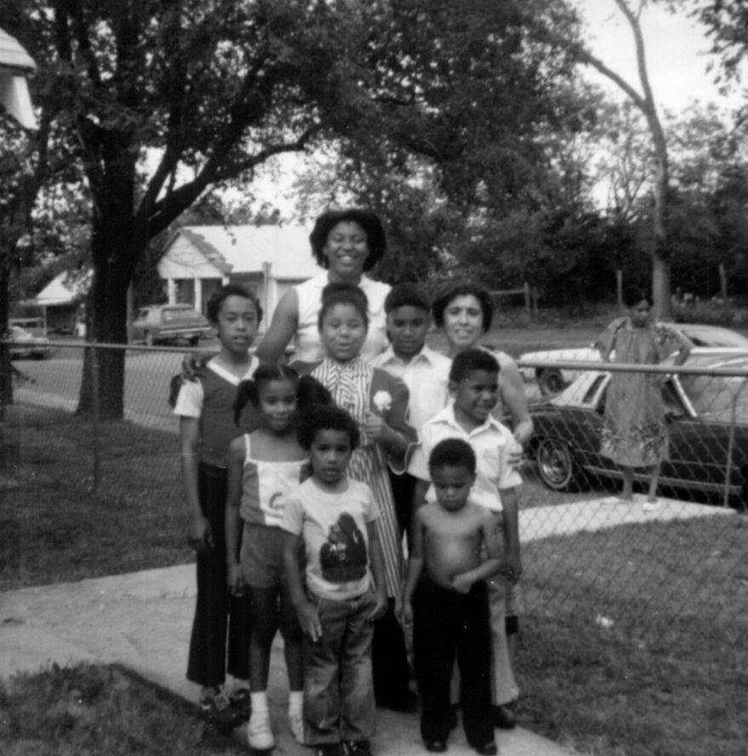

Figure 1: The Lows circa 1979, Researcher’s Family Photo

Before coming to Oklahoma, I heard horror stories about the state of women’s health, women and poverty, and women and incarceration in the state. I didn’t know how, or if this would fit into the framework of my intended research. On the day I moved into the old family home, I didn’t know what or who awaited me. Initially, I had over romanticized life in a rural town, in a town both familiar and strange, a neighborhood intimately known by me in my youth. I imagined friendly neighbors, mornings and evenings on the porch sipping hot tea or coffee and exchanging hellos and goodbyes with the delivery of a hot “down-home,” home-cooked meal. I, after all, was an “honorary” member of this community. I was reared in this neighborhood until the age of six and would return every holiday and summer to spend countless hours playing with cousins, catching crawdads in the creek, and exchanging tales of Bigfoot and the Chicken Man with other children. When I arrived that brutally hot August afternoon, I realized a lot had changed. I had changed, and much of what I remembered, with youthful glee and the eyes of a child, had disappeared.

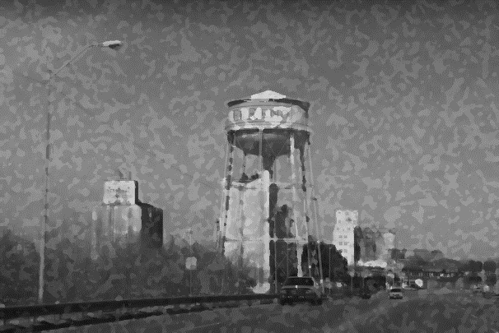

Figure 2: Coming into Town. Photo by Elisha Oliver.

The town looked as if it were eerily stuck in 1975; yet, I detected a dismal, down-trodden change in the town housed in a state with “home” in its name—Okla- “hom(e)-a” and, the neighborhood that I have called home for many years. The neighborhood looked as if it had been abandoned many moons ago. When I arrived at the house that would become my home for the next six years, I sat motionless at the entry to the driveway. I was hesitant to pull the car into the drive; however, I was anxious to dust off old memories. Nostalgia was beckoning to me. Taking a deep breath, I gingerly opened the door. I kept the car running. Extending a bare foot, I quickly was reminded of the searing Oklahoma heat, and strangely, I began half singing-half humming, “Coming Home,” by Roy Orbison, as if a ghost were singing in my ear and I were repeating the lyrics…...

“It’s a long and lonely highway when you’re traveling all alone…. I was on my way to nowhere but now I’m coming home…. I’m coming home.”

I exited the car and felt as if several pairs of eyes were glaring at me from every direction. Walking to open the gate to the driveway, I noticed the curtain move at the house next door. I was being watched.

The curtain opened a little wider, being held by a tiny, frail, and withered light russet brown hand. I didn’t want to stare at the window too long or make it obvious that I was attempting to watch the watcher. I placed a brick at the edge of the gate to hold it open, returned to my car, and pulled into the driveway. I was home.

It Depends on Who’s Looking: Beauty for Ashes or Just Plain Ol’ Ashes

Initially, my days in El Roy seemed to drag me through the neighborhood as if I were a red flyer wagon, weighted down with bricks─ heavy, red from the dirt that blows across the plains, joyless, and unassuming─ from the brickyard, being drug through the street by a small child. The beauty that I witnessed as a child visiting this neighborhood, each summer, had disappeared. It was gone. It had been replaced by the skeletal remains of a few houses burned almost completely to the ground from meth-lab explosions, empty houses with boarded-up windows, barren lots, vacant churches, and occupied houses in various stages of dilapidation. The neighborhood landscape made me feel sad. I, often, longed for the hustle and bustle of urban life, the lights, the traffic, and the skyscrapers of my metropolitan apartment.

The ghostly landscape looked unfamiliar. Each house that I had remembered from my youth had been transformed by age, and time-related weathering. Many of the residents that once occupied The Lows, when I was a child, had either passed away, moved to neighboring towns for economic opportunity, “found love” in a new city, or gambled on the chance to win at “big city life” in a larger metropolitan area. Few remained behind.

My street is comprised of four White families, three Mexican families, three American Indian families, four Multiracial families, and six African American families. The police department and county jail, post office, fire department, other government municipalities, two unused and empty churches, both are Church of God in Christ, a feed store, a corner store, and two “junk” stores also occupy space on my street. The other streets that make-up The Lows all look very similar. When I first arrived, I only saw sadness, hopelessness, and despair. I didn’t realize that my view of this desolate landscape was colored by the tools of youthful remembering. The women that I would come to know saw a different landscape. They saw beauty in the aged and chipping paint that covered the houses in the neighborhood. Beauty lived in neighborhood stories of the births, and sometimes deaths of their children and grandchildren, their histories of past and present family─ their histories of place and space─ it was home.

One afternoon, I found myself exiting the backdoor of my home, walking down the alley, and heading toward the seldom used neighborhood park. As I walked, gazing at everything and nothing, I heard the robust voice of an American Indian woman. She was between the age of thirty-five and forty-five.

“Hey,” she called. “Where you headed?”

“I’m just walking,” I responded.

“Umph!” “What you think you gone see?” she whispered.

“What do you think I should look for?” I asked, walking to the porch where she sat.

“There’s lots to see, depends on what you want to find.” I just boiled some coffee and have some goulash on, you want some?” she asked.

I had been in El Roy long enough to know that it is extremely offensive to turn down an offer of food and drink. Being offered a meal, or soothing drink is a show of reverence.

“Sure,” I stated.

Tammy Lynn rose from the chair, opened the screen door to the wood-frame house and disappeared inside. I grabbed a stick from the grass and began scraping it along the concrete steps like I witnessed many of the children and women on my street doing on occasion. Minutes later, Tammy Lynn returned with a paper bowl filled with goulash, a piece of fry-bread wrapped in a napkin, and a small Styrofoam cup of black, boiling hot coffee.

“Hohou (thank you), “I said, taking the food and coffee.

Tammy Lynn sat down.

“Now, what you looking for?” she asked.

Before I could answer she began sharing the ways in which she saw beauty in the neighborhood.

“Every morning you can hear the crow of the rooster that belongs to the Sandoval family down the street. It’s beautiful. When the wind is up you can hear its music and dance with the red blood-stained dirt swirling around your feet. When you’re walking you can see the beauty of our blankets being used as curtains in the windows at our houses. Even when you walk by the places where the houses have burned because of this or that, you can see beauty. You can either see beauty for ashes or just plain ol’ ashes.”

“I see,” I responded.

“Do you?” she laughed. “You don’t see it yet, but you will.” How did you like that goulash? It’s a recipe from ne’eibehe’ (my grandmother),” she said smiling fully.

I thanked Tammy Lynn and continued my journey. I thought about all that she shared in our time on the porch, a space she considered sacred. During the meal and our informal conversation, Tammy Lynn talked about seeing beauty in a broader sense within community culture. She, like many of my other research participants positions the aesthetics of The Lows landscapes to facilitate agentive capacity of the self, and the landscape that houses their lives. As I continued to travel the streets of the neighborhood, I pondered the days that I had already spent in The Lows and contemplated the days to go. I looked at each house, each building as if deep treasures were housed behind the doors. I was looking with new eyes, the eyes of a resident of The Lows.

Chapter 1: The Landscape of Returning Home
Contested Language, Content, Home, and A Seat at the Table: And so, it begins

“I glimpsed at the sun and stared at the ground. The dirt was brown, and dark like me. Streaks of red seeped through. I could smell the iron. It was the blood of my ancestors. I glimpsed at the sun and stared at the ground. Beneath the soil were the contents of my people. I thought, fuck this and headed home.”
-Lynn (dissertation research participant -creative writing project)

“Content is a glimpse of something, an encounter like a flash. It’s very tiny—very tiny, content.”
-Willem de Kooning

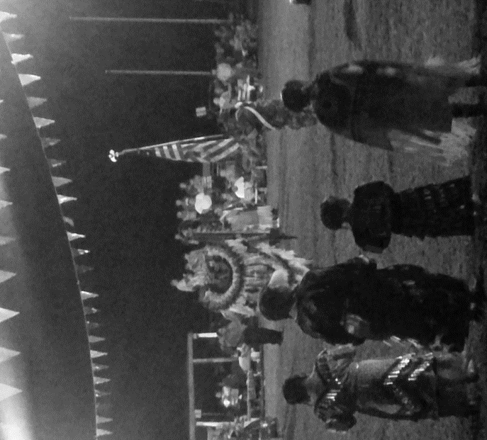
Figure 3: Powwow in a Local Tribal District, 2015. Photo by, E. Oliver 2015

I am and have always been a keeper of words—a documentarian of sorts. As I sit here writing, I am reminded of my earlier conversation with Kyleover lunch. Lunch was fabulous, as always. I’ve known Kyle for what seems like a lifetime. He is my oldest friend, my brother from another mother, a symbolic representation of home; so, his response to my news that, in a very short time and, in due season, I would begin graduate school at OU, was no surprise.
“Nigga is you, crazy? You are going where?” You know there are hardly any people that look like you there, don’t you? he would rhetorically ask with confusion and alarm in his voice. Shaking his head, he mumbled, “you are going to be out of the safety of home.” “What is anthropology and who is it for, really?” he half-asked, half-stated.
Returning home from lunch, as if listening to a radio program from a time without television, I replayed my afternoon with Kyle, I thought deeply about his questions. I hoped that I was making the “right” decision in leaving one home for another. My own questions arose as I prepared to embark on a new journey: Would I be content in Okla-hom-a, the state with home in its name? Would my research produce the type of content that would elicit change in the communities in which I would work? Would the content of my research be consumable for all audiences? These questions and more would consume my thoughts, playing over and over, like an audio recording set to loop continuously. As the time came for me to exchange my very urban landscape for one that was, for all intents and purposes, very rural, I recalled what I had indicated in my grad school application. I had written,
I have always been a ‘people watcher’ and have been drawn to observing others. My strong desire to explore the culture of others fuels my passion for researching populations that are often marginalized. I can clearly trace my passion for culture to observing a pow-wow as a young child. I couldn’t get enough of the rich elements that were being displayed to me. This type of experience has been a constant theme in my academic years.
Remembering the graduate school application passage, I realized it was time for me to return to my first home—the family home located in the neighborhood known as The Lows. There, as a multiethnic anthropologist, at home in The Lows, I would find my “seat at the table” (Navarro et.al, 2013:448-451) through a schema of “inspecting, gathering, and entering (Hanks 2010: preface xv).” I would be given a front row seat to observe the ways in which women make-meaning regarding their daily lived experiences, broker for healthcare needs, construct social and cultural cohesion, and use language and space in their daily lives. Like Kathleen Stewart and Lila Abu-Lughod, I would let stories breathe
Letting Stories Breathe: Borderlands, Boundaries, and Narrativizing in The Lows

The Lows is a pseudonym for a neighborhood that thrives, in its own way, in a town that is one of eight towns that make up a tribal district in the northwest quadrant of Oklahoma. It is a multiethnic, multicultural, economically challenged neighborhood. This is an aging neighborhood where the women outnumber the men, the elderly outnumber the youth, and the poor outnumber the middle class. It is a complex landscape.
The biopsychosocial, geographical, architectural, and semiotic landscapes of this neighborhood are textually and texturally diverse and complex (Basso 1996). Language, the sharing of stories, the exchange of recipes and remedies, the facilitation, creation, and distribution of meals, and the use of space all serve as markers of identity within this neighborhood. My dissertation is about the (re)attachments, (re)imaginings, and (re)workings of and, to intimate space within “uncanny” (Freud 1919 in Penguin Books 2003:123) places that are socially constructed and produced through daily lived experience (Steedman 1986; Masterson 2016).
There have been numerous studies that examine families of color in the United States; however, the research is scant when exploring “adaptive strategies, resourcefulness, and resilience of urban families under conditions of perpetual poverty or the stability of their kin networks” (Stack 1974:22) and, even fewer studies that explore these families in the context of neighborhoods in rural geographies in multigenerational and, primarily, multiethnic female-centered homes. This suggests the need for additional anthropological community studies scholarship situated in resilient, empowered, rural communities of color.
Through six years of extensive participant observation, informal and formal interviews and focus groups, I describe, in thick descriptive detail, the ways in which individual and collective narratives are empowering and emancipatory. I spent these years sitting on my porch and the porches of others, sitting on the mourners’ bench at the church, sitting at a table in the fellowship hall at the mission, leaning against the wall or sitting on the steps at the stoop, and lounging on the seldom used and poorly kept tennis court, that was later transformed into an area for playing basketball at the unkempt and barely used neighborhood park. During these moments, I was occupying a heterotopia—a space at the borderlands—a space at the border of the uncanny and the desirable—a space between the unbelievable and the undeniable. In these spaces, I would just sit…, lean…, talk…, cry…, laugh…, eat…, watch women dance…, listen to women “score” on one another…, get my scalp greased with a mixture of castor oil, ground mint, and sage…, watch incomprehensible healing take place…, and break up a great number of fights. Attending weekly Wednesday, Friday, Saturday, and Sunday meetings at a community mission and church, and traveling to and participating in hand-games across the state were mandatory for my inclusion into the daily lives of the women in the community. Countless hours of meal preparation for chief meetings, births, funerals, and community dinners were also a component of my routine for inclusion in these tightly knit places and spaces. My dissertation undertakes a narrative and ethnographic approach in examining the sentimental economies of belonging and becoming and the affective nature of relatedness shared by the researcher (myself) and the research participants (the women in the community). Furthermore, I discuss the challenges I faced as a “native” anthropologist in “coming home” and my own agency within this community and the ways in which this shaped and framed my own belonging and becoming.
From the spring of 2010 through the Summer of 2016, I conducted fieldwork in a neighborhood known as The Lows, which is home to many multiethnic and multicultural female-centered, multigenerational families. In this community, there is a prevalence of male (father) absence (Gray and Anderson 2010:128-141). The most visible men that are members of this neighborhood “do what they can” (quote from a participant interview 2015) (Duneier 1992) for the elderly women in the community; however, they rarely assist in long-term parenting and neighborhood governing activities. There are several reasons for their absence. The men or fathers that are ‘absent’ from family and community life are incarcerated, deceased, disabled, or disengaged to some degree, or what I call I-Triple-D. They are a hidden population that is often hooked, overlooked and their dramaturgical performances (Goffman 1959:106-141) in the neighborhood, mistook. Their absence from this community has been reported as one that is underpinned by systemic and systematic violence (Bourgois 2003). The role and place of men and the male presence, or lack thereof, in marginalized communities of color, specifically rural and aging communities in the Midwest, is an interesting arena for investigation and inquiry (Liebow 1967; Stack 1986); however, my research focus for this dissertation prominently positions the women at the center and places the men at the periphery of place and space in The Lows.
The Neighborhood
Livin’ In The Lows
“El Roy, that’s my hood…put it in your face, get that shit understood! What, say what? Say it with me, y’all, El Roy, that’s my hood…put it in your face, get that shit understood. Movin’ about each day and night….Livin’ The Lows life…makin’ life right!”
-Jeanine (research participant, creative writing project)

“Adjusting to the local neighborhood reality, many try to coexist, and others flee…. through public experience, a person becomes deeply familiar with elements of the neighborhood—drug dealers, policemen, the local grocer, poor people, homeless people, and middle-class families and individuals making up the community’s social fabric.”
-Elijah Anderson (Street Wise 1990)

Neighborhoods are fascinating and complex sites for research and exploration. The public spaces in these neighborhoods have been sites for sharing and exchanging cultural values, traditions, beliefs, and knowledge. Much can be gleaned through the exploration of neighborhood relationships, structures, pathways of economics, systems of health and other components of daily life (Oliver 2012). The examination of these components and their interrelatedness provides an understanding of the ways in which the neighborhood and spaces within function.
Living in The Lows is often fraught with anguish and pain as well as joy and community cohesion. In this neighborhood, there are little-to-no opportunities for employment. The grocery store that is within walking distance has closed since the beginning of this research project; however, when it was open and operating, it often carried expired foods and spoiled produce. Obtaining healthy foods was a difficult endeavor and often a huge challenge for the residents in this neighborhood.
Many of the homes are dilapidated and lack the desired amenities to provide for what most would perceive as a comfortable living environment. Several homes lack any form of heating or air conditioning which can be brutal in harsh winter and cruel summer months. Most residents living in these homes are single mothers or generations of women who have experienced trauma in various aspects of their lives. Based on participant self-reports, several of the children (adult and youth) have also experienced trauma.
Questions regarding the daily lived experiences of women in a rural community in Northwest Oklahoma, neighborhood health informatics, and the ways in which space contributes to the formation of identity for individuals and groups can be answered through deeply intimate ethnographic research. This ethnographic study, utilizing extensive and immersive participant-observation, formal and informal interviews, and social and spatial network mapping took place in an extremely marginalized neighborhood in a rural Oklahoma community.
In 2012, the population totaled 18,516 residents. To date, the population has increased in number. According to the most current census data, the population now totals 18,786 residents. The Lows, a neighborhood located within the town of El Roy, is predominantly black; however, many residents are of multi-ethnic lineage. The neighborhood, currently, is ethnically and racially mixed. Economically, many residents in The Lows range from extremely impoverished to lower middle class.
Setting the Stage: A Look at El Roy
In the late 1800’s through the early 1900’s there were less than 200 individuals identifying primarily, and due to the “one-drop rule,” as Black living in El Roy, a rural Oklahoma town (Livermore 2015 Interview) that was comprised of American Indian, German, and Jewish groups (Livermore Interview 2015). These individuals lived in a densely populated neighborhood geographically located on a flood plain. The neighborhood became known as The Lows because of its location; however, many residents indicate that the neighborhood took on this moniker because of the high concentration of Blacks that lived in the area. Many of the families that were living in El Roy had been lured to this region with the promise of “a better life.” They had hoped for a chance to achieve prosperity in joining the land run in April of 1889 (Oklahoma Historic Society Archival Review 2015).
Families began settling in El Roy and other unclaimed areas, that would eventually become the very close, neighboring all-black towns of Dorie and Jackson. Community relationships were important to the residents. They established networks that would meet their needs of entertainment, spirituality, education, and health. A bartering system was established among residents and between communities. They would often exchange garden seeds, vegetables and fruit, and wild game (quail, turkey, prairie chickens, rabbits, opossums, raccoons, and squirrels) (Crockett 1979; Franklin 1980; Shepard 1988; Wickett 2000; Saunt 2005) for goods and services that the family needed. Working the land and bartering consumed most of their time; however, families found time to break from their arduous routines to socialize.
Social life for folks living in El Roy, Dorie, and Jackson was structured around school and church activities (Crockett 1979; Franklin 1980; Shepard 1988; Wickett 2000; Saunt 2005). These were designated spaces for social interaction, and community cohesion. On many occasions, where dancing or “a good time” was desired, residents would host “drop-ins” (Crockett 1979; Franklin 1980; Shepard 1988; Wickett 2000; Saunt 2005) at their homes. There, they would have their own form of “toe-parties” as discussed by Zora Neale Hurston in Mules and Men (Hurston 1935). Food, music, and games were available, typically in the front room and kitchen of a home or in a yard space. These intimate spaces were the cultural centers of the communities.
Space or Place? Sites, Semantics, Soliloquys, and Solidarities
Referring to the expanded notion of Bhaba’s third space as discussed by Oldenburg, in terms of third space, residential constructions are areas that are designed to separate and segregate neighbor from neighbor and, neighborhood from neighborhood (Oldenburg 1996-1997:6). In the early 1900’s, the neighborhood known as The Lows was a thriving community. Initially, the historical patterning of houses in The Lows did not have the intent of separating neighbor from neighbor; however, the neighborhood shifted to an ethnically-segregated community. By 1910 segregation changed the neighborhood (Crockett 1979; Franklin 1980; Shepard 1988; Wickett 2000; Saunt 2005).
During this time, The Lows, like many “old Black neighborhoods”, was divided into sections by ethnicity and class. The families that identified as White “lived at the top of the hill” (interview with town elder 2015) while those identifying as Black “lived at the bottom of the hill.” The neighborhood was a thriving neighborhood on both ends of the street, a thriving predominantly White neighborhood; however, since the early to mid-1970’s, this neighborhood, while minimally ethnically diverse is predominantly comprised of African-American individuals and families. The neighborhood has transformed into an economically-segregated area of informal economic interaction and transaction, deep poverty, and extreme marginalization (Oliver 2009; 2011). The most prominent and graphic indicator of the transformative process with which the social, political, and economic climate has changed comes from conversations with the neighborhood elders, a review of old photographs, and interviews with the town historian. Consider the following conversation (Example 1.1) with an African American neighborhood elder:
Example 1.1: Ethnographic Conversations Snapshot, Lila 2015
Lila: Chile we use to be what they call ‘high society.’ We were the only Blacks that lived on the hill on this street. People thought we were rich and as a result my brother and sister and I were always getting picked on by the other kids. They would say, “ya’ll think ya’ll too good, don’t you? I can remember it clear as day….just like it happened yesterday. They would chase us home…throw rocks at us…My sister and brother look Indian so they would get picked on the most….tied her in a chair once. I musta come out the house, picked up a big stick and went to whippin’ heads…I mean, kids was mean during that time because they thought we had money. Hell, we just was fortunate enough to live on the hill. Our house was a stone-type of brick with a big backyard. Our daddy had made good money ‘fore he died in a freak accident…never did determine the “real cause” of his death…Momma said it was because he was Black and out perfomin’ the White man in his job. Anyways….you can look at this street today and wouldn’t even be able to tell there was a separation of houses. Today all the houses look the same…We all look poor.”

In the ethnographic snapshot (Example 1.1) above, the participant provides a glimpse at the ways in which the neighborhood was perceived both in the past and the present. A review and comparison of old photographs with current photos illustrates the drastic changes in the use of neighborhood space, and the ways in which this change has altered neighborhood structure and appearance.
In both biological and socio-cultural anthropology, the examination of space and place is diverse and multifaceted. We often relationally situate these concepts within a broader context to explore types of experience and phenomena. The neighborhood narratives of the past and present illustrate changing social networks and socioeconomic conditions. It is important to keep in mind the ways in which neighborhood space lends itself to cultural production. Edward Sapir ([1912] 2009:226) writes,
“[.…] a single individual may react directly to his environment and bring the rest of the group to share consciously or unconsciously in the influence exerted upon him [….] in actual society even the simplest environmental influence is either supported or transformed by social forces (Sapir [1912] 2009:226).”
In Lila’s narrative, above, we can glean the impact of the neighborhood on cultural performance. By specifically examining biopsychosocial and cultural markers of race, ethnicity, gender, language, family traditions, and intimate spaces we can come to an understanding of the connections between narrative, space, and culture (Worsley 2010:41, 78; Sapir [1912] 2009).
When I first returned to the family home in The Lows for graduate school in the fall of 2010, I had not intended to study the neighborhood. Initially, I was interested in studying the art and practices of curanderismo; however, I discovered that the neighborhood and those participating in this form of healing was largely comprised of women, many living in multigenerational, female-centered homes and, from diverse religious, cultural and ethnic backgrounds. My interest soon turned to examining potential health disparities that existed for the women in this community and the ways in which complementary alternative medicine mediated illness and suffering. During this stage in my research, I found, despite the daily experiences of deep poverty, structural violence, and limited access to resources, the women living in this “place,” have created spaces of emancipation and empowerment. They have contested societal placed labels and stereotypes and, constructed borderless communities within a community. This was a catalyst to further expand my research and examine the function of space within places—communities often perceived as uncanny, and the ways in which these spaces are utilized to construct narratives of identity, health, and religion and, their synergistic relationships. My research pays attention to various mobile landscapes, the cultural practices, neighborhood networks, places, and pathways that encompass the social world of The Lows.
The primary questions driving my research are: What is the cultural significance of spaces within this community? In what ways do these spaces affect the biopsychosocial health of women in the neighborhood? How, and why do constructed, intimate spaces facilitate the telling and sharing of narratives? In what ways do the women living in The Lows make meaning of everyday lived experiences in a rural and aging community?
My research advances anthropological inquiry and theory by holistically examining the interplay of culture and theory and examining the importance of space and place in the context of gendered, and narrated landscapes within a rural community studies framework. Also, in a Bakhtinian sense, I explore the ways in which these landscapes foster connections to one another, facilitate cultural production through the dialogics of the sharing of narratives, and operate as a genealogical practice, and platform for biopsychosocial and historical meaning and agency through the privileging of participant voice.
Landscape is a term that I employ to describe the vast biopsychosocial and historical aesthetic, scenery, and panoramic views of a “naturalized” life in The Lows. In this research, landscape has been characterized as an internal collective “ours.” A scenery shared by all. It is a desirable aesthetic in a seemingly uncanny place where “groups of men and women have invested themselves (their thoughts, their values, their collective sensibilities) and to which they feel they belong (Basso 1996).” Landscape is a home for place, space, and those that are membered to place and space. It is a vast and bountiful external representation of the merging of the past and present through the agency of spatiality.
For my dissertation, I define space as a boundless arena within place where narrativization of daily lived experience mobilizes “social movement” (Frank 2010:2). It is a site for storytelling—a porch, a mission fellowship hall, a sanctuary within a church, a kitchen table in a small home, a stoop for “narrativizing a local cultural real” (Stewart 1996:4-8). These are spaces that provide technologies for women in the community to transcend the confines of intergenerational and historical trauma, to break the chains of structural violence, and give birth to a life well-lived.
There are numerous discussions about the constructions of space within the literature, across disciplines; however, for this dissertation, space is best discussed and examined with a broad and holistic focus—with a focus on the way the women transform unlikely spaces within uncanny environments to provide for their daily biopsychosocial needs. These are spaces of attachment (Hurston 1935; Gwaltney 1993; Stack 1996). Places that encapsulate “a breathing space, a refuge from the maelstrom (Stack 1996).” Basso (1996: Location 90-ebook) indicates, “places, we realize, are as much, a part of us as we are part of them, and senses of place—yours, mine, and everyone else’s-partake complexly of both.” Using Basso’s conception of place, I argue that this is evident in the spaces within places in The Lows. Continuing with this line of thought, Basso writes,

And so, unavoidably, senses of place also partake of cultures, of shared bodies of “local knowledge” (the phrase is Clifford Geertz’s) with which persons and whole communities render their places meaningful and endow them with social importance. Yet cultural anthropologists, some of whom work for years in communities where ties to place are vital and deep-seated, have not, until recently, had much to say about them (Rodman 1992) (Basso 1996: Location 90-ebook).
My dissertation has much to say about the meaningfulness of place and space. It examines constructions of knowledge, health, and well-being by highlighting the most prominent cultural and social network spaces in the neighborhood and delineates the meanings attached to them.
My intimate interactions within The Lows is a conduit that enables me to critically interrogate, compare, and analyze the scholarship of past and present anthropologists who conduct community studies research. My research advances anthropology by answering questions about oppressive paradigms that have empowered community members through oppression. The use of narrative and the importance of space vividly illustrate this form of empowerment in my dissertation.
Through my research, I have been presented with community-based solutions that assist in advancing the anthropological endeavor in resource poor communities. To that end, my dissertation shows ways in which women express their agentive capacity through the sharing of personal narratives, political beliefs, and prideful accounts of daily life in The Lows. Through food, song, story, and dance within intimate spaces, women who participated in my research resist, repel, and repudiate outside reductionist representations of an impoverished life. My research will illustrate that he construction, production, and performances of personal narrative in intimate settings disrupts notions of poverty and disempowerment.
Dissertation Layout
The ethnographic endeavor has changed significantly over time. There are numerous ways in which to approach the construction and writing of an ethnographic project. For my dissertation, I chose to thematically delineate the chapters in a way that makes the reading of this research consumable for audiences in the academy and most importantly, in the community in which I have lived and worked for the entirety of this research. My research is experimental and, somewhat, auto-ethnographic in nature, novel in construction, and poetic in reading and interpretation, and embodies the narrative essence of Zora Neale Hurston, Phillipe Bourgois, Carol Stack, Betty Lou Valentine, Sue Ann Taylor, Joao Biehl, Kathleen Stewart, John Langston Gwaltney, and countless others that have shifted the anthropological gaze within the writing of their research. Like a quilt that is stitched of multiple layers, each chapter is comprised of a colorful woven cloth top, batting, and a woven back. The final writing of this project takes on a multi-narrative identity and results in a type of free-flowing story complete with thick description, colorful conversation, and, the stretching of methodological boundaries as conceptualized by Alisse Waterston and Barbara Rylko-Bauer (Waterston and Rylko-Bauer 2006) in “the construction of ethnography in the intimate spaces of family life (Walley 2015:626).”
Women of color occupy a unique place in scholarship. They are often written about, discussed, and examined as objects. This, sometimes, happens within feminist scholarship. I did not want to write about the women that participated in my research in a way that may be misconstrued as “writing about the women, their lives, their histories as if they were “objects.”
Feminist theory, specifically, “Black Feminist theory” could be used to underpin my dissertation through an intersectionality framework exploring race, class, and gender, and examining the negative stereotype of the “promiscuous and poverty-laden woman of color;” however, I use feminist theory sparingly. My justification for limiting the use of feminist theory derives from the multitude of conversations that took place with my participants. Many of my participants identified their evangelical leanings as a factor in separating themselves from the “feminist label.” Many women in the community are faithful attendees at churches in the community. These churches do not share the same views as the women that participated in my research regarding sexual health, and reproductive rights.
Despite performing “feminist” practices, my participants did not want to be identified as feminist. The women often, voiced that they “felt” that their stories, their lives would best be expressed through a theoretical framework that privileges their oral histories, and gives way for them to express their ethnic identities through spoken word. They indicated that my research was “much broader than a feminist agenda,” and should holistically focus on their lives and the spaces in which life takes place.
Chapter Overview
The introduction above provides a snapshot of my growing interest in this diverse and complex neighborhood and sets the stage to answer my dissertation research questions. My dissertation focuses on the ways in which social and cultural space impact biopsychosocial health, strengthen social and cultural networks, reinforce community cohesion, and script empowerment through the sharing of narrative. Through the inclusion of ethnographic vignettes, snapshots of intimate conversations, and excerpts from focus groups and interviews, thematic topics of gender-based violence, othermothering, local language and storytelling, health and healing, songs and sayings, food environment and, religious and ritual performance in intimate spaces are more salient areas of focus that provide a view into the lives of the women living in The Lows.
In the first chapter, I introduce the reader to the neighborhood setting and landscape. I examine the narrative of space and place as it relates to El Roy. Specifically, I discuss the neighborhood and life in The Lows. This discussion includes a brief historical examination of diverse ethnic groups and the ways in which they transform and transverse landscapes in this Northwest Oklahoma community. Also, a brief discussion of the ways in which each chapter overlaps and interrelated is implicitly presented in this section.
In Chapter 2 I discuss the various methods used in the development and implementation of this research, data collected, and the ways in which data has been analyzed and interpreted. This chapter methodologically grounds the dissertation in its entirety while simultaneously advancing anthropological production as a science. Typically, this section would include the reflexivity and positionality of the researcher; however, discussions of my own agency and technologies of self and womanhood are woven throughout the tapestry of the ethnography. Moving away from the “traditional” positioning and grounding of theoretical literature, in the likeness of a formal review chapter, I elected to contextually frame each chapter with bodies of work that inform the research.
In Chapter 3 an abbreviated, broad, and philosophical discussion of the theoretical orientation and literature that informs this research are contained herein. Additionally, I outline my research questions that informed this research.
Chapter 4 expands the examination of space and place by exploring intimate spaces. These spaces include but are not limited to religious spaces, public city-governed spaces, and intimate home spaces. I also discuss the ways in which these spaces are transformed into sites and stages of storytelling and, of emancipation and empowerment through ritualistic action and participation. This chapter also discusses the biopsychosocial benefits of third spaces.
Chapter 5 discusses findings from interviews, focus groups, and the collection of life histories, participant writings, community cultural myths, songs and sayings, folk remedies and recipes, and health narratives.
Chapter 6 brings the dissertation to a close with recommendations for future research and presents an approach to promoting positive health outcomes in marginalized neighborhoods through a revised approach to the community based participatory research (CBPR) model. This model privileges community based participatory research and, draws on the historical anthropological origins of utilizing community members as research assistants. Like building a home, the research that comprise the chapters of this dissertation, illustrates that there is more than one way to, anthropologically frame, lay a foundation, and construct anthropological research – there is more than one way to “do” anthropology.
Dissertation Writ Large
On any given day, the most novice of observers can catch glimpses of women walking through the neighborhood known as The Lows. They are traveling from one home to another—one porch to another, and to and from the mission, local stoop, corner store, or neighborhood park, trading one morsel of gossip for a bit of knowledge— a home remedy to rid an earache, soothe extreme menstrual pain, or acquire a poultice for shingles from one of the community othermothers. Many visitors and visitees value these moments of social and cultural exchange and reciprocity. They are sites of being and becoming—spaces of knowledge and acknowledgement—places of health and healing.
The mom-and-pop spaces that served up greasy burgers, chicken and fish dinners, and bowls of goulash—Ms. Nettie’s candy shack—Aunt Earline’s snow cones in the back room of her tiny home, the beer taverns, “resorts,” funeral homes, grocery stores, and beauty and barber shops “have long since been gone”, closed and boarded up. Only their ghost—a memory of their former self remains in The Lows. Even though these wood-framed spaces are vacant and have boards covering the windows,several of the women in this neighborhood use these spaces to hustle for money to buy the day’s drink, dinner, “dimebag”, or “doose”. The women who participated in my research are regularly in the community view. A select few of the participants in this research have participated in local civic meetings that are attended by individuals from various neighborhoods throughout town. Their identities are not secret and often the ways in which they engage in informal economy and health brokering are also well-known. In many works, identities are often made public and, making an identity known (in the 5-minutes of fame context) is often requested by the participants in my research; however, I have provided anonymity regarding person and place as my research unfolded over time, in accordance with the anthropological guidelines of human subject protection. A pseudonym or composite sketch has been provided for each individual and place of business discussed in my research. All individuals that are discussed in my research have signed consent forms and separate model release forms. Many have requested that I use their “real” name and do not alter their photos; however, as not to violate confidentiality for ALL involved, I have gone to great lengths to conceal all identities. As an anthropologist working with sensitive issues in communities that automatically distrust, my commitment to protect the identities of the participants and community are of the utmost importance. I elect to do no harm to those who have collaborated on this project. Now, let’s go home.
Chapter 2: Methods, Meaning-Making, and Me
“The future doesn’t belong to anyone except those willing to sit and stay a spell, on this here porch. This is where the real learnin’ happens. You sit. You watch. You listen and then you learn. Real learnin’ gal. You hear me, gal? I said, “real learnin’, and not that textbook stuff.”
Albert Jean (dissertation research participant -informal conversation)

“You gointer stay awhile, Zora? Yep. Several months.”
-Zora Neale Hurston (Mules and Men 1935)

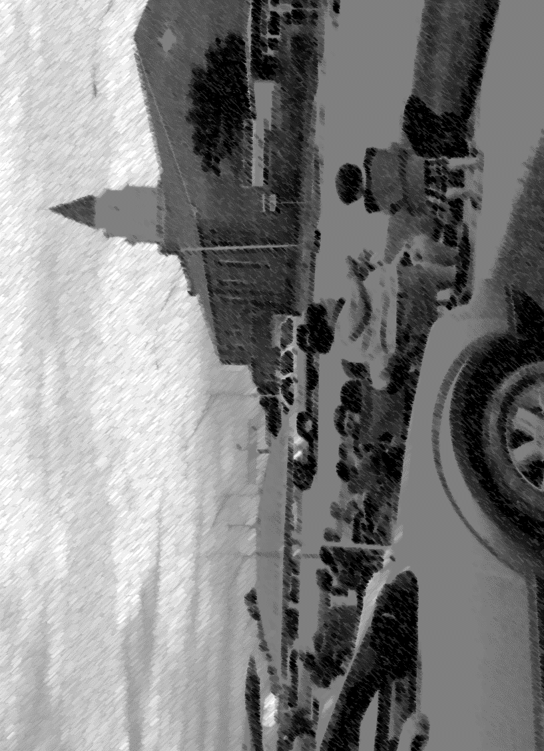
Figure 4: Summer Participation in El Roy. Photo by Elisha Oliver

The Research Endeavor: People and Populations as Distrusting Research Partners

Anthropology, coupled with the research endeavor, is often characterized as “the handmaiden of colonialism” (Asad 1973). Despite the debates that focus on this tenet, indigenous populations and communities of color express a general sense of distrust regarding the research production (Metler et al., 2011; Taran 2011). The concern of distrust was often voiced during my fieldwork in The Lows.
“Research is probably one of the dirtiest words in the indigenous world’s vocabulary” (Smith 1999:1); however, the sentiments associated with research are not exclusive to indigenous peoples. Among populations of color, the word ‘research’ is laden with ‘negative feelings’ (word association from pile sort with community members 2015). Research methods, use of data, dissemination of information resulting from research, time in the field, and level of commitment between the research population and the researcher and research institution are all areas of grave concern among marginalized and oppressed populations (Example 2.1). At a community health board meeting, a revered tribal chief commented,
Example 2.1: Ethnographic Conversation Snapshot, Local Tribal Chief, 2015

“I’m tired of these folks asking for permission to research among our people and they don’t take time to invest in our community. It’s a shame. But, I’m still hoping and waiting to see if they will actually help the people (Tribal Chief at a health board meeting 2015).”
This comment (Example 2.1) and many others speaks to the sentiments and, at times, distaste for research and researchers in communities of color. Consider the following,
“The power of research was not in the visits made by researchers to our communities, nor in their fieldwork and the rude questions they often asked. In fact, many individual non-indigenous researchers remain highly respected and well-liked by the communities with whom they have lived. At a common-sense level research was talked about both in terms of its absolute worthlessness to us, the indigenous world, and its absolute usefulness to those who wielded it as an instrument. It told us things already known, suggested things that would not work, and made careers for people who already had jobs (Smith 1999:3).”

The above excerpt by Smith (1999) reveals a much deeper problem for researchers— that is, striking a balance between the academy and the research population — “doing research” that privileges the concerns, needs, and voices of the participants while being “academic, enough.” Another concern, voiced by members of my research population, was the assumption that the data collected would be “used” by legal authorities. This concern was not birthed out of fear of being “found out” as someone that engages in informal economies and adaptive strategies; but, a fear arising out of deep anguish because of harassment by local officials. There were several occasions when I was asked if I were:
- working for the police to collect information about the community;

- If I were sent by social services to “snoop around” regarding certain neighborhood families;

- If I collected information to “turn people in” for a variety of reasons: insurance fraud, undocumented status, or any other number of fears that are components of daily life in The Lows.

Ethnographic Methods
Ethnography and ethnographic methods have long been an integral part of the anthropological endeavor. Their use within anthropology has been contemplated, contested, and criticized; however, this research approach and strategy has been equally celebrated and confirmed as a valid research tool. Ethnography is a vehicle that lends itself to the passenger seeking to understand the nuanced and often ambiguous social and cultural lifeways, behaviors, and experiences of individuals and groups (O’Reilly 2012:2; Murchison 2010:5; LeCompte & Schensul 1999:1; Clifford & Marcus 1986:2). David Fetterman describes the processes involved in ethnography as an “ambitious journey through the complex world of social interactions (Fetterman 2010: xi).” The use of ethnographic methods is best used to document processes within complex communities, to describe and define a range of issues that are often embedded in multifarious systems and, to serve as an apparatus for explaining meaning-making among research participants.
Meaning-making with regards to intimate discussions and explanations of life-ways within this community are best explained through ethnography and the ethnographic method as used, initially, by Bronislaw Malinowski, known as the “inventor of intensive fieldwork (Young 124).” These methodological tools have a deep and rich history beginning with Malinowski and his work with the Trobriand Islanders (Malinowski 1916). Malinowski, using the ethnographic method, engaged in an extensive study of the Kula. He writes,
The results of scientific research in any branch of learning ought to be presented in a manner absolutely candid and above board. No one would dream of making an experimental contribution to physical or chemical science, without giving a detailed account of all the arrangements of the experiments; and exact description of the apparatus used; of the manner in which the observations were conducted; of the degree of approximation with which each measurement was made (Malinowski 1922:3).
This method of inquiry and data collection is useful in examining patterns of behavior associated with health, identity, and notions of being. The research for this dissertation was conducted using a collective body of qualitative ethnographic and narrative methodologies to obtain data. They included full immersive and extensive participant observation, social network and spatial mapping and analysis, n=176 informal and n=45 formal interviews, and nine focus groups, collectively to obtain data.
Ethnography and the ethnographic method have transformed the ways in which the practice of anthropology is participated in by both the researcher and the participant. Prominently positioning the voice of participants and the researcher has transformed “the ways in which anthropology is done” (Abu-Lughod 1993; Stewart 1996; Biehl 2005; Stewart 2007; Rosaldo 1944). In a classical/traditionalist mode of anthropological research, authoritative license has been given to the researcher, and his or her reflexivity and positionality has been, to some degree, omitted from much of the anthropological record. Rosaldo indicates that many anthropologists feel a sense of “hesitation in introducing themselves into the research account” (Rosaldo 1944:541); however, in recent years, many anthropologists posit that such positioning adds a richness to the research account that makes anthropology consumable (as done by Margaret Mead in her writing for Redbook Magazine – Mead 1971) for a wide variety of audiences. Ethnographic methods are common qualitative approaches used by researchers to gain an emic perspective with regards to the socio-cultural and, quite often, biological and health issues of communities and cultural groups (Singer 1990:548-549; Bernard 1995:23; Trotter and Schensul 1998:695; Marcus and Fisher 1999:45; Savage 2000:1400; LeCompte and Schensul 2002:1). The ethnographic approach for this research has been significantly improved with the incorporation of intensive participant observation and informal and formal interviews.
Participant Observation & Interviewing
Participant observation is a methodology in which ethnographers immerse themselves in a community for an extended period intending to first, observe and second participate in community life, to gain a thorough and nuanced understanding of the research community. Hortense Powdermaker (1996) writes:
To understand a strange society, the anthropologist has traditionally immersed himself in it, learning, as far as possible, to think, see, feel, and sometimes, act as a member of its culture and at the same time as a trained anthropologist from another culture. This is the heart of the participant observation method – involvement and detachment. Involvement is necessary to understand the psychological realities of a culture, that is, its meanings for the indigenous members (Powdermaker 1966:9).
Interviewing can take on many forms. Some interviews are structured using a set of prepared questions and are often scheduled ahead of time with a distinct meeting place arranged. Majority of the interviews that framed this research were unstructured and conversational. They would often take place sitting on the porches of the women in the community, on the steps of the local stoop, or in hushed secretive tones on the back row at the neighborhood mission and church. They typically involved a prepared narrative prompt or a set of questions that would elicit responses from the participant that were deeply reflective. Other interviews were formal and followed an interview script that was segmented into various domains of inquiry. These domains elicited responses that targeted identity, community (including but not limited to the neighborhood and notions of home), gender-based violence, substance use and abuse, incarceration, and health. I used these forms of interviewing interchangeably during my time in The Lows.

Participant Observation & Focus Groups
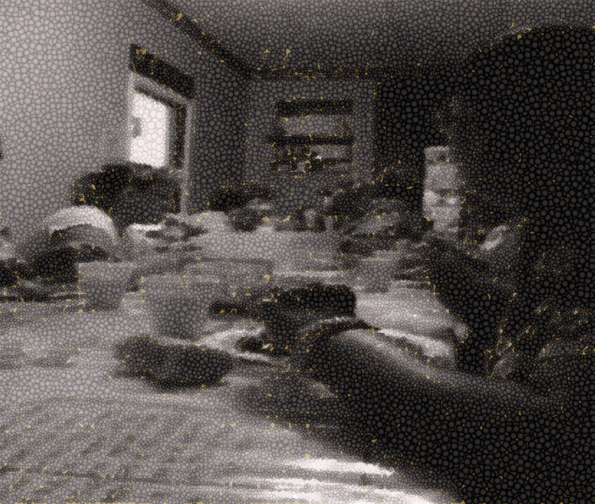
Figure 5: Focus group session and a meal, summer 2013

During the beginning stages of my research, I found that community members more readily would discuss daily lived experiences and the pros and cons associated with these experiences in group settings. Oftentimes, the participants in the focused groups would use this time as a type of “gripe session”—a time for “testifying” and “witnessing” (a concept discussed later in the dissertation). This prompted the use of a focused group interview to obtain data that represented both individual and collective thought. Conducting the group interviews proved to be both an advantageous and successful component of this research. Schensul (1999) writes,
Group interviews are useful and have a number of advantages. They are excellent ways to generate a considerable quantity of data in a relatively short period from a larger number of people than would be possible by interviewing key informants only. Researchers are able to record and analyze group members’ reactions to ideas and to each other. Group interviews also produce data and insights that would be less accessible without the interaction found in a group. And, finally, these types of interviews elicit useful “natural language discourse” that allows the researcher to learn idiomatic expressions, common terminology and communication patterns in the community in a rapid and concise manner (Schensul 1999:52).
After the initial focused group interviews in 2012, I obtained a culturally relevant vocabulary that was more conducive to working and communicating with individuals in this community. Having insider language and knowledge greatly assisted in the two additional focused groups that followed in 2013 and 2014.
Khan et al. (1990) suggests, “ethnographers must conduct at least two focus groups for each variable of concern to ensure that they capture most aspects related to the subject of inquiry.” Keeping this in mind, twelve focused groups, three each year, were conducted during the late summers of 2012, 2013, 2014, and 2015. The focus groups consisted of ten individuals per group. These focus groups were conducted at the Greater Healing Hands and Heart Mission located in the neighborhood where this research takes place. The sessions began with a fifteen-minute informed consent period and were followed by ninety minutes of topic introduction and informal and formal group discussion. All focus group sessions were audio recorded using a Sony digital recorder.
During the focus groups, I would introduce a topic of discussion that derived from my research questions and that informed my research hypotheses. This would result in an open discussion of the topic among focus group participants. After introducing the topic to be discussed, tailored and formal focus group interview questions were asked. As a general focus and introduction to discussion topics, participants were asked the same question in each session; however, the focus changed with each session. Topic specific group questions were designed to be both direct (close-ended) and open-ended. There were seven broad domains. They are (1) General questions and topics of discussion, (2) Demographic related questions, (3) Social and cultural norms (self, family & community), (4) Identity, (5) Health related programs and services, (6) Motherhood (and opinions with regards to Fatherhood) and, (7) Importance of place and space (social and cultural landscapes, riskcapes, healthscapes, soundscapes, and storyscapes). Incorporating the use of the pilesort and freelisting techniques, these seven broad domains were narrowed down to four culturally specific themes. All the themes were underpinned with concepts of narrative and health and health brokering. Questions related to these domains produced participant led discussions and stories that overflowed with cultural beliefs, symbolism, and agency.
The leading topic-specific questions inquired about the daily lived experiences of rural life and the ways in which these experiences impacted health, mothering, intimate relationships, community sustainability, group participation (inclusion and exclusion), and neighborhood needs and wants. During these focused group interviews a variation in opinions and attitudes were shared. Upon completion of the focus groups, I determined that creating a social network and spatial map and having the participants create their own versions of the map would inform the research significantly.
Social Network and Spatial Mapping
As mentioned previously, many public spaces in this community are used as gathering sites to exchange information, spaces for gossip, spaces of informal economy—a spot for simple bartering and exchange, and spaces of community building and advocacy. Many residents often gossip about the latest arrest, birth, death, handgame tournament wins and losses, relationships statuses of neighborhood members, and intimate and personal health issues they or others are facing. They share important and not so important community information regarding grassroots support group meetings, food assistance, and clothing give-aways. Many observe “the comings and goings” at these public spaces. Residential porches, on the steps of BTW High School, known as the stoop, which was, once a “Black only” school, in the parking lot of the abandoned Jesus Place Church, a Church of God and Christ organization, at Bardwell Park, and at women’s meetings at Greater Healing Hands and Heart Mission are the most popular places for sharing and exchanging information and material culture, in this community. Informal economy, bartering, and exchange are conducted at the stoop, Bardwell Park, and at the empty lots of Jesus Place. The more intimate nature of these exchanges is often conducted at Jugheads, a private residence that doubles as a “gathering spot and club.” The vast array of spaces and individuals transgressing the boundaries of these spaces is best captured through social network and spatial mapping.
Social network and spatial mapping is a method used to illustrate the diverse relationships that exist within this community. These maps show the position of the various spaces that the women use in this community in relation to spaces and places of resource accessibility and, access to one another. Spaces of inclusion and exclusion are also defined. Murchison (2010) writes,
Ethnographers also produce visual representations that represent a condensed version of ethnographic information and help them communicate their ideas and findings to their audiences most effectively. These representations are the most beneficial additions to ethnographic texts. They are most helpful if they communicate information that is hard to communicate adequately with a verbal explanation alone and if they help the reader to understand the basis for analysis and larger models (Murchison 2010:215).
The maps constructed for this research have the purpose of aiding readers in the visualization of the interior space/s of The Lows occupied by research participants. They also serve as an illustration of spatial relationships and spatial distances. Mapswere initially hand-sketched and then computer generated. In addition to the construction of maps, photography and video was implemented in this research project.
Visual Documentation
The use of visual representations in the ethnographic record is beneficial when “they help communicate information (Murchison 2010:215).” The use of photography and video provides a powerful framework that significantly impacted and informed this research by adding visual representations of research practices and community life. Photography and video was incorporated in my research to provide additional context to the data presented in my dissertation. Individuals and places and spaces are not identifiable through these methods. After determining and deciding which research and data collection methods were most appropriate for this project. I began working to recruit research participants.
Recruitment of Participants and Compensation
In the opening pages of this dissertation, I position myself as both a member and non-member of this community. Upon entering the graduate program, I had “returned home,” so to speak. Many of the individuals I interacted with as a child had moved from the area or had “passed away”. As mentioned in the earlier section of my dissertation, many individuals were leaving a seemingly “dying town” to go to larger surrounding areas for promise, prosperity, and proposal; however, many stayed behind because El Roy “was home.”
My contacts were few and limited; however, a small number of family members reside in the town. Being the niece, granddaughter, or cousin of “so-in-so” helped minimally in making community connections and locating primary key informants and interlocutors; however, more scripted sampling techniques were needed for this research.
Using convenience sampling techniques, I coupled purposive and snowball or network sampling with family introductions to conduct this research. A purposive sample is sample chosen for a specific need or purpose with a focus on a specific group (Krueger and Casey 2009). I had a need and deep interest in exploring the daily lived experiences of women in this neighborhood. A snowball or network sample refers to the selection of a participant based on the recommendation or referral of a past participant or research collaborator (Schensul 1999; Krueger and Casey 2009). This method of sampling proved to be most useful. Questions about daily survival and community sustainability guided the sampling.
Participant contact, and referral information came from personal communication after having received responses to flyers that were distributed at the local grocery, convenience stores, liquor stores, churches, missions, and a town bowling alley. Flyers were also placed in the “reachable” doors of homes in the community. In addition to personal referrals, the Greater Healing Hands and Heart Mission staff and, the local tribal health board suggested referrals and recommendations for obtaining participants.
Participants
Historically and within the formative and classical years of anthropology, researchers—missionaries, ethnographers, anthropologists and— others were intent on studying entire populations. Schensul (1999) writes,
Historically, ethnographers sought to study entire populations. Populations usually are made up of human beings, but they also can constitute communities, organizations, programs, animals, places, things, time periods, documents, words, phrases, sentences or paragraphs, interview texts and transcripts, specific activities or bits of behavior, or any form of unit whatsoever. The populations that ethnographers once studied were conceived of as intact, bounded, and rather small groups, often on islands, in remote villages, or otherwise located in exotic places. Under such conditions, it was not difficult to contact and to study intensively, every member or unit in a population. However, current ethnographic practice often involves the study of large groups that may be embedded within other groups, organizations, activities, or settings; they may even be scattered over a number of sites. In such cases, studying every single member of a population is not possible, and researchers must engage in sampling (Schensul 1999:231).

Regarding the text above, I would have welcomed the opportunity to participate in the lives of each woman in The Lows and, to have daily conversations about their lived experiences over time and space; however, this was an impossible feat. I elected to engage in ethnographic sampling.
I determined an approximate and manageable participant count for my research. After determining a participant number that would be manageable, I established a set of sampling criteria for identifying diverse members of the population to ensure that all categories of membership in the comprehensive population were adequately represented within my sampling frame. A sampling frame is defined as a “comprehensive list of all members or units within a population, from which samples are chosen (Beck et al., 2004; Lance 2017: Schensul 1999).” I discovered that using convenience, purposive, and network sampling techniques were best suited for this research.
During the preliminary stages of my research, fifty-three (n =53) females and thirteen males (n =13) responded to the flyers. In a phone conversation, callers were asked screening questions to determine if they were able to participate in the research. The screening process was implemented to exclude individuals that were members of special populations. In the first stages of research, thirty (n = 30) women, and zero (n = 0) men were selected to participate. In the subsequent years (2013, 2014, and 2015), forty-six additional participants, twenty-seven women (n = 27) and twenty (n=19) men, eighteen and older were added to the study.
Compensation and Reciprocity
There is a give-and-take in fieldwork —a “process of gift and counter-gift,” (Clifford 1980:529) — an exchange between the researcher and an individual participant, participants, or community that is the focus of research. In much of the social science literature, this often-elaborate exchange, is called reciprocity. Reciprocity is a mutual exchange of goods and services. In 2013, the beginning stage of this research, each focus group participant received a $30 gift card from Walmart. In the following years reciprocity between the researcher and the participant occurred in several venues and in diverse ways. In much of the ethnographic literature, we see that reciprocity is a given in fieldwork. It is especially prominent between researchers and gatekeepers in the field site. Having key informants, gatekeepers, and important interlocutors is critical and salient to the overall success of the project.
Key Informants and Interlocutors
There is a long history of distrust in various areas of Oklahoma. The oppressed and marginalized have, sometimes, found individuals of a certain privilege and with a seemingly bourgeois or “bougesie Miss Ann” status to be “stuck-up,” unapproachable, and mean-spirited. Members of this community cite examples that illustrate the deep history of distrust of outsiders in this community. The literature that, minimally, discusses the comprehensive composition of the people in this area, provides examples and illustrations of colonialism, racism, and various other oppressive regimes that facilitate and perpetuate this notion of distrust (Berthrong 1963; Dorsey and Kroeber 1997; Fowler 2002 & 2010; Franklin 1980; Grinnell 1972; Moore 1987 & 1996; Saunt 2005). Despite my affiliations with individuals within the community and neighborhood, I was, initially, viewed as a “Miss Ann.” This was a complicating factor in my ability to, on occasion, complete fieldwork in a variety of settings; because, as discussed above, I was educated and appeared privileged—an outsider desiring to conduct research with women, who were viewed as unapproachable and mean-spirited. I did not expect the few family members I had in this community to assist with introductions, break down neighborhood and group barriers and, build rapport and trust with members of the community but, I had hoped they would. Sluska (2012:36) posits, “the success of ethnographic fieldwork is in large measure determined by the ability to establish good rapport and develop meaningful relations with research participants.”
Building trust proved to be extremely difficult within the first three years of this research as material goods, interactions in my personal home space with others from outside of the community, and the presence of my notebook and camera while strolling through the neighborhood became equated with “bougesie Miss Ann doing work for the man” (translating to I was a privileged woman that had white friends and I am recording what members of the community are doing to “tell-on” them). This is a community built on trust and acceptance. It took me slightly over a year to develop trust with a select group of women in the community. One evening, I invited a research colleague, a white male, to my home to discuss collaboration on a health-related project. The invitation that I extended to my colleague caused a rift between myself and the group of women I had worked so diligently to win over. After all, this was a community where everything is noticed. A snapshot (Example 2.2) of that event and an example of the neighborhood “bougesie Miss Ann” assumption follows:
Example 2.2: Ethnographic Snapshot, 2015
Early one spring morning, I groggily walked out onto the porch, balancing a steaming hot cup of strong coffee, two field note journals, several pens, pencils, highlighters, and my netbook in hand. I noticed a tattered 8.5 x 11 fluorescent yellow and orange paper taped to the glass of my screen door, a usual way to deliver messages in The Lows.
“This is urgent and WE need to talk…we’ve called a meeting,” was scrawled in large bold black print across the paper.
“We’ve called a meeting” was code for “something has gone seriously wrong in the ‘hood and we need to devise a plan to fix it.” This was not the first time that a meeting had “been called” and my attendance was necessary—no, mandatory. I sat my items down on the outdoor table and, with dread, looked in the direction of the mission. It is two doors down from my home. Parked in front was the familiar unassuming van, that was barely operational, that brought a few of the women to meetings, services, and events. I contemplated sitting down on the vinyl sofa and drinking the hot magical elixir in my cup that was sure to rouse me to full attention and readiness; however, I gathered up my items, took a few sips from the cup and returned inside. I dressed in a university t-shirt, running shorts, and flip-flops and made my way to the mission. When I walked through the door the women looked away as I bid them good morning. Something was wrong. I had done something wrong, but what? The last time I had been “summoned” to the mission, a question about my personal romantic relationship had become an issue of concern. Sister Janna, an American Indian woman, and the original founding member and one my key collaborators, was the first to address me.
“We called this meeting because we have some concerns,” she said.
The other women were silent and either averted my gaze, “rolled their eyes,” or smirked when I attempted to make eye contact. I sat at the table where we, as a group shared many meals, conversations, laughter, and tears both related and not related to the research. I felt uncomfortable as if I were under the microscope of examination. I felt like an outsider—a “new comer” to the community, once again. I fidgeted with a loose thread on the hem of my shorts and bounced my right knee up and down. What had I done? When did I do it? Did I wrong someone, unknowingly? I couldn’t come up with a response for my interrogating mind. Sister Janna continued with a tremendous amount of anger and agitation in her voice.
“Did you turn in Lori”, she questioned?” Are you working for those white folks? Did they turn in Lori? Did they tell you to turn her in?”
She fired these questions at me without giving the opportunity for a response. The other women sat silent with looks—masks of consternation and condemnation meticulously plastered on their faces. I sat there stunned, as if I had been slapped or punched in the stomach. I did not know how or if to answer these questions. I did not, at that time, have a full understanding of what had occurred in the community that I had been calling home. Another woman finally spoke up, shattering the plastered mask she had been wearing and with gentleness in her voice stated,
“If you turned in her in”, referring to Lori,” you have betrayed us, and you have betrayed all that is important in the neighborhood.”
At that moment, I understood the context in which this meeting was “being called.” Earlier in the week, a colleague visited my home. Nothing goes unnoticed in this neighborhood. Someone is always watching, like Foucault’s panopticon. Subsequently, the family, a White Family, living in the house across the street had been reported to child welfare services. In the previous week, I had a conversation with Sister Jana about being advised to report Lori to child welfare services for having thirteen children in the home and no central heat and air. I did not. The conversation with Sister Janna, the visit from my colleague, and the visit to the family across the street from child welfare were all coincidental. I could, clearly, understand the hurt and anger the women were experiencing in that moment. The woman continued,
“…we want you to help us fight the system. We don’t want you to fall in line with the system …you know? We thought you were here to help,” she said.
I felt nauseous. I did not and could not understand where this ill-assuming discord was coming from, where it had originated. I still did not answer the question that Sister Janna had asked me. A part of me was livid that such an accusation had been made and I wondered by whom? But, I remembered, this is a community that sees all and hears all. There is no secret space among spaces in this neighborhood. The other women sat silent as Sister Janna resumed speaking.
“We feel like you can’t truly understand what we face in this community if you are in fact involved with people and organizations who symbolize what holds us back—what has always held us back—what continues to hold us back. “It’s almost as if you’re a traitor…a part of the very system that looks down on us. How could you? You’re a Mexican and a Blandian”, she said.
I was completely taken aback. I am a multiracial, Mexican-African-American-American-Indian woman. My mother is African American and Mexican, and my father is African American and American Indian. Following a matrilineal line, I self-identify as a Mexican African American, in other words, an Afro Latina woman. I had been naïve to think that my interactions with others would go unnoticed. It wasn’t until days later that I began to understand the hurt and anger that Sister Janna, a woman that identifies as American Indian, felt towards anything and anyone that was a representation of the, often, unjust community where she lived.
The social relationships among various groups in this multiracial community is often one of deep trust that has been established throughout years of reciprocity. This area of Oklahoma, historically, housed “all-black” towns, and geographically, contained tribal reservations. Systems of barter and exchange were commonplace. These systems established and strengthened social relationships. This continues to the be the case. As such, I had to show and prove, through literal and figurative hard work, that I was not in an unwelcoming and unwholesome league with the spider— the devil—the tricksters—the big nose.
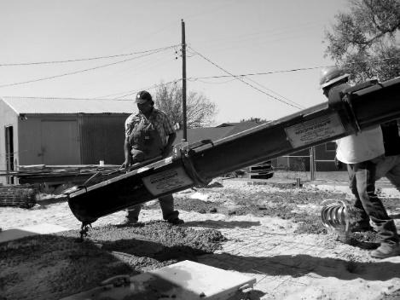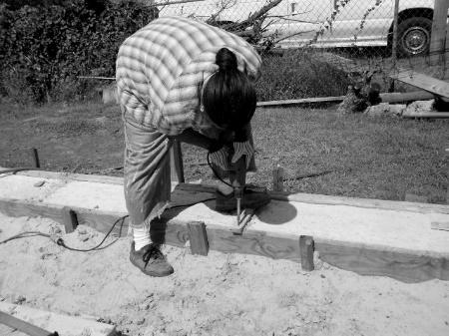
Figures 6 & 7: I (the researcher) am assisting in building an additional room that will connect to the mission.

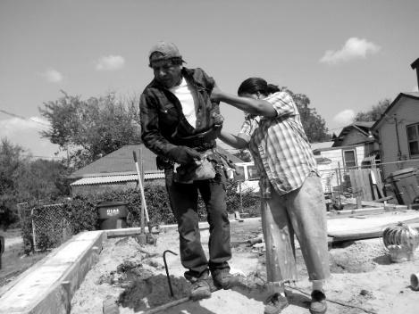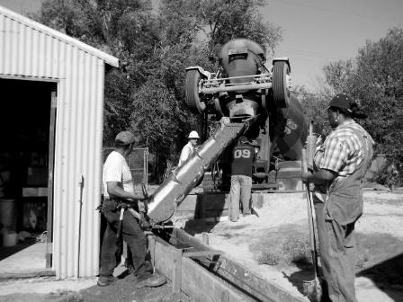
Figures 8 & 9: I (the researcher) am assisting in building an additional room that will connect to the mission.

When the women, that had so misguidedly discounted my commitment to them and the community, witnessed me working at every meeting, helping build an additional room at the mission in the searing heat of the summer, giving rides to and attending handgames, delivering food, clothes, toiletries, and school supplies to families and organizations in the community, my relationships with women were restored. Through the painstakingly and ticklish process of reestablishing trust and rapport, I developed deep, meaningful friendships with several women in the community. Discussing the nature of key informants and the nature of friendships in the field and writing of his fieldwork with the Tapirapé Indians, Charles Wagley (1960) reflects,
In the security of our studies and in the classroom, we claim that anthropology is a social science…But, at its source, in the midst of the people with whom the anthropologist lives and works, field research involves the practice of an art in which emotions, subjective attitudes and reactions, and undoubtedly subconscious motivations participate…Anthropological field research is a profoundly human endeavor…the anthropologist almost inevitably is involved in a complex set of human relations among other people…and each anthropologist is a distinctive personality and each undoubtedly handles in his own way his dual role as a sympathetic friend to key informants and as scientific observer of a society and culture which is not his own (Wagley 1960:414-415).
The most rewarding and notable friendship was the relationship I developed with an elderly African American woman, Fannie Lee, a key research interlocutor.
Miss Fannie Lee
Miss Fannie Lee found out about my research by sitting in a plastic lawn chair, cloaked behind a latticed screened porch and observing me, the observer. Fannie Lee is the ears and eyes of the neighborhood. She is what Cheryl Gikes and Patricia Hill Collins describes as an othermother. For a woman nearing 80, she was spry and “full of fire.”
Miss Fannie Lee is an elderly African American woman in her early eighties. She owns a neighborhood daycare center. It is the only daycare center in the area and the only affordable daycare in town. She spent her life caring for babies, her own and those of others. Her family was from Dorie, an “all-black” town near El Roy. When the town went “under”, she and her family migrated to El Roy and here she would remain until her final days.
She would tell me, in one of our early morning porch conversations, that she had always been an inquisitive child; however, helping out and providing care for younger siblings on the family farm and, later supporting a family of her own, kept her “away from formal schooling.” This would be her lot in life—providing care for others while many times denying herself the care she often needed. Miss Fannie Lee had been married three times and had a host of “boyfriends,” had several children, grandchildren, and great-grandchildren. She was outspoken about her daily lived experiences, likes and dislikes, and the ways in which she viewed herself and others. She did not mince words when she stated vehemently one morning,
“You know, Boo (a nickname with multiple meanings she had given me) I don’t ‘ways like them Indians.”
I almost choked on the coffee that contained “a little nip” she had served me. I found her statement to be both ironic and problematic. Miss Fannie Lee had biracial children (twin daughters by a “boyfriend”), multiracial grandchildren. and great grandchildren.
The first time Miss Fannie Lee and I met, it was under unwelcomed and troubling conditions. Her granddaughters had staged, filmed, and posted to social media, a gang-like fight with my niece. At the time, I didn’t know that this was “typical” teenage girl behavior in this area. Our second meeting was much more pleasant, and we instantly had a rapport of contentedness and ease, not only because we had met previously, and it was established that we both cared for youth, but also because we both had experience, hers was life-long and mine, off-and-on, of growing up in The Lows. Because of this unique relationship, I was able to ask questions about the community and its members, share a great number of research ideas and ask for her insights, and to become deeply immersed in community life. Miss Fannie Lee was one of three women that othermothered a huge number of folk, White, Black, Indian, and otherwise, from this town. Miss Fannie Lee contributed to my research in ways that are long-lasting and life- enrichening. Like Miss Fannie Lee, Sister Delora, an elderly, multiethnic, Mexican American and American Indian woman, was a prominent figure in the neighborhood and community.
Sister Delora
Sister Delora, a woman identifying as Mexican, specifically, Chicana in her mid-to-late eighties, and another key interlocutor, found out about my research with women in the community through one of my relatives. Sister Delora and her husband run a neighborhood mission and nondenominational church in El Roy. Upon learning of my research, she invited me to breakfast at her home. She and Brother Tomiah, her husband, are early risers. My invitation was for eight that morning; however, they had both been up since three. Brother Tomiah goes to the church to pray and Sister Delora prays at home. I arrived right as the cuckoo clock in their home struck eight. I could hear it outside of their door as it was positioned in the foyer of their home. I entered their stone and brick home that had many unique identities as I would later discover. Brother Tomiah, speaking with a thick Mexican accent greeted me and ushered me into the tiny kitchen. The familiar and comforting smell of fresh homemade tortillas, chorizo, frijoles, and eggs embraced me like a long-lost lover. The heavily starched yellow table linen that rested beneath a white lace tablecloth was a perfect accompaniment to the trays of sundia, uvas, and melón (watermelon, grapes, and honeydew melon) that adorned the round table. Slices of tomato and onion were nestled among velvety smooth avocado. A small dish of red peppers neighbored a small crystal bowl of chile verde. The setting was an ocular delight. “Sit mija,” Sista Delora gently commanded. I took my seat with gleeful anticipation.
We held hands as first, Brother Tomiah followed by Sister Delora, offered prayer. They were both former Catholics but still held tightly to the formalities of much of that religion. Sister Delora served my plate first and then Brother Tomiah’s before serving herself. I waited patiently to partake in the meal before me, but on the inside, I was like an impatient child ready for a meal after a long day of play—and—the day had just begun. As we sat there eating and discussing their relationship with my relative, they expressed interest in the research and hoped that I would use the research to improve the “hurting neighborhoods.” I shared with the beautifully kind couple my intent, my hopes, and my vision for my research. They questioned me for what felt like hours about the nature of anthropology. They wanted to make sure that they were not participating in a práctica de mal, a practice that was “unsightly to God.” To them, anthropology was enigmatic.
I explained many of the facets of anthropology in the United States. Her mother came to the United States from Mexico as a baby. Sister Delora’s grandmother was a single mother. She had polio and often found it difficult to provide for a baby in an environment where she had so little. Growing tired of the hardships and struggles that she was plagued with in Mexico, she traveled, by foot, to the United States to find work. She knew that “it would be almost impossible for a cripple to cross the border with a baby in tow.” Isabella, Sister Delora’s grandmother, fashioned a cloth contraption that would safely secure her baby beneath the many layers of mismatched fabric that she had sewn together to create a “decent” skirt for travel. “New clothes were a luxury that she could not afford in three lifetimes,” Sister Delora stated. Having secured her infant, she made her way to the border. Isabella was praying to Mary, for safe passage. After all, Mary knew the plight of wanting to protect a child. As she drew closer to the border that separated Mexico from Texas, she hoped and prayed that her extreme limp and deformed hand would draw more attention than the way her skirt engulfed her frail body causing her to look heavier than her true weight. Sister Delora continued with her story of her grandmother, Isabella, and Irene, her mother.
Irene, like Isabella, suffered from polio. She grew up in a small Texas town and as a teenager fell in love with a man that “traveled between the states.” One evening he mentioned to Irene his intent on moving to a place that he often visited. That place was Oklahoma. He believed that there would be opportunity for “someone like him.” He had no intentions on “taking a wife” nor did he want one. He left.
Heartbroken and wanting to try and make a way for herself, Sister Delora’s mother traveled with a caravan of folks that were headed to what they had heard was a place of opportunity for prosperity seekers looking to live a peaceful life. Irene arrived in a town close to El Roy and the memory of the man that looked past her deformities faded into a landscape of nothingness. Sister Delora’s grandmother continued to work and met a new man that also saw past the disfiguration of her body. They began spending countless evenings together when they weren’t working. He was a tall, dark-skinned mestizo.
Within a few short months a baby boy, Sister Delora’s older brother, was born. A year later, Sister Delora would be born. Dabbing her eyes with an old, yellowed-with-age handkerchief, Sister Delora stops her story abruptly, rises from the table, and begins clearing the dishes and uneaten food. She summarized that period in their lives:
“It was a difficult time for my mother. She was a single mother with two babies and very little work. Our father helped when he could, but it just was not enough. My poor mother, she sure did suffer and so did we.”
It wouldn’t be until a year and a half later that I would come to know the full extent of the suffering of Sister Delora and Igncacio, Sister Delora’s brother. I offered to assist in the cleaning of the kitchen but was playfully swatted away.
“You must have school work to get back to,” Sister Delora stated. I will speak with Tomiah, we will pray, and let you know how we best can help you in your research.”
I thanked her for the wonderful meal and hospitality and left the house with narratives of many identities. Later that evening Brother Tomiah would stop by with a large container of his “special soup” and a basket of fruit. He informed me that they were anxious to help with the research and had several people they wanted to introduce me to. The first would be Sister Janna.
Sister Janna
Sister Janna became another very important key interlocutor for this research. Her wisdom and willingness to share information regarding American Indian experiences for many of the women in this community proved to be invaluable. When I first met Sister Janna I recognized her larger than life personality, resilience, and silent strength. Sister Janna is an American Indian woman in her early sixties. She is the mother of five children and grandmother of many. In our first meetings, Sister Janna and I would begin our conversations with an air of caution…she, trying to “feel me out” and I, hoping not to appear “bougesie” and not down to earth. We would meet at the Wednesday and Sunday meetings at the mission over two-day old coffee and an assortment of dollar store cookies. In the beginning our conversations felt strained and laborious. I felt I was failing miserably at everyday communication. It was awkward. The breakthrough in our less-than-perfect interactions came one Wednesday afternoon during a discussion about sexual and reproductive health services in the community. Sister Janna was in the process of organizing a health fair at the mission and needed assistance. I quickly volunteered to assist in the development, implementation, and facilitation of the event. I did not want to give the appearance that I was trying to take over Sister Janna’s idea; however, I knew that my participation in the health fair would improve my relations and help establish a degree of trust. Sister Janna’s event came to fruition and exceeded her expectations. Our relationship improved, and our friendship began to flourish. In the months to come, Sister Janna would take me under her wing and I would meet many women, men, and children at the mission. In particular, a biracial, Afro Latina, woman, Miss Essie Mae with an uncanny knack for blunt conversation and who would give Miss Fannie Lee a run for her money in colorful discourse, would become one of my favorite key interlocutors.
Miss Essie Mae
Miss Essie Mae is as colorful as her language. She does not “hold her tongue” and is very quick to share her opinions, thoughts, likes and dislikes, and beliefs on all topics. Miss Essie Mae was born to a Mexican mother and African American father in El Roy, in a house two blocks from where she currently resides.
“Even though my daddy was military, I was born in a shack,” she rattled as she took a huge draw on her carnival cigarette.
The sharing of this tidbit of information would be the beginning of countless hours of information, usually, with her talking and me listening. Miss Essie Mae is a talker and can converse for hours without tiring.
She and I became fast friends. Miss Essie Mae was my next-door neighbor and the law of our block. Her nickname in the community is “The Hawk”—she sees and hears everything. Everyone that lives on the block, and many individuals that do not, know that if you were on Evelena Street, “you may want to be on your best behavior.” Even though Miss Essie Mae was 4’11” and 84 pounds, “She walked and talked like a giant. She is viewed as the authority figure by many individuals in the neighborhood and constructs the boundaries of movement in a four-house radius. Miss Essie Mae advised me on important issues such as neighborhood language, how to watch the flow of foot traffic in the community, who to invite into the home, and who not to invite inside—not even the yard. Her advice and admonitions, while sometimes seeming farfetched, were typically accurate and, I appreciated them immensely during my fieldwork.
While Miss Essie Mae, Sista Delora, and Sister Janna helped me to gain entrée into different groups within The Lows, it was two of Miss Essie Mae’s daughters, half-sisters, Ashiley and Krystal Mae who showed me “how to be” in the neighborhood. Ashiley had gone through a separation in 2008 when she decided to move back to The Lows to be close to family. Krystal Mae, Miss Essie Mae’s youngest daughter moved to The Lows not long after Miss Essie Mae “moved back home” to be closer to her mother. All three women left a major metropolitan area in search of peace and solace. The daughters of Miss Essie Mae, to date, have found peace and solace; however, the small, rural town life they have grown accustomed to has “worn out its welcome.” Ashiley and Krystal Mae, both, indicate that they have grown bored and are on the hunt for action and adventure, but don’t really have an interest in leaving the safety and comfort of home ─ The Lows.
Ashiley and Krystal Mae
Sitting on my front porch, one fall evening after my research had gained a comfortable momentum, I received two visitors, Ashiley and Krystal Mae. The ladies pulled up and parked in front of my home. For some reason, it was the first time I noticed that Krystal Mae’s rusty Blazer had a slight but noticeable lean that made the automobile “look… not quite right.”
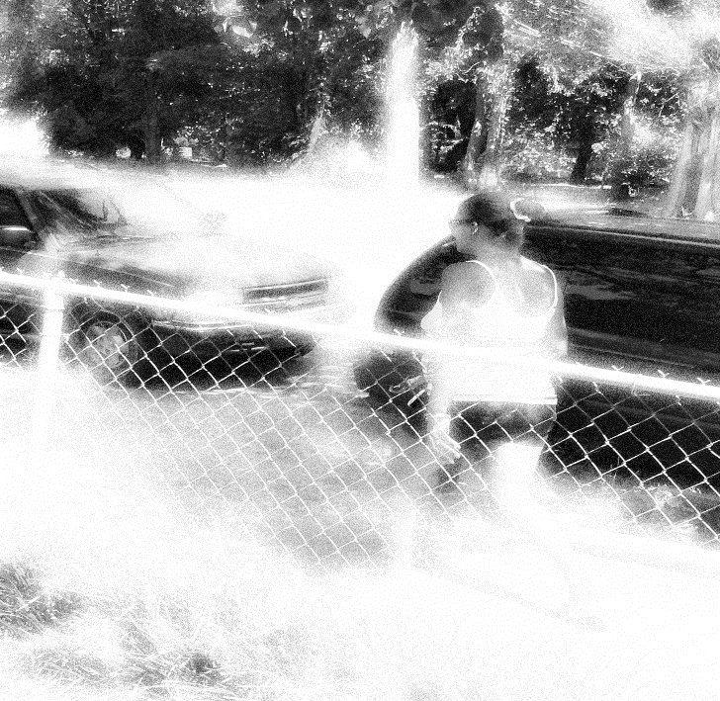
Figure 10: Krystal Mae returning to her Blazer

They hopped out laughing and walked up to the porch.
“What you cook today,” squeaked Krystal Mae.
“Not a thing,” I replied. “I can offer ya’ll some sweet tea though.” Ashiley declined. She was the quieter of the two sisters.
Krystal accepted and asked, “You have a nip to go in that tea?”

“No,” I responded.
“Damn girl, we gone have to get you fixed up in here,” laughed Krystal Mae.
I went inside and poured the tea while the two women looked at the plants on my porch. I felt that they were making fun of my attempts to make my porch look lively and inviting. They were not.
The two women had stopped by to offer many insights that contributed to my research, such as outlining some of the neighborhood do’s and don’ts. They wanted to “stroll” with me in the evening. These strolls and walking tours became an important tool in the collection of data. Ashiley, Krystal Mae, who often walked with a slight limp, and myself would stroll for what seemed like hours. Krystal Mae would do most of the talking with Ashiley interjecting randomly. They were teaching me “how to be” on these walks, even though I didn’t always recognize their intent. They, like so many others, were attempting to make me feel welcome in the community. They were bracketing their own biases regarding my status and privilege as an educated woman of color, and they were helping me not to “mess up” too badly in my research endeavor.
The Others
There were several other research participants who made this project possible, from elders in the local American Indian community, Chief Miles Moon, and Chief Albert Standingwater, to Mickey Dale, a homeless man whom everyone in the town knows, who shared my love for the Sunday meals served at the mission. Lula Constant from SCRAPS, a non-profit organization in El Roy also offered invaluable insights into the issues that formerly incarcerated women face in this geographical context. She also works with men that are currently serving prison sentences at a nearby prison. The SCRAPS organization partners with Greater Healing Hands and Hearts Mission to assist men serving prison sentences in obtaining skills that will prepare them for re-entry into the community. Many of these men assist Sister Delora and Brother Tomiah with a variety of tasks.
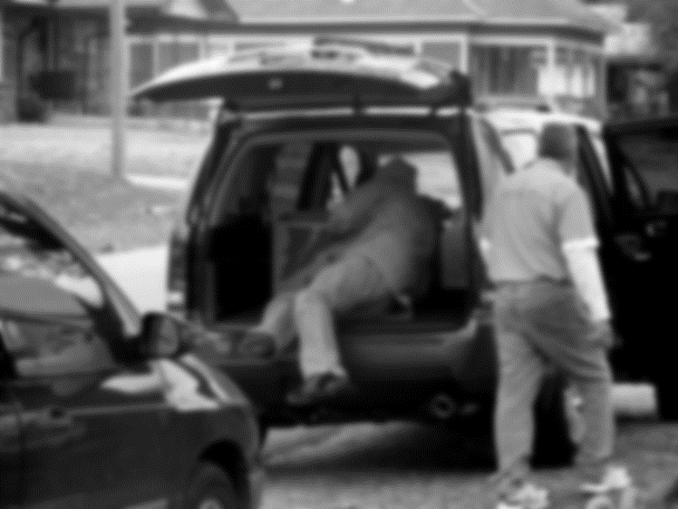
Figure 11: Men participate in the partnership between SCRAPS and Greater Healing Hands and Heart Mission.
The men attend Sunday morning worship services and take part in a family-style meal. The families of the men are invited to the service and to dinner. A small number of women who participated in my research have incarcerated spouses that are receiving training from the SCRAPS and Greater Healing Hands and Hearts partnership. Partnerships are the lifeforce of many of the organizations helping community members that experience biopsychosocial and economic distress. To explore the town history, I contacted Pennley Livermore, the identified town historian.
Pennley Livermore, a White and American Indian long-time resident, and an amateur community historian, provided me with a wealth of information about non-profit, governmental, and tribal organizations in El Roy. She spends her mornings and afternoons at the local library, scouring files, making copies of old documents and records, and taking notes. I would often accompany Pennley to the library. During these trips, we often found a quiet room to peruse old family photos that she had stored in shoeboxes. In this small intimate library space, Pennley would recount her family and life history narrative while I used a voice recorder to record her narrative. Pennley grew to trust me as a friend and confidante.
My research was of a peripatetic nature. It carried me to homes in different neighborhoods in different towns, to different organizations within communities, and to different governmental organizations. For many in the community, I became the friend, the fictive kin niece, the confidante, the not quite insider-outsider-insider who could be depended on in a time of need, trusted with sensitive and intimate information, and confided in when there were disagreements between family members, church members, or community members, even as they knew and understood that I was conducting research with them positioned, not at the periphery, but at the center. The stories that were shared with me by research participants in this project varied across time and space. Some were heartbreaking, some pleasantly comical, some unbelievable and shocking but, all were intimately genuine and meaningful. James Clifford (1988:11) writes, “Intervening in an interconnected world, one is always, to varying degrees, ‘inauthentic’- caught between cultures, implicated in others.” As mentioned in the opening of this paragraph, my research immersed me in many different journeys that were all unique and important.
Performance, Being, and Multi sited & Multifaceted Ethnography
Above, I mentioned the various spaces and places where this research was conducted. Traversing across literal and figurative borders to conduct fieldwork, to become immersed in the daily lives of research populations, and to collect these stories and experiences can be compared very closely to what Marcus (1995) refers to as “multi-sited ethnography. ”I feel very fortunate to have been a residence in The Lows— a part of the social world of the women, men, children, and organizations in this community.
Historically and in the present day, anthropologists have been and are “on the move”. We move from site to site to participate in the daily experiences of our research population. Over time, our methods have evolved and the ways in which we conduct anthropology has grown in scale. Arjun Appadurai (1996) discusses the expansion, evolution, and growth of the daily lived experiences of the folks, communities, and organizations we research. He situates his discussion in the global; however, his arguments apply in local domestic settings and spheres, as well. Ghassan Hage (2005) critiques the notion of “multisitedness.” He writes, “I simply do not think that there can be such a thing as a multi-sited ethnography (Hage:2005:465).” Hage’s primary argument and critique of “multisitedness,” like many others who agree with Hage, is not, necessarily, in the validity of the method; however, it is often situated in the ways in which it is facilitated and implemented. Jean and John Comaroff (2003) illustrate the ways in which “classical or traditional (incorporating ethnological practices) methods of doing anthropology can be coupled with contemporary methods (such as multi-sited ethnography) to produce a rich body of work that advances anthropological knowledge and theory, in their research in southern Africa. They write,
Consequently, in order to account for the social archaeology of the place, and for the ebullient memories of its people, we were forced from the first to historicize our methods; this, in the early 1970's, at a time when there was a great deal of antipathy within anthropology toward history. We had no alternative but to develop an ethnography of the archives to discern the processes by which the past and the present had constructed each other; an ethnography that, among other things, entailed scouring the records – images, inventories, accounts, material shards, documents, linguistic residues, even silences and absences – for the constellation of ordinary practices, the passions and interests, that produced and reproduced this site as an empirical fact, a named-and known locale (Comaroff and Comaroff 1992). Often this meant trawling texts for what they were not, putting into conversation pieces of paper that, in the cold storage of the archives, languish as solitary objects. It also necessitated our transposing inert verbs and nouns into depictions of living things, of vibrant ritual activities, of expressions of collective affect, effort, effect. If the ethnography of the archives proved anything, it was that Mafikeng, “Place 13 of Stones,” had, from the start, been situated between a rock and a hard place. The town was established by the ruling Tshidi chief, in the 1850's, with two ends in mind: to ward off the seizure of his land by white settlers and to quarantine the rise of Christianity, along with its Eurocentric forms of civility. In time, and for complicated historical reasons, Mafikeng would become the capital of the chiefdom. It was here that Tshidi asserted their autonomy as fully as they could from the colonial state, the settler economy, and the British missions; here that they fashioned an ethnically-marked localism – referred to, explicitly, as setswana, “Tswana ways and means” – that quietly fused into itself the cultural practices of various others. For their part, the Protestant converts, original residents of the place, were also to make common cause with a national black petite bourgeoisie anxious to proclaim its modernity. We hardly need insist here that, to be read ethnographically, these economies of signs and practices have to be situated in the intimacy of the local contexts that gave them life. At the same time, they require to be inserted into the translocal processes of which they were part ab initio: processes – commodification, colonization, proletarianization, and the like – composed of a plethora of acts, facts, and utterances… (Comaroff & Comaroff 2003:12-13).

The Comaroffs discuss and describe their ethnological and ethnographic work within the global anthropological discipline. They argue,
ethnography is like much else in the social sciences; indeed, more so than anthropologists often acknowledge. It is a multi-dimensional exercise, a co-production of social fact and sociological imagining, a delicate engagement of the inductive with the deductive, of the real with the virtual, of the already-known with the surprising, of verbs with nouns, processes, with products, of the phenomenological with the political.

Taking this argument into consideration, “doing anthropology” that is multi-sited, multifaceted, and multidimensional, with a single population or sample of participants is possible. My fieldwork took me to three states, eight tribal districts, four all-black ghost towns, five neighborhoods, three organizations, and several homes. While this type of fieldwork was deeply rewarding, at times, it was physically and emotionally exhausting. I always had to be cognizant of the “self” that I was performing. I mentioned, earlier in this dissertation, that I occupy a position of an insider, to some degree, due to my familial connections to this town and neighborhood; however, I am still very much an outsider because of my “performed privilege” (that of an academic and anthropologist – someone educated). This blurred identity can blur the lines of fieldwork. Naomi Leite (2017:20) suggests,
conducting field research in a cultural or national context in which one is a partial participant, a descendant, or even a native anthropologist can cause troubling moments of blurring between the self and other, researcher and subject which is all the more true in fieldwork that involves participant- observation from multiple angles within a coherent system, particularly if the researcher can reasonably be read by the local people as a “native” or “halfie” in every subject position she occupies within the system.
My hybridized familial neighborhood connection and association made me a “homegirl” to some and a “wannabe” to others; however, my positionality is one of privilege on all fronts.

Privilege and Formal Anthropological Training
In the summer of 2009, I had the privilege of participating in an NSF (National Science Foundation) sponsored and funded research experience program under the direction of the Anthropology Department at The University of North Texas. In this program, I received intensive training regarding designing, implementing, and facilitating anthropological research. The entire summer was spent reviewing anthropological theory, becoming acquainted with classical and contemporary field methods among living populations, and being trained in the protection of human research subjects. My participation in the NSF experience led to several research projects during my tenure at the University of North Texas. The NSF project focused on homeless populations and informal economy in the southern sector of Dallas. I lived on the streets of South Dallas, in what is presently known as “Tent City,” for two weeks. Through immersive and deep participant-observation, interviews, and social and spatial network mapping, I found that homeless individuals in this area disproportionately experience structural violence as opposed to homeless populations in other areas of Dallas. This research experience and intensive and thorough course of study laid the foundation for my continuing my anthropological studies and research experiences at the University of Oklahoma. The chapters contained in this dissertation reflect that experience.
Writing and Voice
In the chapters contained herein, I have elected to write primarily from the position of the women in the community. Their daily lived experiences in this neighborhood has birthed multiplicities of reflection regarding the ways in which intimate space is used to construct identity, notions of relatedness and inclusion within groups and, being and belonging. It is a privilege to be able to share this intimate account of the social and cultural lives of many women in the town of El Roy and specifically, The Lows neighborhood.
Data Analysis and Coding
The analysis for this dissertation is situated within the framework of grounded theory. Grounded theory is contingent on an inductive process by which “the patterns, themes, and categories of analysis come from the data; they emerge out of the data rather than being imposed on them prior to data collection and analysis” (Patton 1980). This methodology is an iterative methodology used to formulate understanding and conceptualizations after continuous systematic review of the data ( Lingard, Albert, & Levinson, 2008; Walker & Myrick, 2006).
Data was sorted into broad topical groups and systematically reviewed for reoccurring themes. Hierarchical categorical systems were developed to illustrate the themes, patterns, and relationships among participant responses. A coding scheme was established based on both a priori and emergent themes. The a priori themes corresponded to the four broad topical areas covered in the individual interviews and focus group scripts. These were put into comparison with fieldnote observations, jottings, and informal conversational scripts and writings, folkloric storytelling, and the sharing of narratives.
Printed segments of the interview transcripts were reviewed, cut, and sorted into piles based on content. I employed a hierarchical coding process including open, focused, and axial coding steps, whereby data was sorted, conceptualized, and reassembled based on the intersection of identified themes and degrees of similarity (Corbin & Strauss, 2008; and, Lewins & Silver, 2007). This approach was useful for revealing the presence, absence and, consistency of data supporting both a priori and emergent themes related to perceptions of intimate community spaces, health and healing, and social relationships. Interview transcripts, observational notes, and coded data were reviewed multiple times to ensure consistency in the identification of additional themes that may have emerged throughout the data analysis phase. A color-coded filing system was established to group emerging themes and domains across all data collection areas. Data are examined for relationships across areas. All interviews and focus group transcripts were transcribed, organized, coded and analyzed. Like approaches used by Auerbach and Silverstein (2003) and Saldana (2009), data was coded both manually and with the aid of computer software for the presence of dominant themes. I used both Nvivo and Atlas.ti, data analysis software packages that permit precise searches of qualitative datasets and, that has a considerable amount of flexibility to permit changes to coding schemes as interpretations evolve. Emergent themes included, but were not limited to, the improvement of personal and community relationships because of space, trauma assistance in defined spaces, health brokering, and the importance of social networks. Lastly, a word cruncher was also utilized in the creation of a word cloud to determine the prevalence of commonly used terms, descriptors, and phrases.
As my fieldwork unfolded, I often checked-in with my participants to confirm my understandings of conversations, interactions, reciprocal practices, recipe preparations, stories, and musical scores. I was either corrected or praised. Through my research, and the intimate interactions with my participants, I discovered that active listening as a researcher, not only facilitates individual and community empowerment, but also becomes a conduit for healing and hope as the women let their stories breathe.

Chapter 3: The Language of Returning Home
The Language of Literature: Academic and Otherwise
The descriptions and definitions of house and home in the anthropological literature are diverse; however, the concept of home, in my research, is best informed by an interdisciplinary approach and exploration of the available literature. Historically, anthropology has “always freely borrowed ideas from other fields of study” (McGee and Warms 2012:1). Literature from literary studies, specifically, English, African American, Mexican, and Native American literature, and the disciplines of philosophy, specifically, Kantian frameworks, human geography, architecture, psychology, and sociology as well as folk tales, folk remedies and recipes, and song are examined and help situate the multiplicitous meanings of home within an anthropological framework that is both linguistically historical—the ways in which home is discussed—and cultural in context and meaning. These descriptions and definitions are both subjective and objective in perception, meaning, understanding, and the interchangeable application of the terms house and home and, space and place regarding language, mothering, religion, and health in this body of work. Furthermore, examining home in the context of space as conceptualized by Henri Lefebvre and, placing the examination of home as a first space and, expanding the concept of third space(s) as coined by Homi Bhabha and expanded by Edward Soja and, semantically and conceptually broadened by Ray Oldenburg, following Oldenburg’s conceptualization of third space, I argue that home spaces such as the porch, the stoop, and the church/mission, those spaces that embody the affective nature of home and the home sentiment, function as critical third spaces—spaces that are emancipatory and empowering and, intimately connected to health and well-being. Before examining space, we must, within an anthropological paradigm, unpack the, often contested and varied, history of the meaning, use, and study of affect, emotion, and sentiment—feelings of attachment and disconnection.
Being and Emotion: Affect and Sentiment in The Lows
“Feelings are not substances to be discovered in our blood but social practices organized by stories that we both enact and tell.”
-Michelle Rosaldo (1984:143)

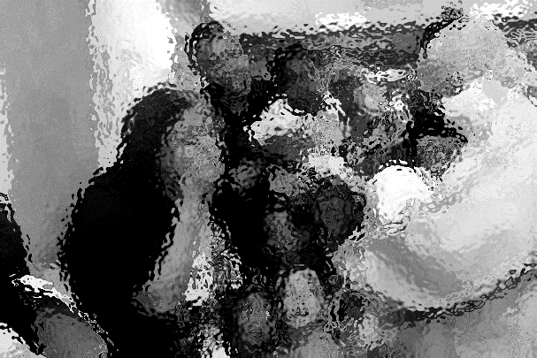
Figure 12: The Birth of Emotion. Photo by Elisha Oliver

Boellstorff and Lindquist (2004) write,
Emotion has represented a tantalizing subject for social scientific inquiry because it appears to tell us about our true selves; the self that, after all the thinking and interacting are done, feels the welling-up of rage, the tender pangs of love the black emptiness of despair (Boellstorff and Lindquist 2004:437).

Lutz (1988) posits, “emotions are treated through the process of reification, not as concepts used to do certain kinds of things in the world but as labels for concretized psycho-physical states or objectivized internal ‘event things’ (Lutz 1988:9).” Geertz (1973:81) argues that “emotions are cultural artifacts.” They are much more than ideas, thoughts, and universal, isomorphic feelings. This is evident when thematically examining the interview, focus groups, and ethnographic material contained in this dissertation.
The study and theorization of emotions within the discipline of anthropology is often complex, complicated, and widely contested. Questions regarding what it means “to feel,” the lexicons of emotion, ethnographic understandings of emotions, and the numerous ways in which to locate emotion within culture (Boellstorff and Lindquist 2004; Kovecses 2000; Lutz and White 1986), have been subject to numerous debates among scholars. Often, scholars from disciplines outside of anthropology err on the side of being reductionist, in that they dichotomously group emotions— “feeling” within static boxes of either mind or body. The discipline of anthropology has not been different.
Leavitt (1986) indicates “anthropology is divided between views of the emotions as primarily biological and as primarily sociocultural in nature” (Leavitt 1986:514). Discussing affect, emotion, and sentiment and the ways in which these concepts are scripted onto being requires a broad but abbreviated philosophical and anthropological examination of the study of behavior as it occurs in a natural environment. Basically, it is the study of human ethos—the fundamental spirit or character of a culture—the underlying sentiment that informs the beliefs, customs, or practices of a group or community and its formation. This examination provides a framework for understanding the methods, practices, systems, policy of opinion, emotional state, and attitudes of those in relationship with one another and with their community. It is also demonstrative of the ways in which emotion is portrayed and interpreted across cultures, and helps to reflect upon agency, power, and community relationships—quite simply, the understanding of experience versus the expression or, the experience and the expression of the individual or group. For this, we must begin with a philosophical exploration of emotion in the transformation and continuity of culture and the ways in which sentiment occupies a force and, an attachment to space within the lives of the interlocutors discussed in this dissertation.
The Philosophy of Being and Emotion: The Anthropology of Affect and Sentiment
Hobbes (1651) posited that society had a deep and profound impact on an individual’s behavior. He believed that the events taking place in a society (space and place) could shape and mold the actions of an individual or group. Hobbes argued that certain societal pressures, good or bad, would affect the “mood” or sentiments of the group which would result in psychological and/or somatic expressions. Locke would expand the propositions made by Hobbes by focusing on the “mental mind” of the individual.
Locke (1689), building on the work of Hobbes (1651), argued that an individual is born as a blank slate, a ‘tabula rasa,’ in which the experiences of life are imprinted. Locke examined the relationships between the microsocial, macrosocial, and psychosocial processes experienced by individuals and communities. He found that the ways in which an individual “functions” in society has much to do with the acquired knowledge he or she has received from his or her group. This knowledge informs the behavior of the individual. During the years following the propositions posed by Hobbes and Locke, philosophers, economists, psychiatrists, and many other scholars began expanding and exploring meanings of individual and collective being as they relate to society and culture. Wilhelm Wundt would follow the early philosophical arguments of Hobbes and Locke by introducing the concept of feeling (emotion) or Gefühl and, affect or Affekte (Wundt 1902).
Critically and carefully examining the Aristotelian text, Nichomachean Ethics, which pays particular attention to the totality of “feeling” through explorations of virtue and vice (Aristotle, Book VII: Chapters 1-10), Wundt proposed examining Gefühl, or “feeling”—emotion (Wundt 1902: Vol. 2:357, Wundt 1903: Vol. 3:120-124) as both an object and subject of a person or group. In his argument, he posited that the relationships that were explored were primarily situated in the overall cultural shaping of the individual. Wundt investigated the possibilities of physiological expressions of Gefühl—emotion (Wundt 1902: Vol. 2:357, Wundt 1903: Vol. 3:120-124). He argued that a close examination of daily experiences and systems in which an individual existed along with the ways in which these systems were processed was necessary to understand the psychological and physiological development of an individual in that individual’s environment.
In Wassman’s (Wassman 2017:165-167) examination of the history of the language of emotion, she indicates that Wundt argued that “Gefühl was a judgement in relation to us (Wassman 2017). It is feeling that is both subjective and objective. Furthermore, she writes, in addressing emotion, sentiment, and affect through a textual analysis of Wundt,
Wundt addressed these questions, [questions of emotion] beginning in Vorlesungen (1863), when he asked “Was ist das Gefühl?” The German texts also discussed the feeling of self, the sense of self, and the distinction made by the brain between “I” and the environment during infant development. Furthermore, motivation, desire, and volition were included in the reflections about Gefühl; as was the relation between simple sense feelings (sinnliche Gefühle), more complex emotional composites (Gefühle or Affekte), and highly abstract intellectual emotions or sentiments (Wundt, 1874, 1902–1903). This set of meanings is not equivalent with the six “basic emotions” that are commonly associated with the term emotion in English today, referring to the classifications based on facial expressions provided by Darwin (1872) and Ekman (Ekman & Friesen, 1975).

Analyzing Wundt and Wassman and, putting them in dialogue with one another, before transitioning to an anthropology of emotion framework, perceptions related to space and place in The Lows are constructed by the experiences of meaning and feeling involving both the body and mind of the participants in this research. These constructions are deeply connected to the discourse and dialogue that occurs in uncanny spaces and places, as discussed by Freud (Freud 1919:123-134), that are uniquely connected to the concept of home and health. Using ethnographic data, Wundt found that myths, beliefs, customs, language, food, and other group workings greatly influenced the behavior, or feeling of an individual, the membership of that individual to a larger group, and the group’s response/s or feelings toward individual behavior (Wundt 1913). In reviewing the varied meanings and interpretations of emotion within the anthropological literature, we find the culture and personality school of thought contemporized, albeit questionably, the philosophical arguments as discussed above.
Parallel to Wundt, anthropologists developed an overwhelming interest in “culture and personality.” Bateson, Malinowski, Mead, and Benedict were members of the culture and personality school of thought. This group of anthropologists, through cross-cultural research, explored the many facets of individual development and cognition by comparing universals and differences within individuals and groups. Moreover, they examined the relationships between culture and personality or, behavior. This anthropological line of inquiry examined the “complex whole” (McGee & Warms 2017:159-163) of being and becoming.
Malinowski (1927), in his research with the Trobriand Islanders, argued that a universal did not exist pertaining to relationships and feelings that individuals had with a parent. Benedict (1934) examined universal consciousness and discovered that many groups experience events in psychologically similar ways. Malinowski and Benedict posited that there were some distinct universals with regards to certain psychological processes and their relationship to life events; however, the ways in which cultures contextualized the two were often markedly different. Francis Hsu, a student of Malinowski would broaden the theoretical frameworks of the culture and personality school. He advocated for a “moving away” from the ways in which research was conducted and proposed a renaming of the area of study.
Hsu (1953) argued that the culture and personality school in many ways had become stagnant with regards to the examination of the psychology of a people and culture. Hsu posited that much could be gleaned by comparing multiple cultures regarding the ways in which mental suffering and illness and emotional ailments were expressed, understood, and treated. With his comparative study of mental suffering experienced by Chinese women and Western women, Hsu laid the foundation for the disruption of Western categories of mental and emotional suffering. This is important to this dissertation, in that, cultural classifications of health and illness are discussed by various participants.
An expansive body of literature has been used to underpin the work of these early researchers that have contributed to the anthropology of emotion. Much of this literature is relevant to my own work; however, the contributions to anthropology, specifically, the anthropology of emotion, that are most relevant to my research and this dissertation is that of Michelle Rosaldo, Renato Rosaldo, and Catherine Lutz. Other influential scholarship includes the works of Jean Genet, Arjun Appadurai, Raymond Williams, Giorgio Agamben, Didier Fassin, Eli Wiesel, and Susan Sontag. These scholars explore linkages between the human condition, human experience, and the essence of being and feeling through examinations of symbolic interrelated intersections of body, behavior, and structure—place and space.
Michelle Rosaldo (1984) likens ‘affect (feelings) to the societies in which we live’ (Rosaldo 1984:145). She explores the complex relationships that exist between physical experiences, place and space, and intimate emotional states (Rosaldo 1983:136). Within these explorations there is a collapsing of time and space; yet, history, life transitions, and life timings are intimately intertwined with the emotional state of the individual. Through the scripting of history and memories shared between the researcher (myself) and the research participant, data obtained from participant observation reveals the ways in which space and place unpattern negative emotion (trauma) and reconstruct the human condition through the sharing of narratives.
Renato Rosaldo vividly discusses “empathy and resonance” (Rosaldo 1989, Wikan 1992; Beatty 2005) in his work, “Grief and Head Hunter’s Rage.” After the tragic death of his wife, Rosaldo can identify with the sadness, suffering, rage, and ritualistic retribution of the head hunter. Their pain resonates with his and vice-versa. During my time in The Lows, I often found myself in the company of women that openly, graphically, and vividly discussed a range of emotions (feelings). I was able to understand the importance of space to the women living in The Lows when they shared narratives about past and present traumas, and past and present joys. These narratives, bidirectionally, elicited strong emotions from both the researcher and research participant.
It wasn’t until I experienced my own series of life events and transitions, during my fieldwork, did I fully understand what it meant to learn how to hustle to pay the light bill; to wake in the morning and need to go to the stoop in search of a prescription pill to stave off the grief that welcomed in the day; to wait for the healer to come to the mission and await my turn to be anointed—bathed—swathed in an oil soaked cloth to take away all the biopsychosocial ills that would plague my being; to find a porch and listening ear to purge hurt and harm through the sharing of narratives while sitting between the legs of an othermother as she greased my scalp. It was my own experiences of trials and tribulations while living in The Lows that brought resonance and empathy when the women shared their stories. Beatty (2005) would argue, “…if we lack a comparable emotional experience we are unlikely to appreciate what we witness in the field and will fall back on Translation or Culture (Beatty 2005:21).” Our (mine and the women in The Lows) histories and, our lives, at present, are socially and culturally intertwined. There exists a deep understanding of emotions within and outside of anthropological inquiry. Beatty (2005) writes,
The arguments from experience and from human nature (which overlap but are not identical) rely on a conception of emotions as unitary, each hitting a certain note and requiring the ethnographer something like perfect pitch: ‘only connect’ and you will vibrate in harmony (Beatty 2005:22).
Renato Rosaldo would suggest that I, “the ethnographer, as a positioned subject, grasp certain human phenomena better than others” (Rosaldo 1993[1989]:175).
It was through the everyday connections with Sister Janna, Doiba, Krystal, and countless others did I come to recognize and understand the ‘emotional vocabulary’ (Beatty 2005: 23) of the neighborhood along with the numerous ways in which emotions (feelings) are consumed and distributed. The ritualistic aspect of health and healing attached to space is prominently positioned in this body of work. The mission, the stoop, the front porch, and the kitchen are all important spaces of ritual associated with emotion.
Lutz and White (1986) discuss the anthropological genealogy of ritual, ritualistic performance, and emotion. They pay attention to the “cultural transformation of personal experience” (Lutz and White 1986:413). During my participation in the community, I found that the various spaces for health and healing were crucial components of the ways in which ritual mediates emotion and the human condition. Many of these mediations could not be explained; however, they not only promoted community cohesion, through emotion, they produced community. Witnessing and participating in prayer, the laying of hands, anointing with oil, the ingesting of herb-based elixirs, the eating of certain foods, and several other practices comprise ritual efficacy.
The representations we have of the ways in which the human condition is experienced and expressed linguistically are vast. In “The Ethnography of Speaking,” Dell Hymes (1998) suggests that “speakers of a language in particular communities are able to communicate with each other in a manner that is not only correct but also appropriate to the socio-cultural context (Hymes 1998:125).” In my dissertation, with the use of narrative theory, we can determine that ritual efficacy, as a technology, transforms and transfigures the human condition through the telling of stories, and a familiarity involving knowledge of the linguistic codes, socio-cultural rules, norms, expectations, and values in the telling of stories. Through the telling of stories, and a series of “other-worldly” events and practices, women in the community are empowered to face the most difficult and undesirable situations.
An examination of literary texts reveals transformations and transfigurations through the sharing of narratives that represent a duality of autobiographical and semi-fictional accounts that implicitly and explicitly recount the important influential impact of ritual and ritual efficacy. For example, in “The Thief’s Journal,” Jean Genet, presents an inverted duality of the self. His writing describes the ways in which the undesirable—the uncanny can be made desirable through the inverting of social, cultural, and heteronormative imaginaries (Genet 1964). In a Levi-Straussian, structuralist sense, each narrative that is shared in this dissertation locates binary-opposites at the borderlands of empowerment. The ethnographic chronicles and vignettes contained herein are illustrative of the transformations and transfigurations that are present in Genet’s text. To further use examples from the literary texts to elaborate on the human condition and, transformations and transfigurations I pull from the readings of Eli Wiesel, Giorgio Agamben, and Susan Sontag.
In “Night,” Wiesel (1958) presents an introspective and insider view of the human experience and condition because of historical traumatology that can be analyzed with theoretical precepts of narrative, life course perspective, and third space examinations. He vividly discusses the leaving of one home—one that is familiar, steeped in storytelling, tradition, and religion for another—one that is strange, miserably and murderously macerated in a topography of terror. Consider the following (Example 3.1),
Example 3.1: Excerpt: Elie Wiesel, Night
My father was crying. It was the first time I saw him cry. I had never thought it possible. As for my mother, she was walking, her face a mask, without a word, deep in thought. I looked at my little sister, Tzipora, her blond hair neatly combed, her red coat over her arm: a little girl of seven. On her back a bag too heavy for her. She was clenching her teeth; she already knew it was useless to complain. Here and there, the police were lashing out with their clubs: "Faster! " I had no strength left. The journey had just begun and I already felt so weak… "Faster! Faster! Move, you lazy good-for-nothings!" the Hungarian police were screaming. That was when I began to hate them, and my hatred remains our only link today. They were our first oppressors. They were the first faces of hell and death (Wiesel 1958:19).
Now, consider the following ethnographic snapshot (Example 3.2) taken from a research interview,
Example 3.2: Interview: El Roy Resident, El Roy, Oklahoma
“I can still remember the sound of the ruler as it would strike my knuckles. THWACK!!! THWACK!!! THWACK!!! NOT IN THAT LANGUAGE, the Sister would yell. My brother and sister would look at me with pure anguish—terror and tears would fill their eyes and there was nothing I could do. We were just kids, after all. We didn’t know that speaking our mother’s language—Spanish would get us beaten with a yardstick. The nuns hated us anyway. I mean we were these half-Black, half-Mexican kids that looked more Black than anything in an all-White Catholic place. At a young age, I learned what it meant to hate. I hated the nuns, I hated being Catholic, I hated the church, I think I even hated god. And, I felt that Momma hated us because she sent us there. It wouldn’t be ‘til much later when I would let all that go. But, you know, we all learned to hate. At that time, it was just a little odd to see mixed kids in this neighborhood — a neighborhood where the White Folks lived up on the hill, where we lived and, where all the other Black folks lived down low (Miss EssieMae: Interview 2015) Each time I tell this part of my history—my story, I forgive a little more. I hate a little less. I love a little more and, I am freed.”

Lastly, examine and, put into dialogue with the text from Wiesel and, the interview from Miss Essie Mae, the following participant selected poem (Example 3.3), The Endangered Roots of a Person, written by Wendy Rose, a Native American (Hopi and Miwok) writer,
Example 3.3: Poem Excerpt: Wendy Rose
I remember lying awake
in a Phoenix motel. Like that
I remember coming apart accidentally
like an isolated hunk of campfire soot
cornered by time into a cave.
I live even now
in an archaeological way.
Becoming strong on this earth is a lesson
in not floating, in becoming less transparent,
in becoming an animal shape against the sky.
We were born
to lose our eyes in the Sun Dance
and send out lengths of fishline
for clouds, reel them in
and smooth away all the droughts
of the world.
Sometimes Medicine People shake their heads
over you and it is this; to drop your bones
into the sand, to view yourself
bursting through the city
like a brown flash flood.
The healing of the roots
is that thunderhead-reeling;
they change and pale
but they are not in danger now.
That same morning
I went for coffee down the street
and held it, blowing dreams
through the steam, watching silver words
bead up on my skin. The Hand-trembler said
I belong here. I fit in this world
as the red porcelain mug
merges in the heat of my hand.
On some future dig
they’ll find me like this
uncovered where I knelt
piecing together the flesh
that was scattered in the mesa wind
at my twisted-twin birth
(Wendy Rose 1997:269-270)

The answer to any question is a story. We envision our lives as a narrative—a schema—a frame—a pattern in which we filter information so that it stays within the frame in which we want to see it. Putting the three examples above into dialogue with one another and, taking a critical stance in the interrogation of each writing, the examples from each author and interviewee embody the reflective solidarity of transmutations, transformations, translations, and transfigurations in the daily lives of the women living in The Lows. We can draw comparisons of being and becoming. Experience is contextualized, and home is problematized. There are those moments, both common and uncommon when memories contradict history—when the extreme experiences of a fragmented past (re)write narrative to help us repair and reconfigure the ruptures of a multilayered history. The writings above speak to types of historical traumas associated with place. Through the sharing of narratives, the narrator is “freed” from their traumatic past.
The writings of Girogio Agamben and Susan Sontag illustrate the technologies of testimony and witnessing in the telling of stories. These technologies locate self, allowing us to make meaning of our past and write ourselves into histories that can be distributed and consumed. They (testimony and witnessing) are technologies that are ever present in The Lows. Through storytelling, we become external representations of the past. Consider the following account of testimony and witnessing by Kelly Oliver (2001),
Dori Laub, a psychoanalyst interviewing survivors as part of the Video Archive for Holocaust Testimonies at Yale University, remarks on a tension between historians and psychoanalysts involved in the project. He describes a lively debate that began after the group watched the taped testimony of a woman who was an eyewitness to the Auschwitz uprising in which prisoners set fire to the camp. The woman reported four chimneys going up in flames and exploding, but historians insisted that since there was only one chimney blown up, her testimony was incorrect and should be discredited in its entirety because she proved herself an unreliable witness. One historian suggested that her testimony should be discounted because she "ascribes importance to an attempt that, historically, made no difference" (Felman and Laub 1 992, 61). The psychoanalysts responded that the woman was not testifying to the number of chimneys blown up but to something more "radical" and more "crucial" -namely, the seemingly unimaginable occurrence of Jewish resistance at Auschwitz, that is to say, the historical truth of Jewish resistance at Auschwitz. Laub concludes that what the historians, listening for empirical facts, could not hear, was the "very secret of survival and of resistance to extermination" (62). The Auschwitz survivor saw something unfamiliar, Jewish resistance, which gave her the courage to resist. She saw something that in one sense did not happen-four chimneys blowing up-but that in another made all the difference to what happened. Seeing the impossible-what did not happen-gave her the strength to make what seemed impossible possible: surviving the Holocaust. (Oliver 2001:1).
The excerpt above illustrates a push in the direction of both recognizing and acknowledging—testimony (testifying) and witnessing. Through this process, we can understand who “the other”—the narrator of the narrative (typically the one that has experienced the action in the story) is and locate them in a series of judgements—structures of experience that have to be reanimated. In this process we can identify the agency of the individual—the imaginaries of performativity in a variety of landscapes. Using Appadurai, broadly, like culture, the “scapes” are in a constant state of flux (Appadurai 1990, 1996). They are dynamic and continuously shift and slip to reveal a negative space for witnessing within the narrative. Susan Sontag (2003), in Regarding the Pain of Others, through the discussion of photographic technologies, elicits an affective and sentimental register for witnessing and testimony through an examination of people’s pain. She provides an alternative definition for the structure of feelings, specifically feelings and emotions associated with the production, consumption, and distribution of images and imagery of death. We can explicitly analyze the process of witnessing and testimony in her writing regarding the visual experiences of war. She writes,
Creating a perch for a particular conflict in the consciousness of viewers exposed to dramas from everywhere requires the daily diffusion and rediffusion of snippets of footage about the conflict. The understanding of war among people who have not experienced war is now chiefly a product of the impact of these images. Something becomes real—to those who are elsewhere, following it as “news” —by being photographed […..]Nonstop imagery (television, streaming video, movies, is our surround, but when it comes to remembering, the photograph has the deeper bite (Sontag 2003:21-22).

In the passage above witnessing and testimony are situated within a framework of shock and cliché—images of war. Like a selection of the photographs contained in this dissertation, the photographs that Sontag describes embody a nostalgic representation of the authority of (the) real(ity). It is an objective record—a personal testimony of the war. Keeping this in mind as we explore witnessing and testimony related to emotions (feelings) and affect, a further examination of literary text, specifically the writing of Gorgio Agamben, further grounds this dissertation in narrative, space, and the life course perspective.
In Remnants of Auschwitz: The Witness and The Archive, Agamben textually illustrates the ways in which the tension between the social and personal create a remnant of experience and memory. Agamben introduces the reader to the memory of testimony and witnessing with the introduction of the Musselman through a series of scripts where tensions mediate landscape and, violence is tangible. Agamben provides a description of the Musselman as one who is without hope. He is a shell of his former self. He is a “ghost in the shell.” Agamben (1999) writes,
It is worth reflecting upon lacuna, which calls into question the very meaning of testimony and, along with it, the identity and reliability of the witnesses. ‘I must repeat: we, the survivors, are not the true witnesses….We survivors are not only an exiguous but also an anomalous minority: we are those by who their prevarications or abilities or good luck did not touch bottom. Those who saw the Gorgon, have not returned to tell about it or have returned mute, but they are the Muslims, the submerged, the complete witnesses, the ones whose deposition would have a general significance (Agamben 1999:33).
In this passage space (lacuna) is conceptualized as a space for witnessing and testimony. It is an area—a space where the production and legitimization of marginalization is presented as an alternative history—a history presented from the point of view of the survivor. With a bottom-up view analogous to the presentations of histories as told by the women in my dissertation, the “sacred spaces,” while seemingly sites for profound dislocation, are spatial horizons of promise and possibility—they are heterotopic spaces— “spaces on the side of the road” (Duffy 2015:7; Stewart 1996 Foucault 1967). These are spaces of “real and locatable counter emplacements.” They are “places outside of all places” (Foucault 1967:16). Stewart (1996) posits,
The ‘space on the side of the road’ begins and ends in the eruption of the local and particular; it emerges in imagination when ‘things happen’ to interrupt the expected and naturalized, and people find themselves surrounded by a place and caught in a haunting doubled epistemology of being in the midst of things and impacted by them and yet making something of things (Stewart 1996:4).
Reflecting on the concepts of space and place as discussed by Foucault and Stewart we must look at these “othered” spaces as spaces of autonomy, paying close attention to the spatial distributions of everyday social practices within built spaces.
Not Your Ordinary Third Space: Spaces and Third Space Theory

Third space theory has a central focus on power, community and identity. It is a theory attributed to Homi K. Bhaba (Bhaba 1994) that explores a (re)imagining of space connected to culture and, symbolic representations of individual and community identity. This is especially true for individuals and/or communities that are marginalized or pathologized in public thought and perception. Bhaba’s scholarship foregrounds the importance of narratives and the transformative space/s in which these narratives are produced and reproduced in historical and cultural contexts (Bhaba 1994; Routledge 1996; Papoulias 2004; Emdin 2009). Moreover, third space is a site that is emancipatory and empowering. It is a site where cultural significance is attached to ritual efficacy and healing and, identities are hybridized through these practices.
Bhaba discusses third space as a space of “inclusion that initiates new signs of identity” and provides an arena to produce “innovative sites for collaboration and contestation.” These spaces are “in-between spaces” (Bhabha 1994:2) in which cultural hybridity, as conceptualized by Bhabha, lends itself to new identity formation. In exploring informal spaces, such as the front porches of homes in the community, the stoop of an old abandoned schoolhouse, and the park bench at a seldom used park, to name a few, the ways in which women communicate with one another, their actions and activities in these spaces, and the construction of implicit and invisible boundaries-through performance, are all indicative of the hybridized identities that Bhaba discusses in his work. The following, unedited, ethnographic snapshot (Example 3.4) is illustrative of this concept.

Example 3.4: Ethnographic Snapshot, El Roy Oklahoma
The morning began quite abruptly with a banging on the outside door to my bedroom. Those in the neighborhood that have become familiar friends, and frequent my home know that I am usually in my bedroom and will come to the side door instead of going to the front door. I do not have a peep hole and have grown accustomed to peeping through the blinds like the rest of the folks in the neighborhood. It was Taungie. Instead of opening the side door, I walked to the front of the house, opened my front door, and stepped onto the porch. I have a huge bundle of large Christmas bells that hang on the inside of the front door. They jingle, loudly when the door is opened and closed. Taungie heard the bells and bellowed,
“Hey, you home?”
“Yeah girl,” I responded.
Taungie sauntered around the corner in her usual jovial way.
“Girl, you got some coffee,” she asked.”
Come on in and I’ll get you a cup, I responded.
“Nah, let’s sit out. Oh, and don’t put none of that ‘white folk shit’ in my coffee. You know I like it black”, she responded in her usual gruff but genteel tone.
Taungie took a seat in a chair on my porch and lit a cigarette. When I arrived with her coffee, she was pulling long drags off the cigarette and blowing the smoke from her mouth with a fervent determination. I handed the cup with the Starbucks logo emblazoned across the front to Taungie. She examined it thoughtfully.
“Is everything you got ‘white folks shit”, she asked. “Nah, girl….I’m just playin,” she laughed, before I could respond.
I had yet to learn the difference between criticism and playful banter in this neighborhood.
“You got that bike fixed yet,” she asked, immediately moving the conversation along.
Yes, I picked it up the other day, I answered.
“Good! Go get it and let’s ride”, Taungie almost demanded. “If you want to be down like us, you can’t always drive your car. You need to sit on the porch and talk or what have you, walk the neighborhood, and ride your bike for transportation. “You claim to want to know this life but you really act like them,” she would go on to say.
The ethnographic snapshot (Example 1.4) above is demonstrative of the notion of the third space as a site for the creation of social bonds. Taungie, in this interaction, explained how space, i.e., the front porch—walking the neighborhood—drinking coffee without cream—riding in lieu of driving a car are representations of local cultural norms. Furthermore, it is through the dramaturgical performances of both Taungie and I, on the front porch over coffee that expectations for regional behavior are discussed and explained (see Goffman 1959:116-121). It is the space—the front porch, connected to place—the home, that is transformed into a social and cultural structure where ways of being are exchanged.
Bhaba posits, third spaces—spaces of settlement and movement — are transitional, transformative, and transgressive in that boundaries and borderlines are transfigured, transposed, and translational. Identity associated with home, as I understand it, and the ways in which meaning and cultural significance are attached to these sites of personhood by the interlocutors living within The Lows embodies the expanded notions of third space that Bhabha discusses and, Oldenburg expands in their scholarship Oldenburg and Brissett (1982) posit that “third spaces ─gathering spaces for social interaction ─are spaces for community building, social interaction and expression, and spontaneous exchange. These elements were present in the exchange between Taungie and I.
When examining the various intimate spaces within the community and, the interaction between Taungie and I, with a Lefebvreian framework, we see the disappearance of binary opposites (researcher and participant – self and other) within our social interaction and praxis. Oftentimes, spaces such as the front porch, the mission fellowship hall, and the stoop can be conceptualized using the arguments positioned in the literature by Lefebvre. These intimate spaces are material, mental, and social spaces with strong symbolic attachments to home and being.
The concept and phenomenon of “home” as a complex, multimodal, and multilayered, fixed and transitional construction (Abu-Lughod 2008; Anderson 1990; Bowlby et. al., 1997; Gwaltney 1993; Horst 2011; Hurston 1935; Mallet 2004; Somerville 1992; Stack 1974; Stewart 1996; Valentine 1978; Whyte 1943) has been written about and discussed as a temporal and liminal space of belonging and becoming, a space of cultural change and transformation, a first space often constructed as third space by the individuals in these spaces. Edward Soja (1996:29) writes, “third space is the space we give meaning to.” The “home” spaces described and discussed in this research hold varied meanings for the women in the community.
The women that participated in this research indicate, passionately, that “home is where the heart is,” that the front porch or BTW stoop is “where it all goes down”— “good food, good gossip, good health, and good lovin”, that seats at the mission table are freeing—emancipating them from their pasts and empowering them to fully participate in their futures. For the women living in The Lows, the above mentioned third spaces are of paramount importance in the construction and performance of identity, health brokering and bartering, and emancipatory and empowering practices that contribute to their biopsychosocial health as first positioned in the literature by Dr. George Engel (1977). This perspective will be discussed broadly in my dissertation. However, it will be disaggregated to place emphasis on key thematic issues and concepts that the research community feels are important; however, we will, first, examine the ways in which the life course perspective contributes to this dissertation. Drawing from these bodies of work and situating the study of life and lives in The Lows within multiple theoretical frameworks, the life course perspective is most appropriate for examining the intersection of history, individual and community biography, and social structure (Elder 2003:4).
A Life Worth Living in The Lows: Life Course Theory and Biopsychosocial Technologies

When electing to conduct research in a marginalized an economically depressed environment, such as The Lows, one must be prepared to answer the general question, “how does an early environment, one experienced in childhood, and the events experienced in this environment impact later development and behavior (Belsky 2001)? Other driving questions that shaped this research were:
(1) What is the cultural significance of spaces within this community?
(2) In what ways do these spaces affect the biopsychosocial health of women in the neighborhood?
(3) How and why do constructed, intimate spaces facilitate the telling and sharing of narratives? And,
(4) In what ways do the women living in The Lows make meaning of everyday lived experiences in a rural and aging community?
Keeping these questions in mind, it is important to note, many of the women that reside in The Lows have lived here since birth. Reflecting on the opening statement and question, the basic underpinning premise that provides select answers to these questions is grounded in evolutionary inspired, life-history driven arguments suggesting that there are factors that have a significant effect on being and becoming; however, this is not suggesting that these factors are universal. For individuals with a longtime history of living in The Lows, the connections between the early environment, which includes informal spaces, contributes to the ways in which a life worth living in The Lows is patterned by influences from within the community and, behaviors are structured to represent these influences.
Ellis et al. (2003), argue that the evolutionary arguments “advance the claim that individuals should vary in their developmental plasticity and susceptibility to environmental influence.” One way to think about this, within a neighborhood context, is to consider the impact of the pathways of space and place on the overall health of the residents living in The Lows, using the life course approach as a foundation for understanding.
The life course approach is popularly utilized to examine the biopsychosocial determinants of optimal health (Hosking et al., 2011; Shiner et al., 2009; Guyer et al., 2009; CSDH 2008; Arronson et al., 2007; Smith 2004; Corvalan et al., 1999). For this dissertation, the life course approach was most beneficial and notable for the following:
“(1) socio-historical and geographical location;
(2) timing of lives;
(3) linked lives and social ties to others;
(4) human agency and personal control; and
(5) how the past shapes the future (Mitchell 2000; Price, McKenry, and Murphy 2000; Elder 1998; Hareven 1996; O’Rand 1996; Clausen 1991; Riley 1989; Elder 1985; Hagestad and Neugarten 1985; Elder 1974).”
The use of the life course approach in this research took shape in the investigation of the daily lived experience of the women in The Lows, and the multifaceted biopsychosocial structural context, and social change within community settings. When examining the ways in which women in the neighborhood “go about their lives,” attention was directed toward the social networks of the community and the numerous spaces that the women occupied, many with significant historical associations.
For example, the space known as the stoop, located at the old Booker T. Washington school, is a site for sharing stories of important life events while exchanging items that were acquired in trade. During these moments of exchange, the sociobiographic memory of “we” is expressed through the telling of stories of births, deaths, failures, and triumphs across time and space in The Lows. It is important to keep in mind, “participant-observation ethnographic techniques developed primarily by cultural anthropologists since the 1920s are better suited than exclusively quantitative methodologies for documenting the lives of people who live on the margins of a society that is hostile to them” (Bourgois 2003:13).
Thinking about the rich ethnographic data that is acquired through participant-observation and total immersion into the community, it is important to note that the data obtained for this dissertation were acquired through daily life and living in The Lows, being fully present with the women in their homes and intimate spaces. With this premise in mind, the following ethnographic snapshot (Example 3.5) gives a tangible form to the five life course characteristics discussed above.
Example 3.5: Ethnographic Snapshot, Nellie Truitt, El Roy, Oklahoma
Nellie Truit: “Girl, I remember being a little ol’ thing at this school. Use to be a stores’ right across the street ‘chere. After school let out we would go by our cherry sours n come sit on these stoop steps and talk ‘bout what boy we like or hatin’ to go to Miss Maxines to get our hair hot combed. It was our meetin’ place for those “in-between” times….you know, before school, after school, after church, on a Sat’day afternoon…just whenever life didn’t have us so scheduled up with chores and such. We’d sit and watch the old geeches tryin to holla at all the older girls as they made they way to Shorty’s pool hall. We had pool halls, and stores, and restaurants, and dancing clubs, and (winking at me) the other kinds of clubs too. It was a different time then. You could see everything from these steps. The ‘ndian women would pass this way some time on they way to dead she mound, walking you know. Shoots it just wasn’t them….lots of women walked to dead she mound. They was going to get dirt to eat to help them with they pregnancy. It was full of the important minerals and vitamins we sometimes couldn’t afford. As we growed up we still come to these steps to catch up on the gossip of the community, to trade items that we needed to take care of our kids, or our man, or something that our man done did, you know….these steps was a hospital, a courthouse, a store, you name. And, they still is….the more thangs change, the more the thangs stay the same. Girl, if these steps could talk, the tales they’d tell.”


Figure 13: Dead She Mound 2015. Photo by E. Oliver 2015

In the ethnographic snapshot (Example 3.5) above, Nellie Truit provides her audience with a type of chronotopic historical imaginary (see Hitchcock 2013; Stewart 1996; Bakhtin 1988) regarding the stoop steps as a site for (re)membering. In my dissertation, I draw on the chronotopic definitions conceptualized by Bakhtin, Basso, Blommaert, and Hymes. The chronotope as used, and proposed by the above-mentioned scholars, temporally and spatially position individual historical imaginations of experience in a dialogical continuum. The chronotope, as conceptualized in my dissertation illustrates the women’s relation to the biological, psychological, social, and sexual environments in which they live. The (re)telling of stories within intimate spaces is an external representation of the past. The past is (re)defined in the present.
Keeping this in mind, we see in the above ethnographic snapshot, in this space, and at this time, those gathered at the stoop were able to examine a piece of Nellie Truit’s life history. If we are to hold true to the conceptual definition of life course theory as posited by Giele and Elder (1998), we see that Nellie Truit has utilized the stoop, over the course of her life in El Roy, to provide for a broad range of needs across many spheres. The definition put forth by Giele and Elder indicates one way to approach the application of this theoretical orientation to micro-level inquiry and research is to examine the ways in which socially defined events occur and the role/s that the individual enacts over time (Giele and Elder 1998:22).
The life course perspective serves as a conduit for examining the common values and experiences of struggle and triumph, of the women living in this neighborhood, individually and, as a cohesive collective. Expanding the conceptual framework put forth by Giele and Elder and, incorporating life stage and life span timings, transitions, and trajectories, we can examine the roles of biological and fictive kin and, constructed space with the aim of understanding biological, psychological, and social health (independently and synergistically) of an individual living in The Lows. Disaggregating biopsychosocial health into individual components with the aim of understanding the “whole person” and, then (re)assembling these components (bio-psycho-social) to show their interrelatedness, situates health and, the function of space within this dissertation. Using a public health perspective in the examination of each component of biopsychosocial health, in partnership with the life course approach, the work of Tony L. Whitehead, public health professional and anthropologist, is most useful for a neighborhood such as The Lows.
Whitehead (2001) suggests “identifying and responding to the health care needs of those at greatest risk of disease and ill health, the most underserved in terms of health care and other services, those in need of health care services and often the hardest to reach when services are available is of the utmost public health importance” (see Whitehead 2001:3). Witnessing the daily lived experiences of women in The Lows, I discovered that health promotion, illness prevention, and biopsychosexual (biological-psychological-and sexual [reproductive]) intervention endeavors, specifically those most needed in this neighborhood and, that address psychological issues are best delivered in informal spaces (see Saunders, Holt, Le, Slade Whitehead et al., 2015:1300).
The Psychological at Home in The Lows
I begin this section of the dissertation by disassembling the biopsychosocial apparatus of health situating the psychological first. Self-reported and self-identified issues of a “psychological nature,” was a common reoccurring theme in this research. Women often reported feeling “depressed, stressed, and hopeless” at times of extreme disruptions and disturbances in daily life. Several of the women that participated in this report suffering from “nerves” at various intervals within their life course.
The anthropological contributions, within a psychological and psychiatric context, of Arthur Kleinman are best suited for this dissertation. Kleinman masterfully moves beyond the boundaries of Western biomedical and psychological categories of illness and suffering classifications, diagnoses, and treatment. Using a holistic method of inquiry and exploration, Kleinman (1988) examines illness, pain, and suffering experienced by persons from diverse social and cultural backgrounds. His explorations of depression, neurasthenia, chronic pain, and other mental and emotional ailments and the ways in which these are experienced by the individual, understood by the individual and, experienced and understood by the group to which that individual belongs, demonstrates the profound ways that anthropology contributes to research that explores issues of mental health. Kleinman extensively discusses the ways in which psychoanalysis has been used and misused in the diagnoses and treatment of individuals. Faulting the exclusive use of Western categories of diagnoses and the prescription of universal treatments has been novel in Kleinman’s work. This is important for this dissertation in that “non-normative” treatments for “cultural” illnesses and various traumas and traumatic events are discussed in this dissertation. Many women in the community discuss and describe, in detail, their experience of traumatic occurrences. Continuing with the work of Kleinman and incorporating other scholars whose work examines issues associated with mental health, a brief discussion of trauma and traumatic events benefits this dissertation.
Kleinman (1984, 1988) and, Das, Kleinman, Locke (1997), through a series of essays, examines the contextualization and construction of the experiences of trauma and, the DSM-IV criteria for PTSD diagnoses. They describe the ways in which individuals have processed the traumatic events and how these events impact and inform their daily lived experience. Many individuals have sought treatment that fosters healing through “being heard.” Treating clinicians have medicalized emotional ailments and mental disruptions. Jenkins (2010) vividly illustrates a unique shift in psychiatric anthropology. This shift includes the use of pharmaceuticals in the treatment and healing processes of the individual or group.
Delvecchio-Good et al. (2006) in Jenkins (2010) discuss their participation in a project that explores exposure to political and natural traumatic events among the Aceh. The authors detail the ways in which individuals exchange their suffering narratives for “medicine” (either the gold packet vitamins or pharmaceuticals used in the treatment of depression and anxiety. The attending clinician is a cultural member of the group and employs the process of “hearing,” as defined and described by Kleinman, when treating the individuals. A close examination of the culture provided a benefit regarding the treatment of the individuals within the community. Determining what was culturally relevant and important to the Aceh, both politically and in the wake of disaster, methodologically illustrates the usefulness of anthropology with regard to mental and emotional ailments and suffering (Das, Kleinman, Locke 1995; Caruth 1996; Drozdek and Wilson 2007). Suffering, as we see in the vignettes included in this dissertation, “take[s] on many forms” (Kleinman 1984, 1988). There are numerous examples in the text by Jenkins that detail the ways in which individuals with a variety of ailments and illnesses seek treatment, conceptualize what is “crazy” and what is not and the ways in which society at large interacts with these individuals. An expansive body of literature has been used to underpin the work of those that contribute to these broad and diverse explorations of suffering and trauma; however, to reposition this conversation within the context of mental illness, a current review of mental health status in rural communities is necessary.
In the October 2017 Morbidity and Mortality Weekly Report, the Surveillance Summary indicate “suicide rates in rural areas are higher than suicide rates in more urban areas and understanding demographic trends and mechanisms of death is important to developing and targeting prevention efforts” (Stephenson, Crosby, Jack et al., 2017:1). This, coupled with the data obtained from the interviews, focus groups, and participant observation, suggests there is a growing need and extreme importance for understanding and finding solutions for illness and suffering — (self-identified and described) issues of “nerves.” It is further hypothesized, within the neighborhood known as The Lows, in comparison with other neighborhoods located in rural geographies, a substantial spike in the decline in health outcomes, life expectancies, increased morbidity and risk factors, and detrimental effects on the quality of life are expected if spaces are not made available for the delivery of health services and health education. This would have a tremendous impact on the women and children residing in this community.
Many of the women living in poverty within the neighborhood known as The Lows specifically, and the tribe service district in northwestern Oklahoma broadly, have experienced violence and long exposures to trauma and have had or still have self-reported (occasional) issues with substance abuse. Prescription drugs, alcohol and marijuana misuse and use have been the most prevalent and widely recognized among the women in this group. These are often recognized as “gateway drugs” that, in many cases, have led to crack, meth, or heroin use and abuse. A significant number of women who participated in this research identify as American Indian, African American, or Multiracial (American Indian and African American) and have witnessed or experienced violence. A select few have been the perpetrators of violence towards others. They indicate that this [violence] is a learned behavior. For many, there is a long history of trauma that is situated within the erasure or enslavement of their people. Maria Yellow Horse Brave Heart (1998, 1999, 2003) indicates that historical trauma can significantly impact the ways in which individuals respond to events.
Intergenerational transmission of hopelessness, notions of fatalism, and emotional suffering have the propensity to be linked to historical trauma. Historically, the women in The Lows have turned to alcohol as a remedy for deep wounds of trauma; however, for the women that participated in this research, informal spaces located within the landscape of this community have, largely, replaced the need to anesthetize pain and suffering with the overuse of alcohol and drugs. One of the leading factors in seeking alternative methods to mediate illness, pain and suffering— “nerves” and stress— was a concern with reproductive health.
It has been noted, almost all the women that participated in this research identify as mothers or “othermothers” in the community. Their strong concern about reproductive rights, education, and technologies within the community locally, throughout the state, and globally stems from worries resulting from systemic and structural violence. In the section to follow, a focus on the biological component of the biopsychosocial apparatus will be situated within a framework of reproductive health.

The Biological at Home in The Lows
Not long after I first began attending the weekly meetings at the mission, I noticed a basket of various types of condoms and packets of herbs for teas that sat on a table by the entryway to one of the classrooms. I thought it was an odd mix of western biomedical, and what appeared to be traditional health prevention solutions that had been place within a categorically defined sacred space. As the women entered the classroom, I noticed that most of them rifled through the contents of the basket. Most took the packets of tea and only a few selected the condoms. Tonight, the women would be sharing birthing stories and discussing condom and herbal tea use regarding reproductive health. Reproductive health in this neighborhood has been a growing concern among public health officials, tribal health leaders, and community members. They all argue that “Oklahoma is no home for pregnant mothers.”
The most current report on reproductive health in Oklahoma shows that Oklahoma ranks 46th in the nation when examining the health of women and children. In 2009 women’s health in Oklahoma received an “F” on the State of the State’s Health Report Card regarding the ways in which their health status was identified (Oklahoma State Department of Health 2011, 2014). In 2008 Oklahoma ranked 41st worst in the United States in the percentage of residents living in poverty. This was 19 percent worse than the U.S. average. In 2016 Oklahoma ranked 38th worst regarding residents living in poverty. This is a slow and slight improvement. Oklahoma’s women, young adults, and non-whites had the highest rates of poverty in 2016.Currently, the health status and report card rating are slightly improved in the areas of infant mortality; however, overall mortality rates are at an alarming all-time high among American Indians and Blacks.
A large percentage of women (79.5%) of ethnic and multiethnic backgrounds who reside in Oklahoma rated their health as extremely poor (Oklahoma State Department of Health 2016). Data collected by the Oklahoma State Department of Health (2016) shines light on the health status and outcomes of impoverished women in this state. Many of the challenges and issues faced by minority women in Oklahoma are related to intersections of race, class, and gender. In the literature, we find that the familiar tenets of structural violence impact the health needs of women living in impoverished neighborhoods in rural communities in the United States. This is evident in The Lows.
Compared to national averages, Oklahoma has a growing status of unfavorable health outcomes for women. When examining the recent data for women who self-report fair or poor health, the rate of women who lack health insurance is 25% (http://www.statehealthfacts.org : accessed on October 10, 2017). It is important to note, many of the women in this neighborhood do not have healthcare. It has been noted that Oklahoma women rank among the worst in the country for rates of receiving routine pap smears and mammograms. Beyond the routine medical services of reproductive health, women are extremely limited when it comes to reproductive choice. There are a limited number of doctors who can perform an abortion in the entire state, and extreme requirements including sonograms, listening to fetal heartbeats, and a 24-hour waiting period must be adhered to before services can be rendered (http://www.statehealthfacts.org: accessed on October 2, 2012). The women living in this neighborhood regularly hold community meetings to discuss “the state” of their reproductive health at home in The Lows. Most recently, women have sought the services of a nursing program from a local community college to assist with very basic prenatal examinations. These examinations consist of weight and blood pressure checks. They are administered at the local mission.
My “Good Girl”, Philosophy, and Women of The Lows: History, Biopolitics, and Bioethics of Reproduction

The politics and ethics of reproduction and women’s health are often contested, complex, conflated, and convoluted. This is especially true when this is situated within marginalized and economically depressed communities. Reproductive health is one of the major areas of concern in this community. The biological section that privileges reproductive health and technologies, in this dissertation, is divided into two components. Component one applies a philosophical Kantian framework of theory to the process of reproduction using natural and legal rights as a foundation to explore reproductive health within The Lows. For my dissertation, I have synonymously equated natural and legal rights with reproductive rights. This section stretches the theoretical and philosophical work of Immanuel Kant. I have used philosophical frameworks throughout this dissertation as a starting point to examine current anthropological thought and, the perception of issues by the research community.
In addition, the second component outlines two ways in which women, specifically women that participated in this research, along with their reproductive rights are identified by dominant societal systems as medicalized and politicized subjects. Component one is in dialogue with the broad theoretical discourse from the previous section and serves as a backdrop for component two. In this section, current reproductive arguments from advocacy groups coupled with empirical data from my current research will be articulated. These arguments are the basic underpinnings for gaining insight into the ways in which public discourse and ideology shape public, political, ethical, and medical thought, opinion, and knowledge.
Finally, the significance of a continuous exploration of reproductive health within this community is presented. I attend, in some detail, to the ways in which women of reproductive age and women interested in forming women’s rights groups in this community understand their reproductive rights, access reproductive services, and engage and participate publicly with this issue. This component closes with propositions made by the women in the community regarding future research endeavors.
Using the interview and focus group data as a launching point to explore reproductive health, a topic that the women in the community have identified as important and asked that it be included in this research and with, the basic tenets of structural and systemic violence in mind, the section of the dissertation will apply a philosophical treatment to the exploration of reproductive rights as natural rights. Also, discussions by the women that participated in my research, regarding current reproductive issues within the community and state provides a snapshot of the concerns within the community. A glimpse of future potentialities and possibilities of reproductive technologies and processes complete this component.
Situating the Stakeholders
The tribal health board, women-focused grassroots organizations and, women’s advocacy groups are greatly concerned with a broad range of women’s health issues, specifically maternal and child health, reproductive technologies, and reproductive rights and, diverse areas of trauma or traumatic life events. Consider the following abbreviated transcript (Example 3.6) from a focus group that took place at the local mission,
Example 3.6: Reproductive Health Focus Group Excerpt (2015)
(P = Participant)

001 EO: Tell me about the reproductive health concerns that you have as the relate to the neighborhood, the town, and/or the state.
002 P 27: Look, first of all “Miss Anne” you gone have to stop with the bougesie talk. You act like you talkin’ to them folks you work with. We are neighborhood folk. Stop using $100 dollar words in a $10 dollar sentence.
003 EO: Ok tell me about your “woman business.”
004 P 27: Now that’s more like it. You know how we do. Girl, we have a lot of concerns about taking care of our womanly needs. I mean look around. Shit, what do you see her? T’aint no doctors that look like us. Many of us don’t even feel like we can get medical treatment without being looked down on and now you talking about health issues all up under our clothes. We have learned to take care of our own. We need something, we head to the stoop. We need some emotional care, we head to the church.
005 P15: We have a lot of health-related concerns in this neighborhood. The local government is failing at providing services for us. Truth be told, the state government is failing at providing services for us─the most vulnerable. There are not any local jobs that pay a good living wage….so you know that means we can’t afford regular check-ups and medical services. It comes down to costs. What will it cost my family? Will my annual pap smear take the place of groceries for the week? Will it make me stressed because I have used the light bill money to get an exam? Will it cost additional gas money to travel to a good provider? I mean there is just so much involved. Sometimes, it’s too disheartening to think about, so I don’t (shaking her and looking down with a look of sad resolve on her face).
006 EO: Some of you have identified as enrolled tribal members. What about getting services with the tribe?
007 P9: Well that works for some of us. Like for example, you have to be able to prove you can qualify for certain services. I don’t qualify for services because I am not Indian enough….I mean I am Indian, my momma is but my daddy, he’s Indian and Black….So, I am just all kinds of mixed-up which keeps me out of the loop. You know, tribal folks say, you’re not enough of this group and you’re not enough of that group, so, sorry….not this…I, basically, just fall through the cracks. My babies don’t even qualify and my babies daddies are full Indian from one tribe but because of me, well, they don’t qualify… (This response was given by a multi-racial, multi-ethnic woman with three young children. Neither she nor her children qualify for services offered by a local American Indian Tribe).
008 P11: Lisha, you been here long enough to see the way women fall through the cracks, not only because of tribal policies but just in general. If you’re poor or thought of as poor, and many of us are, you’re treated like second-class citizens when you go to the county health department. Look, I have sex. I enjoy having sex. I can’t afford the expensive cost of going to an OBGYN …I don’t want to go to the health department because they treat you like trash. I went in for condoms and got a lecture on morals and working hard and I am almost 40. I don’t have time for that. So, I just started going to the stoop or using the old ways to prevent pregnancy and diseases…because who is not trying to get pregnant or be caught burnin’ is me and “my good girl.”. It’s just one of those things. You have to know where to go, who to go to, and when to go. The stoop or kitchen conjuring is my clinic. You know what I mean?
009 EO: (addressing participant 11): So, are you saying that you rely on home remedies for birth control methods?
010 P11: Girl, yes!!!! You get caught and you’re not quite ready…there’s a tea that can fix that. You start burnin’…you better hope one of the grandmas have grown the right herb to fix you up. I mean a lot of us use the old ways. Don’t get me wrong we use the pharmacy ways too, when we can afford it but we rely a lot on the old ways and then trading at the stoop….At the stoop we’re like those stockbrokers you see on TV but we brokering on a whole “nother” level….. Don’t ya’ll agree (addressing others in the group)?
011 P7: She’s right. They make you feel like trash [at the health department]….don’t ask any questions about your needs. They just assume. Look, I know I’m poor but I put on decent clothes and fix myself up a bit when I have appointments….but none of that matters.
012 P10: I’m just going to lay this right here….I’m an older woman, a momma, a grandma, a great grandma. I want to get tested for HIV not because I think I have it …’cause I know My Lord takes care of his own and I am one of his own…. But…well, I had a partner who found out he had it after we had broken up…said he got it from shooting up ….now I’m not saying we did something sexual and besides this is before I even moved back to town but I was around him a lot ….sharing food and such…and I just want to be sure…you know....but….I don’t want those people up their treating me like trash because I am using free services or because my skin is darker than theirs…..this place[El Roy] is bad about that…always has been and probably always will be. Now, this is one thing that going to the stoop, the church, somebody’s kitchen can help. No ma’am, I need to get a test from the clinic.
013 EO: Well, since we’re on the subject of sexual health, let’s change gears a bit and focus on the next group of questions. Once again, if at any time you feel uncomfortable with the line of questions, please let me know. You are not under any obligation to answer any questions. Please, keep in mind that what we discuss here is confidential. This is a safe and respectful environment. Tell me about any services or programs in the community that provide sexual and reproductive health information and services and/or sex education classes?
[ A great amount of laughter occurred when this question was asked]
014 P15: You got jokes…Girl, there aren’t any classes or programs. We have to hold our own classes and clinic….at the stoop, here at the mission, on somebody’s porch, around somebody’s kitchen table, in the alley, or at the park…Girl, school is in session then….
[Again, roars of laughter filled the room]
015 P17: When I was in school, they showed us that one film. You know the one where the boys couldn’t be in the room and you had to get that permission slip signed. My grannie almost didn’t sign it.
016 P18: My daughter goes to the little country school and they don’t tell or show anything. I don’t know what she’s learning or who she is learning from. Some things we just don’t talk about.
017 EO: (addressing P8): Do you talk with your daughter about sex education and sexual and reproductive health?
018 P8: I really don’t because I don’t know how. My momma didn’t talk with me and that’s how it’s been. It’s one of those things you don’t really talk about….you just hope they don’t get into trouble or you figure ya’ll will be on somebody’s porch or at somebody’s kitchen table and the subject will come up.
019 EO: What about the rest of you? Was this a topic that was discussed with you as you were growing up? Is this a topic that has been discussed in the home or that you discuss with your children?
020 P4: No, not really. I have a teenage son and I just tell him to wrap up his junk. If he can’t afford condoms then he can’t afford sex, is what I tell him. I have also had “grandma” tell him how to use saran wrap if he just has to have some. I know he has been trying to get there with girls but what am I supposed to tell him? He’s a boy.
021 P20: I think they should have a class for it. We’re in The Lows and sometimes the only type of fun to be had is sometimes the fun we don’t need. We should add that to our agenda for our next meeting.
022 P7 (addressing the group): Let me ask y’all something. Do ya’ll think that they talk about staying away from drugs more than they talk about how to keep from getting pregnant in the schools? Or about going to college when they know most our kids can’t even go? I mean, why they do that?
023 All: Yes.
024 P11: Sex wasn’t taught in the home and in many of the families around here…it’s just not one of those things that are discussed. We’re taught to keep our legs closed or don’t be around boys and men…especially never be around men. It’s a fear….a history of fear of being abused
025 EO: Is there a community church, group, or organization that focuses specifically on providing services for sexual abuse or other sexual trauma? Sex trafficking survivors? Are y’all afraid that your girls will be trafficked?
026 P2: It happens and you move on. You deal with it. For many of us, it’s a part of history. It has followed us through the generations. Do you read anything other than them school books, Sis [directing her question at me]? You read The Color Purple [not giving me time to respond]? “ A girl child ain’t safe in a family of men.”…..I tell you, when I read what that Sophia said, I hollered…I said sho you right, Miss Sophia, sho you right…but yeah, we know sex trafficking is an issue. We see that shit all the time. My niece got caught up in that shit. We [a group of aunts and female cousins] found her, got her back, but, it’s like she was brainwashed or something. It was like her lifestyle while she was with those dudes [referring to those responsible for the niece’s life in forced transactional sex] became normal. We been doing all kinds of old school magic to clean her mind, you know. We about to break this generational curse and lay down some strong root. [the group grew quiet; however, mumbles of “cosigning” could be heard throughout the room]
-end transcript-
The women in the focus groups (Example 3.6 above) and, in particular, Miss Louise, a multiethnic, Afro Latina woman in her early sixties (Example 3.7) who has worked as a labor and delivery nurse for over forty-five years, expressed a variety of concerns pertaining to personal reproductive health, policy structured reproductive health, politically governed reproductive health, and they indicate the need for culturally appropriate services that would address sexual and reproductive health issues. They all agreed that issues of trauma require further in-depth exploration as a community based participatory research endeavor.
Miss Louise, The Lows and The Politics of Life
Rose (2007) argues that the terms politics and life “convey something that is neither self-evident nor unchanging and the meaning and function of these words in both lay and professional discourses, has varied greatly over time, as have the practices associated with each” (Rose 2007:41). Questions about the conceptualizations of “life” often were a part of daily conversations among women in the neighborhood. What is life? What constitutes life and how do scientists, researchers, advocates, and others engage in conversation with regard to these questions? Do the definitions of “what life is” include rights? All of these questions and more were typically asked and addressed during meetings at the mission. A review of the literature, with a focus of bioethics, specifically the work of Rose, Latour, Rabinow, and Foucault, presents varying delineations of life and the ways in which it is understood socially, politically, morally, and scientifically. Rose indicates that “we are seeing the emergence of new ideas of what human beings are, what they should do, and what they can hope for” (Rose 2007:6). The women in this community, specifically Miss Louise, a reproductive health nurse has a different conception of “Life.”
These visualizations of humanness—"Life”—have significant implications with regard to the ways in which women’s health and reproduction have come under close surveillance of the ethical, political and medical gaze of the Union. Debates and discourse with regards to the “natural” and “legal” rights of reproduction have moved into the forefront of scholarship discussion. Questions concerning who has the right to conceive and reproduce and with what methods, interventions, and preventions have surfaced in large political conversations, local public conversations, and intimate private conversations on the front porch of a home in the neighborhood or on the steps at the stoop. A review of the philosophical and historical theories with regards to natural and legal rights presents an argument that provides a space to answer these questions. Miss Louise contends that the mother’s body is a home—a space for reproducing life; however, she argues that life doesn’t begin immediately. Consider this excerpt (Example 3.7) from a recorded conversation with Miss Louise:
Example 3.7: Ethnographic Conversation, Miss Louise 2015
“I have been a labor and delivery nurse for more than forty-five years. I have enjoyed every minute of it. I will tell you that for me, as a strong Christian woman, a holiness woman, what I am about to share with you will seem like a contradiction; however, I know the science behind reproduction and reproductive processes. Does life occur at the moment of insemination? No, at that time it’s a mass of cells. People don’t get that. It is a woman’s right to do what she will with her body; however, it must be done early. I don’t agree with abortions after the mass of cells have transitioned into being.”

There is a general belief among women living in The Lows regarding the timing of life. Like Miss Louise (Example 3.7), they believe that life occurs several weeks after insemination. They also agree that it is “a woman’s right to control her reproductive health.” The following responses (Example 3.8) provide a view of the opinions held by the women in The Lows regarding control over their reproductive processes,
Example 3.8: Sexual and Reproductive Health Focus Group Responses, 2015

“It’s my body. I should be able to decide what to do with it (KA 2015).”

“My ‘good girl’ is my ‘good girl’ (TW 2015).”
“I have the right to decide…not any white man that has never had a p***y or never will have a p***y that pushes out a baby (DM 2015).”

“All women should have the right to choose what happens with our bodies. We shouldn’t have to jump through hoops for proper care…proper prevention. I mean what year is this anyway. Do they [politicians] want us to return to coat hangers and back alleys (KS 2015)?”

“Her [referring to white feminists and politicians] rights are not my rights. She has a set of privileges I will never have (AR 2015).”

“They need to keep their hand out of my ‘sugar bowl’ (RF 2015).”

The women that live in The Lows have extremely strong opinions (Example 3.8) about their right to make decisions about their bodies. All the women that participated in this research passionately convey that the government [tribal, local, state, national] has ‘no place’ in determining their reproductive and sexual health.
Rights? What are Rights?
Neyer and Barnardi (2011) argue that “reproduction and motherhood have been at the core of women’s and feminist movements since groups began to organize” (Neyer and Barnardi 2011:3). The women that occupy space at the stoop, attend the weekly mission meetings, or find their way onto Miss Essie Mae’s or Miss Fannie Lee’s porch have indicated that reproduction and motherhood is “women’s business” and “not just any woman but a woman that looks like them” (taken from a front porch conversation 2014). Limited access to abortion, increased maternal mortality rates for select cultural groups, inequitable access to reproductive resources and services, and limited or no access to contraceptives have been introduced into political discourse not only as reproductive rights issues but also as issues of natural and legal rights that are found in diverse geopolitical conversation. To examine this with a Kantian lens, one would argue that reproductive rights are inalienable. To examine this with a lens from The Lows, one would argue that reproductive rights are only rights for those that can afford them.
Component 1: Immanuel Kant and I Can’t
Kant (1785) posits “it would be better to maintain that there are no practical laws at all, but only counsels for the service of our desires, than to raise merely subjective principles to the rank of practical laws, which have objective necessity, and not merely subjective, and which must be known by reason a priori, not by experience (however empirically universal they may be)” (Kant 1785:25-26). Kant is theorizing that all persons have certain inalienable rights under the law. Using Kant’s proposition, in contemporary U.S. society, this would include the right to equitable access to reproductive health care and services and reproductive interventions and inventions. Kant (1785) writes,
Even the rules of corresponding phenomena are only called laws of nature (e.g. the mechanical laws), when we either know them really a priori or (as in the case of chemical laws) suppose that they would be known a priori from objective grounds if our insight reached further. But in the case of merely subjective practical principles, it is expressly made a condition that they rest not on objective but subjective conditions of choice, and hence that they must always be presented as mere maxims; never as practical laws (Kant 1785:26).

Kantian theory and ideology provides a historical, yet new, lens in which to view ethical and political reproductive debates. Hamburger (1993) states that scholars claim that natural law and natural rights have an unconstrained degree of liberty (Hamburger 1993:907). Pairing the ideologies of Kant and Hamburger, suggests that women should be free from the overbearing patriarchal hand of the state when it comes to reproductive rights. Hamburger (1993) writes,
In the 1780’s and early 1790’s, Americans occasionally specified which of their rights were natural rights and which were not, and they tended to agree in their characterizations. On the assumption that the state of nature was a condition in which all humans were equally free from subjugation to one another-in which individuals had no common superior-Americans understood natural liberty to be the freedom of individuals in the state of nature. That is, they understood natural liberty to be the freedom an individual could enjoy as human in the absent of government (see Hamburger 1993:918-919).
Women living in The Lows argue that they “are far from free.” After reviewing interview and focus group transcripts, participants, clearly voice, their feelings and dissatisfaction with the ways in which governments and governmentality govern their reproductive assemblages.
The sentences above speak to the nature of the reproductive rights arguments that saturate community, academic, political, and popular culture discourse. Neyer and Barnardi (2011) contend “feminists have regarded women’s acquisition of control over their own reproduction not only as a necessary step to individual freedom and autonomy, but also as a fundamental condition to overcome patriarchal control and to improve the situation of women as a group (see Neyer and Barnardi 2011:11).” Maternal rights advocates and, post-structural feminists would concede that motherhood situated within a framework of “natural liberty”, as indicated by Hamburger, frees reproductive processes from governmental control and management; however, the politicization of reproductive processes has constrained women’s freedoms. Many of the women in The Lows have expressed the view that they cannot support feminist’s arguments on reproductive rights. They indicate that they don’t view the women identifying as feminist advocates and allies as advocates or allies for them. Examine the following interview excerpt (Example 3.9),
Example 3.9: Interview Excerpt, TW, 2015
001 EO: So, we have had several conversations about birth control, abortion, sexuality, and so forth. What do you think about the various discussions being held around the state about reproductive rights as women rights?
002 TW: Look, like I have always say, I need them [referring to male politicians and policy makers] to keep their hands out f my p****. I mean that literally and figuratively.
003 EO: I see you’re serious about this. Why did you make that statement with, what I perceive, as animosity?
004 TW: I told you, time and time again, I am tired of folks, especially white men, trying to tell me what to do with my body. I just can’t….not today, not yesterday, not tomorrow. I can’t. And, don’t even get me started on the feminist face in the media. Who they look like? Come on now, don’t just sit there silent ‘cause you have your recorder going and “your people [using air quotes] might read this….who they look like? Do they look like you? Do they look like me? I’ll make it easy for you. I’ll answer. No, they look like the white men. So, yeah, I just can’t. I’m not down with all that.
005 EO: I see. I can understand that you may feel as though women’s groups in the state are comprised of, primarily, white women; however, have you considered that the women in this community are a women’s group…a group comprised of women that, primarily, look like you?
006 TW: I mean yes and no. We are a women’s group but you know we don’t have the clout like the groups that are in the news. Nobody wants to hear our voices….especially voices that don’t use your school girl words [and you know I don’t mean anything by that…I got mad love for you…you a down-ass chick] but, yeah, we won’t get heard….they don’t care if we have access to safe abortions, condoms, good hospitals….we ain’t gone be about shit to them until we really become a burden on their wallets or pocket books….I can’t get down with those folks, like for real…and don’t even get me started on that governor..I can’t even.. with her ...rights for all? Yeah, right….I know most people think that we are just a bunch of dumb, backwards folk in this neighborhood but we look and we book….in other words we’re watching and taking note of the folks that really are trying to help us in the community. And don’t even get me started on your school…shit, you would have to turn that recorder off, might get you fired or some shit….
007 EO: Have you thought about joining one of those groups that you see on the news?
008 TW: Now you are doin’ the fool [smirking at me]. How are we gone get to the meetings? You gone pile us in your car? Are we gone embarrass you when you’re with your OU friends at these meetings [I know you ain’t like that….you got a little hood in you…so, I know you’re legit and all] but no, I can’t.
The section above (Example 3.9) briefly and, broadly paints a picture of the numerous ways in which reproductive assemblages and the reproductive process is thought about, discussed, and shared among those that participated in this research. Also, this section is loosely underpinned with a philosophical, theoretical framework to paint a broad picture of rights, specifically reproductive rights that should be available to all women despite their locations in life.
My “Good Girl” is Not for Sale
Women’s rights groups, reproductive rights advocates, and many feminist scholars argue that the vagina and the processes of reproduction have been and, in many ways, continue to be managed and controlled by the scientific, medical and political communities. In a book that examines categorizations of reproduction, Margaret Lock argues that women’s reproductive processes have become pathologized and, subject to the management and control of a medical community that can create a market for its services by redefining certain events, behaviors, and problems as diseases (Lock 1993:257). Taking Lock’s argument one step forward, women’s reproductive processes are not only managed and controlled by the medical community but face an even greater threat from the political community.
Throughout the course of history, there has been a change in the way reproduction has been studied and researched, practiced, discussed, and written about. This reshaping and reconstruction has been made possible by a number of technologies. According to Rose (2007), a technology is an assemblage of social and human relations that are structured by a practical rationality governed by a conscious goal that includes knowledges, instruments, persons, systems of judgment, and buildings and spaces underpinned at the programmatic level by certain presuppositions and assumptions about human beings (see Rose 2007:16-17). One of the most profound assemblages has been found in political narrative.
The ways in which narratives that have a strong focus on women’s bodies has been produced, shaped, and constructed within political arenas that are underpinned by patriarchal and hegemonic notions of morals and values. The female body is marked, often by a political and medical gaze, as inferior. Women are provided a minimal amount of control over their own bodies through the denial of certain rights and privileges. This form of body politic is illustrated worldwide; however, for the purpose of this dissertation the focus is placed in Oklahoma, specifically in a community known as The Lows.
Within the last few years, controversy surrounding Senate Bill 452 has ran amok throughout Oklahoma. The women in this neighborhood are avid “news watchers,” and regularly share the events of the day over steaming cups of strong black coffee, or glasses of Pepsi. Senate Bill 452 was and continues to be a hot topic of debate. This continues to be an area that women in the neighborhood monitor closely.
Returning to the discussion of SB 452, the bill was crafted to allow employers in Oklahoma to opt-out of providing insurance coverage for contraceptives and abortions to women and their dependents employed by companies that held moral or religious objections. This was established under the Affordable Care Act. The bill passed in the Senate Business and Commerce Committee by a vote of 9-0 without question or concern in February of 2013 (Tulsa World 2013). The bill explicitly stated, “Notwithstanding any other provision of state or federal law, no employer shall be required to provide or pay for any benefit or service related to abortion or contraception through the provision of health insurance to his or her employees” (Sen. Clark Jolley 2013). Several women in the community felt that this issue had serious implications for the women living in their neighborhood. It did. Many of the women didn’t have health coverage of any kind. They expressed feeling “the policies set forth by the state were a continued war on women.” The policies and practices of regulating women’s bodies by the State exemplifies the relationship between body politics and women’s reproductive rights. The institutional power that is prominently displayed in Oklahoma’s government and laws is problematic, and negates reasonable recommendations and accommodations as prescribed by the Affordable Care Act.
The Affordable Care Act tried to spell out a proposition that would require employee group insurance plans to cover contraception unless the company offering these benefits are categorized as religious organizations. In Oklahoma, women’s bodies, specifically their reproductive organs, have become a political and religious battleground backed by ill-informed medical discourse. This discourse suggests that contraceptive use poisons women’s bodies and prohibits them from “doing what is natural.” This would include pregnancy, giving birth, and mothering. Dr. Dominic Pedulla, an Oklahoma City cardiologist, self-proclaimed “natural” family planning consultant, women’s health researcher, and Oklahoma political constituent is the purveyor of this ill-informed discourse. This reinvents and reproduces a contemporary version of the nature versus nurture debate.
Pedulla argued that, “women are worse off with contraception because it suppresses and disables who they are” (Tulsa World 2013). He goes on to argue that a part of a woman’s identity is the potential to be a mother and that contraceptive use will “suppress and radically contradict their identity while simultaneously poisoning their bodies” (Tulsa World 2013). It is true that most women have the capability to have children; however, women, like men, are free moral agents, a type of biological citizen, with the right to choose whether they elect to have a child, and with or without reproductive technologies. To deny women these rights, whether they are focused on contraceptives or abortion sets the stage for an increase in unwanted pregnancies, increased health risks, and, increased risks of economic burden to women of low-to-moderate income. This was and continues to be a burden for the women that participated in this research.
During a Wednesday morning women’s meeting at the mission, one of the spaces of significance in this community, I asked the eight women in attendance “what they believed their reproductive rights to be, and if they were given the opportunity to respond to the statements made by Pedulla, what they would say?” The answers I received were varied. Norma, one of the founding members of the group indicated, “she didn’t personally believe in abortion; however, she felt that it was the individual’s right to choose abortion and to choose how many.” The following snapshot articulates Norma’s opinions (Example 3.10) about reproductive services and options.
Example 3.10: Ethnographic Conversation Snapshot, Norma 2015
Norma: “I don’t personally believe in abortions. For me all life is precious but I don’t knock others that do, you know…..I mean it’s up to the individual woman or couple or family or whatever. That’s their right. No government should be able to step-in and make decisions for them. I mean, I want that right. If you ask me it’s just another form of control…..of controlling what we do with our bodies. If you really could talk to every older woman still alive in this neighborhood, you would find out that many of us have been faced with tough decisions like this and with no place to turn.”
Norma’s sentiments were shared by all in the group. Adelia (Example 3.11) had this to add,
Example 3.11: Ethnographic Conversation Snapshot, Adelia 2015
Adelia: “Family is important for us (referring to her tribal affiliation) but there are some times when you just can’t afford to have a child…...for one reason or another (waving her hand in the air and shaking her head from side to side)….I mean it’s just not possible…..you want to know that you can get whatever you need….the pill or whatever….do they still use that (laughing)?......No, but if a girl needs a service she should be able to get it…that’s all I’m saying and as far as that “paddle” or whatever you called him goes…well, tell him to screw himself….that’s what I would tell him. It’s not his body!” And you know there’s a history of folks trying to control Indian bodies.”

Norma (Example 3.10) and Adelia’s (Example 3.11) opinions are not only shared by the women that attended this Wednesday meeting, but have been echoed by various organizations within the state.
ACLU of Oklahoma executive director, Ryan Kiesel, argued that "by denying a woman access to contraceptive coverage and other insurance coverage dealing with reproductive health care, you make it that much more difficult for a woman to control her own economic future” (Tulsa World 2013). This presupposition was confirmed by the Bennett Fertility Institute Medical Director, Dr. Eli Reshef, of Oklahoma City. Reshef indicated, “depriving women of contraception increases the likelihood of abortion” which has the potential to have a direct impact on the economic conditions of women (Tulsa World 2013).
Historically, women have battled legislatures for the right to control their bodies. Oklahoma is one of the states in the nation with the most restrictive abortion laws. Currently, there are only four abortion clinics. This number is dwindling quickly because providers fear religious retribution. To deny women the ability to control their bodies leads to debates in bioethics.
One of the big questions that have been asked in these debates is, “Is it ethical to deny an individual complete autonomy over their reproductive processes? There has been no conclusive answer; however, the women in this community believe “working for an employer, especially a big chain store that employs several women, should afford them the right to reproductive services and health care, without penalty.
The Bioethics of Life in The Lows
A select few who participated in this research have shared narratives of births resulting from rape, forced sterilization, and many other unspeakable state regulated atrocities. Rose indicates that bioethics─ the socio-politics of life itself─ can serve to insulate researchers from criticism, and from the detailed examination of the nature and consequences of their activities, by routinizing and bureaucratizing the processes whereby they can obtain “ethical clearance” for what they do (Rose 2007:256); this appears to also apply to politicians and governments. In other words, in various social, political, and medical arenas, women have no “real authority” over their own bodies.
Component 2: The Male Gaze, Male Directed Medicalization, Multiple Voices, and The Masses

Sargent and Brettell (1996:12) argue that bioethical debates regarding gender, medical ethics and personhood, and reproductive technologies reflects not only the problematic aspects of medical technology, but powerful and conflicting societal values regarding individual rights to autonomy, definitions of personhood, and meanings of life and death. These reproductive debates as well as the myriad of others surrounding issues of health directly influence the ways in which scientific knowledge is acquired, shared, and discussed. Women’s bodies and their reproductive processes, although private and protected by federal laws, are subjected to public scrutiny. This reinforces the medical gaze and medicalization of the individual.
The appropriation of individual reproductive decision-making and choice, biologizing reproductive choice, and the medicalization of the female body contributes to the loss of personhood. The woman is reduced to a docile body in discourse. During a Saturday workshop at my research site, an impassioned workshop presenter, whom I will call Donna, discussed the lack of access to emergency contraception with regards to American Indian women. I present her unedited and unabridged dialogue (Example 3.12) to privilege the voice of the women in this community and, to place concerns regarding reproductive rights into context.
Example 3.12: Ethnographic Snapshot, Donna, Workshop 2015
Donna: “Let’s take this one step at a time starting with Roe v. Wade. This landmark Supreme Court decision gave the women the right to privacy under the use process clause of the 14th amendment. The Due Process clause in the 14th amendment prohibits states and local governments from interfering with a person’s right to life, liberty or property. This being the case, Roe versus Wade provided protection for women under that amendment to choose if they want to have an abortion or not. A women’s right to do with her body what she wishes is a fundamental human right. I mean we have had to fight so hard for this right… El Roy surely doesn’t carry it….You know what they say….go to a pharmacy or get a prescription….Hell, what good are they? You got the Oklahoma Government, Our Government, The United States Government all up in our business….we are still being controlled! A colonized womb then…a colonized womb now….!”
This unabridged monologue (Example 3.12) clearly illustrates the frustration and embittered feelings expressed toward various levels of government. The Native American Women’s Health Education Resource Center has facilitated a Plan B campaign to ensure that all Native women have access to this emergency contraceptive. They have employed the use of social media to share and exchange knowledge concerning women’s health. Many organizations, such as the Oklahoma Coalition for Reproductive Justice, have also employed the use of social media as a tool for public engagement regarding issues of women’s reproductive health.
Effective and equitable reproductive health relies greatly on how efficient reproductive knowledge is shared with all stakeholders interested and concerned with women’s health. Women, politicians and policy makers, physicians and clinicians, and a host of others have a vested interest in the ways in which reproductive health knowledge is shared and exchanged across platforms. It is these interests that have contributed to policy shaping and implementation.
Hayden (2003) posits that “interest” is a term with a dense legacy in liberal theories of why people do the things they do (Hayden 2003:20). Ranging from career building and fact making on the part of the scientist to a woman’s freedom to communicate with a physician about birthing options, “interests” take many forms. Citing Latour, Hayden (2003) indicates that, “science studies scholars have made one of their most iconic arguments: that (scientific) knowledge does not simply represent (in the sense of depict) “nature,” but it also represents (in the political sense) the “social interests” of the people and institutions that have become wrapped up in its production (Hayden 2003:21).” This is evident in reproductive discourse.
Public discussions with about women’s biological processes are numerous and varied. These discussions occur in online news formats such as the Huffington Post and in legislatures across the nation. Locally, women in the community have held “writing dinners” to draft women’s health literature to post at local stores, leave in local laundromats, and distribute after Wednesday and Sunday church services. Women are engaging in conversations about reproductive capability, safe sex, partner selection, reproductive technologies, contraception, ownership of birth by-products, such as the placenta, and birth choices through blogs, vlogs, and social media platforms. These various and diverse publics are facilitating and implementing new ways to participate in the writing and dissemination of reproductive related knowledge. The female body has become a public space for research and policy and research related discussion, giving birth to a multitude of biological narratives.
Jasanoff (2005) outlines the creation and control of the biotechnological narrative. She illustrates the ways in which fact and to some extent, fiction has permeated the scientific and political narratives encompassing human reproduction. Jasanoff (2005) compares the reproductive narratives of the United Kingdom, the United States, and Germany. She indicates, that “the issues posed by the new reproductive technologies in each national context were virtually identical to start with: when and on what basis can a pregnancy be intentionally terminated; under what conditions is it appropriate to manipulate the course of human embryonic development; and, in an era of growing technological sophistication, how if at all should legal concepts of “natural” family relationships be extended or modified (Jasanoff 2005:3540 Kindle Edition)?” These issues along with several other reproductive related topics, are not only prominent in national discourse and debate but are present at local levels.
Women are often not invited to engage in political, ethical, and moral conversations; however, we see from Donna’s impassioned statement (Example 3.12) that women are finding and exercising their voices with regards to their own health. Kitcher (2011) writes, “The general structure of public knowledge has been defined by processes of investigation, submission, certification, and transmission, elaborated in different ways in different societies (Kitcher 2011:1552 Kindle Edition). The social interests of women regarding their sexual and reproductive rights have gained national and global attention.
On page 177 in the Critique of Practical Reason, Immanuel Kant writes, “Examples are the go-kart of judgment” (Kant 1909:177). This would suggest that “good” political and scholarly examples of engaging the public in biomedical discourse would lead to “good” judgments when creating and enacting laws that may constrain an individual’s natural and legal rights. Many activists, scholars, and politicians are striving to engage women in public discussions regarding their reproductive health. It is with much hope that these public and inclusive engagements will prevent unhealthy pregnancies, reduce the number of unintended pregnancies, and critically address many public health concerns. An anthropological, community-based participatory research agenda that not only examines the biological health of the expectant mother but also incorporates the ways in which she uses spaces in the community to meet her reproductive needs, would prove to be most effective from a public health perspective.
There is no fail-safe solution to ensure that the “everyday” woman’s voice─ the marginalized woman’s voice, the voices of the women in The Lows are included in public discussion with regard to reproductive health; however, as scientists, scholars, and policy -shapers and -makers, we can position discussions within a framework that is not only scientific but also combines science, compassion and justice. This will be discussed in the concluding section of the dissertation.
Jasanoff (2005) posits that “the success of science as an instrument of national welfare is measured in many forms, the most common being monetary measurements” (Jasanoff 2005:5355 Kindle Edition). Science must begin to move beyond this capitalistic notion of gain from the commodification of the production of knowledge and share its authority with the very individuals from which it profits; in this case, women. An equitable plan that provides access to resources free from politics has not been developed. There is no conclusive indication of what the future holds for women like those whose voice is prominently positioned within my dissertation; however, it is evident that women and women’s grassroots movements, like those taking place in The Lows, are investing in a “(re)productive” future that will promote and produce emancipation, empowerment and autonomy.
Imagery and public discourse regarding women’s bodies often exacerbate the daily lived experiences in The Lows. There is a disconnect between the ways in which state authorities view a woman living in poverty, and that woman’s reality. The reproductive narratives from women in The Lows and determinants of a life “well-lived” disrupt popular political discourse and perception. The narratives of the women who participated in my research dialogically illustrate that “poor doesn’t mean poor choice.”

Chapter 4: Intimate Spaces
Peopling in Private and Public Places
“Why am I here? Why am I here in this place that is home but not home? I, often, am lonely. My husband is gone and without him my house is lonely. This place (laughing but with tears streaming from her eyes), and the spaces that I go to sit, to think is like the skin of a snake, something to be shed, but the other women, they make me laugh when all I want to do is cry. They make this place happy”
-Raylene (participant interview excerpt)

“Now they are happy. ‘This looks like a good place,’ they are saying to each other.”
-(Basso 1996)

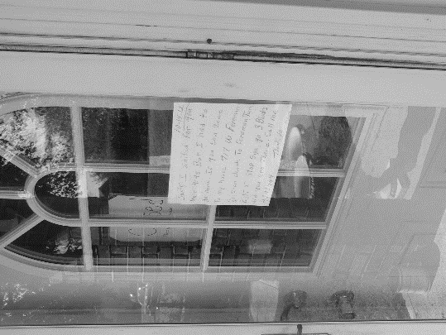
Figure 14: “We’re closed, but I left you a note.” 2016, Photo by E. Oliver 2016

Space is one of the unique features that informs culture and the daily lived experiences of individuals and groups. Delaney and Kaspin (2017:35) posit, “space, is perhaps, our primary means of orientation in the world—physically, socially, and cosmologically.” Against this background, the examination of space as a mechanism of symbolism that encodes social meanings, values, and the performance of identity is necessary. David M. Schneider (1972) writes,
“By symbols and meanings I mean the basic premises which a culture posits for life; what its units consist in; how those units are defined and differentiated; how they form an integrated order or classification; how the world is structured; in what parts it consists and on what premises it is conceived to exist, the categories and classifications of the various domains of the world of man and how they relate one with another, and the world that man see himself living in (Schneider 1972:38).”

A typological approach to the examination of space within The Lows would seemingly be most appropriate; however, a closer investigation of the spatial orientation among the women in this community shows that such an approach would obscure and minimalize the importance of these spaces (Delaney & Kaspin 2017; and, Kim 2006:260). The spaces would be viewed as ordinary community spaces that are void of intimacy. Keeping this in mind, space is explored intimately, intentionally, and intrinsically.
Religion & Healing in The Lows: Greater Healing Hands and Heart Church and Mission

Historically healing has often been associated with religious space. In the neighborhood called The Lows, “Greater Healing Hands and Heart Mission and Church” is operated under the direction of Sister Delora and Brother Tomiah, a strong blending of Mexican cultural healing practices with contemporary Christianity is noticeable. The mission/church is an intimate space where individuals from within and outside the neighborhood seek healing that is spiritual, emotional, and physical or numerous combinations of the three, administered through Sister Delora and Brother Tomiah and a visiting Peruvian healer, Sister Doña. Men, women, and children walk through the doors at the Greater Healing Hands and Heart Mission and Church at various times of the day and night, when open. They do not always believe in the healing arts, but they are always looking for remedios, an answer from the ancestor, or help from the Holy Spirit. Many times, those that wander in, or are referred by a community member, encounter curanderismo at work and Doña M. at the center of this space and practice.
Syncretism: Community, Culture, and Curanderismo
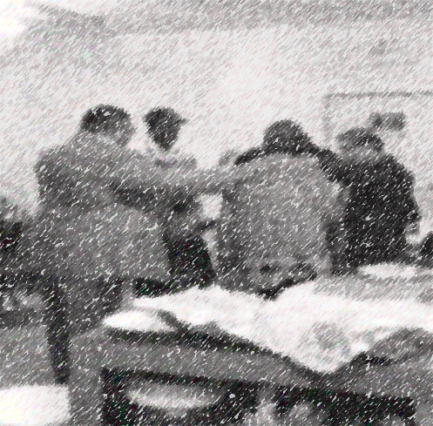
Figure 15: Prayer, Health, and Healing, 2015. Photo by E. Oliver, 2015.
The difficulty of assessing the different practices and experiences of alternative healing within The Lows, specifically, curanderismo and the ways in which folk medicine and healing have been interpreted through the multiple lenses of Anthropology, Psychology, and Religion, does not only illustrate theoretical and pragmatic problems within the framework of religious and supernatural theories, but shows the difficulty of diagnosing and treating cultural-bound and self-diagnosed illnesses in contemporary medical settings. This is particularly true for women that do not have accesses to resources, primarily financial resources, for Western biomedical treatment. Treatment seeking and ways in which to address biopsychosocial illnesses take place in “spatially coordinated worlds “that transcend common cosmological personal and individual experiences and realities (see Delaney & Kaspin 2017). For example, in addition to the variation in “troubles” that are treated in complementary and alternative medicinal frameworks within religious spaces, this section of the dissertation primarily explores curanderismo and examines the opinions surrounding the development, diagnoses, and treatment of “nerves,” in a American Indian context; “bad nerves” within an African American context; and nervios or ataque de nervios (attack of nerves) (ADN) among Mexican community members.
The theme of “nerves or bad nerves” is common among research participants. Several of the women attribute a real or perceived traumatic experience as a causal factor. The healer that visits with and treats many of the women in this neighborhood indicates that this condition is linked to a traumatic experience that occurred at some pivotal point in the life of that individual. She will typically send them to the downtown market for an assortment of herbs before determining the most appropriate method of treatment.
Examining blended and syncretic healing practices within hybridized spaces, as a component of my research, is not intended to sensationalize or exoticize the cultural practice of curanderismo. This examination is intended to illustrate the ways in which women looking for relief from their biopsychosocial ills seek treatment in unique spaces. Also, this section of the dissertation describes how curanderas y curanderos produce healing effects to treat the illnesses, specifically all the forms of nerves, anger, and “sadness” that the women in this neighborhood experience. It also briefly examines the much larger complexities of cultural psychology as structures and mechanisms for healing and the practices used to control and cure illnesses within a blended community. As an observer, I wondered why Doña M. relied heavily on religion and the supernatural within her practice of treating women from diverse ethnic and cultural backgrounds, but more specifically, religious backgrounds.
To answer this question, I had to become intimately acquainted with Doña M. and the practice of curanderismo in a way that was anthropologically relevant to my dissertation, blending culture and history. In the same way, an intimate and deep exploration of complex relationships among community members, the supernatural realm, and various landscapes was necessary to understand the multiple ways in which intersections of religion, complementary alternative medicine, ritual, the community at work for the practitioner, and the women that seek treatment. Just as it is imperative to become familiar with curanderismo, it is equally important to have an adequate understanding of the ways in which women conflate most of their illness experiences within “nerves” and other maladies resulting from daily stressors. Resting on this knowledge, it becomes conceivable to explain the unthinkable to disbelieving scholars, modern medical practitioners, and some religious leaders by examining the spaces utilized by the members of this community.
A visitor to the local Mexican market, which doubles as a covert botanica shop, may be surprised and even frightened at the aesthetics and various effigies that are prominently displayed in the back of the store, methodically placed on counters, and that line the walls. Figurines of the spirit of death sit juxtaposed to the crucifix of Christ. This shop, at first glance, would appear to have no resemblance to a practice firmly rooted in Christian belief. With strange roots, herbs, powders, and elixirs store shelves are overflowing with items that are said to cure illness, heal ailments, and promote “all” things good. A small room in the back of the store is designated for meeting with a curandera total, a yerbera or herbalist, a partera or midwife, or a sobradora which is also known as a masseuse.
It has been stated that at least six major historical influences have shaped the beliefs and practices of the curanderismo encompassing Judeo-Christian religious beliefs, symbols, and rituals. These include: early Arabic medicinal and health practices combined with Greek humoral medicine, medieval and late European witchcraft; American Indian herbal lore and health practices; modern beliefs about spiritualism and psychic phenomena; and scientific medicine (see Trotter and Chavira, 1997). It is believed that each influence is as equally important in the healing process; however Judeo-Christian beliefs overwhelmingly provide the basic structure for the practice of the curanderismo. The Bible and the teachings of the Church have been combined with folk wisdom to produce a foundation for theories of both illness and healing that make up much of the structure of curanderismo (see Trotter and Chavira, 1997). Many curanderas and curanderos make it a point to distinguish themselves from the “bad” practitioners known as the bruja or brujo. They believe that their don is a gift from God like the gifts bestowed upon certain apostles with healing powers. They indicate that this comes strictly from Biblical scripture and that the Saints play a crucial role in their ability to heal. According to some healers, the Saints act as intercessors between the curandera and God and are oftentimes responsible for the healing gift the patient receives. They state that this belief in the intercessory power of the Saints is a common tenant of the Catholic Church. Because they have been chosen by God and have proven themselves worthy, the Saints are considered holy by the Catholic Church-worthy of veneration and able, through God’s grace, to intercede on behalf of mortals seeking blessings from above (see Perrone, Stockel, and Krueger, 1989). During my time at the church/mission, I noticed the deep ties to Catholicism; however, it is not appropriate to make these comparisons when discussing these practices with individuals that come to the church/mission because many found it offensive. During my research, I found, a select few viewed the Catholicism and the Catholic Church as “oppressors”, “a cult-like organization”, or “a place where the wealthy congregate.” Others revered the practice of Catholicism and the Catholic Church as “being as close to God, The Father, The Son, and The Holy Ghost as humanly possible.”
The curandera firmly believes that the patient must have a strong belief in God to fully receive healing from their illnesses and ailments. This is one of the areas that I found curious. A select few of the individuals that seek healing have identified as “non-believers” or “believing outside of Christian precepts and examples”. It is not only this belief in a higher power, but it is the belief in the curandera as well. Doña M, a Peruvian healer curandera from Oklahoma City, indicates that the patient must believe that he or she can receive healing. “It is a mental thing”, she says. “It (healing) happens in the mind, the soul, and the heart… If a person has doubt, the treatment often will not work.” Tricia, an American Indian patient of Doña M., confirms this statement of belief. Tricia indicates that she suffers from a nervous condition resulting from years of gender-based violence; however, she insists that her attacks and “fits” are not as bad as they once were. She shared with me that many of her peers in the community often “poke fun” at her strong belief in the healing arts that is slightly different from that of her cultural tradition. Furthermore, Tricia indicates that the mission is the only place that she can receive the freedom from the “fits” through the practice of ritualistic aspects of curanderismo. She openly discusses what she considers a “fit” in the following ethnographic snapshot (Example 4.1).
Example 4.1: Ethnographic Snapshot, Tricia 2015
“My husband and I divorced, you know? I mean, I thought I would just die. I couldn’t eat or sleep. I would just stand in the middle of the street and weep, scream, for hours on end. The neighbors tried to help me but I would just find my way back to the street to look for him. I would scream his name; you know…hoping the wind would carry my screams to him. I was no good to my five (5) kids. And, then, one day, even know I am not a believer in the God you know I just laid down in the middle of the street and prayed to God and the divine mother to let a car run over me…to take me from the pain and stress but it didn’t happen. And as if a dream, Sister Delora appeared with Doña M and another woman….the three seemed to lift me with supernatural strength. They took me inside the mission and placed me on the floor in front of the cross. They begin to pray….they removed my shoes and rubbed oil on the soles of my feet, my spine, my heart, my temples. They gave me a drink of orange juice and powder. They told me to follow a specific diet for three days. They put the items that I needed to eat in a sack. They were still praying as they were giving me instruction. I lost track of the time but my soul began to feel better. My fits went away and I began to heal. I was able to return to work, to take care of my kids, to feel better.
She reiterated that her “fits” were removed with the aid of the three women. Tricia indicates (Example 4.2) that many of her family and friends doubt the power of the women that helped her through her relationship struggles. Her continued trips to the home of Doña M. were met with a huge amount of skepticism and criticism by her peers.
Example 4.2: Ethnographic Snapshot, Tricia 2015
“They could never come here for healing; they’re unbelievers and turn to American doctors to treat all of their illness.” “Colonization long ago did that,” she says. “It (curanderismo) just doesn’t work if you don’t believe that powers outside of the physical realm can make you sick or make you well”, she stated. “I mean, my people know that but…. [long pause] …well, it’s just seen as a Mexican thing, you know, something silly,” she continued on.

Seemingly, the practice of curanderismo has the potential to divide communities into those that view the practice through the lens of skepticism and traditional culture; however, for those that continue to practice and believe in the healing art of curanderismo, social bonds between community members of diverse ethnic origins are strengthened. Cultural bonds are transcended and transformed through the creation of blended beliefs and practices, cultural identity is reconfigured to encompass the diversity of beliefs and practices. Many of these blended beliefs and practices are not only situated within Mexican culture but encompass Christianity, and African healing origins. The language used in blending of these beliefs and practices creates a shared belief system, a patchwork of syncretism that help and heal the biopsychosocially ill through cultural participation.
Considering the notion of syncretism, as discussed above, we can examine blended religious beliefs, practices, and performances through a comparison, and expansion of the work of Jane and Kenneth Hill. The Hills explore syncretic language, “the blending, performance of, and participation in spoken language” through an ecological perspective (Hill and Hill 1986:59). Through their exploration of Mexicano speech they illustrate the ways in which speech registers, natural and learned, dictate talk from a fairly traditional form to one that is of a more flexible dialogic structure, depending on the participants. (Hill and Hill 1986:79). Referring to the discussion of syncretic religion in the paragraph above, we see that natural and learned practices of curanderismo dictate the effectiveness of healing.

It is argued that members of society create religious objects, rituals, beliefs, and symbols to integrate their cultures. In small, non-urban communities, like those in these areas of rural Oklahoma, successful healing has a strong communal component. Neighborhood residents and community members that use the services at Greater Healing Hands and Heart, a non-denominational church and mission, share the same beliefs in spiritual beings. These beings are both “good” and “bad”, and bring health, wealth, and peace as well as illness, hopelessness, and chaos. These “spiritual beings” may manifest in a variety of physical forms, such as animals, events, people, and other unexplained occurrences. These unifying beliefs play a tremendous role in the ways in which curanderismo is practiced. As a body of believers, these individuals invoke saints, ancestors, certain animals, celestial bodies, the Holy Spirit, and angels to assist the curanderismo practitioner. The practitioner utilizes these methods to treat a variety of physical and mental illnesses.
After interviewing several women and attending healing sessions, I discovered that the most common causes for nerve-related issues are:
(1) perceived family or generational curses;
(2) not cleansing or smudging properly after visiting a burial site;
(3) spirit attacks, angry ancestors, and domestic-related issues with a spouse.

The women that seek healing services from the church speak of the transformative power of space in their healing process. Participants indicate that the church/mission is transformed into a “type of hospital” that “frees” people using the healing services of the curandera, food, clothing, counseling, and other diverse services. There have been numerous occasions when I have witnessed women that live outside of the neighborhood camp behind the mission overnight so that they may have the opportunity to receive healing help.
Religion, Healing, and Empowerment in The Lows: Writing Intertwined Histories
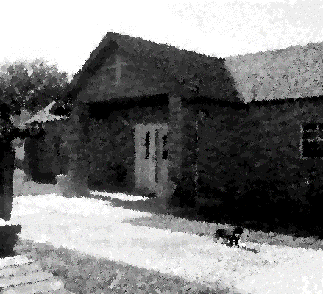
Figure 16: Healing Hands Church and Mission 2015, Photo by, E. Oliver 2015.

The Greater Healing Hands and Heart Church serves as an intimate space for women in the community to gather to discuss their joys and sorrows without the fear of shame and stigmatization. This is a sacred space for health and healing. Believers and non-believers patronize this space to meet a variety of their daily needs. Through the telling and sharing of narratives, women express the ways in which testimony and witnessing [of the narrative] empower them.
In this section of the dissertation, I purposefully discuss the ways in which graphic narratives of gender-based violence are shared in sacred space. Gender-based violence is a theme that is recurring throughout the interviews, focus groups, and participant observation transcripts. I endeavor to describe the importance of space in the women’s discussions of sentimental economies of rape, rage, and reflexivity through the scripting of histories and memories. This section describes the ways in which the sharing of narratives of violence produces novel ways to unpattern the trauma, reconstruct the human condition, and empower being.
Trench (2003:1) posits “language is the structuring mechanism that we employ to make sense of what has happened to us, to understand what is occurring in our immediate interactions and to predict what might happen to us in our potential encounters.” In this section, I show how the production, distribution, and consumption of rape-related histories and memories exceed the personal and individual, becoming a collective endeavor. The fluidity of rage imbues the pre-conscious, conscious, and unconscious collectively through action, narrative, and script at home in the mission.
Intertwined and Intimate: Narrating Violence and Empowerment

He who has loved and betrays love does harm not only to the image of the past, but to the past itself.
-Theodor Adorno, Minima Moralia

Out of suffering have emerged the strongest souls; the most massive characters are seared with scars.
-Khalil Gibran, The Prophet

As mentioned elsewhere in this dissertation, in the neighborhood known as The Lows, the streets often appear dismal and desolate. Many of the old houses look weathered and worn. The chipped and peeling paint, the unattended lawns, and the poorly paved streets are signs of multi-level neglect from a number of community stakeholders for varying reasons. The neighborhood is a forgotten neighborhood, one that is overlooked and often misunderstood. Several of the women in this community say that no one cares about The Lows—that no one cares about them, that women are looked at as being disposable, damaged, downtrodden goods. The women that live in The Lows occupy intersecting categories of race and class. They all have shared nostalgic tales of joy and love, anguish and anger, and triumph and trauma.
On many days, news of adverse experiences, traumatic events, and violence on expansive scales drift and meander through the streets like leaves falling, floating, and sailing from trees on a crisp late-October Oklahoma day. The sentiment associated with the never-ending neighborhood news are inescapable. In this neighborhood, affect, emotion, and sentiments occupy a force in the everyday lived experiences of the women residing in The Lows. This structure of feelings that informs and influences the lives of the women in this community is best explained and understood through a variety of ethnographic and ethnohistorical explorations.
The ways in which individuals and collectives conceptualize, internalize, and (re)act to sentiments is diverse. The experiences of sentiments are both individual and collective. They are implicit and explicit and bind and dismantle categories of being. Reflecting on Foucault and his notion of (his)tory, the life-ways, patterns, and social conditions are never the same or as they seem. Foucault posits,
[H]istory is the concrete body of a development, with its moments of intensity, its lapses, its extended periods of feverish agitation, its fainting spells…” [He goes on to suggest that]“genealogy does not pretend to go back in time to restore an unbroken continuity that operates beyond the dispersion of forgotten things; its duty is not to demonstrate that the past actively exists in the present, that it continues secretly to animate the present having imposed a predetermined form on all its vicissitudes. (Foucault 1977:80-81)

For this section of the dissertation, it is important to (re)member Foucault’s suppositions as rape, rage, and intimate ethnographic space are reflexively explored within a case study that is both experimental and intimate.

Relationships, Memory, and History
The relationship between the histories and memories of the actor in throughout this dissertation are neither horizontal nor vertical. There is no directionality. Consider the following,
Linguistic exchange ─ a relation of communication between sender and a receiver, based on enciphering and deciphering, and therefore on the implementation of a code or a generative competence ─ is also an economic exchange which is established within a particular symbolic relation of power between a producer, endowed with a certain linguistic capital, and a consumer (or market), and which is capable of procuring a certain material or symbolic profit. In other words, utterances are not only (save in exceptional circumstances) signs to be understood and deciphered; they are also signs of wealth, intended to be evaluated and appreciated, and signs of authority, intended to be believed and obeyed (Bourdieu 1999:502).
Thinking about the excerpt above, the linguistic exchange between the participants among themselves and with me, as the researcher, the narratives received within the mission space are “endowed with linguistic capital” (Bourdieu 1999) that emancipates the women from their traumatic histories. The histories associated with memories often shift, slip, and are inverted to make sense of what has happened in the past and what is happening in the present within individual and collective spaces.
Sister Janna and The Language of Intention
Sister Janna, a resident of The Lows, creates an explanatory framework for sentiments, the language of intention, and the landscape of gendered violence through her personal narrative of intention, rape, and rage. Confronting the typical rape culture discourse, I suggest that the rage that Sister Janna experienced transformed and translates her rape into an experience that created conditions for the construction of spaces of being, by providing topography for meaning making. In this section, rape, as a script of violence, shapes the non-linear forms of subjectivity in ways that advance the affective turn and privilege truth as perceived by the narrator. Duranti (2015) writes,
“According to Aristotle, the essential nature of truth is a correspondence between human judgment (in the mind) and things (in the world). As pointed out by Franz Brentano (1996), Aristotle’s definition of truth is found not only in the medieval doctrine that ‘veritas est adaequatio rei et intellectus’ (which can be roughly translated as ‘truth is the correspondence between and object (thing) and a state of mind’), but also in the Logic of Port Royal (1660) and in Kant’s Critique of Pure Reason, where we read: ‘The nominal definition of truth, that is the agreement of knowledge with its object, is assumed as granted...’(Kant 1965:97)…(Duranti 2015:104).
Such scripts of truth are invaluable to the actors on the fault line that participated in this research, in that, experience is claimed to contest and contemplate dominant representations of being (Biehl and Locke 2010:318-319). Here, I describe the rape script as a transformative notion that allows the incorporation of unintended effects of individual and collective “plastic power” (Biehl 2005:15) used in a Nietschian way. It destabilizes the meanings of perceived truth and the sense of being by bridging the past (the histories) with the present (the contemporary). In a quantum loop of body, emotion, and affect, rape as a structure of experience informs the ways in which scholars of the human condition “think” and “feel” about sentiments as social forms (Williams 1977:130-132).
As scholars of the human condition, we strive to explore and explain the ways in which the past and the present influence the social forms of individuals and the collective. We examine behaviors, experiences, emotions, actions and reactions. We use our authoritative lens and framework to “make sense” of the scripts we are seeing, hearing, and often, ourselves, experiencing. Exploration and examination of the life-ways of the experiences of individuals and groups not only sheds light on the ways in which other cultures are organized and function but enables theoreticians, anthropologists, and other researchers to explore and observe their own experiences with a reflexive lens. We are not only studying “down”, we are studying “up.” This form of bidirectional research relationship allows us to be both objective and subjective in the examination of emotions. We are able to participate in the experience and performance of the human condition of those whom we study, while reflecting on our own attached sentiments to these experiences and observations.
Anthropology, like many other disciplines, speaks volumes about the human condition. It is an observation of humankind at its worst and best and serves as an apparatus to explore relationships and tensions that exist within social systems. These relationships and tensions are underpinned with scripts of emotion and sentiments. Emotion affects all action. Cognitively, emotions can be conceptualized as concrete objects constituted biopsychosocially (Lutz and White 1986:407). The emotional affects the social.
Williams argues that “social forms are evidently more recognizable when they are articulate and explicit.” Shaped by our “culturally ordered past,” this is applicable to sentiments in which we internally and externally think about, participate in, and observe (Williams 1977:130 and M. Rosaldo 1986:137). Raymond Williams (1977:131) textually illustrates the tension between the social and the personal. This tension often exists temporally in the relationship between what is perceived to be true and what escapes from the scripts we narrate, witness, and retell. Script categories and boundaries are consistently moved, shifted, and re-shaped (Stoler 2004:254) to allow the actor(s) to push in the direction of both recognizing and acknowledging the script. Self, then, is rewoven into the script.
The literature on rape focuses on the structural vulnerability of the gendered self. It writes the gendered self in a way that suffers the self to the status of victim. This form of scripting presents the trauma of rape as not able to be claimed and not able to be represented in a way that informs the subjective trajectory of becoming. Claiming trauma is an act of becoming. Consider the following vignettes that take place at a church in The Lows.
Writing on the Mourner’s Bench
Sitting on the mourner’s bench at the front of the church, I nervously fidgeted and twirled my braids between my thumb and index finger, thumbed through my weathered and worn moleskin journal reading the previous day’s fieldnotes, and checked my watch repeatedly as I waited for the women to enter the church for their weekly meeting. One by one, the women entered the sacred space, carrying a basket of this or a box of that, containing mementos of the past and present. Tonight, was a special night. Not only would the women speak stories of tragedy and triumph, they would be reading from journal entries that they had written, and they would spend the evening sharing and showing the special items from their baskets and boxes. A therapeutic show-and-tell, if you will.
Many of the women had started using writing, specifically journaling and poetry, coupled with attending weekly Wednesday meetings as a means to record their past and present experiences and as an apparatus to move beyond the stagnant positions of victim ─ to move into a space of freedom and power. The extended and fictive kin networks at the church, the sharing of narratives, the rewriting of scripts “support identity formation, a sense of belonging, recognition of a shared history, and facilitate the survival of the group of women that meet each week (Yellow Horse Brave Heart and DeBruyn 1998:363).
Sister Janna, a key research collaborator, entered the sanctuary of the church. The usual brilliance in her eyes was replaced with dark raven glass. Her demeanor was pensive and foreboding. I was unsettled. I didn’t know if the feeling was fear of my hearing stories that would make me uncomfortable or, fear that my own truth would be revealed.
Andrea Dworkin (1987:66) writes “women have been chattels to men as wives, as prostitutes, as sexual and reproductive servants. Being owned and being fucked are/ have been virtually synonymous experiences in the lives of women. He owns you; he fucks you (Dworkin 1987:66).” I would soon realize that the narrative of owning via marriage and fucking via rape would unsettle me even more than Sister Janna’s demeanor, evoking my own sentiments, my own troubled nostalgic memories of trauma.
And, Then She Spoke: Songs and Speech of Suffering
Oh Sister, what’s wrong with your mind? You used to be so strong and stable. My sister, what made you fall from grace? I’m sorry that I was not there to catch you. What have the demons done? What have the demons done with the luminous light that once shined from your eyes? What makes you feel so alone? Is it the whispering ghosts that you feared the most? But the Blackness in your heart won’t last forever
-City and Colour

I felt like a voyeur as I sat in the back of the room listening to the women sing, recite poetry, and share their stories, which were explicitly pornographic at times with talk of cock and fucking, of things that bring them so much pleasure; yet, have caused them so much pain. I was uncomfortable. I don’t know if it was because my glimpses of the graphic memories of others was taking place in a religious space or if I was glimpsing at the memories, many of which appeared too nostalgic, in many ways to happy women who have experienced great trauma and suffering, or if the discomfort I was experiencing was based on my own haunted past. Facing the demons and ghosts of one’s own past can be disquieting. This was confirmed as Sister Janna walked to the front of the church as if her shoes were weighted with lead, each step calculated and careful. She reached the front of the room, stood before the cross, and spoke. Her story did not start at the beginning nor did it begin at the end. It started somewhere in the middle of muck, murk, and mire. She sang “Amazing Grace” in her mother tongue and then she spoke. Respecting her request, these are her words unabridged, unchanged, unscripted (Example 4.3).
Example 4.3: Ethnographic Vignette, Sister Janna 2015
“I held his cock in my left hand, stroking it, loving it, getting it hard and I had this knife (pulling the knife from a basket that she created herself) in the other. I wanted to take from him the very thing that he and I loved the most at times. In that moment, I hated him. I wanted him to suffer. He was half sleep…lovin’ what I was doing but he woke up. I don’t know if it was the look in my eyes or the light reflecting off this blade that made him jump up. Without thinking and full of rage and hate, sorrow and pain, I lunged at him digging the knife into his cheek hoping to reach his fucking throat. I don’t know what I was thinking. I was just filled with feelings I can’t describe or comprehend. My soul felt black. It’s like the rape he put together with his buddies, the rapes at the boarding schools, the rapes in the foster homes, and the rapes by my uncles all came back on me. I was crazed with anger….crazed.”
I had stopped fidgeting and was more than attentive as she spoke. She was more than a collaborator, more than a friend, she was like a sister. I was enraged as she graphically talked about the drunken gang-rape that initially began as a welcome home party for her husband, JohnD,
Sister Janna vividly narrated the story of the surprise party she gave in celebration of JohnD’s homecoming. Sister Janna described the festive party in rich detail, recounting the guests that were invited, the food, the drinks, and games that were played that evening.
“Everyone was having such a good time. We were laughin’ and playin’ the dozens and then he had to go and bring those drugs out. Once, I got clean, I didn’t even want to see a needle, she would recount.”

She would continue to describe, what I felt were horrific details, the ways in which her refusal to use injectable drugs led to her gang-rape.
I became angrier, angry at her as she recounted the “good times” that she shared with her husband and the “good qualities” that her husband, her victimizer, her oppressor, possessed. I doubted her “happy memories”. My anger was replaced with guilt. I felt that my anger towards her was another form of rape, an unconscious rape. I wanted to save her from herself, from the creation of memories that I assumed had to be false. This sickened me just as much as what her husband orchestrated sickened me.
I felt the coffee in my stomach bubbling, sloshing, churning, bringing on a sick feeling that I’m certain my face displayed. It is the same ill feelings that I experience when I think of my own past and when I write about the emotive experiences of others. Rosaldo (1993) writes the following,
The emotional force of a death, for example, derives less from an abstract brute fact than from a particular intimate relation’s permanent rupture. It refers to the kinds of feelings one experiences on learning, for example, that the child just run over by a car is one’s own and a stranger’s. Rather than speaking of death in general, one must consider the subject’s position within a field of social relations in order to grasp one’s emotional experience (1993:167).

Initially, I decided that I empathetically was experiencing emotions of rage and sorrow because my collaborator, my friend, my sister had felt these emotions, because I could not have saved her from a lifetime of pain; however, the sentiments were my own. Her story was my sentimental register of my own past and my own traumatic experiences; however, from an anthropological and ethnolinguistic position, Sister Janna’s affective speech (Example 4.3) was creating and promoting solidarity within the sacred space of the church. The affective immediacy of the rape narrative strengthened the voices of the other women that would follow.
In the Key of E: Eugenia and Elisha
This highway's dark and empty. Just miles and miles of endless road. I've got a sickness pounding in my head. I'm at the mercy of the ghost. What will it take to live as if I would not another day? To live without despair, and to be without disdain. How can I instill such hope, but be left with none of my own? What if I could sing just one song and it might save somebody's life? I sought after, after reasons to stay. I was lost, I was lost. Then the sky turned black, and the rains poured down. I was waiting, waiting to be found. oh, no. How can I instill such hope, but be left with none of my own? What if I could sing just one song and it might save somebody's life?
Then I would sing all that I could sing. Cause that is when, when I feel that I'm not just counting time. Oh when I sing all that I can sing. Maybe just for a moment thing would seem all right. Oh when I sing, oh when I sing. Oh when I sing, oh when I sing.
-City and Colour

Palmer, Bennett, and Stacey (1998) posit, “Most linguists, psychologists, and anthropologists today will agree that emotion and language are tightly intertwined (Palmer, Bennett, and Stacey in Palmer and Ochi 1999:171).” This is evident when reviewing the above mini narrative as told by Sister Janna. The emotions that were produced, distributed, and consumed in the sharing of the narrative served as a platform for empowerment and emancipation. Eugenia, a multiethnic, Mexican and African-American woman in her mid-forties participated in the activity, and began with the following Haiku (Example 4.4):
Example 4.4: Participant Writing, Eugenia 2015
Blow away the tears
The scent of healing in me
Wind kissed honey sage (Eugenia 2015).

She stood tall, unmoved, and with an unusual blend of emotion ─ an amalgamated look of pain, joy, and weariness ─ a look of a woman that has survived life. She began her story just as she began the haiku, soft and assuming, but fiercely unafraid and unapologetic (Example 4.5).
Example 4.5: Ethnographic Snippet, Eugenia 2015
I do not openly share, nor do I care much to discuss my own traumas, my own pain. I don’t like revisiting the past; however, being here, tonight, has strengthened me. I am powerful (placing her hands on her hips like a superhero about to take flight ─ a version of superwoman in a daishiki). I am strength. I am forgiveness. I am healing. I am you.

Eugenia took her seat to loud roars of clapping and cheers. In that moment, I understood the power of words, scripts, and narratives (Examples 4.4 and 4.5) shared in safe spaces. I did not have the courage to stand before the women and share my stories [they encouraged me to do so; but, at this moment, I very much wanted to be “just the researcher ─ just the anthropologist”]. In the margin of my field notebook I drafted the following jotting (Example 4.6):
Example 4.6: Research Jotting, EO 2015
I am the author of my own scripts. They are my scripts to be changed, altered, omitted, washed, rewashed, and bleached with a fluidity that allows me to move beyond the boundaries and borders of the gate keeping mechanisms of memory. I am no longer the oppressed. Hearing the narratives of the women present tonight ─I am free.

In that moment of inward reflection and jotting fieldnotes (Example 4.6), I realized that in this space and time, the histories of the researcher and the participants of the research were intertwined, not concretely but in an abstract way of being. Hierarchies did not exist in this space. Our histories were blended and we, Sister Janna, Eugenia, and I, researcher and participants, were one.
Stories at the Stoop
Marcus and Fischer (1999) write, “perhaps the most effective focus for descriptions that would deal with the ways in which cultures most radically differ from one another is a consideration of conceptions of personhood-the grounds of human capabilities and actions, ideas about the self, and the expression of emotions (Marcus and Fischer 1999:45).” Following the ethnographic methods of Abu-Lughod and Stewart the narratives contained in this section of my dissertation consider the conceptions of personhood as outlined by Marcus and Fischer.
Historically, the representations that we have of women, their lived experiences, their material reality and their past and present traumas have been transcribed and translated through patriarchal and hegemonic writings. Abu-Lughod (2008) posits “that writing about women, specifically women that face intersecting modes of marginalization is problematic (Abu-Lughod 2008:13).” Using storytelling Abu-Lughod illustrates contested ideologies of marriage, parenting, reproduction, religion, identity, and gender. This dissertation has followed the experimental ethnographic method as used by Stewart and Abu-Lughod. Abu-Lughod indicates that she experiments with the construction of narratives and uses this form of narrative experimentation to illustrate women’s worlds and experiences by writing against culture (Abu-Lughod 2008:13). Like Stewart (1996), Abu-Lughod allows the women to be present in her work.
Stewart vividly explores “othered spaces”. These spaces are ethnographically rich and articulate the events and experiences that have been constructed via the (re)telling, (re)membering, and the (re)presenting of stories from individuals in this community. According to Stewart, “culture as it is seen through its productive forms and means of mediation is not, then, reducible to a fixed body of social value and belief or a direct precipitant of lived experience in the world but grows into a space on the side of the road where stories weighted with sociality take on a life of their own (Stewart 1996:210).” This suggests that the speech economy of a community coupled with habitus transform marginalized and uncanny spaces into discursive areas of discourse both within and outside of academia. Spaces, such as the stoop, are transformed by the ways in which they are used. The stoop is a site for bartering and brokering, trading stories, and acquiring advice. The following sections (Examples 4.7 a & b and, 4.8) detail the ways in which the stoop is used by members of this neighborhood.

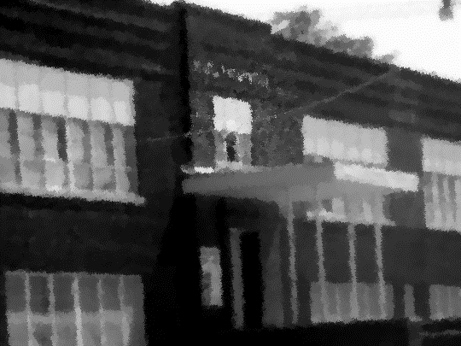
Figure 17: The Stoop 2014, Photo by E. Oliver 2014.

Roxie M.
Roxie, a middle-age African American woman, climbed the steps of the stoop to sit in the classroom with the other nine women that were gathered to swap items for the day. A lively conversation about the health of one of the women was taking place. Roxie sat down, placed her yellow, plastic Dollar General bag next to her. One of the other women moved to sit between Roxie’s legs. Roxie pulled a comb and a container of Sulfur 8 from her bag. She began parting the hair of the woman between her legs.
Roxie was quiet and extremely reserved while the other women joked and made small talk about the latest neighborhood gossip. Occasionally, she would interject a comment or two to either confirm or deny facts of a story being told about someone in the neighborhood. As the women gathered at the stoop began trading items, I posed questions regarding the significance of the stoop in the community. Each woman provided detailed answers and willingly shared narratives (Examples 4.7a &b and, 4.8) of their own personal experiences at, and the uses of, the stoop. Most of the women in this group expressed that they and/or someone they were acquainted with had, at some point, experienced a traumatic life event and the stoop became their saving grace. Roxie shared a story that shook each of the women gathered on the concrete steps.
Example 4.7a: Ethnographic Narrative, Roxie 2015
Roxie: “You know, I really don’t know how to answer your questions (referring to a question asked about a history in intimate partner violence in the home.) My momma has always had the worst luck with men. They either abuse us or her (referring to physical and sexual violence). She say that’s just the way it is though…..I guess she kind of got used to it. I mean she’s always talking about how she was removed from her home and sent off to live with this White “church” family. She say same thing happened to her momma. Our people always had to deal with that kind of stuff, you know. I mean being sent to boarding schools, not being able to be with family just suffering, you know…..I guess over time you get used to suffering. I know I have. I been in a few bad relationships where my man beat me and I stayed. I mean, what else was I gone’do. I didn’t have no where to go. My family, they have they own problems, you know. But after my second baby….I made up my mind that I wasn’t gone be like them…you know the other women in my family. I was gone do something right….give my babies a chance. I left my man and moved in with my Auntie. She don’t have much but at least me and my kids have a chance…you know. I’m working at a facility taking care of old people and working on getting my CNA….I’m going to make sure my kids have opportunities that I didn’t have and when I can’t afford diapers or money to pay for a ride to work when it gets cold, I can come down here to the stoop and trade something for the items I need. It [the stoop] saves me during the lean times…and its plenty of those.

Roxie shared this narrative (Example 4.7a) without interruption (parts of this chronicle have been left out so as not to sensationalize her story). I asked Roxie if she felt that her experiences of past trauma and “suffering” affected the way she parents. This was her response:
Example 4.7b: Ethnographic Narrative Response, Roxie 2015

Roxie: “I think that going through all those things with my momma and then being involved with the same type of men in my own relationships made me want to be a better momma to my kids, you know. I mean, I just didn’t want them going through some of them things that I been through. I want to give them things I didn’t have….not like material things. You know, a place to have friends over and not be afraid something bad is going to happen (referring to an experience where friends were over for a sleepover and her mother and mother’s boyfriend had a volatile encounter). That kind of stuff…..I want to be able to go to my kid’s school and not have bruises all over my face and body. So yeah, I guess I been affected but I don’t see it as a negative thing, you know. It was a learning experience and even though my home life growing up wasn’t like I wanted. I could escape by coming here [referring to the stoop]. Shoot, Lish [pronounced like ‘leash’ – an abbreviated version of my name that many women in the community use], I been coming to these steps since I was 8-years old….just to hang out and, sometimes, get the motherin’ that I wasn’t getting’ at home…the stoop was home.”

Roxie indicated that she didn’t perceive her past traumatic experiences negatively. She saw them as experiences that forced her to be a “better” parent and to provide for her children in ways that she felt she “missed out on” growing up. She went on to confirm, the stoop was a space to ‘learn how to mother,’ a space to ‘help provide for her children,’ and a space for ‘restoration and rest.’
Furthermore, she indicates that her drive and determination to have a much healthier relationship with her children stems from hearing the stories shared by other women that frequent the stoop. Roxie intends to follow a plan of action that “moves them [the children] out of harm’s way.” The chronicle that Roxie shared during this afternoon at the stoop elicited a response from several others that were gathered on the steps. Pat, a middle-aged White woman, shared the following narrative (Example 4.8).
Pat
Example 4.8: Ethnographic Narrative, Pat 2015
“Hmmm….[with tears in her eyes]…I have experienced abuse. I’ve been abused [tears streaming down her cheeks]. He started coming into my room when I was ten. At first, he would just fondle me but it started to progress to other things. At first Sarah [my mom] didn’t believe me. ….a few weeks later, she was shipping me off to her friend’s house…shit didn’t get much better there…the boyfriend of Leanne [my mom’s friend] was a real character, that one. He and Leanne would come in drunk and shit. She’d pass out and here he would come….always trying to force me to do things, you know….I used to fight like hell. You see this scar above my eye [turning to show everyone the scar]…I got that when he pushed me down. I fell and gashed it open on the corner of the coffee table….that was some fucked up shit….later that night, I stole Leanne’s pills and some beer and came here to kill myself. I just couldn’t take it anymore, you know. There was nothing that I could do to stop the pain. I found the darkest corner [pointing to the other set of steps] opened those pills and downed them with a beer. Shit, I didn’t even see Corie sitting across the street at the church. She saw me and came across the street. She walked me all night. I was so mad at her. I tried to fight her because she was keeping me from leaving this world. When the sun came up, I was alive and hungry. Corie opened her bag and pulled out a ham and cheese sandwich. It was the best damn sandwich I had ever had. We ate in silence. I started living out here…doing what I needed to do to get by…I finally ended up in the system. I been out a long while [referring to prior incarceration]. You know Oklahoma is the worst state to live in if you a woman… growing up here is hard but growing up here is twice as hard if you’re Indian, or Black, or anything but White and you’re a woman. I’m poor and White so that kind of groups me with Blacks and Indians, you know. The system is fucked up. When I got out, I came back to the stoop….I was looking for women to help like Corie helped me. I come by here every morning and night. It gets bad sometimes and folks got to know that there is always a better way…always a better way.”

Pat’s narrative (Example 4.8) is, indeed, tragic and reflects experiences and responses that have been present throughout the course of this research. Her narrative of her time at the stoop supports the claim made by many women that participated in this research, “the stoop is an inclusive, significant space of being and becoming.” Just like the gatherings at the stoop, mealtimes at the mission are significant events, within a significant space, that reinforce social bonds.
Mealtime at the Mission: Language, Love, and Food
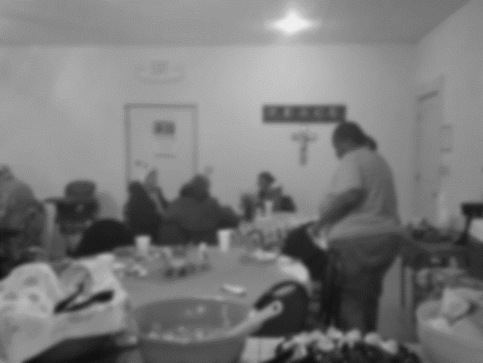
Figure 18: Mealtime at the Mission 2016, Photo by E. Oliver 2016.

The central focus of this section of the dissertation is structured around meals at the neighborhood mission. This mission is a space for sharing ideas, exchanging stories, trading information, sharing recipes, and swapping gossip. The mission functions in many different capacities for the residents in this community and each function comes with a story.
Stories that are ripe with cultural values, beliefs, customs, wives’ tales, myths, and traditions are often shared at many public spaces within these neighborhoods; however, the mission is a space where meals are served with memorable stories. The mission is a central meeting place for community residents, specifically women, to share a meal and discuss personal and community events.
Information about domestic violence, sexual health, and a myriad of other health-related issues and concerns are frequently exchanged at this community hub with friends and food. Just as cultural information and health-related knowledge are exchanged and shared; gossip and complaints are also very much a part of the neighborhood narrative. Complaints lodged against a landlord, city services, Indian Health Service (IHS) Clinics, or other entities can be overheard as the women swap stories while working at the mission. Tidbits of gossip float through the air like leaves on a windy Oklahoma day. The narratives shared and exchanged are complex, informational, educational, and meaningful.
The purpose of this section is to direct attention toward the agency of mealtimes and gatherings at the mission. In keeping with the flow, thus far, in my body of work, I prominently position myself as well as the voices of the women in this neighborhood within this section of the dissertation. The two primary questions this section answers are,
(1) In what ways do mealtimes at the mission connect the women in this community?
(2) Do these events facilitate agency?

This section is divided into three components. Component 1 further explores theoretical applications that speak to the empirical, auto-ethnographic data that is presented in components two and three. Component 1 builds upon the theoretical perspectives of Ortner and Bourdieu. These works are the basic underpinnings for gaining insight into the ways in which I, as well as the women, discussed my dissertation, navigate mealtimes and social interactions at the mission. Also, this section illustrates the ways in which community cohesion takes form using the mission and meals as a launching point.
Component 2 of this section delineates my presence in this neighborhood and community. This component is in dialogue with the theoretical discourse from the previous component. In this section of the dissertation, auto-ethnographic background information regarding the community and neighborhood are reintroduced to the reader. This serves as the backdrop for the women’s narratives that are included in the subsequent component 3 of my dissertation.
Finally, Component 3 presents a selection of individual narratives in a variety of formats. In this component, the reader of my dissertation, can become intimately acquainted with each of the women that participate in mealtime and gathering activities at the mission through the narration of their stories. To provide this intimate acquaintance, I employ the use of experimental ethnography as used by Lila Abu-Lughod in “Writing Women’s Worlds” and Kathleen Stewart in “A Space on the Side of the Road,” as discussed in the previous sections of this dissertation. I attend, in some detail, to the ways in which the women understand the importance of the mission in their personal lives, the role of shared meals at the mission, neighborhood experiences, and the perceptions of social networks and community cohesion. The reader becomes aware of the significance of each shared meal and the experiences associated with these meals from the perspectives of each woman included in this section of the dissertation. The reader also becomes acquainted with my personal experiences and the ways in which these mealtime gatherings influenced my research.
In this section of the dissertation, I articulate the life experiences of women living in The Lows. I recount the ways in which these women believe that their daily lived experiences are influenced and affected by social interactions within the neighborhood. Many of these interactions occur at the mission and always occur over a shared meal. In the social interaction narratives, social and cultural capital, agency, habitus, and doxa are intertwined with space and place. As mentioned in the methods section of this dissertation, a variety of research methods were used in obtaining the data that informs the domains of social and cultural capital, agency, habitus, doxa, and space and place in this section of my research.
During my field research, specifically related to my time at the mission, I facilitated Saturday afternoon workshops there. During the other days of the week much of my time was spent assisting in the building of additional mission classrooms, performing community gardening tasks, preparing and distributing food baskets, and organizing the clothes closet. On many days, I offered participants rides to grocery stores that carry fresh produce, assisted with childcare while women were attending classes at the mission, and provided rides to work, using the mission as a pick-up and drop-off point.

Component 1: Ortner and Bourdieu in Dialogue at Mealtime: A Review of Space and Place

According to Veenstra et al. (2004:5), “the social capital and health discourse intently focused on certain social networks, i.e., voluntary associations, has generally acknowledged the interconnectedness of the micro-level (individuals participating in such networks), the meso-level (the social networks themselves), and the macro contexts that shape both individuals and networks (e.g., political and economic structures).” These networks exist in The Lows.
During a Saturday lunch, a woman that frequents the mission asked the following [a question that would be asked of me repeatedly during my research] question (Example 4.9),
Example 4.9: Ethnographic Conversation, Miss J., an older African-American woman, 2015

“Lisha you know why they call this area “The Lows?” Before I could respond she stated, “there have never been any economic opportunities, social activities, or decent grocery stores in this area. It’s a “low” way to live.
Heaping pea salad onto a plate, another woman, expressed the following,
Example 4.10: Ethnographic Conversation, Lanna, an older White Woman, 2015
“They call this area The Lows cause they don’t care nothin’ bout no Indians and no Blacks! Hell, they don’t care bout no poor White folk either. You know, it’s like we the people at the lowest rung of the ladder….don’t nobody care about us or this neighborhood but us, that’s why they call it The Lows.

I took these various explanations (Examples 4.9 and 4.10) as windows into the ways in which others identify with the neighborhood. A review of the literature with regard to identity and neighborhoods reveals an array of theoretical perspectives. The residents and civic leaders in this community have spatialized this neighborhood based on equitable access to resources, geography, and in many ways, culture. Setha Low (1996) writes,
“By spatialize I mean to locate, both physically and conceptually, social relations and social practice in social space. Thus, the social construction of space is the actual transformation of space-through people’s social exchanges, memories, images, and daily use of the material setting-into scenes and actions that convey symbolic meaning (Low 1996:861-862).”
The women that shared their comments and opinions of The Lows all interact with the neighborhood differently. The neighborhood has been viewed as a constructed place of oppression for some. Others remember the neighborhood as a place for meaningful social exchange, while those residing outside of the bounded groupings of streets known as The Lows construct this area as a place of pure geography. Referencing Michel de Certeau (1984), Low writes,
“By tracing out the operations of walking, naming, narrating, and remembering the city, Certeau develops a theory of lived space in which spatial practices elude the discipline of urban planning (Low 1996:863).”

This text presented by Low references a systematic set of practices and use of constructed space within the neighborhood, specifically, the mission and the associated mealtime activities. Bourdieu’s perspective on habitus and doxa inform Low’s argument and serve as a framework for situating the activities at the mission.
Bourdieu and Ortner
The residents in this neighborhood identify the mission as a place that unifies them through the preparation and sharing of multiple weekly meals in a kitchen space. The preparation of meals at the mission is a practice that is never taken for granted in this neighborhood. The women believe that mealtime is a sacred and necessary event. Bourdieu (1977) indicates that habitus, doxa, and practice are best understood together. They complement one another. Bourdieu (1977) indicates that the notion of habitus is an explanatory concept that relates to the functioning of social space at the micro-level and describes the relationship between the environment shared by a group of people and the practices of the inhabitants of these spaces (Bourdieu 1977:72).
Based on Bourdieu’s concept of habitus the mission is a social space that serves a function and each participant has both a group and an individual relationship with this space. They’re relationships with the mission space inform their group and individual practices. Citing Bourdieu, Chopra (2003) writes,
“Practice, an important term in Bourdieu, can be defined as those embodied activities and competencies that are “learned” and carried out by individuals in a social space. It would be more appropriate to say that these practices are acquired as a result of being integrated, acclimatized and shaped in a particular type of environment. These learned practices in turn enable individuals to negotiate interactions with other individuals in that social space (Chopra 2003:425).”

Several of the women state that they have learned the meaning of “breaking bread” together. Rosie, a woman that has participated in the preparation and sharing of meals at the mission for five years observed the following (Example 4.11),
Example 4.11: Ethnographic Snippet, Rosie, a middle-aged, Mexican Woman, 2015

“I’ve learned so much in this kitchen. I’m not just talking about certain meals to cook for this or that. I mean, I’ve learned how to build and restore relationships with people I couldn’t stand…many of them right here in this building (laughing heartily as she stirred a pot that was brimming with freshly picked herbs and a mixture of beans and corn).”

This snippet from Rosie reiterates and reinforces Chopra’s claims. Rosie has “learned” new skills and practices that are both culinary and social. Bourdieu (1980) posits,
“As an acquired system of generative schemes, the habitus makes possible the free production of all thoughts, perceptions, and actions inherent in the particular conditions…..through the habitus, the structure of which it is the product governs practice…( Bourdieu 1980:55).”

The women who participate in mealtime activities are marginalized and many express “feeling oppressed by the hand of the man.” Several of the women who participated in this research have experienced multiple forms of trauma. Many
do not have equitable access to resources that would greatly improve their circumstances. Despite these conditions, the women that frequent the mission enact agency because of their participation and relationships at the mission. Sherry Ortner would assert that these women are actors within their social networks.
Ortner advances Bordieu’s theoretical framework through practice theory. Her theory can be applied to the ways in which the women in my dissertation interact with one another as well as the ways in which they position themselves against large societal structures. Ortner (2006) writes,
“….practice theory was a general theory of production of social subjects through practice in the world, and of the production of the world itself through practice (see Ortner 2006:16).”
Keeping this in mind, we can see the importance of the mission space as a conduit for community cohesion. In this space the women are consistently (re)inventing, (re)shaping, and (re)membering social networks.

Component 2: My Sense of Space, Place, and Position: The Auto-ethnography

I would like to think of myself as an indigenous anthropologist with regards to this research. I was born in Oklahoma. For the first five years of life, I was reared in the very neighborhood where this research takes place; in fact, my mother was born in this neighborhood. It wasn’t called “The Lows” then. It was called “The Claire Heights Addition.” Then, the neighborhood was vibrant, progressive, and safe for families. It was a middle-class neighborhood where teachers, dentists, nurses, and military personnel resided.
My mother left this neighborhood and later, I would follow. As mentioned in the introduction, I would return every summer to the house where I currently live. My grandmother lived there. I would spend countless hours playing in the creek, riding my green bicycle with the banana seat, or walking to the neighborhood five-and-dime store for a bag of penny candy. The Lows, as it is now called, was considered a “good” neighborhood. It was growing and prospering. That was then. The socio-economic landscape of this neighborhood has changed and now residents, city officials, and visitors consider this area of town to be “bad” ─ to be an unsafe place, a place that is not desirable for visiting or living. I beg to differ.
I see this neighborhood through the eyes of a researcher ─ the eyes of an anthropologist seeking and seeing to make “the familiar strange and the strange familiar.” I began living in a house so familiar to me that I could walk through it blindfolded. I recognized every creak and groan the house made when the wind blew, when the rain beat against the windows, or when simply, the house settled. On many mornings and evenings, I would sit in the semi-rusted-out metal rockers on the porch and observe the interactions, the social and personal relationships of the residents, and the comings and goings at the mission. Many weeks were spent observing and writing and writing and observing. I also spent several weeks driving throughout this rural geography, photographing landmarks, dilapidated dwellings, and cultural sites of significance. Eventually, I would make my way two doors down to investigate the constant stream of women going to and from the mission.
After I started attending the weekly Wednesday and Saturday meetings, I began offering my assistance where needed. I immersed myself into mission programs and community life. Admittedly, I made several mistakes in the beginning of the intense participation. I didn’t know the local neighborhood language, could not always recognize nuanced joking ─ “scoring” relationships that, at times, felt like personal attacks, and, on occasion, ‘overstepped’ boundaries in my attempts to help prepare meals at the mission.
At first, the women at the mission kept to themselves despite their familiarity with my family. They often excluded me from conversations, assigned menial duties, or code-switched in my presence to keep tidbits of information from my comprehension. To them I was strange. I, the observer, was often being observed.
Our interactions were polite and formal; however, as time passed the women became more relaxed and engaged me in conversations regarding my opinions and perceptions of the neighborhood, of the town, and of the state. They wanted to know about my family, my love life, my career, my views on religion, and my political leanings. The women eventually began including me in organizational and planning meetings related to women’s health.
On many occasions they asked my suggestions for program platforms that focused on domestic violence, breast and ovarian cancer awareness, and sexual health. They requested my assistance with completing grant applications, writing resumes, and teaching basic word processing skills. A few of the older women in the group even asked my assistance in finding them a husband.
My assistance was met with generous reciprocity. On many days, I would open my front door to find bags of cat food for the kittens I had rescued, baskets of fruit, pots of soup, or cards that contained small tokens of appreciation, knitted scarves, and worn cookbooks that had the appearance of being well-used for generations. On a few occasions, I would even find a person or two waiting for me to open the curtains, front door, and deliver coffee. I was often told, “Lisha, you can’t collect people” (in reference to the kittens that I had rescued that would hang around the porch waiting to be fed. The presence of “people,” usually those who felt most abandoned and alone in the community, became a regular occurrence.).
My interactions with the women meeting at the mission led to casual conversations over shared meals in the fellowship hall, dinner at their homes, and lunch dates that usually consisted of potted meat sandwiches, fry bread, and beer at the local park. I would later come to understand that shared meals occupied an important role for these women. This was a shared time for exchanging knowledge, community building, bonding, and planning. Suggestions and recommendations for navigating legal systems, Department of Human Services, the tribal government, and many other organizations were often shared during meals. This was also a time to air grievances against one another and foster forgiving when misunderstandings occurred among the women. Meals were more than just a time-centered activity to foster healing and restoration. The mealtime activity was a ritualized practice.
I discovered that during mealtime, women felt most comfortable in discussing issues of shattered or shaken faith due to trauma, family problems, health and wellness issues related to “women things,” and expressing needs, wants, and desires. Mealtimes were sacred times. They were social times. As an anthropologist, I was intrigued by the symbolism of the meal, the ways in which cultural knowledge was exchanged and shared, and the impact that sharing narratives had on matters and decisions related to women’s health. It was important for me, the insider and the outsider, to represent the women, the mission, and the neighborhood in a way that would not provoke further marginalization, exoticization, or fetishization. I would let the women speak for themselves.
Component 3: In Their Own Words: The Women Speak
It was Tuesday. The women had spent several hours pouring and smoothing concrete for the new classroom addition at the mission. Many left to shower and collect the ingredients for the dishes that would be prepared that evening. A few of the older women stayed at the mission to do the major prep work for the meal. They chopped vegetables, seasoned meat, and made fresh pots of coffee and pitchers of tea. I was assigned the task of setting the table. I hadn’t been fully accepted into the kitchen space. My mealtime preparation participation was limited. One by one, the women returned, each carrying a basket of this or a box of that. Tonight, was a special night. Not only had the women worked vigorously to get the concrete poured and pulled for the new addition to the mission, they would be reading from journal entries. Many of the women had started using writing as a means to record their past and present experiences. I open this section with ethnographic data (Examples 4.12, 4.13, and 4.14) that were collected over dinner at the mission.
Francesca
Francesca, an American Indian woman, is one of the original founding members of the women’s group that meets regularly at the mission. She has indicated that, during her childhood, she along with her three sisters were removed from her family and community and were placed in a boarding school. She states that she has suffered from alcohol and drug abuse and was physically and sexually abused as a child and adult. Francesca shared that coming to the mission helped her. She adamantly states that preparing and sharing meals has provided an avenue to heal her soul and spirit from a troubled past.
Example 4.12: Participant Poem, Francesca 2015
“No Joy” by Francesca
there is no joy for a colonized woman~colonized to:
addiction
men
representation
labels
self-loathing
there is no joy in giving birth~birth to:
a colonized child
a colonized relationship
a colonized career
a colonized friendship
a colonized life
a colonized nation
Francesca strongly believes that writing with the expectation of sharing her words over meals at the mission “strengthens” her to get through the day. She indicates that reading her poems and semi-autobiographical short stories aloud and in the presence of others is like voicing a prayer or incantation. “It [reading my writing] out loud for others to hear as they eat creates a dialogue between me, them, and the world [spirit world] we don’t see. They take in my words with eat bite of food. They ingest freedom with my words. It begins to sit in their soul and we all are changed”, she states.
Bethany
Bethany is one of the primary meal preparers at the mission. She states, “To feed a person is to feed their soul.” Bethany has lived in this community for eighty years. She has been married twice and has four children. The youngest of the four died shortly after being born. This is her uninterrupted narrative (Example 4.13).
Example 4.13: Ethnographic Narrative, Bethany, an elderly Mexican-American Woman, 2015

“I don’t even know where to begin. Growing up, I was poor. There was just my brother, momma, and I. My father was a lady’s man and had many families, so he wasn’t around that much. My mother married him too early anyway. She was thirteen and he was twenty-one. It wasn’t uncommon then to marry young. Anyway, I can remember always being hungry. I told myself I would never allow anyone to be hungry if I could figure out how to get out [of] being poor. That’s one of the reasons I take joy in cooking at this mission. I know what it’s like to be hungry and I just don’t mean “food hungry.” There’s other ways a person could be hungry. They could be spiritually or emotionally hungry. My mother taught me to always have something prepared in the event someone stopped by and needed feeding. She usually had a pot of beans, some corn, tortillas, coffee, and a kind word prepared for anyone in need. We didn’t have much but we always had beans and rice. Anyway the best way to feed a soul is through the stomach. A person can tell when you prepared their meals with love, forgiveness, thoughtfulness…..it shows. Many of these women come in here and they have been abused, they have been beaten, they may be drunk, or have been out on the street all night and they just need to know somebody cares….somebody is not going to judge them and they get that here. I don’t ask questions, I don’t push, prod, or pry. The meal does all that, I don’t have to ask their story. They start eating and they start talking and before they know it with each meal eaten here, they have found the courage to overcome their adversities. They’re speaking up for themselves and for others. It’s all in the meal. They learn to give….to share….to interact with others and not just with the folks in this neighborhood. They share food that nourishes the body, stories that nourish the soul and heart, and share thoughts that have the potential to nourish the mind. It really is all in the meal (smiling as she stirs the pot of beans on the stove).”
This abbreviated narrative (Example 4.13) from Bethany reinforces the supposition that meals and shared mealtimes serve a function for the women who frequent the mission. The mission and the mealtime activities function to connect the women in the neighborhood. The women are united and empowered through space (the mission kitchen) and events (the meals). The last voice that will be presented in my dissertation is that of Tessa-hawk. Tessa is a very outspoken and verbose woman. She was born in this neighborhood but moved away for most of her adult life. She recently returned to the neighborhood and community after the passing of her husband. The following is a portion of the interview (Example 4.14) that I conducted with Tessa-hawk, a multi-ethnic woman in her mid-sixties, during a mission dinner.
Example 4.14: Ethnographic Interview, Tessa-hawk 2015
001: EO: Can you talk about the reasons that prompted you to return to this neighborhood after being away for so long?
002: T-h: Oh, there were many reasons. I wanted to return home was the main reason. My husband had passed, my kids are grown, and I just wanted to be around people I knew. There really is no place like home, you know. I mean, I grew up knowing most of the people here and Sister Delora knew me my whole life. You know, they (referring to Sister Delorah and her husband Tomiah) started the mission out of their garage…..feeding people and what not. I mean can you imagine a garage filled with folks in need of something? I remember when they bought that house. They did a lot of work to get that mission looking like that and out of their own pockets too (shaking her head). You can’t get most of our people to do anything out of their own pockets…..but (pausing and staring off into the ceiling)…..the mission….this mission, well, it unites folks…don’t matter if you’re Indian, Black, White, whatever….it just brings you together…erases all the differences, you know?
Each of the participant’s shared writings, narratives, and interviews included above (Examples 4.12, 4.13, and 4.14) are uniquely different but share commonalities. These commonalities situate meaning-making with regard to space and place. Also, the importance of social networks within neighborhood spaces are attached to the varying conceptualizations of home.
Clifford and Marcus (1986) indicate that “ethnography is actively situated between powerful systems of meaning. It poses its questions at the boundaries of civilizations, cultures, classes, races, and genders (see Clifford and Marcus1986:2).” To reference the experimental ethnographic style of Abu-Lughod and Stewart, again, positioning and privileging the voices of the women who participated in my research, gives them a “seat at the table.” Through their narratives, the importance of space in fostering and maintaining community cohesion is evident. It is safe to suggest that there are relationships that exist between mealtime experiences, social interactions, and agency. Stewart (1996) writes,
“Such story fragments and lyric images are not easily captured by transcendent theories of culture but flood the very effort with voices and forces of their own and an “Other” epistemology. To re-present them is to retell them in another context that must itself grow nervous in the wake of its own partial understandings and dense under the weight of its own political unconscious (see Stewart 1996:210).”
In this section of my dissertation, the social environment, experiences of and in space, and the ways in which women living in The Lows interact within these spaces present a unique system of neighborhood cultural practices. In the brief section that follows, the importance of intimate spaces connected to the architectural structure of the “home place” is illustrated through the presentation of kitchen table and front porch vignettes. Many of the interactions that take place within the spaces of the participants house, are events that promote community cohesion and reinforce social networks. The following ethnographic vignette (Example 4.15) details the ways in which intimate spaces within the house function in diverse and culturally specific ways.
Taking Care of the ‘Kitchen’ in the Kitchen

Figure 19: Doin’ Momma’s Hair, Photo by E. Oliver 2016
The scents of burnt hair, cigarette smoke, and white diamonds perfume intermingled with the faint smell of a litter box greeted me when I entered Krystal’s home. There were two other women here awaiting their turn to get their hair pressed.
Example 4.15: Ethnographic Vignette, At home in the Kitchen 2016
KM: Girl, you made it. I really didn’t think you were going to stop by.
EO: I decided to take you up on your offer and get my hair “did.”
KM: It’s about time. I don’t know why you wear that weave anyway. I mean, really, you trying to fit in at the school you go to?
[the other women sat in silence. They were concentrating on the “story” that was on the television that was on top of the refrigerator]
EO: No, girl….I just don’t even have the time to do my hair. This is easier.
KM: Well, pull up a seat at the table. I am almost through with momma [referring to her mother]. Girl, can you believe she want to put some color in her hair…she ready to catch a man.
As I sat down in an empty chair at the table, one of the women who had been captivated by the television show, moments earlier, turned to me and asked,

TB: When was the last time you had your hair pressed like this?

EO: I can’t even remember….probably as a child over on Garand Street.

TB: We forget you used to live here as a little girl. Ms. Gladys do your hair?

EO: Yes, and, I hated it. It cut into my time of playing in the creek.
[The women laughed. TB resumed watching her “story.”]
KM: I know this seems so old school [referring to doing hair in her kitchen] but I am cheaper than any beauty shop. The hair I do is in trade…for a ride, or some stamps [referring to food benefits], or whatever. You see this hot comb [showing me the iron comb she would be using on my hair]…it’s momma’s.
Her mother, wrapped in a blanket just nodded her head in agreement.
KM: Anyway, girl, doing hair in my kitchen is more personal than going to some shop. This is one of the ways we take care of one another in The Lows. Now come on over here and let me take care of that kitchen.

These events and interactions (Example 4.15), examples of transculturalism, illustrate the intimacy of the kitchen space. It is a space of inclusion. As expressed by Krystal, the use of kitchen space is one of the many ways that women living in the neighborhood provide for one another’s needs.
Spanking and Sparing Me on The Front Porch: Ms. Fannie Lee & Ms. Essie Mae
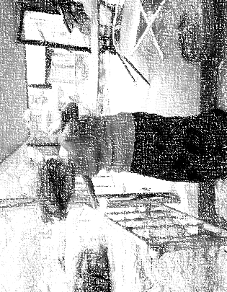
Figure 20: “I’m Not Trying to Hear That Shit,” Photo by E. Oliver 2016

Symbolically, front porch spaces are often referred to spaces for therapy. The porch is “freeing.” It is a space that facilitates “opening up.” Many of the elder women in the community spend a great deal of time on their front porch. They administer verbal and physical “spankings” to those in need and spare many women (and children, and some men) heartache and pain with their no-nonsense, non-tongue biting verbosity. In this space, they are the eyes and ears of the community. They are the therapists for a hurting community. The following ethnographic snapshot (Example 4.16) presents the function of this space.
On this morning, I was standing on my porch enjoying the cool fall air. The leaves had started to fall, and my front yard was covered. Travis, a transient man from the neighborhood, walked over and stood outside of my front gate. He was holding trash bags and a rake.

Example 4.16: Ethnographic Snapshot, Travis and Others 2016
Travis: “Hey baby sis., I can give you a good price on those leaves”, he stated.
EO: “How much you talking”, I asked. [I had become familiar with the local language and could codeswitch on a moment’s notice.]

Travis: “I can do it for a nickeland a cup of hot black coffee,” he responded.
I agreed to let Travis rake the leaves. I went in and prepared a thermos of coffee for Travis. Fifteen minutes later, I returned to the porch and paid Travis. I paid him more than he required.
Travis: “Nah, baby sis., this is too much money”, Travis stated. “I don’t want folks thinkin’ I took advantage of you or nothing. These folks talk, you know what I mean?”

EO: “No, it’s good and what goes on between us goes on between us”, I responded. I thanked him and handed him the thermos of coffee.

Travis: “I sure appreciate this”, he laughed. “This sure is some good coffee”.

EO: “Well, whenever you want some hot coffee and you see my car in the driveway, knock on the door”, I said.

Travis: “Sure will, baby sis…. sure will”, he said as he closed the front gate behind them.

As I was about to turn to go inside, I heard the gruff voice of Miss Fannie Lee. It was a voice that I had become well-acquainted with and welcomed in those moments of loneliness, often experienced in fieldwork.
FL: “Hey Boo”, a nickname that she often called me, “come here!”, she hollered to me from her porch.

I didn’t know that she had been sitting on her porch the entire time I was interacting with Travis. The lattice that framed her front porch often cloaked her presence.
EO: “Yes ma’am”, I responded and walked across the street.

I climbed the steep stairs that led to her front porch, pulled open the screen door and smiled at Miss Fannie Lee.
FL: “You found me a boyfriend yet?” she laughed.
EO: “Not yet, but I’m working on it,” I responded.
FL: “What you cook for breakfast?” she asked.
EO: “Coffee”, I laughed.
FL: She lit a cigarette, took a long drag and asked, “ You get over that lonely spell?”

EO: “Yes ma’am”, I responded. Just weeks earlier, I had shared with Miss Fannie Lee the ways in which fieldwork could be isolating and lonely.

FL: “Good!!! I was just checking. You know, sometimes you just need to sit on the porch more…not with your notebook or books, but just you. Talk to folks as they walk up and down the street, as they ride by on their bikes. Just sit and talk. When you get too lonely, you open yourself up to visits from snakes…..I’m talking about folk that mean you no good…They slither in and they slither out. You best get rid of that loneliness ‘fore you invite snakes in your yard. Now, go get me some of that coffee”, she half requested ─ half demanded.
As I rose to walk back across the street to my home, Miss Essie Mae opened her front door and walked outside. Her daughter followed her.
EM: “What y’all doing over there?” Miss Essie Mae called.

FL. “Talking ‘bout getting you a boyfriend,” Miss Fannie Lee, bellowed.

EM: “I’m not tryin’ to hear that shit, Y’all got me bent all kinds of crooked”, she responded. If I need a man, I’ll go buy me the plastic kind,” she continued.

FL: “Essie Mae, girl, hush that non-sense, you know we still got those needs,” Miss Fannie Lee laughed.

EM: “Y’all need to talk to the hand,” Miss Essie Mae, said harshly.

Even older women have intimate desires and needs; women are seeking intimate partners and are concerned with others finding intimate partners. This brief front porch exchange (Example 4.16) among Miss Fannie Lee, Miss Essie Mae and I is a common occurrence among many of the women in the community. These local cultural practices are systems that structure neighborhood behaviors. The cultural and symbolic capital of having a front porch to share with individuals in the neighborhood, creates a type of hierarchy in The Lows. The front porch space is a site for the delivery and learning of lessons and transformations in the lesson-learning process. As indicated in the ethnographic exchange above, space, language, and meaning-making are intimately intertwined.

Chapter 5: Findings
Folklife, Family, and Food
“Chile, I don’t know about no ‘folklife’ in The Lows. I know about life in The Lows. Life is family, a full stomach and a song in your heart. Now, understand, that song can be a song of blues or it can be a song of ‘old 100 praises, but it’s still a song nonetheless.”
-Larue (research participant interview)

“Ah’ll play if you sing it,” he countered. So he played and I sang the verses I knew.
-Zora Neale Hurston (Mules and Men)

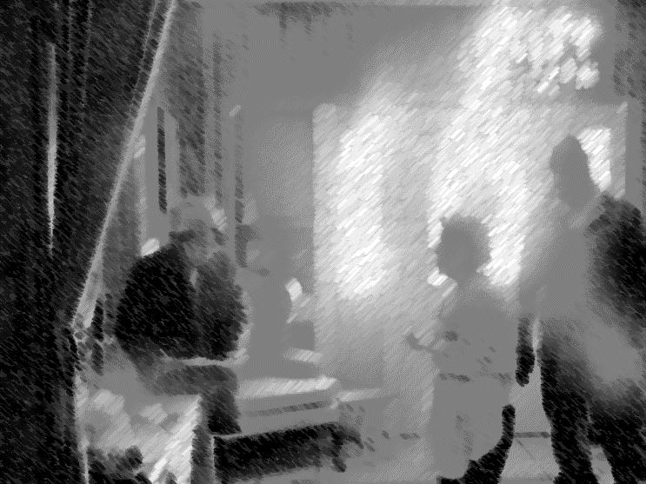
Figure 21: Jerald Comes to Play His Song, Photo by E. Oliver 2016

The church that often doubles as a mission is not large in structure. In fact, it once was a house obscured with a grove of apricot trees. The apricot trees are gone and the house has been transformed. Upon entering the metal and glass-plated, front door, a person is immediately greeted by an open atrium that is flanked by classrooms. There is a small entryway with a bathroom for women on the left. It was remodeled during a brisk fall morning. Friends and family of the church (mission) founders gathered to update the women’s bathroom. The small group painted the bathroom walls, refinished the bathtub, built a changing table for babies, and added shelves full of toiletries and personal care products for the women who visited.
Walking a few steps will lead to a set of concrete steps that deliver an invitation into the sanctuary. The men’s restroom is located to the left of the concrete steps, in the sanctuary. There is an elevated area to the right of the concrete stairs. A computer and sound system are housed there.
The sanctuary is a large open room. There are five rows of chairs on the left and right sides. On the left side of the sanctuary, another open area flanks the rows of chairs. This area was the former fellowship hall. Now, it houses a drum set, an electric guitar, an acoustic guitar, and a piano.
On this day, I volunteered to sort school supplies for an upcoming neighborhood give-away. There were only a few of us there on that day. Jerald, an African-American man in his early sixties was one of the few. Jerald is one of the few men who reside in The Lows that will volunteer a small portion of his time to help with mission work. Jerald stood in the atrium waiting for instructions for the next task. He wreaked of liquor and cigarettes. He began mumbling to himself about the slow delivery of instruction. It appeared that he was becoming a bit agitated. I attempted to engage him in conversation. He looked at me and said, “Hey come down here,” walking into the sanctuary. I followed.
Jerald walked past the piano chair cushioned with a red velvety fabric. He walked toward the acoustic guitar, picked it up and began playing a little ditty. Still attempting to keep Jerald in a pleasant mood, I began humming the tune I had heard many times at the stoop. As often as I had heard this ditty, I did not know all the words. This interaction between Jerald and I reminded myself of the importance of space and community connection.
Upon entering the various intimate spaces within The Lows neighborhood, one can see the community connections, the deep meaningful relationships, and the ways in which activities and interactions within diverse spaces facilitate health and healing, broadly. To triangulate my data, I consulted with my research participants numerous times, over the course of the extended research period in this community, to determine what voice, what space, what event would be privileged in the body of this work. The selected voices, vignettes, visuals of space are those that appeared numerous times throughout the data analysis phase of this research.
My research was informed by the frameworks of narrative and the life course perspective; however, third place ideologies, with a prominent focus on space, are foundational to this body of work and, greatly, underpin this research. Using Schuler (1996) as a backdrop for understanding the importance of third places. More specifically, it is in spaces within these places, that we find that the intimate spaces within The Lows are spaces of inclusion that provide platforms for the sharing of narratives. In these spaces women feel safe in sharing intimate details of their daily lived experiences within the neighborhood, their historical experiences throughout their life course, and the systematic survival strategies─ from kitchen conjuring to informal economic practices, that have helped them overcome illness and suffering.
My use of third place, within this dissertation involves the creation and manifestation of hybridized spaces ─ first, second, and third spaces (home spaces, work spaces, and social spaces) by the othermothers in the community. They purposefully engage in cultural and ethnic boundary and border transfigurations to provide opportunities for empowerment and emancipation through storytelling. Through the process of witnessing and testifying (testimony) within designated spaces in the community, a sense of belonging and becoming is shared by women in the community.
Seventy-six participants (n= 76 [females n=57; males n=19]) took part in this research. Participants varied in age, ethnicity, education, religion, and socioeconomic background. Across the sample of participants there were shared perceptions and similar experiences of space, health and healing, motherhood, and neighborhood norms. The qualitative interviews, focus groups, and fully-immersive, participant observation produced a variety of responses about the use of space within the neighborhood, reproductive health, trauma, and mothering. The dominant themes that emerged throughout participants’ responses involved the importance of space in maintaining close community networks, the role of intimate spaces in promoting and improving acceptable health outcomes, and individual and community healing. Reproductive health through community-based grassroots efforts, gathering in intimate spaces within in the community with the purpose of meal preparation and “kitchen conjuring” to facilitate trauma remediation, and the perceived benefits of community othermothering are also dominant themes of my research.

Themes & Questions
Theme 1: Intimate Spaces
This research revealed that the women living in The Lows utilize a type of third space (the mission kitchen, the church, the kitchen table, the stoop, and the front porch) to share narratives of past and present traumas, to seek advice for a variety of bio-psychosocial issues, and to socialize. In these spaces, poignantly rich, emotion-laden conversations and interactions take place. Many participants discussed the importance of intimate spaces throughout the field research for my dissertation. These spaces were located in public and private spheres in the community. The spaces had a remarkable ability to unite individuals from diverse backgrounds (socioeconomic, educational, religious, and ethnic). This created community cohesion. In this dissertation, community cohesion is defined by social and spatial proximity. This similarly aligns with the definition of community by Goodsell, Flaherty, and Brown (2014). They posit that community is defined by “moral proximity ─ in which community is the sphere of individuals, institutions, and activities for which a person feels responsible (see Goodsell, Flaherty, and Brown 2014:626).” The women who participated in my research voiced feeling responsible for the well-being of one another. This responsibility extended to fictive and biological children. Stories of responsibility, providing and receiving biopsychosocial care in The Lows are shared through private and public spaces.
One of the most prominent features of the spaces in this neighborhood is the ability to elicit storytelling. The most popular and frequented spaces in The Lows are Good Healing Hands and Heart Church (when it functions as a mission), the front porch spaces of the elder women in the community, the kitchen table at the home of one of the participants, and the stoop located at the old Booker T. Washington School. The women felt that they could share their life stories without the fear of being pathologized, stigmatized, or shamed. When reviewing the literature that discusses stigma, one of the primary scholar-led discussions focuses on the ways in which individuals are perceived by self and other (see Goffman 1963). In reviewing Goffman’s writing, stigma is defined as an unfavorable individual or group characteristic or attribute that distinguishes that individual or group from those with more desirable behavior. The individual or group is often stereotyped and treated with negative evaluations. The women who took part in my research indicated feeling that they were viewed with a stereotypical (poor = dirty; The Lows = criminal behavior; women from The Lows = promiscuous; poor = uneducated; The Lows = crime and drugs) lens from those living outside of the neighborhood; however, within the spaces in The Lows, I found that the women consistently voiced that they felt “cared for,” like “a mother would care for her child.” They felt safe, nurtured, and “well.” The intimate spaces were spaces of resistance and autonomy. Furthermore, I found that these spaces were viewed by the women as powerful agents of change that impacted their biopsychosocial health.
Theme 2: Space, Health, and Healing
The biopsychosocial and cultural practices, behaviors, and representations of space within this community have a strong relationship with health and healing through narrative sharing, holistic multicultural treatments for suffering and illness, and community-based activism. The women in the community have used the spaces mentioned in my dissertation to create their own systems of health care and provision. Trading and bartering at the stoop for feminine hygiene products, medication, diapers, food benefits, clothing, and a range of other services and products comprise a component of this community created health care system. Performing culturally-based healing practices at the church is also a novel way in which women living in The Lows have taken ownership of their health and healing. As illustrated in my dissertation has shown, reproductive health and women’s rights are a grave community concern.
The women in the community use neighborhood spaces to discuss, develop, and deliver plans that will improve their sexual and reproductive health. Several of the elder women in the community shared narratives of being birthed in homes in the neighborhood. They indicate that this was a result of the extreme prejudice and racism during “their time.” There were no hospitals in the area that “took folks of color.” Participants desire culturally tailored women’s health services that holistically “treat” the whole person. The women who participated in my research suggest that “we,” people are comprised of various “biological, psychological, social, and sexual components or elements. When one is out of balance, we are out of balance.” They argue for a new method of treating illness and suffering that privileges the environment and social spaces related to the culture of the individual. Many of the women indicate a need for a holistic women’s wellness center in the community that is staffed by herbalists, doulas, community health educators, and cultural counselors. The most common themes presented here and the discussion surrounding each theme speak to the questions that were outlined in the opening chapter of this dissertation.
Question 1: What is the cultural significance of spaces within this community?
I found that there are a significant number of women residing in The Lows that utilize neighborhood spaces to perform culture in a way that is “freeing.” Through my interviews, and informal conversations with the women in the neighborhood, I discovered that neighborhood spaces provide the ability for my participants to have authentic, and freely chosen lives. As stated earlier in this dissertation, spaces in this neighborhood serve as a system of community support. In these spaces women can infuse their cultural heritage into the lifeways of others through the sharing of narratives, the preparing of a meal, the exchange of a home remedy, the offering of advice, or the delivery of an “adage associated with myth”. Spaces within the community are conduits for this type of sharing and exchange.
Question 2: In what ways do these spaces affect the biopsychosocial health of women in the neighborhood?

Through my research, I found that the spaces used in the provision of biopsychosocial benefits in this neighborhood are “unlikely” spaces of healing. These are spaces of language and embodied action. The spaces mentioned in this dissertation serve as sites for spiritual and mental (psychological) healing. The women in this neighborhood posit that spiritual health is deeply connected to psychological health which, in turn, is connected to biological health, and so on. The women who participated in this research represent an array of religious faiths, ideologies, and beliefs; however, they all believe in a “spirit world” that interacts with the physical world. Through the interactions discussed above, I discovered that transformations of healing take place. The spaces that are frequented, in this neighborhood, serve as a stage for these interactions. I found that the intimate community spaces transform faith, ideologies, and belief systems into useable medicine.
In the discussion of spaces, within this dissertation, a myriad of uses is illustrated. Women frequent the stoop to barter or broker for medication or feminine products that they cannot financially afford. I found that the women participating in my research use the church to interact with a cultural healer to remedy “bad nerves,” provide relief or protection from spiritual attacks launched against them or someone in their family, to mediate interactions between real, and spiritual actors, and to receive spiritual medicine in the form of the application of oils, the laying on of hands, or intimate spiritual cleansing practices. When the church functions as a mission space, women use the space to strengthen community bonds while preparing and sharing meals. The meals function as spiritual and physical food. The church/mission space also serves as a site for grassroots activism.
Women in the community are advocates for women’s rights and issues, and often use mealtime at the mission to organize trips to participate in public protests, to write letters to policy makers, and to develop sustainability programs that will provide for the community. I found that the women in the community do not openly identify as “feminists “for a variety of reasons, as discussed in Chapter 1; however, much of their activity is aligned with feminist agendas that contribute to the “well-being” of the community. I found that culture and women’s autonomy is determinant in the quality of health of the community. This is evident when examining neighborhood usable space.
Personal “porch gardens,” front yard “gardenscapes,” and small backyard usable space has been constructed to provide herbs to use in “medicine” and for cooking, to provide fresh fruits and vegetables that can be obtained in walking distance, and as a means of socialization and exercise. To date, the women have provided enough fresh fruit and vegetables to exchange for fresh eggs and New Zealand rabbit with a local farmer. The spaces in the community not only are significant in the sharing of cultural and traditional lifeways, and the provision of biopsychosocial benefits; but, they are arenas for demonstrating authoritative knowledge of health realities that are intercultural and gender sensitive. In addition to be agentive spaces of community care, I found these spaces to be stages for storytelling that locate social actors.
Question 3: How, and why do constructed intimate spaces facilitate the telling and sharing of narratives?

I found that the spaces discussed in my dissertation to be spaces of rich, intimate conversation. These are “safe spaces” where women freely discuss the most intimate details of their past and present lives. Stories (narratives) are shared without the fear of being shamed or stigmatized. These spaces are welcoming spaces where taboo topics do not exist. Through the telling of a story, the women express a feeling of “breaking free” from traumatic events. They indicate “hope is restored with the release of every word.” Through the delivery of a story, important advice, home remedies, and “soul solutions” are often provided to those in need. For example, one of the community othermothers called me one afternoon to deliver a very alarming warning. The following snapshot (Example 5.1) illustrates the warning in the story.

Example 5.1: A Message in the Story, 2016
It was an unusual early fall day. The sun was bright, the wind was strong, and an unusual air of peace swaddled the neighborhood like a mother swaddles a newborn baby. I was sitting in the front room, the front door was open to “let in the light,” and I had a cup of black coffee in hand (attempting to become tolerant of the taste without creamer). My cell phone rang, welcomingly distracting me from the bitter taste of the strong coffee. Hello, I would answer.
Miss Jeri Sue: “Hey baby sis, did I catch you busy?”, she would ask.

EO: “No ma’am”, I responded.
Miss Jeri Sue: “Good. I see you have your front door open. I need you to come out but don’t come out the front. Go through your side door and be quiet and look before you come out.”

There was a stern tone to Miss Jeri Sue’s voice. It caused me a bit of alarm. I immediately began going through a mental rolodex of my interactions with the participants over the last few days. I was afraid that I may have inadvertently committed a research faux pas, or that there was a research-related concern. I walked to the bedroom, heeding Miss Jeri Sue’s warning, I exited the side door. Miss Jeri Sue had walked to the entry to the driveway of my house. She smiled, put a finger to her lips as to indicate to be quiet, and motioned me toward her. I arrived, opened the gate, and greeted her.
She grabbed my hand, gave it a squeeze, and whispered, “Girl, you done let the devil in.” A feeling of horror engulfed me. I didn’t know what she was referring to. She continued to hold my hand and walked me to the front of the house. We stood outside of the front gate. Women that were walking to the stoop stopped and looked as Miss Jeri Sue pointed to a low-cut grassy area in front of my porch. The women walked up and repeated Miss Jeri Sue’s words, “Girl, you done let the devil in.” There in the grass, lay a huge snake.
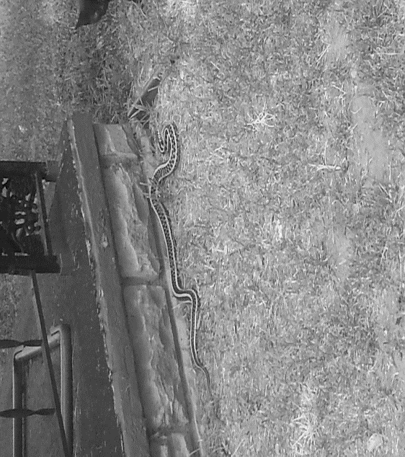
Figure 22: “Girl, you done let the devil in 2016, Photo by E. Oliver 2016

Miss Jeri Sue gave the following story/adage/advice as we looked on.
Miss Jeri Sue: “Look here, Baby Sis, when you see something like this it can mean several things; however, you need to look beyond what you are seeing. See this here snake is close to your front door. You need to be careful who you let into your space because everything that look pretty ain’t pretty. See he’s just resting there all comfortable, not a care in the world…not afraid, not trying to move…just resting and waiting. You let the wrong folks in your home and they just gone rest and wait until they ready to strike. So you keep your eyes open and be wise. My momma had a special relationship with snakes, she knew the ones to kill, the ones to keep as pets, and the ones to let go.”
I returned inside to write about the snake encounter in its entirety; however, several months would pass before I would have another snake encounter while I assisted in mowing the grass at the house next door.

Figure 23: Second Snake Encounter 2016, Photo by CWD, 2016

I had shown the photo of the snake to several different community members. I was told that the snake was even closer to the front door and I should really be mindful of the warnings that were being given. My visit from the snake became the topic of conversation at the stoop, in the park, and at the mission. I would hear countless stories of “snake encounters”, symbolism behind snakes, and ways in which to use the “snake visits” to my advantage; however, it wasn’t until much later, that I realized the meaning in the message.
The snapshot above (Example 5.1) illustrates the ways in which space is used in the sharing of stories, myths, warnings, and advice. These spaces become arenas that connect the present with the past through verbal highways replete with tradition and culture. These stories inform the ways in which women in the community make meaning of their everyday lived experiences.
Question 4: In what ways do the women living in The Lows make meaning of everyday lived experiences in a rural and aging community?

In various works of literature, conceptualizations of individual and community-wide agency are offered to explain the resilience and “grit” of a person or community. Researchers and scholars across time and space, and discipline posit that societal structures impact the ways in which individuals “act” ─ “behave” ─ “perform” within the boundaries of their communities (Goldstein 2007).
There is much to be said about this when examining the ethnographic details contained in this dissertation. Many of the women who participated in this research have experienced some form of trauma in their lives. Conceptually, trauma is defined in the literature as an event that severely challenges and shatters the way an individual understands the world and his or her place in it. This definition offers an explanation to the feelings of reduced or lack of agency and hopelessness that is sometimes present in the daily experiences of the women participating in this research; however, and more importantly, the perceptions of the space as an agent of empowerment and emancipation, as experienced by the women participating in this research, is important to note. The women examine their lives comprehensively and use intimate spaces coupled with cultural and traditional practices to remedy biopsychosocial ills. The women living in The Lows recognize the neighborhood as an aging and dying neighborhood; however, they continue to face adversity with strength, social cohesion, and sisterhood.

Chapter 6: Conclusion and Recommendations
Going Home to Be With The Lord: Beloved Soul
“Relax my beloved, don't worry for me
Don't shed a tear for me always be near for me
Be comforted my love don't bow your head for me
Promise you'll smile for me don't ever cry for me
You know these walls they may fall down
But I'll still hold on to you
At heights higher than you'd imagine me too.”
-Alex Clare, Relax My Beloved

“There's a leak in this old building and my soul
has got to move
My soul
has got to move
My soul
has got to move
There's a leak in this old building and my soul
has got to move
to another building
A building not made by man's hands….
Before this time, another year I may be dead and gone. But before I go, I'm gonna let you know that I moving to my brand new home…..
When I can read my title clear. Two mansions in the sky. I'll bid farewell to all my friends. God said he would wipe my weeping eyes.”
-Spiritual sung by Lashun Pace


Figure 24: The Light on The Porch of Miss Fannie Lee (Porch Light, Alley Light, Full Moon, and Star)

One cannot mistake the appearance of a life well lived, just as there is no mistaking the sights, sounds, and smells of death. I have experienced all of these in this small community in rural Oklahoma ─ the laughter, the joy of a new baby being born to a mother that was told she would never have children ─ the weeping, identifying the body of a research participant that had been murdered by a boyfriend. I have experienced it all ─ life and death.
On this night, the stench of death sits on the breath of the wind like a sumo wrestler sitting on a much smaller, weaker opponent—heavy and immovable. I have inhaled this unpleasantness many times before, each time, hoping that it would be the last and yet, it has returned. It sits beside me, invading my memories of the people in The Lows—invading my personal space—my safe space—my healing space. I have cued my playlist to play, “Relax My Beloved” by Alex Clare, the song that I was listening to when I was thinking about death and dying— when I was remembering the day that the porchlight on the house across the street, not just any house but the house of an othermother, Miss Fannie Lee’s house, was turned off with finality and force. It would be a mistake to believe that the light would return in the near future to burn brightly. Several months would pass before her son and “daughter-in-love” would decide to rent her home. So many have died. So many have “gone home to be with The Lord.” So many have left a partial piece of their angel wing for us to grasp onto and take flight when we think we’re all alone. Some days it’s as if they are still here. You feel their gazing eyes, hear their voices, smell something that resembles their uniqueness, feel them brush by you, sight unseen, but, then you realize they’re gone. The wind has tricked you as it found your memory, took it from you, placed it on its breath and blew it in your direction. It is a trick of the senses, a trick of the sentiments, a trick of feeling. It is nostalgia complicated by landscape—complicated by the end of fieldwork in space and time.
What is the “thing” at the edge of thought that warrants the veiling of discussions of the landscapes of intimate space, emotion and sentiments, narrative and healing? Is it that we are all critics of this particular type of culture? Consider the following by Theodor Adorno,
The cultural critic makes such distinction in his privilege and forfeits his legitimation by collaborating with culture as its salaried and honoured nuisance. This, however, affects the substance of criticism. Even the implacable rigour with which criticism speaks the truth of an untrue consciousness remains imprisoned within the orbit of that against which it struggles, fixated on its surface manifestations….When the critics in their playground-art-no longer understand what they judge and enthusiastically permit themselves to be degraded to propagandists or censors, it is the old dishonesty of trade fulfilling itself in their fate. The prerogatives of information and position permit them to express their opinion as if it were objectivity. But it is solely the objectivity of the ruling mind. They help to weave the veil. (Adorno: 1967)

Borrowing from Kluckhon’s Mirror of Man, and applying a Geertzian framework, the culture and poetics of sentimental space is layered and multi-prismatic. It often appears in the guise of a veiled discussion of the self and the ways in which space is ascribed, inscribed, proscribed, and prescribed onto the self of the individual and the self of others.
Thought and cognition inform the way we interpret the world around us, the way we make sense of intimate space and the self, make sense of our experiences, our actions, and our reactions to ourselves and others. Mead argues that “the self is reflexive and indicates that which can be both subject and object” (see Mead 1934). The self is synonymous with the conscious coupled with experience.
Thinking about the daily lived experience of women in The Lows and, the explanatory frameworks of narrative, the life course perspective, and space coupled with sentiments and healing, it is important to note the significance of action or stimulus. Mead would concede that intertwined histories between researcher and research population are “a contrast between an experience that is absolutely wound up in outside activity in which the self as an object does not enter, and an activity in which the self is the principle object” (Mead 1934). My dissertation vividly illustrates varying notions of the self in intimate, empowering, and emancipatory spaces and through acts conducted within these spaces. The participants and the researcher can be viewed as the stimulus that facilitates actions within these spaces. These are borderless spaces with fluid boundaries ─ fluid identities.
The narratives and experiences shared by women that participated in this research construct an argument for the emancipatory and empowering properties that space has the potential to embody. For residents in The Lows, othermothering is largely the world of the elder women but in cultural contexts surrounding community care, especially in this neighborhood, women of all ages play significant roles in the care of individuals and the neighborhood as a collective. As discussed in Chapter 4, intimate spaces can be viewed as a primary social actor and the women as secondary social actors in this neighborhood performance of social network building and community cohesion.
The cultural practices described in this research are part of the narrativized space of being and becoming. The language used in intimate spaces, the meals prepared and shared, and the interactions to meet daily needs are all examples of embodied translational, cultural practices that are a part of the chronotopic social world of women living in The Lows. History and time, shifts and slips, and is inverted to create a master narrative for all the individuals participating in The Lows performance of life. I, the researcher has been included in this performance. Kathleen Stewart (1996) suggests,
“A master narrative might take such a moment as a symbol that initiates a line of thought and gathers events to it; launched from such a perch the story of history snaps into place a litany of events in which one thing leads to another (Stewart 1996:97).”
With the above in mind and memories of all the events that have occurred during my time in The Lows, personal and otherwise, I would have done well to listen carefully and, for meaning, to the polyphonic chorus of “old-wives-tales (tells)” and cultural folklore during my time engulfed in research. I would have heeded the warnings, paid closer attention to the way a cooked dish turned out, examined the yolk of the egg used in a cleansing ceremony, more closely, looked at the tea leaves with more scrutiny, and listened to the song of the candle with an ear for the ancestors as I watched the flame dance as the candle burned. I would have done all these things that, sometimes, were overlooked as I recorded narrative after narrative, observation after observation, interview after interview. I would have listened. I would have seen. I would have realized that the stories told me were history patterned onto the present and the present patterned onto history ─ textually and texturally scripted onto my body and the bodies of my participants as we each witnessed the telling of a story or, told our own.
As mentioned throughout this narrative of The Lows, many of the women make meaning through their use of space and the ways in which the space functions in their life. The cultural practices and traditions that are a part of the biopsychosocial world of the women in this community are present in every facet of their daily lived experience. This is vitally important to these women and their sense of self. Many research participants remarked how their desire to live outside of this community led them to other geographies within and outside of this state, how some of them wanted a different life for their children and hence, moved; however, the women that made these remarks indicate that “desperately missing” aspects of their cultural identity tied to place and space and, being able to eat certain foods prepared by members of the community, attend cultural events, or keep up with the latest gossip brought them back to the community. It brought them home.
Another factor that facilitated their return was fear. The women who discussed moving away from the community, only to return months or years later, express “feeling like no one outside The Lows would understand having bad nerves and the need for an othermother to lay down a root or to be anointed with oil.” Furthermore, they have a strong belief that living outside of the neighborhood would isolate and exclude them from a “protected and meaningful life.” The women express the mission, the front porch of an othermother, a seat at the kitchen table of a friend, and the stoop, have helped mitigate fears and feelings of exclusion by providing a social space where they “can be understood.”
The Lows social and cultural practices and traditions are paramount to a life well-lived in this community. The most prominent of these practices are the nightly gatherings on porches of neighborhood residents, the Sunday family-style dinners at GHHAH, that often reunites an absent father —husband—boyfriend with women in the community, the handgames, the support meetings that allow women to talk candidly in a safe-space, the ability to receive healing and prayer, and the ability to purchase “medicine” without going to a physician or hospital for a prescription. The kinship that develops because of these events helps to make the uncanny desirable— empowering—freeing.
In terms of empowerment and emancipation that is linked to space, the women occupying visible and invisible spaces in the neighborhood and, the ways in which they use space to their advantage, as mentioned in my dissertation, is emblematic of the freeing and strengthening properties of space. These women have affective ties to one another that are quintessentially rooted in the lack of biopsychosocial resources.
The layout of neighborhood space secures membership in this group. The Lows is a place called home. Places such as GHHAH, neighborhood porches, and the stoop are important inclusive cultural spaces that allow for the expression of issues and ideas. In this way, these spaces are like third space as outlined in Oldenburg’s discussion of types of space (2002). These spaces act as social spaces where women can maintain ties to one another. They also act as a social space where all women can participate in the maintenance of the neighborhood. Through this participation, women can organize efforts to improve the quality of health in the community, increase educational opportunities, and help infuse new life into a seemingly dying neighborhood as a result of grassroots efforts.
Most of the women I met while doing fieldwork in The Lows had children, many of them born into multi-generational female-centered home. For the women in this community, The Lows, while seemingly undesirable, served as a “safe haven” for their children. To the women in this community and based on my time in this community, this is a neighborhood where the children are “watched after” and “cared for” by neighborhood residents.
Situating Research and The Way Forward
As a multiracial and somewhat privileged female entering a social space where privileged females are rarely seen, trust was central to my ability to speak with anyone in the neighborhood. Even after more than three years of fieldwork, I often found myself the butt of jokes suggesting that “Miss Ann thinks her ‘shit don’t stink’ but she shits just like the rest of us” (said in a joking, friendly tone but still signifying and indicating my outsider status and identity as a researcher and anthropologist). My association with the university spotlighted my outsider status as a “bougesie female” in this social world as my identity as a researcher metaphorically projected the power of the state and other institutions that often stigmatizes the women in the community. One of the major obstacles to completing this research was, initially, distrust; however, my commitment to assisting the women when they requested assistance helped eliminate distrust.
Eventually, I was able to move from being viewed with distrust to the front porch and, into the homes of the women that participated in this research to get firsthand experience of what a seat at the “kitchen table” is like ─ what “true” life in The Lows is like. Participating in the daily activities that the women participated in also allowed me to create strong social bonds with many of the women I was working with. Being co-laborers created rapport and allowed me to build the trust that I greatly needed in order to continue long-term research in this community. Being familiar with “life on the street” also helped when we had volunteers at our community dinners who did not have the familiarity of working with individuals that suffered a plethora of injustices as a part of their lifetime lived experiences.
Working with the women at the mission increased the amount of time I could dedicate to fieldwork. I was able to attend activities throughout the week as well as on Saturdays and Sundays. At these services and meetings, I could engage in various conversations with the women from the community ─ a third space characteristic. During these interactions, the atmosphere felt casual and “non-research” related. The women and I often found common ground discussing disappointments in relationships, children, and current events. These interactions were the same on more formal “church-oriented” days as being a member of the church/mission allowed me more opportunities to interact with the women in the neighborhood and visitors from outside of these geographical boundaries. I often was the bridge between the outside world and the world of a resident of The Lows.
Residents in the community held strong beliefs about researchers that only “glimpse” at their life. In other words, many women believed that the only “good” research a researcher could perform, would be research conducted alongside research participants. This translated to a new way of “doing anthropology” ─ a new way of doing community-based, participatory research. Keeping the opinions and concerns of the community members, related to research and researchers, in mind. I conceptualized a holistic research model that privileges the research participant while simultaneously staying true to the discipline of anthropology and, social science inquiry.
While the research for this dissertation focused on the presence of women and the meanings of intimate space in this neighborhood, future research will incorporate an examination of the male presence or, lack thereof, in this community. Also, a closer examination of mothering behaviors within intimate spaces and the relationships to child development across time and space is scheduled for future research. Fanon (1963) writes,
“To tell the truth, the proof of success lies in a whole social structure being changed from the bottom up. The extraordinary importance of this change is that it is willed, called for, demanded. The need for this change exists in its crude state, impetuous and compelling, in the consciousness and in the lives of the men and women who are colonized.”

Vine Deloria Jr. (1994) writes,
“Again we see the fundamental conception of life as a continuing unity involving land and people. One might be tempted to suggest that as land is held by the community, the psychic unity of all the worlds is made real.”
As anthropologists ─ social scientists of a craft that was founded on the principles of holistic research, we must begin to allow junior scholars the opportunity to “do anthropology” differently. The voices of our participants must be “married” to the authoritative voice of social science research because, we are all members of a vast phenomenological landscape.

Epilogue
“…As the Lord liveth, and as thy soul liveth, I will not leave thee…”
2 Kings 2:1-18 [abbreviated]

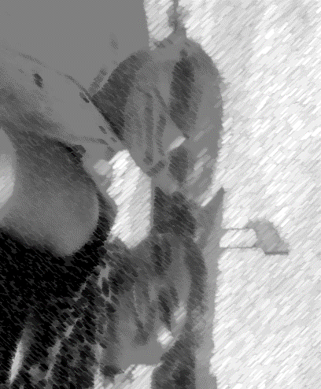
Figure 25: Best of Friends, 2015. Photo by, E. Oliver 2015.

August 2017: The ground shook seven times within a 28-hour period. One…, two…, three…, four…, five…, six…, seven. The report in the news indicated that seven consecutive earthquakes had occurred that day. It seemed a bit unusual; however, this is an area known for fracking and the earthquakes, unwelcomingly, have increased. I didn’t pay much attention to this phenomenon because it has become “old hat;” however, in hindsight, I realize that the earth was releasing its grip on my old friend, my mentor, CMGSJ—Maheo was calling his warrior—a great spiritual leader, home. In the day to follow, I would receive the news that my friend had left me. I had known the day was coming for he had been ill; however, I wasn’t ready for him to leave me. This was selfish, I knew but my heart and spirit cleave to his. We had been an unlikely pair of friends. He was my Elijah and I, his Elisha.
In the fall of 2011, I would make his acquaintance at a community health meeting. He never faced me directly. He kept his back to me for the first half of the meeting. I believed, then, that this was due to my gender; however, I learned that I had committed a huge fashion faux pas steeped deeply in cultural belief. One of the accessories I had worn to the meeting was viewed as an ominous symbolic representation of death (I excused myself from the table where we sat, exited the room, removed the necklace, and took it to the car). I returned to the meeting and my friend turned to face me with a smile that could warm the coldest room. We would become the best, unlikely friends over the next several years. We would spend afternoons over meals discussing his history, his time in The Lows and the surrounding neighborhoods. He would teach me his grandmother’s recipe for frybread and, when I didn’t get the measurements correct, and the bread turned out as heavy as a stone, he would eat it and praise my efforts. He was a great teacher, but an even greater friend.
I took our time together for granted. I thought there would be plenty of time to learn the songs he had sung in his mother tongue, to dance beside him at the honor dances, to get the frybread recipe “right,” but; time ran out. As I began editing this dissertation, my friend left this physical space. Our last encounter, after a Sundance ceremony the summer of 2017, was an encounter where “I knew” our time together in this physical world was coming to an end. His body was frail, his spirit was strong, and his smile was even warmer than the first time I experienced it. He was sitting in the passenger seat of his truck. I walked to him. He smiled. I hugged him. He grabbed my hand, gave it a squeeze, kissed my cheek, and asked, “You finish with that book yet?” I smiled, kissed him back, hugged him tighter and said, “not yet. Now, as I sit here, alone, writing this final sentence. I can whisper to no one and everyone, especially my friend, that it is finished.

References
Abu-Lughod, Lila (1993). Writing Women’s Worlds: Bedouin Stories. Berkeley: University of California Press.

Adams, Alice (1995). Maternal Bonds: Recent Literature on Mothering. Signs: Journal of Women in Culture and Society 20(2): pp. 414–427.

Agamben, Giorgio. (1999). Remnants of Auschwitz: The Witness and The Archive. Translated by Daniel Heller-Roazen. New York: Zone Books.

Allen Gunn, Paula (1997). Going Home: December 1992. Reinventing the Enemy’s Language: Contemporary Native Women’s Writings of North America. Joy Harjo and Gloria Bird, eds. Pp. 151-156. New York: W.R. Norton & Company.

Altmann, Jeanne (1980). Baboon Mothers and Infants. Cambridge: Harvard University Press.

Anderson, Benedict (2006[1983]). Imagined Communities: Reflections on the Origins and Spread of Nationalism. New York: Verso.

Anderson, Elijah (1990). Street Wise: Race, Class, and Change in an Urban Community. Chicago: The University of Chicago Press.

Anderson, Elijah (1999). Code of the Street: Decency, Violence, and the Moral Life of the Inner City. New York: W.W. Norton & Company.

Angelou, Maya (1994). Phenomenal Women: Four Poems Celebrating Women. New York: Random House.

Anzaldúa, Gloria (1987). Borderlands: La Frontera: The New Mestiza. San Francisco: Aunt Lute Book Company.

Appadurai, Arjun (1996). Modernity at Large: Cultural Dimensions of Globalization. Minneapolis: University of Minnesota Press.

Appadurai, Arjun (1990a). Topographies of the Self: Praise and Emotion in Hindu India,” Affecting Discourse: Anthropological Essays on Emotions and Social Life. C. Lutz and L. Abu-Lughod (Eds.). New York and London: Cambridge University Press: 92-112.

Appadurai, Arjun (1990b). Disjuncture and Difference in the Global Cultural Economy. Theory, Culture, & Society 7:295-310.

Arnold, Mary Smith (1995). Exploding the myths: African-American families at promise. In Beth Blue Swadener and Sally Lubeck (eds.), Children and Families “At Promise”: Deconstructing the Discourse of Risk, pp. 143–162. Albany: State University of New York Press.

Aronson, Robert, Wallis, Anne, Campo, Patricia, Whitehead, Tony, and Peter Schafer (2007). Ethnographically Informed Community Evaluation: A Framework and Approach for Evaluating Community Based Initiatives. Maternal and Child Health Journal 11(2):97-109.

Asad, Talal (1973). Anthropology & the Colonial Encounter. New York: Ithaca Press.

Atkinson, Paul, Coffey, Amanda, and Sara Delamont (2003). Key Themes in Qualitative Research: Continuities and Change. Walnut Creek: Altamira Press.

Auerbach, C. & Silverstein, L. (2003). Qualitative Data: An Introduction to Coding and Analysis. 68-70. New York: University Press.

Babbie, Earl R. (1979). The Practice of Social Research. 2nd edition. California: Wadsworth Publishing Company Inc.

Basso, Keith H. (1979). Portraits of “The Whiteman”: Linguistic play and cultural symbols among the Western Apache. New York: Cambridge University Press.

Basso, Keith H. (1996). Wisdom Sits in Places: Landscape and Language Among the Western Apache. Albuquerque: University of New Mexico Press.

Beach, Luci (1997). 2 months’ rent due and 1 bag of rice. Reinventing the Enemy’s Language: Contemporary Native Women’s Writings of North America. Joy Harjo and Gloria Bird, eds. Pp. 262-263. New York: W.R. Norton & Company.

Beatty, Andrew (2005). Emotions in the Field: What are we Talking About. Journal of Royal Anthropological Institute 11:17-37.

Behan, Margaret (1997). Puberty. Reinventing the Enemy’s Language: Contemporary Native Women’s Writings of North America. Joy Harjo and Gloria Bird, eds. Pp. 116-120. New York: W.R. Norton & Company.

Belsky, Jay (2001). Developmental risks (still) associated with early child care. Journal of Child Psychology and Psychiatry 42:845-859.

Benedict, Ruth (1934). Patterns of Culture. Boston, New York: Houghton Mifflin Company.

Beneria, Lourdes (2011). Accounting for women’s work: the progress of two decades. The Women, Gender, & Development Reader. Nalini Visvanathan, Lynn Duggan, Nan Wiegersma, and Laurie Nisonoff, eds. Pp. 114-120. Halifax: Fernwood Publishing.

Bernard, Jessie (1974). The Future of Motherhood. New York: Penguin Books.

Bernard, Russell H. (2000). Social Research Methods: Qualitative and Quantitative Approaches. Thousand Oaks, CA: Sage Publications Inc.

Bernard, Russell H. (2010). Research Methods in Anthropology. 5th ed. Lanham: Sage Alta Mira Press.

Bhabha, Homi K. (1994). The Location of Culture. New York. Routledge.

Biehl, João and Peter Locke (2010). “Deleuze and the Anthropology of Becoming. Current Anthropology 51(3):317 -351.

Biehl, João (2015). Vita: Life in a Zone of Social Abandonment. Berkeley and Los Angeles. University of California Press.

Blaser, Kimberly (1997). Rituals, Yours-Mine: Contemporary Native Women’s Writings of North America. Joy Harjo and Gloria Bird, eds. Pp. 114-117. New York: W.R. Norton & Company.

Blockland, Talja. (2008). “You Got to Remember you Live in Public Housing”: Place-Making in an American Housing Project. Housing, Theory, and Society 1(31):31-46.

Blommaert, Jan (2006). Ethnopoetics as Functional Reconstruction: Dell Hymes Narrative View of the World. Functions of Language 13:22-249.

Boellstorf, Tom, and Johan Lindquist. (2004). Bodies of Emotion: Rethinking Culture and Emotion through Southeast Asia. Ethnos 69:(4):437-444.

Bonjour, Laurence ( 1976). The Coherence Theory of Empirical Knowledge. In Contemporary Readings in Epistemology. Michael F. Goodman and Robert A. Snyder, eds. Pp. 70-88. New Jersey: Prentice-Hall, Inc.

Bourdieu, Pierre (1977). Outline of a Theory of Practice. Cambridge: Cambridge University Press.

Bourdieu, Pierre (2001). Masculine Domination. Stanford: Stanford University Press.

Bourgois, Philippe (2003). In Search of Respect: Selling Crack in El Barrio. Cambridge: Cambridge University Press.

Briga, M., I. Pen, and J. Wright (2012). Care for Kin: Within-group Relatedness and Allomaternal Care are Positively Correlated and Conserved Throughout the Mammalian Phylogeny. Biology Letters 8(4):533-536.

Brave Heart, Maria Yellow Horse (2003). The Historical Trauma Response Among Natives and Its Relationship with Substance Abuse: A Lakota Illustration

Brave Heart, Maria Yellow Horse (1999). Gender differences in the historical trauma response among the Lakota. Journal of Health and Social Policy, 10(4):1-21.

Brave Heart, Maria Yellow Horse and L. De Bruyn (1998). The American holocaust: Historical unresolved grief among native American Indians. National Center for American Indian and Alaska Native Mental Health Research Journal, 8(2):56-78.

Brown, Shan-Estelle (2017). Writing in Anthropology: A Brief Guide. Oxford: Oxford University Press.

Butler, Judith (1990 ). Gender Trouble: Feminism and the Subversion of Identity. New York: Routledge.

Butler, Judith (1993). Bodies That Matter: On the Discursive Limits of “Sex”. New York: Routledge.

Caruth, Cathy (1996). Unclaimed Experience: Trauma, Narrative, and History. Baltimore: John Hopkins University Press.

Caruth, Cathy (1995). Trauma: Explorations in Memory. Baltimore: John Hopkins University Press.

Causey, Andrew (2016). Drawn to See: Drawing as an Ethnographic Method. Ontario: University of Toronto Press.

Chant, Sylvia (2011). The ‘feminization of poverty’ and the ‘feminization’ of anti-poverty programmes: room for revision. The Women, Gender, & Development Reader. Nalini Visvanathan, Lynn Duggan, Nan Wiegersma, and Laurie Nisonoff, eds. Pp. 174-194. Halifax: Fernwood Publishing.

Chopra, Rohit (2003). Neoliberalism as Doxa: Bourdieu’s Theory of the State and The Contemporary Indian Discourse on Globalization and Liberalization. Journal of Cultural Studies, 17(3-4):419-444.

Chrystos (1997). The Old Indian Granny. Reinventing the Enemy’s Language: Contemporary Native Women’s Writings of North America. Joy Harjo and Gloria Bird, eds. Pp. 232-234. New York: W.R. Norton & Company.

Clare, Alex (2017). A to Z Lyrics . www.azlyrics.com/lyrics/alexclare/relaxmybeloved.html, accessed August 11, 2017.

Clausen, John A. (1991). Adolescent Competence and the Shaping of the Life Course. American Journal of Sociology 96:805–84.

Clifford, James and George Marcus (1986). Writing Culture: The Poetics and Politics of Ethnography. Santa Fe: School for Advanced Research Press.

Collins, Patricia Hill (1990). Black Feminist Thought: Knowledge, Consciousness, and the Politics of Empowerment. New York: Routledge.

Collins, Patricia Hill (2000). Black Women and Motherhood: Black Feminist Thought. New York. Routledge.

Collins, Patricia Hill (2016). Patricia Hill Collins at OU 2016: Public Talk. Norman, Oklahoma.

Cook, Donelda A. and Michelle Fine (1995). “Motherwit”: Childrearing lessons from African American mothers of low income. In Beth Blue Swadener and Sally Lubeck (eds.), Children and Families “At Promise”: Deconstructing the Discourse of Risk, pp. 118–142. Albany: State University of New York Press.

Corbin, J. & A. Strauss (2008). Basics of Qualitative Research: Techniques and Procedures for Developing Grounded Theory. Thousand Oaks: Sage Publications, Inc.

Corvalan CF, Kjellstrom T, KR Smith (1999). Health, environment and sustainable development: identifying links and indicators to promote action. Epidemiology 10:(5):656-660

Crockett, Norman (1979). The Black Towns. Lawrence: University of Kansas Press.

CSDH: (2008). Closing the gap in a generation: health equity through action on the social determinants of health. Final report of the Commission on Social Determinants of Health Geneva, Switzerland: World Health Organization.

Csordas, Thomas J. (1990). Embodiment as a Paradigm for Anthropology. Ethos 18(1):5-47.

Davey Smith G and J. Lynch (2004). Life course approaches to socioeconomic differentials in health. In A life course approach to chronic disease epidemiology. 2nd edition. Edited by: Kuh D, Ben-Shlomo Y. Pp. 77-115. New York: Oxford University Press.

Davis, Dona (1988). Health, Culture and the Nature of Nerves. Medical Anthropology. 11:1-95.

DeBerry, Jarvis (2014). An Epiphany on the N-word: Richard Pryor, The N-word. http://www.nola.com/opinions/index.ssf/2014/02/an_epiphany_on_the_n-word_jarv.html, accessed August 15, 2017.

Delaney, Carol and Deborah Kaspin (2017). Investigating Culture: An Experiential Introduction to Anthropology. New Jersey: John Wiley & Sons, Inc.

De La Portilla, Elizabeth (2009). They All Want Magic. Texas: Texas A&M University Press.

DeMunck, Victor (2009). Pile Sorting. In Research Design and Methods for Studying Cultures. Lanham: Alta Mira Press.

DeMunck, Victor (2010). Research Methods in Anthropology. 5th edition.Pp.76-89. Lanham: Alta Mira Press.

Dubey, Madhu (1995). Gayle Jones and the matrilineal metaphor of tradition. Signs: Journal of Women in Culture and Society 20(2): 245–267.

Duffey, Christopher James (2015). Heterotopic Space in Selected Works of J. G. Ballard. The University of Leeds.

Duneier, Mitchell (1992). Slim’s Table: Race, Respectability, and Masculinity. Chicago: University of Chicago Press.

Dummett, Michael (1959). Truth. In Contemporary Readings in Epistemology. Michael F. Goodman and Robert A. Snyder, eds. Pp. 206-223. New Jersey: Prentice-Hall, Inc.

Duranti, Alessandro (2015). The Anthropology of Intentions: Language in a World of Others. Cambridge: Cambridge University Press.

Dworkin, A. (1987). Intercourse. New York. Simon and Schuster.

Drožđek, Boris (2007). Voices of Trauma: Treating Psychological Trauma Across Cultures. New York: Springer.

Dyson, Michael Eric (2007). Know What I Mean? Reflections on Hip Hop. New York: Basic Civitas Books.

Earling, Debra (1997). The Old Marriage. Reinventing the Enemy’s Language: Contemporary Native Women’s Writings of North America. Joy Harjo and Gloria Bird, eds. Pp. 454-463. New York: W.R. Norton & Company.

Elder, Glen, Johnson Monica Kirkpatrick, and Robert Crosnoe (2003). The Emergence and Development of Life Course Theory. In Handbook of the Life Course. Jeylan T. Mortimer and Michael J. Shanahan., eds. Pp. 3-19. New York: Academic/Plenum Publishers.

Elder, Glen. H. (1998). The Life Course as Developmental Theory. Child Development 69(1):1-12.

Elder, Glen. H. (1995). The life course paradigm: Social change and individual development. In Moen P., Elder G. H. Jr., & Lüscher K. (Eds.), Examining lives in context: Perspectives on the ecology of human development Pp. 101–139. Washington, DC: American Psychological.

Elder, Glen. H. (1992). Models of the life course. Contemporary Sociology, 21(5), 632–635.

Elder, Glen. H. Jr., & Caspi A. (1990). Studying lives in a changing society: Sociological and personological explorations. In Rabin A. I. (Ed.), Studying persons and lives: The Henry A. Murray lectures in personality. New York: Springer.

Elliott, Denielle and Dara Culhane (2017). A Different Kind of Ethnography: Imaginative Practices and Creative Methodologies. Toronto: University of Toronto Press.

Enel, George (1977). The Need for a New Medical Model: A Challenge for Biomedicine. Science 196(4286):129-136.

Fallo-Mitchell L., & Carol D. Ryff (1982). Preferred timing of female life events: Cohort differences. Research on Aging, 4: 249–267.

Fischer, A.H., and A.S. R. Manstead (2000). The Relation between Gender and Emotions in Different Cultures. In Gender and emotion: social Psychological Perspectives. A.H. Fischer ed. Pp. 71-94. Cambridge: Cambridge University Press.

Foster, Miche’le (1993). Othermothers: Exploring the educational philosophy of Black American women teachers. In Feminism and Social Justice in Education: International Perspectives, M. Arnot and K. Weiler (eds.), pp. 101–123.

Foucault, Michel (2002). The Order of Things. London: Routledge.

Foucault, Michel (2000). Different Spaces. Trans. by Robert Hurley In Aesthetics: Essential Works of Foucault 1954-1984, Volume 2. James D. Faubion (ed.), pp. 175-185. London: Penguin.

Foucault, Michel (1986). Of Other Spaces. Diacritics 16(1):22-27.

Foucault, Michel (1967). Of Other Spaces. Trans. by Michiel Dehaene and Lieven de Cauter In Heterotopia and the City: Public Space in a Postcivil Society. Michiel Dehaene and Lieven de Cauter (ed.). (London: Routledge 2008) pp. 13-30.

Fire, Arlene (1997). Hard-to-Kill-Woman. Reinventing the Enemy’s Language: Contemporary Native Women’s Writings of North America. Joy Harjo and Gloria Bird, eds. Pp. 301-308. New York: W.R. Norton & Company.

Franklin, Jimmie Lewis (1980). The Blacks in Oklahoma. Oklahoma: University of Oklahoma Press.

Freud, Sigmund (1919). The Uncanny. Trans. David McLintock. England: Penguin Classics, 2003.

Genet, Jean (1964). The Thief’s Journal. New York: Grove Press.

Geertz, Clifford (1973). The Interpretation of Cultures. London: Fontana Press.

Giddens, Anthony (1991). Modernity and Self-Identity: Self and Society in the Late Modern Age. Stanford: Stanford University Press.

Gilkes, Cheryl Townsend (2001). If it Wasn’t for the Women...:Black Women’s Experience and Womanist Culture in Church and Community. New York: Orbis Books.

Good, Mary-Jo DelVecchio, Jesse Grayman, and Matthew Lakoma (2006). Psychosocial needs assessment of communities affected by the conflict in the districts of Pidie, Bireuen and Aceh Utara [PNA1]. In Pharmaceutical Self: The Global Shaping of Experience in an Age of Psychopharmacology. Edited by: Janis H. Jenkins. Pp.41-66. Santa Fe: School For Advanced Research Press.

Good, Mary-Jo DelVecchio, Byron J. Good, and Michael J. Fischer (1988). Introduction: Discourse and the Study of Emotion, Illness and Healing. Culture, Medicine, and Psychiatry 12:1-7.

Goodsell, Todd, and Jeremy Flaherty and Ralph Brown (2014). Community as Moral Proximity: Theorizing Community in a Global Economy.

Goffman, Erving (1991). The Presentation of Self in Everyday Life. New York. Doubleday.

Goffman, Erving (1963). Stigma: Notes on the Management of Spoiled Identity. New Jersey. Prentice-Hall.

Gray, Peter B. and Kermyt G. Anderson (2010). Fatherhood. Evolution and Human Paternal Behavior. Cambridge, London: Harvard University Press.

Greene, Maxine (1999). Lived Spaces, Shared Spaces, Public Spaces. In Construction Sites: Excavating Race, Class, and Gender Among Urban Youth. Lois Weis and Michelle Fine, eds. Pp. 293-303. New York: Teachers College Press.

Guyer B, Ma S, H. Grason , KD Frick, DF Perry, A. Sharkey, J. McIntosh (2009) Early childhood health promotion and its life course health consequences. Academy of Pediatrics 9:(3):142-149

Gupta, Akhil and James Ferguson (1997 ). Discipline and Practice: “The Field” as Site, Method, and Location, in Anthropology. In Anthropological Locations: Boundaries and Grounds of a Field Science. Akhil Gupta and James Ferguson, eds. Berkeley: University of California Press

Gwaltney, John Langston (1993). DryLongSo. Berkeley, New York: The New York Press.

Hagestad G. O., & B.L. Neugarten (1985). Age and the life course. In Shanas E. and Binstock R. (Eds.). Handbook of aging and the social sciences. 2nd ed., Pp. 36–61. New York: Van Nostrand and Reinhold Company.

Hamburger, Phillip (1993). Natural Rights, Natural Law, and American Constitutions. The Yale Law Journal. 102:907.

Hanks, William F. (2010). Converting Words. Maya in the Age of the Cross. Berkeley, Los Angeles, London: University of California Press.

Hareven, t. k., ed. (1996). Aging and generational relations: life course and cross-cultural perspectives. New York: Aldine de Gruyter.

Hayden, Cori (2003). When Nature Goes Public. New Jersey. Princeton University Press.

Heider, Karl G. (1991). Landscapes of Emotion: Mapping Three Cultures of Emotion in Indonesia. Cambridge: Cambridge University Press.

Hill, Jane, & Kenneth Hill (1986). Speaking Mexicano: Dynamics of Syncretic Language in Central Mexico. Tucson: University of Arizona Press.

Hogan, Ashley M. (2010). Appadurai’s 5-scapes. https://www.amherst.edu/academiclife/departments/courses/1011F/MUSI/MUSI-04-1011F/blog/node/229354 accessed October 15, 2017.

Hollan, Douglas W. and Jance C. Wellenkamp (1994). Contentment and Suffering: Culture and Experience in Toraja. New York: Columbia Press.

Hosking, Jamie, Ameratunga, Shanthi, Morton, Susan and Danilo Blank (2011). A Life Course Approach to Inquiry Prevention: A Lens and Telescope Conceptual Model. BMC Public Health 11(695): 1-8.

Hrdy, Sara Blaffer (2009). Mothers and Others: The Evolutionary Origins of Mutual Understanding. Cambridge, London: The Belknap Press of Harvard University Press.

Hrdy, Sara Blaffer (1999). Mother Nature: Maternal Instincts and How They Shape The Human Species. New York: Ballantine Books.

Hrdy, Sara Blaffer (1977/1980). The Langurs of Abu: Female and Male Strategies of Reproduction. Cambridge: Harvard University Press.

Hrdy, Sara Blaffer (1976). "Care and exploitation of nonhuman primate infants by conspecifics other than the mother". Advances in the Study of Behavior 6:101–158.

Hsu, Francis L. K. (1953). Americans and Chinese: Two Ways of Life. New York: Eakin Press.

Hsu, Francis L.K. (1980). Americans and Chinese: Passage to Differences. Hawaii: University of Hawaii Press.

Hunter Yazzie, Nora (1997). Old Great-Grandma. Reinventing the Enemy’s Language: Contemporary Native Women’s Writings of North America. Joy Harjo and Gloria Bird, eds. Pp. 122-123. New York: W.R. Norton & Company.

Hymes, Dell. (1962). The Ethnography of Speaking. Anthropology and Human Behavior. T. Gladwin and W. Sturtevant, eds. Pp. 13-35. Washington, DC: The Anthropological Society of Washington.

James, George (2012). A Solid Understanding of Negative Space. Sitepoint.

James, Stanlie (1993). Mothering: A possible black feminist link to social transformation? In Stanlie James and Abena P. A. Busia (eds.). Theorizing Black Feminisms: The Visionary Pragmatism of Black Women, pp. 44–54. New York: Routledge.

Jasanoff, Sheila (2005). Designs on Nature: science and democracy in Europe and United States. New Jersey. Princeton University Press.

Jenkins, Janis H. (2010). Pharmaceutical Self: The Global Shaping of Experience in an Age of Psychopharmacology. Santa Fe: School for Advanced Research Press.

Jonson, Hannibal (2002). Acres of Aspiration: The All-Black Towns in Oklahoma. Texas: Henry Schuman Press.

Kant, Immanuel (1909). Critique of Practical Reason. Cosimo Inc.

Kennedy, Randall (2002). Nigger: The Strange Career of a Troublesome Word. New York: Vintage Books.

Kitcher, Philip (2011). Science in a Democratic Society. New York. Prometheus Books.

Kleinman, Arthur (1997). Social Suffering. Berkeley/Los Angeles/London: The University of California Press.

Kleinman, Arthur (1995). Writing at the Margin: Discourse Between Anthropology and Medicine. Berkeley/Los Angeles/London: The University of California Press.

Kleinman, Arthur (1988a). Rethinking Psychiatry: From Cultural Category to Personal Experience. New York: The Free Press.

Kleinman, Arthur (1988b). The Illness Narratives: Suffering, Healing & The Human Condition. United States: Basic Books.

Kovecses, Zoltan (2000). Metaphor and Emotion: Language, Culture, and Body in Human Feeling. Cambridge: Cambridge University Press.

Kovecses, Zoltan (1990). Emotion Concepts. New York: Springer-Verlag.

Krueger, Richard A. and Mary Anne Casey (2009). Focus Groups: A Practical Guide for Applied Research. 4th edition. California: Sage Publications.

Langfeldt, John (1986). Meaning and Feeling in the Anthropology of Emotions. American Ethnologist 23(3):514-539.

Laub, J. H. (2004). The life-course of criminology in the United States: The American Society of Criminology 2003 Presidential Address. Journal of Criminology, 42(1), 1-26.

Leavitt, John (1986). Meaning and Feeling in the Anthropology of Emotions. American Ethnologist 23(3):514-539.

Levine-Rasky, Cynthia (2002). Introduction. In Working through Whiteness: International Perspectives. Cynthia Levine-Rasky, ed. Pp. 1-22. Albany: SUNY Press.

Lewins, A & Silver, C. (2007) Using Software in Qualitative Research: A Step-by-Step Guide. New York: Sage Publications.

Lewis, C.I. (1923). A Pragmatic Conception of the A Priori. In Contemporary Readings in Epistemology. Michael F. Goodman and Robert A. Snyder, eds. Pp. 117-123. New Jersey: Prentice-Hall, Inc.

Liebow, Elliot (1967). Tally’s Corner: A Study of Negro Streetcorner Men. Boston, Toronto: Little, Brown and Company.

Limon, Jose E. (1989). Carne, Carnales, and the Carnivalesque: Bakhtinian Batos, Disorder, and Narrative Discourses. American Ethnologist 16(3):471-486.

Lingard, L., Albert, M., & Wendy Levinson (2008). Grounded Theory, Mixed Methods, and Action Research. BMJ 337:1-7.

LeCompte, Margaret D. and Jean J. Schensul (1999). Analyzing & Interpreting Ethnographic Data. London: Altamira Press.

Lock, Margaret (1993). Encounters with Aging: Mythologies of Menopause in Japan and North America. Berkeley: University of California Press.

Locke, John (1689). An Essay Concerning Human Understanding. Oxford: Clarendon Press.

Locke, John (1952). The Second Treatise of Government. Edited by Thomas P. Peardon. New York, NY: Macmillan Publishing Company.

Low, Setha (1996). Spatializing Culture: The social production and social construction of public space in Costa Rica. American Ethnologist 23(4):861-879.

Lyon, Margot L. (1995). Missing Emotion: The Limitations of Cultural Constructionism in the Study of Emotion. Cultural Anthropology 10(2):244-263.

Lutz, Catherine (1988). Unnatural Emotions: Everyday Sentiments on a Micronesian Atoll and Their Challenge to Western Theory. Chicago: University of Chicago Press.

Lutz, Catherine, and Geoffrey M. White (1986). The Anthropology of Emotions. Annual Review of Anthropology 15:405-436.

McDaniel, Wilma Elizabeth (1997). Eavesdropping. Reinventing the Enemy’s Language: Contemporary Native Women’s Writings of North America. Joy Harjo and Gloria Bird, eds. Pp. 68-72. New York: W.R. Norton & Company.

McGee R. Jon and Richard L. Warms (2017). Anthropological Theory: An Introductory History. 6th edition New York: McGraw Hill.

McGee, R. Jon and Richard L. Warms (2012). Anthropological Theory: An Introductory History. 5th edition New York: McGraw Hill.

McGlashan, June (1997). The Island of Women. Reinventing the Enemy’s Language: Contemporary Native Women’s Writings of North America. Joy Harjo and Gloria Bird, eds. Pp. 510-515. New York: W.R. Norton & Company.

Main, Kelly and Gerardo Francisco Sandoval (2015). Placemaking in a Translocal Receiving Community: The Relevance of Place to Identity and Agency. Urban Studies 52(1): 71-86.

Malinowski, Bronislaw (1927). Sex and Repression in Savage Society. London, New York. Kegan Paul, Trench, Trübner & Co. Ltd.

Marcus, George and M. Fischer (1999). Anthropology as Cultural Critique. Chicago: University of Chicago Press.

Masterson, Vanessa Anne (2016). Sense of Place and Culture in The Landscape of Home: Understanding social-ecological dynamics of the Wild Coast, South Africa. Sweden: Stockholm University Press.

Mauss, Marcel (1973). Techniques of the Body. Economy and Society 2(1):70-88.

Maxwell, J. (2005). Qualitative research design: An interactive approach (Vol. 41). Thousand Oaks: Sage Publications.

Mertens, Donna M. (1998). Research Methods in Education and Psychology: Integrating Diversity with Quantitative & Qualitative Approaches. Thousand Oaks: Sage Publications.

Million, Dian. (1997). The Housing Poem. Reinventing the Enemy’s Language: Contemporary Native Women’s Writings of North America. Joy Harjo and Gloria Bird, eds. Pp. 164-167. New York: W.R. Norton & Company.

Minks, Amanda (2008). Performing Gender in Song Games Among Nicaraguan Miskitu Children. Language and Communication 28:36-56.
Mitchell, Barbara (2000). The Refilled Nest: Debunking the Myth of Families- in-Crisis. in the overselling of population aging: apocalyptic demography, intergenerational challenges, and social policy, ed. e. m. gee and g. m. gutman. toronto: oxford university press.

Moya, Paula M. L. (2000). Introduction: Reclaiming Identity. In Reclaiming Identity: Realist Theory and the Predicament of Postmodernism. Paula M. L. Moya and Michael R. Hames-Garcia, eds. Pp. 1-26. Berkeley: U. of California Press.

Murchison, Julian M. (2010). Ethnography Essentials: Designing, Conducting, and Presenting Your Research. California: Jossey-Bass.

Navarro, Tami, Bianca Williams, and Attiya Ahmad (2013). Sitting at the Kitchen Table: Fieldnotes from Women of Color in Anthropology. Cultural Anthropology.
Neyer, Gerda and Bernardi, Laura (2011). Feminist Perspectives on Motherhood and Reproduction. Stockholm Research Reports in Demography. 2011:3.

NPR (2007). Book Tour: Michael Eric Dyson. Know What I Mean http://www.npr.org/2007/09/18/14486132/michael-eric-dyson-discusses-know-what-i-mean., accessed August 15, 2017.

Oklahoma Coalition for Reproductive Justice (2013-2017). Oklahoma Reproductive Facts, News, and Updates.

Oklahoma State Department of Health (2011-2017). Oklahoma Reproductive Facts, News, and Updates.

Oldenburg, R. and D. Brissett (1982). The Third Place. Qualitative Sociology 5(4).

Oldenburg, R. and D. Brissett (1999). The Great Good Place: Cafés, Coffee Shops, Bookstores, Bars, Hair Salons, and other Hangouts at the Heart of the Community. Cambridge, Da Capo Press.

Oliver, Elisha (2012). Perceptions of Women’s Health Care in Oklahoma: An Ethnography of Lived Experiences. M.A. thesis, Department of Anthropology, University of Oklahoma.

Oliver, Elisha (2012). (Re)interpreting the Culture of Poverty: An Autoethnographic Exploration.

Oliver, Elisha (2011-2016). Fieldnotes, Interviews, and Focus Groups, Participant Writings, Participant Drawings.

Oliver, Elisha (2010). Personal Journal Entry.

Oliver, Elisha (2010). University of Oklahoma Graduate School Application.

Oliver, Kelly (2001). Witnessing: Beyond Recognition. Minneapolis, London: University of Minnesota Press.

Omi, Michael and Howard Winant (1986). Racial Formation in the United States: From the 1960s to the 1980s. New York: Routledge.

O’rand, A. (1996). The precious and the precocious: understanding cumulative disadvantage and cumulative advantage over the life course. The Gerontologist 36:230–238.

O’reilly, Karen (2005). Ethnographic Methods. London and New York: Routledge.

Ortner, Sherry B. (2006). Anthropology and Social Theory: Culture, Power, and The Acting Subject. Durham and London: Duke University Press.

Ortner, Sherry B. (1997). Thick Resistance: Death and Cultural Construction of Agency in Himalayan Mountaineering. Representations 59:135-162.

Pace, Lashun (2017). Lyrics on Demand . www.lyricsondemand.com/l/lashunpacelyrics/theresaleakinthisoldbuildinglyrics.html, accessed August 11, 2017.

Palmer, Gary and Heather Bennett and Les Stacey. (1998). Bursting with Grief, Erupting with Shame: A Conceptual and Grammatical Analysis of Emotion-Tropes in Tagalog. In Languages of Sentiment. Gary B. Palmer and Debra J. Occhi, eds. Pp. 171-200. Amsterdam and Philadelphia: John Benjamins Publishing Company.

Parthasarathy D. (2017). Global Flows or Rural–Urban Connections? Temporality, Public Spaces and Heterotopias in Globalising Mumbai. In: Jayaram N. (eds) Social Dynamics of the Urban. Exploring Urban Change in South Asia. Springer, New Delhi.

Patton, M.Q. (1980). Qualitative Evaluation Methods. Beverly Hills: Sage.

Perrone, Bobbette, Stocke, Henrietta H., and Krueger, Victoria. Medicine Women, Curanderas, and Women Doctors. (1989). Oklahoma. University of Oklahoma Press.

Pew Hispanic Center (2017). Demographics of Mexican Immigrants in Oklahoma. www.pewhispanic.org/states/state/ok/, accessed August 11, 2017.

Prescott, Tony (2017). How Ghost in the Shell Ducks Philosophical Questions Posed by a Cyborg Future. New York: The Collector.

Price, Sharon, McKenry, Patrick, and Megan Murphy (2000). Families Across Time. A Life Course Perspective. Oxford: Oxford University Press.

Rendon, Marci (1997). Do You See This Body: Contemporary Native Women’s Writings of North America. Joy Harjo and Gloria Bird, eds. Pp. 279-281 New York: W.R. Norton & Company.

Resecher, Nicholas (1993). Fundamental Aspects of the Coherence Theory of Truth. In Contemporary Readings in Epistemology. Michael F. Goodman and Robert A. Snyder, eds. Pp. 174-185. New Jersey: Prentice-Hall, Inc.

Rich, Adrienne (1976). Of Woman Born: Motherhood as Experience and Institution. New York: Bantam Press.

Riessman Kohler, Catherine (1993). Narrative Analysis. Qualitative Research Methods Series (30).

Riley, Matlida (1989). Psychological Well-Being Revisited: Advances in the Science and Practice of Eudaimonia. Psychotherapy and Psychosomatics 83(1):10-28.

Rogoff, Barbara (2003). The Cultural Nature of Human Development. Oxford: Oxford University Press.

Rosaldo, Michelle (1984). Toward An Anthropology of Self and Feeling. In Culture Theory: Essays on Mind, Self, and Emotion. Richard A. Sweder and Robert A. LeVine, eds. Pp. 143-144. Cambridge: Cambridge University Press.

Rosaldo, Michelle (1983). The Shame of Headhunters and the Autonomy of the Self. Ethos 11(3):135-151.

Rosaldo, Michelle (1980). Knowledge and Passion: Ilongot Notions of Self and Social Life. Cambridge: Cambridge University Press.

Rosaldo, Renato (1989). Grief and a Headhunter’s Rage. In Culture and Truth: The Remaking of Social Analysis. Boston. Beacon Press.

Rose, Nikolas (2007). The Politics of Life Itself: Biomedicine, Power, and Subjectivity in the Twenty-First Century. New Jersey. Princeton University Press.

Rose, Wendy (1997). The Endangered Roots of a Person. Reinventing the Enemy’s Language: Contemporary Native Women’s Writings of North America. Joy Harjo and Gloria Bird, eds. Pp. 269-270. New York: W.R. Norton & Company.

Rowell, T.E., R.A. Hinde, and Y. Spencer-Booth (1964). “Aunt”-infant interaction in captive rhesus monkeys. Animal Behavior 12:219-226.

Royle, Nick, Per T. Smiseth, and Mathias Kollicker (2012). The Evolution of Parental Care. Oxford University Press.

Ruddick, Sara (1989). Maternal Thinking: Toward a Politics of Peace. New York: Balantine Books.

Russell, Bertrand (1912). Truth and Falsehood. In Contemporary Readings in Epistemology. Michael F. Goodman and Robert A. Snyder, eds. Pp. 170-174. New Jersey: Prentice-Hall, Inc.

Sadra, Mullah. (2007). Some Notes on Agamben’s Remnants of Auschwitz. United Kingdom: Hakmat.

Saldana, J. (2009). The Coding Manual for Qualitative Researchers. 74-99. London. Sage Publications.

Sapir, Edward. (2009). “Language and Environment.” American Anthropologist 14 (2): 226–42. First published 1912. Retrieved from http://onlinelibrary.wiley.com/doi/10.1525/aa.1912.14.2.02a00020/abstract.

Sargent, Carol & C. Brettell. (1996). Gender and Health: An International Perspective. New York. Prentice Hall.

Saunders, Darlene R., Cheryl L. Holt, Daisy Le, Jimmie L. Slade, Tony L. Whitehead et al. (2015). Recruitment and Participation of African American Men in Church-Based Health Promotion Workshops. Journal of Community Health 40:1300-1310.

Saunt, Claudio (2005). Black, White, and Indian: Race and the Unmaking of an American Family. Oxford: Oxford University Press.

Schensul, Jean D., LeCompte, Margaret D., II Trotter, Robert T., Cromley, Ellen K., and Merrill Singer (1999). Mapping Social Networks, Spatial Data, & Hidden Populations. London: Altamira Press.

Schuler, D. (1996). New Community Networks. New York: ACM Press.

Shepard, Bruce (1988). North to the Promised Land: Black Migration to the Canadian Plains: Oklahoma. The Chronicles of Oklahoma 66.

Scheper-Hughes, Nancy (1992). Death Without Weeping: The Violence of Everyday Life In Brazil. Berkeley: University of California Press.

Scheper-Hughes, Nancy and Margaret M. Lock (1987). The Mindful Body: A Prolegomenon to Future Work in Medical Anthropology. Medical Anthropology Quarterly 1(1):6-41.

Schneider, David (1972). What is Kinship All About? In Kinship Studies in the Morgan Centennial Year. ed. P. Reining. Washington: Anthropological Society 32-63.

Shaver, Phillip R., Upekkha Murdaya and R. Chris Fraley (2001). Structure of the Indonesian Emotion Lexicon. Asian Journal of Social Psychology 4:201-224.

Smith, Linda T. (2012). The Mexicans in Oklahoma. Norman: University of Oklahoma Press.

Smith, Michael M. (1980). Decolonizing Methodologies: Research and Indigenous Peoples. Dunedin: University of Otago Press.

Sontag, Susan. (1994). Against Interpretation. London: Vintage Books.

Sontag, Susan (2003). Regarding the Pain of Others. New York: Picador.

Stack, Carol B. (1974). All Our Kin: Strategies for Survival in a Black Community. New York: Harper & Row Publishers.

Stack, Carol B. (1986). The Culture of Gender: Women and Men of Color. Signs 11(2): 321-324.

Stack, Carol B. (1993). Writing Ethnography: Feminist Critical Practice. Frontiers: A Journal of Women Studies 13(3): 77-89.

Stack, Carol B. (1993). The culture of gender: Women and men of color. In Mary Jeanne Larrabee (Ed.), An Ethic of Care: Feminist and Interdisciplinary Perspectives, pp. 108–111. New York: Routledge.

Stack, Carol B. and Linda M. Burton (1993). Kinscripts. Journal of Comparative Family Studies 24(2): 157-170.

Stanford, Craig (1992). Costs and Benefits of Allomothering in Wild Capped Langurs. Behavioral Ecology and Sociobiology 30(1):29–34.

Steedman, Carolyn Kay (1986). Landscape for a Good Woman: A Story of Two Lives. Great Britain: Virago Press Limited.

Stephenson-Ivey, Asha Z, Alex E. Crosby, Shane P.D. Jack, Tadesse Haileyesus, et al. (2017). Suicide Trends Among and Within Urbanization Levels by Sex, Race/Ethnicity, Age Group, and Mechanism of Death — United States, 2001–2015.Surveillance Summaries 66(18):1-16.

Stewart, Kathleen (1996). A Space on the Side of the Road: Cultural Poetics in Another America. Princeton: Princeton University Press.

Stocking, George. W. (1986). Malinowski, Rivers, Benedict, and Other: Essays on Culture and Personality. History of Anthropology Volume 4. Wisconsin: The University of Wisconsin Press.

Stoler, A. (2004). Affective States in A Companion to the Anthropology of Politics. Blackwell Publishing.

Strauss-Lévi, Claude (1963). Structural Anthropology. New York: Basic Books Inc.

Sweet, Denise. (1997). My Mother and I Had a Discussion One Day. Reinventing the Enemy’s Language: Contemporary Native Women’s Writings of North America. Joy Harjo and Gloria Bird, eds. Pp. 496-499. New York: W.R. Norton & Company.

Tarski, Alfred (1944). The Semantic Conception of Truth and the Foundations of Semantics. In Contemporary Readings in Epistemology. Michael F. Goodman and Robert A. Snyder, eds. Pp. 186-198. New Jersey: Prentice-Hall, Inc.

Taylor, Janelle S. (2005). Surfacing the Body Interior. Annual Review of Anthropology 34:741-756.

Thunder Calling, Debra (1997). Voices of the Invisible. Reinventing the Enemy’s Language: Contemporary Native Women’s Writings of North America. Joy Harjo and Gloria Bird, eds. Pp293-299. New York: W.R. Norton & Company.

Tohe, Laura (1997). She was Telling It This Way: Contemporary Native Women’s Writings of North America. Joy Harjo and Gloria Bird, eds. Pp. 42-45. New York: W.R. Norton & Company.

Tolston, Arthur (1966[1972]). The Black Oklahomans. Louisiana: New Orleans Printing Company.

Trask, Haunani-Kay (1997). Sisters. Reinventing the Enemy’s Language: Contemporary Native Women’s Writings of North America. Joy Harjo and Gloria Bird, eds. Pp. 520-522. New York: W.R. Norton & Company.

Trebilcot, Joyce (1983). Mothering: Essays in Feminist Theory. Totowa, NJ: Rowman & Allanheld.

Trinch, Shonna L. (2003). Latinas’ Narratives of Domestic Abuse: Discrepant versions of violence. Amsterdam and Philadelphia: John Benjamins Publishing Company.

Trotter, Robert and Chavira, Juan Antonio (1997). Curanderismo: Mexican American Folk Healing. Georgia: University of Georgia Press.

Tulsa World ( 2013). Reproduction in Oklahoma.

U.S. Census (2010). 2010 United States Census Data. Washington D.C.: U.S. Census Bureau.

Valentine, Bettylou (1978). Hustling and Other Hard Work: Life Styles in the Ghetto. New York: The Free Press.

Veenstra, G., and I. Luginaah,, S. Wakefield, S. Birch, J. Eyles, and S. Elliot (2004) Who you know, where you live: social capital, neighbourhood and health. Social Science & Medicine 60: 2799-2818.

Wacquant, Loïc (2004). Body and Soul: Notebooks of an Apprentice Boxer. Oxford: Oxford University Press.

Wacquant, Loic (2009). Punishing the Poor: The Neoliberal Government of Social Insecurity. Durham: Duke University Press.

Walker, Alice (1983). In Search of Our Mothers' Gardens: Womanist Prose. San Diego: Harcourt Brace Jovanovich.

Wallis, Velma (1997 ). Two Old Women. Reinventing the Enemy’s Language: Contemporary Native Women’s Writings of North America. Joy Harjo and Gloria Bird, eds. Pp. 190-193. New York: W.R. Norton & Company.

Waterston, A. and B. Bauer-Rylko (2006). Out of the shadows of history and memory: Personal family narratives in ethnographies of rediscovery. American Ethnologist 33(3): 397-412.

Whitehead, Tony L. (2001). Health Care Reform, “Racialized Urban Ghettos,” and Community Based Participatory Research. Maryland: The Cultural Systems Analysis Group: Community Action Anthropology.

Wickett, Murray R. (2000). Contested Territory: Whites, Native Americans, and African Americans in Oklahoma 1865-1907. Baton Rouge: Louisiana State University Press.

Wierzbicka, Anna (1999). Emotions Across Languages and Cultures: Diversity and Universals. Cambridge: Cambridge University Press.

Wiesel, Elie (1958). Night. New York. Hill and Wang.

Wikan, Unni (1990). Managing Turbulent Hearts: A Balinese Formula for Living. Chicago: University of Chicago Press.

Wilk, Stephen (2000). Medusa: Solving the Mystery of the Gorgon. Oxford: Oxford University Press.

Williams, C, JJ. Finnerty, Y. Newberry, R. West., T. Thomas, and J. Pinkerton (2003). Reproduction in couples who are affected by immunodeficiency virus: Medical, ethical, and legal considerations. American Journal of Obstetric Gynecology 189(2):333-341.

Williams, R. (1977). Structures of Feeling. Marxism and Literature

Wilson, E.O. (1975). Sociobiology: the new synthesis. Cambridge, Mass.: Belknap Press of Harvard University Press.

Winzeler, Robert (1990). Amok: Historical, Psychological, and Cultural Perspectives. In Emotions of Culture: A Malay Perspective. Wazir Jhan Karim, ed. Singapore: Oxford University Press.

Wolcoot, Harry J. (2001). Writing Up Qualitative Research. California: Sage Publications.

Wolf, Diana L. (1997). Daughters, decisions, and domination: an empirical and conceptual critique of household strategies. The Women, Gender, & Development Reader. Nalini Visvanathan, Lynn Duggan, Nan Wiegersma, and Laurie Nisonoff, eds. Pp. 137-153. Halifax: Fernwood Publishing.

Worsley, Shawan M. (2010). Audience, Agency and Identity in Black Popular Culture. New York: Routledge.

Woody, Elizabeth (1997). By our hand, through the memory, the house is more than form. Reinventing the Enemy’s Language: Contemporary Native Women’s Writings of North America. Joy Harjo and Gloria Bird, eds. Pp. 510-515. New York: W.R. Norton & Company.

Woody, Elizabeth (1997). The Girlfriends. Reinventing the Enemy’s Language: Contemporary Native Women’s Writings of North America. Joy Harjo and Gloria Bird, eds. Pp. 103-104. New York: W.R. Norton & Company.

Wundt, Wilhelm (1863). Vorlesungen über die Menschen- und Thierseele. [Lectures on human and animal psychology] (Vol. 2). Leipzig, Germany: L. Voss.

Wundt, Wilhelm (1874). Grundzüge der physiologischen Psychologie [Principles of physiological psychology]. Leipzig, Germany: Engelman.

Wundt, Wilhelm (1887). Grundzüge der physiologischen Psychologie [Principles of physiological psychology] (3rd rev. ed.). Leipzig, Germany: W. Engelmann.

Wundt, Wilhelm (1891). Zur Lehre von den Gemüthsbewegungen [On the doctrine of emotions]. Philosophische Studien, 6, 335–393.

Wundt, Wilhelm (1900). Bemerkungen zur Theorie der Gefühle [Comments on the theory of emotions]. Philosophische Studien, 15, 149–182.

Wundt, Wilhelm (1902). Grundzüge der physiologischen Psychologie [Principles of physiological psychology] (Vol. 2., 5th ed.). Leipzig, Germany: W. Engelmann.

Wundt, Wilhelm (1903). Grundzüge der physiologischen Psychologie [Principles of physiological psychology] (Vol. 3., 5th ed.). Leipzig, Germany: W. Engelmann.

Wundt, Wilhelm (1913). Die Psychologie im Beginn des zwanzigsten Jahrhunderts [Psychology at the beginning of the twentieth century]. In Reden und Aufsätze (pp. 163–231). Leipzig, Germany: A. Kröner.

Appendix A: Local Language Glossary
At Home in The Lows
______________________________________________________________
Language in The Lows
_______________________________________________________________
Slang Term or Phrase Meaning
A mental thing Something of the mind
Anoint with oil Rub an individual with oil while prayer for the individual
Ataque de nervios An attack on or of the nerves
Aye Right, True, It’s so (American Indian slant)
Bad Nerves Stress, Stressors that cause “feelings of uneasiness, not being settled, and anxiousness
Big Boy Policeman that drives SUV patrol vehicle
Big Nose White man (American Indian Term)
Birdie Vulva/Vagina
Blandian Biracial (Black/Native American) Person
Bob/My Bob Battery operated boyfriend or White Man
Breaking Bread Together Sharing a Meal
Bruja Witch
Brujo Warlock
Burnin’ Have an STI/STD
Catch a Man Find a man to date
‘chere There, over there
Clean-up Woman Commercial Sex Worker
Comings and Goings Movement through the community
Comods Government distributed food commodities
Cosigning Agreeing with
Curandera Female Folk Healer
Curanderismo Mexican Folk Healing
Curandero Male Folk Healer
Devil Untrustworthy white male (African American term)
Dimebag A $10 bag of marijuana
Ditty Musical tune
Don’t get me started Saying something that unnerves and individual
Doose Woman’s hygiene product
Down-ass Chick A respected woman
Formal Schooling Formalized Education
Frijoles Beans
Fun “Fun” involving sex and/or drinking
Geeche Older African-American Male
Geeche Manitoube Older African-American Male (with emphasis)
Get Caught Pregnant
Get into trouble Pregnant
Get my hustle on Informal work to make money
Get the motherin’ Receive parental care
Give-aways Distribution of items (food, closes, etc.,)
Give a Good Price On Make an affordable deal, Negotiate monetary compensation
Got mad love for you Have respect for
Got me bent Made a mistake in someone’s character
Got me bent all kinds of crooked Made a mistake in someone’s character
Got me fucked up Made a mistake in someone’s character
Handgame An American Indian game used to reinforce social bonds

Have to have some Have sexual intercourse
Hohou Thank you (Southern Plains American Indian Language)
Hood Street wise, Street sense
‘hood Neighborhood
Hot Comb Metal comb used for straightening hair
Hot Combed The use of a metal comb placed over the flame of a gas stove. The comb is warmed to an extremely high temperature, and combed through the hair (A process of straightening hair in the African American community)
Hustle Work multiple or odd jobs to pay bills or provide for daily living needs
I can’t even Not be willing to deal with a situation or person
In between times Unscheduled free time
Jugheads A house where drinking and other parties occur.
Junk Penis
Kitchen Hair at the nape of the neck
Kitchen Conjuring The use of herbal remedies, candles, and casting or binding sayings
Lay down strong root Cultural healing and protection practices
Lay this right here State it plainly
Laying of hands Touch someone in prayer
Legit Sincere, Loyal
Look and book Take note of, keep a record of, take an account of
Maheo The Creator (Southern Plains American Indian Language)
Mal Bad, Sick
Mal de ojo (evil eye) A cultural-bound syndrome in Mexican culture believe to afflict babies, the elderly, and women, primarily. Participants in this research have reported experiencing inconsolable crying, insomnia, and “soul” weakening
Melón Honeydew Melon
Mija Girl (Term of endearment)
Miss Anne Viewed as a privileged, “uppity” or “bourgeois” woman of means
My Good Girl Vulva/Vagina
My Hood Neighborhood
My Sugar Bowl Vulva/Vagina
Ne’eibehe’ Grandmother (Southern Plains American Indian Language)
Nerves Anxiety, Sadness, Stress, Stressors
Nervios A condition of stress
Nickel Five dollars
Nip A small-to-medium amount of alcohol consumed alone or added to a beverage
Old school Something or someone of age
One hundred-dollar words Academic jargon
On that stuff Substance use/abuse issues
Old hat Regular occurrence of an event
Old-school magic Cultural healing practices
Partera Midwife
Passed Away Transitioned in death
Pay the root worker Compensate an individual that is known in the community as a root worker for the performance of services
Playin’ the dozens Ridicule one another in a friendly manner
Poke Fun Ridicule in a mean-spirited manner
Práctica de mal Bad practice, Something unpleasing to God
Pressed The use of a metal comb placed over the flame of a gas stove. The comb is warmed to an extremely high temperature, and combed through the hair (A process of straightening hair in the African American community)
Pretty Boy African-American Male that will not perform laborious tasks
Remedios Remedy

Root A cultural term with the connotation of “putting a spell,” condition, or wishing or desiring something of ill-effect to come to someone
Root Worker A person that is trained in placing or removing a “spell,” condition, or ill-effect from an individual
Scor/e/ing Talk about someone in their presence, in a joking, semi-unkind manner. This is a bonding performance and endeavor. Similar to what is discussed in the linguistic literature that examines African-American English/African-American Vernacular English (AAE/AAVE), specifically, signifying and specifying (similar to “playin’ the dozens).

Snake A male not to be trusted
Sobradora Masseuse
Spider Untrustworthy White Male (American Indian term)
Stamps Government-issued food benefits
Story Daytime Soap Opera
Stuck Up Snobbish, unapproachable
Stroll Walk around the neighborhood with the intent of visiting other neighbors, or seeing what activities are taking place
Sucked in taken advantage
Sundia Watermelon
Talking all up under my clothes Discussing personal matters related to women’s health
Talk to the hand I am ignoring you; I don’t want to hear what you have to say
Tell On Report
The Man Local or State Government
The Stoop Steps at an abandoned high school
The Store Home where items are sold or bartered
The System Systems or structures of authority
Trickster Untrustworthy white male (African American, American Indian, Mexican, Mexican American Term)
Uvas Grapes
Wanna Want to
We’ve Called a Meeting An urgent issue needs to be discussed because of a transgression
Where it all goes down Site of action
Whippin’ Heads Fighting
White folks shit Everyday items that have their own agency and social capital (flavored coffee creamer, reusable grocery bags, etc.)
Woman Business Menstrual cycle, sexual health habits and practices
Womanly Needs Woman’s health care needs
Ya Yeah, yep, yes
Yerbera Herbalist
You done let the devil in Allowed someone untrustworthy into one’s home; Associating with an untrustworthy person

You got jokes A sarcastic saying that implies something was stated in ignorance or something not stated seriously

Appendix B: University of Oklahoma IRB Approval Letter
IRB# 0684
______________________________________________________________
Sexual and Reproductive Health Attitudes and Behaviors in the Cheyenne-Arapaho Tribe Service Area
_______________________________________________________________
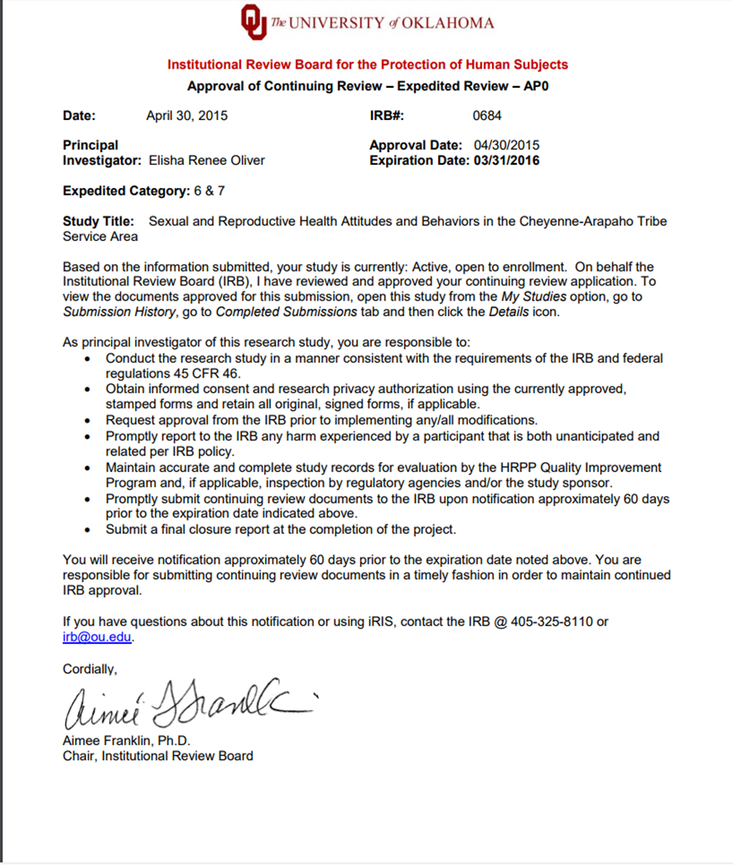

Appendix C: Participant Recruitment Flyer
IRB# 0684
______________________________________________________________
Sexual and Reproductive Health Attitudes and Behaviors in the Cheyenne-Arapaho Tribe Service Area
_______________________________________________________________
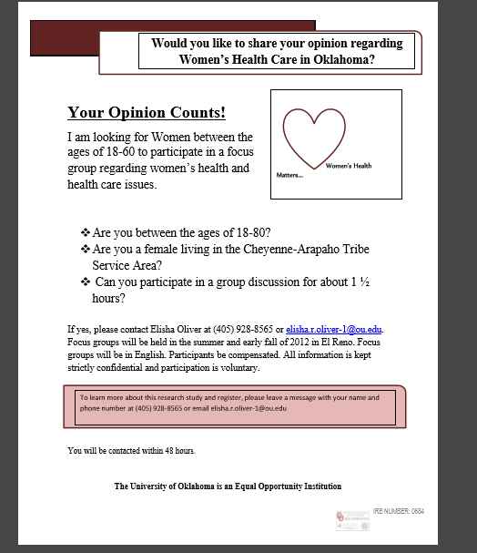

Appendix D: Participant Demographic Information
Output: 001
______________________________________________________________
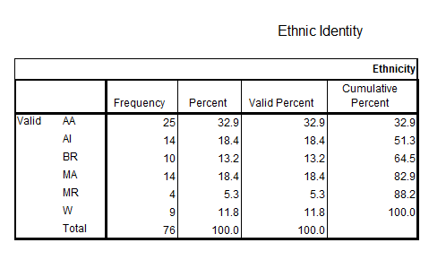

Output: 002
______________________________________________________________
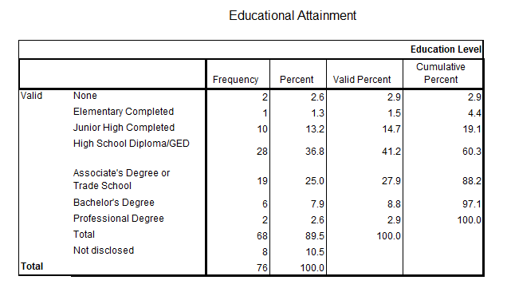

Output: 003
______________________________________________________________
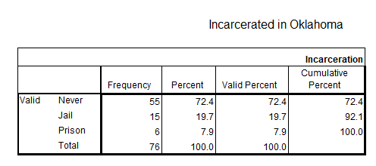

Output: 004
______________________________________________________________
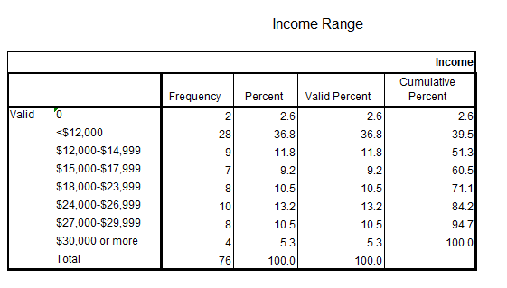

Output: 005
______________________________________________________________
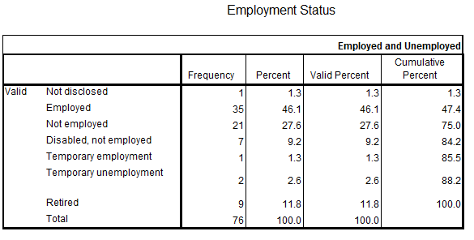

Output: 006
______________________________________________________________
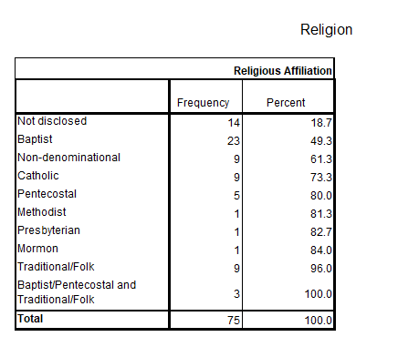

Output: 007
______________________________________________________________
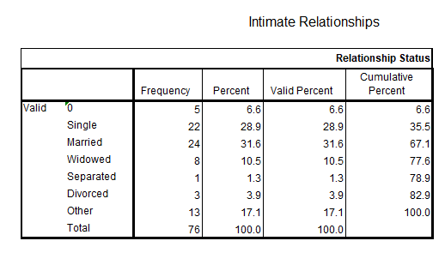

Output: 008
______________________________________________________________
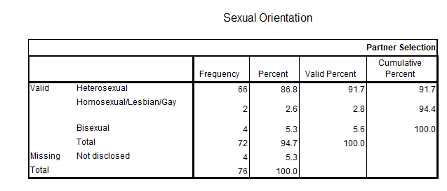

Output: 009
______________________________________________________________
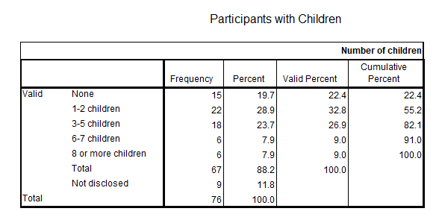

Output: 010
______________________________________________________________
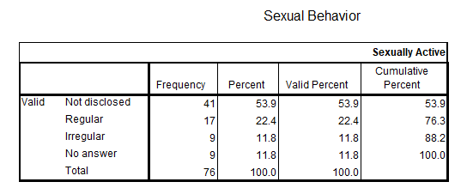

Output: 011
______________________________________________________________
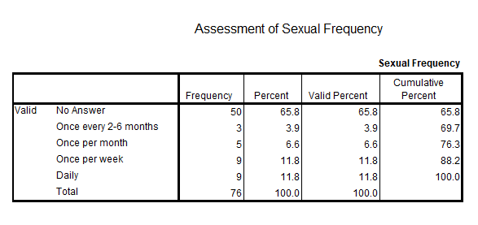

Output: 012
______________________________________________________________
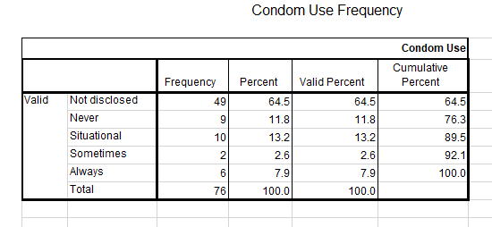

Output: 013
______________________________________________________________
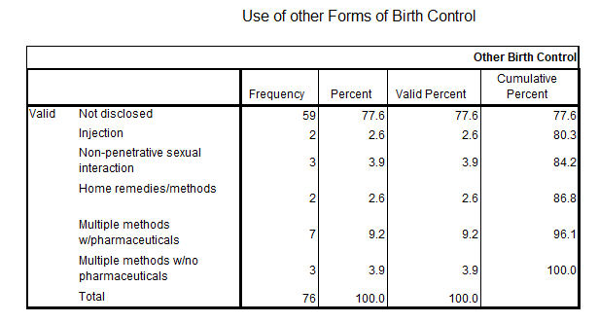

Output: 014
______________________________________________________________
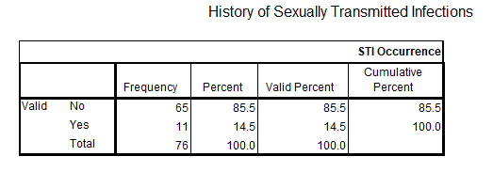

Output: 015
______________________________________________________________
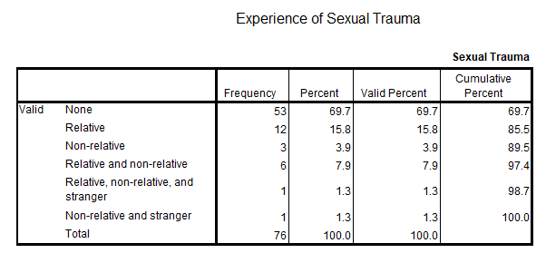
Output: 016
______________________________________________________________
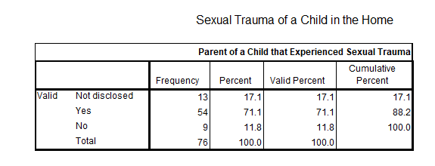

Output: 017
______________________________________________________________
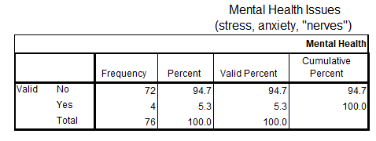

Output: 018
______________________________________________________________
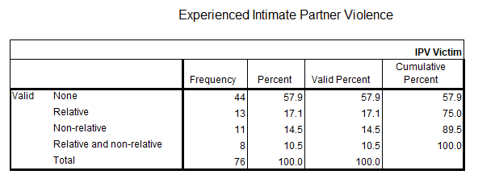

Output: 019
______________________________________________________________
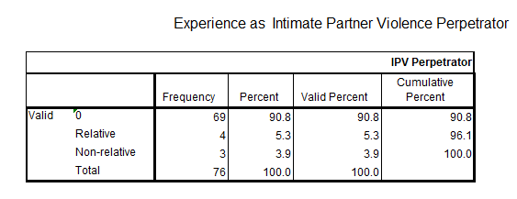

Output: 020
______________________________________________________________
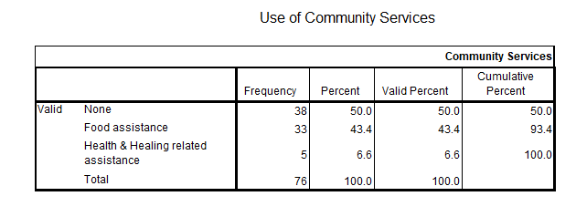

Appendix E: Collected Recipes

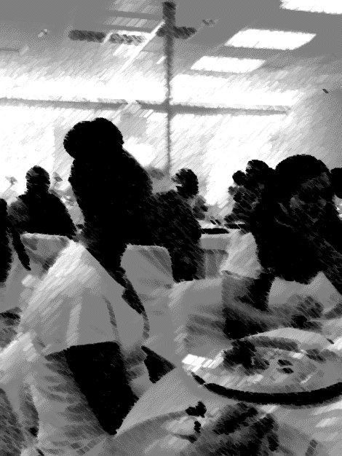

Figure 26: In Celebration of Women Brunch, 2015. Photo by, E. Oliver 2015.

Anna & Pete’s Fry Bread
(Recipe from field note taken from recorded conversation)

2 cups Whole-wheat flour
2 cups White flour
4 level Tablespoons Baking powder
1 Teaspoon Salt
¼ cup Warm water
Pot for Frying
Good Cooking Oil
Mix together whole-wheat flour, white flour, baking powder and salt. Add vegetable oil a little at a time. The flour needs to look something like corn meal. Sing some good songs to Maheo while you do all this. Slowly add 1 cup warm water only adding enough to make your dough stick together, not to make a gooey mess. Roll into fist-sized balls. But not if you have a big fist like Peete…aye…. Cover the bowl with a towel for about 10 minutes…enough time for a smoke and a Pepsi. Pat the dough out with your hands to make small pancakes. Fry in the good oil until golden brown on both sides. Make sure you have enough to share. Don’t let it cook to long. You should have some good eatin’…. invite us over…aye….

Gayla’s Cheese Salad with Peas
(Recipe from field note~taken from recorded conversation)

1 Package of Frozen Peas or a Can of Peas
1 cup of Comod Cheese (I like to add extra-my kids love the extra)
2 boiled eggs…just the white part
¼ cup Chopped Celery
2 Tablespoons of Chopped Onions
1/3 cup Mayonaise
1/8 Teaspoon Pepper
6 Good Tomatoes
Lettuce Leaf
Cook the peas. Drain the peas. Cool the peas. In a big bowl, combine peas, cheese, egg, celery, onion. Combine mayonnaise and pepper. Add to the pea mixture. Mix everything up good. Cover and put in the refrigerator for half-a-day or, a full day, if you can. Stir mixture well. Cut tomatoes to make wedges. Put the tomatoes on the lettuce leaf. Fill the tomatoes with the pea salad. Add some extra cubes of cheese as garnish.

Ananta’s Love Casserole
(Recipe from field note~taken from recorded conversation)

1 pound of Ground Beef
½ cup Diced White Onion
1 small Container of Sour Cream
1 can of Corn (drain the corn)
½ cup Diced Green Bell Pepper
1 package of Wide Egg Noodles
2 cans of Cream Mushroom Soup
About ¼ Teaspoon of Garlic Powder
Ananta’s Seasoning Blend (Lawry’s, Salt, Pepper, Dried Rosemary ground to a powder, Oregano)
Cook your meat and pour off the grease. Add the onion, bell pepper, garlic, powder, my seasoning blend. Continue cooking. Stir everything in good. Cook the noodles. Drain the water. Add the meat, the soup, the corn and sour cream to the noodles. Add a little water. Mix well. Put into a baking dish. Put it in the oven….about 350 to 375 degrees. “You got a gas stove?”…..I love my gas stove….Anyway, bake for about 45 minutes. Invite yo man over…. “You got a man?”….Anyway, invite somebody over you want to “love”….eat and get to lovin’

Doña M’s Mexican Fruit Cake
(Recipe from field note~taken from recorded conversation)

2 cups Flour
2 Teaspoons Baking Soda
1 ½ cups Sugar
2 Eggs (beaten)
1 Teaspoon Vanilla
1 cup chopped nuts
1 can Crushed Pineapple (a big can and don’t drain it)
Cake Topping
1 8oz Package of Cream Cheese
2 cups Powdered Sugar
1 stick of Melted Butter
1 Teaspoon Vanilla
*Mix all ingredients well
Mix dry ingredients all together. Mix with nuts, pineapple –including the juice, eggs, vanilla. Mix well. Pour into long cake pan and bake at 350 to 375 for 45 minutes to 1 hour. When cake is done, pour the cake topping over the hot cake and let it set. Once the cake is cooled, put it in the refrigerator. Add ½ cup of pecans to the cake before serving.

Krystal’s Pink Stuff
(Recipe from field note~taken from recorded conversation)

1 large Container of Cool Whip (or whatever is on sale)
1 large can Crushed Pineapple (drain it)
1 can Sweetened Condensed Milk
1 large can Cherry pie filling
A lot of chopped nuts (you know I have all those pecan trees)
Combine all the ingredients in a big bowl. Mix well. Cover and freeze overnight. Thaw before serving.

Miss Charlene’s When You Need to ‘Miss Ann’ Creation
(Recipe from field note~taken from recorded conversation)

2 cans of Crescent rolls (off brands work – they won’t know the difference)
1 cup Sugar
8 oz Cream Cheese
1 can of whatever pie filling is on sale
Line the bottom of a square pan with 1 can of crescent rolls. Bake until lightly brown. Mix the cream cheese and sugar. Make sure it’s creamy. Spread the cream cheese mixture on the cooled crescent rolls. Spread the pie filling over the cream cheese. Layer the other can of crescent rolls on top. Bake and serve. Voila! Miss Ann!!!

Sis. Janna’s Mormon Cake
(Recipe from field note~taken from recorded conversation)

2 cups Sugar
2 cups Four
2 Teaspoons of Soda
2 Eggs
1 Teaspoon of Vanilla
1 20oz can Crushed Pineapple (keep the juice)
Frosting
½ cup softened butter
1 8oz Package Cream Cheese (softened)
1 ½ cup Powdered Sugar
*Mix together and well

Mix everything together. Bake at 350 degrees until toothpick inserted in center comes out clean (roughly 40-50 minutes). Cool. Frost with cream cheese frosting.

The Lows Snow Ice Cream
(Recipe from field note~taken from recorded conversation)

This ice cream recipe was being shared at a celebration for women. Everyone contributed to the recipe and each individual had their own rendition or add-in. The most common version is written below.
2 quarts of Fluffy Snow (don’t get the yellow snow)
1 Teaspoon of Vanilla
1 ½ to 2 cups of Milk
1/3 cup Sugar
Mix milk, vanilla, and sugar. Pour into snow. Stir until mixed. Enjoy
*other additions include adding peppermint extract, chocolate syrup or powder, strawberry syrup, or tang.

Appendix F: Here’s to Your Health: Front Porch Roots, Kitchen Conjuring, and Remedies

Amulets

Gold Bead: Wealth & Money

Silver Bead or Silver from Old Jewelry: Harmony in one’s home

Red Bead or Red Bean: Rid you of envy

A Horseshoe or Wire Bent in the shape of a Horseshoe: Prosperity in business or work

Health & Healing

To prevent anger (for those who are always fighting physically with others)

Pinch of Epsom salt in castor oil ~ 1 time a day for 3 weeks. Eat 5 to 7 whole fruits a day for 5 months.

3 Red Carnations ~ individual must lie down prone on fresh crisp sheets. Sweep the body with the carnations. Perform on Wednesday, Thursday, Friday. Repeat. Drink tea of citron flowers daily.

Anorexia

Hard bread loaf. Split the loaf. Sprinkle the loaf with alcohol. Fill with peppermint leaves (it grows in abundance in The Lows). Add nasturtium, cinnamon cloves, and onions. Wrap the bread in a white cloth. Bandage over the stomach. Do this for 3 nine-day periods.

Reproductive Economies

Afterbirth: Mix basil, honey, nutmeg. It will aide in expelling the afterbirth.

Milk production in nursing: Make a stinging nettle tea.

Reduce milk flow: Make a mild tea of Yerba de la Negrita (Scarlet Globe mallow) and Yucca.

Reduce menstrual flow: Make a stinging nettle and peppermint tea.

To bring on menstruation: use in small doses. Make a rue tea. Add sugar.

To “excite” love: Make a mild cinnamon milk tea. Fill the room with cinnamon and lavender.

Arthur (Arthritis)

Stinging Nettle: Slap the arthritic joints with fresh plant.

Aloe Vera Liquid: Blend and mix liquid fresh fruits. Consume daily.

Mud Bath and Lettuce Leads. Cover in rich mud or clay. Wrap the arthritic joints with lettuce leaves.

Rosemary: Make a rosemary tincture with dried rosemary and alcohol. Rub on arthritic joints

Spirit and Energy Clearing

Burn sage or cedar to clear the negative energy from a space. Bathe in sage smoke to clear the negative energy from self. *Can bundle with lavender, rosemary, basil, or rose petals. Use a wing of designated bird to assist in the smudging or smoking.

Appendix G: Participant Roster

Participant Number | Participant ID | Gender | Age | Ethnicity
p001 | Miss Fannie Lee | F | 76 | AA
p002 | Miss J | F | 62 | AA
p003 | Nellie Truitt | F | 86 | AA
p004 | Lila | F | 64 | AA
p005 | Teresa | F | 51 | AA
p006 | Corie | F | 48 | AA
p007 | Jeanine | F | 19 | AA
p008 | Tangela | F | 18 | AA
p009 | Shay | F | 20 | BR (AA)
p010 | Chicago | F | 19 | AA
p011 | Carmen | F | 21 | AA
p012 | TB | F | 45 | AA
p013 | Malisia | F | 19 | AA
p014 | Miss Johnnie Mack | F | 74 | AA
p015 | Roxie | F | 52 | AA
p016 | Sis Janna | F | 54 | AI
p017 | Kylie Rain | F | 29 | AI
p018 | Leigha | F | 49 | AI
p019 | Kelise | F | 28 | AI
p120 | Donna | F | 55 | AI
p121 | Francesca | F | 61 | AI
p122 | Adelia | F | 51 | AI
p123 | Tammy Lynn | F | 25 | AI
p124 | Rosie | F | 58 | MA
p125 | Sister Delora | F | 78 | MA
p126 | Gloria | F | 47 | MA
p127 | Rosita | F | 35 | MA
p128 | Ellie | F | 52 | MA
p129 | Farrah | F | 50 | MA
p230 | Bethany | F | 78 | MA
p231 | DonaM | F | ? | MA
p232 | TH | F | 62 | MA (MR)
p233 | Bess | F | 31 | W
p234 | Penley | F | 51 | BR
p235 | Pat | F | 49 | W
p236 | Lula | F | 42 | W
p237 | Krystal Mae | F | 40 | MR
p238 | Ronnie | F | 22 | MR
P239 | Miss Essie Mae | F | 64 | BR
p340 | Ashiley | F | 47 | MR
p341 | Miss Louise | F | 63 | BR
p342 | Eugenia | F | 37 | BR
p343 | Raylene | F | 37 | BR
p344 | Ryan | F | 23 | MR
p345 | Taungie | F | 43 | BR
p346 | Grancine | F | 77 | AA
p347 | Gwyn | F | 53 | AA
p348 | Rhonda | F | 52 | AA
p349 | Lori | F | 40 | W
p450 | Brother Tomiah | M | 64 | MA
p451 | Colendrus | M | 61 | MA
p452 | Bernel | M | 70 | AA
p453 | Carl | M | 39 | AA
p454 | Travis J | M | 49 | AA
p455 | DJ | M | 20 | AI
p456 | Issac | M | 57 | MA
p457 | Travis S | M | 23 | BR
p458 | Javion | M | 23 | AA
p459 | Miles | M | 78 | AI
p560 | Albert | M | 64 | AI
p561 | Velmer | M | 51 | BR
p562 | Dexter | M | 51 | W
p563 | Henry | M | 48 | AA
p564 | Ponce | M | 23 | MA
p565 | Pete | M | 60 | AI
p566 | Tricia | F | 59 | AI
p567 | Sara | F | 68 | W
p568 | Chuck | M | 53 | AA
p569 | Anthony | M | 36 | AA
p670 | JohnWesley | M | 65 | BR
p671 | Bonnie | F | 68 | W
p672 | Lanna | F | 67 | W
p673 | Jerrylyn | F | 59 | AI
p674 | Marie | F | 26 | BR
p675 | Pat | F | 48 | W
p676 | Johnathan | M | 48 | MA

Appendix H: Foot Traffic and Social Network Relationships

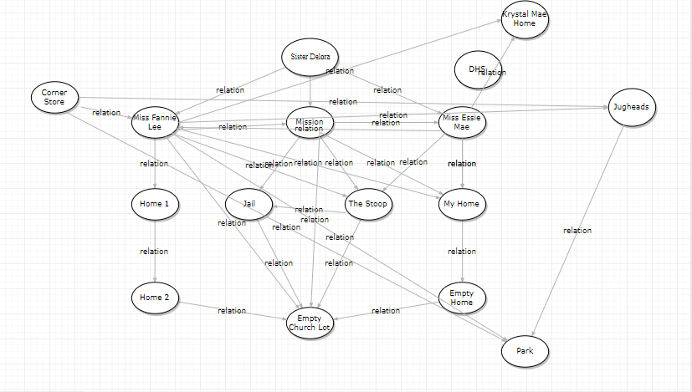
Figure 27: Foot Traffic and Social Network Relationships

The map above illustrates intimate space locations and activity sites. The analytical approach to representing the complexity of the importance of the data above has relied heavily on travel vectors among participants. An examination of the relationships and shared narratives within these spaces confirm the importance of these spaces regarding the daily lived experiences of the women in the community.

Appendix I: Formal and Functional Regions in El Roy and The Lows

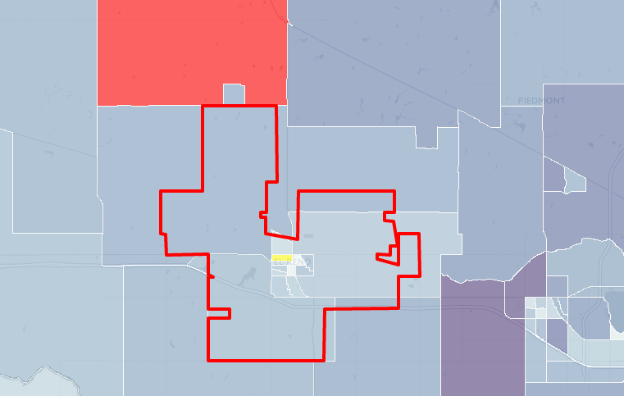
Figure 28: Formal and Functional Regions in El Roy and The Lows
The community where this research took place is outlined by the blue square on the map above. This square illustrates the spatial dimensions of the neighborhood compared with the larger El Roy community. The purple graduated circle displayed within the blue square is the largest territorial space where frequent interactions occur. This space is also significant regarding similarities in the cognitive maps and sense of place by the participants. This is also both the formal and functional region of the neighborhood. The green circle is a smaller functional region of the neighborhood. Neighborhood interactions and transactions occur in both the purple and green areas. The yellow circle exists on the periphery of the secondary green location. The flow of foot traffic, goods, and information to-and-from this area is minimal but is a significant component of the community.

Appendix J: Visual Ethnographic Explorations

In the fall of 2010, I began an ethnographic study in The Lows, a rural neighborhood in El Roy, Oklahoma. My research addressed the following set of questions: (1) What is the cultural significance of spaces within this community? (2) In what ways do these spaces affect the biopsychosocial health of women in the neighborhood? (3) How and why do constructed, intimate spaces facilitate the telling and sharing of narratives? And,
(4) In what ways do the women living in The Lows make meaning of everyday lived experiences in a rural and aging community? During my time in the neighborhood, the women participating in my research suggested that I implement the use of photography to add meaning to the narratives that I would collect. I followed through with this suggestion and strategically planned how where and how to capture daily-lived experiences. Over 10,000 photographs were taken during the research process; however, the photos included in my dissertation were those selected for inclusion by my participants. Collaboratively, we put together a storyboard that blends ethnography and the biographies of the women featured in my research.
Beginnings and Histories
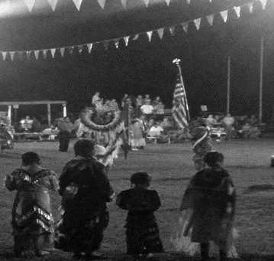
Figure 29: The Land of My People

“This is the land of my people. These powwow-stomp grounds are representations of us. The land is life. It’s a big family reunion. Our relations are all here.”

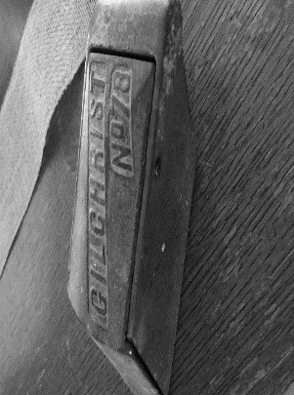
Figure 30: Snacks and Snow cones

“Aunt Earline had the best cherry shaved ice in the neighborhood. She only had three flavors ─grape, cherry, and lemon─ but she made the best shaved ice and had the best penny-candy in The Lows. A lot of memories were made standing in line at her back door. Ooh child that was so much fun.”
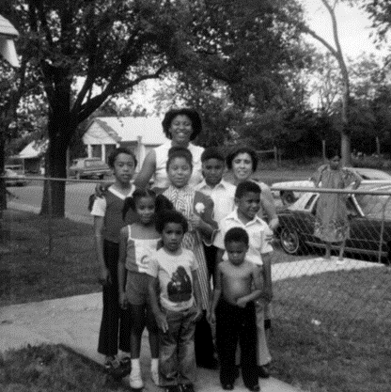
Figure 31: Researcher and Family 1979

The neighborhood has changed significantly over the years. Viewing The Lows from the eyes of an adult anthropologist and researcher as an additional layer to meaning-making related to place and space.”

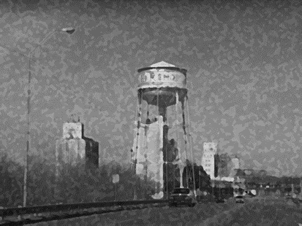
Figure 32: Coming into Town

The view of the water tower and grain elevators are symbolic representations of arriving home.
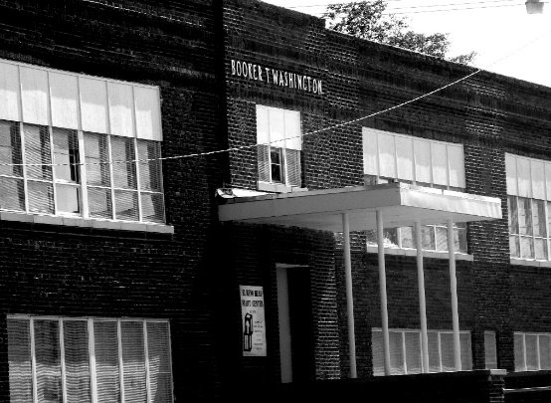
Figure 33: The Stoop

The stoop is a significant formal and functional region of this neighborhood. This has been a gathering space for women for decades. It is a site to share and exchange community information, to barter for goods and services, and to further community cohesion.
Meaning-Making in Intimate Spaces and Places

Figure 34: Dead She Mound

There are several stories associated with Dead She Mound. Many of the elderly women in the community recount stories of having witnessed many pregnant women walking to the mound to gather dirt to eat. Stories passed through the generations recount the stories of women that held the common belief of It can be assumed that the mound was rich in minerals that were beneficial to the health of the women.
Emotion and Intimacies
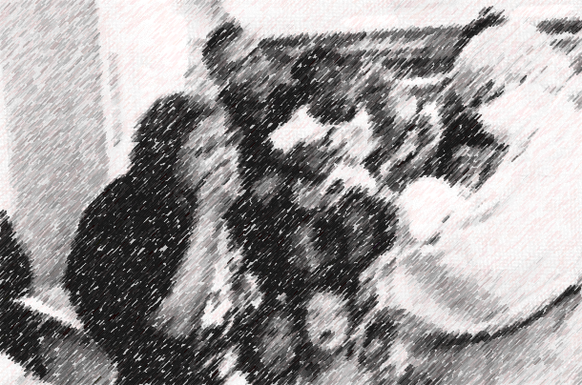
Figure 35: The Birth of Emotion

The topic of reproductive health is replete with varying degrees of emotion in The Lows. Othermothering or alloparenting is a serious occupation in this neighborhood. Women share responsibility in the rearing and caretaking of children.
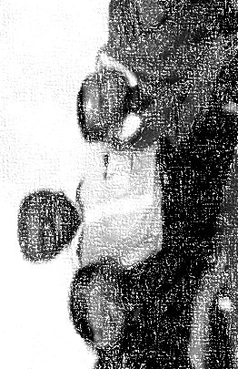
Figure 36: Multiethnic and Multicultural Joking Relationships

The joking relationships observed in The Lows reinforce social bonds, ease tensions, and are indicators of social acceptance.
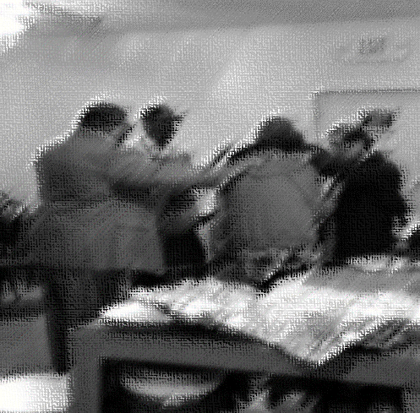
Figure 37 Prayer, Health, and Healing

The laying of hands and praying are syncretic religious services that transcend cultural and ethnic boundaries. They are sought out by individuals within and outside The Lows. Individuals believe that this is a critical component in their health and healing.
Magic, Myth, and Medicine
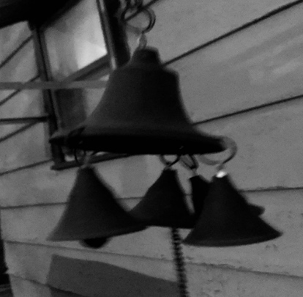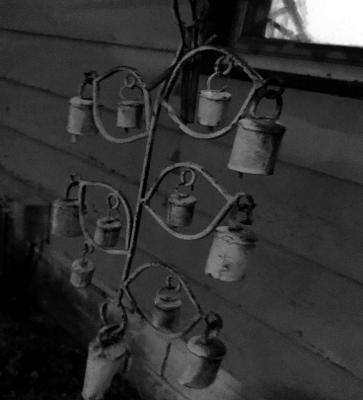
Figures 38 & 39: Bells and Chimes

The placement of bells and windchimes throughout the inside and outside of the house, particularly in doorways and on the outside of windows is a common sight in The Lows. Participants indicate that there are many purposes for these placements. The bells and chimes serve as a type of alarm to alert the occupant of the home of the presence of a visitor ─seen and unseen─ and to detour spirits from gathering around entryways into the house.
In this neighborhood, there is a strong belief in magic, myth, and the marrying of the two to create physical and spiritual medicine that heal and protect. Aspects of these beliefs, and the rituals associated with them mirror those found prior to the introduction of Christianity. Kitchen magic, othermother science, root work, and ancestor worship and reverence are a part of the fabric of this community. The syncretism of religious beliefs in this neighborhood reinforce social bonds and community cohesion. They also serve as an alternative to western medicine that is often unaffordable, and unavailable to neighborhood residents and their families.

Figure 40: The Evil Eye and The Eye of Prevention:

The Evil Eye and The Eye of Prevention look similar in delivery; however, the purpose differs greatly. The most common distribution of The Evil Eye is to “lay down a curse” on an individual or individuals that have committed an offense against an individual or the individual’s family. The Eye of Protection is the “all-seeing eye” that can detect harm and danger. The delivery of The Eye of Protection can either protect and shield an individual from malevolent forces or blocks an individual from causing ill-intent.
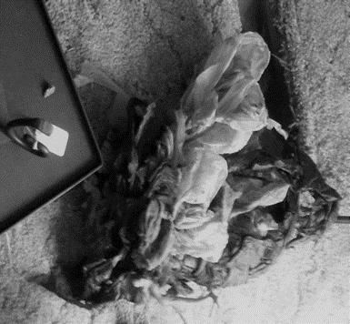
Figure 41: Laying Down a Root

The photo above illustrates materials used in “the laying down of a root.” The ingredients used in this root had the purpose of bringing about economic change for a family in the community. A variety of materials are used in root work depending on the desired need, or outcome of a situation.
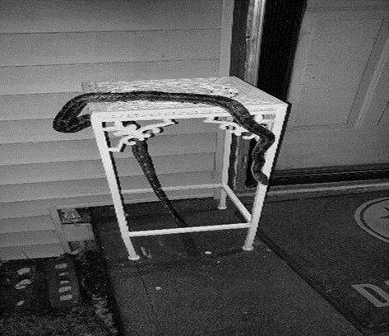
Figures 42 & 43: A Snake in Disguise

Many women in the neighborhood view the visitation of certain animal as “signs” or symbolic representations of the occurrence of events, or the entering and exiting of an individual from one’s life. During my research, I was visited twice by a snake. The women in the community advised me to be cautious about the individuals that I allowed to visit my home.

Meaning-Making and Meals
The preparation and sharing of meals at the mission have an important role in maintaining community cohesion. In this space, the sharing of narratives, the exchange of culture and tradition, and the creation of fictive kin relationships occur throughout the long process of meal preparation. This is also a time to share remedies for a host of biopsychosocial ills.
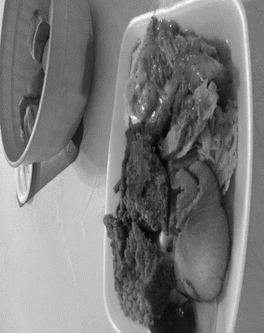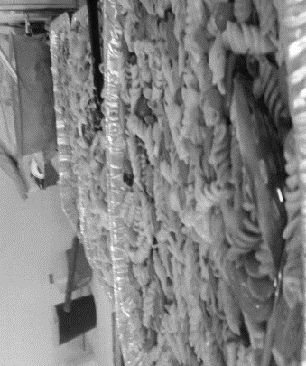
Figures 44 & 45: Meals and the Sharing of Meals

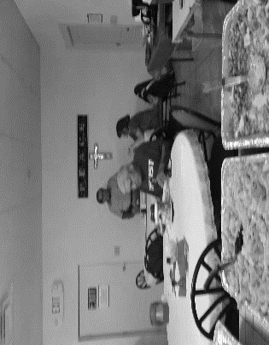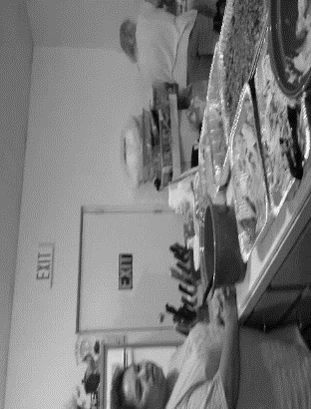
Figures 46 & 47: Meals and the Sharing of Meals

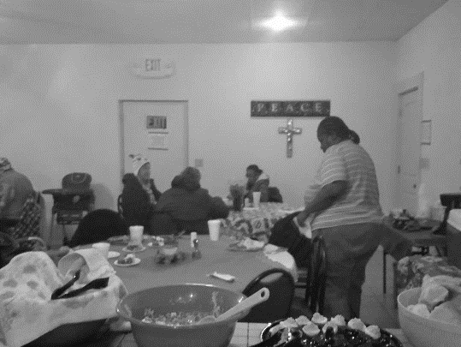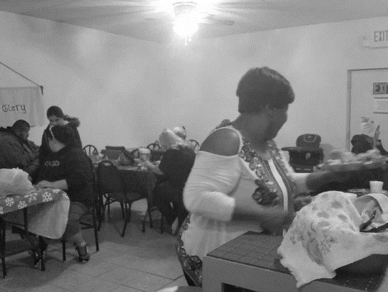
Figures 48 & 49: Meals and the Sharing of Meals

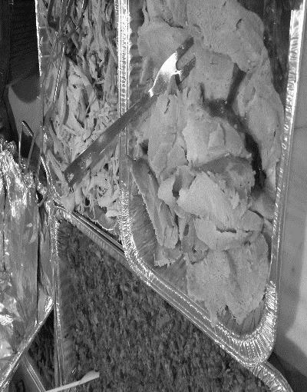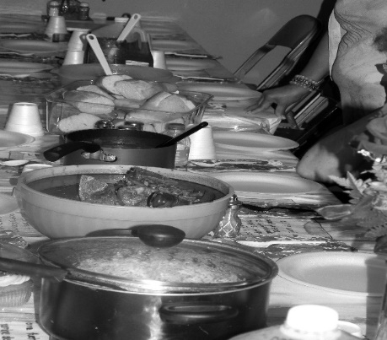
Figures 50 & 51: Meals and the Sharing of Meals

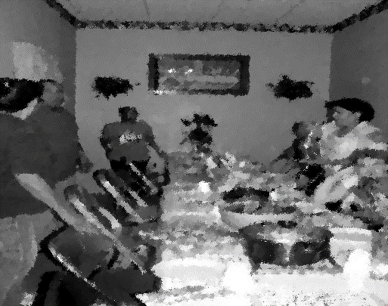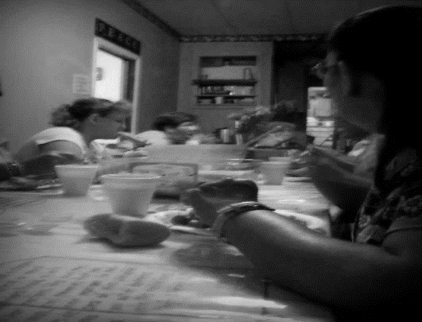
Figures 52 & 53: Meals and The Sharing of Meals

Sharing a meal is an act of intimacy between two or more individuals. The photos above illustrate the ways in which people from diverse backgrounds interact within an intimate space. “Breaking bread” with one another is a form of meaning-making attached to space. The traditional American Indian handgame is also demonstrative of community cohesion, meaning-making, and kinship bonds within identified intimate spaces.
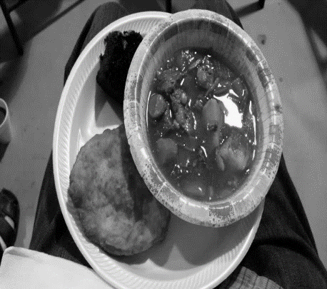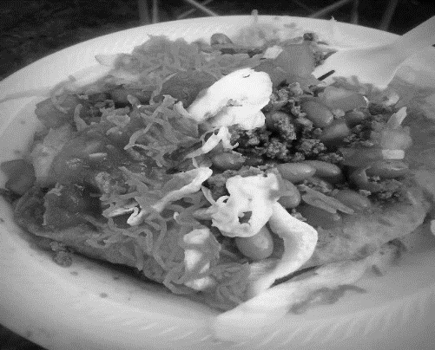
Figures 54 & 55: Handgame Meals

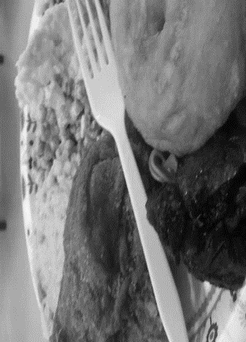
Figures 56 & 57: Handgame Meals

There are several similarities regarding mealtime within intimate spaces; however, nuanced differences are associated with each space. For example, the photos above are taken at handgames that were held at tribal specific places. During these games, soups and fry bread are always staples. The preparation and sharing of meals at these events are not only to build coalitions, strengthen bonds, and facilitate partnerships, they are also prepared and served to honor the visiting guests. Just as we see the sacredness of mealtime in the mission, and at the handgames, we can recognize this in the personal residence of my research participants.

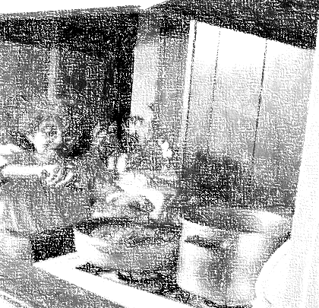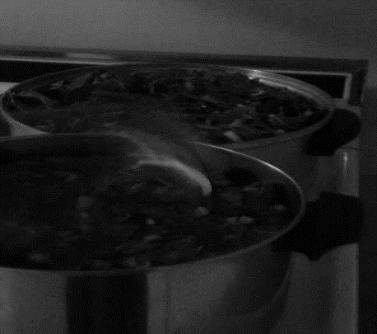
Figures: 58 & 59: Keep Something on The Stove

When I visited the private residences of my participants, I always found a pot of beans, pot of greens, or some type of soup cooking. My participants took great pride in being able to offer visitors something to eat. This was a recognition of respect and a sign of gratitude for the visit. Several women that participated in my research indicated that a special skill was involved in making a pleasurable meal out of only the items on hand. They stated that this was a skill passed down through the generations and was historically significant in that their ancestors were required to feed a family or families with the “scraps they were given.” These scraps include “comods (government distributed commodities),” discarded pieces of meat and bone, such as the tongue of an animal, the tail, the hooves, and items found on the land. As mentioned above, the preparation and sharing of a meal was often used as a sign of respect and gratitude. On several occasions, events orchestrated by the women in the neighborhood were held to honor the “othermothers” for their commitment to the community. These were occasions where the women could dress in their finest “Sunday-go-to-meeting” clothes and take part in an elegant dining experience.
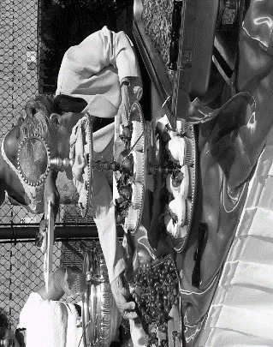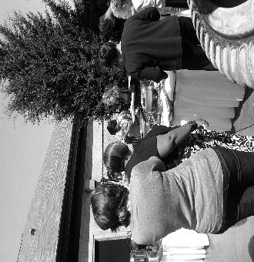
Figures 60 & 61: Sisterhood in The Hood

My dissertation explores the associations between the biopsychosocial dimensions of daily lived experiences of women in The Lows with the narratives and used spaces within the neighborhood. Women, men, and others flow in-and-out of these spaces for diverse reasons. The following photos depict the daily life of women, men, and others in the community, and the various ways they participate in town activities. The activities serve as a time to gather outside of the normal gathering spaces.

Groups and Gatherings
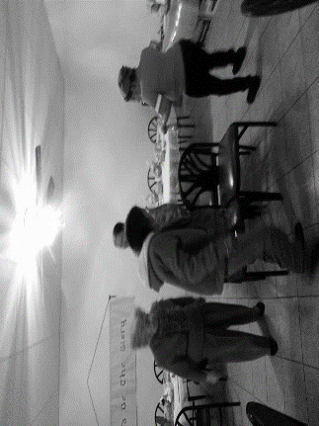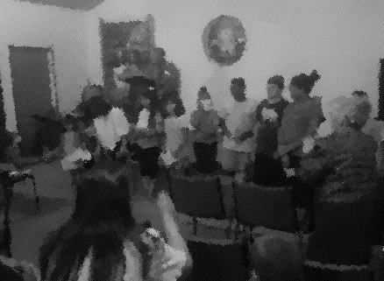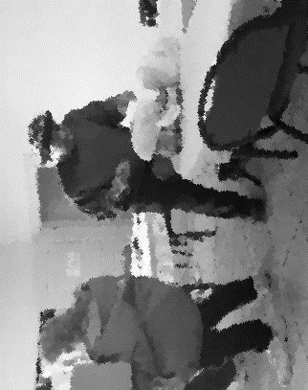
Figures 62, 63, & 64: This is Community

As mentioned in the body of my dissertation, the male presence in this neighborhood is almost nonexistent. The men that are contributing members in The Lows indicate “they do what they can” to help where needed. They are silent actors in the neighborhood.
A Seat at the Table: Doin’ Hair, Sharing Stories, and Meaning-Making
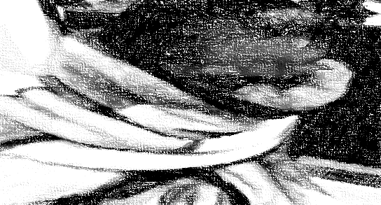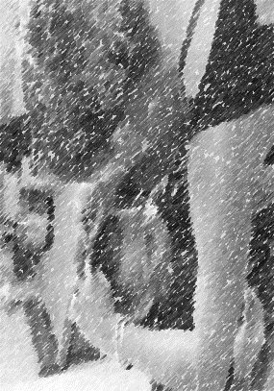
Figures 65 & 66: Taking Care of the Kitchen in the Kitchen


Figures 67 & 68: Taking Care of the Kitchen in the Kitchen

The intimate space of kitchens in the houses of the women in the neighborhood serve as spaces for activism, economic empowerment, and reinforcing neighborhood bonds. These are the most private and intimate of neighborhood spaces.

Reciprocity and Reflexivity
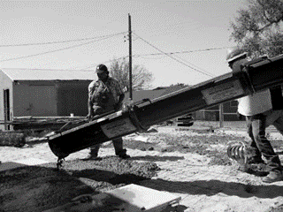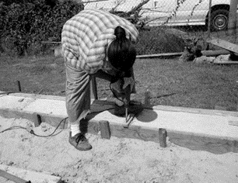
Figures 69 & 70: A Researcher Living in The Lows

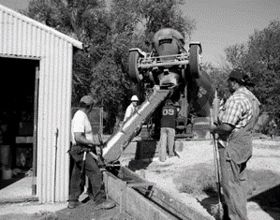
Figures 71: A Researcher Living in The Lows

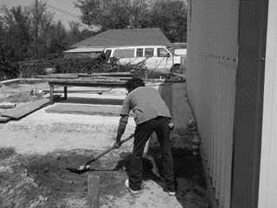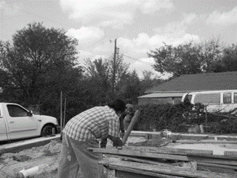
Figures 72 & 73: A Researcher Living in The Lows

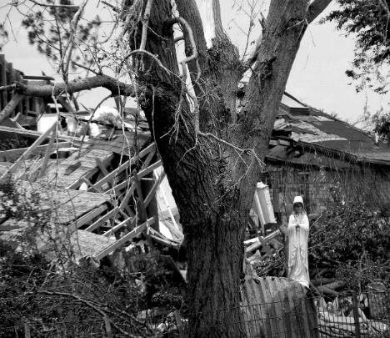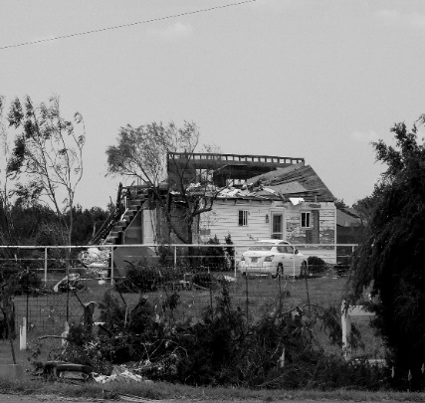
Figures 74 & 75: A Researcher Living in The Lows

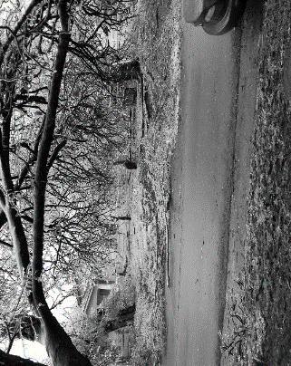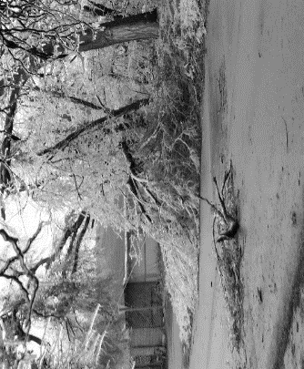
Figures 76 & 77: A Researcher Living in The Lows

The absence of men in the neighborhood create a space where women are the primary caretakers of home and community. This includes contributing to what is viewed as gender-based projects and tasks. There were punctuated times throughout my research when my commitment to the neighborhood was questioned. The best response that I could give was helping with all tasks and projects. This included assisting in the building of a new addition to the mission. This addition became a new classroom, new dining room and kitchen. The new dining room and kitchen’s occupant capacity was increased, and two storm shelters were constructed. During my research I shared in several environmental experiences with my neighbors. There were two tornados, an ice storm, and several earthquakes.
The use of visual ethnography articulates my research photographically. It has captured the social realities of Life in The Lows. The joys, the sorrows, the gains, and the sometimes, overwhelming losses have been a blaring and, frightening. A reality that has often been lonely, the lone ethnographer making the familiar strange and the strange familiar.

Appendix K: Neighborhood Myths and Legends
The Chicken Man (as told by a neighbor in the community)
When the neighborhood was a relatively new neighborhood for folks a color, a young family moved to a house at the bottom of the hill. The man of the house was very handsome. He was the son of an Indian mother and Black father. He was not only handsome, he was extremely gifted with his hands. He could make anything out of wood. He would often craft birdhouses, jewelry boxes, and shelves for neighbors. This supplemented his income from the brickyard. Now, this was a time when things were changing economically. There were “let-go’s” at the brickyard. Residents could no longer afford his crafts. The savings that the man had acquired went quickly. A harsh winter came and there was very little food in the house. His wife and children began to grow ill. The churches in the community could offer very little help. Out of desperation the man went to the Safeway down the street. He went into the store and stole enough food to feed his family that night. As he was leaving the store, a clerk noticed that he was leaving without paying. She called after him. A bagger began chasing the man. The man ran to his house dropping many of the ingredients along the way. The man arrived at his home in a deep panic. He told his wife that she needed to take the kids that evening and go to her sister’s house. He gave his wife a loaf of bread, a bologna loaf, and hog’s head cheese and sent her on her way. The man knew that the authorities would come for him. Later that night, a group of men arrived at the house, they pulled the man from his house, and tar and feathered him. The man suffered in tremendous pain. From that night on he vowed to make the children and the children’s children of the men suffer as he had. If you are ever out at dusk and see a huge bird-looking creature flash by, it’s the chicken man. It’s good to know your people, who you come from, so you can make sure the chicken man doesn’t come for you or your children.
Bigfoot Lives Here (as told by a tribal elder)
Hey! You know when you here that noise that sounds like the train cars bumping into one another, that’s not a train. It’s the sound of bigfoot walking on the rez. Bigfoot lives here, you know…Aaaayee!
The Statue Will Turn His Head
Don’t get caught walking in downtown Elroy after midnight, especially if you’re walking by the soldier of the statue. It’s a haunted statue. If you stare at it too long, he’ll turn his head and watch you as you walk away.

Figure 2: Photo of the water tower, grain elevators, and a road entering El Roy.
In this neighborhood, many of the women use the “moon” as a marker for time in discussing events.
Roy Orbison co-wrote “Coming Home” in 1988. He soon died, thereafter. The song has been discussed as metaphorically alluding to death.
During my research, I designed and facilitated a creative writing project with women that participated in the weekly meetings at the mission. The women participating in my dissertation research and, the writing project gave permission to have segments of their writing featured in my dissertation.
This quote is accessed from the Willem de Kooning Foundation. It was recorded in an interview with David Sylvester, March 1960. Accessed from: http://www.dekooning.org/documentation/words/content-is-a-glimpse on August 16, 2017. Willem de Kooning is best known for his work as an abstract expressionist artist.
This excerpt from the summer of 2010 is taken from a personal journal. This brief snapshot details a lunch date in which I shared the news of acceptance to graduate school with a long-time friend. Written consent was obtained from Kyle to use this journal excerpt.
Everyone that is present, or “takes up space” in this dissertation, chose their own pseudonym. This was another way that these individuals collaborated in the creation of this dissertation. It was a form of “co-ownership” of this body of work for the participants—their way of privileging their voice through the selection of a pseudonym they “felt” was true to their identity.
Having earned a PhD from a prestigious University in Texas and joining the ranks of a small percentage of folk, particularly black folk known as Dr. Kyle is known as Dr. Kyle in most circles; however, he often uses the controversial N-word in conversation. The use of this word does not speak to his lack of intelligence, his street personae and credibility, or his distaste for folk that look like him. To him, it is an intimate term used intimately between friends and family. The words N***a and the ways in which this word is used as a term of ascription, proscription, and prescription have been and continue to be debated in popular discourse. Randall Kennedy (2007) discusses the linguistic permutation of the contentious term in the introduction of his book, Nigger. He writes, “nigger is fascinating precisely because it has been put to a variety of uses and can radiate a wide array of meanings (Kennedy 2007:34).” He is not the only scholar to problematize the N-word. Michael Eric Dyson (2007) illustratively discusses “who can and who can’t” use this word as a moniker of description, the NAACP symbolically buries the n-word and, Richard Pryor, through comedy and referencing anthropology, discusses the (mis)use of the word and his decision to lay it to rest (http://www.nola.com/opinions/index.ssf/2014/02/an_epiphany_on_the_n-word_jarv.html). While, I understand the painful traumatic history that accompanies the use of the n-word; I, also, recognize and acknowledge the endearments associated with this word between friends that look alike. This is a term of familiarity that is often used in The Lows.
This small excerpt was taken from my statement of purpose on my graduate school application (Oliver 2010).
Kathleen Stewart, and Lila Abu-Lughod privilege and position the voices of the women that participated in their research. This purposeful positioning and privileging of voices narrates the cultural production of spaces and places that are significant to their participants. Like Stewart, and Abu-Lughod, I let the participants in my dissertation “speak for themselves.” For more concrete examples, see: Kathleen Stewart, A Space on the Side of the Road: Cultural Poetics in an “Other” America (1996), and Lila Abu-Lughod, Writing Women’s Worlds: Bedouin Stories (1993, 2008).
A more thorough explanation of “father absence” and the impact on biopsychosocial health can be found in Chapter 6 of the Gray and Anderson 2010 text (Pp. 120 – 141) on Fatherhood. While an in-depth and intimate exploration of health outcomes related to father presence and/absence is an interesting line of inquiry, or as Gray and Anderson (2010:141) suggest, “understanding the motivations of men’s parental behaviors (or lack thereof) is an important first step to explaining and possibly altering the behaviors themselves,” the focus of this dissertation, at this time is on the female presence in the community.
See Table, “output 015 and output 018” located in Appendix D.
El Reno Ok Population. (2016, December 05). Retrieved April 22nd, 2017, from http://worldpopulationreview.com/us-cities/el-reno-ok-population/ and https://www.census.gov/quickfacts/fact/table/elrenocityoklahoma/PST045216
A graph detailing the financial status of the individuals participating in this research is included in the Appendix D
Through a series of interviews and focus groups, I discovered that the individuals residing in this neighborhood do not want to be identified as African American. They prefer to be called Black.
The historical information with regard to El Roy and the neighborhood known as The Lows was obtained from interviews with the town historian, the eldest neighborhood members, and countless hours of archival research at the oldest community churches in El Roy and the Oklahoma Historical Society.
In reviewing archival and railroad information, I discovered that there were three all black towns in this geography. They have disappeared. Through countless trips to search for markers that would indicate the location of these towns, I have located only one. It is a cemetery, located in the middle of a cow pasture, once belonging to the residence of Dorie.
Zora Neale Hurston documents “toe parties” in Mules and Men. These are parties where food and “coon dick (homemade liquor)” are served. Card games are played. Men bring instruments for musical entertainment and, women step behind a make-shift curtain (a bed sheet nailed or strung to resemble a curtain), remove a shoe, stick a toe beneath the curtain, and the men place bids on the “toe” they desire. After they have won the bid, the man purchases food and drinks for their date. They dance, socialize, and play games. After a period of time has elapsed the women return to stand behind the curtain for a chance to be with a new suitor. This goes on until all the men are out of money (Hurston 1935).
A reading copy of the dissertation was given to each participant that is prominently positioned within the research and, to each person that had a desire to read the dissertation as it progressed.
Much of my dissertation is written implicitly and thematically, and, in some cases, explicitly, in components of 3’s. The number three is a number of significance in this neighborhood. Several of the participants indicate that it a number that holds deep sociocultural and religious significance.
Othermothering has been discussed in the literature as, women who provide care for their biological children as well as the children that are not biologically their own. The provision of care also is extended to community members, typically younger in age than the individual providing the care (see Adams 1995; Angelou 1994; Arnold 1995; Bernard 1974; Collins 1990, 2000, 2016; Cook and Fine 1995; Dubey 1995; Foster 1993; Gilkes 2001; James 1993; Rich 1976; Ruddick 1989; Trebilcot 1983; Walker 1983). Examining other mothering from a primatological paradigm, we can classify parental care of non-descendant young as alloparenting. Alloparenting occurs in a variety of animal groups; however, from a primatological perspective, an examination of vervet monkeys, langurs, and lemurs provides an evolutionary look at other mothering (see Altmann 1980; Briga, Pen, and Wright 2012; Hrdy 1977, 1980, 1999,2009; Rowell 1964; Royle, Smiseth, and Kolliker 2012; Stanford 1992; E.O. Wilson 1975).
See Appendix J for a photo of a device that former resident (she is deceased), “Aunt” Earline Johnston used in the making of snow cones.
The term “resorts” was used to describe homes or hotels that primarily functioned as sites for transactional sex. This term was discussed was brought up in conversation by the neighborhood octogenarians and nonagenarians. This term was also found in several historical newspapers and, the sections of the recorded town history.
“long since been gone” is often used by residents in this neighborhood. It is the local language, almost always, used to discuss businesses, people, or events that were once an integral part of this neighborhood.
A glossary of terms used in this community, that, potentially, are unfamiliar to the reader, and that are used in this dissertation, are included in Appendix A.
The participants vividly described the numerous ways in which they would provide goods and services in exchange for monetary compensation-a type of day labor. The money was often used to purchase feminine products (“doose” is what many women call feminine hygiene solutions), diapers, food from the corner store, and beer.
Participants were asked at various intervals during the research period if they wanted to remain in the study. Everyone that participated in this research desired to complete the research. During this research, four (4) participants died ─ two were murdered in domestic violence situations, one (1) from cancer, and one (1) from an overdose.
Many of the photographs used in this dissertation have been blurred or altered to conceal the identities of the individuals, except, where a signed photo model release form has been obtained. Also, the language used in this dissertation, while sometimes explicit, has not been “sanitized” per request of the research population. After reviewing the written dissertation with my collaborators, they indicated that my omission of profanity or explicit terminology, “made their way of speaking seem white.” They felt that to sanitize the language was to “other” them (be ashamed of who and how they were in the neighborhood—to “make them more palatable for white audiences.”); therefore, ethnographic vignettes, interview excerpts, and conversations have been left as audio and textually recorded as a form of authenticity.
Pile sorting is a qualitative research method that was used in this dissertation. It is most useful with helping to identify themes that exist with cultural domains (Bernard 2010; DeMunck 2010). In this dissertation, it was used to determine and discover the research participants’ perceptions about the overall research project, health, healthcare, and healthcare knowledge, parenting, space and place, ritual and religion, and community and civic engagement. Both, cards containing text (words) and, cards containing pictures were used in the sorting process. Initially, participants were instructed to sort according to the free single pile sort method. After the data was collected and filed for later analysis, the participants were instructed to sort according to the constrained pile sort method. These, too, were collected and filed for later analysis. There are advantages and limitations in the use of pile sorts. The greatest advantage for this body of work facilitated a growing understanding of community values; cultural norms regarding this population; community beliefs about the research process and, the researcher as “other;” alternative health and healing practices; and the views of community spatiality.
Maps of spaces of importance and neighborhood pathways are included in Appendix I
The term “passed away” refers to death and dying. It is a term/saying that is commonly and frequently used within this community.
Snowball sampling is often used interchangeably in academic literature and discourse (Schensul 1999:72).
Many of the front doors to homes in the community are often inaccessible. It is common to see a fence (or gate) within a fence that leads to a locked front-porch door.
The terms “bougesie” and “Miss Ann” are often used in this community to describe an individual, almost always a woman, that has attended a trade school, junior college, or university and, works in a higher than minimum wage job. Typically, this individual has an automobile, home or apartment, and gives the appearance of being able to “shop at the mall” instead of the local small and large retail chain stores.
Spider, devil, trickster and big nose are cultural terms that are often used by women within this neighborhood to describe white men (primarily) and women that represent and perform in a way that suggested privilege and entitlement.
An ethnographic visual of a traditional handgame is included in Appendix J. Handgames are competitive “hiding and guessing” game between two groups. Historically, the game, took place between two opposing tribes. This game represents community cohesion, the reinforcement of social bonds, and prestige and honor.
Both Cheryl Townsend Gikes and Patricia Hill Collins discuss and describe ‘othermothers.’ These are women that fused kinships (fictive and biological) together through their endless watchfulness, lesson-teaching, caregiving, and commitment to the community. They can be any category and classification of woman (sisters, aunts, neighbors, grandmothers, etc.) that provides medicine (food, comfort, a hug, a switch, a shoulder to cry on etc.) to allay, alleviate, and assuage the (dis)stress and discomfort of some daily lived experiences.
“Full of fire” are words used by women in this community to describe an individual that is high-spirited, outspoken, and has a strong and resilient disposition.
“Formal schooling” is language used to describe trade school, junior college, and four-year colleges and universities. At times, it is used to describe and discuss middle-school and high school.
A nip is a term that is defined as a small amount of liquor.
Sister Delora does not acknowledge her American Indian ancestry.
The house where Sister Delora and Brother Tomiah reside has many lives and stories to tell. “If these walls could talk” would be an understatement when speaking of their home. The home was originally built in 1940. It would later be turned into a speakeasy and brothel. When Sister Delora and Brother Tomiah purchased the home in the mid-nineties it had long been abandoned and was in beyond dilapidated condition. They completely renovated the property with the intent of housing women released from prison. State regulations and city ordinances prevented them from opening the doors to the half-way house they had been led by God to build. Within seven months, Sister Delora and Brother Tomiah had packed the belongings in their family home, a home that had Sister Delora purchased with military benefits after the death of her first husband, locked the doors to the home they had lived in for more than thirty years and moved into the renovated “would-have-been” half-way house.
Throughout this dissertation, titles such as, “Miss,” “Sister,” “Brother,” “Mr.”, and “Chief” are used in front of the proper names of an individual older in age than I (the researcher). To not do so would have been an almost unforgivable and quickly corrected error. The use of titles before names of those older in age (a 10-15-year span) is common local and neighborhood cultural knowledge. For example, someone that is 20 years of age addressing or speaking to someone that is 35 years of age would address them as “Miss” so-in-so.” One interesting exception is addressing men in the neighborhood. Only the very senior men (55 and older) are addressed with a title preceding their name.
“Holding one’s tongue” refers to not speaking what is on one’s mind, being tactful in speech and communication with others, and knowing when to be gentle in talk and when to be frank.
Ashiley and Krystal Mae have different fathers. Their fathers are African American and American Indian, from two different tribal groups.
Stroll is a term that is often used interchangeably with walk and/or visit with other folks in the neighbor.
The incarcerated men that participate at the healing hands mission were not interviewed for this research. Casual greetings and nonrelated research between the researcher and the men were exchanged; however, the conversations that took place with the men are not included in this research.
Referring to the opening paragraphs in the methods section with regards to Bronislaw Malinowski and his work with the Trobriand Islanders, exploring the Kula ring, we have read that his method was a type of multi-sited ethnography; although, at the time, it was unnamed. Malinowski would travel from island to island. This is what George Marcus has referred to as “following the people –a form of multi-sited ethnography (Marcus 1998: -90).
The term “homegirl” references a female or someone identifying as female as a close friend. “Wannabe” references an individual that is making attempts to fit into a group by way of dress, language, and action (behavioral accoutrements).
The laying of hands refers to touching another individual (the one “in need” of prayer or healing) while reciting a request (prayer) for deliverance for whatever malady the individual is experiencing. The individual also can “stand-in” (stand in intercession – in place of) for another.
Anointing with oil refers to applying an oil to an area of the body of an individual. The oil chosen is specific to the ailment or need of the individual. The oil is applied to one or more of the following areas: the temples, forehead, palms, chest, spine, abdomen, pelvic area, or souls of the feet.
Claude Lévi-Strauss popularized the concept of binary opposition (see Lévi-Strauss 1963); however, for this dissertation a more pertinent application of the theory is most noted in the disciplines of literature, film, and media.
In this dissertation the concept of “borderlands” is best aligned with Gloria Anzaldúa’s notion of borders and borderlands. The women that Anzaldúa references and writes about are marginalized and face a host of social ills. She writes, “The world is not a safe place to live in. We shiver in separate cells in enclosed cities, shoulders hunched, barely keeping the panic below the surface of the skin, daily drinking shock along with our morning coffee…[see Anzaldúa1987:21-23]. In her writing, Anzaldúa blends autobiography with various genres of writing to conceptualize borders and borderlands as spaces of remarkable connection among its members. Her concepts of home are often ruptured. They shift, slip, and are inverted to reveal the ways in which women feel oppression; yet, find ways to become emancipated and empowered.
In the passage referenced above, Elie Wiesel (1958) is referencing the very beginning stages of angst and anguish. One of the dominant themes throughout Night is religious faith and the ongoing struggle that Elie Wiesel had with regard to his relationship with god. Several themes arise in this text. The reader is witnesses the testimonies of translations and transfigurations throughout the book. Each place and space that Wiesel occupies transforms his biopsychosocial being. He, simultaneously, is being and becoming.
This ethnographic snapshot is part of a much longer interview where Miss Essie Mae discusses her changing relationship with the church, her faith, her identity in The Lows, her mother, and the significance of space contributing to these changes.
During my research, the reading and use of poetry and literature, specifically those writings by women of color were often used by participants to frame discussions of their daily lived experiences.
In this dissertation, I have, purposely, chosen to include a variety of writings in unabbreviated, unaltered, and unedited form. Electing to choose this method of textual inclusion keeps the integrity of the meaning of the writing and provides a holistic reading and conceptualization of the dissertation. The poem by Wendy Rose has been included in this dissertation in the exact format form in which it was included in, The Endangered Roots of a Person. Reinventing the Enemy’s Language: Contemporary Native Women’s Writings of North America. Joy Harjo and Gloria Bird, eds.
Appadurai’s writing is situated within the context of globalization and modernity; however, his argument about various “scapes” (ethnoscapes, mediascapes, technoscapes, financescapes, ideoscapes) and the social imaginary can be applied broadly to this section of the dissertation. Appadurai’s writing suggest that multiple remembrances, realities, and reflections, as social and cultural imaging and imaginings, takes on a variety of forms and changes context that is dependent on the witness. Ashley Hogan (2010) writing about Appadurai’s “scapes” posits, “With the meaning of ideas changing depending on the person ingesting them, we must then grapple with the existence of an “imagined world,” in which our reality is no more real than somebody else’s (see Hogan 2010: https://www.amherst.edu/academiclife/departments/courses/1011F/MUSI/MUSI-04-1011F/blog/node/229354 accessed October 15, 2017.) We are able to extend this to the example provided above by Kelly Oliver and, this application is critically important in the examination of the use of storytelling and performativity (the performance of person and space) in The Lows. Appadurai (1990) contends, “I use terms with the common suffix scape to indicate first of all that these are not objectively given relations which look the same from every angle of vision, but rather that they are deeply perspectival constructs, inflected very much by the historical, linguistic, and political situatedness of different sorts of actors: nation-states, multinationals, diasporic communities, as well as sub-national groupings and movements (whether religious, political or economic), and even face-to-face groups, such as villages, neighborhoods, and families. Indeed, the individual actor is the last locus of this perspectival set of landscapes, for these landscapes are eventually navigated by agents who both experience and constitute larger formations, in part by their own sense of what these landscapes offer (see Appadurai 1990b: 296).” Using Appadurai as a platform for understanding, we are able to look beyond the surface of the shared narrative and empathetically and contextually connect and locate ourselves to the spaces and, as participants in the lives of the women in The Lows.
In this dissertation, “negative space” is being used in the context of theories within art and media studies. It is defined as the space of, around, and between the image or images. Often, it is the most interesting area of the image and, is the authentic subject of that image (see James 2012).
I use the term “ghost in the shell” in the context of the science fiction film, Ghost in the Shell that was derived from a series of manga comics. In the film the “ghost” is equated with the mind or the consciousness of the individual and the shell is a technologically based cybernetic body. An analysis of the film in comparison with Agamben’s Musselman reveals a unique dialectic of hypervisibility (see —one that is philosophically Kantian in nature. Mulla Sadra (2007) writes, “The term Muselmann (Muslim) was used at Auschwitz to denote a passive prisoner who had given up, had no consciousness or conscience, was despised and not object of sympathy, and was a mere staggering corpse, a bundle of physicality of no consequence [Agamben 1999b: 41–43]. More importantly, he had no agency, no dignity, and was not a survivor who could testify as he was devoid of his humanity. This state of being the Muslim is the limit case, the exception, the Orientalised and objectified Other. Survivors and witnesses speak for the inhuman Muselmann and resent it [Agamben 1999b: 120] (Sadra 2007).” Reviewing Agamben’s description of the Muselmann and placing it in dialogue with the implicit theme in Ghost in the Shell, we are able to identify the significant changes in the human condition that one undertakes in times of extreme change. More aptly, Toni Prescott (2017), in a review of the film, references a very present theme in chapter 1 of this dissertation. This is the theme of affect, emotion, sociobiographic memory, biopsychosocial health, witnessing and testimony, the human condition, and transmutations, translations, and transfigurations. He writes, “A scene midway through the film shows, even more bluntly, the central role of memory in creating the self. We see the complete breakdown of a man who, having been mind-jacked, faces the realization that his identity is built on false memory of a life never lived, and a family who never existed. Rather than being defined by our memories….we cling to memories as if they define us, but what we do defines us (Prescott 2017).”
In Greek mythology, the Gorgon(s) were three vicious and venomous mythical creatures that happened to be female. They had the uncanny ability to turn an individual that glanced upon them to stone. The theme of binary opposites exists within this myth. It is important to note that the Gorgon(s) possessed traits that were remarkably and magnificently beautiful; however, they also possessed traits that were hideously and horrendously evil (see Wilk 2000).
Many of the spaces (the front porch, the mission, the stoop, and Burton park) have been described as “sacred spaces” by the women in this community. The spatial identity has been ascribed in relationship with its function in the lives of the women in this community.
Foucault argues that heterotopic spaces are spaces of ‘otherness.’ These spaces exist in the “real world” (see Foucault 1967:17). In the opening pages of The Order of Things, Foucault employs the use heterotopia to define the textual and textural spaces of same and other. Comparing the binary opposites of same and other and putting heterotopias in dialogue with utopias, Foucault writes, “Utopias afford consolidation: although they have no real locality there is nevertheless a fantastic, untroubled region in which they are able to unfold; they open up cities with vast avenues, superbly planted gardens, countries where life is easy, even though the road to them is chimerical. Heterotopias are disturbing, probably because they secretly undermine language, because they make it impossible to name this and that, because they shatter or tangle common names, because they destroy ‘syntax’ in advance, and not only the syntax with which we construct sentences but also that less apparent syntax which causes words and things (next to and also opposite one another) to ‘hold together’ (see Foucault 2002:xix).
In many homes in the neighborhood, it is quite common to find bells and windchimes hanging throughout and outside of the home. There are multiple reasons why residents adorn their homes with these items. Several have indicated that they are an “alert system” to signal when someone (seen or unseen—as in a spiritual or spirit world context) has entered the residence.
Participant voice will be bolded and underlined in examples like the one above, throughout this dissertation.
Many women in this community have the perception that adding cream or creamer, or any other additional ingredients is a sign of someone “trying to be uppity” or “bougesie.” It can be interpreted as a classist construction by the women in the community. Also, it, adding additional ingredients to coffee is a sign of “not being hard” —not tough enough to drink coffee as is—strong and black. This coffee perception has often been discussed and described by participants (n=19) as a reflection of the self— “strong,” “sometimes bitter,” “black,” and “full-bodied.” An offer of hot tea was often regarded with disdain and appeared classist to the participants. I quickly learned to not offer hot tea.
“Them” is a term that is used to denote the dominant class or group—those in power. The women in the community use “them” to shift the perception of “other.”
Using the biopsychosocial model as a technology to understand and treat illness, disease, and suffering has been critiqued by many within and outside of the discipline of anthropology; however, because culture is dynamic and, following the first inception of a holistic method of treatment as proposed by Engel (1977), I suggest that we move away from compartmentalized thinking with regard to illness, pain, and suffering, as experienced by individuals in economically depressed neighborhoods, in a way that compartmentalizes and disaggregates the biological from the psychological and both, from the social. Instead, I propose a focus on the “whole individual” using Engel’s biopsychosocial approach which is grounded in general systems theory. Engel (1977) writes, “In all societies, ancient and modern, preliterate and literate, the major criteria for identification of disease have always been behavioral, psychological and social in nature (see Engel 1977:130). This notion proposed by Engel is most applicable when examining the various aspects of health in The Lows. A review of the ethnographic data contained in this dissertation reveals that there is a blurred line between concrete determinations of “sick” (having a strong case of nerves) and “well” (having balanced health). Engel (1977) suggests, “the boundaries between health and disease are far from clear and never will be clear, for they are diffused by cultural, social, and psychological considerations (see Engel 1977:132).”
On this particular afternoon, Mother Truit stopped at the stoop to talk to a few women that were gathered to trade medication (5 anxiety tablets) and diapers (1/2 pack) for cupcakes (24 cupcakes from a local chain store), birthday party decorations, and soda (for a child’s birthday party). Nellie Truit is one of the neighborhood elders. She moved to El Roy, with her parents, two aunts, three uncles, and a grandmother, from Dorie, once, an all-black town, at the age of 7. She has remained in El Roy her entire life. Mother Truit was out walking to “see what the eyes could see,” she indicated.
The following sections focus on the issues that my research participants felt were the most important issues facing the women in this community. In keeping with the fundamental tenets of Community Based Participatory Research, I chose to include the topics that were requested by the stakeholders involved in this participation.
This information can be viewed in Appendix D.
Structural violence is a form of either implicit or explicit violence against an individual or group that prevents them from equitable access to resources providing for their most basic needs (Dilts 2012; Galtung 1969; Galtung 1975). This form of violence is often visible; however, there are invisible aspects that plague certain groups. Structural violence that is not often visible is almost always embedded in ubiquitous social institutions and structures (DuNann-Winter & Leighton 1999; Galtung 1969).
See: https://www.americashealthrankings.org/learn/reports/2016-health-of-women-and-children-report/state-summaries-oklahoma for a review of the current report. Accessed on October 10,2017.
Philosophy is interspersed throughout the body of this dissertation. Many social science disciplines were founded on the tenets of philosophical thought. McGee and Warms (2017) argue, “modern anthropology is built on the work of earlier generations of researchers (McGee and Warms 201:1-5).” Many of these researchers built their work from the earliest philosophical thinkers.
At the time of this focus group, there were not any physicians of color in the town; however, in 2016, the town hospital hired an African American Female emergency room physician. This improved the women’s willingness to seek medical treatment at the hospital.
To “get caught” references pregnancy. The recipe for a tea that has been used quite prolifically to abort pregnancies has been shared with me by one of the community othermothers; however, I have elected to not include it in this dissertation.
In this particular response, “grandma” is referencing Miss Fannie Lee, one of the elder participants in this research. Several of the younger women in the neighborhood refer to her as “grandma.
Charts that contain demographic data are included in Appendix D of this dissertation.
It is important to keep in mind while reading this dissertation, the research conducted took place over a six-year period. This dissertation contains community issues, information, and data collected over this time span.
Out of respect for the participants that shared these narratives, I elected to omit specific details about the experience from this dissertation.
The neighborhood known as The Lows is within walking (2 miles) of the market/botanica. A small number of women utilizing the services of Dona M are unable to walk to the market. They typically ask other neighborhood members to pick up needed items. Several of the women have started growing their own traditional herbs used in teas, as food sources, and in “kitchen magic.”
During the course of this research, women were the only members of the neighborhood seeking treatment from Dona M.; however, on a few occasions, women would bring children for treatment for a variety of reasons (earaches to stomachaches to disruptive behavior in school). The women would often stand in as intercessors for their male relatives, relatives outside the community, boyfriends, or spouse. The women that seek treatment from the curandera indicate that they believe that “this type of medicine and treatment” is more effective than the care provided in a western biomedical context.
An example of a representation of a spiritual being in the guise of an animal is included in the appendix. A participant indicated that the presence of the snake in my yard and the yard of a neighbor was an omen of “things to come.”
Field jottings are shortened, quickly written, fieldnotes.
The military base is 36 miles southeast of El Roy
The term “pressed” used here is referencing placing an iron comb on the burner of the stove to straighten hair.
The term “story” used here is referencing daytime soap operas.
The use of “kitchen” in this passage refers to the hair at the back and base of the head.
In this passage a nickel references $5.
Coffee, fry bread, and cigarettes are a form of currency in The Lows.
Several of the older residents often refer to songs and instrument led musical selections played on the front porch, at the stoop, or occasionally at the park, as ditties.
See Appendix D for demographic data.
The associations are a part of a pile-sorting technique to elicit research data.
In a community health discussion several of the women participating in this research indicate that people are systems comprised of several components that all must work together synergistically to keep “us” healthy and whole. I equated this to the historical medical teaching of humors.
“…in-love” is often used in place of “in-law” in The Lows.
“Gone home to be with the Lord is a popular saying used in many African American communities to indicate the death of an individual that was intimately associated with a church. This saying is used prolifically in The Lows.
Earthquake Reports: https://www.forbes.com/sites/trevornace/2017/08/07/oklahoma-shakes-hit-7-earthquakes-28-hours/#23d147015b8f ; http://www.npr.org/sections/thetwo-way/2017/08/03/541298754/earthquake-shakes-central-oklahoma-one-of-7-in-28-hours ; http://www.cnn.com/2014/07/13/us/oklahoma-earthquakes/index.html
In August 2017, 7 earthquakes were recorded in Oklahoma within a 28-hour span.
Many of the elders in this community use the term “old hat” to reference an event or an occurrence that happens frequently and, has become part of the norm. In the epilogue, I use “old hat” as used by my good friend and research collaborator, CMGSJ.
Maheo is a term used by many Native American tribal members in this geographic region of Oklahoma when referencing the creator or “God.”
Each performed ritual must be done with prayer; typically, The Lord’s Prayer and the Apostles Creed or, a prayer offered to the ancestors petitioning assistance with matters of importance. Always give thanks for the plant and, thank the plant for allowing use.

