UNIVERSITY OF OKLAHOMA
GRADUATE COLLEGE

AN EXPLORATION OF TEACHERS’ CULTURALLY RESPONSIVE TEACHING PRACTICES AND STUDENTS’ ACCULTURATION EXPERIENCES IN THE ELEMENTARY SCHOOL CLASSROOM

A DISSERTATION
SUBMITTED TO THE GRADUATE FACULTY
in partial fulfillment of the requirements for the
Degree of
DOCTOR OF PHILOSOPHY

BY
RAE K. ROSS
Norman, Oklahoma
2020

AN EXPLORATION OF TEACHERS’ CULTURALLY RESPONSIVE TEACHING PRACTICES AND STUDENTS’ ACCULTURATION EXPERIENCES IN THE ELEMENTARY SCHOOL CLASSROOM

A DISSERTATION APPROVED FOR THE
DEPARTMENT OF INSTRUCTIONAL LEADERSHIP & ACADEMIC CURRICULUM

BY THE COMMITTEE CONSISTING OF:

Dr. Vickie Lake, Chair

Dr. Libby Ethridge

Dr. Tim Ford

Dr. Diane Horm

Dr. Kyong-Ah Kwon

©Copyright by RAE K. ROSS 2020
All Rights Reserved.

DEDICATION

“Before a dream is realized, the Soul of the World tests everything that was learned along the way. It does this not because it is evil, but so that we can, in addition to realizing our dreams, master the lessons we’ve learned as we’ve moved toward that dream.”
-Paulo Coelho, The Alchemist
I dedicate this to all of those along the way who have helped me master the lessons of my dream.

Acknowledgements
I am genuinely overwhelmed with the amount of support I have received throughout this process, and I cannot begin to thank each and everyone one of you enough. Therefore, similar to the Oscar’s 45-second time-limit, I will do the same.
To my parents, and my biggest heroes, thank you for your never-ending support in every aspect of my life.
To my brothers, thank you for always being my loudest cheerleaders even though you did not always know what you were cheering for.
To my friends, thank you for keeping my social spirit alive despite my attempts to say, “I can’t; I need to write.” Especially Libby, who always found the perfect time to say, “look at this cheap flight…we should go.”
To my Jenks family and community, thank you for raising me as an educator and continuously supporting me in my academic endeavors.
To the Owls, thank you for sharing this process with me.
To my committee members, Dr. Libby Ethridge, Dr. Timothy Ford, Dr. Diane Horm, and Dr. Kyong-Ah Kwon, thank you for sharing your knowledge and wisdom with me.
To my chair, Dr. Vickie Lake, I am especially thankful for your support, stories, and sarcasm. I am forever grateful for your Owl wisdom.
Last, but not least, I would like to thank Dr. Jorge Lightfoot for always encouraging…
(45 second time limit; cue play-off music)

Table of Contents
List of Tables xii
List of Figures xiii
PROLOGUE xiv
Dissertation Abstract xv
MANUSCRIPT I 0
The Integration of Third Space Theory and Culturally Responsive Teaching: A Balanced Model to Working with Culturally Diverse Students 0
Third Space Theory 4
Third Space in the School Environment 5
A space of reform 5
A space of dialogic scripts 7
Culturally Responsive Teaching 8
The Threefold Intervention 10
18 Pillars of Practice 11
A Balanced Model to Working with Culturally Diverse Students 14
The Cultural Block 17
The Academic Block 19
The Psychological Block 24
Conclusion 28
References 30
MANUSCRIPT II 34
Teachers’ Culturally Responsive Teaching Practices and Students’ Acculturation Experiences: A Case Study 34
Abstract 35
Teachers’ Culturally Responsive Teaching Practices and Students’ Acculturation Experiences: A Case Study 36
Theoretical Framework 37
Review of Literature 40
Cultural Practices 41
Academic Practices 42
Psychological Practices 43
Acculturation in the School Setting 44
Method 46
Participants 47
Setting 48
Procedures 49
Data Sources 50
Culturally Responsive Teaching Self-Efficacy Scale (CRTSE) 50
Interviews 51
Data Analysis 51
Trustworthiness 52
Results and Discussion 53
Case 1 – Anna 53
Cultural practices 54
Academic practices 56
Psychological practices 57
Case 2 – Whitney 59
Cultural practices 60
Academic practices 61
Psychological practices 63
Case 3 – Julia 65
Cultural practices 66
Academic practices 68
Psychological practices 70
Limitations 72
Conclusion and Implications 73
References 76
MANUSCRIPT III 83
Culturally Responsive Teaching Practices: Supporting Students’ Cultural, Academic, and Psychological Well-Being 83
Abstract 84
Culturally Responsive Teaching Practices: Supporting Students’ Cultural, Academic, and Psychological Well-Being 85
A Balanced Model to Working with Culturally Diverse Students 86
Cultural Practices 90
Academic Practices 93
Psychological Practices 96
Conclusion 99
Bonus Practice: Showing You Care 100
References 104
APPENDIX A: PROSPECTUS 107
AN EXPLORATION OF TEACHERS’ CULTURALLY RESPOSNIVE TEACHING PRACTICES AND STUDENTS’ ACCULTURATION EXPERIENCES IN THE ELEMENTARY SCHOOL CLASSROOM 108
Table of Contents 110
Abstract 113
CHAPTER 1: INTRODUCTION 115
Background 115
Research Problem 116
Research Purpose 118
Research Questions 118
Theoretical Framework 118
Significance of the Study 120
Definition of Terms 121
CHAPTER 2: LITERATURE REVIEW 123
Acculturation 124
Factors Affecting Acculturation 127
A Culturally Responsive Space 128
Third Space Theory 129
A space of reform, negotiation, and collaboration 130
Third Space in the school environment 131
Transforming discourses and knowledge 133
Culturally Responsive Teaching 135
A Cultural, Academic, and Psychological Approach to CRT 139
18 Pillars of CAP 139
Cultural Intervention 140
Academic Intervention 143
Psychological Intervention 147
Conclusion 150
CHAPTER 3: METHODOLOGY 151
Research Design 151
Participants and Setting 151
Data Sources and Procedures 153
Student interviews 153
Teacher interviews 154
Culturally Responsive Teaching Self-Efficacy Scale (CRTSE) 154
Field notebook 154
Data Analysis 155
Trustworthiness 156
Credibility 156
Transferability, dependability, and confirmability 157
Ethical Considerations 158
References 160
Appendix A: Consent Forms 170
Appendix B: Translator Attestation Form 178
Appendix C: Teacher Survey 179
Appendix D: Jenks Research Request Form 181
Appendix E: Alignment of Interview Questions to Research Questions 183
Appendix F: Student Interview Protocol 189
Appendix G: Teacher Interview Protocol 190
Appendix H: CRTSE Scale Approval 191
Appendix I: Timeline 192
Appendix J: Internal Review Board Study Approval Letter 193

List of Tables
MANUSCRIPT I
Table 1 Gay’s (2010) 18 Pillars of Practice 13
MANUSCRIPT II Table 2 Teacher Demographics and Classroom Characteristics 48
Table 3 CRTSE Scoring Scale 51
MANUSCRIPT III Table 4 Academic Practices in Action 95

List of Figures
MANUSCRIPT I
Figure 1 A Concrete View of Third Space Theory 5
Figure 2 Igoa’s (1995) CAP Intervention 10
Figure 3 A Balanced Model to Working with Culturally Diverse Students 16
MANUSCRIPT II Figure 4 A Balanced Model to Working with Culturally Diverse Students 39
MANUSCRIPT III Figure 5 A Balanced Model to Working with Culturally Diverse Students 87
Figure 6 Third Space 88
Figure 7 CAP Trifold for Teachers 102

PROLOGUE
This dissertation adheres to a journal-ready format. Three journal articles prepared for submission to refereed journals comprise the first part of the dissertation. Manuscript I, The Integration of Third Space Theory and Culturally Responsive Teaching: A Balanced Model to Working With Culturally Diverse Students is prepared for the journal Urban Education. Manuscript II, Teachers’ Culturally Responsive Teaching Practices and Students’ Acculturation Experiences: A Case Study is prepared for the journal Teaching and Teacher Education. Manuscript III, Culturally Responsive Teaching Practices: Supporting Student’s Cultural, Academic, and Psychological Well-Being is prepared for the journal Young Children.

Dissertation Abstract
Supporting students from culturally diverse backgrounds requires a restructuring of current pedagogical practices. However, many teachers feel unprepared and lack the knowledge and practices necessary to work with students from diverse cultural backgrounds (Ballantyne, Sanderman, & Levy, 2008; Bankeree & Luckner, 2013). Considering this, a new theoretical model is presented which combines Third Space Theory and Culturally Responsive Teaching (CRT) so educators are equipped with a model that supports students’ cultural, academic, and psychological well-being collectively. Next, a qualitative phenomenological case study is shared that explores three teacher’s CRT practices, their students’ perceptions of these practices, and students’ strategy use within the same elementary school. The study, which was conducted in a large, diverse school in the Midwest utilized the Culturally Responsive Teacher Self-Efficacy Scale (Siwatu et al., 2015) and teacher and student interviews in order to explore the phenomenon at study. Results from the study revealed that CRT is a multifaceted phenomenon and even within classrooms where CRT practices are prevalent, how these practices are perceived often differ from student to student due to various factors (i.e., students’ purpose or goal, immigration experience, time in host country, or English language proficiency) and this has a reciprocal impact on their strategy use. Last, based on the theoretical model presented, educators are provided with a ready-to-use display that includes practices to support students’ cultural, academic, and psychological well-being.

MANUSCRIPT I

The Integration of Third Space Theory and Culturally Responsive Teaching: A Balanced Model to Working with Culturally Diverse Students

This manuscript is prepared for submission to the peer-reviewed journal Urban Education and is the first of three manuscripts prepared for a journal-ready doctoral dissertation.

Abstract
This article presents a new and comprehensive model for working with culturally diverse students in the classroom. First, Third Space Theory is discussed as a necessary foundation before implementing Culturally Responsive Teaching (CRT) practices. Then, a new model is presented that is built on the existence of Third Space and focuses on a balanced approach to supporting students’ cultural (C), academic (A), and psychological (P) well-being. In using this new model, educators can reflect on their pedagogical practices while ensuring they are providing a balanced approach when working with culturally diverse students.
Keywords: Third Space Theory, Culturally Responsive Teaching, culturally diverse students

The Integration of Third Space Theory and Culturally Responsive Teaching: A Balanced Model to Working with Culturally Diverse Students
Since the 1960’s the U.S. has been a top destination for international migrants (Zong, Batalova, & Hallock, 2017), and today, one out of every four students in the U.S. is from an immigrant family (Migration Policy Institute, 2017). By 2065, whites/Caucasians will become less than the majority of the population making the U.S. a majority minority country (Cohn, 2016). For our youngest school age students, we can see this trend already occurring. With changing demographics comes the integration of differing cultural backgrounds. Unfortunately, this integration is met with challenges and the existence of these different cultural backgrounds is often neglected in the classroom environment (Ballantyne, Sanderman, & Levy, 2008; Banjeree & Luckner, 2013).
As the U.S. society and classrooms become more diverse, schools need to identify effective methods for, 1) teaching culturally diverse students and 2) supporting them during the acculturation process (Richards, Brown, & Forde, 2007). This includes addressing students’ social, emotional, and adaptive needs (Igoa, 1995). To meet this challenge, classroom environments should welcome students’ unique cultural backgrounds and use their experiences as a scaffold which supports their academic achievement and psychological well-being (Richards et al., 2007). Additionally, students need a space to explore and negotiate their own dispositions, discourses, and cultural practices as these have an impact on their identity construction (Gutiérrez, 2008).
Considering this, culturally responsive teaching (CRT), serves as a sound pedagogical practice for supporting students from diverse cultural backgrounds. Broadly defined, CRT is a form of pedagogy that invites students’ cultural backgrounds, experiences, and perspectives into the classroom which are often excluded from mainstream classrooms. While CRT is established as a sound teaching practice, there are several challenges that exist which, make it difficult for educators and schools to effectively implement CRT practices. First, CRT is grounded in a set of beliefs and practices that are “fundamentally different from most of those that govern how educational programs and practices historically have been designed” (Gay, 2018, p. 50). Due to this mismatch, educators must have the courage, confidence, and space to question the standard curriculum in order to make their practices more culturally responsive for their students (Gay, 2018). This can be accomplished through the creation of Third Space which, in this article, is presented as the foundational component for CRT practices to exist. Second, CRT practices primarily focus on ways to support students’ academic achievement leaving out practices that support their cultural and psychological well-being (Igoa, 1995). Therefore, educators need a comprehensive model that looks at practices to support students’ cultural, academic, and psychological well-being collectively. Third, while many educators have some understanding or conceptualization of CRT, their understanding is often inconsistent and varies widely (Ebersole, Kanahele-Mossman, Kawakami, 2016). Thus, educators need a model that provides them with a common set of ideologies and a clear understanding of what CRT looks like in the elementary classroom. Finally, while educators are often supportive of CRT as a pedagogical practice (Banks et al., 2005), they lack the knowledge and application of explicit CRT strategies.
Considering these critical gaps in the literature, this article presents a new and comprehensive model for educators to utilize in order to create the most optimal learning opportunities for culturally diverse students. A discussion of Third Space Theory is presented first because this creates the space and foundation that is necessary for CRT practices to exist. Next, Igoa’s (1995) Cultural, Academic, and Psychological (CAP) model is discussed in order to present educators with a balanced framework for supporting students’ cultural, academic, and psychological well-being. Next, Gay's (2010) 18 Pillars of Practice are embedded into Igoa’s (1995) CAP framework so educators are equipped with specific CRT practices. By integrating Third Space Theory, CAP, and CRT, educators are prepared with A Balanced Model to Working with Culturally Diverse Students (Ross, 2020); a model that examines CRT practices in the classroom environment while focusing on the development of the whole child.

Third Space Theory
Third Space theory, which serves as the foundation for the presented model, draws from the work of several scholars and theorists and revolves around the continuous integration and reconstruction of knowledge, discourses, and human interaction (Gutiérrez, 2008; Moje, Ciechanowski, & Kramer, 2004). It is often described as a hybrid of space, or spaces, created by the accumulation of knowledge from various resources (Moje et al., 2004; Yahya & Wood, 2017). While Third Space theory has been applied to different contexts including politics, tourism, cultural hybridity, cultural identity, and education (Moje et al., 2004), for the purpose of this article, it will be specifically applied in relation to students from culturally diverse backgrounds in the school setting. In doing so, this creates the space that is necessary for educators to question current educational ideologies and practices so they can in turn create an environment that is culturally responsive.

Third Space in the School Environment
While Third Space theory is often considered an abstract concept, Figure 1 provides a concrete visualization of the theory in the classroom. The model displays how the cultures, languages, discourses, knowledge, ideologies, and values of students (First Space) and teachers/schools (Second Space) merge in the Third Space. It is within Third Space that true reform takes place as students and teachers engage in discourse in order to negotiate, deconstruct, reconstruct, and integrate their unique characteristics and experiences. In doing so, this creates new understandings of cultures, languages, discourses, knowledge, ideologies, and values. Considering this structure, the following sections outline two major goals for educators in order to create a Third Space.
Figure 1
A Concrete View of Third Space Theory
A space of reform. The first goal of Third Space is to build a space centered around reform. Bhabha (1994) described Third Space as a site of collaboration and negotiation that takes place within the larger society. It is a site where overlap and displacement regarding domains of differences among individuals (i.e., race, gender, cultural values, customs, and languages) exist. Given these differences, Bhabha suggests that individuals need a space to attempt to integrate, generate, and give rise to these differences. However, for students from diverse cultural backgrounds, they often struggle to find this space due to a culture that is “pointed in a direction away from, [their] country or [their] people” (Bhabha, 1994, p. xi). This then brought Bhabha’s attention to the influence of power in these spaces and, in turn, the misrepresentation of these marginalized groups throughout different aspects of society.
In applying Bhabha’s understanding of Third Space to the school setting, it creates a space for reform which challenges educators to think about instances or places in the classroom where the dominant culture (i.e. white-middle class) is emphasized and marginalized cultures are hidden. To do this, educators begin by examining and questioning their classroom materials: Are there ethnic and cultural diversity in textbooks, trade books, and materials? How diverse are images in the classroom? Are these ethnic and cultural groups represented fairly, accurately, and free from stereotypes?
As educators ask these questions, they are naturally cultivating a classroom environment where cultural borders become fluid and students from diverse cultural backgrounds have the opportunity to navigate spaces in the classroom freely (Gutiérrez, 2008). In addition, because Third Space allows students to negotiate and explore unique languages, customs, and values, this also supports their development of new understandings regarding different cultural groups and their identity construction (Choi, Park, Lee, Yasui, & Kim, 2018). Additionally, by creating a classroom that is centered around cultural and ethnic inclusivity, educators are not only supporting students as they navigate between home and school cultures, but they are also laying the foundation for CRT practices to follow.
A space of dialogic scripts. The second goal of Third Space is to bring attention to the multivoiced and multiscripted contexts within (Gutiérrez, 2008). This requires educators to create a transformative learning space that supports authentic interactions, thus shifting the social organization of the classroom away from a monologic script. The monologic script, or teacher script, is the primary discourse in the classroom and is often reflective of the values and practices of the dominant culture (i.e. white middle class) (Goffman, 1961). Most teacher scripts fail to discuss marginalized groups, oppressed aspects of society, or represent diverse cultural groups accurately or positively in the classroom. Considering this, Gutiérrez (2008) studied various student to student and student to teacher interactions and found that the teacher script was very influential on these interactions. For example, when moments of tension, conflict, or disruption (i.e. conversations about racism, discrimination, or marginalization) of the normal curriculum emerged, teachers often ignored, suppressed, or redirected students’ attention back to the official curriculum. However, in a classroom where Third Space exists, and where new scripts are welcomed, moments of friction or discomfort serve as the catalyst for learning opportunities. An example of this is outlined in a study by Certo’s (2015) who used poetry writing and performance to affirm elementary students’ transnational identities. Students were encouraged to draw from their own cultural backgrounds and experiences when creating their own poetry pieces. Not only were students engaged in a highly cognitive and social activity, but they were also engaged in a highly linguistic and cultural act which allowed them to explore and integrate their personal scripts into the classroom.
Third Space not only provides students with the opportunity to learn the tools necessary for cognitive and social development, but it also provides educators with the opportunity to engage students in transformative learning experiences (Certo’s, 2015; Gutiérrez,2008). Third Space welcomes multiple discourses in order to support the varying topics, interactions, engagements, languages, and cultures that emerge in the classroom environment (Gutiérrez, Baquedano-López, & Tejeda, 1999). For students from culturally diverse backgrounds, the existence of Third Space is even more instrumental as it allows them to explore and negotiate their own discourses, dispositions, and cultural practices, thus supporting their identity construction and acculturation experience (Berry et al., 2006; Choi et al., 2018).
In sum, the fundamental goal of Third Space is to create a space centered around reform in which new knowledges and discourses are framed within the various cultural, social, and epistemological discourses in the school setting. Bhabha and Gutiérrez suggest that in order to accomplish this, academic knowledges and discourses should not be exclusive to the privileged colonizer (i.e. white middle class). Instead, a reform of academic and social discourses needs to take place in order to support the multiple discourses that students from diverse backgrounds bring into the classroom setting which, in turn, naturally supports the integration of CRT practices.

Culturally Responsive Teaching
While many different definitions exist regarding CRT, Gay’s (2010) construct
is utilized for this article. She describes CRT as the use of “cultural characteristics, experiences, and perspectives of ethnically diverse students as conduits for teaching them more effectively” (2002, p. 106). Cultural characteristics include student’s values, customs, languages, relationships, communication styles, and methods of learning (Gay, 2001). In order to implement CRT practices effectively, Gay (2013) believes that educators need to examine their own beliefs and dispositions first before alternating or implementing any pedagogical practice. Specifically, and sequentially, Gay focused on “restructuring attitudes and beliefs about ethnic and cultural diversity; resisting resistance or countering opposition to cultural diversity; centering culture and difference in the teaching process; and establishing pedagogical connections between cultural responsiveness” (p. 48). This order of practice not only reflects her ideologies about CRT, but also aligns with ideologies of Third Space theory; before implementing CRT practices, educators need to reflect and restructure the discourses and dispositions of the classroom so a Third Space can exist.
It can be argued that Third Space needs to exists in schools as a theoretical foundation before other pedagogical practices, such as CRT, can exist. Philosophically, if educators are not supportive of creating an environment that includes reform, negotiation, collaboration, and a redistribution of power, then it is difficult to expect them to effectively implement CRT practices. However, once Third Space is created, a reciprocal relationship begins to develop in which educators continuously reflect on their pedagogical practices in order to ensure they are supporting the development of the whole child.

The Threefold Intervention
As previous research has highlighted, CRT is a complex and dynamic process (Ebersole et al., 2016) with a heavy emphasis on practices that support students’ academic achievement but fewer practices that integrate their culture into the classroom or support their psychological well-being (Igoa, 1995; Yeh et al., 2005). Therefore, in order to organize CRT in a way that supports culturally diverse students in a balanced manner, Igoa’s (1995) Threefold Intervention is presented which, serves as the main framework for the model. During Igoa’s work with immigrant students, she implemented an interdisciplinary threefold model that focused on her students’ cultural (C), academic (A), and psychological (P) well-being, known as CAP. When working with students, their cultural and psychological well-being served as the filter through which academics were taught. Although Igoa emphasized the importance of focusing on student’s cultural or psychological supports first, she stressed the need for educators to keep academic supports clearly in focus, so students understand its importance and relevance in the school setting. Additionally, all three components must remain balanced in order to support the development of the whole child. Therefore, the goal of the CAP Intervention is to maintain and connect student’s cultural experiences to academic practices while supporting their psychological well-being (Igoa, 1995). Figure 2 represents Igoa’s (1995) CAP Intervention. The circle represents the whole child who is supported in a balanced manner through cultural, academic, and psychological practices.
Figure 2
Igoa’s (1995) CAP Intervention
Similar to Gay’s (2010) ideological approach to CRT in which students’ cultural backgrounds serve as the filter for pedagogical practices, Igoa’s (1995) CAP Intervention also places the student at the focal point by which all cultural, academic, and psychological practices flow through. Of importance and like Gay’s (2010) conceptualization of CRT, CAP requires the existence of Third Space; a space that is transformative, supportive of multiple discourses, and reflective of student’s varying and diverse perspectives and experiences.

18 Pillars of Practice
Once educators understand Igoa’s framework for supporting culturally diverse students in a balanced manner, they then need specific CRT practices. While the components and preparation for effective CRT practices are expansive, Gay (2010) developed a list of 18 Pillars of Practice for implementation at the classroom and school level (see Table 1). Like Third Space, the platform for her pillars is built upon the idea that educators have the space to welcome multiple discourses and teach through student’s cultural filters as these characteristics and perspectives serve as the foundation for their knowledge construction.

Table 1
Gay’s (2010) 18 Pillars of Practice
18 pillars of Practice
- Is integral to all classes and all skills taught
- Enhances learning for all, not some, students
- Happens systematically, continuously, and purposefully, not just sometimes
- Cultivates success for all aspects of a person without negatively affecting cultural identity
- Integrates context, culture, and lived experiences of students of color into curriculum
- Creates a classroom culture of academic success, collaboration, reciprocity, and community
- Reflects students’ differing perspectives and cultures in all inter-related areas of curriculum, school and classroom climate, instruction, and communication styles
- Uses both general group and individual student cultural patterns
- Provides accurate information about contributions of members of ethnic groups, discussion of moral or ethical issues, power and privilege or distribution, and deconstruction of academic racism and hegemony
- Teaches students of color the informal, unstated, implicit rules and behaviors needed to succeed
- Uses multiple assessments like cultural preferences, participation, and communication styles
- Empowers students with tools for continuous self-assessment
- Demands with genuine caring and appropriate amounts of assistance that students achieve high levels of academic success
- Scaffolds learning between school culture and content and students’ funds of knowledge
- Helps students imagine a different life, create goals, and pursue a path to their dreams
- Develops intolerance for oppression and moral courage to address injustice and promote justice
- Requires professional development to improve cultural knowledge, teaching skills, reflection, and self-monitoring of classroom situations for students of color
- Uses school or educator resources of time, funds and imagination for student success

A Balanced Model to Working with Culturally Diverse Students
As previously discussed, educators often focus on individual aspects of the CAP Intervention such as emphasizing student’s academic success over psychological well-being or integrating their culture into the classroom, but not using their culture as a scaffold for academic practices (Igoa, 1995). The ability to support students from culturally diverse backgrounds in a balanced manner is extremely important because these are often the students who have experienced psychological challenges due to immigration experience or limited English proficiency or felt marginalized in the school setting due to their heritage culture being different from their host culture (Lo, 2010). Another challenge educators face is the implementation of specific CRT practices that support students’ cultural, academic, and psychological well-being (Gay, 2010; Igoa, 1995). In order to overcome these challenges, a new model is presented that embeds Gay’s (2010) 18 Pillars of Practice into Igoa’s (1995) CAP framework (see Figure 3). Each of the 18 pillars has been examined regarding its fit within the CAP model and is represented in one of the three blocks (cultural, academic, and psychological). This model allows educators to reflect on CRT practices at the classroom level while ensuring a balanced approach when working with culturally diverse students.
CRT and CAP (whether presented as individual or combined constructs) need Third Space for effective implementation. Third space, the theoretical foundation of the model, serves as the fulcrum of the balance as it represents the most central and essential piece to implementing this model. Third Space then supports the main framework of the model which focuses on specific cultural, academic, and psychological practices. In the cultural block, the goal is to invite and integrate students’ unique cultural backgrounds, experiences, and perspectives into the classroom. As teachers do this, they are supporting the practices that take place in the academic block because they are using students’ cultural backgrounds and experiences as a scaffold for academic practices. In the psychological block, teachers focus on social and emotional aspects of development including supporting students’ identity construction, pride, and self-esteem. It is important to note that in Igoa’s (1995) model, each block must remain balanced in order to ensure the development of the whole child. If one block is emphasized over the others (i.e. cultural over academic), then the model will not remain balanced. For example, if teachers integrate students’ cultural backgrounds into their classrooms, but do not use it as a scaffold for their academic practices, then they are missing an opportunity to not only support students’ academic achievement, but also instill a sense of pride in one’s cultural group. Therefore, even though each CAP block is presented separately in the model, it must be emphasized that they are highly interrelated and influential on one another.

Figure 3
A Balanced Model to Working with Culturally Diverse Students

To better understand the balanced model and CRT practices that fall within each block, the following sections use parenthesis to represent the block (C, A, or P) and the pillar (1-18). For example, (C5) would represent the cultural block, pillar 5: integrates context, culture, and lived experiences of students of color into the curriculum.

The Cultural Block
The cultural block encompasses the ways in which educators can Culture encompasses the customs, social institutions, roles, expectations, and languages of a given social group (Samuels, 2018), and understanding these cultural characteristics of students from diverse backgrounds is imperative for effective CRT implementation (C1) (Gay, 2002). Gay (2010) places culture as the conduit and the filter for which all other learning takes place. Within the school setting there are aspects of culture (traditions, cultural values, relationships, and learning styles) that are most valuable to educators because they have a direct impact on teaching and learning (Gay, 2002). Educators should also consider different ethnic groups’ approaches to education, motivation, and task performance and how these differences play out in the interactions and socializations within the school setting (C5, C6).
Several studies have highlighted that when educators are aware of students’ linguistic and cultural backgrounds and incorporate this knowledge into their teaching practices, students experience greater success in school (Ladson-Billings, 1995a; Nieto, 2010; Stowe, 2017). For example, Irizarry and Antrop-Gonzalez (2007) constructed narratives with Puerto Rican students by using their cultural backgrounds as the main source of information. The researchers found that educators must develop an understanding of each students’ unique identity and use this knowledge to connect their cultural backgrounds to school contexts. Additionally, students described how their
teachers authentically cared about their culture and genuinely wanted to learn more, which positively influenced their engagement at school. This was seen through the teachers’ attempts to learn their students’ home language and inquire about their cultural practices at home. Similar to Irizarry and Antrop-Gonzalez (2007), Bauml and Morgan (2014) also looked at ways to incorporate students’ cultural backgrounds into the school environment. In pre-kindergarten and kindergarten classrooms, they utilized daily sharing time as an opportunity to engage children in discourse regarding their unique cultural backgrounds. Children not only gained cultural knowledge and a better understanding of themselves and others, but they also learned to develop respect and appreciation for diversity, both of which are valuable social skills. When educators acknowledge students’ unique cultural backgrounds and experiences and embed those within the curriculum, students are more engaged, responsive, and academically successful (Delpit, 1995; Ladson-Billings, 1994).
When discussing culture, educators are cautioned against using homogenous identifiers to study different ethnic groups because, even within groups such as Asians, there is much diversity regarding language use, customs, experiences, and traditions (Yeh et al., 2005). Therefore, Gay (2002) recommends that educators develop detailed and factual information about specific ethnic groups’ cultural particularities and use this information as a conduit for teaching practices (C8, C16). For example, Souryasack and Lee (2007) wanted to engage and improve Laotian students’ writing by focusing on their unique experiences and connecting their writing back to their cultural heritage. At the beginning of each workshop, the teacher and students engaged in individual conferences about Laotian heritage. With the existence of Third Space, the teacher and students worked together to find readings, current events, or poetry that were reflective of Laotian culture and how Asian culture in general is represented and/or misrepresented in the U.S. Although the study did not correlate with students’ academic outcomes, the study did reveal students’ increased motivation and positive attitudes towards writing. Of importance is that their findings revealed how the existence of Third Space allowed the students to critique discourses of power, thus supporting the integration of their own discourses and knowledges into the school environment, while at the same time, providing valuable knowledge about Laotian culture for the teacher and class.
Gay (2013) posits that understanding cultural differences is an essential component to the foundation of the CRT framework. While several studies support the importance of incorporating students’ cultural backgrounds into the school environment (Baul & Mongan, 2014; Nieto, 2010; Souryasack & Lee, 2007), this cannot be accomplished without the creation of Third Space, in which differing discourses and knowledges can exit harmoniously (Gutiérrez, 2008). In sum, educators need to develop an understanding of students’ unique cultural and ethnic backgrounds, but also consider the creation and role of Third Space in supporting, welcoming, and representing students’ diverse backgrounds.

The Academic Block
In addition to developing a knowledge base of student’s unique cultural backgrounds, educators must be able to convert this knowledge into culturally responsive instruction and design (Gay, 2013). Ladson-Billings (1994) and Delpit (1995) reported that when students’ real-life experiences were acknowledged and connected to the curriculum, they were more engaged and responsive to instruction. Gay (2002) highlights three ways educators should examine curriculum for effective CRT implementation. First, educators need to determine the strengths, weaknesses, and gaps of the formal curriculum. Since Third Space has already been created, much of this work has been started. Educational institutions have formal plans for instruction in place approved by district boards, state institutions, and governing bodies. However, these formal plans are not always culturally responsive. Therefore, educators need to ask themselves, 1) Does the curriculum validate and represent my students’ personal experiences and cultural heritages? 2) Does the curriculum equally portray ethnic groups in written texts and illustrations? and 3) Does the curriculum avoid issues related to racism, powerlessness, and historical travesties?
Aronson and Laughter (2016) describe how there is a discourse of invisibility for non-European groups within formal school curriculums. However, through close and critical analysis of the curriculum, educators can begin to make the changes necessary so it is culturally responsive (Aronson & Laughter, 2016; Igoa, 1995). An example of this is outlined in a study by Fain (2008) who explored literature with first and second grade students. The students participated in literature circles and wrote journal entries in which they examined the representation and perspectives of different cultural groups in trade books. Findings revealed that not only did students construct deeper meanings of the text, but they also developed an awareness of oppression and misrepresentation due to the lack of diversity and omission of other cultural groups. For educators, true cultural academic analysis focuses on the accuracy, variety, significance, and authenticity of curricula while bringing awareness to the invisibility of non-European groups (A9) (Ladson-billings, 1995a).
After educators examine the formal curriculum, then they need to consider the symbolic curriculum (Gay, 2002). This includes the images, symbols, celebrations, and artifacts that are used to teach students (A2, A3, A9). The most common forms of symbolic curriculum include trade books, decorations, images of heroes and heroines, occupations, and displays of achievement (Gay, 2002). When Third Space exists, teachers are aware of the symbolic curriculum and the power, meaning, value, and action it conveys about different cultural groups. They are also aware of the misrepresentation of different cultural groups (Igoa, 1995).
When educators examine the symbolic curriculum, they are better equipped to integrate students’ home culture into the school environment (Ladson-Billings, 1994). The selection of quality literature, which can support and bring awareness to similarities and differences among individuals, is one example of how educators can mitigate the effects of the Eurocentric symbolic curriculum (Conrad, Gong, Sipp, & Wright, 2004). This can be seen in Conrad et al.’s (2004) work in which they integrated texts representative of students’ diverse backgrounds in combination with Text Talks to develop students’ language and comprehension. Texts that were selected reflected the cultural heritages of different ethnic groups, contained illustrations that represented different ethnic groups, and supported students’ understanding and development of tolerance and respect for other cultures. Through Text Talks, students engaged in discourse regarding the misrepresentation of different ethnic groups and connected their experiences to the texts they were reading while supporting their oral language and vocabulary development.
Rychly and Graves (2012) caution against the hidden curriculum in which books, images, and posters display what and who is most valued both in and out of the school environment. Therefore, educators need to ensure the symbolic curriculum of the classroom represents a wide array of ages, genders, social classes, and positions of power across ethnic groups because the physical classroom environment serves as an extension of the formal curriculum and is used as an advertising space from which students learn from. Overtime and through continuous exposure, students learn to value what is present and visible, and devalue what is absent and hidden within their classroom environments (Gay, 2002).
The third curriculum educators need to consider is the societal curriculum (Gay, 2002). This includes the knowledges and discourses displayed through mass media including TV, internet, games, movies, and newspapers. Societal curriculum is more than the transmission of information or entertainment; it also reflects and conveys certain cultural, societal, political, and social expectations and standards. Unfortunately for some students, this is their only source of exposure to diversity and often what is portrayed through the societal curriculum is inaccurate and prejudicial (Aronson & Laughter, 2016; Gay, 2002). However, in the classroom environment, educators can create a site for social change through social justice education (A2, A3, A9) (Arson & Laughter, 2016). Ladson-Billings (1995b) emphasizes the educator's role and obligation in developing student's sociopolitical consciousness to critique, understand, and recognize social inequalities. For educators, this includes the often-difficult task of discussing differences openly, embracing students’ curiosity about race and prejudices, and choosing books, media, and visuals that represent an array of diverse groups in positive and non-stereotypical roles (Boutte, 2008).
Regarding academic intervention, Igoa (1995) highlights another area that educators must consider for effective CRT implementation. In a culturally responsive classroom, it is not only important that students feel academically challenged through culturally responsive curricula, but also that they feel successful (A11, A17, A18). Therefore, educators must consider students’ differing schooling experiences when providing academic supports. During Igoa’s (1995) work with immigrant students, she conducted dialogic interviews in order to develop a better understanding of each students’ academic background. During these interviews, she asked students, 1) What was the school day like at your previous school? 2) How do you feel about school? and 3) Do your parents help you with school at home? The interviews revealed that students did not progress naturally through school systems which created a very fragmented schooling experience. Mobility was also a prominent factor among students, as many had moved either intrastate, interstate, or even globally. In using dialogic interviews, Igoa gained insight into students’ academic history which allowed her to fill in educational gaps and provide appropriate academic supports so her students would feel successful.
The fundamental aim of the academic block is to empower students from diverse cultural backgrounds to become “co-originators, co-designers, and co-directors of their education” (Gay, 2010, p. 127). However, this can only occur if teachers are willing to enhance, supplement, or put away pieces of the prescribed curriculum. The student must become the source and center for which academic practices flow through. Therefore, the academic block focuses on making curriculum meaningful and relevant which comes from a validation of students’ personal experiences and cultural backgrounds.

The Psychological Block
Acting as a guide in the psychological block, the teacher helps students develop aspects of their social and emotional well-being including their identity, pride, and self-esteem. For Igoa (1995), supporting student’s psychological well-being stems from the same dialogic approach discussed in the academic block. The dialogic approach gives students the power of talk (Skidmore, 2006; Snell & Lefstein, 2018), and allows them to reflect on their feelings and emotions, which often leads to the development of close relationships (Igoa, 1995). The approach encourages and supports students in engaging in conversations with the teacher regarding their lived experiences through the following questions: How do you feel about school? Do you have friends at school? How do you feel about leaving your country? How do you feel about living in a new country? (Igoa, 1995).
Dialogic interviews also assist educators in hearing the challenges that often block students’ successful acculturation experience; they encourage students to ask questions about diversity and differences while providing them with the opportunity to discuss real world injustices, inequities, and social influences (Samuels, 2018). It is important to note that dialogic interviews are more than a form of communication. It is a social relationship with emotional aspects of communication (Alexander, 2010) including elements of trust, respect, concern, appreciation, and hope. The teacher assumes a role as a mediator and a member of the learning community guiding and coaching students through various psychological situations (P14) (Igoa, 1995).
When teachers engage students in dialogic conversations, the conversations take place in the Third Space that has been created in the classroom. Third Space shifts conversations from monologic (talk controlled by the teacher) to dialogic (shared interactions between the teacher and student) (Skidmore, 2006). Additionally, the teacher establishes high expectations for participation so students feel encouraged to engage in discourses in which multiple perspectives and experiences are shared (P4, P12, & P13) (Samuels, 2018). It is important to understand that the dialogic approach is grounded in positive language, which focuses on students’ successes, confidence, and academic ability instead of failures, disadvantages, or inequities (P15) (Gay, 2010). In order for students to have some degree of mastery or competence, they need to have personal confidence and courage which requires educators to teach to and through students’ personal experiences, strengths, and prior accomplishments (P10). Examples of dialogic intervention with positive language in the classroom include:
Student: I can’t write.
Teacher: You can write your name.
Student: I can’t read.
Teacher: You just read that word.
Student: I am afraid to speak English.
Teacher: It is amazing you are learning two languages.
Researchers have continued to look at students’ psychological well-being in the school environment in order to support their personal and social development and their ethnic identity development (Berry, Phinney, Sam, & Vedder, 2006; Gonzalez, Eades, & Supple, 2014; Homma & Saewyc, 2007). Williams and Butler (2003) listed several concerning factors regarding students’ arrival to the U.S. including atypical developmental concerns, delayed English language development, limited social support groups, lack of acceptance among peers, posttraumatic stress, and difficulty understanding cultural norms. These factors not only impact students’ academic success, but also serve as a barrier for positive social and interpersonal adaptation (Berry et al., 2006). In another study, Homma and Saewyc (2007) utilized a school-based census to examine the correlation between school and emotional distress among Asian-American minority youth. Their findings revealed that minority youth who had negative perceptions of school displayed lower levels of self-esteem, which in turn was associated with greater levels of emotional distress. To overcome this, Gonzalez et al. (2014) describes how school personal can work towards students’ positive social and emotional development by supporting their identity development. Supporting students’ identity development includes engaging students in discourse regarding their cultural group and affirming feelings of pride in their group’s cultural beliefs, behaviors, and traditions. Other researchers have found that supporting students’ identity has also been linked to positive outcomes such as improved coping skills, self-esteem, academic success, school adjustment, and overall acculturation experience (Fulingni, Witkow, & Garcia, 2005; Kiang, Yip, Gonzales-Backen, Witkow, & Fulingni, 2006). These findings 2006) bring to light the role of Third Space in creating a safe, secure, and caring environment which is culturally sensitive, supportive, and responsive to students’ psychological well-being.
For Gay (2010), caring is also an essential emotional component when working with culturally diverse students as it focuses on caring for instead of about the academic success (P13, P15). However, it must be understood that the two are interrelated. Furthermore, caring as a psychological approach is more action-driven than emotionally centered (Gay, 2010). While emotions such as concern and compassion are important, they lack the behavioral action that facilitates academic learning. Therefore, caring must be translated to actions. Ladson-Billings (2009) asked students what a caring teacher does to which they shared she listens to and respects them, encourages them to speak when they have opinions, and is kind in and out of the classroom. Additionally, a caring teacher is one that helps her students set goals and plans to achieve them. Lastly, a caring teacher does not limit their interactions with their students to merely academic matters (Gay, 2018); caring teachers consistently display concern for their students’ social, emotional, physical, and mental well-being.
The foundational goal of the phycological block is to engage students in meaningful conversation that is grounded in respect and support while honoring their cultural backgrounds and experiences (Igoa, 1995; Gay, 2002). While dialogic discourse may serve as a primary practice within the psychological block, educators also need to create a classroom community that is consistently caring. This is accomplished through actions of care that are fostered within responsive and reciprocal relationships (Gay, 2010). As educators implement psychological practices, they begin to see the powerful role it plays in culturally responsive pedagogy for all students. Furthermore, these psychological practices cannot exist without Third Space as this space provides students with the opportunity to participate in the construction of their own knowledge and identity development (Berry et al., 2006; Fulingni et al., 2005; Skidmore, 2006).

Conclusion
This article provides a model for working with culturally diverse students by integrating Third Space Theory, CRT, and CAP. Ladson-Billings (1995b) emphasized that true CRT does not simply bridge knowledges and discourses, instead, it brings together multiple discourses that lead to the creation of new discourses. In using Third Space theory as the foundation for the model, educators are equipped with a theoretical approach that naturally opens up and lends itself to the use and implementation of CRT practices. Third Space shifts the power of the classroom by moving from monologic to dialogic conversation and in doing so, new representations and interpretations of the material world are fostered. Students become agents of change as they negotiate, deconstruct, and reconstruct their own knowledges and discourses, thus supporting their identity construction. Once educators understand Third Space as a theoretical and physical foundation, they can begin to use the Balanced Model to Working with Culturally Diverse Student (see Figure 3) to reflect on their practices and ensure they are supporting culturally diverse students’ cultural, academic, and psychological well-being in a balanced manner.
In sum, CRT challenges educators to question and often expand the standard curriculum, and to put children and their needs at the forefront their pedagogical practices, which in turn improves educational equity for all students. True educational reform is a challenging and lengthy process as it requires curriculum and instructional transformation at the macrolevel (Gay, 2010), but microlevel changes (such as the ones presented in this article) can take place today. By reconceptualizing Third Space Theory and CRT practices as necessities to one another, now is the time for educators and schools alike to refocus their lens on supporting and empowering culturally diverse students, an often-marginalized group, with the best possible learning opportunities so they can begin to dream of a secure and successful future.

References
Alexander, H. (2010). Dialogue in teaching: Theory and practice. Journal of Curriculum Studies, 32(6), 878-881.

Aronson, B., & Laughter, J. (2016). The theory and practice of culturally relevant education: A synthesis of research across content areas. Review of Educational Research, 86(1), 163-206.

Ballantyne, K. G., Sanderman, A. R., & Levy, J. (2008). Educating English language learners: Building teacher capacity. Roundtable Report. National Clearinghouse for English Language Acquisition & Language Instruction Educational Programs.

Banjeree, R., & Luckner, J. L. (2013). Assessment practices and training needs of early childhood professionals. Journal of Early Childhood Teacher Education, 34(3), 231-248.

Banks, J. A., Cookson, P., Gay, G., Hawley, W. D., Irvine, J. J., Nieto, S., ...Stephan, W. G. (2005). Education and diversity. Social Education, 69(1), 36-40.

Bauml, M., & Mongan, K. (2014). Getting to know you: Sharing time as culturally relevant teaching. Dimensions of Early Childhood, 42(2), 4-11.

Berry, J. W., Phinney, J. S., Sam, D. L., & Vedder, P. (2006). Immigrant youth: Acculturation, identity, and adaptation. Applied Psychology: An International Review, 55, 303–332.

Bhabha, H. K. (1994). The location of culture. New York, NY: Routledge.

Boutte, G. S. (2008). Beyond the illusion of diversity: How early childhood teachers can promote social justice. The Social Studies, 99(4), 165-173.

Certo, J. (2015). Poetic language, interdiscursivity and intertextuality in fifth graders’ poetry: An interpretive study. Journal of Literacy Research, 47(1), 49–82. doi:10.1177/1086296X15577183

Choi, Y., Park, M., Lee, J. P., Yasui, M., & Kim, T. Y. (2018). Explicating acculturation strategies among Asian American youth: Subtypes and correlates across Filipino and Korean Americans. Journal of Youth & Adolescence, 47(10), 2181–2205. https://doi-org.ezproxy.lib.ou.edu/10.1007/s10964-018-0862-1

Cohn, D. (2015). Future immigration will change the face of America by 2065. Pew Research Center. Retrieved from https://www.pewresearch.org/fact-tank/2015/10/05/future-immigration-will-change-the-face-of-america-by-2065/

Conrad, N. K., Gong, Y., Sipp, L., & Wright, L. (2004). Using Text Talk as a Gateway to Culturally Responsive Teaching. Early Childhood Education Journal, 31(3), 187–192. Retrieved from http://search.ebscohost.com.ezproxy.lib.ou.edu/login.aspx?direct=true&db=aph&AN=11980132&site=ehost-live

Delpit, L. (1995). Other people’s children. New York, NY: New Press.

Ebersole, M., Kanahele-Mossman, Huihui, Kawakami, A. (2016). Culturally responsive teaching: Examining teachers’ understandings and perspectives. Journal of Education and Training Studies, 4(2), 97-104.

Fain, J. G. (2008). “Um, they weren’t thinking about their thinking”: Children’s talk about issues of oppression. Multicultural Perspectives, 10(4), 201–208.

Fitts, S. (2009). Exploring Third Space in a dual language setting: Opportunities and challenges. Journal of Latinos and Education, 8(2), 87–104.

Fuligni, A., Witkow, M., & Garcia, C. (2005). Ethnic identity and the academic adjustment of adolescents from Mexican, Chinese, and European backgrounds. Developmental Psychology, 41, 799–811.

Gay, G. (2001). Preparing for culturally responsive teaching. Journal of Teacher Education, 53(2), 106-116.

Gay, G. (2002). Preparing for culturally responsive teaching. Journal of Teacher Education, 53(2), 106-116.

Gay, G. (2010). Culturally responsive teaching: Theory, research, and practice (2nd ed.). New York, NY: Teachers’ College Press.

Gay, G. (2013). Teaching to and through cultural diversity. Curriculum Inquiry, 43(1), 48-70.

Gay, G. (2018). Culturally responsive teaching: Theory, research, and practices (Multicultural edition). New York, NY: Teachers College Press.

Goffman, E. (1961). Encounters: Two studies in the sociology of interaction. New York, NY: Vintage Books.

Gonzalez, L. M., Eades, M. P., & Supple, A. J. (2014). School community engaging with immigrant youth: Incorporating personal/social development and ethnic identity development. School Community Journal, 24(1), 99–117.

Gutiérrez, K. D. (2008). Developing a sociocultural literacy in the Third Space. Reading Research Quarterly, 43(2), 148-164.

Gutiérrez, K., Baquedano-López, P., & Tejeda, C. (1999). Rethinking diversity: Hybridity and hybrid language practices in the third space. Mind, Culture, and Activity, 6, 286–303.

Homma Y, & Saewyc E. M. (2007). The emotional well-being of Asian-American sexual minority youth in school. Journal of LGBT Health Research, 3(1), 67–78.

Igoa, C. (1995). The inner world of the immigrant child. Mahwah, NJ: Lawrence Erlbaum Associates.

Irizarry, J. G., & Antrop-González, R. (2007). RicanStructing the discourse and promoting school success: Extending a theory of culturally responsive pedagogy for diasporicans. Centro Journal, 19(2), 37–59. doi:10.1891/15404153.6.4.172

Kiang, L., Yip, T., Gonzales-Backen, M., Witkow, M., & Fuligni, A. J. (2006). Ethnic identity and the daily psychological well-being of adolescents from Mexican and Chinese backgrounds. Child Development, 77, 1338–1350.

Ladson-Billings, G. (1994). The dreamkeepers. San Francisco, CA: Josssey-Bass.

Ladson-Billings, G. (1995a). Towards a theory of culturally relevant pedagogy. American Educational Research Journal, 32(3) 465-491.

Ladson-Billings, G. (1995b). But that’s just good teaching! The case for culturally relevant pedagogy. Theory into Practice, 34(3), 159-165.

Ladson-Billings, G. (2009). The Dreamkeepers: Successful teachers of African American children. San Francisco, CA: Wiley.

Lo, Y. (2010). The Impact of the Acculturation Process on Asian American Youth's Psychological Well-Being. Journal of Child and Adolescent Psychiatric Nursing., 23(2), 84-91.

Manyak, P. (2002). Welcome to salón 110: The consequences of hybrid literacy practices in a primary-grade English immersion class. Bilingual Research Journal, 26(2), 213–234.

Migration Policy Institute. (2017). Children in U.S. immigrant families. Retrieved from https://www.migrationpolicy.org/programs/data-hub/charts/children-immigrant-families

Moje, E. B., Ciechanowski, K. M., Kramer, K. (2004) Working toward third space in content area literacy: An examination of everyday funds of knowledge and Discourse. Reading Research Quarterly, 39(1): 38–70.

Nieto, S. (2010). Language, culture, and teaching: Critical perspectives (2nd ed.). New York, NY: Taylor & Francis.

Richards, H. V., Brown, A. E., & Forde, T. B. (2007). Addressing diversity in schools: Culturally responsive pedagogy. Teaching Exceptional Children, 39(3), 64–68. https://doi-org.ezproxy.lib.ou.edu/10.1177/004005990703900310

Ross, R. K. (2020). An exploration of teacher’s culturally responsive teaching practices and students’ acculturation experiences in the elementary classroom. (Unpublished doctoral dissertation). University of Oklahoma.

Rychly, L., & Graves, E. (2012). Teacher Characteristics for Culturally Responsive Pedagogy. Multicultural Perspectives, 14(1), 44-49.

Samuels, A. (2018). Exploring culturally responsive pedagogy: Teacher’s perspectives on fostering equitable and inclusive classroom. SRATE Journal, 27(1), 22-30.

Skidmore, D. (2006). Pedagogy and dialogue. Cambridge Journal of Education, 36(4), 503–514.

Snell, J., & Lefstein, A. (2018). “Low Ability,” participation, and identity in dialogic pedagogy. American Educational Research Journal, 55(1), 40–78.

Souryasack, R., & Lee, J. L. (2007). Drawing on students’ experiences, cultures and languages to develop English language writing: Perspectives from these Lao heritage middle school students. Heritage Language Journal, 5, 79–97.

Stowe, R. (2017). Culturally Responsive Teaching in an Oglala Lakota Classroom. Social Studies, 108(6), 242–248.

Williams, F. C., & Butler, S. K. (2003). Concerns of newly arrived immigrant students: Implications for school counselors. Professional School Counseling, 7, 9–14.

Yahya, R., & Wood, E. A. (2017). Play as third space between home and school: Bridging cultural discourses. Journal of Early Childhood Research, 15(3), 305–322.

Yeh, C. J., Ma, P. W., Madan-Bahel, A., Hunter, C. D., Jung, S., Kim, … A., Sasaki, K. (2005). The cultural negotiations of Korean immigrant youth. Journal of Counseling and Development, 83(2).

Zong, J., Batalova, J., & Hallock, J. (2017). Frequently requested statistics on immigrants and immigration in the United States. Migration Policy Institute. Retrieved from https://www.migrationpolicy.org/article/frequently-requested-statistics-immigrants-and-immigration-united-stat

MANUSCRIPT II

Teachers’ Culturally Responsive Teaching Practices and Students’ Acculturation Experiences: A Case Study

This manuscript is prepared for submission to the peer-reviewed journal Teaching and Teacher Education and is the second of three manuscripts prepared for a journal-ready doctoral dissertation.

Abstract
The current study examined teachers’ culturally responsive teaching practices, students’ perceptions of those practices, and the different acculturation strategies students utilized in the school setting. A multiple, bounded, case study design was conducted with three elementary teachers and their Zomi students in a large public elementary school in the Midwest. Through teacher and student interviews and a teacher self-efficacy scale, the study examined the following research questions: (1) What culturally responsive teaching practices (cultural, academic, and psychological) do teachers utilize to support Zomi immigrant youth in the school setting? (2) How do Zomi immigrant youth perceive the cultural, academic, and psychological practices within their classroom? (3) Within the classroom environment, what strategies (assimilation, separation, integration, marginalization) do Zomi immigrants use during their acculturation experience? Teachers demonstrated considerable variation in their CAP practices. Additionally, when teachers did implement CRT practices, students did not always perceive these practices in the way teachers intended. Last, there was substantial variation in students’ strategy use due to several external factors.
Keywords: culturally responsive teaching, acculturation, culturally diverse students

Teachers’ Culturally Responsive Teaching Practices and Students’ Acculturation Experiences: A Case Study
As schools become more diverse, teachers are challenged with working with ethnically diverse students (Gay, 2002). Additionally, many teachers feel unprepared and lack formal professional development opportunities to work with students from diverse cultural backgrounds (Ballantyne, Sanderman, & Levy, 2008; Banjeree & Luckner, 2013). However, research continues to document the importance of culturally responsive teaching (CRT) as a sound pedagogical practice not only for students from diverse backgrounds, but for all students (Antony-Newman, 2019; Choi, Tan, Yasui, & Hahm, 2016; Gay, 2018). CRT is defined as the “cultural characteristics, experiences, and perspectives of ethnically diverse students” (Gay, 2002, p. 106), and it is more than mere awareness of, respect for, and general recognition of differences between ethnic groups. It is based on the premise that when academic skills and knowledges are situated within students’ lived experiences it makes it personally meaningful and concepts are learned more easily and thoroughly. Research also highlights the impact of CRT on students’ acculturation experience (Aronson & Laughter, 2016; Berry, 2005; Yeh et al., 2005). Since CRT invites students’ cultural heritage into the classroom, students are able to retain their heritage ties, which is associated with a positive acculturation experience (Choi, Park, Lee, Yasui, & Kim, 2018).
While there is substantial research on CRT and acculturation, there are several limitations within these areas of research that this study aims to address. First, previous studies on CRT have primarily focused on practices that occur at the secondary and college level leaving out practices that occur in the elementary classroom (Gay, 2015). The need for research regarding CRT and acculturation at the elementary level is particularly important because these early experiences have an impact on later developmental outcomes including cognitive and language development (Naqvi, McKeough, Thorne & Pfitsche, 2013; Sneddon, 2008), social and emotional development (Fulingni, Witkow, & Garcia, 2005; Kiang, Yip, Gonzales-Backen, Witkow, & Fulingni, 2006), and identity construction (Choi et al., 2018). Second, the research regarding acculturation has primarily focused on the experiences of Northeast Asian groups (i.e. Chinese, Korean, Japanese, and Taiwanese) with scarce literature exploring the acculturation experiences of Southeast Asian subgroups (Byrd, 2016; Choi, et al., 2018; Sam, 2000; Tandon, 2016), and no research exists that explores acculturation among Zomi immigrant youth. Last, a critical gap in the literature exists regarding CRT practices from the teacher and student perspective collectively and how teacher’s CRT practices influence students’ acculturation experience. It is vital to explore these areas simultaneously in order to develop a better understanding of how CRT practices influence students’ strategy use during acculturation and if students’ perceive these practices in the way teachers intended. Therefore, the purpose of this study was to, (1) explore teachers’ CRT practices, with a focus on Zomi immigrants, in the elementary classroom, (2) explore how Zomi immigrants perceived these practices, and (3) what strategies Zomi students used during their acculturation experience.

Theoretical Framework
Ross’ (2020) Balanced Model for Working with Culturally Diverse Students (see Figure 4) serves as the theoretical framework for the study. The model integrates Third Space theory, Igoa’s (1995) CAP (cultural, academic, and psychological) Model, and Gay’s (2010) 18 Pillars of Practice into a new model for working with culturally diverse students. This model allows educators to reflect on CRT practices at the classroom level while ensuring a balanced approach (by focusing on their cultural, academic, and psychological practices collectively) when working with culturally diverse students. In the cultural block, the goal is to create an environment centered around community and collaboration where students’ differing backgrounds, experiences, characteristics, and perspectives are welcomed, supported, and integrated into the classroom. In the academic block, teachers systematically and purposefully use students’ cultural backgrounds and experiences as a scaffold for academic practices. As teachers welcome and integrate students’ experiences and cultures into the classroom they are supporting practices in the psychological block because they are connecting learning between the school culture and students’ fund of knowledge. The psychological block also encompasses practices that supports students’ social and emotional development (i.e., identity, self-esteem, pride, and confidence) by empowering students to plan and pursue a path to their dreams.
Foundational to the model is the existence of Third Space; meaning, a space needs to exist where the cultures, languages, discourses, knowledge, ideologies, and values of students (First Space) and teachers/schools (Second Space) can overlap in the Third Space. When this happens, new understandings of cultures, languages, discourses, ideologies, and values are created which then, lay the foundation for cultural, academic, and psychological practices to follow.

A Balanced Model to Working with Culturally Diverse Students
Figure 4

While CRT is often examined in relation to students’ academic outcomes, it also supports students during their acculturation experience (Iwai, 2019; Yeh et al., 2005). Therefore, Berry’s (1997) model of acculturation served as the secondary theoretical framework for the study. The model is used to describe an individual’s response to acculturation through four different strategies: assimilation, separation, integration, and marginalization. Individuals who primarily engage with the host culture use assimilation as a strategy. In contrast, individuals who exclude themselves from the host culture while maintaining allegiance to their heritage culture use separation as a strategy. Individuals who maintain allegiance to their heritage culture while adopting aspects of the host culture use integration as a strategy, and individuals who exclude themselves from both their host and heritage culture use marginalization as a strategy.
When applying Berry’s model of acculturation, it is important to remember that strategy use is dynamic and fluid, not static. Meaning, variability in strategy use is dependent on an individual's goals, motives, needs, and environment (Yeh, 2003). For culturally diverse students, integration has been found to be the most optimal strategy and marginalization the least (Akiba, 2007; Berry, 2005; Choi et al., 2018; Yeh et al., 2005). Assimilation and separation, both which entail individuals adopting either their host or heritage culture have been found to be maladaptive (Choi et al., 2018). In using Berry’s model of acculturation injunction with Ross’ model for working with culturally diverse students, the researcher was able to explore (1) teachers’ CAP practices, (2) how students perceived these practices, and (3) students’ strategy use.

Review of Literature

Cultural Practices
Gay (2010) places culture as the conduit for which all other learning takes place, and within the school setting, there are aspects of culture (traditions, cultural values, relationships, and learning styles) that are most valuable to educators because they have a direct impact on teaching and learning (Gay, 2002). Several studies have highlighted that when educators are aware of students’ linguistic and cultural backgrounds and incorporate this knowledge into their teaching practices, students experience greater success in school (Ladson-Billings, 1995; Nieto, 2010; Stowe, 2017). This can be accomplished through designated sharing times (Bauml & Morgan, 2014), constructed narratives (Irizarry & Antrop-Gonzalez, 2007), and individual conferences (Souryasack & Lee, 2007) all of which are centered on gaining information about students’ cultural heritage. These practices not only help students develop a better understanding of themselves and their culture, but also help them to develop respect and appreciation for diversity, both of which are valuable social skills.
When educators acknowledge students’ unique cultural backgrounds and experiences and embed those within the curriculum, students are more engaged, responsive, and academically successful (Delpit, 1995; Ladson-Billings, 1994). Additionally, the validation of students’ cultural backgrounds into the school environment has a positive impact on their acculturation experience (Sam & Berry, 2006). Since students are able to incorporate their cultural backgrounds and experiences to the classroom, this supports their use of integration, which has been found to be the most successful acculturation strategy (Berry, 2005; Shankar, 2011; Yeh et al., 2005).

Academic Practices
In addition to developing a knowledge base of student’s unique cultural backgrounds, educators must then be able to convert this knowledge into culturally responsive instruction and design (Gay, 2013). Ladson-Billings (1994) and Delpit (1995) reported that when students’ real-life experiences were acknowledged and connected to the curriculum, they were more engaged and responsive to instruction. However, this requires educators to critically examine the curriculum in order to ensure that it is culturally responsive (Aronson & Laughter, 2016; Igoa, 1995). An example of this is outlined in a study by Fain (2008) who critically examined literature with first and second grade students. The students participated in literature circles and examined the representation of different cultural groups in trade books. Findings revealed that not only did students construct deeper meanings of the text, but they also developed an awareness of oppression and misrepresentation due to the lack of diversity and omission of other cultural groups in the texts. This also brings attention to educators’ role in mitigating the effects of the Eurocentric symbolic curriculum (Conrad, Gong, Sipp, & Wright, 2004). This can be accomplished through the integration of content that is reflective of students’ cultural backgrounds and experiences. This practice not only supports students’ understanding and development of tolerance and respect for other cultures, but also supports their identity construction which is an integral component to a successful acculturation experience (Fulingni et al., 2005; Kiang et al., 2006).
The fundamental aim of the academic block is to empower students from diverse cultural backgrounds to become “co-originators, co-designers, and co-directors of their education” (Gay, 2010, p. 127). The student must become the source and center for which academic practices stem from. Therefore, the academic block focuses on making curriculum meaningful and relevant which comes from a validation of students’ personal experiences and cultural backgrounds.

Psychological Practices
Acting as a guide in the psychological block, the teacher helps her students recognize and value their own cultural heritages while developing an understanding of her students’ unique backgrounds herself. This can be accomplished through dialogic interviews (Igoa, 1995). Dialogic interviews assist educators in hearing the challenges that often block students’ successful acculturation experience; they encourage students to ask questions about diversity and differences while providing them with the opportunity to discuss real world injustices, inequities, and social practices (Samuels, 2018).
Researchers have also looked at several other factors in regard to students’ psychological well-being including students’ arrival to the U.S., delayed English language development, limited social support groups, lack of acceptance among peers, posttraumatic stress, and difficulty understanding cultural norms (Berry, Phinney, Sam, & Vedder, 2006; Gonzalez, Eades, & Supple, 2014; Homma & Saewyc, 2007; Williams & Butler, 2003). These factors not only have an impact on students’ academic success, but also serve as a barrier to their positive social and interpersonal adaptation (Berry et al., 2006). However, through dialogic interview, teachers can begin to mitigate the effects of these circumstances (Igoa, 1995).
Gonzalez et al. (2014) further describes how teachers can work towards students’ positive social and emotional development by supporting their ethnic identity development. This includes engaging students in discourse regarding their cultural group and affirming feelings of pride in their groups’ beliefs, behaviors, and traditions. Other researchers have found that supporting students’ ethnic identity has also been linked to positive outcomes such as improved coping skills, self-esteem, academic success, school adjustment, and overall acculturation experience (Fulingni et al., 2005; Kiang et al., 2006). Additionally, creating and developing strong partnerships between families and schools also supports students’ psychological well-being as it provides teachers with a more thorough understanding of their students’ unique cultural backgrounds (Gillard & Moore, 2007; Kidd, Sanchez, & Thorp, 2008; Riley et al., 2012). For Asian American youth, this is especially important as stronger connections between the school culture and the heritage culture supports their use of integration, the most optimal acculturation strategy (Lo, 2010).
The foundational goal of the psychological block is to honor students’ cultural backgrounds and experiences (Igoa, 1995; Gay, 2002). This is primarily accomplished through dialogic interviews which invites students to engage in meaningful and purposeful conversations with their teachers. As educators implement psychological practices, they begin to see the powerful role it plays in not only supporting the psychological well-being of students from diverse cultural backgrounds, but for all students in their classroom.

Acculturation in the School Setting
CRT invites students’ cultural backgrounds and experiences into the classroom, therefore, it is important to examine how these practices influence students’ strategy use in the school setting (Iwai, 2019; Yeh et al., 2005). Due to the lack of research on Zomi students’ acculturation experiences, the following shares research that has examined acculturation among other Asian ethnic subgroups. Previous studies have highlighted that overall, Asian immigrant youth exhibit better acculturation adjustment when they are able to integrate aspects of their home culture into the school environment (Yeh, 2003). Additionally, the more aspects they are able to maintain of their home culture, the less distress they experience during acculturation (Choi et al., 2018). While research has found integration to be the most successful strategy among Asian youth, other studies have found assimilation and separation to be beneficial in certain contexts (Miller et al., 2013; Park et al., 2013). For example, Asian youth often resort to assimilation in the school context in order to receive support with academic content. In contrast, separation has been employed when Asian youth experience social exclusion and discrimination from peers of the host culture (Min, 2006).
Although acculturation has been widely explored among Asian subgroups collectively, there is a paucity of literature that examines acculturation among distinctive subgroups (Choi et al., 2018). Tam and Freisthler (2015) bring attention to the contextual differences that exist among Asian ethnic groups, and particularly the vast differences that exist in groups from Southeast Asia. This is particularly important for the current study which, examines acculturation among Zomi youth, an ethnic group from the country of Myanmar. In comparison to other Asian ethnic groups, many Burmese (the official nationality) immigrants are refugees as they have often been removed from their home country due to war and ethnic genocide (Lederman, 2018). This has left many Burmese with little to no formal schooling experiences and limited financial resources (“Pew Research Center,” 2015). For example, 65% of Burmese 25 and older have a high school degree or less in comparison to 29% of all Asians and 41% of all Americans. Additionally, 35.2% of the Burmese population in the U.S. lives in poverty in comparison to 12.1% of all Asians, and 15.1% of all Americans. These characteristics are important to consider as they may have a reciprocal, yet, different impact on students’ acculturation experiences in comparison to other Asian ethnic groups.
Research continues to document CRT as a sound practice for working with culturally diverse students (Choi et al., 2018; Kiang et al., 2006; Naqvi et al., 2013; Sneddon, 2008). Furthermore, as teacher’s implement CRT practices, they are positively supporting student’s acculturation experience because they are welcoming, supporting, and integrating their cultural backgrounds, perspectives, and characteristics into the classroom (Aronson & Laughter, 2016; Berry, 2005; Yeh et al., 2005). While the research on CRT and acculturation has been widely explored in the literature, there are still several gaps in which the current study aimed to address. First, limited research exists regarding CRT practices exist at the elementary level. Second, the research that has explored CRT practices at the elementary level has not examined it from the teacher and student perspective collectively. Third, there is no research that examines CRT or acculturation with Zomi immigrant youth. Considering these gaps in the literature, the purpose of this study was to 1) explore teacher’s CRT practices in relation to each CAP block, 2) examine Zomi students’ perceptions of these practices, and 3) explore Zomi students’ strategy use in the elementary classroom.

Method
This qualitative study utilized a multiple, bounded, case study design (Yin, 2018) in order to investigate three teacher’s CRT practices, their students’ perceptions of these practices, and their students’ strategy use within the same elementary school. In using a case study design, the researcher’s goal was to explore the phenomenon at study across each case individually. Teacher and student interviews, and a teacher self-efficacy scale were utilized in order to answer the following research questions:
- What culturally responsive teaching practices (cultural, academic, and psychological) do teachers utilize to support Zomi immigrant youth in the school setting?
- How do Zomi immigrant youth perceive the cultural, academic, and psychological practices within their classroom?
- Within the classroom environment, what strategies (assimilation, separation, integration, marginalization) do Zomi immigrants use during their acculturation experience?

Participants
Purposeful sampling (Shenton, 2004) was used to select three teachers from second to fourth grade classrooms who completed the Culturally Responsive Teacher Self-Efficacy Scale (CRTSE) (Siwatu, Putman, Starker-Glass, & Lewis, 2015) and indicated a willingness to participate in a semi-structured interview. Purposeful sampling was also utilized to select 2-3 students from each teacher participant based on the following criteria: Zomi immigrant student in 2nd-4th grade who had lived in the U.S. for at least two years and received English language services for at least two years.
The study’s sample included three white, female teachers (Anna, Whitney, and Julia) and their students (all names are pseudonyms). Table 2 provides teacher demographics, classroom characteristics, and student participants. On average, each classroom had 25.5 students; 8.6 of which were Zomi immigrants.

Table 2
Teacher Demographics and Classroom Characteristics
Case Study | Teacher | Cert. | Years of Teaching Experience | Grade Taught | Number of ELLs | Number of Zomi Students | Students
1 | Anna | Elem. Educ. | 4 | 3rd | 10 | 7 | Nang, Ngin
2 | Whitney | Elem. Educ. | 5 | 3rd | 7 | 4 | Kam, Niang, Pau
3 | Julia | Elem. Educ. | 15 | 4th | 9 | 5 | Nuam, Cing

Setting
The setting for the study took place at a large public elementary school in the Midwest. The school serves approximately 2,000 students enrolled in grades pre-kindergarten through 4th grade and is a Title 1 school with 61% of its students on the free or reduced school lunch program. Purposeful sampling (Shenton, 2004) was used to select the study site because of its large minority population (60% of its students are non-white) (Great Schools, 2020). Of importance is the school’s large Zomi population which has seen a continuous influx over the last 10 years. Approximately 1,105 students identify as Zomi/Burmese within the district, and due to a well-established Zomi community within the elementary school’s boundary, ⅓ of the Zomi/Burmese population attends the school where the study was conducted.
In addition to a diverse student population, the study site was also selected because of their role as a community school. The school has developed strong partnerships with community members and resources in order to bring together a range of supports and opportunities for students and their families (Coalition for Community Schools, 2020). Specific to the Zomi community, the school offers adult English language courses, parenting courses, and family engagement nights. By selecting a large, diverse, community school, the researcher hoped the site would be a rich source of information for unearthing the phenomenon surrounding CRT and acculturation in the elementary school classroom.

Procedures
Prior to conducting the study, the researcher obtained approval from the university’s Institutional Review Board. A separate approval was also obtained from the study site’s district school board. Upon approval from the school’s principal, a recruitment email was distributed to teacher participants who met study criteria. The recruitment email included information pertinent to the study and a link to a Qualtrics survey which contained the CRTSE Scale (Siwatu, et al., 2015) (approval for use of the scale was obtained prior to survey distribution). At the end of the survey, teachers had the option to provide their contact information if they were willing to participate in an interview.
Simultaneously, an information packet was distributed to all students who met inclusion criteria. The packet contained information pertinent to the study and a parent consent form. Consent forms were returned to the school secretary in a sealed envelope in order to protect students’ identity and reduce any undue coercion. The returned forms were picked up by the researcher one week after distribution. Returned parent consent forms were then cross-checked with consenting teachers in order to develop the three case studies.
For each case study, the researcher scheduled the teacher and student interviews during the same week. A second consent form was used for the teacher interviews so the researcher could obtain permission to record them. Additionally, child assent was obtained before conducting the student interviews.

Data Sources
Interviews served as the primary method of data collection (Merriam & Tisdell, 2015), and were used to uncover the essence of teachers’ CRT practices, students’ perceptions of these practices, and their strategy use (Seidman, 2013). Other data sources included the CRTSE scale and the researcher’s field notebook. The use of multiple data sources was utilized to ensure triangulation of the data (Bazeley, 2013). All interviews took place on the school’s campus either in the teacher’s classroom or a small room on site, and were recorded, transcribed, and uploaded into Dedoose (n. d.), an online program for data analysis.
Culturally Responsive Teaching Self-Efficacy Scale (CRTSE) (Siwatu et al., 2015). The CRTSE scale was used to elicit descriptive information from teachers regarding their beliefs and perceived ability to effectively implement CRT practices. The scale consists of 41 Likert items in which participants ranked their degree of confidence in implementing CRT practices ranging from 0 (no confidence at all) to 10 (completely confident). Based on the theoretical framework, the 41 items were grouped into three blocks (cultural, academic, and psychological practices). Table 3 displays the scoring system used to determine each teacher’s level of confidence within each block and provides an overall CRTSE score. Internal reliability for scores on the measure is .96 (Siwatu et al., 2015).
Table 3
CRTSE Scoring Scale
 |  | TOTAL CRTSE Score | Cultural  Practices | Academic  Practices | Psychological Practices
Level of Confidence | Low | 0-137 | 0-36 | 0-63 | 0-36
Level of Confidence | Moderate | 138-274 | 37-73 | 64-127 | 37-73
Level of Confidence | High | 275-410 | 74-110 | 128-190 | 74-110

Interviews. A 30-minute semi-structured interview (Merriam & Tisdell, 2015) was conducted with each teacher in order to explore the CRT practices in place that supported Zomi students’ cultural, academic, and psychological well-bring. Zomi students participated in a 20-minute semi-structured interview (Merriam & Tisdell, 2015) that explored their perceptions surrounding the cultural, academic, and psychological practices in their classroom. The interviews also explored their strategy use. An interview protocol was used for both student and teacher interviews, but additional questions were asked in order to develop a more thorough understanding of the phenomenon at study.

Data Analysis
The researcher utilized a with-in case analysis approach (Ayres, Kavanaugh, & Knafl, 2003) to examine the phenomenon within each case, respectively. First, the research analyzed the CRTSE scale in order to obtain descriptive information regarding each teacher’s confidence in implementing CRT practices. Next, teacher and student interviews were analyzed through first and second cycle coding (Saldaña, 2013). Based
on the literature and theoretical framework, priori codes, a start list of codes covering a range of phenomena expected to meet in the data, were applied during first cycle coding (Bazeley, 2013). First cycle codes were based on Berry’s acculturation strategies and Ross’ (2020) CAP model. Second cycle coding was then used to group first cycle codes into thematic categories based on Igoa’s (1995) three-fold model (cultural, academic, and psychological). A critical lens was utilized throughout the analysis process in order to reveal similarities and/or differences between teacher practices and student perceptions and examine the phenomenon from multiple perspectives.

Trustworthiness
In qualitative research, a small, purposeful sample is selected because the researcher wishes to understand a phenomenon in depth (Merriam & Tisdell, 2015). Guba and Lincoln (1982) propose four criteria that should be considered by qualitative researchers in pursuit of a trustworthy study: credibility, transferability, dependability, and confirmability. Credibility was established through rapport building in informants, iterative questioning, debriefing sessions with peers and mentors, and reflective journaling (field notebook) (Shenton, 2004). Triangulation was ensured through various data collection methods including interviews, surveys, and a field notebook. This enhanced the quality of data by providing information from various sources while compensating for limitations within each data collection method (Anney, 2014). Before the interviews, participants were ensured their participation in the study would not have any effect on their job (teachers) or schooling experience (students). Transferability was ensured through thick, rich description of the setting, participants, and data collection methods. In doing so, the reader was provided with a thorough understanding of the phenomenon under study (Shenton, 2004). Dependability was achieved through the use of multiple data collection methods, and the processes for research design and implementation were reported in full detail in the methods section (Shenton, 2004).

Results and Discussion
The following section presents findings from each case study individually. Based on the theoretical framework for the study, parenthesis is used to represent the CAP practice that was evident in each case study. For example, (C5) would represent the cultural block, pillar 5: integrates context, culture, and lived experiences of students of color into the curriculum.

Case 1 – Anna
When I hear it [CRT], I think of including all cultures and all students of all diverse backgrounds…to me it's just being inclusive and we should be actively thinking about including others, being aware, and being conscious of what we say and what we talk about
Anna, a 3rd grade teacher of 4 years, had an overall score of 221 on the CRTSE scale indicating moderate confidence in her CRT practices. She had a score of 54 on cultural practices (moderate), 72 on academic practices (moderate), and 95 on psychological practices (high). For Anna, developing a personal relationship with her students, creating a community of learners, and building a sense of trust in her students were the most important CRT practices. She firmly believed that after secure relationships were established, then she could begin to focus on academic practices. Anna found implementing cultural practices particularly challenging. She did not feel confident in her ability to use students’ cultural backgrounds as a filter for academic practices or design a classroom environment reflective of a variety of cultures. This was, in part, due to the limited information about her students’ home life and cultural backgrounds she had obtained. Despite these challenges, Anna indicated her drive to learn more about “how they [Zomi students] perceive themselves in their culture” and for her, this begins by “hearing their individual stories.”
Cultural practices. “I think it's important for them to converse in a language that they're comfortable in. I’ll even ask them what, ‘what are you saying? You said that so beautifully. Could you repeat it? I would love to learn it.’” Supporting Zomi students’ home language use in the classroom was one of Anna’s strongest cultural practices (C5; C6). She recognized changes in her students’ body language and the excitement in their faces when she encouraged and attempted to speak Zomi herself. Ngin shared, “she likes to learn Zomi words and other kinds of language…it is fun to teach her.” For students from linguistically diverse backgrounds, supporting and encouraging their home language use in the classroom lays the foundation for their English language acquisition (Dixon et al., 2012; Hammer, Lawrence, Davison, & Miccio, 2009). This also supports their literacy skill development because they are engaging in conversations in which key vocabulary words are taught across languages (Koda, 2008).
Anna’s willingness to let her students speak Zomi in the classroom not only supports their English language acquisition and literacy skill development, but it also influences their strategy use, which in turn supports their identity construction (Shankar, 2011). Ngin shared, “if I just talk only English I forget Zomi…so I do both.” His comment displays his level of comfort in speaking both English and Zomi in the school environment which also reveals his use of integration as a strategy. Previous studies have found integration to be the most successful acculturation strategy because it allows an individual to negotiate their own identity construction (Berry, 2005; Shankar, 2011; Yeh et al., 2005).
One of Anna’s biggest challenges was developing a strong knowledge base of the Zomi culture. Even though she welcomed her students’ cultural backgrounds into the classroom (which supported their use of integration), she struggled to obtain information beyond the Zomi language (C7). She stated, “they are so private about what their home life is like and even about what school life is like for them.” During the interviews with Anna’s students, the disconnect between home and school cultures became more apparent. When Ngin was asked if he talks about the Zomi people at school he shared, “we get to, but we just don’t.” The researcher then asked if he liked to talk about the Zomi people to which he responded, “not really…it makes me nervous.” Nang also shared how he “does not like to bring his Zomi foods to school…people might think it’s gross.” Even though the students in Anna’s class are encouraged and have the opportunity to share information about their cultural backgrounds, they prefer not to. Not only does this provide some insight as to why Anna feels challenged with incorporating students’ home culture into the school culture, but it also sheds light on her students’ use of separation as a strategy. Previous students have found that immigrant youth utilize separation when they experience social discomfort and exclusion from their host culture (Berry, 2005; Min 2006). It is possible that Nang and Ngin experienced similar challenges when they attempted to integrate aspects of their culture into the school environment.
Although Anna’s primary cultural practice was supporting students’ home language use in the classroom, she was more than willing to incorporate other aspects of her students’ culture. However, during her interview she revealed that she has received little to no formal training on working with Zomi students outside of a voluntary 1-hour professional development. This also provides insight as to why she felt challenged with incorporating other aspects of the Zomi culture beyond their language. Despite Anna’s lack of formal training, she often resorted to “googling on [her] own” because she greatly wants to create an environment that is reflective of her students’ cultural backgrounds.
Academic practices. “There is a disconnect…I do not even know where to start…I do not have the background knowledge of their culture, and then I do not know how to incorporate it into lessons” shared Anna regarding her academic practices. Anna’s limited knowledge of her students’ home culture was not only reflected in her cultural practices but was also reflected in her academic practices. She struggled to use her students’ backgrounds and experiences as a filter for academic practices (A3). This was in part due to her students’ preference for separation regarding their culture and receiving little to no formal training on the Zomi culture (A17).
Even though Anna felt challenged by incorporating students’ cultural backgrounds into academic practices, she still implemented other academic practices that have been outlined by Gay (2010) and Siwatu (2007) as effective CRT practices; “I provide my students with read-alouds [adapting instruction to meet their needs]…I use mixed-groups [gathering information about how my students like to learn]…I let them converse in a language they are comfortable with [using a variety of teaching methods]…when I get a new student I pair them up with someone who speaks their language [developing a community of learners]” (A3; A11). The impact of Anna’s academic practices was revealed during her students’ interviews. Nang and Ngin both shared that they preferred to ask their teacher for help instead of asking their Zomi friends. This also displays their use of assimilation. Previous studies have found that assimilation is often associated with help-seeking behaviors (Berry, 2005; Miller et al., 2013), which supports Anna’s students’ preference for her help versus other students in regard to academic tasks.
“It feels like we are all guessing…and we are getting better at the guesswork” commented Anna. Although Anna feels as if she is “guessing” when it comes to implementing culturally responsive academic practices, what she does not realize is that she is cultivating cooperation, collaboration, and mutual respect between herself and her students (Gay, 2018); all of which are characteristics of a culturally responsive teacher. For Anna, the next step is to develop a thorough understanding of the Zomi culture (which requires more consistent and thorough training at the school level) and then integrate this information into her academic practices.
Psychological practices. Overall, Anna indicated she was most confident in implementing psychological practices. This included creating opportunities for “individual conferences…creating leadership boards (P13)…and developing wildly important goals (P15).” Anna’s practices were also recognized by her students; Ngin shared, “she helped us with new things that we never knew like in math and when we don’t know she helps us.” Nang also recognized Anna’s supportive demeanor in his comment, “she helps me with my WIG [wildly important goal]…with tens units.” Although these practices have academic outcomes, they support students’ psychological well-being because students gain confidence and self-esteem as they accomplish their goals.
Although Anna felt confident in implementing psychological practices, she still felt challenged with truly getting to know her students without affecting their cultural identity (P4); “I feel like my Zomi students are still more private or guarded… I know they trust me but they kind of handle their own problems...I don’t want to push them.” Nang and Ngin’s interview provided some clarification to this challenge. Ngin shared how he “keeps them [feelings] inside” while Nang shared, “I don’t talk about those [feelings].” A follow-up question revealed that this was in part due feeling “embarrassed and shy” and expectations that have been set by their parents. Ngin commented, “my mom says issues, feeling bad, or sad, or upset, is not for at school.” These comments not only reveal expectations of the Zomi culture, but also reveal students’ use of separation. While separation has been recognized as a successful acculturation strategy in certain circumstances (i.e., building economic and social communities) (Berry, 2005), it has also been found to isolate individuals from the host cultures practices (Choi et al., 2018). In this case, that practice is working with the school counselor. Interestingly, the school counselor (who is also Zomi) shared with Anna that “by third grade they shouldn't really need it [counseling]” which further suggests that this is a common expectation among the Zomi culture and why separation is a common strategy within the school environment when it involves students’ social and emotional needs. However, further analysis revealed that Anna’s students would benefit from working with a school counselor. Ngin commented on how he feels “sad” and “kind of alone” when he is around other Americans. Additionally, Nang mentioned how he feels “shy…because they don’t understand [his language].” Lo (2010) brings attention to how Asian American youth’s psychological well-being is influenced by their acculturation experience. Therefore, a stronger connection between the school culture and Zomi community needs to be established in order to better support Zomi student’s psychological well-being during their acculturation experience.
Through Anna’s interview, she demonstrated genuine care and provided scaffolded assistance in order to help her Zomi students succeed (P13). She expressed, “I love getting to know them individually so I can better differentiate instruction to reflect what they are into.” Despite these interactions, Anna still found it challenging to bridge the school culture and Zomi culture (P14), which was a common struggle across her cultural and academic practices as well. Across the psychological block, Anna’s biggest goal was to help her students “become risk takers and become advocates for themselves.”

Case 2 – Whitney
When I hear that [CRT] I think of trying to reflect my students' cultures within my teaching…I read an article once that said literature should not be just a window but it should be a mirror…kids should be able to see their own lives reflected in the classroom. In my mind, culturally responsive teaching is just that - Whitney
Whitney, a third-grade teacher of five years, had an overall CRTSE score of 317 indicating high confidence in her CRT practices. She scored a 64 on cultural practices (moderate), 156 on academic practices (high), and a 97 on psychological practices (high). Regarding academic practices, Whitney rated her confidence the highest when it involved ensuring that the curriculum was culturally sensitive, free from bias, and representative of her students’ backgrounds. Since Whitney was willing to critique the academic curriculum, she was then able to incorporate students’ background experiences, knowledge, and interests into her academic practices. This was evident in her psychological practices and how she developed personal relationship with her students, established positive home-school relationships, and created a community centered on diversity. Despite Whitney’s confidence in her academic and psychological practices, she still felt challenged with integrating her students’ cultural backgrounds into the classroom. This included creating a classroom environment that reflected her Zomi students’ culture as well as identifying ways in which the school culture (i.e., values, norms, and practices) differed from her students’ home culture. Challenges aside, it was apparent throughout Whitney’s interview that she wanted her students to feel valued and respected and she did this by encouraging her students to become “advocates for their peers and themselves.”
Cultural practices. “I feel like I try and respect that what you do at home is different and that's okay and that it is beautiful that you do something different” commented Whitney regarding her cultural practices. Although Whitney rated her confidence the lowest in implementing cultural practices, it was apparent through her interview that she continuously attempted to integrate her students’ culture and lived experiences into the curriculum (C5; C7). Whitney shared, “my Zomi kiddos love to sew, so when we prepare for Rosehill [fieldtrip to a schoolhouse set in the 1920s], we make a class quilt and those kids shine! They can use that skill and the other kids are always like, ‘wow, how do you know how to do that?’” Whitney’s students also shared her willingness to learn the Zomi language. Niang said, “I like to teach her words…boy and girl.” Bauml and Morgan (2014) bring attention to the importance of incorporating students’ cultural backgrounds into the classroom as a means for increasing their appreciation and respect for others from diverse backgrounds. For Whitney, welcoming the Zomi culture into her classroom not only provides an opportunity for all of her students to engage in discourse regarding their unique cultural backgrounds and experiences, but it also supports her Zomi students’ identity construction (Gonzales, Eades, & Supple, 2014). Furthermore, this practice displays her Zomi students’ use of integration (Berry, 2005) which among Asian American youth, has been found to be associated with positive behavior and psychological adjustment, and overall acculturation experience (Choi et al., 2018; Hong, Zhan, Morris, & Benet-Martinez, 2016).
Whitney also focused on creating a classroom culture that was built on respect, collaboration, and community (C6). She implements Responsive Classroom (n.d.) practices which are focused on social and emotional competencies including cooperation, assertiveness, responsibility, and empathy (C1; C16). It was evident that her students responded well to these practices; Kam shared “I can ask English friends, Zomi friends, or teacher for help.” Niang shared how she “sits together to make friends…so we are not alone and we can just talk to each other.” Her students’ willingness to seek support and engage with both American and Zomi friends signifies their use of integration; the most optimal acculturation strategy (Berry, 2005). Since Whitney has focused heavily on creating a space that is welcoming and supportive for all students, she can now begin to focus on obtaining knowledge specific to the Zomi culture and then, integrate this knowledge throughout her academic and psychological practices.
Academic practices. Whitney felt the most confident in implementing culturally responsive academic practices. She used multiple modes of assessment (“read-alouds and modified formats”), provided modifications for tasks (“word banks, sentence stems, and scripts”), and used different means for communication (“visuals and student interpreters”) (A3; A11). While Whitney was more than willing to utilize her personal resources and imagination to cultivate student success (A18), she expressed the challenge with finding the time; “you have to go and find the resources and find the information and then tie it back into the curriculum because it does not lend itself to it.” Additionally, Whitney expressed she has not received adequate professional development regarding how to improve her academic practices for her Zomi students (A17). She shared, “I feel like that [professional development] is even farther and fewer between. I have attended one specifically about Zomi/Burmese culture in five years.” Unfortunately, Whitney’s lack of professional development on culturally responsive instruction is common across the field of education (Ballantyne, Sanderman, & Levy, 2008; Banjeree & Luckner, 2013). Due to this, many educators feel unprepared to work with students from culturally diverse backgrounds.
Interestingly, Whitney was not the only one who was aware of the lack of conversation in her classroom about the Zomi culture (A9), her students also were. Niang and Pau both expressed that their teacher “does not talk about the Zomi culture at school.” However, they both indicated that they would like to talk about the Zomi culture at school which suggests their preference for integration. Pau shared that he would tell people “how to say the words so they can understand” and that “rice is English and Zomi food.” Pau’s comments indicate that he feels comfortable integrating his heritage culture into the school, and this is in part due to Whitney’s efforts to create a classroom environment where her students feel confident in contributing to the knowledge of the class (A9).
Even though Whitney feels she lacks the professional development and knowledge of the Zomi culture to truly inform her academic practices, she recognizes the discourse of invisibility for minority groups and she systematically and purposefully makes attempts to represent other ethnic groups in the curriculum (A3). Whitney shared,
I noticed that in our math curriculum, the names that were used in the problems were Sally, John, etc. With our population having a ton of Zomi and Burmese families, I changed the names when I created the reviews, so it was Thang, Kam, and Niang. When I would go into classrooms and see the kids for review, they would light up when they heard familiar names. It seemed to involve them more and make them more engaged.
Ladson-Billings (1995) emphasizes the educator's role and obligation in critiquing and recognizing social inequalities in the curriculum, and then, ensuring the curriculum represents a wide array of ages, genders, social classes, and positions of power across ethnic groups. For Whitney, she was very passionate about recognizing what was portrayed and hidden within the curriculum because she wants her “students to be advocates for social justice, for their peers, and for themselves.”
Psychological practices. Whitney also rated her confidence high in implementing culturally responsive psychological practices. She credited her success to Responsive Classroom (n.d.) which is an approach that focuses on creating a safe and inclusive environment where all teaching decisions stem from knowledge of students’ social, emotional, physical, and cognitive development (P4). Although Whitney feels this has contributed to her ability to support her students’ psychological well-being, she still faces barriers when working with her Zomi students. She shared, “my Zomi students are very reserved, and very shy and they take an extra-long time to feel comfortable…I have not been able to bridge that gap.” Interviews with Whitney’s students provided some insight into the barriers she is facing with implementing psychological practices. Pau shared, “I don’t talk about it [feelings]…I keep them inside.” However, Pau did indicate the he talks to his mom or dad at home when he is feeling upset which signifies his use of separation. Kam also resorts to separation as he prefers to discuss his feelings with his friend Mung (who is also Zomi). Previous studies have outlined that students often resort to separation for help-seeking behaviors (Yeh et al., 2005) or when they encounter social exclusion from their host culture (Min, 2006). Interestingly, Niang resorted to a different strategy, marginalization; she does not talk to her teacher, friends, or parents when she is feeling upset. Niang expressed, “if I'm sad, they'll have too much care for me. I don’t want that if I'm feeling lonely or stuff.” Research has found that Asian immigrant youth often experience anxiety, have low self-esteem, and experience social withdrawal during the acculturation process (Lo, 2010). In addition, they often lack the social skills necessary to engage in conversation regarding their psychological well-being. While these serve as possible explanations for Niang’s strategy preference, her comment also sheds light on a larger cultural characteristic that is common among Asian groups; a social stigma exists that prevents Asians from seeking support in regard to behavioral/mental health (Kramer, Kwon, Lee, & Chung, 2002). Sharing challenges or struggles is viewed as shameful and disgraceful to the family name. It possible that this stigma is prevalent in the Zomi culture and may help to explain why Niang prefers to withdraw herself instead of engaging in conversation about her emotional well-being.
Even though Whitney still feels challenged with breaking through to her Zomi students, she has laid the groundwork for a classroom environment that cultivates success (P4). She empowers her students to create and attain goals (P12; P15) and provides them with opportunities to conference with her regarding their goals. Niang commented on how Whitney helps her “to know more multiplication,” while Pau shared how Whitney helps him to “make friends and have partners.” For Whitney, her goal is to “bridge that gap.” This includes creating scaffolded opportunities for her students to practice sharing challenges or feelings that may come about during their acculturation experience or within the classroom environment (P14) while simultaneously honoring their cultural identity (P4).

Case 3 – Julia
I’ve had students from all different cultures, so for me it [CRT] is being respectful and embracing all cultures in my classroom…making students feel comfortable and acknowledging the differences – Julia
Julia, a 4th grade teacher of 15 years, had an overall score of 362 on the CRTSE scale indicating high confidence in her CRT practices. She scored an 83 on cultural practices (high), 169 on academic practices (high), and 110 on psychological practices (high). Julia’s psychological practices were embedded in creating a community of learners where cultural differences were welcomed and acknowledged. Not only did she help her students feel like important members of the classroom, but she also supported her students in developing positive relationships with each other. Even though Julia had a high CRTSE score overall, she indicated areas of challenge regarding academic practices such as revising instructional material to include a better representation of cultural groups and teaching students about their groups’ contributions to society. For Julia, she feels “very lucky to teach in a school that has so many different cultures because we all have so much to share.”
Cultural practices. Julia’s cultural practices were centered around creating a classroom environment built on respect, reciprocity, and community (C6). She shared,
I have a very diverse classroom both culturally and developmentally [students with severe or profound disabilities], but every day we start with morning meeting; we greet each other, we do it in different languages, we share cares and concerns, and brainstorm ideas for how to deal with problems…it is amazing what has happened in this room.
Although Julia created opportunities for her students to share and bring their cultural backgrounds and experiences into the classroom (C7), her Zomi students had mixed feelings about this practice. Nuam shared, “I don’t talk about it [Zomi culture] at school…I feel embarrassed” indicating her use of separation. In contrast, Cing expressed how she enjoys talking about the Zomi culture so “they [other students] could learn more.” Previous studies have highlighted how strategy use is influenced by immigration experience, time in the host country, and English language proficiency (Berry, 2005; Hilario, Vo, Johnson, & Saewyc, 2014; Yeh et al., 2005). Meaning, a positive immigration experience, more time in the host country, and English proficiency are often associated with integration. Although Nuam and Cing have both resided in the U.S. for at least two years, Cing has attended school in the U.S. since pre-kindergarten in comparison to Nuam who started school in the U.S. in second grade. This variance in exposure to the host country and English language may help to explain the difference in Nuam and Cing’s strategy use.
Although Julie’s students were not always willing to engage in discourse regarding their lived experiences and cultural backgrounds, Julia purposefully made attempts to do so (C5). She shared, “when we did animal studies, we talked about animals from their native land and same with our weather studies.” However, Julia indicated that this was “tough to do” because it required her to pull information on her own as the curriculum did not lend itself to it. Gay (2010) has highlighted that while CRT is important at the teacher level, it alone cannot resolve the larger challenge at play; institutional and structural reform and transformation needs to take place across the field of education. This includes changes to policy, funding, and academic curriculum so it is more culturally responsive (Khalifa, Gooden, & Davis, 2016).
An interesting finding regarding Julia’s cultural practices was her stance on students’ home language use in the classroom. When the researcher asked Julia how she felt about her students speaking Zomi in the classroom she shared, “well, if they are translating to help educationally. I'm good. If it is just social conversations, no, because we are here to learn English…they can do that on the playground.” This was confirmed by Cing who said, “I don’t teach her [Julia] words, but sometimes I tell my friends some words like, ‘what’s your name in Zomi.” When students are able to explore commonalities and differences between language systems, this supports their second language acquisition and phonological skill development (Koda, 2008). However, due to Julia’s stance on home language use in the classroom, she is not only missing an opportunity to support her students second language development, but she is negatively impacting her students’ identity construction by showing disapproval for their home language use (Ngo, 2009).
Although there is imbalance in Julia’s cultural practices, overall, she continuously made attempts to create a classroom built on respect and collaboration (C6). The next step for Julia is to develop knowledge of second language acquisition because this not only supports her students’ English language development, but also their identity construction and acculturation experience (Gonzalez et al., 2014; Choi et al., 2018).
Academic practices. “I use read-alouds…mixed groups…modified assignments…and Seesaw,” shared Julia which outlined her ability to use multiple modes for assessment and adapt instruction to meet her students’ needs (A11). This practice is especially important for English language learners as they are often at a disadvantage to their English-speaking peers due to linguistic and cultural factors (Sandberg & Reschly, 2010). Although Julia indicated high confidence in her academic practices, it was challenging to discern other academic practices in place. Even when it came to addressing misconceptions or misrepresentations of cultural groups in the curriculum (A9), she opted to overlook it versus speaking to it. She shared, “I ignore it and just do my own thing. I would say it's not necessarily anything I pick out to talk about.” Boutte, Lopez-Robertson, and Powers-Costello (2011) bring attention to the color-blind approach which places an emphasis on sameness; the idea that commonalities are more important than differences. It is possible that Julia (subconsciously or not) adopted this approach as well, especially if we consider her cultural practices of focusing on creating a community centered around a common set of goals (respect, collaboration, reciprocity). Unfortunately, despite research that discredits this to as a means to address misconceptions or misrepresentations in the early childhood classroom, the color-blind approach continues (Boutte et al., 2011; Park, 2012).
Although it was difficult to discern other academic practices taking place from Julia’s interview, her students provided some insight into her academic practices. Nuam and Cing recognized Julia as a consistent support system (A3), which highlights her passion in creating opportunities that enhance learning for all of her students (A2). Nuam shared, “I ask my friends and teacher and sometimes my table mates for help…I want to be a teacher like Mrs. Julia...because she helps me.” Similar to Nuam, Cing shared “sometimes I almost give up [with math]…but I can ask Mrs. Julia how to do it and she help me.” If Julia was not available, both Nuam and Cing indicated that they felt comfortable approaching other students (regardless of ethnicity) for academic support which underlines their use of integration. Nuam and Cing’s responses also suggest that Julia has cultivated a classroom environment that guarantees each child has access to caring, encouraging, and supportive interactions with her and their peers (Bondy, Ross, Gallingane, & Hambacher, 2007), which in turn supports their acculturation experience (Berry, 2005; Lo, 2010).
Similar to Julia’s cultural block, there are some misunderstandings regarding her knowledge of culturally responsive academic practices that need to be addressed. This can be accomplished through professional development opportunities (A17) to help her develop the knowledge and skills necessary to address misconceptions and misrepresentations of diverse racial and ethnic groups in the curriculum. Challenges aside, Julia “feels very lucky to teach in a school that has so many different cultures.”
Psychological practices. Julia’s desire to create a classroom environment that is supportive and responsive to her students’ needs was also evident in her psychological practices. She shared, “I don’t want anyone to feel alone…we are all friends, and we are all family.” Julia also focused on empowering her students to set goals for themselves (P13; P15). She stated, “we do a fourth-grade goal and we do a smaller goal [personal or academic] I bring them up individually and we look at where they are and what to do to reach their goal…they love meeting their goals.” Nuam’s goal was to become an actress; she shared, “we go to kindergarten and then we did like a skit, like a show and I was a character named Stormi. We were telling them who's being proactive and who's not…I had to act like I wasn't being proactive and Sunny was being proactive…Mrs. Julia helped me act.” Previous studies have highlighted how goal setting with students guides teachers’ practices, increases students’ engagement and motivation, and supports the development of strong partnerships between teachers and students (Bell, 2017). Additionally, goal setting validates students’ identity construction by allowing them to become actively engaged in their schooling experience (Chik & Breidbach, 2011), which is further linked to a successful acculturation experience (Choi et al., 2018; Shankar, 2011).
Julia also assisted her students in understanding the rules and behaviors needed to succeed in the classroom (P10). “One of the practices in the responsive classroom is the teacher not speaking, and instead, showing the students what I want them to do. I have one student model, and then I ask the class what they noticed and then we will do it again.” In Responsive Classrooms (n.d.), this practice is referred to as interactive modeling. It is a systematic process for effectively teaching students academic, social, procedural, or routine-centered skills. For students, and especially students learning a second language, this practice is extremely beneficial as it is student-centered, interactive, and models appropriate language use and behaviors (Bouchard et al., 2010; Kelly, 2015).
Challenging to Julia was scaffolding learning between the school culture and her students’ culture, especially when it involved their social or emotional needs (P14). Although there was some evidence of Julia incorporating her students’ culture into academic practices, Julia still felt that this “was minimal at best” and it did not provide insight into any psychological challenges her students may be facing. She shared, “I have had some kiddos that are very vocal and very open, but the majority of my Zomi students…no…I do not know what is going on.” Nuam provided further insight into Julia’s challenge; when Nuam was asked about who she talks to when she is feeling scared or mad, she shared, “I just talk to my [Zomi] friend.” Cing’s response was similar, “I don't really talk to anyone, but if it's like a big deal, I tell my parents.” Nuam and Cing’s preference to share challenges with their Zomi friends versus with their American friends or Julia, implies their use of separation. Studies of acculturation among Southeast Asian youth point to the importance of social and family connectedness as a means for dealing with emotional distress (Berry et al., 2006; Hilario et al., 2014). This serves as a possible explanation for Nuam and Cing’s preference for separation regarding emotional challenges. Research has also found that feelings of destress can persist for up to 10 years following immigration. Therefore, educators have an obligation to develop strong partnerships between school and family contexts in order to best support immigrants during their acculturation experience (Hilario et al., 2014).
For Julia, the need for additional professional development to bridge the home and school partnership is also prevalent in her psychological practices. She expressed that the Zomi culture has a very “positive view of the school and that education is highly valued,” but she still believes that this is an area that needs to be strengthened. Julia recognized the importance in creating an environment where “all students feel comfortable in their culture,” but that this sense of comfort also needs to be extended to the parents and families of her students.

Limitations
Several limitations exist in the current study. First, although the use of a multiple case study design provides detailed and specific information relative to each case individually, the design limits the transferability of the results across other classroom settings due to different contextual factors (i.e., student, teacher, and school demographics). For example, previous studies have shown that when student and teacher races match, teachers are more understanding of their student’s needs, and therefore, more culturally responsive (SJoshi, Doan, & Springer, 2018; Wright, Gottfried, & Le, 2017). In the current study, the teachers were all white and their students were Burmese. Considering this, future research should examine CRT and acculturation with teachers and students from the same racial group. Second, the study was implemented in a community school. Therefore, the school had access to community resources that might not be available in other public-school settings including adult English language development classes, parenting classes, and Zomi family engagement nights. Access to these services might increase teacher’s CRT practices as the school environment is more conducive to integrating and supporting students from diverse cultural backgrounds. The school was also a Title 1 school, so classroom teachers had access to English language development specialists which could provide support services, translators, and instructional strategies to teachers who worked with Zomi students. It is possible that these additional resources and services increased teachers’ confidence and implementation of CAP practices in comparison to a school without these services. This may have also influenced students’ strategy use (integration) because students have opportunities to integrate their home language in areas of the school environment. Third, the researcher was a former employee at the school. Therefore, teachers might have felt pressured to respond in ways that were in support of CRT practices despite the researchers attempt to remove any undue coercion. Last, teacher and student interviews were approximately 30-minutes. Short interview times may have limited the amount of information that was gathered regarding the phenomenon at study. Future research should incorporate multiple interview sessions in order to capture a more in-depth picture of CRT and acculturation.

Conclusion and Implications
Results from the study revealed that CRT is a complex and dynamic process and even within classrooms where CRT practices are prevalent, how these practices are perceived often differ from student to student due to various factors (i.e., students’ purpose or goal, immigration experience, time in host country, English language proficiency, or cultural stigmas). However, there was evidence that when teachers purposefully and consistently made attempts to integrate their students’ cultural backgrounds and experience’s into the classroom, students often resorted to integration. In contrast, in classrooms where CRT practices were less consistent, strategy use varied. Across all case studies. a consistent finding was the teachers’ commitment to creating a classroom environment that centered around caring for their students. Eaker-Rich and Van Galen (1996) and Gay (2018) outline how “caring about is emotionality without intentionality or purposeful action, whereas caring for is deliberate and purposeful action with emotionality” (p. 57). The teachers at study cared for their students by purposefully making attempts to integrate their students’ culture into the classroom, by deliberately setting goals with their students, and by emotionally investing themselves in their students’ success.
While these teachers continuously made attempts to care for their students, these practices were not always understood. Some students resorted to separation or marginalization despite their teachers’ efforts to incorporate their cultural backgrounds or experiences into the classroom. Meanwhile, even within the same classroom, other students preferred to use assimilation or integration. Furthermore, students’ strategy use was often influenced by their involvement in their teacher’s CRT practice. If students were directly involved and guided through a cultural, academic, or psychological practice, they often resorted to assimilation or integration in contrast to separation or marginalization which were often associated with help-seeking behaviors or emotional distress.
Although this study provides an in-depth exploration of three individual cases, the findings shed light on larger issues at play. First, while most teachers recognize the urgent need to support students from culturally diverse groups, many feel unprepared to do so (Gay, 2002; Iwai, 2019; Samson & Collins, 2012). They lack the knowledge, skills, and strategies to effectively work with culturally diverse students. Therefore, current teachers, would benefit from continuous and consistent professional development opportunities centered around cultural, academic, and psychological practices collectively that support students from culturally diverse backgrounds. Additionally, teacher preparation programs would also benefit from the integration of CRT pedagogy throughout their coursework so their teachers are prepared to work with students from diverse backgrounds when they enter the teaching field. Second, significant changes need to take place regarding how students from diverse cultural backgrounds are taught in school (Gay, 2018). This requires reform across educational entities including curriculum and assessment developers, policy makers, and financial institutions in order to ensure the curriculum is accessible and responsive to students from diverse backgrounds. Third, more research is necessary in order to better understand teachers’ CRT practices at the elementary level with specific cultural groups and how these practices may influence students’ strategy use because as the current study displays, this phenomenon is much more complex and extends far beyond the walls of the classroom.

References
Akiba, D. (2007). Ethnic retention as a predictor of academic success: Lessons from the children of immigrants: Families and black children. Clearing House, 80(5), 223-2236.

Anney, V. (2014). Ensuring the quality of the findings of qualitative research: Looking at trustworthiness criteria. Journal of Emerging Trends in Educational Research and Policy Studies, 5(2), 272-281.

Antony-Newman, M. (2019). Parental involvement of immigrant parents: A Meta-synthesis. Educational Review, 71(3), 362–381.

Aronson, B., & Laughter, J. (2016). The theory and practice of culturally relevant education: A synthesis of research across content areas. Review of Educational Research, 86, 237-276.

Ayes, L., Kavanaugh, K., & Knafl, K. A. (2003). Within-case and across-case approaches to qualitative data analysis. Qualitative Health Research, 13(6), 871-883.

Ballantyne, K. G., Sanderman, A. R., & Levy, J. (2008). Educating English language learners: Building teacher capacity. Roundtable Report. National Clearinghouse for English Language Acquisition & Language Instruction Educational Programs.

Banjeree, R., & Luckner, J. L. (2013). Assessment practices and training needs of early childhood professionals. Journal of Early Childhood Teacher Education, 34(3), 231-248.

Bauml, M., & Morgan, K. (2014). Getting to know you: Sharing time as culturally relevant teaching. Dimensions of Early Childhood, 42(2), 4-11.

Bazeley, P. (2013). Qualitative data analysis: Practical strategies. London: Sage.

Bell, S. (2017). Response: Student goal-setting in the classroom [Audio Podcast]. Retrieved from http://blogs.edweek.org/teachers/classroom_qa_with_larry_ferlazzo/2017/01/student-goal-setting-in-the-classroom.html

Berry, J. W. (1997). Immigration, acculturation, and adaptation. Applied Psychology, 46(1), 5-34.

Berry, J.W. (2005). Acculturation: Living successfully in two cultures. International Journal of Intercultural Relations, 29, 698-712. doi:10.1016/j.ijintrel.2005.07.013

Berry, J. W., Phinney, J. S., Sam, D. L., & Vedder, P. (2006). Immigrant youth: Acculturation, identity, and adaptation. Applied Psychology: An International Review, 55, 303–332.
Bondy, E., Ross, D. D., Gallingane, C., & Hambacher, E. (2007). Creating environments of success and resilience: Culturally responsive classroom management and more. Urban Education, 42(4), 326–348.

Bouchard, C., Bigras, N., Cantin, G., Coutu, S., Blain-Brière, B., Eryasa, J., & Brunson, L. (2010). Early childhood educators’ use of language-support practices with 4-year-old children in child-care centers. Early Childhood Education Journal, 37(5), 371–379. doi: 10.1007/ s10643-009-0355-7

Boutte, G. S., Lopez-Robertson, J., & Powers-Costello, E. (2011). Moving beyond colorblindness in early childhood classrooms. Early Childhood Education Journal, 39(5), 335-342.

Byrd, C. M. (2016). Does culturally relevant teaching work? An examination from student perspectives. SAGE Open, 6, 1-10.

Chik, A., & Breidbach, S. (2011). Identity, motivation and autonomy: a tale of two cities. In G. Murray, X. A. Gao, & T. Lamb (Eds.), Identity, motivation and autonomy in language learning (pp. 145-159). (Second Language Acquisition; Vol. 54). Bristol, United Kingdom: MULTILINGUAL MATTERS LTD.

Choi, Y., Tan, K. P., Yasui, M., & Hahm, H. C. (2016). Advancing understanding of acculturation for adolescents of Asian immigrants: Person-oriented analysis of acculturation strategy among Korean American youth. Journal of youth and adolescence, 45(7), 1380–1395. doi:10.1007/s10964-016-0496-0

Choi, Y., Park, M., Lee, J. P., Yasui, M., & Kim, T. Y. (2018). Explicating acculturation strategies among Asian American youth: Subtypes and correlates across Filipino and Korean Americans. Journal of Youth & Adolescence, 47(10), 2181–2205.

Coalition for Community Schools. (2020, January 10). What is a community school? Retrieved from http://www.communityschools.org/aboutschools/what_is_a_community_school.aspx

Conrad, N. K., Gong, Y., Sipp, L., & Wright, L. (2004). Using Text Talk as a Gateway to Culturally Responsive Teaching. Early Childhood Education Journal, 31(3), 187–192.

Delpit, L. (1995). Other people’s children. New York, NY: New Press.

Dixon, L. Q., Zhao, J., Shin, J. Y., Wuy, S., Su, J. H., Burgess-Brigham, R., Gezer, M., Snow, C (2012). What we know about second language acquisition from four perspectives. Review of Educational Research, 82, 5-60

Eaker-Rich, D., & Van Galen, Jane. (1996). Caring in an unjust world : Negotiating borders and barriers in schools / edited by Deborah Eaker-Rich and Jane Van Galen. Albany: State University of New York Press.
Fain, J. G. (2008). “Um, they weren’t thinking about their thinking”: Children’s talk about issues of oppression. Multicultural Perspectives, 10(4), 201–208.

Fuligni, A., Witkow, M., & Garcia, C. (2005). Ethnic identity and the academic adjustment of adolescents from Mexican, Chinese, and European backgrounds. Developmental Psychology, 41, 799–811.

Gay, G. (2002). Preparing for culturally responsive teaching. Journal of Teacher Education, 53(2), 106-116.

Gay, G. (2010). Culturally responsive teaching: Theory, research, and practice (2nd ed.). New York, NY: Teachers’ College Press.

Gay, G. (2013). Teaching to and through cultural diversity. Curriculum Inquiry, 43(1), 48-70.

Gay, G. (2015). Teachers' beliefs about cultural diversity. In H. Fives, & M. G. Gill (Eds.), International handbook of research on teachers' beliefs (pp. 453e474). New York: Routledge.

Gay, G. (2018). Culturally responsive teaching: Theory, research, and practices (Multicultural edition). New York, NY: Teachers College Press.

Gilliard, J. L., & Moore, R. A. (2007). An investigation of how culture shapes curriculum in early care and education programs on a Native American Indian reservation. Early Childhood Education Journal, 34(4), 251- 258.

Gonzalez, L. M., Eades, M. P., & Supple, A. J. (2014). School community engaging with immigrant youth: Incorporating personal/social development and ethnic identity development. School Community Journal, 24(1), 99–117.

Great Schools. (2020, January 10). Jenks East elementary school. Retrieved from https://www.greatschools.org/oklahoma/jenks/720-Jenks-East-Elementary-School/

Guba, E. G., & Lincoln, Y. S. (1982). Establishing dependability and confirmability in naturalistic inquiry through an Audit. Paper presented at the Annual Meeting of the American Educational Research Association, New York, NY.

Hammer, C. S., Lawrence, F. R., Davison, M., Miccio, A. W. (2009). The effect of maternal language on bilingual children’s vocabulary and emergent literacy development during Head Start and kindergarten. Scientific Studies of Reading, 13, 99-121.

Hilario, C., Vo, D., Johnson, J., Saewyc, E. (2014). Acculturation, gender, and mental health of Southeast Asian immigrant youth in Canada. Journal of Immigrant and Minority Health, 16(6), 1121.

Homma Y, & Saewyc E. M. (2007). The emotional well-being of Asian-American sexual minority youth in school. Journal of LGBT Health Research, 3(1), 67–78.

Hong, Y. Y., Zhan, S., Morris, M. W., & Benet-Martínez, V. (2016). Multicultural identity processes. Current Opinion in Psychology, 8, 49–53.

Igoa, C. (1995). The inner world of the immigrant child. Mahwah, NJ: Lawrence Erlbaum Associates.

Irizarry, J. G., & Antrop-González, R. (2007). RicanStructing the discourse and promoting school success: Extending a theory of culturally responsive pedagogy for diasporicans. Centro Journal, 19(2), 37–59. doi:10.1891/15404153.6.4.172

Iwai, Y. (2019). Culturally responsive teaching in a global era: Using the genres of multicultural Literature. Educational Forum, 83(1), 13–27.

Joshi, E., Doan, S., & Springer, M. (2018). Student-teacher race congruence: New evidence and insight from Tennessee. AERA Open, 4(4), 25.

Kelly, L. (2015). Language environment of dual language learners and the use of language support practices. New Waves-Educational Research and Development Journal, 18(2), 1–15.

Khalifa, M. A., Gooden, M. A., & Davis, J. E. (2016). Culturally responsive school leadership: A synthesis of the literature. Review of Educational Research, 86(4), 1272–1311. https://doi.org/10.3102/0034654316630383

Kiang, L., Yip, T., Gonzales-Backen, M., Witkow, M., & Fuligni, A. J. (2006). Ethnic identity and the daily psychological well-being of adolescents from Mexican and Chinese backgrounds. Child Development, 77, 1338–1350.

Kidd, J. K., Sanchez, S. Y., & Thorp, E. K. (2008). Defining moments: Developing culturally responsive dispositions and teaching practices in early childhood preservice teachers. Teaching and Teacher Education, 24(2), 316-329.

Koda, K. (2008). Impact of prior literacy experiences on second language learning to read. In Koda, K. & Zehler, A. (Eds). Learning to Read across Languages: Cross-Linguistic Relationships in First- and Second-Language Literacy Development. New York: Cambridge University Press.

Kramer, E. J., Kwon, K., Lee. E., & Chung, H. Cultural factors influencing the health of Asian American. The Western Journal of Medicine, 176(4), 227-231.

Ladson-Billings, G. (1994). The dreamkeepers. San Francisco, CA: Josssey-Bass.

Ladson-Billings, G. (1995). Towards a theory of culturally relevant pedagogy. American Educational Research Journal, 32(3) 465-491.

Lo, Y. (2010). The Impact of the Acculturation Process on Asian American Youth's Psychological Well-Being. Journal of Child and Adolescent Psychiatric Nursing., 23(2), 84-91.

Merriam, S. B. & Tisdell, E. J. (2016). Qualitative research: A guide to design and implementation (4th ed.). San Francisco, CA: Jossey-Bass.

Miller, M. J., Yang, M., Lim, R. H., Hui, K., Choi, N. Y., Fan, X., Blackmon, S. K. (2013). A test of the domain-specific acculturation strategy hypothesis. Cultural Diversity and Ethnic Minority Psychology, 19(1), 1-12.

Min, P. G. (2006). Korean Americans. In P. G. (Ed.), Asian Americans: Contemporary trends and issues (pp. 230-259). Thousand Oaks: Pine Forge Press.

Naqvi, R., McKeough, A., Thorne, K., & Pfitscher, C. (2013). Dual-language books as an emergent literacy resource: Culturally and linguistically responsive teaching and learning. Journal of Early Childhood Literacy, 13(4), 501–528.

Nieto, S. (2010). Language, culture, and teaching: Critical perspectives (2nd ed.). New York, NY: Taylor & Francis.

Ngo, B. (2009). Beyond “culture clash” understandings of immigrant experiences. Theory Into Practice, 47(1), 4-11.

Park, C. C. (2012). Teaching and learning about racial and ethnic diversity in early childhood classrooms. Paper presented at the Annual Meeting of the American Educational Research Association. Vancouver, BC, Canada.

Pew Research Center. Burmese in the U.S. fact sheet. (2017). Retrieved from https://www.pewsocialtrends.org/fact-sheet/asian-americans-burmese-in-the-u-s/

Responsive Classroom. (n.d.). Responsive classroom. Retrieved from https://www.responsiveclassroom.org/

Riley, J. G., Gichuru, M., & Robertson, J. (2012). Perceptions of culturally diverse head start families: A focus group study. Multicultural Education, (20),33–37).

Saldaña, J. (2013). The coding manual for qualitative researchers (2nd ed.). London: Sage.

Sam, D. L. (2000). Psychological adaptation of adolescents with immigrant backgrounds. Journal of Social Psychology, 140, 2-25.

Sam, J. W., & Berry, J. W. (2006). Stress perspectives on acculturation. In J. W. Berry (Eds.), The Cambridge handbook of acculturation psychology (p. 43–57). Cambridge, UK: Cambridge University Press.

Samson, J. F., & Collins, B. A. (2012). Preparing all teachers to meet the needs of English language learners: Applying research to policy and practice for teacher effectiveness. Washington, DC: Center for American Progress.

Samuels, A. (2018). Exploring culturally responsive pedagogy: Teacher’s perspectives on fostering equitable and inclusive classroom. SRATE Journal, 27(1), 22-30.

Sandberg, K. L., & Reschly, A. L. (2011). English learners: Challenges in assessment and the promise of curriculum-based measurement. Remedial and Special Education, 32(2), 144–154.

Seidman, I. (2013). Interviewing as qualitative research (4th ed.). New York, NY: Teachers College Press.

Shankar, S. (2011). Asian American Youth Language Use: Perspectives across Schools and Communities. Review of Research in Education, 35(1), 1–28.

Shenton, A. (2004). Strategies for ensuring trustworthiness in qualitative research projects. Education for Information, 22, 63-75.

Siwatu, K. O. (2007). Preservice teacher’s culturally responsive teaching self-efficacy and outcome expectancy beliefs. Teaching and teacher education, 23(7), 1086-1101.

Siwatu, K. O., Putman, S. M., Starker-Glass, T. V., & Lewis, C. W. (2015). The culturally responsive classroom management self-efficacy scale. Urban Education, 52(7), 862-888.

Sneddon, R. (2008). Magda and Albana: Learning to read with dual language books. Language and Education, 22(2), 137–154.

Souryasack, R., & Lee, J. L. (2007). Drawing on students’ experiences, cultures and languages to develop English language writing: Perspectives from these Lao heritage middle school students. Heritage Language Journal, 5, 79–97.

Stowe, R. (2017). Culturally Responsive Teaching in an Oglala Lakota Classroom. Social Studies, 108(6), 242–248.

Tam, C., & Freisthler, B. (2015). An exploratory analysis of linguistic acculturation, neighborhood, and risk behaviors among children of Southeast Asian immigrants. Child & Adolescent Social Work Journal, 32(4), 383–393.

Tandon, M. (2016). Resettlement struggles of Burmese refugee students in U.S. high school: A qualitative study. Journal of Southeast Asian American Education and Advancement, 11(1), 1-29.

Williams, F. C., & Butler, S. K. (2003). Concerns of newly arrived immigrant students: Implications for school counselors. Professional School Counseling, 7, 9–14.

Wright, A., Gottfried, M., & Le, V. (2017). A kindergarten teacher like me: The role of student-teacher race in social-emotional development. American Educational Research Journal, 54(1_suppl), 78S-101S.

Yeh, C. J. (2003). Age, acculturation, cultural adjustment and mental health symptoms of Chinese, Korean, and Japanese immigrant youth. Cultural Diversity and Ethnic Minority Psychology, (9)1, 24-28.

Yeh, C. J., Ma, P. W., Madan-Bahel, A., Hunter, C. D., Jung, S., Kim, … A., Sasaki, K. (2005). The cultural negotiations of Korean immigrant youth. Journal of Counseling and Development, 83(2).

Yin, R. K. (2018). Case study research and applications: Design and methods. Thousand Oaks, CA: SAGE Publications.

MANUSCRIPT III

Culturally Responsive Teaching Practices: Supporting Students’ Cultural, Academic, and Psychological Well-Being

This manuscript is prepared for submission to the peer-reviewed journal Young Children and is the third of three manuscripts prepared for a journal-ready doctoral dissertation.

Abstract
In this article, Whitney, a 3rd grade classroom teacher, reflects on her practices that support her students from culturally diverse backgrounds. In alignment with Ross’ (2020) theoretical framework, the article also provides teachers with a ready-to-use display that includes practices to support students’ cultural, academic, and psychological well-being.

Culturally Responsive Teaching Practices: Supporting Students’ Cultural, Academic, and Psychological Well-Being
“I read an article once that said literature should not be just a window, but it should be a mirror…kids should be able to see their own lives reflected in the classroom. In my mind, culturally responsive teaching is just that” (Whitney). She is one of many classroom teachers from all over the globe who work with students from diverse backgrounds. Whether it is diversity due to capabilities, socioeconomic-status, religion, ethnicity, or race, teachers need to develop the pedagogical practices that are necessary to support students from diverse backgrounds (Lin & Bates, 2014). In the U.S., an understanding of cultural diversity is particularly important as schools are more diverse now than they have ever been (Gay, 2018). Between 2000 and 2015, the percentage of white students enrolled in public elementary and secondary schools decreased from 61 to 49 percent and this number is expected to continue to decrease to 45% by 2027 (National Center for Education Statistics, 2019). Considering this decline, culturally responsive teaching (CRT) serves as a sound pedagogical practice for teachers who are working or will work with culturally diverse students (Antony-Newman, 2019; Edwards & Edick, 2013; Gay, 2002; Ladson-Billings, 1995; Lin & Bates, 2014). Despite consensus of the necessary existence of CRT practices in the school setting, many current classroom teachers do not feel prepared and/or lack the pedagogical practices necessary to work with culturally diverse students (Ballantyne, Sanderman, & Levy, 2008; Banjeree & Luckner, 2013)
This article introduces you to Whitney, a 3rd grade teacher who shares the CRT practices that she implemented with her students. These practices are explored in relation to Ross’ (2020) Balanced Model to Working with Culturally Diverse Students which focuses on students’ cultural (C), academic (A), and psychological (P) well-being. First, a discussion of Third Space is presented so teachers can create the foundation for CAP practices to exist. Then, Whitney shares the CAP practices she implemented which are integrated with additional practices so current and future classroom teachers can be better prepared to work with culturally diverse students.

A Balanced Model to Working with Culturally Diverse Students
Ross’ (2020) model (see Figure 5) integrates Third Space theory, Igoa’s (1995) CAP (cultural, academic, and psychological) theory, and Gay’s (2010) 18 Pillars of Practice into a framework that allows educators to reflect on CRT practices at the classroom level. The model allows teachers to analyze if they are supporting students in a balanced manner through cultural, academic, and psychological practices collectively. However, before ÇRT can exist in the classroom, Third Space must be established as a foundational component. Third Space (see Figure 6) describes the space where the cultures, languages, and experiences of students (First Space) and teachers/schools (Second Space) exist harmoniously.
Figure 5
A Balanced Model to Working with Culturally Diverse Students

Figure 6
Third Space

When creating a Third Space, the goal is to create a space that is centered around reform and a redistribution of power. A space of reform challenges teachers to think about instances or places in the classroom where the dominant culture (i.e. white-middle class) is emphasized and marginalized cultures are hidden. To do this, teachers can begin by asking the following questions:
- Are there ethnic and cultural diversity in textbooks, trade books, and materials?
- How diverse are images in the classroom?
- Are different ethnic and cultural groups represented fairly, accurately, and free from stereotypes?
As teachers ask these questions, they begin to notice the misrepresentation and omission of diverse cultural groups that is often present in the school environment. In order to alleviate this, a redistribution of power needs to take place. This occurs in the Third Space as teachers welcome and integrate the diverse perspectives, experiences, languages, and cultures students bring into the classroom which, in turn, further creates the space that is necessary for discussions centered around racism, discrimination, and marginalization. Whitney accomplished this by “encouraging these hard conversations because I want my students to be advocates for social justice and I want them to be advocates for their peers and themselves.” Since Whitney created a Third Space, which was centered around reform and a redistribution of power, this naturally created the space that she needed to implement CAP practices.
In line with Ross’ (2020) model, the following sections outline CAP practices that Whitney implemented with her students. Parenthesis are used to represent the CAP practice that was evident in Whitney’s classroom. For example, (C5) would represent the cultural block, pillar 5: integrates context, culture, and lived experiences of students of color into the curriculum

Cultural Practices
Whitney centered her cultural practices on celebrating her students’ differences. “I feel like I try and respect that what you do at home is different and that's okay and that it is beautiful that you do something different.” She then used her students’ differences as a springboard for integrating their culture and lived experiences into her classroom (C5; C6).
My Zomi kiddos love to sew, so when we prepare for Rosehill [fieldtrip to a schoolhouse set in the 1920s], we make a class quilt and those kids shine! They can use that skill and the other kids are always like, ‘wow, how do you know how to do that?’
Since Whitney celebrated and welcomed her students’ experiences into the classroom, it made for an easy and natural connection between her students’ background experiences and the school context.
When teachers develop an understanding of their students’ lived experiences outside of the classroom walls, they are better equipped to create learning experiences that are more meaningful and relevant (C1; C5; C8) (Gay, 2018). However, in order to develop a knowledge base of students’ cultural backgrounds, teachers need to engage in meaningful and purposeful conversations with their students. Igoa (1995) suggests that teachers use mini interviews to develop a more thorough knowledge base of their students’ unique cultural backgrounds. Whitney does this by “check[ing] in with each of my students every morning to do a little one-on-one…just a blip. It's really short, but it's something as simple as, ‘how was your weekend or tell me what your family did?’” This cultural practice allowed Whitney to personally connect with each of her students and validate their cultural heritage all while providing her with the knowledge necessary to better inform her pedagogical practices in the classroom. Other questions teachers might consider during mini interviews with their students include:
- What do you enjoy doing at home with your family?
- What was it like living in (student’s home country)?
- What traditions or holidays does your family celebrate?
- Are there things that you do at home that are different from what you do at school?
Once teachers gain knowledge of students’ cultural backgrounds and experiences, they then need to integrate this knowledge into their learning environment. In order to do this, Gay (2018) suggests that teachers reflect on the following questions:
- Do I integrate resources from my students’ cultures into my classroom and my lessons?
- Do I consistently begin my lessons with what students already know from their homes, communities, and cultures?
- Does my classroom visually represent my students (books, posters, displays, etc.)?
While many teachers may feel challenged to answer these questions, there are several practices that can be implemented in order to support students’ heritage culture in the classroom. First, teachers should consider students and their families as the most valuable resource (C7). Teachers can ask them to bring in materials, photographs, or artifacts that represent their heritage culture. Second, teachers can use the items that students and families share as a springboard or introductory component for lessons. Third, teachers can then display these items throughout the classroom, so it becomes a nest of cultural familiarity and comfort (Igoa, 1995). Last, yet arguably the most valuable cultural practice, is integrating and supporting students’ home language in the classroom. Research continues to document that when students’ home language is welcomed in the classroom, it supports their identity construction (Gonzales, Eades, & Supple, 2014), acculturation experience (Berry, 2005), and overall success in school (Igoa, 1995; Ladson-Billings, 1995; Bauml & Morgan, 2014). In Whitney’s classroom, she consistently made attempts to learn her students’ home language while encouraging her students to use their native language for academic or social needs. One of her students shared, “she likes to learn Zomi words and other kinds of language…it is fun to teach her.” Other practices that support and validate students’ home language use in the classroom include signs, books, or visuals in the students’ native language (Genesee, Paradis, & Crago, Leonard, 2010; Igoa, 1995).
As teachers begin to reflect on their current cultural practices in order to ensure they are integrating and supporting students’ cultural backgrounds and experiences, they are cultivating a classroom environment that is centered around respect, reciprocity, and community (C6). In addition, they are creating a space that counters intolerance and injustice (C16) because they are using their students’ diverse cultural backgrounds and experiences to guide and influence their pedagogical practices. Since Whitney was so purposeful and intentional in creating a classroom environment centered around her students’ cultural backgrounds and experiences (C6), it created a natural transition when using this knowledge as a filter for her academic and psychological practices.

Academic Practices
In addition to developing a knowledge base of student’s unique cultural backgrounds and experiences, teachers must then be able to convert this knowledge into culturally responsive instruction and design (Gay, 2018). First, teachers need to determine the strengths, weaknesses, and gaps of the formal curriculum in order to ensure the content is accurate and reflective of diverse groups. When Whitney recognized the discourse of invisibility for minority groups in the academic curriculum (A9), she began to remove and replace:
I noticed that in our math curriculum, the names that were used in the problems were Sally, John, etc. With our population having a ton of Zomi and Burmese families, I changed the names when I created the reviews (remove), so it was Thang, Kam, and Niang (replace). When I would go into classrooms and see the kids for review, they would light up when they heard familiar names.
This practice not only displays a simple solution to modifying the academic content (so it is more culturally responsive), but it also shows the students’ excitement when they heard familiar names in the content (names which are often marginalized otherwise) (A2). Previous studies have found that when students’ backgrounds and experiences are acknowledged and connected to the curriculum, they are more engaged and responsive to instruction because their cultural heritage is validated within the classroom (Aronson & Laughter, 2016; Gay, 2002). Other academic practices that integrate students’ cultural backgrounds and experiences into the academic content include (Gay, 2018):
- the integration of multicultural literature and trade books that represent and affirm diverse cultural groups,
- the use of a variety of sources (i.e., mass media, music, personal experiences, and technology) to share the wide range of perspectives and experiences that are often void in academic curriculum, and
- engaging students in the analyses of curriculum content in order to reveal implicit values, biases, attitudes, and perceptions.
After teachers examine the formal curriculum, they then need to consider who is, or is not, represented in the symbolic curriculum (Gay, 2002). The symbolic curriculum includes the visuals, symbols, celebrations, and artifacts that are used to teach students. The most common forms of the symbolic curriculum include decorations, posters, and displays of achievement. As previously discussed in Whitney’s cultural practices, the resources and artifacts that teachers gather from students and families now become components of the symbolic curriculum as they are continuously and purposefully used to teach students (A3).
In addition to examining the academic curriculum (both formal and symbolic), it is also important that teachers reconfigure the day to day academic practices of the classroom (Igoa, 1995). Whitney shared how she used multiple modes of assessment (A11) including “read-alouds and written-format,” provided accommodations for tasks such as “word banks, sentence stems, and scripts,” and used different means for communication including “visuals, signs, and student interpreters.” Table 4 further details the practices Whitney discussed and includes additional academic practices for teachers to implement in their classrooms.
Table 4
Academic Practices in Action
Modifications for Assessments | Modifications for Tasks | Modifications for Communication
- Let students demonstrate their knowledge or skills through the use of objects, oral explanations, role playing, or drawing (Padilla, 2001)  - Provide students with additional time on tests (Padilla, 2001)  - Administer tests individually or in small groups (Padilla, 2001)  - Verbally read and repeat directions to students (Padilla, 2001) | - Create word banks to brainstorm lists of words that are relevant to a task or area of study and display these for students to reference (Igoa, 1995)  - Provide students with sentence frames (i.e., This reminds me of_____because _____) or stems (i.e., what surprised me was...) (Donnelly & Roe, 2010)  - Use students’ native language to support and scaffold academic tasks (Perez & Holmes, 2010) | - Use visualizations to complement verbal and written texts (i.e., signs, symbols, and images) (Igoa, 1995)  - Keep records of unfamiliar words, phrases, and nonverbal cues exhibited by students from different cultural groups; use these as a guide when interacting with your students (Gay, 2018)  - Have students tutor the teacher and each other in their heritage language (both verbal and nonverbal) (Gay, 2018)

It is important to note that these practices must happen systematically, continuously, and purposefully (A3) in order to truly support culturally diverse students in the classroom environment. Moreover, these academic practices are not only beneficial to students from diverse backgrounds, but to every student in the classroom (A2).
The primary goal of the academic block is to empower students from diverse cultural backgrounds to become “co-originators, co-designers, and co-directors of their education” (Gay, 2010, p. 127). However, this can only occur if teachers are willing to remove, replace, and reconfigure pieces of the prescribed curriculum so it is reflective of culturally diverse students. Additionally, as teachers focus on making the academic curriculum more meaningful and relevant, they are further validating students’ personal experiences and cultural backgrounds which are a key component to students’ overall success in school (Bauml & Morgan, 2014; Igoa, 1995; Ladson-Billings, 1995; Perez & Holmes, 2010).

Psychological Practices
Whitney’s psychological practices were embedded in the same mini interviews that were utilized in her cultural practices. The mini interviews helped her gain insight into her students’ social, emotional, and cognitive development (P4). The mini interviews also assisted Whitney in hearing the challenges that often blocked her students’ successful acculturation experience or academic achievement (Samuels, 2018). Possible questions for teachers to ask their students during mini interviews include:
- What is challenging for you at school?
- What are you successful at in school?
- How can I help you at school?
It is important to note that mini interviews are more than a form of communication; they are centered around creating relationships that are built on trust, respect, concern, appreciation, and empowerment (P13) (Alexander, 2010).
Goal setting was another psychological practice that was prominent in Whitney’s classroom. Previous studies have highlighted how goal setting with students guides teachers’ practices, increases students’ engagement and motivation, and supports the development of strong partnerships between teachers and students (P15) (Bell, 2017). Goal setting also validates students’ identity construction by allowing them to become actively engaged in their schooling experience (P4) (Chik & Breidbach, 2011). Whitney used goal setting by “let[ting] them choose an academic goal or personal goal, so for some of them it is to read more or practice multiplication facts, but for a lot of them it is to make friends.” Acting as a guide and facilitator, Whitney used Wildly Important Goals (WIGs) to help her students cultivate success. A WIG is an expressed, written, and specific statement with smaller attainable goals along the way (Leeser, 2014). The following are key components teachers should consider when helping students create WIGs.
- What is the student’s goal? It is an academic or personal goal?
- When will the student accomplish the goal?
- To reach the goal, what smaller and attainable goals can the student achieve along the way?
- How will the student track their goal?
- Who will help the student reach their goal?
In addition to goal setting as a means to support students’ psychological well-being, Gonzalez et al. (2014) describes how teachers can work towards students’ positive social and emotional development by supporting their ethnic identity development. Whitney accomplished this through a daily closing circle which is embedded in Responsive Classroom (n.d.) practices. Similar to morning meeting, closing circle is a short (10-minute) way to wrap up the day through sharing, reflection, and celebration.
I try to get my Zomi students to share so I can highlight things that are different. I encourage them to share what they did even if it is something as simple as what they said [in their heritage language] or a certain food they brought and other children think it's the coolest thing ever! Then they feel empowered and start sharing like crazy and they don’t want to stop sharing.
Not only does this practice provide Whitney’s students with a scaffolded opportunity to practice communication skills and bridge their funds of knowledge with the school culture (P14), but it also honors her students’ cultural identity (P4).
Another practice that supports students’ cultural identity is by bridging the gap between their home culture and school culture (P14). However, for Whitney, this practice was challenging. She shared, “the families that I have met with are very shy and introverted…they like to just keep to themselves and they're not super open. I have not been able to bridge that gap very well.” While these challenges are often due to language barriers or differing cultural expectations within the school environment (Thao, 2009), there are ways that teachers can begin to bridge the home and school environment. First, teachers need to show interest in parents’ cultural backgrounds and experiences. Teachers can ask parents to share information about their immigration experience, cultural holidays, or family traditions. This knowledge can then be integrated into the school environment. Second, when communicating with culturally diverse parents (i.e., face-to-face, phone calls, emails, newsletters), teachers need to make sure their language is clear, concise, and free of technical language (Graham-Clay, 2005). This will help parents better understand the teacher’s expectations and how they can best support their child at school. Third, and most optimal if available, is to utilize school liaisons and interpreters as they can help bridge various barriers (i.e., language, cultural differences, and expectations) that often impede the development of strong home-school partnerships (Sobel & Kugler, 2007). By creating stronger partnerships between students’ home and school culture, teachers are not only supporting their students’ identity development (Umaña-Taylor et al., 2014), but also their overall schooling experience (Gonzalez et al., 2014).
The foundational goal of the psychological block is to honor students’ cultural backgrounds and experiences (Igoa, 1995; Gay, 2002). This is primarily accomplished through mini interviews which invites students to engage in meaningful and purposeful conversations with their teachers. Additionally, the parents of students also need to be included in the psychological block as they can provide teachers with invaluable insight into their family’s home and cultural practices. As educators implement psychological practices, they begin to see the powerful role it plays in supporting the psychological well-being of all students, whether they are from diverse cultural backgrounds or not.

Conclusion
Research continues to document that teaching practices are most effective when students’ prior knowledges, experiences, cultural backgrounds, and ethnicities are included in its implementation (Aronson & Laughter, 2016; Edwards & Edick, 2013; Gay, 2018; Gonzalez et al., 2014; Igoa, 1995). However, as this article outlines, it is also important to approach these practices in a balanced manner in order to support the development of the whole child. At the core of Whitney’s practice was her ability to engage in purposeful and meaningful conversations with her students. These conversations provided the knowledge and insight that was necessary to guide her CAP practices.
While schools often struggle to find the time, resources, or funding for professional development to support teachers in implementing CRT practices, Figure 7 is provided for teachers to use so they are equipped with the pedagogical practices necessary to work with culturally diverse students today. The ready-to-use display outlines practices within each CAP block respectively and strategies/resources for creating a Third Space. It is hoped that this article not only provides teachers with practices to create a culturally responsive classroom, but that is also sheds light on the larger curriculum and instructional reform that needs to take place in order to empower culturally diverse students, an often-marginalized group, with the best possible learning opportunities.

Bonus Practice: Showing You Care
A consistent finding across Whitney’s CAP practices was her commitment to creating a classroom environment that centered around caring for her students. Eaker-Rich and Van Galen (1996) and Gay (2018) outline how “caring about is emotionality without intentionality or purposeful action, whereas caring for is deliberate and purposeful action with emotionality” (p. 57). Whitney intentionally and purposefully made attempts to create a classroom environment that welcomed and validated her students’ cultural heritage which then allowed her to filter her students’ cultural backgrounds through her academic and psychological practices. The following offers several suggestions for teachers to enhance their caring practices (Gay, 2018):
- Reflect over your attitudes, beliefs, and expectations about different ethnic, racial, and cultural groups and how they are manifested in your pedagogical practices
- Learn to see, hear, and listen to your students from diverse cultural backgrounds so you too, become a multicultural learner
- Ask students for their personal feedback on the classroom climate and use this information to modify your classroom practices
- Hold your students accountable for high efforts and performances
Figure 7
CAP Trifold for Teachers (side 1)

CAP Trifold for Teachers (side 2)

References
Alexander, H. (2010). Dialogue in teaching: Theory and practice. Journal of Curriculum Studies, 32(6), 878-881.

Antony-Newman, M. (2019). Parental involvement of immigrant parents: A Meta-synthesis. Educational Review, 71(3), 362–381.

Aronson, B., & Laughter, J. (2016). The theory and practice of culturally relevant education: A synthesis of research across content areas. Review of Educational Research, 86(1), 163-206.

Ballantyne, K. G., Sanderman, A. R., & Levy, J. (2008). Educating English language learners: Building teacher capacity. Roundtable Report. National Clearinghouse for English Language Acquisition & Language Instruction Educational Programs.

Banjeree, R., & Luckner, J. L. (2013). Assessment practices and training needs of early childhood professionals. Journal of Early Childhood Teacher Education, 34(3), 231-248.

Bauml, M., & Morgan, K. (2014). Getting to know you: Sharing time as culturally relevant teaching. Dimensions of Early Childhood, 42(2), 4-11.

Bell, S. (2017). Response: Student goal-setting in the classroom [Audio Podcast]. Retrieved from http://blogs.edweek.org/teachers/classroom_qa_with_larry_ferlazzo/2017/01/student-goal-setting-in-the-classroom.html

Berry, J. W. (2005). Acculturation: Living successfully in two cultures. International Journal of Intercultural Relations, 29, 698-712. doi:10.1016/j.ijintrel.2005.07.013

Chik, A., & Breidbach, S. (2011). Identity, motivation and autonomy: a tale of two cities. In G. Murray, X. A. Gao, & T. Lamb (Eds.), Identity, motivation and autonomy in language learning (pp. 145-159). (Second Language Acquisition; Vol. 54). Bristol, United Kingdom: MULTILINGUAL MATTERS LTD.

Donnelly, W. B., & Roe, C. J. (2014). Using sentence frames to develop academic vocabulary for English learners. The Reading Teacher, 64(2), 131-136.

Eaker-Rich, D., & Van Galen, Jane. (1996). Caring in an unjust world: Negotiating borders and barriers in schools / edited by Deborah Eaker-Rich and Jane Van Galen. Albany: State University of New York Press.

Edwards, S., & Edick, N. A. (2013). Culturally responsive teaching for significant relationships. Journal of Praxis in Multicultural Education, 7(1), article 4.

Gay, G. (2002). Preparing for culturally responsive teaching. Journal of Teacher Education, 53(2), 106-116.

Gay, G. (2010). Culturally responsive teaching: Theory, research, and practice (2nd ed.). New York, NY: Teachers’ College Press.

Gay, G. (2018). Culturally responsive teaching: Theory, research, and practices (Multicultural edition). New York, NY: Teachers College Press.

Genesee, F., Paradis, J., & Crago, M., Leonard, L. V. (2010). Dual language development and disorders: A handbook on bilingualism and second language learning, 2nd Edition. Baltimore, Maryland: Brookes Publishing.

Gonzalez, L. M., Eades, M. P., & Supple, A. J. (2014). School community engaging with immigrant youth: Incorporating personal/social development and ethnic identity development. School Community Journal, 24(1), 99–117.

Graham-Clay, S. (2005). Communicating with Parents: Strategies for Teachers. School Community Journal, 16(1), 117–129.

Igoa, C. (1995). The inner world of the immigrant child. Mahwah, NJ: Lawrence Erlbaum Associates.

Ladson-Billings, G. (1995). Towards a theory of culturally relevant pedagogy. American Educational Research Journal, 32(3) 465-491.

Lesser, K. (2014). Goal setting: Wildly important goals ensure student success. Retrieved from https://www.leaderinme.org/blog/goal-setting-2/

Lin, M., & Bates, A. (2014). Who is in my classroom? Teachers preparing to work with culturally diverse students. International Research in Early Childhood Education, 5(1), 27-42.

National Center for Education Statistics. (2019). Indicator 6: Elementary and secondary enrollment. Retrieved from https://nces.ed.gov/programs/raceindicators/indicator_rbb.asp

Padilla, A. M. (2001). Issues in culturally appropriate assessment. In L. A. Suzuki, J. G. Ponterotto, & P. J. Meller (Eds.), Handbook of multicultural assessment: Clinical, psychological, and educational applications (p. 5–27). Jossey-Bass.

Perez, D., & Holmes, M. (2010). Ensuring Academic Literacy for Ell Students. American Secondary Education, 38(2), 32-43. Retrieved March 3, 2020, from www.jstor.org/stable/41406160

Responsive Classroom. (n.d.). Responsive classroom. Retrieved from https://www.responsiveclassroom.org/

Samuels, A. (2018). Exploring culturally responsive pedagogy: Teacher’s perspectives on fostering equitable and inclusive classroom. SRATE Journal, 27(1), 22-30.

Sobel, Andrea, & Kugler, Eileen Gale. (2007). Building partnerships with immigrant parents. Educational Leadership, 64(6), 62-66.

Thao, M. (2009). Parent involvement in school: Engaging immigrant parents. In Wilder Research. Wilder Research.

Umaña-Taylor, A., O’donnell, M., Knight, G., Roosa, M., Berkel, C., & Nair, R. (2014). Mexican-Origin Early Adolescents’ Ethnic Socialization, Ethnic Identity, and Psychosocial Functioning. The Counseling Psychologist, 42(2), 170-2

APPENDIX A: PROSPECTUS
UNIVERSITY OF OKLAHOMA
GRADUATE COLLEGE

AN EXPLORATION OF TEACHERS’ CULTURALLY RESPOSNIVE TEACHING PRACTICES AND STUDENTS’ ACCULTURATION EXPERIENCES IN THE ELEMENTARY SCHOOL CLASSROOM

A PROSPECTUS
SUBMITTED TO THE GRADUATE FACULTY

in partial fulfillment of the requirements for the

Degree of

DOCTOR OF PHILOSOPHY

By
RAE K. ROSS
Norman, Oklahoma
2020

AN EXPLORATION OF TEACHERS’ CULTURALLY RESPOSNIVE TEACHING PRACTICES AND STUDENTS’ ACCULTURATION EXPERIENCES IN THE ELEMENTARY SCHOOL CLASSROOM

A DISSERTATION APPROVED FOR THE
DEPARTMENT OF INSTRUCTIONAL LEADERSHIP AND ACADEMIC CURRICULUM

BY

Dr. Vickie Lake, Chair

Dr. Libby Ethridge

Dr. Tim Ford

Dr. Diane Horm

Dr. Kyong-Ah Kwon

Table of Contents
Abstract 113
CHAPTER 1: INTRODUCTION 115
Background 115
Research Problem 116
Research Purpose 118
Research Questions 118
Theoretical Framework 118
Significance of the Study 120
Definition of Terms 121
CHAPTER 2: LITERATURE REVIEW 123
Acculturation 124
Factors Affecting Acculturation 127
A Culturally Responsive Space 128
Third Space Theory 129
A space of reform, negotiation, and collaboration 130
Third Space in the school environment 131
Transforming discourses and knowledge 133
Culturally Responsive Teaching 135
A Cultural, Academic, and Psychological Approach to CRT 139
18 Pillars of CAP 139
Cultural Intervention 140
Academic Intervention 143
Psychological Intervention 147
Conclusion 150
CHAPTER 3: METHODOLOGY 151
Research Design 151
Participants and Setting 151
Data Sources and Procedures 153
Student interviews 153
Teacher interviews 154
Culturally Responsive Teaching Self-Efficacy Scale (CRTSE) 154
Field notebook 154
Data Analysis 155
Trustworthiness 156
Credibility 156
Transferability, dependability, and confirmability 157
Ethical Considerations 158
References 160
Appendix A: Consent Forms 170
Appendix B: Translator Attestation Form 178
Appendix C: Teacher Survey 179
Appendix D: Jenks Research Request Form 181
Appendix E: Alignment of Interview Questions to Research Questions 183
Appendix F: Student Interview Protocol 189
Appendix G: Teacher Interview Protocol 190
Appendix H: CRTSE Scale Approval 191
Appendix I: Timeline 192
Appendix J: Internal Review Board Study Approval Letter 193

Abstract
In the last ten years the United States has seen a rise in the number of Asian immigrants (Alpert, 2017). Previous research regarding the acculturation experiences of Asian immigrants has focused on the experiences of adults and adolescents, leaving out the experiences of children (Sam, 2000). Furthermore, despite the wide range of research on acculturation, there is a gap in the literature regarding acculturation experiences of Southeast Asian immigrant youth. As population demographics continue to shift and classrooms become more diverse, schools and teachers must acknowledge the need for culturally responsive teaching practices in order to support students during their acculturation experience (Banks, 2004; Gay, 2004). The purpose of this qualitative phenomenological study is to explore teachers’ use of cultural, academic, and psychological practices that support Zomi immigrant youth in the school setting. The study also aims to explore Zomi students' perceptions regarding teachers’ use of cultural, academic, and psychological practices and the different strategies Zomi immigrants utilize during their acculturation experience. Through student and teacher interviews, the study seeks to answer the following research questions:
- What culturally responsive teaching practices (cultural, academic, and psychological) do teachers utilize to support Zomi immigrant youth in the school setting?
- How do Zomi immigrant youth perceive the cultural, academic, and psychological practices within their classroom?
- Within the classroom environment, what strategies (assimilation, separation, integration, marginalization) do Zomi immigrants use during their acculturation experience?
Keywords: acculturation, culturally responsive teaching, assimilation, integration, separation, marginalization, Asian immigrant, Zomi immigrant

CHAPTER 1: INTRODUCTION

Background
Since the 1960s, the U.S. has been the top destination for international migrants (Zong, Batalova, & Hallock, 2017). Today, one out of every four children in the U.S. is either a refugee, immigrant (documented or undocumented), or a U.S. born child of immigrants. Currently, the U.S. has more immigrants than any other nation and is expected to reach a historic high of 78 million foreign-born immigrants by 2065 (Cohn, 2015). Furthermore, by 2065 whites/Caucasians will become less than the majority of the population making up 46% of the total population. Of the foreign-born population, Asian immigrants will become the nation’s largest immigrant group making up 38% of the total population. The projected rise of Asian immigrants as the nation’s largest immigrant group has its own implications not only within the larger society, but also within smaller entities such as schools.
As schools become more diverse, teachers are challenged by working with ethnically diverse students (Gay, 2002). Culturally responsive teaching (CRT) is used to define the “cultural characteristics, experiences, and perspectives of ethnically diverse students as conduits for teaching” (Gay, 2002, p. 106). CRT is more than mere awareness of, respect for, and general recognition of differences between ethnic groups. It is based on the premise that when academic skills and knowledges are situated within students’ lived experiences it makes it personally meaningful and concepts are learned more easily and thoroughly. Student’s culture and academics are not the only facets teachers must consider when working with culturally diverse students (Igoa, 1995). Teachers must also reflect on student’s psychological well-being as many suffer from depression and post-traumatic stress disorder during the resettlement process (Keles, Friborg, Idsoe, Sirin, & Oppedal, 2018). Therefore, CRT places teachers in an ethical and emotional partnership with students anchored in respect, support, understanding, and a deep belief in the creation of a transcendent space (Gay, 2000). A thorough understanding of CRT requires that teachers work with students through their cultural filters instead of being dispensers of information (Gay, 2002).

Research Problem
Of Asian immigrants, Southeastern Asian immigrants, which include those from Myanmar, Cambodia, Indonesia, Malaysia, Philippines, Singapore, Thailand, and Vietnam accounted for the largest share of Asian immigrants in 2014 (Zong Batalova, & Hallock, 2017). Although Southeast Asian immigrants have become one of the fastest growing Asian immigrant populations, researchers describe how the model minority stereotype has skewed and influenced the lack of research on this subgroup (Chaudhary, Vyas, & Parrish, 2010: Yeh et al., 2005). The model-minority stereotype perceives the Asian immigrant as having little to no financial, emotional, or adaptive issues during acculturation (Yeh & Hwang, 2000). Additionally, the model minority stereotype also encompasses Asians as a homogeneous group when in reality, Asians are diverse in language, origin, culture, and immigration experience.
By removing the model minority stereotype and recognizing the stark differences among Asian immigrant groups, an understanding of individual acculturation experiences will begin to emerge. While research exists regarding the acculturation experiences of adolescent Asian immigrants (Arslangilay, 2018; Keles et al., 2018; Yeh et al., 2005), a gap in the literature exists regarding the acculturation experiences of Southeast Asian immigrant youth (Byrd, 2016; Choi, et al., 2018; Sam, 2000; Tandon, 2016) and more specifically Burmese immigrant youth. A thorough scan of the literature revealed researchers have primarily explored health and illness issues among Burmese immigrant families (Choi, Park, Lee, Yasui, & Kim, 2018; Fernandes, Liamputtong & Wollersheim, 2015; Kercood & Morita-Mullany, 2015; Kwak & Berry, 2010; Lo, 2010), but even that literature is scant (Tandon, 2016). Furthermore, the research on Burmese immigrant youth, and specifically Zomi immigrant youth, is missing.
In addition to the scant literature regarding the acculturation experiences of Zomi immigrant youth, a gap in the literature exists regarding the supports in place for this population in the school setting. While CRT is widely studied and regarded as a sound pedagogical practice, to the researchers knowledge, there is no literature that explores CRT with Zomi immigrant youth. Additionally, previous studies have primarily explored CRT at the secondary and college level leaving out research that explores CRT in the elementary classroom (Gay, 2015). Examining CRT and acculturation at the elementary level is particularly important because these early experiences have an impact on later developmental outcomes including cognitive and language development (Naqvi, McKeough, Thorne & Pfitsche, 2013; Sneddon, 2008), social and emotional development (Fulingni, Witkow, & Garcia, 2005; Kiang, Yip, Gonzales-Backen, Witkow, & Fulingni, 2006), and identity construction (Choi et al., 2018). A last critical gap in the literature exists regarding CRT practices from the teacher and student perspective collectively and how teacher’s CRT practices influence students’ acculturation experiences. It is vital to explore these areas simultaneously in order to develop a better understanding of how CRT practices influence students’ strategy use during acculturation

Research Purpose
The purpose of this research study will be to explore teacher’s cultural, academic, and psychological practices, how students perceive these practices, and the different acculturation strategies Zomi immigrants utilize during their schooling experience. A qualitative methodological design will be used in order to capture students’ and teachers’ individual experiences and understandings of the world in which they interact (Bazeley, 2013; Miles, Huberman, & Saldaña, 2014). By using a qualitative phenomenological approach, the study will honor the individual experiences of students and teachers in order to reveal the phenomenon surrounding culturally responsive teaching and acculturation.

Research Questions
- What culturally responsive teaching practices (cultural, academic, and psychological) do teachers utilize to support Zomi immigrant youth in the school setting?
- How do Zomi immigrant youth perceive the cultural, academic, and psychological practices within their classroom?
- Within the classroom environment, what strategies (assimilation, separation, integration, marginalization) do Zomi immigrants use during their acculturation experience?

Theoretical Framework
As the demographics in schools continue to change, teachers must be prepared to work with children who are from culturally, racially, ethnically, and linguistically diverse backgrounds (Iwai, 2019). Gay’s model of Culturally Responsive Teaching (2002) will serve as one of the theoretical frameworks for this study. Gay defined culturally responsive teaching as “using the cultural knowledges, prior experiences, frames of reference, and performance styles of ethnically diverse students to make learning encounters more relevant to and effective for them” (p. 31). When teachers provide students with opportunities to learn through their own personal frames, their learning becomes richer and more meaningful. CRT not only supports students’ academic achievement, but also their acculturation experience within the school environment (Iwai, 2019; Yeh et al., 2005). Gay (2013) asserted that CRT is not a program; it is a philosophy of teaching practices centered on the promotion of educational equality, the creation of a community of diverse learners, and the development of children’s agency, efficacy, and empowerment.
This study will also be grounded in Berry’s (1997) model of acculturation (see Figure 8). The model is used to describe an individual’s response to acculturation through four different strategies: assimilation, separation, integration, and marginalization. Individuals who adopt their host culture while rejecting their heritage culture use assimilation as a strategy. In contrast, individuals who adopt their heritage culture, but reject their host culture use separation as a strategy. Individuals who maintain their heritage culture while adopting aspects of the host culture use integration as a strategy, and individuals who reject their heritage and host culture use marginalization as a strategy.

Figure 8
Berry’s Model of Acculturation
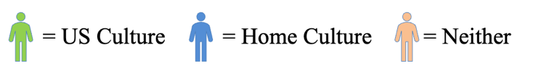
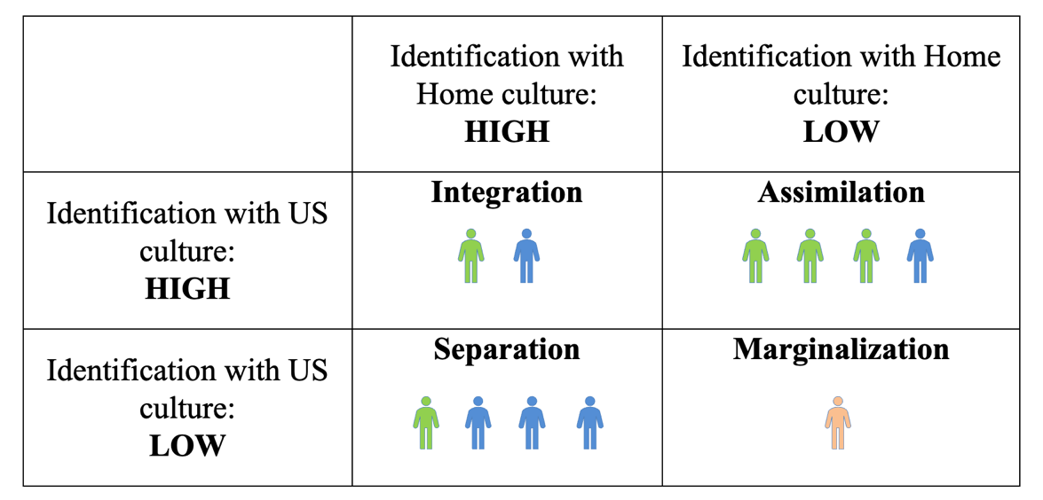

The theoretical framework also influences the methodology of the study. A qualitative phenomenological study will be used to explore the lived experiences of participants who have had direct experience with the phenomenon of acculturation and CRT (Merriam & Tisdell, 2016). By explicating the phenomenon of acculturation and CRT through lived experiences of participants, the essence of teachers’ CRT practices and Zomi students’ perceptions of these practices and acculturation experiences will be revealed.

Significance of the Study
Public schools in the U.S. are continuing to experience shifts in school-aged demographics (Iwai, 2019). Currently, one in four children in America are from immigrant families (Samson & Collins, 2012) and this number will continue to increase through 2065 (“Pew Research Center,” 2017). As immigrant youth enter the school environment, they are met with conflicting values, discourses, and cultural norms and must find strategies to ease their immigration experience (Berry, 1997). Researchers have emphasized the important role that teachers play when working with culturally, ethnically, racially, and linguistically diverse students in order to support their acculturation experience (Banks, 2004; Gay, 2002; Iwai, 2019; Samson & Collins, 2012).
While most teachers recognize the urgent need to support immigrant youth, many feel unprepared to do so (Gay, 2002; Iwai, 2019; Samson & Collins, 2012). Educators agree that in order to effectively teach immigrant youth, mastery of content knowledge and CRT practices are necessary (Gay, 2002). Teachers must develop and use a variety of approaches to integrate children’s cultural backgrounds into the school environment and curriculum. They must also demonstrate cultural sensitivity in order to build culturally responsive learning communities in which teachers work with students as partners to create the most optimal acculturation experience.
While a large body of research exists regarding the acculturation experiences of immigrants, a thorough review of the literature failed to reveal the acculturation experiences of Zomi immigrant youth in the school setting. This study will fill a gap in the literature by providing insight into the acculturation experiences of Zomi immigrant youth by exploring their strategy use within the school setting and their perceptions of culturally responsive teaching practices. The study will also expand the literature regarding teachers’ use of culturally responsive teaching practices by not only exploring the impact on students’ academic success but also their cultural and psychological well-being.

Definition of Terms
The following operational definitions of terms will be used in this study:
- Acculturation: The dual process of cultural and psychological change that takes place as a result of contact between two or more cultural groups and their individual members (Berry, 2005).
- Asian model minority: A stereotypical myth that characterizes Asian Americans as a polite, law-abiding group who have achieved higher levels of success (academically, financially, economically) than the general population (Blackburn, 2019) and that they experience little to no adaptive or acculturation problems (Yeh et al., 2005).
- Culturally Response Teaching (CRT): the use of cultural characteristics, experiences, and perspectives of ethnically diverse students as conduits for teaching them more effectively (Gay, 2002).
- Culture: the phenomenon of shared meanings, customs, ways of living, and understandings held by a group of people (Phinney, 1996).
- Ethnicity: membership in a group with a specific heritage, values, beliefs, and customs. Ethnicity is often affiliated with nationality (Phinney, 1996).
- Zomi immigrant: Immigrant of Myanmar affiliated with the Chin ethnic group.

CHAPTER 2: LITERATURE REVIEW
An Exploration of Zomi Immigrant Youth’s Acculturation Experiences in the Elementary School Classroom
Many people are born in one country and move, either forced or willingly, to another country during their lifetime (Schwartz, Unger, Zamboanga, & Szapocznik, 2010). The decision to leave one's country and move to another can be a painful, challenging, and discomforting process. Individuals and groups bring ingrained values and roles from their home culture to their new culture, and these values often conflict with existing values. As individuals and groups from diverse backgrounds merge and live together, a culturally plural society emerges. Often, cultural groups are not equal in power (numerically, economically, or politically) (Berry, 1997). Therefore, individuals and groups involved in cultural transitions must find strategies to cope with new societal-cultural pressures and standards. Acculturation is used to define this process of negotiation and encompasses the strategies individuals use to integrate themselves into the new culture.
For immigrant youth this process of negotiation is even more challenging as they lack the skills and strategies to navigate the school environment and their own identity construction (Berry, Phinney, Sam, & Vedder, 2006). As classrooms become more diverse, schools need to recognize effective methods for not only teaching immigrant children, but also supporting them during their acculturation experience (Richards, Brown, & Forde, 2007). This includes addressing children’s social, emotional, and adaptive needs (Igoa, 1995). To meet this challenge, teachers must create a classroom environment where culture and diversity are supported and where the strengths of children are identified and utilized to support achievement both academically and psychologically (Richards et al., 2007). The classroom environment also needs to include a space for children to explore and negotiate their own dispositions, discourses, and cultural practices as these have an impact on their identity construction (Gutiérrez, 2008).
The following literature examines acculturation and the necessary creation of Third Space in order to support CRT practices. Due to the limited research on Zomi immigrant youth, the studies throughout the literature review focus on varying Asian ethnic groups. However, a similar message exists across the literature. In order to support immigrant youth most optimally during their acculturation experience, educators need a space, a Third Space, which naturally supports the use of CRT practices.

Acculturation
In all societies, groups as well as individual members of dominant and non-dominant cultures experience some form of acculturation (Berry, 1997). One of the main principal conditions regarding acculturation is that at least two cultural groups must come into continuous first-hand contact (Teske & Nelson, 1974). While these interactions can occur in almost any intercultural contact, acculturation is most often studied with immigrants, refugees, or asylum seekers (Schwartz, Unger, Zamboanga, & Szapocznik, 2013). Of importance is that while early conceptualizations viewed acculturation as a unidirectional process (Park 1930; Gordon, 1964), more recent models, including Berry’s (1995) model of acculturation, view it as a bidirectional process (Arnett, 2002; Schwartz et al., 2013).
As long as there are culturally different groups interacting with one another, acculturation will continue to take place (Berry, 2005). Some long-term adaptations to acculturation include language acquisition, food preferences, forms of dress, and characteristics of social interactions. These adaptations can take place through culture shedding and culture learning (Berry, 1995). However, these adaptations can also create conflict during the acculturation process. In addition to individual and group variations, there are variations within and among families. Negotiation continues long after the initial contact within a society, thus making acculturation a continuous process. Two other terms are often associated with acculturation, ethnicity and culture. Ethnicity refers to membership in a group with a specific heritage, values, beliefs, and customs and is often affiliated with nationality (Phinney, 1996). Culture defines the phenomenon of shared meanings, customs, ways of living, and understandings held by a group of people.
Strategy Use
In Berry’s framework, two key issues are raised: the degree to which individuals wish to maintain their home culture and identity, and the degree to which individuals seek involvement within the new culture and larger society (Berry et al., 2006). When these issues intersect, the concept of acculturation is created. Berry’s (1997) four strategy framework can be used to describe how individuals express their acculturation experience. However, when applying Berry’s model of acculturation, it is important to remember the strategies are dynamic and fluid, not static. Meaning, variability in strategy use is based on an individual's goals, motives, and needs (Yeh, 2003). Therefore, even within the same person, strategy use may vary at different times during the acculturation process.
While research concludes that acculturation occurs at various rates and is dependent upon the variables at play, integration has been found to be the most optimal strategy and marginalization the least (Akiba, 2007; Berry, 2005; Choi et al., 2018; Yeh et al., 2005). Assimilation and separation, both of which entail individuals inhabiting either their host or heritage culture have been found to be maladaptive (Choi et al., 2018). Of interest is that both strategies have a differential impact among ethnic groups. Park et al. (2013) found that Asian American youth experienced racial and ethnic discrimination despite their self-assessed willingness and attempts to assimilate into the host culture. While Yeh et al. (2008) found that a majority of participants (67%) used several different acculturation strategies but preferred to use assimilation in help-seeking behaviors, such as requesting academic support from American peers. Although separation has been found to be the least adaptive strategy (Berry, 2005), it has been found to be beneficial in certain circumstances. This has been seen in immigrant groups who employed separation as a strategy to build social communities of support (Min, 2006). Examples of this include the Hmong community of St. Paul, Minnesota (Yang, 2015) and the Zomi community of Tulsa, Oklahoma (Eaton, 2016).
Acculturation Among Asian Ethnic Groups
The ability to contribute, operate, and interact in American culture and society has been linked to higher levels of acculturation success (Yeh, 2003). A possible explanation for this may be linked to one’s English language competency. Research continues to find a strong connection between one’s English language competency and overall ease of acculturation (Berry et al., 2006; Yeh, 2003). Asian immigrant youth who were able to function across their native and English language showed better acculturation adjustment overall (Lafromboise, Coleman, & Gerton, 1993; Yeh, 2003). Therefore, the ability to function in both English and one’s home language could prove more advantageous (Yeh, 2003) and serve as a predictor of higher levels of acculturation success (LaFramboise et al., 1993; Yeh, 2003). In other words, individuals who use integration as a strategy experience higher levels of acculturation success.
Sodowsky and Lai (1997) examined cultural adjustment among Chinese, Asian Indian, Vietnamese, Korean, Japanese, and Filipino immigrants. They found acculturation was significantly related to general and cultural stress during transition, and the more traditional aspects one maintained of their home culture, the higher level of distress found during acculturation. Furthermore, age was found as a predictor of acculturation distress. Younger immigrants lacked the social skills to form peer support groups, which are needed during the acculturation process. Their study further supports the importance of immigrant youth maintaining aspects of their home culture as this has an impact on their levels of distress during acculturation.

Factors Affecting Acculturation
In order to understand acculturation, one must look beyond the operational definition of acculturation and consider the interactional context in which acculturation occurs (Schwartz et al., 2013). Context includes the characteristics of the immigrants themselves, county of origin, socioeconomic status, resources, the area in which they immigrate to, and language. Yu and Wang (2011) also consider the impact of different contextual factors including closeness between home culture and host culture, cultural plurality or perception in the home culture, level of education, cultural identity, age, and gender.
The acculturation experiences of Southeast Asian Youth differ from that of most other Asian ethnic groups (Tam & Freisthler, 2015). They are at risk for poor adjustment because of the challenge of negotiating between their home and host culture. While many Asian immigrants from the Philippines, India, Korea, and China were admitted to the U.S. based on family sponsorships or personal endeavors (Rumbaut, 2006), many Southeast Asian immigrants were removed from their home countries as refugees due to war and ethnic genocide (Lederman, 2018). These circumstances have left Southeast Asian immigrants with little financial resources and working low-wage jobs with long hours (Tam & Freisthler, 2015). Furthermore, Southeast Asian immigrant parents often lack formal schooling experiences and are often poorly equipped to serve as an educational support for their children (Yang, 2004). This has a reciprocal impact on their children as parents are not equipped to help children with academic tasks. Therefore, children rely heavily on the support of the school system (Yang, 2004; Ngo & Lee, 2007).

A Culturally Responsive Space
As classrooms become more diverse and more immigrant youth enter the school setting, schools need to identify effective methods for not only teaching immigrant students, but also supporting them during their acculturation experience (Richards et al., 2007). This includes addressing their social, emotional, and adaptive needs (Igoa, 1995). To meet this challenge, teachers must create a classroom environment where culture and diversity are supported and where the strengths of students are identified and utilized to support achievement both academically and psychologically (Richards et al., 2007). The classroom environment also needs to include a space for students to explore and negotiate their own dispositions, discourses, and cultural practices as this has an impact on their identity construction (Gutiérrez, 2008). Gibson (1997) found that immigrant youth’s acculturation success was dependent upon a variety of factors including society of origin and society of settlement. Furthermore, factors such as age, gender, and previous schooling experience all influenced immigrant youth’s acculturation experience. Most important to his findings was that immigrant youth who were able to integrate new cultural knowledges within their existing cultural knowledges (integration) were more successful in the school setting than those who sought to assimilate to the new culture.
Research has indicated that Burmese immigrant adults have low English proficiency and low educational attainment (“Pew Research Center,” 2015). Therefore, the school is instrumental in the acculturation experiences of Zomi immigrant youth as it becomes the main source for students’ education and English language development. In order to best support Zomi youth in the school setting, the school needs to create a space, a Third Space, in which students can integrate their existing cultural knowledges and dispositions into the new culture. The following literature examines Third Space Theory and its implications for creating a culturally responsive space supportive of immigrant youth in the school setting.

Third Space Theory
Drawing from the work of several scholars and theorists, the construct of third space revolves around the continuous integration and reconstruction of knowledge, discourses, and human interaction (Gutiérrez, 2008; Moje et al., 2004; Soja, 1996). Winnicott (1989) postulated the idea of a transitional space which is used to examine how individuals creatively and actively respond to others and the outside world. He referred to this space as a holding environment, later termed Third Space, which bridged the gap between the individual and the environment. The concept of Third Space is often described as a hybrid of space, or spaces, created by the accumulation of knowledge from various resources (Moje et al., 2004; Yahya & Wood, 2017). Early conceptualizations of a Third Space focused on the teacher student dyad and how the formal and informal spaces interacted and intersected in order to create the potential for learning and the development of new knowledge (Gutiérrez, 2008). Gutiérrez, Baquedano-López, and Tejada (1999) further described Third Space as a hybrid of learning where students’ linguistic or cultural norms are transformed due to the linguistic and cultural norms of the school, teacher, or classroom. Several studies have displayed that the creation of Third Space is advantageous for immigrant youth by providing them with the opportunity to explore, express, and engage in personally meaningful ideas and identity-affirming activities (Gutiérrez, 2008; Kennedy, Oviatt, & De Costa, 2019).
A space of reform, negotiation, and collaboration. Bhabha (1994) described culture as the site of collaboration and negotiation that takes place within the larger society. A site where overlap and displacement regarding domains of differences including race, class, gender, and ethnicity occurred. He further looked at the impact of power and misrepresentation among competing communities. Despite the shared histories of many communities (deprivation, discrimination, alienation, etc.), Bhabha struggled to find a collaborative and dialogic exchange of values, meaning, and priorities among groups. Bhabha (1994) contextualized his analysis of culture in post-colonialism because it challenged the unequal and misrepresentation of cultures due to political and social authority in the larger society. He suggested cultural misrepresentation was due to an antagonistic and conflictual struggle centered around power.
Gutiérrez (2008) further elaborated on Bhabha’s (1994) construction of Third Space to include the relationship between Third Space and learning. Gutiérrez’s (1993) early conceptualizations of Third Space focused on the multiple layers, powers, and structures of the classroom. He suggested that differences in learning, participation, and involvement of children in the classroom were influenced by the teacher’s script (Gutiérrez, 2008). The teacher script, or monologic script, is the primary script in the classroom and is reflective of the values and practices of the dominant culture (Goffman, 1961). By examining the various interactions in the classroom as influenced by the teacher script, he noted the creation of multiple social spaces which supported authentic interactions and shifted the understanding of knowledge and learning (Gutiérrez, 2008; Gutiérrez, Rymes, & Larson, 1995).
Following the early understandings of multiple social spaces, Gutiérrez (2008) set out to better understand the impact of culture on social spaces. He attended to the ways in which individuals negotiate, extend, challenge, and reinforce their dispositions and cultural practices within the Third Space. Children are exposed to many different discourses and need access to various resources in order to navigate the natural world. For Gutiérrez, the nature of these different discourses yielded the need for a Third Space in order to provide immigrant students with the tools necessary for social and cognitive development within the school environment.
Third Space in the school environment. Moje et al. (2004) posited that Third Space falls into three conceptualized views. One view describes Third Space as a bridge connecting knowledges and discourses often marginalized in the school setting due to the dominant culture (Gutiérrez, 1993). This space allows marginalized voices the opportunity for success in school by increasing their academic engagement and knowledge production (Moje et al., 2004). The second view describes Third Space as a navigational space providing children with the opportunity to cross between different discourses or communities (Fitts, 2009). A navigational space further supports children as they bring their own funds of knowledge into the school setting (Moje et al., 2004). The final view describes Third Space as a transformational space in which different cultural, social, and epistemological discourse merge. In a transformational Third Space, home, school, and/or community-based funds of knowledge integrate to create new forms of learning and knowledge (Fitts, 2009). Figure 9 displays the three conceptualized views of Third Space.
Figure 9
Conceptualized views of Third Space

All conceptualizations of Third space prove productive, valuable, and beneficial for educators and children in the school setting (Fitts, 2009; Gutiérrez, 2008; Moje et al., 2004). For the immigrant child, these conceptualizations of Third Space are even more instrumental as they promote and support bilingualism, biculturalism, and multiculturalism within the classroom and larger school environment (Fitts, 2009; Manyak, 2002). Furthermore, it provides children from diverse cultural and linguistic backgrounds the opportunity to gain the skills necessary for successful knowledge production (Moje et al., 2004). The ultimate goal is to create a space in which new knowledges and discourses are framed within what is already known. By welcoming and celebrating the various cultural, social, and epistemological discourses in the school setting, schools can create a space in which new knowledges are constructed, merged, and transformed.
Transforming discourses and knowledge. Within the school context, negotiation often takes place regarding participation, the production of knowledge, and the creation of meaning due to power injustices (Fitts, 2009; Moje et al., 2004). Bhabha’s (1994) construction of Third Space is situated in postcolonialism and the privilege of power. Schools are often created with an assimilative mindset, meaning only certain discourses, ideologies, and traditions are included and validated within. Therefore, children from diverse cultural backgrounds often struggle to find a harmonious balance between the differing discourses. Bhabha (1994) suggests that academic discourses are akin to the colonizer and limit the learning of students from diverse backgrounds. Content areas such as reading, writing, and language can act as colonizers by only validating certain knowledges, discourses, and cultures. Gutiérrez et al. (1995) also focused on the uneven distribution of power and the various ways in which it was exemplified in the social spaces of the classroom, especially through the teacher script.
The creation of a Third Space forces social change within the classroom. A teacher who is conscious of the existence of Third Space does not project a script of existing institutional structures, knowledges, and ideologies (Soja, 1996). Rather, the teacher and children work together to create a dialogic and transitional space where power is unidirectional and multiple discourses are supported. Bhabha’s and Gutiérrez’s view of Third Space suggests that academic knowledges and discourses should not be exclusive to the privileged colonizer. Instead, a reconstruction of academic and social discourses needs to take place in order to support the multiple discourses of children from diverse backgrounds in the school setting.
Finding and working towards a Third Space in the school environment is challenging given the structural and institutional constraints. However, several studies have highlighted how Third Space serves as a way to merge students’ sociocultural and linguistic experiences with the curriculum (Fitts, 2009; Gutiérrez, 1995; Piazza, 2009). Fitts (2009) examined the ways that students and teachers constructed Third Space in a dual-language classroom. Students’ funds of knowledges and personal experiences were used to connect, transform, and merge academic tasks and discourses found within the school setting to enrich their learning experiences. By doing so, a space and opportunity was created to work out differences in power, ways of knowing, and ways of learning; thus, supporting students from diverse backgrounds.
Several other studies have also examined teaching practices within the Third Space in order to challenge the teacher/student binary and create a space that honors and emphasizes students’ diverse cultural backgrounds (Kennedy et al., 2019; Souto-Mannin & Martell, 2016). Kennedy et al. (2019) investigated the use of multimodal and multicultural learning activities with 4th grade Chin refugees. The activities allowed students to engage in conversations about Chin and American cultures and share various experiences, perspectives, and challenges they faced during their acculturation experience. When students were provided with a space to negotiate and merge various and differing discourses and knowledges, they felt supported in their cultural and linguistic explorations. Darvin (2015) suggests that the creation of Third Space serves as a natural support for immigrant’s youth acculturation experience.

Culturally Responsive Teaching
Since the 1980’s, anthropologists have examined the impact of culture on instruction and academic success (Ladson-Billings, 1995a). Au and Jordan (1981), who coined the term culturally appropriate, were among the first anthropologists to incorporate children’s cultural backgrounds into their instruction. During reading instruction, they allowed children to use talk-story, which was a common form of communication among Native Hawaiian children. This had a positive impact on children’s’ standardized reading tests. Similar work was conducted by Mohatt and Erickson (1981) who used the term culturally congruent to describe how they incorporated children’s language patterns into the school setting. This resulted in the creation of a learning environment that was responsive and more beneficial to children from diverse backgrounds.
Ladson-Billings (1995a) believed these early terms implied that children accommodate or assimilate to the mainstream culture instead of creating a more dynamic relationship between their home culture and school culture. From this stemmed the theory of culturally relevant teaching which is a type of teaching that supports students academically, socially, and emotionally (Aronson & Laughter, 2016). Additionally, it challenges the discourses and social inequalities in place by the mainstream culture which are commonly found in large social institutions such as schools (Ladson-Billings, 1995a).
For Ladson-Billings (1995b) culturally relevant teaching is supported by three criteria. First, children must develop the skills necessary for academic success. These skills will vary depending on children’s cultural tools (Miller, 2016). However, scaffolding from a more knowledgeable other provides children with the opportunity to develop an understanding of the cultural tools necessary for success (Miller, 2016; Vygotsky, 1978). Second, children must maintain some cultural identity (Ladson-Billings, 1995b). Teachers who are culturally relevant integrate children’ home culture to support learning in the school environment. Third, culturally relevant teachers must move beyond children’s grounded academic skills in order to develop a more sociocultural consciousness (Ladson-Billings, 1995b). This allows children to engage in a critical analysis of cultural norms and values in order to create a more developed and diversified perspective on society.
Gay, who uses the term culturally responsive teaching (CRT), has been recognized as one of the most prominent authors regarding CRT pedagogy (Rychly & Graves, 2012). She describes CRT as the use of “cultural characteristics, experiences, and perspectives of ethnically diverse students as conduits for teaching them more effectively” (2002, p. 106). Cultural characteristics include differences in values, customs, and languages between students and teachers (Gay, 2001). It also encompasses differences in communication styles, relationships, and methods of learning.
Gay (2010) built upon previous notions of CRT and argued that children's academic achievement was directly influenced by the teacher’s cultural responsiveness. When teachers embed academic knowledge within the lived experiences and backgrounds of children, they are creating more meaningful, thorough, and appealing learning opportunities (Gay, 2001). As a result, children from diverse backgrounds will experience higher levels of academic achievement because they are learning through their own cultural filters. Hilario, Vo, Johnson, and Saewyc (2014) studied the relationship of Southeast Asian youth’s acculturation experiences and mental health. Their study revealed that family and school connectedness was associated with lower odds of extreme despair and stress. Additionally, they found that higher levels of cultural connectedness (integration) were related to lower odds of extreme despair.
Gay (2010) also stressed the need for schools to educate students from diverse backgrounds through their own cultural filters in order to increase their engagement, effort, and achievement in the school setting. As Hilario et al.’s (2014) study revealed, this also supports their mental health by lowering their odds of despair. In order to assess the success of individual or institutional practices of CRT, Gay developed a list of 18 principles or pillars of CRT. The platform of her pillars is built upon the idea that children’s cultural characteristics and perspectives are the main platform for knowledge construction. Table 5 summarizes Gay’s (2010) 18 pillars of CRT.

Table 5
Geneva Gay’s (2010) 18 Pillars of Culturally Responsive Teaching
18 pillars of CRT
- Is integral to all classes and all skills taught
- Enhances learning for all, not some, students
- Happens systematically, continuously, and purposefully, not just sometimes
- Cultivates success for all aspects of a person without negatively affecting cultural identity
- Integrates context, culture, and lived experiences of students of color into curriculum
- Creates a classroom culture of academic, success, collaboration, reciprocity, and community
- Reflects students’ differing perspectives and cultures in all inter-related areas of curriculum, school and classroom climate, instruction, and communication styles.
- Uses both general group and individual student cultural patterns
- Provides accurate information about contributions of members of ethnic groups, discussion of moral or ethical issues, power and privilege or distribution and deconstruction of academic racism and hegemony
- Teaches students of color the informal, unstated, implicit rules and behaviors needed to succeed
- Uses multiple assessments like cultural preferences, participation, communication styles
- Empowers students with tools for continuous self-assessment
- Demands with genuine caring and appropriate amounts of assistance that students achieve high levels of academic success
- Scaffolds learning between school culture and content and students’ funds of knowledge
- Helps students imagine a different life, create goals, and pursue a path to their dreams
- Develops intolerance for oppression and moral courage to address injustice and promote justice
- Requires professional development to improve cultural knowledge, teaching skills, reflection, and self-monitoring of classroom situations for students of color
- Uses school or teacher resources of time, funds & imagination for student success

A Cultural, Academic, and Psychological Approach to CRT
Igoa (1995) implemented a threefold intervention in her work with immigrant children. Through dialogic intervention, she created and integrated an interdisciplinary model that includes cultural, academic, and psychological aspects, known as CAP. Cultural and psychological aspects serve as the foundation for intervention which are then used to pave the way for academic intervention. She emphasizes that all three components must remain balanced in order to support the development of the whole child. The goal of CAP intervention is to maintain and connect children’s native culture to academic achievement (Igoa, 1995). Thus, the approach requires the creation of Third Space; a space in which children can frame their new knowledges and discourses within what is already known. The teacher’s role is to act as a mediator and provide children with the necessary tools for cultural, academic, and psychological success. The following literature embeds Gay’s (2010) 18 pillars of CRT into the CAP framework. Doing so allows the researcher to explore each area of the CAP model as supported by Gay’s 18 pillars of CRT. The integration of the two models is also used to support the methodology of the study.

18 Pillars of CAP
When educators use the pillars to examine CRT practices, effectiveness needs to be examined within context (Gay, 2010). Igoa (1995) emphasized the importance of focusing on the cultural or psychological aspects of intervention first but keeping the academic aspects clearly in focus so children understand its importance in the school setting. As seen in Figure 2, by embedding Gay’s 18 pillars (see Table 6) CRT into Igoa’s threefold CAP model, educators can begin to determine the effectiveness of classroom level implementation of CRT and how those pillars break out into cultural, academic, and psychological practices.
Table 6
18 Pillars of Cultural, Academic, and Psychological Intervention (CAP)
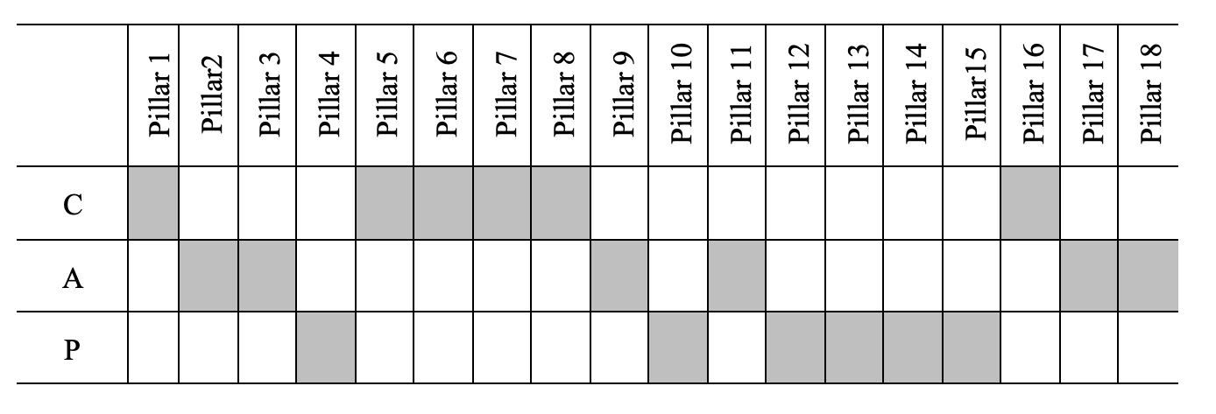

Cultural Intervention
Understanding the cultural characteristics of children from diverse backgrounds is imperative for effective CRT implementation (Pillar 1) (Gay, 2002). Culture encompasses the customs, social institutions, roles, expectations, and languages of a given social group (Samuels, 2018. Gay (2010) places culture as the conduit for which all other learning takes place. Within the school setting there are some aspects of culture that are more valuable to educators because they have a direct impact on teaching and learning (Gay, 2002). Children’s traditions, cultural values, relationships, and learning styles are among some of the aspects educators need to develop a strong understanding of. Educators should also consider different ethnic groups’ approaches to education, motivation, and task performance and how these differences play out in interactions and socializations within the school setting (Pillars 5 & 6).
Several studies have highlighted that when teachers are aware of students’ linguistic and cultural backgrounds and incorporate this knowledge into their teaching practice, students experience greater success in school (Ladson-Billings, 1995a; Nieto, 2010; Stowe, 2017). Irizarry and Antrop-Gonzalez (2007) constructed narratives with Puerto Rican students in order to positively inform their teaching practices by incorporating students’ cultural backgrounds into the school environment. The researchers found that teachers must address each student’s unique identity and create a sense of connectedness. Teachers in the study valued the cultural capitol students brought with them to school and supported the use of their native language and culture. Several students described how their teacher authentically cared about their culture and genuinely wanted to learn more.
Like Irizarry and Antrop-Gonzalez (2007), Auslander (2018) investigated the impact of teaching practices and collaboration centered around culturally and linguistically responsive instruction for newcomer English Language Learners (ELLs). Her findings revealed that school partnerships and collaboration centered on student’s cultural and linguistic backgrounds helped to generate a welcoming climate that addressed students’ needs both inside and outside of the school environment. More importantly, her findings revealed the importance of using student’s home language as a powerful tool for supporting English language development which also affirmed and validated other linguistic perspectives and forms of cultural knowledge in the school setting.
Educators are cautioned when using homogenous identifiers to study different ethnic groups because, even within groups such as Asians, there is much diversity regarding language use, customs, experiences, and traditions (Yeh et al., 2005). This can be observed in the stark differences between Burmese and other Asian ethnic groups. Gay (2002) recommends that educators develop detailed and factual information about specific ethnic groups’ cultural particularities and to use this information as a conduit for teaching (Pillar 8 & 16). For example, Souryasack and Lee (2007) wanted to engage and improve Laotian student’s writing by focusing on their own experiences and connecting their writing back to their cultural heritage. At the beginning of each workshop, the teacher and students engaged in individual conferences about Laotian heritage. The teacher and students worked together to find readings, current events, or poetry that were reflective of Laotian culture and how Asian culture in general is represented and misrepresented in the U.S. Although the study did not correlate with students’ academic outcomes, the study did reveal students’ increased motivation and positive attitudes towards writing. Most importantly, their findings revealed how their use of CRT provided a space for students to critique discourses of power thus supporting the integration of students’ own discourses and knowledges into the school environment.
Many challenges exist for immigrant youth, but for those who come to the U.S. from war torn countries often experience greater challenges because they have received little to no formal schooling experience (Aronson & Laughter, 2016). Considering this, Nykiel-Herbert (2010) examined the academic performance of Iraqi refugee youth who participated in 50-60 minutes of pull-out English as a Second Language (ESL) instruction per day. Although providing instruction in the Iraqi students’ native tongue was not possible, students were encouraged to use their native tongue, Kurdish and Arabic, for communication and collaboration in the ESL classroom. Their findings not only reveled the success of extra instructional time and support, but that the creation of a learning environment supportive of their home culture and language use enhanced their success.
Gay (2013) posits that understanding cultural differences is an essential component to the foundation of the CRT framework. While several studies support the importance of incorporating students’ cultural backgrounds into the school environment (Nieto, 2010; Nykiel-Herbert, 2010; Souryasack & Lee, 2007), this cannot be accomplished without the creation of a space, a Third Space, in which differing discourses and knowledges can exit harmoniously (Gutiérrez, 2008). In sum, educators must not only develop an understanding of student’s unique cultural and ethnic backgrounds, but also consider the creation and role of Third Space in supporting, engaging, and representing students’ diverse backgrounds.

Academic Intervention
In addition to developing a knowledge base of student’s cultural needs, educators must be able to convert this knowledge into culturally responsive instruction and design (Gay, 2013). Ladson-Billings (1994) and Delpit (1995) reported that when children’s real-life experiences were acknowledged and connected to the curriculum, they were more engaged and responsive to instruction. Gay (2002) highlights three curriculums in which educators should consider in order to effectively implement CRT. First, educators need to determine the strengths, weaknesses, and gaps of the formal curriculum. Educational institutions have formal plans for instruction in place approved by district boards, state institutions, and governing bodies. However, these formal plans are not always culturally responsive and avoid issues such as racism, powerlessness, and historical travesties.
Aronson and Laughter (2016) describe how there is a discourse of invisibility for non-European groups within formal school curriculums. Through close and critical analysis of curricula, CREs can make the changes necessary to create culturally relevant curricula (Aronson & Laughter, 2016; Igoa, 1995). An example of this is outlined in a study by Coughran (2012) who examined the impact of CRT on student outcomes. Coughran taught two culturally responsive lessons a week with her kindergarten students and found that when she connected their lived experiences to the curriculum, they not only developed an understanding of racism, but the community of the classroom was also strengthened. True cultural academic analysis focuses on the accuracy, variety, significance, and authenticity of curricula while developing a community of learners (Pillar 9) (Ladson-billings, 1995a).
After educators examine the formal curriculum, they then need to consider the symbolic curriculum (Gay, 2002). This includes the images, symbols, celebrations, and artifacts that are used to teach children (Pillars 2, 3, & 9). The most common forms of symbolic curriculum include trade books, decorations, images of heroes and heroines, occupations, and displays of achievement (Gay, 2002). CREs are aware of the symbolic curriculum and the power, meaning, value, and action it conveys about different cultural groups. They are also aware of the misrepresentation of different cultural groups through the symbolic curriculum (Igoa, 1995).
When educators are aware of the symbolic curriculum, they are better equipped to integrate student’s home culture into the school environment (Ladson-Billings, 1994). The selection of quality literature, which can support and bring awareness to similarities and differences among individuals, is one example of how educators can mitigate the effects of the Eurocentric symbolic curriculum (Conrad, Gong, Sipp, & Wright, 2004). This can be seen in Conrad et al.’s (2004) work in which they integrated texts representative of students’ diverse backgrounds in combination with Text Talk to develop students’ language and comprehension. Texts that were selected reflected the cultural heritages of different ethnic groups, contained illustrations that represented different ethnic groups, and supported student’s understanding and development of tolerance and respect for other cultures. Through Text Talks, students engaged in discourse regarding misrepresentations among different ethnic groups and connected their experiences to the texts they were reading while supporting their oral language and vocabulary development.
Rychly and Graves (2012) caution against the hidden curriculum in which books, images, and posters display what and whom is most valued both in and out of the school environment. Culturally responsive educators need to ensure the symbolic curriculum of the classroom represents a wide array of ages, genders, social classes, and positions of power across ethnic groups. The physical classroom environment serves as an extension of the formal curriculum and is used as an advertising space in which children can learn. Overtime and through continuous exposure, children learn to value what is present and visible and devalue what is absent and hidden within their classroom environments (Gay, 2002).
The third curriculum CREs need to consider is the societal curriculum (Gay, 2002). This includes the knowledges and discourses displayed through mass media including TV, internet, games, movies, and newspapers. Societal curriculum is more than the transmission of information or entertainment; it also reflects and conveys certain cultural, societal, political, and social expectations and standards. Unfortunately, for some children, this is their only source of exposure to diversity and often what is portrayed through the societal curriculum is inaccurate and prejudicial (Aronson & Laughter, 2016; Gay, 2002). However, in the classroom environment, educators can create a site for social change and social justice education (Pillar 2, 3, & 9) (Arson & Laughter, 2016). Ladson-Billings (1995b) emphasized the teacher's role and obligation in developing children's sociopolitical consciousness to critique, understand, and recognize social inequalities. Sociopolitical consciousness begins with the teacher’s recognition of injustices regarding race, ethnicity, gender, and class before critiquing the societal curriculum (Arson & Laughter, 2016; Ladson-Billings, 1995b).
Regarding academic intervention, Igoa (1995) highlights another area that educators must consider for effective CRT implementation. In a culturally responsive classroom, it is not only important that children feel academically challenged through culturally responsive curricula, but also that they feel successful (Pillars 11, 17, & 18). Immigrant children vary regarding their previous school experiences, immigration experiences, formal schooling experiences, and exposure to the English language (Yeh et al., 2005). Educators must consider all these different factors when providing academic intervention. During Igoa’s (1995) work with immigrant children, she conducted dialogic interviews in order to develop a better understanding of their previous schooling experiences. She found that children did not progress naturally through grades which created a very fragmented schooling experience. Mobility was also prominent among children as many had moved either intrastate, interstate, or even globally. Dialogic interviews allowed Igoa to investigate children’s academic history so she could fill in the educational gaps and provide appropriate academic intervention accordingly.

Psychological Intervention
For Igoa (1995), the teacher acts not only as a guide, helping children recognize their own cultural beliefs and practices, but also as a student, learning from children just as they learn from the teacher. Her approach to psychological intervention stems from dialogic intervention which encourages and supports children in their willingness to engage in conversation with the teacher regarding their different lived experiences (Igoa, 1995). Embedded in sociocultural psychology and the theoretical ideas of Bakhtin (1981), dialogic intervention gives children the power of talk (Skidmore, 2006; Snell & Lefstein, 2018). It is more than good dialogue (Bushe & Marshak, 2016) as it addresses the feelings and emotions of children through the development of close relationships (Igoa, 1995). Such dialogue should encourage children to ask questions about diversity and differences and provide them with the opportunity to discuss real world injustices, inequities, and social influences (Samuels, 2018). Furthermore, dialogue is grounded in positive language which focuses on children’s successes, confidence, and academic ability instead of failures, disadvantages, or inequities (Pillar 15) (Gay, 2010). The approach draws from Vygotsky’s sociocultural approach by embedding children in a sociocultural matrix (Snell & Leftstein, 2018). It is within these different sociocultural contexts that meaning is co-constructed through the interactions and dialogue with others and it is mediated by the more knowledgeable other (Pillar 10).
Bakhtin’s (1981) theory draws attention to monologic and dialogic discourses. In a monologic classroom, talk is controlled by the teacher and the purpose is to transmit knowledge from the teacher to the children. Gutiérrez (1993) referred to monologic discourse as the teacher script. In contrast to a monologic classroom, a classroom that emphasizes dialogic discourse is based upon the shared interaction between the teacher and children (Skidmore, 2006). The teacher is expected to establish high expectations for participation so children feel encouraged to participate in discussions in which multiple perspectives are shared (Pillar 4, 12, & 13) (Samuels, 2018). Larson, Bradshaw, Rosenberg, and Day-Vines (2018) studied whether teachers’ self-efficacy and use of CRT practices were associated with student behavior at the classroom level. Teachers focused on relating lessons to students’ lived experiences, successes, and real-world applications through the creation of dialogic discourse in the classroom environment. Their findings revealed that their use of CRT practices and dialogic discourse was related to more positive ratings of proactive behavior management and observed student behavior. Thus, teacher’s self-efficacy, CRT, and dialogic discourse support positive student behavior outcomes.
Researchers have continued to look at immigrant youth’s psychological well-being in the school environment in order to support their personal and social development as well as their ethnic identity development (Berry et al., 2006; Gonzalez, Eades, & Supple, 2014; Homma & Saewyc, 2007). Williams and Butler (2003) listed several concerning factors regarding immigrant youth’s arrival to the U.S. including typical developmental concerns, English language development, creation of social support groups, feelings of acceptance, coping with posttraumatic stress, and understanding different cultural norms. These factors have implications not only for academic success, but also for social and interpersonal adaptation (Berry et al., 2006). Therefore, supporting immigrant youth in these tasks is essential for their academic achievement, personal growth, and psychological well-being.
Homma and Saewyc (2007) utilized a school-based census to examine the correlation between school and emotional distress among Asian-American minority youth. Their findings revealed that minority youth who had negative perceptions of school displayed lower levels of self-esteem, which in turn was associated with great levels of emotional distress. To combat this, Gonzalez et al. (2014) describes how school personal can work towards positive social and emotional development by support immigrant youth’s ethnic identity development. Supporting immigrant’s ethnic identity development includes engaging in discourse regarding one’s cultural group and affirming feelings of pride in one’s cultural beliefs, behaviors, and traditions. Other researchers have found that supporting immigrant’s ethnic identity has also been linked to positive outcomes such as improved coping skills, self-esteem, academic success, and school adjustment (Fulingni, Witkow, & Garcia, 2005; Kiang, Yip, Gonzales-Backen, Witkow, & Fulingni, 2006). These findings highlight the importance of creating safe, secure, and caring environments which are culturally sensitive, supportive, and responsive to immigrant youth’s psychological well-being.
Dialogic discourse, in conjunction with CRT practices, creates an opportunity for children to participate in the construction of their own knowledge and identity development thus supporting their psychological well-being (Berry et al., 2006; Fulingni et al., 2006; Skidmore, 2006). It is important to note that dialogic intervention is more than communication, it is also a social relationship with emotional aspects of communication (Alexander, 2010). Emotional factors include trust, respect, concern, appreciation, and hope while tolerance, patience, and openness outline communicative factors. The teacher serves as a mediator and a member of the learning community guiding and coaching children through various psychological situations (Pillar 14) (Igoa, 1995).

Conclusion
The current literature displays how immigrant students’ cultural, academic, and psychological needs can be supported through the construction of Third Space and CRT practices. In a Third Space classroom, power is unidirectional, new representations and interpretations of the material world are fostered, and multiple discourses are supported. The teacher serves a vital role in creating an environment in which a Third Space can exist. Through CRT practices embedded within the CAP framework, educators can create a Third Space that provides immigrant students the opportunity to negotiate, deconstruct, and reconstruct their knowledges and discourse thus supporting their cultural identity. Ladson-Billings (1995b) emphasized that true CRT does not simply bridge knowledges and discourses, instead, true CRT brings together multiple cultures that can be supported through the creation of Third Space. As immigration continues to increase (Zong et al., 2017) and societies become more culturally plural (Berry, 1997), the school has an obligation to create an environment that promotes identity development and one that is not reflective of certain institutional structures, knowledges, or ideologies. Through a culturally responsive Third Space, educators can provide immigrant students, an often-marginalized group, the resources and tools necessary for a successful acculturation experience (Moje et al., 2004).

CHAPTER 3: METHODOLOGY

Research Design
The purpose of this qualitative phenomenological study is to 1) gain insight into teacher’s CRT practices, 2) students’ perceptions of these practices, and 3) students’ strategy use. A phenomenological research design is utilized in order to share the lived experiences of teachers and Zomi students (Merriam & Tisdell, 2016). This study will also utilize a multiple, bounded, case study design (Yin, 2018) in order to investigate these phenomena within the same elementary school. In using a case study design, the researcher’s goal will be to explore the phenomenon at study across each case individually. Teacher and student interviews, and a teacher self-efficacy scale will be used to answer the following research questions:
- What culturally responsive teaching practices (cultural, academic, and psychologic) do teachers utilize to support Zomi immigrant youth?
- How do Zomi immigrant youth perceive the cultural, academic, and psychological practices within their classroom?
- Within the classroom environment, what strategies (assimilation, separation, integration, marginalization) do Zomi immigrants use during their acculturation experience?

Participants and Setting
Participation in the study will be done in a purposeful and selective manner (Shenton, 2004). Consent forms from teachers, parents of student participants, and the students will be required prior to participation in the study (see Appendix A). All participants will be given pseudonyms in order to protect their identity
The researcher will contact the English Language Development (ELD) coordinator at the school in order to develop a list of potential student participants based on the following criteria: Zomi immigrant student in 2nd through 4th grade who has lived in the U.S. for at least two years. The two-year criteria is used so participants have had at least two year of exposure to the English language. Participants who meet the select criteria will be given a parent consent form to take home to their parents to sign and return to their home room teacher if they are willing to participate in the study. The researcher will collect signed parent consent forms from teachers a week after distribution. Parent consent forms will be translated to Zomi by Thawng Hatzaw, an interpreter and translator for the City of Tulsa (see Appendix B). Ellevation, an online school database, will be used to obtain basic demographic information, English Language Proficiency (ELP) test scores, and instructional information related to each student’s English language development.
Teacher participation will also be done in a purposeful and selective manner (Shenton, 2004). Teachers of second to fourth grade students will be emailed a link to a Qualtrics survey. The survey will contain a consent form, demographic questionnaire, and the Culturally Responsive Teacher Self-Efficacy Scale (CRTSE) (see Appendix C). Only participants who complete the survey and opt in to participate in an interview will be considered for participation in the study.
The setting for the study will take place at a large public elementary school in the Midwest with approximately 2,000 students enrolled in grades pre-kindergarten through 4th grade. The school is a Title 1 school with 61% of its students on the free or reduced school lunch program. Students can receive Title 1 reading and math support, as well as ELD services. The school is diverse with over 40 languages represented. Overall, 1,105 students are identified as Zomi or Burmese in the district. Due to a well-established community of Zomi immigrants within the school’s boundary, ⅓ of the Zomi population attends the school in which this study will be conducted. Prior to conducting the study, the district will be contacted for permission to implement the study. Per the school district’s policy, a research request form will be filled out and returned to the assistant superintendent for approval (see Appendix D).

Data Sources and Procedures
Data sources will include student interviews, teacher interviews, and the researcher’s field notebook. The use of multiple data sources will help ensure triangulation of the study (Bazeley, 2013). Interviews will take place on the school’s campus. Zoom, an online video communication platform, will serve as a back-up setting for conducting teacher interviews if scheduling conflicts arise. An audio recording device will be used for all interviews in order to accurately document participants’ responses. If the teacher is interviewed using Zoom, the interview will be recorded through the program. All interviews will be transcribed verbatim and uploaded into Dedoose (n. d.), an online program for data analysis. Table 1 and Table 2 (see Appendix E) align the student and teacher interview questions with the research questions.
Student interviews. In phenomenological studies, interviews serve as the primary method for data collection (Merriam & Tisdell, 2015). They focus on uncovering the essence of an individual’s lived experience (Seidman, 2013). A semi-structured interview will be used to explore students’ perceptions of the culture, academic, and psychological practices in their classrooms as well as their use of acculturation strategies within the school setting (Merriam & Tisdell, 2015). An interview protocol will be used, but all questions will remain flexible with allowance for expansion as necessary (see Appendix F). Each participant will be interviewed once for approximately 25-minutes.
Teacher interviews. A semi-structured interview will be conducted with the teachers of student participants in order to explore their knowledge, skills, strategies and practices in place for Zomi immigrant youth in their classrooms. An interview protocol will be used, but all questions will remain flexible with allowance for expansion as necessary (see Appendix F). Each interview will take approximately 45-minutes to conduct.
Culturally Responsive Teaching Self-Efficacy Scale (CRTSE) (Siwatu, 2007). The scale has been approved for use in the study by Kamau Oginga Siwatu, professor of educational psychology at Texas Tech University (see Appendix H). The scale will be used to elicit information from teachers regarding their use of CRT practices. The scale consists of 41 Likert items in which participants rank their degree of confidence in implementing CRT practices ranging from 0 (no confidence at all) to 10 (completely confident). Participants who score higher on the CRTSE scale feel more confident in their ability to implement CRT practices in comparison to those who have lower scores feel less confident. Internal reliability for scores on the measure is .96 (Siwatu, Putman, Starker-Glass, & Lewis, 2015).
Field notebook. A field notebook is understood as an essential component to qualitative research as it enriches data and provides rich context and description for analysis (Phillippi & Lauderdale, 2017). Each field entry will be documented with the date, time, location, and context in order to aid in thick description of the study (Bazeley, 2013). During interviews, the field notebook will be used to capture the thoughts, impressions, reactions, and observations of the researcher (Phillippi & Lauderdale, 2017). It will also be used to capture participant’s emotions, body language, and interactions during the interviews. This will allow the researcher to gather information that may not have been evident through the transcripts. At the end of each interview, the researcher will record personal thoughts, reactions, reflections, and final notes.
During data analysis, Dedoose (n. d.) will serve as a digital field notebook. The memos section will be used to document the researcher’s thoughts, reactions, and coding processes during data analysis. As codes are changed, deleted, or merged, the memos section will aid in the management and organization of the coding process (Bazeley, 2013).

Data Analysis
Data analysis will take place concurrently with data collection in order to help the researcher cycle back and forth between thinking about existing data and collecting new data (Miles et al., 2014). This will also help the researcher fill in any blind spots during data collection. The CRTSE will be used to collect descriptive data from teacher participants regarding their classroom demographics and confidence in implementing CRT practices.
Coding, a fundamental task for qualitative analysis, is typically divided into two cycles: first cycle coding and second cycle coding (Saldaña, 2013). First cycle coding consists of initial codes assigned to chunks of data (Miles et al., 2014). Second cycle coding groups first cycle codes into smaller categories, themes, or constructs. Based on the literature and theoretical framework, priori codes will be applied during first cycle coding (Bazeley, 2013). Priori codes are a start list of codes covering a range of phenomena expected to be in the data. First cycle codes will be based on Gay’s (2010) 18 pillars of CRT and divided into student perceptions and teacher practices. Second cycle coding will be used to group first cycle codes into categories based on Igoa’s (1995) three-fold intervention (culture, academic, and psychologic), Berry’s model of acculturation (assimilation, separation, integration, and marginalization), and possibly areas of Third Space. Upon completion of data analysis, similarities and differences among student and teacher perspectives and practices will be explored in order to synthesize, understand, and covey the phenomenon at study (Bazeley, 2013). Examining student and teacher perspectives will also contribute to triangulation of the study by examining the cultural, academic, and psychological practices in place from varying perspectives.

Trustworthiness
In qualitative research, a small, purposeful sample is selected because the researcher wishes to understand the phenomenon in depth (Merriam & Tisdell, 2015). Due to this, concepts of validity and reliability cannot be addressed in qualitative research. Guba and Lincoln (1982) propose four criteria that should be considered by qualitative researchers in pursuit of a trustworthy study: credibility, transferability, dependability, and confirmability. The following section discusses how the researcher plans to achieve trustworthiness.
Credibility. Credibility will be established through triangulation, rapport building in informants, iterative questioning, debriefing sessions, peer scrutiny, reflective journaling (field notebook), thick and rich description of the study, and examination of previous research (Shenton, 2004). Triangulation will be ensured through various data collection methods including interviews, surveys, and a field notebook. The use of different methods enhances the quality of data from different sources and compensates for limitations within each method (Anney, 2014). Participants will be ensured their participation in the study will not have any effect on their schooling experience or job and that their responses will remain anonymous. During the interviews, rapport will be developed by encouraging participants to be honest and open. Iterative questioning will be used to probe and elicit detailed data during the interviews. Debriefing sessions will be conducted between the researcher and her committee as well as opportunities for scrutiny of the study by peers throughout the process. The different perspectives will challenge assumptions, help eliminate bias, refine methods, and focus attention on possible flaws in the study (Shenton, 2004). A field notebook will be used to record the researcher’s thoughts and impressions during data collection sessions, check for bias, and aid in providing rich description about the phenomenon studied. An examination of previous research will be conducted in order to assess the degree to which the findings align with the existing literature.
Transferability, dependability, and confirmability. Transferability will be ensured through thick, rich description of the setting, participants, and data collection methods. This will provide the reader with a proper understanding of the phenomenon under study and enable her to compare instances described in the study with those she has seen emerge in other situations (Shenton, 2004). Purposeful sampling will be used to facilitate transferability of the study (Anney, 2014). Dependability will be achieved through the use of multiple methods (interviews, surveys, and field notebook) and the processes for research design and implementation will be reported in full detail in the methods section (Shenton, 2004). Such in-depth description allows the reader to assess the extent to which the research methods have been followed. A field notebook will be used as an audit trail which will validate the data and ensure both dependability and confirmability (Guba & Lincoln, 1982).

Ethical Considerations
Ethical considerations are essential for all types of research, but it is sufficient to say that qualitative research poses several unique challenges in regard to participant consent and participation, diverse communities, role of the researcher, and interpretation of data (Ponterotto, 2010). Regarding participant consent, phenomenological research is discovery-oriented and thus, it is often difficult to prepare participants for what will take place and what will be discussed during the interviews. In order to combat this, the researcher will make all attempts to avoid or limit deception in the study. Parent consent will be required for child participation and consent will be required for teacher participation. The researcher will fully explain to the participants the purpose and procedures of the interviews (Ponterotto & Grieger, 2008). Furthermore, participants will be informed that their participation is completely voluntary, and at any time during the interview they may choose not to answer certain questions. Lastly, participants will be informed of their right to withdraw from the study at any time.
All interviews will be audio recorded and transcribed. Audio recordings and transcriptions will be kept in a safe and secure location. Regarding participants’ privacy, all identifying information will remain confidential and pseudonyms will be used to mask participant’s identity. In preparing discussions and conclusions for the study, the researcher will take care to present rich and thick description of the results and findings in order to ensure participants’ voices and experiences are accurately represented (Ponterotto, 2010).

References
Akiba, D. (2007). Ethnic retention as a predictor of academic success: Lessons from the children of immigrants: Families and black children. Clearing House, 80(5), 223-2236.

Alexander, H. (2010). Dialogue in teaching: Theory and practice. Journal of Curriculum Studies, 32(6), 878-881.

Alpert, M. (2017). By the numbers: The United States of refugees. Smithsonian Institution. Retrieved from https://www.smithsonianmag.com/history/by-numbers-united-states-refugees-180962487/

Anney, V. (2014). Ensuring the quality of the findings of qualitative research: Looking at trustworthiness criteria. Journal of Emerging Trends in Educational Research and Policy Studies, 5(2), 272-281.

Arnett, J. J. (2002). The psychology of globalization. American Psychology, 57(10), 774-783.

Aronson, B., & Laughter, J. (2016). The theory and practice of culturally relevant education: A synthesis of research across content areas. Review of Educational Research, 86(1), 163-206.

Arslangilay, S. A. (2018). The reflection of immigration on school culture: A qualitative study. International Journal of Instruction, 11(2), 585-602.

Au, K., & Jordan, C. (1981). Teaching reading to Hawaiian children: Finding a culturally appropriate solution. In H. T. Trueba, G. P. Guthrie, & K. H. Au (Eds.), Culture and the bilingual classroom: Studies in classroom ethnography (pp. 139-152). Rowley, MA: Newbury House.

Auslander, L. (2018). Building Culturally and Linguistically Responsive Classrooms: A Case Study in Teacher and Counselor Collaboration. Journal of Ethnographic & Qualitative Research, 12(3), 207–218.

Bakhtin, M. (1981). The dialogic imagination: Four essays. Austin, TX: University of Texas Press.

Banks J. 2004. Cultural Diversity and Education: Foundations, Curriculum, and Teaching (4th ed). Boston, MA: Allyn & Bacon.

Bazeley, P. (2013). Qualitative data analysis: Practical strategies. London: Sage.

Berry, J.W. (2005). Acculturation: Living successfully in two cultures. International Journal of Intercultural Relations, 29, 698-712. doi:10.1016/j.ijintrel.2005.07.013

Berry, J. W. (1997). Immigration, acculturation, and adaptation. Applied Psychology, 46(1), 5-34.

Berry, J. W., Phinney, J. S., Sam, D. L., & Vedder, P. (2006). Immigrant youth: Acculturation, identity, and adaptation. Applied Psychology: An International Review, 55, 303–332.

Bhabha, H. K. (1994). The location of culture. New York, NY: Routledge.

Blackburn, S. (2019). What is the model minority myth? Teaching Tolerance. Retrieved from https://www.tolerance.org/magazine/what-is-the-model-minority-myth

Brown, D. F. (2004). Urban teachers’ professed classroom management strategies: Reflections of culturally responsive teaching. Urban Education, 39(3), 266-289.

Bushe, G. R. & Marshak, R. J. (2016) The dialogic organization development approach to transformation and change. In W. Rothwell, J. Stravros, & R. Sullivan (Eds.), Practicing Organization Development 4th Ed. (pp. 407-418). San Francisco, Wiley.

Byrd, C. M. (2016). Does culturally relevant teaching work? An examination from student perspectives. SAGE Open, 6, 1-10.

Chaudhary, N., Vyas, A., & Parrish E. B. (2010). Community based organizations addressing South Asian American health. Journal of Community Health, 35(4), 384-391.

Choi, Y., Park, M., Lee, J. P., Yasui, M., & Kim, T. Y. (2018). Explicating acculturation strategies among Asian American youth: Subtypes and correlates across Filipino and Korean Americans. Journal of Youth & Adolescence, 47(10), 2181–2205.

Cohn, D. (2015). Future immigration will change the face of America by 2065. Pew Research Center. Retrieved from https://www.pewresearch.org/fact-tank/2015/10/05/future-immigration-will-change-the-face-of-america-by-2065/

Conrad, N. K., Gong, Y., Sipp, L., & Wright, L. (2004). Using Text Talk as a Gateway to Culturally Responsive Teaching. Early Childhood Education Journal, 31(3), 187–192.

Coughran, M. J. (2012). Enacting culturally relevant pedagogy: Going beyond heroes and holidays curriculum (Doctoral dissertation). Available from Proquest Dissertations and Theses Database. (UMI No. 1510828)

Darvin, R. (2015). Representing the margins: Multimodal performance as a tool for critical reflection and pedagogy. TESOL Quarterly, 49(3), 590–600. doi:10.1002/tesq.235

Dedoose. (n.d.). [Online Analysis App]. Retrieved from https://www.dedoose.com/

Delpit, L. (1995). Other people’s children. New York, NY: New Press.

Eaton, K. (2016). Zomi USA: How a city in Oklahoma became home for an ethnic group from Southeast Asia. Retrieved from https://www.nbcnews.com/news/asian-america/zomi-usa-how-city-oklahoma-became-home-ethnic-minority-southeast-n692046

Fernandes, S., Liamputtong, P., & Wollersheim, D. (2015). What makes people sick? Burmese refugee children’s perceptions of health and illness. Health Promotion International, 30(1), 151-161.

Fitts, S. (2009). Exploring Third Space in a dual language setting: Opportunities and challenges. Journal of Latinos and Education, 8(2), 87–104.

Fuligni, A., Witkow, M., & Garcia, C. (2005). Ethnic identity and the academic adjustment of adolescents from Mexican, Chinese, and European backgrounds. Developmental Psychology, 41, 799–811.

Gay, G. (2001). Preparing for culturally responsive teaching. Journal of Teacher Education, 53(2), 106-116.

Gay, G. (2002). Preparing for culturally responsive teaching. Journal of Teacher Education, 53(2), 106-116.

Gay, G. (2000). Culturally responsive teaching: Theory, research, and practice. New York: Teachers College Press.

Gay, G. (2010). Culturally responsive teaching: Theory, research, and practice (2nd ed.). New York, NY: Teachers’ College Press.

Gay, G. (2013). Teaching to and through cultural diversity. Curriculum Inquiry, 43(1), 48-70.

Gay, G. (2015). Teachers' beliefs about cultural diversity. In H. Fives, & M. G. Gill (Eds.), International handbook of research on teachers' beliefs (pp. 453e474). New York: Routledge.

Gibson, M. A. (1997). Complicating the immigrant/involuntary minority typology. Anthropology and Education Quarterly, 28(3), 431–454.

Gonzalez, L. M., Eades, M. P., & Supple, A. J. (2014). School community engaging with immigrant youth: Incorporating personal/social development and ethnic identity development. School Community Journal, 24(1), 99–117.

Gordon, M. (1964). Assimilation in American life. New York, NY: Oxford University Press.

Guba, E. G., & Lincoln, Y. S. (1982). Establishing dependability and confirmability in naturalistic inquiry through an Audit. Paper presented at the Annual Meeting of the American Educational Research Association, New York, NY.

Gutiérrez, K. D. (1993). Scripts, counter scripts, and multiple scripts. Paper presented at the annual meeting of the American Educational Research Association, Atlanta, GA.

Gutiérrez, K. D. (2008). Developing a sociocultural literacy in the Third Space. Reading Research Quarterly, 43(2), 148-164.

Gutiérrez, K. D., Baquedano-López, P., & Tejada, C. (1999). Rethinking diversity: Hybridity and hybrid language practices in the third space. Mind, Culture and Activity, 64(4), 286–303.

Gutiérrez, K. D., Rymes, B., & Larson, J. (1995). Script, counterscript, and underlife in the classroom: James Brown versus Brown v. Board of Education. Harvard Educational Review, 65, 445–471.

Hilario, C., Vo, D., Johnson, J., Saewyc, E. (2014). Acculturation, gender, and mental health of Southeast Asian immigrant youth in Canada. Journal of Immigrant and Minority Health, 16(6), 1121.

Homma Y, & Saewyc E. M. (2007). The emotional well-being of Asian-American sexual minority youth in school. Journal of LGBT Health Research, 3(1), 67–78.

Igoa, Cristina (1995). The inner world of the immigrant child. Mahwah, NJ: Lawrence Erlbaum Associates.

Irizarry, J. G., & Antrop-González, R. (2007). RicanStructing the discourse and promoting school success: Extending a theory of culturally responsive pedagogy for diasporicans. Centro Journal, 19(2), 37–59. doi:10.1891/15404153.6.4.172

Iwai, Y. (2019). Culturally responsive teaching in a global era: Using the genres of multicultural Literature. Educational Forum, 83(1), 13–27.

Keles, S., Oddgeir, F., Friborg, O., Idsoe, T., Sirin, S., & Oppedal, B. (2018). Resilience and acculturation among unaccompanied refugee minors. International Journal or Behavioral Development, 42(1), 52-63.

Kennedy, L. M., Oviatt, R. L., De Costa, P. I. (2019). Refugee youth’s identity expressions and multimodal literacy practices in a Third Space. Journal of Research in Early Childhood Education, 33(1), 56-70.

Kercood, S. & Morita-Mullaney, T. (2015). Health perceptions and practices of Burmese refugee families: A participatory mixed method study. Journal of Southeast Asian American Education and Advancement, 10(1), article 8.

Kiang, L., Yip, T., Gonzales-Backen, M., Witkow, M., & Fuligni, A. J. (2006). Ethnic identity and the daily psychological well-being of adolescents from Mexican and Chinese backgrounds. Child Development, 77, 1338–1350

Kim, B. S. K., Brenner, B. R., Liang, C. T. H., & Asay, P. A. (2003). A qualitative study of adaptation experiences of 1.5-generation Asian Americans. Cultural Diversity and Ethnic Minority Psychology, 9(2), 156-170.

Kwak, K., & Berry, J. W. (2010). Generational differences in acculturation among Asian families in Canada: A comparison of Vietnamese, Korean, and East-Indian groups. International Journal of Psychology, 36(3), 152-162.

Ladson-Billings, G. (1994). The dreamkeepers. San Francisco, CA: Josssey-Bass.

Ladson-Billings, G. (1995a). Towards a theory of culturally relevant pedagogy. American Educational Research Journal, 32(3) 465-491.

Ladson-Billings, G. (1995b). But that’s just good teaching! The case for culturally relevant pedagogy. Theory into Practice, 34(3), 159-165.

LaFromboise, T. Coleman, H., & Gerton, J. (1993). Psychological impact of biculturalism: evidence and theory. Psychological Bulletin, 114(3), 395-412.

Lederman, J. (2018). U.S. report says ethnic cleansing of Rohingya persists in Myanmar. Retrieved from https://www.pbs.org/newshour/world/u-s-report-says-ethnic-cleansing-of-rohingya-persists-in-myanmar

Lo, Y. (2010). The Impact of the Acculturation Process on Asian American Youth’s Psychological Well-Being. Journal of Child & Adolescent Psychiatric Nursing, 23(2), 84–91. https://doi-org.ezproxy.lib.ou.edu/10.1111/j.1744-6171.2010.00227.x

Manyak, P. (2002). Welcome to salón 110: The consequences of hybrid literacy practices in a primary-grade English immersion class. Bilingual Research Journal, 26(2), 213–234.

Merriam, S. B. & Tisdell, E. J. (2016). Qualitative research: A guide to design and implementation (4th ed.). San Francisco, CA: Jossey-Bass.

Miller, P. (2016). Theories of developmental psychology 6th ed. New York, NY: Worth Publishers.

Miles, M. B., Huberman, A. M., & Saldaña, J. (2014). Qualitative data analysis: A methods sourcebook (3rd ed.). San Francisco, CA: Sage Publications, Inc.

Min, P. G. (2006). Korean Americans. In P. G. Min (Ed.), Asian Americans: Contemporary trends and issues (pp. 230–259). Thousand Oaks: Pine Forge Press.

Mohatt, G., & Erickson, F. (1981). Cultural differences in teaching styles in an Odawa School: A sociolinguistic approach. In H. T. Trueba, G. P. Guthrie, & K. H. Au (Eds.), Culture and the bilingual classroom: Studies in classroom ethnography (pp. 105-119). Rowley, MA: Newbury.

Moje, E. B., Ciechanowski, K. M., Kramer, K. (2004) Working toward third space in content area literacy: An examination of everyday funds of knowledge and Discourse. Reading Research Quarterly, 39(1): 38–70.

Naqvi, R., McKeough, A., Thorne, K., & Pfitscher, C. (2013). Dual-language books as an emergent literacy resource: Culturally and linguistically responsive teaching and learning. Journal of Early Childhood Literacy, 13(4), 501–528.

Ngo, B., & Lee, S. J. (2007). Complicating the image of model minority success: A Review of Southeast Asian American education. Review of Educational Research, 77(4), 415–453. https://doi.org/10.3102/0034654307309918

Nieto, S. (2010). Language, culture, and teaching: Critical perspectives (2nd ed.). New York, NY: Taylor & Francis.

Nykiel-Herbert, B. (2010). Iraqi refugee students: From a collection of aliens to a community of learners. Multicultural Education, 17(30), 2–14.

Park, I. J., Schwartz, S. J., Lee, R. M., Kim, M., & Rodriguez, L. (2013). Perceived racial/ethnic discrimination and antisocial behaviors among Asian American college students: Testing the moderating roles of ethnic and American identity. Cultural Diversity and Ethnic Minority Psychology, 19(2), 166–176.

Phillippe, J., & Lauderdale, J. (2017). A guide to field notes for qualitative research: Context and conversation. Qualitative Health Research, 28(3), 381-388.

Phinney, J. S (1996). When we talk about U.S. ethnic groups, what do we mean? American Psychologist, 51, 918–927.

Piazza, S. V. (2009). First step toward Third Space. Multiliteracies and Writing, 25(1), 17-21.

Ponterotto, J. G. (2010). Qualitative research in multicultural psychology: Philosophical underpinnings, popular approaches, and ethical considerations. Cultural Diversity & Ethnic Minority Psychology, 16(4), 581–589. https://doi.org.ezproxy.lib.ou.edu/10.1037/a0012051

Richards, H. V., Brown, A. E., & Forde, T. B. (2007). Addressing diversity in schools: Culturally responsive pedagogy. Teaching Exceptional Children, 39(3), 64–68. https://doi-org.ezproxy.lib.ou.edu/10.1177/004005990703900310

Rumbaut, R. (2006). Vietnamese, Laotian, and Cambodian Americans. In P. G. Min (Ed.), Asian Americans: Contemporary trends and issues (2nd ed.). Thousand Oaks, CA: Sage Publications.

Rychly, L., & Graves, E. (2012). Teacher Characteristics for Culturally Responsive Pedagogy. Multicultural Perspectives, 14(1), 44-49.

Saldaña, J. (2013). The coding manual for qualitative researchers (2nd ed.). London: Sage.

Sam D.L. (2000). Psychological adaptation of adolescents with immigrant backgrounds. Journal of Social Psychology, 140, 2-25.

Samson, J. F., & Collins, B. A. (2012). Preparing all teachers to meet the needs of English language learners: Applying research to policy and practice for teacher effectiveness. Washington, DC: Center for American Progress.

Samuels, A. (2018). Exploring culturally responsive pedagogy: Teacher’s perspectives on fostering equitable and inclusive classroom. SRATE Journal, 27(1), 22-30.

Schwartz, S. J., Unger, J. B., Zamboanga, B. L., & Szapocznik, J. (2010). Rethinking the concept of acculturation: Implications for theory and research. The American psychologist, 65(4), 237-51.

Seidman, I. (2013). Interviewing as qualitative research (4th ed.). New York, NY: Teachers College Press.

Shenton, A. (2004). Strategies for ensuring trustworthiness in qualitative research projects. Education for Information, 22, 63-75.
Siwatu, K. O. (2007). Preservice teacher’s culturally responsive teaching self-efficacy and outcome expectancy beliefs. Teaching and teacher education, 23(7), 1086-1101.

Siwaut, K. O., Putman, S. M., Starker-Glass, T. V., & Lewis, C. W. (2015). The culturally responsive classroom management self-efficacy scale: Development and initial validation. Urban Education, 52(7), 862-888.

Skidmore, D. (2006). Pedagogy and dialogue. Cambridge Journal of Education, 36(4), 503–514.

Sneddon, R. (2008). Magda and Albana: Learning to read with dual language books. Language and Education, 22(2), 137–154.

Snell, J., & Lefstein, A. (2018). “Low Ability,” participation, and identity in dialogic pedagogy. American Educational Research Journal, 55(1), 40–78.

Sodowsky, G. R., & Lai, E. W. M. (1997). Asian immigrant variables and structural models of cross-cultural distress. In A. Booth (Ed.), International migration and family change: The experience of U.S. immigrants (pp. 211–237). Mahwah, NJ: Erlbaum.

Soja, E. W. (1996). Thirdspace: Journeys to Los Angeles & other real & imagined places. Canadian Geographer, 43(2), 201-212.

Souryasack, R., & Lee, J. L. (2007). Drawing on students’ experiences, cultures and languages to develop English language writing: Perspectives from these Lao heritage middle school students. Heritage Language Journal, 5, 79–97.

Souto-Manning, M., & Martell, J. (2016). Reading, writing, and talk: Inclusive teaching strategies for diverse learners, K-2. New York, NY: Teachers College Press.

Stowe, R. (2017). Culturally Responsive Teaching in an Oglala Lakota Classroom. Social Studies, 108(6), 242–248.

Tam, C., & Freisthler, B. (2015). An exploratory analysis of linguistic acculturation, neighborhood, and risk behaviors among children of Southeast Asian immigrants. Child & Adolescent Social Work Journal, 32(4), 383–393.

Tandon, M. (2016). Resettlement struggles of Burmese refugee students in U.S. high schools: A qualitative study. Journal of Southeast Asian American Education and Advancement, 11(1), article 4.

Teske, R. & Nelson, B. (1974). Acculturation and assimilation: A clarification. American Ethnologist, 17, 218-235.

Vygotsky, L. S. (1978). Mind in society: The development of higher psychological processes. Cambridge, MA: Harvard University Press.

Williams, F. C., & Butler, S. K. (2003). Concerns of newly arrived immigrant students: Implications for school counselors. Professional School Counseling, 7, 9–14.

Winnicott, D. W. (1989). The fate of the transitional object’ and on the work of other analysts: review of maternal care and mental health. In Psychoanalytic Explorations, London, UK: Karnac.

Yahya, R., & Wood, E. A. (2017). Play as third space between home and school: Bridging cultural discourses. Journal of Early Childhood Research, 15(3), 305–322.

Yang, K. Y. (2002). Southeast Asian American children: Not the model minority. Children of Immigrant Families, 14(2), 48-73.

Yang, N. (2015). 10 things about Hmong culture, food, and language, you probably didn’t know. Retrieved from https://www.mprnews.org/story/2015/03/01/10-things-hmong

Yeh, C. J. (2003). Age, acculturation, cultural adjustment and mental health symptoms of Chinese, Korean, and Japanese immigrant youth. Cultural Diversity and Ethnic Minority Psychology, (9)1, 24-28.

Yeh, C. J., & Hwang, M. Y. (2000). Interdependence in ethnic minority and self: Implication for theory and practice. Journal for Counseling and Development, 78, 420-429.

Yeh, C. J., Ma, P. W., Madan-Bahel, A., Hunter, C. D., Jung, S., Kim, … A., Sasaki, K. (2005). The cultural negotiations of Korean immigrant youth. Journal of Counseling and Development, 83(2).

Yeh, C. J., Okubo, Y., Cha, N., Lee, S., & Shin, S. (2008). Evaluation of an Intervention Program for Chinese Immigrant Adolescents’ Cultural Adjustment. Journal of Immigrant & Refugee Studies, 6(4), 567–590. https://doi-org.ezproxy.lib.ou.edu/10.1080/15362940802480597

Yu, W., & Wang, S. (2011). An investigation into the acculturation strategies of Chinese students in Germany. Intercultural Communication studies, 2, 190-210.

Zong, J., Batalova, J., & Hallock, J. (2017). Frequently requested statistics on immigrants and immigration in the United States. Migration Policy Institute. Retrieved from https://www.migrationpolicy.org/article/frequently-requested-statistics-immigrants-and-immigration-united-state

Appendix A: Consent Forms
Parent Consent Form-English
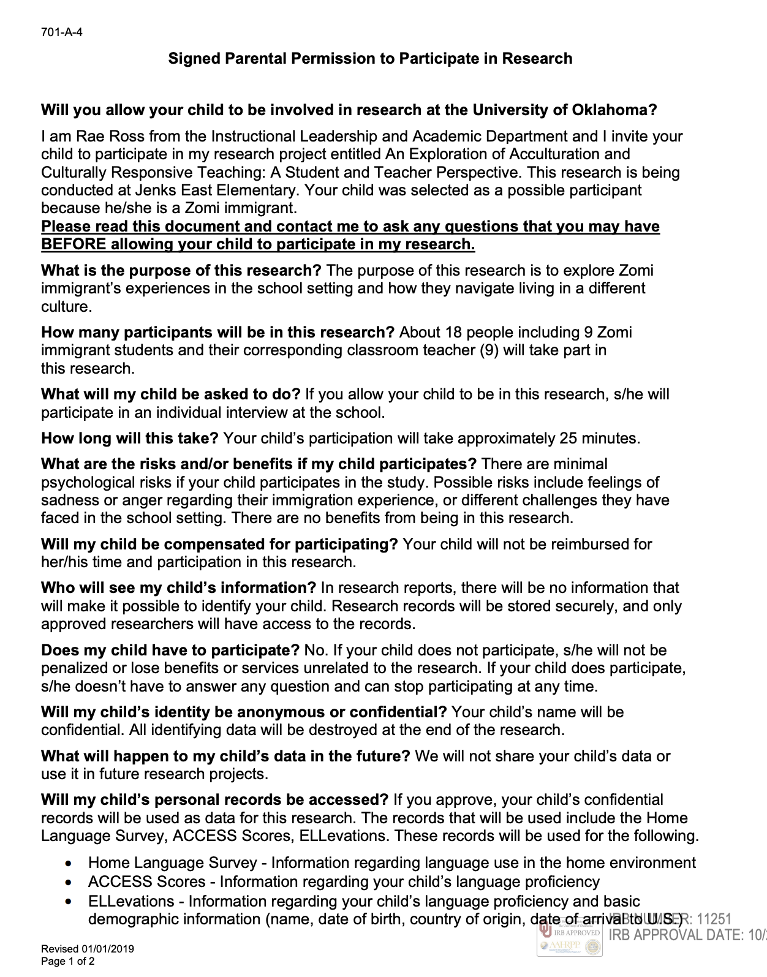
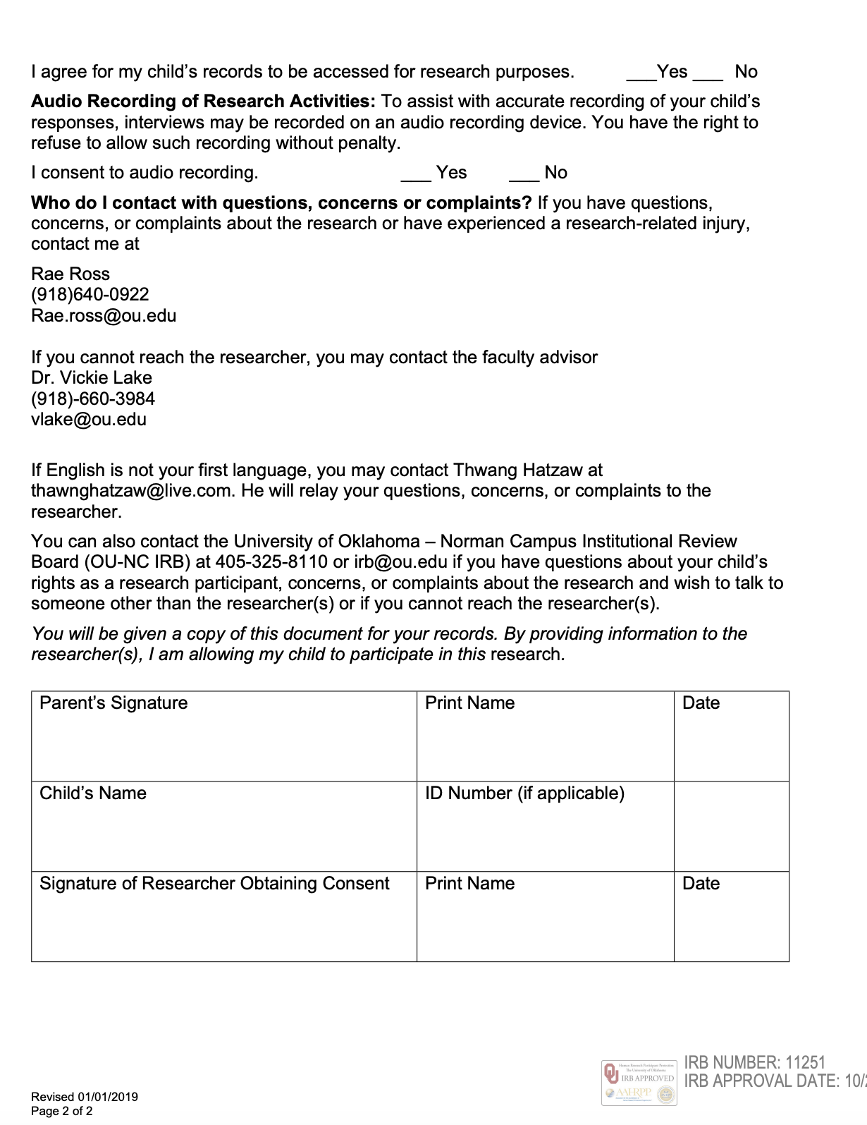

Parent Consent Form – Zomi
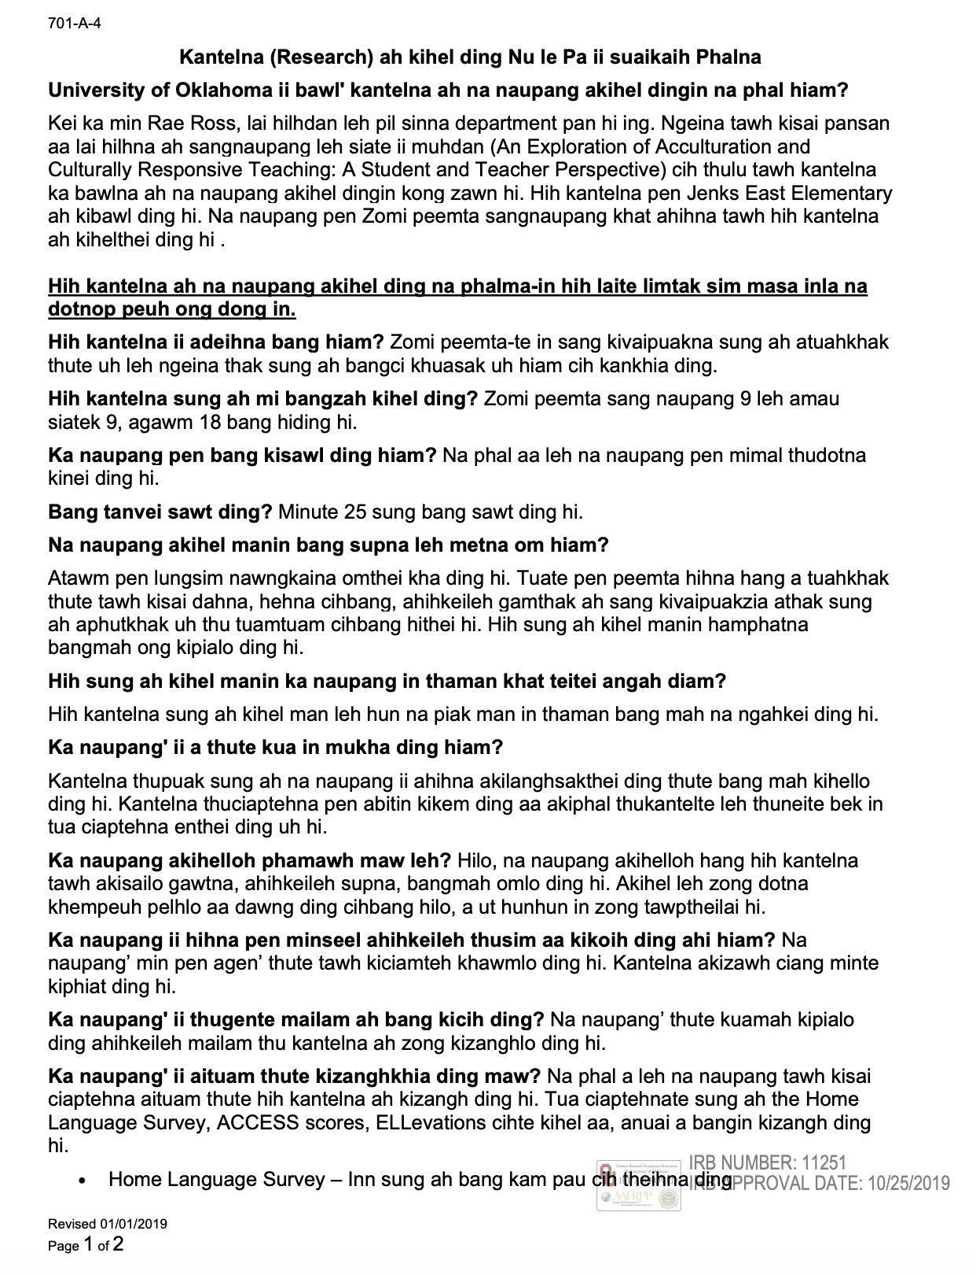
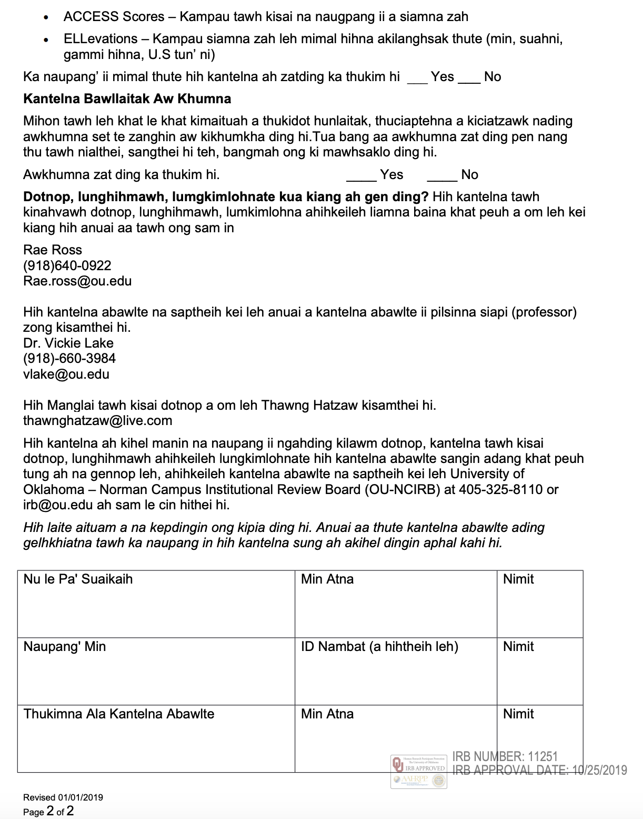

Teacher Consent Form
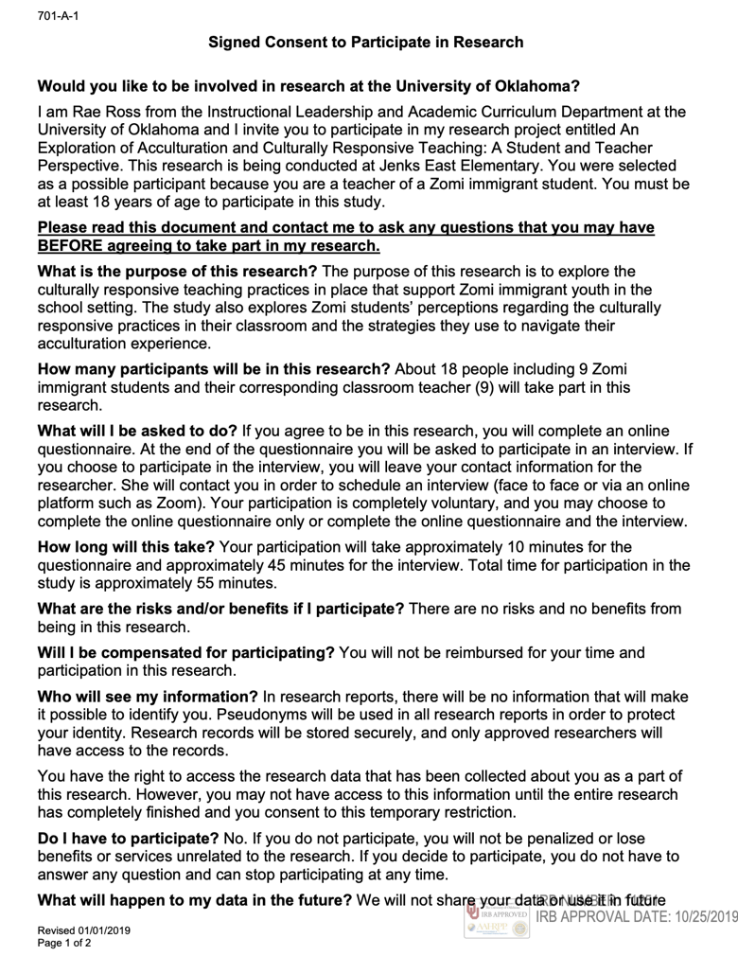
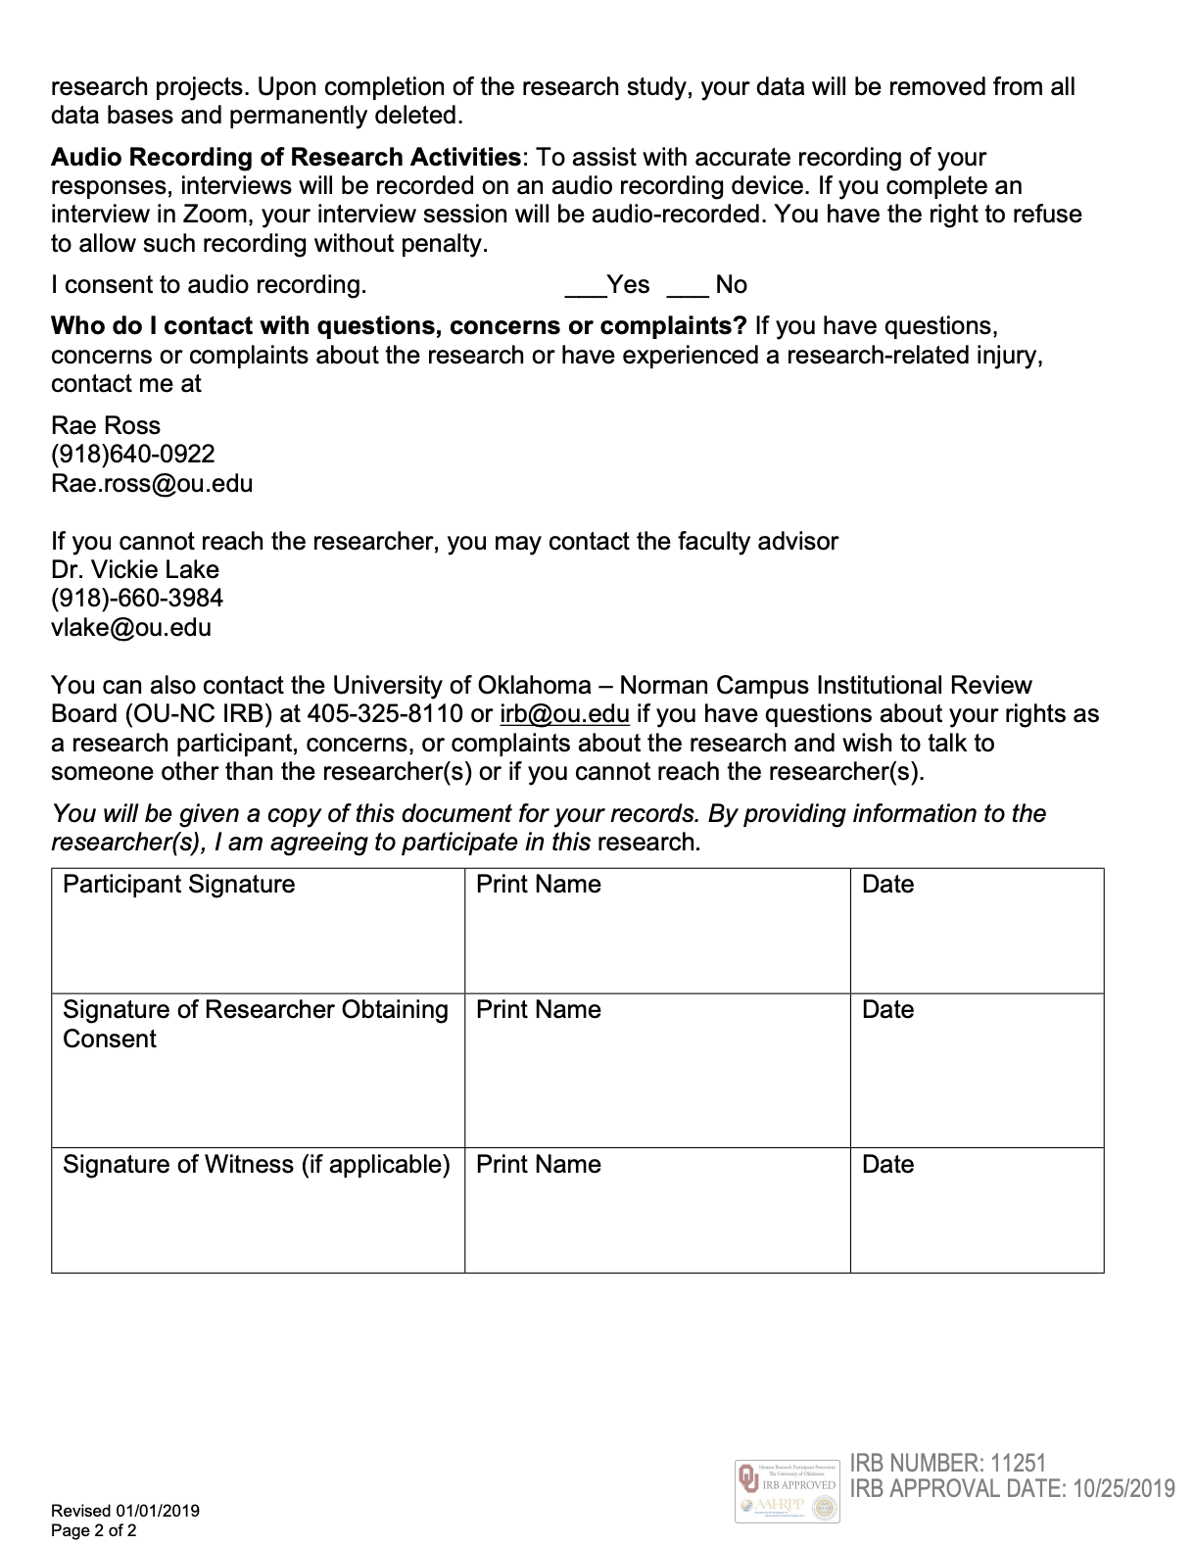
Child Assent


Appendix B: Translator Attestation Form
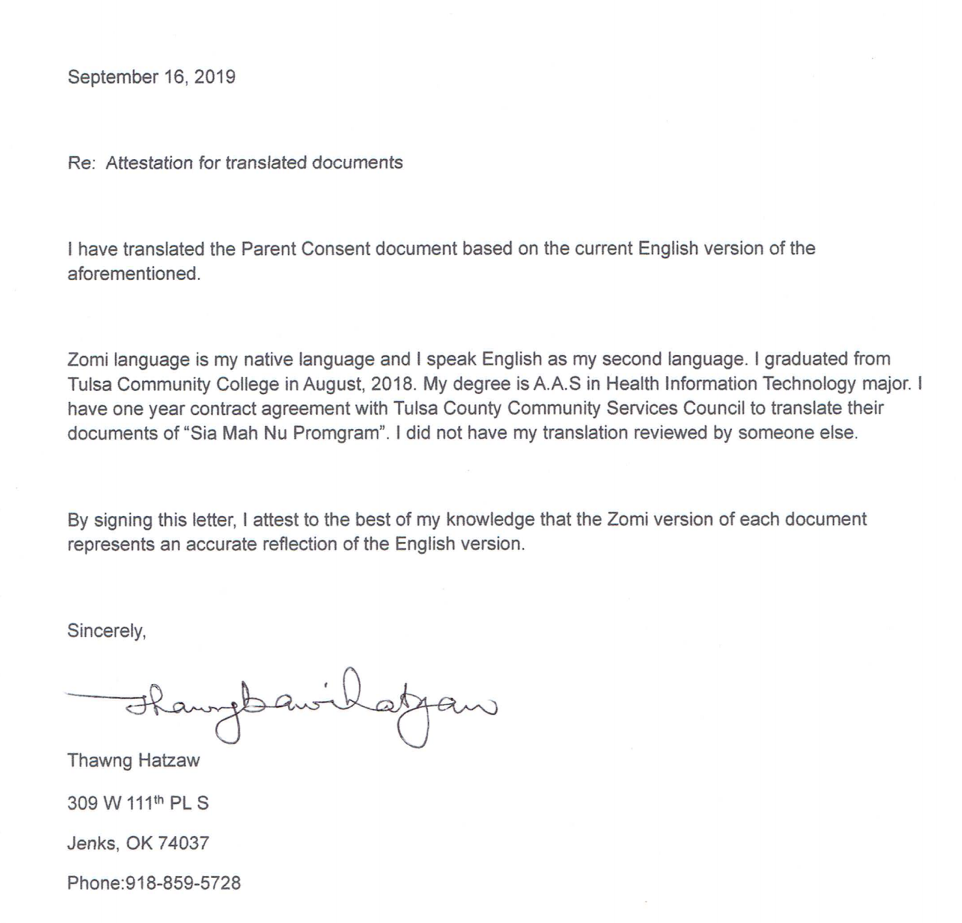

Appendix C: Teacher Survey
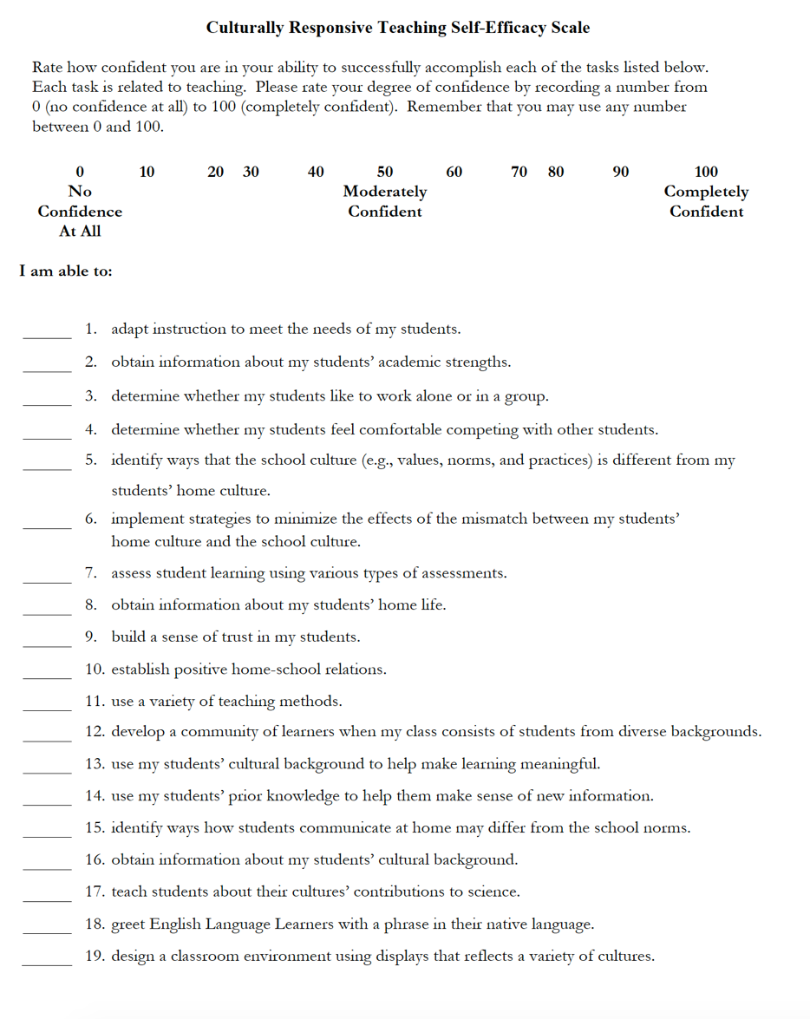


Appendix D: Jenks Research Request Form

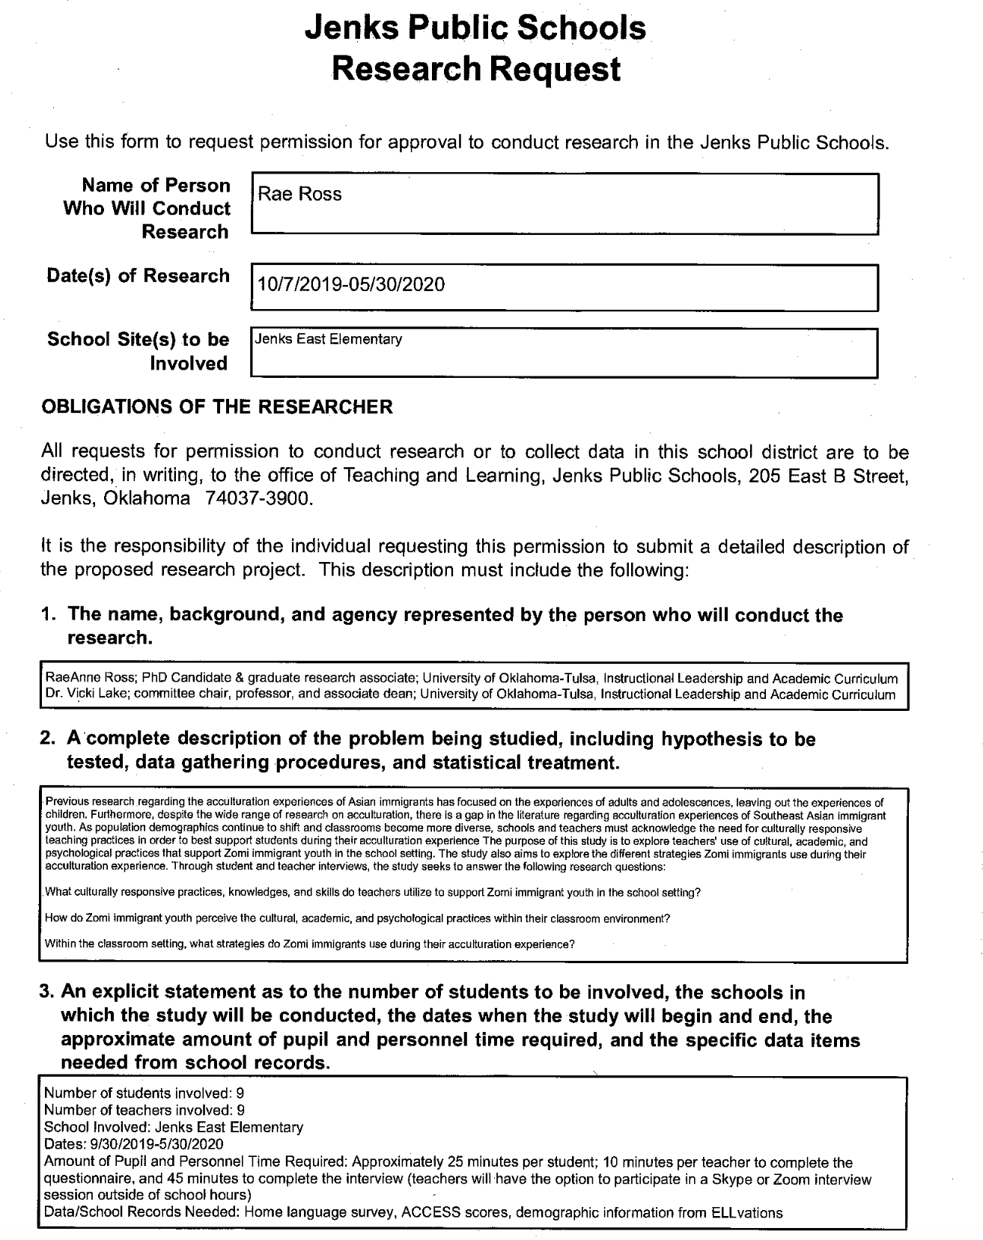
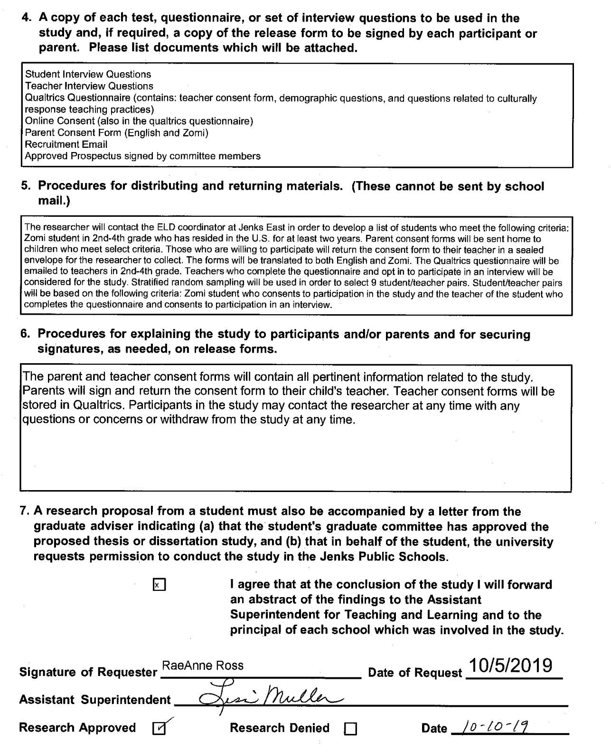

Appendix E: Alignment of Interview Questions to Research Questions
Table 1

Alignment of Student Interview Questions to Research Questions 3 &4:

- How do Zomi immigrant youth perceive the cultural, academic, and psychological practices within their classroom?
- Within the classroom environment, what strategies (assimilation, separation, integration, marginalization) do Zomi immigrants use during their acculturation experience?
Igoa (1995) CAP Framework | Interview Question | 18 Pillars of CRT (Gay, 2010)
Culture |  | Pillars, 1, 5, 6, 7, 8, 16
 | What does culture mean to you? | Pillar 1: Is integral to all classes and all skills taught
 | Do you bring your Zomi culture into the classroom? | Pillar 5: Integrates context, culture, and lived-experience of students of color
 | Does your classroom feel like a community where everyone is successful? | Pillar 6: Creates a classroom culture of academic success, collaboration, reciprocity, and community
 | Does your teacher talk about the Zomi culture in the classroom? Do you get to talk about the Zomi culture to your teacher or other students? | Pillar 7: Reflects students’ differing perspectives and cultures in all inter-related areas of curriculum, school and classroom climate, instruction, and communication styles.
 | Does your teacher support the Zomi culture in your classroom? Does your teacher support you? | Pillar 8: Uses both general group and individual student cultural patterns
 | Have you ever been made fun of because of your race? Or where you are from? How did you handle the issue? | Pillar 16: Develops intolerance for oppression and moral courage to address injustice and promote justice
Academic |  | Pillars: 2, 3, 9, 11, 17, 18
 | Does your teacher support all students if they need help with math, reading, etc? | Pillar 2: Enhances learning for all, not some, students
 | Does your teacher talk about the Zomi culture in math, reading, etc? Daily? Weekly? Throughout the year? | Pillar 3: Happens systematically, continuously, and purposefully, not just sometimes
 | Does your teacher talk about other ethnic groups?  Racism? Or how other groups have been treated unfairly? | Pillar 9: Provides accurate information about contributions of members of ethnic groups, discussion of moral or ethical issues, power and privilege or distribution and deconstruction of academic racism and hegemony
 | When you take tests, does your teacher give you any other supports? | Pillar 11: Uses multiple assessments like cultural preferences, participation, communication styles
 | N/A | Pillar 17: Requires professional development to improve cultural knowledge, teaching skills, reflection, and self-monitoring of classroom situations for students of color
 | N/A | Pillar 18: Uses school or teacher resources of time, funds & imagination for student success
Psychological |  | Pillars 4, 10, 12, 13, 14, 15
 | Do you get to talk about your emotions or challenges you may have with your teacher? Friends? | Pillar 4: Cultivates success for all aspects of a person without negatively affecting cultural identity
 | How do you learn the rules and behaviors of school? Do you feel that you can succeed in school? | Pillar 10: Teaches students of color the informal, unstated, implicit rules and behaviors needed to succeed
 | Do you think about your successes? Does your teacher talk to you about setting goals for success? | Pillar 12: Empowers students with tools for continuous self-assessment
 | Do you feel supported in school by your teacher? Friends? | Pillar 13: Demands with genuine caring and appropriate amounts of assistance that students achieve high levels of academic success
 | Does your teacher ask you about the Zomi community? | Pillar 14: Scaffolds learning between school culture and content and students’ funds of knowledge
 | What is your biggest dream? Does your teacher help you pursue your dream? | Pillar 15: Helps students imagine a different life, create goals, and pursue a path to their dreams

Table 2

Alignment of Teacher Interview Questions to Research Questions 1:
- What culturally responsive practices, knowledge, and skills do teachers utilize to support students from culturally diverse, non-American backgrounds?
Igoa (1995) CAP Framework | Interview Question | 18 Pillars of CRT (Gay, 2010)
Culture |  | Pillars, 1, 5, 6, 7, 8, 16
Culture | What does culturally responsive teaching mean to you?  Do you believe culturally responsive teaching is important? Why or why not? | Pillar 1: Is integral to all classes and all skills taught
Culture | How do you integrate aspects of Zomi students’ home culture or life experiences into your classroom? Into the curriculum? | Pillar 5: Integrates context, culture, and lived experiences of students of color into curriculum  Pillar 7: Reflects students’ differing perspectives and cultures in all inter-related areas of curriculum, school and classroom climate, instruction, and communication styles.
Culture | What does a culturally responsive classroom look like?  How do you create a culture of success and community in your classroom? | Pillar 6: Creates a classroom culture of academic success, collaboration, reciprocity, and community
Culture | How you support the Zomi culture in your classroom? How do you support individual students? | Pillar 8: Uses both general group and individual student cultural patterns
Culture | Have you witnessed any issues related to racism, power, or privilege? If so, how did you address the issue? | Pillar 16: Develops intolerance for oppression and moral courage to address injustice and promote justice
Academic |  | Pillars: 2, 3, 9, 11, 17, 18
 | How do you support learning for all students? | Pillar 2: Enhances learning for all, not some, students
 | How do you incorporate children’s culture into academics daily? Weekly? Throughout the year? | Pillar 3: Happens systematically, continuously, and purposefully, not just sometimes
 | Regarding issues related racism, power, and privilege, how do address these topics in your classroom?  How do you address misconceptions or misrepresentations of different ethnic groups in academic content?  Do you think it is important to address these issues? Why or why not? | Pillar 9: Provides accurate information about contributions of members of ethnic groups, discussion of moral or ethical issues, power and privilege or distribution and deconstruction of academic racism and hegemony
 | How do you provide modifications for your Zomi students during assessments? | Pillar 11: Uses multiple assessments like cultural preferences, participation, communication styles
 | What professional development opportunities have you participated in order to better support your Zomi students?  Do you feel competent in your ability to support your Zomi students academically?  Do you feel knowledgeable about the Zomi community? | Pillar 17: Requires professional development to improve cultural knowledge, teaching skills, reflection, and self-monitoring of classroom situations for students of color
 | What resources do you use to support your Zomi students? | Pillar 18: Uses school or teacher resources of time, funds & imagination for student success
Psychological |  | Pillars 4, 10, 12, 13, 14, 15
 | How do you support Zomi students’ social and emotional development? Self-esteem? Motivation to learn? | Pillar 4: Cultivates success for all aspects of a person without negatively affecting cultural identity  Pillar 13: Demands with genuine caring and appropriate amounts of assistance that students achieve high levels of academic success
 | How do you support Zomi students’ understanding of rules, behaviors, and procedures of the school culture? | Pillar 10: Teaches students of color the informal, unstated, implicit rules and behaviors needed to succeed
 | Do Zomi students have opportunities to self-reflect with you or individually? | Pillar 12: Empowers students with tools for continuous self-assessment
 | How do you bridge the gap between Zomi students’ home environment and school environment? | Pillar 14: Scaffolds learning between school culture and content and students’ funds of knowledge
 | Do Zomi students have opportunities to set goals? | Pillar 15: Helps students imagine a different life, create goals, and pursue a path to their dreams

Appendix F: Student Interview Protocol
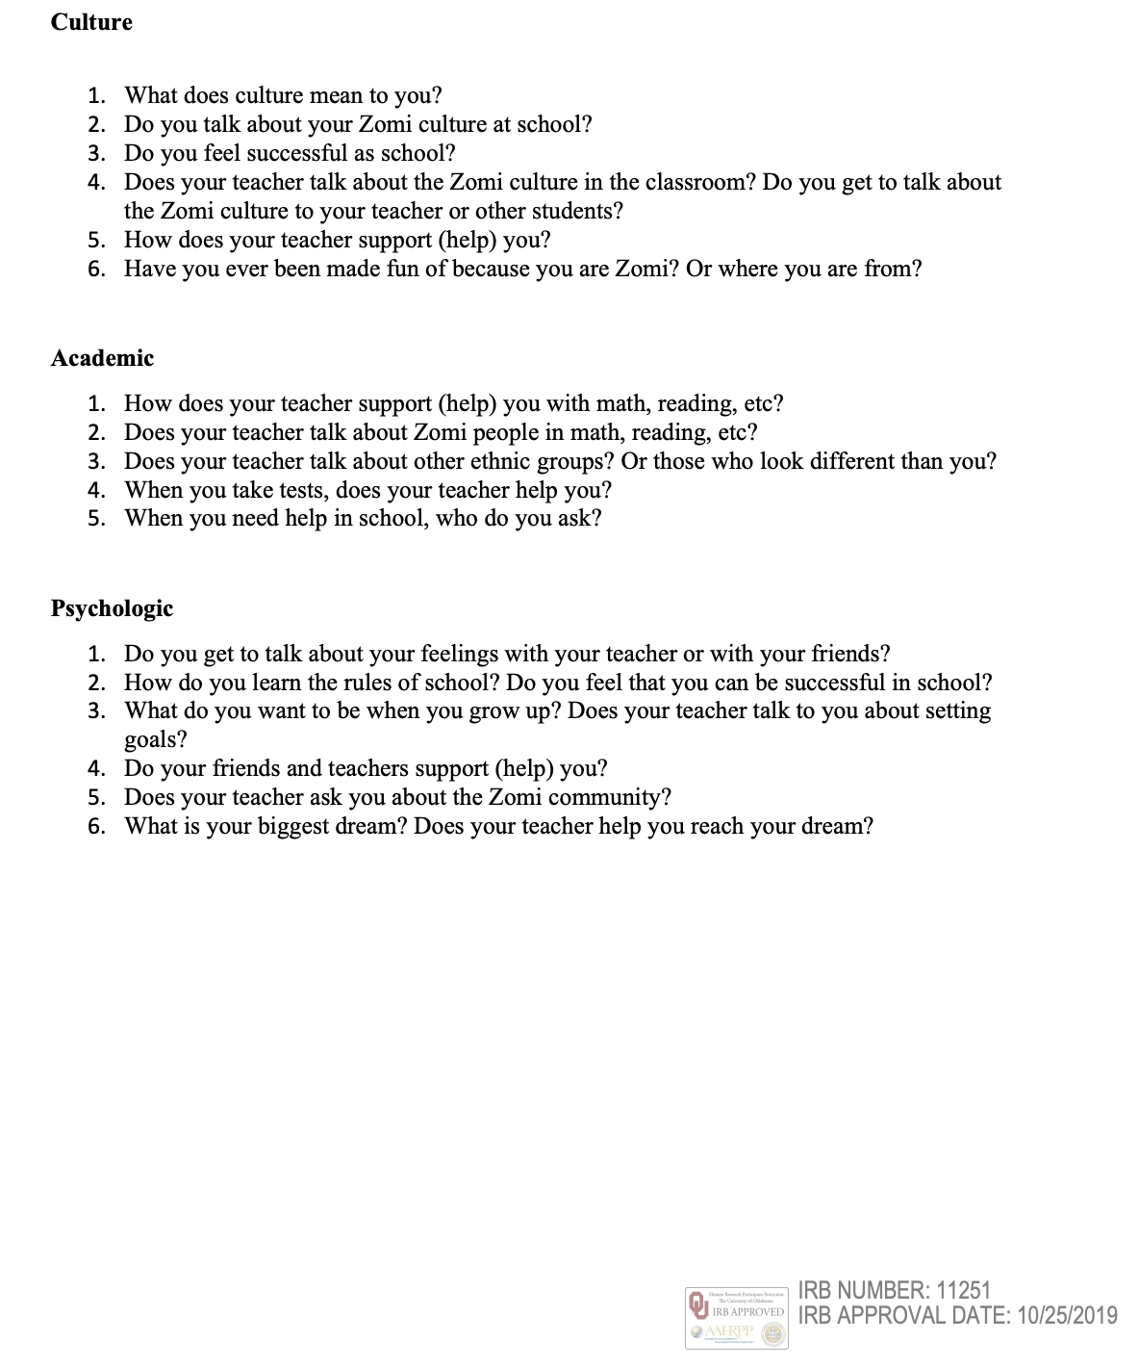

Appendix G: Teacher Interview Protocol
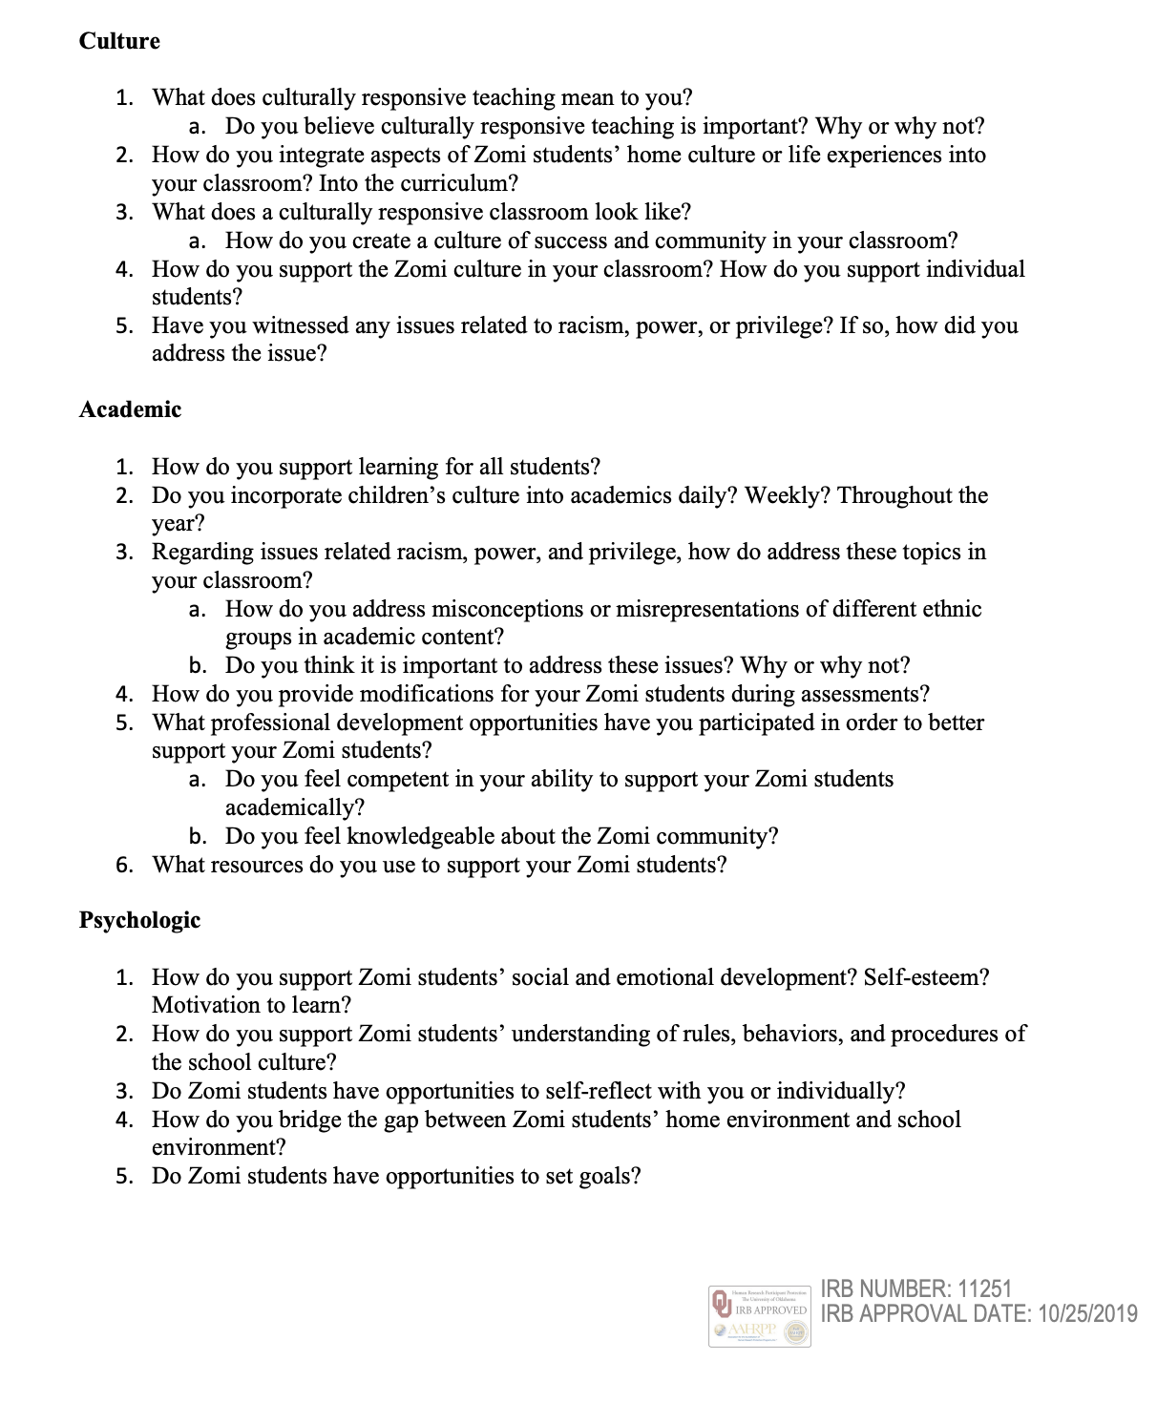

Appendix H: CRTSE Scale Approval
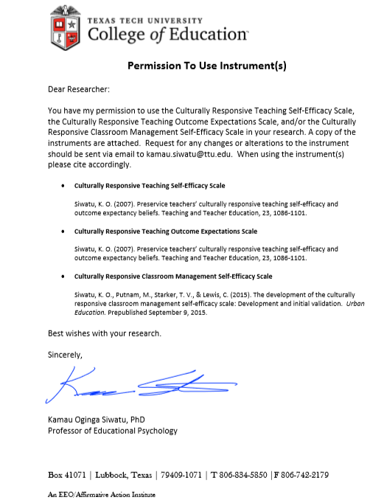

Appendix I: Timeline
- October
  - Defend Prospectus
  - Submit IRB for approval
  - Submit Research Request Form to District
  - Conduct and Transcribe Interviews
  - Data Analysis

- November
  - Conduct and Transcribe Interviews
  - Data Analysis

- December
  - Data Analysis
  - Begin Article 1: Empirical

- January
  - Finish Article 1
  - Begin Article 2: Empirical

- February
  - Apply for Graduation
  - Finish Article 2
  - Begin Article 3: Practitioner

- March
  - Finish Article 3
  - Submit Dissertation to Committee

- April
  - Submit Degree Check (online)
  - Submit Request for Authority to Defend
  - Complete Dissertation Defense

- May
  - Submit Dissertation Defense to SHAREOK
  - Close IRB

Appendix J: Internal Review Board Study Approval Letter
