University of Oklahoma

Graduate College

BREEDING AND MIGRATION ECOLOGY OF BAR-HEADED GOOSE ANSER INDICUS AND SWAN GOOSE ANSER CYGNOIDES IN ASIA

A Dissertation

submitted to the Graduate Faculty

in partial fulfillment of the requirements for the

Degree of

Doctor of Philosophy

By

nyambayar batbayar
Norman, Oklahoma
2013

BREEDING AND MIGRATION ECOLOGY OF BAR-HEADED GOOSE ANSER INDICUS AND SWAN GOOSE ANSER CYGNOIDES IN ASIA

A Dissertation approved for the
Department of Microbiology and Plant Biology

By

______________________________
Dr. Xiangming Xiao, Chair

______________________________
Dr. John Y. Takekawa

______________________________
Dr. Jeffrey F. Kelly

______________________________
Dr. May Yuan

______________________________
Dr. Paul A. Lawson

© Copyright by nyambayar batbayar 2013
All Rights Reserved.

Dedication

I dedicate this work to my lovely family, wife Sarangoo Batmunkh, kids Anar and Garid who have supported me each step of the way
Also I dedicate this work to my late mentor academician Dr. Ayurzana Bold, one of the first ornithologists in Mongolia, who inspired me to pursue my career in ornithology

Acknowledgements
First and foremost I wish to thank my advisor, Professor Dr. Xiangming Xiao, the head of the Earth Observation an Modelling Facility, Department of Microbiology and Plant Biology at the University of Oklahoma. He has been incredibly generous and supportive since the days I began working on the project and in the lab. I would never have been able to finish my dissertation without his guidance. I am indebted to you for your help.
I am really grateful to Dr. John Y. Takekawa of the USGS Western Ecological Research Center who solidly supported me not only providing excellent waterfowl and satellite tracking research guidance for last seven years, but also emotionally from the beginning of my participation in the avian influenza research project in Mongolia to the end to finish this thesis.
My gratitude extends to my committee members Dr. May Yuan, Dr. Paul A. Lawson, and Dr. Jeffrey F. Kelly for kindly serving on my committee, encouraging me to complete my work, and giving me the opportunity to further my education and research experience at the University of Oklahoma. It was a great pleasure to getting know you and working with you.
I am thankful for Dr. Tseveenmyadag Natsagdorj, and all my friends and colleagues at the Institute of Biology of the Mongolian Academy of Sciences and the Wildlife Science and Conservation Center of Mongolia who supported me through participating in the field to collect field data and for being reliable support back in Mongolia throughout all these years.
I would like to express my gratefulness to my family for their unwavering and endless support from the beginning to the end. I would like to thank my parents, Batbayar Ulziibat and Nyamjav Sharav, and my brothers and sisters for their continuous love and encouragement.
I would also like to send a special thanks to my lab mates for offering much needed supports during the last few years, for all the fun and memories we had during my study period.
Finally, I would like to thank my wife, Saraa, and my two sons, Anar, and Garid, for supporting and cheering me up all these time and stood by me through the rough road to finish my study in Norman, Oklahoma.

Table of Contents

Acknowledgements iv
Table of Contents vi
List of Tables viii
List of Figures ix
Abstract xiii
INTRODUCTION 1
References 10
Chapter I. SITE SELECTION AND NEST SURVIVAL OF WATERBIRDS IN SEMIARID CENTRAL ASIA: BAR-HEADED GEESE (ANSER INDICUS) ON THE MONGOLIAN PLATEAU 14
Abstract 14
Introduction 15
Methods 18
Results 23
Discussion 27
Acknowledgments 34
References 35
Tables and Figures 40
Chapter II. MIGRATION STRATEGIES OF SWAN GEESE (ANSER CYGNOIDES) FROM NORTHEAST MONGOLIA 50
Abstract 50
Introduction 51
Study area and methods 52
Results 55
Discussion 61
Acknowledgments 65
References 66
Tables and Figures 70
Chapter III. BAR-HEADED GOOSE (ANSER INDICUS) MIGRATION PATTERNS AND PHENOLOGY RELATED TO ENVIRONMENTAL CONDITIONS DETERMINED FROM REMOTELY SENSED IMAGERY 77
Abstract: 77
Introduction 78
Methods 81
Results 85
Discussion 90
Acknowledgments 96
References 98
Tables and figures 103
SUMMARY AND CONCLUSION 113
References 118

List of Tables

Chapter 1.
Table 1 - 1. Measurements of eggs and nests of Bar-headed Geese (Anser indicus) in westcentral Mongolia. 40
Table 1 - 2. Clutch size and number of nests of Bar-headed Geese nesting on islands and cliffs in westcentral Mongolia. 41
Table 1 - 3. Nest initiation date of Bar-headed Geese (Anser indicus) in westcentral Mongolia in 2009-2011. 42
Table 1 - 4. Akaike Information Criterion model selection results for Bar-headed Goose Anser indicus nesting in westcentral Mongolia from 2009-2011. Models are ordered according to ascending ΔAICc values. 43

Chapter 2.
Table 2 - 1. Morphological data for Swan Geese fitted with satellite transmitters and a summary of the performance of the transmitters. *Not included in the analysis 70
Table 2 - 2. Chronology and movements of satellite-tracked Swan Geese during their annual cycle. 71
Table 2 - 3. Location, habitat, and duration of stay of Swan Geese at selected major stopover sites (i.e. where birds spent on average more than 10 days). After moulting, geese spent over a week at 54 different migration locations. 72

Chapter 3.
Table 3 - 1. Summary of marked bar-headed geese with satellite telemetry 103

List of Figures
Chapter 1.
Figure 1 - 1. Map of the study area in westcentral Mongolia. Gray circles show locations of Bar-headed Geese (Anser indicus) observed during spring and summer surveys. Bold (+) symbols show locations of island nests, and “X” symbols show nest locations oin cliffs. Dashed lines indicate the survey route used during the study period. The inset map shows the location of the study areas (black circles) in westcentral Mongolia. 44
Figure 1 - 2. Decreasing egg weights for Bar-headed Geese (Anser indicus) during the incubation period. 45
Figure 1 - 3. Proportions of Bar-headed Goose (Anser indicus) nests with different clutch sizes at island and cliff sites. 46
Figure 1 - 4. Bar-headed Geese (Anser indicus) daily nest survival (DNS) with 95% confidence intervals from westcentral Mongolia in 2009, 2010, and 2011. 47
Figure 1 - 5. Variation in Bar-headed Geese (Anser indicus) daily nest survival (DNS) between different habitat types (island, cliff), accessibility (low, high), and depredation levels (low, high) from 2009-2011. 48
Figure 1 - 6. Daily survival rate (DSR) of Bar-headed Geese (Anser indicus) nests in relation to nest age (days since egg laying) in westcentral Mongolia from 2009-2011. The logistic-exposure model curve and 95% confidence limits are shown. 49

Chapter 2.
Figure 2 - 1. Migration paths, locations, and important stopover sites of Swan Geese marked with satellite transmitters in northeast Mongolia. Swan Geese were captured at the Mongol Daguur, and many used the Yalu River Estuary as a major stopover site. Poyang Lake, China was the main wintering area along the Yangtze River Basin. White circles = major stopover locations; black shading = urbanised areas. 73
Figure 2 - 2. Foraging and roosting locations of Swan Geese at major staging and wintering areas. Contours represent 99% fixed kernel home ranges in three different seasons. Yellow contours show areas used during autumn migration (September - December), red contours indicate spring migration locations (March - April), and green contours show wintering locations (January - February). Blue dots shown are locations for five birds that made a complete migration cycle. A. Yalu River Estuary at the border area between China and North Korea. B. Poyang Lake, Jiangsu Province, China. 74
Figure 2 - 3. Changes in linear distance from stopover sites to the nearest urban area in relation to latitude (n = 5 birds). Size of the circles indicates the duration of stay (in days) at stopover sites,; each circle represents a location and duration is illustrated in the legend 75
Figure 2 - 4. Consecutive flight distance and groundspeed of migration for Swan Geese relative to breeding and wintering locations (latitude). Latitude represents the midpoint of 4 degree intervals. Outliers indicate capability of some individuals to cover long flight distances at rapid speeds during non-stop flights. 76

Chapter 3.
Figure 3 - 1. Locations of bar-headed geese during spring and autumn migration. Map shows the importance of the Qinghai-Tibet Plateau for bar-headed geese during migration. Red squares are locations where the bar-headed geese are found breeding and blue squares are location where they spend the winter. 104
Figure 3 - 2. Relationship in departure dates from a) wintering grounds and b) breeding areas and migration distances between these areas. The horizontal axis shows the Julian Date and the vertical axis shows the distance travelled per season during the migration by bar-headed geese. Most bar-headed geese departed near the median departure date regardless of their final destination for the northbound migration, whereas those that started earlier tended to travel farther during the southbound migration. The median departure Julian date in the spring was day 75, and day 252 in the autumn. 105
Figure 3 - 3. The relationship between arrival date at a) wintering and b) summer areas and the distance travelled during migration. Horizontal axis shows the Julian date and vertical axis shows the distance travelled. Late arriving birds have travelled farther compared to early arrivers during both south and northbound migrations. Median arrival julian date in spring is 129 and 332 in autumn. 106
Figure 3 - 4. Spatial patterns of normalized difference vegetation index and bar-headed geese movements in different months representing different migration seasons. Maps show the advancing and retreating of green vegetation in the wintering grounds to the south and in the breeding grounds to the north. 107
Figure 3 - 5. Summer, fall, winter, and spring season changes in the normalized difference vegetation index (different months shown as colored lines) along the elevation (shaded gray area) and latitudinal gradients. Vegetation index (NDVI) values are on the left y-axis and the elevation values are on the right y-axis. Black bars are locations of bar-headed geese in relation to latitude. 108
Figure 3 - 6. Summer, fall, winter, and spring season changes in the night time land surface temperature (different months shown as colored lines) along the elevation (shaded gray area) and latitudinal gradients. Land surface temperature values are on the left y-axis and the elevation values are on the right y-axis. Black bars are locations of bar-headed geese in relation to the latitude. 109
Figure 3 - 7. Summer, fall, winter, and spring season changes in the snow cover (different months shown as colored lines) along the elevation (shaded gray area) and latitudinal gradients. Snow cover percentage values are on the left y-axis and the elevation values are on the right y-axis. Black bars are locations of bar-headed geese in relation to latitude. 110
Figure 3 - 8. Major stopover locations of bar-headed geese on the Qinghai-Tibetan Plateau. Details of selected locations in yellow squares are shown in the bottom row. 111
Figure 3 - 9. Bar-headed geese migration corridor on the Qinghai-Tibetan Plateau. The migration route was basically confined within the Tibetan Plateau alpine shrublands and meadow biome which is a narrow strip between the Central Tibetan Plateau alpine steppe and Southeast Tibetan Plateau scrublands and meadow biomes. 112

Abstract
Most waterfowl that breed in Mongolia, part of the semiarid northern region of East Asia, are long distant migrants. They depend on availability of lake, river, and wetland habitats on their breeding and wintering grounds and need suitable staging and stopover sites along their flight routes to complete their migration. Waterfowl in this region have developed important adaptations and strategies to ensure their survival and reproductive fitness across generations. I studied the ecology of two goose species endemic to this semiarid region, the bar-headed goose (Anser indicus) and swan goose (Anser cygnoides), to examine their use of highly-variable, wetland habitats. I studied the breeding biology of bar-headed geese across three summers (2009-2011) while conducting the first systematic nesting study in the semiarid Khangai Mountains region of west-central Mongolia. Bar-headed geese were found nesting on both islands and cliffs, but their daily nest survival was higher at cliff nests and ranged from 0.94 to 0.98 with average nest survival of 42.6% during the incubation period. Information-theoretic models indicated that nest survival decreased with nest age and varied annually. Waterfowl in this region may be limited by available nest sites, but disturbance and depredation also may play a critical role in their population dynamics. I also tracked the migration of both species via satellite telemetry from their breeding grounds to wintering grounds. Satellite tracking data revealed that swan geese migrated through the Yalu River Delta to a wintering area primarily restricted to Eastern China. In contrast, bar-headed geese had a much greater wintering area ranging from southern China to the southern tip of India. Recently, wintering grounds of both species have had significant land cover and land use changes related to global warming and human activities. For the first time, I was able to document unique and narrow migration corridors for both species that were related to landscape features. The migration corridor of bar-headed geese on the Qinghai-Tibetan Plateau was restricted to one biogeographic biome, while swan geese moved across biomes in a loop migration, preferred stopover sites in natural landscapes, avoided areas of eastern China with large scale developments and high human densities, and wintered in the Yangtze River Basin. Migration of bar-headed geese was associated with vegetation green-up as indicated by the Normalized Difference Vegetation Index (NDVI), and geese strategically moved between areas with peak NDVI values extending from their wintering grounds in India, migration stopover areas on the Qinghai-Tibetan Plateau, and breeding grounds in Mongolia. The arrival of bar-headed geese at staging areas during the spring migration was correlated with a decline of green vegetation biomass on their wintering grounds in India and advancement of vegetation green-up in northern latitudes. During the autumn migration, snow cover and land surface temperature corresponded well with their southward movement. These results will have important implications to improve understanding of wild bird biology in this region as well as disease ecology -- waterfowl may contribute to gene flow of avian influenza viruses among different geographical populations of wild and domestic birds through their long distance migration. Species distributions are expected to shift in response to climate change, and swan and bar-headed geese likely will alter their distribution and migratory behavior in response but constrained by both natural habitat availability and human effects limiting their habitats.
Keywords: waterfowl, long distance migration, breeding ecology, migration strategy, land surface phenology, vegetation index

INTRODUCTION
My dissertation is about breeding and migration strategies of two species of geese, the bar-headed goose Anser indicus and swan goose Anser cygnoides, which are only found in semi-arid temperate Asia. Both species have very unique distribution patterns, ecological niches, and migration routes, and both species have been little studied in the wild.
The swan goose is a globally threatened species (International Union for Conservation of Nature (IUCN) category: Vulnerable) with a population size of <100,000 individuals that occurs in East Asia (Wetlands International, 2006). The current breeding range of the species (Figure 1) includes wetlands on the vast steppe-grassland habitats across a large portion of eastern Mongolia, northeastern China, and parts of the Russian Far East, Amur and Primorye Regions and northern part of Sakhalin Islands in Russia. Almost the entire population of the swan goose winters in the Yangtze River floodplain in east China; however, some birds overwinter in South Korea (Cao et al., 2008; Del Hoyo et al., 2001; Goroshko et al., 2004; Poyarkov, 2001; Tseveenmyadag et al., 2007b). Three closely-located wetlands - Poyang Lake, Donting Lake, and Fengsha Lake - support over 95% of its global population (Wetlands International, 2006; Zhang et al., 2010). Recent population data from the breeding grounds in Mongolia and Russia indicates that swan goose populations may have experienced dramatic declines in the region (Goroshko, 2003; Goroshko et al., 2004; Tseveenmyadag et al., 2007a). One of the major breeding sites in East China, severe decreases in Swan Goose numbers have been documented since 2004 (Zhang et al., 2011). Causes of the decline have been attributed to drought induced wetland loss, disturbance by livestock on nesting birds, competition for grazing area with livestock, illegal hunting, egg collection, reduction in submerged vegetation due to water pollution and dam water regulation, and wetland conversion for agriculture and development projects (Barter et al., 2005; Cao et al., 2008; Goroshko, 2003, 2004; Poyarkov, 2001; Tseveenmyadag et al., 2007a; Zhang et al., 2011).
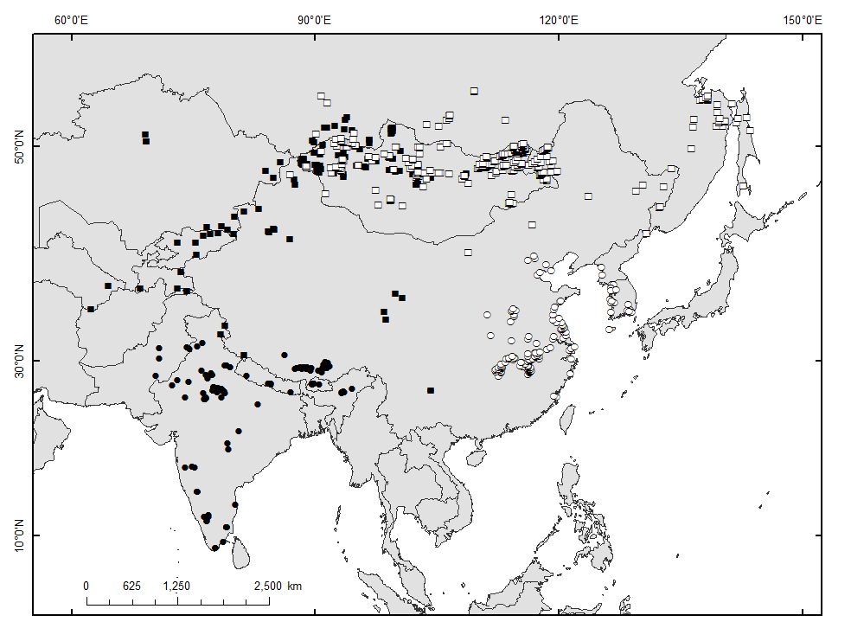
Figure 1. Distribution of bar-headed goose (in black) and swan goose (in white) in Asia. Squares denote summer and breeding range, circles are locations recorded in winter period.

In contrast, the bar-headed goose is a species found in mostly high altitude wetlands within the Central Asian Flyway (Del Hoyo et al., 2001). It is a monotypic species with a global population of <60,000 individuals in the wild (Wetlands International 2006). It makes remarkable high-altitude migrations travelling across the Himalayan mountain range (mean altitude 5,000m) from breeding areas as far north as Mongolia and southern Russia to wintering areas as far south as southern India (Hawkes et al., 2011; Takekawa et al., 2009). In 2005, the largest outbreak of highly pathogenic avian influenza (A subtype H5N1) occurred at Qinghai Lake in western China and killed 5-10% of the global population of bar-headed geese at the single largest known colony of this species (Chen et al., 2005; Liu et al., 2005).
The majority of the global breeding distribution of both the bar-headed goose and swan goose are primarily found within Mongolia and China. However, many aspects of the population ecology, distribution, and habitat selection are not well studied. For example, although there are many records of their distribution from countries within the Central Asian Flyway, no single paper has been written specifically describing the bar-headed goose in Mongolia where a significant proportion of the world breeding population is found. Many breeding areas in Russia, Mongolia, and China are either poorly studied or undocumented because of lack of research capacity and remoteness in these areas. The situation is more or less the same for the swan goose. Until recently, there were few detailed studies focused on swan goose population numbers and distributions (Barter et al., 2006; Cao et al., 2008; Goroshko et al., 2004; Tseveenmyadag et al., 2007a; Zhang et al., 2010) and feeding habits (Fox et al., 2011; Fox et al., 2008), and no long term population monitoring program exists for both species throughout their range, except for some efforts being started in China (swan goose only; (Cao et al., 2011).
Among species of migratory birds, waterbirds make some of the most dramatic long distance migrations. They cover tens of thousands of kilometers during their annual migration and connect ecosystem processes to the Arctic Circle in the north and the tropical regions in the south. One of the well-known ecosystem services of insectivorous migratory birds is their role in reducing insect populations in grasslands and forests, thus keeping these ecosystems healthy (Whelan et al., 2008). Similarly, migratory waterfowl provide important aquatic ecosystem services through herbivory, depredation, ecosystem engineering, dispersing plant seeds, nutrients, invertebrates across large geographical areas and at local scale (Green and Elmberg, 2013). In addition, waterfowl also carry many kinds of infectious diseases as well (Wobeser, 1981) and have the potential to introduce infectious diseases such as avian influenza viruses from one area to another along the flyway (Olson and Dinerstein, 1998; Stallknecht and Brown, 2009).
Avian influenza viruses are identified into subtypes on the basis of two surface proteins, hemagglutinin (HA) and neuraminidase (NA). There are 16 HA subtypes (N1 to H16) and 9 NA subtypes (N1 to N9) of avian influenza virus. All of them have been documented in waterfowl, and they circulate between wild bird populations at wintering and breeding grounds through migration (Stallknecht and Brown, 2009). However, not all avian influenza viruses are highly pathogenic avian influenza (HPAI) viruses that are defined as though highly lethal to chickens. The four types of avian influenza viruses known to be highly pathogenic include H5N1, H7N3, H7N7, H7N9, and H7N12 (Suarez, 2009).
Since December 2003, the highly pathogenic avian influenza virus A subtype H5N1 intensified and spread to more than 60 countries across three continents including Asia, Europe, and Africa. It has caused culling of hundreds of millions of poultry and has infected more than 660 people, claiming3 over 375 human lives (57%; WHO, 2013). Genetic analysis showed that transmission of the H5N1 virus from poultry to humans is rare, although humans have frequent contacts with poultry products (Van Kerkhove et al., 2011). H5N1 has continued to mutate, and different strains of the virus have shown different effects on different species (Yuan et al., 2013). Future HPAI outbreaks may be more lethal than the 1918 Spanish flu that caused a worldwide pandemic infecting one third of the world’s human population, killing 50-100 million people. The possibility of disease outbreaks in a large worldwide pandemic still exists today (Taubenberger and Morens, 2006; Webster and Walker, 2003).
After the Qinghai Lake H5N1 outbreak, the bar-headed geese unintentionally became a species of particular interest because of its presence in close proximate to poultry farms outside of the breeding season, high mobility and long flight range during its annual migration, and involvement in subsequent H5N1 outbreaks in Mongolia where poultry were uncommon and transmission was very unlikely. Around the same time, there was a large effort to study waterfowl migration in East Asian and Central Asian Flyway (Iverson et al., 2011; Newman et al., 2012; Takekawa et al., 2010; Yamaguchi and Higuchi, 2008).
I was very fortunate to be involved in a unique multinational collaborative project that consisted of a team of scientists from the University of Birmingham, UK; the University of British Columbia, Canada; the Bombay Natural History Society, India; the Max Planck Institute, Germany; the Wildlife Science and Conservation Center of Mongolia, the Mongolian Academy of Sciences; the University of Tasmania, Australia; the U.S. Geological Survey, the University of Oklahoma, USA; and the United Nations Food and Agricultural Organization. From 2006-2012, the team sought to study HPAI disease transmission, prevalence of HPAI H5N1 in wild bird populations, migratory connectivity issues focused on waterfowl in Asia, and high altitude flight physiological studies. The overall collaborative effort had several different components with several different elements. During the project implementation period, the group published over 40 papers in peer-reviewed journals, and I co-authored ten papers related to migration, disease ecology, and flight physiology of the bar-headed goose, swan goose, and whooper swan (see complete list of publication on page 8).
The fundamental motivation of the collaborative project was to understand how the HPAI H5N1 virus transmission occurred between domestic birds in farms and wild migratory birds; to determine the potential role of wild birds in transmitting HPAI H5N1 across a large geographical area; and to identify potential locations, areas, and timing related to wild bird migration and HPAI outbreaks.
Wild and poultry birds sometimes intermix in significant numbers in many parts of Southeast Asia, China, East Asia, and Africa where HPAI H5N1 repeatedly occurred and the migratory movements by wild birds between regions of infection occur annually. However, it has been determined that not all outbreaks are linked or caused by wild bird movements, and outbreaks differed by major flyways (Feare, 2007; Gaidet et al., 2010; Gilbert et al., 2011; Iverson et al., 2011; Newman et al., 2012; Prosser et al., 2009; Takekawa et al., 2010).
Since 2006, our project has marked over 100 birds with satellite transmitters including three species in Mongolia alone and many more in China and south Asia to track the movements of wild birds across large geographical areas in Asia, Europe, and Africa. My contribution to this collaborative effort was to study migration strategies of swan goose and bar-headed goose and to document the breeding performance of the bar-headed goose in Mongolia. Also, I was responsible for capturing and marking swans and geese with satellite transmitters; color bands and collect avian influenza samples from eastern and western Mongolia; conduct data analyses; and organize field logistics. The contents of my dissertation are comprised of an Introduction section, three chapters dealing with specific subjects, and a Discussion section that is based on my work under the umbrella of the avian influenza research project implemented between 2006 and 2012.
Chapter One was about breeding site selection and performance of the bar-headed goose in west-central Mongolia. Compared to many breeding waterfowl in high-latitude regions, species in semi-arid regions in the temperate zone have received little study. Since the collapse of Soviet-backed economic and political systems in all Central Asian counties and Mongolia, the study of waterfowl has suffered from lack of financial support from central governments. In this chapter, I present detailed documentation of bar-headed geese breeding based on systematic surveys conducted over three years which was the first nesting study about bar-headed geese in Mongolia.
In Chapter Two of my dissertation, I described the migration strategies of the swan goose from northeast Mongolia. I examined satellite tracking data obtained from 25 swan geese that were captured and marked on three lakes in the steppe region of northeast Mongolia. I documented migration timing, stopover and staging areas, two different migration routes, and the migratory behavior of the swan geese.
Chapter Three was about the relationship between the annual migration of bar-headed geese in relation to changes in land surface phenology represented by the seasonal vegetation index, land surface temperature, and snow cover. I used data products derived from the Moderate Resolution Imaging Spectroradiometer (MODIS) sensors to examine the temporal and spatial variation of environmental conditions in relation to stopover, wintering, and breeding locations along latitudinal gradients based on bar-headed geese satellite tracking data. I investigated whether migration timing, route, and time spent at stopover sites by bar-headed geese were associated with environmental conditions represented by vegetation, snow, and land surface temperature.
The list of papers that I authored and co-authored related to my research on bar-headed geese and swan geese include:
- Batbayar, N., J. Y. Takekawa, T. Natsagdorj, Kyle A. Spragens, and X. Xiao. Site Selection and Nest Survival of Waterbirds in Semiarid Central Asia: Bar-headed Geese (Anser indicus) on the Mongolian Plateau, submitted to journal Waterbirds.
- Batbayar, N., J. Y. Takekawa, S. H. Newman, D. J. Prosser, T. Natsagdorj, and X. Xiao. 2011. Migration strategies of Swan Geese Anser cygnoides from northeast Mongolia. Wildfowl 61:90-109.
- Bourouiba, L., J. H. Wu, S. Newman, J. Takekawa, T. Natdorj, N. Batbayar, C. M. Bishop, L. A. Hawkes, P. J. Butler, and M. Wikelski. 2010. Spatial dynamics of bar-headed geese migration in the context of H5N1. Journal of the Royal Society Interface 7:1627-1639.
- Gilbert, M., S. H. Newman, J. Y. Takekawa, L. Loth, C. Biradar, D. J. Prosser, S. Balachandran, M. V. S. Rao, T. Mundkur, B. P. Yan, Z. Xing, Y. S. Hou, N. Batbayar, T. Natsagdorj, L. Hogerwerf, J. Slingenbergh, and X. M. Xiao. 2010. Flying Over an Infected Landscape: Distribution of Highly Pathogenic Avian Influenza H5N1 Risk in South Asia and Satellite Tracking of Wild Waterfowl. Ecohealth 7:448-458.
- Hawkes, L. A., S. Balachandran, N. Batbayar, P. J. Butler, B. Chua, D. C. Douglas, P. B. Frappell, Y. Hou, W. K. Milsom, S. H. Newman, D. J. Prosser, P. Sathiyaselvam, G. R. Scott, J. Y. Takekawa, T. Natsagdorj, M. Wikelski, M. J. Witt, B. Yan, and C. M. Bishop. 2013. The paradox of extreme high-altitude migration in bar-headed geese Anser indicus. Proceedings of the Royal Society B-Biological Sciences 280.
- Hawkes, L. A., S. Balachandran, N. Batbayar, P. J. Butler, P. B. Frappell, W. K. Milsom, N. Tseveenmyadag, S. H. Newman, G. R. Scott, P. Sathiyaselvam, J. Y. Takekawa, M. Wikelski, and C. M. Bishop. 2011. The trans-Himalayan flights of bar-headed geese (Anser indicus). Proceedings of the National Academy of Sciences of the United States of America 108:9516-9519.
- Newman, S. H., N. J. Hill, K. A. Spragens, D. Janies, I. O. Voronkin, D. J. Prosser, B. Yan, F. Lei, N. Batbayar, T. Natsagdorj, C. M. Bishop, P. J. Butler, M. Wikelski, S. Balachandran, T. Mundkur, D. C. Douglas, and J. Y. Takekawa. 2012. Eco-Virological Approach for Assessing the Role of Wild Birds in the Spread of Avian Influenza H5N1 along the Central Asian Flyway. PLoS One 7:e30636.
- Newman, S. H., S. A. Iverson, J. Y. Takekawa, M. Gilbert, D. J. Prosser, N. Batbayar, T. Natsagdorj, and D. C. Douglas. 2009. Migration of Whooper Swans and Outbreaks of Highly Pathogenic Avian Influenza H5N1 Virus in Eastern Asia. PLoS One 4.
- Takekawa, J. Y., S. R. Heath, D. C. Douglas, W. M. Perry, S. Javed, S. H. Newman, R. N. Suwal, A. R. Rahmani, B. C. Choudhury, D. J. Prosser, B. Yan, Y. Hou, N. Batbayar, T. Natsagdorj, C. M. Bishop, P. J. Butler, P. B. Frappell, W. K. Milsom, G. R. Scott, L. A. Hawkes, and M. Wikelski. 2009. Geographic variation in Bar-headed Geese Anser indicus: connectivity of wintering areas and breeding grounds across a broad front. Wildfowl 59:102-125.
- Tseveenmyadag, N., Batbayar, N., Monkhzul, T., Paek, W.K., Chun, B.S., Paik, I.H., 2007, Distribution and population status of swan geese (Anser cygnoides) in Amur River basin in Mongolia. Journal of Institute of Biology, Mongolian Academy of Sciences, 23:134-138.

References
Barter, M., Cao, L., Liwei, C., Gang, L., 2005. Results of a survey for waterbirds in the lower Yangtze floodplain, China, in January–February 2004. Forktail 21, 1-7.
Barter, M., Lei, G., Cao, L., 2006. Waterbird Survey of the Middle and Lower Yangtze River Floodplain (February 2005). China Forestry Publishing House, Beijing, China.
Cao, L., Barter, M., Lei, G., 2008. New Anatidae population estimates for eastern China: Implications for current flyway estimates. Biological Conservation 141, 2301-2309.
Cao, L., Barter, M., Zhao, M., Meng, H., Zhang, Y., 2011. A systematic scheme for monitoring waterbird populations at Shengjin Lake, China: methodology and preliminary results. Chinese Birds 2, 1-17.
Chen, H., Smith, G.J.D., Zhang, S.Y., Qin, K., Wang, J., Li, K.S., Webster, R.G., Peiris, J.S.M., Guan, Y., 2005. H5N1 virus outbreak in migratory waterfowl. Nature 436, 191-192.
Del Hoyo, J., Elliott, A., Christie, D., 2001. Handbook of the Birds of the World, vol. 1. Ostrich to Ducks., 2nd Edition. Lynx Edicions, Barcelona.
Feare, C.J., 2007. The role of wild birds in the spread of HPAI H5N1. Avian Dis 51, 440-447.
Fox, A.D., Cao, L., Zhang, Y., Barter, M., Zhao, M.J., Meng, F.J., Wang, S.L., 2011. Declines in the tuber-feeding waterbird guild at Shengjin Lake National Nature Reserve, China - a barometer of submerged macrophyte collapse. Aquat Conserv 21, 82-91.
Fox, A.D., Hearn, R.D., Cao, L., Cong, P.H., Wang, X., Zhang, Y., Dou, S.T., Shao, X.F., Barter, M., Rees, E.C., 2008. Preliminary observations of diurnal feeding patterns of Swan Geese Anser cygnoides using two different habitats at Shengjin Lake, Anhui Province, China. Wildfowl 58, 20-30.
Gaidet, N., Cappelle, J., Takekawa, J.Y., Prosser, D.J., Iverson, S.A., Douglas, D.C., Perry, W.M., Mundkur, T., Newman, S.H., 2010. Potential spread of highly pathogenic avian influenza H5N1 by wildfowl: dispersal ranges and rates determined from large-scale satellite telemetry. Journal of Applied Ecology 47, 1147-1157.
Gilbert, M., Newman, S., Takekawa, J., Loth, L., Biradar, C., Prosser, D., Balachandran, S., Subba Rao, M., Mundkur, T., Yan, B., Xing, Z., Hou, Y., Batbayar, N., Natsagdorj, T., Hogerwerf, L., Slingenbergh, J., Xiao, X., 2011. Flying Over an Infected Landscape: Distribution of Highly Pathogenic Avian Influenza H5N1 Risk in South Asia and Satellite Tracking of Wild Waterfowl. EcoHealth, 1-11.
Goroshko, O.A. 2003. 2003 - extremely unfavourable year for Swan Geese in Dauria trans-boundary region (Russia and Mongolia). In International Anatidae Symposium in East Asia & Siberia Region, 31October - 3 November 2003 (Seosan, Korea, Hanseo University), 83-92.
Goroshko, O.A., 2004. Data for waterbirds at Buyr-Nuur (Eastern Mongolia). Mongolian Journal of Biological Science 2, 67-68.
Goroshko, O.A., Songtao, L., Ler, B., 2004. Census of Cranes and Geese in Dalai Lake and Huihe Nature Reserves in Inner Mongolia, China. Mongolian Journal of Biologycal Sciences 2, 75-76.
Green, A.J., Elmberg, J., 2013. Ecosystem services provided by waterbirds. Biological reviews of the Cambridge Philosophical Society.
Hawkes, L.A., Balachandran, S., Batbayar, N., Butler, P.J., Frappell, P.B., Milsom, W.K., Tseveenmyadag, N., Newman, S.H., Scott, G.R., Sathiyaselvam, P., Takekawa, J.Y., Wikelski, M., Bishop, C.M., 2011. The trans-Himalayan flights of bar-headed geese (Anser indicus). Proceedings of the National Academy of Sciences of the United States of America 108, 9516-9519.
Iverson, S.A., Gavrilov, A., Katzner, T.E., Takekawa, J.Y., Miller, T.A., Hagemeijer, W., Mundkur, T., Sivananinthaperumal, B., DeMattos, C.C., Ahmed, L.S., Newman, S.H., 2011. Migratory movements of waterfowl in Central Asia and avian influenza emergence: sporadic transmission of H5N1 from east to west. Ibis 153, 279-292.
Liu, J., Xiao, H., Lei, F., Zhu, Q., Qin, K., Zhang, X.W., Zhang, X.L., Zhao, D., Wang, G., Feng, Y., Ma, J., Liu, W., Wang, J., Gao, G.F., 2005. Highly pathogenic H5N1 influenza virus infection in migratory birds. Science 309, 1206-1206.
Newman, S.H., Hill, N.J., Spragens, K.A., Janies, D., Voronkin, I.O., Prosser, D.J., Yan, B., Lei, F., Batbayar, N., Natsagdorj, T., Bishop, C.M., Butler, P.J., Wikelski, M., Balachandran, S., Mundkur, T., Douglas, D.C., Takekawa, J.Y., 2012. Eco-Virological Approach for Assessing the Role of Wild Birds in the Spread of Avian Influenza H5N1 along the Central Asian Flyway. PLoS One 7, e30636.
Olson, D.M., Dinerstein, E., 1998. The Global 200: A Representation Approach to Conserving the Earth’s Most Biologically Valuable Ecoregions. Conservation Biology 12, 502-515.
Poyarkov, N.D., 2001. The Swan-Goose: its origin, number dynamics, biology, and conservation. Casarca 7, 51-67.
Prosser, D.J., Takekawa, J.Y., Newman, S.H., Yan, B., Douglas, D.C., Hou, Y., Xing, Z., Zhang, D., Li, T., Li, Y., Zhao, D., Perry, W.M., Palm, E.C., 2009. Satellite-marked waterfowl reveal migratory connection between H5N1 outbreak areas in China and Mongolia. Ibis 151, 568-576.
Stallknecht, D.E., Brown, J.D. 2009. Ecology of Avian Influenza in Wild Birds, In: Avian Influenza. Blackwell Publishing Ltd., 43-58.
Suarez, D.L. 2009. Influenza a Virus, In: Avian Influenza. Blackwell Publishing Ltd., 1-22.
Takekawa, J.Y., Heath, S.R., Douglas, D.C., Perry, W.M., Javed, S., Newman, S.H., Suwal, R.N., Rahmani, A.R., Choudhury, B.C., Prosser, D.J., Yan, B., Hou, Y., Batbayar, N., Natsagdorj, T., Bishop, C.M., Butler, P.J., Frappell, P.B., Milsom, W.K., Scott, G.R., Hawkes, L.A., Wikelski, M., 2009. Geographic variation in bar-headed geese Anser indicus: connectivity of wintering areas and breeding grounds across a broad front. Wildfowl 59, 100-123.
Takekawa, J.Y., Prosser, D.J., Newman, S.H., Bin Muzaffar, S., Hill, N.J., Yan, B.P., Xiao, X.M., Lei, F.M., Li, T.X., Schwarzbach, S.E., Howell, J.A., 2010. Victims and vectors: highly pathogenic avian influenza H5N1 and the ecology of wild birds. Avian Biol Res 3, 51-73.
Taubenberger, J.K., Morens, D.M., 2006. 1918 influenza: the mother of all pandemics. Emerging Infectious Diseases 12, 15-22.
Tseveenmyadag, N., Nyambayar, B., Monkhzul, T., Paek, W.K., Chun, B.S., Paik, I.H., 2007a. Distribution and population status of swan geese (Anser cygnoides) in Amur River basin in Mongolia. Journal of Institute of Biology, Mongolian Academy of Sciences, 134-138.
Tseveenmyadag, N., Nyambayar, B., Paek, W.K., L., H. 2007b. Popuation status of Swan Goose in eastern Mongolia (Ulaanbaatar-Daejon, Mnistry of the Nature and Environment of Mongolia and Korean Cultural Heritage Administration).
Van Kerkhove, M.D., Mumford, E., Mounts, A.W., Bresee, J., Ly, S., Bridges, C.B., Otte, J., 2011. Highly Pathogenic Avian Influenza (H5N1): Pathways of Exposure at the Animal-Human Interface, a Systematic Review. PLoS One 6.
Webster, R.G., Walker, E.J., 2003. Influenza - The world is teetering on the edge of a pandemic that could kill a large fraction of the human population. Am Sci 91, 122-129.
Wetlands International, 2006. Waterbird Population Estimates, fourth ed. Wetlands International, Wageningen.
Whelan, C.J., Wenny, D.G., Marquis, R.J., 2008. Ecosystem services provided by birds. Ann Ny Acad Sci 1134, 25-60.
Wobeser, G.A., 1981. Diseases of the wild waterfowl. Plenum Press, New-York.
Yamaguchi, N., Higuchi, H., 2008. Migration of birds in east Asia with reference to the spread of avian influenza. Global Environmental Research 12, 41-54.
Yuan, R., Cui, J., Zhang, S., Cao, L., Liu, X., Kang, Y., Song, Y., Gong, L., Jiao, P., Liao, M., 2013. Pathogenicity and transmission of H5N1 avian influenza viruses in different birds. Vet Microbiol In Press, Accepted Manuscript. Available online 26 October 2013
Zhang, Y., Cao, L., Barter, M., Fox, A.D., Zhao, M., Meng, F., Shi, H., Jiang, Y., Zhu, W., 2010. Changing distribution and abundance of Swan Goose Anser cygnoides in the Yangtze River floodplain: the likely loss of a very important wintering site. Bird Conservation International.
Zhang, Y., Cao, L., Barter, M., Fox, A.D., Zhao, M.J., Meng, F.J., Shi, H.Q., Jiang, Y., Zhu, W.Z., 2011. Changing distribution and abundance of Swan Goose Anser cygnoides in the Yangtze River floodplain: the likely loss of a very important wintering site. Bird Conservation International 21, 36-48.

Chapter I. SITE SELECTION AND NEST SURVIVAL OF WATERBIRDS IN SEMIARID CENTRAL ASIA: BAR-HEADED GEESE (ANSER INDICUS) ON THE MONGOLIAN PLATEAU

Abstract
Waterbirds breeding on the Mongolian Plateau in central Asia must find suitable wetland areas for nesting in a semiarid region of highly variable water conditions. We conducted the first systematic nesting study of a waterbird dependent on this region as their breeding grounds -- the Bar-headed Goose (Anser indicus). We estimated daily nest survival of 235 nests from eight areas of westcentral Mongolia across three summers (2009-2011). Their daily nest survival ranged from 0.94 to 0.98 with an average nest survival of 42.6% during incubation. We found that Bar-headed Geese nested on islands and cliffs, but daily nest survival was higher for cliff nests than for island nests. Information-theoretic models indicated that nest survival decreased with nest age and varied annually with changing annual conditions. Our results suggested that Bar-headed Geese rely on island sites for nesting, but these sites are less successful compared with cliff sites, because islands are affected by disturbance and depredation. Thus, conservation efforts for waterbirds in the semi-arid region should be focused on conserving their nesting islands and protecting them from disturbance, especially in light of reductions in availability of undisturbed nest sites in areas of high livestock densities experiencing a rapidly warming climate.

Introduction
The Mongolian Plateau is an extensive area located in eastern Central Asia which stretches from the Gobi Desert in the south to the Siberian Taiga Forest in the north. The landscape is dominated by grassland ecosystems that receive little summer precipitation and frequently experience drought (Batima and Dagvadorj 1998). In this semiarid region, breeding waterbirds must search for suitable nesting areas under highly variable water conditions. Wetlands in the Mongolian Plateau support nesting of many species including several ducks, three cranes, two swans, and three true geese (tribe Anserini). The Bar-headed Goose (Anser indicus) and Swan Goose (Anser cygnoides) are species of conservation concern that nest in this region. Their populations are threatened by rapid climate change in their steppe breeding grounds (Kirilyuk et al. 2012) and by habitat conversion in their migration and wintering areas (Batbayar et al. 2011; Iwamura et al. 2013; MacKinnon et al. 2012; Murray and Fuller 2012).
Most true geese migrate several thousand kilometers from southern wintering areas to northern latitudes for breeding. However, the Bar-headed Goose is unique as it winters on the Indian subcontinent or in southwestern China and crosses the Himalaya and migrates short distances to breed (Bishop et al. 2011; Hawkes et al. 2011; Takekawa et al. 2009). Its primary breeding areas are in high altitude wetlands of the Qinghai-Tibetan Plateau in western China, western Mongolia, and in small numbers in southeastern Kazakhstan, southern Kyrgyzstan, Pakistan, and northern India (Del Hoyo et al., 2001; Köppen et al., 2010; Prins and Wieren, 2004). The global population is estimated at <60,000 individuals (Wetlands International, 2006),
Although the population trend has been decreasing due to land use change, hunting, egg collection, and habitat loss, this species is not considered threatened by the International Union for the Conservation of Nature (IUCN), because it has an extensive breeding range and meets the threshold for breeding adults (BirdLife International, 2009). However, there are several new and emerging threats related to this species. In 2005, more than 3000 Bar-headed Geese were found dead at Qinghai Lake in western China, the largest known breeding colony for this species, due to infection of highly pathogenic avian influenza H5N1 virus (Chen et al., 2005). This disease remains endemic in the region, although dispersal probability is thought to be relatively low (Gaidet et al., 2011; Iverson et al., 2011; Liu et al., 2005). In addition, Bar-headed Geese have suffered extensive loss of breeding habitats, because the species nest in semiarid temperate regions subject to decreased rainfall and loss of wetlands with rapid global warming since the beginning of the 20th century (Bridge et al., 2013). Concomitant melting of glaciers in the Himalaya have affected the extent of wetland nesting areas in China and India (Xu et al., 2009). Furthermore, land use change in India (Contina et al., 2013) and the southeast Tibetan Plateau (Bridge et al., 2011) are dramatically changing their wintering habitats.
Breeding success, nest, egg, and nestling survival are all integral parts of the critical information required to understand population dynamics and population trends of migratory waterbirds (Newton, 1998). Though the reproductive and population biology of most Anserini has been well described, little has been reported about the breeding biology and ecology of geese breeding in semiarid regions. Nesting requirements and reproduction of Bar-headed Geese are different compared to species that breed in wetter and greener Arctic environments. For example, the vegetation growth season in the Arctic is relatively short, and any delay in their nest initiation has serious negative effects in decreasing reproductive fitness and survival of both adults and young geese (Black et al., 2007; Newton, 1998).
We conducted field surveys for Bar-headed Geese during three breeding seasons (from early May to early June) between 2009 and 2011 in westcentral Mongolia. This area supports a significant proportion of the global population of Bar-headed Geese. However, little has been reported in the literature about the breeding biology and nesting ecology of Bar-headed Geese in Mongolia, and published breeding data for this species was very limited.
Thus, this study aimed to document the breeding biology of Bar-headed Geese on the Mongolian Plateau, examine their nesting habitats and reproductive success, and assess potential threats or risks that may adversely affect their reproduction. We tested three hypotheses to explain variation in their breeding success. First, we hypothesized that depredation by native Mongolian Gulls (Larus mongolicus) had a negative effect on nest survival during the incubation period. Second, nest disturbances by humans, cattle, and ground predators such as foxes, wolves, and domestic dogs had direct negative effects on their nest survival. Finally, nests on undisturbed cliff sites had better nest survival than nests on island sites that are regularly disturbed.

Methods
Study Area
Bar-headed Geese breeding habitats in westcentral Mongolia are restricted to lakes and river valleys in mountainous areas in the central, north, and west (Fomin and Bold, 1991; Gombobaatar and Monks, 2011). Our study was conducted at eight sites located in the northern part of Khangai Mountain Range (hereafter Khangai region) extending between Arkhangai and Zavkhan provinces in west-central Mongolia (Figure 1-1). Geographically, much of Mongolia is located in the temperate semi-arid zone of the Eastern Palearctic. The study area is elevated between 1800 and 3900 meters above sea level, and the region is characterized by forested mountains with short grass steppe distributed at lower elevations in the river valleys between the mountains with well-developed river and lake systems. Several of Mongolia’s large rivers originate in the Khangai Mountains, and several large freshwater lakes are found in this region including Terkhiin Tsagaan (6100 ha), Sangiin Dalai (16500 ha), Telmen (19400 ha), and Khar Lakes (8450 ha). However, most other lakes are small in size and with mesotrophic saline or low mineralized water quality (Tserensodnom, 2000).
The main climate of the Khangai mountain region is continental semiarid. The region has long and cold winters, short summers, and large annual and seasonal air temperature fluctuations. The average annual precipitation is above 350 mm which falls within the highest precipitation levels of this semiarid region (Tsegmid, 1968). In some wet years, precipitation reaches 400-500 mm; January is the coldest month and average air temperatures range between -20ºC to -24ºC. The warmest month is July, and average air temperatures range from 10ºC to 15ºC. In the spring and the summer, average daily air temperature is usually lower compared to adjacent geographical regions, and rapid air temperature drops in the summer are observed annually (Dagvadorj et al., 2009; Jambaajamts, 1989). Conditions with cold winds are observed on a daily basis, and occasional light snow and hail events have been recorded in May and June.
The primary land use in the Khangai region is livestock herding; the region is in a relatively undisturbed area without large agricultural fields, mines, or major cities or towns. The human population of the nearest towns numbered around 600; otherwise, the landscape was sparsely inhabited by nomadic livestock-herding families. The major sources of human-related disturbances were access from dirt roads and nomadic livestock herding.
Field Observations of Bird Nests and Eggs
Fieldwork was conducted during 2009 (11 May to 11 June), 2010 (20 May to 10 June) and 2011 (23 May to 11 June). Because available descriptions of Bar-headed Geese breeding ecology indicated selection for nesting islands within lakes, we initially focused efforts towards searching lakes in the region. However, during transitions between lakes we visited, we unexpectedly encountered several geese nesting on cliffs and included them into the study design.
Upon discovering nests at island or cliff sites, we initiated a nest monitoring protocol to determine their fate until the nest failed or the eggs hatched. Nests were revisited one to three times during the incubation period at 4-7 days intervals to obtain information on nest fate. During each nest visit, we recorded GPS location, clutch size, nest site habitat, number of livestock, distance to closest herder-families, and we determined the incubation stage and weighed and measured the width and length of the eggs. Eggs were marked with black permanent marker to facilitate the checks to be made during the next visits. The incubation stage of each egg was evaluated by standard candling techniques which allowed assessment of the growth of embryo development. The method and criteria for determination of the development stage were adapted from standard protocols (Klett et al., 1986; Reiter and Andersen, 2008; Weller, 1956).
We left the nests covered with nesting materials to avoid the exposure of eggs to avian predators and wind-chill. However, we cannot entirely rule out the possibility that nest depredation by gulls and ravens may have occurred related to our visits, although we took precautions to avoid spending unnecessary time at the nest site. We took notes on the evidence of egg and nest depredation by recording factors such as broken egg shells and fresh footprints of cattle, dogs, or other carnivorous animals. Fresh cattle dung also was used as an evidence of possible nest disturbance on the nesting islands. The number of gulls and ravens present on the island and near the nest site were noted as well, as an indicator of potential avian depredation.
Statistical Analysis
Differences among means were tested with one-way ANOVA tests, and any differences between means were analyzed with protected t-tests (Zar, 1999). Differences in nest initiation time and clutch size across three years were examined with a non-parametric Kruskal–Wallis test. We used the year as a group variable and the standardized nest initiation date and clutch size as the measurement variables. Two-way analysis of variance was used to examine differences in the mean clutch size among years and habitat types. Test statistics were reported as significant when P<0.05. All analyses were performed using the R v.2.14.0 programming environment (R Development Core Team, 2013).
Modeling Nest Survival
Because Bar-headed Goose nests in this study were found at several ages, commonly used logistic regression models (Aebischer, 1999) and apparent nest success estimators (Mayfield, 1975) were inappropriate for calculating nesting success. Instead, we used the daily nest survival (DNS) module in Program MARK (White and Burnham, 1999) to examine variations in DNS rates and estimate overall nest survival (Dinsmore and Dinsmore, 2007). The assumptions of the DNS model were that: 1) nests were correctly aged when they are first found, 2) nest fates were correctly determined, 3) nest visits did not influence the survival of nests, 3) fates were independent, and 4) nest survival rate was homogenous (Dinsmore and Dinsmore, 2007; Rotella et al., 2004). To use the DNS model, at each nest we recorded: 1) k, the day the nest was found, 2) l, the last day the nest was checked alive, 3) m, the last check date, 4) the fate of the nest where 0 = successful or 1 = failed, and 5) the number of nests with same encounter history (Dinsmore and Dinsmore, 2007; Dinsmore et al., 2002; Rotella et al., 2004).
We considered a nest successful if the nest produced at least one successfully hatched chick. We also assumed a nest was successful if we observed eggs pipping, egg shells had large pieces of inner membranes that remained intact but were detached from the shell, and if chicks were making sounds inside the eggs (Klett et al., 1986). We used 28 days as the incubation period based on averaging the incubation period of eight eggs with known history from the start (N = 8, = 28.4 d, range = 28-29 d). Nests without repeated visits were not included for the DNS analysis. We standardized 11 May as Day 1 and numbered all nest check dates sequentially thereafter. Most geese do not start incubation until the clutch is complete (Black et al., 2007); therefore, the nest age was determined by adding the incubation stage and number of eggs in the nest. The nest age was used to estimate the nest initiation and hatch dates. All calendar dates (e.g. 5 May 2009) were converted to Julian Dates (e.g. 125) and used for calculations (Klett et al., 1986).
The number of Mongolian Gulls, breeding and non-breeding, at or near the nest site was used as an indication of potential nest depredation. If no gull was nesting on the same nest site or island or their number was <10, the effect of gull depredation on nest survival was coded as 0, while nests with adjacent nesting gulls and >10 individuals were coded 1. If we found evidence of nest depredation by mammals, the nest site also was coded 1. Evidence of ground predators was based on sign of fresh tracks or scats of dogs, wolves, foxes, and cattle; nests apparently disturbed by mammals; signs and tracks of animals crossing channels separating islands from shore; or presence of fresh cattle dung. If no evidence of disturbance was present, the nest site was given a code of 0.
We initially calculated overall DNS for the model without any explanatory variables. A series of separate DNS rates were calculated between sites with high and low gull depredation, accessible and inaccessible nests, and island and cliff-nesting areas. Then, variation in DNS rates were examined across years. We did not address observer effects on nesting geese due to the lack of observer associated data, but we assumed this affected groups in each comparison similarly. We used an information-theoretic approach for model selection (Burnham and Anderson 2002) to investigate additive and interactive effects of the year, habitat, gull depredation, and accessibility levels on DNS. Model selection was based on rankings by Akaike’s Information Criterion corrected for small sample size (AIC_{c}) and the model with the lowest AIC_{c} value was considered best fit model and compared to intercept only (S_{(.)}) models (Burnham and Anderson, 1998). Models with less than two AIC_{c} values were considered as competing models, and Akaike’s weights (ω) were used to examine the relative strength of those competing models (Dinsmore and Dinsmore, 2007). We obtained the probability of the nest success estimate by raising the estimated daily survival rate (DSR) to a power equal to the incubation periods (28 days) (Dinsmore and Dinsmore, 2007).

Results
We monitored a total of 345 nests: 323 nests on islands and 22 nests on cliffs found at eight different locations in the Khangai region during the three years of study. These nests included: (a) 29 nests were recorded at Khag Lake, (b) 152 nests at Angirt Lake (c) 34 at Telmen Lake, (d) 31 nests at Shivert Lake, (e) 21 nests at Khanan Khad Cliff, (f) two nests at Kholboo Lake, (g) one nest in a cliff just north of Tariat town, and (h) 75 nests at Khunt Lake. A cliff nest at Ogii Lake (i) and nests on the island at Terkhiin Tsagaan Lake (j) nests were not included in the analysis because they were checked only once.
Bar-headed Geese nested in small colonies (range = 2-81 nests across all years) on the islands of freshwater and saline lakes or nested alone or in small colonies on rocky cliffs (range = 1-14 nests). Two island colonies had the largest numbers of nesting pairs: Angirt Lake (66-81) and Khunt Lake (19-56). At Khanan Khad Cliff, the number of nesting pairs significantly increased over 3 years from one pair in 2009 to 14 pairs in 2011.
Nest and egg-related data were collected from 156 nests in 2009, 65 nests in 2010, and 124 nests in 2011 (Table 1-1). The nests of Bar-headed Geese on islands were round in shape, made with mostly goose down, and located on shallow cups in dirt and sand. Nests on cliffs were either placed on rock ledges or in nests previously built by upland buzzards (Buteo hemilasius) or ravens (Corvus corax). Size of the nests was 10-40 cm (mean = 20 ± 5.2 cm, n = 173) in width and 4-15 cm in depth (mean = 7.6 ± 1.6 cm, n=171). Egg length averaged 81.3 mm, ranging from 70.1 to 91.2 mm (N=670). Egg width averaged 54.6 mm, ranging from 50.4 to 58.8 mm (N=667). Weight of the eggs ranged from 83 g to 162 g (N=1016), and the mean weight decreased gradually towards the hatch date (Figure 1-2). Clutch size ranged from one to eight eggs that they incubated for 28-29 days. The mean clutch size was 3.2 eggs (SD ± 1.6), but nests with 2-4 eggs were most common (N=328, Table 1-2, Figure 1-3). We encountered two nests with more than ten eggs (n = 11, 14) that were more likely parasitized and were excluded from further analyses.
Clutch size of nests located on rock cliffs were 3.9 on average (N=20), whereas for nests on the islands, it was 2.9 eggs (N=306). Average clutch size was 3.4 eggs (N=155) in 2009, 2.6 eggs (N=65) in 2010, and 2.6 eggs (N=106) in 2011. Mean clutch size across years (F_{(2,326)} = 8.5, P < 0.0001) and between cliff and island habitat types (F_{(1,326)} = 14.6, P < 0.004) were significantly different.
We found two sites with apparent nest parasitism which is the laying of one’s eggs in the another pair’s nest (Davies, 2000). One nest in the Khunt Lake colony had 14 eggs with similar embryo development. Ten eggs hatched successfully while three eggs were infertile and one egg was depredated by gulls. Another nest on a cliff ledge at Ogii Lake had 11 eggs. Seven eggs had similar embryonic development, but the other four eggs were fresh. In these cases, it is likely that the nests were parasitized which is known to occur in this species (Weigmann and Lamprecht, 1991). Actual nest parasitism could be higher, because our nest revisit interval was not constant, nests were found at various incubation stages, and we did not do systematic observations on nest parasitism. However, this is the first report of nest parasitism for this species in the wild.
The earliest nest initiation date was 22 April (observed only in 2009) and the latest date was 5 June (Table 1-3). The observed mean nest initiation date was 9 May (SD ±10.3 d) in 2009, 19 May (SD ±8.6 d) in 2010, and 17 May (SD ±8.5 d) in 2011. The observed mean nest initiation date across three years was 13 May (SD±10.5 d), and the mean nest initiation date was significantly different across the three years (H = 39.0, df = 2, P < 0.001). We found no differences in nest initiation date between island and cliff nests (F_{(1,279)} = 0.11, P >0.74).
We documented a total of 21 nests (15 on islands and six on cliffs) with eggs depredated by Mongolian Gulls, and nine nests (four on islands and five on cliffs) with eggs depredated by ravens. Also, tracks of a large canine (dog or wolf) and smaller dogs were documented at the Khunt Lake where we lost most of the colony in 2010. Actual egg depredation is likely much higher, because we were unable to visit these widely dispersed frequently enough to have a detailed record of egg fate. Goose colonies nesting near large gull colonies apparently suffered the most depredation and may have lower nest survival during incubation and before hatch. On one occasion, a pair of ravens depredated all six newly-hatched chicks from a cliff nest; however, we do not have detailed data to determine if complete clutch loss caused by ravens is common.
Nest survival during the incubation period was estimated on the basis of 235 nests with known fate and at least one exposure period. The overall DNS rate for the incubation period was 0.97 (CI: 0.96-0.98) with the lowest rate in 2010 (0.94, CI: 0.88-0.97) compared to 2009 (0.98, CI: 0.97-0.98) and 2011 (0.97, CI: 0.95-0.98).
For the three years combined, the estimated probability of nest survival during incubation period was 44.4% (N=235). Nest survival did vary among years (χ2 = 10.31, P = 0.0058) which was 56.8% in 2009, 17.7% in 2010, and 42.6% in 2011 (Figure 1-4).
There was a difference in nest survival between the island and cliff-nesting geese (χ2 = 3.71, df = 1, p-value = 0.05), and it was consistent across years. However, we found no significant differences in DNS between the accessible and inaccessible nests (χ2 = 0.14, df = 1, p-value = 0.706) and between nests with low and high gull depredation (χ2 = 0.05, df = 1, p-value = 0.823). The pattern of differences between habitat types, depredation levels, and accessibility was consistent across years (Figure 1-5).
The best-supported model contained nest age variable (ΔAIC_{c} = 0, wi = 0.25), indicating that the DNS varied with nest age during the incubation period. There was no support for the null model that assumed constant survival throughout incubation period (ΔAIC_{c} = 23.4, wi = 0). The best-supported model indicated that DSR decreased with nest age, since the slope estimate of the best model was negative (β_{nestAge} = -0.052, SE - 0.01, 95% LCI = -0.073, 95% UCI = -0.031) (Figure 1-6). The second-best model indicated that the DNS rate decreased with nest age and varied by study year (ΔAIC_{c} = 1.13, wi = 0.14) (Table 1-4). In general, all top models with ΔAIC_{c}<2 included nest age and indicated that nests were more vulnerable nearer towards their hatch date. Also, all models that included a constant DNS rate varying by habitat type were not supported, and the ΔAIC_{c} for these models were 22 units away from the top model (wi = 0).

Discussion
For the first time, we documented the nesting ecology and breeding biology of the Bar-headed Goose on the Mongolian Plateau. We found that Bar-headed Geese in westcentral Mongolia nested at both island and cliff sites. Nests in cliffs were solitary or few in number, similar to what had been reported for a few cases in northern India (Gole, 1982) and southern Russia (Baranov, 1991). Colony sizes on islands based on our small sample size seem to be related to the size of the islands and the number of other birds sharing the island. The smallest island where they nested was about 22 m long and 5 m wide (0.011 ha), and the geese shared this tiny island with over 100 Mongolia gulls and 20 great cormorants (Phalacrocorax carbo). Published sources from India, China, and Russia indicated that it was common to see small colonies of Bar-headed Geese nesting on relatively small barren islands (Baranov, 1991; Gole, 1982; Ma and Cai, 1997). The largest island known to have a large colony of Bar-headed Geese was reported at the Qinghai Lake National Nature Reserve (36° 59' 19.01" N, 99° 51' 15.24" E) on the Qinghai-Tibetan Plateau, China (Cui et al., 2011). In addition, we found two adjacent Bar-headed Geese nesting in trees during 2009 in central Mongolia. These trees were elm (Ulmus spp.) about ~7 meters tall located 3.7 km away from the nearest river with no lakes present in the area. Both nests were known to be previously used by Saker falcons (Falco cherrug), upland buzzards, and ravens interchangeably. Tree nesting by Bar-headed Geese was previously reported from the Tuva region in southern Russia (Baranov, 1991).
Although we found Bar-headed Geese nesting at island sites and cliff sites, their breeding sites were mainly within lakes on islands spanning a wide range of sizes. Availability of suitable, protected nest locations may be one of the main limiting factors for this species in westcentral Mongolia. In the Khangai region, most lakes lacked suitable islands where Bar-headed Geese could nest. Several lakes formerly had islands depicted on maps, but they were not present in the years of our study due to insufficient precipitation in recent years. Also, we found Bar-headed Geese nesting on temporally exposed sand bars among gull nests. In a few cases, we found their eggs in gull nests being incubated by Mongolian Gulls which might have been indicative of a shortage of suitable nest sites. Possible nest parasitism previously had been documented in Bayinbuluke Lake in northern China (Ma and Cai, 1997) and in the Tuva region of southern Russia (Baranov, 1991), but the total numbers of nests in these areas were not reported.
Bar-headed Goose nest survival was best explained by nest age and year. DNS was not constant during the incubation period with survival decreasing in older nests -- the top two explanatory models included nest age and gull depredation. In general, waterfowl produce more eggs when environmental and safety conditions are better, and the environmental conditions during early stages of nesting control the size of clutches (Haywood and Perrins, 1992). Egg laying dates in geese are controlled by several factors such as lack of nesting sites, fitness cost associated with early nesting, and limited food resources en route to the breeding grounds (Black et al. 2007). In general, the Bar-headed Goose lays eggs between the last week of April and the last week of May (Jensen et al., 2008). Ming et al. (1997) reported that they start nesting at the end of April and early May right after returning from spring migration in Xinjiang, China. Bar-headed Geese started laying eggs during the first week of May in Ladakh region in India (Gole, 1982; Prins and Wieren, 2004), while in Tuva of southern Russia, the first eggs were observed on 26 April (Baranov, 1991). Nest initiation and egg laying dates observed in Mongolia were very similar to the above-mentioned reports. All of these reports suggest that this species has asynchronous nest initiation and hatching dates that can span up to one month throughout their geographical range. Also, compared with Arctic nesting geese (Roweling, 1978), the nest initiation date of was 7-21 days earlier. We speculate that this might be related to the differences in vegetation green-up timing (Cargill and Jefferies, 1984; MacInnes and Dunn, 1988; Madsen et al., 1989) and possibly spring temperature (MacInnes and Dunn, 1988) in different parts of this semi-arid region along a latitudinal gradient.
The range of clutch sizes was consistent with the numbers reported elsewhere for this species (Baranov, 1991; Gole, 1982; Lamprecht, 1986; Ma and Cai, 1997; Prins and Wieren, 2004). The frequency of clutch sizes for nests in Khangai region of Mongolia and the Bayinbuluke Lake of the Tianshan Mountains in northwestern China (Ma and Cai, 1997) was similar; however, the average clutch size for Bar-headed Geese was smaller (3.2±1.6), and smaller clutches of one to four eggs were more frequent. In contrast, the average clutch size at Bayinbuluke Lake was 4.47±2.2 and nests with 3-5 eggs were more frequent (Ma and Cai, 1997). In southern Russia, the average clutch size was 3.6 eggs (Baranov, 1991). The lower clutch size observed in our study may be related to higher depredation pressure and nest site limitations in Mongolia compared to geese breeding in northwestern China and Russia. The clutch size of Bar-headed Geese at cliff sites was greater than clutch sizes at island sites, and geese at cliff sites consistently had better DNS rates than at island sites. Either cliff sites provided better protection from inclement weather and depredation, or island sites were in lakes often frozen until June and were not available for early nesting compared with cliff sites.
Furthermore, we observed a general negative relationship between egg laying date and clutch size which suggests that the early nesting birds may have had more eggs (R²=0.39), but that relationship could be affected by yearly variation in nest initiation dates. That pattern is similar to what has been reported for Canada Geese (Branta canadensis) and Brant Geese (Branta leucopsis) that nest at northern latitudes (Lindholm et al., 1994; Roweling, 1978; Sedinger and Raveling, 1986).
Annual variation in nesting success of waterfowl has often been related to onset of snow melt on breeding ground, weather condition, depredation, and competition for food during brood rearing (Black et al., 2007). Earlier nest initiation in 2009 was probably related to warmer temperatures in the spring and less snow. The warmest year of the study was in 2009, and lakes were clear of ice by the middle of May. The spring of 2011 was colder compared to 2009 and 2010. Lake ice was still partially present until the beginning of June in 2010 and 2011.
During nest searching, we noticed that Bar-headed Geese have the tendency to avoid lakes with full or partial ice coverage. They generally preferred completely ice-free lakes. However, our nest monitoring data indicated that many geese may have started laying eggs when the lakes still were ice-covered. It is highly likely that most geese wait to lay eggs until the ice becomes very thin or fragile and it is risky for ground predators to approach nesting islands. It has been suggested that the delay between arrival and initiation of egg laying date causes reduced clutch sizes in Canada Geese (Branta canadensis) nesting in Arctic regions (MacInnes and Dunn, 1988). Therefore, the year effect could be a reflection of the delay in nest initiation because of lower air temperatures, since 2010 and 2011 were colder years than 2009.
Many nests in our study sites were depredated by Mongolian Gulls, ravens, and dogs, or trampled by livestock. Also, we have seen White-tailed Eagles (Haliaeetus albicilla) and Golden Eagle (Aquila chrysaetos) predating on adult molting geese in the same region. Nearly every lake we visited was occupied by gulls in large numbers, and they nested on same islands where the geese nested. However, comparison of DNS rates between sites with high and low densities of Mongolian Gulls was not significant. Gull depredation may increase towards hatch date which is also similar to the hatching date of the geese.
Many species of large gulls are known as top predators for geese (Black et al., 2007; Merow et al., 2013), and the Mongolian Gulls are known to steal eggs and chicks from other birds when given the opportunity. Nest depredation by gulls, Black Kites (Milvus migrans), and ravens on Bar-headed Geese also was observed in India, China and Russia (Baranov, 1991; Gole, 1982; Ma and Cai, 1997). We observed Mongolian Gulls carrying out coordinated attacks to separate goslings from parents; unfortunately, we were unable to systematically quantify the success rate and frequency of these infrequent attacks. Gulls likely were most responsible for nest failures on inaccessible islands (which are often ideal places for gull nesting), whereas dogs and other mammals likely were related to nest failures on accessible islands.
Nests on islands were more vulnerable and had fewer eggs compared to nests on cliffs. However, nest accessibility and depredation covariates did not provide additional explanation of these differences (ΔAIC_{c} = 2.5). In contrast, accessibility to nest sites combined with nest age (ΔAIC_{c} = 1.52) may have influence on the DNS rates. We presumed nests potentially vulnerable to ground mammals such as dogs and foxes would be less successful compared to nests inaccessible to such predators. But, we did not find significant differences in nest survival between these locations. In both habitat types, the nest survival showed similar patterns of declined throughout incubation period and varied between years.
It should be noted that egg collection, which has been a significant threat in northern India (Gole, 1982) and northwest China (Ma and Cai, 1997), was not a serious threat in Mongolia. Bird nests and eggs are traditionally not touched by nomadic people in Mongolia. Perhaps interaction of poor foraging conditions in later incubation period and livestock grazing pressure acted together to result in poor waterbird nesting success.
We observed significant variability in lake water levels during our study. In 2010, the water level at Khunt Lake was very low, and carnivores and cattle that trampled nests were able to reach the nesting islands in the late spring. Similar increased depredation due to water level change was observed at Angirt Lake in 2011. In both cases, the water level was reduced as the season progressed in the late spring and the early summer.
The spring air temperature has increased by 1.4◦ C from 1990-2006 throughout Mongolia, and water evaporation has increased by 10-15% in the Khangai region resulting in disappearance of many small and shallow lakes and streams (Dagvadorj et al., 2009). These landscape level changes may negatively affect the nesting of Bar-headed Geese and other waterbirds, because their nesting is highly dependent on islands and lakes. If water levels continue to drop in this region during the spring, accessibility of island nest sites to mammalian predators and drying of lakes will likely increase. Also, we have seen larger numbers of non-breeding Bar-headed Geese in the same region when they molt in July. We estimate that the non-breeding population of Bar-headed Geese in Khangai region is at least 15,000 individuals, but the full extent of their breeding grounds is not well known.
Recent studies indicate that the warming climate is expected to be most obvious at northern latitudes (Mitchell et al., 1990), and during the spring, climatic variation has been documented to explain nearly 50% of variation in reproductive phenology of some Arctic nesting geese (Dickey et al., 2008). Similarly, it will be critical to understand the future effects of climate change on water levels of lakes and wetlands on Mongolian grassland steppe to predict future nesting success and conservation of Bar-headed Goose populations.
Mongolia has experienced the most rapid rise in temperatures in the past decade outside of the Arctic regions. In the semiarid grassland steppe, wetlands already have been affected by water use demands of local communities. If the warming climate results in drying of lakes and reduction of protected areas available for nesting waterbirds, rapid reductions in their populations may occur in the near future.
For future studies of waterbirds nesting on the semiarid steppe, researchers should attempt to use standardized nest-visit intervals for improved statistical power and collect additional island habitat features, climate variables, and nest site and forage availability. For Bar-headed Geese, increasing sample sizes of nests on cliff sites, identifying conditions resulting in increased Mongolian Gull depredation, and comparing characteristics of islands with and without nests would provide support to better understand which islands were best for reproductive success and warranted for greatest future conservation efforts. We have uploaded the photos of the nest sites into the geo-referenced field photo library of the Earth Observation and Monitoring Facility at the University of Oklahoma which may be used in the future to allow visual comparison of changing habitat conditions.

Acknowledgments
We are grateful to S.Mongonbagana, R.Janlavtsogzol, E.Bolormunkh, Ts.Ochgerel, E.Boldbaatar, and drivers S.Natsagdorj, B.Amarjargal and D.Tserennorov for their assistance in the field. The Ministry of Nature, Environment, and Tourism and the Khorgo-Terkhiin Tsagaan National Park Administration granted the work permissions in the area. This study was funded by grants from the Avian Influenza Program through U. S. Geological Survey and the University of Oklahoma. The data analysis was supported by a grant from the U. S. National Science Foundation EPSCoR program (NSF-0919466) and from the NIH Fogarty International Center through the NSF/NIH Ecology of Infectious Diseases program (R01-TW007869). Protocols for the study were reviewed by a U. S. Geological Survey Animal Care and Use Committee and the Institute of Biology, Mongolian Academy of Sciences. Any use of trade, product, or firm names in this publication is for descriptive purposes only and does not imply endorsement by the U.S. government.

References
Aebischer, N.J., 1999. Multi-way comparisons and generalized linear models of nest success: extensions of the Mayfield method. Bird Study 46, 22-31.
Baranov, L.A., 1991. Rear and Little-Studied Birds of Tuva. Krasnoyarsk State University, Krasnoyarsk.
BirdLife International, 2009. Species factsheet: Anser indicus. Downloaded from http://www.birdlife.org on 5/2/2010
Black, J.M., Prop, J., Larsson, K., 2007. Wild goose dilemmas: population consequences of individual decisions in barnacle geese. Branta Press, Groningen, i-x, 1-254 pp.
Bridge, E.S., Fudickar, A.M., Kelly, J.F., Contina, A., Rohwer, S., 2011. Causes of bimodal stable isotope signatures in the feathers of a molt-migrant songbird. Can J Zool 89, 951-959.
Bridge, E.S., Kelly, J.F., Contina, A., Gabrielson, R.M., MacCurdy, R.B., Winkler, D.W., 2013. Advances in tracking small migratory birds: a technical review of light-level geolocation. Journal of Field Ornithology 84, 121-137.
Burnham, K.P., Anderson, D.R., 1998. Model selection and inference : a practical information-theoretic approach. Springer, New York, xix, 353 p. pp.
Cargill, S.M., Jefferies, R.L., 1984. The Effects of Grazing by Lesser Snow Geese on the Vegetation of a Sub-Arctic Salt-Marsh. Journal of Applied Ecology 21, 669-686.
Chen, H., Smith, G.J.D., Zhang, S.Y., Qin, K., Wang, J., Li, K.S., Webster, R.G., Peiris, J.S.M., Guan, Y., 2005. H5N1 virus outbreak in migratory waterfowl. Nature 436, 191-192.
Contina, A., Bridge, E.S., Seavy, N.E., Duckles, J.M., Kelly, J.F., 2013. Using Geologgers to Investigate Bimodal Isotope Patterns in Painted Buntings (Passerina Ciris). Auk 130, 265-272.
Cui, P., Hou, Y.S., Tang, M.J., Zhang, H.T., Zhou, Y.C., Yin, Z.H., Li, T.X., Guo, S., Xing, Z., He, Y.B., Prosser, D.J., Newman, S.H., Takekawa, J.Y., Yan, B.P., Lei, F.M., 2011. Movement patterns of Bar-headed Geese Anser indicus during breeding and post-breeding periods at Qinghai Lake, China. Journal of Ornithology 152, 83-92.
Dagvadorj, D., Natsagdorj, L., Dorjpurev, J., Namkhainyam, B., 2009. Mongolia Assessment Report on Climate Change 2009. Ministry of Environment, Nature and Tourism, Mongolia.
Davies, N.B., 2000. Cuckoos, Cowbirds and other Cheats. T. & A. D. Poyser, London, UK.
Del Hoyo, J., Elliott, A., Christie, D., 2001. Handbook of the Birds of the World, vol. 1. Ostrich to Ducks., 2nd Edition. Lynx Edicions, Barcelona.
Dickey, M.H., Gauthier, G., Cadieux, M.C., 2008. Climatic effects on the breeding phenology and reproductive success of an arctic-nesting goose species. Global Change Biol 14, 1973-1985.
Dinsmore, S.J., Dinsmore, J.J., 2007. Modeling avian nest survival in program mark. Studies in Avian Biology 34, 73-83.
Dinsmore, S.J., White, G.C., Knopf, F.L., 2002. Advanced techniques for modeling avian nest survival. Ecology 83, 3476-3488.
Fomin, V.E., Bold, A., 1991. Catalogue of Birds of the Mongolian People's Republic Nauka, Moscow.
Gaidet, N., Cappelle, J., Takekawa, J.Y., Iverson, S.A., Perry, W.M., Douglas, D.C., Prosser, D.J., Mundkur, T., Newman, S.H., 2011. Potential Spread of Highly Pathogenic Avian Influenza H5N1 by Wildfowl: Dispersal Ranges and Rates Determined from Large-scale Satellite Telemetry. Ecohealth 7, S35-S35.
Gole, P., 1982. Status of Anser indicus in Asia with special reference to India. Aquila 89, 141 - 149.
Gombobaatar, S., Monks, E.M. 2011. Regional Red List Series Vol 7. Birds (Ulaanbaatar, Zoological Society of London, National University of Mongolia and Mongolian Ornithological Society).
Haywood, S., Perrins, C.M., 1992. Is Clutch Size in Birds Affected by Environmental-Conditions during Growth. P Roy Soc B-Biol Sci 249, 195-197.
Iverson, S.A., Gavrilov, A., Katzner, T.E., Takekawa, J.Y., Miller, T.A., Hagemeijer, W., Mundkur, T., Sivananinthaperumal, B., DeMattos, C.C., Ahmed, L.S., Newman, S.H., 2011. Migratory movements of waterfowl in Central Asia and avian influenza emergence: sporadic transmission of H5N1 from east to west. Ibis 153, 279-292.
Jambaajamts, B., 1989. Climate of Mongolia. The Institute of Geography, Mongolian Academy of Sciences, Ulaanbaatar.
Jensen, R.A., Madsen, J., O'Connell, M., Wisz, M.S., Tommervik, H., Mehlum, F., 2008. Prediction of the distribution of Arctic-nesting pink-footed geese under a warmer climate scenario. Global Change Biol 14, 1-10.
Klett, A.T., Duebbert, H.F., Faanes, C.A., Higgins, K.F., 1986. Techniques for studying nest success of ducks in upland habitats in the prairie pothole region. U S Fish and Wildlife Service Resource Publication, 1-24.
Köppen, U., Yakovlev, A., Barth, R., Kaatz, M., Berthold, P., 2010. Seasonal migrations of four individual bar-headed geese Anser indicus from Kyrgyzstan followed by satellite telemetry. Journal of Ornithology 151, 703-712.
Lamprecht, J., 1986. Social-Dominance and Reproductive Success in a Goose Flock (Anser-Indicus). Behaviour 97, 50-65.
Lindholm, A., Gauthier, G., Desrochers, A., 1994. Effects of Hatch Date and Food-Supply on Gosling Growth in Arctic-Nesting Greater Snow Geese. Condor 96, 898-908.
Liu, J., Xiao, H., Lei, F., Zhu, Q., Qin, K., Zhang, X.W., Zhang, X.L., Zhao, D., Wang, G., Feng, Y., Ma, J., Liu, W., Wang, J., Gao, G.F., 2005. Highly pathogenic H5N1 influenza virus infection in migratory birds. Science 309, 1206-1206.
Ma, M., Cai, D., 1997. Aggregated distribution of Anser indicus nest in Bayinbuluke of Tianshan Mountains and its breeding ecology. Chinese Journal of Applied Ecology 8, 287-290.
MacInnes, C.D., Dunn, E.H., 1988. Components of clutch size variation in Arctic nesting Canada geese. Condor 90, 83-89.
Madsen, J., Bregnballe, T., Mehlum, F., 1989. Study of the breeding ecology and behaviour of the Svalbard population of Light-bellied Brent Goose Branta bernicla hrota*. Polar Research 7, 1-21.
Mayfield, H.F., 1975. Suggestions for Calculating Nest Success. Wilson Bulletin 87, 456-466.
Merow, C., Smith, M.J., Silander, J.A., 2013. A practical guide to MaxEnt for modeling species’ distributions: what it does, and why inputs and settings matter. Ecography, no-no.
Mitchell, J., Manabe, S., Meleshko, V., Tokioko, T. 1990. Equilibrium climate change – and its implications for the future, In: Houghton, J., Jenkins, G., Ephraums, J. (Eds.) Climate Change, the IPCC Scientific Assessment Cambridge University Press, Cambridge, 283-310.
Newton, I., 1998. Population limitation in birds. Academic Press, San Diego, London etc., i-x, 1-597 pp.
Prins, H.H., Wieren, S.E.v., 2004. Number, population structure and habitat use of bar-headed geese Anser indicus in Ladakh (India) during the brood-rearing period. Acta Zoologica Sinica 50, 738-744.
R Development Core Team 2013. R: A Language and Environment for Statistical Computing (Vienna, Austria, R Foundation for Statistical Computing).
Reiter, M.E., Andersen, D.E., 2008. Comparison of the egg flotation and egg candling techniques for estimating incubation day of Canada Goose nests. Journal of Field Ornithology 79, 429-437.
Rotella, J.J., Dinsmore, S.J., Shaffer, T.L., 2004. Modeling nest-survival data: a comparison of recently developed methods that can be implemented in MARK and SAS. Animal Biodiversity and Conservation 27, 187-205.
Roweling, D.G., 1978. The timing of egg laying by northern geese. Auk 95, 294-303.
Sedinger, J.S., Raveling, D.G., 1986. Timing of Nesting by Canada Geese in Relation to the Phenology and Availability of Their Food Plants. J Anim Ecol 55, 1083-1102.
Tsegmid, S., 1968. Physical geography of Mongolia. The Institute of Geography, Mongolian Academy of Sciences, Ulaanbaatar.
Tserensodnom, J., 2000. Catalog of lakes of Mongolia. The Institute of Geography, Mongolian Academy of Sciences, Ulaanbaatar.
Weigmann, C., Lamprecht, J., 1991. Intraspecific Nest Parasitism in Bar-Headed Geese, Anser-Indicus. Anim Behav 41, 677-688.
Weller, M., 1956. A Simple Field Candler for Waterfowl Eggs. Journal of Wildlife Management 20, 111-113.
Wetlands International, 2006. Waterbird Population Estimates, fourth ed. Wetlands International, Wageningen.
White, G.C., Burnham, K.P., 1999. Program MARK: survival estimation from populations of marked animals. Bird Study 46, S120-S139.
Xu, J.C., Grumbine, R.E., Shrestha, A., Eriksson, M., Yang, X.F., Wang, Y., Wilkes, A., 2009. The Melting Himalayas: Cascading Effects of Climate Change on Water, Biodiversity, and Livelihoods. Conservation Biology 23, 520-530.
Zar, J.H., 1999. Biostatistical analysis, 4th Edition. Prentice Hall, Upper Saddle River, N.J.

Tables and Figures
Table 1 - 1. Measurements of eggs and nests of Bar-headed Geese (Anser indicus) in westcentral Mongolia.
Variables | N | Mean | SD | Median | Min | Max
Egg length (mm) | 670 | 81.3 | 3.3 | 81.4 | 70.1 | 91.2
Egg width (mm) | 667 | 54.6 | 1.6 | 54.5 | 50.4 | 58.8
Egg weight* (g) | 1016 | 125.1 | 12.2 | 125.0 | 83.0 | 162.0
Nest diameter (cm) | 403 | 13.7 | 8.3 | 14.0 | 8.0 | 40.0
Nest depth (cm) | 173 | 15.6 | 8.0 | 18.0 | 4.0 | 31.0
Nest height (cm) | 82 | 19.8 | 2.6 | 19.8 | 14.0 | 26.0
* During inclement weather condition some eggs were only weighed without taking other measurements, and also some eggs were measured twice during incubation period.

Table 1 - 2. Clutch size and number of nests of Bar-headed Geese nesting on islands and cliffs in westcentral Mongolia.
Year |  | 2009 |  |  | 2010 |  |  | 2011 |  |  | Total
Clutch size |  | island | cliff |  | island | cliff |  | island | cliff |  | island | cliff
1 |  | 15 |  |  | 19 |  |  | 19 | 1 |  | 53 | 1
2 |  | 34 | 1 |  | 11 | 1 |  | 35 | 2 |  | 80 | 4
3 |  | 38 |  |  | 16 |  |  | 20 | 3 |  | 74 | 3
4 |  | 36 |  |  | 10 | 2 |  | 15 | 3 |  | 61 | 5
5 |  | 17 |  |  | 3 | 3 |  | 4 | 2 |  | 24 | 5
6 |  | 9 |  |  |  |  |  | 1 | 1 |  | 10 | 1
7 |  | 3 |  |  |  |  |  |  |  |  | 3
8 |  | 1 | 1 |  |  |  |  |  |  |  | 1 | 1
total |  | 153 | 2 |  | 59 | 6 |  | 94 | 12 |  | 306 | 20

Table 1 - 3. Nest initiation date of Bar-headed Geese (Anser indicus) in westcentral Mongolia in 2009-2011. | 2011 | Date | 17-May |  | 3-May | 29-May | 8-May | 17-May
 | 2011 | N=81 | 25 | 8.5 | 11 | 37 | 16 | 25
 | 2010 | Date | 19-May |  | 30-Apr | 26-May | 25-May | 24-May
 | 2010 | N=18 | 27 | 8.6 | 8 | 34 | 33 | 32
 | 2009 | Date | 9-May |  | 22-Apr | 2-Jun | 29-Apr | 8-May
 | 2009 | N=136 | 17 | 10.3 | 0 | 41 | 7 | 16
 |  |  | Average | SD | Earliest | Latest | Mode | Median

Table 1 - 4. Akaike Information Criterion model selection results for Bar-headed Goose Anser indicus nesting in westcentral Mongolia from 2009-2011. Models are ordered according to ascending ΔAICc values.
Model | AICc | ΔAICc | w | Model Likelihood | K | Deviance
Nest Age | 253.96 | 0 | 0.25 | 1 | 2 | 249.95
Nest Age + Year | 255.08 | 1.13 | 0.14 | 0.57 | 4 | 247.06
Nest Age + Depredation | 255.41 | 1.45 | 0.12 | 0.48 | 3 | 249.40
Nest Age + Accessibility | 255.47 | 1.52 | 0.12 | 0.47 | 3 | 249.46
Nest Age + Habitat | 255.96 | 2.01 | 0.09 | 0.37 | 3 | 249.95
Constant + Year | 274.89 | 20.93 | 0.00 | 0 | 3 | 268.88
Constant + Habitat + Year | 275.96 | 22.01 | 0 | 0 | 4 | 267.94
Constant + Accessibility | 276.50 | 22.55 | 0 | 0 | 2 | 272.50
Constant + Accessibility + Year | 276.84 | 22.88 | 0 | 0 | 4 | 268.82
Constant + Depredation + Year | 276.86 | 22.90 | 0 | 0 | 4 | 268.84
Constant | 277.32 | 23.36 | 0 | 0 | 1 | 275.32
Constant + Depredation + Accessibility + Habitat | 277.32 | 23.37 | 0 | 0 | 4 | 269.30
Constant + Habitat + Accessibility | 277.49 | 23.54 | 0 | 0 | 3 | 271.48
Constant + Depredation + Accessibility | 277.96 | 24.01 | 0 | 0 | 3 | 271.95
Constant + Depredation | 279.24 | 25.28 | 0 | 0 | 2 | 275.23
Constant + Habitat | 279.31 | 25.35 | 0 | 0 | 2 | 275.30
Constant + Habitat + Depredation | 281.24 | 27.28 | 0 | 0 | 3 | 275.23

Figure 1 - 1. Map of the study area in westcentral Mongolia. Gray circles show locations of Bar-headed Geese (Anser indicus) observed during spring and summer surveys. Bold (+) symbols show locations of island nests, and “X” symbols show nest locations oin cliffs. Dashed lines indicate the survey route used during the study period. The inset map shows the location of the study areas (black circles) in westcentral Mongolia.
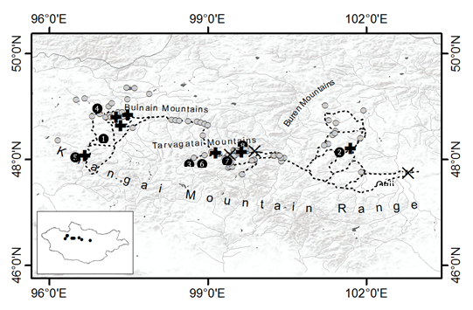

Figure 1 - 2. Decreasing egg weights for Bar-headed Geese (Anser indicus) during the incubation period.
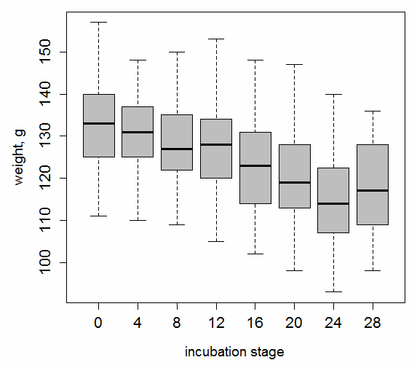
Figure 1 - 3. Proportions of Bar-headed Goose (Anser indicus) nests with different clutch sizes at island and cliff sites.

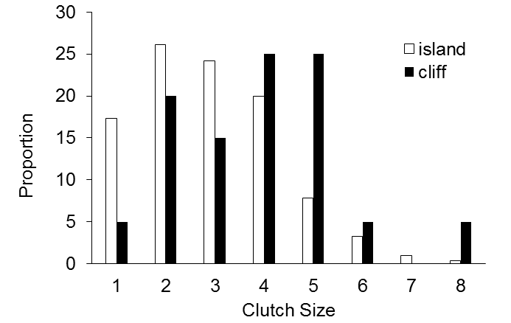

Figure 1 - 4. Bar-headed Geese (Anser indicus) daily nest survival (DNS) with 95% confidence intervals from westcentral Mongolia in 2009, 2010, and 2011.
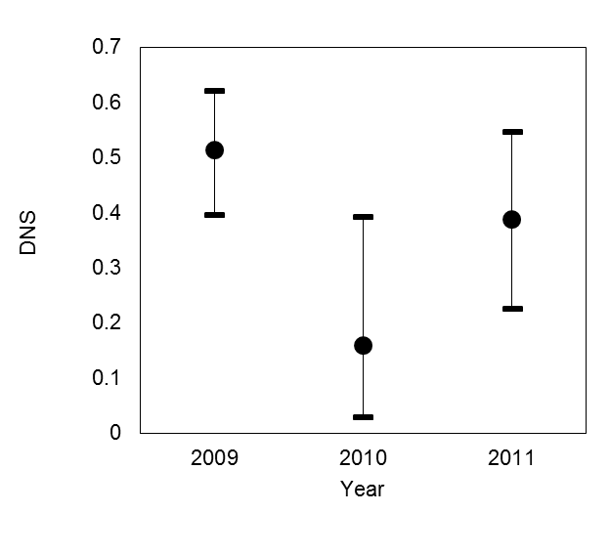

Figure 1 - 5. Variation in Bar-headed Geese (Anser indicus) daily nest survival (DNS) between different habitat types (island, cliff), accessibility (low, high), and depredation levels (low, high) from 2009-2011.
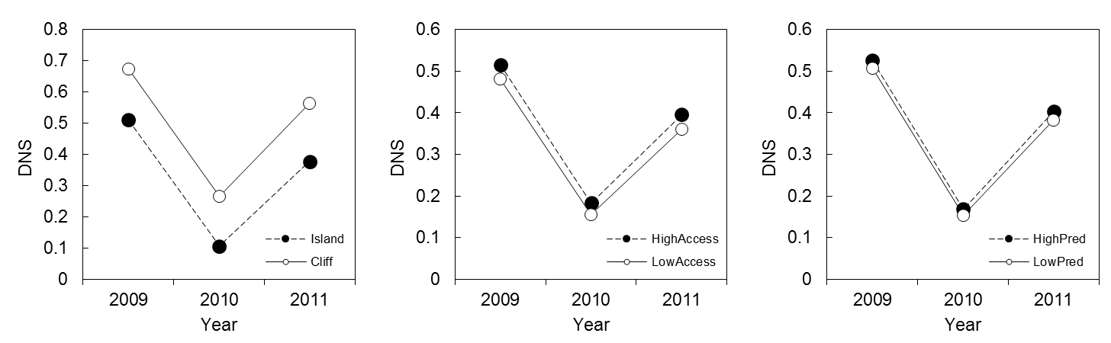

Figure 1 - 6. Daily survival rate (DSR) of Bar-headed Geese (Anser indicus) nests in relation to nest age (days since egg laying) in westcentral Mongolia from 2009-2011. The logistic-exposure model curve and 95% confidence limits are shown.
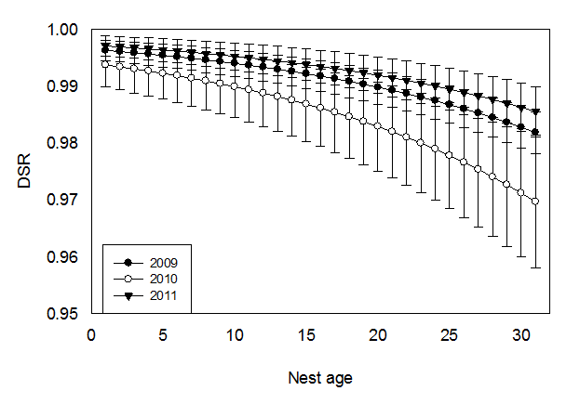

Chapter II. MIGRATION STRATEGIES OF SWAN GEESE (ANSER CYGNOIDES) FROM NORTHEAST MONGOLIA

Abstract
In 2006–2008, 25 Swan Geese Anser cygnoides were marked with solar-powered GPS satellite transmitters in northeast Mongolia to examine the timing and pathways of their migration. Most geese began their autumn migration in August, flying southeast toward a staging area at the Yalu River Estuary on the China-North Korea border. After staging for several weeks, the Swan Geese continued to their wintering grounds at wetlands along the Yangtze River Basin of eastern China in December. Spring migration commenced in late February, and the birds following either a same-route or loop migration to arrive at the breeding grounds in mid April. Swan Geese used a larger number of staging areas for a longer duration when they were north of 42°N latitude; they seemed to avoid staging for extended periods in the highly urbanised areas of eastern China.

Introduction
Understanding local movements and migration across large landscapes is critical for identifying the factors that influence the survival of migratory birds and for devising effective conservation strategies (Berger 2004; Newton 2007). Migration data provide insights into specific areas used, migratory connectivity, timing, stopover sites, migratory behaviour and physiology (Berthold et al. 2003; Robinson et al. 2010). In addition, use of satellite tracking data has improved our understanding of the ecology of diseases such as avian influenza and the connectivity between outbreak areas and wild bird locations (Gaidet et al. 2010; Newman et al. 2009; Takekawa et al. 2010).
The Swan Goose Anser cygnoides is a globally threatened species listed as “vulnerable" in the latest Red List of Threatened Species of the International Union for Conservation of Nature and only occurs in East Asia (BirdLife International 2009). Recent counts made both at the breeding grounds in Mongolia and Russia (Goroshko 2003; Goroshko et al. 2004; Tseveenmyadag et al. 2007) and at wintering sites in China (Zhang et al. 2010) indicate a dramatic decline in numbers which has been attributed to: drought-induced wetland loss, disturbance of nesting birds by livestock, competition with livestock for grazing areas, illegal hunting, egg collection, reduction in the abundance of submerged vegetation (i.e. the birds’ food supply) due to water pollution and dam water regulation, and wetland conversion for agriculture and development projects (Goroshko 2003; Goroshko et al. 2004; Poyarkov 2001; Poyarkov 2006; Tseveenmyadag et al. 2007; Zhang et al. 2010; Fox et al. 2011). The decreasing population size may also be related to habitat change or degradation at stopover sites along the migration flyway. Furthermore, the highly pathogenic avian influenza H5N1 virus, which has been reported across the Swan Goose wintering range, poses a significant threat to this species.
In 2006 and 2008, moulting geese were fitted with satellite transmitters and tracked from their breeding sites on the Mongol Daguur in northeast Mongolia to their wintering grounds in the Yangtze River Basin of eastern China. Global positioning system (GPS) location data were used to describe their annual migration in detail, including identifying stopover and wintering sites, documenting the timing of migration, and delineating migration corridors along the East Asian Flyway. In addition to providing the first documentation of the complete migration cycle of the Swan Goose, a major focus of this study was to determine how the birds used the landscape in relation to human populations. We hope that the greater knowledge and understanding of how Swan Geese use the landscape, provided by tracking the movements of individual birds, will help to improve the prospects of conservation efforts directed at this species.

Study area and methods
The Mongol Daguur is a temperate region characterised by vast grassland steppes, low mountains and rolling hills, and with numerous small and medium sized steppe lakes and wetlands. Nomadic herders and their livestock are the main populations in the area. Mosts lakes in this region are fed by rain water; only a few are fed by running streams. The lake and wetland steppe landscape extends north into neighbouring Russia and east into China; this border region of the three countries is an important area for the Swan Goose and many other wetland-dependent species in northeast Asia (BirdLife International 2005).
Swan Geese were captured during their moulting period by herding them into a drive-trap or by capturing them in dip-nets from boats. A total of 25 Swan Geese were caught at the Khaichiin Tsagaan Lake (49.683°N, 114.684°E) in the Mongol Daguur of northeast Mongolia in July 2006, and a further 41 geese at Khaichiin Tsagaan Lake, Khorin Tsagaan Lake (49.661°N, 114.606°E), and Khokh Lake (49.540°N, 115.585°E), in the same region of northeast Mongolia, in 2008. All captured geese were tested for the avian influenza virus, but none were found to be positive (authors’ unpubl. data). Geese were measured and marked with aluminium metal leg rings and plastic neck collars for individual identification, using orange neck collars with black alphanumeric codes (with one letter and two numbers) in 2006 and green neck collars with white alphanumeric codes in 2008.
We fitted 45 g or 70 g solar-powered Argos-GPS platform transmitter terminals (PTTs: Microwave Telemetry, Inc., Columbia, MD, USA) to the backs of selected adults, using a teflon-ribbon harness (Bally Ribbon Mills, Bally, PA, USA). Ten 70 g transmitters were fitted in 2006 and fifteen 45 g transmitters in 2008. Backpack harnesses for the transmitters were reinforced to prevent loss, because Swan Geese have very strong bills and their lower mandibles are serrated for cutting plants and grasses. The weight of the transmitter and harness was < 3% of the birds’ body mass. Birds were released as soon as possible after marking, typically within an hour, near their capture locations. Procedures for capture, handling and marking were reviewed and approved by the U.S. Geological Survey Patuxent Wildlife Research Center Animal Care and Use Committee and University of Maryland Baltimore County Institutional ACUC (Protocol EE070200710). Transmitters were programmed to record GPS locations every 2 h and Argos locations downloaded every 2–3 days. Only geese that had complete migration routes were included in analyses, and only GPS data were used, which are typically accurate to distances of < 100 m.
The annual cycle of the Swan Goose was divided into five different periods: 1) autumn (southbound) migration, 2) wintering, 3) spring (northbound) migration, 4) breeding season, and 5) moulting or post-breeding. We examined the location data and used specific areas, duration of stay, and scale of movements to estimate the duration of these periods. Movement from the moulting and wintering areas was used to indicate the onset of migration. Geese were classified as breeding if the GPS fixes were found to be in very close proximity to each other at a site over more than a one-week period during the breeding season (Ely et al. 2007). The arrival time was defined as the first date that swan geese were detected on the breeding grounds. Swan Geese prefer to use larger lakes for moulting because they provide more safety when flightless (authors’ pers. obs.). We assumed that movements of several kilometres from breeding areas on smaller lakes to larger lakes indicated that the birds had moved to moulting grounds. Staging areas, where migrating birds store fuel for migration, were identified as sites where birds remained in the vicinity (i.e. no large-scale movements to or from the site occurred) over a period of ≥ 7 days during the migration period (Warnock 2010). Visual inspection of locations in close proximity and limited movements at the southern end of the migration were used as cut-off dates for the fall migration and to determine the arrival at wintering grounds (Oppel et al. 2008).
Various factors such as food supply, local environment, weather, proximity to main wintering areas, and hunting pressure may disturb and eventually influence the timing of bird migration (Berthold et al. 2003). In this study, the linear distance from stopover locations to the nearest urban area was used as an indicator of potential disturbance to Swan Geese along the migration route (Benitez-Lopez et al. 2010). Furthermore, we examined the flight speeds and distances travelled by birds between consecutive locations to see whether flights north and south of 42°N differed significantly, with the density of urban areas in the Swan Goose flyway generally being higher south of this latitude. Mean flight duration and distances are given with s.d. values throughout.
The European Space Agency’s GlobCover land cover map with 300 m spatial resolution (Bicheron et al. 2008) produced for the period December 2004 – June 2006 was used to determine land cover types at stopover and staging locations along the Swan Goose migration route in East Asia and for calculating distances between towns or villages and stopover locations. Location data were plotted within ArcGIS 9.3 (ESRI 2008) to determine the migration route and stopover sites, and to calculate the flight distances of Swan Geese. The 50%, 95% and 99% fixed kernel home ranges were calculated using Hawth's Analysis Tools (Beyer 2004) in ArcGIS 9.3 to determine the areas used by Swan Geese at the Yalu River Estuary and Poyang Lake and to define the boundaries of movements by individual geese in these areas.

Results
Ten geese were fitted with satellite transmitters in 2006 and 15 geese in 2008. Overall, 17 (68%) birds provided satellite tracking data useful for evaluating migration. Fourteen of the useful tracks were from the 2008 deployment, but only three of 10 geese from 2006 yielded data (Table 2-1). Although the other seven birds appeared normal upon release, they did not swim well, and five were recaptured by the next day. We found that they had been adversely affected by capture myopathy, because for short periods they had entangled their wings or feet in the small-mesh fishing net used as a holding pen that year (a different type of holding pen was used in subsequent years). A total of 15,458 GPS fixes were obtained with an average of 858 locations per individual, ranging from 14–2,420 locations per bird. Such large individual variation was influenced primarily by the duration over which signals were received (range = 29–489 days). Departure from the post-breeding area was documented for 17 birds, five of which provided complete autumn and spring migration histories, and twelve birds had partial migration histories. Two geese with working transmitters made autumn migrations in the second year after capture. All birds migrated within the East Asian Flyway (Figure 2-1).
Autumn migration
The route and timing of the autumn migration was documented for six male and eleven female geese. Autumn migration started between 3 August and 16 September (median date = 8 August, n = 19). Most birds started their migration in August, but two birds (transmitter numbers 82103 and 82108) started in September in 2008. Signals for five birds (#67578, 82104, 82110, 82114 and 82115) that started their autumn migration ended before reaching the Hinggan Mountains in Inner Mongolia, China. Ten Swan Geese progressed across eastern Mongolia and the Manchurian Plain to the Yalu River Estuary on the border of China and North Korea, but from here they flew southwest to wintering areas in East China. Two Swan Geese migrated to areas at the same latitude as the Yalu River Estuary but flew directly south to the wintering grounds (#67585, 82113).
The Yalu River Estuary on the border between China and North Korea was a key staging area for Swan Geese (Figs. 1 and 2a). Two birds tracked in 2006 arrived after mid October, whereas five birds tracked in 2008 arrived at the end of September, and two arrived around at the end of October. All birds stayed at this staging area until the end of December when air temperatures sharply decreased and freezing conditions likely reduced availability of food resources. The 99% fixed kernel home ranges for Swan Geese in this location during the autumn and spring migration were 176 km² and 190 km², respectively.
Swan Geese arrived at the wintering grounds in December, although one bird arrived on 1 January (Table 2-2). Five birds (#67585, 82105, 82107, 82108, and 82111) that successfully completed the southbound migration travelled 2,580–3,170 km (mean = 2,900 ± 272 km, n = 5) to reach their wintering grounds in eastern China. Autumn migration for these birds took 74–146 days (mean = 107 ± 29 days, n = 5). Individual variation in the autumn migration period was largely due to the different length of time geese spent at the staging areas.
Wintering
Poyang Lake (29.217°N, 115.960°E), located in the Jiangxi Province along the Yangtze River and the largest freshwater lake in China, was an important wintering area for the Swan Geese tracked from northeast Mongolia (Figure 2b). Four geese (#67585, 82105, 82107 and 82111) arrived first at the northwest region of the lake. Later, geese moved to the south of the lake for most of the remaining wintering period and returned to the northwest just before the spring migration began. Another goose (#82108) spent the winter at Fengsha Lake (30.927°N, 117.630°E) in Anhui Province located within the Yangtze River Basin 240 km northeast of Poyang Lake and known to be another important wintering site for Swan Geese (Fox et al. 2008). Arrival dates at wintering areas ranged from 23 October to 1 January with a median date of 7 December (n = 5). Swan geese spent 56–155 days (mean = 104 ± 37 days) at the wintering grounds. The 50%, 95%, and 99% fixed kernel home range of Swan Geese in this location during their winter stay were of 60 km², 370 km² and 580 km², respectively.
Spring migration
Swan Geese departed for their spring migration between 25 February and 5 April (median = 14 March, n = 5 birds). Northbound travel lasted for 30–66 days with an average of 52 days (s.d. = 15 days). The spring migration routes for three of the Swan Geese were similar to those taken during the autumn migration. Two geese followed different routes, flying directly to the north without staging at the Yalu River Estuary. Geese which followed a same-route spring migration took 30–66 days to reach the breeding grounds, with many shorter stopovers between staging areas, whereas the two geese following a loop migration travelled for 43 and 60 days respectively, differing from geese following the same-route migration by having longer non-stop flights with fewer staging periods. The five geese completed the spring migration after travelling 2,570–2,700 km (mean = 2,630 ± 54 km) to reach the breeding grounds in northeast Mongolia.
Arrival at breeding and post-breeding areas
The first bird arrived at the breeding grounds on 13 April and the last arrived on 4 June (median = 9 May, n = 5). The geese stayed on the breeding grounds for 43–70 days (mean = 53 ± 15 days). Four birds arrived at the same area where they were captured in the previous year, the fifth (#82105) probably bred at Tsagaan Lake (47.911°N, 119.604°E) in China. Swan Geese arrived at their moulting sites between 16–22 June. Post-breeding areas where geese typically moult were on lakes with grassy meadows. Swan Geese remained at these post-breeding areas for two months prior to the beginning of autumn migration in August. Two birds were tracked on a second autumn migration beginning on 23 August 2007 (#67585) and on 18 August 2009 (#82105). Migration routes of these birds were similar to the previous year up to the time their transmitter signals ended in mid migration.
Staging areas
A total of 54 staging areas were used by the 17 Swan Geese after they left the breeding and moulting grounds. Five female Swan Geese that had complete migration cycles had similar numbers of stopover areas during the migration (ANOVA test: F4, 49 = 0.17, P = 0.95). The number of staging areas where birds spent on average more than 10 days ranged from 4 to 9 sites per bird. Birds were spending 8–70 days per site (mean = 23 days; 95% UCI = 41, LCI =4). We also obtained detailed information on location and habitat for selected major staging and stopover sites (Table 2-3).
The Yalu River Estuary was a key staging area or pre-wintering area. Eight Swan Geese spent 16–70 days there (mean = 34 days) from 16 September to 20 December. The Swan Geese did not use adjacent agriculture fields to forage during this period. Instead, they used mostly mudflat areas and habitats along the coastline (Figure 2a).
In general, the number of stopover and staging areas and the duration Swan Geese spent at important staging areas were greater when geese were north of 42°N. There was some preliminary evidence that the distance from a stopover location to urban areas decreased as the birds flew south, with the smallest distances involved being close to the wintering grounds (Figure 2-3). Few Swan Geese used Buir Lake which is one of the largest lakes in the region as a stopover site where over 24,000 Swan Geese have been recorded (Goroshko 2004). Only one of our marked geese stopped at this lake for 1–2 days during their autumn migration.
There were 78 flight paths which were useful to estimate flight speeds and successive distances during migration. Of this total, 38 flight paths belonged to the autumn migration, and 40 were for spring migration. Overall, the swan geese migrated at an average of 31±1.8 km (N=78) per hour with the range for individual flight speed of 11-77 km/h. During autumn migration, the swan geese migrated at an average speed of 31±2.2 km/h (N=38) with individual flight speeds ranged from 12 to 66 km/h. During spring migration, the swan geese travelled at an average speed of 32±2.8 km/h (N=40) and it ranged from 11-77 km/h. There was no apparent difference in average flight speed during the autumn and spring migrations, and the average distance traveled by individual birds did not differ in both autumn and spring seasons (Figure 2-4). Maximum duration of nonstop flights over 24 hours was observed for three occasions. Goose #82105, #82107 and # 82111 flew for 26, 29 and 30 hours, respectively, in September and December of 2008. During these flights, they effectively covered 977, 1053, and 1395 km at speeds of 38, 36, and 47 km/h, respectively.

Discussion
Two distinct flight paths were used during autumn migration by the Swan Geese tracked in our study: 1) an indirect flight between Mongol Daguur in northeast Mongolia and Poyang Lake in eastern China through the Yalu River Estuary on the China-North Korean border, and 2) a direct flight between the Mongol Daguur and the Poyang Lake. Geese flying through the Yalu River Estuary during their migration flew more than 300 km farther than those flying straight from the Mongol Daguur to Poyang Lake, but more marked geese used this route. In terms of maximising energy and minimising time, migration along this pathway appears more costly than the direct flight. Many migratory species make detours to avoid hazardous and inhospitable land masses or water bodies, and thus reduce the risks encountered during migration (Newton 2007). However, there are no major physical barriers such as a large mountain range or body of water that would prevent Swan Geese flying directly south to Poyang Lake from Mongolia. In fact, geese flying to the Yalu River Estuary must cross Bohai Bay en route to the Yangtze River Basin.
One possible explanation for the intensive use of this estuary by Swan Geese is that weather and climate patterns influenced their migration (Gordo 2007). Prevailing winds and favourable conditions may favour stopovers by migratory birds along the Yellow Sea (van de Kam 2010). Alternatively, the Swan Geese may have been avoiding interior areas with highest densities of human, agriculture, and infrastructure development while exploiting natural areas as much as possible before arriving at Poyang Lake. Furthermore, flying via Yalu River could be a traditional migration route to Japan and South Korea where Swan Geese commonly used to winter (Brazil 1991).
Swan Goose migration between the Yalu River Estuary and Poyang Lake was brief, with fewer stopovers compared to flights between Mongol Daguur and the Yalu River Estuary. In general, we did not see major changes in average flight speed and distance throughout the migration along the direct route. Although, there were some remarkable maximum groundspeed and flight distances of Swan Geese until the geese reached the Yalu River Estuary during fall migration. It was demonstrated that marked Swan Geese can cover about 1400 km within 30 hours. But what ecological and environmental factors may have influenced such flights is unknown.
Availability of stopover sites and duration of stay are important parts of the annual cycle and influence birds’ migration strategies (Berthold et al. 2003; Newton 2007). Marked Swan Geese made more stopovers in the areas north of 42°N latitude, which may indicate the presence of more suitable sites in the north that were primarily natural wetlands. There are currently few large human concentrations in the areas intersecting northeast Mongolia, Russia, and China where Swan Geese breed and moult. Thus, the region is mostly undisturbed or underdeveloped. Swan Geese exhibited longer stopover durations in the north of 42°N latitude during both the autumn and spring migration. Furthermore, our data suggests that the proximate distance from a stopover location to urban areas decreased as birds flew south, and the distance was least near the wintering area. Swan Geese may prefer to use landscapes with lower human densities and less urbanisation while exploiting areas with rich in food supply.
The scale of urbanization in eastern China, home to 10% of the world’s population (van de Kam 2010) and the majority of the population in China, is very intensive. As a result, human development has dramatically changed land cover and land use practices in eastern China (Deng et al. 2008). Avian species often respond dramatically to urbanization and development depending on spatial scales and local food, available habitats, and disturbance levels (Clergeau et al. 1998; Garaffa et al. 2009; Klein 1993; Marzluff 2001; Traut & Hostetler 2003). Large scale changes at a landscape level in East China may have affected migratory behaviour of the Swan Geese historically, but there are too few historical data available to analyse this hypothesis.
Nonetheless, eastern China is the most important wintering area for the Swan Goose, and nearly 95–100% of the geese from the Dauria region are found wintering there (Cao et al. 2008a; Zhang et al. 2010). In the last four decades, the wintering range of Swan Geese has gradually contracted coincident with a decline in their populations likely related to increased poaching, water-level control for irrigation and industrial use, habitat degradation of coastal and inland wetlands, and pollution (Barter et al. 2007; Cao et al. 2010; Quan et al. 2002; Zhang et al. 2010). Expansion of urbanization and economic development in East Asia has caused large-scale change in ecosystems of the region. Also, degradation of wetlands in eastern China has contributed to distribution range shifts, contraction, and northward expansion for many waterbird species (Cao et al. 2008b; Cao et al. 2010; de Boer et al. 2011).
Extensive use of mudflats by Swan Geese has been document during the non-breeding season. Swan Geese were commonly observed grubbing on underground rhizomes of Vallisneria asiatica in mud flat habitats at wintering sites in Shengjin Lake (Fox et al. 2008; Zhang & Lu 1999) and in Han River Estuary (Han et al. 2003). It is unclear what constitutes the main food supply for staging Swan Geese in the Yalu River Estuary mudflats and why geese do not use grassland habitats and agricultural fields. However, it could be related to available foraging habitats in that region and easy access to food rich in nutrition food.
In addition, Poyang Lake is one of the major wintering areas for the Swan Goose and many other waterbirds but has been called the potential rbanized of HPAI H5N1 (Cao et al. 2008a; Prosser et al. 2009; Takekawa et al. 2010). Outbreaks of highly pathogenic avian influenza H5N1 have occurred along the migration route from northeast Mongolia through the Yalu River Estuary to Poyang Lake (Sakoda et al. 2010; Takekawa et al. 2010). The density of wetlands along this migration route is sparse in northern compared to southern regions where man-made wetlands are abundant (Bicheron et al. 2008). Thus, Swan Geese may have greater chances of interactions in stopover areas north of 42°N with waterbirds originating from different parts of South and East Asia increasing the potential for H5N1 transmission. Consequently, potential spread and persistence of HPAI H5N1 in this region may pose a threat to the Swan Goose population.
It remains unclear whether the migratory pathway we documented through the Yalu River Estuary is a historical or recently-developed route that arose in response to land use and land cover changes in eastern China. However, Takekawa et al. (2010) documented that several different duck species migrated from Poyang Lake to northeast China and eastern Russia in the spring and made extensive use of the region as a staging area as do many shorebirds (van de Kam 2010). Thus, if we wish to conserve stopover areas along routes for migratory bird species in East Asia, obtaining a better understanding of the effects of urban area expansion and development at key stopover sites such as the Yalu River Estuary is crucial. Those impacts may be most visible for species with larger body size and narrow habitat niches such as the Swan Goose.

Acknowledgments
This work was funded by the U. S. Geological Survey (Patuxent Wildlife Research Center, Western Ecological Research Center, Alaska Science Center, and Avian Influenza Program), the United Nations Food and Agriculture Organization, Animal Production and Health Division, EMPRES Wildlife Unit. The field work of Mongolian and Korean researchers in 2006 was funded by the Cultural Heritage Administration of Korea through Korean-Mongolia Joint Swan Goose Research Project. The data analysis was supported by a grant from the US National Science Foundation EPSCoR program (NSF-0919466). We are grateful to Sabir Bin Muzaffar, Eric Palm, David Douglas, Bill Perry (U. S. Geological Survey), Taej Mundkur (Wetlands International), Martin Gilbert (Wildlife Conservation Society), Paek Won Kee, Chun Byung Sun (Korean National Science Museum), and the staff of the Wildlife Science and Conservation Center of Mongolia for their assistance in the field. The Ministry of Nature and Environment of Mongolia provided permission to capture and satellite mark swan geese through the Institute of Biology, Mongolian Academy of Sciences. Protocols for the study were reviewed by a U. S. Geological Survey Animal Care and Use Committee. Any use of trade, product, or firm names in this publication is for descriptive purposes only and does not imply endorsement by the U.S. government.

References
Barter, M.A., X. Yu, L. Cao, B. F. Liu, Z. L. Yang & Zheng., D.T. 2007. Wintering waterbird survey of the coastline of Fujian Province, China: 8–27 February 2006. Beijing: China Forestry Publishing House.
Benitez-Lopez, A., Alkemade, R. & Verweij, P.A. 2010. The impacts of roads and other infrastructure on mammal and bird populations: A meta-analysis. Biological Conservation 143: 1307–1316.
Berger, J. 2004. The last mile: How to sustain long-distance migration in mammals. Conservation Biology 18: 320–331.
Berthold, P., Gwinner, E. & Sonnenschein, E. 2003. Avian Migration. Berlin: Springer.
Beyer, H.L. 2004. Hawth’s Analysis Tools for ArcGIS. Available at http://www.spatialecology.com/htools. .
Bicheron, P., Defourny, P., Brockmann, C., Schouten, L., Vancutsem, C., Huc, M., Bontemps, S., Leroy, M., Achard, F., Herold, M., Ranera, F. & Arino, O. 2008. GlobCover 2005 – Products description and validation report, Version 2.1, 2008 (a). Available on the ESA IONIA website (http://ionia1.esrin.esa.int/).
BirdLife International. 2009. Species factsheet: Anser cygnoides. Downloaded from http://www.birdlife.org on 5/2/2010.
Brazil, M.A. 1991. The Birds of Japan. Christopher Helm, London, UK.
Cao, L., Barter, M. & Lei, G. 2008a. New Anatidae population estimates for eastern China: Implications for current flyway estimates. Biological Conservation 141: 2301–2309.
Cao, L., Barter, M. & Lewthwaite, R. 2008b. The Declining Importance of the Fujian Coast, China, for Wintering Waterbirds. Waterbirds 31: 645–650.
Cao, L., Zhang, Y., Barter, M. & Lei, G. 2010. Anatidae in eastern China during the non-breeding season: Geographical distributions and protection status. Biological Conservation 143: 650–659.
Clergeau, P., Savard, J.P.L., Mennechez, G. & Falardeau, G. 1998. Bird abundance and diversity along an urban-rural gradient: A comparative study between two cities on different continents. Condor 100: 413–425.
de Boer, W.F., Cao, L., Barter, M., Wang, X., Sun, M., van Oeveren, H., de Leeuw, J., Barzen, J. & Prins, H.H.T. 2011. Comparing the Community Composition of European and Eastern Chinese Waterbirds and the Influence of Human Factors on the China Waterbird Community. AMBIO: A Journal of the Human Environment 40: 68–77.
Deng, X.Z., Huang, J.K., Rozelle, S. & Uchida, E. 2008. Growth, population and industrialization, and urban land expansion of China. Journal of Urban Economics 63: 96–115.
Ely, C.R., Bollinger, K.S., Densmore, R.V., Rothe, T.C., Petrula, M.J., Takekawa, J.Y. & Orthmeyer, D.L. 2007. Reproductive strategies of Northern Geese: Why wait? Auk 124: 594–605.
ESRI. 2008. ArcGIS 9.3. Redlands, CA: Environmental Systems Research Institute.
Fox, A.D., Hearn, R.D., Cao, L., Cong, P.H., Wang, X., Zhang, Y., Dou, S.T., Shao, X.F., Barter, M. & Rees, E.C. 2008. Preliminary observations of diurnal feeding Patterns of Swan Geese Anser cygnoides using two Different habitats at Shengjin Lake, Anhui Province, China. Wildfowl 58: 20–30.
Fox, A.D., Cao, L., Zhang, Y., Barter, M., Zhao, M.J., Meng, F.J. & Wang, S.L. 2011. Declines in the tuber-feeding waterbird guild at Shengjin Lake National Nature Reserve, China – a barometer of submerged macrophyte collapse? Aquatic Conservation: Marine and Freshwater Ecosystems 21: 82–91.
Gaidet, N., Cappelle, J., Takekawa, J.Y., Prosser, D.J., Iverson, S.A., Douglas, D.C., Perry, W.M., Mundkur, T. & Newman, S.H. 2010. Potential spread of highly pathogenic avian influenza H5N1 by wildfowl: dispersal ranges and rates determined from large-scale satellite telemetry. Journal of Applied Ecology 47: 1147–1157.
Garaffa, P.I., Filloy, J. & Bellocq, M.I. 2009. Bird community responses along urban-rural gradients: Does the size of the urbanized area matter? Landscape and Urban Planning 90: 33–41.
Gordo, O. 2007. Why are bird migration dates shifting? A review of weather and climate effects on avian migratory phenology. Climate Research 35: 37-58.
Goroshko, O.A. Year. 2003 – extremely unfavourable year for Swan Geese in Dauria trans-boundary region (Russia and Mongolia). Proceedings of the 2003 International Anatidae Symposium in East Asia & Siberia Region, pp. 83–92. Hanseo University, Seosan, Korea.
Goroshko, O.A. 2004. Data for waterbirds at Buyr-Nuur (Eastern Mongolia). Mongolian Journal of Biological Science 2: 67-68.
Goroshko, O.A., Songtao, L. & Ler, B. 2004. Census of Cranes and Geese in Dalai Lake and Huihe Nature Reserves in Inner Mongolia, China. Mongolian Journal of Biologycal Sciences 2: 75–76.
Han, S.W., Yoo, S.H., Lee, H., Lee, K., Paek, W.K. & Song, M. 2003. A study on the wintering population of geese in Cheolwon, Korea. Proceedings of the 2003 International Anatidae Symposium in East Asia and Siberia region, Seosan, Korea: Hanseo University. Pp. 95–101. Seosan City, South Korea,
Kam, J. van de, Battley P. McCaffery B. Rogers D. Hong J.S., Moores, N. Yung-Ki, J., Lewis, J. & Piersma, T. 2010. Invisible connections: why migrating shorebirds need the Yellow Sea. Collingwood, Victoria, Australia.
Klein, M.L. 1993. Waterbird behavioral responses to human disturbances. Wildlife Society Bulletin 21: 31-39.
Marzluff, J.M. 2001. Worldwide urbanization and its effects on birds. In: J.M. Marzluff, R. Bowman, & R. Donnelly (eds)., Avian ecology and conservation in an urbanizing world, pp. 19–47. Kluwer Academic Publishers, Boston, USA.
Newman, S.H., Iverson, S.A., Takekawa, J.Y., Gilbert, M., Prosser, D.J., Batbayar, N., Natsagdorj, T. & Douglas, D.C. 2009. Migration of whooper swans and outbreaks of highly pathogenic avian influenza H5N1 virus in eastern Asia. PloS One 4: e5729.
Newton, I. 2007. The migration ecology of birds. Academic Press, London, UK.
Oppel, S., Powell, A.N. & Dickson, D.L. 2008. Timing and distance of King Eider migration and winter movements. Condor 110: 296–-305.
Poyarkov, N.D. 2001. The Swan-Goose: its origin, number dynamics, biology, and conservation. Casarca 7: 51–67.
Poyarkov, N.D. 2006. The swan goose Anser cygnoides research and conservation programme in Russia. In G.C. Boere, C.A. Galbraith and D.A. Stroud (eds.), Proceedings of the Waterbirds around the world: a global overview of the conservation, management and research of the world’s waterbird flyways, pp. 482–483. The Stationery Office, Edinburgh, UK.
Prosser, D.J., Takekawa, J.Y., Newman, S.H., Yan, B., Douglas, D.C., Hou, Y., Xing, Z., Zhang, D., Li, T., Li, Y., Zhao, D., Perry, W.M. & Palm, E.C. 2009. Satellite-marked waterfowl reveal migratory connection between H5N1 outbreak areas in China and Mongolia. Ibis 151: 568–576.
Quan, R.C., Wen, X.J. & Yang, X.J. 2002. Effects of human activities on migratory waterbirds at Lashihai Lake, China. Biological Conservation 108: 273–279.
Robinson, W.D., Bowlin, M.S., Bisson, I., Shamoun-Baranes, J., Thorup, K., Diehl, R.H., Kunz, T.H., Mabey, S. & Winkler, D.W. 2010. Integrating concepts and technologies to advance the study of bird migration. Frontiers in Ecology and the Environment 8: 354–361.
Sakoda, Y., Sugar, S., Batchluun, D., Erdene-Ochir, T.-O., Okamatsu, M., Isoda, N., Soda, K., Takakuwa, H., Tsuda, Y., Yamamoto, N., Kishida, N., Matsuno, K., Nakayama, E., Kajihara, M., Yokoyama, A., Takada, A., Sodnomdarjaa, R. & Kida, H. 2010. Characterization of H5N1 highly pathogenic avian influenza virus strains isolated from migratory waterfowl in Mongolia on the way back from the southern Asia to their northern territory. Virology 406: 88–94.
Takekawa, J.Y., Newman, S.H., Xiao, X.M., Prosser, D.J., Spragens, K.A., Palm, E.C., Yan, B.P., Li, T.X., Lei, F.M., Zhao, D.L., Douglas, D.C., Bin Muzaffar, S. & Ji, W.T. 2010. Migration of Waterfowl in the East Asian Flyway and Spatial Relationship to HPAI H5N1 Outbreaks. Avian Diseases 54: 466–476.
Traut, A.H. & Hostetler, M.E. 2003. Urban lakes and waterbirds: Effects of development on avian behavior. Waterbirds 26: 290–302.
Tseveenmyadag, N., Nyambayar, B., Monkhzul, T., Paek, W.K., Chun, B.S. & Paik, I.H. 2007. Distribution and population status of swan geese Anser cygnoides in Amur River basin in Mongolia. Journal of Institute of Biology, Mongolian Academy of Sciences, 23:134–138. [In Mongolian with English abstract]
Warnock, N. 2010. Stopping vs. staging: the difference between a hop and a jump. Journal of Avian Biology 41: 621-626.
Zhang, J.X. & Lu, J.J. 1999. Feeding ecology of two wintering geese species at Poyang Lake, China. Journal of Freshwater Ecology 14: 439–445.
Zhang, Y., Cao, L., Barter, M., Fox, A.D., Zhao, M., Meng, F., Shi, H., Jiang, Y. & Zhu, W. 2010. Changing distribution and abundance of Swan Goose Anser cygnoides in the Yangtze River floodplain: the likely loss of a very important wintering site. Bird Conservation International 21:36–48.

Tables and Figures

Table 2 – 1. Morphological data for Swan Geese fitted with satellite transmitters and a summary of performance of the transmitters. *Not included in the analysis | Total number of GPS fixes | 378 | 1618 | 721 | 811 | 14 | 437 | 134 | 2.302 | 418 | 1.534 | 2.420 | 468 | 314 | 1.954 | 1.100 | 306 | 227 | 302
 | Total days with signals | 50 | 472 | 124 | 127 | 99 | 135 | 29 | 389 | 63 | 489 | 388 | 59 | 147 | 291 | 137 | 102 | 39 | 39
 | Date last signal received | 17-Sep-06 | 13-Nov-07 | 30-Nov-06 | 2-Dec-08 | 4-Nov-08 | 9-Dec-08 | 24-Aug-08 | 18-Aug-09 | 27-Sep-08 | 27-Nov-09 | 18-Aug-09 | 23-Sep-08 | 20-Dec-08 | 13-May-09 | 10-Dec-08 | 5-Nov-08 | 5-Sep-08 | 3-Sep-08
 | Start date of transmission | 30-Jul-06 | 30-Jul-06 | 30-Jul-06 | 29-Jul-08 | 29-Jul-08 | 27-Jul-08 | 27-Jul-08 | 26-Jul-08 | 27-Jul-08 | 27-Jul-08 | 27-Jul-08 | 27-Jul-08 | 27-Jul-08 | 27-Jul-08 | 27-Jul-08 | 27-Jul-08 | 29-Jul-08 | 27-Jul-08
 | Tarsus (mm) | 835 | 986 | - | 84.5 | 89.6 | 81.9 | 92.6 | 91.5 | 75.4 | 80.5 | 79.9 | 84.6 | 80.5 | 75.8 | 77.7 | 80.5 | 76.4 | 50.3
 | Culmen (mm) | 40.5 | - | - | 98.6 | 103.4 | 84 | 89.2 | 95.3 | 84.7 | 90.5 | 92.7 | 89 | 89.9 | 88.2 | 80.7 | 88.1 | 83.8 | 55.4
 | Weight (g) | 3550 | 2600 | 2500 | 2700 | 2900 | 2920 | 3800 | 3490 | 2550 | 3100 | 2850 | 3150 | 1700 | 2750 | - | 2720 | 2700 | 3100
 | Age | Ad | Ad | Ad | Ad | Ad | Ad | Ad | Ad | Subad | Ad | Ad | Ad | Ad | Ad | Ad | Ad | Ad | Ad
 | Sex | F | F | F | F | M | F | M | F | F | F | F | M | M | F | M | F | M | M
 | Satellite ID | 67578 | 67585 | 67697 | 82101 | 82102* | 82103 | 82104 | 82105 | 82106 | 82107 | 82108 | 82109 | 82110 | 82111 | 82112 | 82113 | 82114 | 82115

Table 2 – 2. Chronology and movements of satellite-tracked Swan Geese during their annual cycle. | Post-breeding | 3 | 16 Jun – 22 Jun | 21-Jun | 61–65 | 63 | - | -
 | Breeding | 5 | 13 Apr – 4 Jun | 9-May | 43–70 | 53 | - | -
 | Spring migration | 5 | 25 Feb – 5 Apr | 14-Mar | 30–66 | 52±15 | 2,570–2,700 | 2,630 ± 54
 | Winter | 5 | 23 Oct–1 Jan | 7-Dec | 56–155 | 104 | - | -
 | Autumn migration | 18 | 3 Aug–16 Sep | 8-Aug | 74–146 | 107 ± 29 | 2,580–3,170 | 2,900 ± 272
 | Migration periods | N | Start or arrival date (range) | Start or arrival date (median date) | Min–Max duration(days) | Average duration ± s.d. (days) | Linear distance travelled (km) | Average linear distance travelled ± s.d. (km)

Table 2 – 3. Location, habitat, and duration of stay of Swan Geese at selected major stopover sites (i.e. where birds spent on average more than 10 days). After moulting, geese spent over a week at 54 different migration locations. | Range | 22 | 2–18 | 26 | 17 | 13–-27 | 8–13 | 34 | 27 | 19–26 | 16–70 | 13–63 | 30 | 24 | 14
 | Average Days | 22 | 10 | 26 | 17 | 20 | 10 | 34 | 27 | 22 | 34 | 38 | 30 | 24 | 14
 | Marked birds | 1 | 6 | 1 | 1 | 2 | 2 | 1 | 1 | 2 | 8 | 2 | 1 | 1 | 1
 | Date | 13 Aug – 3 Sep | 25 Aug – 24 Sep | 15 Sep – 10 Oct | 10 Sep – 26 Sep | 10 Sep – 12 Oct | 22 Sep – 2 Nov | 20 Sep – 23 Oct | 8 Oct – 5 Nov | 15 Mar – 14 Apr | 16 Sep – 20 Dec | 1 Oct – 4 Dec | 4 Oct – 5 Nov | 6 Dec – 30 Dec | 26 Nov – 9 Dec
 | Season | Autumn | Autumn | Autumn | Autumn | Autumn | Autumn | Autumn | Autumn | Spring | Autumn | Autumn | Autumn | Autumn | Autumn
 | Habitat | Lake | Lake and riparian meadow | Lake and riparian meadow | Lake | Lake | Small lakes | Small lake | Small lake | Estuary | Estuary | Seashore | Seashore | Ponds and irrigation channels | Lake
 | Coordinates | N 49.347° E 114.416° | N 48.504° E 116.333° | N 47.200° E 117.275° | N 47.913° E 119.606° | N 43.377° E 116.705° | N 44.331° E 121.065° | N 42.795° E 122.439° | N 43.628° E 122.817° | N 39.869° E 124.301° | N 39.869° E 124.301° | N 39.530° E 125.367° | N 37.809° E 119.185° | N 31.824° E 119.096° | N 30.939° E 117.624°
 | Location | Khavtsgait Lake | Shandin Lake and Kherlen River | Olziitiin Shavar Lake | Bayan Hushu Lake | Dalai Hu Lake | Ajila Gacha Lake | Sulishi Lake | Huojia Lake | Yalu River Estuary | Yalu River Estuary | Changp’o | Yellow River delta | Chishan Lake | Chenyao Lake
 | Country | Mongolia | Mongolia | Mongolia | China | China | China | China | China | China and North Korea | China and North Korea | North Korea | China | China | China

Figure 2 – 1. Migration paths, locations, and important stopover sites of Swan Geese marked with satellite transmitters in northeast Mongolia. Swan Geese were captured at the Mongol Daguur, and many used the Yalu River Estuary as a major stopover site. Poyang Lake, China was the main wintering area along the Yangtze River Basin. White circles = major stopover locations; black shading = Urbanized areas.
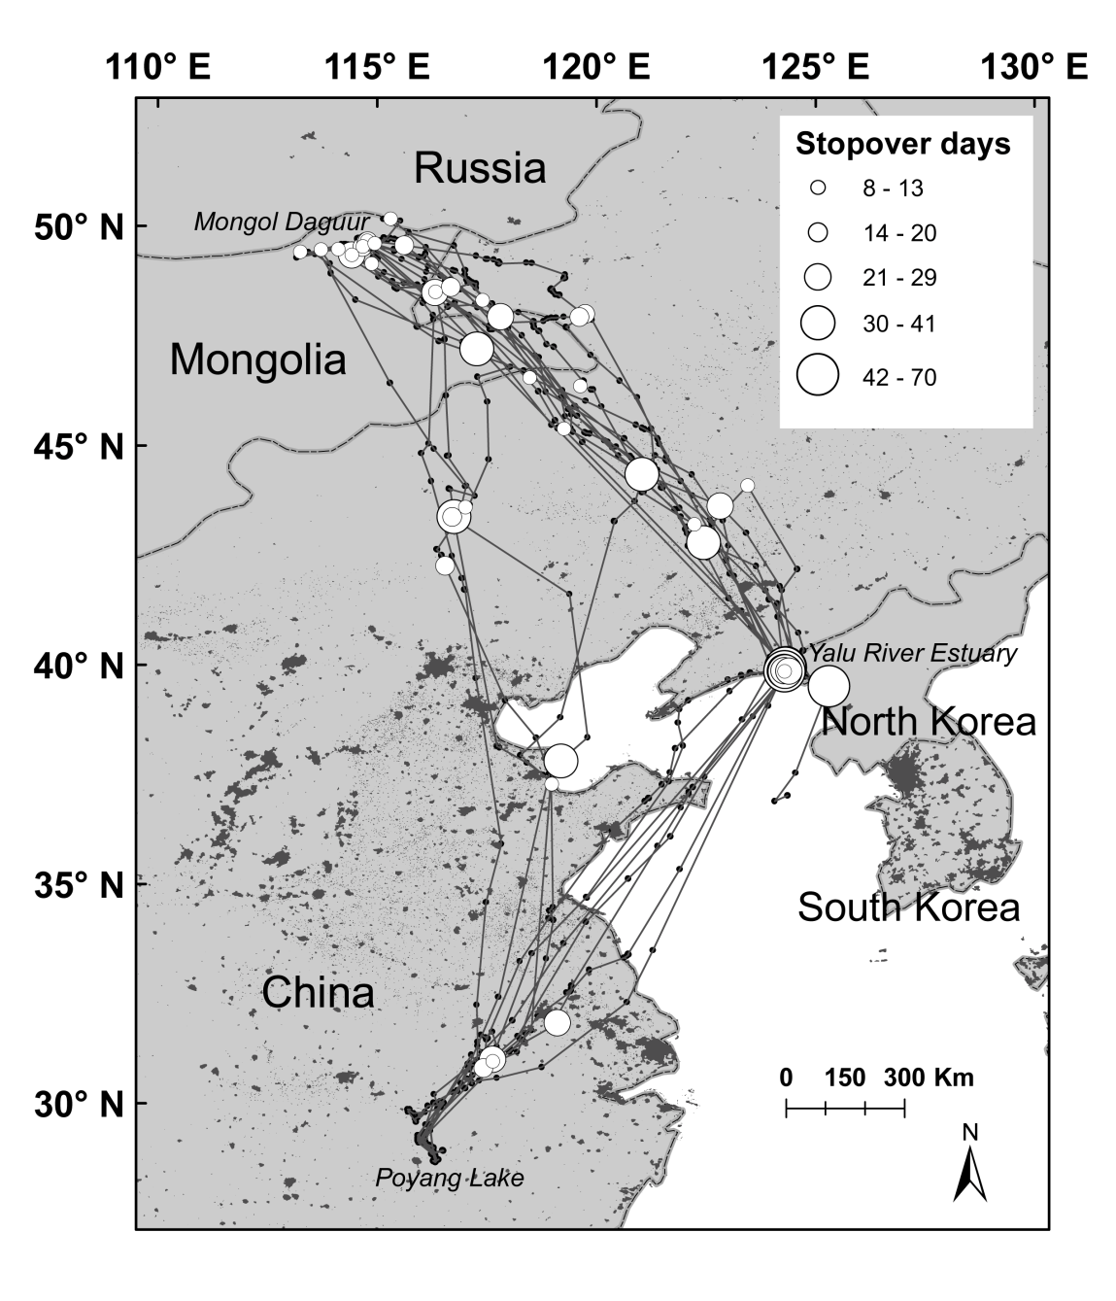

Figure 2 – 2. Foraging and roosting locations of Swan Geese at major staging and wintering areas. Contours represent 99% fixed kernel home ranges in three different seasons. Yellow contours show areas used during autumn migration (September – December), red contours indicate spring migration locations (March – April), and green contours show wintering locations (January – February). Blue dots shown are locations for five birds that made a complete migration cycle. A. Yalu River Estuary at the border area between China and North Korea. B. Poyang Lake, Jiangsu Province, China.
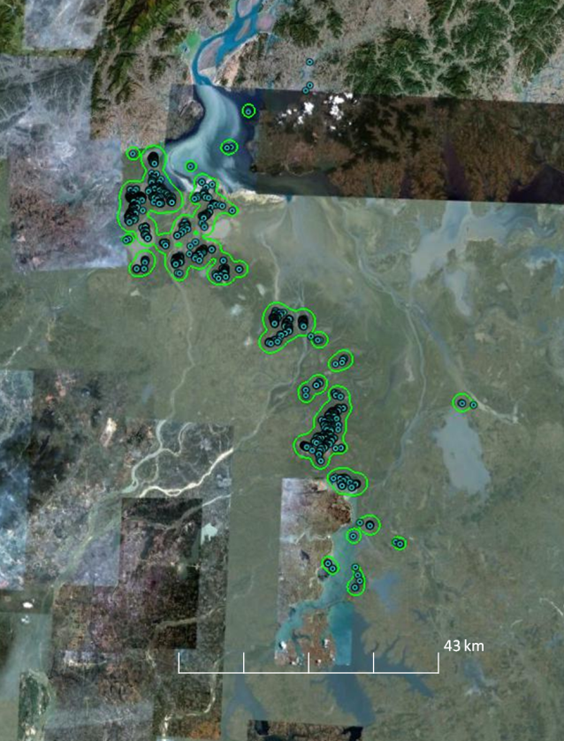
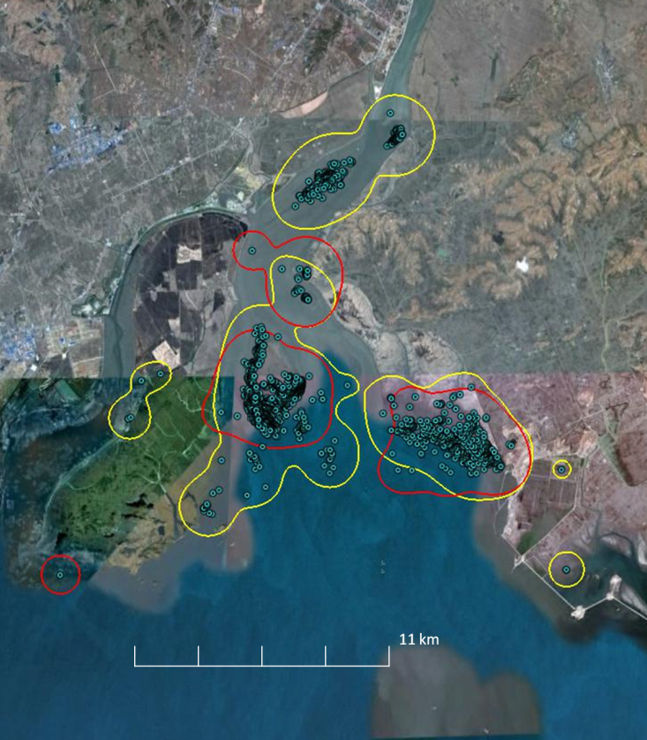
B
A

Figure 2 – 3. Changes in linear distance from stopover sites to the nearest urban area in relation to latitude (n = 5 birds). Size of the circles indicates the duration of stay (in days) at stopover sites,; each circle represents a location and duration is illustrated in the legend
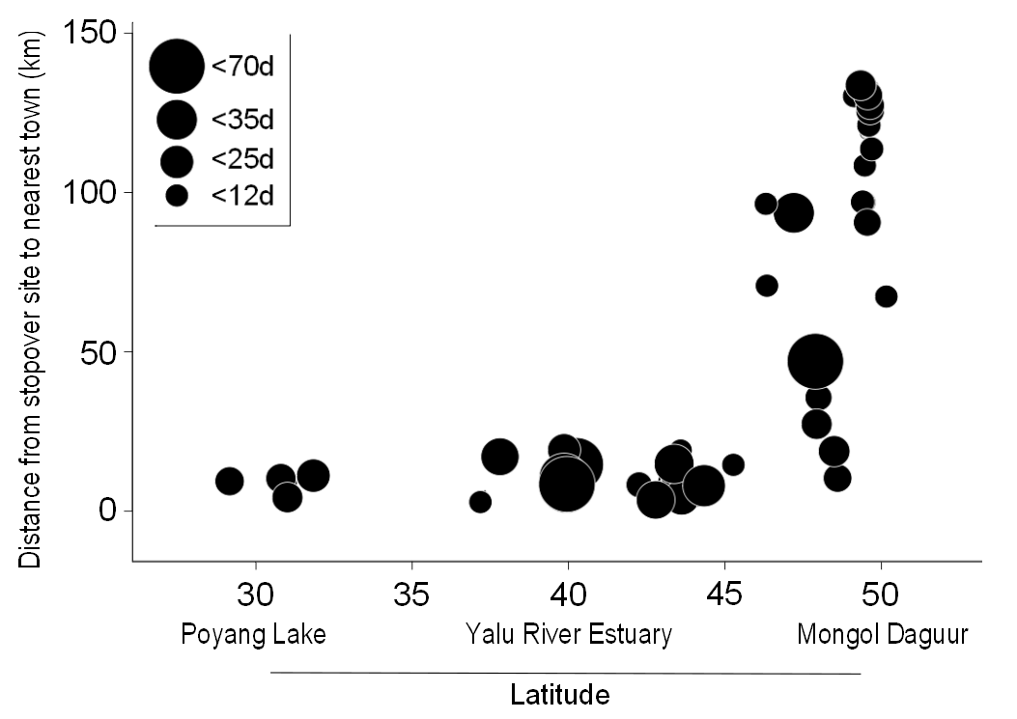

Figure 2 – 4. Consecutive flight distance and groundspeed of migration for Swan Geese relative to breeding and wintering locations (latitude). Latitude represents the midpoint of 4 degree intervals. Outliers indicate capability of some individuals to cover long flight distances at rapid speeds during non-stop flights.
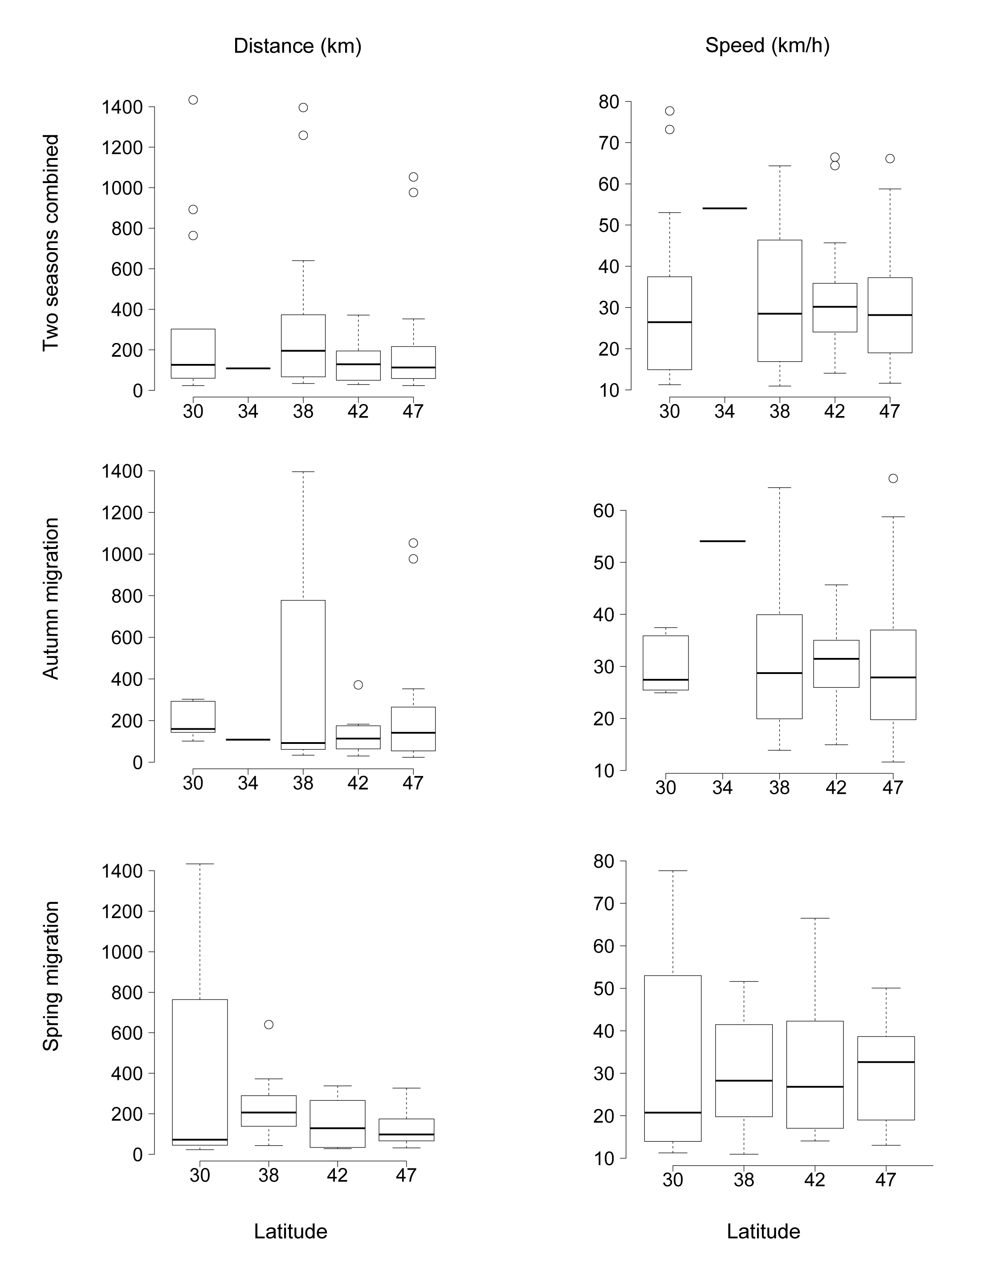

Chapter III. BAR-HEADED GOOSE (ANSER INDICUS) MIGRATION PATTERNS AND PHENOLOGY RELATED TO ENVIRONMENTAL CONDITIONS DETERMINED FROM REMOTELY SENSED IMAGERY

Abstract:
We described migration timing, duration, and distribution of stopover locations of bar-headed geese with satellite telemetry data and land surface phenology data. We used MODIS-derived monthly normalized difference vegetation index (NDVI), snow cover, and land surface temperature products with 0.05 degree (~5600 km) spatial resolution. The bar-headed geese migration was associated with NDVI, because these areas probably provided the highest forage quality and quantity. The geese strategically moved between peak green areas at the wintering grounds in India, the staging grounds on the Qinghai-Tibetan Plateau, the breeding grounds in Mongolia, and during both spring and autumn migration. Arrival at staging and breeding grounds were related to the decline of vegetation biomass at the wintering ground in India and advancement of vegetation green-up in northern latitudes. Snow cover and land surface temperature corresponded well with southward movement of bar-headed geese. The Qinghai-Tibetan Plateau was the most important staging ground for the species during both spring and autumn migrations.

Introduction
The decision to start a long distance migration, choosing the travel route, and deciding on the amount of time to spend during migration are often influenced by the fitness of migratory individuals, food and environmental conditions at stopover sites, and the distance to their destination (Berthold et al., 2003; Newton, 2007). Migrating birds experience different ecological and climate conditions and land surface types at different latitudes along their migration flyways which often forces them to use more than one stopover or staging sites for refueling (Mansson and Hamalainen, 2012; Newton and Dale, 1996).
Understanding the influence of environmental conditions on long distance migrants is an important part of migration ecology studies. Changes in environmental conditions along the flyways can have significant influence on the timing and duration of long distance migration (Newton 2004). We examined the temporal and spatial variation of environmental conditions in relation to stopover, wintering, and breeding locations along latitudinal gradients based on bar-headed goose (Anser indicus) satellite tracking data. The bar-headed goose is a long distance migrant that spends the summer in cooler northern temperate regions of Kazakhstan, Kirgizstan, southeastern Russia, Mongolia, and western China. They winter in tropical and subtropical regions in the Indian subcontinent and along the Yarlung Zangbo River, Lhasa River, Penbo River, and Niang River valleys in southern Tibet (Bishop et al., 1997; Takekawa et al., 2009; Zhang et al., 2013). The majority of the breeding bar-headed geese are found in western China and Mongolia. A large portion of the wintering and summering range of the species is separated by the Himalayan Mountain Range (Hawkes et al., 2011; Takekawa et al., 2009). Areas south from the Himalayan Mountain Range are mostly lowlands and have much higher precipitation and vegetation biomass compared to cooler semi-arid grassland steppe environments in western China and Mongolia (Justice et al., 1985). Between the two extreme wintering and breeding grounds, bar-headed geese travel through a variety of environments during the migration period, and almost half of their travel goes through high altitude deserts and grasslands where forage conditions are often poor.
During their long journey, bar-headed geese have to find the most suitable habitats and locations for refueling and resting en route to their wintering or breeding areas. Because bar-headed geese forage mostly on aboveground green parts of plants, they have to find places that have grasses with high quality and quantity. When geese start migrating to the breeding grounds in the early spring, vegetation biomass is often not at its best condition; therefore, geese move between the areas with peak vegetation biomass where they can obtain he highest quality plant matter during their northward migration (Justice et al., 1985; Owen, 1980). Therefore, deciding on the timing needed to arrive at the right moment, when forage quality and quantity are at their best, is often critical for individuals to successfully reproduce. However, grassland conditions along the migration flyway are not uniform and markedly different in several major biomes found along the latitudinal gradient from northern Mongolia to southern India (Morgner et al., 2010; Olson et al., 2004).
In the last two decades, studies of long distance migrants have greatly advanced due to the satellite-borne remotely-sensed imagery and the development of satellite and cellular tracking technologies that allows collection of high-accuracy, bird movement data throughout the flyway. Large birds such as waterfowl are ideal subjects for satellite tracking studies (Bridge et al., 2011; Gaidet et al., 2010). Global and regional scale satellite derived land surface phenology data such as vegetation indices, snow cover and temperature, are freely available via several online satellite data warehouses (Sellers et al., 1995). Combining high accuracy satellite tracking data with the global scale land surface phenology data provides critical knowledge on the ecology of long distance migrants (Gottschalk et al., 2005).
There are many studies that have use satellite derived data products such as the vegetation index, soil moisture index, land cover, land surface temperature, and snow cover data to study bird migration and migration phenology (Balbontin et al., 2009; Papes et al., 2012; Robson and Barriocanal, 2011; Tombre et al., 2008; Xiao et al., 2007). Green vegetation biomass is a good indicator of habitat quality for geese (Bos et al., 2005), and generally, there is a positive relationship between the magnitude of better habitat quality and quantity and the higher normalized difference vegetation index (NDVI) values (Santin-Janin et al., 2009). NDVI is a measure of land surface primary productivity based on recorded photosynthetic activity of vegetation, and it has been demonstrated that such satellite derived vegetation index can be used in variety of studies that traditionally required ground measures (Pettorelli et al., 2011).
We investigated whether migration timing, routes, and time spent at stopover sites by bar-headed geese were associated with environmental conditions represented by vegetation, snow, and land surface temperature. The objectives of the study were to: 1) determine the timings of migration departure and arrival, and 2) understand associations between changing environmental conditions along the migration route and movements of satellite-marked bar-headed geese.

Methods
Capture and marking
The capture of bar-headed geese took place at both breeding and wintering grounds. Geese were captured during moult by herding them into a drive-trap at the Terkhiin Tsagaan Lake in westcentral Mongolia (N48.1478, E99.5768). Also, geese were captured with leg nooses, consisting of monofilament loops attached to wooden sticks connected with nylon cord in lines of 50–100 nooses, at two wintering locations in India (Chilika Lake in east India, N19.6948, E85.3078; Koonthankulum Bird Sanctuary in south India, N8.4728, E77.7058). Upon capture, geese were kept in a corral comprised of a capture fence layered with fabric for a visual barrier, and they were processed to take morphological measurements and record their sex, age, and weight. We selected apparently-healthy-looking individuals and marked them with 30-70 g battery or solar-powered Platform Terminal Transmitters (PTTs: Microwave Telemetry, Inc., Columbia, MD, USA) attached with Teflon harnesses (Bally Ribbon Mills, Bally, PA, USA). Birds were released as soon as possible after marking, typically within an hour, near their capture locations. In Mongolia, some birds were kept in the holding pen for about 4 hours and released with other captured birds at same time. All captured geese were tested for avian influenza virus, by real-time quantitative PCR using matrix gene primers and probes, but none were found to be positive (authors’ unpubl. Data). Geese were measured and marked with aluminium metal leg rings and green plastic neck collars for individual identification. Procedures for capture, handling and marking were reviewed and approved by the U.S. Geological Survey Patuxent Wildlife Research Center Animal Care and Use Committee and University of Maryland Baltimore County Institutional ACUC (Protocol EE070200710).
Transmitters were programmed to obtain 12-24 locations each day, and data were uploaded every 2-3 day to the Argos satellite tracking system (CLS America Inc., Largo, MD, USA). Data were recovered via receivers aboard polar-orbiting weather satellites. CLS calculated PTT locations from the perceived Doppler-effect shifts in transmission frequency during a satellite overpass. The accuracy of each Doppler-derived location was rated by CLS and assigned a location class. Standard and conventional location classes 0, 1, 2, and 3 indicated that the location was derived from ≥ 4 transmissions and possessed 1-sigma error radii with accuracy of > 1,000 m, 350– 1,000 m, 150–350 m, and ≤ 150 m, respectively. CLS does not attribute accuracy estimates for the auxiliary location classes A (3 transmissions) and B (2 transmissions). Only high accuracy GPS locations and Argos fixes with location classes of 1-3 were used in the analysis.
Tracking analysis
Data from geese that had complete seasonal migrations were used to calculate migration distance, duration, and identify stopover/staging sites. In addition, selected locations from incomplete migrations were used to identify stopover sites and time spent at stopover locations. Significant departure, in most cases the travels more than 100 km within a day, from the post moulting and wintering areas was used to indicate the onset of migration. Geese were classified as breeding if the GPS fixes were found to be in very close proximity to each other at a site over more than a one-week period during the breeding season (Ely et al. 2007). The arrival time was defined as the first date that bar-headed geese were detected on the breeding grounds. Sites were identified as stopover sites if the birds remained in the vicinity for more than 2 days during the migration period. Mean flight duration and distances were given with median and range values throughout. Total migration distance was defined as connecting major stopover locations between breeding locations and wintering sites. Tracking data were roughly grouped into four seasons a) summering (June, July, August), b) autumn migration (September, October, November), c) winter (December, January, February), and spring migration (March, April, May) based on majority of the point locations of the marked geese.
MODIS normalized difference vegetation index, land surface temperature, and snow cover data
The Moderate Resolution Imaging Spectroradiometer (MODIS) satellite provided a global coverage of imagery every one to two days at the moderate resolutions (250 m, 500 m, and 1 km), and the images were available to the public via several online archives at no cost. We downloaded monthly snow cover (MOD10CM), monthly night time land surface temperature (MOD11C3), and normalized vegetation difference index data (MOD13C2) from the USGS’s LP DAAC data warehouse (https://lpdaac.usgs.gov). Downloaded MODIS data was collected from July 2009 to December 2010 for analyses. The MODIS/Terra snow cover monthly global data set contains snow cover values calculated based on daily global products. The normalized vegetation difference index data are produced from cloud-free spatial composites of the gridded 16-day 1-kilometer MOD13A2 and are provided as a monthly product. Cloud-free global coverage is achieved by replacing clouds with the historical MODIS time series climatology record. The global land surface and emissivity product is a level-3 monthly composited average, derived from the MOD11C1 daily global product and stored as clear-sky land surface temperature values. These data are available in 0.05 degree (~5600 km) spatial resolution and offer comparable measures of ecological conditions globally and between regions. This data is especially very useful when ground-based meteorological station data sets are not available across the region. In addition, the Digital Terrain Elevation Model with ~ 80 meters spatial resolution was downloaded from USGS EROS Data Center and used in the study.
We re-sampled satellite tracking data ( >92,900 points) to reduce bias related to spatial autocorrelation by randomly selecting single location per cell over a grid with 0.05 degree spatial resolution. This spatial filtering resulted in 3404 non-overlapping point locations, and these were used to extract corresponding snow cover, night time land surface temperature, and NDVI values (observed values) from the MODIS products. We also generated one dissolved buffer along the center line of the migration route using 300 km radius buffer along the center line of the flight route. Within this one giant polygon we randomly generated 10000 random points with minimum distance of 1 km between points and then used them to extract background land surface phenology values.
Satellite derived data were visually examined by plotting the bar-headed geese satellite tracking data over corresponding monthly NDVI, snow cover, and land surface temperature maps. A non-parametric and distribution-free Wilcoxon test was used to compare the medians between observed and background values (Zar, 1999). Test statistics were reported as significant when P<0.05. All analyses were performed with the R v.2.14.0 programming environment (R Development Core Team, 2013). ArcMap 10.1 software (Environmental Systems Research Institute, Redlands, CA) was used for spatial analyzing raster and vector data and mapping migration routes and distributions.

Results
A total of 25 bar-headed geese were captured and marked at two wintering sites in India in December 2008 (Chilika Lake, n=15; Koonthankulum Bird Sanctuary, n=10), and 37 geese were captured at the breeding and moulting site Terkhiin Tsagaan Lake in Mongolia in July 2008 and July 2009. Fifty-three bar-headed geese were tracked for 55-726 days, and a total of 92,930 locations were obtained – most of them were on the Qinghai-Tibetan Plateau. Eight transmitters stopped working soon after deployment and did not provide any useful data. We documented the southward migration of 24 geese and the northward migration of 23 geese (Table 3-1). All birds migrated within the Central Asian Flyway (Figure 3-1).
Migration timing
Spring migration
During northward migration, the median start date for spring migration was 16 Mar (ranging from 6 Feb to 22 Apr, N=23), and the median arrival date at the wintering ground was 28 Nov (ranged from 10 Nov to 20 Dec). The spring migration was completed within 52 days (ranging from 14 to 93). Mean distance travelled during the autumn migration was 2846 km (ranged from 982 to 5515). We identified 57 stops along the northbound migration routes. Maximum speed for non-stop flights during spring migration was 54-84 km per hour. They crossed the Himalaya on median date of 24 Mar (range: 15 Mar to 6 May).
Breeding and summering
Median arrival date at breeding sites was 9 May (ranged from 16 Mar to 13 Jun). They spend the summer and breed at several locations in Khovsgol, Khangai, Mongol Altai, Zavkhan River and the Tuul River valleys in Mongolia. Also, bar-headed geese bred and spent the summer at Hujir Ulaan Lake, Chigo Co Lake, Maququ, Danghe River, Jianghe wetland, Zhaling-Eling Lakes, and Qinghai Lake on the Qinghai-Tibetan Plateau. Bar-headed geese stayed in the pre-moulting grounds until the end of June, then they moved to moulting areas starting in early July. In general, bar-headed geese completed their moult in 3-4 weeks and finished at the end of July, then they moved to nearby locations for grazing and moult.
Fall migration
All bar-headed geese migrated from Mongolia following similar routes across the Qinghai-Tibetan Plateau and Himalayan Mountains to arrive at their wintering grounds. Ther median departure date from the breeding grounds in Mongolia and Qinghai-Tibetan Plateau in China was 9 Sep (ranged from 19 Aug to 10 Nov, N=24), and the median date when they arrived to the breeding grounds was 9 May (ranged from 16 Mar to 13 Jun). They spent 68 days (range from 15 to 119 d) during the autumn migration. Mean distance travelled from the breeding grounds to wintering grounds was 2255 km (range 933 to 5720 km) during the autumn migration. We were able to identify 101 stopover sites along the southward migration routes. Maximum speed for non-stop flights during the autumn was 59-98 km per hour. Bar-headed geese crossed the Himalaya on the median date of 20 Nov (ranging from 10 Nov to 19 Dec).
Wintering
Their median arrival date at wintering locations was 28 Nov (ranged from 10 Nov to 20 Dec). Bar-headed geese wintered in Chilika Lake, Koonthankulum Bird Sanctuary, Anekere Lake, Almatti Reservoir, Singur Dam Reservoir, Tilaiya Dam Reservoir, Bahadurpur, Karnataka, Odisha, Jharkhand, and Bhagalbur in India. Also, some geese wintered in Dochen tso Lake, Nyang Qu River, Chigu Lake, and the Yarlung Zangbo River on the southern Tibetan Plateau where daily mean temperature remained above 0ºC despite an elevation of nearly 3500 meters (Zhang et al., 2011).
Staging and stopover sites
Within Mongolia, bar-headed geese used Khovd River, Boon Tsagaan Lake and Galuut Lake at the upper Baidrag River as major stopover sites. Once they left Mongolia, the Qinghai-Tibetan Plateau was the most important staging and stopover area during both their autumn and spring migrations.
The number of stopover sites used greatly varied by individual geese. Some birds used few stopover sites, while other birds stopped frequently. During spring migration, individual bar-headed geese spent on average 15 days (ranged from 2 to 110) at stopover sites. In contrast, they spent 11 days (ranged from 5 to 48) at stopover sites during the autumn migration. In general, individuals that made more stops arrived later at both breeding and wintering areas.
Geese migration and timing of environmental conditions
Ecological conditions significantly influenced the different stages of the long distance migration by bar-headed geese. Most bar-headed geese departed around the median departure date (16 March) regardless of their final destination for northbound migration; however, those geese that started migrating earlier tended to travel farther during the southbound migration (Figure 3-2). Longer migration length resulted in late arrival at both breeding and wintering areas (Figure 3-3).
Regardless of their departure date, the number of stopover sites used for the northbound migration was similar; however, on their southbound migration, geese that started earlier tended to use more stopover sites. Late arriving birds travelled farther compared to early arriving geese during both south and northbound migrations.
NDVI
NDIV values were highest (0.5-0.6) only during summer months of June, July, and August at the breeding grounds in Mongolia and Qinghai-Tibetan Plateau and 0.5-0.7 in August during the winter months in December, and January in India (Figure 3-4 and 3-5).
Mean and max NDVI values at stopover sites during the autumn migration were higher compared with the spring migration periods. Bar-headed geese started migrating southward when NDVI values started dropping below 0.3 at the breeding grounds in September. Foraging condition on bigger lakes of the Qinghai-Tibetan Plateau were highlyvariable in October. During this period, geese mostly used areas away from the main lake body where better forage condition can be found along rivers and streams supported by geothermal activities.
Land surface temperature
Observed minimum and maximum land surface temperature ranges in December, January, February, July, and August were most narrow because geese are more sedentary during these times. Whereas rest of the year, temperature range was variable. Breeding grounds in Mongolia (mean LST = 24-36) was warmer compared to Qinghai-Tibetan Plateau (mean LST = 13-21) (Figure 3-6).
Minimum land surface temperature below 0ºC degrees seemed to be a good indicator of departure timing for their southbound migration. Temperatures started dropping below 0ºC starting in September in areas of northern Mongolia and Siberia. Cold temperature slowly advanced, and by November and December, the entire northern region was already frozen and remained that way until April. However, neither mean, minimum, nor maximum land surface temperature was a good indicator of northbound spring migration.
During the summer, geese stayed in cooler areas on Qinghai-Tibetan Plateau and Khangai, Khovsgol, and Altai Mountain regions in Mongolia where average summer temperature is around 20ºC. Areas south of the Himalaya and the Gobi desert in northern China and Mongolia were hotter during the summer.
Snow cover
Snow cover data were obtained for the Himalaya Mountains and areas farther north. The first signs of snow started in September in Siberia and Mongolia. High elevation areas of the Himalayan Mountains have snow year around (Figure 3-7).
In general, there was a subjective link between the migration movements of bar-headed geese and the advancement of snow from Siberia during the autumn as the snow retreats back to the north in the spring. Bar-headed geese initiated migration before the snow arrived at the most breeding locations. They moved to the south 2-4 weeks ahead of the snow. It seemed that snow cover in the north pushed birds farther south. However, the eastern and central Tibetan Plateau received snow in October when many geese were still in migration. However, snow cover and goose locations were not overlapping.
Northbound migration in the spring followed the retreat of snow, but the relationship between migration ecology of bar-headed geese and snow cover in the spring remained unclear. When birds arrived at the breeding grounds, many places still had snow cover of up to 70%. In high elevation areas, 1-4% of the snow cover remained until June.

Discussion
For long distance migratory birds, the ecological conditions along the flyway significantly influenced timing of their migration (Bety et al., 2003; Robson and Barriocanal, 2011), duration of migration (Tottrup et al., 2008), arrival dates at breeding and wintering sites (Saino et al., 2004; Tottrup et al., 2010), breeding performance in the spring (Black et al., 2007; Trinder et al., 2009), population dynamics (Ambrosini et al., 2011; Black et al., 2007), survival during and after the migration (Norris and Taylor, 2006), and physiological fitness of individual birds (Blums et al., 2005; Norris and Taylor, 2006).
Migratory waterfowl spend parts of their annual life cycle at different places along the migration route for certain periods, and this phenomenon is usually linked to many spatial and temporal environmental factors and their interactions. The ‘green wave hypothesis’ (Drent et al. 1978; Owen 1980) predicted that waterfowl follow green vegetation emergence and early growth along their spring migration route, suggesting that primary productivity was the main force driving their northward migration (van der Graaf et al., 2006). Similarly, the weather, especially temperature and snow, triggered southward migration in some waterfowl species (Newton, 2007). Xiao et al (2007) showed how low land surface temperatures represented by nighttime frost events triggered the southward migration of waterfowl in northern territories of Europe. Results from our study on bar-headed geese agreed with these previous studies.
In the northern breeding grounds of bar-headed geese, the semiarid steppe of Mongolia is mostly dominated by perennials (Hilbig, 1995). The average onset date of vegetation green-up in Mongolia is significantly related to day length, temperature, and precipitation gradients (Lee et al., 2002; Madsen et al., 1989), and vegetation biomass reached its maximum in July (Hilbig, 1995; Reed et al., 1994). Bar-headed geese breed and molt in high altitude wetlands in western and northern Mongolia, and their molting season took place during the period with the highest vegetation biomass. When the forage quality decreased in August and September and cold air fronts approached from Siberia, bar-headed geese started migrating to the south starting at the end of August and September.
Bar-headed geese migrated within the Central Asia Flyway which connected South Asia and India through western China, Kazakhstan, Kirgizstan, Russia, and Mongolia. Our satellite marked geese migrated through a relatively narrow migration corridor to reach their wintering grounds in India. They made frequent and lengthy stops at the Qinghai-Tibetan Plateau until continuing their migration both during the southbound and northbound migrations.
The Qinghai-Tibetan Plateau was the most important stopover and staging grounds for bar-headed geese en route to the wintering grounds. It is the largest high altitude plateau on earth and has a wide range of alpine grasslands and meadow habitats suitable for waterbirds to breed. The distribution of precipitation and vegetation is markedly variable along the northwest to southeast gradient and gradually increases from the northwest to south on the plateau. The peak NDVI value was attained during the growing season from July to September on the Qinghai-Tibetan Plateau, and the growing season was usually shorter in the northern and southern parts of the region (Ding et al., 2007).
During the northbound migration, bar-headed geese extensively used many locations on the Qinghai-Tibetan Plateau, probably because they had available emerging vegetation biomass and vegetation conditions rapidly deteriorate in India during this period. In the highly dynamic lowland agricultural regions of India where bar-headed geese spend the winter, the vegetation index is highest in August-September due to monsoonal rainfall but then declines during October, increases in December, and then declines again in February before reaching its lowest point in March (Dubey and Pranuthi, 2012; Nigam et al., 2011). Therefore, the emergence of fresh green grass on the Qinghai-Tibetan Plateau probably attracts geese in the spring and provides much needed nutrients before the breeding season, thus making the Plateau the most important staging grounds for bar-headed geese. In western China, the vegetation green-up gradually moves northward starting in March, and dormancy is observed southward from late September (Zhang et al., 2004).
Timing of migration by individual birds was found to be correlated with specific nesting latitudes in long distance migrants (Conklin et al., 2010). Bar-headed geese nesting in northern latitudes departed earlier after spending significant amounts of time on the Qinghai-Tibetan Plateau. However, they arrived at same time or earlier than short distance migrating geese on the breeding grounds. Generally, early arriving birds have higher chances to be negatively affected by locally unstable bad weathers in the spring (Shen et al., 2011). Although this strategy might be more energetically expensive in short run, it may be advantageous for the geese to increase their fitness and secure better nesting areas.
In general, geese are capital breeders that use stored energy reserves for reproduction in the spring. They obtain these energy reserves at staging and stopover sites along the flyway (Arzel et al., 2006; Black et al., 2007; Owen, 1980). Although the number of stopover sites used by individual geese vary greatly because of individual fitness differences, geese spend significant amounts of time at numerous locations along the Qinghai-Tibetan Plateau compared to few stopover locations used for less time in Mongolia and India. These results suggest that bar-headed geese refuel on the Qinghai-Tibet Plateau before they continue their migration northward and southward. Therefore, the number of days they spend at each stopover location during the spring and autumn migrations most likely have positive relationships with suitable grazing conditions during the migration period.
Local temperature is a good indicator of migration phenology in birds (Shen et al., 2011). In the region where bar-headed geese are found during the summer, the vegetation green-up starts in early May (Yu et al., 2003). Grassland conditions in the northern breeding grounds become better (NDVI > 0.4) due to increased air temperatures and moisture. When bar-headed geese arrive at the breeding grounds in late April and early May, the forage conditions are still not good, and night time air temperatures are often below 0ºC with many areas still covered with snow. But within 1-2 weeks, the vegetation growing season starts. However, a small amount of snow cover and low night-time temperatures will not cause a delay in nesting. Some geese forage little and invest most of their energy to lay and tend their eggs securing the best nest sites at the beginning of breeding season (Black et al., 2007). Bar-headed geese may have similar strategies, but we do not have data from the early nesting period to test that hypothesis.
Reduced forage quality and abundance and decreasing air temperatures may trigger the southward migration. Towards the end of September, forage quality and conditions in Mongolia become very poor, and the night time temperature becomes colder. The first snow starts in the middle of September, and the first night time frost is observed in the first to second week of September in northern Mongolia. In general, advancement of low air temperatures and snow cover from Siberia and the southward movement of bar-headed geese correspond well with each other. However, because of the spatial and temporal scale of the data used in this study, we were not able to define in fine scale which factor determines the onset of migration in the autumn season.
The Qinghai Tibetan Plateau is the closest stopover areas during the southbound migration with abundant grass and water for geese to refuel after crossing the vast, dry Gobi Desert where water and feeding ground is scarce. However, the bar-headed geese from Mongolia overlap with different populations in the western part of the plateau where more than 35,000 individuals spend the winter (Bishop and Tsamchu 2007, Takekawa et al. 2009). Our satellite tracking data showed that bar-headed geese make extensive use of rivers and stream beds that are most likely linked to geothermal activities in this region (Figure 3-8) -- the central and southern regions of the Qinghai-Tibetan Plateau have very active geothermal activity (Hochstein and Regenauer-Lieb, 1998). In this area, many wetlands and river valleys remain open and attract many waterfowl, since they sustain forage conditions longer in this high altitude region. Food availability and abundance might be higher at these places where geothermal activity is high. Therefore, river valleys and lakes in southern Tibet could be major wintering ground areas with potentially higher competition for resources.
In general, the migration corridor of bar-headed geese was narrow despite their lengthy travel distances. Especially on the Qinghai-Tibetan Plateau, the migration route was basically confined within the Tibetan Plateau alpine steppe and scrubland and meadow environment which is a narrow strip between the Central Tibetan Plateau alpine steppe and Southeast Tibetan Plateau scrubland and meadow environments (Olson et al., 2004) (Figure 3-9).
Although the combination of satellite telemetry data and the land surface phenology data based on satellite remote sensing images provide a unique opportunity to further our understanding of migration ecology of bar-headed geese, two major concerns with our results still exist. First, the overall duration of the study was relatively short, and second, most birds were tracked for one or two seasons. These issues may have influenced the process of adequately revealing the variability of stopover habitat use and migratory strategies by bar-headed geese. Furthermore, the decision to migrate, time to spend on migration, and usage of stopover or staging sites could be particularly complex for species like the bar-headed goose which migrate though extreme landscapes and elevations. It would be desirable to compare satellite-derived vegetation, soil moisture, and land surface temperature phenological estimates with data measured on their breeding grounds.

Acknowledgments
Primary funding support was provided by the United Nations Food and Agriculture Organization, the U.S. Geological Survey, Western Ecological and Patuxent Wildlife Research Centers and Avian Influenza Program, and the University of Oklahoma. We are grateful to Shane Heath, David Douglas, William Perry, Asad Rahmani, Diann Prosser, Baoping Yan, Yuansheng Hou, Peter Frappell, Bill Milsom, Graham Scott, K. Spragens, and Eric Palm for their help in executing the project. Satellite tracking work was part of a project funded through a grant awarded to Dr. Charles Bishop and Dr. Peter Butler (grant no. BB/F015615/1) from the British Biotechnology and Biological Sciences Research Council, from the NSERC of Canada to W.K.M., and from the Max Planck Institute for Ornithology. Support was also provided by The Ministry of Environment and Forests, Chief Wildlife Wardens of Tamil Nadu and Orissa in India, and the Ministry of Nature, Environment, and Tourism and the Khorgo-Terkhiin Tsagaan National Park Administration granted the work permissions at capture sites. The data analysis was supported by a grant from the U. S. National Science Foundation EPSCoR program (NSF-0919466) and from the NIH Fogarty International Center through the NSF/NIH Ecology of Infectious Diseases program (R01-TW007869). Protocols for the bird study were reviewed by a U. S. Geological Survey Animal Care and Use Committee and the Institute of Biology, Mongolian Academy of Sciences. Any use of trade, product, or firm names in this publication is for descriptive purposes only and does not imply endorsement by the U.S. government.

References
Ambrosini, R., Orioli, V., Massimino, D., Bani, L., 2011. Identification of Putative Wintering Areas and Ecological Determinants of Population Dynamics of Common House-Martin (Delichon urbicum) and Common Swift (Apus apus) Breeding in Northern Italy. Avian Conserv Ecol 6.
Arzel, C., Elmberg, J., Guillemain, M., 2006. Ecology of spring-migrating Anatidae: a review. Journal of Ornithology 147, 167-184.
Balbontin, J., Moller, A.P., Hermosell, I.G., Marzal, A., Reviriego, M., de Lope, F., 2009. Individual responses in spring arrival date to ecological conditions during winter and migration in a migratory bird. J Anim Ecol 78, 981-989.
Berthold, P., Gwinner, E., Sonnenschein, E. 2003. Avian Migration (Berlin, Springer).
Bety, J., Gauthier, G., Giroux, J.F., 2003. Body condition, migration, and timing of reproduction in snow geese: A test of the condition-dependent model of optimal clutch size. Am Nat 162, 110-121.
Bishop, M.A., Yanling, S., Zhouma, C., Binyuan, G., 1997. Bar-headed Geese Anser indicus wintering in south-central Tibet. Wildfowl 48, 118-126.
Black, J.M., Prop, J., Larsson, K., 2007. Wild goose dilemmas: population consequences of individual decisions in barnacle geese. Branta Press, Groningen, i-x, 1-254 pp.
Blums, P., Nichols, J.D., Hines, J.E., Lindberg, M.S., Mednis, A., 2005. Individual quality, survival variation and patterns of phenotypic selection on body condition and timing of nesting in birds. Oecologia 143, 365-376.
Bos, D., Drent, R.H., Rubinigg, M., Stahl, J., 2005. The relative importance of food biomass and quality for patch and habitat choice in Brent Geese Branta bernicla. Ardea 93, 5-16.
Bridge, E.S., Thorup, K., Bowlin, M.S., Chilson, P.B., Diehl, R.H., Fleron, R.W., Hartl, P., Kays, R., Kelly, J.F., Robinson, W.D., Wikelski, M., 2011. Technology on the Move: Recent and Forthcoming Innovations for Tracking Migratory Birds. Bioscience 61, 689-698.
Conklin, J.R., Battley, P.F., Potter, M.A., Fox, J.W., 2010. Breeding latitude drives individual schedules in a trans-hemispheric migrant bird. Nat Commun 1.
Ding, M.J., Zhang, Y.L., Liu, L.S., Zhang, W., Wang, Z.F., Bai, W.Q., 2007. The relationship between NDVI and precipitation on the Tibetan Plateau. J Geogr Sci 17, 259-268.
Dubey, S.K., Pranuthi, G., 2012. Assessing the Relation Between NDVI and Rainfall over India. International Journal of Water Resources and Arid Environments 2, 108-144.
Gaidet, N., Cappelle, J., Takekawa, J.Y., Prosser, D.J., Iverson, S.A., Douglas, D.C., Perry, W.M., Mundkur, T., Newman, S.H., 2010. Potential spread of highly pathogenic avian influenza H5N1 by wildfowl: dispersal ranges and rates determined from large-scale satellite telemetry. Journal of Applied Ecology 47, 1147-1157.
Gottschalk, T.K., Huettmann, F., Ehlers, M., 2005. Thirty years of analysing and modelling avian habitat relationships using satellite imagery data: a review. Int J Remote Sens 26, 2631-2656.
Hawkes, L.A., Balachandran, S., Batbayar, N., Butler, P.J., Frappell, P.B., Milsom, W.K., Tseveenmyadag, N., Newman, S.H., Scott, G.R., Sathiyaselvam, P., Takekawa, J.Y., Wikelski, M., Bishop, C.M., 2011. The trans-Himalayan flights of bar-headed geese (Anser indicus). Proceedings of the National Academy of Sciences of the United States of America 108, 9516-9519.
Hilbig, W., 1995. The vegetation of Mongolia. SPB Academic Publisher, Amsterdam.
Hochstein, M.P., Regenauer-Lieb, K., 1998. Heat generation associated with collision of two plates: the Himalayan geothermal belt. J Volcanol Geoth Res 83, 75-92.
Justice, C.O., Townshend, J.R.G., Holben, B.N., Tucker, C.J., 1985. Analysis of the Phenology of Global Vegetation Using Meteorological Satellite Data. Int J Remote Sens 6, 1271-1318.
Lee, R., Yu, F., Price, K.P., Ellis, J., Shi, P., 2002. Evaluating vegetation phenological patterns in Inner Mongolia using NDVI time-series analysis. Int J Remote Sens 23, 2505-2512.
Madsen, J., Bregnballe, T., Mehlum, F., 1989. Study of the breeding ecology and behaviour of the Svalbard population of Light-bellied Brent Goose Branta bernicla hrota*. Polar Research 7, 1-21.
Mansson, J., Hamalainen, L., 2012. Spring stopover patterns of migrating Whooper Swans (Cygnus cygnus): temperature as a predictor over a 10-year period. Journal of Ornithology 153, 477-483.
Morgner, E., Elberling, B., Strebel, D., Cooper, E.J., 2010. The importance of winter in annual ecosystem respiration in the High Arctic: effects of snow depth in two vegetation types. Polar Research 29, 58-74.
Newton, I., 2007. The migration ecology of birds. Academic Press.
Newton, I., Dale, L.C., 1996. Bird migration at different latitudes in eastern North America. Auk 113, 626-635.
Nigam, R., Bhattacharya, B.K., Gunjal, K.R., Padmanabhan, N., Patel, N.K., 2011. Continental scale vegetation index from Indian geostationary satellite: algorithm definition and validation. Curr Sci India 100, 1184-1192.
Norris, D.R., Taylor, C.M., 2006. Predicting the consequences of carry-over effects for migratory populations. Biology Letters 2, 148-151.
Olson, D.M., Dinerstein, E., Wikramanayake, E.D., Burgess, N.D., Powell, G.V.N., Underwood, E.C., D'Amico, J.A., Itoua, I., Strand, H.E., Morrison, J.C., Loucks, C.J., Allnutt, T.F., Ricketts, T.H., Kura, Y., Lamoreux, J.F., Wettengel, W.W., Hedao, P., Kassem, K.R., 2004. Terrestrial Ecoregions of the World: A New Map of Life on Earth Bioscience 51, 933-938.
Owen, M., 1980. Wild geese of the world: their life history and ecology. Batsford.
Papes, M., Peterson, A.T., Powell, G.V.N., 2012. Vegetation dynamics and avian seasonal migration: clues from remotely sensed vegetation indices and ecological niche modelling. J Biogeogr 39, 652-664.
Pettorelli, N., Ryan, S., Mueller, T., Bunnefeld, N., Jedrzejewska, B., Lima, M., Kausrud, K., 2011. The Normalized Difference Vegetation Index (NDVI): unforeseen successes in animal ecology. Clim Res 46, 15-27.
R Development Core Team 2013. R: A Language and Environment for Statistical Computing (Vienna, Austria, R Foundation for Statistical Computing).
Reed, B.C., Brown, J.F., Vanderzee, D., Loveland, T.R., Merchant, J.W., Ohlen, D.O., 1994. Measuring Phenological Variability from Satellite Imagery. J Veg Sci 5, 703-714.
Robson, D., Barriocanal, C., 2011. Ecological conditions in wintering and passage areas as determinants of timing of spring migration in trans-Saharan migratory birds. J Anim Ecol 80, 320-331.
Saino, N., Szep, T., Romano, M., Rubolini, D., Spina, F., Moller, A.P., 2004. Ecological conditions during winter predict arrival date at the breeding quarters in a trans-Saharan migratory bird. Ecol Lett 7, 21-25.
Santin-Janin, H., Garel, M., Chapuis, J.L., Pontier, D., 2009. Assessing the performance of NDVI as a proxy for plant biomass using non-linear models: a case study on the Kerguelen archipelago. Polar Biology 32, 861-871.
Sellers, P.J., Meeson, B.W., Hall, F.G., Asrar, G., Murphy, R.E., Schiffer, R.A., Bretherton, F.P., Dickinson, R.E., Ellingson, R.G., Field, C.B., Huemmrich, K.F., Justice, C.O., Melack, J.M., Roulet, N.T., Schimel, D.S., Try, P.D., 1995. Remote-Sensing of the Land-Surface for Studies of Global Change - Models, Algorithms, Experiments. Remote Sens Environ 51, 3-26.
Shen, M.G., Tang, Y.H., Chen, J., Zhu, X.L., Zheng, Y.H., 2011. Influences of temperature and precipitation before the growing season on spring phenology in grasslands of the central and eastern Qinghai-Tibetan Plateau. Agr Forest Meteorol 151, 1711-1722.
Takekawa, J.Y., Heath, S.R., Douglas, D.C., Perry, W.M., Javed, S., Newman, S.H., Suwal, R.N., Rahmani, A.R., Choudhury, B.C., Prosser, D.J., Yan, B., Hou, Y., Batbayar, N., Natsagdorj, T., Bishop, C.M., Butler, P.J., Frappell, P.B., Milsom, W.K., Scott, G.R., Hawkes, L.A., Wikelski, M., 2009. Geographic variation in Bar-headed Geese Anser indicus: connectivity of wintering areas and breeding grounds across a broad front. Wildfowl 59, 102-125.
Tombre, I.M., Hogda, K.A., Madsen, J., Griffin, L.R., Kuijken, E., Shimmings, P., Rees, E., Verscheure, C., 2008. The onset of spring and timing of migration in two arctic nesting goose populations: the pink-footed goose Anser bachyrhynchus and the barnacle goose Branta leucopsis. Journal of Avian Biology 39, 691-703.
Tottrup, A.P., Rainio, K., Coppack, T., Lehikoinen, E., Rahbek, C., Thorup, K., 2010. Local Temperature Fine-Tunes the Timing of Spring Migration in Birds. Integr Comp Biol 50, 293-304.
Tottrup, A.P., Thorup, K., Rainio, K., Yosef, R., Lehikoinen, E., Rahbek, C., 2008. Avian migrants adjust migration in response to environmental conditions en route. Biology Letters 4, 685-688.
Trinder, M.N., Hassell, D., Votier, S., 2009. Reproductive performance in arctic-nesting geese is influenced by environmental conditions during the wintering, breeding and migration seasons. Oikos 118, 1093-1101.
van der Graaf, S.A.J., Stahl, J., Klimkowska, A., Bakker, J.P., Drent, R.H., 2006. Surfing on a green wave - how plant growth drives spring migration in the Barnacle Goose Branta leucopsis. Ardea 94, 567-577.
Xiao, X.M., Gilbert, M., Slingenbergh, J., Lei, F., Boles, S., 2007. Remote sensing, ecological variables, and wild bird migration related to outbreaks of highly pathogenic H5N1 avian influenza. J Wildlife Dis 43, S40-S46.
Yu, F.F., Price, K.P., Ellis, J., Shi, P.J., 2003. Response of seasonal vegetation development to climatic variations in eastern central Asia. Remote Sens Environ 87, 42-54.
Zar, J.H., 1999. Biostatistical analysis, 4th Edition. Prentice Hall, Upper Saddle River, N.J., 1 v. (various pagings) p.
Zhang, B., Wu, Y.H., Lei, L.P., Li, J.S., Liu, L.L., Chen, D.M., Wang, J.B., 2013. Monitoring changes of snow cover, lake and vegetation phenology in Nam Co Lake Basin (Tibetan Plateau) using remote SENSING (2000-2009). J Great Lakes Res 39, 224-233.
Zhang, X., Friedl, M., Schaaf, C., Strahler, A., 2004. Climate controls on vegetation phenological patterns in northern mid- and high latitudes inferred from MODIS data. Global Change Biol 10, 1133-1145.
Zhang, Y., Hao, M., Takekawa, J.Y., Lei, F., Yan, B., Prosser, D.J., Douglas, D.C., Xing, Z., Newman, S.H., 2011. Tracking the autumn migration of the bar-headed goose (Anser indicus) with satellite telemetry and relationship to environmental conditions. International Journal of Zoology 2011, 1-10.

Tables and figures
Table 3 - 1. Summary of marked bar-headed geese with satellite telemetry
Migration information | Autumn migration | Spring migration
Number of birds tracked | 24 | 23
Total number of days tracked | 813 | 702
Median departure date | 9 Sep | 16 Mar
Departure date range | 19 Aug – 10 Nov | 6 Feb – 22 Apr
Median arrival date | 28 Nov | 9 May
Arrival date range | 10 Nov – 20 Dec | 16 Mar – 13 Jun
Mean duration | 68 | 54
Median duration | 73 | 52
Duration range | 15-119 | 14-93
Mean distance travelled | 2255 | 2846
Range of distance travelled | 933-5720 | 982-5515
Average number of stop over sites per bird | 5 | 5
Number of stop over sites | 101 | 57
Average number of days spent at stop over sites | 11 | 15
Range of days spent at stop over sites | 2-58 | 2-110

Figure 3 - 1. Locations of bar-headed geese during spring and autumn migration. Map shows the importance of the Qinghai-Tibet Plateau for bar-headed geese during migration. Red squares are locations where the bar-headed geese are found breeding and blue squares are location where they spend the winter.
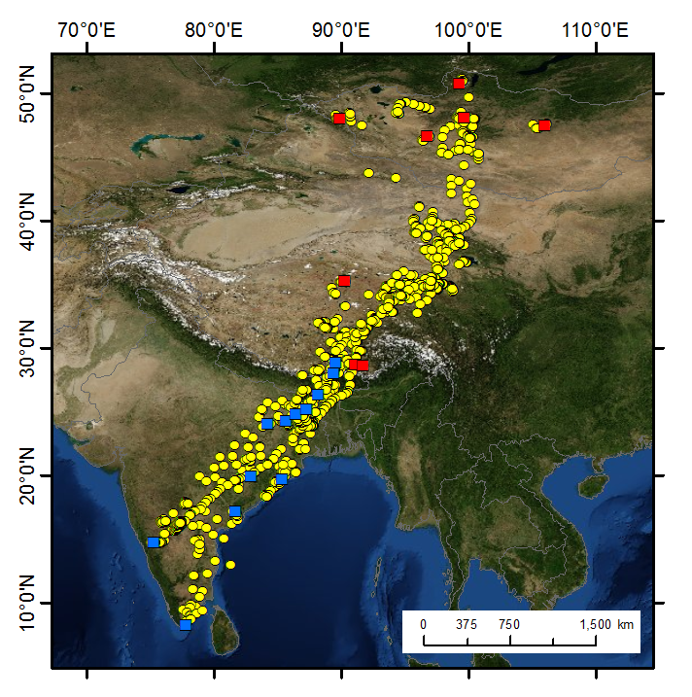
Figure 3 - 2. Relationship in departure dates from a) wintering grounds and b) breeding areas and migration distances between these areas. The horizontal axis shows the Julian Date and the vertical axis shows the distance travelled per season during the migration by bar-headed geese. Most bar-headed geese departed near the median departure date regardless of their final destination for the northbound migration, whereas those that started earlier tended to travel farther during the southbound migration. The median departure Julian date in the spring was day 75, and day 252 in the autumn.
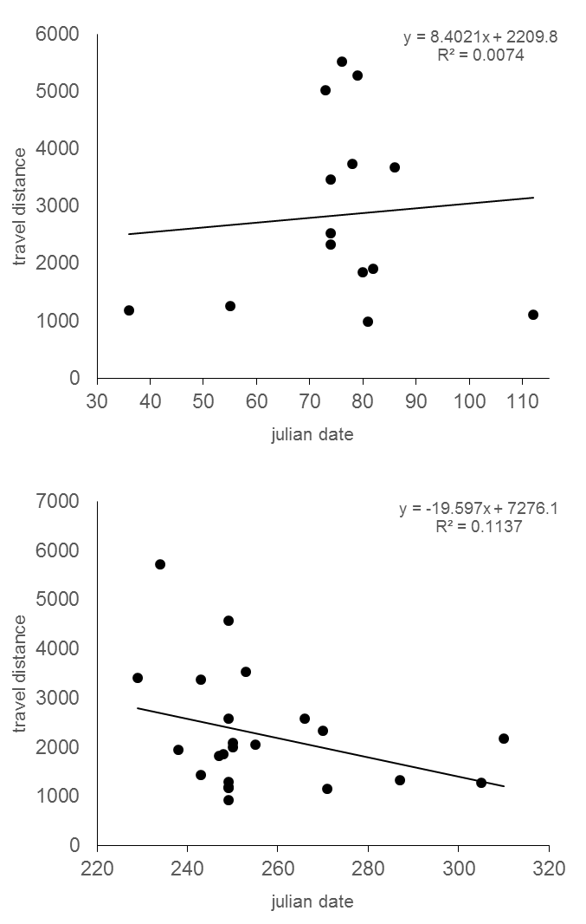

Figure 3 - 3. The relationship between arrival date at a) wintering and b) summer areas and the distance travelled during migration. Horizontal axis shows the Julian date and vertical axis shows the distance travelled. Late arriving birds have travelled farther compared to early arrivers during both south and northbound migrations. Median arrival julian date in spring is 129 and 332 in autumn.
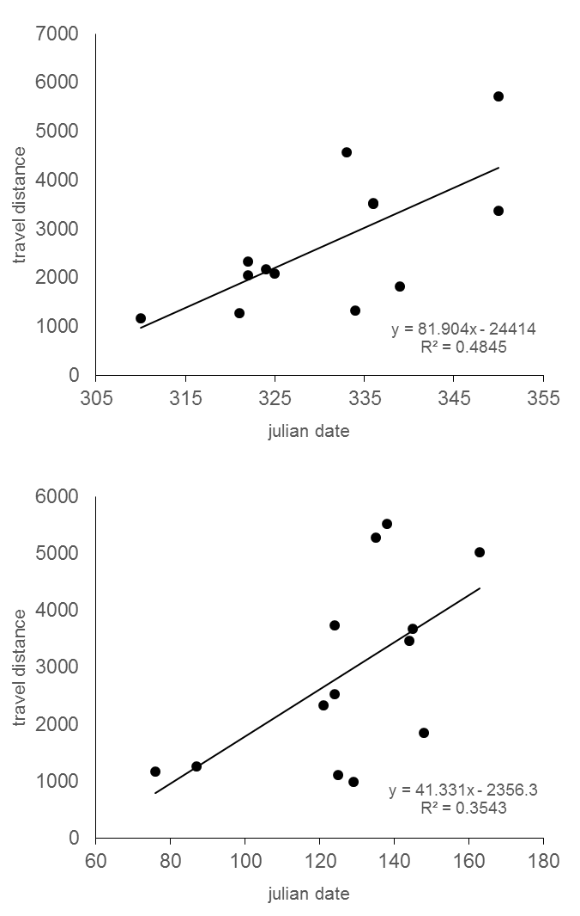

Figure 3 - 4. Spatial patterns of normalized difference vegetation index and bar-headed geese movements in different months representing different migration seasons. Maps show the advancing and retreating of green vegetation in the wintering grounds to the south and in the breeding grounds to the north.
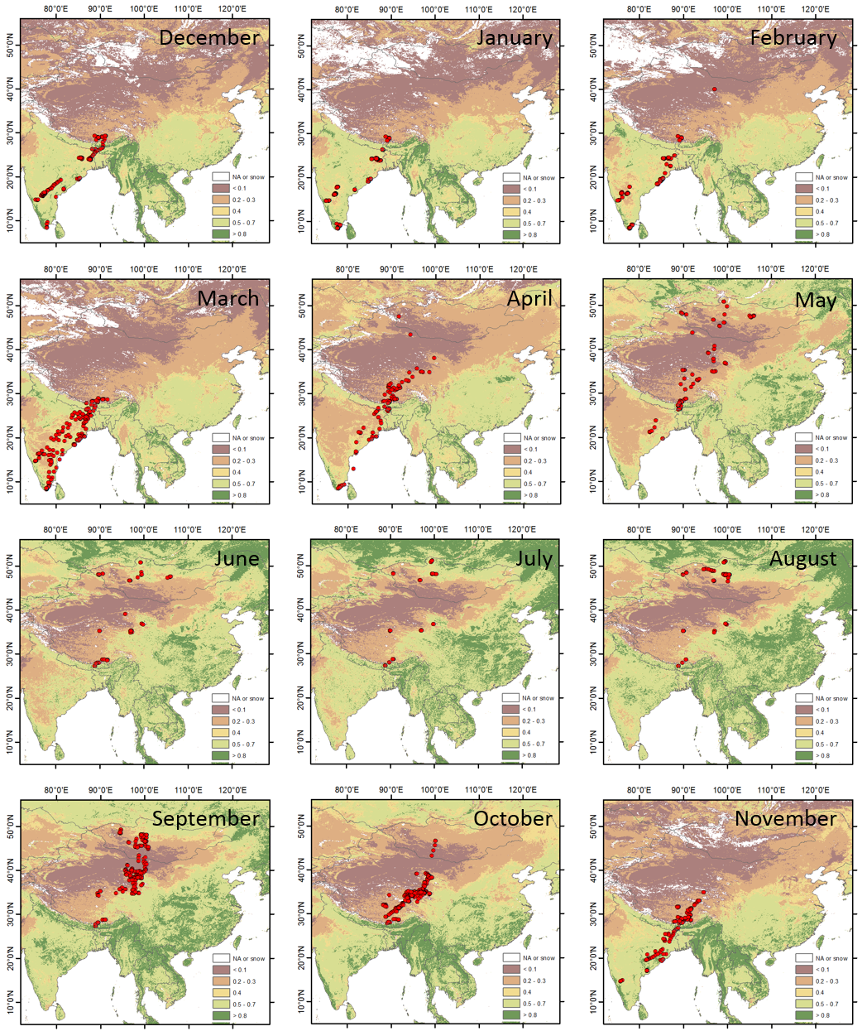

Figure 3 - 5. Summer, fall, winter, and spring season changes in the normalized difference vegetation index (different months shown as colored lines) along the elevation (shaded gray area) and latitudinal gradients. Vegetation index (NDVI) values are on the left y-axis and the elevation values are on the right y-axis. Black bars are locations of bar-headed geese in relation to latitude.
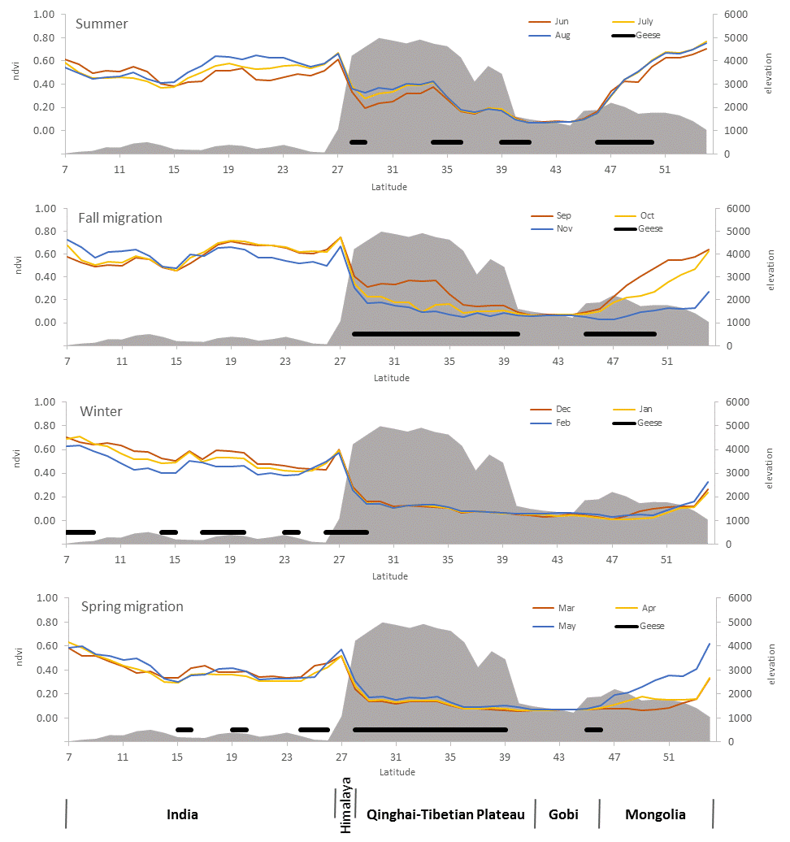

Figure 3 - 6. Summer, fall, winter, and spring season changes in the night time land surface temperature (different months shown as colored lines) along the elevation (shaded gray area) and latitudinal gradients. Land surface temperature values are on the left y-axis and the elevation values are on the right y-axis. Black bars are locations of bar-headed geese in relation to the latitude.
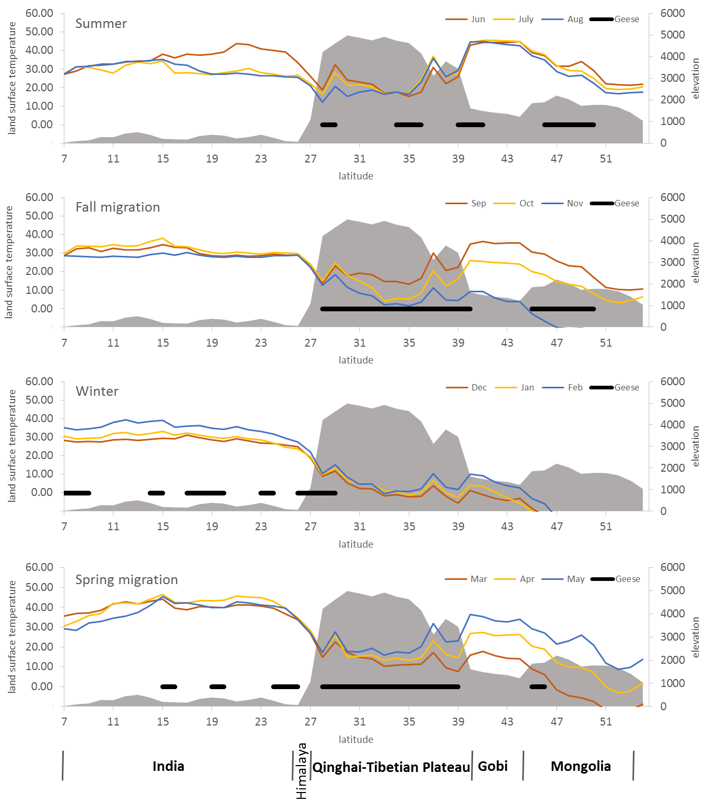

Figure 3 - 7. Summer, fall, winter, and spring season changes in the snow cover (different months shown as colored lines) along the elevation (shaded gray area) and latitudinal gradients. Snow cover percentage values are on the left y-axis and the elevation values are on the right y-axis. Black bars are locations of bar-headed geese in relation to latitude.
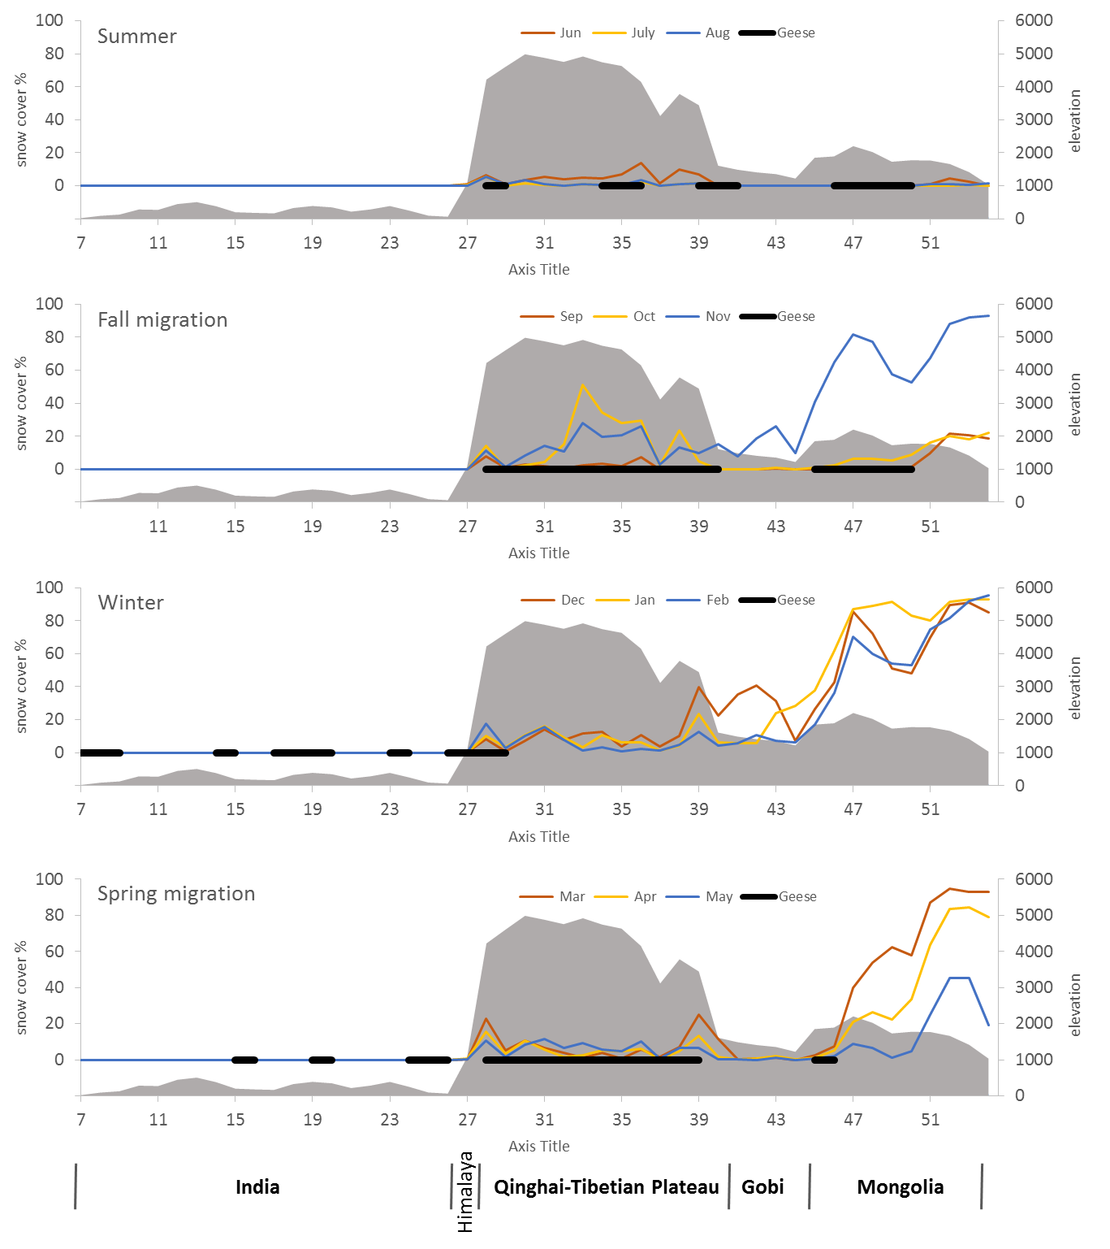

Figure 3 - 8. Major stopover locations of bar-headed geese on the Qinghai-Tibetan Plateau. Details of selected locations in yellow squares are shown in the bottom row.
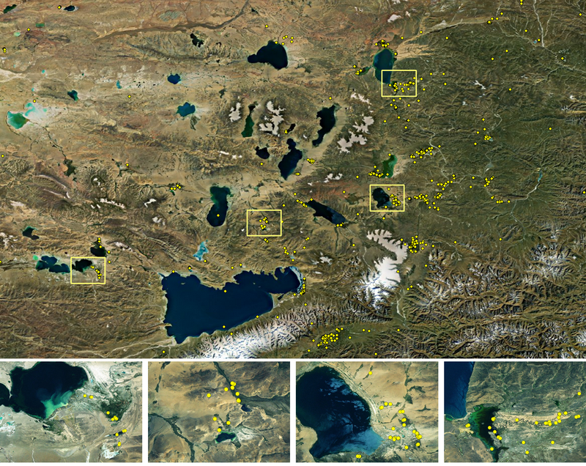

Figure 3 - 9. Bar-headed geese migration corridor on the Qinghai-Tibetan Plateau. The migration route was basically confined within the Tibetan Plateau alpine shrublands and meadow biome which is a narrow strip between the Central Tibetan Plateau alpine steppe and Southeast Tibetan Plateau scrublands and meadow biomes.
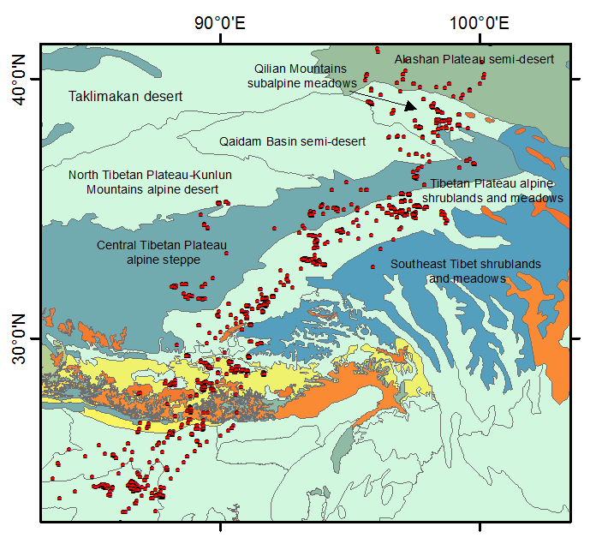

SUMMARY AND CONCLUSION
Human influences on natural ecosystems have become a major ecosystem regulating force due to magnitude of our activities and resultant footprint on the Earth’s surface (Muhly et al., 2013). We see many examples of large scale catastrophic effects on ecosystems and biodiversity caused by the human society, and birds and their habitats are no exception. Studies have shown that the normal migrations of many species have been interrupted due to some anthropogenic causes and many crucial phenomenon related to annual migrations are changing their traditional course. In some cases, the magnitude of migration, in terms of abundance, is declining at significant rate (Wilcove and Wikelski, 2008).
Bar-headed geese and swan geese satellite tracking data show that the migration ecology of these two species may already have been severely affected by urban area expansion, agriculture, infrastructure and industrial developments. Because many stopover sites used by these geese are in man-made landscapes, there are signs of possible changes in traditional migration routes and staging grounds.
China, India, and southern Asia are very important regions for the wintering waterbirds that breed during the summer in the Arctic, Siberia, Mongolia, and northern China. Anthropogenic factors affecting waterbirds in this wintering ground region are probably most dramatic and dynamic because these regions have the highest density of human population and rapidly developing economy and infrastructure networks in the world (Hvistendahl, 2011; Yue et al., 2005). Thus, pressures from the development and human activities in these regions present challenges and severe threats to waterbirds.
Since the 1990s, China has converted far more grasslands and forestlands into agriculture compared to other countries in the world (Gao and Liu, 2011; Liu et al., 2005). Consequently, within the historical swan goose breeding and wintering ranges, much has been changed in the past several decades. Alarmingly, the wintering distribution of swan geese in China is now restricted to Yangtze River valley which is the home of one-third of human population in China (Yue et al., 2005). In addition, the main winter congregation of swan geese is located at Poyang Lake which was once the largest freshwater lake in China (Liu et al., 2013). Therefore, possible negative effect of human and economic development on major wintering grounds of the swan geese may be inevitable in this region (Zhang et al., 2011). Situations in South Asia and on the Indian subcontinent are no better. India is developing its economy at steady rate. It has been projected that the human population size of India will surpass China by 2025 (Hvistendahl, 2011). Today, most bar-headed geese wintering in India depend on river valleys where agricultural activity dominates almost everything else. In contrast to the restricted winter range of swan geese in East China, the winter locations of bar-headed geese in India are widely disbursed. Also there is a large number of geese winter in southern part of the Tibetan Plateau in China. Furthermore, because bar-headed geese occupy wide winter range and distributed across large area and different ecological conditions, they may have more flexibility to survive compared to the swan geese. It is also supported by the fact that migration corridor of swan geese is narrower and the number of stopover sites they use is fewer than bar-headed geese.
Today, the wildlife population monitoring may have become more important and urgent because of increased loss of habitats and mortality throughout the distribution range. The most crucial and heavily impacting threats are changes in human land use, alterations in livelihood, and climate change. The Daurian Steppe, comprising the Daurian forest steppe and Mongolian-Manchurian grassland of Russia, Mongolia, and China, is the largest intact steppe ecosystem remaining in the Palearctic (Olson and Dinerstein, 1998). In this semiarid region, the populations of large number of waterbirds including swan geese depend on finding suitable breeding areas under highly variable water and wetland conditions. Unfortunately, due to combined effects of climate change and large scale wetland conversions to agricultural lands, swan geese populations are disappearing from most of northeast China (Zhang et al., 2011).
In Mongolia, wetland habitat loss due to climate change and livestock impact has increased in the last several decades (Batima and Dagvadorj, 1998). However, because of lack of population data, it has been impossible to elaborate the effects on breeding populations of bar-headed geese in Mongolia. We conducted a systematic study to understand breeding habitat requirements and nest survival of the species for the first time. We found that bar-headed geese nests are located sporadically throughout western Mongolia. Also, despite a far greater number of non-breeding individuals, there were very few locations suitable for post-breeding molt. We observed that the bar-headed geese nests and eggs were often depredated by gulls, and the increased gull numbers may have significant impact on nesting waterbirds. However, no work has been performed to date to look at gull depredation rates on nesting waterbirds including the bar-headed geese. The situation for bar-headed geese in China may well be same or similar (Ma and Cai, 1997).
Today, the data accuracy and collection frequency of GPS PTTs have much improved and there are several options of adding specific sensors available from selected manufacturers (Bridge et al., 2011). Therefore, flyway scale migration ecology studies can be greatly benefited by the use of latest satellite and cellular tracking technologies. It is known that most large waterfowl can carry radio transmitters with varying weight and migrate long distances; thus making them suitable candidates for complex migration ecology, habitat selection, disease transmission, and climate change impact studies across large geographical areas and along migration routes.
Modelling the spread and transmission of infectious disease agents can be done using high accuracy locations collected at short time interval. For example, the swan geese can be an excellent model because the highly pathogenic avian influenza outbreaks occurred repeatedly at Poyang Lake, which is the East Asian hub for wintering migratory waterbirds. In the worst case, an outbreak of avian influenza or other pathogenic diseases can have devastating impact not only on swan geese, but also on many species of other waterbirds.
Furthermore, the impact of expansion of urban areas on migratory waterbirds and swan geese in Asia needs to be monitored. Because the development between Poyang Lake and Beijing continues to expand, the network of natural wetlands will probably not be sufficient to support the wintering population and their migration. Increased water and wetland pollution from runoff of cities and agricultural lands are additional conservation challenges.
A comparative study to understand how climate change might affect these geographically distinct species of geese in long run might be an intriguing idea. It is known that the climate change is having significant impacts on wetlands where waterbirds occur. For example, an increase in runoff from glaciers has resulted in numerous small transitional wetlands on the Tibetan-Qinghai Plateau, and the many years of drought and lack of precipitation have caused drying of numerous lakes in Mongolia and northern India (Batima et al. 2005; Xu et al. 2008). As a result, many potential nesting habitats and areas could be lost forever because of changes in precipitation patterns and temperature increases. Nevertheless, species distributions are expected to shift in response to climate change (Wilson et al. 2005), and swan geese and bar-headed geese may alter their breeding and wintering distributions and migratory behavior given their narrow migration corridor and habitat alterations in western China and northern India. However, it is most likely that they may respond differently because of their spatial extent and the restricted location of their wintering areas. Here, a species distribution modelling exercise may be useful. Models that predict distributions of species by combining known occurrence records with digital layers of environmental variables have great potential for application in conservation and management (Peterson 2001; Pearson 2007). In addition, MODIS based land surface and vegetation phenology data can greatly facilitate the understating of climate change impacts on bar-headed geese and swan geese in Asia.

References
Batima, P., Dagvadorj, D. 1998. Climate Change and its Impact in Mongolia (Ulaanbaatar, JEMR), 227.
Bridge, E.S., Thorup, K., Bowlin, M.S., Chilson, P.B., Diehl, R.H., Fleron, R.W., Hartl, P., Kays, R., Kelly, J.F., Robinson, W.D., Wikelski, M., 2011. Technology on the Move: Recent and Forthcoming Innovations for Tracking Migratory Birds. Bioscience 61, 689-698.
Gao, J., Liu, Y., 2011. Climate warming and land use change in Heilongjiang Province, Northeast China. Appl Geogr 31, 476-482.
Hvistendahl, M., 2011. Demography. China's population growing slowly, changing fast. Science 332, 650-651.
Liu, Y., Wang, D., Gao, J., Deng, W., 2005. Land Use/Cover Changes, the Environment and Water Resources in Northeast China. Environ Manage 36, 691-701.
Liu, Y.B., Wu, G.P., Zhao, X.S., 2013. Recent declines in China's largest freshwater lake: trend or regime shift? Environ Res Lett 8.
Ma, M., Cai, D., 1997. Aggregated distribution of Anser indicus nest in Bayinbuluke of Tianshan Mountains and its breeding ecology. Chinese Journal of Applied Ecology 8, 287-290.
Muhly, T.B., Hebblewhite, M., Paton, D., Pitt, J.A., Boyce, M.S., Musiani, M., 2013. Humans Strengthen Bottom-Up Effects and Weaken Trophic Cascades in a Terrestrial Food Web. PLoS One 8, e64311.
Wilcove, D.S., Wikelski, M., 2008. Going, going, gone: Is animal migration disappearing? Plos Biol 6, 1361-1364.
Yue, T.X., Wang, Y.A., Liu, J.Y., Chen, S.P., Qiu, D.S., Deng, X.Z., Liu, M.L., Tian, Y.Z., Su, B.P., 2005. Surface modelling of human population distribution in China. Ecological Modelling 181, 461-478.
Zhang, Y., Cao, L., Barter, M., Fox, A.D., Zhao, M.J., Meng, F.J., Shi, H.Q., Jiang, Y., Zhu, W.Z., 2011. Changing distribution and abundance of Swan Goose Anser cygnoides in the Yangtze River floodplain: the likely loss of a very important wintering site. Bird Conservation International 21, 36-48.

