UNIVERSITY OF OKLAHOMA
GRADUATE COLLEGE

THE IMPACT OF LIGHTING ON GENDER CONSUMERS' SHOPPING BEHAVIOR IN FASHION RETAIL STORES

A THESIS
SUBMITTED TO THE GRADUATE FACULTY
in partial fulfillment of the requirements for the
Degree of
MASTER OF SCIENCE IN INTERIOR DESIGN

BY
YU CHEN
Norman, Oklahoma
2021

THE IMPACT OF LIGHTING ON GENDER CONSUMERS' SHOPPING BEHAVIOR IN FASHION RETAIL STORES

A THESIS APPROVED FOR THE
CHRISTOPHER C. GIBBS COLLEGE OF ARCHITECTURE

BY THE COMMITTEE CONSISTING OF

Mia S. Kile, Chair
Dr. Negar H. Matin
Dr. Chuck Ingene

© Copyright by Yu Chen 2021
All Rights Reserved.

TABLE OF CONTENTS

TABLE OF CONTENTS…………………………………………………………iv
ACKNOWLEDGEMENT………………………………………………………...v
ABSTRACT……………………………………………………………………...vi
LIST OF ABBREVIATIONS……………………………………………………..1
- INTRODUCTION………………………………………………………...1
- REVIEW OF LITERATURE……………………………………………..3
- HYPOTHESIS…………………………………………………………...11
- METHODOLOGY………………………………………………………12
- RESULTS………………………………………………………………..14
- FACTORS AFFECTING DATA COLLECTION………………………28
- DISCUSSION AND CONCLUSION…………………………………...29
- FUTURE IMPLICATIONS……………………………………………...32
APPENDICES…………………………………………………………………...34
- INFORMED CONSENT FORM………………………………………...34
- SURVEY QUESTIONS…………………………………………………36
- LETTER OF APPROVAL FROM INSTITUTIONAL REVIEW BOARD………………………………………………………………… 47
REFERENCES…………………………………………………………………..48

Acknowledgement
I would first like to thank my advisor, Professor Mia S. Kile, for her patience and endless support, both academically and otherwise, and for the technical guidance needed to complete my course and this thesis. Without her, none of this would have been possible. I would also like to thank my committee members, Dr. Negar H. Matin and Dr. Chuck Ingene, for their advice and review of my dissertation to achieve my goal of completing my master's degree. In addition, I would like to thank Dr. Natalie Ellis and Professor Suchismita Bhattacharjeej for their guidance and support during my graduate online courses.
In addition, I would like to thank my friends in Norman and in China, as I am pleased to meet them and share the entire journey of studying in the United States with them.
I also would like to thank my parents, partner, and big family for supporting me on my journey and raising me to be the person I am today. Again, without their support, I would never have gotten to where I am today.
Finally, I would like to thank all participants who participated in the questionnaire for providing the data necessary to complete this study.

Abstract
This study examines the effect of lighting on consumer buying behavior in apparel retail stores, examining the relationship between the effective use of lighting in retail stores, the effect of lighting on product display, and consumer expectations of the shopping atmosphere. Many scholars have explored the study of lighting on consumer behavior. However, the behavior of specific gender-specific consumers in clothing stores has not been studied in depth. In this study, a questionnaire was administered to 73 volunteers ranging from 18 to 54 years old and from various backgrounds. The questionnaire contains a total of 19 questions, 11 of which are about understanding their shopping habits, as well as their perceptions of retail lighting and their definition of shopping atmosphere. In addition, participants viewed pictures and renderings of three different types of clothing stores and select and evaluate each set of renderings. These surveys determined the correlation between lighting and consumer preferences and can be found in the paper's results section.
Keywords: lighting, consumption, buying behavior, gender

THE IMPACT OF LIGHTING ON GENDER CONSUMERS' SHOPPING BEHAVIOR IN FASHION RETAIL STORES
Introduction
Light can create a variety of atmospheres that can influence people's emotions and decisions. The inappropriate use of light can make extravagant jewelry mundane, while proper lighting can highlight the item's quality. Therefore, the correct use of light can evoke sensitivity and awareness of the item. The color temperature of the light is the same as the color, and different colors give different feelings and thus produce different psychological effects. Warm-colored light can give a warm, healthy, and comfortable feeling due to its high red component (Hyde, 2018). Therefore, warm-colored light is mainly used for rest, relaxation, and entertainment in homes, dormitories, hotels, restaurants, cafes, and other places. Furthermore, cool-colored light is close to natural light, with a bright feeling of concentration and cleanliness. It is mainly used in shopping centers, specialty stores, fast food restaurants, schools, libraries, and other places (Pelletier, 2016). As one of the brick-and-mortar stores that consumers frequently visit, clothing stores, in a sense, sell not only clothes but also the atmosphere that shoppers experience. People make purchases because of the store's shopping atmosphere and may stay longer in the store thus resulting in spending more money than intended. The shopping experience is precisely the reason why, in the age of e-commerce, online stores are not as good as retail stores. Therefore, in the clothing store, the atmosphere is closely related to the performance of lighting and plays a very crucial role. The same piece of clothing may appear completely different based on different lighting selections and quality. The differences in lighting can have an effect on the display of merchandize, and also impact the consumers experience.
Moreover, good lighting design illuminates the lighting effect so that the display environment has the visual style expected by the clothing designer. At the same time, lighting can also support branding, impact wayfinding through the store and provide the sense of quality and safety among retail staff and consumers. In addition, lighting has also been shown to be a way to set a specific mood or feeling in a space, which can subconsciously influence a person to stay longer in the space, leading to more purchases (Imam, 2013). Lighting is often not noticed or considered for its level of impact on the everyday consumer beyond its importance in general lighting, an area and field of design and construction that is often not explored in depth.
This project explores how clothing stores can use lighting to impact the shopping behavior of gender-specific customers and encourage them to buy more products. This project also explores how the lighting in clothing stores influences consumers' decisions to purchase apparel products. While this lighting area has been studied in supermarkets and brick-and-mortar stores in the electronics category, the specific area of apparel stores and gendered consumers has not been explored in depth. Thus, more testing is needed to determine any correlation between lighting in apparel stores and consumer's preferences. Since exploring how lighting affects human perception and decision-making is a process that requires extensive experimentation and data, this study uses a questionnaire to collect a large amount of data to determine the relationships. Participants in the experiment are required to complete a pre-survey that examines their buying preferences and additional questions based on their shopping patterns. Participants are asked to view multiple sets of modeled renderings and answer a post-survey based on their reactions to each place and preferences. This study confirms how important lighting is to consumer behavior and shopping habits in terms of presence.
Literature Review
Consumption is the act and process of consuming various material goods, spiritual goods, and labor services that people consume to satisfy their needs. A consumer is a person who buys and uses various products and services (Friedman, 2018). Consumer buying behavior is a long process, which means that consumers need to identify the product, carefully study its features, advantages and disadvantages, and price before deciding whether to buy this product (Leary et al., 2014). Because consumption is a long process of comparison, many factors influence consumers' purchasing behavior. The internal factors that influence consumers' consumption behavior are personal factors, including age, gender, health status, and physical characteristics. In addition, psychological factors, including perceptions, interests, attitudes, and motivations also influence consumption behavior (Gwozdz et al., 2017).
On the other hand, environmental factors can also influence consumers' purchasing behavior, which includes macro-environmental and micro-environmental. Macro-environmental factors include demographic, economic, political, legal, social, and cultural factors. The micro-environment includes the mall environment, salesperson's attitude, and product concept (Friedman, 2018). By understanding consumer psychology and making corresponding changes to the shopping environment, consumer behavior can be significantly improved.
Merchants, especially those in the retail sector, bear the brunt of the need to understand and meet the needs of their customers. Due to the growth of the Internet and the growth of e-commerce in the last decade, nearly 40% of traditional apparel retailing has been replaced by e-commerce (Goldmanis et al., 2010). In recent years, the sales growth of apparel stores in the United States has generally declined. In 2019 alone, U.S. apparel retailers experienced a 6.1% year-over-year decline in sales (Goolsbee & Syverson, 2020). Part of the reason for this decline is a shift in consumer shopping patterns, with more and more people choosing to shop online rather than in brick-and-mortar stores. This year many brick-and-mortar clothing stores and department stores were forced to close due to the new Coronavirus, so more people are choosing to shop online because it is a safer way to shop (Pantano et al., 2020). This decline in retail store sales may also be due to the severe homogenization of the apparel industry. The article by Mr. Reinecke (2010) posted on Competition & Change suggests that not many retail stores in the apparel market have unique characteristics and can effectively differentiate themselves from other apparel stores. Second, the shopping experience in brick-and-mortar stores is also an essential factor. The hardware facilities of the store create the overall feel and mood of the retail experience (Mouhoubi, 2014). In addition, the gender and age of consumers also influence their attitudes towards shopping at the mall. According to Chan and Chong (2013), the younger generation spends 1/3 of their income on entertainment activities, watching movies, going to concerts, online videos, and games. In the face of fast-paced life and life pressure, young people's demand for and time spent on entertainment activities is at an all-time high. Young shoppers pay more attention to the shopping experience as opposed to simply buying an item. The experience mentioned here refers to whether the product experience interface is friendly and easy to use, as well as the shopping experience in the retail store (Ha, 2012). For retail, the shopping experience is more about how the store feels or better connects to the consumer's life scenario outside the store (Michon et al., 2005). With the development of the Internet, the experience economy is emerging, and the demands on the retail industry are increasing.
In addition, research has shown that in retail fabric stores, lighting has a significant impact on consumers' purchase decisions in-store (Mouhoubi, 2014). Lighting is the most critical aspect of visual communication between retailers and consumers. At the same time, and it can also leave a good impression on the minds of customers. In addition, lighting effects can affect the mood of the customer. Lighting also has the role of guidance and direction. Lighting can create an intimate, comfortable, and pleasant shopping environment that prolongs customers' shopping time and influences shopping habits. In an article on the effect of lighting and shelf height on customers in retail stores, Mouhoubi (2014) stated that in retail stores, merchants could induce impulse spending by improving the consumer experience and shopping environment. Furthermore, lighting is one of the most critical ways retailers can create a pleasant atmosphere for their customers. People enter a store and form impression of brands and products, their emotions may be strongly related to the lighting used (Postnova et al., 2013). Lighting would direct shoppers' attention to critical products and significantly influence their overall brand impression and product sales (Mouhoubi, 2014). For apparel stores in particular, lighting design is fundamental to the apparel store shopping experience. Good lighting design can improve the aesthetic value of a clothing store and make it look more attractive (Saeed, 2015). In addition, good interior lighting design can attract more customers to patronize the store, increase the aesthetic appeal of the clothing, and stimulate customers' desire to buy (Mouhoubi, 2014). Warm and soft lighting can make people feel relaxed and comfortable, while bright lighting helps customers to see the products more clearly (Saeed, 2015). Decorative lighting for high-end branded clothing stores usually use relatively low basic illumination (300 LUX), warm colors (2500-3000 K), and excellent color rendering (Ra>90). High-end stores also use many decorative spotlights to create dramatic effects (AF15-30:1) to draw consumers' attention to the latest fashions and to match the decor and lighting atmosphere of the clothing store (Reddy et al., 2011). General clothing store decoration lighting: average illumination (300-500 LUX), natural tones (3000-3500 K), good color rendering (Ra>90). They combine with a large amount of accent lighting to create a relaxed and dramatic atmosphere (AF 10-20:1) for clothing store décor (Reddy et al., 2011). Popular stores generally have high basic illuminance (500-1000), neutral color temperature (4000), and good color rendering (>80). Few spotlights highlight superior products in specific areas of the store, creating a friendly and casual atmosphere (Reddy et al., 2011). Thus, the lighting mix in clothing stores needs to be designed according to the positioning of the clothing brand. Different brands use completely different lighting in their retail stores. For example, the lighting setup in H&M stores focuses on the models and core display areas, while in the aisles, the lighting is dimmed (Kirtley, 2013). In addition, specific products in the clothing store can be highlighted with bright spotlights. This lighting technique that puts visual focus on products can quickly attract customers' attention (Juhari et al., 2012). However, in Uniqlo stores, the lights are bright even during the day. Uniqlo's retail stores create a spacious, bright, clean, and transparent shopping environment (Kirtley, 2013). In the characteristically different Abercrombie & Fitch stores, the dim lighting and strong perfume smell usually show people that this is a standard "nightclub cafe" style suitable for young people (Juhari et al., 2012). Also, by using arrays or solid visuals, such as using exaggerated display props or eye-catching colors, many of them have an above-life art style that satisfies consumers' artistic pursuits and stimulates their consumption.
Women may be better suited to the experience economy than male consumers because women are more perceptive and more inclined to experience-based shopping (Chiang & Yu, 2010). The female consumer market is a huge market with great potential for the retail industry, as female consumers play a significant role in purchasing activities (Yang & Lee, 2016). While making purchase decisions for the consumer products they need, they can also assume various roles in the household, such as mothers, daughters, wives, and homemakers. Therefore, they are also the majority consumers of children's products, elderly products, men's products, and household products (Law et al., 2012). The most significant difference from men's purchasing behavior is that women place more emphasis on "beauty" in their purchases, and emotions easily influence them to make purchases. Intuitive feelings primarily influence women's desire to buy, so they pay more attention to appearance and design, especially packaging (Chiang & Yu, 2010). In Electronic Commerce Research's research journal, Bae and Lee (2011) stated that female consumers seek product experience. Women are naturally savvier when it comes to shopping, and they like to shop around. They demand good quality products, low-value prices, and seek high-cost performance. Second, female consumers are more in pursuit of service experience. As women are naturally more emotional and sentimental, the quality of service experience would directly determine consumption behavior (Yang & Lee, 2016). Furthermore, female consumers are highly concerned about the pursuit of the consumption experience, whether they consume online or purchase offline. This is especially so for young, high-income women, who have higher expectations of consumption experience (Chiang & Yu, 2010). In addition, emotions and feelings can take customers out of rationality and become impulsive for a short period, causing them to lose control and purchase many products that they may not have planned (Michon, 2005). This buying behavior, also known as impulsive buying, refers to a purchase decision made on the fly before purchasing a product or service. People who tend to behave in this way are known as impulse buyers (Gong et al., 2020). Moreover, female consumers are more likely to engage in impulsive buying behavior than male consumers. Studies have found that emotions and feelings are the decisive reasons for female consumers to stimulate impulse purchases after seeing a product or elaborate promotional messages (Imam, 2013). Therefore, high added value in retail stores can be achieved when the shopping experience and products bring enough enthusiasm to customers to make them enjoy the store's products. This is because female consumers are better suited to the experience economy than male consumers, and women have more vital perceptual skills than men (Gwozdz et al., 2017). Furthermore, the field of whether lighting can facilitate the shopping experience in retail stores for female consumers has not been addressed in depth. Therefore, this study selects women as the primary target for further investigation as a group with great potential in the retail industry.
Furthermore, as an essential competitive tool for retail firms, the store environment plays a crucial role in consumers' purchase decisions and retail firms' marketing performance. Tantanatewin and Inkarojrit (2016) noted that store environment characteristics have a significant emotional impact on consumers' shopping experience in stores. These emotional experiences play a critical mediating role in impulsive spending and retail stores. Quartier et al. (2014) conducted a study to understand the impact of different lighting on shoppers and stores on consumer shopping behavior. The researchers interviewed shoppers immediately after their purchases, asked them about their shopping experience, and compiled statistics on the amount spent and the spending experience. The researchers found that there was a positive correlation between the number of items shoppers purchased in the store and the amount of time spent in the store with lighting. Unfortunately, as a correlational study, the causal relationship is uncertain. Therefore, this study aimed to find out the effect of lighting on gender consumers' shopping behavior in retail clothing stores and also to determine the causal relationship, using retail clothing stores as a reference.
Hypothesis
According to Women’s Wear Daily (2020), more than 50 major fashion retailers saw their revenues fall by more than the million-dollar mark in 2020, including retailers such as H&M, Levi's, and Nike, which dominate the fashion industry (Saphores & Xu, 2021). Digital innovation, increasing globalization, and changing consumer habits have thrown the fashion industry's sales model into a sea change. In the U.S. alone, the e-commerce fashion industry accounts for 29.5% of fashion retail sales in 2020, while retail stores account for just under 60% of sales. The fashion industry is more unpredictable than ever before (Djafarova & Bowes, 2021).
This study helped inform the design of apparel retail stores for consumers, taking into account that the atmosphere of comfortable shopping, especially the lighting aspect, significantly impacted customers and their shopping habits. The study also explained how lighting plays an essential role in the consumer's decision-making process when buying new clothes or new designer fashion items. In additional, the study also attempted to demonstrate how vital the role of lighting design is in influencing people to engage in consumer behavior. Furthermore, the study attempted to demonstrate how interior design, explicitly lighting design, might influence consumers’ shopping decisions, thus enabling them to purchase the products they desire while also allowing the apparel retailer to increase sales. The study hypothesizes that when the lighting in a clothing store is brighter or adjusted to a particular color temperature, consumers would be more likely to stay longer and choose to buy products.
Methodology
Sample and Participant Selection
To determine the hypothesis of whether lighting promotes female consumer behavior, not only friends and peers were invited to participate in the recruitment process, but also students and faculty members at the University of Oklahoma. Participants were required to be 18 years of age or older, and all subjects volunteered to participate. Participants' backgrounds and professions are not be investigated. A total of 114 volunteers participated in the study, of which 73 participants agreed to the informed consent form and completed the entire process. Of these 73 participants, 44 were female, and 29 were male. The age range of the participants was from 18 to 54 years. In addition, 56% of the participants in this questionnaire were students, 36% were faculty employees, and the remainder were entrepreneurs or a mix of other occupations.
Assessment and Measures
The questionnaire consisted of four sections with a total of 19 questions. In the first part, 11 questions are investigated the shopping habits of the participants and their definition of a good shopping atmosphere. In addition, this section determined the participants' perceptions of the usefulness of lighting in clothing stores. The data helped to summarize the shopping habits and preferences of consumers and their initial judgments about the role of lighting. In addition, the data from this section helped distinguish the differences in shopping habits between men and women. After completing the first part, participants are asked to view three physical photographs of the store and evaluate each photograph for the overall shopping environment and detail. The three photos of the physical stores were taken at three different international brands. All three brands have the same target market, but the shopping environment is designed very differently. In this session, participants are not told the brand name, which helped shoppers evaluate each photo more fairly. This data helped to understand the shoppers' definition of a good shopping environment.
In the next session, participants viewed two different lighting color temperatures applied to the same women's and men's clothing stores and evaluate the overall effect and details of the two sets of images. The data from this session helped determine whether the different lighting temperatures have a positive impact on the environment of the store and determine the type of lighting temperature needed for male and female consumers. In the final part of the questionnaire, participants viewed a comparison chart of the same clothing and shoes at four different lighting color temperatures and answer questions based on the comparison chart. This data helped determine whether the same clothing at different color temperatures has different visual variability and thus affects shopping behavior. The questionnaire was distributed by email, and Qualtrics collected and evaluated the data. The survey results were demonstrated by using graphs and charts that describe the research questions in detail. This information is used to determine the correlation between lighting temperature and consumer preferences and is used in the qualitative and quantitative discussion in the results section.
Results/Main Findings
The study was conducted using Qualtrics on 114 participants, 73 of whom agreed to the informed consent form and completed the entire process so that the findings were analyzed comprehensively among these 73 participants. Of these 73 participants, 44 were female, and 29 were male. The age of the participants ranged from 18 to 54 years. In addition, 56% of the participants in the questionnaire were students, 36% were corporate employees, and the remaining were entrepreneurs or a mix of other professions. In the question about preference for online or offline shopping, 52% of the participants said they preferred online shopping, and those who chose online shopping were primarily young people between the ages of 18 and 34. Thus, the participants who prefer to shop online do not need to consider the impact of lighting on their clothing products or shopping experience when shopping online, as the factors that affect their shopping experience may be more about the design of the website's display. When asked how often they shop for clothes, 39% of participants said they shop for clothes at least once a month, while 38% shop for clothes four to six times a year. Another 6% of participants said they shopped for clothes once a week.
The survey results show that online stores have gradually replaced offline brick-and-mortar stores due to the rise of e-commerce in recent years. Younger consumers or busy consumers prefer to shop online because they can spend money online with their fingers. Therefore, a question can be drawn from the change of consumer consumption pattern: How can lighting enhance the shopping atmosphere of physical stores to improve the competitiveness of offline shopping? The survey questionnaire answered this question, with 90% of participants agreeing that lighting is an essential factor in the shopping experience.
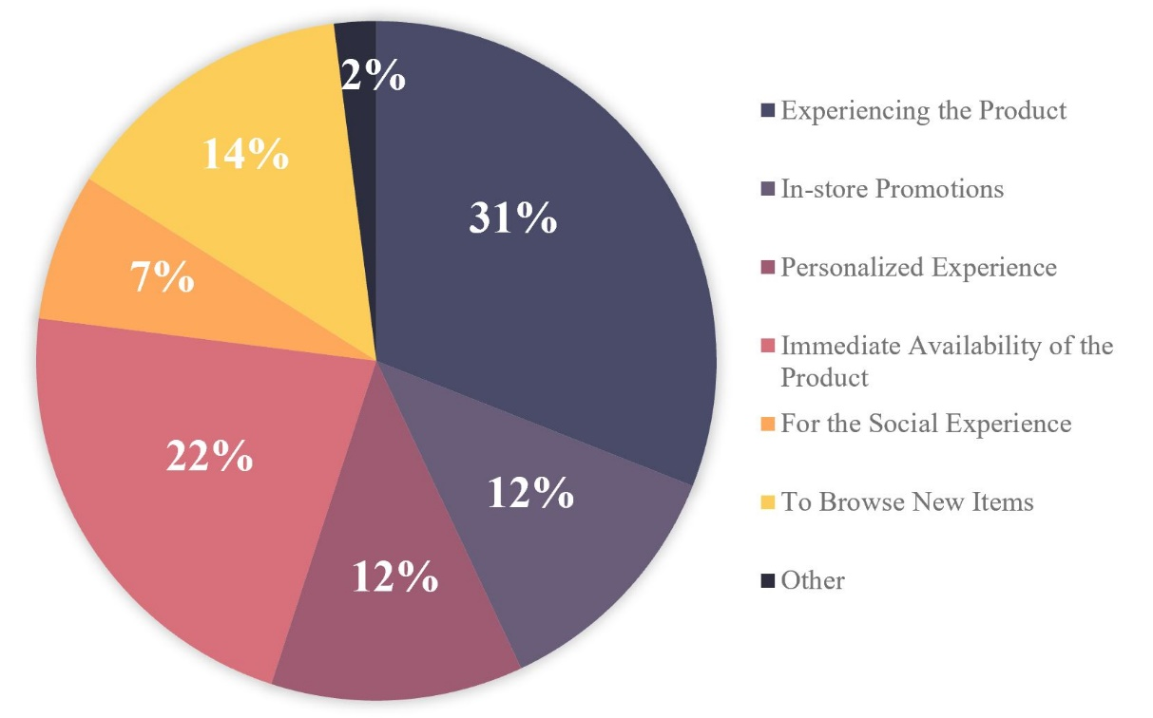
Figure 1. Reason for Choosing In-Store Shopping
Furthermore, 87% of those surveyed said that the lighting in the clothing stores they frequent offline meets expectations and is appropriate to the brand. In addition, as shown in Figure 1, when asked about the advantages of offline shopping over online shopping, shows that 30% of participants said they would choose offline shopping because they could experience the product, while 22% said they chose offline because they could get the product immediately and save time waiting for it to be shipped. Participants ' answers were more evenly split when asked what essential elements make up a good shopping environment.
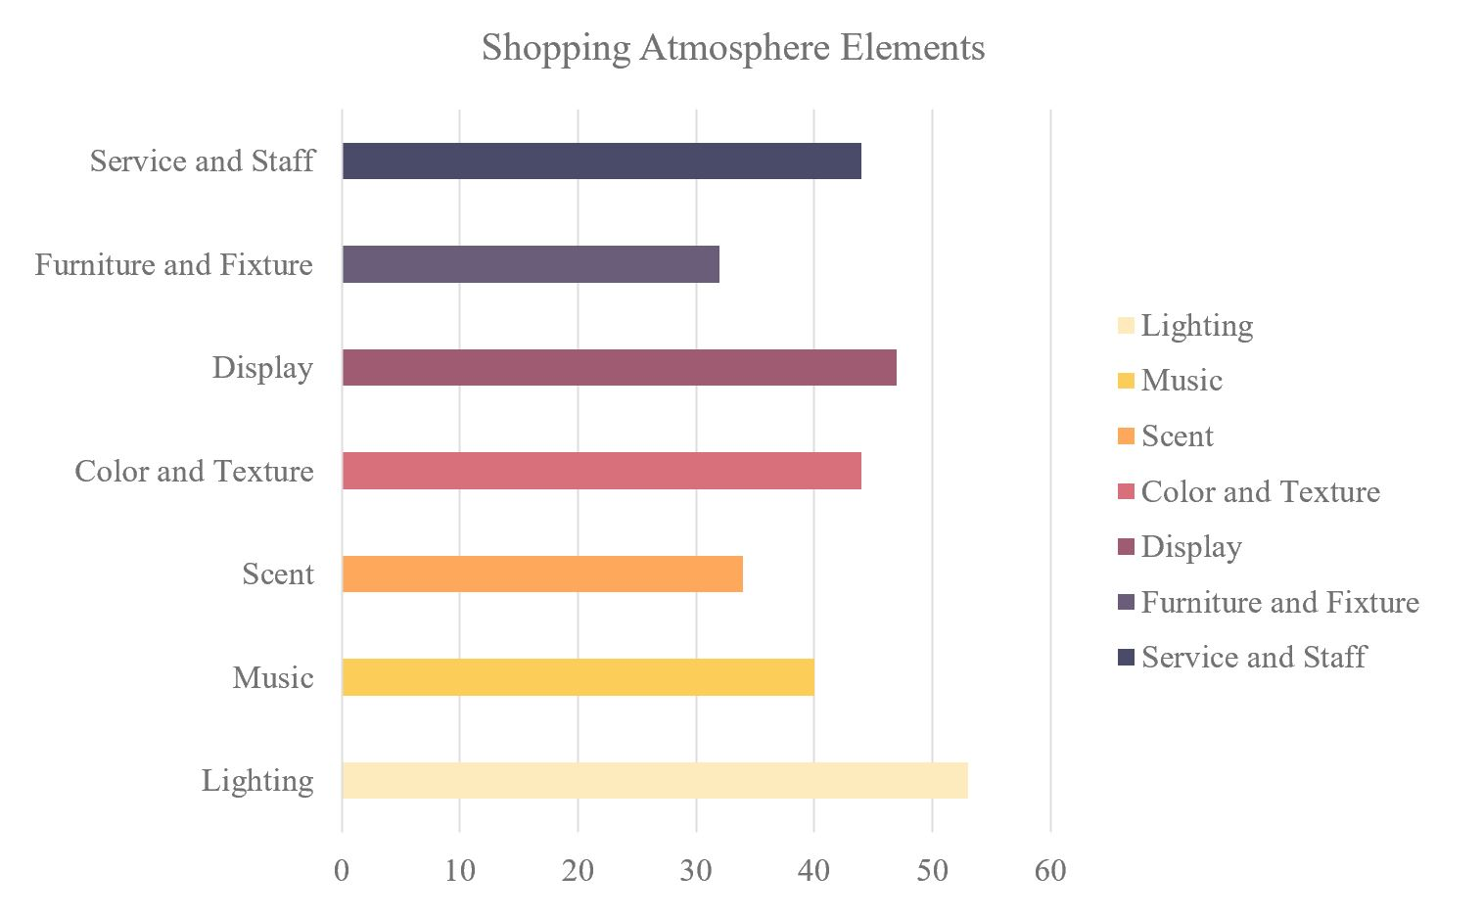Figure 2. Components of Good Shopping Atmosphere
According to the questionnaire, Figure 2 shows that the top five elements of good shopping atmosphere were lighting, merchandising, room color, service, and music. The survey results show that lighting is a significant factor in the offline shopping experience. Theoretically, lighting is an inaccessible element of the shopping experience, and the lighting can affect the time consumers spend in the store. Consumers stay longer in the store, which leads to more purchase behavior.

The images below are taken of the physical stores that participants viewed after completing the first part of the survey questionnaire and the evaluation results.
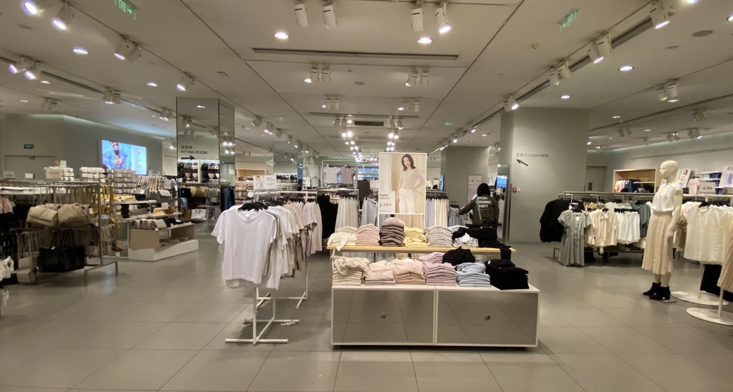
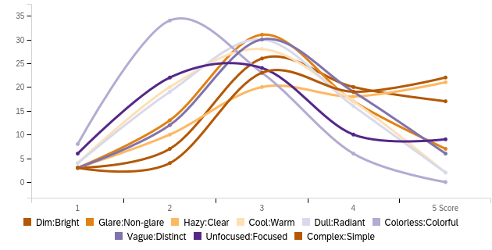Store 1
Counts
Figure 3. Shopping Environment Assessment

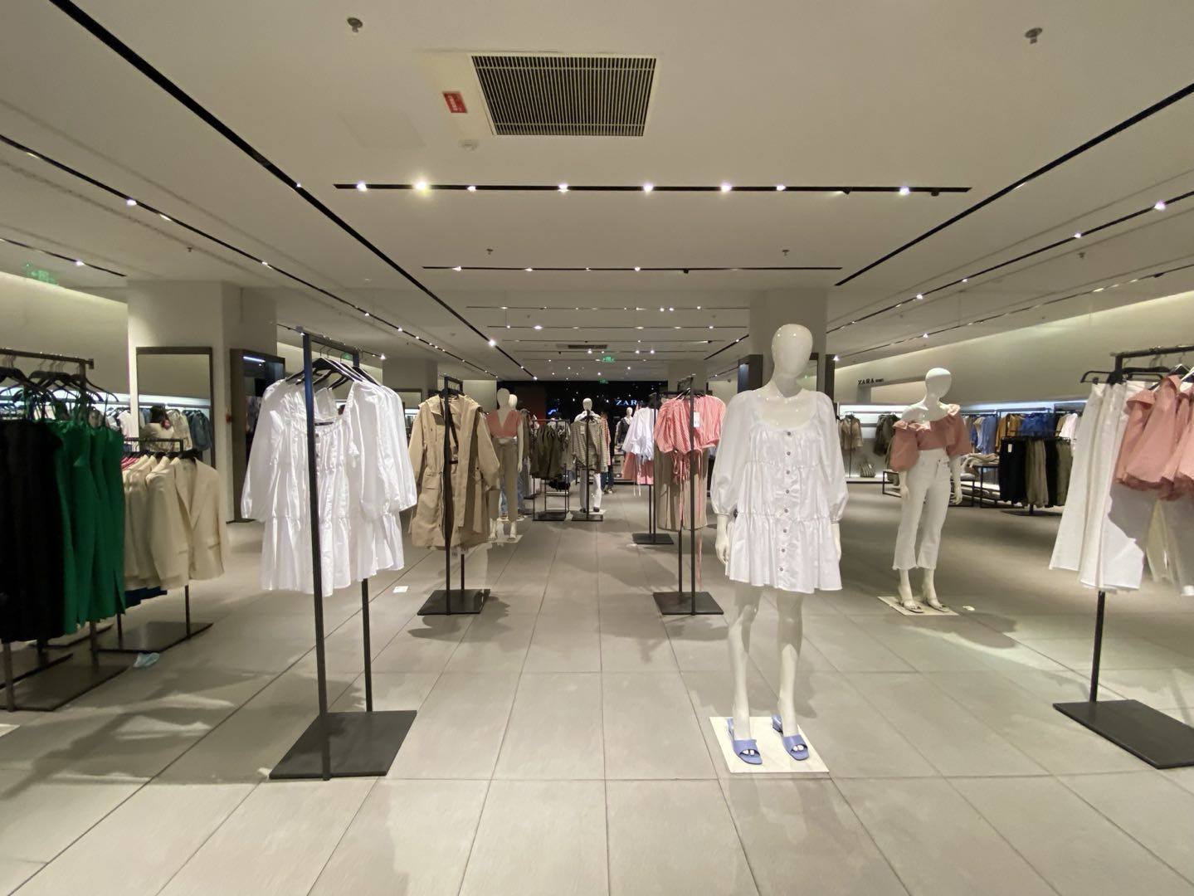

Store 2
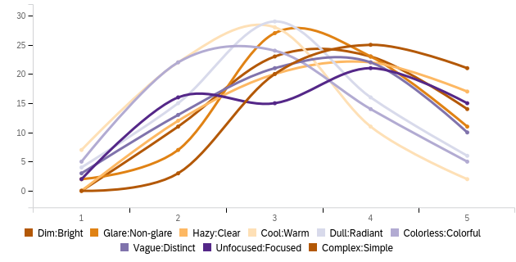
Counts
Score

Figure 4. Shopping Environment Assessment

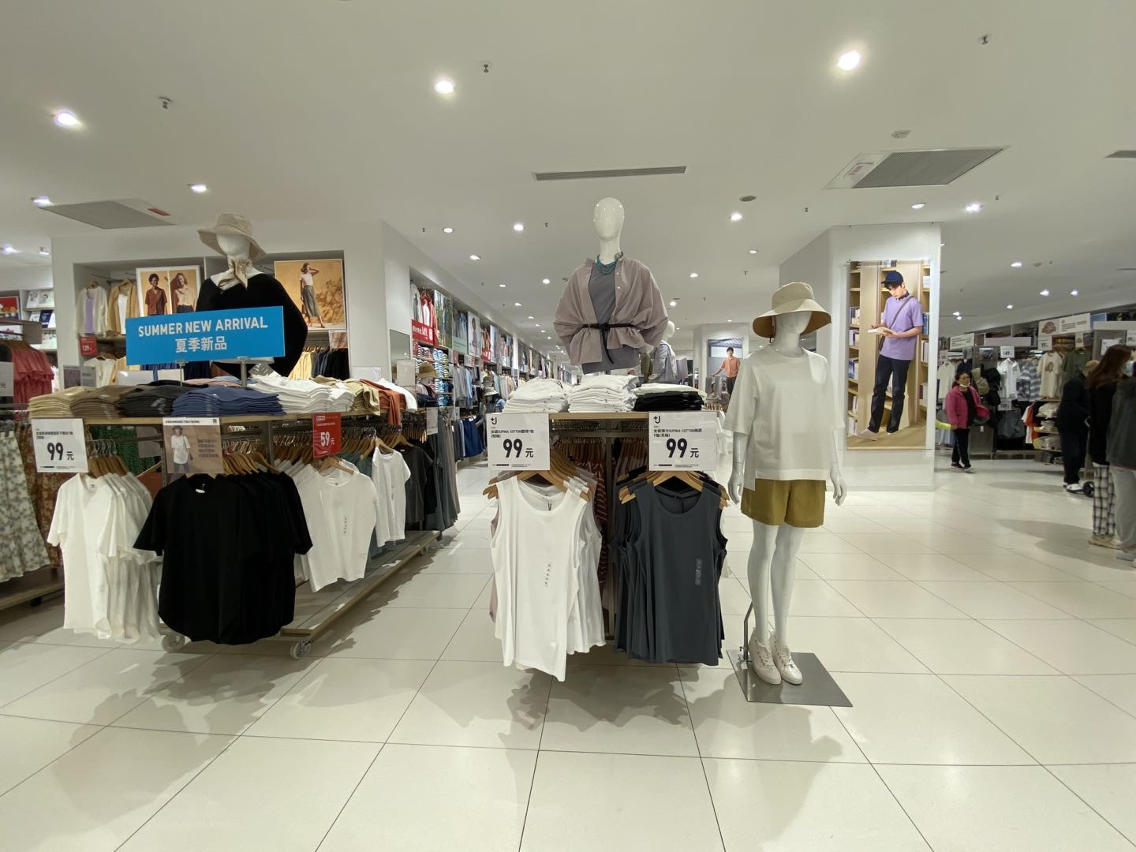
Store 3
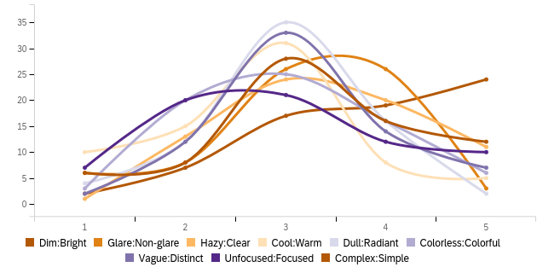
Score
Counts

Figure 5. Shopping Environment Assessment

In this part, for the sake of the reliability of the survey data, the participants, without knowing the brand names of the brick-and-mortar stores, scored three stores on a scale of 1 to 5 and assessed the details of each brick-and-mortar store environment. The scores for stores 1 through 3 were 3.43, 3.66, and 3.1, respectively. Store 2 had the highest score. According to the results of this section, Figure 4 shows that store 2 received positive ratings from participants for its straightforward displays, dim but adequate lighting, and overall cool color palette. In addition, Figure 3 and Figure 4 show that the participants' comments on physical stores 1 and 3 were that the interior lighting was too bright and dazzling, the product display was unfocused, and the interior colors were too monochromatic. This survey shows that lighting is a double-edged sword for retail stores and that brighter lighting is not better for clothing stores. Theoretically, the effective use of proper lighting in a clothing store can improve the overall shopping experience, highlight the products and thus motivate consumers.

The following two sets of images are the third part of the subject participation questionnaire and the presentation of the results.
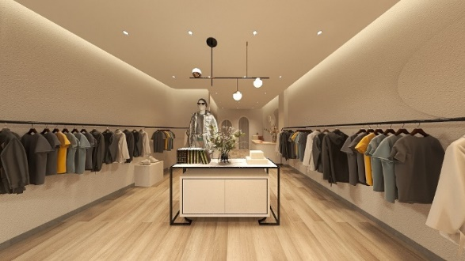

Model 1a (2700K)

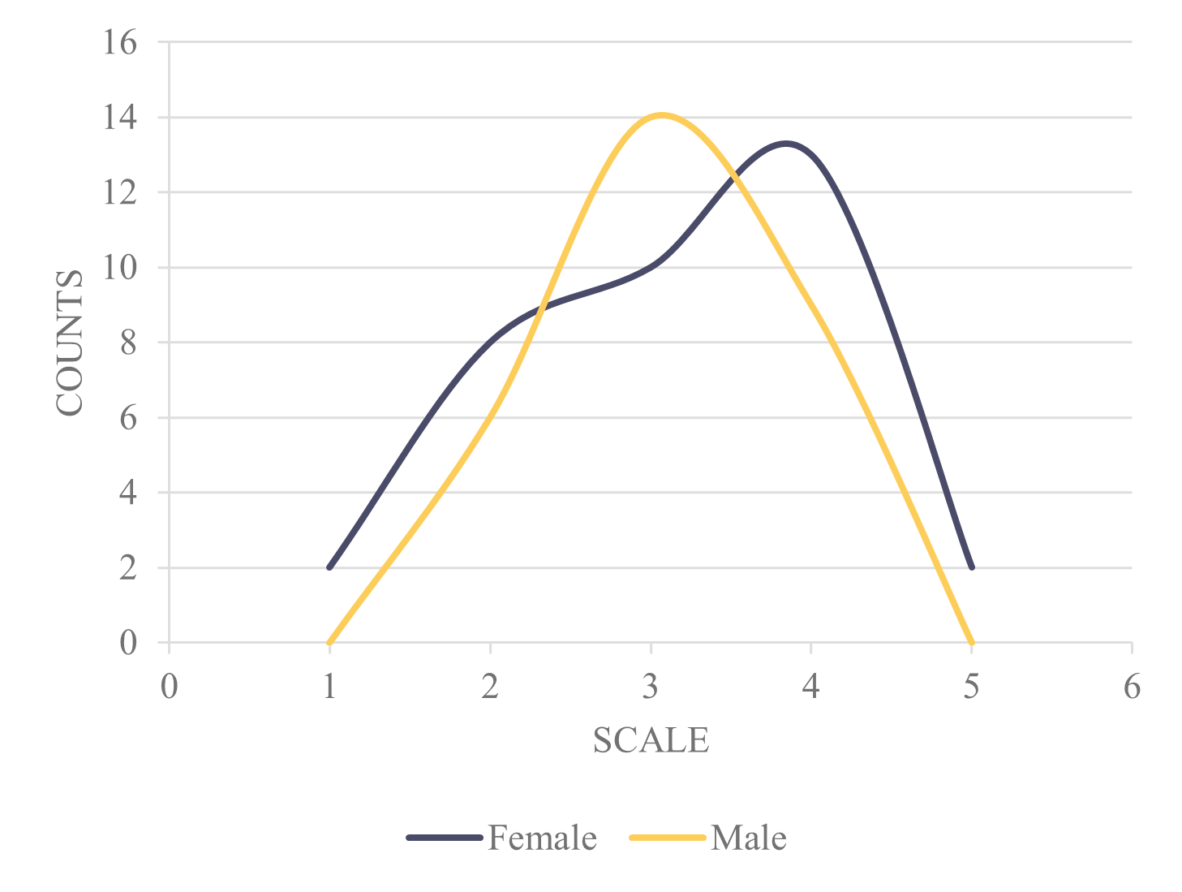
Figure 6. Participants Preference for Model 1a

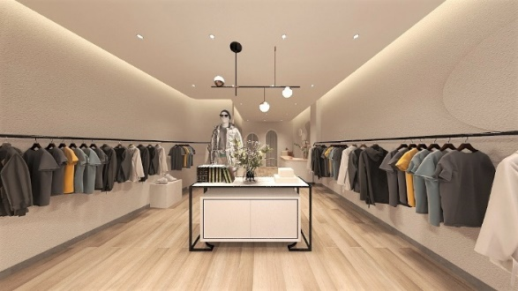
Model 1b (4000K)

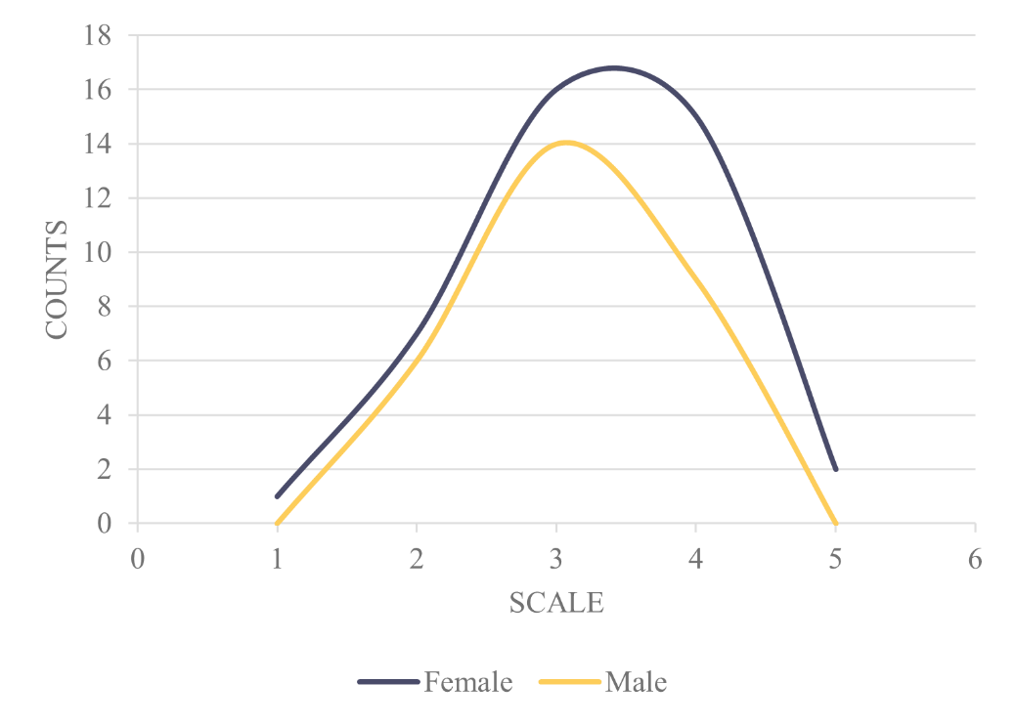
Figure 7. Participants Preference for Model 1b

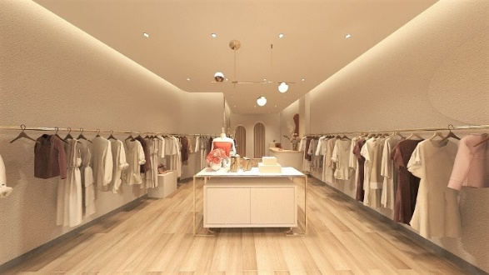

Model 2a (2700K)

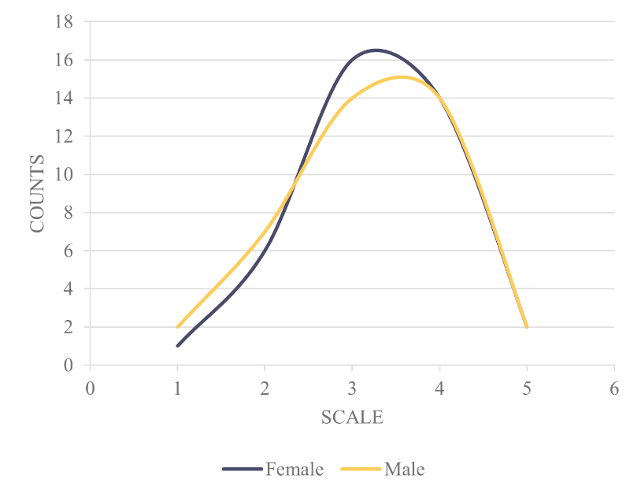
Figure 8. Participants Preference for Model 2a

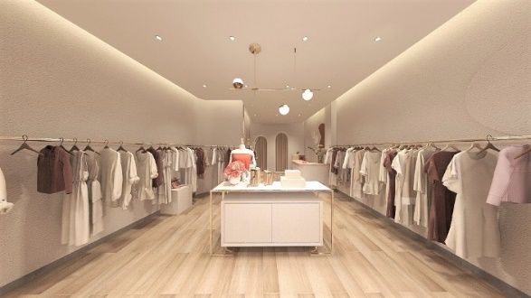

Model 2b (4000K)

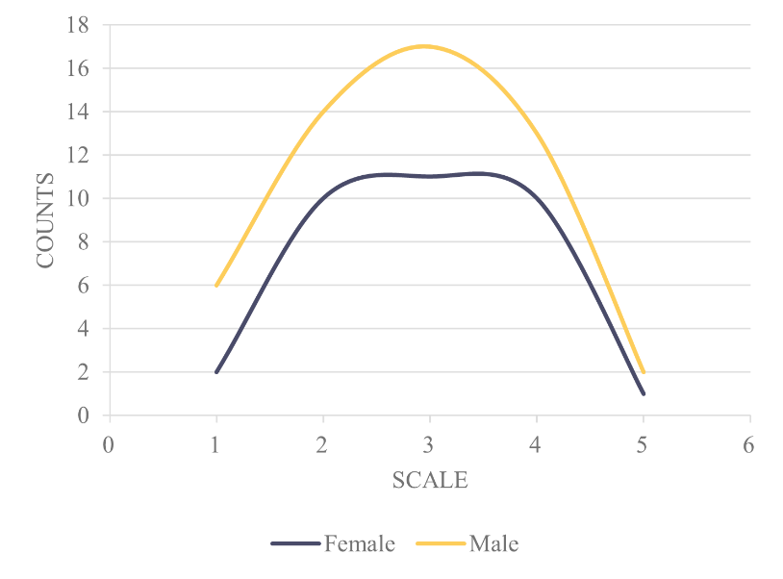

Figure 9. Participants Preference for Model 2b

The two groups of models are female clothing stores and male clothing stores, respectively, both modeled by Sketchup and using LED lighting. Each group has two subgroups with different light levels. The color temperature of the model in the group 1a and 2a are low, about 2700K, which emits yellowish light and gives people a warm and cozy feeling, while the model in group 1b and 2b has a medium color temperature, about 4000K, which gives people a comfortable and peaceful feeling. According to the questionnaire survey results, there was no significant difference in the evaluation of the models with different color temperatures between the two groups for both women and men. The ratings of female participants for models 1a and 1b were 4.2 and 4.29, respectively, while models 2a and 2b were 4.0 and 4.29. Figure 8 shows that the ratings of female participants for models with a color temperature of 4000k in Model 1b and Model 2b were slightly higher than those with a color temperature of 2700K in Model 1a and 1b. Furthermore, Figure 9 shows that it can be concluded that female consumers slightly preferred the model with a color temperature of 4000k, but the difference was not significant. In addition, male participants rated models 1a and 1b at 4.1 and 4.04, respectively, while models 2a and 2b were rated at 3.7 and 3.86. In comparing these two groups of models, Figure 6 and Figure 9 show that male participants' choices showed a preference for the 2700K male clothing store and the 4000K female clothing store. The results of this section do not determine the color temperature preferences of male consumers because the data did not differ significantly, and the results of the male participants' options were opposed to each other.
The following set of images is the last part of the subject's participation questionnaire.
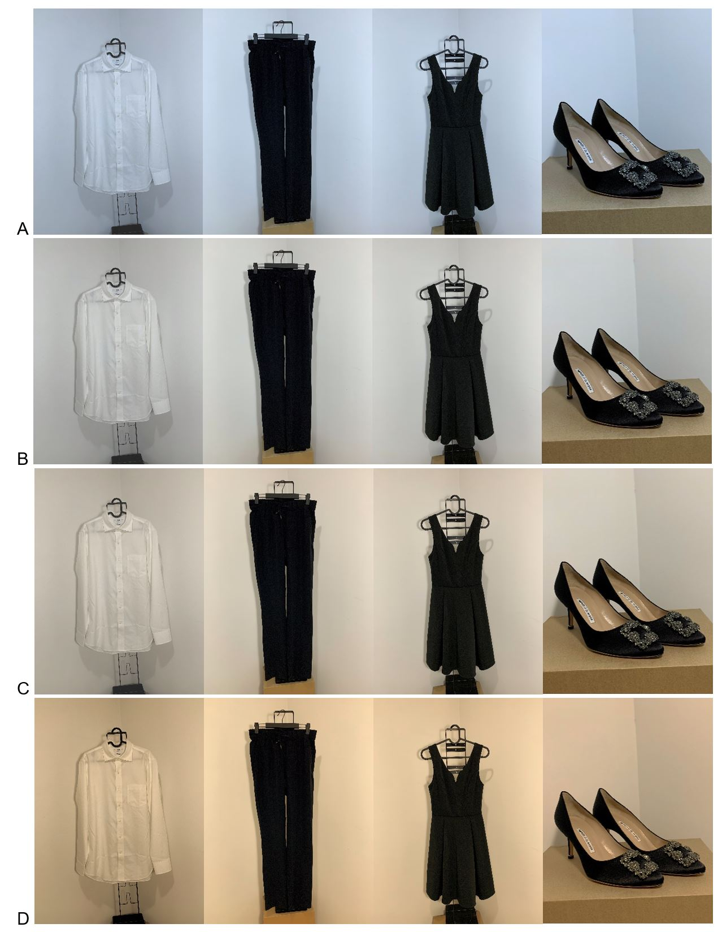
Figure 10. Model of Color Temperature Comparison
This section consists of four sets of images comparing different color temperatures on the same clothing. All four sets of comparison images were taken with the same LED light source with variable color temperature and were taken with the iPhone XS Max phone. Group A is 6000K, Group B is 5000K, Group C is 4500K, and Group D is 3000K. The questionnaire results showed that 81% of the participants thought that the light affected the quality of the product. Also, in all four groups, both female and male participants indicated that the overall quality of the clothing in group B was the best, while group A was the lowest. In comparing each item in different color temperatures, participants still unanimously said that whether it was a shirt or a shoe, group A's lighting looked much cheaper. From this result, it can be concluded that 6000K white light would make the apparel look cheap and magnify the items' shortcomings, so clothing stores should avoid using too bright white light. Some of the findings from the questionnaire survey are directional, but some are not. However, overall, these data side-by-side corroborate some of the literature reviews, and the research discussed.
Factors Affecting Data Collection
The total number of participants was 114, but only 73 completed the questionnaire thoroughly. The degree of completion of the first part of the whole questionnaire was high, but the completion of the last three parts was low as the following content increased. Due to the reasons that the questionnaire was too long and there was only one type of question, the unreliability of the results could not be excluded because the participants may have answered the questions randomly. Secondly, the questionnaire is online-based, so participants may use cell phones or computers to answer the questions. Since cell phone screens and computer monitors are different, the color and brightness of the images may be very different, leading to instability of the results.
Furthermore, the study was conducted with gender-specific consumers, and the presence of male versus female participants could provide a gender contrast for the study. However, the total number of female participants in the study was 44, compared to 29 male participants. The ratio of males to females was not 1:1. Therefore the male consumer group in this study was not quantitatively representative.
Discussion/Conclusion
This project began with the hypothesis that "lighting plays a positive role in consumer buying behavior. When consumers shop in clothing stores, they are more likely to stay in the store and choose to buy more products if the lighting is of the right brightness or adjusted to a certain color temperature. Through the above research and results, appropriate lighting positively affects both female and male consumers. Male consumers, especially female consumers, they have more acute color vision compared to men (Chiang & Yu, 2010). Female consumers prefer to buy clothes in clothing stores with high warm color temperature LED lighting or clothing stores with color temperature close to 4000K-5000K. Male consumers can accept that the interior lighting range is relatively large, and stores should use a color temperature of 2700k-5000k to keep male consumers. 81% of the participants indicated significant variability in the quality of the same garment at different color temperatures, with the same garment looking best at 4500K to 5000K light color temperatures and the same garment looking somewhat cheaper at 6000K color temperature. This visual variability is because the color temperature of 4500K to 5000K has a warm color temperature of light due to its micro-red component and has a very relaxing effect. What about the broad range of color temperature is from 1000K to 10000K and above. The lower the number, the more warm or red and yellow colors the fixture would exhibit. The higher the number, the brighter the luminaire would appear, or white or blue (Noguchi & Sakaguchi, 1999). While cool white lights at 6000K look brighter at the same wattage, they also emit less comfortable light. Therefore, warm white lights are more suitable for general clothing stores and specific clothing display areas.
This study shows that lighting can affect the overall shopping atmosphere of a clothing store and the visual impact of the products, thus influencing customers' shopping preferences for clothing. Furthermore, the study found that 52% of participants preferred to shop online, and the reason they chose to shop offline was that they could get the product faster and experience it physically. The result leads to improving retail stores to positively influence their shopping experience, never to improve the competitiveness of brick-and-mortar stores to online store. Lighting is undoubtedly an essential element used to influence shoppers. According to research, consumers have different psychological reactions when spending money in different styles of stores, and the environment and lighting are essential assets to motivate shoppers in a way that e-commerce does not bring (Scarpi et al., 2014). It can be further concluded that lighting and the environment in some way influence consumers. In particular, as mentioned in the previous quotation, how it affects and helps the brick-and-mortar apparel stores achieve the desired sales requirements in today's prevalent online shopping and provide customers with an overall enjoyment and shopping experience in a particular space. While it is crucial to understand how lighting affects consumer shopping behavior, it is also essential to mention the setup and design of the retail space. According to the above study, the components of a good shopping atmosphere also include store layout, colors, services, flavors, and even music, and in an article on shopping atmosphere, Bohl (2012) suggests that an overall improvement in shopping atmosphere can improve the competitiveness of a brick-and-mortar store. In the process of consumption, consumers sometimes do not deliberately buy. In other words, some consumers enjoy the consumption process and the high quality of service. If merchants want to increase store sales, stores also need to satisfy customers emotionally. A good shopping experience would encourage customers to become loyal fans of that store, and it is likely to bring more customer traffic to the store. Overall, the main point of this study is that merchants or designers can increase in-store sales by influencing the shopping behavior of different genders through their lighting preferences, and remember that lighting is an essential element of the shopping atmosphere, but it is not the only one. It improves the overall shopping environment that can provide a sustainable competitive advantage for retail stores.
Future Implications
Lighting design as part of the store’s visual marketing for the entire retail force can make the brand’s image more outstanding and create a better shopping experience. The results of this study show that brand clothing stores, in addition to creating a comfortable atmosphere in the choice of lighting, also need to be very good at color reproduction of clothing, which is linked to the color rendering index of the lamps. Future research can further explore whether the color rendering of lamps and lanterns is different for different materials of fabrics. In addition, in daily life, consumers are in environment affected by various colors of light and shadow, so trying on clothes in a clothing store or at home can lead to different effects on the body. Therefore, designers must restore the reality of clothes or products, improving consumers' satisfaction with the products and reducing consumers' return and exchange behavior. In addition, based on this study to explore the impact of lighting from the perspective of gender differences, then in the future to further explore from different age groups. In addition, as a researcher or designer, we should consider all the factors that affect the shopping experience, including personalized and quick shopping services, comfortable and beautiful shopping spaces, and high-quality and low-cost products. Researchers can further explore this issue from the overall shopping atmosphere and consumers' perspective in the future.

APPENDICES
Informed Consent Form
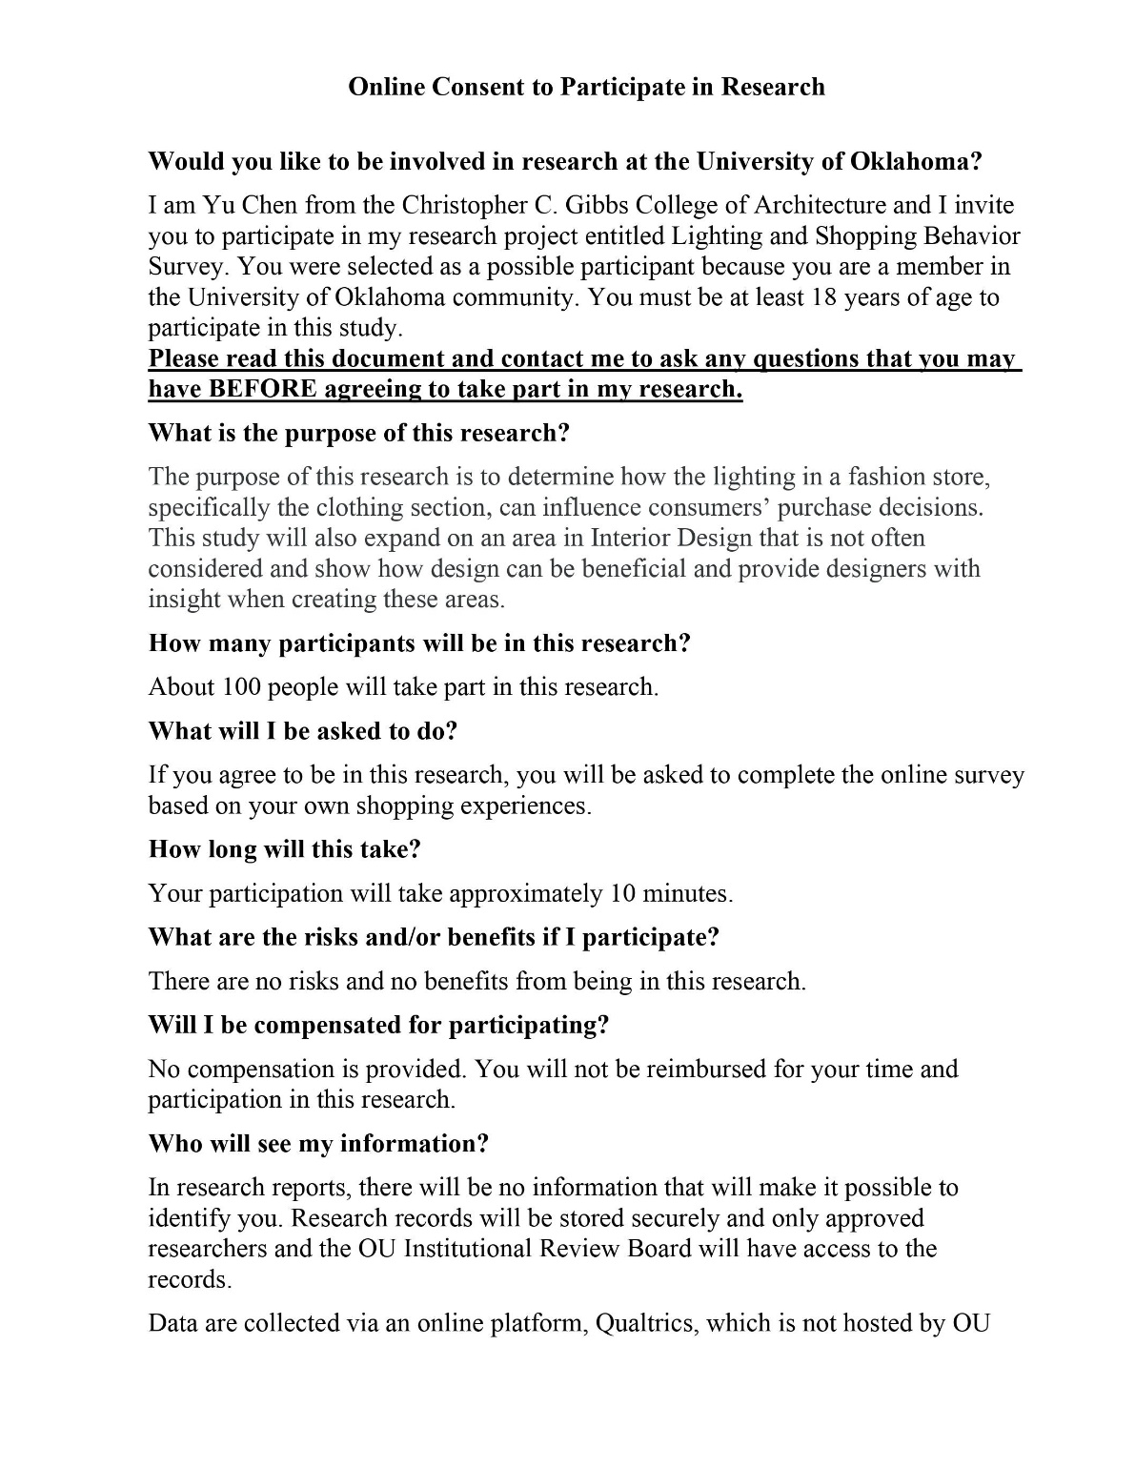
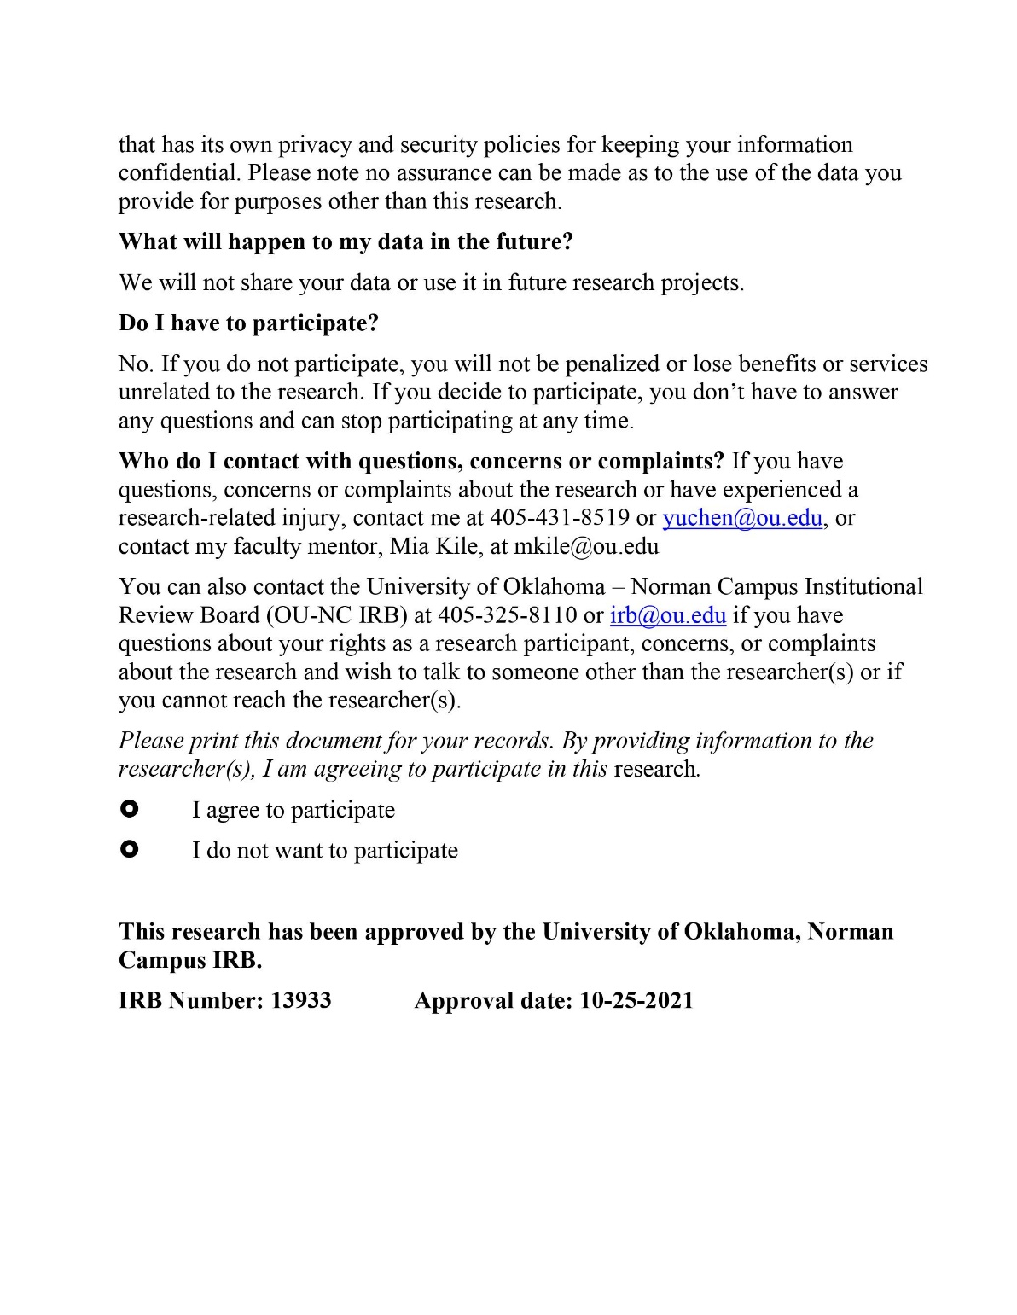
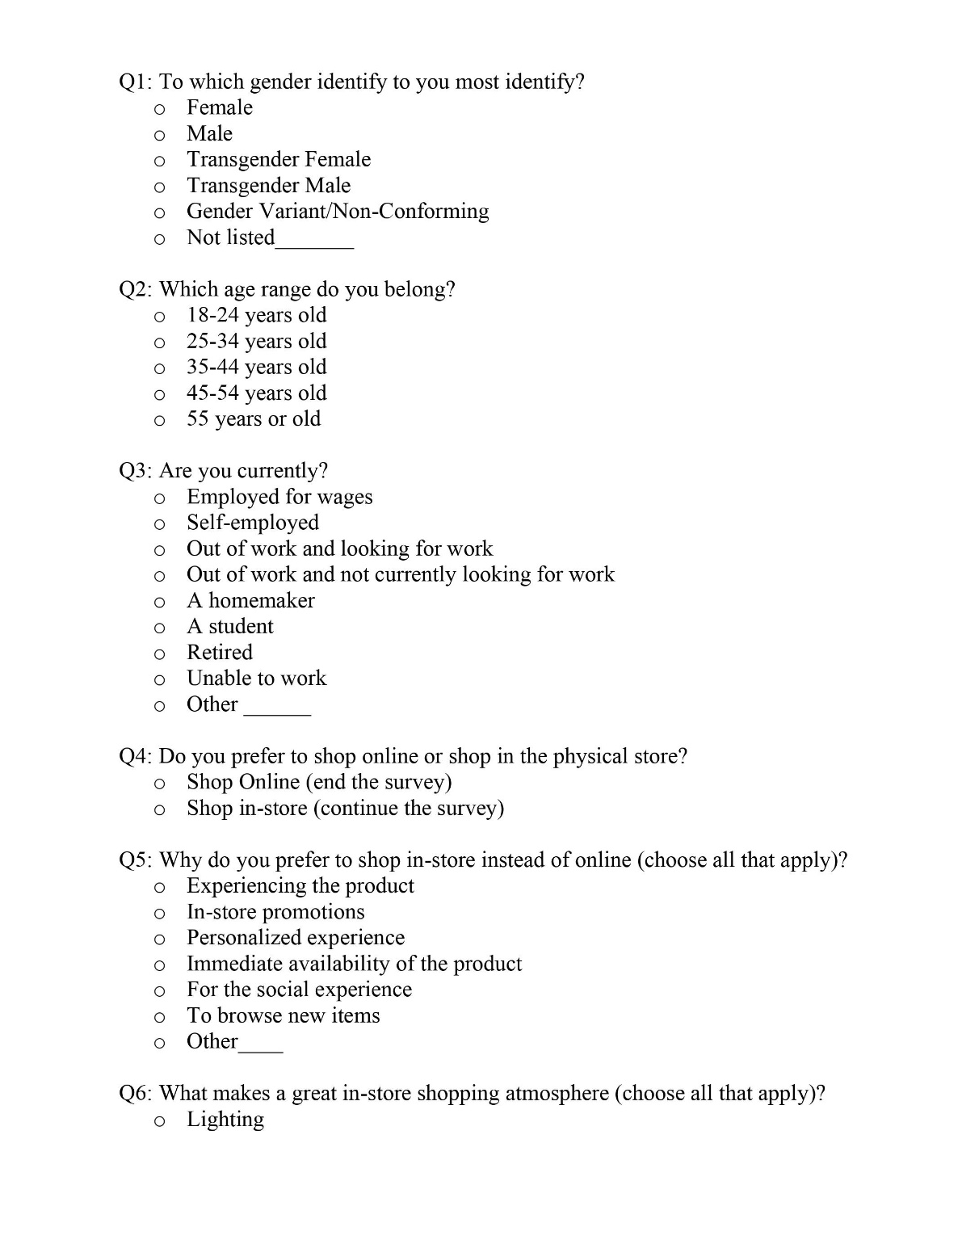

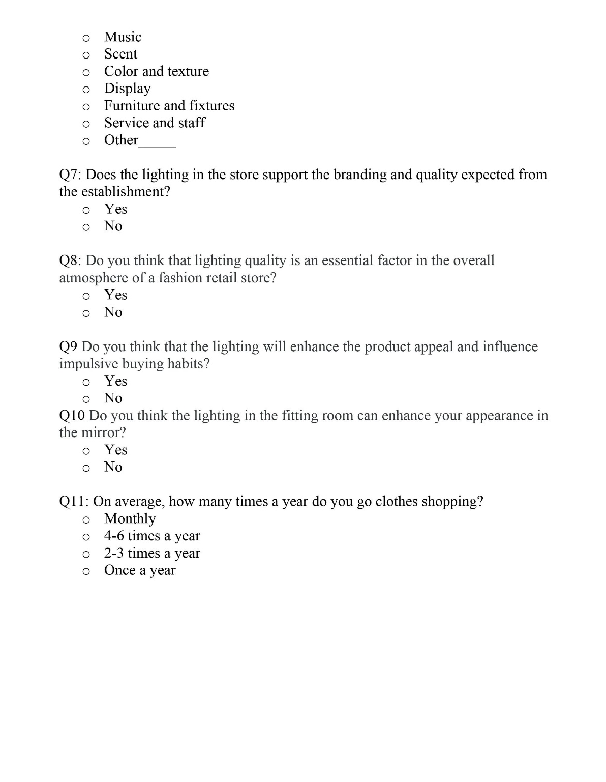

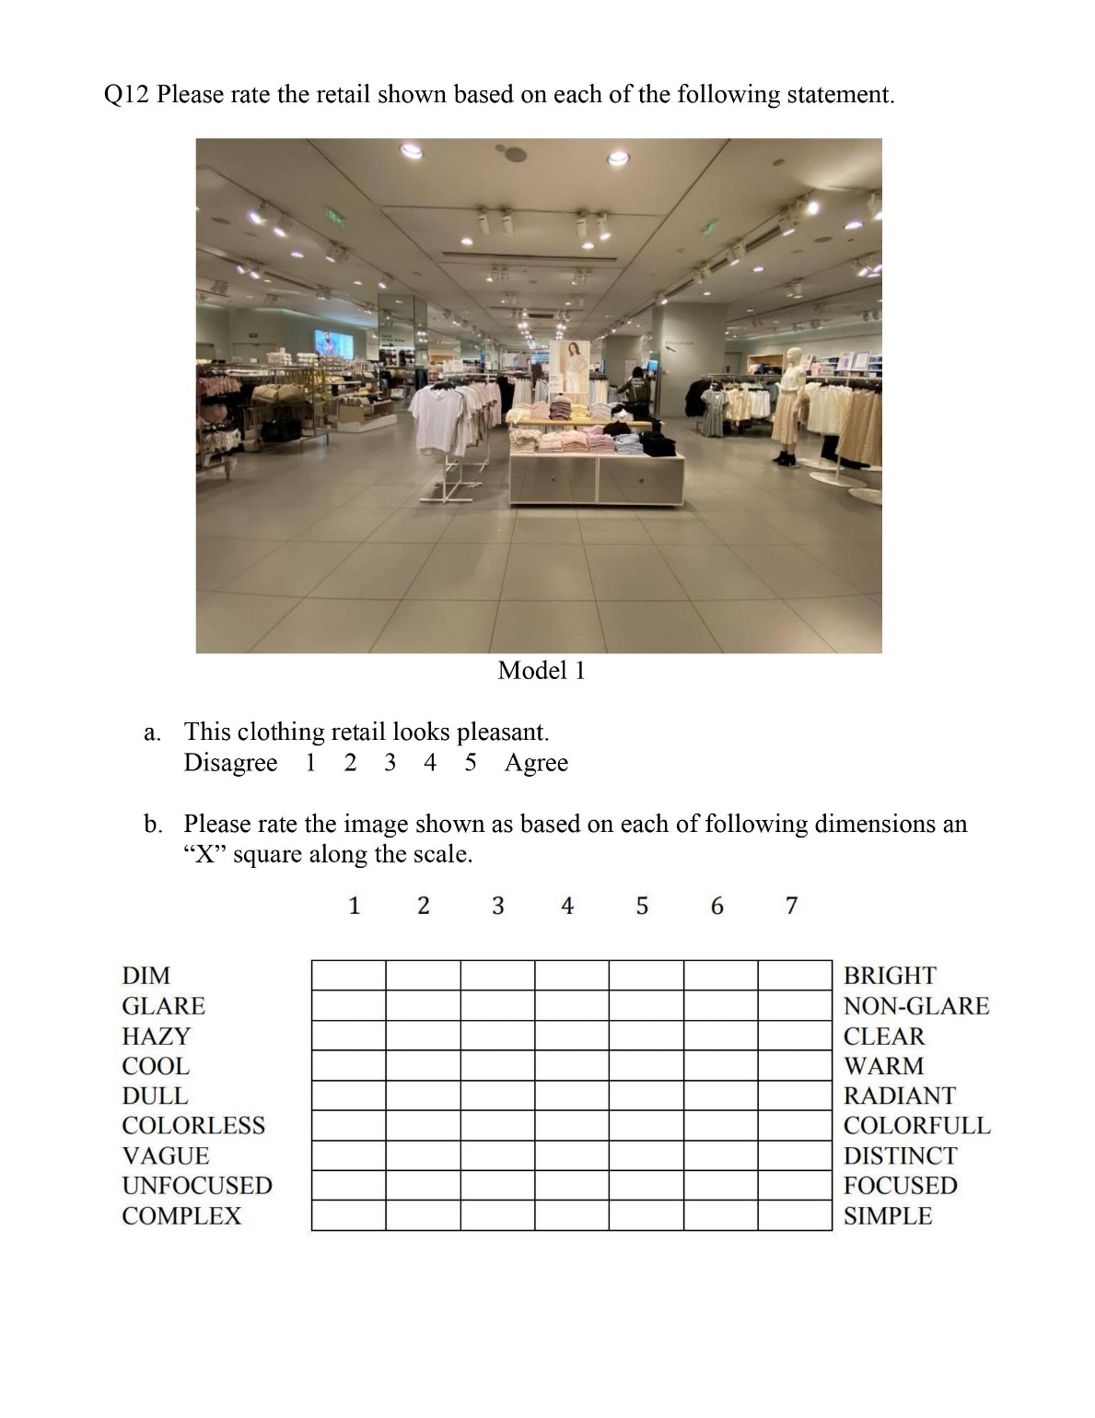

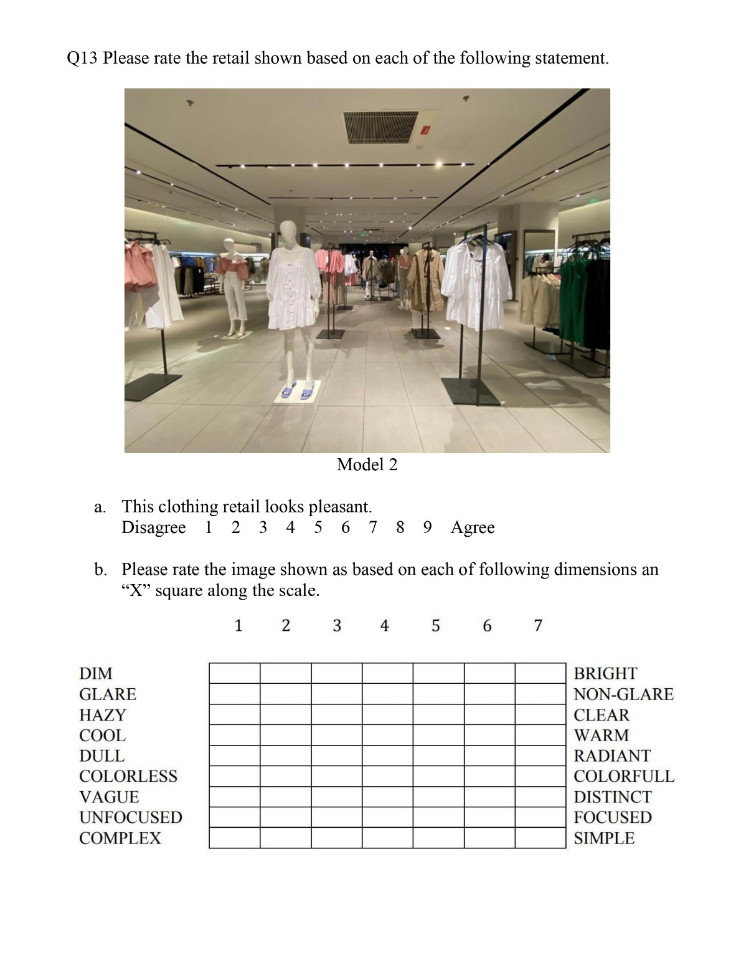

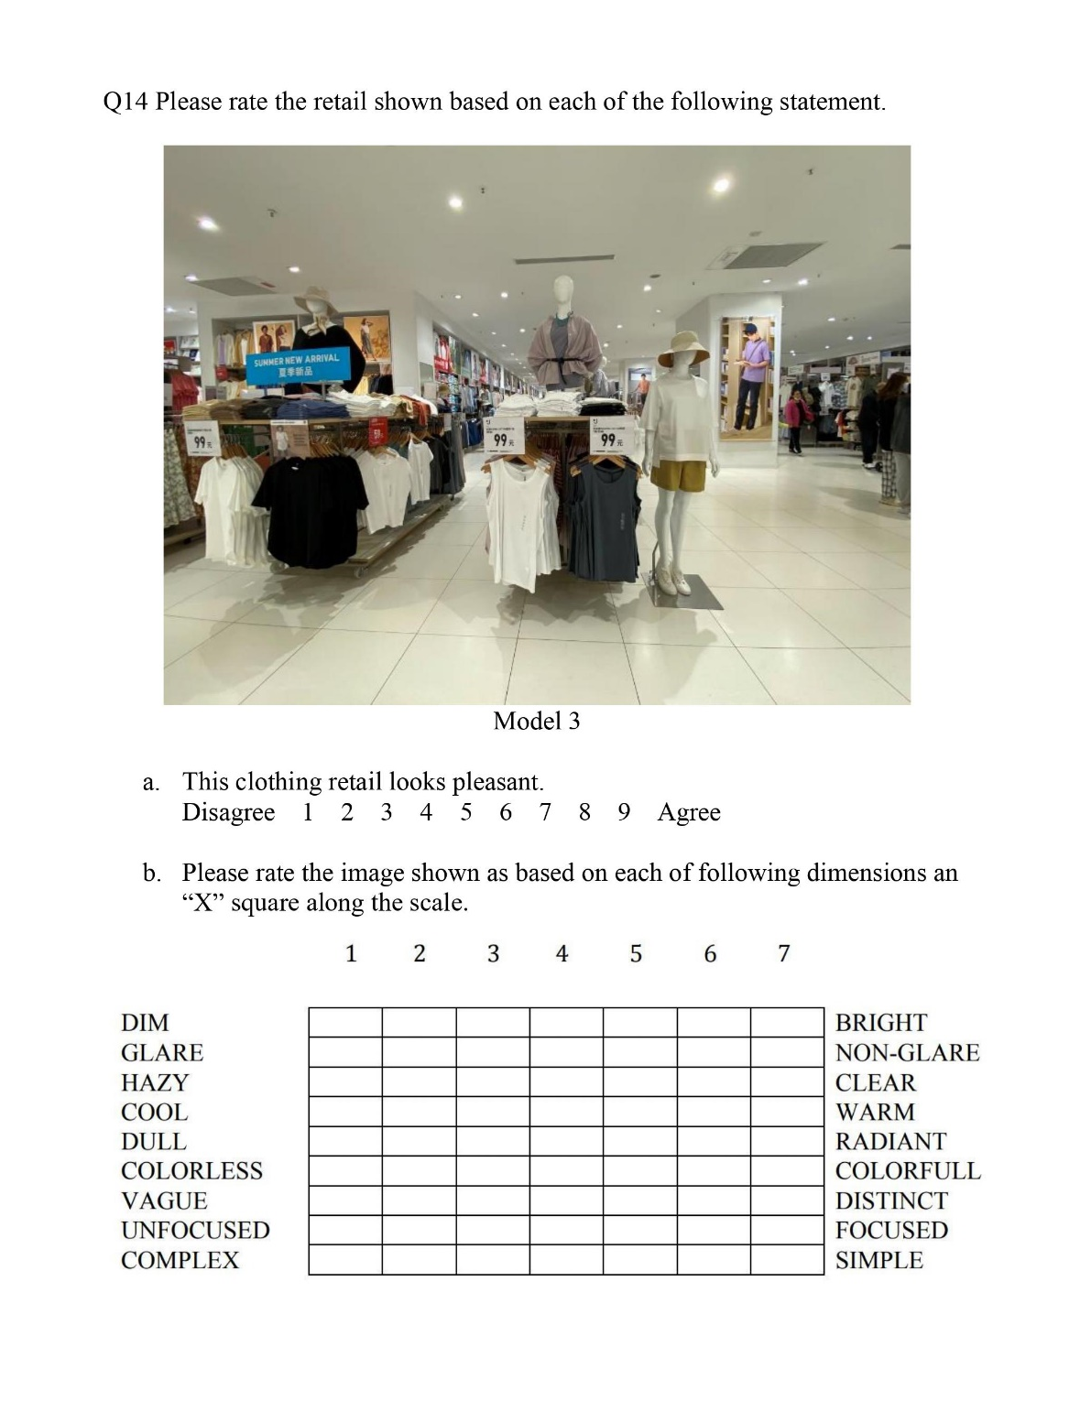

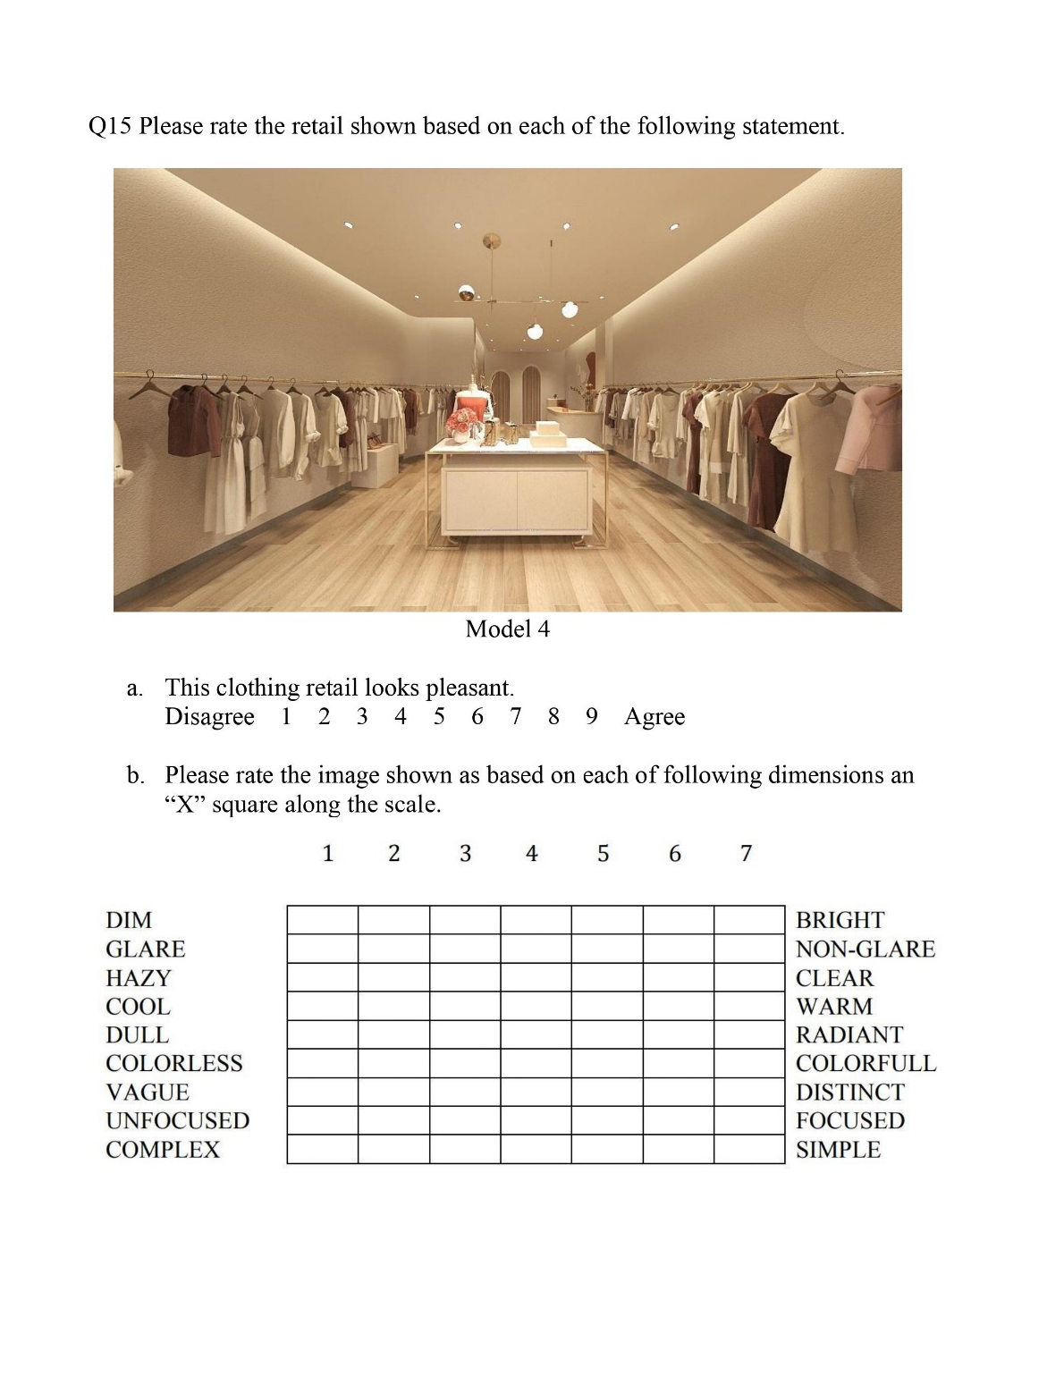

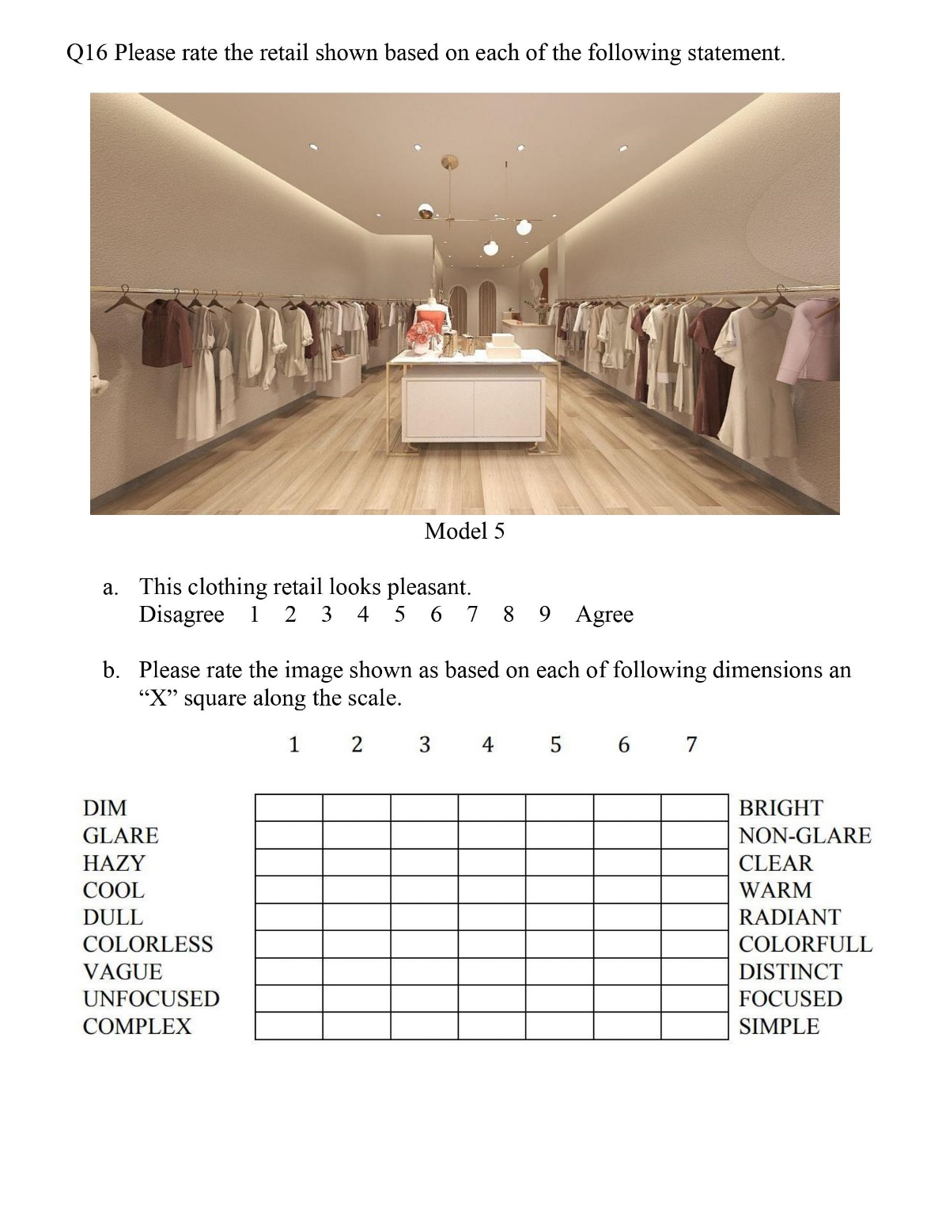

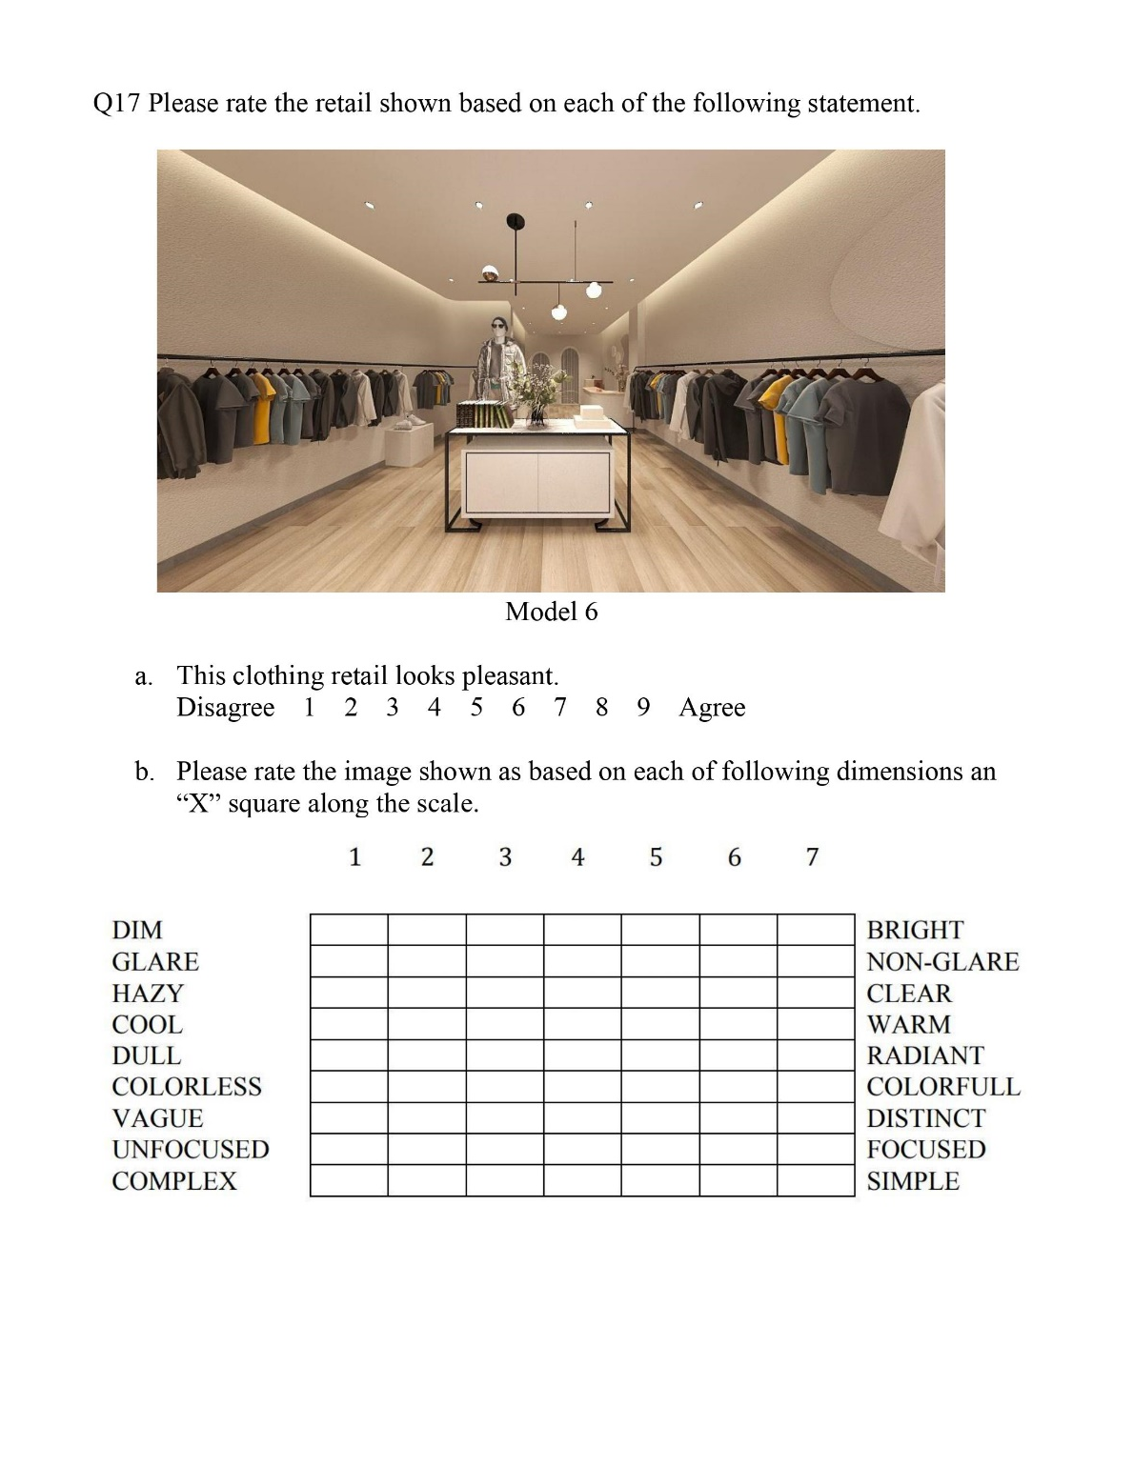

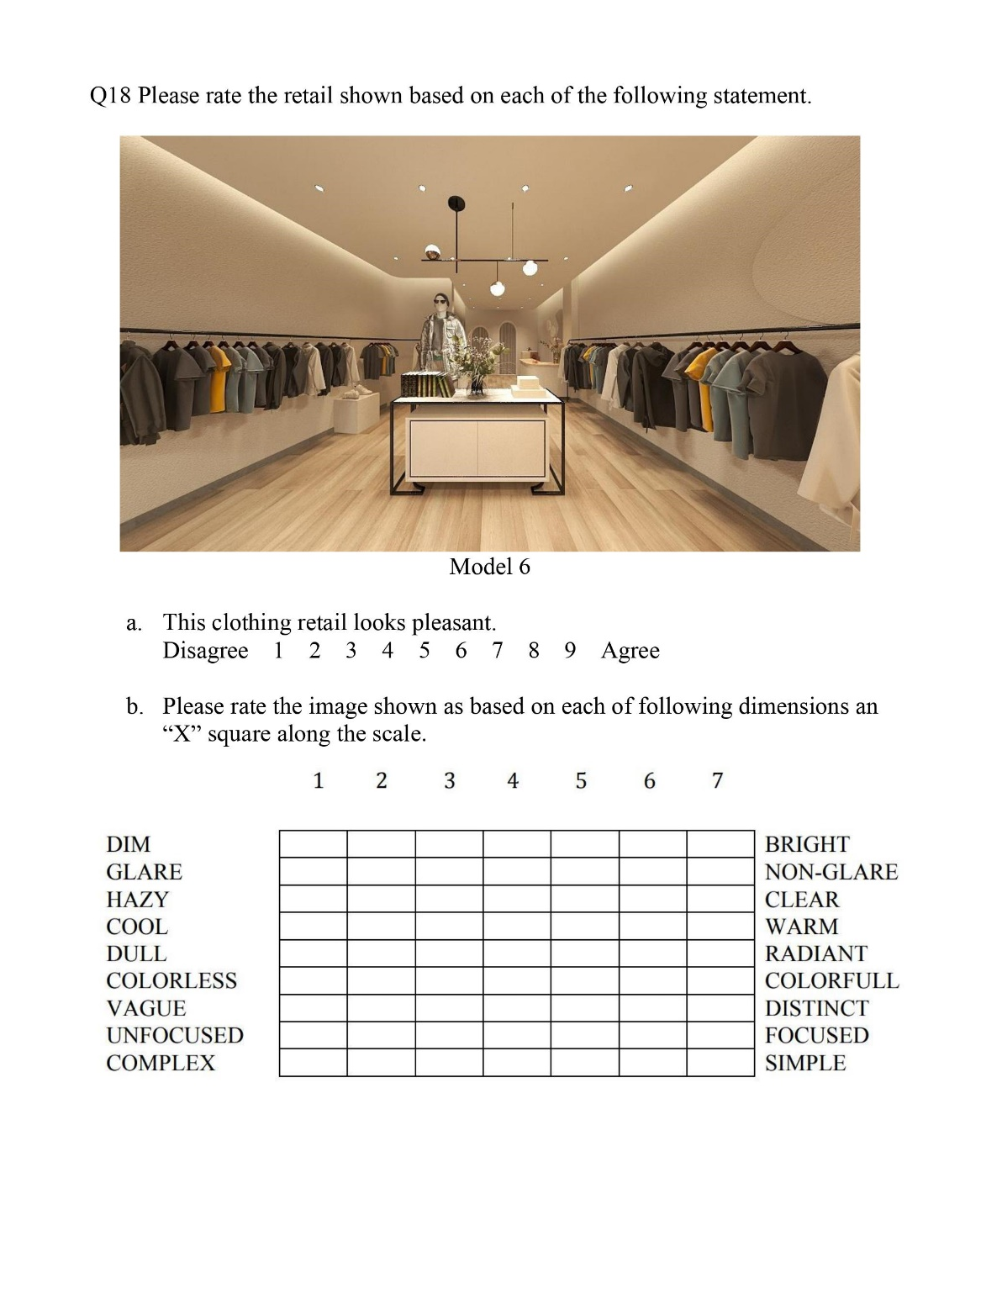

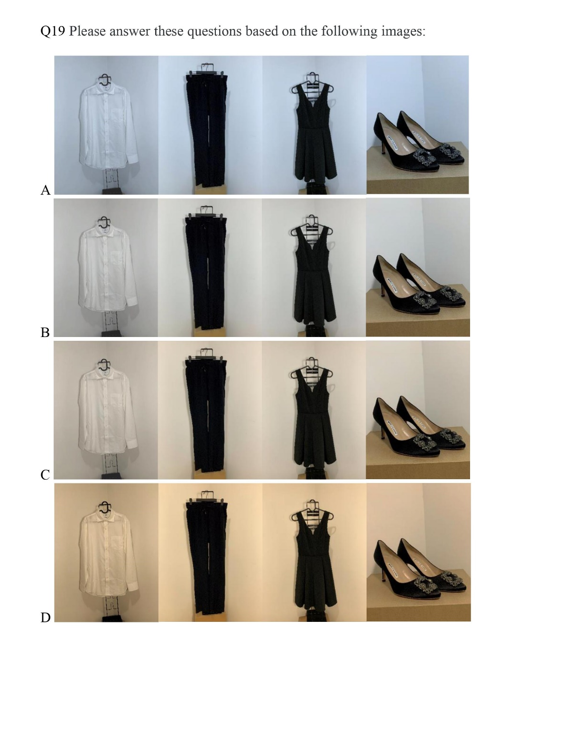

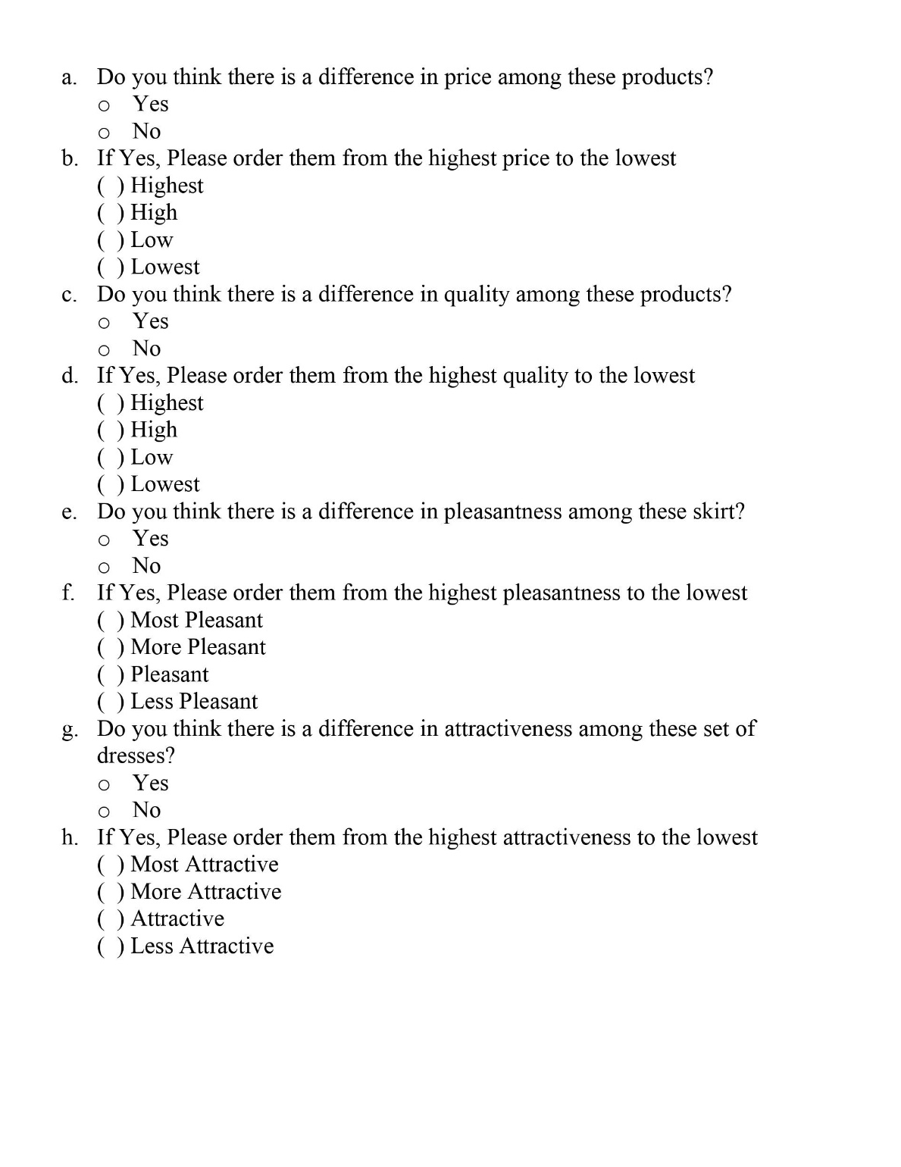

Letter Of Approval From Institutional Review Board

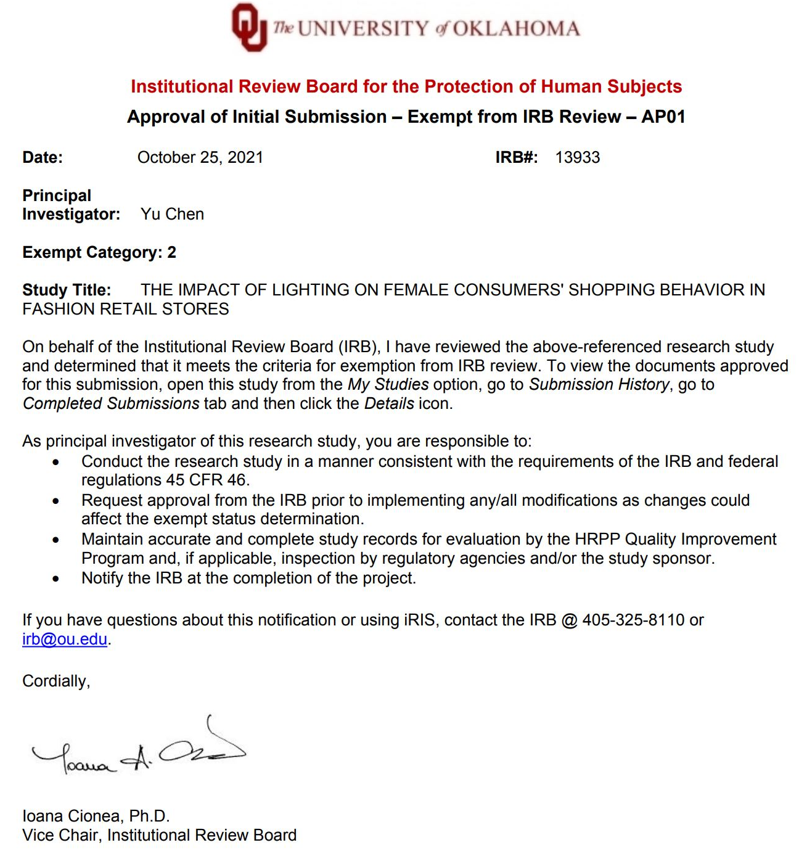

Reference
Bae, S., & Lee, T. (2011). Gender differences in consumers’ perception of online consumer reviews. Electronic Commerce Research, 11(2), 201-214.
Bohl, P. (2012). The effects of store atmosphere on shopping behaviour-A literature review. Corvinus Marketing Tanulmányok, 2012(1).
Chan, F. T., & Chong, A. Y. L. (2013). Analysis of the determinants of consumers’‐commerce usage activities. Online Information Review.
Chiang, C. T., & Yu, W. C. (2010). Research of female consumer behavior in cosmetics market case study of female consumers in Hsinchu Area Taiwan. I-Business, 2(4), 348.
Djafarova, E., & Bowes, T. (2021). ‘Instagram made Me buy it’: Generation Z impulse purchases in fashion industry. Journal of Retailing and Consumer Services, 59, 102345.
Friedman, M. (2018). Theory of the consumption function. Princeton university press.
Gong X, Ye Z, Liu K., & Wu N. (2020). The Effects of Live Platform Exterior Design on Sustainable Impulse Buying: Exploring the Mechanisms of Self-Efficacy and Psychological Ownership. Sustainability, 12(6), 2406.
Goldmanis, M., Hortaçsu, A., Syverson, C., & Emre, Ö. (2010). E‐commerce and the Market Structure of Retail Industries. The Economic Journal, 120(545), 651-682.
Goolsbee, A., & Syverson, C. (2020). Fear, lockdown, and diversion: Comparing drivers of pandemic economic decline 2020 (No. w27432). National Bureau of Economic Research.
Gwozdz, W., Steensen Nielsen, K., & Müller, T. (2017). An environmental perspective on clothing consumption: Consumer segments and their behavioral patterns. Sustainability, 9(5), 762.
Ha, Joong-Gyu. (2012). Using Colours to alter Consumer Behaviour and Product Success. International Journal of Contents, 8(1), 69–73. https://doi.org/10.5392/IJOC.2012.8.1.069
Imam, F. (2013). Gender differences in impulsive buying behavior and post- purchasing dissonance under incentive conditions. Journal of business strategies, 7(1), 23.
Juhari, N. H., Ali, H. M., & Khair, N. (2012, March). The shopping mall service scape affects customer satisfaction. In 3rd International Conference on Business and Economic Research (3rd ICBER 2012) Proceeding (pp. 617- 632).
Kirtley, P. (2013). Urban Wear Fit For The Wilds? UNIQLO Ultra Light Down Gilet.
Law, D., Wong, C., & Yip, J. (2012). How does visual merchandising affect consumer affective response?. European Journal of marketing.
Leary, R. B., Vann, R. J., Mittelstaedt, J. D., Murphy, P. E., & Sherry Jr, J. F. (2014). Changing the marketplace one behavior at a time: Perceived marketplace influence and sustainable consumption. Journal of Business Research, 67(9), 1953-1958.
Michon, R., Chebat, J. C., & Turley, L. W. (2005). Mall atmospherics: the interaction effects of the mall environment on shopping behavior. Journal of Business Research, 58(5), 576- 583.
Mouhoubi, F. (2014). The effects of retail store lighting and shelf height on consumer' feeling of safety and behavior. : Oregon State University.
Noguchi, H., & Sakaguchi, T. (1999). Effect of illuminance and color temperature on lowering of physiological activity. Applied human science, 18(4), 117- 123.
Pantano, E., Pizzi, G., Scarpi, D., & Dennis, C. (2020). Competing during a pandemic? Retailers’ ups and downs during the COVID-19 outbreak. Journal of Business Research.
Pelletier, B. (2016, November). Solid state lighting in commercial applications. In 2016 13th China International Forum on Solid State Lighting (SSLChina) (pp. 80-82). IEEE.
Postnova, Svetlana, Robinson, Peter A, & Postnov, Dmitry D. (2013). Adaptation to shift work: Physiologically based modeling of the effects of lighting and shifts' start time. PloSOne, 8(1), E53379.
Quartier, K., Vanrie, J., & Van Cleempoel, K. (2014). The mediating role of consumers’ perception of atmosphere on emotions and behavior. A study to analyze the impact of lighting in food retailing.
Reddy, N. R. V., Reddy, T. N., & Azeem, A. (2011). Role of in-store lighting in store satisfaction. International Journal of Business and Management Tomorrow, 1(3), 1-8.
Reinecke, G. (2010). Upgrading or decline? Globalization, retail structure, and labour in the Chilean textile and clothing industry. Competition & Change, 14(1), 23-47.
Saeed, A. (2015). Impact of lighting as a visual merchandising tool on consumer’s purchase behaviour. Pakistan Business Review, 17(2), 430-443.
Saphores, J. D., & Xu, L. (2021). E-shopping changes and the state of E-grocery shopping in the US-Evidence from national travel and time use surveys. Research in Transportation Economics, 87, 100864.
Scarpi, D., Pizzi, G., & Visentin, M. (2014). Shopping for fun or shopping to buy: is it different online and offline?. Journal of Retailing and Consumer Services, 21(3), 258-267.
Yang, D. J., & Lee, C. W. (2016). In-store promotional mix and the effects on female consumer buying decisions in relation to cosmetic products. International Journal of Management, Economics and Social Sciences, 5(2), 35-56.

