UNIVERSITY OF OKLAHOMA
GRADUATE COLLEGE

Putting ADHD Into Words (and Images, and Videos): A Transmedial Experience

A THESIS
SUBMITTED TO THE GRADUATE FACULTY
In partial fulfillment of the requirements for the
Degree of
MASTER OF ARTS

By
JACOB CHAMBLISS
Norman, Oklahoma
2023
Putting ADHD Into Words (and Images, and Videos): A Transmedial Experience

A THESIS APPROVED FOR THE
DEPARTMENT OF ENGLISH

BY THE COMMITTEE CONSISTING OF

Dr. Sandra Tarabochia, Chair
Dr. Will Kurlinkus
Dr. Susan Kates

© Copyright by JACOB CHAMBLISS 2023
All Rights Reserved.
Putting ADHD Into Words (and Images, and Videos): A Transmedial Experience

Abstract

This project is the culmination of the author’s efforts to put into words, images, and videos, among other things, his attention-deficit hyperactive disorder (ADHD), which was diagnosed during his time at graduate school. This diagnosis afforded the author a new perspective on his education so far. It prompted him to research further into how neurodiverse thinkers adapt to life in the university, and how the university adapts to their presence, in a word: poorly. There are too few accounts from scholars with ADHD or autism spectrum disorder (ASD) just to name a couple of neurodivergent identities. It is the author’s hope that by reimagining the way a text may look in the field of Rhetoric and Writing Studies, we can begin to move the needle on how we think about thinking in the classroom. While this document does its best to simulate the original project, you will get the best experience by viewing this document in its original, hypertextual format, which will be linked to in the Appendix.

Table of Contents

About...............................................................................................................................................1
Sanity Breaks...................................................................................................................................4
It’s About Time................................................................................................................................5
Let’s Get Theoretical......................................................................................................................10
Walls..............................................................................................................................................18
Arriving.........................................................................................................................................27
Appendix.......................................................................................................................................30
Bibliography..................................................................................................................................31
About

The Author
Jacob Chambliss is a neurodivergent (ADHD, GAD) dual master's student in English (Rhetoric) and Library and Information Studies, as well as a Graduate Teaching Assistant at The University of Oklahoma.

Invitation/Exigence/Disclaimer
What does it mean to live with ADHD? What does it mean to be doing academic work and have ADHD? What does it mean to be asked to write about meaning, the meanings of words and how we use them, and how we choose to structure them (which some might say is this discipline we call rhetoric) and have ADHD? What if we add anxiety into the equation? Is there an equation? (Honestly, I hope not, as I have never been that great at math, but maybe something like... a process.)

There are not enough (at least in my limited researching experience) accounts of mental disability that are positive and affirming. Most of the literature is about people with mental disability, rather than from them, and while I take seriously Jack Halberstam's call in The Queer Art of Failure "to poke holes in the toxic positivity of contemporary life," being "'a mass delusion' that emerges out of a combination of American exceptionalism and a desire to believe that success happens to good people and failure is just a consequence of a bad attitude rather than structural conditions" (3), I also know there must be more to living with mental disability than the challenges we are always (or told we are) facing. Margaret Price tells me that "autobiographies of mental disability have something important to add to the study of disability autobiography: they show unique talent for refiguring the rational, thus exposing the possibilities that may emerge when we dance on generic truths" and I find myself hoping she is right.
What might texts look like if they were not designed according to the standards that have been so deeply entrenched in our profession, and who might find themselves feeling more included if these... let's say... experimental texts, to use an unfortunate term, were less of an experiment but instead something that simply existed alongside the kinds of scholarly writing that we are all used to seeing. Were, themselves, being seen as scholarly writing. And so, rather than an essay "that ma[kes] consistent and linear points that d[o] not go against one another" I have strived to "change the form[] in order to arrive at different content" (Waite 186, 185), content that engages you on multiple levels (as well as me, in its creation). Plenty of scholars have gone before me in this endeavor, such as Melanie Yergeau in her text Wandering Rhetoric, Rhetoric Wandering, a remarkably personal piece that has us going down multiple paths as we "wander" with her. Therefore, I do not see myself as reinventing the wheel, or the text, but rather "joining a community of scholars whose interests and work focus[] on the intersections of rhetoric, writing, and technology" (Eyman, 2015, p. 2). With that said, as you explore this text, I encourage you not to rush through it. Engage with me in the same kind of "mind-meandering, a process of creative problem-solving and dialoguing with the self" (Attias, 2020, p. 62) that has gone into its inception.

Some things you might find within the pages of this text:
- Text (sometimes more, sometimes less) Even in my best efforts to resist writing a standard article, it is hard to unlearn years of rhetorical training
- meep morps (links, videos, images) meant to take your mind elsewhere. Sometimes these might be very relevant to the discussion, sometimes they might be stray thoughts.
- A sense of humor (I always try to approach my writing with one)
- Me. My ADHD. Maybe.

I encourage you to explore each page, not necessarily thoroughly, it is best to go at a pace that is comfortable for you, but at least beyond the purely textual elements when they are present. You will probably have more fun if you do so, and I hope it will help you to see things a bit more from my perspective (the lived perspective of someone with ADHD). Or, if you and I are already on the same page, perhaps prompt a hearty "This is me!," or "I never thought about it that way!," or some other reaction bearing a similar sentiment, which would be just as gratifying as far as I am concerned.

Sanity Breaks
When doing intensive reading (or writing, on my part) I always find it is important to distract yourself every now and then. Here are a few recommendations that work well for me:
​
- Pace around for a few minutes. Nothing helps me to process information better than to shut my brain off and move for a little bit.
- Close your eyes and listen to relaxing music or calming music. You may have your own idea of what this means. As for me, I am partial to Lofi Girl's "lofi hip hop radio 📚 - beats to relax/study to" (Sometimes I will even have this on while I'm working. Light auditory distraction can actually help keep an ADHD mind more engaged, but that, of course, is highly dependent on the individual!)
- Napping is highly encouraged if you can fit it in. It is so common that I start reading and have to sleep shortly into doing so, but a nap helps my mind feel refreshed to take on intellectual challenges when I come to.
​
Whenever you feel refreshed again, feel free to use the navigation to return to where you were, or to investigate a new part of the text.

It's About Time
Backdrop: Salvador Dali's The Persistence of Memory (Brittanica, 2023)
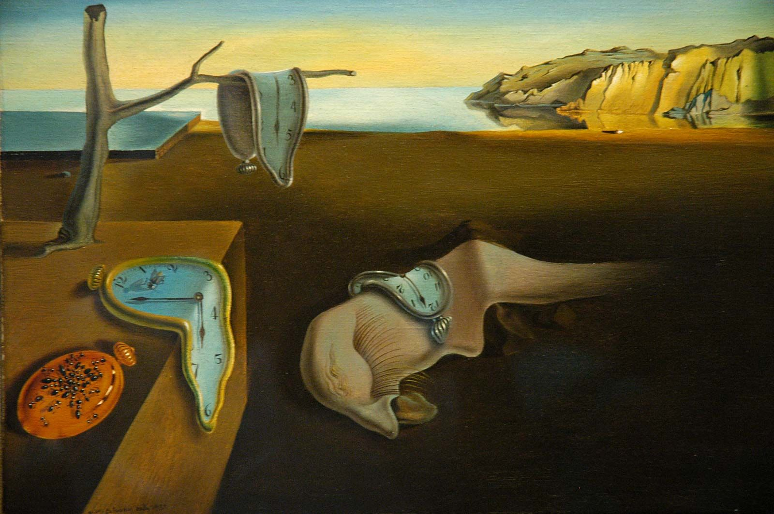

Margaret Price volunteers the notion of “crip time,” borrowed from “disability culture,” as “a flexible approach to normative time frames.” This could mean many things, such as, “at a conference,” “recognizing that audience members are processing language at various rates and adjusting the pace of conversation” (Chapter 2). I would like to extend Price’s statement to make it more generally applicable by acknowledging that “people” process “information” at varying rates. Stimuli might even be a better word than information here. Per Price, as per my understanding, Crip time is one way of pushing back against normative notions of what productivity ought to look like. (Earlier in her book, she volunteers “productivity” as one of the “common topoi of academe interest” that “intersect problematically with mental disability,” alongside others such as “rationality, presence, participation, security, and truth,” to name those that resonate with me, in particular (Chapter 1).
These topoi present an opportunity for engaging a discourse of resistance to academic norms which pathologize and make invisible (or attempt to) those who do not fit easily into ideal bodies, particularly those norms of “productivity,” and “presence.” Assumptions about our usages of time are one case where such violence may occur for the neurodivergent student. The website, HigherGrad, offers the following suggestions for how much time one should spend on material outside of the classroom:

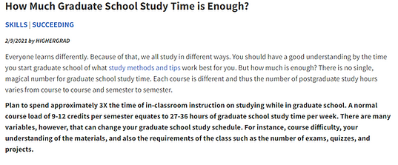
Provided by HigherGrad (2021)
As part of our segment on time, I invite you to watch Commander Benjamin Sisko's Three Part Lecture on the Nature of Linear Time
In Ellen Samuels' (2017) creative nonfiction essay, "Six Ways of Looking at Crip Time" in which she ruminates on the less pleasant aspects of living in crip time she writes "Crip time is time travel. [sic] Disability and illness have the power to extract us from linear, progressive time with its normative life stages and cast us into a wormhole of backward and forward acceleration, jerky stops and starts, tedious intervals and abrupt endings." Crip time is non-linear time, but humans, as Sisko explains to the Bajoran emissaries that exist outside of linear time, are linear beings. We have no choice but to suffer the ravages of time, and many of us, like Sisko, whose grief keeps him perpetually temporally located at the moment of his wife's death, understand that "Crip time is grief time. [sic] It is a time of loss, and of the crushing undertow that accompanies loss." The emissaries are initially fearful of the concept of linearity, seeing it as aggressive and violent, and are skeptical that any beings can exist in this way. You and me both, emissaries.

Challenging Assumptions About Study Time Served Three Ways
What about those students who, in the same 27-36 hours spent studying outside of the classroom will struggle to do as well as their neurotypical peers? (What about when a good portion of the time we're supposed to be studying our thoughts look like this?) Mikka Nielsen (2020) argued in ADHD and Temporal Experiences that "ADHD is characterized as a disruption in the experience of time" (p.51) making living with ADHD then an always-on embodiment of crip time. In Will Lindstrom et al. (2019), while researching study behaviors and study quality, it was found that students both neurotypical and neurodivergent spend similar amount of time studying, but that "implementation of deliberate [study] practice behaviors was less effective for students with ADHD. In our investigation, the study time of students without ADHD fell far below recommended amounts, they tended to cram for tests, and they chose poor study environments. Despite these choices, their academic performance was quite good. Making similar decisions to peers, students with ADHD had less success" (p. 57). The natural conclusion, then, is that students with ADHD will need to study more than their peers to achieve similar results, or to find a new way of studying that suits their strengths. We don't know exactly how much more time ought to be needed, but when significant amounts of time and energy are already being expended by neurodivergent individuals to simply keep pace. Unfortunately, we do not have a 13-hour clock we can go by, and so one must ask where or how we're going to find that extra time. Instead we must work toward new ways of considering students with different abilities and how they might best be served, inside and outside of the classroom.

What about those of us who just learn better at different times than many of our neurotypical peers? In a study done on procedural memory consolidation in individuals with ADHD, researchers found that “in individuals with ADHD (frequently exhibiting evening chronotypes), training session[s] afforded during morning hours negatively affect procedural memory consolidation (off-line, delayed) processes” (Korman et al., 2017, p. 9). This echoes my experience in dealing with ADHD, in which I always manage to be more productive during the evening hours. I know that my best work gets done in the early morning hours, roughly between 2 and 8 a.m. There are less distractions during these hours. My wife is at work, my friends are (usually) asleep, my cat is chill, and (to end this thought with a poetic flourish), the world is at rest. However, preferring to work and think at such times is not always tenable in a world structured around the neurotypical 9-5 workday. If I'm up at midnight to start working, and I have to be in a class at 8:00 am. when do I sleep? More to the point, when do I find time to do anything other than sleep or be in class? Would it be too overdramatic then to suggest that 8 a.m. class times are a form of institutional violence? How about 11:59 p.m. due dates where dropboxes close on the dime (and just before I wake up most nights)?

Tara Wood's, "Cripping Time in the College Classroom," takes to task the "strict adherence to normative time frames" (275) that structures academic life both in the classroom and at home. In a series of interviews with neurodivergent students, she takes seriously the challenges they face with things we consider to be typical parts of the composition classroom such as in-class timed writing assignments, or even more simply, due dates. She writes, "The belief that student writers, given a set amount of time, have an equitable opportunity to perform in a way that suits their cognitive style and pace relies on an assumption of normativity" (269). Fifteen minutes of writing time may be more than enough for one student, but for another (especially one with disability) that may barely be enough time to get started. Due dates also come under scrutiny. Several of the students name their disability as directly interfering with their ability to comply with due dates. Those with OCD struggle to turn in something that is less than perfect in their eyes, for others, such as students who suffer from chronic illness or, as one of my own students does, suffers from intermittent seizures that keeps them from being in the physical classroom much of the time. For those of us that don't occupy normative bodies "crip time isn’t always a choice that one can make; the adherence to a crip clock may be'“pre-programmed,'" in the sense that we do not choose when our conditions affect us in grievous ways, "and yet in the context of a writing classroom, such an acknowledgment is not a possibility in the face of the seemingly inevitable and 'normal' imposition and regulation of a due date" (276).

Let’s Get Theoretical
Backdrop: The Jedi Council Chambers on Coruscant (Bossk’s Bounty, 2023)


Art speaks to people, that's why they use it against you
When you hear, hundreds of times a day; stuff that's anti your development.
Make you sing songs that tell you you don't have no sense, you're crazy,
you don't have no future and you think you're just singing a song.
You're actually teaching yourself the propaganda of the opposed.
​~Amiri Baraka, by way of milo

The question: Define theory—why and how is it violent, show me. Define autotheory.

Define Theory? What a Sisyphean task! Where to even start? Perhaps with some word from our sponsors (or, a cheeky kind of literature review vis-à-vis Aja Martinez' Counterstory methodology in which she imagines the scholars she is working with as literally in conversation with one another (and herself)). For this exercise, it would be best if you imagined those I loan from here in the garb of the Jedi Council:

Me: "So what is this thing we call theory? Theory with a capital 'T'?"
Lauren Fournier: "Theory … is a discourse embedded in academic institutions."
Jack Halberstam: A wiser man once said, "Theory is not an end unto itself but 'a detour en route to something else.'" (Stuart Hall, qtd. in Halberstam 15)
Me: *jots down* I think that resonates, but it might be abstract for me at this stage... but basically, Theory is a discursive way of knowing? Does that sound right?
Halberstam: *laughs* I think it will do.
Me: And is it just one thing, or just an academic thing, for that matter?
Fournier: I don't know if it's just an academic thing.
Halberstam: Yeah, that's a good question.
Fournier: But, as academics, we probably deal with it more than most. And it's certainly not just one thing. It's lots of things. It's everything.
Me: Everything? Isn't that too much?
Halberstam: Well, it's everything but you can break it down. For example, a Marxist critic understands a text through material or economic metaphors.
Fournier: And a a queer theorist might use hetero-normative metaphors such as "the nuclear family" to explain why queer ways of knowing are undervalued in a capitalist world.
Me: And I think I see both kinds of metaphors in that example, so, maybe theory is a set of metaphors by which we understand the world around us.
Fournier: That's a good way of putting it: a way of understanding the world, but it's not simply a matter of breaking down a text, or an idea, or a structure. Whenever we do that, we create something. So we create the world as we understand it, or as we hope it will be understood by others.
Me: Well that sounds pretty nifty. If I can create the world I want to see.
Halberstam: Well, it would be, wouldn't it? If we were all equally positioned, and all perspectives were valued similarly, but that historically hasn't been the case. I like to think of it in terms of high theory and low theory. High theory is that theory that... tells us how the world *should* be. According to someone. Probably someone in a position of power, or from that perspective. It says this is what is, and what's right. Whether that fits everyone or not.
Fournier: Right, and academic institutions themselves, if that's where we are primarily locating theory have their own issues. Walled gardens that are often "inaccessible—at best daunting, at worst hostile and violent—to certain publics, including those that are neurodivergent, are living with mental illness, are survivors of sexual violence, or are unable to access higher education due to class-and race-based discrimination." When you think about it that way, capital T theory is "enmeshed with pain" (25-6, 267).
Halberstam: And if we're thinking about Theory that comes from a dominant perspective in our society, then to do theory "means to accept the order of things and to internalize them; it means that we begin to deploy and think with the logic of the superiority of orderliness and that we erase and indeed sacrifice other, more local practices of knowledge, practices moreover that may be less efficient, may yield less marketable results," which maintain the "hierarchies of knowledge" that are continuing to privilege that dominant perspective in the first place.
Me: Well, when you put it that way, theory sounds kind of dangerous. Especially as someone who navigates academic spaces through the ever-present lens of ADHD.
*In walks Remi Yergeau, with impeccable timing, holding a lightsaber up to her face for dramatic effect*
Yergeau: It is dangerous. And "the stakes are as severe as bodily annihilation" (Three).
*Remi takes their seat and shuts off their lightsaber, the point well-made*
Me: Bodily annihilation?! What do you mean by that?!
Yergeau: Well, theory shapes assumptions about others. Especially in our field, theory shapes assumptions about who is in our classrooms, and who is not (or at least, who is not expected to be), so when those assumptions don't include neurodivergent bodies like ours, or to put it another way, when the expectation is that most students are going to be young, white, neurotypical, able-bodied, christian of some kind or another, and when "the logics of ableism are intertwined with the logics of racism, classism, and heterosexism" (Introduction) then practices aren't aligned with our needs pretty much by default. And that's one way you get institutionalized violence.
Me: So, what can we do about that? Can we push back against it?
Fournier: Well, we can make sure our voices are heard. Show people that we are here, that we have certain needs, and that we should be expected in these spaces. As students, as teachers, as scholars. And theory can help us to do that too, though maybe we take different roads than Jack's "high theory."
Halberstam: Right, and that's why I conceptualize it like that. If high theory is this thing that maintains this hierarchy by telling us what we should think is good and right and correct, then "low theory" is a "mode[] of transmission that revels in
the detours, twists, and turns through knowing and confusion, and that seeks not to explain but to involve" so it wants to bring in people and ideas, rather than to tell us what or who people are or what ideas we should privilege (15-6).
Fournier: Building on that, when the metaphors the academy have given us don't work for us, then we've got to change them or build our own. And when no prescribed sets of metaphors work out for us, then maybe that's where we look inside. And we start to think about new forms, or changing the forms we've become used to. This is where autotheory comes in. "Autotheory is transmedial, taking shape across forms—from the personal essay, new journalism, and creative nonfiction to the expanded field of art writing and criticism, confessional feminist memes and performance for the camera, and film and television." It is "The integration of the auto or 'self' with philosophy or theory, often in ways that are direct, performative, or self-aware" (2, 7).
Me: Well that sounds really compelling. How do we do that? How do we do autotheory?
Fournier: Well, a big part of it is being honest and vulnerable in your work. Academics have compelling reasons to inflate their competency, job security is at stake, being published or not
the pressures of capitalism are felt as keenly inside these walls as anywhere else, so there's an incentive not to be honest.
Me: Right, that makes sense. One of the funniest traditions to me is that we always have to trace back a quote to an original source, rather than being honest about where we found it.
Halberstam: Well, that goes both ways. I do think there's an element of honestly at play there, but also, we want to be sure we're honoring the original contribution, or that it's not being misused by the author quoting it. Which isn't cut and dry, but there's nuance. Like with most things.
Me: I see. And what about vulnerability? Where does that come in?
Fournier: Well, it goes along with honesty. It's about putting you into the text. As much as you can, and so, the metaphors you generate are ones the come from you. "Autotheory is theory and performance, autobiography and philosophy, research and creation, knowledge that emerges from lived experience and material-conceptual experiments in the studio and the classroom" (29) which isn't to say it's not informed by other bodies of knowledge, but it's how that knowledge is mediated through the things that make sense to you.
Me: So, if I change the form of the text to be transmedial, and I'm self-reflexive about the writing and what goes into it, and I rely on my bodily understanding of things and foreground that, and I show that understanding, like really show it, in visual terms, then I'm doing autotheory?
Fournier: Maybe. Like Jack said it's not some cut-and-dry thing. But it's certainly a start.
Me: Thank you all for participating in this forum. I feel like I've learned a lot, like I've managed to put into words some of the concepts I've been wrestling with. So, have I mastered theory now?
ALL, in unison, scarily: You are on this council, but we do not grant you the rank of master.
Me: That's fair.

Supplementary: In Conversation
The Question: How are you conceptualizing neurotypical and neurodivergent?
The "neuro" family of terms, neurodiversity, neurodivergent, neurotypical, are a vocabulary used to resist the medical model of disability, in which disability is a defect in the individual. Neurodiversity conceptualizes different thought processes as expected variations between human, and that disability is what occurs when the environment is constructed in a way that limits the individual based on these factors. This reflects the social model of disability, and importantly, rejects the notion that neurodivergent people such as those with autism or ADHD need to be cured.
The Question: Show me queer failure, show me autotheory—either through your own examples or borrowing from the authors you cite.
Queer failure is:
Going to graduate school to be a professor and coming out of it a librarian
Forgetting to put the link to your audition video in an application for a YouTube company
Falling asleep after an hour of reading
It's existing in the betweenities, the insecurities
It's finding questions more interesting than answers
It's being willing to be wrong (but not without loving to be right, you just can't help it)
Queer failure is:
Making a video to show someone what ADHD looks like, only to realize you can't show them. Not like this. It's called an invisible disability for a reason. Maybe you can see it, because you know what to look for. But it can't just be shown. You perform it everyday, but there is no audience, because they don't see it unless you tell them and teach them how to look. But you make it anyways, and you reiterate it, knowing it fails to achieve the desired effect, but also knowing "to court failure, to bring failure into view [i]s a necessary, illuminating, and imperative part of any attempt to teach (or to write) queer" (Waite 24). And when the video doesn't work, you think of other ways to show your ADHD. You think of what you are writing now.
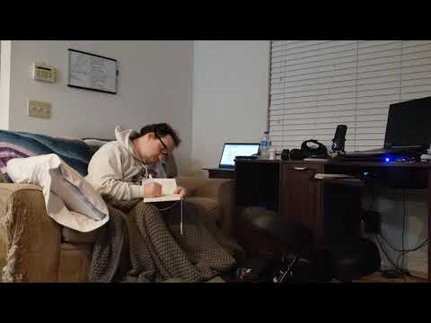
Walls (This section really doesn’t work well as a piece of text! Refer to Appendix!)
Jay Dolmage tells us, “Higher education has needed to create a series of versions of ‘lower education’ to justify its work and to ground its exceptionalism, and the physical gates and steps trace a long history of exclusion.” As if in response to this exclusion, Margaret Price, speaking for (with?) many unheard neurodivergent faculty, staff, and students, asks, “What transformation would need to occur before those who pursue academic discourse can be “heard” (which I take to mean “respected”), not in spite of our mental disabilities, but with and through them?” This project endeavors to show, through means both scholarly and creative (conceptions of academic work that often feel pitted against each other) why this transformation needs to take place, and, perhaps, in my own small way, begin to imagine what that transformation could look like. This project will hopefully serve as both testimony and guide in terms of imagining what a more equitable experience with higher education for neurodivergent learners might look like.
Scholars such as Dolmage and Price call on each of us to think about the academic structures (both physical and metaphorical) that we inhabit, and to imagine how they might be different--how they need to be different--in order for neurodivergent minds to have the same opportunities as their neurotypical peers within the walls of these institutions. Yergeau and other scholars offer the concept of rhizomes as a way of thinking outside of the rigid structures of academic knowing, but for at least one person with ADHD (myself) this way of thinking offers too many options, too many variables and connections, that I am bound to lose myself in, and so I turn to my own structural metaphor that in its own way does the work of pushing on these structures, by breaking them down to a versatile component.
Walls probably exist for good reasons. The walls of our homes keep us safe from the elements, or from people and things that might do us harm. But walls also confine us, or separate us. They demarcate the places where we belong and where we don't. That's good when it comes to our personal safety, but not so great

Collage by the Author

Walls as Brick Walls
when they inhibit our thinking, or block creative insights. I imagine we're all familiar with that wall called writer's block. ADHD can sometimes feel like a terminal case of writer's block. Either because you can't recall what

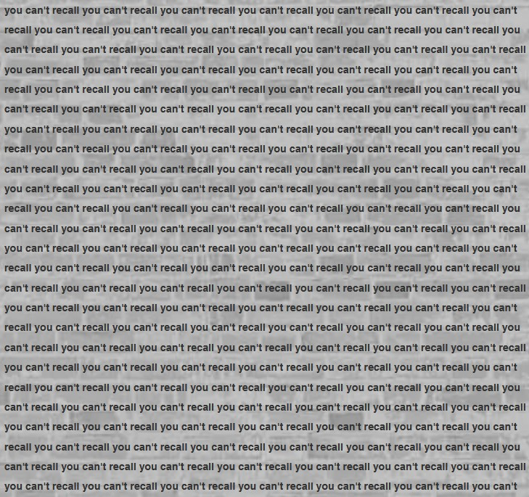

Intermission: What were we talking about?
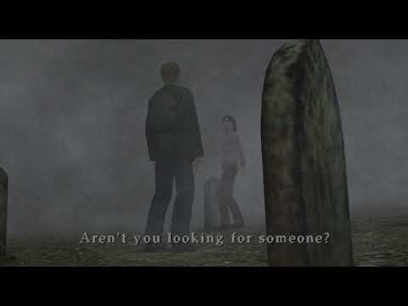

Walls as Found Structure or Process (Or, Walls as Walls of Text, because sometimes you just can't help yourself)
I like songs about drifters, books about the same
They both seem to make me feel a little less insane
~Modest Mouse, "The World at Large"

In their capacity to keep in or out people, thoughts, and nature--walls function as boundaries. They provide us with structure. The kind of structure that ought to keep me from suddenly interjecting, in the middle of this conversation, the following thought (which ought to come a little further along in this essay-web-thing): What does ADHD look like? Recently it means looking up and comparing game engines such as Godot and Unity for a video game I want to make when I should, for now, be working on this thesis. It is sometimes forgetting to shower, or even to eat when you’re caught up in something that excites you. At all times it has meant doing my best thinking and writing at 3 or 4 am when I should be sleeping for the class I have at 8 am. Ellen Samuels writes that "crip time is vampire time. [sic] It's the time of late nights and unconscious days, of life schedules, lived out of sync with the waking, quotidian world" (2017).
Feeling and thinking, embodying crip time, taking "a flexible approach to normative time frames" (Price, 2011) is one way of resisting that "waking, quotidian world." (We academics sure love resisting, don't we?) Maybe you are even resisting this text. Picking it apart as un-academic, self-indulgent, or even masturbatory. Well, hopefully not as masturbatory as THAT study, which is perhaps a good reminder for us all that some structure, some boundaries, are probably there for our benefit.
I think it's fair to say that most of us aren't responsible for constructing the walls around us. I mean, maybe you do construction on the side, but I cannot claim the same. In my case, I can't even claim to have ever resided within the same few walls over a particularly long period of time. I count myself among the transitories of the world, a feeling grounded in a childhood taking place through a revolving door of motels, cars, and apartments, never quite sure if the set of walls I am sleeping within one night will be the same set of walls I will be sleeping within


Al Pacino (Left) and Gene Hackman (Right) in Scarecrow, a 1970s film about two drifters who partner up to travel accross the United States and start a car wash business.

tomorrow. But, even in my family's darkest times, we usually could find some set of walls that would harbor us, whether it was for a few nights, or maybe even a year, if we were lucky and my parents had their shit together. They so rarely had their shit together. And thus, to oversimplify things quite a bit, I became accustomed to found boundaries and structure, and received little training in (and had little predilection for) creating a functioning structure for myself. And if I knew I had ADHD as a child, well, a lot of things might have made sense. Or not. After all, times were tumultuous for the younger me by pretty much all quantifiable standards.
Returning to my oversimplification, making the herculean effort to bring this section to a close, because I have to, and I can feel my hands and my mind resisting the attempt at finality, my whole body tensing up, squinting at the screen as if it is my mortal enemy, pursing my lips in frustration at my inability to just. make. the. point. Like that thing where you segment a line over and over again and never reach the end point. This is the part of mind-meandering that is "harder to see as liberatory, more challenging to find a way to celebrate" (Samuels, 2017), because this project will be due eventually (soon, in fact!), and presumably it should arrive somewhere (more on arriving later), and so I find myself once again relying on that greatest of all extrinsic motivators, the wall, specifically, the one my back is against.
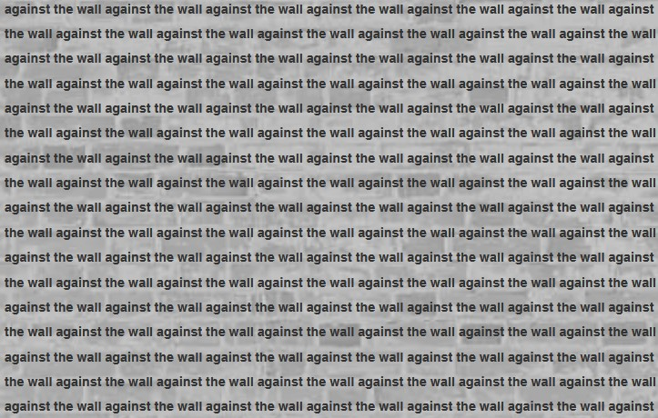

When we think of this phrase, I imagine most of us do not conjure up a pleasant feeling. Perhaps in your imagination even, if it is sufficiently vivid, the wall is at the end of a tunnel, and a train (in the form of some obligation or another) is bearing down on you with no signs of stopping. It can certainly feel that way at times. Unfortunately, I am not here with panacea in hand to assuage that feeling. I have not figured out the secret of productivity that I can now pass on to you. But, if I have a secret it might be this: I might secretly like having my back against the wall. My options limited. No way out. This is not to pawn off some pithy aphorism on you such as "When your back's against the wall, just break through" but, as someone who struggles to create (or stick to) their own structure, who struggles to decide on a course of action when there are many possibilities, who has difficulty envisioning future scenarios (all symptoms many of those with ADHD will be familiar with), sometimes there is nothing more comforting than being at the wall (at the least, it is something you can lean against) and knowing that now, now at last, despite all your failed attempts to scaffold, to outline, to think and work ahead, that now it is do or die time. And so you do. As best as you can. Knowing that it will be a few hours, or maybe a day late. Hopefully no longer than a week. Fortunately, you find, the wall, while firm, is not inflexible. You will explain to your professor as best as you can why (Your ADHD made it hard to focus, which is always true, but this time more so than usual. Your anxiety got in the way of starting the assignment because everything you write is terrible. You could not get anything done this week because you had to catch up on sleep for the past month--which had you staying up til dawn and only sleeping a few hours each night. And lots of other reasons that they may or may not take at face value.), and hope they are understanding, and usually they are. But not always.
This conceptualization of process runs far afield of the rhizomatic "and its attendant concepts of nonlinearity and multiplicity" but in its own way "works toward complexity and differentiation." While I am compelled by "these wander lines [that] reveal[] habit and errancy as their own kinds of invention, pathways that both embrace[] and resist[] the framings of description" (Yergeau), I find that level of open-endlessness (a charming auto-correction(?) of open-endedness that I think I will run with) daunting. I am in insofar as resisting linearity and hierarchical thinking goes, but I know I will easily become overwhelmed by too much freedom, too many options. And so again, I return to the wall as a metaphor for thinking and doing. This time throwing things at the wall and seeing what sticks. The wall is a place where I can form those non-linear collections, while letting those ideas, articles, or concepts which do not connect fade away as detritus. And because, as shown earlier, the wall is usually accompanied by a sense of desperation, it is a place where you learn to make those connections quickly, with a sense of pragmatism (but with also just enough play) that what emerges is something clever, insightful, but most importantly, necessary. Necessary in the practical sense that you needed to complete this thing, this thesis, at this time, but also necessary in the larger sense that you had to think these thoughts, to write these words, because their being out in the world, their very formation, even (your neck tenses as you tilt your head in search of the exact right way to say this next thing) feels vital to your understanding of self.

Arriving

In the post-apocalyptic world of Half-Life 2, a rambling man comments on the fact that trains go in and out, but no one ever leaves City 17... by train.

In Chris W. Gallagher's (2001) piece, "If This Were Not a Collage: A Collage," he asks himself "I wonder, as I always do, ARE we arriving somewhere? Is the form speaking, working, moving us along? Is this more than experiment for its own sake? More than cuteness, more than cleverness?" (p. 40) and I find myself wondering the same as I approach the end of this project. Do the pop cultural references to TV, movies, video games, fall flat or do they show how so much of my interest in and understanding of many of the concepts present in this text is mediated through this referential lens. (My undergraduate literature focus was in film studies, if that helps you to understand the perspective I am writing from.) I think that sentiment is what I hope to convey with this project: Not that I have chosen a hypertext simply for the fun of its creation (though, I do think we should put a greater emphasis on enjoying ourselves and having fun while doing scholarly work, which is also not to say that there wasn't a fair amount of pain in working on it) but that envisioning texts in these way, and casting the discussions herein in multi-modal forms helps me to understand what I am talking about. Helps me to dig more deeply, and then to display the digging that I have done. It would be wonderful if more texts could be experienced in such a way. Can we have a rule against how many PDF's or full-sized books students can be expected to read in a week, while some of the work is picked up by texts that engage our minds on multiple levels? Technology has enabled us to do so much more when it comes to the production of scholarly work (or any creative process, really) but by and large we are still producing swaths of text, on text. I understand the irony in that this project too presents a great deal of text, but I have endeavored to the best of my ability, such as it is, to hypermediate it in ways that won't leave you quite as fatigued as the seven other journal articles you have already read today. In lending my perspective in this way, whether you are a neurotypical or neurodivergent reader, I hope to have sparked some ideas for how we might engage the neurodiverse better, if not necessarily in our classrooms (although that is certainly an outcome I will always push for) then at least in our textual practices. Doing so will surely make those of us who crave other ways of processing information feel more welcomed in these spaces, and will help to normalize these kinds of texts for other students like me, who do not feel well-represented within or by the pages of many academic journals.

The limitations (including my own) and potentiality of this project in the future
First off, the site that consists of the hypertext project is built using site building software which I have learned comes with many weird limitations such as how things can be arranged--or really, how they can't. A future version of this project would be done using a non-proprietary framework, but that requires me to have coding skills and knowledge under my belt that I just can't claim. Yet. Far more interactivity with elements, would be desirable to better sell many of the arguments and concepts in play. While I am happy with many of the visual and hypertextual elements included here, so many of them have you leaving the pages, which is fine for some things, but I would also love to have things that keep you here but give you different ways to think about what is being said or done on a given page. Also, I really wish I could have played music on the "Sanity Breaks" page. Content wise, there is always more that could be done, but calling back to my wall metaphor, we must give ourselves some structure some end point, and maybe that too is a moment of queer failure, knowing that there's so much more that should be and needs to be said, but only being able to do so much at a given time, in a given piece of writing. And, more pragmatically, we must all give ourselves stopping points, or at least I must, or else I will keep writing forever and possibly also go insane. (If I have not already reached that point.) But, as a final thought on the matter, I do think also that moving this project into a format with more freedom of presentation, more customization, would also open up the possibilities for a better discussion of content, and new roads (with all their requisite detours) to go down.

Appendix
The link to the original hypertext document can be found here. It is far more beneficial to experience the project in this way:
https://sephx595.wixsite.com/thesisproj

Bibliography
Attias, Mikka. (2020). Mind-Meandering as AD(H)D methodology: An embodied, neuroqueer practice of art-\making and resistance in dialogue with Kurt Cobain’s and Lee Lozano’s journals. Research in Arts and Education, 2020(4), 53–85. https://doi.or/10.54916/rae.119283
Dolmage, Jay T. Academic ableism: Disability and higher education. University of Michigan Press. Kindle Edition.
Eyman, Douglas. (2015). Digital rhetoric: Theory, method, practice. University of Michigan Press. E-book, https://doi.org/10.3998/dh.13030181.0001.001
Fournier, Lauren. (2021). Autotheory as feminist practice in art, writing, and criticism. (1st ed.). Cambridge: MIT Press. E-book, https://doi-org.ezproxy.lib.ou.edu/10.7551/mitpress/13573.001.0001
Gallagher, Chris W. (2000). If this were not a collage: A collage. Writing on the Edge, 11(2), 33–42. http://www.jstor.org/stable/43158850
Halberstam, Jack. (2011). The Queer Art of Failure. (1st ed.). Durham: Duke University Press. E-book, https://muse.jhu.edu/book/71155
Korman, Maria et al. (2017). "Procedural memory consolidation in attention-deficit/hyperactivity disorder is promoted by scheduling of practice to evening hours." Frontiers in Psychiatry, 8(140) https://doi.org/10.3389/fpsyt.2017.00140
Lindstrom, W., Nelson, J. M., & Foels, P. (2020). Postsecondary attention‐deficit/hyperactivity disorder and deliberate practice: Study time, study quality, and self‐perceptions. Psychology in the Schools, 7(1), 44–61. https://doi.org/10.1002/pits.22316
Martinez, Aja Y. (2020). Counterstory: the rhetoric and writing of critical race theory. Conference on College Composition and Communication.
Nielsen, Mikka. (2020). ADHD and temporal experiences: Struggling for synchronization. In Michael G.
Flaherty, Lotte Meinert, Anne Line Dalsgård (Eds.), Studies of temporal agency (pp. 50-64). https://doi.org/10.230/j.ctv1tbhq6s
Price, Margaret. Mad at school: Rhetorics of mental disability and academic life. University of Michigan Press. Kindle Edition.
Samuels, Ellen. (2017). Six ways of looking at crip time. Disability Studies Quarterly, 37(3). https://dsq-sds.org/index.php/dsq/article/view/5824/4684#endnote01
Wood, Tara. (2017). Cripping time in the college composition classroom. College Composition and Communication, 69(2), 260–286. http://www.jstor.org/stable/44783615
Yergeau, M. Remi. (2018). Authoring autism: On rhetoric and neurological queerness. queerness Duke University Press. Kindle Edition.
Yergeau, Melanie. Wandering rhetoric, rhetoric wandering. Making future matters. https://ccdigitalpress.org/book/makingfuturematters/yergeau-intro.html
​

Media Assets
A PERFECT LIFE MOMENT. (2017, November 11). Star trek: Deep space nine emissary time is linear part 1 [Video file]. YouTube. https://www.youtube.com/watch?v=MuBqfZ6Osbg&t
Dali, Salvador. (1931). The persistence of memory. Brittanica. https://www.britannica.com/topic/The-Persistence-of-Memory
fantano. (2023, August 15). Top 10 rap albums of the 2010s [Video file]. YouTube. https://www.youtube.com/watch?v=WuE7CiZWGrQ
HigherGrad. (2021). Graduate school study time | How much is enough? Retrieved November 10, 2023, from https://www.highergrad.com/entries/graduate-school-study-time-how-much-is-enough
Kleiner Timmy (9). (2022, November 21). Anakin isn't granted the rank of master but doesn't mind [Video file]. YouTube. https://www.youtube.com/watch?v=1o0vxBwgTuo&t
ManticoreEscapee. (2021, November 27). DS9 scenes - It's not linear [Video file]. YouTube. https://www.youtube.com/watch?v=4dhkTXd8SI4&t
misbah lughmani. (2021, January 11). Half life 2 rambling man at city 17 [Video file]. YouTube. https://www.youtube.com/watch?v=h91C-rnvpTA
Talelle. (2021, November 15). Autotheory project [Video file]. YouTube. https://www.youtube.com/watch?v=oL_hkXLnVk0
Viral9. (2007, March 4). DS9 - Emissary; human existence [Video file]. YouTube. https://www.youtube.com/watch?v=dJ33e9BK9aU&t

