THE UNIVERSITY OF OKLAHOMA
GRADUATE COLLEGE

A COMPARISON OF THE IVAN GALAMIAN AND RACHEL BARTON PINE EDITIONS OF THE SONATA NO. 3 IN C MAJOR FOR SOLO VIOLIN BY JOHANN SEBASTIAN BACH, BWV 1005

A DOCUMENT
SUBMITTED TO THE GRADUATE FACULTY
in partial fulfillment of the requirements for the
Degree of
DOCTOR OF MUSICAL ARTS

By
CHANDLER HARRISON FADERO
Norman, Oklahoma
2023

A COMPARISON OF THE IVAN GALAMIAN AND RACHEL BARTON PINE EDITIONS OF THE SONATA NO. 3 IN C MAJOR FOR SOLO VIOLIN BY JOHANN SEBASTIAN BACH, BWV 1005

A DOCUMENT APPROVED FOR THE
SCHOOL OF MUSIC

BY THE COMMITTEE CONSISTING OF

Dr. Gregory Lee, Chair

Dr. Yena Lee

Dr. Jonathan Shames

Dr. Sanna Pederson

Dr. James Zeigler

Copyright by Chandler Harrison Fadero 2023
All Rights Reserved.
TABLE OF CONTENTS
Table of Contents……..………………………………………………………….….........iv
Acknowledgements………..…………………………………………………….…….......v
List of Figures……….……………………...…...……………………….…...……….…vii
Abstract…………………………………………………….……………….…….……..xix

Chapter 1: Introduction……..…………...……………………………….……..………1
Chapter 2: An Overview of the Sonata No. 3 in C Major, BWV 1005……………….4
Chapter 3: An Overview of the Galamian and Pine editions………………...…...….12
3.1 Musical Figures and Excerpts………………………………………………..14
3.2 Editorial and Interpretive markings………………………...………………..16
3.3 “RBP on JSB”…...……………………………...……………………………19
3.4 Bowings…………...………………………………...……………………….20
3.5 Fingerings……………...…………………………………………………….21
3.6 The Execution of Chords……………………………………………….……23
3.7 Embellishments and Ornamentation…….…………………………...………29
3.8 Rhythmic error in the Autograph Manuscript………………..………………32
3.9 Baroque Violins……………………….……………………………………..33
3.10 Baroque Bows…………………...………………………………………….39

Chapter 4: A Comparison of the Bowings and Fingerings of the Ivan Galamian and Rachel Barton Pine Editions of the Sonata No. 3 in C Major, BWV 1005….………42
4.1 Adagio………………………………………………………………………..42
4.1.1 Adagio Bowings……………………………………………………44
4.1.2 Adagio Fingerings………………………………………………….52
4.2 Fuga………………………………………………………………………….57
4.2.1 Fuga Bowings…………………………………...…………………59
4.2.2 Fuga Fingerings…………………………..………………………..72
4.3 Largo…………………………………………………………………………83
4.3.1 Largo Bowings…………………………………………………….84
4.3.2 Largo Fingerings………………………………...…………………92
4.4 Allegro assai………………………………………………...……………….98
4.4.1 Allegro assai Bowings…………………………………...…….…..99
4.4.2 Allegro assai Fingerings………………………………………….110

Chapter 5: Conclusion………………,…………….…….……………………………118

Chapter 6: Notes and advice from the Author………………………………………121

Bibliography……………………………………………...……………………………125

Autograph manuscript………..………………….………………...…………………128

Acknowledgements

First, I want to express my gratitude to my terrific committee, from whom I gained much insight, support, and guidance. In particular, I would like to thank my chair, Dr. Gregory Lee, with whom I studied violin during my doctoral studies. Music stops for nothing, not even a global pandemic.

Second, I want to thank all of my violin teachers: Evelyn Blalock, Scott Garrett, Ernest Pereira, Nancy Bargerstock, Bruce Berg, and Gregory Lee. Each of you loved me in your own way. Great teachers can make violinists out of anyone, even idiots like me.

Third, I want to thank all of my friends and colleagues. Rubbing elbows with dedicated artists serves as my bottomless source of inspiration. I am privileged to learn with and from you.

Fourth, I want to thank my wonderful partner, Ruthie, who loved and supported me through these challenging final years of my education. You are my greatest treasure.

Fifth, I want to thank my family, who supported me from the very beginning in my journey with the violin. Each of you gave me something along my path that contributed to the musician, artist, and person that I am today. My brother Tanner served as a lifelong model for excellence, dedication, and passion. The same can be said about my sister-in-law Brittany, who inspires me with her dedication to academia and research in art history. Through my mother Susan, I understood the value and privilege of education from the very beginning. My step-father Michael loved me without reservation, as though I were his own son. My step-mother Lisa showed me the value in letting loose once in a while, and enjoying the ride (she also makes stellar cocktails). My father Stephen understood and accepted my love for violin right from the beginning. His support and belief in me have been constant, and looking back, I could not have done any of this without him.

I want you all to know you received a limitless return in happiness. You helped me find my place in the world, and what a place it is. To spend my days dedicated to making the world a more beautiful place…I cannot think of a better way to spend the gift of life.
__________________________________

Don’t ask me how, but I knew almost immediately violin would be my life’s work. Only a few months after I began playing, I found a recording of Nathan Milstein playing the Preludio from Bach’s E Major Partita. Bach spoke to me with words I never knew. It was like waking up. I was hooked, plain and simple.

I’ve had countless life-changing experiences in music. But my true love, from the very beginning, has always been unaccompanied Bach. Where some may feel unaccompanied playing lacking or even downright boring, it is my borderless canvas upon which I paint. I can’t remember the last day I went without playing Bach. Many nights in college, long after everyone was in bed asleep, I spent countless hours sitting in secluded stairwells (or sneaking into concert halls, if they were left unlocked) to play Bach.

One of the curious features of the violin are its sympathetic vibrations; that is, while playing on one string, the others can vibrate and resonate on their own. Done just right, you feel the faintest quaver of vibration in your hands, and a soft and golden glow adorning the tone. Situated just between your brain and your heart, it really feels alive. The trick of this, for the strings to come alive, is that they must be left alone. As soon as you even touch a resonating string, it is silenced. The glow is extinguished.

To receive music, for its power and beauty to flow through us, we must approach it with a deep inward stillness. When we completely allow our minds and hearts to think and feel freely in the face of music, so too will our own heartstrings sympathetically vibrate.

If you ever need me, you’ll find me after dark in some secluded stairwell, playing Bach.

List of Figures

- Jean Sibelius studying an edition of the Sonatas and Partitas.
- Title page of the autograph manuscript of the Sonatas and Partitas.
- Excerpt from Gigue of Westhoff Partita No. 1 in A minor.
- Fuga excerpt (mm. 1—4) from de Baillot L’Art du Violon.
- Mvt. III Largo mm. 18—22, Galamian edition.
- Mvt. III Largo mm. 18—22, Pine edition.
- Mvt. IV Allegro assai mm. 49—51, Galamian edition.
- Mvt. I Adagio m. 38—39, Pine edition.
- Excerpt from Editor’s note in the Galamian edition.
- Mvt. II Fuga mm. 263—265, Galamian edition.
- Excerpt from Editor’s note in the Galamian edition.
- Mvt. II Fuga mm. 131—132, Galamian edition.
- Use of Ysaÿe symbol. Mvt. I Adagio m. 39, Pine edition.
- The Necker cube.
- Examples 75—77 from Principles of Violin Playing and Teaching.
- Examples 78 from Principles of Violin Playing and Teaching.
- Mvt. II Fuga mm. 243—245, Galamian edition.
- Mvt. I Adagio mm. 15—18, Galamian edition.
- Figure of downward break from Principles of Violin Playing and Teaching.
- Inward break towards middle voices. Adagio mm. 22—23, Galamian edition.
- Mvt. I Adagio m. 14, Autograph manuscript.
- Mvt. I Adagio m. 14, Galamian edition.
- Mvt. I Adagio m. 14, Pine edition.
- Mvt. I Adagio m. 11, Pine edition.
- Mvt. I Adagio m. 11, Galamian edition.
- Mvt. III Largo mm. 6—7, Galamian edition.
- Mvt. III Largo mm. 6—7, Pine edition.
- Mvt. II Fuga m. 164, Pine edition.
- Mvt. I Adagio m. 39, Autograph manuscript.
- Mvt. I Adagio m. 39, Pine edition.
- Mvt. I Adagio m. 39, Galamian edition.
- Excerpt editing, step I: Unedited captured measures.
- Excerpt editing, step II: Erased unwanted measures.
- Excerpt editing, step III: Clean margins.
- Excerpt editing, step IV: Superimposed bowings.
- Violin by Jacob Stainer, ca. 1650.
- Evolution of violin bows.
- Mvt. I Adagio mm. 1—4, Autograph manuscript.
- Mvt. II Mm. 1—5 of Bach transcription (BWV 974) of Marcello Oboe Concerto.
- Adagio in G Major for Harpsichord BWV 968, mm. 1—4.
- Mvt. I Adagio mm. 1—6, Autograph manuscript.
- Mvt. I Adagio mm. 1—6, Pine edition.
- Mvt. Adagio mm. 1—6, Galamian edition.
- Mvt. I Adagio m. 20, Autograph manuscript.
- Mvt. I Adagio m. 20, Galamian edition.
- Mvt. I Adagio m. 20, Pine edition.
- Mvt. I Adagio m. 10, Galamian edition.
- Mvt. I Adagio mm. 11—14, Galamian edition.
- Mvt. I Adagio m. 10 and m. 44, Galamian edition.
- Mvt. I Adagio m. 10 and m. 44, Pine edition.
- Mvt. I Adagio mm. 22—27, Galamian edition.
- Mvt. I Adagio mm. 22—27, Pine edition.
- Mvt. I Adagio mm. 34—36, Galamian edition.
- Mvt. I Adagio mm. 34—36, Pine edition.
- Mvt. I Adagio mm. 34—36, Autograph manuscript.
- Mvt. I Adagio mm. 37—39, Galamian edition.
- Mvt. I Adagio mm. 37—39, Pine edition.
- Mvt. I Adagio mm. 43—47, Galamian edition.
- Mvt. I Adagio mm. 43—47, Pine edition.
- Mvt. I Adagio m. 29, Galamian edition.
- Mvt. I Adagio mm. 3—4, Galamian edition.
- Mvt. I Adagio mm. 3—4, Pine edition.
- Mvt. I Adagio m. 10, Galamian edition.
- Mvt. I Adagio m. 10, Pine edition.
- Mvt. I Adagio m. 12, Galamian edition.
- Mvt. I Adagio m. 12, Pine edition.
- Mvt. I Adagio mm. 19—20, Galamian edition.
- Mvt. I Adagio mm. 19—20, Pine edition.
- Mvt. I Adagio m. 22, Galamian edition.
- Mvt. I Adagio m. 22, Pine edition.
- Mvt. I Adagio mm. 34—37, Galamian edition.
- Mvt. I Adagio mm. 34—37, Pine edition.
- Mvt. I Adagio m. 42, Galamian edition.
- Mvt. I Adagio m. 42, Pine edition.
- Mvt. I Adagio mm. 45—46, Galamian edition.
- Mvt. I Adagio mm. 45—46, Pine edition.
- Mvt. II Fuga mm. 1—4, Autograph manuscript.
- Mvt. II Fuga, mm. 1—4, Autograph manuscript.
- Mvt. II Fuga, mm. 109—113, Autograph manuscript.
- Mvt. II Fuga, mm. 186—190, Autograph manuscript.
- Mvt. II Fuga, mm. 24—28, Autograph manuscript.
- Mvt. II Fuga, mm. 92—97, Autograph manuscript.
- Mvt. II Fuga, mm. 1—4, Pine edition.
- Mvt. II Fuga, mm. 1—4, Galamian edition.
- Mvt. II Fuga, mm. 4—6, Pine edition.
- Mvt. II Fuga, mm. 4—5, Galamian edition.
- Mvt. II Fuga, mm. 113—117, Galamian edition.
- Mvt. II Fuga, mm. 113—117, Pine edition.
- Mvt. II Fuga, mm. 201—205, Autograph manuscript.
- Mvt. II Fuga, mm. 201—205, Galamian edition.
- Mvt. II Fuga, mm. 201—205, Pine edition.
- Mvt. II Fuga, mm. 228—232, Pine edition.
- Mvt. II Fuga, mm. 228—232, Galamian edition.
- Mvt. II Fuga, mm. 8—10, Galamian edition.
- Mvt. II Fuga, mm. 8—10, Pine edition.
- Mvt. II Fuga, mm. 115—121, Galamian edition.
- Mvt. II Fuga, mm. 115—121, Pine edition.
- Mvt. II Fuga, mm. 141—143, Galamian edition.
- Mvt. II Fuga, mm. 141—143, Pine edition.
- Mvt. II Fuga, mm. 149—152, Galamian edition.
- Mvt. II Fuga, mm. 149—152, Pine edition.
- Mvt. II Fuga, mm. 103—106 Galamian edition.
- Mvt. II Fuga, mm. 88—89, Galamian edition.
- Mvt. II Fuga, mm. 69—70, Galamian edition.
- Mvt. II Fuga, m. 186, Galamian edition.
- Mvt. II Fuga, mm. 193—194, Galamian edition.
- Mvt. II Fuga, mm. 273—275, Pine edition.
- Mvt. II Fuga, mm. 12—16, Autograph manuscript.
- Mvt. II Fuga, mm. 12—16, Galamian edition.
- Mvt. II Fuga, mm. 12—16, Pine edition.
- Mvt. II Fuga, mm. 59—61, Autograph manuscript.
- Mvt. II Fuga, mm. 59—61, Galamian edition.
- Mvt. II Fuga, mm. 59—61, Pine edition.
- Mvt. II Fuga, m. 42, Autograph manuscript.
- Mvt. II Fuga, m. 42, Galamian edition.
- Mvt. II Fuga, m. 42, Pine edition.
- Mvt. II Fuga, mm. 288—296, Autograph manuscript.
- Mvt. II Fuga, mm. 293—297, Galamian edition.
- Mvt. II Fuga, mm. 292—296, Pine edition.
- Mvt. II Fuga, mm. 174—178, Galamian edition.
- Mvt. II Fuga, mm. 174—178, Pine edition.
- Mvt. II Fuga, m. 11, Galamian edition.
- Mvt. II Fuga, m. 11, Pine edition.
- Mvt. II Fuga, mm. 20—23, Galamian edition.
- Mvt. II Fuga, mm. 20—23, Pine edition.
- Mvt. II Fuga, mm. 43—44, Galamian edition.
- Mvt. II Fuga, mm. 43—44, Pine edition.
- Mvt. II Fuga, mm. 68—71, Galamian edition.
- Mvt. II Fuga, mm. 68—71, Pine edition.
- Mvt. II Fuga, mm. 84—87, Galamian edition.
- Mvt. II Fuga, mm. 84—87, Pine edition.
- Mvt. II Fuga, mm. 88—93, Galamian edition.
- Mvt. II Fuga, mm. 88—93, Pine edition.
- Mvt. II Fuga, mm. 107—111, Galamian edition.
- Mvt. II Fuga, mm. 107—111, Pine edition.
- Mvt. II Fuga, m. 158, Galamian edition.
- Mvt. II Fuga, m. 158, Pine edition.
- Mvt. II Fuga, mm. 169—171, Galamian edition.
- Mvt. II Fuga, mm. 169—171, Pine edition.
- Mvt. II Fuga, mm. 183—185, Galamian edition.
- Mvt. II Fuga, mm. 183—185, Pine edition.
- Mvt. II Fuga, m. 195, Galamian edition.
- Mvt. II Fuga, m. 195, Pine edition.
- Mvt. II Fuga, m. 282, Galamian edition.
- Mvt. II Fuga, m. 282, Pine edition.
- Mvt. II Fuga, mm. 202—206, Galamian edition.
- Mvt. II Fuga, mm. 202—206, Pine edition.
- Mvt. II Fuga, mm. 245—249, Galamian edition.
- Mvt. II Fuga, mm. 245—249, Pine edition.
- Mvt. II Fuga, mm. 259—268, Galamian edition.
- Mvt. II Fuga, mm. 259—268, Pine edition.
- Mvt. II Fuga, mm. 1—5, Galamian edition.
- Mvt. II Fuga, mm. 288—293, Galamian edition.
- Mvt. II Fuga, m. 4, Pine edition.
- Mvt. II Fuga, m. 292, Pine edition.
- Mvt. II Fuga, m. 73, Galamian edition.
- Mvt. III Largo, mm. 1—2, Autograph manuscript.
- Mvt. III Largo, m. 5, Galamian edition.
- Mvt. III Largo, m. 10, Galamian edition.
- Mvt. III Largo, mm. 1—2, Autograph manuscript.
- Mvt. III Largo, mm. 1—2, Galamian edition.
- Mvt. III Largo, mm. 1—2, Pine edition.
- Mvt. III Largo, mm. 9—10, Galamian edition.
- Mvt. III Largo, mm. 9—10, Pine edition.
- Mvt. III Largo, mm. 3—4, Autograph manuscript.
- Mvt. III Largo, mm. 3—4, Galamian edition.
- Mvt. III Largo, mm. 3—4, Pine edition.
- Mvt. III Largo, m. 7, Autograph manuscript.
- Mvt. III Largo, m. 7, Pine edition.
- Mvt. III Largo, m. 17, Autograph manuscript.
- Mvt. III Largo, m. 17, Pine edition.
- Mvt. III Largo, m. 7, Galamian edition.
- Mvt. III Largo, m. 17, Galamian edition.
- Mvt. III Largo, m. 13, Galamian edition.
- Mvt. III Largo, m. 13, Pine edition.
- Mvt. III Largo, m. 18, Galamian edition.
- Mvt. III Largo, m. 18, Pine edition.
- Mvt. III Largo, mm. 9—13, Pine edition.
- Mvt. III Largo, mm. 9—13, Galamian edition.
- Mvt. III Largo, m. 19, Galamian edition.
- Mvt. III Largo, m. 19, Pine edition.
- Mvt. III Largo, m. 22, Galamian edition.
- Mvt. III Largo, m. 22, Pine edition.
- Mvt. III Largo, m. 6, Pine edition.
- Mvt. III Largo, mm. 14—15, Galamian edition.
- Mvt. III Largo, mm. 1—2, Pine edition.
- Mvt. III Largo, mm. 1—2, Galamian edition.
- Mvt. III Largo, m. 7, Pine edition.
- Mvt. III Largo, m. 17, Galamian edition.
- Mvt. III Largo, m. 3, Galamian edition.
- Mvt. III Largo, m. 3, Pine edition.
- Mvt. III Largo, m. 5, Galamian edition.
- Mvt. III Largo, m. 5, Pine edition.
- Mvt. III Largo, mm. 8—13, Galamian edition.
- Mvt. III Largo, mm. 8—13, Pine edition.
- Mvt. III Largo, mm. 18—21, Galamian edition.
- Mvt. III Largo, mm. 18—21, Pine edition.
- Mvt. IV Allegro assai, mm. 1—4, Autograph manuscript.
- Mvt. IV Allegro assai, mm. 1—2, Galamian edition.
- Mvt. IV Allegro assai, mm. 43—44, Galamian edition.
- Mvt. IV Allegro assai, mm. 1—2, Pine edition.
- Mvt. IV Allegro assai, mm. 5—8, Autograph manuscript.
- Mvt. IV Allegro assai, mm. 5—8, Autograph manuscript.
- Mvt. IV Allegro assai, mm. 5—8, Pine edition.
- Mvt. IV Allegro assai, mm. 5—8, Galamian edition.
- Mvt. IV Allegro assai, mm. 64—66, Galamian edition.
- Mvt. IV Allegro assai, mm. 64—66, Pine edition.
- Mvt. IV Allegro assai, mm. 25—28, Autograph manuscript.
- Mvt. IV Allegro assai, mm. 25—28, Pine edition.
- Mvt. IV Allegro assai, mm. 25—28, Galamian edition.
- Mvt. IV Allegro assai, mm. 29—34, Autograph manuscript.
- Mvt. IV Allegro assai, mm. 29—34, Pine edition.
- Mvt. IV Allegro assai, mm. 29—34, Galamian edition.
- Mvt. IV Allegro assai, mm. 47—51, Pine edition.
- Mvt. IV Allegro assai, mm. 47—51, Galamian edition.
- Mvt. IV Allegro assai, mm. 73—77, Autograph manuscript.
- Mvt. IV Allegro assai, mm. 73—76, Pine edition.
- Mvt. IV Allegro assai, mm. 73—76, Galamian edition.
- Mvt. IV Allegro assai, mm. 35—42, Autograph manuscript.
- Mvt. IV Allegro assai, m. 40, Pine edition.
- Mvt. IV Allegro assai, m. 35, Galamian edition.
- Mvt. IV Allegro assai, m. 100, Pine edition.
- Mvt. IV Allegro assai, m. 100, Galamian edition.
- Mvt. IV Allegro assai, mm. 67—68, Galamian edition.
- Mvt. IV Allegro assai, mm. 67—68, Pine edition.
- Mvt. IV Allegro assai, mm. 85—86, Galamian edition.
- Mvt. IV Allegro assai, mm. 87—93, Galamian edition.
- Mvt. IV Allegro assai, m. 84, Pine edition.
- Mvt. IV Allegro assai, mm. 85—93, Pine edition.
- Mvt. IV Allegro assai, mm. 47—63, Galamian edition.
- Mvt. IV Allegro assai, mm. 47—62, Pine edition.
- Mvt. IV Allegro assai, mm. 21—24, Galamian edition.
- Mvt. IV Allegro assai, mm. 21—24, Pine edition.
- Mvt. IV Allegro assai, m. 70, Galamian edition.
- Mvt. IV Allegro assai, m. 70, Pine edition.
- Mvt. IV Allegro assai, m. 40, Galamian edition.
- Mvt. IV Allegro assai, m. 40, Pine edition.
- Mvt. IV Allegro assai, m. 100, Galamian edition.
- Mvt. IV Allegro assai, m. 100, Pine edition.
- Mvt. IV Allegro assai, m. 38, Galamian edition.
- Mvt. IV Allegro assai, m. 38, Pine edition.
- Mvt. IV Allegro assai, mm. 40—41, Pine edition.
- Mvt. IV Allegro assai, mm. 40—41, Galamian edition.
- Mvt. IV Allegro assai, m. 70, Galamian edition.
- Mvt. IV Allegro assai, m. 70, Pine edition.
- Mvt. IV Allegro assai, m. 77, Galamian edition.
- Mvt. IV Allegro assai, m. 77, Pine edition.
- Mvt. IV Allegro assai, m. 36, Pine edition.
- Mvt. IV Allegro assai, m. 36, Galamian edition.
- Mvt. IV Allegro assai, mm. 88—89, Pine edition.
- Mvt. IV Allegro assai, mm. 88—89, Galamian edition.
- Mvt. IV Allegro assai, mm. 40—41, Galamian edition.
- Mvt. IV Allegro assai, mm. 79—80, Galamian edition.
- Wanderer above the Sea of Fog (1818) by Caspar David Friedrich.
- Mvt. III Largo, m. 19, Pine edition.
- Mvt. III Largo, m. 19, Galamian edition.

Abstract

Study of the Sonatas and Partitas by Johann Sebastian Bach (1685—1750) is an inevitable avenue of the violinist’s artistic journey. The most commonly studied version of the Sonatas and Partitas is the edition published in 1971 by the renowned 20th century pedagogue Ivan Galamian. In recent years, interest and observance of historical performance practice has increased. As such, new editions and treatises of the Sonatas and Partitas have been published featuring historically-informed interpretations, including one such edition by Rachel Barton Pine in 2017.
Of the Sonatas and Partitas, the Sonata No. 3 in C Major BWV 1005 tends to be considered as one of the most challenging of the set. This document will therefore compare the classic fingerings and bowings of the Ivan Galamian and the historically-informed approach of Rachel Barton Pine of the Sonata No. 3 in C Major. There are two major factors that lead to the differences. First, violinists of the early 18th century tended to utilize first position while contemporary violinists use a wider variety of positions. Second, bowing styles were better suited to a different bow, as evidenced by the bowings included in the autograph manuscript. The Pine edition tends to remain closer to the bowings indicated in the autograph manuscript, where the Galamian edition makes a number of changes that better suit the modern bow. The fingerings and bowings are the chosen criteria for comparison as they account for the two most significant areas of editing that are found in both editions.
Both editions offer unique and illuminating insight, which merits in-depth study. Ideally, a violinist would adopt ideas from both editions (and styles) in forming their own interpretations of the Sonata No. 3 in C Major, BWV 1005.
Chapter 1: Introduction

The 20th century virtuoso violinist Georges Enescu described The Six Sonatas and Partitas for Solo Unaccompanied Violin BWV 1001—1006.1 by Johann Sebastian Bach as “The Himalayas of Violinists.” Through these six separate masterpieces, Bach significantly codified the art of violin-playing for later generations. From bright-eyed, bushy-tailed students to history’s finest virtuosos, all violinists study and perform the Sonatas and Partitas. They are, in essence, a rite of passage. They are ardently revered by violinists, composers, and audiences alike.
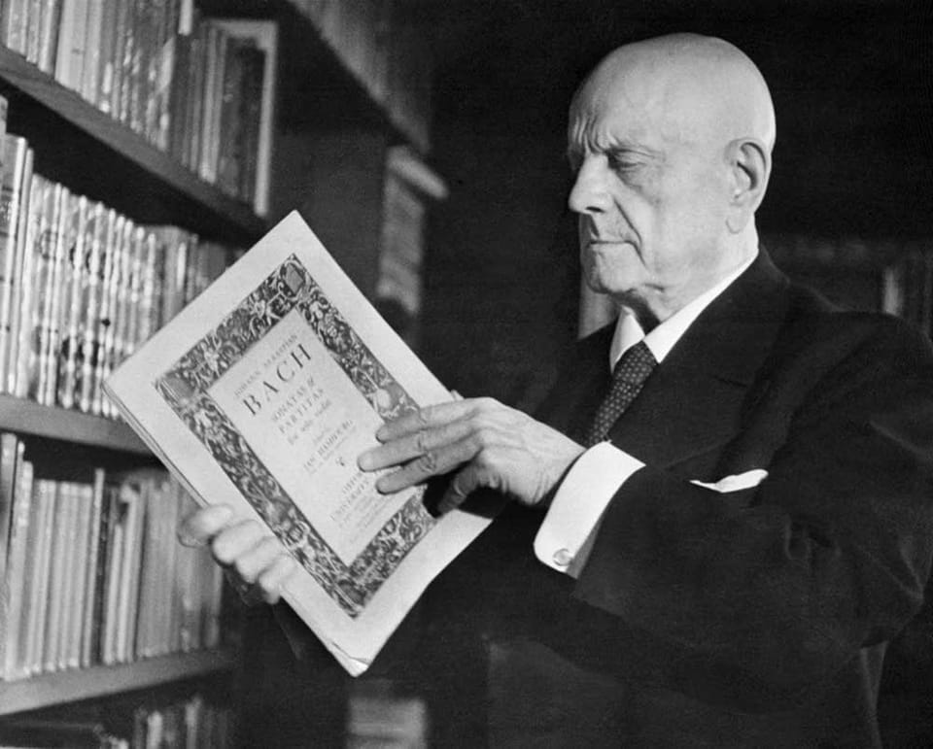
Figure 1. Jean Sibelius (1865—1957) studying an edition of the Sonatas and Partitas.

Although each of the Six Sonatas and Partitas pose their own unique challenges, the Sonata No. 3 in C Major, BWV 1005, is especially demanding. The 2013 Canadian Royal Conservatory of Music violin syllabus categorizes the various movements of this Sonata in their most advanced categories. Ivan Galamian, the revolutionary 20th century violin pedagogue, only allowed students who had extensively studied every other Sonata and Partita from the set before undergoing study of the Sonata No. 3. If the Sonatas and Partitas are the Himalayas, the Sonata No. 3 is Mount Everest.
The most frequently studied edition of the Sonatas and Partitas is the Ivan Galamian edition from 1971. This edition was constructed with a 20th century style of interpretation on a contemporary violin. In recent years, the interest in historical performance practices has risen significantly, and as such, a number of treatises have been published on the art of interpreting the Sonatas and Partitas in a more historically-accurate way. One such edition comes from the violinist Rachel Barton Pine, both the youngest ever (at age 14) and only American to win a Gold Medal at the international J. S. Bach competition. Pine specializes in both contemporary and historical performance practices, and her edition reflects a more historically-accurate approach.
The central question of this document concerns the differences between the fingerings and bowings between the Galamian and Pine editions of the Sonata No. 3 in C Major, BWV 1005. The Galamian and Pine editions employ different bowings and fingerings based on their respective stylistic choices. However, just as the contemporary or historical performance practices are not outright superior to one another, neither the Galamian nor the Pine editions are inherently superior. Because Baroque performance practice has become increasingly more mainstream, any violinist looking to cultivate a personal interpretation of the Sonatas and Partitas should consult multiple sources while forming their own ideas. A violinist studying both the Galamian and Pine editions would ideally concoct their own unique interpretation of the Sonata No. 3, resting somewhere in the grey area between both editions, with varying and multidimensional degrees of observance of both modern and historical ideas.

Chapter 2: An Overview of the Sonata No. 3 in C Major, BWV 1005

Violinists are hardly left wanting for solo repertoire from Johann Sebastian Bach. Between the Violin Concerti, Brandenburg Concerti, unaccompanied Sonatas and Partitas, Sonatas for Violin and Keyboard, and numerous obligato solo violin parts from various compositions, one could study Bach’s solo violin compositions for an entire lifetime. Although the each of the Sonatas and Partitas are celebrated, the Sonata No. 3 in C Major, BWV 1005 presents some of the most considerable challenges. As Isabelle Faust remarked in an interview:
"In a way, [the Sonatas and Partitas are] the most difficult. I mean, the huge C major fugue! To enter this kind of music and not only understand it intellectually but also emotionally? It's sometimes almost strange to go on stage. I've always wondered: did Bach really mean for them to be played in public? I have my doubts."
Sandwiched between two of the most popular works in the violin repertoire—Partita No. 2 in D minor, BWV 1004, and Partita No. 3 in E Major BWV 1006.1, respectively—the Sonata No. 3 can be overshadowed. Despite this, this sonata has served an important role in the history of Bach’s music and violin-playing as a whole.
The Sonata No. 3, like the other Sonatas from the Six Sonatas and Partitas by Johann Sebastian Bach, is a Sonata di Chiesa. Unlike the unique Partitas, each of the Sonatas follows the same four-movement pattern:
Movement I: A slow movement, improvisatory in nature
Movement II: A fugue
Movement III: A slow and lyrical movement
Movement IV: A fast and technically brilliant finale

The violin and the music of virtuoso violinists played a large role in Bach’s career. His first music lessons were probably centered around training in basic music theory and the violin. In 1703, Bach secured his very first position as a professional musician as a “lackey” at the court of Duke Johann Ernst III in Weimar, where his duties probably were mainly centered around playing the violin in the court orchestra, among other non-musical roles. Bach only remained in Weimar for about seven months before assuming new appointments elsewhere, but eventually returned to Weimar in 1708 as court organist. In 1714, Bach was promoted to the role of Konzertmeister, which included, among other responsibilities, the duty of directing the orchestra from the concertmaster spot. While in Weimar, Bach notably studied works of the prominent Italian virtuoso violinists and composers such as Vivaldi and Corelli, and re-worked several of their compositions for various keyboard instruments.
In 1717, Bach found employment at the court of Leopold, Prince of Anhalt-Köthen. This position proved to be one of the most influential and fruitful in terms of Bach’s output. Bach’s most prominent compositions from this time were the Six Sonatas and Partitas for Solo Unaccompanied Violin, the Six Suites for Solo Cello, three Orchestral Suites, the Brandenburg Concerti, as well as a number of secular cantatas. Additionally, Bach composed his lesser-known (but no less brilliant) Six Sonatas for Violin and Harpsichord, BWV 1014—1019. In 1723, Bach was appointed as the Cantor at St. Thomas’s church in Leipzig, where he lived for the remainder of his life.
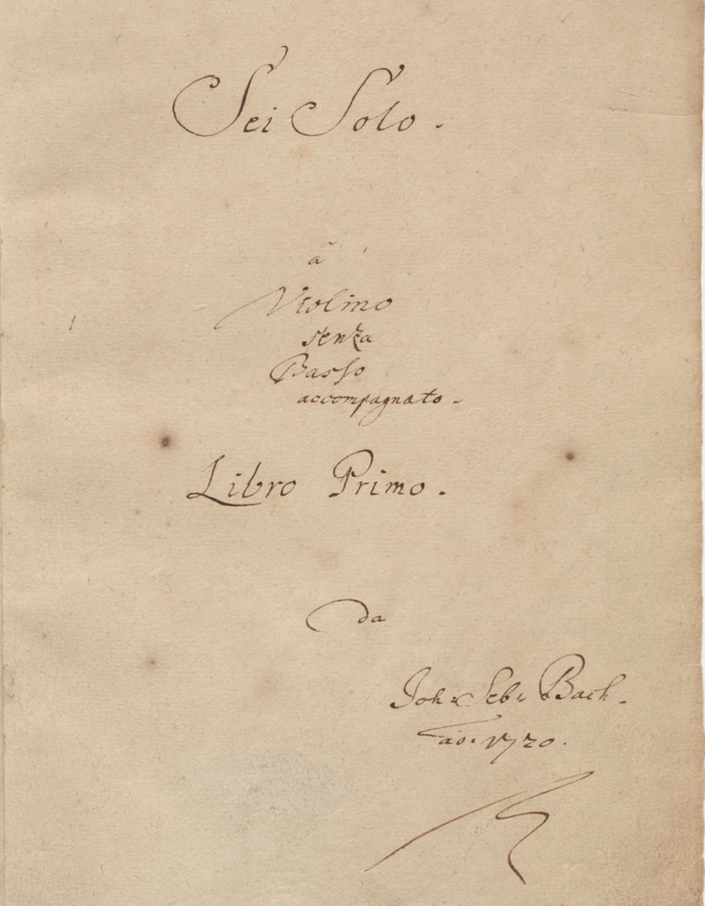
Figure 2. Title page of the autograph manuscript of the Sonatas and Partitas.

Where Bach derived the inspiration to compose the Sonatas and Partitas is unknown. Polyphonic works for unaccompanied violin has already been explored by German composers before Bach, such as Heinrich Franz Ignaz Biber (1644—1704), who most notably composed a Passacaglia in G minor for unaccmpanied violin. Another contributor to this genre was Johann Paul von Westhoff (1656—1705), a German composer and virtuoso violinist. Westhoff was a violinist at the Weimar court during Johann Sebastian Bach’s first employment there. By the time the 18-year-old Bach arrived, Westhoff has composed and published a set of six partitas for solo unaccompanied violin.
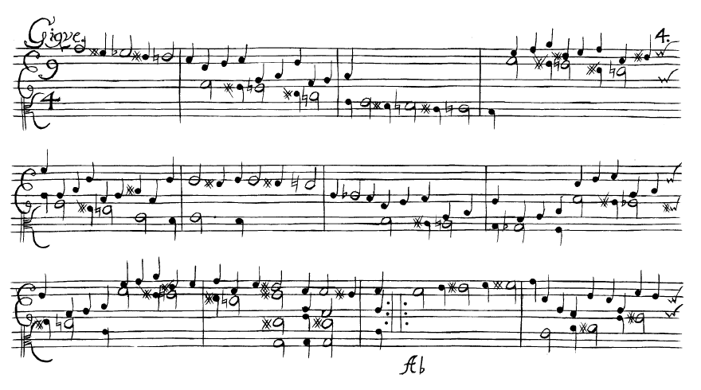
Figure 3. Excerpt from Gigue of Westhoff Partita No. 1 in A minor.

Given Bach’s proximity with the composer, the Westhoff partitas seem a likely candidate for influence and inspiration for Bach’s own unaccompanied violin compositions. Regardless of the influences, Bach began composition on the Sonatas and Partitas around 1717, or at the beginning of his employment at the court in Köthen.
Unlike the Goldberg Variations BWV 988, it is unclear who the first performers or intended recipient of the Sonatas and Partitas were. Of these, one of the most likely candidates would have been Johann Georg Pisendel (1687—1755). Bach and Pisendel enjoyed a life-long relationship, both personal and professional. Pisendel was one of the leading violinists of the early 18th century, and served as concertmaster of the orchestra at the Dresden court (the finest orchestra in Europe at the time). In 1717, Pisendel composed his own work for unaccompanied violin, the Sonata in A minor for Solo Violin, during an eight-month period in Venice, where he studied with none other than Antonio Vivaldi. Bach first met Pisendel that same year upon his return from Venice.
Although Johann Sebastian Bach preferred keyboard instruments, few realize he was also an able violinist. After all, Bach’s first professional employment in Weimar in 1703 was in the capacity as a violinist, and his second position there included leading the orchestra from the concertmaster position. Indeed, Bach’s son Carl Philipp Emanuel Bach wrote of his father’s skill on the violin: “In his youth, and until the approach of old age, he played the violin very cleanly and powerfully.” Perhaps, then, Bach might have written the Sonatas and Partitas for himself.
Nearly a century after their initial composition, N. Simrock produced the first publication of the Six Sonatas and Partitas in Bonn in 1802. This publication seems to have used an unreliable source, due to the numerous inconsistencies with the autograph manuscript. However, this was only the first complete publication. In 1798, Jean-Baptiste Cartier published a compilation of works for solo violin through the Paris Conservatory, titled L’Art du Violon. This publication would become so popular that it merited a second and third edition, which appeared in 1799 and 1803, respectively. Cartier was particularly well-known for his reverence of the “old masters,” whose music he considered essential to violin study. Within L’Art du Violon, Cartier includes a variety of pieces by notable composers such as Corelli, Vivaldi, Tartini, LeClair, etc.
“…[Viotti] taught, guided and inspired many young French violinists and grounded them in the great Italian tradition. Several of them, including Jean-Baptiste Cartier, began to take a deep interest in the largely forgotten work of Italian masters like Corelli, Tartini, Nardini, and Pugnani (Viotti’s teacher) and in the solo works of Johann Sebastian Bach.”

-Zvi Zeitlin
The final section of the L’Art du Violon includes works for solo unaccompanied violin. Among those listed is one entry by Johann Sebastian Bach, which is none other than the Fuga (Mvt. II) from the Sonata No. 3. According to the title given, Cartier sourced the manuscript for this publication from Pierre Gaviniès (1728—1800), the most significant violin pedagogue at the Paris Conservatory from his appointment in 1795 until his death. Being that Cartier’s publication pre-dates the 1802 Simrock publication, the Fuga within L’Art du Violon stands as the earliest known publication of any of the Sonatas and Partitas, albeit incomplete. It seems plausible, therefore, that the Sonata No. 3 served a notable role in violin pedagogy by the 19th century.
In 1835, Paris Conservatory and virtuoso violinist Pierre Marie François de Sales Baillot (1771—1842) produced yet another treatise in violin-playing published through the Conservatory, also titled L’Art du Violon. Baillot cited two works by Bach in this treatise: Sonata No. 3 in C Major for solo unaccompanied violin BWV 1005 and Sonata No. 4 in C minor for Violin and Harpsichord BWV 1017.
The citation of the Sonata No. 3 in C Major BWV 1005 was once again through the Fuga. Baillot stresses the importance of ease of technical facility on chords, outlined by this excerpt from his own L’Art du Violon:
We stated in the Introduction that the violin lent itself so well to harmony that it could produce broken chords like the harp and simultaneous chords like the piano—the first by means of arpeggios, the second by chords struck simultaneously. Since the study of chords has been too neglected, we have put exercises in harmonic preludes at the end of the melodic preludes, in order to make more familiar one of the most beautiful effects of the violin—chords—and to put students more quickly into condition to perform all the fugues and sonatas of Corelli, Tartini, and Geminiani, and the Sonatas of [Johann] Sebastian Bach. Bach’s Fugue in C Major, illustrated here, would in itself demand that the student apply himself to this type of study in order to succeed in rendering all its beauties.

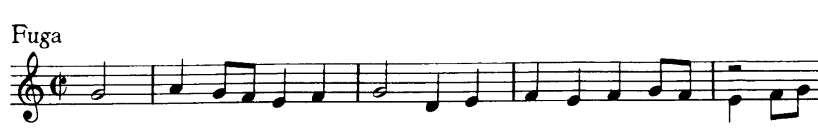
Figure 4: Excerpt used in Baillot’s L’Art du Violon: Fuga mm. 1—4.

The Sonata No. 3 in C Major by Johann Sebastian Bach served a vital role in the history of the violin as well as its pedagogical tradition. It was well-known and important to some of history’s greatest violin pedagogues—Jean-Baptiste Cartier, Pierre Gaviniès, and Pierre Marie François de Sales Baillot—at the Paris Conservatory. This institution for bringing the music of Bach in the mainstream, as well as codifying the standards of violin performance practice. This document will continue that great pedagogical tradition of this magnificent masterpiece by Johann Sebastian Bach.

Chapter 3: An Overview of the Galamian and Pine Editions

“If we knew (which we do not) exactly how Bach wanted his music to sound, there would still remain the question of whether it should be played precisely in the historical style of Bach’s day, or whether it should be adapted to modern ideas, means, and surroundings…in the long run, every student who aspires to the level of true artistry will have to form his own opinion, make his own choice, and take his own responsibility. Therefore, the important point, fundamentally, is that the student must become fully equipped with all of the technical tools so that his musical ideas may be fully realized.”
—Ivan Galamian

“There is no one right way to play Bach. More than almost any repertoire, each individual’s interpretation is as unique as their personality. Though I have spent decades studying Bach’s music as well as that of his contemporaries and predecessors, my final rationale for artistic decisions is often taste and instinct. Every violinist who undertakes a lifetime’s journey with this incredible repertoire is continuing discovering new ideas. Thus, the opinions on the following pages may evolve over time.”
—Rachel Barton Pine

A violinist’s experience with the Sonatas and Partitas is a life-long and ever-evolving journey. In many ways, these works are the most versatile and challenging works for violin, because all elements of the musical experience rely solely on the violinist alone. Every practice session is essentially a full rehearsal. A violinist need only consult with themselves on interpretive matters. The goal of this document is to help a violinist produce a more personal interpretation by comparing two prominent editions of the Sonata No. 3 in C Major, BWV 1005, reflecting two different interpretive styles.
It is important to note that neither Pine’s edition nor historical performance practice as a whole constitute a “more correct” way of interpreting the Sonata No. 3, or Bach as a whole for that matter. This document will therefore not present one edition as superior to another; rather, it will present their differences as a reflection of style.
Most violinists probably want to interpret the Sonata No. 3 (or any of the Sonatas and Partitas) with some degree of “authenticity,” which is to say, to produce an interpretation both honoring the artistic vision of the composer, as well as considering and replicating some of the performative practices of the early 18th century. Fortunately, it is not an “either/or” situation: the endeavor of “authenticity” is broad and multi-dimensional. What is more, both modern and historically-driven philosophies can produce sublime interpretations.
Both editions approach “authenticity” in different ways. For instance, the autograph manuscript includes no indicated dynamics. Similarly, the Galamian edition includes no dynamics, however the Pine edition indicates them widely throughout. The use of bowings serves as another example. Aside from a small handful of exceptions, the Pine edition follows the bowings indicated by the autograph manuscript, where the Galamian edition departs from the original bowing quite frequently.
The chosen editions by Ivan Galamian and Rachel Barton Pine reflect two prominent styles of interpreting Bach: contemporary and historical. Additionally, this document will also make use of musical examples from the Autograph manuscript for contextual purposes, the score of which was sourced from the Ivan Galamian edition. The remainder of this chapter covers general details of the respective editions and interpretive styles, as well as details of the analysis.

Chapter 3.1: Musical Figures and Excerpts

This document employs figures and excerpts from the respective editions of the Sonata No. 3 in C Major BWV 1005 prepared by Ivan Galamian (1971) and Rachel Barton Pine (2017). Additionally, examples were taken from the autograph manuscript prepared by the composer in 1720 to display original bowings for contextual purposes.
Musical examples were edited by the author solely for the purpose of clarity. No edits were made in any way to alter or change editorial markings of either Galamian or Pine, nor the autograph manuscript. All bowings added by the author are done in red, and only for the purposes of displaying bowings implied by the editor not implicitly notated by the edition in those specific measures. The figures below document the editing process or musical examples.
Step I: Capture desired measures from score (Mm. 25—28 from Allegro Assai).
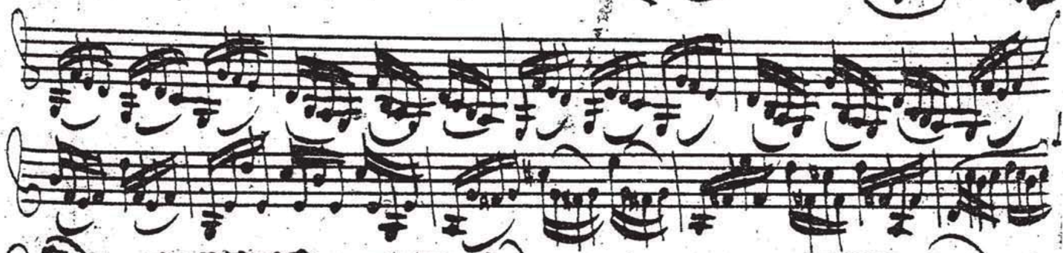
Figure 32. Allegro assai, mm. 25—28: Autograph manuscript. Unedited captured measures.

Step II: Remove unnecessary measures from the example. (Mm. 21—24; m. 29)
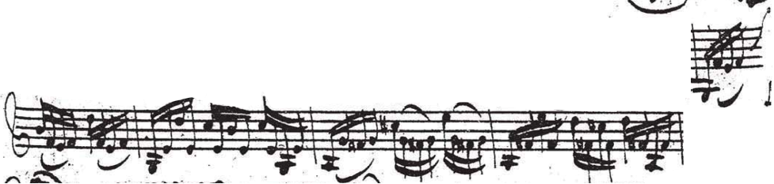
Figure 33. Erased unwanted measures.

Step III: Remove markings from surrounding lines.
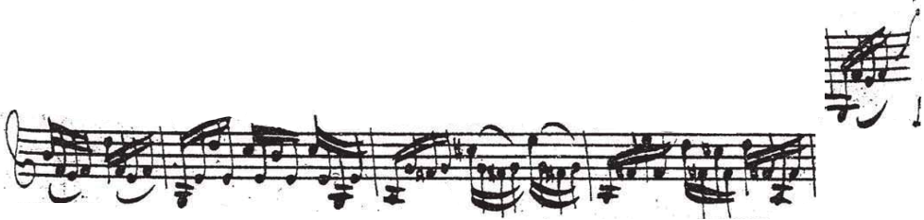
Figure 34. Clean margins.

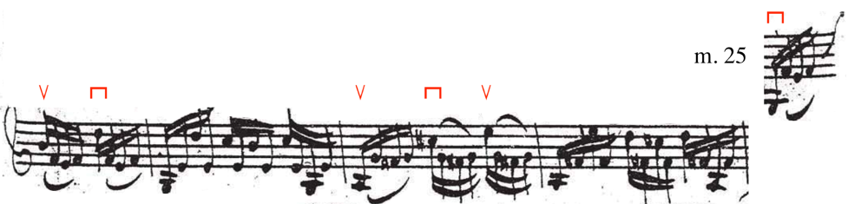
Step IV: Add bowings and measure numbers (if applicable).
Figure 35. Superimposed bowings.

Chapter 3.2: Editorial and Interpretive markings

As was common in the early 18th century, the autograph manuscript lacks a number of interpretive markings modern violinists are accustomed to, including dynamics, articulation, fingerings, etc. Both editions have navigated these aspects differently.
The dynamics indicated on the autograph manuscript of the Sonatas and Partitas for Solo Unaccompanied Violin are sparse at best. In some cases, such as the Sonata No. 3 in C Major BWV 1005, Bach did not include any dynamic markings whatsoever. While dynamics obviously serve a vital interpretive role, the Galamian edition includes no dynamics, while the Pine edition notates them throughout.
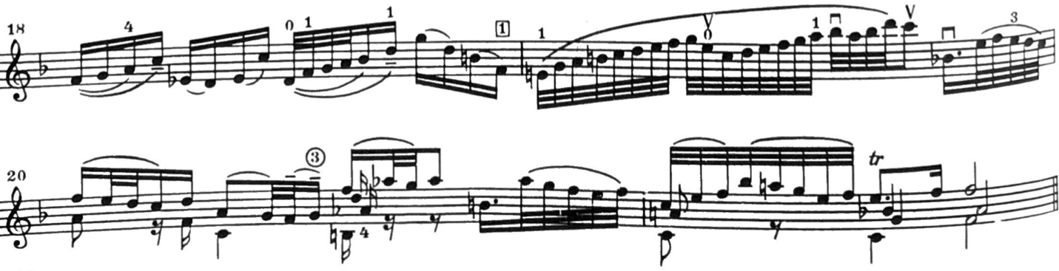
Figure 6. Largo mm. 18—22: Galamian edition. No dynamic markings.
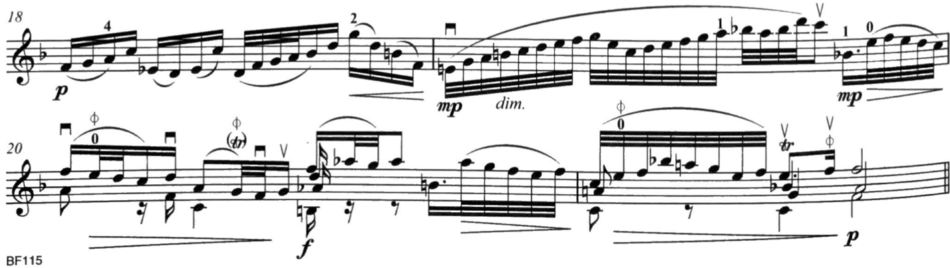
Figure 5. Largo, mm. 18—22: Pine edition. Reflective of the number of dynamic markings found in the Pine edition.

Articulative markings are also non-existent in the autograph manuscript, but appear in the respective editions for different reasons. Galamian uses legato markings when indicating a hooked bowing, in order to give the impression of separation of the respective notes. They are also employed in areas to show emphasis for phrasing or bow control.
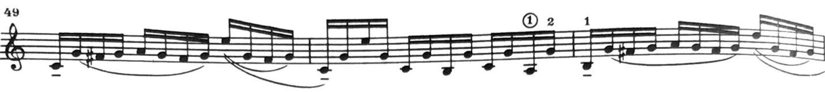
Figure 7. Allegro assai, mm. 49—51: Galamian edition. Downbeats both hooked or used to show emphasis.

Pine also employs legato markings to notate emphasis in the execution of hemiolas in the Adagio.
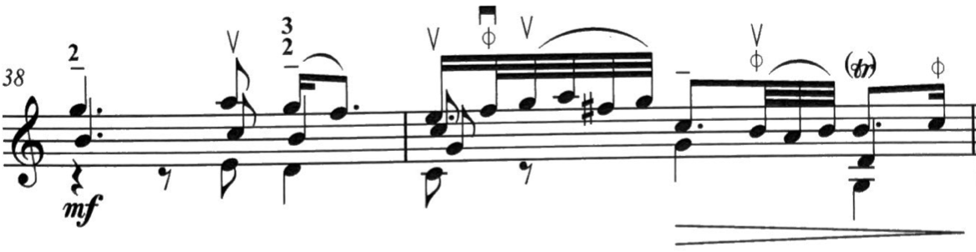
Figure 8. Hemiola indicated by legato markings. Adagio, mm. 38—39: Pine edition.

Galamian’s style of notating shifts versus extensions and contractions is explained in the Editor’s Note on page ii.
Figure 9. Excerpt from page ii of Editor’s note: Galamian edition.

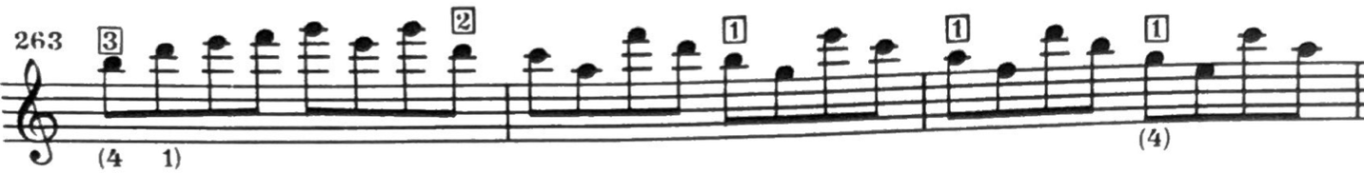
Figure 10. Fuga, mm. 263—265: Galamian edition. Use of shifts.

Figure 11. Excerpt from page ii of Editor’s note: Galamian edition.

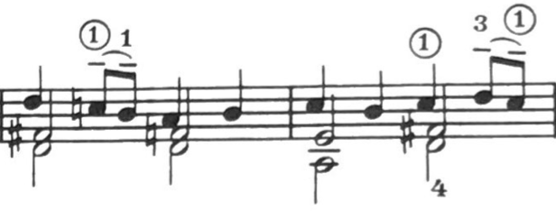
Figure 12. Fuga, mm. 131—132: Galamian edition. Use of extensions and contractions.

The 20th century practice of sustaining all notes of a chord for the full written duration (if possible) was not the style of the 18th century. It is difficult, however, to notate exactly how and when to break chords in a manner that best reflects a more historically-accurate approach. As such, the Pine edition adopted a symbol used in the Six Sonatas for Solo Violin, Op. 27 by Eugène Ysaÿe (1858—1931) to indicate when a voice should no longer be held. This symbol appears widely throughout the Sonata No. 3, except for the Allegro assai, which contains no chords.

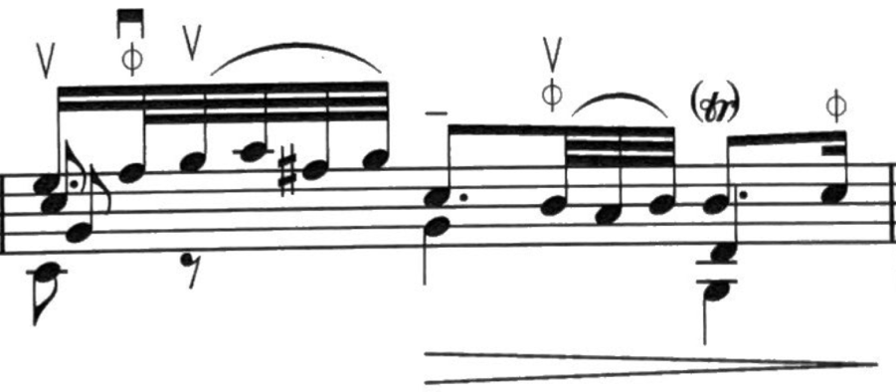
Figure 13. Adagio, m. 39: Pine edition. Use of Ysaÿe symbol on F-natural in first beat, B in second beat, and C in third beat.

Chapter 3.3: “RBP on JSB”

The companion to the Pine edition is a video series titled “RBP on JSB” (Rachel Barton Pine on Johann Sebastian Bach), published through the Violin Channel on Rachel Barton Pine’s own YouTube channel. Pine dedicates an in-depth video to each and every movement of the Sonatas and Partitas, ranging from 15 to 50 minutes in length. Additionally, Pine created a video on the overall approach to the Sonatas and Partitas as a whole.
Much of what these videos cover are her own editorial markings from her edition of the Sonatas and Partitas, as well as artistic and interpretive matters. These videos are an excellent resource in studying the Pine edition, the Sonata No. 3, and the Sonatas and Partitas as a whole. Although the Pine edition includes much insightful markings and information, only so much can be discerned about style and interpretation from ink on paper. As such, using these (free) resources online as a companion to the Pine edition would be a helpful way to gain insight on style and interpretation, particularly in historical matters.

Chapter 3.4: Bowings

The bowings presented in the autograph manuscript present three principal problems. Both editions address these challenges differently.
- Bach’s handwriting is not always neat, and therefore his ideas are not always clear.
- Some bowings are not consistent with one another. There are instances of similar figures featuring different bowings from one another, or instances of possible/probable mistakes.
- Sometimes, following the autograph manuscript’s bowings can prove to be uncomfortable or awkward, especially for the modern bow.
Rachel Barton Pine’s edition always follows the bowings indicated by the autograph manuscript with only a number of notable exceptions. On the other hand, Ivan Galamian makes significant bowing changes in his edition. The bowing choices made by the respective editors comes largely from the type of bow the editor used. Pine, an expert in historical performance practice conceived her edition with a baroque bow. In contrast, Galamian created his edition with the modern bow in mind.
As stated before, the violin (and the bow, especially) has significantly evolved since 1720. The greater number of bowing modifications in the Galamian edition can be owed to the fact that, in many ways, Ivan Galamian was producing a transcription for a different instrument than Bach was familiar with. The biggest challenge he faced was how to employ the modern bow in order to do justice to these works in a comfortable way.

Chapter 3.5: Fingerings

Unlike bowings, there are no fingerings included in the autograph manuscript. As such, the fingerings within the Galamian and Pine editions are entirely original to the editors. Generally, violinists of the 18th century shifted positions less often than contemporary violinists do. The Pine edition tends to remain in first position more frequently while the Galamian edition explores upper positions more liberally.
The reasons for this are two-fold. Firstly, violinists of the 18th century did not have chin rests or shoulder rests. The chin rest did not appear until violinist Louis Spohr (1784—1859) introduced them circa 1820; the shoulder rest appeared about a century after that. These innovations allow violinists to focus less on supporting the instrument with the left hand and more on music-making. Shifting comfortably without that support can prove to be much more challenging.
Secondly, modern strings are made of entirely different materials than the early 18th century. Violinists of Bach’s generation used strings formed from animal intestine (commonly known as “gut” strings), whereas modern strings are made from metal and/or synthetic materials. Obviously, they do not behave the same way and feature different sound profiles altogether, particularly the E-string. Modern E-strings are much brighter and more “metallic” sounding than their gut-string counterparts, and as such can stick out of the texture. For this reason, there are multiple instances throughout the Galamian edition where higher positions are employed on lower strings in order to achieve a warmer and rounder sound, as to imitate the sound profile of gut-strings.

Chapter 3.6: The Execution of Chords

The Sonata No. 3 contains the highest concentration of multi-stop chords in any of the Sonatas and Partitas, particularly in the first two movements, the Adagio and Fuga.
Chords are at the heart of the polyphony represented in the Sonatas and Partitas. However, three- and four-voice polyphony isn’t technically possible on a single violin. Violin bridges are curved pieces of wood, designed such that each string may be played independently and cleanly. Double stops (or chords of two notes) are easy enough: so long as they’re on two adjacent strings, just place the bow on both of those respective strings. However, problems arise when triple and quadruple stops (chords of three or four notes, respectively) appear in the music.
Although the bow can hit three or four strings simultaneously, this usually cannot be achieved without a considerable attack from the air. Continuous three-voice polyphony could be executed if the bow is played close to or over the fingerboard (sul tasto), but this restricts the dynamics to quieter ranges. In addition, this requires pressing down on the middle string so that it depresses enough to allow the bow to hit the adjacent strings on either side, which can make the dynamics of the voicing uneven: the middle string is too loud, and the outer strings are too soft comparatively. Therefore, continuous four-voice polyphony on a violin is flat-out impossible. The limiting factor comes down to the bow hair being a straight plane, and the bridge being a curved one.
Baroque violinist and pedagogue Jaap Schröder sums up the quandary of the polyphony of Bach’s fugues his treatise on the Sonatas and Partitas:
If we think of a polyphonic composition as a construction in space, this three-dimensional object can be projected onto a flat surface (like the notation of a fugue). This projection—say, the illustration of a pyramid or cylinder—is perfectly able to suggest the spatial character of the object in question, but only the viewer’s imagination and the artist’s skill and power of suggestion can make it happen.

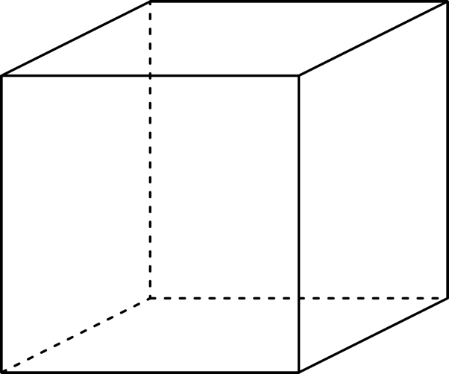
Figure 14: The Necker Cube, an optical illusion of a 2-dimensional drawing creating a perceived 3-dimensional object.

Because of the bow’s limitations, violinists must employ masterful bow technique to create this illusion of multiple continuous voices. Ivan Galamian and Rachel Barton Pine have different views on how chords in Bach should be broken. This particular section of the document will focus on the right hand (bow technique) through the philosophy of breaking of chords.
In his 1985 treatise Principles of Violin Playing and Teaching, Ivan Galamian outlines his ideas on chords and how to approach them. According to Galamian, chords have three elements: intonation, building of the chord, and sound production. The first two elements are centered around left-hand technique, while the third lies with right-hand.
In instances when the notes of a chord cannot be played simultaneously (which occurs far more often than not), one must “break” the chord. “Breaking” a chord is merely a form of arpeggiation of the chord. In instances of three-note chords, the bottom and middle notes are played before the beat (as a grace note), and the middle and upper notes are played on the beat. Less common executions of three-note chord breaking can be seen in Example 76 from Principles of Violin Playing and Teaching. The typical breaking of four-note chords are much the same, where the bottom two notes are played before the beat, while the upper two are played on the beat.
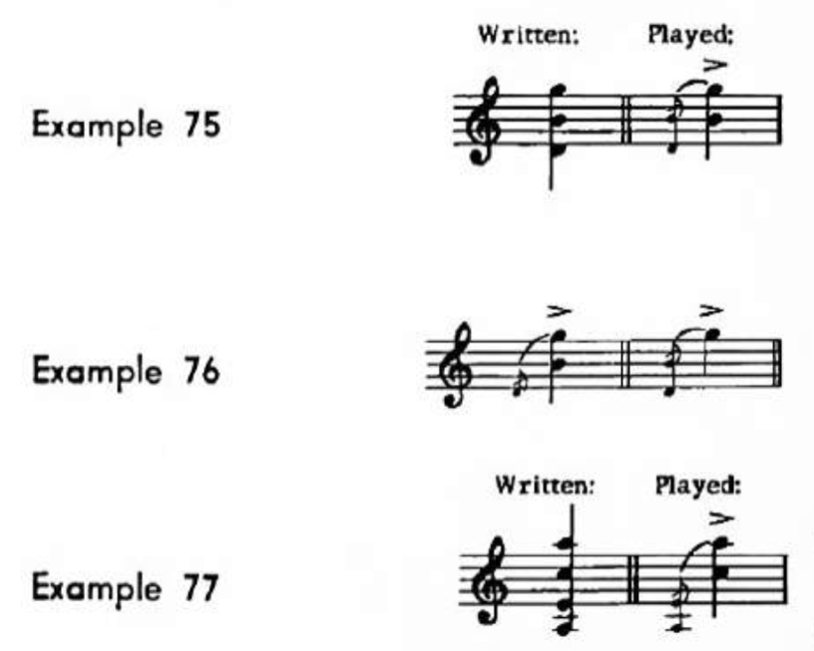
Figure 15. Examples 75-77 from Principles of Violin Playing and Teaching.

Examples 77 works best when the top two pitches must be emphasized. However, this may be modified to produce a smoother break, as seen in Example 78 from Principles of Violin Playing and Teaching.

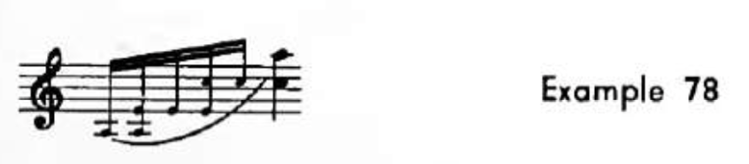
Figure 16. Example 78 from Principles of Violin Playing and Teaching.
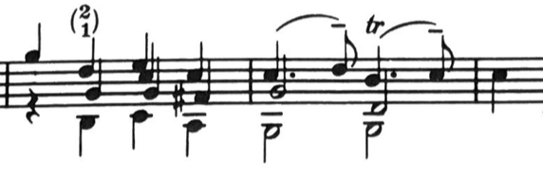
Figure 17. Fuga, mm. 243—245: Galamian edition.

Ultimately, it is up to the violinist to design their chord execution to give the best impression of polyphony. Each passage presents its own unique challenges and therefore may require a different approach.
What happens when the top voice isn’t holding the melody? A standard arpeggiation would then literally “break” the flow of the melody, and therefore making smooth continuous phrasing difficult. For instance, when the melodic line is in a lower voice, Galamian suggests to break chords from top to bottom, allowing that lower voice to be sustained. Mm. 15—18 of the Adagio serves as a good example. This excerpt features lower, middle, and upper voices trading off the ostinato rhythm. The added arrows show the direction of the implied break according to Galamian’s method. M. 15 and m. 18 are broken downwards, while mm. 16—17 are broken upwards.
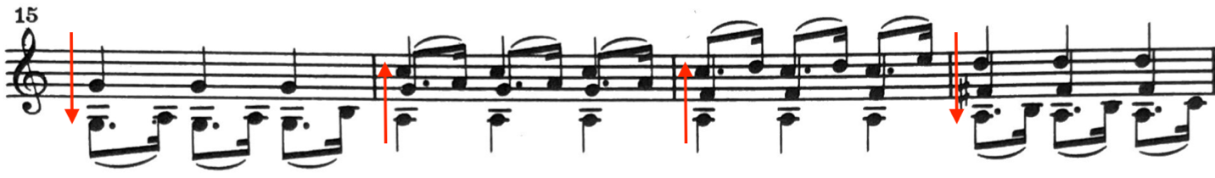
Figure 18. Adagio, mm. 15—18: Galamian edition. Arrows showing direction of break.

Several similar instances occur in the Fuga, where Galamian would suggest a downward break. He includes an excerpt from the Fuga (mm. 56—58) from the Sonata No. 3 in Principles of Violin Playing and Teaching, indicating how it is written and how he prefers it to be executed.
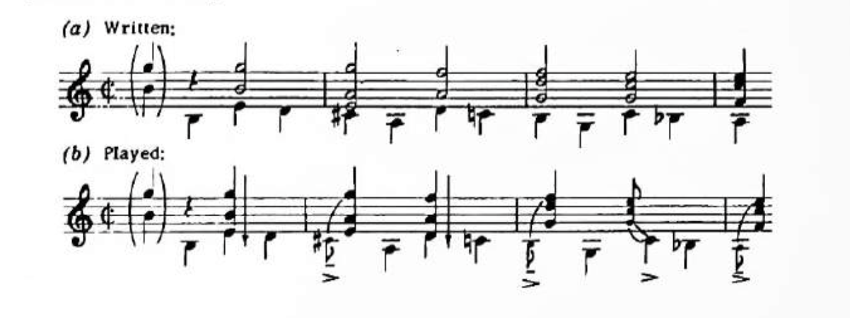
Figure 19. Figure from Principles of Violin Playing and Teaching.

In that same vein, there are instances where a middle voice (or voices) may be called upon to be sustained. In these moments, the chord breaks from the bottom to the top, but then returns to the middle. Mm. 22—23 of the Adagio could serve as an example of middle voices being sustained in this manner.
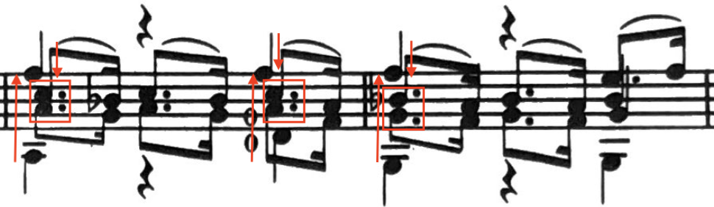
Figure 20. Adagio, mm. 22—23: Galamian edition.

This is not always standard practice, and many violinists have not adopted this technique in their interpretations, particularly in historically-driven performances. Even in modern interpretations, changing the direction of breaking can produce a break in the flow of the phrase.

“There is a certain awkwardness about the bow’s downward direction of emphasis, a breaking or plane-changing bow stroke from upper notes to lower notes, which limits its use to those instances wherein a melodic line is clearly in the lowest voice.”

—Denman Wayne Gerstrung

Conventional wisdom of historically-accurate performance states that downward breaking was not a technique used in the early 18th century, and therefore is an unfavorable technique to apply in the Sonatas and Partitas. As such, Rachel Barton Pine’s recording of the Sonatas and Partitas (Testament), she only breaks the chords from bottom to top. Pine reiterates this philosophy in her Foreword: “Regardless of whether the primary voice is on a lower string, all chords should be rolled upwards.”
Chords in the baroque were generally rolled similar to Example 78 found in Galamian’s treatise. The characteristics of an early 18th century violin bow were much more conducive to multi-stop chord playing than the modern bow.

Chapter 3.7: Embellishments and Ornamentation

In the Baroque era, it was customary for musicians to add their own personal artistic voice to a work through added ornamentation. However, most artists today generally limit the amount of added “flair” to the Sonatas and Partitas, partly out of respect for the works, and partly out of lack of necessity: these works already come exquisitely ornamented. This sentiment is perhaps best summarized in the notes regarding ornamentation in the Foreword of Rachel Barton Pine’s edition: “Further decorations [other than trills at cadential points] are not needed in the Sonatas and Partitas, though there are certainly occasions in which they may be added if you are inspired to do so…but any extra notes or decorations that you perform should flow naturally and spontaneously from your own imagination.”
As mentioned by Pine, it is standard practice to add a trill at cadential points in Baroque music. There are a number of instances in the Adagio and Largo movements where trills are added parenthetically by either one or both editors. For instance, trills are not indicated by the autograph manuscript in m. 14 of the Adagio, although they almost certainly were expected.
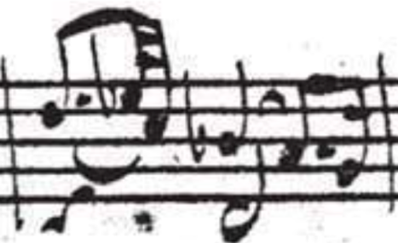
Figure 21. Adagio, m. 14: Autograph manuscript.
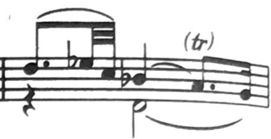
Figure 22. Adagio, m. 14, Galamian edition.
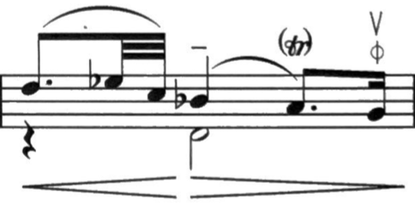
Figure 23. Adagio, m. 14: Pine edition.

There are instances where the Pine edition adds trills in the Adagio where the Galamian edition does not. For instance, m. 11 features a parenthetical trill in the Pine edition but not in the Galamian.
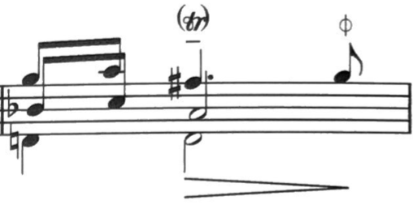
Figure 24. Adagio, m. 11: Pine edition.
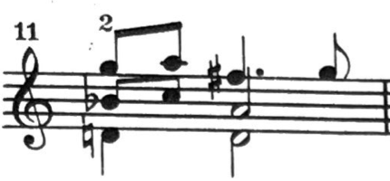
Figure 25. Adagio, m. 11: Galamian edition.

An added trill appears in m. 7 of the Largo in both the Pine and Galamian editions. The added trill continues a figure from the previous measure.
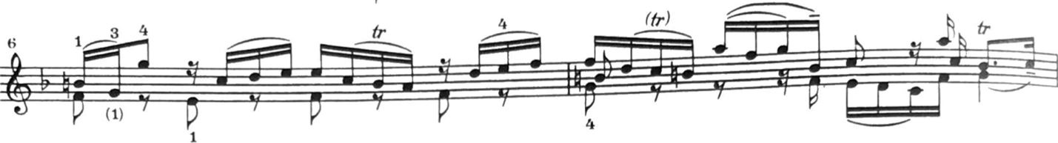
Figure 26. Largo, mm. 6—7, Galamian edition.
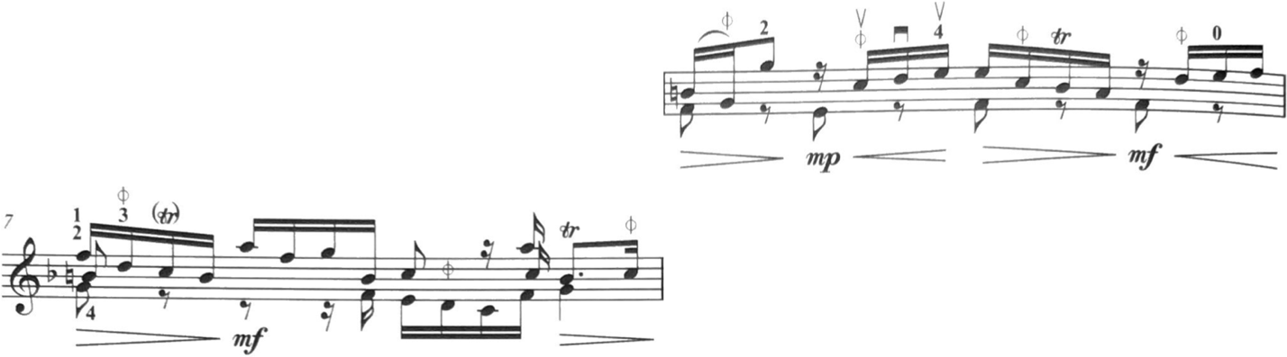
Figure 27. Largo, mm. 6—7: Pine edition.

Another instance of an added ornamentation comes from the Pine edition, in m. 164 of the Fuga, where Pine adds an anticipation parenthetically.
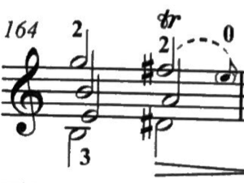
Figure 28. Fuga, m. 164: Pine edition.

Chapter 3.8: Rhythmic error in the Autograph Manuscript

The autograph manuscript contains a rhythmic error in m. 39 of the Adagio. The Pine edition retains this rhythmic error, (dotted 8th note followed by three 32nd notes) “so that the performer can choose how to interpret these anacrusic gestures,” while the Galamian edition includes a rectified form of this rhythm.

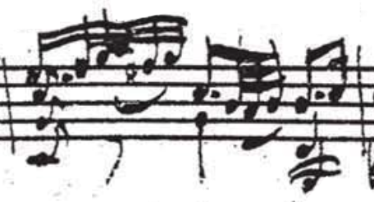
Figure 29. Adagio, m. 39: Autograph manuscript.

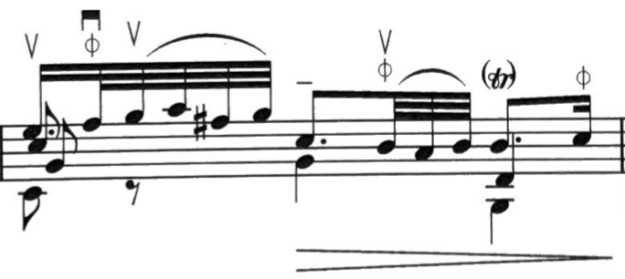
Figure 30. Adagio, m. 39: Pine edition.

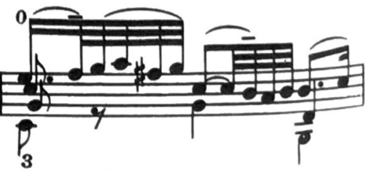
Figure 31. Adagio, m. 39: Galamian edition.

Chapter 3.9: Baroque Violins

“In the 21st century it is common to listen to a violin built in the 17th century, set up as a classical instrument in the 18th century, and played with a 19th century bow while subjected to the pressure of 20th century steel strings.”
—Jaap Schröder

Jaap Schröder points out some of the main evolutionary points: the violin “set-up,” bow style, and strings. Contemporary violins reflect centuries of musical evolution and innovations. Violins of Bach’s lifetime had different sound profiles; therefore, understanding the differences between Bach’s violin and the modern counterpart holds inherent value in the study of the Sonata No. 3 in C Major.
The Baroque era of Western Classical music spanned from 1600—1750. Much changed about the way violins were constructed and played in those 150 years, particularly during the 18th century. Indeed, the Baroque was a time of great experimentation and development, both in music and the instruments that originated during this time. Therefore, is difficult to say anything overly meaningful about violins as a whole from the Baroque era. Just as compositional and performative characteristics varied from one locality to another, so too were violins constructed and set up differently. This holds especially true for bows.
Despite this, we do know what kind of violins Johann Sebastian Bach possessed at the time of his death in 1750: a violin by Jakob Stainer (ca. 1618—1683), a “less valuable” violin, and a piccolo violin. Bach would have used the Stainer violin as his primary performing violin.
Jacob Stainer (1618—1683) was one of the most important luthiers of the 17th century. It really isn’t terribly surprising Bach owned a Stainer violin; they were the “crème de la crème” in the early 18th century. Leading violinists of the 17th and 18th centuries regularly favored them. Francesco Maria Veracini (1690—ca. 1750) owned not one, but two Stainer violins, which he named “St. Peter” and “St. Paul.” The foremost prominent violinist in England of the early 18th century Francesco Geminiani also played on a Stainer violin. Heinrich Ignaz Franz von Biber knew of the high quality of Stainer instruments, interacted with them regularly, and probably owned one himself. Leopold Mozart (1719—1787), father of Wolfgang Amadeus Mozart (1756—1791) and author of the highly significant violin treatise Versuch einer gründlichen Violinischule (1756) played on a “beloved” Stainer violin. The cover of the original publication depicts the author holding a violin, presumably, his Stainer. Wolfgang Amadeus Mozart himself was presented a Stainer violin from 1656 by Prince Lobkowitz in 1786.
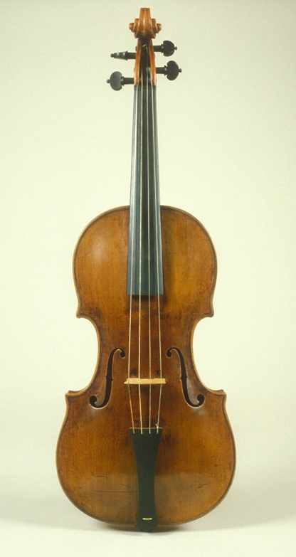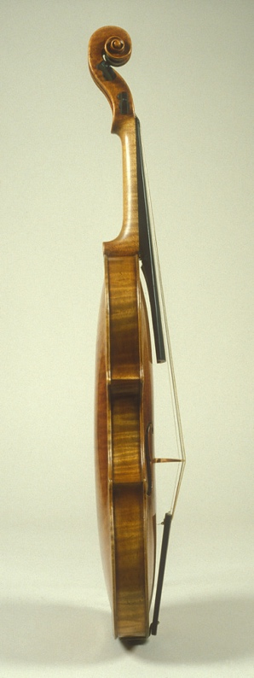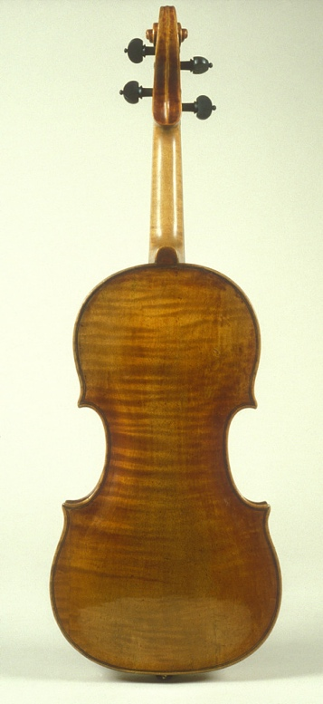
Figure 36. Violin by Jacob Stainer, ca. 1650.

By the onset of 19th century, Stainer instruments began to fall out of favor. The sonic characteristics of Stainer violins are often described as sweet, warm, and earthy. However, Stainers tend to project less easily; a quality violinists began to value after Stainer’s death. While much of this comes with the territory of tuning to A=415 and using gut strings, the Stainer violin provides an even more intimate sound than other historical violins.
As composers of the late 18th and early 19th century began to write for larger ensembles, violinists (particularly soloists) tended to prefer instruments that featured easier projection and greater brilliance in tone. Over time, violinists began to gravitate towards the instruments of Antonio Stradivari (1644—1737) and Bartolomeo Giuseppe Guarneri “del Gesù” (1698—1744) among other Cremonese makers from the late 17th to 18th centuries, which featured these newly-desired qualities. This trend has continued to the modern day: the violins of Stradivari and Guarneri are the most in-demand, and command staggering prices. Stainer violins may not often be in the hands of major soloists, but they are favored by violinists who specialize in early music. Nevertheless, Stainer’s days as a violinist’s instrument of choice have long since passed.
This is not to diminish the craftsmanship of Jacob Stainer. His instruments were conceived with 17th century music in mind. The sizes of ensembles were significantly smaller, much of which we would consider chamber music. What is more, the spaces in which violins were played—salons, churches, etc.—were considerably smaller than modern concert halls. In short, we cannot fault Jacob Stainer for not foreseeing the demands of violinists and composers nearly four centuries later. All of this paints a picture of as David Boyden so aptly described as “the change of reputation over time.” On the violins of modern-day major soloists are almost always 18th century Italian instruments, particularly those of Stradivari or “del Gesù.” These are undoubtably superb violins, but they are not quite the sound that Bach had in mind while writing the Sonatas and Partitas.
The modest violins Bach himself was more familiar with fits his legacy—all too often, we forget that Bach too was a humble man, from humble beginnings, like his Sonatas and Partitas. These works were not designed for major concert halls, rather, for churches and salons with small audiences. They were an intimate exploration of the capabilities of the violin, a contemplative and personal venture. Stainer violins were designed with the same principles in mind—intimacy, contemplation—and they suit this artistic endeavor.
What makes violins of the early 18th century sound so different than the violins we hear today? The most notable differences in 18th century violins and contemporary violins are:
- Tuning
- String material
- Neck
- Bridge shape
- Arching/shape
- Fingerboard length
During the 20th century, the international standard tuning pitch was established as A4=440Hz, however, 18th century tuning standards were certainly not universal, and varied enormously by locality. However, in general, the standard pitch was thought to be about a half-step lower, and the common historical tuning for A4 is 415Hz. Since Bach’s lifetime, the tuning pitches have slowly risen. Lower tuning provides more colorful, vocal, and organic sound; where higher tuning results in a brighter, more vibrant sound that projects easier.
Gut strings provide less power and focus compared to modern metal strings. They are less responsive, meaning they do not produce sound as easily as their modern counterparts. On the other hand, gut strings provide complex tone color and vibrancy, producing a more organic or vocal sound. Like violin-makers, string-makers experimented through the 18th century. By the end of Johann Sebastian Bach’s life, strings with metal winding were more commonplace.
Early 18th century violin bridges were shaped slightly differently than modern bridges. A baroque bridge is much flatter, which helps with producing three-note and four-note chords.
Early 18th century violins generally had shorter fingerboards than modern violins. An early 18th century fingerboard was about an inch or two shorter than that of a modern violin, and sometimes even shorter. As composers continued to write music demanding higher pitches, luthiers in turn produced violins with longer fingerboards.
Luthiers experimented with violin shape throughout the 18th century. Before Antonio Stradivari, violins generally had higher arches, which resulted in a colorful and resonant sound. Around 1700, Stradivari began to diminish these arches, which resulted in less body to the sound but significantly more focus. Over time, violins that were able to project further became gradually more favored.

Chapter 3.10: Baroque bows

The violin bow evolved significantly since Bach’s lifetime, much of that evolution occurring in the 18th century. Around 1800, Francois Xavier Tourte (1747—1845) created the modern violin bow as we know it today. There are several key differences in the modern bow to the baroque bow. Modern bows are heavier, longer, more rigid, and have more horsehair. Additionally, they are shaped concave, where baroque bows were shaped convex. All of these changes resulted in the ability to access louder volumes and more sustain in the sound.
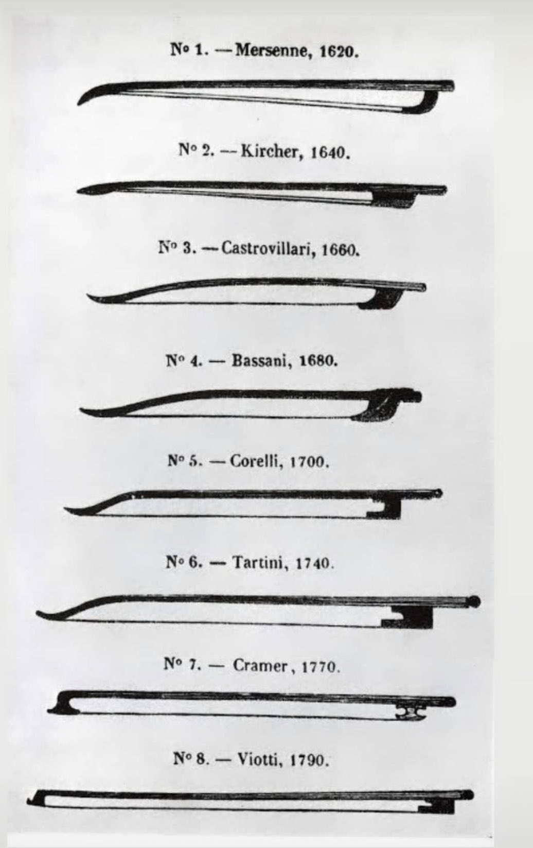
Figure 37. Evolution of violin bows from early baroque to modern model.

Rachel Barton Pine strongly suggests the use of a baroque bow while studying the Sonatas and Partitas. Her preference to using a baroque bow over a modern is not “guided by ‘authenticity’ for its own sake,” rather the physical advantages a baroque bow offers. According to Pine, the advantages are “twofold:”
- Producing a round and light sound as necessitated by these works with a modern bow requires a great deal of easing up on attacks in the right hand, thereby “diluting the energy of the music.” Using a baroque bow allows one to take advantage of this music without needing to be too delicate.
- The baroque bow is better-suited for multi-stop chords and polyphonic playing, and as such, would prove most useful in the first two movements of the Sonata No. 3 in C Major. Thus, even if one does not desire to interpret these works in a historical style, a baroque bow might make the necessary technique easier to execute.
Baroque bows are now both more affordable and accessible than ever: “These days, it is possible to buy a baroque bow of decent quality on the internet for such a price that every student and professional can now own one.” Given the advantages baroque bows offers and their newfound accessibility, any violinist should seriously consider exploring this avenue. Considering new ideas and expanding one’s horizons is quintessential to both academia and artistry.
It is important to reiterate that performing Bach on a baroque violin or bow (or even a Stainer violin) does not necessarily constitute a better performance. It is merely important to note the stylistic differences between the violins and bows between Bach’s lifetime and those of the modern day, so that the Sonata No. 3 can be better understood. All violinists should feel free to experiment with their instrument set-ups, trying out modern or historical violins and bows, and see what advantages come with each iteration.

Chapter 4.1: Adagio

The first movement of the Sonata No. 3 in C Major features double, triple, and quadruple-stop chords on nearly every beat, necessitating mature left- and right-hand technique. This first movement features a repeated rhythmic ostinato, a dotted eighth note followed by a 16th note. This figure permeates nearly every measure of the first movement of the Sonata No. 3 in C Major.
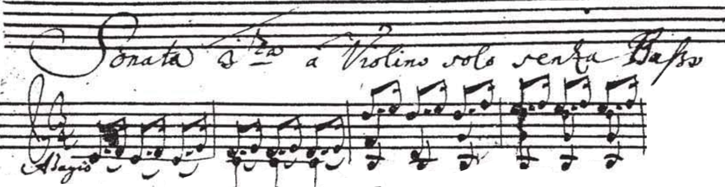
Figure 38. Adagio, mm. 1—4: Autograph manuscript.

The Sonata No. 3 in C Major may have roots in Bach’s second Weimar tenure. In 1715, Bach produced a keyboard transcription (BWV 974) of an Oboe concerto by Alessandro Marcello. The second movement of this work (Adagio) is of particular interest, whose opening resembles the opening of the first movement of the Sonata No. 3.
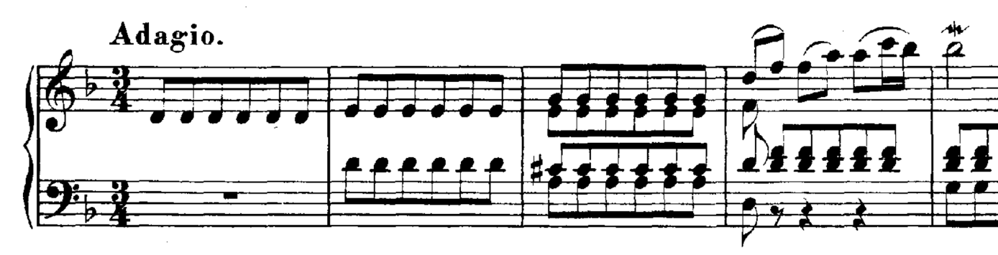
Figure 39. Mm. 1—5 of Bach transcription for Harpsichord (BWV 974) Concerto for Oboe Mvt. II Adagio by Alessandro Marcello.

Additionally, Bach produced a keyboard transcription of this movement, known as the Adagio in G Major for Harpsichord, BWV 968.
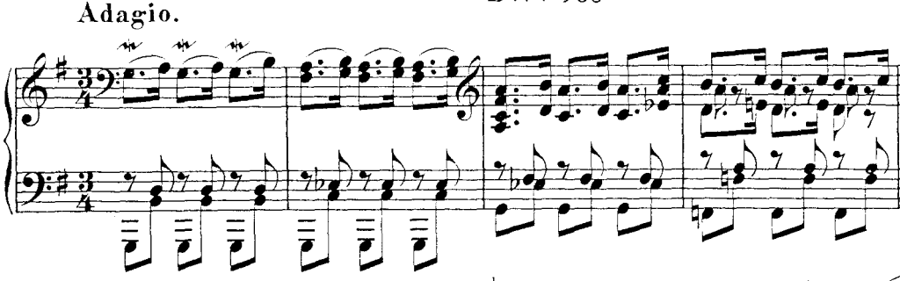
Figure 40. Adagio in G Major for Harpsichord, BWV 968, mm. 1—4.

4.1.1: Adagio Bowings

The bowings of the ostinato figure highlight the different bowing philosophies between the Galamian and Pine editions. Galamian almost always indicates slurs, while Pine alternates between slurred and separate bowings, as indicated by the autograph manuscript. The first six measures of Adagio serves as a perfect example.
The autograph manuscript indicates a variety of bowings. The first two measures of the figure are slurred, while the following two are separate. The eighth notes in m. 5 are slurred, but the ostinato figure is bowed separately at its return in m. 6.
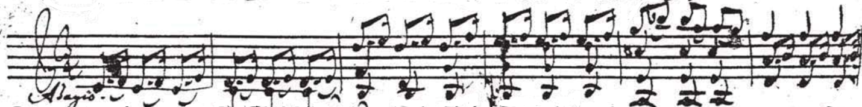
Figure 41. Adagio, mm. 1—6: Autograph manuscript.

Pine’s edition follows this bowing, aside from an added hooked up-bow on the downbeat of m. 6, setting up downbows for the chords on beats two and three of the same measure.
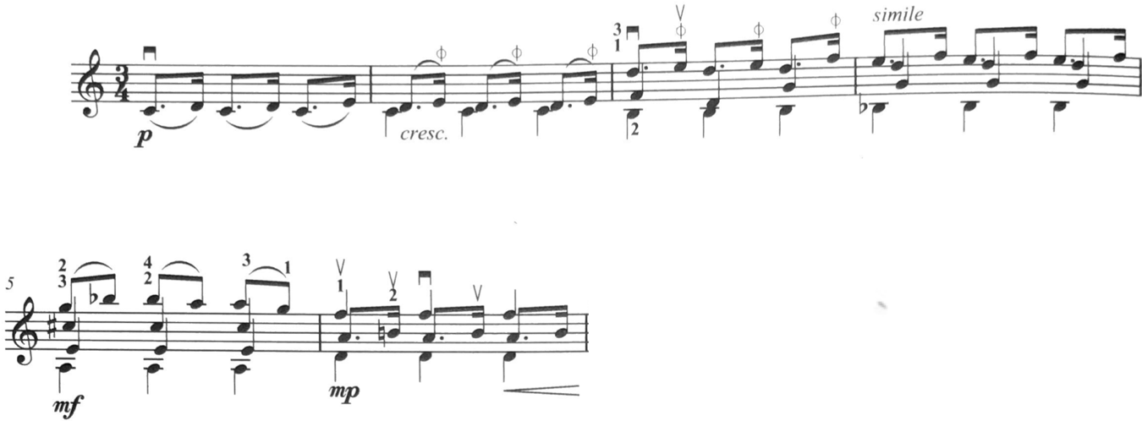
Figure 42. Adagio, mm. 1—6: Pine edition.
In contrast, Galamian slurs all of the ostinato figures identically as they appear in mm. 1—2.
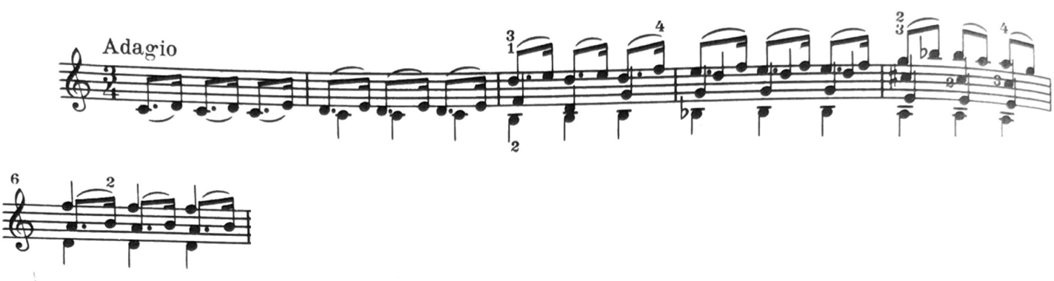
Figure 43. Adagio, mm. 1—6: Galamian edition.

Similarly, m. 20 of the autograph manuscript serves as point of interest. The manuscript lacks a slur on the second beat of m. 20, where all the surrounding figures of the ostinato rhythm have slurs. There being no clear musical reason for this bowing change, it was probably a mistake by Bach while preparing the manuscript.
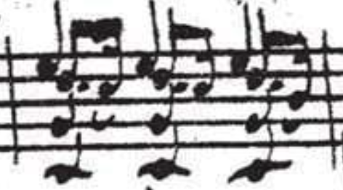
Figure 44. Adagio, m. 20: Autograph manuscript.

Both Galamian and Pine suggest to slur this beat in their respective editions, although Pine’s slur is added parenthetically.
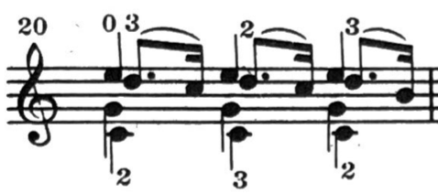
Figure 45. Adagio, m. 20: Galamian edition.

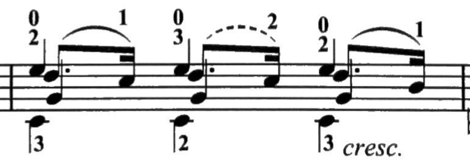
Figure 46. Adagio, m. 20: Pine edition.

One aspect of the Adagio that remains unclear from Galamian’s edition is the intended starting bow direction. If down-bow is presumed, the prescribed bowing sets up an awkward bowing between mm. 11—14, which ends up counterintuitively backwards. The problem stems from m. 10, where Galamian hooks the final two sixteenth notes of that measure. If this is omitted, the bowing works out.
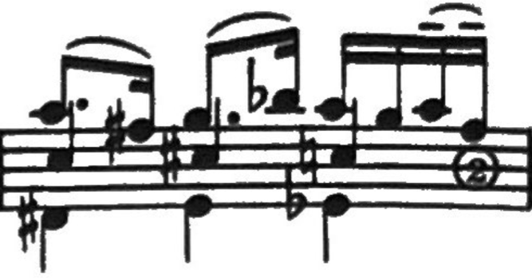
Figure 47. Adagio, m. 10: Galamian edition. Hooked bowing on last 16ths. 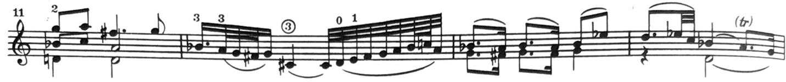
Figure 48. Adagio, mm. 11—14: Galamian edition. Setting up G minor cadence.

Conversely, the bowing works out in mm. 11—14 as written if the Adagio is begun up-bow. However, this sets up m. 6 for a down-bow on the downbeat, which most violinists play with an up-bow. Additionally, this would set up an awkward bowing in mm. 11—12, placing up-bows where the emphasis ought to be.
The bowings indicated in the cadences of m. 14 and m. 44 of the Galamian edition feature different bowings.
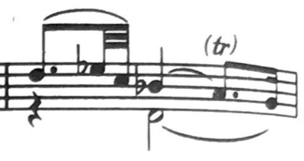
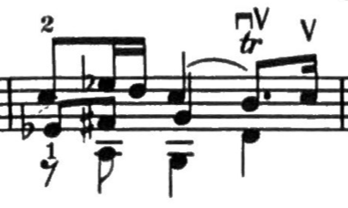
Figure 49. Adagio, m. 10 and m. 44: Galamian edition. Cadences featuring different bowing.

The Pine edition suggests the up bow only on the final 16th note of the figure.
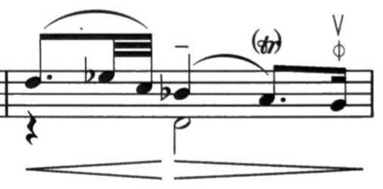
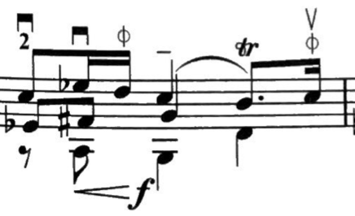
Figure 50. Adagio, m. 10 and m. 44: Pine edition. Identical bowings in both cadential points.

Interpreting the bowing in m. 14 edition Galamian’s edition identically to m. 44 would make the bowings of both Galamian and Pine editions line up in a couple key areas. These are, namely, the respective cadences at m. 22 and m. 27. Assuming one begins m. 15 down-bow (as indicated by the Pine edition, or executed based on aforementioned assumption by the Galamian edition), both editions execute the downbeats of m. 22 and m. 27 as up-bow and down-bow, respectively, albeit with different bowings in-between.
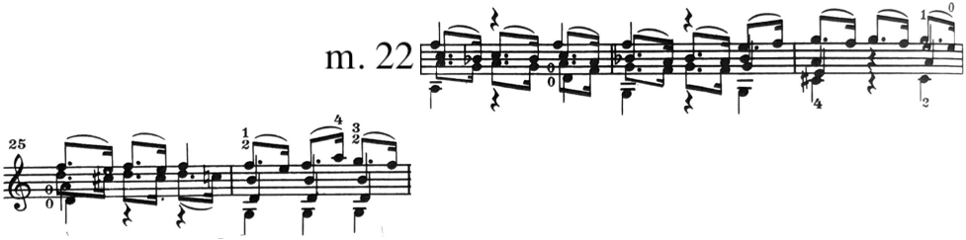
Figure 51. Adagio, mm. 22—27: Galamian edition.
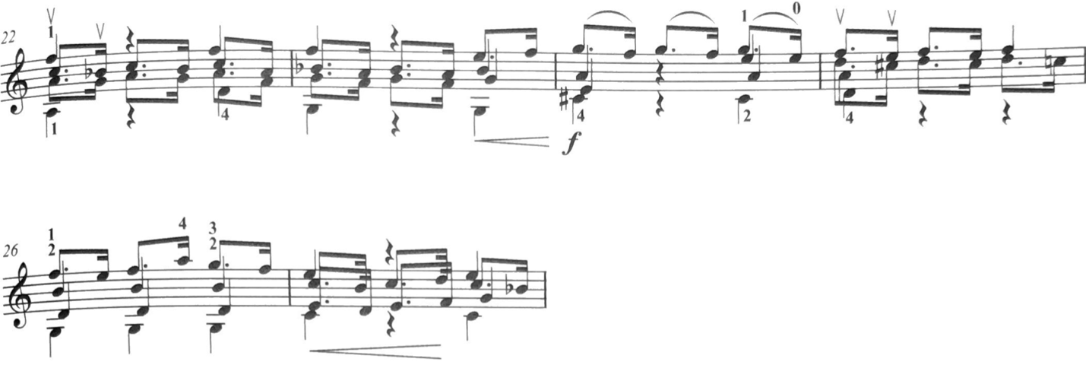
Figure 52. Adagio, mm. 22—27: Pine edition.

Despite a number of differences in bowings in the surrounding material, both Galamian and Pine have interpreted the bowing of the cadences at m. 22 and m. 27 similarly, indicating a general interpretive consensus. In short, Galamian and Pine interpret the m. 22 cadence holding less musical gravity to the cadence found in m. 27. This stands to reason: the cadence at m. 22 is a tonicization of the subdominant key of F Major, while the arrival at m. 27 marks a perfect authentic cadence in the tonic key of C Major.
The material following the half cadence in m. 34 of Adagio serves as another example of differences in bowing interpretation. Galamian slurs these figures outright, while Pine indicates a hooked 16th note at the end of each.
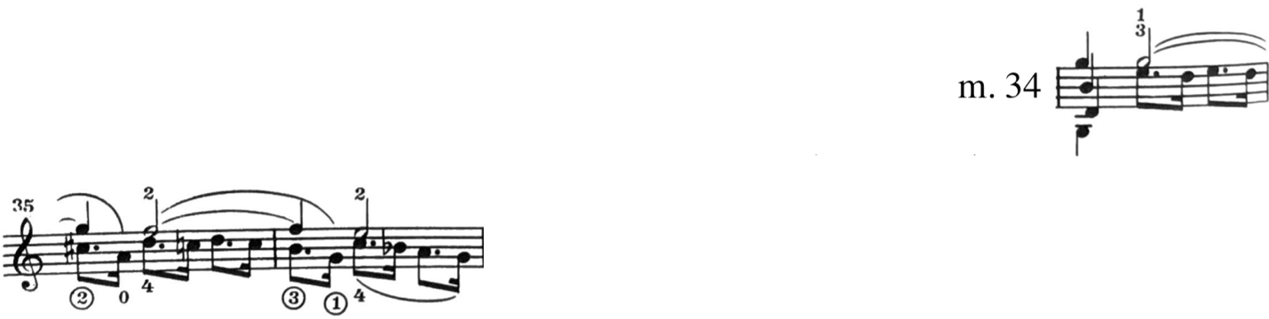
Figure 53. Adagio, mm. 34—36: Galamian edition.
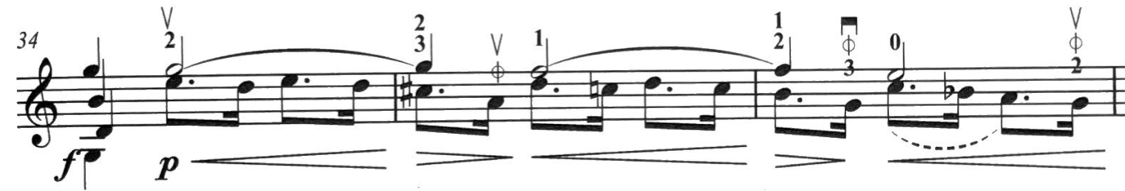
Figure 54. Adagio, mm. 34—36: Pine edition.

The autograph manuscript does indicate a slur in the figure in m. 36, however both Galamian and Pine bow this in the same manner as the previous two.
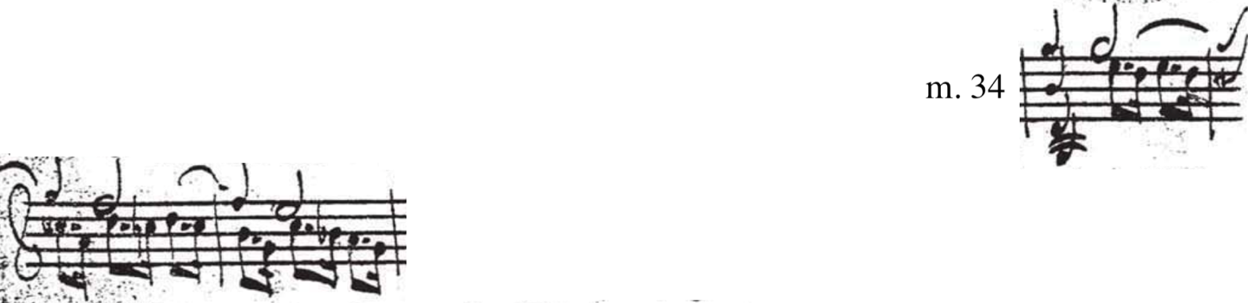
Figure 55. Adagio, mm. 34—36: Autograph manuscript.

This bowing could be interpreted literally, perhaps, if a crescendo was desired moving into the downbeat of m. 37.
The respective bowings in mm. 37—39 feature more noticeable differences. Both begin with a down-bow in the downbeat in m. 37. Galamian hooks the ostinato figures, while Pine’s edition follows the autograph manuscript. The result is a difference in bow direction at the arrival of m. 39: Galamian is down-bow, while Pine is up-bow. This arrival in m. 39 holds significance, as it sets the stage for the sudden tonal shift in m. 40. The direction of the bow indicates different ways of interpreting this chord, cadence, and phrase. Down-bow features a stronger arrival, while an up-bow would do the opposite.
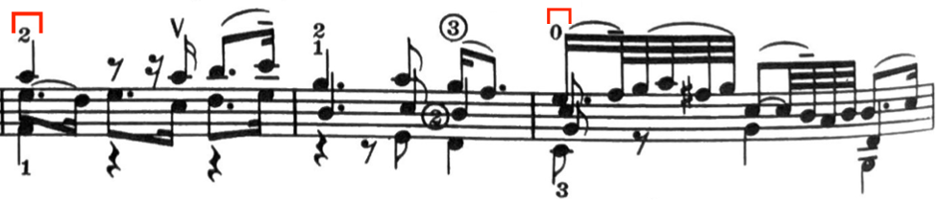
Figure 56. Adagio, mm. 37—39: Galamian edition.
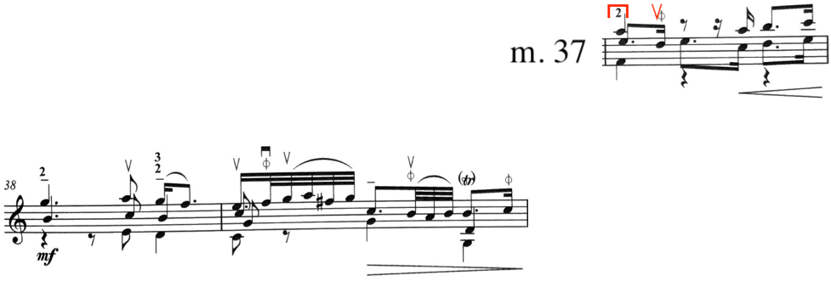
Figure 57. Adagio, mm. 37—39: Pine edition.

In mm. 43—47, Galamian slurs the ostinato figure while Pine indicates them separate. Pine follows the autograph at the cadence of mm. 44—45, and Galamian hooks the 16th notes in m. 46 when the original has them separate.

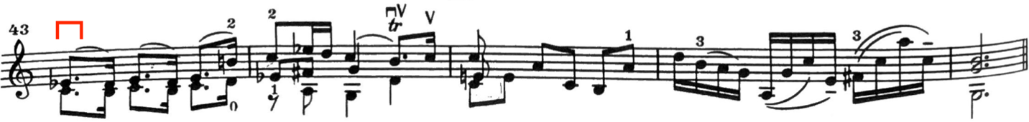
Figure 58. Adagio, mm. 43—47: Galamian edition.
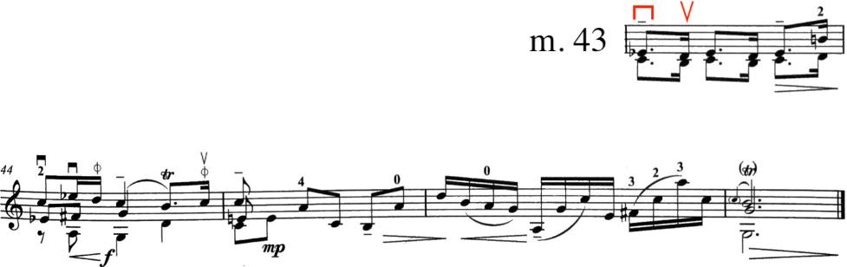
Figure 59. Adagio, mm. 43—47: Pine edition.

4.1.2: Adagio Fingerings

There is one instance of a parenthetical fingering supplied by Galamian, which occurs on the third beat of m. 29. The alternate fingering suggests a shift into second position for the chord on beat three.
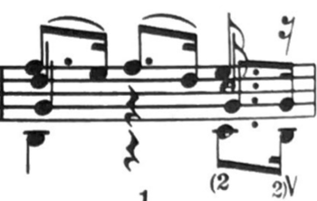
Figure 60. Adagio, m. 29: Galamian edition.

The first instance of a difference in fingering occurs in m. 3, where Galamian indicates an extended fourth finger to play the F-natural. Neither edition notates whether the 16th note E on the first and second beats of that same measure should be played with an open string or a fourth finger, although given Galamian’s tendency to avoid E string notes (especially open E string), it might be safe to assume that those E’s are intended to be played with a fourth finger.
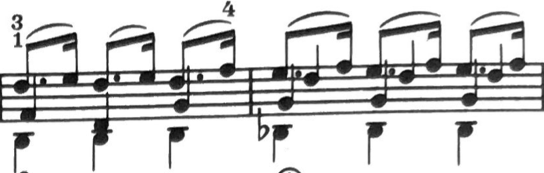
Figure 61. Adagio, mm. 3—4: Galamian edition.
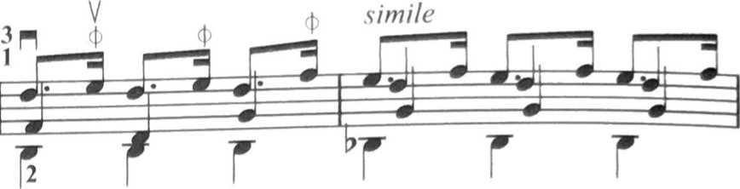
Figure 62. Adagio mm. 3—4: Pine edition.

M. 10 features a contracted second finger to play the F-sharp on the third beat of the measure in the Galamian edition. This avoids removing the first finger from the lowered position found on the beginning of that beat (E-flat) and allowing the first finger to play the B-flat found on the down-beat of m. 11. Pine’s edition has the first finger moving around.
Figure 63. Adagio, m. 10: Galamian edition.
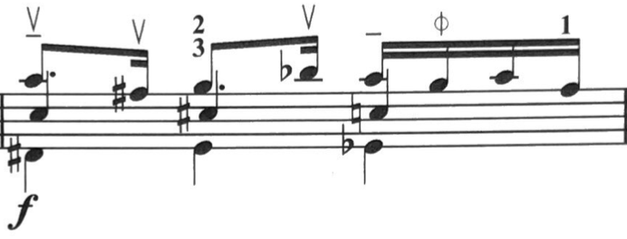
Figure 64. Adagio, m. 10: Pine edition.

M. 12 serves as the first instance where Galamian and Pine depart significantly from one another. The key feature of this measure is a fully diminished vii0/V. Galamian suggests third position with a gradual move back into first, while Pine remains in first position throughout. An upper position would provide a darker and richer sound, while first position would be clearer, brighter, and more resonant.
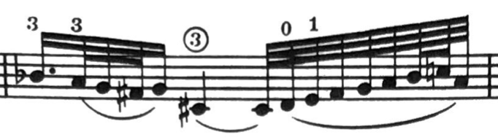
Figure 65. Adagio, m. 12: Galamian edition.
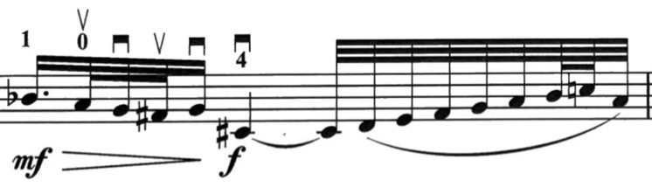
Figure 66. Adagio m. 12: Pine edition.

Mm. 19—20 serves as another point of interest. Galamian suggests second position, while Pine remains in first. Interestingly, Galamian and Pine’s respective fingerings for m. 20 are identical in concept, although opposite in execution. Both return to first position in m. 21.
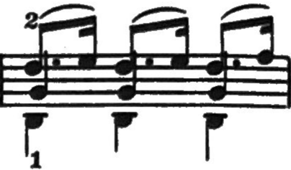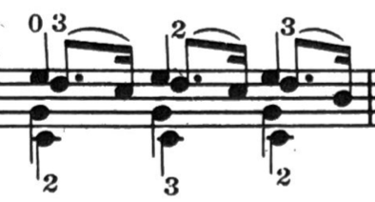
Figure 67. Adagio, mm. 19—20: Galamian edition.
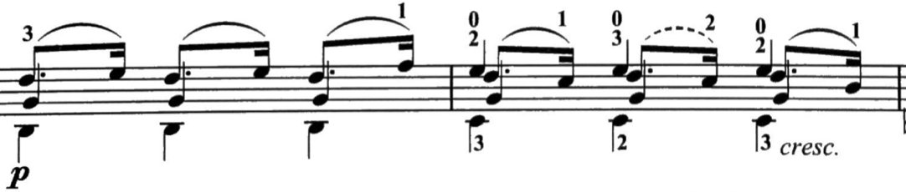
Figure 68. Adagio, mm. 19—20: Pine edition.

Pine indicates the third beat of m. 22 to use a fourth finger in order to cover the fifth of the bottom two voices of that chord. While this is difficult to execute, it stays true to the polyphony by keeping each voice separate by using separate strings. The Galamian edition suggests to use open strings instead. This is much easier to execute, while also providing more resonance. The same fingering suggestion occurs again in m. 25.
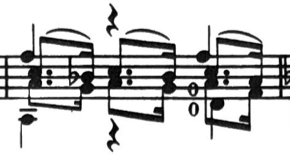
Figure 69. Adagio, m. 22: Galamian edition.
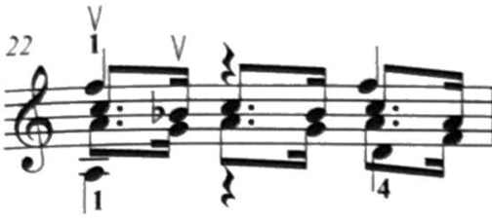
Figure 70. Adagio, m. 22: Pine edition.

In mm. 34—37, once again, Galamian suggests the use of a higher positions while Pine stays in first position. Galamian indicates second, fourth, third, and second positions, while Pine remains in first until m. 37, where she shifts into second position.
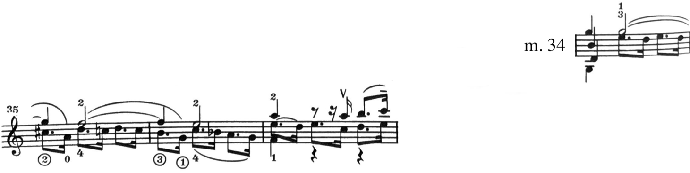
Figure 71. Adagio, mm. 34—37: Galamian edition.

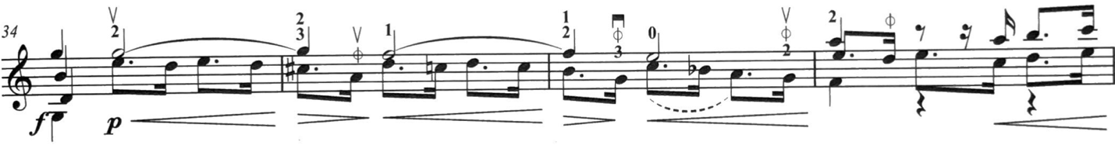
Figure 72. Adagio, mm. 34—37: Pine edition.

In m. 42, Pine remains in first position, while Galamian uses second position to play the diminished chord.
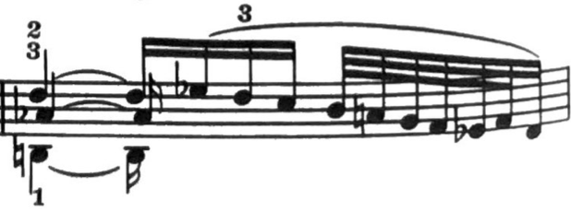
Figure 73. Adagio, m. 42: Galamian edition.
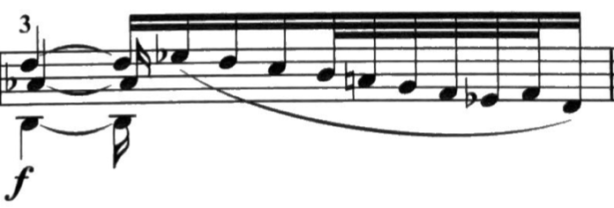
Figure 74. Adagio, m. 42: Pine edition.

Similarly, in mm. 45—46, Galamian suggests fourth position and third position, while Pine remains entirely in first position.
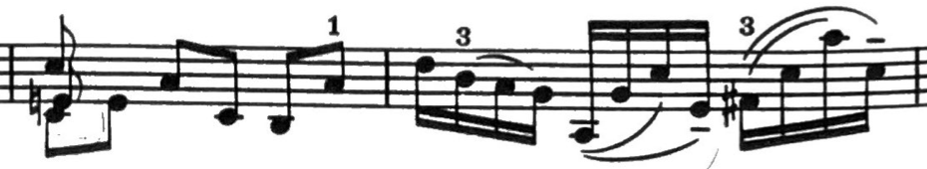
Figure 75. Adagio, mm. 45—46: Galamian edition.
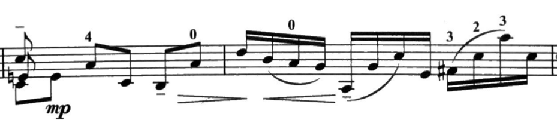
Figure 76. Adagio, mm. 45—46: Pine edition.

Chapter 4.2: Fuga

Not only is the Fuga from the Sonata No. 3 the longest fugue of the Sonatas and Partitas, but at 354 measures, it is the longest fugue written by Bach. This four-voice fugue is one of the most challenging movements from the Sonatas and Partitas. Seven pages stocked to the brim with double, triple, and quadruple stops: the opening Adagio is merely a warm-up for this fugue.
As previously discussed, the subject in the C Major Fuga derives from a chorale melody. Bach used this material in a number of other compositions, some of which being fugues.
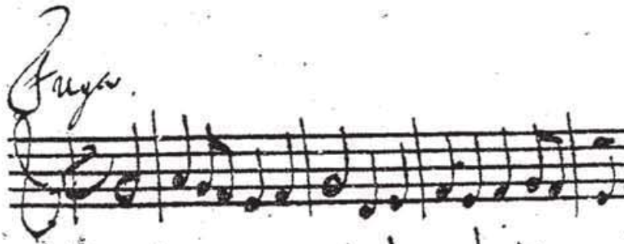
Figure 77. Fuga mm. 1—4: Autograph manuscript. Fugue subject.

Joseph Joachim famously championed the Sonatas and Partitas and brought them to the forefront of the solo violin repertoire. In 1890, Joachim performed the Sonata No. 3 in a recital, which received a brutal review by music critic Bernard Shaw.
“[Joachim] played Bach’s Sonata in C at the Bach Choir Concert at St. James’s Hall on Tuesday. The second movement of that work is a fugue three or four hundred bars long. Of course, you cannot really play fugue in three continuous parts on the violin; but by dint of double stopping and dodging from one part to another, you can evoke a hideous ghost of a fugue that will pass current if guaranteed by Bach and Joachim. That was what happened on Tuesday. Joachim scraped away frantically, making a sound after which an attempt to grate a nutmeg effectively on a boot sole would have been as the strain of an Aeolian harp. The notes which were musical enough to have any discernable pitch at all were mostly out of tune. It was horrible—damnable! Had he been an unknown player, introducing an unknown composer, he would not have escaped with his life. Yet we all—I no less than the others—were interested and enthusiastic. We applauded like anything; and he bowed to us with unimpaired gravity. The dignified artistic career of Joachim and the grandeur of Bach’s reputation had so hypnotized us that we took an abominable noise for the music of the spheres.”

In short, even the great Joseph Joachim struggled with the Fuga from the Sonata No. 3.

4.2.1: Fuga Bowings

As in any fugue, the interpretation of the subject lies at the very core of the artistic endeavor. Bowing choices, therefore, are of considerable importance. In general, it can be helpful to phrase fugue subjects similarly, so that their appearances may be more easily aurally detected by the listener. This holds especially true in the case of performing an unaccompanied fugue on a violin, where true polyphony isn’t technically possible. However, each entry of the subject presents its own unique circumstances and challenges, and sometimes requires different bowings.
The reasons for this are two-fold. First, the fugue subjects sometimes take slightly different forms, as indicated below.
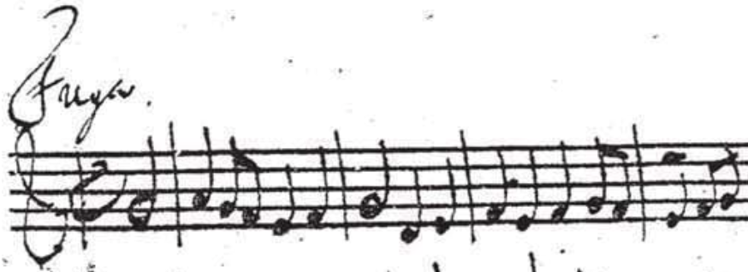
Figure 78. Fuga, mm. 1—4: Autograph manuscript. Fugue Subject.
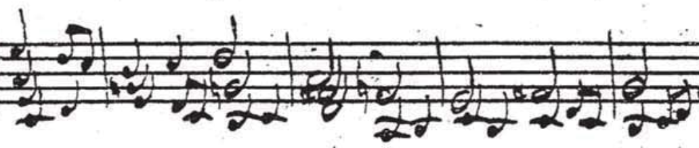
Figure 79. Fuga, mm. 109—113: Autograph manuscript. Subject found in lowest voice, featuring a stepwise pickup.

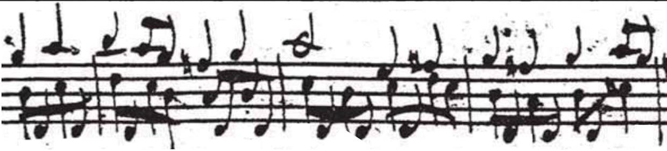
Figure 80. Fuga, mm. 186—190: Autograph manuscript. Stepwise pickup, and pedal D in lower voice.

Second, the voices surrounding the various subjects at times dictate their own unique bowings.
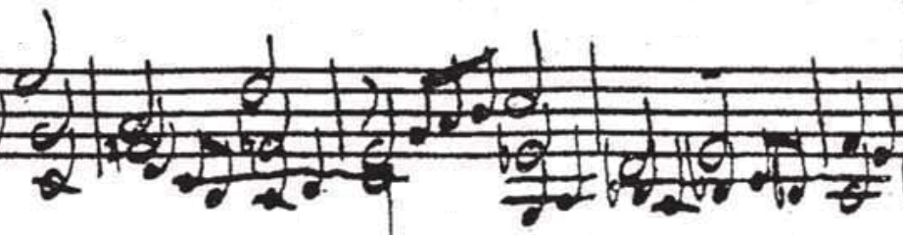
Figure 81. Fuga, mm. 24—28: Autograph manuscript. Subject in lowest voice.

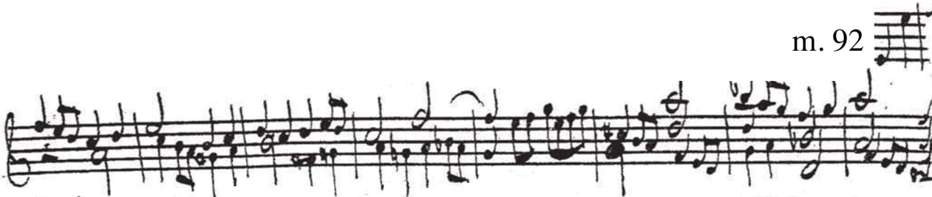
Figure 82. Fuga, mm. 92—97: Autograph manuscript. Use of stretto.

Pine’s edition begins the opening subject with an up-bow, placing emphasis on the downbeat of the first full measure, and again on the downbeat of m. 3.
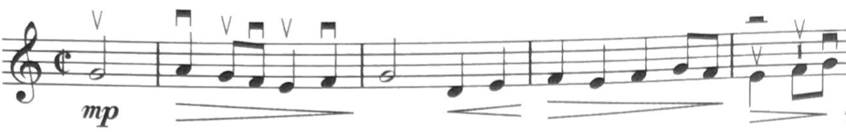
Figure 83. Fuga, mm. 1—4: Pine edition.

In contrast, Galamian’s version begins with a down-bow, thereby placing emphasis on the half-note pickup, the down-beat of m.2, and again on the down-beat of m. 4.
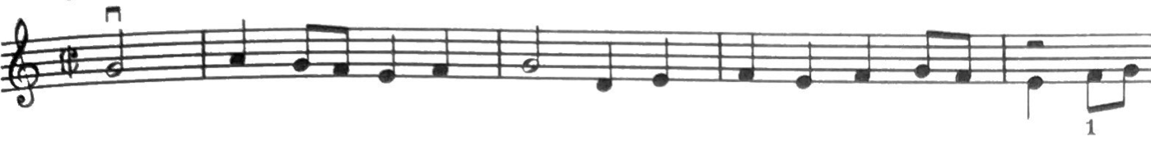
Figure 84. Fuga, mm. 1—4: Galamian edition.

No matter which direction is chosen, a problem arises in m. 5. The entrance of the subject in the second voice would begin with a bowing opposite of the original. To combat this, Pine’s edition hooks in the first eighth note on beat two of m. 4, so the second appearance of the subject would be executed identically to the first.
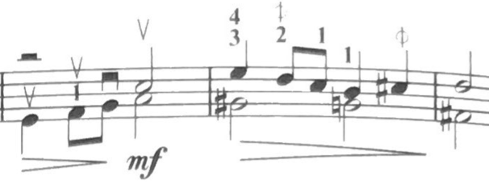
Figure 85. Fuga, mm. 4—6: Pine edition.

In contrast, Galamian’s edition features no hooked or otherwise modified bowing in the first four measures of the Fuga. Therefore, the second appearance of the fugue subject would be executed opposite to the first, starting up-bow.
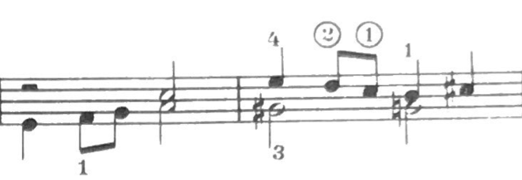
Figure 86. Fuga, mm. 4—5: Galamian edition.

Even though the surrounding material changes throughout the Fuga, Galamian and Pine generally stay consistent with their originally indicated bowing in the opening measures. Galamian emphasizes the half-note pickup and on the downbeat of m. 2, where Pine puts weight on the downbeats of m. 1 and m. 3. For Galamian, this means an up-bow on the downbeat of the first full measure, and for Pine, the contrary.
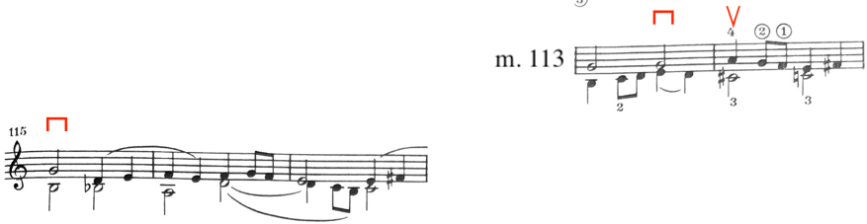
Figure 87. Fuga, mm. 113—117: Galamian edition.
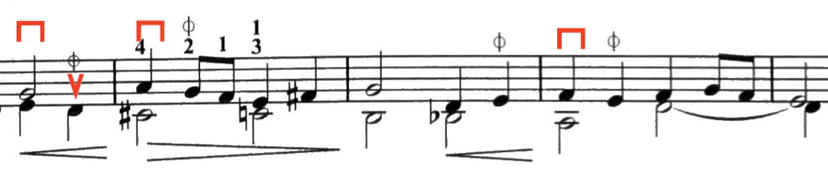
Figure 88. Fuga, mm. 113—117: Pine edition.

In m. 201, Bach introduces a new fugue subject. This new subject is just the original subject in retrograde: the intervals are written out oppositely. In other words, Bach creates a mirror-image of the original subject. In the score, Bach writes “al riverso” meaning “in reverse.”
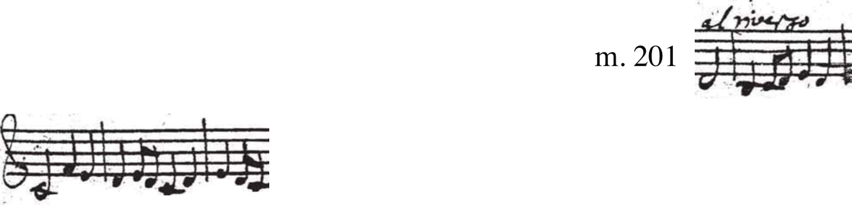
Figure 89. Second fugue subject “al riverso.” Fuga, mm. 201—205: Autograph manuscript.

The section that features the second fugue subject occurs from 201—273. Both Galamian and Pine bow this new subject identically to their respective bowings for the first subject.
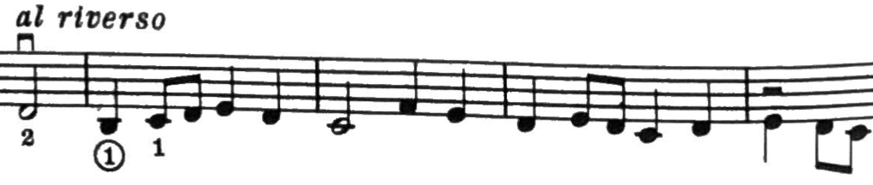
Figure 90. “al riverso” Fuga, mm. 201—205: Galamian edition.

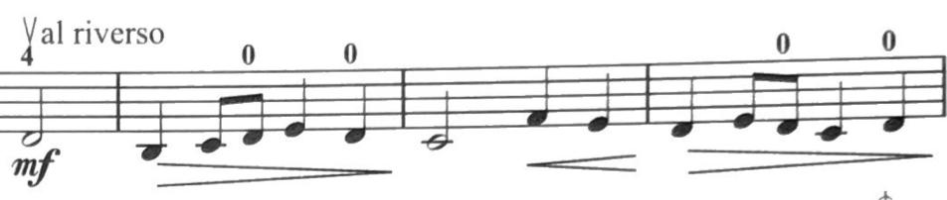
Figure 91. “al riverso” Fuga, mm. 201—205: Pine edition.

The bowings of the subsequent material introducing the voices (again) with the second subject follows the same landscape as the first subject: bowings may differ on a case-by-case basis, however key points of the implied phrasing remain consistent with each edition.
One case where the bowing was backwards from the first appearance of the second subject in m. 201 is found in m. 228. The surrounding material dictates that this subject entry be performed with backwards bowing (Galamian puts down-bow on the downbeat of 229, Pine puts up-bow).
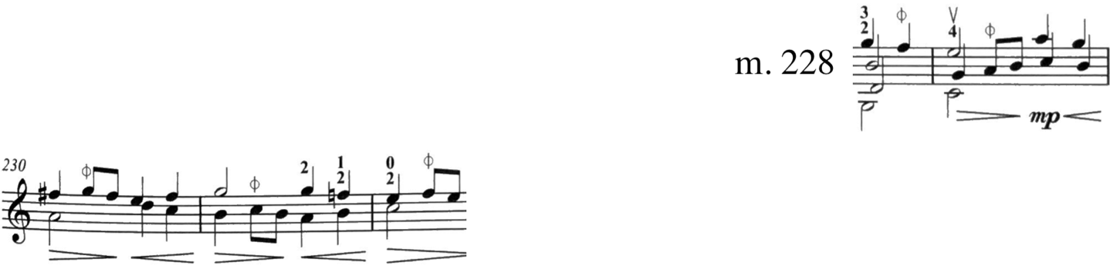
Figure 92. Backwards bowing. Fuga, mm. 228—232: Pine edition.
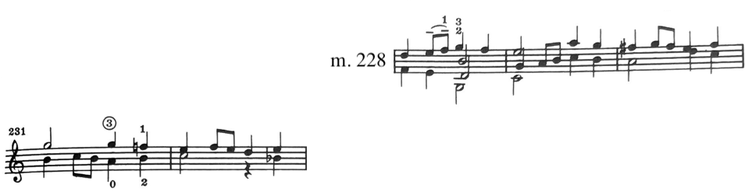
Figure 93. Fuga, m. 228—232: Galamian edition. Backwards bowing.

There are a number of instances in the Fuga where Galamian elects to use long slurs that are not indicated in the autograph manuscript. The first instance occurs in mm. 8—10. Galamian slurs in the bottom E, while Pine indicates they be separate up-bows.
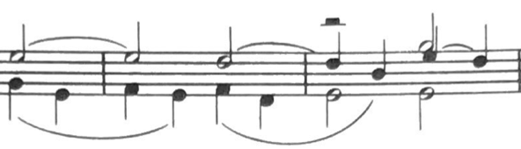
Figure 94. Fuga, mm. 8—10: Galamian edition.
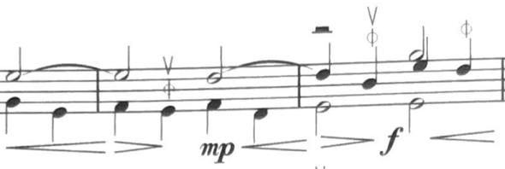
Figure 95. Fuga, mm. 8—10: Pine edition.

The same concept appears again in mm. 115—121.
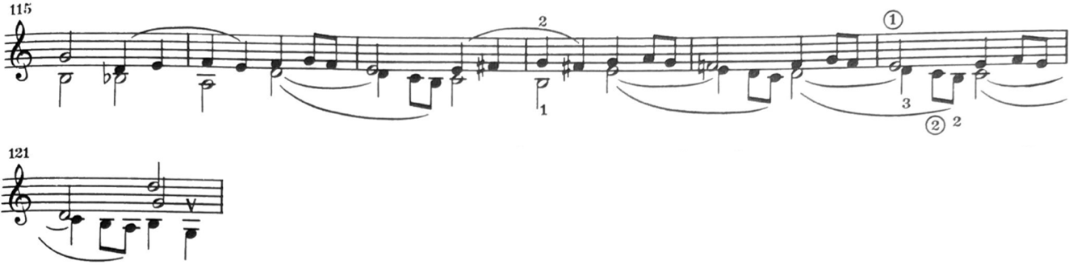
Figure 96. Fuga, mm. 115—121: Galamian edition.
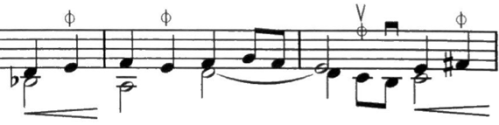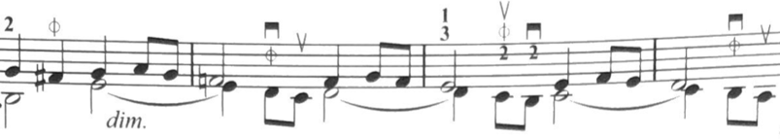
Figure 97. Fuga, mm. 115—121: Pine edition.

This idea repeats itself where a similar spot occurs in mm. 141—143.
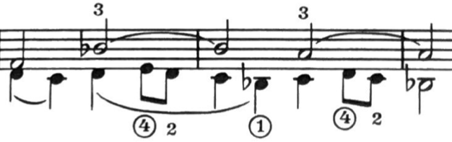
Figure 98. Fuga, mm. 141—143: Galamian edition.
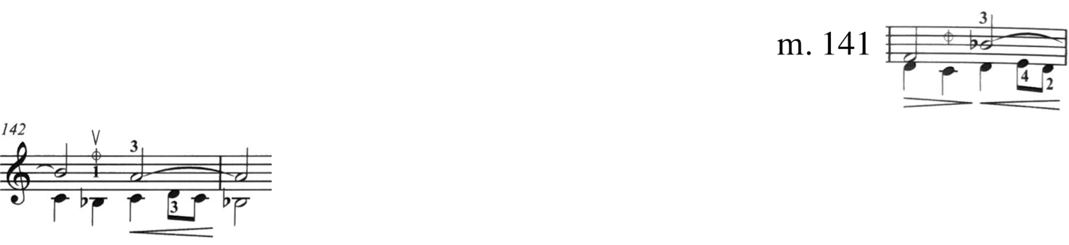
Figure 99. Fuga, mm. 141—143: Pine edition.

Again at mm. 149—152 the slurring reflects the different editor’s preferences: Galamian employing longer slurs and Pine retaining the original bowings from the autograph manuscript.
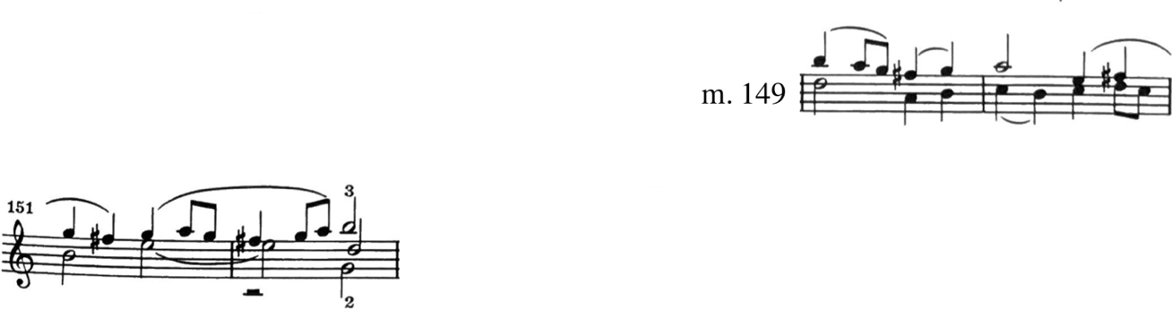
Figure 100. Fuga, mm. 149—152: Galamian edition.

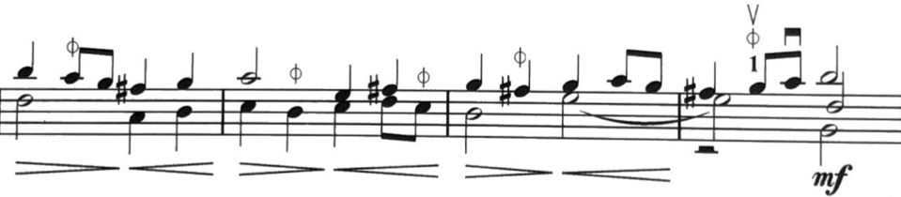
Figure 101. Fuga, m. 149—152: Pine edition.

Because the modern bow is better suited to execute chords on down-bows, much of Galamian’s bowing facilitates as many larger chords to be played with down-bow as possible. This is evidenced by the copious use of the hooked bows found throughout the Fuga. The hooked up-bows are not in the original manuscript, nor do they appear in Pine’s edition.

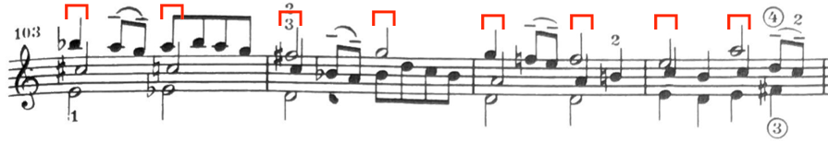
Figure 102. Fuga, mm. 103—106: Galamian edition.

Occasionally Galamian uses hooked bows for distribution purposes. One example occurs in mm. 88—89.
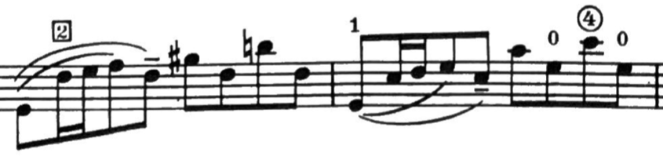
Figure 103. Fuga, mm. 88—89: Galamian edition.

Some bowings are designed to keep the bowing near the frog in order to execute other original bowings. One example occurs in mm. 69—70.

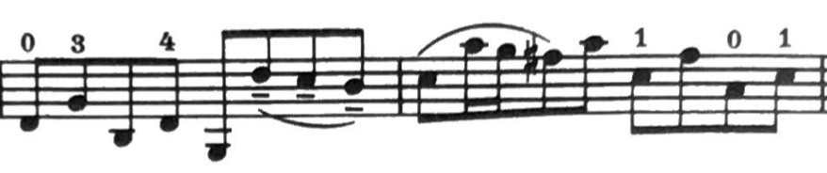
Figure 104. Fuga, mm. 69—70: Galamian edition.

One exception to the down-bow rule for chords comes in mm. 186—201. Galamian hooks a bowing in 186, forming up-bows on the double stops beginning in m. 186.
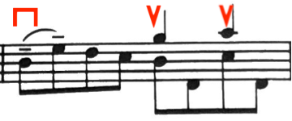
Figure 105. Fuga, m. 186: Galamian edition.

Galamian hooks another bowing in 193, moving the double stops to downbows. Galamian makes this change to place emphasis on the top of this line, reaching the top E.
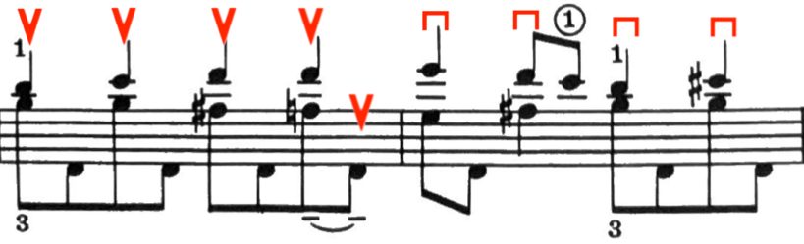
Figure 106. Fuga, mm. 193—194: Galamian edition. Bowing change via hooked bow.

This alternating bowing in mm. 186—201 obviously does not appear in the autograph manuscript, and therefore does not appear in the Pine edition.
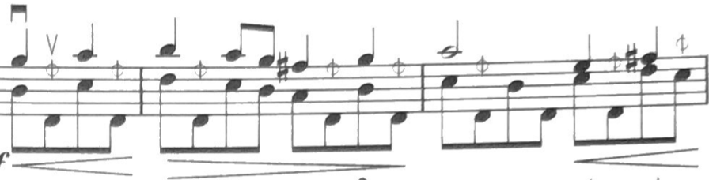
Figure 107. Fuga, mm. 273—275: Galamian edition. All down bow.

The autograph manuscript frequently features bowings throughout the Fuga that could produce awkward phrasing or bow distribution, which may necessitate some editing. One instance appears in mm. 12—16, where Galamian adds hooked up-bows on the last beats of m. 12 and m. 13 to set chords up for down-bows. The Pine edition plays the bowings as they come.
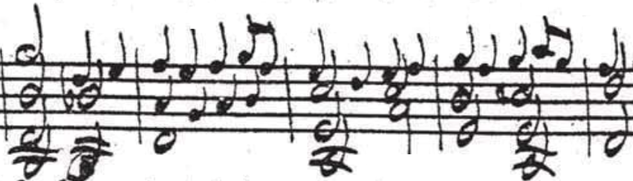
Figure 108. Fuga, mm. 12—16: Autograph manuscript.

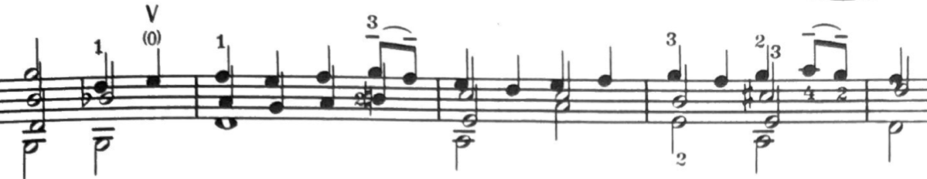
Figure 109. Fuga, mm. 12—16: Galamian edition.

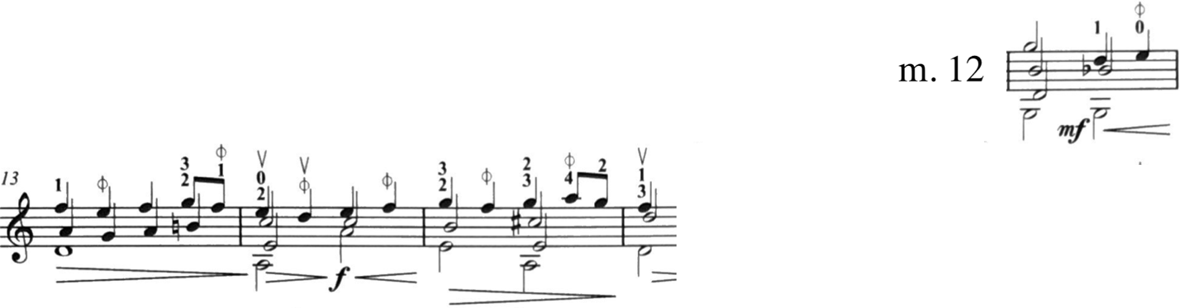
Figure 110. Fuga, mm. 12—16: Pine edition.

Another example occurs in mm. 59—61. Galamian uses two hooked up-bows on the third beat of mm. 59, where Pine places a down-bow on the second beat of m. 59.
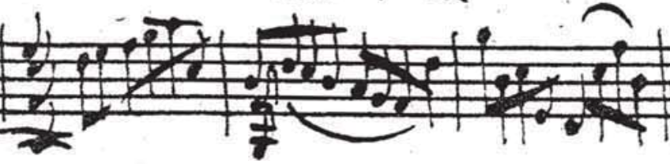
Figure 111. Fuga, mm. 59—61: Autograph manuscript. Unclear bowing.
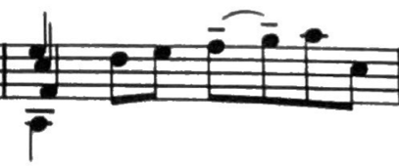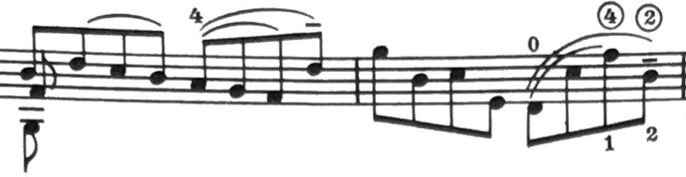
Figure 112. Fuga, mm. 59—61: Galamian edition.
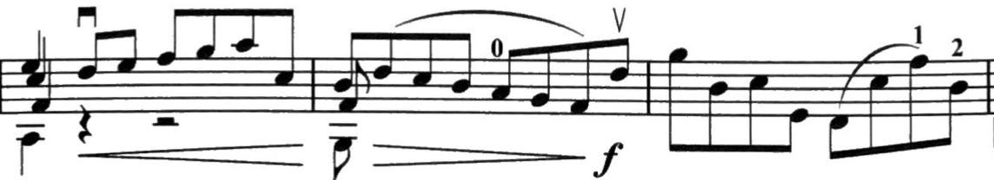
Figure 113. Fuga, mm. 59—61: Pine edition. Downbow on second beat of m. 59. Hooked in D in m. 60.

Furthermore, there are many instances of Galamian using different slurring and hooked bowings than originally prescribed by the autograph manuscript. The Pine edition nearly always uses the bowings indicated by the autograph manuscript.
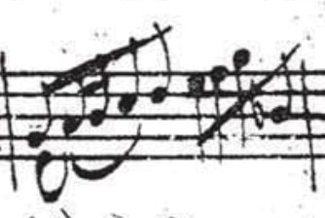
Figure 114. Fuga, m. 42: Autograph manuscript.
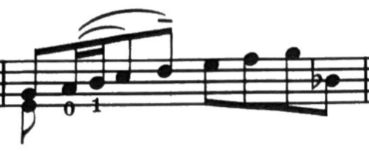
Figure 115. Fuga, m. 42: Galamian edition. Hooked in D.
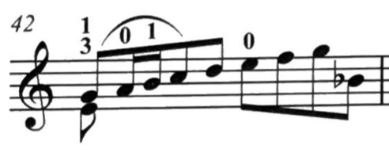
Figure 116. Fuga, m. 42: Pine edition. Slurred in chord.

At the return of the first subject in its original form in m. 288, Bach repeats the first 65 measures of material from the opening of the Fuga. This material is identical except for the first eight measures (mm. 288—296), where Bach adds additional voices that were not present in mm. 1—8. Following m. 296, the material is identical. Both the Galamian and Pine editions feature slightly modified bowings in mm. 288—296.
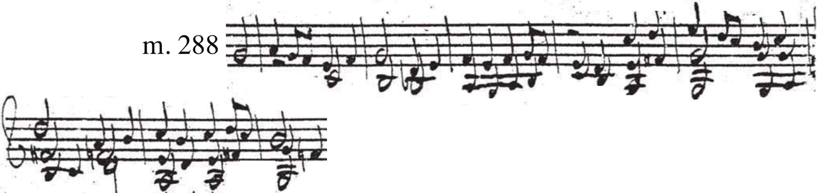
Figure 117. Fuga, mm. 288—296: Autograph manuscript.

In m. 293, Galamian hooks the two eighth notes on the second beat, so that more triple stops would be executed with down-bows.
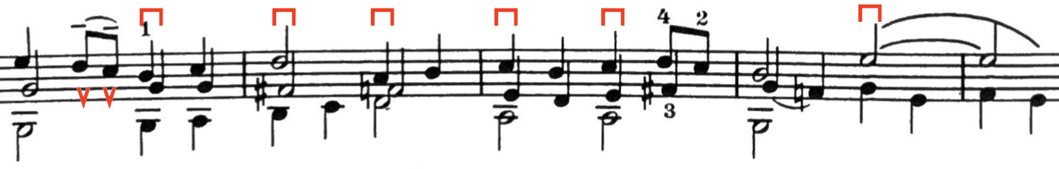
Figure 118. Fuga, mm. 293—297: Galamian edition.
The same bowing issue that occurs in the Galamian edition at m. 4 (the second entry of the subject) occurs again in the repeat of the opening material at m. 288. This would place down-bow on the downbeat of m. 293, contrary to his typical phrasing. As was the case in m. 5 of the Pine edition, the bowing of the subjects is consistent between the subject entries in m. 288 and m. 293.
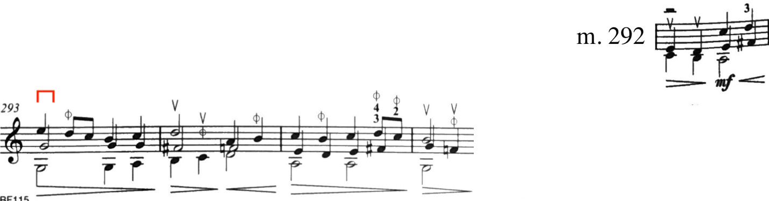
Figure 119. Fuga, mm. 292—296: Pine edition.

4.2.2: Fuga Fingerings

Much like the Adagio, Galamian tends to use a wider variety of positions in the Fuga, where Pine usually plays in first position. However, in general, the Galamian and Pine editions tend to agree on many fingerings throughout, particularly in passages that feature heavy chromaticism. One example of this can be observed in mm. 174—178.
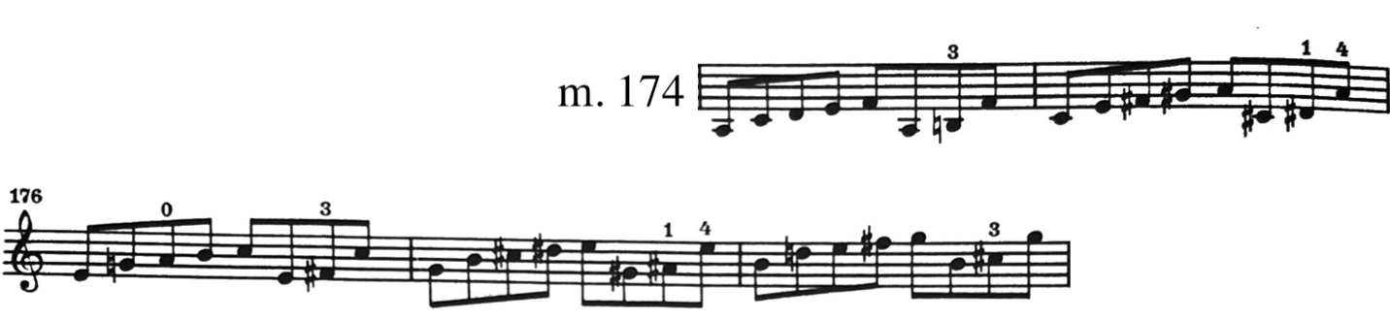
Figure 120. Fuga, mm. 174—178: Galamian edition.
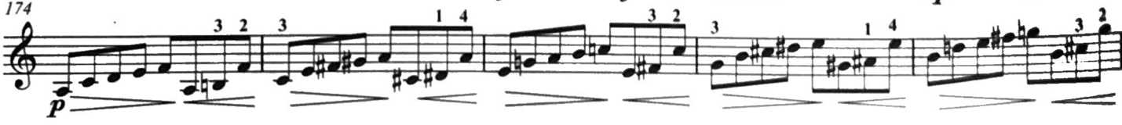
Figure 121. Fuga, mm. 174—178: Pine edition.

M. 11 serves as one example of a difference. Galamian uses half position or contracted third and fourth fingers for the top notes of the quadruple stop on the down-beat, where Pine uses standard first position and moved the second finger down for the G on the second beat.
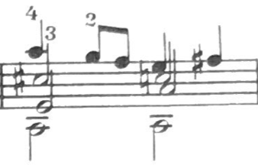
Figure 122. Fuga, m. 11: Galamian edition.
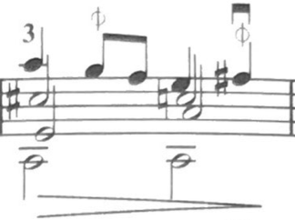
Figure 123. Fuga, m. 11: Pine edition.

M. 20 begins the first episode, and Galamian is in 3rd position, while Pine remains in first. The same ideas occur at the beginning in m. 34.
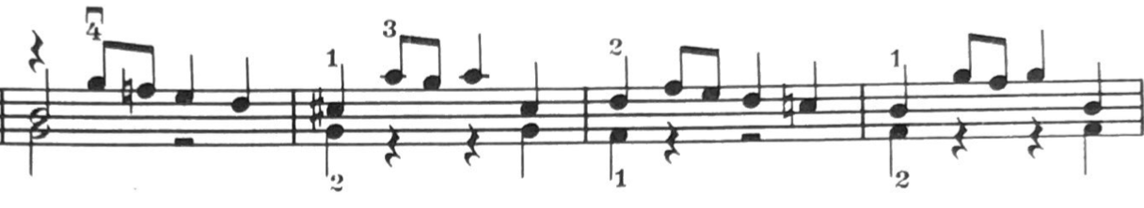Figure 124. Fuga, mm. 20—23: Galamian edition.
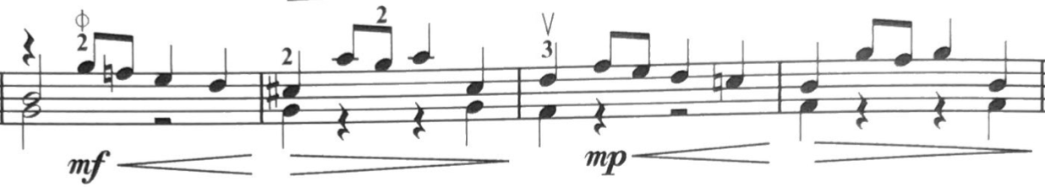
Figure 125. Fuga, mm. 20—23: Pine edition.

Mm. 60—62 uses and extension and contraction right next to one another in the Galamian edition, as to avoid the E-string. Pine uses half position, which is the parenthetical alternate fingering provided below the staff in the Galamian edition.
Galamian features a shift into 2nd position on the fourth beat on m. 43, then returning to first position on the downbeat of m. 44.
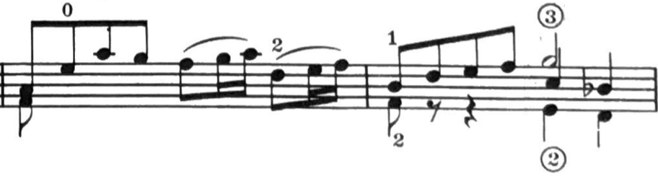
Figure 126. Fuga, mm. 43—44: Galamian edition.

The Pine edition stays in first position throughout m. 43 and moves into half position for the tritone on the downbeat of m. 44.
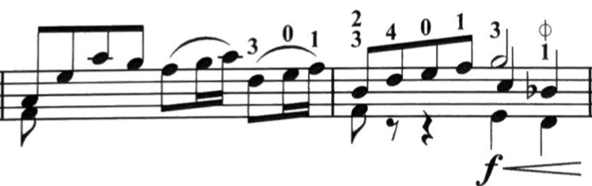
Figure 127. Fuga, mm. 43—44: Pine edition.

M. 68—71 feature the use of upper positions in the Galamian edition, where the Pine edition remains in first throughout.
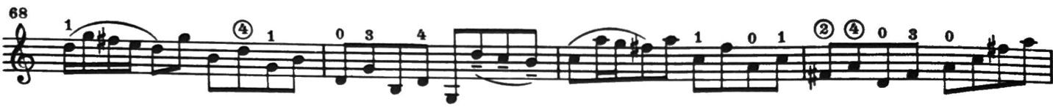
Figure 128. Fuga, mm. 68—71: Galamian edition.
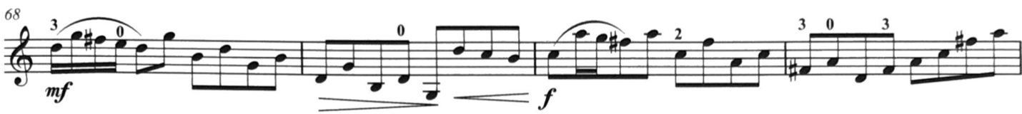
Figure 129. Fuga, mm. 68—71: Pine edition.

In mm. 84—87, Galamian shifts on the downbeat of each measure as the figures successively ascend, where Pine remains in first position and utilizes a lowered fourth finger to execute the G-sharp.
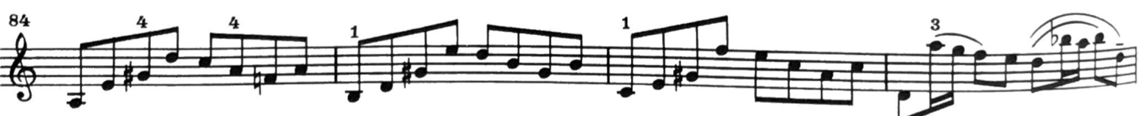
Figure 130. Fuga, mm. 84—87: Galamian edition.
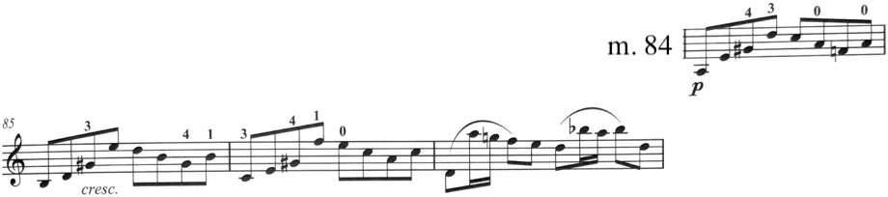
Figure 131. Fuga, mm. 84—87: Pine edition.

In m. 88, Galamian uses second position to eliminate a string crossing, where Pine remains in first position. Mm. 89—90 feature the same fingering throughout both editions, but
m. 91 serves as an example of the different fingerings of a diminished arpeggio. Galamian uses low four—one—(shift) one—three—four—four, while Pine executes this same measure with a shift into fourth position on the fourth beat of m. 91: low four—one—three—(shift) two—three—four.
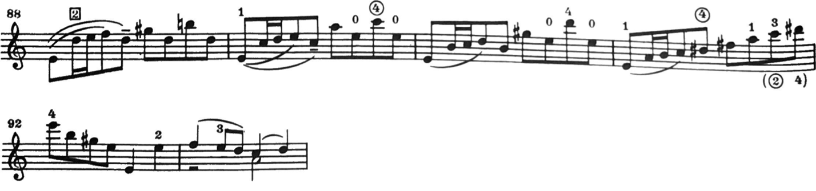
Figure 132. Fuga, mm. 88—93: Galamian edition.

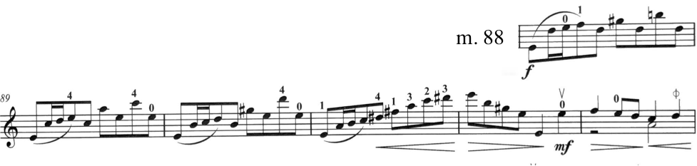
Figure 133. Fuga, mm. 88—93: Pine edition.

Galamian also makes use of upper positions in mm. 107—111. Additionally, the downbeat of m. 110 features a root-position E Major triad, where Galamian uses four—two—one, the first finger being the extension. Pine’s fingering for the E Major triad is similar but uses a third finger on the G-sharp, thereby making the fourth finger the extension.
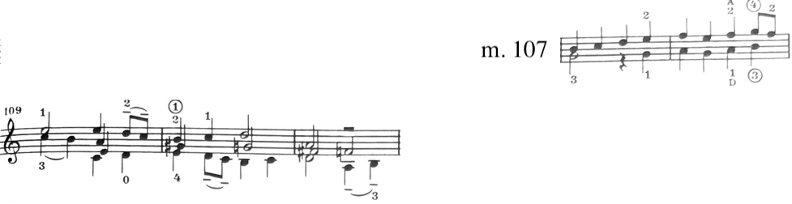
Figure 134. Fuga, mm. 107—111: Galamian edition.
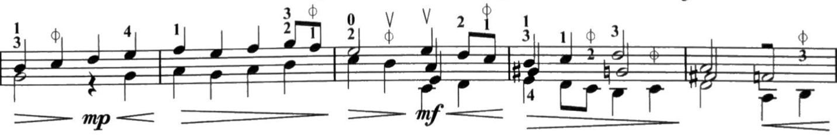
Figure 135. Fuga, mm. 107—111: Pine edition.

One instance where the fingering is identical occurs on the downbeat of m. 158, where fingered octaves are necessary.
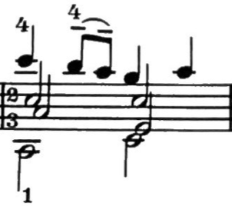
Figure 136. Fuga, m. 158: Galamian edition.
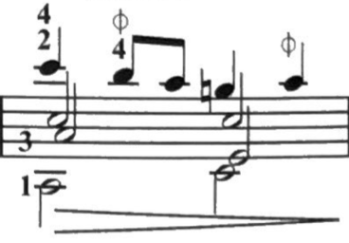
Figure 137. Fuga, m. 158, Pine edition.

Mm. 169—171 feature more upper position use in the Galamian edition, where the edition indicates ascending stepwise through first, second, and third positions before returning to third position. Pine’s edition briefly uses second position in m. 169 to execute the tritone but remains in first afterwards.
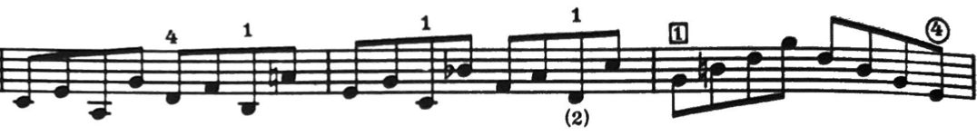
Figure 138. Fuga, mm. 169—171: Galamian edition.
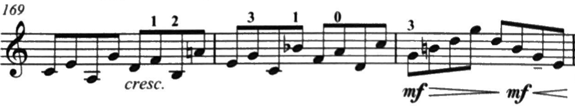
Figure 139. Fuga, mm. 169—171: Pine edition.
Similarly, in mm. 183—185 Galamian ascends positions, while Pine remains in first position.
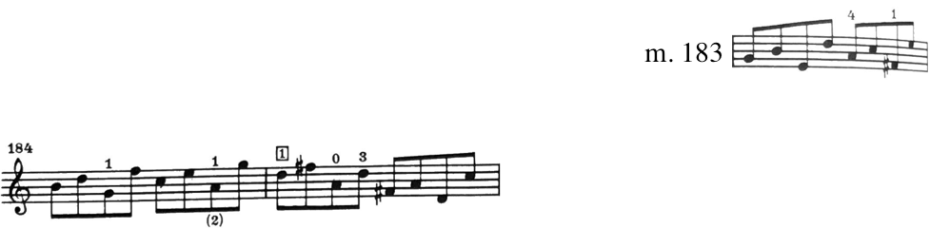
Figure 140. Fuga, mm. 183—185: Galamian edition.
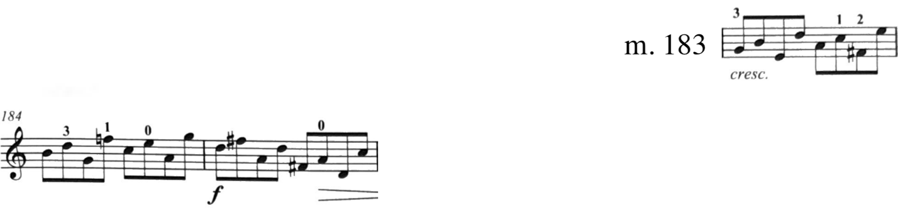
Figure 141. Fuga, mm. 183—185: Pine edition.

M. 195 features different shifts from fourth position into third position, where Galamian shifts on the downbeat, Pine shifts on beat three.
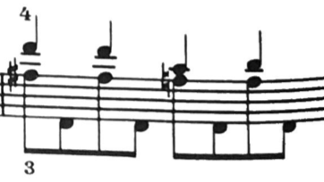
Figure 142. Fuga, m. 195: Galamian edition.
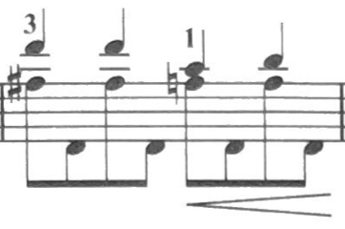
Figure 143. Fuga, m. 195: Pine edition.

This same idea occurs again in m. 282.
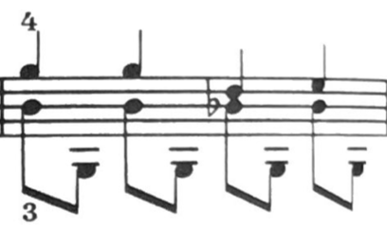
Figure 144. Fuga, m. 282: Galamian edition.
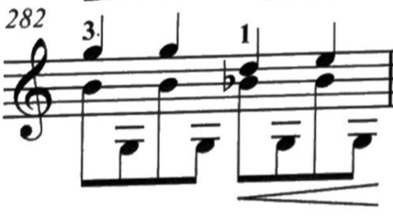
Figure 145. Fuga, m. 282: Pine edition.

Galamian begins the “al riverso” (m. 202) in third position with an extension first finger on the downbeat of m. 203, where pine remains in first position.
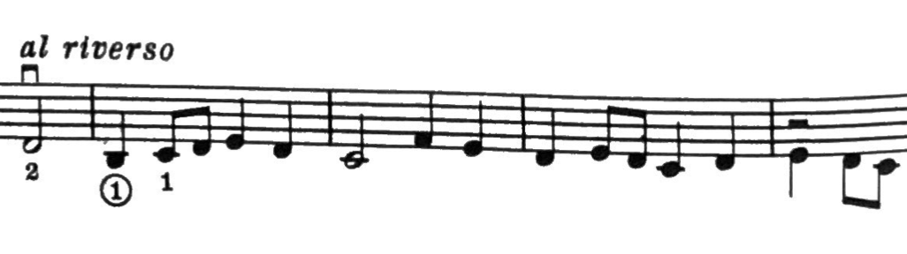
Figure 146. Fuga, mm. 202—206: Galamian edition.
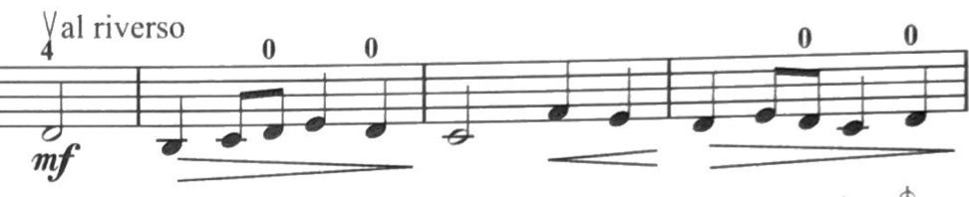
Figure 147. Fuga, mm. 202—206: Pine edition.

Similarly, Galamian begins the passage from m. 245—249 in third position, where Pine begins this in first position.
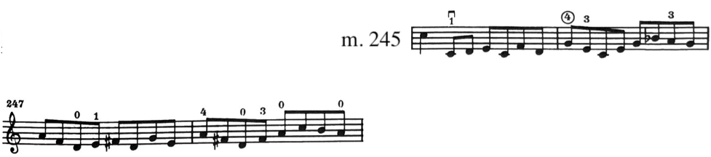
Figure 148. Fuga, mm. 245—249: Galamian edition.
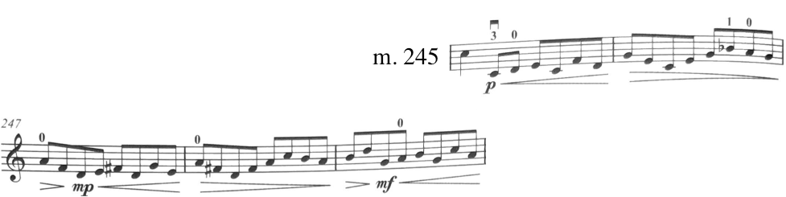
Figure 149. Fuga, mm. 245—249, Pine edition.

The passage in mm. 259—268, feature different ways of ascending and descending. Both editions shift on the beginning of each measure from mm. 259—261. While Galamian continues this pattern through m. 263, Pine’s edition begins shifting on the second 8th note of mm. 262—263. Both editions descend from m. 264 similarly, although Galamian uses the first finger as the point of shifting where Pine uses the third finger in m. 264 as the shifting finger. Galamian’s parenthetical fingering on the third beat of m. 265 is identical to the fingering indicated in Pine’s edition.
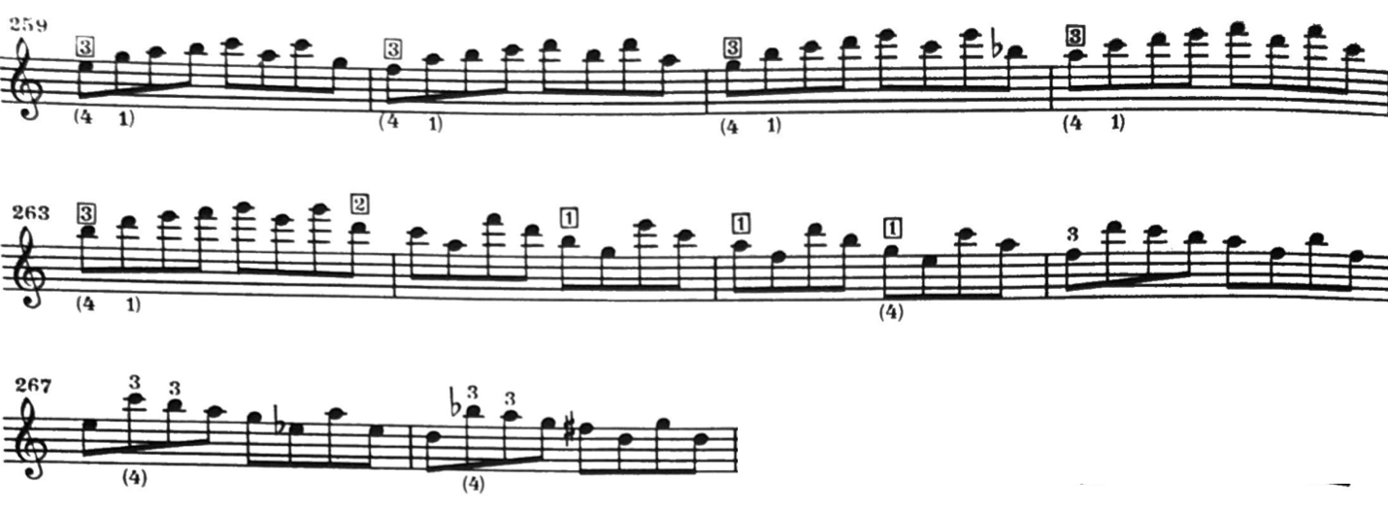
Figure 150. Fuga, mm. 259—268: Galamian edition.
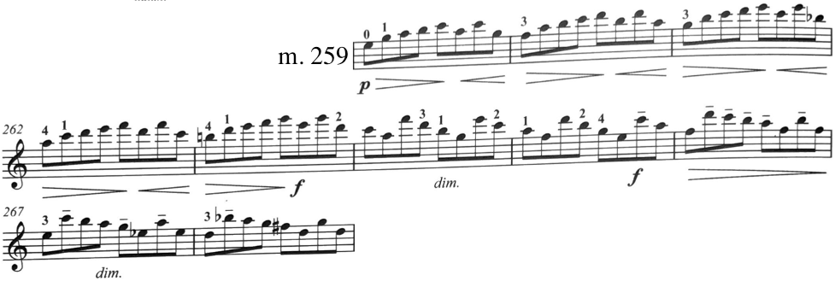
Figure 151. Fuga, mm. 259—268: Pine edition.

The beginning measures of the repeat or Da Capo feature different voicing that the exposition found in mm. 1—8, and therefore a couple different fingerings in the editions.
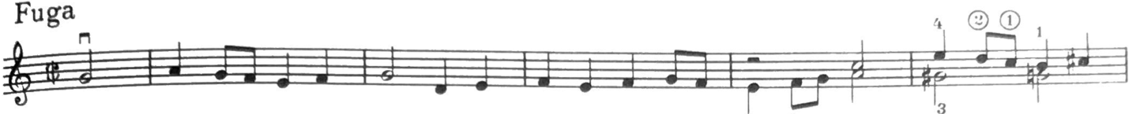
Figure 152. Fuga, mm. 1—5: Galamian edition.

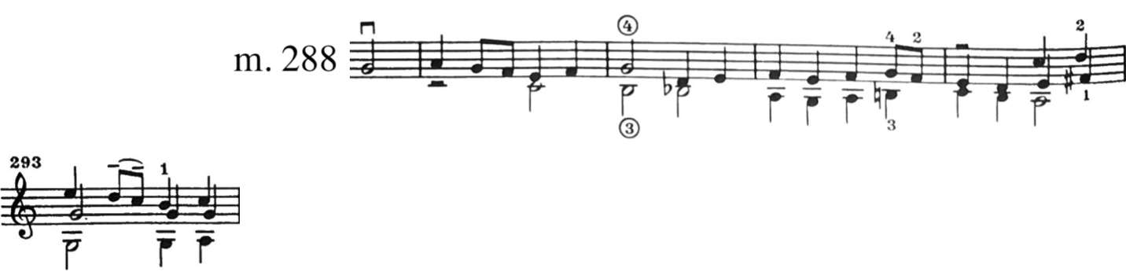
Figure 153. Fuga, mm. 288—293: Galamian edition.

In this same passage, the Pine edition features just one alteration, which occurs in mm. 292—293.
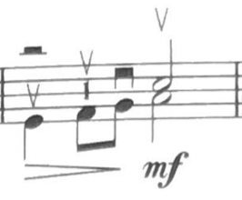
Figure 154. Fuga, m. 4: Pine edition. 2nd position.
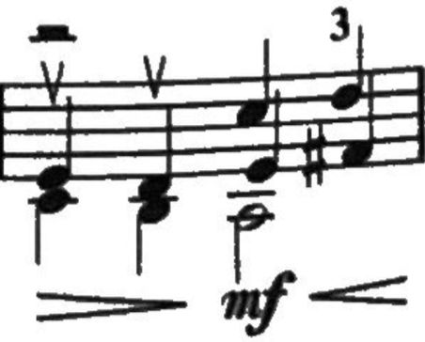
Figure 155. Fuga, m. 292: Pine edition. First position.

One fingering style used by Galamian often throughout the Fuga is either extended or contracted fourth fingers. M. 73 serves as an example where these both occur.
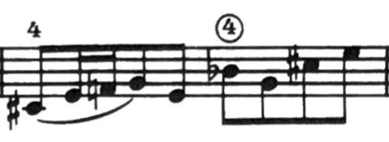
Figure 156. Fuga, mm. 73: Galamian edition.
Chapter 4.3: Largo

Largo does not employ as many multi-stop chords as the first two movements of this Sonata. The texture can be described as homophonic, an upper melody accompanied by chords below.
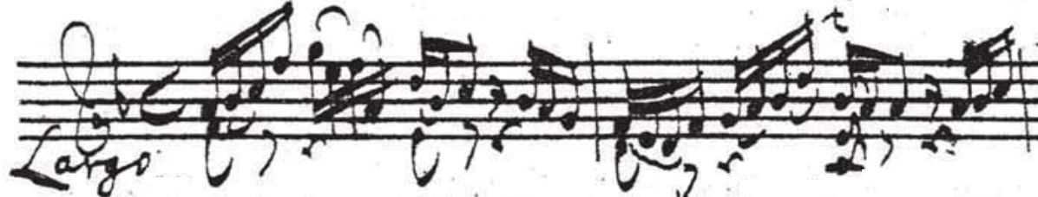
Figure 157. Largo, mm. 1—2: Autograph manuscript.

In general, both editions seem to prefer a more legato and connected sound. Galamian produces this by adding longer slurs than originally indicated; the baroque bow can do so without much editing; therefore, Pine’s edition remains closer to the autograph manuscript.
The revolutionary music theorist Heinrich Schenker (1868—1935) himself produced an analysis of this movement.

4.3.1: Largo Bowings

There are two instances of parenthetical bowings added in the Galamian edition. These optional bowings would produce a more legato sound, while using bowings that the autograph manuscript indicates in other areas of Largo. The Pine edition observes separate bows in these spots.
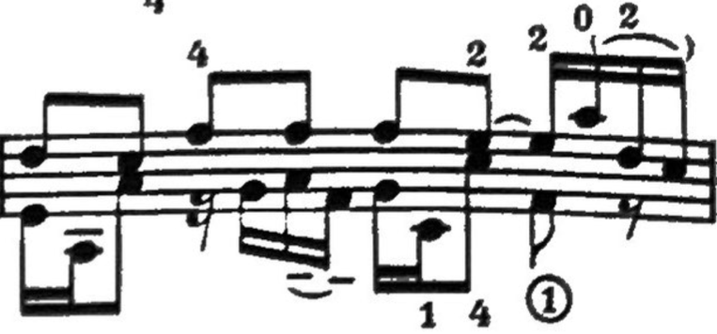
Figure 158. Largo, m. 5: Galamian edition.

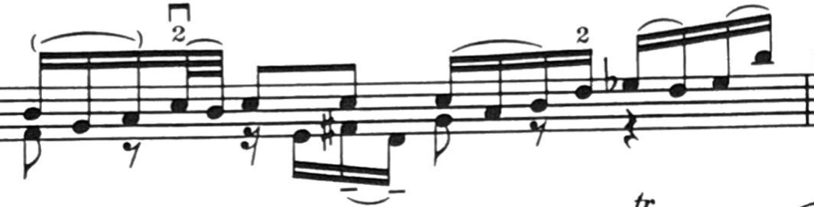
Figure 159. Largo, m. 10: Galamian edition.

Several instances of added hooked bowings appear in the Galamian edition. Galamian employs hooked up-bows in place where separate bows were indicated by the autograph manuscript.
Mm. 1—2 of Largo feature the same rhythm and bowing in each measure. In the final three 16th notes of each measure, Galamian begins the figure with down-bow, hooking the final two 16th notes up-bow. Pine elects to begin the same figure up-bow, which does not necessitate any further changes.
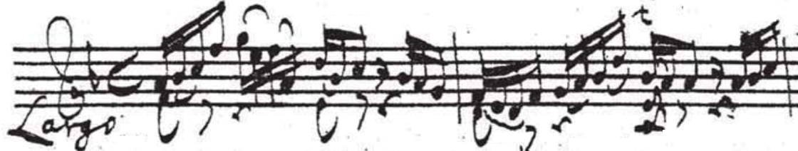
Figure 160. Largo, mm. 1—2: Autograph manuscript.
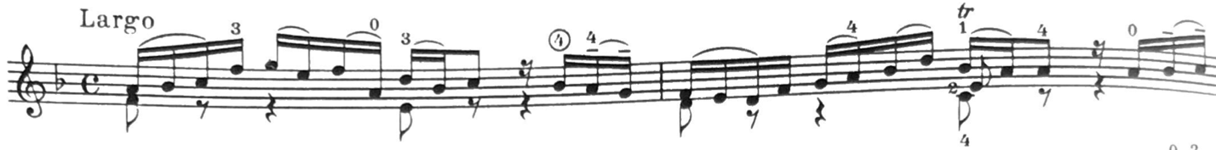
Figure 161. Largo, mm. 1—2: Galamian edition.
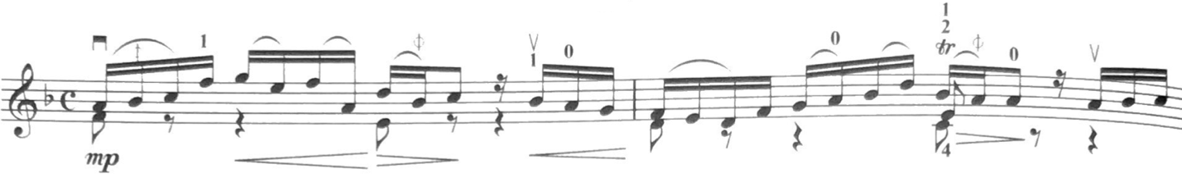
Figure 162. Largo, mm. 1—2: Pine edition.

Similar bowing decisions are made in mm. 9—10. Galamian hooks the final two 16th notes of this figure, while Pine plays them separately as they come.
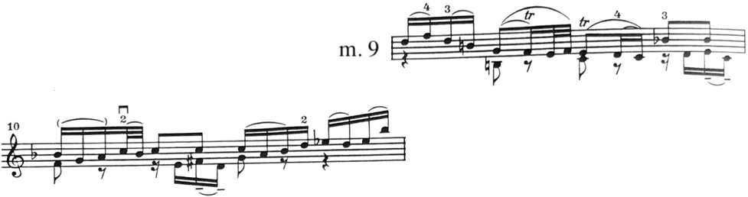
Figure 163. Largo, mm. 9—10: Galamian edition.
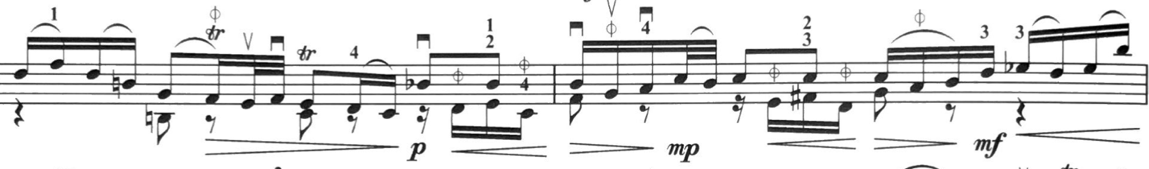
Figure 164. Largo, mm. 9—10: Pine edition.

In mm. 3—4, Galamian writes hooked up-bows on the last three 16th notes of the measure, while the Pine edition indicates to play the bowing as it comes.
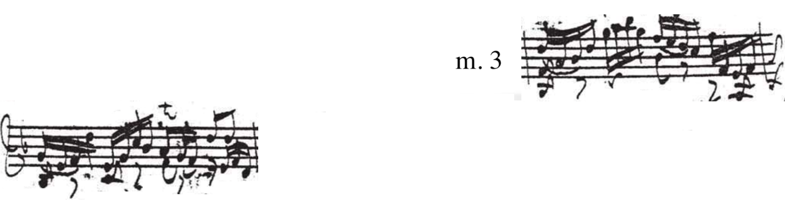
Figure 165. Largo, mm. 3—4: Autograph manuscript.
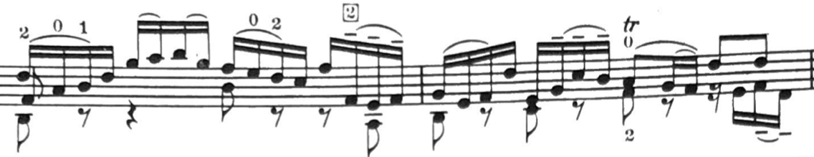
Figure 166. Largo, mm. 3—4: Galamian edition.
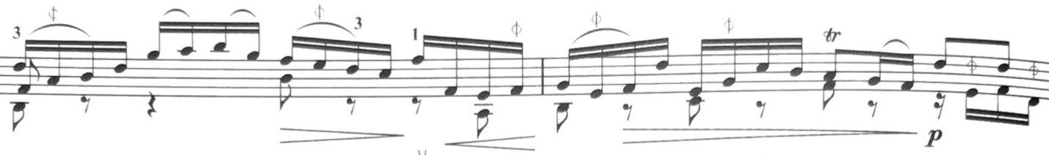
Figure 167. Largo, mm. 3—4: Pine edition.
Although the cadential material found in mm. 7—8 and mm. 17—18 are nearly identical, the autograph manuscript features inconsistent bowings. M. 8 of the autograph is played with separate bows, while m. 17 contains slurred notes. The Pine edition is consistent in following the indicated bowings from the autograph manuscript.
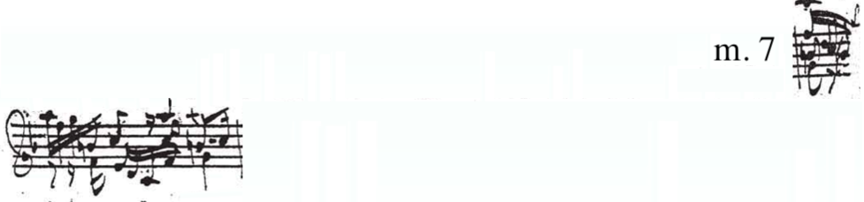
Figure 168. Largo, m. 7: Autograph manuscript.

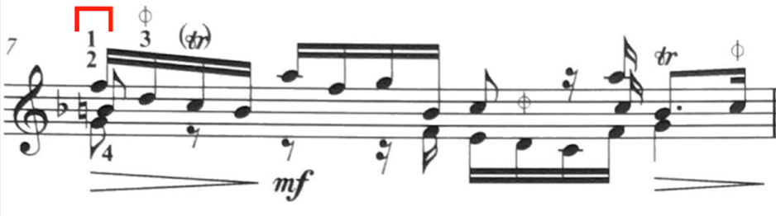
Figure 169. Largo, m. 7: Pine edition.
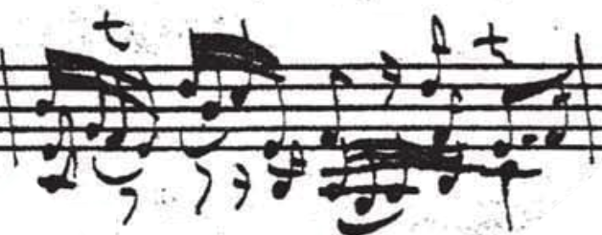
Figure 170. Largo, m. 17: Autograph manuscript.
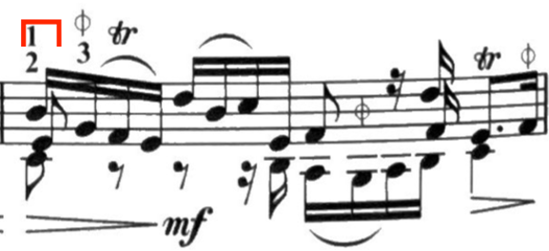
Figure 171. Largo, m. 17: Pine edition.

In contrast, Galamian provides identical bowings for both these measures, which resembles the bowing found in the autograph manuscript in m. 17. Although, he adds hooked bowings on the second and fourth beats, which sets up a downbow on the triple stop of the fourth 16th note on the third beat.
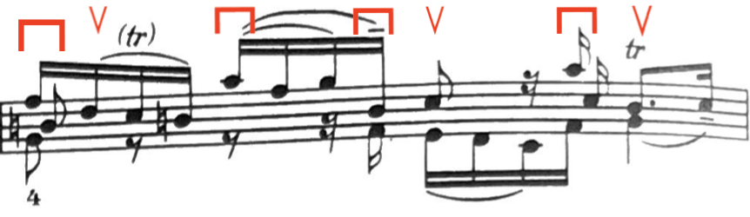
Figure 172. Largo, m. 7: Galamian edition.
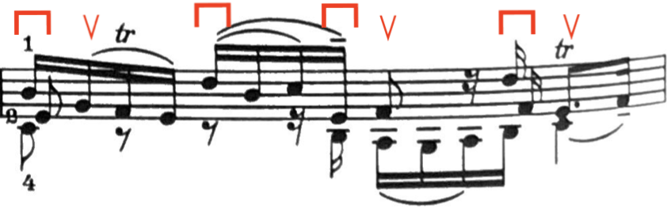
Figure 173. Largo, m. 17: Galamian edition.

Galamian often hooks in the last 16th note in a group of four to help produce a legato sound. Pine plays these bowing separately, as indicated by the autograph manuscript.
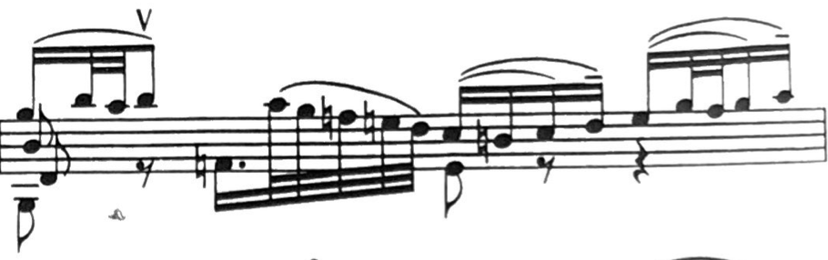
Figure 174. Largo, m. 13: Galamian edition.
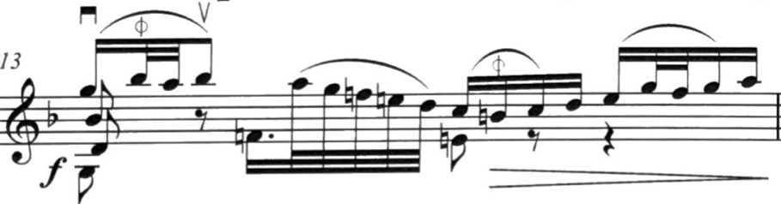
Figure 175. Largo, m. 13: Pine edition.
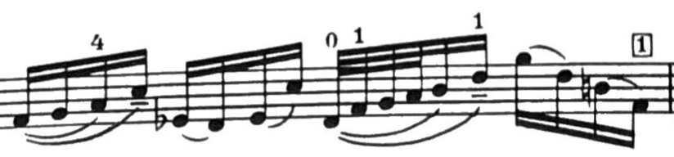
Figure 176. Largo, m. 18: Galamian edition.
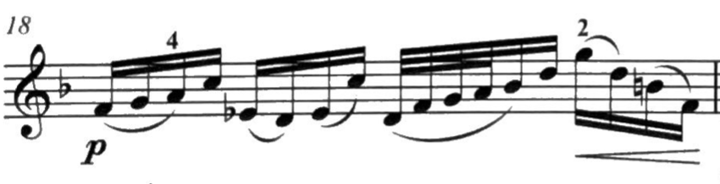
Figure 177. Largo, m. 18: Pine edition.

Mm. 9—13 of the autograph manuscript features an awkward bowing which necessitates some additional editing.
Pine begins this passage with up-bow on the pickup to m. 9. Beat four of m. 9 is executed down-bow, and from there follows the autograph manuscript until the second beat of m. 12, which includes another added down-bow. The bowing found on the downbeat of m. 13 is split.
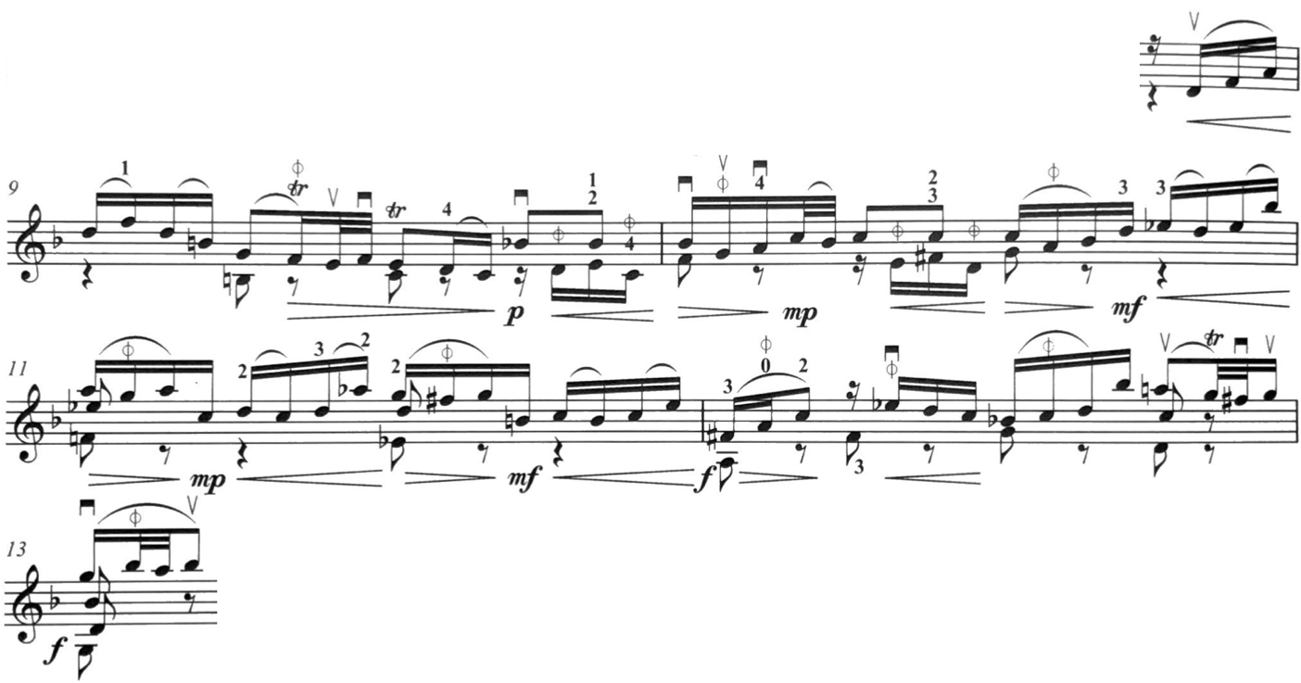
Figure 178. Largo, mm. 9—13: Pine edition.

Galamian begins this passage with a downbow on the pickup to m. 9. He slurs in the 32nd notes on beat 2 on m. 9, as well as the 16th notes on beat 3. He also employs a hooked bowing on the last two 16th notes on m. 9. The downbeat on m. 10 is one of the instances of parenthetical bowing notated in the Galamian edition, which would make the bowing identical those found throughout Largo. Beat 2 of m. 10 features more hooked bowings. Galamian splits the bowing found on the downbeat of m. 12, and features more hooked bowings on beats 2 and 4. Both Galamian and Pine break the bowing on the downbeat of m. 13 identically, contrary to the autograph manuscript.
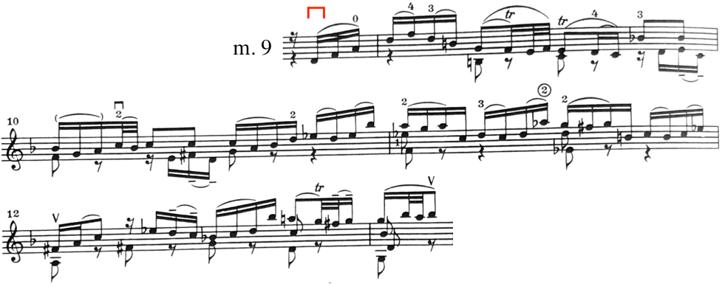
Figure 179. Largo, mm. 9—13: Galamian edition.

M. 19 features a long slur. Galamian notates the original slur, but places up- and down-bow markings underneath indicating a breaking of that larger slur. The Pine edition retains the slur as written.
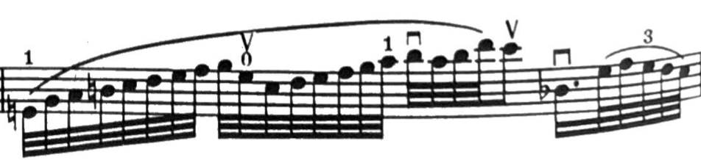
Figure 180. Largo, m. 19: Galamian edition.
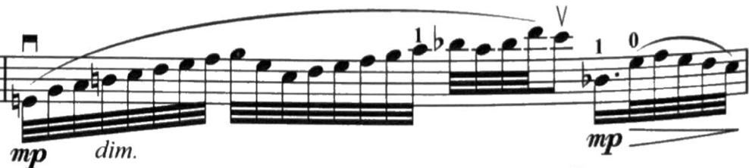
Figure 181. Largo, m. 19: Pine edition.

A similar bowing choice is made in m. 22. Galamian breaks a longer bow, while Pine retains the original bowing. Although, Pine’s edition hooks up-bows on the penultimate chord as to play the final chord down-bow.
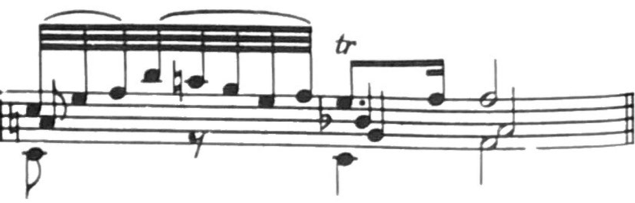
Figure 182. Largo, m. 22: Galamian edition.
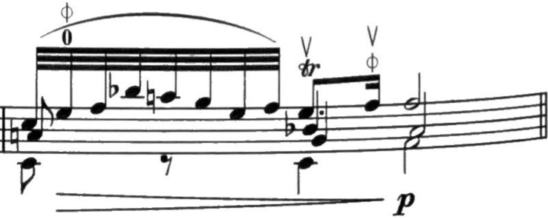
Figure 183. Largo, m. 22, Pine edition.

4.3.2: Largo Fingerings

There are two parenthetical or alternative fingerings indicated by the Galamian edition in Largo. The first instance appears on the downbeat of m. 6, where the shift into third position could be executed on the lower G instead of shifting to the top G.
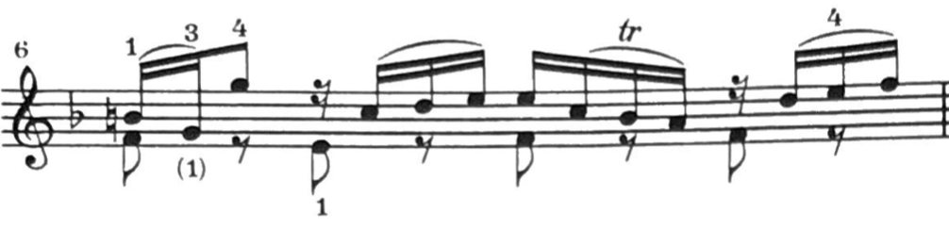
Figure 184. Largo, m. 6: Galamian edition.

The second occurrence of a parenthetical fingering occurs in mm. 14—15, where the alternative fingering plays in third position on the A-string to avoid the E-string.
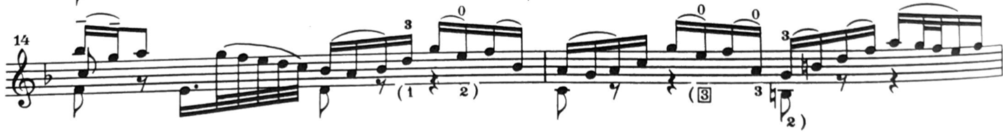
Figure 185. Largo, mm. 14—15: Galamian edition.

The opening measure of Largo is played in first position in the Pine edition. Only in m. 2 does Pine use half position to execute the V7 chord.
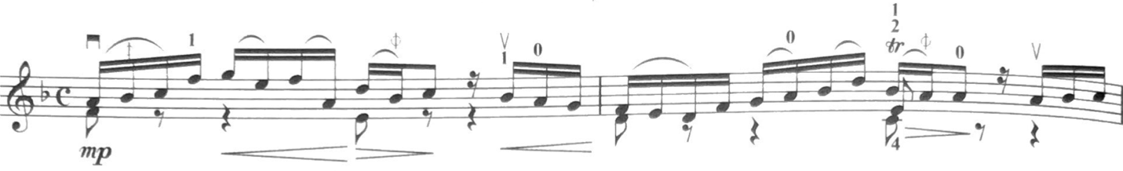
Figure 186. Largo, mm. 1—2: Pine edition.

In contrast, Galamian elects to retain the melody on the A-string. M. 1 begins in first position, moving into third, returning back to first by the end of that measure. Similar to the Pine edition, half position is used to execute the V7 chord found on beat three of m. 2.
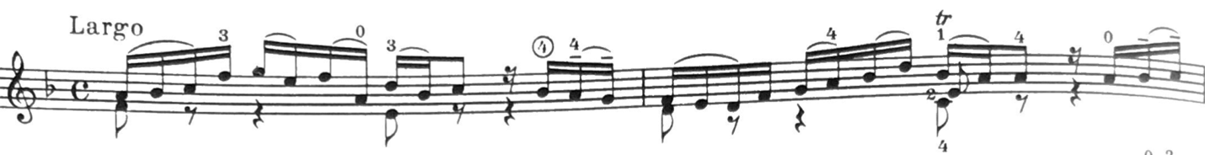
Figure 187. Largo, mm. 1—2: Galamian edition.

Beat three of m. 2 features a fingering using 4-2-1 in half position. This same chord (V7) and fingering occurs again on the downbeat of m. 17. Additionally, it occurs on the downbeat of m. 7 in the form of a V7 of the dominant key of C Major. Both editions employ this fingering in each of these areas.
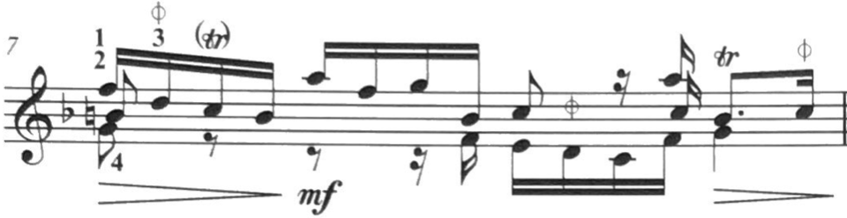
Figure 188. Largo, m. 7: Pine edition. V7 of dominant.
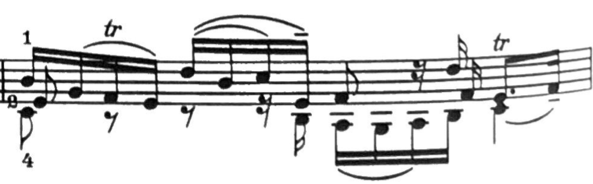
Figure 189. Largo, m. 17: Galamian edition. V7 of home key.

The Galamian edition features second position in m. 3. This measure of the Galamian edition alternating between first and second positions. Second position occurs on the downbeat as to avoid the lateral move of the second finger across the strings (the pickup is in first position). Galamian returns to first position on the third 16th note of the measure but then shifts back into second position to keep the melody on the A-string.
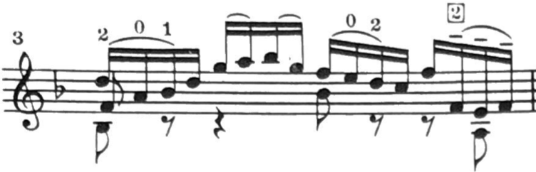
Figure 190. Largo, m. 3: Galamian edition.

The Pine edition remains in first position throughout m. 3.
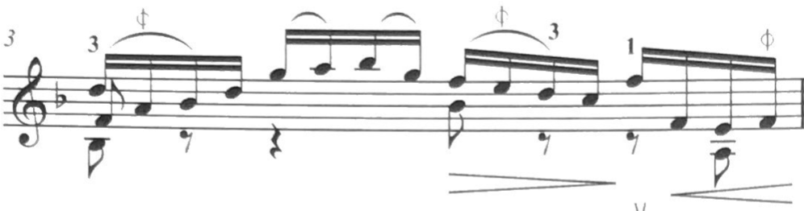
Figure 191. Largo, m. 3: Pine edition.

M. 5 also features a number of shifts, particularly in the Galamian edition. Once again, Galamian shifts into higher positions on the A-string as to avoid the E-string. What begins in first position moves to second on the second beat, third position on the third beat, and uses a harmonic A before moving back to second position.
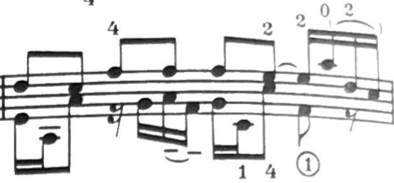
Figure 192. Largo, m. 5: Galamian edition.

The Pine edition also moves to second position on beat two, but remains there until the return to first position on beat four.
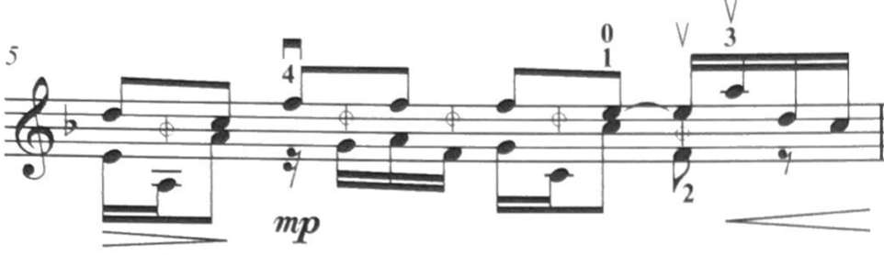
Figure 193. Largo, m. 5: Pine edition.

The fingering in m. 5 holds significance particularly because of beat four, where the lower voice moves from C to F under the sustained E. Executing beats three and four as written would be impossible in a single position, and require an extension, which is indicated in the Galamian edition. However, the historical style of executing this moment would not fully sustain the E and play the F below alone. In other words, an extension may not be necessary at all depending on the interpretation. This is consistent in the Pine edition and the marking to break the sustained E and to play the bottom F alone.
In m. 9, Galamian indicates using an extended fourth finger for the top F-natural, where the Pine edition indicates playing that same F-natural on the E-string. moves to third position on beat four, where Pine moves to half position. Both editions move to second position in the fourth beat of m. 10, and return to first on beat three of m. 11. M. 12 of the Pine edition implies more momentary half position with the third finger on the F-sharp. Galamian’s edition does not explicitly state what fingering to use in m. 12, although employing the Pine fingering could also work in this instance.
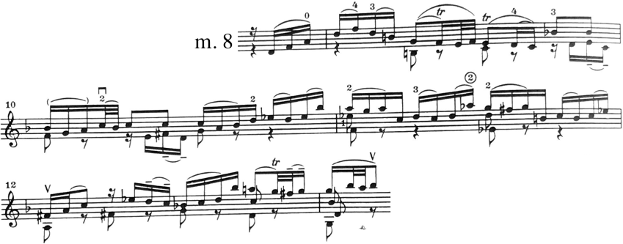
Figure 194. Largo, mm. 8—13: Galamian edition.
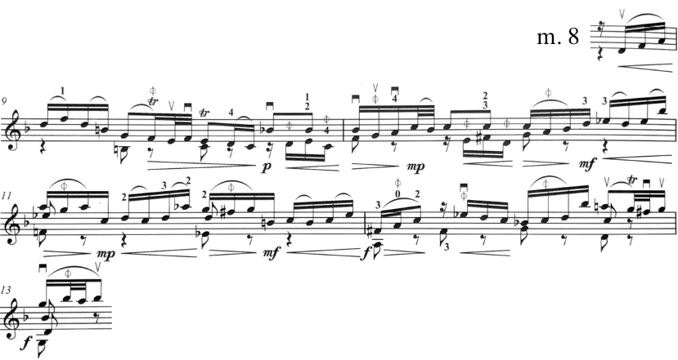
Figure 195. Largo, mm. 8—13: Pine edition.

Mm. 18—21 feature similar choices made by the respective editors. In m. 18, Galamian’s edition once again avoids use of the E-string and retains the melody on the A-string via upper position. In this case, shifting to second position and third position on the third beat of m. 18, before returning to second position then first position on the downbeat of m. 19. Third position is then assumed again on the second beat, and retained until the fourth beat of m. 19 with a shift downwards to second position. Second position is retained (again, to avoid the E-string) until a compression with the third finger on beat two of m. 20. From there, the Galamian edition remains in first position.
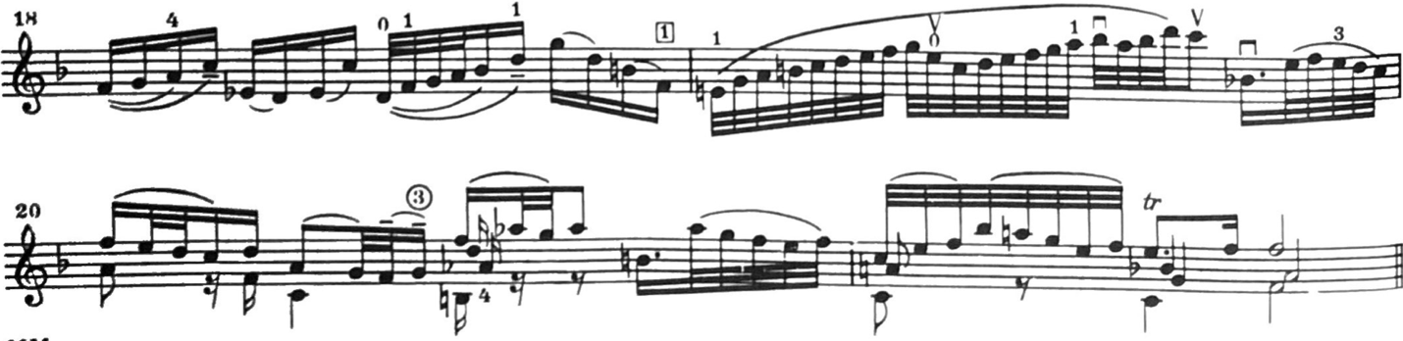
Figure 196. Largo, mm. 18—21: Galamian edition.

In contrast, the Pine edition remains in first position through mm. 18—22, aside from the move into third position during the ascending 32^{nds} run in m. 19.
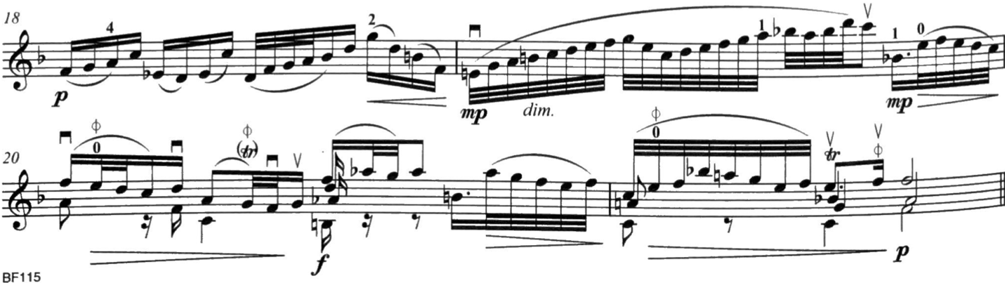
Figure 197. Largo, mm. 18—21: Pine edition.

Chapter 4.4: Allegro Assai

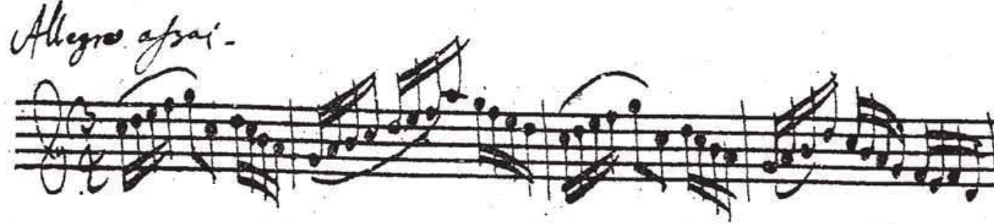
Figure 198. Allegro Assai, mm. 1—4: Autograph manuscript.

The final movement of the Sonata No. 3 in C Major features rapid scales, passagework, and string crossings. It is said that Johann Sebastian Bach himself enjoyed playing this movement on keyboards, supplying harmony with the left hand as necessary.
The high G found in m. 89 is the highest pitch of the Sonatas and Partitas. In the present day, playing a G6 is hardly note-worthy, but in Bach’s time, was downright virtuosity. As previously mentioned, the fingerboard on a baroque violin was about an inch or two shorter than our modern violins. Reaching this high G would have been right at the edge of the fingerboard—Bach is literally pushing the violin and violinists to their limits.
While the Galamian and Pine editions differ significantly in bowings, their respective fingerings are quite similar.

4.4.1: Allegro assai Bowings

The opening of Allegro Assai begins with a parenthetical bowing in m. 2 of the Galamian edition. The top bowing is original to the autograph manuscript, while the bottom is Galamian’s editorial suggestion. The bottom bowing (identical to the bowing found in m. 1) may be observed for bow distribution purposes. Alternatively, a modern bow could also execute the upper bowing, as long as bow is conserved. Similarly, this parenthetical bowing appears in m. 44 at the onset of the B section.
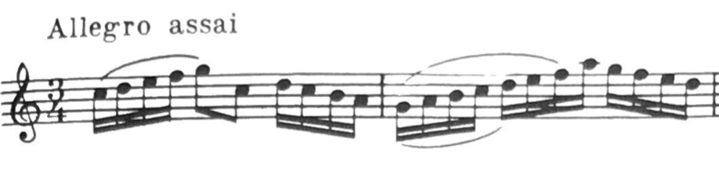
Figure 199. Allegro Assai, mm. 1—2: Galamian edition. Upper bowing is original, the lower bowing is the parenthetical suggestion.

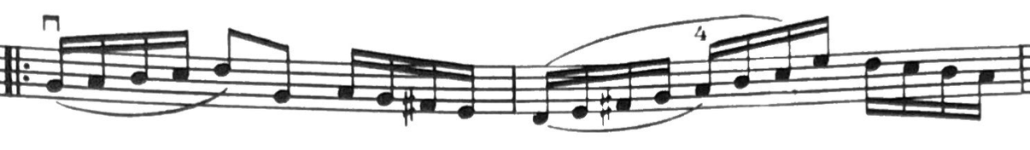
Figure 200. Allegro Assai, mm. 43—44: Galamian edition.

The Pine edition follows the bowing supplied by the autograph manuscript and does not include a parenthetical alternative.

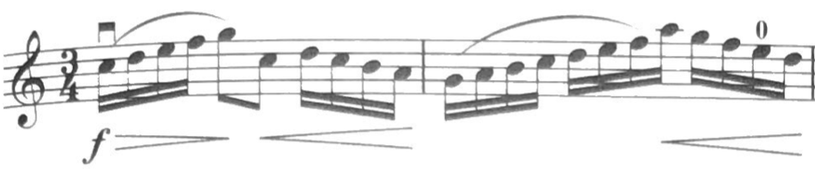
Figure 201. Allegro Assai, mm. 1—2: Pine edition.

The motivic material found in mm. 5—8 appears throughout Allegro Assai. Generally, the bowings are consistent between the respective editors in each of these appearances.
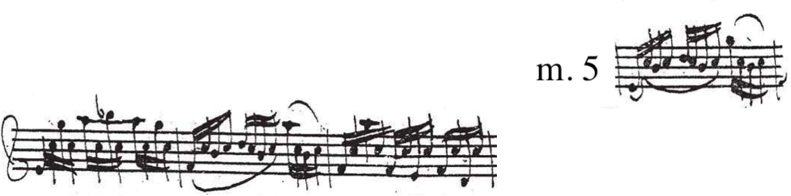
Figure 202. Allegro Assai, mm. 5—8: Autograph manuscript.

M. 5 of the autograph manuscript slurs the first and second beats together (down-bow), while beat three is slurred separately (up-bow). The following measure is played with separate bows. Bach repeats this pattern again in mm. 7—8.
M. 6 and m. 8 feature moving voices juxtaposed to a static pitch. In m. 6 and m. 8, this is a C-natural. M. 6 features the moving voice above the static pitch, while m. 8 features the moving voice below the static pitch.
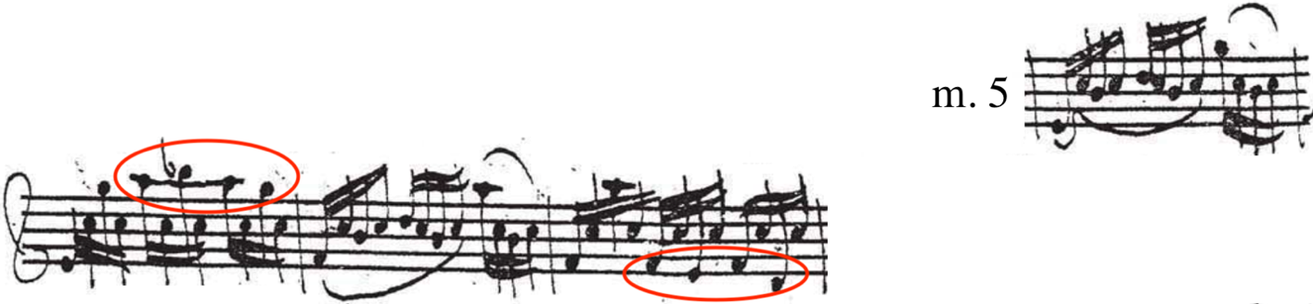
Figure 203. Allegro Assai, mm. 5—8: Autograph manuscript. Moving voice above in m. 6 and below in m. 8.

Pine’s edition follows the bowing as written, where mm. 5—6 and mm. 7—8 are bowed identically.

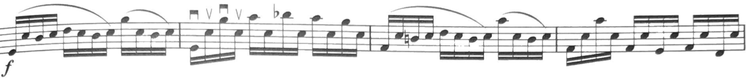
Figure 204. Allegro Assai, mm. 5—8: Pine edition.

In contrast, the Galamian edition features a modified bowing in mm. 5—8. This edition begins m. 5 with down-bow on the first 16th note, while slurring in the following seven 16th notes. Beat three is slurred into the next downbeat of the measure, where Galamian indicates a legato marking for emphasis.
This ultimately sets up the upper moving notes in m. 6 to be played with up-bows. The last two 16th notes of m. 6 are then slurred to begin m. 7 down-bow. Unlike Pine’s edition, the bowing in mm. 7—8 in not identical to mm. 5—6 in the Galamian edition. Galamian slurs in only the first 16th note of m. 8, thus setting up the moving voice in m. 8 to be played with down-bows. The modern bow can bring out the moving notes more effectively with up-bows in m. 6 and down-bows in m. 8. In addition, the alternation of bow-stokes can add variety to the sound.
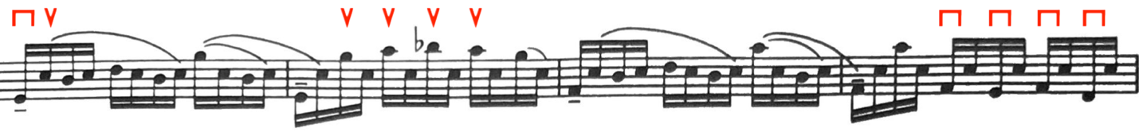
Figure 205. Allegro Assai, mm. 5—8: Galamian edition.

While the bowing Galamian employs in m. 5 and m. 7 is not original to the autograph, it bears some resemblance to another bowing found in mm. 64 and 66 of the autograph manuscript. Both Pine and Galamian observe this bowing in those measures.

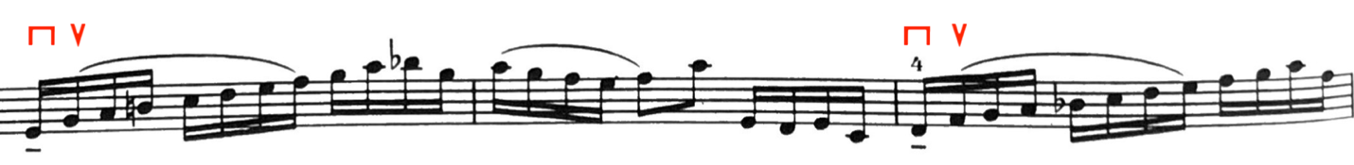
Figure 206. Allegro Assai, mm. 64—66: Galamian edition.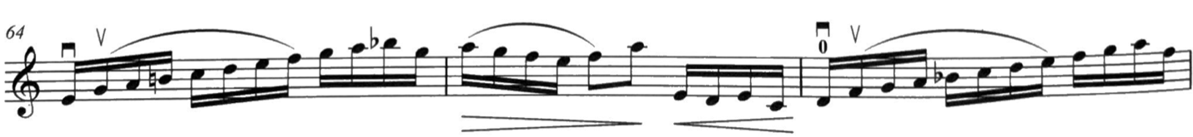
Figure 207. Allegro Assai, mm. 64—66: Pine edition.

Although the material found in mm. 5—8 appears frequently throughout Allegro Assai, the autograph manuscript’s bowings are not always consistent. In mm. 25—28, the autograph indicates each beat slurred separately, contrary to m. 5 where the first two beats are slurred together.
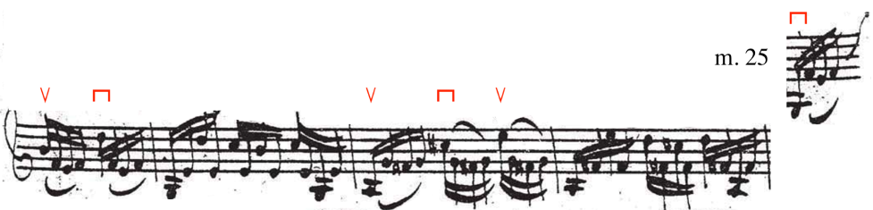
Figure 208. Allegro Assai, mm. 25—28: Autograph manuscript.

The Pine edition follows this bowing in m. 25 and m. 27, but places two hooked up-bows on the first two 16ths of the measures of separate bows. These added up-bows allow for the moving notes of each measure to be played down-bow.
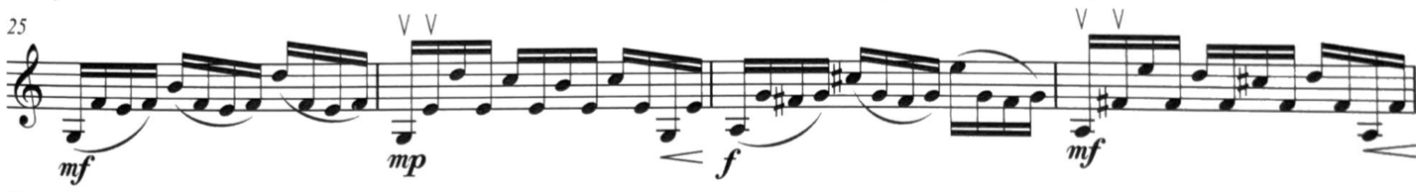
Figure 209. Allegro Assai, mm. 25—28: Pine edition.

Similarly, the Galamian edition also bows each beat separately, but because mm. 25—28 feature upper moving voices, Galamian executes them with up-bows. He achieves this by slurring in the first two 16th notes of m. 26 and m. 28. At the end of those measures, Galamian slurs the last two 16ths so that the following measure begins down-bow.
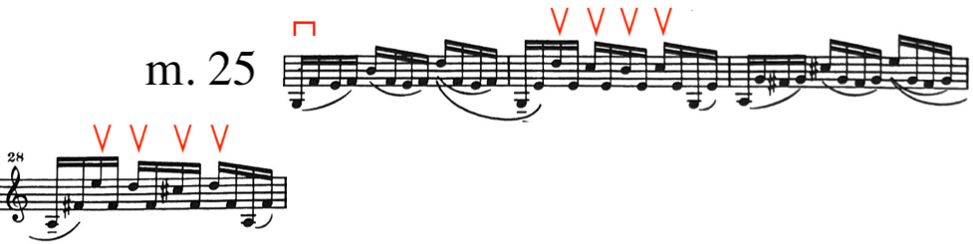
Figure 210. Allegro Assai, mm. 25—28: Galamian edition.

When the autograph manuscript returns to the original bowing in mm. 29—34, both editions also return to their original bowing notated in mm. 5—8.
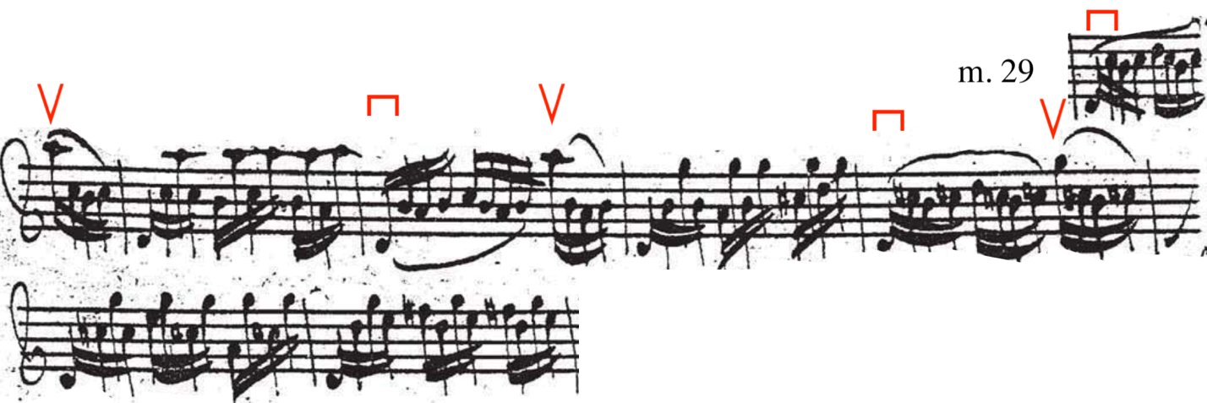
Figure 211. Allegro Assai, mm. 29—34: Autograph manuscript. Original bowing.
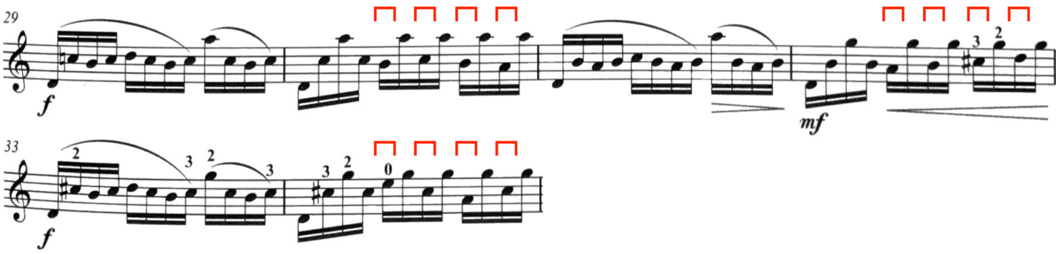
Figure 212. Allegro Assai, mm. 29—34: Pine edition. Original bowing.

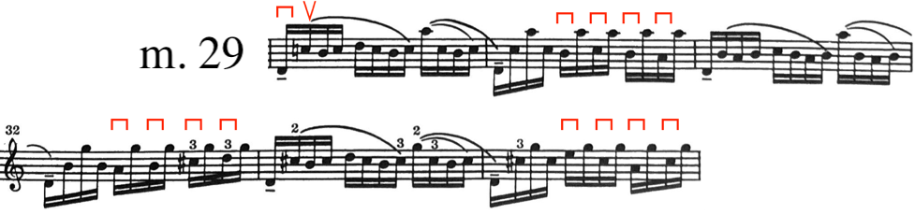
Figure 213. G Allegro Assai, mm. 29—34: Galamian edition. Original bowing.

Mm. 47—62 also feature the material found in mm. 5—8, using same corresponding bowings for both respective editions.
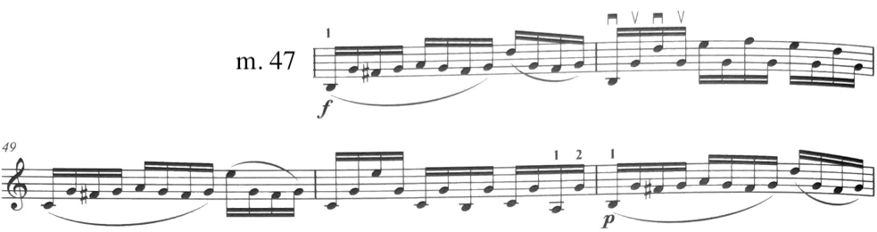
Figure 214. Allegro Assai, mm. 47—51: Pine edition. Same bowings for both.
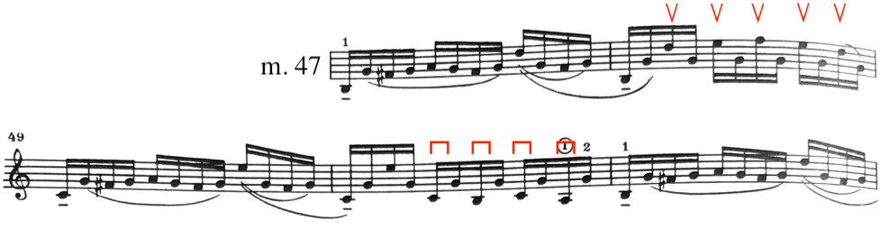
Figure 215. Allegro Assai, mm. 47—51: Galamian edition. Up-bows on upper voices, down-bows on lower voices.

Another inconsistency of the autograph manuscript’s bowing appears in mm. 73—76. In fact, the bowing is different between mm. 73—74 and mm. 75—76. Mm. 75—76 are consistent with the original bowing, where mm. 73—74 differ. M. 73 bears resemblance to the bowing found in m. 25, while m. 75 is the original.
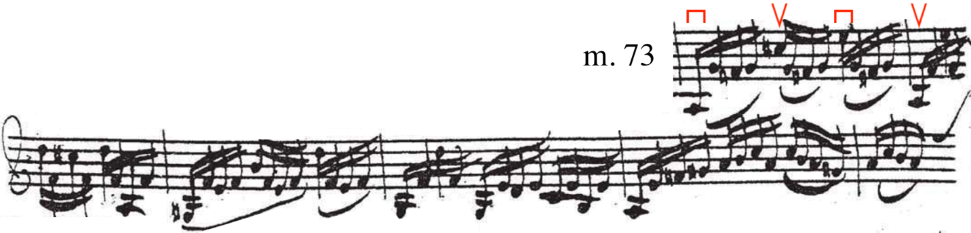
Figure 216. Allegro Assai, mm. 73—76: Autograph manuscript. Inconsistent bowings.

Pine plays the bowing in mm. 73—74 as written, adding two hooked up-bows in mm. 74. Pine suggests a parenthetical bowing in mm. 75, suggesting an alternative interpretation that follows the bowings found in mm. 73—74.
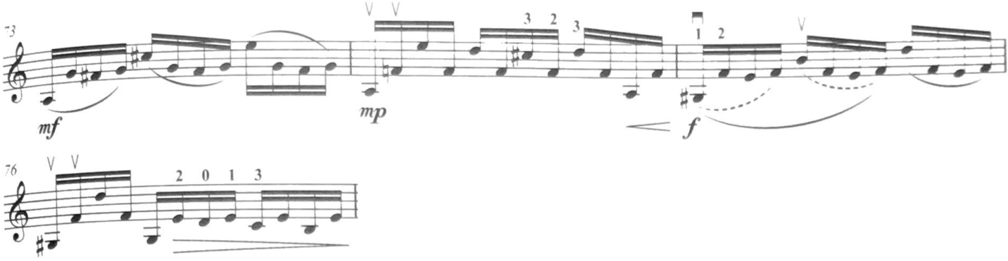
Figure 217. Allegro Assai, mm. 73—76: Pine edition.

On the other hand, Galamian superimposes his bowing from mm. 25—28 to be executed again in mm. 73—76.
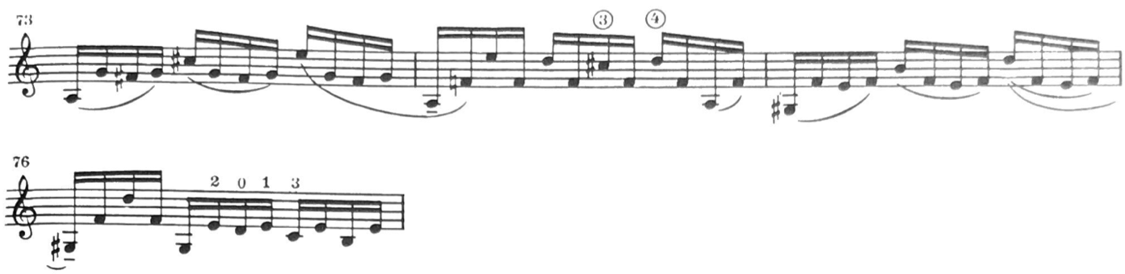
Figure 218. Allegro Assai, mm. 73—76: Galamian edition. Same bowing as mm. 5—8.

Mm. 35—42 of the autograph manuscript features an awkward bowing. If followed exactly, the autograph manuscript places an up-bow on the downbeat of m. 41, which would be contrary to the phrasing of m. 1. Ultimately, both editions place m. 41 with a down-bow, although Pine and Galamian reach this solution differently.
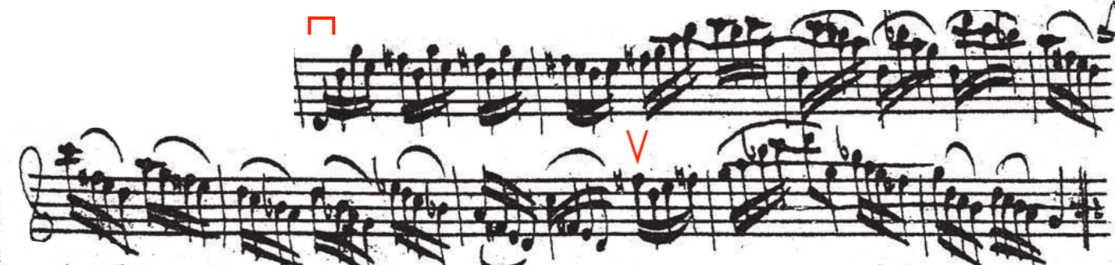
Figure 219. Allegro Assai, mm. 35—42: Autograph manuscript. Awkward bowing.

Pine hooks two groups of four slurred 16th notes in m. 40, thus resulting in a down-bow on the downbeat of m. 41.
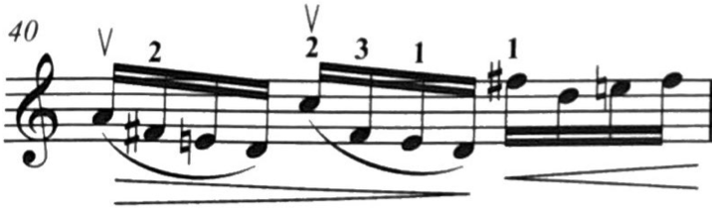
Figure 220. Allegro Assai, m. 40: Pine edition.

Galamian accounts for this problem earlier, adding a hooked down-bow in m. 35, also setting up a down-bow on the down-beat of m. 41.
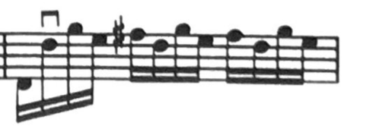
Figure 221. Added hooked down-bow. Allegro Assai, m. 35: Galamian edition.

Similarly, the same bowing problem appears again at the end of the B section. Both editors employ their rectifications found in the A section again.
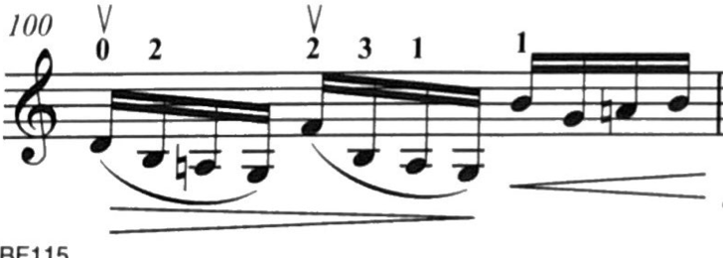
Figure 222. Allegro Assai, m. 100: Pine edition.
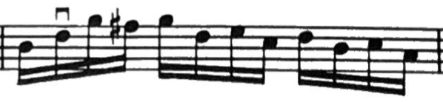
Figure 223. Allegro Assai, m. 100: Galamian edition.

Hooked bows appear in mm. 67—68 of the Galamian edition to avoid unintentional accents and smoother phrasing. Pine’s edition plays both bars with the bowings indicated by the autograph manuscript.
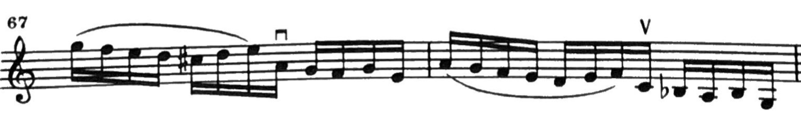
Figure 224. Allegro Assai, mm. 67—68: Galamian edition.
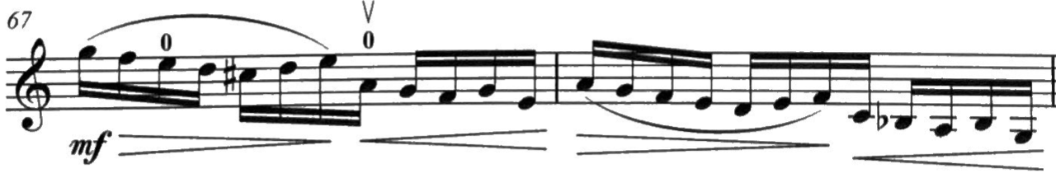
Figure 225. Allegro Assai, mm. 67—68: Pine edition.

The bowings found in m. 85 of each edition are reminiscent of the bowings found in mm. 5—8. This section beginning at m. 85 begins up-bow, which sets up moving voices in mm. 85—86 to be played with up-bows.
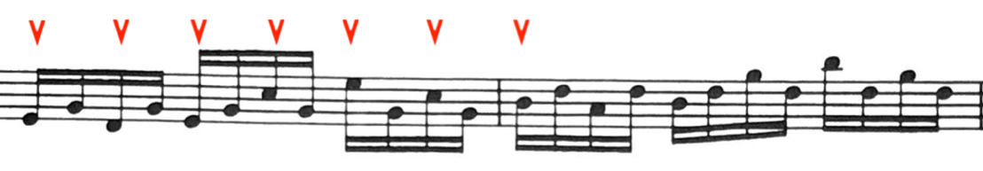
Figure 226. Allegro Assai, mm. 85—86: Galamian edition. Moving notes on up-bows.

Galamian then switches the bowing to down-bow on the moving notes in m. 89, via an added up-bow in m. 87.
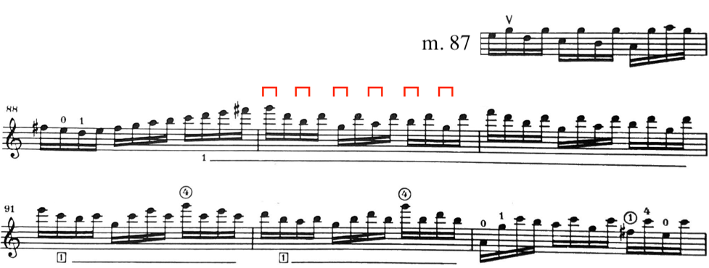
Figure 227. Allegro Assai, mm. 87—93: Galamian edition. Moving notes on down-bows.

Pine’s edition interprets this section differently, having all the moving notes played with down-bows. To begin down-bow in m. 85, Pine hooks the last two 16th notes in m. 84.
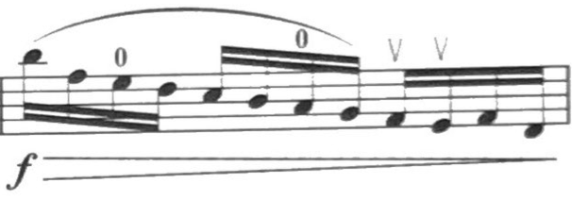
Figure 228. Allegro Assai, m. 84: Pine edition.

The bowing in mm. 85—93 is then executed as it comes, contrary to Galamian’s edition.
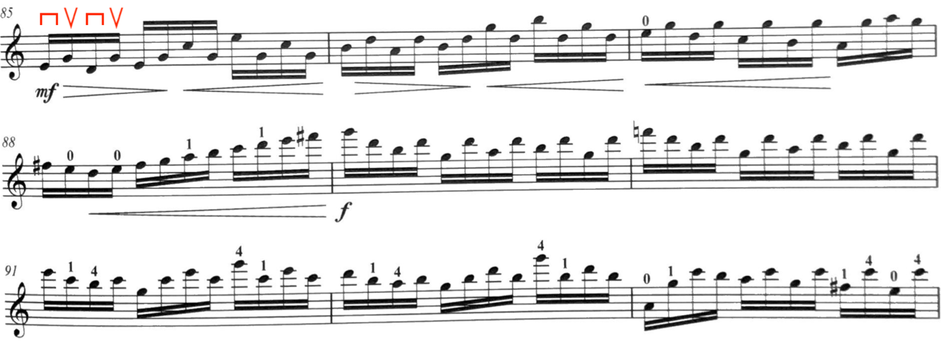
Figure 229. Allegro Assai, mm. 85—93: Pine edition.

4.4.2: Allegro assai Fingerings

Much of the fingering choices made by Galamian and Pine in Allegro Assai are either identical or outright similar, and unlike previous movements, there are fewer differences between the two. Mm. 47—63 serve as an example of both editions featuring identical fingerings.
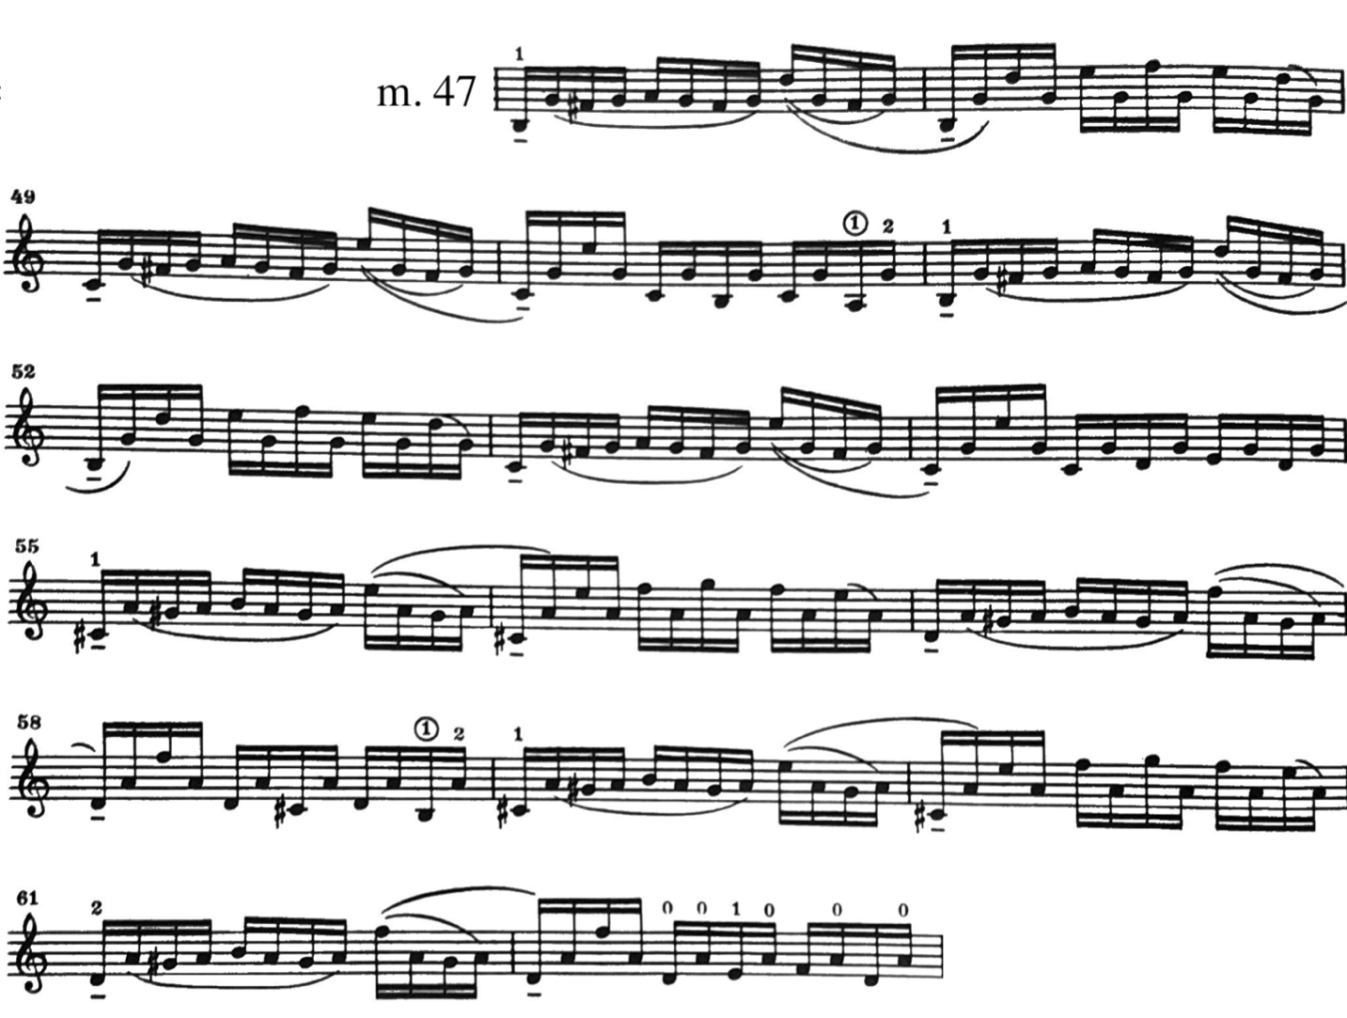
Figure 230. Allegro Assai, mm. 47—63: Galamian edition.
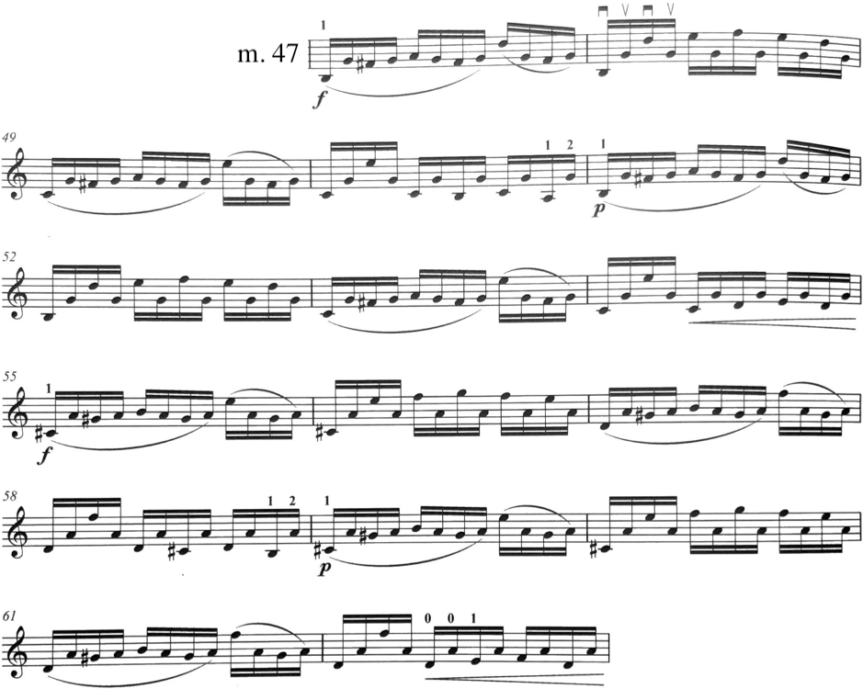
Figure 231. Allegro Assai, mm. 47—62: Pine edition.

Much of this movement necessitates the use of either half position or contractions in fingerings. This first appears in mm. 21—24. The Galamian and Pine editions agree on the fingering here, although differ in when and how it is executed. Galamian uses the lowered third finger on the first beat of m. 22, where the Pine edition waits until the second beat. Both editions return to second finger on the B in m. 24.
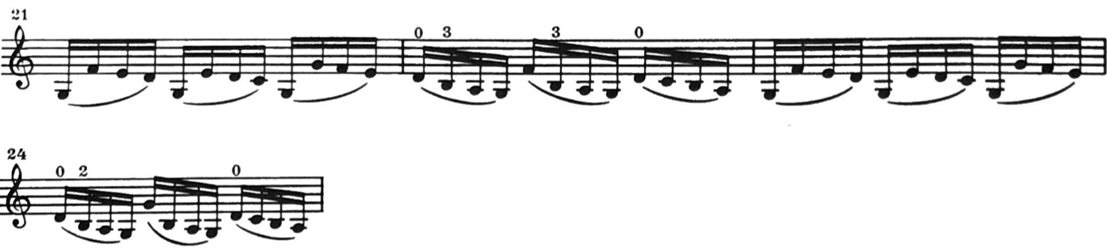
Figure 232. Allegro Assai, mm. 21—24: Galamian edition.
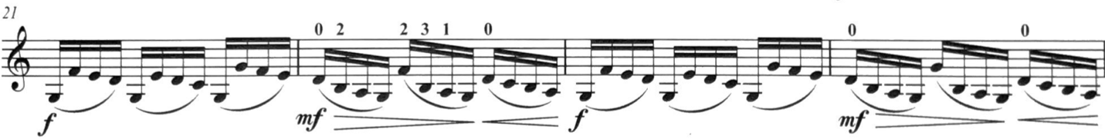Figure 233. Allegro Assai, mm. 21—24: Pine edition.

This figure appears again in mm. 69—70, where m. 70 features the use of the contracted fourth finger. Both editions follow their same pattern as before: Galamian uses the lower fourth finger on the first and second beat, where Pine only uses it on the second.
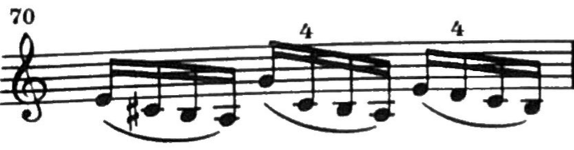
Figure 234. Allegro Assai, m. 70: Galamian edition.
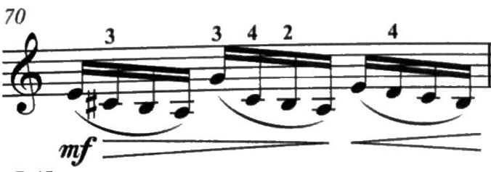
Figure 235. Allegro Assai, m. 70: Galamian edition.

The same idea also applies in m. 40, where Galamian uses the lowered third finger on both the first and second beats while Pine only employs this on the second beat.
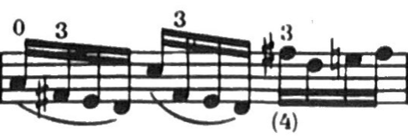
Figure 236. Allegro Assai, m. 40: Galamian edition.
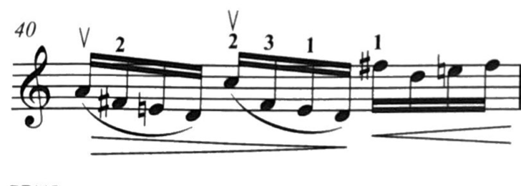
Figure 237. Allegro Assai, m. 40: Pine edition.

This figure also occurs in m. 100, however, Galamian uses a fourth finger on the D on the downbeat, which implies the use of second finger on the first B, therefore only using the contracted third finger on the second beat.
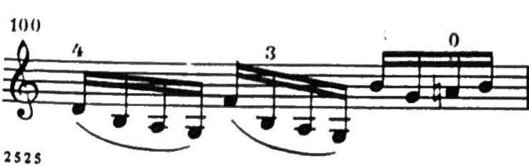
Figure 238. Allegro Assai, m. 100: Galamian edition.
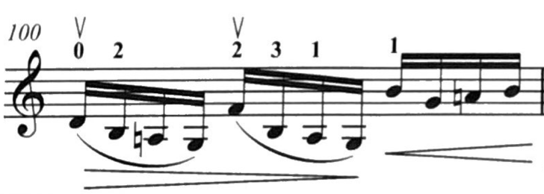
Figure 239. Allegro Assai, m. 100: Pine edition.

Another instance of contracted fingerings occurs in m. 38, where both editions use the same fingering.

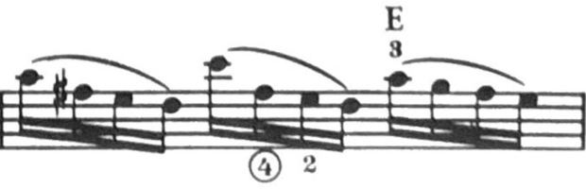
Figure 240. Allegro Assai, m. 38: Galamian edition.
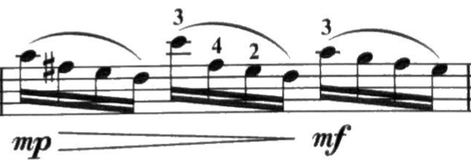
Figure 241. Allegro Assai, m. 38: Pine edition.

A similar spot occurs in mm. 40—41, where Galamian shifts into third position before the Pine edition.
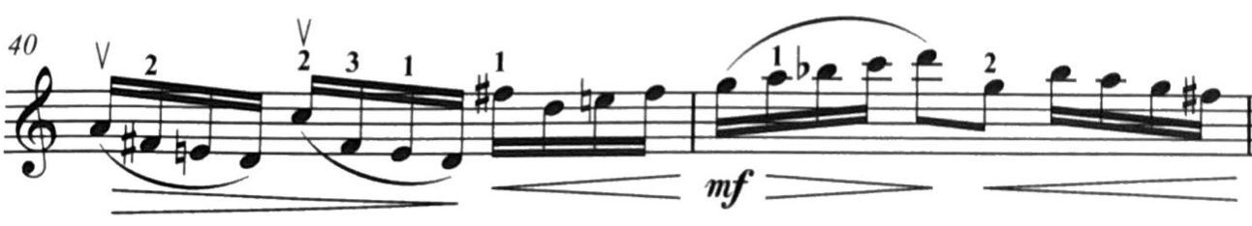
Figure 242. Allegro Assai, mm. 40—41: Pine edition.
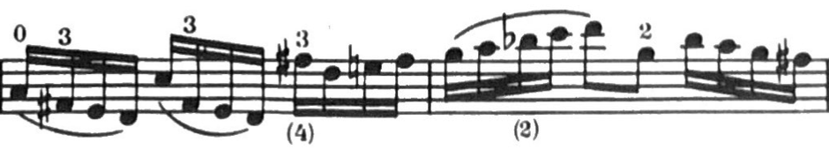
Figure 243. Allegro Assai, mm. 40—41: Galamian edition.

In m. 74, Galamian indicates that both the third and fourth fingers be contracted, where the Pine edition just uses the lowered third finger.

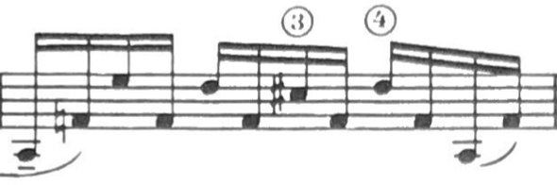
Figure 244. Allegro Assai, m. 70: Galamian edition.
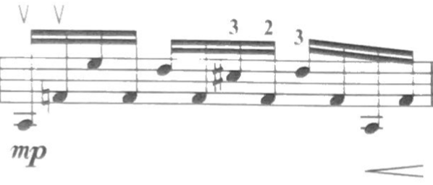
Figure 245. Allegro Assai, m. 70: Pine edition.

M. 77 is a point of interest for this same reason. Galamian uses a contracted fourth finger for the G#, where Pine uses third finger.
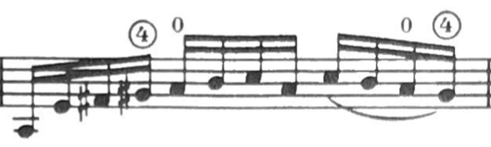
Figure 246. Allegro Assai, m. 77: Galamian edition.
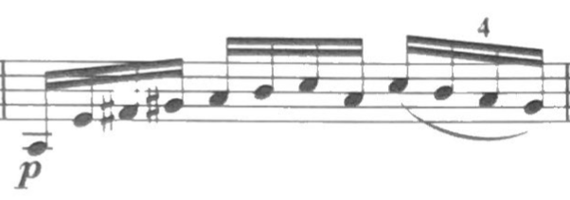
Figure 247. Allegro Assai, m. 77: Pine edition.

Passages that feature ascending scales feature shifts entirely on the E-string in the Pine edition, where Galamian tends to shift earlier. M. 36 stands as an example.
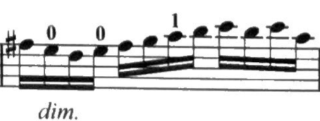
Figure 248. Allegro Assai, m. 36: Pine edition.
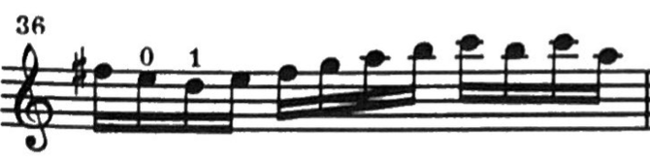
Figure 249. Allegro Assai, m. 36: Galamian edition.

Another spot to consider is found in mm. 88—89, where Galamian shifts into third position on the first beat, where the Pine edition shifts up the E-string starting on beat two.
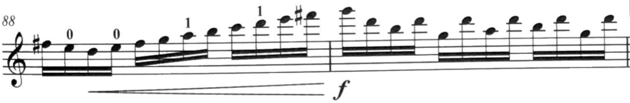
Figure 250. Allegro Assai, mm. 88—89: Pine edition.
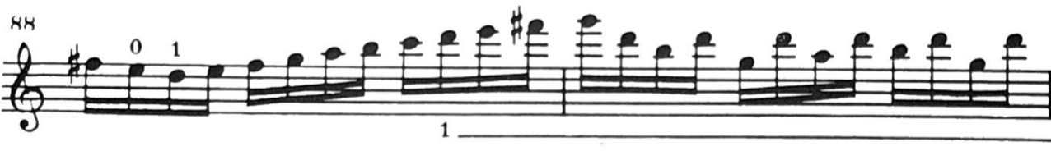
Figure 251. Allegro Assai, mm. 88—89: Galamian edition.

Galamian includes two parenthetical fingerings in Allegro Assai, in mm. 40—42, and mm. 79—80. Both alternate fingerings involve second position.

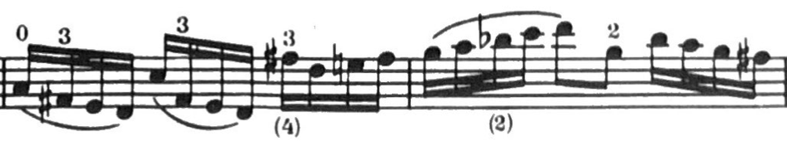
Figure 252. Allegro Assai, mm. 40—41: Galamian edition.
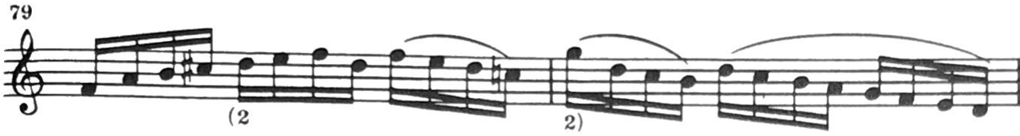
Figure 253. Allegro Assai, mm. 79—80: Galamian edition.

Chapter 5: Conclusion

The artistic and philosophical differences of the Galamian and Pine editions are evident even through comparing the purely mechanical aspects of their respective interpretations, i.e., the prescribed fingerings and bowings. Across the movements of the Sonata No. 3 in C Major, BWV 1005, the Pine edition tended to remain closer to the original bowings indicated by the autograph manuscript, and provided fingerings more consistent with the historical style. In contrast, the Galamian edition made significantly more edits in these matters, departing from the bowings of the autograph manuscript and exploring fingerings outside of first position. As previously mentioned, the kind of violin set-up each of the editors were working for, particularly the bow, heavily influenced their interpretations and editions.
As stated in the introduction, neither the Galamian nor the Pine edition are superior to one another: this document merely sought to compare two influential and insightful interpretations of a masterpiece. Using the Sonata No. 3 in this way—in a pedagogical and exploratory sense—fits the traditions set by pedagogues of previous generations, such as Cartier, Gaviniès, and de Baillot. Certain ideas presented by one edition may work for or inspire one violinist, but not another. It is up to the violinist to seek and test out these ideas and interpretations, and decide for themselves what they find most compelling. Studying the Sonata No. 3 in this way can provide a violinist new opportunities to explore different perspectives, which will inevitably strengthen their relationship to Bach and their own understanding of his music.
It’s not terribly difficult to understand why the Sonatas and Partitas gained popularity in the mid-19th century: German romanticism celebrated introspection and solitude above all else. The essence of the Sonatas and Partitas by Johann Sebastian Bach are rooted in these principles. They are the ultimate contemplative and solitary musical endeavor. Perhaps we violinists are meant to wander alone through the Sonata No. 3, playing it merely for ourselves, where practicing and performing become one and the same. What better way to meditate on the Sonata No. 3 (or any piece, for that matter) than to consider the interpretations of the masters before us?
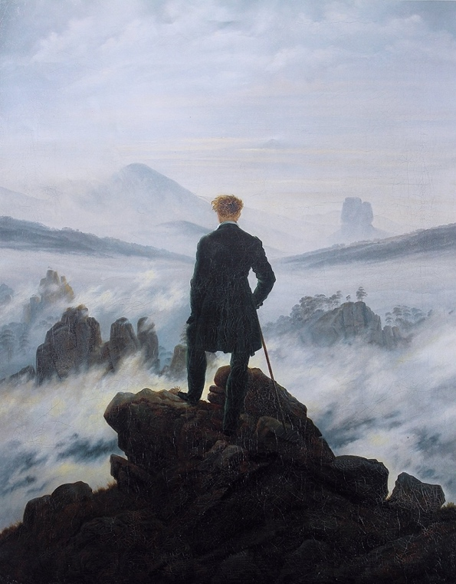
Figure 254. Wanderer above the sea of fog (1818) by Casper David Friedrich.

When we study, perform, or hear the brilliant music of Johann Sebastian Bach, it is easy to imagine him as some mythological musical titan, divinely endowed with seemingly limitless wisdom and skill. But Bach was of flesh and bone, not marble. At his core, Bach was a lifelong student. His unquenchable thirst for knowledge and creativity was the white-hot flame of his industrious furnace, with which he forged music, equally exquisite and ingenious.
During Bach’s final years, he increasingly dedicated himself to the study of counterpoint and music of the Renaissance masters. Bach studied music until the end of his life exactly as he was taught in his youth: meticulously copying out parts by hand. Befittingly, just as Johann Sebastian Bach religiously studied the works of great composers before him, modern musicians still learn from and revere Bach.
We would do well to follow in Bach’s footsteps, ever seeking the wisdom of the masters before us. Let us join the scores of violinists (those both before our time and our contemporaries) as well as Bach himself in the exploration of the endless artistic capabilities of the violin. Although we are physically alone while we play the Sonata No. 3, we are united in the journey we share in the exploration of the sublime music of Johann Sebastian Bach.

Chapter 6: Notes and advice from the Author

My love affair with baroque literature and historical performance practice began in high school. My orchestra teacher was a member of a local baroque ensemble, and I attended a number of their performances. I feel in love with the sound of both the baroque violin and baroque ensemble. The sound of baroque music and ensembles were quite unlike the symphony orchestra I was accustomed to, I found. It was warm, inviting, and distinctly more human. It seemed the baroque celebrated individuality more than any other era; there I found the license to infuse my own being into the music. That artistic freedom—to find my own distinct and unique path through the music—was (and still is) my heart’s jewel.
My passion for baroque music reached a point where in my senior year, I purchased a cheap baroque bow online. I was eager to experiment, and assimilate the bow into my formal studies—however, my private teacher wasn’t so keen. Whether it was a lack of experience or interest on his part (or both), I wasn’t allowed to study Bach with my baroque bow. (Naturally, I did so anyway—just not in his presence). The tide changed once I began my undergraduate studies. I was not only allowed to explore Bach with a baroque bow, but encouraged to do so. I explored baroque performance practice through performing with the Collegium Musicum in undergrad. Over the years, I experimented with different instrument set-ups and performance styles throughout my Bach studies. I always felt that solo Bach was my artistic sanctuary where I was allowed free reign. I am so appreciative of those teachers who allowed me that freedom to explore.
In the fall of 2019, mere months before the arrival of the Covid-19 pandemic, I had the opportunity to play in a masterclass for Rachel Barton Pine. Little did I know that this experience would ultimately lead me to the finish line of my doctorate! The masterclass took place in Tulsa, and because of an unavoidable obligation in Norman, I had to speed—and I mean that quite literally—the whole way to make it on time. Only seconds after I (breathlessly) entered the seminar room, it was my turn to play. There must have been about a hundred people present to observe the masterclass. All eyes shifted to me. I only have to perform (without warming up) one of the most difficult movements of solo Bach for one of the world’s foremost experts in his violin literature—no pressure. I took a deep breath, and played the Adagio from the Sonata No. 3 in C Major. Truthfully, it was one of my finest performances—the circumstances were so ridiculous that I felt calm and focused. Much of Pine’s comments on my playing were regarding the flow of the phrases, as well as the manner in which I broke the chords, but I think she was satisfied with my playing. It’s a miracle I didn’t get a speeding ticket.
I recognize that this document and all the information presented might be a lot to consume all at once. Before picking up your violin, spend some time listening to recordings. These days, you can easily find hundreds of exceptionally fine recordings online through virtually any music streaming service—YouTube, Apple Music, Spotify, etc. Seek out a variety of recordings, and take note of what seems appealing. Start to get an idea for what you want to explore. This process should continue even after you start playing.
The obvious question is where to start once you do pick up the violin. It is difficult to give direction here, because each violinist is a unique artist with a unique set of passions, skills, and preferences. Most people would probably be more familiar with the Galamian edition, or at least contemporary performance practice, so that edition may be a good place to start when first leaning this piece. Transitioning to more historically-accurate styles and ideas once a foundation has been created might be a general plan to follow. I ardently support exploring the baroque bow, particularly in exploring more original bowings, i.e., those found in the Pine edition or autograph manuscript. Much of the differences in the bowings found in the respective editions reflect the tendencies of the bows in question, and were not always entirely based on musical decisions.
For example, m. 19 of the Largo movement displays bowings that suit different bows. Pine’s edition suits the lighter baroque bow, which while shorter than the contemporary bow, can execute the bowing without creating an unwanted accent on the top C. The bowing found in the Galamian edition is a bowing more of convenience than musicality, owing to the nature of the contemporary bow.

Figure 255. Largo, m. 19: Pine edition.
Figure 256. Largo, m. 19: Galamian edition.

Using the modern bow in a quasi-historical way is another option. This can be achieved by holding the bow closer to the balancing point, which poses two advantages. First, the weight of the bow will feel lighter, and therefore resemble the weight of a baroque bow. Secondly, with a higher bow grip, the useable amount of bow will resemble the baroque bow, which is shorter than the modern bow.
Like bows, the hands in question can determine the best fingering, regardless of the style decided. Not all fingerings work for all violinists. Galamian tended to write fingerings that supported larger hands, while the Pine edition could suit a smaller hand size. Similarly, dynamics should be taken with a grain of salt, and depend largely on the interpreter in question.
It is befitting that I end my formal education with the way it began, by exploring the artistic and interpretive possibilities of the Sonatas and Partitas of Johann Sebastian Bach. My own personal journey (both in discovering my personal path in Bach, and composing this document) have been fulfilling beyond measure. With all that said, there is one last scrap of wisdom I can offer: The ultimate question in solo Bach is not “How should this be played?” but rather “How will I play this?” or “How to I breathe life into this music?”
Perhaps now, after much ado, you can finally begin your journey.

Bibliography

Bach, Johann Sebastian. Three Sonatas and Three Partitas for Solo Violin, rev. ed. Edited by Günter Haußwald and Rudolf Gerber. Revised by Peter Wollny. Preface by Peter Wollny. Kassel, Germany: Bärenreiter-Verlag Karl Vötterle GmbH & Co., 2001.

Bach, Johann Sebastian and Galamian, Ivan. Six Sonatas and Partitas S. 1001—1006 for Violin Solo, with Facsimile of the Autograph Manuscript. Edited by Ivan Galamian. Preface by Paul Affelder. New York: International Music Company, 1971.

Bach, Johann Sebastian. “Sei Solo à Violino senza Bass accompagnato; Libro Primo da Joh. Seb. Bach, ao. 1720.” Autograph manuscript completed by the composer in 1720. Berlin Staatsbibliothek, Stiftung Preußischer Kulturbesitz, Mus. Ms. Bach P 967.

Bach, Johann Sebastian and Enescu, Georges. “J. S. Bach 6 Sonatas & Partitas for Violin Solo: Educational Edition.” Technical indications and comments by George Enescu. Collected and edited by Serge Blanc. Unpublished edition, March 3, 2015. https://vmirror.imslp.org/files/imglnks/usimg/9/93/IMSLP371128-PMLP04292-bach- 6violin-sonatas-partitas.pdf

Bach, Johann Sebastian and Barton Pine, Rachel. J.S. Bach: Six Sonatas and Partitas for Violin Alone. Edited by Rachel Barton Pine. Preface by Rachel Barton Pine. New York, New York: Carl Fischer Music, 2018.

Baillot, Pierre Marie François de Sales. The Art of the Violin. Ed. and trans. by Louise Goldberg. Foreword by Zvi Zeitlin. Evanston, Illinois: Northwestern University Press, 1991.

Boyden, David D. The History of Violin Playing from its Origins to 1761 and its Relationship to the Violin and Violin Music. London: Oxford University Press, 1965.

Cartier, Jean-Baptiste and Bach, Johann Sebastian. L’art du Violon, ou division des écoles choisies dans les Sonates Italienne, Française, et Allemande. Facsimile of 1799 edition. Monuments of Music and Music Literature in Facsimile: First Series—Music, XIV. New York: Broude Brothers Limited, 1973.

Clarke, Garry. “The Baroque Violin and the Modern Violin: Similar, but very Different.” Published on BaroqueBand channel. March 9, 2010. Educational video, 7:03. https://www.youtube.com/watch?v=UhTqpmHu5yg

Galamian, Ivan. Principles of Violin Playing and Teaching, 2nd ed. Engelwood Cliffs, NJ: Prentice-Hall, Inc, 1985.

Gardiner, John Elliot. Bach: Music in the Castle of Heaven. New York: Vintage Books, a division of Random House LLC, a Penguin Random House company, 2015.

Gerstrung, Denman Wayne. “Performance Practice of Multiple Stops in the Sonatas and Partitas for Unaccompanied Violin of J. S. Bach (Volumes I and II).” D.Mus.Ed diss, University of Oklahoma, Norman, OK, 1970.
https://shareok.org/bitstream/handle/11244/2844/7023976.PDF?sequence=1&isAllowed=

Kim, Eunho. “Formal Coherence in J. S. Bach’s Three Sonatas For Solo Violin, BWV 1001, 1003, and 1005.” Master’s Thesis, University of Cincinnati, Cincinnati, OH, 2005.
https://etd.ohiolink.edu/apexprod/rws_etd/send_file/send?accession=ucin1122323822&di sposition=inline

Kolneder, Walter. The Amadeus Book of the Violin. Trans. and ed. by Reinhard G. Pauly. Amadeus Press: Portland, Oregon, 1993.

Ledbetter, David. Unaccompanied Bach: Performing the Solo Works. New Haven, Great Britain: Yale University Press, 2009.

Lester, Joel. Bach’s Works for Solo Violin: Style, Structure, Performance. New York, New York: Oxford University Press, Inc, 1999.

Moroney, Davitt. Bach: an extraordinary life. London, United Kingdom: The Associated Board of the Royal Schools of Music Publishing Limited, 2000.

Moser, Andreas. “Geschichte des Violinspiels: Zweite verbesserte und ergänzte Auflage von Hans- Joachim Nösselt.” Ersten Band Das Violinspiel bis 1800. Tutzing, Germany: Hans Schneider, 1966.

Oh, Hea-Seung. “Interpreting J. B. Bach’s Solo Violin Sonatas and Partitas Through Leopold Mozart, Joachim/Moser, and Galamian.” Doctoral Treatise, University of Texas at Austin, Austin, TX, 2005.
https://repositories.lib.utexas.edu/bitstream/handle/2152/1686/ohh10869.pdf?sequence=2 &isAllowed=y

Picard, Anna. “Isabelle Faust: musical sleuth.” The Guardian, September 15, 2013. Accessed July 2, 2022.
https://www.theguardian.com/music/2013/sep/15/isabelle-faust-violin-musical-sleuth- interview.

Pisendel, Johann Georg. Sonate für Violine allein ohne Baß. Edited by Günter Hausswald. Hortus Musicus 91. Kassel: Bärenreiter-Verlag, 1952.

Ritchie, Stanley. The Accompaniment in “Unaccompanied” Bach: Interpreting the Sonatas and Partitas for Violin. Bloomington, IN: Indiana University Press, 2016.

Schenker, Heinrich. “The Largo from Bach’s Sonata No. 3 for Unaccompanied Violin, [BWV 1005].” The Music Forum, Vol. 4 (1974), 141-159. Trans. by John Rothgeb.
https://books.google.com/books?id=u808KBU5zGQC&pg=PA148&lpg=PA148&dq=Schenker:+The+Music+Forum+%E2%80%9CHorizontal+elaboration+of+vertical+events%E2%80%9D&source=bl&ots=_fyVpEveBH&sig=ACfU3U3krhowd3LR90iUL50hOHJC__PQ9Q&hl=en&sa=X&ved=2ahUKEwju9fPH_pv5AhXzkmoFHecdBQQQ6AF6BAgCEAM#v=onepage&q&f=false. Accessed June 28, 2022.

Schröder, Jaap. Bach’s Solo Violin Works: A Performer’s Guide. Bury St. Edmunds, Great Britain: Yale University Press, 2007.

Schute, Benjamin. Sei Solo: Symbolum? Eugene, OR: Pickwick Publications, 2016.

Shaw, Bernard. Music in London 1890-94, in Three Volumes (London: Constable and Company Limited, 1932), vol. 1.

Smend, Friedrich. Bach in Köthen. Trans. by John Page. Ed. and rev. by Stephen Daw. St. Louis, MO: Concordia Publishing House, 1985.

Szigeti, Joseph. Szigeti on the Violin. Frederick A. Praeger, Inc.: New York, New York, 1970.

Telmanyi, Emil. “The Baroque German Violin Bow.” Baroquemusic.org. Accessed August 13, 2022. https://www.baroquemusic.org/barvlnbo.html

Tommasini, Anthony. “Grandeur of the North, Yours by the Bushel, From Sibelius.” The New York Times, August 28, 2007. https://www.nytimes.com/2007/08/28/arts/music/28sibe.html

The Royal Conservatory of Music. “Violin Syllabus: 2013 edition.” Accessed August 22, 2022. https://files.rcmusic.com//sites/default/files/examinations/documents/online_syllabi/S 36_Violin%20Syl_2016_RCM_online_SECURED.pdf

Westhoff, Johann Paul von. “Six Partitas for Solo Violin.” Unpublished manuscript, 1696.

Wolff, Christoph. Johann Sebastian Bach: The Learned Musician. W. W. Norton: New York, New York, 2000.

Wolff, Christoph. The New Bach Reader. Ed. by Hans T. David and Arthur Mendel. Rev. and enlarged by Christoph Wolff. New York, New York: W. W. Norton & Company, 1998.

Johann Sebastian Bach and Georges Enescu, “J. S. Bach 6 Sonatas & Partitas for Violin Solo: Educational Edition.” Technical indications and comments by George Enescu. Collected and edited by Serge Blanc. (Unpublished edition, March 3, 2015), 1. https://vmirror.imslp.or g/files/imglnks/usimg/9/93/IMSLP371128-PMLP04292-bach-6-violin-sonatas-partitas.pdf
Anthony Tommasini, “Grandeur of the North, Yours by the Bushel, From Sibelius,” The New York Times, August 28, 2007. https://www.nytimes.com/2007/08/28/arts/music/28sibe.html
The ARCT (Associate of the Royal Conservatory of Music) is defined by the 2013 Royal Conservatory of Music Violin Syllabus as “The culmination of the Royal Conservatory Examinations Certificate Program, and is evaluated as a concerto performance. Excellence in every aspect is expected.” I.E. the ARCT is the capstone experience for students at the Royal Conservatory. See: “Violin Syllabus: 2013 edition,” The Royal Conservatory of Music, Accessed August 22, 2022. https://files.rcmusic.com//sites/default/files/examinations/documents/online_syllabi/S36_Violin%20Syl_2016_RCM_online_SECURED.pdf
Rachel Barton Pine, J.S. Bach: Six Sonatas and Partitas for Violin Alone. Edited by Rachel Barton Pine. Preface by Rachel Barton Pine. (New York, New York: Carl Fischer Music, 2018)
Leading researcher on the music of J. S. Bach Domink Sackmann is “doubtless” that the Sonata No. 3 in C Major was the final completed work of the set, owing to its compositional and artistic maturity. See: Benjamin Schute, Sei Solo: Symbolum? (Eugene, OR: Pickwick Publications, 2016), 15.
Anna Picard, “Isabelle Faust: musical sleuth.” The Guardian, September 15, 2013. https://www.theguardian.com/music/2013/sep/15/isabelle-faust-violin-musical-sleuth-interview.
Davitt Moroney, Bach: an extraordinary life. (London, United Kingdom: The Associated Board of the Royal Schools of Music Publishing Limited, 2000), 5.
Davitt Moroney, Bach: an extraordinary life, 18—19.
A Weimar Court document from 1703 implies that he may have deputized as organist Johann Effler (1634—1711), illustrating he had already demonstrated his capabilities on the organ during his brief first employment at Weimar. See: Davitt Moroney, Bach: an extraordinary life, 18, 27.
Although his contract does not explicitly state that Bach would lead while playing the violin, the term “Konzertmeister” at that time still referred to the first violinist of an ensemble. However, Bach may have also led from a keyboard/continuo position. See: Malcolm Boyd. “The Bach Family.” The Cambridge Companion to Bach. Ed. by John Butt. (New York, New York: Cambridge University Press, 1997), 14.
Despite his departure from the court in Köthen, Bach remained on good terms with Prince Leopold.
Johann Sebastian Bach and Ivan Galamian, Bach, J. S.: 6 Sonatas and Partitas S. 1001—1006 for Violin Solo, with Facsimile of the Autograph Manuscript. Edited by Ivan Galamian. Preface by Paul Affelder. (New York: International Music Company, 1971.), 67.
David Boyden calls this passacaglia “a worthy predecessor to Bach’s unaccompanied Sonatas.” See: David D. Boyden, The History of Violin Playing, 225.
Beixi Gao, “The use of multiple stops in works for Solo Violin by Johann Paul von Westhoff (1656—1705) and its relationship to German polyphonic writing for a single instrument.”, 3. DMA diss., (University of North Texas, 2017). https://digital.library.unt.edu/ark:/67531/metadc984169/m2/1/high_res_d/GAO-DISSERTATION-2017.pdf
Andreas Moser calls Westhoff “the greatest master of polyphonic music for violin prior to Bach. See: Andreas Moser, Geschichte des Violinspiels: Zweite verbesserte und ergänzte Auflage von Hans- Joachim Nösselt. Ersten Band Das Violinspiel bis 1800 (Tutzing, Germany: Hans Schneider, 1966), 132.
Johann Paul von Westhoff, “Six Partitas for Solo Violin” (unpublished manuscript, 1696), 1.
Bach may have been aware of Biber’s Passacaglia, or other similar unaccompanied violin pieces by different composers.
Johann Georg Pisendel, Sonate für Violine allein ohne Baß. Edited by Günter Hausswald. Hortus Musicus 91. (Kassel: Bärenreiter-Verlag, 1952)
It is worth reiterating that 1717 marks the year that Bach probably began serious work on his Sonatas and Partitas. Additionally, Bach’s life-long admiration for the music of Antonio Vivaldi also merits mention. Particularly during the second Weimar period, Bach arranged countless transcriptions of Vivaldi’s music for various keyboards. The study of Vivaldi, one of the greatest virtuoso violinists and composers of all time, almost certainly produced an impact on Bach’s desire to compose for solo violin.
David Ledbetter, Unaccompanied Bach, 14.
Cartier was a pupil of the virtuoso Giovanni Battista Viotti (1755—1824), and taught violin at the Paris Conservatory. See: Pierre de Baillot, The Art of the Violin, ix.
Pierre Marie François de Sales Baillot, The Art of the Violin. Ed. and trans. by Louise Goldberg. Foreword by Zvi Zeitlin. (Evanston, Illinois: Northwestern University Press, 1991), ix.
Pierre Marie François de Sales Baillot, The Art of the Violin, ix.
Unlike Cartier’s treatise, which was largely a compilation of relevant literature, Baillot produced a true violin-playing manual, similar to prior publications produced by Francesco Geminiani (1751) and Leopold Mozart (1756).
Baillot himself, like Cartier, was fascinated by old masters and collected unpublished manuscripts. Apparently, this was a passion passed on through students and followers of Viotti, which both Jean-Baptiste Cartier and Pierre Baillot were. One wonders, therefore, if Viotti knew of the Sonatas and Partitas, and exposed his students and protégées to them. Viotti was a close friend of Joseph Haydn and Ludwig van Beethoven—might he have introduced them to this music also?
Compare this number to the number of works cited by Beethoven (18), Haydn (23), and Viotti (35). Indeed, Baillot tended cite the works of his fellow pedagogues at the Paris Conservatory, such as Pierre Rode, Rudolph Kreutzer, and himself. Much of these works have fallen into obscurity, aside from their études, which are widely used in the modern day.
Pierre Marie François de Sales Baillot, The Art of the Violin, 329.
Pierre Marie François de Sales Baillot, The Art of the Violin, 329.
Ivan Galamian, Principles of Violin Playing and Teaching, 4—5.
Rachel Barton Pine, J.S. Bach: Six Sonatas and Partitas for Violin Alone. Edited by Rachel Barton Pine. Preface by Rachel Barton Pine. (New York, New York: Carl Fischer Music, 2018), 5.
Because both editions were conceived for different set-ups, the chosen set-up upon which a violinist intends to tackle the Sonata No. 3 might play a key role in decisions made.
Johann Sebastian Bach and Ivan Galamian, 6 Sonatas and Partitas, 102.
Ivan Galamian, Bach, J. S.: Six Sonatas and Partitas, 54.
Rachel Barton Pine, J.S. Bach: Six Sonatas and Partitas, 66.
Ivan Galamian, Bach, J.S: 6 Sonatas and Partitas, 56.
Rachel Barton Pine, J.S. Bach: Six Sonatas and Partitas, 7.
Rachel Barton Pine, J.S. Bach: Six Sonatas and Partitas, 59.
Ivan Galamian, Bach, J.S: 6 Sonatas and Partitas, iii.
Ivan Galamian, Bach, J.S: 6 Sonatas and Partitas, iii.
Ivan Galamian, Bach, J.S: 6 Sonatas and Partitas, 49.
Rachel Barton Pine, J.S. Bach: Six Sonatas and Partitas, 59.
Rachel Barton Pine, “RBP on JSB: Overview of the Bach Sonatas and Partitas.” YouTube, March 12, 2018. https://www.youtube.com/watch?v=b73g8LR3zD4&list=PLtzGl4rw7X3eKJeRF9rCvUtIiIZ73CF6r&index=3.
The cover of the Rachel Barton Pine edition features her using a baroque bow. Nevertheless, Pine’s edition states that “All of these markings are designed to work with a baroque bow, or a modern violin and modern bow.” See: Rachel Barton Pine, J.S. Bach: Six Sonatas and Partitas, 5.
Only one fingering appears in the entirety of the Sonatas and Partitas: a 3 and 1 appear on the downbeat of m. 34 of the Gavotte en Rondeau from Partita No. 3 in E Major, BWV 1006. See: Ivan Galamian, Bach, J. S.: Six Sonatas and Partitas, 107.
Jaap Schröder. Bach’s Solo Violin Works: A Performer’s Guide. (Bury St. Edmunds, Great Britain: Yale University Press, 2007), 26.
This figure is not taken from Schröder’s text, but used as a visual aid to his words on polyphonic execution on the violin.
The section of Galamian’s treatise concerning chords features almost exclusively examples from the Sonatas and Partitas, including one example from the Fuga. Ivan Galamian, Principles of Violin Playing and Teaching, 88—92.
Ivan Galamian, Principles of Violin Playing and Teaching, 88.
Ivan Galamian, Principles of Violin Playing and Teaching, 88.
Ivan Galamian, Principles of Violin Playing and Teaching, 89.
Ivan Galamian, Bach, J. S.: Six Sonatas and Partitas, 51.
Ivan Galamian, Bach, J. S.: Six Sonatas and Partitas, 46.
Ivan Galamian, Principles of Violin Playing and Teaching, 89.
Ivan Galamian, Bach, J. S.: Six Sonatas and Partitas, 46.
Denman Wayne Gerstrung, “Performance Practice of Multiple Stops in the Sonatas and Partitas for Unaccompanied Violin of J. S. Bach (Volumes I and II).”, 67. D.Mus.Ed diss., (University of Oklahoma, Norman, OK, 1970). https://shareok.org.
Rachel Barton Pine, J.S. Bach: Six Sonatas and Partitas, 5.
Rachel Barton Pine, J.S. Bach: Six Sonatas and Partitas, 5—6.
Johann Sebastian Bach and Ivan Galamian, 6 Sonatas and Partitas, 98.
Ivan Galamian, Bach, J. S.: Six Sonatas and Partitas, 46.
Rachel Barton Pine, J.S. Bach: Six Sonatas and Partitas, 58.
Rachel Barton Pine, J.S. Bach: Six Sonatas and Partitas, 58.
Ivan Galamian, Bach, J. S.: Six Sonatas and Partitas, 46.
Ivan Galamian, Bach, J. S.: Six Sonatas and Partitas, 54.
Rachel Barton Pine, J.S. Bach: Six Sonatas and Partitas, 66.
Rachel Barton Pine, J.S. Bach: Six Sonatas and Partitas, 62.
Rachel Barton Pine, J.S. Bach: Six Sonatas and Partitas, 6.
Johann Sebastian Bach and Ivan Galamian, 6 Sonatas and Partitas, 98.
Rachel Barton Pine, J.S. Bach: Six Sonatas and Partitas, 59.
Ivan Galamian, Bach, J. S.: Six Sonatas and Partitas, 46.
A catalogue of Bach’s estate was drawn up following his death. The makers of the “lesser” violin and piccolo violin were not indicated. Unfortunately, we do not know what kind of bows Bach was working with. See: Christoph Wolff. The New Bach Reader, 252.
The fate of the Stainer violin listed in Bach’s estate in 1750 is unknown, and probably lost to history. It is possible that it still survives, played on by an unknowing musician, but it would be impossible to track. More likely than not, the violin no longer exists.
Biber apparently commissioned a set of Stainer instruments. See: Walter Kolneder, The Amadeus Book of the Violin, 123.
Letters from Jacob Stainer himself mention “the eminent virtuoso Biber could and would testify to [Stainer instrument’s] excellence.” Biber also commissioned a set of instruments for his former employer, the Bishop of Olmütz. See: Walter Kolneder, The Amadeus Book of the Violin, 123.
David D. Boyden, The History of Violin Playing, 195.
Prince Lobkowitz had a large collection of instruments, among which were several Stainers. See: Walter Kolneder, The Amadeus Book of the Violin, 123.
Guarneri “del Gesù” also apprenticed under Nicola Amati, like Stainer. Interestingly, Antonio Stradivari has generally been thought to also study under Nicola Amati, but like Stainer, no definitive evidence for this apprenticeship has ever surfaced. Like Stainer, early Stradivari violin labels indicate the relationship, and their general construction appears to be based off Amati models.
David D. Boyden, The History of Violin Playing, 195.
Once again, it is important to note that very little was standardized in the early 18th century. All of the criteria listed differed regionally and by maker, thus the respective information are generalizations to some degree.
Garry Clarke. “The Baroque Violin and the Modern Violin: Similar, but very Different.”
Garry Clarke, “The Baroque Violin.”
Mm. 88—89 of Allegro assai feature an ascending scale reaching a top G5, which at the time would have probably been near the edge of the fingerboard; Bach literally pushing the violin to its limits.
Garry Clarke, “The Baroque Violin.”
Rachel Barton Pine, J.S. Bach: Six Sonatas and Partitas, 7.
Rachel Barton Pine, J.S. Bach: Six Sonatas and Partitas, 7.
Rachel Barton Pine, J.S. Bach: Six Sonatas and Partitas, 7.
Rachel Barton Pine, J.S. Bach: Six Sonatas and Partitas, 7.
Interestingly, Adagio is one of only two ostinato movements from the entire Sonatas and Partitas. The other movement, Ciaccona, which occurs directly before this movement, is a harmonic ostinato. This may indicate some larger sense of cyclicity of the Sonatas and Partitas as a whole. See: Eunho Kim, “Formal Coherence in J. S. Bach’s Three Sonatas For Solo Violin, BWV 1001, 1003, and 1005.” Master’s Thesis, (University of Cincinnati, Cincinnati, OH, 2005). https://etd.ohiolink.edu/apexprod/rws_etd/send_file/send?accession=ucin1122323822&disposition=inline
Johann Sebastian Bach and Ivan Galamian, 6 Sonatas and Partitas, 96.
Bach, Johann Sebastian, Keyboard Works of Doubtful Authenticity. Edited by Ulrich Bartels and Frieder Rempp. BA 05250. (Kassel, Germany: Bärenreiter-Verlag Karl Vötterle GmbH & Co., 2006)
Bach, Johann Sebastian, Keyboard Works of Doubtful Authenticity.
Johann Sebastian Bach and Ivan Galamian, 6 Sonatas and Partitas, 96.
Rachel Barton Pine, J.S. Bach: Six Sonatas and Partitas, 58.
Ivan Galamian, Bach, J. S.: Six Sonatas and Partitas, 46.
Johann Sebastian Bach and Ivan Galamian, 6 Sonatas and Partitas, 96.
Ivan Galamian, Bach, J. S.: Six Sonatas and Partitas, 46.
Rachel Barton Pine, J.S. Bach: Six Sonatas and Partitas, 58.
Ivan Galamian, Bach, J. S.: Six Sonatas and Partitas, 46.
Ivan Galamian, Bach, J. S.: Six Sonatas and Partitas, 46.
Ivan Galamian, Bach, J. S.: Six Sonatas and Partitas, 46.
Rachel Barton Pine, J.S. Bach: Six Sonatas and Partitas, 58—59.
Ivan Galamian, Bach, J. S.: Six Sonatas and Partitas, 46.
Rachel Barton Pine, J.S. Bach: Six Sonatas and Partitas, 59.
Ivan Galamian, Bach, J. S.: Six Sonatas and Partitas, 46.
Rachel Barton Pine, J.S. Bach: Six Sonatas and Partitas, 59.
This added bowing is notated parenthetically in Pine’s edition, but observed in her recording.
Johann Sebastian Bach and Ivan Galamian, 6 Sonatas and Partitas, 96.
Ivan Galamian, Bach, J. S.: Six Sonatas and Partitas, 46.
Rachel Barton Pine, J.S. Bach: Six Sonatas and Partitas, 59.
Ivan Galamian, Bach, J. S.: Six Sonatas and Partitas, 46.
Rachel Barton Pine, J.S. Bach: Six Sonatas and Partitas, 59.
Ivan Galamian, Bach, J. S.: Six Sonatas and Partitas, 46.
Although, the use of the open E string is unavoidable in m. 4.
Ivan Galamian, Bach, J. S.: Six Sonatas and Partitas, 46.
Rachel Barton Pine, J.S. Bach: Six Sonatas and Partitas, 58.
Ivan Galamian, Bach, J. S.: Six Sonatas and Partitas, 46.
Rachel Barton Pine, J.S. Bach: Six Sonatas and Partitas, 58.
Ivan Galamian, Bach, J. S.: Six Sonatas and Partitas, 46.
Rachel Barton Pine, J.S. Bach: Six Sonatas and Partitas, 58.
Ivan Galamian, Bach, J. S.: Six Sonatas and Partitas, 46.
Rachel Barton Pine, J.S. Bach: Six Sonatas and Partitas, 58.
Ivan Galamian, Bach, J. S.: Six Sonatas and Partitas, 46.
Rachel Barton Pine, J.S. Bach: Six Sonatas and Partitas, 59.
Ivan Galamian, Bach, J. S.: Six Sonatas and Partitas, 46.
Rachel Barton Pine, J.S. Bach: Six Sonatas and Partitas, 59.
Ivan Galamian, Bach, J. S.: Six Sonatas and Partitas, 46.
Rachel Barton Pine, J.S. Bach: Six Sonatas and Partitas, 59.
Ivan Galamian, Bach, J. S.: Six Sonatas and Partitas, 46.
Rachel Barton Pine, J.S. Bach: Six Sonatas and Partitas, 59.
Johann Sebastian Bach and Ivan Galamian, 6 Sonatas and Partitas, 97.
Bernard Shaw, Music in London 1890-94, in Three Volumes (London: Constable and Company Limited, 1932), vol. 1 317-18.
According to Joseph Szigeti, this review by Shaw is evidence of the 19th century resistance to the solo works of Johann Sebastian Bach. See: Joseph Szigeti, Szigeti on the Violin. (Frederick A. Praeger, Inc.: New York, New York, 1970), 126.
Johann Sebastian Bach and Ivan Galamian, 6 Sonatas and Partitas, 97.
Johann Sebastian Bach and Ivan Galamian, 6 Sonatas and Partitas, 97.
Johann Sebastian Bach and Ivan Galamian, 6 Sonatas and Partitas, 99.
Johann Sebastian Bach and Ivan Galamian, 6 Sonatas and Partitas, 97.
Johann Sebastian Bach and Ivan Galamian, 6 Sonatas and Partitas, 98.
Pine’s dynamics also reflect and support this phrasing choice.
Rachel Barton Pine, J.S. Bach: Six Sonatas and Partitas, 60.
Ivan Galamian, Bach, J. S.: Six Sonatas and Partitas, 47.
Rachel Barton Pine, J.S. Bach: Six Sonatas and Partitas, 60.
Ivan Galamian, Bach, J. S.: Six Sonatas and Partitas, 47.
Ivan Galamian, Bach, J. S.: Six Sonatas and Partitas, 49.
Rachel Barton Pine, J.S. Bach: Six Sonatas and Partitas, 61.
Johann Sebastian Bach and Ivan Galamian, 6 Sonatas and Partitas, 99.
Ivan Galamian, Bach, J. S.: Six Sonatas and Partitas, 50.
Rachel Barton Pine, J.S. Bach: Six Sonatas and Partitas, 63.
Rachel Barton Pine, J.S. Bach: Six Sonatas and Partitas, 63.
Ivan Galamian, Bach, J. S.: Six Sonatas and Partitas, 51.
Ivan Galamian, Bach, J. S.: Six Sonatas and Partitas, 47.
Rachel Barton Pine, J.S. Bach: Six Sonatas and Partitas, 60.
Ivan Galamian, Bach, J. S.: Six Sonatas and Partitas, 49.
This figure is one of the rare examples where a figure cannot be presented in its original positioning, as the figure occurs over a page break. See: Rachel Barton Pine, J.S. Bach: Six Sonatas and Partitas, 61—62.
Ivan Galamian, Bach, J. S.: Six Sonatas and Partitas, 49.
Rachel Barton Pine, J.S. Bach: Six Sonatas and Partitas, 62.
Ivan Galamian, Bach, J. S.: Six Sonatas and Partitas, 49.
Rachel Barton Pine, J.S. Bach: Six Sonatas and Partitas, 62.
Ivan Galamian, Bach, J. S.: Six Sonatas and Partitas, 49.
Ivan Galamian, Bach, J. S.: Six Sonatas and Partitas, 48.
Ivan Galamian, Bach, J. S.: Six Sonatas and Partitas, 48.
Ivan Galamian, Bach, J. S.: Six Sonatas and Partitas, 50.
This bowing found in mm. 186—201 of the Fuga bears resemblance to a bowing found in mm. 5—8 of the Allegro assai of the Galamian edition. See: Ivan Galamian, Bach, J. S.: Six Sonatas and Partitas, 55.
Ivan Galamian, Bach, J. S.: Six Sonatas and Partitas, 50.
Rachel Barton Pine, J.S. Bach: Six Sonatas and Partitas, 64.
Johann Sebastian Bach and Ivan Galamian, 6 Sonatas and Partitas, 97.
Ivan Galamian, Bach, J. S.: Six Sonatas and Partitas, 47.
Rachel Barton Pine, J.S. Bach: Six Sonatas and Partitas, 60.
Johann Sebastian Bach and Ivan Galamian, 6 Sonatas and Partitas, 97.
This figure is one of the few examples of a figure that cannot be presented in its original format, because it occurs over a page break. See: Ivan Galamian, Bach, J. S.: Six Sonatas and Partitas, 47—48.
Rachel Barton Pine, J.S. Bach: Six Sonatas and Partitas, 60.
Johann Sebastian Bach and Ivan Galamian, 6 Sonatas and Partitas, 97.
Ivan Galamian, Bach, J. S.: Six Sonatas and Partitas, 47.
Rachel Barton Pine, J.S. Bach: Six Sonatas and Partitas, 60.
Johann Sebastian Bach and Ivan Galamian, 6 Sonatas and Partitas, 100.
Ivan Galamian, Bach, J. S.: Six Sonatas and Partitas, 52.
Rachel Barton Pine, J.S. Bach: Six Sonatas and Partitas, 64.
Ivan Galamian, Bach, J. S.: Six Sonatas and Partitas, 50.
Rachel Barton Pine, J.S. Bach: Six Sonatas and Partitas, 62.
Ivan Galamian, Bach, J. S.: Six Sonatas and Partitas, 47.
Rachel Barton Pine, J.S. Bach: Six Sonatas and Partitas, 60.
Ivan Galamian, Bach, J. S.: Six Sonatas and Partitas, 47.
Rachel Barton Pine, J.S. Bach: Six Sonatas and Partitas, 60.
Ivan Galamian, Bach, J. S.: Six Sonatas and Partitas, 47.
Rachel Barton Pine, J.S. Bach: Six Sonatas and Partitas, 60.
Ivan Galamian, Bach, J. S.: Six Sonatas and Partitas, 48.
Rachel Barton Pine, J.S. Bach: Six Sonatas and Partitas, 61.
Ivan Galamian, Bach, J. S.: Six Sonatas and Partitas, 48.
Rachel Barton Pine, J.S. Bach: Six Sonatas and Partitas, 61.
Ivan Galamian, Bach, J. S.: Six Sonatas and Partitas, 48.
Rachel Barton Pine, J.S. Bach: Six Sonatas and Partitas, 61.
Ivan Galamian, Bach, J. S.: Six Sonatas and Partitas, 49.
Rachel Barton Pine, J.S. Bach: Six Sonatas and Partitas, 61.
Ivan Galamian, Bach, J. S.: Six Sonatas and Partitas, 49.
Rachel Barton Pine, J.S. Bach: Six Sonatas and Partitas, 62.
Ivan Galamian, Bach, J. S.: Six Sonatas and Partitas, 50.
Rachel Barton Pine, J.S. Bach: Six Sonatas and Partitas, 62.
Ivan Galamian, Bach, J. S.: Six Sonatas and Partitas, 50.
Rachel Barton Pine, J.S. Bach: Six Sonatas and Partitas, 63.
Ivan Galamian, Bach, J. S.: Six Sonatas and Partitas, 50.
Rachel Barton Pine, J.S. Bach: Six Sonatas and Partitas, 63.
Ivan Galamian, Bach, J. S.: Six Sonatas and Partitas, 52.
Rachel Barton Pine, J.S. Bach: Six Sonatas and Partitas, 64.
Ivan Galamian, Bach, J. S.: Six Sonatas and Partitas, 50.
Rachel Barton Pine, J.S. Bach: Six Sonatas and Partitas, 63.
Ivan Galamian, Bach, J. S.: Six Sonatas and Partitas, 51.
Rachel Barton Pine, J.S. Bach: Six Sonatas and Partitas, 64.
Ivan Galamian, Bach, J. S.: Six Sonatas and Partitas, 52.
Rachel Barton Pine, J.S. Bach: Six Sonatas and Partitas, 64.
Ivan Galamian, Bach, J. S.: Six Sonatas and Partitas, 47.
Ivan Galamian, Bach, J. S.: Six Sonatas and Partitas, 52.
Rachel Barton Pine, J.S. Bach: Six Sonatas and Partitas, 60.
Rachel Barton Pine, J.S. Bach: Six Sonatas and Partitas, 64.
Ivan Galamian, Bach, J. S.: Six Sonatas and Partitas, 48.
Johann Sebastian Bach and Ivan Galamian, 6 Sonatas and Partitas, 101.
Schenker, Heinrich. “The Largo from Bach’s Sonata No. 3 for Unaccompanied Violin, [BWV 1005].” The Music Forum, Vol. 4 (1974), 141-159. Trans. by John Rothgeb. https://books.google.com/books?id=u808KBU5zGQC&pg=PA148&lpg=PA148&dq=Schenker:+The+Music+Forum+%E2%80%9CHorizontal+elaboration+of+vertical+events%E2%80%9D&source=bl&ots=_fyVpEveBH&sig=ACfU3U3krhowd3LR90iUL50hOHJC__PQ9Q&hl=en&sa=X&ved=2ahUKEwju9fPH_pv5AhXzkmoFHecdBQQQ6AF6BAgCEAM#v=onepage&q&f=false. Accessed June 28, 2022.
Ivan Galamian, Bach, J. S.: Six Sonatas and Partitas, 54.
Ivan Galamian, Bach, J. S.: Six Sonatas and Partitas, 54.
Johann Sebastian Bach and Ivan Galamian, 6 Sonatas and Partitas, 101.
Ivan Galamian, Bach, J. S.: Six Sonatas and Partitas, 54.
Rachel Barton Pine, J.S. Bach: Six Sonatas and Partitas, 66.
Ivan Galamian, Bach, J. S.: Six Sonatas and Partitas, 54.
Rachel Barton Pine, J.S. Bach: Six Sonatas and Partitas, 66.
Johann Sebastian Bach and Ivan Galamian, 6 Sonatas and Partitas, 101.
Ivan Galamian, Bach, J. S.: Six Sonatas and Partitas, 54.
Rachel Barton Pine, J.S. Bach: Six Sonatas and Partitas, 66.
Johann Sebastian Bach and Ivan Galamian, 6 Sonatas and Partitas, 101.
Rachel Barton Pine, J.S. Bach: Six Sonatas and Partitas, 66.
Johann Sebastian Bach and Ivan Galamian, 6 Sonatas and Partitas, 101.
Rachel Barton Pine, J.S. Bach: Six Sonatas and Partitas, 66.
Ivan Galamian, Bach, J. S.: Six Sonatas and Partitas, 54.
Ivan Galamian, Bach, J. S.: Six Sonatas and Partitas, 54.
Ivan Galamian, Bach, J. S.: Six Sonatas and Partitas, 54.
Rachel Barton Pine, J.S. Bach: Six Sonatas and Partitas, 66.
Ivan Galamian, Bach, J. S.: Six Sonatas and Partitas, 54.
Rachel Barton Pine, J.S. Bach: Six Sonatas and Partitas, 66.
Rachel Barton Pine, J.S. Bach: Six Sonatas and Partitas, 66.
Ivan Galamian, Bach, J. S.: Six Sonatas and Partitas, 54.
Ivan Galamian, Bach, J. S.: Six Sonatas and Partitas, 54.
Rachel Barton Pine, J.S. Bach: Six Sonatas and Partitas, 66.
Ivan Galamian, Bach, J. S.: Six Sonatas and Partitas, 54.
Rachel Barton Pine, J.S. Bach: Six Sonatas and Partitas, 66.
Ivan Galamian, Bach, J. S.: Six Sonatas and Partitas, 54.
Ivan Galamian, Bach, J. S.: Six Sonatas and Partitas, 54.
Rachel Barton Pine, J.S. Bach: Six Sonatas and Partitas, 66.
Ivan Galamian, Bach, J. S.: Six Sonatas and Partitas, 54.
Rachel Barton Pine, J.S. Bach: Six Sonatas and Partitas, 66.
Ivan Galamian, Bach, J. S.: Six Sonatas and Partitas, 54.
Ivan Galamian, Bach, J. S.: Six Sonatas and Partitas, 54.
Rachel Barton Pine, J.S. Bach: Six Sonatas and Partitas, 66.
Ivan Galamian, Bach, J. S.: Six Sonatas and Partitas, 54.
Rachel Barton Pine, J.S. Bach: Six Sonatas and Partitas, 66.
Ivan Galamian, Bach, J. S.: Six Sonatas and Partitas, 54.
Rachel Barton Pine, J.S. Bach: Six Sonatas and Partitas, 66.
Ivan Galamian, Bach, J. S.: Six Sonatas and Partitas, 54.
Rachel Barton Pine, J.S. Bach: Six Sonatas and Partitas, 66.
Johann Sebastian Bach and Ivan Galamian, 6 Sonatas and Partitas, 102.
See: Ivan Galamian, Bach, J. S.: Six Sonatas and Partitas, 57.
Ivan Galamian, Bach, J. S.: Six Sonatas and Partitas, 55.
Ivan Galamian, Bach, J. S.: Six Sonatas and Partitas, 55.
Rachel Barton Pine, J.S. Bach: Six Sonatas and Partitas, 67.
Johann Sebastian Bach and Ivan Galamian, 6 Sonatas and Partitas, 102.
The material in mm. 5—8 as a whole is repeated again in mm. 9—12.
Johann Sebastian Bach and Ivan Galamian, 6 Sonatas and Partitas, 102.
Rachel Barton Pine, J.S. Bach: Six Sonatas and Partitas, 67.
Ivan Galamian, Bach, J. S.: Six Sonatas and Partitas, 55.
Ivan Galamian, Bach, J. S.: Six Sonatas and Partitas, 56.
Rachel Barton Pine, J.S. Bach: Six Sonatas and Partitas, 68.
Johann Sebastian Bach and Ivan Galamian, 6 Sonatas and Partitas, 102.
Rachel Barton Pine, J.S. Bach: Six Sonatas and Partitas, 67.
Ivan Galamian, Bach, J. S.: Six Sonatas and Partitas, 55.
Johann Sebastian Bach and Ivan Galamian, 6 Sonatas and Partitas, 102.
Rachel Barton Pine, J.S. Bach: Six Sonatas and Partitas, 67.
Ivan Galamian, Bach, J. S.: Six Sonatas and Partitas, 55.
Rachel Barton Pine, J.S. Bach: Six Sonatas and Partitas, 68.
Ivan Galamian, Bach, J. S.: Six Sonatas and Partitas, 56.
Johann Sebastian Bach and Ivan Galamian, 6 Sonatas and Partitas, 103.
Rachel Barton Pine, J.S. Bach: Six Sonatas and Partitas, 69.
Ivan Galamian, Bach, J. S.: Six Sonatas and Partitas, 57.
Johann Sebastian Bach and Ivan Galamian, 6 Sonatas and Partitas, 102.
Rachel Barton Pine, J.S. Bach: Six Sonatas and Partitas, 67.
Ivan Galamian, Bach, J. S.: Six Sonatas and Partitas, 55.
Rachel Barton Pine, J.S. Bach: Six Sonatas and Partitas, 69.
Ivan Galamian, Bach, J. S.: Six Sonatas and Partitas, 57.
Ivan Galamian, Bach, J. S.: Six Sonatas and Partitas, 56.
Rachel Barton Pine, J.S. Bach: Six Sonatas and Partitas, 68.
Ivan Galamian, Bach, J. S.: Six Sonatas and Partitas, 57.
Ivan Galamian, Bach, J. S.: Six Sonatas and Partitas, 57.
Rachel Barton Pine, J.S. Bach: Six Sonatas and Partitas, 69.
Rachel Barton Pine, J.S. Bach: Six Sonatas and Partitas, 69.
Ivan Galamian, Bach, J. S.: Six Sonatas and Partitas, 56.
Rachel Barton Pine, J.S. Bach: Six Sonatas and Partitas, 68.
Ivan Galamian, Bach, J. S.: Six Sonatas and Partitas, 55.
Rachel Barton Pine, J.S. Bach: Six Sonatas and Partitas, 67.
Ivan Galamian, Bach, J. S.: Six Sonatas and Partitas, 56.
Rachel Barton Pine, J.S. Bach: Six Sonatas and Partitas, 68.
Ivan Galamian, Bach, J. S.: Six Sonatas and Partitas, 55.
Rachel Barton Pine, J.S. Bach: Six Sonatas and Partitas, 67.
Ivan Galamian, Bach, J. S.: Six Sonatas and Partitas, 57.
Rachel Barton Pine, J.S. Bach: Six Sonatas and Partitas, 69.
Ivan Galamian, Bach, J. S.: Six Sonatas and Partitas, 55.
Rachel Barton Pine, J.S. Bach: Six Sonatas and Partitas, 67.
Rachel Barton Pine, J.S. Bach: Six Sonatas and Partitas, 67.
Ivan Galamian, Bach, J. S.: Six Sonatas and Partitas, 55.
Ivan Galamian, Bach, J. S.: Six Sonatas and Partitas, 56.
Rachel Barton Pine, J.S. Bach: Six Sonatas and Partitas, 68.
Ivan Galamian, Bach, J. S.: Six Sonatas and Partitas, 57.
Rachel Barton Pine, J.S. Bach: Six Sonatas and Partitas, 69.
Rachel Barton Pine, J.S. Bach: Six Sonatas and Partitas, 67.
Ivan Galamian, Bach, J. S.: Six Sonatas and Partitas, 55.
Rachel Barton Pine, J.S. Bach: Six Sonatas and Partitas, 69.
Ivan Galamian, Bach, J. S.: Six Sonatas and Partitas, 57.
Ivan Galamian, Bach, J. S.: Six Sonatas and Partitas, 55.
Ivan Galamian, Bach, J. S.: Six Sonatas and Partitas, 57.
Aryeh Oron. “Johann Christoph Bach (Composer).” Bach Cantatas Website. December 2005. https://www.bach-cantatas.com/Lib/Bach-Johann-Christoph.htm
Rachel Barton Pine, J.S. Bach: Six Sonatas and Partitas, 66.
Ivan Galamian, Bach, J. S.: Six Sonatas and Partitas, 54.

