UNIVERSITY OF OKLAHOMA
GRADUATE COLLEGE

A User-Friendly Wrapper for DSIDES

(Decision Support in the Design of Engineering Systems)

A THESIS
SUBMITTED TO THE GRADUATE FACULTY
in partial fulfillment of the requirements for the
Degree of
MASTER OF SCIENCE

By
SARA HAJIHASHEMI
Norman, Oklahoma
2023

A User-Friendly Wrapper for DSIDES

(Decision Support in the Design of Engineering Systems)

A THESIS APPROVED FOR THE
SCHOOL OF INDUSTRIAL AND SYSTEMS ENGINEERING

BY THE COMMITTEE CONSISTING OF

Dr. Janet K. Allen, Chair

Dr. Farrokh Mistree, Co-Chair

Dr. Doyle Dodd

© Copyright by SARA HAJIHASHEMI 2023
All Rights Reserved.

I extend my heartfelt gratitude to my parents for being my constant motivation and to my supportive husband and children for their unwavering support in my pursuit of graduate school. Their encouragement and belief in me have been invaluable throughout my academic journey.

Acknowledgements
I express my heartfelt gratitude to several individuals who have played instrumental role in shaping my academic journey:
Professors Farrokh Mistree and Janet K. Allen have been unwavering pillars of support and guidance throughout my master’s program. Their mentorship and profound wisdom have been invaluable in shaping my academic and research pursuits. Their unwavering belief in my abilities, their nurturing guidance, and their encouragement have been instrumental in my academic growth. They have not only imparted their knowledge but also instilled in me the art of research, mentorship, and the invaluable skill of critical thinking. Their recognition of my latent potential and their relentless efforts to help me improve and acquire competencies have had a transformative impact on my academic journey.
Siavash Mandegari and Dr. Rajlakshmi Nayak have been essential in validating the effectiveness and usability of my Wrapper. Their support and contributions have been pivotal in ensuring the success of this project.
I extend special thanks to Gehendra Sharma, Mathew Baby, and Dr. Lin Guo for providing problems that allowed me to rigorously test the functionality of the Wrapper.
Your collective contributions have been indispensable to my academic success, and I am deeply appreciative of your guidance, mentorship, and unwavering support.
I gratefully acknowledge the financial support that I received from the :John and Mary Moore Chair and the L.A. Comp Chair held by Professors Allen and Mistree, respectively.
Finally, and most importantly, I thank my family members, who mean everything to me.

Table of Contents
Contents
Acknowledgements v
Table of Contents vii
List of Figures ix
List of Tables xi
Abstract: xii
Part One: DSIDES Software and cDSP Construct: An Introduction 1
I.1 Overview of Part 1 1
I.2 On the Realization of Complex Systems: 1
I.3 A Brief History of The Compromise Decision Support Problem (cDSP) Construct 2
I.4 Formulating Compromise Decision Support Problems 4
I.5 Descriptors of the Compromise DSP Formulation 6
I.5.1 System Variables and System Constraints 7
I.5.2 Deviation Variables and System Goals 8
I.5.3 Range of Values for Deviation Variables 12
I.5.4 Bounds on System and Deviation Variables 15
I.5.5 The Deviation Function 16
I.6 Archimedean and Preemptive Form : Comparing Solutions 16
I.7 Expanded cDSP Examples : The Two Coal Problem 29
I.7.1 Case A: The Word Problem 32
I.7.2 Case A: Derivation of the Constraints and the Objective Function 33
I.7.3 Case A: The Mathematical Form of the Word Problem 40
I.7.4 Case A: The Graphical Solution 41
I.7.5 Case A: Recommendation 43
I.7.6 Case A: Post-solution Analysis 44
I.7. 7 Case B: Formulation and Graphical Solution 52
I.7. 8 General Formulation 53
I.7.9 Case C: The Word Problem 55
I.7.10 Case C: The Mathematical Form of the Word Problem 56
I.7.11 Case C: Graphical Solution 57
I.7.12 General Formulation of the Linear, Multigoal Compromise DSP 58
I.7.13 Case D: The Mathematical Form of the Word Problem 60
I.7.14 Case D: Graphical Solution 62
I.7.15 Case E: Mathematical Formulation 62
I.7.16 Case E: Graphical Solution 65
I.8 DSIDES Software 68
I.8.1 History of DSIDES 1976 to 2023 68
I.8.2 DSIDES: A Historic Compiled Program in FORTRAN 73
I.8.3 Programming with Punched Cards 76
I.8.4 Comparing the DSIDES Versions: Evolution and User Experience 79
I.9 PDSIDES 84
I.10 The Path Forward: Future Plans for Wrapper Improvement 85
I.11 Summary and Way Forward 87
Part Two: Designing the User-Friendly Wrapper for DSIDES 89
Overview of Part 2 89
Glossary 89
II.1 Understanding Front-End, Back-End, and Wrapper: Enhancing User Experience and Functionality 91
II.2 Preparing Input for DSIDES in Different Sheets in the Wrapper 101
II.2.1 Linear Archimedean Sheet 108
II.2.2 Linear Preemptive Sheet 135
II.2.3 Nonlinear Sheet 138
II.2.4 Ternary Plot Sheets 155
II.3 Interpret the Output File 158
II.4 Verification and Validation 169
II.4.1 Elephant Stand Problem in Archimedean Form 170
II.4.2 One-Stage Reduction Gearbox in Preemptive Form 199
II.4.3 Hot rod rolling problem in Archimedean Form 218
II.5 Summary and Way Forward 230
Part Three: Program Manuals and Improvement of DSIDES 232
preamble about Part 3: 232
Overview of Part 3: 232
III.1 Overview of DSIDES Program's Nested Subroutines and their Versatility 233
III.2 Main Input Files 238
III.2.1 ALPLIM Subroutine 239
III.2.2 ALPDAT Subroutine 242
III.2.3 ALPMOD Subroutine and its Flowchart 282
III.2.4 COPYTX (ALPUTL) Subroutine 285
III.2.5 ALPCTL Subroutine and Its Flowchart 286
Summary OF Part 3: 289
Summary of Thesis 289
Appendix 300
ALPMOD Subroutine: 300
Detailed Flowchart of ALPMOD: 301
ALPMOD Subroutine: 303
ALPCTL Subroutine 321
References: 342

List of Figures
Figure I. 1: Typical Design Space For A Two Variable Compromise DSP 7
Figure I. 2: The System Goal 12
Figure I. 3: Design Space, For Example Problem 27
Figure I. 4: Conveyor capacity 35
Figure I. 5: Pulverizer capacity 36
Figure I. 6: Limit on sulfur oxides 37
Figure I. 7: Smoke constraint 38
Figure I. 8: The objective function 40
Figure I. 9: Case A feasible design space 42
Figure I. 10: Case A solution 43
Figure I. 11: Change in slope of objective function 46
Figure I. 12: Change in right hand side coefficient 48
Figure I. 13: Case B solution 53
Figure I. 14: Case C design space 58
Figure I. 15: Case D solution space 62
Figure I. 16: Case E design space 66
Figure I. 17: Computer CDC 6600 | Old computers, Old technology https://www.pinterest.com/pin/10907224075942812 74
FigureI. 18: Punch Card in Punch Card Machine (https://www.computerhope.com/jargon/p/punccard.htm) 75
Figure I. 19: IBM FORTRAN Punch Cards ( https://www.are.na/block/1023150) 76
Figure I. 20: Punch Card (https://twitter.com/dannsimmons/status/1063412986189094912) 77
Figure I. 21: PDSIDES Overview 85
Figure I. 22: Different Types of Visualization Techniques 86

Figure II. 1: Integration Diagram: Front-end and Back-end Connection in DSIDES 92
Figure II. 2: Flowchart of DSIDES Wrapper 101
Figure II. 3: Overview of Elephant stand problem. 102
Figure II. 4: Files Included in the Main Folder 108
Figure II. 5: Overview of LinearArchimedian sheet 110
Figure II. 6: Overview of Nonlinear sheet 140
Figure II. 7: Overview of TernaryPlot sheet 156
Figure II. 8: Overview of Linear sheet in Elephant stand problem. 177
Figure II. 9: Overview of NonLinear sheet in Elephant stand problem. 178
Figure II. 10: Overview of final result in Elephant stand problem 179
Figure II. 11: Overview of TernaryPlot1 sheet in Elephant Stand Problem 180
Figure II. 12: Ternary plot for goal 1 in Elephant Stand Problem 181
Figure II. 13: Overview of TernaryPlot2 sheet in Elephant Stand Problem 181
Figure II. 14: Ternary plot for goal 2 in Elephant Stand Problem 182
Figure II. 15: Overview of TernaryPlot3 sheet in Elephant Stand Problem 182
Figure II. 16: Ternary plot for goal 3 in Elephant Stand Problem 183
Figure II. 17: Satisficing space for goal 1 in the Elephant Stand Problem 186
Figure II. 18: Satisficing space for goal 2 in Elephant Stand Problem 186
Figure II. 19: Satisficing space for goal 3 in Elephant Stand Problem 187
Figure II. 20: No Superimposed region of three goals in the Elephant Stand Problem 187
Figure II. 21: Satisficing space for goal 1 in the Elephant Stand Problem after implementing the Altering Designer's Preferences method. 191
Figure II. 22: Satisficing space for goal 2 in the Elephant Stand Problem after implementing the Altering Designer's Preferences method. 191
Figure II. 23: Satisficing space for goal 3 in the Elephant Stand Problem after implementing the Altering Designer's Preferences method. 192
Figure II. 24: Satisficing space for all goal in Elephant Stand Problem , after implementing Altering Designer's Preferences method. 193
Figure II. 25: Comparison of Design Scenarios; Original Problem Formulation vs. Modified Problem Specifications in Elephant Stand Problem 194
Figure II. 26: Modified Elephant Stand Problem Formulation 195
Figure II. 27: Refined Feasible Space for Goal 1 in Elephant Stand Problem; Adjusted Problem Specifications 197
Figure II. 28: Refined Feasible Space for Goal 2 in Elephant Stand Problem; Adjusted Problem Specifications 197
Figure II. 29: Refined Feasible Space for Goal 3 in Elephant Stand Problem; Adjusted Problem Specifications 198
Figure II. 30: Final Satisficing Result for All Three Goals in Elephant Stand Problem with Adjusted Problem Specifications 198
Figure II. 31: Overview of LinearPreemptive Sheet in Design of Gearbox Problem 210
Figure II. 32: Overview of NonLinear Sheet in Design of Gearbox Problem 214
Figure II. 33: Overview of Final Result in Design of a Gearbox 217
Figure II. 34: Overview of Linear sheet for hot rod rolling problem. 226
Figure II. 35: Overview of Nonlinear sheet for hot rod rolling problem. 228

Figure III. 1: General Flowchart of ALPMOD Subroutine 283
Figure III. 2: Block STOPCR in the DAT file 285
Figure III. 3: Flowchart of ALPCTL Subroutine 289

Summary Figure 1: Comparison of Optimization and Satisficing Assumptions Regarding KKT Conditions 292
Summary Figure 2: Relation between the optimal, satisficing, and near-optimal solutions 293
Summary Figure 3: Flowchart of Thesis Layout 299
Summary Figure 4: Detailed Flowchart of ALPMOD 303

List of Tables
Table I.1: Deviation Function Values For Archimedean Solution 28
Table I.2: Coal and material handling characteristics 30
Table II.1: Mandatory Blocks in LinearSheet 111
Table II.2: Optional Blocks in LinearSheet 111
Table III.1: List of Subroutines and Functions in the DSIDES Program 233
Summary Table 1: Summary of Satisficing in Managing Engineering Design Problems at Each Step 293

Abstract:
When dealing with complex systems, we need to consider that these systems have behaviors that are hard to predict or control, and uncertainties are always present since computational models are abstracts of reality. It is recognized that in many situations, it may not be possible to simultaneously optimize all objectives due to inherent conflicts, resource limitations, or uncertainty. As George E.P. Box said: "All models are wrong, but some are useful." The consequences of these observations are significant. We need to accept that our models might not capture everything and that uncertainties are a part of the picture. Hence, we must accept and deal with uncertainty instead of ignoring it and find solutions that are relatively insensitive to the uncertainties.
When choosing a method to work with, we need to consider the quality of our data. To make this all work, we need a method to find solutions that achieve a reasonable compromise or balance among the objectives and identify a set of solutions that are relatively insensitive to uncertainties. Also, be able to facilitate the exploration of solution space to support human decision-making. This ties into the problems we face in supporting decisions for complex systems. These problems involve choosing between options and making compromises.
The compromise Decision Support Problem (cDSP) construct and the Adaptive Linear Programming algorithm has been developed as a result, which was first introduced by Mistree and co-authors (1993). It is a domain-independent, multiobjective decision model based on mathematical and goal programming. They effectively deal with multiobjective problems involving bounds, linear and nonlinear constraints, goals, and consisting of Boolean and continuous variables. The requirements for this construct are:
1) Identify a set of solutions that are relatively insensitive to uncertainties
2) Facilitate the exploration of solution space to support human decision-making
Mistree and co-authors also designed a computer program to implement cDSP construct. It has been written in FORTRAN to identify robust satisficing solutions to design problems when the models are abstractions of reality. It is called DSIDES (Decision Support in the Design of Engineering Systems).
DSIDES is a software tool developed to help engineers and designers make better decisions in the design of complex engineering systems and provides decision support for the design of complex engineering systems.
In this thesis, our primary objective is to enhance the accessibility and user-friendliness of DSIDES by designing a user-friendly wrapper. Three key areas of focus are included in this thesis:
- Exploration of cDSP Construct: In this part, the examination of the cDSP (Compromise Decision Support Problem) construct, including its structural components and the formulation of problem statements within the cDSP framework, has been discussed.
- Comprehensive Analysis of the DSIDES Wrapper: A detailed exploration of the DSIDES wrapper and a step-by-step walkthrough of the wrapper's functionalities are covered.
- DSIDES Software Program Manuals: Program manuals for the DSIDES software has been created. These manuals are helpful resources for individuals seeking to enhance, expand, or modify the software.
Based on these key areas of focus, there are three different parts to this thesis:
- Part One: DSIDES Software and cDSP Construct: An Introduction.
- Part Two: Designing the User-Friendly Wrapper for DSIDES.
- Part Three: Program Manuals and Improvement of DSIDES.
In the following sections, all three parts and their related details are discussed, respectively.

A User-Friendly Wrapper for DSIDES

(Decision Support in the Design of Engineering Systems)

Part One: DSIDES Software and cDSP Construct: An Introduction

I.1 Overview of Part 1
In the first part of this thesis, enhanced information about the compromise Decision Support Problem (cDSP) and formulation of a problem in cDSP, including Archimedean and preemptive forms in detail with some examples, a short description about DSIDES software and platform of DSIDES are provided. Upon reading the first part, the reader will have learned the necessary information to formulate a problem in cDSP, allowing them to start using the software effectively.

I.2 On the Realization of Complex Systems:
When dealing with complex systems, it is important to consider that these systems have behaviors that are difficult to predict or control. Additionally, uncertainties are always present since computational models are abstracts of reality. It is recognized that in many situations, it may not be possible to simultaneously optimize all objectives due to inherent conflicts, resource limitations, or uncertainty. Also, as George E.P. Box said: "All models are wrong, but some are useful." The consequences of these observations are significant. We need to accept that our models might not capture everything and that uncertainties are a part of the picture. When choosing a method to work with, it is important to consider the quality of our data. To make this all work, we need a method to find solutions that achieve a reasonable compromise or balance among the objectives and identify a set of solutions that are relatively insensitive to uncertainties. Also, be able to facilitate the exploration of solution space to support human decision-making. This ties into the problems when faced with supporting decisions for complex systems. These problems involve choosing between options and making compromises.
The compromise Decision Support Problem (cDSP) construct and the Adaptive Linear Programming algorithm were developed by Mistree and co-authors (1993). It is a domain-independent, multiobjective decision model based on mathematical and goal programming. These tools effectively deal with multiobjective problems involving bounds, linear and nonlinear constraints, goals, and consisting of Boolean and continuous variables.
In the next section, the compromise decision support problem (cDSP) construct will be discussed in detail to learn more about it and understand how to formulate the problem statement in the cDSP construct to find solutions that are relatively insensitive to uncertainty. In Part Two of this thesis, in Sections II.4.1, II.4.2, and II.4.3, three different examples are used that start from the problem statement and are followed by steps to convert it to the cDSP construct and, finally, how to implement them in the user-friendly wrapper. They could be good sources to practice and ensure learning this construct.

I.3 A Brief History of The Compromise Decision Support Problem (cDSP) Construct
In 1981, Mistree, Hughes, and Phuoc presented an algorithm titled SLIP2 (Sequential Linear Programming 2nd Generation). Since then, this stand-alone version has been significantly improved and is now a major component of the DSIDES (Decision Support In the Design of Engineering Systems) system. The SLIP2 algorithm was extended to solve multilevel, hierarchical problems and was then called SLIPML (Sequential Linear Programming Multilevel). Refinements to the SLIPML resulted in the Adaptive Linear Programming (ALP) algorithm and the compromise Decision Support Problem formulation. Multiobjective problems involving bounds, both linear and nonlinear constraints and goals, and consisting of Boolean and continuous variables are now effectively dealt with by the compromised DSP. Goal Programming and Sequential Linear Programming respectively are the basis for the compromise Decision Support Problem and the Adaptive Linear Programming algorithm for multiobjective decision support problems.
The Compromise DSP involves the improvement of an alternative through modification. It is a class of decision problems in which multiple conflicting objectives or criteria must be considered simultaneously to find satisfactory compromise solutions in engineering design. Compromise DSP is taken into account when there are trade-offs between different design objectives or performance measures, and a decision-maker seeks to balance them. In other words, compromise DSP is used to determine values of design variables that satisfy a set of constraints and simultaneously achieve, as well as possible, a trade-off between a set of conflicting goals.
The goal is to assist decision-makers in exploring the design space, understanding the trade-offs between conflicting objectives, and ultimately selecting compromise solutions that align with their preferences and constraints.
It is worth noting that the cDSP construct is closely related to the field of multiobjective decision support problems and decision-making under uncertainty. The need to consider multiple objectives, manage conflicts, and handle uncertainty in decision-making is recognized by cDSP and applied in various domains.
In the following section, the process of formulating the problem into the cDSP construct will be discussed.

I.4 Formulating Compromise Decision Support Problems
The preceding formulation of a compromise DSP is a hybrid formulation in that it incorporates concepts from traditional mathematical programming and goal programming (GP) and uses some new ones. It is similar to goal programming in that the multiple objectives are transformed into system goals (involving both system and deviation variables), and the deviation function is solely a function of the goal deviation variables. (This is in contrast to traditional mathematical programming, where multiple objectives are modeled as a weighted function of the system variables only.) However, the concept of system constraints is retained from the traditional constrained optimization formulation. Special emphasis is placed on the bounds of the system variables, unlike in traditional mathematical programming and goal programming. In effect, the traditional formulation is a subset of the compromise DSP - an indication of the generality of the compromise formulation.
The Compromise DSP - involves improvement of an alternative through modification. It is stated in words as follows:
Given
- An alternative that is to be improved through modification. Assumptions used to model the domain of interest.
- The system parameters.
- The goals for the design.
Find
- The values of the independent system variables (they describe the attributes of an artifact).
- The values of the deviation variables (they indicate the extent to which the goals are achieved).
Satisfy
- The system constraints that must be satisfied for the solution to be feasible.
- The system goals that must achieve a specified target value as much as possible.
Bounds
- The lower and upper bounds on the system variables.
Minimize
- The deviation function which is a measure of the deviation of the system performance from that implied by the set of goals and their associated priority levels or relative weights.
The preceding formulation of a compromise DSP is a hybrid formulation in that it incorporates concepts from both traditional mathematical programming and goal programming (GP) and makes use of some new ones. It is similar to goal programming in that the multiple objectives are transformed into system goals (involving both system and deviation variables) and the deviation function is solely a function of the goal deviation variables. (This is in contrast to traditional mathematical programming where multiple objectives are modeled as a weighted function of the system variables only.) The concept of system constraints, however, is retained from the traditional constrained optimization formulation. Special emphasis is placed on the bounds on the system variables unlike in traditional mathematical programming and goal programming. In effect the traditional formulation is a subset of the compromise DSP - an indication of the generality of the compromise formulation.

I.5 Descriptors of the Compromise DSP Formulation
System descriptors are used to define a compromise DSP.
Parameters - are used to complete the modeling of the compromise DSP. For example, in the case of the design of a structure, the material properties are invariably treated as parameters, that is, their values are needed to enable solution but they are not affected by the solution process itself. Parameters are sometimes called "fixed variables".
Variables
- System variables.
- Deviation variables.
System constraints
(Equivalent to rigid goals in the GP formulation).
System goals
(Equivalent to soft goals in the GP formulation).
Bounds
- On system variables (formulated as rigid goals in the GP formulation).
Deviation function
In this section, the system descriptors for a compromise DSP are described. The descriptors are illustrated in Figure I.1 for a two dimensional compromise DSP.
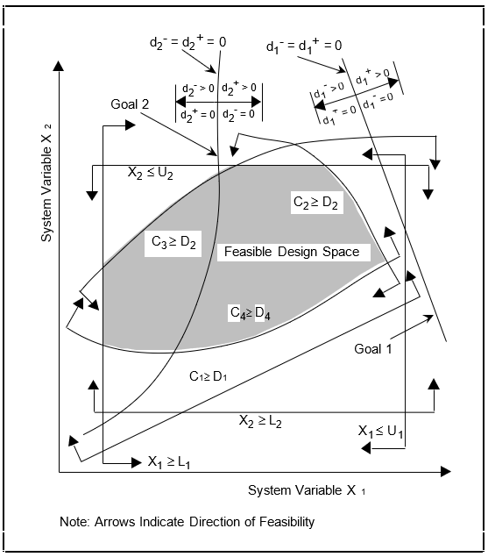
Figure I. 1: Typical Design Space For A Two Variable Compromise DSP

I.5.1 System Variables and System Constraints
System Variables
X = (X1, X2, ..., Xn), Xi ≥ 0.
System Constraints
Ci(X) ≥, or = Di(X) ; i = 1, 2, 3 ..., m.
Compromise DSPs have a minimum of two system variables. Consider a set of 'n' design variables represented by X. The vector of variables includes continuous variables and Boolean variables (1 if TRUE, 0 if FALSE). System variables are, by their nature, independent of the other descriptors and can be changed as required by the designer to alter the state of the system. System variables that define the physical attributes of an artifact are always nonzero and positive. In Figure I.1 the system variables X1 and X2, being independent, are represented by the abscissa and ordinate, respectively. Each member of the set X represents an axis of an 'n' dimensional space.
A system constraint is a constraint placed on the design. The set of system constraints must be satisfied for the feasibility of the design. Mathematically, system constraints are functions of system variables only. They are rigid and no violations are allowed. They relate the demand placed on the system D(X) to the capability of the system C(X) to meet the demand. The region of feasibility defined by the system constraints is called the feasible design space.
The set of system constraints may be all linear, nonlinear or consist of both linear and nonlinear functions. In engineering problems the system constraints are invariably inequalities. However, occasions requiring equality constraints may arise. All system constraints shown in Figure I.1 are inequalities.

I.5.2 Deviation Variables and System Goals
A set of system goals is used to model the aspiration a designer has for the design. It relates the goal (aspiration level), Gi, of the designer to the actual attainment, Ai(X), of the goal. Three conditions need to be considered:
- Ai(X) ≤ Gi ; we wish to achieve a value of Ai(X) that is equal to or less than Gi.
- Ai(X) ≥ Gi; we wish to achieve a value of Ai(X) that is equal to or greater than Gi.
- Ai(X) = Gi; we would like the value of Ai(X) to equal Gi.
We will now introduce the concept of a deviation variable. Consider the third condition, namely, we would like the value of Ai(X) to equal Gi. The deviation variable is defined as: d = Gi - Ai(X).
The deviation variable d can be negative or positive. Considerable simplification of the solution algorithm is effected if one can assert that all the variables in the problem being solved are positive. Therefore, the deviation variable d is replaced by two variables:
d= di- - di+
where
di- . di+ = 0
and
di- , d + ≥0 .
i
The preceding ensures that the deviation variables never take on negative values.
The system goal becomes:
Ai(X) + di- - di+ = Gi ; i = 1, 2, ..., m (1.1)
where
di- , di+ ≥ 0 and di- . di+ = 0
The product condition ensures that one of the deviation variables will always be zero. If the problem is solved using an algorithm that provides a vertex solution as a matter of course then the condition is automatically satisfied, making its inclusion in the formulation redundant. Since, the solution scheme described in this book and the software that is available for solution makes use of an algorithm that provides a vertex solution we will assume that this condition is satisfied. For completeness we include this condition as a constraint in the mathematical forms of the compromise DSP given later in this chapter and for brevity will omit this constraint from all subsequent formulations.
Note that a system goal is always expressed as an equality. It is possible that the designer's aspiration levels are inordinately high, or the system constraints are much too restrictive to attain the desired levels of achievement. The deviation variables di- and di+ are used to allow the designer a certain degree of latitude in making decisions. The deviation variables therefore relate the actual performance of the design to the aspired level of performance. These variables serve to "anchor" the aspiration levels to realistic achievement levels. When considering Equation 1.1, the following will be true:
IF Ai ≤ Gi (underachievement) THEN di- > 0 and di+ = 0.
IF Ai ≥Gi (overachievement) THEN di- = 0 and di+ > 0,
IF Ai = Gi (exact achievement) THEN di- = 0 and di+ = 0
How do we model the three conditions listed earlier using Equation 1.1?
  - To satisfy Ai(X) ≤ Gi, we must ensure that the positive deviation di+ is zero. The negative deviation di- will measure how far is the performance of the actual design from the goal.
  - To satisfy Ai(X) ≥Gi, the negative deviation di- must be made equal to zero. In this case, the degree of overachievement is indicated by the positive deviation di+.
  - To satisfy Ai(X) = Gi, both deviations, di- and di+ must be zero.
The difference between a system variable and a deviation variable is that the former represents a distance in the ith dimension from the origin of the design space, whereas the latter originates on the surface of the system goal. This is illustrated in Figure I.2. The value of the ith deviation variable is determined by the degree to which the ith goal is achieved. It depends upon the value of Ai(X) alone (since Gi is fixed by the designer). Ai(X) in turn is dependent upon the system variables X. The set of deviation variables can be all continuous, all Boolean or some can be Boolean and others continuous. Obviously, both the deviation variables associated with a particular system goal will be of the same type.
The system goal represents an equation for a family of either parallel linear or nonlinear functions. In Figure I.2, goal i (represented by line A) is the target goal to be achieved. Assume that lines B and C represent the maximum acceptable excursion that is possible from the target goal. In other words, the system variables can achieve any value in the shaded region. Three representations for lines B and C are shown in the figure, as follows,
- In terms of system variables.
- In terms of the system variables and the nonzero deviation variable.
- In terms of the system variables and both the deviation variables.
In 1 (see Figure I.2) the right hand sides for the equations for A, B and C are different. In 2 and 3 the right hand sides for both B and C are the same (b1) however the deviation variables are different. In 3 both B and C are expressed in terms of the system variables and the two deviation variables. For B, the underachievement d1- is nonzero and the overachievement d1+ is zero. For C it is the other way around. Since only one deviation variable, by definition, can be nonzero we are able to write the equation for the family of system goals B through C. This is analogous to Equation 1.1.

I.5.3 Range of Values for Deviation Variables
The objective of a traditional single objective optimization problem requires the maximization or minimization of a certain function. This function is in terms of the system variables. In a compromise DSP formulation, each of the objectives is converted into a goal (using Equation 1.1) with its corresponding deviation variables. The resulting formulation is similar to a single objective optimization problem but with the following differences:
- The objective is always to minimize a function.
- The objective function is expressed using deviation variables only.
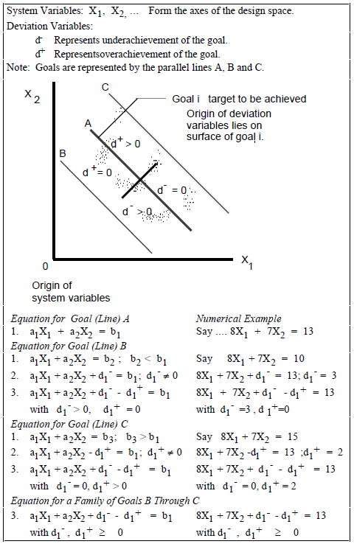
Figure I. 2: The System Goal
The objective in the compromise DSP formulation is called the deviation function. As indicated earlier, the deviation variables are associated with system goals and therefore their ranges of values depend on the goal itself. Goals are not equally important to a designer. Therefore to solve the problem, given a designer's preferences, the goals are rank ordered into priority levels. Within a priority level it is imperative that the deviation variables are of the same order of magnitude. This is achieved by normalizing the goals. If this is not done the deviation variable with the larger numeric value will dominate the solution process without regard to the designer- established preference for the set of goals.
A solution to the order of magnitude problem is to normalize the achievement Ai(X) with respect to the target value Gi before the deviation variables are introduced. The following rules are used to formulate the system goals in a way that ensures that all the deviation variables will range within the same values (0 and 1 in this case).
- To maximize the achievement, Ai(X) , choose a target value Gi greater or equal to the maximum expected value of Ai(X) , so that the ratio Ai(X) /Gi is always less or equal than 1. For example, if Ai(X) is the reference stress then Gi could be the yield stress. Consider the following:
Ai(X) ≤ Gi ⇒ Ai(X) /Gi ≤ 1
Transform the expression into a system goal by adding and subtracting the corresponding deviation variables (which in this case will range between zero and one).
Ai (X) / Gi + di-- di+ = 1 (1.2)
In this case, the overachievement variable, di+, will always be zero, as indicated in Section 4.2.2. Then minimize the underachievement deviation, di-, to ensure that the performance of the design will be as close as possible to the desired goal.
- To minimize the achievement, Ai(X), the following steps are in order:
i. Choose a target value, Gi, less than or equal to the minimum expected value of Ai(X) . In this case, the ratio Gi / Ai(X) will be less than or equal to one.
Ai(X) ≥ Gi ⇒ Gi / Ai(X) ≤ 1
Transform the expression into a system goal (note the inversion of G and A) and flip the signs of the deviation variables (to account for the inversion). The deviation variables will vary between 0 and 1.
Gi / Ai (X) - di- + di+ = 1 (1.3)
The underachievement deviation, di-, will be zero as indicated in Section I.5.2. Minimizing the overachievement deviation, di+, will ensure that the performance of the design is as close as possible to the desired goal.
  - If the target value, Gi, is taken as zero, get an estimate of the maximum value that the achievement, Ai(X) , can obtain within the bounds set for the system variables, Aimax(X).Then divide the inequality by this maximum value and convert into a system goal with the following result:
Ai (X) / Aimax(X). + di- - di+ = 0 (1.4)
The deviation variables will now vary between 0 and 1. Note that the signs of the deviation variables remain as in the original Equation 1.1. In this case, the underachievement deviation di- will always be zero. Minimize then the
overachievement deviation di+ to ensure that the
performance of the design will be as close as possible to the desired value of zero.
- If it is desired that Ai(X) = Gi, and
  - If the target value Gi is approached from below by Ai(X) , use Equation 1.2 and minimize the sum (di-+ di+).
  - If the target value Gi is approached from above by Ai(X) , use Equation 1.3 and minimize the sum (di-+ di+).
  - If the target value Gi is equal to zero, use Equation 1.4 and minimize the sum (di-+ di+).

I.5.4 Bounds on System and Deviation Variables
Bounds are specific limits placed on the magnitude of each of the variables. Each variable has associated with it a lower and an upper bound. Bounds are important for modeling real-world problems because they provide a means to include the experience-based judgment of a designer in the mathematical formulation. Unfortunately, in most engineering design textbooks that encourage the notion of using optimization techniques in design there has been a tendency to ignore bounds. Bounds on the system variables take the form
L ≤ X ≤ U
where L and U represent the set of lower and upper bounds, respectively. The bounds on the system variables demarcate the region in which a search is to be made for a feasible solution. In engineering design, the lower bounds are always nonzero and positive, reflecting physical limitations.
Deviation variables are by definition nonnegative (see Section I.5.2) and therefore a lower bound of zero is always associated with them.

I.5.5 The Deviation Function
In the compromise DSP formulation, the aim is to minimize the difference between that which is desired and that which can be achieved. This is done by minimizing the deviation function, Z(d⁻, d⁺), which is always written in terms of the deviation variables.
A designer sets an aspiration level for each of the goals. It may be impossible to obtain a design that satisfies all the levels of aspiration. Therefore, a compromise solution must be accepted by the designer. It is desirable, however, to obtain a design whose performance matches the aspiration levels as closely as possible. This in essence is the objective of a compromise solution. The difference between the goals and achievement is expressed by a combination of appropriate deviation variables, Z(d⁻, d⁺). This deviation function provides an indication of the extent to which specific goals are achieved.
All goals may not be equally important to a designer and the formulations are classified as Archimedean or Preemptive - based on the manner in which importance is assigned to satisficing the goals.
In the following section, we will delve into both of these forms, examining their applications in optimization and cDSP construct , and ultimately, we will compare their respective outcomes.

I.6 Archimedean and Preemptive Form : Comparing Solutions
Archimedean In the context of multiobjective optimization: In the context of multiobjective optimization, a mathematical framework that allows the combination of multiple objectives into a unified objective function has been provided in the Archimedean form. With the Archimedean form, compromise solutions can be identified by decision-makers, taking into account conflicting objectives.
The Archimedean form is characterized by the aggregation of individual objectives using an Archimedean aggregation operator. This operator incorporates the relative weights or importance assigned to each objective by the decision-maker, enabling the expression of preferences and the reflection of the relative significance of different objectives in the optimization process.
One of the commonly used Archimedean aggregation operators is the weighted sum operator. It involves the linear combination of individual objectives by multiplying each objective with its corresponding weight and summing the results. The weighted sum operator is expressed as follows:
The aggregated objective function, F(x), is given by the equation:
F(x) = w₁ * f₁(x) + w₂ * f₂(x) + ... + w_{n} * f_{n}(x)
Here, F(x) represents the aggregated objective function, while f₁(x), f₂(x), ..., f_{n}(x) denote the individual objective functions. The weights w₁, w₂, ..., w_{n} are associated with each objective and reflect their relative importance.
Determining the weights is subjective and relies on the decision-makers preferences, priorities, and domain knowledge. Techniques such as direct elicitation, pairwise comparisons, or the analytic hierarchy process (AHP) can be employed to assign appropriate weights.
In addition to the weighted sum operator, other Archimedean aggregation operators can be utilized based on the decision-makers preferences and the nature of the objectives. For example, the weighted product operator considers the product of individual objectives raised to their corresponding weights. The weighted power mean operator computes a weighted average of individual objectives using a power
function.
Once the objectives are aggregated into a single objective function, optimization algorithms can be employed to search for optimal or near-optimal solutions. The objective is to identify solutions on the Pareto front, representing the set of non-dominated solutions. A solution on the Pareto front cannot be improved in one objective without sacrificing at least one other objective.
Decision-makers could get a structured framework for handling multiobjective optimization problems with Archimedean form. By converting multiple objectives into a single objective function, the complexity of analyzing and comparing objectives is simplified. Adjusting the weights allows decision-makers to explore different trade-offs and identify solutions that align with their preferences and requirements.
Archimedean In the context of cDSP: A significant role is played by the Archimedean form in the context of the Compromise Decision Support Problem (cDSP) by providing a mathematical framework to handle conflicting objectives and facilitate decision-making. In the cDSP, the focus is on finding compromise solutions that balance multiple objectives, considering the inherent conflicts, resource limitations, and uncertainties present in real-world decision scenarios.
The cDSP formulation is aimed at minimizing the difference between desired goals and achievable goals in the Archimedean form. In this formulation, weights can be assigned to each goal by the designer based on their level of importance and satisfaction.
In the Archimedean formulation, the deviation function, denoted as Z(d⁻, d⁺), is used to express the difference between the desired goals and their achievement.
The underachievement and overachievement of each goal are represented by the deviation variables (d⁻, d⁺) in the Archimedean form.
The deviation function is defined as follows:
Z(d⁻, d⁺) = ∑(W_{i}(d_{i}⁻ + W_{i}(d_{i}⁺)) for i = 1,...,m
In this formulation, m represents the number of goals, and W_{i} denotes the weight assigned to the i-th goal. The weights reflect the level of desire to achieve each goal, and they should satisfy the following conditions:
∑W_{i} = 1, and W_{i} ≥ 0 for all i.
The representation of aspiration levels for each goal, which signifies the desired performance, is enabled by the Archimedean formulation. However, the recognition that it may be impossible to simultaneously achieve all aspiration levels is acknowledged by the Archimedean formulation. Therefore, a compromise solution must be accepted. In the Archimedean formulation, the deviation function is minimized by considering the weighted sum of the deviation variables for each goal. The objective is to find a solution that closely matches the desired aspiration levels for all goals.
Various methods can be used to determine the appropriate weights, such as pairwise comparison techniques. These methods involve comparing the goals in pairs and expressing the preference between them. Overall, balancing multiple goals in the compromise, DSP is facilitated by the framework provided by the Archimedean formulation, allowing informed decisions to be made by the designer based on the relative importance of each goal and the extent to which they are achieved.
The formulation classifies the goals into different priority levels. The designer can determine the importance of goals either by using Archimedean weights or by rank ordering the goals in a preemptive approach. The previous discussion covered the Archimedean formulation of the compromise Decision Support Problem (cDSP). Now, let us delve into the preemptive form of the cDSP, which provides an alternative approach to solving such problems.
Preemptive In The Context Of Multiobjective Optimization: In the context of multiobjective optimization, the preemptive form involves rank-ordering goals or objectives based on their priority levels. The sequential optimization of goals is permitted by this approach, with higher priority goals being achieved before lower priority goals are addressed. The preemptive form is particularly useful when assigning weights or preferences to the goals is difficult.
In the preemptive form, goals are organized into priority levels, and the optimization process aims to minimize the deviations or underachievement of each goal at its respective priority level. Once a goal is fully satisfied, the optimization focuses on the next priority-level goal. This process continues until all goals have been addressed.
The formulation of the preemptive form involves defining deviation variables for each goal and constructing a deviation function that captures the deviations at each priority level. The deviation function is designed to minimize the deviations at each priority level while maintaining the achieved levels of higher priority goals.
A structured approach to multiobjective optimization, allowing for systematic consideration of goal priorities, has been provided by the preemptive form. It is particularly useful when there is limited information available to assign precise weights or preferences to the goals. By prioritizing higher priority goals first, a way is provided to achieve a satisfactory compromise solution while considering the relative importance of different objectives. Note that the preemptive form is just one of the approaches in multiobjective optimization, and the choice of the approach depends on the problem characteristics, available information, and the preferences of the decision-maker.
Preemptive In The Context Of cDSP: In the preemptive formulation, the emphasis is placed on rank-ordering the goals rather than assigning explicit weights to them. This approach is particularly useful when it is challenging to assign meaningful weights or when there is limited information available in the early stages of design or in an industrial environment. The preemptive form is one of the approaches in multiobjective decision support problems, and the choice of the approach depends on the problem characteristics, available information, and the preferences of the decision-maker.
In the Preemptive approach, the difficulty of assigning weights is circumvented by rank ordering the goals. The measure of achievement is obtained in terms of the lexicographic minimization of an ordered set of goal deviations, wherein within each set of goals at a particular rank, weights may be used. Goals are ranked lexicographically, and an attempt is made to achieve a more important goal before considering other goals.
The mathematical definition of lexicographic minimum follows,
LEXICOGRAPHIC MINIMUM Given an ordered array f of nonnegative elements, fk's, the solution, given by f⁽¹⁾, is preferred to f⁽²⁾ if
f_{k}⁽¹⁾ < f_{k}⁽²⁾
and all higher-order elements (i.e., f₁, ... , f_{k-1}) are equal. If no other solution is preferred to f, then f is the lexicographic minimum.
The goals are ranked in order of priority, and the aim is to achieve the higher-ranked goals before considering the lower-ranked ones. This ranking represents the preference of one goal over another without quantifying the degree of preference or importance.
To illustrate this concept, consider a set of goals with associated deviation variables: goal 1 (d₁⁻, d₁⁺), goal 2 (d₂⁻, d₂⁺), goal 3 (d₃⁻, d₃⁺), and so on. The preemptive deviation function can be expressed as:
Z = [ f₁(d₁⁻, d₁⁺), f₂(d₂⁻, d₂⁺), f₃(d₃⁻, d₃⁺), ... ]
In this formulation, each priority level, represented by f₁, f₂, f₃, etc., is minimized sequentially. The priority levels are determined by the rank order of the goals. The objective is to find a solution that minimizes the deviation variables at each priority level while maintaining the achieved goals at the higher priorities. Formulation of the preemptive form in cDSP involves the following steps:
Goal Ranking: The first step is to rank the goals in order of priority. This ranking is typically based on the preferences and importance assigned by the decision-maker. Higher-ranked goals are considered more important and should be achieved before lower-ranked goals.
Deviation Variables: Deviation variables are introduced to quantify the deviation between the desired goal values and the achieved values. For each goal, two deviation variables are defined: d_{i}⁻ (underachievement) and d_{i}⁺ (overachievement). The extent to which a particular goal is not fully satisfied or exceeds the desired level is represented by these variables.
Deviation Function: The deviation function, denoted as Z(d⁻, d⁺), is formulated to measure the overall deviation between the desired goals and their actual achievement. In the preemptive form, the deviation function is written as:
Z = [ f₁(d_{i}⁻, d_{i}⁺), ..., f_{k}(d_{i}⁻, d_{i}⁺ )]
Where k represents the number of goals or priority levels, the deviation variables corresponding to each priority level are included in the deviation function.
Minimization: The objective is to minimize the deviation function while satisfying the constraints of the problem. The solution is sought by finding a set of values for the decision variables that minimize the deviations for the highest-priority goal and then sequentially minimize the deviations for lower-priority goals.
Mathematical Representation: The preemptive form can be mathematically represented using cDSP techniques. The formulation includes the goal constraints, system constraints, and the deviation function. The goal constraints specify the desired levels of achievement for each goal, while the system constraints represent the limitations or requirements of the problem.
By solving the preemptive form of cDSP, a solution that achieves the highest-priority goal as closely as possible while considering the subsequent goals in the ranked order is obtained.
Example:
As an example, consider two solutions, f^{(r)} and f^{(s),} where
f^{(r)} = (0, 10, 400, 56)
f^{(s)} = (0, 11, 12, 20)
In this example, note that f^{(r)} is preferred to f^{(s).} The value 10 corresponding to f₂^{(r)} is smaller than the value 11 corresponding to f₂^{(s)}. (Since the objective is to minimize or achieve smaller values for the second element, f^{(r)} is preferred over f^{(s)} because f₂^{(r)} (10) is smaller than f₂^{(s)} (11)) .Once a preference is established, then all higher-order elements are assumed to be equivalent. Hence, the deviation function for the Preemptive formulation is written as
Z = [ f₁(d_{i}⁻,d_{i}⁺), ..., f_{k}(d_{i}⁻,d_{i}⁺) ] .
For a four goal problem, the deviation function may look like
Z(d⁻, d⁺) = [ (d₁⁻ + d₂⁻ ), (d₃⁻ ), (d₄⁺) ]
In this case, three priority levels are considered. The deviation variables, d₁⁻ and d₂⁻, have to be minimized preemptively before variable d₃⁻ is considered, and so on. These priorities are represented by rank, indicating the preference for one goal over another. No conclusions can be drawn with respect to the amount by which one goal is preferred or is more important than another. This approach is, therefore, suitable when there is little information available. For a simple problem with only two system variables, a graphical solution can be easily found by satisficing the goals in a logical manner. This is in contrast to the Archimedean approach, in which the numerical evaluation of the deviation function is required even for the simplest case. The numerical solution of a Preemptive formulation requires the use of a special optimization algorithm developed to solve these types of problems. One such algorithm has been developed by Ignizio [J. P. Ignizio, "Multiobjective Mathematical Programming via the MULTIPLEX Model and Algorithm," European Journal of Operational Research, 22, 1985, 338-346.]. It is also possible to solve the Preemptive formulation by reformulating the deviation function into a pseudo-preemptive form, as suggested by Schniederjans [M. J. Schniederjans, Linear Goal Programming, Petrocelli Books, Princeton, N.J, 1984.]. Schniederjans' notion is to force the deviation function to satisfy the priorities by multiplying each priority level by a quantity Pi, whose numerical value is much larger than the corresponding one associated with the next priority level. The deviation function for the example problem presented earlier expressed in a pseudo-preemptive fashion looks like
Z(d⁻, d⁺) = P₁ (d₁⁻ + d₂⁻) + P₂ ( d₃⁻ ) + P₃ ( d₄⁺) where P₁ >> P₂ >> P₃,
In the preceding, the >> implies preference, and the Pi's represent rank-ordered priorities that are modeled numerically. Lexicographic preference is modeled numerically on a computer only if the numerical values between the priorities are substantial. For example, let us try to model the following numerically:
P1 >> P2 >> P3.
Consider the following series of numbers:
3 >> 2 >> 1
300 >> 200 >> 100
1037 >> 1020 >> 1010 .
Which of the three series models is the preference the best? The correct answer is the third set of numbers.
In the subsequent section, an illustrative example is employed to provide a more detailed explanation of the contrast in solutions achieved through the utilization of preemptive and Archimedean formulations.
Comparing Solutions: Preemptive and Archimedean Formulations
The following example is presented to illustrate the difference in the solution obtained by using the preemptive and Archimedean formulations. The design space for the example problem is shown in Figure I.3.
The algorithms that have been developed to solve the compromise DSPs provide vertex solutions. Therefore, we will restrict our discussion to vertex solutions only. Further, we are seeking a solution that achieves all three goals completely.
Find
System Variables X₁, X₂
Deviation Variables d₁⁻, d₁⁺, d₂⁻, d₂⁺, d₃⁻, d₃⁺
Satisfy
System Constraints
2X₁ + 3X₂ ≤ 30 [c1]
6X₁ + 4X₂ ≤ 60 [c2]
System Goals (Dimensionless, Normalized)
X₁/10 + X₂/10 + d₁⁻ - d₁⁺ = 1 [g1]
X₂/ 7 + d₂⁻ - d₂⁺ = 1 [g2]
X₁/8 + d₃⁻ - d₃⁺ = 1 [g3]
Bounds omitted for brevity.
Minimize
Case a: Using the Preemptive approach (lexicographic minimum).
Z = [(d₁⁻+ d₁⁺), (d₂⁻+ d₂⁺), (d₃⁻+ d₃⁺)]
All deviation variables are considered due to equality goals.
Case b: Using the Archimedean approach.
Z = W₁(d₁⁻+ d₁⁺), + W₂(d₂⁻+ d₂⁺), + W₃(d₃⁻+ d₃⁺),
where W1 = W2 = W3 = 1/3 (assumed values)
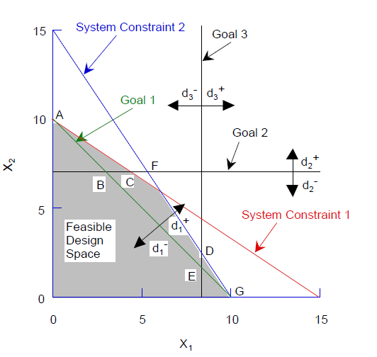
Figure I. 3: Design Space, For Example Problem
The solution to the preceding compromise DSP using both the Preemptive and Archimedean approaches follows:
Case A: Preemptive
- The goal with the highest priority is considered first (Goal 1). This goal lies completely within the feasible design space, and consequently, any point satisfying the goal is considered to be a solution, namely, vertices A, B, E, and G.
- We next move to priority level 2, which requires the minimization of d₂⁻ and d₂⁺. Notice that in Figure 1.2, these deviations may be set to zero at point B without reducing the value of the solution obtained for priority 1. That is, d₂⁻ and d₂⁺ may be set to zero without any increase in either d₁⁻ or d₁⁺. Therefore, vertex A is the second preferred solution, with the first priority still being satisfied (d₁⁻, d₁⁺ = 0) and a minimum value for the overachievement of the second goal d₂⁺.
- Moving to priority level 3, we attempt to minimize d₃⁻ and d₃⁺ without degrading the solution for the other priority levels. In this case, the solution point that comes closer is once again point B, with d₁⁻, d₁⁺, d₂⁻, d₂^{+,} and d₃⁺= 0 and a minimum value of the third goal underachievement d₃⁻.
- If the priorities were changed to goals 1, 3, and 2 in that order, the preferred solution would be at point E. We suggest that you solve this as an exercise.
Case B : Archimedean
In Table I.1, the values of the deviation variables and the deviation function at different vertices are summarized. It follows from the table that the best solution is at 'C' where Z is a minimum Z=0.196).
The solutions obtained in the two cases are different. The Preemptive approach is suitable when less is known about the design, and consequently, a designer can only rank-order the preferences for the goals. Using the Archimedean approach is warranted when it is possible to determine the relative importance of the goals using a pairwise comparison method.
Should all the deviation variables be included in the formulation of the deviation function? Deviation variables will be zero; consequently, we can exclude them from the deviation function. If one is interested in varying the target values to study the sensitivity of the solution, it is necessary to include all the deviation variables in the deviation function.

Table I.1: Deviation Function Values For Archimedean Solution
Acceptable Value of Solution
Vertices Normalized Dev. Var. Sum Func.
(coord.) d₁⁻ d₁⁺ d₂⁻ d₂⁺ d₃⁻ d₃⁺ ∑(d_{i}⁻+ d_{i}⁺) Z
A = (0, 10) | 0 | 0 | 0 | 0.429 | 1 | 0 | 1.429 | 0.476
B = (3, 7) | 0 | 0 | 0 | 0 | 0.625 | 0 | 0.625 | 0.208
C = (4.5, 7) | 0 | 0.150 | 0 | 0 | 0.438 | 0 | 0.588 | 0.196
D = (8, 3) | 0 | 0.100 | 0.571 | 0 | 0 | 0 | 0.671 | 0.224
E = (8, 2) | 0 | 0 | 0.714 | 0 | 0 | 0 | 0.714 | 0.238
F = (6, 6) | 0 | 0.200 | 0.143 | 0 | 0.250 | 0 | 0.593 | 0.198
G = (10, 0) | 0 | 0 | 1 | 0 | 0 | 0.250 | 1.250 | 0.417

Subsequent to the deliberation on the compromise decision support problem, the following section, the DSIDES software, a developed tool designed for the implementation of the cDSP construct, has been described.

I.7 Expanded cDSP Examples : The Two Coal Problem
Recent revisions of pollution control laws have had a direct influence on the running of a power station. These revisions have reduced the allowable emission of pollutants into the atmosphere from the plant’s exhaust gases. To comply with these new regulations expeditiously and eliminate downtime it is desired, now, to control the emission rates by the appropriate use of coal.
Historically, coal has been bought from two sources, say A and B. Both types of coal are transported to the plant and stored in separate stockpiles. From there they are fed by a mechanical conveyer into a pulverizer, crushed into fine particles, mixed at a specified rate and burnt in a combustion chamber.
Coal from source A, Coal A, is relatively hard, clean burning, has a low sulfur content and is more expensive than Coal B which is soft, smoky when burnt, and has a high sulfur content. The thermal value, in terms of steam produced, is 24,000 lbs/ton for Coal A and 20,000 lbs/ton for Coal B. Since Coal A is hard, the pulverizer can handle 16 tons/hr of it. Since Coal B is soft, the pulverizer can handle 24 tons/hr of it. The capacity of the conveyer is 20 tons/hr for both types of coal. There is a limit to the amount of coal that can be stockpiled. This limit translates to a maximum of 25 tons/hr for any type of coal that can be burnt.
The new pollution regulations limit sulfur oxide emissions to 3,000 parts per million and the particulate emissions (smoke) to 12 kg/hr. The characteristics of the two types of coal are summarized in Table I.2.
Case A: A Linear Single Objective Optimization Problem.
Problem Statement: Determine the most efficient combination of the two types of coal to be burnt that satisfies the constraints and bounds and maximizes the rate of production of electricity. No information is given in the story about the lower bounds on the rates of consumption of the two types of coal. It is reasonable to assume, initially, that the lower bounds are zero. The implication of this assumption is that a solution that requires the burning of a single type of coal, in our case coal from a single vendor, is acceptable.

Table I.2: Coal and material handling characteristics
PROPERTIES | Coal A | Coal B | Units
Thermal value | 24,000 | 20,000 | lbs steam / ton
Sulfur oxides emission | 1,800 | 3,800 | ppm
Particulate emission | 0.5 | 1.0 | kg / ton
Pulverizer coal handling
capacity | 16 | 24 | tons / hour
Conveyer coal handling
capacity | 20 | 20 | tons / hour
Case B: The Linear Single Objective Optimization Problem - Revisited.
Problem Statement: The power company does not want to rely on a single source for its supply of coal. The purchasing department has determined that there is a minimum order quantity for the coal. This minimum order quantity translates to a lower bound of 5 tons of each type of coal per hour. Determine the most efficient combination of the two types of coal to be burnt that satisfies the constraints and bounds and maximizes the rate of production of electricity.
This problem is used to illustrate the algorithm for solving the most general linear single objective optimization problem. The preceding requires the introduction of two nonzero lower bounds on the system variables and the introduction of artificial variables to get an initial solution by inspection. Unlike Case A, in this case it is inappropriate to drop the lower bounds at the very outset.
Case C: A Linear Single Goal Compromise Decision Support Problem.
Problem Statement: The demand for steam is likely to increase to 432,000 lbs/hr during the summer months. Can this be achieved without violating any of the constraints and bounds?
This problem is formulated as a single goal compromise DSP, and the solution compared to that of the single objective optimization problem, Case A.
Case D: A Linear, Multigoal Compromise Decision Support Problem.
Problem Statement: The demand for steam is going to increase to at least 432,000 lbs/hr during the summer months. Management is prepared to violate some of the pollution constraints and pay a fine, if necessary, to get this amount of steam from the plant. Company executives have identified one viable scenario as putting out as much sulfur oxides and smoke as is permissible and maximizing the amount of steam produced.
This problem is used to illustrate the solution of a multigoal compromise DSP.
Case E: A Nonlinear, Multigoal Compromise Decision Support Problem.
Problem Statement: The plant is being modified and access to the warehouse is limited. For a short period the management would like to hold the stockpiling down so as not to exceed 10 tons/hr of Coal A and 5 tons/hour of Coal B. The cost for stockpiling per ton is assessed proportionally to the excess capacity, over the desired capacities, and is equal to $3/(excess ton of Coal A) and $4/(excess ton of Coal B). The prices reflect the difficulties in stockpiling the softer Coal B. An incentive
is provided in stockpiling less coal than available capacity and is equal to $3/(surplus ton of Coal A) and $4/(surplus ton of Coal B). It is desirable to limit the total stockpiling costs to $30/hr.
Linear Single Objective Optimization: Formulation and Graphical Solution

I.7.1 Case A: The Word Problem
Given
❑ The properties of Coal A and Coal B.
❑ The capacity of the conveyer unit.
❑ The capacity of the pulverizer unit.
❑ Emission limit on sulfur oxides.
❑ Emission limit on particulates.
❑ Upper limits on the amount of coal that is stockpiled.
Assumptions
❑ Uninterrupted supply of coal is available.
❑ The combustion chamber can handle any amount of coal supplied from the pulverizer.
❑ The maximization of the rate of electricity produced is equivalent to the maximization of the rate of steam generated.
❑ The coal prices are stable.
Find
Independent System Variables
The rate of consumption of Coal A: X1 [tons/hr]
The rate of consumption of Coal B: X2 [tons/hr]
Satisfy
System Constraints
- The conveyer capacity is 20 tons/hr for any type of coal.
- The pulverizer can process 16 tons of Coal A and 24 tons of Coal B per hour.
- The emission of sulfur oxides is limited to 3,000 parts per million.
- The emission of particulates (smoke) is limited to 12 kg/hr.
Bounds on the System Variables
- The system variables should be nonnegative
- The maximum of any one type of coal that can be burnt is 25 tons/hr.
Maximize
- The rate of steam generated and therefore, the electricity produced.

I.7.2 Case A: Derivation of the Constraints and the Objective Function
The system variables. In the short run the plant's facilities are fixed. It is quite appropriate that management has decided to affect the output of electricity by using the best combination of the two types of coal. Therefore, let X1 be the number of tons of Coal A burnt per hour, and
X2 be the number of tons of Coal B burnt per hour. These variables
have two characteristics. One, they are physical quantities and are therefore nonnegative. Two, these variables are continuous, that is, any value that is feasible is acceptable from a mathematical standpoint.
The system constraints and bounds. The system constraints are written in terms of the system variables. In engineering, system constraints are invariably inequalities. The system constraints and bounds must be satisfied for feasibility. System constraints generally model the physics of the problem. The bounds, on the other hand, are the product of experience-based insight. They represent what is acceptable to the designer without regard to the physics of the problem. A constraint invariably has two or more system variables. A bound contains only one system variable and is always parallel (geometrically) to the axis represented by the system variable. Rarely is a constraint specified in terms of a single system variable. In this case the
constraint plays the same role as a bound in the design space even though it may represent the physics of the problem.
1 The constraint on conveyer capacity
The conveyer has a capacity of 20 tons/hour. This capacity is independent of the type of coal that is placed on the conveyer. Therefore, the constraint is written as:
X1 + X2 ≤ 20 [tons/hr]
The constraint is shown in Figure I.4.
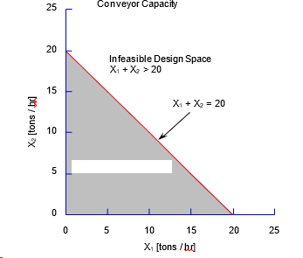
Figure I. 4: Conveyor capacity

2 The constraint on pulverizer capacity
The pulverizer capacity constraint is shown in Figure I.5. The maximum capacity of the unit is 16 tons of Coal A or 24 tons of Coal B per hour or any corresponding combination of the two. The right hand side for this constraint has not been specifically given in the problem statement. It has to be figured out. In this case, consider the amount that can be pulverized in one hour: it takes 1/16 of an hour to pulverize a ton of Coal A and 1/24 of an hour to pulverize a ton of Coal B.
Therefore, the constraint is written as:
X1/16 + X2/24 ≤ 1
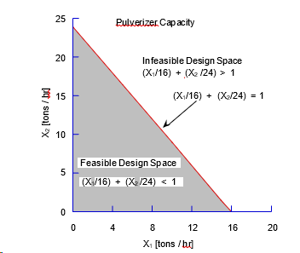
Figure I. 5: Pulverizer capacity

Therefore, the pulverizer capacity for one 24 hour day is (multiplying through by 24 [hrs/day]):
1.5X1+ X2 ≤ 24 [day]
Notice the units. Normally, multiplying through does not result in meaningful units. In this case, because there are 24 hours in a day, the second form of the constraint has meaningful units.
- The limit on sulfur oxides emission
The maximum emission of sulfur oxides is limited to 3,000 ppm. This constraint is shown in Figure I.6. There may be an urge to specify the constraint as:
1,800X1 + 3,800X2 ≤ 3,000.
What is wrong with the constraint? The units on the left hand side and the right hand side of the equation do not match. What is to be done? The units of 1,800, 3,800 and 3,000 are parts per million. If only the X1 and X2 were dimensionless the preceding constraint
would be acceptable. The way around this problem is to normalize X1 and X2 and make them dimensionless. How? Given that the two coals are burnt simultaneously, assume that a combination of X1 tons/hr of Coal A and X2 tons/hr of Coal B is fed into the combustion chamber as a homogeneous mixture.
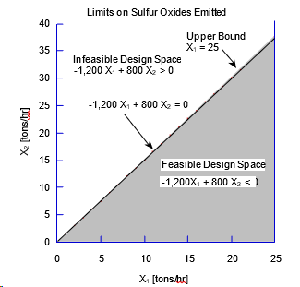
Figure I. 6: Limit on sulfur oxides

Then,
The proportion of Coal A in the total mixture is
X1/(X1 + X2), and
The proportion of Coal B in the total mixture is
X2/(X1 + X2).
Now the constraint on the sulfur oxides emission level is equal to the weighted average of the individual levels, i.e.,
1,800X1/(X1 + X2) + 3,800X2/(X1 + X2) ≤ 3,000 [ppm]
The preceding can be rewritten as:
-1,200X1 + 800X2 ≤ 0 [NMU]
The second form of the constraint, though algebraically simpler than the first has no meaningful units (NMU). The second form is more convenient to use from a computational standpoint. Since the second form has no meaningful units associated with it, it will not be possible to gain much meaningful insight through post-solution analysis. Since the first form has meaningful units, it is preferred over the second form for the post-solution analysis.
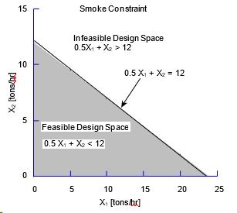
Figure I. 7: Smoke constraint

- The limit on particulate (smoke) emission
According to the information given, each ton of Coal A produces 0.5 kg of smoke and each ton of Coal B, 1 kg of smoke. The amount of smoke that can be emitted per hour is limited to 12 kg. Therefore, this constraint is stated as:
0.5X1 + X2 ≤ 12 [kg/hr]
This constraint is shown in Figure I.7
- The lower bounds on the system variables
Nothing is mentioned explicitly in the problem statement about lower bounds. Since this problem deals with physical quantities and they are always nonnegative, the lower bounds on the system variables are stated as follows:
X1 ≥ 0 [tons/hr]
X2 ≥ 0 [tons/hr]
6 The upper bounds on the system variables
The upper bounds on the system variables are explicitly stated in the problem statement and these are as follows:
X1 ≤ 25 [tons/hr]
X2 ≤ 25 [tons/hr]
The objective (deviation) function. The objective (see Figure 4.8) is to maximize the electricity produced at the plant. Since electricity is produced by using steam to drive the turbines, there is a direct relationship between the amount of electricity that is produced and the amount of steam that is produced in a specified length of time. What is the amount of steam produced for any arbitrary combination of coal used in any hour?
Coal Steam (lbs/ton) Fuel used (tons/hr) Steam (lbs/hr)
A 24,000 X1 24,000X1
B 20,000 X2 20,000X2
The total amount of steam (lbs/hr) = 24,000X1 + 20,000X2. The objective function therefore is,
Z = 24,000X1 + 20,000X2 [lbs/hr]
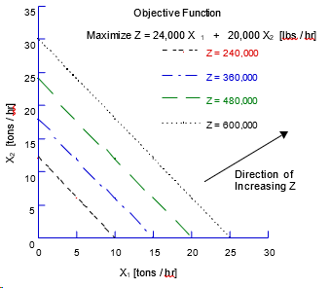
Figure I. 8: The objective function

I.7.3 Case A: The Mathematical Form of the Word Problem
Given
As stated in the word problem.
Find
System Variables
X1 - the rate of consumption of Coal A [tons/hr]
X2 - the rate of consumption of Coal B [tons/hr]
Satisfy
System Constraints
- Conveyer capacity
X1 + X2 ≤ 20 [tons/hr]
- Pulverizer capacity
X1/16 + X2/24 ≤ 1 [tons/hr] or
1.5X1 + X2 ≤ 24 [tons/day]
- Sulfur oxides emission
1,800X1/(X1 + X2) + 3,800X2/(X1 + X2) ≤ 3,000 [ppm]
or
-1,200X1 + 800X2 ≤ 0 [NMU]
- Smoke emission
0.5X1 + X2 ≤ 12 [kg/hr]
Bounds on system variables
- Lower bounds on system variables
X1 ≥ 0 [tons/hr]
X2 ≥ 0 [tons/hr]
- Upper bounds on system variables
X1 ≤ 25 [tons/hr]
X2 ≤ 25 [tons/hr]
Maximize
- The rate of steam produced
Z = 24,000X1 + 20,000X2 [lbs/hr]
= 24 X1 + 20 X2 [1000 lbs/hr]

I.7.4 Case A: The Graphical Solution
The set of all combinations of the system variables that satisfy all constraints and bounds simultaneously is called the set of feasible solutions and the space consisting of the feasible solutions is called the feasible design space. This is shown in Figure I.9. A solution that results in the violation of any of the constraints or bounds is called an infeasible solution. A constraint or bound that does not border the feasible design space is called a redundant constraint or bound. In this example, the upper bounds and the conveyer constraint are redundant.
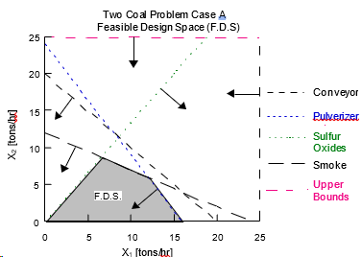
Figure I. 9: Case A feasible design space
The graphical solution is shown in Figure I.10. Pay particular attention to the following:
- The independent system variables are the axes of the design space.
- The system constraints and bounds form the feasible design space.
- The direction of feasibility is indicated, with arrows, on each constraint and bound. Experience has shown that many errors are avoided if students do not omit this simple step.
- The constraints and bounds are labelled in a way that makes it easy to refer back to the word problem and its mathematical form. A one-to-one correspondence should exist between the word problem, its mathematical form and the graphical solution. Experience has shown that the errors made by students are fewer if this is checked as a matter of course.
- The best solution for the model, at which the objective has the highest value (when maximizing), is at a vertex of the feasible design space.
- The solution to the problem consists of not just the values of the system variables and the objective function but also the active and inactive constraints, etc. The solution is shown on the graph and a recommendation is made, as required, to management.
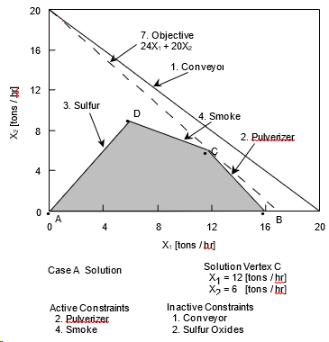
Figure I. 10: Case A solution

I.7.5 Case A: Recommendation
If 12 tons of Coal A and 6 tons of Coal B are burnt per hour, 408,000 lbs of steam will be generated per hour. This will result in the maximum amount of electricity being produced with all the constraints and bounds being satisfied.
The best solution for the model occurs at vertex C in Figure I.10. At vertex C the smoke constraint, constraint 4, and the pulverizer constraint, constraint 2, are active. The maximum amount of particulates that can be emitted into the air are being emitted and there is no reserve capacity for the pulverizer.

I.7.6 Case A: Post-solution Analysis
Post-solution analysis deals with the “What is the impact on ... if ...” questions. For example,
- What happens if there is a change in the coefficient of a variable in the objective function?
- What happens if there is a change in the right hand side of a constraint?
- What is the impact on the solution of adding a variable, i.e., another type of coal?
- What happens if one of the coefficients on the left hand side of a constraint changes?
The first three will be answered in this section.
Slack and surplus variables. For any feasible solution, the difference between the left hand side and the right hand side of the constraint is called the amount of slack (for  inequalities) or surplus (for  inequalities). In system constraints, this difference is represented by the inclusion of slack or surplus variables. For Case A, after the introduction of the slack and surplus variables, the mathematical form is as follows (note the form used for constraint 3):
Find
X1, X2, S1, S2, S3, S4, S5, S6, S7, S8
Satisfy
- X1 + X2 + S1 = 20 [tons/hr]
- 1.5 X1 + X2 + S2 = 24 [hours]
- 1,800 X1/(X1+X2) + 3,800X2/(X1 + X2) + S3 = 3,000 [ppm]
- 0.5 X1 + X2 + S4 = 12 [kg/hr]
- X1 - S5 = 0 [tons/hr]
- X2 - S6 = 0 [tons/hr]
- X1 + S7 = 25 [tons/hr]
- X2 + S8 = 25 [tons/hr]
Maximize
Z = 24 X1 + 20 X2 [1,000 lbs/hr]
Slack and surplus variables represent unused resource or capacity. If either the slack or surplus variable is zero for a particular constraint, then that constraint is active. If the slack or surplus variable for a constraint is nonzero, then the corresponding constraint is inactive. For Case A, with X1 = 12 and X2 = 6 tons/hour the slacks and surplus variables are:
Conveyer S1= 2 [tons/hr] Inactive
Pulverizer S2 = 0 [hours] Active
Sulfur S3 = 533.33 [ppm] Inactive
Smoke S4 = 0 [tons/hr] Active
The nonzero slacks indicate the amount of reserve capacity or resources. For Case A, the amount of reserve conveyer capacity is 2 tons per hour and the additional amount of sulfur oxides that can be emitted into the atmosphere without penalty is 533 parts per million.
Change in the slope of the objective function. What happens if the values of the coefficients of the objective function change? Assume that the thermal value of Coal A is 32,000 pounds of steam per ton. The objective function changes to
Z = 32 X1 + 20 X2 [1000 lbs/hr].
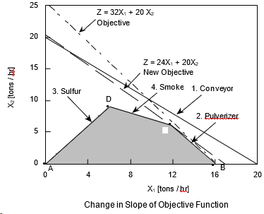
Figure I. 11: Change in slope of objective function
The change in the coefficient changes the slope of the objective function and if this slope is sufficiently large the solution will move to another vertex, Figure 4.11. This will alter the values of the system variables, the objective function and the slack and surplus variables. In Case A, the solution moves to vertex B. Ranging or parametric analysis of the objective function is the answer to the following question: By how much can we change the coefficient of the objective function and still keep the same solution? Ranging involves identifying the range of change of a coefficient for which the solution remains the same. For example, if C1 is the coefficient of X1, then the solution will be at vertex C or include vertex C as long as C1 satisfies the following
10 ≤ C1 ≤ 30
Change in the right hand side value of a constraint. Suppose the management is contemplating the installation of emission control equipment that would reduce smoke emission from the smoke stack by 25 percent. This would allow legal emission standards to be met by “uncontrolled” emission of smoke at the furnace of up to 15 kg/hr. How much would this be worth per hour in terms of steam output?
Assume, for the present, that the limit on particulate emission is raised by 1 kg/hr. In this case the right hand side of the smoke constraint goes from 12 to 13 and the smoke constraint becomes:
0.5X1 + X2 ≤ 13.
As seen from Figure I.12, the solution moves from vertex C to vertex C'. The net change in the amount of steam produced is calculated as follows:
Old Solution  Point C | New Solution  Point C' | Difference | Change in Z
X1 = 12 | X1 = 11 | -1 | ( -1) 24
X2 = 6 | X2 = 7.5 | +1.5 | (1.5) 20
Net change in Z
The new value of the objective function is (408 + 6), i.e., 414. So, 414,000 lbs of steam is generated per hour. This change in value of the objective for a unit change in the value of the right hand side is called imputed value, opportunity cost, shadow price, dual price or dual variable.
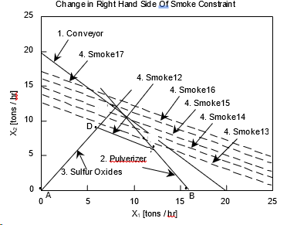
Figure I. 12: Change in right hand side coefficient
As the right hand side of the smoke constraint is further relaxed to 14, 15, etc., the value of the objective function continues to increase until a maximum steam production of 432,000 lbs. of steam per hour is reached at a right hand side value of 16. Further increase in the right hand side coefficient of the constraint has no impact on the value of the objective function since smoke constraint becomes inactive and the conveyer and sulfur constraints become active. The pulverizer constraint continues to remain active. At C", the imputed value for relaxing the smoke constraint goes to zero. The imputed value for tightening the smoke constraint is
-6.
Slacks, imputed values and insight. The imputed value for an active constraint is nonzero. For an inactive constraint it is zero and therefore the impact of the constraint on the objective, after a change in its right hand side, will remain zero. Therefore, it is adequate to compute the imputed values for the active constraints. These values provide insight into the stability of the solution from the standpoint of the active constraints. The slack or surplus variable is zero for an active constraint and nonzero for an inactive constraint. The nonzero slacks provide insight into the stability of the solution from the stand- point of the inactive constraints. For Case A, the information used to understand the stability of the solution is as follows:
Constraint | Slack/Surplus | Imputed Value | Constraint Status
Conveyer | 2 | 0 | Inactive
Pulverizer | 0 | 14 | Active7
Sulfur | 533.33 | 0 | Inactive
Smoke | 0 | 6 | Active
A constraint is said to be tightened if by changing the right hand side value of the constraint, the feasible design space is reduced. A constraint is said to be relaxed if changing the right hand side value increases the size of the feasible design space. With this by way of definition, what if it becomes necessary to reduce the design space (say because of maintenance of equipment), which constraint should be tightened? If on the other hand it is possible to increase the size of the feasible design space by investing in some equipment, which constraint should be relaxed?
The addition of another system variable.
Problem Statement: Plant management is evaluating the possible use of a third type of coal, Coal C. This coal has the following properties:
Pulverizer 1/20 hour pulverizer time/ton
Sulfur oxide emission rate 2,000 ppm
Smoke emission rate 0.8 kg/ton
Equivalent thermal value 21,000 lbs/ton.
The questions are:
- Should this coal be used? If no,
- What should be the properties of a coal that is likely to be selected?
The mathematical form for the Three Coal Problem follows.
Find
System Variables
X1 - the rate of consumption of Coal A [tons/hr]
X2 - the rate of consumption of Coal B [tons/hr]
X3 - the rate of consumption of Coal C [tons/hr]
Satisfy
System Constraints
- Conveyer capacity
X1 + X2 + X3 ≤ 20 [tons/hr]
- Pulverizer capacity
  - X1 + X2 + 1.2 X3 ≤ 24 [hours]
- Sulfur oxides emission
-1,200 X1 + 800 X2 - 1000 X3 ≤ 0 [NMU]
- Smoke emission
  - X1 + X2 + 0.8 X3 ≤ 12 [kg/hr]
Bounds on System Variables
- Lower bounds on system variables
X1 ≥ 0 [tons/hr]
X2 ≥ 0 [tons/hr]
X3 ≥ 0 [tons/hr]
- Upper bounds on system variables
X1 ≤ 25 [tons/hr]
X2 ≤ 25 [tons/hr]
X3 ≤ 25 [tons/hr]
Maximize
- The rate of steam produced
Z = 24 X1 + 20 X2 + 21 X3 [1000 lbs/hr]
The preceding can be solved by starting afresh or by using the imputed values from the Two Coal Problem solution, Case A.
Let us assume (arbitrarily) that 1 ton of Coal C is burnt per hour. This has the same effect of reducing the right hand sides of the system constraints as follows:
- Conveyer capacity
X1 + X2 ≤ 20 - 1 [tons/hr]
- Pulverizer capacity
  - X1 + X2 ≤ 24 - 1.2 [hours]
3. Sulfur oxides emission
-1,200 X1 + 800 X2 ≤ 0 + 1000 [NMU]
- Smoke emission
0.5 X1 + X2 ≤ 12 - 0.8 [kg/hr]
The change in the value of the objective function on using 1 unit of Coal C is computed as follows:
Constraint | Imputed value | Change in RHS | Change in Z
1. Conveyer | 0 | -1 | 0
2. Pulverizer | 14 | -1.2 | -16.8
3. Sulfur | 0 | 1,000 | 0
4. Smoke | 6 | -0.8 | - 4.8
Total change in steam output -21.6
Steam produced by 1 unit of Coal C 21.0
Net change in steam output [1000 lbs/hr] -0.6
Since the steam output decreases, Coal C is not competitive and should not be used. For Coal C to be competitive its thermal value should be greater than 21,600 lbs/hr.

I.7. 7 Case B: Formulation and Graphical Solution
The mathematical form of Case B is identical to that of Case A. In Case B, however, the lower bounds on the system variables are nonzero:
X1 ≥ | 5 | [tons/hr]
X2 ≥ | 5 | [tons/hr]
The solution space, for Case B, is shown in Figure I.13. Because of the nonzero lower bounds in Case B, the feasible design space in Figure I.13 is smaller than the feasible design space for Case A in Figure I.11. The best solution occurs at vertex C and is the same as that for Case A. The active constraints are also the same in both cases. Why then are the two cases being presented?
The reason is principally pedagogical. Case A is used to illustrate the method of formulating a linear single objective optimization problem so that the pivoting operations required for solving the problem using the pre-multiplication technique are possible. For Case B, it is assumed that a person knows how to pivot, the formulation is extended so that the pre-multiplication technique can be used to solve any linear single objective optimization problem.
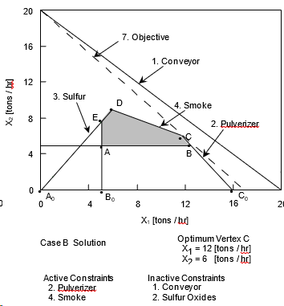
Figure I. 13: Case B solution
The Single Goal Compromise Decision Support Problem
In this section, the single objective optimization problem is reformulated and solved as a single goal compromise DSP. It will be shown that single objective optimization problems that call for the minimization or the maximization of an objective can be reformulated and solved as single goal compromise DSP.

I.7. 8 General Formulation
The linear optimization problem can be rewritten as a single goal compromise DSP. A target value is first assigned to the objective which can then be written as a goal. Then depending on the objective the appropriate deviation variable is included in the minimizing deviation function.
Find
The Independent System Variables
X1, X2
The Deviation Variables
d-, d+
Satisfy
System Constraints
a11 X1 + a12 X2 ≤ b1
a21 X1 + a22 X2 ≤ b2
a31 X1 + a32 X2 ≥ b3
System Goal (Normalized)
(c1/T)X1 - (c2/T)X2 + d- - d+ = 1 (T = Target value)
Bounds on System Variables
X1 ≥ X1min
X2 ≥ X2min
X1 ≤ X1max
X2 ≤ X2max
Minimize
The Deviation Function
Z = d- + d+ or d- or d+.
The formulation here is different from the single objective case in that it includes deviation variables and a system goal. Also the “objective” here is in terms of the deviation variables only. The target value T has to be set to an appropriate value.

I.7.9 Case C: The Word Problem
Given
Same as in Section for Case A.
Target value, T, of steam to be produced [lbs/hr]
Assumption
The maximization of the rate of electricity produced is equivalent to the maximization of the rate of steam generated.
Find
Independent System Variables
The rate of consumption of Coal A: X1 [tons/hr]
The rate of consumption of Coal B: X2 [tons/hr]
Deviations from the target amount of steam to be produced
d⁻ underachievement of the rate of steam production [-]
d⁺ overachievement of the rate of steam production [-]
Satisfy
System Constraints
1. The capacity constraint on the conveyer unit.
2. The capacity constraint on the pulverizer unit.
3. The emission of sulfur oxides is limited.
4. The emission of particulates (smoke) is limited.
System Goal
5. It is desirable to achieve the target value of steam, T, to be produced.
Bounds on the System Variables
6. The system variables should not be less than a specified value.
7. The system variables should not exceed a specified upper limit.
Minimize
Underachievement of the steam production target, d-.

I.7.10 Case C: The Mathematical Form of the Word Problem
Given
As stated in the word problem
T= 432000 lbs/hr
Find
System Variables
X1 - the rate of consumption of Coal A [tons/hr]
X2 - the rate of consumption of Coal B [tons/hr]
Deviations from the Target Amount of Steam to be Produced
d- underachievement of the rate of steam production
d+ overachievement of the rate of steam production
Satisfy
System Constraints

1 Conveyer capacity  X1 + | X2 | ≤ 20 | [tons/hr]
2 Pulverizer capacity  1.5X1 + | X2 | ≤ 24 | [hours]
3 Sulfur oxides emission  -1200X1 + 800X2 |  | ≤ 0 | [NMU]
4 Smoke emission  0.5X1 + X2 |  | ≤ 12 | [kg/hr]
System Goal
Steam generation
(24,000/T) X1 + (20,000/T) X2 + d- - d+ = 1
Bounds on System Variables
X1 ≥ 0, X2 ≥ 0 [tons/hr]
X1 ≤ 25, X2 ≤ 25 [tons/hr]
Minimize
The deviation from the target rate of steam production, T.
Z = d-

I.7.11 Case C: Graphical Solution
The solution space is shown in Figure 4.14. The following points are pertinent to the solution:
- The compromise solution is at point C in the figure.
- The rate of consumption of Coal A (X1) is 12 tons/hour.
- The rate of consumption of Coal B (X2) is 6 tons/hour.
- The pulverizer constraint, constraint 2, and the particulate emission constraint, constraint 4, are active.
- The slack capacity of the conveyer constraint (S1) is 2 tons/hour.
- The slack in the sulfur oxides emission limit is (S3) 533.33 ppm.
- The target amount of steam cannot be generated without violating at least one of the other constraints. The shortfall of steam generated, d-, is 24,000 lbs/hour. Therefore, only 408,000 lbs of steam can be generated without violating any of the constraints.
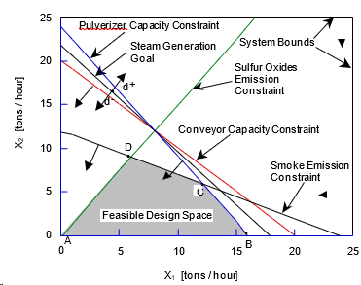
Figure I. 14: Case C design space
The Linear, Multigoal Compromise Decision Support Problem

I.7.12 General Formulation of the Linear, Multigoal Compromise DSP
Given
Same as in Section I.7. 8
Assumption
The maximization of the rate of electricity produced is equivalent to the maximization of the rate of steam generated.
Find
Independent System Variables
The rate of consumption of Coal A: X₁ [tons/hr]
The rate of consumption of Coal B: X₂ [tons/hr]
Deviations from the rate of sulfur oxides emission
d1- surplus capacity to emit sulfur oxides without penalty.
d₁⁺ sulfur oxides emitted over specified limit.
Deviations from rate of smoke emission
d₂⁻ surplus capacity to emit smoke without penalty.
d₂⁺ smoke emitted over limit.
Deviations from the target amount of steam to be produced
d₃⁻ underachievement of the rate of steam production.
d₃⁺ overachievement of the rate of steam production.
Satisfy
System Constraints
1. The capacity constraint on the conveyer unit.
2. The capacity constraint on the pulverizer unit.
System Goals
3. The emission of sulfur oxides is limited.
4. The emission of particulates (smoke) is limited.
5. It is desirable to achieve the target value of steam, T, to be produced.
Bounds on the System Variables
6. The system variables should be greater than the specified lower limit.
7. The system variables should not exceed a specified upper limit.
Minimize
A function of the deviation variables. All goals have the same importance.

I.7.13 Case D: The Mathematical Form of the Word Problem
The derivation of all the constraints and the goals in the mathematical formulation has been covered in Section 4.5. Of special interest is the adjustment of the coefficients of constraint 3 to ensure that the deviation variables of all goals vary within the same range. The constraint was divided by 10 to make the coefficients on its left hand side of the same order as in the other system goals.
Find
System Variables
X₁ - the rate of consumption of Coal A [tons/hour]
X₂ - the rate of consumption of Coal B [tons/hour]
Deviations from the Target Rate of Sulfur Oxides Emission (normalized)
d₁⁻ surplus capacity to emit sulfur oxides without penalty
d₁⁺ sulfur oxides emitted above limit
Deviations from the Target Rate of Smoke Emission (normalized)
d₂⁻ surplus capacity to emit smoke without penalty
d₂⁺ smoke emitted above limit
Deviations from the Target amount of steam to be generated (normalized)
d₃⁻ underachievement of the rate of steam production
d₃⁺ overachievement of the rate of steam production
Satisfy
System Constraints
Conveyer capacity X₁ + X₂ ≤ 20 [tons/hour]
Pulverizer capacity 1.5X₁ +X2 ≤ 24 [hours]
System Goals
Sulfur oxides emission
-0.1X1 + 0.0667X2 + d1- - d1+ = 0
Smoke emission
(0.5/12)X1 + (1/12)X2 + d2- - d2+ = 1
or
0.0417X1 + 0.0833X2 + d2- - d2+ = 1
Steam generation (Target value, T = 432,000)
(24,000/T) X1 + (20,000/T) X2 + d3- - d3+ = 1
or
0.0556X1 + 0.0463X2 + d3- - d3+ = 1
Bounds on System Variables
X1 ≥ 0, X2 ≥ 0 [tons/hour]
X1 ≤ 25, X2 ≤ 25 [tons/hour]
Minimize
The deviation function
Z = W₁ d₁⁺ + W₂ d ₂⁺ + W₃ d₃ ⁻
where W₁ + W₂ + W₃ = 1 and W₁ = W₂ = W₃ = W.
The value of W = 0.33 is used in this case.

I.7.14 Case D: Graphical Solution
The design space for Case D is shown in Figure I.15. The feasible design space has been identified. In this case the solution lies at point P on the boundary of the feasible design space. The solution is the same as the one obtained in Cases A, B and D. The smoke emission goal is exactly satisfied at this point. The sulfur oxide emission and steam generation target values are underachieved. Note that because of fewer system constraints the feasible design space is larger.
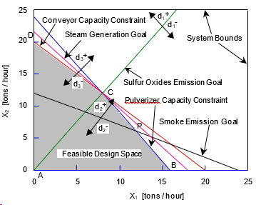
Figure I. 15: Case D solution space
The Nonlinear, Multigoal Compromise Decision Support Problem

I.7.15 Case E: Mathematical Formulation
The modification to the story introduces a new, nonlinear, constraint in the original formulation. The constraint deals with the upper limit on the stockpiling costs.
It reads:
3X₁( X₁ - 10) + 4X₂ (X₂ - 5) ≤ 30 ($/hour)
The mathematical formulation for the nonlinear problem is given next. An additional system constraint is added and the lower bounds on the system variables are taken as zero.
Given
Same as for Cases A and B.
The penalties (gains) from stockpiling coal above (below) the desired limits. A maximum stockpiling cost of $30/hour.
Assumption
The maximization of the rate of electricity produced is equivalent to the maximization of the rate of steam generated.
Find
System Variables
X₁ The rate of consumption of Coal A [tons/hour]
X₂ The rate of consumption of Coal B [tons/hour]
Deviations from the target rate of sulfur oxides emission (normalized)
d₁⁻ Surplus capacity to emit sulfur oxides without penalty
d₁⁺ Sulfur oxides emitted above limit
Deviations from the target rate of smoke emission (normalized)
d₂⁻ Surplus capacity to emit smoke without penalty
d₂+ Smoke emitted above limit
Deviations from the target amount of steam to be generated (normalized)
d3⁻ underachievement of the rate of steam production
d3⁺ overachievement of the rate of steam production
Satisfy
System Constraints
Conveyor capacity
X1 + X2 ≤ 20 [tons/hour]
Pulverizer capacity
  - X1 + X2 ≤ 24 [hours]
Stockpiling cost
3 X1 (X1 - 10) + 4 X2 (X2 - 5) ≤ 30 [$/hour]
System Goals
Sulfur oxides emission
-0.1X1 + 0.0667X2 + d1- - d1+ = 0
Smoke emission
0.0417X1 + 0.0833X2 + d2- - d2+ = 1
Steam generation
0.0556X1 + 0.0463X2 + d3- - d3+ = 1
Bounds on system variables
X1 ≥ 0, X2 ≥ 0 [tons/hour]
X1 ≤ 25, X2 ≤ 25 [tons/hour]
Minimize
The deviation function
Z = W1 d1+ + W2 d2+ + W3 d3-
W1 + W2 + W3 = 1 and W1 = W2 = W3 = W ( = 0.33)

I.7.16 Case E: Graphical Solution
The design space for this problem is shown in Figure 4.16. The feasible design space is shown by hatched lines. The new constraint, constraint 3, is also shown. The graphical solution is obtained by linearizing constraint 3. The method for linearizing equations is described in greater detail in Volume 2.
Step 1
Rewrite constraint as f(X) ≥ 0
f(X) = 30 - 3X1(X1 - 10) - 4X2(X2 - 5) ≥ 0
Step 2
Choose an initial starting point, Xº
Xº = { X₁º = 0, X₂º = 0 }
Step 3
Evaluate the following coefficients at Xº
A = f(X) = 30
B1 = ∂f(X)/∂X1 | x0 = 30 B2 = ∂f(X)/∂X2 | x0 = 20
C1 = ∂2f(X)/∂X12 | x0 = -6 C2 = ∂f(X)/∂X22 | x0 = -8
Step 4
Evaluate secant plane derivatives
a1 = (AC1/B1)/(1 - (1-2AC1/B12)0.5) = 32.748
a2 = (AC2/B2)/(1 - (1-2AC2/B22)0.5) = 24.832
Step 5
This step is skipped because the roots are real.
Step 6
Evaluate the right hand side of the linearized constraint.
b = a1X1o + a2X2o - A = -30
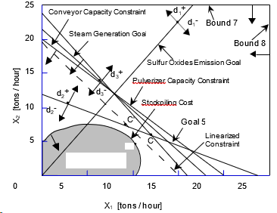
Figure I. 16: Case E design space
Step 7
Establish the linearized constraint
a1X1 + a2X2 ≥ b
i.e.,
32.748 X1 + 24.832 X2 ≥ -30
This constraint, when plotted in the design space makes the entire first quadrant of the design space feasible and therefore is redundant.
Step 8
Choose C, Figure I.16, as the next initial point.
Xo = { X1 = 12, X2 = 6 }
Step 9
Evaluate the following coefficients.
A = -66
B1 = -42 B2 = -28
C1 = -6 C2 = -8
Step 10
Evaluate the secant plane derivatives.
a1 = -36.588
a2 = -18.857/(1- (-0.3469)0.5)
Step 11
Are a₁ and a₂ real?
a2 is imaginary Set a2 = B2 = -28
Step 12
Evaluate the right hand side of the linearized constraint. Hence,
b = -541.06
Step 13
Establish the linearized constraint, viz.,
36.588 X1 - 28 X2 ≥ -541.06 or
36.588 X1 + 28 X2 ≤ 541.06
This constraint is plotted, line 3', in Figure 4.16. As determined by the set of linearized constraints, the optimum is found to be at C' = {X1 = 9.08, X2 = 7.46}. However, this solution is approximate. It is in the vicinity of the optimum. To obtain a more accurate solution, a new starting point needs to be chosen and steps 1 through 8 repeated to obtain solutions close to the actual optimal. Point C'' {X1 = 10, X2 = 5.75} is determined to be the true optimum. The algorithm is cumbersome when calculations are done by hand.

I.8 DSIDES Software

I.8.1 History of DSIDES 1976 to 2023
The acronym DSIDES stands for Decision Support In the Design of Engineering Systems. It was developed to provide a comprehensive decision support environment for all decision makers, whether engineers or not. The foundation for DSIDES is the Decision Support Problem Technique (DSPT) as developed under the direction of Farrokh Mistree at the Systems Design Laboratory, University of Houston[1] . In turn, the DSPT is itself built on the fundamental paradigm that design is a decision-based activity. Much has been written about the DSPT and Decision-Based Design (DBD) . [2,3,4]
In 1974, Farrokh Mistree started as a Post-doctoral research fellow under the mentorship of the late Professor Owen F. Hughes at the University of New South Wales, Sydney, Australia. The Sequential Linear Programming 2nd order (SLIP2) algorithm was jointly developed by Owen Hughes and Farrokh Mistree during their years of research collaboration (1974-1980) at the University of New South Wales in Sydney, Australia.
The SLIP2 algorithm was specially developed for a ship structural optimization program called AUSTROSHIP. The development of AUSTROSHIP was funded by the Department of Defence (NAVY), Canberra (1974-1976). The American Bureau of Shipping (ABS) continued support for the ship structural optimization work (1977-1980). The ABS sponsored structural optimization program is called SHIPOPT. In 1979 a grant was received from the Australian Research Grants Committee to develop a stand-alone version of the optimization program. H.B. Phuoc was supported by these funds and he collaborated with Farrokh Mistree in the development of the stand-alone version of SLIP2 (which now stood for Sequential Linear Programming 2nd generation).
Many people have contributed to the development of SLIP2 over the years. The first attempt to develop this algorithm was made by Brian Morley an undergraduate student at the University of New South Wales under the supervision of Dr. Owen Hughes in 1973-74. Morley, in his undergraduates honors thesis, identified the problems that needed to be solved. Rigby Gilbert, in his honors thesis (1976) provided insight which lead to the use of a "convex approximation" for modeling the nonlinear constraint function. Dr. Vedran Zanic (University of Zagreb) contributed significantly to overcoming some major obstacles.
- particularly in the area of data management. He also contributed the routines to formulate the Simplex tableau and parts of the input routine (1976).
The multi-objective feature was introduced by Farrokh Mistree in 1980. This work was started and completed at the University of New South Wales in 1980. Some refinements were introduced by Farrokh Mistree after he moved to the University of Houston in 1981. In 1983, Tim Lyon (Department of Defense (Navy), Canberra), assisted in the validation of this feature and also introduced the feature for post-solution analysis, while he was a graduate student at the University of Houston. In 1985, the feature to solve hierarchical decision support problems was introduced and the SLIPML (Sequential Linear Programming: Multi-Level) algorithm was born. The multilevel feature was validated by Warren Smith (Department of Defense (Navy), Canberra), Azim Jivan and Jon Shupe.
In 1979 Andrew Cawsey, for his undergraduate honors thesis at the University of New South Wales under the supervision of Farrokh Mistree, developed a stand-alone program (Program SELECT) for solving selection decision support problems. Saiyid Kamal was responsible for the integration of DSIDES into a single unit. In 1987, Eduardo Bascaran and Harshavardhan Karandikar implemented the feature for automatically determining a suitable starting solution. This feature was refined by Ravi Reddy in 1988. In 1988 Eduardo Bascaran wrote the code for the multiplex algorithm and integrated it into DSIDES [5] . This algorithm is used to solve the true-Preemptive formulation (not the pseudo­ preemptive formulation) of the compromise and coupled DSPs.
Adaptive linear programming was introduced by Bert Bras in 1989 [6] . This was based on some work done at MARIN, (Maritime Research Institute Netherlands, Wageningen, Netherlands). Bert Bras and Harshavardhan Karandikar made a number of modifications to improve the robustness and convergence speed of the ALP algorithm. In 1990 Stan Abeln created a graphic post-processor for the SUN based on the X-Windows system.
The UH team transformed the card based input to terminal based input, provided options for various levels of output, and included XPLORE [7] to find a good starting solution for DSIDES. The UH team standardized the code to FORTRAN 77 and ensured that the code ran on the mainframe at the University of Houston and also on the Vax/VMS and later on the SUN/OS/UNIX mini computers. The UH team made it possible to solve not only the compromise Decision Support Problem (cDSP) but also the selection DSP (sDSP), the heuristic DSP (hDSP), and the coupled Decision Support Problems using the Archimedean and Preemptive formulations of the cDSP in a synergistic manner.
In April 1991, it was decided to undertake a major rewrite of the entire program. This represented the first major restructuring of the program since its inception in 1976. The changes implemented in this rewrite were the creation of simpler formats for user files, the modularization of the output, the use of the MULTIPLEX algorithm as the primary solver, the incorporation of a robust adaptive reduced move limit scheme for improved convergence, and a feature for preliminary exploration of the design space. This process was coordinated by Warren Smith, with Bert Bras serving as a consultant to the group. The rewrite was carried out by Warren Smith and Ravi Reddy, with Srinivas Vadde creating the new output routines. The new data input modules were designed and created by Ravi Reddy. The adaptive reduced move limit algorithm was implemented by Ravi Reddy. The option for creating tab-delimited text files (for exporting to spreadsheet programs) was created by Warren Smith. The new interface for coupled problems was created by Warren Smith. The sensitivity analysis for selection problems was added by Ravi Reddy. Uwe Lautenschlager performed a lot of testing during this phase.
In March 1992, a manual for DSIDES 4.0 was released. This manual represents the work of many people. Ravi Reddy coordinated its creation. The authors and contributors in alphabetical order are Bert Bras, Wei Chen, Stein Erikstad, Samir Karandikar, Badrinath Krishnakumar, Uwe Lautenschlager, Aashish Malhotra, Farrokh Mistree, Sangram Mudali, Bharat Patel, Rama Pakala, Ravi Reddy, Warren Smith, Srinivas Vadde.
In the late nineties, Mathew Marston (graduate student at the Georgis Institute of Technology) created a stripped down version of DSIDES in Java to run on an IBM PC. Lin Guo (University of Oklahoma 2021), in her doctoral dissertation, added the following functionalities to DSIDES [8] :
• Adaptive Linear Programming with Parameter Learning (ALPPL) to replace heuristics with knowledge about the behavior of the system.
• Adaptive Leveling-Weighting Clustering Algorithm (ALWC) a method to facilitate subsystem reorganization.
• Adaptive Scenario Planning a method to capture emergent properties of a complex system while it is being designed.
She also created videos to help novices learn how to prepare input files.
In 2023, Sara Hajihashemi, for her MS thesis to facilitate ease of input created a wrapper for DSIDES. To be consistent, DSIDES is used by Sara Hajihashemi in her thesis to refer to various versions and manifestation of SLIPML.
Upon translating the problem statement into a mathematical formulation within the cDSP construct, this mathematical representation can be seamlessly incorporated into the DSIDES software to obtain results. Notably, DSIDES is coded in FORTRAN. In this thesis, we design a user-friendly wrapper for DSIDES, aiming to harness the computational speed advantages of FORTRAN while ensuring user-friendliness akin to Excel. Additionally, we are establishing a connection between Excel and MATLAB for post-processing analysis; all details are discussed in Part 2 of this thesis.
To gain a clearer understanding of my thesis contribution and to compare the initial DSIDES version with the DSIDES Wrapper I have developed, it is essential to delve more into the history of DSIDES.

I.8.2 DSIDES: A Historic Compiled Program in FORTRAN
The Age of Batch Processing
DSIDES was developed in FORTRAN in the early 70 on a CDC 6600 mainframe with 120k RAM. The program was written for batch processing. On account of 120k RAM the program was heavily overlayed. The program was written on cards, complied and the complied version was executed. The data input was also via cards. The CDC 6600 was in use in the 1960s and early 1970s. It was one of the fastest computers of its time. The picture of CDC 6600 is shown in Figure I.17.
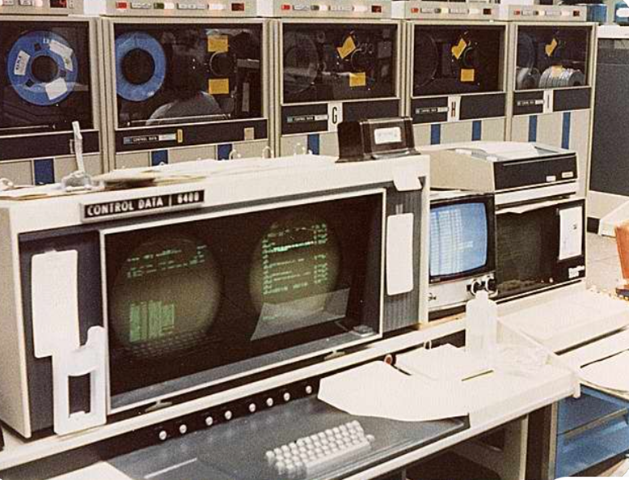
Figure I. 17: Computer CDC 6600 | Old computers, Old technology https://www.pinterest.com/pin/10907224075942812
In this context:
Compilation: DSIDES, like many programs of its time, was compiled. The source code, written in FORTRAN, was transformed into an executable file using a compiler. By this process, the computer's processor could execute the program without the need for interpreting the source code each time it ran.
Memory Limitations: DSIDES operated under severe memory constraints. Mistree and Hughes had a mere 120 K (kilobytes) of memory at their disposal, and through determined effort, they managed to secure an extra 4 K for overnight use. By modern standards, this amount of memory is extraordinarily limited, emphasizing the ingenuity needed to make the most of it.
Compilation Overlays: Overlay techniques were employed by the compiled version of DSIDES to operate efficiently within these memory limitations. This involved loading different segments of the program into memory as needed, swapping them in and out to make the best use of the available space. This was a challenging and meticulous process.
Handling the Physical Medium: Punch Cards
DSIDES operated during an era where computer input and output were managed through punched cards. A figure of punch card machine is presented in Figure I.18.
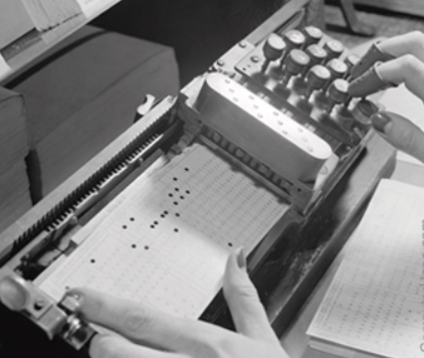
FigureI. 18: Punch Card in Punch Card Machine (https://www.computerhope.com/jargon/p/punccard.htm)
This presented its own set of unique challenges:
Punched Card Deck: To run DSIDES, a deck of punched cards was prepared as the program input. Each card contained specific instructions or data, and the order of the cards was crucial for the compilation and correct execution of the program. A stack of IBM FORTRAN punch cards is represented in Figure I.19.
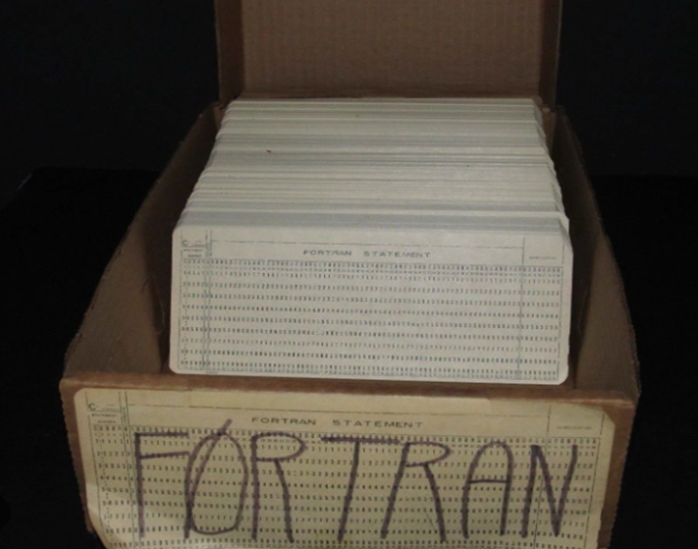
Figure I. 19: IBM FORTRAN Punch Cards ( https://www.are.na/block/1023150)
Fragility: Punched cards were fragile and required careful handling. Dropping or mis-ordering the cards could lead to errors during program execution, making the process laborious and error-prone.
As previously mentioned, DSIDES, originating in the 1970s, was initially coded in the punch card format. Let Us Let us delve into the world of programming with punched cards to gain a deeper understanding of this unique and historical method of software development.

I.8.3 Programming with Punched Cards
In the early days of computer programming, especially in the 1960s and 1970s, programmers used punched cards for writing and storing computer programs. The historic method of coding and inputting computer programs using physical cards with holes punched in them is referred to as programming with punch cards. These punched cards contained holes that represented instructions or data and were used to input programs and data into early computer systems.
Punched Card Format
Punched cards were typically 80 columns wide and 12 rows tall. Each column could represent a character, digit, or a control character. FORTRAN program statements had this format:
Column 1 – Comment - usually marked with a “C”
Column 1-5 - Line Number – usually used with format statements
Column 6 - Continuation of statement on previous card
Column 7-72 - the actual FORTRAN code (latter systems used 7-80 )
Column 72-80 – Sequence or Identification number
Creating Punched Cards
- Writing Code: Programmers wrote their code on coding sheets, with each line of code corresponding to a single punch card. A figure of punch card is shown in Figure I.20.
- Punching the Cards: After writing the code, it was transferred to punch cards using keypunch machines. Programmers created holes in the cards, representing binary data. The pattern of holes encoded the instructions and data.
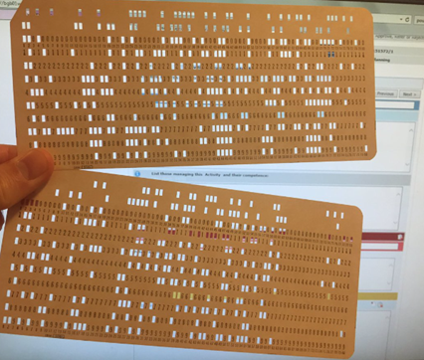
Figure I. 20: Punch Card (https://twitter.com/dannsimmons/status/1063412986189094912)

Compilation and Execution
Once the punch cards were ready, they were fed into card readers, and the code was compiled or interpreted by the computer. This process turned the punched holes into executable instructions.
Programming Process
- Card Sorting: Programs were typically written on stacks of punched cards, with each card representing a line of code. The sequence of cards determined the program's flow. To make changes to the program, programmers created new cards or updated existing ones and re-sorted the entire deck of cards.
- Card Numbering: It was common practice to number each card to maintain the correct sequence. Card numbers were typically in columns 73-80, used for debugging and version control.
- Languages Used: Various programming languages were used with punch cards, including assembly language, FORTRAN, COBOL, and others, depending on the computer and the application. FORTRAN was a popular language used with punched cards.
Challenges and Handling
- Error Handling: If a card were damaged, misplaced, or dropped, it could result in errors when running the program. Therefore, careful handling of the cards was essential.
- Deck Management: Managing a deck of punched cards was a critical aspect of programming. Large programs could result in stacks of cards that needed to be kept in order, making it easy to introduce errors when making changes.
- Batch Processing: Early computers operated in batch mode. Programmers submitted their card decks to a computer operator who fed the cards into the computer for processing. The results, often printed output, were returned to the programmer at a later time.
- Debugging: Debugging programs was a laborious process. If an error was discovered, the programmer had to locate the erroneous card, correct it, and then recompile the program, often by generating a new deck of cards.
The limitations and the unique challenges associated with punched card programming, such as the specific card format and the need to avoid card mishandling, were characteristic of this era. However, punched card systems were eventually replaced by text-based programming on terminals and personal computers, significantly simplifying the programming process and eliminating many of the inconveniences associated with punched cards.

I.8.4 Comparing the DSIDES Versions: Evolution and User Experience
Following the initial release of DSIDES, a series of iterative improvements were made. The culmination of these enhancements, which introduced the Preemptive form into the software, occurred in 1982. The DSIDES wrapper has been crafted based on DSIDES 1982. In this section, a concise comparison between the DSIDES 1982 and the modern DSIDES Wrapper 2023 is provided. The significant improvements in user experience and functionality offered by the DSIDES Wrapper are underscored by this comparison.
Input File Preparation and Interface
In the DSIDES 1982, users faced the challenge of preparing input files within plain Notepad documents. This process lacked descriptions and required users to refer to multiple documents to ensure they considered all necessary data blocks. In contrast, this process has been streamlined by the DSIDES Wrapper through the adoption of an Excel-based interface. All required data blocks are readily available, and each cell is accompanied by a description, making it easier for users to understand and input data accurately.
Execution and User-Friendliness
Running the DSIDES 1982 was a multi-step process. Users had to save Notepad files in specific folders, obtain file paths, navigate through command prompts, and adhere to specific file structures. This complex process is simplified by the DSIDES Wrapper through the implementation of a user-friendly interface. Users can now achieve the same results by merely clicking a "Run" button, eliminating the need for intricate command-line operations.
Normalization and Post-Processing
In the DSIDES 1982, after obtaining results, users faced additional challenges. They had to manually calculate normalized values for each scenario (including 13 different scenarios) and then switch to MATLAB to import data and create ternary plots for post-processing analysis. In contrast, the normalization process is automated by the DSIDES Wrapper, and a seamless connection to MATLAB is established. With just one click, users can generate colorful or black-and-white ternary plots, providing a more efficient and user-friendly post-processing experience.
In summarizing, a substantial enhancement is represented by the DSIDES Wrapper over the original DSIDES 1982 version. Notably, the following changes are deemed pivotal in this transformation:
Reducing the Number of Steps in the Process:
DSIDES 1982:
- Generate a plain-text document with linear information, ensuring adherence to the specified block structure and input data order crucial for the software. Save the file at the designated location in the ".DAT" format.
- Generate a text document containing nonlinear information and save it to a specified location with the file extension ".f."
- Navigate to the specific address on your server (Computer/LocalDisk/MinGW/msys).
- Select the file named 'msys.'
- In the popped-up command window, type 'cmd' and press 'Enter.'
- Navigate to your problem's directory by typing 'cd XXXX' and pressing 'Enter' (where 'XXXX' is the path to your problem).
- Run DSIDES to solve the model by typing 'runalp XXXX' and pressing 'Enter' (where 'XXXX' is your model's name).
- Return to the main folder to find the output file.
DSIDES Wrapper 2023:
- Open the main folder and select the Excel file located in this folder.
- Fill out the Linear sheet and click the RUN button. All necessary information and descriptions are provided in the sheet.
- Fill in the Nonlinear sheet and click the RUN button. The output file will appear on the screen.
In summary, the steps to obtain the final result for cDSP have been reduced from 8 in DSIDES 1982 to 3 in DSIDES 2023.
Minimizing the Occurrence of Errors:
In DSIDES 1982, users were prone to errors during command prompt operations, file imports, and when filling out the linear and nonlinear sheets due to specific formatting requirements. These challenges are addressed by DSIDES 2023, with potential mistakes being eliminated through the provision of a user-friendly interface that standardizes input formats and is accompanied by detailed instructions.
Enhancing Time Efficiency:
The reduction of steps and the addition of information and descriptions to the linear and nonlinear sheets in DSIDES 2023 result in a significant enhancement of time efficiency. Users can now navigate through the streamlined process more swiftly, reducing the time required for input preparation and execution.
Facilitating Post-Process Analysis:
DSIDES 2023 streamlines post-process analysis by automating normalization and simplifying connectivity to MATLAB. The generation of ternary plots is facilitated with a single click, providing a more efficient and user-friendly experience for users engaged in post-processing tasks.
Overall, data input, execution, and post-processing tasks are simplified, resulting in an enhanced overall user experience and making it a valuable tool for engineering systems in the modern era.
Having highlighted the significant enhancements in the DSIDES Wrapper, let us now delve into my key contributions as “I statement” in making these improvements a reality.
I Statement
Learning FORTRAN Language
One of the foundational steps in understanding DSIDES was learning the FORTRAN programming language. Since the program was originally coded in FORTRAN, I needed to familiarize myself with its syntax and structure. I acquired this knowledge, allowing me to comprehend the different subroutines and intricacies of the program.
Understanding Punch Card Logic
To bridge the gap between the archaic punch card era and modern computing, I had to schedule the logic of the program. This involved understanding how programming was executed through punch cards. Importantly, I did not modify the punch cards themselves; instead, I created a front-end interface designed to seamlessly integrate with this legacy format.
Learning VBA Language
Visual Basic for Applications (VBA) was another essential skill I had to acquire. I developed the user-friendly wrapper within Microsoft Excel, enhancing the program's accessibility and ease of use with VBA.
Connecting Excel and FORTRAN
DSIDES is compiled, making it impossible to make direct alterations to the original code. To overcome this challenge, I had to learn how to establish a connection between Excel and FORTRAN. I enabled data transfer and interaction between the two platforms, preserving the integrity of the original DSIDES code.
Integrating Excel and MATLAB
In addition to connecting Excel and FORTRAN, I learned how to integrate Excel with MATLAB for post-process analysis. I further extended the capabilities of DSIDES by enabling the analysis and interpretation of results.
In summary, my work on the DSIDES Wrapper encompassed an adequate learning journey, from mastering the FORTRAN language to understanding the logic of punch cards and effectively connecting Excel with FORTRAN and MATLAB. A more user-friendly and accessible version of DSIDES has been achieved through these efforts, granting engineers access to a powerful tool for addressing complex design challenges in the modern era.

I.9 PDSIDES
DSIDES will fit in the PDSIDES platform. PDSIDES, the Platform for Decision Support in the Design of Engineering Systems, is a smart system designed to help designers work faster and create better, cost-effective designs. The tricky part of making decisions during the design process, especially when dealing with complex engineering systems, is addressed by PDSIDES. Previous work that employed templates and ontologies to capture decision-related knowledge is built upon PDSIDES. But now, it takes these templates and turns them into a handy computer tool. This tool is useful for different users involved in design work, whether creating, editing, or implementing templates. Various design scenarios, like starting from scratch, adapting existing designs, or making variations, are covered by it.
Its worth is demonstrated by PDSIDES through its successful assistance in the design of a hot rod rolling system (HRRS), illustrating how design work can be made more efficient and top-notch results can be ensured without breaking the bank.
An overview of PDSIDES is illustrated in Figure I.21. PDSIDES is divided into three parts: knowledge, users, and decision-based design. What follows is the description of the platform from the bottom up, including how these three parts are connected to enable the functionalities. ( Ming, Z., Nellippallil, A. B., Yan, Y., Wang, G., Goh, C. H., Allen, J., & Mistree, F. July 2018, PDSIDES—A Knowledge-Based Platform for Decision Support in the Design of Engineering Systems. Journal of Computing and Information Science in Engineering, DOI: 10.1115/1.4040461.
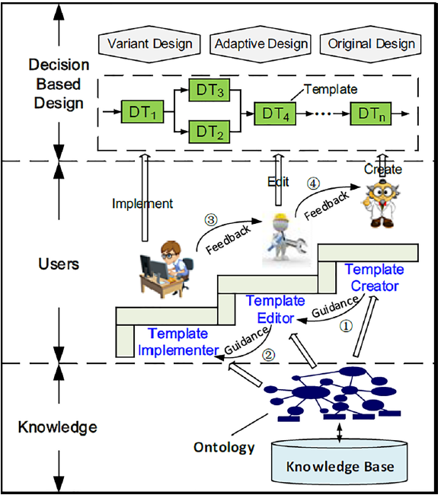
Figure I. 21: PDSIDES Overview

I.10 The Path Forward: Future Plans for Wrapper Improvement
In response to the inherent limitations of traditional visualization methods, including Ternary Plots, which are characterized by a restriction in representing conflicting goals to only three variables, a commitment has been made to advancing the capabilities of the wrapper, extending to addressing challenges associated with other prominent techniques. Different types of visualization techniques and their limitation has been represented in Figure I.22.

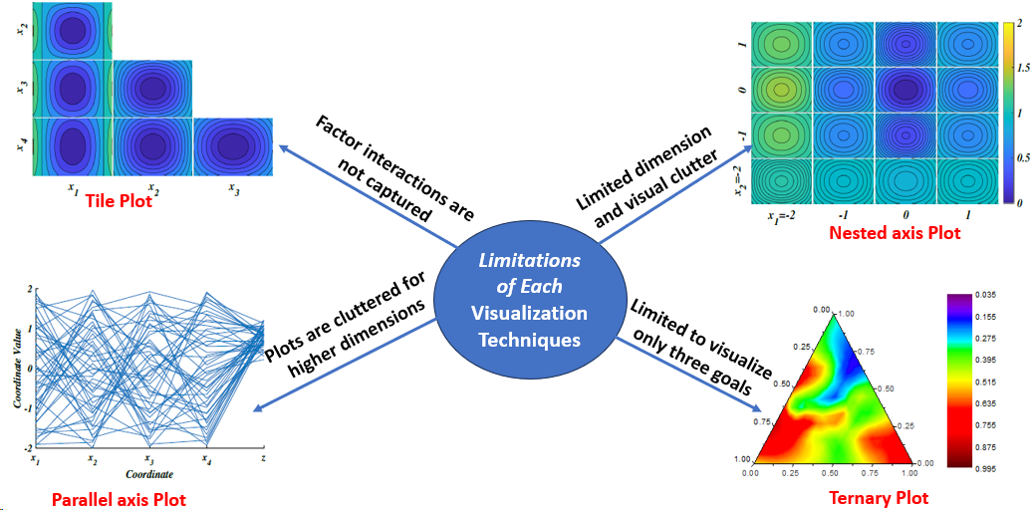
Figure I. 22: Different Types of Visualization Techniques
Notably, the relationship between two categorical variables is displayed using rectangular tiles in a tile plot, also known as a mosaic plot, where the proportion of data in each category is represented by the area of each tile. However, there are some limitations, such as challenges in interpretation when there are numerous categories, and it may not be well-suited for visualizing relationships between more than two categorical variables.
Also, the Parallel Axis Plot, a method employed for visualizing multivariate data through multiple parallel axes, has limitations in the form of potential clutter when faced with numerous variables. The resulting complexity may make interpretation difficult, especially in the context of complex datasets.
Similarly, challenges are faced as the number of nested variables increases in the Nested Axis Plot, despite its effectiveness in showcasing relationships between multiple variables through nested axes. Increased visual complexity may be introduced, potentially complicating the interpretation, particularly in scenarios with a substantial number of nested variables.
Moreover, the Ternary Plot, specifically designed for three variables, has constraints when applied to datasets exceeding this dimensionality. This limitation has restricted its utility for scenarios involving more than three conflicting goals, thereby underscoring the necessity for a more adaptive and encompassing visualization approach.
In light of these considerations, a machine learning-based visualization technique, specifically the interpretable self-organizing maps (ISOM), is incorporated into the future path. Positioned as an unsupervised neural network structure, excelling at transforming high-dimensional data into a two-dimensional space is a characteristic of ISOM. Through this strategic integration, users are granted access to a robust and interpretable visualization platform capable of accommodating and elucidating multiple conflicting goals simultaneously, with the aim of overcoming the limitations posed by traditional methods. A proactive response to the challenges posed by existing visualization techniques is indicated by the adoption of ISOM, ensuring a more comprehensive exploration of complex solution spaces within the wrapper.

I.11 Summary and Way Forward
In Part 1 of this thesis, We focus on the introduction of the compromise Decision Support Problem (cDSP) construct and DSIDES. Moving forward, in Part 2 of this thesis, our focus is on the practical implementation of a user-friendly interface for DSIDES. The implementation includes the provision of a user manual, guiding users through the functionalities and features of the wrapper. Users can interact seamlessly with the DSIDES wrapper and effectively utilize it to address complex decision problems.
Furthermore, the interpretation of output results from DSIDES is discussed, enabling users to analyze and comprehend the solutions provided by the DSIDES wrapper. The post-process analysis in the decision-making process is explained to enhance users' understanding of the results generated by DSIDES. To validate the effectiveness of the wrapper and demonstrate its capabilities, three example problems are presented.
In conclusion, in Part 1, we learn how to formulate the problem in the form of mathematics in cDSP construct; in Part 2, we implement and convert math formulation from Part 1 to the template. Initially, we focus on mastering the skill of translating problem statements into the cDSP construct. Subsequently, we apply this understanding within the DSIDES wrapper for implementation.

Part Two: Designing the User-Friendly Wrapper for DSIDES

Overview of Part 2
In the second part of this thesis, the main focus is on introducing a user-friendly wrapper that has been designed and implemented for DSIDES. In Part 2, detailed information about how to work with the DSIDES’s Wrapper effectively, including the Front-end that has been designed to prepare the input for DSIDES and the Back end that is designed to support the exploration of the solution space to find solutions that are relatively insensitive to uncertainty, is provided. There is information on interpreting the results and verifying and validating the DSIDES’s Wrapper in Part 2. To this end, three problems are presented that demonstrate how to start from scratch, formulate the problem in cDSP, and finally implement the problem in the wrapper. This section is a useful document for users to practice and learn how to use the software effectively.

Glossary
DSP: The Decision Support Problem (DSP) is a framework used to help make better decisions when different goals conflict with each other. Solutions that balance these goals fairly are sought by the DSP. A structured way to analyze and choose the best option from different choices is provided by the DSP. Complex situations are guided by decision support systems, which utilize data, models, and criteria, facilitating informed choices that align with our needs and priorities.
cDSP: The compromise Decision Support Problem (cDSP) is a hybrid model combination of mathematical programming and goal programming techniques that are provided to offer structure and support for decision-making that involves multiple conflicting goals or objectives. The objective of cDSP is to enhance the design of a system by modifying its variables, taking into account system constraints, goals, and bounds. The goal of cDSP is to minimize the deviation between the system's performance and the desired target values specified in the problem requirements list.
DSIDES: (Decision Support in the Design of Engineering Systems). It is written in FORTRAN to implement the cDSP construct to identify robust satisficing solutions to design problems when the models are abstractions of reality.
Wrapper: Wrapper is a protective layer. The underlying functionality of a component or system has been simplified with the use of a wrapper. The core functionality is wrapped around, and a simplified interface for interacting with the underlying front-end or back-end systems is provided. In our work, we have designed a user-friendly Wrapper for DSIDES.
Interface: A set of rules or specifications is defined by an interface, which determines how different front-end or back-end components can communicate and interact with each other. Compatibility is ensured, and seamless communication between different parts of the system is facilitated by the interface, which acts as a bridge.
Front-End: The user-facing part of a software application or website, known as the Front-end, is where content is presented, user input is facilitated, and an intuitive and engaging user experience is provided. It includes visual elements, user interface, and interactive features directly interacted with by users in Front-End. In our work, Front-end has been designed to prepare the input for DSIDES.
Back-End: In general, the server-side of a software application or website, known as the back end, is where data processing, business logic, and communication with the Front-end are handled. It includes components, databases, and logic that are responsible for managing and storing data, executing complex calculations or operations, and providing the necessary information and functionality to the Front-end for a seamless user experience. In our work, Back-end is designed to support exploring the solution space to find solutions relatively insensitive to uncertainty.
II . Introduction To the Wrapper for DSIDES
The second part of this thesis is about the user-friendly wrapper of DSIDES, which is designed to implement the formulated problem and find solutions that are relatively insensitive to uncertainty. Building upon the material presented in Part 1 of the thesis, in Part 2, detailed instructions on effectively using the wrapper, including working with the interface, interpreting the output results, and verifying and validating the software, have been provided. To illustrate the process, three problems are presented that demonstrate how to start from scratch, formulate the problem in cDSP, and ultimately implement it in the wrapper ace. By combining the theoretical foundations established in the first part with practical examples and step-by-step guidance, this section is designed to serve as a valuable resource for users to become proficient in utilizing DSIDES for their research purposes.

II.1 Understanding Front-End, Back-End, and Wrapper: Enhancing User Experience and Functionality
Front-end and back-end are terms used by programmers and computer professionals to illustrate the layers that make up hardware, a computer program, or a website, which are defined based on how accessible they are to a user. The Front-end and back-end can also be used to describe situations where the customer has access to one view and employees have access to another. Front-end components are customer-facing, while rights to the back end are exclusively for authenticated users. In other words, Professionals usually handle the front-end aspect of a project, while engineers and developers handle the back end. Integration Diagram: Front-end and Back-end Connections have been represented in Figure II.1. In this figure, specifically, the DSIDES’s wrapper has been considered. ( In Figure II.1, "HTC" stands for "Human-Technology Collaboration. The collaboration and interaction between humans (users or designers) and technology (software or systems) to achieve a specific goal or outcome are signified by HTC. In the context of wrapper design and programming, the combined efforts of designers and programmers working together to create a wrapper that meets the needs and expectations of users are referred to as HTC, which means the importance of considering both the human aspect (user experience, usability, visual design, etc.) and the technological aspect (programming, functionality, data processing, etc.)).
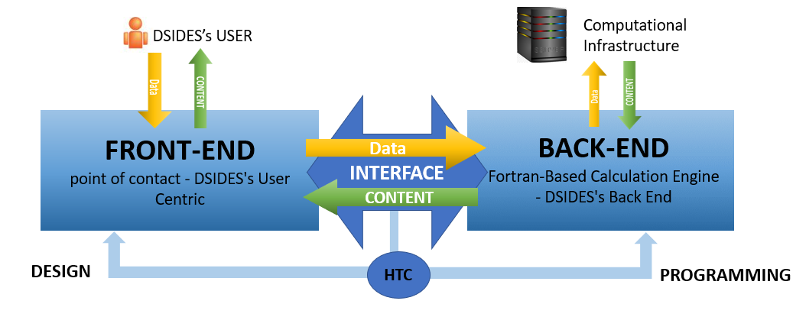
Figure II. 1: Integration Diagram: Front-end and Back-end Connection in DSIDES
In this section, we explore what front-end and back-end are and their importance and explain the wrapper concept and role in integrating the front and back-end.
The Front-end refers to the user-facing parts of an application, while the back end refers to the parts of an application that operate without user accessibility. Typically, front-end development involves designing and implementing the elements that users interact with, such as buttons, menus, forms, and other graphical elements.
Front-End: Front-end development is a critical part of software development as it directly impacts an application's usability and overall user experience. Designing a good user interface is one of the essential aspects of front-end development. The designer must consider the application's purpose, target audience, and other factors that affect the user experience when creating the user interface. A good user interface should be intuitive and easy to navigate, allowing users to perform tasks quickly and efficiently.
Front-end development has evolved significantly in recent years, with new technologies, tools, and techniques emerging every day. However, the basic principles of front-end development remain the same. The primary goal of front-end development is to create an attractive, intuitive, and user-friendly interface that engages users and meets their needs.
Front-end development also involves optimizing the application's performance, such as reducing the size of files and images, compressing code, and minimizing the number of server requests. By doing so, the application can load faster, providing a better user experience.
Several popular front-end frameworks, such as React, Angular, and Vue.js, provide developers with pre-built components and structures, making it easier to create complex user interfaces quickly. Additionally, they often have a strong community of developers who contribute to their development, providing resources and support to other developers.
Front-end development also involves integrating the user interface with back-end systems, which requires an understanding of how data is stored, retrieved, and processed. In many cases, front-end developers work closely with back-end developers to ensure the user interface and back-end systems are compatible and work seamlessly together.
Testing is another critical aspect of front-end development. Front-end developers must test their code thoroughly to ensure that the user interface functions correctly and provides a positive user experience. This involves testing the application on different devices and browsers and testing for accessibility and performance.
To illustrate the importance of front-end development, let us consider an example. Imagine that you are building a website for an e-commerce store. The website's Front-end must be intuitive and easy to use, with clear navigation and a simple checkout process. If the Front-end is poorly designed or difficult to use, users may abandon their shopping carts and go to a competitor's website instead. In contrast, a well-designed and user-friendly Front-end can increase user engagement, improve customer satisfaction, and ultimately lead to more sales and revenue for the store.
In conclusion, front-end development is a constantly evolving field critical to the success of software applications. It is an essential part of web development that involves designing and implementing a website's visual and interactive elements. It requires combining technical skills, design knowledge, and communication skills. In addition, a good front-end developer must understand user interface design, accessibility, and performance optimization. Software applications can provide a seamless and enjoyable user experience by considering these key aspects of front-end development.
Back-End: The back end refers to parts of a computer application or a program's code that let it operate Without user accessibility. In other words, it refers to any system that supports back-office applications and manages orders, inventory, and supply processing. The back end gets input from front-end applications, supports user services, and interfaces with required resources. It may interact directly with the Front-end or be called from an intermediate program that intercedes front-end and back-end activities.
Most data and operating syntax are saved and accessed in the back end of a computer system. Usually, the code is comprised of one or more programming languages. It is also called the data access layer of software or hardware and comprises any functionality that requires to be accessed and navigated to by digital means.
The processing and management of data, execution of core functionality, and performance of calculations are handled by the back end of a software system. The back end operates on the server-side and collaborates with the Front-end to ensure users are provided with a comprehensive and interactive experience.
Tasks and operations involved in back-end processing are executed behind the scenes to process data and perform complex calculations. This includes the handling of user inputs, interaction with databases, execution of computations, and generation of results. Achieving efficient and accurate execution to attain the desired functionality of the software system is the main focus.
Data management within the back end encompasses the software system's organization, storage, retrieval, and manipulation of data. Activities such as database management, data validation, integration, and security are included. Data integrity is ensured by the back end, suitable storage solutions are implemented, and efficient mechanisms for data access and retrieval are provided.
A seamless and efficient user experience is delivered by collaborating the back end with the Front-end. Behind the scenes, the back-end processes data and executes complex operations necessary for the functioning of the software application. Data is retrieved and processed, computations are performed, and results are presented to the users by the Front-end through communication with the back end. Back-end processing takes place on the server-side and remains concealed from direct user interaction. It is responsible for handling the heavy lifting of data processing, calculations, and core functionality execution. Efficient data processing and generation of accurate results are ensured by the back end for the smooth operation of the software system.
Maintaining the integrity of the system's data and organizing it is crucial, and this is accomplished through data management in the back end. It involves tasks such as managing databases, validating data inputs, integrating data from various sources, and implementing security measures to safeguard sensitive information. Effective data manipulation and access by the Front-end and other system components are enabled by providing efficient mechanisms for data storage and retrieval by the back end.
Overall, the back end of a web application is responsible for managing data and providing the necessary functionality to the Front-end. It is a complex system that requires a range of skills and expertise to build and maintain.
Wrapper: In programming, a wrapper is a piece of code or software designed to simplify or enhance the use of an existing functionality or component. It wraps around the original code or component and provides a more user-friendly or convenient interface to work with.
Think of it like a gift wrapper. The gift inside may have its own shape, size, and packaging, but the wrapper makes it easier to handle and present. Similarly, a programming wrapper makes it easier for developers to interact with complex code by providing a simpler and more intuitive interface. It hides the complexity of the underlying code and exposes a more straightforward way to use it.
A wrapper can also add extra features or functionality to the original code. It may include additional methods or functions that extend the capabilities of the wrapped code, making it more versatile and adaptable for different purposes. In other words, a wrapper in programming is a convenient and user-friendly layer that simplifies the use of existing code or components, making them easier to work with and enhancing their functionality if needed.
The wrapper concept in software development is a piece of code or software component that is acted upon as an intermediary layer between the front and back-end of an application. Its primary role is played by facilitating the integration and communication between these two components.
The bridge is served by the wrapper between the user interface and the underlying functionality or data processing logic (back-end). It is acted upon as an encapsulator of complex operations and is provided with a simplified and standardized interface for the Front-end to be interacted with by the back end.
Some Key Roles of a Wrapper in Integrating the Front-End and Back-End:
Abstraction and Simplification: The underlying complexity of the back end is abstracted by the wrapper, as it is provided with a simplified and user-friendly interface for interaction with the Front-end. A set of functions or methods are presented by it, which can be utilized by the Front-end without needing to understand the intricacies of the back-end implementation.
Data Transformation and Validation: The tasks of data transformation and validation are handled by the wrapper, ensuring that the data passed between the Front-end and back-end is in the correct format and meets the required specifications. The data is converted and prepared from the format used by the Front-end to the format expected by the back end and vice versa.
Communication and Interfacing: Communication channels are established between the Front-end and back-end by the wrapper, thus facilitating the exchange of data and commands. The transmission of requests from the Front-end to the back end is handled by it, and the corresponding responses are received, ensuring smooth interaction and data flow between the two components.
Error Handling and Exception Management: Mechanisms for handling errors and exceptions that may occur during the interaction between the Front-end and back-end are included within the wrapper. Errors or exceptions raised by the back end are captured and processed by it, providing appropriate feedback or error messages to the Front-end.
Security and Access Control: Security measures and access control policies can be enforced by the wrapper, ensuring that only authorized requests and data are passed between the Front-end and back-end. User credentials can be authenticated and validated, access to specific functionalities or data can be authorized, and data privacy and protection can be enforced.
Overall, the integration of the Front-end and back-end is facilitated by the wrapper, providing a simplified and standardized interface, handling data transformation and validation, managing communication, handling errors, and ensuring security. Seamless collaboration between the user interface and the underlying functionality is enabled by it, contributing to the overall efficiency, usability, and robustness of the software application.
After learning about the front-end, back-end, and Wrapper, we can now delve into the detailed workings of the wrapper and provide users with a detailed user manual. In these next sections, we will explore the various features and functionalities of the wrapper step by step, guiding users on how to navigate and utilize its capabilities effectively.
Before proceeding to the next section, we will present the steps of the DSIDES wrapper in the form of a flowchart in Figure II.2. This will allow the user to easily and quickly review the process, ensuring a better understanding of the DSIDES wrapper workflow. As represented in Figure II.2, the user needs to follow the following steps:
Step 1: Formulate the problem in the cDSP construct. (Elephant Stand Problem has been represented as an example in part II.2)
Step 2: Open the main folder.
- It could have any name based on user preference. ( Suggestion is to select the project’s name.)
- This folder includes 2 folders (OutPut_Files and TernaryPlot) and one excel file (DSIDES_Wrapper.xlsm).
Step 3: Is the problem in Archimedean form?
- If yes: Import the required information into the LinearArchimedean sheet. (Section II.2.1)
- If No: Import the required information into the LinearPreemptive sheet. (Section II.2.2)
Step 4: After importing the data in the proper sheet, Save the data and press the Run button. After this step, DSIDES.dat will be built in the Output_Files folder."
Step 5: Import the required information into the NonLinear sheet. (Section II.2.3).
Step 6: Save the imported information and press the Run button. After this step, several files will be built in the Output_Files folder.“ They are DSIDES.f, DSIDES.out, DSIDES.O, DSIDES.exe, DSIDES.ppi, DSIDES.ppc
Note: if you press the Run button for the second time, the output file ( DSIDES.out) will pop up on the screen
Step 7: Ternary Plot for Goal 1: Import the required input into the TernaryPlot1 sheet to generate the ternary plot for the first goal (Section II.2.4)
Step 8: Ternary Plot for Goal 2: Import the required input into the TernaryPlot2 sheet to generate the ternary plot for the second goal (Section II.2.4)
Step 9: Ternary Plot for Goal 3: Import the required input into the TernaryPlot3 sheet to generate the ternary plot for the third goal (Section II.2.4)
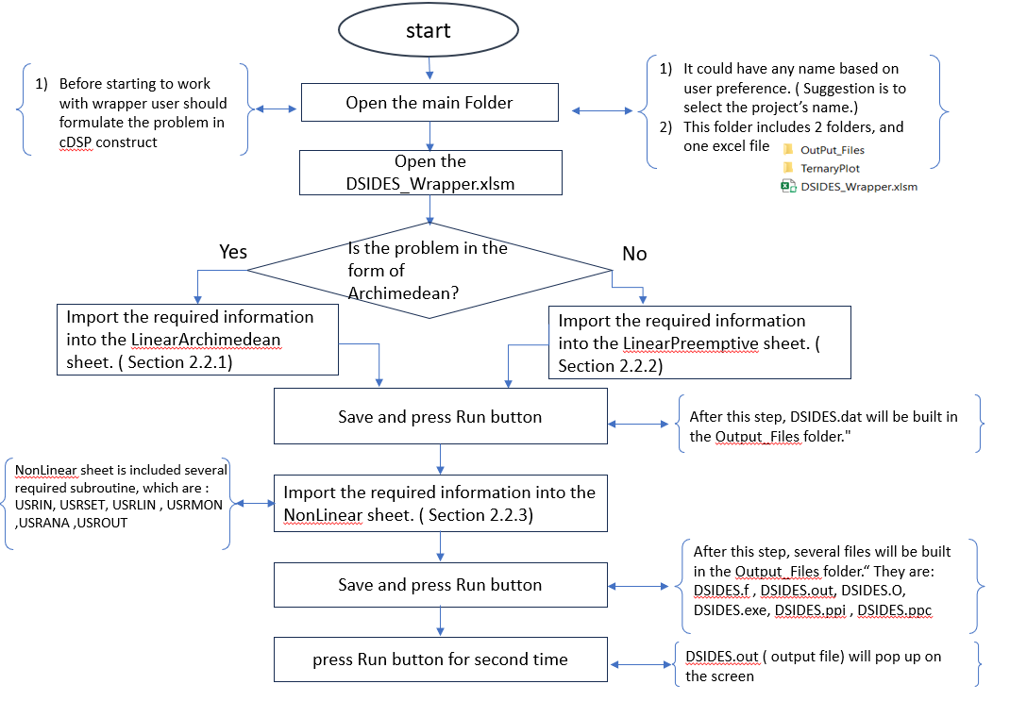
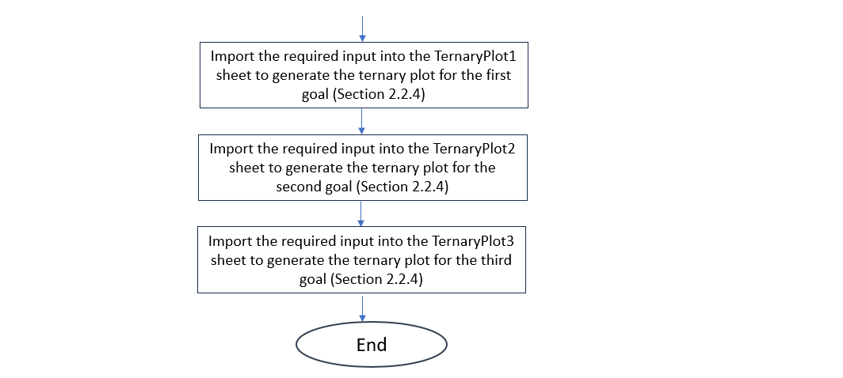
Figure II. 2: Flowchart of DSIDES Wrapper

II.2 Preparing Input for DSIDES in Different Sheets in the Wrapper
As outlined in Part 1 and shown in Figure II.2, it is necessary to formulate the problem as a Compromise Decision Support Problem (cDSP) construct before utilizing the DSIDES wrapper. To demonstrate the functionality of the DSIDES wrapper, the Elephant Stand problem, as an illustrative example, has been represented. Consequently, various steps to address this example have been presented, including defining the problem statement, formulating the cDSP (both in word and mathematical form), and finally implementing it within the DSIDES wrapper.
Elephant Stand Problem in Archimedean Form
Problem Statement:
In the late 1800s, Ringling Bros and Barnum and Baily Circus were looking to establish dimensions of a new pedestal for their circus elephant Jumbo. They would play a trick that involved a support pedestal where Jumbo would perform a one-legged hand stand. The cost of manufacturing must be minimized, which depends on its thickness, width, and the amount of material it consumes. And it must be as tall as possible for a wow factor. And finally, the pedestal must be wide enough to ensure Jumbo has enough room to safely stand on one foot. This means the goals of the design are to minimize the manufacturing cost, maximize the height, and maximize the outer radius. A material of 2014 Aluminum with a modulus of 10600 ksi and a density of 0.1 lb/in^3 has been selected.
Jumbo's foot is approximately 25" in diameter, so the pedestal must also be greater than 25". Jumbo weighs 13,560lb and stands 13.5ft tall. Use a factor of safety of 1.5.
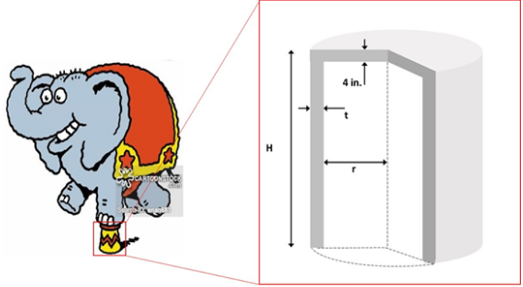 | 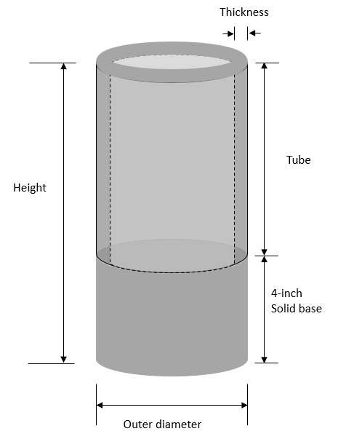
Figure II. 3: Overview of Elephant stand problem.
Given a certain type of material, design a cylinder (the “elephant stand”). The cylinder has two parts joined together. The upper half is a tube, and the designer’s interest is to determine its thickness, radius, and height that best satisfies the goals identified. The lower half is a 4-inch-height solid base. The goals identified by the designer include Minimizing the manufacturing cost, maximizing the height, and maximizing the outer diameter. Requirements include the upper and lower limit of the parameters that the cylinder can physically reach. The overview of the elephant stand problem is represented in Figure II.3.
cDSP Formulation:
Word Formulation:
Given
System parameters
Material – 2014 Aluminum
The elastic modulus for the material
Safety factor
Yield stress for the material
Density of the material
Load (elephant’s weight)
Moment of inertia for the cylindrical section
Maximum normal stress
Maximum buckling stress for a fixed free column
Cost target
Height target
OR target
Find
System variables
Radius, Thickness, Height
Satisfy
System constraints
Reaching the minimum outer diameter.
Not exceeding a certain height-to-width ratio.
Reaching the stress requirement.
Not exceeding the maximum weight.
Not exceeding the maximum load in stand.
System goals
Goal 1: reaching minimum cost target.
Goal 2: reaching maximum height target.
Goal 3: reaching maximum outer radius target.
Bounds
The upper and lower limit of Radius, Thickness and Height
Minimize
The deviation function.
cDSP Math Formulation:
Given
E = 10600000.
OR=R+T
SF = 1.5
SIGY = 11000.
P = 12000.
PI = 2*ACOS(0.0)
RHO = 0.1
$I=\frac{π}{4}*\left[{\left(R+T\right)}^{4}-R^{4}\right]$
$W1=π*\left[{\left(R+T\right)}^{2}-R^{2}\right]*\left(H-4\right)$
$W2=π*\left[{\left(R+T\right)}^{2}\right]*4$
W=(W1+W2)∗RHO
STR=P/(π∗[(R+T)^2−R^2 ] )
PCR=(π^2∗E∗I)/ 4∗(H^2 )
COST=e^(2.5/T)∗e^(3/R)∗W
Cost target = 5000
Height target = 180
OR target = 15
Find
System variables
- R Radius
- T Thickness
- H Height
Deviation variables
- $d_{i}^{+}$ over achievement of Goal i, where i=1,2,3
- $d_{i}^{-}$ under-achievement of Goal i, where i=1,2,3
Satisfy
System constraints
- minOD: minimum outer diameter
$2*R+2*T≥6$ (CO1)
- heiwid: height to width ratio
$R+T-0.03*H≥0$ (CO2)
- stress : minimum stress in stand
$\frac{SIGY}{SF}-STR≥0$ (CO3)
- weight: maximum weight
$1000-W≥0$ (CO4)
- buckle: maximum load in stand
$\frac{PCR}{F}-P≥0$ (CO5)
System goals
- Goal 1: minimum cost
$\frac{cost target}{cost}+d_{1}^{-}-d_{1}^{+}=1$ (G1)
- Goal 2: maximum height
$\frac{height}{height target}+d_{2}^{-}-d_{2}^{+}=1$ (G2)
- Goal 3: maximum outer radius
$\frac{OR}{OR target}+d_{3}^{-}-d_{3}^{+}=0$ (G3)
Bounds
3 ≤ R ≤ 45
0.5 ≤ T ≤ 2.5
100 ≤ H ≤ 120
Minimize
The deviation function.
${Z=\sum_{i=1}^{3}{w_{i}∙}(di}^{-}+{di}^{+})$,$\sum_{i=1}^{3}{w_{i}=1}$
Implementation in DSIDES Wrapper:
In this section, a detailed description of the wrapper is provided. The work is initiated with a main folder that contains two subfolders: TernaryPlot and Output_Files. Additionally, an Excel file named DSIDES_Wrapper will be included in this folder.
The TernaryPlot folder encompasses all the necessary files for generating the ternary plot, eliminating the need for user intervention. The second folder, named OutPut_Files, contains all the required files for establishing the connection with the DSIDES software and executing the program to obtain the final solution. Following the execution of the Linear sheet, the DSIDES.dat file is generated within this folder. Subsequently, upon executing the Nonlinear sheet, six additional files are generated in this folder, all named DSIDES. These files are of different types, including Fortran Source (.f), Out File, PPI File, PPC File, O file, and Application. The OUT file contains all output information described in Section II.3, "Interpret the Output File."
Regarding the name of the main folder, users can choose the naming of this folder based on their preference. For instance, they may use the project name for clarity in future reference. As illustrated in Figure II.4, the folder is referred to as DSIDES_ElephantStand.
Note: It is important to note that the folder name should consist of a single word without any spaces between alphabets.
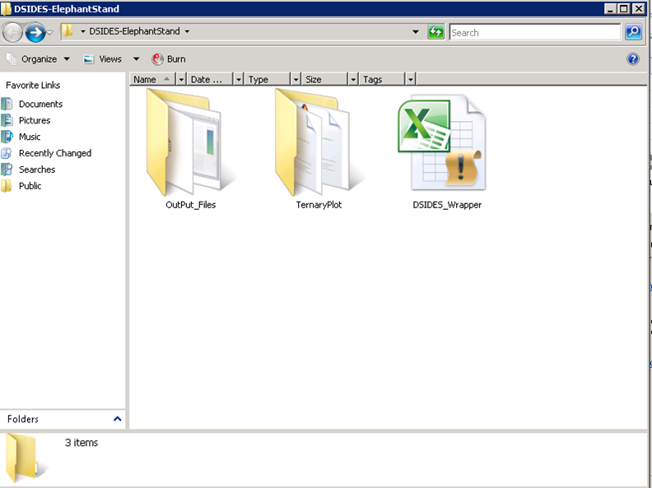
Figure II. 4: Files Included in the Main Folder
In the folder, there is an Excel sheet named "DSIDES_Wrapper." This file is the primary working file for our Wrapper, and it contains six different sheets, namely LinearArchimedian, LinearPreemptive, NonLinear, TernaryPlot1, TernaryPlot2, and TernaryPlot3.
In the subsequent sections, a detailed description of each sheet, outlining the necessary steps for importing the required information into each sheet to enable efficient use of the software based on the Elephant stand problem, is provided.

II.2.1 Linear Archimedean Sheet
As mentioned in Figure II.2 ( Flowchart of DSIDES Wrapper), the third step after defining the problem in cDSP form and opening the DSIDES_Wrapper.xlsm file, the initial sheet is titled "Linear Archimedean Sheet." We will go through this sheet if our problem is Archimedean form. The general layout of this sheet is displayed in Figure II.5. To solve an Archimedean problem ( Such as Elephant Stand Problem), the user must incorporate the linear information of the compromise decision support problem from this source. Therefore, this sheet will be discussed in detail in this section, thoroughly describing its contents and functionalities (the Elephant Stand Problem has been implemented as an example in this section).
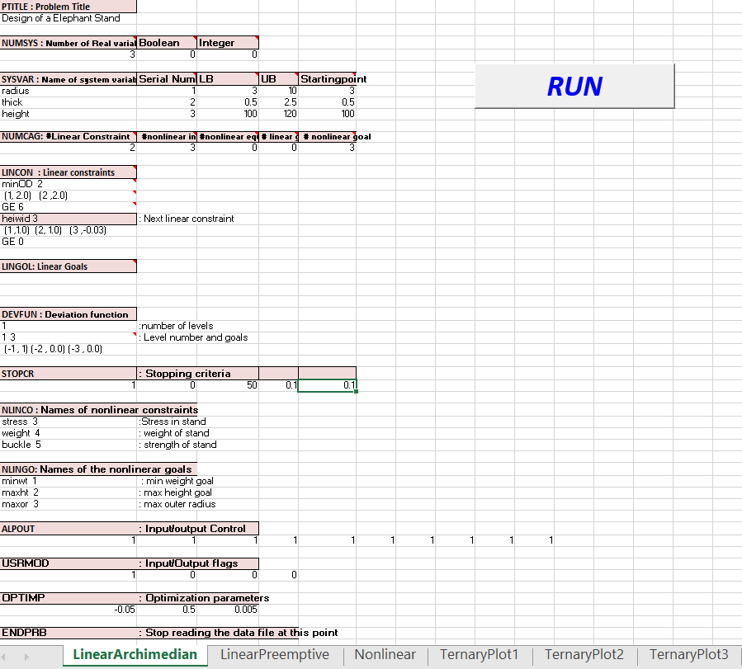
Figure II. 5: Overview of LinearArchimedian sheet
The data file for compromise Decision Support problems is divided into several blocks. Each block has a six-character name, e.g., PTITLE, NUMSYS, etc. The user is allowed to organize the problem-related information into logically arranged chunks of information by the blocks. Certain blocks are mandatory, i.e., they have to be specified for any problem. These blocks constitute the bare minimum amount of information required for a problem. Other optional blocks provide the user with further control of the solution procedure. Advanced users are expected to use more optional blocks than novice users. The various blocks are listed in this section. Mandatory blocks and Optional blocks have been represented in Table II.1 and Table II.2, respectively.

Table II.1: Mandatory Blocks in LinearSheet
PTITLE | 1 | Problem title
NUMSYS | 2 | Number of System Variables
SYSVAR | 3 | Description of System Variables - name, type, bounds, and guess value
NUMCAG | 4 | Number of Constraints and Goals
LINCON | 5 | Linear Constraints - names and data (if specified in NUMCAG)
LINGOL | 6 | Linear Goals- names and data (if specified in NUMCAG)
DEVFUN | 7 | Deviation Function - number of levels and weights of deviation variables
STOPCR | 8 | Stopping Criteria (run and principal print flags, NITER, EPSZ, EPSX)

Table II.2: Optional Blocks in LinearSheet
NLINCO | 9 | Names of Nonlinear Constraints (default names: NLCO##)
NL I NGO | 10 | Names of Nonlinear Goals (default names: NLGO##)
ALP OUT | 11 | Flags for Output Level, Post Processor, and Time Statistics
USRMOD | 12 | Flags for User Modules (USRINP, USROUT, USRMON, USRLIN)
OPTIMP | 13 | Optimization Parameters (VIOLIM, REMO, STEP)
INITFS | 14 | Automatic Generation of Initial Feasible Solution
USRDAT | 15 | User Data Block for Access From USRINP
ADPCTL | 16 | Nonlinear Inequality Constraint Adaption Flag (LADAP)
US ERAN | 17 | Information for USRANA (maximum cycles - NANCY, NSYCY)
FIXVAR | 18 | Fixing of Variables
SUPCON | 19 | Suppression of Nonlinear Constraints
PVALFX | 20 | Particular Values for Stationarity of System Variables
PVALFZ | 21 | Particular Values for Stationarity of Deviation Function Levels
PVSTEP | 22 | Particular Values for STEP
PVCVIL | 23 | Particular Values for VIOLIM
PVREMO | 24 | Particular Values for REMO
ADREMO | 25 | Adaptive Reduced Move Parameters
XPLORE | 26 | Explore the design space for best initial points
ENDPRB | 27 | End of Problem Definition

DESCRIPTION OF DATA BLOCKS:
Subsequent to familiarizing oneself with the significance of the various data blocks, including mandatory and optional fields present in different cells of the Excel sheet, In the subsequent paragraphs, a comprehensive overview of each data block will provide.
PTITLE (Mandatory):
Purpose: Define the problem title and other user information (name, date, etc.)
Format:
Textline1 (80 characters maximum)
textline2 (80 characters maximum)
Variables:
Textline1: string (80 characters maximum)
textline2: string (80 characters maximum)
Example:
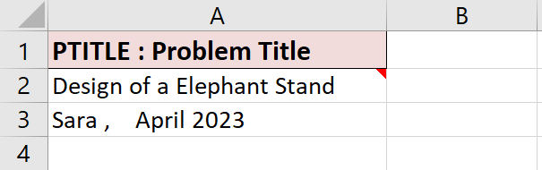
As depicted in the figure above, a small red indicator is visible in a specific cell. Placing the mouse cursor over the red indicator will reveal a pop-up text box that contains the description of the cell.
NUMSYS (Mandatory):
Purpose: Define the number of system variables - real and Boolean.
Format:
i k j
Variables:
i: integer Number of Real variables
k: integer Number of Boolean (selection) variables
j: integer Number of Integer variables
Example:
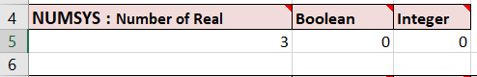
Notes:
If you do not have any variables of one type, you must indicate this by specifying a value of zero. In other words, three integers (i, k, and j) must be specified on the second line of the block. ( Line 5)
SYSVAR (Mandatory):
Purpose: Define system variable information.
Format:
Name Serial number LB UB guess
Variables:
Name: string Name of variable (6 characters long)
Serial number: integer Serial number of variable
LB: (real/integer) Lower bound for variable
UB: (real/integer) Upper bound for variable
guess: (real/integer) Initial guess value for variable (Starting point)
Example:
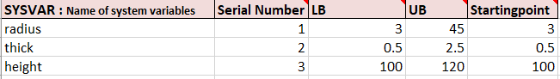
Notes:
• Real variables must precede the integer variables, and the Boolean variables should follow the integer variables.
• If the variable name is not given, a default name is assigned to the variable. This is of the form X## where## is the serial number of the variable, e.g., Xl, X45, etc.
• Variable types are assigned based on the serial number of the variable and are shown in the output file.
• Lower and upper bounds for Boolean variables are O and 1, respectively. The guess value can be either O or 1.
• If the initial guess value is out of the specified bounds, a default value of[min max] is assumed, and a warning is printed in the output file.
• It is possible to add as many variables as necessary. If the available space in a spreadsheet is insufficient, additional rows can be inserted to accommodate new variables. This can be done by right-clicking on the empty cell and selecting the "Insert" option to add a new row. In this way, the data set can be expanded to include any number of variables required for the problem at hand.
4. NUMCAG (Mandatory):
Purpose: Define the number of constraints and goals.
Format:
i j k m n
Variables:
i: integer Number of linear constraints
j: integer Number of nonlinear inequality constraints
k: integer Number of nonlinear equality constraints
m: integer Number of linear goals
n: integer Number of nonlinear goals
Example:
Notes:
• The absence of a particular type of constraint or goal must be explicitly specified by using a zero for the corresponding argument. For instance, zero indicates that there are no nonlinear equality constraints in the above example.
• If linear constraints are specified (i.e., i* 0), then the LINCON block has to be specified.
• If linear goals are specified (i.e., m* 0), then the LINGOL block has to be specified.
• It is assumed that all the nonlinear constraints and nonlinear goals are defined in the user-supplied FORTRAN module USRSET.
• This block must be specified before any of the other blocks relating to constraints and goals.
• The default names for the deviation variable names are assigned based on the total number of goals (=m+n) specified in this block. These names are printed in the output file.
5. LINCON (Mandatory if Required by NUMCAG):
Purpose: Define linear constraints.
Format: (for each linear constraint)
Name n
(ivar₁,cof₁) (... , ...) ... (ivar_{n},cof_{n})
Lc rhs
Variables:
name: string Name of linear constraint (6 characters long)
n: integer Number of terms to follow / Number of variables in this constraint.
ivar: integer System variable number / Serial number of Variable
cof: real Coefficient for system variable
Lc: chr*2 Logical connector, any one of the following: le, LE, <=, ge, GE, >=, eq, EQ, ==
rhs: real Right hand side value for constraint

Example:
The example shows the following two linear constraints.
minOD: minimum outer Diameter : 2*R +2*T >= 6
heiwid : height to width ratio : R+T -0.03 *H >= 0
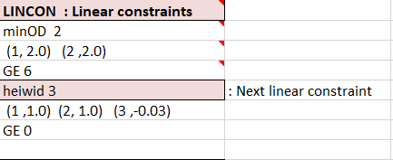
Notes:
• The inequality constraints must precede all equality constraints.
• If the name is not specified, a default name of the form LICO## is assigned to the constraint, e.g., LICO1, LICO37 etc.
• The order of the terms does not matter as can be seen in the specification of the second constraint.
• All other coefficients for the linear constraint are set equal to zero.
• It is possible to add as many constraints as necessary. If the available space in a spreadsheet is insufficient, additional rows can be inserted to accommodate new constraints. This can be done by right-clicking on the empty cell and selecting the "Insert" option to add a new row. In this way, the data set can be expanded to include any number of constraints required for the problem at hand.
6. LINGOL (Mandatory if required by NUMCAG):
Purpose: Define linear goals.
Format: (for each linear goal)
Name k n
(ivar_{l},cof_{l}) (..,..) … (ivar_{n} ,cof_{n})
rhs
Variables:
name: string Name of linear goal (6 characters long)
k: int Serial number of goal.
n: int Number of terms to follow.
ivar: int System variable number
cof: real Coefficient for system variable
rhs: real Right-hand side value for goal
Example:
Since in Elephant Stand Problem, there is no linear goal; another example has been represented. The example shows the following linear goal :
0.3 X₂ +0.7 X₅ +d⁻ - d⁺ = 27.5
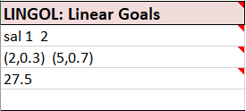
Notes:
• The serial number of the goal is necessary for the specification of the achievement function.
• If the name is not specified, a default name of the form LIGO## is assigned to the goal, e.g., LIGO1, LIGO37, etc.
• The order of the terms does not matter.
• All unspecified coefficients for the linear goal are set equal to zero.
• It is possible to add as many goals as necessary. If the available space in a spreadsheet is insufficient, additional rows can be inserted to accommodate new goals. This can be done by right-clicking on the empty cell and selecting the "Insert" option to add a new row. In this way, the data set can be expanded to include any number of goals required for the problem at hand.
7. DEVFUN (Mandatory):
Purpose: Define Deviation Function - number of levels and weights of deviation variables. It is used in Archimedean form. In Preemptive form, ACHFUN will be used.
Format: (for each linear goal)
K
L n
(m₁,w₁) (... , ...) ... (m_{k},W_{k})
Variables:
k: int Number of levels
L: int Level number.
n : int Number of goals in this level.
m: integer signed integer indicating deviation variable.
( +m for overachievement and -m for underachievement)
w: real weight for deviation variable
Example:
One priority level.
Z1 = 0.3d₁⁻ + 0.6 d₂⁻ + 0.1d₃⁺
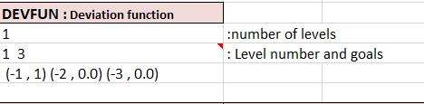
8. STOPCR(Mandatory):
Purpose: Define the stopping criteria.
Format:
i j k a b
Variables:
i: integer = 1, perform calculations
= 0, dry run only, no calculations performed
j: integer = 1, print final solution only, no intermediate results printed.
= 0, print intermediate results
k: integer Maximum number of synthesis cycles (NITER)
a: real Desired stationarity of deviation function (EPSZ)
b: real Desired stationarity of system variables (EPSX) { Recommended value: 0.05}
Example:
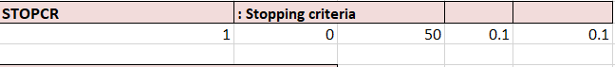
Notes:
• The iterations are stopped if the change in any level of the deviation function is less than EPSZ. Values for individual levels can be changed using the block PVEPSZ.
• The iterations are stopped if the following condition is met by the system variables,
| X_{i,old} - X_{i,new} | <= FRAC_{i}
Where:
FRAC_{i} = EPSX * [ X_{i,max} - X_{i,min} ]
• Particular values for FRAC can be set in the block PVALFX.
9. NLINCO (Optional):
Purpose: Define the names of nonlinear constraints (inequality constraints first).
Format: (for each constraint)
name k
Variables:
name: string Name of nonlinear constraint (6 characters long)
k : integer Number of the nonlinear constraint
Example:
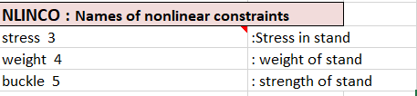
Notes:
• If the name is not specified (i.e., six spaces are specified as the name) or if the NLINCO block is not specified, a default name of the form NLCO## is assigned to the nonlinear constraint, e.g., NLCO1, NLC037 etc.
• The user has the responsibility of matching the numbering scheme for the constraints in the data file with the numbers used in the FORTRAN file (in module USRSET).
• It is possible to add as many names as necessary. If the available space in a spreadsheet is insufficient, additional rows can be inserted to accommodate new names. This can be done by right-clicking on the empty cell and selecting the "Insert" option to add a new row. In this way, the data set can be expanded to include any number of names for nonlinear constraints required for the problem at hand.
10. NLINGO (Optional):
Purpose: Define the names of nonlinear goals.
Format: (for each goal)
name k
Variables:
name: string name of nonlinear goal(6 characters long)
k: integer number of the nonlinear goal
Example:
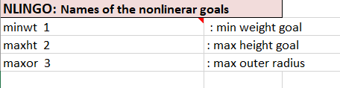
11. ALPOUT (Optional):
Purpose: Output control.
Format:
kl k2 k3 k4 k5 k6 k7 k8 j m
Variables:
kl: integer = 1, print system variables (Default)
= 0, do not print system variables
k2: integer = 1, print deviation variables(Default)
= 0, do not print deviation variables
k3: integer = 1, print deviation function(Default)
= 0, do not print deviation function
k4: integer = 1, print bound information
= 0, do not print bound information(Default)
k5: integer = 1, print linear constraint information
= 0, do not print linear constraint information(Default)
k6: integer = 1, print nonlinear constraint information
= 0, do not print nonlinear constraint information(Default)
k7: integer = 1, print linear constraint activity for a linear solution
= 0, do not print linear constraint activity for linear solution(Default)
k8: integer = 1, print nonlinear constraint activity for a linear solution
=0, suppress nonlinear constraint activity for linear solution(Default)
j: integer = 1, print postprocessor information
= 0, do not print postprocessor information(Default)
m: integer = 1, print time statistics
= 0, do not print time statistics(Default)
Example:
12. USRMOD (Optional):
Purpose: User module-related flags.
Format:
i j k l
Variables:
i: integer = 1, User module USRINP to be used.
= 0, USRINP not used ( Default)
j: integer = 1, User module USROUT to be used
= 0, USROUT not used (Default)
k: integer = 1, User module USRMON to be used
= 0, USRMON not used (Default)
l: integer = 1, User module USRLIN to be used
= 0, USRLIN not used (Default)
Example:
Call USRINP only:
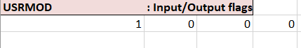
Notes:
• The user module USRINP is called before any computations are performed. It can be used to read problem specific data.
• The user module USROUT is called after all computations are performed. It can be used to perform customized output.
• The user module USRMON is called after every synthesis cycle. It can be used to obtain extra problem-specific output after each cycle.
• The user module USRLIN is called when the linear goals or coefficients have variable coefficients.
13. OPTIMP ( Optional):
Purpose: Define optimization parameters.
Format:
a b c
Variables:
a: real Acceptable violation of nonlinear constraints (VIOLIM).
Negative real number.{ Default value: -0.001}
b: real Reduced move limit (REMO)
Real value between O and 1( Default value: 0.5)
c:real Perturbation step for linearization (STEP) specified as a fraction of the variable range.
Real value between O and 1( Default value: 0.005)
Example:
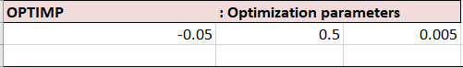
Notes:
VIOLIM defines the acceptable range by which a nonlinear constraint may be violated and yet be considered as being satisfied by SLIPML.
A larger value of REMO (e.g., REMO=l) will usually lead to faster convergence.
If the solution shows large fluctuations between cycles, use a small value of reduced move (e.g., 0.1).
The value of VIOLIM is used for all nonlinear constraints. To specify individual values for constraints, use the PVCVIL block.
The value of the reduced move is used for all system variables (except Boolean variables). To specify individual values for variables, use the PVREMO block. The optional PVREMO block is designed to provide users with the ability to select specific values for REMO when utilizing the advanced model feature. Due to its optional nature, this block has not been included in the main wrapper, and therefore no specific cell has been allocated for it. To utilize this feature, users will need to manually add a cell to the end of the sheet before the ENDPRB block. This can be done by clicking on the cell and selecting the "insert" option, followed by selecting the "entire row" to add a new line. Once the new row has been added, users can import the relevant data based on the instructions provided in PVREMO blocks.
The value of the perturbation step is used for all nonlinear functions. To specify individual values for functions, use the PVSTEP block.
Additional Optional Blocks:
The additional blocks described below are optional and may be useful for advanced users who require greater customization of their model. As such, these blocks have not been included in the main wrapper, and no specific cell has been allocated for them. If users wish to utilize these advanced features, they will need to manually add a cell to the end of the sheet before the ENDPRB block. This can be done by clicking on the desired cell and selecting the "insert" option, followed by selecting the "entire row" to add a new line. Users can then import the relevant data based on the instructions provided. We hope this information is helpful to our users who require greater flexibility and customization in their modeling. Since the following blocks are optional and we did not consider them in the Elephant Stand problem, some other examples have been presented.
14.. INITFS:
Purpose: Automatic generation of initial feasible solution.
Format:
n a b c d e
Variables:
n: integer Maximum allowable number of calls to USRSET.
a: real Expansion factor for pattern search > 1 (Recommended value 2.0)
b: real Contraction factor for pattern search < 1 (Recommended value 0.5)
c: real Acceptable value for the sum of violations (Small value)
d: real Step size as a fraction of range (0 <d < 1)
e: real Minimum allowable fraction of the initial step.
Notes:
• The very presence of the INITFS block acts as a flag for the pattern search to be executed. If you need to tum this option off, remove the block from your data file or inactivate it by placing it after the ENDPRB block.
• The initial feasible solution is generated using the Hook-Jeeves pattern search algorithm with ridge adaptation.
• The pattern search will call the user module USRSET at most n times. When the analysis
is time-consuming, this number can be kept small (e.g., 40). Otherwise, use a large number like 400.
• The pattern search is terminated if the sum of absolute violations is smaller than c.
• The pattern search is initialized with a step size based on the bounds and the parameter d.
STEP_{i} = Step size* (Max_{i} - Min_{i})
• The pattern search is terminated if the step size multiplier becomes smaller than e. The initial multiplier is taken as unity (=1 ). This parameter governs the accuracy of the final solution of the pattern search.
15. USRDAT (Optional):
Purpose: This block contains data that can be read from USRINP.
Format:
K
textline₁
…
textline_{k}
Variables:
k: integer Number of lines of text to follow.
textline 80 characters (maximum) of text
Note:
• This should only be used when a relatively small amount of data needs to be read by USRINP and when the effort of maintaining an additional data file is considered unnecessary.
16. ADPCTL (Optional):
Purpose: Nonlinear inequality constraint adaption flag.
Format:
j
Variables:
j: integer = 1, Use nonlinear constraint/goal adaptation
= 0, No adaptation used (Default)
17. USERAN (Optional):
Purpose: Parameters related to the user analysis module USRANA.
Format:
1
k₁ k₂ ... k_{i}
Variables:
i: integer Number of analysis cycles (NANCY)
k: integer Number of synthesis cycles within each analysis cycle (NYSCY)
Example:
USERAN : USRANA related parameters
3 : NASC # of synthesis cycles
20 30 15 : NANSYC(I)
18. FIXVAR (Optional):
Purpose: Fix system variables to initial guess values.
Format:
1
k1 k2 ... ki (free format list)
Variables:
i: integer Number of system variables to be fixed.
k: integer Serial number of variable to be fixed.
Example:
FIXVAR : Fixing Variables
2
1 4 Fix X1 and X4 to constant Values.
19. SUPCON ( Optional):
Purpose: Suppress nonlinear constraints.
Format:
i
k1 k2 ... ki (free format list)
Variables:
i: integer Number of system constraints to be fixed.
k: integer Serial number of constraint to be suppressed.
Example:
SUPCON : Suppressing constraints.
1
2 : suppress the stress constraint.
20. PAVALFX (Optional):
Purpose: Particular values for stationarity of system variables.
Format:
k
(i₁, r₁) (... , ...) ... (i_{k}, r_{k})
Variables:
k: integer Number of values to follow.
i: integer Serial number of variable
r: real Particular value of FRACX as a fraction of variable range defined by the bounds.
21. PVALFZ ( Optional):
Purpose: Particular values for stationarity of deviation function level.
Format:
k
(i1, ri) (... , ...) ... (ik, fJc)
Variables:
k: integer Number of values to follow
i: integer Priority level number
r:real Particular value of EPSZ for this level
Example:
PVALFZ Stationarity of deviation function
1
(1,0.001) Need accurate convergence for first level goals
22. PVSTEP ( Optional):
Purpose: Perturbation step size for particular set of variables.
Format:
k
(f₁,s₁) (... , ...) ... (f_{k},S_{k})
Variables:
k: integer Number of values to follow.
f: integer Serial number of system variable being perturbed.
s: real Perturbation step size specified as a fraction of the variable range.
Example:
PVSTEP : particular values for steps
1
(2, 0,02) : step size for variable 2
23. PVCVIL ( Optional):
Purpose: Particular values for nonlinear constraint satisfaction (VIOLIM).
Format:
k
(m₁,s₁) (..., ...) ... (m_{k},S_{k})
Variables:
k: integer Number of values to follow.
m: integer Serial number of nonlinear constraint.
s: real acceptable violation for nonlinear constraint (< 0.0)
Example:
PVCVIL : Nonlinear constraint violations
1
(3, -0.005) : strict control for constraint #3

24. PVREMO ( Optional):
Purpose: Particular values for the reduced move.
Format:
k
(i₁, r_{i}) (... , ...) ... (i_{k}, f_{k})
Variables:
k: integer Number of values to follow.
i: integer Serial number of variable.
r: real Reduced move size.
Example:
PVREMO :particular values for reduced move
(1,0.1) (3,0.1) : Reduced move for variables 1 and 3
Note:
• This can be useful when a small number of variables are not converging, but most of the variables are converging. Set the reduced move for these variables at a small value.
25. ADREMO ( Optional):
Purpose: Use adaptive reduced move algorithm.
Format:
k a
Variables:
k: integer Maximum number of calls to USRSET in each cycle
a: real Convergence criterion for the reduced move, R.
{ Recommended value: 0.05}
Example:
ADREMO : adaptive reduced move
10 0.05 : Max . calls, deltaR
Notes:
• The adaptive reduced move is performed using a combination of linear search and a Golden section Search algorithm to find the value of R_{best} ( 0≤ R ≤1 ) which will minimize the deviation function along the line joining the old solution point, X_{old}, to the new solution point, X_{new}·
X_{best} = X_{old} + R_{best} [ X_{new} - X_{old} ] where O ≤ R_{best≤} 1
If point X_{new} is infeasible, the search range is contracted to lie between O and 0.5. This contraction is repeated until a feasible value of R is found or the interval becomes smaller than the convergence criterion given by a.
• The maximum number of calls to USRSET, to achieve convergence to a given value of a, can be calculated from the following equation
N_{max} = 4.82 log10 (1/a) + 2
The maximum number of times that USRSET is actually called is the smaller of the two numbers - k and N_{max.}
26. XPLORE ( Optional):
Purpose: Explore the solution space to find a feasible starting point.
Format:
j₁ j₂ j₃ j₄
i
k₁ k₂ ... k_{i} (free format list)
Variables:
j1: integer Number of points to be generated (NPTGEN)
j₂: integer Number of best points to be selected.
j₃: integer Flag to print best points in standard output file.
= 0, do not print best points
= 1, print best points
j_{4:} integer Integer seed number for pseudo-random number generation ( positive integer less than 2531)
i: integer Number of system variables to be fixed at initial values during the search procedure.
k: integer Serial number of variable to be fixed.
Example:
XPLORE : Exploring Design space
3000 20 1 1233
3
1 4 : fix X1 and X4 to constant values during search
Notes:
• The points in the design space are generated using two different methods depending on the number of points requested. If NPTGEN > 2^{m}, then we use the systematic search algorithm of Aird and Rice (1977) to generate the points. Otherwise, we generate points using random numbers. Here mis the number of variables which are not fixed.
• The best points are stored in a file named ALPPTS.DAT.
At this stage, all the necessary information regarding the Linear Archimedean sheet has been described. The focus will now shift to the Linear Preemptive sheet, which shares many similarities with the previous sheet, but with some minor differences to be discussed in the subsequent section. The forthcoming section will provide a comprehensive overview of the Linear Preemptive sheet, highlighting its distinct features and functionalities.

II.2.2 Linear Preemptive Sheet
In this sheet we are importing linear information regarding the preemptive form. As we described in Section 1.3.6, in the Preemptive approach, the goals are rank ordered to avoid the difficulty of assigning weights. The measure of achievement is obtained in terms of the lexicographic minimization of an ordered set of goal deviations. Weights may be used within each set of goals at a particular rank, but the goals are ranked lexicographically, and an attempt is made to achieve a more important goal before considering other goals. The deviation function in the Preemptive formulation is written as an ordered array of nonnegative elements. In other words, to define the formulation, everything is exactly the same; the only difference is in defining goals. We need to define levels for preemptive since, in Archimedean, levels are equal to 1.
To implement the formulation in this sheet, follow all the rules mentioned in the LinearArchimedian sheet. The difference is to define the deviation function. In the LinearArchimedian sheet, there is a DEVFUN option, which includes only one level, but there is an ACHFUN section in this sheet.
ACHFUN:
Purpose: Define Deviation Function - number of levels and weights of deviation variables. It is used in Preemptive form.

Format: (for each linear goal)

K

L n

(m₁,w₁) (... , ...) ... (m_{k},W_{k})

Variables:

k: int Number of levels

L: int Level number.

n: int Number of goals in this level.
m: integer signed integer indicating deviation variable.
( +m for overachievement and -m for underachievement)
w: real weight for deviation variable
Example:
In the following example, the 3-level preemptive form has been represented, which includes one goal in the first level, three goals in level two (all weights are assigned to the third goal ), and one goal in level three.
Deviation functions (pre-emptive form):
z = [ e₁⁻ , $\sum_{i=1}^{3}{wi}$ . (d_{i} – + d_{i}⁺), d₄⁻], $\sum_{i=1}^{3}{wi}=1$ (w_{i} are weights of the various compromise goals)
where deviation variables are: e₁⁻, e₁⁺, d₁⁺, d₁⁻, d₂⁺, d₂⁻ , d₃⁺, d₃⁻, d₄⁻, d₄⁺
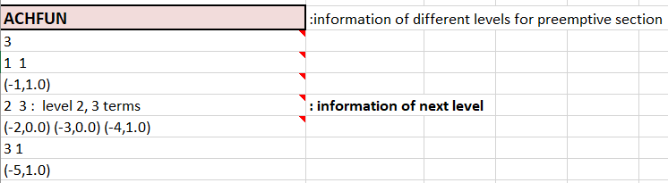

Note:
• It is possible to add as many levels as necessary. If the available space in a spreadsheet is insufficient, additional rows can be inserted to accommodate new levels. This can be done by right-clicking on the empty cell and selecting the "Insert" option to add a new row. In this way, the data set can be expanded to include any number of levels and the information required for the problem at hand.
All other information would be the same as LinearArchimedian and follow the same rules.
At this stage, all the necessary input information for the linear aspect of the problem has been described. The subsequent section will shift the focus toward the nonlinear portion of the problem, wherein its intricate details will be thoroughly examined. This forthcoming section will provide an in-depth analysis of the nonlinear component, covering its various intricacies and complexities.

II.2.3 Nonlinear Sheet
To formulate and solve a Compromise DSP, in addition to the LinearArchimedian or LinearPreemptive sheet that is described in Sections II.2.1 and II.2.2, we need to input the required information in the third sheet, which is the Nonlinear sheet. In this part of the program, the following six user specified subroutines are required:
• USRINP (for user specific input),
• USRSET (for evaluating nonlinear constraints and nonlinear goals),
• USRLIN (for updating linear constraint and linear goal coefficients),
• USRMON (for user specific monitoring of the solution process),
• USRANA (for relevant analysis cycle calculations), and
• USROUT (for user specific output).
In order to streamline the user experience and facilitate quick identification of the necessary input information, the NonLinear sheet incorporates distinct visual elements. These include specific sections highlighted in larger font sizes and colored in red. Within these prominent red sections, users are required to import essential information such as local variables, details pertaining to nonlinear constraints, and specifications for nonlinear goals ( those are related to the Subroutine USRSET). This design approach aims to enhance user efficiency and ensure that the crucial input parameters are readily apparent for the user's attention and completion.
To provide users with a comprehensive understanding of the NonLinear sheet, I have included visual representations in the form of images for this sheet in Figure II.6. With this image, users could have a holistic view of the layout to grasp the appearance and structure of the NonLinear sheet at a glance.
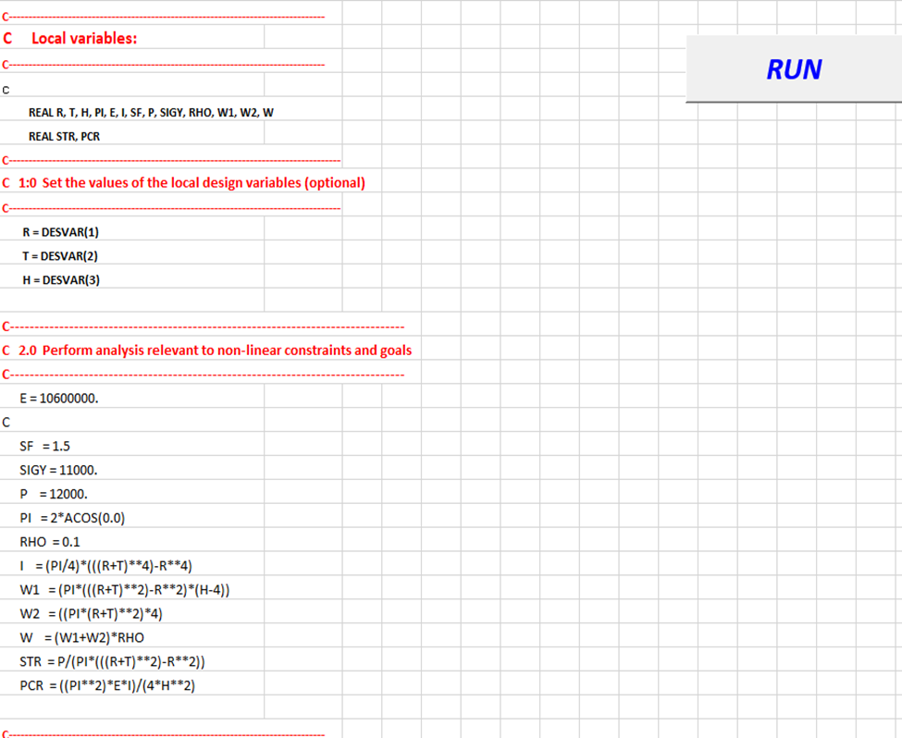
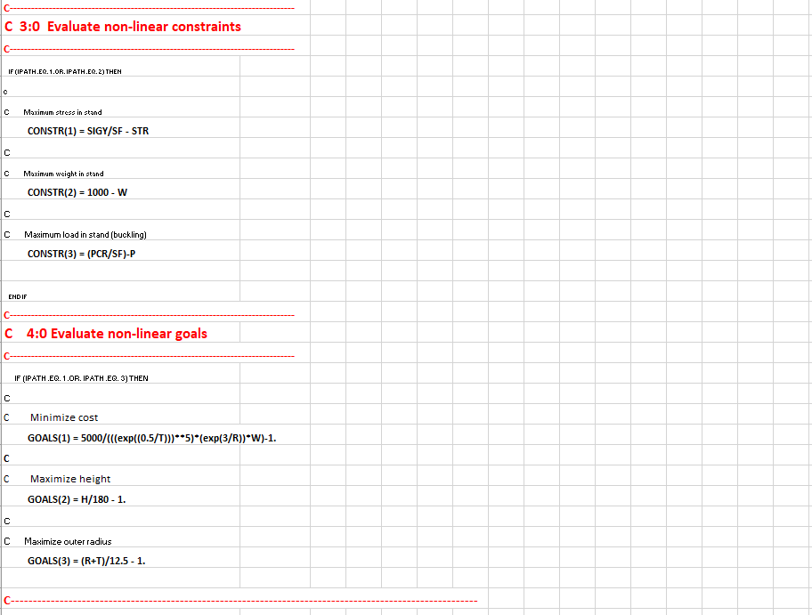
Figure II. 6: Overview of Nonlinear sheet
Important Note:
When importing input data into the sheet, it is crucial to adhere to the formatting rules, which follow the convention of Fortran, the primary language used in the DSIDES program. According to this convention, it is necessary to begin each line with 8 empty spaces before adding the content.
To illustrate, let us consider a scenario where we need to define integer variables named "a" and "b." To properly adhere to the formatting rules, we would begin by inserting 8 empty spaces at the start of each line. Following that, we would write "Integer" to indicate the variable type and then import "a" and "b" on separate lines. Adhering to this specific formatting ensures compatibility with the DSIDES program and maintains consistency with the Fortran language conventions. By incorporating 8 empty spaces at the beginning of each line before adding content, we can effectively import the input data in a manner that aligns with the requirements of the system.
It is essential to know that the absence of any of these six subroutines will result in a warning and/or error message at link time, depending on the system being utilized. The consequence of not providing a subroutine is system dependent. In order to avoid problems, the user should provide at least a "dummy" subroutine within a DSP template such that all external calls are satisfied. The recommended "dummy" routines are defined in Section II.2.3.7.
Since these subroutines are essentials to be in this sheet, we will go through each of them to describe how they will work in the main program.

II.2.3.1 SUBROUTINE USRINP
Subroutine USRINP provides the user with a data input wrapper. By defining a user common block, the relevant data read through this wrapper can then be made available to other user specified subroutines (i.e., the other 5 ALP mandatory user supplied routines or any appropriate additional analysis routines). The desire to actively call subroutine USRINP is flagged through the optional ALP Data Block USRMOD that has been described in Section II.2.1. The first Boolean flag (0/1) specified in USRMOD accommodates the USRINP switch.
To minimize the number of files a user has to provide and maintain, the data to be read by USRINP can be written into the ALP Data Block USRDAT . Again, for details of USRDAT, see II.2.1 in part 12. If USRDAT is included in the active portion of the standard compromise data file, the lines of "text" are written to a temporary file. This file is then rewound, and the unit number of this temporary file is passed in the USRINP argument list . It is then necessary for the user to write in USRINP a set of matching read statements for these lines of "text".
Alternatively, if the ALP Data Block USRDAT is not to be used, all other legal FORTRAN 1/0 constructs could be used in USRINP. For example, USRINP could be written to query the user interactively during runtime or to access some other file or set of files.
C***********************************************************************
C Subroutine USRINP
C
C Purpose: To facilitate the input of domain dependent information
which can be stored in a COMMON (e.g., COMMON/USER/ ...)
C and shared with other user specified routines as required.
c-----------------------------------------------------------------------

c Arguments Name Type Description
C ---------
C Input: NDESV int number of design variables
C NINP int unit number of the input data file
C NOUT int unit number of the output data file
C DESVAR real vector of design variables

C Output : none

C Input/Output: none
c-----------------------------------------------------------------------
C Common Blocks: none
C
C Include Files: none
C
C Called from: ALPCTL
C
C Calls to: none
c-----------------------------------------------------------------------
C Development History
C
C Author:
C Date:
C
C Modifications:
C
C***********************************************************************
c
SUBROUTINE USRINP (NDESV, NINP, NOUT, DESVAR)
C
c---------------------------------------
c Arguments:
c---------------------------------------
INTEGER NDESV, NINP, NOUT
REAL DESVAR(NDESV)
C---------------------------------------
c Local variables:
c---------------------------------------
C
COMMON/USER/ ...
C
C
Any legal FORTRAN statements.
C
RETURN
END

II.2.3.2 SUBROUTINE USRSET
The following subroutine is implemented within the NonLinear sheet of the wrapper, allowing users to import essential data. Its purpose is to evaluate the nonlinear constraints and goals effectively. This subroutine is used to evaluate the nonlinear constraints and goals. It is important that in specifying the constraints, the inequality constraints precede the equality constraints. Failure to do so will result in misinterpretation of the evaluation results by the main program. As far as possible, it is recommended to formulate the constraints so that an increase in x represents an increase in feasibility. All nonlinear constraints must be specified in the form LHS > 0. 0 or LHS = 0. 0. That is, the returned value (CONSTR) should be greater equal than 0.0 for feasibility. Numbering of the indices for constraints and goals within Subroutine USRSET should begin with 1 and run to NNLCON and NNLGOA, respectively.
In this subroutine, there are specific sections highlighted in larger font sizes and colored in red on the sheet. Within these prominent red sections, users are required to import essential information such as local variables, Set the values of the local design variables (optional), Perform analysis relevant to nonlinear constraints and goals, evaluate nonlinear constraints, and evaluate nonlinear goals.
Once the necessary information has been imported into the NonLinear sheet, the user can initiate the computation process by clicking the "Run" button. This action triggers the program to execute the calculations based on the provided input. Subsequently, an output file is generated, encompassing the values of all variables involved in the analysis. This output file is automatically saved in the main folder of the software. In the event that the user decides to run the analysis again by clicking the "Run" button for the second time, the output file is conveniently displayed on the screen. This enables the user to access and review the results promptly, facilitating a seamless and iterative workflow.
C***********************************************************************
C Subroutine USRSET
c
C Purpose: Evaluate nonlinear constraints and goals.
C NOTE - Do not specify the deviation variables
c-----------------------------------------------------------------------
c Arguments Name Type Description
C -----------------------------------------------------------------------------------------------
C Input: IPATH int = 1 evaluate constraints and goals
C = 2 evaluate constraints only
C = 3 evaluate goals only

C NDESV int number of design variables
C MNLNCG int maximum number of nonlinear constraints and goals
C NOUT int unit number of output data file
C DESVAR real vector of current system variables

C Output : CONSTR real vector of constraint values
C GOALS real vector of goal values
C Input/Output: none
c-----------------------------------------------------------------------
c Common Blocks: USER
C Include Files: none
C Called from: GCALC
c Calls to: none
c-----------------------------------------------------------------------
c Development History
C
C Author:
c Date:
C
C Modifications:
C***********************************************************************
c-
SUBROUTINE USRSET (IPATH, NDESV, MNLNCG, NOUT, DESVAR,
& CONSTR, GOALS)
C
c---------------------------------------
c Arguments:
c---------------------------------------

INTEGER IPATH, NDESV, MNLNCG, NOUT
REAL DESVAR(NDESV)
REAL CONSTR(MNLNCG), GOALS(MNLNCG)
C
c---------------------------------------
c Local variables:
c---------------------------------------
C
COMMON/USER/ ...
C
C 1.0 Set the values of the local design variables (optional)
C
Any legal FORTRAN statements.
C
C 2.0 Perform analysis relevant to nonlinear constraints and goals
C
Any legal FORTRAN statements
C
C
C 3.0 Evaluate nonlinear constraints
C
IF (IPATH .EQ. 1 .OR. IPATH .EQ. 2) THEN
C
Any legal FORTRAN statements.
Perform analysis relevant to nonlinear constraints.
Specify CONSTR(J) for each constraint where J = 1, NNLCON
C
END IF
C
C
C 4.0 Evaluate nonlinear goals
C
IF (IPATH .EQ. 1 .OR. IPATH .EQ. 3) THEN
C
Any legal FORTRAN statements.
C
Perform analysis relevant to nonlinear goals
C
Specify GOALS( J) for each goal where J = 1, NNLGOA
C
END IF
C
C 5.0 Return to calling routine
C
RETURN
END

II.2.3.3 SUBROUTINE USRLIN
The Purpose of this subroutine is to facilitate the modification of linear constraint and linear goal coefficients that are functions of system variables. One example of use is the revision of merit function values in coupled problems involving selection.
C***********************************************************************
C Subroutine USRLIN
C
C Purpose: To facilitate the modification of linear constraints and
C linear goal coefficients that are functions of the system
C variables. One example of use is the revision of merit
C function values in coupled problems involving selection.
c-----------------------------------------------------------------------
C Arguments Name Type Description
C Input: MLINCG int maximum total number of linear constraints and goals
C NLINCO int number of linear constraints
C NDESV int number of design variables
C NLINGO int number of linear goals
C NOUT int unit number of the output data file
C DESVAR real vector of current system variables

C Output: none
C Input/Output: COFLIN real matrix of coefficients of linear constraints and goals
C RHSLIN real vector of RHS values for linear constraints and goals
c-----------------------------------------------------------------------
C Common Blocks: USER
C Include Files: none
C Called from DFCALC
C Calls to none
c-----------------------------------------------------------------------
C Development History
C
C Author:
C Date:
C
C Modifications:
C***********************************************************************
c-
SUBROUTINE USRLIN (MLINCG, NDESV, NLINCO, NLINGO, NOUT,
& DESVAR, COFLIN, RHSLIN)
C
c---------------------------------------
c Arguments:
c---------------------------------------
c
INTEGER MLINCG, NDESV, NLINCO, NLINGO, NOUT
REAL DESVAR(NDESV), COFLIN(MLINCG,NDESV), RHSLIN(NLINCO+NLINGO)
C
c---------------------------------------
c Local variables:
c---------------------------------------
c
COMMON/USER/ ...
C
Any legal FORTRAN statements.
C
RETURN
END

II.2.3.4 SUBROUTINE USRMON
C***********************************************************************
C Subroutine USRMON
C
C Purpose: To facilitate monitoring of the solution process and
C to provide the opportunity to generate additional output
C (Called from within ALPMOD prior to calling linear solver)
c-----------------------------------------------------------------------

c Arguments Name Type Description
C ---------
C Input: NDESV int number of design variables
C NMPRI int number of priority levels
C NNLCON int number of nonlinear constraints
C NNLGOA int number of nonlinear goals
C NOUT int unit number of output data file
C CONDEV real total constraint violation
C DESVAR real vector of current system variables
C DEVFUN real vector of deviation function values
C DEWAR real vector of deviation variables
C GVAL real vector of nonlinear constraint and goal values

C Output : none

C Input/Output: none
c-------------------------------------------------------·---------------
Common Blocks: USER
C Include Files: none
C Called from: ALPMOD
C Calls to: none
c-----------------------------------------------------------------------
C Development History
C
C Author:
C Date:
C
C Modifications:
C***********************************************************************
c-
SUBROUTINE USRMON (NDESV, NDEVAR, NMPRI, NNLCON, NNLGOA, NOUT,
& DESVAR, DEVVAR, CONDEV, DEVFUN, GVAL)
C
c---------------------------------------
c Arguments:
c---------------------------------------
c
INTEGER NOUT, NDESV, NDEVAR, NMPRI, NNLCON, NNLGOA
REAL DESVAR(NDESV), DEVVAR(NDEVAR),
& CONDEV, DEVFUN(NMPRI), GVAL(NNLCON+NNLGOA)
C
c---------------------------------------
c Local variables:
c---------------------------------------
c
COMMON/USER/ ...
C
Any legal FORTRAN statements.
C
RETURN
END

II.2.3.5 SUBROUTINE USRANA
C***********************************************************************
C Subroutine USRANA
C
C Purpose: To facilitate access to analysis packages too costly to C call within a synthesis cycle
c-----------------------------------------------------------------------
c Arguments Name Type Description

C Input: NDESV int number of design variables
NOUT int unit number of output data file
DESVAR real vector of current system variables

C Output: none

C Input/Output: none
c-----------------------------------------------------------------------
C Common Blocks: USER
C Include Files: none
C Called from: ALPCTL
C Calls to: none
c-----------------------------------------------------------------------
C************** ********************************************************
SUBROUTINE USRANA (NDESV, NOUT, DESVAR)
C
c---------------------------------------
c Arguments:
c---------------------------------------
INTEGER NDESV, NOUT
REAL DESVAR(NDESV)
C
c---------------------------------------
c Local variables:
c---------------------------------------
c
C
COMMON/USER/ .....
C
Any legal FORTRAN statements.
C
RETURN
END

II.2.3.6 SUBROUTINE USROUT
C***********************************************************************
C Subroutine USROUT
C
C Purpose: To facilitate the customization of the final output
c-----------------------------------------------------------------------

c Arguments Name Type Description
C Input: NOUT int unit number of output data file
C DESVAR real vector of design variables
C LCONDF lgcl TRUE if deviation function converged.
C LCONSV lgcl TRUE if design variables converged
C LXFEAS lgcl TRUE if vector of design variables represents a feasible design
C Output: none
C Input/Output: none
C
C Common Blocks: none
Include Files: none
Called from: ALPCTL
Calls to: none

c-----------------------------------------------------------------------
C***********************************************************************
c
SUBROUTINE USROUT (NDESV, NOUT, DESVAR, LCONDF, LCONSV, LXFEAS)
C
c---------------------------------------
c Arguments:
c---------------------------------------
INTEGER NDESV, NOUT
REAL DESVAR(NDESV)
LOGICAL LCONDF, LCONSV, LXFEAS
C
c--------------------.------------------
c Local variables:
c---------------------------------------
C
COMMON/USER/ .....
C
C
Any legal FORTRAN statements.
C
RETURN
END

II.2.3.7 MINIMUM DUMMY SUBROUTINES
The minimum user specified "dummy" subroutines are defined as given below.

Minimum USRINP "dummy" subroutine

SUBROUTINE USRINP (NDESV, NINP, NOUT, DESVAR)
C
C*** DUMMY ROUTINE. Not used.
C
INTEGER NDESV, NINP, NOUT
REAL DESVAR(NDESV)
C
RETURN
END

Minimum USRSET "dummy" subroutine

SUBROUTINE USRSET (IPATH, NDESV, MNLNCG, NOUT, DESVAR,
& CONSTR, GOALS)
C
C*** DUMMY ROUTINE. Not used in the formulation
C
INTEGER IPATH, NDESV, MNLNCG, NOUT
REAL DESVAR(NDESV)
REAL CONSTR(MNLNCG), GOALS(MNLNCG)
C
RETURN
END

Minimum USRLIN "dummy" subroutine

SUBROUTINE USRLIN (MLINCG, NDESV, NLINCO, NLINGO, NOUT,
& DESVAR, COFLIN, RHSLIN)
C
C*** DUMMY ROUTINE. Not used in the formulation
C
INTEGER MLINCG, NDESV, NLINCO, NLINGO, NOUT
REAL DESVAR(NDESV), COFLIN(MLINCG,NDESV), RHSLIN(NLINCO+NLINGO)
C
RETURN
END

Minimum USRMON "dummy" subroutine

SUBROUTINE USRMON (NDESV, NDEVAR, NMPRI, NNLCON, NNLGOA, NOUT,
& DESVAR, DEVVAR, CONDEV, DEVF.UN, GVAL)
C
C*** DUMMY ROUTINE. Not used in the formulation
C
INTEGER NOUT, NDESV, NDEVAR, NMPRI, NNLCON, NNLGOA REAL DESVAR(NDESV), DEVVAR(NDEVAR),
& CONDEV, DEVFUN(NMPRI), GVAL(NNLCON+NNLGOA)
C
RETURN
END

Minimum USRANA "dummy" subroutine

SUBROUTINE USRANA (NDESV, NOUT, DESVAR)
C
C*** DUMMY ROUTINE. Not used in the formulation
C
INTEGER NDESV, NOUT REAL DESVAR(NDESV)
C
RETURN
END

Minimum USROUT "dummy" subroutine

SUBROUTINE USROUT (NDESV, NOUT, DESVAR, LCONDF, LCONSV, LXFEAS)
C
C*** DUMMY ROUTINE. Not used in the formulation
C
INTEGER NDESV, NOUT
REAL DESVAR(NDESV)
LOGICAL LCONDF, LCONSV, LXFEAS
C
RETURN
END

II.2.3.7 LIST OF RESERVED NAMES
The following is a list of symbols (SUBROUTINE names, FUNCTION names and COMMON block names) which are reserved for use by DSIDES and should not be used in the user's FORTRAN program.
ADNUPT GETNAM PRBNDS SELPRl
ADREMO HJLIMS PRDESV SELPRT
ADVUSl HJMAIN PRDEW SELPRT
ALPDAT HJTEMP PRDEW SELREA
ALPMOD IARFIL PRDFUN SELSEN
BLKCHK INITAB PRFACT SPLITC
CGRAPH INITSL PRICEV SRAN
CHKROW INJFND PRLINA SRCH
COEFF2 INTMUL PRLINC STRNEW
CONACC INVERS PRNLNA STROLD
CONCHK IQSIGN PRNLNC TIMER
CONCOR LEXSML PRPNT TRFORM
CONLIN LUBKSB PRPPCF UPDTAB
CONVER LUDCMP PRPPIF VECMAX
CONVIL LVCEQU PTRAND VECSUM
COPYTX MATMUL PTSRCH XPLORE
DCOMP MKNAME RANCOM ZERONE
DELACC MLINOP RDCOST ZSRCH
DERIV MPLEX REINVR SELDAT
DEVCAL MPLEX RTEST· SELCYC
DFCALC MSETUP SEIGHT PRADPC
ECOMP MULTI1 SELCAL PCIMPR
EIGEN MULTI2 SELCHR NEWVAR
ENTVAR ETAVEC EXPTAB NEWRHS
FDATE GCALC NEWINV SELINT
SELLOG SELMER
At this juncture, all the necessary information and sheets have been described, enabling the smooth execution of the DSIDES software. Upon running the linear and nonlinear sheets, an output file is generated, either in the form of a popup Notepad file displayed on the screen to or saved as an outfile type in the main folder. A comprehensive description of the output file can be found in Section II.3, which elucidates how to interpret its contents. Before delving into the intricacies of the output file, it is imperative to address the remaining three sheets in Section II.2.4, which revolve around ternary plots. These forthcoming sections will provide a thorough exploration of ternary plots, encompassing their functionalities and guiding users on effectively utilizing them.

II.2.4 Ternary Plot Sheets
Within the DSIDES’s wrapper, there are six sheets available to users: LinearArchimedean, LinearPreemptive, NonLinear, TernaryPlot1, TernaryPlot2, and TernaryPlot3. In this section, our focus will be on the last three sheets, specifically dedicated to the plotting of ternary diagrams for each individual goal. Figure II.7 is the general looking of Ternary Plot sheet.
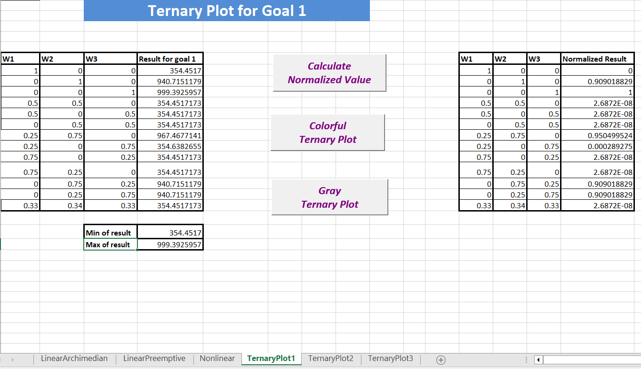
Figure II. 7: Overview of TernaryPlot sheet
In order to facilitate human-based decision-making, users would be able to consider various scenarios and have weights for each goal imported based on their preferences.
Each sheet contains two different tables. The first table on the left side of the sheet consists of four columns and 13 rows (the user can define up to 13 variations by assigning different weights to the goals). In the first three columns the user could assign different weights to each goal, ensuring that the sum of the weights for the three goals is equal to one. $\sum_{i=1}^{3}{wi}=1$
The last column calculates the goal value based on the defined weights and the value of variables that calculated and represented in the output file output file has been interpret in the Section II.3. After importing the weights and the corresponding results for each goal, the user can save the data. Then by pressing the "Calculate the Normalized Value" button, the system calculates the normalized value for each goal based on the defined scenarios. The results are displayed in the second table on the right-hand side of the sheet.
Once the necessary information for plotting the ternary plots is ready, the user is presented with two options: a colorful plot or a gray plot. By simply pressing the respective buttons, the program automatically connects to MATLAB, retrieves the input data from the Excel sheet, and generates the chosen plot. The user can then save the plot for further analysis and documentation. ( User could follow same rules for all three sheets for goal 1 and goal 2 and Goal 3. )
Using DSIDES’s wrapper engineers and designers are able to visualize the trade-offs among multiple goals in a decision-making process. A graphical representation of the relationships between the goals is offered by the ternary plots, providing valuable insights into the decision space. These plots are used as a tool for understanding the impact of different weight assignments and scenarios, aiding users in making informed decisions based on their preferences.
A visually appealing representation is provided by the colorful plot option, with distinct colors assigned to each region within the ternary diagram and users could quickly identify the dominant goal for specific scenarios or combinations of weights. On the other hand, a simplified, monochromatic representation is offered by the gray plot option, which may be preferred in cases where color differentiation is not necessary or desired.
DSIDES is integrated with MATLAB, utilizing its power for data analysis and visualization. Efficient data transfer and accurate plotting of ternary diagrams are enabled by the connection between DSIDES and MATLAB. The user experience is enhanced, and the advanced analytical features provided by MATLAB are leveraged through this integration.
Once the ternary plot is generated, the next step in the DSIDES workflow involves identifying satisficing solutions. However, it is important to note that manual intervention is required to obtain the satisficing space from the ternary plot. This manual process is thoroughly explained in Section II.5.1.4 of the software documentation, which provides detailed step-by-step instructions for users to follow.
In Section II.5.1.4, users are guided through a comprehensive procedure to identify and define the satisficing space within the ternary plot. This process involves visually analyzing the plotted data points and determining the desired range or region that represents satisfactory solutions based on the specific project requirements and constraints.
The step-by-step instructions provided in this section aim to ensure that users effectively navigate through the identification of the satisficing space. The manual intervention required in this stage allows users to exercise their expertise and judgment to determine which solutions within the ternary plot align with their desired criteria for success.
By carefully following the detailed instructions outlined in Section II.5.1.4, users can confidently identify the subset of solutions that meet their predefined thresholds and objectives. This manual approach empowers users to make informed decisions based on their domain knowledge and experience, further refining the solution space to align with their specific project goals.
Before proceeding with the verification and validation section and implementing all the information provided, it is important to evaluate the overall content of the output file. A thorough review of the file will help ensure its accuracy, professionalism, and relevance to the intended purpose.

II.3 Interpret the Output File
Before proceeding with the verification and validation section and implementing all the information provided, it is important to evaluate the overall content of the output file. This output file provides a comprehensive summary of the analysis, results, and key findings obtained through the software's various features and processes. By carefully examining the contents of the output file, users can gain a holistic understanding of the decision-making outcomes and validate the effectiveness of their design choices. The output file consolidates all relevant information, including imported data, calculated values, and other pertinent details, providing a comprehensive record of the user's decision-making journey. By evaluating the output file, users can assess the accuracy, consistency, and reliability of the software's calculations, ensuring that the obtained results align with their expectations and meet the desired project objectives. Additionally, the output file serves as a valuable resource for documentation purposes, allowing users to track and communicate the rationale behind their design decisions. Users could find the output file in the main folder that we have talked about in Section II.2 after running the linear and nonlinear sheet. The file would be in the format of notepad with the name of "DSIDES.out" and the type is Out file. The snapshot of the file has been attached here.
The output file begins by specifying the problem size limits, such as the maximum number of system variables, linear and nonlinear constraints and goals, accumulated constraints, goal priority levels, synthesis and analysis cycles, and other relevant parameters.
The subsequent sections of the output file provide detailed information about the problem being solved. This includes the title of the design problem and the system variable details, such as the number of real variables, discrete variables, and selection (Boolean) variables.
The file also presents information about linear constraints, nonlinear constraints, linear goals, and nonlinear goals. It provides data on the number of terms in each constraint or goal, their respective equations, and any associated deviation variables.
Additionally, the output file includes information on the stop criteria for synthesis cycles, values for stationarity of design variables, names of nonlinear constraints and goals, and other parameters related to optimization. (The additional details originate from the user-provided data in the Linear and Nonlinear sheets.)
Furthermore, the file mentions the output information that will be printed, such as system variables, deviation variables, deviation function, bound information, linear and nonlinear constraint information, and activity for linear and nonlinear solutions.
The output file also provides details about the current point's feasibility, design variables and their values, deviation variables and their values, deviation function value, and bounds on design variables.
It further includes information on linear constraints and goals, nonlinear constraints and goals, and the coefficients and RHS values associated with them.
Also, the file lists any accumulated constraints, suppressed constraints, and additional notes or warnings that may be relevant to the decision base problem process.
Also, as mentioned in Section II.2.1, the Linear sheet user could select that wants to see the final result or result for each iteration. The output typically includes the following information in each iteration:
Design Variables:
The values of design variables for the current synthesis cycle number.
Example:
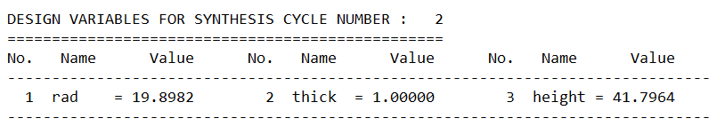
Deviation Variables:
The values of deviation variables associated with the design. These variables quantify the deviations from the desired goals or constraints.
Example:
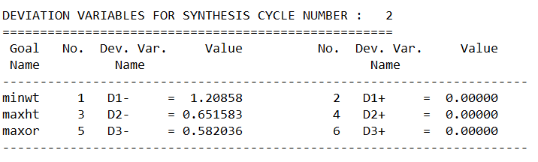
Deviation Function Value:
The value of the deviation function for the current point. This function represents the overall measure of how well the design satisfies the specified goals and constraints. A lower value indicates a better solution.
Example:
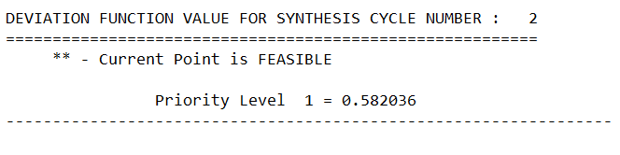
Bounds on Design Variables:
The lower and upper bounds for each design variable. These bounds define the acceptable range of values for the variables during the process.
Example:
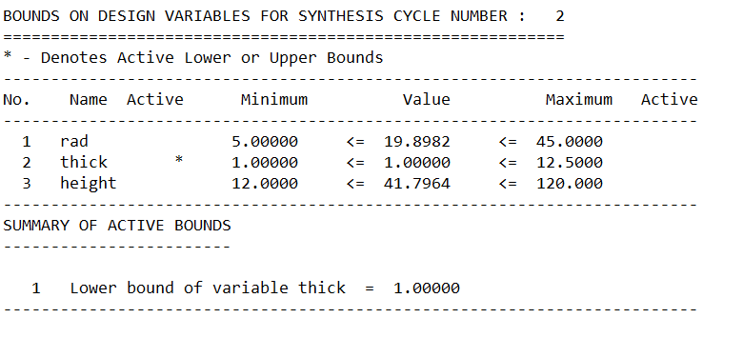
Linear Constraints and Goals:
The linear constraints and goals for the current synthesis cycle. These constraints and goals represent the linear relationships among the design variables and are specified with corresponding coefficients and RHS (right-hand side) values.
Example:
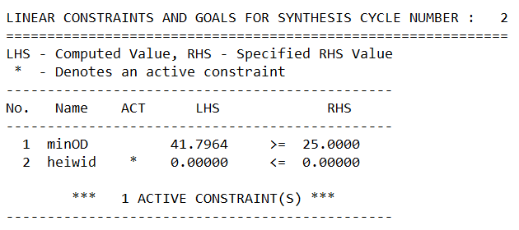
Nonlinear Constraints and Goals:
The nonlinear constraints and goals for the current synthesis cycle. These constraints and goals involve nonlinear relationships among the design variables and are often represented with linearized values and nonlinear values.
Example:
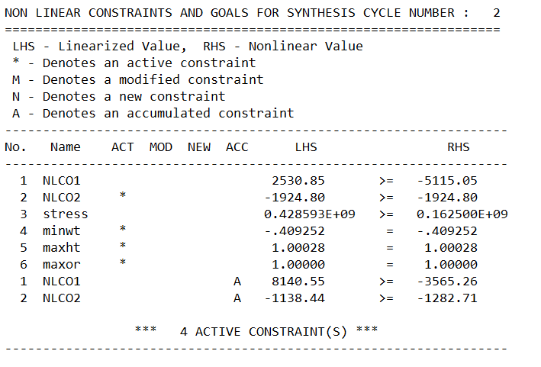
Note:
"Active constraints" refer to the constraints that are currently influencing the decision support process. These constraints are taken into account during the synthesis cycle and can impact the solution.
The term "active" is used to indicate that these constraints are affecting the current iteration and may be restricting the values or relationships of the design variables. Active constraints are typically those that are not satisfied or are close to being violated.
In the given output, the line "4 ACTIVE CONSTRAINT(S)" indicates that there are four constraints that are currently active in synthesis cycle number 2. These constraints are influencing the process and may need to be considered when evaluating the feasibility and quality of the design solution.
The specific constraints mentioned in the output, such as NLCO1, NLCO2, stress, minwt, maxht, and maxor, have corresponding LHS (linearized value) and RHS (nonlinear value) values. The LHS represents the computed or calculated value based on the current design variables, while the RHS represents the desired or specified value for that constraint.
The asterisk (*) next to NLCO2, minwt, maxht, and maxor indicates that these constraints are active, meaning they are currently affecting the decision support process. The "A" in the last two rows for NLCO1 and NLCO2 indicates that these constraints are accumulated constraints, which means they were active in previous synthesis cycles and are still influencing the current cycle.
Overall, the presence of active constraints in the output file indicates that the algorithm is considering and working to satisfy these constraints in order to find a feasible and satisficing design solution.
Dual Variables (Shadow Prices):
The section provides an overview of the dual variables or shadow prices associated with each constraint or goal in the decision support problem. These Lagrangian multipliers indicate the sensitivity and impact of the constraints and goals on the overall problem. They quantify the rate of change of the objective function in response to small perturbations in the corresponding constraints or goals. The number of constraint multipliers is categorized according to the solver's A matrix, distinguishing between linear and nonlinear goals, linear and nonlinear constraints, and various types of nonlinear constraints such as inequality, equality, accumulated, and new (adapted) constraints. These dual variables offer valuable insights into the direction, magnitude, and influence of each constraint or goal on the current solution, with a value of 0 indicating minimal influence.

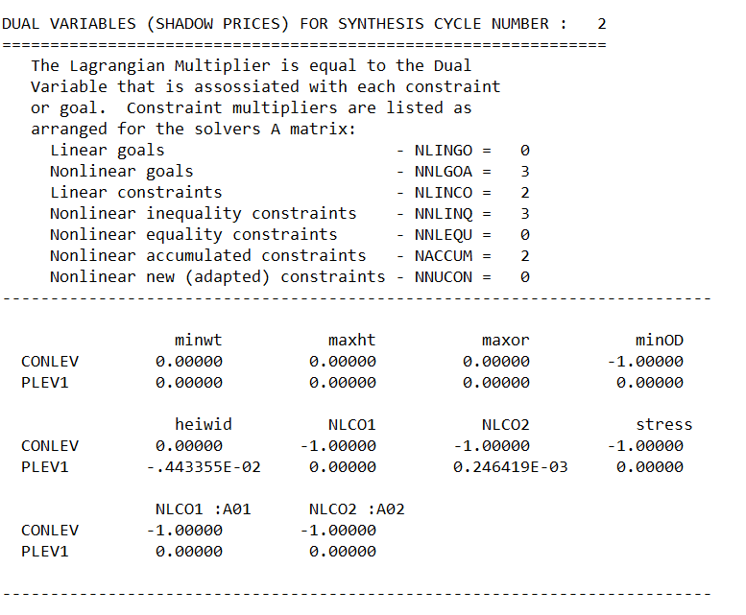
Note:
For example, let us focus on the first constraint "minwt" in the table:
The "minwt" constraint has dual variable or shadow price values of 0.00000 for the design variables "CONLEV," "PLEV1," This indicates that the objective function is not significantly affected by small changes in these variables with respect to the "minwt" constraint.
However, the "minOD" constraint has a dual variable value of -1.00000 for the design variable "CONLEV." This suggests that a small increase or decrease in the "CONLEV" variable would have a significant impact on the objective function, resulting in changes in the shadow price of the "minOD" constraint. The same interpretation applies to other constraints and goals listed in the table.
The provided information corresponds to the final solution of a design problem obtained after the specified synthesis cycle. The convergence criteria have been achieved based on the stationarity of variables and deviation function.
Final Solution:
Bounds:
The section begins by presenting the bounds on the design variables for the given synthesis cycle. It includes the active lower and upper bounds for each variable, denoted by an asterisk (*). The variables are listed along with their respective minimum and maximum bounds.
Example:
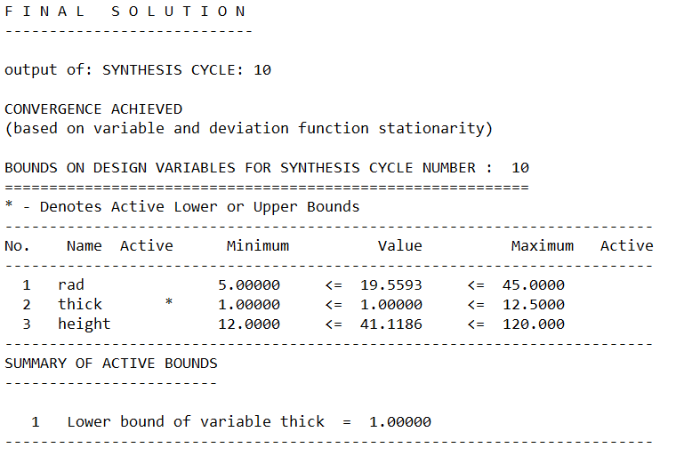
Active constraints:
A summary of the active constraints follows, indicating the constraints that are currently active.
This section distinguishes between active linear constraints, active nonlinear constraints, and active nonlinear goals. It provides insights into which constraints or goals are affecting the current solution.
Example:
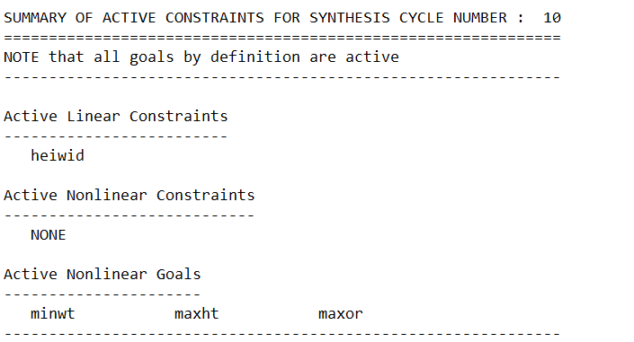
Deviation variables:
Next, the deviation variables for the synthesis cycle are provided. These variables represent the deviation from the desired values for each goal or objective. The deviation variables are labeled and associated with specific goals or objectives, and their corresponding values are given.
Example:
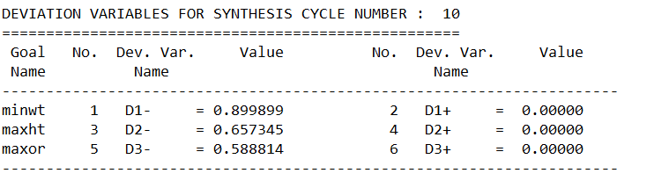
Deviation function:
The deviation function value for the synthesis cycle is presented, indicating the level of deviation or objective function value.
This value provides an indication of the solution's performance with respect to the desired goals or objectives.
Example:
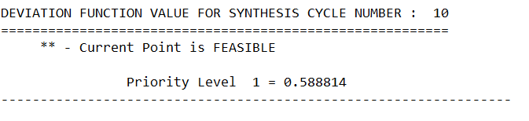
Finally, the section concludes with any additional relevant information, such as the total time required for the problem and the completion details of the job, including the date and time. This information helps assess the computational effort and provides a sense of completion for the problem-solving process.

II.4 Verification and Validation
The developed wrapper is a powerful tool for facilitating various tasks, and it is crucial to ensure its accuracy and reliability. A comprehensive verification process has been undertaken to confirm its performance as intended and ensure that the specified requirements have been met. The wrapper's functionality and performance have been evaluated against predefined benchmarks and user expectations through thorough testing and analysis. The verification process is carried out to validate the implemented features' correctness and ensure that all input and output interactions are functioning as expected. Our goal of this verification step is to ensure that users' needs are effectively addressed by the wrapper, productivity is enhanced, and meaningful solutions are provided for the intended problems. Through successful verification and validation, reliability is established by the wrapper, and it could be used as a reliable platform for users to efficiently and effectively accomplish their tasks. A robust approach has been adopted to verify and validate the system, ensuring its accuracy, reliability, and user-friendliness. Three examples have been presented in preemptive and Archimedean forms, each consisting of a problem statement, cDSP formulation, and wrapper implementation. To ensure thorough evaluation, multiple individuals execute these examples, rigorously assessing the system's performance in terms of accuracy, reliability, and user-friendliness. There are two important purposes for this verification and validation. Firstly, for validation of the functionality and effectiveness of the wrapper, confirming its ability to meet the intended objectives and providing reliable solutions. Secondly, it is a valuable learning opportunity for users to practice and gain proficiency in thesis Parts 1 and 2, enhancing their understanding of the system and its capabilities. The Elephant Stand Problem example, which was used in Section II.2 to demonstrate how different sheets would function and how input should be prepared for DSIDES, is presented in the next section.

II.4.1 Elephant Stand Problem in Archimedean Form
The provided example was utilized to illustrate the wrapper section within the introduction of various sheets. However, given its relevance to the post-solution analysis, it becomes necessary to reiterate it in this context.

II.4.1.1 Problem statement
In the late 1800s, Ringling Bros and Barnum and Baily Circus were looking to establish dimensions of a new pedestal for their circus elephant Jumbo. They would play a trick that involved a support pedestal where Jumbo would perform a one-legged hand stand. The cost of manufacturing must be minimized, which depends on its thickness, width, and the amount of material it would consume. And it must be as tall as possible for a wow factor. And finally, the pedestal must be wide enough to ensure Jumbo has enough room to safely stand on one foot. This means the goals of the design are to minimize the manufacturing cost, maximize the height, and maximize the outer radius. A material of 2014 Aluminum with a modulus of 10600 ksi and a density of 0.1 lb/in^3 has been selected.
Jumbo's foot is approximately 25" in diameter, so the pedestal must also be greater than 25". Jumbo weighs 13,560lb and stands 13.5ft tall. Use a factor of safety of 1.5.
Given a certain type of material, design a cylinder (the “elephant stand”). The cylinder has two parts joined together. The upper half is a tube, and the designer’s interest is to determine its thickness, radius, and height that best satisfies the goals identified. The lower half is a 4-inch-height solid base. The goals identified by the designer include Minimizing the manufacturing cost, maximizing the height, and maximizing the outer diameter. Requirements include the upper and lower limits of the parameters that the cylinder can physically reach. The overview of the elephant stand problem is represented in figure II.6.

II.4.1.2 cDSP Formulation
Word Formulation:
Given
System parameters
Material – 2014 Aluminum
Elastic modulus for the material
Safety factor
Yield stress for the material
Density of the material
Load (elephant’s weight)
Moment of inertia for the cylindrical section
Maximum normal stress
Maximum buckling stress for a fixed free column
Cost target
Height target
OR target
Find
System variables
Radius, Thickness, Height
Satisfy
System constraints
Reaching the minimum outer diameter.
Not exceeding a certain height-to-width ratio.
Reaching the stress requirement.
Not exceeding the maximum weight.
Not exceeding the maximum load in the stand.
System goals
Goal 1: reaching minimum cost target.
Goal 2: reaching maximum height target.
Goal 3: reaching maximum outer radius target.
Bounds
The upper and lower limit of Radius, Thickness, and Height
Minimize
The deviation function.
cDSP Math Formulation:
Given
E = 10600000.
OR=R+T
SF = 1.5
SIGY = 11000.
P = 12000.
PI = 2*ACOS(0.0)
RHO = 0.1
$I=\frac{π}{4}*\left[{\left(R+T\right)}^{4}-R^{4}\right]$
$W1=π*\left[{\left(R+T\right)}^{2}-R^{2}\right]*\left(H-4\right)$
$W2=π*\left[{\left(R+T\right)}^{2}\right]*4$
W=(W1+W2)∗RHO
STR=P/(π∗[(R+T)^2−R^2 ] )
PCR=(π^2∗E∗I)/ 4∗(H^2 )
COST=e^(2.5/T)∗e^(3/R)∗W
Cost target = 5000
Height target = 180
OR target = 15
Find
System variables
- R Radius
- T Thickness
- H Height
Deviation variables
- $d_{i}^{+}$ over achievement of Goal i, where i=1,2,3
- $d_{i}^{-}$ under-achievement of Goal i, where i=1,2,3
Satisfy
System constraints
- minOD: minimum outer diameter
$2*R+2*T≥6$ (CO1)
- heiwid: height to width ratio
$R+T-0.03*H≥0$ (CO2)
- stress : minimum stress in stand
$\frac{SIGY}{SF}-STR≥0$ (CO3)
- weight: maximum weight
$1000-W≥0$ (CO4)
- buckle: maximum load in stand
$\frac{PCR}{F}-P≥0$ (CO5)
System goals
- Goal 1: minimum cost
$\frac{cost target}{cost}+d_{1}^{-}-d_{1}^{+}=1$ (G1)
- Goal 2: maximum height
$\frac{height}{height target}+d_{2}^{-}-d_{2}^{+}=1$ (G2)
- Goal 3: maximum outer radius
$\frac{OR}{OR target}+d_{3}^{-}-d_{3}^{+}=0$ (G3)
Bounds
3 ≤ R ≤ 45
0.5 ≤ T ≤ 2.5
100 ≤ H ≤ 120
Minimize
The deviation function.
${Z=\sum_{i=1}^{3}{w_{i}∙}(di}^{-}+{di}^{+})$,$\sum_{i=1}^{3}{w_{i}=1}$

II.4.1.3 Implementation in DSIDES wrapper
1) Linear sheet
Once the mathematical cDSP formulation is ready, the next step is to finalize the Linear sheet. In this particular problem, which is Archimedean and consists of a single level, we will choose the LinearArchimedean sheet to complete the process. Once the LinearArchimedean sheet is filled with the necessary information, we proceed to press the "Run" button. Executing this command will generate a file named "DSIDES" in the form of a “.dat” file. This file will be automatically saved in the main folder of our project. The overview of the Linear sheet for the Elephant stand problem is represented in Figure II.8

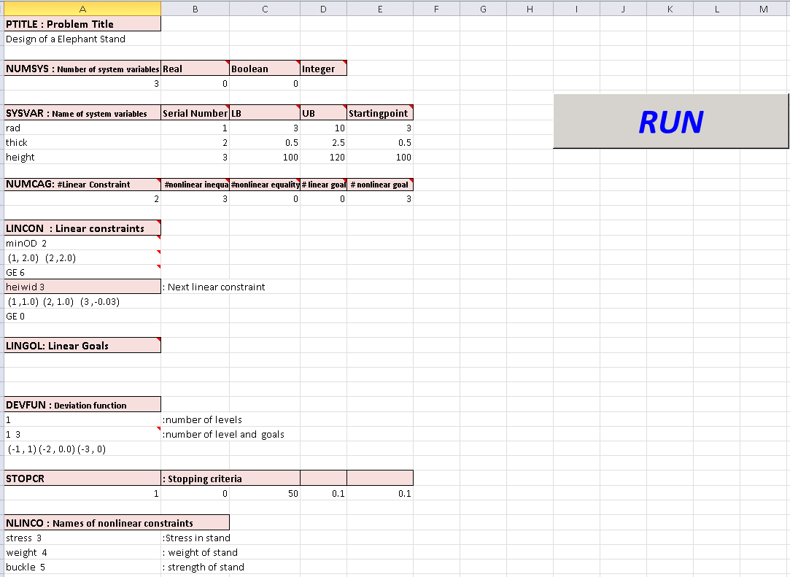
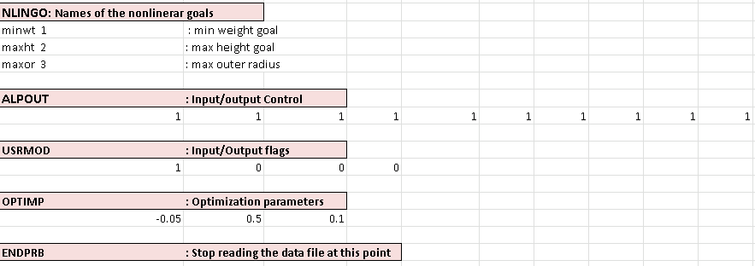
Figure II. 8: Overview of Linear sheet in Elephant stand problem.
2) NonLinear sheet
After this step, we need to fill the Nonlinear sheet form. Once we have completed the previous step, the next task is to complete the Nonlinear sheet form. After filling out the required information in the form, we need to proceed by pressing the "run" button. This action will initiate a process that generates several files, such as "DSIDES.f" and DSIDES.out. The "DSIDES.f" file is in the Fortran format and serves a specific purpose within the system. On the other hand, the DSIDES.out contains all the output information that we require. Upon pressing the "run" button again, the system will display the " DSIDES.out " on the screen, making it easily accessible for further analysis or utilization. The overview of the NonLinear sheet for the Elephant stand problem is represented in Figure II.9.
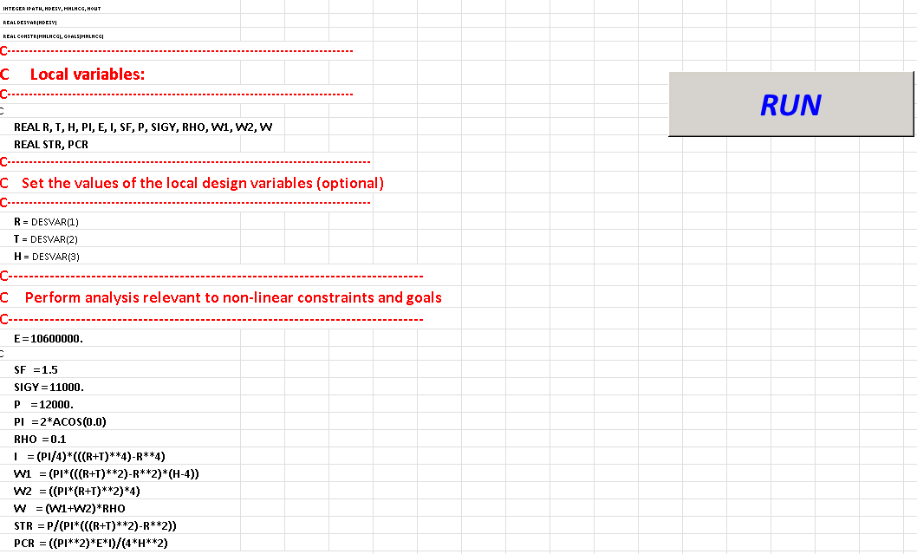
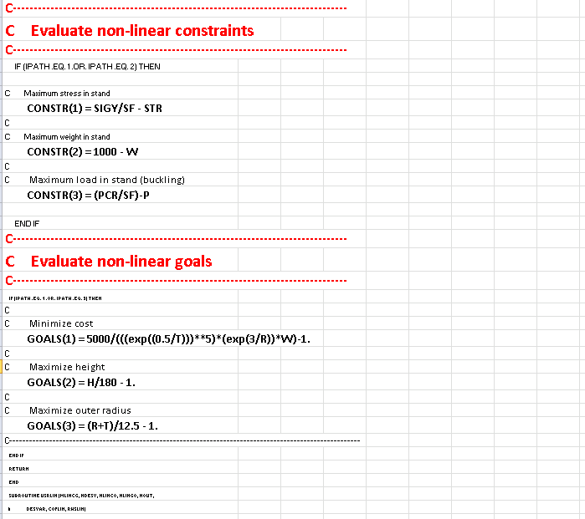
Figure II. 9: Overview of NonLinear sheet in Elephant stand problem.

3) Output file
The final result of these formulations has been represented in Figure II.10
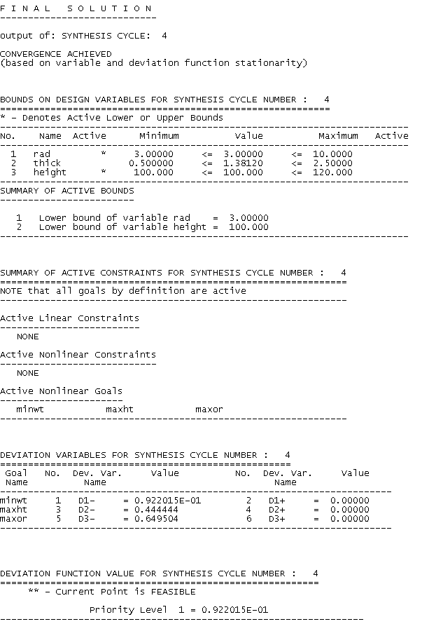
Figure II. 10: Overview of final result in Elephant stand problem

4) Ternary Plot
After performing the linear and nonlinear analysis, an output file is generated. The comprehensive description of this file can be found in Section II.3, titled "Interpretation of the Output File." In this section, users are instructed to carefully examine the output file, taking into account the values of variables, deviation variables, and the weights assigned based on the designer's preferences. By utilizing these factors, users can calculate the results for each goal.
Three separate sheets are provided to aid the analysis, each presenting a ternary plot for an individual goal. These ternary plots are elaborated upon in Section II.2.4, titled "Ternary Plot." They visually represent the results of each goal and facilitate a clearer understanding of the data.
Furthermore, the overview of each sheet has been represented in Figure II.11, II.13, and II.15 that illustrating the calculated results in a graphical format. The ternary plot for goals 1, 2, and 3 is represented in Figures II.12 , II.14, and II.16, respectively.
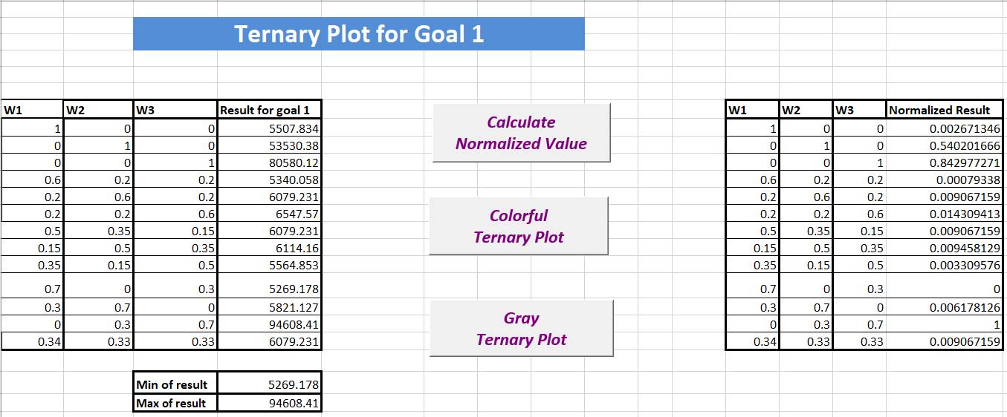
Figure II. 11: Overview of TernaryPlot1 sheet in Elephant Stand Problem
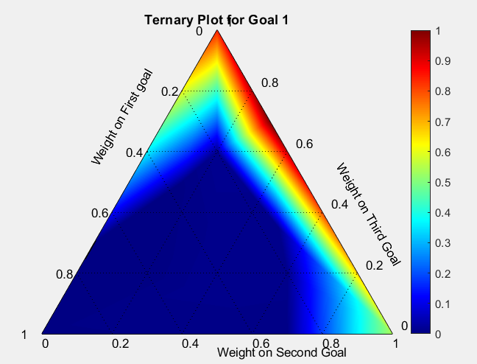
Figure II. 12: Ternary plot for goal 1 in Elephant Stand Problem
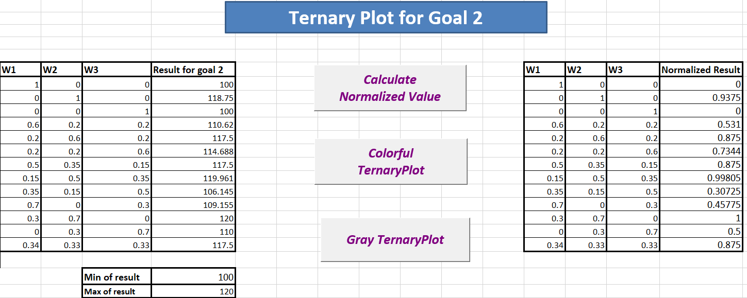
Figure II. 13: Overview of TernaryPlot2 sheet in Elephant Stand Problem
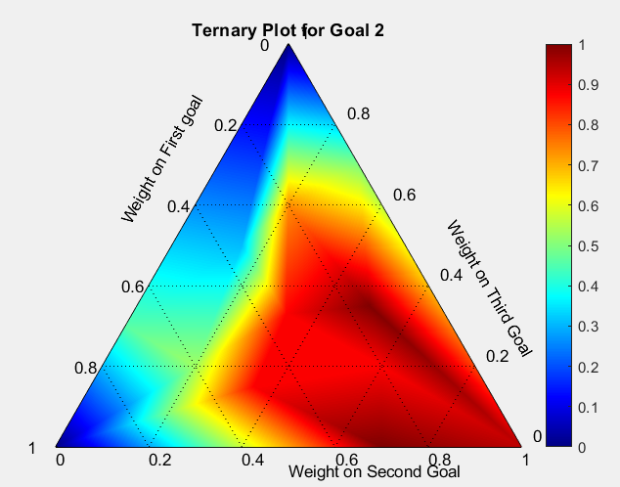
Figure II. 14: Ternary plot for goal 2 in Elephant Stand Problem
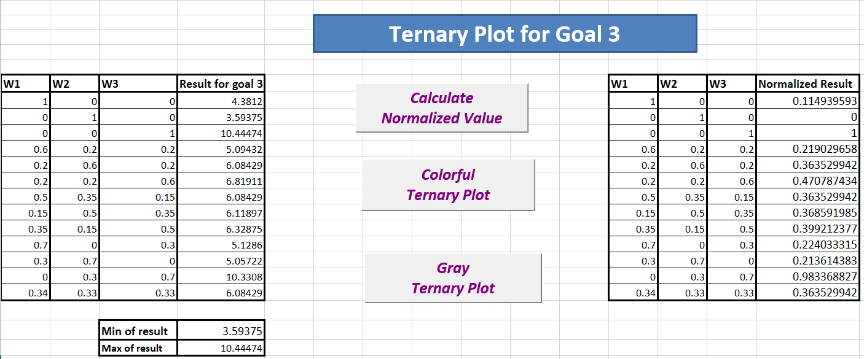
Figure II. 15: Overview of TernaryPlot3 sheet in Elephant Stand Problem

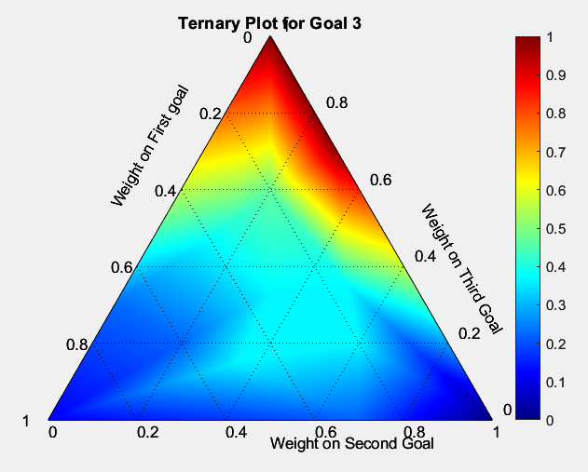
Figure II. 16: Ternary plot for goal 3 in Elephant Stand Problem

II.4.1.4 Find Satisficing Space in Elephant Stand Problem Based on the Ternary Plots
To obtain the satisficing space from the ternary plot, manual intervention is required. The following steps outline the process in a detailed and understandable manner:
- Identify Acceptable Values: Drawing upon their experience and knowledge, the designer should determine the acceptable value range for each goal. These values have represented the desired outcomes for the design problem. While there might be some variations among different designers' perspectives, the focus here is on determining a range of values that represent the desired outcomes rather than seeking a single optimal solution. Given the nature of the satisficing space analysis, where the goal is to find feasible combinations of variables that meet or exceed the acceptable values for all goals, a broader range of acceptable values can be considered. Flexibility and acknowledgment that multiple solutions within the acceptable range can still be considered satisfactory are achieved by this approach.
- Normalize Acceptable Values: Normalize the acceptable values to bring them to a consistent scale. This step ensures that all goals are treated equally during the analysis.
- Draw Contour Lines: Plot the contour lines of the normalized acceptable values on each ternary plot. The boundaries of the acceptable values for each goal are represented with these contour lines. Connect the points with equal normalized values to form the contour lines.
- Identify Feasible Space: The region on each ternary plot that reaches or exceeds the acceptable value of a particular goal is considered the feasible space for that goal. Combinations of variables that satisfy or surpass the designer's expectations for that specific goal are represented by this region.
- Determine Satisficing Space: Superimpose the feasible spaces of all three goals on the ternary plot. The overlapping region, where the feasible spaces intersect, is the satisficing space of the design problem. Combinations of variables that simultaneously satisfy or exceed the acceptable values for all three goals are represented by overlapping region.
- Iterate if Necessary: If there is no superimposed region initially, we could realize that the acceptable values set in the first step may need adjustment. Revisit the first step and redefine the acceptable values until a superimposed region is formed in the ternary plot. With this iterative process, the designer ensures that the design goals are adequately balanced and achievable.
Following the outlined steps, designers can manually analyze the ternary plot to identify the satisficing space, representing the feasible and desirable design solutions. However, it is important to acknowledge that there might be situations where no satisficing space is found initially.
Suppose no superimposed region is observed in the ternary plot, indicating that there is no overlap between the feasible spaces of the individual goals. In that case, the initially defined acceptable values for the goals may need adjustment.
The described steps for identifying the satisficing space were implemented for the elephant stand problem. The ternary plots corresponding to each goal were created, and the results of the analysis were visually presented in Figures II.17, II.18, and II.19.
The ternary plot illustrating the feasible space for the first goal has been presented in Figure II.17, while the ternary plot for the feasible space for the second goal has been represented in Figure II.18. Similarly, the ternary plot of the feasible space for the third goal has been shown in Figure II.19.
The superimposed region of the feasible spaces from the three goals is presented in Figure II.20.
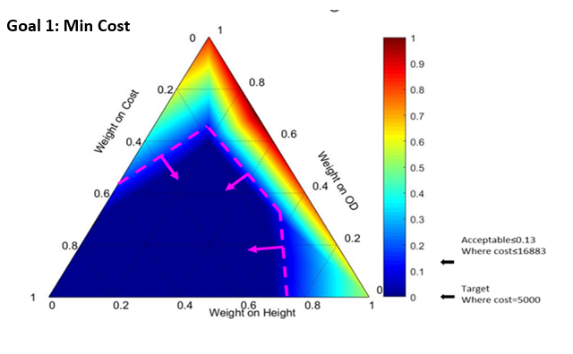
Figure II. 17: Satisficing space for goal 1 in the Elephant Stand Problem

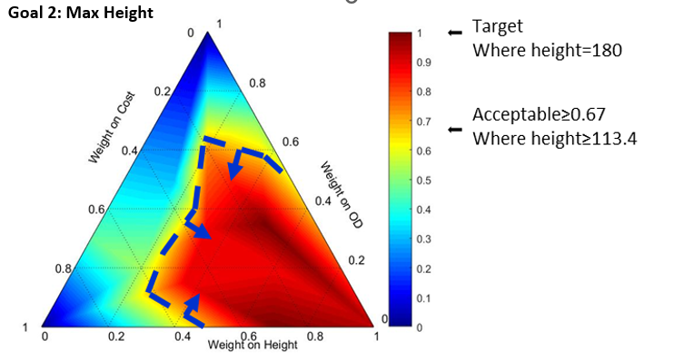
Figure II. 18: Satisficing space for goal 2 in Elephant Stand Problem
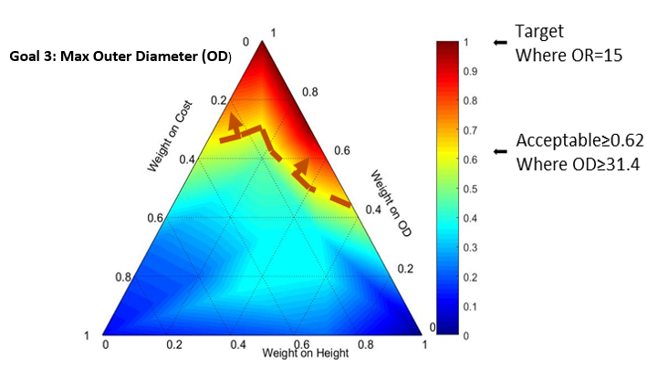
Figure II. 19: Satisficing space for goal 3 in Elephant Stand Problem
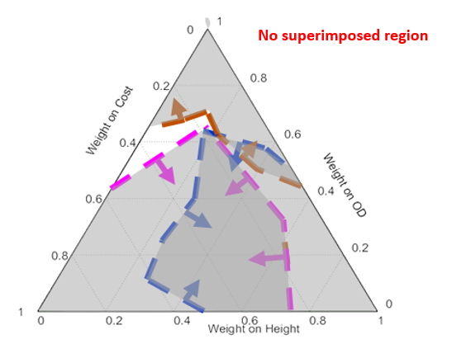
Figure II. 20: No Superimposed region of three goals in the Elephant Stand Problem
NO Satisficing Space in This Case:
In the case where no superimposed region is observed in Figure II.20, the absence of a satisficing space that satisfies all three goals simultaneously is indicated. There are two potential approaches to consider in order to expand or identify a satisficing space:
Altering Designer's Preferences: One approach is reassessing the designer's preferences regarding goal achievements. The range is selected based on the designer’s experience/knowledge/preference. It is not a pure “eye-balled” value; instead, it should be due to the combination of stakeholders’ requirements and the ternary space generated. A human designer uses his/her domain knowledge and experience to make the final decision based on preference. Then, the designer carries out the relaxations on the acceptable values based on his/her judgment.
Through this iterative process, designers can potentially identify a larger satisficing space that aligns with their revised preferences.
Modifying Problem Specifications/Formulation: Another approach is about the reevaluating the problem specifications or formulation. By revisiting the problem constraints, variables, or functional relationships, designers can discover opportunities to redefine the problem to get a larger, satisfying space. This may involve considering alternative design criteria, relaxing certain constraints, or introducing new variables. In addition, designers could have the opportunity to explore different design possibilities and expand the potential solution space by Modifying the problem formulation.
It is important to note that both approaches require careful consideration and analysis. Altering the designer's preferences or modifying the problem formulation should be guided by a comprehensive understanding of the design problem, its requirements, and the potential implications of any changes made. Iterative refinement and experimentation may be necessary to determine the most suitable adjustments that result in an expanded or identified satisficing space.
By exploring these two approaches in detail, designers can gain insights into potential avenues for expanding or identifying a satisficing space, allowing for a more comprehensive exploration of design solutions that meet their goals and requirements.
Altering Designers' Preferences for Elephant Stand Problem:
When considering the option of altering the designer's preference, it is important to emphasize that the selection of acceptable value ranges is not based solely on subjective judgment or "eyeballing." Instead, it involves a combination of stakeholders' requirements, the ternary space generated, and the designer's domain knowledge and experience. Various factors and considerations are taken into account in the process of defining acceptable values for each goal. The designer draws upon their expertise and understanding of the design problem, incorporating stakeholders' requirements and constraints. The acceptable values are determined through a thoughtful analysis that considers the design's feasibility, practicality, and desired outcomes.
For example, let us consider Goal 2. The designer assigns an initial normalized value of "0.67" based on the original value of "113.4". However, due to their experience and judgment, the designer may choose to relax the acceptable value to "112.8", resulting in a normalized value of "0.64". This relaxation is made with careful consideration of the impact on the design, balancing the desired outcome with practical constraints. ( Figure II.22)
Similarly, the designer can apply similar relaxations to the acceptable values of all other goals. These relaxations are carried out based on the designer's judgment, considering the trade-offs, constraints, and requirements of the design problem.
It is crucial to highlight that the designer's role in adjusting the acceptable values is critical to the design process. Their domain knowledge, experience, and understanding of the project context enable them to make informed decisions that align with the stakeholders' requirements while considering the feasible design space. By incorporating these relaxations and adjustments to the acceptable values, designers can explore alternative design possibilities and potentially expand the satisficing space. That the design solution is well-informed, balanced, and aligned with the goals and preferences of the designer and stakeholders is ensured by this iterative process.
The steps described earlier have been successfully implemented and visualized in Figures II.21, II.22, and II.23. The adjustments made to the acceptable value ranges for each goal in order to explore a potentially expanded satisficing space are illustrated by these figures.
In Figure II.21, we depict the updated ternary plot representing the feasible space for the first goal after the relaxation of acceptable values. Similarly, in Figure II.22, the ternary plot of the modified feasible space for the second goal, reflecting the adjustments made based on the designer's judgment, has been shown. In Figure II.23, the ternary plot illustrating the revised feasible space for the third goal, incorporating the relaxations made to the acceptable values, has been represented.
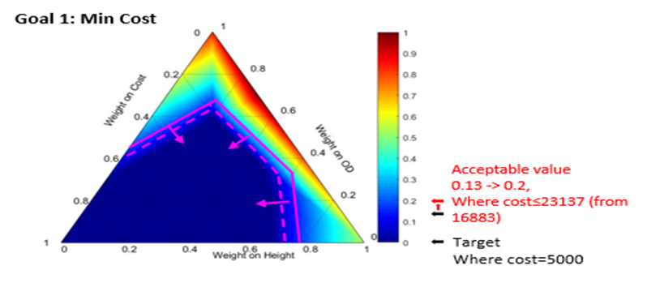
Figure II. 21: Satisficing space for goal 1 in the Elephant Stand Problem after implementing the Altering Designer's Preferences method.

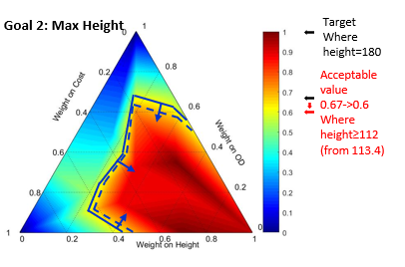
Figure II. 22: Satisficing space for goal 2 in the Elephant Stand Problem after implementing the Altering Designer's Preferences method.

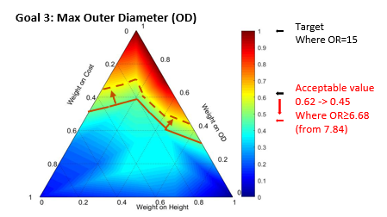
Figure II. 23: Satisficing space for goal 3 in the Elephant Stand Problem after implementing the Altering Designer's Preferences method.
To provide a comprehensive overview, the superimposed region of the updated feasible spaces for all three goals is presented in Figure II.24. In this figure, the intersecting region that defines the expanded satisficing space, where all three goals are simultaneously satisfied or exceeded, is demonstrated. By examining these figures, designers gain valuable insights into the effects of adjusting the acceptable value ranges on the feasible solution space. In addition, the clear identification and comprehension of the expanded satisficing space by designers, enabling the exploration of design solutions that better align with their preferences and stakeholder requirements, is facilitated by the visual representation of the ternary plots and their superimposition in Figure II.24.
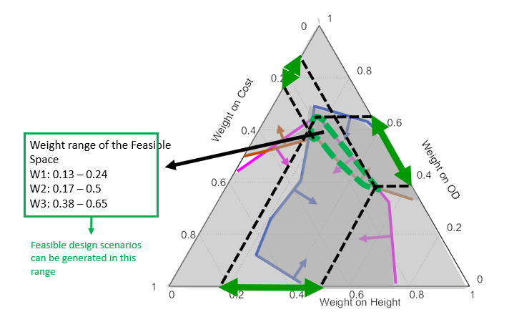
Figure II. 24: Satisficing space for all goal in Elephant Stand Problem , after implementing Altering Designer's Preferences method.
Figures II.21, II.22, II.23, and II.24 are presented as crucial tools for decision-making, offering designers a visual representation of the adjusted feasible spaces and the resulting satisficing space. With these figures, designers can gain insights into the design problem and support the exploration of improved design solutions within an expanded solution space, facilitating a deeper understanding of the design problem and supporting the exploration of improved design solutions within an expanded solution space.
Modifying Problem Specifications/Formulation for Elephant Stand Problem.
The second approach to obtaining a satisficing space is modifying the problem specifications. A practical example is demonstrated through the comparison of two result tables representing various design scenarios in Figure II.25
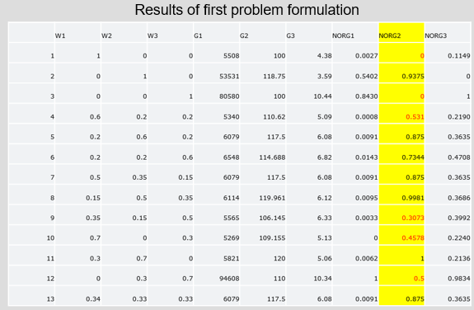
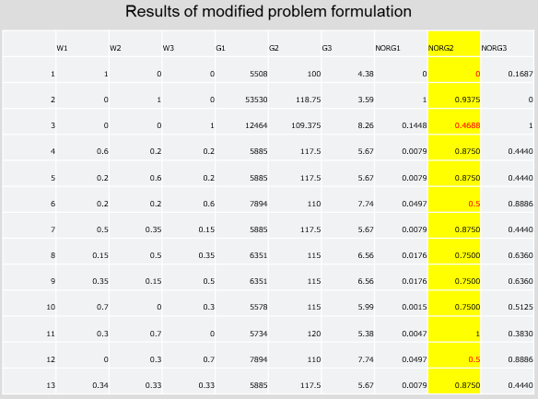
Figure II. 25: Comparison of Design Scenarios; Original Problem Formulation vs. Modified Problem Specifications in Elephant Stand Problem
Based on Figure II.25, In the original problem formulation (top table), specifically concerning Goal 2, out of the 13 scenarios, six have values below 0.6 (indicated by the red entries in the yellow column on the top). To expand the solution space for this goal, a modification is made to the problem by focusing on adjusting the height to be closer to the target value of 120.
To achieve this, the upper bound of the radius is reduced, aiming for a "tall and thin" pedestal rather than a "short and flat" one. It is observed that even though the range of the radius was initially set as [3, 45], the results predominantly fall within the range of [3, 10]. Consequently, the range of the radius is changed to [3, 10]. The modified problem formulation has been presented in Figure II.26.
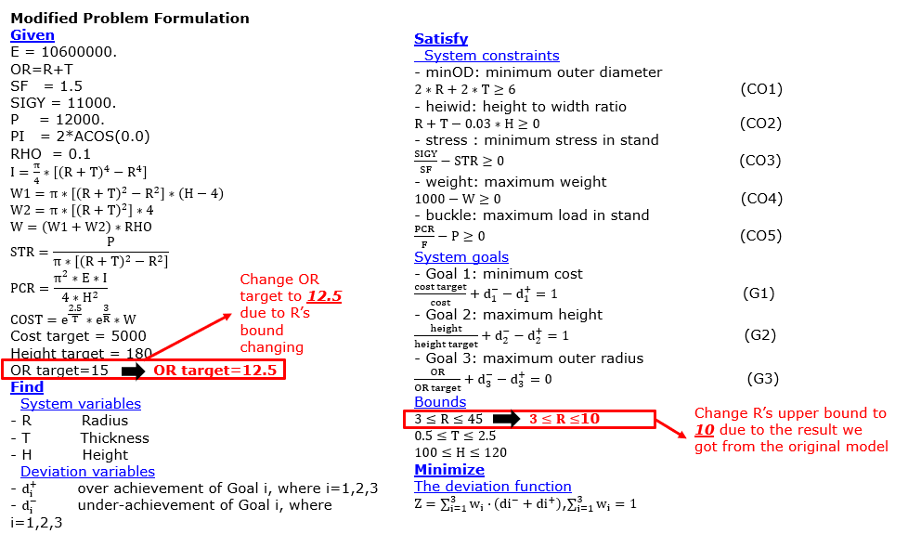
Figure II. 26: Modified Elephant Stand Problem Formulation
By implementing this modification, more results with larger heights are obtained. The number of scenarios where Goal 2 has a normalized value below 0.6 is reduced from six to four (represented by the red entries in the yellow column on the second table in Figure II.25). A similar outcome is observed for Goal 3.
The results of implementing the modified problem specifications are depicted in Figures II.27 (for goal 1), II.28 (for goal 2), and II.29 (for goal 3). Visual representations of the refined feasible spaces for each respective goal have been provided in these figures. The refined feasible space for goal 1, highlighting the adjustments made to the problem specifications, is illustrated in Figure II.27. Similarly, in Figure II.28, the modified feasible space for Goal 2 is showcased, reflecting the impact of the problem specification modifications. The revised feasible space for goal 3, which incorporates the changes made to the problem formulation, is represented in Figure II.29.
The final satisficing result has been presented in Figure II.30 presents, combining the refined feasible spaces for all three goals. The achieved satisficing space, where all three goals are simultaneously satisfied or exceeded, is demonstrated in this figure.
By examining these figures, designers can gain valuable insights into the effects of modifying the problem specifications on the feasible solution space. A clearer understanding of the refined design space and the resulting satisficing solution that meets the goals and requirements of the design problem is enabled by the visual representations. These figures, namely II.27, II.28, II.29, and II.30 are critical visual aids for decision-making, as designers could get a comprehensive representation of the refined feasible spaces and the overall satisficing solution. A deeper understanding of the design problem is facilitated, and the exploration of improved design solutions within the modified solution space is supported through these figures.
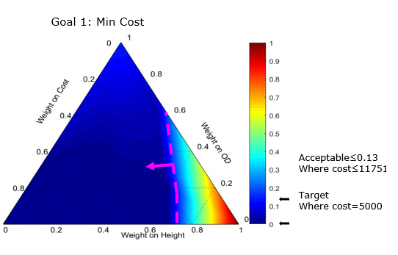
Figure II. 27: Refined Feasible Space for Goal 1 in Elephant Stand Problem; Adjusted Problem Specifications

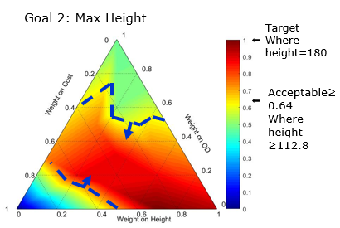
Figure II. 28: Refined Feasible Space for Goal 2 in Elephant Stand Problem; Adjusted Problem Specifications

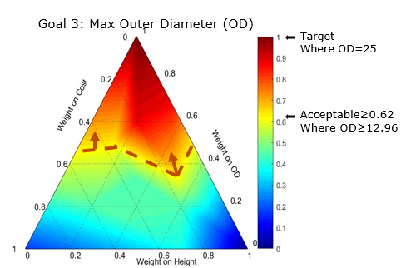
Figure II. 29: Refined Feasible Space for Goal 3 in Elephant Stand Problem; Adjusted Problem Specifications

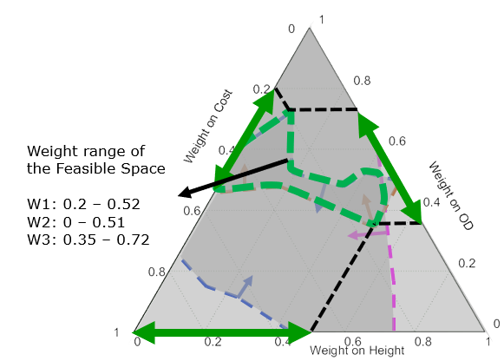
Figure II. 30: Final Satisficing Result for All Three Goals in Elephant Stand Problem with Adjusted Problem Specifications

The importance of even a small adjustment in the acceptable value that can lead to a significant expansion of the solution space is highlighted in this example. By fine-tuning specific problem specifications, designers can satisfy the design outcomes and achieve a larger satisficing space. Through careful analysis and iterative modifications, designers can identify opportunities to redefine problem constraints, variables, or functional relationships to better align with their design objectives. An exploration of alternative design possibilities is enabled by this process, and the chances of finding a satisficing space that accommodates the desired outcomes within the revised problem specifications are enhanced.
Following a thorough and detailed description of the first example, the Elephant Stand problem, which was presented in Archimedean form, our attention now turns towards the second problem, the One-Stage Reduction Gearbox, presented in preemptive form. This particular example is a part of a paper that was published in 2022. In the forthcoming section, we will delve into the intricacies of the One-Stage Reduction Gearbox problem.

II.4.2 One-Stage Reduction Gearbox in Preemptive Form
The paper titled "Designing concurrently and hierarchically coupled engineered systems," authored by Gehendra Sharma, Janet K. Allen, and Farrokh Mistree, was published in 2022. ( Sharma, G., Allen, J.K. and Mistree, F., 2022, ”Designing Concurrently and Hierarchically Coupled Engineered Systems, Engineering Optimization”, Pages 1556-1576. DOI: 10.1080/0305215X.2022.2098953 ) The field of engineering optimization is contributed to by this paper, which investigates the design process for concurrently and hierarchically coupled engineered systems. It presents a comprehensive framework and methodology for addressing complex design problems involving interconnected and interdependent components. Valuable insights into the challenges and considerations involved in designing such systems are provided by the paper, with an emphasis on the importance of concurrent and hierarchical design approaches. By citing this article in the verification section of our DSIDES Wrapper, we acknowledge the foundational work and research conducted in this area and leverage the example presented in the paper to support and validate our own work. To link to this article: https://doi.org/10.1080/0305215X.2022.2098953

II.4.2.1 Problem statement
The problem statement is about the design of a one-stage reduction gearbox with specific requirements and objectives. The goal is to recommend gear design decisions (gear material and dimensions) and shaft design decisions (shear shaft material strength and dimensions) that result in a high-quality design with low weight, low height, and high torque transmission capability.
Note: From the problem perspective, the decision problem involves two sib problems (the gear decision problem and the shaft decision problem). The gear decision problem in itself involves two decisions (geometry decision and material decision). Hence, the formulation has three decision problems ( three levels).
The problem includes the following aspects:
• Required gear ratio of 4.
• Minimum input torque of 80 Nm at 3500 rpm.
• Endurance of at least 10^7 fatigue cycles.
• Gear cutting using a rack cutter with a pressure angle of 20°.
• Required reliability of at least 99%.
• Design goals of low weight and low height while achieving maximum torque transmission capability.
The problem involves the coupled design of gears and shafts, where gear dimension design, material selection, and shaft dimension design are interconnected. The gear design decisions (material and dimensions) form a compromise decision, while the shaft design decision forms a separate compromise decision. The gear material selection decision is horizontally coupled with the compromise decisions, and the compromise decisions are vertically coupled to the shaft design decision.
The mathematical formulations for gear and shaft design are based on the work of Budynas and Nisbett (2019). The problem formulation involves defining the interactions between decisions, considering correction factors for material properties, and exploring the design space through multiple decision scenarios.
The limitations, boundaries, variables, and constraints in this problem include:
• Gear material alternatives and their properties.
• Gear dimensions, such as number of teeth, pitch diameter, and face width.
• Shaft dimensions, such as diameter and length.
• Material strength and fatigue properties.
• Bending stress and contact stress numbers.
• Speed, fatigue cycles, and reliability requirements.
• Weight assignment for decision scenarios.
• Constraints on achieving the desired gear ratio, torque transmission capability, weight, height, and reliability.

II.4.2.2 cDSP Formulation
Word Formulation:
Given
System parameters
Torque (T) ≥ 80 Nm
Gear reduction ratio (G) = 4
Pressure angle (α) = 200
Density (δ) = 7800 kg/m3
Speed (N) = 3500 rpm
Overload factor, Ko = 1
Dynamic factor, Kv = 1
Size factor, Ks = 1
Load distribution factor, KH = 1
Rim thickness factor, KB = 1
Geometry factor for bending strength, YJ = 1
Elastic coefficient, ZE = 1
Surface condition factor, ZR = 1.25
Geometry factor for pitting resistance, ZI = 1
AGMA factor of safety for bending, SF = 1
AGMA factor of safety for contact, SH = 1
Stress cycle factor for bending stress, YN = 1
Temperature factor, Y = 1
Reliability factor, YZ = 1
Stress cycle life factor for contact, ZN = 1
Hardness ratio factor for pitting, ZW = 1
Required gear ratio: The desired gear ratio for the reduction gearbox is 4.
Input torque: The input torque, denoted as T, should be at least 80 Nm at 3500 rpm.
Fatigue cycles: The gears must endure at least 10^7 fatigue cycles.
Pressure angle: The gears are cut using a rack cutter with a pressure angle (α) of 20°.
Reliability requirement: The gearbox should have a reliability of at least 99%.
Find
system variables
Gear design variables:
m: Gear module (a parameter that determines the size of the gear teeth)
Z: Number of teeth (the number of teeth on the gear)
b: Face width (the width of the gear tooth)
T: Input torque (the torque applied to the gearbox)
Shaft design variables:
D_{i}: Input shaft diameter (the diameter of the hole in the center of the gear)
D_{o}: Output shaft diameter (the overall diameter of the gear)
Sy: Shear strength for shaft material (a material property representing the maximum stress a material can withstand before undergoing permanent deformation in shear)
X₁, X₂, X₃, X₄, X₅ : bending stress number and contact stress number for the five Gear materials.
Deviation Variables:
e₁⁻: under-achievement for gear selection goal
e₁⁺: over achievement for gear selection goal
d₁⁻: under-achievement for gear mass goal
d₁⁺: over achievement for gear mass goal
d₂⁻: under-achievement for gear size goal
d₂⁺: over achievement for gear size goal
d₃⁻: under-achievement for gear torque goal
d₃⁺: over achievement for gear torque goal
d₄⁻: under-achievement for shaft mass goal
d₄⁺: over achievement for shaft mass goal
Satisfy
system constraints
Selection constraint for gear material alternatives: The sum of the gear material selection variables (x1, x2, x3, x4, x5) must equal 1.
Maximum allowable bending stress constraint: A constraint ensuring the bending stress in the gear is within the allowable limit.
Maximum allowable contact stress constraint: A constraint ensuring the contact stress in the gear is within the allowable limit.
Maximum allowable shear stress constraint for shafts: Constraints on the shear stress in the shafts to ensure they are within the allowable limit.
Constraints on deviation variables: Constraints ensuring the deviation variables (di⁻, d_{i}⁺) for various compromise goals are non-negative and their product is zero.
system goals
G1: Coupled selection goal : Maximize the merit function (MF) considering the gear material selection, subject to a deviation constraint.
Coupled compromise gear goals:
G2: Minimize the mass of the gear, subject to a deviation constraint.
G3: Minimize the size of the gear, subject to a deviation constraint.
G4: Maximize the torque of the gear, subject to a deviation constraint.
G5: Coupled compromise shaft goal : Minimize the mass of the shafts, subject to a deviation constraint.
Bounds
The upper and lower limit of system variables
Minimize
The deviation function.
Mathematic Formulation
Given
Material attributes
St1 = 184.2
St2 = 266.9
St3 = 301.5
St4 = 342.8
St5 = 380.0
Sc1 = 600.0
Sc2 = 944.0
Sc3 = 1088.0
Sc4 = 1034.0
Sc5 = 1241.0
Merit function Calculations
I1 = 0.0
I2 = 0.0
I3 = 0.5
I4 = 0.5
P1 = 0.161
P2 = 0.177
P3 = 0.212
P4 = 0.242
P5 = 0.218
a12 = 0.068
a13 = 0.270
a14 = 0.235
a22 = 0.170
a23 = 0.225
a24 = 0.235
a32 = 0.218
a33 = 0.180
a34 = 0.235
a42 = 0.238
a43 = 0.216
a44 = 0.176
a52 = 0.306
a53 = 0.108
a54 = 0.118
C1=P1*(b*m**2*z**2)
C2=P2*(b*m**2*z**2)
C3=P3*(b*m**2*z**2)
C4=P4*(b*m**2*z**2)
C5=P5*(b*m**2*z**2)
a11 = 0.4 - (C1/(C1+C2+C3+C4+C5))
a21 = 0.4- (C2/(C1+C2+C3+C4+C5))
a31 = 0.4- (C3/(C1+C2+C3+C4+C5))
a41 = 0.4- (C4/(C1+C2+C3+C4+C5))
a51 = 0.4- (C5/(C1+C2+C3+C4+C5))
MF1= I1*a11+I2*a12+I3*a13+I4*a14
MF2= I1*a21+I2*a22+I3*a23+I4*a24
MF3= I1*a31+I2*a32+I3*a33+I4*a34
MF4= I1*a41+I2*a42+I3*a43+I4*a44
MF5= I1*a51+I2*a52+I3*a53+I4*a54
Select material properties.
St = X1*St1+X2*St2+X3*St3+X4*St4+X5*St5
Sc = X1*Sc1+X2*Sc2+X3*Sc3+X4*Sc4+X5*Sc5
TorC=((Sc*m*z)**2*b)/(29810*191**2)
Find:
System variables
Gear material, x1, x2, . . . . . . . . . ., x5
Gear design variables :
Module (m)
Number of teeth (z)
Face width (b)
T: Input torque (the torque applied to the gearbox)
Shaft design variables:
Shear strength for shaft material (Sy)
Input shaft diameter (Di )
Output shaft diameter (Do)
Deviation variables
e₁−, e₁+ , d₁+ , d₁− , d₂+ , d₂− , d₃+ , d₃− , d₄− , d₄+
Satisfy
System constraints
Selection constraint for gear material alternatives
$$\sum_{i=1}^{5}{X_{i}=1}$$
Maximum allowable bending stress constraint
1 − 10.76 YZ ( T /St ・m²・z²・b)≥ 0 St is the maximum allowable bending stress
Maximum allowable contact stress constraint
1 – (186.42 YZ /S_{c}) $√($3.88 (T / m・z) (1/ b・m・z))≥ 0 S_{c} is the maximum allowable contact stress
Maximum allowable shear stress constraint for shafts
1 – ( 25.46T / D_{i}³ * Sy) ≥ 0 D_{i} is the input shaft diameter
1 – ( 101.86 T / D_{o}³ *Sy) ≥ 0 D_{o} is the output shaft diameter
Compromise system constraints
Constraints on deviation variables
d_{i}⁺ ≥ 0 , d_{i}⁻ ≥ 0 and d_{i}⁺ · d_{i}⁻ = 0 for i = 1, 2 and 3
System goals
Coupled selection goal
G1: Maximize merit function (MF) : Alt 1
MF_{i} (m,b,z) x_{i} +e₁⁻ − e₁⁺ = 1
Coupled compromise gear goals
G2: Minimize mass of gear mgear 2
$\frac{Gear mass target}{Gear mass}+d_{1}^{-}-d_{1}^{+}=1$
G3: Minimize size of gear sgear 3
$\frac{Size target}{Size}+d_{2}^{-}-d_{2}^{+}=1$
G4: Maximize torque of gear Torque 4
$\frac{T}{torque target}+d_{3}^{-}-d_{3}^{+}=1$
Coupled compromise shaft goal.
G5: Minimize mass of shafts mshaft 5
$\frac{Shaft mass target}{Shaft mass}+d_{4}^{-}-d_{4}^{+}=1$
where
MF_{i} (m, b, z) = $\sum_{j=1}^{4}{I_{j}R_{ij}(m, b, z)}$
Bounds:
B1: 24 ≤ b ≤ 72 (mm) B4: 200 ≤ Sy ≤ 400 B7: 0 ≤ x1 ≤ 1 B10: 0 ≤ x4 ≤ 1
B2: 3 ≤ m ≤ 6 (mm) B5: 20 ≤ Di ≤ 40 B8: 0 ≤ x2 ≤ 1 B11: 0 ≤ x5 ≤ 1
B3: 18 ≤ z ≤ 30 B6: 30 ≤ Do ≤ 50 B9: 0 ≤ x3 ≤1

Minimize
The deviation function (pre-emptive form)
${Z=[ e_{1}^{-}\sum_{i=1}^{3}{w_{i}∙}(d_{i}^{-}}^{}+d_{i}^{+})$,$d_{4}^{-}], \sum_{i=1}^{3}{w_{i}=1}$ w_{i} are weights of the various compromise goals.

II.4.2.3 Implementation in DSIDES Wrapper
At this stage, we have transformed the problem into a compromise decision support problem (cDSP) form. Our next step is to implement the cDSP using the DSIDES Wrapper. The first sheet we need to complete is the LinearSheet. Since it is a preemptive form, the user needs to prepare the input for the LinearPreemptive sheet, which is depicted in Figure II.31 of our documentation.
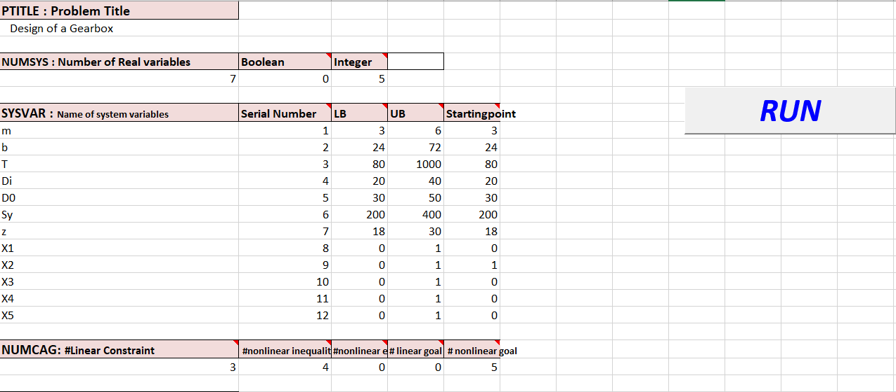
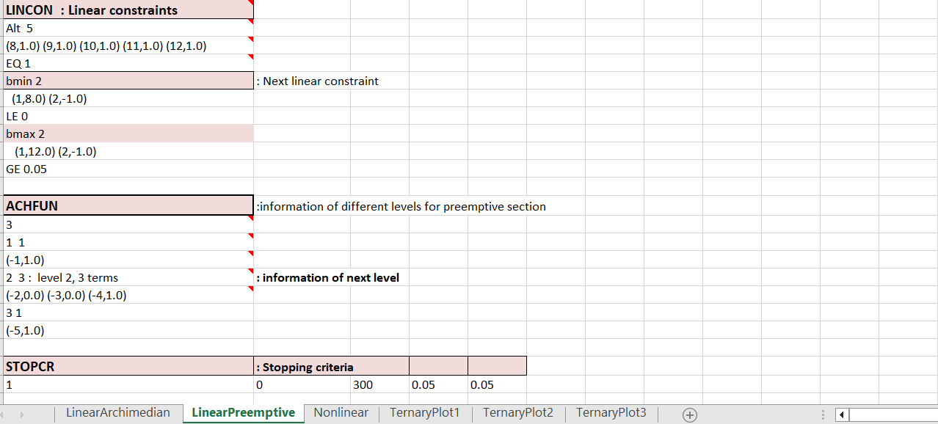
Figure II. 31: Overview of LinearPreemptive Sheet in Design of Gearbox Problem
Once the LinearSheet has been completed and run, a DAT file in the form of a notepad file will be generated in the output folder.
Now, the next step is about completing the NonlinearSheet. The NonlinearSheet, as represented in Figure II.30 of our documentation, is where the incorporation of nonlinear components into the cDSP construct takes place.
To use the NonlinearSheet, the functions or equations that describe the behavior of the nonlinear components within the cDSP will be specified using the graphical interface of the DSIDES software. The inclusion of nonlinear aspects in the system can be simulated and analyzed using the NonlinearSheet. To complete the NonlinearSheet, reference should be made to Figure II.32 in the documentation, in which an overview of the sheet's structure and organization has been provided. By inputting the appropriate equations and parameters into the NonlinearSheet, the nonlinear dynamics of the cDSP can be effectively modeled and studied.
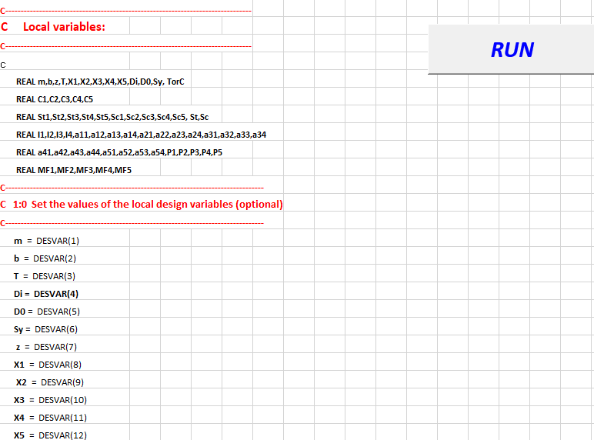
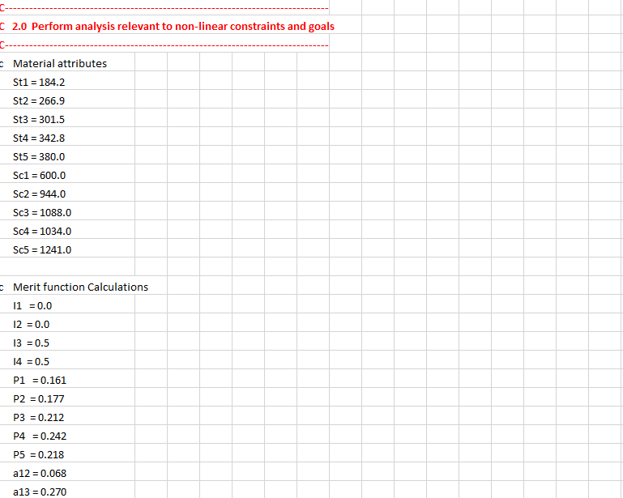
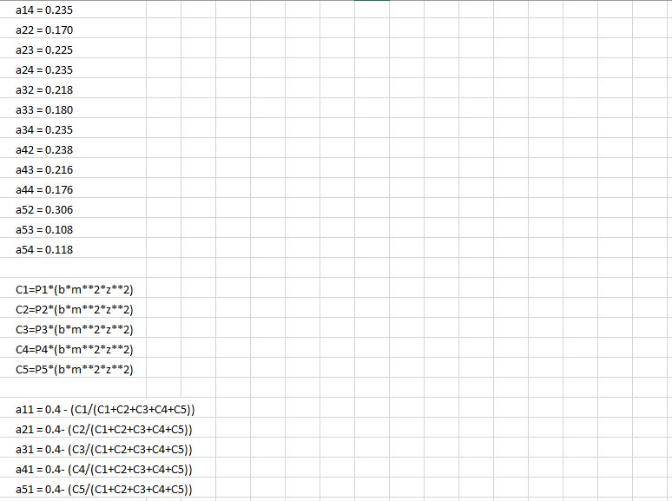
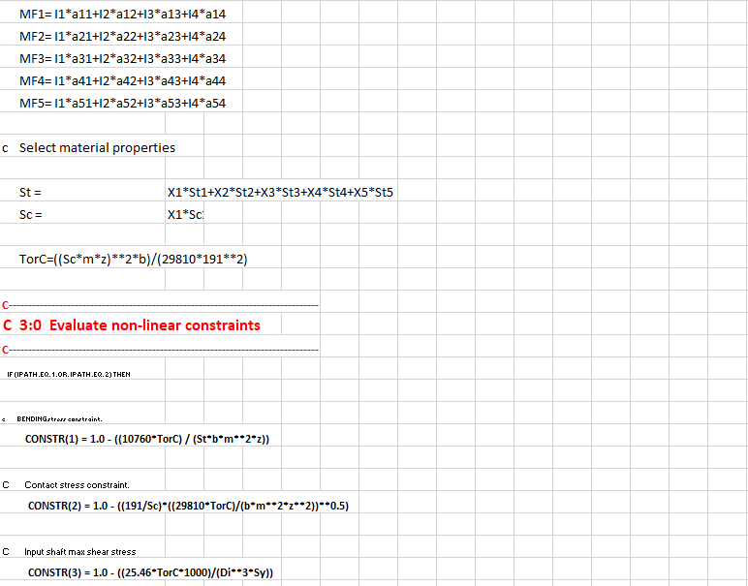
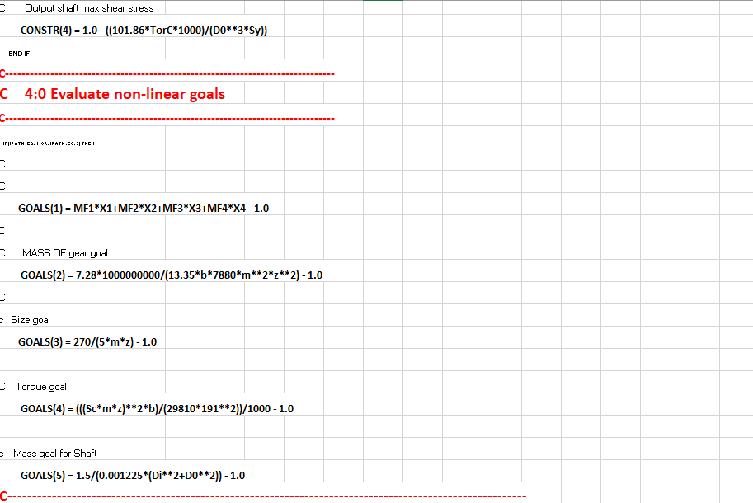
Figure II. 32: Overview of NonLinear Sheet in Design of Gearbox Problem
Note:
There is one important consideration to keep in mind. When importing the data into the NonlinearSheet form, allocating a space of eight characters for each data entry is important. Considering that the Wrapper will link these sheets as input to the primary DSIDES software, written in Fortran, it is important to note that the initial 8 characters will be disregarded by the program. If the user neglects these 8 empty spaces, it may lead to an error in the Wrapper's operation, resulting in the failure to generate the final results.
Final Result:
After the execution of the LinearSheet and NonlinearSheet, an output file will be generated in the Output_Files folder. The output file containing the simulation results will appear as a pop-up on the screen, providing immediate access to the results. Furthermore, a copy of the output file will be saved in the output_file folder of the project, ensuring that the results are easily accessible and can be reviewed at a later time if required.
For the purpose of presenting the final results visually, an image capturing the contents of the output file has been attached in Figure II:33 . A Snapshot of the simulation outcomes for a quick overview of the obtained results has been represented in this figure.
By having the output file readily available and with the attached image for reference, the obtained results of the cDSP model's simulation can be conveniently analyzed and interpreted.
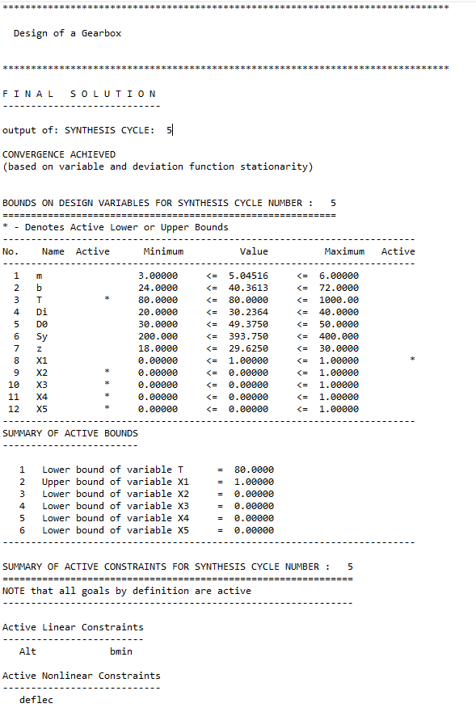
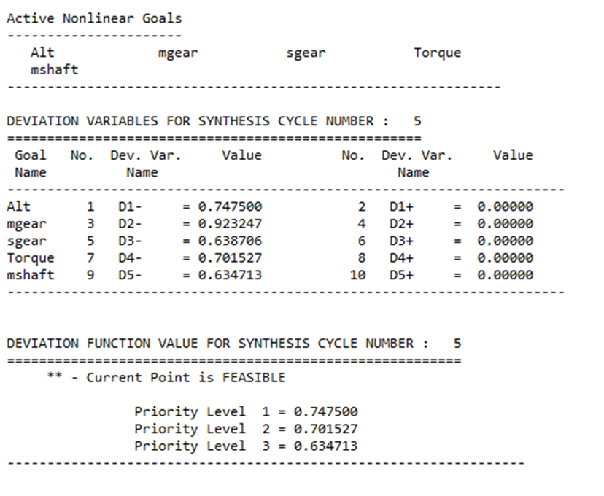
Figure II. 33: Overview of Final Result in Design of a Gearbox
To accurately generate the ternary plot and identify the satisficing space, users should refer to the guidelines outlined in Section II.2.4 Ternary Plot and Section II.4.1.4 Find Satisficing Space Based on the Ternary Plot. The visual representations of the ternary plots and satisficing space have been provided in the paper, which users can utilize as a reference to validate their results and ensure they are following the correct steps for identifying the satisficing space accurately.
Following the description of the first and second examples, presented in Archimedean and Preemptive form, our attention now turns towards the third problem, the hot rod rolling problem involving sequential decisions, presented in preemptive form. This particular example is a part of a paper published in 2022. In the forthcoming section, we will delve into the details of the Hot rod rolling problem.

II.4.3 Hot rod rolling problem in Archimedean Form
The paper titled "An Information-Decision Framework to Support Cooperative Decision Making in the Top-Down Design of Cyber-Physical-Manufacturing Systems" was presented at the ASME 2022 International Design Engineering Technical Conferences and Computers and Information in Engineering Conference (IDETC/CIE2022) held in St. Louis, Missouri from August 14-17, 2022. An innovative framework designed to facilitate cooperative decision-making in the top-down design process of cyber-physical manufacturing systems is introduced in the paper (IDETC2022-90836).
A structured approach for integrating information and decision-making processes is provided by the framework to enhance collaboration and satisfying system design. By leveraging this information-decision framework, researchers and practitioners can effectively address the challenges associated with the design of complex manufacturing systems in the era of cyber-physical integration. This example has been used for verification of our wrapper.

II.4.3.1 Problem statement
The hot rolling process is an essential manufacturing technique used to shape metal sheets or rods by passing them through a sequence of heated rollers. The objective of the hot rolling process is to achieve specific product dimensions while considering various constraints and objectives to ensure high-quality and efficient production.
The problem involves determining the satisfy configuration of process parameters, including roller speeds, roller temperatures, material properties, and other relevant factors, to achieve the desired product specifications. These specifications typically include dimensions such as thickness, width, and length, as well as properties like surface finish and mechanical strength. In addition to the desired product dimensions, the hot rolling process must take into account a range of constraints and considerations. Material properties, such as the type of metal being rolled, its initial temperature, and its mechanical properties, affect the behavior of the metal during the rolling process and impose limitations on the achievable product dimensions.
A crucial role in hot rolling is played by temperature conditions, as they are influential in the material's plasticity and thermal expansion. Maintaining optimal temperature profiles throughout the rolling process is vital to controlling material flow, preventing defects, and ensuring uniformity of the final product. Furthermore, the production throughput requirements, such as the desired production rate or the number of products to be manufactured within a specific timeframe, must be considered to efficiently meet production targets. The hot rolling problem is involved addressing challenges related to process stability, energy consumption, and equipment limitations. For instance, the selection of appropriate roller speeds and temperatures should take into account the mechanical limits of the rolling equipment and the need to avoid excessive strain on the material.
The problem at hand is involved optimizing the hot rod rolling process for C-Mn steels to produce steel rods with specific mechanical properties. The goal is to achieve target values of Yield Strength (YS) of 330 MPa, Tensile Strength (TS) of 750 MPa, and Hardness (HV) of 170The process is comprised of sequential stages, including reheating, rolling, and cooling. Decisions made at each stage impact subsequent stages due to the interconnected nature of the process. A compromise decision support problem approach is employed, considering microstructural characteristics such as Ferrite grain size, Ferrite fraction, and Pearlite interlamellar spacing. The challenge is managing conflicts between the cooling process and the desired mechanical properties, seeking a satisficing solution that balances objectives and constraints. The goal is to develop a cooperative decision-making method that satisfy the process while considering the interconnected decisions and achieving the specified mechanical property targets.

II.4.3.2 cDSP Formulation
Word Formulation:
Given
Yield Strength (YS):
YS1 is calculated based on certain input variables.
YS2 is determined by a combination of input variables.
YS3 is obtained through a combination of input variables.
The overall Yield Strength (YS) is the sum of YS1, YS2, and YS3.
Tensile Strength (TS):
TS1 is computed using specific input variables.
TS2 is determined by a combination of input variables.
TS3 is calculated based on certain input variables.
The overall Tensile Strength (TS) is the sum of TS1, TS2, and TS3.
Hardness (HV):
HV1 is obtained through a combination of input variables.
HV2 is determined based on a specific input variable.
The overall Hardness (HV) is the sum of HV1 and HV2.
• Ferrite fraction – Xf : The proportion or percentage of ferrite present in the microstructure after the cooling process.
• Ferrite grain size - dα (μm): The size or average diameter of individual ferrite grains in the microstructure after cooling.
• Pearlite interlamellar spacing - S0 (μm): The distance between adjacent layers or plates of pearlite in the microstructure after cooling.
• Silicon concentration - [Si] (%): The amount or concentration of silicon in the material after cooling.
• Nitrogen concentration - [N] (%) : The amount or concentration of nitrogen in the material after cooling.
• Manganese concentration - [Mn] (%): The amount or concentration of manganese in the material after cooling.
Find
Design Variables
Ferrite Fraction : Ferfrc
Ferrite Grain Size (microns) : FGrnSz
Pearlite Inter-lamellar Spacing (microns) : Peaspc
Si Concentration (%) : Si
N Concentration (%) : N
Mn Concentration () : Mn
Deviation variables
- $d_{i}^{+}$ over achievement of Goal i, where i=1,2,3
- $d_{i}^{-}$ under-achievement of Goal i, where i=1,2,3
Satisfy
System constraints
Yield Strength (YS) constraint: The Yield Strength value should be within the range of 220 to 330 MPa.
Tensile Strength (TS) constraint: The Tensile Strength value should fall between 450 and 750 MPa.
Hardness (HV) constraint: The Hardness value should be within the range of 131 to 170.
System goals
Goal 1: Maximize YS [MPa] : Yield Strength (YS)
Goal 2: Maximize TS [MPa] : Tensile Strength (TS)
Goal 3: Maximize HV : Hardness (HV)
Bounds
The upper and lower limit of design variables.
Minimize
The deviation function.

Mathematic Formulation:
Given
Yield Strength (YS) target = 330 MPa,
Tensile strength (TS) target = 750 MPa
Hardness (HV), target = 170
YS1=(478.*N**0.5)+(1200.*0.024)
YS2=FERFRC*(77.7+(59.9*MN)+(9.1*(FGRNSZ*0.001)**(-0.5)))
YS3=(1.-FERFRC)*(145.5+(3.5*PEASPC**(-0.5)))
YS=YS1+YS2+YS3
TS1=FERFRC*(20.+(2440.*N**0.5)+(18.5*(0.001*FGRNSZ)**(- 0.5)))
TS2=(750.*(1.-FERFRC))+(92.5*SI)
TS3=(3.*((1.-FERFRC)**0.5)*(PEASPC**(-0.5)))
TS=TS1+TS2+TS3
HV1=FERFRC*(361.-0.357*700.+(50.*SI))
HV2=175.*(1.-FERFRC)
HV=HV1+HV2
Find
Design Variables
X1: Ferrite fraction – Xf
X2: Ferrite Grain size - dα (μm)
X3: Pearlite interlamellar spacing - S0 (μm)
X4: Silicon conc. - [Si] (%)
X5: Nitrogen conc. - [N] (%)
X6: Manganese conc. after cooling - [Mn] (%)
Deviation variables
- $d_{i}^{+}$ over achievement of Goal i, where i=1,2,3
- $d_{i}^{-}$ under-achievement of Goal i, where i=1,2,3
Satisfy
System constraints
CONSTR(1)= (YS/220.)-1 Minimum Yield Strength
CONSTR(2)=1.-(YS/330.) Maximum Yield Strength
CONSTR(3)=(TS/450.)-1 Minimum Tensile Strength
CONSTR(4)=1.-(TS/750.) Maximum Tensile Strength
CONSTR(5)=(HV/131.)-1 Minimum Hardness
CONSTR(6)=1.-(HV/170.) Maximum Hardness
System goals
{YS (X_{j})/YS _{target}} + d₁⁻ - d₁⁺ = 1
{TS (X_{j})/TS _{target}} + d₂⁻ - d₂⁺ = 1
{HV (X_{j})/HV _{target}} + d₃⁻ - d₃⁺ = 1
Bounds
Variable bounds
0.1 ≤ X1 ≤ 0.9
8 ≤ X2 ≤ 25 (μm)
0.15 ≤ X3 ≤ 0.25 (μm)
0.18 ≤ X4 ≤ 0.3 (%)
0.007 ≤ X5 ≤ 0.009 (%)
0.7 ≤ X6 ≤ 1.5 (%)
Deviation variable bounds
d_{i}⁺, d_{i}⁻ >= 0 and d_{i}⁺ * d_{i}⁻ = 0 i = 1, 2, 3
Minimize
The deviation function given below needs to be minimized.
Min Z₁ = 𝜮 W_{i} (d_{i}⁺ + d_{i}⁻), where 𝜮 W_{i} = 1 and i = 1, 2, 3

II.4.3.3 Implementation in DSIDES Wrapper
At this stage, we have transformed the problem into a compromise decision support problem (cDSP) construct. Our next step is to implement the cDSP using the DSIDES Wrapper. The first sheet we need to complete is the Linear Sheet, which is depicted in Figure II.34 of our documentation.
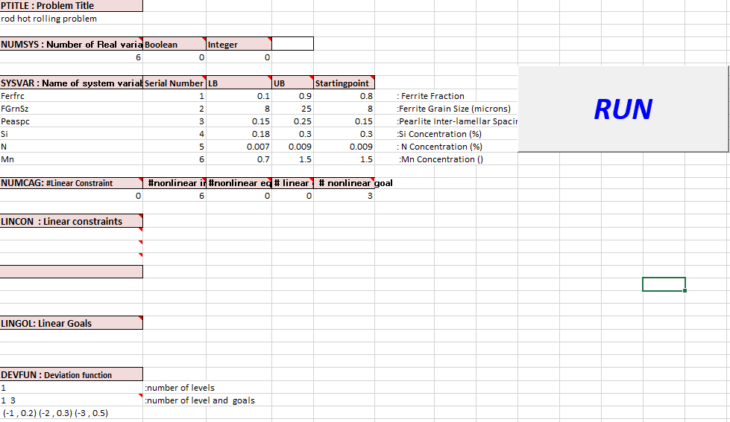
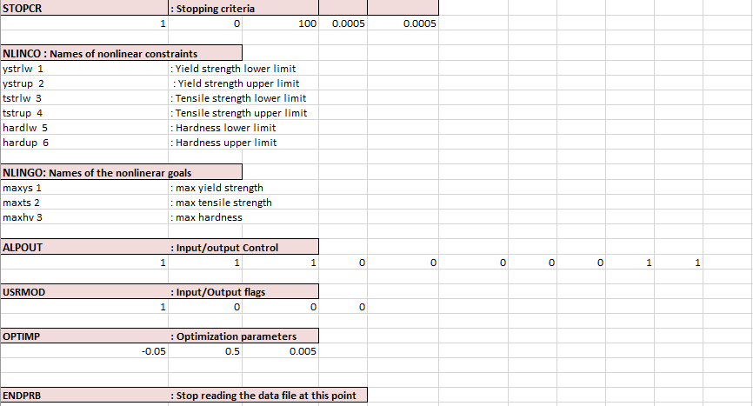
Figure II. 34: Overview of Linear sheet for hot rod rolling problem.
Once the LinearSheet has been completed and run, a DAT file in the form of a notepad file will be generated in the output_files folder. The required input information from the linear simulation for DSIDES software is contained in this DAT file.
Now, the next step involves completing the NonlinearSheet. The NonlinearSheet, as represented in Figure II.35 of our documentation, is where the incorporation of nonlinear components into the cDSP model takes place.
To proceed with the NonlinearSheet, the DSIDES software's graphical wrapper will be utilized to define the nonlinear equations and parameters relevant to the system. The inclusion of nonlinear aspects in the system to be simulated and analyzed is enabled by the NonlinearSheet. By completing this sheet, a more comprehensive understanding of the system's behavior can be obtained, taking into account the nonlinearities present. To complete the NonlinearSheet, reference should be made to Figure II.35 in the documentation, which is an overview of the sheet's structure and organization. By inputting the appropriate equations and parameters into the NonlinearSheet, the nonlinear dynamics of the cDSP can be effectively modeled and studied.
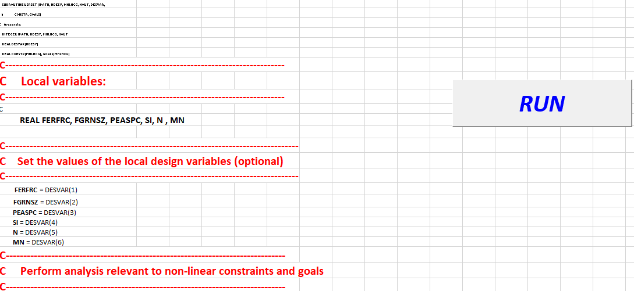
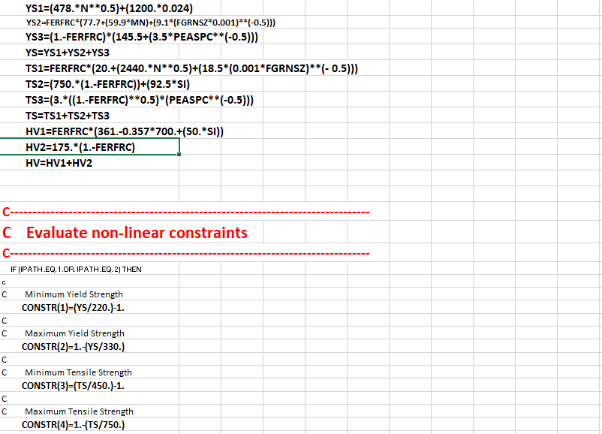
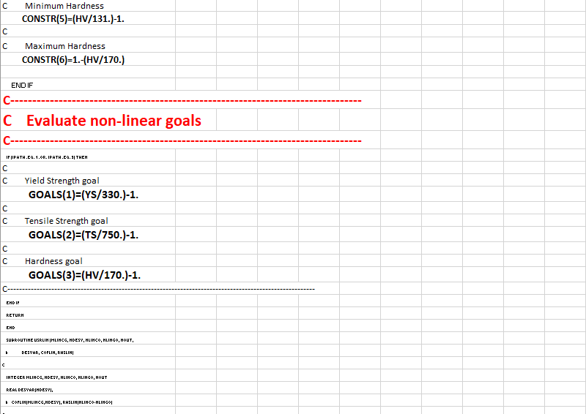
Figure II. 35: Overview of Nonlinear sheet for hot rod rolling problem.
Final Result:
After the execution of the LinearSheet and NonlinearSheet, an output file will be generated in output_files. The output file containing the simulation results will appear as a pop-up on the screen, providing immediate access to the results. Furthermore, a copy of the output file will be saved in the output_file folder of the project, ensuring that the results are easily accessible and can be reviewed at a later time if required.
For the purpose of presenting the final results visually, an image capturing the contents of the output file has been attached in Figure II:36 . A Snapshot of the simulation outcomes for a quick overview of the obtained results has been represented in this figure. By having the output file readily available and with the attached image for reference, the obtained results of the cDSP model's simulation can be conveniently analyzed and interpreted.
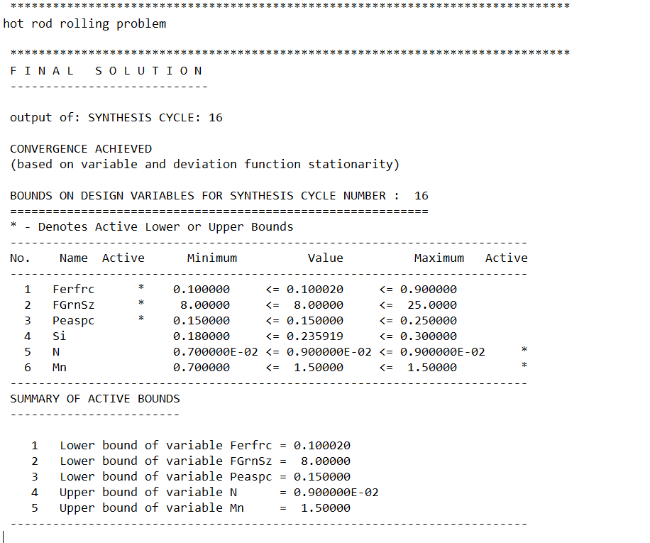
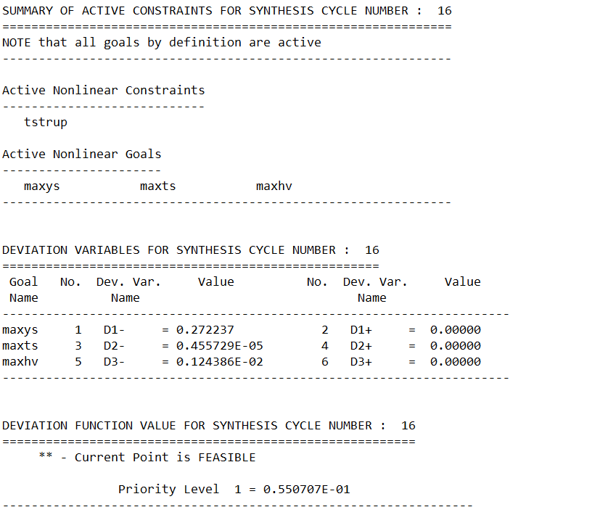
Figure 2:36 . Snapshot of the simulation outcomes in hot rod rolling problem
To accurately generate the ternary plot and identify the satisficing space, users should refer to the guidelines outlined in Section II.2.4 Ternary Plot and Section II.4.1.4 Find Satisficing Space Based on the Ternary Plot. The visual representations of the ternary plots and satisficing space have been provided in the paper, which users can utilize as a reference to validate their results and ensure they are following the correct steps for identifying the satisficing space accurately.

II.5 Summary and Way Forward
In Part 2, we have focused on designing a user-friendly wrapper for the DSIDES software. We have provided a comprehensive description of the wrapper, ensuring that all the necessary details are covered. The user manual created in this part is a valuable resource for users to understand and navigate the wrapper effectively.
Furthermore, to ensure the correctness and usability of our wrapper, three different examples in both preemptive and Archimedean forms have been presented. These examples are intended as verification and validation documents, allowing the functionality and user-friendliness of the wrapper to be assessed. Additionally, practical scenarios are offered to users, enabling them to apply their learnings from Part 1 and further enhance their understanding.
Moving forward, our thesis's next part( Part 3) is about developing a programmer's manual for DSIDES. This manual is helpful for programmers and technical users who require in-depth knowledge about the software. We provide program manuals, flowcharts, coding guidelines, and input/output subroutines that will improve user understanding and simplify comprehension.
One of the key objectives in part 3 is to consolidate all programs and subroutines in one place, creating a comprehensive documentation resource. Multiple purposes are served by this consolidation, including the facilitation of ease of access and reference, the promotion of better organization, and the enhancement of the overall clarity of the programming aspects of DSIDES.
By providing a programmer's manual, we aim to enhance the accessibility and usability of DSIDES, enabling programmers and technical users to utilize the software more efficiently and effectively. This manual will be a valuable asset for both the development team and users, ensuring a smooth and seamless experience with DSIDES.

Part Three: Program Manuals and Improvement of DSIDES

preamble about Part 3:
The main objective of creating Part Three is to provide in-depth material for users seeking to enhance or modify the code. The modification could include improving or changing only a single part or purpose of the program or considering changes in the whole program to another programming language. Since this software includes 90 subroutines, each with its specific role, understanding them becomes essential. Hence, I have compiled all these subroutines in a table, providing their names and specific purpose. With this setup, it is easier for users who want to modify or change specific parts to find the exact subroutine. Additionally, getting to know the different purposes of the subroutines is helpful to understand how the whole program works. Also, because there are five main input files in the program where these subroutines are used, users can understand these input subroutines better. I have also added flowcharts for two of the more complicated input subroutines that might be harder to grasp. Furthermore, I have included some observations based on my understanding after certain input subroutines, which could be beneficial for other users.

Overview of Part 3:
In the third part of this thesis, the programmer manuals, flowcharts, coding, and information about input subroutines in DSIDES are provided. The main focus of this section is on providing information about the input files and their respective purposes ( Output files have been covered in Part two Section 2.3). The objective is to simplify their comprehension of the users by presenting their flowcharts. Additionally, other subroutines that are called through the main files will be cover in this part. This information is necessary for users wanting to improve the software and understand how the programs work. In this section, readers will have access to all the necessary information to improve the software and their work in the future. The focal objective of this section is to consolidate information about the programs and subroutines of DSIDES in a single location for documentation purposes. In the following section, the purposes of all subroutines in the program is outlined to assist users who wish to enhance the software. This will highlight the key aspects addressed by the program and identify specific subroutines that can be improved to cater to changes in particular domains. By providing this information, users will gain a deeper understanding of the program's functionalities and potential areas for refinement, enabling them to make informed decisions when customizing the software to suit their specific needs and requirements.

III.1 Overview of DSIDES Program's Nested Subroutines and their Versatility
The DSIDES program has a complete set of smaller routines, five of them are considered as main input files. Within each of these core subroutines /functions , a hierarchical structure of additional subroutines exists, each serving specific purposes as outlined in Table III.1. These nested subroutines/functions have been designed to fulfill various specialized functions, contributing to the overall effectiveness and versatility of the DSIDES program.
A compilation of 90 subroutines and their respective main purposes has been presented in Table III.1. The aim of this compilation is to provide users with a cohesive overview of each subroutine, thereby facilitating a better understanding of their functionalities.

Table III.1: List of Subroutines and Functions in the DSIDES Program
Name of Subroutine / FUNCTION | Main Purpose
- ALPLIM | Set the limits of the arrays.
- ALPDAT | This routine reads the ALP data file for compromise DSPs and sets the necessary defaults.
- ALPMOD | Perform the synthesis cycles.
- COPYTX(ALPUTL) | This routine copies the contents of input vector array into the output vector array.
- ALPCTL | A main program for DSIDES.
- ADREMO | Adaptive reduced move using a Golden Section line search. If no improvement is found in the initial design, a fixed reduced move is applied to the design point.
- COEFF2 | Determine coefficients of linearized constraint using second-order terms.
- CONACC | Constraint accumulation of nonlinear inequality constraints and "NEW" constraints as generated via adaptation of the nonlinear constraints.
- CONCHK | Determine and record which nonlinear constraints are to be suppressed. Also, determines the right-hand side value of linearized constraints.
- CONCOR | Subroutine CONCOR performs the adaption of the nonlinear constraints.
- CONLIN | This subroutine performs the linearization of constraints and goals. (The deviation variables are not considered here.)
- CONVER | Check for convergence. This is done in several steps.
- DERIV | Calculate gradients of nonlinear constraints and goals.
- DEVCAL | This subroutine calculates the values of the deviation variables.
- DFCALC | Calculate the deviation function for a new set of system variables.
- DISCRT | Solves the discrete problem.
- EXPCTL | Read ALP postprocessor files (control and information) and generate a tab-delimited file, ALPEXP.DAT, suitable for export to a spreadsheet.
- FORAGEMV | Solves the discrete problem.
- GCALC | This subroutine calculates the values of the nonlinear constraints and goals for the current set of design variables. The nonlinear constraints are evaluated in one block, and the goals are evaluated in another.
- HJMAIN | This routine performs pattern search using the Hook and Jeeves algorithm.
- INITAB | Initialize constant portions of Simplex Tableau.
- INITSL | Find an initial feasible solution using the Hook-Jeeves pattern search algorithm.
- MLINOP | Solve the L.P. problem using MULTIPLEX, recording the basis to be used in the next synthesis cycle. The algorithm has integer (branch and bound variation) capability to handle 0/1 "selection" variables.
- TRFORM | Performs the required transformation in the tableau (AMAT) to account for (negative) RHS and (nonzero) lower bounds on the system variables.
- MSETUP | Initial basis setup. MSETUP is called with LITK = 1; that is the initializations are performed for the first priority level.
- ZERONE | The purpose of this routine is to modify the earlier  solution such that the selection variables are forced to go to zero/one values. This is in case they deviate from the zero/one solution in the earlier phase (this may happen due to the influence of constraints).
- MPLEX | PRIMAL MULTIPLEX: Algorithm by J.P. Ignizio
- CHKBXB | This function checks if a reinversion of the basis is required. It returns the absolute value of the largest error.
- CALCXB | This function calculates the basic vector XB according to XB= [BINV][B] - [BINV][Ns][Vs].  XB = MULTIPLEX vector corresponding to the vector formed by multiplying the old RHS by the current inverse. XB is also referred to as Beta.  BINV = MULTIPLEX inverse matrix of the present basis.  B = MULTIPLEX "b" vector of RHS values.
- ECOMP | Calculate the deviation function priority levels NP1 to NP2 for variables NV1 to NV2.  NP1 = MULTIPLEX number of starting priorities.  NP2 = MULTIPLEX number of ending priority level.  NV1 = MULTIPLEX number of starting variables.  NV2 = MULTIPLEX number of ending variable.
- PRICEV | Subroutine PRICEV calculates the pricing vector PIVEC according to the formula [PI] = [CB][BINV]  (For details see "Introduction to Linear Goal Programming" by J.P. Ignizio, SAGE Publications, 1985, page 40.)
- RDCOST | 1 - The subroutine RDCOST calculates the vector DJ, which is known as the shadow price or reduced cost.  2- The subroutine RDCOST determines the entering nonbasic variable based on the highest absolute value of Dj.
- ENTCOL | Update the column [aq] for entering the nonbasic variable IQ.  The resulting column vector is ALPHA. The formula is [Alphaq] = [Binv][aq]  IQ = MULTIPLEX variable denoting the  ALPHA = MULTIPLEX vector corresponding to the updated entering column for IQ.  BINV = MULTIPLEX inverse matrix of the present basis.
- RTEST | Ratio test, which determines the leaving variable.
- UPDBAS | Updates the basis when there is a leaving variable IP and entering variable IQ.
- NEWRHS | The subroutine updates the XB vector for the case where the entering variable does not enter the basis but is set to one of its bounds.
- PFRINV | Compute new basis inverse according to the product form of the inverse method.
- SEIGHT | Step 8 of the LGP algorithm.
- REINVR | Subroutine for reinversion. The current basis matrix is identified, and then the call to the inversion subroutine is made. Variables are used in DOUBLE PRECISION in the latter.
- INVERS | I do not have information about its purpose.
- LUDCMP | I do not have information about its purpose.
- LUBKSB | I do not have information about its purpose.
- PARCMP | This routine determines the relative importance of attributes using the reciprocal pairwise comparison matrix method.  ( Reference: Saaty, T. L., "A Scaling Method for Priorities in Hierarchical Structures", J. of Mathematical psychology, Vol. 15, 1977, pp. 234-281.C)
- EIGEN | Calculate the maximum eigenvalue and the corresponding eigenvector of a matrix using iteration.  (Reference: Shoup, T. E., "Applied Numerical Methods for the Personal Computer", Prentice-Hall, 1984.)
- MATMUL | Matrix multiplication B = A*X  B = real vector of length of the number of variables  A = number of variables matrix  X = real vector of length number of variables
- PCIMPR | This routine is called when the consistency ratio is poor. It provides some additional information regarding each of the decisions made by the user.
- PRMULT | Print the linear solution constraint and goal multipliers (Lagrangians).
- PRPPCF | Create a postprocessor control data file.
- PRPPIF | Create a postprocessor information data file.
- PRDESV | Print design variables.
- PRDEVV | Print deviation variables.
- PRDFUN | Print values of current deviation function.
- PRBNDS | Print bound activity information for a linear solution.
- PRLINC | Print information on linear constraints and goals.
- PRNLNC | Print nonlinear constraint/goal information.
- PRLINA | Print linear constraint activity for a linear solution.
- PRNLNA | Print nonlinear constraint activity for a linear solution.
- PRADPC | Print adapted constraint information.
- PRFACT | Print final solution linear and nonlinear constraint activity.
- SELCAL | Perform the selection DSP calculations  - Normalization of ratings  - Calculation of merit function
- SELCTL | Perform the selection DSP.
- SELCYC | This routine determines the relative importance of  attributes using the reciprocal pairwise comparison matrix method.
- SELDAT | This routine reads the data file for  selection DSPs and sets the necessary defaults.
- SELHLO | This routine determines the relative importance of  attributes using the reciprocal pairwise comparison matrix method.
- SELMER | Provide an interface to the Selection Routines.
- SELPRT | Selection DSP printing
- SELSEN | Perform the sensitivity analysis for selection Decision Support problems using interval arithmetic.
- USRSET | Evaluate nonlinear constraints and goals.
- TIMER | This routine contains the timer routines for:  Sun/O.S. systems.
- UPDTAB | Update multiobjective goal formulation tableau arrays.
- IQSIGN | It is a FUNCTION. This routine returns an integer flag for the inequality sign
- MKNAME | It is a FUNCTION. This routine returns a name by appending an integer to a character string.
- SPLITC | Splits a complex number into an integer and a real value.
- BLKCHK | Splits a complex number into an integer and a real value.
- IARFIL | Fill the IADCON and IACTVR arrays.
- GETNAM | This routine allows for names to be read from data file when the text line has leading blanks.
- LEXSML | Perform lexicographic comparison of two vectors.
- LVCEQU | It is a FUNCTION. Compare the two vectors for convergence.
- VECSUM | It is a FUNCTION. To return the absolute norm of a vector.
- VECMAX | It is a FUNCTION. To return the maximum absolute value from a vector.
- EXPTAB | Export Table printing.
- USRANA | for user provided analysis routine.
- USROUT | user provided output routine.
- XPLORE | Find initial feasible solutions.
- PTSRCH | Return a vector of length N in an N-dimensional cube.
- ZSRCH | To generate K points in an N dimensional space.
- PTRAND | Return a random vector of length N in an N-dimensional cube.
- SRAN | Return a pseudo-random number between 0.0 and 1.0
- ADNUPT | This routine calculates the design point given by REMO Only the real variables are perturbed.
- USRMON | Monitor process .

Learning about all subroutines and their purpose could help the user to have a better understanding of how a program is working. In the next section five main input files are described in more detail with their program and show how other subroutines are used in these five main input files.
Obtaining knowledge about all the subroutines and their purposes is crucial for users to gain a comprehensive understanding of the DSIDES program's functionality in the subsequent section of this document, in-depth descriptions of the five main input files are provided, offering valuable insights into their respective programs and demonstrating the seamless integration of various subroutines. By exploring these detailed explanations, users can enhance their comprehension of the program's inner workings and the strategic utilization of subroutines within the context of these five main input files.

III.2 Main Input Files
The Fortran program includes five main input files, each with its principle. Before delving into the specifics of each subroutine, we will introduce the main objective of each one:
- ALPLIM: Its purpose is to Consider the limit for the arrays.
- ALPDAT: The ALP data file for compromise DSPs is read by this routine, and the necessary defaults are set.
- ALPMOD: Its purpose is to perform the synthesis cycles. ( it's about stopping criteria)
- COPYTX (ALPUTL): Its purpose is to copy the contents of the Y (input vector) array into the X (output vector) array. This subroutine is about the synthesis cycle. So, it keeps the information of the last cycle and uses it to start the next cycle.
- ALPCTL: A main program for DSIDES that other subroutines will call here.
Following the introduction of the five main input files, the subsequent subsections will delve into the details of each mentioned input subroutine, providing further clarification and understanding.

III.2.1 ALPLIM Subroutine
One of the main input subroutines is ALPLIM. In the ALPLIM subroutine, the limit for arrays has been determined. It has a crucial role in other input subroutines. If a user does not specify initial values for variables, the program will rely on ALPLIM to set default initial values. In simpler terms, ALPLIM is like a helper function that sets default values for variables when needed. In this subroutine, the important variables, their definition, and their initial values are identified. I have included the subroutine here, which simply assigns initial values to variables. I did not add a flowchart since the process is straightforward..
C <<<<<<<<<*>>>>>>>>>
C ALPLIM.CMM
C <<<<<<<<<*>>>>>>>>>
C Last update: 28MAR92
C***********************************************************************
C Set the limits of the arrays.
C***********************************************************************
C Compromise DSP limits:
INTEGER MDESV, MDSCV, MLINCG, MNLNCG, MAXACC
INTEGER MAXCAG, MDEVV, MVARMX, MGOLMX
INTEGER MLEVEL, MNSYCY, MNANCY, MTITER
C Selection DSP limits:
INTEGER MATTRB, MSELPR, MPAIRS
C
C Module XPLORE limit:
C
INTEGER MPTBST
C Threshold values:
C
REAL SMALL, THDIFF, TINY, VLINCO
C
C New name Description
C -------- -----------
C MDESV Max. number of design variables
C
C MDSCV Max. number of discrete variables values
C
C MLINCG Max. number of linear constraints + goals
C
C MNLNCG Max. number of nonlinear constraints + goals
C
C MAXACC Max. number of accumulated constraints
C
C MAXCAG Max. number of constraints + goals ( MAXCAG = MLINCG + MNLNCG)
C
C MDEVV Max. number of deviation variables ( MDEVV = 2*MAXCAG)
C
C MVARMX Max. number of variables for Multiplex ( MVARMX = MDESV + 2*(2*MAXCAG + MAXACC) )
C
C MGOLMX Max. number of goals for multiplex ( MGOLMX = MAXCAG + MAXACC + maxnew=
2*MAXCAG + MAXACC)
C

C (NOTE: bounds not included)
C
C MLEVEL Max. number of priority levels including
C constraint level
C MNSYCY MAX. number of synthesis cycles
C
C MNANCY MAX. number of analysis cycles
C
C MTITER MAX. number of total iterations (MTITER = MNSYCY * MNANCY)
C Currently set to 100
C
PARAMETER (MDESV = 40)
PARAMETER (MDSCV = 50)
PARAMETER (MLINCG = 50)
PARAMETER (MNLNCG = 50)
PARAMETER (MAXACC = 20)
PARAMETER (MAXCAG = 100)
PARAMETER (MDEVV = 200)
CCCCC ( Based on the formulation MVARMX should be 480 but, in the program, sets as a 640, since they set the range larger than needed. )
PARAMETER (MVARMX = 640)
PARAMETER (MGOLMX = 220)
C
C Limits increased from preceding values by Bert Bras, 10 August 1993. ( Even the limits increased in 1993 but still the previous amount in used in the subroutine)
CCCCC PARAMETER (MDESV = 200)
CCCCC PARAMETER (MLINCG = 50)
CCCCC PARAMETER (MNLNCG = 450)
CCCCC PARAMETER (MAXACC = 150)
CCCCC PARAMETER (MAXCAG = 500)
CCCCC PARAMETER (MDEVV = 1000)
CCCCC PARAMETER (MVARMX = 2500)
CCCCC PARAMETER (MGOLMX = 1150)

PARAMETER (MLEVEL = 9)
PARAMETER (MNSYCY = 50)
PARAMETER (MNANCY = 25)
PARAMETER (MTITER = 100)
C
C MATTRB MAX. number of attributes
C
C MSELPR MAX. number of selection problems
C
C MPAIRS MAX. number of pairs for pairwise comparison
C MPAIRS = MATTRB * (MATTRB-1)/2

PARAMETER (MATTRB = 20)
PARAMETER (MSELPR = 5)
PARAMETER (MPAIRS = 190)
C
C MPTBST MAX. number of points (best) saved within
C module XPLORE
C
CCCCC PARAMETER (MPTBST = 200)
C
PARAMETER (MPTBST = 1000)
C
C SMALL Threshold for activity of constraints and variable bounds
C
C THDIFF Threshold for general differences
C
C TINY Threshold to avoid underflow
C
C VLINCO Magnitude of small violation as a function of the RHS in linear constraints to be ignored Default magnitude of small violations ignored in non- linear constraints
C
PARAMETER (SMALL = 1.0E-4)
PARAMETER (THDIFF = 1.0E-5)
PARAMETER (TINY = 1.0E-10)
PARAMETER (VLINCO = 1.0E-3)
In the subsequent section, an additional key input subroutine known as ALPDAT is introduced.

III.2.2 ALPDAT Subroutine
The main purpose of this subroutine is to read the ALP data file for compromise DSPs and set the necessary defaults. This subroutine is about all blocks that we have in LinearArchimedian and LinearPreemptive sheet, as they are represented in Table II.1 and Table II.2 in Part Two, there are 8 mandatory blocks and 27 optional blocks which are described in detail in Part Two, Sections II.2.1 and II.2.2.
As it is represented in the two mentioned tables, we have the following blocks in the linear sheets :
- PTITLE: Problem title
- NUMSYS: Number of System Variables
- SYSVAR : Description of System Variables - name, type, bounds, and guess value
- NUMCAG: Number of Constraints and Goals
- LINCON : Linear Constraints - names and data (if specified in NUMCAG)
- LINGOL : Linear Goals- names and data (if specified in NUMCAG)
- DEVFUN: Deviation Function - number of levels and weights of deviation variables
- STOPCR : Stopping Criteria (run and principal print flags, NITER, EPSZ, EPSX)
- NLINCO : Names of Nonlinear Constraints (default names: NLCO##)
- NL I NGO: Names of Nonlinear Goals (default names: NLGO##)
- ALP OUT: Flags for Output Level, Post Processor, and Time Statistics
- USRMOD: Flags for User Modules (USRINP, USROUT, USRMON, USRLIN)
- OPTIMP: Optimization Parameters (VIOLIM, REMO, STEP)
- INITFS: Automatic Generation of Initial Feasible Solution
- USRDAT: User Data Block for Access From USRINP
- ADPCTL : Nonlinear Inequality Constraint Adaption Flag (LADAP)
- USERAN: Information for USRANA (maximum cycles - NANCY, NSYCY)
- FIXVAR : Fixing of Variables
- SUPCON: Suppression of Nonlinear Constraints
- PVALFX : Particular Values for Stationarity of System Variables
- PVEPSZ : Particular Values for Stationarity of Deviation Function Levels
- PVSTEP : Particular Values for STEP
- PVCVIL : Particular Values for VIOLIM
- PVREMO: Particular Values for REMO
- ADREMO: Adaptive Reduced Move Parameters
- XPLORE : Explore the design space for best initial points.
- ENDPRB: End of Problem Definition
Subroutine ALPDAT will go through all the blocks, and if the user defines the value for each block, it will assign it to the required variables; otherwise, will use the default value that has been assigned with the ALPLIM subroutine that has been described in section III.1.1. So ALPLIM is included in this subroutine as well. All the variables have been defined at the beginning of the subroutine in different types like single integers or real numbers, constants, matrices, or arrays. The ALPLIM subroutine has been called to assign the default value if the user did not define the value to some variables and wants to use the default value. Then the program will go through block 1 to block 27 with an if statement; if the if statement is true, the program will execute the specific block of code.
The ALPDAT subroutine is added Below. Several other subroutines are called in ALPDAT, such as IQSIGN, MKNAME, SPLITC, BLKCHK, and IARFIL, which have been introduced in Section III.1.

C***********************************************************************
C
C Subroutine ALPDAT
C
C Purpose: This routine reads the ALP data file for
C compromises DSPs and sets the necessary defaults.
C
C-----------------------------------------------------------------------
C Arguments Name Type Description
C --------- ---- ---- -----------
C Input: NUINP int unit number of the input data file
C NUOUT int unit number of the output data file
C NUSER int unit number of the scratch user data file
C
C Output: NDESV int number of design variables
C NDEVAR int number of deviation variables
C NRELV int number of real (continuous) variables
C *************KL NDISV int number of discrete variables (inc. integer)
C DSTEP int/real step for discrete variables (1 default)
C NVALUS int number of discrete values (override step)
C MAX = 50
C NUMNGH int number of variables to have tabu Nghbrhd
C INDEX int index of initial discrete vars (for tabu)
C NEIGH int counter to set up tabu with DSTEP = 1.0
C TABUN real tabu neighborhood (MDESV, 50)
C NVINT int number of integer variables
C NVSEL int number of selection (boolean)
C variables
C NMPRI int number of goal priority levels
C NLINCO int number of linear constraints
C NLINGO int number of linear goals
C NNLEQU int number of nonlinear equalities
C constraints
C NNLINQ int number of nonlinear inequalities
C constraints
C NNLCON int number of nonlinear constraints
C NNLGOA int number of nonlinear goals
C NNLTOT int total number of nonlinear constraints
C and goals
C = NNLINQ+NNLEQU+NNLGOA
C NANCY int maximum number of analysis cycles
C performed
C NHJMAX int maximum calls to USRSET from INITSL
C NSYCY int vector indicating the maximum number
C of synthesis cycles performed within
C each analysis cycle
C NADREM int ADREMO - maximum number of calls to
C be made to GCALC.
C NPTGEN int number of points to be generated.
C NPTBST int number of best points to be printed.
C IGSEED int seed for the pseudo-random number generator
C IGENFX int vector of variables to be kept fixed.
C during point generation
C IACTVR int vector of flags for active variables
C IADCON int vector of flags for admissible
C nonlinear constraints
C = 0 if suppressed by the user
C = J if admissable
C = -n if suppressed by the program
C IDDEVR chr6 vector of deviation variable names
C IDLICO chr6 vector of linear constraint names
C IDLIGO chr6 vector of linear goal names
C IDNLCO chr6 vector of nonlinear constraint names
C IDNLGO chr6 vector of nonlinear goal names
C IDDESV chr6 vector of design variable names
C PTITLE chr80 problem title
C COFLIN real matrix of coefficients of linear
C constraints and goals
C LISIGN int vector indicating sign for linear
C inequality constraints
C RHSLIN real vector of RHS values for linear
C constraints and goals
C PESTEP real vector of perturbation steps for
C nonlinear constraints and goals
C REDMOV real reduced move step sizes
C VBOUNS real matrix of lower and upper bounds for
C design variables
C DESVAR real vector of design variables
C DFNCOF real matrix of weights for deviation
C function
C DELREM real acceptable convergence criterion for
C reduced move
C HJCONT real pattern search - contraction factor
C HJDELT real pattern search - minimum allowable
C step
C HJEPSY real pattern search - maximum allowable
C violation
C HJEXPA real pattern search - expansion factor
C HJSTEP real pattern search - step size
C FRACX real vector: convergence criteria for X,
C the design variables
C FRACZ real vector: convergence criteria for Z,
C the deviation function
C VILCN real vector of acceptable nonlinear
C constraint violations
C LDRYRN lgcl effect dry run only
C LPRFIN lgcl print final output only
C LPROUT lgcl vector of flags for output control
C LPPROC lgcl create ALP postprocessor files
C LADAP lgcl use constraint adaptation
C LADREM lgcl use adaptive reduced move
C LINIT lgcl generate initial feasible solution
C LTIME lgcl generate time statistics
C LMON lgcl call user supplied subroutine USRMON
C LUINP lgcl call user supplied subroutine USRINP
C LUOUT lgcl call user supplied subroutine USROUT
C LVCOF lgcl call user supplied subroutine USRLIN
C LXPLOR lgcl explore design space
C LPRGEN lgcl print the best points generated in
C exploring design space
C FATAL lgcl failure status in ALPDAT
C
C Input/output: none
C-----------------------------------------------------------------------
C Common Blocks: none
C
C Include Files: alplim.cmm
C
C Calls to: IQSIGN, MKNAME, SPLITC, BLKCHK, IARFIL
C-----------------------------------------------------------------------
C Development History
C
C Author: Ravi P. Reddy
C Date: February 14, 1991
C
C Modifications:
C Bert Bras, July 1993.
C The same default and user-specified values for FRACX are
C used for ALL variables (real and Boolean).
C Prior to this modification, FRACX was set to 1.0 for nonreal
C variables. This caused the (Boolean) variable convergence
C check in CONVER() to be incorrectly satisfied in all cases.
C
C***********************************************************************
SUBROUTINE ALPDAT(NUOUT, NUINP, NUSER,
& NRELV, NDISV, NVINT, TABUN, NVALUS, INDEX, NVSEL,
& NDESV, NDEVAR,
& NLINCO, NLINGO, NMPRI,
&& NNLCON, NNLEQU, NNLGOA, NNLINQ, NNLTOT,
& NANCY, NSYCY,
& NHJMAX, NADREM, IACTVR, IADCON, LISIGN,
& NPTGEN, NPTBST, IGSEED, IGENFX,
& IDDESV, IDDEVR, IDLICO, IDLIGO, IDNLCO, IDNLGO,
& PTITLE, COFLIN, RHSLIN, DFNCOF,
& PESTEP, REDMOV, VBOUNS, DESVAR,
& HJEXPA, HJCONT, HJSTEP, HJEPSY, HJDELT, DELREM,
& FRACZ, FRACX, VILCN,
& FATAL, LDRYRN, LPRFIN,
& LPROUT, LPPROC, LTIME, LADREM, LADAP, LINIT,
& LMON, LUINP, LUOUT, LVCOF, LXPLOR, LPRGEN, LVDISC)
C
INCLUDE 'alplim.cmm'
C
C---------------------------------------
C Arguments:
C---------------------------------------
C Logical Unit numbers for I/O
C
INTEGER NUOUT, NUINP, NUSER
C
C
INTEGER NRELV, NDISV, NVALUS(MDESV), DSTEP, INDEX(MDESV), NUMNGH,
& NVINT, NVSEL, NDESV, NDEVAR,
& NLINCO, NLINGO, NMPRI,
& NNLCON, NNLEQU, NNLGOA, NNLINQ, NNLTOT,
& NANCY, NSYCY(MNANCY),
& NHJMAX, NADREM, IACTVR(MDESV), IADCON(MNLNCG),
& LISIGN(MLINCG),
& NPTGEN, NPTBST, IGENFX(MDESV), IGSEED
C
CHARACTER*6 IDDESV(MDESV), IDDEVR(MDEVV),
& IDLICO(MLINCG), IDLIGO(MLINCG),
& IDNLCO(MNLNCG), IDNLGO(MNLNCG)
C
CHARACTER*80 PTITLE(2)
C
REAL COFLIN(MLINCG,MDESV), RHSLIN(MLINCG),
& DFNCOF(MLEVEL,MDEVV),
& PESTEP(MDESV), REDMOV(MDESV),
& VBOUNS(2,MDESV), DESVAR(MDESV),
& HJEXPA, HJCONT, HJSTEP, HJEPSY, HJDELT, DELREM,
& FRACZ(MLEVEL), FRACX(MDESV), VILCN(MNLNCG),
& TABUN(MDESV,MDSCV)
C
LOGICAL FATAL,
& LDRYRN, LPRFIN,
& LPROUT(8), LPPROC, LTIME,
& LADREM, LADAP, LINIT,
& LMON, LUINP, LUOUT, LVCOF,
& LPRGEN, LXPLOR, LVDISC
C
C---------------------------------------
C Local variables:
C---------------------------------------
C
CHARACTER*6 MKNAME
EXTERNAL MKNAME
INTEGER IQSIGN
C
CHARACTER*80 DUM, DUMOUT
CHARACTER*6 BLKNAM,DUMNAM
CHARACTER*1 VTYPE,ONE
CHARACTER*2 CCSIGN
C
LOGICAL BKIN(30), LNONAM
C
C Modification: Following line was COMPLEX CIR(50)
C
COMPLEX CIR(MDESV)
C
INTEGER JDUM(MDESV), J1, J2, IPR(9), KONT
INTEGER NUM, IVAR, IOUSER, IOUT
INTEGER IMON, JVARC, ML, IADAP, II
INTEGER NPSTEP, NREMOV, NFRAC
INTEGER KDUM, NDUM, NTERMS, NLEVEL
INTEGER KMIN, KMAX, KGES, KSGN, I, J, K, L, KST
C
REAL REMOVS, PSTEP, VIOLIM, NEIGH
REAL VAL, EPSZ, EPSX
REAL XMIN, XMAX, XGES
C
C***********************************************************************
C Initialize Logical Flags
C***********************************************************************
C
LUINP = .FALSE.
LUOUT = .FALSE.
LVCOF = .FALSE.
LTIME = .FALSE.
LINIT = .FALSE.
LADREM = .FALSE.
LADAP = .FALSE.
LMON = .FALSE.
LXPLOR = .FALSE.
LVDISC = .FALSE.
LPRGEN = .FALSE.
FATAL = .FALSE.
C
LPROUT(1) = .TRUE.
LPROUT(2) = .TRUE.
LPROUT(3) = .TRUE.
LPROUT(4) = .FALSE.
LPROUT(5) = .FALSE.
LPROUT(6) = .FALSE.
LPROUT(7) = .FALSE.
LPROUT(8) = .FALSE.
C
C Set other defaults
C
NANCY = 0
REMOVS = 0.5
PSTEP = 0.005
VIOLIM = -VLINCO
C--------------------------------------------------------
C No blocks have been read.
C
D.O. 2 J=1,30
BKIN(J)=.FALSE.
2 CONTINUE
C
C Beginning of main GOTO loop
C Read next block name
C
1111 READ(NUINP,FMT='(A)',END=9000,ERR=8888)DUM
CALL GETNAM(DUM, BLKNAM, KST, LNONAM)
C
IF(LNONAM)THEN
GO TO 1111
ENDIF
C
WRITE(NUOUT,3)BLKNAM
3 FORMAT(/,X,'BLOCK ',A6,X,54('-'),/)
C
CC BLOCK1 ------- PTITLE ---------------------------------------------
C Read Problem Title & User Information
C
IF(BLKNAM.EQ.'PTITLE')THEN
CALL BLKCHK(NUOUT,BKIN(1))
C
DO 4 J = 1,2
READ(NUINP,FMT='(A)',ERR=8888) PTITLE(J)
WRITE (NUOUT, '(A)') PTITLE(J)
4 CONTINUE
C
GO TO 1111
ENDIF
C
CC BLOCK2 ------- NUMSYS ---------------------------------------------
C ***KL
C Read number of design variables - Real, and dicrete
C
C NRELV = number of real variables
C NDISV = number of discrete variables
C NVINT = number of integer variables
C NVSEL = number of selection (boolean) variables
C NDESV = number of standard variables
C = NRELV+NDISV
C --------------------------------------------------------------------
C Programmer's Note
C -----------------
C The current version of the program does not have the capability
C of handling INTEGER variables. If and when this aspect of the
C program is developed, the variable NVINT should be made active
C in the READ statement and the echo FORMAT.
C Remember that the integer variables must follow the real
C variables and precede the selection variables.

C --------------------------------------------------------------------
C
IF(BLKNAM.EQ.'NUMSYS')THEN
CALL BLKCHK(NUOUT,BKIN(2))
C
NVINT = 0
READ(NUINP,FMT=*,ERR=8888)NRELV,NDISV,NVSEL
C
IF (NDISV.GT.0) THEN
LVDISC = .TRUE.
ENDIF

NDESV = NRELV+NDISV+NVSEL
WRITE(NUOUT,20)NRELV,NDISV,NVSEL,NDESV
20 FORMAT(3X,' Number of real variables = ', I5/,
& 3X,' Number of discrete variables = ', I5/,
& 3X,' Number of selection (Boolean) variables = ', I5/,
& 3X,' Total number of design variables = ', I5)
C
IF(NDESV.GT.MDESV)THEN
WRITE(NUOUT,21)MDESV,NDESV
GO TO 9999
ENDIF
21 FORMAT(' E ** Problem Size',/
& 3X,' Maximum number of design variables = ',I5,/
& 3X,' Specified = ',I5)
C
GO TO 1111
ENDIF
C
CC BLOCK3 ------- SYSVAR ---------------------------------------------
C Read design variable information
C
IF(BLKNAM.EQ.'SYSVAR')THEN
CALL BLKCHK(NUOUT,BKIN(3))
C
C Check if NUMSYS has been read.
IF(.NOT.BKIN(2))THEN
WRITE(NUOUT,700)
GO TO 9999
ENDIF
C
WRITE(NUOUT,30)
30 FORMAT(2X,' Number Name Type Minimum Maximum ',
& 3X,'Guess Value',/,
& 2X,' ------ ------ ---- ------------ ------------',
& 3X,'------------')
C
DO 35 K=1,NDESV
READ(NUINP,'(A)',ERR=8888)DUM
CALL GETNAM(DUM, DUMNAM, KST, LNONAM)
IF (LNONAM) DUMNAM = MKNAME('X',K)
C
READ(DUM(KST:80),FMT=*,ERR=8888)J,XMIN,XMAX,XGES
C
C Variable type assigned using serial number
C
C **K.L. changed this to NDISV and 'D'
IF(J.LE.NRELV)THEN
VTYPE='R'
ELSEIF(J.GT.(NRELV+NDISV))THEN
VTYPE='B'
ELSE
VTYPE='D'
ENDIF
C
C Check if values are within bounds
C
IF((XGES.LT.XMIN).OR.(XGES.GT.XMAX))THEN
XGES=0.5*(XMIN+XMAX)
WRITE(NUOUT,32)J
32 FORMAT(/,' I ** Guess value out of bounds, ',
& 'reset to (XMIN+XMAX)/2 for variable number ',I3)
ENDIF
C
IDDESV(J) = DUMNAM
VBOUNS(1,J) = XMIN
VBOUNS(2,J) = XMAX
DESVAR(J) = XGES
C
C THIS SETS up the tabu neighborhood from the bounds.

DSTEP = 1

IF (J.GT.NRELV.AND.J.LT.(NRELV+NDISV+1)) THEN
NVALUS(J) = VBOUNS(2,J) - VBOUNS(1,J) + 1

C This sets the index number as the guess index.
INDEX(J)=(DESVAR(J)-VBOUNS(1,J))/DSTEP + 1

C SETS up the temporary counter for set of discrete values.
C STARTS at the lower bound.

NEIGH = VBOUNS(1,J)

DO 37 L=1,NVALUS(J)
TABUN(J,L) = NEIGH
NEIGH = NEIGH + DSTEP
37 CONTINUE
ENDIF
C
C Use different formats for REAL and other variables.
C
IF(VTYPE.EQ.'R')THEN
WRITE(NUOUT,33)J,IDDESV(J),VTYPE,VBOUNS(1,J),
& VBOUNS(2,J),DESVAR(J)
33 FORMAT(4X,I3,5X,A6,4X,A1,2X,G12.5,3X,G12.5,3X,G12.5)
ELSE
IF(VTYPE.EQ.'D')THEN
WRITE(NUOUT,38)J,IDDESV(J),VTYPE,VBOUNS(1,J),
& VBOUNS(2,J),DESVAR(J)
38 FORMAT(4X,I3,5X,A6,4X,A1,2X,G12.5,3X,G12.5,3X,G12.5)
ELSE
KMIN=XMIN+0.5
KMAX=XMAX+0.5
KGES=XGES+0.5
WRITE(NUOUT,34)J,IDDESV(J),VTYPE,KMIN,KMAX,KGES
34 FORMAT(4X,I3,5X,A6,4X,A1,2X,I10,5X,I10,5X,I10)
ENDIF
ENDIF
C
35 CONTINUE
C
GO TO 1111
ENDIF

C
CC BLOCK4 ------- DISCRETE ---------------------------------------------
C Read discrete design variable information
C
IF(BLKNAM.EQ.'PVDISC')THEN
CALL BLKCHK(NUOUT,BKIN(28))
C
LVDISC = .TRUE.
WRITE(NUOUT,285)
C
READ(NUINP,FMT=*,ERR=8888)NUMNGH

DO 284 J=1,NUMNGH

READ(NUINP,FMT=*,ERR=8888)NUM,NVALUS(NUM),XGES
IF (NUM .LE. NRELV) THEN
WRITE(NUOUT,282)NUM
GO TO 9999
ENDIF
IF (NUM .GT. NRELV+NDISV) THEN
WRITE(NUOUT,282)NUM
GO TO 9999
ENDIF
IF (XGES.LT.1 .OR. XGES.GT.NVALUS(NUM)) THEN
GO TO 9999
ENDIF
IF (NUM .GT. 0) THEN
READ(NUINP, FMT=*, ERR=8888) (TABUN(NUM,I),I=1,NVALUS(NUM))
C Guess value is read is as initial DESVAR
INDEX(NUM) = XGES
DESVAR(NUM) = TABUN(NUM,INDEX(NUM))
CORIGINAL DESVAR(NUM) = TABUN(NUM,XGES)
WRITE(NUOUT,281)NUM,IDDESV(NUM)
WRITE(NUOUT,*)(TABUN(NUM,I),I=1,NVALUS(NUM))
WRITE(NUOUT,286)DESVAR(NUM)
ENDIF
284 CONTINUE

281 FORMAT (4X,'Variable No. ', I2, ' (', A, ')'
& ' has the following discrete values possible.')
282 FORMAT(' E ** Variable number ',I3,' is not discrete')
285 FORMAT(' I ** User inputted discrete data will be used',//)
286 FORMAT(5X,'and the initial value is:',F6.4)

C WRITE(NUOUT,283)
C 283 FORMAT(2X,' Number Name Type values ',
C & 2X,' ------ ------ ---- ------------ ------------',
C & 3X,'------------')

GO TO 1111

ENDIF

C
CC BLOCK4 ------- NUMCAG ---------------------------------------------
C Read number of constraints and goals
C NEW VARIABLES LINCON,LINGOL
C NLINCO Number of linear constraints
C NNLINQ Number of nonlinear inequality constraints
C NNLEQU Number of nonlinear equality constraints
C
C NLINGO Number of linear goals
C NNLGOA Number of nonlinear goals
C
IF(BLKNAM.EQ.'NUMCAG')THEN
CALL BLKCHK(NUOUT,BKIN(4))
C
READ(NUINP,FMT=*,ERR=8888)NLINCO,NNLINQ,NNLEQU,NLINGO,NNLGOA
WRITE(NUOUT,40) NLINCO,NNLINQ,NNLEQU,NLINGO,NNLGOA
40 FORMAT(3X,
& ' Number of linear constraints = ', I5/,
& 3X,' Number of nonlinear inequality constraints = ', I5/,
& 3X,' Number of nonlinear equality constraints = ', I5/,
& 3X,' Number of linear goals = ', I5/,
& 3X,' Number of nonlinear goals = ', I5)
C
NDEVAR = (NLINGO+NNLGOA)*2
NNLTOT = NNLINQ+NNLEQU+NNLGOA
NNLCON = NNLINQ+NNLEQU
C
C Check against maximum limits
C
IF(NDEVAR.GT.MDEVV)THEN
WRITE(NUOUT,44)MDEVV,NDEVAR
GO TO 9999
ENDIF
44 FORMAT(' E ** Problem Size',/
& 3X,' Maximum number of deviation variables = ',I5,/
& 3X,' Specified = ',I5)
C
IF(NNLTOT.GT.MNLNCG)THEN
WRITE(NUOUT,45)MNLNCG,NNLTOT
GO TO 9999
ENDIF
45 FORMAT(' E ** Problem Size',/
& 3X,' Maximum number of nonlinear constraints + goals = ',I5,/
& 3X,' Specified = ',I5)
C
IF((NLINCO+NLINGO).GT.MLINCG)THEN
WRITE(NUOUT,46)MLINCG,NLINCO+NLINGO
GO TO 9999
ENDIF
46 FORMAT(' E ** Problem Size',/
& 3X,' Maximum number of linear constraints + goals = ',I5,/
& 3X,' Specified = ',I5)
C
C Set Default names for nonlinear constraints
C
DO 47 J=1,NNLCON
IDNLCO(J)=MKNAME('NLCO',J)
47 CONTINUE
C
C Set Default names for nonlinear goals
C
DO 48 J=1,NNLGOA
IDNLGO(J)=MKNAME('NLGO',J)
48 CONTINUE
C
C Create names of Deviation Variables
C
DO 41 J=1,NDEVAR
KSGN=MOD(J,2)
IF(KSGN.EQ.1)THEN
ONE='-'
ELSE
ONE='+'
ENDIF
KDUM = (J+1)/2
DUMNAM = MKNAME('D',KDUM)
IF(KDUM.LE.9)THEN
IDDEVR(J)=DUMNAM(1:2)//ONE//' '
ELSE
IDDEVR(J)=DUMNAM(1:3)//ONE//' '
ENDIF
41 CONTINUE
WRITE(NUOUT,42)
42 FORMAT(/,3X,' Names of deviation variables:',/)
WRITE(NUOUT,43)(J,IDDEVR(J),J=1,NDEVAR)
43 FORMAT(4(4X,I3,2X,A6))
C
GO TO 1111
ENDIF
C
CC BLOCK5 ------- LINCON ---------------------------------------------
C Reading in data for linear constraints
C
IF(BLKNAM.EQ.'LINCON')THEN
CALL BLKCHK(NUOUT,BKIN(5))
C
C Check if NUMCAG has been read
C
IF(.NOT.BKIN(4))THEN
WRITE(NUOUT,710)
GO TO 9999
ENDIF
C
WRITE(NUOUT,50)
50 FORMAT(3X,' Linear constraints data:')
C
DO 59 J=1,NLINCO
READ(NUINP,'(A)',ERR=8888)DUM
CALL GETNAM(DUM, DUMNAM, KST, LNONAM)
IF( LNONAM ) DUMNAM = MKNAME('LICO',J)
IDLICO(J)=DUMNAM
C
C Initialize all cofs. to zero
C
DO 51 K=1,NDESV
COFLIN(J,K)=0.0
51 CONTINUE
C
C Read constraint information
C
READ(DUM(KST:80),FMT=*,ERR=8888)NTERMS
WRITE(NUOUT,52)J,IDLICO(J),NTERMS
52 FORMAT(/,4X,I3,2X,A6,': Number of terms = ',I3)
C
READ(NUINP,FMT=*,ERR=8888)(CIR(K),K=1,NTERMS)
C
DUMOUT = ' '
KONT = 0
C

DO 54 K=1,NTERMS
KONT = KONT+1
CALL SPLITC(CIR(K),NDUM,VAL)
C
COFLIN(J,NDUM) = VAL
C
IF(VAL.GE.0.0)THEN
ONE='+'
IF(K.EQ.1)ONE=' '
ELSE
VAL = -VAL
ONE='-'
ENDIF
C
J1 = (KONT-1)*23 + 11
J2 = KONT *23 + 11
WRITE(DUMOUT(J1:J2),53)ONE,VAL, IDDESV(NDUM)
53 FORMAT(X,A,' (',G11.5,'*',A6,')')
C
IF((KONT.EQ.2) .OR. (K.EQ.NTERMS))THEN
WRITE(NUOUT,FMT='(A)') DUMOUT
DUMOUT = ' '
KONT = 0
ENDIF
C
54 CONTINUE
C
READ(NUINP,FMT='(A)',ERR=8888)DUM
CALL GETNAM(DUM,DUMNAM,KST,LNONAM)
READ(DUMNAM(1:2),FMT='(A)',ERR=8888)CCSIGN
KSGN=IQSIGN(CCSIGN)
C
IF(KSGN.LT.1 .OR. KSGN.GT.3)THEN
WRITE(NUOUT,55)
55 FORMAT(' E ** Unidentified sign for linear constraint')
GO TO 9999
ENDIF
C
LISIGN(J)=KSGN
READ(DUM(KST:80),FMT=*,ERR=8888)VAL
RHSLIN(J)=VAL
C
WRITE(NUOUT,56)CCSIGN,VAL
56 FORMAT(55X,A,X,G12.5)
C
59 CONTINUE
C
GO TO 1111
ENDIF
C
CC BLOCK6 ------- LINGOL ---------------------------------------------
C Reading in data for linear goals
C
IF(BLKNAM.EQ.'LINGOL')THEN
CALL BLKCHK(NUOUT,BKIN(6))
C
C Check if NUMCAG has been read.
C
IF(.NOT.BKIN(4))THEN
WRITE(NUOUT,710)
GO TO 9999
ENDIF
C
WRITE(NUOUT,61)
61 FORMAT(3X,' Linear goals data')
C
DO 69 J=1,NLINGO
READ(NUINP,'(A)',ERR=8888)DUM
CALL GETNAM(DUM, DUMNAM, KST, LNONAM)
READ(DUM(KST:80),FMT=*,ERR=8888)K,NTERMS
IF( LNONAM )DUMNAM=MKNAME('LIGO',K)
IDLIGO(K)=DUMNAM
WRITE(NUOUT,62)K,IDLIGO(K),NTERMS
62 FORMAT(/,2X,I3,2X,A6,' : Number of terms = ',I3)
C
C Initialize all cofs. to zero
C
DUM = ' '
C
DO 65 K=1,NDESV
COFLIN(J+NLINCO,K)=0.0
65 CONTINUE
C
READ(NUINP,FMT=*,ERR=8888)(CIR(K),K=1,NTERMS)
C
DUMOUT = ' '
KONT = 0
C
DO 68 K=1,NTERMS
KONT = KONT+1
CALL SPLITC(CIR(K),NDUM,VAL)
C
COFLIN(J+NLINCO,NDUM)=VAL
C
IF(VAL.GE.0.0)THEN
ONE='+'
IF(K.EQ.1)ONE=' '
ELSE
VAL = -VAL
ONE='-'
ENDIF
C
J1 = (KONT-1)*23+11
J2 = KONT *23+11
C
WRITE(DUMOUT(J1:J2),53)ONE,VAL, IDDESV(NDUM)
C
IF( (KONT.EQ.2) .OR. (K.EQ.NTERMS) ) THEN
WRITE(NUOUT,FMT='(A)')DUMOUT
DUMOUT = ' '
KONT = 0
ENDIF
C
68 CONTINUE
C
READ(NUINP,FMT=*,ERR=8888)VAL
RHSLIN(J+NLINCO)=VAL
WRITE(NUOUT,67)IDDEVR(2*J-1),IDDEVR(2*J),VAL
67 FORMAT(10X,' + ( ',A,') - ( ',A,')',22X,'= ',G12.5)
C
69 CONTINUE
C
GO TO 1111
ENDIF
C
CC BLOCK7 ------- DEVFUN ---------------------------------------------
C Reading goal priorities and weights for deviation function
C
IF((BLKNAM.EQ.'DEVFUN') .OR. (BLKNAM.EQ.'ACHFUN'))THEN
CALL BLKCHK(NUOUT,BKIN(7))
C
C Check if NUMCAG has been read.
C
IF(.NOT.BKIN(4))THEN
WRITE(NUOUT,710)
GO TO 9999
ENDIF
C
READ(NUINP,FMT=*,ERR=8888)NMPRI
C
IF(NMPRI.GT.MLEVEL-1)THEN
WRITE(NUOUT,79)MLEVEL-1,NMPRI
GO TO 9999
ENDIF
C
79 FORMAT(' E ** Problem Size',/
& 3X,' Maximum number of goal priority levels = ',I5,/
& 3X,' Specified = ',I5)
C
WRITE(NUOUT,70)NMPRI
70 FORMAT(3X,' Deviation Function data',//
& 3X,' Number of priority levels = ',I3,//
& 3X,' Level Dev.Var. Weight',/
& 3X,' ----- -------- ------')
C
DO 74 J=1,NMPRI
READ(NUINP,FMT=*,ERR=8888)NLEVEL, NTERMS
C
C Set default weights to zero.
C
CC DO 71 K=1,NDEVAR
CC DFNCOF(NLEVEL,K)=0.0
CC 71 CONTINUE
C
READ(NUINP,FMT=*,ERR=8888)(CIR(K),K=1,NTERMS)
DO 73 K=1,NTERMS
CALL SPLITC(CIR(K),NUM,VAL)
IF(NUM.LT.0)THEN
KSGN=0
NUM = -NUM
ELSE
KSGN=1
ENDIF
IVAR=2*NUM-1+KSGN
C
DFNCOF(NLEVEL,IVAR)=VAL
C
WRITE(NUOUT,72)NLEVEL,IDDEVR(IVAR),VAL
72 FORMAT(4X,I3,5X,A6,2X,G12.5)
73 CONTINUE
74 CONTINUE
C
GO TO 1111
ENDIF
C
CC BLOCK8 ------- STOPCR ---------------------------------------------
C Read Stopping criteria
C
IF(BLKNAM.EQ.'STOPCR')THEN
CALL BLKCHK(NUOUT,BKIN(8))
C
READ(NUINP,FMT=*,ERR=8888)J1 , J2, NUM, EPSZ, EPSX
C
C Flag for dry run
C
IF(J1 .EQ. 1)THEN
LDRYRN = .FALSE.
ELSE
LDRYRN = .TRUE.
WRITE(NUOUT, 87)
ENDIF
C
C Flag for printing final output only.
C
LPRFIN = .FALSE.
IF(J2 .EQ. 1)THEN
LPRFIN = .TRUE.
WRITE(NUOUT, 88)
ENDIF
C
IF(NUM.LE.0)THEN
WRITE(NUOUT,84)
GO TO 9999
ENDIF
C
NSYCY(1) = NUM
C
WRITE(NUOUT, 82) NUM, NPTGEN, EPSX
C
WRITE(NUOUT,86)
C
DO 80 K = 1,NDESV
CCCC IF (K.LE.NRELV) THEN
FRACX(K) = EPSX * (VBOUNS(2,K) - VBOUNS(1,K))
CCCC ELSE
CCCC FRACX(K) = 1.0
CCCC ENDIF
WRITE(NUOUT,83)K,IDDESV(K),FRACX(K)
80 CONTINUE
C
DO 81 K = 1,NMPRI + 1
FRACZ(K) = EPSZ
81 CONTINUE
C
82 FORMAT (3X,' Permitted No. of synthesis cycles = ', I7/
& 3X,' Obj. func. value stationarity (EPSZ) = ', G12.4/
& 3X,' Design variable stationarity (EPSX) = ', G12.4//)
83 FORMAT (8X, I3, 8X, A6, 2X, G12.5)
84 FORMAT (' W ** Synthesis cycles must be > 0')
86 FORMAT (3X,' Values for stationarity of design',
& ' variables (FRACX): ',//
& 3X,' FRACX(variable) = EPSX * variable range',//
& 3X,' Variable No. Name FRACX Value'/
& 3X,' ------------ ------ ------------')
87 FORMAT (' I ** Dry run, no computations will be performed',/)
88 FORMAT (' I ** Only the final results will be printed',/)
C
GO TO 1111
ENDIF
C
CC BLOCK9 ------- NLINCO ---------------------------------------------
C Reading in names of nonlinear constraints
C
IF(BLKNAM.EQ.'NLINCO')THEN
CALL BLKCHK(NUOUT,BKIN(9))
C
C Check if NUMCAG has been read.
C
IF(.NOT.BKIN(4))THEN
WRITE(NUOUT,710)
GO TO 9999
ENDIF
C
WRITE(NUOUT,91)
91 FORMAT(4X,'Names of nonlinear constraints:',/)
C
DO 99 J=1,NNLINQ+NNLEQU
READ(NUINP,FMT='(A)',ERR=8888)DUM
CALL GETNAM(DUM, DUMNAM, KST, LNONAM)
READ(DUM(KST:80),*)K
IF( LNONAM ) DUMNAM=MKNAME('NLCO',K)
IDNLCO(K)=DUMNAM
C
WRITE(NUOUT,92)J, IDNLCO(K)
92 FORMAT(6X,'Nonlinear Constraint Number ',I3,' is ',A6)
99 CONTINUE
C
GO TO 1111
ENDIF
C
CC BLOCK10------- NLINGO ---------------------------------------------
C Reading in names of nonlinear goals
C
IF(BLKNAM.EQ.'NLINGO') THEN
CALL BLKCHK(NUOUT,BKIN(10))
C
C Check if NUMCAG has been read.
C
IF(.NOT.BKIN(4)) THEN
WRITE(NUOUT,710)
GO TO 9999
ENDIF
C
WRITE(NUOUT,101)
101 FORMAT(4X,'Names of nonlinear goals:',/)
C
DO 109 J = 1, NNLGOA
READ(NUINP,'(A)',ERR=8888) DUM
CALL GETNAM(DUM, DUMNAM, KST, LNONAM)
READ(DUM(KST:80),FMT=*,ERR=8888) K
C
IF( (K-NLINGO) .LE. 0) THEN
WRITE(NUOUT, 106) NLINGO
GO TO 9999
ENDIF
C
IF( LNONAM ) DUMNAM = MKNAME('NLGO',K)
IDNLGO(K - NLINGO) = DUMNAM
WRITE(NUOUT,102) K, IDNLGO(K - NLINGO)
102 FORMAT(6X,'Nonlinear Goal Number ',I3,' is ',A6)
109 CONTINUE
C
106 FORMAT(' E ** Nonlinear goal numbers must be > NLINGO = ',I5)
C
GO TO 1111
ENDIF
C
CC BLOCK11------- INITFS ---------------------------------------------
C IINIT = 0: Initial feasible solution not generated
C = 1: Generate initial feasible solution
C
IF(BLKNAM.EQ.'INITFS')THEN
CALL BLKCHK(NUOUT,BKIN(11))
C
LINIT =.TRUE.
C
WRITE (NUOUT, 110)
110 FORMAT (' I ** Auto. initial solution generation, based on user',
& ' provided guess.')
C
READ(NUINP,FMT=*,ERR=8888)NHJMAX,HJEXPA, HJCONT,
& HJEPSY,HJSTEP,HJDELT
WRITE(NUOUT,111)NHJMAX,HJEXPA,HJCONT,HJEPSY,HJSTEP,HJDELT
111 FORMAT (3X/,' Pattern search parameters:',//,
& 3X,' Maximum number of calls to USRSET = ', I4/,
& 3X,' Expansion factor = ', G12.4/,
& 3X,' Contraction factor = ', G12.4/,
& 3X,' EPSY = ', G12.4/,
& 3X,' Minimum step = ', G12.4/,
& 3X,' DELTA = ', G12.4/)
C
GO TO 1111
ENDIF
C
CC BLOCK12------- ALPOUT ---------------------------------------------
C
C Flags to control various blocks of output
C Flag = 1 print output data block
C = 0 do not print
C
C LPROUT(1) : design variables
C LPROUT(2) : deviation variables
C LPROUT(3) : deviation function
C LPROUT(4) : bound information
C LPROUT(5) : linear constraint information
C LPROUT(6) : nonlinear constraint information
C LPROUT(7) : linear constraint activity for linear solution
C LPROUT(8) : nonlinear constraint activity for linear solution.
C
C LPPROC : postprocessor information
C LTIME : time statistics
C
IF(BLKNAM.EQ.'ALPOUT')THEN
CALL BLKCHK(NUOUT,BKIN(12))
WRITE(NUOUT,120)
C
C Reset all flags
C
DO 1277 K=1,8
1277 LPROUT(K) = .FALSE.
C
LPPROC = .FALSE.
LTIME = .FALSE.
C
READ(NUINP,FMT=*,ERR=8888)(IPR(K),K=1,8),J1, J2
C
IF (IPR(1).EQ.1) LPROUT(1) =.TRUE.
IF (IPR(2).EQ.1) LPROUT(2) =.TRUE.
IF (IPR(3).EQ.1) LPROUT(3) =.TRUE.
IF (IPR(4).EQ.1) LPROUT(4) =.TRUE.
IF (IPR(5).EQ.1) LPROUT(5) =.TRUE.
IF (IPR(6).EQ.1) LPROUT(6) =.TRUE.
IF (IPR(7).EQ.1) LPROUT(7) =.TRUE.
IF (IPR(8).EQ.1) LPROUT(8) =.TRUE.
C
IF (LPROUT(1)) WRITE (NUOUT, 121)
IF (LPROUT(2)) WRITE (NUOUT, 122)
IF (LPROUT(3)) WRITE (NUOUT, 123)
IF (LPROUT(4)) WRITE (NUOUT, 124)
IF (LPROUT(5)) WRITE (NUOUT, 125)
IF (LPROUT(6)) WRITE (NUOUT, 126)
IF (LPROUT(7)) WRITE (NUOUT, 127)
IF (LPROUT(8)) WRITE (NUOUT, 128)
C
IF (J1 .EQ.1) LPPROC = .TRUE.
IF (J2 .EQ.1) LTIME = .TRUE.
C
IF (LPPROC) WRITE (NUOUT, 720)
IF (LTIME) WRITE (NUOUT, 730)
C
120 FORMAT (4X,'The following output information will be printed:',/)
121 FORMAT (6X,'1. System variables')
122 FORMAT (6X,'2. Deviation variables')
123 FORMAT (6X,'3. Deviation function')
124 FORMAT (6X,'4. Bound information')
125 FORMAT (6X,'5. Linear constraint information')
126 FORMAT (6X,'6. Nonlinear constraint information')
127 FORMAT (6X,'7. Linear constraint activity ',
& 'for linear solution')
128 FORMAT (6X,'8. Nonlinear constraint activity ',
& 'for linear soln.')
720 FORMAT (/,6X,'Post processor information will be printed')
730 FORMAT (/,6X,'Time statistics will be printed')
C
GO TO 1111
ENDIF
C
CC BLOCK13------- USRMOD ---------------------------------------------
C Read flags related to user supplied subroutines.
C IOUSER = 0: User has not provided input routine/s
C = 1: User has provided input routine/s (LUINP)
C IOUT = 0: User has not provided output routine/s
C = 1: User has provided output routine/s (LUOUT)
C IMON = 0: Subroutine USRMON is not called
C = 1: Subroutine USRMON is called
C JVARC = 0: Subroutine USRLIN is not called
C = 1: Subroutine USRLIN is called
C
IF(BLKNAM.EQ.'USRMOD')THEN
CALL BLKCHK(NUOUT,BKIN(13))
C
READ(NUINP,FMT=*,ERR=8888)IOUSER,IOUT,IMON,JVARC
IF (IOUSER.EQ.1) LUINP=.TRUE.
IF (IOUT.EQ.1) LUOUT=.TRUE.
IF (IMON.EQ.1) LMON =.TRUE.
IF (JVARC.EQ.1) LVCOF=.TRUE.
C
IF (LUINP) WRITE (NUOUT, 130)
IF (LUOUT) WRITE (NUOUT, 131)
IF (LVCOF) WRITE (NUOUT, 132)
IF (LMON ) WRITE (NUOUT, 133)
C
130 FORMAT(' I ** User provided input routine USRINP used.')
131 FORMAT(' I ** User provided output routine USROUT used.')
132 FORMAT(' I ** User provided update routine USRLIN used.')
133 FORMAT(' I ** User provided monitoring routine USRMON used.')
C
GO TO 1111
ENDIF
C
CC BLOCK14------- USRDAT ---------------------------------------------
C User provided information to be read in Subroutine USRINP
C Required only if USRINP is called.
C
IF(BLKNAM.EQ.'USRDAT')THEN
CALL BLKCHK(NUOUT,BKIN(14))
C
C ML = Number of lines of user data to be read by USRINP.
C
READ(NUINP,FMT=*,ERR=8888)ML
WRITE(NUOUT,145)ML,NUSER
145 FORMAT(' I ** ',I3,' lines of data written to unit number ',I3)
C
IF (ML .GT. 0) THEN
DO 140 I = 1, ML
READ (NUINP, FMT='(A)', ERR=8888) DUM
WRITE (NUOUT, FMT='(A)') DUM
WRITE (NUSER, FMT='(A)') DUM
140 CONTINUE
ENDIF
C
GO TO 1111
ENDIF
C
CC BLOCK15------- OPTIMP ---------------------------------------------
C Optimization control parameters.
C
IF(BLKNAM.EQ.'OPTIMP')THEN
READ(NUINP,FMT=*,ERR=8888)VIOLIM, REMOVS, PSTEP
CALL BLKCHK(NUOUT,BKIN(15))
C
C * Error traps for VIOLIM and PSTEP values, reset to default if
C * wrong values given.
C
IF ( VIOLIM .GT. -VLINCO) THEN
WRITE(NUOUT,153) -VLINCO, -VLINCO
VIOLIM = -VLINCO
ENDIF
C
IF (PSTEP .LE. 0.0) THEN
WRITE (NUOUT, 154)
PSTEP = 0.005
ENDIF
C
IF ((REMOVS .LE. 0.) .OR. (REMOVS .GT. 1.0)) THEN
REMOVS = 0.5
WRITE (NUOUT, 155)
ENDIF
C
WRITE (NUOUT, 156) VIOLIM, REMOVS, PSTEP
C
DO 150 I=1,NNLCON
150 VILCN(I)=VIOLIM
C
DO 151 I=1,NRELV
151 REDMOV(I) = REMOVS
C
DO 152 I = 1, NDESV
152 PESTEP(I) = PSTEP * (VBOUNS(2,I) - VBOUNS(1,I))
C
153 FORMAT (' W ** VIOLIM must not be greater ',
& 'than ',F8.4,', value reset to ',F8.4/)
154 FORMAT (' W ** Fractional step size cannot be less than ',
& 'or equal to zero, default set to .005 '/)
155 FORMAT (' W ** Reduced move limit is out of range, ',
& ' default value used.')
156 FORMAT (4X,'Relaxation for nonlin. const. (VIOLIM) = ', F8.4/
& 4X,'Reduced move coefficient (REMO) = ', F8.4/
& 4X,'Linearization step size (STEP) = ', F8.4//
& 4X,'PESTEP(variable) = STEP * variable range')
C
GO TO 1111
ENDIF
C
CC BLOCK16------- ADPCTL ---------------------------------------------
C Read adaptive control parameters.
C These are primarily for the advanced user.
C
IF(BLKNAM.EQ.'ADPCTL')THEN
CALL BLKCHK(NUOUT,BKIN(16))
C
LADAP = .FALSE.
C
READ(NUINP,FMT=*,ERR=8888)IADAP
C
IF (IADAP .EQ. 1) THEN
LADAP = .TRUE.
WRITE(NUOUT,163)
ENDIF
163 FORMAT(' I ** Constraint and goal adaptation will be used.')
C
GO TO 1111
ENDIF
C
CC BLOCK17------- USERAN ---------------------------------------------
C Read adaptive control parameters.
C These are primarily for the advanced user.
C
IF(BLKNAM.EQ.'USERAN')THEN
CALL BLKCHK(NUOUT,BKIN(17))
C
READ(NUINP,FMT=*,ERR=8888)NANCY
WRITE(NUOUT,170)NANCY
170 FORMAT(' I ** Number of synthesis cycles = ',I3,/)
C
READ(NUINP,FMT=*,ERR=8888)(NSYCY(J),J=1,NANCY)
WRITE(NUOUT,171)(J,NSYCY(J),J=1,NANCY)
171 FORMAT(4X,'Number of analysis cycles for synthesis cycle',I3,
& ' = ',I3)
C
GO TO 1111
ENDIF
C
CC BLOCK18------- FIXVAR ---------------------------------------------
C Read and print fixing of variables information.
C
IF(BLKNAM.EQ.'FIXVAR')THEN
CALL BLKCHK(NUOUT,BKIN(18))
C
READ(NUINP,FMT=*,ERR=8888)NUM
IF (NUM .GT. 0) THEN
READ (NUINP, FMT=*, ERR=8888) (JDUM(I), I=1,NUM)
DO 180 J = 1, NUM
II = JDUM(J)
IF(II.GT.NDESV)THEN
WRITE(NUOUT,182)II
GO TO 9999
ENDIF
WRITE (NUOUT, 181) II, IDDESV(II)
180 CONTINUE
ENDIF
C
CALL IARFIL ( NUM, JDUM, NDESV, IACTVR )
C
181 FORMAT (4X,'Variable No. ', I2, ' (', A, ')'
& ' has been fixed at initial guess.')
182 FORMAT(' E ** Variable number ',I3,' is unknown')
C
GO TO 1111
ENDIF
C
CC BLOCK19------- SUPCON ---------------------------------------------
C Read and print constraint suppression information.
C
IF(BLKNAM.EQ.'SUPCON')THEN
CALL BLKCHK(NUOUT,BKIN(19))
C
WRITE(NUOUT,191)
C
READ(NUINP,FMT=*,ERR=8888)NUM
IF (NUM .GT. 0) THEN
READ (NUINP, FMT=*, ERR=8888) (JDUM(K), K=1,NUM)
DO 190 J = 1, NUM
WRITE (NUOUT, 192) JDUM(J)
190 CONTINUE
ENDIF
191 FORMAT (4X,'Nonlinear Constraint Suppression Information: ',/)
192 FORMAT (4X,'Suppress nonlinear constraint number: ', I4)
C
CALL IARFIL(NUM,JDUM,NNLCON,IADCON)
C
GO TO 1111
ENDIF
C
CC BLOCK20------- PVALFX ---------------------------------------------
C If FRACX for individual variables to be specified read
C and print these values
C
IF(BLKNAM.EQ.'PVALFX')THEN
CALL BLKCHK(NUOUT,BKIN(20))
C
READ(NUINP,FMT=*,ERR=8888)NFRAC
IF (NFRAC .GT. 0) THEN
C
READ (NUINP, FMT=*, ERR=8888) (CIR(K), K=1,NFRAC)
WRITE (NUOUT, 201)
C
DO 200 K = 1, NFRAC
CALL SPLITC(CIR(K),II,VAL)
CCCC IF (II.LE.NRELV) THEN
FRACX(II) = VAL * (VBOUNS(2,II) - VBOUNS(1,II))
CCCC ELSE
CCCC FRACX(II) = 1.0
CCCC ENDIF
200 WRITE (NUOUT, 202) II, IDDESV(II), FRACX(II), VAL
ENDIF
C
201 FORMAT (4X,'Particular values for stationarity of design',
& ' variables (FRACX): ',//
& 4X,'FRACX(variable) = Fraction * variable range'//
& 4X,'Variable No. Name Fraction FRACX Value'/
& 4X,'------------ ------ ------------ ------------')
202 FORMAT (4X,' ', I3, 9X, A6, 3X, G12.4, 3X, G12.4)
C
GO TO 1111
ENDIF
C
CC BLOCK21------- PVALFZ ---------------------------------------------
C If FRACZ for individual variables to be specified read
C and print these values
C
IF(BLKNAM.EQ.'PVALFZ')THEN
CALL BLKCHK(NUOUT,BKIN(21))
C
READ(NUINP,FMT=*,ERR=8888)NFRAC
IF (NFRAC .GT. 0) THEN
C
READ (NUINP, FMT=*, ERR=8888) (CIR(K), K=1,NFRAC)
WRITE (NUOUT, 211)
C
DO 210 K = 1, NFRAC
CALL SPLITC(CIR(K),II,VAL)
WRITE (NUOUT, 212) II, VAL
210 FRACZ(II+1) = VAL
ENDIF
C
211 FORMAT (4X,'Particular values for stationarity of deviation',
& ' function (FRACZ): '//
& 4X,'Priority Level FRACZ Value'/
& 4X,'-------------- ------------')
212 FORMAT (4X,' ',I3, 11X, G12.4)
C
GO TO 1111
ENDIF
C
CC BLOCK22------- PVSTEP ---------------------------------------------
C Perturbation step specification for nonlinear constraints and goals.
C
IF(BLKNAM.EQ.'PVSTEP')THEN
CALL BLKCHK(NUOUT,BKIN(22))
C
WRITE(NUOUT,224)PSTEP
C
DO 225 I = 1, NDESV
225 PESTEP(I) = PSTEP * (VBOUNS(2,I) - VBOUNS(1,I))
C
READ (NUINP, FMT=*, ERR=8888) NPSTEP
C
IF (NPSTEP .GT. 0) THEN
READ (NUINP, FMT=*, ERR=8888) (CIR(K), K=1,NPSTEP)
WRITE (NUOUT, 221)
C
DO 220 J = 1, NPSTEP
CALL SPLITC(CIR(J),NUM,VAL)
IF (VAL .LE. 0.0) THEN
WRITE (NUOUT, 222)
VAL = 0.005
ENDIF
PESTEP(NUM) = VAL * (VBOUNS(2,NUM) - VBOUNS(1,NUM))
WRITE (NUOUT, 223) NUM, IDDESV(NUM), PESTEP(NUM), VAL
220 CONTINUE
C
ENDIF
C
221 FORMAT (4X,'Perturbation step size for linearizing',
& ' nonlinear constraints & goals:')
222 FORMAT (' W ** Fractional step size cannot be less than ',
& 'or equal to zero default set to .005 '/)
223 FORMAT (' Variable No.', I3, ', Name: ', A,
& ' linearization step size = ', F7.4,
& ' (fraction = ',F7.4,')')
224 FORMAT (3X,' Default value of STEP = ',G12.5,//
& 3X,' PESTEP(variable) = STEP * variable range')
C
GO TO 1111
ENDIF
C
CC BLOCK23------- PVCVIL ---------------------------------------------
C If FRAC3 for individual nonlinear constraints to be
C specified read and print these values
C
IF(BLKNAM.EQ.'PVCVIL')THEN
CALL BLKCHK(NUOUT,BKIN(23))
C
WRITE(NUOUT,233) VIOLIM
233 FORMAT(4X,'Default value of VIOLIM = ',G12.5)
DO 234 I=1, NNLCON
234 VILCN(I) = VIOLIM
C
READ(NUINP,FMT=*,ERR=8888)NFRAC
IF (NFRAC .GT. 0) THEN
READ (NUINP, FMT=*, ERR=8888) (CIR(K), K=1,NFRAC)
WRITE (NUOUT, 231)
C
DO 230 K = 1, NFRAC
CALL SPLITC(CIR(K),NUM,VAL)
WRITE (NUOUT, 232) NUM, IDNLCO(NUM), VAL
230 VILCN(NUM) = VAL
ENDIF
C
231 FORMAT (' '/4X,'Particular values for nonlinear constraint',
& ' satisfaction (VILCN):'//
& 4X,'Nonlinear NAME VILCN'/
& 4X,'Constraint No.'/
& 4X,'-------------- ------ --------')
232 FORMAT (8X, I3, 10X, A, 3X, F8.2)
C
GO TO 1111
ENDIF
C
CC BLOCK24------- PVREMO ---------------------------------------------
C If different move limit required for variables.
C
IF(BLKNAM.EQ.'PVREMO')THEN
CALL BLKCHK(NUOUT,BKIN(24))
C
WRITE(NUOUT,243)REMOVS
243 FORMAT(3X,' Default value of reduced move = ',G12.5)
C
DO 244 I=1,NRELV
244 REDMOV(I) = REMOVS
C
READ(NUINP,FMT=*,ERR=8888) NREMOV
C
IF (NREMOV .GT. 0) THEN
READ (NUINP, FMT=*, ERR=8888) (CIR(J), J=1,NREMOV)
WRITE (NUOUT, 241)
DO 240 J = 1, NREMOV
CALL SPLITC(CIR(J),NUM,VAL)
WRITE (NUOUT, 242) NUM, IDDESV(NUM), VAL
REDMOV(NUM) = VAL
240 CONTINUE
ENDIF
C
242 FORMAT (' Variable No.', I3, ', Name: ', A, ', Reduced ',
& 'move limit is = ', F7.4)
241 FORMAT (' Reduced move limits for variables: ')
C
GO TO 1111
ENDIF
C
CC BLOCK25------- ADREMO ---------------------------------------------
C Parameters for adaptive reduced move.
C
IF(BLKNAM.EQ.'ADREMO')THEN
CALL BLKCHK(NUOUT,BKIN(25))
C
LADREM = .TRUE.
C
WRITE(NUOUT,250)
250 FORMAT(' I ** Adaptive reduced move limit will be used',//)
C
READ(NUINP,FMT=*,ERR=8888)NADREM, DELREM
WRITE(NUOUT,252)NADREM, DELREM
252 FORMAT(' I ** Maximum number of calls to USRSET = ',I3,/,
& ' Minimum reduced move = ',G10.2)
C
GO TO 1111
ENDIF
C
CC BLOCK27------- ENDPRB ---------------------------------------------
C Special block to indicate termination.
C
IF(BLKNAM.EQ.'ENDPRB')THEN
WRITE(NUOUT,260)
260 FORMAT(' I ** Stop reading data file',
& ' - Rest of data file will be ignored',//)
GO TO 9000
ENDIF
CC BLOCK26------- XPLORE ---------------------------------------------
C Read and print fixing of variables information.
C
IF (BLKNAM.EQ.'XPLORE') THEN
CALL BLKCHK(NUOUT,BKIN(26))
C
LXPLOR = .TRUE.
C
DO 275 J = 1, NDESV
IGENFX(J) = 0
275 CONTINUE
C
READ(NUINP,FMT=*,ERR=8888)NPTGEN,NPTBST,J1,IGSEED
C
IF (J1.EQ.1) THEN
LPRGEN = .TRUE.
WRITE (NUOUT, 278)
ELSE
WRITE (NUOUT, 279)
ENDIF
C
WRITE (NUOUT, 2711) NPTGEN, NPTBST
C
IF ( IGSEED .GT. 2530 ) THEN
WRITE (NUOUT, 274) IGSEED
IGSEED = 2530
ELSE
IF ( IGSEED .LT. 1 ) THEN
WRITE (NUOUT, 276) IGSEED
IGSEED = 1
ELSE
WRITE (NUOUT, 277) IGSEED
ENDIF
ENDIF
C
READ(NUINP,FMT=*,ERR=8888)NUM
C
IF(NUM.GT.NDESV)THEN
WRITE(NUOUT,273)NUM,NDESV
GO TO 9999
ENDIF
C
IF (NUM .GT. 0) THEN
READ (NUINP, FMT=*, ERR=8888) (JDUM(I), I=1,NUM)
DO 270 J = 1, NUM
II = JDUM(J)
C
IF(II.GT.NDESV)THEN
WRITE(NUOUT,272)II
GO TO 9999
ENDIF
C
IGENFX(II) = 1
WRITE (NUOUT, 271) II, IDDESV(II)
270 CONTINUE
ENDIF
C
271 FORMAT (4X,'Variable No. ', I2, ' (', A, ')'
& ' will be fixed at initial guess.')
272 FORMAT(' E ** Variable number ',I3,' is unknown')
273 FORMAT(' E ** Number of fixed variables = ',I4,/,
& ' Number of design variables = ',I4)
274 FORMAT(' I ** User supplied integer seed = ',I6,/,
& ' Seed reset to maximum value = 2530')
276 FORMAT(' I ** User supplied integer seed = ',I6,/,
& ' Seed reset to minimum value = 1')
277 FORMAT(4X,'User supplied integer seed = ',I6,/)
278 FORMAT(4X,'Data printed to standard output file',/)
279 FORMAT(4X,'Data NOT printed to standard output file')
2711 FORMAT(4X,'Total number of points to be generated = ',I6,/
& 4X,'Number of best points recorded = ',I6)
C
GO TO 1111
ENDIF
C
C------------------------------------
CCC* Fall through option for bad block name
C
WRITE(NUOUT,987)BLKNAM
987 FORMAT(' E ** Fatal error: Invalid blockname >> ',A)
GO TO 9999
C------------------------------------
9000 CONTINUE
C
C Successful end of data file input indicated by
C end-of-file or the ENDPRB block
C
C Consistency checks:
C
C Check if all mandatory blocks have been read.
C
IF(.NOT.BKIN(1))THEN
WRITE(NUOUT,510)'PTITLE'
GO TO 9999
ENDIF
C
IF(.NOT.BKIN(2))THEN
WRITE(NUOUT,510)'NUMSYS'
GO TO 9999
ENDIF
C
IF(.NOT.BKIN(3))THEN
WRITE(NUOUT,510)'SYSVAR'
GO TO 9999
ENDIF
C
IF(.NOT.BKIN(4))THEN
WRITE(NUOUT,510)'NUMCAG'
GO TO 9999
ENDIF
C
IF((NLINCO.NE.0).AND.(.NOT.BKIN(5)))THEN
WRITE(NUOUT,510)'LINCON'
GO TO 9999
ENDIF
C
IF((NLINGO.NE.0).AND.(.NOT.BKIN(6)))THEN
WRITE(NUOUT,510)'LINGOL'
GO TO 9999
ENDIF
C
IF(.NOT.BKIN(7))THEN
WRITE(NUOUT,510)'ACHFUN'
GO TO 9999
ENDIF
C
IF(.NOT.BKIN(8))THEN
WRITE(NUOUT,510)'STOPCR'
GO TO 9999
ENDIF
C
510 FORMAT(' E ** Mandatory block ',A,' not specified')
C
C Default print settings
C
IF(.NOT.BKIN(12))THEN
WRITE(NUOUT,120)
WRITE(NUOUT,121)
WRITE(NUOUT,122)
WRITE(NUOUT,123)
ENDIF
C
C Default names for nonlinear constraints if NLINCO not given
C
IF((NNLCON.GT.0).AND.(.NOT.BKIN(9)))THEN
WRITE(NUOUT,520)
520 FORMAT(/,3X,' Default names of nonlinear constraints')
DO 540 J=1,NNLCON
IDNLCO(J)=MKNAME('NLCO',J)
WRITE(NUOUT,530)J,IDNLCO(J)
530 FORMAT(3X,I3,2X,A)
540 CONTINUE
ENDIF
C
C Default names for nonlinear goals if NLINGO not given
C
IF((NNLGOA.GT.0).AND.(.NOT.BKIN(10)))THEN
WRITE(NUOUT,550)
550 FORMAT(/,3X,' Default names of nonlinear goals')
DO 570 J=1,NNLGOA
IDNLGO(J)=MKNAME('NLGO',J)
WRITE(NUOUT,560)J,IDNLGO(J)
560 FORMAT(3X,I3,2X,A)
570 CONTINUE
ENDIF
C
C Other default values to be set
C
C Default VILCN values
C
IF((.NOT.BKIN(15)).AND.(.NOT.BKIN(23)))THEN
WRITE(NUOUT,*)
WRITE(NUOUT,233) VIOLIM
DO 580 I=1,NNLCON
580 VILCN(I) = VIOLIM
ENDIF
C
C Default REDMOV values
C
IF((.NOT.BKIN(15)).AND.(.NOT.BKIN(24)))THEN
WRITE(NUOUT,*)
WRITE(NUOUT,243)REMOVS
DO 590 I=1,NRELV
590 REDMOV(I) = REMOVS
ENDIF
C
C
C Default PESTEP values
C
IF((.NOT.BKIN(15)).AND.(.NOT.BKIN(22)))THEN
WRITE(NUOUT,*)
WRITE(NUOUT,224)PSTEP
DO 600 I = 1, NDESV
600 PESTEP(I) = PSTEP * (VBOUNS(2,I) - VBOUNS(1,I))
ENDIF
C
C
C Default IACTVR values or
C modify corresponding linear terms to appear as constants
C and transfer values to the RHS
C
IF ( .NOT.BKIN(18) )THEN
DO 610 J = 1, NDESV
IACTVR(J) = J
610 CONTINUE
ELSE
IF ( NLINCO+NLINGO .GT. 0 ) THEN
DO 630 J = 1, NDESV
IF ( IACTVR(J) .LE. 0 ) THEN
DO 620 I = 1, NLINCO+NLINGO
IF ( COFLIN(I,J) .NE. 0.0 ) THEN
RHSLIN(I) = RHSLIN(I) - COFLIN(I,J)*DESVAR(J)
COFLIN(I,J) = 0.0
IF ( I .LE. NLINCO ) THEN
WRITE (NUOUT, 625) IDLICO(I), IDDESV(J)
ELSE
WRITE (NUOUT, 625) IDLIGO(I-NLINCO), IDDESV(J)
ENDIF
ENDIF
620 CONTINUE
ENDIF
630 CONTINUE
ENDIF
ENDIF
C
C
C Default IADCON values
C
IF (.NOT.BKIN(19))THEN
DO 650 J = 1, NNLCON
IADCON(J) = J
650 CONTINUE
ENDIF
C
C
C Sucessful completion of data input
FATAL = .FALSE.
WRITE(NUOUT,*)
WRITE(NUOUT,*)
C
RETURN
C
C
C-------------------------------------
C
C FORTRAN read error encountered
C
8888 CONTINUE
C
WRITE(NUOUT,988)BLKNAM
GO TO 9999
C -------------------------------------
C
C Unsuccesful data input for any reason
C
9999 CONTINUE
C
WRITE(NUOUT, 777)
FATAL = .TRUE.
WRITE(NUOUT,*)
WRITE(NUOUT,*)
C
C
RETURN
C
C***********************************************************************
C
C Formats:
C
625 FORMAT(' I ** ', A6,' - COFLIN and RHSLIN modified due to fixed',
& ' variable, ',A6)
700 FORMAT(' E ** NUMSYS block must precede SYSVAR')
710 FORMAT(' E ** NUMCAG must precede this block')
777 FORMAT(/,' E ** Fatal error reading data file. END OF JOB.')
988 FORMAT(' E ** Error reading data in block ',A)
C
C***********************************************************************
C End of Subroutine ALPDAT
C***********************************************************************
C
END

Up to this point, two input subroutines have been encompassed in our study: ALPLIM, where all other main input subroutines are invoked, and ALPDAT, where information from all linear sheet blocks is meticulously processed. The third input subroutine, ALPMOD, will be introduced in the next section.

III.2.3 ALPMOD Subroutine and its Flowchart
The purpose of this subroutine is to perform the synthesis cycles. (It is about stopping criteria). To better view this subroutine, I have considered two flowcharts. The first one is more general to give a big picture to the user, and the second flowchart is in more detail. The general flowchart of ALPMOD is represented in Figure III.1, but the detailed flowchart and the subroutine have been added in the appendix.
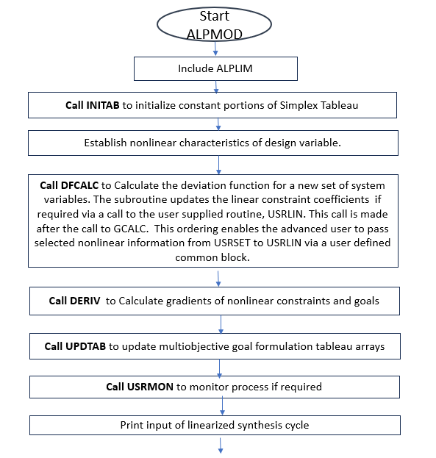
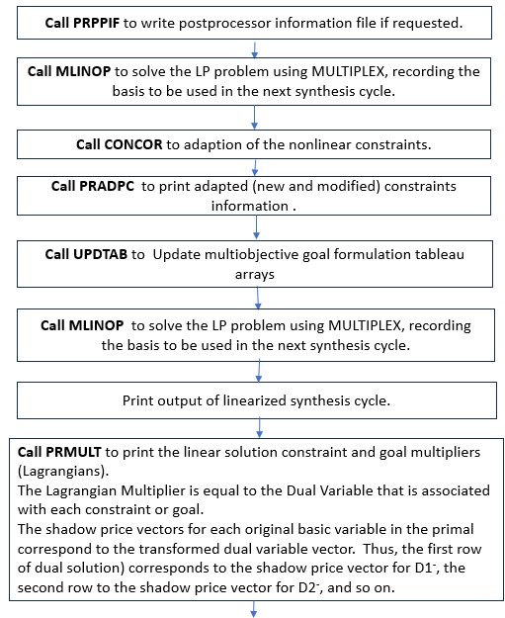
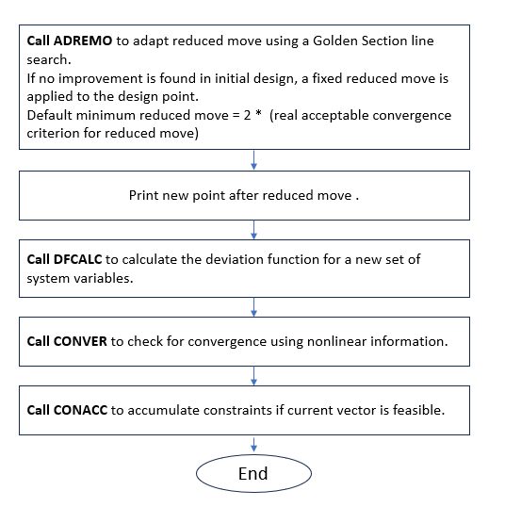
Figure III. 1: General Flowchart of ALPMOD Subroutine
Note about some variables in ALPMOD:
- REDMOV real reduced move step sizes
Variable REDMOV is defined as a real variable(reduced move step sizes), But it is considered as a vector with length MDESV (maximum number of design variables) in the subroutine.
- FRACX real vector: convergence criteria for X, the design variables
- FRACZ real vector: convergence criteria for Z, the deviation function
The FRACX vector has n dimensions, similar to the dimensionality of the vector of variables X. If, in any one or more dimensions, the difference between X_{i} (1 <= i <= n) is less than 0.005 (or 0.5%), then we stop the program. Therefore, FRACX probably means "fraction of X," so it is a percentage of the absolute value of X_{i}.
However, in DSIDES Manual Chapter 9, Section 9.12 (8. STOPCR) (Figure 3.2), the definition is EPSZ (desired stationarity of deviation function) and EPSX (desired stationarity of system variables). EPSZ is not a vector, as the deviation function always yields a single value. Thus, if the difference in Z between two consecutive iterations is no more than 0.02, the program will terminate. However, EPSX, in my understanding, is a vector; if we set it as 0.02, it means when any X_{i} (one dimension of vector X) in two iterations in a row is not more different than 0.02, then we stop the program.
The difference between FRACX and EPSX is that FRACX is the real fractional difference (%), but EPSX is a threshold. For example, see the Notes in Figure 3.2. the program will stop if the real fractional difference is less than or equal to the threshold.
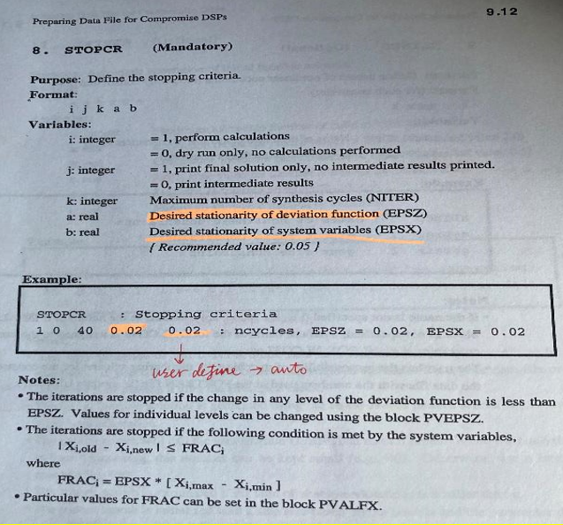
Figure III. 2: Block STOPCR in the DAT file
Following the discussion and representation of the ALPMOD flowchart, the subsequent section is about ALPUTL, which is denoted as ALPUTL in the files but referred to as COPYTX in all other subroutines.

III.2.4 COPYTX (ALPUTL) Subroutine
The main purpose of this subroutine is to copy the contents of the Y (input vector) array into the X (output vector) array. This subroutine is about the synthesis cycle. So it keeps the information of the last cycle and uses it to start the next cycle. For instance, if the user wants to do 20 cycles and now, we are in the 10th cycle, it will save the information on the 10th cycle in an array and pass it to the program to start the 11th cycle.
C Subroutine COPYTX ( ALPUTL)
C
C Purpose: This routine copies the contents of the Y array into the X array.
C
C-----------------------------------------------------------------------
C Arguments Name Type Description
C --------- ---- ---- -----------
C Input: N int length of vectors
C Y real input vector
C
C Output: X real output vector
C
C Input/Output: none
C
C***********************************************************************
C-
SUBROUTINE COPYTX ( N, X, Y)
C
INTEGER N, K
REAL X(N), Y(N)
C
DO 100 K = 1, N
X(K) = Y(K)
100 CONTINUE
C
RETURN

III.2.5 ALPCTL Subroutine and Its Flowchart
This subroutine is the main program for DSIDES and is a central module that other subroutines will invoke. By comprehending this subroutine, users can gain a clearer insight into the overall functionality and operation of the program. The flowchart and outline of the sequence of execution for the ALPCTL subroutine has been displayed in Figure III.3, and the subroutine is in the appendix since it is a long subroutine.
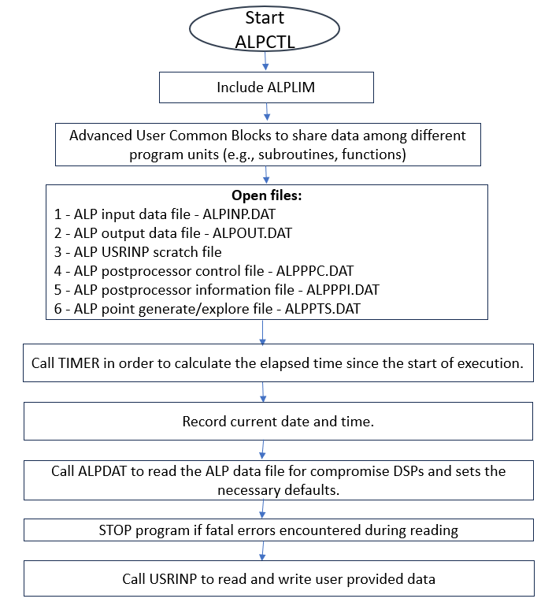
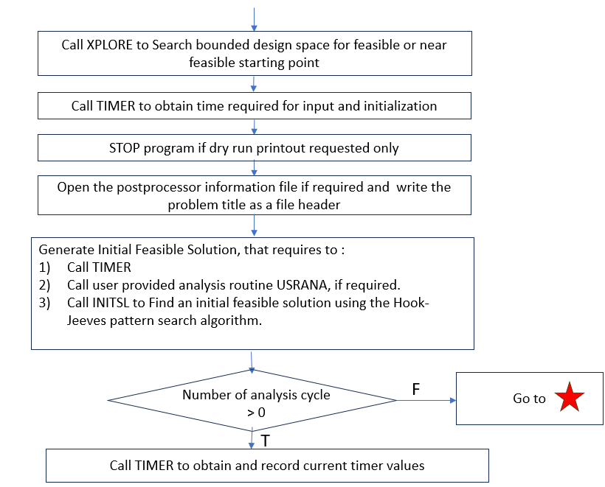
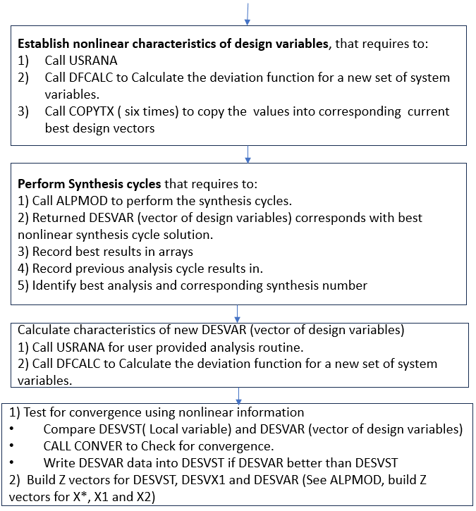
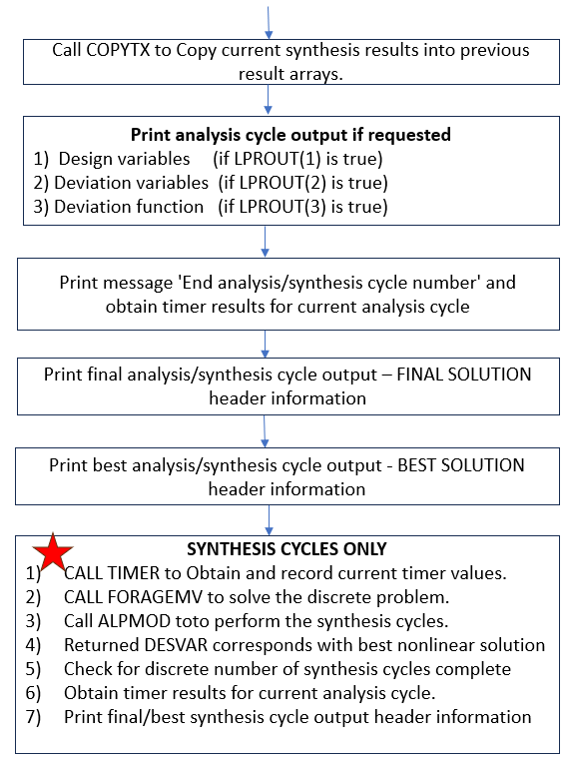
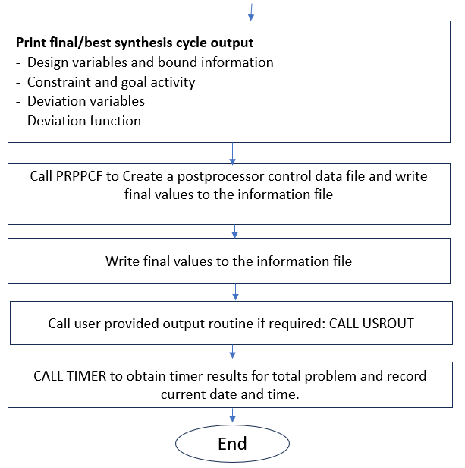
Figure III. 3: Flowchart of ALPCTL Subroutine

Summary OF Part 3:
In this part, we have covered the main input subroutines and also reviewed all the subroutines and their purpose. This part could be helpful for anyone who has a plan to improve and consider changes in the program in the future. All the subroutines are located on the server of the System Realization Laboratory in OU. ( Following address in the server of SRL lab : C:\Sara_DSIDES )

Summary of Thesis
The summary section of my thesis comprises five distinct components: the preamble, an introduction and an overview of the three main parts, a thesis layout flowchart, and closing remarks.
1: Preamble:
When dealing with complex systems, we need to consider that these systems have behaviors that are hard to predict or control, and uncertainties are always present since computational models are abstracts of reality. It is recognized that in many situations, it may not be possible to simultaneously optimize all objectives due to inherent conflicts, resource limitations, or uncertainty. Also, as George E.P. Box said: "All models are wrong, but some are useful." The consequences of these observations are significant. We need to accept that our models might not capture everything and that uncertainties are a part of the picture. Hence, we must accept and deal with uncertainty instead of ignoring it and find solutions that are relatively insensitive to the uncertainties.
When choosing a method to work with, we need to consider the quality and the amount of our data. To make this all work, we need a method to find solutions that achieve a reasonable compromise or balance among the objectives and identify a set of solutions that are relatively insensitive to uncertainties. Also, be able to facilitate the exploration of solution space to support human decision-making. This ties into the problems we face in supporting decisions for complex systems. These problems involve choosing between options and making compromises.
The compromise Decision Support Problem (cDSP) construct, and the Adaptive Linear Programming algorithm has been developed as a result, which was first introduced by Mistree and co-authors (1993). It is a domain-independent, multiobjective decision model based on mathematical and goal programming. They effectively deal with multiobjective problems involving bounds, linear and nonlinear constraints, goals, and consisting of Boolean and continuous variables. The requirements for this construct are:
1) Identify a set of solutions that are relatively insensitive to uncertainties.
2) Facilitate the exploration of solution space to support human decision-making.
Why do We Use Satisfying Strategy?
We choose a satisfying strategy because it is more flexible and realistic and we are able to manage uncertainty to give robust design. The fact that our math isn't perfect is acknowledged by the satisficing strategy, but it is still capable of assisting us in crafting robust designs. In contrast, the optimizing strategy is based on the assumption that math is flawless and necessitates the fulfillment of specific conditions, which may not always align with circumstances.
In the context of the difference between optimization and satisficing in terms of assumptions regarding the KKT conditions, we present Summary Figure 1.
Gradient based optimization means we must reach both necessary and sufficient KKT conditions, which contain 3 different assumptions for optimizing strategy:
1) The mathematical models are 100% complete and accurate abstraction of physical problems. ( Only using in optimization). It is like thinking our math is always right, even though we know it is not always true. With optimizing, when we find the best solution, we believe it'll work perfectly in any problem, any time, any situation, because our math is perfect.
2) All equations of the problems are differentiable. (Common for satisfying strategy and optimizing strategy). This condition is integral to mathematical programming, as it necessitates the utilization of first or second-order derivatives to facilitate solution derivation.
In essence, the need for differentiability across all equations in the problem is underscored by this assumption.
3) the convexity degree of at least one nonzero linear combination of all constraints is higher than the convexity degree of objective function. ( Only using in optimization). This specific assumption becomes relevant when an optimizing approach is chosen, indicating that a higher level of convexity than the primary objective function is exhibited by certain constraints.

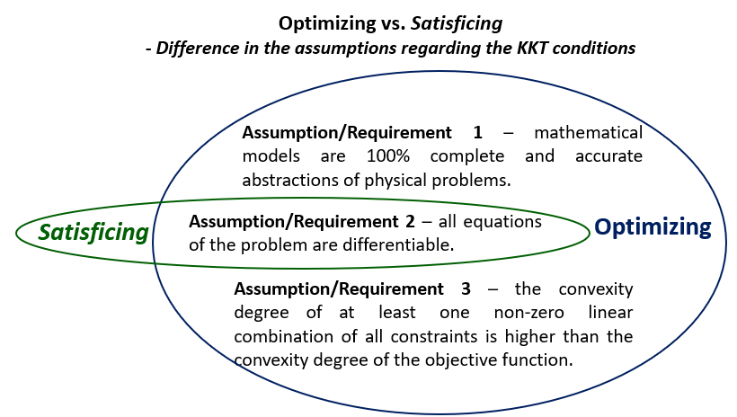
Summary Figure 1: Comparison of Optimization and Satisficing Assumptions Regarding KKT Conditions
Relation Between The Optimal, Satisficing, And Near-Optimal Solutions:
As it is represented in Summary Figure 2 , in the quest for an optimal solution, the use of KKT conditions is crucial, demanding adherence to both necessary and sufficient KKT conditions. In this, the satisfaction of the first-order conditions and the Lagrange function is entailed, with these being key components. Additionally, there are sufficient KKT conditions, represented in the second-order Lagrange function, which must be met.
In contrast, satisfying solutions remain solely to the necessary KKT conditions, typically represented by the first Lagrange equation. Another concept, frequently encountered in evolutionary and generic algorithms, is the 'near-optimal’ solution. These solutions, although falling short of optimality, exhibit minimal distance from the optimal solution. The exact definition of 'near' optimal varies depending on the context.
Interestingly, the encompassing of optimal solutions by satisfying solutions can occur, as the sufficient KKT conditions may be unintentionally met by some satisfying solutions. Typically, these solutions are often outperformed by most near-optimal ones due to their proximity to the optimal solution. Consequently, the concept of 'good enough' is defined.
In contrast, the objective of optimization is to reach the peak of a precise model. However, it is important to know that sometimes the model itself can be flawed.Now, in the context of the satisfying strategy, as implemented in cDSP, we shift our focus to a flat region. It is not a pinpoint spot but more like an area. Our aim is to consistently include this 'ball' within that flat area. This approach ensures that we always have a solution that works and is practical.
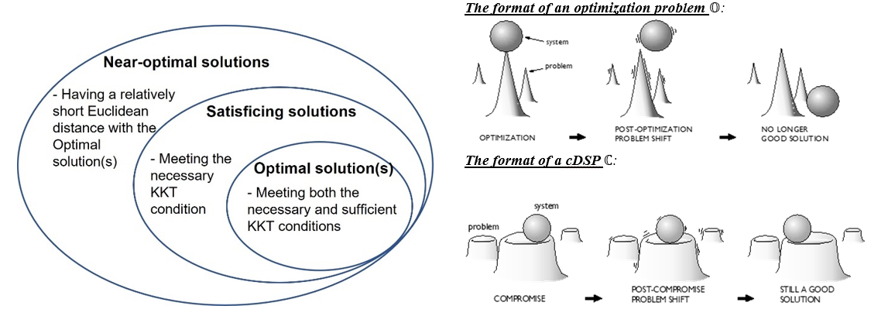
Summary Figure 2: Relation between the optimal, satisficing, and near-optimal solutions

A summary of the unique features of satisficing in terms of its application to managing engineering design problems at each step has been presented in Summary Table 1.

Summary Table 1: Summary of Satisficing in Managing Engineering Design Problems at Each Step
Stage | Feature | Advantage
Formulation | Using Goals and Minimizing Deviation Variables Instead of Objectives | At a solution point, only the necessary KKT conditions are met, whereas the sufficient KKT conditions do not have to be met.  Therefore, designers have a higher chance of finding a solution and a lower chance of losing a solution due to parameterizable and unparameterizable uncertainties.
Approximation | Using second-order sequential linearization | Designers can have a balance between linearization accuracy and computational complexity.
Approximation | Using accumulated linearization | Designers can manage nonconvex problems in a way, and deal with highly convex, nonlinear problems relatively more accurately.
Exploration | Combining interior-point searching and vertex searching | Designers can avoid being stuck into local optimum to some extent and identify satisficing solutions relatively insensitive to starting points changing.
Evaluation | Allowing some violations of soft requirements, such as the bounds of deviation variables | Designers can manage rigid requirements and soft requirements in different ways to ensure feasibility.  As a result, goals and constraints with different scale can be managed

Mistree and co-authors designed a computer program to implement cDSP construct. It has been written in FORTRAN to identify robust satisficing solutions to design problems when the models are abstractions of reality. It is called DSIDES (Decision Support in the Design of Engineering Systems).
DSIDES is a software tool developed to help engineers and designers make better decisions in the design of complex engineering systems and provides decision support for the design of complex engineering systems.
In this thesis, our primary objective is to enhance the accessibility and user-friendliness of DSIDES by designing a user-friendly wrapper. Three key areas of focus are included in this thesis:
- Exploration of cDSP Construct: In this part, the examination of the cDSP (Compromise Decision Support Problem) construct, including its structural components and the formulation of problem statements within the cDSP framework, has been discussed.
- Comprehensive Analysis of the DSIDES Wrapper: A detailed exploration of the DSIDES wrapper and a step-by-step walkthrough of the wrapper's functionalities are covered.
- DSIDES Software Program Manuals: Program manuals for DSIDES software are provided. These manuals are helpful resources for individuals seeking to enhance, expand, or modify the software.
2: Introduction and Overview of Three Parts
As mentioned earlier, a complex system has emergent properties that cannot be predicted or controlled, and uncertainties are always present since computational models are abstracts of reality; they cannot eliminate uncertainties that are a significant factor in any design problem. Therefore, we need to accept the incompleteness of the models, manage the uncertainty embodied therein, and identify a set of solutions that are relatively insensitive to uncertainties. Also, it could facilitate the exploration of solution space to support human decision-making. The compromise Decision Support Problem(cDSP) and the Adaptive Linear Programming algorithm have been developed, which was first introduced by Mistree and co-authors (1993).
They also designed a computer program to implement cDSP construct. It has been developed in FORTRAN to identify robust satisficing solutions to design problems when the models are abstractions of reality. It is called DSIDES (Decision Support in the Design of Engineering Systems).
Our focus in this thesis is on designing a user-friendly interface for DSIDES, providing information on the software, the necessary information to work with it effectively, and program manuals to improve the software for future use. Based on that, there are three different parts to this thesis:
- Part One: DSIDES Software and cDSP Construct: An Introduction.
- Part Two: Designing the User-Friendly Wrapper for DSIDES.
- Part Three: Program Manuals and Improvement of DSIDES
Overview of Part 1: DSIDES Software and cDSP Construct: An Introduction.
In the first part of this thesis, enhanced information about the compromise Decision Support Problem (cDSP) and formulation of a problem in cDSP, including Archimedean and preemptive forms in detail with some examples, a short description about DSIDES software and platform of DSIDES are provided. Upon reading the first part, the reader will have learned the necessary information to formulate a problem in cDSP, allowing them to start using the software effectively.
Overview of Part 2: Designing the User-Friendly Wrapper for DSIDES
In the second part of this thesis, the main focus is on the user-friendly interface that has been designed for DSIDES. In this part, detailed information about how to work with the wrapper effectively, including implementing the formulated cDSP construct into the DSIDES wrapper to find solutions that are relatively insensitive to uncertainty, is provided. This section also includes an interpretation of the output results and verification and validation for the software. To this end, three problems are presented that demonstrate how to start from scratch, formulate the problem in cDSP, and finally implement the problem in the wrapper. This Section is a useful document for users to practice and learn how to use the DSIDES wrapper effectively.
Overview of Part 3: Program Manuals and Improvement of DSIDES
In the third part of this thesis, the program manuals, flowcharts, coding, and information about input subroutines in DSIDES are provided. The main focus of this part is on providing information about the input files and their respective purposes. The objective is to simplify their comprehension of the users by presenting their flowcharts. Additionally, other subroutines that are called through the main files will be covered in this part. This information is necessary for users who want to improve the software and understand how the programs work. In this part, readers will have access to the necessary information to improve the software and their work in the future. (The focal objective of this Section is to consolidate all the functions and subroutines of DSIDES in a single location for documentation purposes.)
3: Thesis Layout Flowchart
An understanding of the organization and flow of the thesis is offered by an illustrative representation in Figure A, in which its sequential structure is outlined. A concise overview of the chapters, sections, and their interconnections is provided within this illustrative representation to enhance clarity and facilitate navigation.
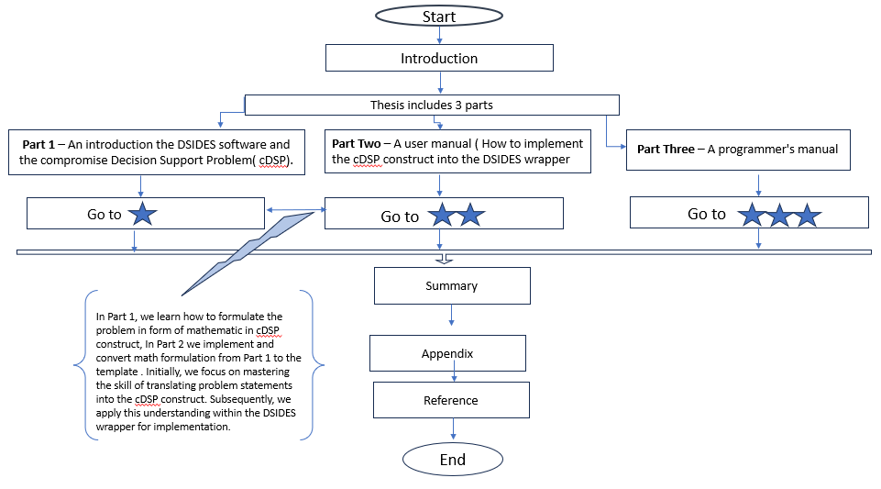
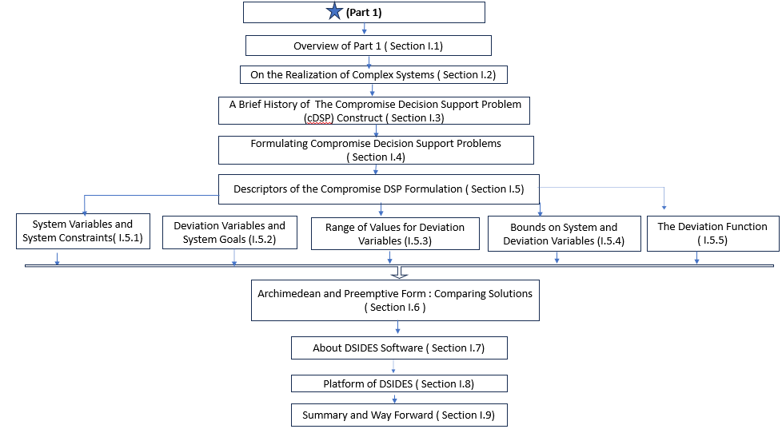
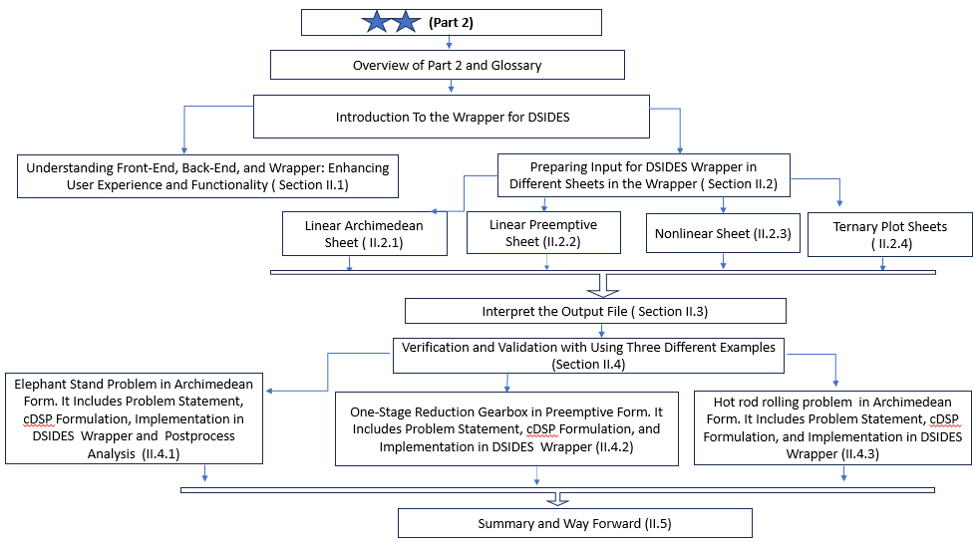
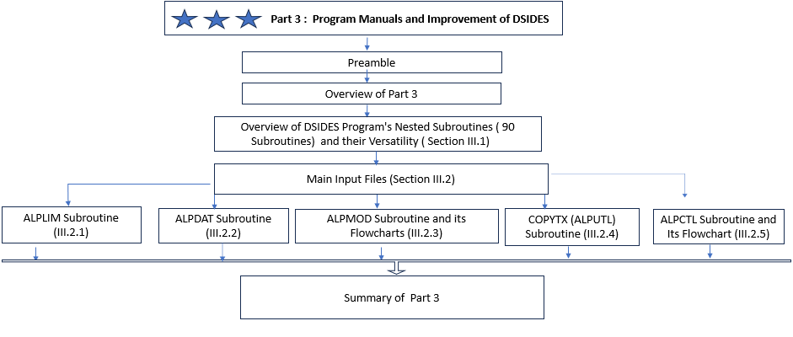
Summary Figure 3: Flowchart of Thesis Layout
After providing an overview of the thesis layout through the flowchart presentation, the detailed table of contents is presented in the subsequent section to enumerate all sections and subsections.

5: Closing Remarks
Our goal in this thesis is the development of a user-friendly Wrapper for DSIDES software, with a focus on addressing the challenges posed by uncertainty and complexity in design problems. Within the field of engineering design, a significant contribution is sought through the integration of MATLAB and Excel to facilitate the exploration of the solution space, supporting human decision-making.
Multiobjective problems, which encompass bounds, linear and nonlinear constraints, goals, and a combination of Boolean and continuous variables, are effectively managed by the software. Substantial impact is expected, encompassing improvements in efficiency, increased productivity, and an enhanced user experience in engineering design. Furthermore, validation of the software's performance and functionality, utilizing both empirical and theoretical methods, ensures reliability and efficiency. In summary, this thesis's contribution lies in the provision of a practical and efficient solution to tackle the challenges associated with uncertainty and complexity in engineering design.

Appendix

ALPMOD Subroutine:
For this subroutine, one detailed flowchart and the program are added here.

Detailed Flowchart of ALPMOD:
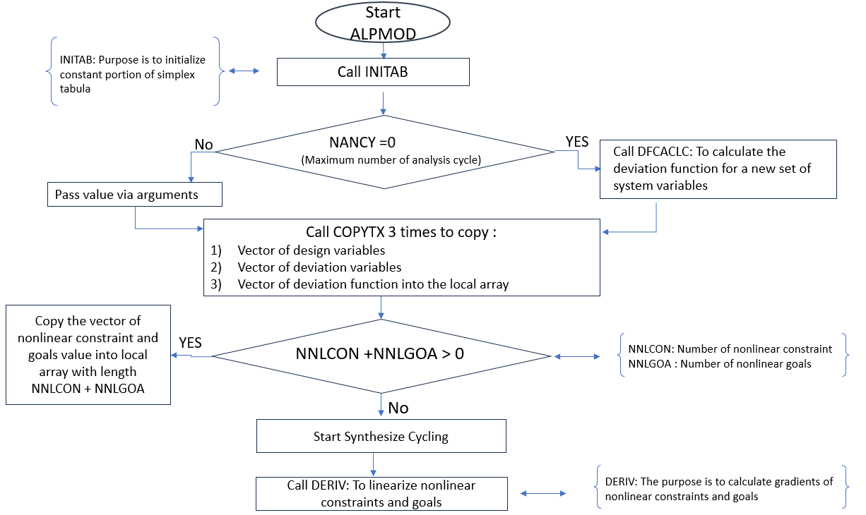
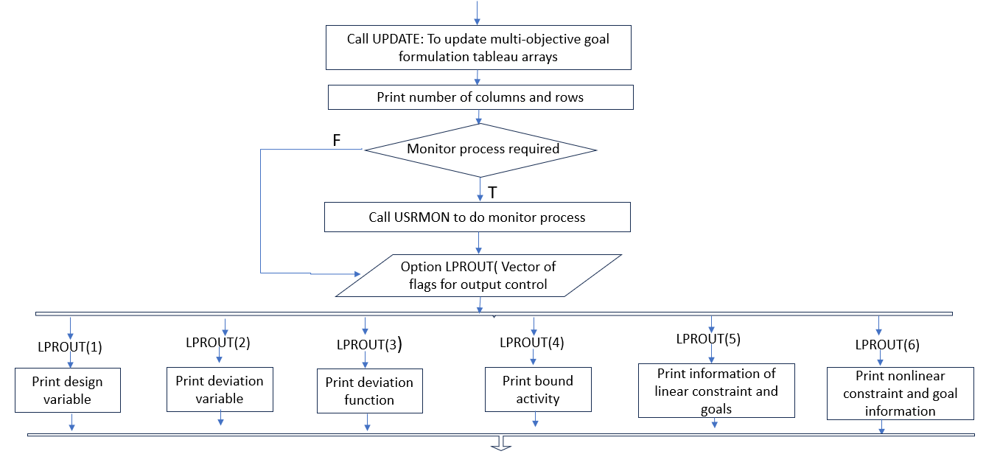
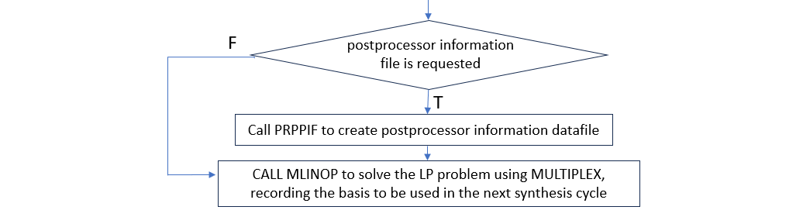
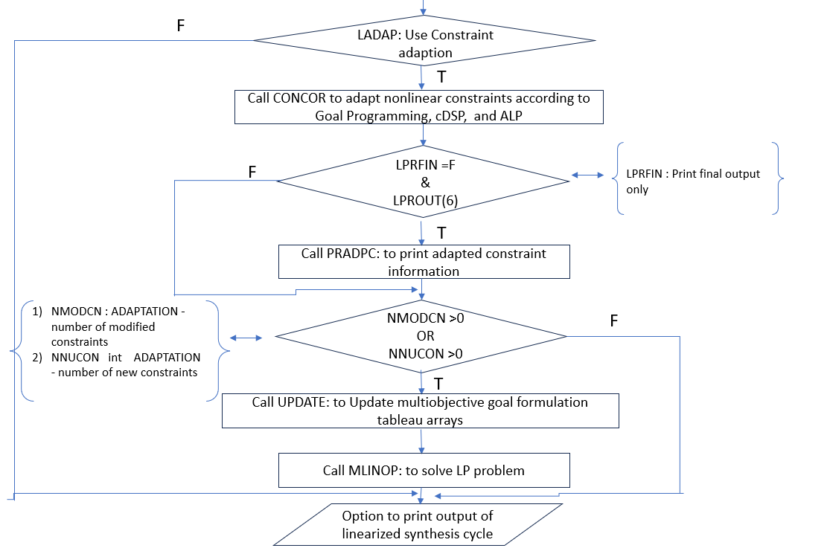
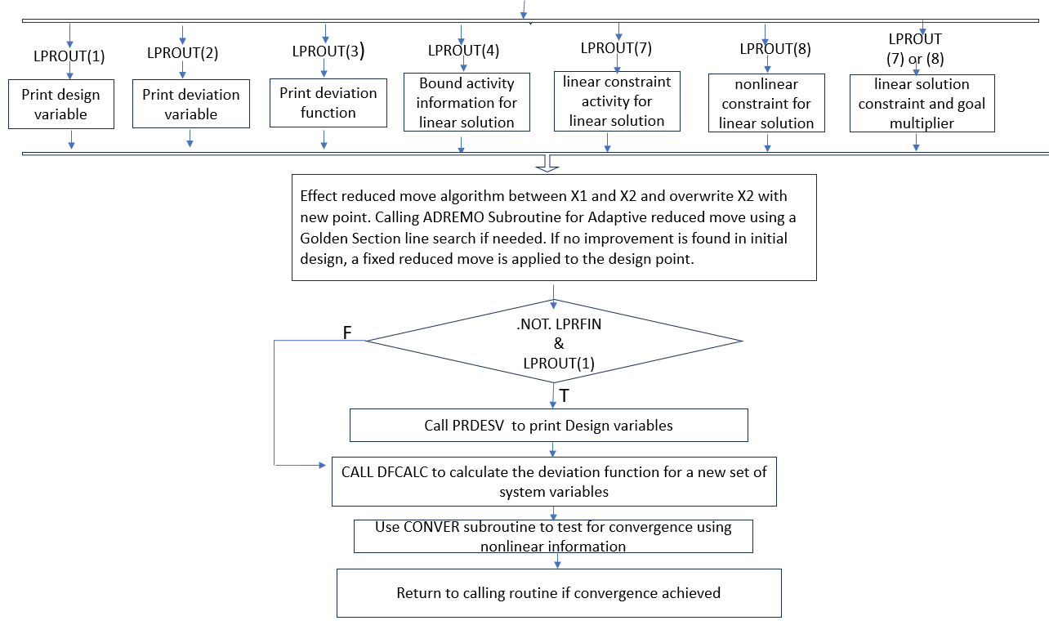

Summary Figure 4: Detailed Flowchart of ALPMOD

ALPMOD Subroutine:
+
C***********************************************************************
C
C Subroutine ALPMOD
C
C Purpose: Perform the synthesis cycles
C
C-----------------------------------------------------------------------
C Arguments Name Type Description
C --------- ---- ---- -----------
C Input: NANCY int maximum number of analysis cycles
C performed
C INUMAN int analysis cycle number
C NTITER int total number of iterations performed
C NUOUT int unit number of output data file
C NUPPI int unit number of postprocessor
C information data file
C NRELV int number of real (continuous) variables
C NVINT int number of integer variables
C NVSEL int number of selection (Boolean)
C variables
C NDESV int number of design variables
C NDEVAR int number of deviation variables
C NLINCO int number of linear constraints
C NLINGO int number of linear goals
C NNLINQ int number of nonlinear inequalities
C constraints
C NNLEQU int number of nonlinear equalities
C constraints
C NNLCON int number of nonlinear constraints
C NNLGOA int number of nonlinear goals
C NNLTOT int total number of nonlinear constraints
C and goals
C NMPRI int number of goal priority levels
C NSYCY int vector indicating the maximum number
C of synthesis cycles performed within
C each analysis cycle
C IACTVR int vector of flags for active variables
C IADCON int vector of flags for admissible
C nonlinear constraints
C = 0 if suppressed by user
C = J if admissible
C = -n if suppressed by program
C LISIGN int vector indicating sign for linear
C inequality constraints
C JSYCY int synthesis cycle number corresponding
C to X* (within a given analysis cycle)
C NADREM int ADREMO - maximum number of calls to
C be made to GCALC
C CONDEV real total constraint violation
C DELREM real acceptable convergence criterion for
C reduced move
C COFLIN real matrix of coefficients of linear
C constraints and goals
C DESVAR real vector of design variables
C DFNCOF real matrix of weights for deviation
C function
C DEVFUN real vector of deviation function values
C DEVVAR real vector of deviation variables
C FRACX real vector: convergence criteria for X,
C the design variables
C FRACZ real vector: convergence criteria for Z,
C the deviation function
C GVAL real vector of nonlinear constraint and
C goal values
C PESTEP real vector of perturbation steps for
C nonlinear constraints and goals
C REDMOV real reduced move step sizes
C RHSLIN real vector of RHS values for linear
C constraints and goals
C VBOUNS real matrix of lower and upper bounds for
C design variables
C VILCN real vector of acceptable nonlinear
C constraint violations
C LADAP lgcl use constraint adaptation
C LADREM lgcl use adaptive reduced move
C LMON lgcl call user supplied subroutine USRMON
C LVCOF lgcl call user supplied subroutine USRLIN
C LPRFIN lgcl print final output only
C LPROUT lgcl vector of flags for output control
C LPPROC lgcl create ALP postprocessor files
C LCONDF lgcl TRUE if deviation function converged
C LCONSV lgcl TRUE if design variables converged
C LIMPRV lgcl TRUE if point 2 is better than point 1
C IDDESV chr6 vector of design variable names
C IDDEVR chr6 vector of deviation variable names
C IDLICO chr6 vector of linear constraint names
C IDLIGO chr6 vector of linear goal names
C IDNLCO chr6 vector of nonlinear constraint names
C IDNLGO chr6 vector of nonlinear goal names
C
C Output:
C
C Input/Output:
C
C-----------------------------------------------------------------------
C Common Blocks: none
C
C Include Files: alplim.cmm
C
C Calls to:
C-----------------------------------------------------------------------
C Development History
C
C Author: Warren Smith
C Date: November 15, 1991
C
C Modifications: Bert Bras, July 13, 1993.
C Added NRFIX for INITAB() and MLINOP().
C Added MODIF() for PRNLNC().
C
C***********************************************************************
C-NVINT---KL** Watch changing all NVINT to NDISV
C NVINT int number of integer variables
C *************KL NDISV int number of discrete variables (inc. integer)

C
SUBROUTINE ALPMOD (NANCY, INUMAN, NTITER, NUOUT, NUPPI,
& NRELV, NDISV, NVSEL, NDESV, NDEVAR,
& NLINCO, NLINGO,
& NNLINQ, NNLEQU, NNLCON, NNLGOA, NNLTOT,
& NMPRI, NSYCY, IACTVR, IADCON, LISIGN,
& JSYCY, NADREM,
& CONDEV, DELREM,
& COFLIN, DESVAR, DFNCOF,
& DEVFUN, DEVVAR, FRACX, FRACZ, GVAL,
& PESTEP, REDMOV, RHSLIN, VBOUNS, VILCN,
& LADAP, LADREM, LMON, LVCOF, LPRFIN, LPROUT,
& LPPROC, LCONDF, LCONSV, LIMPRV,
& IDDESV, IDDEVR, IDLICO, IDLIGO, IDNLCO, IDNLGO)
C
INCLUDE 'alplim.cmm'
C
C---------------------------------------
C Arguments:
C---------------------------------------
C
INTEGER NANCY, INUMAN, NTITER, NUOUT, NUPPI,
& NRELV, NDISV, NVINT, NVSEL, NDESV, NDEVAR,
& NLINCO, NLINGO, NNLINQ, NNLEQU, NNLCON, NNLGOA, NNLTOT,
& NMPRI, NSYCY, IACTVR(MDESV), IADCON(MNLNCG), LISIGN(MLINCG),
& JSYCY, NADREM
C
REAL CONDEV, DELREM,
& COFLIN(MLINCG,MDESV), DESVAR(MDESV), DFNCOF(MLEVEL,MDEVV),
& DEVFUN(MLEVEL), DEVVAR(MDEVV),
& FRACX(MDESV), FRACZ(MLEVEL),
& GVAL(MNLNCG), PESTEP(MDESV), REDMOV(MDESV),
& RHSLIN(MLINCG), VBOUNS(2,MDESV), VILCN(MNLNCG)
C
LOGICAL LADAP, LADREM, LMON, LVCOF,
& LPRFIN, LPROUT(8), LPPROC,
& LCONDF, LCONSV, LIMPRV
C
CHARACTER*6 IDDESV(MDESV), IDDEVR(MDEVV), IDLICO(MLINCG),
& IDLIGO(MLINCG), IDNLCO(MNLNCG), IDNLGO(MNLNCG)
C
C---------------------------------------
C Local variables:
C---------------------------------------
C
INTEGER INUMSY, IPATH, J, JJ, KON1, NFIX, NRFIX, NCOL, NROW,
& NACCUM, NDEVUS, NDVUSR, NMODCN, NNLCUS, NNLGUS,
& NNUCON, NOUT, NPRUSR, NZ, MODIF(MNLNCG),
& MODCON(MNLNCG), MODGDX(MNLNCG,MDESV), MODSEQ(MNLNCG),
& NEWCON(MNLNCG), NEWDG(MNLNCG,MDESV), NEWSEQ(MNLNCG),
& NACCIT(MAXACC), NACCON(MAXACC)
C
REAL CONVX1, CONVX2, DELTA, DUMCON,
& AMATX(MGOLMX,MVARMX), BLO(MVARMX), BUP(MVARMX),
& BRHS(MGOLMX), CTWO(MLEVEL,MVARMX), CONVEX(MNLNCG),
& DESVX1(MDESV), DESVX2(MDESV),
& DEVVX1(MDEVV), DEVVX2(MDEVV),
& DFUNX1(MLEVEL), DFUNX2(MLEVEL),
& DG(MNLNCG,MDESV), DGTNGT(MNLNCG,MDESV),
& D2GDX2(MNLNCG,MDESV),
& DGACC(MAXACC,MDESV), DGNEW(MNLNCG,MDESV),
& DJMAT(MLEVEL,MVARMX),
& DUMDEV(MDEVV), DUMDFN(MLEVEL),
& DUMGVL(MNLNCG), DUMVAR(MDESV),
& GVALX1(MNLNCG), GVALX2(MNLNCG),
& RHS(MNLNCG), RHSACC(MAXACC), RHSNEW(MNLNCG),
& XVAL(MVARMX), ZVAL(MLEVEL),
& ZSTAR(MLEVEL), Z1(MLEVEL), Z2(MLEVEL)
C
LOGICAL LPRCOV, LCOVIL
C
C***********************************************************************
C
C Initializations
C ---------------
C
C Initialize accumulation constraint counter, NACCUM
NACCUM = 0
C
C Initialize the synthesis cycle number corresponding to X*
JSYCY = 0
NVINT = 0
C
C
C Initialize constant portions of Simplex Tableau
C (CTWO, AMATX, BUP, BLO)
C - CALL INITAB

C Subroutine INITAB
C
C Purpose: Initialize constant portions of Simplex Tableau
C - BUP, BLO, AMATX, BRHS and CTWO

C
CALL INITAB (NDESV, NRELV, NDISV, NDEVAR,
& NLINCO, NLINGO, NMPRI, NNLGOA,
& IACTVR, LISIGN,
& COFLIN, DFNCOF, RHSLIN, VBOUNS, LVCOF,
& NFIX, NRFIX, AMATX, BLO, BUP, BRHS, CTWO)
C
C
C Establish nonlinear characteristics of DESVAR.
C (DESVAR and its associated arrays (CONDEV, DEVFUN, DEVVAR,
C GVAL) correspond to the current best design (X*))
C - CALL DFCALC
C (if NANCY = 0; otherwise values are passed in via argument)
C
IF ( NANCY .EQ. 0 ) THEN
IPATH = 1
LPRCOV = .TRUE.
LCOVIL = .FALSE.

C Subroutine DFCALC
C
C Purpose: Calculate the deviation function for a new set of
C system variables.
C
C IPATH = 1: Evaluate both constraints and goals
C Return CONDEV and DEVFUN(CONDEV real total constraint violation
DEVFUN real vector of deviation function values

C IPATH = 2: Evaluate constraints only
C Return CONDEV
C IPATH = 3: Evaluate goals only
C Return DEVFUN
C
C (The subroutine updates the linear constraint coefficients
C if required via a call to the user supplied routine, USRLIN.
C This call is made after the call to GCALC. This ordering
C enables the advanced user to pass selected nonlinear information
C from USRSET to USRLIN via a user defined common block.)

C
CALL DFCALC (NUOUT, IPATH, NDESV, NMPRI,
& NLINCO, NLINGO, NNLINQ, NNLCON, NNLGOA,
& IADCON, LISIGN, LPRCOV, LCOVIL, LVCOF,
& COFLIN, RHSLIN, DESVAR, DFNCOF, VILCN,
& CONDEV, DEVFUN, DEVVAR, GVAL)
ENDIF
C
C Copy values into corresponding X1 arrays
C - i.e., CONVX1, DESVX1, DEVVX1, DFUNX1 AND GVALX1
C
CONVX1 = CONDEV
CALL COPYTX (NDESV, DESVX1, DESVAR)
CALL COPYTX (NDEVAR, DEVVX1, DEVVAR)
CALL COPYTX (NMPRI, DFUNX1, DEVFUN)
IF ( NNLCON+NNLGOA .GT. 0 ) THEN
CALL COPYTX (NNLCON+NNLGOA, GVALX1, GVAL)
ENDIF
C
C
C Start Synthesis Cycling
C -----------------------
DO 1000 INUMSY = 1, NSYCY
C
NTITER = NTITER + 1
NNUCON = 0
C
C Print header 'cycle number(s)'
C
IF ( .NOT. LPRFIN ) THEN
IF ( NANCY .EQ. 0 ) THEN
WRITE (NUOUT, 1010) INUMSY
ELSE
WRITE (NUOUT, 1020) INUMAN, INUMSY
ENDIF
ENDIF
C
C
C Linearize nonlinear constraints and goals
C - CALL DERIV (Purpose: Calculate gradients of nonlinear constraints and goals)

C
CALL DERIV (NUOUT, NDESV, NNLCON, NNLGOA, NVSEL, IACTVR,
& DESVX1, GVALX1, PESTEP, VBOUNS,
& IADCON, KON1, MODIF,
& CONVEX, DG, DGTNGT, D2GDX2, RHS)
C
C
C Update multiobjective goal formulation tableau arrays
C (AMATX, CTWO, RHS)
C - CALL UPDTAB

C Subroutine UPDTAB
C
C Purpose: Update multiobjective goal formulation tableau arrays:
C
C Arrangement of rows in A and RHS matrices:
C Linear goals NLINGO
C Nonlinear goals NNLGOA
C Linear constraints NLINCO
C Nonlinear inequality constraints NNLINQ
C Nonlinear equality constraints NNLEQU
C Nonlinear accumulated constraints NACCUM
C Nonlinear new (adapted) constraints NNUCON
C
C NOTE: Bounds are not considered explicitly.
C
C Arrangement of rows in CTWO matrix:
C Constraint deviation coefficients 1
C Goal deviation coefficients 2 to (NMPRI+1)

C
CALL UPDTAB (NACCUM, NDESV, NLINCO, NLINGO, NNLEQU,
& NNLGOA, NNLINQ, NNUCON,
& IACTVR, IADCON, NEWCON,
& COFLIN, DG, DGACC, DGNEW,
& RHS, RHSACC, RHSLIN, RHSNEW,
& LVCOF,
& NCOL, NROW,
& AMATX, BRHS, CTWO)
C print *,"after UPDTAB, NCOL = ",NCOL
C print *,"NROW = ",NROW
C
C
C Monitor process if required
C - CALL USRMON
C
IF ( LMON ) THEN
NDVUSR = NDESV
NDEVUS = NDEVAR
NPRUSR = NMPRI
NNLCUS = NNLCON
NNLGUS = NNLGOA
NOUT = NUOUT
DUMCON = CONVX1
CALL COPYTX (NDESV, DUMVAR, DESVX1)
CALL COPYTX (NDEVAR, DUMDEV, DEVVX1)
CALL COPYTX (NMPRI, DUMDFN, DFUNX1)
IF ( NNLCON+NNLGOA .GT. 0 ) THEN
CALL COPYTX (NNLCON+NNLGOA, DUMGVL, GVALX1)
ENDIF
C
CALL USRMON (NDVUSR, NDEVUS, NPRUSR, NNLCUS, NNLGUS, NOUT,
& DUMVAR, DUMDEV, DUMCON, DUMDFN, DUMGVL)
ENDIF
C
C
C Print input of linearized synthesis cycle
C - Design variables (if LPROUT(1) is true)
C - Deviation variables (if LPROUT(2) is true)
C - Deviation function (if LPROUT(3) is true)
C - Bound information (if LPROUT(4) is true)
C - Linear constraint coefficients (if LPROUT(5) is true)
C - Nonlinear constraint coefficients (if LPROUT(6) is true)
C
IF ( .NOT. LPRFIN ) THEN
WRITE (NUOUT, 1030)
IF ( CONVX1 .EQ. 0.0 ) THEN
WRITE (NUOUT, 1040)
ELSE
WRITE (NUOUT, 1050)
ENDIF
IF ( LPROUT(1) ) THEN
CALL PRDESV (NUOUT,INUMSY, IDDESV, DESVX1, NDESV)
ENDIF
IF ( LPROUT(2) ) THEN
CALL PRDEVV (NUOUT, INUMSY, NLINGO, NNLGOA,
& DEVVX1, IDLIGO, IDNLGO, IDDEVR)
ENDIF
IF ( LPROUT(3) ) THEN
CALL PRDFUN (NUOUT, INUMSY, NMPRI, NDEVAR,
& CONVX1, DFUNX1)
ENDIF
IF ( LPROUT(4) .AND. INUMSY .EQ. 1 ) THEN
CALL PRBNDS (NUOUT, INUMSY, NDESV,
& VBOUNS, DESVX1, IDDESV)
ENDIF
IF ( LPROUT(5) ) THEN
CALL PRLINC (NUOUT, INUMSY, NDESV, NLINCO, NLINGO,
& COFLIN, LISIGN, RHSLIN, IDDESV,
& IDLICO, IDLIGO, IDDEVR)
ENDIF
IF ( LPROUT(6) ) THEN
CALL PRNLNC (NUOUT, INUMSY, IADCON, MODIF, NDESV, NNLTOT,
& NACCUM, NNLINQ, NNLEQU, NLINGO, NNLGOA,
& NACCON, GVALX1, DG, DGACC,
& DESVX1, RHS, RHSACC,
& IDDESV, IDNLCO, IDNLGO, IDDEVR)
ENDIF
ENDIF
C
C
C Write postprocessor information file if requested
C - Call PRPPIF
C
IF ( LPPROC ) THEN
CALL PRPPIF (NSYCY, NTITER, NDESV, NDEVAR,
& NNLINQ, NNLEQU, NNLGOA, NMPRI,
& CONVX1, DESVX1, DFUNX1, DEVVX1,
& GVALX1, RHS, DG, DGTNGT, D2GDX2)
ENDIF
C
C
C Solve LP problem, exit with X2
C - CALL MLINOP(Solve the LP problem using MULTIPLEX, recording the basis to be used in the next synthesis cycle.)
C
CALL MLINOP (NUOUT, NCOL, NDESV, NFIX, NRFIX,
& NMPRI, NROW, NVSEL,
& AMATX, BLO, BUP, BRHS, CTWO,
& DJMAT, XVAL, ZVAL)
C
C Write XVAL into DESVX2
C
JJ = 0
DO 10 J = 1, NDESV
IF ( IACTVR(J) .GT. 0 ) THEN
JJ = JJ + 1
DESVX2(J) = XVAL(JJ)
ELSE
DESVX2(J) = DESVAR(J)
ENDIF
10 CONTINUE

C
C
C Adapt constraints if requested
C - CALL CONCOR (Subroutine CONCOR performs the adaption of the nonlinear constraints according to: “Goal Programming, the Compromise Decision Support Problem and Adaptive Linear Programming"

C
IF ( LADAP ) THEN
C
CALL CONCOR (NDESV, NNLINQ, NRELV, IACTVR, IADCON,
& CONVEX, DESVX1, DESVX2, DG, DGTNGT, D2GDX2,
& RHS,
& NMODCN, NNUCON,
& MODCON, MODGDX, MODSEQ,
& NEWCON, NEWDG, NEWSEQ,
& DGNEW, RHSNEW)
C
C
C Print adapted (new and modified) constraints if requested
C - supplimentary input
C
IF ( .NOT. LPRFIN .AND. LPROUT(6) ) THEN
CALL PRADPC (NUOUT, INUMSY, NDESV, NMODCN, NNUCON,
& MODCON, MODGDX, NEWCON, NEWDG,
& GVALX1, DG, DGNEW, RHSNEW, RHS, DESVX1,
& IDDESV, IDNLCO)
ENDIF
C
C
IF ( (NMODCN .GT. 0) .OR. (NNUCON .GT. 0) ) THEN
C
C
C Update multiobjective goal formulation tableau arrays
C (AMATX, CTWO, RHS)
C - CALL UPDTAB
C
CALL UPDTAB (NACCUM, NDESV, NLINCO, NLINGO, NNLEQU,
& NNLGOA, NNLINQ, NNUCON,
& IACTVR, IADCON, NEWCON,
& COFLIN, DG, DGACC, DGNEW,
& RHS, RHSACC, RHSLIN, RHSNEW,
& LVCOF,
& NCOL, NROW,
& AMATX, BRHS, CTWO)
C
C
C Solve LP problem ,exit with new X2
C - CALL MLINOP ( Purpose: Solve the LP problem using MULTIPLEX, recording the basis to be used in the next synthesis cycle. Algorithm has integer (branch and bound variation) capability to handle 0/1 "selection" variables.

C
CALL MLINOP (NUOUT, NCOL, NDESV, NFIX, NRFIX,
& NMPRI, NROW, NVSEL,
& AMATX, BLO, BUP, BRHS, CTWO,
& DJMAT, XVAL, ZVAL)
C
C
C Write XVAL into DESVX2
C
JJ = 0
DO 20 J = 1, NDESV
IF ( IACTVR(J) .GT. 0 ) THEN
JJ = JJ + 1
DESVX2(J) = XVAL(JJ)
ELSE
DESVX2(J) = DESVAR(J)
ENDIF
20 CONTINUE

C
ENDIF
C
ENDIF
C
C
C Write DEVVX2, CONVX2 and DFUNX2 corresponding to the
C linear solution
C
DO 30 J = 1, NDEVAR
JJ = JJ + 1
DEVVX2(J) = XVAL(JJ)
30 CONTINUE
CONVX2 = ZVAL(1)
DO 40 J = 2, NMPRI + 1
DFUNX2(J-1) = ZVAL(J)
40 CONTINUE
C
C Print output of linearized synthesis cycle
C - Design variables (if LPROUT(1) is true)
C - Deviation variables (if LPROUT(2) is true)
C - Deviation function (if LPROUT(3) is true)
C - Bound activity (linear) (if LPROUT(4) is true)
C - Linear constraint activity (linear) (if LPROUT(7) is true)
C - Nonlinear constraint activity (linear) (if LPROUT(8) is true)
C
C - Shadow Prices/Dual Variables/Multipliers
C (if LPROUT(7) is true .OR. LPROUT(8) is true)
C
IF ( .NOT. LPRFIN ) THEN
WRITE (NUOUT, 1060)
IF ( LPROUT(1) ) THEN
WRITE (NUOUT, 1061)
CALL PRDESV (NUOUT,INUMSY, IDDESV, DESVX2, NDESV)
ENDIF
IF ( LPROUT(2) ) THEN
WRITE (NUOUT, 1061)
CALL PRDEVV (NUOUT, INUMSY, NLINGO, NNLGOA,
& DEVVX2, IDLIGO, IDNLGO, IDDEVR)
ENDIF
IF ( LPROUT(3) ) THEN
WRITE (NUOUT, 1061)
CALL PRDFUN (NUOUT, INUMSY, NMPRI, NDEVAR,
& CONVX2, DFUNX2)
ENDIF
IF ( LPROUT(4) ) THEN
WRITE (NUOUT, 1061)
CALL PRBNDS (NUOUT, INUMSY, NDESV,
& VBOUNS, DESVX2, IDDESV)
ENDIF
IF ( LPROUT(7) ) THEN
WRITE (NUOUT, 1061)
CALL PRLINA (NUOUT, INUMSY, NDESV, NLINCO,
& NLINGO, LISIGN, DESVX2, COFLIN,
& DEVVX2, RHSLIN, IDLICO, IDLIGO)
ENDIF
IF ( LPROUT(8) ) THEN
WRITE (NUOUT, 1061)
CALL PRNLNA (NUOUT, INUMSY, NDESV, NNLINQ, NNLEQU,
& NNLTOT, NACCUM, NLINGO, MODCON, MODGDX,
& NEWCON, NEWDG, NACCON, IADCON,
& DG, DGNEW, DGACC, RHS, DESVX2, DEVVX2,
& RHSNEW, RHSACC, IDNLCO, IDNLGO)
ENDIF
C IF ( LSHPRC ) THEN
C Subroutine PRMULT (Purpose: Print the linear solution constraint and goal multipliers
C (Lagrangians)
C The Lagrangian Multiplier is equal to the Dual Variable
C that is associated with each constraint or goal.
C
C The shadow price vectors for each original basic variable
C (i.e., the Dn- variables) in the primal correspond to the
C transformed dual variable vector. Thus, the first row of
C Y* (dual solution) corresponds to the shadow price vector
C for D1-, the second row to the shadow price vector for
C D2-, and so on.

IF ( LPROUT(7) .OR. LPROUT(8) ) THEN
WRITE (NUOUT, 1061)
CALL PRMULT(NDESV, NFIX, NMPRI, NUOUT, INUMSY,
& NACCUM, NLINCO, NLINGO, NNLEQU,
& NNLGOA, NNLINQ, NNUCON,
& IADCON, NACCON, NEWCON, DJMAT,
& IDLICO, IDLIGO, IDNLCO, IDNLGO)
ENDIF
C ENDIF
ENDIF
C
C
C Effect reduced move algorithm between X1 and X2
C and overwrite X2 with new point
C Subroutine ADREMO
C Purpose: Adaptive reduced move using a Golden Section line search.
C If no improvement is found in initial design, a fixed
C reduced move is applied to the design point.
C
C Default minimum reduced move = 2 * DELREM
(DELREM = real acceptable convergence criterion for reduced move)

C
IF ( LADREM ) THEN
C
CALL ADREMO (NUOUT, NDESV, NRELV, NMPRI,
& NNLINQ, NLINCO, NLINGO, NNLCON, NNLGOA,
& IADCON, LISIGN, LVCOF, COFLIN, RHSLIN,
& DFNCOF, VILCN, NADREM, DELREM, CONVX1,
& DESVX1, DESVX2, DFUNX1, DFUNX2)
C
ELSE
C
IF ( NRELV+NDISV .GT. 0 ) THEN
DO 50 J = 1, NRELV+NDISV+NVINT
IF ( IACTVR(J) .GT. 0 ) THEN
DELTA = ( DESVX2(J) - DESVX1(J) ) * REDMOV(J)
IF ( J .GT. (NRELV+NDISV) ) THEN
DELTA = FLOAT(INT(DELTA + 0.5))
ENDIF
DESVX2(J) = DESVX1(J) + DELTA
ENDIF
50 CONTINUE
ENDIF
ENDIF
C
C
C Print new point after reduced move if requested
C - Design variables (if LPROUT(1) is true)
C
IF ( .NOT. LPRFIN .AND. LPROUT(1) ) THEN
WRITE (NUOUT, 1070)
CALL PRDESV (NUOUT,INUMSY, IDDESV, DESVX2, NDESV)
ENDIF
C
C
C Establish nonlinear characteristics of X2
C GVALX2 and DFUNX2
C - CALL DFCALC
C
IPATH = 1
LPRCOV = .TRUE.
LCOVIL = .FALSE.
C
CALL DFCALC (NUOUT, IPATH, NDESV, NMPRI,
& NLINCO, NLINGO, NNLINQ, NNLCON, NNLGOA,
& IADCON, LISIGN, LPRCOV, LCOVIL, LVCOF,
& COFLIN, RHSLIN, DESVX2, DFNCOF, VILCN,
& CONVX2, DFUNX2, DEVVX2, GVALX2)
C
C
C Subroutine CONVER
C
C Purpose: Check for convergence. This is done in several steps.
C
C Given X1 the current starting vector (with dev. fun. = Z1)
C X2 the new vector (with dev. fun. = Z2)
C & X* the best vector (with dev. fun. = Z* found at iteration J*)
C
C 1. Check for convergence of deviation function.
C 2. Check for convergence of design variables.
C 3. If X2 is better than X1, move X1 to X2.
C 4. If X1 is better than X*, move X* to X1 and J* to J2.

C Test for convergence using nonlinear information
C - compare X1 and X2
C - CALL CONVER
C - Write X2 data into X1
C - Write X1 data into X* if X1 better than X*
C [- DESVAR == X*
C - DEVFUN == DEVFUN of (X*)
C - GVAL == GVAL of (X*)]
C
C Build Z vectors for X*, X1 and X2
C
ZSTAR(1) = CONDEV
Z1(1) = CONVX1
Z2(1) = CONVX2
DO 60 J = 2, NMPRI + 1
ZSTAR(J) = DEVFUN(J-1)
Z1(J) = DFUNX1(J-1)
Z2(J) = DFUNX2(J-1)
60 CONTINUE
NZ = NMPRI + 1
C
CALL CONVER (NDESV, NZ, INUMSY,
& JSYCY, DESVAR, DESVX1, DESVX2,
& ZSTAR, Z1, Z2,
& FRACX, FRACZ,
& LCONSV, LCONDF, LIMPRV)
C
CONVX1 = Z2(1)
CALL COPYTX (NDESV, DESVX1, DESVX2)
CALL COPYTX (NDEVAR, DEVVX1, DEVVX2)
DO 70 J = 2, NMPRI + 1
DFUNX1(J-1) = Z2(J)
70 CONTINUE
IF ( NNLCON+NNLGOA .GT. 0 ) THEN
CALL COPYTX (NNLCON+NNLGOA, GVALX1, GVALX2)
ENDIF
C
IF ( JSYCY .EQ. INUMSY ) THEN
CONDEV = ZSTAR(1)
CALL COPYTX (NDEVAR, DEVVAR, DEVVX1)
DO 80 J = 2, NMPRI + 1
DEVFUN(J-1) = ZSTAR(J)
80 CONTINUE
IF ( NNLCON+NNLGOA .GT. 0 ) THEN
CALL COPYTX (NNLCON+NNLGOA, GVAL, GVALX1)
ENDIF
ENDIF
C
C
C Return to calling routine if convergence achieved
C
IF ( LCONSV .AND. LCONDF ) THEN
C
GOTO 1001
C
ELSE
C
C Accumulate constraints if X1 is feasible
C - CALL CONACC
C
IF ( CONVX1 .EQ. 0.0 ) THEN
C
CALL CONACC (INUMSY, NACCUM, NDESV, NNLINQ, NNUCON,
& IADCON, NACCIT, NACCON, NEWCON,
& CONVEX, DG, DGNEW, RHS, RHSNEW,
& LADAP,
& DGACC, RHSACC)
C
ENDIF
ENDIF
C
1000 CONTINUE
C
1001 CONTINUE
C
C
C Return to calling routine
C
C
RETURN
C
C***********************************************************************
C FORMATS
C
1010 FORMAT ('1',' S Y N T H E S I S C Y C L E'
& ' N U M B E R: ',I3/,
& ' ',' -----------------------------'
& '-------------------')
1020 FORMAT ('1',' A N A L Y S I S C Y C L E'
& ' N U M B E R: ',I3/,
& ' ',' ---------------------------'
& '-------------------'//,
& ' ',' S Y N T H E S I S C Y C L E'
& ' N U M B E R: ',I3/,
& ' ',' -----------------------------'
& '-------------------')
1030 FORMAT (/' ',' *** I N P U T ***'/
& ' ',' ---------------------')
1040 FORMAT (/' ',' Current point is FEASIBLE'/
& ' ',' .........................'//)
1050 FORMAT (/' ',' Current point is INFEASIBLE'/
& ' ',' ...........................'//)
1060 FORMAT (//' ',' *** O U T P U T F R O M L I N E A R '
& 'S O L V E R ***'/
& ' ',' --------------------------------------------'
& '-----------------'///)
1061 FORMAT (' << Reminder: Following output is from linear solver >>')
1070 FORMAT (//' ',' *** O U T P U T A F T E R R E D U C E D '
& 'M O V E ***'/
& ' ',' ------------------------------------------------'
& '-------------'///)
C
C***********************************************************************
C End of Subroutine ALPMOD
C***********************************************************************
C
END

ALPCTL Subroutine

C
C Program ALPCTL
C
C Purpose: A main program for DSIDES: SLIPML Version 4.80 /
C ALP Release 1.0
C
C-----------------------------------------------------------------------
C Common Blocks: ADVUS1/ IDV, IPERTB
C
C IDV int index of design variable being
C perturbed
C IPERTB int flag indicating current perturbation
C = 1 if 1st (for 1st order approx.)
C = 2 if 2nd (for 2nd order approx.)
C
C INTFLAG int Number of calls to foraging search for
C discrete variables: Kemper Lewis
C
C
C ADINTE/ NRELV, NDISV, NVSEL, NDESV, NDVUSR, NDEVAR,
C NLINCO, NLINGO, NMPRI,
C NNLINQ, NNLEQU, NNLCON, NNLGOA, NNLTOT
C
C
C ADREAL/ VBOUNS
C
C
C ADLOGI/ LMON, LUINP, LUOUT, LVCOF
C
C
C ADCHAR/ PTITLE,
C IDDESV, IDDEVR, IDLICO, IDLIGO, IDNLCO, IDNLGO
C
C
C Include Files: alplim.cmm
C
C Calls to: TIMER, ALPDAT, USRINP, XPLORE, USRANA, COPYTX, INITSL,
C DFCALC, ALPMOD, CONVER, PRDESV, PRDEVV, PRDFUN, DISCRT,
C PRBNDS, PRPPCF, PRFACT, and USROUT
C-----------------------------------------------------------------------
C Development History
C
C Author: Warren Smith
C Date: November 15, 1991
C
C Modifications:
C June 16, 1993 (Bert Bras):
C - Correction of user analysis cycle convergence check
C
C***********************************************************************
C-
PROGRAM ALPCTL
C
INCLUDE 'alplim.cmm'
C
C---------------------------------------
C Advanced User Common Blocks:
C---------------------------------------
C
COMMON/ADVUS1/ IDV, IPERTB

INTEGER IDV, IPERTB

INTEGER INTFLAG
C
C
C *****KL added NDISV in all commons
COMMON/ADINTE/ NRELV, NDISV, NVSEL, NDESV, NDVUSR, NDEVAR,
& NLINCO, NLINGO, NMPRI,
& NNLINQ, NNLEQU, NNLCON, NNLGOA, NNLTOT
INTEGER NRELV, NDISV, NVINT, INDEX(MDESV),
& NVSEL, NDESV, NDVUSR, NDEVAR, NDSCC(MDESV)
INTEGER NLINCO, NLINGO, NMPRI
INTEGER NNLINQ, NNLEQU, NNLCON, NNLGOA, NNLTOT
C
C
COMMON/ADREAL/ VBOUNS(2,MDESV)
REAL VBOUNS
C
C
COMMON/ADLOGI/ LMON, LUINP, LUOUT, LVCOF
LOGICAL LMON, LUINP, LUOUT, LVCOF
C
C
COMMON/ADCHAR/ PTITLE,
& IDDESV, IDDEVR, IDLICO, IDLIGO, IDNLCO, IDNLGO
CHARACTER*80 PTITLE(2)
CHARACTER*6 IDDESV(MDESV), IDDEVR(MDEVV), IDLICO(MLINCG),
& IDLIGO(MLINCG), IDNLCO(MNLNCG), IDNLGO(MNLNCG)
C
C---------------------------------------
C Other Local variables:
C---------------------------------------
C
INTEGER NUINP, NUOUT, NUPPC, NUPPI, NUSER, NOUT, NUSR
INTEGER NANCY, NSYCY(MNANCY), NTITER
INTEGER NHJMAX, NADREM
INTEGER IACTVR(MDESV), IADCON(MNLNCG), LISIGN(MLINCG)
INTEGER IGSEED, NPTBST, NPTGEN, NUPTS, IGENFX(MDESV)
INTEGER I, INUMAN, IPATH, J, JANCY, JSYCY, JSYCST, NLEVEL, K
C
REAL DESVAR(MDESV), DUMVAR(MDESV), CONDEV, DEVFUN(MLEVEL),
& DEVVAR(MDEVV), GVAL(MNLNCG), Z2(MLEVEL), TABUN(MDESV,MDSCV)
REAL DESVX1(MDESV), CONVX1, DFUNX1(MLEVEL),
& DEVVX1(MDEVV), Z1(MLEVEL)
REAL DESVST(MDESV), CONVST, DFUNST(MLEVEL), DEVVST(MDEVV),
& GVALST(MNLNCG), ZSTAR(MLEVEL)
REAL COFLIN(MLINCG,MDESV), DFNCOF(MLEVEL,MDEVV),
& FRACX(MDESV), FRACZ(MLEVEL), PESTEP(MDESV), REDMOV(MDESV),
& RHSLIN(MLINCG), VILCN(MNLNCG), GOALS(MNLNCG), CONSTR(MNLNCG)
REAL HJEXPA, HJCONT, HJSTEP, HJEPSY, HJDELT
REAL DELREM
C
LOGICAL LFATAL, LDRYRN, LPRFIN, LPROUT(8), LPPROC, LADREM, LADAP,
& LINIT, LPRGEN, LTIME, LXPLOR
LOGICAL LCONDF, LCDF, LCONSV, LCSV, LIMPRV, LXFEAS
LOGICAL LPRCOV, LCOVIL, LVDISC
C
CHARACTER CURTIM*24, TIMCOM*75
REAL INITIM(3), EXETIM(3)
C
C***********************************************************************
C ******* WARNING *******
C
C ****** INPUT AND OUTPUT UNIT NUMBER ASSIGNMENTS ******
C
NUINP = 11
NUOUT = 13
NUSER = 99
NUPPC = 98
NUPPI = 97
NUPTS = 96
C
C Open files:
C 1 - ALP input data file - ALPINP.DAT (Unit # NUINP)
C 2 - ALP output data file - ALPOUT.DAT (Unit # NUOUT)
C 3 - ALP USRINP scratch file (Unit # NUSER)
C 4 - ALP postprocessor control file - ALPPPC.DAT (Unit # NUPPC)
C 5 - ALP postprocessor information file - ALPPPI.DAT (Unit # NUPPI)
C 6 - ALP point generate/explore file - ALPPTS.DAT (Unit # NUPTS)
C
OPEN (UNIT=NUOUT, FILE='ALPOUT.DAT', ACCESS='SEQUENTIAL',
& FORM='FORMATTED', STATUS='UNKNOWN')
C
CSYS********************************************************************
CSYS ******* WARNING *******
CSYS
CSYS ******* SYSTEM DEPENDENT ROUTINES *******
CSYS
CSYS The routine TIMER is system dependent.
CSYS
CSYS NUOUT : unit number of output data file
CSYS KODE : indicates the timer option to be used.
CSYS CURTIM : contains the current date plus time and is CHARACTER*24
CSYS TIMCOM : contains an input string to be printed with the timer
CSYS results
CSYS EXETIM : returns the time in (CPU)seconds.
CSYS The contents of EXETIM may differ when the system
CSYS is installed on different operating systems.
CSYS Check the comments in the timer routine for an
CSYS explanation of the contents of EXETIM.
CSYS INITIM : contains a reference time used to calculate
CSYS the elapsed time since the start of execution.
CSYS
CSYS The initial time (starting time) is stored in INITIM.
CSYS This initial time may be required by subroutine TIMER in
CSYS order to calculate the elapsed time since the start of
CSYS execution. For instance, this is required
CSYS for the VAX/VMS timer routine, but not for the Sun/OS timer
CSYS routine
CSYS
CSYS
CURTIM = ' '
TIMCOM = ' '
CSYS
CALL TIMER ( NUOUT, 2, TIMCOM, CURTIM, INITIM, INITIM )
CSYS
CSYS********************************************************************
C
C Record current date and time.
C
CALL TIMER ( NUOUT, 0, TIMCOM, CURTIM, INITIM, EXETIM )
C
C Write output program title block
C
WRITE (NUOUT, 1010) CURTIM
WRITE (NUOUT, 1020)
WRITE (NUOUT, 1030)
WRITE (NUOUT, 1031) MDESV, MLINCG, MNLNCG, MAXACC,
& MLEVEL, MNSYCY, MNANCY, MTITER,
& MATTRB, MSELPR, MPTBST
WRITE (NUOUT, 1020)
C
C
C Initializations
C ---------------
C
IDV = 0
IPERTB = 0
C
C Read in control information and initialize values
C - Call ALPDAT
C
OPEN (UNIT=NUINP, FILE='ALPINP.DAT', ACCESS='SEQUENTIAL',
& FORM='FORMATTED', STATUS='OLD')
C
OPEN (UNIT=NUSER, STATUS='SCRATCH',
& FORM='FORMATTED', ACCESS='SEQUENTIAL')
C
CALL ALPDAT (NUOUT, NUINP, NUSER,
& NRELV, NDISV, NVINT, TABUN, NDSCC, INDEX, NVSEL,
$ NDESV, NDEVAR,
& NLINCO, NLINGO, NMPRI,
& NNLCON, NNLEQU, NNLGOA, NNLINQ, NNLTOT,
& NANCY, NSYCY,
& NHJMAX, NADREM, IACTVR, IADCON, LISIGN,
& NPTGEN, NPTBST, IGSEED, IGENFX,
& IDDESV, IDDEVR, IDLICO, IDLIGO, IDNLCO, IDNLGO,
& PTITLE, COFLIN, RHSLIN, DFNCOF,
& PESTEP, REDMOV, VBOUNS, DESVAR,
& HJEXPA, HJCONT, HJSTEP, HJEPSY, HJDELT, DELREM,
& FRACZ, FRACX, VILCN,
& LFATAL, LDRYRN, LPRFIN,
& LPROUT, LPPROC, LTIME, LADREM, LADAP, LINIT,
& LMON, LUINP, LUOUT, LVCOF, LXPLOR, LPRGEN, LVDISC)
C
CLOSE (NUINP)
C
C STOP program if fatal errors encountered during reading
C
IF ( LFATAL ) THEN
CLOSE (NUSER)
GOTO 9999
ENDIF
C
C
C Read and write user provided data
C - Call USRINP
C
IF ( LUINP ) THEN
REWIND (NUSER)
NDVUSR = NDESV
NUSR = NUSER
NOUT = NUOUT
CALL COPYTX (NDESV, DUMVAR, DESVAR)
CALL USRINP (NDVUSR, NUSR, NOUT, DUMVAR)
ENDIF
C
CLOSE (NUSER)
C
C
C Search bounded design space for feasibile or near feasible
C starting point
C - Call XPLORE
C
IF ( LXPLOR ) THEN
OPEN (UNIT=NUPTS, FILE='ALPPTS.DAT', ACCESS='SEQUENTIAL',
& FORM='FORMATTED', STATUS='UNKNOWN')
C
CALL XPLORE (IGSEED, NDESV, NLINCO, NLINGO, NMPRI, NNLINQ,
& NNLCON, NNLGOA, NPTBST, NPTGEN, NUOUT, NUPTS,
& IADCON, IGENFX, LISIGN,
& COFLIN, DFNCOF, RHSLIN, VBOUNS, VILCN,
& LPRGEN, LVCOF, IDDESV, PTITLE,
& DESVAR)
C
CLOSE (NUPTS)
ENDIF
C
C
C End of input and initialization
C Obtain timer results if required
C
IF ( LTIME ) THEN
TIMCOM = 'Time required for input and initialization:'
CALL TIMER ( NUOUT, -1, TIMCOM, CURTIM, INITIM, EXETIM )
ENDIF
C
C
C STOP program if dry run printout requested only
C
IF ( LDRYRN ) THEN
IF ( LUOUT ) THEN
NDVUSR = NDESV
NOUT = NUOUT
CALL COPYTX (NDESV, DUMVAR, DESVAR)
LCDF = .FALSE.
LCSV = .FALSE.
LXFEAS = .FALSE.
CALL USROUT (NDVUSR, NOUT, DUMVAR, LCDF, LCSV, LXFEAS)
ENDIF
WRITE (NUOUT, 1040)
GOTO 9999
ENDIF
C
C
C Open the postprocessor information file if required and
C write the problem title as a file header
C
IF ( LPPROC ) THEN
OPEN (UNIT=NUPPI, FILE='ALPPPI.DAT', ACCESS='SEQUENTIAL',
& FORM='FORMATTED', STATUS='UNKNOWN')
WRITE (NUPPI, *) PTITLE(1)
WRITE (NUPPI, *) PTITLE(2)
ENDIF
C
C
C Generate Initial Feasible Solution
C ----------------------------------
C - Call USRANA (for user supplied/default starting point only)
C - Call INITSL
C
IF ( LINIT ) THEN
IF ( LTIME ) THEN
CALL TIMER ( NUOUT, 2, TIMCOM, CURTIM, INITIM, EXETIM )
ENDIF
C
C Call user provided analysis routine USRANA, if required
C
IF ( NANCY .GT. 0 ) THEN
NDVUSR = NDESV
NOUT = NUOUT
CALL COPYTX (NDESV, DUMVAR, DESVAR)
CALL USRANA (NDVUSR, NOUT, DUMVAR)
ENDIF
C
CALL INITSL (NUOUT, LVCOF, NLINCO, NNLINQ, NNLCON,
& NRELV, NDESV, IACTVR, IADCON,
& NHJMAX, HJEXPA, HJCONT, HJSTEP, HJEPSY, HJDELT,
& DESVAR, VBOUNS, COFLIN, LISIGN, RHSLIN, VILCN,
& CONDEV)
C
WRITE (NUOUT, 1050) CONDEV
IF ( NANCY .GT. 0 ) THEN
WRITE (NUOUT, 1060)
ENDIF
WRITE (NUOUT, 1020)
C
IF ( LTIME ) THEN
TIMCOM = 'Time required for generation of initial solution:'
CALL TIMER ( NUOUT, -3, TIMCOM, CURTIM, EXETIM, EXETIM )
ENDIF
ENDIF
C
C
C
C Perform appropriate cycling
C ---------------------------
C
NTITER = 0
C
C NANCY = NUMBER OF ANALYSIS CYCLES!!

IF ( NANCY .GT. 0 ) THEN
C
C ANALYSIS CYCLES
C '''''''''''''''
C
C Obtain and record current timer values
C
CALL TIMER ( NUOUT, 2, TIMCOM, CURTIM, INITIM, EXETIM )
C
C Establish nonlinear characteristics of DESVAR.
C (DESVST and its associated arrays (CONVST, DFUNST, DEVVST,
C GVAL) correspond to the current best design (X*))
C - Call USRANA
C - Call DFCALC
C
NDVUSR = NDESV
NOUT = NUOUT
CALL USRANA (NDVUSR, NOUT, DESVAR)
C
IPATH = 1
LPRCOV = .TRUE.
LCOVIL = .FALSE.
C
CALL DFCALC (NUOUT, IPATH, NDESV, NMPRI,
& NLINCO, NLINGO, NNLINQ, NNLCON, NNLGOA,
& IADCON, LISIGN, LPRCOV, LCOVIL, LVCOF,
& COFLIN, RHSLIN, DESVAR, DFNCOF, VILCN,
& CONDEV, DEVFUN, DEVVAR, GVAL)
C
C Copy values into corresponding X* arrays
C - i.e., CONVST, DESVST, DEVVST, DFUNST AND GVALST
C
CONVST = CONDEV
CONVX1 = CONDEV
CALL COPYTX (NDESV, DESVST, DESVAR)
CALL COPYTX (NDEVAR, DEVVST, DEVVAR)
CALL COPYTX (NMPRI, DFUNST, DEVFUN)
CALL COPYTX (NDESV, DESVX1, DESVAR)
CALL COPYTX (NDEVAR, DEVVX1, DEVVAR)
CALL COPYTX (NMPRI, DFUNX1, DEVFUN)
IF ( NNLCON+NNLGOA .GT. 0 ) THEN
CALL COPYTX (NNLCON+NNLGOA, GVALST, GVAL)
ENDIF
C
C
JANCY = 0
C
C
C Start Analysis Cycling
C ----------------------
DO 1000 INUMAN = 1, NANCY
C
C
C Perform Synthesis cycles
C - Call ALPMOD
C - Returned DESVAR corresponds with best nonlinear
C synthesis cycle solution
C - Record best results in arrays ....ST()
C - Record previous analysis cycle results in ....X1()
C - JANCY, JSYCST identify best analysis and corresponding
C synthesis number
C
CALL ALPMOD (NANCY, INUMAN, NTITER, NUOUT, NUPPI,
& NRELV, NDISV, NVSEL, NDESV, NDEVAR,
& NLINCO, NLINGO,
& NNLINQ, NNLEQU, NNLCON, NNLGOA, NNLTOT,
& NMPRI, NSYCY, IACTVR, IADCON, LISIGN,
& JSYCY, NADREM,
& CONDEV, DELREM,
& COFLIN, DESVAR, DFNCOF,
& DEVFUN, DEVVAR, FRACX, FRACZ, GVAL,
& PESTEP, REDMOV, RHSLIN, VBOUNS, VILCN,
& LADAP, LADREM, LMON, LVCOF, LPRFIN, LPROUT,
& LPPROC, LCONDF, LCONSV, LIMPRV,
& IDDESV, IDDEVR, IDLICO, IDLIGO, IDNLCO, IDNLGO)
C
C
C Calculate characteristics of new DESVAR
C - Call USRANA
C - Call DFCALC
C
NDVUSR = NDESV
NOUT = NUOUT
CALL USRANA (NDVUSR, NOUT, DESVAR)
C
IPATH = 1
LPRCOV = .TRUE.
LCOVIL = .FALSE.
C
CALL DFCALC (NUOUT, IPATH, NDESV, NMPRI,
& NLINCO, NLINGO, NNLINQ, NNLCON, NNLGOA,
& IADCON, LISIGN, LPRCOV, LCOVIL, LVCOF,
& COFLIN, RHSLIN, DESVAR, DFNCOF, VILCN,
& CONDEV, DEVFUN, DEVVAR, GVAL)
C
C
C Test for convergence using nonlinear information
C - compare DESVST and DESVAR
C - CALL CONVER
C - Write DESVAR data into DESVST
C if DESVAR better than DESVST
C
C Build Z vectors for DESVST, DESVX1 and DESVAR
C (See ALPMOD, build Z vectors for X*, X1 and X2)
C
NLEVEL = NMPRI + 1
ZSTAR(1) = CONVST
Z1(1) = CONVX1
Z2(1) = CONDEV
DO 61 J = 2, NMPRI + 1
ZSTAR(J) = DFUNST(J-1)
Z1(J) = DFUNX1(J-1)
Z2(J) = DEVFUN(J-1)
61 CONTINUE
C
CALL CONVER (NDESV, NLEVEL, INUMAN,
& JANCY, DESVST, DESVX1, DESVAR,
& ZSTAR, Z1, Z2,
& FRACX, FRACZ,
& LCONSV, LCONDF, LIMPRV)
C
IF ( JANCY .EQ. INUMAN ) THEN
JSYCST = JSYCY
CONVST = ZSTAR(1)
CALL COPYTX (NDEVAR, DEVVST, DEVVAR)
DO 81 J = 2, NMPRI + 1
DFUNST(J-1) = ZSTAR(J)
81 CONTINUE
IF ( NNLCON+NNLGOA .GT. 0 ) THEN
CALL COPYTX (NNLCON+NNLGOA, GVALST, GVAL)
ENDIF
ENDIF
C
C Copy current synthesis results into previous result arrays.
C
CONVX1 = CONDEV
CALL COPYTX (NMPRI, DFUNX1, DEVFUN)
CALL COPYTX (NDESV, DESVX1, DESVAR)
CALL COPYTX (NDEVAR, DEVVX1, DEVVAR)
C
C Print analysis cycle output if requested
C - Design variables (if LPROUT(1) is true)
C - Deviation variables (if LPROUT(2) is true)
C - Deviation function (if LPROUT(3) is true)
C
IF ( .NOT. LPRFIN ) THEN
WRITE (NUOUT, 1070) INUMAN
IF ( LPROUT(1) ) THEN
CALL PRDESV (NUOUT, JSYCY, IDDESV, DESVAR, NDESV)
ENDIF
IF ( LPROUT(2) ) THEN
CALL PRDEVV (NUOUT, JSYCY, NLINGO, NNLGOA,
& DEVVAR, IDLIGO, IDNLGO, IDDEVR)
ENDIF
IF ( LPROUT(3) ) THEN
CALL PRDFUN (NUOUT, JSYCY, NMPRI, NDEVAR,
& CONDEV, DEVFUN)
ENDIF
ENDIF
C
C
C Print message 'End analysis/synthesis cycle number' and
C obtain timer results for current analysis cycle
C
WRITE (NUOUT, 1080) INUMAN
IF ( LTIME ) THEN
TIMCOM = 'Time required to complete analysis cycle:'
CALL TIMER ( NUOUT, -3, TIMCOM, CURTIM, EXETIM, EXETIM )
ENDIF
C
IF ( LCONSV .AND. LCONDF ) THEN
C
C Print final analysis/synthesis cycle output - FINAL
C SOLUTION header information
C
WRITE (NUOUT, 1090) (PTITLE(J), J = 1, 2)
WRITE (NUOUT, 1100) JANCY, JSYCST
IF ( CONVST .GT. 0.0 ) THEN
WRITE (NUOUT, 1111)
WRITE (NUOUT, 1113)
WRITE (NUOUT, 1114)
WRITE (NUOUT, 1113)
WRITE (NUOUT, 1115)
ENDIF
GOTO 1001
ENDIF
C
1000 CONTINUE
C
C
C Print best analysis/synthesis cycle output - BEST SOLUTION
C header information
C
WRITE (NUOUT, 1090) (PTITLE(J), J = 1, 2)
WRITE (NUOUT, 1110) JANCY, JSYCST
WRITE (NUOUT, 1111)
WRITE (NUOUT, 1112)
IF ( CONVST .GT. 0.0 ) THEN
WRITE (NUOUT, 1113)
ENDIF
WRITE (NUOUT, 1114)
IF ( CONVST .GT. 0.0 ) THEN
WRITE (NUOUT, 1113)
ENDIF
WRITE (NUOUT, 1112)
WRITE (NUOUT, 1115)
C
C
ELSE
C
C SYNTHESIS CYCLES ONLY
C '''''''''''''''''''''
C
C Obtain and record current timer values.
C
CALL TIMER ( NUOUT, 2, TIMCOM, CURTIM, INITIM, EXETIM )
C
C******Discrete Part of solution -> Call TABU/FORAGING Algorithm
C
IPATH = 1

IF( LVDISC ) THEN
INTFLAG = 1
ELSE
INTFLAG = 50
ENDIF

83 IF (INTFLAG.LT.14) THEN

CALL FORAGEMV(INTFLAG,DESVAR,NDESV,NRELV,NDISV,TABUN, NDSCC,
& IPATH,NNLTOT,NOUT,NNLCON, NNLGOA,
& DFNCOF, NMPRI, INDEX, VBOUNS, IACTVR)

print *,"DESVAR(pre-alp) = ",(DESVAR(I),I=1,NDESV)
C SET INACTIVE vars to discrete ones
DO 82 K=NRELV+1,NRELV+NDISV
IACTVR(K) = 0
82 CONTINUE
ENDIF
C
C
C
C Perform Synthesis cycles
C - Call ALPMOD
C - Returned DESVAR corresponds with best nonlinear solution
C
INUMAN = 0
C
CALL ALPMOD (NANCY, INUMAN, NTITER, NUOUT, NUPPI,
& NRELV, NDISV, NVSEL, NDESV, NDEVAR,
& NLINCO, NLINGO,
& NNLINQ, NNLEQU, NNLCON, NNLGOA, NNLTOT,
& NMPRI, NSYCY, IACTVR, IADCON, LISIGN,
& JSYCY, NADREM,
& CONDEV, DELREM,
& COFLIN, DESVAR, DFNCOF,
& DEVFUN, DEVVAR, FRACX, FRACZ, GVAL,
& PESTEP, REDMOV, RHSLIN, VBOUNS, VILCN,
& LADAP, LADREM, LMON, LVCOF, LPRFIN, LPROUT,
& LPPROC, LCONDF, LCONSV, LIMPRV,
& IDDESV, IDDEVR, IDLICO, IDLIGO, IDNLCO, IDNLGO)

C
C This is to check for discrete number of synthesis cycles complete
C
WRITE (NUOUT,*) "***********************************"
WRITE (NUOUT,*) "This is the end of synthesis cycles.”
WRITE (NUOUT,*) "***********************************"

print *,"DESVAR(post-alp) = ",(DESVAR(I),I=1,NDESV)

IF (INTFLAG.LT.1) THEN
INTFLAG = INTFLAG + 1
goto 83
ENDIF
C
C Obtain timer results for current analysis cycle.
C
CALL USRSET (IPATH, NDESV, MNLNCG, NOUT, DESVAR,
& CONSTR, GOALS)

IF ( LTIME ) THEN
TIMCOM = 'Time required to complete synthesis cycles:'
CALL TIMER ( NUOUT, -3, TIMCOM, CURTIM, EXETIM, EXETIM )
ENDIF
C
C
C Print final/best synthesis cycle output header information
C
WRITE (NUOUT, 1090) (PTITLE(J), J=1,2)
IF ( LCONSV .AND. LCONDF ) THEN
WRITE (NUOUT, 1120) JSYCY
IF ( CONDEV .GT. 0.0 ) THEN
WRITE (NUOUT, 1111)
WRITE (NUOUT, 1113)
WRITE (NUOUT, 1114)
WRITE (NUOUT, 1113)
WRITE (NUOUT, 1115)
ENDIF
ELSE
WRITE (NUOUT, 1130) JSYCY
WRITE (NUOUT, 1111)
WRITE (NUOUT, 1112)
IF ( CONDEV .GT. 0.0 ) THEN
WRITE (NUOUT, 1113)
ENDIF
WRITE (NUOUT, 1114)
IF ( CONDEV .GT. 0.0 ) THEN
WRITE (NUOUT, 1113)
ENDIF
WRITE (NUOUT, 1112)
WRITE (NUOUT, 1115)
ENDIF
C
C
ENDIF
C
1001 CONTINUE
C
C
IF ( NANCY .GT. 0 ) THEN
C
C Copy X* values back into original arrays
C
JSYCY = JSYCST
CONDEV = CONVST
CALL COPYTX (NDESV, DESVAR, DESVST)
CALL COPYTX (NDEVAR, DEVVAR, DEVVST)
CALL COPYTX (NMPRI, DEVFUN, DFUNST)
IF ( NNLCON+NNLGOA .GT. 0 ) THEN
CALL COPYTX (NNLCON+NNLGOA, GVAL, GVALST)
ENDIF
C
ENDIF

C
C Print final/best synthesis cycle output
C - Design variables and bound information
C - Constraint and goal activity
C - Deviation variables
C - Deviation function
C
CALL PRBNDS (NUOUT, JSYCY, NDESV,
& VBOUNS, DESVAR, IDDESV)
CALL PRFACT (NUOUT, JSYCY, NDESV, NLINCO, NLINGO,
& NNLCON, NNLGOA, IADCON,
& COFLIN, DESVAR, GVAL, RHSLIN,
& LVCOF, IDLICO, IDLIGO, IDNLCO, IDNLGO)
CALL PRDEVV (NUOUT, JSYCY, NLINGO, NNLGOA,
& DEVVAR, IDLIGO, IDNLGO, IDDEVR)
CALL PRDFUN (NUOUT, JSYCY, NMPRI, NDEVAR, CONDEV, DEVFUN)
C
IF ( LCONSV .AND. LCONDF ) THEN
IF ( CONDEV .GT. 0.0 ) THEN
WRITE (NUOUT, 1111)
WRITE (NUOUT, 1113)
WRITE (NUOUT, 1114)
WRITE (NUOUT, 1113)
WRITE (NUOUT, 1115)
ENDIF
ELSE
WRITE (NUOUT, 1111)
WRITE (NUOUT, 1112)
IF ( CONDEV .GT. 0.0 ) THEN
WRITE (NUOUT, 1113)
ENDIF
WRITE (NUOUT, 1114)
IF ( CONDEV .GT. 0.0 ) THEN
WRITE (NUOUT, 1113)
ENDIF
WRITE (NUOUT, 1112)
WRITE (NUOUT, 1115)
ENDIF
C
C
C Write postprocessor control file if requested and write
C final values to the information file
C - Call PRPPCF
C
IF ( LPPROC ) THEN
OPEN (UNIT=NUPPC, FILE='ALPPPC.DAT', ACCESS='SEQUENTIAL',
& FORM='FORMATTED', STATUS='UNKNOWN')
C
CALL PRPPCF (NUPPC, PTITLE, NDESV, NDEVAR,
& NMPRI, NNLINQ, NNLEQU, NNLGOA, NTITER,
& VBOUNS, IDDESV, IDDEVR, IDNLCO, IDNLGO)
C
CLOSE (NUPPC)
C
C Write final values to the information file
C
WRITE (NUPPI, *)
WRITE (NUPPI, *) NTITER+1, ' = The Final Solution'
WRITE (NUPPI, *)
DO 30 I = 1, NDESV
WRITE (NUPPI, *) DESVAR(I), ' = desvar(', I, ')'
30 CONTINUE
DO 40 I = 1, NDEVAR
WRITE (NUPPI, *) DEVVAR(I), ' = devvar(', I, ')'
40 CONTINUE
WRITE (NUPPI, *)
WRITE (NUPPI, *) CONDEV, ' = condev'
DO 50 I = 1, NMPRI
WRITE (NUPPI, *) DEVFUN(I), ' = devfun(', I, ')'
50 CONTINUE
DO 60 I = 1, NNLINQ+NNLEQU+NNLGOA
WRITE (NUPPI, *) GVAL(I), ' = gval(', I ,')'
60 CONTINUE
C
CLOSE (NUPPI)
C
ENDIF
C
C
C Perform sensitivity analysis.
C
C IF ( LCONSV .AND. LCONDF .AND. CONDEV .EQ. 0.0 ) THEN
C CALL POSSOL
C ENDIF
C
C
C Call user provided output routine if required
C
IF ( LUOUT ) THEN
IF ( CONDEV .EQ. 0.0 ) THEN
LXFEAS = .TRUE.
ELSE
LXFEAS = .FALSE.
ENDIF
NDVUSR = NDESV
NOUT = NUOUT
CALL COPYTX (NDESV, DUMVAR, DESVAR)
LCDF = LCONDF
LCSV = LCONSV
CALL USROUT (NDVUSR, NOUT, DUMVAR, LCDF, LCSV, LXFEAS)
IF ( LCONSV .AND. LCONDF ) THEN
IF ( CONDEV .GT. 0.0 ) THEN
WRITE (NUOUT, 1111)
WRITE (NUOUT, 1113)
WRITE (NUOUT, 1114)
WRITE (NUOUT, 1113)
WRITE (NUOUT, 1115)
ENDIF
ELSE
WRITE (NUOUT, 1111)
WRITE (NUOUT, 1112)
IF ( CONDEV .GT. 0.0 ) THEN
WRITE (NUOUT, 1113)
ENDIF
WRITE (NUOUT, 1114)
IF ( CONDEV .GT. 0.0 ) THEN
WRITE (NUOUT, 1113)
ENDIF
WRITE (NUOUT, 1112)
WRITE (NUOUT, 1115)
ENDIF
ENDIF
C
C
C Obtain timer results for total problem.
C
9999 CONTINUE
IF (LTIME) THEN
TIMCOM = 'Total time required for problem:'
CALL TIMER ( NUOUT, -1, TIMCOM, CURTIM, INITIM, EXETIM )
ENDIF
C
C
C Record current date and time.
C
CALL TIMER ( NUOUT, 0, TIMCOM, CURTIM, INITIM, EXETIM )
C
WRITE (NUOUT, 1020)
WRITE (NUOUT, 1140) CURTIM
WRITE (NUOUT, 1150)
C
CLOSE (NUOUT)
C
C
C***********************************************************************
C FORMATS
C
1010 FORMAT('1','S L I P M L - JOB BEGUN ON : ', A)
1020 FORMAT(/,' ', 79('*'))
1030 FORMAT(/,
&' SLIPML - Version 4.80, ALP Release 1.0, February 1992'//,
&' Systems Realization Laboratory'/,
&' Design Methods Group'/,
&' The George W. Woodruff School',
& ' of Mechanical Engineering'/,
&' Georgia Institute of Technology',/,
&' Atlanta, Georgia 30332-0405'/
&' United States of America'////
&' Authorship - Farrokh Mistree and friends ...'//
&' Janet Allen Eduardo Bascaran'/
&' Bert Bras Owen Hughes'/
&' Azim Jivan Harsh Karandikar'/,
&' Saiyid Kamal Tim Lyon'/
&' Ravi Reddy Warren Smith'/,
&' Srinivas Vadde',///)
1031 FORMAT(' Problem Size Limits:'//
&' System variables = ',I4/
&' Linear constraints and goals = ',I4/
&' Nonlinear constraints and goals = ',I4/
&' Accumulated constraints = ',I4/
&' Goal priority levels = ', I4/
&' Synthesis cycles = ', I4/
&' Analysis cycles = ', I4/
&' Iterations (synthesis + ananlysis) = ', I4/
&' Selection attributes = ', I4/
&' Selection problems (coupled) = ', I4/
&' Points saved in XPLORE = ', I4)
1040 FORMAT (//,' *** End of dry run data check'/
& ' -------------------------')
1050 FORMAT (//,' ATTEMPT TO GENERATE AN INITIAL FEASIBLE'
& ' SOLUTION'/
& ' ---------------------------------------'
& '---------'//
& ' CONSTRAINT VIOLATION of Generated Point: ',G12.5,/
& ' (considered feasible if violation is zero)'//
& ' The generated point is used as the input point for ',
& ' Synthesis Cycle Number 1')
1060 FORMAT (//,' NOTE: Since USRANA is not called continually during'/
& ' the pattern search procedure, true feasibility'/
& ' of the generated point cannot be guaranteed.'/
& ' The USRANA information derived is only exact for'/
& ' the users initial guess. As the generated'/
& ' point moves further away from the initail'/
& ' guess, the more imprecise the USRANA assumptions'/
& ' may become and the greater the risk that true'/
& ' feasibility is not achieved.')
1070 FORMAT (//' ',' O U T P U T O F A N A L Y S I S C Y C L E'
& ' N U M B E R: ',I3//,
& ' ',' -----------------------------------------------'
& '-------------------')
1080 FORMAT (//' *** End analysis/synthesis cycle number :',I3/
& ' ----------------------------------------')
1090 FORMAT ('1'/,' ', 79('*'),//,A80,/,A80,//,' ', 79('*'))
1100 FORMAT (/,' ','F I N A L S O L U T I O N'/
& ' ','---------------------------'//
& ' ','from: ANALYSIS CYCLE: ',I3,/
& ' ','output of: SYNTHESIS CYCLE:',I3,//
& ' ','CONVERGENCE ACHIEVED ',/
& ' ','(based on variable and deviation function stationarity)'///)
1110 FORMAT (/,' ','B E S T S O L U T I O N without convergence'/
& ' ','-------------------------'//
& ' ','from: ANALYSIS CYCLE: ',I3,/
& ' ','output of: SYNTHESIS CYCLE:',I3,//
& ' ','MAXIMUM NUMBER OF ANALYSIS CYCLES PERFORMED'/
& ' ','CONVERGENCE NOT ACHIEVED ',/
& ' ','(based on variable and deviation function stationarity)'///)
1111 FORMAT (16X,'***********************************************')
1112 FORMAT (16X,/
& 16X,'C O N V E R G E N C E N O T A C H I E V E D',/
& 16X,'C O N V E R G E N C E N O T A C H I E V E D',/
& 16X)
1113 FORMAT (16X,/
& 16X,'F E A S I B I L I T Y N O T A C H I E V E D',/
& 16X,'F E A S I B I L I T Y N O T A C H I E V E D',/
& 16X)
1114 FORMAT (16X,/
& 16X,'W W AAA RRRR N N IIIII N N GGG',/
& 16X,'W W A A R R NN N I NN N G G',/
& 16X,'W W A A R R NN N I NN N G',/
& 16X,'W W AAAAA RRRR N N N I N N N G',/
& 16X,'W W W A A R R N NN I N NN G GG',/
& 16X,'W W W A A R R N NN I N NN G G',/
& 16X,' W W A A R R N N IIIII N N GGG',/
& 16X)
1115 FORMAT (16X,'***********************************************',///)
1120 FORMAT (/,' ','F I N A L S O L U T I O N'/
& ' ','----------------------------'//
& ' ','output of: SYNTHESIS CYCLE:',I3,//
& ' ','CONVERGENCE ACHIEVED ',/
& ' ','(based on variable and deviation function stationarity)'///)
1130 FORMAT (/,' ','B E S T S O L U T I O N without convergence'/
& ' ','-------------------------'//
& ' ','output of: SYNTHESIS CYCLE:',I3,//
& ' ','MAXIMUM NUMBER OF ITERATIONS PERFORMED'/
& ' ','CONVERGENCE NOT ACHIEVED ',/
& ' ','(based on variable and deviation function stationarity)'///)
1140 FORMAT (//' S L I P M L - JOB COMPLETED ON : ', A)
1150 FORMAT (//' ******** End of Computation ********')
C
C***********************************************************************
C End of Program ALPCTL
C***********************************************************************
C
END

References:
- Muster, D. and Mistree, F., "The Decision Support Problem Technique in Engineering Design," The International Journal of Applied Engineering Education, vol. 4, no. 1, pp. 23-33, 1988.

- Jon A. Shupe, Decision-Based Design: Taxonomy and Implementation, PhD Dissertation, University of Houston, May 1988.

- Mistree, F., Smith, W. F. and Bras, B. A., 1993, "A Decision-Based Approach to Concurrent Engineering" in Handbook of Concurrent Engineering, pages 127-158, (H. R. Parsaei and W. Sullivan, Eds.), New York: Chapman & Hall.

- Mistree, F., Smith, W. F., Bras, B., Allen, J. K. and Muster, D., " Decision-Based Design: A Contemporary Paradigm for Ship Design,” Transactions, Society of Naval Architects and Marine Engineers, vol. 98, pp. 565-597, 1990.

- Ignizio, J. P. (1985) Multiobjective Mathematical Programming via the MULTIPLEX Model and Algorithm, European Journal of Operational Research, 22, 338-346.

- Mistree, F., Hughes, O. F. and Bras, B. A., 1993, "The Compromise Decision Support Problem and the Adaptive Linear Programming Algorithm" in Structural Optimization: Status and Promise, pages 247-286, (M. P. Kamat, Ed.), Washington, D.C.: AIAA.

- Warren Smith, “Modeling and Exploration of Ship Systems in the Early Stages of Decision-Based Design,” PhD Dissertation, University of Houston, July 1992, .

- Guo, L, “Model Evolution for the Realization of Complex Systems,” PhD Dissertation, Industrial and Systems Engineering, University of Oklahoma, 2021.

- Mistree, F., Allen, J. K. and Chirehdast, M. (1989). Decision support in the concurrent engineering design of gas turbine engines. Engineering optimization, 14(3), 209-236.

- This paper introduces the concept of DSIDES and its application in the concurrent engineering design of gas turbine engines.

- Mistree, F., & Chen, W. (1990). Satisficing trade-offs in engineering design. ASME Journal of Mechanical Design, 112(2), 223-229.

- This paper discusses the satisficing approach in engineering design and the role of DSIDES in identifying robust satisficing solutions.

- Yang, R. J., & Wang, X. (2005). A method for robust design based on decision support in the design of engineering systems. Journal of Mechanical Science and Technology, 19(5), 1200-1206.

- This paper presents a method for robust design based on DSIDES, highlighting its role in supporting decision-making in engineering systems design.

- Zhao, L., & Chang, X. (2011). Design optimization for manufacturing system based on DSIDES. Advanced Materials Research, 308-310, 672-676.

- This paper discusses the application of DSIDES in the design optimization of manufacturing systems.

- Official DSIDES Website: http://www.mae.ufl.edu/mdo/DSIDES.htm

- The official website provides information about DSIDES, including its features, applications, and related publications.

- Mistree, F., & Wiecek, M. M. (1995). Concurrent design of products and processes: A strategy for the next generation in manufacturing. In Proceedings of the 1995 ASME International Mechanical Engineering Congress and Exposition (pp. 429-436).

- Mistree, F., Hughes, O. F., & Bras, B. A. (1993). The Decision Support Problem in Concurrent Engineering. Advances in Concurrent Engineering, 1, 113-130.

- This paper by Mistree and his colleagues discusses the Decision Support Problem (DSP) in concurrent engineering and introduces ALP as an approach to addressing the challenges associated with decision-making in complex engineering systems.

- Mistree, F., & Allen, J. K. (1994). Decision support in the design of large-scale complex engineering systems. Systems Engineering, 1(3), 143-161.

- Mistree and Allen's paper presents a methodology for decision support in the design of large-scale complex engineering systems using ALP. It explores the concept of adaptability and the integration of multidisciplinary design objectives.

- Mistree, F., Allen, J. K., & Sitework, D. (1998). Integrated design and manufacturing in mechanical engineering: Decision-based approaches. Journal of Manufacturing Systems, 17(5), 371-392.

- This paper discusses the integration of design and manufacturing processes in mechanical engineering and presents ALP as a decision-based approach to support concurrent design and manufacturing decision-making.

- Allen, J. K., & Mistree, F. (1996). Validating product and process design decisions using adaptive linear programming. Engineering with Computers, 12(4), 238-250.

- Allen and Mistree's paper focuses on the validation of product and process design decisions using ALP. It discusses the implementation of ALP and its application in addressing uncertainties and variations in design and manufacturing processes.

- Allen, J. K., & Mistree, F. (1997). Adaptive linear programming applied to structural design. Structural Optimization, 13(1), 5-14.

- The application of ALP to structural design problems is explored in this paper. The adaptive nature of ALP and its ability to handle uncertainties and variations in structural design decision-making are discussed.

- Thole, S.P., Ramu, P., “Design space exploration and optimization using self-organizing maps”, Struct Multidisc Optima 62, 1071–1088 (2020).

Learning How to Design: A Minds-On, Hands-On, Decision-Based Approach. Farrokh Mistree, Janet K. Allen, Harshavardhan Karandikar, Jon A. Shupe, and Eduardo Bascaran, 1995. It is available on Research Gate https://www.researchgate.net/publication/2818887_Learning_How_to_Design_A_Minds-On_Hands-On_Decision-Based_Approach
In 1974, Farrokh Mistree started as a Post-doctoral research fellow under the mentorship of the late Professor Owen F. Hughes at the University of New South Wales, Sydney, Australia. The early version of DSIDES was called SLIPML and was co-developed by Hughes and Mistree. SLIPML was an integral part of AUSEVAL a ship structural design program. AUSEVAL has morphed into MAESTRO a commercial naval ship and submarine program being used by several navies around the world. In the early eighties, SLIPML was extracted from AUSEVAL and transformed into DSIDES by Warren F. Smith and Bert A. Bras (PhD students at the University of Houston). To be consistent DSIDES is used in this thesis to refer to various versions of SLIPML.

