University of Oklahoma

Graduate College

Stream fragmentation and infrastructure condition in the great plains

A thesis

submitted to the Graduate Faculty

in partial fulfillment of the requirements for the

Degree of

Master of Science

By

nathan sleight
Norman, Oklahoma
2017

stream fragmentation and infrastructure condition in the great plains

A thesis approved for the
Department of Geography and Environmental Sustainability

By

______________________________
Dr. Thomas M. Neeson, Chair

______________________________
Dr. Bruce Hoagland

______________________________
Dr. Rebecca Loraamm

© Copyright by nathan sleight 2017
All Rights Reserved.

Acknowledgements
I would like to thank Kirby Mills, and Fatima Kahn for their assistance in data collection, as well as Kimberly Fitzpatrick for guidance in programming. Funding was provided by a Faculty Investment Program award to Dr. Thomas M. Neeson from the Office of the Vice for President for Research at the University of Oklahoma.

Table of Contents
Acknowledgements iv
List of Figures vi
Abstract vii
Chapter 1: Prologue 1
Chapter 2: Identifying Opportunities for Cost-Sharing to Enhance Stream Ecosystem Connectivity and Infrastructure Condition in the Great Plains 6
Introduction 6
Methods 11
Data Collection 12
Roadway Measurements 12
Structure Measurements 12
Stream Measurements 13
Data Analysis 14
Ecological Index 15
Infrastructure Index 17
Results. 18
Discussion 22
Chapter 3: Conclusions 26
References 36

List of Figures
Figure 1…………………………………………………………………………………28
Figure 2……………………………………………………………………………..…..29
Figure 3…………………………………………………………………………………30
Figure 4………………………………………………………………………………....31
Figure 5…………………………………………………………………………………32
Figure6……………………………………………………………………………….…33
Figure 7…………………………………………………………………………………34
Figure 8…………………………………………………………………………………35

Abstract
Rivers and streams within the Great Plains have undergone extensive levels of fragmentation by road culverts, which has led to habitat loss, degraded water quality, and a loss of aquatic biodiversity. There is a pressing need to retrofit the most problematic structures to ensure aquatic organism passage. At the same time, a vast majority of the road crossing infrastructure within the Great Plains is beyond its projected lifespan, and significant investments will be needed to ensure that this transportation infrastructure remains safe and functional. Historically, these two problems have been addressed separately. The aim of this study is to identify road culverts that are in need of restoration based on both ecological impact and its state as infrastructure. By identifying locations that are in need of repair for both of these parameters managers can pool their funds and restore more sites than previous operations. We surveyed over 700 road-stream crossings to determine if they were fragmenting aquatic habitat, and to determine the condition of the structure. We then developed an index of ecological impact and an index of infrastructure condition based on 20 physical variables measured at each crossing, and the spatial relationships among these structures in the river network. The survey revealed a large number of crossings that were both fragmenting the river network and in poor physical condition. These crossings are high-priority locations where culvert replacement would have both high ecosystem benefit and would eliminate a piece of transportation infrastructure with a high risk of failure. It is hoped that future river restoration practices can be collaborative efforts between conservation managers and those who are managing infrastructure.

Chapter 1: Prologue
Both terrestrial and freshwater ecosystems are experiencing declines in biodiversity, but freshwater biodiversity is declining at a rate five times faster than that of terrestrial systems (Dudgeon et al. 2006). Loss of biodiversity at such a high rate can have severe effects on ecosystems and lead to environmental changes that are of international concern (Hooper et al. 2012). To conserve biodiversity in rivers we should strive to have physical flow regimes closest to their natural state, a natural flow regime is critical for river biota prosperity (Power et al. 1996). A majority of factors leading to losses in freshwater biodiversity and stream degradation are anthropogenic in origin; major stressors include flow alterations, water withdrawals, river fragmentation, and water pollution (Palmer et al. 2007).
River restoration initiatives are one increasingly important way to combat these stressors causing biodiversity loss. Awareness of river restorations has greatly risen in recent years with significant increase in scientific publications on the positive impacts of river restorations and significant increases in the overall number of restoration projects occurring (from less than 100 projects in 1985 to over 5,500 projects in 2000) (Palmer et al. 2007). Currently annual expenditures on river restorations in the United States exceed one billion dollars a year and are steadily increasing (Bernhardt et al. 2005). River restorations provide important ecological improvements (such as increased river connectivity and flow) to river systems that lead to increases in biodiversity (Palmer et al. 2005). The main goal of river restorations is to conserve rare or declining species in stream network habitats by combating habitat loss and fragmentation; the primary threats to aquatic biodiversity (Nilsson et al. 2005; Perkin and Gido 2012). In recent years’ river restoration focus has switched from removing large dams to focusing on upgrading small road stream crossings.
To mitigate impassable road stream crossings conservation practitioners are increasingly interested in replacing or retrofitting road culverts to enhance fish movements. These small road stream crossings have been shown to be equally as detrimental in terms of disconnecting fish assemblages with crucial segments of stream habitat as that of small and larger dams (Warren and Pardew 1998). Additionally, the number of road stream crossings is exponentially larger than that of the number of dams in a typical river network, presenting much more opportunity to improve the passability (Januchowski-Hartley et al. 2013). Improving the passability of road stream crossings is also much more economically feasible than removing large dams, which are often of great economic importance and social benefit (Johnson and Graber 2002). The retrofitting of impassable road culverts is often done by replacing the existing culvert with an adequately sized culvert, bottomless culvert, or when financially possible a small bridge. The use of larger and bottomless structures reduces the water velocity during times of critical flow, effectively lowering the risk of creating a perch as well as keeping velocities low enough to be navigable by fish (Warren and Pardew 1998).
Focusing on these smaller road stream crossings as barriers can be challenging because there are so many potential locations in need of restoration. As a result, conservation managers have begun to coordinate restoration initiatives to maximize the amount of habitat accessible to aquatic life. Previously, restoration projects that focused on the removal of small dams and road stream crossings were selected based on the level of degradation to each individual barrier, and based on local priorities (Magilligan et al. 2016). However, these disjointed random barrier removal projects generally only provided limited improvements in stream connectivity. More often than not an additional barrier is present up or downstream of the recently restored location. Rather than using the previous random approach conservation managers have begun to prioritize, or spatially coordinate barrier removals. By using this prioritization approach conservation managers can effectively identify projects in need of restoration while considering the spatial context of neighboring barriers in the stream network (O’Hanley and Tomberlin 2005). By spatially coordinating restoration projects across entire watersheds managers can be up to nine times more efficient at reconnecting fish to suitable spawning habitat (Neeson et al. 2015).
One of the largest problems with spatially coordinating small barrier restorations is the availability of data on the location and passability of road stream crossings. The current GIS data layers for road and stream networks throughout the world are also incomplete (Gucinski 2001). Not having complete reference layers enhances the difficulty of identifying problematic road stream crossings and devising spatially coordinated removals. To correct this issue, continuous on the ground surveys of road stream crossing structures are necessary to develop databases and effectively spatially coordinate restorations (Januchowski-Hartley et al. 2013). While many road stream crossings fragment critical stream habitat, the transportation infrastructure is primarily managed by transportation departments at the state, county and municipal level.
In the United States a vast majority of road-stream crossing infrastructure is past its projected lifespan, and large investments are needed to maintain a safe and functional transportation infrastructure (ASCE, 2013). With most of America’s road stream crossing infrastructure in need of repair, it is unfeasible to fix all problematic crossings based on monetary and time constraints. Because of this a prioritization approach to infrastructure repair needs to be used (Gokey et al. 2009). Structures with high traffic volume are given priority and if the risk of failure is high the structure may be repaired to prevent catastrophic failure. These high traffic volume structures are given priority because if a highly traversed piece of transportation infrastructure fails, it can have large negative impacts on the economy of a region (Xie and Levinson 2011). For smaller road stream crossings, repairs often do not occur unless the structure fails or the overlaying road surface is in need of replacement. It is estimated that 33% of road stream crossings in the United States are structurally deficient, though this includes only those crossings inventoried with the National Bridge Inventory database (Alkhrdaji et al. 1999).
The National Bridge Inventory includes mostly large structures with high traffic volumes. The location and condition of smaller road culverts remains unknown, even by Departments of Transportation (DOT’s) and other agencies concerned with transportation asset management, which is problematic for conservation research because culverts are often undersized and at a high risk of failure during times of high water flow (Giles et al. 2010). If a culvert fails it too can have a significant economic impact on a region. More importantly the cost of repair after failure is more than the cost it would have been to replace the culvert before failing (Perrin and Jhaveri 2004).
Though DOTs and conservation NGOs have different motivations for replacing road culverts, these seemingly unrelated organizations may in many cases identify the same priority projects. Projects that include replacing undersized culverts that have a high risk of washout during times of high flow by DOT’s, are often the very same culverts that NGO’s identify as impassable to aquatic life. These undersized culverts are often seen as poor pieces of transportation infrastructure and also as barriers leading to environmental degradation and biodiversity loss. This presents an opportunity for collaboration between DOT’s and NGO’s to implement a cost sharing approach to identify and replace problematic road culverts.
In this thesis I will identify road culverts that both conservation practitioners and transportation departments would identify as high-priority projects. To do this, I surveyed more than 700 road culverts across Oklahoma and measured physical attributes of these structures related to both fish passage and infrastructure condition. I then created a methodology to index and score these structures on two dimensions: on an ecological basis, and as a piece of transportation infrastructure. I identify a subset of structures that are of high priority with respect to both of these dimensions, and then propose that conservation managers and those who manage transportation infrastructure should collaborate and work together to select restoration projects that would benefit both stakeholder groups. In doing this stakeholder groups would be able to pool funds and implement a cost sharing approach that would help to disperse the financial burden of restoration projects and help to maximize the benefits for each group.

Chapter 2: Identifying Opportunities for Cost-Sharing to Enhance Stream Ecosystem Connectivity and Infrastructure Condition in the Great Plains

Introduction
Habitat fragmentation and loss threaten biodiversity and ecosystem health on a global scale both aquatic and terrestrial (Perkin et al. 2014; Dudgeon et al. 2006). In the coterminous United States, 85% of large rivers are fragmented by impoundments that divide streams, reduce transport of sediment, prevent fish movement, and alter flow regimes (Perkin and Gido 2011). Although this is a problem throughout the United States, the Great Plains is a region of particular high concern (Gido et al. 2010). Watersheds within the Great Plains have endured substantial land conversion, with more than 90% of land transformed from native prairie to row crop or center pivot agriculture (Gido et al. 2010). The impact is exacerbated by the construction of over 19,000 dams have been built since the 1930’s, resulting in habitat loss, degraded water quality, and a loss of aquatic biodiversity (Costigan and Daniels 2012). Fragmented river systems often prevent the movement of numerous aquatic organisms. Fishes are particularly sensitive to stream fragmentation because they are unable to pass across or through most anthropogenic barriers such as road stream crossings (Fig. 1).
Freshwater biodiversity is declining at a rate five times faster than in terrestrial systems (Dudgeon et al. 2006). The factors causing loss of biodiversity in freshwater ecosystems are anthropogenic in origin; major stressors include water pollution, river fragmentation, flow alterations, water withdrawals, and habitat degradation (Palmer et al. 2007). Appreciation of the magnitude of these impacts was recognized with passage of the Clean Water Act in 1972. Since then each year river restoration has become more common and awareness of river degradation continues to rise. Current annual expenditures on river restoration in the United States exceed one billion dollars a year and are steadily increasing (Bernhardt et al. 2005). River restorations provide important ecological improvements (such as increased river connectivity and flow) to river systems that lead to increases in biodiversity (Palmer et al. 2005). The ultimate goal of river restorations is to conserve rare or declining species in stream network habitats by combating habitat loss and fragmentation, which are the primary threats to aquatic biodiversity (Nilsson et al. 2005; Perkin and Gido 2012). Conserving biodiversity doesn’t just benefit the ecosystems, it also provides benefits to society through the enhanced provisioning of ecosystem services. These ecosystem services are ecological functions that provide humans with essential economic benefits, as well as provide recreational opportunities (Kremen and Ostfeld 2005).
Within the Great Plains, stream fragmentation and hydrological alterations have led to a dramatic decline of native fish diversity (Perkin et al 2014). There has been a decline in the abundance of 41 species of fishes endemic to the Great Plains (84% of the endemics) and this extensive problem is caused by the fragmentation, dewatering, and habitat degradation associated with anthropogenic barriers (Hoagstrom et al. 2011). Pelagic spawning fishes require long stretches of free-flowing river to successfully reproduce, a reproductive guild common in the Great Plains, are particularly susceptible to habitat fragmentation because their semi-buoyant eggs must remain suspended in the water column during development. Perkin et al. (2014) demonstrated that pelagic spawning fish are commonly missing from short river fragments upstream of barriers. These short river fragments have undergone the highest levels of fish loss due to the lack of long river segments which are needed for egg development by native fishes (Perkin and Gido 2012). This lack of habitat has led to several species of native pelagic spawning fishes becoming extinct, endangered, or threatened (Perkin and Gido 2012). To combat this loss of biodiversity river restoration now focuses on small dams and road stream crossings in the Great Plains need to reduce or eliminate small river segments. Improvements to longitudinal river connectivity are likely to improve the abundance and distribution of pelagic spawning fishes, and help preserve fish biodiversity in the Great Plains (Perkin and Gido 2012; Perkin et al. 2015).
There is growing enthusiasm for restoring ecosystem connectivity by removing dams and upgrading road crossings throughout North America. Although any barrier removal project will improve longitudinal connectivity of river systems to some extent, the most dramatic ecosystem gains can be achieved only by systematic spatial prioritization of barrier removal projects (Perkin et al 2014; Fullerton et al. 2010; Januchowski-Hartley et al. 2013). Historically, barrier removal projects were selected based on opportunism and local priorities (Magilligan et al. 2016), and this piecemeal approach to barrier removal often resulted in very little improvement in habitat connectivity, particularly if additional barriers were present up or downstream of that location. When prioritizing, or coordinating barrier removals, barriers are selected by considering both the local benefits of the project and the spatial context of that barrier in the river network (O’Hanley and Tomberlin 2005), an approach that ensures large continuous segments of river are created. Coordinating barrier removals across an entire watershed has proven to be nine times more efficient at reconnecting fish to suitable spawning habitat (Neeson et al. 2015). Also when coordinating restorations across large regions, managers can become up to 60% more cost effective in producing maximum amounts of habitat on a set budget, compared to small-scale planning (Neeson et al. 2015). Barrier removals associated with the maximum gain of connectivity using this large scale coordination approach often produce the greatest potential for increasing the distribution of small bodied pelagic spawning fishes (Perkin et al. 2015).
Although road culverts impact local fish populations, the infrastructure is primarily managed by state department of transportation not conservation agencies. In the Great Plains, the vast majority of road-stream crossings is past their projected lifespan, and large investments are needed to keep this transportation infrastructure functional and safe (ASCE, 2013). Furthermore, by collecting information about the size and construction material of road stream crossings, roadway managers can make more accurate estimations of the cost of removing or restoring a barrier (Neeson et al. 2015). For example, the cost of restoring or removing a large concrete barrier would be much higher than that of removing or restoring a small earth embankment. Mitigating small dams is typically much more politically and socially feasible than removal or restoration of the large barriers that create reservoirs (Perkin et al. 2015). Large barriers that create reservoirs are often of great economic importance within the Great Plains as they create hydropower, municipal water supplies, and create many other ecosystem services.
Historically, these two problems of fragmentation and infrastructure condition have been addressed separately: conservation practitioners have prioritized particular road crossing projects to maximize benefits for stream ecosystems, while transportation agencies have prioritized other projects to maintain roadway infrastructure. Though these two types of organizations have historically operated independently, we hypothesize that there may be widespread opportunities to identify road crossing projects that would provide benefits to both river ecosystems and transportation networks. By identifying locations that are in need of repair with respect to both of these dimensions, conservation practitioners and infrastructure agencies could pool their funds and restore more sites than might be possible if they had been operating independently.
Currently, decision makers are lacking information about the condition and location of barriers. One of the innumerable occurrences of this is the current lack of information of anthropogenic barriers is within Oklahoma watersheds. By collecting information about the distribution, size, and condition of barriers throughout the state of Oklahoma conservation and roadway managers could prioritize restoration initiatives to maximize benefits for both groups.
Here, we combine a large-scale field survey of road culverts with a spatial prioritization analysis to identify road stream crossings that are both fragmenting river networks and in poor condition as transportation infrastructure in Oklahoma. First, we assessed the physical attributes and spatial context of more than 700 road culverts across Oklahoma, and then identified a subset of road crossings that would provide high ecosystem benefit if removed. Second, we identified a different subset of road crossings that are in poor condition as transportation infrastructure; if these road culverts were replaced, it would provide a large increase in the condition and resiliency of the road network. Finally, we identified the intersection of these two datasets; these crossings are high-priority locations where culvert replacement would have high ecosystem benefit and enhance the condition of transportation infrastructure with a high risk of failure. We explore the spatial patterning of these high-priority road crossing projects across Oklahoma and discuss opportunities for cost-sharing between conservation practitioners and transportation agencies.

Methods
We created a geospatially database consisting of road crossing condition (from an infrastructure perspective) and passability (with respect to fish movement) in the state of Oklahoma. These data were used to calculate the total length of the river upstream and downstream of each barrier until the subsequent set of barriers using ArcGIS. After all barrier-habitat associations were completed annual average daily traffic volume data from the Oklahoma Department of Transportation were used to determine the frequency at which a road stream crossing was traversed on a daily basis. We used this traffic density data to determine the potential impact of failure for each crossing. Using this information in conjunction with the field measurements and observations we calculated two indices; the first an index scores of each barriers’ ecological impact, and the second of condition of each barrier/road crossing. Lastly we identified the locations that are in the most need of restoration or repair using a combination of the two indices. A high value indicated that for both parameters we identified barriers that received a high score on both the ecological index and the transportation infrastructure index.

Data Collection
We examined 716 road stream crossings across the state of Oklahoma in the summer of 2016 (Fig. 2). Aquatic passability and graded the crossing as a piece of transportation infrastructure at each location. We selected our field survey sites to encompass the changing topography and ecology from east to west within the Washita River and Canadian River watersheds. All data was recorded in the field using the ArcGIS Collector app on an Apple iPad. The use of the Collector app allowed us to construct a georeferenced database that includes photographs and all measurements taken at each of the locations surveyed.

Roadway Measurements
The location of each stream crossing was recorded using the GPS in an Apple iPad. We then recorded roadway condition and surface type (I.E., concrete, asphalt, gravel, or dirt) in the field and visually assessed roadway condition on a scale of 1-5, using a modified version of the Pavement Surface Evaluation and Rating (PASER) system widely used by transportation agencies in the United States (Walker et al. 2002). In our system, recently resurfaced roads receive a score of 1, while a roadway with numerous fractures, potholes, and/or washing out into the stream would receive a score of 5.

Structure Measurements
We measured the road stream crossing structure’s dimensions (length, width, height), determined the structure’s construction type and condition, and measured the structures’ water depth and gradient. The size, slope, outlet configuration, and outlet velocity of a stream crossing structure greatly influence a fish’s ability to traverse the structure (Kemp and O’Hanley 2010). To measure the structure’s dimensions, we recorded the maximum distance across the structure for each of the three dimensions. We classified the structure’s construction type as one of seven categories: box culvert, round culvert, multiple culverts, winged culvert, open bottom arch, bridge with side slopes, or bridge with abutments (USFWS 2012, USFWS 2002). We visually graded structure condition with 1 being a brand new structure and 5 being a structure in need of replacement. For the structure’s water depth, we recorded the maximum water depth in the structure at the deepest cross section of the structure, which was assumed to be the most probable location for fish passage (Warren and Pardew 1998, US Forest Service 2006). We took the structure’s gradient when possible (only 54% of structures) using the vertical drop over the length of the structure. When it was not possible to obtain this measure because of a lack of a structure floor (i.e., for bridges and open bottom arches), we measured the stream bed gradient instead. We then checked for the presence of an outlet drop, defined as the vertical distance between the lower edge of structure and the water surface of the stream (Januchowski-Hartley 2014). Stream velocity was recorded at the structure’s drainage outlet. If the water was <12cm in depth we measured velocity at the midpoint of water depth, if deeper than 12cm we measured velocity 6cm from the bottom (Januchowski-Hartley 2014).

Stream Measurements
In addition to taking measurements of the structure we also measured numerous variables describing the stream at each location, to determine if the road stream crossing structure is appropriate in size for the stream in which it resides (Giles et al 2010). At each location we measured and recorded the stream bankfull widths, stream wetted widths, and stream depths both upstream and downstream of the structure. Stream bankfull width was measured where we visually found the high water mark both upstream and downstream of the structure (Bain and Stevenson 1999). The wetted stream width was measured at the widest cross section where water was present at the time of measurement, again both upstream and downstream of the structure. Stream depths were measured across the entire cross section of the stream with the deepest measurement being recorded. Lastly, we measured stream gradient upstream of the structure using a stadia rod and viewer following standard methods for stream ecology (Bain and Stevenson 1999). We attempted to be at least 15m apart, but this was not possible at all locations due to fences and the natural morphology of the streams.

Data Analysis
All field data were exported as a File Geodatabase to be used in ESRI ArcMap 10.3.1. The National Hydrography Dataset flow lines layer covering Oklahoma, and the TIGER 2016 roads layers for Oklahoma (USGS 2016, US Census Bureau 2016) were used as the river and road network in which we referred our road stream crossings to. To calculate the area of upstream and downstream habitat (total habitat) associated with each barrier we used the software package RivEx (RivEx 2016), which calculates the distance to the upstream and downstream road stream crossings for each location, and to determine the stream order of all the streams in the NHD flow lines layer covering Oklahoma. We added the total amount of habitat upstream and downstream of each barrier to determine the total amount of habitat associated with each barrier. We incorporated both upstream and downstream habitat since fish species in the region are stream resident fishes that move bidirectionally within the stream network over the course of a year.
To determine the traffic volume on a given roadway we obtained Annual Average Daily Traffic (AADT) data from the Oklahoma Department of Transpiration (ODOT 2106). Locations of the road stream crossing we surveyed, we then snapped to the TIGER 2016 roads layer, this layer could then be spatially joined to the AADT layer we obtained from ODOT. The only roadways with no traffic volume data are small county roads that connect to larger roadways that have data. Because of this we assumed that locations falling on roadways with no traffic volume data to have lower than the minimum value exhibited in the AADT data of 120 vehicles per day.

Ecological Index
Potential ecological benefits of replacing a particular road stream crossing with a fish-friendly structure were a … of the three measures: the presence of an outlet drop, the degree of flow constriction within the barrier, and the total river miles in both the upstream and downstream direction between each barrier and the set of nearest neighboring barriers. Each measure was scored on a standardized 1-5 scale, where 5 equals high restoration priority. To create a summary ecological index, we summed each of these three dimensions to create a single ecological score ranging from 1 (low restoration priority) to 15 (highest restoration priority). The first ecological measure, the presence of an outlet drop, we identified all barriers with an outlet drop >3cm and gave them a score of 5. Barriers with an outlet drop <3cm received a score of 1. We selected a cutoff of 3cm due to the poor swimming and jumping ability of Great Plains fishes (Prenosil et al. 2016). The second ecological measure, the degree of flow constriction within the barrier, was calculated as the depth of water in the barrier divided by depth of water upstream of the barrier. For the resulting ratio, if >1 the barrier received a score of 1. Barriers with a ratio ranging between 1 - 0.75 received a score of 2, from 0.75 - 0.50 received a score of 3, from 0.50 - 0.25 received a score of 4, and lastly if the ratio was <0.25 the barrier received a score of 5. This measure was used as a surrogate for stream velocity because stream velocity measurements declined over the data collection time period due to low summer flows. Stream velocity is important for fish passage since many Great Plains fishes are relatively poor swimmers and have trouble swimming through higher water velocities (Ward et al. 2003). Stream velocity often increases at road stream crossings due to narrowing of the river, lack of substrate in the water to break up flow, and changes in gradient. The depth ratio remains more constant and low values of the ratio indicate tougher navigation for aquatic life.
Our third ecological measure was the total river miles of upstream and downstream habitat to the set of sequential barriers. These values were computed using RivEx and represent the total habitat associated with each road stream crossing. If the structure were to be removed it would allow for this sum of habitat to be available to aquatic life. To score each barriers’ habitat, we first log transformed the total amount of habitat so that scores could be more equally distributed among sites sampled. If the log transformed total habitat was >1 the barrier received a score of 5. Barriers with a log transformed habitat sum between 1 – 0.5 received a score of 4, between 0.5 – 0.0 received a score of 3, between 0.0 – -0.5 received a score of 2, and if the log transformed habitat total was <-0.5 the barrier received a score of 1. Scoring in this manner gives barriers with larger habitat totals higher scores, making these high scoring locations a priority for restoration. By creating longer river segments we provide more suitable spawning habitat for Great Plains fishes (Perkin and Gido 2012; Perkin et al. 2015).

Infrastructure Index
The condition of each road stream crossing was three measures were scored from 1-5 and recorded for each location surveyed. The three measures used to score each location include the condition of the barrier, risk of washout during times of high flow, and potential societal impacts if the barrier were to fail. Similar to the ecological index, we created a summary infrastructure index that sums each of these three dimensions to create a single infrastructure score ranging from 1 (low restoration priority) to 15 (highest restoration priority). To calculate our first infrastructure measure, the condition of the barrier, we used the visual assessment data we collected in the field. To create an index score for each barrier we simply corresponded the visual assessment score (1,2,3,4, or 5) to equal the index score with a score of 1 being a brand new structure, and a score of 5 being a structure in need of replacement.
To calculate our second infrastructure measure, risk of washout during times of high flow, we divided the width of the barrier by the bankfull width upstream of barrier. If this ratio was >1 the barrier received a score of 1. Barriers with a ratio ranging between 1 - 0.75 received a score of 2, from 0.75 - 0.50 received a score of 3, from 0.50 - 0.25 received a score of 4, and lastly if the ratio was <0.25 the barrier received a score of 5. This measure serves as a risk of failure measure for each structure during times of high flow. If the width of the structure is less than the width of the high water mark the barrier is at a high risk of being washed out (Furniss et al 1991).
To calculate our third infrastructure measure, potential societal impacts of failure, we used Annual Average Daily Traffic density data for the roadway. If the number of vehicles that traversed the structure on daily basis was >1,000 vehicles per day, the barrier received a score of 5. Barriers with a traffic density ranging between 1,000 - 750 vehicles received a score of 4, from 750 - 500 received a score of 3, from 500 - 250 received a score of 2, and lastly if the traffic density was <250 vehicles per day the barrier received a score of 1. This measure was used to assess the potential societal impact of a failure for each location. A roadway with higher traffic volumes would impact more people and be a priority to repair over a location that sees little to no traffic. These locations would be a priority since it would force motorists to take an alternate route of travel. Accordingly, the total economic impact of a barrier failure is higher at locations with higher traffic volumes (Xie and Levinson 2011).

Results
Our ecological index revealed that a broad range of road crossing structures across Oklahoma are currently fragmenting freshwater ecosystems. Overall, we found that 177 of the 716 road crossings we surveyed (25 %) received an outlet drop score of 5, having an outlet drop that would block fish movements (Fig. 3a). When considering the depth ratio we find that 403 (56%) received a score of 4 or 5, being a barrier with high velocities that block Great Plains fish movement (Fig. 3b). Considering these two dimensions together, we find that 415 (58%) of barriers surveyed likely block fish movements in some way. The location of these problematic structures is widespread across Oklahoma (Fig. 4), and these problematic structures are equally common across all sizes of streams (Fig. 5). Considering structure type, we found that the most problematic classes of structures are round culverts and box culverts, with 56% of round culverts and 57% of box culverts being impassable do to an outlet drop. In contrast, bridges and open-bottom arches were passable to stream fishes at 97% of the locations surveyed, largely because they typically have a natural stream bottom. The habitat portion of the ecological index reveals 130 locations (18%) having a score of 4 or 5 (Fig. 3c). Having few locations with high habitat scores helps to prioritize and identify locations that would benefit most from restoration. In total the ecological index revealed 5 locations out of the 716 that received the maximum score of 15. On the contrary 65 locations received the minimum score of 3 and are ecological sound barriers. The distribution of ecological scores reveals a majority of barriers receiving low scores (scores < 9), and being passable. The mean ecological score received was 7.68, but there are still 264 locations out of the 716 sampled with an ecological score greater than or equal to 9 (Fig. 7a). Our summary index of ecological priority, which incorporates both fragmentation effects and the potential habitat gains associated with removing a barrier, revealed geographically widespread opportunities to improve river connectivity by removing road crossings in Oklahoma (Fig. 2).
Similarly, our infrastructure index revealed a broad array of transportation structures that are in poor condition and in need of repair. We find that 323 of the 716 locations surveyed (45%) received a condition score of 4 or 5 being in need of repair (Fig. 6a). When considering the width ratio we find that 330 (46%) received a score of 4 or 5, being a barrier at high risk of washout during times of high water (Fig. 6b). Considering these two dimensions together, we find that 458 (64%) of barriers surveyed are at a high risk of failure in some way. Again when considering structure type we find that 53% of round culverts and 39% of box culverts received low condition rating. But unlike the ecological index we find that 33% of bridges and open bottom arches also receive a low condition rating. This reiterates the findings of the American Society of Civil Engineers in saying that a large portion of transportation infrastructure is past its projected lifespan. The traffic density portion of the infrastructure index reveals 137 locations (19%) having a score of 4 or 5 (Fig. 6c). Having few locations with high traffic density scores helps to prioritize and identify locations that would minimize impact of failure if repaired. In total the infrastructure index revealed 7 locations out of the 716 that received the maximum score of 15. On the contrary only 2 locations received the minimum score of 3. The distribution of infrastructure scores is similar to that of the ecological scores with a majority of the locations receiving low scores (scores < 9). The mean infrastructure scores received was 8.42, but having 353 locations out of the 716 sampled with an infrastructure score greater than or equal to 9 (Fig. 7b).
Consideration of our ecological index and infrastructure index together reveals opportunities to replace or upgrade key road crossing structures to benefit both river ecosystems and transportation networks (Fig. 8). When combining these measures we find that 15% of all the road stream crossings surveyed are both in poor condition and fragmenting the river network. This is a relatively high percentage when considering that the state of Oklahoma has an estimated 187,000 road stream crossings. When extrapolating 15% being in poor condition and unpassable, we can estimate that currently there are over 28,000 problematic structures across the state of Oklahoma. The location of these problematic structures is widespread across the state (Fig. 4). Having so many widespread potential locations in need of repair reiterates the importance of having a means of prioritizing projects. The total index score revealed no barriers with a maximum score of 30, the highest score received by any barrier was 27. Similarly, no barrier received the minimum score of 6, but two locations were close receiving scores of 7. The distribution of total index score shows a relatively normal distribution with the mean score being 16.10. However, there is still a large portion that is in a poor state and in need of restoration with 296 locations out of the 716 sampled locations having a total score greater than or equal to 18 (Fig. 7c). In trying to explore what is driving the total index score of a location we looked to stream order. We had surveyed road stream crossings on first through sixth order streams and it seemed as if smaller order streams were more likely to have a high scoring barrier. But upon analysis we find that the size of the stream has little impact on neither the ecological or infrastructure score (Fig. 5). However, it is evident that locations that have high ecological scores also tend to have high infrastructure scores (Fig. 8). Locations that are high scoring for both of these parameters are locations we need to target for restoration and repair. These priority locations have been identified as locations that are both fragmenting the river network and are at a high risk of failure as crucial pieces of transportation infrastructure. This relationship is logical as older structures seemed to have higher ecological scores, and older structures also tend to have higher infrastructure scores being in need of repair. Unfortunately, there is no way to determine or know the age of most road stream crossings, as this data is not recorded for culverts.

Discussion
We find that round culverts and box culverts tend to be the most problematic structures for fish passage and infrastructure condition. Of the 365 culverts sampled 86 (24%) of them are both impassable to aquatic life and received a poor condition rating. Additionally, 15% of all the barriers surveyed are also impassable to aquatic life and at high risk of failure as a piece of transportation infrastructure. These priority locations are barriers that have high ecological scores and have high infrastructure scores (Fig. 8).
Hydrologic connectivity has been highly altered and degraded in stream networks around the world, leading to changes in the ecological integrity of the landscapes in which the streams reside (Pringle 2003). Stream fragmentation by roads alters animal behavior, change the chemical makeup of the stream, alter soil densities, runoff patterns, and add heavy metals to the surrounding environment (Trombulak and Frissel 2000). Additionally, it is estimated that 33% of road stream crossings in the United States are structurally deficient, this only being those crossings inventoried with the National Bridge Inventory database (Alkhrdaji et al. 1999). With 15% of the total barriers surveyed in this study being both in poor condition and fragmenting the river network it is clear that restorations initiatives are needed. With so many potential locations in need of restoration it is essential that conservation and roadway managers begin to collaborate and prioritize which restoration projects are completed. It is unrealistic to restore all road stream crossing infrastructure based on monetary and time constraints, so a prioritization approach to infrastructure repair needs to be used (Gokey et al. 2009). Similarly, not all streams can be restored to free flowing and continuous due to the economic importance of some major stream changes, emphasizing the need for prioritization of stream restoration initiatives (Beechie et al 2008).
The use of indices to prioritize restorations can help to identify structures that would provide the most potential benefit while providing a means to integrate multiple incommensurable metrics into a single prioritization score. In doing this we can effectively reduce the dimensionality of having many driving variables. By scoring each barrier on an ecological index and an infrastructure index project selection can be prioritized to maximize ecological gains and infrastructure repair (Fig. 8). Collaboration between roadway managers and stream conservation managers will allow for maximum amounts of habitat gain and infrastructure repair on set budgets. Maximizing benefits for both conservation and infrastructure stakeholder groups is beneficial for both groups since conservation managers and transportation infrastructure managers can implement a cost sharing approach to restoration.
To maximize habitat gain and infrastructure repair managers should look to use a collaborative prioritization approach. This can be done through barrier prioritizations that maximize gains in connectivity, which can be measured using metrics such as the dendritic connectivity index (DCI; Cote et al. 2009). By managing the stream network to increase longitudal connectivity stream biodiversity can be preserved and maintained (Perkin and Gido 2011, Wilde and Urbanczyk 2013, Perkins et al. 2015). Increased longitudal connectivity has been shown to help in the reestablishment or increase in dispersal of fishes susceptible to habitat fragmentation (Catalano et al. 2007, Walters et al. 2014). It is also important to note that restoring river connectivity does not guarantee reestablishment of all native fish species, because other problems of degradation such as water quality can negatively impact the reestablishment of native fishes (Hoagstrom et al. 2011). Additionally, by incorporating an infrastructure index we look to reduce the economic impact of a piece of transportation infrastructure failing. If a piece of highly used transportation infrastructure fails it can have large negative impacts on the economy of a region (Xie and Levinson 2011). By prioritizing projects based on the traffic volume for the roadway we looked to reduce this impact. For example, the failure of a road crossing with high traffic volume would likely have greater economic consequences than the failure of a road crossings on small county roadway with little traffic. Accordingly, for two road crossings in similar condition, our index would prioritize the repair of the road crossing with higher traffic volume because of the greater potential economic impacts of its failure.
The limitations of our study include variation in the sampling time spent at each location and our inability to measure all of the structural and geomorphological variables at every location. If stream access was limited or unobtainable we collected as much information as possible from the public roadway. During the data collection period we faced issues of access to some of the barriers due to fencing and private property boundaries. It is highly likely that countless other ecologically problematic structures also exist on large parcels of privately owned land. Not having information on these privately maintained barriers could potentially impact the habitat analysis we conducted. If additional barriers are present it could shorten up habitat segments that we currently have identified as being of significant length. If stream access was limited or unobtainable we collected as much information as possible from the public roadway.
Additionally, more effort is needed in collecting data on the location and condition of road stream crossings across the state of Oklahoma. Current data sets on the location and condition of road stream crossings are incomplete. This is evident from the production of our data set which added several barriers to the previously known road stream crossings GIS layers. Current layers include the location of bridges and concrete box culvert structures, but information on their condition and passability to fish is often in need update. The Oklahoma Department of Transpiration currently does not have information on the location and condition of any non-concrete road culverts in the state. By collecting information about the size and construction material of road stream crossings roadway managers can make more accurate estimations on the cost of removing or restoring a barrier (Neeson et al. 2015). To effectively collect more information on the location and condition of road stream crossings managers should identify potential crossings by intersecting road and stream layers. Upon identifying potential crossings field survey efforts should be conducted by local groups to create and compile more complete data sets. Having information about the location and construction of barriers will also allow for an index prioritization approach to be used to maximize benefits from restoration efforts.

Chapter 3: Conclusions
We have demonstrated that by using indices to score road stream crossings on an ecological scale and infrastructure scale we can identify locations in need of restoration for both parameters. These locations would be priority projects for restoration for future collaborations since they look to maximize the amount of habitat gain and repair pieces of infrastructure that have high potential impact if they were to fail. The use of indices to identify priority locations is a great way to minimize the necessary data needed for analysis. Additionally, more effort is needed in collecting data on the location and condition of road stream crossings across the state of Oklahoma. Current data on road stream crossings is greatly lacking and by collecting additional information on these structures conservation and roadway managers alike can make more informed decisions on which projects are selected for restoration.
We have shown that these methods are adequate and effective means of locating problematic road stream crossings. Furthermore these same methods can be implemented throughout the United States and other regions of the world where adequate stream, and road GIS layers are available. In regions that do not have quality GIS data on the location of streams and roads, remote sensing techniques could be used to first identify the location of roadways and streams.
Currently to complete these methods on a large scale conservation groups and roadway managers should look to local groups to gather data on the road stream crossings within their management area. However, this process can be a timely matter that is not always financially feasible for small local governments and conservation groups. Because of these monetary constraints future works should look towards remote sensing techniques for identifying the location and condition of road stream crossings. The use of remote sensing techniques could be used to help automate the process and lower the financial burden in creating complete datasets to be used for river retraction prioritization. The use of remote sensing techniques in this manner also will aid in allowing for the use of prioritization approaches to river restoration to be implemented in all regions of the globe.
Future road culvert restoration practices should be collaborative efforts between conservation managers and those who manage transportation infrastructure. By considering both ecological and transportation perspectives, we can identify locations that are ecologically problematic and at a high risk of failure as pieces of transportation infrastructure. In identifying these highly degraded locations we can prioritize restoration initiatives to maximize the amount of habitat gain and infrastructure repair, while utilizing a cost sharing approach to the restoration of road stream crossings.

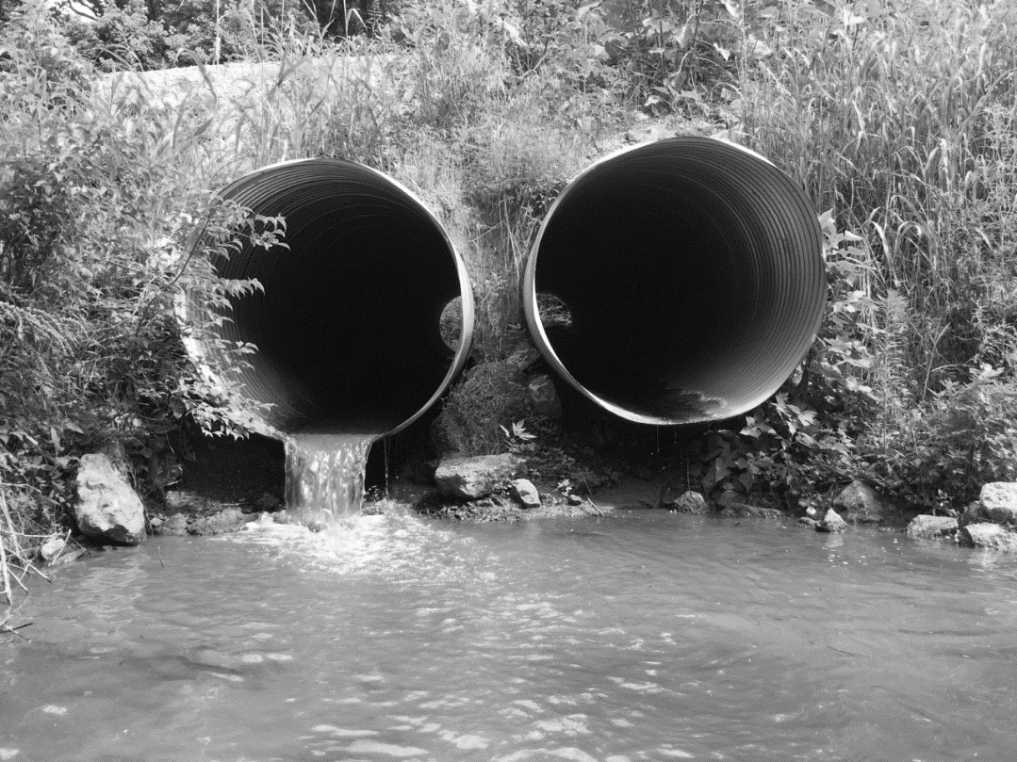
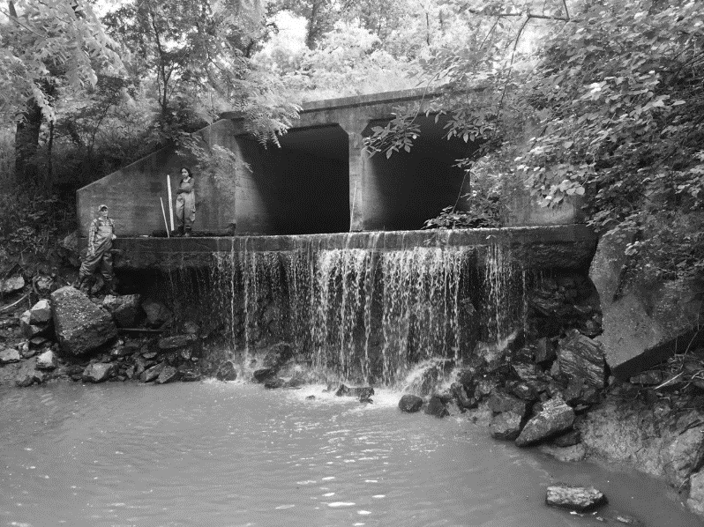
Figure 1. Image a. depicts a box culvert with a significant outlet drop, while image b. shows a round culvert with a significant outlet drop. Both of these barriers are impassable to aquatic life.
b.)
a.)

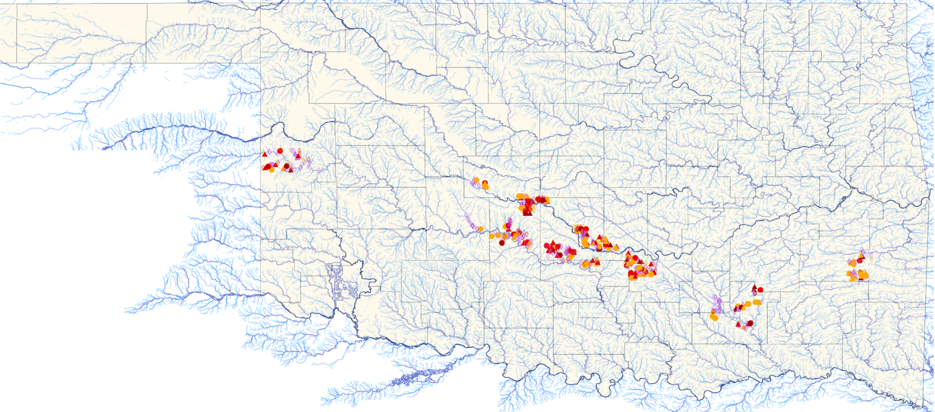
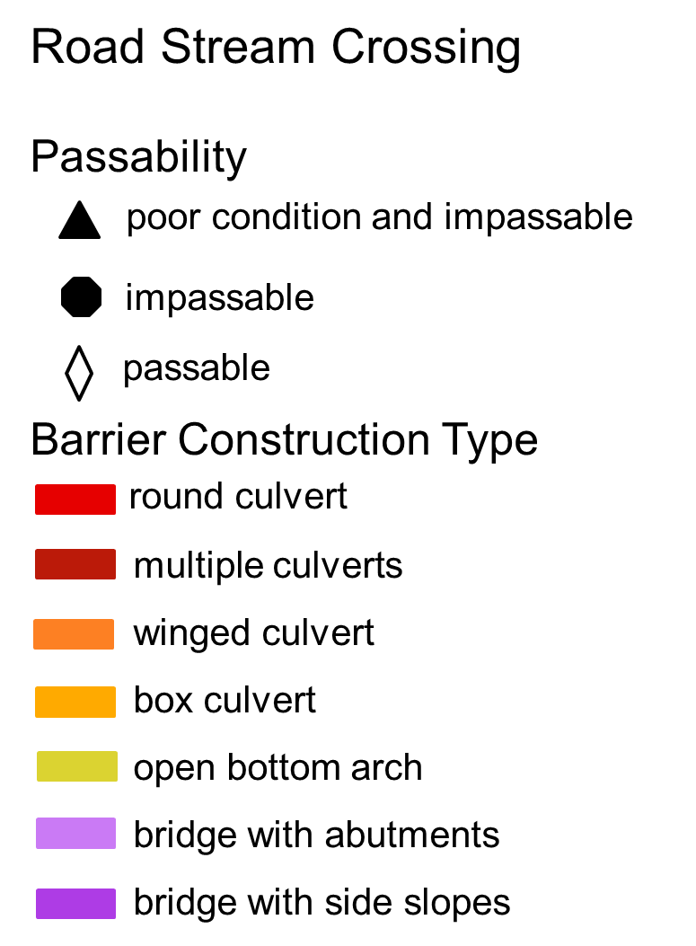
Figure 2. The location, construction type, passability, and condition of all 716 road stream crossings surveyed.
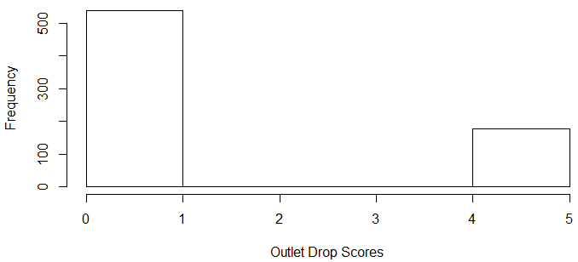
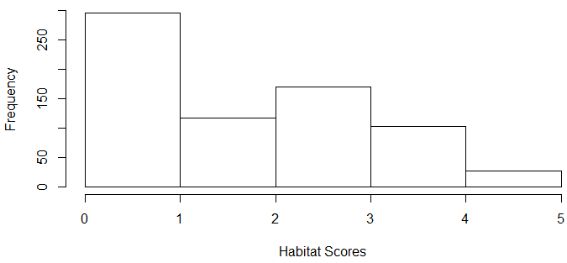
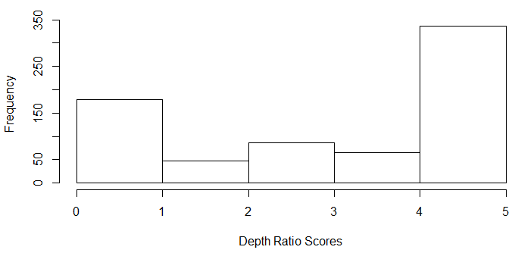
Figure 3. Histograms showing the frequency a given score was achieved for the ecological index. Figure 3a shows the distribution of scores for the first portion of the ecological index, outlet drop. Figure 3b shows distribution of the second portion of the ecological index, depth ratio. Lastly, figure 3c shows the distribution of scores for the habitat portion of the ecological index.
c.)
b.)
a.)
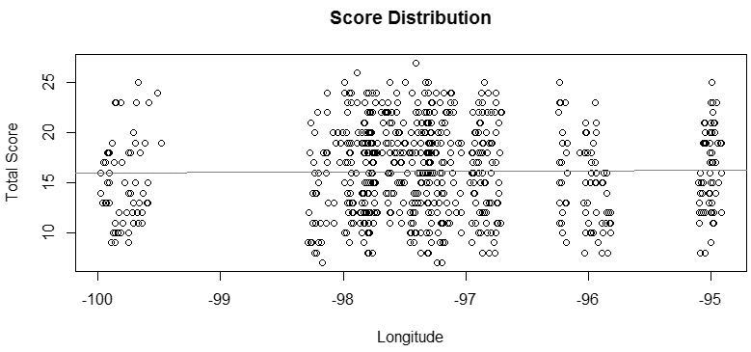
Figure 4. The above plot shows the total index score for each barrier and the longitude at which the structure resides. As shown there is no correlation between location and index score R² = -0.0012
p = 0.7434

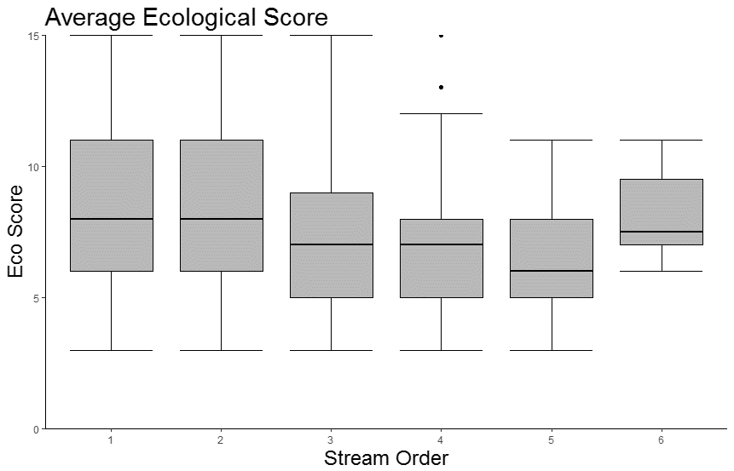
a.)

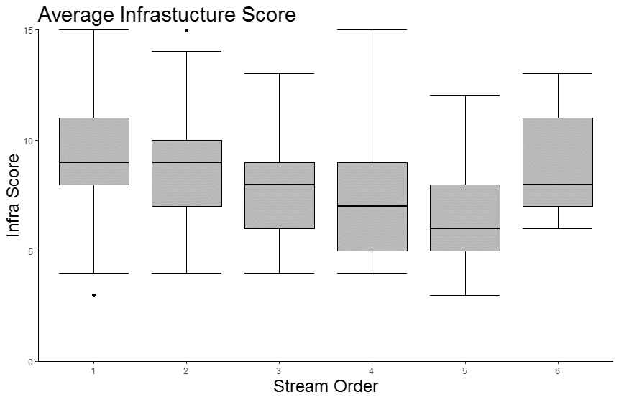
b.)

Figure 5. Boxplots showing the distribution of index score for differing stream orders. Figure 4a shows the distribution of the ecological score while figure 4b shows the infrastructure score. Neither of these distributions have any substantial differences in distribution of index score among differing stream orders.

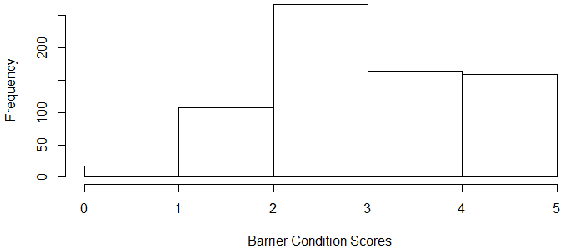
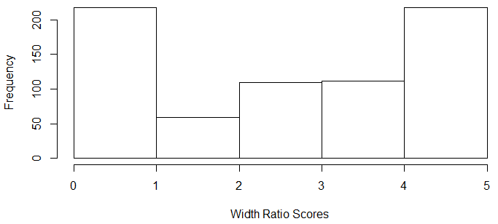
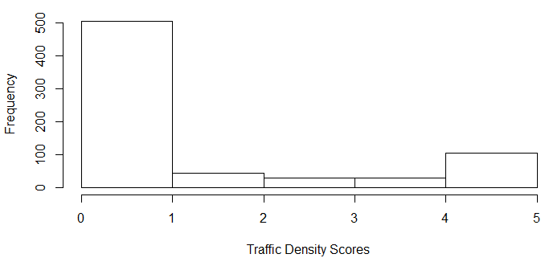
Figure 6. Histograms showing the frequency a given score was achieved for the infrastructure index. Figure 6a shows the distribution of scores for the first portion of the ecological index, barrier condition. Figure 6b shows distribution of the second portion of the infrastructure index, width ratio. Lastly, figure 6c shows the distribution of scores for the traffic density portion of the infrastructure index.
c.)
b.)
a.)
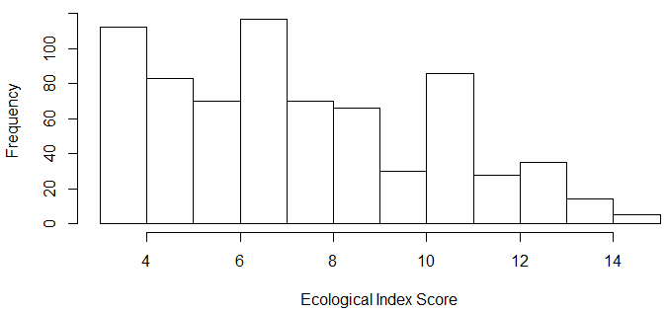
a.)

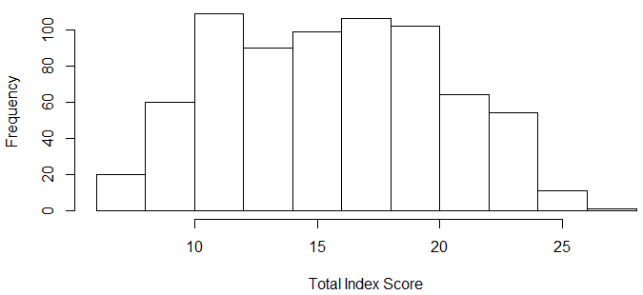
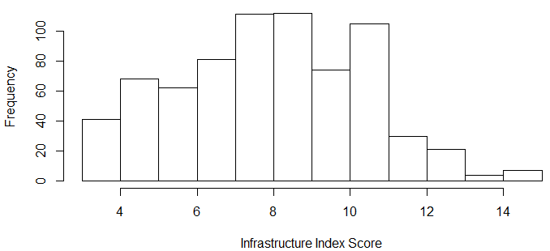
Figure 7. Histograms showing the frequency a given score was achieved for each index. Figure 7a shows the frequency of the ecological score while figure 7b shows the infrastructure score. Figure 7c shows the distribution of the total score, which is the sum of the ecological and infrastructure score for each location sampled.
b.)
c.)

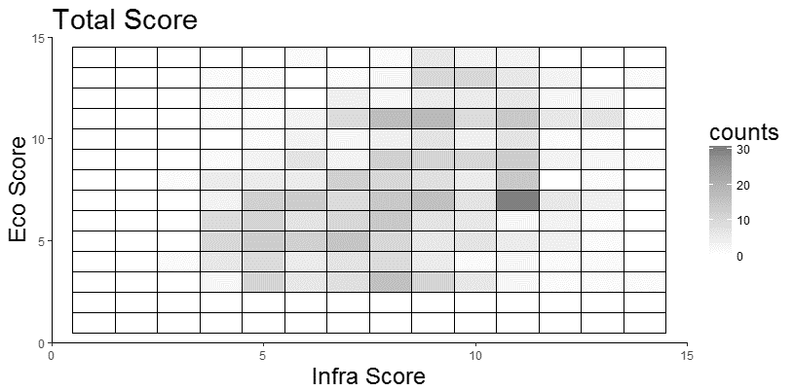

Figure 8. The heat map above depicts the frequency in which a score occurred. Each of the 716 locations surveyed has an ecological score and an infrastructure score. The barriers that would have a high score for each of these indices would fall in the top right corner and be considered a high priority location for restoration and repair.

References
Alkhrdaji T, Nanni A, Chen G, and Barker M. 1999. Upgrading the transportation infrastructure: solid RC decks strengthened with FRP. Concrete International, 21(10), 37-41.

American Society of Civil Engineers (ASCE). 2013. Report Card for America’s Infrastructure, http://www.infrastructurereportcard.org/

Bain MB, and Stevenson NJ. 1999. Aquatic habitat assessment. Asian Fisheries Society, Bethesda.

Beechie T, Pess G, Roni P, and Giannico G. 2008. Setting river restoration priorities: a review of approaches and a general protocol for identifying and prioritizing actions. North American Journal of Fisheries Management, 28(3), 891-905.

Bernhardt ES, Palmer M, Allan JD, Alexander G, Barnas K, Brooks S, Carr J, Clayton S, Dahm K, Follstad-Shah J, Galat D, Gloss S, Goodwin P, Hart D, Hassett B, Jenkinson R, Katz S, Kondolf GM, Lake PS, Lave R, Meyers JL, O’Donnell TK, Pagano J, Powell B, and Sudduth E. 2005. Synthesizing U. S. river restoration efforts. Science 308: 636-637.

Catalano M J, BozekMA, and Pellett TD. 2007. Effects of dam removal on fish assemblage structure and spatial distributions in the Baraboo River, Wisconsin. North American Journal of Fisheries Management 27:519–530.

Costigan KH, and Daniels MD. 2012. Damming the prairie: human alteration of Great Plains river regimes. Journal of Hydrology 444: 90-99.

Cote D, Kehler DG, Bourne C, Wiersma YF. 2009. A new measure of longitudinal connectivity for stream networks. Landscape Ecology 24:101–113.

Dudgeon D, Arthington AH, Gesser MO, Kawabata ZI, Knowler DJ, Leveque C, Naiman RJ, Prieur-Richard AH, Soto D, Stiassny MLJ, and Sullivan CA. 2006. Freshwater biodiversity: importance, threats, status and conservation challenges. Biological Reviews 81: 163-182.

Fullerton AH, Burnett KM, Steel EA, Flitcroft RL, Pres GR, Feist BE, Torgersen CE, Miller DJ, Sanderson BL. 2010. Hydrological connectivity for riverine fish: measurement challenges and research opportunities. Freshwater Biology 55: 2215-2237.

Furniss MJ, Roelofs TD, and Yee CS. 1991. Road construction and maintenance. American Fisheries Society Special Publication 19: 297-323.

Gido KB, Dodds WK, and Eberle ME. 2010. Retrospective analysis of fish community change during a half-century of landuse and streamflow changes. Journal of the North American Benthological Society 29: 970-987.

Giles R, Golbek S, Sullivan A, and Wood J. 2010. Ecology and Transportation: I-90 Snoqualmie Pass East Project's Design Engineering Challenges of Integrating Transportation Needs with Landscape-Level Connectivity and Transportation Corridor-Crossing Objectives in Washington State. Transportation Research Record: Journal of the Transportation Research Board, 2158: 113-121.

Gokey J, Klein N, Macke C, Santos J, Pillutla A, and Tucker S. 2009. Development of a prioritization methodology for maintaining Virginia's bridge infrastructure systems. Systems and Information Engineering Design Symposium. SIEDS'09. IEEE. 252-257.

Gucinski H. 2001. Forest roads: a synthesis of scientific information. DIANE Publishing.

Hoagstrom CW, Brooks JE, and Davenport SR. 2011. A large-scale conservation perspective considering endemic fishes of the North American plains. Biological Conservation 144:21-34.

Hooper DU, Adair EC, Cardinale BJ, Byrnes JE, Hungate BA, Matulich KL, and O’Connor MI. 2012. A global synthesis reveals biodiversity loss as a major driver of ecosystem change. Nature, 486(7401):105-108.

Januchowski-Hartley SR, McIntyre PB, Diebel M, Doran PJ, Infante DM, Joseph C, and Allan JD. 2013. Restoring aquatic ecosystem connectivity requires expanding inventories of both dams and road crossings. Frontiers in Ecology and the Environment 11: 211-217.

Johnson SE, and Graber BE. 2002. Enlisting the Social Sciences in Decisions about Dam Removal: The application of social science concepts and principles to public decision making about whether to keep or remove dams may help achieve outcomes leading to sustainable ecosystems and other goals in the public interest. BioScience, 52(8):731-738.

Kemp PS, and O'hanley JR. 2010. Procedures for evaluating and prioritizing the removal of fish passage barriers: a synthesis. Fisheries Management and Ecology, 17(4):297-322.

Kremen C, and Ostfeld RS. 2005. A call to ecologist: measuring, analyzing, and managing ecosystem services. The Ecological Society of America 3(10): 540-548.

Magilligan FJ, Graber BE, Nislow KH, Chipman JW, Sneddon CS, and Fox CA. 2016. River restoration by dam removal: Enhancing connectivity at watershed scales. Elementa, 4.

Neeson TM, Ferris MC, Diebel MW, Doran PJ, O’Hanley JR, and McIntyre PB. 2015. Enhancing ecosystem restoration efficiency through spatial and temporal coordination. Proceedings of the National Academy of Sciences of the United States of America 112(9):6236-6241.

Nilsson C, Reidy CA, Dynesius M, and Revenga C. 2005. Fragmentation and flow regulation of the world’s large river systems. Science 15:405-408.

O’hanley JR., and Tomberlin D. 2005. Optimizing the removal of small fish passage barriers. Environmental Modeling and Assessment, 10(2):85-98.

Palmer MA, Allan D, Meyer J, Bernhardt ES. 2007. River Restorations in the Twenty-First Century: Data and Experiential Knowledge to Inform Future Efforts. Restoration Ecology 15: 472-481.

Palmer MA, Bernhardt ES, Allan D, Lake G, Alexander G, Brooks S, Carr J, Clayton S, Dahm C, Follstad S, Galat DJ, Gloss S, Goodwin P, Hart DH, Hassett B, Jenkinson R, Kondolf GM, Lave R, O’Donnell TK, Pagano L, Srivastava P, and Sudduth E. 2005. Standards for ecologically successful restoration. Journal of Applied Ecology 42:208-217.

Perrin Jr J, and Jhaveri CS. 2004. The economic costs of culvert failures. In Prepared for TRB 2004 Annual Meeting, Washington DC.

Perkin JS, and Gido KB. 2011. Stream Fragmentation Thresholds for a Reproductive Guild of Great Plains Fishes. Fisheries 36(8):371-383.

Perkin JS, and Gido KB. 2012. Fragmentation alters stream fish community structure in dendritic ecological networks. Ecological Applications 22(8):2176-2187.

Perkin JS, Gido KB, Cooper AR, Turner TF, Osborne MJ, Johnson ER, Mayes KB. 2015. Fragmentation and dewatering transform Great Plains stream fish communities. Ecological Monographs 85(1):73-92.

Perkin JS, Gido KB, Costigan KH, Daniels MD, and Johnson ER. 2014. Fragmentation and drying ratchet. Aquatic Conservation: Marine and Freshwater Ecosystems 25(5):639-655.

Pringle C. 2003. What is hydrologic connectivity and why is it ecologically important? Hydrological Processes 17(13):2685–2689.

Power ME, Dietrich WE, and Finlay JC. 1996. Dams and downstream aquatic biodiversity: potential food web consequences of hydrologic and geomorphic change. Environmental management, 20(6):887-895.

Trombulak SC, and Frissell CA. 2000. Review of ecological effects of roads on terrestrial and aquatic communities. Conservation biology, 14(1):18-30.

U.S. Fish and Wildlife Service. 2012. Maine Stream Crossing Survey Manual. Gulf of Maine Coastal Program.

U.S. Fish and Wildlife Service. 2002. Fish Passage Program. Division of Fish and Wildlife Management and Habitat Restoration 710FW1.

U.S. Forest Service. 2006. National Inventory and Assessment Procedure - For Identifying Barriers to Aquatic Organism Passage at Road-Stream Crossings. U.S. Department of Agriculture.

Walker D, Kummer S, and Entine L. 2002. Pavement Surface Evaluation and Rating; PASER Asphalt Roads Manual. Transportation Information Center University of Wisconsin-Madison.

Walters DM, Zuellig RE, Crockett HJ, Bruce JF, Lukacs PM, and Fitzpatrick RM. 2014. Barriers impede upstream spawning migration of flathead chub. Transactions of the American Fisheries Society 143:17–25.

Ward DL, Schultz AA, and Matson PG. 2003. Differences in swimming ability and behavior in response to high water velocities among native and nonnative fishes. Environmental Biology of Fishes 68(1):87-92.

Warren Jr ML, and Pardew MG. 1998. Road crossings as barriers to small-stream fish movement. Transactions of the American Fisheries Society, 127(4):637-644.

Wilde GR, and Urbanczyk AC. 2013. Relationship between river fragment length and persistence of two imperiled Great Plains cyprinids. Journal of Freshwater Ecology 28:445–451.

Xie F, and Levinson D. 2011. Evaluating the effects of the I-35W bridge collapse on road-users in the twin cities metropolitan region. Transportation planning and technology 34(7):691-703.

