University of Oklahoma

Graduate College

interest and intention in stem fields: applying latent growth modeling

A Dissertation

submitted to the Graduate Faculty

in partial fulfillment of the requirements for the

Degree of

Doctor of Philosophy

By

li lin
Norman, Oklahoma
2018

INTEREST AND INTENTION IN STEM FIELDS: APPLYING LATENT GROWTH MODELING

A Dissertation approved for the
Department of Psychology

By

______________________________
Dr. Lori Snyder, Chair

______________________________
Dr. Eric Day

______________________________
Dr. Robert Terry

______________________________
Dr. Mauricio Carvallo

______________________________
Dr. Paul Spicer

© Copyright by li lin 2018
All Rights Reserved.
To my husband, Jackie, and my family.

Acknowledgements
Words cannot express the appreciations that I have for the individuals that have contributed to the completion of this project and my learning and growth in general. First, I would like to thank my major professor, Dr. Lori Anderson Snyder, for her generous support and guidance. The opportunities that she created for me allowed me to explore my potentials and contribute to research in the ways that I never thought I could have. Second, I wish to thank my committee members, Dr. Eric Day, Dr. Robert Terry, Dr. Mauricio Carvallo, and Dr. Paul Spicer for the suggestions and support that they provided. Third, I want to thank my undergraduate research assistant, Anusha Sadruddin, for her help in styling and formatting of the paper, as well as my colleagues, Ally Finken, Alise Dabdoub, Ashley Jorgenson, Chris Nguyen, and Jessica Johnston-Fisher, for proofreading the paper. Fourth, I want to thank former members of the Snyder research team, Brett Litwiller, Will Taylor, and Tiffany Maglasang, for their contributions to the survey and data that I utilized in my dissertation. In addition to my professional affiliates, I would like to thank my fourth grade English language teacher, who said to me, “You have a powerful voice,” my father, who crossed the Atlantic Ocean to pioneer our American Dream, and my mother, who taught me to remain humble, enduring, and hopeful in all rises and falls of life. Finally, I want to thank my husband for the love, trust, and companionship.

Table of Contents
Acknowledgements iv
List of Tables vii
List of Figures viii
Abstract ix
Introduction 1
Social Cognitive Career Theory: Interest and Intention 3
Social Cognitive Career Theory: Antecedents of Interest and Intention 6
Latent Growth Modeling and Social Cognitive Career Theory 8
The Present Study 11
Final Model 20
Method 21
Participants and Procedures 21
Survey Design and Data Management 23
Analysis 24
Preliminary Analysis 25
Main Analysis 26
Measures 27
Gender and Race/Ethnicity 27
Size of Childhood Town (M = 3.94, SD = 1.50) 27
Math Classes Taken in High School (M = 5.10, SD = 1.53) 27
Realistic Learning Experiences (M = 4.02, SD = 0.75) and Investigative Learning Experiences (M = 4.02, SD = 0.72) 27
Implicit Theories of Math Ability (ITMA; M = 2.84, SD = 1.02) 28
Interest in Physical Sciences 29
Intention to Major in STEM 29
Math ACT (M = 25.63, SD = 4.59) and Academic Performance (M = 3.20, SD = 0.58) 30
Math Emphasis in Students’ Academic Major (M = 2.29, SD = 1.20) 30
Results 31
Preliminary Analyses 31
Main Analyses 31
Hypothesis 1 and Research Question 1 32
Hypothesis 2–Hypothesis 8 and Research Question 2–Research Question 8 33
Hypothesis 9 and Research Question 9 37
Research Question 10 38
Final Model 39
Discussion 42
Limitations 48
Future Research Directions 50
Practical Implications and Suggestions for Intervention 52
Conclusion 56
References 58
Appendix A: Learning Experiences Questionnaire (Realistic Subscale) 91
Appendix B: Learning Experiences Questionnaire (Investigative Subscale) 92
Appendix C: Implicit Theories of Math Ability 93

List of Tables
Table 1. Data Collection: Cohort of Measurement by Time of Assessment 73
Table 2. Participants’ Opportunities to Provide Data 74
Table 3. Inter-variable Correlation 75
Table 4. Interest in Physical Sciences Model Fit 76
Table 5. Model Results for Conditional Latent Growth Models 77
Table 6. Intention to Major in STEM Model Fit 78
Table 7. Final Model Results for Interest in Physical Sciences 79
Table 8. Final Model Results for Intention to Major in STEM 80
Table 9. Effects of Intercept and Slope on Academic Major and GPA 81
Table 10. Summary of Findings 82

List of Figures
Figure 1. A revised version of SCCT’s interest and choice model 83
Figure 2. An example of latent growth model 84
Figure 3. An example of the conditional latent growth model 85
Figure 4. The structure of the final model 86
Figure 5. Interest in physical sciences by gender 87
Figure 6. Intention to major in STEM by gender 88
Figure 7. Interest in physical sciences by ethnicity 89
Figure 8. Intention to major in STEM by ethnicity 90

Abstract
Guided by the proposed paths among interest, intention, and choice variables in Social Cognitive Career Theory (Lent, Brown, Hackett, 1994), the current study utilized latent growth modeling to investigate changes in students’ interest in physical sciences and intention to major in STEM over the course of their undergraduate career. Results indicated that interest in physical sciences was the lowest in students’ second year in college, which may be reflecting the “sophomore slump” phenomenon. Gender, race/ethnicity, math classes taken in high school, realistic learning experiences, investigative learning experiences, implicit theories of math ability, and math ACT were found to be associated with students’ level of interest in physical sciences in their first year of college. Moreover, a higher endorsement of the belief that math ability is fixed was associated with a faster decline in interest in physical sciences. Similarly, gender, race/ethnicity, math classes taken in high school, investigative learning experiences, implicit theories of math ability, and math ACT were found to be associated with students’ level of intention to major in STEM in their first year of college. However, no predictors were found to be associated with the rate of decline in intention to major in STEM. Lastly, models that incorporated students’ chosen academic major also supported that interest in physical sciences and intention to major in STEM in students’ first year in college as well as the rate of decline in intention to major in STEM were associated with the extent to which math was emphasized in students’ chosen majors.

Introduction
Research pertaining to interest and persistence in science, technology, engineering, and mathematics (STEM) fields continues to be a top priority on the nation’s educational research agenda (National Science Board, 2010). The Bureau of Labor Statistics (2017) estimated that between May 2009 and May 2015, STEM occupations grew by 10.5% compared with 5.2% for non-STEM occupations. Moreover, occupations in the Computer category are projected to increase by 12.5%. Despite the significant impact that STEM careers will have on the nation’s economic future, various minority groups (e.g., women and racial/ethnic minorities) continue to be underrepresented in STEM fields (Chen, 2013; National Center for Science and Engineering Statistics, 2013). Individuals who identify as Black, Hispanic, and Native American each constitute a disproportionately small percentage of science and engineering degree recipients as well as jobholders in STEM fields (National Center for Science and Engineering Statistics, 2013). These discrepancies are caused by a myriad of factors, with differential drop-out rates being one of the most profound. Chen (2013) reported that among students who started their bachelor’s degree in 2003 and 2004, approximately 10% of Asian students left STEM by dropping out of college compared to about 20% of White students, 23% of Hispanic students, and 29% of Black students.
Among the various underrepresented racial/ethnic groups in STEM, research on Native Americans has been noticeably limited. For example, the National Center for Science and Engineering Statistics (2013) was unable to report the status of Native Americans’ participation in STEM due to insufficient sample size in the national surveys that were conducted. From the limited research available, Native Americans (61%) were less likely to graduate from high school compared to Asians (91%), Whites (80%), and Hispanics (62%) (Aud, Fox, & KewalRamani, 2010). Additionally, Native Americans between the ages of 18 and 24 were less likely to enroll in colleges and universities (21.9%) than their Asian (57.6%), White (44.2%), Hispanic (25.8%), and Black (32.1%) counterparts (Aud et al., 2010). Moreover, Native Americans (4.2%) were less likely than Asians (8.7%), Whites (5.2%), and Hispanics (4.4%) to obtain an engineering bachelor’s degree (Aud et al., 2010).
In contrast, Asian students were generally comparable to their White counterparts in terms academic achievement (see Stetser & Stillwell, 2014). For example, in 2008, 17% of Asian high school students and 16% of White high school students scored a 3 or better on Advance Placement exams (Aud et al., 2010). Researchers suggested that the difference between Asian students and students of other minority groups in academic achievement and STEM representation may be due to the fact that Asian students are often better prepared in high school mathematics (Berkner & Choy 2008). For example, in 2005, 30% of Asian students had completed a calculus course in high school, compared with 15% of White, 8% of American Indian/Alaska Native, and 6% each of Black and Hispanic students (Aud et al., 2010).
In addition to race/ethnicity, the underrepresentation of women in STEM has been a long-standing issue. For example, only 14.5% of engineers are women. Specifically, women make up 7.9% of the mechanical engineering workforce (National Science Foundation, 2017). In 2014, at the doctorate level, 28.9% of the degree recipients in mathematics and statistics and 18.7% of the degree recipients in physics were women (National Science Foundation, 2017). According to Nauta and Epperson (2003), math and science abilities only explain a small proportion of variance in women’s decisions to choose a STEM field. Additional factors, such as the visibility of demographically similar role models and the influence of social norms often contribute to individual’s career decisions. Because of the future demand for a larger and more diverse STEM workforce, the talent pool should be expanded to be more inclusive of previously underrepresented groups (National Science Board, 2010).

Social Cognitive Career Theory: Interest and Intention
The pathway to successful attraction and retention of women and racial ethnic minority groups in STEM careers is affected by a myriad of personal and environmental factors. The most essential factor is for an individual to be not only interested in a STEM topic (e.g., mathematics and engineering) but also have the intention to choose a STEM major in college. Studies show that at the college level, women and racial/ethnic minorities are less interested in STEM topics and/or have a lower intention of selecting a STEM major. For example, in 2012, 53% of Asian college freshmen reported that they intended to major in science and/or engineering compared with 42% of Hispanic, 37% of White, 36% of Black, and 33% of Native American college freshmen (National Science Foundation, 2014). The pathway leading up to the development of interest and intention to major in STEM is capsulated by the Social Cognitive Career Theory (SCCT; Lent, Brown, & Hackett, 1994), one of the most commonly utilized frameworks in the investigation of the underrepresentation of various groups in STEM (Fouad & Santana, 2016).
Bandura’s self-efficacy theory was first utilized by Betz and Hackett (1981) to investigate women’s career choice patterns (Fouad & Santana, 2016). Lent and colleagues (1994) further enhanced the idea of self-efficacy being the key component in individual’s career in the SCCT framework. Specifically, based on the fundamental assumption of social cognitive theory, that behaviors are derived from the interplays of person predispositions and the environment (Bandura, 1986), the SCCT outlined the interactive variables and paths that are involved in a person’s decision to select and enter a career field. According to SCCT, the process by which a person makes academic-related or career-related decisions can be divided into the initial expression of interest and the actions that one takes to further develop the interest. Specifically, interests promote cognized career choice goals such as intentions, plans, and aspirations, which increase the probability of choice actions, such as the selection of a certain major (Lent et al., 1994).
The SCCT interest and choice model encompasses a number of different variables that influence career choices, some of which include self-efficacy, outcome expectations, interests, and anticipated support and barriers (Fouad & Santana, 2016). The interest and choice model has been examined and supported in racially diverse samples in engineering (Lent et al., 2005; Flores et al., 2014), biological/life sciences (Byars-Winston, Estrada, Howard, Davis, & Zalapa, 2010), and computer science (Lent, Lopez, Sheu, & Lopez, 2011). For example, in a sample of computer science students, interest was predicted by self-efficacy, and intention to persist in computing was predicted by self-efficacy, interest, and supports and barriers (Lent et al., 2011).
Moreover, Lent et al. (2015) noted that SCCT’s interest, choice, satisfaction, and performance models were often studied as separate segments. They proposed and tested an integrative model of interest, satisfaction, and choice using a sample of engineering students across three time points. Interest at a later time point was found to be moderately related to interest in an earlier time point. Similarly, intention to persist at a later time point was also found to be moderately related to interest in an earlier time point. Despite the moderate number of longitudinal studies that have supported SCCT’s interest and choice model, according to Lent, et al. (2008), the majority of studies that have tested different aspects of SCCT were limited by their cross-sectional nature. Cross-sectional designs may be able to establish whether or not the obtained relationships are consistent with SCCT’s hypotheses but are unable to demonstrate longitudinal effects and implications of the SCCT’s variables.
There are several ways by which longitudinal components can be embedded in a study. One of these is a cross-lagged panel design (Bentler & Speckart, 1981; Hamaker, Kuiper, & Grasman, 2015), which has been commonly used to demonstrate the reciprocated relationships among SCCT variables. For example, studies have used cross-lagged panel design to test the extent to which self-efficacy, measured at the first time point, predicts interest, measured at the second time point, all the while controlling for the level of interest that was initially measured (e.g., Nauta, Kahn, Angell, & Catarelli, 2002; Lent, Tracy, Brown, Soresi, & Nota, 2006). In Lent et al. (2008), self-efficacy at time one yielded significant lagged paths to outcome expectations, interests, and persistence goals at time two. However, interests at time one did not produce significant lagged effects on persistence goals at time two. Using the same cross-panel design, Lent, Sheu, Gloster, and Wilkins (2010) and Navarro, Flores, Lee, & Gonzalez (2014) extended Lent et al. (2008) by including additional variables, such as social support, social barriers, and academic satisfaction.
In addition to the cross-lagged panel design, studies have “longitudinally” fitted the SCCT path model in the sense that SCCT variables (e.g., early learning experiences) that were theorized to precede other variables (e.g., number of math classes taken in high school) were collected at an earlier measurement occasion. For example, Nauta and Epperson (2003) collected initial data from students while they were in high school and continued to collect data after these individuals have entered college. Although data were collected at different time points, no repeated assessment was present in these studies. Whereas the goal of cross-lagged panel design is to identify causal dominance among various candidate SCCT variables, the goal of “longitudinal” path models, such as the one utilized in Nauta and Epperson (2003), was to provide support for the paths within the full SCCT model.
Lastly, a third approach to study SCCT interest and intention is to utilize latent growth modeling (Duncan & Duncan, 2004; Jung & Wickrama, 2008). This approach takes the rate of change as a latent variable and allows researchers to investigate the antecedents and impacts of this latent variable. The latent growth model (LGM) framework is currently less common in the studies of SCCT interest and intention. As the central methodological framework of the current study, later sections provided additional reviews on the method.

Social Cognitive Career Theory: Antecedents of Interest and Intention
In SCCT, Lent et al. (1994) indicated that background/contextual affordance variables, personal input variables, and learning experiences determine a portion of variance in career-related interest and choice behaviors. Background/contextual affordance may include racial/ethnic background, socioeconomic background, and family structure. Regarding demographic variables, Lent et al. (1994) suggested that while race and sex can be regarded as biological attributes, they often carry profound psychological and social significance. That is, demographic variables often evoke systematic sociocultural reactions from the environment (e.g., racial stereotypes) which shape people’s perceptions toward themselves and others.
Personal input refers to psychological predispositions such as values, learning orientation, and beliefs about human attributes. Similar to background contextual/affordance variables, SCCT suggests that people’s basic values and beliefs could influence their learning experiences and therefore, affect their perceptions of their own abilities and development of interests. For example, the implicit theories framework, which conceptualizes that people’s perception toward various human attributes are either fixed or malleable, have been shown to be predictive of effort and performance (e.g., Dweck, Chiu, & Hong, 1995; Dweck, 2012). Specifically, the belief that intelligence or ability is fixed was found to be associated with lower self-efficacy and interest, whereas the belief that intelligence or ability is malleable was found to be associated with higher self-efficacy and learning goals (Baird, Scott, Dearing, & Hamill, 2009).
Learning experiences refer to the type and amount of exposure that one receives in early childhood environment. SCCT posits that learning experiences can facilitate one’s self-efficacy and interest in the domains where one has rich learning experiences. Lent and colleagues (e.g., Sheu et al., 2010) often utilize Holland’s six occupation themes (Realistic, Investigative, Artistic, Social, Enterprising, and Conventional; RIASEC; Holland, 1997) as the framework to assess individuals’ learning experiences. One study found that men reported higher learning experiences in the Realistic and Investigative domains whereas women reported higher learning experiences in the Social domain (Williams & Subich, 2006). Another study found that after controlling for gender, learning experiences in the Investigative, Enterprising, and Conventional domains were positively associated with perceived social status (Thompson & Dahling, 2012). Both studies supported that learning experiences in certain domains are positively associated with self-efficacy and outcome expectations in the corresponding domains. In addition to the RIASEC themes, the amount of exposure and positive experiences in math and science-related domains would also lead to higher self-efficacy and interest in math and science-related fields (e.g., Byars-Winston et al., 2010; Lent et al., 2008).
In sum, SCCT posited that variables such as demographics, socioeconomic context, beliefs, learning experiences, and previous accomplishments will jointly predict a person’s academic/career interest, intention, and choice. A simplified version of SCCT’s interest and choice model is presented in Figure 1.

Latent Growth Modeling and Social Cognitive Career Theory
In recent decades, researchers have emphasized the importance of implementing longitudinal designs to understand the change of attitudes and behaviors over time. One of the most common approaches has been latent growth modeling (LGM) within the structural equation modeling (SEM) framework (Duncan & Duncan, 2004). The need for LGM was based on the assumption that individuals differ not only in their baseline level (i.e., the Intercept latent factor in LGM) but also their growth over time (i.e., the Slope latent factor in LGM) (Muthén & Khoo, 1998). With the development of this technique, researchers were able to articulate a wide variety of research questions that could not be easily accommodated with other techniques (Preacher, 2008). For example, with LGM, researchers can incorporate the change of attitudes and behaviors over time as a unique research interest. That is, in addition to studying the mean differences in attitudes and behaviors across individuals at one time point, one could also study the change of attitudes and behaviors over time (Bollen & Curran, 2006; McArdle & Bell, 2000). Additionally, researchers can inquire about the relationship between the initial level (i.e., Intercept) and the rate of change (i.e., Slope), whether groups differ in their trajectories, and whether there are significant predictors for the Intercept and the Slope (see Figure 2 for a graphical representation of LGM).
In educational and developmental psychology, LGM has been commonly applied to achievement-related variables. For example, Muthén and Khoo (1998) investigated growth of math achievement over grades 7 to 10 using two cohorts of students. Specifically, they modeled how the trajectories of math achievement varied as a function of background variables such as gender, mother’s education achievement, and resources at home. In another study, the author utilized LGM to examine changes in students’ attitudes toward science across the middle school and high school years. Results indicated that positive attitudes toward science generally decline over the middle school and high school years (George, 2000). Although George (2000) did not interpret results in accordance to SCCT, findings inadvertently supported some paths in SCCT. For example, teachers’ encouragement and peer attitudes toward science were found to be significant predictors of students’ attitude toward science. This finding supports SCCT’s proposition that proximal and contextual support can influence people attitudes toward a certain academic or career field. In addition, students in metropolitan and rural schools were found to have less positive attitudes toward science in seventh grade compared to students in suburban schools. This finding supports SCCT’s proposition that background/contextual affordance variables can influence individuals’ attitudes toward a certain academic or career fields.
Among adolescent samples, LGM has been applied to study the impact of parental involvement on student achievement (Hong & Ho, 2005), patterns of career exploration and career identity formation (Shevlin & Millar, 2006), changes in self-esteem (Rhodes, Roffman, Reddy, & Fredriksen, 2004), and delinquent activities (Windle, 1990). Among college students, LGM has been applied to study drinking behaviors (Greenbaum, Del Boca, Darkes, Wang, & Goldman, 2005), procrastination (Moon, & Illingworth, 2005), and the development of ethnic identity (Syed & Azmitia, 2009). In general, LGM is more frequently applied to adolescent samples than college samples due to the fact that data on adolescents are often publically available (e.g., Longitudinal Study of American Youth).
Specific to SCCT’s interest and choice model, Frenzel, Goetz, Pekrun, and Watt (2010) utilized LGM to investigate the trajectories of math interest and effects of gender, family context, and school context in a sample of adolescents. The resulting LGM depicted a downward trend of math interest with a high amount of variability in the mean levels of math interest but a low amount of variability in the shape of the trajectories. However, no research is available to indicate whether the trajectories of math or STEM interest would be the same for college students. Decisions and choices that are made in college are more proximal to the selection of a career path. Yet, little longitudinal research regarding college students’ interest in STEM is available. Understanding college students’ development of interests and choice behaviors may provide insights to the underrepresentation of various minority groups in STEM, as well as inform appropriate intervention strategies.

The Present Study
Although many studies that are based on the SCCT framework have utilized longitudinal designs, the majority of these studies are limited to a two-wave design (Lent et al., 2015). Additional waves of data are required to provide compelling evidence on patterns of change over time (Hamaker et al., 2015). One of the root causes of the underrepresentation of women and racial/ethnic minority groups in the STEM workforce is the fact that while in college, these groups of individuals are less interested in STEM topics and/or have a lower intention to major in a STEM field (National Science Foundation, 2014). Stemming from the proposed paths among the interest, intention, and choice variables in SCCT, the current study focused on interest and intention as the two focal variables that can change over time. In addition, the current study investigated how the amount of change in interest and intention may be associated with the choice of major variable.
The current study focused on the Native American student population due to the scarcity of existing data and reports on this group. In many national educational reports, statistics regarding Native American students are represented with asterisks to denote lack of sufficient numbers, incompletion, or unstable results. For example, in a report examining STEM attrition, instead of being in its own category, Native Americans were categorized into “all other races” (Chen, 2013). The “asterisk” phenomenon is a symbolic description of the neglect of in-depth reporting on Native American students’ participation in higher education and the fact that the mainstream understanding of this cultural/ethnic group is highly limited (Shotton, Lowe, & Waterman, 2013). As mentioned previously, the percentage of Native American college freshman (33%) that had the intention to major in STEM fields was lower than that of other racial/ethnic groups. Thus, the current study devoted more emphasis to the Native American student group.
In terms of gender, women are severely underrepresented in engineering, mathematics, and physics (collectively referred to as physical sciences in the current study) in contrast to life sciences such as biology and medicine. For example, in 2015, 47.9% of women were employed as life scientists. In contrast, 14.5% of engineers were women (National Science Foundation, 2017). Thus, for the interest variable, the current study focused on physical sciences while the intention variable was inclusive of all STEM fields.
Utilizing LGM, the first purpose of this study was to investigate the trajectories of students’ (1) interest in physical sciences and (2) intention to major in STEM fields over the course of their college careers. Maltese and Tai (2010) suggested that those with a major in a STEM field have made the career choice decision in high school. In other words, there might not be much fluctuation in STEM interest over a person’s college career. However, research has also found that attrition from STEM fields is prevalent among college students. For example, one report indicated that 48% of bachelor’s degree-seeking students who entered STEM fields between 2003 and 2009 left these fields by Spring 2009 (Chen, 2013), suggesting that interest in STEM and intention to major in a STEM field may exhibit a downward trend over time. Based on these findings, the current study hypothesized the following:
Hypothesis 1. Students’ (a) interest in physical sciences and (b) intention to major in STEM fields will decline over the course of their college careers.
Moreover, the current study also explored the relationship between the starting point of the interest and intention trajectories and the slope of these trajectories. In general, one would expect that higher interest and intention in the initial time point will be either positively related or not significantly related to the change of interest and intention over time. The current study proposed the following question:
Research Question 1. Will there be a positive association between the starting point of the trajectory and the slope of the trajectory for (a) interest in physical sciences and (b) intention to major in STEM?
The second purpose of the study was to investigate the effects of predictors on the trajectories, that is, the estimated Intercept and Slope of the model (see a graphical representation in Figure 3). As shown by previous research (e.g., Chen, 2013; National Science Board, 2010), demographic variables such as gender and race/ethnicity are associated with differences in STEM representation. Using a nationally representative sample, one study found that male students showed higher levels of interest in engineering whereas female students showed higher levels of interest in health and medicine during their high school years. Moreover, male students’ interest in STEM careers remained relatively stable throughout high school, whereas female students’ interest in STEM careers declined significantly (Sadler, Sonnert, Hazari, & Tai, 2012). Thus, the current study hypothesized the following:
Hypothesis 2. Women will have lower levels of (a) interest in physical sciences and (b) intention to major in STEM at the starting point of the trajectory.
Since not enough previous research is available to develop a hypothesis regarding gender’s association with the rate of change in STEM interest or intention in college, the current study explored the following research question:
Research Question 2. Is gender associated with the slope of (a) interest in physical sciences and (b) intention to major in STEM over time?
Given reports that show the underrepresentation of Native Americans in STEM and overrepresentation of Asians in STEM (National Center for Science and Engineering Statistics, 2013), it is likely that the trajectory of interest and intention in STEM would differ across racial/ethnic groups. Maltese and Tai (2010) found that without controlling for other predictors, Asians have higher odds of completing a degree in a STEM field. Thus, the current study hypothesized the following:
Hypothesis 3. In comparison to Asian students, Native American students will have lower levels of (a) interest in physical sciences and (b) intention to major in STEM at the starting point of the trajectory.
Since insufficient research is available to develop a hypothesis regarding race/ethnicity’s association with the slope of these trajectories over time, the current study explored the following research question:
Research Question 3. Is race/ethnicity associated with the slope of (a) interest in physical sciences and (b) intention to major in STEM over time?
The availability of school resources is critical to STEM education (Tytler, Osborne, Williams, Tytler, & Cripps Clark, 2008). Interview data from one study indicated that students who went to a rural high school believed that they had less STEM-related resources, fewer adult role models in STEM fields, and that their community didn’t place a high value on STEM education (Pitchford, 2016). For rural areas that are self-sustaining, college education may not be a priority or a realistic goal for students (see Goodpaster, Adedokun, & Weaver, 2012; Herzog, & Pittman, 1995). In contrast to students who grew up in an urbanized area, or a larger city, students who grew up in a rural area, or a smaller town, may not have extensive exposure to STEM subjects. Thus, the current study hypothesized the following:
Hypothesis 4. The size of students’ childhood town will be positively associated with (a) interest in physical sciences and (b) intention to major in STEM at the starting point of the trajectory.
The current study also explored the following research question:
Research Question 4. Will the size of students’ childhood town be associated with the slope of (a) interest in physical sciences and (b) intention to major in STEM over time?
According to the SCCT, learning experiences early in life, such as exposure to and modeling behaviors in certain subject domains, are critical in shaping individuals’ career interest and choice later in life (Lent et al., 1994). Specific to interest and choice in STEM fields, using Holland’s (1970) classification system, engineers and scientists generally score higher in the Realistic career theme, which includes technical, skilled, and laboring occupations, and the Investigative career theme, which primarily consisted of scientific occupations (O*NET, retrieved 2018). Moreover, Su and Rounds (2015) suggested that the preference to work with people versus things may explain the gender differences in interest in STEM. Previous studies have found gender differences in the Realistic and Investigative domain (Williams & Subich, 2006) as well as supported that exposure to a certain domain would be related to one’s interest in that domain (e.g., Byars-Winston et al., 2010). The current study proposed the following hypotheses and research questions:
Hypothesis 5. The number of math classes that college students took in high school will be positively associated with (a) interest in physical sciences and (b) intention to major in STEM at the starting point of the trajectory.
Research Question 5. Is the number of math classes that college students took in high school associated with the slope of (a) interest in physical sciences and (b) intention to major in STEM over time?
Hypothesis 6. Students’ early learning experiences in the Realistic and Investigative occupation themes will be positively associated with their (a) interest in physical sciences and (b) intention to major in STEM at the starting point of the trajectory.
Research Question 6. Are students’ early learning experiences in the domains of Realistic and Investigative themes associated with the slope of (a) interest in physical sciences and (b) intention to major in STEM over time?
As outlined in the SCCT model, in addition to gender, race/ethnicity, size of childhood town, and learning experiences, individuals’ preexisting beliefs about learning should also influence the development of interest. A person’s beliefs about intelligence or other human attributes has been shown to influence effort and performance outcomes (see Dweck, 2012). One study found that the belief that intelligence is malleable was associated with higher academic self-efficacy (Komarraju & Nadler, 2013). Similarly, the belief that leadership ability is malleable was associated with leadership self-efficacy (Burnette, Pollack, & Hoyt, 2010). As seen in studies of the SCCT (e.g., Lent et al., 2008), self-efficacy in a particular domain is related to interest in that domain. Specific to STEM-related attributes, Chen and Usher (2010) found that a “malleable” view of science ability, or the belief that science ability can change, was associated with higher academic motivation, learning orientation, and science achievement. Moreover, a “malleable” view of intelligence was found to be associated with a positive rate of change in academic performance over time in a group of 7th graders (Blackwell, Trzesniewski, & Dweck, 2007). Thus, the current study proposed the following hypothesis and research question:
Hypothesis 7. A fixed view of math ability will be negatively associated with (a) interest in physical sciences and (b) intention to major in STEM at the starting point of the trajectory.
Research Question 7. Is a fixed view of math ability associated with the slope of (a) interest in physical sciences and (b) intention to major in STEM over time?
Many colleges and universities in the United States require students to submit standardized test scores as a part of the college admission application. Despite calls for the reconsideration of using standardized test scores in admission decisions (Walpole et al., 2005), scores from standardized tests, such as the Scholastic Aptitude Test (SAT) and American College Testing (ACT), are still one of the strongest predictors of college grade point average (GPA; Oswald, Schmitt, Kim, Ramsay, & Gillespie, 2004). Test scores not only provide admission officers a standardized evaluation of students’ abilities, they may also influence students in evaluating their own academic strengths and weaknesses, and therefore impact their academic interest and career intentions. For example, a student who scored low on the math section of the ACT but high on the verbal section of the ACT is very likely to enter a field that requires more writing and less math. The current study proposed the following hypothesis and research question:
Hypothesis 8. Students’ standardized math test score will be positively associated with (a) interest in physical sciences and (b) intention to major in STEM at the starting point of the trajectory.
Research Question 8. Are students’ standardized math test scores associated with the slope of (a) interest in physical sciences and (b) intention to major in STEM over time?
According to the SCCT (Lent et al., 1994), interest and intention will lead to choice actions. Lent and colleagues (1994) stated that the process by which individuals choose an occupation involves a compromise of what is preferred and what is chosen. Interest can be defined as the “psychological state of engaging or the predisposition to reengage with particular classes of objects, events, or ideas over time” (Hidi & Renninger, 2006, p.112). As a psychological state, interest does not directly imply the exhibition of behaviors, but it can be viewed as a precursor of choice intentions and behaviors. Previous studies (e.g., Lent et al., 2018; Sheu et al., 2010) have found support for the links among interest, intention, and choice (Brown & Lent, 2016). Specific to the STEM domain, high interest in physical sciences and intention to major in STEM should be associated with the actual selection of a major in a STEM field. Thus, the current study proposed the following:
Hypothesis 9. Higher levels of (a) interest in physical sciences and (b) intention to major in STEM at the starting point of the trajectory will be associated with higher math emphasis in students’ academic major.
Research Question 9. Is the slope of (a) interest in physical sciences and (b) intention to major in STEM over time associated with having an academic major with higher math emphasis?
Lastly, anxious attitudes and behaviors toward math are commonly observed in some school-age children and people in general (Ashcraft, 2002; Hembree, 1990). For students who are highly anxious about math, poor performance in math classes may be detrimental to overall academic performance. That is, individuals who perform poorly in math or have low interest in math may have lower overall academic performance scores because they may not be able to pass basic math classes. However, it has been commonly reported that, at the college level, introductory classes in STEM fields, such as calculus, chemistry, and physics, are particularly challenging. Seymour (1995) argued that the grading scheme for STEM introductory courses is so strict that it has turned away many high-potential students. Thus, because of the critical grading scheme, students who are well-prepared in math and are interested in STEM fields or have selected a major in a STEM field may also have a lower overall performance score. Since there is no clear expectation to how students’ interest and intention in STEM are associated with their overall performance score, the current study proposed the following:
Research Question 10. Are students’ trajectories of (a) interest in physical sciences and (b) intention to major in STEM associated with their overall academic performance?

Final Model
The interplays among interest, intention, and actual choice behavior carry more nuances than one may imagine. According to the four-phase model of interest development, the process of interest development starts with interest as a situational phenomenon and ends with it being more stable across situations or more individualized (Hidi & Renninger, 2006). Interest involves both affective and cognitive systems (Hidi, 2001; Hidi & Renninger, 2006). However, unlike behavioral intentions, it does not involve realistic considerations of the context.
According to the theory of planned behaviors (Ajzen, 1991), intention is predicted by three major factors: attitude toward the behavior, subjective norms, and perceived behavioral control. That is, in addition to the basic attitude, the context, such as social norms, and perceived ability to control the outcome can also determine one’s intention toward a specific behavior (e.g., choosing an academic major). Lent, Brown, and Hackett (2002) further emphasized that contextual influences, such as career barriers, play a significant role in the relationships among career interest, intention, and choice outcome. For example, one study found that career barriers moderated the relationship between interest and choice intention (Lent et al., 2001).
Both interest and intention can be viewed as precursors of behaviors (Lent et al., 1994). However, neither will guarantee a behavior (e.g., the act of choosing an academic major). According to Greve (2001), there is an alternative explanation to the intention-behavior relationship. That is, from a logical stand point, one could interpret the relationship as action (or behavior) implies intention rather than intention implies action (or behavior). For example, in contrast to the intuitive interpretation that the intention to major in a STEM field will result in the act of choosing a STEM major, it can also be argued that if one has chosen a STEM major, then he or she must have the intention to do so. By the same token, if one has a high intention to choose a major in a STEM field, then it can be inferred that an individual has high interest in STEM. However, under rare circumstances, one could have the intention to select a STEM major without being interested in it (e.g., pressure from parents) or have chosen a STEM career without having true intentions of pursuing the career (e.g., lack of planning and goal-setting).
In addition to testing the hypotheses and research questions, the current study also examined the relationship (1) between interest and choice and (2) between intention and choice by modeling students’ choice of major as an outcome in the final model. Unlike previous studies that rely on self-reports of the choice variable, the current study utilized official records for students’ choice of major.

Method

Participants and Procedures
Participants consisted of 3,116 undergraduate students (40.9% male and 59.1% female) who participated in a longitudinal survey study, referred to as Native American Student Achievement study, from 2014 to 2017. The largest three ethnic groups that were included in the analysis are Native American (n = 826), Asian (n = 568), and White (n = 1,146). Other racial/ethnic groups were not specifically recruited. The sample size for these groups were insufficient for the models in the current study. Given the nature of the study (i.e., longitudinal design with missing data), the sample size varied across models depending on the type of missing data technique that was used.
The Native American Student Achievement study is a multiple-cohort, online survey study that investigates Native American students’ interest, persistence, and success in STEM fields. Asian students and White students were selected as the comparison groups. With the permission from the university, eligible students were invited to participate in an online survey. Following the initial survey, students were continuously invited to subsequent surveys. Each survey took about 30 to 45 minutes to complete. Participants were compensated with a $20 gift card for every survey that they completed. The survey utilized measures that are outlined in the SCCT framework, such as background/contextual affordance variables, learning experiences, interest in STEM fields, and intention to major in STEM fields.
The data collection process started in the spring semester of 2014 and is currently ongoing. Data that were used in the current study were collected between Spring 2014 and Spring 2017. Although repeated measures were administered on an annual basis, survey was launched every semester such that some participants started in the spring semester while others started in the fall semester. With the exception of Spring 2017, new participants were invited to complete the survey every semester. In other words, in the current study, participants could start the initial survey at any given semester between Spring 2014 and Fall 2016 and were continuously invited to subsequent surveys until Spring 2017. The current study consisted of a total of 6 cohorts as defined by the semester that they started the survey (see Table 1).

Survey Design and Data Management
In many applied research settings, the most common metric of time is simply the wave of assessment. However, depending on the research questions, it may be more appropriate to use an alternative metric of time, such as the chronological age of the participants (Bollen & Curran, 2006). In the current study, the metric of time was defined as the years that a person spent in college with one academic year as the equivalent of one-time unit. That is, the first time point would represent students’ first year in college, second time point would represent students’ second year in college, and so on. Since participants of any academic year could participate in the survey at any given point of assessment, not all participants started the survey during their first year of college. Table 2 shows the opportunities that participants had to provide data given their academic standing (i.e., years in college) and cohort of measurement (CM), which is defined by the semester in which the initial survey was completed.
As shown in Table 2, for the cohort that started the study in Spring 2014 (CM1), a first-year college student would have the opportunity to provide data for a set of four repeated measures which covers his or her first year, second year, third year, and fourth year in college. In comparison, those who started the survey in Fall 2016 (CM6) would have the opportunity to provide data for only one set of measures with no repetition before the end of the data collection process. Despite being a part of the study, participants could skip surveys at any time. In other words, the opportunity to take the survey is not the equivalent of the presence of data. Data would be missing for participants who have graduated or were no longer interested in participating.
The current study utilized two forms of data. The first form of data consisted of participants’ responses to surveys that they completed online. SCCT variables such as beliefs toward human attributes, interest in physical sciences, and intention to major in STEM were available in survey data. The time-invariant variables such as demographics and size of childhood town were assessed in the initial survey, whereas time-variant variables such as interest in physical sciences and intention to major in STEM were assessed both in the initial survey and subsequent surveys that were repeated every year.
The second form of data consisted of participants’ academic records, which were retrieved from the university’s information storage system for those students who granted permissions to the researchers. Academic variables such as math standardized test scores and GPA were available in academic records. The survey data were merged with the academic data via the link between students’ participant identification number and their student identification number, and were reassembled in a wide format with each repetition of time-varying variables as unique variables. The data management process, such as matching and merging, was conducted using Microsoft Excel and Statistical Packages for Social Sciences (SPSS).

Analysis
As shown in Table 2, the availability of data was restricted in several ways. Missing data might be caused by events such as withdrawal from school or early graduation. Additionally, participants might have forgotten to participate or chose not to participate at any time. Moreover, a majority of the data was censored by the design of the study (see Schafer and Graham, 2002 for cohort sequential survey design), and thus, can be considered to be missing at random. According to Bollen and Curran (2006), missing data are very common in longitudinal studies. Current literature regarding missing data generally agrees that full information maximum likelihood (FIML) and multiple imputation (MI) are the two most dependable methods for handling missing data (Graham, 2009). The FIML method assumes multivariate normality and computes parameter estimates of the model using available information. On the other hand, the MI method restores the error variance that is lost from regression-based single imputation by pooling the estimates that are produced from using multiple sets of imputed data (see Enders, 2010; Graham 2009). According to Enders (2010), the two methods should produce highly similar results. However, they may differ depending on whether auxiliary variables were included in the imputation process. Given the amount of missing data, the current study took a conservative approach to address the hypotheses and research questions. That is, the current study would use both methods to handle missing data. The effects would be considered significant if estimations using one of the methods (i.e., either FIML or MI) were significant at p < 0.05 while estimations using the other method (i.e., either FIML or MI) were significant at p ≤ 0.08. The current study wish to remain conservative in evaluating the effects.

Preliminary Analysis
Prior to conducting the LGM, the current study explored mean differences between every two consecutive time points for (1) interest in physical sciences and (2) intention to major in STEM. Specifically, the current study conducted paired sample t-tests, comparing the means of interest in physical sciences at students’ first year and second year in college, second year and third year in college, and third year and fourth year in college. This set of analyses was repeated for students’ intention to major in STEM. The preliminary analysis was conducted in SPSS with listwise deletion.

Main Analysis
To address Hypothesis 1 and Research Question 1, unconditional LGMs were run for interest in physical sciences and intention to major in STEM. To examine the unique effect of each of the predictors (Hypothesis 2 through Hypothesis 8 and Research Question 2 through Research Question 8), models were run with one predictor at a time. For example, to address Hypothesis 2 and Research Question 2, gender was included in the model as the predictor of the Intercept and Slope. For Hypothesis 9, Research Question 9, and Research Question 10, the Intercept and Slope in the LGM framework were run as predictors for the level of math emphasis in students’ major and overall academic performance (i.e., GPA). After all models were conducted using FIML, all models were rerun using MI, where 100 sets of imputations were made for every model.
In addition to testing the above hypotheses and research questions, a final model consists of the predictors and the outcome of the Intercept and Slope was also tested. The variables that were found to be significant predictors when run as the predictor in the individual models were entered into the final model as the predictors of the Intercept and Slope. Students’ major was entered into the final model as the outcome of the Intercept and Slope (see Figure 4). All models were conducted using MPlus version 7.11.

Measures

Gender and Race/Ethnicity
Participants were asked to indicate their gender and race/ethnicity in the initial survey. For racial/ethnic group, participants selected one racial/ethnic group that they primarily identify with. Only individuals who self-identified as either Native American, Asian, or White were included in the current study.

Size of Childhood Town (M = 3.94, SD = 1.50)
The size of childhood town was measured with the item “Where did you grow up?” Participants responded by selecting one of the six options: (1) rural (outside of a town), (2) small town (< 1,000 people), (3) medium size town (< 10,000 people), (4) small city (< 100,000 people), (5) medium size city (> 100,000 people), and (6) big city (> 200,000). Higher scores indicate that the participants spent their childhood in a larger city/town.

Math Classes Taken in High School (M = 5.10, SD = 1.53)
Participants were asked to check all of the math classes that they have taken from a list of eight classes, which includes, Pre-Algebra, Algebra, Geometry, Trigonometry/Algebra II, Pre-Calculus, Calculus I, Calculus II, and Statistics. Higher numbers of classes taken indicate that participants have greater exposure to math in high school.

Realistic Learning Experiences (M = 4.02, SD = 0.75) and Investigative Learning Experiences (M = 4.02, SD = 0.72)
Realistic and investigative learning experiences are two subscales that were measured with the Learning Experiences Questionnaires (LEQ; Schaub, 2004; Schaub & Tokar, 2005). The LEQ assesses the extent to which individuals are exposed to and competent with activities that are specific to each of Holland’s six occupation themes (i.e., Realistic, Investigative, Artistic, Social, Enterprising, and Conventional). One study provided support for the independent use of each of the six subscales (Tokar, Buchanan, Subich, Hall, & Williams, 2012).
Realistic and investigative learning experiences each consisted of 20 items that assess the extent to which participants were exposed to, have past accomplishments in, or have negative experiences with realistic-oriented or investigative-oriented activities. A sample item for realistic learning experiences is “I observed people whom I respect repair mechanical things” (see the full set of items in Appendix A). A sample item for investigative learning experiences is “While growing up, I saw people I respected using math to solve problems” (see the full set of items in Appendix B). Participants rated the items using a scale from 1 (strongly disagree) to 6 (strongly agree). Higher scores indicate higher learning experiences in realistic-oriented or investigative-oriented activities. The Cronbach’s alpha was 0.88 for the Realistic subscale and 0.86 for the Investigative subscale.

Implicit Theories of Math Ability (ITMA; M = 2.84, SD = 1.02)
Implicit theories of math ability was measured with an 8-item instrument that was modified based on Dweck’s (1999) measure of implicit theories of intelligence. Similar to Chen and Usher (2013), I modified the measure to reflect “math ability” instead of general intelligence. Participants rated the items using a scale from 1 (strongly disagree) to 6 (strongly agree). A sample item was “You can learn new things, but you can’t really change your basic math ability” (see the full set of items in Appendix C). The items framed in the opposite direction (e.g., “No matter how much math ability you have, you can always change it quite a bit”) were reverse-coded. Higher scores indicate a stronger belief that math ability is fixed. The Cronbach’s alpha was 0.89.

Interest in Physical Sciences
The measure for interest in physical sciences was adopted from Lent et al. (2001). Participants were asked to indicate their interest in a list of subjects using a scale from 1 (strongly dislike) to 5 (strongly like). The list includes Statistics, Chemistry, Physics, Basic Math, Computer Science, Advanced Math, and Engineering. Higher scores indicate that participants have a higher interest in STEM subjects. This measure was assessed repeatedly over time. The Cronbach’s alpha for the measure at first-time point was 0.82.

Intention to Major in STEM
The measure for intention to major in STEM was adopted from Lent et al. (2003). Using a scale from 1 (strongly disagree) to 5 (strongly agree), participants were asked to rate three items: “I intend to major in a science/technology/engineering/math field,” “I think that earning a bachelor’s degree in science/technology/engineering/math is a realistic goal for me,” and “I am fully committed to getting my college degree in science/technology/engineering/ math.” Higher scores indicate a stronger intention to major in STEM fields. This measure was assessed repeatedly over time. The Cronbach’s alpha for the measure at first-time point was 0.97.

Math ACT (M = 25.63, SD = 4.59) and Academic Performance (M = 3.20, SD = 0.58)
Participants’ performance on standardized math tests was operationalized by their math ACT score. Participants’ overall academic performance was operationalized by their overall retention GPA. For participants who provided permission to the researchers to access their records, I retrieved their highest math ACT score and undergraduate retention GPA at the end of the Spring 2017 semester from the university’s information system.

Math Emphasis in Students’ Academic Major (M = 2.29, SD = 1.20)
Participants’ academic majors were coded based on the extent to which math classes are required for the completion of the curriculum. Using guidelines from the National Science Foundation, the National Institutes of Health, and the university in which data was collected from, participants’ academic majors were given a numeric value of 1 (Non-STEM), 2 (Social/Behavioral Sciences; SBS), 3 (Life Sciences), and 4 (Physical Sciences) with 1 representing the majors with a lower number of required math classes and 4 representing the majors with a higher number of required math classes. The value of 1 corresponds to majors that are in the fine arts college, journalism college, English department, and foreign language department. The value of 2 corresponds to majors that are associated with social and behavioral science and/or require some basic math or science training, such as psychology, anthropology, and sociology. The value of 3 corresponds to majors that are associated with the study of life, such as biology, zoology, botany, microbiology, pre-nursing, and pre-medicine. The value of 4 corresponds to majors that are associated with the study of non-living things, such as engineering, computer science, physics, and mathematics.

Results

Preliminary Analyses
Results from the paired-sample t-test indicated that interest in physical sciences in students’ first year in college (M = 3.05, SD = 0.85) was higher than in their second year in college (M = 2.90, SD = 0.90), t(518) = 5.07, p < 0.01. Additionally, interest in physical sciences in students’ second year in college (M = 2.94, SD = 0.89) was lower than in their third year in college (M = 3.00, SD = 0.92), t(358) = -1.98, p < 0.01. However, interest in physical sciences did not differ between students’ third year in college (M = 2.93, SD = 0.95) and fourth year in college (M = 2.97, SD = 0.95), t(363) = -1.10, p > 0.05.
Results from the paired-sample t-test indicated that intention to major in STEM in students’ first year in college (M = 3.61, SD = 1.52) was higher than in their second year in college (M = 3.44, SD = 1.58), t(522) = 3.36, p < 0.01. Additionally, intention to major in STEM in students’ second year in college (M = 3.60, SD = 1.57) was higher than in their third year in college (M = 3.45, SD = 1.61), t(361) = 2.89, p < 0.01. However, intention to major in STEM did not differ between students’ third year in college (M = 3.36, SD = 1.67) and fourth year in college (M = 3.37, SD = 1.66), t(363) = -0.14, p > 0.05.

Main Analyses
Table 3 displays the inter-variable correlations. Figure 5 and Figure 6 displays the interest in physical sciences by gender and intention to major in STEM by gender, respectively. Figure 7 and Figure 8 displays the interest in physical sciences by race/ethnicity and intention to major in STEM by race/ethnicity, respectively. Based on the graphs, one may expect to see some differences in interest in physical sciences and intention to major in STEM across gender and racial/ethnic groups.

Hypothesis 1 and Research Question 1
To test Hypothesis 1 and Research Question 1, I ran two unconditional LGMs using interest in physical sciences and intention to major in STEM.
Interest in physical sciences unconditional LGM. For interest in physical sciences, the model provided minimally acceptable fit to the data when using the FIML method, χ²(5) = 49.67, p < 0.01; RMSEA = 0.06; CFI = 0.96; TLI = 0.96; SRMR = 0.08. However, when using the MI method, the model provided poor fit to the data, χ²(5) = 17.91, p < 0.01; RMSEA = 0.030; CFI = 0.96; TLI = 0.96; SRMR = 0.10. Specifically, the SRMR is greater than the standard cut-off (Hooper, Coughlan, & Mullen, 2008). Thus, taking a conservative approach, the unconditional LGM for interest in physical sciences was considered to be a poor fit to the data.
As shown in Figure 5, the trajectories may vary by gender, such that the unconditional model, which assumes the presence of one group, did not fit well. However, adding predictors to the model may improve the fit. Thus, Hypothesis 1(a), which states that interest in physical sciences will exhibit a declining trend, was not supported. Research Question 1(a), which asks about the relationship between the Intercept and Slope for interest in physical sciences, could not be tested under the current model.
Intention to major in STEM unconditional LGM. For intention to major in STEM, the model provided acceptable fit to the data both when using the FIML method (χ²(5) = 13.56, p < 0.05; RMSEA = 0.03; CFI = 0.99; TLI = 0.99; SRMR = 0.04) and when using the MI method (χ²(5) = 6.52, p > 0.05; RMSEA = 0.01; CFI = 0.99; TLI = 0.99; SRMR = 0.04). Using the FIML method, the estimated factor means for the Intercept (µ = 3.50) and Slope (µ = -0.117) were both significant at p < 0.01. Using the MI method, the estimated factor means for the Intercept (µ = 3.38) and Slope (µ = -0.05) were also both significant at p < 0.01. The Slope was estimated to be negative, which indicates that students’ intention to major in STEM was declining over time. Thus, Hypothesis 1(b), which hypothesized that students’ intention to major in STEM will generally decline over time, was supported.
The estimation of the factor correlation between the Intercept and Slope differed between the FIML method (r = 0.106, p < 0.05) and the MI method (r = 0.07, p = 0.24) for intention to major in STEM. According to the pre-established rule, effects would be considered significant if estimations using one of the methods (i.e., either FIML or MI) were significant at p < 0.05 while estimations using the other method (i.e., either FIML or MI) were significant at p ≤ 0.08. Thus, the current relationship between the Intercept and Slope would not be considered significant. That is, regarding Research Question 1(b), the level of the intention to major to STEM at the start of the trajectory was not related to the rate at which it declines over time under the current study context.

Hypothesis 2–Hypothesis 8 and Research Question 2–Research Question 8
To test the effect of each of the predictors on the Intercept (Hypothesis 2 through Hypothesis 8) and the Slope (Research Question 2 through Research Question 8), I ran a set of 7 conditional LGMs separately for interest in physical sciences and intention to major in STEM, including only one predictor variable per model.
The effects of predictors on the Intercept of interest in physical sciences. For interest in physical sciences, all 7 models provided minimally acceptable fit to the data when using the FIML method and when using the MI method (see Table 4). As shown in Table 5, under the FIML method, gender (β = -0.58), identification as White (in contrast to Native American) (β = 0.14), identification as Asian (in contrast to Native American) (β = 0.41), number of math classes taken in high school (β = 0.18), realistic learning experiences (β = 0.11), investigative learning experiences (β = 0.57), implicit theories of math ability (β = -0.28), and math ACT score (β = 0.08) were individually found to be significant predictors of the Intercept. Results were consistent when the model was conducted with the MI method.
Thus, Hypothesis 2(a), which states that women will have lower interest in physical sciences at the starting point of the trajectory, was supported. Hypothesis 3(a), which states that, in comparison to Native American students, Asian students will have higher interest in physical sciences at the starting point of the trajectory, was also supported. Moreover, in comparison to Native American students, White students also had higher interest in physical sciences at the starting point of the trajectory. Hypothesis 4(a), which states that the size of students’ childhood town will be associated with their interest in physical sciences at the starting point of the trajectory, was not supported. Regarding students’ general learning experiences, Hypothesis 5(a), which states that more exposure to math in high school will be associated with higher interest in physical sciences, and Hypothesis 6(a), which states that higher realistic and investigative learning experiences will be associated with higher interest in physical sciences, were both supported. Hypothesis 7(a), which states that a fixed view of math ability will be negatively associated with interest in physical sciences, was supported. Lastly, Hypothesis 8(a), which states that students’ math score on the ACT standardized test will be associated with their interest in physical sciences, was also supported.
The effects of predictors on the Slope of interest in physical sciences. Regarding Research Question 2(a) through Research Question 8(a), under both the FIML method and the MI method, only implicit theories of math ability emerged as a significant predictor of the Slope (β = -0.02, p = 0.06 and β = -0.04, p < 0.01 for the FIML method and MI method, respectively). Given the declining trajectory, the negative value for the coefficient indicated that a higher fixed view of math ability was associated with a faster rate of decline for interest in physical sciences over time. Thus, addressing Research Question 2(a) to Research Question 8(a), none of the predictors were significantly associated with the rate of decline in students’ interest in physical sciences except for implicit theories of math ability.
The effects of predictors on the Intercept of intention to major in STEM. For intention to major in STEM, all 7 models provided minimally acceptable fit to the data when using the FIML method and when using the MI method (see Table 6). As shown in Table 5, under the FIML method, gender (β = -0.52), identification as Asian (in contrast to Native American) (β = 0.67), number of math classes taken in high school (β = 0.17), investigative learning experiences (β = 0.73), implicit theories of math ability (β = -0.35), and math ACT score (β = 0.10) were individually found to be significant predictors of the Intercept. Under the MI method, results were consistent except that identification as White (in contrast to Native American) was found to be significant (β = 0.18).
However, given the pre-established rule, only gender, identification as Asian (in contrast to Native American), number of math classes taken in high school, investigative learning experiences, implicit theories of math ability, and math ACT score would individually be considered significant predictors of the Intercept. Thus, Hypothesis 2(b), which states that women will have lower intention to major in STEM at the starting point of the trajectory, was supported. Hypothesis 3(b), which states that in comparison to Native American students, Asian students will have higher intention to major in STEM at the starting point of the trajectory, was also supported. However, the anticipation that White students, in comparison to Native American students, would have higher intention to major in STEM at the starting point of the trajectory, was not supported. Hypothesis 4(b), which states that the size of students’ childhood town will be associated with their intention to major in STEM at the starting point of the trajectory, was not supported. Regarding students’ general learning experiences, Hypothesis 5(b), which states that more exposure to math in high school will be associated with higher intention to major in STEM, was supported. However, Hypothesis 6(b) was only partially supported. Only investigative learning experiences were found to be associated with intention to major in STEM. Hypothesis 7(b), which states that a fixed view of math ability will be negatively associated with intention to major in STEM, was supported. Lastly, Hypothesis 8(b), which states that students’ math score on standardized test will be associated with their intention to major in STEM, was also supported.
The effects of predictors on the Slope of intention to major in STEM. Regarding Research Question 2(b) through Research Question 8(b), none of the predictors were found to be significantly associated with the Slope using the MI method. However, identification with Asian (β = 0.11) and the size of childhood town (β = 0.03) were individually found to be significant under the FIML method. Thus, addressing Research Question 2(b) to Research Question 8(b), under the pre-established rule, none of the current predictors were significantly associated with the rate of decline in students’ intention to major in STEM.

Hypothesis 9 and Research Question 9
Hypothesis 9 stated that (a) interest in physical sciences and (b) intention to major in STEM at the starting point of the trajectory would be associated with having a major with higher levels of math emphasis. Research Question 9 asked whether the rate at which (a) interest in physical sciences and (b) intention to major in STEM changes over time would be associated with higher levels of math emphasis in students’ major.
Interest in physical sciences and academic major. For interest in physical sciences, the model that included the level of math emphasis in students’ major as the outcome of the Intercept and Slope provided minimally acceptable fit to the data both when using the FIML method (χ²(7) = 52.55, p < 0.05; RMSEA = 0.05; CFI = 0.98; TLI = 0.97; SRMR = 0.07) and when using the MI method (χ²(7) = 22.59, p > 0.05; RMSEA = 0.03; CFI = 0.97; TLI = 0.96; SRMR = 0.08). As shown in Table 9, using the FIML method, the effects of Intercept (β = 1.24, p > 0.10) and Slope (β = -6.96, p > 0.10) on students’ major were not significant. Using the MI method, the effect of Intercept (β = 0.97, p < 0.05) was found to be significant whereas the effect of Slope (β = -1.67, p > 0.10) was not. Thus, Hypothesis 9(a) was not supported. Interest in physical sciences at the starting point of the trajectory was not associated with having a major with higher math emphasis. Addressing Research Question 9(a), the Slope, or rate at which interest in physical sciences changed over time, was not associated with having a major with higher math emphasis.
Intention to major in STEM and academic major. For intention to major in STEM, the model provided acceptable fit to the data both when using the FIML method (χ²(7) = 21.85, p < 0.05; RMSEA = 0.03; CFI = 1.00; TLI = 0.99; SRMR = 0.04) and when using the MI method (χ²(7) = 11.12, p > 0.05; RMSEA = 0.01; CFI = 0.99; TLI = 0.99; SRMR = 0.04). Using the FIML method, the effect of Intercept (β = 0.70; p < 0.01) was significant whereas the effect of Slope (β = 0.81, p > 0.10) was not. Similarly, using the MI method, the effect of Intercept (β = 0.71, p < 0.01) was found to be significant whereas the effect of Slope (β = 0.51, p > 0.10) was not (Table 9). Thus, Hypothesis 9(b) was supported. Intention to major in STEM at the starting point of the trajectory was associated with having a major with higher math emphasis. Addressing Research Question 9(b), the Slope, or the rate at which intention to major in STEM changed over time, was not associated with having a major with higher math emphasis.

Research Question 10
Research Question 10 asked whether students’ trajectories of (a) interest in physical sciences and (b) intention to major in STEM would be associated with their overall academic performance. To explore this, I ran LGMs with Intercept and Slope as the predictors of GPA.
Interest in physical sciences and GPA. For interest in physical sciences, the model provided minimally acceptable fit to the data when using both when using the FIML method (χ²(7) = 50.44, p < 0.05; RMSEA = 0.05; CFI = 0.96; TLI = 0.95; SRMR = 0.07) and when using the MI method (χ²(7) = 35.52, p > 0.05; RMSEA = 0.04; CFI = 0.95; TLI = 0.93; SRMR = 0.09). As shown in Table 9, using the FIML method, the effects of Intercept (β = -0.19, p > 0.10) and Slope (β = 4.51, p > 0.10) on GPA were not significant. Similarly, using the MI method, the effects of Intercept (β = -0.06, p > 0.10) and Slope (β = 1.93, p > 0.10) were also not significant. Thus, answering Research Question 10(a), students’ trajectory of interest in physical sciences was not related to their overall academic performance.
Intention to major in STEM and GPA. For intention to major in STEM, the model provided acceptable fit to the data both when using the FIML method (χ²(7) = 13.99, p > 0.05; RMSEA = 0.02; CFI = 1.00; TLI = 0.99; SRMR = 0.03) and when using the MI method (χ²(7) = 8.85, p > 0.05; RMSEA = 0.01; CFI = 1.00; TLI = 1.00; SRMR = 0.03). Using the FIML method, the effects of Intercept (β = -0.12, p > 0.10) and Slope (β = 1.55, p > 0.10) on GPA were not significant. Similarly, using the MI method, the estimates of Intercept (β = -0.001, p > 0.10) and Slope (β = 0.07, p > 0.10) were also not significant (Table 9). Thus, answering Research Question 10(b), students’ trajectory of intention to major in STEM was not related to their overall academic performance.

Final Model
The final model was intended to provide a comprehensive view of relationships among the predictor variables, Intercept, Slope, and the level of math emphasis in students’ major. Variables that were found to be significant individual predictors were entered into the final model as predictors of the Intercept and Slope. Students’ major, coded by the level of math emphasis, was entered as the outcome of Intercept and Slope.
Interest in physical sciences final model. For interest in physical sciences, predictors in the final model included: gender, identification as White, identification as Asian, number of math classes taken in high school, realistic learning experiences, investigative learning experiences, implicit theories of math ability, and math ACT score. The model provided acceptable fit to the data both when using the FIML method (χ²(32) = 76.56, p < 0.05; RMSEA = 0.04; CFI = 0.98; TLI = 0.96; SRMR = 0.04) and when using the MI method (χ²(32) = 68.67, p < 0.05; RMSEA = 0.02; CFI = 0.98; TLI = 0.97; SRMR = 0.04).
In the final model that was estimated with FIML, gender (β = -0.28), identification as Asian (β = 0.12), number of math classes taken in high school (β = 0.08), realistic learning experiences (β = 0.10), investigative learning experiences (β = 0.39), implicit theories of math ability (β = -0.15), and math ACT score (β = 0.03) were found to be significant predictors of the Intercept of interest in physical sciences (Table 7) in the final model. This set of results was the same when the model was estimated using the MI method. None of the predictors were found to be significant for the Slope of interest in physical sciences under the FIML method (Table 7). Thus, even though implicit theories of math ability (β = -0.03) emerged as a significant predictor for the Slope under the MI method, it would not be evaluated as significant given the pre-established rule.
Lastly, the effect of Intercept of interest in physical sciences on the level of math emphasis in students’ major was found to be significant under both FIML method and MI method (β = 1.04 and β = 0.91, respectively). That is, students’ interest in physical sciences in their first year in college was associated with higher math emphasis in their major. However, the effect of Slope on the level of math emphasis in students’ major was not significant (see Table 7).
Intention to major in STEM final model. For intention to major in STEM, gender, identification as White, identification as Asian, number of math classes in high school, investigative learning experiences, implicit theories of math ability, and math ACT score were entered as predictors in the final model. The model provided acceptable fit to the data both when using the FIML method (χ²(29) = 68.34, p < 0.05; RMSEA = 0.03; CFI = 0.98; TLI = 0.97; SRMR = 0.03) and when using the MI method (χ²(29) = 44.91, p > 0.05; RMSEA = 0.01; CFI = 0.99; TLI = 0.99; SRMR = 0.03).
In the final model that was estimated with FIML, only identification as Asian (β = 0.39), number of math classes in high school (β = 0.08), investigative learning experiences (β = 0.76), and implicit theories of math ability (β = -0.13) were found to be significant predictors of the Intercept of intention to major in STEM (Table 8). The results varied slightly when the model was estimated using MI. Specifically, gender (β = -0.24) and math ACT score (β = 0.03) were found to be significant predictors of the Intercept. Number of math classes taken in high school was found to be marginally significant (β = 0.05; p = 0.08). Given the pre-established rule, gender and math ACT score would not be considered significant. Given that the effect of number of math classes taken in high school was marginally significant (p ≤ 0.08) for the MI method and was fully supported under the FIML method, it was judged to be a significant predictor in the context of the current study.
Under the FIML method, investigative learning experiences (β = -0.06) and math ACT score (β = 0.01) were found to be significant predictors of the Slope. In addition, gender (β = -0.06) and identification as Asian (β = 0.09) were found to be marginally significant predictors of Slope of intention to major in STEM (p ≤ 0.08). However, none of the predictors were found as significant predictors of Slope under the MI method (Table 8). Thus, the conclusion is that none of these variables were significantly related to the rate at which intention to major in STEM changes over time.
Lastly, as shown in Table 8, the effect of Intercept of intention to major in STEM on the level of math emphasis in students’ major was found to be significant under both FIML method and MI method (β = 0.64 and β = 0.67, respectively). That is, students’ intention to major in STEM in their first year in college was associated with the extent to which math is emphasized in their major. In addition, the effect of Slope of intention to major in STEM on the level of math emphasis in students’ major was found to be (marginally) significant under both FIML method and MI method, (β = 2.20, p < 0.01 and β = 1.09, p = 0.07, respectively). That is, the rate at which students’ intention to major in STEM declined over time was associated with the extent to which math was emphasized in their major.

Discussion
The purpose of the current study was to apply LGM to study changes in students’ interest in physical sciences and intention to major in STEM (see Table 10 for a summary of findings). First, an unconditional model was used to test the overall trajectories. The model with linear declines over time fit well for intention to major in STEM but not interest in physical sciences. Based on the preliminary analysis, students tend to have the lowest interest in physical sciences in their second year. This finding may relate to the general lack of engagement in students’ second year in college, which is commonly known as the “sophomore slump” (McBurnie, Campbell, & West, 2012; Tobolowsky, 2008). In the transition from high school to college, students often question their self-worth and direction in life and often experience withdrawal behaviors such as depression, decreased motivation, and loss of interest in everyday activities (Gerdes & Mallinckrodt, 1994). The “reality check,” (Keup, 2007), that is, realizing that college life is different from the one that was previously imagined, may leave students confused, unconfident, and helpless (McBurnie et al., 2012; Gohn, Swartz, & Donnelly, 2001). For students who are considering a STEM major, the level of difficulty in the math and science classes that are required in STEM curricula in students’ first year may be particularly damaging to students’ self-esteem, persistence, and interest (Kardash & Wallace, 2001).
On the other hand, students’ intention to major in STEM decreased linearly as students move toward their final year in college. In contrast to interest, which can be defined as a motivational state that is initiated by the interaction between the person and an environmental stimulus (Hidi & Renninger, 2006), intention involves more deliberate planning, goal setting, and consideration of the context (Ajzen, 1991). Thus, a student may have high interest in a particular subject while having no intention to pursue it as a degree. The current finding on the decline of intention to major in STEM over the course of undergraduate years extends previous research that indicated that positive attitudes toward science generally decline throughout the middle school and high school years (George, 2000). Moreover, the current study also found that the rate of decline in the intention to major in STEM was not related to the level of intention to major in STEM in the first year.
One of the key advantages of the LGM is that it allows researchers to examine the predictors of the Intercept and Slope. In testing Hypotheses 2 through 8, the current study found that gender, race/ethnicity, the number of math classes taken in high school, realistic learning experiences, investigative learning experiences, implicit theories of math ability, and math ACT score were significant predictors of the Intercept of interest in physical sciences when they were individually modeled as the predictor. However, contrary to Hypothesis 4, the size of childhood town was not related to interest in physical sciences. This hypothesis was based on the assumption that the size of childhood town may be related to an enriched learning environment, socioeconomic status, and exposure to scientific ideas (see Basham, Israel, & Maynard, 2010; Greenwald, Hedges, & Laine, 1996). However, this connection between the size of childhood town and interest in physical sciences may be distal. Alternatively, it is possible that the relationship between city/town size and educational resources is not fully established. Moreover, people may prefer things that are outside of one’s immediate environment or normal experiences (Kashdan, & Silvia, 2009). That is, if a person grew up in an environment where scientific thinking is not emphasized, he or she may be interested in science due to curiosity.
In addressing Research Questions 2 through 8, the current study found that only implicit theories of math ability was related to the rate of change in students’ interest in physical sciences. Specifically, a more fixed view of math ability was associated with a faster rate of decline in interest in physical sciences. That is, students who believe that they cannot change their math ability had a faster decline in their interest in physical sciences across the undergraduate years. This finding supports the main assertion of Dweck’s growth mindset theory, which states that people’s perception regarding the malleability of human attributes will influence their behaviors, such as effort and perseverance in relevant domains (e.g., Komarraju & Nadler, 2013). Furthermore, this finding is consistent with the Blackwell et al.’s (2007) finding, which indicated that the malleable view of intelligence was associated with an upward trajectory in grades across two years in a sample of 7th graders. Given that behavioral outcome variables such as achievement and persistence have an implied temporal element, it is important to examine the effect of people’s implicit theories over time. The current study is one of the few studies that has investigated the long-term effect of people’s implicit theories on interest.
For students’ intention to major in STEM, results of the LGM indicated that gender, identification as Asian, the number of math classes taken in high school, investigative learning experiences, implicit theories of math ability, and math ACT score were significant predictors of the Intercept when they were individually modeled as the predictor (Hypotheses 2b through 8b). Identification with the White group was not a significant predictor, indicating no significant difference between Native American and White students in terms of their intention to major in STEM. Similar to students’ interest in physical sciences, the size of childhood town was not associated with the initial level of intention to major in STEM. Interestingly, realistic learning experiences was not a significant predictor. This could be due to the fact that many highly realistic occupations, such as plumbers and landscape workers, do not require a college education (O*NET, retrieved 2018). That is, interest in a highly realistic occupation may not be highly related to intention to enter a STEM field. Moreover, the Realistic occupation theme may be more associated with physical sciences occupations (e.g., engineering) than life sciences occupations (e.g., medical doctors) or STEM fields in general. One meta-analysis found that the gender difference was larger for the Realistic theme than the Investigative theme (Su et al., 2009). This could explain why both realistic and investigative learning experiences predicted interest in physical sciences in students’ first year in college but only investigative learning experiences predicted intention to major in STEM in students’ first year in college.
Addressing research questions 2(b) through 8(b), the overall conclusion is that there were no significant relationships between any of the predictors and the rate of decline of intention to major in STEM. Although the declining trend of intention to major in STEM was clear, the increment of the decline was relatively small. Given this subtlety, it is not surprising to see that none of the predictors significantly predicted the Slope.
Lastly, the final model tested multiple predictors and the outcome in the same model. For interest in physical sciences, all predictors (except for identification as White) that were statistically significant in the previous step also significantly predicted interest in physical sciences in students’ first year in college when entered into the final model. The interest in physical sciences in students’ first year in college, in turn, predicted the extent to which math is emphasized in students’ academic major. However, concluding based on the results obtained using the FIML method and the results obtained using MI method, none of the predictors were associated with the rate of decline in interest in physical sciences. Moreover, the rate of decline in interest in physical sciences did not predict the extent to which math is emphasized in students’ academic major.
Concluding based on the results obtained using the FIML method and the results obtained using MI method, only identification as Asian, number of math classes taken in high school, investigative learning experiences, and implicit theories of math ability emerged as significant predictors of intention to major in STEM in students’ first year in college. That is, gender and math ACT score did not play a significant role in the intention to major in STEM in the first year. This could be due to the fact that in contrast to the category of physical sciences, proportionally more women are in the general STEM fields, which include life sciences. Similarly, math ACT score may be more relevant to physical sciences than STEM fields in general. Thus, gender and math ACT score may be more relevant to interest in physical sciences and less relevant to the intention to major in general STEM fields.
Similar to interest in physical sciences, intention to major in STEM in students’ first year in college also predicted the extent to which math is emphasized in students’ academic major. Unlike interest in physical sciences, however, the rate of decline in intention to major in STEM also predicted the extent to which math is emphasized in students’ academic major. According to the SCCT model (Lent et al., 1994; Lent et al., 2001), intention is a more proximal predictor of actual choice than interest. This current finding supports this notion, such that the change in interest in physical sciences over time did not predict the choice of a math-heavy major but the intention to major in STEM did. To more directly predict whether or not students will choose a STEM career, interest-based questions (e.g., are you interested in engineering?) may be less predictive than intention-based questions (e.g., do you intend to get a degree in engineering?).
Although not directly tested in the current study, the results provide some support for SCCT’s propositions regarding interest, intention, and choice (e.g., Lent et al., 1994). When approached from a longitudinal perspective, the rate of change for the intention variable was related to the decision outcome whereas the rate of change for the interest variable was not. That is, it can be inferred that intention is a more proximal predictor of the actual career decision. Referring back to the discussion of interest as a psychological state, individuals may remain interested in a particular subject matter regardless if it is a realistic or obtainable career goal.

Limitations
Despite the strengths of the current study in the application of LGM, the utilization of official records, and the inclusion of a large Native American student sample, several limitations should be noted. First, missing data is inevitable in longitudinal research (Bollen & Curran, 2006). I utilized both FIML and MI missing data handling techniques and compared results in order to make conservative conclusions regarding the significance of predictor variables. However, depending on how one perceives the issue, the amount of missing data may not be much of a concern in the current study. For example, consider the reasoning behind a cohort-sequential modeling approach (see Duncan, Duncan, Strycker, & Chaumeton, 2007), under the condition that the sample size is large, variables assessed on an overlapping subset of time points from different groups of individuals can be synthesized and assumed to represent variables for the full set of time points from one group. Given that the current study had a large sample size at each time point, from a macro perspective, the cross-time data can be thought at as coming from the same group despite that there are different individuals in the group.
Another limitation of the current study concerns the fourth time point, which consisted of students who are in their fourth or greater years of college instead of just the fourth year. This limitation is due to the fact that the survey used in the current study attempted to mirror how the university defines “seniors.” Under this system, all students who have earned 90 credit hours or more would be categorized as “seniors.” That is, a student who have earned 90 credit hours and a student who have earned 130 credit hours (who is more likely to have been at the university for more than 4 years), would both be regarded as a “senior.” From the longitudinal modeling perspective, using more specific time points (i.e., the number of times of the repeated assessment) would usually allow researchers to make stronger and more reliable conclusions regarding the results (see Willett, Singer, & Martin, 1998). However, in the current study, the distinction among fourth-, fifth-, and sixth-year students was not available.
In addition, while it would be informative to examine the interest and intention models in combination, in the current study they were examined separately. Complex models require a large amount of data to be sustainable and meaningful (see Myung, 2000). Thus, given the limited amount of data, it is questionable whether sophisticated models that combine the interest and intention variables and intention variable can be held up to scrutiny. Moreover, many cross-sectional studies have provided strong support for the positive relationship between interest and persistence intention (e.g., Lent et al., 2008; Lent et al., 2011). Thus, the gain in the literature regarding the relationship between the longitudinal effect of interest and intention does not outweigh the risk in conducting a complex model that may not converge or be stable.
In the current study, students’ majors, coded in terms of the number of math classes required, was treated as a continuous variable rather than a categorical one. This limitation is due to the fact that a categorical variable with four levels was too complex for the proposed model under the MI method, causing a failure to converge. Given that institutions and government agencies define STEM curricula and fields differently, the current approach in defining the variable as a continuum based on the extent to which math is emphasized may be a useful alternative.
Finally, the study was cautious about making Type I errors by utilizing model results from both the FIML and MI methods. Although the levels of significance for most parameters were the same between the two methods, a small number of them were not. The judgements regarding whether the FIML or MI method should be preferred in those situations were beyond the scope of the current study. A few of the effects (e.g., the effect of the implicit theories of math ability on the Slope of the interest variable) were small despite their significance; thus, practical significance may be debatable.

Future Research Directions
The current study is one the few studies that has examined the interest and intention aspects of the SCCT model longitudinally and may be the first study to have utilized the LGM approach. By considering the results obtained from both the FIML and MI methods, the conclusions of the current study err on the side of caution in terms of rejecting the null hypotheses. Researchers should consider replicating the current models or testing highly similar models if a fuller set of data is available. Furthermore, it would be important to assess the repeated measurements more frequently (e.g., once a semester instead of once a year). The last time point of the current study consists of students in multiple years of college. Considering that most students don’t graduate within four years (Lewin, 2014; National Student Clearinghouse, 2016), fifth-year seniors and sixth-year seniors may have different characteristics compared with students who graduate within four years. For example, for students who completed a bachelor’s degree in 2014 and 2015, women who were 20 years old or older when they started college spent on average 8.8 calendar years for a bachelor’s degree (National Student Clearinghouse, 2016).
As discussed in the limitations section, given the scarcity of data and the complexity of the models, the current study did not attempt to model the paths among the interest variable, the intention variable, and the choice variable. Researchers may be able to obtain a fuller set of data if data were collected more frequently (e.g., once or twice a semester). This would allow a finer examination of the relationships among the Intercept and Slope of the interest variable and the Intercept and Slope of the intention variable, as well as their relationship with the choice variable.
In addition, the current study was one of the few studies to investigate the impact of implicit theories of math ability on outcomes across time. The implicit theories framework defines the extent to which people believe that human attributes can be changed over time (Dweck, 2012). Thus, it is sensible to expect that people’s beliefs regarding the malleability of attributes will be related to behavioral outcomes at not just one time point but over multiple time points. This idea has been supported in Blackwell et al. (2007) where implicit theories of intelligence was related to the trajectory of academic grade over time. Researchers may wish to further verify this finding using other attributes, such as morality and leadership ability. Specific to the study of STEM career decisions, researchers may want to investigate the impact of implicit theories of math ability on effort and persistence in math classes over time.
The current study is an effort to analyze the trajectories of Native American, Asian, and White students’ interest and intention in STEM from a macro and quantitative perspective. Given that qualitative research often provides descriptions and reasoning at a finer, more theoretical level, it is wise for researchers to conduct interviews with students regarding their interest and intention in STEM fields and continuously follow up with the same set of interview questions throughout students’ time in college. Analysis of exemplar cases may provide unique insights to the problem that would not be captured by quantitative analysis otherwise.

Practical Implications and Suggestions for Intervention
One of the primary goals of the current study was to explore the rate of change in interest and intention to major in STEM over students’ time in college. The interest in physical sciences was at the lowest level in students’ second year in college, indicating the potential need for interventions after students’ first year in college to retain students in STEM-related majors. Current programs that are aimed at assisting students in transitioning into college primarily occur in the summer between high school and college. Participation in these summer programs has been associated with higher academic performance and intention to major in a STEM field (Eagan et al., 2014). However, these academic preparation programs (e.g., Headlands Indian Health Careers Program, University of Oklahoma) are often only available to students in the summer before the first year of college. The effectiveness of these programs may further be reduced by other complications (e.g., social relationship and identity crisis) in students’ first year college experience.
Tobolowsky (2008) referred to students’ second year in college as “a forgotten year” for two reasons. First, students who have been given attention such as orientation programs in their first year often feel that they are being forgotten in their second year. Second, Tobolowsky (2008) noted that higher education administrators usually allocate the majority of resources toward programs that are designed to aid students in their first year and last year, neglecting students in their second year. The second year was described as a time of “inertia,” where students can potentially develop strategies to combat the problems that they have experienced in their first year and plan their path for their remaining time in college (Freedman, 1956). Programs (e.g., Second-year Transformational Experience Program at the Ohio State University) that focus on helping second-year students to maintain engagement and interest, particularly those who are interested in STEM in their first year, may be critical in reducing the rate in which students drop out of STEM disciplines.
As shown in the model, for both interest in physical sciences and intention to major in STEM, rates of decline were minimal. In other words, the level of interest in physical sciences and intention to major in STEM over the second, third, and fourth year in college remained relatively similar to the level students reported in their first year. It can be inferred that most of the variation in interest and intention was shaped prior to college. This finding is pessimistic in the sense that the opportunity to improve the current status of underrepresentation of certain groups in STEM during college is minimal. According to SCCT, people’s career decisions are distally influenced by their socioeconomic status and contextual affordance. These variables then impact self-efficacy in a specific domain, resulting in the development of interest and intention in that domain. For example, Thompson and Dahling (2010) found that perceived social status was related to exposure to different types of career-related learning experiences. Specifically, higher perceived social status was found to be related to learning experiences in the Investigative, Enterprising, and Conventional domains. Interventions that target students’ socioeconomic status, family background, and early self-efficacy generally occur prior to college and are beyond the scope of higher education administrators.
However, remaining optimistic, there are a few characteristics and opportunities that are unique to postsecondary education. First, in college, students are not formally under the influence of their parents. Second, unlike primary and secondary schools, students are free to set their own pace of learning in college. As seen in Keup (2007), students view college as a place where they can gain more autonomy regarding their identity and future. Third, postsecondary schools often offer a broader variety of courses, such that students may choose to take courses to address their specific weaknesses if advised appropriately. In general, college freshman find that being able to go to college is satisfying (Ruffalo Noel Levitz, 2015).
To improve the current situation with the underrepresentation of minority groups in STEM, higher education administrators can capitalize on these advantages that are unique to postsecondary education by considering interventions in curriculum design and course plans. In a story in the New York Times, Tough (2014) illustrated the challenges that are experienced by students from lower income families through the lens of a female, African American, first-generation student. The article further discussed how some of the challenges are addressed by the implementation of an alternative course plan called Texas Interdisciplinary Plan. Under this plan, an alternative introductory chemistry class, characterized by a smaller class size, longer hours of instruction, and availability of advisers and peer mentors, was shown to be effective in improving standardized chemistry scores of students who came from lower income families and who scored lower on the SAT (Tough, 2014).
Other intervention plans that focus on providing role models, changing students’ perceptions, and offering tools and strategies to students have also been shown to be effective. For example, in difference-education intervention, students were provided with insights about the contribution of diverse background to education and strategies to combat disadvantages due to socioeconomic background (Stephens, Hamedani, & Destin, 2014). The intervention was effective in increasing first-generation students’ utilization of college resources and eliminating the achievement gap between first-generation and continuing-generation college students (Stephens et al., 2014). In general, studies (e.g., Mattanah et al., 2010) also found that interventions targeting students’ socialization can mitigate negative emotions such as loneliness.
As informed by the current findings, a growth mindset or the malleable view of intelligence or ability is a key ingredient to student success. According to Seymour (1995), one of the major causes of high STEM major drop-out rate resides in the pedagogy styles in introductory STEM courses. The harshness in grading systems, the intensity in the sequence of classes, and the unsupportive culture of science education contribute to the low retention rate in STEM (Seymour, 1995). Furthermore, the practice of telling students that certain classes are intended to “weed out” some students, which signals a fixed view of intelligence and ability, can be especially harmful to students who are among the demographic groups that are traditionally underrepresented in STEM (Kardash & Wallace, 2001; Moss-Racusin, Dovidio, Brescoll, Graham, & Handelsman, 2012). One study found that teachers who hold a fixed view of math ability were more likely to judge students as having low ability and would be more likely to provide “comforting” feedback such as “Not everyone is good at math,” rather than provide students with strategies to improve (Rattan, Good, & Dweck, 2012). In this study, students who received the “comforting” feedback showed lower motivation and lower expectations for their own performance.
As Ratten et al. (2012) stated, the underrepresentation of minority groups in STEM or math achievement in general can be traced back to whether students believe that they can improve by exerting effort. The general declining trajectories in the interest and intention to major in STEM, as seen in the current study, may very well be due to the pedagogy styles, people’s assumptions about human intelligence and abilities, and an unwelcoming culture in STEM classrooms. In sum, interventions would have to be systematically targeting the immediate learning environment in order to facilitate changes in the perceptions. That is, to reduce the underrepresentation of various minority groups in STEM, the first step would be to intervene on how math and science instructions are delivered.

Conclusion
The growth in the number of STEM occupations demands a workforce that is diverse and well-trained in those domains. However, due to various reasons, women and ethnic minority groups continue to be underrepresented in STEM fields. One of the main reasons is the fact that while in college, these groups of individuals are less interested in STEM topics and/or have a lower intention to major in a STEM field (National Science Foundation, 2014). Utilizing the latent growth modeling technique, the current study found that, in general, college students’ interest and intention in STEM are declining over time. However, these declines are minimal, which indicates that changes in interest and intention typically occur before college. This also means that major interventions targeting the development of interest should occur prior to college. Confirming past research on the effects of the learning context, findings regarding implicit theories of math ability speaks to the importance of facilitating a growth mindset in education. With regards to shaping the STEM workforce, the growth mindset emphasis is particularly important to introductory STEM classes at the college level given that they are college students’ first interaction with the subject domains.
In conclusion, the belief that people can improve with persistent effort is a critical criteria for the emergence and maintenance of a workforce. Specific to the STEM workforce, at the societal level, creating the general normative belief that one can further develop math- and science-related skills and abilities will prompt individuals to learn and strive in relevant domains, and therefore, mitigate the problem with underrepresentation of women and ethnic minority groups in STEM fields.

References
Ajzen, I. (1991). The theory of planned behavior. Organizational Behavior and Human Decision Processes, 50(2), 179-211.
Ashcraft, M. H. (2002). Math anxiety: Personal, educational, and cognitive consequences. Current Directions in Psychological Science, 11(5), 181-185.
Aud, S., Fox, M., & KewalRamani, A. (2010). Status and trends in the education of racial and ethnic groups (NCES 2010-015). U.S. Department of Education, National Center for Education Statistics. http://files.eric.ed.gov/fulltext/ED510909.pdf
Baird, G. L., Scott, W. D., Dearing, E., & Hamill, S. K. (2009). Cognitive self-regulation in youth with and without learning disabilities: Academic self-efficacy, theories of intelligence, learning vs. performance goal preferences, and effort attributions. Journal of Social and Clinical Psychology, 28(7), 881-908.
Bandura, A. (1986). Social foundations of thought and action: A social cognitive theory. Englewood Cliffs, NJ: Prentice-Hall.
Basham, J. D., Israel, M., & Maynard, K. (2010). An ecological model of STEM education: Operationalizing STEM for all. Journal of Special Education Technology, 25(3), 9-19.
Bentler, P. M., & Speckart, G. (1981). Attitudes “cause” behaviors: A structural equation analysis. Journal of Personality and Social Psychology, 40, 226 –238.
Berkner, L., & Choy, S. (2008). Descriptive summary of 2003-04 beginning postsecondary students: Three years later (NCES 2008-174). U.S. Department of Education, National Center for Education Statistics. Retrieved from http://files.eric.ed.gov/fulltext/ED502174.pdf
Betz, N. E., & Hackett, G. (1981). The relationship of career-related self-efficacy expectations to perceived career options in college women and men. Journal of Counseling Psychology, 28(5), 399-410.
Blackwell, L. S., Trzesniewski, K. H., & Dweck, C. S. (2007). Implicit theories of intelligence predict achievement across an adolescent transition: A longitudinal study and an intervention. Child Development, 78(1), 246-263.
Bollen, K. A., & Curran, P. J. (2006). Latent curve models: A structural equation perspective (Vol. 467). Hoboken, NJ: John Wiley & Sons.
Brown, S. D., & Lent, R. W. (2016). Vocational psychology: Agency, equity, and well-being. Annual Review of Psychology, 67, 541-565.
Burnette, J. L., Pollack, J. M., & Hoyt, C. L. (2010). Individual differences in implicit theories of leadership ability and self‐efficacy: Predicting responses to stereotype threat. Journal of Leadership Studies, 3(4), 46-56.
Byars-Winston, A., Estrada, Y., Howard, C., Davis, D., & Zalapa, J. (2010). Influence of social cognitive and ethnic variables on academic goals of underrepresented students in science and engineering: A multiple-groups analysis. Journal of Counseling Psychology, 57(2), 205-218.
Chen, J. A., & Pajares, F. (2010). Implicit theories of ability of grade 6 science students: Relation to epistemological beliefs and academic motivation and achievement in science. Contemporary Educational Psychology, 35(1), 75-87.
Chen, J. A., & Usher, E. L. (2013). Profiles of the sources of science self-efficacy. Learning and Individual Differences, 24, 11-21.
Chen, X. (2013). STEM attrition: College students’ paths into and out of STEM fields (NCES 2014-001). U.S. Department of Education, National Center for Education Statistics. Retrieved from http://files.eric.ed.gov/fulltext/ED544470.pdf
Duncan, S. C., Duncan, T. E., Strycker, L. A., & Chaumeton, N. R. (2007). A cohort-sequential latent growth model of physical activity from ages 12 to 17 years. Annals of Behavioral Medicine, 33(1), 80-89.
Duncan, T. E., & Duncan, S. C. (2004). An introduction to latent growth curve modeling. Behavior Therapy, 35(2), 333-363.
Dweck, C. S. (1999). Self-theories: Their role in motivation, personality, and development. New York, NY, US: Psychology Press.
Dweck, C. S. (2012). Implicit theories. Handbook of Theories of Social Psychology (vol 2). (pp. 43-61). Thousand Oaks, CA: Sage Publications Ltd.
Dweck, C. S., Chiu, C. Y., & Hong, Y. Y. (1995). Implicit theories and their role in judgments and reactions: A word from two perspectives. Psychological Inquiry, 6(4), 267-285.
Eagan, K., Stolzenberg, E. B., Ramirez, J. J., Aragon, M. C., Suchard, M. R., & Hurtado, S. (2014). The American Freshman: National Norms Fall 2014. Los Angeles: Higher Education Research Institute, UCLA.
Enders, C. K. (2010). Applied missing data analysis. New York, NY: Guilford Press.
Flores, L. Y., Navarro, R. L., Lee, H. S., Addae, D. A., Gonzalez, R., Luna, L. L., ... & Mitchell, M. (2014). Academic satisfaction among Latino/a and White men and women engineering students. Journal of Counseling Psychology, 61(1), 81-92.
Fouad, N. A., & Santana, M. C. (2017). SCCT and underrepresented populations in STEM fields: Moving the needle. Journal of Career Assessment, 25(1), 24-39.
Freedman, M.B. (1956). The passage through college. Journal of Social Issues, 12(4), 12-28.
Frenzel, A. C., Goetz, T., Pekrun, R., & Watt, H. M. (2010). Development of mathematics interest in adolescence: Influences of gender, family, and school context. Journal of Research on Adolescence, 20(2), 507-537.
George, R. (2000). Measuring change in students' attitudes toward science over time: An application of latent variable growth modeling. Journal of Science Education and Technology, 9(3), 213-225.
Gerdes, H., & Mallinckrodt, B. (1994). Emotional, social, and academic adjustment of college students: A longitudinal study of retention. Journal of Counseling & Development, 72(3), 281-288.
Gohn, L., Swartz, J., & Donnelly, S. (2001). A case study of second year student persistence. Journal of College Student Retention: Research, Theory & Practice, 2(4), 271-294.
Goodpaster, K. P., Adedokun, O. A., & Weaver, G. C. (2012). Teachers' perceptions of rural STEM teaching: Implications for rural teacher retention. Rural Educator, 33(3), 9-22.
Graham, J. W. (2009). Missing data analysis: Making it work in the real world. Annual Review of Psychology, 60, 549-576.
Greenbaum, P. E., Del Boca, F. K., Darkes, J., Wang, C. P., & Goldman, M. S. (2005). Variation in the drinking trajectories of freshmen college students. Journal of Consulting and Clinical Psychology, 73(2), 229-238.
Greenwald, R., Hedges, L. V., & Laine, R. D. (1996). The effect of school resources on student achievement. Review of Educational Research, 66(3), 361-396.
Greve, W. (2001). Traps and gaps in action explanation: Theoretical problems of a psychology of human action. Psychological Review, 108(2), 435-451.
Hamaker, E. L., Kuiper, R. M., & Grasman, R. P. (2015). A critique of the cross-lagged panel model. Psychological Methods, 20(1), 102-116.
Hembree, R. (1990). The nature, effects, and relief of mathematics anxiety. Journal forResearch in Mathematics Education, 21(1), 33-46.
Herzog, M. J. R., & Pittman, R. B. (1995). Home, family, and community: Ingredients in the rural education equation. Retrieved from: https://files.eric.ed.gov/fulltext/ED388463.pdf
Hidi, S. (2001). Interest, reading and learning: Theoretical and practical considerations. Educational Psychology Review, 13, 191–210.
Hidi, S., & Renninger, K. A. (2006). The four-phase model of interest development. Educational Psychologist, 41(2), 111-127.
Holland, J. L. (1997). Making vocational choices: A theory of vocational personalities and work environments. Odessa, FL, US: Psychological Assessment Resources.
Holland, J. L. (1997). Making vocational choices: A theory of vocational personalities and work environments. Psychological Assessment Resources.
Hong, S., & Ho, H. Z. (2005). Direct and indirect longitudinal effects of parental involvement on student achievement: second-order latent growth modeling across ethnic groups. Journal of Educational Psychology, 97(1), 32-42.
Hooper, D., Coughlan, J., & Mullen, M. (2008). Structural equation modelling: Guidelines for determining model fit. Electronic Journal of Business Research Methods. 6(1), 53-60.
Jung, T., & Wickrama, K. A. S. (2008). An introduction to latent class growth analysis and growth mixture modeling. Social and Personality Psychology Compass, 2(1), 302-317.
Kardash, C. M., & Wallace, M. L. (2001). The perceptions of science classes survey: What undergraduate science reform efforts really need to address. Journal of Educational Psychology, 93(1), 199-210.
Kashdan, T. B., & Silvia, P. J. (2009). Curiosity and interest: The benefits of thriving on novelty and challenge. Oxford Handbook of Positive Psychology, 2, 367-374.
Keup, J. R. (2007). Great expectations and the ultimate reality check: Voices of students during the transition from high school to college. Naspa Journal, 44(1), 3-31.
Komarraju, M., & Nadler, D. (2013). Self-efficacy and academic achievement: Why do implicit beliefs, goals, and effort regulation matter?. Learning and Individual Differences, 25, 67-72.
Lent, R. W., Brown, S. D., & Hackett, G. (1994). Toward a unifying social cognitive theory of career and academic interest, choice, and performance. Journal of Vocational Behavior, 45(1), 79-122.
Lent, R. W., Brown, S. D., & Hackett, G. (2000). Contextual supports and barriers to career choice: A social cognitive analysis. Journal of Counseling Psychology, 47(1), 36-49.
Lent, R. W., Brown, S. D., Brenner, B., Chopra, S. B., Davis, T., Talleyrand, R., & Suthakaran, V. (2001). The role of contextual supports and barriers in the choice of math/science educational options: A test of social cognitive hypotheses. Journal of Counseling Psychology, 48(4), 474-483.
Lent, R. W., Brown, S. D., Schmidt, J., Brenner, B., Lyons, H., & Treistman, D. (2003). Relation of contextual supports and barriers to choice behavior in engineering majors: Test of alternative social cognitive models. Journal of Counseling Psychology, 50(4), 458-465.
Lent, R. W., Brown, S. D., Sheu, H. B., Schmidt, J., Brenner, B. R., Gloster, C. S., ... & Treistman, D. (2005). Social cognitive predictors of academic interests and goals in engineering: Utility for women and students at historically black universities. Journal of Counseling Psychology, 52(1), 84-92.
Lent, R. W., Lopez, F. G., Sheu, H. B., & Lopez, A. M. (2011). Social cognitive predictors of the interests and choices of computing majors: Applicability to underrepresented students. Journal of Vocational Behavior, 78(2), 184-192.
Lent, R. W., Miller, M. J., Smith, P. E., Watford, B. A., Hui, K., & Lim, R. H. (2015). Social cognitive model of adjustment to engineering majors: Longitudinal test across gender and race/ethnicity. Journal of Vocational Behavior, 86, 77-85.
Lent, R. W., Sheu, H. B., Gloster, C. S., & Wilkins, G. (2010). Longitudinal test of the social cognitive model of choice in engineering students at historically Black universities. Journal of Vocational Behavior, 76(3), 387-394.
Lent, R. W., Sheu, H. B., Miller, M. J., Cusick, M. E., Penn, L. T., & Truong, N. N. (2018). Predictors of science, technology, engineering, and mathematics choice options: A meta-analytic path analysis of the social–cognitive choice model by gender and race/ethnicity. Journal of Counseling Psychology, 65(1), 17-35.
Lent, R. W., Sheu, H. B., Singley, D., Schmidt, J. A., Schmidt, L. C., & Gloster, C. S. (2008). Longitudinal relations of self-efficacy to outcome expectations, interests, and major choice goals in engineering students. Journal of Vocational Behavior, 73(2), 328-335.
Lent, R. W., Tracey, T. J., Brown, S. D., Soresi, S., & Nota, L. (2006). Development of interests and competency beliefs in Italian adolescents: An exploration of circumplex structure and bidirectional relationships. Journal of Counseling Psychology, 53(2), 181-191.
Lewin, T. (2014). Most college students don’t earn a degree in 4 years, study finds. The New York Times. Retrieved from https://www.nytimes.com/2014/12/02/education/most-college-students-dont-earn-degree-in-4-years-study-finds.html
Maltese, A. V., & Tai, R. H. (2010). Eyeballs in the fridge: Sources of early interest in science. International Journal of Science Education, 32(5), 669-685.
Mattanah, J. F., Ayers, J. F., Brand, B. L., Brooks, L. J., Quimby, J. L., & McNary, S. W. (2010). A social support intervention to ease the college transition: Exploring main effects and moderators. Journal of College Student Development, 51(1), 93-108.
McArdle, J. J., & Bell, R. Q. (2000). An introduction to latent growth models for developmental data analysis. In T. D. Little, K. U. Schnabel & J. Baumert (Eds.), Modeling longitudinal and multilevel data: Practical issues, applied approaches, and specific examples. Lawrence Erlbaum Associates Publishers, Mahwah, NJ.
McBurnie, J. E., Campbell, M., & West, J. (2012). Avoiding the second year slump: A transition framework for students progressing through university. International Journal of Innovation in Science and Mathematics Education (formerly CAL-laborate International), 20(2), 14-24.
Moon, S. M., & Illingworth, A. J. (2005). Exploring the dynamic nature of procrastination: A latent growth curve analysis of academic procrastination. Personality and Individual Differences, 38(2), 297-309.
Moss-Racusin, C. A., Dovidio, J. F., Brescoll, V. L., Graham, M. J., & Handelsman, J. (2012). Science faculty’s subtle gender biases favor male students. Proceedings of the National Academy of Sciences, 109(41), 16474-16479.
Muthén, B. O., & Khoo, S. T. (1998). Longitudinal studies of achievement growth using latent variable modeling. Learning and Individual Differences, 10(2), 73-101.
Muthén, L.K. & Muthén, B.O. (1998-2012). Mplus User’s Guide. Seventh Edition. Los Angeles, CA: Muthén & Muthén.
Myung, I. J. (2000). The importance of complexity in model selection. Journal of Mathematical Psychology, 44(1), 190-204.
National Science Foundation (2014). Science and engineering indicators: 2014. (NSB 14-01). Retrieved from https://www.nsf.gov/statistics/seind14/index.cfm/overview
National Science Foundation, National Center for Science and Engineering Statistics. (2013). Women, minorities, and persons with disabilities in science and engineering: 2013. (Special Report NSF 13-304). Retrieved from http://www.nsf.gov/statistics/wmpd/
National Science Foundation, National Center for Science and Engineering Statistics. (2017). Women, minorities, and persons with disabilities in science and engineering: 2017. (Special Report NSF 17-310). Retrieved from http://www.nsf.gov/statistics/wmpd/
National Science Foundation, National Science Board. (2010). Preparing the next generation of STEM innovators: Identifying and developing our nation's human capital. Retrieved from https://www.nsf.gov/nsb/publications/2010/nsb1033.pdf
National Student Clearinghouse (2016). The New Reality for College Students: Earning a Bachelor’s Degree Takes 5 to 6 Years and Students Attend Multiple Institutions. Retrieved from https://nscnews.org/the-new-reality-for-college-students-earning-a-bachelors-degree-takes-5-to-6-years-and-students-attend-multiple-institutions/
Nauta, M. M., & Epperson, D. L. (2003). A longitudinal examination of the social-cognitive model applied to high school girls' choices of nontraditional college majors and aspirations. Journal of Counseling Psychology, 50(4), 448-457.
Nauta, M. M., Kahn, J. H., Angell, J. W., & Cantarelli, E. A. (2002). Identifying the antecedent in the relation between career interests and self-efficacy: Is it one, the other, or both?. Journal of Counseling Psychology, 49(3), 290-301.
Navarro, R. L., Flores, L. Y., Lee, H. S., & Gonzalez, R. (2014). Testing a longitudinal social cognitive model of intended persistence with engineering students across gender and race/ethnicity. Journal of Vocational Behavior, 85(1), 146-155.
O*Net (retrieved 2017). Summary report for: 19-2012.00 physicists. Retrieved from https://www.onetonline.org/link/summary/19-2012.00#Interests
Oswald, F. L., Schmitt, N., Kim, B. H., Ramsay, L. J., & Gillespie, M. A. (2004). Developing a biodata measure and situational judgment inventory as predictors of college student performance. Journal of Applied Psychology, 89(2), 187-207.
Pitchford, B. N. (2016). The rural effect: How male and female students' STEM perceptions are influenced by attending a rural Georgia high school (Doctoral dissertation, Valdosta State University). Retrieved from https://vtext.valdosta.edu/xmlui/handle/10428/2234.
Preacher, K. J., Wichman, A. L., MacCallum, R. C. & Briggs, N. E. (2008). Quantitative Applications in the Social Sciences: Latent growth curve modeling. Thousand Oaks, CA: SAGE Publications Ltd.
Rattan, A., Good, C., & Dweck, C. S. (2012). “It's ok—Not everyone can be good at math”: Instructors with an entity theory comfort (and demotivate) students. Journal of Experimental Social Psychology, 48(3), 731-737.
Rhodes, J., Roffman, J., Reddy, R., & Fredriksen, K. (2004). Changes in self-esteem during the middle school years: A latent growth curve study of individual and contextual influences. Journal of School Psychology, 42(3), 243-261.
Ruffalo Noel Levitz (2015). 2015 national freshman attitudes report. Coralville, Iowa: Ruffalo Noel Levitz. Retrieved from www.noellevitz.com/FreshmanReport.
Sadler, P. M., Sonnert, G., Hazari, Z., & Tai, R. (2012). Stability and volatility of STEM career interest in high school: A gender study. Science Education, 96(3), 411-427.
Schafer, J. L., & Graham, J. W. (2002). Missing data: Our view of the state of the art. Psychological Methods, 7(2), 147-177.
Schaub, M. (2004). Social cognitive career theory: Examining the mediating role of sociocognitive variables in the relation of personality to vocational interests. Dissertation Abstracts International Section A: Humanities &Social Sciences, 64 (7-A), 2463. (UMI No. AAT 3098455).
Schaub, M., & Tokar, D. M. (2005). The role of personality and learning experiences in social cognitive career theory. Journal of Vocational Behavior, 66(2), 304-325.
Sheu, H. B., Lent, R. W., Brown, S. D., Miller, M. J., Hennessy, K. D., & Duffy, R. D. (2010). Testing the choice model of social cognitive career theory across Holland themes: A meta-analytic path analysis. Journal of Vocational Behavior, 76(2), 252-264.
Shevlin, M., & Millar, R. (2006). Career education: An application of latent growth curve modelling to career information‐seeking behaviour of school pupils. British Journal of Educational Psychology, 76(1), 141-153.
Shotton, H., Lowe, S., & Waterman, S. (2013). Beyond the asterisk: Understanding Native American college students. Sterling, VA: Stylus Publications.
Stephens, N. M., Hamedani, M. G., & Destin, M. (2014). Closing the social-class achievement gap: A difference-education intervention improves first-generation students’ academic performance and all students’ college transition. Psychological Science, 25(4), 943-953.
Stetser, M. C., & Stillwell, R. (2014). Public high school four-year on-time graduation rates and event dropout rates: school years 2010-11 and 2011-12. First Look. (NCES 2014-391). U.S. Department of Education, National Center for Education Statistics. Retrieved from http://files.eric.ed.gov/fulltext/ED544798.pdf
Su, R., & Rounds, J. (2015). All STEM fields are not created equal: People and things interests explain gender disparities across STEM fields. Frontiers in Psychology, 6(189), 1-20.
Syed, M., & Azmitia, M. (2009). Longitudinal trajectories of ethnic identity during the college years. Journal of Research on Adolescence, 19(4), 601-624.
The Labor of Bureau Statistics (2017). STEM occupations: Past, present, and future. Retrieved from https://www.bls.gov/spotlight/2017/science-technology-engineering-and-mathematics-stem-occupations-past-present-and-future/home.htm
Thompson, M. N., & Dahling, J. J. (2012). Perceived social status and learning experiences in social cognitive career theory. Journal of Vocational Behavior, 80(2), 351-361.
Tobolowsky, B. F. (2008). Sophomores in transition: The forgotten year. New Directions for Higher Education, 2008(144), 59-67.
Tokar, D. M., Buchanan, T. S., Subich, L. M., Hall, R. J., & Williams, C. M. (2012). A structural examination of the Learning Experiences Questionnaire. Journal of Vocational Behavior, 80(1), 50-66.
Tough, P. (2014). Who gets to graduate. The New York Times Magazine, 18, 26-30. Retrieved from https://www.nytimes.com/2014/05/18/magazine/who-gets-to-graduate.html
Tytler, R., Osborne, J., Williams, G., Tytler, K., & Cripps Clark, J. (2008). Opening up pathways: Engagement in STEM across the primary-secondary school transition. Canberra: Australian Department of Education, Employment and Workplace Relations.
Walpole, M., McDonough, P. M., Bauer, C. J., Gibson, C., Kanyi, K., & Toliver, R. (2005). This test is unfair: Urban African American and Latino high school students’ perceptions of standardized college admission tests. Urban Education, 40(3), 321-349.
Willett, J. B., Singer, J. D., & Martin, N. C. (1998). The design and analysis of longitudinal studies of development and psychopathology in context: Statistical models and methodological recommendations. Development and Psychopathology, 10(2), 395-426.
Williams, C. M., & Subich, L. M. (2006). The gendered nature of career related learning experiences: A social cognitive career theory perspective. Journal of Vocational Behavior, 69(2), 262-275.
Windle, M. (1990). A longitudinal study of antisocial behaviors in early adolescence as predictors of late adolescent substance use: Gender and ethnic group differences. Journal of Abnormal Psychology, 99(1), 86-91.

Table 1
Data Collection: Cohort of Measurement by Time of Assessment
 | Initial Measurement | Second Measurement | Third Measurement | Fourth Measurement
CM1 | Spring 14 | Spring 15 | Spring 16 | Spring 17
CM2 | Fall 14 | Fall 15 | Fall 16
CM3 | Spring 15 | Spring 16 | Spring 17
CM4 | Fall 15 | Fall 16
CM5 | Spring 16 | Spring 17
CM6 | Fall 16
Note. The data collection process started in Spring 14 and ended in Spring 2017. CM = Cohort of Measurement, which is defined by the semester in which participants completed the initial survey. No new participants were added in Spring 2017. There are a total of 6 possible semesters in which participants could start the initial survey.

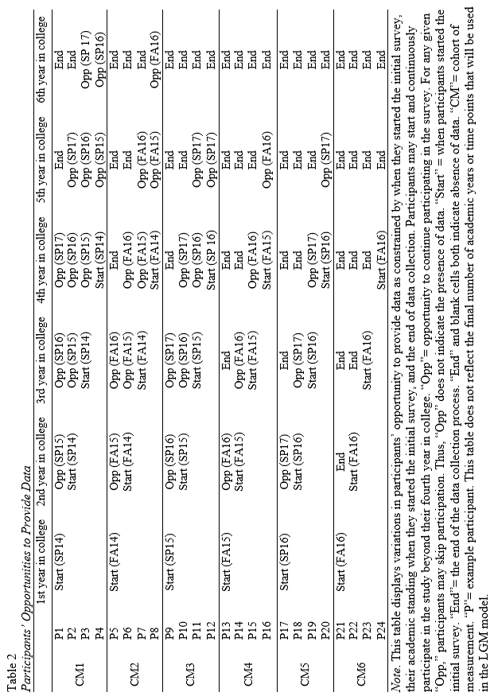
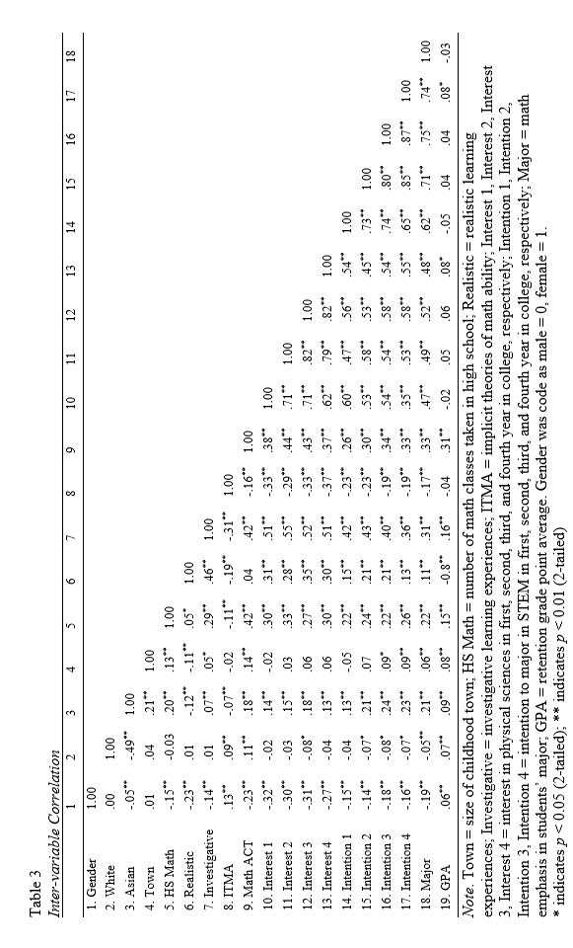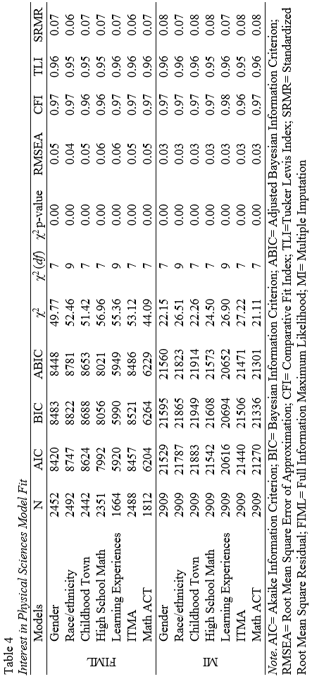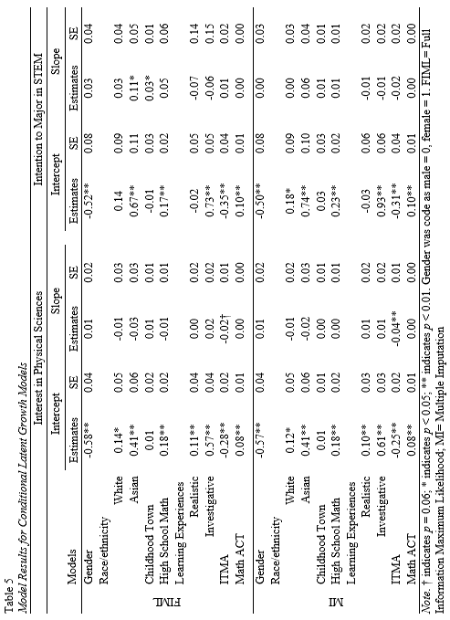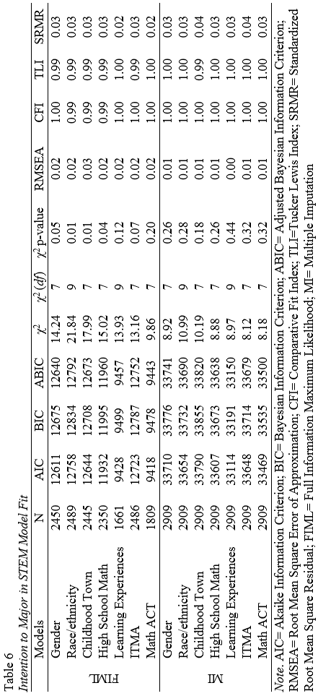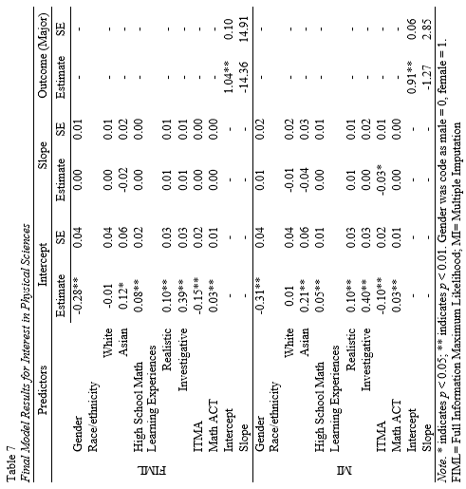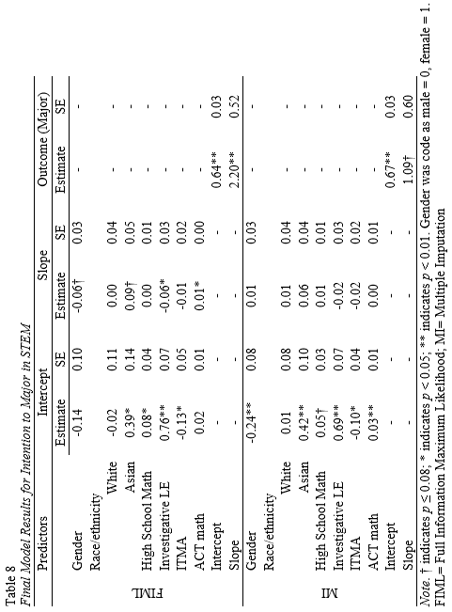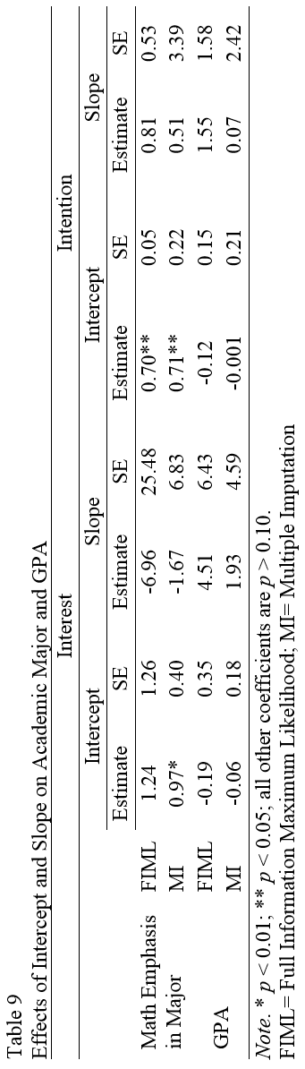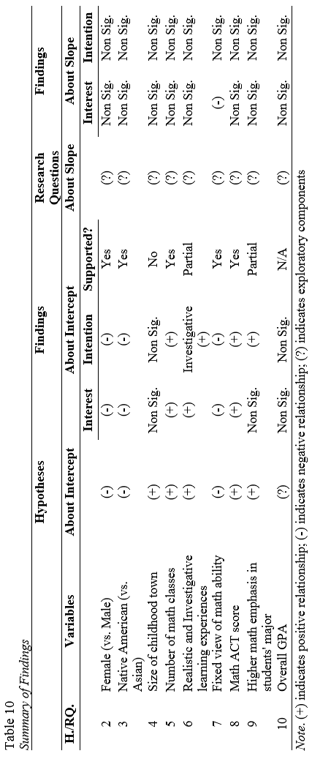
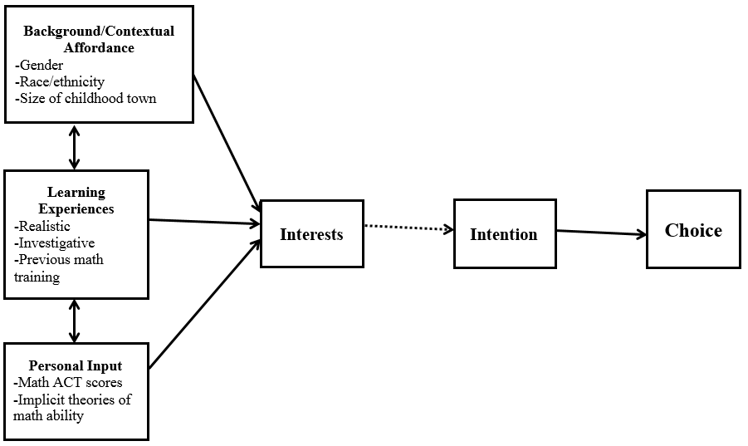
Figure 1. A revised version of SCCT’s interest and choice model. Dashed arrow indicates the path that was not tested in the current study.

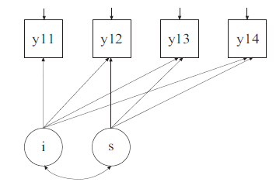
Figure 2. An example of latent growth model.

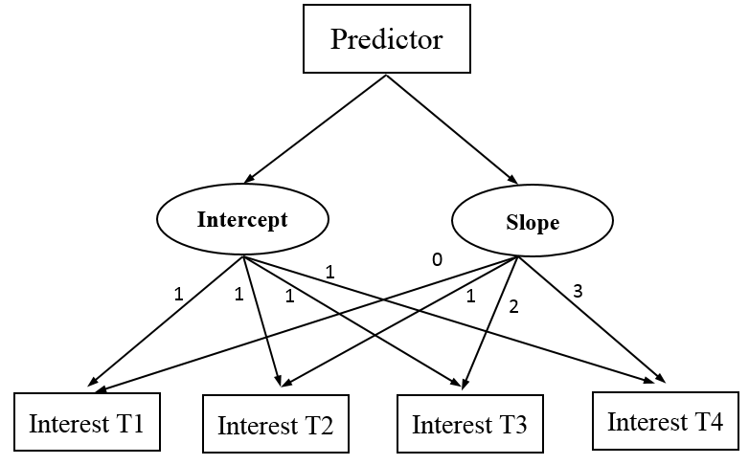
Figure 3. An example of the conditional latent growth model.

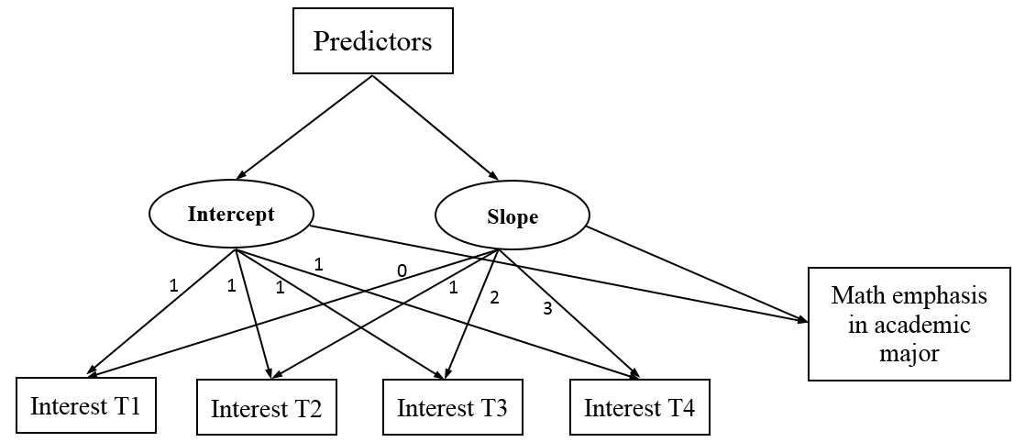
Figure 4. The structure of the final model.

Figure 5. Interest in physical sciences by gender. The scale ranged from 1 = strongly dislike to 5 = strongly like.

Figure 6. Intention to major in STEM by gender. The scale ranged from 1 = strongly disagree to 5 = strongly agree.

Figure 7. Interest in physical sciences by ethnicity. The scale ranged from 1 = strongly dislike to 5 = strongly like.

Figure 8. Intention to major in STEM by ethnicity. The scale ranged from 1 = strongly disagree to 5 = strongly agree.

Appendix A: Learning Experiences Questionnaire (Realistic Subscale)
Learning Experiences Questionnaire (Realistic Subscale; Schaub, 2004)

Note. The instrument was obtained by contacting the author. Participants rated the items using a scale from 1 (strongly disagree) to 6 (strongly agree).

- I have made simple car repairs.
- I have made repairs around the house.
- I have been successful when I used tools to work on things.
- I have done a good job at things that involved physical labor (e.g., landscaping).
- I have done well in building things.
- I have observed members of my family build things.
- I watched people whom I respect work in the outdoors.
- I observed people whom I respect repair mechanical things.
- While growing up, I watched adults whom I respect ﬁx things
- I observed people whom I admire work in a garden.
- People I respect have urged me to learn how to ﬁx things that are broken.
- Teachers I admired encouraged me to take classes in which I can use my mechanical abilities.
- While growing up, adults I respected encouraged me to work with tools.
- People whom I look up to have urged me to pursue activities that require manual dexterity.
- Family members have encouraged me to pursue activities that involve working outdoors.
- I have become uptight while trying to repair something that was broken.
- I have become nervous when working on mechanical things (e.g., appliances).
- I have felt uneasy while using tools to build something.
- I have felt anxious while performing basic repairs on a car. I remember feeling anxious while working on something that required manual labor.

Appendix B: Learning Experiences Questionnaire (Investigative Subscale)
Learning Experiences Questionnaire (Investigative Subscale; Schaub, 2004)

Note. The instrument was obtained by contacting the author. Participants rated the items using a scale from 1 (strongly disagree) to 6 (strongly agree).

- I performed well in biology courses in school
- I was successful performing science experiments in school.
- I received high scores on the math section of my college entrance exam (e.g., SAT).
- I have easily understood new math concepts after learning about them in class.
- I have demonstrated skill at conducting research for my term papers.
- In school, I saw teachers whom I admired work on science projects.
- While growing up, I saw people I respected using math to solve problems.
- I have seen people whom I respect participating in activities that require math abilities
- I recall seeing adults whom I admire working in a research laboratory.
- While growing up, I recall seeing people I respected reading scientiﬁc articles.
- People whom I respect have encouraged me to work hard in math courses.
- I remember my family telling me that it is important to be able to solve science problems.
- People whom I looked up to told me that it is important to read scholarly articles
- My friends have encouraged me to use my research abilities.
- Teachers whom I admire have encouraged me to take science courses.
- I have become nervous while solving math problems.
- I have felt anxious while taking a science course in school.
- I have felt uneasy while learning new topics in biology courses.
- Reading scientiﬁc articles has made me feel uneasy.
- I have felt dread while using math in a job.

Appendix C: Implicit Theories of Math Ability
Implicit Theories of Math Ability

Note. The instrument was modified based on Dweck’s (1999) measure of implicit theories of intelligence. “Intelligence” was replaced with “math ability.” Participants rated the items using a scale from 1 (strongly disagree) to 6 (strongly agree). * indicate “malleable” items.

- You have a certain amount of math ability, and you can’t really do much to change it.
- Your math ability is something about you that you can’t change very much.
- No matter who you are, you can significantly change your math ability level.*
- To be honest, you can’t really change how intelligent you are at math.
- You can always substantially change how intelligent you are at math.*
- You can learn new things, but you can’t really change your basic math ability.
- No matter how much math ability you have, you can always change it quite a bit.*
- You can change even your basic math ability level considerably.*

