UNIVERSITY OF OKLAHOMA
GRADUATE COLLEGE

AN ORCHESTRATION ANALYSIS OF KEVIN WALCZYK’S CONCERTO GAUCHO FOR TRUMPET AND WIND ENSEMBLE (2007) IN CONTEXT WITH THE CONCERTO GENRE FOR BANDS FROM 1880 TO 2007

A DOCUMENT
SUBMITTED TO THE GRADUATE FACULTY
in partial fulfillment of the requirements for the
Degree of
DOCTOR OF MUSICAL ARTS

By
JON R. M. CONRAD
Norman, Oklahoma
2024
AN ORCHESTRATION ANALYSIS OF KEVIN WALCZYK’S CONCERTO GAUCHO FOR TRUMPET AND WIND ENSEMBLE (2007) IN CONTEXT WITH THE CONCERTO GENRE FOR BANDS FROM 1880 TO 2007

A DOCUMENT APPROVED FOR THE SCHOOL OF MUSIC

BY THE COMMITTEE CONSISTING OF

Dr. Shanti Simon, Chair

Dr. William K. Wakefield

Dr. Christopher Baumgartner

Dr. Caroline Hand

Dr. Judith Pender

© Copyright by JON R. M. CONRAD, 2024
All Rights Reserved.

to Dave Turnbull

thank you for believing in me.

ACKNOWLEDGEMENTS

This document would not have been possible were it not for the help of many others along the way. Special thanks and dedication go to my wife, Kailyn, and daughters Reagan and Rylee, for their unending support and patience during the completion of this work. I would also like to thank my parents, Rick and Joan Conrad, and my in-laws, Jeff and Taryn Henning, for the sacrifices they made for my desire to become a musician and for their willingness to foster my musical development.
I am especially grateful to my mentor and teacher, Dr. William Wakefield, whose encouragement, insight, and guidance inspired me to continue. Sincere appreciation is extended to my committee members Dr. Shanti Simon, Dr. Christopher Baumgartner, Dr. Caroline Hand, and Dr. Judith Pender for their time and contribution to this document. Their commentary and candor have been invaluable in making this document clear, accurate, and pertinent. I would also like to thank my amazing teachers and mentors from the University of Oklahoma: Dr. Michael Hancock, Mr. Brian Britt, and Dr. Brian Wolfe for all the faith they had in me throughout my studies at OU, as well as their uncanny ability to “tell it like it is” (whether I wanted to hear it or not).
I had the esteemed privilege of working with several talented and wonderful colleagues who pursued their degrees with me. Without their support and help, I would have fizzled out long ago. They are: Sean Kelley, Teresa Purcell, Ryan Lipscomb, Brian Teed, and Ben Holmes. I wish them all well in their bright futures.
I additionally wish to thank Dr. Kevin Walczyk and Keveli Music for granting permission to excerpt Concerto Gaucho for Trumpet and Wind Ensemble score in this document.
TABLE OF CONTENTS

ACKNOWLEDGEMENTS .............................................................................................. v

TABLE OF CONTENTS ................................................................................................ vi

LIST OF FIGURES ....................................................................................................... viii

LIST OF MUSIC EXAMPLES ........................................................................................ ix

ABSTRACT .................................................................................................................... xi

CHAPTER ONE: INTRODUCTION .............................................................................. 1

Purpose of the Study ............................................................................................ 21
Need for the Study ............................................................................................... 22

Limitations of the Study ...................................................................................... 23

Method of the Study ............................................................................................ 23

CHAPTER TWO: RELATED LITERATURE ............................................................... 25

Kevin Walczyk: Life and Works ........................................................................ 25

Orchestration ...................................................................................................... 26

Historical ............................................................................................................ 29

CHAPTER THREE: BACKGROUND INFORMATION ............................................. 32

Concerto Gaucho for Trumpet and Wind Ensemble .......................................... 32

Kevin Walczyk ................................................................................................... 36

CHAPTER FOUR: ORCHESTRATION ANALYSIS .................................................. 39

I. Candombe ........................................................................................................ 43

II. Milonga .......................................................................................................... 84

III. Candombe Reprise ........................................................................................ 99

CHAPTER FIVE: SUMMARY, CONCLUSIONS, AND RECOMMENDATIONS
FOR FURTHER STUDY .................................................................................. 111

Summary and Conclusions ................................................................................ 111

Recommendations for Further Study ................................................................. 113

BIBLIOGRAPHY ......................................................................................................... 116

APPENDIX A: CATALOG OF THEMATIC MOTIVES ........................................... 120

APPENDIX B: COPYRIGHT PERMISSION ............................................................. 123

APPENDIX C: WORLD PREMIERES OF WIND BAND LITERATURE WITH SOLOISTS AT CBDNA NATIONAL CONFERENCES SINCE 1991 .......... 125
LIST OF FIGURES

Figure 1.1 Program of Goldman Band Concert, 1942 ...................................................... 4

Figure 1.2 Significant events, projects, and literature in developing the concerto genre
for bands ........................................................................................................ 19

Figure 3.1 Concerto Gaucho Consortium Members ........................................................ 33

Figure 3.2 Instrumentation, Concerto Gaucho for Trumpet and Wind Ensemble ............ 34

Figure 4.1 Concerto Gaucho Formal Structure ................................................................ 41

Figure 4.2 Concerto Gaucho Principal and Secondary-Theme Motives .......................... 42

Figure 4.3 Candombe Instruments ................................................................................... 44

Figure 4.4 Candombe Sub-Rhythms ............................................................................... 44

Figure 4.5 Milonga and Décima Formal Structure ........................................................... 85

LIST OF MUSIC EXAMPLES

Music Example 4.1 mm. 1-8 ............................................................................................ 46
Music Example 4.2 mm. 17-20 ........................................................................................ 48
Music Example 4.3 mm. 17-20 ........................................................................................ 49
Music Example 4.4 mm. 25-28 ........................................................................................ 50
Music Example 4.5 mm. 25-28 ........................................................................................ 51
Music Example 4.6 mm. 31-34 ........................................................................................ 52
Music Example 4.7 mm. 31-34 ........................................................................................ 53
Music Example 4.8 mm. 35-38 ........................................................................................ 54
Music Example 4.9 mm. 35-38 ........................................................................................ 55
Music Example 4.10 mm. 39-42 ..................................................................................... 56
Music Example 4.11 mm. 43-46...................................................................................... 58
Music Example 4.12 mm. 47-51 ...................................................................................... 59

Music Example 4.13 mm. 52-55 ...................................................................................... 61
Music Example 4.14 mm. 56-59 ...................................................................................... 63
Music Example 4.15 mm. 60-63 ...................................................................................... 65
Music Example 4.16 mm. 64-67 ...................................................................................... 67
Music Example 4.17 mm. 71-74 ...................................................................................... 69
Music Example 4.18 m. 79 .............................................................................................. 71
Music Example 4.19 mm. 80-81 ...................................................................................... 73
Music Example 4.20 mm. 88-92 ...................................................................................... 75
Music Example 4.21 mm. 92-93 ...................................................................................... 76

Music Example 4.22 mm. 96-98 ...................................................................................... 78

Music Example 4.23 m. 99 ............................................................................................... 79

Music Example 4.24 mm. 104-107 .................................................................................. 80

Music Example 4.25 mm. 108-111 .................................................................................. 81

Music Example 4.26 mm. 112-115 .................................................................................. 82

Music Example 4.27 mm. 132-138 .................................................................................. 86

Music Example 4.28 mm. 139-142 .................................................................................. 87

Music Example 4.29 mm. 151-158 .................................................................................. 89

Music Example 4.30 mm. 159-163 .................................................................................. 91

Music Example 4.31 mm. 159-163 .................................................................................. 93

Music Example 4.32 mm. 168-177 .................................................................................. 95

Music Example 4.33 mm. 194-200 .................................................................................. 98

Music Example 4.34 mm. 213-218 ................................................................................ 100

Music Example 4.35 mm. 219-222 ................................................................................ 102

Music Example 4.36 mm. 223-226 ................................................................................ 103

Music Example 4.37 mm. 227-230 ................................................................................ 104

Music Example 4.38 mm. 235-239 ................................................................................ 105

Music Example 4.39 mm. 240-243 ................................................................................ 106

Music Example 4.40 mm. 250-257 ................................................................................ 107

Music Example 4.41 mm. 262-263 ................................................................................ 108

AN ORCHESTRATION ANALYSIS OF KEVIN WALCZYK’S CONCERTO
GAUCHO FOR TRUMPET AND WIND ENSEMBLE (2007) IN CONTEXT WITH
THE CONCERTO GENRE FOR BANDS FROM 1880 TO 2007
by
JON R. M. CONRAD
ABSTRACT
Kevin Walczyk’s (b. 1964) Concerto Gaucho for Trumpet and Wind Ensemble (2007) represents a significant development of original literature for soloist and full band orchestration. While the twentieth-century band movement gained momentum through many initiatives that primarily focused on developing an original body of literature for the band, new initiatives began focusing with similar intensity on developing an original repertoire featuring soloists. Since the beginning of the twenty-first century, significant progress was made in adding artistic solo literature to the band’s repertoire. This document provides context to the evolution of wind band literature with soloists in regard to addressing balance issues while utilizing the full resource of woodwind, brass, and percussion instruments. The document examines Concerto Gaucho for Trumpet and Wind Ensemble through a phrase-by-phrase analysis of orchestration techniques in regard to balance with the solo voice and clarity within the ensemble.

CHAPTER ONE: INTRODUCTION
According to The New Grove Dictionary of Music and Musicians, the concerto has existed in various forms since the seventeenth century as “an instrumental work that maintains contrast between an orchestral ensemble and a smaller group or a solo instrument.” The vast collection of solo concerti for orchestra existing today indicates an ongoing commitment by composers to develop the solo genre. While these two broad statements reflect the development of the concerto genre for orchestra, concerto development for the much younger band medium is minimal in comparison. However, the development of wind band literature with soloists gained momentum in the twenty-first century following a confluence of late twentieth-century events and initiatives where composers increasingly orchestrated the wind band as an equal and artistic voice to a soloist. Kevin Walczyk’s (b. 1964) Concerto Gaucho for Trumpet and Wind Ensemble (2007) represents an instance in the growing development of artistic wind band literature since the 1990s where composers, conductors, ensembles, and notable soloists collaborate to create new and original literature that addresses a genre gap – solos with wind band.
Walczyk’s Concerto Gaucho exhibits several twenty-first-century repertoire trends common amongst the proliferation of wind band literature with soloists since the 1990s. First, Concerto Gaucho demonstrates adept orchestration techniques that address solo balance with full symphonic orchestration of woodwinds, brass, and percussion to a solo voice, collaboratively reflecting the advancing skills of ensemble musicians. Second, Concerto Gaucho extends the reach of the wind band concerto genre beyond colleges and universities through a vast consortium of twenty-one leading trumpet performers with varied backgrounds intersecting multiple generations. Third, Concerto Gaucho represents a growing list of wind band repertoire that combines composers, ensembles, and notable soloists to generate audience appeal through program variety.
Concerto Gaucho for Trumpet and Wind Ensemble reflects orchestration techniques that contrast the virtuosic display pieces from the “Sousa era (1880–1925).” This includes works by Patrick Gilmore (1829–1892) and John Philip Sousa (1854–1932), which represent “the Golden Age of the American Professional Band.” In addition to performing orchestral transcriptions, overtures, and concert marches, these “golden age” concert bands performed literature with well-known soloists like Frank Simon, Arthur Pryor, Simone Mantia, and Herbert L. Clarke. Advertised to recruit larger audiences, these soloists were vital to advancing audience awareness of the musical and technical capabilities of wind instruments. Although wind band literature with soloists was integral to professional band programming, the band’s common and frequent application of tutti orchestration produced robust decibel levels less favorable to balancing with a solo voice. As a result, the full orchestration of the band was reserved for introductory, transitional, and closing sections, alternating with a smaller group of musicians performing simultaneously to the soloist, similar to the concertino in Baroque concerti grossi. An example demonstrating this orchestration strategy is Jean-Baptiste Arban’s theme-and-variation piece, Carnival of Venice, which effectively emphasizes the soloist while relegating the full ensemble to background and solo breaks.
An emphasis on cultivating serious and artistic literature that integrated the wind band as a more equal voice to the soloist developed organically in the academic and professional settings through the vision of collegiate directors and professional conductors to complement the advancing technical abilities of performers. Edwin Franko Goldman (1878–1956) said in his 1934 publication, Band Betterment, “The band will reach greater heights when more original music is written for it.” Over the next decade, Goldman actively commissioned original works for the wind band, marking a notable beginning to developing an original band repertoire. On July 21, 1942, the Gilmore Band performed a concert comprised entirely of original wind band literature featuring several compositions that Goldman had either fully or partially commissioned. (see Figure 1.1)
Figure 1.1 Program of Goldman Band Concert, 1942

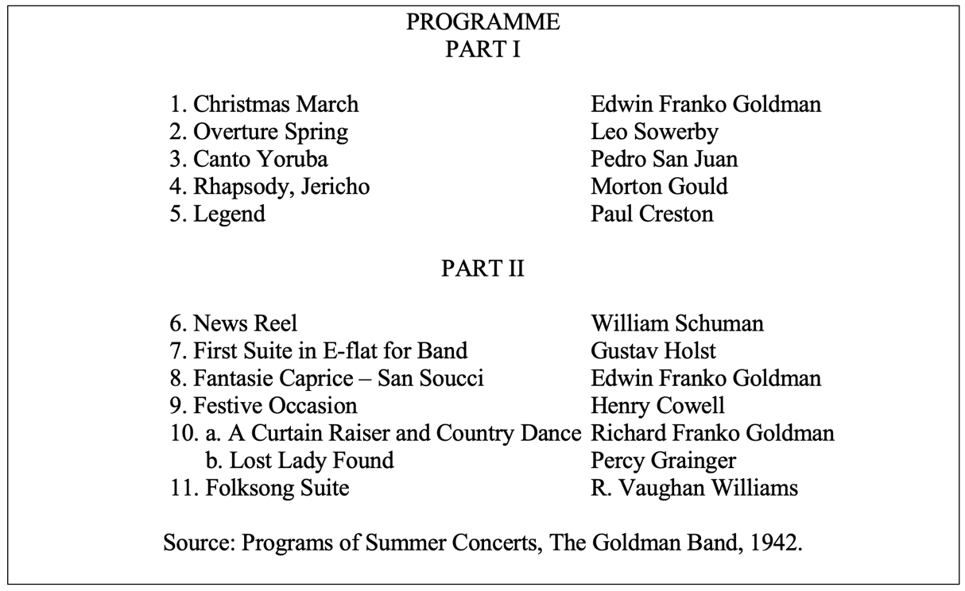

At a time when many conductors relied on orchestral transcriptions to enhance the artistic value of concert programs, the Goldman Band’s 1942 performance, consisting entirely of original literature for the wind band, demonstrated some of the artistic possibilities of the medium. On January 3, 1948, the Goldman Band and The League of Composers performed a concert honoring Goldman’s commissioning legacy on his seventieth birthday using the same program as the landmark 1942 performance. The program consisting of original wind band literature represented the style of repertoire that Goldman had spent thirty years of his life advocating. While the 1942 and 1948 performances are historically significant to developing wind band artistry and original repertoire, neither program included literature with soloists, signaling that the medium was not yet ripe for solo literature.
As the wind band transitioned out of the “golden age” of touring professional concert bands and into the American educational system, an increasing number of conductors at the collegiate level aligned with Goldman’s vision for developing wind band orchestration beyond the conventional tutti orchestration. University of Michigan Director of Bands William Revelli (1902–1994) underscored the need to develop an original band repertoire at the 1946 CBDNA Conference: “Band leaders in colleges and universities must devise ways and means of motivating our better composers to give us masterpieces of original music.” While many in the profession rallied behind the need to develop an original and artistic wind band repertoire, composers held differing opinions on how to approach composing for the wind band. In his 2009 dissertation, Allan Correll compares the varying compositional philosophies of wind band composers in the middle twentieth century when wind band orchestration was beginning to change. Correll states, “While many composers followed the older tradition of [John Philip] Sousa and [Karl] King, the vision of [Percy] Grainger [1882–1961] gradually influenced others toward a new and different artistic model.” Whereas King focused on the entertainment and functional aspects of marches, overtures, waltzes, and serenades, Grainger focused on developing artistic and practical music of high quality, as realized in Lincolnshire Posy (1937).
One of Grainger’s lasting contributions to the wind band is of course his various orchestration techniques, including multiple octave doublings, using entire instrument sections to create choirs, and contrapuntal dynamic effects of changing timbre. However, some may argue that his most crucial contribution was his scoring of independent voicings which required skilled musicians on every part, or as Grainger described it, “democratic polyphony.” This type of scoring that is talked about in Robert “Mark” Rogers’ 1987 dissertation is also apparent in the first and third movements of Walczyk’s Concerto Gaucho, where the clarinet voices (E-flat soprano, 1st, 2nd, 3rd, and bass) are entirely independent of one another to create a composite rhythm and demonstrates how a woodwind section can function like a percussion section. At a time when professional leaders remained steadfast in developing the band’s repertoire, an increasing number of composers such as Darius Milhaud, Gordon Jacob, Florent Schmitt, Sergei Prokofiev, Howard Hanson, and Aaron Copland joined Grainger in exploring the depth and breadth of wind band possibilities through independent orchestration.
The growing collection of original and artistic wind band literature from the second half of the twentieth century represents the growing number of composers willing to write for the wind band and the various methods that conductors used to organize resources for commissioning new works. In 1949, Edwin Franko Goldman “instituted a formal program of commissioning original band works” under the auspices of The League of Composers. The program was the first in the United States to regularly commission works for the wind band. The project was later absorbed by the American Bandmasters Association (ABA), and to this day, the Sousa-ABA-Ostwald Award has “stimulated the creation of many important new compositions for concert band and is responsible for more original band music than any other competition of its kind.” However, among the 62 compositions to receive the Sousa-ABA-Ostwald Award to date, only three feature a soloist: James Curnow’s Symphonic Variants for Euphonium and Band (1984), Michael Daugherty’s Raise the Roof (2007) for solo timpani and wind ensemble, and Steven Bryant’s Concerto for Alto Saxophone (2014). It is interesting to note that the two most recent pieces to win the Ostwald with a feature soloist (Daugherty and Bryant) premiered in close proximity to the 2007 premiere of Concerto Gaucho.
Goldman’s legacy of commissioning new works for the wind band was a model for colleges and universities to follow during the second half of the twentieth century. Conductors initiated individual commissioning projects at institutions with resources and notable composition and instrumental faculty, such as the University of Texas at Austin, the University of Michigan, and Northwestern University. These initiatives were supported by multi-institutional consortium projects and the growing network of professional associations in the twentieth century like the ABA, College Band Directors National Association (CBDNA), and collegiate conference associations (Big Ten Band Directors Association, Big Twelve Band Directors Association, Southeastern Conference Band Directors Association, etc.) resulting in the addition of countless significant works. While the majority of commissioned literature from these organizations during the twentieth century did not include featured soloists, the diverse group of composers who composed for the wind band developed the individual skills of wind musicians by adding new literature exhibiting independent orchestration. Pulitzer Prize-winning composers Aaron Copland, Norman Dello Joio, Leslie Basset, Joseph Schwantner, Karel Husa, and Michael Colgrass were among them.
Concurrent with the development of repertoire initiatives, the Eastman Wind Ensemble, under the direction of Frederick Fennell (1914–2004), played a significant role in developing wind band orchestration closer to meeting the acoustical balance needs of literature with soloists. Prior to the Eastman Wind Ensemble, universities typically staged large ensembles attempting to replicate the size of the symphony orchestra. Fennell envisioned an instrumentation with the orchestral wind section in mind that gave conductors and composers flexibility. Fennell’s vision was to “cut it to the bone, no doubling, begin with a concept that grew from the reed, brass, percussion, keyboard resource . . . add a section of saxophones, keep all doors open and eyes and ears pointed straight ahead.” The Eastman Wind Ensemble’s inaugural performance in 1953 comprised 52 musicians, contrasting the 124-member University of Illinois Concert Band from the same year. The smaller and more flexible Eastman Wind Ensemble instrumentation produced decibel levels more favorable to balancing a solo voice with a large group of wind and percussion instruments. While the Eastman Wind Ensemble’s first concert included one full band work and two chamber compositions for the woodwinds and brass, it omitted compositions that featured soloists. Furthermore, none of the 24 albums professionally recorded by the Eastman Wind Ensemble between 1953 and 1964 include works for soloists reflecting the repertoire goals.
Progress toward developing the wind band as an equal and artistic voice to a soloist accelerated during the second half of the twentieth century following Goldman’s and Fennell’s revolutionary approach to instrumentation. As conductors in the 1950s and ‘60s pressed for more subtle ranges of expression to complement the band’s established powerful decibel level, compositions for the full band instrumentation emerged, demonstrating moments of lighter orchestration. Paul Hindemith’s (1895–1963) Symphony in B-flat (1951) is an early instance of a composition for the full band that utilizes significant texture changes by including chamber and solo orchestrations. Although Hindemith’s Symphony is orchestrated for the full instrumentation without a featured soloist, the second movement provides instances of artistic solo collaboration through extended solo melodies requiring a developed level of independence in the trumpet and alto saxophone.
Another significant composition by a notable composer that advanced wind band artistry closer to collaborating with soloists is Ingolf Dahl’s (1912–1970) Sinfonietta for Concert Band (1961). Representing CBDNA’s first formal commissioning project, Sinfonietta uses portions of the full instrumentation to create chamber music sections by varying the full, chamber, and solo orchestrations. John H. “Jay” Kloecker points out that Sinfonietta contains “very little tutti writing and a minimum of doubling.” While Dahl’s commitment to developing independent voices is apparent throughout the entire composition, particularly noteworthy is the second movement that presents extended solo passages for the clarinet, alto clarinet, and alto saxophone. Additionally, Dahl utilizes instrument color combinations to establish form, as Walczyk does in the second movement of Concerto Gaucho. Sinfonietta primed the repertoire for subsequent literature, demonstrating similar levels of independent orchestration that balanced nicely with a soloist. Reflecting on Dahl’s compositional voice, composer Halsey Stevens (1908–1989) provided a remarkable statement indicating a high level of sophistication and subtlety that described the wind band’s possibilities:
It is not easy to describe that style. Rhythmically it is precise, alert, pertinent, deriving certain characteristics from Stravinsky, others from jazz, but determining its own identity. Its textures are open and economical, its harmonies clean-cut, suggesting, if not unambiguously establishing, tonal allegiances. Melody is spontaneous, of wide ambitus; counterpoints are plastic. Instrumental setting is impeccable, with a keen ear to the idiomatic capabilities of instruments individually and in combination.

Following Hindemith’s and Dahl’s influential compositions for the full wind band instrumentation, new works increasingly emerged exploring the timbre and color possibilities of the wind band through independent orchestration techniques, such as Warren Benson’s (1924–2005) The Leaves are Falling (1964) and Passing Bell (1974). Another seminal work by an important emerging voice who similarly challenged the independence of voices through incorporating the extended keyboard and percussion voices was Joseph Schwanter’s (b.1943) ...and the mountain’s rising nowhere (1977). These works came into fruition in part due to the realization by some composers that the modern wind band was increasingly capable of expressing music at a high artistic level. In a 1982 interview with Donald McLaurin in Interlaken, Switzerland, Karel Husa (1921–2016) summarized his impression of the wind band as a medium for serious musical expression: “I think that today’s writing for winds is entirely professional, in the sense that it is difficult and intricate as it is for orchestral music, and sometimes even as difficult as chamber music with soloistic writing.” Reflecting on the wind band’s significant development between 1950-2000, H. Robert Reynolds (b.1934) points out that “. . . nothing has been more important in the advancement of the wind band in the last 50 years than the enormous increase of quality repertoire. . .” While this statement is accurate for developing literature for the full band instrumentation, two studies examining the wind band repertoire indicate that significant artistic literature with soloists had yet to be widely recognized across the profession.
Acton Ostling Jr.’s 1978 dissertation provided a timely study examining the artistic merit and familiarity of existing wind band repertoire. Of the 1,481 original compositions evaluated, 18 were unanimously designated as “serious artistic repertoire.” Remarkably, only one of the 18 compositions was a solo concerto: Igor Stravinsky’s Concerto for Piano and Wind Instruments (1924). When Jay Gilbert replicated Ostling’s study in 1993, four solo concertos were among the compositions designated as “serious artistic repertoire”: Igor Stravinsky’s Concerto for Piano and Wind Instruments (1924), Ingolf Dahl’s Concerto for Alto Saxophone and Wind Orchestra (1949), Karel Husa’s Concerto for Alto Saxophone and Concert Band (1967), and Husa’s Concerto for Percussion and Wind Ensemble (1970). While neither study concentrated specifically on wind band literature with soloists, the small proportion of solo works represented is a snapshot of the repertoire. However, looking backward at the development from current practice, one can see how the four works listed in Gilbert’s study served as early instances of significant original solo literature for the wind band that addressed orchestration with the same artistic sophistication of Dahl’s Sinfonietta for Concert Band and Hindemith’s Symphony in B-flat.
The data in Ostling and Gilbert’s study is a prime example of the wind band maturing in skills, literature, and audience. Additionally, Gilbert’s study suggests that Dahl’s mid-century Concerto for Alto Saxophone marked a notable beginning to developing solo literature for the wind band. Dahl demonstrated his commitment to the wind band through several revisions of his Concerto that widened its accessibility to soloists and wind bands by developing it from a single to multi-movement work. Renowned saxophonist Sigurd Raschèr, to whom the piece is dedicated, gave the Concerto’s premiere, marking an early instance of a notable soloist and composer collaborating with a wind band. When Raschèr approached Dahl to compose the work, he envisioned the accompaniment scored for orchestra. However, when interviewed about choosing the wind band to accompany his Concerto, Dahl said, “Somebody has to write the big pieces, the symphonic works, if the medium is to be elevated.”
Nearly two decades following the premiere of Dahl’s 1949 Concerto for Alto Saxophone, an important milestone in developing original wind band literature occurred, and this time, it included solo literature. In 1967, Donald Hunsberger (1932–2023), MCA Publications, and Decca Records set out to create a meaningful contemporary music project focused on wind band literature with soloists. The intent was to record and publish “several compositions for solo instruments and wind ensemble,” including Dahl’s Concerto for Alto Saxophone. These works were considered significant but outside of the mainstream repertoire. Despite Hunsberger’s leadership and influence, the project ended in 1970 due to complications surrounding financial constraints, distribution, marketing, contracts, rights, and insufficient performance opportunities. The project’s ending indicates that the time was not yet ripe for advancing the solo repertoire. Richard Hansen points out, “Band conductors had already failed to understand the value of some of the most significant music written in the twentieth century.” Also important to note, following the Hunsberger/MCA/Decca project, professionally recorded albums from 1978–1999 of Frederick Fennell conducting the Tokyo Kosei Wind Orchestra, Cleveland Symphonic Winds, and Eastman Wind Ensemble omitted original wind band literature with soloists.
While Hunsberger’s efforts were met with obstacles, four collaborations in the 1990s provided significant momentum for developing original and artistic wind band literature with soloists. The first was the release of a professionally recorded compact disc in 1993 comprised of works for solo clarinet and wind band titled Ebony Concerto. It featured Grammy Award-winning and Chicago Symphony Orchestra clarinetist John Bruce Yeh and DePaul University’s Wind Ensemble and Jazz Band. Unlike the Hunsberger recording project, the Ebony Concerto album resulted in subsequent recordings and became the first in a series known as the DePaul University Wind Ensemble Recording Project. The project included collaborations with orchestra principals like Charles Vernon, Larry Combs, Donald Peck, Floyd Colley, Mary Sauer, and Mary Stolper. Conductor and project leader Donald DeRoche described his vision for the project:
In this project we try to seek out new and interesting music, older pieces we believe should not be forgotten, and solo works. In addition, we want the solo pieces to be performed by excellent soloists. The works of composers such as Villa-Lobos, Bozza, Martinu, Lopatnikoff, Milhaud, Dahl, Revueltas, Badings, Otterloo, Perle, Henze, Casterede, and Auric served that philosophy.

Prior to the widespread use of the internet and email when conductors relied on live performances, recordings, and personal accounts to identify programming trends, the DePaul University Wind Ensemble Recording Project provided a timely example of a university wind band collaborating with renowned solo artists and charted a path toward building a vital genre for the wind band.
Following the release of the Ebony Concerto album, notable additions of wind band literature with soloists emerged reflecting the same standards of excellence as works for the full band instrumentation. This included works by composers with varied backgrounds ranging from the professional and academic fields, such as Eric Ewazen’s Shadowcatcher (1996) for brass quintet and wind ensemble, Scott McAllister’s X Concerto (1996) for clarinet and wind ensemble, David Maslanka’s Sea Dreams (1997) for two horns and wind ensemble, and Joseph Turrin’s Fandango (1998) for trumpet, trombone, and wind symphony. Whereas wind band literature with soloists from the nineteenth century centered around the technical display of soloists like Herbert L. Clarke’s Carnival of Venice and Arthur Pryor’s The Blue Bells of Scotland, this emerging collection of solo works at the end of the twentieth century, in contrast, featured the developing level of wind band artistry through musically challenging accompaniments presenting the wind band as an equal and collaborative voice.
Another noteworthy instance of internationally recognized orchestra principals collaborating with wind bands ensued when Turrin’s Fandango (1998) became the title track for a collaborative recording project led by conductor Eric Rombach-Kendall that featured New York Philharmonic section principals Philip Smith and Joseph Alessi, composers Joseph Turrin and Stephen Gryc, and the University of New Mexico Wind Symphony. Much like DeRoche’s recording project five years prior, the Fandango album developed the solo genre through an album and digital source material comprised entirely of original wind band literature with solo virtuosos. Fandango’s release was a strong indicator of the ripening time for solo literature that capitalized on the powerful symbiotic relationship where notable soloists, composers, and conductor led ensembles collaborate to create memorable performance opportunities.
Promptly following the release of the Fandango album, New York Philharmonic principal Philip Smith and the University of New Mexico Wind Symphony, under the direction of Eric Rombach-Kendall, gave the premiere performance of Joseph Turrin’s Chronicles (1999) at the 1999 CBDNA National Conference in Austin, Texas. With many college band professionals in attendance, this landmark performance demonstrated the artistic possibilities of an internationally recognized orchestra principal performing with a university wind band at a national conference. The DePaul University and the University of New Mexico collaborations with notable soloists and composers generated significant momentum for developing wind band literature with soloists in a relatively brief period.
Following the premiere of Chronicles at the 1999 CBDNA National Conference, subsequent premieres of wind band literature with soloists ensued at national and regional conferences, demonstrating the artistic possibilities of the wind band solo genre, indicative of growing awareness of the genre by conductors, composers, soloists, and audiences. Subsequent premieres at national conferences include Susan Botti’s Cosmosis (2005) for soprano voice, wind ensemble, and women’s chorus and Michael Daugherty’s Brooklyn Bridge (2005) for clarinet and wind ensemble at the 2005 CBDNA National Conference in New York City, and Daugherty’s Raise the Roof (2007) for timpani and symphonic band at the 2007 CBDNA National Conference in Ann Arbor, Michigan. The premiere performances of these four solo works in rapid sequence at national conferences and the willingness of notable soloists to collaborate with wind bands demonstrate how fertile the genre was in the immediate years before the premiere of Concerto Gaucho.
Concerto Gaucho historically provides momentum to the development of wind band literature with soloists by adding an original work demonstrating the artistic possibilities of the wind band collaborating with soloists as an equal and artistic voice. Following Concerto Gaucho’s premiere, solo literature with renowned soloists continued to premiere at major professional conferences, signaling the genre’s growing significance in the development of original wind band literature. Some examples of premiere performances at professional conferences include Carter Pann’s Concerto Logic (2007) for piano and wind symphony and Verena Mösenbichler-Bryant’s transcription of John Corigliano’s Mr. Tambourine Man: Seven Poems of Bob Dylan for Soprano Voice and Wind Ensemble (2009) at the 2009 CBDNA National Conference in Austin, Texas, John Mackey’s Harvest: Concerto for Trombone (2009) for Joseph Alessi at the University of Washington in 2011, and Steven Bryant’s Concerto for Alto Saxophone (2014) for Joseph Lulloff at the North American Saxophone Alliance Conference at the University of Oklahoma in 2015. A complete list of premiere performances of original wind band literature with soloists since 1990 at the bi-annual CBDNA National Conference is included in Appendix C.
Following the untimely passing of University of New Mexico conductor Eric Rombach-Kendall in 2022, composers, conductors, and performers memorialized Rombach-Kendall’s legacy of developing the solo genre through a consortium-driven composition for wind band and soloists, Triptych for Trumpet, Trombone, and Wind Symphony (2022) by Joseph Turrin. Triptych received its premiere at the 2023 CBDNA National Conference in Athens, Georgia, performed by New York Philharmonic trumpet and trombone principals Christopher Martin and Joseph Alessi and the University of Georgia Wind Ensemble under the direction of Nicholas Enrico Williams. This initiative indicates the ongoing commitment to developing wind band literature with soloists.
The wind band solo genre has developed immensely since 1990, primarily because of works like Concerto Gaucho for Trumpet and Wind Ensemble that demonstrate the collaborative elements of soloists, composers, ensembles, and conductors uniting to perform serious and artistic original wind band literature. The audience for this genre has also developed over this time, resulting in increased performances of wind band literature with soloists at professional conferences such as the CBDNA National Conference and Midwest Clinic, at professional and civic concerts by ensembles like the Dallas Winds, and appearing on professionally recorded albums. What began in the 1990s as a few isolated instances has developed into a sub-genre of the wind band’s repertoire. Concerto Gaucho’s 2007 premiere lies toward the beginning of a prolific period for literature with soloists as it began to intensify. Therefore, an analysis of Concerto Gaucho’s orchestration will provide knowledge of orchestration techniques used at the time that permit the collaborative and artistic possibilities of wind bands with notable soloists. Figure 1.2 presents a chronology of significant events and projects from the Sousa era beginning in the 19th century to 2009 to illustrate the acceleration of concerto genre works of significance for wind band.

Figure 1.2 Significant events, projects, and literature in developing the concerto genre for bands

1892 John Philip Sousa forms the Sousa Band

1893 Trombone virtuoso Arthur Pryor performs for the first time with the Sousa Band

Herbert L. Clarke joins the Sousa band as a soloist

1897 Arthur Pryor’s The Blue Bells of Scotland premieres

1914 Frank Simon joins the Sousa Band as a soloist

1921 Edwin Franko Goldman forms the Goldman Band

1942 Goldman Band performs unprecedented program comprised entirely of original wind band literature

1949 Mark Hindsley, Sigurd Raschèr, and the University of Illinois Concert Band gives the premiere performance of Ingolf Dahl’s Concerto for Alto Saxophone and Wind Orchestra, an early example of original literature for soloist and wind band by a notable composer for a renowned soloist

1961 William Schaefer and the University of Southern California Wind Ensemble give the premiere performance of Ingolf Dahl’s Sinfonietta for Concert Band, an example of original literature by a notable composer demanding player independence from the ensemble

1967 Maurice Stith, Sigurd Raschèr, and the Cornell Wind Ensemble give the premiere performance of Karel Husa’s Concerto for Alto Saxophone and Concert Band, another early example of original literature for soloist and wind band by a notable composer for a renowned soloist

Donald Hunsberger, MCA Publications, and Decca Records attempt to create a meaningful contemporary music project focused on wind band literature with soloists

1993 DePaul University Wind Ensemble Recording Project led by Donald DeRoche releases Ebony Concerto compact disc; example of orchestral principals and notable soloists collaborating with a university wind ensemble

1998 Six simultaneous premieres of David Maslanka’s Sea Dreams given by Arizona State University, Florida State University, Ithaca College, and the universities of Alabama, Iowa, and Missouri at Kansas City utilizing new streaming technologies. Commissioned by a player consortium with ties to academic institutions led by Thomas Bacon at Arizona State University

1999 Release of Fandango compact disc, a collaboration between New York Philharmonic principals Philip Smith, trumpet, Joseph Alessi, trombone, composers Joseph Turrin and Stephen Gryc, conductor Erich Rombach-Kendall, and the University of New Mexico Wind Symphony

Erich Rombach-Kendall, New York Philharmonic principal trumpet Philip Smith, and the University of New Mexico Wind Symphony perform Joseph Turrin’s Chronicles at the CBDNA National Conference in Austin, Texas

2005 Michael Haithcock, Susan Botti, and the University of Michigan Symphony Band give the premiere performance of Botti’s Cosmosis at the CBDNA National Conference in New York City

Michael Haithcock, Michael Wayne, and the University of Michigan Symphony Band give the premiere performance of Michael Daugherty’s Brooklyn Bridge at the CBDNA National Conference in New York City

Mark Davis Scatterday, Mark Kellogg, and the Eastman Wind Ensemble give the premiere performance of Jeff Tyzik’s Concerto for Trombone and Wind Ensemble at the CBDNA National Conference in New York City

2007 Michael Haithcock, Andre Dowell, and the University of Michigan Symphony Band give the premiere performance of Michael Daugherty’s Raise the Roof at the CBDNA National Conference in Ann Arbor, Michigan

Jerry Junkin, Don Fabian, and the Dallas Winds give the premiere performance of John Mackey’s Concerto for Soprano Sax and Wind Ensemble

Premiere performance of Kevin Walczyk’s Concerto Gaucho for Trumpet and Wind Ensemble

2009 Kevin Sedatole and the Michigan State University Wind Symphony premiere Carter Pann’s Concerto Logic with the composer as the soloist

Jerry Junkin, Franklin Gross, Jim James, and the University of Texas Wind Ensemble perform Pulitzer Prize-winning composer John Adams’ Gran Pianola Music at the CBDNA National Conference in Austin, Texas

Jerry Junkin, Hila Plitmann, and the University of Texas Wind Ensemble give the premiere performance of Verena Mösenbichler-Bryant’s band transcription of Pulitzer Prize-winning composer John Corigliano’s Mr. Tambourine Man: Seven Poems of Bob Dylan at the CBDNA National Conference in Austin, Texas

LTC Timothy Holtan, New York City principal trombone Joseph Alessi, and the West Point Academy Band give the premiere performance of John Mackey’s Harvest: Concerto for Trombone

Purpose of the Study
Balancing the wind band to a solo voice has remained a primary concern for composers of wind band literature with soloists. Unlike the homogenous color produced by the combined orchestral string section, the wind band’s multi-colored instrumentation bears complex balance and blending challenges, particularly at soft dynamic levels. The growing accessibility of piano, celeste, harp, and percussion colors, combined with the growing levels of wind musician artistry, has enabled composers to explore timbral colors through orchestration possibilities more confidently, particularly in solo works where balance remains a priority. Kevin Walczyk’s orchestration of Concerto Gaucho for Trumpet and Wind Ensemble not only maintains a clear separation of the solo and accompaniment voices but does so in an artistic way that allows the accompaniment to serve as an equal and collaborative voice.
The purpose of this study is to examine Kevin Walczyk’s orchestration of Concerto Gaucho for Trumpet and Wind Ensemble as it relates to balancing a solo voice with the full resources of woodwind, brass, and percussion instruments of the wind band/wind ensemble. Music examples from Concerto Gaucho for Trumpet and Wind Ensemble will be examined to identify orchestration principles that promote effective separation of the solo trumpet and accompaniment voices, such as timbre, color, texture, instrumentation, and range. Although rhythm lies outside of the umbrella of orchestration, how Walczyk orchestrates the various rhythms is important in the context of this study and will be included. This document will provide a resource for those performing Concerto Gaucho for Trumpet and Wind Ensemble and may provide composers and arrangers with practical strategies for orchestrating solo works with wind band accompaniment.

Need for the Study
While several highly regarded publications address orchestration, only a limited quantity address the orchestral concerto genre, and none specifically address wind band literature with soloists. This study is relevant due to the need for more existing scholarship on orchestrating wind band literature with soloists. The results are intended to serve as a reference for those conducting or performing Concerto Gaucho for Trumpet and Wind Ensemble or those looking for orchestration strategies that promote balance between a solo voice and a wind band.
Although the complex cultural relationships driving the wind band’s development have attracted extensive research regarding the concert literature orchestrated for the full band, limited research explicitly addresses wind band literature with soloists (i.e., Dahl’s Concerto for Alto Saxophone). Considering how approaches to wind band orchestration have shifted from the nineteenth-century virtuosic, theme-and-variation-styled pieces to solo literature composed in the twenty-first century warrants an examination of orchestration techniques through the lens of Walczyk’s Concerto Gaucho to identify and address balance issues of modern wind band literature with soloists.

Limitations of the Study
Although Concerto Gaucho’s accompaniment exists in four versions (wind ensemble, orchestra, chamber ensemble, and solo piano), Kevin Walczyk states in the program notes that “Concerto Gaucho was conceived with the wind ensemble version in mind from the beginning.” Therefore, this study will focus on the orchestration principles of the version for wind ensemble. This document is not intended to serve as an exhaustive history of the solo genre or development of the wind band repertoire. Therefore, historical context relevant to developing independent and artistic voices as they relate to the evolution of wind band repertoire with soloists up to the premiere of Concerto Gaucho will be included, specifically in developing the wind band as an equal and collaborative voice to a soloist(s).

Method of the Study
The growing collection of twenty-first-century wind band literature with soloists allows one to examine orchestration strategies that effectively balance a large wind band with a solo voice. This study aims to analyze Concerto Gaucho’s orchestration using music examples extracted from the score and comparing them to the orchestration techniques listed in Samuel Adler’s book The Study of Orchestration. The six techniques include:
1) Dialogue
2) Assigning foreground vs. background roles
3) Creating color contrast between the soloist and accompaniment
4) Separating solo and tutti by rhythmic independence
5) Using sparse accompanimental textures advantageously
6) Using spacing and register effectively to distinguish the solo from the accompaniment
Innovative techniques discovered within Concerto Gaucho will also be identified and accompanied by examples from the printed score to illustrate the technique.
CHAPTER TWO: RELATED LITERATURE
Kevin Walczyk: Life and Works
Resources devoted to Kevin Walczyk’s compositions are limited. The composer’s professional website, KeveliMusic.com, provides his compositional philosophy, professional biography, discography, and information about his portfolio, namely his works for wind band and soloists, program notes, and background information related to each piece. Beyond this resource, only two publications devote a substantial portion to Kevin Walczyk or his compositions.
Luke Johnson’s 2015 doctoral dissertation, The Need for Technically Accessible Chamber Winds Music and a Conductor’s Guide to “Winter Ricercar” by Kevin Walczyk, offers insight into the compositional techniques of Walczyk’s wind band music through a structural and harmonic analysis of Winter Ricercar. The dissertation also includes an interview transcript that provides additional biographical information not included on the composer’s website related to his musical training and professional career that shaped his compositional voice. While this dissertation provides valuable knowledge about Walczyk’s background, it does not explicitly address the orchestration of Winter Ricercar or other works from his catalog.
The second publication devoting a significant portion to Walczyk and his music is Jacqueline Townsend’s 2018 dissertation, The Renaissance of the American Symphony for Wind Band as Exemplified by the Recent Symphonies of Donald Grantham, David Dzubay, James Stephenson, and Kevin Walczyk. In addition to providing a structural analysis, the dissertation compares Walczyk’s Symphony No. 4: Unforsaken to “a rubric of standard symphonic norms” with consideration given to duration, ensemble size, instrumentation, key relations, thematic cohesion, and composer intent. Townsend interviewed Walczyk to gain insight into his compositional process, which she incorporates into her analysis. Information about Walczyk’s compositional process assists in making well-informed decisions when analyzing Concerto Gaucho; however, her dissertation does not explicitly address orchestration.
Two sources by the composer provide direct insight into the composer’s compositional philosophy. Walczyk’s 1994 DMA dissertation, Capriccio: A Composition for Symphonic Orchestra, and 1991 master’s thesis, Two Movements from the Delphic Suite: A Composition for Orchestra, offer valuable knowledge of how he approaches texture, rhythmic structure, harmonic structure, and melodic structure.

Orchestration
The context of artistry development to advancing the wind band’s repertoire stems from a collection of published resources. Arthur Clappé’s The Principles of Wind-Band Transcription presents the author’s approach to various aspects of wind band orchestration, including tone color, dynamics, and instrumentation. During a time when transcriptions were heavily relied upon for enhancing the artistic quality of the band repertoire, Clappé’s work provides a valuable framework. John Cacavas’ book Music, Arranging, and Orchestration contains a chapter on orchestrating for the symphonic band. This source is beneficial for providing a historical snapshot of the views of orchestration at the time of publication near the premieres of the Dahl and Husa alto saxophone concertos. Bernard Rogers’ The Art of Orchestration provides a point of view from a time after the formation of the Eastman Wind Ensemble in 1953 but before the premiere of Dahl’s Sinfonietta for Concert Band in 1961. His viewpoint on tonal elements, such as “the opposition of tone color,” develops background knowledge for making informed decisions during the analysis process relative to Concerto Gaucho’s orchestration.
Joseph Wagner’s Band Scoring provides a thorough resource for orchestrating the instruments of the wind band relative to timbre, range, harmonic series, commonalities, playing styles, and tone production. This resource addresses the timbres and colors of the percussion section in depth, which many orchestration texts omit or overlook. Furthermore, it specifically addresses orchestrating solo instruments with the wind band, which directly relates to an orchestration analysis of Concerto Gaucho.
Kent Kennan and Donald Grantham’s book The Technique of Orchestration is an extensive resource detailing effective orchestration strategy for each orchestral instrument. While this resource does not directly address featured soloists or instruments unique to the wind band, such as the saxophone and euphonium, it provides foundational knowledge pertinent to examining Concerto Gaucho’s orchestration.
Much like the Wagner and Kennan/Grantham sources, Samuel Adler’s book The Study of Orchestration thoroughly introduces orchestration for all orchestral instruments, including an extensive list of percussion instruments. Additionally, it contains two sections that address the wind ensemble and orchestration. In the third and fourth editions of this book, a chapter titled Scoring for Band or Wind Ensemble provides the fundamentals of wind band orchestration, including a brief history outlining the differences between the traditional concert band and wind ensemble, variations in wind band instrumentation, transcribing existing works for the wind band, and a list of original wind band works worthy of study. It is worth noting that the list does not include solo works; however, an earlier chapter in this book suggests six basic techniques for the composer to consider in developing an orchestral accompaniment: dialogue, foreground vs. background roles, creating color contrast between the soloist and accompaniment, separating solo and tutti by rhythmic independence, using sparse accompanimental textures advantageously, and using spacing and register effectively to distinguish the solo from the accompaniment. These six topics assist in designing the analysis chapter of the document.
Additional published sources directly addressing wind band orchestration are authored by Erik Leidzén (1950), Philip Lang (1950), and Frank Erickson (1983). Lang’s book dedicates a few pages asserting the possibilities of soloists with bands. However, like the Joseph Wagner (1960) and Arthur Clappé (1921) publications, all were published prior to the rise of the “wind ensemble” and the proliferation of original and artistic wind band literature with soloists in the twenty-first century.
Several doctoral dissertations about more recently premiered solo works provide further context for developing solo literature and orchestration. Joseph Cernuto’s 2018 thesis, Analytical, Interpretative, And Performance Guides for Conductors and Soloists to John Mackey’s Harvest: Concerto for Trombone, Drum Music: Concerto for Percussion, and Antique Violences: Concerto for Trumpet provides a valuable addition to orchestration research serving as a basis for analyzing Concerto Gaucho’s orchestration. Jacob Wallace’s 2009 dissertation John Mackey’s Concerto for Soprano Sax and Wind Ensemble (2007): An Analysis and Conductor’s Guide to Performance addresses issues of performance for the conductor that are common in many works for wind band and soloist, including difficulties presented by the techniques and orchestration that are prevalent throughout Concerto Gaucho.

Historical
Source material regarding the historical context and development of wind band literature with soloists comes from numerous sources. Kevin Burns’ 2000 document Karel Husa’s Concerto for Alto Saxophone and Concert Band: A Performer’s Analysis provides valuable historical information about the development of Husa’s concerto, which played a large part in developing solo literature. Carl Thomas Rowles’ 2016 essay Ingolf Dahl’s Concerto for Alto Saxophone and Wind Orchestra: A Revised Edition also provides information pertinent to understanding the context of solo literature development. Christopher Rettie’s monograph, A Performer’s and Conductor’s Analysis of Ingolf Dahl’s Concerto for Alto Saxophone and Wind Orchestra, devotes an entire chapter to historical information, including information about the composer-soloist-conductor relationship that has been a driving force of many modern solo concertos for wind band. Joseph Frye’s 2008 treatise, A Biographical Study of the Trombone Soloists of the John Philip Sousa Band: 1892–1931 , provides historical information about band soloists in the “golden age” and gives context to the early development of wind band literature with soloists.
The development of player independence stems from wind band repertoire for the full band that challenged and advanced the technical skills of individual musicians. Research that addresses the historical development of the concert literature for the full band and the development of independent voices is obtained through a collection of resources, including Richard Franko Goldman’s The Wind Band: Its Literature and Technique, which contains historical information about the “golden age” concert bands and their inclusion of soloists. Frank Battisti’s books, The Twentieth Century Wind Band and The Winds of Change, and Frederick Fennell’s Time and the Winds provide extensive information regarding the development of the individual musician artistry and the maturing of the concert literature. Richard Hansen’s The American Wind Band also speaks to the development of players and repertoire. Acton Ostling Jr.’s landmark doctoral dissertation for wind band repertoire research, An Evaluation of Compositions for Wind Band According to Specific Criteria of Serious Artistic Merit, including replication studies by Jay Gilbert in 1993 and Clifford Towner in 2011, provides data regarding the changing views of wind band literature with soloists. Combined, these resources provide historical context to the development of independent voices that was critical to developing complex original wind band literature with soloists.
Research on the historical development of the wind band, its repertoire, the various full-band orchestration principles, and general knowledge about Kevin Walczyk and Concerto Gaucho for Trumpet and Wind Ensemble exist. However, research on the orchestration of soloists with wind bands has yet to be published. This document will examine orchestration principles through the lens of Concerto Gaucho for Trumpet and Wind Ensemble utilizing the preceding source material to make informed decisions and identify strategies that balance and blend a large accompaniment of wind and percussion instruments to a soloist as an equally artistic voice.

CHAPTER THREE: BACKGROUND INFORMATION
Concerto Gaucho for Trumpet and Wind Ensemble
Concerto Gaucho for Trumpet and Wind Ensemble represents a unique variation to the institutional consortium in a logical way that unites soloists with ensembles to develop both the wind band and solo trumpet repertoires. Kevin Walczyk formed a performer consortium for Concerto Gaucho which comprises twenty-one trumpet performers and their respective institutions/ensembles. Notable consortium members include former Boston Symphony Orchestra principal trumpet Tim Morrison, former Canadian Brass members Brandon Ridenour and Ronald Romm, and freelance artist Joey Tartell. The artistry represented in Concerto Gaucho’s strikingly large and diverse consortium is indicative of the growing enthusiasm espoused by high-profile artists to collaborate with wind ensembles. A complete list of consortium members is printed in Figure 3.1.

Figure 3.1 Concerto Gaucho Consortium Members

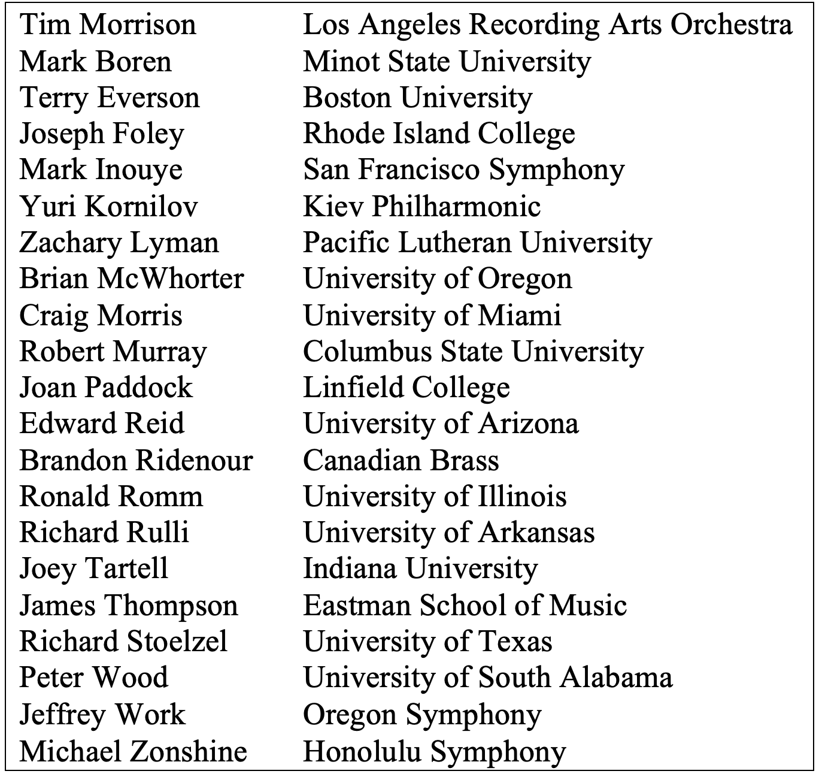

To increase its reach and accessibility across multiple genres, Concerto Gaucho’s accompaniment exists in four versions: wind ensemble, orchestra, chamber septet (piano, percussion, and contrabass), and solo piano. While the orchestration of each version varies due to the instrumentation of the medium, the program note from the printed score states “. . . Concerto Gaucho was conceived with the wind ensemble version in mind from the beginning of the compositional process.” Although it is common practice to reduce the number of musicians performing the accompaniment for balance purposes, Concerto Gaucho for Trumpet and Wind Ensemble utilizes a full orchestration comprised of complete sections of woodwinds, brass, and percussion, plus harp and bass. Within the percussion section, Walczyk utilizes a wide array of colors from 17 different instruments. The complete instrumentation of Concerto Gaucho for Trumpet and Wind Ensemble is printed below.
Figure 3.2 Concerto Gaucho for Trumpet and Wind Ensemble Instrumentation

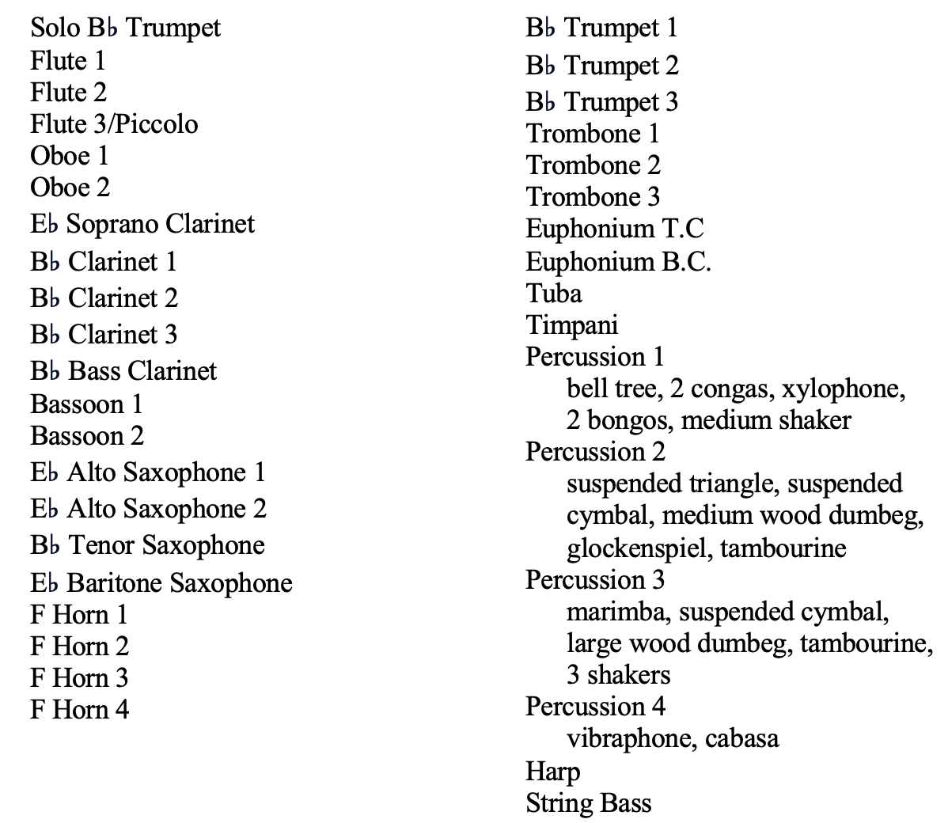

Concerto Gaucho explores the South American musical culture and is dedicated to Uruguayan native Carlos Kalmar, Oregon Symphony Music Director Laureate. Composed in three movements, Concerto Gaucho pays homage to the history-enriched music of Uruguay and Argentina containing musical identities indigenous to the Rio de la Plata region of South America. The gaucho is revered in Uruguay and Argentina as a heroic countryman, akin to the cowboy of the American wild west, and portrayed by historians as a nomadic horseman defending and exploring the uncharted territory of eighteenth and nineteenth-century South America.
Concerto Gaucho’s first and third movements derive from the candombe, a South American folk dance performed at Carnival primarily by Uruguayans of African ancestry. To recreate the dance feel, the percussion section in Concerto Gaucho assumes the role of a Latin rhythm section to establish an authentic style. In addition to utilizing the percussion section, Walczyk amplifies the various Latin rhythms throughout the wind sections of the ensemble. Walczyk depicts the gaucho’s courageous lifestyle through technically demanding and endurance-testing trumpet solo passages symbolizing the gaucho’s bravery, strength, and swagger painted atop the energetic accompaniment. The lyrical second movement derives from the milonga, a traditional Uruguayan song and dance form, where gauchos notoriously sang impromptu folk melodies about their nomadic and solitary lifestyle accompanied by guitar.
Notable performances of Concerto Gaucho beyond the consortium premieres include a professional recording of the orchestral version in 2008 featuring Kiev Philharmonic Orchestra Principal Trumpet Yuri Kornilov with the Kiev Philharmonic Orchestra conducted by Sir Robert Ian Winstin. In 2013, a live performance of the wind ensemble version was performed and recorded in Tokyo, Japan by American trumpeter and New York Philharmonic Orchestra Principal Trumpet Christopher Martin and the Musashino Academia Musicae Wind Ensemble under the baton of Ray Cramer.

Kevin Walczyk
Oregon native Kevin Walczyk (b. 1964) is a critically acclaimed composer of instrumental, choral, jazz, and film genres. He currently serves as Department Chair and Professor of Music at Western Oregon University in Monmouth, Oregon where he teaches courses in composition, orchestration, jazz arranging, and film scoring. Prior to his current appointment, Walczyk attended the University of North Texas from 1989-94 earning a master’s and doctorate in composition. As a master’s student, Walczyk arranged and orchestrated for the renowned University of North Texas One O’Clock Lab Band while studying with prominent jazz arrangers Tom Kubis and Frank Mantooth. As a doctoral student, Walczyk received a teaching fellowship for music theory while studying composition with Larry Austin, Jacob Avshalomov, Thomas Clark, Martin Mailman, and Cindy McTee.
Walczyk’s wind band compositions are performed throughout the United States and abroad by professional, military, and university ensembles, and garner recognition at international juried contests. Symphony No. 2, Epitaphs Unwritten, inspired by a World War II peace marker commemorating “the protagonists of freedom,” received the 2011 National Band Association’s William D. Revelli Memorial Composition Award and was nominated for the 2011 Pulitzer Prize and 2012 Grawemeyer Award. Walczyk was also awarded the 2012 Raymond and Beverly Sackler Music Composition Prize for Symphony No. 3, Quintet Matinee and the 2012 Big East Conference Band Directors Association Composition Contest for Songs of Paradise.
Walczyk’s résumé comprises a steady schedule of commissioning projects, national and international guest composer residencies, and appearances on over thirty professionally recorded albums. As of the date of this document, he has published twenty-seven compositions for the wind ensemble including four symphonies, four concertos, and one piece for chamber winds and percussion with future commissioning projects scheduled. In 2017, Walczyk was nominated and elected to the American Bandmasters Association membership for his significant contribution to the wind band medium.

CHAPTER FOUR: ORCHESTRATION ANALYSIS
In keeping with the previous chapters’ narrative chronicling the wind band’s development in the concerto genre, the current chapter investigates orchestration principles exploring the relationship between soloist and wind band accompaniment through Kevin Walczyk’s Concerto Gaucho for Trumpet and Wind Ensemble. Walczyk’s orchestration techniques will be analyzed chronologically, using music examples from the printed score to illustrate both the composer’s methods and Samuel Adler’s strategies for orchestrating accompaniments in The Study of Orchestration.
When composing a concerto accompaniment for orchestra, Adler recommends composers consider the following orchestration techniques:
- using dialogue
- assigning foreground and background roles to solo and tutti sections
- exploiting color contrast to distinguish the soloist from the orchestra
- separating solo and tutti by rhythmic independence
- using sparse accompanimental textures advantageously
- using spacing and registral placement to distinguish the solo line from the orchestra.

The music examples Adler includes in his orchestration text to illustrate the preceding techniques are from the orchestral repertoire, which is logical given the solo concerto’s origins. While these orchestration principles are helpful in providing various techniques, Adler’s orchestral assumptions do not account for the multitude of instrumental colors available in wind bands or the possibility of part-doubling among wind instruments. Given the increasing number of solo concertos that incorporate wind and percussion accompaniment since the early twenty-first century, it is important to explore strategies for orchestrating soloists with the diverse timbres present in wind bands.
Before looking more closely at strategies for separating and distinguishing the soloist from the accompaniment, it will be helpful to clarify the formal labeling structure outlined in the preface of Concerto Gaucho for Trumpet and Wind Ensemble to better comprehend the forthcoming analysis. Regarding Concerto Gaucho’s form, the program note states the following:
The first and second movements (Candombe and Milonga respectively) are each presented in a ternary structure. The third movement (Candombe reprise) is in a binary structure, and is based on the latter two sections of the first movement. Concerto Gaucho’s thematic structures are based on the (textual) phrase structures of gaucho lyrics. The first movement contains four motives in the principal-theme group (referred to as motives a, b, c, and d), two motives in a secondary-theme group (referred to as motive e and f) in addition to the motive presented in the introduction (referred to as the “open-interval” motive) . . . The second movement contains two motives in the principal-theme group (referred to as motives a and b) and two motives in the secondary-theme group (referred to as c and d) . . . The third movement contains the same principal-theme group motives and secondary-theme group motives as the first movement.

To ensure consistency and clarity in this study, the following orchestration analysis will adopt the motivic/thematic labels exactly as they appear in the preface of Concerto Gaucho. Before delving into the finer details of the orchestration, it would be beneficial to review Concerto Gaucho’s motives and overall thematic structure. A catalog of thematic motives appears after the composer’s formal structure graph as well as in Appendix A for convenient reference.
Figure 4.1 Concerto Gaucho for Trumpet and Wind Ensemble, Formal structure

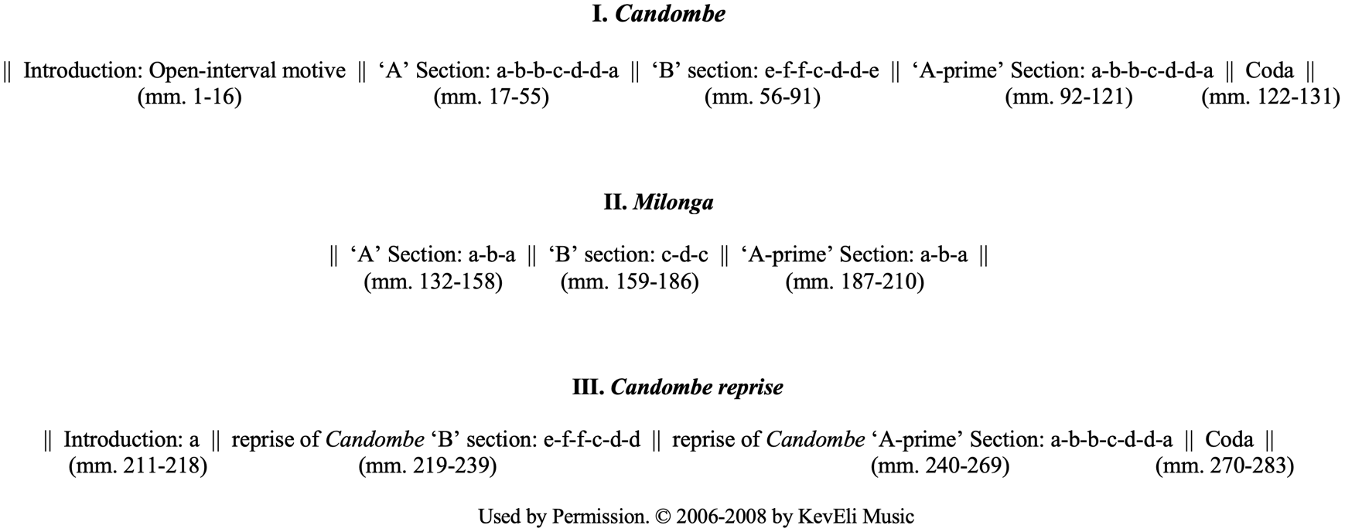
Figure 4.2 Concerto Gaucho’s Principal and Secondary-theme motives

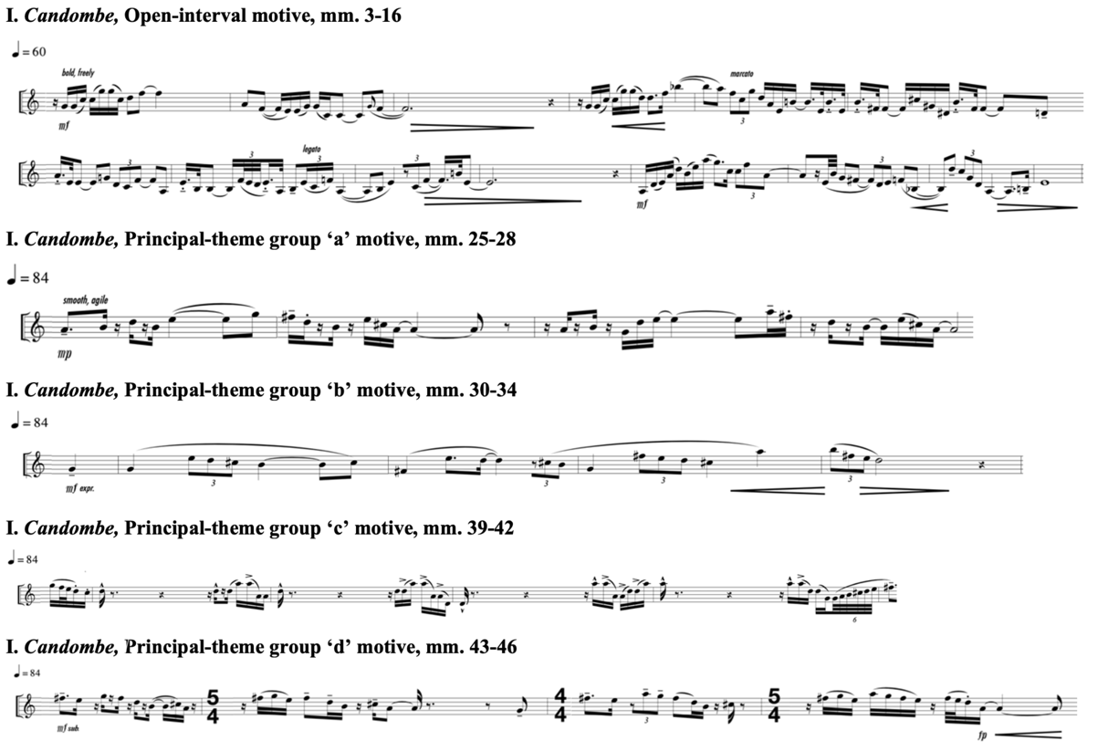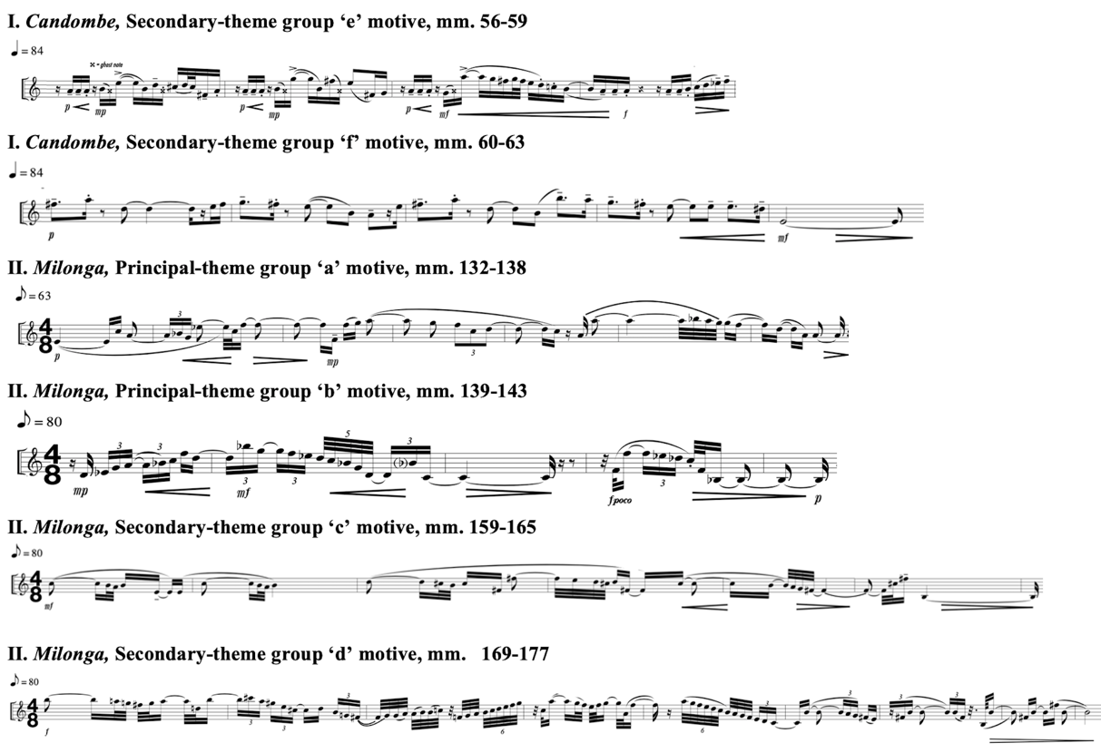

I. Candombe
Concerto Gaucho’s first and third movements, Candombe and Candombe Reprise, stem from the energetic African-based candombe rhythm that was integral in shaping Uruguay’s musical culture. Serving as a major rhythmic underpinning of the first and third movements, the candombe comprises four independent rhythmic layers performed simultaneously, providing foundational motivic and thematic inspiration. An understanding of the candombe rhythm’s multiple parts will assist in comprehending the upcoming orchestration analysis.
Once the practice of eighteenth-century enslaved people from Conga, Angola, and Mozambique, the candombe is part of Uruguay’s folklore tradition. The candombe is often performed outdoors throughout Uruguay during its Carnival period in January and February by groups of drummers at high decibel levels using hands and sticks interchangeably on the heads and sides of varying-sized indigenous drums. Figure 4.3 illustrates the chico, repique, and piano drums, named after the corresponding candombe sub-rhythm they play. Like many Central and South American musical forms, the candombe contains the madera rhythm (or 3:2 son clave) which ties the chico, repique, and piano drum rhythms together. Combined, the four parts create the complete candombe rhythm. (see Figure 4.4) Except for Candombe’s 16-measure introduction and 10-measure coda, variations of the candombe’s rhythmic features permeate the entire first movement as a unifying texture.
Figure 4.3 Candombe instruments

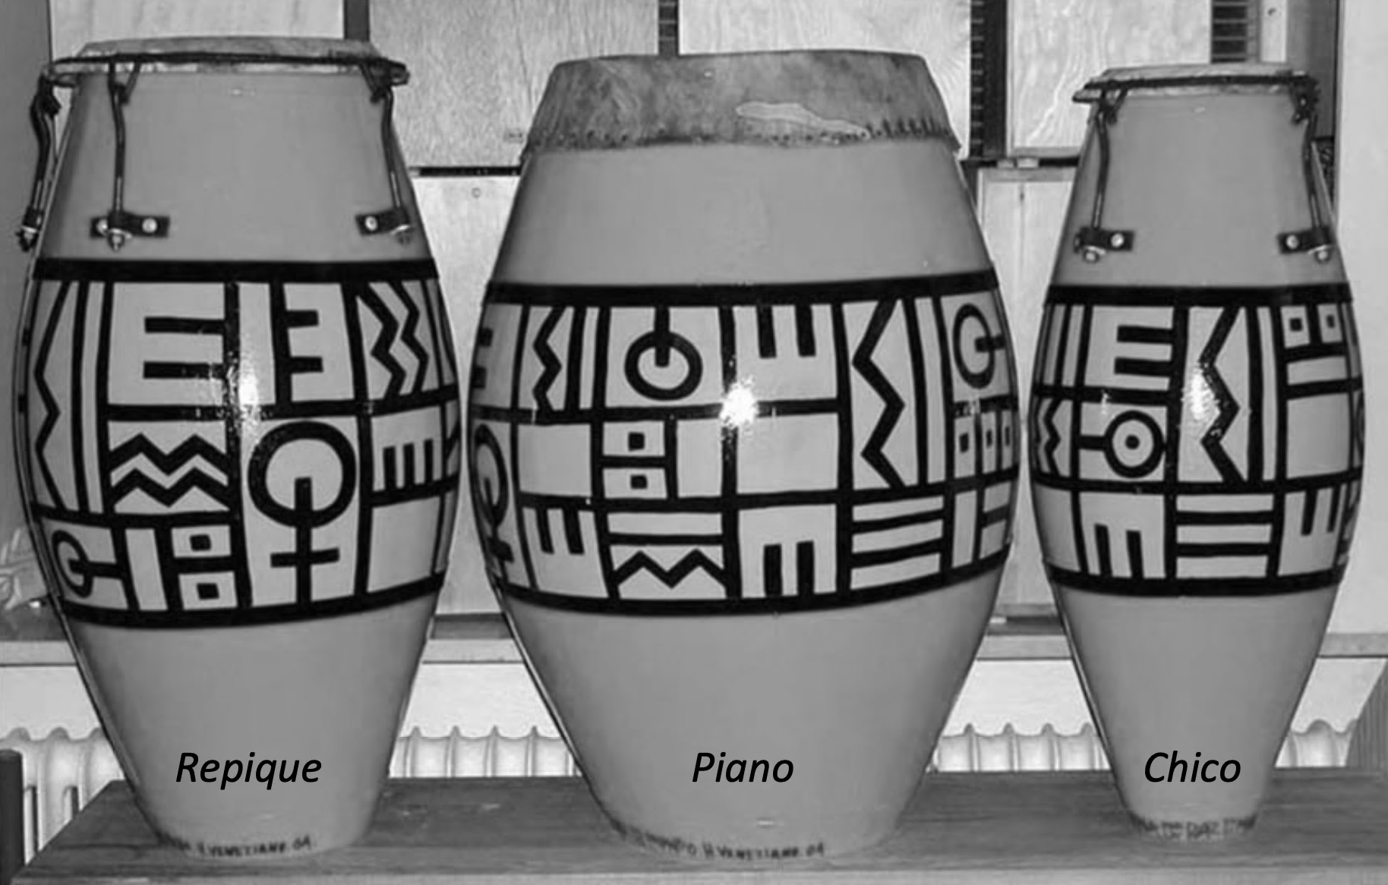

Figure 4.4 Candombe sub-rhythms

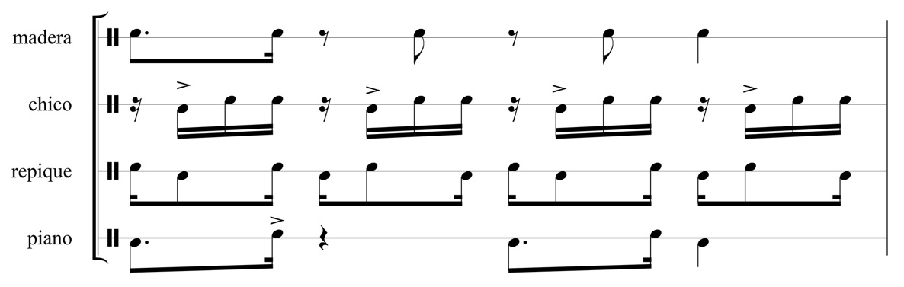

Concerto Gaucho’s Candombe movement begins as an alternating dialogue between solo trumpet and sparsely scored accompaniment (see Music Example 4.1). Walczyk introduces the solo trumpet by setting an atmosphere of loneliness and independence symbolic of the gaucho roaming the uncharted lands of eighteenth and nineteenth-century South America. Candombe’s 16-measure introduction begins with two motivic fragments in the accompaniment preceding the solo trumpet’s first entrance. The soft ascending arpeggios of the undampened harp, bell tree, triangle, and pedaled vibraphone in measures 1, 2, 5, 8, and 12 produce a ringing sustained timbre covering a wide ambitus symbolic of the vast terrain the gaucho traverses. A short, accented chord in the bright upper registers of the Piccolo, Flute 1–2, Oboe 1–2, E-flat Clarinet, Clarinet 1–3, muted Trumpet 1–3, Marimba, and Harp on count 4 of measure 1 punctuate the ending of the sustained arpeggiated chord, perhaps evoking imagery of sun rays beaming over the peak of a distant mountain range.
Music Example 4.1 Concerto Gaucho for Trumpet and Wind Ensemble,
I. Candombe, mm. 1–8
Separating solo and accompaniment voices through dialogue, sparse accompaniment texture, and exploiting contrasting colors

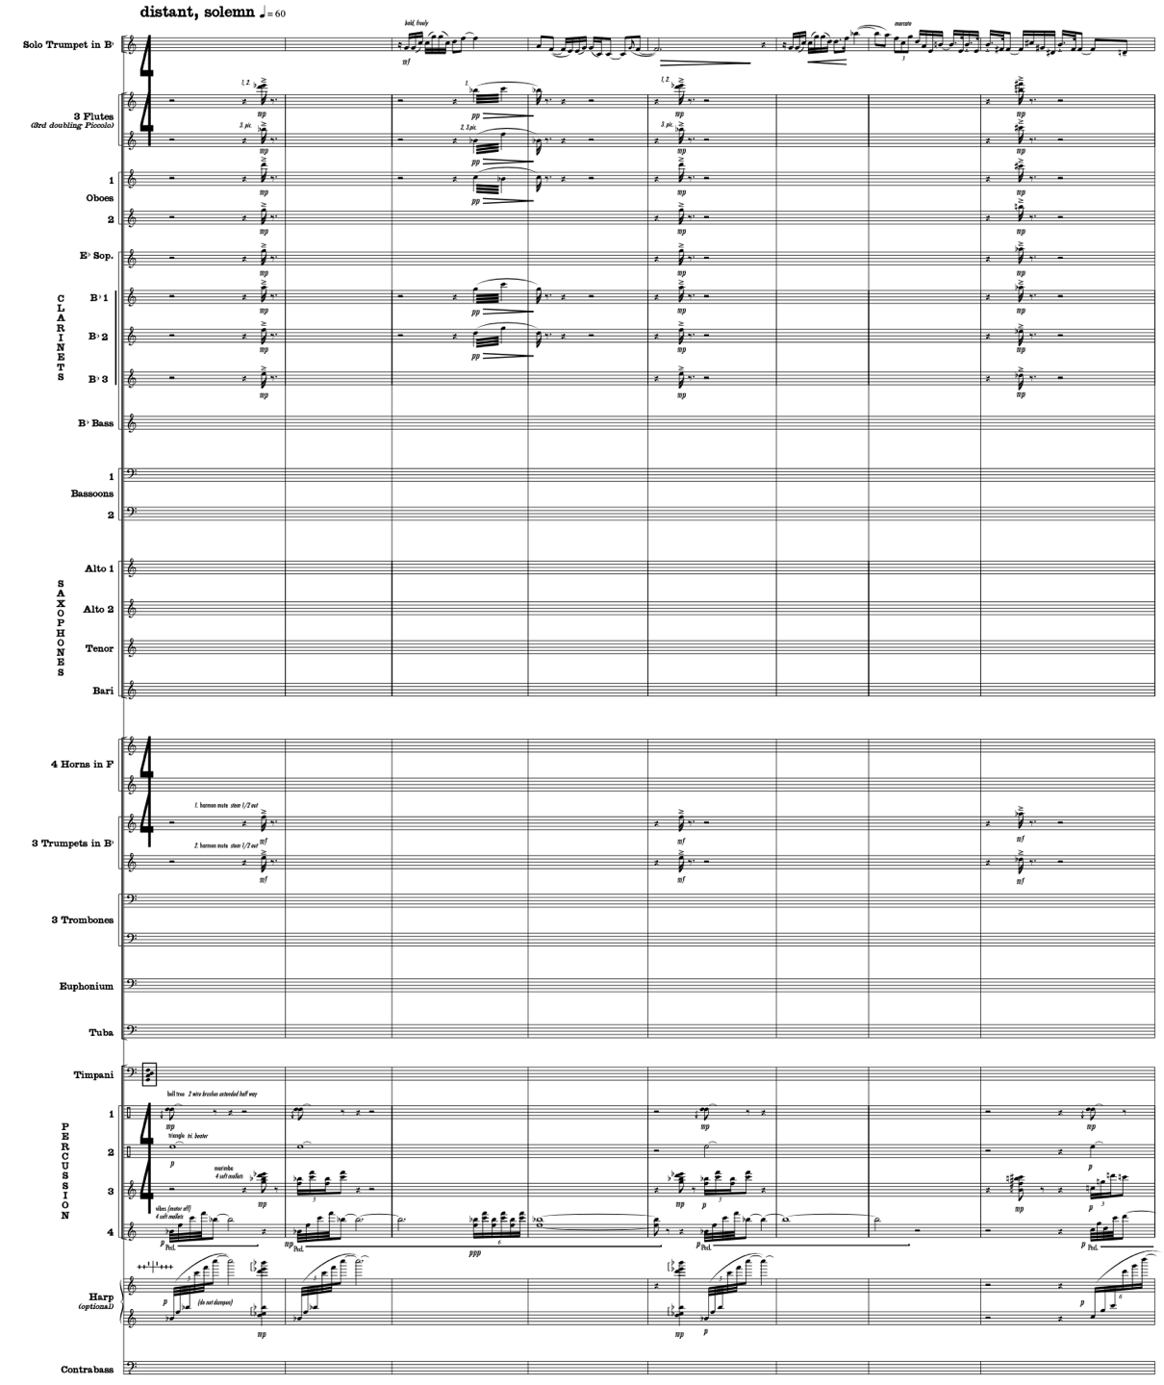
Used by Permission. © 2006-2008 by KevEli Music

With the Uruguayan scenery set, the solo trumpet enters at measure 3 symbolizing the gaucho, accompanied only by the lingering ringing percussion and string timbres from the previous measures, similar to a cadenza or classical opera recitative uninhibited by strict tempo (see Music Example 4.1). During this sparse accompaniment texture, Walczyk establishes the solo trumpet as the primary voice through a rubato, improvisatory-like soliloquy that freely explores all twelve tonal centers. The leaping ascending and descending intervals greater than or equal to a perfect fourth signify the gaucho’s independence and mobility. Walczyk labels this motive as the “open-interval motive,” which loosely traces the chico drum rhythm in the beginning of measures 3 and 6.
A third motivic fragment is introduced in measure 3, consisting of tremolos at soft dynamic levels in the bright upper registers of the piccolo, flutes, oboe, clarinets, and vibraphone. This motivic fragment continues the harmonic development of the introduction through a wispy timbre resembling a gently blowing breeze bending the wild grasslands. Together, the three motivic fragments continue throughout the rubato trumpet solo, reserved for moments when the solo trumpet sustains pitch or rests throughout its wide-ranging rhapsodic melody. Music Example 4.1 illustrates how Walczyk separates the trumpet soloist’s cylindrical brass timbre by orchestrating sparse accompaniment texture while exploiting color contrast of metallic percussion and bright woodwind timbres at soft dynamic levels.
With the soloist resting and the scenery and character of the gaucho established, the orchestration segues at measure 17 from the opening rubato dialogue to a tempo-driven pointillistic presentation of the energetic candombe rhythm dispersed throughout the ensemble (see Music Example 4.2). Rather than utilizing indeterminate-pitched percussion to generate the candombe rhythm in its original form, Walczyk establishes pulse for the first time in the concerto by orchestrating a four-measure pitched version of the candombe rhythm in wind and mallet keyboard instruments. Traditionally, creating completely independent musical lines within the context of band scoring would have been risky in the educational setting. However, the thirteen independent voices performing sparse fragments of the candombe throughout measures 17–20 demonstrate the historical development of wind band musician independence and composers trusting the independent skills of every player. Music Example 4.2 illustrates how Walczyk’s orchestration of the candombe rhythm among the various woodwind, brass, and percussion instruments elicits a light texture from which the soloist can easily project.
Music Example 4.2 Concerto Gaucho for Trumpet and Wind Ensemble,
I. Candombe, mm. 17–20
Pointillistic orchestration requiring player independence

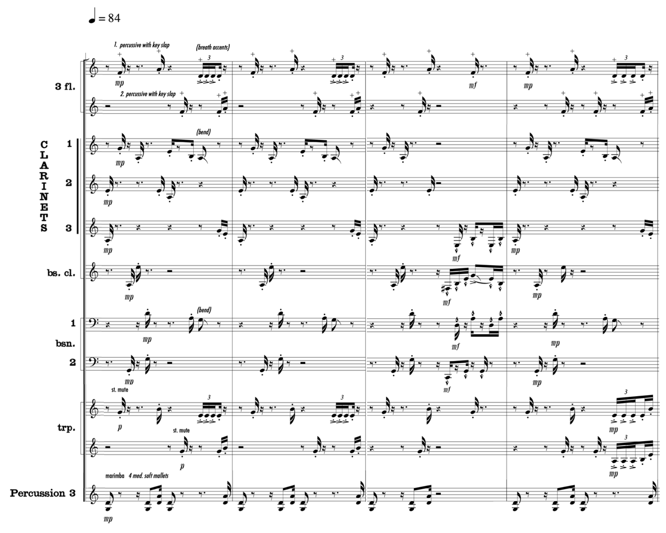
Used by Permission. © 2006-2008 by KevEli Music

Independently, these voices appear as dots on the page. However, combined, they form a composite version of the candombe rhythm, similar to how multiple marching bass drums found in U.S. marching ensembles perform independently to generate a complex composite phrase. Music Example 4.3 presents a reduction of the candombe’s pointillistic orchestration, which effectively sets a light base volume level and harmonic foundation for the approaching principal theme presented by the soloist.
Music Example 4.3 Concerto Gaucho for Trumpet and Wind Ensemble,
I. Candombe, mm. 17–20
Reduction of pitched pointillistic candombe sub-rhythms

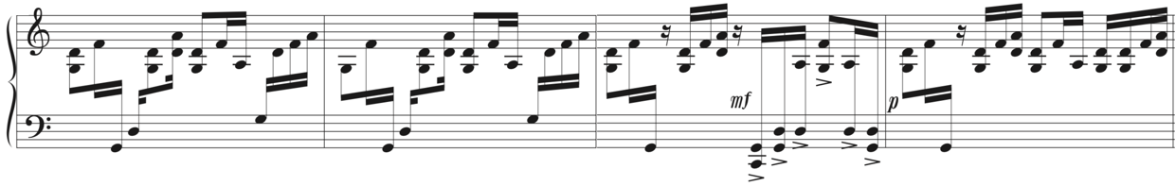
Used by Permission. © 2006-2008 by KevEli Music

In measures 17–28, Walczyk orchestrates extended techniques to exploit color contrast between the solo and accompaniment voices and widen the color palette, such as key slaps and breath accents in the flute section and pitch bending in Clarinet 1, Bass Clarinet, and Bassoon 1. Additionally, Walczyk orchestrates straight mutes in the section trumpets to differentiate their similar timbre from the unmuted Solo Trumpet (see Music Example 4.2). Walczyk’s pointillistic orchestration of wind instruments in a translucent, hollow range, such as independent clarinets in the chalumeau register, allows the solo trumpet to remain in the foreground when it enters with the concerto’s principal-theme group ‘a’ motive at measure 25. The stark contrast in orchestrating the candombe rhythm between the two preceding examples illustrates how advancements in player independence afford the composer more creative strategies to avoid heaviness in tutti band scoring.
In his orchestration text, Adler states the following: “The principle of solo-tutti dialogue stems directly from the Baroque concerto grosso. The composer introduces the solo instrument by itself, implanting its timbre firmly in the listeners’ mind, and then brings in the orchestra, effecting a radical shift in texture and timbre.” Adler’s statement regarding the separation of solo and tutti voices more closely reflects wind band solo literature from the nineteenth century, where the full orchestration was reserved for moments when the soloist is resting or relegated to background roles during solo performance. However, in the context of Concerto Gaucho, the continuous rhythmic texture of the candombe similarly replaces the continuity of the basso continuo.
At measure 25, the established fragmented staccato woodwind and muted brass candombe rhythm continues, providing a light rhythmic track for the solo trumpet to perform the principal-theme group ‘a’ motive. Indicated “smooth, agile,” the melody is orchestrated in the soloist’s third, fourth, and fifth partials of the harmonic series where it can comfortably perform the full melodic range at a mezzo piano dynamic (see Music Example 4.4).
Music Example 4.4 Concerto Gaucho for Trumpet and Wind Ensemble,
I. Candombe, mm. 25–28
Principal-theme group ‘a’ motive

Used by Permission. © 2006-2008 by KevEli Music

After only two beats of the ‘a’ motive, a tonal answer begins in the contrasting timbres of oboes, E-flat clarinet, and alto saxophone imitating the solo trumpet a perfect fourth higher in C Mixolydian (see Music Example 4.5). Although the solo trumpet and tonal answer are assigned the same dynamic, the solo trumpet remains distinguished by the rhythmic displacement of solo and tutti entrances and contrasting tonal centers. Walczyk further separates the imitative tutti woodwind counterpoint and solo melody at measure 27 by orchestrating rhythmic dissonance in the tonal answer consisting of eighth-note triplets against the solo trumpet’s double-syncopated rhythm in simple meter. Music Example 4.5 illustrates how the solo trumpet’s legato articulation markings, contrasting tessitura, rhythmic dissonance, and elongated phrasing distinguishes it from the active accompaniment.
Music Example 4.5 Concerto Gaucho for Trumpet and Wind Ensemble,
I. Candombe, mm. 25–28
Solo voice established prior to accompanying imitation and rhythmic distinction

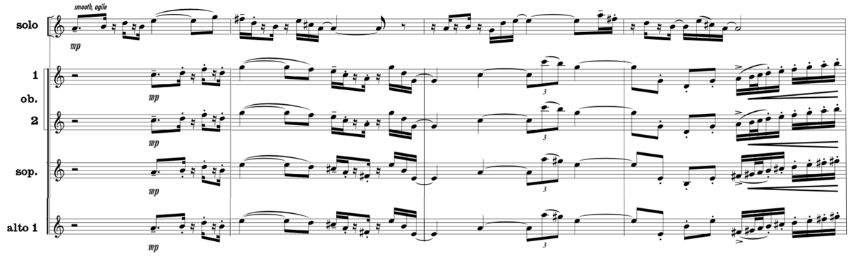
Used by Permission. © 2006-2008 by KevEli Music

A brief two-measure transition at measures 29–30 engages portions of the full band orchestration while providing rest for the soloist. With the solo trumpet absent from the orchestration, Walczyk increases the number of accompanying musicians to create dynamic, timbral, and textural contrast for the listener. The woodwind orchestration in measure 29 gives way to muted brass at measure 30 performing a dry restatement of the madera, clave-like Latin syncopation. In a relatively lower tessitura, the muted brass provides timbral contrast to the solo trumpet’s entrance one beat before measure 31. The two-measure transition segues into the principal-theme group ‘b’ motive introduced by the lyrical, wide-ranging solo trumpet at measure 31, marked espressivo with a mezzo forte dynamic (see Music Example 4.6).
Music Example 4.6 Concerto Gaucho for Trumpet and Wind Ensemble,
I. Candombe, mm. 31–34
Principal-theme group ‘b’ motive

Used by Permission. © 2006-2008 by KevEli Music

The Candombe’s flowing, lyrical melody in the solo trumpet, symbolic of the gaucho’s heroism, is accompanied by a rhythmically active chamber ensemble consisting of flutes, oboes, B-flat clarinets, vibraphone, and harp performing the candombe’s chico drum rhythm. Marked staccato in each instrument’s respective upper register at a piano and mezzo piano dynamic level, they split the load by alternating beats on which they perform (see Music Example 4.7). For example, counts 1 and 3 consist of three flutes, two oboes, and three clarinets performing the chico drum rhythm at a mezzo piano dynamic, while counts 2 and 4 consist of one flute, two oboes, one clarinet, vibraphone with four soft mallets, and harp at a piano dynamic. The softer dynamic level and lighter timbre on weak beats created by the accompaniment’s sparser texture allows the solo trumpet to project as the primary voice when its rhythm accelerates. Music Example 4.7 illustrates how the solo trumpet’s wide ambitus of leaping intervals contrasts the flute’s, oboe’s, and clarinet’s narrow-ranging intervals.
Music Example 4.7 Concerto Gaucho for Trumpet and Wind Ensemble,
I. Candombe, mm. 31–34
Separating solo and accompaniment voices through contrasting style, color, melodic range, and sparse accompaniment texture

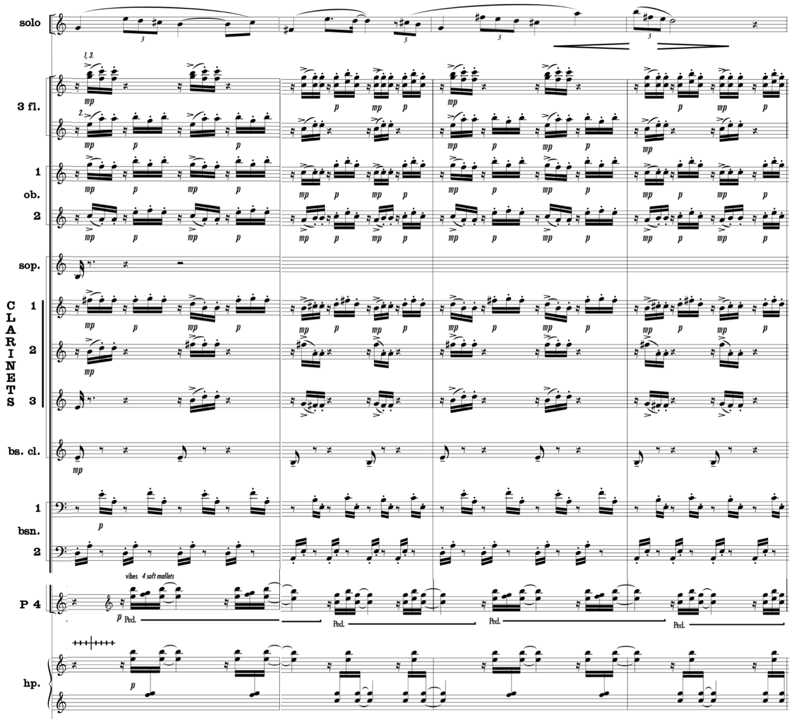
Used by Permission. © 2006-2008 by KevEli Music

Walczyk further differentiates the solo and accompaniment voices at measure 31 by composing rhythmic dissonance on weak beats through eighth-note triplets in the solo trumpet that distinguishes it in compound meter from the darting accompaniment rhythm in simple meter (see Music Example 4.7). Simultaneously, the bassoons reinforce the rhythmic structure of the accompaniment in a buoyant, Alberti-bass style that also provides harmonic foundation through an arpeggiated chord. The solo trumpet’s connected legato phrasing of wide ambitus distinguishes it from the parch, pointillistic orchestration in the ensemble consisting of a narrower interval range, symbolizing the gaucho’s independence. The rhythmic and stylistic contrast assists the solo trumpet with projecting through the numerous ensemble voices. Furthermore, the four-note chordal structure contributes to a lighter texture by reducing any part doubling. Music Example 4.7 illustrates Walczyk’s composition of rhythmic dissonance, contrasting styles, and orchestrating contrasting ranges to distinguish the solo trumpet from the ensemble.
In measures 35–38, the alto and tenor saxophones in octaves perform an exact repetition of the principal-theme group ‘b’ motive. This is contrasted by the solo trumpet performing an embellished version of the ‘b’ motive evoking the image of a gaucho riding horseback and athletically darting in and out of the landscape (see Music Example 4.8).
Music Example 4.8 Concerto Gaucho for Trumpet and Wind Ensemble,
I. Candombe, mm. 35–38
Separating solo and accompaniment voices through rhythmic dissonance, and contrasting style

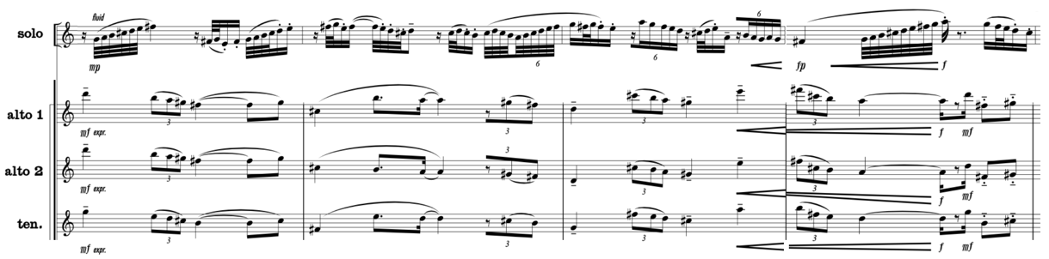
Used by Permission. © 2006-2008 by KevEli Music

Walczyk freshens the harmonic development at measure 35 by replacing the Alberti-bass style arpeggios in the bassoon section with a dotted-eighth sixteenth-note pattern scored in the lower tessitura of bass clarinet, bassoons, and contrabass in octaves outlining the chord structure (see Music Example 4.9). The bass clarinet, bassoon section, and contrabass pitches are reinforced lightly by the marimba performing stacked chords on the madera pattern using four medium mallets. Finally, Walczyk completes the accompanimental texture with light, stylistic cohesion orchestrating the lighter timbres of vibraphone and plucked harp performing the repetitive repique drum rhythm on C throughout the solo trumpet’s off-beat entrances. Although the solo trumpet is assigned a relaxing mezzo piano dynamic, its faster rhythmic values consisting of improvised-like rapidly ascending and descending angular shapes distinguishes it from the saxophones’ legato restatement of the ‘b’ motive at a slower velocity and louder dynamic register of mezzo forte. Music Example 4.9 illustrates Walczyk’s orchestration utilizing some of Adler’s suggested principles to distinguish the solo line from the wind ensemble, such as rhythmic independence, assigning foreground and background roles, and exploiting color contrast to create contrasting styles.
Music Example 4.9 Concerto Gaucho for Trumpet and Wind Ensemble,
I. Candombe, mm. 35–38
Rhythmic independence, contrasting tessitura, and contrasting colors, of background voices

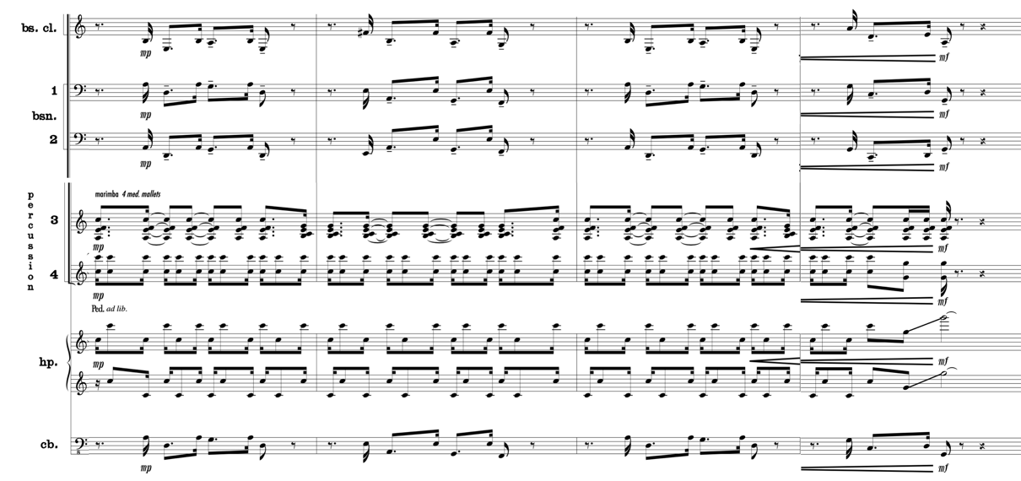
Used by Permission. © 2006-2008 by KevEli Music

Measure 39 marks the beginning of the Candombe’s principal-theme group ‘c’ motive, where the ensemble’s orchestration shifts from light, pointillistic woodwind figures in a high tessitura to full horn, trumpet, trombone, and euphonium sections performing an embellished version of the madera rhythm in their respective powerful middle registers (see Music Example 4.10). Crisp brass articulations, syncopated rhythms, and major seventh chords emphasize the Latin jazz style. Walczyk reserves the solo trumpet for moments when the ensemble sustains chords to keep it in the foreground. When utilized, the solo trumpet performs short phrases connecting the longer ensemble phrases, similar to a jazz drum set fill. Additionally, fortepiano dynamics are utilized in the ensemble when sustaining chords to preserve balance during the soloist’s angular, leaping interjections. Walczyk further separates the solo and section trumpet timbres by orchestrating straight mutes in the section trumpets, providing distinguishable contrast of the similar cylindrical-bored timbres, and engaging them at different times. Music Example 4.10 illustrates how Walczyk creates a dialogue between the soloist and ensemble and orchestrates foreground and background roles through dynamic contrast and rest.
Music Example 4.10 Concerto Gaucho for Trumpet and Wind Ensemble,
I. Candombe, mm. 39–42
Separating solo and accompaniment voices through dialogue, rhythmic independence, and contrasting style

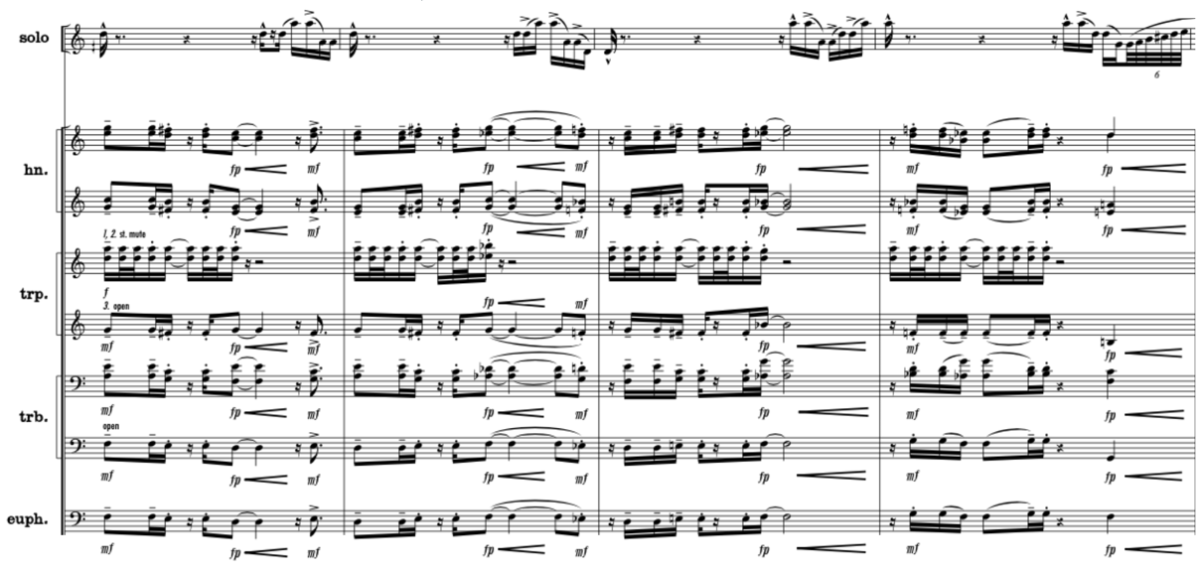
Used by Permission. © 2006-2008 by KevEli Music

The solo trumpet introduces the Candombe’s principal-theme group ‘d’ motive at measure 43 at a mezzo forte dynamic (see Music Example 4.11). A bright, but light and transparent shaker performs continuous eighth notes throughout the ‘d’ motive, providing stability to the off-beat solo trumpet entrances. The soloist is accompanied by B-flat clarinets, bass clarinet, bassoons, and saxophones, performing the madera rhythm in homophonic texture at a mezzo forte dynamic. Walczyk helps separate the solo voice from the accompaniment by combining the eleven voices into a four-voice tertian chord with narrow, stepwise voicings in contrast to the wide-leaning, angular trumpet intervals, closely in range with numerous doublings. Although the accompanying woodwinds share the same dynamic as the solo trumpet, their unifying reed colors in a low tessitura create a homogenous timbre, similar to a string section in the orchestra. Music Example 4.11 illustrates how the solo trumpet’s contrasting rhythm, style, and timbre distinguishes it from the ensemble, elevating it as the primary voice.
Music Example 4.11 Concerto Gaucho for Trumpet and Wind Ensemble,
I. Candombe, mm. 43–46
Separating solo and accompaniment voices through rhythmic, style, and timbral contrast

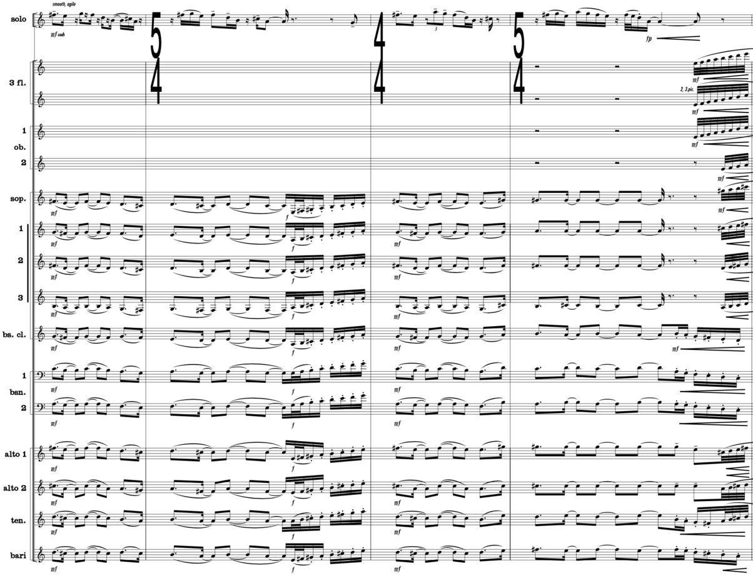
Used by Permission. © 2006-2008 by KevEli Music

In measures 47–51, the rhythmic patterns associated with the chico, repique, and piano drum rhythms cease, while the mostly tutti ensemble restates the principal-theme group ‘d’ motive in A-flat Mixolydian (see Music Example 4.12). With the trumpet soloist resting, Walczyk retains the trumpet timbre with two unmuted section trumpets joining the lighter woodwind timbres at a forte dynamic before gradually increasing the texture with the heavier brass, contrabass, and mallet percussion timbres. At measure 49, Walczyk for the first time in the concerto utilizes all accompanying woodwind, brass, and stringed instruments simultaneously at measure 49, providing dynamic variety for the listener by unleashing a forte dynamic in each part. Walczyk further intensifies the full orchestration through octave doublings in measures 49–50 to create a climactic exclamation point before reducing the orchestration at measure 51 to flutes, oboes, clarinets, bassoons, xylophone, and harp at a piano dynamic. Measures 47–51 provide textural and dynamic contrast for the listener and actively display the power of the ensemble before a softer acoustical texture sets up the return of the solo trumpet.
Music Example 4.12 Concerto Gaucho for Trumpet and Wind Ensemble,
I. Candombe, mm. 47–51
Texture and timbral contrast orchestrated crescendo with increased texture

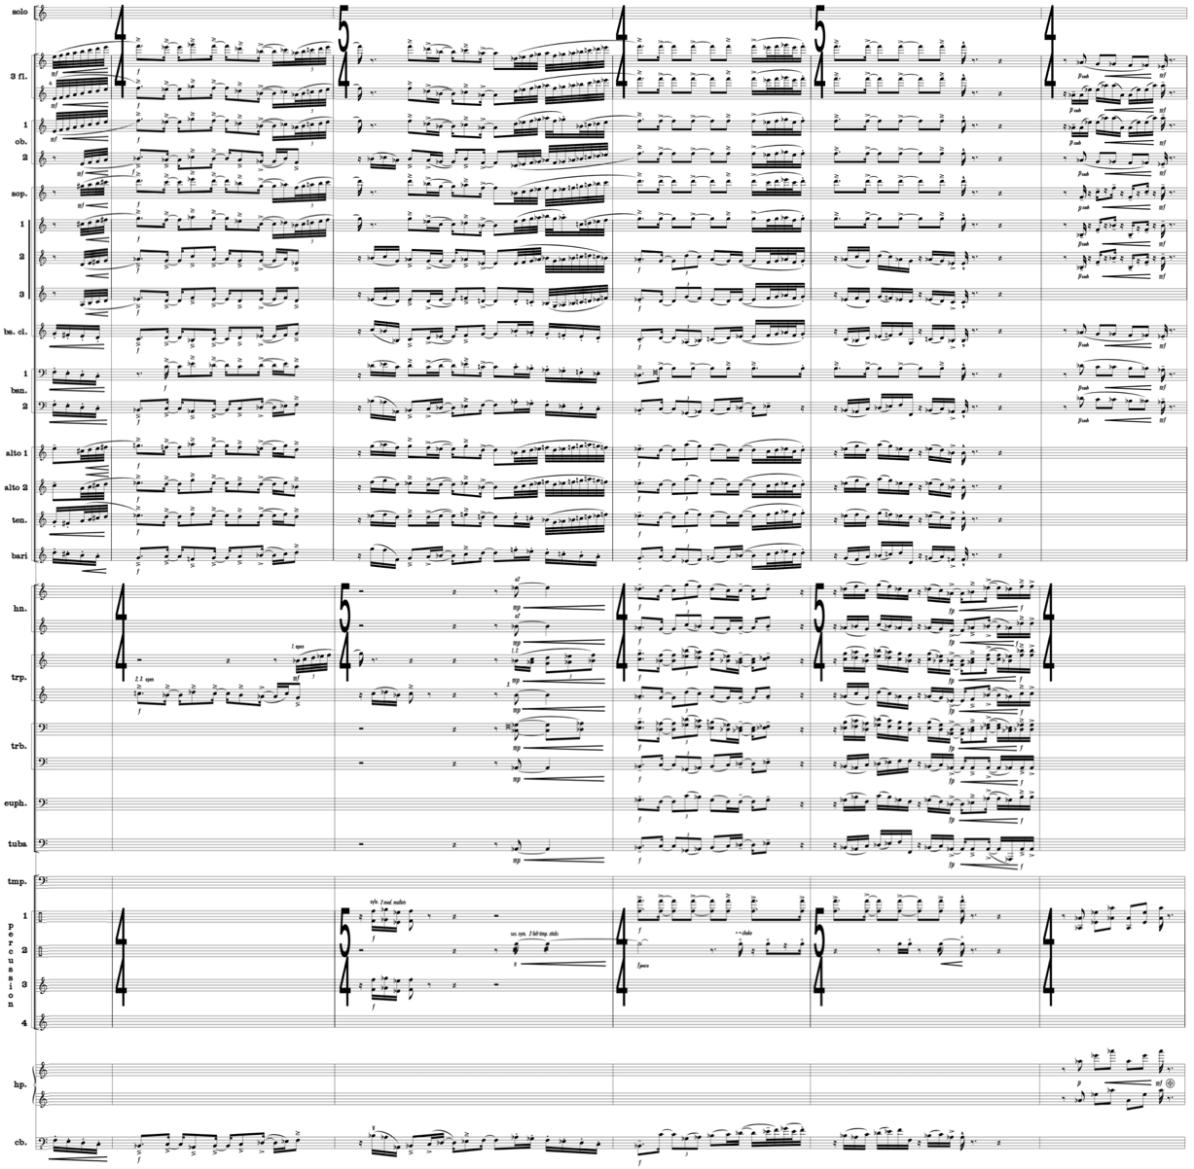
Used by Permission. © 2006-2008 by KevEli Music

At measure 52, the Candombe’s principal-theme group ‘a’ motive returns in the solo trumpet to close out the A section. Walczyk provides a fresh bluesy, relaxed mood to the ‘a’ motive by reorchestrating the original spritely staccato material in the solo trumpet with legato articulations and replacing the pointillistic candombe orchestration with a staccato repique drum rhythm in the middle-low registers of Flute 2, Clarinet 1–3, and Vibraphone (see Music Example 4.13). The instruments performing the repique drum rhythm form a four-voice chord that is orchestrated with one woodwind per note and reinforced by the vibraphone providing rhythmic stability and harmonic foundation for the lightly scored texture. By orchestrating one woodwind voice per part, the accompaniment’s lightness is preserved, creating an easy balance opportunity that matches the relaxed mood of the soloist. The Piccolo, Flute 1, Oboe 1, and Xylophone introduce dialogue using the familiar ‘c’ motive in a relatively higher tessitura and brighter color than the solo trumpet during the soloist’s longer notes. The judicious scoring of delicate, sparsely orchestrated, and agile ensemble colors decorating the solo voice displays the composer’s confidence in performers’ abilities to collaborate with the soloist in an abbreviated, but equal role. The combined timbres of bass clarinet and bassoons spanning a one-octave range form a distant, triadic version of the madera rhythm that ties the soloist, dialogue, and repique drum rhythm together. Although the solo trumpet is marked piano and legato, it remains in the foreground due to contrast between rhythm, articulations, and timbres.
Music Example 4.13 Concerto Gaucho for Trumpet and Wind Ensemble,
I. Candombe, mm. 52–55
Separating solo and accompaniment voices through dialogue, rhythmic independence, and assigning foreground and background roles to solo and tutti sections

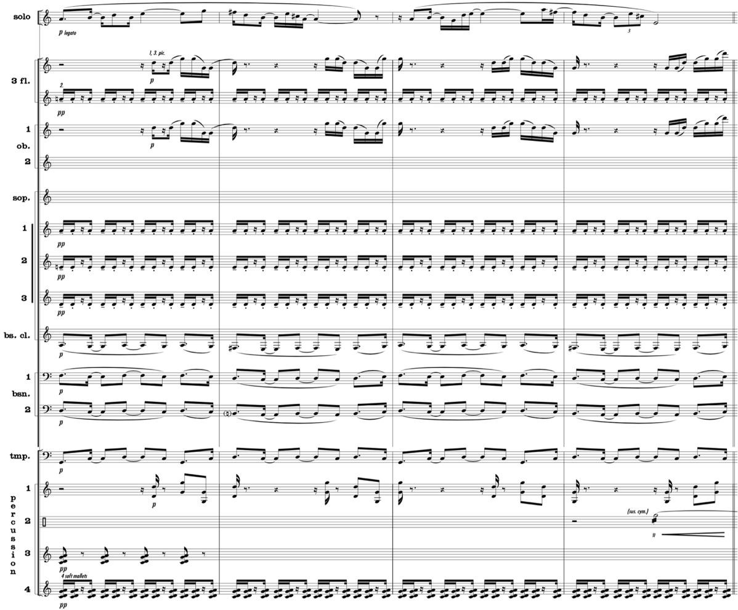
Used by Permission. © 2006-2008 by KevEli Music

The Candombe’s B section begins at measure 56, with the solo trumpet playing the secondary-theme group ‘e’ motive at a mezzo piano dynamic. In measures 56–59, the solo trumpet’s rhythmic velocity increases. To ensure the soloist remains in the foreground, Walczyk adopts phrasing from the jazz idiom, which lends naturally to the trumpet given its role in jazz evolution (see Music Example 4.14). The “ghost note” jazz performance technique allows the solo trumpet to remain light and agile while performing the technically demanding ‘d’ motive. Walczyk’s use of slurred articulation throughout the fast solo melody allows the soloist to navigate the rapidly ascending and descending, occasionally leaping, notation effortlessly. The solo trumpet’s faster rhythmic velocity is accompanied by three contrasting layers of texture. First, the upper woodwinds consisting of two flutes, two oboes, and three clarinets perform cascading descending eighth-note phrases that parallel the solo trumpet’s melodic direction. Second, the low reeds consisting of Bass Clarinet and Bassoon 1 are reinforced by the contrabass performing a staccato version of the leaping open-interval motive on the dominant. Third, a brass choir consisting of four horns and three trombones provide linear harmonic support that contrasts the previous layers’ rhythmic structure. These voices contain complementary timbres at a softer dynamic than the soloist, which provides clarity when combined with their distinct rhythmic and melodic characteristics.
Music Example 4.14 Concerto Gaucho for Trumpet and Wind Ensemble,
I. Candombe, mm. 56–59
Separating solo and accompaniment voices through rhythmic and stylistic contrast

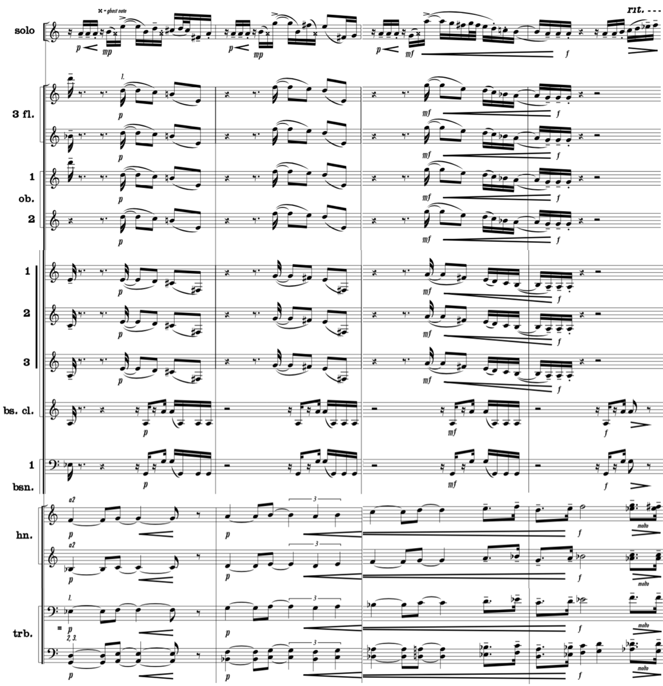
Used by Permission. © 2006-2008 by KevEli Music

The secondary-theme group ‘f’ motive begins at measure 60 in the solo trumpet at a piano dynamic marked “playful, light.” To highlight the solo trumpet as the primary voice, Walczyk uses sparse woodwind accompaniment timbres that contrast the soloist’s single brass timbre (see Music Example 4.15). Walczyk reinforces portions of the ‘f’ motive by orchestrating homophonic texture in the Flute 2 and Oboe 1–2 performing in unison a third below the solo trumpet, which supports the melody without covering it. When the instrumentation is reduced on beats 3 and 4 of measures 60–63, the overall texture becomes lighter. Stepwise accompaniment staccato figures allow the soloist to perform with a relaxed dynamic. The subsequent lighter orchestration allows the harp and vibraphone texture to provide a subtle harmonic foundation in an Alberti-bass style. The lightly textured accompaniment is anchored in tempo by two stationary rhythms consisting of Clarinet 2 performing the repique drum rhythm and shaker performing continuous eighth notes. Music Example 4.15 illustrates the ostinato rhythmic accompaniment figure throughout the phrase that allows the solo trumpet’s heroic octave intervals to soar above the accompaniment.
Music Example 4.15 Concerto Gaucho for Trumpet and Wind Ensemble,
I. Candombe, mm. 60–63
Separating solo and accompaniment voices through register placement and timbral contrast

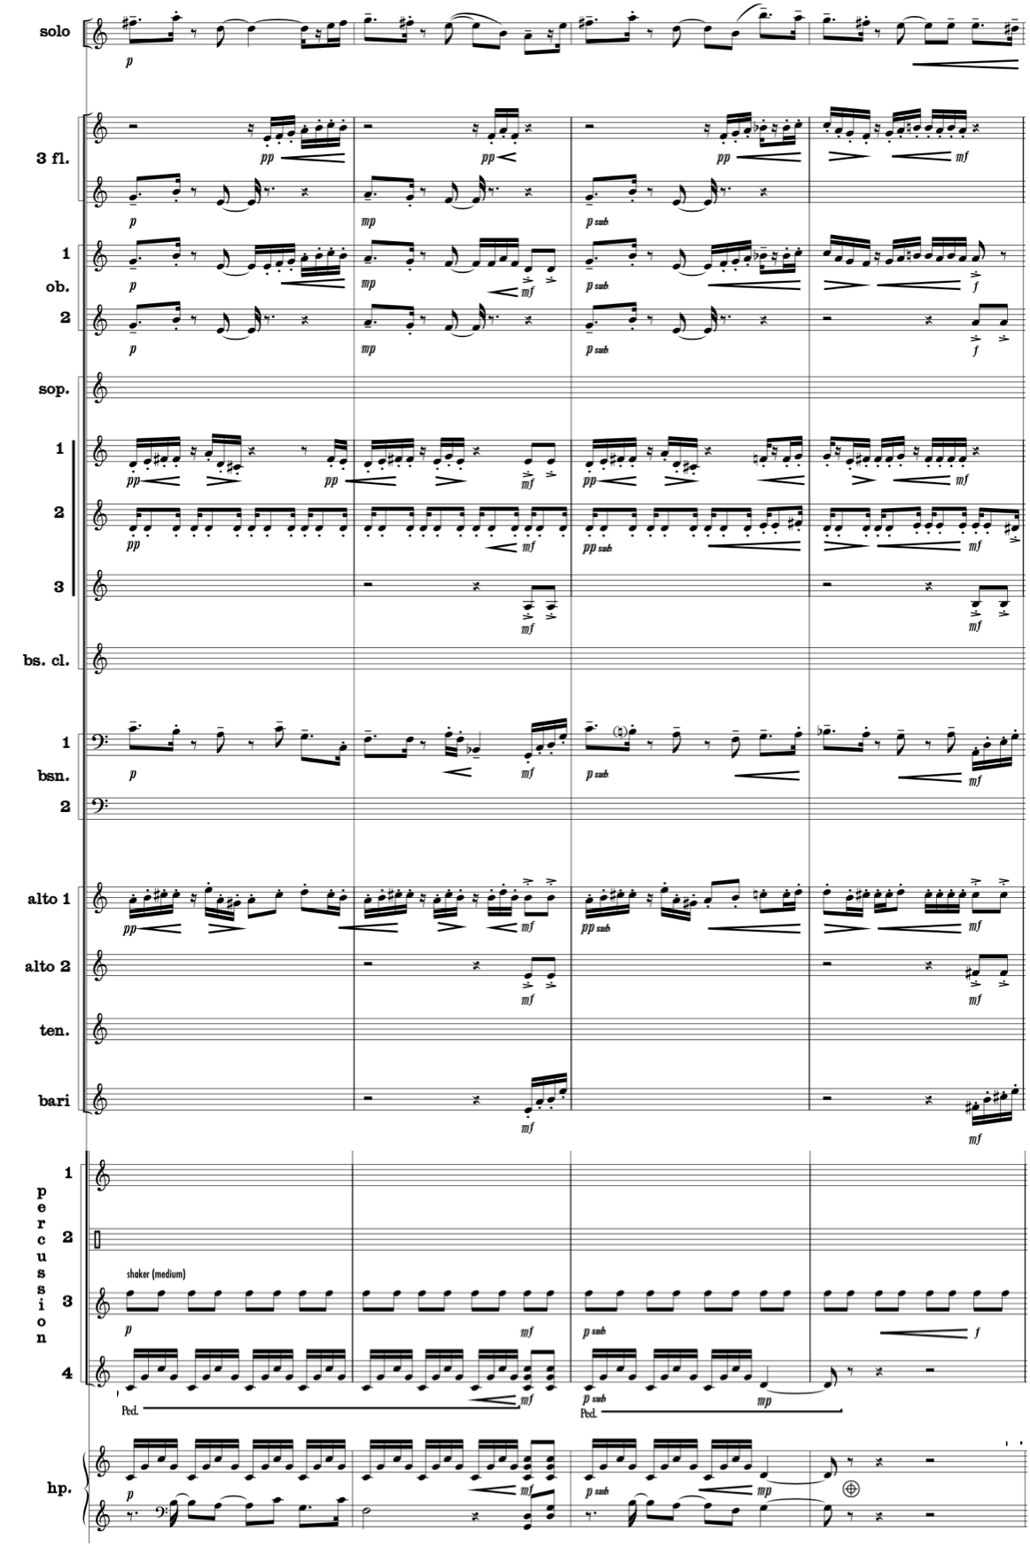
Used by Permission. © 2006-2008 by KevEli Music

With the solo trumpet resting, Walczyk increases the dynamic by scoring more instruments from measures 64–67 as the accompaniment restates the Candombe’s secondary-theme group ‘f’ motive (see Music Example 4.17). Walczyk orchestrates the lyrical ‘f’ motive in Oboe 1 and Clarinet 1 reinforced by Oboe 2 and Clarinet 2 a major sixth below. Dialogue occurs in the Piccolo, E-flat Clarinet, and Alto Saxophone 1, which perform a complementary countermelody while the oboes and clarinets sustain their pitches. Rapid offbeat flute and xylophone phrases imitate the solo trumpet by performing improvisatory-like phrases connecting the oboe and clarinet melody. The repique and chico drum rhythms heard previously in lighter timbres expand to include clarinet, bass clarinet, bassoon, saxophone, and trumpet. Together, they provide light rhythmic and harmonic support through transparent staccato articulations that arpeggiate the harmonic structure. (see Music Example 4.16)
Music Example 4.16 Concerto Gaucho for Trumpet and Wind Ensemble,
I. Candombe, mm. 64–67
Dialogue of connected melody and countermelody in the upper woodwinds contrasted in style and rhythm in a lower tessitura

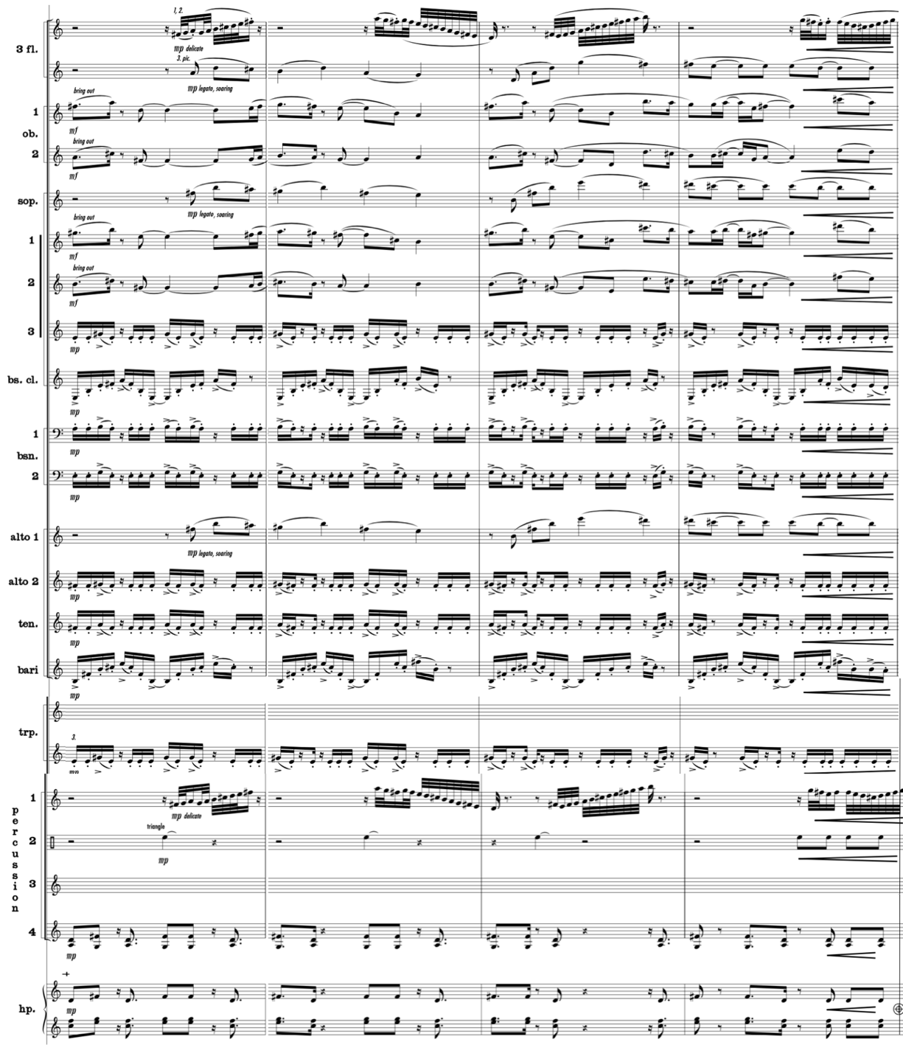
Used by Permission. © 2006-2008 by KevEli Music

Walczyk takes advantage of the opportunity to unleash more ensemble forces at measure 68 when the orchestration shifts from woodwinds to brass during a one-measure transition resembling the madera rhythm. At measure 69, the madera gives way to low brass performing tutti at measure 69, featuring the combined timbres of bass trombone, euphonium, and tuba that provide fresh contrast to the resting solo trumpet’s preceding high tessitura. The low brass statement is displaced two octaves lower than at measure 60, allowing the contrasting bright woodwind orchestration to fill in the absent solo trumpet tessitura through an embellished version of the piano and repique drum rhythms.
The solo trumpet returns at measure 71 accompanied by the majority of woodwind instruments, xylophone, and marimba. Walczyk’s omission of brass timbres produces a contrasting combined woodwind and mallet color that distinguishes the solo trumpet as it performs a technically demanding melody at a faster rhythmic velocity (see Music Example 4.17). With numerous doubled woodwind voices creating a thicker texture in their narrow intervallic range, Walczyk omits the Piccolo, Flute 1–2, and E-flat Clarinet timbres allowing the brighter trumpet timbre to replace their tessitura with a virtuosic stepwise phrase against the madera rhythm.
Music Example 4.17 Concerto Gaucho for Trumpet and Wind Ensemble,
I. Candombe, mm. 71–74
Separating solo and accompaniment voices through rhythmic and color contrast

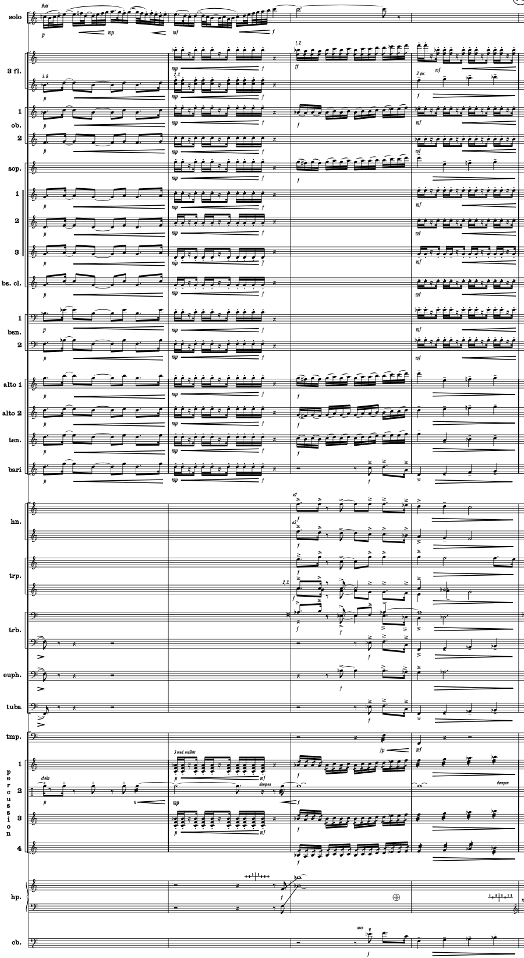
Used by Permission. © 2006-2008 by KevEli Music
The swift solo melody continues in measure 72 while the woodwind orchestration shifts from the connected and syncopated madera rhythm to the staccato repique drum rhythm (see Music Example 4.17). The repique drum rhythm’s downbeats provide security for the solo trumpet to freely paint the improvisatory-like legato descending and ascending melody on top. The linear repetition of woodwind chords constituting the repique drum rhythm builds energy to support the solo trumpet’s dramatic ascent, which is boosted dynamically from mezzo piano to forte. The phrase reaches its climax in measure 73 following rapidly ascending thirty-second notes in the solo trumpet, culminating in a sustained high C above the treble clef staff. The solo trumpet’s climactic high note is further energized by an ascending rush of two flutes, one oboe, three saxophones, xylophone, and marimba. Together, they usher in the remaining unutilized woodwind and brass timbres at measure 74 before a final punctuating brass jazz rhythm extends the musical high point. The fuller ensemble orchestration provides textural and dynamic variety for the listener in this “shout-like” phrase. It is worth noting that measure 74 marks the second instance where the complete orchestration, with exception of the harp, is employed. Like before, the full ensemble orchestration occurs while the solo trumpet is resting.
During the 14-measure solo break in measures 74–87 Walczyk freely explores orchestration techniques throughout the accompaniment, which presents the previous solo trumpet melodic material with fresh colors from choices with the full ensemble possibilities. The Candombe’s principal-theme group ‘c’ motive returns at measure 75. However, in this instance Walczyk adds the full trumpet section and tuba in this iteration to complete the full brass orchestration. With the soloist resting, the contrasting mixed timbres of the Piccolo, E-flat Clarinet, Alto Saxophone 1–2, Marimba, Vibraphone, and Harp replace the soloist’s tessitura with dialogue on beats 3 and 4. At measure 77, the powerful brass orchestration switches to the flute, oboe, clarinet, and bassoon colors at a piano dynamic, scaling back the texture from heavy to light as the concerto transitions into the next section.
With the soloist resting, Walczyk introduces an ornamented version of the madera rhythm at measure 79 in the bongos at a piano dynamic (see Music Example 4.18). Walczyk reserves the percussion section’s full dynamic potential for later in the concerto, opting for light percussion orchestration at a soft dynamic level through most of the work. The aggressive repeated rhythm and accented pattern of the bongos provide a unifying feature while serving as the primary tempo source. It is interesting to note that this marks the first time in this Latin influenced concerto that a percussion instrument is solely responsible for maintaining tempo.
Music Example 4.18 Concerto Gaucho for Trumpet and Wind Ensemble,
I. Candombe, m. 79
Energetic bongo motive

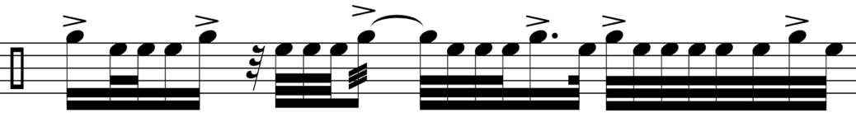

Used by Permission. © 2006-2008 by KevEli Music

With the soloist still resting and the primary tempo source stemming from a single percussion instrument, Walczyk reduces the full tutti scoring to six pairs of instruments performing independent motivic fragments in harmony. The six pairs are flutes, oboes, clarinet/bass clarinet, bassoons, trumpets, and vibraphone/harp. For example, in measures 80–87, the combined dark timbres of Clarinet 3, Bass Clarinet, and Bassoon 1–2 play eighth-note triplets beginning off the beat in contrast to the brighter and faster flute, oboe, and muted trumpet thirty-second notes accented by the harp and vibraphone (see Music Example 4.19). Walczyk also expands the color palette featuring breath accents in the flutes and section trumpets with one voice open and the other with a specific indication of “Harmon mute stem 1/2 out.” While not historically without precedent, this marking reveals the composer’s desire to explore wind band color in unusual ways.
Music Example 4.19 Concerto Gaucho for Trumpet and Wind Ensemble,
I. Candombe, mm. 80–81
Separating solo and accompaniment voices by exploiting color contrast through extended techniques and mutes

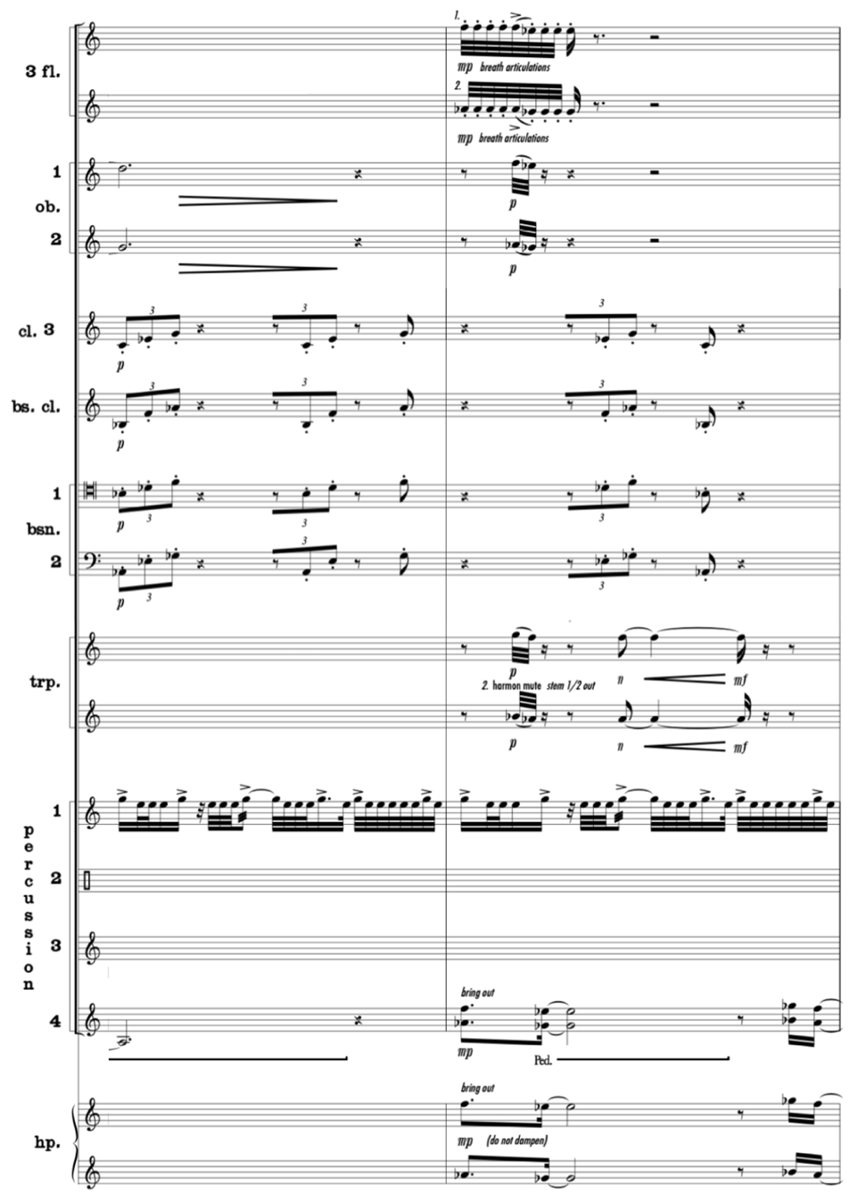
Used by Permission. © 2006-2008 by KevEli Music

The secondary-theme group ‘e’ motive returns in measures 88–91. These four measures showcase the independence of solo and accompaniment voices. Whereas the flute, oboe, clarinet, and saxophone sections perform a rhythmically dissonant accompaniment in compound meter at a soft pianissimo dynamic, the solo trumpet is distinguished by a quick, leaping melody—again utilizing the “ghost note” technique in simple meter at a louder piano dynamic (see Music Example 4.20). Walczyk’s orchestration of seventh chords amongst these instruments reduces the doubling of each pitch allowing more instruments to perform simultaneously while maintaining a softer dynamic as the background voice. Despite being orchestrated in a similar tessitura, the Solo Trumpet’s relatively faster rhythms assist in promoting it as the primary voice.
It is worth noting that in this iteration of the ‘e’ motive, the E-flat Clarinet and section trumpets briefly share the melodic load by performing the first three sixteenth notes of the motive while the soloist rests (see Music Example 4.20). Walczyk’s orchestration of rapid dialogue between section and solo trumpets is likely out of necessity to provide the soloist with an opportunity to breathe. Additionally, the section trumpets remain in simple meter throughout measures 88–91 to reinforce the Solo Trumpet during the numerous woodwinds in compound meter. However, their buzzy, muted timbre contrasts with the solo trumpet’s unmuted timbre, which maintains the solo trumpet as the foreground voice to close out the Candombe’s B section.
Music Example 4.20 Concerto Gaucho for Trumpet and Wind Ensemble,
I. Candombe, mm. 88–92
Separating solo and accompaniment voices through rhythmic dissonance, contrasting colors, and timbral distinction

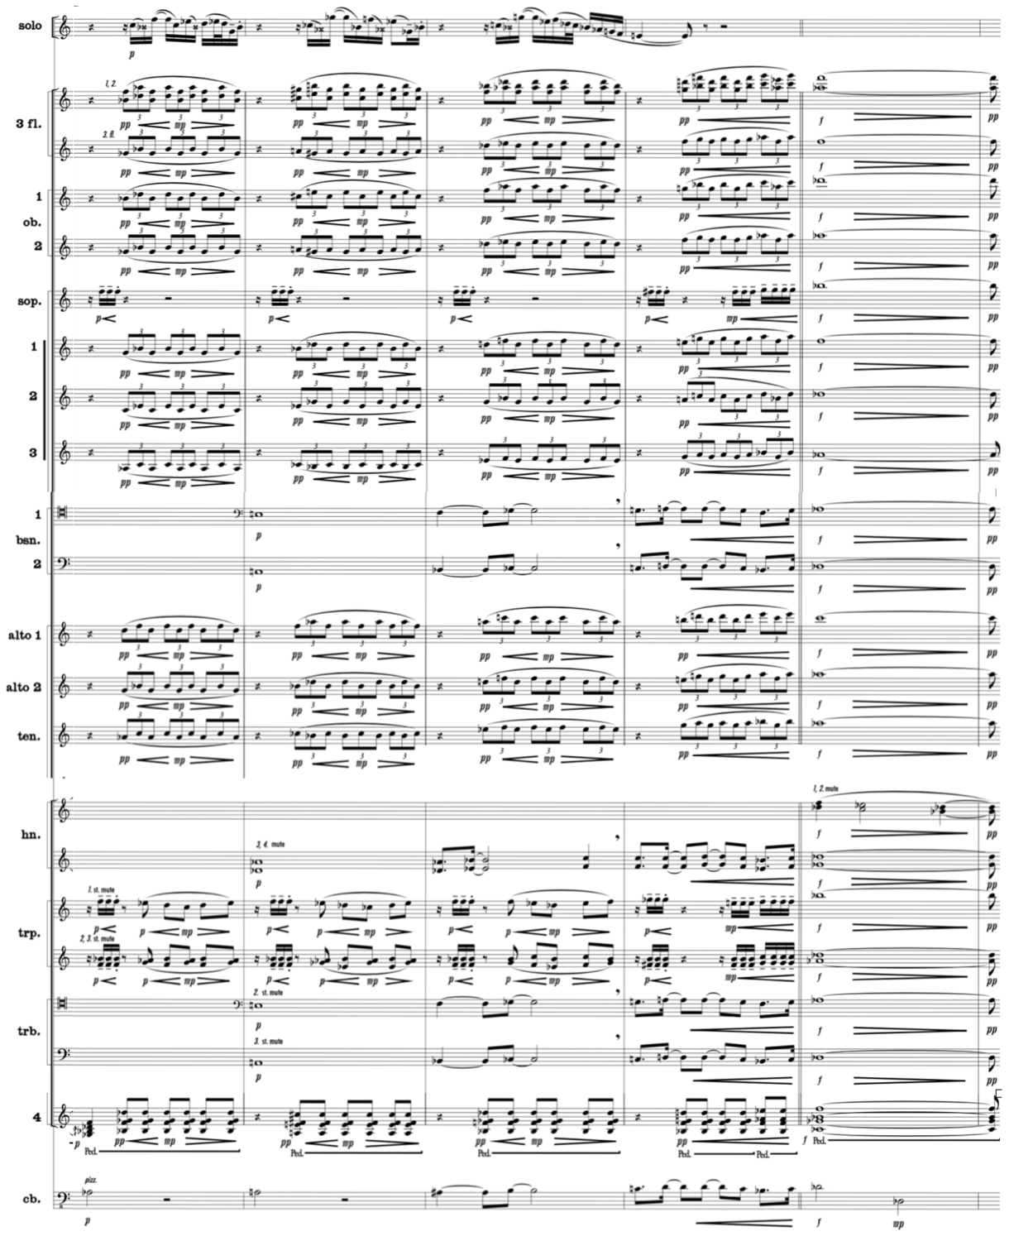
Used by Permission. © 2006-2008 by KevEli Music

A restatement of the candombe rhythm occurs at measure 92 at a forte dynamic, marking the beginning of the A-prime section. However, unlike in prior orchestrations of the candombe rhythm, Walczyk omits the pitched wind and string instruments, opting for an orchestration more closely resembling an authentic presentation of the candombe rhythm with Latin percussion and timpani (see Music Example 4.21). With the solo trumpet resting, the percussion section performs the candombe rhythm at a forte dynamic level providing decibel contrast to peak audience interest. This marks only the second instance that the percussion section is solely responsible for generating the concerto’s tempo. Music Example 4.21 illustrates the candombe rhythm orchestrated entirely in percussion instruments.
Music Example 4.21 Concerto Gaucho for Trumpet and Wind Ensemble,
I. Candombe, mm. 92–93
Candombe rhythm orchestrated entirely in percussion instruments

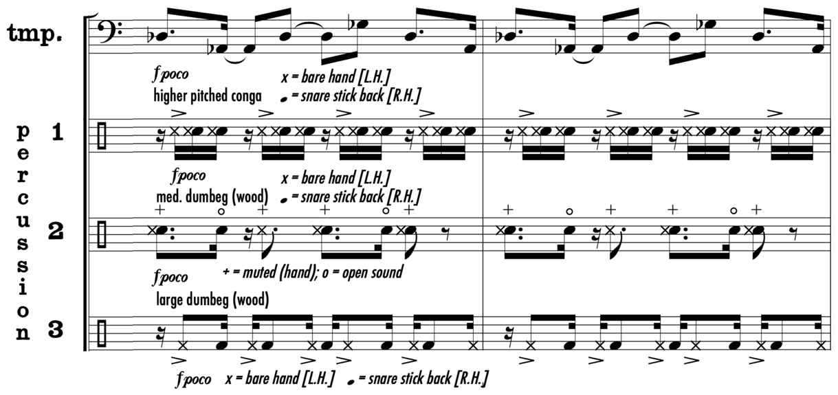
Used by Permission. © 2006-2008 by KevEli Music

In measure 95, Walczyk indicates a diminuendo from forte to piano in the percussion section before the solo trumpet re-enters. After four measures of the candombe percussion soli, the solo trumpet returns at measure 96, distinguished by cup mute timbre, playing an embellished version of the Candombe’s principal-theme group ‘a’ motive primarily in the staff (see Music Example 4.22). The soloist is joined by the lighter timbres of harp and vibraphone performing a skeleton outline of the solo trumpet’s ornamented motive. The woodwinds, serving as a background voice, provide harmonic foundation in long rhythmic values below middle C at a soft volume to ensure the muted solo trumpet remains the prominent voice. Music Example 4.22 illustrates the accompaniment’s relatively low tessitura and slower rhythmic velocity that distinguishes the muted solo trumpet as the primary voice.
Music Example 4.22 Concerto Gaucho for Trumpet and Wind Ensemble,
I. Candombe, mm. 96–98
Separating solo and accompaniment voices through rhythm and tessitura

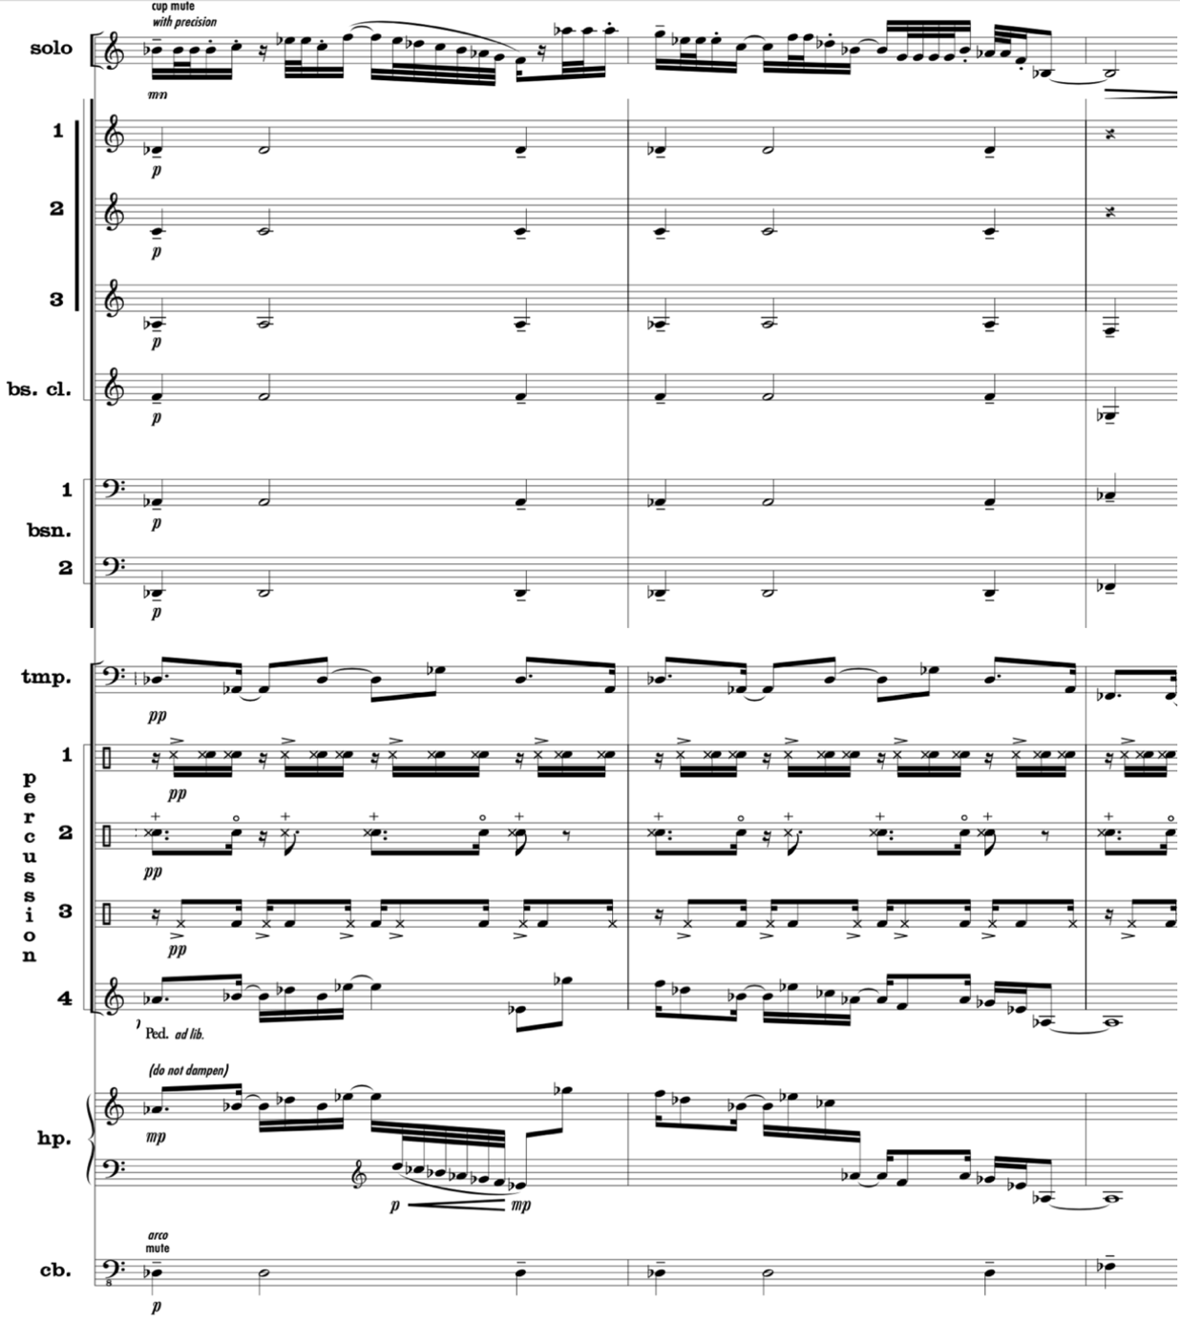
Used by Permission. © 2006-2008 by KevEli Music

The ‘a’ motive concludes at measure 98 when the cup-muted solo trumpet enters off the beat, accompanied by two section trumpets and trombones, also utilizing cup mutes (see Music Example 4.23). The consistency in mute orchestration across solo and accompaniment voices homogenizes the combined brass timbres, elevating the accompaniment as an equal role to the soloist. However, the solo trumpet remains distinguished by its orchestration as the soprano voice in the five-voice arpeggiated chord in unison rhythm at a forte dynamic.
Music Example 4.23 Concerto Gaucho for Trumpet and Wind Ensemble,
I. Candombe, m. 99
Separating solo and accompaniment voices by assigning foreground and background roles through register placement

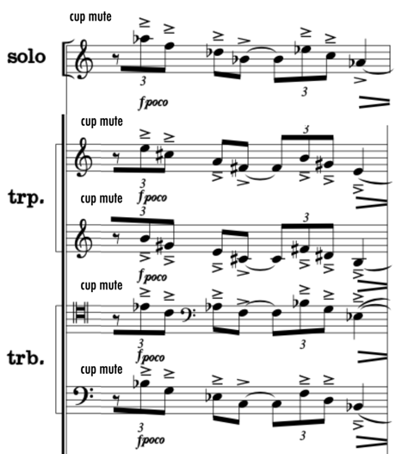
Used by Permission. © 2006-2008 by KevEli Music

Throughout measures 104–107, an embellished version of the principal-theme group ‘b’ motive is accompanied by a homophonic texture of flutes, oboes, clarinets, and bassoons providing pulse stability through ascending and descending staccato sixteenth-note patterns (see Music Example 4.24). The combined dark conical timbres of a single horn and euphonium restate portions of the solo trumpet’s ‘b’ motive two beats later. As this occurs, the solo trumpet fluctuates between a primary role and background role. By omitting other brass instruments, Walczyk creates space for the accompanying horn and euphonium to complement the solo trumpet. This canonic-like dialogue a major sixth below the solo trumpet, illustrated in Music Example 4.24, is an example of exploiting colors to assign foreground and background roles.
Music Example 4.24 Concerto Gaucho for Trumpet and Wind Ensemble,
I. Candombe, mm. 104–107
Separating solo and accompaniment voices through imitative dialogue and contrasting dark and brighter timbres

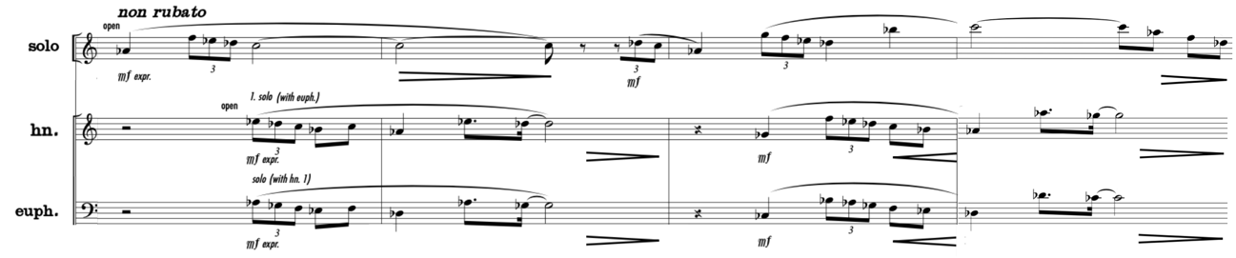
Used by Permission. © 2006-2008 by KevEli Music

The Candombe’s principal-theme group ‘c’ motive, marked “kinetic,” returns at measure 108 (see Music Example 4.25). In contrast to the previous instance of the ‘c’ motive at measure 39 comprised entirely of brass instruments, Walczyk omits the euphonium and replaces horns with saxophones. Cup mutes are used in the section trumpets and trombones to create a softer accompanying dynamic to distinguish their timbre from the unmuted soloist. Additionally, the cup mutes produce a mellow combined timbre that blends with the saxophone color to preserve the solo trumpet as the primary voice. The added percussion timbres consisting of a triangle and shaker provide a precisely defined pulse cutting through the dense texture of major seventh chords stacked closely in thirds. Walczyk assigns a fortepiano dynamic to tutti long notes in the accompaniment from measures 108–111, allowing the solo trumpet to project through the sustained accompaniment chords.
Music Example 4.25 Concerto Gaucho for Trumpet and Wind Ensemble,
I. Candombe, mm. 108–111
Separating solo and accompaniment voices through dialogue and contrasting rhythms

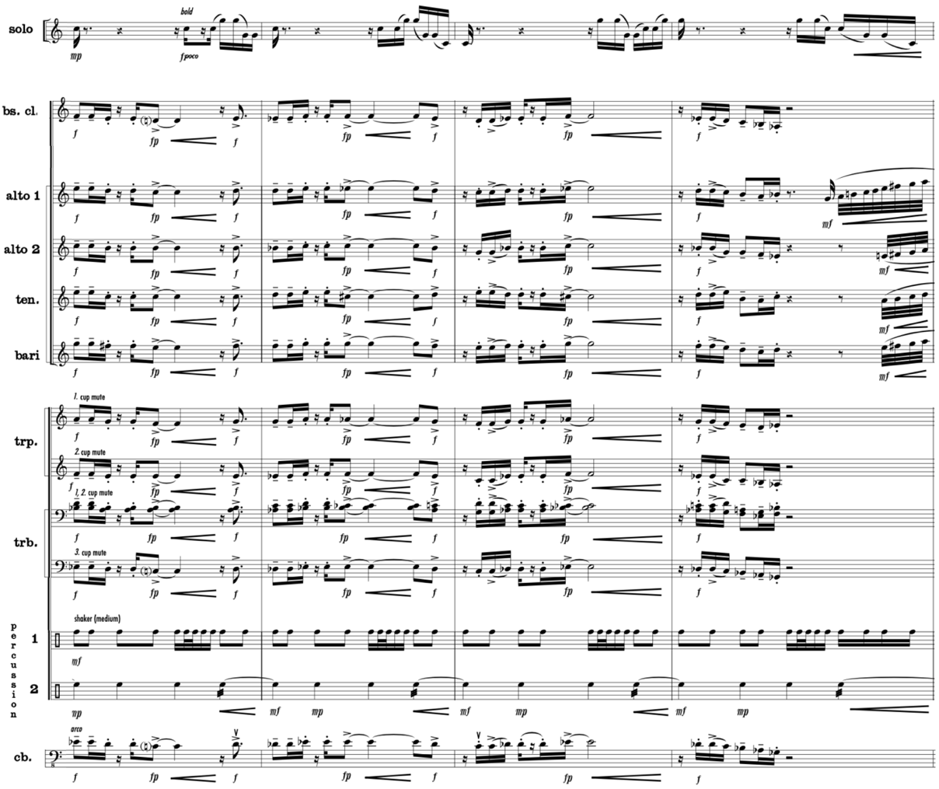
Used by Permission. © 2006-2008 by KevEli Music

Solo and accompaniment dialogue occurs at measure 112, where the Candombe’s principal-theme group ‘d’ motive returns. The motive begins in the accompanying woodwinds and section trumpets while the soloist rests. However, the melody transitions back to the solo trumpet in the following measure while the majority of accompanying voices rest. In this call-and-response dialogue, the lower registers of the horn, trombone, and tuba performing sustained harmonies stand in contrast to the solo trumpet above middle C (see Music Example 4.26). Throughout the four-measure call and response phrase, the Bass Clarinet, Bassoon 2, and Contrabass play a dry, staccato version of the madera rhythm providing a consistent tempo that unifies the back-and-forth dialogue. In this iteration of the ‘d’ motive, the section trumpets perform only when the solo trumpet is resting to maintain separation of the solo and section timbres, as Adler suggests. This two-measure alternating dialogue repeats in measures 114–115 to complete the entire four-measure ‘d’ motive. Music Example 4.26 illustrates the complete 4-measure phrase exhibiting alternating orchestration.
Music Example 4.26 Concerto Gaucho for Trumpet and Wind Ensemble,
I. Candombe, mm. 112–115
Separating solo and accompaniment voices through dialogue, alternating foreground and background roles, and sparse accompanimental texture

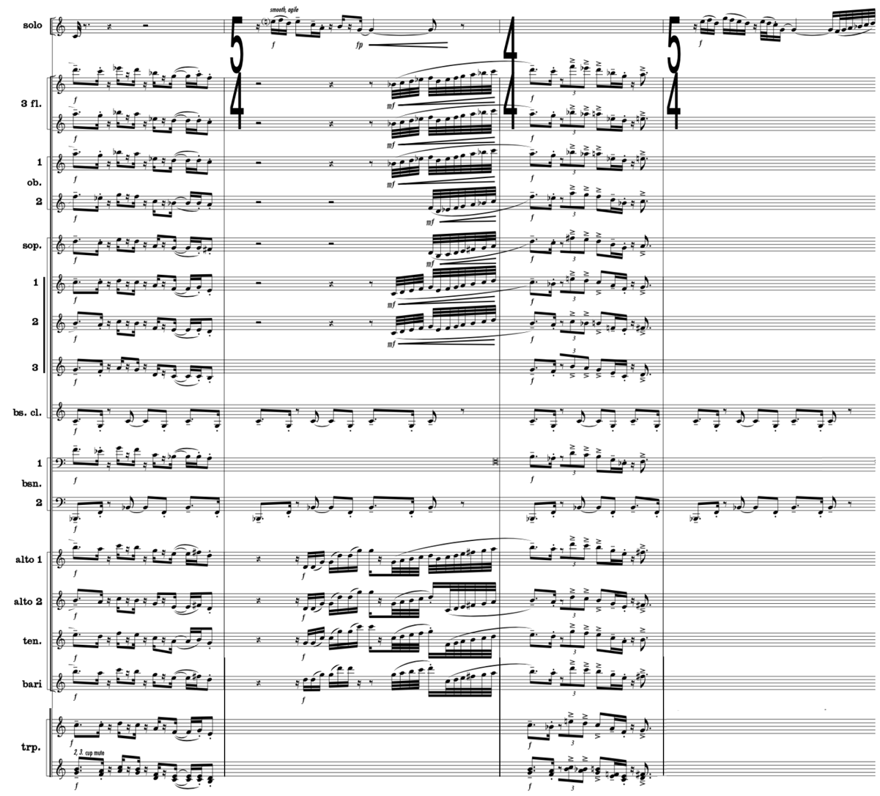
Used by Permission. © 2006-2008 by KevEli Music

In measures 116–119, the solo trumpet plays the ‘d’ motive, but this time a half-step lower to keep the harmonic interest fresh. Meanwhile, three other musical ideas occur simultaneously in the background engaging nearly all the accompanying ensemble instruments. First, the clarinets, bassoons, and saxophones provide rhythmic propulsion using sixteenth notes in a variant of the Candombe’s open-interval theme. The unison octave scoring creates a transparent, open quality that remains light and smooth due to staccato and legato articulations. The second group, consisting of flutes, oboes, section trumpets, xylophone, and marimba, play the Candombe’s principal-theme group ‘a’ motive in unison octaves starting one measure after the solo trumpet begins the ‘d’ motive. The third group comprises the remaining brass, timpani, and contrabass providing harmonic foundation through fortepiano dotted half notes that crescendo at the end of each measure to preserve the solo trumpet as the primary voice. In this instance, a lightness is achieved by lessening each performer’s role throughout the performance of the open-interval and principal-theme group ‘a’ motives. Although most accompanying voices play at a forte dynamic, the solo trumpet remains the focal point due to Walczyk’s orchestration of seventh chords that preserve lightness while recycling familiar motives in the accompaniment.
The Coda beginning at measure 122 closes the concerto’s first movement similarly to the opening rubato and improvisatory introduction. The solo trumpet part is marked “bold, freely,” which Walczyk expresses through leaping intervals in the middle to low registers at a mezzo forte dynamic. The soloist is accompanied by clarinets, bassoons, saxophones, horns, trombones, euphonium, tuba, and contrabass performing whole-note chords at a matching mezzo forte dynamic. The stillness of the accompanying voices and slower harmonic progression allows the solo trumpet to project easily. As the solo trumpet descends into its dark lower register, the reduced orchestration diminuendos at measure 123 before the instrumentation is further reduced to horns, trombones, tuba, and contrabass at measure 125. As the harmony and solo trumpet cadence at measure 126, the woodwinds re-enter performing a hemiola rhythm, which foreshadows one of the Milonga’s upcoming rhythmic elements. After the continuous, active candombe rhythm of the first movement, the Coda serves both as a well-earned respite from the gaucho’s workday and a transition to the more somber and evening setting of the second movement, Milonga.

II. Milonga
While the candombe serves as the rhythmic inspiration for the first and third movements of Concerto Gaucho, the second movement, Milonga, draws inspiration from the milonga de contrapunto, a traditional Uruguayan song form sung by payadores whose verses compete rhythmically. Milonga preserves the hemiola rhythmic identity based on the décima—a ten-line formal structure and rhyme scheme that contains lyrics about politics, history, or current events. In the second movement, the solo trumpet part preserves the expressive melodies associated with the milonga. However, in this wordless rendition, the melodic trumpet soloist duels with the accompaniment’s rhythm, symbolized by their rhythmic hemiola conflict. Figure 4.5 illustrates the formal structures of Concerto Gaucho’s Milonga and the décima.

Figure 4.5
Milonga and décima formal structure

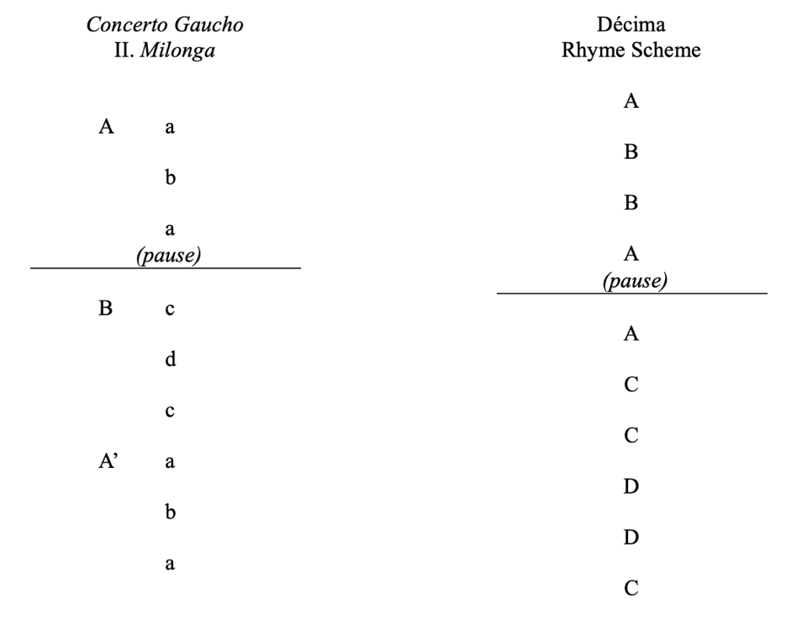
The Milonga’s A section begins at measure 132 with the solo trumpet performing the seven-measure principal-theme group ‘a’ motive at a piano dynamic. The solo trumpet motive consists of wide, leaping intervals accompanied by largely stepwise motion in a narrow range (see Music Example 4.27). The accompaniment begins in Flute 2–3, undampened Harp, and pedaled Vibraphone performing eighth-note B-flats at a unison piano dynamic. Together, these voices anchor the ‘a’ motive’s tonal center. The plucked harp and ringing vibraphone provide pulse clarity to the more sustained voice of the flute. The improvisatory-like solo line and the static timekeeping-voices of Flute 2–3, Harp, and Vibraphone in simple meter are juxtaposed rhythmically by the narrow-range, murmuring middle voices consisting of Flute 1, Clarinet 1–3, Bass Clarinet, and Bassoon 1 in compound meter. Regarding the counterpoint, Walczyk further symbolizes the dueling payadores through contrary motion between the solo and ensemble voices and assigns the solo and accompaniment voices a matching dynamic of mezzo piano.
Music Example 4.27 Concerto Gaucho for Trumpet and Wind Ensemble,
II. Milonga, mm. 132–138
Separating solo and accompaniment voices through rhythmic dissonance and distinctly different voices and colors at a piano and mezzo piano dynamic

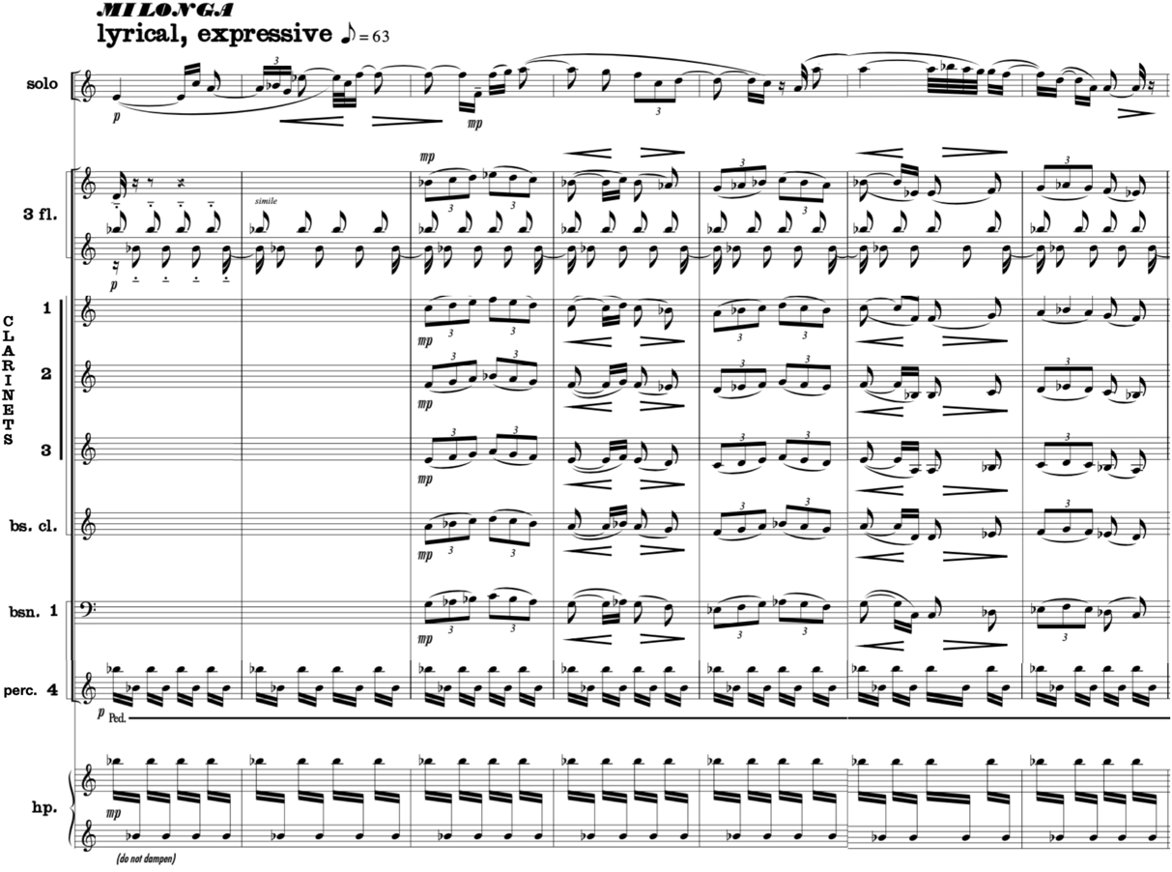
Used by Permission. © 2006-2008 by KevEli Music

At measure 139, the tempo increases slightly from 63 to 80 beats per minute, marking the beginning of the Milonga’s principal-theme group ‘b’ motive. Initially, it can be mistaken for a continuation of the ‘a’ motive. However, the Flute 2–3, Harp, and Vibraphone tacet, allowing the remaining accompaniment voices to play their expressive, rhythmically unified line without interfering with the solo trumpet’s improvisatory, angular passage (see Music Example 4.28). From measures 139–140 the solo trumpet’s dynamic growth parallels the accompaniment, ensuring that it remains in the foreground. To account for the solo trumpet’s increasing rhythmic values in measure 140, Walczyk indicates lifted articulations in the accompaniment voices to allow the soloist’s sustained notes to be directly heard. When the solo trumpet descends below the staff into a dark register at measure 141, the accompaniment leaps to the highest pitch in the phrase underscored by a forte dynamic. The disparate roles provide no aural interference for the listener to distinguish solo from accompaniment voices through register displacement.
Music Example 4.28 Concerto Gaucho for Trumpet and Wind Ensemble,
II. Milonga, mm. 139–142
Separating solo and accompaniment voices through rhythmic dissonance, contrasting ambitus, and dissimilar interval ranges

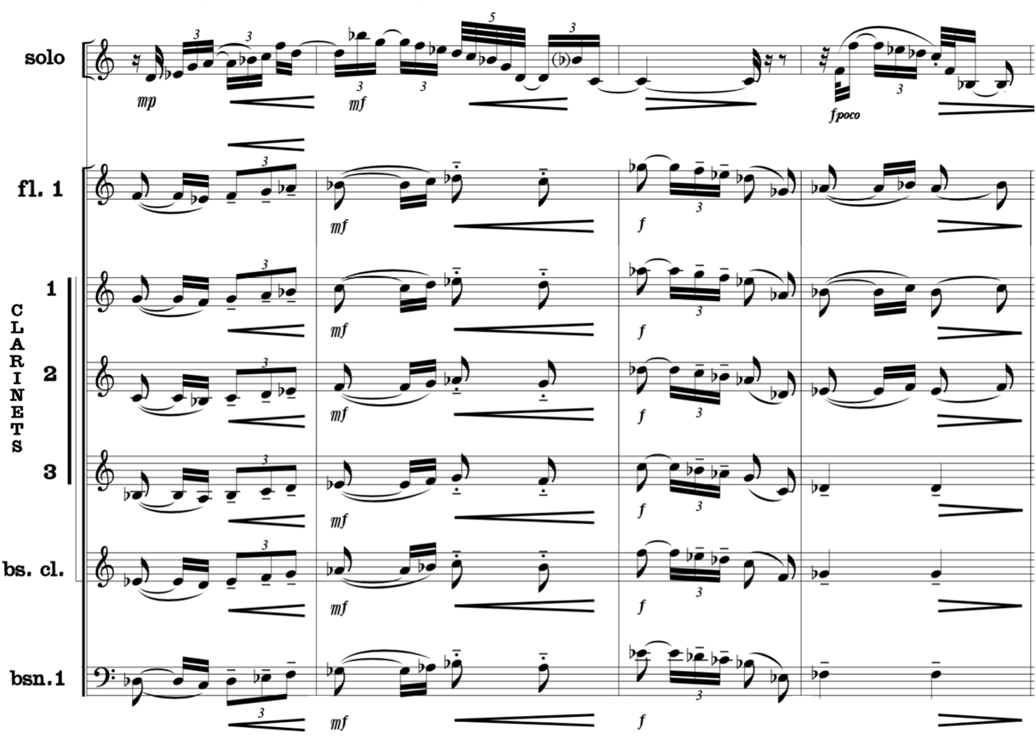
Used by Permission. © 2006-2008 by KevEli Music

The soloist rests from measures 143–150 following a continuous playing in the Milonga’s first two sections. In the soloist’s absence, Walczyk explores orchestration possibilities utilizing the accompaniment’s complete instrumentation, excluding battery percussion and timpani. In measure 143, the rhythmically dissonant woodwind accompaniment becomes the primary voice, adding oboes, E-flat Clarinet, Bassoon 2, and Alto and Tenor Saxophones to the orchestration. The orchestration transitions briefly to pairs of horns, section trumpets, and trombone at measure 145 before returning to woodwinds two measures later. The alternating woodwind and brass sections at comfortable dynamic ranges freshen the timbral interest and maintain the Milonga’s lyrical phrasing.
In the absence of solo trumpet, Walczyk continues the Milonga’s hemiola rhythmic identity at measure 147–149 by orchestrating the rhythmic dissonance between the homophonic woodwind section in simple meter performing against the xylophone and marimba’s contrasting timbre in compound meter. At measure 150, the full accompaniment diminishes in volume from forte to piano setting up the solo trumpet’s entrance at measure 151. The soloist’s entrance in a low tessitura is accompanied by Clarinet 1–3, Bass Clarinet, Harp, and Contrabass (see Music Example 4.29). This chamber ensemble orchestration with one voice to a part permits the solo trumpet to retain the relaxed mood of the Milonga and re-enter at a piano dynamic in a low, dark register. The rhythmic dissonance of the solo trumpet’s compound subdivision versus the accompaniment’s simple meter subdivision helps distinguish it from the accompanying texture.
At measure 152, the solo trumpet continues its decorative role to the ensemble’s primary material (see Music Example 4.29). Walczyk introduces a fresh orchestration color of alto, tenor, and baritone saxophones performing a rhythmically dissonant countermelody to the solo trumpet in compound meter. In measures 155–158, Walczyk changes the orchestration from singular saxophone timbre to the combined timbres of B-flat clarinet, bass clarinet, and bassoon, altering the color from bright to dark. Throughout measures 152–158, the solo trumpet and accompanying voices alternate between simple and compound meter, contrasting in rhythm and tessitura like the dueling payadores. To facilitate smooth transitions when the solo and accompaniment voices alternate simple and compound-meter identities, the undampened harp and vibraphone perform oscillating sixteenth-note B-flats in unison providing a steady sixteenth-note tempo. As the solo trumpet reduces its dynamic in measures 157 and 158, the clarinet and bassoons match the dynamic changes to maintain the solo trumpet in the foreground.
Music Example 4.29 Concerto Gaucho for Trumpet and Wind Ensemble,
II. Milonga, mm. 151–158
Separating solo and accompaniment voices through sparse accompanimental textures and rhythmic distinction

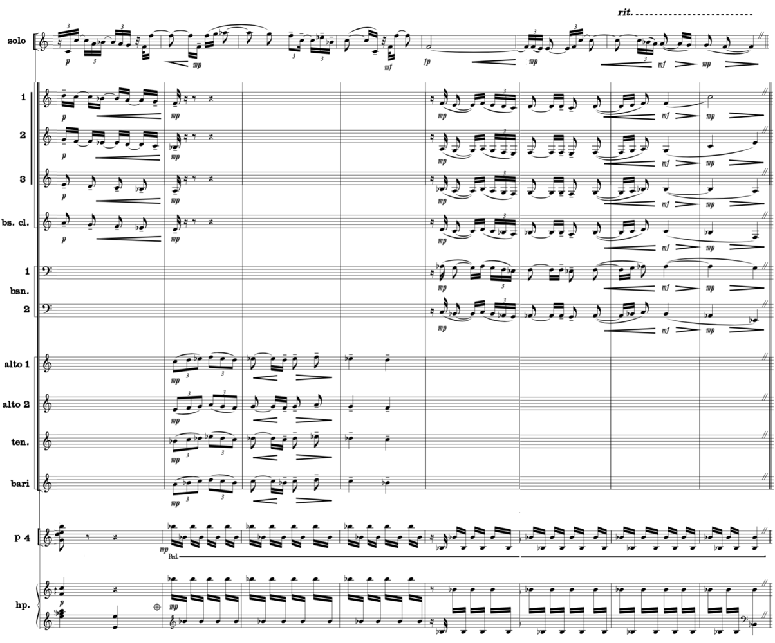
Used by Permission. © 2006-2008 by KevEli Music

The solo trumpet introduces the secondary-theme group ‘c’ motive at measure 159, marking the beginning of the Milonga’s B section. The ‘c’ motive is first presented in the solo trumpet, imitated two beats later by Bassoon 1, Alto Saxophone 1–2, Tenor Saxophone, and Euphonium (see Music Example 4.30). The solo trumpet remains distinguished from the countermelody at the same dynamic due to the repetition through imitation, register displacement, and contrasting timbre of single versus multiple mixed timbres. Throughout this iteration of the ‘c’ motive, the remaining woodwinds, vibraphone, marimba, and contrabass provide rhythmic propulsion, returning to a pointillistic style of orchestration reflecting the strumming of a gaucho’s guitar. As illustrated in Music Example 4.30, the pointillistic orchestration of short notes contrasts the lyrical countermelody through dynamic contrast, achieving separation and distinction between solo and accompaniment voices.
Music Example 4.30 Concerto Gaucho for Trumpet and Wind Ensemble,
II. Milonga, mm. 159–163
Separating solo and accompaniment voices through contrasting styles and imitative dialogue

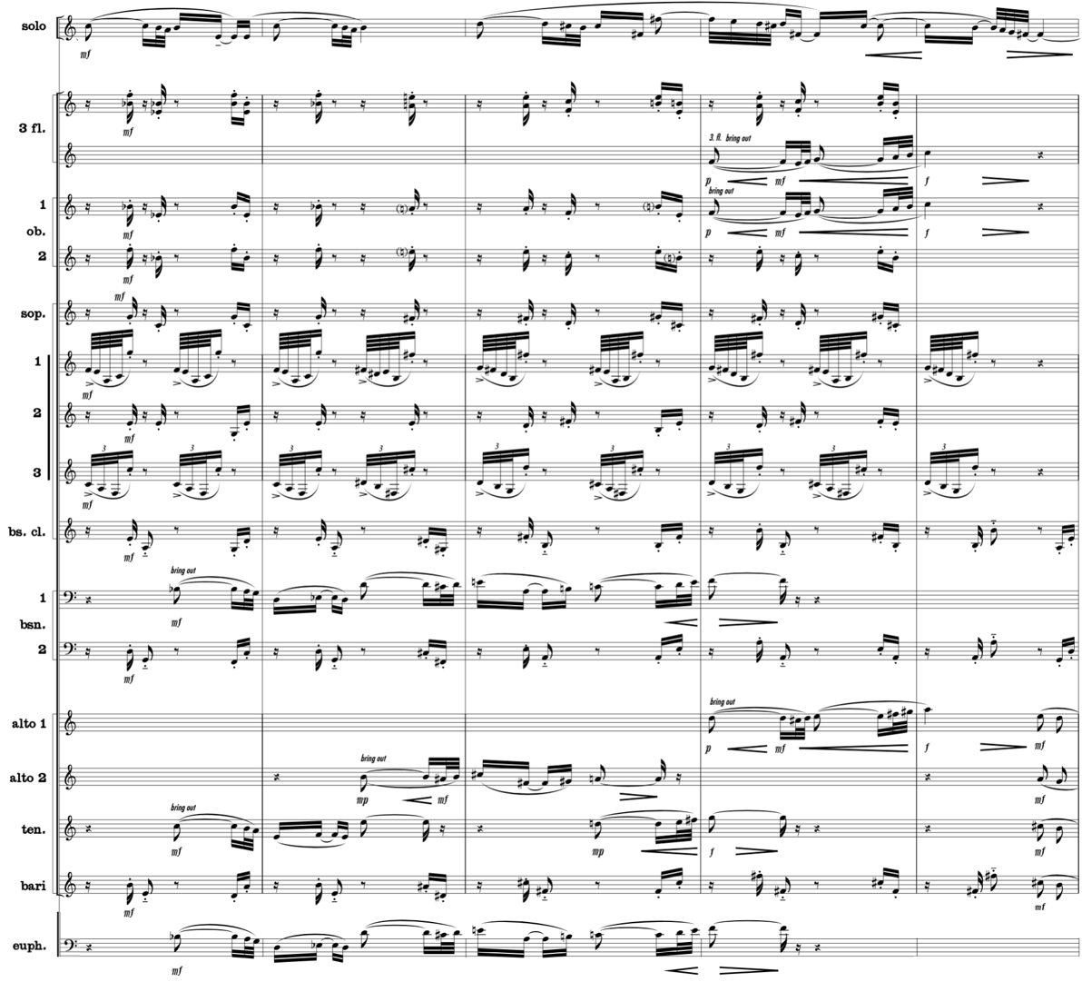
Used by Permission. © 2006-2008 by KevEli Music

In the preceding music example, it is possible to see evidence of the development of wind band musician independence, such as the pointillistic orchestration of the Clarinet 2–3 and bass clarinet voices. Similarly, Walczyk separates the bassoon section by scoring the Bassoon 2 with material different from Bassoon 1. However, the separate bassoon voices are reinforced with alto saxophone, tenor saxophone, and euphonium to create a dialogue that imitates the solo trumpet melody.
During measures 165–168, the solo trumpet briefly relinquishes its role as the primary voice where the melody is passed to the Flute 1–3, Oboe 1–2, E-flat Clarinet, B-flat Clarinet 1, and Trumpet 1 (see Music Example 4.31). These instruments collectively provide register contrast of the Milonga’s principal-theme group ‘c’ motive by performing it one octave higher than the solo trumpet four measures earlier. The register contrast anticipates the solo trumpet’s return at measure 169 when it performs the next phrase in a higher tessitura. Continuing the Milonga’s hemiola rhythmic identity in measures 165–166, Walczyk orchestrates an altered version of the 3:2 hemiola by composing sixteenth-note quintuplets in the saxophones and marimba against the melody’s sixteenth note subdivision creating a 5:4 relationship, rather than the conventional 3:2 hemiola.
Music Example 4.31 Concerto Gaucho for Trumpet and Wind Ensemble,
II. Milonga, mm. 165–166
Example of extreme rhythmic dissonance, modified hemiola 5:4 relationship

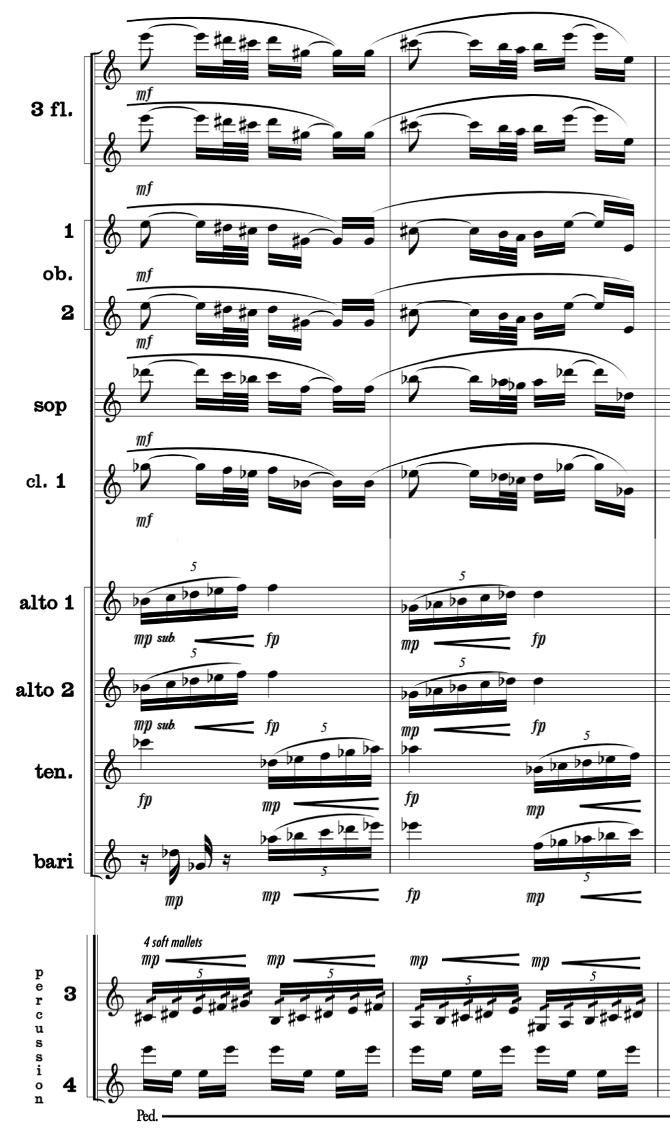
Used by Permission. © 2006-2008 by KevEli Music
The Milonga’s secondary-theme group ‘d’ motive begins at measure 169 heralded by solo trumpet marked “with fervor” at a forte dynamic, symbolic of the gaucho’s tenacity and perseverance required to meet the rugged demands of the gaucho lifestyle. The accompaniment is comprised of three rhythmic identities encompassing a wide ambitus, none of which double the virtuosic solo trumpet melody (see Music Example 4.32). In measures 169–170, Walczyk employs the full complement of woodwind, brass, and mallet keyboard percussion forces for the first time in the Milonga movement, marking the pinnacle moment of the movement with its passionate joy of the gaucho’s heroic lifestyle. In measure 171, the orchestration is reduced, omitting flutes, E-flat clarinet, section trumpets, trombones, tuba, and contrabass. Although the accompaniment’s dynamic level crescendos from forte to fortissimo in measures 171–173, the Solo Trumpet remains distinguished from the lighter woodwind and conical brass orchestration by its faster rhythmic values consisting of sextuplet thirty-second notes covering a wide ambitus from A above the treble clef staff to C below. As the solo trumpet descends into a darker register at measure 174 to close out the ‘d’ motive, Walczyk preserves the solo trumpet as the primary voice by softening the dynamic level of the accompaniment to mezzo forte at measure 175 and piano at measure 177. The horns entering during the solo trumpet’s sustained final note are muted, creating further timbral and dynamic contrast.
Music Example 4.32 Concerto Gaucho for Trumpet and Wind Ensemble,
II. Milonga, mm. 168–177
Separating solo and accompaniment voices through rhythmic and color contrast in thick texture

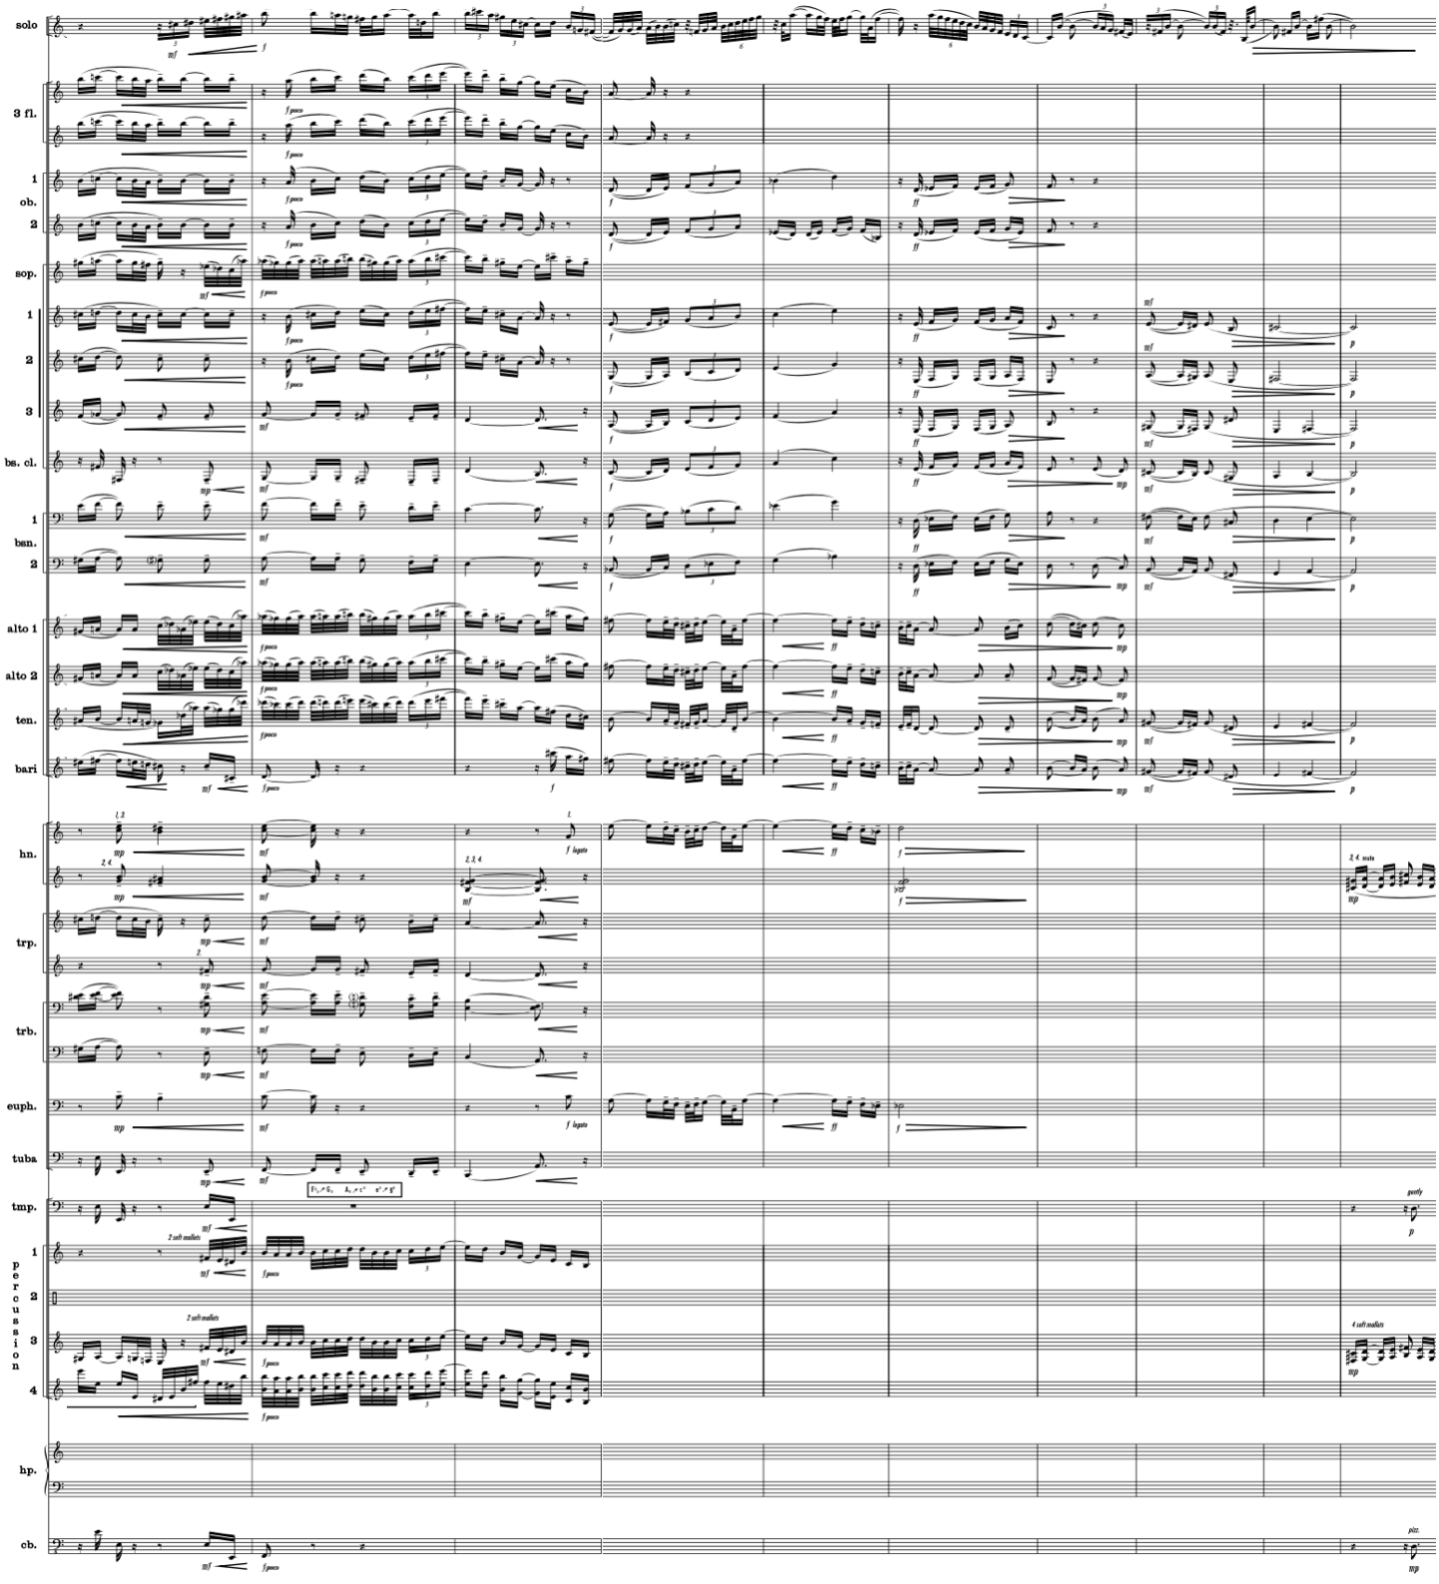
Used by Permission. © 2006-2008 by KevEli Music

The Milonga’s secondary-theme group ‘c’ motive returns at measure 178 in the solo trumpet, indicated “tender.” This version of the ‘c’ motive is slightly more ornamented than the original version containing more offbeat entrances and syncopation. Walczyk utilizes sparse accompaniment texture beginning at measure 178, consisting of Clarinet 2, Bass Clarinet, Horn 1, and Marimba. The thin, transparent texture enables the solo trumpet timbre to project with ease in a low tessitura at a soft dynamic level. A countermelody consisting of Horn 1 in compound meter continues the Milonga’s hemiola rhythmic identity, contrasting the solo trumpet in timbre in simple meter. The solo trumpet and horn are accompanied by the sparse texture of Clarinet 2, Bass Clarinet, and Marimba, providing harmonic support at slower rhythmic values. As the solo trumpet sustains its pitch and begins to fade away in measure 181, the orchestration grows in the following measures to include flutes, oboes, clarinets, bassoons, saxophones, and Harmon-muted section trumpet timbres performing dialogue in the solo trumpet’s absence at a soft piano dynamic. The orchestration transitions to pairs of clarinets and bassoons low in their register setting up the unaccompanied solo trumpet’s entrance at a piano dynamic in a dark, low register.
The Milonga’s A-prime section begins at measure 187 where the principal-theme group ‘a’ motive is stated by the unaccompanied solo trumpet, symbolic of a gaucho performing an unaccompanied song on guitar. The solo trumpet part marked “lyrical and expressive” consists of octave leaps and sustained pitches perhaps symbolizing the gaucho’s courage in facing the hazards of his lifestyle. At measure 189, Walczyk introduces a homophonic countermelody consisting of Flute 1, Clarinet 1–3, Bass Clarinet, and Bassoon 1, which creates a four-voice tertian chord stacked closely with only the soprano and bass voices doubled by mixed timbres. Similar to previous versions of the ‘a’ motive, Flute 2–3, Harp, and Vibraphone provide rhythmic stability to the simple and compound meter voices through repeated staccato sixteenth notes.
At measure 194, the Milonga’s principal-theme group ‘b’ motive” returns in the solo trumpet, beginning at mezzo piano before growing to mezzo forte and eventually forte poco. The indicated dynamic changes are mirrored in the accompanying instruments, suggesting the trumpet’s shared equal role to the accompaniment (see Music Example 4.33). Similar to how the South American gaucho exists in harmony with the surrounding elements, the solo trumpet’s dynamic growth parallels the ensemble crescendo to remain as the primary voice. The dueling nature of payadores that Walczyk references in the program notes is reflected in the equal solo and accompaniment dynamics, symbolic of the gaucho’s struggle to co-exist, adapt, and work with the natural elements of his job.
Music Example 4.33 Concerto Gaucho for Trumpet and Wind Ensemble,
II. Milonga, mm. 194–200
Separating solo and accompaniment voices through rhythmic independence and sparse accompaniment texture

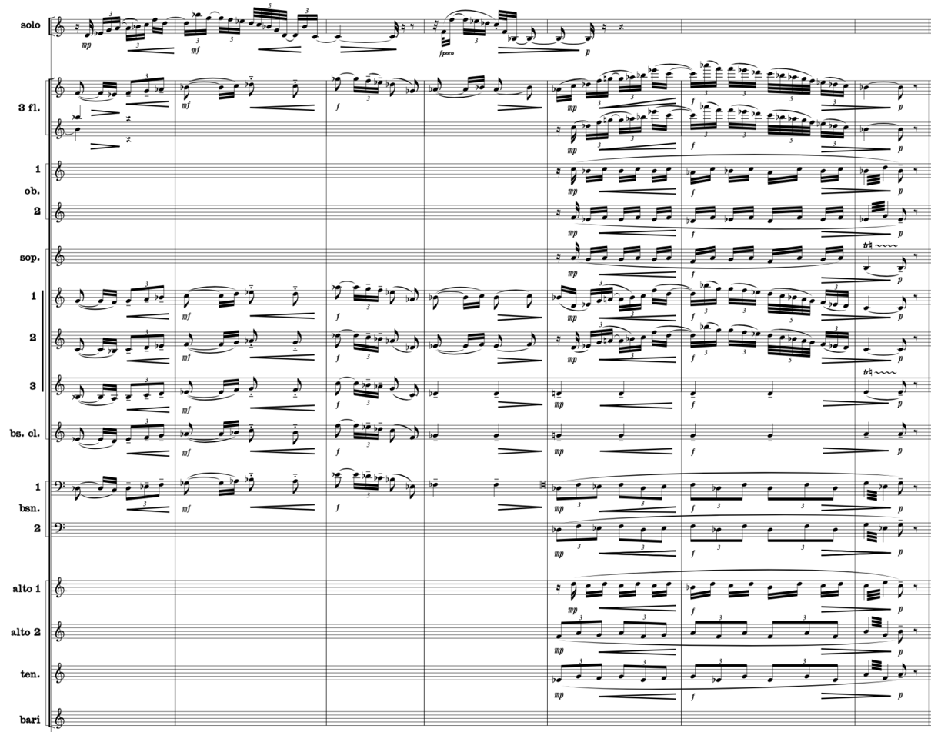
Used by Permission. © 2006-2008 by KevEli Music

The final iteration of the Milonga’s principal-theme group ‘a’ motive begins at measure 202 marked “lyrical and expressive.” Similar to previous occurrences of the ‘a’ motive, the solo trumpet part consists of leaping octave intervals and moderate dynamics in the middle register as it drifts from simple to compound meter. The accompaniment timbres consisting of multiple clarinets orchestrated in the staff at measure 201 and multiple saxophones orchestrated in their respective middle ranges at measure 202 allows the trumpet to project with unforced effort. The oscillating B-flats in the undampened harp and vibraphone resume in measure 202 providing forward momentum into the final cadence. As the ensemble sustains the Milonga’s final note, the lack of rhythmic propulsion caused by the fermata is symbolic of the gaucho pausing beneath the moonlit sky reflecting on the day’s hard work before retiring for the night, setting up the beginning of a new day with the Candombe Reprise

III. Candombe Reprise
Walczyk states in the program notes, “The third movement [Candombe Reprise] does not introduce new motivic material. Instead, it reprises variants of the thematic materials from the first movement, giving the entire concerto its large ternary formal structure.” Walczyk’s statement about the reprised variations of thematic material symbolizes the monotonous tasks in the gaucho’s day-to-day life with slight variation.
The Candombe Reprise begins at measure 211 with the full candombe rhythm orchestrated in the timpani and indeterminate-pitched Latin percussion instruments. The more bold, percussive candombe rhythm is in contrast with its opening movement quiet presentation in the pointillistic clarinets. The more aggressive reprised version in indigenous drumming instruments suggests a more confident and excited gaucho beginning a new day with unknown experiences ahead. With this view, Walczyk’s orchestration re-energizes the imagery associated with the gaucho.
Continuing the movement’s increased energy in contrast to the first movement’s two-voice initiation, principal-theme group ‘a’ motive now appears in a five-voice imitative passage (see Music Example 4.34). The stretto-like entrances are all separated rhythmically by two quarter-note pulses. The increased polyphonic texture achieves clarity by both pitch and registration changes. The first voice is stated in D unison, a step above middle C, and the second unison at D an octave higher. The transparent, sparse orchestration of the first two voices is Oboe 2 and Clarinet 1, followed an octave higher by Oboe 1 and Flute 2. Statements 3 and 4 appear on pitches G and A, a fourth and fifth interval away from the opening D. As the texture thickens in the fugue-like treatment, Walczyk achieves balance clarity by strengthening these entrances by doubling them at the octave. The fifth voice is composed at the same pitch as the first voice, D, but at the middle of the bass clef staff. The lowest voice statement achieves clarity by the two-and-a-half octave separation in Bass Clarinet and Bassoon 1 from statement 4. The five polyphonic voices elevate the musical energy and activity. The finely crafted imitative vignette, as illustrated in Music Example 4.34, could serve as an example of how to achieve clarity in stretto-like imitative counterpoint.
Music Example 4.34 Concerto Gaucho for Trumpet and Wind Ensemble,
III. Candombe Reprise, mm. 213–218
Stretto imitative orchestration technique of ensemble voices without soloist

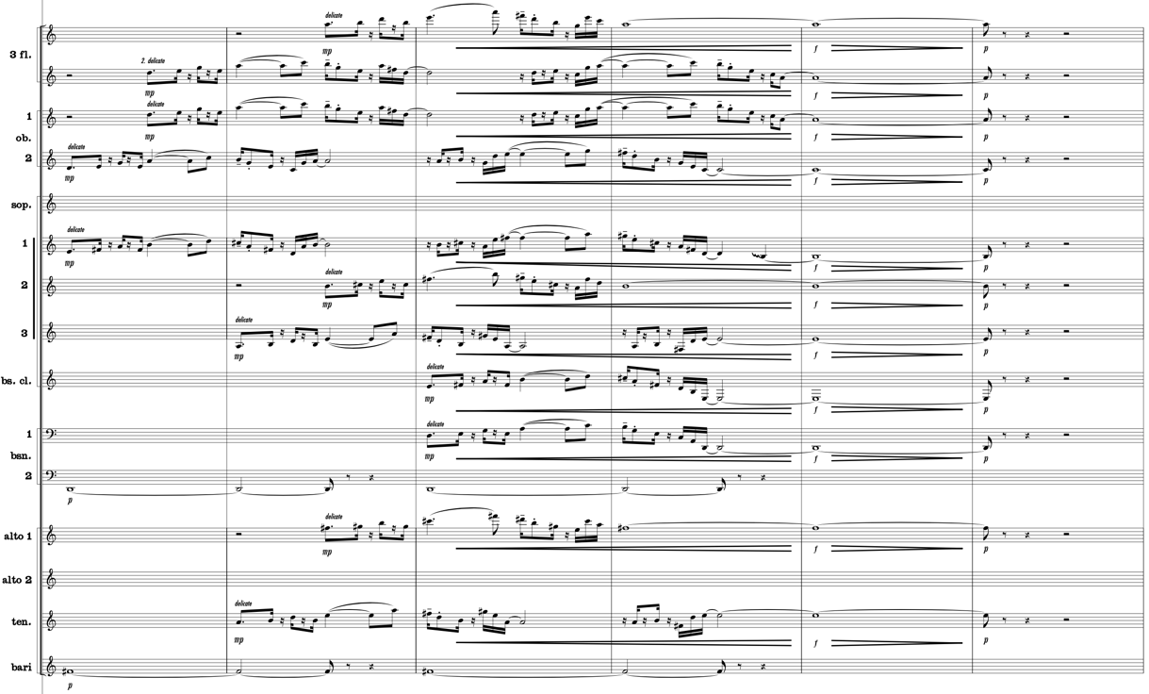
Used by Permission. © 2006-2008 by KevEli Music

At measure 219, Walczyk continues the use of stretto technique utilizing motivic content from Candombe’s secondary-group theme ‘e’ motive. Due to the thickening texture caused primarily by the sustained-pitch harmonic foundation, Walczyk orchestrates straight mutes in the accompanying brass instruments for timbral contrast and dynamic control (see Music Example 4.35). Additionally, the melody line is doubled by as many as seven voices in unison octaves to ensure it projects through the increasingly dense texture. While this example does not address balance between soloist and ensemble, it does address principles of orchestration applicable to any genre.
Music Example 4.35 Concerto Gaucho for Trumpet and Wind Ensemble,
III. Candombe Reprise, mm. 219–222
Stretto technique of ensemble voices without soloist

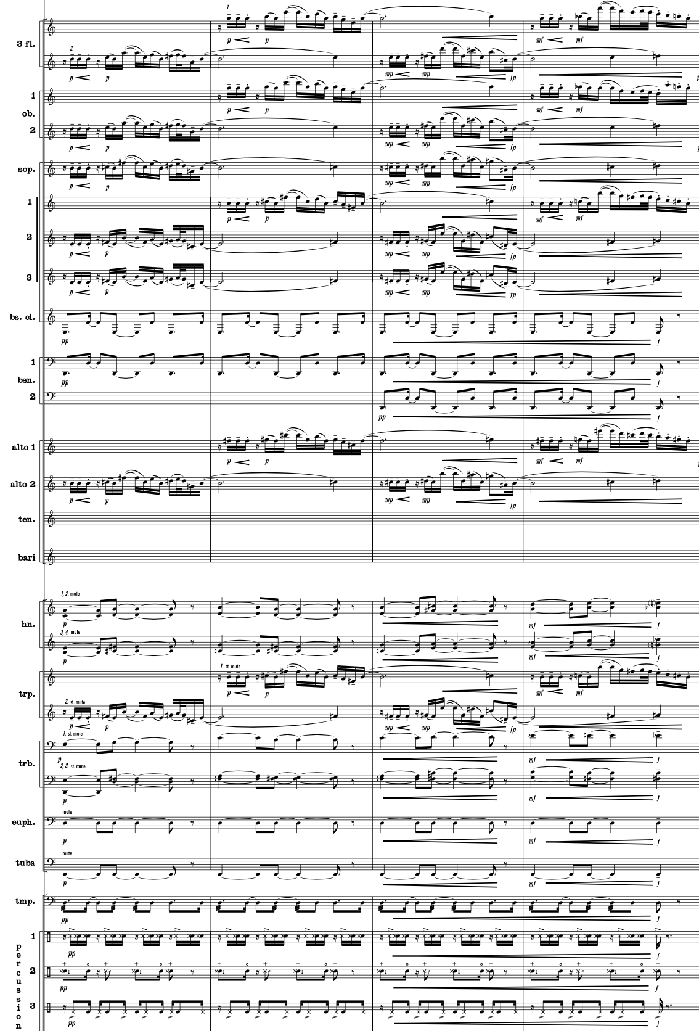
Used by Permission. © 2006-2008 by KevEli Music

Measures 223–226 mark the return of the solo trumpet with Candombe’s secondary-theme group ‘f’ motive, where Walczyk achieves variety of texture through exploring the ensemble colors (see Music Example 4.36). The solo trumpet melody is reinforced a third higher by the combined timbres of Flute 1, Oboe 1, and Clarinet 1 at a piano dynamic. Orchestrating the woodwinds at the interval of a third above the solo trumpet melody distinguishes the soloist from the accompaniment while also infusing the previous material with a new color and added strength. Furthermore, the staccato articulations and pianissimo dynamic level in the remainder of accompanying instruments help maintain the “playful, light” voices in a complemental role to the broad and lyrical singing line in the Solo Trumpet.
Music Example 4.36 Concerto Gaucho for Trumpet and Wind Ensemble,
III. Candombe Reprise, mm. 223–226
Accompaniment voices alternate between foreground and background role by rhythmically doubling portions of the solo part, soloist distinguished as the only instrument playing its pitches

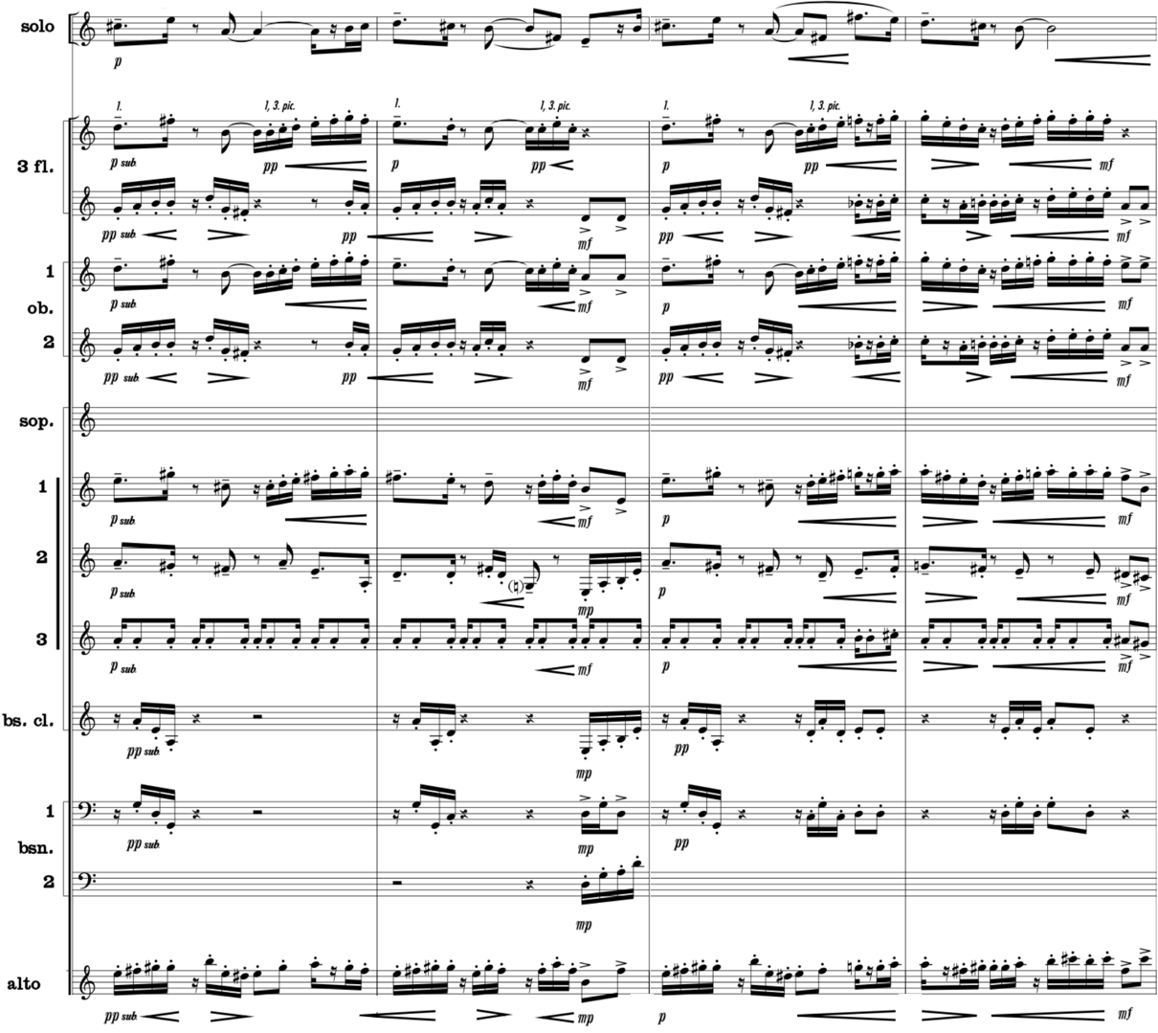
Used by Permission. © 2006-2008 by KevEli Music
Two trombones repeat the secondary-theme group ‘f’ motive in measures 227–230 performing in harmony at various intervals of a third and sixth (see Music Example 4.37). They are joined by a soaring countermelody in the high tessitura of horn 1 reinforced by the trumpet 3 while the remaining wind instruments provide rhythmic support through candombe sub-rhythms. Simultaneously, the solo trumpet performs ornate improvisatory-like flourishes of fast ascending and descending phrases accented by a bright tambourine thumb roll. In this instance, the solo trumpet ornaments the primary melody providing variation on previous melodic material. As an intertwined single voice, it is audible due to its faster rhythmic values.
Music Example 4.37 Concerto Gaucho for Trumpet and Wind Ensemble,
III. Candombe Reprise, mm. 227–230
Rhythmic and stylistic independence of the solo and accompaniment voices, soloist embellishing over two motives in counterpoint

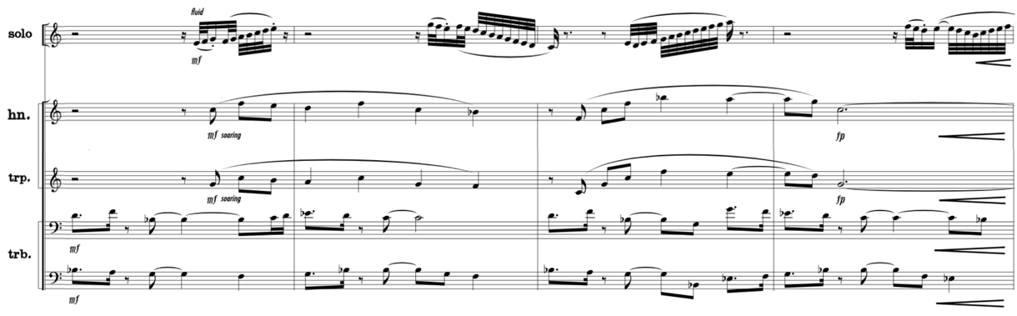
Used by Permission. © 2006-2008 by KevEli Music

The Candombe’s principal-theme group ‘d’ motive returns at measure 235. At this juncture, Walczyk weaves the material between the soloist and accompaniment for another fresh orchestration of repeated material (see Music Example 4.38). The ‘d’ motive begins in the clarinets and saxophones in the key of A-flat before transitioning to the solo trumpet at measure 236 in G-flat. The solo trumpet is accompanied by clarinets, bassoons, saxophones, percussion, and contrabass performing the dry repique drum rhythm, which energizes the pulse with both pitched and non-pitched orchestration. This alternating two-measure pattern continues, first in Flute 1, Oboe 1, and Clarinet 1 in G-flat before returning to the solo trumpet accompanied by the same voices and the addition of horns. The ‘d’ motive finishes without solo trumpet through an imitative stretto of differing timbres, which culminate on count 4 of measure 239 when a sudden rest resets the harmonic and rhythmic development. (see Music Example 4.38)
Music Example 4.38 Concerto Gaucho for Trumpet and Wind Ensemble,
III. Candombe Reprise, mm. 235–239
Accompaniment alternating between a foreground and background role splitting the melodic load with soloist

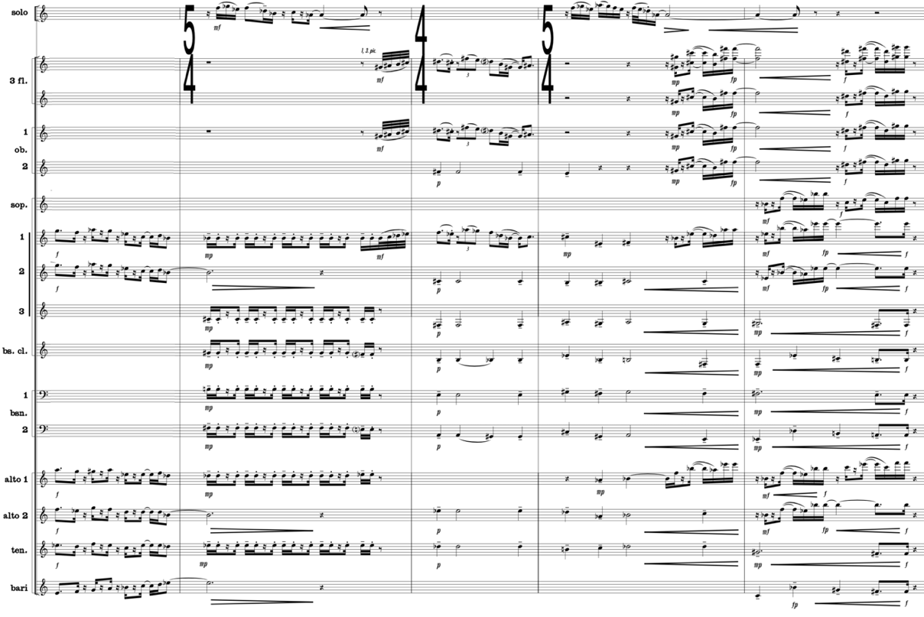
Used by Permission. © 2006-2008 by KevEli Music

With the solo trumpet resting, Walczyk utilizes rhythmic augmentation to further develop the repeated material in the Candombe’s principal-theme group ‘a’ motive (see Music Example 4.39). At measure 240, Flute 1–3, Oboe 1–2, E-flat Clarinet, Glockenspiel, and Vibraphone perform the new, rhythmically augmented version of the ‘a’ motive with entrances often off the beat.
Music Example 4.39 Concerto Gaucho for Trumpet and Wind Ensemble,
III. Candombe Reprise, mm. 240–243
Exploiting color of augmented principal-theme group ‘a’ motive

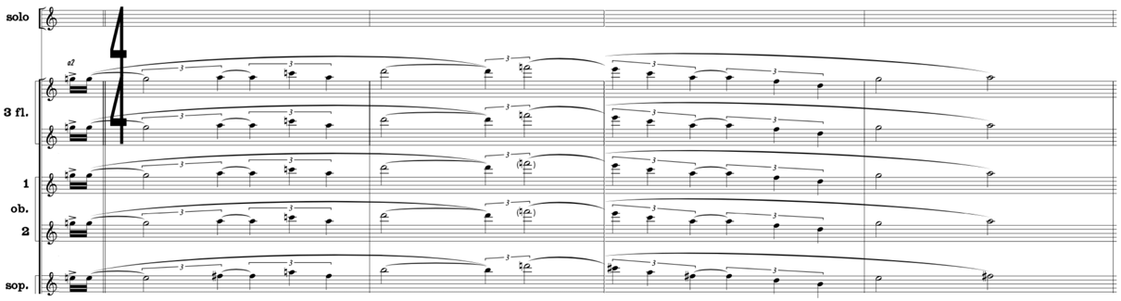
Used by Permission. © 2006-2008 by KevEli Music

This eight-measure rhythmically elongated version of the ‘a’ motive is contrasted by pointillistic accented brass entrances, which combine to create a composite of the piano drum rhythm. Together, the two independent lines create rhythmic dissonance that adds energy and heightens the musical impact of the Reprise’s repeated material. Assisting the woodwind and brass rhythmic identities with pulse security are bongos performing an ornamented version of the madera and two large shakers performing a consistent eighth-note pulse. The rhythmically challenging accompaniment in measures 240–247 gives way to bassoons, saxophones, and contrabass at measure 248 performing a unifying repique drum rhythm. The repique’s steady, repeated material reestablishes a secure pulse bridging the end of the current phrase to the upcoming ‘b’ motive.
At measure 250, the now familiar principal-theme group ‘b’ motive and candombe rhythm signals the comfort of knowing the gaucho’s daily activity is coming to another close. From measures 250–253, the solo trumpet’s expressive lyrical melody easily carries over the dark, heavy, and rich timbre of staccato bassoons, saxophones, triangle, and contrabass, followed by the brighter combined timbres of Flute 1–2, Oboes 1–2, E-flat Clarinet, and Clarinet 1–2 (see Music Example 4.40). A heroic variation of the ‘b’ motive occurs in the solo trumpet consisting of large upward wide-reaching intervals from measure 250–257, perhaps symbolic of the gaucho becoming more and more eager to end his day. The solo trumpet is accompanied by flutes, oboes, and clarinets performing the chico rhythm in their respective high tessituras orchestrated primarily above the solo trumpet range. The lyrical solo trumpet is most distinguished in this section by its wide leaping intervals against the accompaniment’s of staccato, narrow-ranging intervals. (see Music Example 4.40)
Music Example 4.40 Concerto Gaucho for Trumpet and Wind Ensemble,
III. Candombe Reprise, mm. 250–257
Separating solo and accompaniment voices by exploiting color and rhythmic contrast of accompanying voices

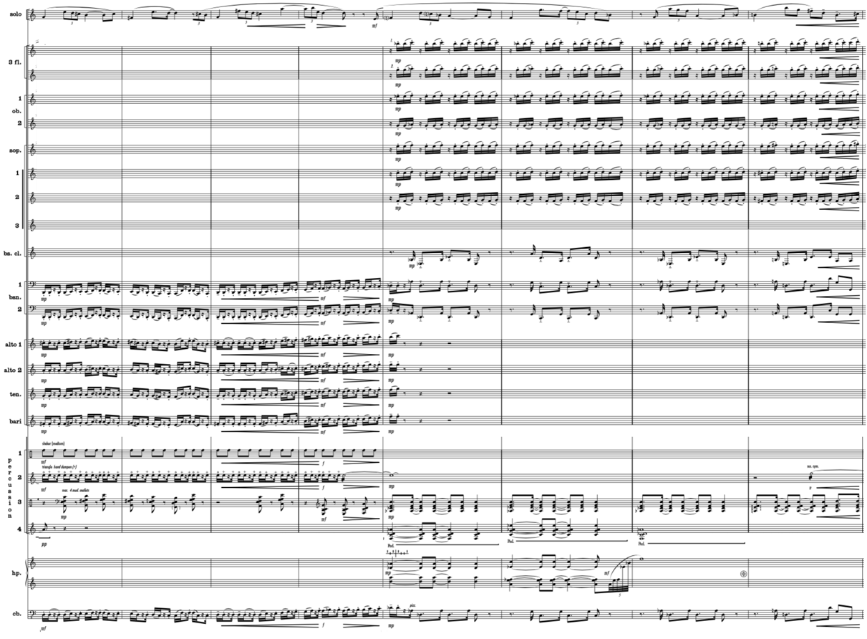
Used by Permission. © 2006-2008 by KevEli Music

The solo trumpet restates Candombe’s principal-theme group ‘d’ motive in measures 262–263. However, this repeat is varied with short, separated, offbeat notes near the top of the staff with written jazz inflections such as turns and tone bending (see Music Example 4.41). Another signal of a triumphant celebration to another day of strenuous work is orchestration of the repeated ‘d’ motive in full trumpet and trombone sections similar to a jazz big band with solo trumpet serving as the “lead” trumpet. The Latin jazz style is further asserted through the return of the candombe rhythm in the percussion section harmonically supported by the bass line scored in bass clarinet, bass trombone, and tuba. Walczyk harmonically solidifies the jazz style through “5-part voicings and tritone substitutions,” reflecting his experience as a former arranger for the University of North Texas One O’Clock Lab Band. At measure 264, the ‘d’ motive continues without solo trumpet where orchestration shifts to the saxophones and dominant woodwind timbres, similar to the orchestration exchange in a jazz big band between the brass and woodwinds.
Music Example 4.41 Concerto Gaucho for Trumpet and Wind Ensemble,
III. Candombe Reprise, mm. 262–263
The soloist remains the foreground voice through registral placement to separate solo and accompaniment voices

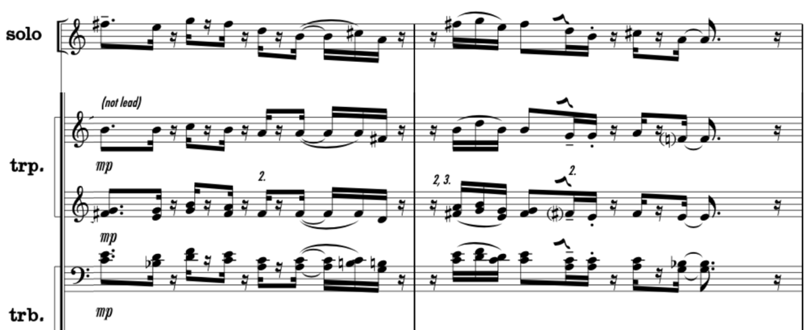
Used by Permission. © 2006-2008 by KevEli Music

At measure 266, Walczyk resets the forces in anticipation of the Coda section by removing the soloist and building the orchestration one final time. The ‘d’ motive is restated in the Flute 1–3, Oboe 1–2, Clarinet 1–2, Alto Saxophone 1, and Euphonium accompanied by the open-interval theme in the E-flat Clarinet, Clarinet 3, Bass Clarinet, Alto Saxophone 2, Tenor Saxophone, and Trumpet 2. Staggered entrances in Bassoon 1–2, Baritone Saxophone, Horn 1–4, Trumpet 1–3, Trombone 1–3, and Tuba marked sforzando provide a composite eighth-note pulse for the dashing open-interval theme and offbeat motivic content. With intensity building, the rhythmic groove abruptly halts on count 3 of measure 269 for the solo trumpet to re-enter a cappella, closing out the A-prime section. The solo trumpet is accompanied only by the ringing sustained harp and vibraphone timbres lingering from the previous measure, reminiscent of the gently blowing breeze.
The Coda begins at measure 271, reprising the pointillistic independent orchestration of the Introduction at measure 17. With the solo trumpet resting from measure 271–277, motivic fragments of Concerto Gaucho’s Candombe begin appearing intermittently from measures 275–278 in the flute, oboe, E-flat clarinet, saxophone, horn, trombone, euphonium, and harp sections. The transition reaches a climax in measure 278, first when the Flute 1–3, Oboe 1–2, and Clarinet 3 join to perform the repetitive repique drum rhythm, followed by scalar, showy flourishes ascending from the low to high register marked “fluid.” The woodwind accompaniment imitates the solo trumpet’s swift scalar passage in measure 279 while brass perform one final iteration of the principal-theme group ‘a’ motive that builds and releases on count 3 of measure 280. The accompaniment’s punctuating half-cadence silence presents the solo voice out front alone recalling a portion of the introduction’s open-interval motive. This is instantly followed by low woodwinds, brass, and contrabass performing the madera, with upper woodwinds restating the solo trumpet open-interval motive as the full percussion section performs the complete candombe rhythm.
The concerto finishes at its peak dynamic level of fortissimo in the flute, oboe, clarinet, saxophone, battery percussion, vibraphone, and harp sections, joined by the remaining voices at a forte dynamic. The concerto’s peak dynamic is matched in intensity by the soloist punctuating the concerto’s conclusion with its highest note, a D above the treble clef staff. With the final signature cast, the gaucho’s journey is complete. The Candombe Reprise recalls the first movement’s material but with each phrase the composer infuses new counterpoint while increasing the overall momentum through the Latin rhythmic patterns appearing in both percussion and winds. The composer maintains focus on the soloist over the ever-thickening orchestration through registral displacement, dynamic contrast, rhythmic contrast, and timbral contrast between the solo and accompaniment voices.
CHAPTER FIVE: SUMMARY, CONCLUSIONS,
AND RECOMMENDATIONS FOR FURTHER STUDY
Summary and Conclusions
This study contributes to a much-needed view of the events and initiatives that led to the wind band solo genre’s growth in expanding literature displaying solo artistry with the band while simultaneously advancing literature representing noteworthy works. Kevin Walczyk’s Concerto Gaucho for Trumpet and Wind Ensemble reflects the historical development of the wind band’s repertoire and musicianship by demonstrating numerous ways in which composers utilize composition techniques and orchestration in particular to distinguish the soloist from a large wind band. Concerto Gaucho also belongs to the small but rapidly growing subset of concerti originally for soloist and wind band accompaniment. Additionally, its South American theme advances the performance practice of repertoire, informing world music performance awareness. Its merits, however, extend beyond merely filling gaps in the repertoire. The preceding orchestration analysis of Concerto Gaucho can assist in developing conductor and composer awareness of scoring practices that not only impacts balance with the soloist but also balance within any repertoire.
Several factors have fostered the pace of concerto development since the 1990s. Collaborations between collegiate conductors, composers, and world-class soloists such as Joseph Alessi, Philip Smith, Hila Plitman, Christopher Martin, and Joseph Lulloff, to name a few, addressed the need for programming variety while also addressing the need for band literature that explores the artistic, expressive potential of the medium in a fresh way. Reflecting on the historical development of the wind band solo genre, one significant difference between nineteenth-century solo works and more recent works like Concerto Gaucho for Trumpet and Wind Ensemble is the orchestration of the accompanying wind band. The advancing independence of wind band musicians throughout the twentieth century gradually allowing composers flexibility in orchestrating combinations of timbres and textures fueled the development and diversity of wind band literature with soloists. While solo accompaniments from the John Philip Sousa and Patrick Gilmore eras were often relegated to background roles due to the band’s reliance on tutti scoring, twenty-first-century wind band literature with soloists demonstrates wind musician independence and presents the wind band in an equal role to the soloist. Walczyk’s orchestration of sparse accompaniment texture in the introduction and the pointillism that follows reflects the latter. Furthermore, the medium’s incorporation of piano, celeste, and harp has afforded composers versatility in distinguishing the solo and accompaniment voices at varying dynamic levels.
When orchestrating music for soloists and wind bands, it is necessary to consider the practicality of the demands of the soloist, accompanying musicians, and the conductor. A thorough knowledge of all instrument ranges, timbres, and technical capabilities is indispensable. A composer’s understanding of the conductor’s expectations throughout the rehearsal process is critical to effectively communicating musical ideas. Walczyk’s Concerto Gaucho prudently avoids extreme ranges and overscoring the accompaniment while a soloist performs. Furthermore, Walczyk’s dynamic architecture is noteworthy, particularly in its laid-back approach, emphasizing color through soft dynamic levels. Rather than relying on the solo trumpet and wind ensemble for power, he captures the essence of the gaucho through lightness, opting for a softer palette of solo and ensemble dynamics, reserving the loudest combined dynamic for Concerto Gaucho’s penultimate measure. Thanks to the musicianship initiatives from within the profession and improvements to instrument technology throughout the twentieth century, solo compositions like Concerto Gaucho for Trumpet and Wind Ensemble join a growing repertoire that distinguishes the soloist from the wind band while engaging the accompaniment as an equal voice.

Recommendations for Further Study
As numerous other compositions for soloists and wind band exist representing significant contributions to the repertoire, this study is in no way intended to be complete in providing the whole gamut of orchestration possibilities for balancing soloists with a wind band. More studies are needed that present historical views of this sub-category and individual works for wind. The present research examining Kevin Walczyk’s Concerto Gaucho for Trumpet and Wind Ensemble can serve as a point of departure for conductors, composers, and arrangers wishing to learn more about the orchestration practices of the concerto genre with wind ensemble. This approach may also provide a model for examining other individual musical works. Existing studies examining wind band orchestrations with soloists are few. While the present study addresses a relatively recent work, studies examining scoring practices of essential works such as Ingolf Dahl’s Concerto for Alto Saxophone and Wind Orchestra could provide comparative historical practices.
While Walczyk’s Concerto Gaucho for Trumpet and Wind Ensemble represents an important example of the collaboration between composers, soloists, and conductors since the 1990s, the potential for similar compositions featuring soloists with wind bands is limited only by the creativity of those seeking to contribute to the repertoire. Further studies on the craft of orchestrating for the wind band and its importance for conductors, composers, and ensembles is needed. Such studies could further assist in developing the solo and band repertoires. It is the hope that readers will gain additional insight into the language and analysis of orchestration elements that can be shared in rehearsal. Similar studies could also be applied not just to the wind band solo literature, but also standard literature that perhaps has not been analyzed through the lens of orchestration, such as Ingolf Dahl’s Sinfonietta.
Although this document provides a long-range lens of events that have occurred in the wind band solo genre, the profession would further benefit from a comprehensive history of the genre. This could include a survey examining the development of solo concertos with wind band accompaniment to determine programming trends identifying what solo literature is being established in the band repertoire. Furthermore, interviewing notable soloists who collaborated with wind bands would provide insight for conductors and composers to use in the future creation or performance of wind band literature with soloists.
The future of wind band repertoire with featured soloists continues to grow. Through a cursory view of concertos programmed from 1990 to present at CBDNA national conferences, the rate of premieres by decade are as follows: ten from 1990–1999, nine from 2000–2009, twelve from 2010–2019, and four since 2020. While this data is not scientifically obtained, it nevertheless reveals a powerful trend given the professional impact of these bi-annual significant events. With the current availability of wind bands at every level of maturity and the desire among its conductors for new, quality pieces of music, innovative, forward-thinking composers are ensured a forum for exploring the medium for years to come. The genre poses great opportunities for wind bands and soloists to collaborate. It is the author’s hope that the preceding examination of Concerto Gaucho for Trumpet and Wind Ensemble will provide conductors with a broader scope of descriptive language to assist in rehearsal or study, as well as provide enthusiasm for further exploration of the potential colors of the wind band.
BIBLIOGRAPHY

Adler, Samuel. The Study of Orchestration. 4th ed. New York: W. W. Norton & Company, Inc., 2016.

American Bandmasters Association. “Sousa-ABA-Ostwald Composition Contest.” http://www.americanbandmasters.org/sousa-aba-ostwald-composition-contest (accessed April 21, 2022).

Battisti, Frank. “The Legacy of Leaders with Vision.” The Instrumentalist (January 1993): 18.

Battisti, Frank. The Twentieth Century American Wind Band/Ensemble. Fort Lauderdale: Meredith Music Publications, 1995.

Battisti, Frank L. The Winds of Change. Galesville: Meredith Music Publications, 2002.

Burns, Kevin. “Karel Husa’s Concerto for Alto Saxophone and Concert Band: A Performer's Analysis.” DMA diss., Louisiana State University, 2000.

Cacavas, John. Music, Arranging, and Orchestration Melville: Belwin-Mills Publishing Corporation, 1975.

CBDNA Report, The. College Band Directors National Association. https://www.cbdna.org/about/the-cbdna-report/ (accessed April 22, 2024).

Cernuto, Joseph. “Analytical, Interpretative, And Performance Guides for Conductors and Soloists to John Mackey’s Harvest: Concerto for Trombone, Drum Music: Concerto for Percussion, and Antique Violences: Concerto for Trumpet.” DMA diss., University of Iowa, 2018.

Clappé, Arthur. The Principles of Wind-Band Transcription. New York: Carl Fischer, 1921.

Dahl, Ingolf. Concerto for Alto Saxophone and Wind Orchestra. Clifton, NJ: European American Music Corporation Rental Library, 1977.

DeRoche, Donald. “The DePaul University Wind Ensemble Recording Project.” BandDirector.com. https://banddirector.com/interviews/the-depaul-university-wind-ensemble-recording-project (accessed February 13, 2021).

Fennell, Frederick. The Wind Ensemble. Arkadelphia, AR: Delta Publications, 1988.

Fennell, Frederick. Time and the Winds, A Short History of the Use of Wind Instruments in the Orchestra, Band and the Wind Ensemble. Kenosha: G. Leblanc, 1954.

Frye, Joseph. “A Biographical Study of the Trombone Soloists of the John Philip Sousa Band: 1892-1931.” D.M. diss., Florida State University, 2008.

Gilbert, Jay. “An Evaluation of Compositions for Wind Band According to Specific Criteria of Serious Artistic Merit; A Replication and Update.” DM diss., Northwestern University, Evanston, 1993.

Goldman, Richard Franko. The Wind Band: Its Literature and Technique. Boston: Allyn and Bacon, 1961.

Hansen, Richard K. The American Wind Band, A Cultural History. Chicago: GIA Publications, 2005.

Husa, Karel. Concerto for Alto Saxophone and Concert Band. New York City, NY: G. Schirmer, Inc., 1967.

Johnson, Luke D. “The Need for Technically Accessible Chamber Winds Music and a Conductor’s Guide To “Winter Ricercar” by Kevin Walczyk.” DMA diss., University of Kansas, 2015.

Kennan, Kent and Donald Grantham. The Technique of Orchestration. 6th edition. Upper Saddle River: Prentice Hall, 2002.

Kernfeld, Barry. “Ghost(ed) note.” Grove Music Online. 2003; Accessed 20 Apr. 2024. https://www-oxfordmusiconline-com.ezproxy.mclennan.edu/grovemusic/view/10. 1093/gmo/9781561592630.001.0001/omo-9781561592630-e-2000167000.

Keveli Music. http://kevelimusic.com (accessed April 22, 2024).

Kloecker, John H. Jay. “An Analysis of Ingolf Dahl's “Sinfonietta for Concert Band”.” Journal of Band Research 28”, 1993.

Mahr, Timothy. “An Annotated Bibliography and Performance Commentary of the Works for Concert Band and Wind Orchestra by Composers Awarded The Pulitzer Prize in Music 1943-1992, and a List of Their Works for Chamber Wind Ensemble.” DMA diss., University of Iowa, Iowa City, 1995.

National Band Association, The. “William D. Revelli Composition Contest.” https://nationalbandassociation.org/composition-contests (accessed March 24, 2020).

Oliven, Ruben George. “The Largest Popular Culture Movement in the Western World: Intellectuals and Gaúcho Traditionalism in Brazil.” American Ethnologist 27, no. 1 (2000): 128-46. http://www.jstor.org/stable/647129.

Ostling Jr., Acton. “An Evaluation of Compositions for Wind Band According to Specific Criteria of Serious Artistic Merit.” PhD diss., The University of Iowa, 1978.

Rettie, Christopher. “A Performer’s and Conductor’s Analysis of Ingolf Dahl’s Concerto for Alto Saxophone and Wind Orchestra.” DMA diss., Louisiana State University, 2006.

Rogers, Robert Mark. “The Hill-Songs of Percy Aldridge Grainger: An Historical and Analytic Study with a New Performance Edition.” DMA diss., University of Texas at Austin 1987.

Rowles, Carl Thomas. “Ingolf Dahl’s Concerto for Alto Saxophone and Wind Orchestra: A Revised Edition.” DMA diss., University of Iowa, 2016.

Steiner, Marty. “The American Bandmasters Association Celebrates Excellence.” School Band and Orchestra (May 13, 2017) https://sbomagazine.com/current-issue/5779-the-american-bandmasters-association-celebrates-excellence.html (accessed March 27, 2020).

Stevens, Halsey. “In Memoriam: Ingolf Dahl (1912-1970).” Perspectives of New Music 9, no.1 (Autumn-Winter 1970): 147-8, accessed April 19, 2022, http://www.jstor.com/stable/832201.

Stoneham, Marshall, Jon A. Gillaspie, and David Lindsay Clark. The Wind Ensemble Sourcebook and Biographical Guide. Westport: Greenwood Press, 1997.

Sutton, Clifford Todd. “The Candombe Drumming of Uruguay: Contextualizing Uruguayan Identity Through Afro-Uruguayan Rhythm.” DMA diss., University of Miami, Coral Gables, 2013.

Towner, Clifford. “An Evaluation of Compositions for Wind Band According to Specific Criteria of Serious Artistic Merit: A Second Update.” DMA diss., University of Nebraska, 2011.

Townsend, Jacqueline Kathryn. “The Renaissance of the American Symphony for Wind Band as Exemplified by the Recent Symphonies of Donald Grantham, David Dzubay, James Stephenson, and Kevin Walczyk.” DMA diss., University of North Texas, 2018.

University of Kansas School of Music, The. “Freedom From Fear Artists.” https://music.ku.edu/freedom-fear-artists (accessed March 24, 2020).

University of North Texas, The. “Kevin M. Walczyk.” Alumni Spotlight. https://composition.music.unt.edu/walczyk-kevin-m (accessed March 24, 2020).

Votta, Michael, ed. The Wind Band and Its Repertoire: Two Decades of Research as Published in the CBDNA Journal. Miami: Warner Brothers, 2003.

Walczyk, Kevin. Concerto Gaucho for Trumpet and Wind Ensemble. McMinnville: Keveli Music Publications, 2008.

Wallace, Jacob. “John Mackey’s Concerto for Soprano Sax and Wind Ensemble (2007): An Analysis and Conductor’s Guide to Performance.” DMA diss., University of Georgia, 2009.

Wilson, Brian. “Orchestrational Archetypes in Percy Grainger’s Wind Band Music.” A.MusD. diss., University of Arizona, 1992.

Wind Repertory Project, The. “Concerts: Concert Programs.” https://www.windrep.org/Concerts:Concert_Programs (accessed April 21, 2024).

Winstin, Robert Ian, Yuriy Kornilov, Galyna Hornostai, Vera Kornilova, and Pavel Kucera. Masterworks of the New Era, Volume 13. ERM Media, CD 2009.

Yeh, John Bruce and the DePaul University Wind Ensemble and Jazz Band. Ebony Concerto. Reference Recordings RR-55, CD, 1993.
APPENDIX A: CATALOG OF THEMATIC MOTIVES

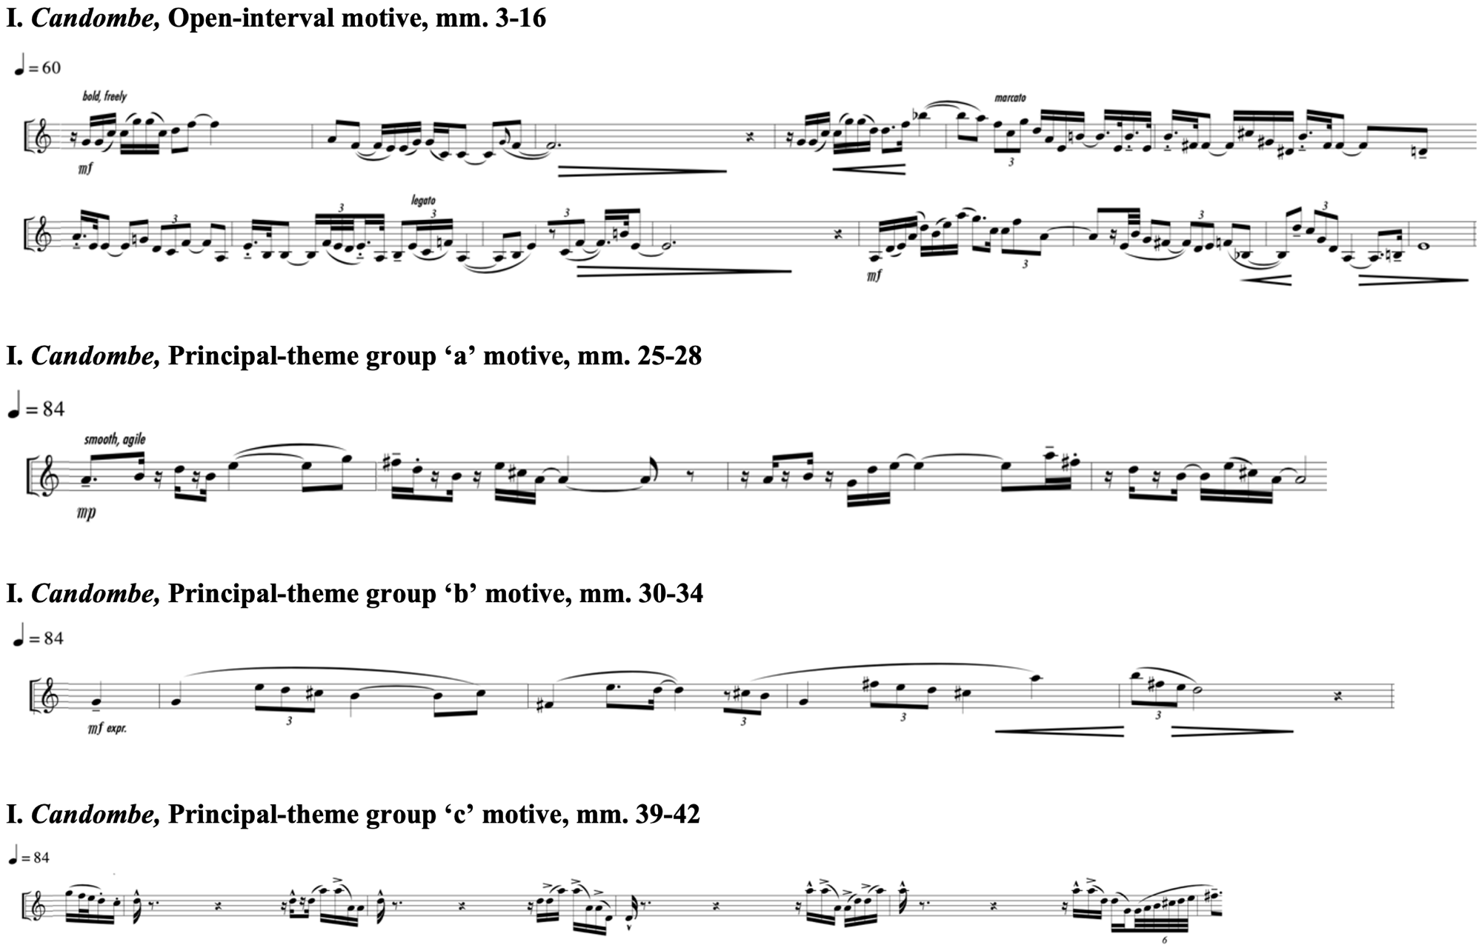
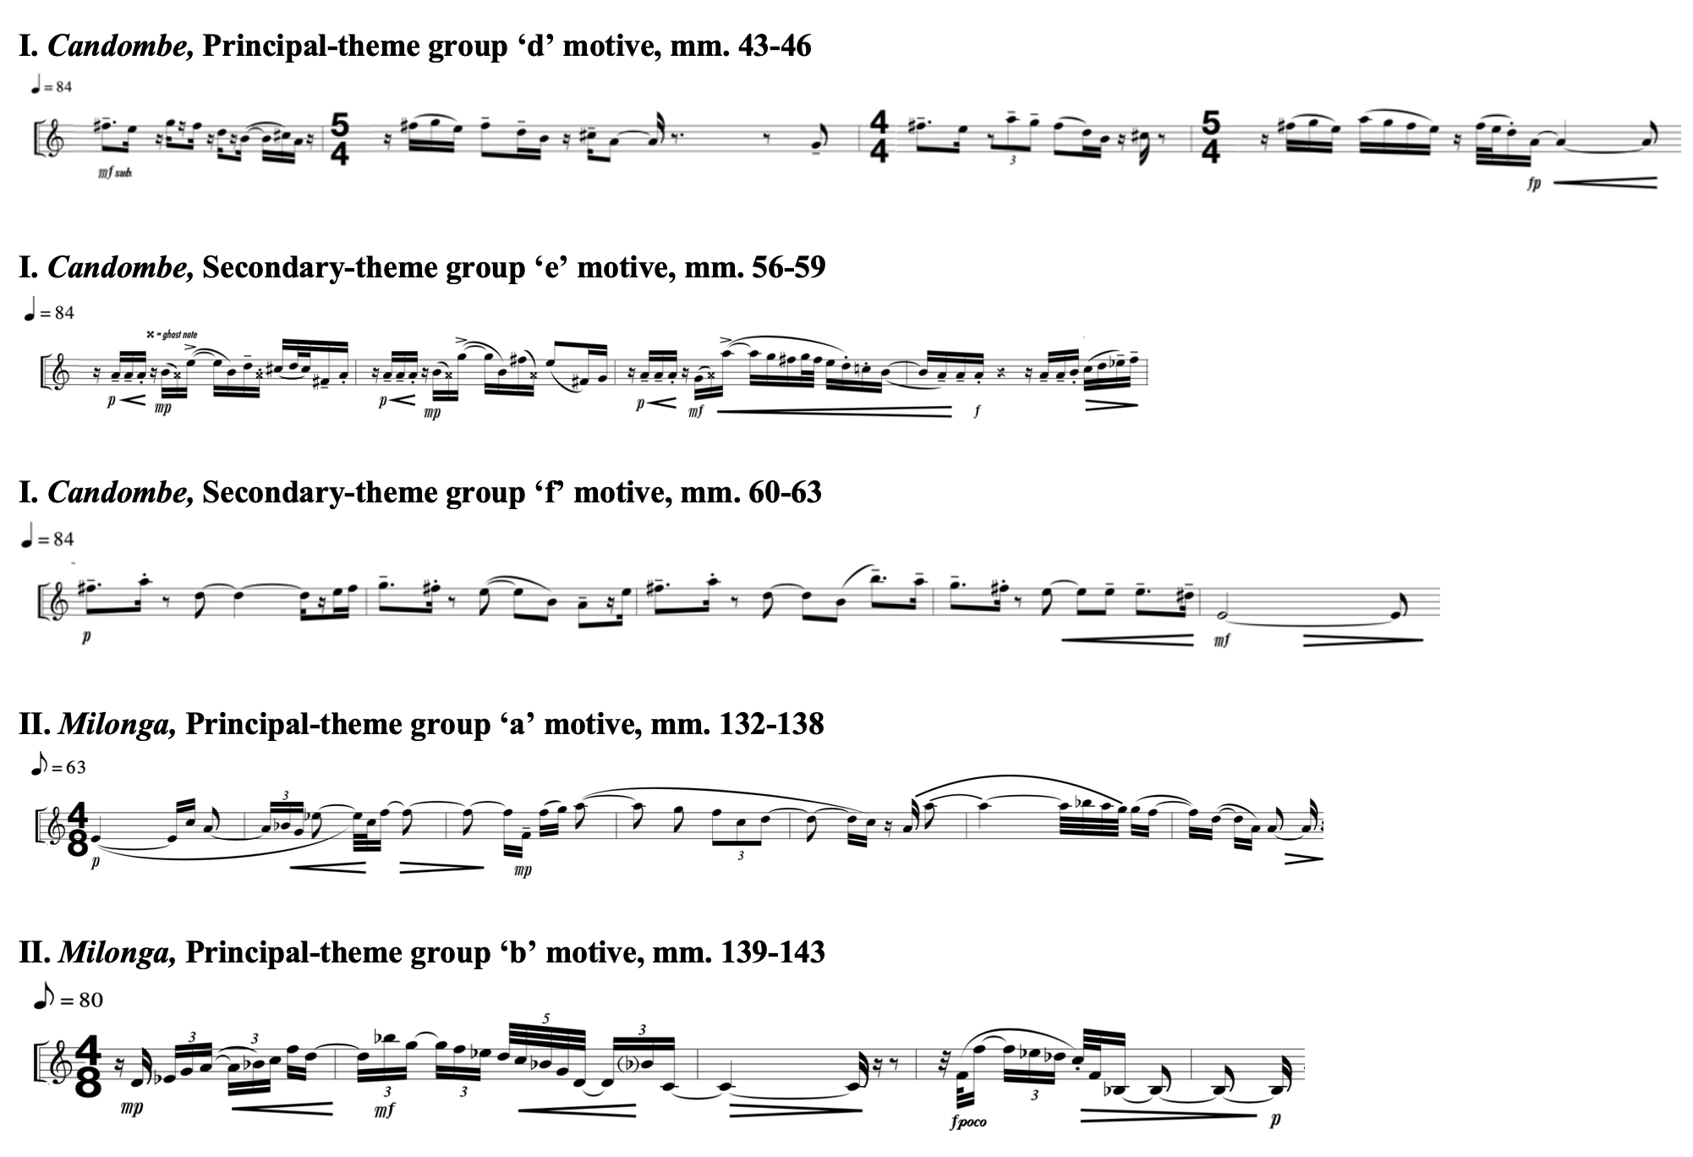

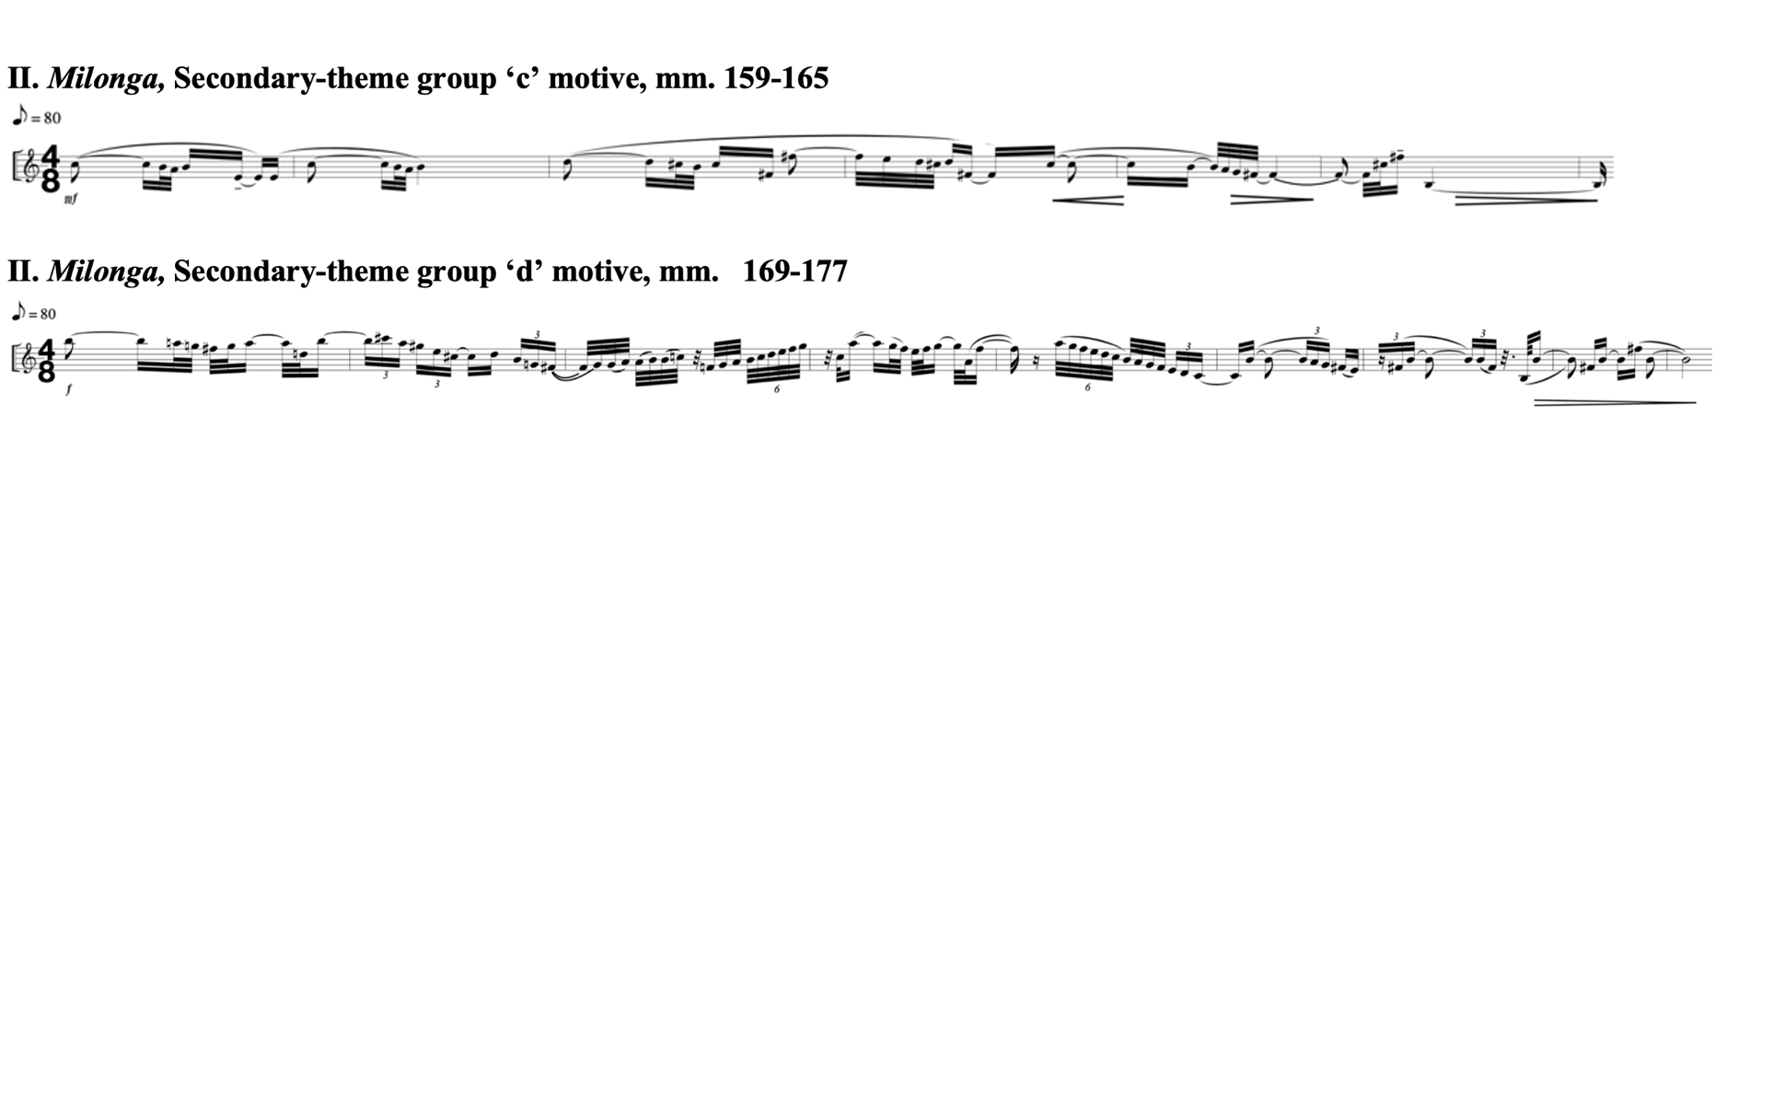
APPENDIX B: COPYRIGHT PERMISSION

From: "Dr. Kevin Walczyk" <keveli@wou.edu>
Subject: Re: Inquiry on using excerpts of Concerto Gaucho for Trumpet and Wind Ensemble in dissertation
Date: February 26, 2024 at 11:07:46 PM CST
To: "Conrad, Jon R." <jonconrad@ou.edu>
Reply-To: keveli@wou.edu

Hi Jon,

I am sending three scores of Gaucho: the first (original) edition was for Orchestra; then the Wind Ensemble reconstruction that followed; and also the piano reduction, which was completed last. The piano reduction will help with harmonic reduction (if you need to do any analysis of harmonic materials) but is devoid of percussion (obviously). But I thought, since your topic is orchestration, that it may be of interest to you to compare the original orchestra orchestration with the wind ensemble orchestration. This may also open a Pandora's Box for you as well.

Hope that helps!!
-Kevin
________________________________________________________________
Dr. Kevin M. Walczyk, Professor & Music Department Head
Western Oregon University APS 228
Monmouth, OR 97361
503.838.8274

On Feb 19, 2024, at 8:04 AM, Conrad, Jon R. <jonconrad@ou.edu> wrote:

Dr. Walczyk,

A PDF of the score would be very helpful, thank you!

Currently, the title is “ Kevin Walczyk’s Concerto Gaucho for Trumpet and Wind Ensemble (2007): An Examination of Orchestration Techniques.” Is there anything you would like me to include in regard to copyright with each musical example?

Sincerely,
Jon
Jon Conrad
Doctoral Conducting Student
University of Oklahoma
Email: jonconrad@ou.edu
On Feb 19, 2024, at 12:00 AM, Dr. Kevin Walczyk <keveli@wou.edu> wrote:

Hi Jon!

Yes, that would be fine with me! And thank you!!

Let me know if you need a PDF of the score so that you can get cleaner images.

Do you have a dissertation title, yet?

All best,
-Kevin
________________________________________________________________
Dr. Kevin M. Walczyk, Professor & Music Department Head
Western Oregon University APS 228
Monmouth, OR 97361
503.838.8274

On Sun, Feb 18, 2024 at 4:14 PM Conrad, Jon R. <jonconrad@ou.edu> wrote:

Dear Dr. Walczyk,

I am a doctoral student at the University of Oklahoma and I’m researching the orchestration of wind band literature with soloists. I will be performing an orchestration analysis of Concerto Gaucho for Trumpet and Wind Ensemble and would like to include portions of this work to illustrate instances of effective orchestration of solos with wind band.

Upon successful defense of my dissertation, it would be deposited into the University of Oklahoma Fine Arts Library and SHAREOK, the joint institutional repository for the University of Oklahoma Libraries (OU), Oklahoma State University Libraries (OSU), and the University of Central Oklahoma Max Chambers Library (UCO).

Please let me know if this is possible and how to obtain proper permissions.

Thank you for your time.

Jon Conrad
Doctoral Conducting Student
University of Oklahoma
Email: jonconrad@ou.edu
APPENDIX C: WORLD PREMIERES OF WIND BAND LITERATURE WITH SOLOISTS AT CBDNA NATIONAL CONFERENCES SINCE 1991

1991 – Kansas City, Missouri
Claude Baker: Three Pieces for 5 Timpani, 5 Roto Toms and Wind Ensemble
Indiana University Symphonic Wind Ensemble
Ray E. Cramer, conductor
Bruce Hamilton, percussion

Joseph Wilcox Jenkins: Concerto for Euphonium and Wind Ensemble, Op. 157
Duquesne University Wind Symphony
Robert C. Cameron, conductor
Brian Bowman, euphonium

Allen Vizzutti: “New Age" Concerto for Trumpet and Winds
University of Kansas Symphonic Band
Robert E. Foster, conductor
Allen Vizzutti, trumpet

Dana Wilson: “Calling, Ever Calling” Concerto for Oboe and Wind Ensemble
Central Michigan University Symphonic Wind Ensemble
John E. Williamson, conductor
Michael Henoch, oboe

1993 – Columbus, Ohio
Larry Delinger: Elegies for Flute, Winds, and Percussion
University of Northern Colorado Wind Ensemble
Kenneth Singleton, conductor
Jill Allen, flute

1995 – Boulder, Colorado
Leonard Bernstein; scored by Kenneth Amis: Songs from Songfest
University of Colorado Wind Ensemble
Allan McMurray, conductor
Lucy Shelton, guest artist

1997 – Athens, Georgia
James Oliverio: Timpani Concerto No. 1 (The Olympian)
University of Southern Mississippi Wind Ensemble
Thomas V. Fraschillo, conductor
Mark Yancich, timpani

Dean Roush: Scherzo Concertante for Horn, Orchestral Winds and Percussion
Wichita State University Symphonic Band and Wind Ensemble
Larry Blocher, conductor
Amy Jo Rhine, horn

James Syler: Storyville
Texas A&M University-Commerce Wind Ensemble
Bobby R. Francis, conductor
Deborah Williamson, soprano
Fred Sampson, alto saxophone
Mary Angela Sedeno, harp

1999 – Austin, Texas
Joseph Turrin: Chronicles
The University of New Mexico Wind Symphony
Eric Rombach-Kendall, conductor
Philip Smith, trumpet

2001 – Denton, Texas
Adam Gorb: Downtown Diversions for Trombone
Texas Tech University Symphonic Wind Ensemble
John Cody Birdwell, conductor
Don Lucas, trombone

2003 – Minneapolis, Minnesota
No premieres

2005 – New York, New York
Susan Botti: Cosmosis
University of Michigan Symphony Band
Michael Haithcock, conductor
Susan Botti, soprano
Women of the University of Michigan Chamber Choir

Michael Daugherty: Brooklyn Bridge
University of Michigan Symphony Band
Michael Haithcock, conductor
Michael Wayne, clarinet

Jeff Tyzik: Concerto for Trombone and Wind Ensemble
The Eastman Wind Ensemble
Mark Davis Scatterday, conductor
Mark Kellogg, trombone

2007 – Ann Arbor, Michigan
Michael Daugherty: Raise the Roof
University of Michigan Symphony Band
Michael Haithcock, conductor
Andre Dowell, timpani

2009 – Austin, Texas
John Corigliano, trans. Verena Mösenbichler-Bryant: Mr. Tambourine Man: Seven Poems of Bob Dylan
University of Texas Wind Ensemble
Jerry Junkin, conductor
Hila Plitman, soprano

Glen Cortese: Apollo’s Fire
West Texas A&M University Symphonic Band
Gary Garner, conductor
Bradley Allen Garner, flute

Wayne Oquin: Tower Ascending
University of Georgia Wind Ensemble
John P. Lynch, conductor
Ray McClellan, clarinet

Joel Puckett: Southern Comforts
Baylor University Wind Ensemble
J. Eric Wilson, conductor
Eka Gogichashvili, violin

2011 – Seattle, WA
Jody Nagel: As You Like It
Ball State University Wind Ensemble
Shawn D. Vondran, conductor
Gene P. Berger, horn

Joel Puckett: The Shadow of Sirius
University of Miami Frost Wind Ensemble
Gary Green, conductor
Trudy Kane, flute

2013 – Greensboro, North Carolina
Brett William Dietz: Spiritual
Louisiana State University Wind Ensemble
Donald McKinney, conductor
Griffin Campbell, alto saxophone

Michael Mower: Concerto Maxo Mosso
University of Kentucky Wind Symphony
John Cody Birdwell, conductor
Osland Saxophone Quartet

Joel Puckett: Short Stories
University Of North Carolina at Greensboro Wind Ensemble
Kevin M. Geraldi, conductor
The McIver Quartet

2015 – Nashville, Tennessee
Stephen Andrew Taylor: Two Spirituals
University of Illinois Wind Symphony
Linda Moorhouse, conductor
Ollie Watts Davis, soprano

2017 – Kansas City, Missouri
Andy Akiho: Ondine’s Epilogue
University of Miami Frost Wind Ensemble
Robert Carnochan, conductor
Svet Stoyanov, percussion

John Corigliano: Concerto for Clarinet and Wind Ensemble
University of Texas, Austin, Wind Ensemble
Jerry Junkin, conductor
Jonathan Gunn, clarinet

John Mackey: Antique Violences
Michigan State University Wind Symphony
Kevin Sedatole, conductor
Justin Emerich, trumpet

2019 – Tempe, Arizona
Michael Daugherty: Songs From a Silent Land
Louisiana State University Wind Ensemble
Damon Talley, conductor
Hila Plitmann, soprano

Kevin Day: Concerto for Euphonium and Wind Ensemble
Texas Christian University Wind Ensemble
Bobby Francis, conductor
Demondrae Thurman, euphonium

John Mackey: Places We Can No Longer Go
Arizona State University Wind Ensemble
Gary Hill, conductor
Lindsay Kesselman, soprano

2021 – Athens, Georgia
Conference postponed due to COVID-19 Pandemic

2023 – Athens, Georgia
Will Healy: Passages
University of Miami Frost Wind Ensemble
Robert Carnochan, conductor
Dizzy Senze, emcee
Chad Nelson, emcee
Jose Ignacio, saxophone

Peter Van Zandt Lane: Ascendant Cycles
University of Georgia Hodgson Wind Ensemble
Nicholas Enrico Williams, conductor
Linqua Franqa, hip hop artist

Ryan Middagh: Tomorrow Will Be Our Last Sunny Day
Vanderbilt University Wind Symphony
Tom Verrier, conductor
Jose Sibaja, trumpet
Jeremy Wilson, trombone

Joseph Turrin: Triptych for Trumpet and Trombone
University of Georgia Hodgson Wind Ensemble
Nicholas Enrico Williams, conductor
Christopher Martin, trumpet
Joseph Alessi, trombone

Arthur Hutchings, Michael Talbot, Cliff Eisen, Leon Botstein, and Paul Griffiths, “Concerto” Grove Music Online, accessed 4 April 2023, https://www.oxfordmusiconline.com.
Ralph Hill, ed., The Concerto (London: Pelican Books, 1952), 1-16.
Frank Battisti, The Winds of Change (Galesville: Meredith Music Publications, 2002), 9.
Ibid.
While the title does not specifically indicate a featured soloist, the tenor trombone part in the second movement of Hector Berlioz’s Grand symphonie funèbre et triomphale (1840) serves as an early instance of original wind band literature utilizing a solo voice.
Richard K. Hansen, The American Wind Band, A Cultural History (Chicago: GIA Publications, 2005), 313.
Marshall Stoneham, Jon A. Gillaspie, and David Lindsay Clark, The Wind Ensemble Sourcebook and Biographical Guide (Westport: Greenwood Press, 1997), 48.
Edwin Franko Goldman, Band Betterment (New York: Carl Fischer, Inc., 1934), 64.
Battisti, The Winds of Change, 37.
Ibid., 38.
Ibid.
David Whitwell and Acton Ostling, Jr., The College and University Band (Reston: Music Educators National Conference, 1977), 7.
Phillip Correll, “Percy Grainger’s Wind Band Setting of The Immovable Do: Its History and Analysis” (DMA diss., University of Oklahoma, 2009), 1.
Ibid., 30.
Brian Wilson, “Orchestrational Archetypes in Percy Grainger’s Wind Band Music” (A.MusD diss., University of Arizona, Tucson, 1992).
Robert Mark Rogers, “The Hill-Songs of Percy Aldridge Grainger: An Historical and Analytic Study with A New Performance Edition” (DMA diss., University of Texas at Austin, Austin, 1987).
Battisti, The Winds of Change, 37.
Ibid., 39.
American Bandmasters Association, “Sousa-ABA-Ostwald Composition Contest Rules,” accessed April 28, 2023, http://www.americanbandmasters.org/sousa-aba-ostwald-composition-contest-rules.
American Bandmasters Association, “Sousa-ABA-Ostwald Composition Contest Winners,” http://www.americanbandmasters.org.
Frank Battisti, The Twentieth Century American Wind Band/Ensemble (Fort Lauderdale: Meredith Music Publications, 1995), 66.
Timothy Mahr, “An Annotated Bibliography and Performance Commentary of the Works for Concert Band and Wind Orchestra by Composers Awarded The Pulitzer Prize in Music 1943-1992, and a List of Their Works for Chamber Wind Ensemble” (DMA diss., University of Iowa, Iowa City, 1995).
Battisti, The Winds of Change, 43.
Frederick Fennell, The Wind Ensemble (Arkadelphia: Delta Publications, 1988), 16-17.
Battisti, The Winds of Change, 347-8.
Discogs, “Eastman Wind Ensemble,” accessed April 7, 2023, https://www.discogs.com/artist/1202353-Eastman-Wind-Ensemble.
Nikk Pilato, “Concerts: Concert Programs,” The Wind Repertory Project, April 3, 2023, last modified Mach 14, 2023, https://www.windrep.org/Concerts:Concert_Programs.
John H. Jay Kloecker, “An Analysis of Ingolf Dahl's Sinfonietta for Concert Band,” Journal of Band Research, 28 (2), 1993, 41.
Ibid., 86-90.
Halsey Stevens, “In Memoriam: Ingolf Dahl (1912-1970),” Perspectives of New Music, 9, no.1 (Autumn-Winter 1970): 147-8, accessed April 19, 2022, http://www.jstor.com/stable/832201.
Michael Votta, ed., The Wind Band and Its Repertoire: Two Decades of Research as Published in the CBDNA Journal (Miami: Warner Brothers, 2003), 129.
Battisti, The Winds of Change, 272.
Acton Ostling, Jr., “An Evaluation of Compositions for Wind Band According to Specific Criteria of Serious Artistic Merit” (PhD diss., The University of Iowa, 1978), 155-7.
Jay Gilbert, “An Evaluation of Compositions for Wind Band According to Specific Criteria of Serious Artistic Merit; A Replication and Update” (DM diss., Northwestern University, Evanston, 1993), 151-4.
Carl Thomas Rowles, “Ingolf Dahl’s Concerto for Alto Saxophone and Wind Orchestra: A Revised Edition” (DMA diss., University of Iowa, 2016), 15.
Ibid.
Hansen, The American Wind Band, 116.
Ibid., 116.
Danh Pham, “The Tokyo Kosei Wind Orchestra: An Historical Perspective of the Organization” (DMA diss., University of Oklahoma, 2011) 193-207.
Ebony Concerto, John Bruce Yeh and the DePaul University Wind Ensemble and Jazz Band, Reference Recordings RR-55, CD, 1993.
All Music: A Comprehensive and In-Depth Resource for Finding Out More About Albums, Bands, Musicians, and Songs, “Discography: DePaul University Wind Ensemble,” https://www.allmusic.com/artist/depaul-university-wind-ensemble-mn0002269445/discography (accessed April 21, 2022).
Donald DeRoche, “The DePaul University Wind Ensemble Recording Project,” BandDirector.com, https://banddirector.com/interviews/the-depaul-university-wind-ensemble-recording-project (accessed February 13, 2021).
Although this is not an original work for the wind band repertoire, it serves as a strong example of the wind band’s development as a flexible accompaniment voice, particularly with a vocalist.
“The CBDNA Report,” College Band Directors National Association, https://www.cbdna.org/about/the-cbdna-report/ (accessed January 2, 2024).
At the 1993 CBDNA National Conference in Columbus, Ohio, three of the nine ensembles performed original literature for soloists and wind band consisting of one world premiere. Thirty years later at the 2023 CBDNA National Conference in Athens, Georgia, nine of ten ensembles performed original repertoire for soloist and wind band, four of which were premiere performances.
One exception is the clarinet section that can perform the full range homogenously from E-flat soprano to B-flat contrabass. The saxophone family is similar, B-flat soprano to B-flat bass, but does not cover the full range like the clarinet section and requires other instrument colors to be introduced.
Kevin Walczyk, Concerto Gaucho for Trumpet and Wind Ensemble (McMinnville: Keveli Music Publications, 2008).
Samuel Adler, The Study of Orchestration, 4th ed. (New York: W. W. Norton & Company, Inc., 2016).
Luke D. Johnson, “The Need for Technically Accessible Chamber Winds Music and a Conductor’s Guide To “Winter Ricercar” by Kevin Walczyk” (DMA diss., University of Kansas, 2015).
Jacqueline Kathryn Townsend, “The Renaissance of the American Symphony for Wind Band as Exemplified by the Recent Symphonies of Donald Grantham, David Dzubay, James Stephenson, and Kevin Walczyk” (DMA diss., University of North Texas, 2018).
Kevin M. Walczyk, “Capriccio: A Composition for Symphonic Orchestra” (DMA diss., University of North Texas, 1994).
Kevin M. Walczyk, “Two Movements from the Delphic Suite: A Composition for Orchestra” (Master’s thesis, University of North Texas, 1991).
Arthur A. Clappé, The Principles of Wind-Band Transcription (New York: Carl Fischer, 1921).
John Cacavas, Music, Arranging, and Orchestration (Melville, NY: Belwin-Mills Publishing Corporation, 1975).
Bernard Rogers, The Art of Orchestration (New York: Appleton-Century-Crofts, 1951).
Joseph Wagner, Band Scoring (New York: McGraw-Hill, 1960).
Kent Kennan and Donald Grantham, The Technique of Orchestration, 6th edition, Upper Saddle River: Prentice Hall, 2002.
Adler, The Study of Orchestration.
Erik W. G. Leidzén, An Invitation to Band Arranging (Bryn Mawr: Presser, 1950).
Philip Lang, Scoring for the Band (New York: Mills, 1950).
Frank Erickson, Arranging for the Concert Band (Melville: Belwin-Mills Pub. Corp., 1983).
Joseph Cernuto, “Analytical, Interpretative, And Performance Guides for Conductors and Soloists to John Mackey’s Harvest: Concerto for Trombone, Drum Music: Concerto for Percussion, and Antique Violences: Concerto for Trumpet” (DMA diss., University of Iowa, 2018).
Jacob Wallace, “John Mackey’s Concerto for Soprano Sax and Wind Ensemble (2007): An Analysis and Conductor’s Guide to Performance” (DMA diss., University of Georgia, 2009).
Kevin Burns, “Karel Husa’s Concerto for Alto Saxophone and Concert Band: A Performer’s Analysis” (DMA diss., Louisiana State University, 2000).
Rowles, “Ingolf Dahl’s Concerto for Alto Saxophone and Wind Orchestra.”
Christopher Rettie, “A Performer’s and Conductor’s Analysis of Ingolf Dahl’s Concerto for Alto Saxophone and Wind Orchestra” (DMA diss., Louisiana State University, 2006).
Joseph Frye, “A Biographical Study of the Trombone Soloists of the John Philip Sousa Band: 1892-1931” (D.M. diss., Florida State University, 2008).
Richard Franko Goldman, The Wind Band: Its Literature and Technique (Boston: Allyn and Bacon, 1961).
Battisti, The Twentieth Century American Wind Band/Ensemble.
Battisti, The Winds of Change.
Frederick Fennell, Time and the Winds, a Short History of the Use of Wind Instruments in the Orchestra, Band and the Wind Ensemble (Kenosha: G. Leblanc, 1954).
Hansen, The American Wind Band.
Ostling, Jr., “An Evaluation of Compositions for Wind Band.”
Gilbert, “An Evaluation of Compositions for Wind Band.”
Clifford Towner, “An Evaluation of Compositions for Wind Band According to Specific Criteria of Serious Artistic Merit: A Second Update” (DMA diss., University of Nebraska, 2011).
Consortium, Concerto Gaucho for Trumpet and Wind Ensemble, http://kevelimusic.com/portfolio-item/concerto-gaucho (accessed October 2, 2023).
Kevin Walczyk, Concerto Gaucho for Trumpet and Wind Ensemble (McMinnville: Keveli Music Publications, 2008), 3.
Kevin Walczyk, Concerto Gaucho for Trumpet and Wind Ensemble, McMinnville: Keveli Music Publications, 2008, 1.
Ibid., 3.
Ruben George Oliven, “The Largest Popular Culture Movement in the Western World: Intellectuals and Gaúcho Traditionalism in Brazil,” American Ethnologist 27, no. 1 (2000): 128-46. http://www.jstor.org/stable/647129.
Kevin Walczyk, Concerto Gaucho for Trumpet and Wind Ensemble, McMinnville: Keveli Music Publications, 2008, 3.
Kevin Walczyk, Concerto Gaucho, Kiev Philharmonic conducted by Ian Winston with Yuri Kornilov, trumpet, Masterworks of the New Era, Volume 13, ERM Media, CD 2009.
Kevin Walczyk, “Concerto Gaucho,” Keveli Music, http://kevelimusic.com/portfolio-item/concerto-gaucho (accessed October 4, 2023).
The University of North Texas, “Kevin M. Walczyk,” Alumni Spotlight, https://composition.music.unt.edu/walczyk-kevin-m (accessed March 24, 2020).
Kevin Walczyk, “Composer,” Keveli Music, http://kevelimusic.com/composer (accessed August 19, 2019).
The University of Kansas School of Music, “Freedom From Fear Artists,” https://music.ku.edu/freedom-fear-artists (accessed March 24, 2020).
The National Band Association, “William D. Revelli Composition Contest,” https://nationalbandassociation.org/composition-contests/ (accessed March 24, 2020).
David Stabler, “Kevin Walczyk of Western Oregon University Wins Major Composition Prize,” The Oregonian, August 27, 2012, https://www.oregonlive.com/performance/2012/08/kevin_walczyk_of_western_orego.html (accessed March 24, 2020).
Kevin Walczyk, “Discography,” Keveli Music, http://kevelimusic.com/discography (accessed August 19, 2019).
Kevin Walczyk, “Portfolio,” Keveli Music, http://kevelimusic.com/portfolio/ (accessed April 21, 2024).
Marty Steiner, “The American Bandmasters Association Celebrates Excellence,” School Band and Orchestra, May 13, 2017, https://sbomagazine.com/current-issue/5779-the-american-bandmasters-association-celebrates-excellence.html (accessed March 27, 2020).
Adler, The Study of Orchestration, 611.
Ibid., 612.
Walczyk, Concerto Gaucho for Trumpet and Wind Ensemble, iii.
Ibid.
Ibid.
Clifford Todd Sutton, “The Candombe Drumming of Uruguay: Contextualizing Uruguayan Identity Through Afro-Uruguayan Rhythm” (DMA diss., University of Miami, Coral Gables, 2013), 1-3.
Ibid., 4.
Ibid., 38.
Ibid., 52.
Ibid., 38.
Ibid., 53-61.
Adler, The Study of Orchestration, 612.
Grove Dictionary of Music defines “ghost(ed) note” technique as, “A weak note, sometimes barely audible, or a note that is implied rather than sounded.”
Adler, The Study of Orchestration, 620.
Walczyk, Concerto Gaucho for Trumpet and Wind Ensemble, iii-v.
Walczyk, Concerto Gaucho for Trumpet and Wind Ensemble, v.
Nikk Pilato, “Concerts: Concert Programs,” The Wind Repertory Project, April 25, 2023, last modified April 12, 2023, https://www.windrep.org/Concerts:Concert_Programs.
Nikk Pilato, “Concerts: Concert Programs,” The Wind Repertory Project, April 25, 2023, last modified April 12, 2023, https://www.windrep.org/Concerts:Concert_Programs.

