UNIVERSITY OF OKLAHOMA

GRADUATE COLLEGE

AN INVESTIGATION OF THE N400 COMPONENT AS A MEASURE OF CREATIVITY IN ENGINEERING DESIGN

A THESIS

SUBMITTED TO THE GRADUATE FACULTY

in partial fulfillment of the requirements for the

Degree of

MASTER OF SCIENCE

By

MEGAN MARSHALL
Norman, Oklahoma
2020

AN INVESTIGATION OF THE N400 COMPONENT AS A MEASURE OF CREATIVITY IN ENGINEERING DESIGN

A THESIS APPROVED FOR THE
SCHOOL OF AEROSPACE AND MECHANICAL ENGINEERING

BY THE COMMITTEE CONSISTING OF

Dr. Zahed Siddique, Chair

Dr. Janet K. Allen

Dr. Yingtao Liu

© Copyright by MEGAN MARSHALL 2020
All Rights Reserved.

ACKNOWLEDGEMENTS
This material is based upon work supported by the National Science Foundation under Grant No. 1561660 and 1726358, 1726811, and 1726884. Any opinions, findings, and conclusions or recommendations expressed in this material are those of the author(s) and do not necessarily reflect the views of the National Science Foundation.
This research and my degree were also supported by the SMART Scholarship, a Department of Defense Program, and the United States Air Force. Any opinions, findings, and conclusions or recommendations expressed in this material are those of the author(s) and do not necessarily reflect the views of the Department of Defense or United States Air Force.
Completing my Master’s Thesis has been an experience, full of ups, downs, and many opportunities for learning and personal growth. I greatly appreciate the support and guidance I have received from so many, which has made this endeavor possible. I want to thank the DoD, specifically the SMART Scholarship Program and the United States Air Force, for funding my degree and supporting my ability to attend school full time. This allowed me to complete my degree without financial worry, and I was able to fully focus on learning and improving my engineering skills to become a better engineer and more valuable employee.
I also want to thank my advisor and committee chair, Dr. Zahed Siddique, and my lab partners Tess Hartog, Amin Alhashim, and Md Tanvir Ahad for their guidance, feedback, and help in executing my experiment and in many other aspects of this research. Through this research, I had the opportunity to go outside my wheelhouse of mechanical engineering and learn about the fields of neuroscience, psychology, and creativity. I had the opportunity to conduct experimental research and contribute to the growing archive of knowledge regarding the neuroscience of creativity in engineering, which is much different from the developmental projects normally completed in engineering degrees. I also want to thank Dr. Farrokh Mistree and Dr. Janet K. Allen for their extremely valuable classes and their time spent outside the classroom advising and growing me into a better researcher, engineer, and person. Dr. Allen was also part of my thesis committee, and I thank her and Dr. Yingtao Liu for providing me valuable critiques, comments, and support as committee members.
Lastly, I want to thank my family, friends, and God for their love, support, and care. A special shout out goes to my friends Emmanual De Leon and Nirav Modi for getting me through my rough first semester, helping me cultivate my technical skills, and for all the good times. Above all, thanks goes to God for providing me this unique opportunity, for providing my every need during this time, and for carrying me and strengthening me when I could not go on. I am thankful for His support, and all the people and opportunities placed in my life at the right moments, which have enabled me to conduct this research, complete my thesis, and to continue growing into my full potential.

ABSTRACT
The need for creativity in engineering is far from a new concept. In fact, the idea of creativity as a key competency in engineering was identified as far back as the 1960s (Jones, 1964; McDermid, 1965; Sprecher, 1959). Multiple recent reports have also recognized the need for engineers to be “creative” and “innovative,” in addition to having sound technical skills (Robinson et al., 2005; National Academy of Engineering, 2004, 2013; Petrone, 2019). But what exactly is “creativity”? How can it be measured? How can it be cultivated in engineers and used to improve processes and products?
Defining creativity has been an ongoing source of debate (Amabile, 1988; Parkhurst, 1999; Plucker et al., 2004; Simonton, 2012; Abraham, 2018). This is because creativity is an extremely complex concept contingent on multiple variables and assumptions, which also makes it hard to measure. The only two aspects many researchers consistently agree on in any definition of creativity are novelty/originality and appropriateness. Novelty/originality qualitatively is uniqueness or unusualness within a context; quantitatively it is statistical infrequency. Appropriateness is value or usefulness within a context (Abraham, 2018). In this research, these aspects of creativity are explored, and a specific definition is identified to lay a foundation for measuring creativity in an engineering context. Many commonly used methods to measure creativity are also examined, and the neuroscientific techniques of electroencephalography (EEG) and event-related potentials (ERPs) are presented as a direct way to measure creativity quantitatively. EEGs measure the voltage fluctuations on the scalp produced by the postsynaptic activity of groups of neurons firing during mental processes, and ERPs are EEG signals that are time-locked to a stimulus, noted as positive or negative signal amplitude peaks or fluctuations correlated to specific times relative to a stimulus (Luck, 2014; Abraham, 2018). Using these methods to measure creativity quantitatively enable the study of various underlying components of creative processes.
For this research, a case study using ERPs is performed to analyze components related to creativity in engineers. Specifically, the N400 component, a negative amplitude occurring between 300-500ms post-stimulus, is investigated in relation to novelty and appropriateness (two key aspects of creativity), and conceptual expansion and analogical reasoning (a cognitive process integral to creative thinking) (Abraham, 2018; Kröger et al., 2013; Goucher-Lambert et al., 2018). This study also briefly examines the post-N400 component as a secondary area of interest.
Though this was a small case study to investigate the suitableness of this experimental design to study and measure creativity, the initial results were promising, and partially supported the hypothesis posited. Results supported the findings of others that the N400 component does display sensitivity to novelty/unusualness, but its connection to appropriateness during conceptual expansion tasks is less clear (Rutter, Kröger, Hill, Windmann, Hermann, and Abraham, 2012; Kröger, Rutter, Hill, Windmann, Hermann, and Abraham, 2013). In the post-N400 time period, the nonsense condition and creative condition signals diverged, with the nonsense condition continuing a more negative trend while the creative condition experienced a positive shift. More research is needed to fully understand the post-N400 component, but this could be interpreted as creative ideas being successfully integrated into semantic networks (appropriateness) while nonsense ideas fail to be integrated (inappropriateness).
This initial case study showed promising results, and in the future could be expanded into a larger, more statistically significant study with more data. Several other areas of interest could also be investigated with this data set, including what areas of the brain show the most activity in general and within specific frequency bands, if any ERPs can be observed in those areas, and other ERPs that may be related to creative processes. Though this was a case study, this experimental design shows promise for future investigations. It is hoped that others build on this research to further understand creativity in engineering design from a neuroscientific perspective, as well as to investigate the possibility of using neuroscientific techniques to measure creativity in engineers in order to develop their creative ability.

TABLE OF CONTENTS
ABSTRACT vi
CHAPTER 1: A NEUROSCIENTIFIC PERSPECTIVE ON CREATIVITY IN ENGINEERING 1
SECTION 1.1: ENGINEERING, CREATIVITY, AND THE NEED FOR A NEUROSCIENTIFIC PERSPECTIVE 1
SECTION 1.2: THESIS QUESTIONS AND OUTCOMES 3
SECTION 1.3: THESIS OVERVIEW 5
SECTION 1.4: CHAPTER 1 SUMMARY 7
CHAPTER 2: CREATIVITY, ENGINEERING, AND NEUROSCIENCE, A REVIEW 8
SECTION 2.1: THE PROBLEM OF DEFINING CREATIVITY 8
SECTION 2.1.1: DEFINING CREATIVITY FOR THIS RESEARCH 11
SECTION 2.2: HOW TO MEASURE CREATIVITY 12
SECTION 2.3: NEUROSCIENTIFIC TECHNIQUES USED TO STUDY BRAIN PROCESSES RELATED TO CREATIVITY 16
SECTION 2.3.1: NEUROSCIENTIFIC STUDIES OF CREATIVITY 18
SECTION 2.3.2: NERUOSCIENTIFIC STUDIES OF CREATIVITY IN ENGINEERING AND ENGINEERING DESIGN 20
SECTION 2.3.2.1: GAPS IN THE NEUROSCIENTIFIC STUDY OF CREATIVITY IN ENGINEERING ………………………………………………………………………………....22
SECTION 2.4: CHAPTER 2 SUMMARY 23
CHAPTER 3: PILOT STUDY TO UNDERSTAND THE CONNECTION BETWEEN CONCEPTUAL EXPANSION AND THE N400 AND POST-N400 COMPONENTS IN ENGINEERING DESIGN TASKS WITH RESPECT TO NOVELTY AND APPROPRIATENESS 25
SECTION 3.1: DESIGN OF EXPERIMENT 25
SECTION 3.2: EXPERIMENTAL METHOD 27
SECTION 3.3: EXPERIMENTAL SETUP 30
SECTION 3.4: PARTICIPANTS 31
SECTION 3.5: DATA ANALYSIS TECHNIQUES 32
SECTION 3.5.1: SIGNAL ANALYSIS TECHNIQUES 32
SECTION 3.5.2: STATISTICAL ANALYSIS TECHNIQUES 33
SECTION 3.6: CHAPTER 3 SUMMARY 34
CHAPTER 4: RESULTS AND DISCUSSION 35
SECTION 4.1: THE N400 COMPONENT 35
SECTION 4.2: THE POST N400 COMPONENT 38
SECTION 4.3: EXPERIMENTAL ADVANTAGES AND LIMITATIONS 39
SECTION 4.4: CHAPTER SUMMARY 41
CHAPTER 5: A FINAL DISCUSSION 43
SECTION 5.1: SUMMARY OF RESEARCH 43
SECTION 5.1.1: CRITICAL EVALUATION OF HYPOTHESIS 44
SECTION 5.1.2: CONTRIBUTIONS AND OUTCOMES 45
SECTION 5.2: FUTURE WORK 46
SECTION 5.3: CHAPTER SUMMARY 51
ACRONYMS 52
REFERENCES 53

LIST OF TABLES
Table 1: A Comparison of Functional Neuroimaging Techniques 17
Table 2: Design Problems and Associated Common, Creative, and Nonsense Keywords 28

LIST OF FIGURES
Figure 1: Thesis Map 5
Figure 2: Knowledge/Achievement Levels 9
Figure 3: Rhode's Four P's Model (Abraham, 2018) 10
Figure 4: Two Aspects of Creativity, Originality and Appropriateness 15
Figure 5: Experimental Design 29
Figure 6: Mobile EEG Cap with 24 Channels and Corresponding Electrodes of Interest 31
Figure 7: Grand Average Signal of Cz, CPz, and Pz Electrodes for All Subjects 35
Figure 8: Mean Amplitudes for the N400 Component 36
Figure 9: Mean Amplitudes for Post N400 Component 38
Figure 10: Contour Maps of Mean Amplitude of N400 Time Window 46
Figure 11: Contour Maps of Mean Amplitude of Post-N400 Time Window 47
Figure 12: General Pattern of TRP for the Task Across Electrodes 48
Figure 13: General Pattern of TRP Interactions for the Task Across Electrode Locations 49

A NEUROSCIENTIFIC PERSPECTIVE ON CREATIVITY IN ENGINEERING
  - ENGINEERING, CREATIVITY, AND THE NEED FOR A NEUROSCIENTIFIC PERSPECTIVE
The need for creativity in engineering is far from a new concept. In fact, the idea of creativity as a key competency in engineering was identified as far back as the 1960s (Jones, 1964; McDermid, 1965; Sprecher, 1959). Multiple recent reports have also recognized the need for engineers to be “creative” and “innovative,” in addition to having sound technical skills (Robinson et al., 2005; National Academy of Engineering, 2004, 2013; Petrone, 2019). Engineers must be able to “think outside the box.” They must be able to speculate about the future, anticipate new needs, and draw connections from various domains of life to understand problems and provide appropriate solutions. This is because engineers are not just called to solve yesterday’s and today’s problems, but tomorrows as well. Change is inevitable; new problems, needs, and technologies surface every day, and engineers are called upon to provide effective solutions to these novel problems (Cropley, 2015). “Creativity” in engineering has become the umbrella answer to that call, encompassing an engineer’s abilities, the processes used to create a solution, and the aspects of the solution itself. But what exactly is “creativity”?
How to define creativity has been an ongoing source of debate (Amabile, 1988; Parkhurst, 1999; Plucker et al., 2004; Simonton, 2012). This is because any definition of creativity is contingent on multiple variables and assumptions. In her book The Neuroscience of Creativity, Dr. Anna Abraham discusses many of these variables and assumptions. She notes that in different fields, such as dancing, visual arts, music, literature, science, math, etc., creativity can be observed, expressed, and defined in different ways. Not only can creativity be a distinct concept within a field, but also within a knowledge/achievement level, including at the individual level, group level, and on a historical, lasting scale (2018). Definitions of creativity are also dependent on what aspects of creativity are studied, whether focused on a person, a process, a press/place, a product, or in most cases, a mixture of these variables (Rhodes, 1961). Then there are the ideas of creative potential (creativity not fully realized and implemented) and creative achievement (creativity fully realized and implemented). The only two aspects many researchers consistently agree on in any definition of creativity are novelty or originality, and appropriateness. Novelty/originality qualitatively is uniqueness or unusualness within a context; quantitatively it is statistical infrequency. Appropriateness is value or usefulness within a context (Abraham, 2018). All of these aspects will be discussed in further detail in Chapter 2 Section 2.1 to better understand the scope of this thesis. Just from listing a few aspects, though, it is clear that “creativity” is a very complex multi-faceted concept.
“Creativity” is a vast, generalized term that encompasses many ideas and concepts, so how can it be measured? There are many methods used to assess an individual’s creativity, creative processes, and the creativity of a product, the majority of which stem from the psychometric tradition (Plucker et al., 2019). These methods have been used from various psychological perspectives, including cognitive, behavioral, personality, etc., in order to study creativity, and details regarding these methods will be provided in Chapter 2 Section 2.2 to further bound the scope of this thesis. Though commonly used and well established in the literature, these methods for assessing creativity do not provide a direct way to measure creativity quantitatively, and many times rely on subjective processes to turn qualitative data into quantitative data. By using neuroscientific processes to study the brain’s electrical signals, perhaps a more direct, quantitative way to measure creativity can be developed, and used to help cultivate creativity in engineers (Hartog et al., 2020). The following research was conducted with these questions in mind, with the objective to add knowledge to and further understanding in the field of creativity in engineering.

THESIS QUESTIONS AND OUTCOMES
In order to develop neuroscientific techniques to measure creativity, more research is needed to understand brain processes and components related to creativity, especially in an engineering context. In Chapter 2 Sections 2.2-2.3 the related research that has been completed in these areas from both a general and engineering perspective is reviewed, and various gaps in the literature are identified. Specifically, research has been conducted to explore the connection between the creative process of conceptual expansion and the N400 (an electrical signal in the brain with a negative amplitude occurring between 300-500ms post-stimulus) and post-N400 (an electrical signal in the brain with a negative amplitude occurring between 500-900ms post-stimulus) components using a modified Alternative Uses Task (AUT) in both a general student subject pool as well as a specifically engineering subject pool. This was done with respect to novelty and appropriateness, two of the most agreed upon aspects of general creativity (Kröger 2013, Hartog 2020). However, the connection between conceptual expansion and the N400 ERP has not been explored using engineering design tasks. This leads to the following primary question to be addressed in this research.
Primary Question: Is the N400 ERP modulated when processing engineering design tasks requiring conceptual expansion to assess the novelty and appropriateness of a function?
Primary Hypothesis: The perceived novelty and appropriateness of a function for a design task will be exhibited in modulation of the N400 ERP, with highest negative values associated with unusual-inappropriate functions and most positive values associated with usual-appropriate functions.
Though modulation of the N400 was the main focus of this research, the post-N400 ERP was also briefly investigated to explore its relation to the N400, novelty, and appropriateness.
To test the primary hypothesis, an experiment utilizing the ERP technique in the context of engineering design tasks was developed. This experiment is further detailed in Chapter 3 along with a case study to test the viability and validity of the experimental paradigm. The results of this case study are then discussed in Chapter 4 in relation to the established literature to verify results.
The main outcome of this thesis was to test the primary hypothesis in order to further understand the cognitive processes and components related to creativity in an engineering context. In this case, it was to understand the N400 and post-N400 components in relation to the process of conceptual expansion used to identify the novelty and appropriateness of an engineering function. Besides this main outcome, another important outcome was to successfully test and develop an ERP experiment for engineering design tasks, which had not yet been done. These outcomes contribute to the main objective of this research: to further understanding in the field of creativity in engineering. By contributing to this archive of knowledge, perhaps a foundation can be laid to use neuroscientific techniques to provide a more direct, quantitative way to measure creativity. These techniques could then be used to help cultivate engineers’ creative ability by measuring individual growth.

THESIS OVERVIEW
As this thesis follows the steps of the scientific method, the scientific method can be used as a map to provide a guide to the overall organization of this thesis. In Figure 1 is presented this map, along with the key objectives of each chapter and section.
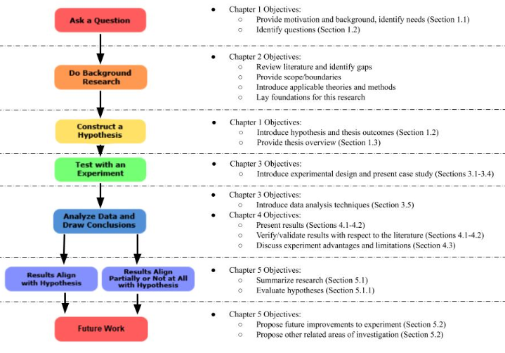
Figure 1: Thesis Map
In Figure 1, Chapter 1 maps to two steps of the scientific method: “Ask a Question,” and “Construct a Hypothesis.” In this chapter, a brief introduction and background discussion of creativity is presented to identify the need for neuroscientific measures of creativity in engineers and the motivation for this research (Section 1.1). A specific question is then posed and a hypothesis posited to investigate (Section 1.2). Chapter 1 concludes with an overview of the thesis and chapter summary.
Chapter 2 maps to the second step in the scientific method: “Background Research.” This chapter is split into several sections to provide a detailed review of the aspects of creativity (Section 2.1), various methods to measure creativity (Section 2.2), and neuroscientific studies that have been conducted in investigate creativity from general and engineering perspectives (Section 2.3). This review lays the foundation for this research, providing scope, boundaries, and detailing the identification of gaps in knowledge.
In Chapter 3, details of the experimental design are provided. This discussion maps to step four in Figure 1. The experimental method is presented in Section 3.2, the experimental setup in Section 3.3, and participant information in Section 3.4. Chapter 3 Section 5 maps to the fifth step in Figure 1. In this chapter, the techniques used to process the signals and analyze the experimental data are presented.
Step four in Figure 1, “Analyze Data and Draw Conclusions” is continued in Chapter 4, where the results of the experiment are presented and discussed. The results for the primary hypothesis regarding modulation of the N400 component are discussed in Section 4.1, and a brief analysis of the post-N400 component is presented in Section 4.2. Chapter 4 concludes with a discussion of the advantages and limitations of this specific experiment as well as the general experimental design, and a chapter summary (Sections 4.3-4.4).
Lastly, Chapter 5 maps to the last two steps of the Scientific Method in Figure 1. In this chapter, the thesis is concluded with a summary of the results and research, a critical evaluation of the hypotheses, and a final look at the overall contributions and outcomes of this research. Future work is proposed in Section 5.2, and the chapter concludes with a final summary in Section 5.3.

CHAPTER 1 SUMMARY
In Chapter 1, an introduction to the general need for creativity in engineering was presented and related to the need for a more directly quantitative way to measure creativity. To quantify creativity, the idea of using neuroscientific techniques to measure specific processes and aspects of creativity in the brain was discussed. The following gap was specifically noted: the connection between conceptual expansion and the N400 component had not been explored using engineering design tasks. A question was then posed in Section 1.2 regarding the modulation of the N400 component when processing engineering design tasks requiring conceptual expansion to assess the novelty and appropriateness of a function. It was hypothesized that modulation would occur, with highest negative values associated with unusual-inappropriate functions and most positive values associated with usual-appropriate functions. The post-N400 component was also introduced as an area of interest. Section 1.2 closed with a discussion of the expected outcomes of this research, the main objective of which was to further understanding in the field of creativity in engineering by adding knowledge from a neuroscientific perspective.
In Section 1.3, the layout of this thesis was presented and mapped to the steps of the scientific method for clarity and verification of the structure of this thesis. The overall objective of this chapter was to present enough details to succinctly motivate and explain the purpose of this research. More detail is discussed in Chapter 2 to fully lay the foundation for this research, provide scope and boundaries, identify gaps in knowledge, and to introduce neuroscientific methods used in other creativity studies.

CREATIVITY, ENGINEERING, AND NEUROSCIENCE, A REVIEW

What is “creativity”? How can it be measured? In this chapter, these questions are explored through a literature review. In Section 2.1, the concept of creativity is explored through a detailed review of various aspects of creativity, and in Section 2.1.1 these aspects are used to craft a definition of creativity that will bound this research. In Section 2.2, various methods to measure these aspects of creativity are introduced, but these methods rely on indirect, qualitative measurements that must be turned into quantitative measurements. Neuroscientific techniques are then introduced in Section 2.3 as a way to more directly study creativity. Several neuroscientific studies are then presented in Sections 2.3.1-2.3.2. The chapter concludes with a discussion of the gaps in the literature in Section 2.3.2.1 and a chapter summary in Section 2.4.

THE PROBLEM OF DEFINING CREATIVITY
Though the concept of creativity in engineering has become a cultural paradigm, how to define creativity has been an ongoing source of debate (Amabile, 1988; Parkhurst, 1999; Plucker et al., 2004; Simonton, 2012). This is because any definition of creativity is contingent on multiple variables and assumptions. In her book The Neuroscience of Creativity, Dr. Anna Abraham calls attention to the importance of addressing these assumptions, both in general and specific creativity research. She notes that in different fields, such as dancing, visual arts, music, literature, science, math, etc., creativity can be observed, expressed, and defined in different ways (2018). For example, in the artistic realms, creativity could be related to style, aesthetic appeal, acoustic appeal, novelty, and the ability to express emotions through different media. In the scientific realms, creativity would be associated with the discovery of new theories that open or propel fields forward, or with unique solutions to difficult, restrictive problems.
Not only can creativity be a distinct concept within a field, but also within a knowledge/achievement level, as depicted in Figure 2.
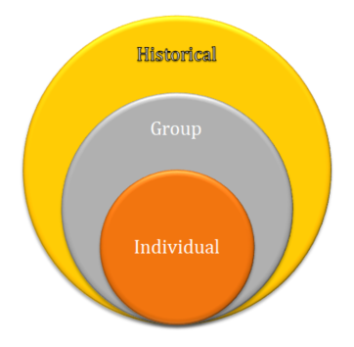
Figure 2: Knowledge/Achievement Levels
In her book, Abraham acknowledges Margaret Boden’s work in 2004, Mihaly Csikszentmihalyi’s work in 1997, MacKinnon’s work in 1978, and Kaufman and Beghetto’s work in 2009 to define these levels. First, there is the individual level, where creativity is recognized and achieved personally. Next, there is a group level, which can be defined based on the group’s characteristics (2018). For instance, a group could be large or small, have general or specific knowledge, be professional or novice, be culturally distinct, etc. Lastly, creativity can be defined on a historical, lasting scale, encompassing everyone, everything, and every time (Abraham, 2018).
Defining a knowledge/achievement level can result in a distinct interpretation of creativity, as can defining where and how creativity is investigated. Rhode’s four p’s model of creativity, depicted in Figure 3, is key to differentiating between creativity in a person, a process, a press/place, or a product.
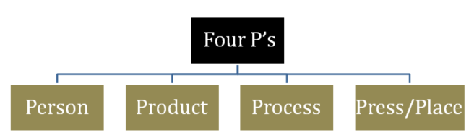
Figure 3: Rhode's Four P's Model (Abraham, 2018)
When analyzing creativity in a person, characteristics of the person are considered, such as personality, intelligence, habits, behavior, and values (1961). This definition could also be extended to include an individual’s brain structure, or any physical or immaterial quality that makes a person unique. When examining creativity in a process, Rhodes refers to mental operations such as perception, learning, thinking, and communicating (1961). Stages of these cognitive processes can be analyzed with relation to components such as “the role of prior knowledge in creativity...and the role of unconscious and conscious operations,” (Abraham, 2018). Studying creativity in relation to press, i.e. place, is all about the environment a person/process are in (Rhodes, 1961). This could include any external factor that affects an individual, such as amount of resources, work environment, social and cultural norms, etc. Lastly, products, or the tangible communication of ideas, can be judged as creative or not with respect to various dimensions of creativity such as the above concepts of field and level (Abraham, 2018). Though in his definition of product Rhodes emphasizes the “tangible” aspect, this definition could be extended to include spoken ideas not physically recorded, as long as they are communicated to others.
Related to knowledge/achievement levels and tangible and intangible forms of creativity is the idea of creative potential versus creative achievement. In The Neuroscience of Creativity, Abraham observes the need to distinguish between these two ideas in any concept of creativity (2018). This is because creative “potential” is what is “possible” and creative “achievement” is what is accomplished, or fully realized. Many individuals and unfinished/un-optimized products could be considered to have creative potential, but without a fully realized product, an individual or product could never reach a status of creative achievement. Just because an individual has not yet produced a work of acclaim does not mean that individual lacks creativity.

DEFINING CREATIVITY FOR THIS RESEARCH
With so many facets, layers, and variables, it is important for any study on the concept of creativity to have a specific definition or context. Even when trying to make general conclusions, these conclusions are very much affected by the framework and parameters of the conducted study (Abraham, 2018). In this research, creativity is studied within the context of applied science, i.e. engineering. In the scientific realm, creativity starts with a question to be answered or a problem to be solved. This means creativity will be explored in relation to the design/problem solving process, which is a deliberate verses a spontaneous form of creativity. Though in engineering there is typically a tangible product created in order to solve a problem or need, this research will focus on intangible ideas, which are iterated on in the design process before becoming a tangible prototype. Focus will be on the individual and group (engineers) levels, specifically using engineering graduate students and faculty. As for approach, a combination of person, process, and product is used to develop the methods in this research. Though press/place is not a specific focus, it should be noted that changes in environment would most likely have an effect on the results. Finally, in this study, focus will be on understanding the creative potential of engineers by studying creative processes in the brain which supports the future goal of understanding how to increase engineers’ creative abilities. Being able to improve one’s creativity will enable engineers to be relevant in an ever advancing society and to fully realize creative products. This context results in the following, very specific, definition of creativity for this research:
Creativity is the ability and potential of an engineer to produce novel and appropriate solutions to unique problems based on individual characteristics and mental processes.

HOW TO MEASURE CREATIVITY
There are many methods used to assess an individual’s creativity, creative processes, and the creativity of a product, the majority of which stem from the psychometric tradition (Plucker et al., 2019). These methods have been used from various psychological perspectives, including cognitive, behavioral, personality, etc., and can be categorized into three general groups: self-reporting measures, divergent thinking tests, and convergent thinking tests (Abraham, 2018).
One way to measure a person’s creativity is to use self-reporting measures. Self-reporting measures assess a person’s characteristics, knowledge, and accomplishments through personality scales, activity checklists, and attitude scales. Commonly used self-reporting measures “... include the Creative Personality Adjective Checklist, which estimates the degree of creativity-relevant traits exhibited by an individual, the revised Creativity Domain Questionnaire, which assesses an individual’s subjective belief about their level of creativity in different domains . . . the Creative Behavior Inventory, which provides an index of a person’s creative behavior and accomplishments . . . [and] the Creative Achievement Questionnaire… which provides measures of domain-general creative achievement alongside domain-specific creative productivity in 10 domains: visual arts, music, creative writing, dance, drama, architectural design, humor, scientific discovery, inventions, and culinary arts,” (Abraham, 2018, 40-41). Besides the aforementioned creativity specific self-reporting measures, Plucker et al., identify several general and creativity specific self-reporting measures in their paper Assessment of Creativity (2019). The reader is directed to this review for further details.
Another way to measure a person’s creativity is through divergent thinking tests. Divergent thinking tests are characterized by open-ended tasks that have no right answer (Abraham, 2018). The most popular divergent thinking test to measure creativity in a person is the Torrance Tests of Creative Thinking (TTCT), which includes several tasks that require the use of various processes linked to creativity. Examples of these tasks include the Alternate Uses Task (AUT), where participants are asked to generate as many alternative uses as possible for a common object such as a pen, the Product Improvement Task, where participants are asked how they would improve a toy, and the Incomplete Figures Task, where participants are given a simple figure and asked to add lines to create a new, complete drawing (Abraham, 2018; Plucker et al., 2019).
Divergent thinking tests can also be used to assess processes, either generally or specifically. Process-general divergent tasks are tasks like the AUT, which can be used to assess the process of divergent thinking as a whole. Process-specific tasks are tasks that can be used to understand specific processes such as conceptual expansion, overcoming constraints, and creative imagery, which play a part in divergent thinking. For example, to assess conceptual expansion, the task might be to draw an animal from a different planet (Abraham, 2018).
The creativity of a process can also be assessed through convergent thinking tests. Convergent tests are characterized by tasks that lead to one correct answer. One such test is the Remote Associations Test (RAT), where participants are given three unrelated words (e.g., age, mile, sand) and asked to identify a fourth word (e.g., stone) that relates to each of the three words individually (e.g., stone-age, mile-stone, sand-stone). Other examples of convergent tests include riddles, analytical problems, and manipulative problems (Abraham, 2018).
Self-reporting measures, divergent thinking tasks, and convergent thinking tasks can only be used to assess creativity via their output, or the product. In the case of self-reporting measures, answers are scored based on characteristics linked to creativity. In the case of convergent thinking tasks, the answer is either right or wrong, and the score will reflect the number of correct answers. Divergent thinking tasks, however, are open ended, with no right answers. Because of this, output generated from a divergent thinking task is scored by experts (Abraham, 2018).
Experts score this output based on various characteristics, such as originality/novelty: how rare the responses are; flexibility: how different the responses are; fluency: how many responses are generated; elaboration: how informative the responses are; appropriateness/usefulness: how well an idea would work; creativity: a first impression of how creative a response is on a numeric scale, and many more (Madore et al., 2016; Wang et al., 2018; Amabile, 1982; Kim, 2011; Park, 2016; Silvia, 2008; Abraham, 2018; Plucker et al., 2019). Sometimes these scores are combined into a single metric, other times they are not. The scores for the product also represent the creativity of the person who generated the product (Abraham, 2018).
Though there are many aspects used to measure creativity in various studies, two aspects stand out as most commonly used across studies: novelty/originality, and appropriateness. According to Dr. Abraham, “originality is what renders an idea to be unique or unusual compared to other ideas that are afloat at any given time. . . . In quantitative terms, an original idea is one that is statistically rare or infrequent. . . appropriateness refers to the value or fit of the response in terms of how meaningful or suitable it is in a given context,” (Abraham, 2018, 7-8). These aspects are independent of each other, and an idea or product can be judged as one and not the other, but only when an idea or product is BOTH original/novel and appropriate is it creative. This idea is depicted in Figure 4.
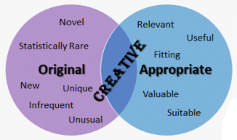
Figure 4: Two Aspects of Creativity, Originality and Appropriateness
If an idea or product is original but not appropriate within a given context, it will be discarded as nonsense and of little value. If it is appropriate but not original, it will be accepted, but not considered creative because it is common and ordinary. Appropriateness is important in any context, and is in many cases a required aspect, making it an essential criterion of creativity. However, in many cases originality/novelty is also required, and it is when both originality/novelty and appropriateness are required that the term creativity is used to encompass the necessity of both.
Though these methods for assessing creativity are commonly used and well established in the literature, they do not provide a direct way to investigate the processes that underlie creativity. Instead of measuring the individual directly, many of these tasks measure a product and use that score to describe the individual. A neuroscientific approach provides a direct way to study creative processes and expert feedback. Through neuroscience, an individual’s brain activity can be monitored while performing and evaluating creative tasks and products, providing a more direct, more objective way to study and understand creativity. Neuroscientific studies can then be correlated to the various measures of assessing creativity discussed above to pinpoint qualities and components of specific processes key to evaluating creativity and increasing creative ability in an individual.

NEUROSCIENTIFIC TECHNIQUES USED TO STUDY BRAIN PROCESSES RELATED TO CREATIVITY
There are many neurological techniques that have been used to investigate the brain processes of creativity. Functional techniques, such as positron emission tomography (PET), single-photon emission computed tomography (SPECT), functional magnetic resonance imaging (fMRI), functional near-infrared spectroscopy (fNIRS), Magnetoencephalography (MEG), and electroencephalography (EEG), are used to measure changes in activity, such as in blood oxygen levels, metabolic processes, and electrical signals (Abraham, 2018). These techniques can be used to directly observe the underlying mental processes of engineers performing and evaluating creative design tasks.
Each technique has its own strengths and weaknesses, but one of the most notable distinctions is the difference in the spatial versus temporal resolution of the obtained data. Spatial resolution relates to a method’s capability to provide fine location detail to map the areas of the brain experiencing activity. Temporal resolution refers to the granularity of time detail obtained when brain activation is occurring. Different techniques offer different combinations of spatial and temporal resolution (Lystad et al., 2009). In Table 1, adapted from Lystad, a comparison of various functional techniques including their spatial and temporal resolutions is presented (2009).
Table 1: A Comparison of Functional Neuroimaging Techniques
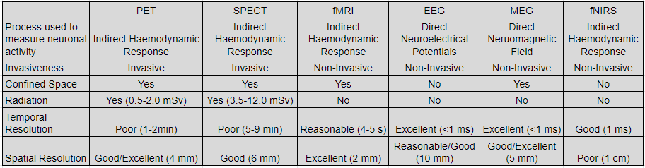

Functional techniques such as fMRI, PET, etc., indirectly measure changes in the blood as it flows to specific regions in the brain. This results in data with a high spatial resolution but low temporal resolution, as blood flow is an indirect, slightly delayed response to cognitive operations. EEGs measure the voltage fluctuations on the scalp produced by the postsynaptic activity of groups of neurons firing during mental processes, resulting in data with a high temporal resolution (Abraham, 2018).
The most commonly used functional techniques are fMRI and EEG, with studies using fMRI and other high spatial resolution techniques comprising the majority of published neuroscientific studies of creativity (Abraham, 2018). Though studies relying on spatial techniques are valuable for understanding what areas of the brain are used during creative activities, more studies are needed to understand the specific timing of creative processes. One technique that can provide temporal resolution down to the millisecond is the event related potential (ERP), an EEG technique (Luck, 2014). ERPs are signals that are time-locked to a stimulus, used to visualize cognitive processes step by step at each electrode during a trial (Abraham, 2018). By using ERPs, specific components of creative processes can be identified, noted as positive or negative signal amplitude peaks or fluctuations correlated to specific times relative to the stimulus. More details of how ERPs and other functional techniques have been used in various creativity studies are provided below, in Sections 2.3.1-2.3.2.

NEUROSCIENTIFIC STUDIES OF CREATIVITY
General creativity studies using high spatial resolution techniques such as fMRI, PET, etc., examine what areas of the brain have the highest activity during creative tasks such as the AUT, the compound associates test (derived from the RAT), the object location task (e.g. think of all the objects that could be found on a beach), creative story generation, verbal fluency (say as many words as possible that start with ‘s’), etc. Each of these tasks is related to specific mental processes related to creativity, such as analogical reasoning, attentional control, episodic cognition, executive function, metaphor processing, problem solving, semantic cognition, insight, conceptual expansion, overcoming knowledge constraints, creative imagery, etc. (Abraham, 2018). Some of these studies designate high creativity and low creativity groups before collecting neuroscientific data from various tasks, not all creative, to compare differences between the two groups. Besides determining specific locations of highest activity, functional techniques have also been used to study these locations’ interactions, i.e. network connectivity, particularly between active and resting states (Abraham, 2018). In these studies, the key measurement is amount of brain activity, which is observed in various locations known to be connected to creative processes.
Creativity studies using EEG tend to investigate creativity as a single complex process or construct (Kröger et al., 2013). In these studies, the total power of the signal is analyzed to measure cognitive activity within various locations, with some focusing on the total power within specific frequency bands. By monitoring tasks such as the AUT, the object characteristics task (e.g. name typical characteristics of an airplane), the word ends task (e.g. words that end with “out”), etc., the most active areas and networks of the brain can be identified and correlated to the creative processes being studied. The total power in specific frequency bands can also be measured and correlated to specific creative processes. Many studies have focused on the alpha band (8-13Hz), which is related to low arousal states conducive to creative ideation. The power in these frequency bands can also be mapped to specific areas to understand which frequencies are related to specific areas of the brain during specific tasks (Abraham, 2018).
One set of studies that did not operate under the paradigm of investigating creativity as a single process or construct was completed by Rutter et al. and Kröger et al. (2012, 2013). Instead of using EEG to investigate alpha waves, this team used the ERP technique to investigate the N400 component in relation to conceptual expansion and the novelty and appropriateness of a stimulus. The N400 is a negatively (signified by the “N”) peaking potential that occurs between 300-500 ms after stimulus presentation. It has been related to the processing of semantic mismatches and violations of prior knowledge (Rutter et al., 2012; Kröger et al., 2013; Abraham, 2018). This set of studies reported that the N400 was responsive as a function of unusualness or novelty/originality to experimental stimuli while investigating conceptual expansion through the use of metaphorical phrases and the AUT. A post-N400 component, a negative varying response directly following the N400 component, was also explored, relating to interpretation processes and concept integration (Rutter et al., 2012; Kröger et al., 2013. More work is still needed to understand these components and their relation to conceptual expansion and other creative processes, especially from an engineering design perspective.

NERUOSCIENTIFIC STUDIES OF CREATIVITY IN ENGINEERING AND ENGINEERING DESIGN
Many neuroscientific studies have been conducted to understand creativity in a general sense, but only recently have more creativity studies been focused on engineering/design. One of the first design investigations using a neurological approach was conducted by Alexiou et al.,‎ who utilized fMRI to study the difference in the cognitive processes employed when solving design tasks compared to problem solving tasks (2009). In this study, the task was to virtually arrange objects in a space according to the instructions given. Problem solving tasks contained specific instructions that led to correct answers. Design tasks contained open ended subjective instructions. The authors found that during design tasks and problem solving tasks, the amount of activity measured in the brain was different for various regions, which led to the conclusion that general problem-solving and design thinking are distinct (Alexiou et al., 2009). Other studies that used this arranging design task include an EEG study by Nguyen and Zeng in 2010, and a 2019 EEG study by Viera et al. In the Viera et al. study, the total task related power was measured, showing which locations were most active at different times during the task (2019). In the Nguyen et al. study, the task related power in specific frequency bands was measured, and it was noted which locations had the most activity in the various bands. These locations were then related to specific processes related to creativity (2010). Both of these studies also indicated that design tasks and problem solving tasks activated various regions of the brain differently (Nguyen et al., 2010; Viera et al., 2019).
Though not using the same design task, another study of note was conducted by Liu et al. (2016). In this study, like the Nguyen et al. study, different frequency bands were measured and analyzed to have high task related power when performing design activities. These frequency bands include the beta-2 (20- 30Hz), gamma-1 (20-30Hz), and gamma-2 (30-40Hz) bands
Other studies focused on aspects of the ideation process. Fu, Sylcott, and Das used fMRI to investigate the brain activity of engineering designers during conceptual generation in order to see if design fixation, defined as adherence to a set of ideas or concepts that limit the final output of a design, could be detected when participants were solving design problems (2019). Some participants were given example images (sketches) and others were not. Areas of the brain associated with creative output were found to be less active in the example condition.
Another study by Shealy et al. utilized fNIRS to investigate the neurological differences in freshman and senior level engineering students during an engineering design brainstorm (2017). Even though this study did not look at the novelty of ideas generated, this study found that freshman generated more solutions than seniors, and had five times greater activation in regions of the brain related to memory, planning, decision making, and the ability to think about multiple concepts at once. On the other hand, seniors had ten times the activation in areas associated with behavior control, uncertainty management, and self-reflection in decision making (Shealy et al., 2017).
Other studies performed by Shealy, Hu, and Gero, investigated three different concept generation techniques, including brainstorming, morphological analysis, and TRIZ (2018, 2019). They found that the left hemisphere was dominant, specifically the dorsolateral PFC (dlPFC) which is central to spatial working memory and filtering information, for morphological analysis and TRIZ tasks. Brainstorming, a divergent thinking task, used the right dIPFC more dominantly. In all these studies, activity was measured in various part of the brain and related to creative processes (Shealy et al., 2018, 2019).
A study of note by Goucher-Lambert et al. (2018) used fMRI to investigate design ideation and concept generation with and without the support of inspirational stimuli (e.g., analogies). In this study, participants were presented with a simplified design question, such as design “a measuring cup for the blind,” and asked to generate multiple solutions (Goucher et al., 2018). Participants were presented with five stimulus words for each task to aid in idea generation; each word set contained only analogically near words, analogically far words, or control words that were presented in the original problem. Results indicated that brain activation was different for participants that were able to successfully use the inspiration to generate an insightful design and those that were unsuccessful (mostly those that did not receive inspiration) (Goucher et al., 2018).
The majority of neuroscientific studies of creativity in engineering and design focus on identifying specific locations and networks in the brain that have the most activity and relate them to creative processes, but few studies have investigated time-locked components of creative processes, or ERPs. Though ERPs were not the main focus of a study by Rojas et al., the N400 component was observed in relation to the appropriateness of adjectives describing packaging design attributes and pictures of different packaging (2015). Another study by Telpaz et al. observed that weaker theta power correlated to preferred products and that the N200 component, associated with categorization of a stimulus, modulated in relation to product preference when subjects were asked to choose between two products (2015). Another study by Yang et al. observed the N400 and P3 component (related to decision making) in relation to idea recognition and memory recall when presented with previously seen stimuli (2017).

GAPS IN THE NEUROSCIENTIFIC STUDY OF CREATIVITY IN ENGINEERING
From this review, the following gaps were observed. The majority of neuroscientific studies of creativity focus on identifying specific locations and networks in the brain that have the most activity and relate them to creative processes. This is true for both general studies and engineering and design specific studies. Few studies have actually investigated this activity in relation to time, and fewer still have studied the time-locked components of creative processes, or ERPs. This is not surprising, as tasks for ERP studies are simple in nature, and are based off of a participants’ reaction to a stimulus (Luck, 2014). Creative tasks, let alone design tasks, are extremely complicated, requiring multiple cognitive processes to understand and complete the task. The exception to this is during an evaluation task, when a first-take response can be analyzed.
In this research, an approach using ERPs is taken to better understand the timing of specific components related to creativity in engineering design. Previous studies have explored the connection between the creative process of conceptual expansion and the N400 and post-N400 components using metaphors and a modified Alternative Uses Task (AUT) in both a general student subject pool as well as a specifically engineering subject pool with respect to novelty and appropriateness (Rutter et al., 2012; Kröger, 2013; Hartog 2020). However, the connection between conceptual expansion and the N400 and post-N400 components has not been explored within the context of engineering design. This leads to the following primary question for this research:
Is the N400 component modulated when processing engineering design tasks requiring conceptual expansion to assess the novelty and appropriateness of a function?

CHAPTER 2 SUMMARY
In this chapter a literature review was presented to lay the foundation for this research, providing scope, boundaries, and detailing the identification of gaps in knowledge. First, various aspects of creativity were discussed, and a definition was formed to govern the boundaries of this research.
This definition takes into account the context of this study, that this is a deliberate form of creativity in the scientific realm, and that focus is on the individual and small group levels with an emphasis on the brain processes used to evaluate creativity. Various commonly used methods for measuring creativity were then presented in Section 2.2, and it was observed that novelty/originality and appropriateness are the most consistently used measures across methods. It was also noted that these methods fail to provide a direct, quantitative way to measure creativity and/or investigate the processes that underlie creativity. Several neuroscientific techniques were then introduced in Section 2.3 as a more direct way to accomplish this task, with high spatial resolution techniques comprising a majority of the creativity studies. ERP was then presented as a way to directly measure the processes of creativity with fine temporal resolution. Finally, in Section 2.3.2.1, various gaps were discussed which led to the chosen focus for this research: to study the N400 component in relation to conceptual expansion in design tasks.

PILOT STUDY TO UNDERSTAND THE CONNECTION BETWEEN CONCEPTUAL EXPANSION AND THE N400 AND POST-N400 COMPONENTS IN ENGINEERING DESIGN TASKS WITH RESPECT TO NOVELTY AND APPROPRIATENESS

To test the primary hypothesis, an experiment utilizing the ERP technique in the context of engineering design tasks was developed. In Section 3.1, the theory behind this experimental design is presented. Details of the experimental method are then provided in Section 3.2, along with the experimental setup in Section 3.3 and participant information in Section 3.4 used in this case study. In Section 3.5, the techniques used to process the signals and analyze the experimental data are presented. The chapter concludes with a brief summary of the information presented.

DESIGN OF EXPERIMENT
To test the primary hypothesis that the perceived novelty and appropriateness of a function for a design task will be exhibited in modulation of the N400 component, with highest negative values associated with unusual-inappropriate functions and most positive values associated with usual-appropriate functions, an experiment was designed based on Kröger et al.’s 2013 study and Goucher-Lambert et al.’s 2018 study. The Kröger et al. study demonstrated that the N400 component is modulated through the creative process of conceptual expansion in relation to novelty and appropriateness. They found that the N400 component was modulated depending on whether the stimulus was perceived as common (low novelty, high appropriateness), creative (high novelty, high appropriateness), or nonsense (high novelty, low appropriateness). Stimuli perceived as common evoked the most positive N400 responses, while stimuli perceived as creative evoked more negative N400 responses, and nonsense stimuli evoked the most negative responses, though only differences between creative-common and nonsense-common were statistically significant. This study was performed using a modified AUT task, which asks the participant to judge the novelty and appropriateness of an alternative “use” or “function” for an object (Kröger et al., 2013). Their study is modified for this research by asking participants to judge the novelty and appropriateness of a given function in relation to a design problem. As such, results of this study are expected to be similar to the Kröger et al. study, since they were designed based on the same theories and concepts.
The Kröger et al. study investigated conceptual expansion, which “...describes the ability to broaden the defining boundaries of semantic concepts beyond their usual characteristics,” (2013). The Goucher-Lambert et al. study investigated analogical reasoning, which “is generally defined as the process by which information from a source is applied to a target through the connection of relationships or representations between the two (source and target),” (2018). Both of these processes rely on the structure of a concept and its relational structure to other concepts when processing novelty/originality (Kröger et al., 2013; Goucher-Lambert et al., 2018). This is because novelty/originality depends on context, or the relationship of a concept to the framework it is placed in. As noted in Chapter 2 Section 2.2, novelty is measured by how rare a response is within a data set (Abraham, 2018). The Goucher-Lambert et al. study used inspirational word sets collected from a previous study that obtained crowd sourced analogies (2017, 2018). Readers are referred to the 2017 study for further details regarding their data collection and analysis techniques. In that study, the analogical distance was measured by the frequency of appearance of a keyword within their data set, which is exactly how one would measure the keyword’s novelty. The frequency of appearance of analogically near keywords in submissions accounted for the top 25% of the frequency distribution of all submitted keywords. On the other hand, analogically far keywords only appeared once within the data set (Goucher-Lambert et al., 2017). For the research in this thesis, the keywords were used as potential functions a solution to the associated design task might have. For consistency, the functions were matched to their original design problems, which had been simplified from design problems used in previous studies, and were well established in the literature (Goucher-Lambert et al., 2017, 2018). Further detail regarding the experimental method used in the current research is presented in Section 3.2.

EXPERIMENTAL METHOD
As discussed in Section 3.1, the experimental design in Kröger et al.’s 2013 study was used in conjunction with the design questions and matching keywords from Goucher-Lambert et al.’s 2018 study. These are listed in Table 2. For this study, the “common” keywords in Table 2 were verbs that were considered analogically near in the Goucher-Lambert et al. studies (2017, 2018). The keywords in the “creative” column, on the other hand, were considered to be analogically far. Nonsense keywords were either taken from the keywords submitted for other design questions in the Goucher-Lambert et al. study, or from the categories designated in a study by Alhashim et al., investigating the AUT creativity assessment process (2017; 2020). Keywords were initially designated as common, creative, or nonsense in order to present an equal number of stimuli for each condition.
Table 2: Design Problems and Associated Common, Creative, and Nonsense Keywords
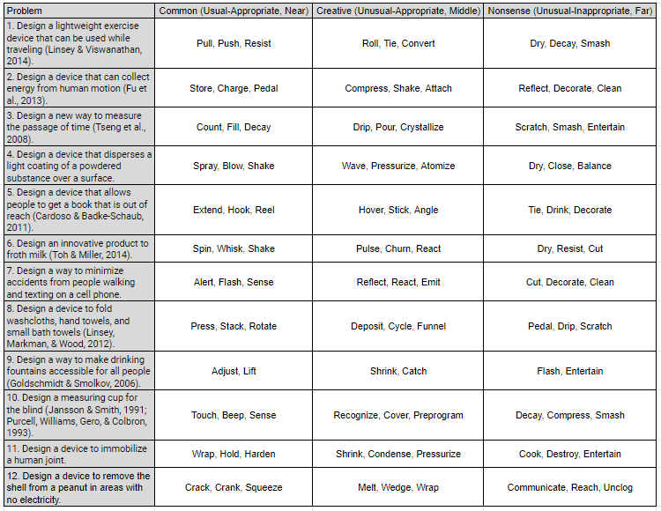

For this experiment, the keywords were used as potential functions a solution to the associated design task might have. In this case, a design task was presented followed by the associated functions/keywords listed in Table 2. The participant was then asked to respond “yes” or “no” to whether a given function was “Unusual” and/or “Appropriate.” The experiment design is depicted in Figure 5.

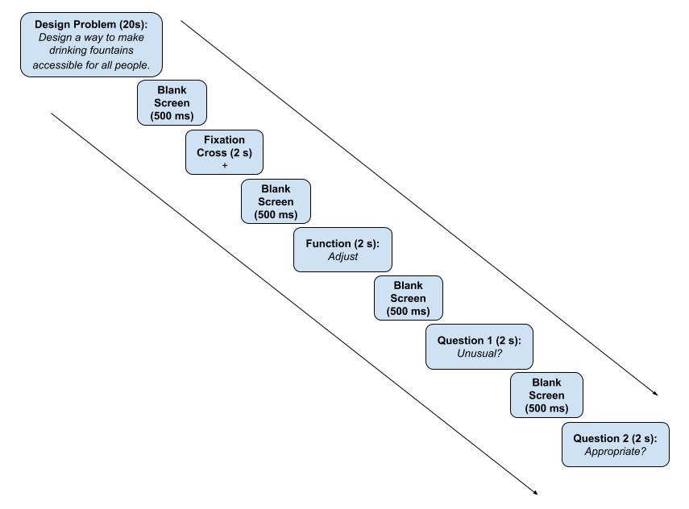
Figure 5: Experimental Design
Before starting the experiment, participants were seated in a chair in front of a computer while the EEG cap was fitted and the electrodes prepared for data collection. Participants were verbally walked through the experiment protocols, including what stimuli to expect, how to respond, and to avoid any unnecessary body movements to reduce artifacts. Each participant then went through a self-paced tutorial to become familiarized with the types of tasks to be completed, including instructions, types of responses needed, and two example design tasks. Once the tutorial was complete, participants completed ten design tasks as part of the experiment. Each task was structured as follows. First, the problem was presented for 20 seconds followed by a blank screen for 500 ms, a fixation cross for 2 seconds, then a blank screen for 500 ms. Once the problem was presented, nine functions were presented in random order, three creative, three common, and three nonsense. Each function was presented for 2 seconds followed by a blank screen for 500 ms and the questions “Unusual” and “Appropriate,” presented for 2 seconds each, separated by a 500 ms blank screen. The questions were followed by a 500 ms blank screen and fixation cross for 2 seconds before continuing to the next design task. To respond, participants were asked to press the right mouse button on the laptop for “yes,” and the left button for “no.” To prevent misunderstandings with perceived definitions for “unusual” and “appropriate,” participants were informed that a function was to be classified as “unusual” if it was novel or unfamiliar to them within the presented context, and “not unusual” if it was known or familiar. A function would be classified as “appropriate” if it was fitting or relevant within the presented context, and “not appropriate” if it was unfitting or irrelevant. Participants were expected to designate “common” functions as “not unusual” and “appropriate,” “creative” functions as “unusual” and “appropriate,” and “nonsense” functions “unusual” and “inappropriate,” as determined in the Kröger et al. study and Hartog et al. study, which tested the same experimental design on engineers (2013; 2020).

EXPERIMENTAL SETUP
The experiment was performed in a low noise environment. A wireless 24 channel SMARTING EEG acquisition system with amplifier from MBrainTrain, shown in Figure 6, and the company’s corresponding recording software were used for this experiment.

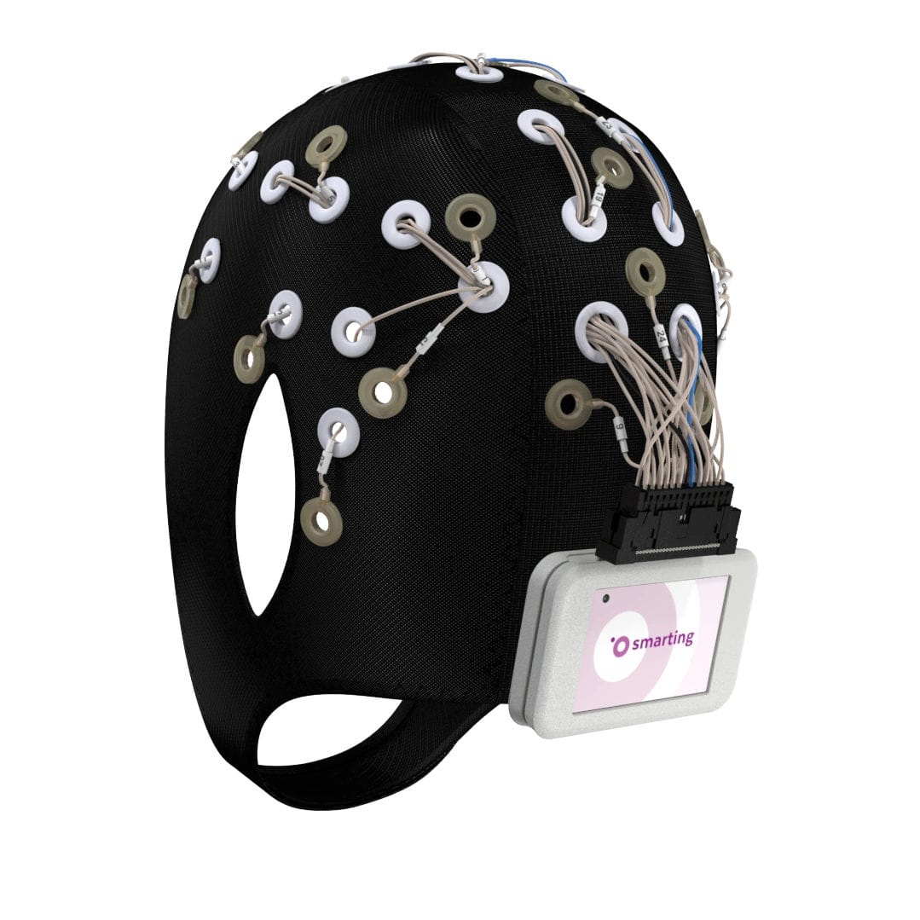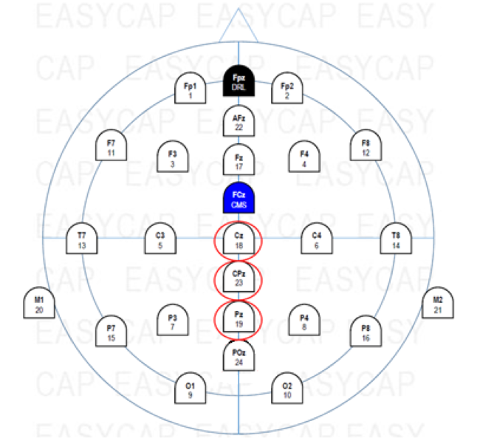
Figure 6: Mobile EEG Cap with 24 Channels and Corresponding Electrodes of Interest
EEG data was sampled at 500 Hz and recorded from all 24 electrodes positioned according to the international 10-20 placement map, as shown in Figure 6. Stimulus presentation was synchronized with the EEG acquisition system via Neurobs Presentation software (Neurobehavioral Systems, Inc., Albany, CA). Low impedance, around 5-10 kΩ, was kept for each electrode during the experiment. A 64-bit Dell Latitude laptop with i5-8250U CPU 1.8 GHz with 8 GB ram (7.86 GB usable) was used to present stimuli and record responses via the left and right touchpad buttons. A second monitor was connected to the laptop in order for lab personnel to monitor EEG signals in real time.

PARTICIPANTS
Three right-handed engineering graduate students, two male one female, and one male right-handed Mechanical Engineering professor participated in this case study. All participants were from the University of Oklahoma. No compensation was given for participation. All the male participants spoke English as a second language. All participants participated in the study with normal or corrected to normal vision, had no history of neurological or psychiatric illness, and were not taking drugs, according to self-report. All gave written informed consent prior to participation, and no identifiable personal information was kept in the research data. The experiment followed the University of Oklahoma Institutional Review Board guidelines and was approved by the responsible committee.

DATA ANALYSIS TECHNIQUES
In this section are presented the signal analysis techniques and the statistical techniques used to process and analyze the data collected. Pre-processing of the EEG signal as well as the ERP processing techniques are presented in Section 3.5.1. The statistical analysis used to process both the N400 and post-N400 components is presented in Section 3.5.2.

SIGNAL ANALYSIS TECHNIQUES
EEG data was processed using the EEGlab plugin in Matlab. A band pass filter from 0.1-100 Hz was applied to raw data to visually inspect and reject unclear/bad data, along with a 60 Hz notch filter to exclude line noise. An independent component analysis (ICA) was then performed in order to reject signal components caused by eye or muscle movement, line noise, etc. EEG data was then processed via ERPlab in Matlab to obtain 1150 ms ERP segments, starting from 150 ms before stimulus presentation to 1000 ms after. Segments were baseline-corrected using the 150 ms time window before stimulus onset. A 30 Hz low-pass Butterworth filter with a slope of 24 dB/Oct was applied to analyze and remove additional artifacts with amplitudes exceeding +/-100 μV.
As in the Kröger et al., study, the ERPs were grouped according to the condition (common, creative, or nonsense) assigned in the subject’s response, regardless of the stimuli’s initially designated condition (2013). This allowed for individual validation of the experimental design. Due to the small number of subjects, data was not rejected based on a required minimum number of trials per condition.

STATISTICAL ANALYSIS TECHNIQUES
To study the N400 and post N400 components, only the Cz, CPz, and Pz electrodes, as circled in Figure 6 above, were selected to analyze. This differs from the Kröger et al. study due to the different types of caps used. In their study, they utilized a cap with 64 electrodes and gathered data from the C1, C2, CP1, CP2, P1, and P2 electrodes as well (2013). The cap used in this study only had 24 electrodes, which did not include the aforementioned electrodes. These electrodes were chosen based on the known centro-parietal distributions of the N400 and post N400 effects (Kröger et al., 2013).
This experiment is a within-subject design with two factors: condition (common, creative, nonsense) and electrode (Cz, CPz, Pz). To analyze the data, a two factor repeated measures ANOVA was performed for time windows of interest. First, though, Mauchly’s Test of Sphericity was used to verify if the variances were equal, i.e. if it was correct to assume sphericity of the data, which is required for this type of analysis. In this case, it was indicated through Mauchly’s Test of Sphericity that the sphericity assumption was not violated for the N400 time window for either condition (Χ² (2) = .402; p = .818) or electrode (Χ² (2) = 2.813; p = .245). Sphericity was also not violated for the post-N400 time window for either condition (Χ² (2) = .715; p = .699) or electrode (Χ² (2) = 3.02; p = .221). Effects sizes including Cohen’s d, partial eta squared (η_{p}²), and partial omega squared (ω_{p}²) are reported with all significance levels. Partial eta squared is included for possible comparisons to other studies, though for this experiment, partial omega squared is more appropriate due to the small sample size.

CHAPTER 3 SUMMARY
This chapter began with a discussion of the experimental design. This design was based on two different studies, and used the concept of novelty to combine the two to create a new experiment, enabling study of the N400 component within an engineering design context. The design structure was then discussed in detail, along with the methods used, the setup, and participant information used in the case study. Lastly, the data analysis techniques used were presented in Section 3.5. Appropriate pre-processing of the EEG signal before ERP analysis is key, as is post-processing of the ERP in order to obtain artifact free data. This clean data can then be analyzed through statistical analysis, specifically a repeated measures ANOVA, to study the modulation of the N400 and post-N400 components. These results are discussed in Chapter 4.

RESULTS AND DISCUSSION

In this chapter the results of the case study are presented. Results regarding the N400 component are presented in Section 4.1, while results for the post-N400 component are presented in Section 4.2. A discussion of the advantages and limitations of this specific experiment as well as the general experimental design are included in Section 4.3. The chapter concludes with a summary in Section 4.4.

THE N400 COMPONENT
In Figure 7 is shown the average of the Cz, CPz, and Pz electrodes from the Grand-averaged ERP of all participants. As observed in previous studies, the signal does display a negative dip in the N400 (300-500ms) time window for the creative and nonsense conditions. The creative and nonsense conditions are also similar in amplitude at their negative peaks (Rutter et al., 2012; Kröger et al., 2013; Hartog et al., 2020).
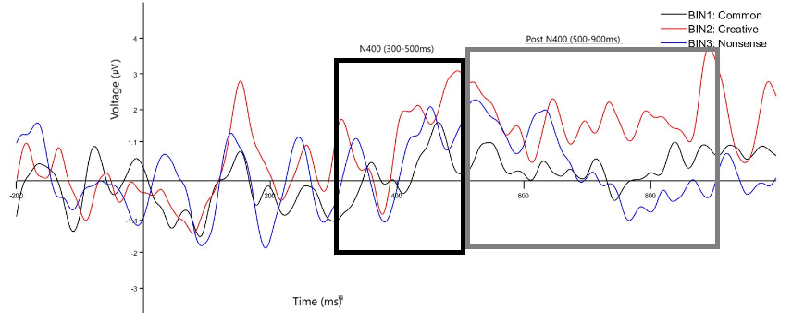
Figure 7: Grand Average Signal of Cz, CPz, and Pz Electrodes for All Subjects
The repeated measures ANOVA showed significant main effects for the factor electrode (F(2,6) = 11.79; p = .033; η_{p}² = .797; ω_{p}² = .09), but main effects were not significant for the factor condition (F(2,6) = .392; p = .663; η_{p}² = .116; ω_{p}² = -.06) or the condition-electrode interaction (F(4,12) = 1.614; p = .234; η_{p}² = .35; ω_{p}² = .00). Size effects are reported, though all are small enough to be considered negligible, including for the factor electrode. In Figure 5 is presented the average mean amplitude for the N400 time window, for the three electrodes analyzed (Cz, CPz, and Pz), for all participants, for each condition (common, creative, nonsense).
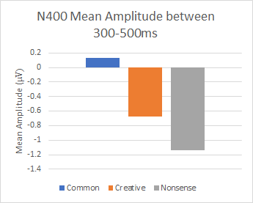
Figure 8: Mean Amplitudes for the N400 Component
The common condition had the least negative mean amplitude (0.128μV), the mean amplitude for the creative condition was more negative (-0.677μV), and the nonsense condition had the most negative mean amplitude (-1.137μV). Though the differences in the means for all pairs were insignificant (common-creative: p = 1, d = .32; common-nonsense: p = 1, d = .42; creative-nonsense: p = 1, d = .16), the trend shown in Figure 8 follows the trends seen in previous studies, with highest negative values associated with nonsense functions and most positive values associated with common functions (Rutter et al., 2012; Kröger et al., 2013; Hartog et al., 2020). These results support the main hypothesis of this thesis that the perceived novelty and appropriateness of a function for a design task will be exhibited in modulation of the N400 component, with highest negative values associated with unusual-inappropriate (nonsense) functions and most positive values associated with usual-appropriate (common) functions.
The Rutter et al. study also found a linear trend in the modulation of the N400 for the factor condition, but no significant linear trend (F(1,3) = 1.28; p = .339; η_{p}² = .3) for condition was observed in this study (2012). However, it is important to note that this was a small pilot study to confirm modulation of the N400 with respect to novelty and appropriateness in an engineering design context. Therefore, the results of this study are to be viewed as initial results, and are compared to other studies to show the promise of this experimental design to further understand modulation of the N400 in an engineering design context. Results are also presented to explore the possibility of using the N400 as a measure to evaluate the creativity of engineering designs and solutions. These evaluations can then be used to improve individual creative ability to produce more innovative solutions.
The initial results of this study fit with the N400 literature, namely that the N400 component is responsive to semantic differences (Rutter et al., 2012; Kröger et al., 2013; Hartog et al., 2020). Other studies, though they used metaphors, sentences, word pairs, or alternative uses, observed this modulation, with greater N400 amplitudes for creative/novel, or nonsense stimuli. Specifically, there was a significant difference between common-creative and common-nonsense mean amplitudes, but not creative-nonsense mean amplitudes (Rutter et al., 2012). Though these experiments result in similar modulation of the N400, the causal underlying processes are still a matter of debate. Some have interpreted these modulations as indexing conceptual blending theory in language processing (the construction of multiple cognitive models and mappings between ideas), others have related it indexing the integration of ideas that have been previously linked versus those with no prior links. Other theories include the N400 as an index for retrieving semantic knowledge from memory, cloze probability (the expectation of an idea to fit the context), prelexical and postlexical processing stages, and mismatches between top-down and bottom-up processes/information and expectations versus the presented idea (Rutter et al., 2012; Kröger et al., 2013). As this experiment was not designed to specifically support any of these theories, the results cannot indicate any specific processes underlying the N400 response. What can be concluded is that the N400 can be modulated by novelty and appropriateness with the same general results.

THE POST N400 COMPONENT
For the post N400 component, the repeated measures ANOVA found no significant main effects for condition (F(2,6) = 1.08; p = .395; η_{p}² = .266; ω_{p}² = .01), electrode (F(2,6) = 3.286; p = .109; η_{p}² = .523; ω_{p}² = .02), or the condition-electrode interaction (F(4,12) = 3.02; p = .061; η_{p}² = .502; ω_{p}² = .00). Size effects are negligible for this time window. In Figure 9 is presented the average mean amplitude for the post N400 time window, for the three electrodes analyzed (Cz, CPz, and Pz) for all participants, for each condition (common, creative, nonsense).
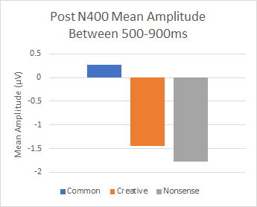
Figure 9: Mean Amplitudes for Post N400 Component
The common condition had the least negative mean amplitude (0.264μV), the mean amplitude for the creative condition was more negative (-1.438μV), and the nonsense condition had the most negative mean amplitude (-1.778μV). The differences in the means for all pairs were insignificant for this time period (common-creative: p = 1, d = .63; common-nonsense: p = .958, d = .76; creative-nonsense: p = 1, d = .15). There was also no significant linear trend (F(1,3) = 1.42; p = .319; η_{p}² = .32) for the factor condition.
Though these results are based on a small case study, the responsiveness of the post-N400 component is comparable to previous studies, except that there was no linear trend indicated in these results as was noted in the Rutter et al. study (2012; Kröger et al., 2013). As seen in Figure 7, during the post-N400 (500-900ms) time window, the nonsense condition continues a more negative trend after 500ms, while the creative condition exhibits a more positive shift, matching the results of previous studies. In those studies, they postulated that this could be the result of failing to integrate nonsense stimuli into existing semantic networks, but successfully being able to integrate creative stimuli (Rutter et al., 2012; Kröger et al., 2013). In this case, though, the signals showed similar positive and negative trends to previous studies, most of the activity in the post-N400 window was positive. Though sustained negativities in the post-N400 time window have been explored in multiple studies, these have been in relation to various cognitive processes (Rutter et al., 2012; Kröger et al., 2013). More research is needed to fully understand these post-N400 components in a creative, especially engineering design context.

EXPERIMENTAL ADVANTAGES AND LIMITATIONS
One of the outcomes of this research was to test the modulation of the N400 component and explore the modulation of the post-N400 component within a new experimental design. Though there were no statistically significant results from this research, the observed modulation trends matched the literature, confirming the viability of this experimental design. This is a key step towards understanding how the ERP paradigm could be applied to engineering design problems. In past studies, the ERP technique has been used to evaluate products and their packaging from a preference stand point, but not as part of the design process (Rojas et al., 2015; Telpaz et al., 2015; Yang et al., 2017). This research sought to apply the ERP technique to the design process, specifically evaluating functions of possible solutions generated through processes such as morphological analysis. The experiment also used a high temporal resolution technique to better understand the timing of processes related to evaluating creativity in engineering design.
Though an advantage of this experimental design was to focus on a single process integral to creative thinking where many other studies analyze creativity as a single, unified structure, a corresponding limitation is that the experiment could not be used to differentiate between other cognitive processes that have been related to the N400 component. Though the N400 and post-N400 components were modulated with respect to the novelty and appropriateness of the stimuli, this could be related to other processes such as analogical thinking, prelexical and postlexical semantic processes, and memory recall, as well as conceptual expansion (Rutter et al., 2012; Kröger et al., 2013, Yang et al., 2017). It does not help that these processes are very similar to each other and overlap in many ways. Further work is needed to distinguish these processes from one another with respect to creativity and otherwise. On the other hand, maybe all of these processes are crucial to evaluating the novelty and appropriateness of a stimulus. In this case, the N400 and post-N400 components could be used as a general measurement for novelty and appropriateness to measure general creativity.
One limitation to this particular study was the number of participants. More participants are needed to obtain statistically significant results. Also, with so few participants, individual differences in thought processes are much more apparent. This technique is much more suited to analyzing modulation of the N400 within a group versus within an individual. In many cases expert evaluation of creativity is submitted as a group, which would make this an appropriate technique to use, at least for larger groups. In any case, more work is needed to understand this aspect, as well as the aforementioned aspects, within this research.
Lastly, it may be noted that this experimental design measures the creativity of the functions presented (the product), and not the individual being monitored. In order to measure the creative potential of an individual, the N400 and post-N400 components would need to be compared to the average modulation of the N400 for a group. It is hypothesized that if an individual is creative, they will have a less negative N400 amplitude when presented with initially designated creative functions. They may also be able to identify functions initially designated as nonsense as creative. Though this is a limitation of the current experiment, this analysis could be conducted in a future expansion of this experiment.

CHAPTER SUMMARY
In Sections 4.1-4.2, the results of this case study were presented and discussed. The grand average ERP displayed in Figure 7 was compared in a qualitative fashion to previous studies, and similar trends were observed with respect to the N400 and post-N400 components’ modulation. The N400 and post-N400 mean amplitudes were also presented for each condition, and their conditions’ respective differences analyzed via a two factor repeated measures ANOVA. The results of the ANOVA were presented along with the corresponding size effects. Although there were no significant differences observed between creative, common, and nonsense conditions, the trends observed matched observations of previous studies. These results support the hypothesis that the perceived novelty and appropriateness of a function for a design task will be exhibited in modulation of the N400 component, with highest negative values associated with unusual-inappropriate (nonsense) functions and most positive values associated with usual-appropriate (common) functions, though further studies are needed for results to be statistically significant.
In Section 4.3 some of the advantages and limitations of this particular study were discussed. One advantage was that this experimental design applied the ERP technique within an engineering design context to understand creativity. This provides a direct link to study components related to creativity such as the N400 to engineering design. Using the ERP technique also allows for greater temporal resolution to better understand the timing of creative processes. Future work with more participants is still needed for results to be statistically significant though, and more studies are necessary to understand the possible distinctions between processes that modulate the N400 and their relation to creativity.

A FINAL DISCUSSION
In this chapter, the thesis is concluded with a summary of the results and research conducted. A critical evaluation of the hypotheses is presented in Section 5.1.1, and a final look at the overall contributions and outcomes of this research is presented in 5.1.2. Future work is proposed in Section 5.2, and the chapter concludes with a final summary in Section 5.3.

SUMMARY OF RESEARCH
“Creativity” and “innovation” have become key competencies sought after in engineers. Engineers must be “creative” and “innovative” to provide effective solutions to novel problems (Robinson et al., 2005; National Academy of Engineering, 2004, 2013; Petrone, 2019). But what exactly is “creativity,” and how can it be measured? In this thesis is presented a novel experimental design to study how the neuroscientific technique of ERP can be used to measure creativity in engineering design. Specifically, this experiment was designed to test the modulation of the N400 component, a component related to creative processes, with respect to the creative process of conceptual expansion. This was done by asking participants to judge the novelty and appropriateness, two generally agreed upon aspects of creativity, of a function as a potential solution to a simplified design problem.
The experimental design was based upon the following definition for creativity presented in Section 2.1.1:
Creativity is the ability and potential of an engineer to produce novel and appropriate solutions to unique problems based on individual characteristics and mental processes.
This definition takes into account the context of this study, that this is a deliberate form of creativity in the scientific realm, and that focus is on the individual and small group levels with an emphasis on the brain processes used to evaluate creativity. Various commonly used methods for measuring creativity were then presented in Section 2.2, but upon further inspection they fail to provide a direct, quantitative way to measure creativity and/or investigate the processes that underlie creativity. Several neuroscientific techniques were then introduced in Section 2.3 as a more direct way to accomplish this task, with high spatial resolution techniques comprising a majority of the creativity studies. ERP was then presented as a way to directly measure the processes of creativity with fine temporal resolution.
In chapter three, the experimental design was discussed in detail, along with the analysis techniques used to process the data. The results were then presented and discussed in chapter 4, along with various advantages and limitations of the experimental design. In Sections 5.1.1-5.1.2 these results, advantages, and limitations will be discussed with respect to the original hypothesis and the contributions and outcomes of this thesis.

CRITICAL EVALUATION OF HYPOTHESIS
The primary question and main hypothesis for this research were as follows:
Primary Question: Is the N400 component modulated when processing engineering design tasks requiring conceptual expansion to assess the novelty and appropriateness of a function?
Primary Hypothesis: The perceived novelty and appropriateness of a function for a design task will be exhibited in modulation of the N400 component, with highest negative values associated with unusual-inappropriate functions and most positive values associated with usual-appropriate functions.
This hypothesis was developed based on previous studies conducted by Rutter et al., Kröger et al., and Hartog et al., which studied the modulation of the N400 when performing tasks requiring conceptual expansion to assess the novelty and appropriateness of stimuli (2012, 2013, 2020). The tasks performed in these studies were processing metaphors and evaluating alternative uses for various objects. As the modified AUT was based on evaluating functions of an object, similar results were expected when evaluating functions for a solution to a design problem.
From the results presented in Chapter 4, it was observed that the common condition had the least negative mean amplitude (0.128μV), the creative condition was more negative (-0.677μV), and the nonsense condition had the most negative mean amplitude (-1.137μV). At a glance, these results support the primary hypothesis, but upon further analysis, the differences in the means for all pairs of conditions were found to be statistically insignificant. Though statistically insignificant, these initial results do display the trend seen in the literature and partially support the hypothesis. To fully support or reject this hypothesis, more data is needed, but initial results show the promise of this experimental design to investigate the current hypothesis with no changes.

CONTRIBUTIONS AND OUTCOMES
The main outcome of this thesis was to test the appropriateness of the primary hypothesis to further understand the brain processes and components related to creativity in an engineering context. In this case, it was to understand the N400 and post-N400 components in relation to the process of conceptual expansion used to identify the novelty and appropriateness of an engineering function. To this end, a novel experimental design was developed. Through this research, the ERP technique was applied to evaluate creativity in an engineering design context, which had not previously been done. This is a key step in understanding how this technique can be used in the future to measure creativity in engineering products and processes, and by extension, the engineers who created them. This technique could then be used to help cultivate engineers’ creative ability. Though the results of this research are preliminary in nature, the experimental design shows promise in using the modulation of the N400 as a measure for creativity. Through this research, more knowledge has been contributed to lay a foundation for using neuroscientific techniques to provide a more direct, quantitative way to measure creativity in an engineering design context.

FUTURE WORK
As the research presented in this thesis was only a small case study, it has already been noted that future work should include collecting more data to obtain statistically significant results for the current hypothesis. The beauty of this experimental design, though, is the capability to use the data from the experiment to study other cognitive components and processes related to creativity in engineering. For example, the data from this experiment was used to create the contour maps in Figures 10 and 11 to explore what areas of the brain showed the most activity for the N400 and post-N400 time windows.
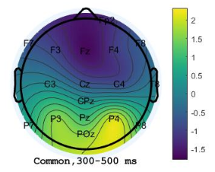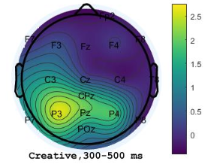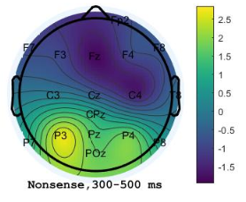
Figure 10: Contour Maps of Mean Amplitude of N400 Time Window
During the N400 time window, for all three conditions, the most negative activity was located in a frontocentral distribution, and more so in the right hemisphere than the left hemisphere. In future studies, the electrodes in this area might be used to investigate the N400 component. Positive activity is seen in the parietal-occipital area, in the right hemisphere for the common condition and the left hemisphere for creative and nonsense conditions. Electrodes in this area could be used to find a positive ERP for this time window.
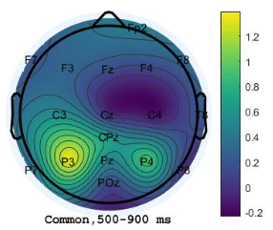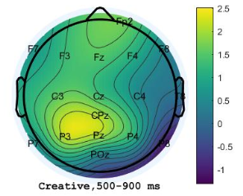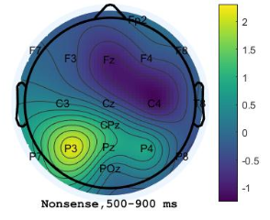
Figure 11: Contour Maps of Mean Amplitude of Post-N400 Time Window
For the post-N400 time period, other areas of interest might include the centro-temporal areas for the common and nonsense conditions, and the left parietal area for all conditions. The P600 is a known positive shift related to processing and syntactic structure in this posterior area (Luck, 2014). Other time windows could also be investigated to explore the presence of other ERP components. From Figure 7, other ERPs of interest could include the N100 (a visual attention to stimulus occurring about 160ms post stimulus) and the P300 (related to decision making occurring around 300ms post stimulus) components (Luck, 2014).
Besides ERP components, the task related power could be calculated for various frequency bands and investigated in specific time windows. For example, the following initial analysis was performed by Md Tanvir Ahad with the data from this experiment. His focus was on analyzing alpha band power (8-13 Hz), which has been related to creative cognitive processes (Abraham, 2018). A 9x2x3 ANOVA was performed to find any areas of the brain that experienced significant task related power (TRP), the results of which are presented in Figures 12 and 13. A significant main effect was found for the factor AREA (F (8,162) = 2.30, p = .024, ηp2 =.102), indicating decreased alpha power during creative ideation over anteriofrontal cortical sites (Fp1/2, see Figure 12) and increased alpha power over centrotemporal (C3/4, see Figure 12). A significant main effect was also observed for the factor HEMISPHERE (F (1,162) =1.48, p=.226, ηp2 =.009), indicating stronger alpha power decreases over left compared to right-hemispheric sites.
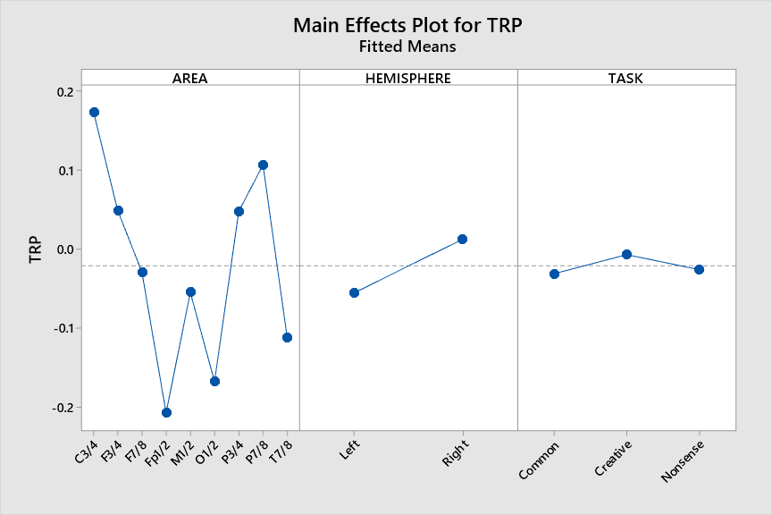
Figure 12: General Pattern of TRP for the Task Across Electrodes
Finally, the interaction AREA × TASK was found to have a significant main effect (F (16,162) = .02, p = 1.0, ηp2 = .002), which revealed a strong decrease in alpha power related to creative tasks on anteriofrontal cortical sites (Fp1/2, see Figure 13), and increased alpha power over centrotemporal (C3/4, see Figure 13).

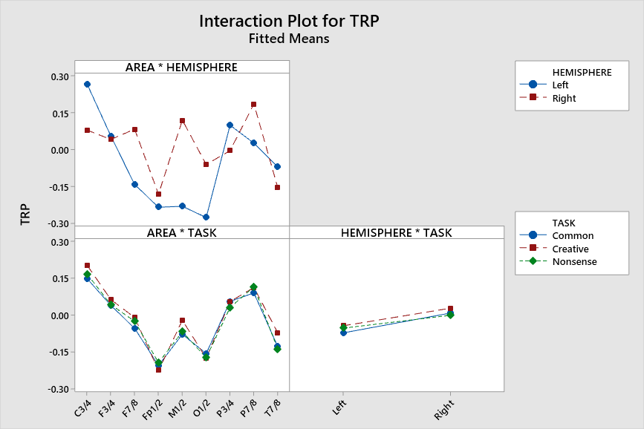
Figure 13: General Pattern of TRP Interactions for the Task Across Electrode Locations
In future studies, the timing of these power increases and decreases within a frequency band could be observed in relation to the stimulus and compared. This analysis could be further used to understand the timing of cognitive processes within a specific frequency band. These are just a few examples of how the data from this one experiment could be used to investigate the various cognitive processes used to evaluate creativity in this task.
As this specific experiment used mostly the same stimulus material as the Goucher-Lambert et al. 2018 study, future work could include investigating the timing of the activity in the areas they found of interest. The designation of stimulus words as common, creative, or nonsense by participants in this experiment could also be compared to the designations obtained by analyzing the crowd-sourced collection of words in the Goucher-Lambert et al. 2017 study. This experimental design could also be used to investigate analogical thinking, which was the main process investigated in the Goucher-Lambert et al. studies and shares similarities with the process of conceptual expansion (2017, 2018).
Another way to expand this research would be to analyze individual differences. As mentioned in Section 4.3, more research is needed to test whether an individual’s creative potential can be measured through comparison to the average N400 amplitude of a group. Individual signals could also be analyzed for other ERPs to compare what operations an individual uses to evaluate creativity and in what order. Certain processes and orders of operations may be more valuable or efficient than others. The timing of these processes could also be noted to understand efficiency. Once analyzed statistically, these individual differences in cognitive operations and brain signals could be analyzed with respect to demographics such as age, gender, race, class, etc., and emotional state while being monitored. Through this analysis, demographic aspects that have the most effect on creativity could be identified, as well as the emotions that are most helpful and hindering to the creative process. These results could then be used to better understand how to grow and stimulate individual creative potential.
Lastly, this experiment used written words as stimuli. In the future, this experiment could be modified to use pictures only, a combination of pictures and words, or even audio stimuli in order to compare any possible differences in brain activity. The N400 has been linked to semantic mismatching, which tends to be language based, so modulation of this ERP may be affected by using different representations of stimuli. Other components related to visual and auditory processing could also be studied (Luck, 2014).

CHAPTER SUMMARY
This chapter began with a summary of the research conducted for this thesis. The importance of creativity in engineering was reiterated, as was the definition for creativity used in the context of this study. In Section 5.1.1 the main hypothesis of this study was critically evaluated, and it was concluded that the initial results of this research partially support the hypothesis. More data is needed, though, to obtain significant results to fully accept or reject the hypothesis. In Section 5.1.2, several contributions and outcomes of this thesis were discussed, the main contribution of which was a novel experimental design that applied the ERP technique to investigate creativity in the engineering design process. By introducing this novel paradigm, it is hoped that a foundation can be laid to use neuroscientific techniques to provide a more direct, quantitative way to measure creativity in an engineering design context. Lastly, various avenues for future work were discussed in Section 5.2, with an emphasis on using the same experimental design, but processing and analyzing the data in different ways to investigate different components and processes of creativity. Though this was a case study, this experimental design shows promise for future investigations. It is hoped that others build on this research to further understand creativity in engineering design from a neuroscientific perspective, as well as to investigate the possibility of using neuroscientific techniques to measure creativity in engineers in order to develop their creative ability.

ACRONYMS
ANOVA – Analysis Of Variance
AUT – Alternate Uses Task
CPU – Central Processing Unit
EEG – Electroencephalography
ERP – Event-Related Potential
fMRI – Functional Magnetic Resonance Imaging
fNIRS - Functional Near-Infrared Spectroscopy
ICA – Independent Component Analysis
MEG - Magnetoencephalography
PET - Positron Emission Tomography
RAT – Remote Associations Test
SPECT - Single-Photon Emission Computed Tomography
TTCT - Torrance Tests of Creative Thinking
TRP – Task Related Power
TRIZ - Theory of the Resolution of Invention-related Tasks

REFERENCES
Abraham, A. (2018). The Neuroscience of Creativity. Cambridge: Cambridge University Press.

Alexiou, K., Zamenopoulos, T., Johnson, J., & Gilbert, S. (2009). Exploring the neurological basis of design cognition using brain imaging: Some preliminary results. Design Studies, 30(6). 623–647.

Alhashim, A., Marshall, M., Hartog, T., Jonczyk, R., Dickson, D., . . . & Siddique, Z. (2020). WIP: Assessing Creativity of Alternative Uses Task Responses: A Detailed Procedure. Paper presented at the Proceedings of the Virtual ASEE Annual Conference, June 22-26, 2020. [Presented].

Amabile, T. M. (1982). Social Psychology of Creativity: A Consensual Assessment Technique. Journal of Personality and Social Psychology, 43(5), 997–1013.

Amabile, T. M. (1988). A Model of Creativity and Innovation in Organizations. Research in organizational behavior, 10(1), 123-167.

Cropley, D. H. (2015). Promoting Creativity and Innovation in Engineering Education. Psychology of Aesthetics, Creativity, and the Arts, 9(2), 161.

Goucher-Lambert, K., Moss, J., & Cagan, J. (2018). A neuroimaging investigation of design ideation with and without inspirational stimulid - understanding the meaning of near and far stimuli. Design Studies. https://doi.org/ 10.1016/j.destud.2018.07.001

Goucher-Lambert, & K., Cagan, J. (2017). Using crowdsourcing to provide analogies for designer ideation in a cognitive study. In: Proceedings of the 21st International Conference on Engineering Design (ICED17), Human Behaviour in Design, 8. Vancouver, Canada, August 21.-25, 2017.

Hartog, T., Marshall, M., Alhashim, A., Ahad, M. T., & Siddique, Z. (2020). WIP: Using neuro-responses to understand creativity, the engineering design process, and concept generation. Paper presented at the Proceedings of the Virtual ASEE Annual Conference, June 22-26, 2020. [Presented].

Jones, F. E. (1964). Predictor variables for creativity in industrial science. Journal of Applied
Psychology, 48(2), 134–136. https://doi.org/10.1037/h0047167

Kim, K. H. (2011). The Creativity Crisis: The Decrease in Creative Thinking Scores on the Torrance Tests of Creative Thinking. Creativity Research Journal, 23(4), 285–295. https://doi.org/10.1080/10400419.2011.627805

Kröger, S., Rutter, B., Hill, H., Windmann, S., Hermann, C. & Abraham, A. (2013). An ERP study of passive creative conceptual expansion using a modified alternate uses task. Brain
Research, 1527. 189–198.

Liu, L., Nguyen, T. A., Zeng, Y., & Hamza, A. B. (2016). Identification of Relationships Between Electroencephalography (EEG) Bands and Design Activities. Proceedings of the ASME 2016 International Design Engineering Technical Conferences and Computers and Information in Engineering Conference, August 21–24, 2016.
Luck, S. (2014). An Introduction to the Event-Related Potential Technique. Second edition. Cambridge, Massachusetts: The MIT Press.
Lystad, R. P., & Pollard, H. (2009). Functional neuroimaging: a brief overview and feasibility for use in chiropractic research. The Journal of the Canadian Chiropractic Association, 53(1), 59–72.
Madore, K. P., Jing, H. G., & Schacter, D. L. (2016). Divergent creative thinking in young and older adults: Extending the effects of an episodic specificity induction. Memory & cognition, 44(6), 974-988.
MBrainTrain. Fully Mobile EEG Devices. Retrieved February 3, 2020, from https://mbraintrain.com/, 2018.

McDermid, C. D. (1965). Some correlates of creativity in engineering personnel. Journal of
Applied Psychology, 49(1), 14–19. https://doi.org/10.1037/h0021658

National Academy of Engineering. (2004). The Engineer of 2020: Visions of Engineering in the New Century: National Academies Press Washington, DC.

National Academy of Engineering. (2013). Educating Engineers: Preparing 21st Century Leaders in the Context of New Modes of Learning: Summary of a Forum. Washington, DC: The National Academies Press.

Park, N. K., Chun, M. Y., & Lee, J. (2016). Revisiting Individual Creativity Assessment: Triangulation in Subjective and Objective Assessment Methods. Creativity Research Journal, 28(1), 1–10. https://doi.org/10.1080/10400419.2016.1125259

Parkhurst, H. B. (1999). Confusion, Lack of Consensus, and the Definition of Creativity as a Construct. The Journal of Creative Behavior, 33(1), 1-21. doi:10.1002/j.2162-6057.1999.tb01035.x

Petrone, Paul. (2019). Why Creativity Is the Most Important Skill in the World. LinkedIn Learning, LinkedIn Corporation, 1 Jan. 2019, learning.linkedin.com/blog/top-skills/why-creativity-is-the-most-important-skill-in-the-world.
Plucker, J. A., Beghetto, R. A., & Dow, G. T. (2004). Why Isn't Creativity More Important to Educational Psychologists? Potentials, Pitfalls, and Future Directions in Creativity Research. Educational psychologist, 39(2), 83-96.

Plucker, J., Makel, M., & Qian, M. (2019). “Assessment of Creativity.” The Cambridge Handbook of Creativity (44-68). New York: Cambridge University Press.

Rhodes, M. (1961). An Analysis of Creativity. The Phi Delta Kappan, 42(7), 305–310.‎

Robinson, M. A., Sparrow, P. R., Clegg, C., & Birdi, K. (2005). Design Engineering Competencies: Future Requirements and Predicted Changes in the Forthcoming Decade. Design Studies, 26(2), 123-153.

Rojas, JC., Contero, M., Camba, JD., Castellanos, MC., García-González, E., & Gil-Macián, S. (2015b). Design perception: Combining semantic priming with eye tracking and event-related potential (ERP) techniques to identify salient product visual attributes. ASME 2015 International Mechanical Engineering Congress and Exposition, Paper No. V011T14A035, Houston, TX, USA, November 13–19.

Rutter, B., Kröger, S., Hill, H., Windmann, S., Hermann, C. & Abraham, A. (2012). Can clouds
dance? Part 2: An ERP investigation of passive conceptual expansion. Brain and
Cognition, 80(3), 301–310.
Science Buddies. (2020, May 19). Steps of the Scientific Method. Retrieved July 07, 2020, from https://www.sciencebuddies.org/science-fair-projects/science-fair/steps-of-the-scientific-method
Shealy, T., Hu, M., & Gero, J. (2018). Patterns of Cortical Activation When Using Concept Generation Techniques of Brainstorming, Morphological Analysis, and TRIZ. Proceedings of the ASME 2018 International Design Engineering Technical Conferences and Computers and Information in Engineering Conference, August 26–29, 2018.

Shealy, T., & Gero, J. (2019). The Neurocognition of Three Engineering Concept Generation Techniques. Proceedings of the Design Society: International Conference on Engineering Design, 1(1), 1833-1842.

Silvia, P. J., Winterstein, B. P., Willse, J. T., Barona, C. M., Cram, J. T., Hess, K. I., . . . Richard, C. A. (2008). Assessing Creativity with Divergent Thinking Tasks: Exploring the Reliability and Validity of New Subjective Scoring Methods. Psychology of Aesthetics, Creativity, and the Arts, 2(2), 68.

Simonton, D. K. (2012). Taking the Us Patent Office Criteria Seriously: A Quantitative Three-Criterion Creativity Definition and Its Implications. Creativity Research Journal, 24(2-3), 97-106.

Sprecher, T. B. (1959). A study of engineers’ criteria for creativity. Journal of Applied
Psychology, 43(2), 141–148. https://doi.org/10.1037/h0047763

Telpaz A, Webb, R., & Levy, DJ. (2015). Using EEG to predict consumers’ future choices. Journal of Marketing Research, 52, 511–529.
University of Pittsburgh University Marketing Communications Webteam. (n.d.). Biomedical Research Imaging Resources. Retrieved July 07, 2020, from http://www.researchimaging.pitt.edu/content/near-infrared-spectroscopy-nirs-brain-imaging-laboratory
Wang, P., Wijnants, M. L., & Ritter, S. M. (2018). What enables novel thoughts? The temporal structure of associations and its relationship to divergent thinking. Frontiers in psychology, 9, 1771.

Yang, C., An, F., Chen, C., & Zhu, B. (2017). The effect of product characteristic familiarity on product recognition. IOP Conference Series: Materials Science and Engineering, 231, 012016.

Graphic developed from https://www.sciencebuddies.org/science-fair-projects/science-fair/steps-of-the-scientific-method
(Abraham, 2018)
Table adapted from Lystad et al., 2009 and http://www.researchimaging.pitt.edu/content/near-infrared-spectroscopy-nirs-brain-imaging-laboratory

