University of Oklahoma

Graduate College

THE TRUMPET DESIGN AND PRODUCTION
TECHNIQUES OF CLIFFORD BLACKBURN

A Document

submitted to the Graduate Faculty

in partial fulfillment of the requirements for the

Degree of

Doctor of Musical Arts

By

LINDSEY R. JESSICK
Norman, Oklahoma
2018

THE TRUMPET DESIGN AND PRODUCTION
TECHNIQUES OF CLIFFORD BLACKBURN

A Document approved for the
School of Music

By

______________________________
Dr. Karl Sievers, Chair

______________________________
Dr. Matthew Stock

______________________________
Dr. Marvin Lamb

______________________________
Dr. Eugene Enrico

______________________________
Dr. Kurt Gramoll

© Copyright by LINDSEY R. JESSICK 2018
All Rights Reserved.

Acknowledgements
Thank you to my committee, Doctors Sievers, Stock, Lamb, Enrico, and Gramoll. Without your thoughtful commentary and helpful suggestions, this document would not have been possible.
Special thanks to my trumpet professor, Dr. Karl Sievers. Without your support and guidance, I would not be the trumpet player that I am today. Thank you for all the opportunities that you have given me.
To Cliff and Bunny Blackburn, thank you for allowing me to write about your lives and business. Instead of treating me like the stranger I was, you generously welcomed me into your home. I am so appreciative of your hospitality, kindness, and willingness to help.
To Tina Erickson, thank you for letting me interview you, for your humor, and for the delicious dessert at Cracker Barrel.
Thank you to my loving parents, David and Laura Jessick, for your constant support, moral and financial, without which I would not have been able to complete this degree. Your kindness, generosity, and unwavering support of me in all that I do are traits which I strive to emulate in my own life and appreciate more than you will ever know. I love you.
And last but certainly not least, to my loving and supportive fiancé, Larry Burroughs, thank you for being there for me throughout this process and always. I am so grateful to have been lucky enough to find someone to share my life with who is not only kind, supportive, and caring, but also understands what I do. I love you. Now you get to marry a doctor!

Table of Contents

Acknowledgements iv
List of Illustrations vii
Abstract viii
Chapter 1: Introduction 1
Statement of Purpose and Need for the Study 1
Scope and Limitations 2
Procedures and Methodology 3
Chapter 2: Survey of Related Literature 4
Chapter 3: Blackburn Biography 13
Clifford Blackburn 13
Blackburn Trumpets 16
Life After Blackburn Trumpets 21
Chapter 4: Acoustic Principles 23
Acoustics of Brass Instruments 23
Collaboration with Acoustic Scientist, William T. Cardwell 27
Chapter 5: Construction Design and Methodology 30
Structural Materials 30
Wires .. 31
Fit and Finish 31
Chapter 6: Manufacturing Concepts and Process 33
Mouthpiece 33
Leadpipe 34
Tuning Slide 37
Valve Section 37
Bell Design 39
Chapter 7: Conclusions and Need for Further Study 42
Bibliography 43
Appendix A: Interview Transcript – Clifford Blackburn 45
Appendix B: Interview Transcript – Nancy “Bunny” Blackburn 78
Appendix C: Interview Transcript – Tina Erickson 87
Appendix D: Interview Transcript – Clifford Blackburn – Follow-Up 100
Appendix E: Institutional Review Board Approval Letters 108

List of Illustrations

Illustration 1: The Blackburns in the Tennessee Shop 16
Illustration 2: Louisville Leadpipe with Logo 17
Illustration 3: Pickett Blackburn Logo 21
Illustration 4: Trumpet Diagram 23
Illustration 5: Standing Wave in a Stopped Pipe 25
Illustration 6: The "Ultimate Zigzag" of Trumpet Intonation 26
Illustration 7: William Cardwell with his Salpingometer 28
Illustration 8: Tina Erickson with Cut Bell Pattern 40

Abstract
Through interviews with Clifford Blackburn and his small staff, this document will discuss not only the design and production techniques of Blackburn Trumpets, but also biographical information about the man himself and the history of his company. By tracing Blackburn’s approach to trumpet-building from the mouthpiece to the bell, all aspects of trumpet construction and manufacturing will be covered. Choice of construction materials as well as Blackburn’s collaboration with acoustic scientist William Cardwell will also be discussed.

Chapter 1: Introduction

Statement of Purpose and Need for the Study
The purpose of this study is to present a comprehensive look at trumpet-maker Clifford Blackburn, his company Blackburn Trumpets, and his unique approach to trumpet design. Blackburn Trumpets was a small custom trumpet-making business owned by Clifford Blackburn and his wife Nancy “Bunny” Blackburn. Starting as an instrument-repair business in Louisville, Kentucky in the 1970s and evolving into a custom trumpet shop in Decatur, Tennessee, Blackburn Trumpets was known for its high quality, attention to detail, and friendly way of doing business. Designed using acoustic principles and formulas that Blackburn learned from his collaboration with acoustic scientist, William T. Cardwell, and utilizing a unique, high-copper bell alloy called ambronze, Blackburn trumpets were and still are highly sought after by musicians of all kinds. Ambronze is known for its ability to help an instrument’s sound project well to the back of a concert hall and for its unique tone quality, different from the typical brass trumpet bell. Although most of Blackburn’s customers were professors, orchestral players, or serious college students who needed excellent instruments for classical or orchestral playing, all their horns were built to order, so they also produced horns appropriate for commercial playing. Several famous trumpeters, including Philip Smith and Doc Severinsen, also have and play Blackburn trumpets.
While there is existing research on trumpet acoustics, this will be the first published interview of its kind with Clifford Blackburn. Mr. Blackburn recently sold his business to another company, Pickett Brass, so it is now more important than ever to preserve the legacy of what was Blackburn Trumpets for over forty years. Historically, when smaller boutique or custom instrument-makers have sold to larger companies, instruments become more mass-produced, often lose their special character, and experience an initial drop in quality. Blackburn Trumpets is in meticulous and capable hands with Pickett Brass, but it is nonetheless important to document the heritage of the original Blackburn Trumpets. Also, having a better understanding of the acoustic principles that govern trumpet playing will help me to become a more informed and efficient performer and teacher.

Scope and Limitations
Although the primary interview subject in this study will be Clifford Blackburn, other members of his small staff, including his wife, Nancy “Bunny” Blackburn and colleague Tina Erickson, will also be interviewed. In addition to providing information about his trumpet design and production techniques, this document will also provide biographical information about Clifford Blackburn and information about Blackburn Trumpets. Whereas mouthpiece design will be mentioned, this document will not delve too deeply into that topic, as that is a topic unto itself.
The intended audience for this paper is trumpet players and other musicians, so although its content may also be of cross-disciplinary interest to some physicists and acousticians, I will not delve too deeply into complex acoustical concepts. This study could lead to future research on acoustics and trumpet design or comparisons of various trumpet companies’ design and production techniques, but this document will focus only on the work of Blackburn.

Procedures and Methodology
I will interview trumpet-maker Clifford Blackburn and his small staff, including his wife Nancy “Bunny” Blackburn and his employee Tina Erickson. These interviews will be recorded, and their transcripts will be included as appendices to this document. Follow-up interviews will be conducted as needed over the telephone, through email, or using Skype. Through these interviews, I will gain knowledge of Blackburn’s design principles, production techniques, and biography. Mr. Blackburn worked with an acoustic scientist, the late William Cardwell, to design his trumpets in an innovative and scientific way. By discussing this collaboration with Blackburn, I will learn about how their partnership affected his design principles.

Chapter 2: Survey of Related Literature
As this will be the first published interview of its kind with Clifford Blackburn, most of the existing related literature is on acoustic principles and their application to instrument design in general.
In Speech and Audio Signal Processing, the authors, who are engineers and computer scientists, include one chapter on musical instrument acoustics, of which only two pages are dedicated to the acoustics of brass instruments. This book discusses instrument acoustics in a mathematical way and is written for an audience of engineers, not musicians.
In Tone: A Study in Musical Acoustics, the authors are musicians and have written a book about acoustics that is meant to be accessible to musicians. The authors model the organization of their book on Goethe’s theory of acoustics, originally laid out in correspondence with kapellmeister Karl Zelter of the Berlin Philharmonic. Goethe’s brief writings on acoustics are presented in three parts: “organic (ear, voice, and body rhythm), mathematic (monochord), and mechanic (instruments).” It is the third part which is most pertinent to a study of trumpet acoustics. The ninth chapter of this book is dedicated to the discussion of wind instrument acoustics. In this chapter, the authors discuss the behavior of sound waves in stopped and open tubes, the overtone series, and factors influencing loudness and timbre. This information is important to understanding how sound is made with a trumpet and is useful to trumpet-makers when designing efficient instruments with beautiful characteristic sounds.
In his article “Playing Without Buzzing: Fact of Fiction?” from the June 2001 International Trumpet Guild Journal, Science Desk editor Thomas Moore discusses the idea, espoused by trumpet pedagogue William Adam, that the player does not buzz the lips to produce a sound, but rather that the lips vibrate as a result of their interaction with the sound waves produced by the air within the trumpet. Moore is a physics professor with an interest in the trumpet. He directed an experimental research program dedicated to understanding the physics of the modern trumpet. His article was written for an audience of trumpet players, so it is accessible to non-physicists. This information is related to the design of trumpets, but not directly to the work of Clifford Blackburn.
In Music and Acoustics: From Instrument to Computer, author Philippe Guillaume gives a detailed overview of the nature of musical sound from a scientific standpoint. He discusses sounds produced by traditional musical instruments as well as synthesized computer sounds. This book is presented mathematically, with formulas, graphs, and diagrams filling most of the pages. Although it does include a section specifically dedicated to the acoustics of tubes, the material is more accessible to an acoustician, mathematician, or computer scientist than to an audience of musicians who may not have knowledge of higher mathematics.
Similarly, The Physics and Psychophysics of Music: An Introduction by Juan G. Roederer, with its wide use of higher mathematics, is geared more towards an audience of physicists than an audience of musicians. This book does contain more prose discussion than the previously mentioned book but is still overall very technical. Where this book differs is in its discussion of not only the physical properties of sound and sound production, but also of the more subjective, psychological sensations of music and how it is interpreted by the human brain. The sections most applicable to the study of trumpet acoustics and design are the ones dedicated to the generation of complex standing vibrations in wind instruments and the “sound spectra of wind instrument tones.”
Edward Tarr’s book, The Trumpet, is a well-known compendium of information about the trumpet, its history, and its players. Although it does not contain detailed information about acoustics or many specifics of trumpet building and design, this book does discuss the innovations in instrument-making which occurred around the year 1400. Before this, instruments were mostly made of heavy cast bronze. After this point, perhaps from the influence of the Saracens after the Crusades, instruments began to be made in roughly the same way that they are today, from sheet metal. Early instrument builders also learned new ways to bend tubing, which were important precursors to today’s instrument-building technologies.
The writings of physicist Arthur H. Benade, including his books, Horns, Strings, and Harmony and Fundamentals of Music Acoustics, and his Scientific American article, “The Physics of Brasses,” are detailed, including diagrams and graphs which would be of use to acousticians. However, the use primarily of prose and the lack of higher mathematics in his writings also make them accessible to musicians. Horns, Strings, and Harmony includes a chapter dedicated to brass instrument acoustics and discusses not only their acoustics, but also gives a brief historical background. Fundamentals of Music Acoustics also dedicates a whole chapter to brass instruments. This book goes into greater detail about how each part of a brass instrument influences its acoustic properties. With sections on the influence of the mouthpiece, flaring versus conical families of brasses, the external and internal sound spectra of a trumpet, and the problem of a clean attack, this book would be very helpful and accessible to a non-physicist instrument maker. The 1973 Scientific American article is similar in that it provides some historical background information on brass instruments and then delves deeper into the technical acoustical information, complete with numerous readable diagrams and graphs. Overall, Benade’s works are the most accessible of the technical books examined.
“Playing the Baroque Trumpet” is an article by Don Smithers, Klaus Wogram, and John Bowsher that was published in Scientific American. Although this article deals primarily with the baroque trumpet, most of the basic physical concepts apply to modern trumpets as well. The authors of this article examine the combination of the instrument, its mouthpiece, and the player; the effects of each component are discussed as well as the resulting whole. The article includes many diagrams to illustrate the concepts discussed and is overall accessible to an audience of musicians. While the authors discuss physics concepts, they do so in an easily understandable way, devoid of higher mathematics and complex formulas.
“Welding Musical Instruments to the Perfect Pitch” by Tim Heston, the Assistant Editor of the Welding Journal, delves not into musical acoustics, but the manufacturing aspects of trumpet-building. This article was written for an audience of welders, but is accessible to musicians. Brass instrument manufacturing in both large factories and smaller custom shops is discussed, including Lawson Brass Instruments, whose French horns directly influenced Blackburn to begin making his trumpet bells from the bronze alloy, ambronze. Some instrument manufacturers weld their instruments, a process which joins pieces of similar metals together at very high temperatures, either by melting the pieces together or by using a filler metal. Other instrument manufacturers torch braze, including Blackburn Trumpets. Brazing, which always includes the use of a filler material, can join any two pieces of metal together if the filler material has a lower melting temperature than either of the metals being joined. Because it is done at a lower temperature, brazing causes less distortion in the metal and seems to be the method of choice in most smaller custom shops. Both methods, when done well, result in a bond that is stronger than the pieces being joined. Attention to detail, which is a very important part of Clifford Blackburn’s approach to building and selling trumpets, is also stressed in this article, acknowledging that whether an instrument is brazed or welded, it must be done perfectly, especially for instruments at the professional level. Other parts of the manufacturing process such as annealing of the metal are also discussed. Stephen Mraz’s short article, “What’s the Difference Between Soldering, Brazing, and Welding?” from Machine Design is a helpful companion to the Welding Journal article, enabling a typical musician to better understand the differences in fastening processes.
Two pertinent United States patents, one by William Cardwell and one by Clifford Blackburn, also exist. Cardwell’s patent for “cup-mouthpiece wind instruments” includes diagrams and parameters for the building of a trumpet. He uses the word “trumpet” throughout the patent, and even though the formulas presented are meant to apply primarily to the trumpet, they could also apply to any primarily cylindrical brass instrument, such as the trombone. Cardwell goes on to discuss the building of all parts of the trumpet, including the leadpipe and bell, according to acoustic principles. The mathematical formulas presented in this patent were used by many trumpet manufacturers including Olds, Stomvi, Kanstul, and Clifford Blackburn himself. The second patent, by Blackburn in collaboration with Steven Wasser of Verne Q. Powell Flutes, Inc., is for a “musical instrument piston valve.” This patent presents a design for a piston valve that could be used on any brass instrument and improves upon previous piston valves by minimizing costs and assembly requirements, ensuring a consistent and accurate location for the piston ports relative to the valve casing, and including an adjustable valve guide. This new valve guide, along with the machining of the valve head and piston from one piece of metal, is intended to reduce the need for aftermarket valve alignments. Valve alignments, through the use of precise measurements and insertion of special pad materials, are often necessary to ensure that the ports in a piston valve accurately line up with the tubes of the trumpet. Attending to these details improves many aspects of an instrument, including intonation, accuracy, and tone color.
Information about William Cardwell can be found in tribute articles in the ITG Journal, on the ITG’s website, and on the website of Stomvi USA. “In Memoriam: Bill Cardwell” is an excerpt from a letter written by R. Dale Olson after Cardwell’s death and published on the ITG website. Although a short notice of Cardwell’s death, written by Olson and Kim Dunnick, was published in the October 2012 ITG Journal, the more complete text of Olson’s letter was published only online. A friend and colleague of Cardwell, Olson has also been an important figure in the world of trumpet design, working with many different trumpet-makers and as Director of Research for F.E. Olds and Son. He calls Cardwell the most profound influence on his theoretical thinking. “The Legacy of William T. Cardwell, Jr.” is an article by Gary J. Bast from the October 2016 ITG Journal. The article gives biographical information about Cardwell as well as information on his collaboration with various trumpet manufacturers including Clifford Blackburn, Dale Olson, Bob Reeves, and K.O. Skinsnes of Stomvi. The website of Stomvi USA also has a similar article, “Bill Cardwell 1917-2012,” in which biographical information is presented and Cardwell’s collaboration with the company’s design team is discussed. All these writings celebrate the important and often overlooked contributions that Cardwell made to the study of trumpet acoustics.
The Stomvi USA website also includes links to several unpublished manuscripts written by William Cardwell about various aspects of trumpet acoustics. “Working Theory of Trumpet Air-Column Design” was a presentation that Cardwell gave at the 72nd Meeting of the Acoustical Society of America on November 3, 1966. This unpublished manuscript is a partial script from this presentation and includes Cardwell’s theory that the proper bell shape for a trumpet can be mathematically calculated if the mouthpiece’s significant contribution to the overall tuning of a trumpet is taken into consideration. “Trumpet Intonation Acoustics” is an unpublished manuscript that was written as an intended portion of a chapter in Edward Tarr’s book The Trumpet. This discussion of trumpet intonation never made it to the book, but in this manuscript, Cardwell discusses the intonation tendencies of trumpets and the behavior of sound waves in trumpet tubes; he includes diagrams illustrating his assertions. He also alludes to the fact that this information could be used by trumpet manufacturers to create a more perfectly in-tune trumpet. Cardwell discusses his intonation testing machine and how it can test a trumpet’s intonation without the inconsistencies of a human player. He does say, however, that the results derived from tests by his machine align with what most human trumpeters have found to be the intonation tendencies of their instruments. “Trumpet Acoustics: Correcting Intonation Faults” was a presentation given by Cardwell at the 92nd Meeting of the Acoustical Society of America on November 19, 1976. This manuscript includes the entire script from his presentation. The content of this presentation is similar to the content of the previously discussed unpublished book chapter but is presented in a more polished way because it is not a draft, but a full presentation. The diagrams included in this manuscript are clearer and easier to read than those in the book chapter.

Chapter 3: Blackburn Biography

Clifford Blackburn
Clifford Blackburn was born on December 25, 1947 and grew up in Knoxville, Tennessee. His mother, a pianist, had a music education degree from Chicago Music College and his father, a violinist, had almost completed a music degree when he left school to join the marine corps during World War II. After the war, his father got a law degree from the University of Tennessee. Later in life, the three of them would form a trio, playing for local churches together.
When he was in fourth grade, Blackburn started playing the trumpet in his school band. He chose the instrument because his parents had one at home, left over from college methods classes. Soon after he started playing, his parents set him up with a private teacher and he continued to play trumpet throughout junior high school, despite not participating in the school band during that time. He rejoined the school band when he got to high school and was active in the marching and concert bands, often playing solos and attracting the attention of colleges.
Blackburn went on to study at Tennessee Technological University in Cookeville, Tennessee. There he studied trumpet with Pat McGuffey for his first three years and George Bitzer during his senior year, earning his Bachelor of Music Education degree in 1969. It was while he was at Tennessee Tech that he met his future wife and business partner, Nancy “Bunny” Gillespie, originally from Chattanooga, Tennessee. Although she is not a musician, they met in the band, where he played trumpet and she carried a conference flag. Together they have two grown children and six grandchildren.
After he graduated, he was an assistant high school band director for one year. During that year, he also won his first orchestral job, as fourth trumpet in the Nashville Symphony. After that one year of teaching band and general music, he realized that teaching public school was not for him and decided to go back to school so that he could become a college professor instead. Blackburn started his master’s degree at the Eastman School of Music in Rochester, New York, but after studying there with Richard Jones for only one summer, he had to leave the school to go to basic training. At the time, the Vietnam War was raging, and Blackburn joined the National Guard as a bandsman. He eventually played in the National Guard bands in both Tennessee and Kentucky. In Tennessee, the Guard band’s duties were to play for military events, but in Kentucky, they were often used as a recruiting tool, playing concerts to help recruiters entice people to join the Kentucky National Guard.
When the Blackburns moved to Kentucky, Clifford went on to study with Leon Rapier and earn his Master of Music degree in trumpet performance from the University of Louisville. Soon after he finished his master’s degree, he auditioned for and won the third trumpet position in the Louisville Orchestra. This orchestra section ended up being the proving ground for his early developments in trumpet design. He has also played with the Knoxville Symphony and the Chattanooga Symphony in Tennessee.
While studying for his master’s degree, Blackburn took a one-credit elective class in instrument repair. He found that he had an aptitude for and interest in instrument repair and his teacher, Francis Fuge, took him under his wing, teaching him extra techniques and introducing him to area instrument repairmen. With the help and support of these experienced repairmen, by the time he finished his master’s degree, Blackburn was doing repairs for five music stores in Louisville. He worked from home and his wife would deliver and pick up instruments to and from each music store each week. They called their business “Blackburn’s Music Services” and did repairs on all types of band instruments.
The Blackburns started their business from nothing, acquiring tools as the need for them arose and using the money from the repairs to finance the tools. They decided early on that they did not want to go into debt, so they built their business a little at a time until they had a very complete repair shop. His parents bought him his first lathe. When they started the business, it was just the two of them, but in time they needed additional workers to help with all the repair work that they were getting. They had various repair helpers over the years, but Clifford Blackburn considers himself to be more of a craftsman than a manager. As a result, he did not always enjoy dealing with workers who were not as dedicated or meticulous as he is. Nevertheless, they had several helpers in Louisville, including a woman who did most of the woodwind repairs so that Blackburn could focus on the brass instruments.
Initially they were dependent on local work, but as the business progressed, they became more of a custom shop, making leadpipes, tuning slides, bells, and rebuilding professional model trumpets. After much practice and experimentation, Blackburn eventually started building complete trumpets. He made a C trumpet for himself, which he eventually sold to a member of the Toronto Symphony, and his custom trumpet business grew from there. By 1987, the business had grown to such an extent that Blackburn resigned from the Louisville Orchestra and he and his wife moved back home to Tennessee.

Blackburn Trumpets
Realizing that they could set up shop anywhere that FedEx and UPS would deliver, in 1987 the Blackburns moved their lives and business to Decatur, Tennessee, renamed their business “Blackburn Trumpets,” and started working only on trumpets. With Clifford in charge of the shop and Bunny as “boss” in the office, the Blackburns ran their business the old-fashioned way, with kindness and their strong Christian values at the forefront of everything they did. Their motto was “quality, service, craftsmanship, integrity.” They preferred to be very hands-on with their customers, personally talking with and building a rapport with each trumpeter. If someone had trouble with their payments, they figured out a way to get things done and were very open about helping people. It was important to them that it be as easy as possible to do business with them.

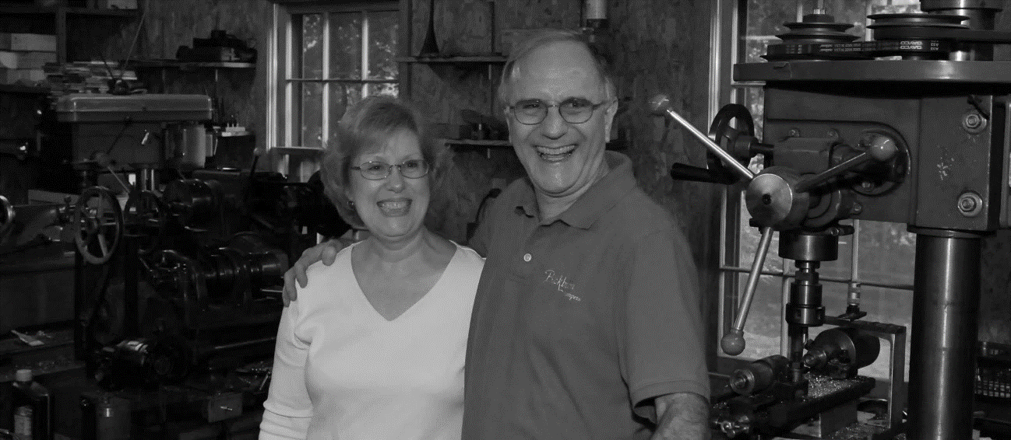
Illustration 1: The Blackburns in the Tennessee Shop

Mrs. Blackburn had no formal business training but participated in a program called Junior Achievement when she was in high school. It was there that she learned many of the skills that she would apply to running Blackburn Trumpets. She also took a few business courses while in college at Tennessee Tech, but by the time they went into business, the things she had learned in college about how to use various business machines were outdated. Computers were not quite common yet when Blackburn Trumpets began, but the machines were on their way out.
Blackburn Trumpets was never about becoming rich; the Blackburns got into business to make a living and were most focused on raising and educating their two children and having a comfortable home. They live frugally and have little interest in extra “toys” like motorcycles and boats. Their shop was on their property, their home in a beautiful wooded rural area. They always considered their business to be a shared journey with God and their faith is very important to them. In fact, their logo for the Louisville Leadpipe is based on an ichthys or sign of the fish and was inspired by this faith.

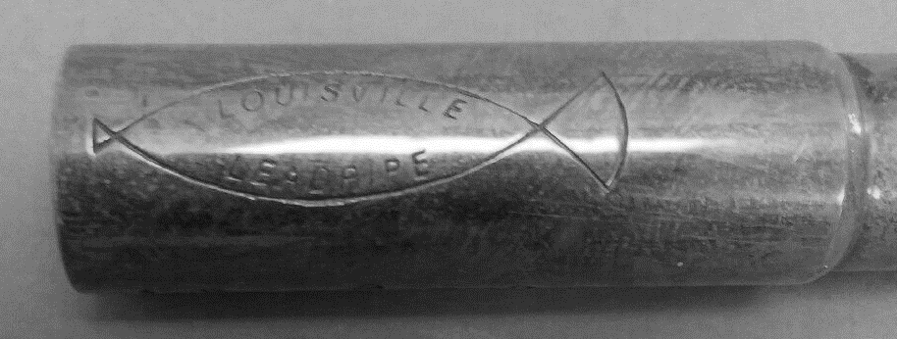
Illustration 2: Louisville Leadpipe with Logo
Blackburn trumpets were all built to order. In the early years, customers would pay half down to get their name on the production list. When it was time for the trumpet to be built, Mrs. Blackburn would call them and let them know. Then the customers would have from the time they started building the trumpet until when it was finished to pay off the rest. Later, once their business was more established, they started letting people put down less money initially and pay along the way. They often got checks from customers at Easter and Christmas time; trumpet gig money would help patrons to pay for their new horns.
When they first moved to Tennessee, they had left all their helpers in Louisville, so Blackburn was back to working alone in his shop. About a year later, Blackburn ran into Tina Erickson at an International Trumpet Guild conference. Erickson, who has a music education degree from the University of New Hampshire, had recently finished her master’s degree in trumpet performance from McNeese University in Louisiana and moved back home to Connecticut. There, she was working as the assistant band director at her old high school, playing in a few different orchestras, and doing various odd jobs. She had met the Blackburns at the previous year’s ITG conference and was struck by their kindness and unpretentiousness. She was also very impressed with their instruments and bought a leadpipe from them, dreaming of the day she would own one of their trumpets.
At the next year’s ITG conference, she was finally ready to put her name on the list for her first Blackburn trumpet. While there, she asked Mr. Blackburn how his business was going since their move and when he told her he needed someone to help him in the shop, she saw a new and interesting opportunity. She asked if he was looking for a trained repairman and he said he would prefer someone who knew nothing who he could train to do things his way, but who had some mechanical skills. Erickson said, “I know nothing, and I drive a 1971 Volkswagon that I keep on the road myself” and she offered to move to Tennessee to become his helper. She was brought down on a trial basis for six weeks in 1988. During her first visit to the shop, Mr. Blackburn attempted to bore her with tedious work, scraping sharp edges off recently milled braces, then attempted to scare her with the big torch. When none of that phased her, they hired her, and she stayed with them for twenty-seven years.
Blackburn’s approach to building trumpets was to be meticulous at every stage of the manufacturing process, so that the end result was as nearly perfect as possible. In Tina Erickson, he found someone who understood and shared these values. Their philosophy was to treat each piece of every trumpet as though it was the only one they were going to work on all day. It got to the point that he could trust her to build almost all the leadpipes and tuning slides. Blackburn would build the valve section, give it to Erickson to build up, she would do the leadpipe and tuning slide, and he would make the bell. In this way, they built trumpets together for many years. They also became good friends and played in a brass quintet together.
At various times, the Blackburns hired additional workers, but none of them stayed for as long as Erickson. Most of the time, it was just Cliff and Tina in the shop and Bunny in the office. They served customers of all sorts, from famous trumpet players like Philip Smith or Doc Severinsen, to college professors, orchestral players, and serious trumpet students. To the Blackburns, every customer was special.
Blackburn only built trumpets; he never branched out into other brass instruments. In order to make larger instruments, you need larger machines and they wanted to keep their business running out of their small shop. They never built flugelhorns, partly because of the manufacturing differences, partly because there were already several good flugelhorns available, and partly because a flugelhorn is usually a secondary instrument for most people and few people would be willing to pay nearly $5,000 for a custom-built flugelhorn.
At the peak of production in their Tennessee shop, Blackburn Trumpets was producing around fifty custom trumpets per year. On average, they would produce around thirty a year. This was in addition to the hundreds of leadpipe orders and tuning slides. While they made a profit on the trumpets, it was the leadpipes and tuning slides that really kept the business running. Many customers who were unable to afford a Blackburn trumpet, but wanted some of the benefits of having one, would purchase a leadpipe or tuning slide to update their own existing trumpet.
Peter Pickett of Pickett Brass worked with Blackburn for several years, producing mouthpiece receivers for them using his computer numerical controlled, or “CNC,” lathes. After working together during that time, Blackburn came to admire the creativity that Pickett brought to his company, always trying to improve things and coming up with new ideas to make his products better and more consistent. This commitment to quality and improvement appealed to the Blackburns and when they decided that they were ready to retire, they approached Peter Pickett to see if he would be interested in purchasing Blackburn Trumpets. He was very receptive to the idea and after working out all the financial details, Pickett Brass officially acquired Blackburn Trumpets in January of 2016.

Life After Blackburn Trumpets
After selling Blackburn Trumpets to Pickett Brass, Blackburn agreed to remain involved with the company in an advisory capacity for two years, training the workers at Pickett Brass to make Blackburn trumpets up to the standards that the Blackburn name has come to represent. He would travel to Lexington, Kentucky, where Pickett Brass is located, about once a month for a couple of days and coach the Pickett employees until they were ready to produce Blackburn trumpets on their own.

Illustration 3: Pickett Blackburn Logo

In retirement, Cliff Blackburn participates in his local ham radio club and emergency communications community. He is also an avid handgun shooter and enjoys teaching others to shoot safely and responsibly. He does not play the trumpet anymore but has taken up the drums and plays in a country band with a few of his friends from the ham radio club. They play mostly just for fun, but also play at assisted living homes and as the entertainment for local community fundraisers. What used to be the trumpet shop is now the band’s rehearsal space. All their machinery has been sold except for the one lathe that his parents bought to get him started and an anvil that was his uncle’s.
Bunny Blackburn has taken up several retirement projects herself, including learning to play the dulcimer and researching the family genealogy. Her handmade wooden dulcimer was a Christmas gift from her husband. She joined a local dulcimer group and they perform in the community at nursing homes, museums, the historical society, and schools. She has been collecting family genealogical information from both her own and her husband’s families for many years and now has more time to sort through the two hundred years of family history stored in their basement.
The Blackburns are also very involved in their church and enjoy spending time with their grandchildren. As he never particularly enjoyed traveling and is described as a “hermit” by his wife, Clifford Blackburn now gets to spend more time at home instead of traveling to trumpet conferences.
Tina Erickson continues to teach five to six days per week at Chattanooga State Community College, Lee University, and the University of Tennessee, as well as at a local high school and in her home. She also freelances and plays with the Chattanooga Symphony and the Jack Daniels Brass Band. She has not been involved with the training of the workers at Pickett Brass and enjoys not having to go into the exhibit rooms at trumpet conferences.

Chapter 4: Acoustic Principles

Acoustics of Brass Instruments
In the simplest terms, a brass instrument is composed of a mouthpiece, a tube, and a bell. This basic shape of a brass instrument is “dictated by the need to provide a set of harmonically related air-column resonances.” The entire mechanism is activated by oscillating air passing through the lips, which act as a flow control valve for the air supply. When they are in the correct position, the lips vibrate sympathetically to the note produced by the trumpet. Put another way, the lips “collaborate with the air column to favor the maintenance of oscillation at frequencies closely matching one or another of the natural frequencies characteristic of the air column itself.” In this way, a trumpet produces the specific pitches or partials whose frequencies correspond to the overtone series of the specific tube in use. The valves serve to change the length of this tube to produce different sets of pitches.

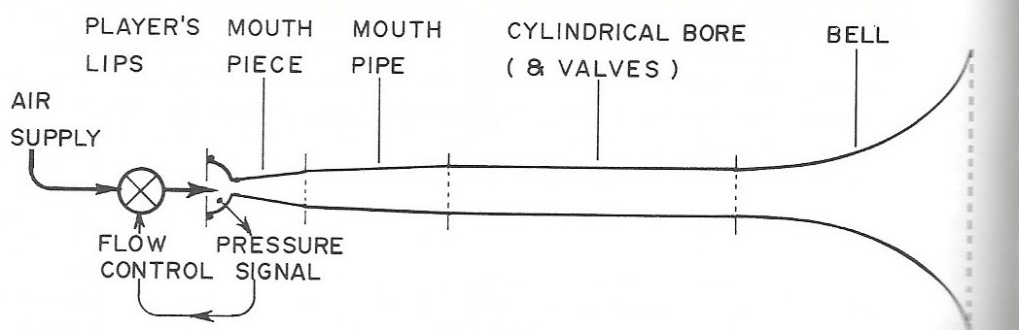
Illustration 4: Trumpet Diagram
The mouthpiece of a brass instrument consists of a cup and a tapered backbore. It serves as the interface between the lips and the instrument. Because the mouthpiece is itself a small tube, it has a resonating frequency of its own, different from that of the instrument tube alone. When the two are combined, the mouthpiece magnifies the instrument’s resonance and expands its useable range of resonant frequencies. The cup allows for people with differing degrees of lip penetration into the mouthpiece to be successful in producing a tone.
The tube of a brass instrument is either cylindrical or conical, although all flare to a bell at the end. As a sound wave travels through a tube and travels into a larger portion of that tube, its pressure amplitude decreases as it spreads over a larger area. The difference between a cylindrical or conical bore instrument is the rate at which this decrease of amplitude takes place. A conical bore instrument will allow this to happen more gradually while a cylindrical bore instrument will not allow this to happen until the bell flare. The bore is what accounts primarily for differences of timbre between different brass instruments. Trumpets are cylindrical for a considerable part of their length.
A brass instrument is a tube with one closed end, called a “stopped pipe.” The closed end, where the player’s lips are, is the called the node, and is where the wavelength of the sound begins. The open end, where the bell is, creates a loop, with the wavelength bouncing back to where it began and interacting with the lips. This cycle of waves is called a standing wave; the higher the note being produced, the higher the frequency of the waves.
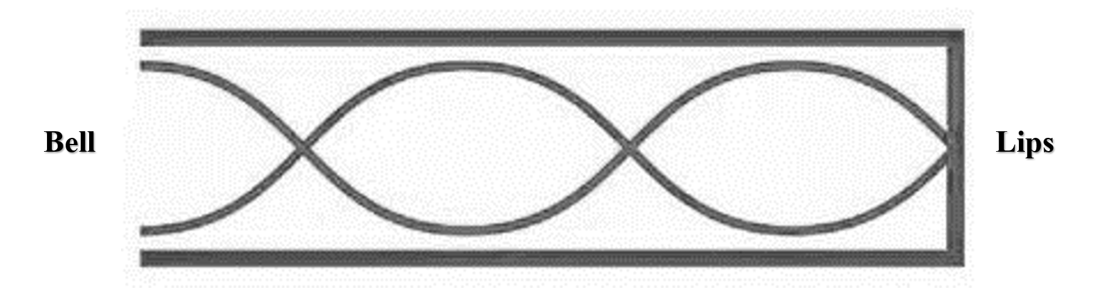
Illustration 5: Standing Wave in a Stopped Pipe

The tuning of a brass instrument depends primarily on the shape of the bore in the first three quarters of an instrument’s length, while the tone quality is dependent on the last third, including the bell. The flaring bell of a trumpet forms the exit from the interior of the horn into the space around it. Putting a mute into a trumpet bell is an example of the way in which changing the shape of the bell will affect the tone quality, but not the intonation to as high a degree.
A brass instrument is a sum of its parts. Each instrument and player’s individual combination of physical attributes, bell flare, leadpipe taper, and mouthpiece proportions create a unique acoustical machine. Changing any one part changes the balance of everything else, so while a thorough understanding of the acoustical properties of a horn can help a manufacturer to produce a better instrument or a player to formulate the best combination of instrument and mouthpiece for him or herself, an acoustically perfect instrument is something that can only be created in theory.
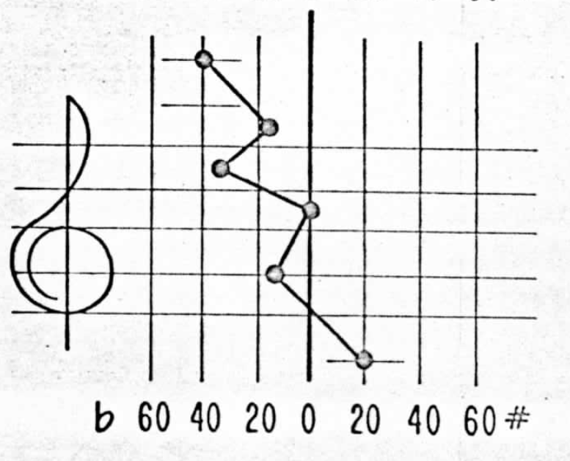
Illustration 6: The "Ultimate Zigzag" of Trumpet Intonation

Naturally, a trumpet’s intonation forms what acoustician William Cardwell called the “ultimate zigzag.” When a typical instrument is tested, and its intonation graphed with tuning note C centered as being in tune at zero cents sharp or flat, the open notes of the harmonic series around it form a zigzag of sharper and flatter pitches. Also, the notes continue to get flatter the higher into the harmonic series they are, a phenomenon Cardwell called “ascending flatting.” This is directly related to either the backbore of the mouthpiece or the flare in the bell stem. Based on Cardwell’s ideas and influence, Clifford Blackburn was able to eliminate or lessen many of these intonation faults in his trumpets.

Collaboration with Acoustic Scientist, William T. Cardwell
William Cardwell was a scientist who worked full time as a chemical engineer, researcher, and patent advisor for the Chevron Oil company, but also had his own acoustics lab and was an amateur trumpet player. He found that his studies on seismic wave exploration and vibration theory at work could be applied to his hobby of playing the trumpet. His serious interest in trumpet acoustics and design was such that his home lab was bigger and more professionally outfitted than that of any trumpet manufacturer.
Clifford Blackburn met Bill Cardwell at the 1982 International Trumpet Guild conference at the University of Kentucky. After a presentation by Blackburn about his experiments with leadpipe development, Cardwell approached him excitedly because Blackburn had come to many of the same conclusions empirically that he had come to scientifically, namely that there is no way to fix one note on a trumpet; when you change anything, it changes everything. So, they started working together.
In his acoustics lab, Cardwell experimented with trumpets. He invented a machine which he dubbed the “salpingometer.” This apparatus, which includes many high-end microphones, can determine the natural resonances of an instrument without any degree of human error and is accurate in measuring the intonation curve of an instrument to within one musical cent. This “extra-human” testing allowed Cardwell to obtain “quantifiable and repeatable test results to support his research.”
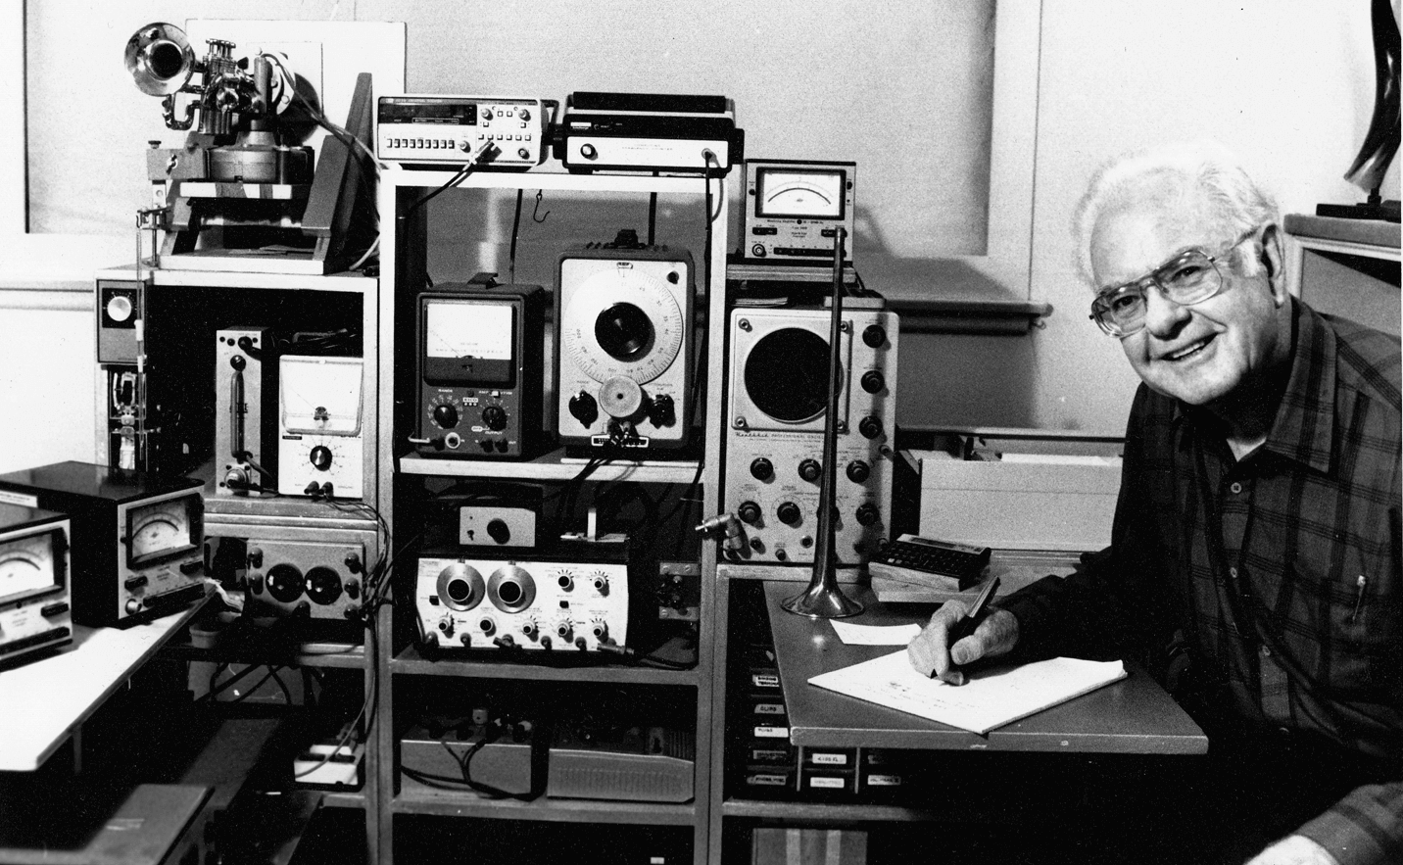

Illustration 7: William Cardwell with his Salpingometer

Cardwell had a patent for the development of an F piccolo bell, complete with formulas and diagrams. Blackburn took these formulas and created a basic computer program that was able to do the complex mathematics for him. In this way, he was able to use the results of the formulas without having to do the math himself. Cardwell was helpful in explaining things to Blackburn along the way and the two became friends as well as colleagues.
Cardwell measured two of Blackburns most successful leadpipes, the 19 and the 20, and helped Blackburn to plug his results into his bell program to predict the proper length and flare rate of the bell stem. Blackburn also created a program to calculate the final flare of the bell using Cardwell’s formulas.
William Cardwell passed away on May 17, 2012, leaving behind a legacy of important research on trumpet acoustics. Although he is not well-known outside of the trumpet world, his work continues to be influential to those who know of and implement it. Blackburn credits Cardwell as one of the most important influences in the development of his instruments and in the success of Blackburn Trumpets. Cardwell also consulted with trumpet-makers at other companies such as Olds, Stomvi, and Kanstul.

Chapter 5: Construction Design and Methodology

Structural Materials
Walter Lawson, a French horn manufacturer and friend of Blackburn, built screw-on French horn bells out of the bronze alloy, ambronze. This material consistently showed through testing that its tonal characteristics projected the best to the back of a concert hall when compared with other metals such as yellow brass or nickel-silver. Blackburn decided that these were the characteristics that he and his customers were looking for in his trumpets and began making his bells out of this metal.
Ambronze is a high-copper alloy consisting of about 85-87% copper, 2% tin, and the remainder is zinc. The small amount of tin in this alloy makes the metal stronger and the high copper content creates a warmer, richer sound. It is harder to work with than brass because it turns springy very quickly and must keep being reheated. In fact, ambronze is so springy that its most common commercial use is in springs for such items as pens or switches in automotive dashboards. It is a commonly used metal but is not commonly used in musical instrument manufacturing. Blackburn only uses ambronze in the making of bells; the rest of the trumpet, including the leadpipe, is made from brass.
Although the use of ambronze as a bell material is one of the things that makes Blackburn trumpets different from horns made by other manufacturers, Blackburn also made yellow brass bells available to his customers. Various thicknesses of metal are also used in making bells to customers’ specifications. The available Blackburn trumpet bells are 20 thousandths of an inch ambronze, 20 thousandths of an inch yellow brass, or 24 thousandths of an inch ambronze. Both ambronze bells possess the characteristic sound of ambronze, but the lighter bell lends more brilliance to the sound. The lighter yellow brass bell results in a bright trumpet sound. Since all Blackburn trumpets were custom built to each customer’s unique specifications, each trumpet player could choose what kind of sound they wanted their trumpet to have.

Wires
Blackburn trumpets can be made with two different types of wires in the bell bead: brass or steel. The brass wire is preferred by commercial players who need a brighter sound, such as a lead player in a big band. The steel wire is universally preferred by orchestral players, who desire a more controlled result at loud dynamics. Since most of Blackburn’s customers tend to be classical or orchestral players, the steel wire is the most common of the two filler materials. Blackburn also experimented with tighter or looser, rounder or flatter bell bead bends, but found that those variations made little difference in the end result. He finally settled on a round bell wire with a bell bead that was simply rolled in and soldered.

Fit and Finish
Early in his career as an instrument maker, Blackburn used to bring his experimental designs in for his trumpet colleagues in the Louisville Orchestra, Leon Rapier and Jerry Amend, to play. Passing a trumpet down the row during rehearsals, the strengths and weaknesses of a particular design would become obvious. These men were very influential to his early designs.
All Blackburn trumpets are tested for quality before they are given to the customer. Both primary builders of Blackburn trumpets, Clifford Blackburn and Tina Erickson, are trumpet players and each play tested every horn. Since they had different approaches to playing the trumpet, if it worked for both of them, they figured that it would be good for most people.
In addition to thorough testing, all Blackburn trumpets were thoroughly lapped and buffed. All slides moved cleanly and easily, and the horn was cleaned and shined. Finish buffing was nobody’s favorite job, so they worked out a deal where Blackburn would buff a horn if it was going straight to the platers and Tina Erickson would buff all the rest. 85-90% of Blackburn trumpets fell into Erickson’s category because they were custom-built and sent out to the customers first and often came back for small adjustments prior to plating.

Chapter 6: Manufacturing Concepts and Process

Mouthpiece
Although Blackburn has never produced any mouthpieces himself, he used to convert existing mouthpieces to screw rim mouthpieces for customers. He could take two mouthpieces and combine them into one screw-rim mouthpiece. Once he became a trumpet-maker and not an instrument repairman, he stopped tinkering with mouthpieces.
Blackburn believes that to build a mathematically perfect and in-tune trumpet, all the tapers in the entire trumpet, including the backbore of the mouthpiece should be balanced. However, he understands the needs and desire of individuals to play with different mouthpieces based on their own physical characteristics and desired sound, but these small changes do affect the balance of the horn to some degree. Lip penetration into the mouthpiece also makes a difference. Someone with heavy lips may fill a mouthpiece cup more and produce a shriller, brighter sound, while someone with thin lips may play that exact same mouthpiece and end up with a dark tone. This is one of many reasons that trumpeters choose to play with different mouthpieces.
When designing his trumpets, Blackburn used a standard stock Bach 7C mouthpiece with a medium backbore. He chose this because it was a good measuring point and a mouthpiece similar to a Bach 7C works well for most people. Even people who play different mouthpieces usually play something similar enough to a 7C for the measurements to be close to correct.
Peter Pickett of Pickett Brass, who has since purchased Blackburn Trumpets, had and continues to have a mouthpiece-making business. Before purchasing Blackburn Trumpets, they primarily sold mouthpieces and aftermarket trim kits. Pickett Brass has computerized CNC lathes and initially, Blackburn approached him at an International Trumpet Guild conference about making some mouthpiece receivers for him. They worked together in this capacity for several years before Blackburn decided to sell his company to Pickett.

Leadpipe
In the early 1980s, while they were still in Louisville and operating as Blackburn’s Music Services, Blackburn’s former professor, Pat McGuffey, approached him with a leadpipe that he had created and been using with his Selmer piccolo trumpet. It consisted of the stock Selmer leadpipe in B-flat with a trumpet mouthpiece receiver to extend it to the length of the A leadpipe. He preferred this to the A leadpipe that had come with the trumpet. Seeing a need for quality aftermarket piccolo leadpipes, Blackburn decided to start making A leadpipes of his own for use with Selmer piccolo trumpets. Originally, these leadpipes had no name until an instrument dealer in Maryland named Clair Christy ordered twelve of them to sell in his store and dubbed them the Louisville Leadpipe.
After his success making and selling piccolo leadpipes and hoping to help people to improve the intonation on their C trumpets, Blackburn progressed to producing C trumpet leadpipes. He would take these leadpipes in to his colleagues at the Louisville Orchestra to try out and they would be able to quickly tell what would work and what would not. The #1 leadpipe was his first attempt at C trumpet leadpipes and played very well in tune at A440, but had no flexibility to adjust to the intonation of an ensemble. So, he took that leadpipe, opened it up a bit, and that became the 1B leadpipe, which was their first successful C trumpet leadpipe. From there, they continued to experiment and develop leadpipes through trial and error.
Building leadpipes was a process with many steps. First, they had to draw all their own tubing. They bought stock tubing from a metal supplier and then resized it to fit their needs. First, they would anneal the tip of the tubing using a torch. Annealing is using heat to soften the brass. Some metals get harder when heated, but brass gets softer. They would gauge the heat of the metal by the color of red that it turned. Then when that cooled, they would lubricate it using Dove soap and use an arbor press machine to ram the tubes through different sized dies, gradually getting smaller until the desired size was reached. Blackburn used Dove soap as a lubricant during production. After much experimentation early in his career, he decided on Dove soap because it worked well and was readily available.
Once the end of the tubing was the correct size, it could be put on the long cylindrical mandrel. They would crimp the end so that it could be locked into a hydraulic ram. Once this crimp was done, they would anneal the entire tube. Then the tubes would be given an acid bath to remove the oxide scale that builds up on the metal during the annealing process. Once it was cleaned and dried, the tube was lubricated with Dove soap and put on the mandrel. Then a die would be put over the outside of the tube and the tube would be hooked into the machine and the hydraulic ram would pull the tubing through, creating a tube with the inner diameter of the mandrel and the outer diameter of the die. At this point in the process, they had created the cylindrical tubing that was used throughout the body of the trumpet.
Initially, Blackburn trumpets had an internal diameter (ID) of 460 thousandths of an inch with an outer diameter (OD) of 500 thousandths of an inch. For years, they made parts for their own trumpets with this OD and aftermarket parts for Bach trumpets using an OD of 507 thousandths of an inch. Eventually, they started making all their tubing with an OD of 507 thousandths of an inch so that they could be used interchangeably.
A leadpipe is a tapered tube, so to make that cylindrical tubing into a leadpipe, a piece of tubing would be cut to a specific length and put through the prepping process once again. After being crimped, annealed, acid cleaned, dried, and lubricated with Dove soap, the tube was drawn over a tapered leadpipe mandrel designed by Blackburn. Instead of using a heavy steel ring around the outside, as with drawing the cylindrical tubing, a flexible steel washer would be put over the tube and it would cave in as it slid up the taper of the leadpipe mandrel. In this way, the outside of the leadpipe was ironed down to the shape of the mandrel and the leadpipe was shaped to the precise taper desired.
Leadpipes are cut to the proper length on a lathe. When metal is cut on a lathe, it leaves a razor-sharp burr behind, which then needs to be scraped off. Blackburn developed a hook scraper from a three-sided file with the end made into a tiny hook. This claw was used to round off the sharp edges so that nobody would get cut. During their years working together in Tennessee, Tina Erickson built the majority of the leadpipes.

Tuning Slide
After realizing that he could not fix everything that he wanted to fix on a trumpet with the leadpipe alone, Blackburn began making tuning slides as well. Tuning slides were made by bending pieces of cylindrical drawn tubing. His first tuning slides were round bow tuning slides, which he found to free up the blow of the trumpet and helped to smooth out some intonation problems. He later made some tuning slides that were called the “rounded square” or “RS” slide. They never made tuning slides that were the same shape as other readily available slides such as the squarer Bach slide.
During their years working together in Tennessee, Tina Erickson made most of the tuning slides. She was also responsible for lapping the tuning slides and making sure that they were moving well.

Valve Section
Since valves require some specialized equipment that he did not have, Blackburn purchased piston valves from other instrument manufacturers for use in his instruments. They decided that investing in that equipment and learning how to make piston valves was going to slow them down and make their trumpets more expensive for their customers. Other larger companies have hourly workers and a custom shop like Blackburn Trumpets would have had to charge shop rate, so it was more cost effective to purchase them. As long as the pistons that they were purchasing were of good quality, they were happy to use them. Blackburn holds a patent for a piston valve, so although he did not make them himself in his shop, he is well-versed in how they are made and could have made them with the correct equipment.
Initially, he purchased valve blocks and pistons from Yamaha. The first few batches of those were very good professional line monel valves. Monel is a very hard metal composed primarily of nickel. Also containing copper and small amounts of other metals, this nickel alloy is stronger than pure nickel and is resistant to corrosion. It is commonly used in the production of piston valves for professional model brass instruments. Yamaha later started selling him valves that were made for student line instruments. The metals looked the same, but these later valves were made of a different metal, yamaloy, that tarnished. Because of this, there ended up being about fifteen to twenty trumpets that Blackburn unknowingly sold to customers with student line valves in them and needed to do free valve rebuilds after about five years. In the meantime, Blackburn had begun making his own cylinders and drilling ports to match the Yamaha valves.
After the Yamaha valves, Blackburn started purchasing pistons from Kanstul and adjusted his own cylinders and ports to match those. They made trumpets using Kanstul valves for many years until the mid-2000s, when they found that the quality of the valves they were receiving was no longer up to their exacting standards. Next, they began to purchase piston valves from Schilke and used them for a long time as well. Eventually, Schilke stopped supplying Blackburn with pistons and he went back to Kanstul. In the Tennessee shop, Cliff Blackburn built all the valve casings. He would braze a valve casing together, clean out the inside where the knuckles stuck out, and hand it over to Tina Erickson to attach many of the other parts.

Bell Design
After building leadpipes and tuning slides and finding that they alone could not accomplish everything that he wanted to improve in a trumpet, Blackburn began to make trumpet bells as well. At the time, he was doing a lot of E-flat trumpet conversions, turning ML Bach C trumpets into orchestral E-flat trumpets, so his first attempt at making a bell was the E1 bell for E-flat trumpets. It was similar to a Bach 236 D trumpet bell, but Blackburn smoothed out the bell stem and changed it until it sounded like he wanted it to.
Blackburn created his own patterns and mandrels and began building bells, but it was two years of practicing this skill before he felt confident when starting to cut out a pattern that he would end up with a bell at the end of the process. Throughout this time, he asked many questions of friends in the business, including Walter Lawson, a French horn maker. It was from him that he got the idea to make trumpet bells out of the bronze alloy, ambronze, and to braze the ambronze bells with the industry standard silver brazing alloy.
To build a bell, Blackburn started with a sheet of metal of the desired thickness and then would cut a piece of that metal to a pattern that he designed. This pattern looked something like a flat umbrella that tapered in and then flared out at the top. After that piece of metal was cut out, it was folded over and silver brazed together at the edges. After it was brazed, they would flatten out the seam and hammer the shape into a rough bell shape. After it was in the rough bell shape, it was fitted onto a mandrel and the bell stem was drawn, much like the process used for making leadpipes. Then the final flare was put on a mandrel and spun on a spinning lathe until the inside of the bell was the exact shape that they wanted it to be.

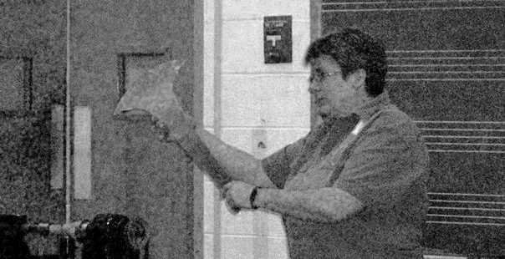
Illustration 8: Tina Erickson with Cut Bell Pattern

Using the formulas from Cardwell’s patent and his own computer programs, Blackburn designed all his own patterns and mandrels to create bells that were mathematically as close to perfect as they could be. He found that the main predictor of intonation on a trumpet was the bell stem. He used his computer programs to match the bell stem to the leadpipe and the bell flare. The shape of the final six or eight inches of the bell flare are most important to controlling the tonal characteristics of a trumpet. He used Cardwell’s formulas to determine this shape and then fine-tuned it based on the alloy used and the thickness of the metal. For instance, the shape of a Bach 229 C trumpet bell works very well when made of yellow brass, but not as well when made of ambronze. So, Blackburn would adjust his shapes to the metal that he was using and once balance was achieved, the sound was better.
Blackburn also experimented with two different fillers for the bell bead: a brass wire and a steel wire. The brass wire produces a brighter sound and is preferred by more commercial players such as a lead player in a big band. Orchestral players universally preferred the steel wire, which allowed for them to push the sound louder without it getting too bright. They also experimented with tighter and looser, rounded and flatter bell beads, and found that these changes made much less of a difference than the wire filler material. Eventually, Blackburn settled on a round bell wire with a bead that was simply rolled in and soldered. Cliff Blackburn was responsible for building the trumpet bells in his Tennessee shop.

Chapter 7: Conclusions and Need for Further Study
Blackburn trumpets are special among available professional model trumpets because they were custom-built to order by hand in a small shop and not in a factory. They also take into consideration a scientific approach to instrument design and use a unique bell alloy, ambronze. The business was run in an old-fashioned way where customers were treated as family.
Further study comparing Blackburn’s horns to other brands could be undertaken. Also, acousticians may be interested in delving more deeply into the mathematical concepts espoused by Blackburn through his collaboration with William Cardwell. As a musician, Blackburn was more concerned with how to use the results of the math than studying how to do the math. Cardwell also collaborated with other trumpet-makers at companies such as Stomvi, Kanstul, and Olds. Comparing manufacturers that worked with him to those that did not could also be an area for further study.
Now that Blackburn Trumpets has been bought by Pickett Brass, an interesting topic to delve into would be the similarities and differences between the “old” Blackburn trumpets and the “new” Blackburn trumpets by Pickett. Although Pickett Brass continues to manufacture Blackburn trumpets by hand in the way that Clifford Blackburn taught them, they are no longer making trumpets only to order and have specific model numbers of trumpets listed for purchase. Another interesting topic would be to compare Blackburn Trumpets’ acquisition by Pickett Brass to other boutique or custom instrument manufacturers’ acquisitions by larger companies and the resulting fluctuations in quality.

Bibliography
Bast, Gary J. “The Legacy of William T. Cardwell, Jr.” ITG Journal 41, no. 1 (October 2016): 51-55, 61.

Benade, Arthur H. Fundamentals of Musical Acoustics. 2nd ed. New York: Oxford University Press, 1990.

Benade, Arthur H. Horns, Strings, and Harmony. 2nd ed. Garden City, NY: Anchor Books, 1992.

Benade, Arthur H. “The Physics of Brasses.” Scientific American 229, no. 1 (July 1973): 24-35.

Cardwell, William T. Jr. Cup-mouthpiece wind instruments. US Patent 3,507,181, filed October 25, 1967, and issued April 21, 1970.

Cardwell, W.T. Jr. “Trumpet Acoustics: Correcting Intonation Faults,” unpublished manuscript of presentation to 92nd Meeting of the Acoustical Society of America, November 19, 1976.

Cardwell, William T. Jr. “Trumpet Intonation Acoustics,” unpublished manuscript, 1973.

Cardwell, W.T., Jr. “Working Theory of Trumpet Air-Column Design,” unpublished manuscript of presentation to 72nd Meeting of the Acoustical Society of America, November 3, 1966.

Gold, Ben, Nelson Morgan, and Dan Ellis. Speech and Audio Signal Processing: Processing and Perception of Speech and Music. 2nd ed. Hoboken, N.J.: John Wiley & Sons, Inc., 2011.

Guillaume, Philippe. Music and Acoustics: From Instrument to Computer. London: ISTE Ltd., 2006.

Heston, Tim. “Welding Musical Instruments to the Perfect Pitch.” Welding Journal 78, no. 6 (June 1999): 43-47.

Levarie, Siegmund and Ernst Levy. Tone: A Study in Musical Acoustics. Kent, Ohio: Kent State University Press, 1968.

Moore, Thomas. “Playing Without Buzzing: Fact or Fiction?” ITG Journal 25, no. 4 (June 2001): 51, 13.

Mraz, Stephen. “What’s the Difference Between Soldering, Welding, and Brazing?” Machine Design. July 14, 2015. http://www.machinedesign.com/fasteners/
whats-difference-between-soldering-brazing-and-welding.

Olson, R. Dale. “In Memoriam: Bill Cardwell.” ITG Website. http://trumpetguild.org/content/itg-news/111-in-memoriam-bill-cardwell.

Roederer, Juan G. The Physics and Psychophysics of Music: An Introduction. 4th ed. New York: Springer, 2008.

Smithers, Don, Klaus Wogram, and John Bowsher. “Playing the Baroque Trumpet.” Scientific American 254, no. 4 (April 1986): 108-117.

Stomvi USA: Art and Technology. Bill Cardwell: 1917-2012. http://stomvi-usa.com/bill-cardwell/.

Tarr, Edward H. The Trumpet. 3rd ed. Chandler, Ariz.: Hickman Music Editions, 2008.

Wasser, Steven and Clifford Blackburn. Musical instrument piston valve. US Patent 7,667,117, filed April 4, 2005, and issued October 5, 2006.

Appendix A: Interview Transcript – Clifford Blackburn
In His Home (Decatur, TN) – September 30, 2016

Lindsey Jessick: Okay, so I guess we'll just start out with you telling me a little bit about yourself. Where are you from?

Clifford Blackburn: I grew up in Knoxville, Tennessee. Went to school there, did my undergraduate degree at Tennessee Tech. Got a Bachelor of Music Education. Got a master's degree from University of Louisville.

L.J.: Who did you study with?

C.B.: At Tennessee Tech, I studied with Pat McGuffey and George Bitzer at University of Louisville. When I was working on the master's degree, I took an elective in instrument repair. It was a one-hour elective. And while taking that course, I found out I was good at it. The teacher kind of took me under his wing and did extra stuff with me to show me and introduced me to some of the repair guys in town who also kind of took me under their wings and helped me. When I would get hung up on something, I could call one of those guys and go over and they'd show me a technique or something to do. So, that was always really helpful. When I finished the degree, by the time I finished the Master's, I was doing repair work for five music stores in Louisville. Bunny would run the route, she'd go pick up or deliver, things that I had fixed, or needed fixing, and she'd bring them back and then the next week... She had daily runs that she did to the different music stores and would bring them home and I would fix them.

L.J.: So, were you guys married before you went to do your Master’s?

C.B.: Yes, and soon after I finished the degree, the third position in the Louisville Orchestra opened up and I auditioned for that and was lucky enough and I won the audition. And ended up, we were going to go there and get the master’s degree and teach college, that was the goal, to teach college. That wasn't the way it went, but I think God had something different for me and showed me basically where I needed to be and what I would be better at. I would have been miserable teaching, I think. I would have been so frustrated. The repair thing worked out to go side by side with playing. And I loved playing and that was always fun, but playing with the orchestra was just really fun and it ended up being the proving ground for the development of the trumpets. Because you can tell when you're playing in an ensemble if something is going to work or it’s not going to work. You can tell almost immediately. But, so that worked out quite well and Leon [Rapier] and Jerry Amend, who is now principal, but he was second at the time, I would bring something in and we would pass it down the row. And they were very influential in saying... Leon never said anything bad... I would have something that was the crummiest thing you've ever seen and he'd play on it and say, "Well, I'm sure there's a use for it somewhere.” But, I did that for seventeen years. And the business grew to such a point that in 1987 I resigned from the orchestra and we moved back home. Essentially, we realized we could go just about any place we wanted to go as long as FedEx and UPS would deliver. And initially we were dependent on local work, high school bands, stuff like that. As we progressed on, it got to be more of a custom shop, where I was doing lead pipes and tuning slides and bells and rebuilding professional line trumpets.

L.J.: So, after-market update kind of things?

C.B.: Yes, and in the early 80s, while we were still in Louisville, Pat McGuffey approached me with this thing, he had put a trumpet to trumpet mouthpiece receiver in a Selmer piccolo leadpipe. He put it in the B-flat side of the leadpipe and it extended it out so he could play it in A. He said, "This plays better than the A pipe that they put with it.” And I looked at it and thought, “You know, I could make that.” And so, I took his idea and developed it and started making the leadpipes. And initially we didn't have any name for it -- it was just an A leadpipe for the Selmer piccolo trumpet. A fellow up in Maryland -- New Windsor, Maryland I think it was -- his name was Clair Christy. Clair had a shop. He was one of the biggest Bach dealers in the country and he worked out of his basement. The guys, the military band guys in Washington DC, would go out to his place and try a Bach trumpet and they would, you know... But, being a Bach dealer, he was also a Selmer dealer, so he had the Selmer piccolos. One of our friends from Louisville who was from up in that area went up and showed him one of the leadpipes and he said, "I want to buy some of those.” So that was my first big order; he ordered twelve. But he called me one day and he said, "What are you calling these things?" And I said, "I don't know..." and he said, "How about we call them the Louisville Leadpipe?" And I thought, "That's catchy!" so they got dubbed the Louisville Leadpipe. Clair Christy was the guy that did that and we progressed from there. From the piccolo leadpipes, it went into the C trumpet leadpipes because anybody that's played a C trumpet understands they can be monstrous as far as intonation and that sort of thing. So, we worked on that and I would try a leadpipe and take it into the orchestra and play it and you could tell almost right away if it was going to work or if it wasn't going to work. My first one was the #1 leadpipe and it was just at that point the #1, and it was very tight, very efficient, but it played really well in tune. And I thought, “This is going to be great!" and I took it into the orchestra and it was in a rehearsal, of course. I've never chipped so many notes! [Imitates sound of chipping notes] I thought, “What's going on?" What I realized was it was so locked in and so rigid that I didn't have the ability to move the pitches within the orchestra. You know, it’s in a constant state of flux within a certain boundary. But, I couldn't move -- it was like A440 was idée fixe. It was just right there. So, I realized that this isn't going to work. So, I made it a little bigger and opened the slots up a little bit so they had a little more room to move and that ended up being the 1B leadpipe, which was the first really successful thing that we did. And from there we continued to develop, and I'd say, "I wonder what would happen if I did this..." So, I'd make a mandrel and draw a leadpipe and try that and it was all trial and error at that point. Mid 80s, late 80s, before we moved down here, I started working on bells. Initially, we started with leadpipes and then I did leadpipes and tuning slides because I realized I couldn't fix everything I wanted to fix with just a leadpipe. So, the next progression was the tuning slide, so I made a round bow tuning slide. And that freed it up a little more and made it a little less, you know, you didn't have to push so hard to get through it. And so that was an improvement and it also smoothed out some of the intonation, but I wasn't able to get where I wanted to go. So, I realized, okay, it’s going to have to be some bell stuff. I was doing a lot of E-flat trumpet conversions at that point, taking a ML Bach C trumpet and turning it into an orchestral E-flat. So, that was my first bell attempt. That was a learning experience. I had a local machinist make the mandrel for me and when I got it, after paying him what was a lot of money at that time for me, got it and started measuring it and I had to put it on my lathe and re-cut it because the dimensions were so far off and I had tried to explain to the guy, this is very critical, just a few thousandths of an inch is going to make a difference. Well, he didn't do what I... So, I had this thing and it was not difficult for me to at that point trim it and put it where I needed it, but it was something I would have preferred not to have had to do. But anyway, that ended up being the E1 bell, so the E1 on the E-flat was a successful thing... I started learning then to make bells. It was like two years before I felt confident that when I started cutting out a pattern that I was actually going to end up with a bell when I finished. So, I finally got to that point. A lot of development, a lot of questions to friends in the business and that sort of thing and I had over the years developed a friendship with Walter Lawson, who was a French horn maker. Walter had started using ambronze for French horn bells and he had screw bells on the French horns that he made. He had done some tests with different alloys on the screw bells. He would make a bell out of yellow brass and one out of nickel-silver and one out of ambronze and he put them on. He had Barry Tuckwell as his tester and they went to the concert hall in Baltimore and set up microphones, one directly behind the bell on the stage, they had a contact a probe mic inside the mouthpiece and it was connected to a decibel meter on the music stand. Barry Tuckwell's job was to sit there and play a note and hold the decibel level from the contact mic to a certain level for a certain amount of time and then they had a recording meter on the microphone right here, one on the front of the stage, one at the middle of the hall, and one at the back of the hall. All the same stuff. And without exception, the ambronze was louder at the back of the hall, it was the loudest one at the back of the hall, out there. So, they learned that the tonal characteristics of that metal projected the sound.

L.J.: What is in ambronze?

C.B.: Ambronze is a high-copper alloy. It’s about 85-87% copper, 2% tin, and then the remainder is zinc. So, it has a little tin in it, where yellow brass or most of the brasses don't have any tin. So, the tin makes it stronger. It’s demonic to try to work. It has a mind of its own. So, it’s terribly hard to work it. Yellow brass is so easy! Ambronze, you can work it a little bit and then you have to soften it again.

L.J.: Is it more brittle or is it just harder?

C.B.: It’s not more brittle, but it turns springy much quicker. As you work any copper alloy, it work hardens. You heat it dull red and quench it and it softens it. So, as you work this stuff, the commercial work of ambronze is springs, like the spring on a fountain pen, like the clip, a lot of times that's ambronze. And they use it for springs in switches on automotive dashboards and everything. It’s a commonly used metal but not necessarily for musical instruments. But Walter told me about that and I thought, "That's what trumpet players are looking for." To get off the stage without having to sound like a chainsaw. Because in the back of the orchestra you have to make a lot of racket to get out over the orchestra. This stuff seemed to work.

L.J.: Do you make leadpipes out of it too or just the bells?

C.B.: Just the bells is what we use that for. It’s a little warmer sound, a little richer sound. It’s purer than the others and you can push it really loud and it doesn't shatter. It doesn't break up like yellow brass will. Yellow brass, you can hurt people with that. Then we started learning about the different thicknesses of the materials and what that would do and experimented with that, and ended up where we are now with 20/1000s ambronze, 20/1000s yellow brass, or 24/1000s ambronze. The two lighter ones are a little brighter sounding, but there again, the lighter ambronze, you get the characteristics of ambronze with a little more brilliance to it. You know, we developed the horns and made a C trumpet and I played on it for a while and one of the players in the Toronto Symphony Orchestra came down to visit and he said, "I gotta have that horn! That's exactly what I'm looking for!" So, I said okay, and I sold that one to him. And it just grew from that point.

L.J.: When you were doing your instrument repair, initially, before you started your own shop and everything, did you repair all kinds of instruments or just brass instruments?

C.B.: I would do everything. It ended up, the thing I could do was look at a mechanism and see what was wrong with it. I had that kind of analytical mind; it was just something that I had. So, I could look at something and say, “Okay here's the problem,” and figure out how to fix it. And because I was good at it, I ended up having clarinet players, good clarinet players, come in town to have me work on their horns and do cork pads on the clarinets. And repad an oboe; that's a job! But I would do anything from a piccolo to a tuba. Did some drums even.

L.J.: Before you started making trumpets, I assume you probably play your own trumpets now, but what kinds of trumpets were you playing before?

C.B.: When I was in high school, I played a Holton trumpet. When I got to college, my teacher said, "You've got to get you something to put you a little more mainstream than that," so I got a Bach 37 ML B-flat and then I got a 239 C trumpet, it was also a ML. I should have gotten a L, but I didn't know any better. So, it always felt like there was somebody in there blowing back at me; it was kind of bright, great chamber horn, but not for orchestra. But that's what I had there and then I played school specialty instruments: piccolos, E-flats, that sort of thing. My senior year, no it wasn't until I was at the master's level, that I got my own Selmer piccolo trumpet.

L.J.: So, initially, you were designing things through trial and error and then at some point you got together with the acoustic scientist, William Cardwell. Can you tell me a little bit about that?

C.B.: Bill Cardwell ended up being a terrific friend. I was struggling with trying to make improvements on the horns by trial and error and the system, the acoustic tube, the mechanism that you're dealing with there, is incredibly complex and so I would do something and it would fix what I wanted to fix, but it would mess up everything else. I was getting frustrated and they asked me, I forget where it was, maybe the University of Kentucky ITG conference, asked me to do a presentation on what I was doing with the leadpipe development and I made the statement that it was kind of, people thought at that time, at least people not in the scientific community, players thought, that you can fix one note. And I said, "I haven't found that you can fix one note.” You can fix maybe a range of notes, but if you move one thing, it’s going to move everything. And Bill Cardwell got so excited because that's what he had come to scientifically; that's the conclusion he had reached. And I found the same thing empirically. He said, "You've proven by practice what I predicted scientifically," so we started working together.

L.J.: How did you meet him?

C.B.: He was at that ITG conference and after I made that presentation, he came up to me.
L.J.: Did he play trumpet too?

C.B.: He was a trumpet player, yes. He was a research scientist for Chevron Oil, but he had his own acoustics lab. He played with trumpets. He had a mechanism set up. He called it his "salpingometer," which is tube-measuring device. He had all the equipment, high-end microphones and things so he could really, truly measure. It was pretty amazing. He could take a trumpet and hook it up to his machine and draw you a graph of the intonation of the trumpet -- you'd look at it and say, "Yeah! that's what it does!" So, working with him, he was not only a, he didn't just say, "Do this or do this.” He would say, "If you work this problem out... Here's the formula for this... If you can figure this out, then it will do this." And so, I did and he had a patent for the development of an F piccolo bell and it had his formulas and stuff in it. I called him up one day and this was when I knew who he was and we had talked, and I said, "Bill, I got a copy of your patent here and it says it’s the cosine of H. We've worked this out and it doesn't work." And he said, "Oh, yeah, in the patent, that's a misprint." And he said it was supposed to be "cosh", not "cosH,” but the hyperbolic cosine. That didn't mean a whole lot to me because I'm a musician and I can sometimes subdivide four beats into triplets, or 12/8 or something. When you get past twelve...Haha. It was really beyond me, so that's where he came in and he helped me and he worked with me on the math stuff and he says, "Here's the way this works..." And I was able to take that and work it into a basic program for the computer so that I can say if you plug these numbers in to this formula, then this formula does this and if these numbers equal a certain place, then go here...
L.J.: So, you set it up so the computer could do the math for you?

C.B.: So the computer could do the math, yes!

L.J.: I was going to ask you how much of the actual physics you had to do.

C.B.: I had to learn to use the formulas. Bill had a great way... He always had some great ways to explain stuff. One day I said, "Bill, I just don't understand the math on this.” He said, "You don't need to understand it; you just need to learn to use it." He said, “It’s kind of like a shovel. I could explain to you using math how a shovel works, but you don't need to know that. You just need to know how to use that shovel.” That was the way he would help me with that stuff. And so, I learned to use it with my computer program. He got so happy when I showed him my program that I had written. He said, "Oh, you figured it out!" He was tickled to death that I was able to use what he taught me. But the computer would spit out, there were hundreds of calculations that would have to be made, and the computer could do it in seconds what would take weeks if you had to sit there with a calculator and figure it out.

L.J.: How did you learn how to make a computer program?

C.B.: *sigh* On my own. I got just a basic program. I forget exactly what it was. Quick Basic, I think. Oh, Quick Basic was later. Initially, it was just a basic program that I wrote with numbered lines and it was before the way they can do it now with basically a command line kind of thing. You had to number the lines so it would go down and then you'd go to a subroutine, you'd say, go sub330, so it would jump to line 330, and then it would run that subroutine, and then at the end of that, you'd hit return and it would go back and pick up where you dropped off and run it again or whatever you needed it to do. So, you kind of had to write your own map of where you wanted it to go. It was a real interesting thing. I doubt I could do it now. I've looked at some of the printouts of some of my programs and I say, "What in the world was I doing? What'd I do there?" I have to rethink the whole thing and figure it out again. That was where he came in and that was all to plug his numbers. He measured two of our most successful leadpipes, the 19 and the 20, and then he said if you plug these numbers into the bell program it will predict what the length of the bell stem needs to be and the flare rate of the bell stem and then there's another program that I worked out that you could work on the final flare. But the bell stem, the long skinny part of the bell, is the main predictor of intonation for the trumpet and it has to match up with the leadpipe or the leadpipe has to match up with it, more likely. But once you get those two things and the mouthpiece backbore, all of the tapers involved in the trumpet, if they're all balanced and everything is working, then theoretically you can get one that plays perfectly. But then you enter the players...who plug in a different mouthpiece. And the different mouthpiece is enough to....and then they want it to blow a little different, so they'll open up the backbore on the mouthpiece. Well, that changes the intonation completely. If somebody played with the standard, that would give them the best results, but being humans, we want something that matches the way we try to do it. And so that's where the variances come in. There's things that you have to take into consideration, like lip penetration into the mouthpiece. So, if you give somebody, say a 7C mouthpiece, you get somebody with heavy lips and that mouthpiece can play really shrill because the lips fill the cup and it plays really bright. You get somebody like me, with thin lips, you get a 7C, and you get this dark tone. And so, it depends on what human is hooking up to the horn as to where it needs to go.

L.J.: So, when you're developing the intonation, do you assume a certain mouthpiece?

C.B.: We started with just a 7C, because that was kind of... 7Cs are everywhere. And it’s kind of the beginning mouthpiece and a lot of people just stay with it. But it was a good measuring point. A stock Bach 7C, with a middle of the road backbore seems to work well for a lot of people and so that was where we started. Almost anybody that's advanced to your level or a professional level, they've played something different, but it’s close enough with that to get it within the ballpark.

L.J.: All of the acoustic formulas, were those basically just about design principles or did Bill Cardwell have anything to say about what metals you used or anything like that?

C.B.: No, the metals that I used were my own, that was my own and was simply through trial and error. I would make it to Cardwell's shapes, but then I got to where I really liked the sound of the ambronze and I thought this is for my ear, this is something that I think is a step in the right direction. But applying to his shapes, and then the final front end, like the final six or eight inches of the bell flare, the shape of that controls the tonal characteristics. That's the main contributor to the tonal characteristics of the horn, it’s that shape. The alloy, the thickness, is fine tuning after the shape. A lot of times, you can take, if I copied say a Bach 229 bell, which with yellow brass works really well, that shape, the sound that comes out of that. If I made that bell in ambronze it gets just kind of tubby and it loses the life. So, I had to adjust the shapes to accommodate the metal I was using, but once the balance was achieved, we felt like it was better.

L.J.: Did you experiment at all with the bell bead?

C.B.: Yes, actually we ended up using two different fillers for the bell bead. One of them is a brass wire and one of them is a steel wire. The brass wire will light up quicker, it gets bright quicker. So, if we have somebody that's a lead player in a big band or something, we would put a brass wire in there, or recommend that we do. Orchestra players seem to universally like the steel wire because it held together. You could push it louder without it getting super bright. But that's the two things. We practiced, we tried different, tight bend or a little looser bend, made a little difference, but not as much as the two different wires.

L.J.: So, it didn't make an awful lot of difference whether it was rounded or flatter?

C.B.: It made some difference, but not an awful lot.

L.J.: So, we've talked about leadpipes, and we've talked about bells, and we've talked about tuning slides. How did you start with the valves?

C.B.: The valves were and continue to be a problem. Initially, I had met a fella at Yamaha that was in sales and everything and I contacted him and said, "Can you guys sell me valve blocks and pistons?" Just the valve set and the pistons. And he said yeah. Bach wouldn't even talk to me. So, I went to Yamaha and talked to them and they sold me initially like ten sets and they were really good, so I ordered some more and they had run out of those pro line things that they were selling me and so it started coming in with student line stuff, looked the same, but the metal on the valves were yamaloy instead of monel and it was a grey metal, it looked the same, but they tarnished and so there were probably fifteen or twenty trumpets that I had to do free valve rebuilds five years down the line because they had student valves and I didn't realize that. So, we started looking for another source for valves at that point. Found Zig Kanstul at Kanstul would make pistons for us. In the meantime, I had started making my own cylinders and drilling the ports and everything to match those. So, we simply adjusted that to fit the Kanstul pistons and we made many, many horns based on Kanstul pistons. In the late 90s or early 2000s I think, maybe 2004/2005, somewhere in there, the quality on the Kanstul stuff started to go down and we started getting stuff with holes drilled in the wrong place, silver braze lines around where they brazed the liner in, you know, they would have gaps in them and they would leak. And so, we started looking for an option there and I talked with Andrew Naumann who was the owner at that point of Schilke. He said, “Sure, we can make you pistons.” They made us a few valve clusters with pistons and I felt like I could do better on the valve clusters than they were doing. But the pistons were really nice, so I said we need to go with just pistons. And so, we did that and used the Schilke pistons for a long time. Now, I'm not sure... Peter Pickett, who bought Blackburn Trumpets, is searching for another… Schilke stopped supplying us, so we had to go back to Kanstul and get some from Kanstul again, but he's looking for a good reliable source. I'm not sure; he's been talking with Bach.

L.J.: So, Bach will talk to him about it now?

C.B.: Initially, they had all that they could do. Back then, they were selling everything they could make. And now the competition has picked up and I'm sure that they're looking for markets.

L.J.: Were any of these people hesitant to sell you pistons because you were a competitor to them?

C.B.: Not really. The Yamaha stuff initially at that point, they were starting to eat everybody's lunch. They were moving. And they had these, they were a discontinued pro line horn and so they had these parts and they weren't going to use them, so they sold them. That was fine. Kanstul never had any reservations about it at all. It was just another place that he could sell something to. He never was really into… Our prime market was orchestral players, college teachers, students that are going in that direction. Kanstul sells drum and bugle corps stuff. Jazz players, you know, that sort of thing. So, I don't think he ever really saw us as competition. Just another market.

L.J.: So, what sort of tests do your instruments go through once you've made them? Do you play test them or have people who play test them?

C.B.: When we were doing it here, Tina and I would always play test them. Both professional players. She has a different approach to the horns than I do. I play very efficiently; she moves a lot of air. So, if it works for both of us, it’s probably good for most people. When we were making them, we were just nuts about doing every part exactly right and making sure every little thing, a little solder joint, okay, that needs a little more attention. We'd spend an extra thirty minutes on one solder joint just to make sure it was right. And that paid off in the end.

L.J.: So, you're just meticulous all the way through and then at the end, you don't have to...

C.B.: Yeah, you don’t have to go back and fix it very often unless there was a defective part, which is the sort of things we found out with some of the pistons. You put the pistons in, then you don't realize, then you start to play it and realize something isn't right and then you'd trace it down and say, "Oh there it is.”

L.J.: So, are the pistons really difficult to make? Is there a reason you decided that you didn't want to make them yourself?

C.B.: They are; they take some specialized equipment and some abilities that we didn't have at the time. We decided rather than investing in all of this equipment and getting all of this stuff and learning how to do this, which is going to slow us down, and then we would have to charge a lot more for that piston than what we can buy them for. Because they've got hourly workers working there and we have to charge shop rate, which at the time was like $100/hour. So, it made economic sense to be able to buy them if you could. We wouldn't be doing anything different than the ones that are well-made, so why not use what you can buy if it’s well-made?

L.J.: So, how are your trumpets different from other brands? Is it just your approach to the bell-flare and the different metal that you use? Are those the primary differences?

C.B.: Primary difference, yeah, is the scientific approach to the design and then the application of the different alloys. Nobody that I know of, at this point at the present time, is using ambronze, but us -- for trumpet bells.

L.J.: You said that one horn company, are they still using ambronze?

C.B.: I think so. I'm not sure exactly what Lawson horns are doing. Walter died several years back and they sold the business to a French horn player and I'm not sure what's going on. I've kind of lost touch with the Lawson horns. But there have been some, one trombone player I know, was lusting after an ambronze bell for his trombone and I sent him some alloy and he found someone to make a bell for him and I think he loves it.

L.J.: So, there is one trombone that has an ambronze bell.

C.B.: There is one trombone that's got ambronze on it!

L.J.: Did you ever consider branching out to other brass instruments from trumpet?

C.B.: No, we always just stayed with trumpet because in our small little shop, if you go to a larger instrument, you need larger machines. It was just stuff we didn't want to get into. We didn't even make a flugelhorn because it’s a whole other animal. We just decided, no we'll just stick with trumpets. There are some decent flugelhorns out there and we just won't go into that. And most of the time, flugelhorns are a secondary instrument for someone. Very few people, Chuck Mangione is the only one I can think of, that's his primary instrument. So, very few people are going to pay nearly $5000 for a flugelhorn. Even if it’s wonderful, unless they've just got money to burn. There are a few of those out there... The doctors and the lawyers, the avocational players.
L.J.: So, when you first started making trumpets, and you were still in the trial and error stage of things, did you start by kind of copying existing trumpets, but making it in your own metal?

C.B.: I started just by trying to copy something and seeing if my measuring attempts and my actual making of the mandrel, if it was actually getting close enough to say, "These two play the same," or play close to the same. And so, it was kind of a "Let’s see if I can duplicate this and if I can duplicate this, then I can move on from there.”

L.J.: So, you started by duplicating something like a Bach?

C.B.: That first E1 bell was sort of like a Bach 236 D trumpet bell, but the measurements on that bell [gestures in and out in a wiggly shape with hands] like this, as it went up the taper, and so I thought, lets smooth this out. And so, I did that, and it played similarly to that bell but better. It did what I wanted it to do.

L.J.: Were you interested in the scientific aspects of acoustics at all before you met Bill Caldwell?

C.B.: No. My math history... I made Cs in math all the way through any time I was required to take a math course, it was a C. I had to take, in college at the undergraduate level, a basic math course, and ugh it was dreadful! I think I got a C- in that class and I was happy to get it because I just got through it. That was a whole other experience. At that point, they were focusing on modern math, which is like the base 10 stuff. It was useless! If I can see how it's used, then I can usually figure it out. This I couldn't see how it was used! What are you going to do with this? You can't balance a checkbook... Plus, the guy that taught the class was a grad assistant and I think he was like Pakistani or something, so I couldn't understand him and he would just scrawl stuff all over the board... Give me the book.

L.J.: So, you started out working for other music stores being a repair person and then branched out to start your own repair business, which became Blackburn Trumpets. Can you tell me a little bit about the business aspect of starting your own company?

C.B.: What we would do is, we started and I had nothing. I knew the tools I needed, so I bought a vice, I made a bench, then I got some specialized little hand tools to do mostly woodwind stuff and if somebody came in with a brass instrument that needed dents removed, then I would buy the dent tools necessary to do that job and then used that job to help pay for the tools. Then slowly but surely, we acquired a very complete shop, as far as tools and equipment and that sort of thing. But we did it very slowly and progressively, adding to it as we went along. We didn't go into debt to get the stuff. We've always found that for us, for Bunny and I, for our personalities, going slow and staying out of debt is the best thing. Working with the pressure of debt stresses you out and is not a pleasant thing. We enjoyed the “no debt” thing as we grew the business and continued and when it got to a point, my folks helped me along the way, they bought me my first lathe.

L.J.: When you started out your company, was it just you and Bunny and then you added more people in later?

C.B.: Yes. Along the way, we've had several people work for us and we've had as many as three, but I found out early on that I was a better craftsman than I was a manager. And I don't deal well with excuses. I don't deal well with somebody that says, "I'm not coming in today because..." That bothers me. I feel like if people commit to something, they need to be there. And so finally, we backed down, in Louisville, we had several helpers, we had one girl there that I trained and she did woodwinds and I would do brass, so we were able to produce and get things done, and of course if she got hung up on something, I could jump in and help her. When we moved down here, all of my helpers lived in Louisville. And so, when we moved down here we didn't have anybody. So, I was kind of working by myself again. We went to an ITG conference and Tina had been there the year before and she came up and talked and said, "How’s it going?" I said, “Well, it’s going fine, but I've got more work than I can do. I need somebody to help me.” She said, "Well, what do you need?" And I said, "I need someone who knows nothing but has mechanical ability," and I said I'll train them how to do it my way. She says, "How about me? I know nothing and I've got a Volkswagon that I've kept running all by myself." And the way she tells it, she says I said, "You're hired!" But we brought her down here and she worked on a trial basis for like six weeks and she agreed to that and I said you know, if it doesn't work out, if for any reason you find that you can't do it, you can leave. If I think you can't do it, then you can leave, haha. But it ended up, man, she was here for like 26 years! So, that worked out. Oh, she was great, a great helper. Got to the point where I didn't even have to look at the leadpipe/tuning slide orders, really. We'd go over and check the trumpet orders, and I'd say, “Okay, we need to start on this one” and I'd do a valve section, give it to Tina, she'd build up the valve section, she'd do the leadpipe, do the tuning slide, while I'm making the bell. And it worked. I mean, it never went smoothly like that because we always had somebody coming in and would order another leadpipe or ordering this for a European dealer coming in with fifty leadpipe orders, you know, so we'd have to stop and do that.

L.J.: So, how many trumpets would you say you guys would build in a year?

C.B.: When we were really cranking, and down here, at that time there were three of us working in the shop, we had a guy that I trained to make bells. Tina was doing her build-up and then I was doing everything else and picking up wherever it needed, we were doing about fifty a year. But, realistically, in the last fifteen years, we would do maybe thirty a year.

L.J.: For people who just wanted leadpipes, how many leadpipes were you doing?

C.B.: Oh, hundreds. Leadpipes and tuning slides were our… That maintained our cash flow. The trumpets, we made a profit on them, but the leadpipes and the tuning slides were what kept the business running.

L.J.: And you mentioned that you experimented with the tuning slides and made them more rounded instead of squared, did you make all of yours rounded or are some of them different shapes?

C.B.: No, we have some, we always figured, at that point, you can buy a Bach slide if you want a Bach slide. They're available. That's probably what you've got already, so there's no need for us to duplicate that. So, we started with the completely round one and then we wanted something to back into the other side a little bit, so we made one that was kind of semi-square. We called it the "rounded square", the RS slide.

L.J.: So, you made the rounded ones and the semi-square ones, did you ever experiment with the more parabolic shaped ones?

C.B.: No, you mean the ones like Dave Monette does? Yeah, no... There's a funny story about that...Terry Warburton, he's crazy, one day we were there and Dave had just started making these slides that were shaped like that. Everybody was looking at them saying, “What?” Terry came in one day and Dave walked in the room and he said, “There's the bender!" And I said, "What?" And he said, "Yeah, look [pretends to bend something over his knee], it’s the shape of the bend!" We've had fun with that. And Dave is a really good friend of ours and we get along really well, but we just don't want to make his slides... That's something he did and that's fine but it wasn't a direction I wanted to go in.

L.J.: Was anyone else in your family musical?

C.B.: Yes, both of my parents. My mother had a music degree from Chicago Music College.

L.J.: What was her instrument?

C.B.: She was a piano player and she had a degree in Music Ed. My dad played violin and almost got a music degree, but World War II came around and he joined the marine corps, went through World War II, came back out, went back to the University of Tennessee and got a law degree. So, they were both musicians and we actually had a little... My sister lives here, and we moved here. My folks lived over in Brentwood, just outside of Nashville, and so once we were both here, they moved over here. And once my folks got here, for several years, we had a little trio: Mother playing piano, Daddy playing violin, and me playing trumpet. We'd go around and play at churches and stuff.

L.J.: Did you ever play the Ewazen trio?

C.B.: No, we never did anything that difficult. [Conversation deviates off topic]
L.J.: So, your family is musical. Is Bunny musical?

C.B.: No, uh, well, Bunny is getting musical. She will jokingly say, "Yeah, I play the radio," but for Christmas or her birthday, I got her a handmade dulcimer. One of my ham radio buddies is a woodworker and he makes dulcimers. So, she has a dulcimer and she started playing with a group playing dulcimer. So that's her instrument now. She's getting pretty good at it!

L.J.: She mentioned to me when I saw her at ITG that you were becoming a drummer...

C.B.: Yes... Again, to step back to ham radio. And I joined the local ham radio club and my neighbor over here next door is a ham so we got together. He's the one who got me into ham radio and so one of his friends that's also a ham, they had played together for years. The friend is a keyboard player and sings and Mike plays bass and some guitar. He says, "Why don’t you come play drums with us?" And I said, "I'm a trumpet player; I'm not a drummer.” He said, "Well, we really don't need a drummer, we just need somebody that can keep time." And I said, "Well, I can tap my foot with the best of them." So, I started doing that and we have more fun! It’s just so relaxed. My whole playing career, you go in there and you sit down in that chair, you better mean business or you won't be back. There's pressure there. It’s exciting, its rewarding, but I don't know that you can say it’s fun. It’s enjoyable, but this, well, if somebody messes up, it’s okay, we just keep going. And so, we just have a good time. And the places we have played, the volunteer fire department will have a fundraiser picnic where we're the entertainment. We'll go to the assisted living place on Sunday afternoon and we'll do hymns and sing for them, get them singing, and it’s just fun.

L.J.: What kind of stuff do you guys play? You said hymns...

C.B.: The stuff that we normally do is country and some old rock, Jerry Lee Lewis, you know, that sort of thing, but fun stuff. A lot of it's country. I've got "Honky Tonk Amnesia.” It’s just... These country songs, some of them are just so funny. We just have fun and I'm learning to play trap set and so I'm getting better! I haven't fallen off the stool in a while, haha.

L.J.: I've tried that a couple of times and I had a hard time because you're doing four different things at once.

C.B.: Oh, it is. I try to keep it simple. But, it's funny, used to be, I'd listen to a recording and I'd focus on the trumpets, I'd listen to what the trumpet players were doing. Now I'm listening to what the drummers are doing! A whole different concept.

L.J.: Do you play trumpet much?

C.B.: No. The last thing I did on trumpet, I played “Taps” for the ham radio club did a mini-field day. Where you go out into someplace and set up your equipment and start broadcasting and transmitting and talking to people, but we also invited local police officers and we had a bunch of them and we did a special memorial service for fallen officers and I played “Taps.” And that's been over a year ago and that's the last time I've touched a trumpet. Basically, I got burned out, just totally burned out. I had enough of it. There were other things I wanted to do and you know, anybody like you, you know, you can't just pick a trumpet up and play it. You know, it’s like running. If you're going to do it, you have to do it. You have to continue to do it and so I just decided, I'm done, I'm going to do something else. And so now my musical outlet is drums.

L.J.: When did you start playing the trumpet and how did you choose the trumpet?

C.B.: Started in the fourth grade and I chose the trumpet because my folks had one left over from when they were in college in methods classes. Had this trumpet, so I started playing in the school band and pretty soon, my folks being musicians, got me hooked up with a private teacher. In junior high school, I quit the band because the band director was an alcoholic and we continued to play just the same things over and over and it’s like, we had this book, "Okay turn to page 12, okay, we're going to do that.” It was always the same stuff. I even switched, I started playing baritone horn, just to have something different to do. So, the private lessons kept me going during that time. In junior high, I played baseball, but I still played the trumpet for private lessons but not any organized... Then in high school, we got a new band director in the high school and he was gung ho and he was a trumpet player. And so, he called up and said, "I understand that you're a trumpet player and I'd love to have you in the band.” And that's all it took and there I went. He was a great influence on me; he got me really playing. I ended up playing obbligato solos out in front of the marching band at the football games and that sort of thing. Got me noticed at, we did the marching festival at Bristol, I did something out front and Jay Julian called and said, "Don't let that trumpet player get away from me!" I just wasn't crazy about getting yelled at and so I didn't go to UT!

L.J.: So, you recently sold your company to Pickett Brass. What was your collaboration with Peter Pickett, prior to and now?

C.B.: Before, he was making some of the parts for us. Of course, he had a mouthpiece-making business and he had these computer machines, CNC lathes and I approached him at one of the ITG conferences about making some parts for us and he said, “Sure.” So, he was making mouthpiece receivers and I noticed that he was very creative. He was saying, "You're hand-marking these. We could engrave those with our machine and you'd be done. It would take a step out and it won't cost you but a nickel more." So, he was always thinking and always trying to improve things and had ideas on how we could make things more consistent. Just from making parts with us and I thought, "This guy's pretty sharp and got a lot on the ball." And so, Bunny and I decided we were getting tired of this and we talked about selling it to the Picketts. So, we approached them and they were very receptive. And so we worked out the financial arrangements and got all of that squared away and my association with them now is, part of the agreement was that I would be available to teach them our way of doing things, and so I go up about once a month for a couple of days and coach Peter's employees and Peter on doing things, you know, how to do it and how to make this work and efficiently do things. They're coming along pretty well. They've produced two or three trumpets now and they've been very good. I'm pleased with the way it’s going.

L.J.: So, before they were mostly mouthpiece people, right?

C.B.: Mouthpieces and trim kits. You know, valve stems and guides and caps and things.

L.J.: Did you ever experiment with mouthpieces when you were making things?

C.B.: No more than just a regular trumpet geek trying different mouthpieces.

L.J.: But you never tried to build any?

C.B.: No. At one time, I would do screw rims for people. I would take two mouthpieces and make one screw rim out of it and that sort of thing. But nothing more than just altering what was there already.

L.J.: Now that you're mostly retired, what are you plans for the future? Right now, you're working with the Pickett people, but after that, will you just kind of set them free on their way?

C.B.: Yeah, I look at that as a consulting job and the job of a consultant is to work himself out of work. It’s to get them good enough. In the agreement, I agreed to be available for up to two years, so this December will be the finish of one year. As I go up there now, I'm seeing less and less that needs to be done. They're picking it up. I foresee within the next year, I'll soon not need to go up there at all. And right now, a lot of the things are just a phone call or a text: "We found this, how can we fix that?" As far as the future, I've always been, for the last twenty years or so, into handgun shooting and into training and teaching people and so I enjoy doing that. I've done it for a lot of folks at our church and people that've never fired a handgun before but who see the way things are going in the world and they want some way to protect themselves. They're not good enough to pass the handgun test for the state, so I work with them and do that, so that's very enjoyable for me. Seeing people learn something that's useful and do it safely and understand what the ramifications are and that sort of thing. To do that, plus playing in the country band is my musical outlet and just having fun. And then the ham radio stuff. I'm part of the local emergency communications community. There's an emergency operations center that we work out of.

L.J.: Do you not have 911 service out here?

C.B.: Oh, we do. This is for things where 911 is overwhelmed or we have a tornado come through and it takes out the communications system. One of our sayings in ham radio is: "When everything else fails, ham radio works." And so, we've got little, they look like walkie talkies, they're called handy talkies, but they're ham radios. We can talk all over the county with those things if we have to, so it’s just an additional backup for... Plus, we've got the nuclear power plant, Watts Bar, is close by. If they have an event, they will call us out and we'll be part of the emergency units to provide communications because the police are going to be overwhelmed with that and so we're part of that organization too. But, community stuff, helping people learn to shoot, and having fun with playing drums. That's kind of where I am right now.

L.J.: And you get to hang out with your grandkids.

C.B.: Yeah, but it’s funny, it seems like we're busier now than we ever were when we were working. I told somebody the other day, "Man, I'm going to have to start back working just so I can get some rest!"

L.J.: I think that's all of the questions that I had. Is there anything else that you'd like to share?

C.B.: I was thinking while we were taking a break, my professional playing experience. My first orchestra job was with the Nashville Symphony Orchestra when Ford Johnson was there. Pat McGuffey, my teacher, was principal, and he said, “There's a job opening for 4th, you ought to do this.” Well, he didn't say, “Do you want to do this?” He said, “You're going to do this,” haha. But I did it during my one year of teaching school. It didn't take me long to learn that I wasn't really set out to be a teacher.

L.J.: You taught school? What did you teach?

C.B.: I was the assistant band director and taught general music. It was not a fun thing for me; I didn't enjoy it at all. So, I thought at that point, my logical thinking in those days, I jumped from the frying pan into the fryer. I was going to go on and get a master’s degree so I could teach at the college level. But it worked out differently and I'm glad it did. So, I had Nashville and then I played in the National Guard band, both Tennessee… I started out in the Tennessee guard unit and then when we went to Louisville I transferred up to Kentucky guard band. I played with Louisville. When we moved back down here, I played with Knoxville. I have played with Chattanooga, so I've gotten quite a bit of playing in orchestra situations and had fun doing that. Plus doing a few solos every once in a while, playing in church quite a bit, that sort of thing, quintets - Tina and I played in a quintet together for a long time.

L.J.: Thank you!

Appendix B: Interview Transcript – Nancy “Bunny” Blackburn
In Her Home (Decatur, TN) – September 30, 2016

Lindsey Jessick: Tell me a little bit about yourself: how you met Cliff and got involved with the whole trumpet world.

Bunny Blackburn: There's not a whole lot about me. I'm not musical. I met Cliff at Tennessee Tech in school. We were both in the band. I carried a conference flag and we were together four years before we married. And then after he got his master’s degree and was having trouble getting a college job and the Lord showed him that he had plenty of work to do in the repair business, we just together one night said, “Lets open a repair business.” So, what I would do is I would go out at the first of the week and pick up instruments from music stores all over Louisville, Kentucky and then bring them back and he would repair them and at the end of the week, I would take them back. And then each of the stores would pay us. But it was a simple matter of the Lord just leading us to do instrument repair. We started out in woodwinds, he taught himself brass, then eventually he taught himself trumpets and eventually sold off the woodwinds and just did brass and trumpets in Louisville. And then when we finally got to the place where we could live anyplace because UPS would deliver, we decided to come back home and then at that point, we changed the name from Blackburn Music Services to Blackburn Trumpets and we stopped doing repairs on any horn except trumpets.

L.J.: Where are you from originally?

B.B.: I'm originally from Chattanooga. I don't know if I mentioned it, but we went to school at Tennessee Tech.

L.J.: Your role in Blackburn Trumpets was mainly administrative; you kept records and things? What was your job?

B.B.: Yes, my job title was “Boss,” which was always a big joke. I took care of the business side of Blackburn Trumpets and Clifford took care of the shop side of Blackburn Trumpets. Interestingly enough, I didn't actually have any real training. When I was in high school, I was in a program called Junior Achievement. Today it's very different than it was back in the 60s. Back in the 60s, big companies in Chattanooga were companies like US Pipe and Combustion and they would get about six people out of the company from different areas, from accounting, from in the shop, and we would start out with about fifteen kids in a company and we went out and sold stock and then they helped us to order materials. We decided on a project, we made a product, and then we sold it. And we had to do banking. There was a bank and they did… They had a group that they taught banking as these guys were teaching us about how to run a company and then I did that for two years and then my senior year in high school I worked in a bank part time and so I had all of that knowledge from 3 years of being in Junior Achievement and that's how I ran Blackburn Trumpets.

L.J.: What was your major in college?

B.B.: I started out as a home ec major and I was in a work study program and when Vietnam got so bad that they had to cut the work study programs, the last year that I was there, I took some business courses, but it turned out that the courses I took didn't help me at all because they were machines and by that time, by the time we got in business, the machines were already outdated. Computers weren't in quite yet, but the old way of doing business by machines was going out.

L.J.: So, when was it that you guys actually started Blackburn Trumpets? What year was that?

B.B.: I'm not sure. I don't think we changed the name; we were still making Blackburn Trumpets under Blackburn Music Services until we moved here in 1987. I think that's right.

L.J.: So, you officially became Blackburn Trumpets when you came here?

B.B.: Yes, before that we were Blackburn Music Services.

L.J.: When did you guys start that, under your own name.

B.B.: 1972. I think Clifford graduated in '71 and we started that in '72.
L.J.: Do you have any role in the training of the Pickett people?

B.B.: No, actually, Peter already, because he was already set up in business, he does business different than we did business. We did business the old-fashioned way. We were very hands on with our customers and Peter just does business different, just because he's younger and he grew up and was educated in a different way of doing business. Strangely enough, most people really preferred the way we did business. I mean, people would call up and ask questions and I would say, “If you'll wait just a minute, I'll see if Cliff can come to the phone.” And they would go, "I can talk to him?" And I'd say, "Mmhmm, you really can." So, they were always surprised that they could talk to Tina, they could talk to Clifford, you know, talk to me. We would, if somebody had a problem with their payments, we figured out a way to get things done and we just were very open about helping people.

L.J.: And you guys built to order, right?

B.B.: Correct, correct, we did not build a horn until it was on a list and you paid half down in the early years and then as time went on and we had so much work, we began to let people actually put less down. And a lot of people… And then we also originally, you put down half and then when it came time to build it, I would contact them and say, "Clifford's ready to start your horn and the balance will be this." And so, they had from the time he started building it until the time we were ready to ship to get their money in and then as years went on, in the last probably fifteen years at least, we would let people pay along the way. We would get checks at Easter time and Christmas time. We would get lots of checks from people and they would just sign over their church checks and put them in the mail and sent it to us. We tried to make doing business with us as easy as possible.

L.J.: Is there anything else you would like to share that I may not have thought to ask?

B.B.: Other than that the trumpet business just became a real journey with the Lord and we just, when we didn't have enough we would just pray and ask Him to send work and He always did. We never got in business to make a lot of money. We got in business to make a living and it simply came down to raising and educating the two children and then after that it was just us. But we didn't need a lot of money because we didn’t have motorcycles and boats, you know, all that stuff. And the Lord just always provided and we look to Him. It was always a shared business with the Lord from the very beginning and hopefully most people did recognize that. I'll tell you one funny story, there were numerous times when we would get telephone calls and on the other end of the phone would be, “Are you guys Christians?" And I would say, "Yes, we are." And then I would hear them go, "I told you so!" And then they would say, "Okay, bye." And then that was it. They just wanted to know. Somewhere in some house or some school the discussion was, because of our logo, “These people must be Christians.” So, they would call and go, "Are you guys Christians?" And we would go, "Yes!" And then it was like they'd turn around and go, "I told you so!" And that's what they would do. It was so funny. Another funny story, and you don't need to put this in your paper, but...

[Unrelated conversation]

B.B.: I guess if there was one thing that I would want people to know would be that it was just a journey with the Lord. Never, never dreamed... When Clifford asked me to marry him, my mother spent a year preparing me to be a schoolteacher's wife, including my wardrobe...

L.J.: And that's not what you ended up being.

B.B.: No. No, just we never dreamed. I asked Clifford one time, I said, “Why did you get a degree at Tennessee Tech to be a band director?” And he said, “Because at that time, that's all you could do in music.” And he's such a hermit. He is a true hermit. And most people don't know how much he loves the Lord or the simple fact that he is pretty much a hermit. He would never leave this property if he didn't have to.

L.J.: It is nice out here.

B.B.: Yes, he really does love the Lord and it was a gift, totally a gift from the Lord. I was amazed that he figured out how to make trumpets on his own. It just was like, "How do you do that? How do you figure out how?" [And he would say,] "I just do." So, but it’s been a great journey with the Lord. Never dreaming we would, I never thought we would travel like we've traveled. Of course, Clifford never liked travel, he just never liked it. I loved it because I grew up traveling with my family. So, we've got to go places and do things that we never would have gotten to do. Yeah, it’s been a great journey, just a great journey.

L.J.: So, what are your plans for the future now that you are retired?

B.B.: Well, since I am not very musical, Clifford has decided that I need to learn to play an instrument, so he bought me a dulcimer. Yeah, he bought me a dulcimer for Christmas and it’s the easiest instrument to learn and it takes a lifetime to master. So, since I don't have much of a lifetime left, I don't think I'm going to get it mastered, haha. It is fun. And I do play with a dulcimer group and I'm the newest member and sometimes I remember to practice. We're working on Christmas music now.

L.J.: Where do you guys play?

B.B.: We play at nursing homes, at the museum here, we play for schoolchildren, just stuff like that. It’s all free. They play for the historical society. We are big uptown, just really uptown here, in this small town, haha. But it is fun and we're enjoying it. I am trying to get 200 years-worth of genealogy in our family under control, which is totally out of control downstairs, as you've seen. I am the keeper of the stuff in my family and so when somebody has family stuff it comes to me and I've got to figure out what to do with it.

L.J.: So, you're doing the genealogy of your side of the family?

B.B.: All, both sides of our family. It is a huge job and there is plenty of information. I spent about fifteen years doing it with my mother and we liked to go to courthouses and libraries, places like that, and I have just started to do some internet genealogy work and I have had our family ancestry DNA done through Ancestry.com and that was pretty eye opening. Clifford and I are pretty close in our DNA and our son is off the charts on being Scandinavian and Clifford and I are European. We're going to have our daughter done just to see if she's off the charts on Scandinavian too, but all the Europeans come down through Scandinavia, the Vikings and all the Scottish people and the Irish people, they all came down through the Normans and the Vikings. But it is pretty interesting to find him at 47% Scandinavian. I'm only 16% Scandinavian, but I really did the DNA because my mother always believed and had heard that her grandmother was Cherokee Indian and so I did the DNA to see if I could prove that and I am 1% Native American. And with every generation, your DNA gets less in certain areas, but for some strange reason, for Thomas, his Scandinavian popped up there at almost 50%. Both of our children have red hair also.

[Conversation continues to deviate to topic of genealogy]

B.B.: Ramsay's Annal places us in Tennessee when it was still North Carolina, so we're first families of Tennessee and through the deeds in the counties that they lived in, back at the time Tennessee became a state, our family plantations were side by side. I found it first in Clifford's family deed, when it said the line ran to the Gillespie (maiden name) such and such. I went to my mother and said, "Oh Mother, look what I have found." And so, we immediately went and looked at the Gillespies because now we knew where they were and sure enough our deed states that the line runs to the Blackburn such and such a line, so we proved it two ways, but that was interesting. That's just for fun.

L.J.: Thank you!

Appendix C: Interview Transcript – Tina Erickson
Cracker Barrel (Athens, TN) – October 1, 2016

Lindsey Jessick: So, can you just start by telling me a little bit about yourself and what your trumpet background is?

Tina Erickson: I am a misplaced New Englander. I am a “Damn Yankee” because I came south and stayed. Originally from Massachusetts. And started playing trumpet when I was nine because we had one in the house. My oldest brother had started on trumpet, but his ears were so good they moved him to horn. And we had this beat up old piece of crap Bundy that I think every child in that town had learned on before us and so I started playing it and it just clicked. I loved it. I was good at it from the first day. Although, I was that kid the very first day that I got my mouthpiece stuck showing everybody at the bus stop, so I had to get on the bus holding my case under my arm. Not an auspicious start, but it got better from there. Went to the University of New Hampshire, in music education, and did my Master’s at McNeese in Louisiana. So, my main professors were Robert Stibler at UNH and Mike Ewald was at McNeese before he went to Illinois. And I met Cliff and Bunny at an ITG Conference, my very first one that I went to, which was 1987, maybe or 1986. '87, I think, in Kalamazoo. I was knocked out by the stuff. Mike Ewald made me go to the room; I was too shy to go because I knew I didn't have money and when I walked into the Monette room, the first thing they did was look at your nametag to see if you were somebody and if you weren't, you know, I picked up a horn and started to play it and somebody came by and screamed at me like, "Be careful with that! Do you know what that's worth?" [I felt like saying,] "Sorry to hurt your trumpet by playing on it, mister..." So, then I went into the Blackburn room and he was like, "Hi, I'm Cliff Blackburn. This is my wife, Bunny. Have you met Gordon Mathie? He's a founder of ITG…" And I was like, “What's wrong with you people?" So, at that conference, I bought my first leadpipe. Bought a piccolo leadpipe for my Yamaha picc and… Another story about them: I only had a credit card, they didn't take credit cards then, I did not have my check book with me, and they let me take it anyway and send them a check when I got home and I was like, "Are you people for real? What is wrong with you, seriously?" But they also wrote down the numbers of the C trumpet that we ended up with and I just loved that C trumpet. I took that card out every now and then and I'd look at it and I'd dream of the day when I could have that horn. So, the next year, ITG was at North Texas and I went back and I pulled out my little ratty card and said, "Could you put that together for me?" And they had just moved then. So, while he was putting that together, just to make small talk, I was like, "Well, so how's the move? How are you enjoying Tennessee?" And he said, "You know, it’s really great, but I'm way behind because we left all of our help in Louisville." And I thought, "Hmm." And at the time I had moved back to my parents', I was done with grad school, didn't get any kind of a job that I wanted, went home, which was in Connecticut, the now famous Newtown that nobody ever heard of before the Sandy Hook thing... And I was the assistant band director at my old high school. I was an assistant picture framer, I played in two or three different orchestras around, I was teaching privately, and I worked at a racquet ball club handing out towels and keys. And I thought to myself, “Hmm, here's a possibility.” And so, I said, "Who would you be looking for? Are you looking for a trained repairman?" And he said, "No, actually I want somebody who knows nothing so that I can train them so that there is no conflict of method down the road, but they've got to have mechanical skills." And I said, "I know nothing. And I drive a 1971 Volkswagon that I keep on the road myself." And he was like, "You're hired!" And we both laughed. But we had lunch. I thought we'd go out to lunch, but they sat down and locked the door and took out a brown bag with pimento cheese sandwiches. I was like, "Okay, these are simple people. That's okay." And we arranged for me to visit. So, I came down for a weekend in July and first they tried to bore me to death and they took a bunch of braces that had just been milled. And when that happens, you know, it’s basically just like a drill bit that's spinning and you move the piece underneath it and that's how you get that nice radius on the inside. But it leaves a little bit of flash on the outside. There are like little shards of metal that are very sharp, so he gave me a scraper and said, "Okay, I just want you go and scrape that off the edge of these things." And this was the clincher: he said, "I want you to treat each one like it’s the only one you have to do all day." I was like, "Oooh!" [dawning realization] Because I'm crazy anal like that and I thought, “Alright.” So, he let me do that for a while. I think he got bored of it before I did. Finally, he said, "Alright, enough of that." And he said at the time, "Well, I tried to bore you to death, that didn't work, let’s see if we can scare you to death." And he got out the big torch. And I'd never worked with anything like this before. I worked at a metal shop in between summers in college one year, but I worked a drill press or something like that, nothing that detailed. So, he got out the big torch and I was like, "Oh man, fire, yeah!" And I was like, "Okay, alright, maybe this will work out." So, they hired me. I came down on a trial basis. We thought maybe we'll give it six months, see what happens. Friend of mine that helped me move down, she saw the area and she said, "Yeah, I give you six months." But that was 28 years ago almost, so it worked out. And, you know, the fact that I was a player and teacher were also two things that were very important to me, but that worked out too. I was able to do all three of those things and so I think I'm a little ADD to be honest with you. I can't be happy just doing one thing all the time. It’s great if there’s a variety, so it worked out perfectly. So, that's how I came to be a part of the Blackburn Trumpet team.

L.J.: So, you've been with them basically the whole time they've been in Tennessee?

T.E.: They were here about a year before I joined them. Yeah, they moved in '87 and I came down in '88.

L.J.: So, did you just kind of learn as you went?

T.E.: Yeah. The first thing he taught me was crimping tubing. I don't know if, well, he probably couldn't show you much of this stuff because it’s all in Lexington anymore. We drew all of our own tubing. So, you bought stock tube from your metal supplier and then you resize it to fit whatever your needs are. So, the first thing is, you take out the torch and you anneal just the tip and annealing is using fire to soften the brass. Some metals get harder when you anneal them, like steel, there's all kinds of different tempers of steel that you heat up to a certain temperature and then quench in oil or air hardening or whatever. But brass gets softer and you gauge a lot of it just by color. There are different levels of red hot. There's like a dull cherry red and then there’s a bright orange, and then it starts to go white and that's way too hot for what we were doing. But, so, you anneal about a half an inch, three quarters of an inch at the tip of the thing and that's the first step and then when that cools, we used Dove soap as a lubricant. He tried a bunch of things early in his career and he kind of landed on that one and it worked real well and it was cheap and easily available and smelled like roses, so there you go. So, you soap the tip and then you would use the arbor press which is a machine that has sort of a ram on the top that you operate with a handle, so there's all kinds of leverage that you can get with the weight of the ram and the handle. So, you would put those tubes in different size dies, which are like little metal donuts. So, you start with a bigger one and then you bring it down gradually in size and you knock off that one and go to the next one so that when you're done you get a tube with a smaller diameter at the top, so you could then put that on a mandrel, which is just a long cylinder, and we had a bayonet system. So, the very end of these things had, how do I describe this? They're sort of smaller in diameter than the rest of the tube, or the rest of the rod, and rounded at the tip with a notch in either side that would lock into a holder on this hydraulic ram that we used. So, once the crimp was done, then you'd anneal the whole tube. Then we would give those an acid bath just to remove the scale because the oxide builds up on the outside and you don't necessarily want that. It can grab and foul up your process. So, acid clean, wash them off, dry them out. We used that same Dove on the mandrel and the tube, put the tube on the mandrel, put a die over top of the mandrel, and then click it in to the holder and then the hydraulic ram would just pull it through, so that when you're done the inside is exactly the same as the outside of the mandrel and the outside is exactly the same as the inside of the die, right? So, if we needed 460 tubing, which is what we used for a ML, so 460 ID, internal diameter, you'd use a 460 mandrel and then use like a 507 OD, eventually. It started out with 500, like half-inch, but Bach was 507 or 508, so for years we had stuff that we made for Blackburn trumpets and stuff that we made for Bach trumpets and eventually he got tired of the double inventory and said, “You know what, we're just going to change our size to match the Bach so I could just make this many leadpipes and we could just use them on our horns or send them out for Bachs, either way.” So, that was the first thing that I learned was the crimping and the drawing tubing. And then he introduced me to the lathe and how to cut lengths and how to use the hook scraper. Because when you cut things off on a lathe, you put a tube in, the lathe rotates, so the piece that's going to be cut is spinning, then you bring a stationary tool in and back it out to make a cut. But when you do that, there's like a razor sharp burr left behind, so we have what's called a hook scraper which basically is a – we made our own – it was a 3-sided file that he would shape the front of to be like this little hook, like a little claw, and you'd go in and just kind of round off those edges so that everything was real smooth and nobody got cut. And that takes touch to figure out how all of that goes, so that took a little while for me to really get the hang of, but so that was like the next thing. So, then I was drawing the tubing, I was cutting tubing, and then the next thing I did was leadpipes. So eventually, within just a few months probably, hard to remember all that time ago, but certainly within six months, I was making all of the leadpipes and then moved onto tuning slides as well. So, that was kind of my first thing and then kind of went from there. And eventually, my part of the deal was I would put the body of the trumpet together and he would work on the bells. He did all of the valve casings, so he would braze together a valve casing and you know, clean out the inside because the knuckles would stick out, so he'd clean up all of that, so by the time I got it, it was just ready to be built on. So, I put the balusters on, and then all the tubes and the leadpipe and tuning slide and I got the valve slides lapped and moving well, all that kind of stuff. So, he would put the bell on, fit the valves, then we're done. It was clockwork. Plus, I did all of the aftermarket stuff, so all of the extra tuning slides, the leadpipes, the piccolo pipes too, which was a different process, and I did most of the finish buffing too. Everybody's least favorite job. But unfortunately I got good at it and he kept saying, "It’s because you're better than me." And I'm like, "Oh, shut up, you just don't want to do it, haha." So, we worked out a deal to where if it was one of those horns, if it was something that was going straight to the platers, that was his, he would have to do the buffing for that, but if it was something that went out to the customer and came back and all that kind of stuff, that was mine, which was 85-90% of them.

L.J.: So, now that they have sold to Pickett Brass, I know that Mr. Blackburn is helping to train their people. Do you have any role in the training of their people?

T.E.: Not at all. The only continuing relationship that I was offered was to work the tables at ITG, to which I pretty much said, "No." That was the least favorite part of my job. I mean it was great meeting the people, it was nice, but... After 27 years, this last ITG was the first one in 27 years that I didn't have to be in those rooms. I didn't even go; I didn't even go upstairs. And as a board member, I was supposed to. That's kind of my deal, I'm supposed to kind of be a liaison for those people, but I was like, "Yeah, not this year, not happening."

L.J.: You can be available to help people in other areas of the building...

T.E.: Yeah, and on Thursday I'm going to Disneyland, so screw that, haha.

[Diversion to talking about Disneyland]

L.J.: So, what are your plans for the future now that you're not working at Blackburn Trumpets anymore?

T.E.: Well, currently, I'm teaching a lot, which I love. It’s great! I'm teaching at Chattanooga State, Lee University, and UT, plus one high school that I go to and they just kind of come to me there and at home. So, basically I'm teaching five days a week, sometimes six, and playing. I play with the Chattanooga Symphony, still with the Jack Daniels group if they go out, which is less and less these days, but we're hoping that turns around at some point because it’s such a fun gig. And freelancing. I do get called to play in Knoxville sometimes still, but their schedule is so concurrent with Chattanooga's and I get a contract from Chattanooga at the beginning of the year, basically, so I have not been able to make that happen lately. And so, it’s crazy, my schedule is pretty nuts, but I am happy that way. I'm exhausted, but I'm happy when things are a little bit out of control. And I experienced the first summer off that I've had since I was 14 years old this past summer. At first it was a little bit daunting. I got up one morning and thought, "I don't even have to be up now! What should I do? Coffee and Netflix!” And after about a day and half that got a little bit old, so I painted my house. Sat down and made a list of projects: a two-page list of projects and took on painting my house. Got about half of it done. I'll do the other half next summer. So, I'm still kind of finding where I am, "life after Blackburn Trumpets" honestly. And financially as well, just making sure that all those ends meet. But so far so good. So, we'll see what else is down the line. I have been approached by some people saying, "Oh, maybe you want to come work with us now..."

L.J.: I was going to ask you that. Now that you have some trumpet-building expertise...

T.E.: Yeah, and so far, I just haven't had any interest, because mostly what they want me for I think is my face and my recognizability because I was with Cliff for all those years. Which means sales and exhibit rooms and things like that and I'm still like, "Nah nah nah..." I'm still way over-exposed to all of that stuff. But, you know, I have to keep that door open, I think, just for possibilities. But right now, I'm kind of enjoying being kind of a freelancer at everything, which is a little scary, but again, I don't mind scary. That's exciting to me. The dogs are eating, mortgage is paid... I do miss getting out of bed, throwing on old ripped up jeans and a crummy old t-shirt and going out and working with machines. I miss that part. But I still see them. I still go out there and use the shop. I still have a key. You probably saw, did he show you the shop?

L.J.: I haven't gone in it, no. He didn't take me down there.

T.E.: He's changed it over kind of to a man cave. Because you know, he plays drums now. So that's their little garage band hang out.

L.J.: I asked, “So, what do you still have in the shop?” And he said that they got rid of almost everything except for their anvil and one machine: one lathe and an anvil that was his uncle's. But no, they haven't taken me down there.

T.E.: Peek in the window on the way. The stained glass that's hanging, I did that. Yeah, so there's one lathe now, pushed way over against the wall and but he's also a gunsmith, so he needs some machines for that sometimes.

L.J.: Bunny was saying that they wanted her to move her scrapbooking stuff down there and her genealogy stuff.

T.E.: Yeah, that's the plan. The plan is for her to overtake that office and they think they're going to redo it first, but it doesn't seem to be progressing very quickly. But what's the hurry?

L.J.: She said she wanted to organize everything before she took it down there. Is there anything else that you would like to share that I didn't think to ask?

T.E.: For most of that time, it was just the two of us in the shop. We had a third guy probably three or four different times, but they were always pretty short-lived for one reason or another. And so, it was Bunny in the office, when she was there, which wasn't all the time. You never knew when it was going to happen sometimes, and then Cliff and I in the shop. You know, it was fun, because the phone would ring and it would be Phil Smith and I got real good at being nonchalant, talking to famous people on the phone until the day that Doc called and then I turned into a sixth grade girl! So, it’s been really great to get to know him. Overall, it’s been a really great ride.

[Diversion to talking about Doc Severinsen]

T.E. continued: So, had it not been for Blackburn Trumpets, I probably never would have met him. He called to order an E-flat and we had just turned over the shop E-flat, so we didn't have one for him to play on and Cliff was on the phone and I was just sort of hanging around in the background and when I heard him say, "We don't have anything for you to play on right now, I'm sorry," I said, "You can play on mine!" And Cliff said, "Doc, Tina says you can play on her horn." And he says, “He'd be glad to pay you for that.” And I was like, “No, I don't need any money! I want him to adopt me and I want to have Thanksgiving at his house from now on...” [I was] joking, thinking that Cliff would get that it was a joke and then he started to say that into the phone and I was like, "No, shut up, man!" [Cliff said,] "Well, Doc, she says that she wants you to adopt her and she wants to have Thanksgiving with you from now on." And there was a long pause and he said, "Well, I hope she likes Italian food." So, that was my first real interaction with him. I cleaned my horn up and – I had a different leadpipe on it and a little tiny thumb ring that somebody had given me that fits me – so I switched all that stuff out and shined it up for him, but it was not plated. It was just raw brass, so I wrote a note saying, "Doc, so excited that you're going to play on this. It’s polished right now, but it’s going to tarnish, so don't worry about it if it gets not shiny, unless you want your trumpet to be shinier than your jacket, then maybe you're going to have to polish it. I don't know, it’s kind of up to you.” So, we kept exchanging sort of smart-ass comments back and forth. He'd call and leave a message for me on the answering machine going, "Uh, Tina, this is Doc. Just wanted to let you know I’m smoking a big cigar every time I play on your trumpet so that when you get it back people are going to really wonder about you.” And things like that. It was just so much fun! And when it was all over, when he sent it back to me, he also sent a check for 500 bucks, which I didn't want. I mean it really was just kind of a privilege to be able to do that for him, so I knew that he was an animal guy, so I gave it to the ASPCA here in town. Made a donation in his name. And I told him that when we finally got to meet face to face. "Thank you so much for the gift that you sent along with it, but I really felt awkward and I didn't want to insult you by returning it, but I didn't want to keep it, so that's what I did." And he said, "Next time, insult me!" But yeah, it’s been great. And I miss it sometimes and sometimes I don't. Twenty-seven years might be long enough to do anything. And I don't miss dealing with the public and truly the amount of stupid questions that you get and people calling up and thinking that they know stuff and they start spouting to you like, "Well, I have this Venturi on my mouthpiece, blah blah blah..." You don't know what you're talking about, you play and just let us worry about that stuff. I don't miss that.

L.J.: Alright, thank you!

Appendix D: Interview Transcript – Clifford Blackburn – Follow-Up
Telephone Call – April 18, 2018

Lindsey Jessick: So, I just had a few more questions and a few things to clarify and then I think we're pretty good to go. So, the first thing I was wondering is could you tell me what your birthday is?

Clifford Blackburn: December 25, 1947.

L.J.: Oh, Christmas!

C.B.: Yeah!

L.J.: That's easy to remember! Alrighty, and also what were the years that you graduated with your Bachelor’s and Master’s?

C.B.: The Bachelor’s was 1969 and the Master's was 1971.

L.J.: Okay, and what was your first repair teacher, your first repair mentor's name?

C.B.: His name was Francis Fuge.

L.J.: Okay, and so we had talked before about the bell bead and the wires and all of that and you had said that you had tried some different folds for the bell bead and you had found that it hadn’t really made a big difference overall, but what was the one that you kind of settled on?

C.B.: The one I settled on was a round bell wire and simply rolled in and soldered.

L.J.: Also, this was from when I had interviewed Tina, she had been talking about the inner and outer diameters of the tubing and the bell thicknesses and that kind of stuff. What is the unit of measurement used for that?

C.B.: Thousandths of an inch. And that was one thing where you had it listed under leadpipes and that was actually, what she was describing there was making the cylindrical tubing. So, that was quite a different process.

L.J.: Okay, can you tell me a little bit more about the process for the leadpipes?

C.B.: Yeah, the leadpipes we would take some of that drawn tubing that she was talking about – you know, the finished tubing for the cylindrical sizes – and cut it to a specific length and then go through that prepping process one more time. And once the end was crimped down and the entire thing was annealed and it was acid cleaned and dried and all soaped up and everything like she was talking about. Then we would draw it over a tapered mandrel. A tapered leadpipe mandrel. And instead of using a steel doughnut like she talked about on the tubing, we would use a thin, flexible steel washer that would cave in as it slid up the taper and it would iron that piece of tubing down on that taper mandrel and that way we would get a precise taper on the piece of tubing.

L.J.: And did you make your own mandrels and everything?

C.B.: Yes, uh huh, yeah.

L.J.: Alrighty, and can you tell me a little bit about the process of actually building the bell?

C.B.: Building the bell, we would start with a sheet of brass that was the thickness that we wanted, either brass or ambronze or whatever the alloy was. We would start with a sheet of that and cut it out to a pattern that kind of looked like, the best thing I could describe is an umbrella. It would taper up and kind of flare out at the top. Once we had that cut out, we would fold it over and bring the two edges together and silver braze those.

L.J.: What made you choose silver for the brazing?

C.B.: The silver brazing alloy was what was traditional within the industry. And that's another thing that Walter Lawson shared with us: what the specific alloy was that he used with ambronze. And so, we stayed with that. And once we brazed it, we would flatten that seam out and then hammer the shape out to a very rough bell shape. And once we got it to the rough bell shape, we would fit it onto the mandrel and draw it, very much like we did the leadpipes. We would draw the long skinny part, the bell stem, we would draw that out and then spin the final flare out there where the big end of the bell, we would spin that on a spinning lathe.

L.J.: Okay, so you spun it on a spinning lathe. Was that on a shape, like a mandrel?

C.B.: Yes, it was on a mandrel. The drawing of it and the spinning of it was on a mandrel that was the exact shape that we wanted the inside to be.

L.J.: Okay, and that's something that you also came up with?

C.B.: Well, I made the mandrels, but that's a process that's fairly ancient. It's what just about everybody does in the industry. Yeah, there's nothing really unique about that other than the shape of the mandrels. And our mandrels were shaped according to Cardwell's numbers and stuff that he predicted for us.

L.J.: Okay. And another thing that I had forgotten to ask you about the last time was, could you tell me a little bit about the bell stud? And how you developed what you liked for that?

C.B.: Okay, the bell stud was only used for tuning bell instruments. And that was simply a piece of tubing that was the bore size of the horn. So, that's really not all that significant. I wouldn't even think you would need to include that.

L.J.: Okay, and one other thing that I wanted to ask you about was Dr. Sievers had told me that he thought at one point you had shown him some kind of a graph or something that showed your intonation based on the formulas and all that. Do you have such a thing?

C.B.: Uh, no longer, no, I don't.

L.J.: Okay, is there anywhere where that might exist that you know of?

C.B.: I don't. That's kind of really old stuff that I had that would... It was things that Cardwell had given us – some graphs, or some forms basically – that we could chart the intonation as we played. And you would have a line going down through the middle and to the right side it would be sharp and to the left side would be flat and it was gauged in cents. When we played something as we were developing stuff, as we would play something, we'd start with tuning note C, basically, in the staff, and we would center that up on the line and everything else would be in relationship to that line. So, it’s like if you look at a typical Bach 229 C trumpet, if you center up that middle C up there, the low C on the horn is going to be sharp, the G in the staff is going to be flat. Tuning note C, you know, if you're relating it to everything else, it's going to be sharp, but for the graph it was centered up. The E, the open E, is going to be flat. The G at the top of the staff is going to be sharp. High C is going to be flat and then the higher you go, the flatter you get. Cardwell called that the “ultimate zigzag.” So, every other open tone, every other mode in the acoustics of the horn was the opposite direction. So, you had a sharp low C, a flat G, a sharp C, a flat E, a sharp G, and a flat high C. It was amazing and when he told me about that, I said, "Yes, I know that scale right there!" That's what we'd all been dealing with.

L.J.: So, his idea was to try to eliminate that zigzag as much as possible?

C.B.: Eliminate the zigzag, yes. And another part of it was the higher you went, the flatter you got, so he referred to that as "ascending flatting." So, and that was directly related to either the backbore of the mouthpiece or the flare in the bell stem. And we were able to correct that with the flare in the bell stem.

L.J.: So, was there anything else that I have missed maybe about how Cardwell's formulas influenced your designs or helped or anything more about that?

C.B.: No, you had that covered pretty well. And most of what you had written on that was pretty dead on. I think you got that pretty well. Cardwell was a major influence on the development of our trumpets though, so I can't over-emphasize that. He had a great deal to do with our success.

L.J.: And was there anything else when you were reading through it that you were thinking you wish I'd put more in there about or any other information that you thought, "Oh, I should have mentioned such and such when we talked?”

C.B.: Well, the only things were the things I wrote to you about the teachers. Pat McGuffey and George Bitzer were my teachers. Pat McGuffey was initially my teacher through my junior year at Tennessee Tech and my senior year George Bitzer came in. And then when I went to Louisville, Leon Rapier was my teacher there. And I don't know if you want to include this or not, but I actually started my master’s degree at Eastman, the Eastman School, and studied with Richard Jones up there for one summer before I had to leave the school to go into basic training. Because it was right in the middle of the Vietnam War, and I joined the National Guard and so I had to go into basic training, so I wasn't able to stay there.

L.J.: Okay, so you were in the National Guard. I know you had told me before you had played in the Guard bands, but what were your other duties?

C.B.: Well, that was it; I was a member of the National Guard band. And in Nashville, we simply played for military events and were pretty much a standard military unit. In Kentucky, when I played in the Kentucky guard band, they used us as a recruiting tool. Instead of going to summer camp in the summers, we would go around the state of Kentucky and play concerts and help the recruiters to recruit people into the Kentucky National Guard.

L.J.: Well, I think that was all of the questions that I had thought of that I wanted to ask you.

C.B.: Okay, well, I think we've got it! And, Lindsey, feel free if you get to a place and you think, "Oh, I don’t remember this," if you've got a question, call me! Feel free to call, if I'm here, I’d be glad to talk to you.

L.J.: Okay, will do, thank you so much!

Appendix E: Institutional Review Board Approval Letters
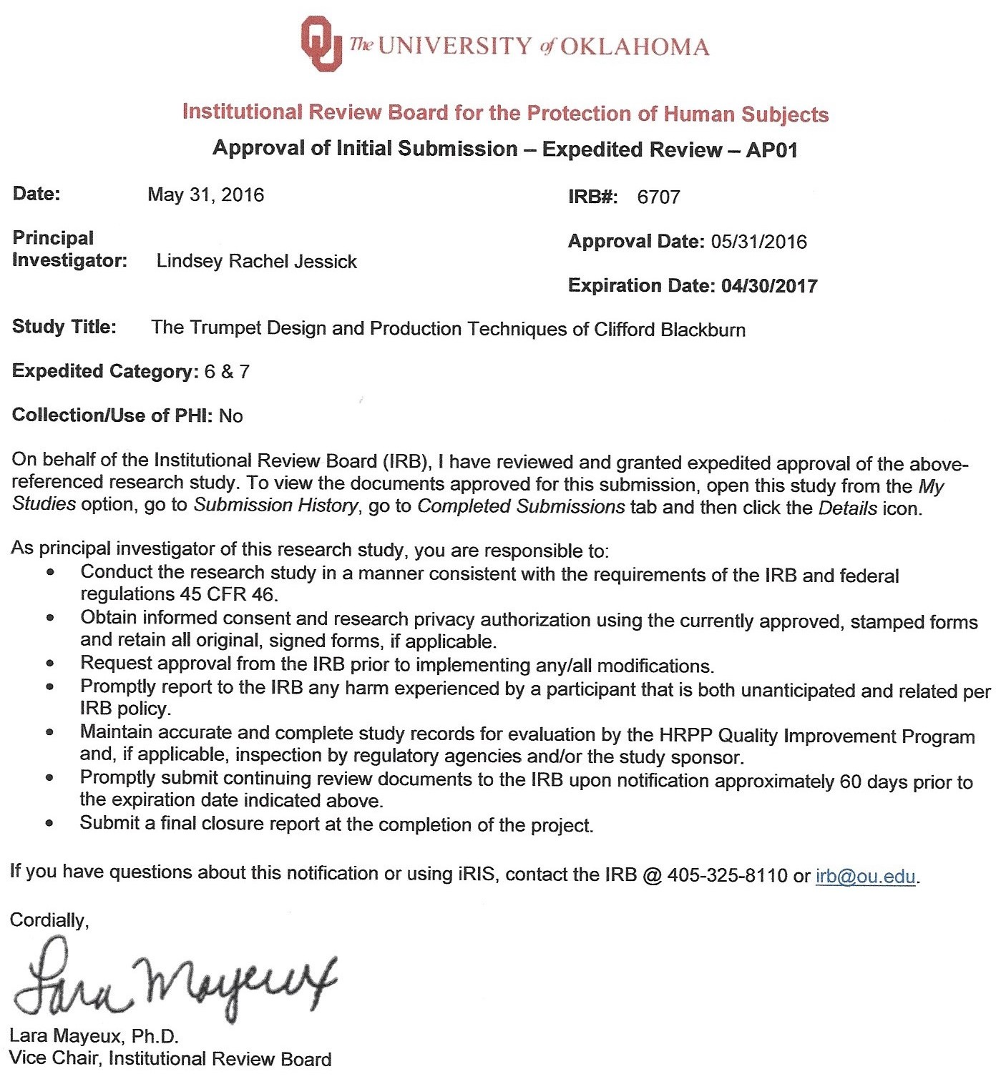

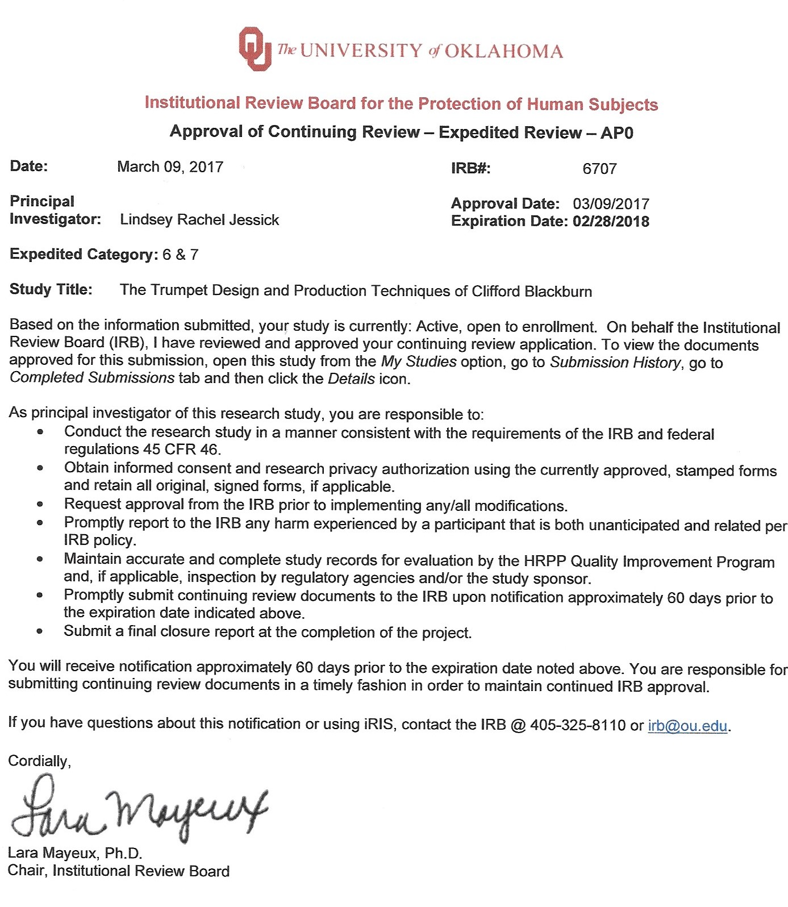
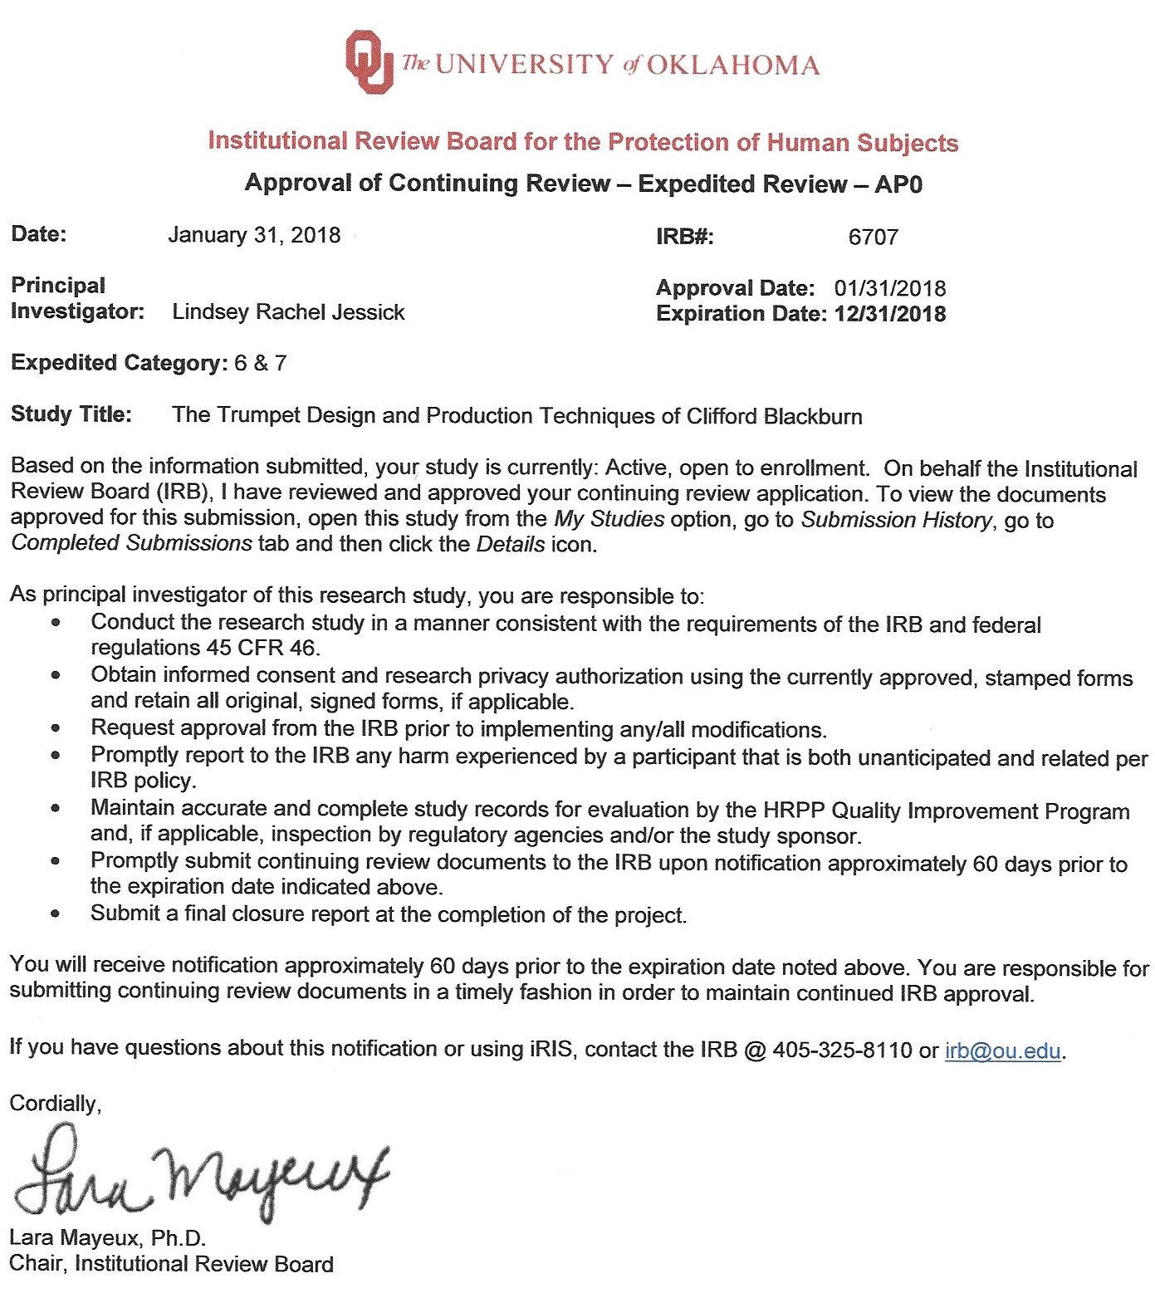

Ben Gold, Nelson Morgan, and Dan Ellis, Speech and Audio Signal Processing: Processing and Perception of Speech and Music, 2nd ed. (Hoboken, N.J.: John Wiley & Sons, Inc., 2011).
Siegmund Levarie and Ernst Levy, Tone: A Study in Musical Acoustics (Kent, Ohio: Kent State University Press, 1968).
Ibid., viii.
Thomas Moore, “Playing Without Buzzing: Fact of Fiction?” ITG Journal 25, no. 4 (June 2001): 51, 13.
Philippe Guillaume, Music and Acoustics: From Instrument to Computer (London: ISTE Ltd., 2006).
Juan G. Roederer, The Physics and Psychophysics of Music: An Introduction, 4th ed. (New York: Springer, 2008).
Ibid., 145.
Edward H. Tarr, The Trumpet, 3rd ed. (Chandler, Ariz.: Hickman Music Editions, 2008).
Arthur H. Benade, Horns, Strings, and Harmony, 2nd ed. (Garden City, NY: Anchor Books, 1992).
Arthur H. Benade, Fundamentals of Musical Acoustics, 2nd ed. (New York: Oxford University Press, 1990).
Arthur H. Benade, “The Physics of Brasses,” Scientific American 229, no. 1 (July 1973): 24-35.
Don Smithers, Klaus Wogram, and John Bowsher, “Playing the Baroque Trumpet,” Scientific American 254, no. 4 (April 1986): 108-117.
Tim Heston, “Welding Musical Instruments to the Perfect Pitch,” Welding Journal 78, no. 6 (June 1999): 43-47.
Stephen Mraz, “What’s the Difference Between Soldering, Brazing, and Welding?," Machine Design, http://www.machinedesign.com/fasteners/whats-difference-between-soldering-brazing-and-welding.
Annealing is the heating and then cooling of a metal to strengthen and make it less brittle.
Mraz, “Soldering, Brazing, and Welding.”
William T. Cardwell, Jr., Cup-mouthpiece wind instruments, US Patent 3,507,181, filed October 25, 1967, and issued April 21, 1970.
R. Dale Olson, “In Memoriam: Bill Cardwell,” ITG Website, http://trumpetguild.org/content/itg-news/111-in-memoriam-bill-cardwell.
Steven Wasser and Clifford Blackburn, Musical instrument piston valve, US Patent 7,667,117, filed April 4, 2005, and issued October 5, 2006.
Olson, “In Memoriam: Bill Cardwell.”
Gary J. Bast, “The Legacy of William T. Cardwell, Jr.,” ITG Journal 41, no. 1 (October 2016): 51-55, 61.
Stomvi USA: Art and Technology, Bill Cardwell: 1917-2012, http://stomvi-usa.com/bill-cardwell/.
W.T. Cardwell, Jr., “Working Theory of Trumpet Air-Column Design,” unpublished manuscript of presentation to 72nd Meeting of the Acoustical Society of America, November 3, 1966.
William T. Cardwell, Jr., “Trumpet Intonation Acoustics,” unpublished manuscript, 1973.
W.T. Cardwell, Jr., “Trumpet Acoustics: Correcting Intonation Faults,” unpublished manuscript of presentation to 92nd Meeting of the Acoustical Society of America, November 19, 1976.
Photo from the Blackburns’ private collection.
Photo from eBay.
From Pickett Brass Website, http://www.pickettblackburn.com/.
Benade, Fundamentals, 405.
Moore, “Playing Without Buzzing: Fact or Fiction?,” 51.
Benade, Fundamentals, 393.
Ibid., 392.
Levarie and Levy, Tone: A Study in Musical Acoustics, 126.
Ibid.
Benade, Horns, Strings, and Harmony, 188.
Cardwell, “Trumpet Intonation Acoustics,” 34.
Bast, “The Legacy of William T. Cardwell, Jr.,” 51.
Ibid., 52.
Ibid.
Stomvi USA, Bill Cardwell 1917-2012.
Photo from Tina Erickson’s private collection.

