UNIVERSITY OF OKLAHOMA
GRADUATE COLLEGE

ILLICIT MASCULINITY: EXAMINING GENDER DIFFERENCES IN ADOLESCENT DRUG USE

A THESIS
SUBMITTED TO THE GRADUATE FACULTY
In partial fulfillment of the requirements for the degree of
Master of Arts

BY

Sally Wiser
Norman, Oklahoma
2022

ILLICIT MASCULINITY: EXAMINING GENDER DIFFERENCES IN ADOLESCENT DRUG USE

A THESIS APPROVED FOR THE DEPARTMENT OF SOCIOLOGY

BY THE COMMITTEE CONSISTING OF

Dr. Meredith Worthen, Chair

Dr. B. Mitchell Peck

Dr. Julie Gerlinger

© Copyright by Sally Wiser 2022
All Rights Reserved.

ACKNOWLEDGEMENTS
To Dr. Meredith Worthen, thank you for mentoring me and assisting me throughout this process. You have been a great supporter of mine, and I am grateful for your kindness, intellect, and emotional support.

To Trevor, for being my rock and support throughout this tumultuous semester. I could not have done this without your support, love, and encouragement.

To my peers and my cohort, for making it this far beside me, encouraging me in moments of stress and despair, and offering friendship and laughter amid a pandemic. Thank you.
Table of Contents

ABSTRACT viii
INTRODUCTION 1
CONCEPTUAL FRAMEWORK 1
Masculinity 2
Measuring Illicit Masculinity 4
Patriarchal Families 4
Patriarchal Norms. 5
Gender Norms and Alcohol Use 6
Gender Norms and Marijuana 7
Gender and Other Illicit Substances 8
Cocaine. 8
Heroin and Opioids. 9
Gender Norms and Other Illicit Substances 9
CURRENT RESEARCH 10
METHODS 11
Data 11
Sample 12
Dependent Variable 12
Independent Variables 13
Controls 14
Analytical Strategy 15
RESULTS 17
Marijuana 17
Cocaine 23
Heroin 28
Narcotics 31
Summary 36
DISCUSSION 36
Marijuana 37
Cocaine 39
Heroin 40
Narcotics 41
Summary of Overall Findings 43
CONCLUSION 44
Future Research 46
Limitations 47
Contributions 49
Implications 50
References 51
APPENDIX 55

ABSTRACT
While previous literature has examined how attitudes towards patriarchal and traditional gender norms influence alcohol and marijuana consumption, little research explores how these norms influence illicit drug use, particularly among juveniles. This research begins to explore that gap in the literature and attempts to open up further paths for examining how family structure and patriarchal norms influence the relationships between gender and crime. Using data from Monitoring the Future (N=115,492), this research examines the relationship between masculinity and the use of various illicit drugs (marijuana, n = 48,589; cocaine, n = 49,029; heroin, n = 49,094; and narcotics, n = 49,094) among U.S. high schoolers as they vary between young men and young women. Findings show statistically significant gender differences in each of the substances included in the study. Family structure has no significant effect on the gender differences in substance use, but agreement with patriarchal norms contributes to a significantly larger gender difference in marijuana, cocaine, and narcotics use when compared to disagreement with patriarchal norms. This research contributes to the literature that has focused on the gender gap in crime and provides insight into how masculinity contributes to gender differences in substance abuse.

Key words: masculinity and crime, gender and crime, substance use, gender gap

Illicit Masculinity: Examining Gender Differences in Adolescent Drug Use

INTRODUCTION
While previous literature has examined how attitudes towards patriarchal and traditional gender norms influence alcohol and marijuana consumption, little research explores how these norms influence illicit drug use, particularly among juveniles. This research begins to explore that gap in the literature and attempts to open up further paths for examining how patriarchal norms influence the relationships between gender and crime. Using data from Monitoring the Future (N=115,492), this research examines the relationship between masculinity and the use of various illicit drugs (marijuana, n = 48,589; cocaine, n = 49,029; heroin, n = 49,094; and narcotics, n = 49,094) among U.S. high schoolers as they vary between young men and young women. While gender and sex are not the same and a binary representation is not ideal, due to the limitations of the Monitoring the Future dataset, gender will be derived from the respondents’ sex and treated as a binary (Westbrook and Saperstein 2015). Based on previous literature, it is expected that stronger adherence to patriarchal norms will increase the likelihood of illicit drug use in young men and decrease the likelihood of illicit drug use in young women. Results from this research contribute to the literature that has focused on the gender gap in crime and provide insight into how masculinity contributes to gender differences in substance abuse.

CONCEPTUAL FRAMEWORK
In this research, I develop and discuss a concept that I refer to as illicit masculinity. Illicit masculinity is the idea that norms that have been traditionally associated with manliness/masculinity (e.g., Brannon’s (1976) typology of "No Sissy Stuff"; "The Big Wheel"; "The Sturdy Oak"; "Give 'Em Hell”) are linked to illicit activities, such as illicit drug use. I argue that adherence to traditional ideas of masculinity increases the likelihood of illicit substance use among men and decreases the likelihood of illicit substance use among women, because masculinity encourages risky behaviors and delinquency. In Western cultures, masculinity is associated with risk taking, aggressiveness, and power (Brannon and David 1976; Kimmel 1994; Norland, Wessel, and Shover 1981). This association encourages men to display their masculinity through risky or delinquent behaviors, while simultaneously setting a societal standard that these types of behaviors are unacceptable for women, as engaging in such behaviors is unfeminine (Connell and Messerschmidt 2005; Kimmel 1994; Norland et al. 1981; Schippers 2007).. As discussed more below, gender differences in substance use are common and present amongst several types of illicit substances (Dahl and Sandberg 2015; Kasperski et al. 2011; Marsh et al. 2018; Palamar et al. 2016; Schneider et al. 2018). Gender norms and masculinity have also been associated with the use of illicit drug use, including marijuana and cocaine, suggesting that men may express their masculinity through the use of illicit substances and that women may refrain from illicit substances due to the association between illicit substances and masculinity (Dahl and Sandberg 2015; Darcy 2018, 2020; Kolar 2021). While previous literature (discussed more below) has begun to explore the connection between masculinity and illicit substances, I offer a term to describe that association: illicit masculinity. Illicit masculinity not only refers to the association between masculinity and illicit activities, but also posits that illicit activities are more acceptable for men than they are for women, thus contributing to the gender differences seen in illicit activities, including illicit substance use.

Masculinity
To provide context for the development of illicit masculinity, I must first review previous conceptualizations and developments of masculinities. Brannon (1976) summarized the definition of manhood into four categories. The first, “No Sissy Stuff!” sets masculinity in direct opposition to femininity – men should never engage in any behaviors deemed feminine or “sissy”, lest they risk being emasculated. The second, “Be a Big Wheel” summarizes the link between masculinity and power (Brannon and David 1976; Kimmel 1994). In this second category, Brannon (1976) argues that masculinity is measured by social status, power, and success, and that men should strive to be more powerful than other men, creating a link between power, competition, and masculinity. The third, “Be a Sturdy Oak,” refers to the idea that men must keep their emotions in check and under control (Brannon and David 1976; Kimmel 1994). Here, Brannon (1976) emphasizes the idea that masculinity can be proven through never showing emotion and that real men do not cry. Finally, Brannon’s (1976) fourth category of manhood, “Give ‘Em Hell”, establishes the relationship between masculinity and aggression, assertiveness, and risk taking by claiming that daring behaviors and aggression are appropriate displays of masculinity.
Beyond Brannon’s (1976) typology and other work that stems largely from it, scholarship on masculinities has expanded previous definitions and conceptualizations of masculinity in a few ways. For example, Connell (1987, 1995) developed the concepts of hegemonic masculinity and nonhegemonic masculinities. Hegemonic masculinity reinforces the gender order that places men in dominant social positions over women in societies, reinforces dominant patriarchal norms, and establishes both masculine and feminine standards (Connell 1987, 1995; Connell and Messerschmidt 2005; Messerschmidt and Messner 2019; Schippers 2007). Expanding on Connell’s (1987, 1995) work on hegemonic and nonhegemonic masculinities, Messerschmidt and Messner (2019) discuss new types of masculinities, including “dominant,” “dominating,” and “positive” forms of masculinity. They also develop the concept of hegemonic masculinity further, linking it to the maintenance of a hierarchal gender order that places men in higher positions of social power than women (Connell and Messerschmidt 2005; Messerschmidt and Messner 2019). They also discuss that masculinities are not limited to those assigned male at birth, but that those who are assigned female at birth also exhibit masculine qualities (Connell and Messerschmidt 2005; Messerschmidt and Messner 2019). Messerschmidt and Messner (2019) end their discussion of masculinities by promoting future research that continues to expand definitions and concepts of masculinities, explaining that more research into masculinities will extend sociological knowledge of gender. This research seeks to continue expanding concepts of masculinity by addressing the relationship between masculinity and illicit substance use and proposing the phrase “illicit masculinity” as a term that can be used to describe this relationship.

Measuring Illicit Masculinity
The current literature examining the relationship between masculinity and substance use (discussed more below) is primarily qualitative. As I take a quantitative approach, I draw on measurements that have been used in previous research to examine gender differences in delinquency in order to formulate possible measure of illicit masculinity.
Patriarchal Families. I first draw from research centered around power-control theory, which posits that gender differences in labor force participation among mothers and fathers translate into gender differences in parental control household (Blackwell 2000; Grasmick et al. 1996; Hadjar et al. 2007). Power-control theory also incorporates gender ideologies into its assumptions, arguing that families who have a father in the workplace and a mother at home (patriarchal families) are more likely to perpetuate traditional gender norms, which power-control theory argues increases the likelihood of having delinquent sons and non-delinquent daughters (Blackwell 2000; Grasmick et al. 1996; Hadjar et al. 2007). This is due to an unequal application of social controls on sons and daughters by the mother – a mother in a patriarchal home, according to power-control theory, may apply more social controls to their daughters than their sons, thus increasing their sons’ likelihood for delinquency, while decreasing their daughters’, thus contributing to the gender gap in delinquency (Blackwell 2000; Hadjar et al. 2007). Power-control theory posits that families in which both the mother and father work (egalitarian families), however, are more likely to apply controls equally to their sons and daughters, decreasing the likelihood of risky behaviors and delinquency equally, regardless of gender. Drawing from this concept of family structure contributing to the gender gap in crime due to the suspected perpetuation of traditional gender norms in patriarchal structures, I include family structure as a proxy measure for illicit masculinity in this study. While power-control theory has its critiques due to its heteronormative approach and lack of inclusion of single-parent families, as no measure for illicit masculinity exists, I nonetheless test the prospect of patriarchal family structure as a proxy for illicit masculinity.
Patriarchal Norms. As this research draws on previous developments of hegemonic masculinity and other masculinities, I also include a measure of patriarchal norms, with the intention of measuring respondents’ attitudes towards the patriarchy, and infer that positive attitudes towards the patriarchy translate to positive attitudes towards a hegemonic gender order (Connell 1995; Connell and Messerschmidt 2005; Schippers 2007). As hegemonic masculinity is rooted in a gender order in which patriarchal norms are perpetuated and reflected, I propose that positive attitudes towards patriarchal norms reflects an agreement with a subsequent concept of illicit masculinity: that illicit activities are more acceptable for men than they are for women. This, then, deters women from engaging in illicit activities and promotes engagement in illicit activities for men as a display of their masculinity (Connell and Messerschmidt 2005; Darcy 2020; Messerschmidt and Messner 2019). While this measure may not be an exact measure of masculinity, I propose its use as a proxy for illicit masculinity and test its prospects as an acceptable measure in this research.
LITERATURE REVIEW

Gender Norms and Alcohol Use
In the last few decades, criminologists have examined gender norms to better understand gender differences in alcohol consumption with mixed findings (Christie-Mizell and Peralta 2009; Huselid and Cooper 1992; Whaley, Hayes-Smith, and Hayes-Smith 2013; Wilkinson et al. 2018). For example, Christie-Mizzel and Peralta (2009) use a sample from the National Longitudinal Survey of Youth (N=1,488) to examine how gender role attitudes and various adult roles (employment, marriage, and parenthood) relate to gender differences in alcohol consumption. Results suggests that positive attitudes towards patriarchal gender norms relate to less frequent drinking for both young men and women as they transition to adulthood. However, another study using data from the Michigan Alcohol and Other Drugs school-based survey (N=78,103) offers support for the claim that boys and girls are affected by gender norms in different ways. Using a combination of social control, social learning, and feminist pathways approaches, Whaley, Hayes-Smith, and Hayes-Smith (2013) argue that examining gender differences in substance use via a gendered pathways approach highlights the extent to which gender influences life experiences that may lead youth to drink alcohol. Results reveal that boys are more likely to abuse alcohol than girls, though the authors claim that more research is needed to better understand this relationship (Whaley et al. 2013). Such findings suggest that patriarchal norms may be related to gender differences in alcohol use, yet it is unclear how such results may inform research that focuses on illicit drug use (other than adolescent alcohol use). Below, these patterns are further examined as they relate to gender norms and the use of marijuana, cocaine, heroin, and narcotics (opioids).

Gender Norms and Marijuana
When it comes to gender differences in the use of marijuana, research suggests that marijuana use is associated with masculinity, even though most data do not find a significant relationship between gender and marijuana usage (Dahl and Sandberg 2015; Haines et al. 2009). This suggests that, while both men and women use marijuana, the cultural norms surrounding the use of this drug are centered around masculine ideals. Taking an exploratory, qualitative approach to gender norms and gender differences in marijuana usage, Kolar (2021) finds several gender-related stigmas surrounding the use of cannabis, including ideas such as "it's worse if a girl [smokes]" and “[smoking marijuana] is generally a ‘man’ thing.” Her research suggests that the recent increase in women's use of marijuana can be attributed to both the increased availability of marijuana (as it has become legal in more areas) as well as its (related) increasing social acceptability. Kolar (2021) discusses that, prior to being decriminalized, smoking marijuana was seen as a more masculine activity due to the criminal risks surrounding its use. As society tends to see women committing crimes as doubly deviant and less acceptable than men committing crimes, women smoking marijuana has been frowned upon more so than men smoking marijuana; however, with the illicitness of marijuana decreasing through its continued legalization and regulation, the societal view that women using marijuana is less acceptable has been waning as well. Overall, Kolar’s (2021) research suggests that the negative stigmas around marijuana usage may be waning and that further research into the relationship between gender norms and gender differences in the use of marijuana is needed.

Gender and Other Illicit Substances
While gender norms have been discussed in relation to alcohol and marijuana use, much less is known about patterns associated with gender norms and the use of other illicit substances. In fact, much research focuses on identifying gender differences in illicit substance use without providing much discussion as to why these differences exist. These studies are reviewed below and provide support for the importance of examining how gender norms relate to illicit substance use.
Cocaine. A study conducted in 2010 using longitudinal data from years 2003-2006 of the College Life Study to examine trends in cocaine use among college students (N=1,253) finds that men have significantly more opportunities to use cocaine compared to women, as men in the sample were offered cocaine at a higher rate than women; however, their research shows that women in the sample used cocaine more frequently than men and were more likely to become dependent on it (Kasperski et al. 2011). In another study looking at cocaine use among high school seniors in the United States, Schneider et al. (2018) use data from the National Youth Risk Behavior Surveys (YRBS) to examine trends in cocaine use from 1999 to 2015. Results show that while cocaine use was not as common in 2015 as it was in the 1990s, rates of adolescent cocaine use have significantly increased recently, with 2.5 percent of high school seniors having used cocaine in 2009 compared with 5.2 percent having used cocaine in 2015. The gender differences in cocaine use have also increased from the early 2000s. In 2003, the gender difference in cocaine use was 1.05 percent, and in 2015 the difference was 2.55 percent; the largest gender difference recorded in the fifteen years of data used in the study, with men having higher rates of cocaine use than women (Schneider et al. 2018). Thus, gender differences in the rates of cocaine use are evident across multiple studies.
Heroin and Opioids. Examining gender differences in trends of heroin use and opioid abuse, Marsh et al. (2018) use data from the National Survey on Drug Use and Health (NSDUH) to examine trends in the current opioid epidemic in the United States, along with trends in heroin use from 2007 to 2014 (N=447,188). Results indicate a steady increase in heroin use and a steady decline in the nonmedical use of opioids for both men and women, but with differential rates of change. Women’s use of heroin has been increasing at a faster rate than men, and women’s use of opioids is decreasing as a slower rate than men (Marsh et al. 2018). In another study examining heroin and opioid use among American high school seniors, Palamar et al. (2016) use years 2009 through 2013 of Monitoring the Future (N=67,822) to look at the association between heroin and opioid use through several sociodemographic correlates, including gender. Results from this study show that 12.4 percent of high school seniors report using nonmedical opioids at least once in their life, while 1.2 percent reported lifetime heroin use. Results also suggest that young women are less likely to report the use of both opioids and heroin compared to young men (Palamar et al. 2016). Together these studies demonstrate that there are gender differences in the use of heroin and opioids.

Gender Norms and Other Illicit Substances
Though the bulk of the existing literature has focused on establishing gender differences in rates of illicit substance use, some sociologists have begun to explore the reasoning behind such differences, suggesting that gender norms and expectations may play a role in the gender gap that is present in illicit drug use (Darcy 2018, 2020; Keane 2017). For example, a qualitative study consisting of twenty in-depth interviews with current male recreational drug users links masculinity to illicit drug use, suggesting that the use of illicit drugs is a highly gendered activity (Darcy 2018, 2020). The findings from this research suggest that using illicit drugs can send a symbolic message about the drug user’s masculinity and that men’s drug habits intersect with their perceptions of their own masculinity. While the research notes that drug use is a highly complex matter, Darcy (2018, 2020) begins to expand on the gendered contexts involved in illicit drug use. The current study extends upon this important work.

CURRENT RESEARCH
This research examines the relationship between patriarchal norms and gender differences in the use of four types of drugs (marijuana, cocaine, heroin, and narcotics) and seeks to investigate the question: How do family structure and beliefs in patriarchal norms relate to gender differences in the use of illicit drugs? Specifically, I explore patriarchy and masculinity as they relate to drug use among adolescents and propose the idea of illicit masculinity; that is, that illicit activities such as crime and drug use are linked to ideas of patriarchy and masculinity. As discussed above, masculinity has already been linked to the use of illicit drugs, though there is room for further expansion and development of this connection. I posit that positive attitudes towards patriarchal norms in adolescent boys are associated with their likelihood of using illicit drugs while positive attitudes towards patriarchal norms in adolescent girls have a simultaneous converse effect. Young men who hold negative views towards patriarchal norms will have a lower likelihood of using illicit drugs, while young women who hold negative views towards such norms will have higher likelihoods of using illicit drugs. Overall, I argue that illicit masculinity, measured through patriarchal family structure and the belief of patriarchal norms, contributes to a significant gender gap in adolescent drug use. Using logistic regression models to examine the effects of gender and patriarchal norms on the use of various drugs, I propose and test the following hypotheses:
Hypothesis 1a: Gender is significantly related to the use of cocaine, narcotics, and heroin, in that young men are more likely to use these drugs than young women.
Hypothesis 1b: Gender is not significantly related to the use of marijuana.
Hypothesis 2: Patriarchal family structures will contribute to a larger gender difference in each illicit substance use when compared to egalitarian family structures.
Hypothesis 3: Agreement with patriarchal norms will result in a larger gender difference in each illicit substance use when compared to disagreement with patriarchal norms.

METHODS

Data
In this study, I use data from the Monitoring the Future (MTF) dataset from 1976 to 2019. The survey explores changes in values, behaviors, and lifestyles of American youth and contains a nationally representative sample of 8th-, 10th-, and 12th -graders across the United States. This dataset includes both public and restricted-use data and consists of six questionnaires covering various subjects assigned randomly to participants. For this research, I focus on the publicly available data from questionnaire three for 12th-grade participants. This questionnaire contains various questions regarding the participants’ drug use, family life, and cultural beliefs about gender. As my research question focuses on illicit drug use and a belief in patriarchal norms, these data provide an insight into the experiences and beliefs of those about to leave high school and begin their adult lives.

Sample
Using listwise deletion, I form my sample from respondents who report their gender, family structure, and attitudes towards patriarchal norms. To examine each illicit substance independently, I create four subgroups. The first subgroup is formed from youth who report whether or not they have used marijuana in their lifetime and is composed of 48,589 observations. The second subgroup includes respondents who report whether or not they have used any form of cocaine in their lifetime and is composed of 49,029 observations. The third subgroup includes respondents who have reported whether or not they have used heroin at least once in their lifetime and is composed of 49,103 respondents, while the fourth subgroup is composed of youth who report whether or not they have illegally used narcotics at least once in their lifetime and is composed of 49,094 observations.

Dependent Variable
Substance Use
The MTF survey collects data on participants’ use of several illicit substances in their lifetime by asking the question “On how many occasions (if any) have you [used x substance] in your lifetime?” substituting in different substances and appropriate descriptions of the substance for each question. Responses to these questions range from “0 Occasions” to “40 or More Occasions.” My analysis contains four separate measures of substance use: marijuana, cocaine, heroin, and narcotics. Each measure serves as a dependent variable in its corresponding subgroup. Alcohol consumption is not included in this study. For each drug examined in the study (marijuana, cocaine, heroin, and narcotics) I recode responses to the question into a dichotomous indicator variable, with a value of 1 representing participants who report having used the corresponding substance and a value of 0 representing those who report having never used the aforementioned substance.

Independent Variables
Gender
To capture gender difference, I create an indicator for young men (coded as 1) and young women (coded as 0). Gender in this context is formed from a question asking about the respondent’s sex and is treated as a binary. While a binary representation of gender is not ideal, due to the limitations of this survey, it is treated as such and is interpreted as “men” and “women.”
Patriarchal Families
The patriarchal family measure is composed of two questions from the MTF survey. The first question asks respondents “Which of the following people live in the same household with you?” and provides the options: Father (or stepfather), mother (or stepmother), and brothers (or stepbrother) and sisters (or stepsisters). Due to the public use format of these data, the MTF creators deleted observations that fell into other alternatives, such as living with grandparents, other relatives, or living alone. The responses from this question are recoded into a categorical variable measuring family structures, with categories for single-father homes and single mother homes, with dual parent homes serving as a reference category. The MTF survey also asks the respondent about their mother’s work status by asking: “Did your mother have a paid job (half-time or more) during the time you were growing up?” Responses to this question are recoded into an indicator variable, with those whose mothers worked during their childhood coded as 1 and those whose mothers did not work during their childhood coded as 0. This variable is then grouped with the family structure variable and recoded so that respondents from dual-parent homes in which the mother does not work are assigned a value of 1, representing a patriarchal family structure, while respondents who come from dual-parent homes (a mother and a father, in this case) whose mother also worked during their childhood are coded as 0, representing egalitarian family structures. For the purposes of this research, those respondents coming from single-parent homes were dropped (see Blackwell 2000).
Attitudes Toward Patriarchal Norms
The MTF survey measures the participants’ level of agreement with several cultural beliefs, including those pertaining to gender ideals and norms. To create my attitudes toward patriarchal norms variable, I recode the five-point Likert scale from participants’ level of agreement with the following statement: “It is usually better for everyone involved if the man is the achiever outside the home and the woman takes care of the home and family,” with those who agree (strongly or in general) coded as 1, compared to those who disagree (strongly or in general), coded as 0. Those who indicated “neither” were dropped from the sample.

Controls
Parents’ Education
Serving as a proxy for the respondents’ socioeconomic status, the control measures for each parent’s education (mothers’ and fathers’) are two separate categorical variables. Each variable is coded into five categories: “Less Than High School,” “High School,” “Some College,” “College,” and “Graduate/Professional Degree,” with less than high school serving as the reference category for each.
Race
I control for race using an adapted version of the MTF’s race variable. Prior to 2005, the MTF creators removed any respondents from the public use data who identified as anything other than non-Hispanic white or non-Hispanic Black. In 2005, the MTF creators changed the coding of the publicly available dataset to include Hispanic respondents. In order to accurately examine trends across several decades, I create a race variable that only includes White and Black respondents, excluding Hispanic respondents from the model.
Time
I control for time by year, using the year in which the survey was administered.

Analytical Strategy
As I have four subgroups with four separate dependent variables, I perform each of my models described below four times, once for each subgroup. For the analyses focusing on marijuana, cocaine, and narcotics, I use logistic regression models. Table 1 displays the descriptive statistics for each subgroup. Preliminary data analysis revealed that about 1 percent of the sample report using heroin. Since this is a rare outcome in these data, I performed both a rare outcomes logistic model and a standard logistic regression. Differences between the models were minimal and non-substantive. The analyses display the standard logistic regression model, and the rare outcomes model is included in the appendix. Model 1 is a regression of substance use on gender, controlling for family structure, attitudes towards patriarchal norms, parent education, race, and time. Model 2 introduces an interaction between gender and patriarchal family structure, and Model 3 includes an interaction between gender and attitudes towards patriarchal norms.

Table 1. Descriptive Statistics
 | Marijuana |  | Cocaine |  | Heroine |  | Narcotics
 | Mean (%) | Std. Dev | Mean (%) | Std. Dev | Mean (%) | Std. Dev | Mean (%) | Std. Dev
Main Variables
Substance Use | 47.41 | .50 | 8.83 | .28 | 0.93 | .09 | 9.17 | .29
Gender (Young Men) | 45.84 | .50 | 45.88 | .50 | 45.87 | .50 | 45.89 | .50
Patriarchal Family | 24.78 | .43 | 24.76 | .43 | 24.77 | .43 | 24.77 | .43
Agree with Patriarchal Norms | 40.45 | .49 | 40.84 | .49 | 40.84 | .49 | 40.84 | .49
Controls
Mother’s Education
Less than High school | 9.31 | .29 | 9.38 | .29 | 9.40 | .29 | 9.40 | .29
High school | 34.71 | .48 | 34.75 | .48 | 34.77 | .48 | 34.75 | .47
Some College | 19.79 | .40 | 19.77 | .40 | 19.76 | .40 | 19.77 | .39
College | 54.55 | .43 | 24.50 | .43 | 24.48 | .43 | 24.46 | .43
Graduate Degree | 11.63 | .32 | 11.60 | .32 | 11.58 | .32 | 11.61 | .32
Father’s Education
Less than High school | 12.95 | .34 | 13.02 | .34 | 13.05 | .34 | 13.05 | .34
High school | 28.54 | .45 | 28.63 | .45 | 28.61 | .45 | 28.61 | .45
Some College | 17.86 | .38 | 17.83 | .38 | 17.85 | .38 | 17.85 | .38
College | 24.31 | .43 | 24.23 | .43 | 24.24 | .43 | 24.23 | .42
Graduate Degree | 16.33 | .37 | 16.28 | .47 | 16.25 | .37 | 16.26 | .37
Race (Black) | 8.92 | .28 | 9.05 | .27 | 9.06 | .29 | 9.07 | .28
Observations: | 48,589 |  | 49,029 |  | 49,103 |  | 49,094

Due to the number of interactions performed with categorical variables in these analyses, it is important to note that I will not be relying on coefficients alone in my interpretations. I also examine differences in predicted probabilities, referred to as first-order differences, for the Model 2 and Model 3 interactions in order to determine significant gender differences in illicit substance use (Long and Mustillo 2021). I also compare the gender differences across the family structure and attitudes toward patriarchal norms variables using linear combination tests to determine if the change in gender differences between categories is significantly variant. In other words, I examine both the first-order differences and the differences of differences in predicted probabilities (or: the difference between two first-order differences), which are referred to as second-order differences. By examining the differences in the predicted probabilities, I can determine if observed probabilities are significantly different across the gender, family, and patriarchal norm variables represented in these data, and also whether the differences between those differences are significant. For example, after testing the second-order gender differences between respondents with positive attitudes toward patriarchal norms and respondents with negative attitudes toward patriarchal norms, I find that the gender difference in predicted cocaine use among youth who disagree with patriarchal norms is significantly smaller than the gender difference in predicted cocaine use among youth who agree with such norms.

RESULTS
The results are organized by type of substance analyzed. I first explain the findings regarding marijuana use, followed by cocaine, heroin, and narcotics. In each section below, I discuss whether the findings support each hypothesis described above.

Marijuana
Table 2 below displays the results for all three models in the marijuana subgroup, presented in log odds. Looking at Model 1, I find that young men have 0.29 higher log-odds of using marijuana when compared to young women, holding other factors constant. In simpler terms, young men have a 51.2 percent predicted probability of trying marijuana, while young women have a 44.2 percent predicted probability. This difference in predicted probabilities is displayed in Figure 1. These results do not support Hypothesis 1b, which posits that there is no significant gender difference in predicted marijuana use. Instead, there is a significant a positive relationship between gender and marijuana use that suggests that young men are significantly more likely to try marijuana than young women.

Table 2. Ordinal Logistic Regression of Lifetime Marijuana use on Independent Variables
 | Model 1 |  | Model 2 |  | Model 3
 | β | SE | β | SE | β | SE
Main Effects
Men | 0.29*** | (.02) | 0.29*** | (.02) | 0.19*** | (.03)
Patriarchal Family | -0.16*** | (.02) | -0.15*** | (.03) | -0.16*** | (.02)
Patriarchal Norms | -0.05** | (.02) | -0.05** | (.02) | -0.18* | (.03)
Interactions
Men x Patriarchal Family |  |  | -0.01 | (.04)
Men x Patriarchal Norms |  |  |  |  | 0.24*** | (.04)
Controls
Mother’s Education
High School | -0.08* | (.04) | -0.07* | (.04) | -0.08* | (.04)
Some College | -0.11** | (.04) | -0.11** | (.04) | -0.11** | (.04)
College | -0.13** | (.04) | -0.13** | (.04) | -0.13** | (.04)
Graduate/Prof degree | -0.13** | (.05) | -0.13** | (.05) | -0.13** | (.05)
Father’s Education
High School | -0.11*** | (.03) | -0.11*** | (.03) | -0.12*** | (.03)
Some College | -0.17*** | (.04) | -0.17*** | (.04) | -0.17*** | (.04)
College | -0.17*** | (.04) | -0.17*** | (.04) | -0.17*** | (.04)
Graduate/Prof degree | -0.15*** | (.04) | -0.15*** | (.04) | -0.15*** | (.04)
Race (Black) | -0.41*** | (.03) | -0.41*** | (.03) | -0.40*** | (.03)
Years | -0.01*** | (.00) | -0.01*** | (.00) | -0.01*** | (.00)
Observations | 48,589
AIC | 66423.37 |  | 66425.30 |  | 66388.48
BIC | 66546.45 |  | 66557.16 |  | 66520.35
Standard errors in parentheses
Source: Monitoring the Future (1976-2019)
* p < 0.05, ** p < 0.01, *** p < 0.001

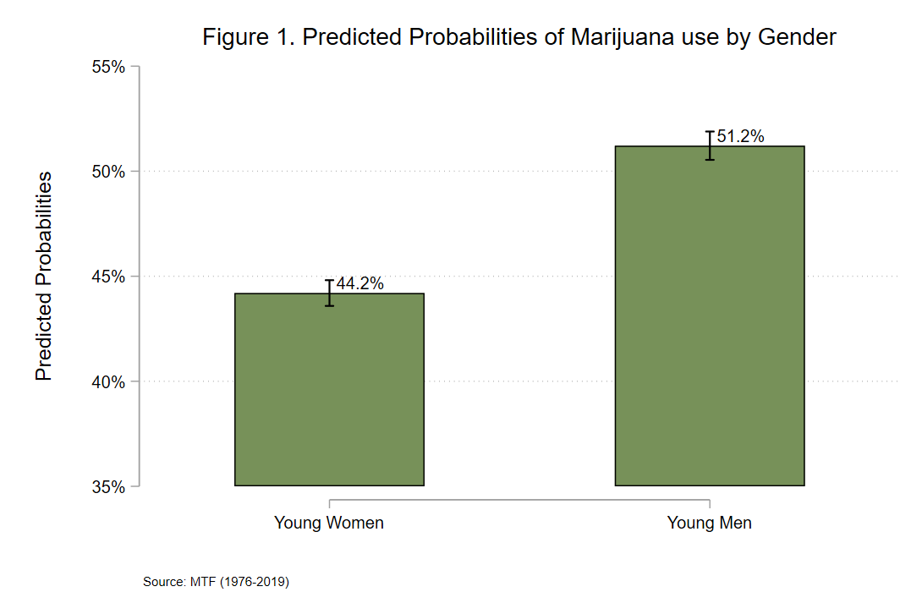
Model 1 in Table 2 also reveals that having a patriarchal family structure and having positive attitudes towards patriarchal norms have strong, negative relationships with the probability of using marijuana. Specifically, youth from patriarchal families have 0.16 lower log odds of trying marijuana than youth from egalitarian homes. Youth with positive attitudes towards patriarchal norms have 0.05 lower log odds of trying marijuana compared to youth with negative attitudes toward patriarchal norms. Put more simply, youth from patriarchal families have a 44.5 percent predicted probability of trying marijuana while youth from egalitarian homes have a 48.4 percent predicted probability. Youth with positive attitudes toward patriarchal norms have a 46.7 percent predicted probability of trying marijuana and youth with negative attitudes towards such norms have a 47.9 percent predicted probability.
Model 2 in Table 2 displays the results of the interaction between gender and family structure, presented in log odds. Here we see that young men from patriarchal families have 0.01 lower log odds of trying marijuana when compared to young men from egalitarian homes. While this does not appear to be statistically significant, I turn to the predicted probabilities displayed in Figure 2 to examine this relationship further. In Figure 2, we see that young men from egalitarian families have a 52.2 percent predicted probability of trying marijuana, while young men from patriarchal families have a 48.2 percent predicted probability. Testing this 4 percent first-order difference in predicted probabilities using a linear combination test reveals that this first-order difference in predicted probabilities is statistically significant. For young women, those from egalitarian families have a 45.1 percent predicted probability of trying marijuana and those from patriarchal families have a 41.5 percent predicted probability. This 3.6 percent first-order difference between predicted probabilities is also statistically significant. From Figure 2, we see that coming from an egalitarian family increases the predicted probabilities of marijuana use for both young men and young women.
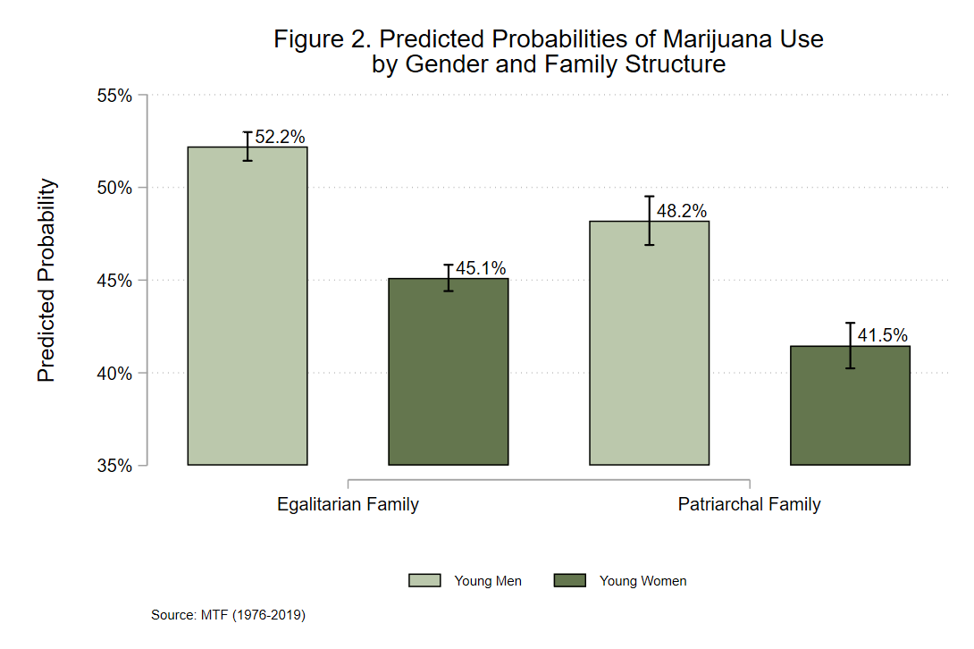
I now turn to the second-order differences to determine if Hypothesis 2 is supported by these findings. Looking first at the first-order gender difference among youth from egalitarian families, I find that there is a first-order gender difference in predicted marijuana use of 7.1 percent. For youth from patriarchal families, there is a first-order gender difference of 6.7 percent. The difference between these two gender differences (the second-order difference) is 0.4 percent and is non-statistically significant. Thus, this finding does not support Hypothesis 2, as the gender differences among youth from patriarchal families are not significantly larger than the gender difference among youth from egalitarian families.
Model 3 in Table 2 displays the results of the interaction between gender and attitudes towards patriarchal norms. Here we see that men who agree with patriarchal norms have 0.24 higher log odds of trying marijuana when compared to men who disagree with patriarchal norms. Turning to Figure 3, we see these results presented in predicted probabilities, along with the results for young women. Here we see that young men who agree with patriarchal norms have a 51.6 percent predicted probability of trying marijuana, while young men who disagree with such norms have a predicted probability of 50.1 percent, resulting in a significant difference of 1.5 percent. Young women also see a significant difference in predicted probabilities, though the direction is opposite from what is seen for young men. While the predicted probabilities increase for young men when they agree with patriarchal norms, the predicted probabilities for young women significantly decrease when they agree with patriarchal norms. Looking at the first-order difference in predicted probabilities for those who agree with patriarchal norms, there is a large, significant gap of 10.4 percent. For those who disagree with patriarchal norms, there is also a significant first-order difference of 4.6 percent. Furthermore, this 5.8 percent second-order difference in the gender differences seen among those who agree and disagree with patriarchal norms is statistically significant. This finding supports Hypothesis 3, which posits that agreement with patriarchal norms will result in a larger gender gap when compared to those who disagree with such norms. In other words, the gender difference amongst young men and women who agree with patriarchal norms is significantly larger when compared to the gender difference seen amongst young men and women who disagree with patriarchal norms.
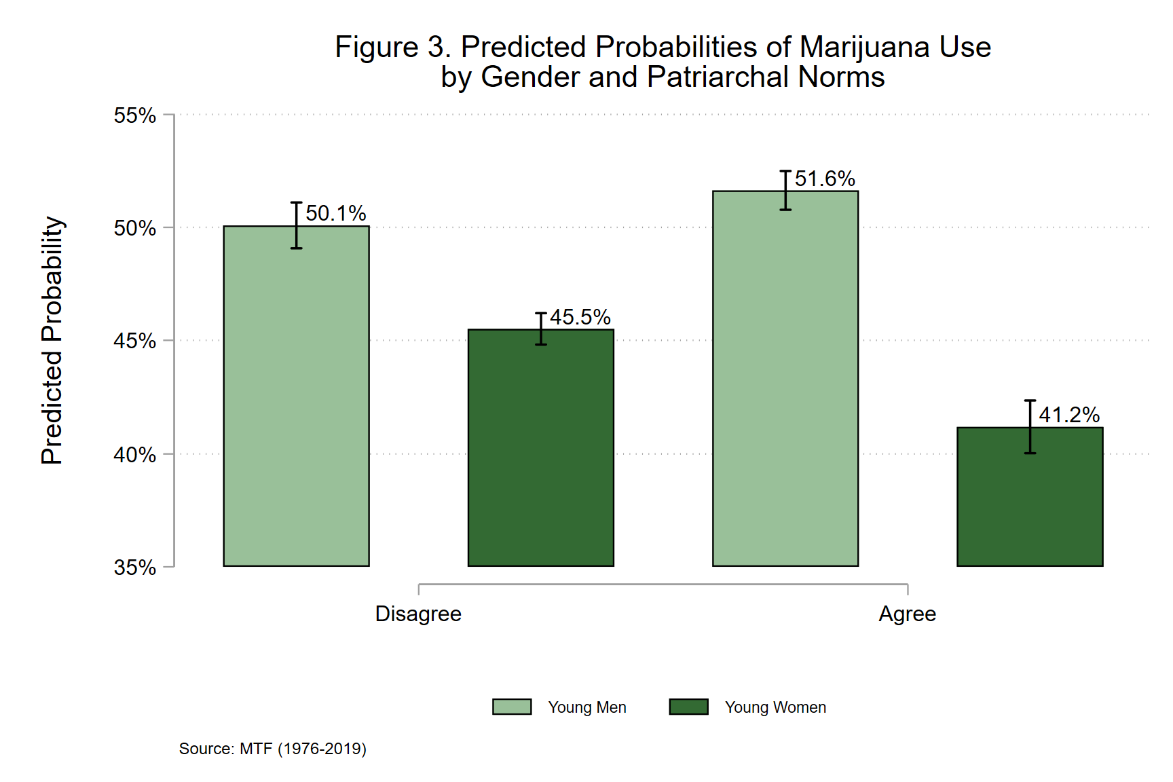

Cocaine
Table 3 displays the results of all three models for the subgroup containing observations focused on cocaine use, presented in log odds. Looking at Model 1, we see that there is a strong, positive relationship between gender and trying cocaine, in that young men have 0.38 higher log odds of trying cocaine when compared to young women. This relationship is also displayed in Figure 4 below, presented in predicted probabilities. From Figure 4, we see that young men have a 10.5 percent predicted probability of trying cocaine, while young women have a 7.4 percent predicted probability, holding other factors constant. This supports Hypothesis 1a, which asserts that young men will be significantly more likely to try cocaine than young women. Model 1 in Table 3 also reveals that youth from patriarchal families have significantly lower log odds of using cocaine, with youth from patriarchal families having an 8.1 percent predicted probability of using cocaine and youth from egalitarian families having a 9.1 percent predicted probability.
Table 3. Ordinal Logistic Regression of Lifetime Cocaine use on Independent Variables
 | Model 1 |  | Model 2 |  | Model 3
 | β | SE | β | SE | β | SE
Main Effects
Men | 0.38*** | (.03) | 0.36*** | (.04) | 0.29*** | (.04)
Patriarchal Family | -0.14*** | (.04) | -0.19*** | (.06) | -0.14*** | (.04)
Patriarchal Norms | 0.00 | (.03) | 0.00 | (.03) | -0.13* | (.05)
Interactions
Men x Patriarchal Family |  |  | 0.09 | (.07)
Men x Patriarchal Norms |  |  |  |  | 0.23*** | (.07)
Controls
Mother’s Education
High School | -0.08 | (.06) | -0.08 | (.06) | -0.08 | (.06)
Some College | 0.03 | (.07) | 0.03 | (.07) | 0.03 | (.07)
College | -0.11 | (.07) | -0.11 | (.07) | -0.11 | (.07)
Graduate/Prof degree | -0.16* | (.08) | -0.16* | (.08) | -0.16* | (.08)
Father’s Education
High School | -0.11* | (.05) | -0.11* | (.05) | -0.12* | (.05)
Some College | -0.12 | (.06) | -0.12 | (.06) | -0.12 | (.06)
College | -0.12 | (.06) | -0.12 | (.06) | -0.12* | (.06)
Graduate/Prof degree | -0.08 | (.07) | -0.08 | (.07) | -0.08 | (.07)
Race (Black) | -0.87*** | (.08) | -0.87*** | (.08) | -0.87*** | (.08)
Years | -0.03*** | (.00) | -0.03*** | (.00) | -0.03*** | (.00)
Observations | 49,029
AIC | 28395.12 |  | 28395.51 |  | 28386.09
BIC | 28518.32 |  | 28527.51 |  | 28518.09
Standard errors in parentheses
Source: Monitoring the Future (1976-2019)
* p < 0.05, ** p < 0.01, *** p < 0.001

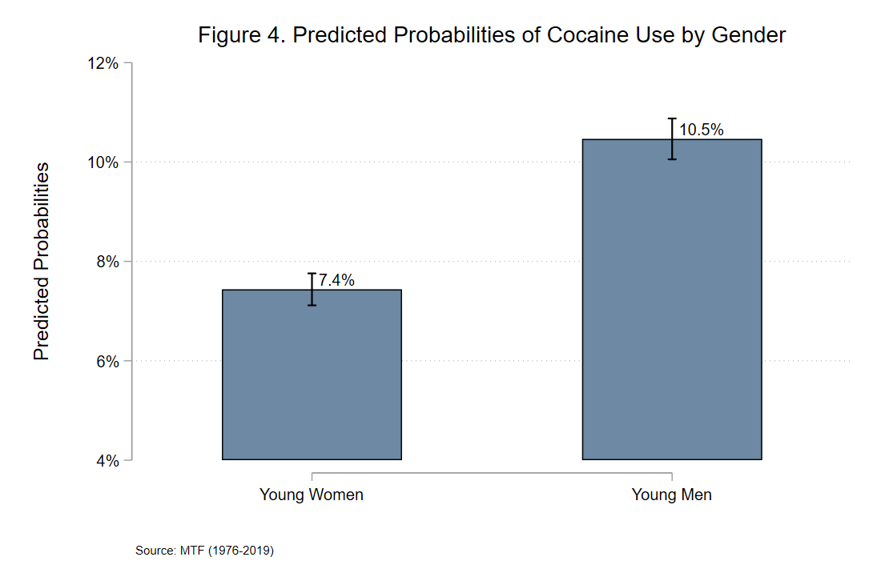 Model 2 in Table 3 displays the results for the interaction between gender and family structure. Results reveal that young men from patriarchal homes have 0.09 higher log odds of trying cocaine when compared to young men from egalitarian homes, though we turn to the predicted probabilities displayed in Figure 5 for further analysis. Looking at Figure 5, I find that there is a slight but non-statistically significant difference in the predicted probabilities for young men in patriarchal homes compared to young men in egalitarian homes. The 1.3 percent difference in predicted probabilities for women, however, is statistically significant.
Observing gender differences in youth from patriarchal families, there is a first-order difference in predicted probabilities of 3.3 percent. The gender difference in predicted probabilities for youth from egalitarian families is slightly smaller at 2.9 percent, though the difference between each gender difference (the second-order difference of 0.4 percent) is not statistically significant. These findings do not support Hypothesis 2. While each gender difference represented in Figure 5 is statistically significant, they are not significantly different from each other. Patriarchal family structures in these data do not contribute to a larger gender gap in cocaine use when compared to egalitarian families.
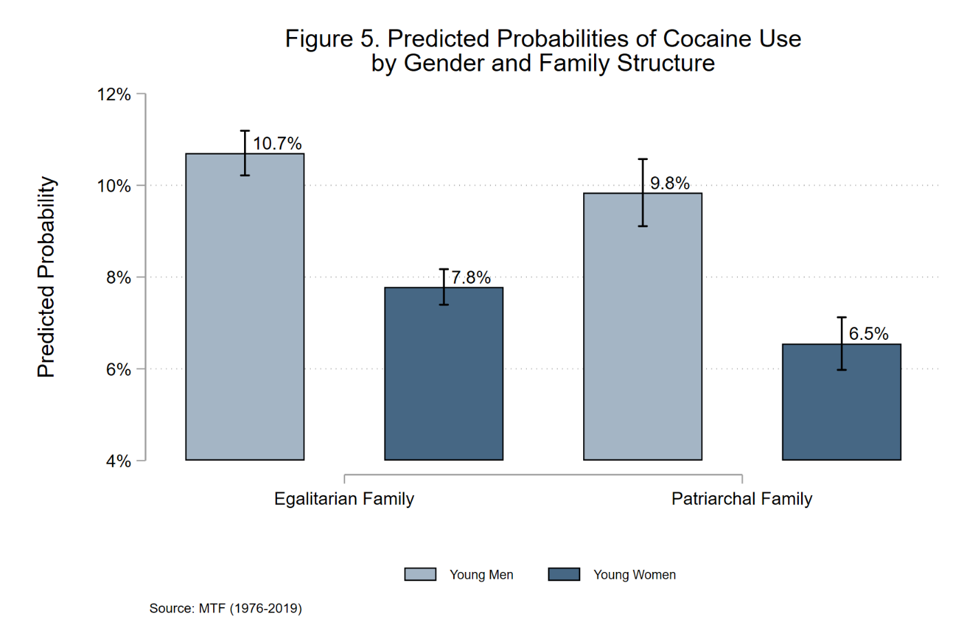
Model 3 in Table 3 displays the results for the interaction between gender and attitudes towards patriarchal norms. Here we see that young men who agree with patriarchal norms have 0.23 higher log odds of trying cocaine than young men who disagree with patriarchal norms. Turning to Figure 6, we see that young men who agree with patriarchal norms have a 10.8 percent predicted probability of trying cocaine, while young men who disagree with such norms have a 9.9 percent predicted probability. While small, this 0.9 percent difference is statistically significant. Young women too, have a significant difference in predicted probabilities, though in the reverse direction. While the predicted probabilities increase for young men when they agree with patriarchal norms compared to young men who disagree, the predicted probability of using cocaine for young women who agree with patriarchal norms is significantly less than the predicted probability for young women who disagree with such norms.
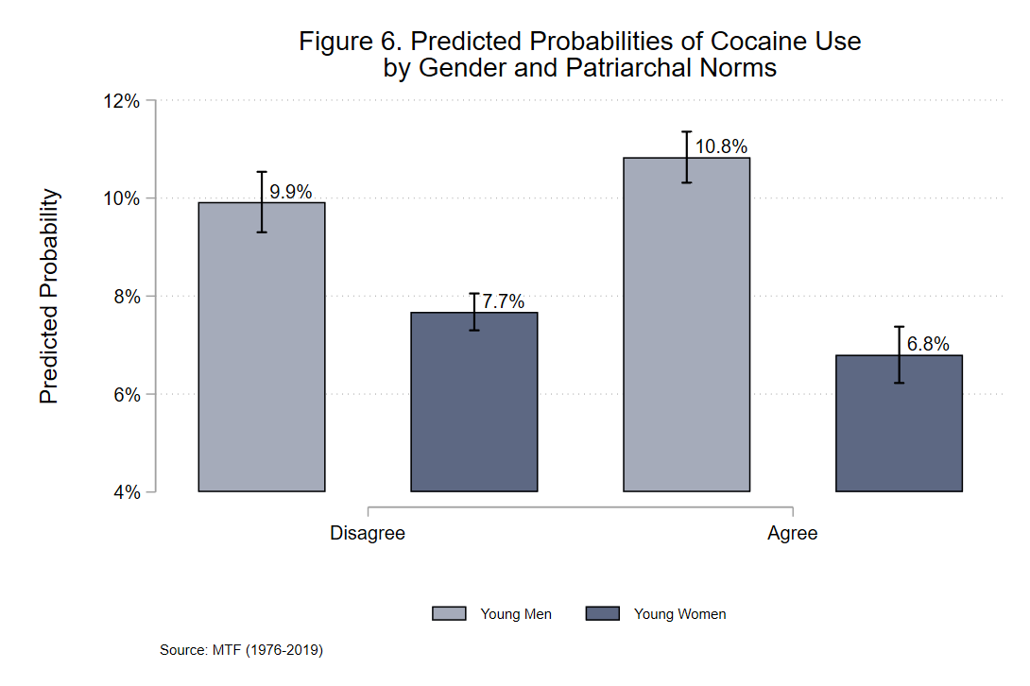
Furthermore, amongst young men and women who agree with patriarchal norms, there is a 4 percent first-order gender difference of predicted probabilities for using cocaine. For youth who disagree with patriarchal norms, there is a 2.2 percent difference. The second-order difference between these two gender differences is also statistically significant, meaning that while there is still a significant gender difference in predicted cocaine use for youth who disagree with patriarchal norms, it is significantly smaller than the gender difference seen amongst youth who agree with such norms. These findings support Hypothesis 3, which posits that agreeing with patriarchal norms contributes to a larger gender difference in predicted cocaine use when compared to disagreement with patriarchal norms.

Heroin
Table 4 displays the results for all three models performed on the subgroup focusing on heroin use. Here, we see that young men have 0.49 higher log odds of using heroin compared to women. This relationship is depicted in Figure 7, displayed in predicted probabilities. From Figure 7, we see that young men have a 1.2 percent predicted probability of using heroin, while young women have a 0.7 percent predicted probability. This 0.5 percent difference, while small, is statistically significant.
Table 4. Ordinal Logistic Regression of Lifetime Heroin use on Independent Variables
 | Model 1 |  | Model 2 |  | Model 3
 | β | SE | β | SE | β | SE
Main Effects
Men | 0.49*** | (.10) | 0.59*** | (.12) | 0.50*** | (.13)
Patriarchal Family | -0.09 | (.11) | 0.14 | (.16) | -0.09 | (.11)
Patriarchal Norms | -0.07 | (.10) | -0.07 | (.10) | -0.06 | (.16)
Interactions
Men x Patriarchal Family |  |  | -0.42 | (.22)
Men x Patriarchal Norms |  |  |  |  | 0.02 | (.21)
Controls
Mother’s Education
High School | -0.51** | (.16) | -0.51** | (.16) | -0.51** | (.16)
Some College | -0.37* | (.18) | -0.37* | (.18) | -0.37* | (.18)
College | -0.41* | (.18) | -0.40* | (.18) | -0.41* | (.18)
Graduate/Prof degree | -0.24 | (.22) | -0.24 | (.22) | -0.24 | (.22)
Father’s Education
High School | -0.34* | (.15) | -0.34* | (.15) | -0.34* | (.15)
Some College | -0.46** | (.17) | -0.46** | (.17) | -0.46** | (.17)
College | -0.44** | (.17) | -0.44** | (.17) | -0.44** | (.17)
Graduate/Prof degree | -0.34 | (.19) | -0.34 | (.19) | -0.34 | (.19)
Race (Black) | -0.72*** | (.22) | -0.72*** | (.22) | -0.72*** | (.22)
Years | -0.01* | (.00) | -0.01* | (.00) | -0.01* | (.00)
Observations | 49,103
AIC | 5132.02 |  | 5130.38 |  | 5134.02
BIC | 5255.25 |  | 5262.41 |  | 5266.04
Standard errors in parentheses
Source: Monitoring the Future (1976-2019)
* p < 0.05, ** p < 0.01, *** p < 0.001
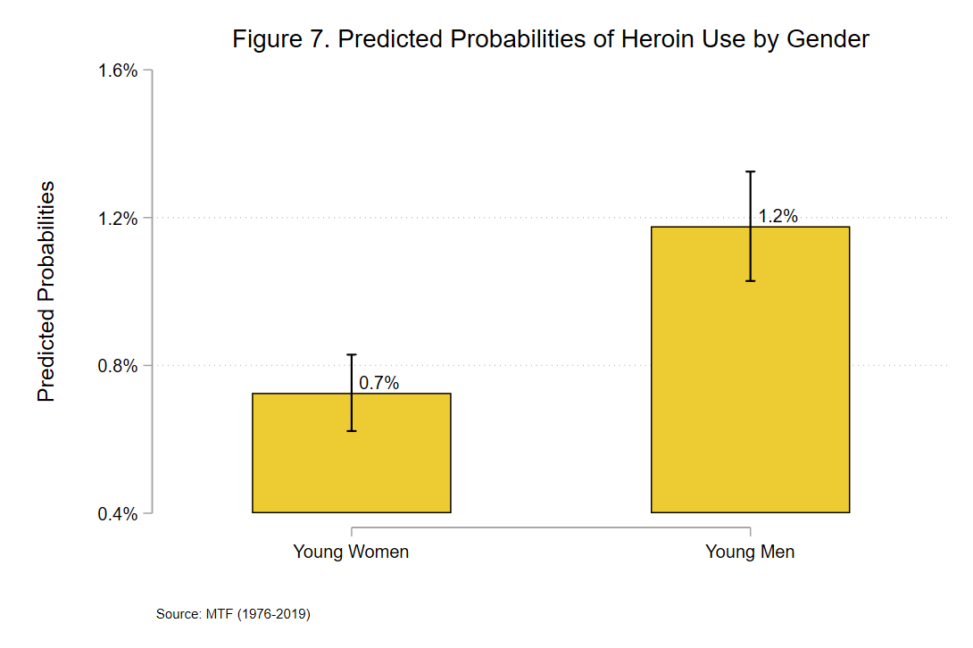

Model 2 in Table 4 displays the results for the interaction between gender and family structure. This relationship is also displayed in Figure 8, presented in predicted probabilities. Here we see that young men from egalitarian families have a 1.3 percent predicted probability of using cocaine, young women from egalitarian families have a 0.7 percent predicted probability, young men from patriarchal families have a 1.0 percent predicted probability of using cocaine, and young women from patriarchal families have a 0.8 percent predicted probability. The only difference in this interaction that is statistically significant, interestingly, is the difference between young men and young women from egalitarian families. There is a 0.5 percent first-order difference between young men and young women from such homes. Hypothesis 2 argues that the gender difference in patriarchal families will be larger than the gender difference in egalitarian families; however, as the gender difference in patriarchal families is non-statistically significant, Hypothesis 2 is not supported.
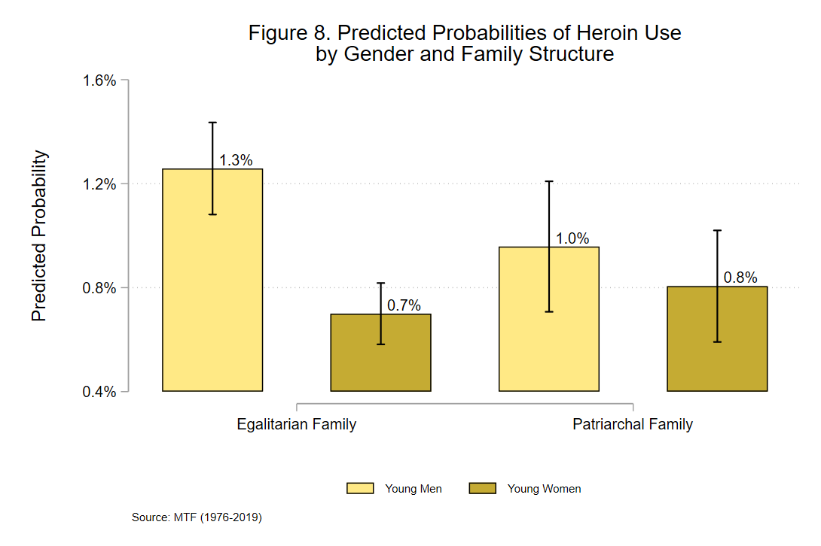
Figure 9 displays Model 3 – the interaction between gender and belief in patriarchal norms – presented in predicted probabilities. Here, there is no significant difference for men who agree or disagree with patriarchal norms, nor is there a significant difference for young women who agree or disagree with such norms. What is, significant, however, is the first-order gender differences seen in both youth who agree with gender norms and youth who disagree with gender norms. The second-order difference, however, is not statistically significant. This does not support Hypothesis 3, and suggests that a belief or disbelief in patriarchal norms has no effect on the gender difference in heroin use amongst the represented youth.
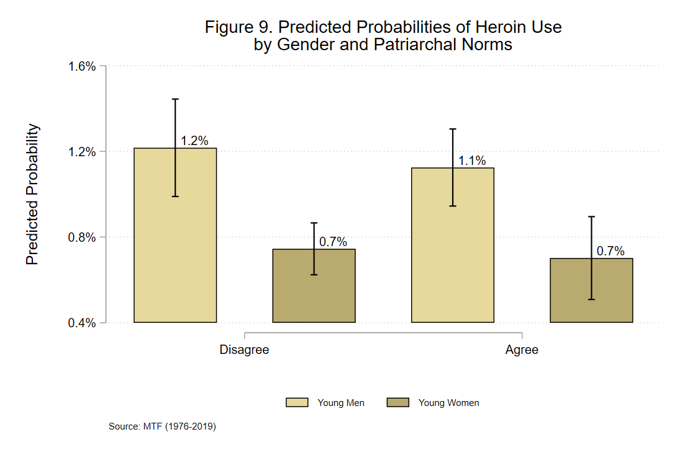

Narcotics
Table 5 displays the results of all three models performed on the subgroup observing illicit narcotic use. From Model 1, we see that young men have 0.28 higher log odds of using illicit narcotics compared to young women. This relationship is also displayed in Figure 10, displayed in predicted probabilities. Here, it is shown that young men have a 10.4 percent predicted probability of using illicit narcotics while young women have an 8.1 percent predicted probability of using illicit narcotics. This difference in predicted probabilities is significant and supports Hypothesis 1a.

Table 5. Ordinal Logistic Regression of Lifetime Narcotic use on Independent Variables
 | Model 1 |  | Model 2 |  | Model 3
 | β | SE | Β | SE | β | SE
Main Effects
Men | 0.28*** | (.03) | 0.26*** | (.04) | 0.23*** | (.04)
Patriarchal Family | -0.14*** | (.04) | -0.18 | (.05) | -0.14*** | (.04)
Patriarchal Norms | 0.03 | (.03) | 0.03 | (.03) | -0.04 | (.05)
Interactions
Men x Patriarchal Family |  |  | 0.09 | (.07)
Men x Patriarchal Norms |  |  |  |  | 0.13 | (.07)
Controls
Mother’s Education
High School | -0.31*** | (.06) | -0.31*** | (.06) | -0.31*** | (.06)
Some College | -0.23*** | (.06) | -0.23*** | (.06) | -0.23*** | (.06)
College | -0.27*** | (.07) | -0.27*** | (.07) | -0.27*** | (.07)
Graduate/Prof degree | -0.23** | (.08) | -0.23** | (.08) | -0.23** | (.08)
Father’s Education
High School | -0.06 | (.05) | -0.06 | (.05) | -0.06 | (.05)
Some College | -0.02 | (.06) | -0.02 | (.06) | -0.02 | (.06)
College | -0.09 | (.06) | -0.09 | (.06) | -0.09 | (.06)
Graduate/Prof degree | -0.07 | (.07) | -0.07 | (.07) | -0.07 | (.07)
Race (Black) | -1.16*** | (.08) | -1.16*** | (.08) | -1.15*** | (.08)
Years | 0.01*** | (.00) | 0.01*** | (.00) | 0.01*** | (.00)
Observations | 49,094
AIC | 29707.34 |  | 29707.91 |  | 29705.61
BIC | 29830.56 |  | 29839.93 |  | 29837.63
Standard errors in parentheses
Source: Monitoring the Future (1976-2019)
* p < 0.05, ** p < 0.01, *** p < 0.001

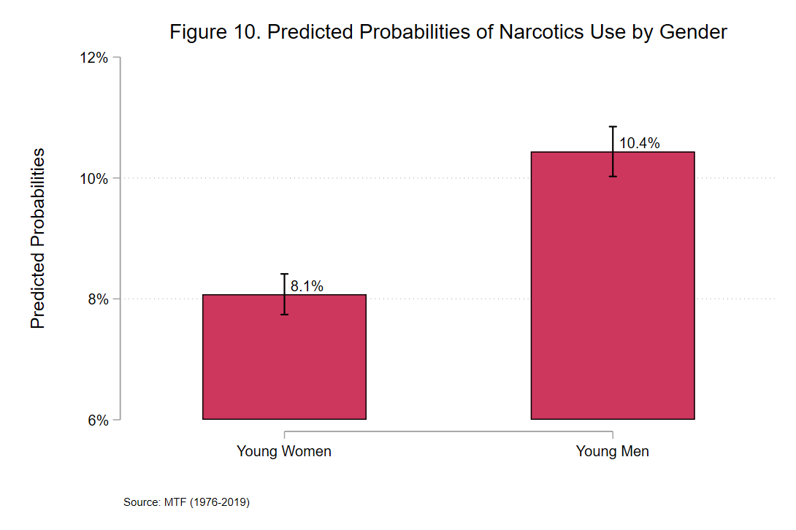
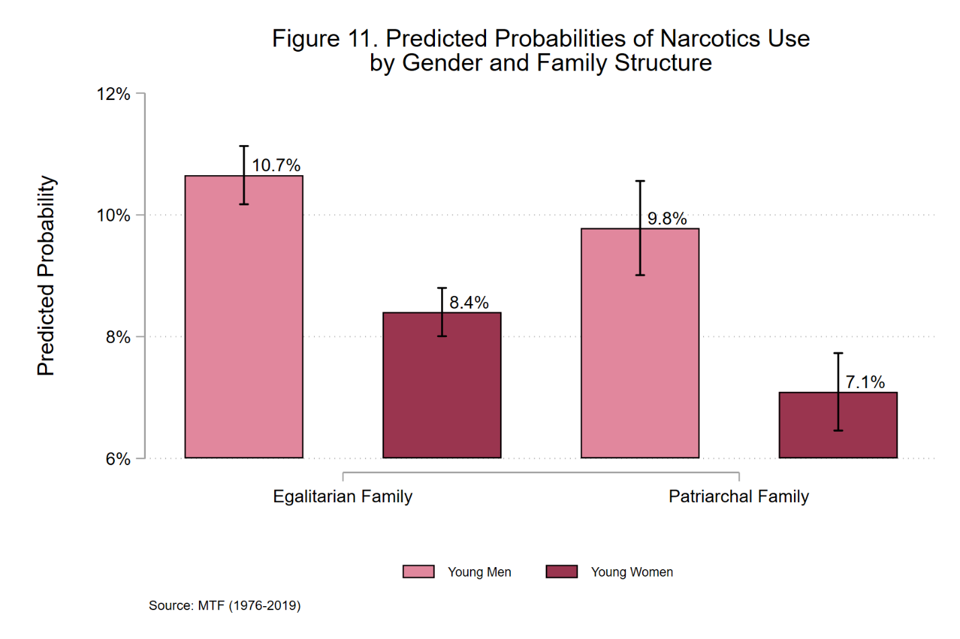
Moving to Model 2, which introduces the interaction between gender and family structure, Table 5 shows that young men from patriarchal families have 0.09 higher log odds of using illicit narcotics when compared to young men from egalitarian families. This relationship is displayed in Figure 11, presented in predicted probabilities. Here, I find that young men from patriarchal families have a 9.8 percent predicted probability of using illicit narcotics, while young men from egalitarian families have a 10.7 percent predicted probability. When testing this first-order difference of 0.9 percent, however, I find that it is non-statistically significant. The first-order difference seen between young women from patriarchal families and young women from egalitarian findings (a difference of 1.3 percent), however, is statistically significant. The 2.7 percent first-order gender difference in predicted narcotics use for youth from patriarchal families is a significant difference, as is the 2.3 percent gender difference among youth from egalitarian families. The second-order difference of 0.4 percent, however, is non-statistically significant, offering no support for Hypothesis 2. These results imply that family structure does not have a significant effect on the gender gap in illicit narcotics use.

The interaction between gender and patriarchal norms featured in Model 3 for this subgroup is displayed in Figure 12, presented in predicted probabilities. For young men, there is a significant difference for those who agree with patriarchal norms compared to those who do not. Those who agree have a 10.8 percent predicted probability of using illicit narcotics, while those young men who disagree with patriarchal norms have a 10 percent predicted probability. For young women who agree with patriarchal norms, there is a 7.8 percent predicted probability of using illicit narcotics, while women who disagree with such norms have an 8.1 percent predicted probability. This first-order difference amongst women, however, is non-statistically significant. From these results, I gather that young men who agree with patriarchal norms have significantly higher predicted probabilities of using narcotics compared to young men who disagree with such norms, though there is no significant effect of patriarchal beliefs on young women’s predictions.
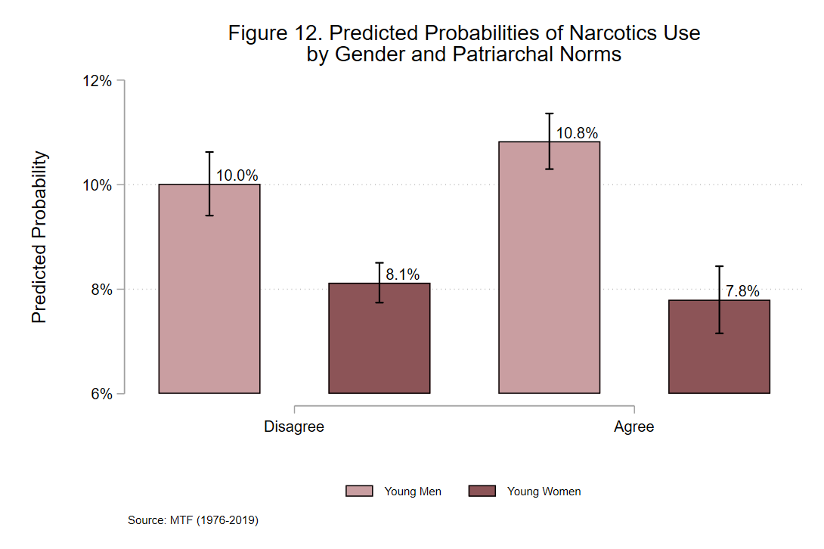
Looking now at the gender differences among these youth, I find support for Hypothesis 3. While there is no significant difference among women in this model, the second-order difference between youth who agree and disagree with patriarchal norms is statistically significant. This significant change in the gender differences brought on by the significant change in predicted probabilities for young men. For youth who agree with patriarchal norms, there is a gender difference of 3 percent. Youth who disagree with patriarchal norms, however, display a gender difference of 1.9 percent. This results in a second-order difference of 1.1 percent, which is a statistically significant difference. This suggests that a belief in patriarchal norms does significantly affect the gender differences in illicit narcotic use, even if there is no significant difference seen amongst young women. Instead, the significant drop in predicted probabilities seen in young men who disagree with patriarchal norms compared to those who agree creates a large enough difference in the gender gap, that the two gender gaps are now significantly different. Thus, a belief in patriarchal norms leads to a significantly larger gender difference in the use of illicit narcotics.

Summary
There are statistically significant gender differences in predictions of substance use across all substances analyzed in that young men have significantly higher predicted probabilities for using each substance compared to young women. These findings support Hypothesis 1a, but do not support Hypothesis 1b. Across all subgroups, Hypothesis 2 is not supported. While family structure has a significant effect on young women’s predictions for marijuana, cocaine, and narcotics use, and young men’s predictions for marijuana use, there are no statistically significant second-order differences that support Hypothesis 2’s claim that patriarchal families contribute to a larger gender gap in substance use when compared to egalitarian families. Hypothesis 3, however, is supported in three out of the four subgroups. In the marijuana, cocaine, and narcotics subgroups, youth who agree with patriarchal norms have significantly larger gender differences in substance use predictions when compared to youth who disagree with such norms. In the heroin subgroup, no such second-order difference is found. Possible explanations for this inconsistency are discussed below.

DISCUSSION
Similar to the results section above, this discussion is organized by each substance analyzed, followed by a conclusion discussing the findings as a whole.

Marijuana
The hypotheses proposed around gender differences in marijuana use posit that there will be no significant gender difference in marijuana use, but that patriarchal families and beliefs in patriarchal norms will contribute to a larger gender difference in marijuana use when compared to egalitarian families and a disagreement with patriarchal norms. The first hypothesis, Hypothesis 1b, is not supported by these findings. The findings indicate that there is a significant gender gap in marijuana use among high school seniors, holding other factors constant. While the reasoning behind Hypothesis 1b is based on the idea that the gender differences in marijuana use have decreased due to the drug’s legalization, it is possible that these data do not accurately represent that change. Previous research examining the gender gap in marijuana use have predicted a shrink in the gender gap as attitudes toward marijuana become more liberal and as marijuana use becomes more normalized (Dahl and Sandberg 2015; Elder and Greene 2019; Haines et al. 2009; Kolar 2021). While this I formed Hypothesis 1b off these predictions from previous literature, this expected narrowing of the gender gap may not have yet occurred, and perhaps future years of these data will reveal a smaller gender gap. Future research can utilize trend analyses to better explore the relationship between gender differences in marijuana use through its legalization and observe any possible narrowing of the gender gap in marijuana use.
Hypothesis 2 is not supported by the analyses. While Hypothesis 2 posits that patriarchal family structures will increase the gender differences in marijuana use, the results reveal that egalitarian families raise the predicted probabilities of both young men’s and young women’s marijuana use, and that there is no significant difference between the gender difference of youth from patriarchal families and youth from egalitarian families. Perhaps this is because youth from egalitarian families may be more liberal than youth from patriarchal families, thus making them more likely to use marijuana due to the politics surrounding its legalization. Research examining political opinions of U.S. high school seniors using data from Monitoring the Future (N = 11,594) finds that youth with more liberal views are more likely to support the liberal policies, including the legalization of marijuana (Palamar 2014). Elder and Greene (2019) state that attitudes toward marijuana use and legalization have become more liberal in recent years and predict that attitudes toward marijuana use and legalization will continue to liberalize. The data in this research may be beginning to reflect that continued liberalization, as predictions for both young men and young women increase when coming from egalitarian families. Further research can examine if political opinions are related to family structure and if those aspects influence the gender gap in marijuana use.
Hypothesis 3, unlike the previous two hypotheses, is fully supported. The gender difference among youth who disagree with patriarchal norms is significantly smaller than the gender difference among youth who agree with such norms. This significant second-order difference is contributed to by both a significant decrease in young men’s use of marijuana and a significant increase in young women’s use. Here, the argument for illicit masculinity is supported by the data, and I argue that when youth disagree with patriarchal norms, they are less likely to see substance use as a gendered activity. Dahl and Sandberg's (2015) research on masculinities and marijuana argues that some women who use marijuana are challenging gendered expectations and use marijuana despite the masculinity surrounding the substance. They also discuss that an egalitarian form of masculinity, a masculinity that protests hegemonic masculinity, may be contributing to the increase in women’s use of marijuana (Dahl and Sandberg 2015). Kolar's (2021) research also supports the idea that an adherence to gender norms deters women from using marijuana, and that when gendered barriers are removed, women may be more likely to use marijuana. Haines et al. (2009) establishes a link between hegemonic gender ideals and marijuana use, explaining that young men and young women often link masculinity to marijuana, thus increasing the likelihood of young men using marijuana and decreasing the likelihood for young women. This, too, supports the argument for illicit masculinity. If women disagree with patriarchal norms, they may be more likely to use marijuana, while if men disagree with patriarchal norms, they may be less likely to use marijuana, as the masculine stereotypes surrounding marijuana use may have less importance to them.

Cocaine
The results for the analyses performed on the cocaine subgroup reveal support for two hypotheses, but partial support for one. Hypothesis 1a is supported by the findings, as there is a significant gender difference in cocaine use amongst adolescents. Young men are significantly more likely to try cocaine than young women. When examining how family structure affects this gender difference, I find no support for Hypothesis 2. While having a patriarchal family structure makes young women significantly less likely to try cocaine, there is no significant difference for young men. The gender differences between the to family structures are also not significantly different. This lack of support is consistent with the pattern seen in the marijuana subgroup, which may mean that a patriarchal family structure may not be an accurate measurement of masculinity.
Hypothesis 3, however, is fully supported by the results. Youth who disagree with patriarchal norms have a significantly smaller gender difference in cocaine use than youth who agree with such norms. Similar to the marijuana subgroup, this is due to predictions for young men significantly lowering while predictions for young women raise significantly. It is important to note, however, that while the difference between young women who agree with patriarchal norms and young women who disagree is significant, the predicted probability of young women using cocaine regardless of their attitudes towards patriarchal norms is 7.4 percent, while the predicted probability of young women who disagree is 7.7 percent. This is a much smaller change in predictions compared to young men, which may suggest that the effect of having negative attitudes towards patriarchal norms may have a stronger effect on young men than it does for young women. Darcy’s (2018, 2020) work on masculinities and illicit substance use explains that, for some men, using stimulants such as cocaine enabled them to feel and appear more masculine. For the men in Darcy’s (2018, 2020) research, cocaine enhanced their masculinity, made them more impressive to other men, and allowed them to display their masculinity by out-drinking other men. With cocaine being so strongly related to masculinity, women may face gendered barriers that are harder to dismantle than those surrounding other substances, such as marijuana. The strong link between masculinity and cocaine may also contribute to the strong effect that disagreeing with patriarchal norms has on young men’s predictions of using cocaine. If young men disagree with patriarchal norms, they may not feel a need to prove or perform their masculinity, thus lowering their likelihood of using cocaine; or, conversely, young men who agree with patriarchal norms may feel more pressured to prove their masculinity, thus increasing their likelihood of using cocaine. Future research can examine that possibility further using second-order differences.

Heroin
For this subgroup, only Hypothesis 1a is supported by the results. While young men are significantly more likely to try heroin than young women, there is no significant effect on these predicted probabilities for youth from egalitarian or patriarchal families, thus offering no support for Hypothesis 2. In fact, when examining the gender differences among youth from egalitarian or patriarchal homes, a significant gender difference is only seen in youth from egalitarian homes. Attitudes toward patriarchal norms also have no significant effect on either young men’s or young women’s predicted probabilities of using cocaine, offering no support for Hypothesis 3. These results, outside of the findings for Hypothesis 1a, are inconsistent with the results for the other subgroups. I suspect that this is related to the low number of students who report using heroin. With less than one percent of the entire subgroup reporting any heroin use (n = 456), it is possible that the data do not contain enough information to analyze this relationship properly. It is evident from these results, however, that heroin should be studied separately from the other illicit substances here, since significantly fewer youth report using the substance. Perhaps it is more difficult to obtain, or perhaps there is a stronger stigma surrounding its use. Darcy’s (2018) research on masculinity and illicit substance use also discusses the stereotypes surrounding heroin. Men in Darcy’s (2018) study explain that heroin is deemed a “harder” drug than cocaine and marijuana and is met with greater disapproval and harsher stereotypes. While men who used cocaine were often lauded as being rich, masculine, and impressive, heroin use was deemed as unacceptable and men who used heroin were referred to as scumbags, junkies, and less masculine than men who used “softer” drugs like cocaine or marijuana (Darcy 2018). Thus, the stigmas and stereotypes surrounding heroin use may be deterring youth from using the substance. Future research can examine the patterns of heroin use amongst youth further.

Narcotics
Finally, results from the narcotics subgroup are similar to the results seen in the marijuana and cocaine subgroups. Hypothesis 1a is supported, as there are significant gender differences in the use of illicit narcotics. Hypothesis 2 is not supported. Coming from a patriarchal family has a significantly negative effect on the predicted probabilities for young women’s use of narcotics, but family structure has no significant effect on young men’s predictions. Despite the statistically significant effect of family structure on young women’s use of narcotics, there is no statistically significant effect on the second-order gender differences. Here, I suspect, as mentioned above, that family structure may not be an accurate measure of masculinity. Previous research on the intersection of masculinity and illicit substance use has been primarily qualitative (Dahl and Sandberg 2015; Darcy 2020, 2020; Haines et al. 2009; Kolar 2021). These qualitative projects allow for a more conceptualized idea of masculinity and can explore its intersection with illicit substance use more freely than quantitative work. While some research has quantified masculinity, the data in these studies were gathered from surveys tailored to gather information specifically related to masculinity (Offer and Kaplan 2021; Willer et al. 2013). No studies to my knowledge explore the intersection of masculinity and illicit substance use using quantitative data. The survey used in this research includes questions about gender ideology and family structure, and while family structure may influence youths’ concepts of masculinity, it is an indirect and imperfect measure.
The results surrounding Hypothesis 3 are intriguing, as they support the claim of the hypothesis, but not in the way I anticipated. Attitudes towards patriarchal norms have no significant effect on young women’s predicted probabilities; however, the significant effect that attitudes towards patriarchal norms do have on young men are so strong that they create a significant second-order difference. In other words, the negative effect that disagreeing with patriarchal norms has on young men’s predictions for trying illicit narcotics is so strong that it creates a significantly smaller gender difference in the use of narcotics when compared to youth who agree with patriarchal norms. In the previous subgroups (excluding the results of the heroin subgroup), the significant difference in the gender gaps is contributed to by both a significant decrease in predictions for young men and a significant increase in young women who disagree with gender norms when compared to youth who agree with such norms. For the narcotics subgroup, however, this significant second-order difference is due entirely to the effect that beliefs in patriarchal norms have on young men. Very little research on masculinity and narcotics use exists, though one study examining gender differences in narcotics use finds that adolescent use of nonmedical prescription opioids is influenced by peer and parent pressure (Egan et al. 2019). Youth whose peers engaged in using such substances were more likely to report using prescription opioids, while youth whose peers did not use opioids were less likely to report using opioids. Parental disapproval, however, was a stronger deterrent for young women than it was for young men (Egan et al. 2019). It is possible that peer use amongst boys may involve aspects of masculinity that are not measured in the study. Future research can examine how gender norms and masculinity influence adolescents use of narcotics.

Summary of Overall Findings
Overall, across all subgroups, there is a significant gender difference in substance use, despite the change in marijuana’s illicitness in recent years. Hypothesis 1a is supported across all corresponding subgroups, while Hypothesis 1b is not supported. Hypothesis 2 is not supported. I argue that family structure is not an accurate measure of illicit masculinity, as findings from all four subgroups find no significant difference between the gender differences seen in youth from egalitarian and patriarchal families. As discussed above, most research examining the intersection of masculinity and illicit substance use utilize qualitative data that is specifically tailored to gather information on the respondents’ ideas and conceptualizations of masculinity as it relates to substance use (Dahl and Sandberg 2015; Darcy 2020, 2020; Haines et al. 2009; Kolar 2021).
Hypothesis 3, however, is strongly supported throughout the results, except for the results presented in the heroin subgroup. In the marijuana, cocaine, and narcotics subgroup, there are significant second-order differences in the gender differences for youth who agree or disagree with patriarchal norms. Here, it appears that such attitudes may measure illicit masculinity. While a belief in patriarchal norms is not a direct measure of masculinity, the concept of illicit masculinity links ideas of hegemonic masculinity to illicit activities (Connell 1995). Hegemonic masculinity implies a gender order – men are superior to women under the assumption of hegemony, and certain behaviors are expected from men and women that reflect this gender order (Connell 1995; Schippers 2007). With illicit masculinity, I argue that, because masculinity is associated with illicit substance use, young men are more likely to use illicit substances in order to display their masculinity, and young women are less likely to use illicit substances in order to refrain from being seen as masculine (Darcy 2020, 2020; Kolar 2021). Thus: illicit masculinity contributes to the gender gap in illicit substance use. The results that support Hypothesis 3 reflect this pattern, as they illustrate that young men and young women who agree with patriarchal norms – norms that are related to hegemony – have a significantly larger gender gap in marijuana, cocaine, and narcotics use when compared to youth who disagree with such norms (Connell 1995; Schippers 2007).

CONCLUSION
The purpose of this research was to examine previous definitions and conceptualization of masculinities, summarize existing literature linking masculinity to gender differences in illicit substance use, and posit and test the concept of illicit masculinity: the idea that norms associated with traditional views of manliness/masculinity are linked to illicit activities, including illicit substance use. Masculinity has already been linked to substance use, and there have been consistent gender differences in illicit substance use throughout recent years (Dahl and Sandberg 2015; Darcy 2020, 2020; Haines et al. 2009; Kasperski et al. 2011; Kolar 2021; Marsh et al. 2018; Palamar 2014; Schneider et al. 2018). While some sociologists have examined how gender norms influence the gender differences in substance use, the literature has primarily focused on gender differences in alcohol consumption (Christie-Mizell and Peralta 2009; Huselid and Cooper 1992; Whaley et al. 2013; Wilkinson et al. 2018). This research expands the exploration of how gender norms influence gender differences in substance use by examining the intersection of masculinity and the use of illicit substances, which I refer to as illicit masculinity.
This research draws on previous literature examining masculinity, gender norms, and gender differences in behaviors and delinquency to propose two possible avenues for measuring illicit masculinity: family structure and an agreement with patriarchal norms (Blackwell 2000; Connell 1995; Connell and Messerschmidt 2005; Grasmick et al. 1996; Hadjar et al. 2007). Drawing from power-control theory, Hypothesis 2 is centered around patriarchal family structure and posits that a patriarchal family structure alone will contribute to a larger gender difference in illicit substance use (Blackwell 2000). Hypothesis 2, however, is not supported by the results. Here, while patriarchal families may perpetuate a hegemonic gender order, it does not appear to be an accurate measure of individual levels of masculinity (Blackwell 2000; Connell 1995; Schippers 2007). Hypothesis 3, which draws from literature linking dominant patriarchal norms to traditional ideas of masculinity focuses on patriarchal norms and asserts that an agreement with patriarchal norms will contribute to a larger gender difference in illicit substances (Connell 1995; Connell and Messerschmidt 2005; Messerschmidt and Messner 2019). This is supported in three out of the four subgroups used in the study. An individual’s level of agreement with norms rooted in the patriarchy and hegemonic gender order may be a more accurate measure of masculinity, as the results support the argument put forth by Hypothesis 3 (Connell 1995; Schippers 2007).

Future Research
As discussed briefly above, there are several avenues for future research. When looking at substances individually, as done in this piece, future research can examine historical trends in substance use, how the gender differences have changed over time, and how those gender differences have been affected by masculinity, patriarchal norms, or other gender ideologies (Kasperski et al. 2011; Marsh et al. 2018; Palamar 2014; Schneider et al. 2018; Yu et al. 2020). For marijuana specifically, a historical analysis may shed light on how the legalization of the drug has affected the gender differences (Yu et al. 2020). Future research focusing on cocaine use can examine the possibility of illicit masculinity having a stronger effect on young men than it does for young women (Darcy 2018, 2020). As already mentioned, future research into heroin use amongst youth using data with a larger sample of reported heroin users may reveal a more accurate interpretation of how masculinity affects the gender differences in its use (Darcy 2018; Marsh et al. 2018). I believe that the non-statistically significant findings from the heroin subgroup may be due to the low percentage of reports of using the substance. Should further research be performed looking more closely at heroin use among youth, perhaps oversampling youth who use heroin, to examine support for the idea of illicit masculinity and its effects on the gender differences in heroin use (Darcy 2018; Marsh et al. 2018). As for narcotics, it is possible that it is more socially acceptable for young women to use narcotics than it is for young men, meaning that illicit masculinity would not apply to young women using narcotics (Egan et al. 2019; Kapetanovic et al. 2022). For all substances studied here, future research can explore youth’s reasoning behind using such substance. Youth who use substances to impress their friends or spite their parents may be more inclined to be affected by illicit masculinity than youth who use substances as a coping mechanism. Research on peer influence and parent disapproval of illicit substances imply that youth may associate with delinquent peers to rebel against their parents wishes and may participate in delinquent behavior in order to fit in with their peer group (Egan et al. 2019; Kapetanovic et al. 2022; Keijsers et al. 2012; Litt, Stock, and Lewis 2012).
Future research can also expand on the theories surrounding masculinity and crime and test the concept of illicit masculinity against such theories. For example, it could be argued that the social pressures of masculinity could act as a source of strain, causing adolescents to have negative emotions and leading them to illegitimate coping mechanisms (Agnew 1992, 2001; Baron 2007; Broidy and Agnew 1997). Following the concept that family structure plays a role in adolescent’s delinquent behaviors, a power-control theory perspective may also assist in explaining the intersection of masculinity and illicit substance use (Blackwell 1995, 2000; Eitle and Eitle 2015; Grasmick et al. 1996; Hadjar et al. 2007). Masculinity could also act as a social control, and tests of illicit masculinity could apply Hirschi's (1969) social control theory to continue the development of illicit masculinity (Chapple and McQuillan 2019; Chapple, McQuillan, and Berdahl 2005).

Limitations
This study is not without its limitations. A limitation already mentioned, but worth mentioning one final time, is the measurement of gender. Gender does not exist as a binary, nor is it equivalent to sex. For the purposes of this research and due to the limitations of the data, however, sex and gender are treated as the same thing and are examined only as men and women, excluding any nonbinary respondents from the analysis (Westbrook and Saperstein 2015). Other measurements in the study have limitations as well. With no direct measure of masculinity available in the MTF dataset, I focused on family structure and patriarchal norms. The family structure variable only includes dual-parent (mother and father) families, excluding any single-parent homes and gay or lesbian families from the study (Blackwell 2000). The patriarchal norm measure is also limited in that there is only one question in the questionnaire used for this study that pertains to patriarchal norms. A patriarchal gender norm scale may allow for a broader understanding of how patriarchal norms influence masculinity and adolescent substance use (see Worthen 2021).
My controls are also limited, as I focused primarily on three measures: parent education (as a proxy for family income), race, and time. The measurement of race is a limitation, as the MTF creators only included Black and White respondents in their public use data until 2005, when they included non-White Hispanics as well. But for the purposes of the research, non-White Hispanic respondents were dropped to remain consistent with the data from years prior to 2005. Some controls that were not included in this study but may affect the results in future analyses include region and environmental factors. The region of the U.S. in which the respondent lives may also play a role in their predictions of substance use, and controlling for location would provide more validity to the findings (Levy, Phillips, and Sampson 2020; Sampson 2019). Family members’ substance use, such as parents or siblings use of illicit substances, is also not controlled for in this study. The environmental and family factors that contribute to the risk of substance use that youth face were not considered in this study (Levy et al. 2020; Wilson 1987).
Another limitation is the low number of youths who reported using heroin at least once in their lives. With only 456 youth in the subgroup reporting having tired heroin, this limits the validity of the findings in the heroin subgroup. Also, this study examines U.S. high school seniors. Behaviors may change based on the age of the respondents, and research observing young adults in college or in the work force may reveal different patterns of illicit masculinity (Hirschi 1969; Sampson 1993).

Contributions
This research brings forth several contributions to the existing literature. While previous research has linked masculinity to both risky behaviors and illicit substances, this research begins to solidify the concept of illicit masculinity by exploring it further and offering quantitative measurements of masculinity and substance use, where past literature exploring this link have been primarily qualitative pieces (Dahl and Sandberg 2015; Darcy 2018, 2020; Kolar 2021). The results from this study offer support for the concept of illicit masculinity, and this research facilitates the development of further studies that can expand on illicit masculinity through alternate measures of masculinity, trend analyses, and more focus on specific substances (Dahl and Sandberg 2015; Darcy 2020; Marsh et al. 2018; Schneider et al. 2018; Yu et al. 2020). The gender gap in crime is something that has been widely studied, and this research contributes to the understanding of that gap by offering an explanation for the gender differences in illicit substance use (Chapple and McQuillan 2019; Christie-Mizell and Peralta 2009; Huselid and Cooper 1992; Whaley et al. 2013). This research also develops a new approach to masculinity by examining the intersection of masculinity and illicit substance use and developing a concept that is supported by the results of the study (Connell 1995). In short, this research contributes to the understanding of gender and crime by exploring and offering support for the concept of illicit masculinity as it relates to gender differences in adolescent substance use.

Implications
This research has several implications for discussions of substance use outside of the field of sociology. By exploring the concept of illicit masculinity, this research has linked patriarchal norms to the use of illicit substances in adolescents. Social workers, drug counselors, and other healthcare professionals can apply these findings to their clients and patients to better understand the reasonings and motivations behind adolescent drug use and work towards a more gender-informed solution. Parents can also benefit from these findings. Raising children to have egalitarian principles can lower their risk of using illicit substances. When examining adolescent substance use through the lens of illicit masculinity, those who aim to reduce drug use can address issues surrounding patriarchy and gender inequality, as these contribute to the use of illicit substances in youth, especially in young men.

References
Agnew, Robert. 1992. “Foundation for a Generalism Strain Theory of Crime and Delinquency.” Criminology 30(1):47–88.
Agnew, Robert. 2001. “Building on the Foundation of General Strain Theory: Specifying the Types of Strain Most Likely to Lead to Crime and Delinquency.” Journal of Research in Crime and Delinquency 38(4):319–61. doi: 10.1177/0022427801038004001.
Baron, Stephen W. 2007. “Street Youth, Gender, Financial Strain, and Crime: Exploring Broidy and Agnew’s Extension to General Strain Theory.” Deviant Behavior 28(3):273–302. doi: 10.1080/01639620701233217.
Blackwell, Brenda Sims. 1995. “Elaborating Power-Control Theory: Predicting Gender Differences in Social Bonds, Perceived Sanction Threats, and Low Self-Control.” Ph.D., The University of Oklahoma, United States -- Oklahoma.
Blackwell, Brenda Sims. 2000. “Perceived Sanction Threats, Gender, and Crime: A Test and Elaboration of Power-Control Theory.” Criminology 38(2):439–88.
Brannon, Robert, and Deborah Sarah David. 1976. The Forty-Nine Percent Majority: The Male Sex Role. Reading, Massachusetts: Addison-Wesley Publishing Company.
Broidy, Lisa, and Robert Agnew. 1997. “Gender and Crime: A General Strain Theory Perspective.” Journal of Research in Crime and Delinquency 34(3):275–306. doi: 10.1177/0022427897034003001.
Chapple, Constance L., Julia A. McQuillan, and Terceira A. Berdahl. 2005. “Gender, Social Bonds, and Delinquency: A Comparison of Boys’ and Girls’ Models.” Social Science Research 34(2):357–83. doi: 10.1016/j.ssresearch.2004.04.003.
Chapple, Constance, and Julia McQuillan. 2019. “A Matter Of Control: Social Controls and the Gender Gap in Delinquency.” Pp. 257–76 in Fifty Years of Causes of Delinquency.
Christie-Mizell, C. André, and Robert L. Peralta. 2009. “The Gender Gap in Alcohol Consumption during Late Adolescence and Young Adulthood: Gendered Attitudes and Adult Roles.” Journal of Health and Social Behavior 50(4):410–26.
Connell, R. W. 1987. Gender and Power. Sydney, Australia: Allen and Unwin.
Connell, R. W. 1995. Masculinities. Cambridge, UK: Polity Press.
Connell, R. W., and James W. Messerschmidt. 2005. “Hegemonic Masculinity: Rethinking the Concept.” Gender and Society 19(6):829–59.
Dahl, Silje Louise, and Sveinung Sandberg. 2015. “Female Cannabis Users and New Masculinities: The Gendering of Cannabis Use.” Sociology 49(4):696–711.
Darcy, Clay. 2018. “Making the Invisible Visible: Masculinities and Men’s Illicit Recreational Drug Use.” Irish Journal of Sociology 26(1):5–24. doi: 10.1177/0791603517735772.
Darcy, Clay. 2020. “Men and the Drug Buzz: Masculinity and Men’s Motivations for Illicit Recreational Drug Use.” Sociological Research Online 25(3):421–37. doi: 10.1177/1360780419879940.
Egan, Kathleen L., Eric Gregory, Vicki L. Osborne, and Linda B. Cottler. 2019. “Power of the Peer and Parent: Gender Differences, Norms, and Nonmedical Prescription Opioid Use Among Adolescents in South Central Kentucky.” Prevention Science 20(5):665–73. doi: 10.1007/s11121-019-0982-1.
Eitle, Tamela McNulty, and David Eitle. 2015. “Explaining the Association between Gender and Substance Use among American Indian Adolescents: An Application of Power-Control Theory.” Sociological Perspectives 58(4):686–710.
Elder, Laurel, and Steven Greene. 2019. “Gender and the Politics of Marijuana.” Social Science Quarterly (Wiley-Blackwell) 100(1):109–22. doi: 10.1111/ssqu.12558.
Grasmick, Harold G., John Hagan, Brenda Sims Blackwell, and Bruce J. Arneklev. 1996. “Risk Preferences and Patriarchy: Extending Power-Control Theory.” Social Forces 75(1):177–99. doi: 10.2307/2580761.
Hadjar, Andreas, Dirk Baier, Klaus Boehnke, and John Hagan. 2007. “Juvenile Delinquency and Gender Revisited: The Family and Power-Control Theory Reconceived.” European Journal of Criminology 4(1):33–58. doi: 10.1177/1477370807071729.
Haines, Rebecca J., Joy L. Johnson, Connie I. Carter, and Kamal Arora. 2009. “‘I Couldn’t Say, I’m Not a Girl’ – Adolescents Talk about Gender and Marijuana Use.” Social Science & Medicine 68(11):2029–36. doi: 10.1016/j.socscimed.2009.03.003.
Hirschi, Travis. 1969. Causes of Delinquency. Berkeley, University of California Press.
Huselid, Rebecca Farmer, and M. Lynne Cooper. 1992. “Gender Roles as Mediators of Sex Differences in Adolescent Alcohol Use and Abuse.” Journal of Health and Social Behavior 33(4):348–62. doi: 10.2307/2137313.
Kapetanovic, Sabina, Birgitta Ander, Sevtap Gurdal, and Emma Sorbring. 2022. “Adolescent Smoking, Alcohol Use, Inebriation, and Use of Narcotics during the Covid-19 Pandemic.” BMC Psychology 10(1):44. doi: 10.1186/s40359-022-00756-1.
Kasperski, Sarah J., Kathryn B. Vincent, Kimberly M. Caldeira, Laura M. Garnier-Dykstra, Kevin E. O’Grady, and Amelia M. Arria. 2011. “College Students’ Use of Cocaine: Results from a Longitudinal Study.” Addictive Behaviors 36(4):408–11. doi: 10.1016/j.addbeh.2010.12.002.
Keane, Helen. 2017. “Female Vulnerability and Susceptible Brains: Gendered Discourses of Addiction.” The Social History of Alcohol and Drugs 31:126–39. doi: 10.1086/SHAD31010126.
Keijsers, Loes, Susan Branje, Skyler T. Hawk, Tom Frijns, Hans M. Koot, Pol van Lier, Seth J. Schwartz, and Wim Meeus. 2012. “Forbidden Friends as Forbidden Fruit: Parental Supervision of Friendships, Contact With Deviant Peers, and Adolescent Delinquency.” Child Development 83(2):651–66.
Kimmel, Michael S. 1994. “Masculinity as Homophobia: Fear, Shame, and Silence in the Construction of Gender Identity.” Pp. 119–43 in Theorizing Masculinities. Thousand Oaks, CA: Sage.
Kolar, Kat. 2021. “Women’s Use of and Access to Illicit Cannabis: An Investigation of Gendered Norms among College Students in Canada.” Sex Roles 84(7):418–38. doi: 10.1007/s11199-020-01176-4.
Levy, Brian L., Nolan E. Phillips, and Robert J. Sampson. 2020. “Triple Disadvantage: Neighborhood Networks of Everyday Urban Mobility and Violence in U.S. Cities.” American Sociological Review 85(6):925–56. doi: 10.1177/0003122420972323.
Litt, Dana M., Michelle L. Stock, and Melissa A. Lewis. 2012. “Drinking to Fit in: Examining the Need to Belong as a Moderator of Perceptions of Best Friends’ Alcohol Use and Related Risk Cognitions Among College Students.” Basic and Applied Social Psychology 34(4):313–21. doi: 10.1080/01973533.2012.693357.
Long, J. Scott, and Sarah A. Mustillo. 2021. “Using Predictions and Marginal Effects to Compare Groups in Regression Models for Binary Outcomes.” Sociological Methods & Research 50(3):1284–1320. doi: 10.1177/0049124118799374.
Marsh, Jeanne C., Keunhye Park, Yu-An Lin, and Cliff Bersamira. 2018. “Gender Differences in Trends for Heroin Use and Nonmedical Prescription Opioid Use, 2007–2014.” Journal of Substance Abuse Treatment 87:79–85. doi: 10.1016/j.jsat.2018.01.001.
Messerschmidt, James W., and Michael A. Messner. 2019. “Hegemonic, Nonhegemonic, and ‘New’ Masculinities.” Pp. 35–56 in Gender Reckonings: New Social Theory and Research. New York: New York University Press.
Norland, Stephen, Randall C. Wessel, and Neal Shover. 1981. “Masculinity and Delinquency.” Criminology 19(3):421–33.
Offer, Shira, and Danny Kaplan. 2021. “The ‘New Father’ Between Ideals and Practices: New Masculinity Ideology, Gender Role Attitudes, and Fathers’ Involvement in Childcare.” Social Problems 68(4):986–1009. doi: 10.1093/socpro/spab015.
Palamar, Joseph J. 2014. “An Examination of Opinions Toward Marijuana Policies Among High School Seniors in the United States.” Journal of Psychoactive Drugs 46(5):351–61. doi: 10.1080/02791072.2014.962716.
Palamar, Joseph J., Jenni A. Shearston, Eric W. Dawson, Pedro Mateu-Gelabert, and Danielle C. Ompad. 2016. “Nonmedical Opioid Use and Heroin Use in a Nationally Representative Sample of Us High School Seniors.” Drug and Alcohol Dependence 158:132–38. doi: 10.1016/j.drugalcdep.2015.11.005.
Robert J Sampson. 2019. “Neighbourhood Effects and Beyond: Explaining the Paradoxes of Inequality in the Changing American Metropolise.” Urban Studes 56(1):3–32.
Sampson, Robert J. 1993. Crime in the Making: Pathways and Turning Points through Life / Robert J. Sampson and John H. Laub. Cambridge, Mass.: Harvard University Press.
Schippers, Mimi. 2007. “Recovering the Feminine Other: Masculinity, Femininity, and Gender Hegemony.” Theory and Society 36(1):85–102. doi: 10.1007/s11186-007-9022-4.
Schneider, Kristen E., Noa Krawczyk, Xuan Ziming, and Renee M. Johnson. 2018. “Past 15-Year Trends in Lifetime Cocaine Use among US High School Students | Elsevier Enhanced Reader.” Drug and Alcohol Dependence 183:69–72. doi: 10.1016/j.drugalcdep.2017.10.028.
Westbrook, Laurel, and Aliya Saperstein. 2015. “New Categories Are Not Enough: Rethinking the Measurement of Sex and Gender in Social Surveys.” Gender & Society 29(4):534–60. doi: 10.1177/0891243215584758.
Whaley, Rachel Bridges, Justin Hayes-Smith, and Rebecca Hayes-Smith. 2013. “Gendered Pathways? Gender, Mediating Factors, and the Gap in Boys’ and Girls’ Substance Use.” Crime & Delinquency 59(5):651–69. doi: 10.1177/0011128710389581.
Wilkinson, Andra L., Paul J. Fleming, this link will open in a new window Link to external site, Carolyn Tucker Halpern, Amy H. Herring, and Kathleen Mullan Harris. 2018. “Adherence to Gender-Typical Behavior and High-Frequency Substance Use from Adolescence into Young Adulthood.” Psychology of Men & Masculinities 19(1):145–55. doi: http://dx.doi.org.ezproxy.lib.ou.edu/10.1037/men0000088.
Willer, Robb, Christabel L. Rogalin, Bridget Conlon, and Michael T. Wojnowicz. 2013. “Overdoing Gender: A Test of the Masculine Overcompensation Thesis.” American Journal of Sociology 118(4):980–1022.
William J Wilson. 1987. The Truly Disadvantaged. University of Chicago Press.
Worthen, Meredith G. F. 2021. “Rape Myth Acceptance Among Lesbian, Gay, Bisexual, and Mostly Heterosexual College Students.” Journal of Interpersonal Violence 36(1–2):NP232–62. doi: 10.1177/0886260517733282.
Yu, Bin, Xinguang Chen, Xiangfan Chen, and Hong Yan. 2020. “Marijuana Legalization and Historical Trends in Marijuana Use among US Residents Aged 12–25: Results from the 1979–2016 National Survey on Drug Use and Health.” BMC Public Health 20(1):156. doi: 10.1186/s12889-020-8253-4.
APPENDIX
Table 6. Rare-Outcomes Logistic Regression of Lifetime Heroin use on Independent Variables
 | Model 1 |  | Model 2 |  | Model 3
 | β | SE | β | SE | β | SE
Main Effects
Men | 0.49*** | (.10) | 0.59*** | (.11) | 0.50*** | (.13)
Patriarchal Family | -0.09 | (.11) | 0.15 | (.16) | -0.09 | (.11)
Patriarchal Norms | -0.07 | (.10) | -0.07 | (.10) | -0.05 | (.16)
Interactions
Men x Patriarchal Family |  |  | -0.42 | (.22)
Men x Patriarchal Norms |  |  |  |  | -0.03 | (.21)
Controls
Mother’s Education
High School | -0.51*** | (.15) | -0.51** | (.15) | -0.51*** | (.15)
Some College | -0.37* | (.18) | -0.37* | (.18) | -0.37* | (.18)
College | -0.41* | (.18) | -0.40* | (.18) | -0.41* | (.18)
Graduate/Prof degree | -0.24 | (.22) | -0.24 | (.22) | -0.24 | (.22)
Father’s Education
High School | -0.34* | (.15) | -0.34* | (.15) | -0.34* | (.15)
Some College | -0.45** | (.17) | -0.46** | (.17) | -0.45** | (.17)
College | -0.44** | (.17) | -0.44** | (.17) | -0.44** | (.17)
Graduate/Prof degree | -0.33 | (.19) | -0.33 | (.19) | -0.33 | (.19)
Race (Black) | -0.70** | (.21) | -0.70** | (.21) | -0.70** | (.21)
Years | -0.01* | (.00) | -0.01* | (.00) | -0.01* | (.00)
Observations | 49,103
AIC | 5066.28 |  | 5061.57 |  | 5065.09
BIC | 5189.50 |  | 5193.59 |  | 5197.12
Standard errors in parentheses
Source: Monitoring the Future (1976-2019)
* p < 0.05, ** p < 0.01, *** p < 0.001

Data on 8th- and 10th-graders were gathered by the MTF creators starting in 1991. To use the full range of data, this research focuses only on 12th-grade respondents.
The survey asks respondents about their marijuana use by inserting: “used marijuana (weed, pot) or hashish (hash, hash oil)” into the question; cocaine use by inserting: “used “crack” (cocaine in chunk or rock form)/cocaine in any other form” into the question; heroin use by inserting: “used heroin” into the question; and narcotics by inserting: “taken narcotics other than heroin on your own—that is, without a doctor telling you to take them” into the question.

