University of Oklahoma

Graduate College

guided reflexivity and the importance of strategy change to adaptive team performance

A Dissertation

submitted to the Graduate Faculty

in partial fulfillment of the requirements for the

Degree of

Doctor of Philosophy

By

Matthew L. Arsenault
Norman, Oklahoma
2014

guided reflexivity and the importance of strategy change to adaptive team performance

A Dissertation approved for the
Department of Psychology

By

______________________________
Dr. Eric Day, Chair

______________________________
Dr. Mark Bolino

______________________________
Dr. Shane Connelly

______________________________
Dr. Jorge Mendoza

______________________________
Dr. Robert Terry

© Copyright by Matthew L. Arsenault 2014
All Rights Reserved.

Table of Contents

List of Tables vi
List of Figures vii
Abstract viii
Guided Reflexivity and the Importance of Strategy Change to Adaptive Team Performance 1
Purpose and Study Overview 2
Team Reflexivity 3
Performance Demands 8
Method 12
Participants 12
Performance Task 12
Procedures 16
Reflexivity Manipulation 17
Novel Demands Manipulation 18
Measures 20
Covariates 25
Results 26
Hypothesis Tests with Reflexivity Condition 31
Hypothesis Tests with Reflexivity Scores 39
Discussion 44
Routine Performance Demands and Strategy Stability 45
Adapting to Novel Performance Demands 47
Limitations and Future Directions 50
References 55
Appendix A: Unguided Reflexivity Worksheet 59
Appendix B: Taskwork Guided Reflexivity Worksheet 60
Appendix C: Teamwork Reflexivity Worksheet 62
Appendix D: Reflexivity Questionnaire 64
Appendix E: Tables 65
Appendix F: Figures 76

List of Tables
Table 1. Descriptive Statistics and Intercorrelations of Covariates, Performance, Strategy, and Team Process Variables 66
Table 2. Descriptive Statistics for Performance, Strategy Stability, and Strategy Change by Reflexivity Condition 68
Table 3. Descriptive Statistics and Intercorrelations of Reflexivity Scores with Study Variables 69
Table 4. Descriptive Statistics for Team Processes by Reflexivity Condition 70
Table 5. Team Process and Reflexivity Condition Predicting Strategy Change in Novel Demands Missions 71
Table 6. Team Processes and Change Predicting Novel Demands Performance 72
Table 7. Reflexivity Scores Predicting Routine Mission Performance and Strategy Stability 73
Table 8. Reflexivity Scores Predicting Team Processes, Change, and Performance in the Novel Demands Missions 74
Table 9. Team Process and Reflexivity Scores Predicting Strategy Change in Novel Demands Missions 75

List of Figures
Figure 1. Annotated peacekeeping game mission map 77
Figure 2. Annotated peacekeeping game key tasks 78
Figure 3. Summary of Protocol Procedures 79
Figure 4. Behavior-based Performance Strategies 80
Figure 5. Adjusted Performance Scores from the Reflexivity Condition × Novel Mission Order × Novel Performance Demands Interaction 81
Figure 6. Adjusted Communication Efficacy Scores From the Reflexivity Condition × Novel Mission Order Interaction 82

Abstract
Theories describing team adaptive performance provide insight into the mechanisms that facilitate adaptive performance; however, these theories have yet to link these mechanisms to the nature of the novel demands teams face. The present study examined the effects of team reflexivity content (i.e., taskwork, teamwork, and general metacognition), strategy stability and change, and team processes on performance when teams faced routine and novel performance demands. Using a command-and-control style videogame, 97 three-person teams performed three missions characterized by routine performance demands and two missions each characterized by a different type of novel performance demands—apparent versus subtle. Results showed that taskwork reflexivity had an indirect effect on adaptive performance through routine performance when teams faced either type of novel performance demands. General metacognition reflexivity had a direct effect on adaptive performance when the novel demands were apparent. Contrary to expectations, neither strategy change nor teamwork processes were beneficial to adaptive performance. Rather, routine performance accounted for the most variability in adaptive performance across both apparent and subtle novel demands. Results are discussed with respect to the importance of considering the need for theory and research on adaptive team performance that distinguish different types of novel performance demands and underscores the importance of task proficiency in adaptive performance.

Guided Reflexivity and the Importance of Strategy Change to Adaptive Team Performance
The value of using team structures in organizations is in the team’s capability to handle complex tasks in dynamic work environments especially under novel circumstances (Burke, Stagl, Salas, Pierce, & Kendall, 2006; Gersick & Hackman, 1990; Kozlowski, Gully, Nason, & Smith, 1999). Empirical research on team adaptation continues to develop, offering insight into several mechanisms that can facilitate team adaptability (Gurtner, Tschan, Semmer, & Nägele, 2007; LePine, 2005; Randall, Resick, & DeChurch, 2011). Research investigating team reflexivity shows that this particular mechanism builds a shared understanding of a performance context within the team (van Ginkel, Tindale, & van Knippenberg, 2009), facilitates learning from past experiences (Schippers, Homan, & van Knippenberg, 2013), and leads to innovative solutions (Widmer, Schippers, & West, 2009). Criticism of the empirical research on reflexivity centers on the heavy use of correlational designs and that the beneficial effects may only be realized under specific circumstances (Moreland & McMinn, 2010). Only a few studies have experimentally manipulated reflexivity (e.g., Gurtner et al., 2007; Muller, Herbig, & Petrovic, 2009; Pieterse, van Knippenberg, & van Ginkel, 2011; van Ginkel et al., 2009), thus our understanding of reflexivity’s effect on team performance is limited. The present experiment was designed to provide insight into the relationship between team reflexivity and team adaptation by examining if simple instructions can be used to manipulate what teams are focusing on during reflexivity and how reflexivity is related to team performance and strategy implementation across a series of performance episodes characterized by routine versus novel performance demands.

Purpose and Study Overview
The overall purpose of this laboratory study using a command-and-control computer simulation was to empirically investigate the effect of what team members are considering during reflexivity and how these considerations influence performance under routine demands versus qualitatively-different unanticipated novel demands. Simple instruction worksheets were used as a means of focusing reflexivity onto three conditions: (1) unguided with no specific guidance, (2) taskwork guidance focusing on task performance, and (3) teamwork guidance focusing on teamwork processes. Reflexivity was also measured via a questionnaire. This study differentiates between routine performance demands, defined as the demands similar to what teams experience during practice and training, and two types of novel performance demands: (1) situational demands (i.e., unexpected and ambiguous subtle disruptions from routine demands) and (2) structural demands (i.e., unexpected and noticeably apparent disruptions from routine demands). When experiencing novel performance demands, it is commonly thought that teams need to change their established performance strategies in order to perform at or near the performance levels reached while experiencing routine demands (LePine, 2003). The specific focus of team reflexivity should interact with the type of performance demands. First, it was expected that receiving reflexivity guidance would facilitate team performance across routine missions compared to teams receiving no guidance. Second, it was expected that teamwork guidance would be more beneficial to adapting to novel demands than receiving taskwork guidance or no guidance. Third, it was expected that taskwork guidance would inhibit adaptation to novel situational demands, where the need to change performance strategies is more ambiguous (i.e., situational or subtle demands) versus novel structural demands where the need is more noticeable (i.e., structural or apparent demands). Additionally, it was expected that the effects of reflexivity on team performance would be mediated by the development of specific performance strategies during routine missions and by changing performance strategies during novel missions.

Team Reflexivity
Team performance can improve within and across temporal performance episodes consisting of action and transition phases (Marks, Mathieu, & Zaccaro, 2001). Team reflexivity is a mechanism teams engage in during transition phases that involves team members overtly reflecting upon the team’s current or past objectives, performance strategies, and teamwork processes, and how to adapt them to match current or anticipated demands (West, 1996). De Dreu (2007) describes team reflexivity as a team process that involves deep and systematic information processing which facilitates the active combination and integration of information to restructure the team’s methods (i.e., performance strategies) for completing routine tasks and solving novel problems. This conceptualization of team reflexivity corresponds with self-regulation theory, such that when discrepancies emerge between desirable performance levels and actual performance levels, teams will use regulatory processes to decrease the discrepancy (Lord, Diefendorff, Schmidt, & Hall, 2010; Schippers et al., 2013). An underlying proposition of the present study is that the motivated information processing resulting from engaging in reflexivity improves team performance across performance episodes, and it provides a shared understanding of the performance context that facilitates sensemaking and adapting to novel circumstances within a performance episode (DeChurch & Haas, 2008; Muller et al., 2009).
The teams most likely to benefit from team reflexivity are those engaging in complex decision-making tasks with little to no external feedback mechanisms and with high levels of autonomy (West, 1996). Correlational research consistently shows team reflexivity being positively related to team performance (Widmer et al., 2009). However, the causal effects between team reflexivity and team performance are still relatively unknown as well as whether reflexivity leads to actual improvements in performance (Schippers et al., 2013), and the positive relationship between reflexivity and performance may be found only in certain performance contexts (Moreland & McMinn, 2010; West, 1996). Two laboratory experiments (Arsenault, 2011; Gurtner et al., 2007) manipulating team reflexivity and measuring team performance across multiple performance episodes provide insight into how team reflexivity facilitates performance.
In one study, team members performed a series of seven routine missions with a guided reflexivity intervention occurring halfway through the series of missions (Gurtner et al., 2007). The mission, a team-based military air-surveillance task, consisted of three team members observing and classifying planes moving through an air space. Each team member had access to unique items of information in order to assess the threat level of planes. The team members provided their team commander with their unique items of information in order for the team commander to make the threat-classification decision. Three reflexivity conditions (i.e., individual reflexivity, group reflexivity, and no reflexivity) were used to assess the role of reflexivity on team performance, strategy communication, and strategy implementation. The individual and group reflexivity conditions were guided by reflexivity worksheets describing how to engage in reflexivity. The teams in the no reflexivity condition discussed an unrelated topic. The results showed that reflexivity led to higher levels of team performance, more strategy communication, and more strategy implementation on the final mission. Strategy communication and strategy implementation mediated the reflexivity-team performance relationship. These results emphasize the importance of communicating and implementing performance strategies in order to improve team performance under routine circumstances (Gurtner et al., 2007).
A second study showed how important it is to consider the nature of performance demands when examining the effectiveness of reflexivity by comparing results across a series of test missions characterized by the nature of the performance demands teams faced (Arsenault, 2011). The team performance task was a peacekeeping simulation in which teams were to increase their influence in a foreign land by repairing power generators in three villages and persuading locals that saw the team as hostile. Teams performed four test missions, the first two missions were characterized by routine performance demands that were similar to what teams experienced during practice and training and the second two missions were characterized by unexpected novel performance demands. The two novel performance demands missions were characterized by either subtle demands in which it was not readily noticeable to teams that they needed to change their performance strategies or apparent demands in which it was readily noticeable to teams that changes in their performance strategies were needed. Teams were assigned to either an unguided or a guided reflexivity condition. Similar to Gurtner et al (2007), teams followed worksheets describing how to engage in reflexivity. The unguided reflexivity condition consisted of team members being informed about the benefit of reflecting upon and discussing past performance and adapting current performance processes to improve team performance on the next mission. Teams in the guided reflexivity condition were prompted to consider the importance of being proficient on specific tasks that were considered critical to team performance. Comparing performance across the two routine missions, teams undergoing guided reflexivity showed improvement but teams in the unguided condition did not. Results comparing team performance in the mission characterized by subtle novel demands showed that scores in the unguided condition were higher than in the guided condition, but there was no difference between the conditions for the mission characterized by apparent novel demands. An examination of team communication showed no meaningful differences in the frequency or speed in which teams in the two conditions recognized the novel demands. Instead, the results showed that teams in the guided condition were substantially less likely to make any changes to their performance strategies to meet the novel demands. Taken together, the benefits of guided reflexivity, focusing on specific aspects of mission performance, improved performance on routine missions but this benefit did not transfer to missions characterized by novel performance demands, especially when the novel performance demands were subtle.
Reflexivity focusing on task-specific strategies should result in performance benefits under routine demands but may entrench teams in suboptimal strategies under novel circumstances (Arsenault, 2011). Focusing reflexivity on generic teamwork processes (e.g., communicating, team monitoring and backing up, coordinating, and systems monitoring) rather than task-specific strategies may facilitate adaptation through more refined communication, scanning, and coordination processes when encountering unforeseen changes in the team’s performance environment (Kozlowski & Ilgen, 2006; Marks et al., 2001). Focusing on teamwork processes should facilitate the implementation of new performance strategies during action phases because of the high level of communication and coordinated effort required to develop and implement new performance strategies while performing a complex task (Burke et al., 2006; Gurtner et al., 2007). Focusing on teamwork processes also provides teams with a better understanding of the performance task in relation to the roles each team member assumes and provides a foundation for team-level skill development (Ellis, Bell, Ployhart, Hollenbeck, & Ilgen, 2005). Teamwork reflexivity should help teams develop flexibility that would facilitate adapting strategies under novel performance demands by developing team processes for sensemaking and strategy implementation via communication and coordination.
A key presumption underlying the rationale for this study’s hypotheses is that teams will follow the guidance provided through simple instructions to facilitate discussion and reflection upon specific facets of team performance (i.e., taskwork and teamwork). Previous studies manipulating reflexivity imposed structure on reflexivity such that teams would either engage in group versus individual reflexivity (Gurnter et al., 2007; Muller et al., 2009) or engage in reflexivity versus a discussion activity unrelated to team performance (Gurnter et al., 2007; Muller et al., 2009; Pieterse et al., 2011; van Ginkel et al., 2009). Although these studies find beneficial effects of reflexivity on team performance, it remains unclear how the effects of reflexivity differ depending on the content being discussed and reflected upon. The use of simple instructions to guide discussion and reflection is fairly unobtrusive. Although such an unobtrusive approach has an applied appeal in terms of having few logistical difficulties, teams may choose to disregard the simple instructions because they have an alternative understanding of what the team should discuss and reflect upon given their experiences with the performance task. Nonetheless, to better understand the mechanisms through which reflexivity influences team performance, manipulating the content of discussion and reflection is important. Therefore, the following research question was tested.
Research Question. Will providing guidance, through simple instructions, have an effect on what teams discuss and reflect on during performance reviews?

Performance Demands
Performance demands include both task and environmental conditions teams face in an action phase. When demands are relatively stable, teams are able to develop routine patterns of behavior (Gersick & Hackman, 1990). Routines are functional to the extent that they provide predictability within a team, reduce the amount of time and energy spent developing new strategies in familiar situations, and create a shared understanding of the performance environment (Louis & Sutton, 1991). Routine demands are performance conditions that are relatively similar to what teams have experienced in training or past performance episodes, and novel demands are characterized by performance conditions that are unfamiliar or with which the team has limited experience (LePine, 2005; Waller, 1999). It is likely that the relationship between reflexivity and team performance under routine versus novel demands depends on both the focus of the reflexivity and the nature of the demands in which teams must perform.
Guided reflexivity, whether focusing on taskwork or teamwork, should facilitate team performance under routine demands, because guidance provides structure for teams to actively share and systematically process relevant information (De Dreu, 2007; Muller et al., 2009). This structure focuses team members on the retrieval and combination of relevant and unique information that might otherwise not be shared or processed by the team (Mesmer-Magnus & DeChurch, 2009). Accordingly, the following hypotheses were tested.
Hypothesis 1: Guided team reflexivity, both taskwork and teamwork, compared to unguided reflexivity will lead to higher levels of team performance under routine performance demands.
Hypothesis 2: Beneficial effects of guided team reflexivity will be mediated by stable strategy implementation under routine performance demands.
Routine performance strategies become suboptimal when teams face novel performance demands because teams relying on habitual routines often limit environmental scanning, reduce the implementation of innovative performance processes, and entrench previously successful teams in their established patterns of behavior (Burke et al., 2006; Gersick & Hackman, 1990; Gorman, Cooke, & Amazeen, 2010). Although research focusing on team performance and adaptive team performance has grown considerably over the last few decades, there is still relatively little discussion about different types of demands to which teams must adapt in their performance environment and the differential effects of the mechanisms that facilitate adaptation (Burke et al., 2006; Mathieu, Maynard, Rapp, & Gilson, 2008). In Arsenault’s (2011) study, teams in both the guided and unguided reflexivity conditions equally recognized, in terms of frequency and speed, the novel performance demands, but teams engaging in guided reflexivity did not adapt their performance strategies when the novel performance demands were subtle compared to novel performance demands that clearly affected the team’s performance strategy.
The explicit distinction between two types of novel performance demands is an important contribution of the present study. Situational demands are one type of novel performance demands which are characterized by unanticipated subtle changes to the performance task or environment that are ambiguous because these changes do not directly disrupt team processes. Because team processes are not directly disrupted, the effects stemming from the novel situational demands may not be readily noticeable, the novel demands may be difficult to discover, and the need to change performance strategies may not be salient. Structural demands are a second type of novel performance demands which are characterized by unanticipated changes to the performance task or environment that directly disrupt team processes. Because team processes are directly disrupted, the effects stemming from novel structural demands should be readily noticeable, the novel demands should be quickly identifiable, and the need to change performance strategies should be salient. Teams engaging in teamwork reflexivity will benefit under both types of novel performance demands because the specific focus on scanning the environment for changes, communicating relevant information, and coordinating teamwork behaviors will provide these teams with quicker awareness of the novel demands and a mechanism through which they can effectively enact changes. As such, the following hypotheses were tested.
Hypothesis 3: Teamwork reflexivity will be more effective than either taskwork or unguided reflexivity for adapting to novel performance (situational or structural) demands.
Hypothesis 4: Beneficial effects of teamwork team reflexivity for adapting to novel performance demands will be mediated by team processes that facilitate strategy change.
Taskwork reflexivity has the potential to hinder performance during novel demands. Focusing on task performance may not be effective when facing novel demands if teams become entrenched in a set of strategies that are no longer appropriate for meeting the performance demands. The primary reason is the lack of refined processes through which the team is able to enact strategy change. Teams undergoing taskwork reflexivity may be able to recognize the novel demands, but they may not be able to (a) efficiently make sense of how the demands affect their current strategy, (b) communicate possible alternatives, and (c) implement the new strategies while also performing their tasks. Under novel demands that closely resemble the routine performance environment, ambiguity of the changes may be even more detrimental to team performance for teams who undergo taskwork reflexivity (Arsenault, 2011). In contrast to task-specific reflexivity, teams engaging in unguided reflexivity will likely spend some of their time reflecting and developing generic teamwork processes that could help them identify changes in their environment and then help them communicate and coordinate strategy change. Accordingly, the following hypotheses comparing taskwork guided reflexivity and unguided reflexivity were tested.
Hypothesis 5: Unguided reflexivity will be more effective than taskwork reflexivity for adapting to novel situational demands.
Hypothesis 6: Effectiveness of unguided team reflexivity under novel situational demands will be mediated by team processes that facilitate strategy change.

Method

Participants
A total of 303 students from the University of Oklahoma participated in the present study. Twelve participants (4 teams) did not complete the study and were removed from all analyses. Participant ages ranged from 16 to 34 (M = 19.02; SD = 1.90) and 50.52% were male. Participants received research credits for a psychology course requirement for completing the study. Participants were randomly assigned to one of three 3-person team reflexivity conditions (n = 33 unguided; n = 32 taskwork guidance; n = 32 teamwork guidance).

Performance Task
Three participants performed as a team in a peacekeeping simulation game programmed using the Distributed Dynamic Decision-Making software (APTIMA, 2007). Team members sat at separate computer workstations and communicated with each other through headsets. For the purpose of the study, team members were asked to refer to each other by their workstation’s designation: Alpha, Bravo, or Charlie. The peacekeeping game is a computer-based command-and-control simulation where each team member independently controls three units across a mission map in order to accomplish the overall mission objective—increase the team’s level of influence over the local population. The team’s level of influence was displayed on each team member’s computer screen as their performance score. The goal interdependent nature of the peacekeeping simulation rewarded teams for being proficient at key performance tasks and effectively working together to complete the overall mission objective. The peacekeeping simulation best resembles a decision-making performance task where there is no definitive correct answer or way to handle mission objectives (McGrath, 1984), which provides teams with an opportunity to arrange their resources in a number of different ways to optimize team performance.
Figures 1 and 2 provide brief descriptions and illustrations of the mission map and key performance tasks. The mission map included a neutral zone, three villages, and a city. The four key performance tasks included detecting friendly and hostile locals, persuading hostile locals, repairing generators, and resupplying units. Team members controlled their units by using the left and right mouse buttons. The left mouse button was used to select units and unit capabilities. The right mouse button was used to execute action commands. For example, to move a unit, a team member would first select one of the units the team member controls with the left mouse button and then use the right mouse button to click a place on the map where the team member wanted the unit to move.
Locals in the area regarded the team as being either friendly (friendly local) or hostile (hostile local). Locals first appeared at the perimeter of the neutral zone and then moved toward the city’s center. To detect locals, team members moved their units around the map until a local appeared on a unit’s radar. Locals were not visible on the map until they appeared on the radar of a participant’s unit. Once a local was detected, team members identified the local as either friendly or hostile by selecting the local and then reading the local’s “Status” which was displayed on the left-side panel under “Unit Status.” The status read “Friendly” for friendly locals and “Hostile” for hostile locals.
To persuade a hostile local, participants selected one of their units, then activated the “persuade capability,” and finally selected the local to be persuaded. More than one unit could persuade a given hostile local at a time, resulting in the hostile local being persuaded more quickly than one unit persuading alone. In addition to the persuade capability, each unit had a unique “coordinated effort capability” that could be used in combination with other units’ unique coordinated effort capability to persuade hostile locals. The coordinated effort capability was the most efficient method for persuading hostile locals; however, using the coordinated effort capability required a high level of coordination and precise timing among team members compared to using the persuade capability.
A broken generator was located in each of the three villages. Teams were tasked with repairing all three generators. Only one generator could be repaired at a time. To repair a generator, participants moved one of their units into a village, then activated the “repair capability,” and finally selected the generator to be repaired. More than one unit could repair a generator at a time, resulting in the generator being repaired more quickly than one unit repairing alone. Once a generator was repaired, the village where the generator was located provided support for the team by persuading hostile locals moving through the area inside and immediately surrounding the village. If 10 hostile locals reached the city’s center, the team lost influence in the three villages resulting in all the generators becoming broken again and the village would no longer provide support for the team.
Fuel was used each time a unit was moved across the map. Once units ran out of fuel, these depleted units could no longer perform the other three key tasks. To refuel a unit, team members moved their depleted units into the city and the unit would be refueled. Performing these four key tasks to reach the overall mission objective provided a range of potential strategies to be considered and implemented.
Team member units. Each team member controlled the movement and actions of three types of units (nine units total per team): (1) an informant, (2) a medic, and (3) a tech support. Each unit type had six basic capabilities but each unit type differed with respect to these capabilities: (1) persuade capability, (2) coordinated effort capability, (3) repair capability, (4) movement speed, (5) fuel capacity (how far a unit can travel before running out of fuel), and (6) radar range (the area each unit can see). Team members could move their units anywhere on the mission map but each team member was primarily responsible for their own section of the map. Team members could only see locals within their own units’ radar ranges.
Local units. Computer-controlled units were called locals. Friendly locals were distractors; once a local was identified as friendly, the team did not have to do anything to these units. When hostile locals moved through the city, performance scores would decrease. Teams were tasked with persuading hostile locals to increase their influence in the area. Locals were represented by one of three icons. Unlike the team members’ units, locals only had the capability to move.

Procedures
Figure 3 provides a summary of the study’s procedures. At the outset of participation in the study, participants were told that the purpose of the study was to examine the dynamics associated with a command-and-control decision-making environment. Participants then completed a demographics questionnaire. Two training modules followed, consisting of a tutorial and a scripted step-by-step training scenario. One training module targeted key performance tasks (e.g., persuading hostile locals) and the other targeted generic teamwork processes (e.g., systems monitoring). Next, team members became acquainted with each other through a team discussion activity. After the team discussion activity, team members performed a series of three 2-minute strategy sessions. Each strategy session was followed by a 5-minute practice mission. These strategy sessions and practice missions provided teams with an opportunity to develop task proficiency as well as strategies for accomplishing the overall mission objective of the peacekeeping game. The three 5-minute practice missions hierarchically introduced the team to the complexities of the peacekeeping game: (1) repairing the generators only, (2) repairing the generators with locals entering the mission map after two and a half minutes, and (3) repairing the generators while locals are entering the mission map. After the 5-minute practice missions, another 2-minute strategy session was held and then the team completed a 15-minute training mission. This training mission was similar to the routine missions that followed. Teams were told that the twofold purpose of the practice and training missions was to practice performing the key tasks and to learn how to work together as a team.
The team reflexivity manipulation followed the training mission. Team members were given worksheets providing instructions on how to use their performance review time. These instructions differed depending on which condition the team was assigned. Team members completed a performance review on their own (3 min) and then together with the team (7 min). Performance reviews occurred in between each training mission. After the performance review, team members returned to their workstations. This basic design was carried out for the five mission scenarios: individual performance review, group performance review, and peacekeeping mission. Team members were told that each mission differed from each other and that they would need to appropriately adapt to improve their performance. The team performed five missions, the first three characterized by routine performance demands and the last two characterized by novel performance demands.

Reflexivity Manipulation
The reflexivity manipulation incorporated and extended the logic of Gurtner et al.’s (2007) team reflexivity instructions. Reflexivity instructions were first read aloud to team members after the training mission. Instructions for the unguided reflexivity condition emphasized three key points of reflexivity, the (1) importance of reflecting on past performance in order to improve performance in the future, (2) considering how to adapt current behaviors to improve performance, and the (3) setting and planning of how to achieve self-set goals. The read-aloud instructions for the taskwork and teamwork conditions emphasized a fourth point. The taskwork condition’s instructions emphasized the importance of being proficient and being able to adapt the manner in which four key tasks are performed by the team: detecting friendly and hostile locals, persuading hostile locals, repairing generators, and resupplying units. The teamwork condition’s instructions emphasized the importance of being proficient and being able to adapt four teamwork processes: communicating, team monitoring and backing up, coordinating, and systems monitoring.
Appendixes A, B, and C show the reflexivity performance review worksheets for the unguided, taskwork guided, and teamwork guided conditions, respectively. Reflexivity performance review worksheets were distributed for the individual and group performance review sessions. The review worksheets for the unguided condition reemphasized the three key points of reflexivity. The taskwork and teamwork conditions received review worksheets prompting team members with a series of questions designed to get team members to reflect on and consider ways to improve their performance on the key tasks and teamwork processes, respectively. The taskwork and teamwork review worksheets did not suggest specific strategies or provide information on how to improve task performance or teamwork processes.

Novel Demands Manipulation
The first three performance missions were characterized as routine missions. During the three routine missions, team members experienced demands that were similar to the demands they experienced during their training and practice missions. Specifically, for every minute of the routine missions, three friendly locals and three hostile locals entered from the perimeter of the neutral zone and started moving toward the city. The local’s entry time and point of entry was structured in such a way that within each minute two locals (one friendly and one hostile) entered each team member’s section at a random second and at a random point along the perimeter of the map. Locals stopped moving right before they entered into the city for about 10 seconds and then continued toward the city center. During the routine missions, the generators required the same amount of resources from the team members in order to become fully repaired. This particular structure provided a balanced workload for each team member and a relatively stable performance environment (yet with some variability) across routine missions. Therefore, routine patterns of behavior and coordinated action developed during the series of practice and training missions positively transferred to the routine missions. During the last two performance missions, team members experienced a different set of novel demands in each mission. These two novel demands missions were counterbalanced. Team members were not given specific instructions to prepare the team for the novel demands missions. The teams needed to recognize and adapt to the novel demands which were discoverable within the performance environment.
The Novel Situational Demands mission was characterized by a set of demands that did not readily appear to differ from what the team experienced performing in the routine missions. The situational demands changed the parameters of several mission components: (1) generators took twice as many resources to be fully repaired, (2) players’ units carried less fuel, (3) hostile locals did not stop before entering the city, and (4) the hostile locals moved faster than in the routine missions. These four demands were novel and required the team to adapt in order to accomplish the overall mission objective, but this particular set of demands maintained the basic task structure of the routine missions and therefore it was not immediately apparent that changes to team strategies were needed.
In the Novel Structural Demands mission, established teamwork processes became dysfunctional. Specifically, the way the team members coordinated with each other during the routine missions no longer worked (i.e., the rules underlying coordinated effort changed) and the locals’ pattern of movement changed. Coordinated effort used a unit’s unique coordinated effort capability in combination with one or two other team members’ unit’s coordinated effort capability. During the Novel Structural Demands mission, the specific combination required for the coordinated effort to be successful changed, thus requiring the team members to discover and learn the new combinations. The pattern of movement in previous missions and in the Novel Situational Demands mission was relatively uniform across team members’ section of the mission map (i.e., balanced workload), but in the Novel Structural Demands mission, the movement patterns changed so that each team members’ region became overloaded with a disproportionately high number of locals at certain points in the mission. Specifically, starting with the first minute, all locals entering the map entered into one team members’ section at a rate of six locals per minute (3 friendly and 3 hostile) for 4 minutes and then the section being overloaded changed to another team member’s sector. Therefore, each team member was systematically overloaded with locals. These two demands are readily apparent when they first occur in the mission. For instance, it would only take one attempt at the coordinated effort to determine that the underlying rules have changed.

Measures
Team performance. At the beginning of each mission, the performance score was set to zero and would change in response to four basic rules: (1) increase by 20 points per second once all three generators were repaired, (2) decrease by 1 point per second per hostile local moving through the city, (3) increase/decrease by 300 points per hostile/friendly local persuaded in the neutral zone, and (4) increase/decrease by 150 points per hostile/friendly local persuaded in the city. For Rules 3 and 4, the point values were multiplied by the number of team members’ units involved in persuading the local. For example, if two team members used one unit each to persuade the same hostile local in the neutral zone (Rule 3) the performance score would increase by 600 points. Thus, the performance score was directly affected by how well teams repaired generators and persuaded locals.
Team processes. Team processes were measured through team communication. Team communication was recorded during each mission with a program called Ventrilo (Flagship Industries, 2012). The recorded audio files were then transcribed into text. Ventrilo provides identification markers indicating which team member made each communication and provides the functionality to listen to the audio from one team member at a time. Due to technical disruptions, hardware malfunctions, and operator errors, audio from approximately half the teams was not useable for analysis. For the purpose of this study, only team process data from the two novel missions were used (n = 50 and 55 for the Novel Situational Demands and Novel Structural Demands missions, respectively). Four team processes were measured: (1) communication efficiency, (2) communication centralization, (3) performance monitoring, and (4) systems monitoring.
Communication efficiency and communication centralization were measured by frequency counts. Specifically, communication efficiency was the mean number of words per communication per mission. Teams with lower communication efficiency scores had more efficient communication processes. Communication centralization was measured by calculating the proportion of communications each team member made and then calculating the standard deviation of the team member scores. Teams with higher communication centralization scores had a more centralized communication structure.
Performance monitoring and systems monitoring were rated based on the communication content. Two graduate students and four undergraduate students were trained on sorting communications based on several criteria. Communications that mentioned the team’s progress toward repairing generators or persuading locals were classified as performance monitoring. Communications that mentioned changes in the performance task or environment that were related to the novel demands were classified as systems monitoring. All raters were instructed on how to use the rating scheme and practiced using the rating scheme before rating communications on their own. Each transcript was rated by at least two raters. Rater agreement was high for ratings of both performance monitoring (average proportion of agreement = .98) and systems monitoring (average proportion of agreement = .97). Disagreements were resolved through consensus meetings.
Strategy stability and change. Teams performed the key performance tasks in a variety of ways ranging from independent to interdependent behaviors. Behaviors related to the completion of the key performance tasks were recorded by the peacekeeping game software. These behaviors were organized into one of two general behavioral-strategy categories: (1) repair method, representing the particular method used to repair the generators; and (2) persuade method, representing the particular method of persuading hostile locals. Figure 4 lists and describes the possible strategies for both categories. Teams could repair the generators using nine repair method strategies which included each team member repairing a generator independently, one team member repairing all the generators, team members helping each other repair the generators, and a mixed approach combining any of the three previous repair methods. An additional repair method accounted for missions when the generators were not repaired. Teams could persuade the hostile locals using nine persuade method strategies which included each team member persuading independently, helping each other persuade, using the coordinated effort, and any combination of these methods. An additional “infrequent” persuade method included persuade methods that were used by teams less than three times across all three routine missions. There were more persuade method possibilities than persuade methods actually used in the study.
Strategy stability was the extent to which teams used the same strategy across the three routine missions. The stability scores ranged from 0 to 2: (0) used a strategy in Routine Mission 3 that was not used previously; (1) used a strategy during routine Mission 3 that was used previously; or (2) used the same strategy in all three routine missions.
Strategy change indicated whether or not the strategy used in Routine Mission 3 was retained in the novel missions. Strategy change could occur for the two strategy categories when transitioning to either of the two novel demands missions. Therefore, there were four dichotomous (0 = no change; 1 = change) strategy change scores: repair method changed transitioning to (1) Novel Situational Demands and (2) Novel Structural Demands, and persuade method changed transitioning to (3) Novel Situational Demands and (4) Novel Structural Demands.
Reflexivity. The extent to which teams engaged in reflexivity was measured after Routine Mission 2 using a 15-item reflexivity measure (see Appendix D). Participants responded to each item using a 5-point Likert scale (1 = strongly disagree; 5 = strongly agree). Two 4-items subscales, adapted from previous reflexivity measures (e.g., Schippers, Hartog, & Koopman, 2007; Tjosvold & West, 2004; van Woerkom & Croon, 2008) assessed the extent to which either teamwork or taskwork was focused on during the performance reviews. An example item for teamwork reflexivity is “People on this team discuss how well team members coordinated actions with each other.” An example item for taskwork reflexivity is “People on this team discuss how well the team repaired the generators.” Seven additional items adapted from Ford, Smith, Weissbeing, Gully, and Salas (1998) targeted general team-focused metacognition. An example of a generic metacognition item is “People on this team discussed the team’s strengths and weaknesses.” Coefficient alphas were .92 for the full scale and .84, .72, and .88 for teamwork, taskwork, and general metacognition reflexivity subscales, respectively. For an index of team member agreement, the a_{wg(j)} was .73 for the full scale and .74, .73, and .72 for teamwork, taskwork, and general metacognition reflexivity subscales, respectively (Brown & Hauenstein, 2005). Results from confirmatory factor analyses showed that a one-factor reflexivity model did not fit the data (χ² [90] = 395.30, p .01, CFI = .86, and RMSEA = .11) as well as a 3-correlated factor model (χ² [87] = 243.34, p < .01; CFI = 0.93; and RMSEA = .08), Δχ² (3) = 151.96, p < .01. The amount of time spent in each performance review was also recorded.

Covariates
General mental ability. General mental ability was measured using the 12-item short form (Arthur & Day, 1994) of the Raven’s Advanced Progressive Matrices (APM; Raven, Raven, & Court, 1998) and self-report ACT/SAT scores. Participants were given 15 minutes to complete the APM short form. The sum of correct APM responses was used as the participant’s APM score. A Spearman-Brown odd-even split-half reliability of .64 was obtained for the APM. SAT scores were converted to ACT scores. Team-level APM and ACT scores were calculated by taking the mean of the three team members’ scores. The composite team-level general mental ability score was calculated using the following steps: (1) the three team members’ scores for the APM and the ACT were standardized, (2) the team members’ standardized APM and ACT scores were then averaged across the team to produce team-level APM and ACT scores, and then (3) the mean of the team-level APM and ACT scores was calculated to produce a team-level general mental ability score. Following recommendations outlined by Wang and Stanley (1970), a composite reliability of .83 was obtained for this index of general mental ability.
Team sex composition. Team sex composition was the proportion of male team members on a team. Team sex composition took the following values: 0.00 (n = 13, zero males), 0.33 (n = 32, one male), 0.67 (n = 41, two males), and 1.00 (n = 11, three males).
Videogame experience. Videogame experience was measured using four items. For the first two items, participants responded using a 5-point Likert scale ranging from 1 (not at all) to 5 (daily) to the following questions: (a) “Over the last 12 months, how frequently have you typically played video/computer games?” (M = 2.68, SD = 1.37) and (b) “Over the last 12 months, how frequently have you typically played strategy/command-and-control video/computer games (e.g., Command and Conquer, War Craft III, Rise of Nations, Total War)?” (M = 1.67, SD = 1.01). For the second two items, participants indicated how many hours per week they typically play video/computer games (M = 4.04, SD = 7.11, min. = 0.00, max. = 40.00) and how many hours per week they typically play strategy/command-and-control video/computer games (M = 0.90, SD = 2.83, min. = 0.00, max. = 28.00). Scores for these four items were standardized and then averaged into a single videogame experience score. The coefficient alpha for these four items was .83. Three team members’ scores were averaged to produce a team-level videogame experience score.

Results
Table 1 shows the means, standard deviations, and intercorrelations for the covariates, team performance, strategy stability and change, and team processes. Performance was significantly correlated with general mental ability (mean r = .22, p < .05), team sex composition (mean r = .32, p < .01), and videogame experience (mean r = .32, p < .01). However, in subsequent tests of the hypotheses general mental ability and videogame experience were not statistically significant covariates in many of the analyses and were thus excluded in the final set of analyses. Performance scores increased from Routine Mission 1 (M = 8,528.05, SD = 7,354.11) to Routine Mission 3 (M = 13,996.52, SD = 6,904.57), t (96) = 7.96, p < .01, d = 0.74. Performance scores were significantly lower on the Novel Situational Demands mission (M = 7,203.68, SD = 6,808.89) compared to both Routine Mission 3 (t [96] = -8.24, p < .01, d = -0.98) and the Novel Structural Demands mission (M = 12,602.51, SD = 7,404.87), t (96) = -6.84, p < .01, d = -0.73. The difference between performance scores on Routine Mission 3 and the Novel Structural Demands mission was also statistically significant, t (96) = -2.19, p < .05, d = -0.20.
Performance scores on Routine Mission 3 were not correlated with strategy stability (rs = -.16 and -.05, p > .05). Performance scores in the two novel demands missions were not significantly correlated with strategy change for persuade method in both the Novel Situational Demands (r = .03, p > .05) and the Novel Structural Demands (r = -.11, p > .05) missions. Performance showed statistically significant negative correlations with strategy change for repair method in both the Novel Situational Demands (r = -.24, p < .05) and Novel Structural Demands (r = -.28, p < .01) missions. Thus, contrary to general expectations, changes during the novel demands missions were either negatively or not correlated with performance. Strategy stability in the routine missions was negatively correlated with strategy change in the novel demands missions (rs ranging from -.20 to -.41, p < .05) indicating that teams with stable strategy implementation during the routine missions were less likely to change their strategies during the novel demands missions. Strategy change in the Novel Situational Demands and Novel Structural Demands missions were also significantly correlated (rs = 44, and .31, p < .01, for repair method and persuade method, respectively) indicating that teams that changed strategies in one novel mission where likely to change strategies in the second novel mission.
Table 2 shows the means and standard deviations for team performance, strategy stability and change, and reflexivity scores by reflexivity condition. Table 3 shows the means, standard deviations, and intercorrelations of the reflexivity scores with the covariates, performance, strategy stability and change, and team processes. In general, the reflexivity scores had weak correlations with performance. The strongest correlations were for taskwork reflexivity during Routine Mission 2 (r = .27, p < .01), Routine Mission 3 (r = .21, p < .05), and the Novel Structural Demands mission (r = .20, p < .05). The correlation between taskwork reflexivity and performance monitoring in the Novel Situational Demands mission was negative (r = -.29, p < .01) indicating that teams that discussed and reflected on taskwork in between routine missions did less performance monitoring during the Novel Situational Demands mission.
Research question: manipulating reflexivity with simple instructions. One-way reflexivity condition ANCOVAs controlling for training performance and team sex composition were used to examine the research question, “Will providing guidance, through simple instructions, have an effect on what teams discuss and reflect on during performance reviews?” If simple instructions indeed influenced what teams discussed and reflected upon, the scores from the reflexivity measure should show this influence. Specifically, teams in the teamwork reflexivity condition should have indicated more teamwork reflexivity, teams in the taskwork reflexivity condition should have indicated more taskwork reflexivity, and teams in the unguided reflexivity condition should have indicated more general metacognition. The results indicated that there were no statistically significant differences between reflexivity conditions in any of the three reflexivity scores: teamwork (F [2, 92] = 0.67, p > .05, partial η² = .01), taskwork (F [2, 92] = 0.72, p > .05, partial η² = .02), and general metacognition (F [2, 92] = 0.73, p > .05, partial η² = .02). These results indicated that simple instructions were ineffective in guiding teams to focus on specific content areas.
In addition to investigating reflexivity scores, the length of time teams spent in performance reviews and the sheer amount of communication during missions was examined. The amount of time spent in each performance review session was first separately standardized and the mean performance review time across all five performance reviews was calculated. One-way reflexivity condition ANCOVAs controlling for training performance and team sex composition showed a significant reflexivity condition main effect, F (2, 92) = 17.71, p < .01, partial η² = .28. These results showed that teams in the unguided condition spent significantly less time (Madj = –0.51, SE = 0.10) in the performance review than either the taskwork (Madj = 0.25, SE = 0.11, t [63] = –5.04, p < .01, d = –1.27) or teamwork (Madj = 0.27, SE= 0.10, t [63] = –5.26, p < .01, d = –1.33) reflexivity conditions. Thus, the teams in the unguided condition spent significantly less time in the performance review compared to teams in the two guided conditions. However, the mean amount of time spent in performance reviews was not significantly correlated with performance in either the routine or the novel demands missions (rs ranged from –.09 to .04, p > .05).
The sheer amount of communication during missions was also examined using one-way reflexivity condition ANCOVAs controlling for training performance and team sex composition. The mean amount of communication for each mission was first standardized and then the mean amount of communication across routine and novel demands missions was calculated. The results of the one-way ANCOVA showed a non-significant main effect for reflexivity conditions, F (2, 63) = 0.04, p > .05, partial η² = .00. However, when only the amount of communication during the novel demands missions was examined, results showed a significant main effect for reflexivity condition during the Novel Situational Demands (F [2, 45] = 3.76, p < .05, partial η² = .14) but not the Novel Structural Demands (F [2, 45] = 1.04, p > .05, partial η² = .04) mission. In the Novel Situational Demands mission, teams in the teamwork reflexivity condition communicated significantly more (Madj = 0.60, SE = 0.26) compared to teams in the unguided (Madj = –0.14, SE = 0.23, t [63] = 2.19, p < .05, d = 0.55) and taskwork reflexivity (Madj = –0.32, SE = 0.23, t [62] = 2.59, p < .05, d = 0.66) conditions. The amount of communication was not significantly correlated with performance during either the routine (rs ranged from –.15 to .17, p > .05) or novel demands (r = .24 and .05, p > .05 for the Novel Situational and Novel Structural Demands, respectively) missions.
Overall, the reflexivity manipulation did have an effect on the amount of time teams spent in performance reviews and the sheer amount of communication during missions; however, reflexivity conditions did not affect what teams discussed during their performance reviews. Even though there were no significant differences in the reflexivity scores, the hypotheses were examined to better understand how the simple instructions affected performance when teams were faced with routine versus novel demands. Below are two sets of hypothesis tests: (1) reflexivity condition results which used the reflexivity manipulation as the reflexivity variable and (2) reflexivity score results which used the scores on the reflexivity measure as the reflexivity variable. The first set of hypothesis tests examined the hypotheses in full. The second set complemented the first set by providing additional tests based on the reflexivity scores.

Hypothesis Tests with Reflexivity Condition
Hypothesis 1 (condition): reflexivity and routine performance demands. A 3 (reflexivity condition) by 3 (routine mission) mixed analysis of covariance (ANCOVA) controlling for training mission performance and team sex composition was first used to examine Hypothesis 1, “Guided team reflexivity, both taskwork and teamwork guided, compared to unguided reflexivity will lead to higher levels of performance under routine performance demands.” Although there was not a significant effect for team sex composition (F [1, 92] = 3.27, p > .05, partial η² = .03), there was a statistically significant effect for training mission performance (F [1, 92] = 42.89, p < .01, partial η² = .32) and the results showed a significant within-subjects effect for mission showing that performance scores generally increased across the three missions, F (2, 184) = 4.29, p < .05, partial η² = .05. However, the results did not show a significant main effect for reflexivity (F [2, 92] = 0.06, p > .05, partial η² = .00) or a significant condition × mission interaction, F (4, 184) = 0.01, p > .05, partial η² = .00. Adjusted means on the third mission for the unguided, taskwork, and teamwork conditions were 13,788.25 (SE = 1,054.88), 14,265.23 (SE = 1,074.01), and 13,942.58 (SE = 1,060.61), respectively. Thus, these results did not support Hypothesis 1. Similarly, as a more direct test of Hypothesis 1, the taskwork and teamwork reflexivity conditions were collapsed into a single “guided” condition and a 2 (reflexivity condition) by 3 (routine mission) mixed ANCOVA was conducted. Nevertheless, again Hypothesis 1 was not supported as the results showed no main effect for reflexivity (F [1, 93] = 0.07, p > .05, partial η² = .00) or a reflexivity × mission interaction, F (2, 186) = 0.02, p > .05, partial η² = .00.
Hypothesis 2 (condition): stable strategy and routine performance demands. The mediating effect of strategy stability as predicted in Hypothesis 2, “Beneficial effects of guided team reflexivity will be mediated by stable strategy implementation under routine performance demands” was not tested because as reviewed above (a) there was a lack of beneficial effects for guided team reflexivity and (b) strategy stability was not correlated with performance on Routine Mission 3 as reviewed above. Thus, the results did not support Hypothesis 2. Nonetheless, I examined the effect of reflexivity on strategy stability. Table 1 provides the intercorrelations between strategy stability and performance during Routine Mission 3. Overall, there was no relation between strategy stability and performance during the Routine Mission 3 for repair method (r = –.05, p > .05), and persuade method (r = –.16, p > .05). Furthermore, results from one-way (reflexivity condition) ANOVAs showed that there were no statistically significant differences between the reflexivity condition for the two strategy stability types: (1) repair method, F (2, 94) = 0.13, p > .05, partial η² = .00; and (2) persuade method, F (2, 94) = 2.09, p > .05, partial η² = .04 (see Table 2 for strategy stability means and standard deviations by reflexivity condition).
Hypothesis 3 (condition): reflexivity and novel performance demands. A 3 (reflexivity condition) by 2 (novel mission order) by 2 (novel performance demands) mixed ANCOVA controlling for performance on Routine Mission 3 and team sex composition was used to examine Hypothesis 3, “Teamwork reflexivity will be more effective than either taskwork guided or unguided reflexivity for adapting to novel performance (situational or structural) demands.” Results showed statistically significant effects for performance on Routine Mission 3 (F [1, 89] = 29.42, p < .01, partial η² = .25) and team sex composition (F [1, 89] = 7.50, p < .05, partial η² = .08). There was no significant main effect for reflexivity (F [2, 89] = 2.17, p > .05, partial η² = .05) or a significant reflexivity × novel performance demands interaction (F [2, 89] = 0.02, p > .05, partial η² = .00). However, there was a significant reflexivity × novel mission order × novel performance demands interaction (F [2, 89] = 3.16, p < .05, partial η² = .07), but the pattern of these results did not support Hypothesis 3. In fact, the results shown in Figure 5 are somewhat contradictory to what was predicted.
Figure 5 shows that when faced with novel situational demands first, teams in the teamwork reflexivity condition were less able to adapt when subsequently faced with novel structural demands (Madj = 8,496.47, SE = 1,444.03) compared to teams in the unguided (Madj = 15,298.39, SE = 1,558.06) and taskwork (Madj = 13,351.74, SE = 1,487.73) reflexivity conditions. To specifically examine if the lower performance for the teamwork condition was statistically significant, the unguided and taskwork guided reflexivity conditions were collapsed to form one group and only teams that faced novel situational demands first were included in the analysis. Results of a one-way reflexivity condition (teamwork versus unguided and taskwork) ANCOVA controlling for performance on Routine Mission 3 and team sex composition showed that teams in the teamwork reflexivity condition were less effective at adapting on the Novel Structural Demands mission when experiencing the novel situational demands first, compared to teams in the unguided and taskwork reflexivity conditions, F (1, 47) = 9.85, p < .01, partial η² = .17. In sum, no support for Hypothesis 3was found. In fact, teams in the teamwork reflexivity condition did not adapt better to novel performance demands. Rather, the results showed less adaptability for teams in the teamwork reflexivity condition, particularly when facing novel structural demands after facing novel situational demands.
Hypothesis 4 (condition): teamwork reflexivity and strategy change. Hypothesis 4, “Beneficial effects of teamwork reflexivity for adapting to novel performance demands will be mediated by team processes that facilitate strategy change” was not tested because (a) there was a lack of beneficial effects for teamwork reflexivity in the novel demands missions and (b) strategy change was either not correlated (rs = .03 and –.11, p > .05) or negatively correlated (r = –.24, p < .05 and r = –.28, p < .01) with performance, indicating that strategy change was not beneficial to performance. Thus, the results did not support Hypothesis 4. Nonetheless, I first investigated the effect of reflexivity condition on the four team processes—communication efficiency, communication centralization, performance monitoring, and systems monitoring. Then I investigated the effect of reflexivity and team processes on repair and persuade change. Lastly, I examined the effect of team processes and change on novel mission performance.
Table 4 shows the means and standard deviations for the four team processes by reflexivity condition and novel demands mission. 3 (reflexivity condition) by 2 (novel mission order) by 2 (novel performance demands) mixed ANCOVAs controlling for Routine Mission 3 performance and team sex composition were examined for each of the four team processes. Significant main effects and interactions with reflexivity are reviewed. A statistically significant reflexivity main effect was found for performance monitoring, F (2, 39) = 3.67, p < .05, partial η² = .16, indicating that teams in the teamwork reflexivity condition engaged in more performance monitoring (Madj = 242.13, SE = 15.61) compared to teams in the unguided (Madj = 191.71, SE = 13.33, F [1, 41] = 6.30, p < .05, partial η² = .13 ) and taskwork (Madj = 194.36, SE = 12.86, F [1, 41] = 5.99, p < .05, partial η² = .13) reflexivity conditions. However, performance monitoring was not significantly correlated with performance in the novel demands missions (rs –.16 and.24, p > .05 for Novel Situational Demands and Novel Structural Demands, respectively). For communication efficiency, there was a statistically significant reflexivity × novel mission order interaction, F (2, 39) = 4.26, p < .05, partial η² = .18 (see Figure 6), indicating that teams in the unguided reflexivity condition had less efficient communication versus teams in the taskwork and teamwork reflexivity conditions when teams experienced the Novel Situational Demands mission first. However, when teams faced the Novel Structural Demands mission first, there were no differences in communication efficiency between teams in the unguided reflexivity versus taskwork and teamwork conditions.
Communication efficiency was statistically significantly correlated with performance in the Novel Situational Demands mission (r = –.33, p < .05 for communication efficiency); however, communication efficiency was not linked to reflexivity. Neither communication centralization nor systems monitoring were statistically significantly correlated with performance (rs ranging from –.16 to –.08, p > .05).
In testing Hypothesis 3, a significant reflexivity × novel mission order × novel performance demands interaction was found. Although the pattern of the interaction was contrary to the hypothesized direction, I examined the potential role of team processes in this interaction. Specifically, the role of team processes in the Novel Structural Demands mission were investigated for teams that performed the Novel Structural Demands mission as their second novel demands mission and the unguided and taskwork reflexivity conditions were collapsed and compared to teamwork reflexivity. Results from one-way (reflexivity conditions) ANCOVAs controlling for team sex composition and performance on Routine Mission 3 were examined. There were no statistically significant main effects for reflexivity for the four team processes: (1) communication efficiency, F (1, 21) = 0.66, p > .05, partial η² = .03; (2) communication centralization, F (1, 21) = 0.44, p > .05, partial η² = .03; (3) performance monitoring, F (1, 21) = 0.26, p > .05, partial η² = .01; and (4) systems monitoring, F (1, 21) = 1.25, p > .05, partial η² = .06. Again, reflexivity did not have any effect on the team processes.
Four logistic regression models were used to examine repair and persuade change: (1) Novel Situational Demands and repair change, (2) Novel Situational Demands and persuade change, (3) Novel Structural Demands and repair change, and (4) Novel Structural Demands and persuade change. Change was regressed onto the reflexivity, novel mission order, the four team processes, performance in Routine Mission 3, and team sex composition (see Table 5). Communication centralization was found to predict persuade change in the Novel Situational Demands mission, B = –17.78 (SE = 7.47), Wald χ² = 5.66, indicating that teams with centralized communication patterns were less likely to change their persuade strategy in the Novel Situational Demands mission. Performance monitoring was found to predict repair change in the Novel Structural Demands mission, B = 0.01 (SE = 0.01), Wald χ² = 4.08, indicating that the more performance monitoring teams engaged in the more likely they were to change their repair strategy in the Novel Structural Demands mission. These results suggest that the team processes involved in facilitating change may depend on the type of demands teams experienced and the type of change (repair versus persuade) implemented.
Multiple regression analyses were used to investigate the relation between team processes and change with novel mission performance. Specifically, novel mission performance was regressed onto the four team processes, repair and persuade strategy change, Routine Mission 3 performance, and team sex composition (see Table 6). No statistically significant team processes or change predictors were statistically significant. Routine Mission 3 performance was the best predictor of performance in the novel missions, with larger effects in the Novel Structural Demands (B = 0.62 [SE = 0.13], p < .01) versus Novel Situational Demands (B = 0.32 [SE = 0.16], p < .05) mission. This difference in magnitude of effects indicates that previous performance predicted adaptive performance better when the novel demands were apparent versus when the novel demands were subtle. Overall, no evidence was found for team processes and change mediating the relation between reflexivity and performance in the novel demands missions.
Hypothesis 5 (condition): unguided reflexivity and novel situational demands. Hypothesis 5 stated that “Unguided reflexivity will be more effective than taskwork reflexivity for adapting to novel situational demands”. A 2 (unguided versus taskwork guided reflexivity) by 2 (novel mission order) ANCOVA controlling for performance on Routine Mission 3 and team sex composition was used to examine Hypothesis 5. Results for the covariates showed that performance on Routine Mission 3 was not statistically significant (F [1, 59] = 1.00, p > .05, partial η² = .02) but team sex composition was statistically significant (F [1, 59] = 5.27, p < .05, partial η² = .08). The results did not show a significant main effect for novel mission order (F [1, 59] = .00, p > .05, partial η² = .00) or a significant reflexivity × novel mission order interaction, F (1, 59) = 01, p > .05, partial η² = .00. However, the reflexivity conditions main effect supported Hypothesis 5, F (1, 59) = 4.09, p < .05, partial η2 = .07. Teams in the unguided reflexivity (Madj = 8,434.67, SE = 1,160.95) adapted better to novel situational demands compared to teams in the taskwork reflexivity condition (Madj = 5,054.21, SE = 1,181.25).
Hypothesis 6 (condition): unguided reflexivity and strategy change. To test Hypothesis 6, “Effectiveness of unguided team reflexivity under novel situational demands will be mediated by team processes that facilitate strategy change,” I first examined the relation between reflexivity and team processes in the Novel Situational Demands mission. Specifically, I examined the effect of reflexivity (unguided versus taskwork reflexivity) on team processes via results from 2 (reflexivity condition) by 2 (novel mission order) ANCOVAs controlling for Routine Mission 3 performance and team sex composition. There were no statistical significant reflexivity main effects on the team processes: (1) communication efficiency, F (1, 28) = 0.76, p > .05, partial η² = .03; (2) communication centralization, F (1, 28) = 0.00, p > .05, partial η² = .00; (3) performance monitoring, F (1, 31) = 0.02, p > .05, partial η² = .00; and (4) systems monitoring, F (1, 31) = 0.72, p > .05, partial η² = 0.02. Thus, reflexivity had no effect on team processes.
As previously mentioned, logistic regression models were used to examine repair and persuade change in the Novel Situational Demands mission (see Table 5). Communication centralization was a found to predict persuade strategy change, B = –17.78 (SE = 7.47), Wald χ² = 5.66, indicating that teams with centralized communication patterns were less likely to change their persuade strategy in the Novel Situational Demands mission. To align the logistic analysis to address Hypothesis 6, targeted logistic regressions contrasting only unguided and taskwork reflexivity conditions during the Novel Situational Demands mission was examined. The results were similar to the logistic regression model with all three reflexivity conditions included (Table 5). Although reflexivity did affect performance in the Novel Situational Demands mission (see Hypothesis 5 [condition] results), no connections between reflexivity and team processes or strategy change were found to indicate a potential mediating mechanism between reflexivity and performance in the Novel Situational Demands mission.

Hypothesis Tests with Reflexivity Scores
Hypothesis 1 (scores): reflexivity scores and routine performance demands. Hierarchical multiple regression analyses were used to test Hypothesis 1 (see Table 7). In Step 1, performance in the routine demands missions was regressed onto training performance and team sex composition, which accounted for a significant amount of the variance in routine mission performance for Routine Mission 1 (R² = .35, p < .01), Routine Mission 2 (R² = .29, p < .01), and Routine Mission 3 (R² = .29, p < .01). Both training performance (β = .59, p < .01, β = .45, p < .01, and β = .41, p < .01 for Routine Mission 1, 2, and 3, respectively) and team sex composition (β = .19, p < .05 and β = .23, p < .05 for Routine Mission 2 and 3, respectively) were significant predictors of routine performance.
In Step 2, the three reflexivity scores—teamwork, taskwork, and general metacognition—were entered into the regression models. The reflexivity scores provided statistically significant incremental prediction for Routine Mission 2 (ΔR² = .08, p < .05) and Routine Mission 3 (ΔR² = .07, p < .05). Only the taskwork scores significantly predicted performance in Routine Mission 2 (β = .25, p < .05) and Routine Mission 3 (β =.35, p < .01). Moreover, the regression coefficients for the teamwork scores were in the opposite of the hypothesized direction (βs ranging from –.03 to –.19, p > .05). Thus, Hypothesis 1 for reflexivity scores was partially supported. Although the taskwork scores predicted performance in Routine Mission 2 and 3, the teamwork scores failed to predict performance in the routine demands missions. Thus, the results indicated reflecting and discussing taskwork was beneficial when facing routine performance demands.
Hypothesis 2 (scores): stable strategy and routine performance demands. As reviewed in the results for Hypothesis 2 by reflexivity condition, strategy stability was not correlated with performance during Routine Mission 3. Therefore, a mediation analysis was not appropriate. Nonetheless, the effects of the reflexivity scores on strategy stability were examined. Table 7 shows results from two hierarchical multiple regression analyses used to examine the effect of reflexivity scores on repair and persuade strategy stability in the routine demands missions. In Step 1, performance in the routine demands missions was regressed onto training performance and team sex composition. In Step 2, the three reflexivity scores were entered into the models. Overall, neither model explained a significant amount of the variation (R² = .02 and .10, p > .05 for repair and persuade stability, respectively). However, results showed that general metacognition scores significantly but negatively predicted persuade stability (β = –.33, p < .05), indicating that less general metacognition was associated with more stability in persuade strategy implementation. No statistically significant effects were found for taskwork and teamwork reflexivity scores.
Hypothesis 3 (scores): reflexivity scores and novel performance demands. To test Hypothesis 3 for reflexivity scores, separate hierarchical multiple regression analyses were used for each novel mission (see Table 8). In Step 1, performance in the novel demands missions was regressed onto Routine Mission 3 performance and team sex composition. Together, Routine Mission 3 and team sex composition accounted for a significant amount of the variance in performance during the Novel Situational Demands (R² = .12, p < .01) and Novel Structural Demands (R² = .40, p < .01) missions. Routine Mission 3 performance significantly predicted performance in both the Novel Situational Demands mission (β =.23, p < .05) and the Novel Structural Demands mission (β =.56, p < .01). Team sex composition did not significantly predict novel mission performance for either the Novel Situational Demands (β = .20, p > .05) or the Novel Structural Demands (β = .15, p > .05) missions. In Step 2, the three reflexivity scores were entered into the models, but the overall amount of additional variation explained was not statistically significant for both the Novel Situational and the Novel Structural demands missions (ΔR² = .03 and .04, respectively). However, general metacognition did explain a significant amount of variability above what was explained by Routine Mission 3 performance in the Novel Structural Demands mission, β = .28, p < .05. This finding indicates that more general metacognition reflexivity was associated with higher performance when teams faced novel structural demands.
In the aforementioned test of Hypothesis 3 by reflexivity condition, a significant reflexivity × novel mission order interaction was found indicating that teams in the teamwork reflexivity condition were less able to adapt when faced with the Novel Structural Demands mission as their second novel mission. Accordingly, an additional step for the Novel Structural Demands mission included effects for novel mission order and reflexivity scores × novel mission order. However, there were no statistically significant interactions with the novel mission order and the teamwork scores (β = .00, p > .05), the taskwork scores (β = .14, p > .05), and the general metacognition scores (β = –.25, p > .05). Thus, the results did not support Hypothesis 3 when examining the effects based on the reflexivity scores.
Hypothesis 4 (scores): teamwork reflexivity scores and strategy change. As previously reviewed in the results for testing Hypothesis 4 by reflexivity condition, strategy change was not beneficial to performance in the novel demands missions. Thus, the results did not support Hypothesis 4 (scores). Nonetheless, I first investigated the effect of the reflexivity scores on the four team processes and then I investigated the effect of the reflexivity scores and team processes on repair and persuade strategy change.
Table 8 shows hierarchical multiple regression analyses for each of the four team processes—communication efficiency, communication centralization, performance monitoring, and systems monitoring. In Step 1, the team processes were regressed onto Routine Mission 3 performance and team sex composition, and then the reflexivity scores were added in Step 2. The inclusion of the reflexivity scores accounted for a significant amount of additional variation in performance monitoring (ΔR² = .17, p < .05) in the Novel Situational Demands mission. Specifically, the teamwork scores significantly predicted performance monitoring (β = .45, p < .05) in the Novel Situational Demands mission. The inclusion of reflexivity scores did not account for a significant amount of additional variation in the other three team processes (ΔR²s ranged from .01 to .12, p > .05). However, in the Novel Situational Demands mission, the taskwork scores significantly but negatively predicted systems monitoring (β = –.39, p < .05). In general, the reflexivity scores were weak to non-significant predictors of the four team processes.
Similar to testing Hypothesis 4 by reflexivity condition, logistic regression analysis was used to examine the effects of reflexivity scores and team processes on repair and persuade strategy change. Strategy change was regressed onto performance in Routine Mission 3, team sex composition, the reflexivity scores, and the four team processes (see Table 9). The reflexivity scores did not predict repair or persuade strategy change. Thus, the results did not support Hypothesis 4 when examining the effects based on the reflexivity scores.
Hypothesis 5 (scores): general metacognitive reflexivity scores and novel situational demands. As previously reviewed in the test of Hypothesis 3 for reflexivity scores, there was no beneficial effect for general metacognitive reflexivity versus taskwork reflexivity in adapting to novel situational demands. These results do not support Hypothesis 5 when examining the effects based on reflexivity scores.
Hypothesis 6 (scores): general metacognitive reflexivity scores and strategy change. Because there was no relation between general metacognition scores and Novel Situational Demands mission performance (r = .17, p > .05), no tests for mediational mechanisms were conducted. Thus, Hypothesis 6 for reflexivity scores was not supported. Nonetheless, I examined the effect of general metacognition scores on the four team processes and strategy change during the Novel Situational Demands mission. As shown in Table 8, general metacognition scores did not significantly predict the four team processes or the repair and persuade strategy change (βs ranging from –.33 to .31, p > .05). Thus, general metacognition was not related to team processes or strategy change.

Discussion
The twofold purpose of this study was to investigate the (1) effects of the content teams reflect upon and discuss during between-mission performance reviews and (2) the mechanisms through which that content influences team performance during routine demands versus novel demands. This study makes several important contributions to the adaptive team performance literature. First, simple instructions were not enough to focus team reflection and discussion onto different content areas. Second, both taskwork and general metacognition reflexivity were linked to routine and adaptive performance in different ways. Third, neither strategy stability nor strategy change was beneficial to team performance. Fourth, routine performance explained more variability in adaptive performance than team processes and reflexivity content. Thus, theories of adaptive team performance should explicitly consider team task proficiency as a key (perhaps the primary) antecedent to adaptive performance and establish links between specific mediating mechanisms that contribute incremental prediction above the effect of task proficiency.
The analysis of the team reflexivity measure indicated that the simple reflexivity instructions were not effective in guiding teams to focus on different content areas. Therefore, the hypotheses were examined using both the reflexivity condition—determined by simple instructions—and reflexivity scores—determined by a three-factor self-report reflexivity measure. The hypothesized beneficial effects for guiding reflexivity were not supported. Specifically, the guided reflexivity conditions were generally not linked to routine or adaptive performance. However, as expected, teams in the unguided reflexivity condition were better able to adapt when faced with unanticipated novel situational demands (i.e., subtle demands) compared to teams in the taskwork reflexivity condition. Due to an overall lack of effects for the reflexivity conditions, the reflexivity scores are emphasized in this Discussion. Furthermore, the results did not support the mediation effects that the four team processes—communication efficiency, communication centralization, performance monitoring, systems monitoring—and strategy change were hypothesized to have on the association between reflexivity and adaptive performance. The results for routine performance demands are reviewed first, followed by novel performance demands, and lastly limitations of the present study and directions for future research are discussed.

Routine Performance Demands and Strategy Stability
The results of the present study showed that focusing on specific aspects of taskwork during performance reviews was beneficial when teams faced routine demands. Focusing on taskwork when demands are familiar should result in team performance processes becoming more efficient and effective (Gersick & Hackman, 1990; Louis & Sutton, 1991). Indeed, higher levels of taskwork reflexivity were associated with higher levels of performance in later routine missions. The increasing magnitude of this effect after the first routine mission, coupled with increases in routine performance, suggests that teams were indeed still learning the performance task and therefore engaging in reflexivity was increasingly beneficial to team performance. As team proficiency increases and team members are satisfied with their performance, the relation between reflexivity and performance should weaken substantially (Schippers et al., 2013).
Teams with higher levels general metacognition reflexivity explored different persuade strategies compared to teams reporting lower levels of general metacognition. This finding is congruent with research showing that individual metacognition is useful in learning tasks that provide little external guidance (Schmidt & Ford, 2003) because learners engaging in metacognitive activity will be more likely to develop and diagnose the effectiveness of their own strategies (Keith & Frese, 2005). Specifically, rather than staying with initial strategies, teams engaging in more general metacognition reflexivity were more likely to explore the effectiveness of different strategies to reach the mission objectives. However, simply exploring different strategies did not lead to improvements in routine performance outcomes. It is possible that with only three routine missions there were not enough performance episodes for the beneficial effects of exploration to become evident in team performance outcomes.
Contrary to expectations, practicing the same performance strategies was not related to routine performance. Two explanations can help explain the lack of beneficial effects for stable strategy implementation. First, as task proficiency developed across routine missions, the range of strategies teams were capable of implementing increased compared to what they were capable of implementing in early missions. Teams may forego engaging in strategies requiring high levels of both individual task competency and team coordination until the team has reached a certain level of task proficiency. Second, teams may have required more time for exploring the effectiveness of different strategies before choosing a particular strategy to use routinely. Because the present study used teams with no previous history and a performance task that was both novel (i.e., teams had no practice with the task prior to the study) and intricate (e.g., the task had a moderate degree of equifinality), teams may have required more time to explore different strategies before finding a suitable strategy to routinely implement. Thus, the beneficial effects of implementing routine performance strategies (Gersick & Hackman, 1990) were not realized by teams in this study.

Adapting to Novel Performance Demands
The two types of novel performance demands had different effects on team performance. When the novel demands were apparent (i.e., novel structural demands), teams were better able to adapt than when the novel demands were subtle (i.e., novel situational demands). In general, performance was adversely affected when teams faced novel demands; however, the decrease in performance compared to routine missions was significantly smaller when teams faced unanticipated apparent demands. Not only were teams more adaptive when faced with novel apparent versus subtle demands, but previous performance under routine demands explained more of the variance in adaptive performance when teams faced apparent demands. These findings support the theoretical proposition that teams are more capable of aligning their resources and adapting their performance processes to meet novel demands when changes to the performance environment are apparent (Gersick & Hackman, 1990; Kozlowski & Ilgen, 2006). Thus, team proficiency is a critical determinant of adaptive performance, especially when the novel demands are apparent. Although novel demands place unanticipated and unfamiliar performance demands on teams, past performance remains a critical indicator of adaptive capacity.
To further examine the role of reflexivity in relation to routine performance and adaptive performance, ancillary tests of mediation (Preacher & Hayes, 2004) were conducted. Taskwork reflexivity was significantly positively correlated to both routine (r = .21, p < .05 for Routine Mission 3) and adaptive performance when the novel demands were apparent (r = .20, p < .05 for Novel Structural Demands) and weakly correlated with adaptive performance when the novel demands were subtle (r = .10, p > .05). Thus, the indirect effects of routine performance on the relation between taskwork reflexivity and adaptive performance were examined. The results of the simple mediation analysis showed a significant indirect effect of taskwork reflexivity on performance when teams were faced with apparent novel demands (95% bootstrapping confidence interval = 213.35, 4,737.47) and subtle novel demands (95% bootstrapping confidence interval = 47.51, 2,384.70). Thus, routine performance was an important mediating mechanism linking taskwork reflexivity to adaptive performance.
In the present study, teamwork reflexivity was hypothesized to lead to more flexible team processes because the focus of reflexivity was guided toward team processes that enhance sensemaking and the capacity to effectively enact changes. However, teamwork reflexivity was not associated with adaptive performance. Rather, general metacognition reflexivity explained a significant amount of variance in adaptive performance when the novel demands were apparent. Previous research has shown that metacognition can be beneficial in training environments (e.g., Ford et al. 1998; Keith & Frese, 2005). It is possible that focusing on performance objectives more broadly, as opposed to focusing on narrow performance elements, facilitates adaptive performance. Reflecting and discussing performance with respect to broader mission objectives may provide teams with more flexible mental models. Therefore, the narrow focus of teamwork reflexivity may have prohibited the development of a broader understanding of the performance environment that would be required to adapt to novel performance demands (Gurtner et al., 2007).
The results of the present study showed that making changes to performance strategies was generally not adaptive. This finding underscores how the potential costs associated with changing performance strategies during a time of uncertainty may outweigh the potential benefits. Strategy change may be maladaptive when performing complex team tasks where there is no clear new optimal strategy. Implementing changes to overall strategies may result in unanticipated process losses and reliance on task behaviors and team processes that were not well developed. Thus, the execution of practiced strategies, with small tactical changes, during times of uncertainty and change may be a better adaptive strategy than initiating major changes.
Although strategy change is often seen as an adaptive process, the reason for strategy change needs to be more thoroughly examined. For instance, strategy change can be initiated (1) proactively based on previous experience and proficiency in initiating the strategy change, (2) consequently when previous strategy options are no longer available, (3) opportunistically when new strategy options are available and understood as viable, or (4) by abandonment of mission objectives because goal pursuit in the face of the novel demands appears to be unfeasible. Recent models of adaptive performance do not emphasize the inherent difficulties in changing strategies when faced with novel performance demands (cf. Burke et al., 2006). However, in light of these results, a better understanding of how strategy change relates to adaptive performance in complex performance environments is needed.

Limitations and Future Directions
The general purpose of the present study was to investigate mechanisms that facilitate team adaptation under different types of novel performance demands. Some limitations are important considering the complex pattern of effects and the many non-significant effects observed.
The purpose of the simple reflexivity instructions was to encourage reflection and discussion on specific aspects of team performance, but in retrospect these specific aspects of performance may not have been as discrete as originally conceived. These simple instructions were intended to guide teams to focus on either important taskwork behaviors or teamwork processes in order to facilitate improvement in performance through different mechanisms (e.g., strategy implementation and team processes). The organization of the performance task into discrete elements made sense from a design perspective; however, this organization may have seemed artificial to teams (Antoni & Hertel, 2009). For example, persuading hostile locals was a priori considered taskwork and coordination was a priori teamwork. Because persuading hostiles could be accomplished more efficiently as an interdependent coordinated process, teams discussing ways to improve persuading hostile locals would likely have eventually considered to do so through coordinated behaviors.
Also, the simple instructions may have failed to focus team reflexivity toward different content areas because adherence to these instructions was not enforced. Although teams were provided with reflexivity worksheets during their performance reviews that outlined reflection and discussion points, team members may have considered the guidance inadequate or misaligned with their performance goals. When teams focus on performance outcomes, the development of strategies and processes that enable teams to reach those outcomes are often hindered (LePine, 2005). Therefore, having a trained facilitator guide teams through the reflexivity worksheets would ensure that teams assess their previous performance and make plans to improve their future performance through the content provided in the simple instructions. In a recent meta-analysis, debriefs which used facilitators were more beneficial for team performance than unfacilitated debriefs (Tannenbaum & Cerasoli, 2013).
Stable strategy implementation under routine task demands should lead to more efficient and effective execution of these strategies and thus result in higher levels of performance (Gersick & Hackman, 1990; Louis & Sutton, 1991). However, stable strategy implementation was not related to performance. One explanation for this finding is that teams needed more time to explore the effectiveness of different strategies. Including additional performance trials would provide teams with more opportunities to explore different strategies. It is important to actively process and engage environments when situations are unfamiliar and then switch to automatic modes of processing by establishing routine performance processes as the situation becomes familiar (Louis & Sutton, 1991). In other words, teams may have actively engaged the routine missions through testing different strategies because after only three routine missions the routine demands may still have appeared novel. If teams performed additional missions, the novelty should wear off and routine patterns of behavior should have emerged. Another possible explanation is that the complexity of the performance task allowed for too many strategy options. Having a clearly articulated set of strategies the team can choose from may help teams settle upon a particular strategy early in their lifecycle.
Another limitation is the substantial decrease in number of teams available for testing the hypotheses involving teamwork processes and the resulting loss to statistical power. In order for communication data to be used in the analyses, all three team members needed to have recorded audio data during the mission being used in the analysis. Although participants could decline consent for their communication to be recorded, the decrease in sample size was primarily a result of operator errors. Upon investigating the communication data, it became clear that operator errors were caused more often by participants than the research assistants conducting the study. In the present study, teams performed in the same laboratory space which made the headset unnecessary for team members to communicate with each other. Some team members moved the headset’s microphone away from their mouth during missions, others accidently turned the microphone off, and others talked too softly for the recoding software to register their communication. In all these scenarios, team members could still hear each other and thus no corrective action would have seemed necessary from the team’s perspective. Several steps can be taken to resolve many of these issues. First, team members should be in separate areas requiring the use of the headset for communication. This would ensure that all communications team members are processing is recorded. Second, using a push-to-talk rather than a voice activated recording system would enable softer voices to be transmitted through the microphone. Voice activation is more natural than push-to-talk and requires no additional input from team members; however, the sensitivity of the voice activation needs to be balanced so that simply breathing or other non-essential noises are being screened out. When voices are too soft, voice activation cannot distinguish the voice from other irrelevant sounds.
One of the unexpected findings of the present study was the negative relation between strategy change and adaptive performance. Research on adaptive performance places considerable emphasis on the need to change strategies in order to effectively adapt to novel demands. Future research should explore the conditions under which teams maintain practiced strategies and under what conditions teams determine that changes to performance strategies are in fact needed. Learned strategies may still be applicable even when teams are faced with novel demands. Under certain conditions, making smaller tactical changes to performance processes may be more adaptive than making major changes to strategies. Furthermore, the positive or negative effects of strategy change may be due to the characteristics of the performance task (e.g., complex versus simple), the team (e.g., shared versus unshared leadership), the reason for the strategy change (e.g., based on experience and proficiency versus exploration), and the nature of the novel demands (e.g., subtle versus apparent).
In light of the findings of the present study, it is clear that theories of adaptive team performance need to address how teams adapt to different types of novel performance demands. Models of adaptive performance in teams (e.g., Burke et al., 2000; Pulakos, Arad, Donovan, & Plamondon, 2000; Entin & Serfaty, 1999) detail the antecedents of adaptive performance but do not explicate the relation of the antecedents with the nature of the demands teams face. In the present study, the association between the antecedents of adaptive performance and adaptive performance differed depending on whether the novel demands were apparent or subtle. When teams faced novel demands that were apparent, the nature of the novel demands were clear and teams could more easily understand how to align their resources to meet the demands. However, when teams were faced with subtle demands, the nature of the demands was unclear and teams had greater difficulty meeting the novel demands. Theories of team adaptive performance can be enhanced by including taxonomies of novelty and describing the relation of the antecedents of adaptive performance to adaptive performance when facing different types of novel demands. Furthermore, current theories of adaptive team performance underemphasize the importance of general task proficiency developed from performing under routine circumstances and perhaps overemphasize the need to change strategies in order to effectively adapt to novel experiences.

References
APTIMA (2007). DDD v4.0 scenario writing guide: Revision 2. Woburn, MA: APTIMA.
Antoni, C., & Hertel, G. (2009). Team processes, their antecedents and consequences: Implications for different types of teamwork. European Journal of Work and Organizational Psychology, 18, 253-266. doi: 10.1080/13594320802095502
Arsenault, M. L. (2011). Task-based guided reflexivity and team effectiveness under routine versus novel performance demands. Unpublished master’s thesis. University of Oklahoma, Norman, OK.
Arthur, W., Jr., & Day, D. V. (1994). Development of a short form for the Raven Advanced Progressive Matrices test. Educational and Psychological Measurement, 54, 394-403. doi: 10.1080/08959285.2010.515277
Brown, R. D., & Hauenstein, N. M. A (2005). Interrater agreement reconsidered: An alternative to the rwg indices. Organizational Research Methods, 8, 165-184. doi: 10.1177/1094428105275376
Burke, C. S., Stagl, K. C., Salas, E., Pierce, L., & Kendall, D. (2006). Understanding team adaptation: A conceptual analysis and model. Journal of Applied Psychology, 91, 1189-1207. doi: 10.1037/0021-9010.91.6.1189
DeChurch, L. A., & Haas, C. D. (2008). Examining team planning through an episodic lens: Effects of deliberate, contingency, and reactive planning on team effectiveness. Small Group Research, 39, 542-568. doi: 10.1177/ 1046496408320048
De Dreu, C. K. W. (2007). Cooperative outcome interdependence, task reflexivity, and team effectiveness: a motivated information processing perspective. Journal of Applied Psychology, 92, 628–38. doi: 10.1037/0021-9010.92.3.628
Ellis, A. P. J., Bell, B. S., Ployhart, R. E., Hollenbeck, J. R., & Ilgen, D. R. (2005). An evaluation of generic teamwork skills training with action teams: Effects on cognitive and skill-based outcomes. Personnel Psychology, 58, 641–672. doi: 10.1111/j.1744-6570.2005.00617.x
Entin, E. E., & Serfaty, D. (1999). Adaptive team coordination. Human Factors, 41, 312-325. doi: 10.1518/001872099779591196
Flagship Industries, Inc. (2012). Ventrilo (Version 3.0.0). Retrieved from http://www.ventrilo.com/index.php
Gersick, C. J. G., & Hackman, J. R. (1990). Habitual routines in task-performing groups. Organizational Behavior and Human Decision Processes, 47, 65-97. doi: 10.1016/0749-5978(90)90047-D
Gorman, J. C., Cooke, N. J., & Amazeen, P. G. (2010). Training adaptive teams. Human Factors, 52, 295-307. doi: 10.1177/0018720810371689
Gurtner, A., Tschan, F., Semmer, N. K., & Nägele, C. (2007). Getting groups to develop good strategies: Effects of reflexivity interventions on team process, team performance, and shared mental models. Organizational Behavior and Human Decision Processes, 102, 127-142. doi: 10.1016/j.obhdp.2006.05.002
Keith, N., & Frese, M. (2005). Self-regulation in error management training: Emotion control and metacognition as mediators or performance effects. Journal of Applied Psychology, 90, 677-691
Kozlowski, S. W. J., Gully, S. M., Nason, E. R., & Smith, E. M. (1999). Developing adaptive teams: A theory of compilation and performance across levels and time. In D. R. Ilgen, & E. D. Pulakos (Eds.) The changing nature of work performance: Implications for staffing, motivation, and development (pp. 240-292). San Fransisco: Jossey-Bass.
Kozlowski, S. W. J., & Ilgen, D. R. (2006). Enhancing the effectiveness of work groups and teams. Psychological Science in the Public Interest, 7, 77-124. doi: 10.1111/ j.1529-1006.2006.00030.x
LePine, J. A. (2003). Team adaptation and postchange performance: Effects of team composition in terms of members’ cognitive ability and personality. Journal of Applied Psychology, 88, 27-39. doi: 10.1037/0021-9110.88.1.27
LePine, J. A. (2005). Adaptation of teams in response to unforeseen change: Effects of goal difficulty and team composition in terms of cognitive ability and goal orientation. Journal of Applied Psychology, 90, 1153-1167. doi: 10.1037/0021-9010.90.6.1153
Lord, R. G., Diefendorff, J. M., Schmidt, A. M., & Hall, R. J. (2010). Self-regulation at work. Annual Review of Psychology, 61, 543-568. doi: 10.1146/ annurev.psych.093008.100314
Louis, M. R., & Sutton, R. I. (1991). Switching cognitive gears: From habits of mind to active thinking. Human Relations, 44, 55–76. doi:10.1177/ 001872679104400104
Marks, M. A., Mathieu, J. E., & Zaccaro, S. J. (2001). A temporally based framework and taxonomy of team processes. Academy of Management Review, 26, 356-376. doi: 10.2307/259182
Mathieu, J., Maynard, M. T., Rapp, T., & Gilson, L. (2008). Team effectiveness 1997-2007: A review of recent advancements and a glimpse into the future. Journal of Management, 34, 410-476. doi: 10.1177/0149206308316061
McGrath, J. E., (1984). Groups: Interaction and performance. Englewood Cliffs, NJ: Prentice Hall.
Mesmer-Magnus, J. R., & Dechurch, L. A. (2009). Information sharing and team performance: A meta-analysis. Journal of Applied Psychology, 94, 535–46. doi: 10.1037/a0013773
Moreland, R. L., & McMinn, J. G. (2010). Group reflexivity and performance. In S.R. Thye & E.J. Lawler (Eds.) Advances in Group Processes, Volume 27 (pp. 63-95). Emerald Group Publishing Limited.
Müller, A., Herbig, B., & Petrovic, K. (2009). The explication of implicit team knowledge and its supporting effect on team processes and technical innovations: An action regulation perspective on team reflexivity. Small Group Research, 40, 28-51. doi: 10.1177/1046496408326574
Pieterse, A. N., van Knippenberg, D., & van Ginkel, W. P. (2011). Organizational behavior and human decision processes. Organizational Behavior and Human Decision Processes, 114, 153-164. doi: 10.1016/j.obhdp.2010.11.003
Preacher, K., & Hayes, A. (2004). SPSS and SAS procedures for estimating indirect effects in simple mediation models. Behavior Research Methods, Instruments, & Computers, 36, 717-731. doi: 10.3758/BF03206553
Randall, K. R., Resick, C. J., & DeChurch, L. A. (2011). Building team adaptive capacity: The roles of sensegiving and team composition. Journal of Applied Psychology, 96, 525-540. doi: 10.1037/a0022622
Raven, J., Raven, J. C., & Court, J. H. (2004). Manual for Raven’s Progressive Matrices and Vocabulary Scales. San Antonio, TX: Harcourt Assessment.
Schippers, M. C., Hartog, D. N., & Koopman, P. L. (2007). Reflexivity in teams: A measure and correlates. Applied Psychology: An International Review, 56, 189-211. doi: 10.1111/j.1464-0597.2006.00250.x
Schippers, M. C., Homan, A. C., & van Knippenberg, D. (2013). To reflect or not to reflect: Prior team performance as a boundary condition of the effects of reflexivity on learning and final team performance. Journal of Organizational Behavior, 34, 6-23. doi: 10.1002/job.1784
Schmidt, A. M., & Ford, J. K. (2003). Learning within a learner control training environment: The interactive effects of goal orientation and metacognitive instruction on learning outcomes. Personnel Psychology, 56, 405-429. doi: 10.1111/j.1744-6570.2003.tb00156.x

Taggar, S., Hackett, R., & Saha, S. (1999). Leadership emergence in autonomous work teams: Antecedents and outcomes. Personnel Psychology, 52, 899-926. doi: 10.1111/j.1744-6570.1999.tb00184.x
Tannenbaum, S. I., & Cerasoli, C. P. (2013). Do team and individual debriefs enhance performance? A meta-analysis. Human Factors, 55, 231-245. doi: 10.1177/ 0018720812448394
Tjosvold, D., Tang, M. M. L., West, M. (2004). Reflexivity for team innovation in China: The contribution of goal interdependence. Group & Organization Management, 29, 540-559. doi: 10.1177/1059601103254911
van Ginkel, W., Tindale, R. S., & van Knippenberg, D. (2009). Team reflexivity, development of shared task representations, and the use of distributed information in group decision making. Group Dynamics: Theory, Research, and Practice, 13, 265-280. doi: 10.1037/a0016045
van Woerkom, M., & Croon, M. (2008). Operationalising critically reflective work behaviour. Personnel Review, 37, 317-331. doi: 10.1108/00483480810862297
Waller, M. J. (1999). The timing of adaptive group responses to nonroutine events. Academy of Management Journal, 42, 127–137. doi: 10.2307/257088
Wang, M. W., & Stanley, J. C. (1970). Differential weighting: A review of methods and empirical studies. Review of Educational Research, 40, 663-705. doi: 10.3102/00346543040005663
West, M. A. (1996). Reflexivity and work group effectiveness: A conceptual integration. In M. A. West (Ed.) Handbook of work group psychology. Chichester, England: Wiley.
Widmer, P. S., Schippers, M. C., & West, M. A. (2009). Recent developments in reflexivity research: A review. Psychology of Everyday Activity, 2, 2-11.

Appendix A: Unguided Reflexivity Worksheet
The purpose of this 2-step sheet is to help your team identify and define one or more goals for your next mission. Step 1 is designed to help you focus on your team’s performance and how to improve. You will state your goal(s) in step 2.

- Discuss and reflect on your team’s past performance. Discuss each team member’s individual responses. Furthermore, discuss how the different team member’s responses relate to each other. Consider, as a team, how to adapt your behaviors to improve performance on the next mission.

- In the space below, write down one or more team goals for the next mission, BE SPECIFIC AS POSSIBLE and then identify what the team must focus on to achieve the goal(s).

Appendix B: Taskwork Guided Reflexivity Worksheet
The purpose of this 5-step sheet is to help your team identify and define one or more goals for your next mission. Steps 1-4 are designed to help you focus on your team’s performance and how to improve. You will state your goal(s) in step 5.

Discuss and reflect about your team’s task execution and performance in the missions you have been playing through. Discuss each team member’s individual responses. Furthermore, discuss how the different team member’s responses relate to each other. Remember, your team’s performance will improve the more you discuss and reflect upon how the team members should carry out specific tasks to accomplish its objectives. Consider, as a team, how to adapt your behaviors to improve task execution and performance on the next mission.

The KEY TASK HANDOUT provides a description of all the tasks included on this sheet.

- Using the scale below, indicate how your team performed with respect to the following four tasks. See the Key Task sheet if you need a review of the four tasks.

Needs substantial improvement | Needs improvement | Satisfactory | Good | Excellent

Repairing generators
Detecting hostile and friendly locals
Persuading hostile locals
Resupplying units

- Discuss and reflect on how the execution of specific tasks AFFECTED mission performance?

- Repairing generators:

- Detecting hostile and friendly locals:

- Persuading hostile locals:

- Resupplying units:
- Discuss and reflect on what the team can do to IMPROVE upon the specific tasks?

- Repairing generators:

- Detecting hostile and friendly locals:

- Persuading hostile locals:

- Resupplying units:

- Consider the next mission. Circle AT LEAST ONE of the following to indicate the specific task the team will concentrate on improving.

Repairing generators | Detecting hostile and friendly locals | Persuading hostile locals | Resupplying units

- In the space below, write down one or more team goals for the next mission, BE SPECIFIC AS POSSIBLE and then identify what the team must focus on to achieve the goal(s).

Appendix C: Teamwork Reflexivity Worksheet
The purpose of this 5-step sheet is to help your team identify and define one or more goals for your next mission. Steps 1-4 are designed to help you focus on your team’s performance and how to improve. You will state your goal(s) in step 5.

Discuss and reflect on how the members of the team have monitored each other and worked together in the mission you have been playing through. Discuss each team member’s individual responses. Furthermore, discuss how the different team member’s responses relate to each other. Remember, the team’s performance will improve the more you discuss and reflect upon how the team members should monitor each other and work together as a team to accomplish its objectives. Consider, as a team, how to adapt your processes to improve teamwork and performance on the next mission.

The ADVANCED SKILLS HANDOUT provides a description of all the tasks included on this sheet.

- Using the scale below, indicate how your team performed with respect to the following four teamwork processes. See the Team Processes sheet if you need a review of the four processes.

Needs substantial improvement | Needs improvement | Satisfactory | Good | Excellent

Communicating
Team monitoring and backing up
Coordinating
Systems monitoring

- Discuss and reflect on how monitoring each other and working together as a team AFFECTED mission performance?

- Communicating:
- Team monitoring and backing up:
- Coordinating:
- Systems monitoring:

- Discuss and reflect on what the team can do to IMPROVE specific teamwork processes?

- Communicating:

- Team monitoring and backing up:

- Coordinating:

- Systems monitoring:

- Consider the next mission. Circle at least one of the following to indicate the teamwork process(es) the team should concentrate on improving.

Communicating | Team monitoring and backing up | Coordinating | Systems monitoring

- In the space below, write down one or more team goals for the next mission, BE SPECIFIC AS POSSIBLE and then identify what the team must focus on to achieve the goal(s).

Appendix D: Reflexivity Questionnaire
Please carefully consider each statement below, with respect to your performance reviews so far. Indicate how much you agree with each statement by selecting the response that most applies to how you feel about your team.

Strongly  Disagree | Disagree | Neither Agree nor Disagree | Agree | Strongly  Agree

People on this team discussed how well team members…
- communicated with each other.
- monitored team performance and backed each other up.
- coordinated actions with each other.
- tracked team resources and mission conditions.
- repaired generators.
- detected hostile and friendly locals.
- persuaded hostile locals.
- resupplied units.

People on this team…
- talked about different ways in which the team could reach its objectives.
- discussed the relative importance of different objectives.
- worked out what the team could learn from past missions.
- questioned whether a pattern could be discerned from mission events.
- discussed the team’s strengths and weaknesses.
- set specific goals for improvement.
- talked about trying to do things differently in future missions.

Append E: Tables
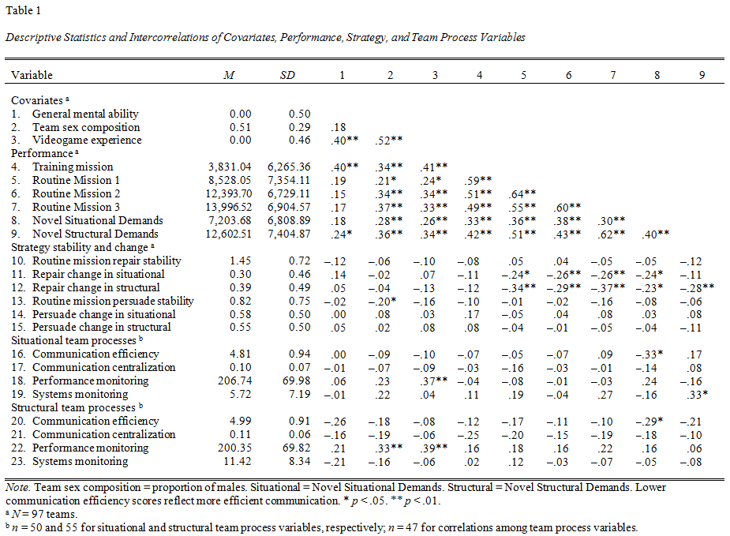
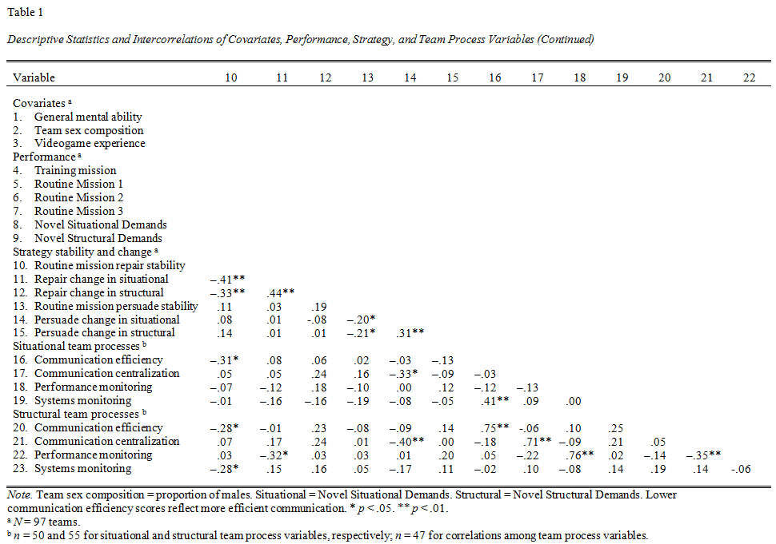
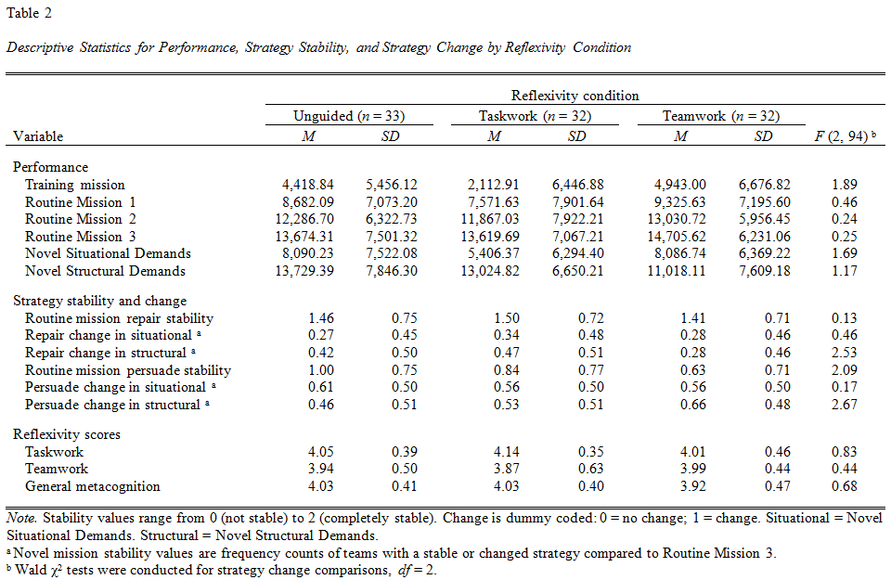
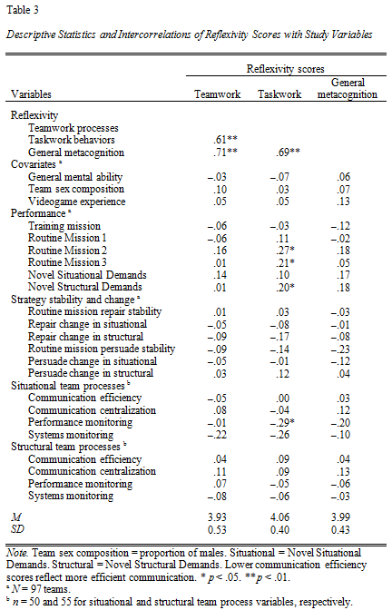
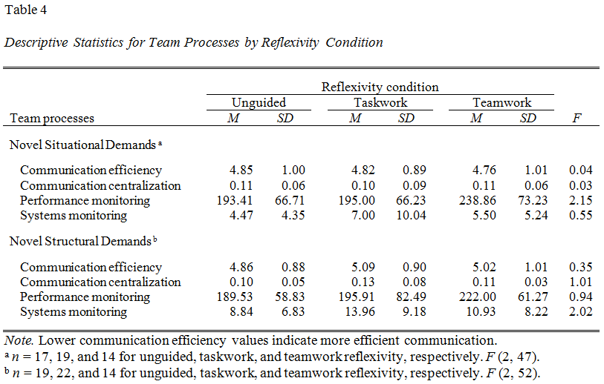
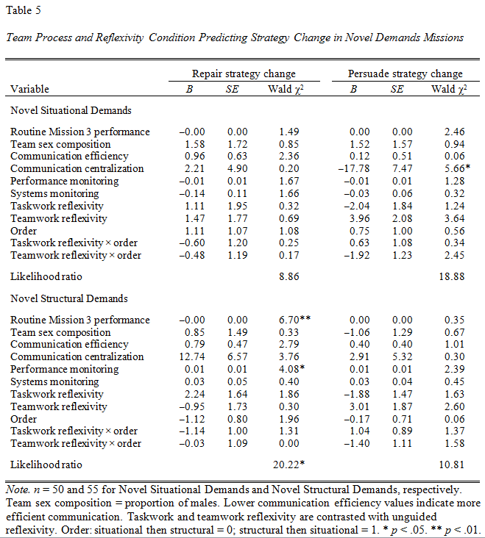

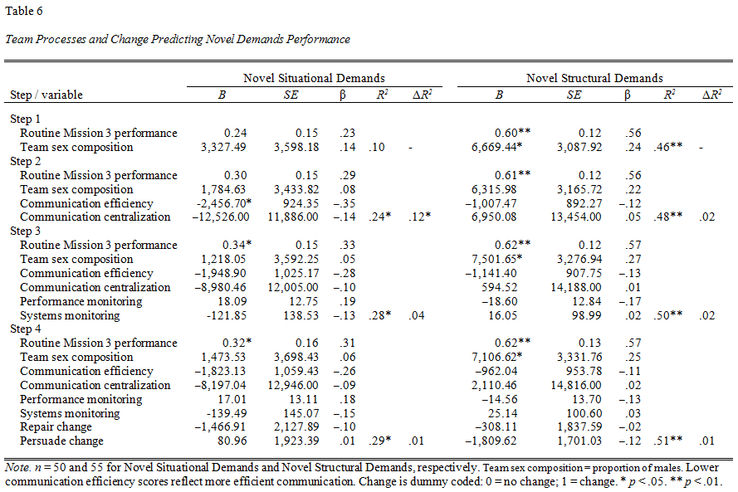
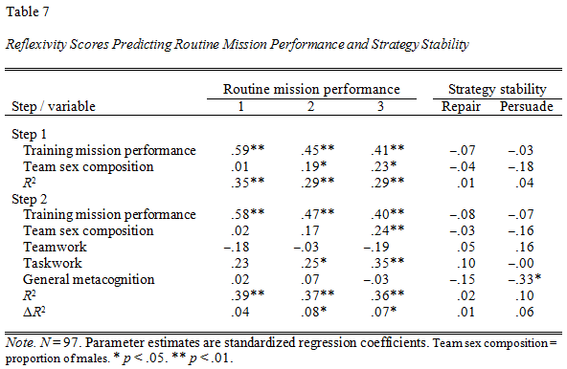

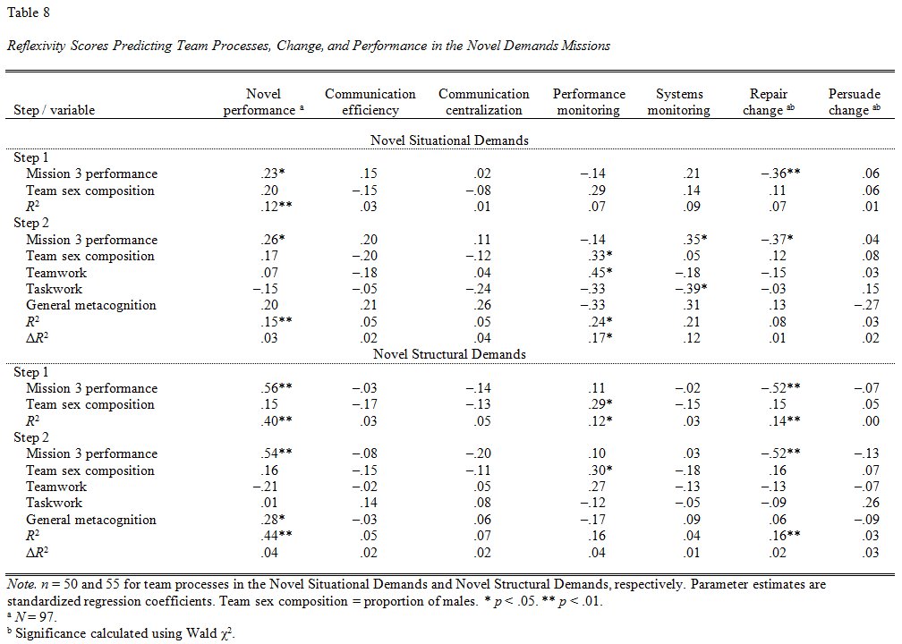

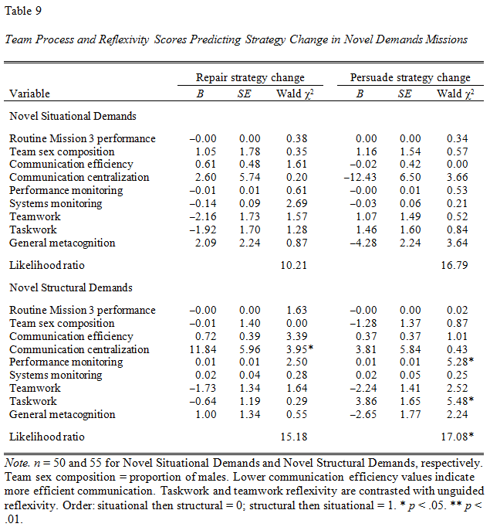

Appendix F: Figures


