UNIVERSITY OF OKLAHOMA
GRADUATE COLLEGE

INVESTIGATION INTO MANUFACTURING PARTS WITHIN PARTS TO PRODUCE A HIGHER PRESSURE RESILIENT SPHERICAL PRESSURE VESSEL

A THESIS
SUBMITTED TO THE GRADUATE FACULTY
in partial fulfillment of the requirements for the
Degree of the requirements for the
Degree of
MASTER OF SCIENCE

By
ERIC MARTINEZ
Norman, Oklahoma
2024

INVESTIGATION INTO MANUFACTURING PARTS WITHIN PARTS TO PRODUCE A HIGHER PRESSURE RESILIENT SPHERICAL PRESSURE VESSEL

A THESIS APPROVED FOR THE
SCHOOL OF INDUSTRIAL AND SYSTEMS ENGINEERING

BY THE COMMITTEE CONSISTING OF

Dr. Shivakumar Raman, Chair
Dr. Byeong-Min Roh, Co-Chair
Dr. Janet K. Allen

© Copyright by ERIC MARTINEZ 2024
All Rights Reserved.

Table of Contents

ABSTRACT v
FIGURES, TABLES, AND EQUATIONS vi
CHAPTER 1: INTRODUCTION 1
CHAPTER 2: BACKGROUND AND THESIS OBJECTIVES 4
CHAPTER 3: LITERATURE REVIEW 12
CHAPTER 4: METHODS 22
CHAPTER 5: FINDINGS 37
CHAPTER 6: CONCLUSION 46
CHAPTER 7: DISCUSSION 50
REFERENCES 52

ABSTRACT

Specifically, this thesis is an investigation into the use of Additive Manufacturing (AM) for the construction of a small rocket component whose fabrication by means of AM has not been researched extensively. In general, it is an example of how AM can be used to introduce complexity into simple, common parts for the purpose of innovation. AM is maturing into a disruptive technology allowing for the placement of payloads into Low Earth Orbit (LEO) and deep space with record-breaking cost reductions. Common AM practices allowing these cost reductions are the use of AM to produce whole systems with reduced amounts of material, manufacturing whole systems with fewer components, or constructing exotic geometries that are not obtainable by means of subtractive manufacturing but result in higher performance characteristics or efficiencies. During the preliminary literature review, it became apparent much of the research and development in the field of AM applications for spacecraft are on those systems providing opportunities for improved cost/benefit margins such as the propulsion system and human-spacecraft interfaces.
However, I believe there is missed opportunity in terms of innovation by not researching the use of AM in the other systems. In April 2022, NBC News published an article stating that the cost of sending a pound of payload into space on the space shuttle cost nearly 30,000 USD (in 2021 dollars), while the emergence of modern rockets and their systems has allowed the cost to drop down to around 1,296 USD on the Falcon 9 rocket (Chow, 2022). While this 95.68% reduction in cost is significant, our imaginations are coming up with more expensive, capable, and heavier payloads which further drives our need to find additional ways to improve efficiency and reduce weight. One way we may be able to do this is by reevaluating systems that can be manufactured through AM processes and have a relatively uncomplicated function and construction. This lack of complexity implies that a new, and hopefully innovative, design approach will add little risk to performance, reliability, and safety while providing the opportunity to shave a few pounds.
With the need to innovate in mind, I will design and manufacture artifacts representative of the traditional method by which modern spherical Pressure Vessels (PVs) are fabricated (essentially two hemispheres joined in the center by a weld) and a new, potentially innovative design only possible via AM and consisting of two unlike pieces that combine to form a spherical PV. The goal of this new design is to produce a PV that can withstand higher pressures as compared to a similar PV constructed through traditional means. Using FEA analysis and minor postprocessing, I will analyze both designs to evaluate if there is value in researching and re-thinking how we design, build, and use simple products. The results show both artifacts can withstand 100%, 125%, and 150% of their expected normal operating pressures. However, the “traditional” artifact will undergo catastrophic failure at a pressure that is about 2% greater than the point at which the “innovative” artifact experiences catastrophic failure.

FIGURES, TABLES, AND EQUATIONS

Figure 1: Original Prusa XL printer, an example of a FDM AM printer with multi-material capabilities. (Prusa3d.com) 5
Figure 2: Illustration of the LEM which shows many examples of cylindrical and spherical PVs. (National Air and Space Museum, Apollo Lunar Module Cutaway (si.edu)) 8
Figure 3: Exploded view of the Orion system used on NASA's Space Launch System (SLS). Note the copper, carbon, and stainless-steel PVs used in the service module. (NASA, https://www.nasa.gov/reference/orion-spacecraft/) 9
Figure 4: Illustration of stresses existing inside and outside of a spherical pressure vessel. (University of Nebraska-Lincoln, http://emweb.unl.edu/negahban/em325/18-pressure-vessels/pressure%20vessels.htm) 15
Figure 5: Illustration of stresses existing inside and outside of a cylindrical pressure vessel. (University of Nebraska-Lincoln, http://emweb.unl.edu/negahban/em325/18-pressure-vessels/pressure%20vessels.htm) 16
Figure 6: Drawing of the Saturn V booster stage (S-IC) showing the internal fuel and oxidizer tanks whose cylinder surfaces provide structural support to the airframe. (NASA, https://ntrs.nasa.gov/api/citations/20090016301/downloads/20090016301.pdf) 17
Figure 7: Two AM produced pressure vessel parts manufactured by NGIS. The left artifact has had no surface postprocessing work. The artifact on the right has undergone machining, giving it a shiny finish. (ASME, https://doi-org.ezproxy.lib.ou.edu/10.1115/PVP2019-94033) 19
Figure 8: An AM produced pressure vessel manufactured by NGIS. This article is a cylindrical PV with spherical ends. Note the location of the weldment at the midpoint of the cylinder.(ASME, https://doi-org.ezproxy.lib.ou.edu/10.1115/PVP2019-94033) 19
Figure 9: Example of a PLA part that has been surface finished by dry-tumbling with hardwood medium. (Steven Schneider, Kramer Industries, Inc., Vibratory Tumbling 3D Printed Plastic and Metal Parts | Kramer Industries, Inc (kramerindustriesonline.com)) 21
Figure 10: Sketch of hemisphere that will be used to fabricate the PV using the traditional method. 23
Figure 11: Sketch revolved around the axis to produce a 3D hemisphere. 24
Figure 12: Two hemispheres seated together to show how the part will look. The placement of the weldment is also annotated. 25
Figure 13: Image of the simulation tree just prior to running the FEA for the traditional PV. 26
Figure 14: Sketch of minor body piece that will be used to fabricate the PV using the "innovative" design. 28
Figure 15: Sketch revolved around the axis to produce a 3D minor body piece. 28
Figure 16: Sketch of major body piece that will be used to fabricate the PV using the "innovative" design. 29
Figure 17: Sketch revolved around the axis to produce a 3D major body piece. 29
Figure 18: Cutaway view of the assembled "innovative" PV to show how the minor body piece seats against the major body piece. 30
Figure 19: Figure 19 Cutaway view showing how the "innovative" PV will need to be constructed to allow for FEA. 31
Figure 20: Cutaway view showing the "innovative" PV model configuration for FEA. 32
Figure 21: FEA compatible model of innovative design, ready for meshing. 32
Figure 22: STL model of the hemisphere to be used in the traditional fabrication method. 33
Figure 23: PLA print of the hemisphere. 34
Figure 24: Two PLA prints. The left hemisphere has the support structure removed. 34
Figure 25: PLA print of the hemisphere showing the support structure removed. 34
Figure 26: CAD model showing the intended geometries and orientations of the major and minor body parts during printing. 35
Figure 27: STL model showing how the major and minor bodies will be printed. 35
Figure 28: PLA print of the "innovative" PV. The material at the bottom is a support structure added during the build to prevent deformation. 36
Figure 29: An inside view of the "innovative" PV. Note the rough surface on the underside of the minor body piece. 36
Figure 30: Traditional PV Stress @ 590 PSI 37
Figure 31: Traditional PV Weldment @ 590 PSI 37
Figure 32: Traditional PV Displacement @ 590 PSI 37
Figure 33: Traditional PV Stress @ 737.5 PSI 38
Figure 34: Traditional PV Weldment @ 737.5 PSI 38
Figure 35: Traditional PV Displacement @ 737.5 PSI 38
Figure 36: Traditional PV Displacement @ 885 PSI 39
Figure 37: Traditional PV Weldment @ 885 PSI 39
Figure 38: Traditional PV Stress @ 885 PSI 39
Figure 39: Traditional PV Stress @ 1600 PSI 40
Figure 40: Traditional PV Weldment @ 1600 PSI 40
Figure 41: Traditional PV Displacement @ 1600 PSI 40
Figure 43: Part-Within-Part PV Weldment @ 590 PSI 41
Figure 42: Part-Within-Part PV Stress @ 590 PSI 41
Figure 44: Part-Within-Part PV Displacement @ 590 PSI 41
Figure 45: Part-Within-Part PV Stress @ 737.5 PSI 42
Figure 46: Part-Within-Part PV Weldment @ 737.5 PSI 42
Figure 47: Part-Within-Part PV Displacement @ 737.5 PSI 42
Figure 49: Part-Within-Part PV Stress @ 885 PSI 43
Figure 48: Part-Within-Part PV Weldment @ 885 PSI 43
Figure 50: Part-Within-Part PV Displacement @ 885 PSI 43
Figure 51: Part-Within-Part PV Stress @ 1600 PSI 44
Figure 53: Part-Within-Part PV Displacement @ 1600 PSI 44
Figure 52: Part-Within-Part PV Weldment @ 1600 PSI 44
Figure 54: Article for the "innovative" model cut in half for visual inspection. 48
Figure 55: The inner surfaces of the two hemispheres for the traditional design shown for visual inspection. 48
Figure 56: Visualization of recommended changes to make a spherical PV serviceable and/or inspectable. 51

Table 1: Vessel Types (OSHA, https://www.osha.gov/otm/section-4-safety-hazards/chapter-3) 12
Table 2: Difference in characteristics between EBM and MLS. (Additive Manufacturing Technologies, Second Edition. Gibson, Rosen, and Stucker. Springer2015) 19
Table 3: Pressure schedule for FEA testing 27
Table 4: Traditional model results at 590 PSI. 37
Table 5: Traditional model results at 737.5 PSI. 38
Table 6: Traditional model results at 885 PSI. 39
Table 7: Traditional model results at 1600 PSI. 40
Table 8: Innovative model results at 590 PSI. 41
Table 9: Innovative model results at 737.5 PSI. 42
Table 10: Innovative model results at 885 PSI. 43
Table 11: Innovative model results at 1600 PSI. 44
Table 12 Test Results 45

Equation 1: t ≤0.356×R 14
Equation 2: P ≤0.665×S×E 14
Equation 3: t=P×R2×S×E-0.2×P 14
Equation 4: P=2×S×E×tR+0.2×t 14
Equation 5 σ=PR2t 15
Equation 6 σh=PRt 16
Equation 7 σa= PR2t 16
Equation 8 LTW=C=2×π×r ∴2×π×2 in=12.57 in 50
Equation 9 LIW=C=2×π×r∴2×π×1.15=7.23 in 50

CHAPTER 1: INTRODUCTION

This thesis will follow a progressive flow beginning with a discussion of the topic. Chapter 2 will provide a high-level review of what AM is, the different methods employed within AM, and why this approach might be taken. To understand the strengths and weaknesses of AM, we will also need to briefly review its counterpart, subtractive manufacturing. The discussion will then move on to introduce Pressure Vessels (PVs). The two types of PVs will be introduced and their applications within spacecraft will also be discussed.
Chapter 3 will begin by investigating the standards, methods, and procedures set forth by ASME’s Boiler and Pressure Vessel Code Section VIII, Rules for Construction of Pressure Vessels Division 1 standard. Here we will cover the Society’s information regarding how a spherical PV should be designed, how to determine the PV’s performance limitations and what test requirements should be employed to ensure that the PV is safe for use. This review will also include a review of the ASME standards on the use of weldments for constructing the spherical PV. Once we understand how to calculate the required geometries for our PV, we will then be able to research previous applications of spherical PVs for spacecraft.
Investigating how PVs have been used historically in space vehicles, we will also have to review applicable design considerations that limit the use of how and when spherical PVs can be used. To validate our innovative design, we will need to understand when a spherical PV should be used and when the use of a cylindrical PV becomes the correct design approach. During this part of the research, we will look at a few examples of both so that we can better understand the functionality, and design requirements for our spherical PV. Upon completing this portion of the thesis, we should also be able to derive acceptable certification and verification requirements for our article. Doing so allows us to have objective goals that we can use to determine whether our attempt of producing an innovative PV design resulted in a superior product as compared to a “traditionally” constructed PV.
Equipped with information from the ASME Boiler and Pressure Vessel Code along with valuable context gained by reviewing the historical application of pressure vessels in spacecraft, we can move on to reviewing the literature for the use of AM produced spherical PVs in space applications. More specifically, we will investigate recent research conducted by the Northrup-Grumman Company regarding their use of AM to manufacture a spherical PV. This information will give us a great understanding of how mature the research and development is for these components and can perhaps allow us to identify current knowledge gaps in the community as well as areas of opportunity for innovative design.
We’ll then use our gap analysis to identify a use case for the design of our test article. This will provide us with a clear idea about what our PV needs to do by providing functional and performance definition. This is not contrary to our earlier work where we defined our design requirements, instead this step will take the existing requirements and add further design constraints by taking the “general” spherical PV and attaching a specific use case to it along with the associated environmental, behavioral, and functional characteristic of a spherical PV manufactured for use in our chosen use case. We can then discuss our options for an innovative PV design. I believe the best place to start will be the designing of a spherical PV whose parts (hemispheres) can be manufactured via AM means but is constructed by the traditional means of welding the two parts at the at its great circle. This article will be representative of a standard, modern PV and will serve as the baseline from which we can compare and validate our innovative design. Similarly, we will review the design of the new model. Here we will need to discuss and explain the innovative part of our design along with how it is expected to react/perform during the test phase of the research. As the functionality of the new PV is essentially the same as the first model, the discussion here will focus on only those aspects that are different to avoid the repetitive use of talking points and information.
Logically, we next proceed to the test phase of the project in Chapter 4. At this point, we will focus on two artifacts. While both are manufactured using AM, one model will consist of two hemispheres being welded at the great circle, while the other is constructed mostly as one piece with a small portion of one end being built inside the larger part. The smaller part is intended to be welded to the larger body after post-processing. We will need to discuss the methods by which both articles will be tested. Unfortunately, since the artifacts needed to be constructed from Polylactic Acid (PLA), we will not be able to subject each artifact to the high pressures that would have been appropriate for their metal counterparts. Instead, we will rely on Finite Element Analysis (FEA) to give us an idea of how the artifacts would have reacted if they were to operate in the environment expected for their designed use case. The digital model for each article will be exposed to a range of simulated pressures. The calculated stresses will be evaluated against the material’s (stainless steel) ultimate strength to determine the article’s structural integrity under the given load. The deformation will be a recorded parameter to give us an idea of what physical operating limitations we may experience in terms of volumetric allocations and interference with other components or systems. We will also be able to perform a modified post processing step, allowing us to evaluate the degree of complexity and difficulty each design lends to their post processing. Each method should be aligned to address our verification and validation requirements, while being able to be applied to both articles in the same manner. The procedure for each test method will also be discussed in detail to mitigate the possibility of ambiguity influencing the validity of the test results and the conclusion.
Chapter 5 will disclose the findings for each article’s test. While I expect this session to be relatively short, it should also be straight forward and provide the critical data to drive the thesis’ conclusion. As the University of Oklahoma resides in the United States of America, I will strive to report all data in terms of the Imperial System (ft., lbs., in.). I intend for the layout of this section to be such that several illustrations are laid out side-by-side to provide a comparison of both articles being subjected to the same pressures. This will allow us to make a quick and simple evaluation of stress and deformation status for both articles. Illustrations will also be provided of both articles’ post processed surfaces, allowing us to determine the quality of the post processed surface, and the effectiveness/complexity of applying post processing measures.
Chapter 6 will synthesize the information provided in the previous sections to derive a final stance on whether the innovative design and its fabrication process provides for a stronger, more durable pressure vessel. The stance will be given based upon how well each article meets the verification and validation requirements defined at the end of Chapter 2. I will also include speculative thoughts on the results where possible and when the results do not agree with the values I expected.
Chapter 7 will conclude this thesis and will capture my recommendations for future research. I will use my professional experience to evaluate and provide commentary on whether there is a benefit to using the innovative approach over the traditional method. I will also try to conclude my thoughts on my work on this topic and insights gained from this experience.

CHAPTER 2: BACKGROUND AND THESIS OBJECTIVES

Additive Manufacturing (AM) has been a popular fabrication method for the last two decades. This process of adding material, known as feedstock, in layers over layers in such a way that the layers bond together has become a disruptive technology for many industries. There are certainly many different forms of AM such as vat photopolymerization, Powder Bed Fusion (PBF), extrusion, material jetting, binder jetting, sheet lamination, Directed Energy Deposition (DED), and direct writing; with each method having a particular medium, such as plastic, metal, porcelain, and organics, that it excels in using as feedstock. Given that unique machines with unique characteristics (build speed, build space, usable feedstocks, melting pool temperatures, etc.) exist for each method, each method has applications for which they are better suited for (metal or plastic printing, high fidelity parts, rapid prototyping, large or small parts, etc.).
Fused Deposition Modeling (FDM) for instance, is a type of AM process that uses the extrusion method to heat polymer-based feedstocks to their melting point, or just past it, so that the liquified material can be pushed through a nozzle and deposited on to the surface just below. Refer to Figure 1 for an example of an FDM printer. The use of the word “surface” is intentional as the nozzle could be depositing the material onto a build plate, which acts as an initial surface for the item being manufactured to build upon but is not a part of the item, or it could be the previous layer of the item itself. This method uses polymer-based feedstock, making FDM a good approach for many prototyping efforts where form and design are the more important features to be analyzed. However, the limitations to this format include slower build speeds which lead to longer build times. Since the feedstock is polymer based, there are mechanical limitations to items produced via FDM as well. For example, if you were to build a prototype crescent wrench using a polymer feedstock such as Acrylonitrile Butadiene Styrene (ABS) you would have a product to help illustrate properties such as the ergonomics, geometries, and dimensions of your design, but you would not want to try to use this protype to tighten a metal bolt to verify functionality. Chances are that the metal bolt would all but deform, if not break, your plastic protype wrench. When determining the correct method of AM for a particular build, not only does the designer and/or fabricator need to consider these unique properties to identify fabrication and product limitations, but they also need to consider what post-processing steps that method will require to obtain the desired final product.
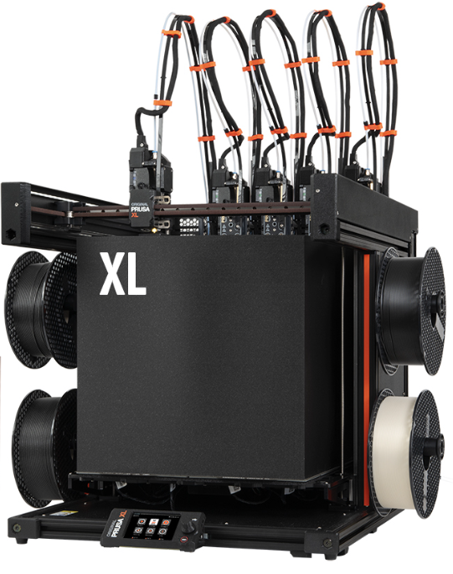
Figure 1: Original Prusa XL printer, an example of a FDM AM printer with multi-material capabilities. (Prusa3d.com)

Post-processing includes any additional steps that must be taken to achieve the desired characteristics of the final product such as surface smoothness or porosity. These steps can include the removal of support structures needed during the build process (most AM process cannot build surfaces less than 45⁰ from the horizontal plane due to gravity. Support structures help prevent the surface of the item from sagging downward), painting, heat treatment, ball-peening, grinding, and sanding. Although we are focusing on additive manufacturing, it is not uncommon for AM produced part to undergo subtractive processes in order to reach their final design configuration. Any required or desired post-processing steps can have a direct impact on what AM process is chosen. For instance, most metal products fabricated using AM require some type of heat treatment to relieve residual stresses, improve the bonding between layers, or reduce porosity. However, if you do not have access to a kiln or other suitable heat source, you may opt to choose different AM processes and/or different feedstocks to achieve a certain design goal. Opting not to use post-processing steps that are generally considered common practice, like heat treatments for metal prints, can lead to unintended and undesirable outcomes such as early failure due to fatigue stress, cracking, pitting, or unusable parts due to unacceptable geometric tolerancing.
So far, we have a general idea of what AM is, a list of the different AM methods, and some of the design choices that need to be considered to ensure parts are manufactured successfully for their intended function. Taking into consideration all this information, one may feel that the use of AM may not be as simple or straightforward a process as it first seems. This is true, AM can be quite complicated and with there still being much unknown about AM, there is not a lack of research being conducted to answer the many questions being asked about the AM process. Yet, despite any AM limitations and constraints, there is an undeniable necessity for AM across the industries where it has filled gaps left by subtractive processes.
The much older counterpart to AM, subtractive manufacturing is the process by which material is removed from a larger part to fabricate the desired product. As society has used many forms of this method over thousands of years, industries have become quite effective and efficient in the different forms of subtractive processes to produce many of the things we use in everyday life such as automobiles, furniture, personal computer computers, to name just a few. However, there are also limitations to subtractive manufacturing. Ironically, while AM processes can be time consuming for mass producing products, the use of subtractive manufacturing to produce one-off parts such as prototypes can be impractical as subtractive manufacturing often relies on processes that require comparatively longer lead times than AM such as the procurement of special tooling. For example, the production of a carbon-fiber manifold may require a mold. The mold may require special tooling to be formed, which could take several weeks to months to purchase and procure. The mold then needs to be created successfully. If issues in the mold’s quality require that a new mold be made, additional or new tooling may be required. This unfortunate event could push the timeline out even further. AM may be able to mitigate this issue by offering the ability to produce the same part in a timeframe of several days to a few weeks without the dependency of special tooling.
There is also the unique ability of AM to produce complex geometries that are simply not possible by means of subtractive manufacturing. This feature alone has led to innovative designs and significant advancements in different engineering fields including aerospace, heat exchangers, prosthetics, and medical implants. These complex geometries allow engineers to design more elegant solutions to meet the needs of their stakeholders. This point will be illustrated later where pictures of SpaceX’s Merlin engines show how a modern design has been able to remove surfaces that were required with subtractive manufacturing but are unnecessary in an AM approach. The use of AM to produce complex bends and use exotic feedstocks has resulted in weight reduction, fewer weldments, and elegant designs with fewer parts that can fail. Another example comes from Northrup Grumman Innovation Systems (NGIS), where the team was able to take a subtractively manufactured Slosh Control Device (SCD), composed of 10 individual components, and manufacture a comparable SCD as a single piece using AM. The “new one-piece additive manufactured SCD took advantage of the positive attributes of AM technology and eliminated all the piece parts and weld operations. Eliminating the welds also eliminated the associated costs such as pre-weld cleaning, post weld non-destructive examination (NDE), and multiple pieces of manufacturing planning. This newer design is less expensive to manufacture and facilitates a faster procurement cycle.” (Tam, Wlodarczyk, & Hudak, 2019)
Given all the different ways professionals and amateurs have been able to apply AM, it can be argued that AM is the most disruptive technology contributing to innovation today. However, it is my observation that of all the benefits AM can provide, those looking to leverage AM to produce innovative products focus on the obvious benefits as previously mentioned: the production of limited quantity parts at lower cost and faster rates than other manufacturing processes, manufacturing complex geometries that are not possible otherwise, and the ability to fabricate single piece components using multiple materials using gradients as desired by the designer. In general, my concern is that we have identified certain limitations of AM and have used those limitations to determine that we should pursue AM research and applications specifically in areas where subtractive manufacturing is not desirable. I interpret the current use case for AM being situations where a complex problem needs to be made simpler or made more cost effective. However, why can we not take on a simple problem and make it better? It may be that opportunities to discover other ways in which AM can offer additional innovative solutions are being forfeited by not researching how components ideal for subtractive manufacturing can be produced via AM. Instead of taking the complex and making it better by using a more elegant design, can we take the simple and make it better by incorporating elegance into its design? I’d like to further investigate this concept by asking, can we improve upon the simple spherical Pressure Vessel (PV) by utilizing a more complex design, achievable only by AM processes, to build a product?
The spherical PV has been used in countless applications across several industries where the need to distribute stresses evenly (high pressure environments) is necessary. Like their cylindrical PV counterparts, spherical PVs are used to store gases and liquids. They have historically been manufactured using a combination of subtractive manufacturing and welding. These components have become so common that the American Society of Mechanical Engineers (ASME) has compiled enough manufacturing and operational data to compose its popular Section VIII, Boiler and Pressure Vessel Code (BPVC) manual. This publication clearly defines the technical procedures and requirements necessary to produce spherical PVs with predictable and reproducible performance characteristics, leaving little room for a desire to improve upon the design. Supporting this claim in the aerospace industry, NGIS notes, “For over 55 years, the conventional subtractive manufacturing approach had been the primary tank shell manufacturing method. This was no coincidence. In the past six decades, scientists and engineers from governments, satellite primes, propulsion system integrators, launch vehicle providers, tank manufacturers, research organizations, and academia had all invested significant resources to build an extensive database in support of the subtractive manufacturing methodology” (Tam, Wlodarczyk, & Hudak, 2019).
Pressure vessels have two general categories: cylindrical and spherical. Each one has characteristics that make it suitable for certain applications. The Lunar Excursion Module (LEM), the system that landed man on the moon in the 1960’s and 1970’s, uses both styles (see Figure 2) in its descent and ascent stages. A more modern application can be seen in Figure 3, where the use of PVs can be seen in the service module. The type of PV chosen for any given application can depend on the characteristics of the material needed to construct the PV or the space allocatable to a PV. Large tanks are typically used in areas where space is a constraint.
This sounds counter-intuitive, but we will come back to this point. Applications requiring a tank’s contents to be subjected to higher pressures will usually use spherical PVs. All other parameters being equal, spherical PVs are typically preferred over cylindrical PVs due to characteristics we will cover in the literature review section.

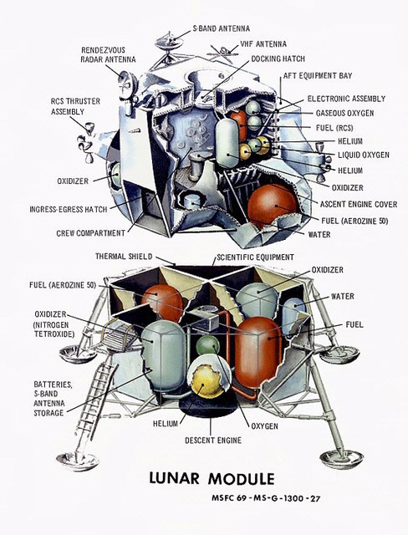
Figure 2: Illustration of the LEM which shows many examples of cylindrical and spherical PVs. (National Air and Space Museum, Apollo Lunar Module Cutaway (si.edu))

The excerpt referenced on page 7 from NGIS originates from a research paper discussing the need to investigate additively manufacturing PVs because, while the processes are well defined and the production methods are well understood, “a less favorable outcome of this highly refined and highly controlled process is a long manufacturing throughput time and the resulting high cost” (Tam, Wlodarczyk, & Hudak, 2019). While the NGIS research will play an important part in this thesis, I want to underscore that NGIS’ investment into their project was not motivated by a wanting to expand the knowledge of AM in non-complex parts, but as I’ve mentioned before, a desire to reduce production time and cost. This objective they set for themselves has resulted in a cylindrical pressure vessel with hemispherical ends. Unfortunately, while their PV was produced using AM, the fabrication approach they used was the production of two identical pieces welded at the center, replicating the traditional means by which PVs are constructed (see Figure 8).
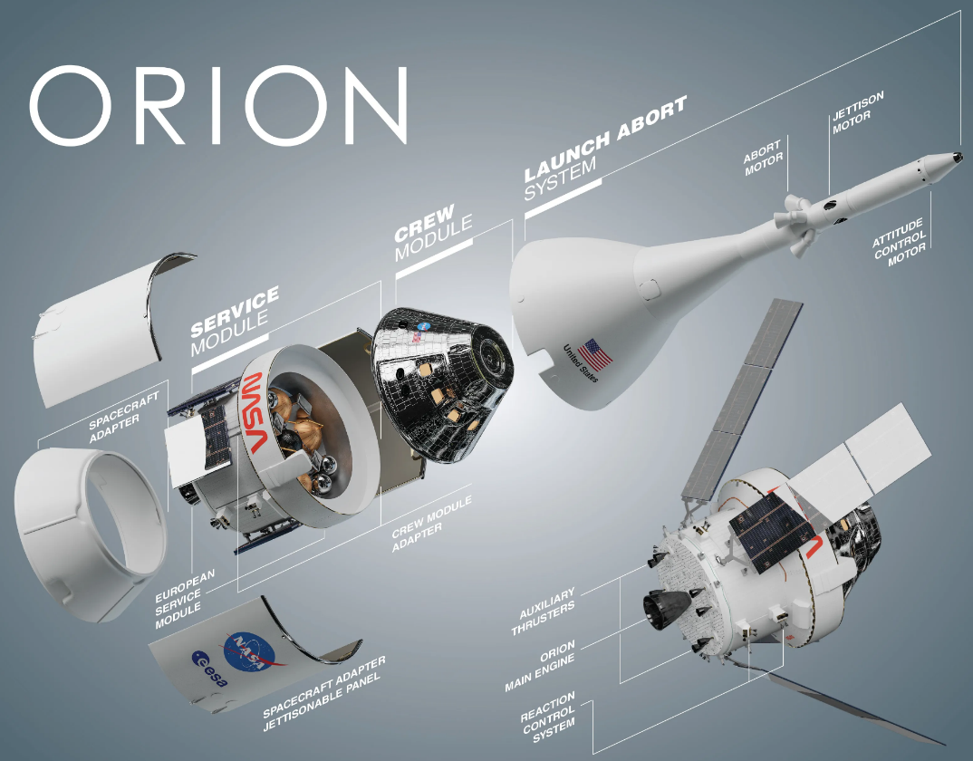
Figure 3: Exploded view of the Orion system used on NASA's Space Launch System (SLS). Note the copper, carbon, and stainless-steel PVs used in the service module. (NASA, https://www.nasa.gov/reference/orion-spacecraft/)

However, NGIS’ published research has laid the groundwork for an exciting opportunity to investigate a specific use case for a spherical pressure vessel in the aerospace industry with potential implications for any spherical PV use case: a fuel cell. Again, the scope of this thesis is not to find a part that can easily be produced using subtractive means and then trying to replicate that part using AM processes. The objective is to add value to academia and encourage further innovation by taking a non-complex part that can easily be produced using subtractive means and include a feature or characteristic to the part that is exclusive to AM resulting in a new, and hopefully innovative, revision.
As the title of the thesis suggests, my approach to innovation will be the construction of a spherical PV using two parts, one inside of the other (see Figure 18). The two parts will be identified as the major and minor body pieces. The major piece will consist of a portion of a spherical PV that is almost a single complete sphere with only a fraction of the top missing. The part being manufactured inside of the major body piece will be the minor body piece, whose shape will complement that part missing from the major body piece. The minor body piece will also feature a lip on the inner surface which extends radiantly (see Figure 15). I anticipate this lip to serve two functions. First, it will prevent the minor body piece from being able to vacate the inside of the major body piece. Second, this PV will require a weldment but instead of being placed at the great circle, it will be placed where the faces of the major and minor body pieces meet (see Figure 20). The lip of the minor body piece will increase the effective wall thickness under the area where the weldment will be placed. I argue that this added wall thickness will result in the weldment being subjected to reduced stress levels as compared to the weldment of a PV using a traditional design. Weld lines tend to fail before the material used to construct a PV; if the weldment is subject to less stress, this should result in a PV that can withstand higher loads. Being able to operate at higher loads could imply that a given PV can be used in applications not suitable for its traditional equivalent due to system pressures. There are also instances where the ability of the fuel cell to operate at a higher pressure may increase thrust efficiency. This is possible because combustion efficiency of the propellants is dependent on the pressures at which the fuel and oxidizer are introduced into the combustions chamber.
One of the potential setbacks for the “innovative” design may be the ease with which it can be post-processed. Currently, it is generally accepted that post processing AM metal parts helps to reduce the probability of premature failure due to fatigue, stress cracking, or issues caused in other parts of the system due to particulates and burrs detaching from the rough surface and causing blockages elsewhere. Research is currently ongoing in determining if this is indeed an issue or just an educated deduction as to what might be happening on rough surfaces. However, I did not come across information confirming that rough surfaces are not an issue therefore, this should be taken into consideration when discussing the benefits of the new design. The design itself may be innovative but, if it must be postprocessed and it cannot be readily achieved, the design may simply become a novel idea and not worth pursuing further.
To determine what value, if any, the innovative design adds to the performance of a spherical pressure vessel, I will conduct two tests to obtain and compare data for parameters across a traditionally designed PV and a PV using the “innovative” design. First, I will analyze the performance characteristics of each PV under load and compare vessel stress, and deformation values, as well as weldment resiliency over a range of pressures until both PVs have reached their failing point. Second, I will evaluate the ease with which the surfaces of the two vessels can be post processed.
To accomplish the first test, I will create two digital models of a spherical PV in SolidWorks. Due to resource constraints, I will not be able to fabricate and test physical metal articles. I will, however, be able to run Finite Element Analysis (FEA) on the digital models which simulate hydrostatic testing. Hydrostatic testing is the process where a test article is filled with some type of incompressible fluid in a controlled manner to determine the article’s ability to maintain its structural integrity and not fail. The first model will use a traditional design. The traditional model will only need one half of its sphere to be designed. The part can then be duplicated to produce the second half. Both hemispheres will then be mated within SolidWorks to form the complete PV. SolidWorks’ FEA application allows for the placement and analysis of weldments, allowing for a high-fidelity model to be used in the virtual test environment. The model for the “innovative” design will be created and tested using the same procedure, except that the new PV will involve the design and creation of more than one part since each part is not identical.
While I do not have the ability to fabricate physical metal artifacts, I can print PLA articles using an FDM printer. The yield strength and melting point for PLA is much less than that of the metals I would consider using for a fuel cell, but the use of PLA will allow me to create articles that are geometrically the same. For the second test, I can use the PLA articles to simulate the postprocessing of metal parts for each design, which in this case involves tumbling the pieces using abrasive media to gently remove burrs and rough inner surfaces from the PVs. I can then subjectively report the difficulty of post processing the innovative design as compared to the traditional design.
Ideally, the “innovative” design will be successful in outperforming the traditional design. To be successful, it must achieve at least two of the five objectives listed:
- Reach a higher pressure before reaching its yield strength (implying it reached its burst pressure).
- Receive a smaller max displacement value at its burst pressure.
- Achieve a smaller, in terms of thickness, calculated weldment line at its burst pressure.
- Have a surface finish with the same or less surface roughness quality.
Before we move on to the literature review, let’s establish some operational context to our PVs that will allow us to derive the requirements for model design. The PV we will be designing is intended to be used as a fuel cell for a rocket whose body diameter is 5 inches. Due to mounting structures and any other systems, cabling, or plumbing that may need to run, the diameter of the fuel cell shall not exceed 4 inches in diameter. The fuel cell will be constructed using 316 stainless steel and shall hold kerosene at temperatures between 32⁰F to 105⁰F. When not operating, the pressure within the fuel cell will be equal to ambient pressure. When operating, the maximum allowable operating pressure will not exceed 590 psig.

CHAPTER 3: LITERATURE REVIEW

The Occupational Safety and Health Administration (OSHA) defines a pressure vessel as a “storage tank or vessel that has been designed to operate at pressures above 15 p.s.i.g.” (Occupational Safety and Health Administration, 2024). Table 1 provides a list of vessels which OSHA includes in the PV category and a list of vessels which are specifically excluded. Pressure vessels can be constructed using different materials, shapes, and sizes; there are numerous applications for this category of tanks. As these vessels are intended to hold liquids or gases under pressure, they pose a hazard to people and property in the vicinity should a rupture occur, which can lead to injury via blast effects (concussive pressure waves), or fragmentation (the rapid spreading of pressure vessel pieces). Depending on the material being stored in the pressure vessel, leakage failures can also be of significant concern as it can lead to suffocation, poisoning, fire, combustion, chemical or thermal burns. To lower the probability of a structural failure and to induce predictability in the performance of a product, OSHA encourages the use of either Section VIII of the ASME BPVC, or the American Petroleum Institute (API) Standard 620 when constructing a PV.

Table 1: Vessel Types (OSHA, https://www.osha.gov/otm/section-4-safety-hazards/chapter-3)
Vessels included: | Vessel types specifically excluded:
Stationary and unfired | Vessels used as fired boilers
Used for pressure containment of gases and liquids | Vessels used in high-temperature processes (above 315° C, 600° F) or at very low and cryogenic temperatures
Constructed of carbon steel or low alloy steel | Vessels and containers used in transportable systems
Operated at temperatures between -75° and 315° C (-100° and 600° F) | Storage tanks that operate at nominally atmospheric pressure
 | Piping and pipelines
 | Safety and pressure-relief valves
 | Special-purpose vessels, such as those for human occupancy

Before moving on from information provided by OSHA, I would like to address a line item within Table 1 that was initially concerning and could complicate my research. The third row under the “Vessel types specifically excluded” column defines vessels and containers used in transportable systems as not being members of the PV category. I interpreted the definition to mean any pressure vessel used in a system having a transport function to not being considered a PV. My example of this would be a container used to transport gasoline from a refinery to gas stations. The vessel used to store the gasoline is a vessel which requires itself to be mobile for the gasoline to be transported. Is this not a PV? What about the gas tanks used by the semi-truck transporting the gasoline vessel? Since I intend to conduct research and analysis on a vessel used to store fuel for a rocket motor, this definition could have significant impacts to my work as the vessel can be seen as a container used to transport fuel within the rocket’s airframe until the time at which all the fuel is moved from the vessel to the motor for combustion. Fortunately, Section VIII of BPVC further clarifies that, “except as covered in U-1(f), structures whose primary function is the transport of fluids from one location to another within a system of which it is an integral part, that is, piping systems” (ASME Boiler and Pressure Vessel Committee Subcommittee on Pressure Vessels, 1986) are excluded. Section U-1(f) addresses the use of pressure relief devices, which are not within the scope or functionality of the type of vessel I am researching. Going back to my example, the tanks would be considered PVs, however any piping existing within the tanks would not be considered a part of the PV. That is, my gasoline tank examples would have been considered PVs if at some point they were pressurized to at least 15 psig. Therefore, I am comfortable in classifying the fuel cell I’m designing as a PV.
Section VIII of ASME’s BPVC provides constraints for the minimum thickness of a shell under internal pressure for both cylindrical and spherical PVs in subsection UG-27. This section also defines many important parameters such as the inside radius of the shell (R), maximum allowable stress (S), and weldment joint efficiency (E), which will be used to determine the design limitation of the fuel cell in terms of minimum required thickness (t), and design pressure (P). Paragraph (d) of subsection UG-27 contains equations for determining a spherical PV’s minimum required thickness and design pressure (see Equation 1 through Equation 4). These equations require the input of additional parameters which can be found using Table UW-12, Maximum Allowable Joint Efficiencies for Arc and Gas Welding Joints; subsection UG-24, Castings, paragraph (5)(a); and table UHA-23, Maximum Allowable Stress Values in Tension for High Alloy Steels. These additional parameters provide the designer with multipliers to account for imperfect weldments (Table UW-12), imperfections in the shell due to the fabrication method (UG-24), and the maximum allowable stress characteristic of the material being used to fabricate the shell (UHA-23).

IF
Equation 1: $t ≤0.356×R$
AND
Equation 2: $P ≤0.665×S×E$
THEN USE
Equation 3: $t=\frac{P×R}{2×S×E-0.2×P}$
OR
Equation 4: $P=\frac{2×S×E×t}{R+0.2×t}$

Section VIII also covers required inspections and tests of the final PV. Once the PV has been fabricated, it must undergo some form of testing to ensure the vessel can maintain its structural integrity under a pressure loading based upon the maximum allowable working pressure within or outside of the PV during normal operating conditions. The maximum allowable working pressure is the maximum pressure that can be expected to exist within or external to the pressure vessel under defined normal operating conditions. Section VIII, subsection UG-99(b) states, “Except as otherwise permitted in (a) and (k), vessels designed for internal pressure shall be subjected to a hydrostatic test pressure which at every point in the vessel is at least equal to $11/2$ time the maximum allowable working pressure to be marked on the vessel multiplied by the lowest ratio… of the stress value S for the test temperature on the vessel to the stress value S for the design temperature” (ASME Boiler and Pressure Vessel Committee Subcommittee on Pressure Vessels, 1986).
In addition to the test requirement just described “Modern Engineering for Design of Liquid-Propellant Rocket Engines” by Dieter K. Huzel and David H. Huang identifies another test point from the military standard MIL-STD1522A (USAF), Standard General Requirements For Safe Design and Operation Of Pressurized Missile And Space Systems. (Huzel & Huang, 1992) This standard requires an intermediate test point at $11/4$ of the maximum allowable working pressure along with the ASME required $11/2$ factor. As the research of this thesis will involve spherical PVs modeled for use on high-powered rockets, this additional test point will also be included in the fuel cell’s analysis.
Having defined what a PV is, providing examples of some PV applications, and reviewing the typical design and test process of a spherical PV, we will now begin to discuss the use of spherical PVs for rocket and space-vehicle applications. Aerospace engineers Huzel and Huang originally wrote their book to train their young mentees. Considered an essential resource for those aspiring to become rocket propulsion scientists and engineers, “Modern Engineering for Design of Liquid-Propellant Rocket Engines” offers rich, in-depth information applicable to this research topic. Chapter 8, Design of Propellant Tanks, covers the use cylindrical and spherical pressure vessels. The literature goes on to say that spherical PVs offer many superior characteristics when compared to their cylindrical counterparts. One of these characteristics is that a sphere “offers the smallest surface-to-volume ratio and the smallest shell stress for a given internal pressure”. This is a very important concept which will play a factor in the design of my “innovative” fuel cell. As can be seen in Figure 4, the spherical pressure vessel experiences stress parallel to the z and y axes and equal in magnitude. This stress (σ) can be expressed mathematically as shown in Equation 5.

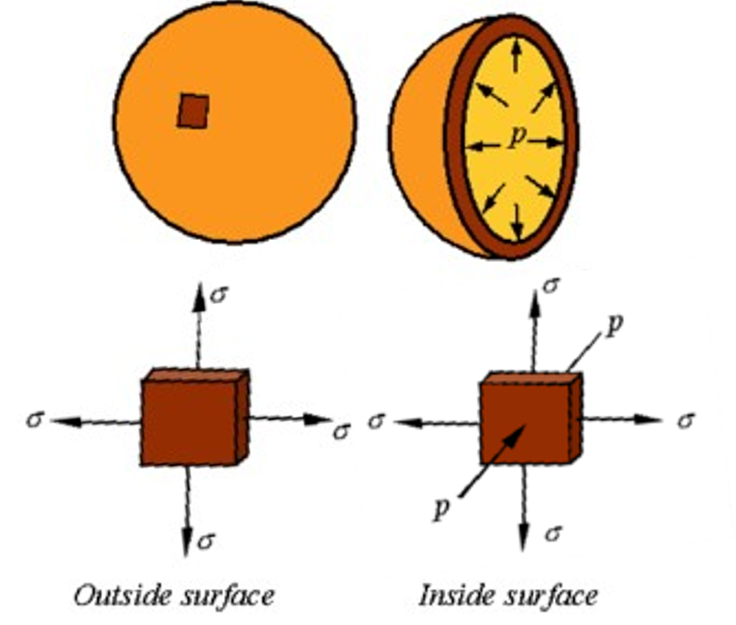
Figure 4: Illustration of stresses existing inside and outside of a spherical pressure vessel. (University of Nebraska-Lincoln, http://emweb.unl.edu/negahban/em325/18-pressure-vessels/pressure%20vessels.htm)

Equation 5 $σ=\frac{PR}{2t}$

Cylindrical PVs experience similar stresses. However, magnitudes in the z and y plane differ from each other due to hoop stresses ($σ_{h})$ which act tangentially to the curvature of the PV. The stress in the plane perpendicular to the hoop stresses has the same magnitude of stress as that seen in the spherical PV. To differentiate this stress from the hoop stress, we shall define it as the axial stress ($σ_{a})$. Hoop and axial stress for a cylindrical PV can be mathematically expressed using Equation 6 and Equation 7 respectively. Analyzing the equations, we can see spherical PVs are better suited for high-pressure applications since the magnitude of the hoop stresses in a cylindrical PV are twice the magnitude of the axial stresses (which are the same as the stresses that would be subjected to a spherical PV of the same internal radius, shell thickness, and operating pressure).

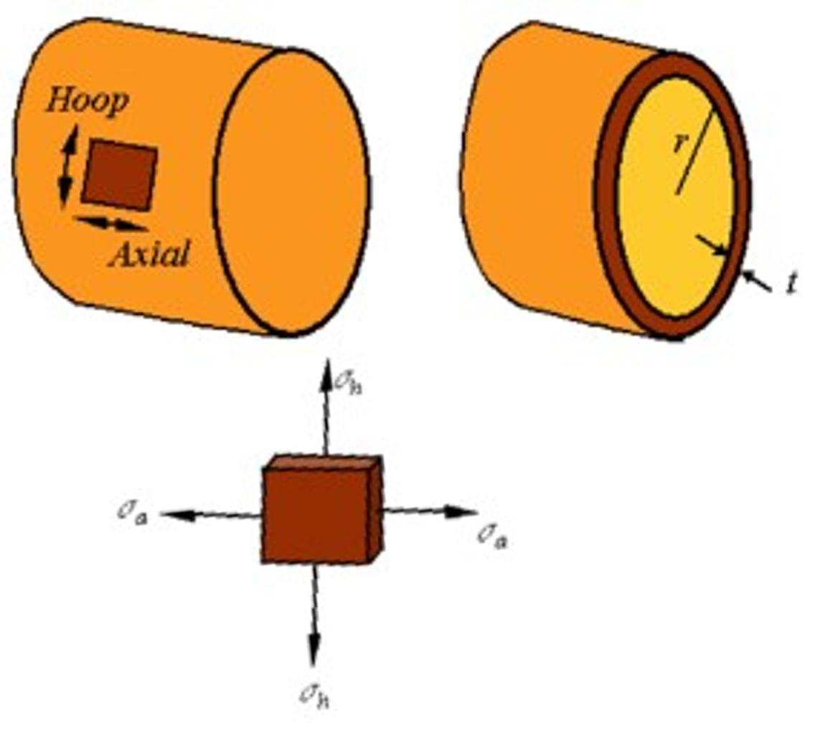
Figure 5: Illustration of stresses existing inside and outside of a cylindrical pressure vessel. (University of Nebraska-Lincoln, http://emweb.unl.edu/negahban/em325/18-pressure-vessels/pressure%20vessels.htm)

Equation 6 $σ_{h}=\frac{PR}{t}$
Equation 7 $σ_{a}= \frac{PR}{2t}$

These are only a couple of many design parameters that need to be considered. Those design parameters where the cylindrical PV is more advantageous are space allocation and the ability to use the walls of the PV as structural support for the spacecraft’s structure. Figure 6 shows how the propellant tanks contributed to the strength of the Saturn V rockets booster stage (S-IC). This is done by placing the tanks just behind the skin of the airframe, where the length of the cylinder’s surface can act as a load bearing structure. This is especially important for the booster stages of larger rockets which must be strong enough to bear the load of any other rocket stages and payloads above them. Spherical pressure vessels cannot be used effectively this way since their shell walls will only interface with the skin of the airframe at the great circle. There is also the matter of space allocation. For example. If the diameter of a spacecraft must be 30 feet and we have a length of 40 feet to allocate to a propellant tank, we can use basic geometry to show the cylinder’s advantage. Note (H) represents the internal height of the cylindrical PV.
Assuming the shell thickness is 1 inch, the volume for a spherical PV will be:
$$R=30 ft×12 in-2 in=358 in∴V=\frac{4}{3}πR^{3}=1.922×{10}^{8} {in}^{3}$$
Assuming the shell thickness is 1 inch, the volume for a cylindrical PV will be:
$$R=30 ft×12 in-2 in=358 in;H=40ft×12 in-2 in=478 in∴V=πR^{2}H=1.925×{10}^{8} {in}^{3}$$
By using a spherical PV, you are foregoing the ability to carry an additional $300,000 {in}^{3}$ of fuel or oxidizer. We now have a better grasp of why Huzel and Huang claim “both vehicle configuration and tank pressure will determine the shape of the propellent tank” (Huzel & Huang, 1992).

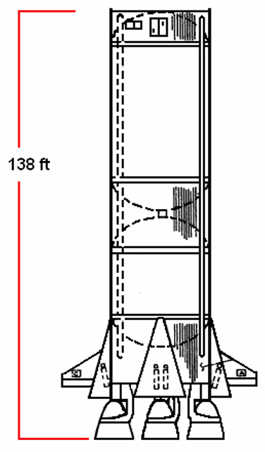
Figure 6: Drawing of the Saturn V booster stage (S-IC) showing the internal fuel and oxidizer tanks whose cylinder surfaces provide structural support to the airframe. (NASA, https://ntrs.nasa.gov/api/citations/20090016301/downloads/20090016301.pdf)

The 2019 conference paper by the NGIS team composed of Walter Tam, Kamil Wlodarczyk, and Joseph Hudak is meant to give conference attendees, and those reading the document, a progress report on their research related to the additive manufacturing of pressure vessels. This paper is significant to this thesis research as it was the only paper identified covering the topic of using AM to produce pressure vessels specifically for spacecraft applications. There are a few federated efforts that the authors discuss in their paper and while all topics were interesting, not all were relevant to the scope of this thesis’ research. The information that was helpful included work that has gone into establishing a material database. So far, their research implies that the mechanical properties of AM produced parts may be superior to the mechanical properties of similar, forge-made artifacts (Tam, Wlodarczyk, & Hudak, 2019).
The proceeding covers findings regarding what types of AM are best suited to produce PVs. The recommended processes identified are Direct Metal Laser Sintering (DMLS), which is a member of a PBF method known as Liquid-Phase Sintering (LPS) and Electron Beam Melting (EBM), which is also a PBF method. Both approaches use a machine that spreads a layer of powder across the build space. A laser, in the case of DMLS, or electron beam, in the case of EBM, forces the particles to melt. The means by which the particles are raised to a melting temperature differ and this is the primary difference between DMLS and EBM. Once the laser or EBM mechanisms are finished selectively melting particles for a given layer, the platform on which all the powder rests will shift downward, allowing the next layer of powder to be spread on the build surface so the process can continue. One of the major benefits of PBF is that the volume of un-melted powder acts as a means of providing structural support to any part of the artifact requiring such support, usually any overhangs with angles less than 45⁰ from the horizontal plane. Since a sphere contains such overhangs, the use of PBF eliminates the need to build support structures along with the artifact which causes longer build times and can cause significant postprocessing time requirements as the support structures need to be removed. Table 2 shows the differences between the EBM and MLS processes (Gibson, Rosen, & Stucker, 2015). Considering the concerns around surface finishing, DMLS may be the better approach as it offers a superior surface finish, and higher feature resolution.

Table 2: Difference in characteristics between EBM and MLS. (Additive Manufacturing Technologies, Second Edition. Gibson, Rosen, and Stucker. Springer2015)
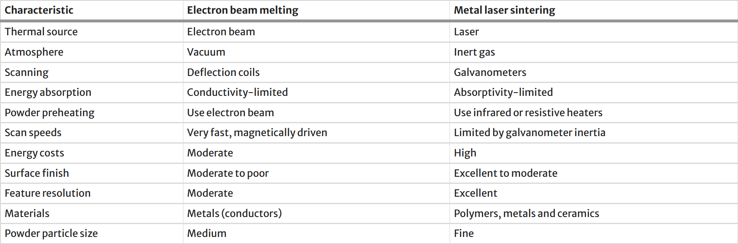

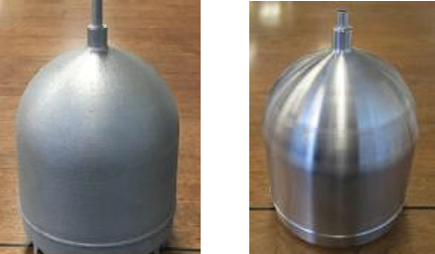
Figure 7: Two AM produced pressure vessel parts manufactured by NGIS. The left artifact has had no surface postprocessing work. The artifact on the right has undergone machining, giving it a shiny finish. (ASME, https://doi-org.ezproxy.lib.ou.edu/10.1115/PVP2019-94033)

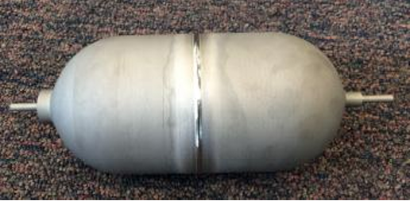
Figure 8: An AM produced pressure vessel manufactured by NGIS. This article is a cylindrical PV with spherical ends. Note the location of the weldment at the midpoint of the cylinder.(ASME, https://doi-org.ezproxy.lib.ou.edu/10.1115/PVP2019-94033)

Tam, Wlodarczyk, and Hudak also discuss the concern of material shedding. Their research on this topic is ongoing but, they are investigating whether a non-surface postprocessed artifact does pose an operational risk due to material being dislodged from the surface under the vibratory agitation that occurs during a rocket’s ascent. Currently, there is uncertainty regarding to what extent this phenomenon does happen, but material shedding can cause impurities to enter the medium stored in the tank, possibly leading to clogged plumbing or filters. Additionally, unfinished surfaces from AM produced parts have historically been a cause of concern for premature fatigue failure. As I could not find an update to this research, I will assume that the industry standard is that AM produced parts need to be surface finished.
Originally, I was inclined to grind the internal surfaces of the PV article. However, two issues became apparent. First, due to resource limitations, I will not be metal printing spherical PV articles. However, I will be able to simulate physical artifacts and their post processing by PLA printing 1:1 articles. Grinding is an issue for PLA because the heat generated in grinding will quicky reheat the PLA to its melting point. Deformation can happen very quicky causing the model to deform. This would lead to an unacceptable article for analysis. Thus, I further researched other methods to surface finish stainless steel 316, the feedstock I will use in my FEA analysis. My findings lead me to believe that tumbling is the correct method as it is commonly used to debur and polish stainless steel. Reviewing websites for several companies which provide finishing service, no information was found regarding specific process, tools, or materials used to accomplish the tumbling method. I assume this information is protected by each company as proprietary data. I did find information from a commercial supplier which could help identify the type of tumbling media that may be used for the process: “Ceramic tumbling media is made of abrasive grit with a ceramic binder to finish and debur fabricated and cast workpieces. Ceramic is an aggressive material that speeds processing over other abrasive materials when used on cast iron, titanium, steel, and stainless steel.” (Tumbling Media, 2024)
As ceramic media may be suitable for stainless steel, I am concerned that it will be too aggressive for the PLA. I still intend to use the tumbling method for surface finishing the spherical PV articles but, I will need to substitute ceramic media with crushed walnut shell. Figure 9 shows an example from Kramer Industries, Inc. where a PLA printed part was subjected to a dry-tumbling session using hardwood media with a polishing paste (Schneider, 2019). My objective in adding a tumbling step would be to evaluate the complexity in post processing a PV where the weldment resides at the great circle as compared to a PV where the weldment is placed closer to one of the inlet/outlet tubes. As the traditional method of manufacturing PVs uses two half-spheres, access to the inner surfaces is not difficult. The “innovative” design that I propose in this work offers an access area which is a fraction of the diameter of the sphere’s great circle. This increases the difficulty to access the inner surfaces, likely increasing the postprocessing time and resources needed, therefore increasing manufacturing time and costs. Although I expect my PV design to perform better than a PV where the weldment is at the great circle, a complex and difficult postprocessing effort may overshadow any performance benefits accrued by the new design and so should be analyzed.
I do have one final thought regarding the NIGS’ proceeding. Ironically, the most important information gained from this research comes from the pictures. Figure 7 and Figure 8 show two sets of pictures from the proceeding. While all articles show a cylindrical PV with spherical ends, the valuable knowledge here is the way in which the PVs are assembled. Figure 7 shows two halves of the PV which appear to be symmetrical and of the same dimensions. This implies that, if they were to be two halves of the same PV, they would need to join such that the weld line would be at the center of the PV. This assumption is confirmed in Figure 8 where we can see a completed PV. This is an example where an effort is using the disruptive technology only to exchange how an artifact is fabricated, in this instance forging is replaced by AM, but is not going far enough to leverage the benefits of AM to innovate the fabrication process or characteristics of the artifact. Needless to say, there was no information on manufacturing a PV using parts within parts in the AM build step.

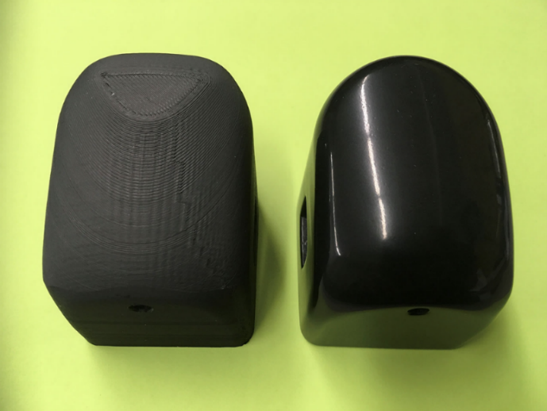
Figure 9: Example of a PLA part that has been surface finished by dry-tumbling with hardwood medium. (Steven Schneider, Kramer Industries, Inc., Vibratory Tumbling 3D Printed Plastic and Metal Parts | Kramer Industries, Inc (kramerindustriesonline.com))

CHAPTER 4: METHODS

The purpose of this section is to review the processes being used during the setup and testing phases. Recording these processes are important as they help to give context to the results and could possibly help identify the cause of any issues should there be any. This section will be broken into five distinct subsections. The first three subsections include activities to help determine the performance characteristics of both articles, while the last two activities are intended to evaluate the ease with which both artifacts can be postprocessed. These two areas cover the parameters being evaluated in validating the innovative design. Remember, we want to know if additive manufacturing a spherical vessel using parts within parts (the innovative aspect) will result in an innovative design that is more preferable to an additively manufactured spherical vessel that is fabricated using the traditional method of welding two half-spheres at the great circle. The five subsections are:

- Performance Testing
  - Performance of calculations as outlined by the ASME Section VIII manual. These calculations provide us with estimated values for our parameters and perhaps most importantly, a value for the minimum shell thickness allowed.
  - Design process for a traditional spherical PV (two half-spheres) as well as an “innovative” pressure vessel using SolidWorks.
  - Execution of FEA to simulate hydrostatic testing for both articles using SolidWorks.
- Post-processing Testing
  - FDM fabrication of both PV articles.
  - Post-processing of both PV articles for de-burring and surface finishing.

Using Equations 1 and 2 we find that:
$t=0.356×R ∴0.356×1.92 in=0.683 in;$
$$0.08 in<0.683 in$$

$P=0.665×S×E∴0.665×18.8×1000 psi=12,502 psi;$
$$560 psi<12,502 psi$$
Therefore, we can use Equations 3 and 4 to determine the minimum allowable wall thickness and maximum design pressure allowed, respectively:
$$t=\frac{P×R}{2×S×E-0.2×P} ∴\frac{590 psi×1.92 in}{2×18.8×1000 psi×.80-0.2×590 psi}=.038 in$$
$$P=\frac{2×S×E×t}{R+0.2×t}∴\frac{2×18.8×1000 psi×.80×0.08 in}{1.92 in+0.2×0.08 in}=1242.98 psi$$

Now that we know our design wall thickness of 0.08 in and design pressure of 590 psi are withing ASME tolerances for spherical PVs, we can begin designing our articles in SolidWorks. We’ll start with the traditional method:
To begin designing this article we only need to sketch a quarter of the spherical PV. Once we have the sketch, we’ll need to revolve the sketch around its axis to produce a 3D model. This will produce a hemisphere. Since this PV will be two hemispheres welded together at the great circle, the elegance in this design is the simple need to fabricate the same part twice.

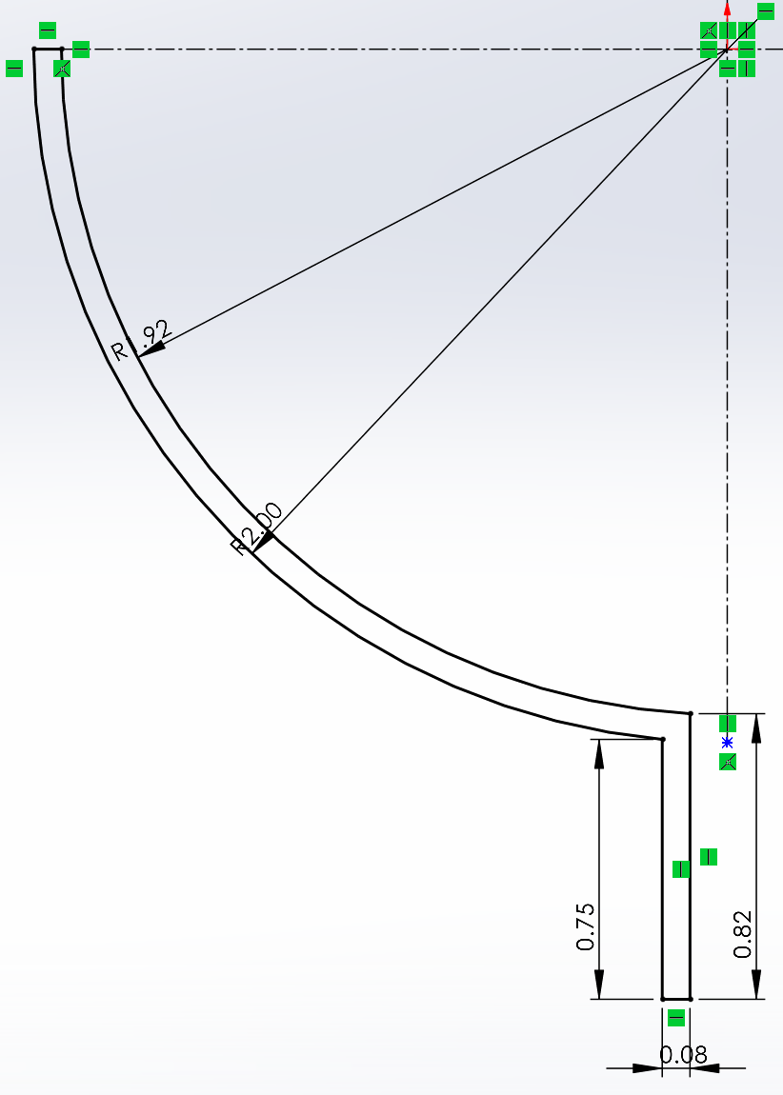
Figure 10: Sketch of hemisphere that will be used to fabricate the PV using the traditional method.

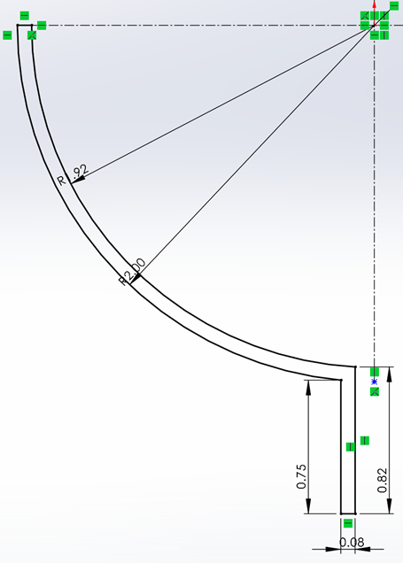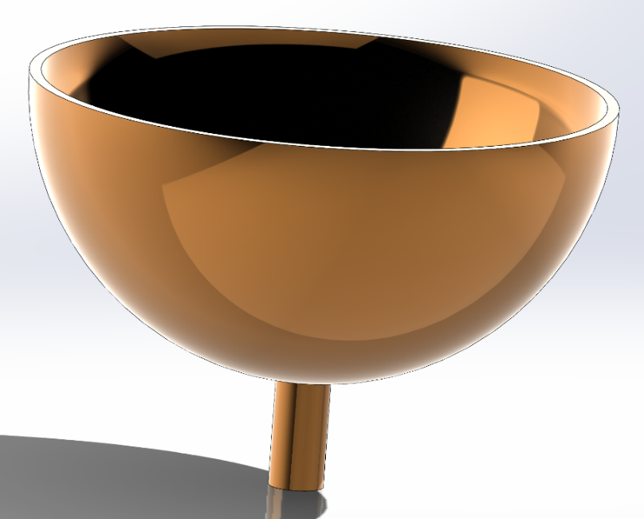
Figure 11: Sketch revolved around the axis to produce a 3D hemisphere.

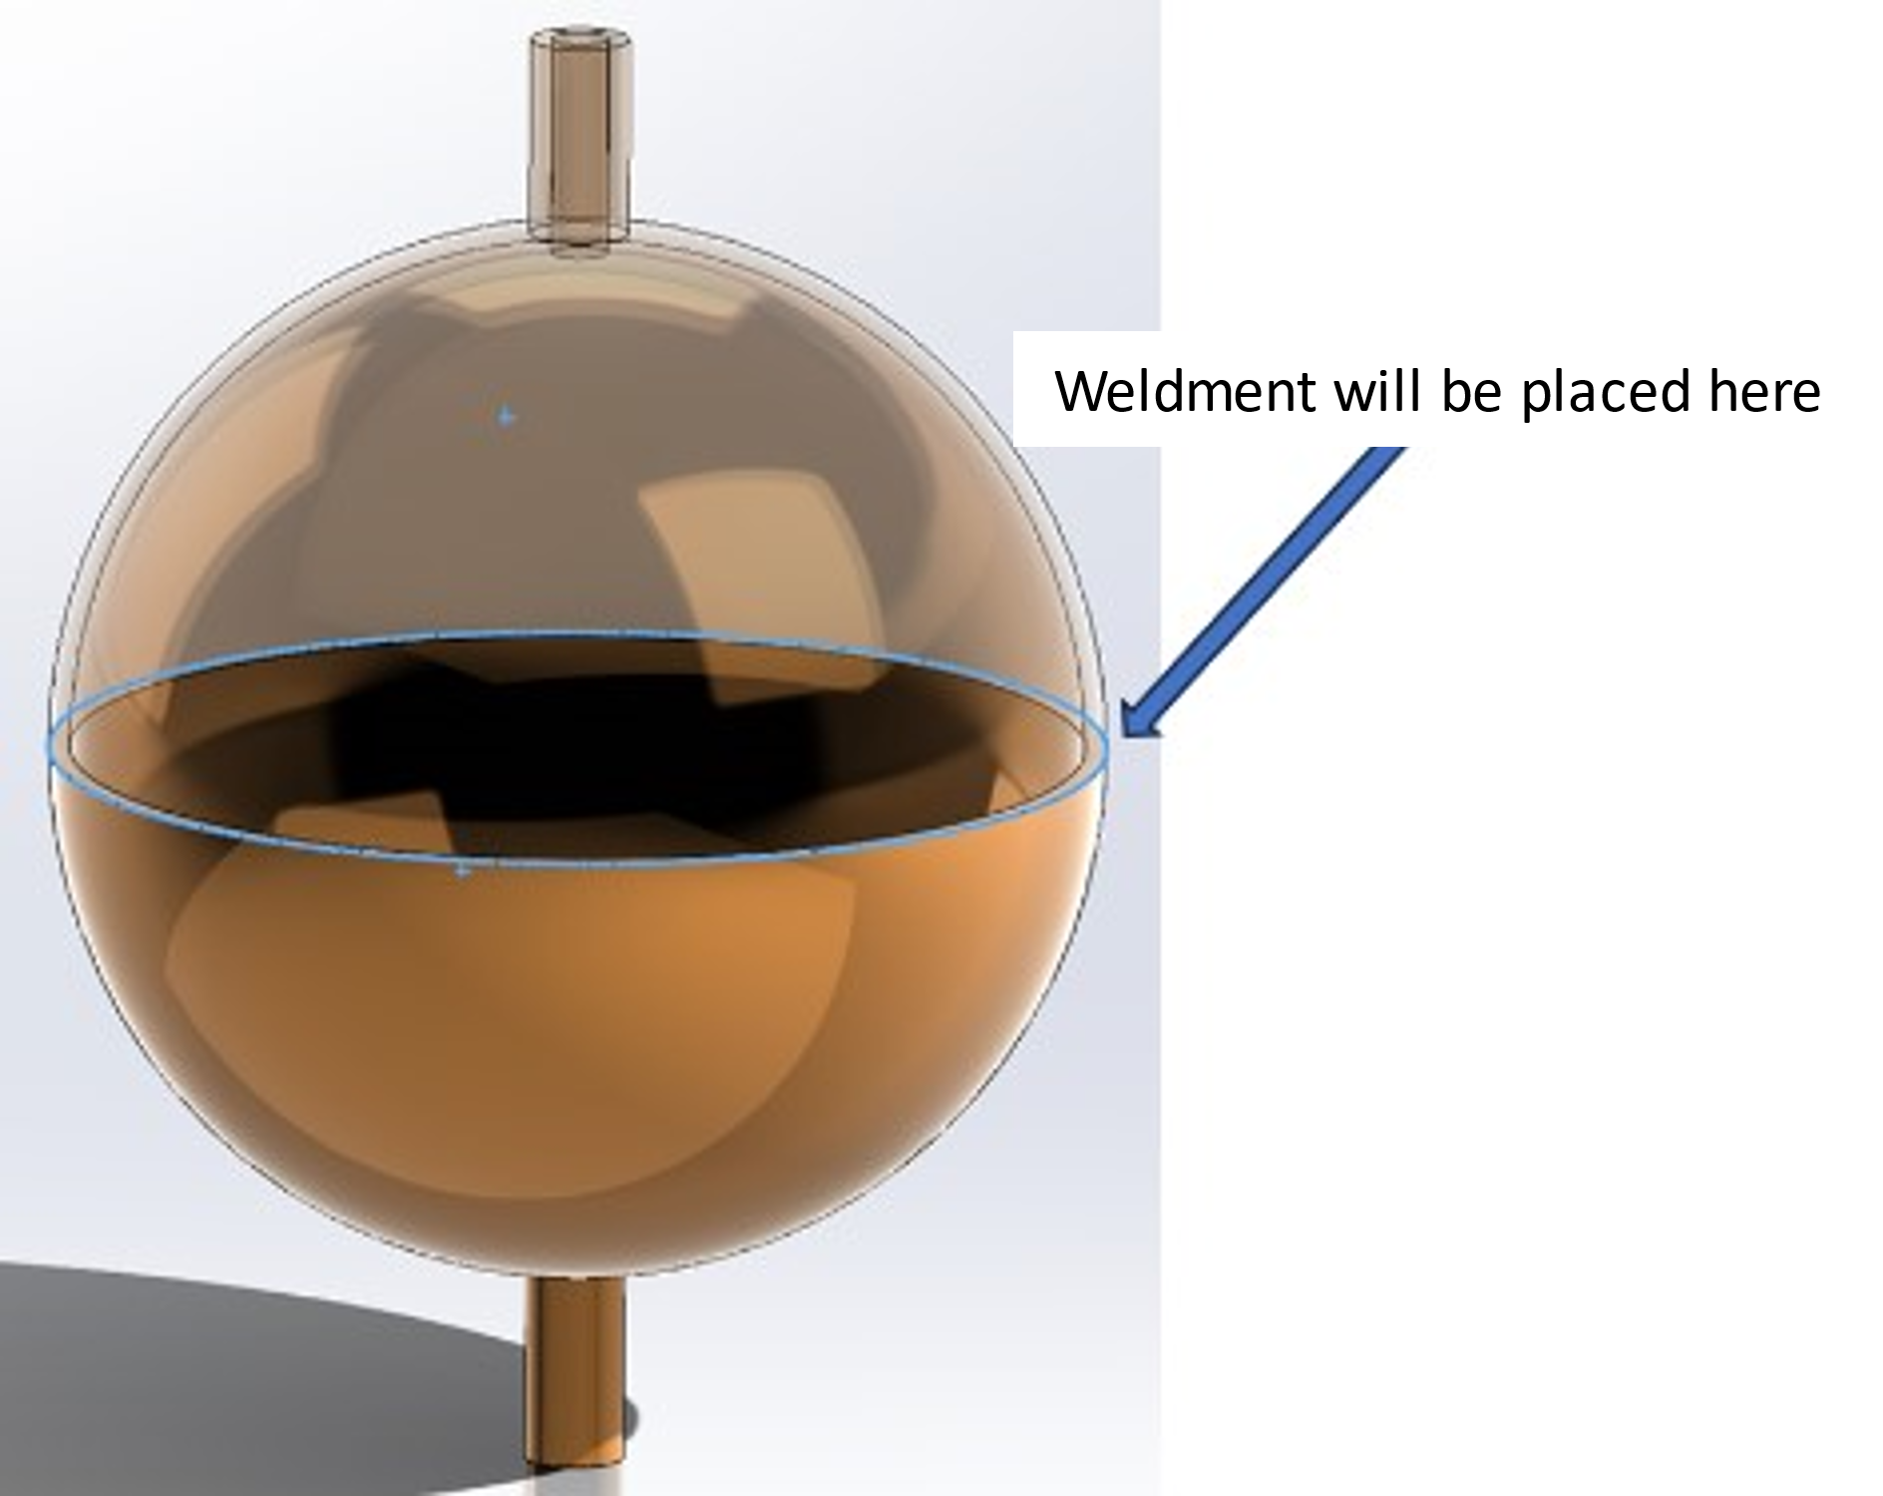
Figure 12: Two hemispheres seated together to show how the part will look. The placement of the weldment is also annotated.

When have the final 3D model, we can create and run a FEA analysis to simulate a hydrostatic test. The type of FEA analysis being run is a static, linear, non-dynamic test. The test parameters were set so that the material is Stainless Steel 316 (sheet form), initial internal pressure is 590 psi, weldment is placed at the great circle where the two hemispheres meet, and fixtures paced at the ends of the inlet and outlet ports. It should also be noted that the weldment was set to 4 mm using the highest available weld grade in SolidWorks. This is done to simulate the use of an aerospace application quality weld. Before running the analysis, the article must be meshed. This was done using the finest setting available to maximize the number of Stereolithography (STL) elements used. This helps to provide a greater fidelity to the analysis.

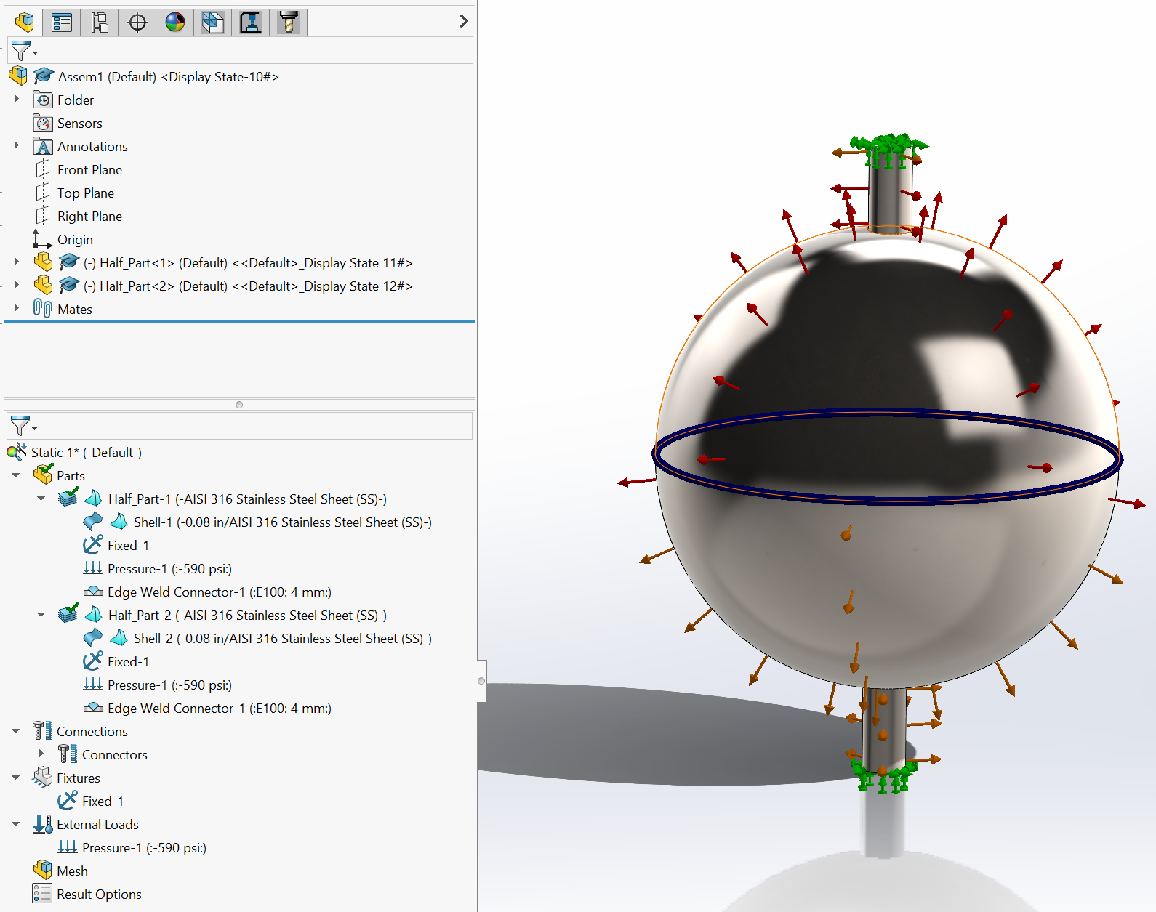
Figure 13: Image of the simulation tree just prior to running the FEA for the traditional PV.

After the meshing was completed, the FEA was run, and the stress and displacement results were recorded. Another static simulation was then set up for the next test pressure. Tests were run for the following test points.

Table 3: Pressure schedule for FEA testing
PSI | Notes
590 | Design pressure
737.5 | 125% of design pressure
885 | 150% of design pressure (burst pressure)
900 | Raised to the nearest 100 psi value to simulate the continuation of a typical hydrostatic test.
1000
1100
1200
1300
1400
1500
1600

Once the last test for the traditional PV was completed, I began work on the design for the “innovative” PV. Like the traditional PV, the innovative PV consists of two parts welded together. Unlike the traditional PV, one of the innovative PV parts makes up most of the PV. A smaller part of the innovative PV consists of two concentric areas (see Figure 15), the smaller area is on top and the larger concentric area on the bottom. The upper area compliments the walls of the major body piece. That is, put together, the major body piece and the smaller concentric area of the minor body piece will create a sphere. The larger concentric area should provide two functions. First, it will act as a lip which prevents the minor body piece from being ejected once the PV is pressurized by seating into the inside surface of the major body. Second, as the larger concentric area doubles the wall thickness (.16 in instead of .08) in its area, I believe this will help subject the weldment to lower stress values, increasing the durability of the PV. It is extremely important to note here that this innovative design is unique to AM as you cannot build the minor body part, as a single piece, inside of a single-piece major body using non-AM fabrication methods.

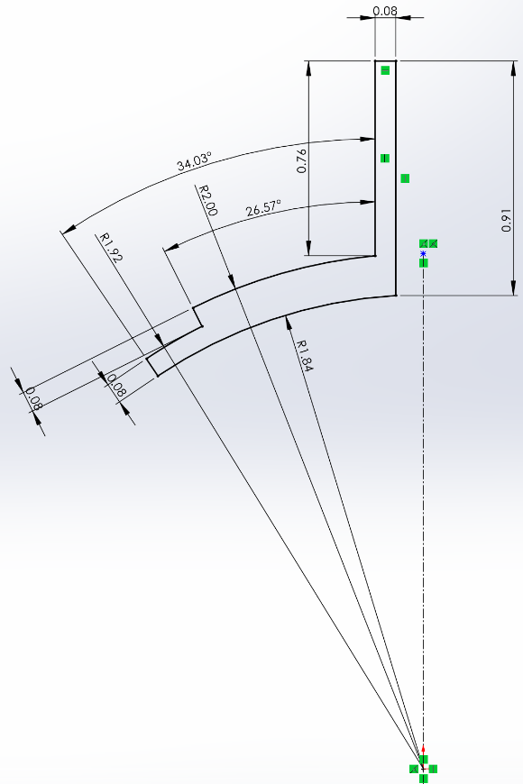
Figure 14: Sketch of minor body piece that will be used to fabricate the PV using the "innovative" design.

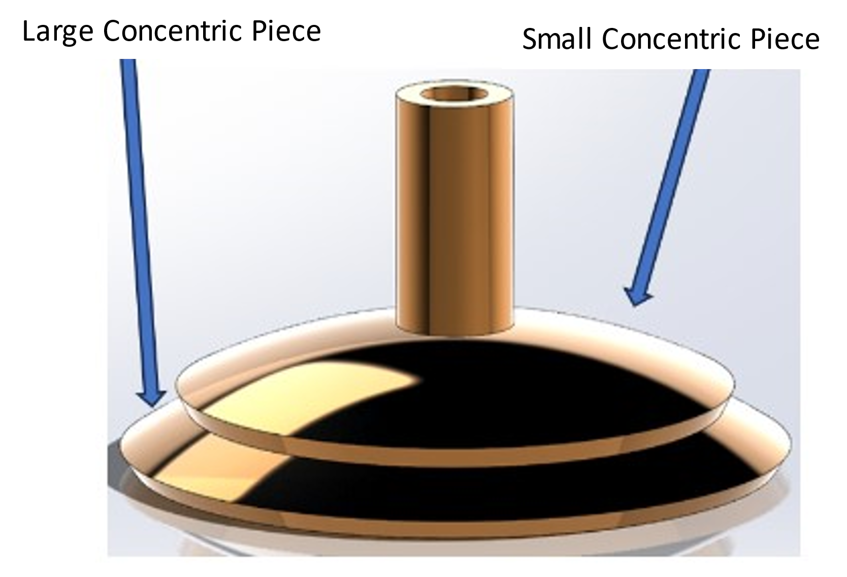
Figure 15: Sketch revolved around the axis to produce a 3D minor body piece.

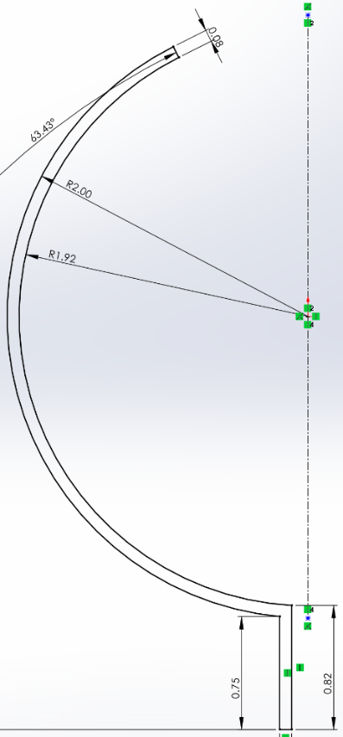
Figure 16: Sketch of major body piece that will be used to fabricate the PV using the "innovative" design.

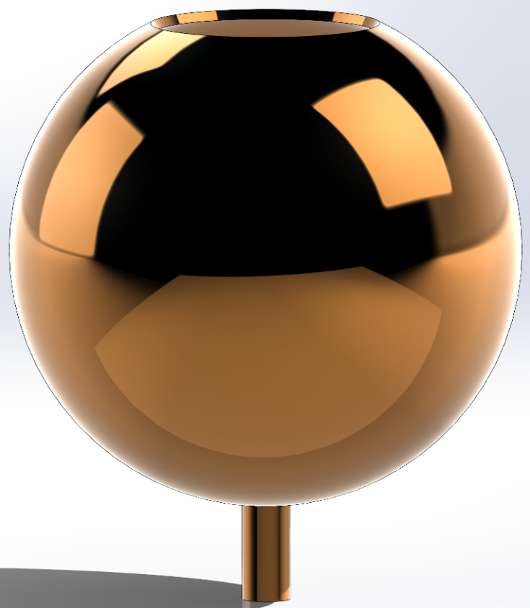
Figure 17: Sketch revolved around the axis to produce a 3D major body piece.
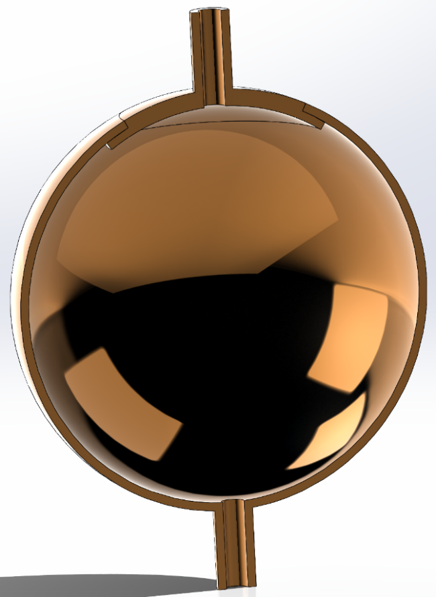
Figure 18: Cutaway view of the assembled "innovative" PV to show how the minor body piece seats against the major body piece.

There is an interesting issue with the model for the innovative design that prevents me from using it for the FEA analysis. Before an FEA can be performed, a feature called a shell must be added to the model. A shell can be placed on any face of the model, or it can be offset from any face. For the purposes of the FEA, the function of the shell is to provide a foundation from which the FEA analysis is performed. There is an additional feature for a shell that allows a thickness to be added to it. For our purposes, this allows us to tell the FEA algorithm that it must consider the dimensionless shell surface plus the added thickness. The FEA will then provide results for parameters as recorded at the shell surface. This means that the shell surface is where we place FEA features such as anchor points, and loads (pressure in this case). Unfortunately, the analysis on the weldment also requires us to place the weldment on a shell surface. The problem is that we cannot easily create shells that maintain continuity and allow for the weldment and pressures to be added in the locations where they belong. The root cause of the problem is that the innovative model requires the major and minor pieces to have their own shell surfaces. When this is done, there is a discontinuity that exists in the area where the large concentric area of the minor body seats against the large body resulting in errors for the FEA analysis. To resolve this issue, I created a second model consisting of four pieces (see ). Part 3 solves the problem with the discontinuity by combining the area where the major and minor bodies overlap as one solid piece. This will allow for the creation of a shell that is compatible between parts 1 and 4. The shells created by parts 1 and 3 will produce a divide between the faces where a weldment can be placed. Figure 21 shows the model ready for meshing and follow-on FEA analysis. The FEA for the innovative design was conducted using the same procedure used for the traditional model. The results will be covered in the next section.
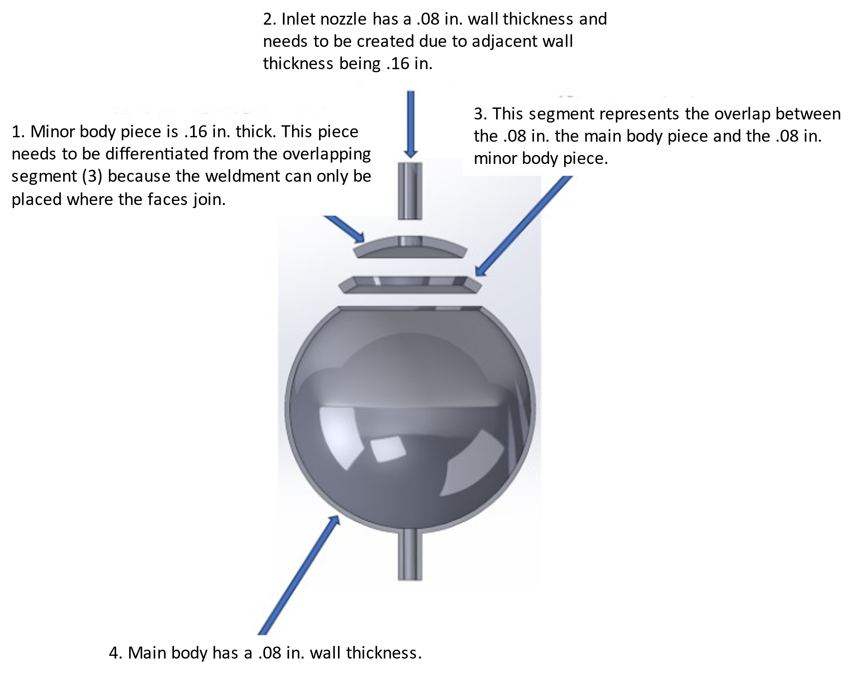

Figure 19: Figure 19 Cutaway view showing how the "innovative" PV will need to be constructed to allow for FEA.

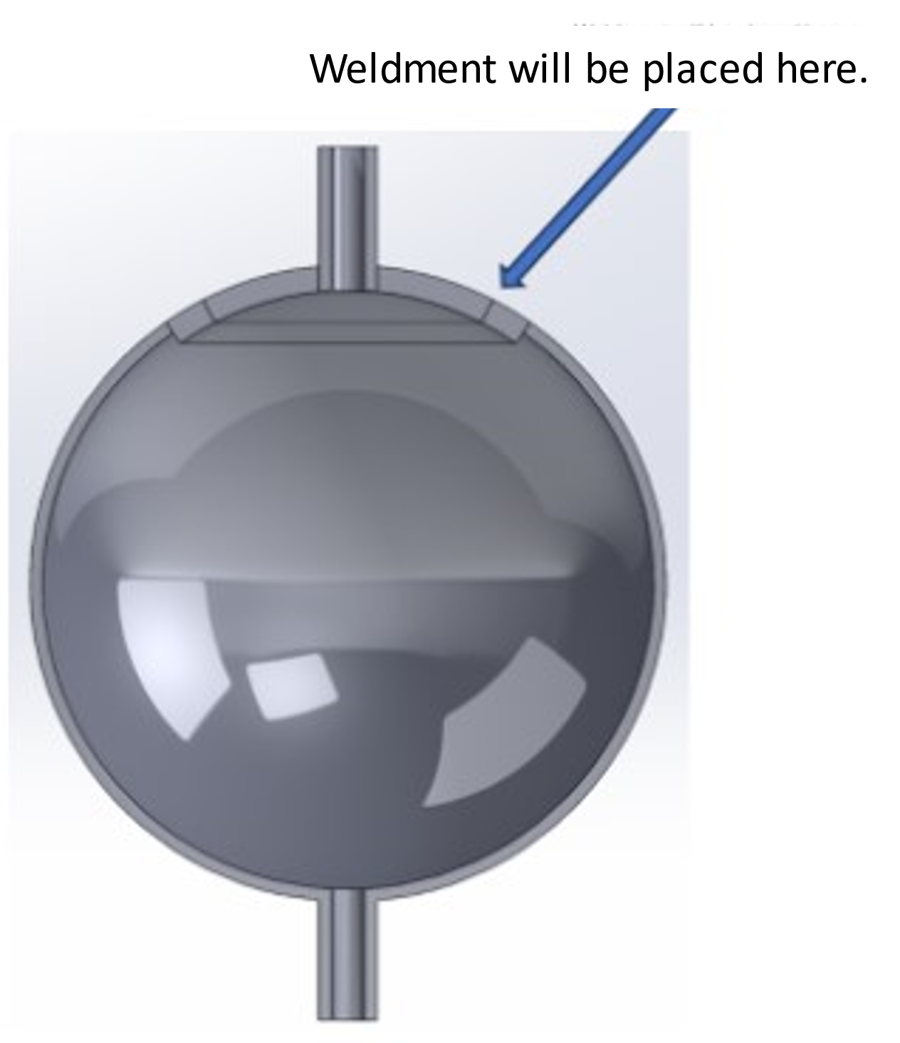
Figure 20: Cutaway view showing the "innovative" PV model configuration for FEA.

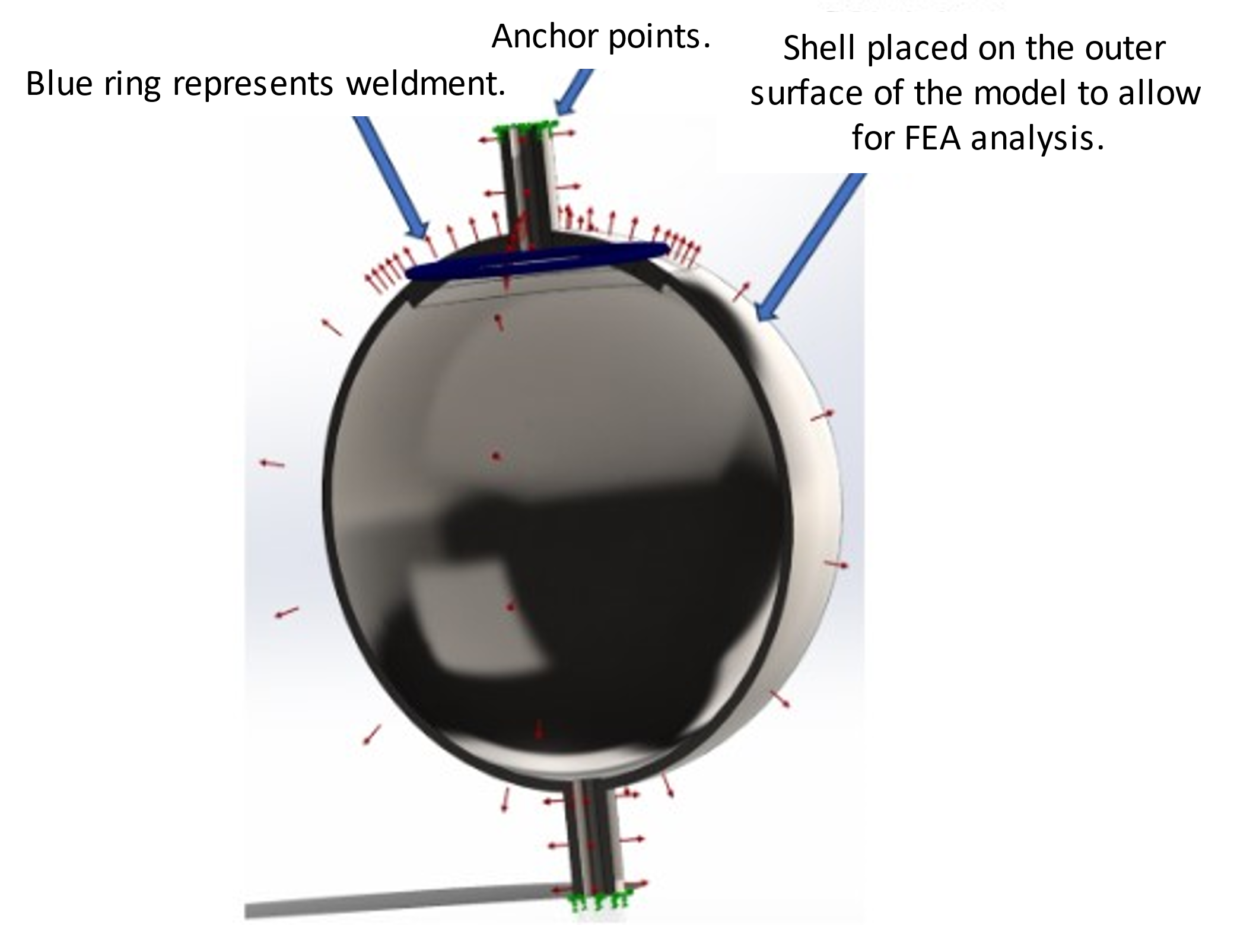
Figure 21: FEA compatible model of innovative design, ready for meshing.
Lastly, we need to discuss the fabrication of the PLA PV articles that will be used for postprocessing testing as well as the set up for the postprocessing. The model for the single piece designed for the traditional method of fabrication was converted to STL and transferred to PrusaSlicer where it was sliced and then printed twice. Due to curvature of the sphere, structural support was needed to print the article and was subsequently removed after the build was complete.
To ensure that the postprocessing step was comparable between the two approaches, I elected to use centrifugal tumbling instead of a bowl tumbling approach. My concern was that the tumbling media would not be able to effectively process the inner surfaces of the “innovative” PV since the bowl approach mostly depends on the use of vibration to rub the media across an article’s surface. However, there is not a feature to ensure that parts are rotated within a bowl tumbler. Because of this, am not convinced that the media will be sufficiently circulated through the PV and applied to all surfaces within it if I use a bowl tumbler.
The centrifugal approach will keep the media within the PV. The PV will be attached to a spindle which is constantly rotated by a motor. This will force the media to contact the inner surfaces of the PV. Using 12 grit crushed walnut media, I will place enough media to fill one of the hemispheres. I will then bond this hemisphere with the second one, bonding them with a strong, but removable, adhesive. The sphere will then be connected to the tumbler and rotated for 14 hours.

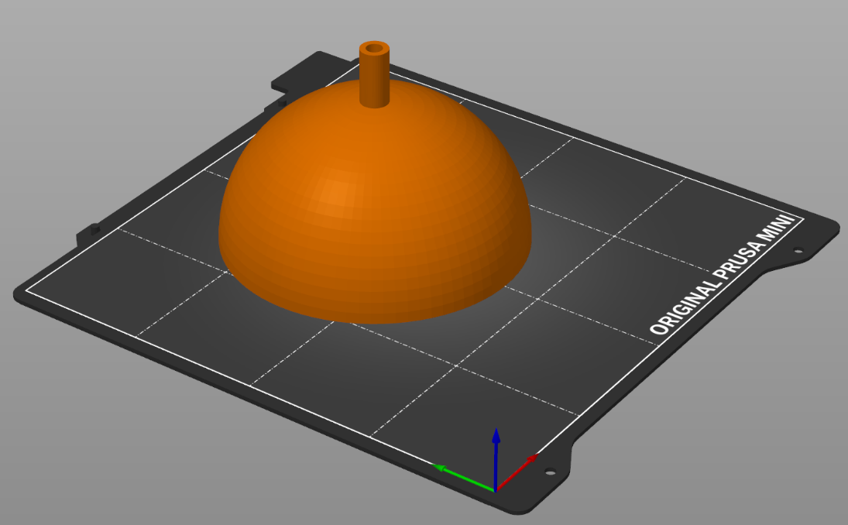
Figure 22: STL model of the hemisphere to be used in the traditional fabrication method.

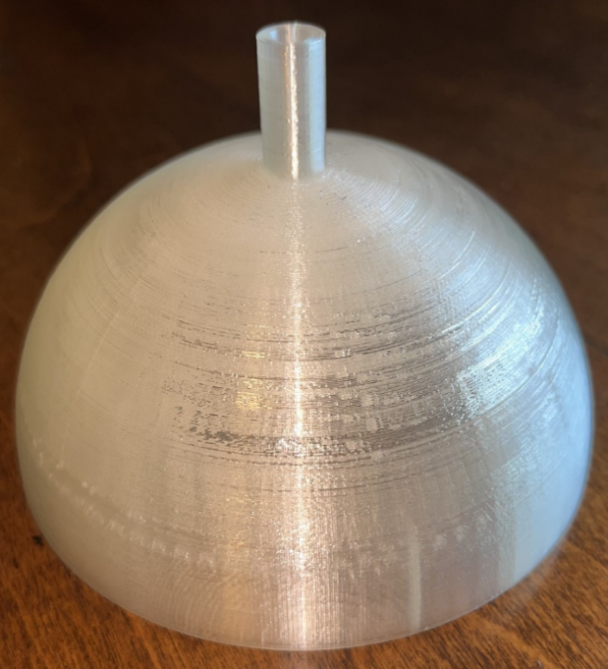
Figure 23: PLA print of the hemisphere.
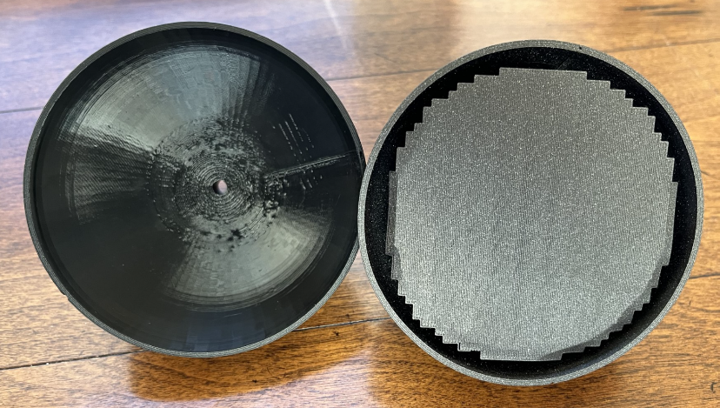
Figure 24: Two PLA prints. The left hemisphere has the support structure removed.
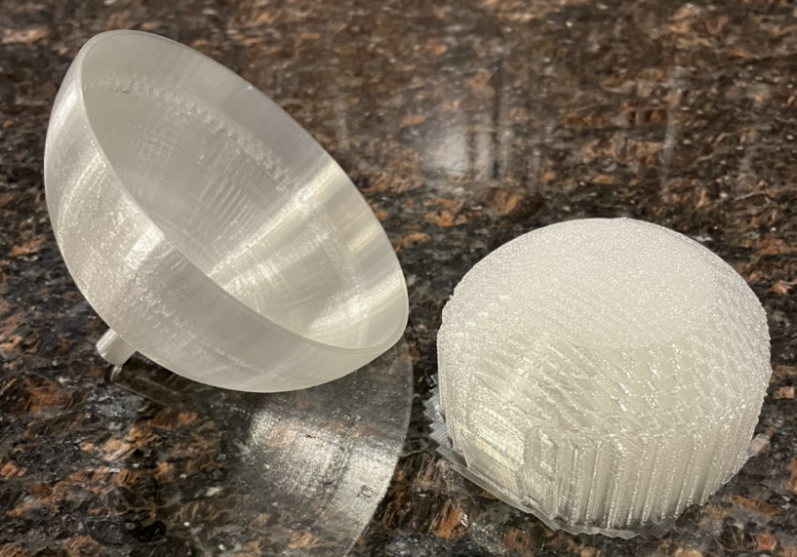
Figure 25: PLA print of the hemisphere showing the support structure removed.
The fabrication of the “innovative” design will be like the process used for the first article but will require that a part will be fabricated within another part. The geometry and orientation of the minor body piece within the major body piece are shown in Figure 26 and Figure 27. Figure 28 and Figure 29 show the printed articles.
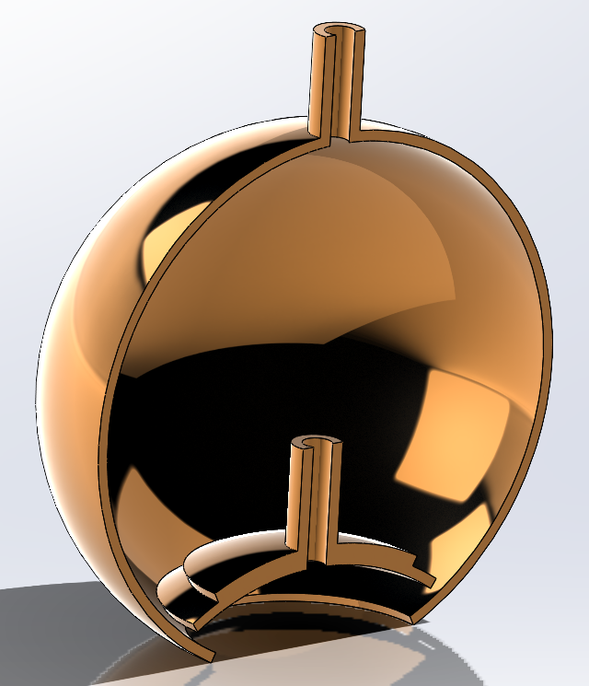
Figure 26: CAD model showing the intended geometries and orientations of the major and minor body parts during printing.

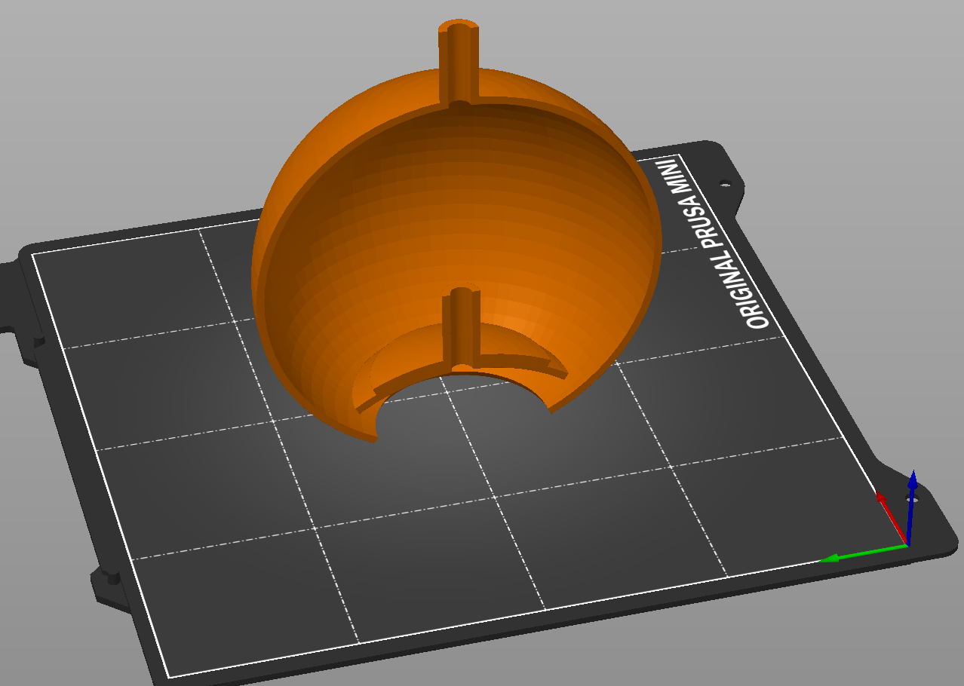
Figure 27: STL model showing how the major and minor bodies will be printed.
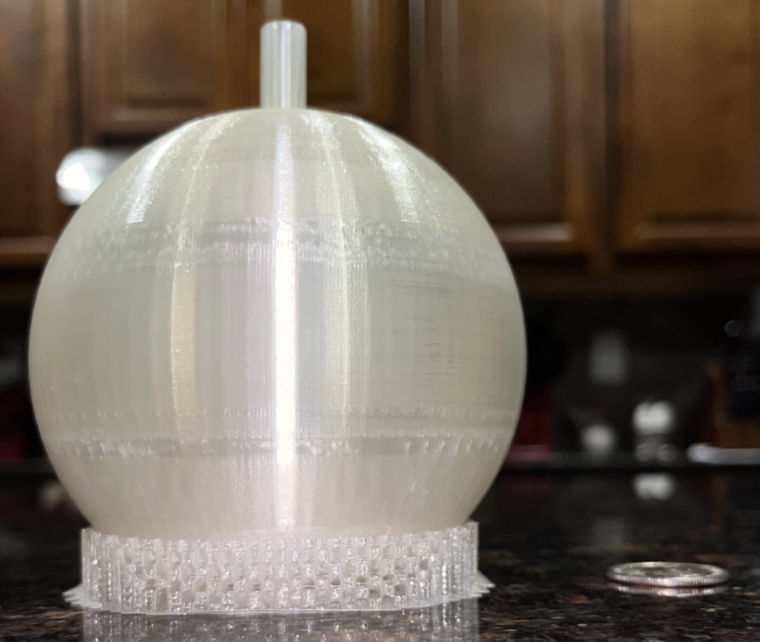
Figure 28: PLA print of the "innovative" PV. The material at the bottom is a support structure added during the build to prevent deformation.
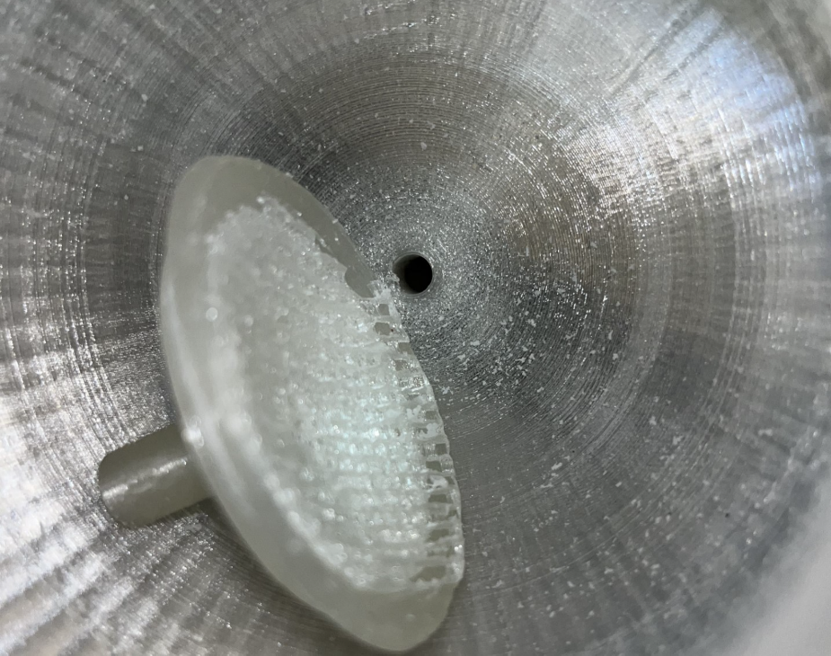
Figure 29: An inside view of the "innovative" PV. Note the rough surface on the underside of the minor body piece.

CHAPTER 5: FINDINGS

FEA Analysis of Traditionally Manufactured SS Spherical PV at 590 PSI

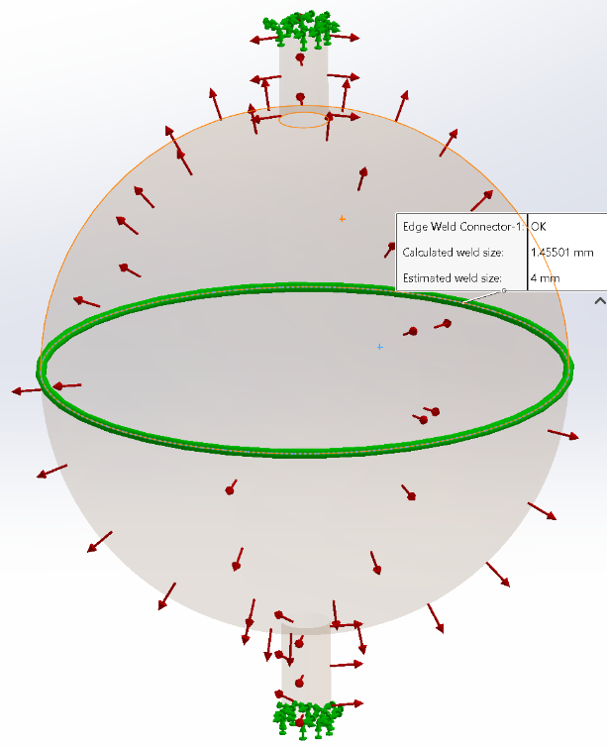
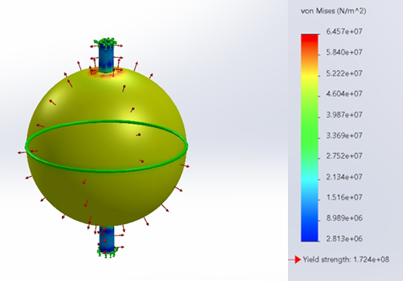
Figure 30: Traditional PV Stress @ 590 PSI
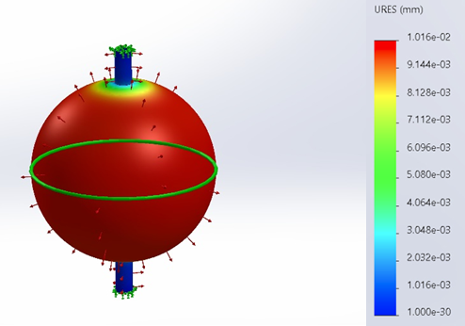
Figure 31: Traditional PV Weldment @ 590 PSI
Figure 32: Traditional PV Displacement @ 590 PSI

Table 4: Traditional model results at 590 PSI.
Parameter | Observed | Limit
Stress (N/m²) | 6.46e+07 | 1.72e+08
Displacement (mm) | 1.02e-02 | NA
Weldment (mm) | 1.46 | 4

FEA Analysis of Traditionally Manufactured SS Spherical PV at 737.5 PSI
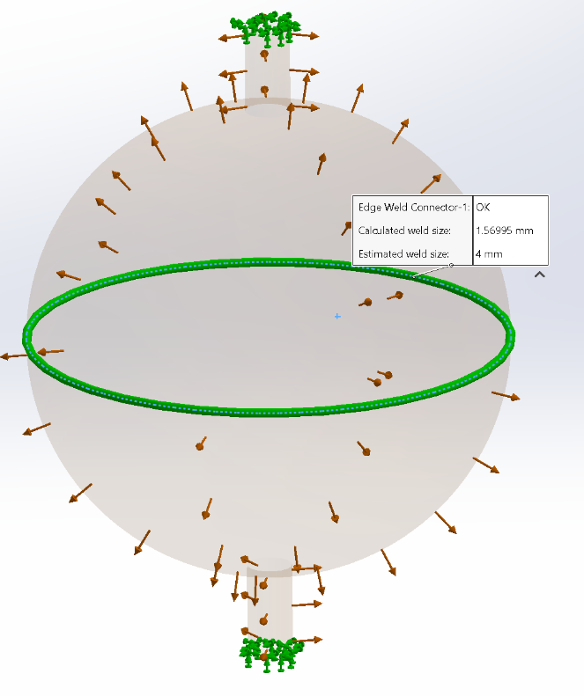
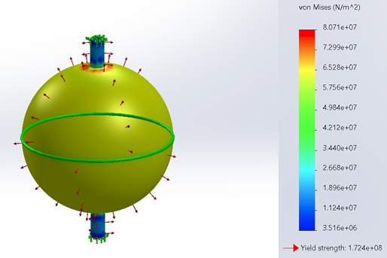
Figure 33: Traditional PV Stress @ 737.5 PSI
Figure 34: Traditional PV Weldment @ 737.5 PSI
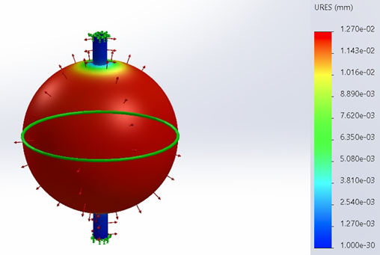

Figure 35: Traditional PV Displacement @ 737.5 PSI

Table 5: Traditional model results at 737.5 PSI.
Parameter | Observed | Limit
Stress (N/m²) | 8.07e+07 | 1.72e+08
Displacement (mm) | 1.27e-02 | NA
Weldment (mm) | 1.57 | 4

FEA Analysis of Traditionally Manufactured SS Spherical PV at 885 PSI

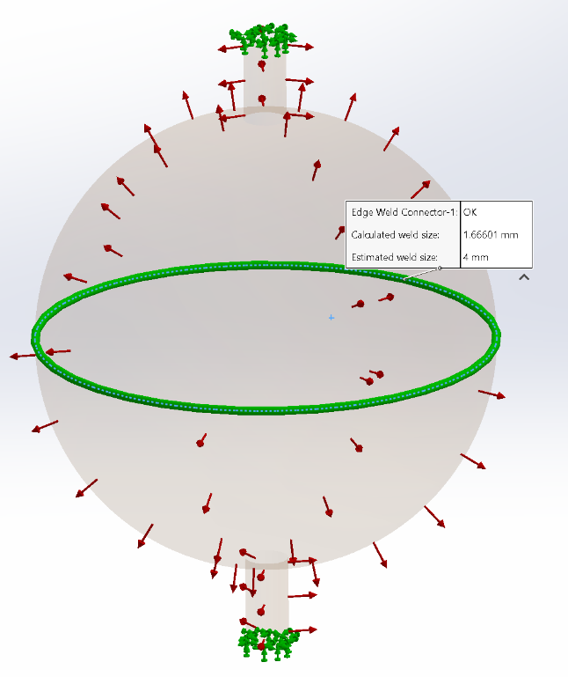
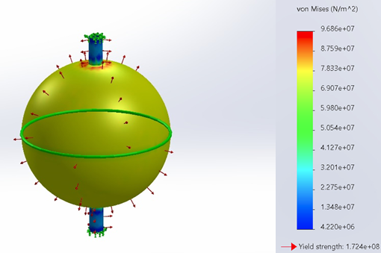
Figure 36: Traditional PV Displacement @ 885 PSI

Figure 37: Traditional PV Weldment @ 885 PSI

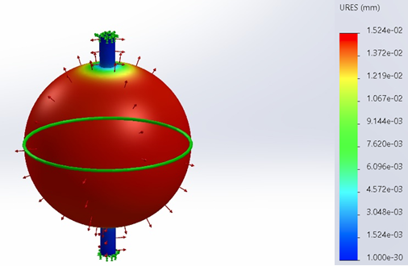

Figure 38: Traditional PV Stress @ 885 PSI

Table 6: Traditional model results at 885 PSI.
Parameter | Observed | Limit
Stress (N/m²) | 9.69e+07 | 1.72e+08
Displacement (mm) | 1.52e-02 | NA
Weldment (mm) | 1.67 | 4

FEA Analysis of Traditionally Manufactured SS Spherical PV at 1600 PSI
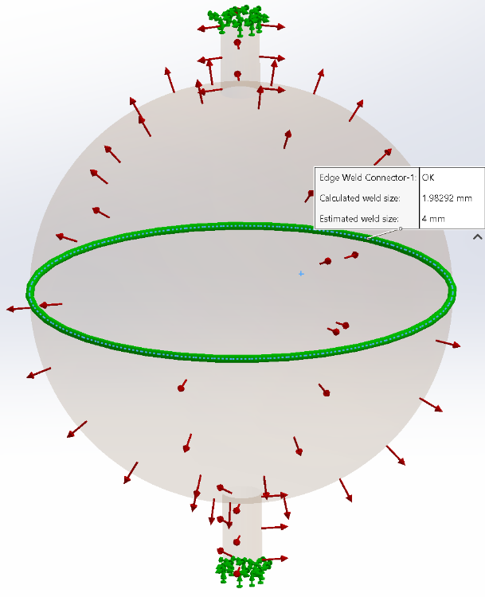
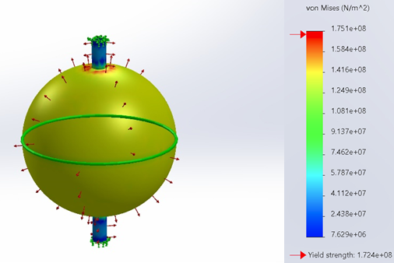
Figure 39: Traditional PV Stress @ 1600 PSI

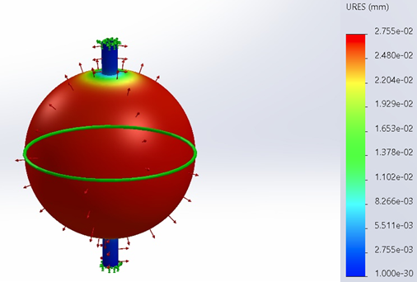
Figure 40: Traditional PV Weldment @ 1600 PSI
Figure 41: Traditional PV Displacement @ 1600 PSI

Table 7: Traditional model results at 1600 PSI.
Parameter | Observed | Limit
Stress (N/m²) | 1.75e+08 | 1.72e+08
Displacement (mm) | 2.76e-02 | NA
Weldment (mm) | 1.98 | 4

FEA Analysis of Part-Within-Part Manufactured SS Spherical PV at 590 PSI

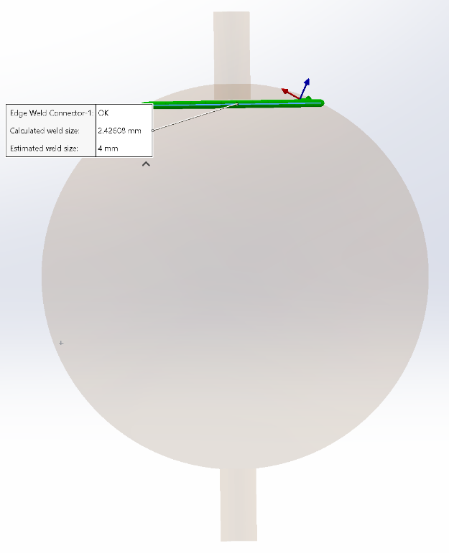
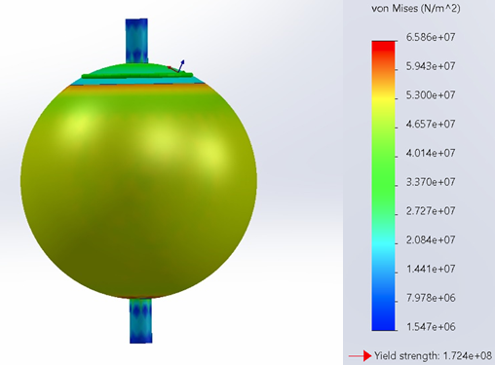
Figure 42: Part-Within-Part PV Weldment @ 590 PSI
Figure 43: Part-Within-Part PV Stress @ 590 PSI
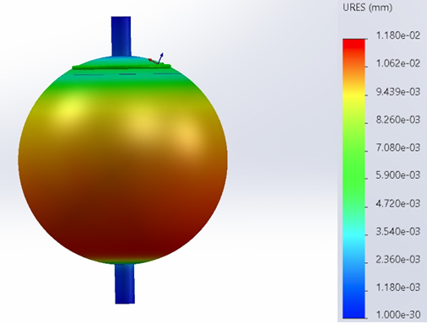
Figure 44: Part-Within-Part PV Displacement @ 590 PSI

Table 8: Innovative model results at 590 PSI.
Parameter | Observed | Limit
Stress (N/m²) | 6.59e+07 | 1.72e+08
Displacement (mm) | 1.18e-02 | NA
Weldment (mm) | 2.43 | 4

FEA Analysis of Part-Within-Part Manufactured SS Spherical PV at 737.5 PSI

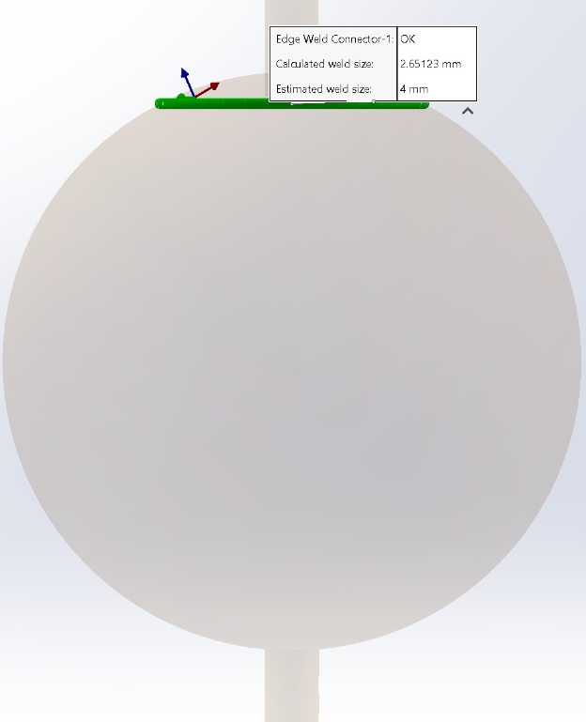
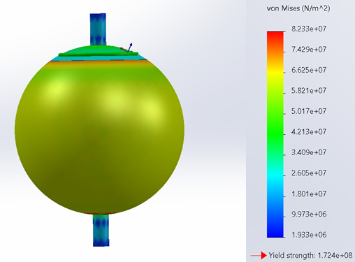 Figure 45: Part-Within-Part PV Stress @ 737.5 PSI
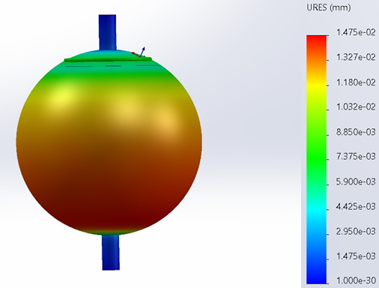
Figure 46: Part-Within-Part PV Weldment @ 737.5 PSI
Figure 47: Part-Within-Part PV Displacement @ 737.5 PSI

Table 9: Innovative model results at 737.5 PSI.
Parameter | Observed | Limit
Stress (N/m²) | 8.23e+07 | 1.724e+08
Displacement (mm) | 1.48e-02 | NA
Weldment (mm) | 2.65 | 4

FEA Analysis of Part-Within-Part Manufactured SS Spherical PV at 885 PSI

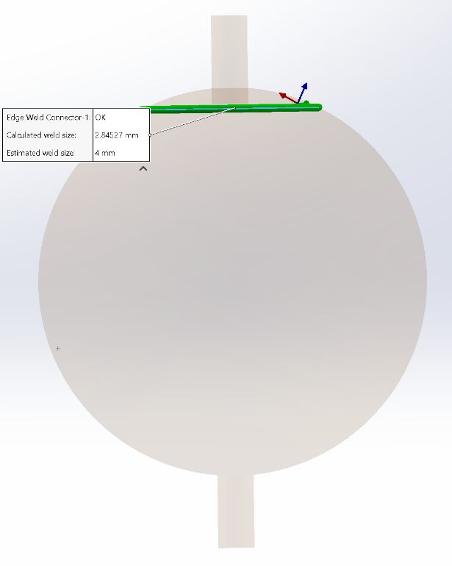
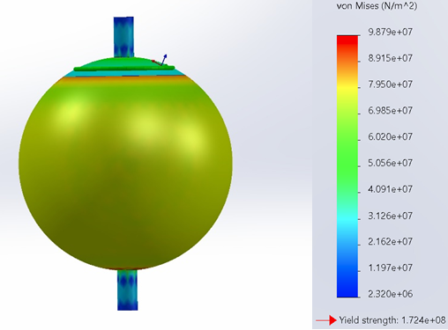
Figure 49: Part-Within-Part PV Stress @ 885 PSI
Figure 48: Part-Within-Part PV Weldment @ 885 PSI

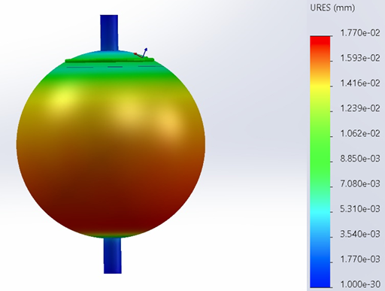
Figure 50: Part-Within-Part PV Displacement @ 885 PSI

Table 10: Innovative model results at 885 PSI.
Parameter | Observed | Limit
Stress (N/m²) | 9.88e+07 | 1.72e+08
Displacement (mm) | 1.77e-02 | NA
Weldment (mm) | 2.85 | 4

FEA Analysis of Part-Within-Part Manufactured SS Spherical PV at 1600 PSI

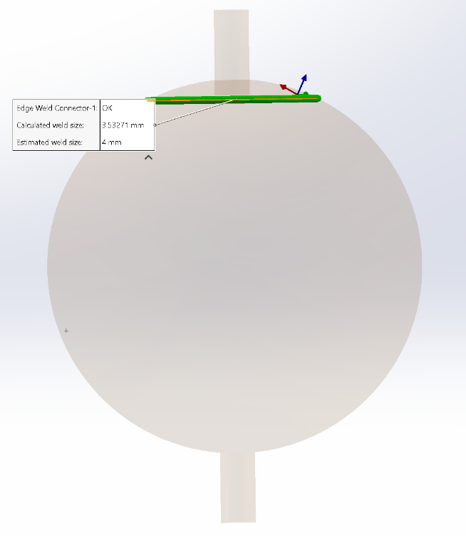
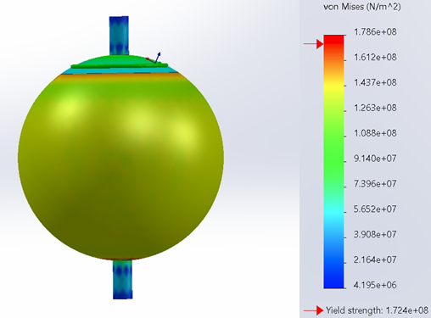
Figure 51: Part-Within-Part PV Stress @ 1600 PSI
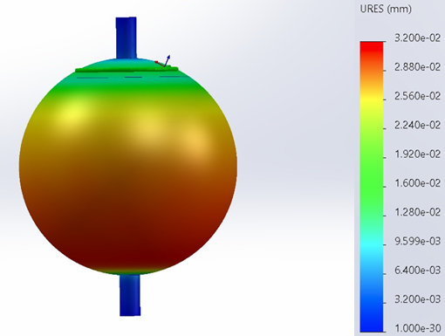
Figure 52: Part-Within-Part PV Displacement @ 1600 PSI
Figure 53: Part-Within-Part PV Weldment @ 1600 PSI

Table 11: Innovative model results at 1600 PSI.
Parameter | Observed | Limit
Stress (N/m²) | 1.79e+08 | 1.72e+08
Displacement (mm) | 3.20e-02 | NA
Weldment (mm) | 3.53 | 4

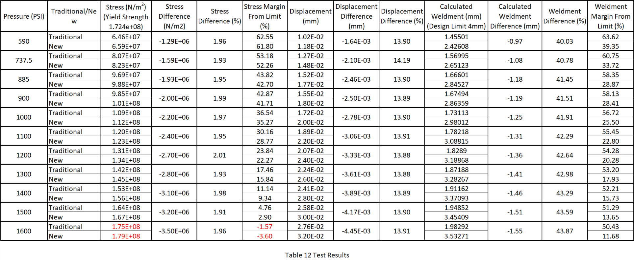
Table 12 Test Results

CHAPTER 6: CONCLUSION

The results of the FEA analysis were interesting and unexpected. Using data from Table 12 we can deduce plenty of information to help us verify and validate our “innovative” design. Evaluating the PV stress measurements, we see that for a given pressure, the stress is always higher for the new design. Furthermore, looking across the different pressures, we see the difference in stress gradually increases from 1.29E+06 N/m² at 590 psi to 3.50E+06 N/m² at 1600 psi, while the new design is consistently subjected to approximately 2% more stress than the traditional design for any given pressure. This implies the traditional method is better able to withstand pressure as the pressure increases. The stress values at 1600 psi along with the stress margins tell us that both articles experience catastrophic (burst) failure somewhere between 1500 and 1600 psi. The stress value and margin are higher for the new model (1.79E+08 N/m² and -3.60% respectively) as compared to the traditional model (1.75E+08 N/m² and -1.57% respectively), leading me to believe that while both articles would reach their yield strength somewhere between 1500 and 1600 psi, the new model will reach this limit first. Therefore, the “innovative” design fails to reach its first objective.
Reviewing the displacement values, we see something like the stress analysis occurring. The difference in displacement starts at 1.64E-03 mm at 590 psi to 4.45E-03 mm at 1600 psi, with an average of 3.41E-03 mm difference in displacement. Although the difference values in displacement increase as the pressure increases, the new and traditional designs maintain a constant ratio difference in displacement with a 14% larger displacement for the new design as compared to the traditional one at all test pressures. The pressures recorded for the traditional and models were 2.76E-02 mm and 3.02E-02 mm, respectively. Unfortunately, this suggests that the “innovative” design failed to reach its second objective as well. While having displacement in general is not necessarily a bad thing, displacement can be positively correlated with increasing pressures, therefore being a decent indicator as to which article may fail first. We’ll soon get into the analysis of the weldment lines, which was also surprising. While the results of that analysis were not what I was expecting, it is the result of this displacement analysis that I believe helps to explain why we are observing the weldment results we have.
The weldment analysis mirrors the first two analyses in that the value in the difference of the parameter between the traditional and new designs increases as the pressure increases (.97 mm to 1.55 mm from 590 to 1600 psig). Unlike the first two analyses, the ratio of the difference also increases with an increase in pressure (.40 to .44 from 590 to 1600 psig). This second observation is concerning as it suggests that not only is stress applied to the weldment higher for the new design, but also, the rate at which the stress is applied is increasing as compared to the traditional model. At 4 mm, the weldment did not fail for either model. However, the calculated weld size of the traditional method started at 1.46 mm at 590 psig and ended at 1.98 mm at 1600 psig. This was an increase of only .52 mm and left a 50.43% margin to the 4 mm design thickness! For the new design, we start at a calculated weldment of 2.43 mm at 590 psig and end at 3.53 mm at 1600 psig. This is an increase of 1.1 mm and leaves us with an 11.68% margin to the 4 mm design thickness. Using this information, I conclude that not only does the new design subject the weldment to a higher initial stress, but the new design also requires an additional 1.55 mm to avoid failure at the final test pressure of 1600 psig. This result shows that the new design fails to achieve its third objective as it required a thicker weld line at burst pressure.
The weldment findings were particularly surprising to me as I was sure that the added thickness of the sphere under the weldment would provide protection to the weld line from local stress, but the opposite was true. Reviewing the stress and displacement figures, I can see that there is indeed less stress being applied in the local area of the weld. The flaw in my hypothesis was that I was anticipating added material in a plane perpendicular to the planes where stress is being applied to reduce those stresses. What I believe did happen was that the added material did strengthen the local area minimizing the displacement there. However, there is a location on the sphere where the thickness is reduced from .16 to .08 in. At this location, there is an imbalance of stress subjected to the area which is contrary to the characteristics of a spherical PV (see Figure 4). I believe the is causing stress to shift to the areas of thinner walls for the “innovative” design resulting in a ballooning effect in one direction. While ballooning is also experienced in the traditional model, as is apparent given the fact that the traditional model also undergoes displacement, the symmetrical design and constant wall thickness help to shed stress evenly across both hemispheres from the weldment.
The final verification test is the surface evaluation of both articles after postprocessing via tumbling with crushed walnut shell media. The article for the new design was cut in half so that the inner surface could be inspected (see Figure 54). Since the article for the traditional design is composed of two symmetrical hemispheres, the two components only needed the adhesive used to hold them together during the tumbling process to be removed. Doing this allowed access to the inner surfaces for inspection (see Figure 55). Visual inspections of both models showed that the tumbling process did have noticeable effects on the inner surfaces. I will admit though, the effects were limited to softly smoothing some of the imperfections and rough surfaces, stopping far short or making the inner surfaces completely smooth.

This limited effect could be due to the mildness of the abrasive media used and the capability of the tumbler used. I am satisfied with the outcome of this test and am willing to say that the extent and quality of the postprocessing seen in the new design is comparable to that seen in the traditional design. Given the surface finish was the same across the two artifacts, I will note that the new design was easier to prepare for postprocessing and the traditional method required the used of adhesive to join the parts together and allowing the media to reside within the PV. Based on the requirement for this test, I will say that the “innovative” design met its objective.
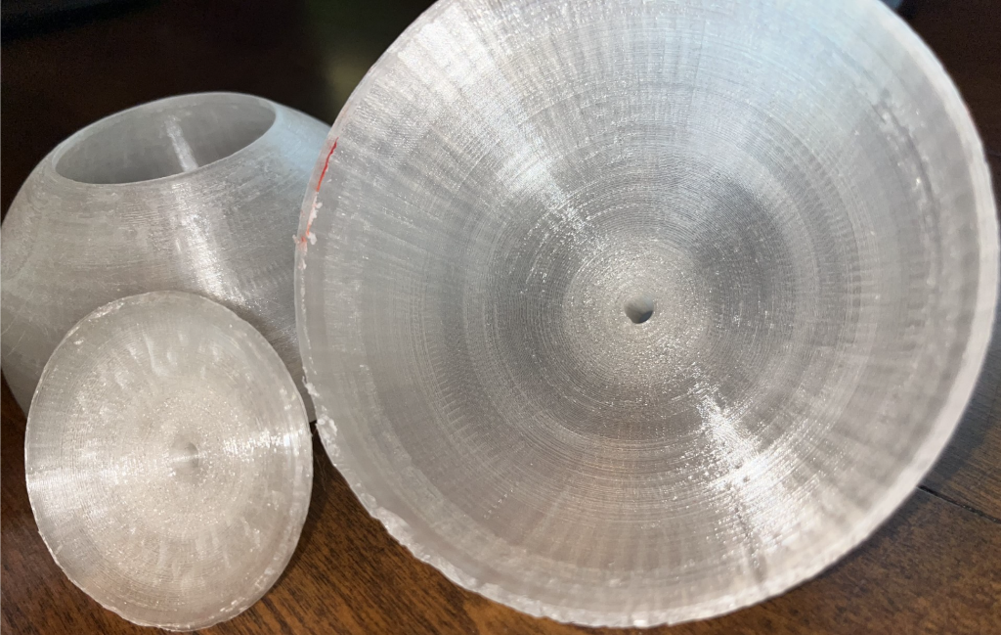
Figure 54: Article for the "innovative" model cut in half for visual inspection.

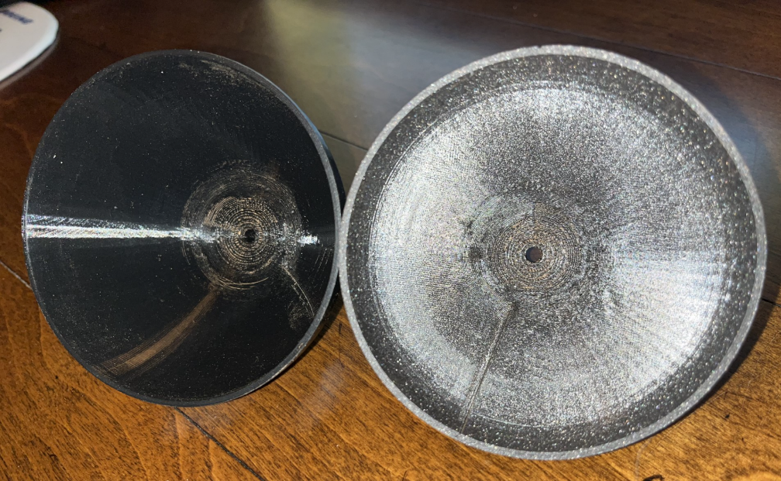
Figure 55: The inner surfaces of the two hemispheres for the traditional design shown for visual inspection.

To conclude my research, using the verification results just discussed, I cannot say that the “innovative” design is game changing when it comes to how we design and fabricate spherical pressure vessels. The new design failed to meet three of its four objectives. The only objective it did meet was to have a surface finish with the same or less surface roughness quality as compared to the traditional design, it did so by having a surface finish that was equivalent to the traditional method and not better than it. If we were investigating whether this new approach provides opportunities to manufacture PVs faster, cheaper, or as I was hoping, with better performance characteristics, the answer is a disappointing no. However, my thesis question is, can we improve upon the simple spherical Pressure Vessel (PV) by utilizing a more complex design, achievable only by AM processes. While my verification results imply the answer is no, it could be that I used the wrong objectives to answer my question or that there are several correct answers to address the question. If you missed it, I am hinting there may be a silver lining in this failure which we will cover in the next, and final chapter.

CHAPTER 7: DISCUSSION

As mentioned in the last chapter, the new design does not perform any advantages over the traditionally made design for the typical PV application. While this was disappointing, I feel there were concepts developed by this research that may lead to future projects and efforts. Before we get into these discussions, it will be important to understand that while the new design failed to outperform the traditional design, the percentage difference between the two models at the final test point of 1600 PSI was only 2%. Yet, the maximum operating pressure to be expected during normal operations is 590 psi. This is significantly less than the pressure where failure was experienced. With this in mind, we can proceed. The first concept concerns the amount of weld line needed in the new design. Since the weldment of the traditional method is placed on a great circle, the length of the weld is:

Equation 8 $L_{TW}=C=2×π×r ∴2×π×2 in=12.57 in$

Where L_{TW} is the length of the traditional weld, C is the circumference, and r is the radius as measured from the outer surface, instead of R, the inside radius. The projected radius for the minor body part of the “innovative” design is 1.15 in. This gives us:

Equation 9 $L_{IW}=C=2×π×r∴2×π×1.15=7.23 in$

Where L_{IW} is the length of the weld associated with the “innovative” design. The innovative design used a weld line that was 42.48% less than that used in the traditional model. For applications where the quality of the weld may be a concern, or where one of the design objectives is to reduce the probability of weld failure, the “innovative” design may be an attractive design approach.
The second concept was identified by reflecting on the validation of the “innovative” pressure vessel. While the new design is not as resilient as the traditional one, it can still perform the basic functions of a PV. The biggest drawback to the new design is the large stress the change in wall thickness places on the weldment. This undesirable characteristic led me to wonder if a weld was really needed. If not, what would that look like? Would this still be a PV? How would I keep the vessel closed? My initial solution to this problem is the replacement of the weldment with threading (see Figure 56).
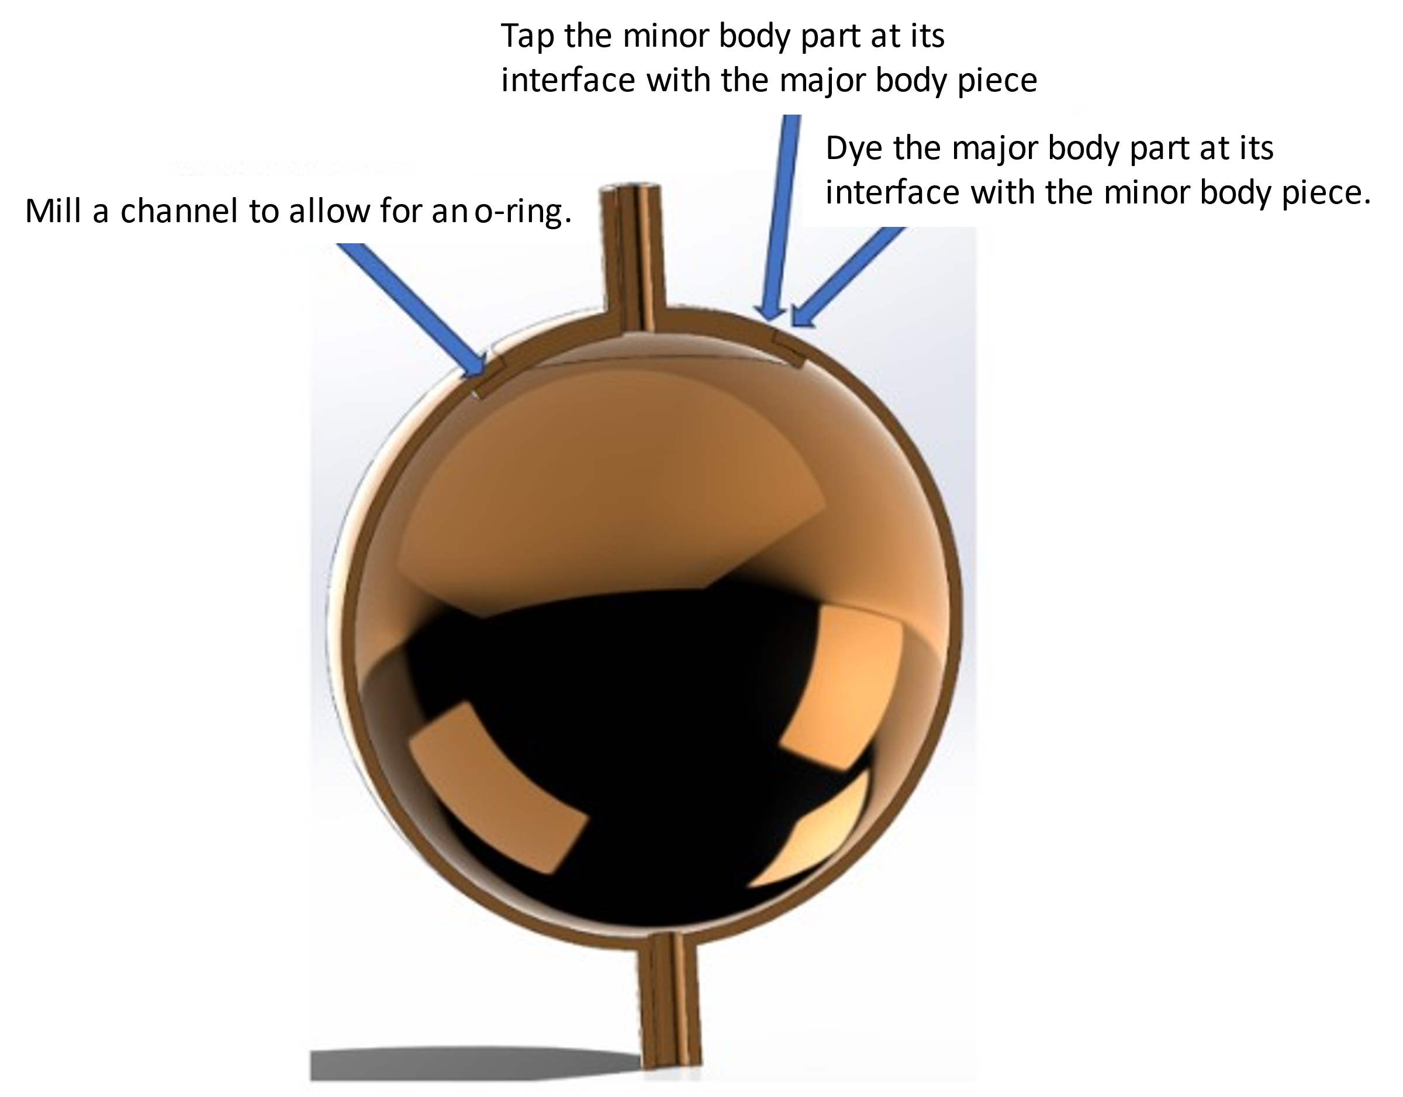
Figure 56: Visualization of recommended changes to make a spherical PV serviceable and/or inspectable.

By dying the major body where it interfaces with the minor body and tapping the minor body where it interfaces with the major body, I believe there is a possibility of creating a PV that is sealed by tightening the two pieces together instead of welding them. By designing a groove into the channel, or major body piece where the two areas interface, it may also be possible to add an O-ring or some other type of seal so that the liquid or gas does not escape through the tiny channel created by the two body pieces. The culmination of these changes could result in a new type of PV that is accessible to allow for periodic maintenance, and inspections. This capability is not readily available on modern PVs due to the use of weldments.
My final thought is this: I cannot refute that my initial design was better than its traditionally designed counterpart. However, the exercise of trying to see how I could add some degree of complexity to something that is arguably simple, has led me to understand the value of tinkering and re-investigating the known. While I am disappointed my design wasn’t in itself innovative, I am extremely grateful in being able to experience how the mundane can lead to new opportunities and innovation by asking, “what if”.

REFERENCES

ASME Boiler and Pressure Vessel Committee Subcommittee on Pressure Vessels. (1986). Introduction. In A. B. Vessels, Section VIII Pressure Vessels Division 1 1986 ASME Boiler and Pressure Vessel Code (Vol. VIII, p. 1). New York, New York, Unites States of America: American Society of Mechanical Engineers. Retrieved February 10, 2024
Chow, D. (2022, April 8). To cheaply go: How falling launch costs fueled a thriving economy in orbit. Retrieved February 22, 2024, from NBC News: https://www.nbcnews.com/science/space/space-launch-costs-growing-business-industry-rcna23488
Gibson, I., Rosen, D., & Stucker, B. (2015). Additive Manufacturing Technologies: 3D Printing, Rapid Prototyping, and Direct Digital Manufacturing (2 ed.). New York, New York, United States of America: Springer Science+Business Media. Retrieved March 10, 2024
Huzel, D. K., & Huang, D. H. (1992). Modern Engineering for Design of Liquid-Propellant Rocket Engines. Washington, DC, Washington, DC, United States of America: American Institute of Aeronautics and Astronautics, Inc. Retrieved March 7, 2024
Occupational Safety and Health Administration. (2024, March 6). Pressure Vessels. Retrieved March 6, 2024, from Occupational Safety and Health Administration: https://www.osha.gov/pressure-vessels
Schneider, S. (2019, July 30). Tumbling 3D Printed Plastic Parts. Retrieved March 2024, 10, from Kramer Industries, Inc.: https://www.kramerindustriesonline.com/tumbling-3d-printed-plastic-parts/
Tam, W., Wlodarczyk, K., & Hudak, J. (2019). Additive Manufactured Pressure Vessel Development: An Update. ASME 2019 Pressure Vessels & Piping Conference (p. 7). San Antonio: American Society of Mechanical Engineers. Retrieved March 9, 2024, from https://watermark-silverchair-com.ezproxy.lib.ou.edu/v003t03a084-pvp2019-94033.pdf?token=AQECAHi208BE49Ooan9kkhW_Ercy7Dm3ZL_9Cf3qfKAc485ysgAABKowggSmBgkqhkiG9w0BBwagggSXMIIEkwIBADCCBIwGCSqGSIb3DQEHATAeBglghkgBZQMEAS4wEQQMcLNAwhg4DUTEP4h0AgEQgIIEXX1SazDazq
Tumbling Media. (2024, March 10). Retrieved March 10, 2024, from Grainger: https://www.grainger.com/category/abrasives/vibratory-tumbling-finishing/tumbling-media?attrs=Media+Type%7CCeramic%7CWalnut+Shell&filters=attrs

t ≤0.356×R
P ≤0.665×S×E
t=P×R2×S×E-0.2×P
P=2×S×E×tR+0.2×t
σ=PR2t
σh=PRt
σa= PR2t
LTW=C=2×π×r ∴2×π×2 in=12.57 in
LIW=C=2×π×r∴2×π×1.15=7.23 in

The lip is annotated as the “large concentric piece” in Figure 15.
The lip feature is why the “innovative” PV must be manufactured via AM. The geometry prevents the minor body from being manufactured outside of the major body and then being placed inside of it. It is also not practicable to manufacture the minor body piece inside the major body piece using subtractive means.
The term “great circle” will be used to define the perimeter created on the sphere by dividing the sphere in half at a distance that is equal from the top and bottom of the sphere. The top and bottom are identified by the inlet and out ports for the fuel.
Section VIII, subsection UG-16(b) states that unless a special exception applies, the absolute minimum thickness for a shell shall be $1/{16}$ in. regardless of form or the type of material used to construct the vessel. This thickness does not account for corrosion allowances.
For the purposes of the illustrations in Figures 4 and 5, we will assume the planes are labeled per the standard 3D coordinate system. In this case, pressure (P) vector is operating on the X axis.
The average difference in stress is 2.69 N/m² per 100 psi. This value is obtained by finding the average stress difference values from the tests conducted from 900 to 1600 psig.
The average difference in displacement value is obtained by finding the average difference in displacement values from the tests conducted from 900 to 1600 psig.

