UNIVERSITY OF OKLAHOMA
GRADUATE COLLEGE

Settling in at the Cross Bar Ranch
  - Antelope Creek Settlement Patterns and Distributions in the Texas Panhandle

A THESIS
PRESENTED TO THE GRADUATE FACULTY
in partial fulfillment of the requirements for the
Degree of
Master of Arts

By
Michael William Krause
Norman, Oklahoma
2022
SETTLING IN AT THE CROSS BAR RANCH
ANTELOPE CREEK SETTLEMENT PATTERNS AND DISTRIBUTIONS IN THE TEXAS PANHANDLE

A THESIS APPROVED FOR THE
DEPARTMENT OF ANTHROPOLOGY

BY THE COMMITTEE CONSISTING OF

Dr. Sarah Trabert, Chair
Dr. Brandi Bethke
Dr. Patrick Livingood
Dr. Asa Randall

© Copyright by Michael William Krause 2022
All Rights Reserved.

Acknowledgements
I cannot begin to list the number of people who made this endeavor possible, nor could I ever express my gratitude for their efforts and patience. First I would like to acknowledge the professor (Dr. Sarah Trabert) who helped me even gain entry into the program, as well as all the people who helped to keep me in the program (in particular Dr. Kermyt Anderson [KG]). Additionally, I could not have accomplished anything here without the constant and endless support of Dr. Sarah Trabert and Dr. Brandi Bethke, who strove to always find me sources of funding, and thesis directions, as well as frequently checking on my mental health and academic progress. I would also like to Dr. Patrick Livingood for not only teaching the ropes of proper GIS analyses, but also for helping to ensure that this thesis held water. However, I also want to thank both my mother (Katherine Krause) and my father (Dr. Richard Krause) for everything they did to provide me with the path I stride down today, for without their guidance, I would be completely lost. Finally, I would like to thank the Texas Archaeological Research Laboratory and the Bureau of Land Management for providing me with all the data and other information necessary to complete this examination.

Table of Contents
Acknowledgements……………………………………………………………………………………………………………………………..iv
List of Tables………………………………………………………………………………………………………………………………………viii
List of Figures………………………………………………………………………………………………….……………………………………ix
Abstract…………………………………………………………………………………………………………………………………….xi
Chapter 1: Introduction……………………………………………………………………………………………………….1
Introduction…………………………………………………………………………………………..………………….…..1
Chapter 2: Environmental Background…………………………………………………………………4
The Great Plains…………………………………………………………………………..…………….…..4
The Llano Estacado………………………………………………………………………………………..…………….…5
The Hydrology of the Llano Estacado……….…………………………………………..………….…7
Topography of the Llano Estacado……….……………………………………………..……………..8
Geology of the Llano Estacado……………….……………………………………………..……………9
Soils of the Llano Estacado…………………………………………………………………….………….12
Climate and Precipitation of the Llano Estacado……………………………….…………..….13
The Canadian River Valley………………………………………………………………………….…………..…….15
The Outer Valley………………………………………………………………………….……………..…….16
The Inner Valley…………………………………………………………………..……………………………17
Flora of the Canadian River Valley…………………………………………………………………….18
Fauna of the Canadian River Valley…………………………………………………………………..20
Chapter 3: Cultural Context and Previous Work in the Cross Bar Ranch…………………22
The Southern Plains Village Tradition…………………………………………………………………………..22
Origins of the Southern Plains Village Tradition……………………………………………………………23
Characteristics of the Southern Plains Village Tradition……………………………………………….24
Select Cultural Complexes of the Southern Plains Village Tradition……………………………..25
The Antelope Creek Phase……………………………………………………………………………………………26
Material Culture of the Antelope Creek Phase………………………………………………….27
Antelope Creek Phase Architecture………………………………………………………………….29
End of the Southern Plains Village Tradition…………………………………………………………………31
Lintz’s Antelope Creek Site Types…………………………………………………………………………………33
Hamlets……………………………………………………………………………………………………………34
Homesteads……………………………………………………………………………………………………..36
Subhomesteads………………………………………………………………………………………………..38
Antelope Creek Phase Settlement Patterns………………………………………………………………….41
Lintz’s Assertions for Antelope Creek Settlements……………………………………………………….43
Chapter 4: Theoretical Orientation………………………………………………………………………………….50
Hand in Hand: Archaeology and GIS……………………………………………………………………………..50
Theoretical Underpinnings……………………………………………………………………………………………53
Chapter 5: Methodological Approaches…………………………………………………………………………62
Study Area: The Cross Bar Ranch………………………………………………………………………………….64
Sites Selected for Analysis…………………………………………………………………………………………….65
41PT90……………………………………………………………………………………………………………..67
41PT91……………………………………………………………………………………………………………..67
41PT92……………………………………………………………………………………………………………..68
41PT93……………………………………………………………………………………………………………..68
41PT96……………………………………………………………………………………………………………..69
41PT97……………………………………………………………………………………………………………..70
41PT98……………………………………………………………………………………………………………..71
41PT99……………………………………………………………………………………………………………..71
41PT109……………………………………………………………………………………………………………72
41PT112……………………………………………………………………………………………………………73
41PT113……………………………………………………………………………………………………………74
41PT253……………………………………………………………………………………………………………75
41PT254……………………………………………………………………………………………………………76
41PT257……………………………………………………………………………………………………………76
41PT280……………………………………………………………………………………………………………77
41PT282……………………………………………………………………………………………………………78
41PT283……………………………………………………………………………………………………………78
41PT509……………………………………………………………………………………………………………79
Testing the Model………………………………………………………………………………………………………..80
Creating the Site Type Dataset………………………………………………………………………….82
Chapter 6: Results, Discussion, and Conclusion……………….…………………………………………..91
Results………………………………………………………………………………………………………………………….92
Discussion…………………………………………………………………………………………………………………..106
Conclusion………………………………………………………………………………………………………………….113
Appendix A (Cross Bar Ranch Additional Information...…………………………………………….121
Appendix B (Comprehensive Site Results)……………………………………….………………………....126
Appendix C (Reference Maps and Additional Illustrations)….………………………………….132
References ……………….………………………………………………………………………………………………………..138

List of Tables
- The elevation and distance of Cross Bar Ranch sites to the nearest source of water..….95
- A Chi-Squared correlative test of the sites’ distance to water……………………………………...99
- Rangeland Productivity, Soil Diversity, and NCCPI values for Cross Bar Ranch Sites……104
- Archaeological Projects that have been conducted within the Cross Bar Ranch………...121
- Floral species within the designated floral association zones for the Cross Bar Ranch..123
- Rangeland Productivity and NCCPI soil type values…………………………………………………….124
- Rangeland Productivity, Soil Diversity, and NCCPI values for individual sites………………126
- Various First Order attributes for individual sites……………………………………………………….127
- Comprehensive water distance and cost distance site values…………………………………….129
- Tabulation of the elevation information for sites within the Cross Bar Ranch…………….130
- The distances between homesteads and their nearest camp or subhomestead…………131

List of Figures
- A depiction of the Great Plains’ boundaries……………………………………………………………………5
- An illustration of the Llano Estacado’s boundaries………………………………………………………...7
- An illustration of the local geologic formation………………………………………………………………10
- An illustration of the Blackwater Draw Formation………………………………………………………..12
- An illustration of the Canadian River Breaks System…………………………………………………….16
- An illustration of the cultural complexes in the Late Precontact Period………………………..26
- The five patterns of Antelope Creek architecture, as illustrated by Lintz……………………...30
- A plan view map from the Footprint Site………………………………………………………………………36
- A plan view map of the Jack Allen Site………………………………………………………………………….38
- A plan view map of the Pickett Site………………………………………………………………………………40
- An illustration of Lintz's study area for his 1986 dissertation………………………………………..46
- An illustration of the boundaries of the Cross Bar Ranch………………………………………………64
- A map depicting the Cross Bar Ranch Antelope Creek sites.…………………………………………66
- An example of the Lidar data used to illustrate the Canadian River Breaks…………………..86
- An illustration of the slope gradients in the Cross Bar Ranch………………………………………..89
- A Cost-Distance map illustrating the ease of access to rivers and tributaries……………….90
- A photograph taken of the West Amarillo Creek canyon and valley……………………………..97
- A classified Cost-Distance surface for the Cross Bar Ranch……………………………………………98
- An illustration of the soil designations for the 1 km catchment zones………………………..102
- Pringle's (1980) Table of Potter County annual precipitation, temperature, and wind conditions…………………………………………………………………………………………………………………..125
- A classified digital elevation model for Lintz's study area……………………………………………132
- A classified digital elevation model for the Cross Bar Ranch……………………………………….133
- A lidar example of a possible intersite pairing in the Cross Bar Ranch…………………………134
- Example of TIN data, utilized through Google Earth Pro……………………………………………..135
- Cost-Path evidence for Homestead 41PT96 and Temporary Camp 41PT90………………..136
- Cost-Path evidence for Homestead 41PT257 and Temporary Camp 41PT280…………….137

Abstract
Previous research conducted by Dr. Christopher Lintz into the settlement patterning of Antelope Creek groups in the southern Great Plains found that those settlements could be typified according to their site function, and further delineated through specific environmental preferences and architectural styles. The purpose of this examination is to assess the validity of Lintz’s Antelope Creek settlement model using more recent spatial statistics and other GIS analyses, while also testing his model within a study area different from his own. Specifically investigated is the relationship between various sites and their local ecological preferences, as well as plausible associations between sites sharing a close proximity. In particular, environmental elements such as elevation, degree of slope, distance and access to potable water, flora/fauna diversity, soil composition, and topographic setting are compared between Lintz’s site typologies of subhomesteads and homesteads within an area of the Texas panhandle known as the Cross Bar Ranch.

Chapter 1: Introduction
Antelope Creek Phase (AD 1200-1450) groups lived in what is now the Texas panhandle and in western Oklahoma in semi-sedentary settlements relying on a mix of hunting and horticulture for their subsistence. Their archaeological sites provide an excellent example of shifting subsistence needs centered around their exploitation of local resources. This work examines where Antelope Creek groups chose to place their settlements as a means of understanding their possible environmental preferences and how they differentially utilized the resources available in specific locales, such as soil productivity and fauna diversity. These arguments and interpretations are structured through the evaluation of a previous Antelope Creek settlement patterning model created by Christopher Lintz for another area within the Texas panhandle.
Much of what we know about Antelope Creek archaeology in this region has come from the work of Lintz, who established a foundational model to explain and predict Antelope Creek settlements patterns (Lintz 1984, 1986, 1991, 2002, 2010). His model interpreted various elements, such as primary subsistence style (either hunting/gathering, or horticultural endeavors), architecture (shape, size, and number of associated structures), and location (referencing of the ecological assets available), as evidence for underlying functions so as to differentiate specific types of Antelope Creek sites. In this way, Lintz examined the methods through which Antelope Creek groups exploited their local environments. By interpreting these ecological preferences, his model then suggested where those sites might be found in the future. As a result of his examination, Lintz found that the Antelope Creek sites near Lake Meredith, and a segment of the Canadian River Valley in the Texas panhandle conformed to specific settlement configurations, which he would later classify as subhomesteads, homesteads, and hamlets. In addition to defining site type categories for this complex, he also hypothesized that specific types of relationships existed within and between the different site types. However, while still widely cited, the bulk of this work was conducted as part of his dissertation, published in 1986. Since then, more technological avenues of investigation, such as geographic information systems and geophysical surveys have become more widely available to archaeologists. Contract companies and university field schools (Lintz 2002; Bousman 2017) have also recently investigated Antelope Creek sites in the Texas panhandle, adding new site data that was not considered in Lintz’s original model.
While Lintz’s model provided an excellent classificatory framework for examining Antelope Creek settlements and their distributions, it has not been formally applied to Antelope Creek sites occurring outside of his original study area. However, under the direction of the Bureau of Land Management (BLM) and in the context cultural resource management (CRM) Lintz did examine another area of the Texas panhandle, the Cross Bar Ranch. Using his previous understandings of Antelope Creek settlement patterning, he was able to provide a very preliminary predictive model of areas that he deemed were high or low in their probability of containing archaeological sites.
This thesis builds upon Lintz’s work, to ask the following questions: Can Lintz’s model be applied to regions beyond his original project area, such as in the Cross Bars Ranch, in order to further understand Antelope Creek Phase settlement patterning? Can ArcGIS Pro be used to test whether the key environmental variables identified by Lintz are significant in Antelope Creek settlement decision making? What roles might environmental elements such as distance to water, topographic landforms, soil productivity, and elevation above the nearest water source play in settlement decisions by precontact peoples living in the Cross Bars Ranch? Providing an updated perspective on Lintz’s work can not only give greater nuance to our understandings of Antelope Creek peoples’ decision making, but also provide an updated model that archaeologists in the future can use to anticipate precontact settlements in the Cross Bar Ranch.
This project uses data from Antelope Creek sites in the Cross Bar Ranch area of the Texas panhandle to reexamine Lintz’s site types and interpretive models concerning Antelope Creek groups. This research questions if it can be shown that Antelope Creek groups preferred specific environmental variables (soil productivity/diversity, access to water, topographic placement, etc.), and if so, how was that reflected in their settlement patterning? Specifically, previous documentation of the landscape, spatial modelling, and cost-based GIS analyses were used to analyze environmental elements such as elevation, access to water, fauna diversity, and soil productivity to test some of Lintz’s hypotheses regarding Antelope Creek settlement strategies and resource use. To begin, the first two chapters provide background information relevant for contextualizing the regional environment, as well as the cultural and archaeological elements considered within this thesis. The following chapter details the theoretical influences of the methods employed, while also presenting those methods themselves. Finally, the last chapter features the results of the analyses, a discussion concerning the implications of those results, and the overall conclusions developed over the course of the examination.

Chapter 2: Situating the Cross Bar Ranch Environment
Before discussing Lintz’s model of Antelope Creek settlement patterning, it is important to situate the project area in terms of both the general environment, as well as the specific locale. By progressing from the broadest regional designation to the most specific, this chapter contextualizes several significant environmental variables and processes underwriting human occupational preferences for the Cross Bar Ranch.

The Great Plains
In broad terms, one-third of the territory representing the continental United States falls into the conceptual designation of The Great Plains (Hirmas & Mandel 2017:131). This vast physiological zone is commonly considered bounded on the west by the Rocky Mountains, on the east by the Central Lowlands of Oklahoma and Southeast Texas, and on the south by the Gulf Coastal Plains, with an ambiguous northern boundary extending into southern Canada (Trabert & Hollenback 2021:4). More specifically, the southern Great Plains is the area of interest to this project, as it includes the Texas Panhandle, as well as the Cross Bar Ranch.
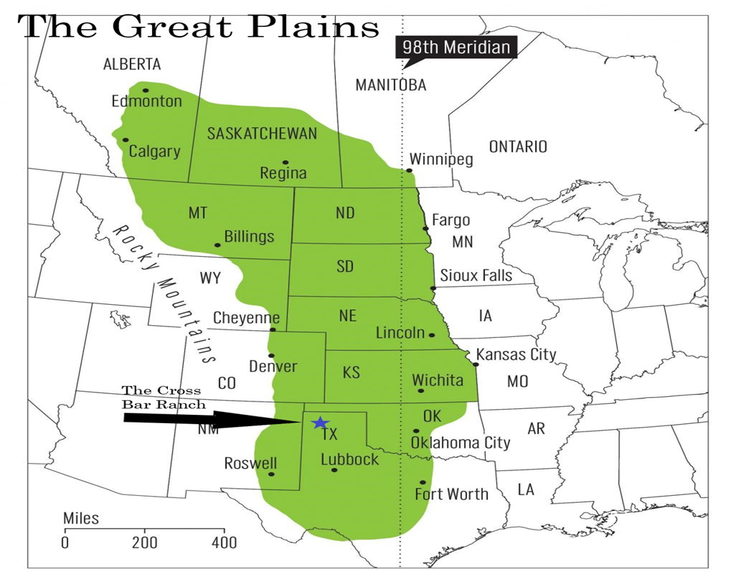
While broadly located within the southern Great Plains, the Cross Bar Ranch area (located within Potter County Texas) is also classified as the High Plains (Rathjen 1971:11). Characterized by a high degree of flat landscapes interrupted by relatively deep valleys, with interspersed and unpredictable playa lakes, this section of the High Plains is even further segmented by the Canadian River, which forms the northern boundary of what is known as the Llano Estacado (Rathjen 1971:13).
Figure 1: A map depicting the boundaries of the Great Plains (https://www.unl.edu/plains/about/about.shtml).

The Llano Estacado
Encompassing approximately 20,000 square miles, and exhibiting a gentle eastward slope, the Llano Estacado is composed of a relatively flat plateau bounded on three sides by steep escarpments (Wendorf 1961:14). The distinctive “broken land” topography associated with the Llano Estacado was a consequence of the combination of multiple, but distinct, environmental and geological processes. The initial formative episode is believed to be connected to the formation of the Rocky Mountains to the west, whose captured water was eventually channeled down its slopes in the form of raging rivers (Rathjen 1971:2). Carried along by these rivers were immense amounts of rocky sediments, which were themselves eroded from the newly formed Rocky Mountains (Hirmas & Mandel 2017:131). Over time these streams carried sediments spread out across the Southern High Plains, and in doing so they created a gently rolling landscape, otherwise known as an Alluvial Plain (Hirmas & Mandel 2017:149).
Arguably the most influential result of this Miocene depositional event in the context of the topographic formation of the Llano Estacado, was the accumulation of those Rocky Mountain gravels into what would eventually become the Ogallala Formation, which underlies nearly the entire Llano Estacado (Johnson 2008:122). However, another influential depositional episode occurred throughout the later Pliocene period, in which a loose sand and gravel layer was deposited over the region. Over time these loose sediments would conform to the local wind currents, which formed the gently rolling landscape observed today (Hirmas & Mandel 2017:131). An additional result can be seen in the soils of the Llano Estacado, which generally conform to the broad designation of Lithosols, in reference to the fact that many of these soils are relatively shallow and retain moisture poorly (Rathjen 1971:17).
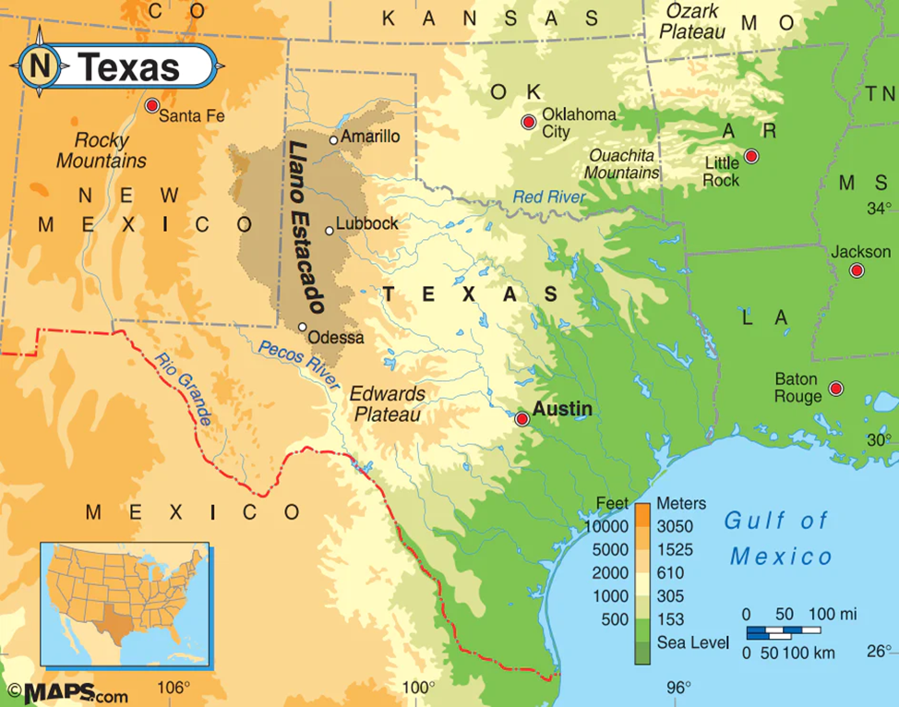
Figure 2: Illustration of the Llano Estacado (Geo-Joint: Roaming the Llano Estacado | Maps.com.com)

Hydrology of the Llano Estacado
Although the features of sediment deposition were indeed an important factor in the formation of the Llano Estacado, another highly influential aspect of the landscape concerns the Canadian River. Flowing eastward, the Canadian River traverses the majority of the Southern High Plains, in particular travelling through the plains of Texas and Oklahoma, and eventually joining the Mississippi River. As the largest source of water, the Canadian River, along with its associated tributaries, over time formed the distinctive Llano Estacado broken land topography, featuring steep slopes and deep draws (Quigg et al. 2010:15-16).
Even though the river valleys contain steep slopes, the surrounding terrain is relatively level, which in conjunction with an inability to retain moisture, results in a haphazard distribution of natural water. Depending on the season precipitation in the locale either evaporates, collects on the surface in the form of playa lakes, or is minimally retained and supplements the underlying aquifer (Rathjen 1971:13; For Potter County historic precipitation records see Figure 20 in Appendix A). Finally, the entire Llano Estacado, including the Canadian River and its associated tributaries are underwritten by the Ogallala Aquifer (Johnson 2008:125). As the name suggests, the Ogallala Aquifer is closely tied to the Ogallala geologic formation, which is due in large part to the amount of moisture retaining sediments (in particular sand) contained within the formation (Rathjen 1971:23). The sheer size and location of the Ogallala Aquifer has also made it one of the most important local aquatic features in both precontact and contemporary contexts (Hirmas & Mandel 2017:131).

Topography of the Llano Estacado
While much of the topography of the Southern High Plains features rolling, yet mostly flat plateaus, a series of sharp, sometimes sudden, changes in topography, commonly described as a system of breaks, also define the region (Rathjen 1971:14). The most distinctive topographic feature of these breaks can be seen in the escarpments bordering the river and tributary valleys and draws. These escarpments can range anywhere from 50 to 200 meters in height, and can vary in the steepness of their slopes proportional to differential degrees of erosion (Brosowske 2005:35-36). The geologic composition of these escarpments also factors into the resulting topography. For example, rivers and streams passing through slopes containing significant amounts of dolomite can only cut narrow corridors, creating limited, constrained floodplains (Gould 1907:10). However, other landform types characterizing this “broken ground” topographic setting include; narrow ridges/spurs, steep slopes, isolated conical hills, buttresses, and their supported peaks (Rathjen 1971:14).

Geology of the Llano Estacado
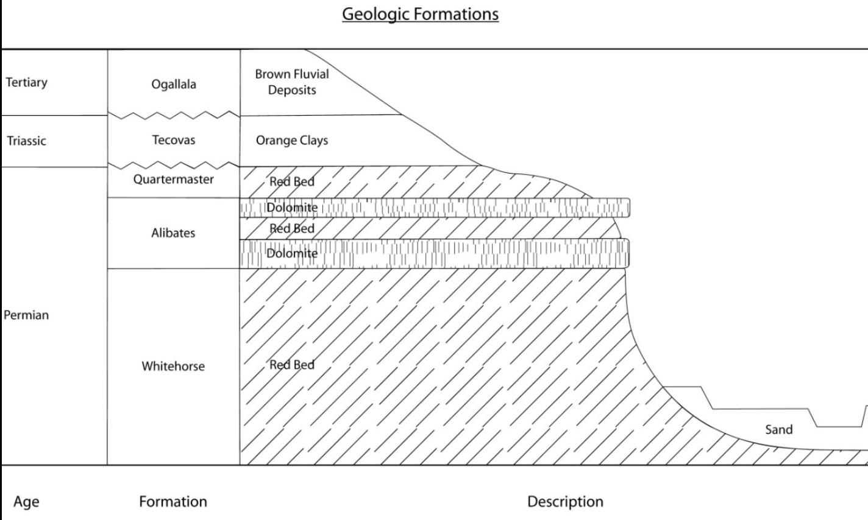
The geologic setting for the Llano Estacado is restricted to four geologic ages (from the most contemporary to the eldest); the Quaternary, the Tertiary, the Triassic, and the Permian (Quigg et al. 2010:16). While the majority of the soils and geologic features present in the Llano Estacado can be described as younger than most Permian aged sediments, “red bed” materials can still be observed within the locale’s deep river and tributary valleys (Drass & Turner 1989:4). As a consequence of the extended age of the Permian in proportion to the Triassic, Tertiary, and Quaternary, some geologists delineate Permian aged formations, while others utilize the Quartermaster Formation as an umbrella designation (Quigg et al. 2010:18). This umbrella configuration often features unsystematic lenes of red colored siltstone, mudstone, shale, and sandstone, as well as veins of dolomite and white gypsum (Quigg et al. 2010:18). However, while the Whitehorse and Quartermaster formations are distinguished by little more than stratigraphic location (as both the Whitehorse and Quartermaster formations contain similar geologic units, predominantly featuring red bed sediments [Drass & Turner 1989:4]), the Alibates formation nestled in between them exhibits a slightly different composition. Of particular interest here concerns the result of agatized dolomite, otherwise known as Alibates Chert, was one of the preferred lithic materials for flintknappers in the region (Quigg et al. 2010:19).
Figure 3: Illustration of the Geologic Ages (Quigg et al. 2010:53).
As previously stated, the most wide-ranging foundational geologic formation exhibited throughout the Llano Estacado is referred to as the Ogallala Formation. Although, while containing alluvial and fluvial sediments from both the Pliocene and Miocene epochs, its uppermost section consists of a rigid calcrete capstone overlay (Hirmas & Mandel 2017:151). While these deposits appear contradictory, the establishment of the capstone layer was a direct result of the alluvial composition in conjunction with local environmental conditions. Over time, as a consequence of the semi-arid climate, the moisture retained within the calcite bearing alluvial silt and sand worked its way upward in a capillary manner. As the moisture reached the surface, it fully evaporated, leaving behind calcareous material that eventually aggreged into the capstone sheet observed today (Rathjen 1971:3). Consequently, the unyielding nature of this capstone sheet is also considered responsible for the distinctively flat landscape associated with the Southern High Plains (Johnson 2008:124).
Mantling the Ogallala Formation for almost the entirety of the Llano Estacado, the Blackwater Draw Formation represents the most contemporary Quaternary geologic age (Holliday 1989:1598). Similarly to the Ogallala Formation, the Blackwater Draw formation is composed of alluvial sediments which were also formed locally into a thick calcrete layer (Johnson 2008:124). Furthermore, this more recent capstone layer serves to reinforce the characteristically level topography of the Llano Estacado, with subsequent depositional events either cutting into, or sitting atop this formation (Hurst et al 2010:99). Conversely, while the capstone layers of the Ogallala and Blackwater Draw formations are credited with the region’s lack of topographic relief, the wind-blown distribution of other Quaternary loess sediments have been considered influential in bolstering the region’s rolling topography (Rathjen 1971:22).
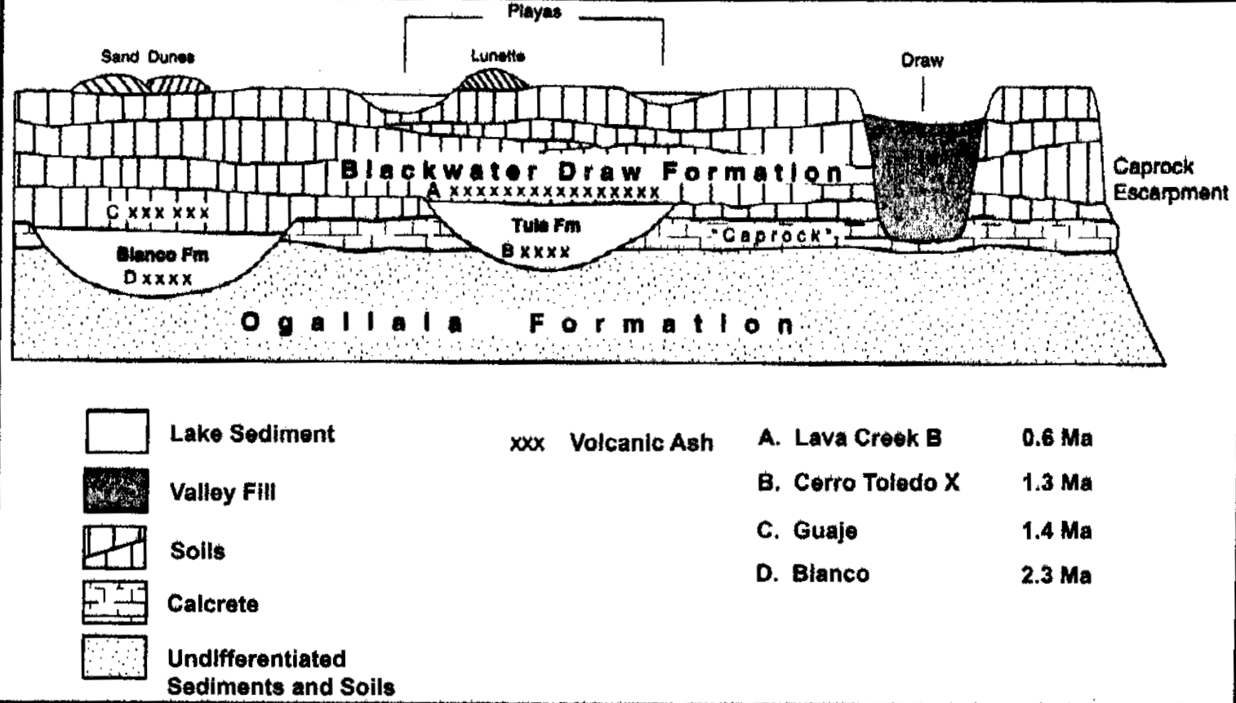
Figure 4: Illustration of the Blackwater Draw Formation (Johnson 2008:9).

Soils of the Llano Estacado
Owing to their alluvial origins, the vast majority soils currently residing in the Llano Estacado fall under the classification of Eolian sediments (Forman et al 2001:7). The two broad types of depositional sediments considered of consequence here are sand and loess (Hirmas & Mendel 2017:141). While it is true that sand dunes can be found on surfaces of the Blackwater Draw Formation, the majority of sediments contained within the formation derive from earlier episodes of deposited Pliocene loess. Developed under these conditions were two main soil orders, the Alfisols and the Mollisols (Hirmas & Mendel 2017:143-144). In proportion to the surrounding environment, both of these soil orders exhibit a relatively high degree of moisture retention, however, Mollisols are more likely to capped by a calcic horizon (Lintz 1986:82, 86). On the other hand, the wind-blown sand dunes and sheets of the Llano Estacado are associated with the development of the Entisols soil order. Unlike the Alfisols and Mollisols, the sandy foundation of this soil order results in a significant amount of water drainage, thus preventing those soils from maintaining a high saturation content (Hirmas & Mendel 2017:144). Another consequence of their wind-blown distribution can be seen in the lack of any meaningful pedogenic development on their more recent depositional surfaces (Lintz 1986:87).

Climate and Precipitation of the Llano Estacado
Similar to its topography, the climate and precipitation patterns provide another dichotomous facet of the Llano Estacado. The climate of the southern High Plains, including the Llano Estacado, is differentiated between the sub-humid portion in the east and the semi-arid sections of the west (Brosowske 2005:45). The primary instigator of this east-west climate dichotomy relates to the differential amount of annual precipitation received by those sections. Documentation from across the general area of the southern Great Plains appears to reference an increase in the annual amount of precipitation as one moves from west to east (Hirmas & Mendel 2017:135). This east-west precipitation trend has also been recognized and documented more locally within the area of the Texas Panhandle. While the eastern counties of the Texas Panhandle receive approximately 21.5 inches of rain per year, those in the western sections of the area receive only 18.5 inches per year. Although a difference of three inches may appear insignificant, it is enough to describe the eastern portion of the region as sub-humid and the western portion as semi-arid (Rathjen 1971:19).
Another contributing factor to the climate and precipitation patterns of the Llano Estacado is believed to involve the composition of the soils. Examinations engaging in environmental modeling have indicated a correlation between a soil’s ability to retain moisture and the aridity of the surrounding climate. These studies suggest that increased aridity is a consequence of diminished amounts of evaporative cooling, as a result of the reduced amount of moisture retained. This in turn serves to raise the temperature of the surrounding ground surfaces. Furthermore, this increase in surface temperature also increases the surrounding air pressure, which works to avert the air currents responsible for carrying precipitation (Forman et al 2001:23).
However, the climate pertaining specifically to the Cross Bar Ranch area has been described as a “dry steppe.” Within this area, the precipitation patterns are deemed highly variable, underscoring a recurring pattern of droughts and heavy thunderstorms. However, despite the fluctuations in precipitation trends, the annual amount of rainfall in the area has been measured at 20.28 inches, with the overwhelming majority (79%) occurring during the summer and fall months of May through October (Pringle 1980:76). Interestingly, this heavy summer rainfall supports the environmental models implying that during times of increased moisture saturation (such as summer thunderstorms), regional precipitation is more likely to increase as well (Forman et al 2001:23). In other words, rainfall can be understood to beget more precipitation episodes, which in more water starved regions can result in recurring periods of heavy rainfall, as well as sustained droughts.

The Canadian River Valley
Although located within the Llano Estacado, this thesis focuses on the more localized area of the Cross Bar Ranch, which is situated within the Canadian River Valley. Within the immediate area of Potter County, Texas, the Canadian River is the dominant topographic feature (Pringle 1980:1). Akin to other areas of the Southern High Plains, the Canadian River Valley also features an extensive amount of broken ground topography, which has been codified into a system referred to as The Canadian River Breaks. Here, distinctions are made between two inverse environmental zones designated as the Inner Valley and the Outer Valley. This dual valley scheme illustrates and classifies contrasting topographic features, as well as their associated floral, faunal, geologic, and soil elements, present within the Canadian River Valley (Lintz 1986:76).
Specifically, each valley is subdivided into a series of topographic sections that serve to delineate both gradual and sudden variations within the overall environment. The characteristically divergent nature of these sections can be understood as a product of the differential degree of environmental influences, such as wind currents, sun exposure, and erosion, of which each valley designation was subjected (Lintz 1986:91). For instance, over the course of Lintz’s (1986) doctorial examination of the Canadian River Valley, he discovered that soil productivity values could be separated into five general settings, three of which are assumed to be exclusive to a particular valley designation. Listed here in terms of highest to lowest soil productivity value are: floodplains/terraces (inner valley base), foot slopes, upper slopes, uplands (outer valley base and wall), and steep slopes (inner valley wall) (Lintz 1986:337-338). Even though a limited number of mutual attributes can be discerned between the valley designations, the dichotomy illustrated through the Canadian River Breaks still serves as an excellent tool of general environmental differentiation.
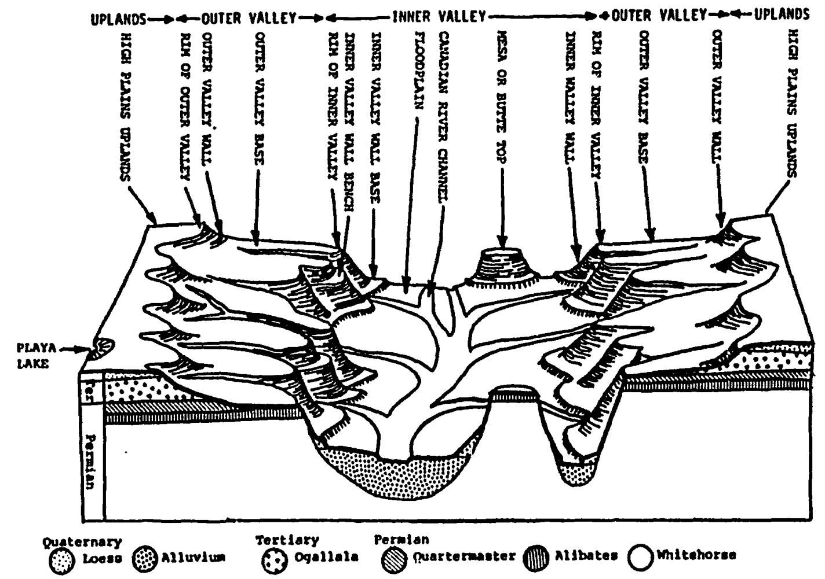
Figure 5: Illustration of the Canadian River Breaks System (Lintz 1986:106).

The Outer Valley
Situated in the rolling, relatively level upland plateaus of the Canadian River Valley, and predominantly composed of shallow deposits surrounded by gently sloping topography, the outer valley is reminiscent of a wide, shallow basin. Furthermore, owing to the reduced influence of erosional processes in proportion to the inner valley which occurs as a result of the more level topography, the majority of the geologic elements present within the outer valley date to the more contemporary Tertiary and Quaternary geologic ages (Lintz 1986:74,81). As opposed to the increased degree of erosional processes related to broken ground topography, the more level plateaus of the outer valley have accumulated a thin sheet of wind-blown Quaternary sandy sediments. Although blanketed by Quaternary deposits, three Tertiary aged soil orders, Alfisols, Inceptisols, and Mollisols are featured throughout the outer valley (Lintz 1986:74-75). Typically the soils subsumed under these categories have been known to retain a limited amount of moisture, but are also considered almost problematically porous, and thus are believed to have only supported limited savannah-style mixed grasslands (Lintz 1986:84-87).

The Inner Valley
The inner valley serves as the primary location of the characteristic slopes, bluffs, draws and other broken ground landforms that are commonly associated with the Canadian River Valley (Lintz 1986:74). As a consequence of their steep slopes and increased degree of erosion, the majority of the inner valley geologic formations carry an older Triassic and Permian aged designation (Lintz 1986:82). In other words, most of the more contemporary geologic deposits have either been eroded away, blown away, or a mixture of both, leaving the older geologic formations exposed along the slopes and valleys. The primary soil order here is the Entisols, which are generally characterized as porous, loamy, alluvial soils with very little to no additional pedogenic activity after initial deposition (Lintz 1986:88). Unlike the thin sandy blanket of the outer valley, these soils form thick sand sheets and dunes, featured in the slopes and floors of the inner valley. These accretions form as a consequence of wind-blown sandy sediments captured by those landforms that interrupt the natural wind currents (Johnson 2008:124; Hirmas & Mendel 2017:144). Owing to the loose nature and poor moisture retention of these soils, the vegetation of the inner valley consists of a very limited scattering of xerophytic shrubs, as well as a modest variety of mixed ephemeral grasses (Lintz 1986:88).

Flora of the Canadian River Valley
Despite the surrounding environmental elements such as soil composition, geologic age, climate/precipitation patterns, and topographic relief that serve to limit the quantity and diversity of floral assemblages within the Canadian River Valley, specific floral communities can still be located and identified. To this end, several surveys pertaining to the vegetation present throughout the Canadian River Valley have been undertaken. In one study, Wright & Meador (1979) conducted an examination of the flora present around the area of Lake Meredith, which is considered by Lintz (1986) to conform to an inner valley designation. In another study, a survey led by Sikes & Smith (1975) was aimed at investigating the floral assemblages specific to outer valley designations within the Canadian Breaks system (Lintz 1986:99-100). However, generally speaking, the more contemporary flora documented in this locale are dominated by a few floral species, namely, mesquite trees, prickly pears, and cholla grasses (Texas Archaeological Site Atlas; Quigg et al. 2010:39; For a fully list of local flora in the Canadian River Valley see Table 6 in Appendix A).
These endeavors resulted in the establishment of five distinctive floral associations, each reflecting a specific environmental setting exhibited by the Canadian River Valley. Progressing from the depths of the inner valley to the elevated plateaus of the outer valley, these zones are; the bottomlands, the steep slopes, the mesa tops, the gravelly slopes, and the sandy hills. As the name suggests, the bottomlands are exclusively located near the alluvial floodplains and terraces of the inner valley, where the elements present have been heavily influenced by riparian environmental processes. Due to the frequent flooding that occurs in this setting, both the soils and flora have become resistant to such over saturation, resulting in an assortment of grass species, with a few trees also thrown into the mix. Next, situated in the “flanks” of the inner valley, the steep slope zone, while similarly as sparce as the bottomlands, boasts a greater degree of uniformity among its distribution of floral inhabitants. While short grass stands constitute the majority of the area’s floral consistency, a few shrubs can also be found littering the locality (Lintz 1986:100).
Continuing to the lower sections of the outer valley, the mesa top zones are distinguished by their placement directly atop of the dolomite capstones of the Alibates geologic formation. Because their associated soils overlay solid capstone layers, the vegetation supported in this setting requires a shallow root system, reflective of those shallow soils. Farther up the outer valley, the ridges, knolls, and other undulating landforms fall into the category of gravelly slopes. Although topographically distinctive, this zone contains the relatively same, or at least a relatively similar distribution of grass species, only breaking from the previous categories in terms of the greater size of its shrubs. The final floral zone, referred to as sand hills, occur only on the upper slopes of the outer valley. These sand hills, also known as sand dunes, have been described as mantling the upper capstone of the Canadian River Valley. As a result, the vegetation documented within this zone emphasizes this sandy nature, as evidenced by the presence of sand sagebrush and sand dropseed, as well as various other short grass species such as buffalo and blue gamma grasses (Lintz 1986:100-102; Hill 2019:6).

Fauna of the Canadian River Valley
In terms of faunal associative systems, the entire Llano Estacado is subsumed into the Kansan Biotic Province. Out of the three districts that compose the Kansan Biotic Province, the Llano Estacado specifically occupies what is known as the Shortgrass Plains District (Wendorf 1961:17). However, the powerful crosscutting quality of the Canadian River across the Texas Panhandle created a narrow microenvironmental corridor separate from the rest of the Shortgrass Plains District. This microenvironment was documented in 1973 when Scudday and Scudday (1975) conducted a multi-day faunal survey along the banks and natural breaks of a section of the Canadian River located in Oldham County, Texas. Over the course of their investigation, they discovered that the faunal communities within Canadian River Valley were substantially limited in comparison to the surrounding area. The faunal community observed within the Canadian River microenvironmental corridor consisted of merely four species of amphibians and nine mammalian species (in comparison to the fifty-nine mammalian and fourteen amphibious species documented in the surrounding environment) (Quigg et al. 2010:47).
Historically however the Canadian River Valley was home to a wide variety of wildlife, although specific fauna populations waxed and waned in relation to the highly variable climactic shifts which occurred periodically (Creel 1991:45) as evidenced through differing frequencies of bison remains documented and dated within various timeframes Brosowske 2005:61). The variety and density of these fauna populations in the past have been evidenced through early accounts of sheep herders living along the Canadian River. These sheep herders documented such creatures as: blue and bobwhite quail, prairie chickens, various waterfowl, antelope, white tail deer, coyotes, lobos, and finally buffalo herds that numbered in the thousands (Rathjen 1971:28).

Chapter 3: Cultural Context and Previous Work in the Cross Bar Ranch
In addition to understanding how these important ecological variables may have influenced archaeological settlement patterns, it is also equally important to contextualize this landscape through the lens of its past residents. By understanding the local population, certain elements of their relationship with their environment can be identified and examined. Although not comprehensive, this chapter presents relevant cultural, social, artifactual, and architectural facets of the peoples that occupied the Cross Bar Ranch between AD 1250 and 1450 otherwise known as the Antelope Creek Phase of the Southern Plains Village Tradition.

The Southern Plains Village Tradition
The Plains Village Tradition of the southern Great Plains encompasses the peoples that populated a large physical and temporal space that spanned from southeastern Colorado, through most of southern Kansas, as well as parts of the Texas panhandle and much of western Oklahoma (Trabert & Hollenback 2021:93). It is generally accepted that around AD 1000 an intensification of environmental exploitation occurred, primarily through an increased reliance on agricultural activities (Drass 2012:373). Regional archaeological evidence also suggests that these peoples were more sedentary than earlier mobile hunter and gathers who inhabited the area before them. This assertion is evidenced by the introduction of more intentional long-term housing in conjunction with the adoption of horticultural activities (Drass & Turner 1989:24).
These more sedentary populations preferred to live in small communities situated within fertile environments along rivers and tributaries (Drass 1998:415). These settlement patterns were likely influenced by the adoption of horticultural practices, as riparian areas were excellent places to grow crops (Drass 2012:374). This is due not only to the more fertile soils in the floodplain areas, but also because of the relative reliability of rivers and tributaries, as opposed to the temporary playa lakes scattered throughout the region (Boyd 2008:39). These bottomland settings also provided easier access to small game animals, fish, and wild plants (Drass 2012:374).

Origins of the Southern Plains Village Tradition
Initially researchers believed that the southern Plains Village populations migrated from outside of the region, given the differences in material culture from their Woodland predecessors (Drass 1998:415). However, more contemporary researchers find that the distinctive cultural and material practices not documented in earlier contexts were more likely due either to localized adaptation or interregional interaction, rather than the arrival of new migrants to the region (Drass 2012:374). In support of this adaptive model, non-local crops such as corn, beans, and squash have been recovered from both the earlier Woodland Period and subsequent southern Plains Village Tradition contexts (Trabert & Hollenback 2021:89-90). The presence of these non-local crops in assemblages that both predate and postdate the emergence of the southern Plains Tradition suggests that those populations were already established in the region, rather than migrants who introduced those non-local crops. This is further supported by the inclusion of cordmarked pottery within both Woodland Period and southern Plains Village assemblages (Drass & Turner 1989:22-24). In summation, these peoples were more than likely present during the previous Woodland Period, and simply adapted differentially to their local environmental domains over time (Drass 1998:415).

Characteristics of the Southern Plains Village Tradition
Much like their Plains Village neighbors to the north, Southern Plains Village groups tended to live in isolated hamlets or homesteads and relied on bison hunting and the cultivation of local and nonlocal plants for subsistence. Furthermore, populations throughout the central and southern Great Plains also have been found to have lived in bottomland settings near rivers and tributaries (Drass 2012:373-374). On the other hand, examples of regional variation can be seen in the architectural differences between the southern Plains Village settlements situated along the Canadian River from those placed in the more northern upland prairies. In particular, structures documented along the banks of the Canadian River exhibit some Puebloan influences, such as the more Puebloan utilization of adjoining rooms within a single structure (Wedel 1961:142).
Their shift in subsistence economy was also accompanied by a functional shift in the types of tools that were preferred and manufactured (Duncan 2002:49). For instance, similar to other Great Plains peoples, this increased preference for large game is evidenced by the introduction of more specialized forms of end scrapers, as well as through the increased frequency of diamond-shaped beveled knives (sometimes referred to as Harahey knives). Consequently, both of these specialized tool forms were geared towards expanding the expediency of big game processing. While the end scrapers would more easily separate the fur and thin the hide, the knives were necessary to cut the thicker hides of those big game animals (Creel 1991:42-43). On the horticultural side, the focus on agricultural cultivation can be seen through the increased number of digging implements, such as bison scapula hoes, found at nearly every southern Plains Village site (Drass 2012:377). Other types of artifacts, such as smaller, notched projectile points and cordmarked pottery became more common throughout this period (Duncan 2002:49). Finally, while southern Plains Village populations shared many of the functional aspects of their tool assemblages, slight stylistic variations and available raw materials use provides researchers valuable insights into possible distinctions between these groups (Drass 2012:377).

Select Cultural Complexes of the Southern Plains Village Tradition
As mentioned earlier, another distinctive facet of the southern Plains Village Tradition is in the amount of variation exhibited between the cultural complexes. However, due to the sheer volume of cultural variation found in this region, only those complexes immediately surrounding the Cross Bar Ranch will be briefly discussed. Of interest here, is a specific slice of time within the Texas and Oklahoma Panhandles from AD 1100-1450 generally referred to as the Late Precontact Period (Duncan 2002:49). Within the Late Precontact Period, three cultural complexes are close to the Cross Bar Ranch; the Buried City Complex, the Zimms Complex, and the Antelope Creek Phase. However while the Buried City Complex (AD 1150-1350) and Zimms Complex (AD 1250-1450) are contemporaneous with the Antelope Creek Phase (AD 1200-1450), only Antelope Creek sites have been identified within the Cross Bar Ranch study area (Drass & Turner 1989:25; Duncan 2002:60; Lintz 1986:3; Lintz 2002:32). Therefore, only the Antelope Creek Phase will be here; see Lintz 1986, Moore 1998, Duncan 2002, Drass & Turner 1989, Eyerly 1912, Vehik 1988, Drass 1986, Brooks et al 1992, Flynn 1986 for more information on the other contemporaneous complexes.
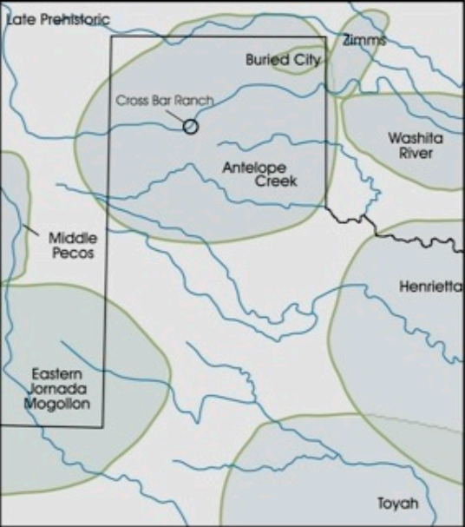
Figure 6: Illustration of the cultural complexes in the Late Precontact Period (Mudd 2016:30).

The Antelope Creek Phase
Initially referred to as the Antelope Creek Focus, the Antelope Creek Phase has been more recently has been reclassified as a distinct Phase spanning from AD 1200-1450 (Lintz 1986:3). Settlements assigned to this designation are found across the southern High Plains, and are most commonly found within the drainage basins of the Canadian River and Wolf Creek in the Texas and Oklahoma panhandles (Drass & Turner 1989:3; Lintz 1984:325). Similar to other southern Plains Village populations, Antelope Creek communities practiced a semi-sedentary lifestyle featuring bison and other game hunting supplemented by limited agricultural activities (Lintz 2010). Furthermore, Lintz (1986) postulated settlements in close proximity would cooperate to share resources and maximize their ecological setting (Lintz 1986:332).

Material Culture of the Antelope Creek Phase
Akin to other aspects of Antelope Creek peoples’ utilization of local resources, the overwhelming majority of their lithic tools were composed of local Alibates chert (Lintz 1984:331). Specifically, Antelope Creek assemblages feature a range of small, triangular projectile points, diamond beveled knives, and an abundance of various forms of hide-scrapers. Besides the indistinct smaller triangular projectile points, three more identifiable (diagnostic) projectile point classes (Washita, Harrell, and Fresno) are also commonly observed within Antelope Creek lithic assemblages (Drass 1998:421). Beyond projectile points, other stone tools, such as one-handed manos, and stone basin metates were also employed in the processing of plant and other horticultural entities (Duncan 2002:57). While side and end scrapers are recovered with abundance within these assemblages, a particular form referred to as “guitar-pick” scrapers are considered distinctive of Antelope Creek material culture (Drass 1998:421).
The majority of non-lithic tools associated with Antelope Creek contexts are comprised of bone tools, with bison scapulas and tibias as the primary digging implements for tilling their agricultural fields (Duncan 2002:57). Besides bison, billets developed from deer and antelope antlers were also used as pressuring flaking tools (Lintz 1984:333). The vast majority of pottery commonly attributed to Antelope Creek populations is referred to as Borger Cordmarked (Duncan 2002:57). These ceramic vessels were constructed by coiling welded clay fillets composed of sand, mica, or crushed quartz and subsequently applied with a cordwrapped paddle, resulting in a vertically oriented cordmarked pattern. However, breaking from other southern Plains Village pottery templates, Antelope Creek potters rarely decorated the surface of their vessels (Lintz 1984:334).
As one of the defining facets of the southern Plains Village Tradition, the presence of non-local goods, assumed to be evidence of interregional exchange, are regularly observed within Antelope Creek material cultural assemblages. The most distinguishable of these trade goods, Puebloan pottery, can be found in high quantities throughout the Antelope Creek Phase, specifically at sites consisting of at least four residential structures (Brosowske 2005:211-214). The depth of this Plains-Pueblo exchange, in terms of pottery, is clearly demonstrated through the documentation of at least nineteen distinct Puebloan pottery styles within Antelope Creek site assemblages (Lintz 1991:95). One of the other easily distinguishable non-local materials, obsidian, is also widely distributed throughout Antelope Creek contexts (Lintz 1991:95). Besides obsidian, other non-local lithic materials such as mica and turquoise that have been linked to the Jemez Mountains have also been recovered from various Antelope Creek assemblages (Duncan 2002:58). Lastly, items regarded as mortuary offerings are seldomly documented among Antelope Creek Phase settlements reflective of the scarcity of documented Antelope Creek burials, however, in those limited circumstances, these items are generally indicative of personal adornment rather than overtly utilitarian (Lintz 1984:336).

Antelope Creek Phase Architecture
While many of the characteristics and attributes displayed by Antelope Creek peoples can also be found throughout the southern Great Plains, these groups are distinguished by their distinctive architecture. In particular, Antelope Creek architecture follows five general arrangements (possibly related to function) and may or may not be associated with other structures (Lintz 1984:327-328). These structural arrangements can also delineated by several elements, such as the presence of a centrally depressed floor channel, central hearths, and interior roof supports (Lintz 1986:61). Despite the numerous variations of Antelope Creek architectural attributes, these structures are all share a few similarities, such as a semi-subterranean layout, walls supported by at least one row of vertically placed dolomite slabstones, and an east facing entryway (Drass 1998:419). A further distinction has been noted through specific wall construction techniques, which are thought to have been heavily influenced by available building materials. This is evidenced by an increase in the employment of supplemental materials, such as mud and branches in areas where the natural dolomite cobbles were too small to support their characteristic slabstone architecture (Lintz 1986:321).

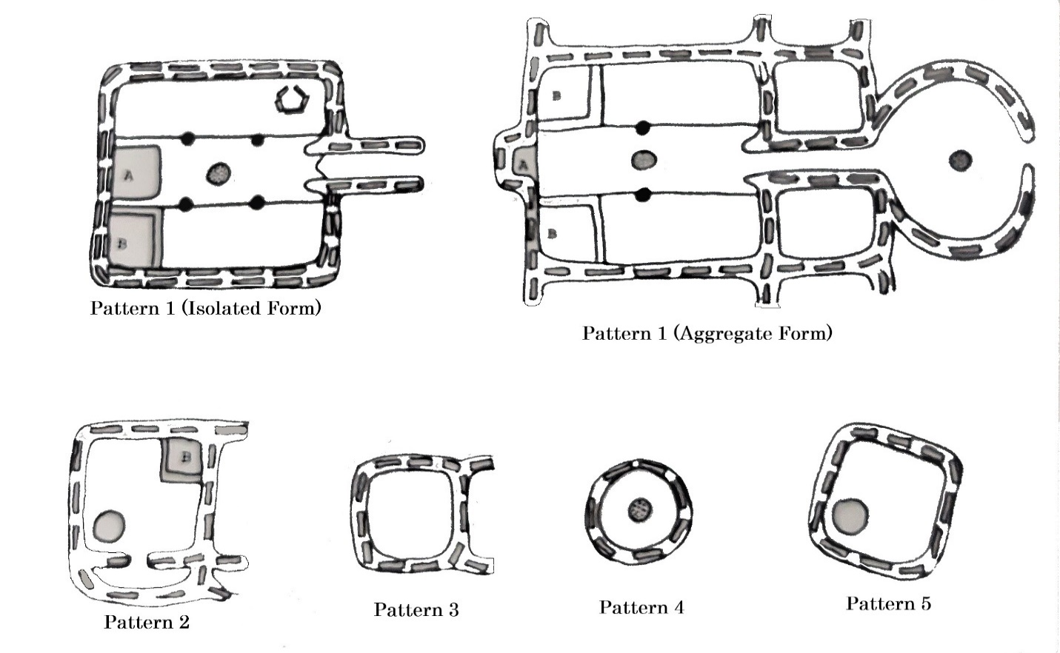
Figure 7: The Five patterns of Antelope Creek architecture, as illustrated by Lintz (Lintz 1984:327).
Besides square or rectangular rooms, circular ones have also been documented at Antelope Creek sites. These structures have also described as either “free-standing” or alternatively integrated into larger multi-room structures (Lintz 1986:4). Furthermore, Antelope Creek architecture is typically delineated through the number and size of their rooms, along with residential versus supplemental (storage and/or processing areas) functional layouts (Lintz 1986:141). In particular, the characteristics of storage features, such as the presence, placement (interior vs exterior), and type (the presence or absence of stone lining, and flat versus rounded bottom) is also used to further differentiate these architectural variations (Lintz 1984:300). Other architectural traits, such as room size, entryway elaboration, and number of wall supports have also been used to roughly delineate an early vs late chronological placement within the Antelope Creek Phase (Lintz 1986:422-423). Unfortunately, although a wealth of information exists correlating the ratio of various room attributes to numerous aspects of Antelope Creek social characteristics, the limited data produced by the archaeological investigations within the Cross Bar Ranch prevents more in-depth analyses. Although specific architectural patterns will not be discussed at length here, these arrangements form the foundation of a concept central to this thesis; the general architectural site types of hamlets, homesteads, and subhomesteads. Within these distinctions only a very basic analogy of room quantity and size as they relate to site function is utilized in the designations of hamlet, homestead, and subhomestead.

The End of the Southern Plains Village Tradition
Similar to its beginning date, there is no exact end date for the southern Plains Village Tradition, although it widely considered to occur around AD 1450 (Trabert & Hollenback 2021:92). On one hand the Pacific Climate Episode lasting from AD 1250-1550 produced a recurring cycle of droughts, that is believed to have dramatically limited the types and quantities of available resources. This climate episode is credited with facilitating the buffering strategy commonly attributed to the southern Plains Village Tradition’s mixed subsistence style (Lintz 1991:101-102). However, after approximately AD 1400 these drought patterns intensified and along with a myriad of other environmental factors, caused the southern Plains Village populations to shift their subsistence practices back to an emphasis on bison hunting, which curbed their more sedentary horticultural practices (Vehik 2006:207). While these prolonged droughts affected agricultural endeavors, the resulting resource instability was also felt by the regional bison, whose herds became smaller, faster, and more unpredictable as their resource domains became less tenable (Bozell 1995:154). Presumably to counter the increased resource instability, Plains-Pueblo exchange intensified, which is thought to have prompted southern Plains Village populations to refocus their subsistence economy towards the procurement of bison related trade goods unavailable to their Pueblo trade partners. This increase of Plains-Pueblo exchange after AD 1350 is supported by the increased amount of trade goods recovered from assemblages that have been dated to after AD 1350 (Lintz 1991:101-102).
On the other hand, another possible cause of the absence of the southern Plains Village peoples has been attributed to an increase in conflict occurring in the latter half of the timeframe. The bulk of these assertions rely on physical elements of violence present on documented skeletal assemblages within the southern Plains Village context. Specifically, evidence of dismemberment and decapitation has been recorded within Antelope Creek and Zimms Complex sites (Vehik 2002:42). What are believed to have been decapitated trophy skulls have also been recovered from sites considered core areas within the Antelope Creek physical environments (Brosowske 2005:114). Furthermore, in a limited number of these violent contexts, burials containing multiple individuals, who were believed to have been interned simultaneously have also been noted as evidence of violent episodes (Vehik 2002:42). Although debated, the more elevated locations selected for occupation that have been dated, or assumed contemporaneous with an AD 1350 context, generally reflect defensive considerations associated with an upswing in conflict, or at the very least lingering group hostilities (Brosowske 2005:113-114).
While not definitive and questionable at best, it is interesting that Coronado’s 1541 expedition into the southern Great Plains failed to record or document any distinguishable Plains Village settlements in the area of the Texas panhandle (Krieger 1946:48). Although, while Coronado noted an absence in formal settlements, he did observe a range of mobile bison hunters, lending credence to the hypothesized late subphase shift away from horticultural reliance and towards more abundant/advantageous bison hunting activities (Lintz 1984:340). However, postulations have also been put forth suggesting that regardless of the mechanism of change, the southern Plains Village peoples were prompted to integrate with other regional populations that would eventually come to be known broadly as the Wichita and Affiliated Tribes (Vehik 2006:206). Advocates of this coalescence point towards the linguistic similarities found throughout the later Caddoan languages in the region as evidence of this cultural integration (Trabert & Hollenback 2021:132).

Lintz’s Antelope Creek Site Types
In his 1986 dissertation, Lintz established three distinct expressions of Antelope Creek settlements predicated on the architectural elements present at the sites: hamlets, which consisted of multiple households (representing a multi-family community); homesteads, which are isolated households occupied by a single family; and subhomesteads, seasonal encampments with ambiguous social details. Settlements lacking in architectural remains are also found within the Antelope Creek Phase, such as small temporary camps used to supplement the resource procurement and processing of the more established settlements (Lintz 1986:348). Lintz further subdivided these site types into simple vs complex designations, but due to the paucity of archaeological evidence within the Cross Bar Ranch, here only the overarching designations will be considered.
The artifactual assemblages associated with these site types reflect an amount of variation in the activities conducted at each (Lintz 1986:267-268). For example, subhomesteads, as smaller, seasonal settlements on the outskirts of the larger and more permanent homesteads and hamlets, were thought to be utilized as procurement and processing areas for both floral and faunal resources. This was due to the abundance of specialized tools, such as bison scapula and tibia hoes, indicative of a focused, but limited range of activities (Lintz 1986:303,426). Alternatively, while homesteads also served as procurement and processing sites, their more permanent structures suggest that they functioned as base camps for these activities. Finally, hamlets, as the largest unit within this system, represent centers of interaction, both as a community comprised of multiple residential structures, and as a foci of interregional exchange, evidenced through the increased quantity of trade goods in comparison to the subhomesteads and homesteads (Lintz 1986:265-267). Although these designations share a few general characteristics, each one also exhibits its own unique properties, which serves to highlight the complexity of Antelope Creek settlements.

Hamlets
The largest unit of Lintz’s site types, referred to as hamlets, concern those settlements that contain at least two primary structures, as well as multiple subordinate structures (Lintz 1986:427). These settlements are thought to have encompassed multiple households, in turn forming (social) communities of various sizes. The increased amount of social complexity at these settlements can be seen through a more expansive variety of artifact and tool types than the assemblages for either the homesteads or the subhomesteads. The artifact assemblages documented at hamlets indicate that these settlements were comprehensively engaged the procurement and processing of a wide range of faunal and floral resources, which is also seen at homesteads (Lintz 1986:266). However, unlike the more isolated nature of the homesteads (when not associated with an adjacent subhomestead), hamlets are considered to have been occupied simultaneously by multiple family units (Lintz 1986:427).
One Antelope Creek site found within Lintz’s study area, referred to as the Footprint Site, provides an excellent example of several characteristics associated with hamlet sites. Situated on a knoll fifteen meters above the Canadian River, the site consists of three adjacent rectangular structures, as well as an accompanying circular cist. Furthermore, radiocarbon dates derived from materials gathered from each structure suggested that all three structures were occupied contemporaneously. Upon excavation, multiple burials were discovered within one of the structures, possibly indicative of an extended occupation by a single social group. While the number of internments (estimated at thirty-two individuals) indicated a larger population than would be found at either a homestead or a subhomestead, several burials also were found to truncate each other. The overlapping nature of these burial contexts indicates that the population would reuse that singular location, further suggesting a prolonged, perhaps even generational occupational duration not associated with either homestead or subhomestead sites (Lintz 1986:572-575).
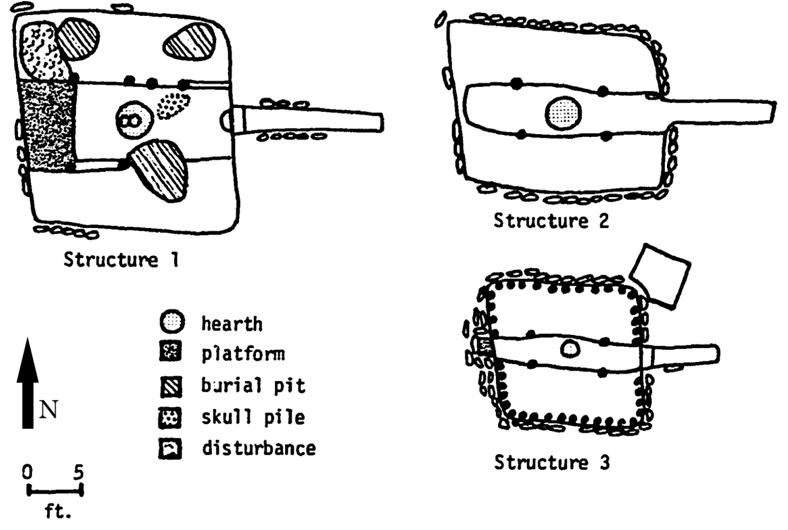
Figure 8: A Plan View map from the Footprint Site (Lintz 1986:574).

Homesteads
The primary feature delineating homesteads from subhomesteads, is the inclusion of a single dominant structure, with the possible inclusion of smaller associated subordinate structures to be located within a close proximity (Lintz 1986:245). These sites are thought to have been inhabited by a single family and were occupied over a more extended period of time (Lintz 1986:427). Furthermore, single internment burials tend to be only found at or a short distance away (Lintz 1986:275). Homestead sites also feature a wide range of artifact/tool types, which are considered proportional to the wide range of economic activities conducted at these sites. These artifacts include hunting tools such as projectile points, tools associated with faunal processing such as awls, scrapers, and knives. In addition, homesteads have also been documented containing horticultural tools, such as bison tibia digging implements or scapula hoes, as well as tools indicative of flora processing, such as manos, metates, and hammerstones (Lintz 1986:265). The presence of pottery as well as interior pits/cists at homesteads, in comparison to their absence at subhomesteads suggests a greater emphasis on the storing of materials. This disposition towards storage artifacts and features further demonstrates the difference in assumed length of occupation between the settlements (Lintz 1986:263, 265, 427).
Underscoring the homestead site type’s emphasis on nearby storage features, the Jack Allen Site exhibits not only a single dominate structure, but also two subordinate storage pits. Positioned atop a terrace twelve meters above Spring Creek (a tributary of the Canadian River), and away from any other Antelope Creek settlement conforms to the isolated nature characteristic of homestead sites (Lintz 1986:73, 551). Although featuring a rectangular design, a depressed central floor channel, and an east facing entryway reminiscent of structures found at hamlets, the majority of artifacts at this homestead were recovered from the storage pits, instead of from the general context of the structure (Lintz 1986:551).
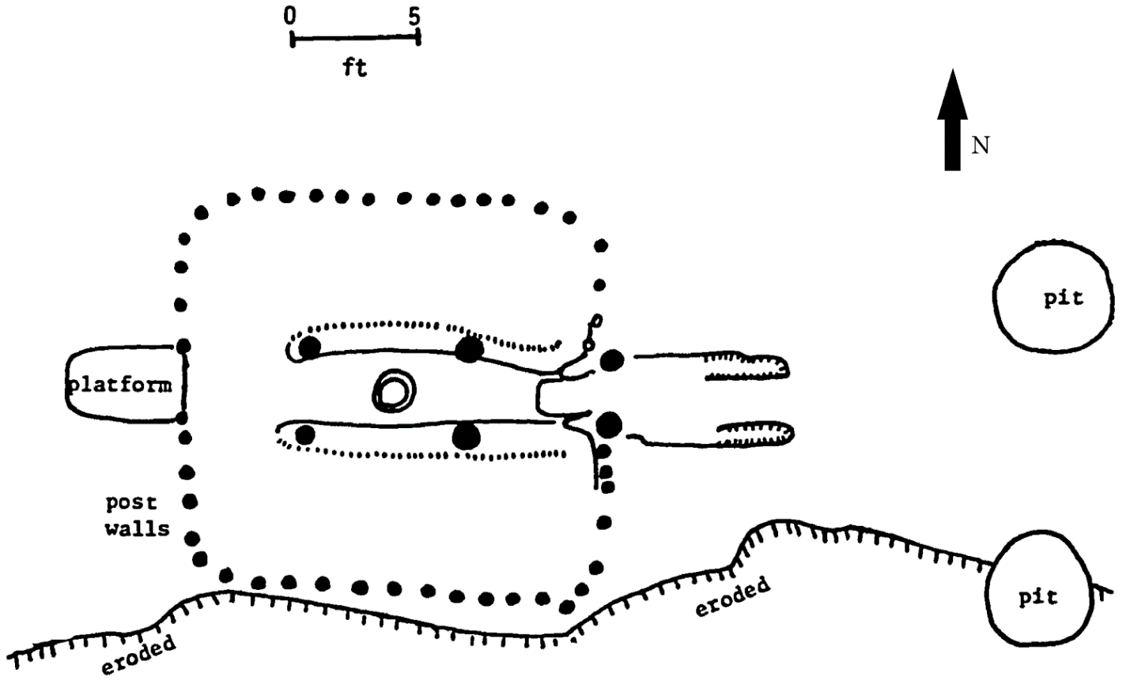
Figure 9: A Plan View map of the Jack Allen Site (Lintz 1986:552).

Subhomesteads
While homesteads and hamlets are comprised of various structural styles ranging in both internal complexity and size, subhomesteads exhibit only simple subordinate structures, typically measuring three meters or less in diameter and lacking in any internal demarcation (Lintz 1986:426). Featuring either a square or oval design, these simple structures are also the only ones that have been documented containing an interior central hearth. However, unlike homesteads and hamlets, these site assemblages lack any evidence of interregional exchange, normally reflected by the presence of trade good such as pipes and non-local pottery (Lintz 1986:254-255). The lack of pottery recovered from these sites also suggest that transportation of the processed resources may have taken priority over storage (Lintz 1986:263). Another indication of their more temporary occupation is implied through the absence of any documented examples of burials observed at subhomestead sites (Lintz 1986:275). However, it should be noted that future investigations involving subhomesteads could undermine this determination.
A prime example of a subhomestead found within Lintz’s project area, the Pickett Site, references multiple elements associated with the subhomestead site type category. Situated only three meters above an unnamed tributary of the Canadian River, the site is composed of a single, small, circular structure slightly larger than five feet in diameter and significantly less complex than structures documented at homestead and hamlet sites. While the site does feature a borrow pit, researchers noted that the wide, shallow pit contained only trash, and not evidence of stored resources. While the site failed to produce a significant amount of artifacts, several of those documented, principally bison tibia tilling implements, and a stone pestle referenced agricultural and processing activities. The low frequency of artifacts prompted Lintz to infer that the site was only occupied for a very limited duration. Furthermore, its apparently brief occupation, coupled with Duffield’s (1970) interpretation of the faunal remains from the site (which imply that the settlement was inhabited during the late spring or early summer), suggest that the Pickett Site could have plausibly served as a small seasonal field camp (Duffield 1970:192; Lintz 1986:542-544).
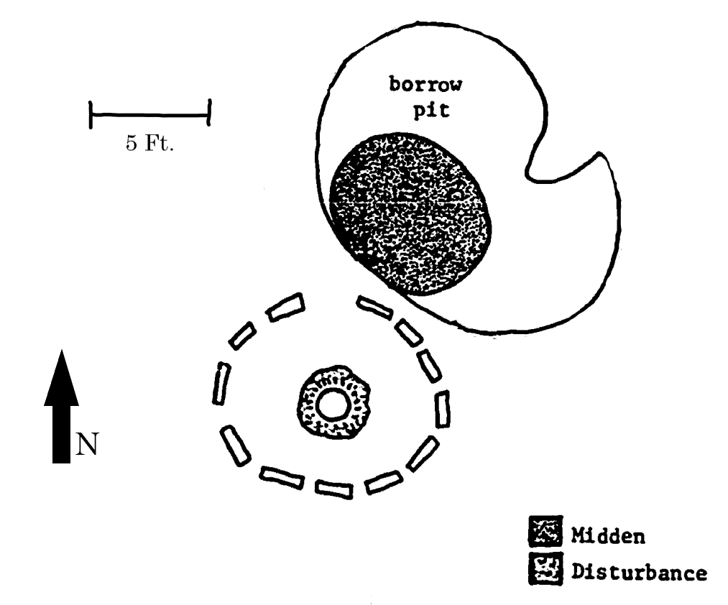
Figure 10: A Plan View map of the Pickett Site (Lintz 1986:543).
Owing to a close proximity and inverse topographic placement from homestead and hamlet sites, Lintz suggested it was plausible that subhomesteads formed interdependent relationships with these larger sites (Lintz 1986:328). Lintz (1986) proposed that the subhomesteads’ exclusive placement in the lower settings of the Inner Valley floor, in conjunction with the placement of homesteads and hamlets in more elevated settings, could be interpreted as a scheme to exploit the resources restricted to each environment. He supported this assertion through the similarities found in the faunal remains recovered among these sites, as either a reference to food sharing, or as evidence of (mutual) population movement among the sites (Lintz 1986:328). Mudd (2016) examined this interdependent relationship further through an investigation of two sites within the Cross Bar Ranch identified as a subhomestead (41PT283) and a homestead (41PT257). He found that each topographic setting was apt to emphasize a differential form of ecological exploitation. In particular, the lowland setting of the subhomestead would have been highly advantageous for seasonal agricultural endeavors, yet close enough to the homestead site to imply a residential relationship (Mudd 2016:223-224). These seasonal occupations are further supported by the fluctuations in river channel settings’ water discharged, ranging from high and abundant in the summer and spring months, while low and sluggish in the remaining months (Lintz 1986:348).

Antelope Creek Phase Settlement Patterns
While there have been documented Antelope Creek settlements in southern High Plains upland settings, the majority of sites are located either along the floodplains or atop elevated sections of low land settings, such as mesa tops, bluffs, terraces, and canyon rims (Lintz 1986:54). This patterning is thought to have been a utilization of the more stable water supply provided by the Ogallala Aquifer (Lintz 1991:92). The increased accessibility and stability of the Ogallala Aquifer could have acted as a counter to the unpredictable precipitation characteristic of the southern High Plains, making these areas highly advantageous for agricultural activities (Lintz 1991:92). Furthermore, the subsurface nature of the Ogallala Aquifer would have provided additional protection against the evaporative processes contributing to seasonal hydrologic variations in rivers, tributaries, and playa lakes (Boyd 2008:38-39).
More than their placement across the physical landscape, a temporal component is also thought to have contributed to differing aspects of Antelope Creek settlement patterning. The most visible expression of this temporal variation can be observed in the distance and distribution of various Antelope Creek settlements within their local resource domains, as well as in relation to each other. In the early subphase (AD 1250-1350) smaller settlements were located in close proximity to other designated Antelope Creek villages, forming small clusters which were thought to have possibly fostered a degree of intersite interaction (For a possible example within the Cross Bar Ranch see Figure 23 in Appendix C). Conversely, settlements believed to represent a late subphase (AD 1350-1500) distinction are often spread out farther from other Antelope Creek occupations, as well as located in more isolated sections of the landscape (Lintz 1986:316-318).
Although more widely dispersed, the larger and relatively more complex late subphase architecture, exhibited through the increase in average room size, also implies an increased density of occupants per settlement (Lintz 1986:392-394). To explain this trend, Lintz has posited that in in the early subphase, multiple settlements appear to be collectively oriented as a means to differentially exploit their local resource domain, as opposed to the more self-supported isolated settlements of the late subphase (Lintz 1986:328). An example of this can be seen within the Canadian River Valley in the placement of larger settlements (hamlets and homesteads) in more elevated locations adjacent to nearby smaller suburb-style settlements considered to be associated farmsteads (subhomesteads) (Lintz 1991:93). Although possibly connected, these smaller subordinate sites were considered to have been occupied seasonally, rather than permanently in order to capitalize on the weather patterns more beneficial for agricultural endeavors (Duffield 1970:260). Alternatively, the more isolated late subphase settlements are located in both high and low settings along the tributaries of the Canadian River, implying a more self-contained style of resource procurement (Lintz 1991:93).
Another hypothesized explanation for this differential temporal settlement patterning correlates a decrease in local resources due to the effects of climatic trends combined with a progressive increase population, resulting in an increase in population pressure. This population pressure is believed to have been mitigated through settlement dispersion across several resource domains as a type of buffering mechanism (Lintz 1986:387). Still others feel that defensive considerations also influenced the distinction in settlement distribution and placement in the late subphase (Vehik 2002:42). For example, while the movement of Antelope Creek populations towards more elevated and isolated, easily regulated resource areas has been used as evidence of climatic shifts, these intentionally selected locations were also less accessible to outside peoples, and thus more readily defendable (Vehik 2002:42).

Lintz’s Assertions for Antelope Creek Phase Settlements by Site Type
Lintz’s project area for his 1986 dissertation, centered around Lake Meredith, contained five subhomesteads, ten homesteads, and ten hamlets and while mentioned briefly, temporary camps were not considered. In his study Lintz discovered that certain site types are more likely to be found within certain sections of the Canadian River breaks (Lintz 1986:343, 411). These observations laid the groundwork for configuring the site types characteristics that were tested over the course of this investigation into Antelope Creek settlement patterning. For example, the more complex site types such as hamlets and homesteads were situated at higher elevations (in relation to the Canadian River and its tributaries) than subhomesteads as a means of accessing more diverse biotic resources (Lintz 1986:103, 334). However, temporary camps, while considered less complex (owing to a lack of architectural features), should be positioned in more elevated upland settings than the hamlets and homesteads (Lintz 1986:71). Although Lintz’s examination largely disregarded temporary camps, and thus they are not used as a comparative category here, they were included in many of the computations within this thesis, as a means to more fully assess the Antelope Creek population in the Cross Bar Ranch. More specifically, subhomesteads should be found along the Inner Valley floor and wall benches, while homesteads should most likely be positioned near Inner Valley base terraces, or atop Inner Valley rims (Lintz 1986:328, 342, 347). Furthermore, subhomesteads are more likely to be situated closer to rivers and tributaries than the homesteads (Lintz 1986:331). Another distinction Lintz discovered between subhomesteads, and homesteads were the differences in the surrounding soil productivity and diversity, which he articulated through a series of rangeland productivity calculations aimed at determining a rough estimate of agricultural suitability (Lintz 1986:336).
His findings suggested that subhomesteads were located in areas that had the lowest overall soil diversity, while homesteads were in places with the greatest diversity. The soil productivity follows the same trend, with homesteads situated in areas that were deemed more productive than the locations occupied by subhomesteads (Lintz 1986:342). Although, Lintz also indicated that the rangeland productivity values and soil diversity of subhomestead sites were negatively impacted by the presence of steep slopes within their catchment zones (Lintz 1986:348). However, while these sites lacked soil diversity, their riparian settings would have made these areas highly desirable for agricultural endeavors. Furthermore, the increased amount of soil diversity and rangeland productivity exhibited at homestead sites were indicative of a more wide-ranging set of subsistence activities (Lintz 1986:342). Additionally, the more elevated settings of the homesteads were thought to have served as better base camps for accessing more grassland biotic resources, such as large game animals, a marked difference from the narrower subsistence options available to the subhomestead areas (Lintz 1986:348).
Instead of comparing these site types by the general elevations in which they were documented, Lintz felt that a better measure of elevation, not skewed by broad topographic settings, would be to classify them according to their elevation above either the Canadian River or the closest tributary (Lintz 1986:332). He found that on average, the subhomestead sites were roughly nineteen meters above the Canadian River, and around seven meters above the nearest tributary. As for homesteads, he found that their average elevation above the Canadian River was forty-two meters, while their average elevation above the nearest tributary was approximately twenty-three meters (Lintz 1986:330). Using these site type elevation comparisons, Lintz was able to further his argument that specific environmental settings, in this case specific settings correlating with topographic elevation, were preferred based on the site type (Lintz 1986:332). Lintz also found that out of the five subhomesteads, four of them coincided with the topographic designation of Inner Valley base, while the remaining one site fell under the category of Inner Valley wall bench. Out of the ten homesteads within his project area, five were located at the Inner Valley base, three on the Inner Valley rim, one on an Inner Valley mesa top, and one along an Inner Valley wall bench (Lintz 1986:320).
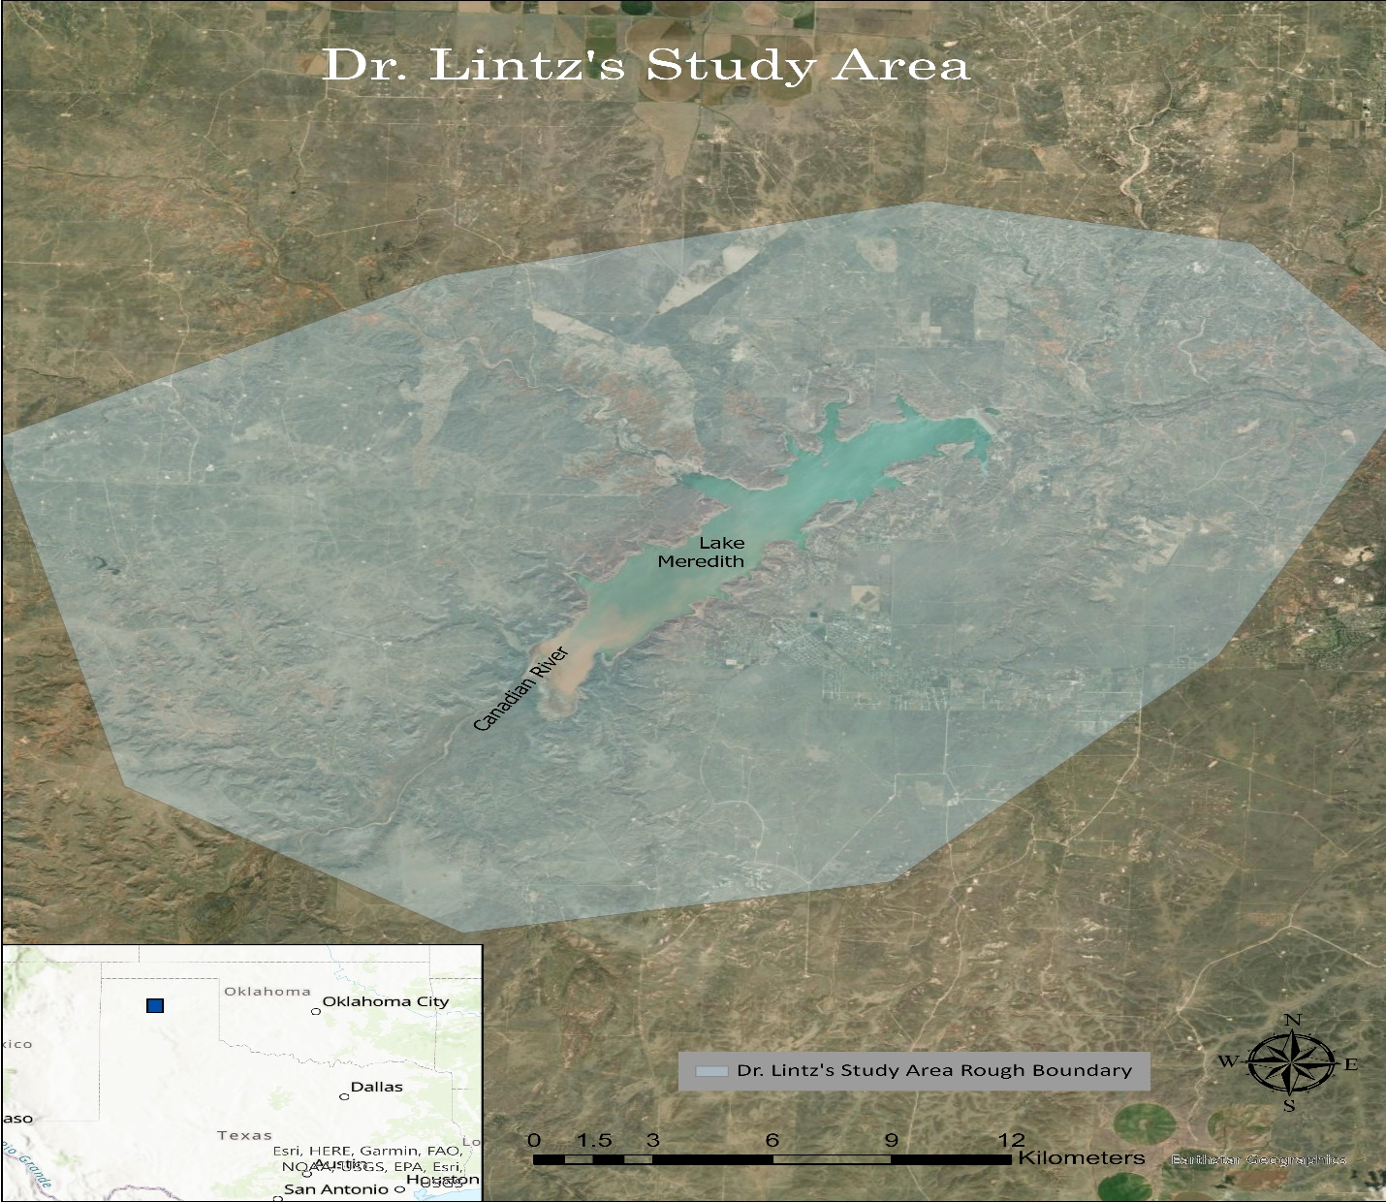
Figure 11: A general illustration of the study area in Lintz (1986).
When examining each site types’ distance from the river, Lintz established three proportional categories based on the distances from all of the sites within his project area. He found that 80% of subhomesteads were located near a river, with the remaining 20% considered to have been located slightly farther away in the midrange category. Conversely, the homesteads, while slightly more evenly distributed, occupied contrasting distance categories, with 60% located near a river, and the other 40% situated in far designation. Furthermore, Lintz also conducted a chi-square test of independence, which is a mathematical test to determine whether there is a statistical association between two variable groups. He found that his variable groups of site types and proximity (near, midrange or far) to water exhibited a lower degree of freedom (independence) among them than the documented frequencies between the groups. In other words, he found that the statistically, these two variable categories were indeed dependent upon each other (Lintz 1986:331).
Unfortunately, due to the inaccessibility of local small scale (under an acre) soil maps, in order to calculate his rangeland productivities, he was forced to take into account the entirety of the project area, spanning the Texas counties of Carson, Hutchison, Moore, and Potter (Lintz 1986:337). Although the specific rangeland productivity values differ between this thesis and his dissertation, the general trends based on relational data among the site types are still viable and will be used as the basis of my comparisons. For example, the relationship Lintz found concerning an increased amount of soil diversity present within a 1 km homestead catchment, in comparison to their decrease within subhomestead catchment areas can still be tested against the Antelope Creek sites within the Cross Bar Ranch. In this way, other general trends that Lintz found among the site types, such as soil productivity, elevation, and distances to water can still be examined within the Cross Bar Ranch.
In summation, Lintz put forth the following hypotheses concerning the Antelope Creek Phase settlement strategies which will be examined in this thesis:
- Antelope Creek Phase sites can be delineated according to their architectural, environmental, and social attributes, referred to here as site types (subhomesteads, homesteads, and hamlets).
- Antelope Creek site types reflect aspects of the site functions present at each settlement.
  - Subhomesteads served as seasonal focused agricultural field camps, whose produce were given or at least shared with the homesteads.
  - Homesteads comprised the primary occupational nucleus, as evidenced by residential structures and more resource diverse catchment areas, both of which resulted in greater amounts of artifactual remains indicative of processing activities.
- Sites were positioned by their residents at specific and meaningful locations within the Canadian River Break topographic setting as a means of optimally exploiting the surrounding resources. Resource needs were based on a site’s function.
- These environmental attributes included: specific topographic locale, elevation, access to water, soil type (in terms of soil productivity, primary soil association, and overall soil diversity), and available fauna.
  - Topographic Locale: Subhomesteads were more likely to be found in bottomland sections such as the Inner Valley base and floodplains, while the homesteads were more likely to be positioned along the Inner Valley base terraces and rims.
  - Elevation: Homesteads were also documented at higher mean elevations (above the Canadian River) than the subhomesteads.
  - Water: Subhomestead were found to reside closer to sources of potable water than the homesteads.
  - Soil Type: Whereas homestead catchment zones contained a greater degree of soil diversity, the subhomesteads were located in settings more beneficial to agricultural activities.
  - Biodiversity: Similarly, the flora and fauna diversity were also skewed in favor of the homesteads, as reflected by the increased amount of soil diversity, which was considered further evidence for the agricultural focus attributed to the subhomesteads.
In order to assess the assertions stated above, site-specific environmental attributes, such as soil type/diversity, general elevation, distance/access to water, and specific topographic setting were collected and formulated into comparable datasets. These site-specific environmental attributes were compiled using more contemporary geographic information systems (GIS) than were widely utilized when Lintz first made these assertions. The ensuing datasets, which were also organized according to various facets of landscape archaeology, were then used to assess Lintz’s assertions within the locale of the Cross Bar Ranch.

Chapter 4: Theoretical Orientation
In order to further examine the anthropological interpretations derived from Lintz’s assessment of Antelope Creek environmental patterning, theoretical models developed within the subfields of landscape and settlement archaeology need to be considered. Here, GIS geoprocessing tools and other spatial/environmental representations (degree of slope, proximity associations, digital elevation models, lidar, and triangular irregular network images) were employed as a means of positioning the site type locations within greater environmental contexts. from this increased amount of environmental context, other functional and social settlement features can be examined and interpreted. For instance, the differential ecological positioning between the more temporary agriculturally oriented subhomesteads and the residential hunting and gathering homestead basecamps provides additional insights into the methods through which Antelope Creek peoples subsisted (through the exploitation of their local environment).

Hand in Hand: Archaeology and GIS
While GIS techniques have been used in archaeological investigations for some time, their employment at a landscape scale began to increase throughout the latter half of the 20th Century. Specifically, these analyses began to more closely examine the relationship between archaeological site locations and surrounding environmental variables as quantitative sets of data which could be more easily measured, tabulated, and empirically compared (Conolly & Lake 2006:7). This more quantitative interpretation of the environment was particularly attractive to the researchers of the Processual, or New Archaeology movement of the 1960s (Dell’Unto & Landeschi 2022:52). Fostered by the increased interest in digital analyses of site environments, a distinct subsection of archaeological endeavors, referred to as landscape archaeology, started to become more prevalent. In short, landscape archaeology attempts to understand the physical context in which past peoples meaningfully interacted with their environment (David & Thomas 2008:38).
Currently, landscape archaeologists differentiate between two conceptual perceptions of what constitutes a landscape. The first, landscapes as a “space,” places an emphasis on the physical environment as a systematic backdrop used to contextualize and interpret the activities of its human residents. Although downplaying the human aspect of the landscape, this framework objectively quantifies the environmental elements present, which can be useful when local human residential data is limited or inadequate. Alternatively, landscapes have also been conceptualized as a “place,” which brings the human residents to the forefront in the construction of their unique local environment. This more subjective interpretation of the landscape considers these locales as imbued with the residents’ beliefs, thus weaving their cultural traits into the very fabric of their physical landscape (Lock & Pouncett 2017:130). For example, in order to frame Cherokee landscapes as a “place,” Townsend et al (2020) examined these landscapes as integrated communities encompassing not only human ecological interactions, but also as cultural elements ascribed to features within those landscapes (Townsend et al 2020:970). Instead of a unit isolated from the environment, these Cherokee settlements are considered an integral part in the continued existence of the landscape, influencing the cultural beliefs that in turn affected human/environment interactions (Townsend et al 2020:972). Thus, many modern landscape archaeologists strive to find a balance between landscapes as a “space,” but also as a “place,” underscoring a collaboration with both Indigenous knowledge and GIS modeling (Warner-Smith 2020:769).
While not exclusively conducted through GIS, many of those endeavors can be accomplished through the employment of a wide range of models and analyses, such as cost-distance models, catchment analyses, and spatial statistics. For example, catchment analyses are used to create an inventory of the resources available within specific sections of the environment, usually in relation to archaeological site locations, as a means of assessing interactions reflective of past peoples’ behaviors and lifestyles (Ullah 2010:624). Similarly, another avenue of landscape investigations, known as settlement archaeology, attempts to understand the distribution of specific communities across their landscape. Common methods used to investigate those settlement distributions are undertaken by utilizing cost-distance models, as well as interpretations of spatial statistics such as point patterning distributions (Kvamme 2020:212-214).
Essentially, cost-based models attempt to describe the movement of past peoples through their environments by illustrating the difference in difficulty incurred (cost) while navigating these environments (Herzog 2020:333). Instead of modeling local movement, point pattern distributions are used to organize and interpret both the environmental characteristics, as well as relational social patterning assumed to have influenced the settlement decisions of specific populations. These environmental characteristics commonly encompass categories such as distance to water, as well as the degree of slope present, but can also include factors geared towards typifying the roughness of the landscape, sometimes referred to as local relief (Kvamme 1992:25-27). With the help of GIS functions, those environmental characteristics are attached to certain points (sites), resulting in a visual representation of the trends, tendencies, and similarities of the points (sites) within the area of interest (Kvamme 2020:227-228).

Theoretical Underpinnings
A theory is a logically consistent set of assertions that help to answer a non-trivial question rooted in scientific inquiry (Hempel 1965:245-295). Instead of the creation of a theory, this thesis attempts to verify a facet of Lintz’s model concerning the ways the environment may have influenced Antelope Creek groups’ decisions regarding settlement locations. To reiterate, Lintz’s model implied that specific site types (subhomesteads, homesteads, and hamlets) were intricately linked to the sites’ function, which in turn was referenced by their placement in the local landscape. Given these considerations, a new approach drawing interpretative inspiration from landscape and settlement frameworks can be used to reexamine some of the assumptions underlying Lintz’s model.
Landscape Archaeology can be understood as one of the most advantageous means of utilizing limited surface archaeological data gathered exclusively through pedestrian surveys (Lock et al 1999:55). This is due in part to recentering the landscape as an active manifestation of the interaction between humans and their local environment (Crumley & Marquart 1990:73). However, this approach can also integrate other facets of archaeological inquiry, such as ethnographic accounts and faunal behaviors. For instance, Oetelaar (2014) combined ethnographic (including mythology), archaeological, and bison behavioral data (grazing patterns, preferences, and seasonal diets) in order to both understand communal hunting practices, as well as how the spiritual beliefs of the local Blackfoot population influenced their interpretation of (and subsequent interactions with) their landscape (Oetelaar 2014:13,27).
Thus, spatially-defined features of human occupation such as structures, when placed within the local environment, can be used to understand past peoples’ ecological preferences and subsistence strategies. In this way, the local environment transcends the passive nature of a simple ecological setting and becomes a complex interface between humans and their environment (Anschuetz et al 2001:157,161). Within this interpretive framework, certain ecological zones can be seen as more advantageous if people consistently choose them for their camps and settlements (Crumley & Marquart 1990:77-78). Furthermore, with the help of more modern (in relation to Lintz’s 1986 dissertation) terrain visualization tools (lidar, digital elevation models, hillshade illustrations etc..) investigations into the dynamic use of localized environments has led to greater insights into their utilization by precontact populations. This type of landscape focused approach can be seen in the work of Currás & Sánchez-Palencia (2021), who were able to underscore the social complexity of gold mining operations in the Roman province of Lusitania. By examining the locations of water reservoirs, patterns of mining base camps could be identified, which when supplemented with other archaeological investigations produced further insights into duration, social features, and specific purposed of those camps (Currás & Sánchez-Palencia 2021).
In particular, GIS can help to meaningfully contextualize documented archaeological resources within the physical landscape in which they are located (Witcher 1999:15). The physical landscape is often illustrated through various types of surface analyses, which are visual representations of specific elements of the environment (e.g. elevation, slope, local relief, hillshade…) (Price 2020:345). Once the locale is adequately understood, other GIS-based models can be employed to further interpret human and ecological facets of landscapes in question. For example, through the Locally Adaptive Model of Archaeological Potential (LAMAP), a site catchment area populated by environmental elements is utilized as a means of comparing and categorizing observed mutual characteristics among the sites (Verhagen & Whitley 2020:236). Besides shared environmental attributes, site associations, based on proximity, can also be illustrated through an analysis known as Ripley’s K function. This analysis compares an estimated site frequency within a bounded area, with the actual distribution of known sites within that same area. If the estimated site distances are farther apart from each other than the documented sites, then it can be reasonably concluded that the observed sites can be considered “clustered” (or at least closer together than a calculated average for that area) (Wright et al 2014:11).
The use of cost-function analyses are also another way to model movement in a more economical way rather than relying on distance or effort alone. These more economically oriented approaches use an assumption of rational environmental perceptions, when taken with other documented archaeological and environmental elements are used to establish ecological preferences. In other words, the landscape in question is classified into quantifiable elements, from which a meaningful criteria can then be used to identify apparent preferences (Lock et al 1999:15-17). From those preferences, a general set of organizing probabilistic rules can also be used to construct broad settlement patterns, which can in turn be illustrated through spatial analyses (Anschuetz et al 2001:170). Furthermore, as Richards-Rissetto (2017) warns, the use of GIS analyses should be guided by underlying theory, otherwise the researcher risks falling into the overly quantitative and culturally deficient realm of environmental determinism (Richards-Rissetto 2017:11). For example, in her examination of the possible interactions between various socioeconomic classes in the Maya city of Copan between the fifth and ninth centuries (C.E.), Richards-Rissetto used least-cost analysis (LCA) to measure the potential for public mobility and in turn accessibility, rather than the more static least-cost pathways. In essence, her GIS analysis accounted for human agency, instead of being guided purely by the quantitative least-cost pathways (Richards-Rissetto 2017:13-14).
The use of cost-based modeling to assess whether settlement patterning was influenced by specific environmental variables is nothing new in archaeological investigations. For instance, when examining the placement of Late Iron Age hillforts, Llobera et al (2011) was able to illustrate that the accessibility of the locations was an important factor in their placement. This was achieved through identifying the environmental costs for movement throughout the study area, resulting in a focal mobility network with the hillforts positioned as the focal points. Additionally, this model produced a method for comparing different cost-paths among the hillforts and their local resources (Llobera et al 2011:847-849). Another investigation into medieval settlement patterns, also predicated on cost modelling, found that medieval settlements tended to be clustered around settings with greater access to desirable resources, which in this case was more fertile soils (Negre et al 2017:783-785). While this examination is not as intensive as those mentioned above, cost-based modelling was used to supplement the testing of site type location preferences.
Another overlapping facet of landscape archaeology, referred to as settlement archaeology also aims to examine the relationship between settlement patterns and various social and technological characteristics of past cultures. In particular, this approach focuses around two cultural characteristics; the way in which people used their available technology to adapt to their ecological setting(s), and the inferences that can be made concerning the social structure that composed community patterns (Trigger 1968 53-55). Once both the human and environmental features are sufficiently understood, clustered patterns consisting of settlements and observed preferential environmental elements such as soil productivity and proximity to potable water can begin to be recognized (Hodder & Orton 1976:85). In order to understand these settlement clusters, researchers frequently employ GIS generated point-pattern approaches. Once a settlement distribution is recognized, point-pattern methodologies then categorize the characteristics associated with each of the points within the pattern as a means of further organizing those points into meaningful distributions. The characteristics specific to each point are delineated into two primary classes, known as first-order and second-order point attributes. First-order characteristics group points (settlements) are believed to be influenced more by natural attributes of the landscape, such as access to water, favorable soils, and beneficial flora/fauna diversity. Alternatively, second-order characteristics are more influenced by other points (settlements), which would be the case in situations of central core settlements and satellite communities (Kvamme 2020:213).
Although this examination is primarily focused on the first-order attributes (access to water, rangeland productivity, degree of slope, elevation, flora/fauna diversity) exhibited throughout the Cross Bar Ranch, other second-order characteristics (proximity and interactions between site types) were also considered as explanations for the clustered settlement patterning observed. Here the distinction between first and second order attributes serves as an important check against slipping into environmental determinism. However, it should be noted that while the environmental features within this study constitute a large portion of the data, it is the human facet of meaningful settlement patterning (influenced by the environment) that remains at the heart of this examination. Further illustrating this human element, the clustering of these Antelope Creek settlements can also provide valuable insights into their social conceptions and arrangements.
These settlement clusters can also be used to define aspects of the occupants’ social structure. For instance, the Steed-Kisker peoples of the Central Great Plains, structured their settlements in small semi-isolated farmsteads (separated by 2-5 km), which suggests that their primary social structuring occurred at the nuclear family level (O’Brian 1995:77-79). However, while still confined to nuclear households, Steed-Kisker groups have also been documented utilizing temporary encampments, which were attributed to the exploitation of seasonally specific resources. One implication regarding these more temporary structures, an added degree of population mobility, has been cited as evidence linking Steed-Kisker groups with earlier populations situated along the Lower Missouri River (Logan & Hill 2000:253-254). The implied connection with previous populations within the same locale highlights the importance of properly interpreting the relationship among peoples, their local environment, and the characteristics of their settlements. Thus interpreting subsistence strategies and architecture, in relation to social structures, plays a significant role in understanding the utilization of and adaptations to an environment by its occupants, further underlying the possible reasons for specific settlement patterning (Anschuetz et al 2001:171).
Trigger (1968) divides settlement studies into three levels; 1) the examination of individual structures, 2) the arrangement of those structures within their local community, and 3) the distribution of those settlements throughout the regional landscape (Trigger 1968:53-55). Paralleling Trigger (1968), Lintz constituted his site types at all three levels of examination. First, the most basic delineation of subhomesteads, homesteads, and hamlets concerns the type of structures present at each site. Second, these site types, are further segregated depending on the number/arrangement of associated structures present within the assumed community (Lintz 1986:244-245). Third, the distance between homesteads/hamlets and subhomesteads were also conceived as a means of maximizing the resources specific to their local environments (Lintz 1986:331-332). These types of complementary subsistence site functions have also been used as a means of examining seasonal occupations within settlement patterning (Lintz 1986:260; Trigger 1968:61). However, while Lintz’s model of Antelope Creek settlement patterns encompasses all three levels of settlement archaeology in his composition of site types, here, as a result of limited archaeological data, only the physical properties and spatial arrangements of Antelope Creek settlements will be considered.
There have been critiques of landscape archaeology however, regarding objectively separating physical elements of the land from those who inhabited that same land. These concerns have been slightly mitigated through the increased inclusion of ethnographic information, gathered from Indigenous descendants (David & Thomas 2008:35). Furthermore, by not addressing the cultural components that influenced landscape use, these investigations can relegate the local inhabitants to a more static systems-approach paradigm, in which they are understood simply as a logical expression of basic survival (Anschuetz et al 2001:174). Another issue that can be found within landscape studies involves an assumption of environmental consistency over time for those bounded areas. While the physical landscape might appear consistent, the ecological boundaries and domains of the biotic communities could have shifted in almost imperceivable, yet influential ways over time (Kvamme 2020:217). Although there are numerous pitfalls in the use of landscape approaches, humans and their environment are intricately linked. Thus a greater understanding of that relationship is integral in the facilitation of additional cultural and ecological insights (Crumley & Marquart 1990:79).
For this examination, digital representations of certain topographic settings present within the Cross Bar Ranch, in conjunction with previous anthropological data was used to interpret functional aspects of the relationship between past peoples and their environment. For example, by modelling logical movement throughout the area (utilizing cost-based representations), insights into plausible interactions between settlements, as well as the differential access to water sources was illustrated. Further insights regarding the peoples and their environmental preferences was also interpreted from a bounded inventory of available ecological elements, otherwise known as a catchment analysis. This proved useful for categorizing environmental features, which became important when attempting to differentiate the ecological preferences of separate settlements. While the range of catchment zones differ from one study to the next, the one-kilometer catchments utilized by Lintz, and paralleled in this study provided an excellent backdrop in which to examine Antelope Creek groups’ environmental preferences in the Cross Bar Ranch. In this way, factors such as soil productivity, access to water, and the biotic resources available were used to infer general characteristics of both the specific settlement, as well as its residents. Also deriving from these catchment zones was a point patterning approach, which provided a useful means of further organizing specific site type attributes. For instance, the locations of the different site types were examined both in relation to each other, but also in relation to the ecological elements discussed previously.
In summation, Lintz’s model of Antelope Creek settlement patterning was put to the test within the context of the Cross Bar Ranch. This was accomplished through a combination of GIS based interpretations, landscape archaeological theory, and previous local documentation. Specifically, this study took the ecological elements featured at different site types and collated them into interpretations of the environmental factors that were possibly influential in settlement placement of Antelope Creek peoples.

Chapter 5: Methodological Approaches
The central questions guiding this thesis are; can Lintz’s model concerning Antelope Creek settlement patterning be successfully applied to areas outside of his original study area? Can more contemporary tools, such as ArcGIS Pro, be used to analyze the environmental elements Lintz identified as influential in Antelope Creek groups’ settlement decisions? And how might environmental features such as distance to water, topographic setting, soil productivity, and elevation above the nearest source of water factor into the settlement decision making of Antelope Creek peoples within the Cross Bar Ranch? Specifically, this work will examine the physical placement and distribution of temporary camps, subhomesteads, and homesteads (here collectively referred to as site types) as reflective of assumed site characteristics in the area of the Cross Bar Ranch.
Guided by an overarching question concerning the influences of environmental variables on the settlement placement of Antelope Creek groups, this undertaking attempts to answer that line of inquiry by segmenting the question along the lines of the relationships between the site types and their associated ecological elements. For instance, was there a significant difference in the resources present in the catchment zones between homesteads and subhomesteads? If so, then how can those differences be explained? To answer the first question, features of the Cross Bar Ranch landscape were illustrated through various GIS representations of the local elevations, slope, general terrain, and the distance to the nearest source of water. Other ecological elements, such as soil types, and topographic landforms were also tabulated in association with individual sites. After the variables were collected, the differences in catchment zones features between the site types were interpreted in several ways, with the primary explanation referencing a difference in assumed subsistence strategies. Besides interpretations of subsistence practices, other general site type characteristics, such as plausible occupational durations and residential activities were also examined.
Collectively, the patterning of specific resources and site type locations here are utilized as a means of deriving classified settlement characteristics, and by extension specific settlement distribution patterns. Although Lintz (1986) also discussed settlements classified as hamlets, no examples of hamlets have been formally documented within the Cross Bar Ranch. However, temporary camps were not considered as a comparative unit within Lintz’s examination, and thus here will only be examined in a very limited capacity, as they do not offer enough information to be categorized as a specific, independent site type, but do however represent possible Antelope Creek occupations. Lastly, since the boundaries of these sites are only roughly understood, I decided to utilize GIS feature points for representing the site locations. To ensure consistency, I retained the coordinate system (NAD 1983 with a North American 1983 datum) used by the Texas Archaeological Research Lab (TARL) to record all of the sites (with sub-meter accuracy) within this study.
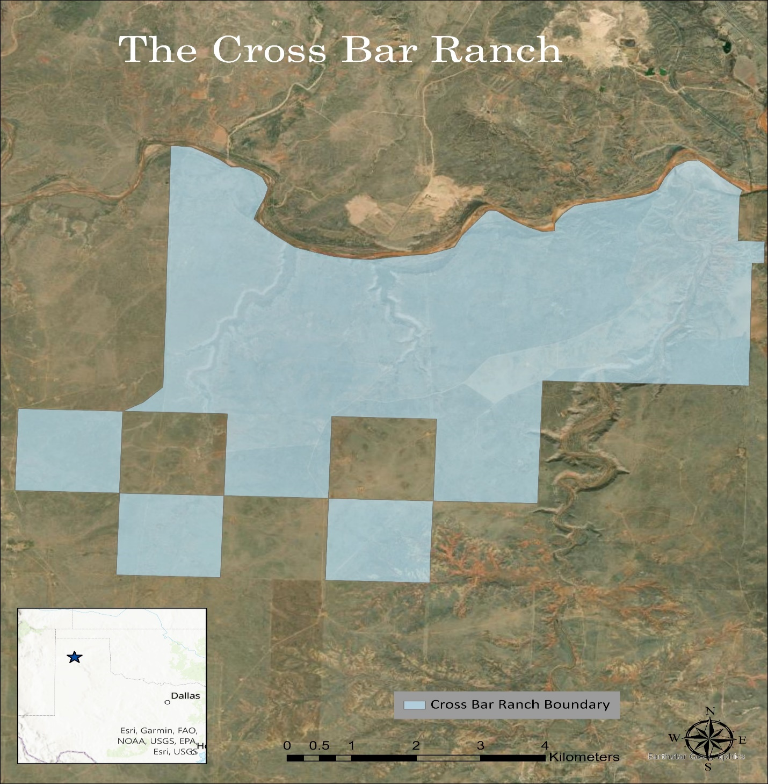
Figure 12: An illustration of the boundaries for the Cross Bar Ranch.

Study Area: The Cross Bar Ranch
As mentioned previously, the project area for this thesis, the Cross Bar Ranch, is a Bureau of Land Management (BLM) owned property, located just a few miles northwest of the city of Amarillo in Potter County, Texas. Over the decades, the Cross Bar Ranch property has changed legal ownership on multiple occasions. From 1928 until 1996, the property was under the control of the U.S. Department of Mines, however, when the department was dissolved in 1996 the land was leased to multiple private citizens, as well as other smaller government organizations (Lintz 2002:5). While many of the privately held leases have been terminated, the land still shows evidence of their activities, consisting mostly of cattle ranching (e.g. barbed-wire fencing, stock tanks, push-dams, and eroded cattle trails) (Lintz 2002:21). To date, much of the archaeological work that has been conducted at the Cross Bar Ranch has consisted of cultural resource management (CRM) projects, although six field schools sponsored by Texas State University were also conducted from 2004 through 2017 (Mudd 2016:98-99; Bousman 2017:2; For a comprehensive list of previous work in the Cross Bar Ranch see Table 5 in Appendix A).

Sites Selected for Analysis
For this thesis, sites were selected within the boundaries of the Cross Bar Ranch, specifically those sites that have either been documented with an Antelope Creek Phase component, or those that have a high likelihood of being related to the Antelope Creek Phase. Certain sites were excluded due a lack of conclusive documentation, and/or ambiguity surrounding their cultural designation. For example, while 41PT254, a circular feature comprised of fifty stones five meters in diameter, with a vertically placed slab in the center was included, site 41PT252, a similar stone ring feature, was excluded due to its small diameter and lack of any vertically placed slabs.
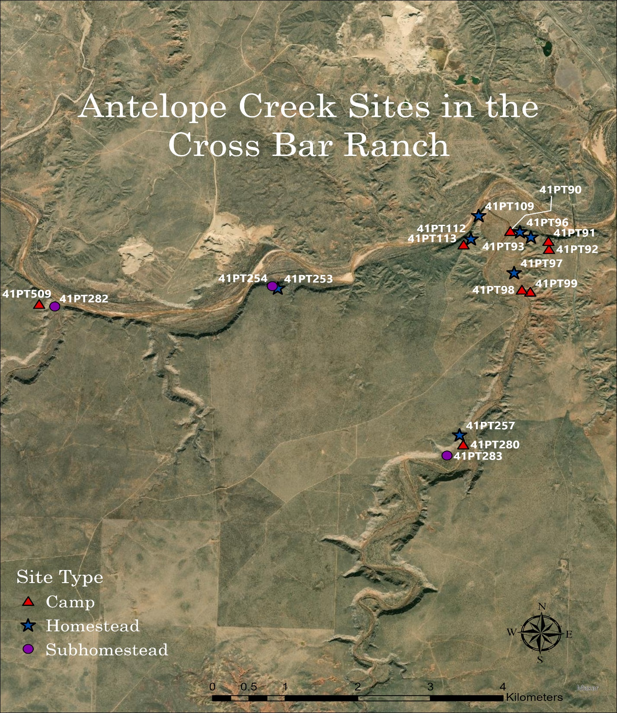
Figure 13: A map depicting the Antelope Creek sites that can be found in the Cross Bar Ranch.

41PT90 (Temporary Camp)
Site 41PT90 is composed of a single dolomite boulder five meters in diameter, with multiple grinding basins. The dimensions of these depressions measured approximately ten centimeters in diameter and three to four centimeters deep (Etchieson 1983:16). Positioned only three meters away from the creek, the site is located on the base of the eastern canyon bordering the mouth of the West Amarillo Creek. However, even while occupying a lower elevation and topography, the vegetation present remains similar to the surrounding landscape containing mesquite grasses, prickly pear, and hackberry bushes (Texas Archaeological Site Atlas).
Despite the lack of related artifacts and structural features, the immovable nature of the dolomite boulder, as well as its close proximity to an identified Antelope Creek site (41PT96), this site is believed to relate to an Antelope Creek occupation. 41PT96 is situated a short distance to the east and atop the crest of the same eastern canyon of the West Amarillo Creek (Etchieson 1983:16).

41PT91 (Temporary Camp)
Unfortunately, due to a high degree of disturbance and scarce observable archaeological materials, little to nothing is known about site 41PT91. The site is positioned along a catclaw covered ridgeline overlooking the southern bank of the Canadian River. Even with the high degree of disturbance, one feature was identified. It is a one-meter diameter cluster of stones (including tabular dolomite slabstones) arranged in a roughly circular pattern, were able to be discerned and documented (Texas Archaeological Site Atlas). Researchers noted that a large pothole, indicative of looting activity, was also found in the center of the circular stone feature. Previous researchers interpreted this circular stone feature as a possible stone cairn, although, without more evidence such an assertion should be considered possible instead of probable (Etchieson 1983:17). Finally, while the dolomite tabular slabstones suggest an Antelope Creek designation, there is simply not enough documented evidence at the site to make an official cultural/chronological determination.

41PT92 (Temporary Camp)
Located less than 150 meters south of 41PT91, this site is nestled in a mesquite flat within the canyon rim of the Canadian River. Although the majority of relevant archaeological materials are believed to remain buried, twenty-centimeter-deep cuts resulting from a field road exposed a lithic scatter approximately 100 meters in diameter. A few isolated dolomite slabstones were observed on the surface south of the field road, however, no discernable pattern was noted (Etchieson 1983:18). While the lithic debitage contained primary, secondary, and tertiary flakes, no worked flakes or specific tools were observed. Additionally, three small clusters of burned quartzite cobbles were found at a southwestern section of the site (Texas Archaeological Site Atlas). Even though the presence of dolomite slabstones would suggest an Antelope Creek designation, their isolated and haphazard positioning relegates the site’s interpretation to that of an open camp of undetermined chronological origins.

41PT93 (Homestead)
Located southeast of 41PT96 and to the west of 41PT91, this site is situated on a relatively level spur running north to south along the canyon rim of the Canadian River. Similar to other sites in the area, the site environment of 41PT93 boasts mesquite trees and catclaw grasses (Texas Archaeological Site Atlas). Also akin to other surrounding sites, 41PT93 has also been crosscut by a field road running east to west, and exhibits evidence of looter activity. Even though only a single Alibates flake was observed on the surface, several structural features were also observed. In particular, one set of dolomite slabstones thought to represent an Antelope Creek residential structure were found surrounding a looter’s pothole. Two other possible dolomite slabstone structures (each containing between two to four dolomite slabstones), as well as one cluster of burned stones were also observed within the 46x76 meter boundary of the site (Etchieson 1983:20).

41PT96 (Homestead)
Sitting atop a prominent bluff on the rim of the eastern canyon of the West Amarillo Creek, site 41PT96 is one of the largest documented Antelope Creek settlements in the Cross Bar Ranch. Composed of four possible structures, two pronounced clusters of burned stone, and a modest scatter of surface artifacts, the site covers an approximant area of 150x50 meters (Etchieson 1983:23). Similar to surrounding sites, the vegetation is dominated by mesquite and yucca grasses interspersed with prickly pear and Russian thistle shrubbery (Texas Archaeological Site Atlas).
Of the four possible structures, two closely resemble rectangular dolomite slabhouses common to Antelope Creek occupations, while the remaining two exhibit more circular dimensions. However, dolomite slabstones were also documented in association with one of the concentrations of burnt stone (Texas Archaeological Site Atlas). Unfortunately, the most intact rectangular structure also shows signs of extensive looter activity (Etchieson 1983:23).
Furthermore, in 2008, 2015, and 2016 the site was subjected to various mapping techniques such as ground penetrating radar (GPR) and magnetometer conducted by members of the Texas State University. Furthermore, in 2016 and 2017 a series of fifteen 1x1 meter units were excavated at the site as part of the field schools from the same university. Over the course of these excavations, 1,672 samples of charcoal, 3,195 faunal remains, 1,024 pieces of chipped stone, 35 pottery sherds (all of which were classified as Borger cordmarked), and other smaller amounts of shell, daub, fire cracked rock, fossils, and stone cobbles were recovered (Bousman 2017:3,17). Finally, a more recent radiocarbon analysis of the elements of the site produced a dates ranging from AD 1280 to 1406 (Bousman et al 2022:5-6).

41PT97 (Homestead)
41PT97 is farther south along West Amarillo Creek from sites 41PT90, 41PT93, 41PT96, and 41PT109. It consists of a 40x30 meter area interspersed with artifacts and features. While the vegetation covering the site remains fairly consistent with previously discussed areas (mesquite trees and cholla grasses), this site also contains “bear” and buffalo grasses (Texas Archaeological Site Atlas). The majority of the site is capped by a layer of gravel near the surface. Similarly to other Antelope Creek sites in the region, the site yielded a variety of lithic tools, including six end-scrapers, one chopper, one unspecified lithic preform, three manos/hammerstones, two grinding slab fragments, one core, one fragment of a beveled knife, one worked flake, and one graver (Etchieson 1983:25). However, unlike other sites within the Antelope Creek designation, no pottery was observed by the surveyors. Also documented was one large unmovable “deep-basin” metate, as well as three areas suspiciously devoid of surface gravel, believed to be indicative of potential buried structures (Etchieson 1983:25). Unfortunately, no dolomite slabstones were visible on the ground surface, although a corner of the large metate is located immediately adjacent to one of the suspicious areas. Due to the possibility of multiple structures and the variety of tools observed, the site is believed to be the remnants of either a village, or at least an area of increased physical activity, such as a quarry or a workshop (Texas Archaeological Site Atlas).

41PT98 (Temporary Camp)
Positioned a short distance to the south of 41PT97, but still along the eastern terrace of the West Amarillo Creek, 41PT98 comprises a 50x30 meter lithic scatter (Texas Archaeological Site Atlas). Much like at 41PT97, archaeologists suggested there was circumstantial evidence of possible buried structures, near where they recorded lithic tools. Although, unlike 41PT97, this site also contained three distinct areas of concentrated FCR situated around the outskirts of the lithic scatter, believed to be hearth features (Etchieson 1983:26-27). Also observed along the surface were several small (50x50x5 cm) dolomite slabstones, one unspecified biface, three hammerstones, one arrowpoint preform, a snub-nosed scraper, two manos, and two obsidian flakes (Texas Archaeological Site Atlas).

41PT99 (Temporary Camp)
This site lies in close proximity (less than 15 meters) to the site boundaries of 41PT98, and exhibits much of the same topographic and floral setting as sites 41PT97 and 41PT98. Positioned within an elevated ridgeline northeast of the West Amarillo Creek, the site covers an area of approximately 15x20 meters (Texas Archaeological Site Atlas). Although yielding a low density of surface artifacts such as one possible hammerstone, one worked flake, and light scattering of unworked lithic flakes, the site also contains a circular feature three meters in diameter, composed of small dolomite slabstones and three to four large gravel cobbles (Etchieson 1983:28). While it is believed to represent a possible tipi ring or footing for a brush structure, the site is designated as a camp of unknown chronological and cultural origins in the site file records (Texas Archaeological Site Atlas).

41PT109 (Homestead)
This site, located to the north of sites 41PT112 and 41PT113, is also situated on top of a steep bluff at the center of an elevated spur separating the Canadian River from the West Amarillo Creek. The site is composed of an individual slabstone structure surrounded by evidence of domestic activities (Etchieson 1983:41). The distribution of surface artifacts indicates an occupation area of approximately forty by fifteen meters in diameter, with a distribution of around ten to twenty artifacts per square meter. Unfortunately, the site also contains evidence of vandalism within the primary slabstone feature (Texas Archaeological Site Atlas).
While the initial descriptions of the site are from a pedestrian survey led by Etchieson in 1983, the site was revisited in 2004 and 2005 by field schools organized through Texas State University (Meier 2007:21). These excavations included eleven one by one-meter units oriented around the three-room slabhouse feature. This testing uncovered numerous domestic features, such as cooking pits, hearths, and refuse middens, as well as a quantity of individual artifacts (3,258 faunal remains, thirty-four pot sherds, and thirteen chipped stone tools). Besides the distinctive dolomite slabstone architecture, the vast majority of the artifacts recovered also indicate an Antelope Creek occupation (Weinstein 2005:44,63,71-72). This is evidenced from the site assemblage, specifically the presence of side-notching style of projectile points and the cord-marking style of pottery, both of which are considered characteristic of Antelope Creek assemblages (Drass 1998:421; Duncan 2002:57). Finally, datable materials recovered during the excavations placed the occupation of the site between AD 1306-1443 (Bousman et al 2022:5-6).

41PT112 (Homestead)
This site, 41PT112, consists of three possible dolomite slabhouse structures spanning an area of approximately 46x61 meters. The site is situated within a relatively flat area dominated by mesquite vegetation (prickly pear, yucca and cholla grasses) and immediately south of the canyon rim overlooking both the Canadian River and the West Amarillo Creek (Texas Archaeological Site Atlas). Two of the three possible structures appear to have been disturbed either by vandalism or farming activities. In these two cases, the largest structure appeared to have been mechanically excavated and backfilled, while another structure sustained damage during the construction and use of a field road, which bisected the entire site. Although not obviously disturbed, the third possible slabhouse was composed of a tight clustering of dolomite slabs. Not surprisingly, the artifact density documented on the ground surface was fairly low. However, a few artifacts such as an end scraper, a drill, the base of a Fresno arrowpoint, an unidentified biface preform, as well as various small faunal and mussel remains were documented nearby (Etchieson 1983:43-44).
While the initial investigation conducted by the Panhandle Archaeological Society was comprised of only pedestrian survey methods, subsequent researchers have performed more contemporary examinations aimed at understanding the buried cultural deposits. From 2015 to 2017, Stephen F. Austin State University field schools conducted a series of geophysical surveys throughout the region, focusing on possible Antelope Creek sites. Through the use of both Ground Penetrating Radar and Magnetometer methods, it was confirmed that the outlines of slabhouse structures were present at the site, indicative of an Antelope Creek settlement (Bousman 2017:14).

41PT113 (Temporary Camp)
Site 41PT113 is located a short distance southwest of site 41PT112, and occupies the same mesquite flat overlooking the Canadian River and West Amarillo Creek. While these two sites exhibit similar physical dimensions (sixty-one meters in diameter), 41PT113 is characterized by an abundance of artifacts found on the ground surface (Texas Archaeological Site Atlas). Although a handful of worked lithics (a corner-notched arrowpoint and three unidentified biface fragments) were observed, the majority of the artifacts consisted of lithic debitage and burnt stone fragments, with a small amount of burned faunal remains and one smoothed cord-marked ceramic sherd. Another two features were also documented; a compact cluster of burnt lithic cobbles (close to where the burned faunal remains were located) and a possible slabstone cist characterized through a circular arrangement of dolomite stone slabs seventy-five centimeters in diameter. Similarly to 41PT112, both of these features were impacted by the field road that crosscuts the site (Etchieson 1983:45).
While the exact nature of the site is debatable, the circular arrangement of dolomite stone slabs is reminiscent of the slabstone architecture favored by Antelope Creek groups. However, the amount of scattered burned stone cobbles, as well as the presence of a corner-notched projectile point (as opposed to the unnotched and side-notched projectile points typically found within Antelope Creek contexts), suggests the possibility of an occupation predating AD 1200. The corner-notched projectile point, the high degree of burned stone cobbles along with the lack of slabstone structures prompts the designation of a chronologically-ambiguous temporary hunting camp (Etchieson 1983:45).

41PT253 (Homestead)
Also known as the Lee B. site, 41PT253 lies within a rolling scrub prairie near the rim of a canyon overlooking the southern bank of the Canadian River. The site consists of an 80x70 meter area, containing one dolomite slabstone structure indicative of an Antelope Creek Phase occupation (Texas Archaeological Site Atlas). Also documented during a pedestrian examination were over thirty pieces of lithic debitage, one Washita projectile point, several quartzite mano fragments, and fire crack stone. Two shovel test probes were also conducted, one of which was devoid of artifacts, while the other produced four lithic flakes, a quartzite mano, a bone fragment, and a charcoal sample. Furthermore, three concentrations of fire cracked rock were situated close to the canyon rim along the eastern boundary of the site. The rectangular slabstone structure, located to the north of the lithic scatter, and to the west of the fire cracked rock features, consisted of a 6x6 meter foundation of partially buried dolomite stones. However, Lintz noted that a large pothole, most likely a result of looter activity, was dug in the center of the structure, which he blamed for the horizontal placement of the dolomite slabstones. Due to its proximity (eighty-two meters) Lintz also felt that this site could have possibly been associated with 41PT254 (Lintz 2002:70-72). Although these sites share a close proximity to one another, only 41PT253 has been dated (radiocarbon dates ranging from AD 1328-1479), thus dampening assertions of association until more work is done in the area (Bousman et al 2022:5-6).

41PT254 (Subhomestead)
Located within the same canyon rim overlooking the southern bank of the Canadian River and less than 100 meters northwest of 41PT253, this site encompasses an area only five meters in diameter (Texas Archaeological Site Atlas). The primary feature, described as a “stone ring,” is composed of approximately fifty dolomite stones placed horizontally in a circular pattern with one dolomite slabstone placed vertically in the center. While the outer stones have eroded, the dolomite slabstone remains partially buried, which left the surveyors hopeful concerning the presence of buried cultural deposits. One edge-modified flake was found adjacent to this feature. While the exact nature, chronology, and cultural affiliation remain unknown, Lintz (2002) suggests that the feature represented a possible dolomite lined cist, possibly utilized for storage during an unspecified precontact context (Lintz 2002:73-76).

41PT257 (Homestead)
Known as the Yellow Creek Site, this site consists of a cluster of possible Antelope Creek structures situated along the western canyon rim of the West Amarillo Creek. In 2001 during a regional survey, Lintz recorded three possible structures within an approximate 40x50 meter bounded area. Two out of the three Lintz (2002) documented were described as residential, with the third structure functioning as a type of subservient structure (Lintz 2002:80). The western most structure, assumed to be the oldest was Structure 1, which consisted of a 5x5 meter square residential structure with an east facing entryway. The largest and most centrally situated, Structure 2 exhibited a wealth of dolomite stones roughly arranged into a 7.5x7.5-meter rectangle. Within this structure, Lintz also noted the presence of a possible stone cist, although he also noted that the angles of the resting stones were indicative of disturbances by either looters or the occupants of the site. Unlike the two preceding residential structures, Structure 3 was composed of two 2.5x2.5-meter square outlines separated by less than a meter. This eastern most feature was also the most heavily vandalized, as Lintz observed that the entire northern section was completely disturbed (Lintz 2002:79-82).
However, despite the close proximity (less than three meters) of the two residential structures, Lintz concluded that these structures were most likely not contemporaneous. He believed that building materials from Structure 1 were most likely utilized in the construction of Structure 2. He supported this interpretation by evidencing the older (Structure 1) structure’s relatively scarcity of dolomite wall stones (compared to the walls of the other two structures), as well as the absence of a distinguishable north wall (Lintz 2002:79-82). Finally, more recent investigations of 41PT257 revealed that elements of the site contained a broad date range of AD 1293-1409 (Bousman et al 2022:5-6).

41PT280 (Temporary Camp)
Nestled atop a low knoll at the base of the western canyon wall of the West Amarillo Creek, 41PT280 is believed to have functioned as a temporary, yet intensely occupied, open camp. Although no structural features were evident, archaeologists noted an interesting distribution of artifacts across the surface. While the eroded slopes of the 15x20 meter knoll contained the most dense concentrations of surface artifacts, including worked and unworked lithic flakes, a distal scraper, and a mano, fire cracked rock was found exclusively along the narrow crest of the knoll. This site is also situated a short distance from 41PT257, which is located within the rim of the same West Amarillo Creek canyon. Archaeologists also noted that this site was heavily affected by local erosion processes, thus complicating any definitive archaeological designations (Texas Archaeological Site Atlas).

41PT282 (Subhomestead)
Located in the valley at the mouth of Horse Creek, site 41PT282 sits atop a small knoll directly to the south of the Canadian River. Based on the dispersion of associated cultural materials such as lithic debitage, fire-cracked rock, and faunal remains, the site encompasses a 30x50 meter area. However, unlike previously discussed sites, the artifacts were not observed on the surface, but were identified in backfill piles produced by rodents at the site. Due to the low density of observed artifacts, the site draws the majority of its significance from the presence of a 3x4 meter rectangular depression thought to represent an Antelope Creek style subterranean pithouse. While no subsurface testing was attempted, the rectangular depression, in conjunction with the low density of associated artifacts suggests the possibility of a single episode of occupation (Texas Archaeological Site Atlas).

41PT283 (Subhomestead)
Situated along the western bank of the West Amarillo Creek, and at the base of the bordering canyon, 41PT283 covers an area approximately 20x25 meters in diameter. While the site was visited twice, in 2002 and 2006, in association with CRM surveys, it was later excavated as part of the 2007 and 2008 Texas State field schools (Mudd 2016:102-103). Over the course of these investigations, multiple features were documented, however the more distinctive ones consisted of a 20x10-meter residential dolomite slabstone structure, two 2x2.5-meter subordinate slabstone structures, and two midden. The residential structure comprised two rooms with a shared eastern wall, and delineated by a depressed central floor channel. In total nineteen 1x1 units were excavated at the site, which yielded 80 pieces of lithic debitage, 509 lithic flakes, and 705 pieces of faunal remains (Mudd 2016:180, 237). These units also produced twelve diagnostic projectile points (six Washita points, four Fresno points, and two Deadman points), and 165 pottery sherds, the majority of which were identified as Borger cordmarked (Mudd 2016:169, 185).
Furthermore, of the two middens investigated, one was exposed by a nearby field road, and contained clam shells, unidentified faunal remains, fire cracked rock, flint, lithic debitage, and broken scrapers (Mudd 2016:103, 198). The other midden deposit, while also containing shell, stone tool fragments, fire cracked rock, and lithic debitage, included a much higher amount of faunal remains (Mudd 2016:196). Finally, an association between sites 41PT283 and 41PT257 has been suggested, an interpretation primarily drawn from their close proximity (363 meters), but also supplemented by the similarities in their faunal assemblages (Mudd 2016:198, 223). Further supporting this claim, radiocarbon analyses conducted at both sites found that it was possible that these sites were occupied contemporaneously. However, unlike 41PT257, this site also contained radiocarbon findings that support the possibility of an earlier occupation, one separate from the Antelope Creek occupation (Bousman et al 2022:5-6, 10).

41PT509 (Temporary Camp)
This site is situated along a bluff overlooking both the confluence of the Canadian River and Horse Creek, as well as situated uphill from 41PT282. Similarly to other sites in the region, mesquite, and yucca grasses, while sparce, are the dominate local vegetation. Constituted entirely by lithics scattered across a 65x60 meter area, 41PT509 has been interpreted as a temporary camp spanning a single episode of occupation. Furthermore, while the surface of the site contained numerous lithic artifacts, limited subsurface testing (four shovel tests) yielded no artifacts or evidence of features also suggesting a limited occupation. All of the lithics from the site (flakes, unifacial scraper, a mono, an edge-modified flake) can be classified as expedient tools or detritus from tool manufacturing (Texas Archaeological Site Atlas).

Testing the Model
Lintz’s model, similarly situated in the Texas panhandle, provides an established framework from which an examination into Antelope Creek settlement patterns and distributions can be conducted within the Cross Bar Ranch. In order to test Lintz’s assertions concerning site type attributes and the relationships among them, I combined both archaeological and environmental data into a collective site type dataset, which was then used as the basis for a number of comparative geospatial analyses (which were conducted exclusively through the ArcGIS Pro application). To begin, I inventoried the available archaeological data within the Cross Bar Ranch, stored within the Texas Archaeological Research Laboratory (TARL) site atlas database. In order to limit the number of sites considered, I set the physical parameters of the sites to be investigated as the boundary of the Cross Bar Ranch, which was achieved by using the Intersect tool to create a site feature class exclusive to the Cross Bar Ranch. From there I categorized the sites into Lintz’s site types based on site locations, artifact assemblages, and architectural attributes, all derived from the TARL site atlas database. Forming the foundation of the initial site type dataset were the architectural attributes documented at each site, separating the homesteads from the subhomesteads. Once the site types were architecturally classified, the site locations and artifact assemblages were utilized to further augment those designations. While the site locations placed the sites within the physical landscape, the artifact assemblages were used to support specific site function interpretations. For example, an abundance of bone digging implements would be indicative of a horticulturally focused settlement, as opposed to an abundance of hunting tools, which instead reflects a predisposition towards hunting activities.
In conjunction with archaeological information, I also gathered relevant environmental data specific to the Cross Bar Ranch. First, in order to incorporate sources of potable water, a shapefile of the local hydrology was obtained through the United States Department of Agriculture digital gateway (https://gdg.sc.egov.usda.gov/GDGOrder.aspx). Unsurprisingly, in semi-arid regions, such as the Llano Estacado, the restricted availability and limited dependability of water sources imbue the hydrological resources present with additional importance in terms of subsistence and survival (Fenneman 1931:87). With the intention of illustrating the soils present in the locale, I downloaded another shapefile containing the soil compositions and designations also derived from the 1980 Potter County soil survey featured throughout the area at a resolution of 1:24000 (Soilweb.com). The specific soilweb polygons were created from the manually recompiled soil film positives on file at the NRCS main office, which were then overlayed atop several 7.5-minute orthophotographs, also on a scale of 1:24000 (Soilweb.com shapefile metadata). These local soil compositions were collected and included due to the insights that could be determined concerning the agricultural potential of the soils for the Cross Bar Ranch.
To remain consistent with Lintz’s specific procedure to calculate soil productivity, I also referenced the same rangeland productivity soil values published by Pringle (1980) in his soil survey of Potter county, Texas (Pringle 1980:80-88). In addition to rangeland productivity, the soilweb shapefile was also used to catalog various soil units, which in turn composed the individual elements used to examine site associated soil diversity. Although only inferential at best, Lintz (1986) considered the differences in soil diversity among the site types as indicative of the range of potential procurable resources, with a high degree of soil diversity representing greater foraging potential than an area exhibiting a low degree of diversity (Lintz 1986:342). Lastly, I also noted the specific soil designation on which each site was directly situated, which here is referred to as the primary soil association.
As a means of illustrating and interpreting various topographic features (e.g. landforms, slope gradients, general elevation) exhibited in the study area, I also acquired a 2019 lidar point cloud data featuring a ten-meter resolution, specific to Potter County and offered through OpenTopography.org. However, to counter the limited nature of rangeland conceptions (rangeland often referring to grazing activities, and thus short grass growth instead of the specific crop productivity of particular soils), I also collected National Commodity Crop Productivity Index (NCCPI) values from SuretyMaps.com. Unlike the rangeland productivity values, the NCCPI values were derived from a number of surrounding environmental features, such as relative landscape and local climate, although it should be noted that these values reflect a more modern timeframe NRCS Online Soil Map Data).

Creating the Site Type Dataset
Although a preliminary site type database was developed using archaeological evidence, the environmental elements discussed in the previous section were also integrated into the database, thus adding environmental variables that could then be compared both among the sites, as well as against Lintz’s model. This was done by isolating certain elements of the landscape, which were then subsequently added to the site type feature class attribute table. With the purpose of understanding the local terrain, the lidar point data cloud mentioned previously was converted into a raster image through the use of the ArcGIS Pro LAS to Raster conversion tool. From there, the resulting raster (mirroring the ten-meter resolution of the LAS data), illustrating the elevation values featured in the area, was again converted through an ArcGIS Pro tool (Raster to DEM), this time from a raster to a digital elevation model (DEM). Utilizing this Cross Bar Ranch DEM, I was able to use the Identify tool to pinpoint each site’s associated elevation value (featured in table 11 of Appendix B). Also derived from the Cross Bar Ranch DEM, I employed the Slope geoprocessing tool, which uses the elevation values of the DEM to illustrate changes in the degree of slope exhibited throughout the area. Once again, through applying the Identify tool in conjunction with the newly created slope map, I was able to distinguish the degree of slope atop which every site was situated (See table 9 in Appendix B for the complete results).
Once the topography of the vicinity was understood, it became possible identify and interpret the assumed costs that could be associated with pedestrian movement within the area. These interpretations, known as cost-distance models, were employed with the intention of evaluating whether certain site types were positioned in areas with easier access to water than others. This access to water dataset was derived from a combination of the surrounding environmental elements of slope, elevation, local relief, and proximity.
Building on the aforementioned DEM and slope representations, a cost-distance surface was created to more accurately grasp the impediments, or lack thereof associated with movement throughout the area. Prior to the development of a cost-distance surface, it was necessary to illustrate the ruggedness of the local terrain, sometimes referred to as a friction surface. This was accomplished by following a formula known as Tobler’s Hiking Function:
(DEM resolution/1000)/(6 * Exp(-3.5 * Abs(Tan((“local slope map” * 3.14159)/180) + .05)))
This formula incorporates Tobler’s mathematical interpretation of the walking speed of an average person in terms of how long (as measured in time) it would take that average person, moving at a constant rate, to traverse a specific landscape. This formula also adjusts for variations in the terrain, such as changes in elevation and the steepness of slopes so as to produce a temporally segmented representation of the locale (White 2015:409). Processed through the Raster Calculator tool, this resulted in the creation of a new raster displaying the tabulated movement penalties that would be encountered in traversing specific sections of the landscape. Drawing from this friction surface, I employed the Cost-Distance geoprocessing tool, which as the name implies, generated a cost-distance representation of the Cross Bar Ranch landscape. However, although the default cost-distance symbolic arrangement displayed movement difficulty in terms of a continuous spectrum from least to most costly, I decided to classify the surface into four categories (0-3) reflecting the level of movement difficulty for specific areas. This was done in order to divide the site settings into more comparable classes, while also distinguishing trends between the site types. Using the same cost framework, a cost-path model was also created to illustrate the most efficient (least costly) route from each site to water, in order to determine if there were any common paths among the sites that could suggest an association.
Further utilizing local lidar data, a 3-D representation of the locale (illustrated through a Local Scene Map via ArcGIS Pro) was instrumental in classifying the local terrain according to the Canadian River Breaks (CRB) topographic scheme, thus linking the sites with their CRB specific setting. However, while the gradual, but persistent southward rise in general elevation throughout the area prevented any kind of uniformed application of the CRB scheme across the Cross Bar Ranch, landforms within site populated subsections were able to conform to the scheme. Supplementing the lidar data, triangular irregular network (TIN) data was also utilized as an additional means of classifying the Canadian Breaks topographic sections. While also gathered from Opentopography.org, these TIN datasets were illustrated through the Google Earth Pro desktop application (For an example of a TIN map see figure 24 in Appendix C). Finally, with the help of the Least Cost Path tool, I gauged each site’s distance to the Canadian River and its associated tributaries, the results of which were used to establish, in a similar fashion to Lintz, three distinct distance categories. The distance categories (near = < 300m., midrange = 301-850m. and far = > 850m.), while not the exact same as Lintz’s distances, these were at least proportional within the Cross Bar Ranch. Here, least cost pathways were utilized in order to compensate for the challenges inherent in traversing the local broken ground topography. Lastly, both the sites’ distance category and their proximity to potable water sources were integrated into the comprehensive site type dataset.

Figure 14: An example of Lidar data used to illustrate the Canadian River Breaks.
Next I followed Lintz’s steps for calculating rangeland productivity, which involved multiplying the percentages of specific soil components by their rangeland productivity values (in units of sorghum productivity per pound within one acre related to that specific soil) listed in Pringle’s (1980) soil survey of Potter county, Texas (Lintz 1986: 336; Pringle 1980:80-88). From there, the resulting soil component values were added together, resulting in the rangeland productivity values for each of the broad soil designations (example: BQG as a broad soil designation is composed of 35% Burson and 30% Quinlan [the rest was unnamed gravel and not included], then the specific rangeland productivity values of those components articulated by Pringle [1980] were located, in which Burson registered a productivity rating of 500 sorghum productivity per pound for that specific soil per acre of land and Quinlan registered a 1,800 sorghum productivity lb./acre; next those specific productivity values were added together, resulting in the rangeland productivity value for the broad soil designation of BQG in terms of pound of soil per acre) (this can also be expressed through the formula; [500*0.35]+[1800*0.3]=715 sorghum productivity lb./acre).
After the rangeland productivity values were established, I then employed the Buffer tool to ascertain one km site catchment zones. This scale was selected in order to parallel Lintz’s examination, in which he cited Chisholm’s (1968) estimation that beyond a one km diameter, resource allocation costs for a community would begin to outweigh the resource yields (Chisholm 1968:102-103; Lintz 1986:338). After that I used the Intersect tool to populate the catchment zones with the soil data (including the newly established rangeland productivity values) from the soilweb shapefile. These one km catchments zones, while not incorporating specific biotic elements, were used as the basis for establishing comparable (to Lintz’s model) rangeland productivity and soil diversity areas for each site (For rangeland site catchment zones see Figure 19). I then calculated the overall and the average values for both the rangeland productivity and the soil diversity for each site (which were subsequently combined according to site type) and added the results to the site type feature class attribute table (For a full list of the relevant Rangeland Productivity and NCCPI values see Table 7 in Appendix A). Similar to the rangeland productivity analysis, I also used the 1 km soilweb site catchments to determine the NCCPI values for each site. By attaching the NCCPI rating for each of the soil designations I created an alternative set of soil values corresponding to perspective crop yields rather than rangeland potential.
Figure 15: An illustration of the slope gradients in the Cross Bar Ranch used to derive subsequent cost representations.
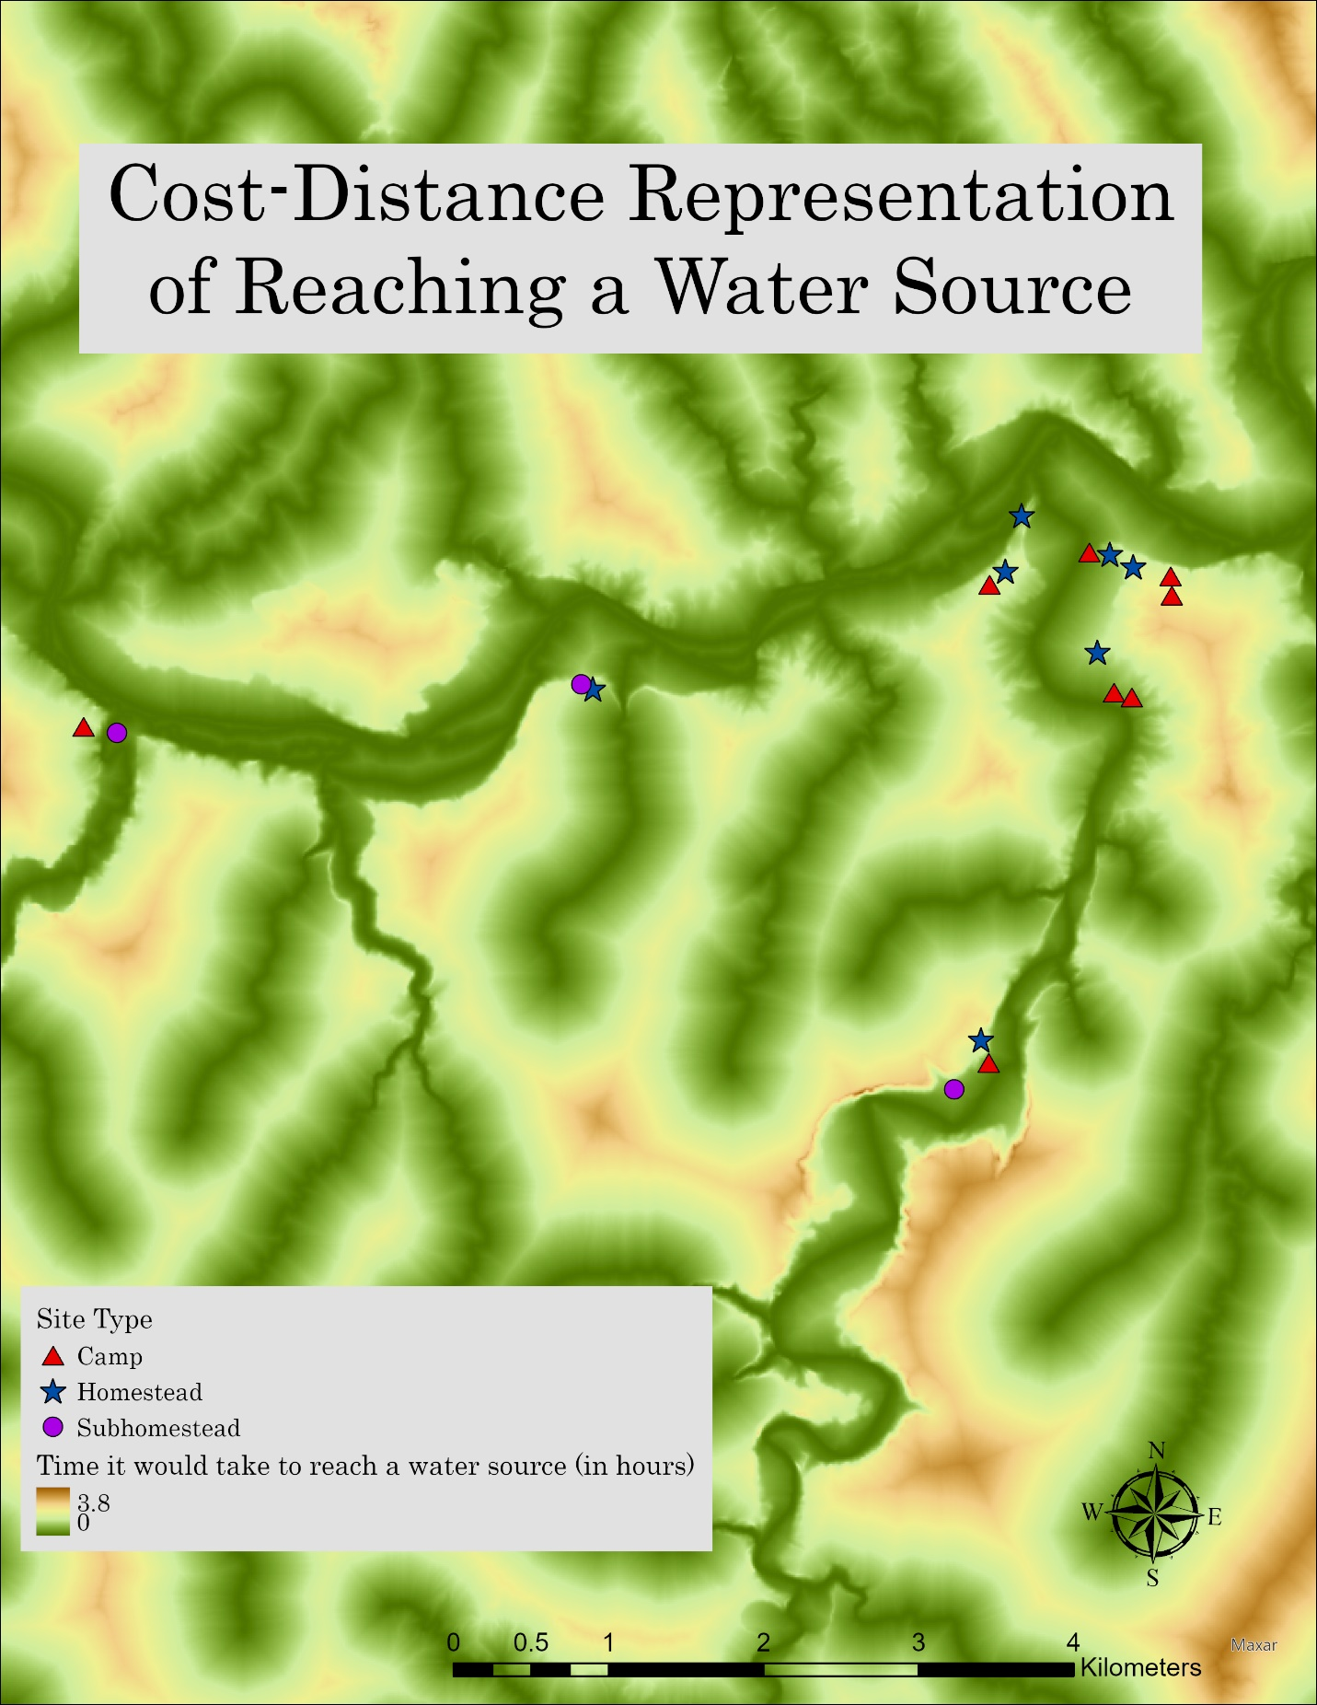
Figure 16: A Cost-Distance Representation illustrating the ease of access to rivers and tributaries in the Cross Bar Ranch.

Chapter 6: Results, Discussion, and Conclusion
Once the Cross Bar Ranch site type dataset was established, a number of ArcGIS Pro analyses involving the influential environmental elements identified by Lintz’s Antelope Creek settlement patterning model was conducted. Those site-associated environmental variables (distance/access to water, topographic setting, soil productivity/diversity, and elevation relative to the nearest water source) exhibited within the Cross Bar Ranch were then compared against Lintz’s model. The results of this comparison indicated that the differences between the site types occurred in a roughly patterned fashion. These patterned results were explained in Lintz’s paradigm as a means through which Antelope Creek groups’ exploitation of their local resources reflected different subsistence strategies featured at specific site types. Utilizing Lintz’s model as an orienting framework, this thesis explored the plausible roles that Lintz’s influential environmental elements played in the settlement decisions of the Antelope Creek peoples within the Cross Bar Ranch, while also assessing the validity of his model for a location outside of his initial project area.
The validation of Lintz’s model outside of his initial study area should be considered a significant step towards a greater understanding of the influential factors related to Antelope Creek settlement distributions within the Texas panhandle. The importance of identifying these organizing elements comes into focus when considering their application within the context of cultural resource management. By identifying these influential landscape elements, greater care can be taken to either avoid or more accurately anticipate the presence of sites that fall within the area of potential effect (APE) for professional earth disturbing projects. While still relatively limited, the data available for use in the construction of the Cross Bar Ranch Antelope Creek site type dataset provided enough context for a comparative examination within the framework of Lintz’s settlement distribution model, the results of which are as follows.

Results
By using Lintz’s model to structure how specific environmental factors influenced Antelope Creek settlement locations , it became necessary to examine several of his assertions and interpretations. One of the more general assertions made by Lintz (1986) suggested that one of the most crucial factors in the placement of Antelope Creek sites within the Canadian River Valley concerned the ease with which people could access water. Through examining a cost-distance surface for the Cross Bar Ranch, I found that almost all the homesteads and subhomesteads were indeed positioned in areas deemed less costly to access in comparison to the more upland settings that were devoid of sites altogether. Lintz’s (1986) claim that temporary camps would primarily be found in upland setting when they were adjacent to homesteads/subhomesteads was also found to be relatively accurate within the Cross Bar Ranch. Although the specific site functions of temporary camps was not explored in this examination, their physical placement in more elevated settings than the homesteads and subhomesteads would appear to support the conclusion that specific site types were indeed situated in differential topographic settings, even if their purpose is not yet specifically understood. The only two exceptions to this assertion consisted of temporary camps that were situated along the least costly routes from the adjacent homesteads to their nearest source of water. This was discovered by utilizing a cost-path model which indicated that least costly route to water for the homesteads of 41PT96 and 41PT257, ran through the documented temporary camps 41PT90 and 41PT280 respectively (See figures 28 and 29 in Appendix C).
According to the lidar and TIN data, one subhomestead (41PT254) is located along the Inner Valley Wall, another (41PT283) was situated at the Inner Valley Base, while the other one (41PT282) was positioned within the floodplains. Similarly, one homestead (41PT109) was located on the Inner Valley Wall, another (41PT97) within the Inner Valley Base, two (41PT93 and 41PT253) were situated atop Inner Valley Wall Benches, while three more (41PT96, 41PT112, and 41PT257) were positioned along the Inner Valley Rim (Table 9 in Appendix B). The placement of the subhomesteads in the more biotically limited lowland settings suggests that those occupants put a greater emphasis on agricultural endeavors. This interpretation is supported by the significantly decreased variety and amount of available flora and fauna within these agriculturally friendly riparian bottomland areas. However, owing to the more temporary occupational duration of subhomesteads (inferred from the absence of storage features and their less robust architecture), it is plausible that those residents left their subhomesteads to participate in long-distance hunting activities, with the accompanying archaeological evidence located elsewhere. On the other hand, the positioning of homesteads in a variety of more biotically diverse settings implies that their residents were more apt to utilize a wide range of subsistence practices, rather than an emphasis on a single one. Furthermore, these findings mirror Lintz’s concerning the placement of subhomesteads in more riparian settings, as well as along Inner Valley Walls (Lintz 1986:348). However, although those homestead positioned within the Inner Valley base terraces and Inner Valley rims, paralleled those found in Lintz’s study area, the Cross Bar Ranch contained three outlier sites; those two located atop Inner Valley Wall Benches, and the one along an Inner Valley Wall.
It was also observed that two sets of homesteads/subhomesteads were located in close proximity to one another. However, while these sets adhered to Lintz’s elevation relationship (homesteads should occupy more elevated settings than their associated subhomesteads), since biotic features were not considered, the procurement of inverse resources postulated by Lintz was not examined beyond the general biotic settings proposed by Duffield (1970:34-36) (Lintz 1986:328). On one hand, one homestead/subhomestead set followed the resource inversion model, while on the other hand another set did not. Specifically, 41PT257 (homestead) was located in what would be considered the more bountiful edge-breaks biotic community, and 41PT283 (subhomestead) in the less diverse moist-aquatic biotic community. Alternatively, 41PT253 (homestead) and 41PT254 (subhomestead) were both situated within close proximity of each other in the edge-breaks biotic community.
Furthermore, recent radiocarbon analyses conducted by Bousman et al (2022) on several Cross Bar Ranch Antelope Creek sites indicated that the sites 41PT257 (homestead) and 41PT283 (subhomestead) contained overlapping radiocarbon dates, suggestive of a contemporaneous occupation between the two settlements. Although not considered here to be strictly associated, Bousman et al (2022) also found that sites 41PT253 (homestead), 41PT109 (homestead), and 41PT283 (subhomestead) contained evidence of overlapping radiocarbon dates (Bousman et al 2022:8-9). However, while a close proximity between sites is occasionally suggestive of contemporaneity, that is not always the case. For example, although situated only 600 meters apart, and within view of each other, 41PT109 and 41PT96 (both homesteads) produced radiocarbon dates indicative of two separate episodes of occupation (Bousman et al 2022:11-13). Even though radiocarbon analyses imply that not all of the Antelope Creek sites within the Cross Bar Ranch were occupied contemporaneously, the dates produced propose that these sites all shared a 160-year span of occupation from AD 1300-1460 (Bousman et al 2022:10).
Site Type | Elevation Above the Canadian River (m) (Average) | Elevation Above the Nearest Tributary (m) (Average) | Distance to the Canadian River (m) (Average) | Distance to the Nearest Tributary (m) (Average)
Camp | 23 | 22 | 832 | 286
Subhomestead | 19 | 3 | 1122 | 203
Homestead | 27 | 20 | 736 | 293
Table 1: A table listing the elevation and distance values relational to the rivers and tributaries for Cross Bar Ranch sites.
As can be inferred from table 1, the elevation trends within Lintz’s study area (that on average subhomesteads occurred at lower elevations for both the river and tributary categories than the homesteads), was also true for the sites located in the Cross Bar Ranch (For site-specific elevation values see Table 11 in Appendix B). Another minor facet of Lintz’s model, the placement of temporary camps at higher elevations than more complex site types, was also shown to be accurate for the camps documented within the Cross Bar Ranch (Lintz 1986:71). However, while the subhomesteads in the Cross Bar Ranch did occur on average closer to the nearest tributary than the homesteads, this trend was not mirrored in those site types proximity to the Canadian River. This differs from Lintz’s findings that suggested subhomesteads were more apt to be found closer to the Canadian River (Lintz 1986:334). Furthermore, in relation to the Canadian River, I found that 67% of the subhomesteads were categorized as near (< 300 m.), while 33% fell into the far range (> 801 m.). As for the homesteads, 29% were classified as near, 42% as midrange (301-800 m.), and 29% were placed within the far category. When these same distance categories were applied to the site types’ distance to the nearest tributary, 67% of the subhomesteads were placed in the near category and 33% in the midrange category, while 43% of the homesteads were considered midrange, with the remaining 57% falling into the near category, none of the subhomesteads or homesteads constituted the far designation (For more information refer to table 9 in Appendix B).
As a result of the cost-distance to water examination, in which the data was classified into four (0-3) natural/local breaks, only one site (a homestead [40PT257]) was identified as occupying the most difficult (relative to the Cross Bar Ranch) (Cost Class 3) area in terms of accessibility to water. Cost classes were utilized instead of temporal measurements (how long it would take reach certain locations), because the measures of time were less empirical (due to the physical walking differences among humans in general, as well as individually preferred pathways that cannot be determined exclusively from the landscape) and thus provided less comparable categories than location-specific cost classes. Furthermore, the broken-land topography of the Cross Bar Ranch also causes difficulty when attempting to determine more specific estimates of travel times, casting doubt on what is likely accurate temporal measurements. For example, pictured below is a photograph of the West Amarillo Creek, and as can be seen, the uneven nature of the canyon walls do not lend themselves easily to assessments of consistent walking rates.
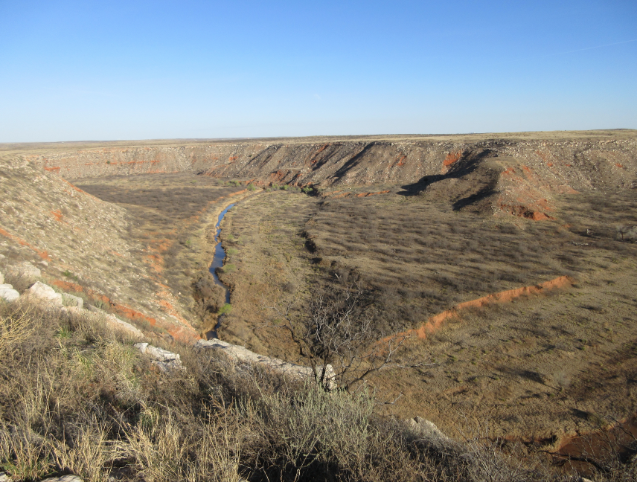
Figure 17: A photograph taken of the West Amarillo Creek canyon and valley (Mudd 2016:101).

However, a regional cost-distance representation of travel time was utilized to become more familiar with the general layout of the Cross Bar Ranch. On the other end, only one homestead (41PT109) was situated in an area considered to represent the least amount of difficulty (Cost Class 0) reaching water. As for the other homesteads, three (41PT96, 41PT97, and 41PT253) occupied the next to least difficulty category (Cost Class 1), while the remaining two (41PT93 and 41PT112) were positioned in the next to highest difficulty area (Cost Class 2). On the other hand, each of the three subhomesteads (41PT254 [Cost Class 2], 41PT282 [Cost Class 0], 41PT283 [Cost Class 1]) occupied a different cost category area spanning 0 to 2, with none of the sites positioned in an area within the most costly classification (Cost Class 3) (For full results see Table 10 in Appendix B).
Figure 18: The classified Cost-Distance surface for the Cross Bar Ranch used to determine site cost classes.
Similar to Lintz, I also conducted a chi-squared test of independence in order to test whether the site types within the Cross Bar Ranch were closely related to their proximity to the nearest water source (Lintz 1986:331). However, my chi-squared test contained one less site type category than the one conducted by Lintz, as well as smaller individual values. This resulted in a p value (referring to the probability value) of 0.36, which indicates that the difference in distances to water between the homesteads and subhomesteads was not mathematically significant. Although my results differed from those found by Lintz, the limited sample size means that we do not know with confidence if there really were differences in rules used to dictate site location with respect to water between the Cross Bar Ranch and Lintz’s study area.
 | Subhomesteads |  |  | Homesteads
Distance Category | Observed Frequency | Expected Frequency |  | Observed Frequency | Expected Frequency |  | Total
Near (<300m.) | 2 |  | 1.2 | 2 |  | 2.8 | 4
Midrange (301-850m.) | 0 |  | 0.9 | 3 |  | 2.1 | 3
Far (>851m.) | 1 |  | 0.9 | 2 |  | 2.1 | 3
Total | 3 |  |  | 7 |  |  | 10
Table 2: A Chi Square test of the connection between site types and their distance to water.
X² (Chi-Squared) =2.06 df (degree of freedom) =2

This difference in chi-square test results can be attributed to the fact that Lintz’s project area contained more sites, and by extension greater associated values than those found within the Cross Bar Ranch. Chi-square tests generally rely on values greater than five in order to be considered reliable, which was not the case for this analysis. To account for the smaller quantities exhibited in my dataset, I also conducted a Fisher’s Exact Test of correlation, which is appropriate for contingency tables with smaller values. However, the results are very similar, with the Fisher’s Exact Test returning a p value of 0.55, which can still be understood as an inconclusive correlation between the site types and their distance to water categories. In summation, neither of the tests of correlation conducted here produced results that would indicate a mathematically significant relationship between specific site types and their distance to the nearest source of water within the Cross Bar Ranch.
Finally, I also examined Lintz’s assertions involving the potential of the surrounding soils to support biotic resources, otherwise known as rangeland productivity (measured in units derived from the pounds of soil per acre in which the soil designation occurs) and soil diversity of different site types (Table 8 in Appendix B). While both the overall and average soil diversity and rangeland productivity values were calculated, due to the difference between the amount of sites investigated between Lintz dissertation and this thesis (25 to 18), as well as the difference in number of homesteads (10 to 7) and subhomesteads (5 to 3) examined in this thesis, only the averages were used comparatively.
I found that the soil diversity and rangeland productivity value averages from the Cross Bar Ranch site types differed from those found within Lintz’s study area. While he found that subhomesteads had the lowest scores for both rangeland production and soil diversity, within the Cross Bar Ranch subhomesteads sites had higher averages (see table 4 below) in both categories than the homesteads. These results indicate that on average, the areas in which the Cross Bar Ranch subhomesteads were situated contained soils that were more apt to support greater quantities of flora and fauna than the areas occupied by the homesteads. Lintz also stated that an increased amount soil diversity was also indicative a greater potential to sustain greater quantities of flora and fauna (Lintz 1986:342). Within his project area, he found the homesteads were positioned in areas featuring higher amounts of soil diversity, however, this was not the case for the homesteads located in the Cross Bar Ranch. On average, the subhomestead areas exhibited a greater variety of soils than those areas containing homesteads (for a comprehensive list of results refer to table 8 in Appendix B).
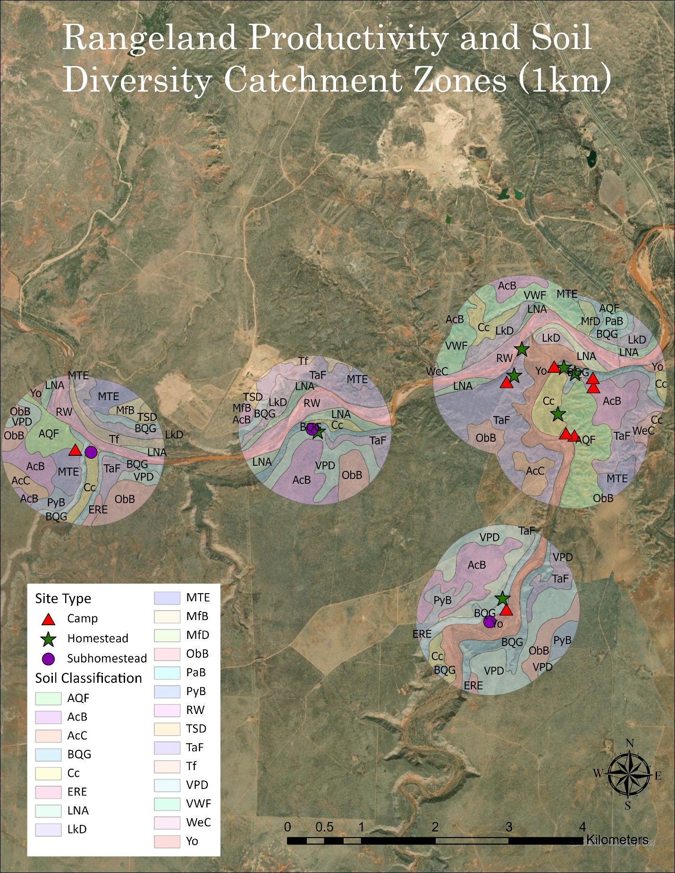
Figure 19: An illustration of the soil designations for the 1 km catchment zones (which were dissolved here into broad catchment areas for illustrative clarity).
Mirroring the rangeland productivity results, the NCCPI (National Commodity Crop Productivity Index) averages also indicated that the subhomesteads (NCCPI average of 544) were indeed located in areas that can be considered more agriculturally favorable (at least according to more contemporary standards) than the homesteads (NCCPI average of 499) (for the complete list of NCCPI site totals, see table 8 in Appendix B). There were also only seven types of soils found to be directly placed within the site centroids (GIS feature points). The most common soil designation (including the camps) was that of Burson-Quinlan-Gravel (BQG- 5 sites), followed by Aspermont-Quinlan (AQF- 4), Tascosa Gravelly Loam (TaF- 3), Yomont (Yo- 3), Acuff (AcB- 1), Veal-Paloduro-Tascosa (VPD- 1) and Clairemont Silty Clay Loam (Cc- 1). Similarly, the majority of the homesteads were found in more gravelly areas containing BQG and TaF, as opposed to the subhomesteads, which instead were situated in more alluvial soils such as Cc and Yo (a complete list of primary soil associations can be found in table 9 within Appendix B). These results conform with Lintz’s assessment that subhomesteads would be located atop more riparian soils (evidenced by 41PT282 and 41PT283), as well as located along the more gravelly slopes of the inner valley wall (as in the case of 41PT254). However, the homesteads featured a mixture of gravelly and bottom land soils, which contradicts Lintz’s postulation that homesteads would be situated among more productive upland soils (Lintz 1986:341-342). Finally, the rangeland productivity, soil diversity, and NCCPI ratings associated with the camp catchment zones were not used comparatively with Lintz’s data, due to their exclusion from his initial calculations. However, although not considered as settlements focused on agricultural activity within Lintz’s site type paradigm, on average the camps outperformed the other site types within the Cross Bar Ranch in terms of rangeland productivity and NCCPI ratings. While surprising, this result can be attributed to not only a greater quantity of sites (8 camps as opposed to 7 homesteads and 3 subhomesteads), but also to their more upland locales.
Site Type | Overall Rangeland Productivity | Average Rangeland Productivity | Overall Soil Types Represented | Average Soil Diversity | Overall NCCPI Rating | Average NCCPI Rating
Camp | 271,020 | 33,878 | 96 | 12 | 5,178 | 647
Subhomestead | 85,772 | 28,591 | 38 | 13 | 1,663 | 544
Homestead | 197,869 | 28,267 | 74 | 11 | 3,490 | 499
Table 3: A table listing the Rangeland Productivity (in terms of sorghum productivity per pound of soil per acre in which it is located), Soil Diversity (as a simple measure of the individual soils present within each site catchment zone), and NCCPI ratings (reflecting numerical ratings of soil productivity used in assessing the agricultural potential for specific soils) for the Cross Bar Ranch Antelope Creek sites.

Over the course of this thesis, specific assertions proposed by Lintz were examined and tested against comparable information available within the Cross Bar Ranch. Below is a more concise, but broad formulation of the results observed during this examination:
- To assess the ease with which Antelope Creek groups could reach the nearest water source, a cost-distance surface was used to derive cost classes among the sites.
  - With the exception of one homestead (41PT257), all of the sites were positioned in areas with relatively easy access to water, which was found to be in agreement with Lintz’s model.
- Lidar and TIN data was utilized in order to classify topographic site locations according to the Canadian River breaks topographic scheme.
  - It was found that certain site types were indeed placed in differential locations conforming to Lintz’s assessment of specific site type functional characteristics as reflected by specific topographic settings.
    - An example of a possible intersite pairing between a homestead and a subhomestead was also discovered, further supporting Lintz’s assertion that differential site type settings were delineated according to site type-specific functions.
- The mean elevation of the sites (above the nearest water source) derived from the Lidar data was utilized to observe elevation trends between homesteads and subhomesteads.
  - Lintz’s assertion that homesteads would be located at higher elevations was also found to be accurate.
- The distances between sites and their nearest source of water was measured through the ArcGIS Pro measure tool and subsequently compared between the site types.
  - The resulting measurements confirmed that the subhomesteads were positioned closer to the nearest water source than the homesteads, which is also in agreement with Lintz’s model.
- Utilizing soil data articulated by the NRCS, rangeland productivity values, soil diversity quantities, and NCCPI ratings were collected as a measure of soil characteristics.
  - All three areas of soil classifications contradicted Lintz’s assessment that homesteads catchment settings would outperform those of the subhomesteads in terms of soil productivity and diversity.

Discussion
By utilizing new methods and approaches to examine Lintz’s documented Antelope Creek site type observations, this project explored certain environmental features, such as the soil productivity/diversity, distance to water, and specific topographic settings to determine if these factors influenced Antelope Creek settlement patterning in the Cross Bar Ranch. This work tested whether his model could be relevant to a location outside of his initial study area, as well as to gleam further insights into the settlement decisions faced by Antelope Creek groups residing in the Cross Bar Ranch. In doing so, this thesis also probed the possible roles that distance/access to water, topographic landforms, soil productivity/diversity, and elevation relative to the nearest water source played in those Antelope Creek groups’ settlement decisions. Although archaeological data from Cross Bar Ranch sites remain limited, other environmental facets connected to the sites made it possible to examine Lintz’s model and assertions. Namely, this was done through an examination of environmental aspects in relation to specific site types, which themselves were assumed to be reflective of particular occupational characteristics. Lintz found that these site types were indicative of certain activities conducted by their residents, referenced by their specific locations, architecture, and artifact assemblages. In this way Lintz established sets of rational ecological preferences displayed by those residents.
For example, Lintz observed that the locations of the subhomesteads were primarily situated in more riparian settings, which are favorable to agricultural endeavors (Lintz 1986:342). However, although these riparian settings were considered beneficial for agricultural activities, which was supported by the NCCPI site type results, they exhibited less biotic diversity than the grassland settings favored by the homesteads (Duffield 1970:34-36). Furthermore, the establishment of subhomesteads in more bottomland settings also implies that those populations were apt to take advantage of the more reliable subsurface water sources necessary for dry farming (Boyd 2008:38-39). The placement of Cross Bar Ranch Antelope Creek settlements closer to the more dependable lateral tributaries, as opposed to the unpredictable Canadian River also evidences the importance of stable sources of water (Lintz 1986:112).
The difference in setting becomes important when inferring specific occupational characteristics. The more simplistic architecture and lack of storage features associated with the subhomesteads implies a more temporary, yet focused field camp function, which would have undercut the lack of biotic diversity. Alternatively, the larger and more complex residential structures, which are commonly accompanied by storage features linked to homestead sites, align more with a base camp arrangement, in which a wide array of procurable resources would have been highly beneficial. The use of supplemental storage structures at homesteads can also be observed as indirect evidence for either agricultural stockpiling or in some cases flora/fauna processing/storing areas, further supporting the perception of a more prolonged residential occupation (Boyd 2008:40).
This differentiation of site location and site function has also been cited as a reason for cooperation between subhomestead and homestead sites (Lintz 1986:318,332). The combination of agriculturally favorable subhomestead settings with the more diverse biotic procurement areas of the homesteads would be consistent with the Antelope Creek style of mixed horticulture and hunting subsistence practices. Furthermore, the limited land available along these tributary valley settings would have constrained the size of the agricultural plots, and by extension, the population that could be sustained at those sites (Lintz 1986:399). Taken in conjunction with their both their close proximity and faunal evidence indicative of food sharing, or at least population movement between these site types, a complementary relationship can be inferred between the smaller agriculturally focused subhomestead occupants and the more residential homestead populations (Lintz 1986:328).
From a landscape archaeological perspective, these complimentary site type relationships could also be inferred as a means through which their occupants attempted to adapt to their ecological setting. This can be seen through their preference for residential centers (homesteads) in elevated locations, which although contained a wider array of available resources, were less suitable for agricultural endeavors than the subhomesteads positioned in the lowlands. Antelope Creek utilization of both Inner Valley rims and base/floodplains would have provided people with the optimal pattern for exploiting a “broken land” environment (Rathjen 1971:2). While only speculation, more elevated settings are also generally considered to be more defensible, even without the presence of defensive fortifications, thus rendering the placement of the residential homesteads in more elevated positions than the subordinate subhomestead a logical choice (Lintz 1986:403; Krieger 1946:42). However, the necessity for defensive considerations can also be inferred from the presence of skeletal remains evidencing the occurrence of violence at several Antelope Creek sites (Lintz 1986:411; Duncan 2002:59; Vehik 2002:42). Finally, whether for subsistence supplementation, and/or defensive considerations, the distribution of Antelope Creek settlements across the Cross Bar Ranch can be understood as reflective of the local challenges faced by the Antelope Creek population. This is evidenced through adaptations in the subsistence strategies of those peoples, which can be observed through the differential placement of sites in locations that catered to specific subsistence needs. Such subsistence necessities can be inferred from the more agriculturally favorable bottomland locations of the subhomesteads, as well as through the positioning of homesteads in locales exhibiting more available quantities of flora and fauna resources.
An analysis of point (site) patterning between first order (environmental elements) and second order (archaeological elements) was also employed to further examine the relationship both among sites, as well as between the sites and their local environment. However, while the first order attributes did not appear to have been significant in terms of site clustering, mutual characteristics were found within the same site types. This suggests that the Antelope Creek groups had certain environmental preferences that were indeed instrumental in their decisions for settlement placement. For archaeologists, these insights could indicate which areas are more likely to contain Antelope Creek sites, and thus either be avoided, or more accurately anticipated prior to fieldwork. These inferences also support Lintz’s paradigm of site type interactional relationships, predicated upon interdependent sites each exhibiting complimentary functions, evidenced by their inverse ecological settings.
In order to build upon Lintz’s work concerning the environmental patterning connected to Antelope Creek site types, I gathered comparable environmental data associated with previously documented Antelope Creek sites located within the Cross Bar Ranch. Paralleling Lintz’s study, I collected the distances from Antelope Creek sites to their nearest source of water, the elevation values for the selected sites (relative to the nearest water source), site-specific soil information including rangeland productivity values and the quantities of specific soil designations, and descriptions of the sites’ topographic setting (expressed through the classificatory Canadian River breaks scheme). However, besides those environmental elements discussed in Lintz’s dissertation, I also compiled additional environmental data such as the ease of access to water sources (derived through a cost-distance surface and articulated through progressive cost class categories) and more contemporary National Commodity Crop Productivity Index (NCCPI) soil ratings. I found that broadly, the Antelope Creek site type environmental patterns observed by Lintz were also present within the Cross Bar Ranch. For instance, supporting Lintz’s findings, two (41PT282 and 41PT283) out of the three subhomesteads identified in my project area were indeed situated in lower elevated riparian settings. Furthermore, although two homesteads (41PT97 and 41PT109) were not located in areas under the designation of the grassland biotic community, the other five (constituting a majority) were found in more upland settings. I also found that my quantified cost classes were in agreement with Lintz’s assessment that access to water was an important consideration in Antelope Creek settlement decisions across all the site types (Lintz 1986:411). I also observed that the NCCPI calculations appear to support Lintz’s assertions concerning the agricultural focus (as seen through their choice of setting) of the subhomesteads in comparison to the homesteads.
However, while the majority of the claims examined in this thesis concurred with his research, a few of Lintz’s findings and subsequent assertions deviated from those found within the Cross Bar Ranch. Several of these deviations can be attributed to differences between Lintz’s project area and my own. For example, Lintz’s study area contained fewer tributaries and was more centered around the Canadian River than the Cross Bar Ranch, which could explain the differences in subhomestead proximity from the Canadian River. The proximity average for the Cross Bar Ranch subhomesteads were also slightly skewed by one subhomestead (41PT283) found over two km away from the Canadian River, while the other two were located within 300 meters of it. Another deviation, the locations of several homesteads outside of the settings Lintz documented, could be attributed to either a difference in the local topography and/or the accuracy of the digital site locations, which while reasonably accurate, can contain a small amount of variance. Differences aside, the supporting data found within the Cross Bar Ranch can be used to further distinguish broad settlement patterning specific to Antelope Creek occupations.
While Lintz only briefly discussed Antelope Creek temporary camps, in particular as settlements located at more elevated settings than more architecturally complex sites, I drew several interpretations from the camps located within the Cross Bar Ranch. For example, although the majority of Cross Bar Ranch camps were indeed located at higher elevations (relative to the nearest water source), than the surrounding Antelope Creek sites, two exceptions (41PT90 and 41PT280) provided an example of an association between camps and homesteads. Both 41PT90 and 41PT280 were found to be situated directly along the least-cost pathways to water for the homesteads of 41PT96 and 41PT257 (see Figures 25 and 26 in Appendix C for the visual representations). In particular, 41PT90 also featured a dolomite boulder containing multiple grinding basins, indicative of processing activities. Similar to the activity-focused subhomesteads, I believe that certain camps also represent an extension of nearby residential homesteads. Furthermore, in line with Lintz’s interpretation that increased amounts of soil diversity reflected increased quantities of available biotic resources, Cross Bar Ranch camps were found to exhibit, on average, a higher amount of soil diversity than the homesteads, rendering them advantageous areas of biotic resource procurement. Although separated from the homesteads, I interpret the nearby camps and subhomesteads as procurement/processing focused sites associated with those homesteads. The association of camps with adjacent homesteads could explain why Cross Bar Ranch homesteads were positioned in locales featuring, on average, the least amount of soil diversity.
Between the agriculturally focused subhomesteads and the procurement focused camps, it would appear that Antelope Creek groups within the Cross Bar Ranch preferred their residential settlements to be located away from their associated procurement and processing centers. Additionally, the importance of access to water among Antelope Creek groups, evidenced through both cost classes, and proximity of sites to water, concurs with the understanding that these peoples were more horticulturally oriented than previous generations (Drass & Turner 1989:24). Although more horticulturally focused than their ancestors, the Antelope Creek populations in the Cross Bar Ranch also employed an amount of hunting and gathering, referenced by the favorable procurement environments of the camps and homesteads. Their mixed subsistence style was also reflected in the differences within the artifact assemblages documented among the various Cross Bar Ranch site types (for specific examples refer to the Sites Selected for Analysis section of Chapter 5). However, at sites where artifacts are limited, such as in the Cross Bar Ranch, the identification of specific Antelope Creek site types can offer meaningful insights into the subsistence activities that occurred in an area.
The separation of smaller camps and subhomesteads associated with more identifiable homesteads should prompt future archaeologists working in the Cross Bar Ranch to give additional consideration to landforms located within half a kilometer of identified homesteads. This range was determined to be significant due to the placement of camps and subhomesteads less than half a kilometer away from their nearest homesteads (For a list of the pairings and their corresponding distances, see table 11 in Appendix B). This includes specifically examining canyon valleys, as well as more elevated adjacent topographic sections. Physically identifiable pathways from homesteads to the nearest water source should also garner additional consideration. Finally, the environmental variables (distance/access to water, topographic setting, soil productivity/diversity, and elevation values relative to the nearest source of water) featured in this updated model of Antelope Creek settlement patterning should be examined as a component of the environmental background research conducted prior to archaeological fieldwork.

Conclusion
Through the utilization of more contemporary geospatial analytic tools, this thesis examined several anthropological assertions posited by Lintz in his articulation of the relationships among specific environmental elements and Antelope Creek occupations. In particular, here the environmental variables included; topographic section (encompassing broad flora/fauna habitats), elevation, access to potable water, and soil productivity/variety. These associations were also segmented and further delineated according to the interpretation of specific site types as reflective of particular occupational activities. Constituting one of these site types were the more architecturally complex homesteads, whose more robust construction, diverse biotic setting, and assorted artifactual assemblages (tools and evidence of flora/fauna processing) were suggestive of more stable residential occupations. On the other hand, subhomesteads were comprised of less complex structures, featuring smaller individual rooms, lack of formal storage features and more agriculturally oriented artifacts were characterized as more seasonal occupational outposts, which served as centers of agricultural production. Additionally, referencing the mixed subsistence practices for Antelope Creek populations, it has been proposed that owing to their close proximity, similar flora/faunal remains, and differential ecological settings, the more agriculturally focused seasonal subhomesteads were possibly used to supplement the more continuous homestead occupations.
In order to explore the relationships among subhomesteads, homesteads and their local environments, the Antelope Creek sites within the Cross Bar Ranch were clustered through proximity, and which in turn was used to demarcate a one-kilometer catchment zone for each cluster. Derived from these catchment zones was an environmental inventory of elements mentioned in Lintz’s works, which served as the basis for a comparative examination. Once the catchment zones were established, GIS spatial modeling (lidar/TIN data) was employed to more accurately articulate the locations of Antelope Creek sites within the Canadian River Breaks topographic scheme. Although there were a few outliers (examined in the Results section of this chapter), the majority of both subhomesteads and homesteads were found to be situated in areas that were considered more beneficial for the occupational activities associated with each site type. These findings concur with Lintz’s assertion that subhomesteads were primarily located in the fertile bottomlands of the Inner Valley, while the homesteads were more apt to be found atop elevated sections underscoring their more expansive resource domains, such as Inner Valley rims and terraces.
Expanding upon Lintz’s model, this work also examined additional aspects of the relationships between sites and their specific ecological settings. Environmental elements such as contact with potable water, catchment zone soil productivity/diversity/NCCPI values, and relative biotic diversity composed additional facets of my investigation. For example, within semi-arid regions such as the Llano Estacado, not only is the availability of water an important resource, but access to that source of water also becomes a significant factor (Fenneman 1931:87). The importance of this was demonstrated by the Antelope Creek population within the Cross Bar Ranch. Cost-function modeling of the degree of slope, elevation gradations, and proximity for the area illustrated a correlation between areas with fewer natural obstacles to streams and rivers, and the places that people chose to occupy. By utilizing contemporary soil data (available through soilweb.com) to determine more precise compositions of the broad soil designations exhibited in the Cross Bar Ranch, I was able to further examine the soil productivity and diversity ratings for site-specific catchment zones. In conjunction with the more crop oriented NCCPI ratings, the updated rangeland productivity values indicated that it was the camp catchment zones that featured, on average, the greatest soil productivity. It was also found that on average, the homestead catchment areas underperformed in rangeland productivity and NCCPI ratings, suggesting that these locations were selected for reasons outside of their agricultural capabilities.
While the floral resources remained relatively consistent throughout the study area (short grasses and other sand-friendly species), the faunal associations between the uplands and the lowlands were thought to have shown considerable variation. The more upland grassland-plains and edge-breaks districts were populated by larger game animals such as bison and deer, while the more aquatic-moist lowlands were comprised of physically smaller creatures such as muskrats, racoons, skunks, and ducks (Duffield 1970:34-36). This differences in biotic provinces was also represented by the presence and amount of faunal remains documented at various Antelope Creek sites. During Duffield’s (1970) investigation of Antelope Creek butchering practices within the Texas and Oklahoma panhandles, he identified the animal species’ remains present at those sites; thirty-eight mammals, twenty-nine avian, eight reptiles, and two fish. Although evidence of bison was found at almost every site, the disproportionate amount of a specific limb (left bison shoulder) found at sites considered to be seasonally occupied (here referred to as subhomesteads) prompted Duffield to consider them indicative of food sharing procedures. Furthermore, the abundance of small animal bones found at these seasonal settlements (subhomesteads), and their relative absence at the grassland-plains and edge-breaks sites (homesteads) also underscores the amount of variance through which Antelope Creek peoples exploited their local faunal communities (Duffield 1970:252-254).
Taken collectively, the environmental variables associated with specific ecological settings appear to have influenced the Antelope Creek groups’ settlement decisions within the Cross Bar Ranch. In particular, these occupied locations not only shared several environmental facets, but also indicated an amount of contrast between the types of settlements. On one hand, environmental aspects such as the availability of water were beneficial across every location and thus mutually found. On the other hand, differences in soil productivity and biotic diversity illustrated that certain locations were preferred, presumably as a means of maximizing subsistence practices by exploiting an optimal location. In line with previous assertions regarding Antelope Creek subsistence strategies, groups within the Cross Bar Ranch were engaged in a form of mixed horticulture and hunting. Here, the homesteads likely facilitated the majority of hunting activities, as evidenced through their topographic placement, faunal assemblages, and lithic tool assortment (Lintz 1986; Duffield 1970; Mudd 2016; Duncan 2002). Alternatively, Cross Bar Ranch subhomesteads can be interpreted as agricultural centers owing both to their riparian settings and to their more horticulturally-oriented artifact assemblages (Lintz 1986; Mudd 2016). Within this site type framework, the possibility exists that occupants of the seasonal subhomesteads supplemented the more residential homesteads through providing agricultural produce such as corn, beans, and squash (Boyd 2008:36). Furthermore, evidence of food sharing activities between subhomesteads and homesteads can also be construed as another means through which the peoples settled in the Cross Bar Ranch participated in a mixed hunting/horticultural subsistence strategy (Duffield 1970:252-254).
The most significant findings of this research suggest that not only were Antelope Creek groups preferencing certain areas in which to establish their settlements, but that specific types of settlements appear to reflect differential subsistence functions . This was determined through an examination of environmental elements associated with the Antelope Creek sites documented within the Cross Bar Ranch. For example, homesteads were found to occur at higher elevations (above the nearest water source) than subhomesteads, referencing a greater emphasis placed on biotically diverse upland settings for the homesteads than the subhomesteads. The locations surrounding subhomesteads featured soils, that in comparison to the homestead settings, were more productive in terms of horticultural activities, evidenced through both rangeland productivity and NCCPI values. Through an examination of the cost classes between the site types, access to water was found to be slightly more difficult from the homestead locations as opposed to the subhomestead settings. This finding was also supported by the increased distance to the nearest tributary for the homesteads in comparison to the subhomesteads. While in no way completely conclusive, these findings can be used to interpret the various assertions referenced throughout this examination.
My work in the Cross Bar Ranch found that not only were types of Antelope Creek settlements delineated according to site-specific functions, but that certain site types could also be examined in association with each other. This was the case for the plausible association between homestead 41PT257 and subhomestead 41PT283. This association was evidenced by both a close proximity (separated by 363 linear meters) and the more agriculturally favorable setting of 41PT283 (observed by the better NCCPI rating for 41PT283 [421] than 41PT257 [411]). Another possible association was observed between the temporary camp 41PT90 and the homestead 41PT96. Located only 135 meters apart, 41PT90 was entirely comprised of a modified dolomite boulder featuring several grinding basins, but lacked any kind of residential shelter. Conversely, 41PT96, considered one of the largest Antelope Creek sites documented within the Cross Bar Ranch, contained evidence for at least one residential structure along with the potential remains of several associated subordinate structures. While not only located in close proximity to each other, the sites were also connected by a mutually found least cost pathway to water. Both of these examples suggest that Antelope Creek groups’ settlement locations, while indicative of specific site functions, were also a means through which they endeavored to optimally exploit a range differential ecological settings.
This thesis also contributes additional evidence supporting previously documented attributes broadly ascribed to Antelope Creek populations. For example, within the Cross Bar Ranch it was observed that Antelope Creek peoples appeared to exhibit specific preferences in the selection of their settlement locations in order to maximize the yields produced by their adoption of a dual hunting/horticulture subsistence strategy. This can be seen through the inverse placement of subhomesteads (representing the agricultural aspect of their subsistence strategy) in moist-aquatic bottomland settings as opposed to the positioning of homesteads in more biotically diverse upland locations (referencing the continued dependence of hunting and other procurement activities). Such ecological pairings were observed throughout the Cross Bar Ranch during the course of this examination. The architectural differences among the site types observed in the Cross Bar Ranch also supported Antelope Creek groups’ documented shift from mobile hunters and gathers to more a more sedentary lifestyle. Evidenced through the less durable construction of the seasonally occupied structures (subhomesteads) would require the utilization of the more enduring architecture associated with longer-term residential structures (homesteads).
As a result of this examination, the environmental patterns associated with Lintz’s site type paradigm should be considered viable for areas outside of his initial study area. The corroboration of the environmental elements related to settlement patterning within the Cross Bar Ranch adds additional credibility to his original work, which provides an additional level of accuracy in the prediction of Antelope Creek settlements than previously documented for the locale. This becomes especially important when considering the anticipation of archaeological resources in preparation for earth disturbing construction projects. Specifically, Antelope Creek occupations at this time, appear to exhibit environmental tendencies in their selection of settlement locations within certain landscapes. This is referenced by the preference of certain environmental factors, such as access to water, differential access to biotic resources, and agriculturally suitable soils among the various types of sites. Furthermore, the delineation of subsistence strategies between the subhomesteads and the homesteads, as well as their possible supplemental subsistence relationship, also align with the current interpretation of Antelope Creek populations as peoples engaged in complimentary horticultural/hunting subsistence practices. These insights become important when attempting to understand the lives and livelihoods of the past inhabitants of the Cross Bar Ranch, and gain additional value when they can be supported by both past and present data.
While these conclusions are grounded in the information currently available for the Cross Bar Ranch, further archaeological work in the area could shed light on alternative insights and interpretations into local precontact settlement distributions. For example, additional field surveys conducted in areas that have not been subjected to archaeological investigations might expose more Antelope Creek sites in environments not considered in this thesis. Additional subsurface testing of known Antelope Creek sites, identified exclusively through pedestrian survey, would also bolster our insights concerning the activities conducted by their occupants. Furthermore, research involving Antelope Creek sites in the area would also benefit from more detailed digital documentation, including; updated site photographs, ground-penetrating radar (GPR), magnetometer. as well as more precise spatial documentation utilizing various forms of high-precision mapping equipment.

Appendix A (Cross Bar Ranch Additional Information)
Sites Investigated | Year | Authors | Report Title
41PT90-41PT109, 41PT112, 41PT113 | 1993 | Meeks Etchieson | An Archeological Survey of a Portion of Helium Operations Land in Potter County, TX
41PT173, 41PT174, 41PT175 | 1997 | Christopher Lintz and Meeks Etchieson | Informal Reconnaissance of the Cross Bar Ranch
Two new sites found (no trinomials) | 1998 | Charles Haecker and James Rancier | Damage Assessment, 41PT92 and 41PT93, on BLM Land (Previously Property of the U.S. Bureau of Mines, Helium Field Operation) U.S. Marines Reserve Training Area, North of Amarillo, TX (Draft)
41PT239, 41PT240, 41PT241, 41PT242, 41PT243, 41PT244 | 2000 | James Briscoe | Archaeological Survey Report on the Sunlight Exploration, Inc. Tecovas Creek Project, Potter County, Texas
41PT246, 41PT247, 41PT248 | 2000 | John Northcutt | An Archaeological Survey of Proposed Power Line R-O-W on the Cross Bar Property, Potter County, Texas
41PT105, 41PT243, 41PT269, 41PT272, 41PT273, 41PT275, 41PT279, 41PT280-41PT289 | 2002 | James Briscoe | Archeological Survey of the Bureau of Land Management Cross Bar Ranch Fire Lanes Project Potter County, Texas
41PT174, 41PT175, 41PT247, 41PT251-41PT275 | 2002 | Christopher Lintz, Jason Smart, Audrey Scott, and Shane Pritchard | Cultural Resource Class II Survey of a 1,500 Acre Sample of the Cross Bar Ranch Complex, Potter County, Texas
41PT109, 41PT422-41PT425 | 2004 | C. Britt Bousman and Abby Weinstein | Cross Bar Ranch Archaeological Investigations 2004: Interim Report
41PT10 | 2005 | C. Britt Bousman | Cross Bar Ranch Archaeological Investigations 2005: Interim Report
Sites Investigated | Year | Authors | Report Title
41PT283 | 2008 | C. Britt Bousman | Cross Bar Ranch Archaeological Investigations 2007: Interim Report
41PT486, 41PT504 | 2013 | Ryan Howell | Cross Bar Cooperative Management Area: Mesquite, Salt Cedar, and Cholla Cactus Eradication: Survey Areas 1 and 2
41PT507, 41PT508 | 2014 | Ryan Howell | Cross Bar Cooperative Management Area: Class III Cultural Resources Inventory of a Proposed Public Access Route
41PT506, 41PT509, 41PT510, 41PT511, 41PT512 | 2015 | Ryan Howell | Management Area: Mesquite, Salt Cedar, and Cholla Cactus Eradication: Survey Areas 3, 4, 5, and 6
41PT96, 41PT112, 41PT283 | 2016 | Robert Selden Jr., Michael Mudd and C. Britt Bousman | Ground Penetrating Radar Survey at Antelope Creek Sites, 41PT96, 41PT112, and 41PT283, Potter County, Texas
41PT96, 41PT112, 41PT257 | 2017 | C. Britt Bousman | Preliminary Results of the 2016 And 2017 Texas State University Field Schools at the Cross Bar Ranch, Potter County, Texas
41PT100, 41PT101, 41PT104, 41PT503, 41PT518 | 2019 | Katie Hill | Cross Bar Management Area: 2019 Mesquite Mastication Project, Potter County, Texas
Table 4: A list of the archaeological projects that have been conducted within the Cross Bar Ranch. Adapted from Mudd (2016).

Floral Association Zone | Floral Species Documented
Bottom Lands | Cottonwood, Chickasaw Plum, Hackberry, Sedge, Salt Grass, Alkali Sacaton, Vine-Mesquite, Common Reed, and Persicaria. Significant contributions to the vegetation cover are also made by Scratch Grass/Muhly, Switchgrass, Canadian Wild Rye, Rush, Iambsquarters and Western Ragweed. The dominant introduced species are Tamarisco/Salt Cedar and Belvedere.
Steep Slopes | Broomweed, Polecat Bush, Feather Plume, Cat's Claw Mimosa, Wafer Ash, Sideoats Grama, Little Bluestem, Western Fleabane, Ragweed, Bladder Pod, White Aster, and to a lesser extent Black Grama and Western Wheatgrass.
Mesa Tops | Plains Prickly Pear, Bear Grass, Mesquite, Broomweed, Blue Grama, Buffalo Grass, Indian Blanket, Bladder Pod, Plantain, and Tahoka Daisy.
Gravelly Slopes | Dominated by Broomweed, Bear Grass, Cat's Claw Mimosa, Blue Grama, Hairy Grama, Texas Grama, Sideoats Grama, White Aster, Bladder Pod, Indian Blanket, Six-Week Fesque, and an introduced species, Russian Thistle.
Sand Hills | Consisting mainly of Sand Sagebrush, Broomweed, Bear Grass, Chickasaw Plum, Scratchgrass/Muhly, Sand Dropseed, Lazy Daisy, Indian Blanket, and Mentzelia.
Table 5: Table listing the Floral species according to their designated floral association zone for the Cross Bar Ranch.

Soil Classification | Rangeland Productivity Value | NCCPI Soil Capability Value
AcB | 1600 | 50
AcC | 1600 | 48
AQF | 1190 | 31
BQG | 715 | 3
BuB | 2053 | 58
Cc | 2600 | 54
ERE | 1200 | 18
LkD | 2068 | 23
LNA | 2166 | 21
MfB | 2057 | 39
MfC | 2057 | 38
MfD | 2057 | 37
MTE | 1915 | 31
ObA | 1596 | 48
ObB | 1598 | 48
PaB | 2000 | 49
PaC | 2000 | 49
PyB | 1700 | 42
PyC | 1700 | 42
TaF | 1200 | 24
TF | 1400 | 19
TSD | 1150 | 23
VPD | 1697 | 40
VWF | 1015 | 20
WVD | 1113 | 33
WeB | 1508 | 33
WeC | 1508 | 33
Yo | 2295 | 41
Table 6: A table listing the rangeland productivity according to soil classification, the NCCPI Capability Classes were provided by SuretyMaps.com.

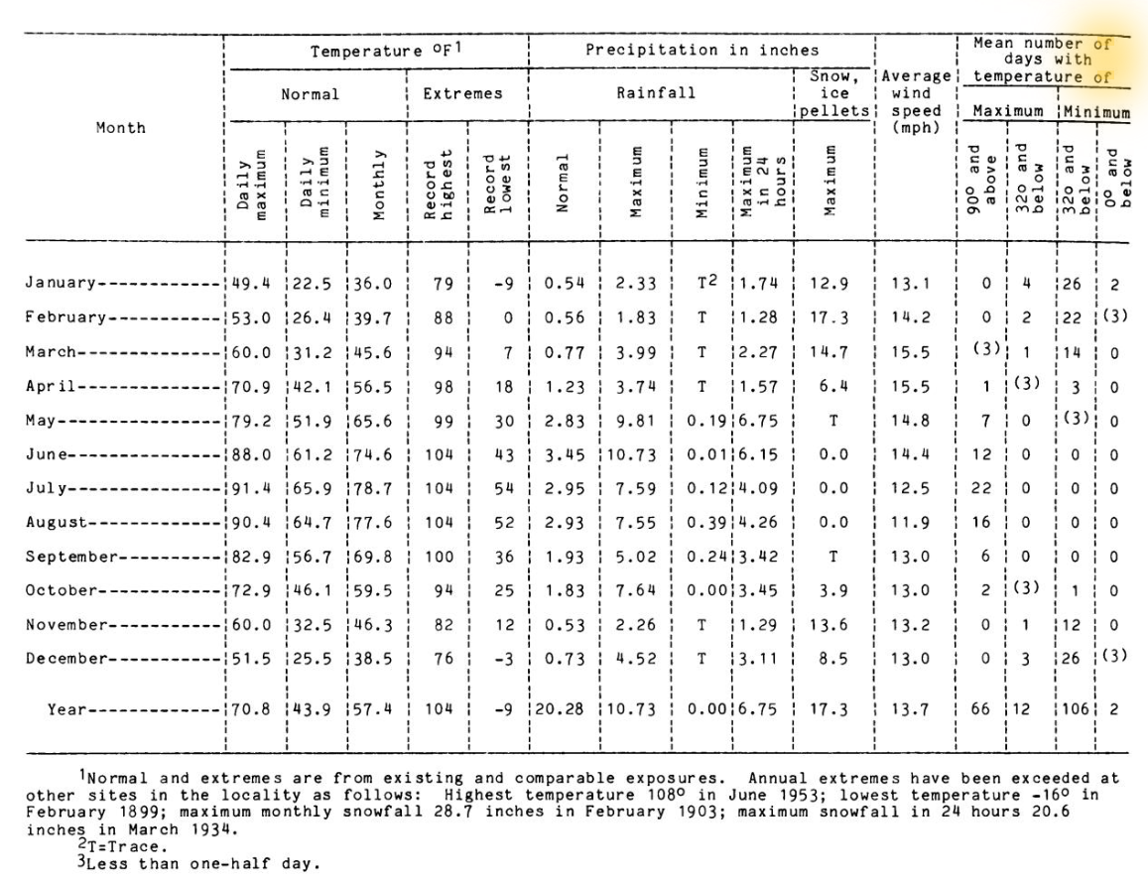
Figure 20: Pringle's (1980) Table of Potter County annual precipitation, temperature, and wind conditions (Pringle 1980:76).

Appendix B (Comprehensive Site Results)
Site | Overall Rangeland Productivity | Average Rangeland Productivity | Soil Diversity | NCCPI Total
41PT90 | 37,160 | 1,689 | 12 | 605
41PT91 | 32,648 | 1,632 | 12 | 583
41PT92 | 31,458 | 1,656 | 12 | 552
41PT93 | 32,774 | 1,639 | 11 | 538
41PT96 | 37,160 | 1,689 | 12 | 605
41PT97 | 22,313 | 1,594 | 11 | 419
41PT98 | 19,587 | 1,632 | 11 | 408
41PT99 | 21,185 | 1,513 | 11 | 456
41PT109 | 33,902 | 1,695 | 11 | 578
41PT112 | 27,047 | 1,690 | 10 | 484
41PT113 | 28,555 | 1,679 | 12 | 515
41PT253 | 25,956 | 1,527 | 11 | 455
41PT254 | 28,013 | 1,556 | 12 | 494
41PT257 | 18,717 | 1,560 | 8 | 411
41PT280 | 18,717 | 1,560 | 9 | 405
41PT282 | 37,842 | 1,577 | 17 | 748
41PT283 | 19,917 | 1,532 | 9 | 421
41PT509 | 81,710 | 1,571 | 17 | 1,654
Table 7: (Above) Rangeland Productivity, Soil Diversity, and NCCPI Values for the individual sites within this study.

Trinomial | Site Type | Canadian River Breaks Section | Primary Soil Association | Soil Age | Degree of Slope
41PT90 | Camp | Floodplains | Yomont (Yo) | Permian | 18°
41PT91 | Camp | Inner Valley Rim | Burson-Quinlan-Rock (BQG) | Permian | 9°
41PT92 | Camp | Outer Valley Base | Acuff (AcB) | Permian | 1°
41PT93 | Homestead | Inner Valley Wall Bench | Burson-Quinlan-Rock (BQG) | Permian | 10°
41PT96 | Homestead | Inner Valley Rim | Burson-Quinlan-Rock (BQG) | Permian | 2°
41PT97 | Homestead | Inner Valley Base | Aspermont-Quinlan (AQF) | Permian | 6°
41PT98 | Camp | Inner Valley Base | Aspermont-Quinlan (AQF) | Permian | 3°
41PT99 | Camp | Inner Valley Wall | Aspermont-Quinlan (AQF) | Permian | 11°
41PT109 | Homestead | Inner Valley Wall | Tascosa Gravelly Loam (TaF) | Permian | 36°
41PT112 | Homestead | Inner Valley Rim | Tascosa Gravelly Loam (TaF) | Permian | 4°
41PT113 | Camp | Inner Valley Rim | Tascosa Gravelly Loam (TaF) | Permian | 1°
41PT253 | Homestead | Inner Valley Wall Bench | Veal-Paloduro-Tascosa (VPD) | Permian | 11°
41PT254 | Subhomestead | Inner Valley Wall | Burson-Quinlan-Rock (BQG) | Permian | 16°
Trinomial | Site Type | Canadian River Breaks Section | Primary Soil Association | Soil Age | Degree of Slope
41PT257 | Homestead | Inner Valley Rim | Burson-Quinlan-Rock (BQG) | Permian | 8°
41PT280 | Camp | Floodplains | Yomont (Yo) | Late Triassic | 10°
41PT282 | Subhomestead | Floodplains | Clairemont Silty Clay Loam (Cc) | Permian | 0°
41PT283 | Subhomestead | Inner Valley Base | Yomont (Yo) | Late Triassic | 4°
41PT509 | Camp | Inner Valley Rim | Aspermont-Quinlan (AQF) | Pliocene to Miocene | 1°
Table 8: A table connecting individual sites with their site type designation, as well as listing various first-order attributes for the individual sites.

Trinomial | Distance to Nearest River (m) | Distance to Nearest Tributary (m) | Cost-Distance Class (0-3= level of difficulty)
41PT90 | 492 | 63 | 0
41PT91 | 269 | 607 | 2
41PT92 | 375 | 647 | 3
41PT93 | 383 | 391 | 2
41PT96 | 419 | 202 | 1
41PT97 | 951 | 344 | 1
41PT98 | 1101 | 100 | 0
41PT99 | 1081 | 120 | 0
41PT109 | 31 | 168 | 0
41PT112 | 208 | 417 | 2
41PT113 | 227 | 433 | 2
41PT253 | 386 | 269 | 1
41PT254 | 271 | 358 | 2
41PT257 | 2774 | 263 | 3
41PT280 | 2919 | 101 | 0
41PT282 | 128 | 60 | 0
41PT283 | 2966 | 191 | 1
41PT509 | 195 | 214 | 2
Table 9: A table detailing Antelope Creek sites' association with the nearest source of water.

Trinomial | Site Elevation (m) | Elevation above Nearest River (m) | Elevation above Nearest Tributary (m)
41PT90 | 925 | 7 | 6
41PT91 | 947 | 29 | 28
41PT92 | 954 | 36 | 35
41PT93 | 940 | 22 | 21
41PT96 | 941 | 23 | 22
41PT97 | 292 | 11 | 8
41PT98 | 928 | 10 | 8
41PT99 | 933 | 15 | 25
41PT109 | 930 | 12 | 12
41PT112 | 946 | 28 | 25
41PT113 | 947 | 29 | 26
41PT253 | 958 | 38 | 3
41PT254 | 957 | 37 | 2
41PT257 | 975 | 54 | 47
41PT280 | 938 | 17 | 10
41PT282 | 928 | 5 | 2
41PT283 | 935 | 14 | 6
41PT509 | 963 | 40 | 37
Table 10: A tabulation of the elevation information for Antelope Creek sites within the Cross Bar Ranch.

Site Type Pairing | Distance Between (in meters)
41PT93 (Homestead) and 41PT91 (Camp) | 201
41PT96 (Homestead) and 41PT90 (Camp) | 135
41PT97 (Homestead) and 41PT98 (Camp) | 274
41PT109 (Homestead) and 41PT113 (Camp) | 406
41PT112 (Homestead) and 41PT113 (Camp) | 100
41PT257 (Homestead) and 41PT283 (Subhomestead) | 363
41PT253 (Homestead) and 41PT254 (Subhomestead) | 82
Table 11: The distances between homesteads and their nearest camp or subhomestead, measured using the Measure too within ArcGIS Pro.

Appendix C (Reference Maps and Additional Illustrations)
Figure 21: A classified digital elevation model for Lintz's study area around Lake Meredith.
Figure 22: A classified digital elevation model for the Cross Bar Ranch.

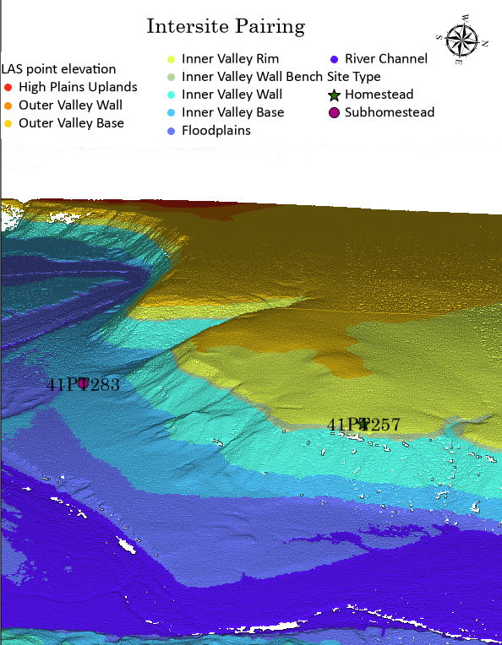
Figure 23: A lidar example of a possible homestead/subhomestead intersite pairing in the Cross Bar Ranch.

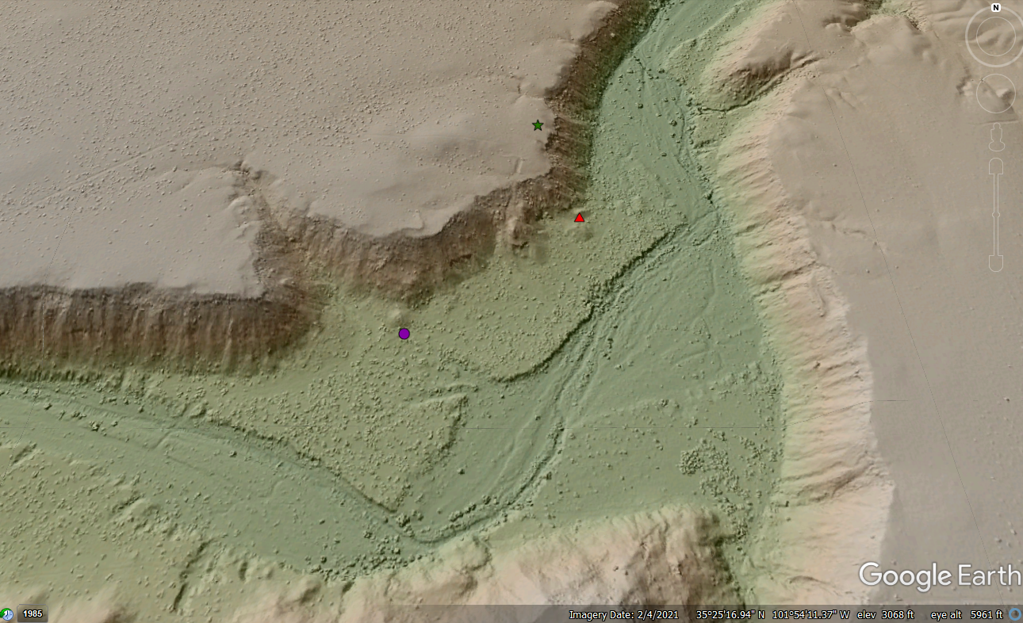
Figure 24: Example of TIN data, utilized through Google Earth Pro.

Figure 25: Cost-Path evidence for a possible association between Homestead 41PT96 and Temporary Camp 41PT90.

Figure 26: Cost-Path evidence for a possible association between Homestead 41PT257 and Temporary Camp 41PT280.

References
Anschuetz, K. F., Wilshusen, R. H., & Scheick, C. L. (2001). An Archaeology of Landscapes: Perspectives and Directions. Journal of Archaeological Research, 9(2), 157–211. http://www.jstor.org/stable/41053175
Bousman, Britt C. (2017). Preliminary Results of the 2016 and 2017 Texas State University Field Schools at The Cross Bar Ranch, Potter County, Texas. Center for Archaeological Studies, San Marcos, Texas.
Bousman, Britt, Curran, R., Dering, P., Mudd, M., Feathers, J. K., Payton, A., Meier, H., & Lintz, C. (2022). Site Occupation Spans at Middle Ceramic Antelope Creek Phase Sites in the Southern Plains of Texas. Plains Anthropologist, 67(262), 103–118. https://doi.org/10.1080/00320447.2022.2036576
Boyd, Douglas K. (2008) Prehistoric Agriculture on the Canadian River of the Texas Panhandle: New Insights from West Pasture Sites on the M-Cross Ranch. Plains Anthropologist 53(205):33–57.
Bozell, J. R. (1995). Culture, Environment, and Bison Populations on the Late Prehistoric and Early Historic Central Plains. Plains Anthropologist, 40(152), 145–163. http://www.jstor.org/stable/25669333
Brosowske, S. D. (2005). The Evolution of Exchange in Small-Scale Societies of the Southern High Plains (dissertation). The University of Oklahoma, Norman, OK.
Chrisholm, M. (1968) Rural Settlement and Land Uses: An Essay in Location. Aldine Press, Chicago.
Conolly, J., & Lake, M. (2006). Geographical Information Systems in Archaeology. Cambridge University Press.
Creel, D. (1991). Bison Hides in Late Prehistoric Exchange in the Southern Plains. American Antiquity, 56(1), 40–49. https://doi.org/10.2307/280971
Crumley, C. L., & Marquart, W. H. (1990). Landscape: A Unifying Concept in Regional Analysis . In Interpreting Space: GIS and Archaeology, Allen, K. M., Green, S. W., W., Z. E. B., (pp. 73–79). essay, Taylor & Francis.
Currás, B. X., & Sánchez-Palencia, F. J. (2021). Landscape Archaeology of Roman Gold Mining in Lusitania: The ‘Aurifer Tagus’ Project. Antiquity, 95(382). https://doi.org/10.15184/aqy.2021.82
David, B. & Thomas, J. (2008). Landscape Archaeology: Introduction. In Handbook of Landscape Archaeology (pp. 27–43). essay, Left Coast Press.
Dell'Unto Nicolò, & Landeschi, G. (2022). Archaeological 3D GIS. Routledge.
Drass, Richard and C.L. Turner (1989) An Archaeological Reconnaissance of the Wolf Creek Drainage, Ellis County, Oklahoma. University of Oklahoma Archeological Resource Survey Report 35, Oklahoma Archeological Survey, Norman.
Drass, Richard. (1998). The Southern Plains Villagers. In Archaeology on the Great Plains, R. Wood (pp. 415–455). University Press of Kansas.
Drass, Richard. (2012). Chapter 31: Planting the Plains: The Development and Extent of Plains Village Agriculturists in the Southern and Central Plains. In The Oxford Handbook of North American Archaeology, Pauketat, T. R. (pp. 373–385). essay, Oxford University Press.
Duffield, Lathel. (1970) Some Panhandle Aspects Sites in Texas: Their Vertebrates and Paleoecology. Unpublished Ph.D. dissertation, Department of Anthropology, University of Wisconsin, Madison.
Duncan, Marjorie A. (2002). Adaptation During the Antelope Creek Phase: Subsistence Strategies at the Two Sisters Site. PhD Dissertation, Department of Anthropology, University of Oklahoma, Norman.
Etchieson, Meeks (1983) An Archeological Survey of a Portion of Helium Operations Land, Potter County, Texas. United States Bureau of Mines, Amarillo, TX.
Fenneman, N. (1931). Physiography of Western United States. McGraw-Hill.
Forman, S. L., Oglesby, R., & Webb, R. S. (2001). Temporal and Spatial Patterns of Holocene Dune Activity on the Great Plains of North America: Megadroughts and Climate Links. Global and Planetary Change, 29(1-2), 1–29. https://doi.org/10.1016/s0921-8181(00)00092-8
Gould, Charles (1907) The Geology and Water Resources of the Western Portion of the Panhandle of Texas. Dept. of the Interior, United States Geological Survey.
Hempel, C. G. (1965). Aspects of Scientific Explanation and Other Essays in the Philosophy of Science. New York: Free Press.
Herzog, I. (2020). Spatial Analysis Based on Cost Functions. In Archaeological Spatial Analysis: A Methodological Guide, Gillings, M., Hacigüzeller Piraye, Lock, G. (pp. 333–358). essay, Routledge.
Hill, K. (2019). Cross Bar Management Area: 2019 Mesquite Mastication Project, Potter County, Texas. Bureau of Land Management.
Hirmas, D., & Mendel, R. (2017). Soils of the Great Plains. In The soils of the USA, West, L. T., Singer, M. J., Hartemink, A.E. (pp. 131–163). Springer International Publishing.
Hodder, I., & Orton, C. (1976). Spatial analysis in archaeology. Cambridge University Press.
Holliday, V. T. (1989). The Blackwater Draw Formation (Quaternary): A 1-4-plus-m.Y. Record of Eolian Sedimentation and Soil Formation on the Southern High Plains. Geological Society of America Bulletin, 101(12), 1598–1607. https://doi.org/10.1130/0016-7606(1989)101<1598:tbdfqa>2.3.co;2
Hurst, S., Johnson, E., McCoy, Z. M., & Cunningham, D. (2010). The Lithology of Ogallala Gravels and Hunter-Gatherer Procurement Strategies Along the Southern High Plains Eastern Escarpment of Texas, USA. Geoarchaeology, 25(1), 96–121. https://doi.org/10.1002/gea.20297
Johnson, E. (2008). Landscapes and Peoples of the Llano Estacado. Archaeological Landscapes on the High Plains, 115–156.
Krieger, A. (1946) Culture Complexes and Chronology in Northern Texas. University of Texas Publication #4640. Austin.
Kvamme, K. L. (1992). A Predictive Site Location Model on the High Plains: An Example with an Independent Test. Plains Anthropologist, 37(138), 19–40. http://www.jstor.org/stable/25669078
Kvamme, K. (2020). Analyzing Regional Environmental Relationships. In Archaeological spatial analysis: A methodological guide, Gillings, M., Hacgüzeller, P., Lock, G. R. (pp. 212–230). essay, Routledge, Taylor & Francis Group.
Lintz, Christopher. (1984). The Plains Villagers: Antelope Creek. In Prehistory of Oklahoma, Bell, R.E. (pp. 325–346), Academic Press, Orlando.
Lintz, Christopher. (1986) Architecture and Community Variability Within the Antelope Creek Phase of the Texas Panhandle. Studies in Oklahoma’s Past, No. 14. Oklahoma Archeological Survey, Norman.
Lintz, Christopher. (1991) Texas Panhandle-Pueblo Interactions from the Thirteenth through the Sixteenth Century. In Farmers, Hunters, and Colonists: Interaction between the Southwest and the Southern Plains, Katherine Spielmann ed., (pp. 89–106). University of Arizona Press, Tucson.
Lintz, Christopher, Smart, J., Scott, A., and Pritchard S. (2002) Cultural Resource Class II Survey of a 1,500 Acre Sample of the Cross Bar Ranch Complex, Potter County, Texas. TRC Environmental, Austin, Texas.
Lintz, Christopher. (2010) Antelope Creek Phase. Texas State Historical Association. Electronic document, https://tshaonline.org/handbook/online/articles/bba07, Accessed October 2, 2022.
Llobera, M., Fábrega-Álvarez, P., & Parcero-Oubiña, C. (2011). Order in Movement: A GIS Approach to Accessibility. Journal of Archaeological Science, 38(4), 843–851. https://doi.org/10.1016/j.jas.2010.11.006
Lock, G., Lloyd, J., & Bell, T. (1999). Chapter 6: Towards a Methodology for Modelling Surface Survey Data: The Sangro Valley Project. In Geographical Information Systems and landscape archaeology, Gillings, M., Mattingly, D. J., Dalen, J. van Dalen, (pp. 55–63). essay, Oxbow.
Lock, G., & Pouncett, J. (2017). Spatial Thinking in Archaeology: Is GIS the Answer? Journal of Archaeological Science, 84, 129–135. https://doi.org/10.1016/j.jas.2017.06.002
Logan, B., & Hill, M. E. (2000). Spatial Analysis of Small-Scale Debris from a Late Prehistoric Site in the Lower Missouri Valley, Kansas. Journal of Field Archaeology, 27(3), 241–256. https://doi.org/10.2307/530441
Maps.com (Roaming the Llano Estacado) https://www.maps.com/blogs/geo-joint/geo-joint-roaming-the-llano-estacado
Meier, H. A. (2007). An Evaluation of Antelope Creek Phase Interaction using Inaa. Unpublished Master’s Thesis, Texas State University, San Marcos.
Moore, Michael. (1988) Additional Evidence for the Zimms Complex? A Reevaluation of the Lamb-Miller Site,34RM 25, Roger Mills County, Oklahoma. Bulletin of the Oklahoma Anthropological Society 37:136 150.
Mudd, Michael. (2016). Interpreting Site Function at 41PT283. MA Thesis, Department of Anthropology, Texas State University, San Marcos.
Negre, J., Muñoz, F., & Barceló, J. A. (2017). A Cost-Based Ripley’s K Function to Assess Social Strategies in Settlement Patterning. Journal of Archaeological Method and Theory, 25(3), 777–794. https://doi.org/10.1007/s10816-017-9358-7
NRCS Online Soil Map Data https://www.agridatainc.com/Home/Products/Mapping%20Features/Land%20Resource%20Intelligence/NRCS%20Online%20Soil%20Maps
O'Brien, P. J. (1995). Taxonomic Determinism in Evolutionary Theory: Another Model of Multilinear Cultural Evolution with an Example from the Plains. In Beyond Subsistence: Plains Archaeology and the Postprocessual Critique, Duke, P., Wilson, M. C., Krause, R. A., Kehoe, A. B., Brooks, J., Zimmerman, L. J., Benn, D. W., O'Brian, P. J., Weimer, M. B., Mirau, N. A., Warburton, M. (pp. 66–89). Essay, University of Alabama Press.
Oetelaar, G. A. (2014). Better Homes and Pastures: Human Agency and the Construction of Place in Communal Bison Hunting on the Northern Plains. Plains Anthropologist, 59(229), 9–37. http://www.jstor.org/stable/43699656
OpenTopography.org https://opentopography.org/
Price, M. H. (2020). Chapter 11: Raster Analysis. In Mastering ArcGIS Pro, Price, M.H. (pp. 339–352). essay, McGraw Hill.
Pringle, Fred. (1980) Soil Survey of Potter County. Texas. U. S. Department of Agriculture, Soil Conservation Service.
Quigg J. Michael, Charles D. Frederick, Paul M. Matchen, and Kendra G. DuBois. (2010) Landis Property: Data Recovery at Three Prehistoric Sites (41PT185, 41PT186 and 41PT245) in Potter County Texas, Vol. I. TRC Report No. 150832. Prepared for the Bureau of Land Management Amarillo Field Office, Amarillo, Texas.
Rathjen, Fredrick. (1971) The Texas Panhandle Frontier. PhD Dissertation, University of Texas, Austin.
Richards-Rissetto, H. (2017). What Can GIS + 3D Mean for Landscape Archaeology? Journal of Archaeological Science, 84, 10–21. https://doi.org/10.1016/j.jas.2017.05.005
SoilWeb.com https://casoilresource.lawr.ucdavis.edu/gmap/
Texas Archaeological Site Atlas https://www.thc.texas.gov/
Townsend, R., Sampeck, K., Watrall, E., & Griffin, J. D. (2020). Digital Archaeology and the Living Cherokee Landscape. International Journal of Historical Archaeology, 24(4), 969–988. https://doi.org/10.1007/s10761-019-00534-7
Trabert, S. J., & Hollenback, K. L. (2021). Archaeological Narratives of the North American Great Plains: From Ancient Pasts to Historic Resettlement (pp. 89–116). essay, The Society for American Archaeology.
Trigger, B. (1968). The Determinants of Settlement Patterns. In Settlement Archaeology, Chang, K. (pp. 53–78). essay, National Press Books.

Ullah, I. I. T. (2010). A GIS Method for Assessing the Zone of Human-Environmental Impact Around Archaeological Sites: A Test Case from the Late Neolithic of Wadi Ziqlâb, Jordan. Journal of Archaeological Science, 38(3), 623–632. https://doi.org/10.1016/j.jas.2010.10.015
USDA Website https://gdg.sc.egov.usda.gov/GDGOrder.aspx
Vehik, S. C. (2002). Conflict, Trade, and Political Development on the Southern Plains. American Antiquity, 67(1), 37–64. https://doi.org/10.2307/2694876
Vehik, S. (2006). Chapter 12: Wichita Ethnohistory. In Kansas Archaeology, Hoard, R. J., Banks, W. E., Johnson, A. E. (pp. 206–218). essay, University Press of Kansas in association with the Kansas State Historical Society.
Verhagen, P., & Whitley, T. (2020). Chapter 13: Predictive Spatial Modelling . In Archaeological Spatial Analysis: A Methodological Guide, Gillings, M., Hacigüzeller, P., Lock, G. (pp. 231–246). essay, Routledge.
Warner-Smith, A. L. (2020). Mapping the GIS Landscape: Introducing “Beyond (within, through) the Grid.” International Journal of Historical Archaeology, 24(4), 767–779. https://doi.org/10.1007/s10761-019-00527-6
Weinstein, A. (2005) Investigations at an Antelope Creek Phase Isolated Homestead (41PT109). Unpublished MA Thesis, Texas State University, San Marcos.
Wendorf, F. (1961). Paleoecology of the Llano Estacado. Museum of New Mexico Press.
White, D. (2015). The Basics of Least Cost Analysis for Archaeological Applications. Advances in Archaeological Practice, 3(4), 407–414. https://doi.org/10.7183/2326-3768.3.4.407
Witcher, R. E. (1999). Chapter 3: GIS and Landscapes of Perception. In Geographical Information Systems and Landscape Archaeology, Gillings, M., Mattingly, D. J., Dalen, J. van Dalen. (pp. 13–22). essay, Oxbow.
Wright, D. K., MacEachern, S., & Lee, J. (2014). Analysis of feature intervisibility and cumulative visibility using GIS, Bayesian and Spatial Statistics: A study from the Mandara Mountains, northern Cameroon. PLoS ONE, 9(11), 1–15. https://doi.org/10.1371/journal.pone.0112191

