UNIVERSITY OF OKLAHOMA
GRADUATE COLLEGE

GEOGRAPHICAL VARIATION IN AN AQUATIC-TO-TERRESTRIAL RESOURCE SUBSIDY PATHWAY

A DISSERTATION
SUBMITTED TO THE GRADUATE FACULTY
in partial fulfillment of the requirements for the
Degree of
DOCTOR OF PHILOSOPHY

By
DARIN KOPP
Norman, OK
2021

GEOGRAPHICAL VARIATION IN THE AQUATIC-TO-TERRESTRIAL RESOURCE SUBSIDY PATHWAY

A DISSERTATION APPROVED FOR THE
DEPARTMENT OF BIOLOGY

BY THE COMMITTEE CONSISTING OF

Dr. Daniel Allen, Chair
Dr. Michael Kaspari
Dr. Jeffrey Kelly
Dr. Thomas Neeson
Dr. Jianguo Wu

© Copyright by DARIN KOPP 2021
All Rights Reserved.

Acknowledgements
This dissertation would not have been possible without the guidance, encouragement, and support of others, to whom I am forever grateful. Specifically, I would like to thank my graduate advisor, Daniel Allen, for providing feedback through this dissertation and several years of financial support through research assistantship. I would also like to thank the members of my graduate advisory committee, Jeffrey Kelly, Jianguo Wu, Thomas Neeson, and Michael Kaspari for their participation in committee meetings and guidance on research approaches and writing. My parents, Diane and Dale, were most encouraging and my elder siblings, Dana and DJ provided a great example of what can be accomplished with hard work. Thank you all. Finally, thank you to my partner, Mary Welsh, for your constant optimism and my friends, Nathan Levek, Daniel Nelson, Rebecca Prather, and Emily Kiehnau for always lending an open ear during stressful times.

Table of Contents

Acknowledgements iv
Abstract viii
1. Stream Network Geometry and the Spatial Influence of Aquatic Insect Subsidies across the Contiguous United States 1
Abstract 2
Introduction 3
Methods 5
Results 10
Discussion 13
Acknowledgements 19
References 19
Appendix S1. Supporting Information 54
2. Trait-environment relationships could alter the spatial and temporal characteristics of aquatic insect subsidies at the macrospatial scale 59
Abstract 60
Introduction 61
Methods 63
Results 68
Discussion 70
Acknowledgements 77
References 77
Appendix S1. Supporting Information 111
3. Climate change effects the quantity of aquatic insect subsidies emerging from streams and rivers of the United States 120
Abstract 121
Introduction 121
Methods 125
Results 125
Discussion 131
References 141
Appendix S1. Supporting Information 160
4. Scaling landscape pattern in river networks: the effects of spatial extent, grain size and thematic resolution 163
Abstract 164
Introduction 165
Methods 168
Results 168
Discussion 175
Acknowledgements 175
References 182
Appendix S1. Supporting Information 217

List of Tables
Table 1.1. 45
Table 1.2. 46
Table S1.1. 57
Table S1.2. 58
Table 2.1. 105
Table 2.2.. 106
Table S2.1. 111
Table S2.2 112
Table S2.3. 113
Table S2.4 113
Table 3.1. 152
Table S3.1. 160
Table S3.2. 161
Table S3.2. 162
Table 4.1. 209
Table 4.2. 210
Table 4.3. 211
Table S4.1. 212

List of Figures
Figure 1.1 49
Figure 1.2 50
Figure 1.3 51
Figure 1.4 52
Figure 1.5 53
Figure S1.1. 56
Figure 2.1 109
Figure 2.2 110
Figure 2.3 110
Figure S2.1 114
Figure S2.2. 115
Figure S2.3. 116
Figure S2.4. 117
Figure S2.5.. 118
Figure S2.6. 119
Figure 3.1 155
Figure 3.2 156
Figure 3.3 157
Figure 3.4 158
Figure 3.5 159
Figure 4.1 214
Figure 4.2 215
Figure 4.3 216
Figure S4.1. 217
Figure S4.2. 218

Abstract
The redistribution of energy and materials across ecosystem boundaries (i.e. resource subsidies) can have substantial consequences for ecosystem processes but the magnitude of these effects are known to vary. Since most investigations are conducted at local spatial scales our understanding of whether, and how, geography underpins this variation is limited. Aquatic insects that metamorphose into terrestrial adults, shuttle resource subsidies from aquatic ecosystems to terrestrial ecosystems. My dissertation explores how aquatic insect resource subsidies can vary geographically because of regional differences in 1) the shape of aquatic ecosystems, 2) the trait-composition of aquatic insect communities, and 3) the quantity of insect biomass exported from streams and rivers. Finally, to integrate these findings with previous studies, I also explore geographical variation in scaling functions that can be used to transfer information from one scale to another.
In chapter one, I investigate how climate, topography, lithology, and vegetation could drive variation in stream network geometry and constrain the spatial extent of aquatic insect subsidies at the continental scale. The geometric properties of stream networks could influence the spatial extent of aquatic subsidies by influencing the degree of contact between the water and land. I found that some level of aquatic insect subsidies can travel throughout the entire terrestrial ecosystem and is strongly influenced by the drainage density (the length of streams per unit watershed area) of the stream network. In turn, drainage density varied across the contiguous US and was strongly influenced by overland runoff. These results suggest that the spatial extent of aquatic insect subsidies in terrestrial ecosystems varies geographically because of the geometry of the stream networks.
In chapter two, I synthesize aquatic biomonitoring and biological trait data to quantify the relative importance of several environmental gradients on the potential spatial and temporal characteristics of aquatic insect subsidies. Species traits related to the development and dispersal of adult aquatic insects should determine their availability to terrestrial consumers. I found trait composition of benthic macroinvertebrate communities varies among hydrologic regions and could affect how aquatic insects transport subsidies as adults. Further, anthropogenic impacts could modify the natural variation in community trait composition by decreasing the frequency of individuals with adult flight and extending the distance subsidies travel into the terrestrial ecosystem. These results suggest that natural and anthropogenic gradients could affect aquatic insect subsidies by changing the trait composition of benthic macroinvertebrate communities across large spatial scales.
In chapter three, I investigate how the quantity of aquatic insect subsidies exported form streams and rivers in the contiguous United States could be altered by climate change. I estimate that streams and rivers can export 78,197 (95% PI: 2,155 - 2.19 x 10⁶) metric tons of insect biomass and found that the effects of climate change could lead to as much as a 250% increase in some regions while others could experience a 50% decrease. I also show that these changes could resonate through terrestrial ecosystems and have consequences for common avian aerial insectivores by altering the amount of aquatic insect subsidies available to them. Collectively, these results suggest that climate change effects on one ecosystem will resonate throughout other ecosystems due to cross-ecosystem linkages.
In my last chapter, I assess whether simple scaling functions can accurately transfer information from one scale of observation to another. Scaling functions can provide a concise description of scale dependency and improve our ability to synthesize research conducted at different scales. I quantified spatial pattern of hydrogeomorphic habitat patches in riverine landscapes and investigated how it changes with different scale components: spatial extent, grain size, and thematic resolution. I found each component of scale influenced the spatial pattern in river networks and, when predictable, scaling functions took linear, logarithmic, or power forms. Contrary to previous findings from other, well-studied landscapes, our results suggest the effects of changing spatial grain may be less predictable than changing spatial extent and thematic resolution. Together, these results support the notion that scaling relationships in riverine landscapes operate differently than other ecosystems because of their dendritic form.

Stream network geometry and the spatial influence of aquatic insect subsidies across the contiguous United States

Published in 2019 at Ecosphere 10 (11): Article e02926

Darin A. Kopp and Daniel C. Allen

Ecology and Evolutionary Biology Program, Department of Biology, University of Oklahoma, Norman, Oklahoma 73071

Abstract
Emergent aquatic insects transport aquatic-derived resources into terrestrial ecosystems but are rarely studied at landscape or regional scales. Here, we investigate how stream network geometry constrains the spatial influence of aquatic insect subsidies in terrestrial ecosystems. We also explore potential factors (i.e. climate, topography, soils and vegetation) that could produce variation in stream network geometry and thus change the extent of aquatic insect subsidies form one region to another. The “stream signature” is the percentage of aquatic insect subsidies traveling a given distance into the terrestrial ecosystem, relative to what comes out of the stream. We use this concept to model the spatial extent (area) and distribution (spatial patterning) of aquatic subsidies in terrestrial ecosystems across the contiguous US. Our findings suggest that at least 8% of the subsidies measured at the aquatic-terrestrial boundary (i.e. the 8% stream signature) are typically transferred throughout the entire watershed and that variation in this spatial extent is largely influenced by the drainage density of the stream network. Moreover, we found stream signatures from individual stream reaches overlap such that the spatial extent of the 8% stream signature often includes inputs from multiple stream reaches. Landscape-scale stream network characteristics increased the area of overlapping stream signatures more than reach-scale channel properties. Finally, we found runoff was an important factor influencing stream network geometry suggesting a potential effect of climate on aquatic-to-terrestrial linkages that has been understudied.

Keywords: Aquatic Insects, Confluences, Meanders, Resource Subsidy, Spatial Patterns, Stream Networks, Sub-basins

Introduction
Aquatic and terrestrial ecosystems comprise a meta-ecosystem linked by flows of material and energy across their boundaries (i.e. “resource subsidies”, Polis et al. 1997, Loreau et al. 2003, Schindler and Smits 2017). Emergent aquatic insects counteract gradational forces and transport aquatic-derived resource subsidies to terrestrial ecosystems (Baxter et al. 2005, Schindler and Smits 2017). These insects, largely members of the orders Diptera (Chironomidae), Ephemeroptera, Plecoptera, Trichoptera and Odonata (Baxter et al. 2005), begin life as aquatic larva and metamorphose into winged, terrestrial adults. Meta-analysis have demonstrated the effects of these aquatic insect subsidies in terrestrial ecosystems can be large (Marczak et al. 2007, Allen and Wesner 2016, Montagano et al. 2018) but they are typically studied along individual stream reaches (Sabo and Hagen 2012, Muehlbauer et al. 2014). Accordingly, the factors that govern the spatial influence of aquatic subsidies at larger spatial scales (i.e. within and between watersheds) are not well known.
At landscape scales, multiple stream reaches form dendritic networks that enhance the amount of physical contact between aquatic and terrestrial systems (Turner 1989, Polis et al. 1997, Gratton and Vander Zanden 2009). The degree a watershed is dissected by streams relates to the amount of terrestrial habitat in proximity to the water’s edge (Baker et al. 2007). Stream networks also include geomorphological features, such as confluences junctions, sub-basin divides and meander bends, that bring individual stream reaches near one another (Sabo and Hagen 2012). These locations can form discrete resource patches for terrestrial consumers that have elevated and/or more stable subsidy inputs because insects that emerge from different stream reaches may overlap when they enter the terrestrial ecosystem (Moore et al., 2015; Power & Rainey, 2000). Sabo and Hagen (2012) have theoretically demonstrated that stream network geometry is important for defining the spatial extent and distribution of aquatic insect subsidies in terrestrial landscapes, but this theory remains to be studied in real stream networks (but see Gratton and Vander Zanden 2009, Bartrons et al. 2013).
Following the theoretical work of Sabo and Hagen (2012) we expect that the spatial extent of aquatic insect subsidies is related to drainage density, and that the number of confluences, sub-basin width and channel sinuosity influences how they are distributed in watersheds. If components of stream network geometry vary among real stream networks this could dive predictable differences in the spatial pattern of aquatic insect subsidies. We also expected components stream network geometry are related to basin features, such as climate, hydrology, soils, topography and vegetation (Moglen et al. 1998, Smith et al. 2013, Sangireddy et al. 2016). If the relationship between basin features and stream network geometry varies regionally, it could highlight drivers macroscale patterns in aquatic-terrestrial resource exchange (Heffernan et al. 2014).
Spatial patterning of aquatic insect subsidies may also be influenced by the distance they travel from the stream. The stream signature concept defines a ecological stream width as the percentage of aquatic subsidies that expected to travel a lateral distance into watersheds (Muehlbauer et al. 2014). For example, an 8% stream signature refers to the distance perpendicular to the stream where 8% of the subsidies measured at the water’s edge can be detected. This distance-decay relationship is derived from a meta-analysis and modeled as an inverse power function that reflects empirical observations (Muehlbauer et al. 2014). Importantly, this model produces distance estimates that can be used to create boundaries, “stream signature buffers”, around individual streams that encompass the terrestrial area that should receive the majority of the aquatic insect subsidies without directly quantifying emergence or deposition.
Here use statistical modeling approaches and Muehlbauer et al. (2014) “stream signature concept” to extend Sabo and Hagen’s (2012) theoretical findings to real stream networks across the contiguous United States (CONUS). We first investigate the relative importance of each component of stream network geometry in driving the spatial pattern of aquatic insect subsides in watersheds. We then create a suite of models to quantify the relationship between several basin features and components of steam network geometry. These models allowed us to assess the relative importance of each basin feature for each component of stream network geometry and determine whether these relationships differ among major hydrologic regions of the CONUS. We use the term “spatial extent” to describe the area of the stream signature (i.e. footprint) relative to the area of the watershed (Sabo and Hagen 2012) and “spatial distribution” to describe the spatial heterogeneity of aquatic insect subsidies in the terrestrial landscape. We hypothesize that 1) stream network geometry controls the spatial extent and distribution of aquatic subsidies in terrestrial ecosystems and 2) regional constrains on these aquatic-terrestrial interactions imposed by stream network geometry result from regional differences in climate, hydrology, topography, soils and vegetation.

Methods
Stream networks
The National Hydrography Dataset Plus Version 2 (NHDPlusV2) integrates features from the Medium Resolution (1:100K) National Hydrography Dataset, National Elevation Dataset and Watershed Boundary Dataset to produce digital stream networks (“flowlines”) for the CONUS (http://www.horizon-systems.com/nhdplus; McKay et al. 2012; Moore & Dewald 2016). This dataset provides a spatial framework to assess macroscale processes in aquatic ecology. The geographic units (i.e. Vector Processing Units; VPU) of NHDPlusV2 generally follow major hydrologic regions of the US that differ in climate, topography, soils and vegetation characteristics (McKay et al. 2012). We randomly selected, 35 fourth-order stream networks from each of the 21 hydrologic regions (N = 735; Figure 1) for our analysis.

Spatial influence of aquatic insect subsidies
We created four stream signature distances buffers representing different levels of aquatic insect subsidies (i.e. 34, 21, 13 and 8% stream signatures) at different distances (i.e. 1, 10, 100, 1000m) (Figure 2D; Muehlbauer et al. 2014) in ArcGIS (Version 10.4 Redlands, CA). We used the inverse power function derived from a meta-analysis of 109 studies and chose coefficients for “all organisms” (i.e. caddisflies, mayflies, stoneflies and midges) dispersing from an ecosystem and with “medium productivity” to reflect average conditions (Muehlbauer et al. 2014). Although stream signature distance is likely influenced by the identity of the subsidy (Muehlbauer et al. 2014) and boundary conditions (Greenwood and Booker 2016), these data were unavailable at our study sites; thus we assume no variation in mean flight strength among communities and completely permeable boundaries. Further, uniform buffers were chosen deliberately to isolate the effects stream networks from the biology.
We quantified the “spatial extent” of aquatic insect subsidies as the proportional area of the stream signature buffer relative to the watershed area (Figure 2A). Variation in the distribution of aquatic insect subsidies within watersheds can occur when stream signature buffers overlap at meander bends, confluences or sub-basin divides (Sabo and Hagen 2012). We quantified the effects of network configuration (sub-basin divides and confluence) and channel planform (sinuosity) on the spatial distribution of insect subsidies separately as proportions of the spatial extent. For network configuration we quantified the total area of overlapping stream signature buffers within the spatial extent and used an area weighted to derive a mean stream signature for the network (Figure 2B). For channel planform we took the difference in area between a stream signature buffer created around a straight channel and the same buffer created around the actual NHDPlusV2 flowline (Figure 2C). It was not possible to directly count the number of overlapping stream signatures resulting from channel planform, so comparisons between network configuration and channel planform were based on the watershed area receiving > 1 stream signature.

Characterizing stream network geometry

For each stream network we quantified the geometrical components that have been theoretically shown to influence the spatial extent and distribution of aquatic subsidies (Figure 2A, Sabo and Hagen 2012). Drainage density ($D_{d}$) is the total length of streams within a network divided by the catchment area (Horton 1945) and expresses how well an area is dissected by rivers; sinuosity ($λ$) is defined at as the length of the NHDPlusV2 flowline divided by the valley length (i.e. straight line length) and captures the curvature of a stream channel; sub-basin width ($W_{b}$) is calculated as the length of the sub-basin divided by the sub-basin area and captures the distance separating adjacent tributaries; and confluences ($C$) occur when two stream reaches merge. Since sinuosity and basin width are measured for every reach within a stream network, we derived network scale equivalents as length-weighted mean and median, respectively. All variables were derived from the NHDPlusV2 dataset using the StreamNetworkTools R-Package (https://github.com/dkopp3/StreamNetworkTools_git).

Characterizing climate, topography, soil and vegetation
We identified several basin features that could influence the geometry of stream networks and indirectly contribute to spatial patterns of aquatic subsidies. Cumulative mean annual runoff ($R$) is the sum of the 1971-2000 runoff grids derived by McCabe & Wolock (2011) within the NHDPlusV2 catchment (McKay et al. 2012). We divided $R$ by catchment area such that units are millimeters per square kilometer (mm km⁻²). Slope estimates are non-negative and unitless and derived from an elevation smoothing technique to ensure a smooth transition between headwater or confluence and network outlet (McKay et al. 2012). As an artifact of the elevation smoothing technique, the lowest slope for a reach that could be obtained was 0.0001. Reaches with unidentifiable slopes typically made up less than 1% of all networks within the hydrological regions. We aggregated identifiable slopes to the network-scale using a length-weighted mean of reaches. Percent bare ground was quantified from the National Land Cover Database (NLCD 2011; https://www.mrlc.gov/) supplied with NHDPlusV2.
The whole soil erodibility factor quantifies the susceptibility of soil particles to detachment and movement by water while accounting for rock fragments. We derived an area-weighted mean erodibility factor ($K_{w}$) from State Soils Geographic Dataset (STATSGO2; https://websoilsurvey.nrcs.usda.gov/). First, we obtained a $K_{w}$ factor for each STATSGO2 map unit using the soil component percentages as a weighting factor. Second, we conducted an intersection in ArcGIS (10.4.1, ESRI Redlands CA) between the STATSGO2 map unit polygons and NHDPlusV2 catchments to weight each map unit value by their shared area. STATSGO2 components with unavailable $K_{w}$ factors (e.g. rocky outcrop, urban areas) were assigned a value of zero (i.e. low erodibility potential).
Statistical Analysis
Statistical analysis proceeded in three parts (Appendix S1: Fig S1). First, we used a simple Bayesian regression model to 1) establish a quantitative relationship between the stream network geometry variables (predictors) and the spatial extent or mean signature (responses) and 2) evaluate how these relationships change with different stream signature buffers (34%, 21%, 13% and 8%). We chose a normal likelihood and minimally informative priors for these models (Appendix S1). Although spatial extent is expressed as a proportion, we chose the normal likelihood because values can be greater than 1 if the stream signature buffer area exceeds the catchment area. We compared the effects of channel planform (i.e. sinuosity) versus network configuration (i.e. overlap at confluences and sub-basin divides) on the proportion of the spatial extent receiving elevated aquatic insect subsidies using an intercept only model with a beta likelihood. Next, we used mixed-effects Bayesian models, to assess regional differences in stream network geometry and the relative importance of the basin features in predicting them. These models included vector processing unit (VPU) as a random effect, stream network basin features (i.e. runoff, erodibility, slope and vegetation) as fixed effects and stream network geometry variables as responses. We used a backwards-stepwise approach to generate a suite of competing models and selected the best preforming models for each response using wAIC (Watanabe 2010). Last, we modeled the relationship between runoff and drainage density as a random effect to assess regional variability in this relationship. For each set of models, we centered and standardized variables to make comparisons of parameter values across different stream signature buffers and regions. We provide a more detailed description of our modeling approach in Appendix S1.
The spatial extent models were fit using Maximum a posteriori fitting due to their simplicity (McElreath 2016). The remaining, more complex models were estimated using Hamiltonian Monte Carlo (HMC). We fit all models in program R (Version 3.5), using the map or map2stan (HMC) functions in “rethinking” package (McElreath 2016) or the stan_betareg function in “rstanarm” package (Goodrich et al. 2018). For each model we sampled from 4 independent chains using 10,000 sampling iterations with a 5,000-iteration warmup. We visually observed trace plots for convergence of the chains and used the mean observed verses expected ratio and R² to assess goodness of fit.

Results
Aquatic insect subsidies and stream network geometry
The mean spatial extent of the 8% stream signature covered 100% of the watershed (Table 1) but higher stream signatures (i.e. 13, 21 and 34%) remained closer to stream channels and covered smaller proportions of the watershed (i.e. 15, 1, and 0.2%, respectively; Table 1). Drainage density was consistently the most important variable predicting the spatial extent of all stream signatures and the number of confluences, mean sinuosity and median sub-basin width had little explanatory power (i.e. β > |0.001|) except at the lowest stream signatures (i.e. 8 and 13%).
We found stream signatures from different reaches within the same network overlapped as many as 37 times (mean ±SD = 9.04 ± 2.8) and that the entire spatial extent could receive subsidies form multiple locations (mean = 2.22, CoV = 0.24). However, excluding the 8% stream signature, areas of overlap were considerably small relative to the spatial extent (Table 1). Of the stream network geometry characteristics, sub-basin width was typically the most important for predicting the mean overlap at the higher stream signature percentages (β > 0.50; Table 1). In general, network configuration (sub-basin width and confluences) contributed more to the area receiving elevated amounts of aquatic insect subsidies than channel planform (Figure 3).
Regional patterning was present in the spatial extent of aquatic insect subsidies and overlapping stream signatures throughout the CONUS (Figure 4). At the 13% (100m) stream signature we found the Lower Mississippi hydrological region (VPU08) had the highest spatial extent of aquatic insect subsidies (i.e. 95% CrI = 20, 22% of the watershed; Figure 4A) and among the highest average overlap between stream signatures (95% CrI = 1.08, 1.09; Figure 4B). Alternatively, the Texas and the Souris-Red-Raniy hydrological regions (VPU12 and 09, respectively) had the lowest spatial extent (95% CrI = 0.09, 0.11) (Figure 4A) and number of overlapping stream signatures (95% CrI = 1.03, 1.04 and 1.04, 1.04, respectively) (Figure 4B). We also found the effects of network configuration (i.e. sub-basin width and confluences; Figure 4C) and channel sinuosity (Figure 4D) varied regionally with the latter being most prevalent in the Midwestern US.

Stream network geometry and basin features
Intercept estimates for the Bayesian mixed effects models indicate differences in stream network geometry components among hydrologic regions (Figure 5A-D; Table S1). Specifically, the Lower Mississippi hydrologic region (VPU 08) had high values for both drainage density ($D_{d}$ = 0.94 [0.87, 1.02], mean [90%CrI]; Figure 5A) and the number of confluences ($C=$164.25 [136.44, 198.52]; Figure 5C) and low values for median effective basin width ($W_{b}$ = 509.4110 [462.80, 561.20]; Figure 5B). Alternatively, the Texas hydrologic region (VPU12) had relatively low drainage density ($D_{d}$ = 0.64 [0.59, 0.7]; Figure 5A) and high values of median effective basin width ($W_{b}$ = 980.95 [907.57, 1057.27]; Figure 5B). Estimates for the intercepts and 90%CrI for other regions are provided in Appendix S1: Table S2.
Runoff and basin slope were included in the best preforming models for each component of stream network geometry (Table 2). The drainage density ($D_{d}$) model included all four basin features (R² = 0.44) and was most strongly influenced by mean annual runoff ($β_{R }=$ 0.22 [0.17, 0.26]) while the effective basin width model ${(W}_{b})$ included three basin features (R² = 0.26) and was most strongly influenced by basin slope ($β_{S}=$–0.07 [–0.09, –0.04]). Lastly confluence number$(C)$ and sinuosity $(λ)$ models both included two variables (R² =0.37 and 0.45, respectively) and indicated runoff had a greater or equal influence on the response compared to basin slope. Model selection results are provided in Appendix S1: Table S2.

Runoff and drainage density
Runoff was an order of magnitude more important than the other variables we considered for predicting drainage density at the national scale (Table 2). Our Bayesian mixed effects model revealed the relationship between drainage density and mean annual runoff varied across the US (Figure 5E) and were consistently positive. The Lower Colorado (VPU15, $β_{R }$ = 0.51[0.2, 0.82]), Northeast (VPU 01, $β_{R }$ = 0.45 [0.30, 0.59]), Rio Grande (VPU13; $β_{R }$ = 0.36 [0.01, 0.71]) and Souris-Red-Rainy (VPU09, $β_{R }$ = 0.35 [0.02, 0.68]) hydrological regions had the strongest relationship between drainage density and mean annual runoff. Regions without strictly positive 90% creditable intervals did not have strong evidence for a relationship between drainage density and runoff were generally found in the western US (Figure 5E).

Discussion
In spite of many studies showing the importance of spatial flows of resources between aquatic and terrestrial ecosystems (Baxter et al. 2005, Richardson and Sato 2015, Ramey and Richardson 2017, Subalusky and Post 2018), few have done so in a spatially explicit manner (but see Sabo and Hagen 2012, Bartrons et al. 2013). Even fewer have studied resource exchanges at regional and larger scales to explore factors that constrain the effects of resource subsidies in recipient ecosystems (but see Montagano et al. 2018). In exploring how stream network geometry contributes to the spatial extent and distribution of aquatic insect subsidies in terrestrial ecosystems, we found that a non-trivial portion of aquatic subsidies can be detected throughout the entire watershed because streams exist in a dendritic network. Moreover, we found aquatic inputs from multiple locations within the stream network overlap to create discrete areas elevated or more stable subsidy inputs, and that these hotspots are incredibly common in watersheds studied across the contiguous United States. We also found spatial patterns of aquatic insect subsidies were related to stream geomorphological features which differed regionally due to runoff, topographical, soil and vegetation conditions. Collectively, these results are striking because they suggest that the spatial influence of aquatic insect subsidies on terrestrial ecosystems may be greater and more complex than previously acknowledged.
On average, the 8% stream signature covered the entire watershed meaning it may be possible to detect some level of aquatic insect subsidies throughout the entire terrestrial ecosystem. Whether this level of aquatic insect subsidies can elicit a detectable response in terrestrial communities is unclear. Likely the magnitude of response depends the quantity and quality of the subsidy leaving the donor system (Marczak et al. 2007, Marcarelli et al. 2011, Subalusky and Post 2018). Unfortunately, continential scale estimates of emergent insect production are unavailable at present, so it was not possible to quntify the level of aquatic insects being deposited within the spatial extent of the stream signature. Other sutdies have estimated emergence as a fraction of benthic insect production (Gratton and Vander Zanden 2009, Bartrons et al. 2013) however and recently global predictions of aquatic secondary production have become available (Patrick et al. 2019). Thus, future studies could combine these newly available secondary production estimates with the stream signature concept and our spatial extent estimates to quantify aquatic insect deposition across broad spatial scales. Even if the subsidy magnitude is small, aquatic insects have higher nutritional value than terrestrial prey for terrestrial predators, containing substantially more omega-3 fatty acids (Martin-Creuzburg et al. 2017, Popova et al. 2017, Twining et al. 2019). Consequently, aquatic insect subsidies could be used by terrestrial organisms disproportionally to their level of input and our study demonstrates this could have spatially extensive implications.
The dendritic nature of stream networks also causes adjacent stream reaches to near one another such that their stream signatures overlap at confluences, along ridgelines and, to a lesser extent, at adjacent meander bends (Figure 3). Thus these geomorphological features could represent areas of elevated (Sabo and Hagen 2012) or more stable (Moore et al. 2015) sources of aquatic insect subsidies, affecting habitat complexity (White et al. 2018), trophic interactions (Iwata et al. 2003) and spatial patterns of species diversity (Ramey and Richardson 2017). Stream networks are often investigated in the context of meta-populations and have been shown to confer stability in aquatic ecosystems through the aggregation of dynamics occurring at individual stream reaches (Yeakel et al. 2014, Moore et al. 2015). Here, our overlapping stream signatures could parallel these findings for terrestrial ecosystems whereby the variance in insect emergence at any single reach is dampened by the others (i.e. meta-stability; Wu and Loucks 1995). Interestingly we found stream signatures from individual stream reaches could overlap as many as 37 times in some networks and recommend future research assess the degree of asynchrony in aquatic insect emergence among stream reaches within river networks, which can be generated by heterogeneity in stream water temperatures (Uno 2016).
A novelty of this research is using a statistical analysis of data from real stream networks to evaluate theory put forth by Sabo and Hagen (2012). Specifically, we confirmed drainage density is the most important component predicting the spatial extent of aquatic subsidies while confluences, basin widths and channel sinuosity become more important at lower stream signature percentages (larger distances) as stream signatures begin to overlap. Drainage density describes the amount of contact between aquatic and terrestrial ecosystems; thus it is unsurprising that it was the best predictor. Coefficients for confluences, sub-basin width and channel sinuosity however begin to differ from 0 at the 21% stream signature (i.e. 100m distance from the water’s edge) meaning statistically these network characteristics did not affect the spatial extent of higher stream signature percentages because they remained closer to the stream channel. We propose overlap occurs between moderate levels (lower stream signatures) of aquatic insect subsidies. Contrary to Sabo and Hagen (2012) we found network configuration (i.e. confluences and sub-basins) were more important for overlapping stream signatures than channel sinuosity (Figure 3). This departure from theory could be driven by the irregularity of meanders in real stream networks – very rarely do they fit simplified version Sabo and Hagen (2012) needed to make the mathematics tractable – which reduces the interaction between adjacent meanders. This finding may be especially important because few if any studies have focused on aquatic insect deposition at confluences and/or subbasin divides.
Linking the spatial patterning of aquatic insect subsidies to the geomorphic template of the stream network allowed us to make predictions about the relative importance of aquatic insect subsidies at regional scales and explore the broad-scale factors that potentially drive differences among regions. For example, the Lower Mississippi (VPU08) hydrologic region is relatively well dissected by streams, has a high number of confluences and narrow sub-basins. Accordingly, we might expect aquatic subsidies to play a more important role in terrestrial ecosystems in this region (i.e. cover a large spatial extent and to overlap more often). Alternatively, the Texas hydrologic (VPU13) region had relatively low drainage density and wide sub-basins and thus could potentially have less extensive dependence on aquatic insect subsidies. Rarely have spatial subsidies been placed in a geographic context but as ecologists are tasked with addressing problems at increasingly large spatial scales, knowing where cross-ecosystems linkages are most important could inform management interventions or study designs to better understand local ecosystem functions (Loreau et al. 2003, Turner and Chapin 2005, McCluney et al. 2014).
Beyond applying a theory of aquatic-terrestrial linkages to a large-scale geospatial dataset spanning the contiguous US and evaluating it statistically, we also found relationships between runoff and stream network geometry which could indicate a potential indirect role of climate in moderating aquatic-to-terrestrial interactions. In particular, associations between runoff and drainage density and confluences have been detected elsewhere (e.g. Smith et al. 2013; Seybold et al. 2017) and we found evidence for geographical dependence of this relationship. Indeed, others have reported nonlinear relationships (i.e. shifting between positive to negative along a continuous precipitation gradients) between drainage density and runoff (Moglen et al. 1998; Smith et al. 2013; Sangireddy et al. 2016) that are inconsistent with the positive parameter estimates reported here. Still, the credible intervals for some regions were not strictly positive or differing from zero and others were exceptionally large, indicating variation in the drainage density-runoff relationship within a hydrologic region. The Pacific Northwest (VPU17) for instance spans a precipitation gradient large enough to produce both positive and negative relationship observed in other studies (Sangireddy et al. 2016). Consequently, at the resolution of our analysis (i.e. hydrologic region), positive associations could mask negative ones when both exist across a large spatial scale. Though future efforts are needed to clarify the exact relationship between basin features and stream network geometry, the linkage we have uncovered here could highlight a potential understudied impact of climate change on aquatic-to-terrestrial resource exchange that could affect some regions more than others (Larsen et al. 2016).

Caveats and model assumptions
A uniform stream signature buffer was appropriate for assessing the spatial influence of aquatic subsidies and allowed us to isolate the effects of network geometry, but this approach greatly reduces the complexity experienced in nature. Foremost we parameterized the stream signature models with general values (i.e. “all taxa” and “medium production”) and sacrificed specific estimates of uncertainty driven by regional variation in these parameters (i.e. variation driven by the ecology of the systems). Specifically, the relative abundance of emergent taxa with different flight capabilities (Vieira et al. 2006) and the level of primary productivity (Marczak et al. 2007) should differ within and among stream networks and will change the stream signature decay curve (Muehlbauer et al 2014). Moreover we did not consider trophic relays (i.e. indirect transfers of aquatic subsidies through trophic interactions) in extending the stream signature within (Schindler and Smits 2017) nor integrate potential effects of land cover on the relative permeability of the aquatic-terrestrial boundary (Greenwood and Booker 2016). With respect to the latter, Muehlbauer et al. (2014) did not find an effect of terrestrial vegetation structure on stream signatures but the data included in the meta-analysis were “poorly quantified” by the original source. Moving forward we encourage future studies to use national scale biological monitoring surveys (e.g. the US Environmental Protection Agency’s National Aquatic Resource Survey) to assess continental scale variation in flight traits, aquatic primary production and boundary permeability to better parameterize stream signature models.
Our analysis relies on the NHDPlusV2 flowlines (McKay et al. 2012) for a spatial framework and is thus susceptible to issues caused by the spatial resolution and original digitization of USGS Quadrangle maps. The medium resolution of the hydrography dataset could underestimate drainage density and therefore affect our estimates of the extent of the aquatic insect subsidies (Benstead and Leigh 2012). Also, planimetric 1:24K maps were generalized to fill in gaps in the 1:100K maps to create a seamless hydrography coverage for the CONUS. As a result, some inconsistencies in drainage densities are present along township boundaries. Currently, there is not scale-based method to resolve this issue (NHDPlus Team, Pers Comm.) but visual inspection of the entire NHDPlusV2 dataset did not reveal systematic inconsistencies between the hydrologic regions. Thus, we assume they are evenly distributed across the US and did not bias our analysis.
Regardless of these limitations, establishing a link between stream network geometry and the spatial influence of aquatic insect subsidies provides a potential explanation of regional differences in the importance of subsidies and is a crucial step towards understanding ecosystem functioning at landscape scales. More generally, this study provides a framework for uniting meta-analyses with theory and large-scale geospatial datasets which could be used to generate novel insights into broad scale patterns in ecology. As ecologists are presented with problems occurring at larger spatial scales this approach could become increasingly important.

Acknowledgements
We would like to thank M. Kaspari, J. Kelly, T. Neeson, J. Wu, W. Cross, S. Leroux and an anonymous reviewer for providing comments on early versions of this manuscript. Financial support was provided by a grant from the National Science Foundation (EF- 1802872) to DCA and the Adams Family Endowment at the University of Oklahoma provided additional financial support to DAK.

References
Allan, J. D. 2004. Landscapes and Riverscapes: The Influence of Land Use on Stream Ecosystems. Annual Review of Ecology, Evolution, and Systematics 35:257–284.
Allen, D. C., and J. Wesner. 2016. Synthesis: comparing effects of resource and consumer fluxes into recipient food webs using meta-analysis. Ecology 97:594–604.
Allen, G. H., and T. M. Pavelsky. 2015. Patterns of river width and surface area revealed by the satellite-derived North American River Width data set. Geophysical Research Letters 42:395–402.
Allen, G. H., T. M. Pavelsky, E. A. Barefoot, M. P. Lamb, D. Butman, A. Tashie, and C. J. Gleason. 2018. Similarity of stream width distributions across headwater systems. Nature Communications 9:610.
Anderson, H. E., L. K. Albertson, and D. M. Walters. 2019. Water temperature drives variability in salmonfly abundance, emergence timing, and body size. River Research and Applications 35:1013–1022.
Anderson, W. B., A. D. Wait, and P. Stapp. 2008. Resources From Another Place and Time: Responses To Pulses in a Spatially Subsidized System. Ecology 89:660–670.
Araújo, M. B., and A. T. Peterson. 2012. Uses and misuses of bioclimatic envelope modeling. Ecology 93:1527–1539.
Baker, M. E., D. E. Weller, and T. E. Jordan. 2007. Effects of stream map resolution on measures of riparian buffer distribution and nutrient retention potential. Landscape Ecology 22:973–992.
Baldwin, D. J. B., K. Weaver, F. Schnekenburger, and A. H. Perera. 2004. Sensitivity of landscape pattern indices to input data characteristics on real landscapes: implications for their use in natural disturbance emulation. Landscape Ecology 19:255–271.
Barnett, T. P., D. W. Pierce, H. G. Hidalgo, C. Bonfils, B. D. Santer, T. Das, G. Bala, A. W. Wood, T. Nozawa, A. a Mirin, D. R. Cayan, and M. D. Dettinger. 2008. Human-Induced Changes in the Hydrology of the Western United States. Science 319:1080–1083.
Bartrons, M., M. Papeş, M. W. Diebel, C. Gratton, and M. J. Vander Zanden. 2013. Regional-Level Inputs of Emergent Aquatic Insects from Water to Land. Ecosystems 16:1353–1363.
Baxter, C. V., K. D. Fausch, and W. C. Saunders. 2005. Tangled webs: Reciprocal flows of invertebrate prey link streams and riparian zones. Freshwater Biology 50:201–220.
Benda, L., N. L. Poff, D. Miller, T. Dunne, G. G. Reeves, G. Pess, and M. Pollock. 2004. The Network Dynamics Hypothesis: How Channel Networks Structure Riverine Habitats. BioScience 54:413.
Benstead, J. P., and D. S. Leigh. 2012. An expanded role for river networks. Nature Geoscience 5:678–679.
Bieger, K., H. Rathjens, P. M. Allen, and J. G. Arnold. 2015. Development and Evaluation of Bankfull Hydraulic Geometry Relationships for the Physiographic Regions of the United States. Journal of the American Water Resources Association 51:842–858.
Blöschl, G., J. Hall, J. Parajka, R. A. P. Perdigão, B. Merz, B. Arheimer, G. T. Aronica, A. Bilibashi, O. Bonacci, M. Borga, Č. Ivan, A. Castellarin, and G. B. Chirico. 2017. Climate change shifts timing of European floods. Science 590:588–590.
Borcard, D., F. Gillet, and P. Legendre. 2018. Numerical Ecology with R. second. Springer Nature, Cham, Switzerland.
Breiman, L. 2001. Random forests. Machine Learning 45:5–32.
Brieuc, M. S. O., C. D. Waters, D. P. Drinan, and K. A. Naish. 2018. A practical introduction to Random Forest for genetic association studies in ecology and evolution. Molecular Ecology Resources 18:755–766.
Bultman, H., D. Hoekman, J. Dreyer, and C. Gratton. 2014. Terrestrial deposition of aquatic insects increases plant quality for insect herbivores and herbivore density. Ecological Entomology 39:419–426.
Bürkner, P. C. 2017. brms: An R package for Bayesian multilevel models using Stan. Journal of Statistical Software 80.
Buyantuyev, A., and J. Wu. 2007. Effects of thematic resolution on landscape pattern analysis. Landscape Ecology 22:7–13.
Campbell Grant, E. H. 2011. Structural complexity, movement bias, and metapopulation extinction risk in dendritic ecological networks. Journal of the North American Benthological Society 30:252–258.
Carlson, P. E., B. G. Mckie, L. Sandin, and R. K. Johnson. 2016. Strong land-use effects on the dispersal patterns of adult stream insects: implications for transfers of aquatic subsidies to terrestrial consumers. Freshwater Biology 61:848–861.
Clarke, A., R. Mac Nally, N. Bond, and P. S. Lake. 2008. Macroinvertebrate diversity in headwater streams: A review. Freshwater Biology 53:1707–1721.
Collins, S. E., S. F. Matter, I. Buffam, and J. E. Flotemersch. 2018. A patchy continuum? Stream processes show varied responses to patch- and continuum-based analyses. Ecosphere 9.
Collins, S. E., M. C. Thoms, and J. E. Flotemersch. 2014. Hydrogeomorphic zones characterize riverbed sediment patterns within a river network. River Systems 21:203–213.
Comte, L., and J. D. Olden. 2018. Fish dispersal in flowing waters: A synthesis of movement- and genetic-based studies. Fish and Fisheries 19:1063–1077.
Cote, D., D. G. Kehler, C. Bourne, and Y. F. Wiersma. 2009. A new measure of longitudinal connectivity for stream networks. Landscape Ecology 24:101–113.
Cushman, S. A., J. Littell, and K. McGarigal. 2010. The Problem of Ecological Scaling in Spatially Complex, Nonequilibrium Ecological Systems. Pages 1–458 in Cushman S.A. and F. Huettmann (editors). Spatial Complexity, Informatics, and Wildlife Conservation. Springer, Tokyo.
Datry, T., H. Pella, C. Leigh, N. Bonada, and B. Hugueny. 2016. A landscape approach to advance intermittent river ecology. Freshwater Biology n/a-n/a.
Davis, J. M., A. D. Rosemond, and G. E. Small. 2011. Increasing donor ecosystem productivity decreases terrestrial consumer reliance on a stream resource subsidy. Oecologia 167:821–834.
Demars, B., R. Manson, J. Ólafsson, G. Gíslason, R. Gudmundsdóttir, G. Woodward, J. Reiss, D. Pichler, J. Rasmussen, and N. Friberg. 2011. Temperature and the metabolic balance of streams. Freshwater Biology 56:1106–1121.
Dodds, W. K., L. Bruckerhoff, D. Batzer, A. Schechner, C. Pennock, E. Renner, F. Tromboni, K. Bigham, and S. Grieger. 2019. The freshwater biome gradient framework: Predicting macroscale properties based on latitude, altitude, and precipitation. Ecosphere 10.
Dodds, W. K., K. Gido, M. R. Whiles, M. D. Daniels, and B. P. Grudzinski. 2015. The Stream Biome Gradient Concept: factors controlling lotic systems across broad biogeographic scales. Freshwater Science 34:1–19.
Dolédec, S., N. Phillips, M. Scarsbrook, R. H. Riley, and C. R. Townsend. 2006. Comparison of structural and functional approaches to determining landuse effects on grassland stream invertebrate communities. Journal of the North American Benthological Society 25:44–60.
Dreyer, J., P. A. Townsend, J. C. Hook, D. Hoekman, M. J. Vander Zanden, and C. Gratton. 2015. Quantifying aquatic insect deposition from lake to land. Ecology 96:499–509.
Dunning, J. B. (Ed.). 2008. CRC Handbook of Avian Body Masses. CRC Press.
Elith, J., J. R. Leathwick, and T. Hastie. 2008. A working guide to boosted regression trees. Journal of Animal Ecology 77:802–813.
Epanchin, P., R. Knapp, and S. Lawler. 2010. Nonnative trout impact an alpine-nesting bird by altering aquatic-insect subsidies. Ecology 91:2406–2415.
Erős, T., and W. H. Lowe. 2019. The Landscape Ecology of Rivers: from Patch-Based to Spatial Network Analyses. Current Landscape Ecology Reports 4:103–112.
Fausch, K. D., C. E. Torgersen, C. V. Baxter, and H. W. Li. 2002. Landscapes to riverscapes: Bridging the gap between research and conservation of stream fishes. BioScience 52:483–498.
Faustini, J. M., P. R. Kaufmann, and A. T. Herlihy. 2009. Downstream variation in bankfull width of wadeable streams across the conterminous United States. Geomorphology 108:292–311.
Fink, D., T. Auer, A. Johnston, V. Ruiz-Gutierrez, W. M. Hochachka, and S. Kelling. 2020a. Modeling avian full annual cycle distribution and population trends with citizen science data. Ecological Applications 30:1–16.
Fink, D., T. Auer, A. Johnston, M. Strimas-Mackey, O. Robinson, S. Ligocki, B. Petersen, C. Wood, I. Davies, B. Sullivan, M. Iliff, and S. Kelling. 2020b. eBird Status and Trends, Data Version: 2018; Released: 2020. Cornell Lab of Ornithology, Ithaca, New York.
Finn, D. S., N. Bonada, C. Múrria, and J. M. Hughes. 2011. Small but mighty: headwaters are vital to stream network biodiversity at two levels of organization. Journal of the North American Benthological Society 30:963–980.
Fox, E. W., R. A. Hill, S. G. Leibowitz, A. R. Olsen, D. J. Thornbrugh, and M. H. Weber. 2017. Assessing the accuracy and stability of variable selection methods for random forest modeling in ecology. Environmental Monitoring and Assessment 189:316.
Fullerton, A. H., B. J. Burke, J. J. Lawler, C. E. Torgersen, J. L. Ebersole, and S. G. Leibowitz. 2017. Simulated juvenile salmon growth and phenology respond to altered thermal regimes and stream network shape. Ecosphere 8.
Giam, X., W. Chen, T. A. Schriever, R. Van Driesche, R. Muneepeerakul, D. A. Lytle, and J. D. Olden. 2017. Hydrology drives seasonal variation in dryland stream macroinvertebrate communities. Aquatic Sciences 79:705–717.
Goodrich, B., J. Gabry, I. Ali, and S. Brilleman. 2018. Package ‘rstanarm’’: Bayesian Applied Regression Medeling via Stan.’ (Available from: http://mc-stan.org/)
Gounand, I., C. J. Little, E. Harvey, and F. Altermatt. 2018. Cross-ecosystem carbon flows connecting ecosystems worldwide. Nature Communications 9:4825.
Gratton, C., D. Hoekman, J. Dreyer, and R. D. Jackson. 2017. Increased duration of aquatic resource pulse alters community and ecosystem responses in a subarctic plant community. Ecology 98:2860–2872.
Gratton, C., and M. . Vander Zanden. 2009. Flux of aquatic insect productivity to land: comparison of lentic and lotic ecosystems. Ecology 90:2689–2699.
Greenwood, M. J. 2014. More than a barrier: The complex effects of ecotone vegetation type on terrestrial consumer consumption of an aquatic prey resource. Austral Ecology 39:941–951.
Greenwood, M. J., and D. J. Booker. 2016. Influence of hydrological regime and land cover on traits and potential export capacity of adult aquatic insects from river channels. Oecologia 180:551–566.
Gregorutti, B., B. Michel, and P. Saint-Pierre. 2017. Correlation and variable importance in random forests. Statistics and Computing 27:659–678.
Greig, H. S., P. Kratina, P. L. Thompson, and W. J. Palen. 2012. Warming, eutrophication, and predator loss amplify subsidies between aquatic and terrestrial ecosystems. Global Change Biology 18:504–514.
Hadwen, W. L., C. S. Fellows, D. Westhorpe, G. N. Rees, S. M. Mitrovic, B. Taylor, D. S. Baldwin, E. Silvester, and R. Croome. 2010. Longitudinal trends in river functioning: Patterns of nutrient and carbin processing in three Australian rivers. River Research and Applications 26:1129–1152.
Hamilton, A. T., R. B. Schäfer, M. I. Pyne, B. Chessman, K. Kakouei, K. S. Boersma, P. F. M. Verdonschot, R. C. M. Verdonschot, M. Mims, K. Khamis, B. Bierwagen, and J. Stamp. 2020. Limitations of trait-based approaches for stressor assessment: The case of freshwater invertebrates and climate drivers. Global Change Biology 26:364–379.
Harding, J. S., and M. J. Winterbourn. 1995. Effects of contrasting land use on physico-chemical conditions and benthic assemblages of streams in a canterbury (South Island, New Zealand) river system. New Zealand Journal of Marine and Freshwater Research 29:479–492.
Hargrove, W. W., and F. M. Hoffman. 2004. Potential of multivariate quantitative methods for delineation and visualization of ecoregions. Environmental Management 34:39–60.
Harris, C., M. Thoms, and M. Scown. 2009. The ecohydrology of stream networks. Ecohydrology of Surface and Groundwater Dependent Systems: Concepts, Methods and Recent Developments 328:127–136.
Heffernan, J. B., P. A. Soranno, M. J. Angilletta, L. B. Buckley, D. S. Gruner, T. H. Keitt, J. R. Kellner, J. S. Kominoski, A. V. Rocha, J. Xiao, T. K. Harms, S. J. Goring, L. E. Koenig, W. H. McDowell, H. Powell, A. D. Richardson, C. A. Stow, R. Vargas, and K. C. Weathers. 2014. Macrosystems ecology: Understanding ecological patterns and processes at continental scales. Frontiers in Ecology and the Environment 12:5–14.
Heino, J., D. Schmera, and T. Eros. 2013. A macroecological perspective of trait patterns in stream communities. Freshwater Biology 58:1539–1555.
Herlihy, A. T., S. G. Paulsen, J. Van Sickle, J. L. Stoddard, C. P. Hawkins, and L. L. Yuan. 2008. Striving for consistency in a national assessment: The challenges of applying a reference-condition approach at a continental scale. Journal of the North American Benthological Society 27:860–877.
Hijmans, R. J. 2020. Package ‘ raster ’: Geographic Data Analysis and Modeling. R Package Documentation.
Hijmans, R. J., S. E. Cameron, J. L. Parra, P. G. Jones, and A. Jarvis. 2005. Very high resolution interpolated climate surfaces for global land areas. International Journal of Climatology 25:1965–1978.
Hill, R. A., E. W. Fox, S. G. Leibowitz, A. R. Olsen, D. J. Thornbrugh, and M. H. Weber. 2017. Predictive mapping of the biotic condition of conterminous U.S. rivers and streams. Ecological Applications 27:2397–2415.
Holt, R. D. 2004. Implications of System Openness for Local Community Structure and Ecosystem Function. Pages 96–114 Foodwebs at the Landscape Level.
Horton, R. 1945. Erosional Development of streams and their drainage basins: hydrophysical approach to quantitative morphology. Geological Society Of America Bulletin 56:151–180.
Hubler, S., D. D. Huff, P. Edwards, and Y. Pan. 2016. The Biological Sediment Tolerance Index: Assessing fine sediments conditions in Oregon streams using macroinvertebrates. Ecological Indicators 67:132–145.
Huryn, A. D., and J. B. Wallace. 2000. Life History and Production of Stream Insects. Annual Review of Entomology 45:83–110.
IPCC. 2014. Climate Change 2014: Synthesis Report. Contribution of Woeking Groups I, II, III to the 5th Assessment Report of the Intergovernmental Panel on Climate Change.
Iwata, T., S. Nakano, and M. Murakami. 2003. Stream meanders increase insectivorous bird abundance in riparian deciduous forests. Ecography 26:325–337.
Jackson, H. B., and L. Fahrig. 2015. Are ecologists conducting research at the optimal scale? Global Ecology and Biogeography 24:52–63.
Johnston, A., T. Auer, D. Fink, M. Strimas-Mackey, M. Iliff, K. V. Rosenberg, S. Brown, R. Lanctot, A. D. Rodewald, and S. Kelling. 2020. Comparing abundance distributions and range maps in spatial conservation planning for migratory species. Ecological Applications 30:1–13.
Jones, C. D., J. K. Hughes, N. Bellouin, S. C. Hardiman, G. S. Jones, J. Knight, S. Liddicoat, F. M. O’Connor, R. J. Andres, C. Bell, K. O. Boo, A. Bozzo, N. Butchart, P. Cadule, K. D. Corbin, M. Doutriaux-Boucher, P. Friedlingstein, J. Gornall, L. Gray, P. R. Halloran, G. Hurtt, W. J. Ingram, J. F. Lamarque, R. M. Law, M. Meinshausen, S. Osprey, E. J. Palin, L. Parsons Chini, T. Raddatz, M. G. Sanderson, A. A. Sellar, A. Schurer, P. Valdes, N. Wood, S. Woodward, M. Yoshioka, and M. Zerroukat. 2011. The HadGEM2-ES implementation of CMIP5 centennial simulations. Geoscientific Model Development 4:543–570.
Kendrick, M. R., A. E. Hershey, and A. D. Huryn. 2019. Disturbance, nutrients, and antecedent flow conditions affect macroinvertebrate community structure and productivity in an Arctic river. Limnology and Oceanography 64:S93–S104.
van Klink, R., D. E. Bowler, K. B. Gongalsky, and A. B. Swengel. 2020. Meta-analysis reveals declines in terrestrial but increases in freshwater insect abundances. Science 420:417–420.
Konapala, G., A. Mishra, Y. Wada, and M. E. Mann. 2020. Climate change will affect global water availability through compounding changes in seasonal precipitation and evaporation. Nature Communications 1–10.
Kraus, J. M., J. Wesner, and D. M. Walters. 2020. Contaminants and Ecological Subsidies. Contaminants and Ecological Subsidies.
Lafage, D., E. Bergman, R. L. Eckstein, E. M. Österling, J. P. Sadler, and J. J. Piccolo. 2019. Local and landscape drivers of aquatic-to-terrestrial subsidies in riparian ecosystems: a worldwide meta-analysis. Ecosphere 10:e02697.
Lancaster, J., B. J. Downes, and G. K. Dwyer. 2020. Terrestrial–aquatic transitions: Local abundances and movements of mature female caddisflies are related to oviposition habits but not flight capability. Freshwater Biology 65:908–919.
Larsen, S., J. D. Muehlbauer, and E. Marti. 2016. Resource subsidies between stream and terrestrial ecosystems under global change. Global Change Biology 22:2489–2504.
Lehner, B., K. Verdin, and A. Jarvis. 2008. New global Hydrography derived from spaceborne elevation data. Eos Transactions 94–94.
Leroux, S. J., and M. Loreau. 2008. Subsidy hypothesis and strength of trophic cascades across ecosystems. Ecology Letters 11:1147–1156.
Li, H., and J. Wu. 2004. Use and misuse of landscape indices. Landscape Ecology 19:389–399.
Liaw, A., and M. Wiener. 2002. Classification and Regression by randomForest. R News 2:18–22.
Loreau, M., N. Mouquet, and R. D. Holt. 2003. Meta-ecosystems: a theoretical framework for a spatial ecosystem ecology. Ecology Letters 6:673–679.
Maasri, A., J. H. Thorp, J. K. Gelhaus, F. Tromboni, S. Chandra, and S. J. Kenner. 2019. Communities associated with the Functional Process Zone scale: A case study of stream macroinvertebrates in endorheic drainages. Science of the Total Environment 677:184–193.
Maechler, M., P. Rousseeuw, A. Struyf, M. Hubert, K. Hornik, M. Studer, P. Roudier, J. Gonzalez, K. Kozlowski, E. Schubert, and K. Murphy. 2019. Package “cluster” for R: ‘Finding Groups in Data’: Cluster Analysis Extended. R package version 2.1.0.
Mallakpour, I., and G. Villarini. 2015. The changing nature of flooding across the central United States. Nature Climate Change 5:250–254.
Marcarelli, A. M., C. V. Baxter, M. M. Mineau, and R. O. J. Hall. 2011. Quantity and quality: unifying food web and ecosystem perspectives on the role of resource subsidies in freshwaters. Ecology 92:1215–1225.
Marczak, L. B., R. M. Thompson, and J. S. Richardson. 2007. Meta-Analysis: Trophic Level, Habitat, and Productivity Shape the Food Web Effects of Resource Subsidies. Eocology 88:140–148.
Martin-Creuzburg, D., C. Kowarik, and D. Straile. 2017. Cross-ecosystem fluxes: Export of polyunsaturated fatty acids from aquatic to terrestrial ecosystems via emerging insects. Science of the Total Environment 577:174–182.
McCabe, G. J., and D. M. Wolock. 2011. Independent effects of temperature and precipitation on modeled runoff in the conterminous United States. Water Resources Research 47:1–11.
McCluney, K. E., N. L. Poff, M. A. Palmer, J. H. Thorp, G. C. Poole, B. S. Williams, M. R. Williams, and J. S. Baron. 2014. Riverine macrosystems ecology: Sensitivity, resistance, and resilience of whole river basins with human alterations. Frontiers in Ecology and the Environment 12:48–58.
McElreath, R. 2016. Statistical Rethinking: A Bayesian Course with Examples in R and Stan. CRC Press, New York.
McGarigal, K., S. Cushman, and E. Ene. 2012. FRAGSTATS v4: Spatial Pattern Analysis Program for Categorical and Continuous Maps.
McKay, L., T. Bondelid, T. Dewald, J. Johnston, R. Moore, and A. Rea. 2012. NHD Plus Version 2: User Guide.
McKie, B. G., L. Sandin, P. E. Carlson, and R. K. Johnson. 2018. Species traits reveal effects of land use, season and habitat on the potential subsidy of stream invertebrates to terrestrial food webs. Aquatic Sciences 80:1–12.
McManamay, R. A., and C. R. Derolph. 2019. Data descriptor: A stream classification system for the conterminous United States. Scientific Data 6:1–18.
Meinshausen, N. 2006. Quantile Regression Forests. Journal of Multivariate Analysis 7:983–999.
Meinshausen, N. 2017. Package ‘quantregForest’: Quantile Regression Forests. R Package Documentation 1–8.
Messan, M. R., D. Kopp, D. C. Allen, and Y. Kang. 2018. Dynamical implications of bi-directional resource exchange within a meta-ecosystem. Mathematical Biosciences 301:167–184.
Moglen, G. E., E. a. B. Eltahir, and R. L. Bras. 1998. On the sensitivity of drainage density to climate change. Water Resources Research 34:855.
Montagano, L., S. J. Leroux, M. A. Giroux, and N. Lecomte. 2019. The strength of ecological subsidies across ecosystems: a latitudinal gradient of direct and indirect impacts on food webs. Ecology Letters 22:265–274.
Montagano, L., S. J. Leroux, M. Giroux, and N. Lecomte. 2018. The strength of ecological subsidies across ecosystems: a latitudinal gradient of direct and indirect impacts on food webs. Ecology Letters 22:265–274.
Moore, J. W., M. P. Beakes, H. K. Nesbitt, J. D. Yeakel, D. A. Patterson, L. A. Thompson, C. C. Phillis, D. C. Braun, C. Favaro, D. Scott, C. Carr-Harris, and W. I. Atlas. 2015. Emergent stability in a large, free-flowing watershed. Ecology 96:340–347.
Moore, R. B., and T. G. Dewald. 2016. The Road to NHDPlus - Advancements in Digital Stream Networks and Associated Catchments. Journal of the American Water Resources Association 52:890–900.
Moore, R. B., L. McKay, A. Rea, T. Bondelid, C. Price, T. Dewald, and C. Johnston. 2019. User’s guide for the national hydrography dataset plus (NHDPlus) high resolution. U.S. Geological Survey 2019–1096:66.
Moriasi, D., J. Arnold, M. Van Liew, R. Bingner, R. Harmel, and T. Veith. 2007. Model evaluation guidelines for systematic quantification of accuracy in watershed simulations. American Society of Agricultural and Biological Engineers 50:885–900.
Morin, A., and P. Dumont. 1994. A Simple Model to Estimate Growth Rate of Lotic Insect Larvae and Its Value for Estimating Population and Community Production. Journal of the North American Benthological Society 13:357–367.
Moyo, S. 2020. Preliminary estimations of insect mediated transfers of mercury and physiologically important fatty acids from water to land. Biomolecules 10:129.
Muehlbauer, J. D., S. F. Collins, M. W. Doyle, and K. Tockner. 2014. How wide is a stream? Spatial extent of the potential “stream signature” in terrestrial food webs using meta-analysis. Ecology 95:44–55.
Mulholland, P. J., C. S. Fellows, S. K. Hamilton, E. Marti, E. S. Division, O. Ridge, O. Ridge, N. Dame, K. B. Station, H. Corners, N. Zealand, J. Hall, and W. Hole. 2001. Inter-biome comparison of factors controlling stream metabolism.
Nagy, K. A., I. A. Girard, and T. K. Brown. 1999. Energetics of free-ranging mammals, reptiles, and birds. Annual Review of Nutrition 19:247–277.
Nakano, S., and M. Murakami. 2001. Reciprocal subsidies: Dynamic interdependence between terrestrial and aquatic food webs. Proceedings of the National Academy of Sciences of the United States of America 98:166–170.
Nelson, D., J. P. Benstead, A. D. Huryn, W. F. Cross, J. M. Hood, P. W. Johnson, J. R. Junker, G. M. Gíslason, and J. S. Ólafsson. 2017. Experimental whole-stream warming alters community size structure. Global Change Biology 23:2618–2628.
O’Neill, R. V, J. R. Krummel, R. H. Gardner, G. Sugihara, B. Jackson, D. L. DeAngelis, B. T. Milne, M. G. Turner, B. Zygmunt, S. W. Christensen, V. H. Dale, and R. L. Graham. 1988. Indices of landscape pattern. Landscape Ecology 1:153–162.
Oksanen, J., F. G. Blanchet, M. Friendly, R. Kindt, P. Legendre, D. Mcglinn, P. R. Minchin, R. B. O’hara, G. L. Simpson, P. Solymos, M. Henry, H. Stevens, E. Szoecs, and H. W. Maintainer. 2019. Package “vegan” Community Ecology Package. R package.
Patrick, C. J., D. J. McGarvey, J. H. Larson, W. F. Cross, D. C. Allen, A. C. Benke, T. Brey, A. D. Huryn, J. Jones, C. A. Murphy, C. Ruffing, P. Saffarinia, M. R. Whiles, J. B. Wallace, and G. Woodward. 2019. Precipitation and temperature drive continental-scale patterns in stream invertebrate production. Science Advances 5:1–10.
Le Pichon, C., G. Gorges, J. Baudry, F. Goreaud, and P. Boet. 2007. Spatial metrics and methods for riverscapes: quantifying variability in riverine fish habitat patterns. Environmetrics 18:697–712.
Poepperl, R. 2000. Benthic secondary production and biomass of insects emerging from a northern German temperate stream. Freshwater Biology 44:199–211.
Poff, N. L., B. P. Bledsoe, M. I. Pyne, C. C. Cuhaciyan, and D. M. Carlisle. 2010. Developing linkages between species traits and multiscaled environmental variation to explore vulnerability of stream benthic communities to climate change. Journal of the North American Benthological Society 29:1441–1458.
Poff, N. L., J. D. Olden, D. S. Finn, N. K. M. Vieira, M. P. Simmons, and B. C. Kondratieff. 2006. Functional trait niches of North American lotic insects: traits-based ecological applications in light of phylogenetic relationships. Journal of the North American Benthological Society 25:730–755.
Poff, N. L. R., E. I. Larson, P. E. Salerno, S. G. Morton, B. C. Kondratieff, A. S. Flecker, K. R. Zamudio, and W. C. Funk. 2018. Extreme streams: species persistence and genomic change in montane insect populations across a flooding gradient. Ecology Letters 21:525–535.
Polis, G. A., W. B. Anderson, and R. D. Holt. 1997. Toward an integration of landscape and food web ecology: the dynamics of spatially subsidized food webs. Annual Review of Ecology and Systematics 28:289–316.
Popova, O. N., A. Y. Haritonov, N. N. Sushchik, O. N. Makhutova, G. S. Kalachova, A. A. Kolmakova, and M. I. Gladyshev. 2017. Export of aquatic productivity, including highly unsaturated fatty acids, to terrestrial ecosystems via Odonata. Science of the Total Environment 581–582:40–48.
Power, M. E., and W. E. Rainey. 2000. Food webs and resource sheds: towards spatially delimiting trophic interactions. Pages 291–314 in E. A. J. Hutchings and A. J. A. Stewart (editors). Ecological Consequences of Habitat Heterogeneity.
Qiu, Y., S. N. Teng, Y. Zhang, J. Santana, J. C. Svenning, L. Reino, S. Abades, H. Ma, L. Yang, Y. Wu, Z. Y. X. Huang, and C. Xu. 2019. The resolution-dependent role of landscape attributes in shaping macro-scale biodiversity patterns. Global Ecology and Biogeography 28:767–778.
Raitif, J., M. Plantegenest, and J. M. Roussel. 2019. From stream to land: Ecosystem services provided by stream insects to agriculture. Agriculture, Ecosystems and Environment 270–271:32–40.
Ramey, T. L., and J. S. Richardson. 2017. Terrestrial Invertebrates in the Riparian Zone: Mechanisms Underlying Their Unique Diversity. BioScience 67.
Recalde, F. C., C. P. B. Breviglieri, and G. Q. Romero. 2020. Allochthonous aquatic subsidies alleviate predation pressure in terrestrial ecosystems. Ecology 101:e03074.
Resh, V. H., A. V Brown, A. P. Covich, M. E. Gurtz, W. Hiram, G. W. Minshall, S. R. Reice, A. L. Sheldon, J. B. Wallace, C. Robert, M. E. Gurtz, H. W. Li, and G. W. Minshall. 1988. The Role of Disturbance in Stream Ecology. Journal of the North American Benthological Society 7:433–455.
Ribera, I., and A. P. Vogler. 2004. Speciation of Iberian diving beetles in Pleistocene refugia (Coleoptera, Dytiscidae). Molecular Ecology 13:179–193.
Richardson, J. S., and T. Sato. 2015. Resource subsidy flows across freshwater-terrestrial boundaries and influence on processes linking adjacent ecosystems. Ecohydrology 8:406–415.
Richardson, J. S., Y. Zhang, and L. B. Marczak. 2010. Resource subsidies across the land-freshwater interface and responses in recipient communities. River Research and Applications 26:55–66.
Rüegg, J., W. K. Dodds, M. D. Daniels, K. R. Sheehan, C. L. Baker, W. B. Bowden, K. J. Farrell, M. B. Flinn, T. K. Harms, J. B. Jones, L. E. Koenig, J. S. Kominoski, W. H. McDowell, S. P. Parker, A. D. Rosemond, M. T. Trentman, M. Whiles, and W. M. Wollheim. 2016. Baseflow physical characteristics differ at multiple spatial scales in stream networks across diverse biomes. Landscape Ecology 31:119–136.
Sabo, J. L., and E. M. Hagen. 2012. A network theory for resource exchange between rivers and their watersheds. Water Resources Research 48.
Sabo, J. L., and M. E. Power. 2002. River-Watershed Exchange : Effects of Riverine Subsidies on Riparian Lizards and Their Terrestrial Prey. Ecology 83:1860–1869.
Sangireddy, H., R. A. Carothers, C. P. Stark, and P. Passalacqua. 2016. Controls of Climate, Topography, Vegetation, and Lithology on Drainage Density Extracted from High Resolution Topography Data. Journal of Hydrology 537:271–282.
Schilke, P. R., M. Bartrons, J. M. Gorzo, M. J. Vander Zanden, C. Gratton, R. W. Howe, and A. M. Pidgeon. 2020. Modeling a cross-ecosystem subsidy: forest songbird response to emergent aquatic insects. Landscape Ecology 35:1587–1604.
Schindler, D. E., and A. P. Smits. 2017. Subsidies of Aquatic Resources in Terrestrial Ecosystems. Ecosystems 20:78–93.
Schmera, D., D. Árva, P. Boda, E. Bódis, Á. Bolgovics, G. Borics, A. Csercsa, C. Deák, E. Krasznai, B. A. Lukács, P. Mauchart, A. Móra, P. Sály, A. Specziár, K. Süveges, I. Szivák, P. Takács, M. Tóth, G. Várbíró, A. E. Vojtkó, and T. Erős. 2018. Does isolation influence the relative role of environmental and dispersal-related processes in stream networks? An empirical test of the network position hypothesis using multiple taxa. Freshwater Biology 63:74–85.
Serra, S. R. Q., M. A. S. Graça, S. Dolédec, and M. J. Feio. 2017. Chironomidae traits and life history strategies as indicators of anthropogenic disturbance. Environmental Monitoring and Assessment 189:326.
Seybold, H., D. H. Rothman, and J. W. Kirchner. 2017. Climate’s watermark in the geometry of stream networks. Geophysical Research Letters 44:2272–2280.
Shangguan, W., T. Hengl, J. Mendes de Jesus, H. Yuan, and D. Yongjiu. 2017. Mapping the global depth to bedrock for land surface modeling. Journal of Advances in Modeling Earth Systems 9:65–88.
Shen, W., G. D. Jenerette, J. Wu, and R. H. Gardner. 2004. Evaluating empirical scaling relations of pattern metrics with simulated landscapes. Ecography 27:459–469.
Šímová, P., and K. Gdulová. 2012. Landscape indices behavior: A review of scale effects. Applied Geography 34:385–394.
Smith, V. B., C. H. David, M. B. Cardenas, and Z. L. Yang. 2013. Climate, river network, and vegetation cover relationships across a climate gradient and their potential for predicting effects of decadal-scale climate change. Journal of Hydrology 488:101–109.
Spiller, K. J., and R. Dettmers. 2019. Evidence for multiple drivers of aerial insectivore declines in North America. Condor 121:1–13.
Statzner, B., S. Doledec, and B. Hugueny. 2004. Biological composition communities trait of European stream invertebrate: the effects of various trait filter assessing types. Ecography 27:470–488.
Statzner, B., and V. H. Resh. 1993. Oecologia Multiple-site and -year analyses of stream insect emergence: a test of ecological theory. Oecologia 96:65–79.
Stenroth, K., L. E. Polvi, E. Fältström, and M. Jonsson. 2015. Land-use effects on terrestrial consumers through changed size structure of aquatic insects. Freshwater Biology 60:136–149.
Stepanian, P. M., S. A. Entrekin, C. E. Wainwright, D. Mirkovic, J. L. Tank, and J. F. Kelly. 2020. Declines in an abundant aquatic insect, the burrowing mayfly, across major North American waterways. Proceedings of the National Academy of Sciences of the United States of America 117:2987–2992.
Stoddard, J. L., A. T. Herlihy, D. V Peck, R. M. Hughes, R. Thomas, E. Tarquinio, J. L. Stoddard, A. T. Herlihy, D. V Peck, and T. R. Whittier. 2008. A process for creating multimetric indices for large-scale aquatic surveys. Journal of the North American Benthological Society 27:878–891.
Subalusky, A. L., and D. M. Post. 2018. Context dependency of animal resource subsidies. Biological Reviews 94:517–538.
Tanentzap, A. J., B. W. Kielstra, G. M. Wilkinson, M. Berggren, N. Craig, P. A. del Giorgio, J. Grey, J. M. Gunn, S. E. Jones, J. Karlsson, C. T. Solomon, and M. L. Pace. 2017. Terrestrial support of lake food webs: Synthesis reveals controls over cross-ecosystem resource use. Science Advances 3:e1601765.
Thoms, M. C., and M. Parsons. 2002. Eco-geomorphology : an interdisciplinary approach to river science. The Structure, Function and Management Implications of Fluvial Sedimentary Systems (Proceedings of an international symposium held at Alice Springs, Australia, September 2002). IAHS Publ. no. 276, 2002. 113–119.
Thoms, M., M. Scown, and J. Flotemersch. 2018. Characterization of River Networks: A GIS Approach and Its Applications. Journal of the American Water Resources Association 54:899–913.
Thorp, J. H., J. E. Flotemersch, M. D. Delong, A. F. Casper, M. C. Thoms, F. Ballantyne, B. S. Williams, B. J. O’Neill, and C. S. Haase. 2010. Linking Ecosystem Services, Rehabilitation, and River Hydrogeomorphology. BioScience 60:67–74.
Thorp, J. H., M. C. Thoms, and M. D. Delong. 2006. The riverine ecosystem synthesis: Biocomplexity in river networks across space and time. River Research and Applications 22:123–147.
Thorp, J., M. Thoms, and D. Michael. 2008. The Riverine Ecosystem Synthesis: towards a conceptual cohesiveness in river science. Elsevier, Oxford, UK.
Tonkin, J. D., F. Altermatt, D. S. Finn, J. Heino, J. D. Olden, S. U. Pauls, and D. A. Lytle. 2017. The role of dispersal in river network metacommunities: Patterns, processes, and pathways. Freshwater Biology 141–163.
Tonkin, J. D., J. Heino, A. Sundermann, P. Haase, and S. C. Jähnig. 2016. Context dependency in biodiversity patterns of central German stream metacommunities. Freshwater Biology 61:607–620.
Townsend, C. R., and A. G. Hildrew. 1994. Species Traits in relation to a habitat templet for river systems. Freshwater Biology 31:265–275.
Turner, M. G. 1989. Landscape Ecology: The Effect of Pattern on Process. Annual Review of Ecology and Systematics 20:171–197.
Turner, M. G., and F. S. Chapin. 2005. Causes and Consequences of Spatial Heterogeneity in Ecosystem Function. Pages 30–51 in G. M. Lovett, C. J. Jones, M. G. Turner, and K. C. Weathers (editors). Ecosystem Function in Heterogeneous Landscapes. Springer S, New York.
Turner, M. G., and R. H. Gardner. 2015. Landscape Ecology in Theory and Practice. Second. Springer-Verlag, New York.
Turner, M. G., R. V. O’Neill, R. H. Gardner, and B. T. Milne. 1989. Effects of changing spatial extent on landscape pattern analysis. Landscape Ecology 3:153–162.
Twining, C. W., J. T. Brenna, P. Lawrence, D. W. Winkler, A. S. Flecker, and N. G. Hairston. 2019. Aquatic and terrestrial resources are not nutritionally reciprocal for consumers. Functional Ecology 0–2.
Twining, C. W., J. R. Shipley, and D. W. Winkler. 2018. Aquatic insects rich in omega-3 fatty acids drive breeding success in a widespread bird. Ecology Letters 21:1812–1820.
U.S. EPA. 2012. Freshwater Biological Traits Database. Global Change Research Program, National Center for Environmental Assessment, Washington, DC EPA/600/R-11/038F. Washington, DC. (Available from: http://www.epa.gov/ncea)
U.S. EPA. 2016a. National Rivers and Streams Assessment 2008-2009: Technical Report, Office of Water and Office of Research and Development, Washington, DC EPA-841-R-16-008.
U.S. EPA. 2016b. National Rivers and Streams Assessment 2008-2009: A Collaborative Survey, Office of Water and Office of Research and Development, Washington, DC EPA-841-R-16-008. Washington, DC. (Available from: http://www.epa.gov/national‐aquatic‐resource‐surveys/nrsa)
Uno, H. 2016. Stream thermal heterogeneity prolongs aquatic-terrestrial subsidy and enhances riparian spider growth. Ecology 97:2547–2553.
Uno, H., and M. E. Power. 2015. Mainstem-tributary linkages by mayfly migration help sustain salmonids in a warming river network. Ecology Letters 18:1012–1020.
USGCRP. 2018. Fourth National Climate Assessment. (D. R. Reidmiller, C. W. Avery, D. R. Easterline, K. E. Kunkel, K. L. M. Lewis, T. K. Maycock, and B. C. Stewart, Eds.). U.S. Global Change Research Program, Washington, DC.
Usseglio-Polatera, P., M. Bournaud, P. Richoux, and H. Tachet. 2000. Biological and ecological traits of benthic freshwater macroinvertebrates: Relationships and definition of groups with similar traits. Freshwater Biology 43:175–205.
Vehtari, A., A. Gelman, and J. Gabry. 2017. Practical Bayesian model evaluation using leave-one-out cross-validation and WAIC. Statistics and Computing 27:1413–1432.
Verberk, W. C. E. P., C. G. E. Van Noordwijk, and A. G. Hildrew. 2013. Delivering on a promise: Integrating species traits to transform descriptive community ecology into a predictive science. Freshwater Science 32:531–547.
Verberk, W. C. E. P., H. Siepel, and H. Esselink. 2008. Life-history strategies in freshwater macroinvertebrates. Freshwater Biology 53:1722–1738.
Vieira, N. K. M., N. L. Poff, D. M. Carlisle, S. R. Moulton, M. L. Koski, and B. C. Kondratieff. 2006. A Database of Lotic Invertebrate Traits for North America. Data Series 187. http://pubs.water.usgs.gov/ds187i. (Available from: http://pubs.water.usgs.gov/ds187)
Viger, R. J., A. Rea, J. D. Simley, and K. M. Hanson. 2016. NHDPlusHR: A National Geospatial Framework for Surface-Water Information. Journal of the American Water Resources Association 52:901–905.
Walling, D. E. 1999. Linking land use, erosion and sediment yields in river basins. Hydrobiologia 410:223–240.
Ward, J. V., F. Malard, and K. Tockner. 2002. Landscape ecology: a framework for integrating pattern and process in river corridors. 17:35–45.
Watanabe, S. 2010. Asymptotic Equivalence of Bayes Cross Validation and Widely Applicable Information Criterion in Singular Learning Theory. 11:3571–3594.
Waters, T. F. 1977. Secondary Production in Inland Waters. Advances in Ecological Research 10:91–164.
Wesner, J. S., D. L. Swanson, M. D. Dixon, D. A. Soluk, D. J. Quist, L. A. Yager, J. W. Warmbold, E. Oddy, and T. C. Seidel. 2020. Loss of Potential Aquatic-Terrestrial Subsidies Along the Missouri River Floodplain. Ecosystems 23:111–123.
Wesner, J., D. Walters, and R. Zuellig. 2019. Pulsed salmonfly emergence and its potential contribution to terrestrial detrital pools. Food Webs 18:e00105.
Whiles, M. R., and J. B. Wallace. 1995. Macroinvertebrate production in a headwater stream during recovery from anthropogenic disturbance and hydrologic extremes. Canadian Journal of Fisheries and Aquatic Sciences 52:2402–2422.
White, M. S., B. G. Tavernia, P. B. Shafroth, T. B. Chapman, and J. S. Sanderson. 2018. Vegetative and geomorphic complexity at tributaty jusctions on Colorago and Delores Rivers: a blueprint for riparian restoration. Landscape Ecology.
Wiens, J. A. 1989. Spatial scaling in ecology. Functional Ecology 3:385–397.
Williams, B. S., E. D’Amico, J. H. Kastens, J. H. Thorp, J. E. Flotemersch, and M. C. Thoms. 2013. Automated riverine landscape characterization: GIS-based tools for watershed-scale research, assessment, and management. Environmental Monitoring and Assessment 185:7485–7499.
Wohl, E. 2004. Limits of downstream hydraulic geometry. Geology 32:897–900.
Woodward, G., D. M. Perkins, and L. E. Brown. 2010. Climate change and freshwater ecosystems: impacts across multiple levels of organization. Philosophical transactions of the Royal Society B 365:2093–2106.
Wu, J. 2004. Effects of changing scale on landscape pattern analysis: Scaling relations. Landscape Ecology 19:125–138.
Wu, J., and H. Li. 2006. Concepts of scale and scaling. Scaling and Uncertainty Analysis in Ecology: Methods and Applications 3–15.
Wu, J., and O. Loucks. 1995. From Balance of Nature to Hierarchical Patch Dynamics : A Paradigm Shift in Ecology. The Quarterly Review of Biology 70:439–466.
Wu, J., W. Shen, W. Sun, and P. T. Tueller. 2002. Empirical patterns of the effects of changing scale on landscape metrics. Landscape Ecology 17:761–782.
Xu, C., S. Zhao, and S. Liu. 2020. Spatial scaling of multiple landscape features in the conterminous United States. Landscape Ecology 35:223–247.
Yager, L. A., M. D. Dixon, T. C. Cowman, and D. A. Soluk. 2013. Historic changes (1941-2008) in side channel and backwater habitats on an unchannelized reach of the missouri river. River Research and Applications 29:493–501.
Yang, L. H., K. F. Edwards, J. E. Byrnes, J. L. Bastow, A. N. Wright, and K. O. Spence. 2010. A meta-analysis of resource pulse–consumer interactions. Ecological Monographs 80:125–151.
Yeakel, J. D., J. W. Moore, P. R. Guimarães, and M. A. M. de Aguiar. 2014. Synchronisation and stability in river metapopulation networks. Ecology Letters 17:273–283.
Yu, H., M. Chin, T. Yuan, H. Bian, L. A. Remer, J. M. Prospero, A. Omar, D. Winker, Y. Yang, Y. Zhang, Z. Zhang, and C. Zhao. 2015. The fertilizing role of African dust in the Amazon rainforest: A first multiyear assessment based on data from Cloud-Aerosol Lidar and Infrared Pathfinder Satellite Observations. Geophysical Research Letters 42:1984–1991.
Zhao, M., and S. W. Running. 2010. Drought-Induced Reduction in Global Terrestrial Net Primary Production from 2000 Through 2009. Science 329:940–944.

Table 1.1. Spatial extent and mean stream signature with parameter estimates (90% credible intervals) for network geometry components. CoV= coefficient of variation $D_{d}$ = drainage density, $C$ = number of confluences, $W_{b}$ = median subbasin width and $λ$ = mean sinuosity
 | Stream Signature Buffer (Distance) | National  Mean (CoV) | Parameter Estimates |  |  |  | R²
 | Stream Signature Buffer (Distance) | National  Mean (CoV) | $D_{d}$ (90%CrI) | $C$ (90%CrI) | $W_{b}$ (90%CrI) | $λ$ (90%CrI) | R²
Extent of Stream Signature | 8% (1000m) | 1.007 (0.229) | 0.947  (0.920,  0.978) | -0.126  (-0.149,  -0.102) | 0.154  (0.124,  0.183) | -0.165  (-0.189,  -0.141) | 0.85
Extent of Stream Signature | 13% (100m) | 0.159 (0.325) | 1.000  (0.995,  1.006) | -0.005  (-0.01,  0.000) | 0.02  (0.014,  0.026) | -0.039  (-0.044,  -0.034) | 0.99
Extent of Stream Signature | 21% (10m) | 0.010 (0.331) | 1.000  (1.000,  1.003) | 0.000  (-0.001, 0.000) | 0.001  (0.001,  0.001) | -0.001  (-0.001,  -0.001) | 1.00
Extent of Stream Signature | 34% (1m) | 0.002 (0.332) | 1.000  (1.000, 1.000) | 0.000  (0.000, 0.000) | 0.000  (0.000, 0.000) | 0.0000  (0.000,  0.000) | 1.00
Mean Stream Signatures | 8% (1000m) | 2.219 (0.237) | 0.682  (0.652,  0.713) | 0.091  (0.066,  0.116) | -0.323  (-0.353,  -0.292) |  | 0.83
Mean Stream Signatures | 13% (100m) | 1.060 (0.025) | 0.255  (0.200,  0.310) | 0.012  (-0.033, 0.056) | -0.506  (-0.561,  -0.452) |  | 0.47
Mean Stream Signatures | 21% (10m) | 1.005 (0.002) | 0.247  (0.195,  0.298) | -0.007  (-0.048, 0.0349) | -0.559  (-0.610,  -0.508) |  | 0.53
Mean Stream Signatures | 34% (1m) | 1.000 (0.000) | 0.245  (0.194,  0.296) | -0.006  (-0.0481, 0.035) | -0.510  (-0.611,  -0.508) |  | 0.53

Table 1.2. Parameter estimates (90% credible intervals) for mixed effects models predicting stream network geometry components. Models are the best preforming (the lowest WAIC) of a suite of competing models generated from a backwards step-wise procedure to iteratively and sequentially remove a single predictor variable. Predictor variables were mean-centered and standardized prior to analysis.
Network Geometry ${(Y}_{i})$ | Basin Slope $(β_{S})$ | Runoff  $(β_{R }$) | Erodibility $(β_{K_{w} })$ | Bare Ground $(β_{V})$ | Sigma  $${(σ}_{i})$$ | R² | Mean (O/E)
($D_{d}$) | 0.08  (0.06, 0.11) | 0.22  (0.17, 0.26) | 0.07  (0.06, 0.09) | -0.02  (-0.03,  -0.01) | 0.21  (0.2, 0.22) | 0.44 | 0.99
Log $(λ)$ | -0.03  (-0.04,  -0.02) | -0.03  (-0.04, -0.02) |  |  | 0.55  (0.52, 0.57) | 0.45 | 0.30
Log $(C)$ | 0.3  (0.24, 0.35) | -1.33  (-1.45, -1.22) |  |  | 0.06  (0.06, 0.06) | 0.37 | 0.63
Log ${(W}_{b})$ | -0.07  (-0.09,  -0.04) | -0.05  (-0.11, 0.01) | -0.03  (-0.05,  -0.01) |  | 0.26  (0.25, 0.28) | 0.26 | 0.84

Figure Captions
Figure 1. NHDPlusV2 vector processing units (e.g. Hydrologic Regions) for the contiguous US: 01 = Northeast, 02 = Mid-Atlantic, 03N = South Atlantic North, 03S = South Atlantic South, 03W = South Atlantic West; 04 = Great Lakes, 05 = Ohio, 06 = Tennessee, 07 = Upper Mississippi, 08 = Lower Mississippi, 09 = Souris-Red-Rainy, 10U = Upper Missouri, 10L = Lower Missouri, 11 = Arkansas- Red-White, 12 = Texas, 13 = Rio Grande, 14 = Upper Colorado, 15 = Lower Colorado, 16 = Great Basin, 17 = Pacific Northwest, 18 = California. Points are randomly selected fourth order river networks (N = 735).

Figure 2. A) The spatial extent of an 8% stream signature and components of stream network geometry. B) The spatial distribution resulting from stream network configuration within an 8% stream signature (1000m) buffer. Increasing shading intensity indicates overlapping stream signature values. C) The difference in area between a stream signature buffer created around the reach (left) and one created around a straight channel of equal length (right) is the area of overlapping stream signature caused by channel planform. D) Inverse power function from Muehlbauer et al. (2014) used to calculate 34, 21, 13 and 8% stream signatures. The figure shows a third-order stream network for clarity while our analysis focused on fourth-order systems.

Figure 3. The proportion of the spatial extent consisting of overlapping stream signatures resulting from channel planform (Black) or network configuration (Gray) at different stream signature distances. 95% credible intervals are displayed over bars.

Figure 4. Regional variation in the spatial extent and distribution of aquatic insect resource subsidies at the 13% stream signature distance (100m). A) shows the regional variability in the mean spatial extent. B) shows area weighted stream signature. C) shows the mean proportion of the spatial extent receiving aquatic insect subsidies form multiple stream signatures because of overlap at confluences and sub-basin divides. D) shows the mean proportion of the spatial extent receiving aquatic insect subsidies form multiple stream signatures because of overlap at meander bends. Circles represent the 95% credible interval range and shading intensity reflects the mean estimate for the hydrological region.

Figure 5. Regional variability in the components of stream network geometry shown as mean parameter estimates. A) mean drainage density, B) mean basin width, C) mean confluence number and D) mean sinuosity. E) shows the mean effect of runoff on drainage density for each hydrologic region (VPU). Estimates in panels B, C and D were natural log transformed and unshaded VPUs in panel E indicate that the 90% creditable intervals overlap with zero

Figure 1.1

Figure 1.2
Figure 1.3
Figure 1.4

Figure 1.5

Appendix S1. Supporting Information

Model Descriptions
The following model was used to assess the relative role of network characteristics on the spatial extent of aquatic subsidies $(E_{A})$:
$E_{A_{i}} \sim N\left(μ_{i} , σ\right)$; $μ_{i}=α+β_{D_{d} }*D_{d}+β_{C}*\log{C}+β_{λ}*\log{λ}+ β_{W_{b}}*W_{b}$; $α \sim N\left(0 , 1\right)$; $β_{D_{d} } \sim N\left(0 , 1\right)$; $β_{C}\sim N\left(0 , 1\right)$; $β_{λ}\sim N\left(0 , 1\right)$; $β_{W_{b}}\sim N\left(0 , 1\right)$; $σ \sim U\left(0 , 10\right)$ | Eq. 1
$i$ indexes the stream signature class (i.e. 31%, 21%, 13% and 8%) and $α$ and $β$ are intercept and regression coefficients. The network characteristics were drainage density ($D_{d}$), confluence number ($C$), sinuosity ($λ$) and median effective sub-basin width $(W_{b})$. Prior to fitting each model, we log transformed $C$ and $S$. The priors for the regression coefficients are minimally informative and normally distributed. Sigma ($σ$) is the standard deviation for each observation and was assigned a minimally informative prior from a uniform distribution. All predictor and the response variables were mean-centered and standardized to permit direct comparisons among regression coefficients (McElreath 2016).
To assess the relationship between basin features and network geometry characteristics we used a backwards step-wise procedure to remove the parameter with the lowest absolute value. We then compared all candidate models and retained the one with the lowest WAIC. For each response variable (i.e. drainage density, sinuosity, confluences and median effective basin width) our global model was:
$Y_{i} \sim N\left(μ_{i} , σ\right)$; $μ_{i}=α_{Y_{i}}\left[vpu\right]+β_{R }*\log{R}+β_{S}*log{S}+β_{K_{w} }* K_{w}$ + $β_{V}*V$; $α\left[vpu\right]\sim N\left(0 , 1\right)$; $β_{R } \sim N\left(0 , 1\right)$; $β_{S }\sim N\left(0 , 1\right)$; $β_{K_{w} }\sim N\left(0 , 1\right)$; $β_{V }\sim N\left(0 , 1\right)$; $σ \sim U\left(0 , 1\right)$ | Eq. 2
where, $Y_{i}$ is a component of network geometry (i.e. $D_{d}, \log{C}, \log{λ}, or\log{W_{b}}$) drawn from a normal distribution with mean ($μ_{i})$ and standard deviation$(σ)$; $α\left[vpu\right]$ is a random intercept, which varies by vector processing unit ($vpu$); and $β$ are regression coefficients for the linear model. $R, S, K_{w}, and V$ are runoff, length-weighted mean slope, area weighted mean erodibility and bare ground (%), respectively. We log-transformed $R and S$ due to skewness and mean-centered and standardized all predictor variables. The priors for the parameters were minimally informative and distributed normally or uniformly. Permitting intercepts to vary randomly for each VPU allowed us to evaluate regional differences in network characteristics. That is, when all predictor variables are zero (i.e. mean value), the intercept, $α\left[vpu\right]$ is the value of the response variable. Consequently, we statistically control for basin features while assessing regional differences in network geometry.
Lastly, we evaluated the geographic dependence in the relationship between runoff and drainage density using a hierarchical varying effects Bayesian model. The model is similar to Eq. 2 but allows $α$ and $β_{R }$to vary by vector processing unit:

${D_{d}}_{i}\sim N\left(μ_{i} , σ\right)$ ; $μ_{i}=α_{Y_{i}}\left[vpu\right]+β_{R }[vpu]*\log{R}+β_{S}*log{S}+β_{K_{w} }* K_{w} + β_{V}*V;; {\left[\begin{matrix}α\left[vpu\right] \\ β_{R }[vpu]\end{matrix}\right]}_{ }\sim MVN\left(\left[\begin{matrix}α \\ {β_{R }}_{ }\end{matrix}\right],Τ\right); Τ=\left[\begin{matrix}σ_{α} & 0 \\ 0 & σ_{β_{R}}\end{matrix}\right]Α\left[\begin{matrix}σ_{α} & 0 \\ 0 & σ_{β_{R}}\end{matrix}\right]$; $α\left[vpu\right] \sim N\left(0 , 1\right)$; $β_{R }\sim N\left(0 , 1\right)$; $β_{S}\sim N\left(0 , 1\right)$; ${β_{K_{w} }}_{ }\sim N\left(0 , 1\right)$; ${β_{V}}_{ }\sim N\left(0 , 1\right);$ $σ \sim HalfCauchy\left(0 , 1\right)$; $σ_{α} \sim HalfCauchy\left(0 , 1\right)$; $σ_{β_{R}}\sim HalfCauchy\left(0 , 1\right)$; $Α \sim LKJcorr\left(2\right)$ | Eq. 3
Varying slopes and intercepts require estimating their correlation for each VPU. We followed, McElreath (2016) in defining the population of varying slopes and intercepts, such that each VPU has an intercept and slope with a prior distribution defined by a 2-dimensional Gaussian distribution with means, $α$ and $β_{R }$and covariance matrix, $Τ$. We designed the covariation matrix by factoring it into separate standard deviations ($σ_{α} and σ_{β_{R}}$) and a correlation matrix, $Α.$ The prior for the correlation matrix, $Α$, is defined by a weakly informative, LKJcorr distribution (McElreath 2016). Priors for the fixed effects regression coefficients are distributed normally and minimally informative while standard deviations $(σ)$ are from the strictly positive half-Cauchy distribution. We provide a schematic of the analysis in Figure S1
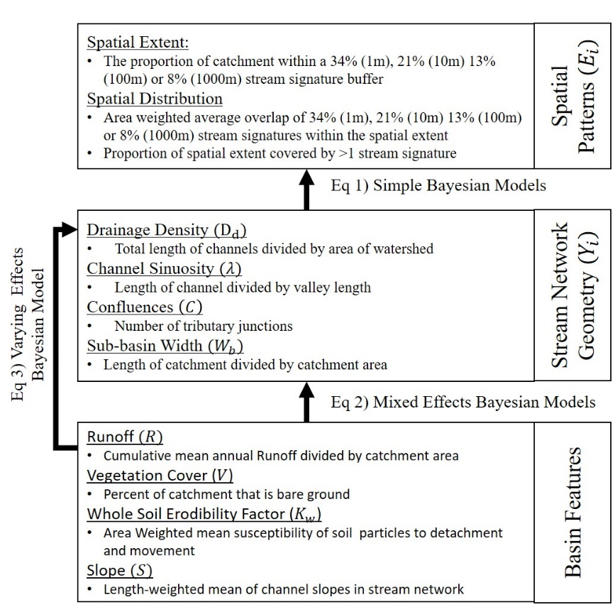
Figure S1.1. Schematic of modeling approach used in the analysis.
Table S1.1. Intercept estimates (back transformed) with 90%CrI demonstrating regional variability in intercept estimates for equation 2. $D_{d}$ = drainage density, $C$ = number of confluences, $W_{b}$ = median basin width and $λ$ = mean sinuosity
VPU | $$D_{d}$$ | $$W_{b}$$ | $$λ$$ | $$C$$
01 | 0.63 (0.57, 0.7) | 620.87 (571.41, 676) | 1.23 (1.21, 1.26) | 78.52 (66.01, 92.94)
02 | 0.62 (0.56, 0.68) | 706.01 (653.62, 765.48) | 1.21 (1.19, 1.24) | 67.87 (57.85, 80.14)
03N | 0.83 (0.76, 0.89) | 570.06 (525.35, 618.04) | 1.18 (1.16, 1.21) | 103.8 (88.22, 122.45)
03S | 0.82 (0.74, 0.89) | 536.01 (490.53, 587.27) | 1.13 (1.1, 1.15) | 89.66 (75.46, 106.42)
03W | 0.91 (0.85, 0.98) | 589.84 (541.31, 642.58) | 1.2 (1.17, 1.22) | 133.45 (111.99, 158.14)
04 | 0.7 (0.64, 0.77) | 654.04 (603.72, 709.16) | 1.26 (1.23, 1.28) | 65.24 (55.21, 76.97)
05 | 0.67 (0.61, 0.74) | 752.51 (695.28, 815.93) | 1.25 (1.22, 1.27) | 91.38 (77.93, 107.58)
06 | 0.76 (0.69, 0.83) | 670.09 (615.12, 732.83) | 1.24 (1.21, 1.26) | 109.83 (92.53, 132.3)
07 | 0.75 (0.68, 0.81) | 742.02 (686.81, 802.8) | 1.23 (1.2, 1.25) | 78.62 (66.85, 92.25)
08 | 0.94 (0.87, 1.02) | 509.41 (462.8, 561.2) | 1.23 (1.21, 1.26) | 164.24 (136.44, 198.52)
09 | 0.69 (0.63, 0.75) | 651.53 (603.04, 704.34) | 1.3 (1.27, 1.32) | 41.24 (34.83, 48.18)
10L | 0.91 (0.85, 0.97) | 650.3 (603.2, 701.37) | 1.27 (1.25, 1.29) | 56.16 (48.11, 65.57)
10U | 0.88 (0.82, 0.93) | 687.68 (639.53, 742.81) | 1.33 (1.31, 1.36) | 38.57 (33.27, 45.11)
11 | 0.85 (0.8, 0.91) | 609.92 (565.04, 655.94) | 1.27 (1.25, 1.3) | 57.34 (49.45, 67.04)
12 | 0.64 (0.59, 0.7) | 980.95 (907.57, 1057.27) | 1.3 (1.28, 1.32) | 47.55 (40.88, 55.9)
13 | 0.71 (0.65, 0.77) | 798.35 (740.69, 862.48) | 1.18 (1.16, 1.2) | 26.42 (22.51, 30.87)
14 | 0.85 (0.79, 0.91) | 674.05 (622.05, 724.35) | 1.21 (1.19, 1.23) | 27.64 (23.6, 32.41)
15 | 0.96 (0.9, 1.02) | 693.59 (638.56, 748.96) | 1.22 (1.2, 1.24) | 24.27 (20.7, 28.45)
16 | 0.83 (0.76, 0.89) | 600.77 (555.27, 653.19) | 1.18 (1.15, 1.2) | 21.59 (18.26, 25.37)
17 | 0.63 (0.57, 0.7) | 776.06 (717.48, 843.83) | 1.2 (1.18, 1.23) | 44.54 (37.22, 52.35)
18 | 0.82 (0.75, 0.88) | 649.14 (597.52, 703.64) | 1.23 (1.2, 1.25) | 39.56 (33.39, 46.85)

Table S1.2. Model selection results for Eq2. S = Slope, R = Runoff, $K_{w}$= Erodibility and V = Percent Bare Ground. Full indicates the model included all variables. WAIC = Watanabe – Akaike information criterion; pWAIC = effective numbers of parameters; dWAIC = delta WAIC; SE = Standard error and dSE is the standard error of the delta WAIC
Model | Variables | WAIC | pWAIC | dWAIC | weight | SE | dSE
Drainage Density | Full | -187.91 | 27.78 | 0 | 0.55 | 51.32 | NA
Drainage Density | $$S, R, K_{w}$$ | -187.52 | 25.66 | 0.39 | 0.45 | 50.82 | 7.02
Drainage Density | $$S, R$$ | -127.23 | 24.52 | 60.67 | 0 | 49.81 | 17.84
Drainage Density | $$R$$ | -105.58 | 23.35 | 82.32 | 0 | 47.85 | 19.76
Drainage Density | Intercept | -24.42 | 22.13 | 163.49 | 0 | 47.38 | 26.35
Basin Width | $$S, R, K_{w}$$ | 158.67 | 25.06 | 0 | 0.35 | 57.5 | NA
Basin Width | $$S, R$$ | 158.71 | 26.12 | 0.04 | 0.35 | 58.28 | 3.03
Basin Width | Full | 159.29 | 26.61 | 0.62 | 0.26 | 58.3 | 3.11
Basin Width | $$S$$ | 163 | 23.88 | 4.33 | 0.04 | 57.01 | 3.59
Basin Width | Intercept | 176.92 | 22.83 | 18.25 | 0 | 56.93 | 8.89
Confluences | $$S, R$$ | 1197.98 | 23.44 | 0 | 0.7 | 42.78 | NA
Confluences | $$S, R, V$$ | 1200.37 | 25.12 | 2.4 | 0.21 | 42.86 | 3.04
Confluences | Full | 1202.06 | 25.92 | 4.08 | 0.09 | 42.93 | 3.3
Confluences | $$R$$ | 1270.37 | 22.53 | 72.39 | 0 | 41.66 | 15.38
Confluences | Intercept | 1518.79 | 21.45 | 320.82 | 0 | 37.39 | 32.46
Sinuosity | $$S, R$$ | -2018.21 | 25.4 | 0 | 0.4 | 60.5 | NA
Sinuosity | Full | -2018.12 | 27.34 | 0.09 | 0.39 | 60.55 | 3.83
Sinuosity | $$S, R, K_{w}$$ | -2016.92 | 26.08 | 1.29 | 0.21 | 60.48 | 0.89
Sinuosity | $$R$$ | -1994.55 | 24.29 | 23.65 | 0 | 60.92 | 10.89
Sinuosity | Intercept | -1960.09 | 23.03 | 58.12 | 0 | 60.51 | 16.54

Trait-environment relationships could alter the spatial and temporal characteristics of aquatic insect subsidies at the macrospatial scale

Published in 2020 at Ecography: https://doi.org/10.1111/ecog.05298
Darin A. Kopp and Daniel C. Allen

Ecology and Evolutionary Biology Program, Department of Biology, University of Oklahoma, Norman, Oklahoma 73071

Abstract
Ecological flows across ecosystem boundaries are typically studied at spatial scales that limit our understanding of broad geographical patterns in ecosystem linkages. Aquatic insects that metamorphose into terrestrial adults are important resource subsidies for terrestrial ecosystems. Traits related to their development and dispersal should determine their availability to terrestrial consumers. Here, we synthesize geospatial, aquatic biomonitoring and biological traits data to quantify the relative importance of several environmental gradients on the potential spatial and temporal characteristics of aquatic insect subsidies across the contiguous United States (CONUS). We found the trait composition of benthic macroinvertebrate communities varies among hydrologic regions and could affect how aquatic insects transport subsidies as adults. Further, several trait-environment relationships were underpinned by hydrology. Large-bodied taxa that could disperse further from the stream were associated with hydrologically stable conditions. Alternatively, hydrologically variable conditions were associated with multivoltine taxa that could extend the duration of subsidies with periodic emergence events throughout the year. We also found that anthropogenic impacts decrease the frequency of individuals with adult flight but potentially extend the distance subsidies travel into the terrestrial ecosystem. Collectively, these results suggest that natural and anthropogenic gradients could affect aquatic insect subsidies by changing the trait composition of benthic macroinvertebrate communities. The conceptual framework and trait-environment relationships we present shows promise for understanding broad geographical patterns in linkages between ecosystems.

Keywords: resource subsidies, aquatic insects, trait-environment relationships, Ephemeroptera, Plecoptera, Trichoptera, Diptera, Odonata, National Rivers and Streams Assessment, streams, bioassessment, Stream Signature

Introduction
Material and energy fluxes across ecosystem boundaries, termed “resource subsidies”, couple adjacent ecosystems (Polis et al. 1997, Loreau et al. 2003, Holt 2004). Resource subsidies are globally common (Polis et al. 1997, Allen and Wesner 2016, Gounand et al. 2018) and play critical roles in controlling food webs and ecosystem production (Leroux and Loreau 2008, Yu et al. 2015, Gratton et al. 2017). The effect of resource subsidies is typically studied at local scales, which limits our understanding of large scale geographical variation in ecosystem linkages (Marcarelli et al. 2011, Subalusky and Post 2018, Lafage et al. 2019). When subsidies are transported by animals, their dispersal and development traits should influence the recipient ecosystem, determining the spatial extent of resource subsidies (i.e. the distance they travel form the donor ecosystem) and the period of time they are available to consumers (Yang et al. 2010, Muehlbauer et al. 2014, Gratton et al. 2017, Subalusky and Post 2018). If the presence of traits varies predictably with environmental conditions, trait distributions could underpin macroscale patterns in ecosystem linkages (Montagano et al. 2018, Lafage et al. 2019).
Aquatic insects that metamorphose into winged, terrestrial adults are important resources in terrestrial ecosystems (Baxter et al. 2005, Richardson et al. 2010, Schindler and Smits 2017). Traits related to their emergence and potential dispersal as adults should influence the duration and magnitude of their effect on terrestrial ecosystems. Terrestrial consumers respond to the quantity of aquatic insect subsidies (Nakano and Murakami 2001, Messan et al. 2018, Recalde et al. 2020) which, in turn, should be related to the proportion of individuals with adult flight stages in aquatic invertebrate communities (Gratton and Vander Zanden 2009, Greenwood and Booker 2016, McKie et al. 2018). Juvenile development speed and adult emergence patterns should determine when, and for how long, aquatic insects are present in terrestrial ecosystems. More frequent emergence events associated with faster development or shorter generation times should prolong the duration of aquatic insect subsidies in terrestrial ecosystems (Anderson et al. 2008, Gratton et al. 2017, McKie et al. 2018). The distance adult aquatic insects travel from the stream determines whether they are accessible to terrestrial consumers living further from the water’s edge (Carlson et al. 2016). Dispersal distance should be related to an individual’s flight strength, adult life span, and/or body size (Muehlbauer et al. 2014, McKie et al. 2018, Lancaster et al. 2020).
Environmental gradients should constrain the spatial and temporal characteristics of aquatic insect subsidies by altering trait composition (Statzner et al. 2004, Heino et al. 2013, Dodds et al. 2015). For example, traits for faster development and greater dispersal abilities typically persist in unpredictable environments because they promote avoidance of, and/or recolonization after, floods and droughts (Townsend and Hildrew 1994, Poff et al. 2010, 2018). Similarly, agriculture and urbanization impairs water quality, favoring pollutant tolerant taxa with smaller body size and shorter generation times (Allan 2004, McKie et al. 2018). At larger spatial scales trait composition may depend on environmental legacies (e.g. past glaciation; Ribera and Vogler 2004) or the regional species pool (Heino et al. 2013). Thus, evaluating trait-environment relationships for in-stream macroinvertebrate communities should be useful for anticipating how spatial and temporal subsidy characteristics might be impacted by global change (Larsen et al. 2016).
Here, we evaluate nine univariate trait-environment relationships for traits that could regulate the supply, extent and duration of aquatic insect subsidies in terrestrial ecosystems (Table 1). Our primary objectives were to: 1) develop a framework to assess large-scale geographic variation in the potential spatial and temporal characteristics of aquatic insect subsidies and 2) evaluate the relative importance of environmental (natural and anthropogenic) and geographical gradients in driving variation in trait composition of benthic macroinvertebrate communities (Figure S1). Because traits reflect an organism’s adaptation to their environment, trait composition should covary with geographic variation in environmental and anthropogenic land use gradients. By synthesizing a national survey of benthic macroinvertebrate communities with a biological traits database, our results can be used to develop hypotheses about the spatial and temporal heterogeneity of aquatic insect subsidies and the potential connectivity between ecosystems.

Methods
Supply, extent and duration of subsidies
We used the National Rivers and Streams Assessment (NRSA; U.S. EPA 2016a) benthic macroinvertebrate surveys to generate nine metrics related to the supply, extent and duration of aquatic insect subsidies (Table 1). The primary goal of the NRSA is to conduct biological assessments of flowing waters in the US (U.S. EPA 2016a). As part of this national effort, NRSA collected composite benthic macroinvertebrate samples and physical habitat data (described below) from 1,924 stream reaches throughout the contiguous US between May and September 2008-2009 (Figure S2). Benthic macroinvertebrates samples containing > 300 individuals were subsampled to a fixed number of individuals (typically 300; U.S.EPA 2016a) and identified to lowest possible taxonomic level (usually genus).
We calculated the proportion of taxonomic Orders with flying adult life stages (i.e. Ephemeroptera, Plecoptera, Trichoptera, Diptera and Odonata; Baxter et al. 2005) relative to other members of the community as an indicator of the supply of aquatic insect subsidies. We estimated the spatial extent of aquatic insect subsidies using the “stream signature” concept, where the stream signature is the distance a given proportion of insect subsidies measured at the water’s edge travels perpendicular from the stream (Muehlbauer et al. 2014). We calculated the distance that 25% of the subsidies emerging from the stream travel away from the water (i.e. “25% stream signature”) using regression coefficients from a negative power function parameterized via meta-analysis of 109 studies given in Appendix B of Muehlbauer et al. (2014). Major taxonomic groups of flying aquatic insects (i.e. Ephemeroptera, Plecoptera, Trichoptera and Chironomidae [Diptera]) have different regression coefficients so we weighted the 25% stream signature by the relative abundance of each taxon for each site. We excluded members of Odonata and non-chironomid Diptera because stream signature coefficients were unavailable for these taxa and used the same “productivity” coefficient for all sites (Muehlbauer et al. 2014).
We derived seven additional metrics of dispersal and development traits using the Freshwater Biological Traits Database (Table 1; U.S. EPA 2012; McKie et al. 2018). Traits were assigned to flying genera collected by the NRSA survey and allowed us to explore potential variation in spatial and temporal subsidy characteristics at a finer taxonomic resolution than the stream signature. Prior to assigning “trait-states” for dispersal and development traits (Table 1; Vieira et al. 2006), we harmonized genus names between the two datasets using the Integrated Taxonomic Information System (https://www.itis.gov/taxmatch.html). We then quantified trait composition as the proportion of individuals expressing a trait-state that could increase the spatial extent or duration of subsidies relative to the total number of flying individuals with trait information (Table 1; McKie et al. 2018).

Environmental gradients and anthropogenic disturbance class
We used a combination of field and GIS data to characterize physical and hydrological conditions and anthropogenic disturbances at each site (Table 2). Mean depth and wetted width of the stream, percent embeddedness and substrate < 16mm in diameter were collected by the NRSA (U.S. EPA 2016a). We obtained catchment area (km²), elevation (m), slope (%), discharge (m³ s⁻¹) and land cover (% agricultural or urban) from the National Hydrography Dataset Plus, Version 2 (NHDPlusV2; McKay et al. 2012). We extracted temperature and hydrologic data at each site from McManamay and Derolph (2019). Briefly, McManamay and Derolph (2019) predicted mean summer water temperature at 1,764 reference locations and classified hydrological conditions at 2,600 USGS stream gages into 15 different classes. Temperature and hydrologic classes were extrapolated to ungaged locations across the entire NHDPlusV2 using a suite of environmental variables (McManamay and Derolph 2019).
The NRSA also classified anthropogenic impacts at each site as “good” (least disturbed), “fair” (moderately disturbed) or “poor” (most disturbed) based on a multi-metric index (MMI) (U.S. EPA 2016a). The MMI combines multiple attributes of the biological community (e.g. composition, tolerance to disturbance and habitat preference) into a single index (Stoddard et al. 2008, U.S. EPA 2016a, Hill et al. 2017). Condition class of a site is assigned using percentiles of MMI scores calculated at minimally impacted sites (Herlihy et al. 2008, Hill et al. 2017). We present analyses linking MMI to traits that could reflect the spatial and temporal characteristics of subsidies to place our results in a general bioassessment context, although we acknowledge that MMI and some trait-states may be correlated.

Data analysis
Of the 1,924 NRSA sites surveyed for benthic macroinvertebrates, 36 samples were lost during processing and 29 sites lacked sufficient environmental data. We discarded an additional 7 sites because it was not possible to estimate a stream signature for sites with only Odonata and/or non-chironomid Diptera as flying taxa, leaving us with 1,852 sites for this study (Figure S2A). Due to data availability, we restricted the trait analysis to sites that had trait assignments for > 50% of the flying individuals (n = 574, Figure S2B) and calculated the frequency of a given trait-state using only individuals with trait data. We chose this threshold to achieve a minimum sample size for each hydrologic region (n ≥ 3, Table S1) but found similar results for more conservative thresholds (i.e. > 60, > 70, and > 80%; Table S2). Further, trait data were only available for 232 genera (46% of flying genera) and were unequally represented among the taxonomic groups collected during the NRSA survey (i.e. 14% Diptera, 75% Ephemeroptera, 67% Odonata, 88% Plecoptera, 68% Tricoptera; Figure S3A). Given the relatively low representation of Diptera in the traits database, sites dominated by these taxa may have been excluded from our analysis (Figure S3B).
We used random forest regression models to predict each of the nine response variables from 15 environmental predictor variables (Breiman 2001,Table 2). Random forest is a machine learning algorithm that combines predictions from multiple independent decision trees and is now common in ecology (Fox et al. 2017, Hill et al. 2017). Prior to model fitting we randomly selected and withheld 20% of sites for validation. We removed strongly correlated variables (r > 0.7; DISCHARGE, WIDTH and DEPTH and JA_TEMP) to avoid potentially misleading estimates of variable importance (Gregorutti et al. 2017). The remaining variables were mean-centered and standardized.
Models were fit using the “randomForest” R-package (Liaw and Wiener 2002). Random forest models have two tuning parameters that specify the number of variables randomly selected at each node (mtry) and the number of trees used to build the model (ntree). We conducted a sensitivity analysis to evaluate different parameter values for each model (Figure S4, S5; Fox et al. 2017, Brieuc et al. 2018). Consistent with Fox et al. (2017), we found the optimal mtry value offered little improvement over the default (mtry = 4) for many of the models (Figure S4), but increasing the number of trees enhanced the reproducibility (Figure S5). We specified mtry = 4 and ntree = 3000 for all models except FSS (mtry =1, ntree = 3000). We evaluated model performance with Nash–Sutcliffe efficiency (NSE), mean absolute error (MAE), the ratio of the root mean square error to the standard deviation of observed data (RSR) and Out-of-Bag R² (Moriasi et al. 2007, Greenwood and Booker 2016).
We used mean decrease in accuracy (MDA) and marginal effects to assess the relative importance and direction of each trait-environment relationship. MDA is the change in mean squared error after permutating a single predictor variable, averaged and scaled by the standard deviation of all trees in the random forest (Liaw and Wiener 2002). Larger MDA values indicate more important variables because permutation increased the mean squared error (Liaw and Wiener 2002). Marginal effects show how a response variable changes with a single independent variable while holding all other variables constant (Elith et al. 2008). We created partial dependence plots to illustrate the marginal effects for the five most important predictor variables for each trait-environmental relationship. When hydrologic region was among the most important predictor variables, we mapped the marginal effects for hydrologic region to visualize geographic differences. The “importance” and “partialPlot” functions were used to calculate MDA and marginal effects, respectively (Liaw and Wiener 2002).
We used Bayesian regression models to evaluate the effect of anthropogenic activities on aquatic insect subsidies. Each model included only NRSA condition class as a grouping term (e.g. “random effect” or “intercept only model”; Wesner et al. 2019) and had either a beta-binominal likelihood with logit link function (i.e. proportional responses) or a normal likelihood (i.e. stream signature distance). We obtained a mean and standard deviation from Muehlbauer et al. (2014) and McKie et al. (2018) to specify the prior for the 25% stream signature and each trait model, respectively (Table S3). All models were fit using the “Rethinking” R package (McElreath 2016) with 4 chains and 10,000 iterations (first 2,000 discarded as warmup). The large number of iterations allowed us to estimate the probability that the posterior distributions of two condition classes overlapped.

Results
Random forest models explained approximately 31% of the variation in the proportion of flying individuals and 18% of the variation in the stream signature distance (Mean Absolute Error [MAE] = 0.17 and 8.79, respectively; Table S4). Elevation, agricultural land use, catchment area and region were among the most important variables in both models (Figure 1A-B). Elevation was associated with an increase in the proportion of flying taxa but a decrease in stream signature distance. Conversely, agriculture had the opposite association. Catchment area had a negative relationship with the proportion of flying taxa and the stream signature distance.
Random forest models explained > 10% of the variation in all trait-states except strong flight strength (min MAE = 0.15, max MAE = 0.23, Table S4). Hydrologic class was the most important variable trait states related to emergence duration (Figure 1C-E) and for large body size (Figure 1F). The “Intermittent Flashy” hydrologic class appeared to have the lowest proportion of individuals with poorly synchronized emergence and fast development but high multivoltinism while the “stable” hydrologic classes had higher proportions of large body size (Figure 1F). Catchment area was most important for high female dispersal (Figure 1G) and the proportion of individuals with long life span declined with the percent of fine substrate (Figure 1H).
Hydrologic region was an important variable in all random forest models except strong flight strength (Figure 2). The California (hydrologic unit code [HUC] 18), Rio Grande (HUC13) and Upper Colorado (HUC 14) had the highest proportion of flying individuals and the Upper Mississippi (HUC 07), Ohio (HUC 05) and South Atlantic (HUC 03N and 03S) had the largest stream signature distance (Figure 2B-C). The proportion of poorly synchronized emergence, multivoltinism and fast developing individuals were highest in the Lower Colorado (HUC 14), and Rio Grande (HUC 13) hydrologic regions (Figure 2D-F). Large body size, long life span and high female dispersal were most prevalent in the California (HUC 18) hydrologic region but were generally variable among hydrologic regions (Figure 2G-I).
The habitat condition class affected the potential spatial and temporal characteristics of aquatic insect subsidies (Figure 3). The least disturbed sites had the greatest proportion of flying individuals (Mean, [95% Credible Interval]: 0.71, [0.68, 0.74]; Figure 3A) but the lowest 25% stream signature distance (27.17, [25.65, 28.69]; Figure 3B). In both instances, the probability of overlap between the posterior distributions of the least and most disturbed condition (hereafter “Pr”) was < 0.0001. Poorly synchronized emergence and fast development were higher at the least disturbed sites (Pr = 0.11 and 0.02, respectively; Figure 3C & 3E) but multivoltinism was higher at the most disturbed sites (Pr < 0.01, Figure 3D). Large body size and long life span were more prevalent in the least disturbed condition (Pr = 0.04 and 0.03, respectively; Figure 3F & 3H) and the proportion of high female dispersal and strong flying strength was higher in the most disturbed condition (Pr = 0.03 and 0.11, respectively; Figure 3G & 3I).

Discussion
Understanding how ecosystems are linked is a focal area of ecological research (Allen and Wesner 2016, Tanentzap et al. 2017, Gounand et al. 2018) but understanding how these linkages vary across large spatial scales remains unclear. We developed a conceptual framework centered on hydroclimatic and physiographic variables that generate geographical variation in species traits that could influence spatial and temporal characteristics of animal-mediated resource subsidies in recipient ecosystems. Using aquatic insects as a focal organism, we tested this framework and found that a combination of watershed and land use variables could influence the supply, duration and distance of aquatic insect subsidy transport to terrestrial ecosystems.
Stream signatures and the potential supply of insect subsidies
The proportion of flying individuals and the 25% stream signature was largely influenced by network position (i.e. catchment area and elevation; Tonkin et al. 2016). Larger proportions of flying individuals at higher elevations and in smaller catchments could result from environmental filters common to these habitats. For example, cooler water temperatures in headwater systems could preclude warm-adapted, non-flying taxa such as many snails (Nelson et al. 2017). Alternatively, the enhanced dispersal abilities of flying taxa could enable them to colonize headwaters as isolated termini of stream networks (Clarke et al. 2008, Finn et al. 2011). Stream signature distance, however, was negatively related to both catchment area and elevation which may be due to the taxa that are most associated with headwaters. Muehlbauer et al. (2014) found that the stream signature decays quickest for Ephemeroptera and Plecoptera (i.e. these orders have the shortest stream signature). Indeed, some Ephemeroptera develop as larva in mainstem river sections (Uno and Power 2015), and cooler water temperatures at higher elevations could favor Plecoptera as cold water adapted taxa (Anderson et al. 2019). Importantly, these findings suggest that the potential supply and spatial extent of aquatic insect subsidies could vary along longitudinal gradients in streams as a result of differences in trait frequencies within benthic macroinvertebrate communities in headwaters vs. mainstems.
Agricultural land use in the watershed was associated with a decrease in the proportion of flying insects but an increase in stream signature distance. Land use intensification can alter the trait composition of benthic macroinvertebrate communities by favoring pollution tolerant taxa (Allan 2004, Dolédec et al. 2006), such as Chironomidae (Diptera) (Serra et al. 2017, Raitif et al. 2019) or mollusks (Harding and Winterbourn 1995, Greenwood and Booker 2016). Chironomidae have the longest stream signature distance of all flying orders studied by Muehlbauer et al. (2014), and increasing their relative abundances could increase the spatial extent of aquatic insect subsidies. Consequently, anthropogenic impacts in the watershed may decrease the relative magnitude of aquatic insect subsidies in the terrestrial environment, but the spatial extent of that subsidy might be relatively greater.
The importance of hydrologic region for explaining the proportion of flying individuals and the 25% stream signature distance supports the notion that cross-ecosystem linkages can vary across broad spatial scales. For example, if we assume the entire larval community can metamorphose into winged adults, then the California (HUC 18) hydrologic region could export 10% more aquatic insect subsidies than the Southern Atlantic (HUC 03S), all else being equal. Similarly, aquatic insects may be expected to travel further from where they emerge in the Upper Mississippi (HUC 07) than the Upper Colorado (HUC 13) because of longer stream signature distances. These regional patterns in trait composition could reverberate throughout the landscape and drive differences in subsidy use among terrestrial consumers (Lafage et al. 2019).

Traits of flying individuals
Hydroclimatic features played an important role in structuring the presence and abundance of trait-states that should influence the spatio-temporal characteristics of aquatic insect subsidies. For example, flying individuals living in perennial or groundwater dominated systems were typically larger and have long-lived adult phases and sites with lower precipitation were associated with higher frequencies of asynchronous emergence and fast development. Given these relationships, we might expect hydrologically stable reaches to export aquatic insect subsidies that are larger in size and can live longer in terrestrial ecosystems and more arid locations to export subsidies more consistently when there is water in the stream channel. If these trait-states increase an organisms ability to survive and reproduce in their environment (Townsend and Hildrew 1994, Giam et al. 2017), these results could provide insights into how the aquatic insect subsidies might be impacted by climate change, as many flow regimes are predicted to become less stable (Barnett et al. 2008, Mallakpour and Villarini 2015, Blöschl et al. 2017).
Many of the trait-environment relationships we analyzed may be partly explained by interdependence among traits (Hamilton et al. 2020) and therefore difficult to mechanistically interpret or to attribute causation (Verberk et al. 2013). For example, we found the percentage of fine substrate was associated with a decreased frequency of large body size among flying taxa, presumably because smaller substrates do not provide refuge and interstitial habitat for larger taxa (Townsend and Hildrew 1994). We also found substrate size was associated with lower frequencies of long life span, and high female dispersal and higher frequency of multivoltinism. These trait-environment relationships are more difficult to attribute to the availability of refugia provided by substrate size but instead are likely correlated with body size (Resh et al. 1988, Usseglio-Polatera et al. 2000, Verberk et al. 2008, Lancaster et al. 2020). Indeed, univariate trait-environment relationships are known to be challenging to interpret from a strict mechanistic perspective (Poff et al. 2006) and may not accurately describe how trait composition will change in under future conditions (Verberk et al. 2013).
Our results elucidate large-scale patterns in trait composition of flying taxa that could drive regional differences in the characteristics aquatic insect subsidies. For example, the California hydrologic region (HUC 18) was associated with taxa with greater body size, female dispersal ability and longer life span. Larger bodied individuals may yield a larger quantity of subsidy to terrestrial consumers and individuals that live longer as adults, or fly further before ovipositing, may be more likely to be consumed further from the stream (McKie et al. 2018) Similarly, terrestrial consumers in the Great Basin (HUC 16) could have access to aquatic insect subsidies for longer periods of time because flying insects in benthic communities typically develop quicker and emerge irregularly throughout the year. Collectively, the geographical patterns we detected in the trait composition of benthic macroinvertebrate communities could provide insights into the large scale variation in the use of aquatic insect subsidies by terrestrial consumers detected in other studies (Lafage et al. 2019).

Extended consequences of anthropogenic impacts
Consistent with other investigations, our results demonstrate that anthropogenic activities could impact aquatic insect subsidy dynamics by altering the trait composition of benthic macroinvertebrate communities (Greenwood and Booker 2016, McKie et al. 2018). We found sites classified as most disturbed had lower proportions of individuals that could fly, and could therefore leave the stream to subsidize terrestrial ecosystems. Proportional data however may not correspond to absolute emergence values. Others have found nutrient additions can increase the abundances of all invertebrate taxa, including those with winged adult phases (Davis et al. 2011, Greenwood and Booker 2016, McKie et al. 2018). Among our sites elevated nitrogen or phosphorous concentrations were a good predictor of site degradation (U.S. EPA 2016b), but absolute abundance values could not be calculated given the survey methods. If anthropogenic activities increase the overall abundance of flying taxa, exceptional emergence events from disturbed sites may be able to offset some anthropogenic nutrient loading in waterways (Stepanian et al. 2020).
The most disturbed sites also had the longest stream signatures which could suggest aquatic insect subsidies are available to consumers living further from the water’s edge at these sites. Members of Chironomidae (Diptera) often dominate disturbed sites (but see Serra et al. 2017) and, being generally small bodied taxa, their longer stream signature distance may be due to wind transport (Muehlbauer et al. 2014). Diptera are an exceptionally diverse order, however, and we only included members of Chironomidae to calculate the stream signature due to limitations of data availability in the meta-analysis of Muehlbauer et al. (2014). It is possible that other Diptera taxa could change the potential relationship between the level of disturbance and lateral extent of aquatic insect subsidies. Further we do not know how the condition of the aquatic ecosystem interacts with the permeability of the terrestrial boundary (but see Greenwood 2014, Carlson et al. 2016 and Alberts and Sullivan 2016). Clarifying these uncertainties will require increasing the representation of Diptera in traits databases and increasing our understanding of how boundary conditions could alter the spatio-temporal characteristics of aquatic insect subsidies beyond what their traits suggest.
The frequency of trait-states among flying taxa also differed according to disturbance class. High female dispersal, strong flight strength and multivoltinism were more common at the most disturbed sites, suggesting that individuals may be able to travel comparatively further into the terrestrial environment and, because of their shorter generation times, emerge from the stream more often. We also found that large body size, long life span, poorly synchronized emergence and fast development were more common at least disturbed sites. Interestingly, it seems that both least and most disturbed sites could increase the spatial extent and duration of insect subsidies by favoring different trait-states. One should note, however, that high female dispersal in agricultural sites can result from the presence of small-bodied, blood-feeding Diptera (Ceratopogonidae and Simuliidae, McKie et al. 2018) which may be available to a different suite of terrestrial consumers than large bodied taxa (Davis et al. 2011). Thus, even though the least and most disturbed sites are associated with traits that increase spatial extent, their subsequent effect on terrestrial consumers may be different. Future research should address the relative importance of, and interactions between, larval traits as indicators of spatial and temporal characteristics of aquatic insect subsidies.

Limitations
Our results are indicative of potential characteristics of aquatic subsidies as they are transported into terrestrial ecosystems by adults. Although adults and their traits are sourced from aquatic communities, emergence rates are likely variable among taxa (Poepperl 2000, Moyo 2020) and location (Gratton and Vander Zanden 2009). The trait-environmental relationships we uncovered however, could be used in tandem with large-scale analyses of aquatic secondary production (Patrick et al. 2019) to refine estimates of aquatic insect deposition (Gratton and Vander Zanden 2009, Bartrons et al. 2013). For example, the proportion of flying taxa in a larval community may constrain the amount of secondary production that can be exported from a stream. Site-specific estimates of the stream signature distance could better capture variation in lateral extent of subsidies in the terrestrial ecosystem.
Additionally, trait-environment relationships were assessed at the genus (or order for stream signature) level, and thus sensitive to the availability of trait data. This could mask variation at lower taxonomic levels (Heino et al. 2013). Resolving these limitations will require increasing our knowledge of the relative intra-generic variability in traits and the number of non-chironomid Diptera represented in traits databases.
Finally, we used univariate models to assess trait environment relationships. Although univariate models permit relatively straightforward and transparent interpretation of the trait-environment relationships (Hamilton et al. 2020), multivariate statistical techniques can assess multiple traits simultaneously (Poff et al. 2010, Heino et al. 2013). Evaluating multiple traits could be insightful for identifying the trait(s) that explain most variation among sites and potentially the most important trait driving differences in spatial and temporal characteristics of subsidies.

Conclusions
Benthic macroinvertebrate communities and their traits vary along natural and anthropogenic gradients within and among drainage basins. Importantly, here we show this variation could potentially impact terrestrial consumers by changing the spatial and temporal characteristics of aquatic insect resource subsidies. Several trait-environment relationships were associated with hydroclimate features. If these relationships are mechanistically grounded they could inform predictions about how the frequency of these traits and the potential linkages between aquatic and terrestrial ecosystems could be impacted by global change (Larsen et al. 2016). More generally, the framework and trait-environment relationships we present may be useful for understanding broad geographical patterns in linkages between ecosystems and promote novel applications of biomonitoring data to address novel questions in macroscale ecology.

Acknowledgements
We would like to thank M. Kaspari, J. Kelly, T. Neeson, J. Wu, D. Nelson, M. Busch, J. Heino and two anonymous reviewers for comments on a previous version of this manuscript. We also thank B. McKie for providing data to specify prior distributions for the traits analysis. DA and DK were supported by the US National Science Foundation (award 1802872, and additional support to DA was provided by award 1754389).

References
Allan, J. D. 2004. Landscapes and Riverscapes: The Influence of Land Use on Stream Ecosystems. Annual Review of Ecology, Evolution, and Systematics 35:257–284.
Allen, D. C., and J. Wesner. 2016. Synthesis: comparing effects of resource and consumer fluxes into recipient food webs using meta-analysis. Ecology 97:594–604.
Allen, G. H., and T. M. Pavelsky. 2015. Patterns of river width and surface area revealed by the satellite-derived North American River Width data set. Geophysical Research Letters 42:395–402.
Allen, G. H., T. M. Pavelsky, E. A. Barefoot, M. P. Lamb, D. Butman, A. Tashie, and C. J. Gleason. 2018. Similarity of stream width distributions across headwater systems. Nature Communications 9:610.
Anderson, H. E., L. K. Albertson, and D. M. Walters. 2019. Water temperature drives variability in salmonfly abundance, emergence timing, and body size. River Research and Applications 35:1013–1022.
Anderson, W. B., A. D. Wait, and P. Stapp. 2008. Resources From Another Place and Time: Responses To Pulses in a Spatially Subsidized System. Ecology 89:660–670.
Araújo, M. B., and A. T. Peterson. 2012. Uses and misuses of bioclimatic envelope modeling. Ecology 93:1527–1539.
Baker, M. E., D. E. Weller, and T. E. Jordan. 2007. Effects of stream map resolution on measures of riparian buffer distribution and nutrient retention potential. Landscape Ecology 22:973–992.
Baldwin, D. J. B., K. Weaver, F. Schnekenburger, and A. H. Perera. 2004. Sensitivity of landscape pattern indices to input data characteristics on real landscapes: implications for their use in natural disturbance emulation. Landscape Ecology 19:255–271.
Barnett, T. P., D. W. Pierce, H. G. Hidalgo, C. Bonfils, B. D. Santer, T. Das, G. Bala, A. W. Wood, T. Nozawa, A. a Mirin, D. R. Cayan, and M. D. Dettinger. 2008. Human-Induced Changes in the Hydrology of the Western United States. Science 319:1080–1083.
Bartrons, M., M. Papeş, M. W. Diebel, C. Gratton, and M. J. Vander Zanden. 2013. Regional-Level Inputs of Emergent Aquatic Insects from Water to Land. Ecosystems 16:1353–1363.
Baxter, C. V., K. D. Fausch, and W. C. Saunders. 2005. Tangled webs: Reciprocal flows of invertebrate prey link streams and riparian zones. Freshwater Biology 50:201–220.
Benda, L., N. L. Poff, D. Miller, T. Dunne, G. G. Reeves, G. Pess, and M. Pollock. 2004. The Network Dynamics Hypothesis: How Channel Networks Structure Riverine Habitats. BioScience 54:413.
Benstead, J. P., and D. S. Leigh. 2012. An expanded role for river networks. Nature Geoscience 5:678–679.
Bieger, K., H. Rathjens, P. M. Allen, and J. G. Arnold. 2015. Development and Evaluation of Bankfull Hydraulic Geometry Relationships for the Physiographic Regions of the United States. Journal of the American Water Resources Association 51:842–858.
Blöschl, G., J. Hall, J. Parajka, R. A. P. Perdigão, B. Merz, B. Arheimer, G. T. Aronica, A. Bilibashi, O. Bonacci, M. Borga, Č. Ivan, A. Castellarin, and G. B. Chirico. 2017. Climate change shifts timing of European floods. Science 590:588–590.
Borcard, D., F. Gillet, and P. Legendre. 2018. Numerical Ecology with R. second. Springer Nature, Cham, Switzerland.
Breiman, L. 2001. Random forests. Machine Learning 45:5–32.
Brieuc, M. S. O., C. D. Waters, D. P. Drinan, and K. A. Naish. 2018. A practical introduction to Random Forest for genetic association studies in ecology and evolution. Molecular Ecology Resources 18:755–766.
Bultman, H., D. Hoekman, J. Dreyer, and C. Gratton. 2014. Terrestrial deposition of aquatic insects increases plant quality for insect herbivores and herbivore density. Ecological Entomology 39:419–426.
Bürkner, P. C. 2017. brms: An R package for Bayesian multilevel models using Stan. Journal of Statistical Software 80.
Buyantuyev, A., and J. Wu. 2007. Effects of thematic resolution on landscape pattern analysis. Landscape Ecology 22:7–13.
Campbell Grant, E. H. 2011. Structural complexity, movement bias, and metapopulation extinction risk in dendritic ecological networks. Journal of the North American Benthological Society 30:252–258.
Carlson, P. E., B. G. Mckie, L. Sandin, and R. K. Johnson. 2016. Strong land-use effects on the dispersal patterns of adult stream insects: implications for transfers of aquatic subsidies to terrestrial consumers. Freshwater Biology 61:848–861.
Clarke, A., R. Mac Nally, N. Bond, and P. S. Lake. 2008. Macroinvertebrate diversity in headwater streams: A review. Freshwater Biology 53:1707–1721.
Collins, S. E., S. F. Matter, I. Buffam, and J. E. Flotemersch. 2018. A patchy continuum? Stream processes show varied responses to patch- and continuum-based analyses. Ecosphere 9.
Collins, S. E., M. C. Thoms, and J. E. Flotemersch. 2014. Hydrogeomorphic zones characterize riverbed sediment patterns within a river network. River Systems 21:203–213.
Comte, L., and J. D. Olden. 2018. Fish dispersal in flowing waters: A synthesis of movement- and genetic-based studies. Fish and Fisheries 19:1063–1077.
Cote, D., D. G. Kehler, C. Bourne, and Y. F. Wiersma. 2009. A new measure of longitudinal connectivity for stream networks. Landscape Ecology 24:101–113.
Cushman, S. A., J. Littell, and K. McGarigal. 2010. The Problem of Ecological Scaling in Spatially Complex, Nonequilibrium Ecological Systems. Pages 1–458 in Cushman S.A. and F. Huettmann (editors). Spatial Complexity, Informatics, and Wildlife Conservation. Springer, Tokyo.
Datry, T., H. Pella, C. Leigh, N. Bonada, and B. Hugueny. 2016. A landscape approach to advance intermittent river ecology. Freshwater Biology n/a-n/a.
Davis, J. M., A. D. Rosemond, and G. E. Small. 2011. Increasing donor ecosystem productivity decreases terrestrial consumer reliance on a stream resource subsidy. Oecologia 167:821–834.
Demars, B., R. Manson, J. Ólafsson, G. Gíslason, R. Gudmundsdóttir, G. Woodward, J. Reiss, D. Pichler, J. Rasmussen, and N. Friberg. 2011. Temperature and the metabolic balance of streams. Freshwater Biology 56:1106–1121.
Dodds, W. K., L. Bruckerhoff, D. Batzer, A. Schechner, C. Pennock, E. Renner, F. Tromboni, K. Bigham, and S. Grieger. 2019. The freshwater biome gradient framework: Predicting macroscale properties based on latitude, altitude, and precipitation. Ecosphere 10.
Dodds, W. K., K. Gido, M. R. Whiles, M. D. Daniels, and B. P. Grudzinski. 2015. The Stream Biome Gradient Concept: factors controlling lotic systems across broad biogeographic scales. Freshwater Science 34:1–19.
Dolédec, S., N. Phillips, M. Scarsbrook, R. H. Riley, and C. R. Townsend. 2006. Comparison of structural and functional approaches to determining landuse effects on grassland stream invertebrate communities. Journal of the North American Benthological Society 25:44–60.
Dreyer, J., P. A. Townsend, J. C. Hook, D. Hoekman, M. J. Vander Zanden, and C. Gratton. 2015. Quantifying aquatic insect deposition from lake to land. Ecology 96:499–509.
Dunning, J. B. (Ed.). 2008. CRC Handbook of Avian Body Masses. CRC Press.
Elith, J., J. R. Leathwick, and T. Hastie. 2008. A working guide to boosted regression trees. Journal of Animal Ecology 77:802–813.
Epanchin, P., R. Knapp, and S. Lawler. 2010. Nonnative trout impact an alpine-nesting bird by altering aquatic-insect subsidies. Ecology 91:2406–2415.
Erős, T., and W. H. Lowe. 2019. The Landscape Ecology of Rivers: from Patch-Based to Spatial Network Analyses. Current Landscape Ecology Reports 4:103–112.
Fausch, K. D., C. E. Torgersen, C. V. Baxter, and H. W. Li. 2002. Landscapes to riverscapes: Bridging the gap between research and conservation of stream fishes. BioScience 52:483–498.
Faustini, J. M., P. R. Kaufmann, and A. T. Herlihy. 2009. Downstream variation in bankfull width of wadeable streams across the conterminous United States. Geomorphology 108:292–311.
Fink, D., T. Auer, A. Johnston, V. Ruiz-Gutierrez, W. M. Hochachka, and S. Kelling. 2020a. Modeling avian full annual cycle distribution and population trends with citizen science data. Ecological Applications 30:1–16.
Fink, D., T. Auer, A. Johnston, M. Strimas-Mackey, O. Robinson, S. Ligocki, B. Petersen, C. Wood, I. Davies, B. Sullivan, M. Iliff, and S. Kelling. 2020b. eBird Status and Trends, Data Version: 2018; Released: 2020. Cornell Lab of Ornithology, Ithaca, New York.
Finn, D. S., N. Bonada, C. Múrria, and J. M. Hughes. 2011. Small but mighty: headwaters are vital to stream network biodiversity at two levels of organization. Journal of the North American Benthological Society 30:963–980.
Fox, E. W., R. A. Hill, S. G. Leibowitz, A. R. Olsen, D. J. Thornbrugh, and M. H. Weber. 2017. Assessing the accuracy and stability of variable selection methods for random forest modeling in ecology. Environmental Monitoring and Assessment 189:316.
Fullerton, A. H., B. J. Burke, J. J. Lawler, C. E. Torgersen, J. L. Ebersole, and S. G. Leibowitz. 2017. Simulated juvenile salmon growth and phenology respond to altered thermal regimes and stream network shape. Ecosphere 8.
Giam, X., W. Chen, T. A. Schriever, R. Van Driesche, R. Muneepeerakul, D. A. Lytle, and J. D. Olden. 2017. Hydrology drives seasonal variation in dryland stream macroinvertebrate communities. Aquatic Sciences 79:705–717.
Goodrich, B., J. Gabry, I. Ali, and S. Brilleman. 2018. Package ‘rstanarm’’: Bayesian Applied Regression Medeling via Stan.’ (Available from: http://mc-stan.org/)
Gounand, I., C. J. Little, E. Harvey, and F. Altermatt. 2018. Cross-ecosystem carbon flows connecting ecosystems worldwide. Nature Communications 9:4825.
Gratton, C., D. Hoekman, J. Dreyer, and R. D. Jackson. 2017. Increased duration of aquatic resource pulse alters community and ecosystem responses in a subarctic plant community. Ecology 98:2860–2872.
Gratton, C., and M. . Vander Zanden. 2009. Flux of aquatic insect productivity to land: comparison of lentic and lotic ecosystems. Ecology 90:2689–2699.
Greenwood, M. J. 2014. More than a barrier: The complex effects of ecotone vegetation type on terrestrial consumer consumption of an aquatic prey resource. Austral Ecology 39:941–951.
Greenwood, M. J., and D. J. Booker. 2016. Influence of hydrological regime and land cover on traits and potential export capacity of adult aquatic insects from river channels. Oecologia 180:551–566.
Gregorutti, B., B. Michel, and P. Saint-Pierre. 2017. Correlation and variable importance in random forests. Statistics and Computing 27:659–678.
Greig, H. S., P. Kratina, P. L. Thompson, and W. J. Palen. 2012. Warming, eutrophication, and predator loss amplify subsidies between aquatic and terrestrial ecosystems. Global Change Biology 18:504–514.
Hadwen, W. L., C. S. Fellows, D. Westhorpe, G. N. Rees, S. M. Mitrovic, B. Taylor, D. S. Baldwin, E. Silvester, and R. Croome. 2010. Longitudinal trends in river functioning: Patterns of nutrient and carbin processing in three Australian rivers. River Research and Applications 26:1129–1152.
Hamilton, A. T., R. B. Schäfer, M. I. Pyne, B. Chessman, K. Kakouei, K. S. Boersma, P. F. M. Verdonschot, R. C. M. Verdonschot, M. Mims, K. Khamis, B. Bierwagen, and J. Stamp. 2020. Limitations of trait-based approaches for stressor assessment: The case of freshwater invertebrates and climate drivers. Global Change Biology 26:364–379.
Harding, J. S., and M. J. Winterbourn. 1995. Effects of contrasting land use on physico-chemical conditions and benthic assemblages of streams in a canterbury (South Island, New Zealand) river system. New Zealand Journal of Marine and Freshwater Research 29:479–492.
Hargrove, W. W., and F. M. Hoffman. 2004. Potential of multivariate quantitative methods for delineation and visualization of ecoregions. Environmental Management 34:39–60.
Harris, C., M. Thoms, and M. Scown. 2009. The ecohydrology of stream networks. Ecohydrology of Surface and Groundwater Dependent Systems: Concepts, Methods and Recent Developments 328:127–136.
Heffernan, J. B., P. A. Soranno, M. J. Angilletta, L. B. Buckley, D. S. Gruner, T. H. Keitt, J. R. Kellner, J. S. Kominoski, A. V. Rocha, J. Xiao, T. K. Harms, S. J. Goring, L. E. Koenig, W. H. McDowell, H. Powell, A. D. Richardson, C. A. Stow, R. Vargas, and K. C. Weathers. 2014. Macrosystems ecology: Understanding ecological patterns and processes at continental scales. Frontiers in Ecology and the Environment 12:5–14.
Heino, J., D. Schmera, and T. Eros. 2013. A macroecological perspective of trait patterns in stream communities. Freshwater Biology 58:1539–1555.
Herlihy, A. T., S. G. Paulsen, J. Van Sickle, J. L. Stoddard, C. P. Hawkins, and L. L. Yuan. 2008. Striving for consistency in a national assessment: The challenges of applying a reference-condition approach at a continental scale. Journal of the North American Benthological Society 27:860–877.
Hijmans, R. J. 2020. Package ‘ raster ’: Geographic Data Analysis and Modeling. R Package Documentation.
Hijmans, R. J., S. E. Cameron, J. L. Parra, P. G. Jones, and A. Jarvis. 2005. Very high resolution interpolated climate surfaces for global land areas. International Journal of Climatology 25:1965–1978.
Hill, R. A., E. W. Fox, S. G. Leibowitz, A. R. Olsen, D. J. Thornbrugh, and M. H. Weber. 2017. Predictive mapping of the biotic condition of conterminous U.S. rivers and streams. Ecological Applications 27:2397–2415.
Holt, R. D. 2004. Implications of System Openness for Local Community Structure and Ecosystem Function. Pages 96–114 Foodwebs at the Landscape Level.
Horton, R. 1945. Erosional Development of streams and their drainage basins: hydrophysical approach to quantitative morphology. Geological Society Of America Bulletin 56:151–180.
Hubler, S., D. D. Huff, P. Edwards, and Y. Pan. 2016. The Biological Sediment Tolerance Index: Assessing fine sediments conditions in Oregon streams using macroinvertebrates. Ecological Indicators 67:132–145.
Huryn, A. D., and J. B. Wallace. 2000. Life History and Production of Stream Insects. Annual Review of Entomology 45:83–110.
IPCC. 2014. Climate Change 2014: Synthesis Report. Contribution of Woeking Groups I, II, III to the 5th Assessment Report of the Intergovernmental Panel on Climate Change.
Iwata, T., S. Nakano, and M. Murakami. 2003. Stream meanders increase insectivorous bird abundance in riparian deciduous forests. Ecography 26:325–337.
Jackson, H. B., and L. Fahrig. 2015. Are ecologists conducting research at the optimal scale? Global Ecology and Biogeography 24:52–63.
Johnston, A., T. Auer, D. Fink, M. Strimas-Mackey, M. Iliff, K. V. Rosenberg, S. Brown, R. Lanctot, A. D. Rodewald, and S. Kelling. 2020. Comparing abundance distributions and range maps in spatial conservation planning for migratory species. Ecological Applications 30:1–13.
Jones, C. D., J. K. Hughes, N. Bellouin, S. C. Hardiman, G. S. Jones, J. Knight, S. Liddicoat, F. M. O’Connor, R. J. Andres, C. Bell, K. O. Boo, A. Bozzo, N. Butchart, P. Cadule, K. D. Corbin, M. Doutriaux-Boucher, P. Friedlingstein, J. Gornall, L. Gray, P. R. Halloran, G. Hurtt, W. J. Ingram, J. F. Lamarque, R. M. Law, M. Meinshausen, S. Osprey, E. J. Palin, L. Parsons Chini, T. Raddatz, M. G. Sanderson, A. A. Sellar, A. Schurer, P. Valdes, N. Wood, S. Woodward, M. Yoshioka, and M. Zerroukat. 2011. The HadGEM2-ES implementation of CMIP5 centennial simulations. Geoscientific Model Development 4:543–570.
Kendrick, M. R., A. E. Hershey, and A. D. Huryn. 2019. Disturbance, nutrients, and antecedent flow conditions affect macroinvertebrate community structure and productivity in an Arctic river. Limnology and Oceanography 64:S93–S104.
van Klink, R., D. E. Bowler, K. B. Gongalsky, and A. B. Swengel. 2020. Meta-analysis reveals declines in terrestrial but increases in freshwater insect abundances. Science 420:417–420.
Konapala, G., A. Mishra, Y. Wada, and M. E. Mann. 2020. Climate change will affect global water availability through compounding changes in seasonal precipitation and evaporation. Nature Communications 1–10.
Kraus, J. M., J. Wesner, and D. M. Walters. 2020. Contaminants and Ecological Subsidies. Contaminants and Ecological Subsidies.
Lafage, D., E. Bergman, R. L. Eckstein, E. M. Österling, J. P. Sadler, and J. J. Piccolo. 2019. Local and landscape drivers of aquatic-to-terrestrial subsidies in riparian ecosystems: a worldwide meta-analysis. Ecosphere 10:e02697.
Lancaster, J., B. J. Downes, and G. K. Dwyer. 2020. Terrestrial–aquatic transitions: Local abundances and movements of mature female caddisflies are related to oviposition habits but not flight capability. Freshwater Biology 65:908–919.
Larsen, S., J. D. Muehlbauer, and E. Marti. 2016. Resource subsidies between stream and terrestrial ecosystems under global change. Global Change Biology 22:2489–2504.
Lehner, B., K. Verdin, and A. Jarvis. 2008. New global Hydrography derived from spaceborne elevation data. Eos Transactions 94–94.
Leroux, S. J., and M. Loreau. 2008. Subsidy hypothesis and strength of trophic cascades across ecosystems. Ecology Letters 11:1147–1156.
Li, H., and J. Wu. 2004. Use and misuse of landscape indices. Landscape Ecology 19:389–399.
Liaw, A., and M. Wiener. 2002. Classification and Regression by randomForest. R News 2:18–22.
Loreau, M., N. Mouquet, and R. D. Holt. 2003. Meta-ecosystems: a theoretical framework for a spatial ecosystem ecology. Ecology Letters 6:673–679.
Maasri, A., J. H. Thorp, J. K. Gelhaus, F. Tromboni, S. Chandra, and S. J. Kenner. 2019. Communities associated with the Functional Process Zone scale: A case study of stream macroinvertebrates in endorheic drainages. Science of the Total Environment 677:184–193.
Maechler, M., P. Rousseeuw, A. Struyf, M. Hubert, K. Hornik, M. Studer, P. Roudier, J. Gonzalez, K. Kozlowski, E. Schubert, and K. Murphy. 2019. Package “cluster” for R: ‘Finding Groups in Data’: Cluster Analysis Extended. R package version 2.1.0.
Mallakpour, I., and G. Villarini. 2015. The changing nature of flooding across the central United States. Nature Climate Change 5:250–254.
Marcarelli, A. M., C. V. Baxter, M. M. Mineau, and R. O. J. Hall. 2011. Quantity and quality: unifying food web and ecosystem perspectives on the role of resource subsidies in freshwaters. Ecology 92:1215–1225.
Marczak, L. B., R. M. Thompson, and J. S. Richardson. 2007. Meta-Analysis: Trophic Level, Habitat, and Productivity Shape the Food Web Effects of Resource Subsidies. Eocology 88:140–148.
Martin-Creuzburg, D., C. Kowarik, and D. Straile. 2017. Cross-ecosystem fluxes: Export of polyunsaturated fatty acids from aquatic to terrestrial ecosystems via emerging insects. Science of the Total Environment 577:174–182.
McCabe, G. J., and D. M. Wolock. 2011. Independent effects of temperature and precipitation on modeled runoff in the conterminous United States. Water Resources Research 47:1–11.
McCluney, K. E., N. L. Poff, M. A. Palmer, J. H. Thorp, G. C. Poole, B. S. Williams, M. R. Williams, and J. S. Baron. 2014. Riverine macrosystems ecology: Sensitivity, resistance, and resilience of whole river basins with human alterations. Frontiers in Ecology and the Environment 12:48–58.
McElreath, R. 2016. Statistical Rethinking: A Bayesian Course with Examples in R and Stan. CRC Press, New York.
McGarigal, K., S. Cushman, and E. Ene. 2012. FRAGSTATS v4: Spatial Pattern Analysis Program for Categorical and Continuous Maps.
McKay, L., T. Bondelid, T. Dewald, J. Johnston, R. Moore, and A. Rea. 2012. NHD Plus Version 2: User Guide.
McKie, B. G., L. Sandin, P. E. Carlson, and R. K. Johnson. 2018. Species traits reveal effects of land use, season and habitat on the potential subsidy of stream invertebrates to terrestrial food webs. Aquatic Sciences 80:1–12.
McManamay, R. A., and C. R. Derolph. 2019. Data descriptor: A stream classification system for the conterminous United States. Scientific Data 6:1–18.
Meinshausen, N. 2006. Quantile Regression Forests. Journal of Multivariate Analysis 7:983–999.
Meinshausen, N. 2017. Package ‘quantregForest’: Quantile Regression Forests. R Package Documentation 1–8.
Messan, M. R., D. Kopp, D. C. Allen, and Y. Kang. 2018. Dynamical implications of bi-directional resource exchange within a meta-ecosystem. Mathematical Biosciences 301:167–184.
Moglen, G. E., E. a. B. Eltahir, and R. L. Bras. 1998. On the sensitivity of drainage density to climate change. Water Resources Research 34:855.
Montagano, L., S. J. Leroux, M. A. Giroux, and N. Lecomte. 2019. The strength of ecological subsidies across ecosystems: a latitudinal gradient of direct and indirect impacts on food webs. Ecology Letters 22:265–274.
Montagano, L., S. J. Leroux, M. Giroux, and N. Lecomte. 2018. The strength of ecological subsidies across ecosystems: a latitudinal gradient of direct and indirect impacts on food webs. Ecology Letters 22:265–274.
Moore, J. W., M. P. Beakes, H. K. Nesbitt, J. D. Yeakel, D. A. Patterson, L. A. Thompson, C. C. Phillis, D. C. Braun, C. Favaro, D. Scott, C. Carr-Harris, and W. I. Atlas. 2015. Emergent stability in a large, free-flowing watershed. Ecology 96:340–347.
Moore, R. B., and T. G. Dewald. 2016. The Road to NHDPlus - Advancements in Digital Stream Networks and Associated Catchments. Journal of the American Water Resources Association 52:890–900.
Moore, R. B., L. McKay, A. Rea, T. Bondelid, C. Price, T. Dewald, and C. Johnston. 2019. User’s guide for the national hydrography dataset plus (NHDPlus) high resolution. U.S. Geological Survey 2019–1096:66.
Moriasi, D., J. Arnold, M. Van Liew, R. Bingner, R. Harmel, and T. Veith. 2007. Model evaluation guidelines for systematic quantification of accuracy in watershed simulations. American Society of Agricultural and Biological Engineers 50:885–900.
Morin, A., and P. Dumont. 1994. A Simple Model to Estimate Growth Rate of Lotic Insect Larvae and Its Value for Estimating Population and Community Production. Journal of the North American Benthological Society 13:357–367.
Moyo, S. 2020. Preliminary estimations of insect mediated transfers of mercury and physiologically important fatty acids from water to land. Biomolecules 10:129.
Muehlbauer, J. D., S. F. Collins, M. W. Doyle, and K. Tockner. 2014. How wide is a stream? Spatial extent of the potential “stream signature” in terrestrial food webs using meta-analysis. Ecology 95:44–55.
Mulholland, P. J., C. S. Fellows, S. K. Hamilton, E. Marti, E. S. Division, O. Ridge, O. Ridge, N. Dame, K. B. Station, H. Corners, N. Zealand, J. Hall, and W. Hole. 2001. Inter-biome comparison of factors controlling stream metabolism.
Nagy, K. A., I. A. Girard, and T. K. Brown. 1999. Energetics of free-ranging mammals, reptiles, and birds. Annual Review of Nutrition 19:247–277.
Nakano, S., and M. Murakami. 2001. Reciprocal subsidies: Dynamic interdependence between terrestrial and aquatic food webs. Proceedings of the National Academy of Sciences of the United States of America 98:166–170.
Nelson, D., J. P. Benstead, A. D. Huryn, W. F. Cross, J. M. Hood, P. W. Johnson, J. R. Junker, G. M. Gíslason, and J. S. Ólafsson. 2017. Experimental whole-stream warming alters community size structure. Global Change Biology 23:2618–2628.
O’Neill, R. V, J. R. Krummel, R. H. Gardner, G. Sugihara, B. Jackson, D. L. DeAngelis, B. T. Milne, M. G. Turner, B. Zygmunt, S. W. Christensen, V. H. Dale, and R. L. Graham. 1988. Indices of landscape pattern. Landscape Ecology 1:153–162.
Oksanen, J., F. G. Blanchet, M. Friendly, R. Kindt, P. Legendre, D. Mcglinn, P. R. Minchin, R. B. O’hara, G. L. Simpson, P. Solymos, M. Henry, H. Stevens, E. Szoecs, and H. W. Maintainer. 2019. Package “vegan” Community Ecology Package. R package.
Patrick, C. J., D. J. McGarvey, J. H. Larson, W. F. Cross, D. C. Allen, A. C. Benke, T. Brey, A. D. Huryn, J. Jones, C. A. Murphy, C. Ruffing, P. Saffarinia, M. R. Whiles, J. B. Wallace, and G. Woodward. 2019. Precipitation and temperature drive continental-scale patterns in stream invertebrate production. Science Advances 5:1–10.
Le Pichon, C., G. Gorges, J. Baudry, F. Goreaud, and P. Boet. 2007. Spatial metrics and methods for riverscapes: quantifying variability in riverine fish habitat patterns. Environmetrics 18:697–712.
Poepperl, R. 2000. Benthic secondary production and biomass of insects emerging from a northern German temperate stream. Freshwater Biology 44:199–211.
Poff, N. L., B. P. Bledsoe, M. I. Pyne, C. C. Cuhaciyan, and D. M. Carlisle. 2010. Developing linkages between species traits and multiscaled environmental variation to explore vulnerability of stream benthic communities to climate change. Journal of the North American Benthological Society 29:1441–1458.
Poff, N. L., J. D. Olden, D. S. Finn, N. K. M. Vieira, M. P. Simmons, and B. C. Kondratieff. 2006. Functional trait niches of North American lotic insects: traits-based ecological applications in light of phylogenetic relationships. Journal of the North American Benthological Society 25:730–755.
Poff, N. L. R., E. I. Larson, P. E. Salerno, S. G. Morton, B. C. Kondratieff, A. S. Flecker, K. R. Zamudio, and W. C. Funk. 2018. Extreme streams: species persistence and genomic change in montane insect populations across a flooding gradient. Ecology Letters 21:525–535.
Polis, G. A., W. B. Anderson, and R. D. Holt. 1997. Toward an integration of landscape and food web ecology: the dynamics of spatially subsidized food webs. Annual Review of Ecology and Systematics 28:289–316.
Popova, O. N., A. Y. Haritonov, N. N. Sushchik, O. N. Makhutova, G. S. Kalachova, A. A. Kolmakova, and M. I. Gladyshev. 2017. Export of aquatic productivity, including highly unsaturated fatty acids, to terrestrial ecosystems via Odonata. Science of the Total Environment 581–582:40–48.
Power, M. E., and W. E. Rainey. 2000. Food webs and resource sheds: towards spatially delimiting trophic interactions. Pages 291–314 in E. A. J. Hutchings and A. J. A. Stewart (editors). Ecological Consequences of Habitat Heterogeneity.
Qiu, Y., S. N. Teng, Y. Zhang, J. Santana, J. C. Svenning, L. Reino, S. Abades, H. Ma, L. Yang, Y. Wu, Z. Y. X. Huang, and C. Xu. 2019. The resolution-dependent role of landscape attributes in shaping macro-scale biodiversity patterns. Global Ecology and Biogeography 28:767–778.
Raitif, J., M. Plantegenest, and J. M. Roussel. 2019. From stream to land: Ecosystem services provided by stream insects to agriculture. Agriculture, Ecosystems and Environment 270–271:32–40.
Ramey, T. L., and J. S. Richardson. 2017. Terrestrial Invertebrates in the Riparian Zone: Mechanisms Underlying Their Unique Diversity. BioScience 67.
Recalde, F. C., C. P. B. Breviglieri, and G. Q. Romero. 2020. Allochthonous aquatic subsidies alleviate predation pressure in terrestrial ecosystems. Ecology 101:e03074.
Resh, V. H., A. V Brown, A. P. Covich, M. E. Gurtz, W. Hiram, G. W. Minshall, S. R. Reice, A. L. Sheldon, J. B. Wallace, C. Robert, M. E. Gurtz, H. W. Li, and G. W. Minshall. 1988. The Role of Disturbance in Stream Ecology. Journal of the North American Benthological Society 7:433–455.
Ribera, I., and A. P. Vogler. 2004. Speciation of Iberian diving beetles in Pleistocene refugia (Coleoptera, Dytiscidae). Molecular Ecology 13:179–193.
Richardson, J. S., and T. Sato. 2015. Resource subsidy flows across freshwater-terrestrial boundaries and influence on processes linking adjacent ecosystems. Ecohydrology 8:406–415.
Richardson, J. S., Y. Zhang, and L. B. Marczak. 2010. Resource subsidies across the land-freshwater interface and responses in recipient communities. River Research and Applications 26:55–66.
Rüegg, J., W. K. Dodds, M. D. Daniels, K. R. Sheehan, C. L. Baker, W. B. Bowden, K. J. Farrell, M. B. Flinn, T. K. Harms, J. B. Jones, L. E. Koenig, J. S. Kominoski, W. H. McDowell, S. P. Parker, A. D. Rosemond, M. T. Trentman, M. Whiles, and W. M. Wollheim. 2016. Baseflow physical characteristics differ at multiple spatial scales in stream networks across diverse biomes. Landscape Ecology 31:119–136.
Sabo, J. L., and E. M. Hagen. 2012. A network theory for resource exchange between rivers and their watersheds. Water Resources Research 48.
Sabo, J. L., and M. E. Power. 2002. River-Watershed Exchange : Effects of Riverine Subsidies on Riparian Lizards and Their Terrestrial Prey. Ecology 83:1860–1869.
Sangireddy, H., R. A. Carothers, C. P. Stark, and P. Passalacqua. 2016. Controls of Climate, Topography, Vegetation, and Lithology on Drainage Density Extracted from High Resolution Topography Data. Journal of Hydrology 537:271–282.
Schilke, P. R., M. Bartrons, J. M. Gorzo, M. J. Vander Zanden, C. Gratton, R. W. Howe, and A. M. Pidgeon. 2020. Modeling a cross-ecosystem subsidy: forest songbird response to emergent aquatic insects. Landscape Ecology 35:1587–1604.
Schindler, D. E., and A. P. Smits. 2017. Subsidies of Aquatic Resources in Terrestrial Ecosystems. Ecosystems 20:78–93.
Schmera, D., D. Árva, P. Boda, E. Bódis, Á. Bolgovics, G. Borics, A. Csercsa, C. Deák, E. Krasznai, B. A. Lukács, P. Mauchart, A. Móra, P. Sály, A. Specziár, K. Süveges, I. Szivák, P. Takács, M. Tóth, G. Várbíró, A. E. Vojtkó, and T. Erős. 2018. Does isolation influence the relative role of environmental and dispersal-related processes in stream networks? An empirical test of the network position hypothesis using multiple taxa. Freshwater Biology 63:74–85.
Serra, S. R. Q., M. A. S. Graça, S. Dolédec, and M. J. Feio. 2017. Chironomidae traits and life history strategies as indicators of anthropogenic disturbance. Environmental Monitoring and Assessment 189:326.
Seybold, H., D. H. Rothman, and J. W. Kirchner. 2017. Climate’s watermark in the geometry of stream networks. Geophysical Research Letters 44:2272–2280.
Shangguan, W., T. Hengl, J. Mendes de Jesus, H. Yuan, and D. Yongjiu. 2017. Mapping the global depth to bedrock for land surface modeling. Journal of Advances in Modeling Earth Systems 9:65–88.
Shen, W., G. D. Jenerette, J. Wu, and R. H. Gardner. 2004. Evaluating empirical scaling relations of pattern metrics with simulated landscapes. Ecography 27:459–469.
Šímová, P., and K. Gdulová. 2012. Landscape indices behavior: A review of scale effects. Applied Geography 34:385–394.
Smith, V. B., C. H. David, M. B. Cardenas, and Z. L. Yang. 2013. Climate, river network, and vegetation cover relationships across a climate gradient and their potential for predicting effects of decadal-scale climate change. Journal of Hydrology 488:101–109.
Spiller, K. J., and R. Dettmers. 2019. Evidence for multiple drivers of aerial insectivore declines in North America. Condor 121:1–13.
Statzner, B., S. Doledec, and B. Hugueny. 2004. Biological composition communities trait of European stream invertebrate: the effects of various trait filter assessing types. Ecography 27:470–488.
Statzner, B., and V. H. Resh. 1993. Oecologia Multiple-site and -year analyses of stream insect emergence: a test of ecological theory. Oecologia 96:65–79.
Stenroth, K., L. E. Polvi, E. Fältström, and M. Jonsson. 2015. Land-use effects on terrestrial consumers through changed size structure of aquatic insects. Freshwater Biology 60:136–149.
Stepanian, P. M., S. A. Entrekin, C. E. Wainwright, D. Mirkovic, J. L. Tank, and J. F. Kelly. 2020. Declines in an abundant aquatic insect, the burrowing mayfly, across major North American waterways. Proceedings of the National Academy of Sciences of the United States of America 117:2987–2992.
Stoddard, J. L., A. T. Herlihy, D. V Peck, R. M. Hughes, R. Thomas, E. Tarquinio, J. L. Stoddard, A. T. Herlihy, D. V Peck, and T. R. Whittier. 2008. A process for creating multimetric indices for large-scale aquatic surveys. Journal of the North American Benthological Society 27:878–891.
Subalusky, A. L., and D. M. Post. 2018. Context dependency of animal resource subsidies. Biological Reviews 94:517–538.
Tanentzap, A. J., B. W. Kielstra, G. M. Wilkinson, M. Berggren, N. Craig, P. A. del Giorgio, J. Grey, J. M. Gunn, S. E. Jones, J. Karlsson, C. T. Solomon, and M. L. Pace. 2017. Terrestrial support of lake food webs: Synthesis reveals controls over cross-ecosystem resource use. Science Advances 3:e1601765.
Thoms, M. C., and M. Parsons. 2002. Eco-geomorphology : an interdisciplinary approach to river science. The Structure, Function and Management Implications of Fluvial Sedimentary Systems (Proceedings of an international symposium held at Alice Springs, Australia, September 2002). IAHS Publ. no. 276, 2002. 113–119.
Thoms, M., M. Scown, and J. Flotemersch. 2018. Characterization of River Networks: A GIS Approach and Its Applications. Journal of the American Water Resources Association 54:899–913.
Thorp, J. H., J. E. Flotemersch, M. D. Delong, A. F. Casper, M. C. Thoms, F. Ballantyne, B. S. Williams, B. J. O’Neill, and C. S. Haase. 2010. Linking Ecosystem Services, Rehabilitation, and River Hydrogeomorphology. BioScience 60:67–74.
Thorp, J. H., M. C. Thoms, and M. D. Delong. 2006. The riverine ecosystem synthesis: Biocomplexity in river networks across space and time. River Research and Applications 22:123–147.
Thorp, J., M. Thoms, and D. Michael. 2008. The Riverine Ecosystem Synthesis: towards a conceptual cohesiveness in river science. Elsevier, Oxford, UK.
Tonkin, J. D., F. Altermatt, D. S. Finn, J. Heino, J. D. Olden, S. U. Pauls, and D. A. Lytle. 2017. The role of dispersal in river network metacommunities: Patterns, processes, and pathways. Freshwater Biology 141–163.
Tonkin, J. D., J. Heino, A. Sundermann, P. Haase, and S. C. Jähnig. 2016. Context dependency in biodiversity patterns of central German stream metacommunities. Freshwater Biology 61:607–620.
Townsend, C. R., and A. G. Hildrew. 1994. Species Traits in relation to a habitat templet for river systems. Freshwater Biology 31:265–275.
Turner, M. G. 1989. Landscape Ecology: The Effect of Pattern on Process. Annual Review of Ecology and Systematics 20:171–197.
Turner, M. G., and F. S. Chapin. 2005. Causes and Consequences of Spatial Heterogeneity in Ecosystem Function. Pages 30–51 in G. M. Lovett, C. J. Jones, M. G. Turner, and K. C. Weathers (editors). Ecosystem Function in Heterogeneous Landscapes. Springer S, New York.
Turner, M. G., and R. H. Gardner. 2015. Landscape Ecology in Theory and Practice. Second. Springer-Verlag, New York.
Turner, M. G., R. V. O’Neill, R. H. Gardner, and B. T. Milne. 1989. Effects of changing spatial extent on landscape pattern analysis. Landscape Ecology 3:153–162.
Twining, C. W., J. T. Brenna, P. Lawrence, D. W. Winkler, A. S. Flecker, and N. G. Hairston. 2019. Aquatic and terrestrial resources are not nutritionally reciprocal for consumers. Functional Ecology 0–2.
Twining, C. W., J. R. Shipley, and D. W. Winkler. 2018. Aquatic insects rich in omega-3 fatty acids drive breeding success in a widespread bird. Ecology Letters 21:1812–1820.
U.S. EPA. 2012. Freshwater Biological Traits Database. Global Change Research Program, National Center for Environmental Assessment, Washington, DC EPA/600/R-11/038F. Washington, DC. (Available from: http://www.epa.gov/ncea)
U.S. EPA. 2016a. National Rivers and Streams Assessment 2008-2009: Technical Report, Office of Water and Office of Research and Development, Washington, DC EPA-841-R-16-008.
U.S. EPA. 2016b. National Rivers and Streams Assessment 2008-2009: A Collaborative Survey, Office of Water and Office of Research and Development, Washington, DC EPA-841-R-16-008. Washington, DC. (Available from: http://www.epa.gov/national‐aquatic‐resource‐surveys/nrsa)
Uno, H. 2016. Stream thermal heterogeneity prolongs aquatic-terrestrial subsidy and enhances riparian spider growth. Ecology 97:2547–2553.
Uno, H., and M. E. Power. 2015. Mainstem-tributary linkages by mayfly migration help sustain salmonids in a warming river network. Ecology Letters 18:1012–1020.
USGCRP. 2018. Fourth National Climate Assessment. (D. R. Reidmiller, C. W. Avery, D. R. Easterline, K. E. Kunkel, K. L. M. Lewis, T. K. Maycock, and B. C. Stewart, Eds.). U.S. Global Change Research Program, Washington, DC.
Usseglio-Polatera, P., M. Bournaud, P. Richoux, and H. Tachet. 2000. Biological and ecological traits of benthic freshwater macroinvertebrates: Relationships and definition of groups with similar traits. Freshwater Biology 43:175–205.
Vehtari, A., A. Gelman, and J. Gabry. 2017. Practical Bayesian model evaluation using leave-one-out cross-validation and WAIC. Statistics and Computing 27:1413–1432.
Verberk, W. C. E. P., C. G. E. Van Noordwijk, and A. G. Hildrew. 2013. Delivering on a promise: Integrating species traits to transform descriptive community ecology into a predictive science. Freshwater Science 32:531–547.
Verberk, W. C. E. P., H. Siepel, and H. Esselink. 2008. Life-history strategies in freshwater macroinvertebrates. Freshwater Biology 53:1722–1738.
Vieira, N. K. M., N. L. Poff, D. M. Carlisle, S. R. Moulton, M. L. Koski, and B. C. Kondratieff. 2006. A Database of Lotic Invertebrate Traits for North America. Data Series 187. http://pubs.water.usgs.gov/ds187i. (Available from: http://pubs.water.usgs.gov/ds187)
Viger, R. J., A. Rea, J. D. Simley, and K. M. Hanson. 2016. NHDPlusHR: A National Geospatial Framework for Surface-Water Information. Journal of the American Water Resources Association 52:901–905.
Walling, D. E. 1999. Linking land use, erosion and sediment yields in river basins. Hydrobiologia 410:223–240.
Ward, J. V., F. Malard, and K. Tockner. 2002. Landscape ecology: a framework for integrating pattern and process in river corridors. 17:35–45.
Watanabe, S. 2010. Asymptotic Equivalence of Bayes Cross Validation and Widely Applicable Information Criterion in Singular Learning Theory. 11:3571–3594.
Waters, T. F. 1977. Secondary Production in Inland Waters. Advances in Ecological Research 10:91–164.
Wesner, J. S., D. L. Swanson, M. D. Dixon, D. A. Soluk, D. J. Quist, L. A. Yager, J. W. Warmbold, E. Oddy, and T. C. Seidel. 2020. Loss of Potential Aquatic-Terrestrial Subsidies Along the Missouri River Floodplain. Ecosystems 23:111–123.
Wesner, J., D. Walters, and R. Zuellig. 2019. Pulsed salmonfly emergence and its potential contribution to terrestrial detrital pools. Food Webs 18:e00105.
Whiles, M. R., and J. B. Wallace. 1995. Macroinvertebrate production in a headwater stream during recovery from anthropogenic disturbance and hydrologic extremes. Canadian Journal of Fisheries and Aquatic Sciences 52:2402–2422.
White, M. S., B. G. Tavernia, P. B. Shafroth, T. B. Chapman, and J. S. Sanderson. 2018. Vegetative and geomorphic complexity at tributaty jusctions on Colorago and Delores Rivers: a blueprint for riparian restoration. Landscape Ecology.
Wiens, J. A. 1989. Spatial scaling in ecology. Functional Ecology 3:385–397.
Williams, B. S., E. D’Amico, J. H. Kastens, J. H. Thorp, J. E. Flotemersch, and M. C. Thoms. 2013. Automated riverine landscape characterization: GIS-based tools for watershed-scale research, assessment, and management. Environmental Monitoring and Assessment 185:7485–7499.
Wohl, E. 2004. Limits of downstream hydraulic geometry. Geology 32:897–900.
Woodward, G., D. M. Perkins, and L. E. Brown. 2010. Climate change and freshwater ecosystems: impacts across multiple levels of organization. Philosophical transactions of the Royal Society B 365:2093–2106.
Wu, J. 2004. Effects of changing scale on landscape pattern analysis: Scaling relations. Landscape Ecology 19:125–138.
Wu, J., and H. Li. 2006. Concepts of scale and scaling. Scaling and Uncertainty Analysis in Ecology: Methods and Applications 3–15.
Wu, J., and O. Loucks. 1995. From Balance of Nature to Hierarchical Patch Dynamics : A Paradigm Shift in Ecology. The Quarterly Review of Biology 70:439–466.
Wu, J., W. Shen, W. Sun, and P. T. Tueller. 2002. Empirical patterns of the effects of changing scale on landscape metrics. Landscape Ecology 17:761–782.
Xu, C., S. Zhao, and S. Liu. 2020. Spatial scaling of multiple landscape features in the conterminous United States. Landscape Ecology 35:223–247.
Yager, L. A., M. D. Dixon, T. C. Cowman, and D. A. Soluk. 2013. Historic changes (1941-2008) in side channel and backwater habitats on an unchannelized reach of the missouri river. River Research and Applications 29:493–501.
Yang, L. H., K. F. Edwards, J. E. Byrnes, J. L. Bastow, A. N. Wright, and K. O. Spence. 2010. A meta-analysis of resource pulse–consumer interactions. Ecological Monographs 80:125–151.
Yeakel, J. D., J. W. Moore, P. R. Guimarães, and M. A. M. de Aguiar. 2014. Synchronisation and stability in river metapopulation networks. Ecology Letters 17:273–283.
Yu, H., M. Chin, T. Yuan, H. Bian, L. A. Remer, J. M. Prospero, A. Omar, D. Winker, Y. Yang, Y. Zhang, Z. Zhang, and C. Zhao. 2015. The fertilizing role of African dust in the Amazon rainforest: A first multiyear assessment based on data from Cloud-Aerosol Lidar and Infrared Pathfinder Satellite Observations. Geophysical Research Letters 42:1984–1991.
Zhao, M., and S. W. Running. 2010. Drought-Induced Reduction in Global Terrestrial Net Primary Production from 2000 Through 2009. Science 329:940–944.

Table 2.1. Description of trait-states potentially effecting the spatial and temporal characteristics of aquatic insect subsidies in terrestrial ecosystems. Modified from McKie et al (2018) and The Freshwater Traits Database (U.S. EPA 2012).
Trait-State | Name | Description | Assumed Function
Winged Adult Life Stage | Flying | Proportion of flying individuals (Diptera, Ephemeroptera, Plecoptera, Odonta and Trichoptera) in benthic communities | Individuals with flying adult life stages can exit the aquatic ecosystem, while non-flying individuals cannot
Stream Signature Distance | SS25 | Community weighted 25% stream signature distance (m) | Stream signature could reflect the lateral distance aquatic insects could travel from the stream
Body Size (Large) | BSL | Large Body Size. Proportion of flying individuals having a maximal body size > 9mm | Large body size could correspond to more energy reserves that allow individuals to disperse further from the stream
Life Span (Long) | LSL | Long Life Span. Proportion of flying individuals having an adult life span > 1week | Long adult life span could correspond to individuals that have more time in the terrestrial environment to disperse further from the stream
Flight Strength (Strong) | FSS | Proportion of flying individuals that can fly into a light breeze | Strong flight strength could correspond to individuals that have innate abilities (e.g. wing morphologies) that allow them to disperse further from the stream
Female Dispersal (High) | FDH | Proportion of flying individuals having females capable of flying >1km before laying eggs | High female dispersal could correspond to females that disperse further from the stream in search of a suitable oviposition sites
Development Speed (Fast) | DSF | Proportion of flying individuals having fast development occurring over spring/summer | Fast development could correspond to taxa that have multiple emergence events throughout the season and extend the duration of subsidies.
Emergency Synchrony (Poor) | ESP | Proportion of flying individuals having poorly synchronized emergence | Poorly synchronized emergence could correspond to individuals that emerge from the stream at different times and extend the duration of subsidies
Voltinism (Multi) | VOM | Proportion of flying individuals having > 1 generation per year | Multivoltinism could correspond to taxa that reach adult life stages and emerge from the stream multiple times during the year and extend the duration of subsidies

Table 2.2. Predictor variable used in our analysis and their descriptions.
Gradient | Abrev. | Description | Data Source
Region | REGION | Major hydrologic region | NHDPlusV2
Habitat | EMBED | Embeddedness (%) | NRSA
Habitat | FINES | Substrate <16mm in diameter (%) | NRSA
Habitat | SLOPE | Slope of channel (%) | NHDPlusV2
Network Positon | ELEV | Elevation (m) | NHDPlusV2
Network Positon | AREA | Log of catchment area (km²) | NHDPlusV2
Land Use | AGRI | Agricultural land cover (%) | NHDPlusV2
Land Use | URBAN | Urban land cover (%) | NHDPlusV2
Hydro-climate | PRECIP | Mean annual precipitation (mm) | NHDPlusV2
Hydro-climate | TEMP_MA | Mean annual temperature (degC) | NHDPlusV2
Hydro-climate | TEMP_JA | Mean July August temperature (degC) | McManamay and Derolph (2019)
Hydro-climate | TEMP_CoV | Mean monthly temperature coefficient of variation | NHDPlusV2
Hydro-climate | PRECIP_CoV | Mean monthly precipitation coefficient of variation | NHDPlusV2
Hydro-climate | WIDTH | Mean channel width (m) | NRSA
Hydro-climate | DEPTH | Mean thawleg depth (cm) | NRSA
Hydro-climate | DISCHARGE | Mean annual discharge (m³ s⁻¹) | NHDPlusV2
Hydro-climate | HYDROCLASS | Hydrological Class | McManamay and Derolph (2019)

Figure Captions
Figure 1: Partial dependence plots for random forest models with > 10% proportion of variation explained. (A) proportion of flying individuals, “Flying”; (B) 25% stream signature distance, “SS25”; (C) poorly synchronized emergence, “ESP”; (D) multivoltinism, “VOM”; (E) fast development speed, “DSF”; (F) large body size, “BSL”; (G) high female dispersal, “FDH”; (H) long life span, “LSL”. AREA = Catchment area, ELEV = Elevation, SLOPE = Channel Slope, FINES = Percent Fine Substrate, EMBED = Percent Embeddedness, AGRI = Percent Agricultural Land Cover, URBAN = Percent Urban Land Cover, PRECIP = Mean Annual Precipitation, TEMP_CoV = Mean Annual Temperature Coefficient of Variation, PRECIP_CoV = Mean Annual Precipitation Coefficient of Variation. For hydrological class, “HYDROCLASS”: 1 = “Intermittent Flashy 1”, 2 = “Late Timing Runoff”, 3 = “Perennial Runoff 1”, 4 = “Perennial Runoff 2”, 5 = “Super Stable Groundwater”, 6 = “Stable High Baseflow”, 7 = “Intermittent Flashy SW”, 8 = “Snowmelt 2”, 9 = “Perennial Flashy”, 10 = “Intermittent Flashy 2”, 11 = “Western Coastal Runoff”, 12 = “Stable High Runoff”, 13 = “Harsh Intermittent”, 14 = “Snowmelt 1”, 15 = “Glacial High Runoff” (see McManamay and Derolph 2019). All predictor variables were mean-centered and scaled by their standard deviation prior to analysis. Line widths represent ranked importance of each variable.

Figure 2: Regional variability in benthic macroinvertebrate traits displayed as marginal effects of hydrologic region. A) hydrologic regions; B) proportion of flying individuals, “Flying”; C) 25% stream signature distance, “SS25”; D) poorly synchronized emergence, “ESP”; E) multivoltinism, “VOM”; F) fast development speed, “DSF”; G) large body size, “BSL”; H) high female dispersal, “FDH”; I) long life span, “LSL”. Trait definitions are provided in Table 1. Legend shows hydrologic region codes and “rank” indicates the ranked importance of hydrologic region relative to other variables in the random forest models.

Figure 3: Posterior distributions of the mean for each response variable and for each habitat condition class. White is least disturbed, gray is intermediate and black is most disturbed. Flying = proportion of flying taxa; SS25 = 25% Stream Signature Distance; FDH = Female Dispersal (High), BSL = Body Size (Large), LSL = Life Span (Long), FSS= Flight Strength (Strong); ESP = Emergence Synchrony Poor; DSF = Development Speed (Fast) and VOM = Voltinism (Multi); Trait definitions are provided in Table
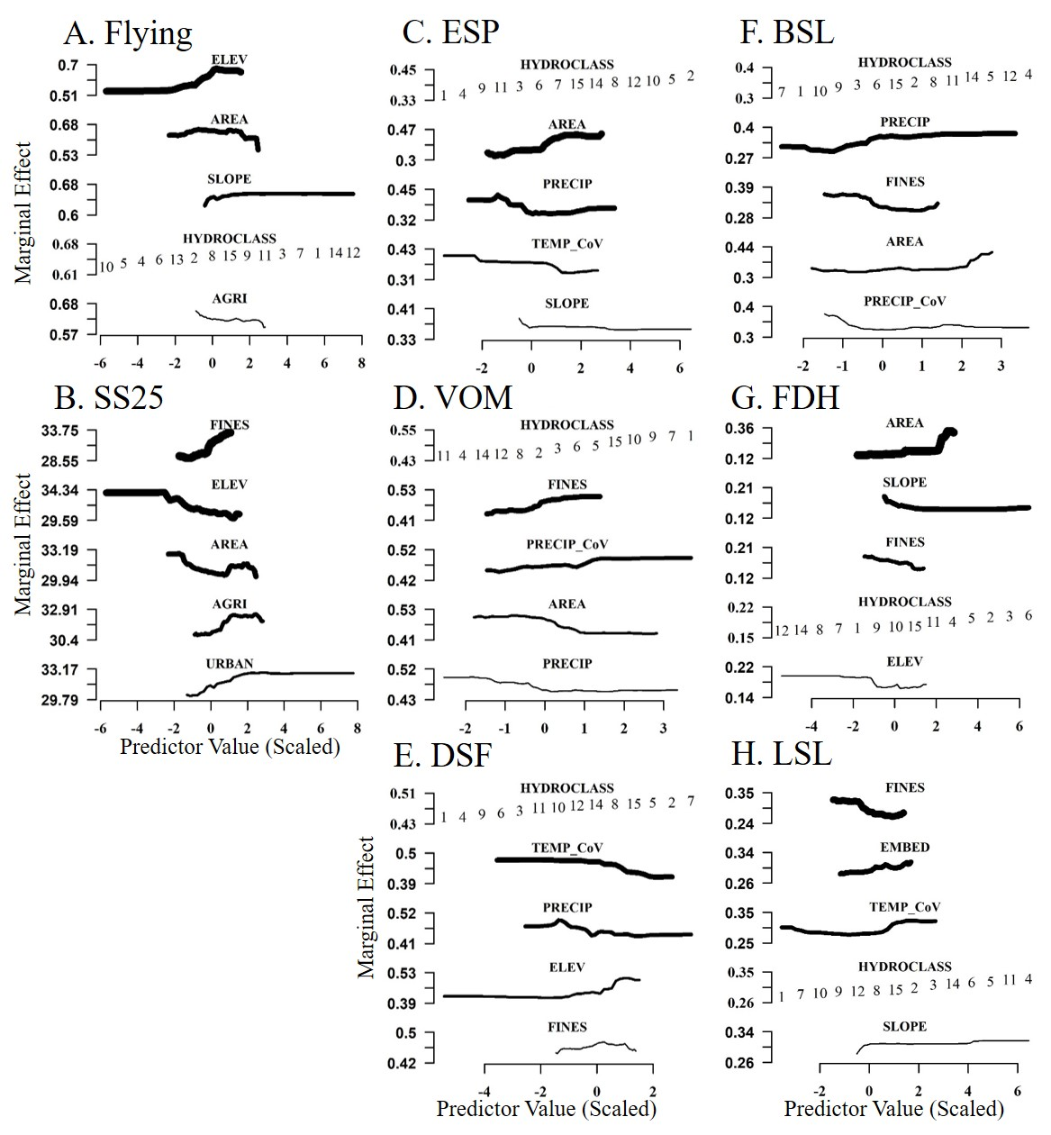
Figure 2.1
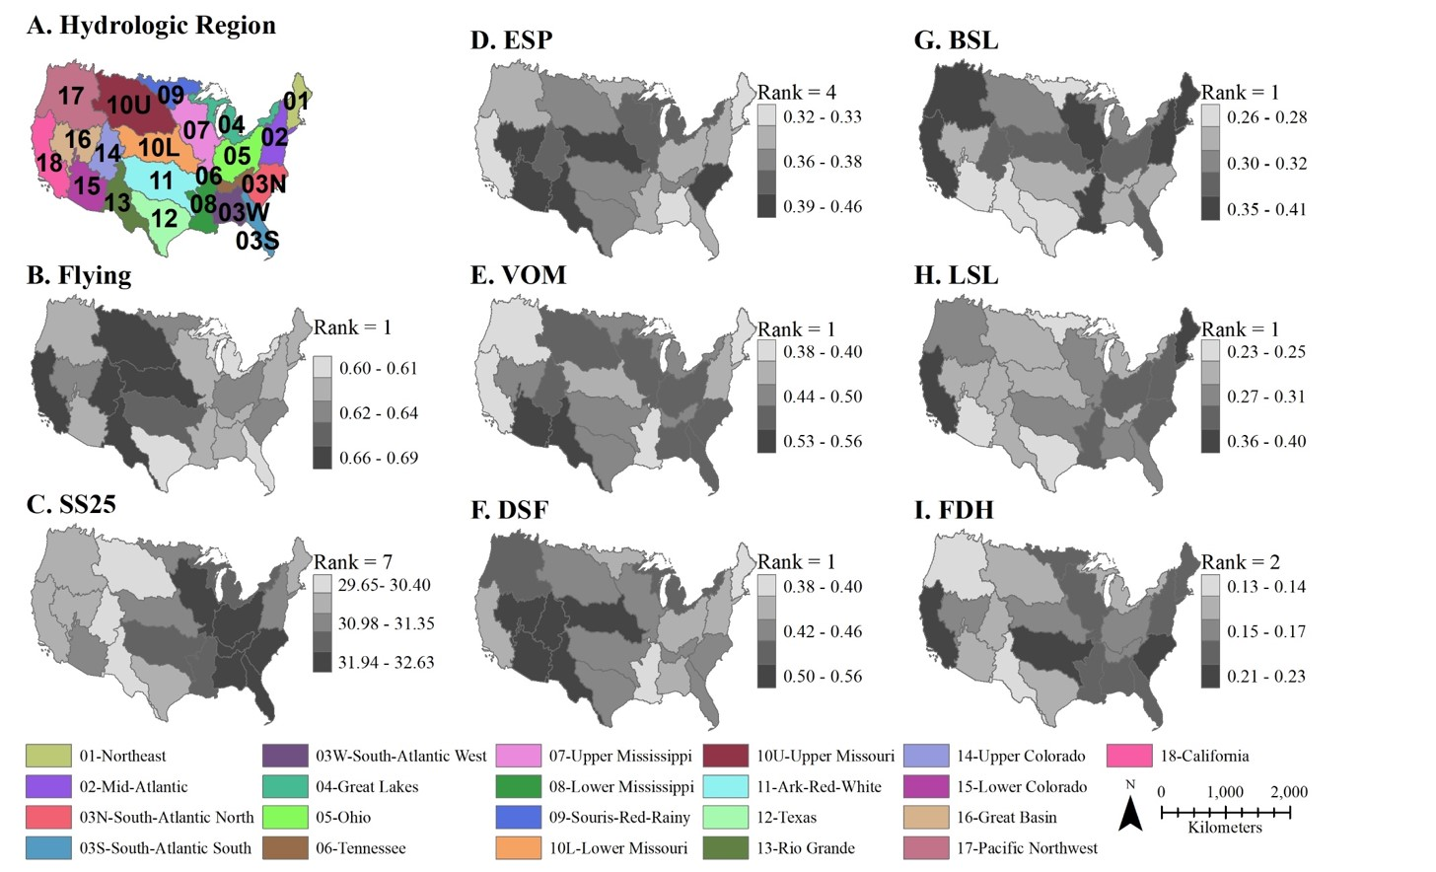
Figure 2.2
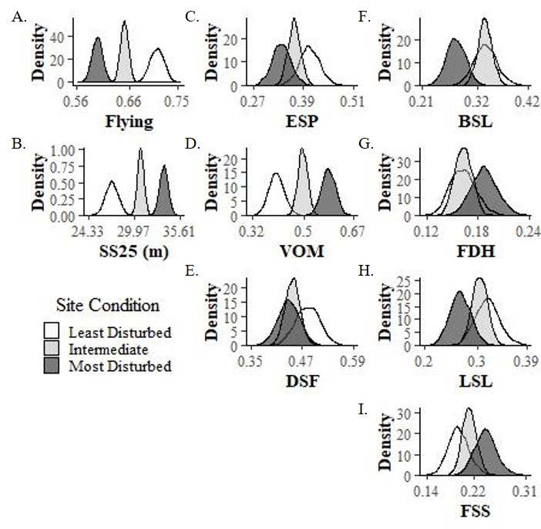
Figure 2.3

Appendix S1. Supporting Information

Table S2.1. Number of sites exceeding a threshold indicating the proportion of flying individuals with trait data for each hydrologic region. For this analysis we chose > 0.5 to maintain a minimum sample size (n ≥ 3) for all hydrologic regions.

 | Threshold for Inclusion in Traits Analysis
Hydrological  Region | >0.1 | >0.2 | >0.3 | >0.4 | >0.5 | >0.6 | >0.7 | >0.8 | >0.9
01 | 84 | 64 | 52 | 39 | 32 | 21 | 11 | 4 | 0
02 | 103 | 93 | 77 | 56 | 42 | 19 | 5 | 1 | 0
03N | 53 | 38 | 25 | 10 | 7 | 5 | 3 | 0 | 0
03S | 17 | 8 | 5 | 4 | 3 | 2 | 1 | 0 | 0
03W | 51 | 43 | 29 | 18 | 13 | 6 | 3 | 2 | 0
04 | 75 | 54 | 44 | 36 | 27 | 19 | 8 | 3 | 0
05 | 102 | 79 | 63 | 42 | 30 | 16 | 8 | 3 | 0
06 | 30 | 23 | 17 | 12 | 6 | 1 | 0 | 0 | 0
07 | 124 | 95 | 77 | 51 | 31 | 22 | 13 | 9 | 2
08 | 79 | 59 | 44 | 30 | 22 | 13 | 8 | 2 | 2
09 | 23 | 18 | 12 | 9 | 6 | 3 | 1 | 0 | 0
10L | 93 | 78 | 63 | 50 | 31 | 26 | 20 | 14 | 7
10U | 180 | 161 | 143 | 122 | 98 | 79 | 51 | 28 | 12
11 | 111 | 91 | 71 | 50 | 37 | 22 | 12 | 4 | 0
12 | 33 | 31 | 29 | 21 | 17 | 10 | 7 | 4 | 2
13 | 21 | 20 | 17 | 16 | 14 | 11 | 10 | 4 | 2
14 | 53 | 50 | 47 | 38 | 32 | 25 | 19 | 12 | 4
15 | 38 | 35 | 31 | 25 | 21 | 17 | 11 | 7 | 1
16 | 44 | 37 | 34 | 33 | 22 | 16 | 12 | 5 | 0
17 | 117 | 103 | 89 | 74 | 61 | 42 | 26 | 14 | 3
18 | 39 | 35 | 32 | 29 | 22 | 15 | 9 | 5 | 3
Total | 1470 | 1215 | 1001 | 765 | 574 | 390 | 238 | 121 | 38

Table S2.2. Variable importance rankings for duration and extent traits using sites at threshold values for community traits data. At the 50% threshold only sites with > 50% of their flying taxa have traits data are included in the analysis. Predictor variables are: AREA = Catchment area, ELEV = Elevation, SLOPE = Channel Slope, FINES = Percent Fine Substrate, EMBED = Percent Embeddedness, AGRI = Percent Agricultural Land Cover, URBAN = Percent Urban Land Cover, PRECIP = Mean Annual Precipitation, TEMP_MA = Mean Annual Temperature, TEMP_CoV = Mean Annual Temperature Coefficient of Variation, PRECIP_CoV = Mean Annual Precipitation Coefficient of Variation, HYDROCLASS = hydrological class. Note, many thresholds have similar important variables, but the percent variation explained (PVE) decreases with more conservative threshold values.
Predictor Variable | Development Speed (Fast) Threshold |  |  |  | Voltinism (Multi)  Threshold |  |  |  | Emergence Synchrony (Poor) Threshold
Predictor Variable | >50% | >60% | >70% | >80% | >50% | >60% | >70% | >80% | >50% | >60% | >70% | >80%
AGRI |  | 2 | 1 | 3
FINES |  |  | 5 | 1
SLOPE |  |  |  |  |  |  | 6 | 5
TEMP_MA | 6 | 3 | 3 | 4 |  |  |  | 3 | 5 | 5 | 4 | 1
TEMP_CoV | 1 | 1 | 2 |  | 1 | 2 | 2 | 2 | 2 | 1 | 2 | 5
EMBED |  |  | 6 |  |  |  |  |  |  |  |  | 6
ELEV | 2 | 4 | 4 | 2 |  |  |  |  |  |  |  | 4
HYDROCLASS | 5 | 6 |  |  | 4 | 3 | 3 |  | 6
PRECIP_CoV |  |  |  | 5 | 5 | 4 | 5 | 6 |  | 6 | 6
PRECIP | 4 |  |  | 6 | 6 | 6 | 4 | 4 | 4 | 4 | 3 | 3
REGION | 3 |  |  |  | 2 | 1 | 1 | 1 | 3 | 2 | 1 | 2
URBAN |  | 5
AREA |  |  |  |  | 3 | 5 |  |  | 1 | 3 | 5
PVE | 0.26 | 0.2 | 0.17 | 0.06 | 0.3 | 0.3 | 0.3 | 0.16 | 0.21 | 0.26 | 0.23 | 0.12
Predictor Variable | Flight Strength (Strong)  Threshold |  |  |  | Life Span (Long)  Threshold |  |  |  | Female Dispersal (High)  Threshold |  |  |  | Body Size (Large)  Threshold
Predictor Variable | >50% | >60% | >70% | >80% | >50% | >60% | >70% | >80% | >50% | >60% | >70% | >80% | >50% |  | >60% | >70% | >80%
AGRI |  |  |  |  | 6 | 3 | 2 |  |  | 2 | 2 |  | 5
FINES |  |  | 6 |  | 4 |  |  |  | 2 | 3 | 1
SLOPE |  | 1 | 2 |  |  |  |  |  |  |  | 5 |  |  |  | 5 | 6
TEMP_MA |  |  | 4 |  |  | 6 | 4 |  |  |  |  |  |  |  |  | 4 | 3
TEMP_CoV | 3 | 2 | 5 |  | 1 | 2 | 1 |  | 4 |  | 4 |  | 1 |  | 1 | 2 | 5
EMBED | 2 | 6 |  |  | 5 | 5 | 6 |  | 6 |  |  |  |  |  |  |  | 6
ELEV
HYDROCLASS | 5 |  |  |  | 2 | 1 | 3 |  | 3 | 5 |  |  | 4 |  | 4 | 5 | 4
PRECIP_CoV |  |  |  |  |  |  |  |  |  |  |  |  | 6
PRECIP |  | 3 |  |  |  |  | 5 |  |  |  |  |  | 3 |  | 3 | 3 | 2
REGION | 4 |  |  |  |  |  |  |  | 5 | 6 |  |  | 2 |  | 2 | 1 | 1
URBAN | 6 | 5 | 3 |  | 3 | 4 |  |  |  | 4 | 6
AREA | 1 | 4 | 1 |  |  |  |  |  | 1 | 1 | 3 |  |  |  | 6
PVE | 0.04 | 0.01 | 0.01 | -0.04 | 0.13 | 0.05 | 0.02 | -0.06 | 0.16 | 0.13 | 0.08 | 0 | 0.26 |  | 0.25 | 0.25 | 0.05

Table S2.3. Prior distributions for Bayesian regression models. Mean and standard deviation for proportional data are logit transformed. Trait abbreviations are: FDH = Female Dispersal (High), BSL = Body Size (Large), LSL = Life Span (Long), FSS= Flight Strength (Strong); ESP = Emergence Synchrony Poor; DSF = Development Speed (Fast) and VOM = Voltinism (Multi); Trait definitions are provided in Table 1

Subsidy Characteristic | Trait | Prior Information
Supply | Flying | N(0.85, -1.45)
Extent | SS25 | N(21.5, 18)
Extent | BSL | N(-2.44, -2.59)
Extent | LSL | N(-1.90, -1.82)
Extent | FDH | N(0.28, -1.15)
Extent | FSS | N(-1.66, -1.39)
Duration | DSF | N(1.52, -1.59)
Duration | VOM | N(-0.58, -1.39)
Duration | ESP | N(-1.45, -1.73)

Table S2.4. Descriptive statistics and model performance metrics. Trait abbreviations are: SS25 = community-weighted 25% stream signature, BSL = maximal body length > 9mm, LSL = adult life span > 1 week; FDH = high female dispersal, FSS = Strong flying strength, DFS = Fast development, VOM = Multivoltinism, ESP = Poorly Synchronized Emergence. Trait definitions are given in Table 1. OBO R² = Out of Bag R², NSE = Nash–Sutcliffe efficiency, RSR = ratio of the root mean square error to the standard deviation of observed data (RSR) and MAE = mean absolute error.

Subsidy Characteristic | Trait | National  Mean (±SD) | OBO R² | NSE | RSR | MAE
Supply | Flying | 0.65 (±0.26) | 0.31 | 0.32 | 0.83 | 0.17
Extent | SS25 | 31.09 (±12.59) | 0.18 | 0.22 | 0.88 | 8.79
Extent | BSL | 0.32 (±0.26) | 0.26 | 0.23 | 0.87 | 0.17
Extent | LSL | 0.29 (±0.26) | 0.10 | 0.12 | 0.93 | 0.2
Extent | FDH | 0.16 (±0.20) | 0.19 | -0.01 | 1 | 0.15
Extent | FSS | 0.20 (±0.24) | 0.03 | 0.06 | 0.96 | 0.18
Duration | DSF | 0.47 (±0.31) | 0.26 | 0.24 | 0.87 | 0.23
Duration | VOM | 0.48 (±0.31) | 0.28 | 0.26 | 0.86 | 0.23
Duration | ESP | 0.37 (±0.28) | 0.18 | 0.22 | 0.88 | 0.21

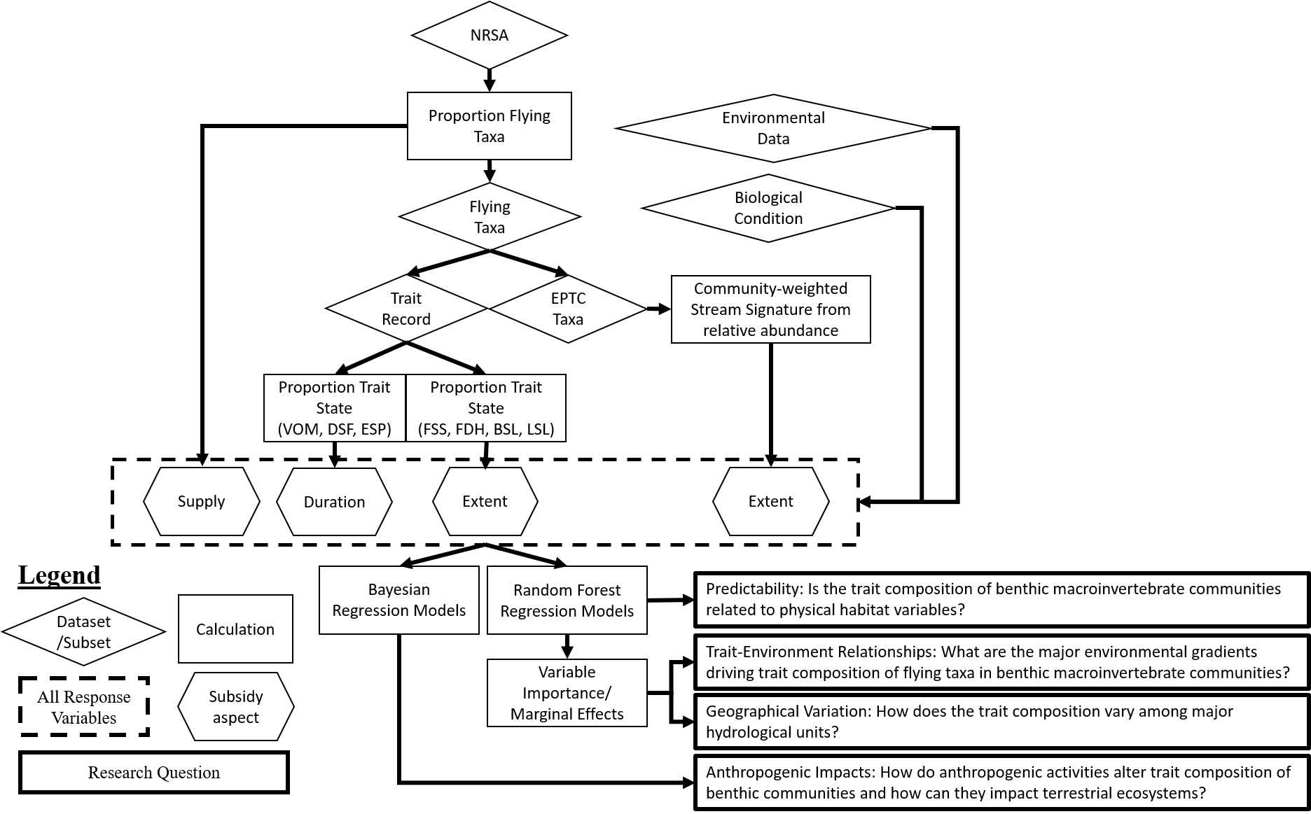
Figure S2.1 Schematic of investigation with path to research questions in the main text. NRAS = composite benthic macroinvertebrate samples collected by the national rivers and streams assessment; Flying taxa = Diptera, Ephemeroptera, Plecoptera, Odonata and Trichoptera; EPTC taxa = Ephemeroptera, Plecoptera, Trichoptera and Chironomidae [Diptera]; Traits Record = flying taxa with matching record in traits database. Trait abbreviations are: Trait abbreviations are: FDH = Female Dispersal (High), BSL = Body Size (Large), LSL = Life Span (Long), FSS= Flight Strength (Strong); ESP = Emergence Synchrony Poor; DSF = Development Speed (Fast) and VOM = Voltinism (Multi); Trait definitions are provided in Table 1

Figure S2.2. Top: Major Hydrologic Regions of the United States with survey locations used by National Rivers and Stream Assessment program (Points, n = 1,857). Bottom: Survey locations where > 50% of the EPTDO genera have suitable information about traits (Triangles, n = 578).

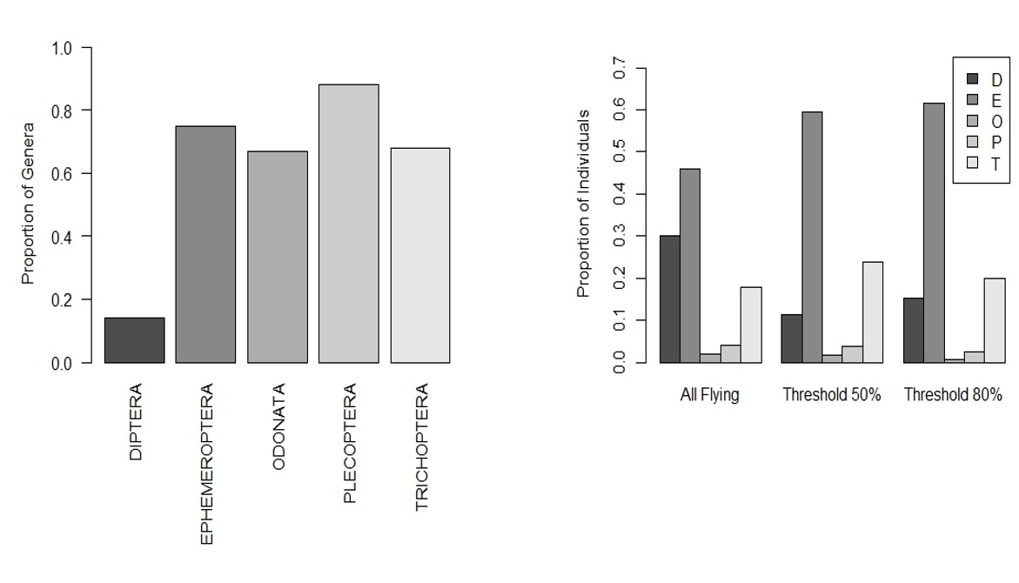
Figure S2.3. Left: The proportion of flying genera with trait data collected during the NRSA survey. Note trait data were available for 14% of the Diptera, thus these taxa may be underrepresented in the traits analysis. Right: The composition of flying taxonomic Orders at all NRSA survey locations (All flying) and at sites included in the 50% threshold (i.e. trait data available for >50% of the flying taxa community) and 80% threshold. Relative to all NRSA survey locations, the sites included in the traits analysis have lower frequencies of Diptera and higher frequencies of Ephemeroptera.

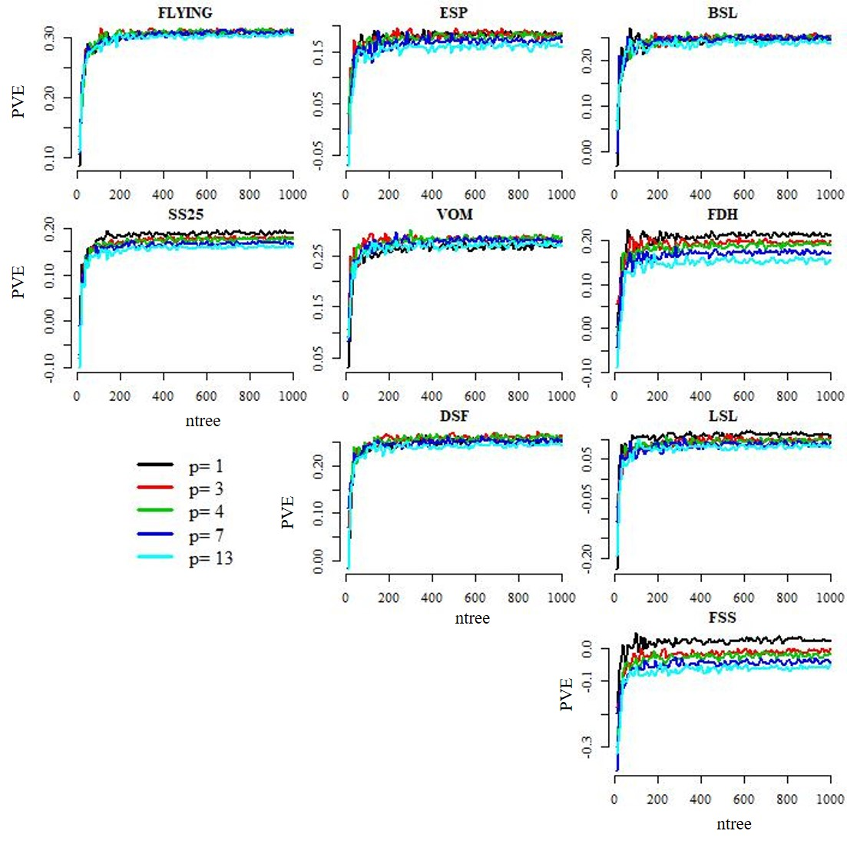
Figure S2.4. Convergence of the proportion of variation explained (PVE) for different values of mtry (p) with increasing the number of trees (ntree). We selected 1, 2$\sqrt{p}$, 0.2$p$, $p$/3 and $p$ as candidate mtry values. Consistent with other studies (Fox et al. 2017), we found the optimal value for mtry offered little improvement (i.e. <5% change in PVE) over the default ($p$/3 = 4) for all models except FSS. This model explained little variation in the proportion of individuals with strong flight strength and mtry=1 is possibly indicating stochastic outcome.
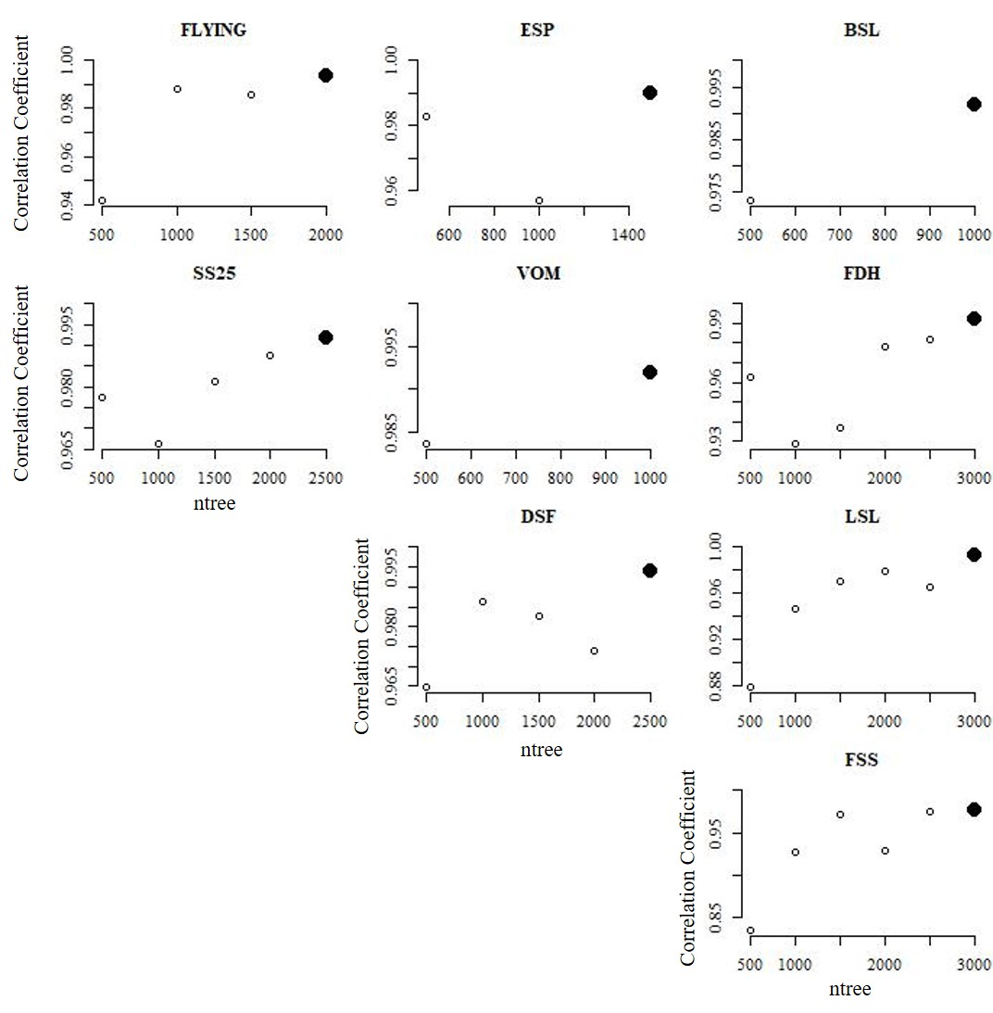
Figure S2.5. Correlation coefficients between the variable importance values from two independent random forest models. We tested several values for ntree (500, 1000, 1500, 2000, 2500 and 3000) and found the consistency of results (i.e. correlation coefficient) increased with the number of trees. At ntree =3000 the agreement in the variable importance values >0.98 for all models.
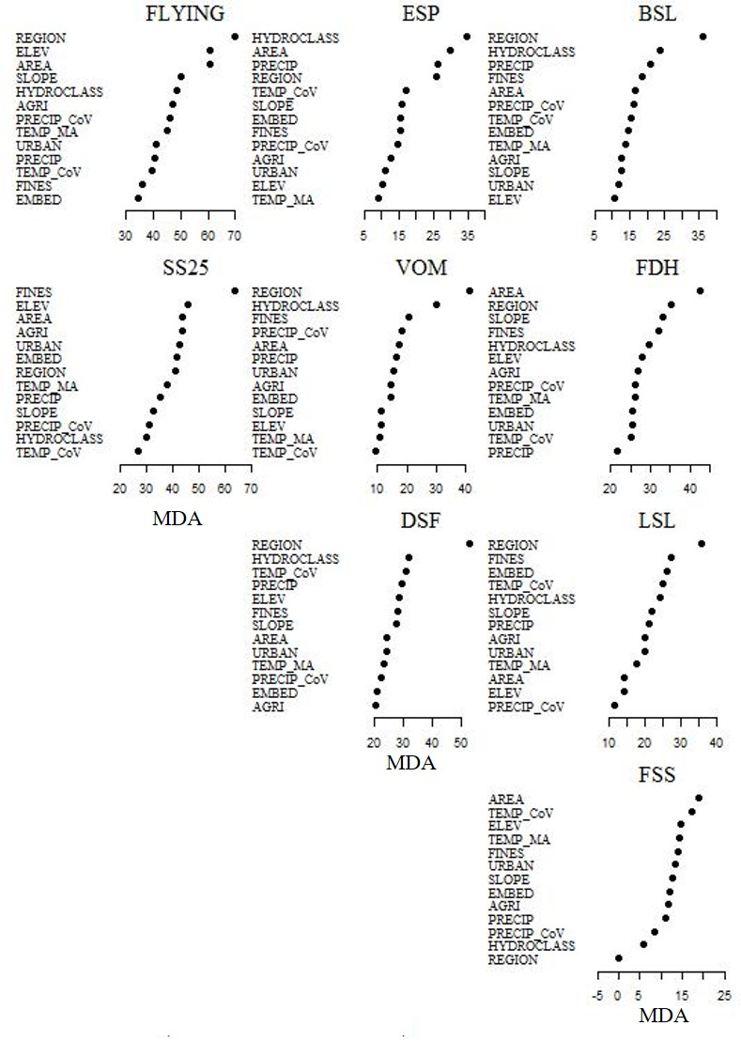
Figure S2.6. Variable importance plots (MDA = mean decrease accuracy). Predictor variables are: AREA = Catchment area, ELEV = Elevation, SLOPE = Channel Slope, FINES = Percent Fine Substrate, EMBED = Percent Embeddedness, AGRI = Percent Agricultural Land Cover, URBAN = Percent Urban Land Cover, PRECIP = Mean Annual Precipitation, TEMP_MA = Mean Annual Temperature, TEMP_CoV = Mean Annual Temperature Coefficient of Variation, PRECIP_CoV = Mean Annual Precipitation Coefficient of Variation, HYDROCLASS = hydrological class. Trait abbreviations are: FDH = Female Dispersal (High), BSL = Body Size (Large), LSL = Life Span (Long), FSS= Flight Strength (Strong); ESP = Emergence Synchrony Poor; DSF = Development Speed (Fast) and VOM = Voltinism (Multi); Trait definitions are provided in Table 1

Climate change may affect quantity of aquatic insect subsidies emerging from streams and rivers

Darin A. Kopp, Alva Strand, Jeffrey Kelly, and Daniel C. Allen

Ecology and Evolutionary Biology Program, Department of Biology, University of Oklahoma, Norman, Oklahoma 73071

Abstract
Fluxes of materials and energy across ecosystem boundaries (i.e. “resource subsidies”), are globally common and likely impacted by climate change. Aquatic insect larvae metamorphose into flying terrestrial adults that subsidize terrestrial ecosystems with energy and nutrients. The magnitude of this effect should be controlled by the quantity of insects that emerge from the aquatic ecosystem, but it is not clear how climate change could impact aquatic insect emergence. Here, we investigate how climate change could alter the quantity of aquatic insect subsidies reaching terrestrial ecosystems. Leveraging existing large-scale datasets, we modeled 1) the surface area of streams and rivers and 2) the production of emergent aquatic insects per unit area under present day climate and two climate change scenarios for 2070. We then extrapolate these results to the nearly 2.3 million streams and rivers of the contiguous United States and explore how the quantity of emergent aquatic insects may or may not satisfy the metabolic demand of insectivorous birds that inhabit these regions. Our estimates suggest that these ecosystems can export 78,197 (95% PI: 2,155 - 2.19 x 10⁶) metric tons of insect biomass under present conditions, and climate change could increase emergent biomass by 250% in some regions while decreasing it by 50% in others. These changes could resonate through terrestrial ecosystems by shifting the energy supplied by aquatic insect subsidies to common avian aerial insectivores. Under future climate projections, many southern hydrologic regions are expected to experience a decline in the ratio of energy supplied by aquatic insects relative to energy demanded by insectivores. Collectively, our results demonstrate that climate change effects on one ecosystem will resonate throughout other ecosystems due to cross-ecosystem linkages.

Keywords: Climate change, resource subsidies, emergent aquatic insects, avian aerial insectivores, temperature, precipitation, cross ecosystem linkages

Introduction
Fluxes of materials and energy that cross ecosystem boundaries are often termed, “resource subsidies” (Polis et al., 1997; Loreau et al., 2003; Montagano et al., 2019). In recipient ecosystems, resource subsides can influence consumers (Twining et al., 2018), trophic interactions (Sabo and Power, 2002), and ecosystem processes (Bultman et al., 2014). Although resource subsidies are ubiquitous (Marczak et al., 2007; Allen and Wesner, 2016; Gounand et al., 2018), we know little about how they might be affected by climate change (Greig et al., 2012; Larsen et al., 2016). The quantity of resource subsidies reaching a recipient ecosystem is an important factor that can drive the magnitude of their effect (Marczak et al., 2007; Marcarelli et al., 2011; Subalusky and Post, 2018). In many instances, subsidy quantity is proportional to productivity of the donor ecosystem (Polis et al., 1997; Gratton and Vander Zanden, 2009; Bartrons et al., 2013). Consequently, climate change-induced shifts in ecosystem production could resonate across ecosystem boundaries (Zhao and Running, 2010; Patrick et al., 2019).
Insects that develop in aquatic ecosystems as larva and emerge as flying terrestrial adults (hereafter, “emergent insects”) subsidize terrestrial ecosystems (Baxter et al., 2005; Richardson et al., 2010; Schindler and Smits, 2017). They can account for a significant proportion of the energy budgets of terrestrial consumers or meaningfully contribute to the detrital resource pool (Baxter et al., 2005; Dreyer et al., 2015; Wesner et al., 2019). Among the consumers that are subsidized, emergent insects may be especially beneficial for avian aerial insectivores (Nakano and Murakami, 2001; Marczak et al., 2007; Schilke et al., 2020). For example, emergent insects have been linked to avian breeding success and population density (Gray, 1993; Epanchin et al., 2010; Twining et al., 2018). Unconsumed emergent insects are also important for detrital food webs and contribute limiting nutrients to plants (Bultman et al., 2014; Dreyer et al., 2015; Wesner et al., 2019). In many instances the fate of aquatic insect subsidies in terrestrial ecosystems is still unclear but may depend on quantity of insect subsidies relative to energetic demands of terrestrial consumers (Wesner et al., 2019).
The quantity of emergent insects entering the terrestrial ecosystem is contingent on production of aquatic insects and surface area of the aquatic ecosystem (Gratton and Vander Zanden, 2009; Bartrons et al., 2013). Emergent insects are a fraction of the entire aquatic community’s secondary production, as many aquatic invertebrates do not have flying life stages (e.g. snails, leeches, etc., Huryn and Wallace 2000, Gratton and Vander Zanden 2009). Because this fraction is generally consistent among invertebrate populations, aquatic ecosystems with higher insect production should export more subsidies to terrestrial ecosystems (Statzner and Resh, 1993; Huryn and Wallace, 2000; Gratton and Vander Zanden, 2009). On the other hand, Surface area is one measure of aquatic ecosystem size and, on a per unit area basis, larger ecosystems will export a greater amount of aquatic insect subsidies (Gratton and Vander Zanden, 2009; Bartrons et al., 2013). Multiplying per unit area insect production by surface area yields estimates for quantity of emergent insects exported from an aquatic ecosystem (Bartrons et al., 2013; Schilke et al., 2020).
Climate change could impact secondary production of aquatic ecosystems and surface area by altering water temperatures and water availability through changes in precipitation and evapotranspiration patterns (Woodward et al., 2010; Patrick et al., 2019; Konapala et al., 2020). In the United States, mean annual temperature is expected to increase between 1.6 and 6.6 ºC while changes in precipitation patterns are expected to vary regionally (USGCRP, 2018). Secondary production in aquatic ecosystem may increase because increases in water temperature could elevate primary production, providing a greater resources base for consumers (Mulholland et al. 2001, Demars et al. 2011, Patrick et al. 2019). Indeed, a mesocosm experiment found warming increased the emergence of aquatic insects (Greig et al. 2012). As temperatures increase and precipitation patterns change, the surface area of aquatic ecosystems may also be impacted by increased evaporation rates or anthropogenic demands (USGCRP, 2018). Although climate change will have widespread impacts on aquatic systems (Woodward et al., 2010), there is little information about how these impacts could resonate across the aquatic-terrestrial interface (Larsen et al., 2016).
Here, we investigate how climate influences, emergent insect production and surface area of lotic ecosystems within the contiguous United States (CONUS). We focus on stream ecosystems because, relative to lakes, they are more spatially extensive across the CONUS and have more contact with adjacent terrestrial ecosystems (Bartrons et al., 2013). After we establish an empirical linkage between climate, stream surface area and emergent insect production, we extrapolate our results to the approximately 2.3 million streams and rivers of the CONUS under present day climate and under two future climate change scenarios (RCP 2.6 and 8.5). This allowed us to assess 1) the large-scale variation in quantity of emergent insects across the CONUS and 2) how climate change might affect these patterns. Lastly, we compare energy content of emergent insects to the field metabolic rates (FMR) of common avian aerial insectivores under both present day and future climate scenarios to generate insights about the fate and potential conservation implications of aquatic insect subsidies.

Methods
Overview
Our primary goals were to estimate the quantity of insects emerging from lotic ecosystems of the CONUS under present day and projected climates, and to compare these estimates to metabolic demands of avian aerial insectivores. To accomplish these objectives, we created two separate models to predict 1) per unit area production of emergent aquatic insects and 2) stream surface area using climate and watershed variables. We combined these estimates to calculate total emergence from each stream in units of grams ash free dry mass per year (gAFDM y⁻¹) as the product of emergent insect production in grams ash free dry mass per square meter per year (gAFDM m⁻² y⁻¹) and wetted stream area (m²). Both models used a suite of bioclimate variables and watershed area, that are readily available for the entire CONUS. This spatial coverage allowed us to extrapolate predictions to nearly 2.3 million streams and rivers and forecast potential changes given future climate projections. We also used these predictions to calculate potential energy supplied by emergent insects (kilojoules per year, kJ y⁻¹) to terrestrial ecosystems and draw comparisons with energetic demand of avian aerial insectivores (kJ y⁻¹).

Datasets for predicting emergent insect production
We used the National Hydrography Dataset Version 2 (NHDPlusV2) as a geospatial hydrologic framework (McKay et al., 2012; Moore and Dewald, 2016). This dataset was assembled at 1:100K resolution and available for all major hydrologic regions and subregions with the CONUS (i.e. 2-digit and 4-digit hydrologic unit codes, Figure 1). It consists of digital flowlines and value-added attribute tables that contain ancillary data. Since we were focused on insect emergence from lotic ecosystems, we did not consider flowlines that were classified as a divergent path, connector, coastline, pipeline, canal or ditch, or associated with a lake, pond, ice mass, reservoir, swamp, marsh or playa. After removing these features, 2.3 million streams and rivers remained.
Insects that emerge from streams are sourced from in-stream production of aquatic insects (Gratton and Vander Zanden, 2009). We obtained estimates of aquatic insect production from a global database of annual invertebrate community secondary production measurements (Patrick et al. 2019). This database was compiled from a literature review and included studies that measured the annual production of stream invertebrate communities using repeated field sampling (Patrick et al., 2019). We reviewed the 56 publications within the database and identified 92 locations with taxa-specific production estimates (Figure 1). For these 92 studies, we subtracted the non-insect production from the total invertebrate production to calculate annual insect production (gAFDM m⁻² yr⁻¹). We then multiplied annual insect production by 0.19, an estimate of the fraction that emerges from streams, to obtain our estimate of annual insect emergence (Gratton and Vander Zanden 2009, Bartrons et al. 2013, Schilke et al. 2020).
To estimate stream surface area we obtained 2,077 field measurements of summer wetted stream width from the National Rivers and Streams Assessment (NRSA, Figure 1, U.S. EPA 2016a). The NRSA was established to inventory the biological condition of the nation’s streams. At each biomonitoring site, sampling reaches are defined as a length 40x the wetted width or a minimum of 150m. The mean wetted width for each site was derived from measurements taken at 11 equally spaced transects in summer 2008-2009 (U.S. EPA, 2016b). We georeferenced each location to the closest NHDPlusV2 flowline to identify the hydrologic region, upstream catchment area and extract climate variables for modeling (discussed below). We used the predicted wetted width to create a uniform buffer around each NHDPlusV2 flowline to estimate the stream surface area.
We obtained climate data for current and future projections from the Worldclim database (https://www.worldclim.org/, Hijmans et al. 2005). These data are available at a ~4.5 x 4.5 km resolution and consist of mean monthly precipitation and temperature, and 18 bioclimatic variables (Table S1). Bioclimatic variables represent climatic trends, seasonality or extreme or limiting factors and are often used in species distribution modeling (Hijmans et al., 2005; Gill et al., 2020). Future projections of these variables were derived from several General Circulation Models (GCM) at four representative concentration pathways (RCP) (https://worldclim.org/). We selected projections for the year 2070 generated by the HadGEM2-ES model (Jones et al., 2011). The HadGEM2-ES is one of 17 core models used in the Coupled Model Intercomparison Project (CMIP5) to evaluate large-scale climatology (Sheffield et al., 2013) and includes components of the Earth System to integrate chemical reactions and biological interactions with physical processes that influence climate (Collins et al., 2011). We parametrized this model with two representative concentrations pathways (RCP) that reflect future greenhouse gas emissions. RCP 8.5 reflects a very high emissions scenario while RCP 2.6 reflects stringent mitigation of greenhouse gases (IPCC, 2014). We downloaded the three downscaled climate raster datasets using the “raster” R package (Hijmans, 2017).

Avian aerial insectivore field metabolic rates
Avian aerial insectivores are birds that catch insects exclusively or almost exclusively in flight and consume emergent aquatic insects to, at least partially, meet their energetic demands (Baxter et al., 2005). We identified 53 species of North American breeding birds that belong to Nightjars and Allies (Caprimulgidae), Swifts (Apodidae), Tyrant Flycatchers (Tyrannidae), or Swallows (Hirundinidae) from the Birds of the World database (https://birdsoftheworld.org). For each species, we estimated the field metabolic rate following Nagy et al. (1999):
$$FMR={10.5 M}^{0.681}$$
where FMR is the field metabolic rate (kJ d⁻¹) and M is the body mass (g). We obtained body mass estimates from Dunning (2008). When multiple estimates of body mass were available for a species, we used a weighted average as a single estimate (Table S3).
We obtained abundance information for each species from the eBird Status and Trends data products (Fink et al., 2020b). These data are available at weekly intervals for the entire Western Hemisphere at a ~2.96 x 2.96 km resolution. Abundance estimates were derived from birding observations conducted by citizen scientists and reflect the number of individuals a skilled observer would count beginning at the optimal time of day and expending the effort necessary to maximize detection (Fink et al., 2020a; Johnston et al., 2020). Although these values underestimate absolute abundance, they are relative to all other sites such that it is possible to draw informative comparisons among them (Johnston et al., 2020). To calculate the annual energetic demand of the avian aerial insectivores, we first multiplied the abundance of a species by its FMR (kJ d⁻¹) and then multiplied this value by 7 days to obtain the weekly FMR for each species. The annual energetic demand (kJ y⁻¹) is the sum of weekly FMR for all weeks and species.

Analysis
We used random forest regression to establish an empirical relationship between the annual production of aquatic insects and the suite of bioclimatic variables (Table S1). Random forest is a nonparametric ensemble modeling technique that combines results of multiple independent decision trees (Breiman, 2001). These models are commonly used in ecology (Fox et al., 2017; Hill et al., 2017) but predictions from new data are single point estimates (i.e. mean response, Meinshausen 2006). Therefore, we also estimated 95% prediction intervals using quantile regression forests (Meinshausen, 2006). In brief, quantile regression forests are a generalization of random forest regression that considers the full conditional distribution of the response variable (Meinshausen, 2006). As such, upper and lower bounds of a prediction can be established for a given interval as a measure of uncertainty of an estimate.
Prior to model fitting, we randomly split the 92 estimates of insect production into training (80%) and testing data (20%) and removed strongly correlated bioclimatic variables (i.e. r > 0.7). The final model included mean annual temperature, mean diurnal range, isothermality, mean temperature of wettest quarter, mean temperature of driest quarter, mean annual precipitation and precipitation seasonality as predictor variables (Table S1, https://www.worldclim.org/). We optimized the number of variables that are randomly selected at each node (mtry = 4) and the number of independent trees (ntree = 400) by choosing the combination that maximized the percent variation explained by, and repeatability of, the model (Fox et al., 2017; Brieuc et al., 2018). The mean conditional response (i.e. point estimates) were generated using the “randomForest” R-package (Liaw and Wiener, 2002) and we constructed 95% prediction intervals using the “quantregForest” R-package (Meinshausen, 2017).
We used a Bayesian mixed effects model to assess the relationship between mean stream width and climate variables and watershed area (Table S1). Climatic variables (i.e. mean annual precipitation, mean annual temperature, and precipitation seasonality) were considered population-level effects and drainage area was a group-level effect with hydrologic region as the single grouping term. The wetted width measurements from the NRSA and catchment area were log-transformed prior to modeling because stream channel properties typically follow simple power functions with changing catchment area (Faustini et al., 2009). We also centered and scaled the predictor and response variables and split the dataset into random training (80%) and testing (20%) portions. We then used a backwards stepwise routine to iteratively remove the single variable with the weakest relationship to wetted width and generate a suite of competing models. Leave-one-out cross validation was then used to identify the model with the best predictive accuracy (Vehtari et al., 2017). All models were fit with 5,000 iterations (2,000 warmup) using the BRMS R-package (Bürkner, 2017).
We extrapolated the empirical relationships established for insect production and stream width to the nearly 2.3 million NHDPlusV2 stream reaches in the CONUS for present day and future climate projections. For each reach we obtained the upstream catchment area from the NHDPlusV2 and extracted climate variables (current and projected, Table S1) at the center of each flowline. We used these data to predict per unit area production of emergent aquatic insects (gAFDM m⁻² yr⁻¹) and stream surface area (m²). Since both models were fit on the log scale, we used exponentiation to back-transformed predictions. We bounded our estimate of total emergence using the product of the lower and upper bounds of the 95% prediction intervals for per unit area insect production and stream surface area. Finally, the potential effect of climate change on emergent aquatic insect subsidies was assessed using the percent change in per unit area emergent insect production (gAFDM m⁻² yr⁻¹), stream surface area (m²) and total emergence (tADFM yr⁻¹). To explore potential regional variation, we present the median percent change of all reaches within each major hydrologic region (HUC 2, Figure 1).
To investigate how energy provided by aquatic insect subsidies could support terrestrial consumers, we compared energy content of emergent aquatic insect to field metabolic rates (FMR) of common avian aerial insectivores (kJ yr⁻¹). Since the resolution of the insectivore dataset was large enough to intersect several individual streams, we reduced our analysis to 8,221 randomly sampled pixels (Figure 1). We stratified sampling by hydrologic subregions (4-digit hydrologic units, HUC4) such that there were approximately 30 pixels within each (Figure 1). We calculated the total emergence as the product of stream surface area within pixel and the predicted emergence production for both current and future climate scenarios. We converted units of total emergence (gAFDM yr⁻¹) to grams carbon per year (gC yr⁻¹) (1 gAFDM = 0.55 gC, Waters 1977) and assumed 1 gC of insect biomass contains 23.01 kJ of energy (Wesner et al., 2020).
We used supply and demand ratios (SDR) to assess energy supplied by emergent insects relative to energy demanded by insectivores for each site. We log-transformed SDR such that values < 0 indicate locations where energy supply exceeds demand. We assessed change caused by future climate by subtracting the SDR under current conditions from the SDR under both future climate scenarios. Here, negative values indicate that the SDR declines under future conditions. Of the 8,221 randomly selected pixels, we removed 16 from the analysis because the common aerial insectivores we identified from the eBird dataset were not predicted to be present. We aggregated remaining sites to the subregional scale (HUC4) using median pixel value (Figure 1).

Results
The emergent insect production and stream width models provided adequate reflections of the underlying structure of the data (Figure 2). The insect production model explained 56% of the variation in the data and mean annual precipitation, mean annual temperature and precipitation seasonality were positively related to insect production (Figure 3, Table S1). The stream width model explained 88% (95% CrI: 0.87, 0.88) of the variation among wetted width measurements and included upstream catchment area, mean annual precipitation, mean annual temperature, and precipitation seasonality (Table S1 & S3). Wetted width was positively associated with larger catchment areas (β = 0.95, 95% CrI: 0.88, 1.01) and higher mean annual precipitation (β = 0.26, 95% CrI: 0.23, 0.29) and negatively associated with higher mean annual temperatures (β = -0.12, 95% CrI: -0.15, -0.08) and precipitation seasonality (β = -0.15, 95% CrI: -0.18, -0.12, Figure 4).
We estimate that streams and rivers within the CONUS export 78,197 (95% PI: 2,155 - 2.19 x 10⁶) metric tons of insect biomass to terrestrial ecosystems annually (tAFDM yr⁻¹). Emergent insect production (gAFDM m⁻² yr⁻¹), stream surface area, and total emergence (gAFDM y⁻¹) varied among hydrologic regions (Table 1). The geometric mean of emergence production for each region ranged from 0.53 to 4.61 gAFDM m⁻² yr⁻¹, which is comparable to other estimates (i.e. Gratton and Vander Zanden 2009, mean [95% Confidence Interval]: 2.104 [0.844, 6.238] gAFDM m⁻² yr⁻¹ ). The California, Rio Grande, and Upper Missouri hydrologic regions had the lowest median stream surface area while Texas, Northeast, and Tennessee had the greatest stream surface area. Often per unit area emergent production did not track total emergence in the same region. For example, the Pacific Northwest was among the lowest in emergent insect production per unit area, but among the highest in total emergence. Similarly, the Souris Red Rainy hydrologic region had moderate production per unit area but generally low total emergence (Table 1).
We found that climate projections under RCP 2.6 and RCP 8.5 scenarios could alter per unit area emergent insect production, stream surface area, and total emergence (Figure 4). emergent insect production could increase in northern hydrologic regions (i.e. Pacific Northwest, Upper Missouri and Northeast) and decrease in southern regions (i.e. Rio Grande, Texas, Lower Mississippi, and Southern Atlantic). On the other hand, median stream surface area will decline in all regions by as much as 20% under RCP 2.6 scenario and 40% under RCP 8.5 scenario (Figure 4). The combined effects of climate-induced changes on per unit area emergent insect production and stream surface area could cause several southern hydrologic regions (e.g. South Atlantic, Lower Mississippi and Rig Grande) to experience a decline in total aquatic insect emergence and northern hydrologic regions (e.g. Northeast, Great Lakes, and Pacific Northwest) to experience an increase. In general, climate-induced changes are more extreme under RCP 8.5 than RCP 2.6 scenario (Figure 5).
The contribution of emergent aquatic insects to the annual energetic demands of avian aerial insectivorous varied within the CONUS (Figure 5). The median demand within a hydrologic subregion ranged from 31 to 1,542 (kJ x1000 yr⁻¹) (Figure 5A). In much of the southeastern US, the energy content provided by emergent insects exceeded the demand by aerial insectivores. Alternatively, throughout the western US, demand exceeded supply (Figure 5B). Under future climate projections the amount of energy supplied by aquatic insects is predicted to decline the greatest in subregions of the upper Missouri, Lower Colorado, and Rio Grande while in many subregions in the northern US, insect supply will exceed current demand (Figure 5C-D).

Discussion
Although climate change is a pervasive threat to aquatic ecosystems (Woodward et al., 2010), little is known about how the effects could resonate throughout terrestrial ecosystems (Greig et al., 2012; Larsen et al., 2016). We expand the frameworks of Gratton and Vander Zanden (2009) and Bartrons et al. (2013) to estimate that approximately 78,000 tAFDM yr⁻¹ (95% PI: 2,155 - 2.19 x 10⁶) of insect biomass are exported from streams and rivers to terrestrial ecosystems within the CONUS. Together, variation in emergent insect production per unit area and stream width revealed that under present day conditions quantity of aquatic insect subsidies entering terrestrial ecosystems varies among hydrologic regions. For example, the Lower Mississippi hydrologic region could potentially export 60-fold more aquatic insect subsidies than the Great Basin hydrologic region. We also demonstrate that climate change could impact terrestrial ecosystems by altering the quantity of aquatic insect subsidies. Indeed, some regions could experience up to a 50% decline in total emergence, while others could experience up to a 250% increase. Finally, these changes could subsequently alter energy budgets for common aerial insectivores by either increasing or decreasing the amount of energy that aquatic insect subsidies could contribute to their metabolic demands. Collectively, our results reveal that the effects of climate change on one ecosystem can resonate throughout other ecosystems by altering subsidy quantity.
Per unit area insect production was influenced most by mean annual precipitation, seasonality of precipitation, and mean annual temperature. In our study, insect production had a nonlinear response with mean annual precipitation, increasing near mean precipitation levels and leveling at the extremes. Others have found that precipitation patterns may influence insect production through floods and droughts (Whiles and Wallace, 1995; Kendrick et al., 2019; Patrick et al., 2019). For example, Fisher et al. (1982) found a flash flood reduced invertebrate biomass by 98% but recovered to preflood levels 2-3 weeks later. Similarly, Ledger et al. (2011) found drought reduced aquatic secondary production by half. The positive relationship between insect production and precipitation seasonality could be driven by taxa with multiple cohorts and fast development traits (Jackson and Fisher, 1986). Finally, the positive effect of mean annual temperature could be underpinned by concomitant increases in water temperatures and the availability of nutrients or food resources (Morin and Dumont, 1994; Huryn and Wallace, 2000; Patrick et al., 2019). Collectively, our results may support the notion that aquatic insect production is constrained by climate and large-scale climatic patterns could explain regional differences in the per unit area emergent insect production.
Future climate scenarios may affect insect production per unit area differently depending on the region. In many northern hydrologic regions (e.g. Pacific Northwest, Upper Missouri, and Northeast) insect production is expected to increase presumably because of the expected increases in mean annual air temperature (USGCRP, 2018). Higher temperatures could benefit organism metabolism and, by extension, increased emergence (Greig et al., 2012; Muehlbauer et al., 2020). Indeed, whether these relationships persist into the future will depend on the thermal tolerance and survival of different taxa. Alternatively, in many southern hydrologic regions, insect production is expected to decline because of the anticipated effects of climate change on precipitation and seasonality (USGCRP, 2018). Importantly, these results suggest that the effects of climate change on per unit area emergent insect production will vary among major hydrologic regions of the CONUS.
The surface area of aquatic ecosystems rivers is a major determinant of total insect emergence (Gratton and Vander Zanden, 2009; Bartrons et al., 2013). In general, we found wetted width was positively associated with mean annual precipitation and negatively associated with mean annual temperature and precipitation seasonality. Higher precipitation levels may contribute to overland runoff and higher temperatures could be indicative of evaporative losses, both could explain relationships stream width. On the other hand, precipitation seasonality could increase variation in streamflow and the duration of water in the stream channel. Since our measures were taken during the summer season, increased variation in precipitation could reduce the opportunity for field measures to correspond the wettest seasons. Given these associations it is also likely that major hydrologic regions differ in quantity of aquatic insect subsidies because of differences in stream surface area (Gratton and Vander Zanden, 2009; Bartrons et al., 2013).
Under future climate scenarios we found wetted stream width could decline in many hydrologic regions of the CONUS by 2070. Among these regions, the Lower Mississippi and Rio Grande may incur the greatest reduction in stream surface area which could be caused by future decreases in precipitation and higher air temperatures (USGCRP, 2018). Alternatively, we found that stream surface in the Souris Red Rainy and Upper Mississippi hydrologic regions could experience limited change from present day conditions. In the Northern US, precipitation and temperature are expected to increase (USGCRP, 2018). Consequently, the relatively small effect of climate on stream surface area in these hydrologic regions could be due to elevated precipitation potentially offsetting evaporative losses associated with higher temperatures. Indeed, we did not incorporate changes in societal water demands which are likely to increase given higher temperatures and further impact stream surface area (Perkin et al., 2017; USGCRP, 2018). As such future declines in stream surface area and subsidy exchanges may be greater than what our estimates suggest.
Regional differences in aquatic insect subsidies could underpin large scale variation in terrestrial food webs under present and future conditions (Montagano et al., 2018; Lafage et al., 2019). Throughout much of the western United States we found energetic demands of aerial insectivores exceed energy supplied by emergent aquatic insects and throughout much of the southeastern United States we found the opposite. In regions where aquatic insect subsidies cannot exceed the metabolic demands of insectivores, they may be relatively more important to consumers and eaten at greater rates that what their availability suggests. Indeed there is increasing evidence that emergent insects are a higher quality prey item relative to terrestrial insects (Marcarelli et al., 2011; Martin-Creuzburg et al., 2017; Twining et al., 2018). Conversely, where emergent aquatic insect subsidies exceed the energetic demands of insectivores, they could become available to other consumers or enter the detrital resource pool because insectivores become satiated (Bultman et al., 2014; Dreyer et al., 2015; Wesner et al., 2019). Understanding the geographic variation in subsidies relative to the energetic demands of common insectivores provides insights into large-scale variation in the energy budgets and the potential fate of aquatic insect subsidies in recipient ecosystems.
Climate-induced changes in quantity of aquatic insect subsidies could impact the ratio between energy supplied by emergent aquatic insects and energy demanded by aerial insectivores. In general, throughout much of the southern United States, we predict supply demand ratios (SDR) will decline and could exacerbate already declining insectivorous bird populations (Twining et al., 2018; Spiller and Dettmers, 2019). Alternatively, SDR in many northern regions may increase as a result of climate change. In these regions, the energy supplied by aquatic insects is predicted to exceed present day energy demand by common avian aerial insectivores and perhaps increase population levels. Importantly, both increases and decreases in SDR could illicit several complex indirect effects on other consumers and prey (Baxter et al., 2005; Allen and Wesner, 2016; Montagano et al., 2018) and our results suggest that these effects will also vary regionally.

Caveats and limitations
We provide the first attempt to quantify insect emergence from streams and rivers in the CONUS but other attempts have quantified total emergence from individual rivers or regions (Bartrons et al., 2013; Wesner et al., 2020). For example, Wesner et al. (2020) estimated that the mainstem of the Missouri River and its off-channel habitats can export a median of ~136 tAFDM yr⁻¹ of insect biomass. On the other hand, Bartrons et al. (2013) estimated rivers and streams within the state of Wisconsin export ~2,856 tAFDM yr⁻¹ insect biomass. To put our results in the context of these previous initiatives, we re-estimated emergence for these locations. We estimate the mainstem of the Missouri River (excluding reservoirs and off-channel habitats) could export ~333 tADFM yr⁻¹ insect biomass while streams and rivers within the state of Wisconsin could export ~606 tAFDM yr⁻¹. There are at least two methodological reasons for the discrepancy.
First, Wesner et al. (2020) was able to delineate the surface area of the Missouri River and its off-channel habitats directly from historical maps and aerial photography. Due to the scale of our analysis, we had to rely on simple downstream hydraulic geometry relationships to infer stream surface area (Wohl, 2004; Faustini et al., 2009; Allen and Pavelsky, 2015). Downstream hydraulic geometry relationships do not account for human modifications (Allen and Pavelsky, 2015). The Missouri River has experienced anthropogenic impacts such as channelization and the loss of backwater habitats that could alter the wetted width relative to that predicted from its catchment area (Yager et al., 2013; Wesner et al., 2020). Recent advances in satellite image processing should be useful for resolving these differences (Allen and Pavelsky, 2015; Allen et al., 2018).
Second, Bartrons et al. (2013) used a high resolution (1:24K) hydrography dataset obtained from the Wisconsin Department of Natural Resources. Although a high-resolution national hydrography dataset (NHDHR) is currently in production for the CONUS, it was not completely available at the time of our analysis (Moore et al., 2019). Instead, we relied on the medium resolution (1:100K) NHDPlusV2 for our geospatial framework (McKay et al., 2012). Differences in the resolution of the two hydrography datasets likely reduced the number of streams represented on our maps and contributed to our lower estimates. Other studies have mentioned the importance of considering spatial grain (resolution) for estimating fluxes from lotic ecosystems (Benstead and Leigh, 2012). Here, we reiterate this point in the context of resource subsidies.
To investigate the effects of climate change on aquatic insect subsidies, we intentionally developed simplistic models using only climate variables. Indeed, climate is a major driver of secondary production in aquatic ecosystems (Bartrons et al., 2013; Patrick et al., 2019), and climate projections are often used to model climate-induced changes in species or habitats (Araújo and Peterson, 2012; Gill et al., 2020). However, this approach does not account for other environmental variables that could modify the relationship between climate and aquatic insect emergence. For example, Greig et al. (2012) found that the presence of a predator could offset the combined effects of nutrient additions and temperature warming on the production of emergent insects. Although our results provide insights into the potential effects of climate on the quantity of emergent aquatic insects exported from streams and rivers, the effects of changing climate will likely be accompanied by multiple agents of global change (Larsen et al., 2016).
Finally, our predictions under future climate were derived from a single general circulation model (GCM), HadGEM2-ES (Jones et al., 2011). Although this model is one of 17 core models used in the Coupled Model Intercomparison Project (CMIP5) and includes components of the Earth System (Collins et al., 2011; Sheffield et al., 2013), many other GCMs are available. Because each model has inherent bias, the use of multiple of GCMs is sometimes favorable to better capture uncertainty in future climates (Hannah, 2015; Gill et al., 2020). However, increasing the number of GCM also increases the complexity and computational resources. We intentionally selected a single model because of the scale of our analysis and to reduce the complexity of the results. Relative to other core GCMs, HadGEM2-ES preformed reasonable well in predicting precipitation in North America but generally underestimated winter temperature and overestimated summer temperatures (Sheffield et al., 2013).
Conclusions
Climate change will impact ecosystems globally and these impacts are likely to resonate across ecosystem boundaries. Here we explored the potential consequences of climate change and showed that the total emergence of aquatic insect subsidies will vary geographically and alter the energy budgets of common insectivorous birds. We anticipate these results could have implications for the management of cross-ecosystem boundaries and conservation of declining bird populations.

Acknowledgements
We would like to thank T. Neeson, M. Kaspari, and J. Wu for providing helpful comments on earlier versions of this manuscript and C. Patrick and D. McGarvey for providing annual community secondary production data. This research was supported by a grant from the National Science Foundation (1802872) and DA and JK were supported by additional NSF funding (1754389 and 1840230, respectively). AS was supported by an NSF NRT fellowship (NSF DGE 1545261). This research is part of a dissertation at the University of Oklahoma. DK, AS, JK, and DA developed the conceptual framework. DK and AS conducted the analysis. DK wrote the first draft of the manuscript. All contributed to subsequent revisions and editing.

References
Allen, D. C., and Wesner, J. (2016). Synthesis: comparing effects of resource and consumer fluxes into recipient food webs using meta-analysis. Ecology 97, 594–604. doi:10.1890/07-1861.1.
Allen, G. H., and Pavelsky, T. M. (2015). Patterns of river width and surface area revealed by the satellite-derived North American River Width data set. Geophys. Res. Lett. 42, 395–402. doi:10.1002/2014GL062764.
Allen, G. H., Pavelsky, T. M., Barefoot, E. A., Lamb, M. P., Butman, D., Tashie, A., et al. (2018). Similarity of stream width distributions across headwater systems. Nat. Commun. 9, 610. doi:10.1038/s41467-018-02991-w.
Araújo, M. B., and Peterson, A. T. (2012). Uses and misuses of bioclimatic envelope modeling. Ecology 93, 1527–1539. doi:10.1890/11-1930.1.
Bartrons, M., Papeş, M., Diebel, M. W., Gratton, C., and Vander Zanden, M. J. (2013). Regional-Level Inputs of Emergent Aquatic Insects from Water to Land. Ecosystems 16, 1353–1363. doi:10.1007/s10021-013-9688-6.
Baxter, C. V., Fausch, K. D., and Saunders, W. C. (2005). Tangled webs: Reciprocal flows of invertebrate prey link streams and riparian zones. Freshw. Biol. 50, 201–220. doi:10.1111/j.1365-2427.2004.01328.x.
Benstead, J. P., and Leigh, D. S. (2012). An expanded role for river networks. Nat. Geosci. 5, 678–679. doi:10.1038/ngeo1593.
Breiman, L. (2001). Random forests. Mach. Learn. 45, 5–32. doi:10.1007/978-3-662-56776-0_10.
Brieuc, M. S. O., Waters, C. D., Drinan, D. P., and Naish, K. A. (2018). A practical introduction to Random Forest for genetic association studies in ecology and evolution. Mol. Ecol. Resour. 18, 755–766. doi:10.1111/1755-0998.12773.
Bultman, H., Hoekman, D., Dreyer, J., and Gratton, C. (2014). Terrestrial deposition of aquatic insects increases plant quality for insect herbivores and herbivore density. Ecol. Entomol. 39, 419–426. doi:10.1111/een.12118.
Bürkner, P. C. (2017). brms: An R package for Bayesian multilevel models using Stan. J. Stat. Softw. 80, 1–28. doi:10.18637/jss.v080.i01.
Collins, W. J., Bellouin, N., Doutriaux-Boucher, M., Gedney, N., Halloran, P., Hinton, T., et al. (2011). Development and evaluation of an Earth-System model - HadGEM2. Geosci. Model Dev. 4, 1051–1075. doi:10.5194/gmd-4-1051-2011.
Demars, B., Manson, R., Ólafsson, J., Gíslason, G., Gudmundsdóttir, R., Woodward, G., et al. (2011). Temperature and the metabolic balance of streams. Freshw. Biol. 56, 1106–1121. doi:10.1111/j.1365-2427.2010.02554.x.
Dreyer, J., Townsend, P. A., Hook, J. C., Hoekman, D., Vander Zanden, M. J., and Gratton, C. (2015). Quantifying aquatic insect deposition from lake to land. Ecology 96, 499–509. doi:10.1890/14-0704.1.
Dunning, J. B. ed. (2008). CRC Handbook of Avian Body Masses. CRC Press.
Epanchin, P., Knapp, R., and Lawler, S. (2010). Nonnative trout impact an alpine-nesting bird by altering aquatic-insect subsidies. Ecology 91, 2406–2415.
Faustini, J. M., Kaufmann, P. R., and Herlihy, A. T. (2009). Downstream variation in bankfull width of wadeable streams across the conterminous United States. Geomorphology 108, 292–311. doi:10.1016/j.geomorph.2009.02.005.
Fink, D., Auer, T., Johnston, A., Ruiz-Gutierrez, V., Hochachka, W. M., and Kelling, S. (2020a). Modeling avian full annual cycle distribution and population trends with citizen science data. Ecol. Appl. 30, 1–16. doi:10.1002/eap.2056.
Fink, D., Auer, T., Johnston, A., Strimas-Mackey, M., Robinson, O., Ligocki, S., et al. (2020b). eBird Status and Trends, Data Version: 2018; Released: 2020. Available at: https://doi.org/10.2173/ebirdst.2018.
Fox, E. W., Hill, R. A., Leibowitz, S. G., Olsen, A. R., Thornbrugh, D. J., and Weber, M. H. (2017). Assessing the accuracy and stability of variable selection methods for random forest modeling in ecology. Environ. Monit. Assess. 189, 316. doi:10.1007/s10661-017-6025-0.
Gill, K. C., Fovargue, R. E., and Neeson, T. M. (2020). Hotspots of species loss do not vary across future climate scenarios in a drought-prone river basin. Ecol. Evol. 10, 9200–9213. doi:10.1002/ece3.6597.
Gounand, I., Little, C. J., Harvey, E., and Altermatt, F. (2018). Cross-ecosystem carbon flows connecting ecosystems worldwide. Nat. Commun. 9, 4825. doi:10.1038/s41467-018-07238-2.
Gratton, C., and Vander Zanden, M. J. (2009). Flux of aquatic insect productivity to land: comparison of lentic and lotic ecosystems. Ecology 90, 2689–2699.
Gray, L. J. (1993). Response of insectivorous birds to emerging aquatic insects in riparian habitats of a tallgrass prairie stream. Am. Midl. Nat. 129, 288–300.
Greig, H. S., Kratina, P., Thompson, P. L., and Palen, W. J. (2012). Warming, eutrophication, and predator loss amplify subsidies between aquatic and terrestrial ecosystems. Glob. Chang. Biol. 18, 504–514. doi:10.1111/j.1365-2486.2011.02540.x.
Hannah, L. (2015). “Front Matter,” in Climate Change Biology (Elsevier), iii. doi:10.1016/B978-0-12-420218-4.01001-5.
Hijmans, R. J. (2017). raster: Geographic Data Analysis and Modeling. R package version 2.6-7. Available at: https://cran.r-project.org/package=raster.
Hijmans, R. J., Cameron, S. E., Parra, J. L., Jones, P. G., and Jarvis, A. (2005). Very high resolution interpolated climate surfaces for global land areas. Int. J. Climatol. 25, 1965–1978. doi:10.1002/joc.1276.
Hill, R. A., Fox, E. W., Leibowitz, S. G., Olsen, A. R., Thornbrugh, D. J., and Weber, M. H. (2017). Predictive mapping of the biotic condition of conterminous U.S. rivers and streams. Ecol. Appl. 27, 2397–2415. doi:10.1002/eap.1617.
Huryn, A. D., and Wallace, J. B. (2000). Life History and Production of Stream Insects. Annu. Rev. Entomol. 45, 83–110. doi:10.1146/annurev.ento.45.1.83.
IPCC (2014). Climate Change 2014: Synthesis Report. Contribution of Working Groups I, II, III to the 5th Assessment Report of the Intergovernmental Panel on Climate Change.
Jackson, J. K., and Fisher, S. G. (1986). Secondary production, emergence, and export of aquatic insects of a sonoran desert stream. Ecology 67, 629–638.
Johnston, A., Auer, T., Fink, D., Strimas-Mackey, M., Iliff, M., Rosenberg, K. V., et al. (2020). Comparing abundance distributions and range maps in spatial conservation planning for migratory species. Ecol. Appl. 30, 1–13. doi:10.1002/eap.2058.
Jones, C. D., Hughes, J. K., Bellouin, N., Hardiman, S. C., Jones, G. S., Knight, J., et al. (2011). The HadGEM2-ES implementation of CMIP5 centennial simulations. Geosci. Model Dev. 4, 543–570. doi:10.5194/gmd-4-543-2011.
Kendrick, M. R., Hershey, A. E., and Huryn, A. D. (2019). Disturbance, nutrients, and antecedent flow conditions affect macroinvertebrate community structure and productivity in an Arctic river. Limnol. Oceanogr. 64, S93–S104. doi:10.1002/lno.10942.
Konapala, G., Mishra, A., Wada, Y., and Mann, M. E. (2020). Climate change will affect global water availability through compounding changes in seasonal precipitation and evaporation. Nat. Commun., 1–10. doi:10.1038/s41467-020-16757-w.
Lafage, D., Bergman, E., Eckstein, R. L., Österling, E. M., Sadler, J. P., and Piccolo, J. J. (2019). Local and landscape drivers of aquatic-to-terrestrial subsidies in riparian ecosystems: a worldwide meta-analysis. Ecosphere 10, e02697. doi:10.1002/ecs2.2697.
Larsen, S., Muehlbauer, J. D., and Marti, E. (2016). Resource subsidies between stream and terrestrial ecosystems under global change. Glob. Chang. Biol. 22, 2489–2504. doi:10.1111/gcb.13182.
Liaw, A., and Wiener, M. (2002). Classification and Regression by randomForest. R News 2, 18–22. Available at: https://cran.r-project.org/doc/Rnews/.
Loreau, M., Mouquet, N., and Holt, R. D. (2003). Meta-ecosystems: a theoretical framework for a spatial ecosystem ecology. Ecol. Lett. 6, 673–679. doi:10.1046/j.1461-0248.2003.00483.x.
Marcarelli, A. M., Baxter, C. V., Mineau, M. M., and Hall, R. O. J. (2011). Quantity and quality: unifying food web and ecosystem perspectives on the role of resource subsidies in freshwaters. Ecology 92, 1215–1225. doi:10.1890/11-1136.1.
Marczak, L. B., Thompson, R. M., and Richardson, J. S. (2007). Meta-Analysis: Trophic Level, Habitat, and Productivity Shape the Food Web Effects of Resource Subsidies. Eocology 88, 140–148.
Martin-Creuzburg, D., Kowarik, C., and Straile, D. (2017). Cross-ecosystem fluxes: Export of polyunsaturated fatty acids from aquatic to terrestrial ecosystems via emerging insects. Sci. Total Environ. 577, 174–182. doi:10.1016/j.scitotenv.2016.10.156.
McKay, L., Bondelid, T., Dewald, T., Johnston, J., Moore, R., and Rea, A. (2012). NHD Plus Version 2: User Guide. 1–179.
Meinshausen, N. (2006). Quantile Regression Forests. J. Multivar. Anal. 7, 983–999. doi:10.1016/j.jmva.2014.06.005.
Meinshausen, N. (2017). quantregForest: Quantile Regression Forests. R package version 1.3-7. Available at: https://cran.r-project.org/package=quantregForest.
Montagano, L., Leroux, S. J., Giroux, M. A., and Lecomte, N. (2019). The strength of ecological subsidies across ecosystems: a latitudinal gradient of direct and indirect impacts on food webs. Ecol. Lett. 22, 265–274. doi:10.1111/ele.13185.
Montagano, L., Leroux, S. J., Giroux, M., and Lecomte, N. (2018). The strength of ecological subsidies across ecosystems: a latitudinal gradient of direct and indirect impacts on food webs. Ecol. Lett. 22, 265–274. doi:10.1111/ele.13185.
Moore, R. B., and Dewald, T. G. (2016). The Road to NHDPlus - Advancements in Digital Stream Networks and Associated Catchments. J. Am. Water Resour. Assoc. 52, 890–900. doi:10.1111/1752-1688.12389.
Moore, R. B., McKay, L., Rea, A., Bondelid, T., Price, C., Dewald, T., et al. (2019). User’s guide for the national hydrography dataset plus (NHDPlus) high resolution. U.S. Geol. Surv. 2019–1096, 66. doi:https://doi.org/10.3133/ofr20191096.
Morin, A., and Dumont, P. (1994). A Simple Model to Estimate Growth Rate of Lotic Insect Larvae and Its Value for Estimating Population and Community Production. J. North Am. Benthol. Soc. 13, 357–367.
Muehlbauer, J., Larsen, S., Jonsson, M., and Emilson, E. (2020). “Variables Affecting Resource Subsidies from Streams and Rivers to Land and their Susceptibility to Global Change Stressors,” in Contaminants and Ecological Subsidies, eds. J. Kraus, D. Walters, and M. Mills (Switzerland: Springer Nature), 129–155.
Mulholland, P. J., Fellows, C. S., Tank, J. L., Grimm, N. B., Webster, J. R., Hamilton, S. K., et al. (2001). Inter-biome comparison of factors controlling stream metabolism. Freshw. Biol. 46, 1503–1517. doi:10.1046/j.1365-2427.2001.00773.x.
Nagy, K. A., Girard, I. A., and Brown, T. K. (1999). Energetics of free-ranging mammals, reptiles, and birds. Annu. Rev. Nutr. 19, 247–277. doi:10.1146/annurev.nutr.19.1.247.
Nakano, S., and Murakami, M. (2001). Reciprocal subsidies: Dynamic interdependence between terrestrial and aquatic food webs. Proc. Natl. Acad. Sci. U. S. A. 98, 166–170. doi:10.1073/pnas.98.1.166.
Patrick, C. J., McGarvey, D. J., Larson, J. H., Cross, W. F., Allen, D. C., Benke, A. C., et al. (2019). Precipitation and temperature drive continental-scale patterns in stream invertebrate production. Sci. Adv. 5, 1–10. doi:10.1126/sciadv.aav2348.
Perkin, J. S., Gido, K. B., Falke, J. A., Fausch, K. D., Crockett, H., and Johnson, E. R. (2017). Groundwater declines are linked to changes in Great Plains stream fish assemblages. 114, 1–6. doi:10.1073/pnas.1618936114.
Polis, G. A., Anderson, W. B., and Holt, R. D. (1997). Toward an integration of landscape and food web ecology: the dynamics of spatially subsidized food webs. Annu. Rev. Ecol. Syst. 28, 289–316. doi:10.1146/annurev.ecolsys.28.1.289.
Richardson, J. S., Zhang, Y., and Marczak, L. B. (2010). Resource subsidies across the land-freshwater interface and responses in recipient communities. River Res. Appl. 26, 55–66. doi:10.1002/rra.
Sabo, J. L., and Power, M. E. (2002). River-Watershed Exchange : Effects of Riverine Subsidies on Riparian Lizards and Their Terrestrial Prey. Ecology 83, 1860–1869.
Schilke, P. R., Bartrons, M., Gorzo, J. M., Vander Zanden, M. J., Gratton, C., Howe, R. W., et al. (2020). Modeling a cross-ecosystem subsidy: forest songbird response to emergent aquatic insects. Landsc. Ecol. 35, 1587–1604. doi:10.1007/s10980-020-01038-0.
Schindler, D. E., and Smits, A. P. (2017). Subsidies of Aquatic Resources in Terrestrial Ecosystems. Ecosystems 20, 78–93. doi:10.1007/s10021-016-0050-7.
Sheffield, J., Barrett, A. P., Colle, B., Fernando, D. N., Fu, R., Geil, K. L., et al. (2013). North American Climate in CMIP5 experiments. Part I: Evaluation of historical simulations of continental and regional climatology. J. Clim. 26, 9209–9245. doi:10.1175/JCLI-D-12-00592.1.
Spiller, K. J., and Dettmers, R. (2019). Evidence for multiple drivers of aerial insectivore declines in North America. Condor 121, 1–13. doi:10.1093/condor/duz010.
Statzner, B., and Resh, V. H. (1993). Oecologia Multiple-site and -year analyses of stream insect emergence: a test of ecological theory. Oecologia 96, 65–79.
Subalusky, A. L., and Post, D. M. (2018). Context dependency of animal resource subsidies. Biol. Rev. 94, 517–538. doi:10.1111/brv.12465.
Twining, C. W., Shipley, J. R., and Winkler, D. W. (2018). Aquatic insects rich in omega-3 fatty acids drive breeding success in a widespread bird. Ecol. Lett. 21, 1812–1820. doi:10.1111/ele.13156.
U.S. EPA (2016a). National Rivers and Streams Assessment 2008-2009: A Collaborative Survey, Office of Water and Office of Research and Development, Washington, DC EPA-841-R-16-008. Washington, DC Available at: http://www.epa.gov/national‐aquatic‐resource‐surveys/nrsa.
U.S. EPA (2016b). National Rivers and Streams Assessment 2008-2009: Technical Report, Office of Water and Office of Research and Development, Washington, DC EPA-841-R-16-008. doi:EPA/841/R-16/008.
USGCRP (2018). Fourth National Climate Assessment. , eds. D. R. Reidmiller, C. W. Avery, D. R. Easterline, K. E. Kunkel, K. L. M. Lewis, T. K. Maycock, et al. Washington, DC: U.S. Global Change Research Program.
Vehtari, A., Gelman, A., and Gabry, J. (2017). Practical Bayesian model evaluation using leave-one-out cross-validation and WAIC. Stat. Comput. 27, 1413–1432. doi:10.1007/s11222-016-9696-4.
Waters, T. F. (1977). Secondary Production in Inland Waters. Adv. Ecol. Res. 10, 91–164. doi:10.1016/S0065-2504(08)60235-4.
Wesner, J. S., Swanson, D. L., Dixon, M. D., Soluk, D. A., Quist, D. J., Yager, L. A., et al. (2020). Loss of Potential Aquatic-Terrestrial Subsidies Along the Missouri River Floodplain. Ecosystems 23, 111–123. doi:10.1007/s10021-019-00391-9.
Wesner, J., Walters, D., and Zuellig, R. (2019). Pulsed salmonfly emergence and its potential contribution to terrestrial detrital pools. Food Webs 18, e00105.
Whiles, M. R., and Wallace, J. B. (1995). Macroinvertebrate production in a headwater stream during recovery from anthropogenic disturbance and hydrologic extremes. Can. J. Fish. Aquat. Sci. 52, 2402–2422. doi:10.1139/f95-832.
Wohl, E. (2004). Limits of downstream hydraulic geometry. Geology 32, 897–900. doi:10.1130/G20738.1.
Woodward, G., Perkins, D. M., and Brown, L. E. (2010). Climate change and freshwater ecosystems: impacts across multiple levels of organization. Philos. Trans. R. Soc. B 365, 2093–2106. doi:10.1098/rstb.2010.0055.
Yager, L. A., Dixon, M. D., Cowman, T. C., and Soluk, D. A. (2013). Historic changes (1941-2008) in side channel and backwater habitats on an unchannelized reach of the missouri river. River Res. Appl. 29, 493–501. doi:10.1002/rra.1614.
Zhao, M., and Running, S. W. (2010). Drought-Induced Reduction in Global Terrestrial Net Primary Production from 2000 Through 2009. Science (80-. ). 329, 940–944.

Table 3.1. The number of streams, median stream surface area, geometric mean insect emergence per unit area and total emergence for the major hydrologic regions of the United States. Numbers in the parenthesis reflect the upper and lower 95% prediction intervals for each estimate within a region. These values are either the median, geometric mean or sum of the upper and lower 95% prediction intervals for the estimated surface area, insect emergence and total emergence, respectively.
2-digit HUC | Hydrologic Region | Streams (#) | Median Surface Area (ha) | Mean Insect Emergence  (gAFDM m⁻² yr⁻¹) | Total Emergence  (tAFDM yr⁻¹)
01 | Northeast | 48517 | 0.57 (0.18, 1.84) | 0.64 (0.05, 5.21) | 665.36 (27.33, 22808.79)
02 | Mid Atlantic | 104309 | 0.39 (0.12, 1.25) | 0.98 (0.2, 11.3) | 2268.51 (138.83, 95092.48)
03N | South Atlantic North | 106026 | 0.34 (0.11, 1.11) | 4.52 (0.29, 26.62) | 6835.99 (113.67, 104386.46)
03S | South Atlantic South | 39430 | 0.31 (0.09, 1.03) | 4.39 (0.21, 27.61) | 2318.26 (32.81, 45313.48)
03W | South Atlantic West | 119572 | 0.35 (0.11, 1.13) | 4.61 (0.23, 28.67) | 5893.01 (92.46, 119511.73)
04 | Great Lakes | 84205 | 0.48 (0.15, 1.54) | 0.89 (0.08, 7.18) | 1767.24 (53.21, 58367.21)
05 | Ohio | 156150 | 0.41 (0.13, 1.31) | 1.69 (0.26, 15.62) | 5650.91 (275.69, 191600.81)
06 | Tennessee | 50640 | 0.51 (0.16, 1.7) | 2.86 (0.28, 27.2) | 1864.29 (52.52, 54516.6)
07 | Upper Mississippi | 161349 | 0.36 (0.11, 1.16) | 1.34 (0.13, 11.09) | 5492.72 (191.11, 225283.46)
08 | Lower Mississippi | 121472 | 0.44 (0.14, 1.43) | 4.06 (0.25, 28.05) | 18165.01 (314.6, 478631.07)
09 | Souris Red Rainy | 20842 | 0.37 (0.11, 1.23) | 1.1 (0.06, 10.96) | 335.36 (8.42, 10742.9)
10L | Lower Missouri | 177728 | 0.38 (0.12, 1.23) | 2.34 (0.33, 11.06) | 3817.04 (170.67, 57251.66)
10U | Upper Missouri | 220982 | 0.18 (0.05, 0.56) | 1.6 (0.28, 10.29) | 2718.97 (143.89, 51284.86)
11 | Arkansas Red White | 180216 | 0.49 (0.15, 1.58) | 2.62 (0.25, 21.26) | 6866.32 (171.79, 171125.38)
12 | Texas | 55108 | 0.6 (0.19, 1.96) | 3.3 (0.21, 27.37) | 3937.76 (70.92, 94775.4)
13 | Rio Grande | 50050 | 0.19 (0.06, 0.65) | 1.55 (0.17, 14.72) | 1039.39 (26.45, 34285.53)
14 | Upper Colorado | 73492 | 0.28 (0.09, 0.92) | 0.89 (0.14, 9.46) | 660.79 (34.74, 22382.88)
15 | Lower Colorado | 92576 | 0.25 (0.08, 0.83) | 1.23 (0.17, 16.54) | 679.27 (28.13, 30267.74)
16 | Great Basin | 85534 | 0.2 (0.06, 0.66) | 0.66 (0.08, 9.41) | 296.37 (17.02, 12369.8)
17 | Pacific Northwest | 217234 | 0.37 (0.12, 1.2) | 0.53 (0.03, 7.55) | 5313.11 (153.98, 260522.33)
18 | California | 122506 | 0.19 (0.06, 0.63) | 1.76 (0.13, 20.77) | 1611.53 (37.43, 58330.02)

Figure Captions
Figure 1: A schematic of study area and sampling design. Estimates for median stream surface area, geometric mean insect emergence per unit area, and total insect emergence were summarized for all rivers and stream within each 2-digit hydrologic unit (HUC 2). We summarized annual supply of aquatic insects and the annual energetic demand of common aerial insectivores for each 4-digit hydrologic units (HUC 4) as the median pixel value within the boundary. At the site level, the resolution was large enough to include multiple streams such that total emergence is the product of the total stream surface area within pixel.
Figure 2. Model performance for the insect production model (top) and wetted stream width model (bottom) for training and testing portions of the datasets. Solid circles are observed values, open circles are modeled point estimates and grey lines are 95% prediction intervals. Open red circles are observations that were not within the prediction intervals.
Figure 3: Partial dependence plots for the most important bioclimatic variables used in the insect production models. We natural log transformed insect production prior to analysis. Variables are ranked from most (top) to least important (bottom): mean annual precipitation, mean annual temperature, precipitation seasonality (coefficient of variation in mean monthly precipitation), mean temperature of wettest quarter and mean diurnal range (mean monthly difference between the maximum and minimum temperature). Values for predictor variables are mean-centered and scaled.
Figure 4: Posterior distributions of population-level effects for the variables used in the wetted width model. Variables are ranked from the largest (top) to the least effect (bottom) on the wetted stream width: catchment area, mean annual precipitation, precipitation seasonality (coefficient of variation in mean monthly precipitation mean annual temperature) and mean annual temperature.
Figure 5: Percent change in surface area, emergent insect production per unit area and total emergence for 2070 climate scenarios under representative concentration pathways (RCP) 2.6 and 8.5. Blue is the climate scenario given stringent mitigation of greenhouse gasses (RCP 2.6). Red is the climate scenario that reflects a very high emissions scenario (RCP 8.5). The dotted line represents no change from current conditions.
Figure 6: The geography of avian aerial insectivore energic demands and emergent aquatic insect energetic supply under present day and future conditions. A) Median energetic demand of common aerial insectivorous species. B) Median energetic supply of emergent aquatic insect subsidies. C) The natural log of the supply and demand ratio (SDR). C) Median natural log SDR for 2070 under RCP 2.6 climate scenario. D) Median natural log SDR for 2070 under RCP 8.5 climate scenario. In some subregions, the effect of climate change could cause the amount of energy to exceed present day demand (black outline) while in others it could cause it to decline under present day demand (red outline).

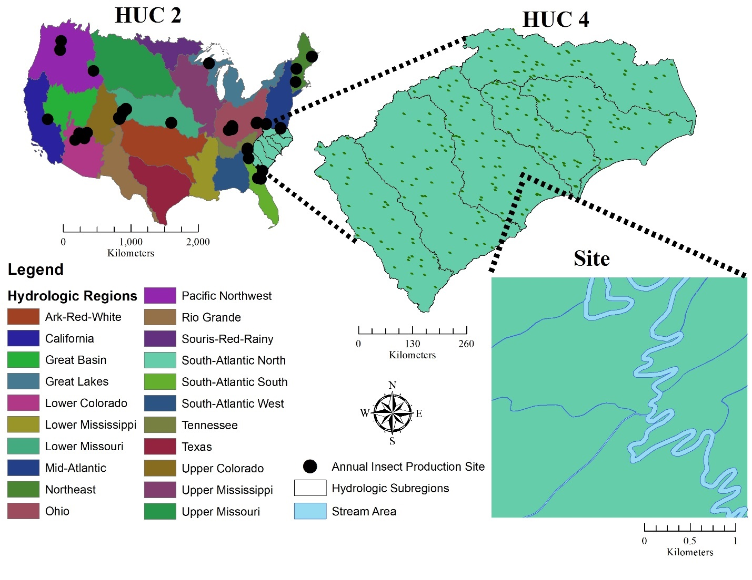
Figure 3.1

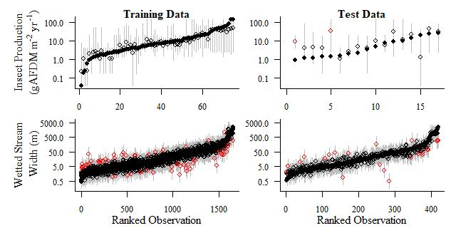
Figure 3.2

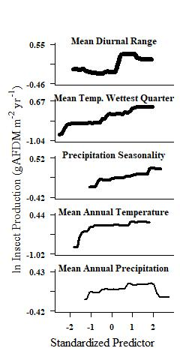
Figure 3.3
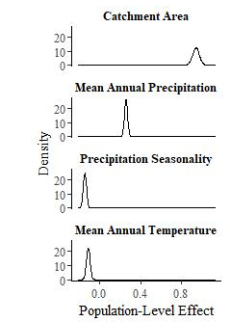
Figure 3.4
Figure 3.5
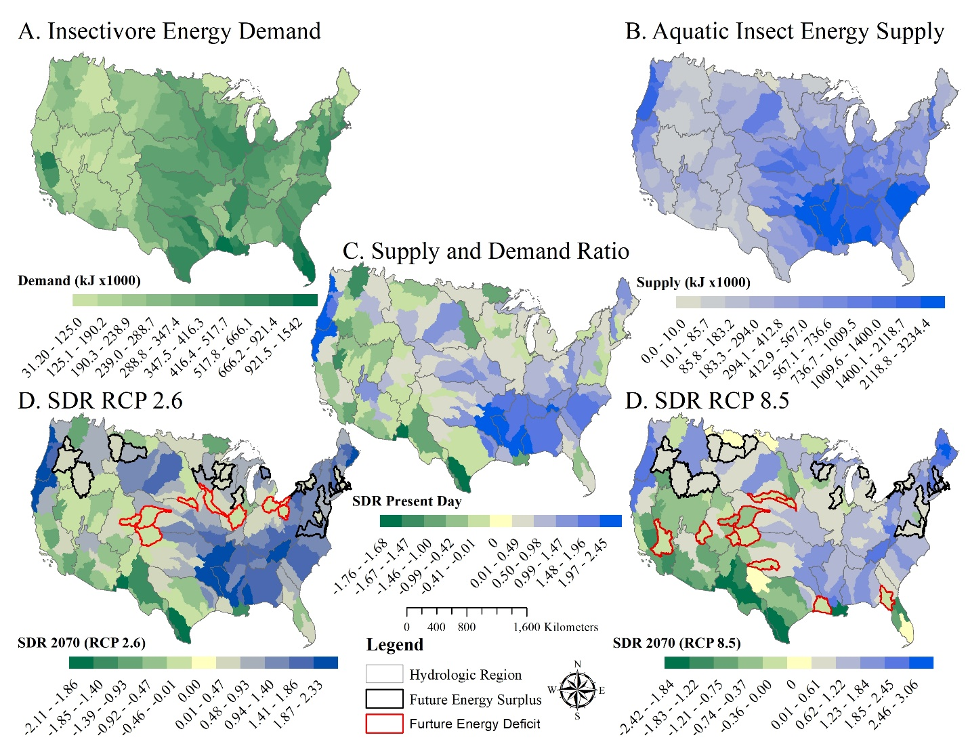

Figure 3.6

Appendix S1. Supporting Information

Table S3.1: Bioclimate variable descriptions used in the stream width and insect production models. Descriptions are adapted from https://www.worldclim.org/. A quarter is defined as a period of three months. We removed highly correlated variables such that bold were included in the analysis.

BIO1 = Annual Mean Temperature
BIO2 = Mean Diurnal Range (Mean of monthly (max temp - min temp))
BIO3 = Isothermality (BIO2/BIO7) (×100)
BIO4 = Temperature Seasonality (standard deviation ×100)
BIO5 = Max Temperature of Warmest Month
BIO6 = Min Temperature of Coldest Month
BIO7 = Temperature Annual Range (BIO5-BIO6)
BIO8 = Mean Temperature of Wettest Quarter
BIO9 = Mean Temperature of Driest Quarter
BIO10 = Mean Temperature of Warmest Quarter
BIO11 = Mean Temperature of Coldest Quarter
BIO12 = Annual Precipitation
BIO13 = Precipitation of Wettest Month
BIO14 = Precipitation of Driest Month
BIO15 = Precipitation Seasonality (Coefficient of Variation)
BIO16 = Precipitation of Wettest Quarter
BIO17 = Precipitation of Driest Quarter
BIO18 = Precipitation of Warmest Quarter
BIO19 = Precipitation of Coldest Quarter

Table S3.2. Avian Areal Insectivorous Birds used to calculate energetic demand. Body mass estimates were obtained from Dunning (2008). Field metabolic rate were estimated from body mass using allometric scaling (Nagy et al. 1999)
Scientific Name | Common Name | Body Mass (g) | Field Metabolic Rate (kJ d⁻¹)
Chordeiles acutipennis | Lesser Nighthawk | 47.7 | 146.08
Chordeiles minor | Common Nighthawk | 79.3 | 206.34
Chordeiles gundlachii | Antillean Nighthawk | 50 | 150.72
Nyctidromus albicollis | Common Pauraque | 56.1 | 163.07
Phalaenoptilus nuttallii | Common Poorwill | 48.1 | 146.84
Antrostomus carolinensis | Chuck-will's-widow | 109 | 256.25
Antrostomus vociferus | Eastern Whip-poor-will | 53.4 | 157.63
Cypseloides niger | Black Swift | 41.3 | 132.47
Chaetura pelagica | Chimney Swift | 23.6 | 90.39
Chaetura vauxi | Vaux's Swift | 17.1 | 72.58
Aeronautes saxatalis | White-throated Swift | 32.1 | 111.46
Stelgidopteryx serripennis | Northern Rough-winged Swallow | 15.8 | 68.94
Progne subis | Purple Martin | 53.8 | 158.46
Tachycineta bicolor | Tree Swallow | 21.2 | 84.02
Tachycineta thalassina | Violet-green Swallow | 14.1 | 63.82
Riparia riparia | Bank Swallow | 13.2 | 61.08
Hirundo rustica | Barn Swallow | 17.2 | 73.12
Petrochelidon pyrrhonota | Cliff Swallow | 21.6 | 85.10
Petrochelidon fulva | Cave Swallow | 24.1 | 91.76
Camptostoma imberbe | Northern Beardless-Tyrannulet | 7.4 | 41.03
Contopus cooperi | Olive-sided Flycatcher | 32.1 | 111.46
Contopus pertinax | Greater Pewee | 27.2 | 99.57
Contopus sordidulus | Western Wood-Pewee | 13.1 | 60.54
Contopus virens | Eastern Wood-Pewee | 13.9 | 63.03
Empidonax flaviventris | Yellow-bellied Flycatcher | 11.8 | 56.38
Empidonax virescens | Acadian Flycatcher | 12.6 | 58.95
Empidonax alnorum | Alder Flycatcher | 12.7 | 59.27
Empidonax traillii | Willow Flycatcher | 13.3 | 61.40
Empidonax minimus | Least Flycatcher | 10 | 50.37
Empidonax hammondii | Hammond's Flycatcher | 10.5 | 52.08
Empidonax wrightii | Gray Flycatcher | 12.3 | 57.99
Empidonax oberholseri | Dusky Flycatcher | 10.4 | 51.73
Empidonax difficilis | Pacific-slope Flycatcher | 10.7 | 52.74
Empidonax occidentalis | Cordilleran Flycatcher | 11.6 | 55.72
Empidonax fulvifrons | Buff-breasted Flycatcher | 7.9 | 42.90
Sayornis nigricans | Black Phoebe | 18.3 | 76.22
Sayornis phoebe | Eastern Phoebe | 19.7 | 79.93
Sayornis saya | Say's Phoebe | 20.9 | 83.21
Pyrocephalus rubinus | Vermilion Flycatcher | 14.4 | 64.57
Myiarchus tuberculifer | Dusky-capped Flycatcher | 18.9 | 77.88
Myiarchus cinerascens | Ash-throated Flycatcher | 28.2 | 102.04
Myiarchus crinitus | Great Crested Flycatcher | 32.1 | 111.46
Myiarchus tyrannulus | Brown-crested Flycatcher | 42.8 | 135.67
Pitangus sulphuratus | Great Kiskadee | 63.7 | 177.91
Myiodynastes luteiventris | Sulphur-bellied Flycatcher | 46.9 | 144.29
Tyrannus melancholicus | Tropical Kingbird | 37.4 | 123.68
Tyrannus couchii | Couch's Kingbird | 39 | 127.26
Tyrannus vociferans | Cassin's Kingbird | 45.6 | 141.56
Tyrannus crassirostris | Thick-billed Kingbird | 55.9 | 162.62
Tyrannus verticalis | Western Kingbird | 39.6 | 128.59
Tyrannus tyrannus | Eastern Kingbird | 38.6 | 126.41
Tyrannus dominicensis | Gray Kingbird | 46.5 | 143.45
Tyrannus forficatus | Scissor-tailed Flycatcher | 39.3 | 127.92

Table S3.3. Leave-one-out model comparison and population-level effects for wetted stream width models.
 | Population-level effects
Model Rank | Catchment Area  (95% CrI) | Mean Annual Precipitation  (95% CrI) | Precipitation Seasonality  (95% CrI) | Mean Annual Temperature  (95% CrI) | Predictive Accuracy Change (SE)
1 | 0.94  (0.88, 1.01) | 0.24  (0.21, 0.27) | -0.17  (-0.2, -0.13) | -0.11  (-0.15, -0.08)
2 | 0.92  (0.85, 0.98) | 0.20  (0.17, 0.23) | -0.16  (-0.20, -0.13) |  | -16.9 (6.9)
3 | 0.90  (0.83, 0.97) | 0.21  (0.18, 0.23) |  |  | -54.8 (12.7)
4 | 0.86  (0.83, 0.88) |  |  |  | -154.7 (20.1)

Scaling landscape pattern in river networks: the effects of spatial extent, grain size and thematic resolution

Darin A. Kopp and Daniel C. Allen

Ecology and Evolutionary Biology Program, Department of Biology, University of Oklahoma, Norman, Oklahoma 73071

Abstract
Abstract:
Context
Spatial pattern reflects ecological processes but is scale dependent. In riverine landscapes, scaling relationships are poorly known and could differ from other well-studied landscapes because of their dendritic form.

Objectives
The objectives of this study were 1) to assess how spatial pattern of hydrogeomorphic habitat patches (HGP) change with spatial extent, grain size, and thematic resolution, and 2) to quantify how spatial pattern in river networks varies across the contiguous United States (CONUS).

Methods
We identified hydrogeomorphic patches in river networks located in different ecoclimatic domains of the CONUS. We then quantified spatial pattern using a suite of landscape metrics and investigated scaling relationships for each component of scale. We also assessed whether watershed area, river network length, and drainage density were related to spatial pattern and explored regional differences in the hydrologic, geomorphologic, and climatic variables that differentiate HGP types.

Results
Scaling relationships varied among river networks. When predictable, they followed either linear, logarithmic, or power functions. Spatial pattern among river networks was related to total network length, catchment area or drainage density. HGP types in different networks were rarely characterized by the same suite of hydrogeomorphic variables.

Conclusions
In riverine landscapes, there are a variety of relationships between scale and spatial pattern which often vary among different river networks. The scaling functions we present can provide a concise description of scale dependency in these landscapes and improve our ability to synthesize research conducted at different scales.

Keywords: Hydrogeomorphic patches, scaling, landscape pattern analysis, riverine ecosystems, dendritic networks, spatial pattern.

Introduction
Spatial pattern is closely linked to ecological processes but the relationship depends on the scale of the investigation (Wiens 1989; Wu et al. 2002; Jackson and Fahrig 2015). Scaling functions can describe how spatial pattern changes with scale and facilitate the transfer of information from one scale to another (Wu et al. 2002; Šímová and Gdulová 2012). Within rivers and streams, heterogeneity of aquatic habitats is an important feature governing ecological processes (Thorp et al. 2006; Thoms et al. 2018; Erős and Lowe 2019). However, previous studies have viewed aquatic ecosystems as homogenous compartments embedded within larger landscapes (Šímová and Gdulová 2012; Erős and Lowe 2019). Aquatic ecosystems are structurally different from terrestrial landscapes (i.e. dendritic networks) and require different metrics and methods to quantify spatial pattern (Williams et al. 2013; Thoms et al. 2018). Understanding how these metrics change with scale is necessary for identifying the operational scale of an ecosystem processes (Jackson and Fahrig 2015; Qiu et al. 2019).
Spatial pattern is typically quantified using landscape metrics that measure the composition (i.e. diversity) or configuration (i.e. spatial arrangement) of habitat patches (McGarigal et al. 2012). Scale can include multiple components (Wu and Li 2006; Turner and Gardner 2015), but most often it refers to spatial extent, the total area used in a study, or spatial grain, the finest resolution that can detect a pattern (e.g. pixel size or linear unit; Wiens 1989, Wu and Li 2006, Cushman et al. 2010). A third component of scale, thematic resolution, refers to the level of detail used to differentiate landscape components. For example, land cover classification maps are often represented as nested hierarchies: at lower levels of the hierarchy thematic resolution increases such that a larger number of subordinate land cover classes are revealed (Buyantuyev and Wu 2007; Šímová and Gdulová 2012; Qiu et al. 2019).
Each component of scale can influence landscape metrics differently. In some instances, these effects are predictable (Wu et al. 2002; Buyantuyev and Wu 2007; Xu et al. 2020). For example, landscape metrics that represent absolute values of spatial pattern, such as mean size or distance between landscape components, should increase monotonically with spatial extent and decrease with spatial grain and thematic resolution (Baldwin et al. 2004; Šímová and Gdulová 2012). Similarly, landscape metrics that quantify diversity should increase when novel landscape components are encountered at larger spatial extents or unveiled by increased thematic detail (Turner et al. 1989; Šímová and Gdulová 2012). They should also decrease with coarsening grain because small or rare landscape components disappear (Turner et al. 1989; Šímová and Gdulová 2012). Changing scale can also cause metrics to display either staircase-like or chaotic patterns, making them less predictable (Wu et al. 2002; Šímová and Gdulová 2012). Evaluating the effects of scale on landscape metrics in multiple landscapes can uncover potential generalities in these relationships (Wu et al. 2002; Shen et al. 2004; Buyantuyev and Wu 2007).
Riverine landscapes include components of the Earth’s surface that are influenced by a river, including aquatic habitats in the river, and riparian corridors and floodplains that occur alongside them (Fausch et al. 2002; Ward et al. 2002; Thorp et al. 2006). These systems are characterized by “habitat patches” which can be classified by their hydrological and geomorphological conditions, often termed "hydrogeomorphic patches" (Thoms and Parsons 2002, Williams et al. 2013). Hydrogeomorphic patches (hereafter “HGP”) are associated with geomorphic and hydrologic forces that shape sections of a riverine ecosystem (i.e. “functional process zones”), and influence ecological processes (Thorp et al. 2006, 2008). The composition and configuration of HGP can characterize the physical structure of entire river networks (Williams et al. 2013; Thoms et al. 2018), influence species diversity patterns (Maasri et al. 2019) and ecosystem processes (Hadwen et al. 2010; Thorp et al. 2010; Collins et al. 2018).
Previous efforts to characterize river networks by their HGPs have focused on a small number of river networks at different spatial scales (Collins et al. 2014; Thoms et al. 2018; Maasri et al. 2019). Since scale dependency is common, this may hinder efforts to synthesize their findings. Scaling functions could provide an accurate way to predict how spatial pattern of HGP changes with spatial extent (watershed area), grain size (resolution of hydrography) or thematic detail. River networks are also embedded in biomes that vary in their climate, hydrology and geomorphology which could contribute to geographical variation in the factors that differentiate HGP types and their spatial pattern (Dodds et al. 2015, 2019). Thus, systematic evaluations of scaling relationships across multiple riverine landscapes will improve our understanding of scale dependencies in spatial pattern within and among different biomes (Wu et al. 2002).
Here, we investigate how the spatial pattern of HGP changes with scale in 18 river networks in the contiguous United States (hereafter “CONUS”). We used climate, hydrologic, and geomorphic variables to identify HGP and adapted several landscape metrics to quantify their configuration and composition in each river network. We then evaluate the relationship between each landscape metric and three components of scale: spatial extent, spatial grain, and thematic resolution (Wu et al. 2002; Buyantuyev and Wu 2007; Xu et al. 2020). Finally, we investigated the role of river network size (i.e. total stream length or catchment area) and topology (drainage density) in driving variation in spatial pattern among biomes and determine if the suite of hydrologic, geomorphic and climatic variables used to differentiate HGP remains consistent across the studied river networks.

Methods
Study sites
We chose a single river network in each of the National Ecological Observation Network (NEON; https://www.neonscience.org/) ecoclimatic domains in the CONUS (Figure 1; Hargrove and Hoffman 2004). Ecoclimatic domains were delineated using multivariate geographic clustering of nine climate variables (Hargrove and Hoffman 2004). Where possible, we used a NEON aquatic or terrestrial site to locate a suitable river network within each ecoclimate domain. We handpicked sites in the Southern Pacific domain (17) to represent a Mediterranean climate (NEON stream sites in the domain 17 are in the Sierra Nevada mountains, with similar climate to other NEON sites), and in the Prairie Peninsula domain (06) due to restrictions in the availability of High Resolution National Hydrography Dataset (NHDHR) at the time of the study (Viger et al. 2016, Moore et al. 2019). We also selected two sites in the Ozarks complex (08) and omitted the Atlantic Neotropical domain (04) because of its relatively small spatial coverage in the CONUS (Figure 1).
We delineated river networks by associating each site to a digital flowline in the NHDHR and navigating downstream to until reaching a catchment area closest 5,000 km² (range = 364.12 and 5,733.06 km²; Strahler Stream Order > 5). We extracted all flowlines draining the catchment from the NHDHR and reconditioned them into valley and reach segments. We define a valley segment as a section of the river between a headwater and confluence, or two confluences. Valley segments < 1km were classified as a single reach while valley segments > 1 km were split into reaches of equal length. River reaches typically ranged between 0.5 and 1 km and served as our spatial unit of replication for each river network (1,154 ≤ n ≤ 13,222; Table 1).

Hydrogeomorphic and climate variables
Hydrologic, geomorphologic and climatic variables were extracted or derived for each reach from several GIS datasets (Table 2; Williams et al. 2013, Thoms et al. 2018, Maasri et al. 2019). Mean annual air temperature (˚C) and precipitation (mm) were obtained from the PRISM Climate Group (1981-2010; https://prism.oregonstate.edu/normals/). Whole soil erodibility factor (kw) and pH values we obtained from the Soil Survey Geographic Database (https://websoilsurvey.nrcs.usda.gov/) and classified as low (kw < 0.25, pH < 6.5), medium (0.25 ≤ kw < 0.4, 6.5 ≤ pH < 8.5) and high (kw ≥ 0.4, pH ≥ 8.5). Depth to bedrock (cm) was obtained from Shangguan et al. (2017). Finally, we used the digital elevation model provided with the NHDHR to determine the elevation (cm) of a reach and derive a suite of metrics to quantify geomorphologic characteristics (Table 2, Figure S1).
Climate, geology, and elevation were extracted at the midpoint of each reach and we established transects perpendicular to the river to measure valley-side slope, valley width, and valley floor width (Figure S1). We used points at the inlet and outlet of the valley segment to measure valley slope. Channel sinuosity and mean meander length were measured using the endpoints of each reach. We reconditioned NHDHR flowlines, identified reaches, sampling points, and transects using the “create module” R-script. We assigned hydrogeomorphic variables to each reach using the “attribute module” R-script (https://github.com/dkopp3/HydrogeomorphicPatches).

Hydrogeomorphic patch identification
Hydrogeomorphic patches (HGP) were identified using agglomerative hierarchical clustering (Borcard et al. 2018). This approach successively groups individual reaches into larger classes based on the similarity of their hydrogeomorphic characteristics (Thoms et al. 2018; Maasri et al. 2019). At the lowest level of the hierarchy, each river reach is an individual class while at the highest level, all reaches are combined into a single class. We used Gower’s dissimilarity index to measure pairwise associations between reaches and Ward’s minimum variance to create hierarchically nested groupings (Borcard et al. 2018; Maasri et al. 2019). We objectively identified the optimal number of HGP types for each network using the maximum average silhouette width (Borcard et al. 2018). Silhouette width is a metric of group similarity at each partition of the dendrogram and the maximum average width corresponds to the partition with the greatest degree of separation among subordinate groups. We used the “daisy” function to generate distance matrices, the “agnes” function for agglomerative hierarchical clustering and the “silhouette” function to conduct the silhouette analysis (Maechler et al. 2019). These functions are embedded within the “cluster module” (https://github.com/dkopp3/HydrogeomorphicPatches).

Spatial pattern analysis
We quantified the spatial pattern using four landscape metrics that measure the composition or configuration of HGP (McGarigal et al. 2012). To measure composition, we combined adjacent stream reaches of the same HGP type and counted the uninterrupted river segments as total number of patches (TP). In addition, we calculated the Shannon Diversity index (SHDI) for each network. The SHDI is commonly used to measure landscape heterogeneity and has recently been applied to riverine landscapes (O’Neill et al. 1988; Turner et al. 1989; Thoms et al. 2018). Following Thoms et al (2018), we calculated SHDI as:
$$SHDI=-\sum{p_{i}\ln{p_{i}}}$$
where $p_{i}$ is the proportional length of the $i$th hydrogeomorphic patch relative to the total length of the river network.
To measure the configuration of HGP within each network we calculated the mean distance separating HGP types as mean patch distance (MPD) and used the dendritic connectivity index (DCI) to measure how connected the different HGP types were in each network (Cote et al. 2009). DCI is based on the probability that an organism can cross a boundary separating one patch from another: $$DCI=\sum_{i=1}^{n}{\sum_{j=1}^{n}{c_{ij}\frac{l_{i}}{L}\frac{l_{j}}{L}}}*100$$
where $c_{ij}$ is probability that an organism can traverse a boundary separating patch $i$ and $j$, $l$ is the length of patch and $L$ is the total length of the network. The index is multiplied by 100 to scale the value between 1 and 100. This index assumes boundaries do not occupy space in the network such that when $c_{ij}=1$ (i.e. complete boundary permeability), $DCI=1$ (Cote et al. 2009). Because we expected the connectivity between two HGPs of the same type depends on the distance separating them we modified DCI as:
$${DCI}_{k}= \sum_{i=1}^{n}{\sum_{j=1}^{n}{c_{k_{i}k_{j}}\frac{l_{k_{i}}}{L_{k}}\frac{l_{k_{j}}}{L_{k}}}}*100$$
where $k$ indexes the HGP type. To specify $c_{k_{i}k_{j}}$ we consider the dispersal distance of an organism, $X,$ as a random variable with a probability distribution,$X\sim exp(λ$). We parameterize the probability density function using the median maximum parent-offspring dispersal distance for riverine fishes (i.e.$λ$ = 1/12km, Comte and Olden 2018). For a parent fish living in patch $i$ of type $k$, $c_{k_{i}k_{j}}$ reflects the probability that the offspring of that fish can disperse to patch$j$. We used the mean of ${DCI}_{k}$ to aggregate the connectivity between $k$ patch types to the landscape level (i.e. $\overline{{DCI}_{k}})$. Landscape metrics were calculated using the “landscape metrics” module (https://github.com/dkopp3/HydrogeomorphicPatches).

Statistical Analysis
Within each river network we evaluated how HGP spatial patterns change with spatial extent, spatial grain, and thematic resolution. In rivers, spatial extent is represented by watershed area, or the surface area contributing runoff to a river channel during precipitation events. We changed spatial extent by randomly identifying sub-networks at 10 km² increments of increasing catchment area (Figure 2). We assessed between 25 and 234 values of spatial extent depending on the size of the network. We manipulated the spatial grain of a stream network by increasing the minimum channel length represented in the network (Figure 2). Each interval coarsened or “pruned” the river network, to provide a range of 24 to 94 values of spatial grain in our analysis. Finally, we manipulated the thematic resolution by decreasing the level of dissimilarity among HGP types beginning at the level specified during the silhouette analysis (i.e. 4-8 HGP types) up to 30 HGP types for each network (Figure 2).
We visually inspected the scaleograms for each river network prior to fitting linear, power, and logarithmic functions. This allowed us to classify each relationship as “predictable”, if the functions could provide a reasonable approximation for the data, or “unpredictable” if the relationship was better characterized by staircase-like patterns or behaved erratically (Wu et al. 2002). For predictable relationships, we fit each function to the data and used the coefficient of determination (i.e. R²) to identify the strongest relationship (Rüegg et al. 2016).
We used a regression analysis to test whether river network length, total catchment area or drainage density explained variation in spatial pattern among river networks in different ecoclimatic regions. Network length is the total length of streams in a network; catchment area is the surface area that contributes overland runoff to a river network; and drainage density is the network length divided by the catchment area. We fit linear, power, and logarithmic models to each pairwise combination of spatial pattern and river network characteristic.
To investigate which variables were most important in differentiating HGP types within river networks we used an Analysis of Similarity (ANOSIM) followed by Similarity Percentage Analysis (SIMPER) (Harris et al. 2009; Thoms et al. 2018; Oksanen et al. 2019). ANOSIM confirmed a statistical difference among HGP types within each river network and SIMPER identified the single variable that was most dissimilar for each pairwise combination. We used the aggregated list of variables for each river network to describe the suite of climatic, hydrologic, and geomorphic variables that contribute most to the differentiation of HGP types for each river network.

Results
Effects of scale on spatial pattern of HGP depended on the component of scale and the landscape metric. For composition metrics, we found a logarithmic function consistently explained the relationship between Shannon diversity index (SHDI) and spatial extent in five river networks (Table 3, R² range: 0.61 - 0.77). The relationship between SHDI and spatial grain on the other hand, often followed a staircase-like pattern and was not reasonably represented by simple functions we considered in our analysis (Table 3, Figure S2). Total patches (TP) had a consistently strong linear relationship with spatial extent in 12 stream networks (R² > 0.93) and followed a power relationship with spatial grain in three networks (R² > 0.93, Figure S2). Finally, thematic resolution was almost perfectly related to both SHDI (R² > 0.98) and TP (R² > 0.96) by either, logarithmic or power functions (Table 3).
In general, scaling relationships for the configuration metrics were different from composition metrics (Table 3). For example, scaling the modified dendritic connectivity index ($\overline{{DCI}_{k}})$ with spatial extent followed linear, power, or logarithmic functions in 12 networks (R² range: 0.66 - 0.94, Table 3) and scaling with thematic resolution followed linear or power functions in 8 networks (R² range: 0.69 - 0.92). When mean patch distance (MPD) was predictable, it also scaled with extent and thematic resolution following linear, power, or logarithmic functions. The effect of changing grain on $\overline{{DCI}_{k}}$ were predictable in 6 networks using linear functions (R² range: 0.80 - 0.97) but was unpredictable for MPD where the relationships were characterized as either chaotic or staircase-like (Figure S2).
We identified between 4 and 8 HGP types in each river network (ANOSIM global R range: 0.4, 0.95, p < 0.001 for all networks; Table 4) and found the variation in spatial pattern among them was related to network length, catchment area and drainage density (Figure 3). Catchment area and total length of the stream network were positively associated with TP (R² = 0.29, P < 0.001; R² = 0.59, P<0.001, respectively), and MPD (R² = 0.80, P < 0.001; R² = 0.90, P < 0.001, respectively). In addition, total network length was negatively associated with $\overline{{DCI}_{k}}$ (R² = 0.32, P < 0.05). Lastly, drainage density was negatively associated with SHDI (R² = 0.24, P < 0.05) and MPD (R² = 0.26, P < 0.05).
For each network, we characterized the suite of variables that contributed to the differentiation of HGPs (Table 4). In general, HGPs in different river networks were characterized by different suites of hydrogeomorphic and climate variables. However, many networks shared at least a single variable. For example, soil erodibility was an important factor driving dissimilarity between HGP types in 13 networks and valley-floor ratio was important for 9 networks. River networks that shared similar hydrogeomorphic variables were typically located in different ecoclimate regions (Table 4).

Discussion
Understanding scale dependencies in spatial patterns can elucidate the operational scale of an ecological process (Wu et al. 2002; Jackson and Fahrig 2015). Increasingly, spatial pattern is quantified within river networks to understand the physical and ecological characteristics of the entire ecosystem (Thoms et al. 2018; Maasri et al. 2019). However, river networks vary in their spatial extent, spatial grain, and thematic detail (Benstead and Leigh 2012; Rüegg et al. 2016), which could hinder opportunities for synthesis or mask important relationships. We extended the framework developed by Wu et al. (2002) and found scaling relationships in river networks vary across a broad geographic area. The effect of thematic resolution was most predictable for composition metrics while the effect of spatial extent was most predictable for configuration metrics. We also found that the effects of changing spatial grain are least predictable, possibly owing to the dendritic structure of river networks and the method used to manipulate grain size (i.e. minimum mapping unit). Importantly, this work demonstrates that spatial pattern in some river networks changes predictably with scale which could facilitate the transfer of information obtained at one scale to another.

Scaling relationships in riverine landscapes
We assessed how spatial patterns of HGP are influenced by three different components of scale and, similar to other landscapes, found that landscape metrics could change either predictably (i.e. following simple scaling functions), or unpredictably (i.e. exhibiting staircase-like or chaotic patterns). In general, the effects of changing spatial extent were more predictable than the effects of changing grain size. Indeed others have found that changing spatial extent is less predictable than change grain size (Wu et al. 2002; Wu 2004). Together, these patterns could support the notion that the method used to manipulate spatial grain influences the scaling relationships that emerge from analyses (Turner and Gardner 2015; Xu et al. 2020). For example, data stored as raster images is commonly upscaled by aggregating smaller pixels via majority rules (Wu and Li 2006; Qiu et al. 2019). River networks on the other hand, are often represented as vector data because of their dendritic structure. Accordingly, we manipulated spatial grain by changing the minimum mapping unit (i.e. iteratively pruning the river networks) such that coarsening grain can result in the removal of HGP types. Indeed, the addition or removal of habitat patches is known to reduce the predictability of scaling relationships (Shen et al. 2004). Thus our results may suggest that there are more opportunities to transfer values of spatial pattern between different spatial extents than hydrography datasets that differ in their spatial resolution (Lehner et al. 2008; McKay et al. 2012; Moore et al. 2019).
Effects of thematic resolution are expected to be similar to those of spatial grain (Buyantuyev and Wu 2007). In general, we found that these effects were more predictable than those of spatial grain for composition metrics and less predictable for configuration metrics. The relationship between thematic resolution and spatial pattern for the composition metrics is unsurprising because increasing the number of HGP types simultaneously increases richness and fragmentation. Configuration metrics on the other hand, were less predictable and often behaved erratically. Indeed, changing thematic resolution may combine, or separate, spatially distant patches and lead to unpredictable scaling relationships (Buyantuyev and Wu 2007).
Lotic ecosystems are known vary geographically as a result of regional differences in climate and geomorphology (Dodds et al. 2015, 2019). We found scaling relationships generally differed among river networks. Indeed, Rüegg et al. (2016) demonstrated that scaling relationships between stream channel characteristics (i.e. width and depth) and catchment area varied geographically. Collectively this suggests that differences among river networks could alter the scaling relationships. However, we only included one river network for each ecoclimate domain and could not ascertained whether scaling relationships were similar within a geographic region. It would be interesting to investigate mechanisms driving apparent variation in scaling relationships.

Spatial patterns in river networks
We quantified spatial pattern at the river network scale by adapting several landscape metrics related to ecological characteristics of lotic ecosystems (Le Pichon et al. 2007; Datry et al. 2016; Thoms et al. 2018). The Shannon diversity index has been applied to quantify heterogeneity in terrestrial and riverine landscapes (Turner et al. 1989; Thoms et al. 2018). Higher SHDI values indicate a greater variety of physical habitat types, which should influence the ecological function of the river network given tight coupling between HGP and ecological processes in rivers (Harris et al. 2009; Thoms et al. 2018; Maasri et al. 2019). Among river networks, we found that drainage density was negatively related to SHDI. This result is surprising because increasing drainage density can increase complexity in river networks because of tributary junctions and their associated confluence effects (Benda et al. 2004; Fullerton et al. 2017). In our study, higher drainage density likely resulted stream reaches coming in closer proximity to one another and thereby having similar hydrologic, geomorphologic and climate properties. Consequently, hydrogeomorphic variables may be more important for driving spatial heterogeneity in networks with lower drainage density while confluence effects may be more important for networks with higher drainage density.
Connectivity among HGPs in stream networks could have implications for species diversity patterns and meta-community dynamics (Cote et al. 2009; Campbell Grant 2011). We found the modified dendritic connectivity index ($\overline{{DCI}_{k}}$) varied among river networks and was negatively related to the total length of the network. We used the watercourse distance separating two HGP types as a measure of permeability and did not consider the concurrent effects of any other barriers (e.g. dams and road culverts, Cote et al. 2009). Since the total length of a river network allows for longer watercourse distances separating two HGPs it is expected that network length would be negatively related to connectivity. From an ecological perspective, this relationship could suggest dispersal limitation may be important in large river networks (Tonkin et al. 2017; Schmera et al. 2018).
The total number of patches (TP) and mean distance separating them (MPD) are absolute measurements of spatial pattern that reflect degree of fragmentation and isolation of HGP types, respectively. We found river networks with greater total stream length had more patches and greater distances separating them. If HGP types have asynchronous dynamics, river networks with more patches could potentially have greater stability in their ecological (Moore et al. 2015). Alternatively, positive association between stream length and mean patch distance suggests dispersal may be limited in larger networks. In general, quantifying spatial patterns in river networks can concisely describe their characteristics and facilitate comparisons among them (Le Pichon et al. 2007; Datry et al. 2016; Thoms et al. 2018).

Hydrogeomorphic patch characteristics
Although the river networks we studied differed in the suite of hydrogeomorphic variables that contributed to differentiation of HGP types, some variables were common among them. For example, soil erodibility contributed to differentiation HGP types in all river networks. This could suggest that these river networks have HGPs that receive relatively higher sediment loads from the adjacent terrestrial environment (Walling 1999). Excess fine sediments can influence benthic macroinvertebrate communities which, because of their central position in aquatic food webs, could have implications for ecosystem processes (Hubler et al. 2016). Considering most of the river networks we studied have HGP types characterized by soil erodibility, it would be interesting to investigate if they also have similar benthic macroinvertebrate communities. Indeed the ecological functions of HGP may also depend on intra- and inter-patch interactions (Wu and Loucks 1995; Thorp et al. 2006) and rarely, did we find two networks share the same suite of hydrogeomorphic variables. Thus, although some HGP types may be similar among river networks, they likely contain other HGP that differ. Another interesting avenue for future investigation could be to consider effect of “hydrogeomorphic context” on the ecological processes occurring within an HGP.

Limitations and caveats
Hydrologic, geomorphologic and climatic characteristics can be readily calculated with GIS-based approaches (Williams et al. 2013; Thoms et al. 2018). For this study, we created a suite of scripts using Program R (https://www.r-project.org/) to eliminate dependencies on proprietary software (e.g. ArcGIS, ESRI, Redlands, CA). We also designed these scripts to depend exclusively on the High Resolution National Hydrography Dataset to facilitate large scale, comparative analyses across the CONUS (Moore et al. 2019). However, the major limitation with this approach is that it can take several weeks of processing and is potentially limited to river networks < 5,000 km² because of computational demands. Further, given the scale of our study it was not feasible to ground-truth the accuracy the GIS-based variables. Still, we followed a similar approach to others that found GIS-derived variables can produce similar results to empirical field-based measures (Thorp et al. 2008; Williams et al. 2013; Thoms et al. 2018).
The choice of the landscape metrics used to quantify spatial pattern should be ecologically justified and may differ depending on the goals of a study (Li and Wu 2004). There are literally hundreds of landscape metrics and many each respond differently to scale (McGarigal et al. 2012; Šímová and Gdulová 2012). We found scaling relationships vary among different river networks, but we only considered four metrics. Evaluating a larger number of metrics will improve our ability to draw general conclusions about differences in the behavior of composition versus configuration metrics. Because there are few landscape metrics that can be adapted to, or are suitable for, riverine landscapes (Le Pichon et al. 2007; Datry et al. 2016; Erős and Lowe 2019), increasing the number of landscape metrics for riverine landscapes should be also be a consideration for investigating general scaling laws.

Conclusions
Spatial pattern analysis can reveal complex linkages between spatial pattern and ecological processes in landscapes (Jackson and Fahrig 2015; Qiu et al. 2019). Although spatial pattern is quantified within river networks to understand ecological processes occurring within them (Thorp et al. 2006; Erős and Lowe 2019), issues of scale dependence can limit opportunities to synthesize results from different spatial scales or potentially mask important relationships. Scaling functions can provide concise descriptions of the multiscaled characteristics of spatial pattern and will improve our ability to detect the most appropriate scale underpinning an ecological process in riverine ecosystems.

Acknowledgements
We would like to thank J. Wu, M. Kaspari, J. Kelly and T. Neeson for comments on previous versions of the manuscript and D. Cote for assistance with the dendritic connectivity index. This research is part of a dissertation at the University of Oklahoma. This work was supported by a grant from the National Science Foundation (1802872) and DA was supported by additional NSF funding (1754389). DK and DA developed the conceptual framework for the study, DK conducted analysis and wrote first draft of the manuscript and DA contributed subsequent revisions of the manuscript.

References
Allan, J. D. 2004. Landscapes and Riverscapes: The Influence of Land Use on Stream Ecosystems. Annual Review of Ecology, Evolution, and Systematics 35:257–284.
Allen, D. C., and J. Wesner. 2016. Synthesis: comparing effects of resource and consumer fluxes into recipient food webs using meta-analysis. Ecology 97:594–604.
Allen, G. H., and T. M. Pavelsky. 2015. Patterns of river width and surface area revealed by the satellite-derived North American River Width data set. Geophysical Research Letters 42:395–402.
Allen, G. H., T. M. Pavelsky, E. A. Barefoot, M. P. Lamb, D. Butman, A. Tashie, and C. J. Gleason. 2018. Similarity of stream width distributions across headwater systems. Nature Communications 9:610.
Anderson, H. E., L. K. Albertson, and D. M. Walters. 2019. Water temperature drives variability in salmonfly abundance, emergence timing, and body size. River Research and Applications 35:1013–1022.
Anderson, W. B., A. D. Wait, and P. Stapp. 2008. Resources From Another Place and Time: Responses To Pulses in a Spatially Subsidized System. Ecology 89:660–670.
Araújo, M. B., and A. T. Peterson. 2012. Uses and misuses of bioclimatic envelope modeling. Ecology 93:1527–1539.
Baker, M. E., D. E. Weller, and T. E. Jordan. 2007. Effects of stream map resolution on measures of riparian buffer distribution and nutrient retention potential. Landscape Ecology 22:973–992.
Baldwin, D. J. B., K. Weaver, F. Schnekenburger, and A. H. Perera. 2004. Sensitivity of landscape pattern indices to input data characteristics on real landscapes: implications for their use in natural disturbance emulation. Landscape Ecology 19:255–271.
Barnett, T. P., D. W. Pierce, H. G. Hidalgo, C. Bonfils, B. D. Santer, T. Das, G. Bala, A. W. Wood, T. Nozawa, A. a Mirin, D. R. Cayan, and M. D. Dettinger. 2008. Human-Induced Changes in the Hydrology of the Western United States. Science 319:1080–1083.
Bartrons, M., M. Papeş, M. W. Diebel, C. Gratton, and M. J. Vander Zanden. 2013. Regional-Level Inputs of Emergent Aquatic Insects from Water to Land. Ecosystems 16:1353–1363.
Baxter, C. V., K. D. Fausch, and W. C. Saunders. 2005. Tangled webs: Reciprocal flows of invertebrate prey link streams and riparian zones. Freshwater Biology 50:201–220.
Benda, L., N. L. Poff, D. Miller, T. Dunne, G. G. Reeves, G. Pess, and M. Pollock. 2004. The Network Dynamics Hypothesis: How Channel Networks Structure Riverine Habitats. BioScience 54:413.
Benstead, J. P., and D. S. Leigh. 2012. An expanded role for river networks. Nature Geoscience 5:678–679.
Bieger, K., H. Rathjens, P. M. Allen, and J. G. Arnold. 2015. Development and Evaluation of Bankfull Hydraulic Geometry Relationships for the Physiographic Regions of the United States. Journal of the American Water Resources Association 51:842–858.
Blöschl, G., J. Hall, J. Parajka, R. A. P. Perdigão, B. Merz, B. Arheimer, G. T. Aronica, A. Bilibashi, O. Bonacci, M. Borga, Č. Ivan, A. Castellarin, and G. B. Chirico. 2017. Climate change shifts timing of European floods. Science 590:588–590.
Borcard, D., F. Gillet, and P. Legendre. 2018. Numerical Ecology with R. second. Springer Nature, Cham, Switzerland.
Breiman, L. 2001. Random forests. Machine Learning 45:5–32.
Brieuc, M. S. O., C. D. Waters, D. P. Drinan, and K. A. Naish. 2018. A practical introduction to Random Forest for genetic association studies in ecology and evolution. Molecular Ecology Resources 18:755–766.
Bultman, H., D. Hoekman, J. Dreyer, and C. Gratton. 2014. Terrestrial deposition of aquatic insects increases plant quality for insect herbivores and herbivore density. Ecological Entomology 39:419–426.
Bürkner, P. C. 2017. brms: An R package for Bayesian multilevel models using Stan. Journal of Statistical Software 80.
Buyantuyev, A., and J. Wu. 2007. Effects of thematic resolution on landscape pattern analysis. Landscape Ecology 22:7–13.
Campbell Grant, E. H. 2011. Structural complexity, movement bias, and metapopulation extinction risk in dendritic ecological networks. Journal of the North American Benthological Society 30:252–258.
Carlson, P. E., B. G. Mckie, L. Sandin, and R. K. Johnson. 2016. Strong land-use effects on the dispersal patterns of adult stream insects: implications for transfers of aquatic subsidies to terrestrial consumers. Freshwater Biology 61:848–861.
Clarke, A., R. Mac Nally, N. Bond, and P. S. Lake. 2008. Macroinvertebrate diversity in headwater streams: A review. Freshwater Biology 53:1707–1721.
Collins, S. E., S. F. Matter, I. Buffam, and J. E. Flotemersch. 2018. A patchy continuum? Stream processes show varied responses to patch- and continuum-based analyses. Ecosphere 9.
Collins, S. E., M. C. Thoms, and J. E. Flotemersch. 2014. Hydrogeomorphic zones characterize riverbed sediment patterns within a river network. River Systems 21:203–213.
Comte, L., and J. D. Olden. 2018. Fish dispersal in flowing waters: A synthesis of movement- and genetic-based studies. Fish and Fisheries 19:1063–1077.
Cote, D., D. G. Kehler, C. Bourne, and Y. F. Wiersma. 2009. A new measure of longitudinal connectivity for stream networks. Landscape Ecology 24:101–113.
Cushman, S. A., J. Littell, and K. McGarigal. 2010. The Problem of Ecological Scaling in Spatially Complex, Nonequilibrium Ecological Systems. Pages 1–458 in Cushman S.A. and F. Huettmann (editors). Spatial Complexity, Informatics, and Wildlife Conservation. Springer, Tokyo.
Datry, T., H. Pella, C. Leigh, N. Bonada, and B. Hugueny. 2016. A landscape approach to advance intermittent river ecology. Freshwater Biology n/a-n/a.
Davis, J. M., A. D. Rosemond, and G. E. Small. 2011. Increasing donor ecosystem productivity decreases terrestrial consumer reliance on a stream resource subsidy. Oecologia 167:821–834.
Demars, B., R. Manson, J. Ólafsson, G. Gíslason, R. Gudmundsdóttir, G. Woodward, J. Reiss, D. Pichler, J. Rasmussen, and N. Friberg. 2011. Temperature and the metabolic balance of streams. Freshwater Biology 56:1106–1121.
Dodds, W. K., L. Bruckerhoff, D. Batzer, A. Schechner, C. Pennock, E. Renner, F. Tromboni, K. Bigham, and S. Grieger. 2019. The freshwater biome gradient framework: Predicting macroscale properties based on latitude, altitude, and precipitation. Ecosphere 10.
Dodds, W. K., K. Gido, M. R. Whiles, M. D. Daniels, and B. P. Grudzinski. 2015. The Stream Biome Gradient Concept: factors controlling lotic systems across broad biogeographic scales. Freshwater Science 34:1–19.
Dolédec, S., N. Phillips, M. Scarsbrook, R. H. Riley, and C. R. Townsend. 2006. Comparison of structural and functional approaches to determining landuse effects on grassland stream invertebrate communities. Journal of the North American Benthological Society 25:44–60.
Dreyer, J., P. A. Townsend, J. C. Hook, D. Hoekman, M. J. Vander Zanden, and C. Gratton. 2015. Quantifying aquatic insect deposition from lake to land. Ecology 96:499–509.
Dunning, J. B. (Ed.). 2008. CRC Handbook of Avian Body Masses. CRC Press.
Elith, J., J. R. Leathwick, and T. Hastie. 2008. A working guide to boosted regression trees. Journal of Animal Ecology 77:802–813.
Epanchin, P., R. Knapp, and S. Lawler. 2010. Nonnative trout impact an alpine-nesting bird by altering aquatic-insect subsidies. Ecology 91:2406–2415.
Erős, T., and W. H. Lowe. 2019. The Landscape Ecology of Rivers: from Patch-Based to Spatial Network Analyses. Current Landscape Ecology Reports 4:103–112.
Fausch, K. D., C. E. Torgersen, C. V. Baxter, and H. W. Li. 2002. Landscapes to riverscapes: Bridging the gap between research and conservation of stream fishes. BioScience 52:483–498.
Faustini, J. M., P. R. Kaufmann, and A. T. Herlihy. 2009. Downstream variation in bankfull width of wadeable streams across the conterminous United States. Geomorphology 108:292–311.
Fink, D., T. Auer, A. Johnston, V. Ruiz-Gutierrez, W. M. Hochachka, and S. Kelling. 2020a. Modeling avian full annual cycle distribution and population trends with citizen science data. Ecological Applications 30:1–16.
Fink, D., T. Auer, A. Johnston, M. Strimas-Mackey, O. Robinson, S. Ligocki, B. Petersen, C. Wood, I. Davies, B. Sullivan, M. Iliff, and S. Kelling. 2020b. eBird Status and Trends, Data Version: 2018; Released: 2020. Cornell Lab of Ornithology, Ithaca, New York.
Finn, D. S., N. Bonada, C. Múrria, and J. M. Hughes. 2011. Small but mighty: headwaters are vital to stream network biodiversity at two levels of organization. Journal of the North American Benthological Society 30:963–980.
Fox, E. W., R. A. Hill, S. G. Leibowitz, A. R. Olsen, D. J. Thornbrugh, and M. H. Weber. 2017. Assessing the accuracy and stability of variable selection methods for random forest modeling in ecology. Environmental Monitoring and Assessment 189:316.
Fullerton, A. H., B. J. Burke, J. J. Lawler, C. E. Torgersen, J. L. Ebersole, and S. G. Leibowitz. 2017. Simulated juvenile salmon growth and phenology respond to altered thermal regimes and stream network shape. Ecosphere 8.
Giam, X., W. Chen, T. A. Schriever, R. Van Driesche, R. Muneepeerakul, D. A. Lytle, and J. D. Olden. 2017. Hydrology drives seasonal variation in dryland stream macroinvertebrate communities. Aquatic Sciences 79:705–717.
Goodrich, B., J. Gabry, I. Ali, and S. Brilleman. 2018. Package ‘rstanarm’’: Bayesian Applied Regression Medeling via Stan.’ (Available from: http://mc-stan.org/)
Gounand, I., C. J. Little, E. Harvey, and F. Altermatt. 2018. Cross-ecosystem carbon flows connecting ecosystems worldwide. Nature Communications 9:4825.
Gratton, C., D. Hoekman, J. Dreyer, and R. D. Jackson. 2017. Increased duration of aquatic resource pulse alters community and ecosystem responses in a subarctic plant community. Ecology 98:2860–2872.
Gratton, C., and M. . Vander Zanden. 2009. Flux of aquatic insect productivity to land: comparison of lentic and lotic ecosystems. Ecology 90:2689–2699.
Greenwood, M. J. 2014. More than a barrier: The complex effects of ecotone vegetation type on terrestrial consumer consumption of an aquatic prey resource. Austral Ecology 39:941–951.
Greenwood, M. J., and D. J. Booker. 2016. Influence of hydrological regime and land cover on traits and potential export capacity of adult aquatic insects from river channels. Oecologia 180:551–566.
Gregorutti, B., B. Michel, and P. Saint-Pierre. 2017. Correlation and variable importance in random forests. Statistics and Computing 27:659–678.
Greig, H. S., P. Kratina, P. L. Thompson, and W. J. Palen. 2012. Warming, eutrophication, and predator loss amplify subsidies between aquatic and terrestrial ecosystems. Global Change Biology 18:504–514.
Hadwen, W. L., C. S. Fellows, D. Westhorpe, G. N. Rees, S. M. Mitrovic, B. Taylor, D. S. Baldwin, E. Silvester, and R. Croome. 2010. Longitudinal trends in river functioning: Patterns of nutrient and carbin processing in three Australian rivers. River Research and Applications 26:1129–1152.
Hamilton, A. T., R. B. Schäfer, M. I. Pyne, B. Chessman, K. Kakouei, K. S. Boersma, P. F. M. Verdonschot, R. C. M. Verdonschot, M. Mims, K. Khamis, B. Bierwagen, and J. Stamp. 2020. Limitations of trait-based approaches for stressor assessment: The case of freshwater invertebrates and climate drivers. Global Change Biology 26:364–379.
Harding, J. S., and M. J. Winterbourn. 1995. Effects of contrasting land use on physico-chemical conditions and benthic assemblages of streams in a canterbury (South Island, New Zealand) river system. New Zealand Journal of Marine and Freshwater Research 29:479–492.
Hargrove, W. W., and F. M. Hoffman. 2004. Potential of multivariate quantitative methods for delineation and visualization of ecoregions. Environmental Management 34:39–60.
Harris, C., M. Thoms, and M. Scown. 2009. The ecohydrology of stream networks. Ecohydrology of Surface and Groundwater Dependent Systems: Concepts, Methods and Recent Developments 328:127–136.
Heffernan, J. B., P. A. Soranno, M. J. Angilletta, L. B. Buckley, D. S. Gruner, T. H. Keitt, J. R. Kellner, J. S. Kominoski, A. V. Rocha, J. Xiao, T. K. Harms, S. J. Goring, L. E. Koenig, W. H. McDowell, H. Powell, A. D. Richardson, C. A. Stow, R. Vargas, and K. C. Weathers. 2014. Macrosystems ecology: Understanding ecological patterns and processes at continental scales. Frontiers in Ecology and the Environment 12:5–14.
Heino, J., D. Schmera, and T. Eros. 2013. A macroecological perspective of trait patterns in stream communities. Freshwater Biology 58:1539–1555.
Herlihy, A. T., S. G. Paulsen, J. Van Sickle, J. L. Stoddard, C. P. Hawkins, and L. L. Yuan. 2008. Striving for consistency in a national assessment: The challenges of applying a reference-condition approach at a continental scale. Journal of the North American Benthological Society 27:860–877.
Hijmans, R. J. 2020. Package ‘ raster ’: Geographic Data Analysis and Modeling. R Package Documentation.
Hijmans, R. J., S. E. Cameron, J. L. Parra, P. G. Jones, and A. Jarvis. 2005. Very high resolution interpolated climate surfaces for global land areas. International Journal of Climatology 25:1965–1978.
Hill, R. A., E. W. Fox, S. G. Leibowitz, A. R. Olsen, D. J. Thornbrugh, and M. H. Weber. 2017. Predictive mapping of the biotic condition of conterminous U.S. rivers and streams. Ecological Applications 27:2397–2415.
Holt, R. D. 2004. Implications of System Openness for Local Community Structure and Ecosystem Function. Pages 96–114 Foodwebs at the Landscape Level.
Horton, R. 1945. Erosional Development of streams and their drainage basins: hydrophysical approach to quantitative morphology. Geological Society Of America Bulletin 56:151–180.
Hubler, S., D. D. Huff, P. Edwards, and Y. Pan. 2016. The Biological Sediment Tolerance Index: Assessing fine sediments conditions in Oregon streams using macroinvertebrates. Ecological Indicators 67:132–145.
Huryn, A. D., and J. B. Wallace. 2000. Life History and Production of Stream Insects. Annual Review of Entomology 45:83–110.
IPCC. 2014. Climate Change 2014: Synthesis Report. Contribution of Woeking Groups I, II, III to the 5th Assessment Report of the Intergovernmental Panel on Climate Change.
Iwata, T., S. Nakano, and M. Murakami. 2003. Stream meanders increase insectivorous bird abundance in riparian deciduous forests. Ecography 26:325–337.
Jackson, H. B., and L. Fahrig. 2015. Are ecologists conducting research at the optimal scale? Global Ecology and Biogeography 24:52–63.
Johnston, A., T. Auer, D. Fink, M. Strimas-Mackey, M. Iliff, K. V. Rosenberg, S. Brown, R. Lanctot, A. D. Rodewald, and S. Kelling. 2020. Comparing abundance distributions and range maps in spatial conservation planning for migratory species. Ecological Applications 30:1–13.
Jones, C. D., J. K. Hughes, N. Bellouin, S. C. Hardiman, G. S. Jones, J. Knight, S. Liddicoat, F. M. O’Connor, R. J. Andres, C. Bell, K. O. Boo, A. Bozzo, N. Butchart, P. Cadule, K. D. Corbin, M. Doutriaux-Boucher, P. Friedlingstein, J. Gornall, L. Gray, P. R. Halloran, G. Hurtt, W. J. Ingram, J. F. Lamarque, R. M. Law, M. Meinshausen, S. Osprey, E. J. Palin, L. Parsons Chini, T. Raddatz, M. G. Sanderson, A. A. Sellar, A. Schurer, P. Valdes, N. Wood, S. Woodward, M. Yoshioka, and M. Zerroukat. 2011. The HadGEM2-ES implementation of CMIP5 centennial simulations. Geoscientific Model Development 4:543–570.
Kendrick, M. R., A. E. Hershey, and A. D. Huryn. 2019. Disturbance, nutrients, and antecedent flow conditions affect macroinvertebrate community structure and productivity in an Arctic river. Limnology and Oceanography 64:S93–S104.
van Klink, R., D. E. Bowler, K. B. Gongalsky, and A. B. Swengel. 2020. Meta-analysis reveals declines in terrestrial but increases in freshwater insect abundances. Science 420:417–420.
Konapala, G., A. Mishra, Y. Wada, and M. E. Mann. 2020. Climate change will affect global water availability through compounding changes in seasonal precipitation and evaporation. Nature Communications 1–10.
Kraus, J. M., J. Wesner, and D. M. Walters. 2020. Contaminants and Ecological Subsidies. Contaminants and Ecological Subsidies.
Lafage, D., E. Bergman, R. L. Eckstein, E. M. Österling, J. P. Sadler, and J. J. Piccolo. 2019. Local and landscape drivers of aquatic-to-terrestrial subsidies in riparian ecosystems: a worldwide meta-analysis. Ecosphere 10:e02697.
Lancaster, J., B. J. Downes, and G. K. Dwyer. 2020. Terrestrial–aquatic transitions: Local abundances and movements of mature female caddisflies are related to oviposition habits but not flight capability. Freshwater Biology 65:908–919.
Larsen, S., J. D. Muehlbauer, and E. Marti. 2016. Resource subsidies between stream and terrestrial ecosystems under global change. Global Change Biology 22:2489–2504.
Lehner, B., K. Verdin, and A. Jarvis. 2008. New global Hydrography derived from spaceborne elevation data. Eos Transactions 94–94.
Leroux, S. J., and M. Loreau. 2008. Subsidy hypothesis and strength of trophic cascades across ecosystems. Ecology Letters 11:1147–1156.
Li, H., and J. Wu. 2004. Use and misuse of landscape indices. Landscape Ecology 19:389–399.
Liaw, A., and M. Wiener. 2002. Classification and Regression by randomForest. R News 2:18–22.
Loreau, M., N. Mouquet, and R. D. Holt. 2003. Meta-ecosystems: a theoretical framework for a spatial ecosystem ecology. Ecology Letters 6:673–679.
Maasri, A., J. H. Thorp, J. K. Gelhaus, F. Tromboni, S. Chandra, and S. J. Kenner. 2019. Communities associated with the Functional Process Zone scale: A case study of stream macroinvertebrates in endorheic drainages. Science of the Total Environment 677:184–193.
Maechler, M., P. Rousseeuw, A. Struyf, M. Hubert, K. Hornik, M. Studer, P. Roudier, J. Gonzalez, K. Kozlowski, E. Schubert, and K. Murphy. 2019. Package “cluster” for R: ‘Finding Groups in Data’: Cluster Analysis Extended. R package version 2.1.0.
Mallakpour, I., and G. Villarini. 2015. The changing nature of flooding across the central United States. Nature Climate Change 5:250–254.
Marcarelli, A. M., C. V. Baxter, M. M. Mineau, and R. O. J. Hall. 2011. Quantity and quality: unifying food web and ecosystem perspectives on the role of resource subsidies in freshwaters. Ecology 92:1215–1225.
Marczak, L. B., R. M. Thompson, and J. S. Richardson. 2007. Meta-Analysis: Trophic Level, Habitat, and Productivity Shape the Food Web Effects of Resource Subsidies. Eocology 88:140–148.
Martin-Creuzburg, D., C. Kowarik, and D. Straile. 2017. Cross-ecosystem fluxes: Export of polyunsaturated fatty acids from aquatic to terrestrial ecosystems via emerging insects. Science of the Total Environment 577:174–182.
McCabe, G. J., and D. M. Wolock. 2011. Independent effects of temperature and precipitation on modeled runoff in the conterminous United States. Water Resources Research 47:1–11.
McCluney, K. E., N. L. Poff, M. A. Palmer, J. H. Thorp, G. C. Poole, B. S. Williams, M. R. Williams, and J. S. Baron. 2014. Riverine macrosystems ecology: Sensitivity, resistance, and resilience of whole river basins with human alterations. Frontiers in Ecology and the Environment 12:48–58.
McElreath, R. 2016. Statistical Rethinking: A Bayesian Course with Examples in R and Stan. CRC Press, New York.
McGarigal, K., S. Cushman, and E. Ene. 2012. FRAGSTATS v4: Spatial Pattern Analysis Program for Categorical and Continuous Maps.
McKay, L., T. Bondelid, T. Dewald, J. Johnston, R. Moore, and A. Rea. 2012. NHD Plus Version 2: User Guide.
McKie, B. G., L. Sandin, P. E. Carlson, and R. K. Johnson. 2018. Species traits reveal effects of land use, season and habitat on the potential subsidy of stream invertebrates to terrestrial food webs. Aquatic Sciences 80:1–12.
McManamay, R. A., and C. R. Derolph. 2019. Data descriptor: A stream classification system for the conterminous United States. Scientific Data 6:1–18.
Meinshausen, N. 2006. Quantile Regression Forests. Journal of Multivariate Analysis 7:983–999.
Meinshausen, N. 2017. Package ‘quantregForest’: Quantile Regression Forests. R Package Documentation 1–8.
Messan, M. R., D. Kopp, D. C. Allen, and Y. Kang. 2018. Dynamical implications of bi-directional resource exchange within a meta-ecosystem. Mathematical Biosciences 301:167–184.
Moglen, G. E., E. a. B. Eltahir, and R. L. Bras. 1998. On the sensitivity of drainage density to climate change. Water Resources Research 34:855.
Montagano, L., S. J. Leroux, M. A. Giroux, and N. Lecomte. 2019. The strength of ecological subsidies across ecosystems: a latitudinal gradient of direct and indirect impacts on food webs. Ecology Letters 22:265–274.
Montagano, L., S. J. Leroux, M. Giroux, and N. Lecomte. 2018. The strength of ecological subsidies across ecosystems: a latitudinal gradient of direct and indirect impacts on food webs. Ecology Letters 22:265–274.
Moore, J. W., M. P. Beakes, H. K. Nesbitt, J. D. Yeakel, D. A. Patterson, L. A. Thompson, C. C. Phillis, D. C. Braun, C. Favaro, D. Scott, C. Carr-Harris, and W. I. Atlas. 2015. Emergent stability in a large, free-flowing watershed. Ecology 96:340–347.
Moore, R. B., and T. G. Dewald. 2016. The Road to NHDPlus - Advancements in Digital Stream Networks and Associated Catchments. Journal of the American Water Resources Association 52:890–900.
Moore, R. B., L. McKay, A. Rea, T. Bondelid, C. Price, T. Dewald, and C. Johnston. 2019. User’s guide for the national hydrography dataset plus (NHDPlus) high resolution. U.S. Geological Survey 2019–1096:66.
Moriasi, D., J. Arnold, M. Van Liew, R. Bingner, R. Harmel, and T. Veith. 2007. Model evaluation guidelines for systematic quantification of accuracy in watershed simulations. American Society of Agricultural and Biological Engineers 50:885–900.
Morin, A., and P. Dumont. 1994. A Simple Model to Estimate Growth Rate of Lotic Insect Larvae and Its Value for Estimating Population and Community Production. Journal of the North American Benthological Society 13:357–367.
Moyo, S. 2020. Preliminary estimations of insect mediated transfers of mercury and physiologically important fatty acids from water to land. Biomolecules 10:129.
Muehlbauer, J. D., S. F. Collins, M. W. Doyle, and K. Tockner. 2014. How wide is a stream? Spatial extent of the potential “stream signature” in terrestrial food webs using meta-analysis. Ecology 95:44–55.
Mulholland, P. J., C. S. Fellows, S. K. Hamilton, E. Marti, E. S. Division, O. Ridge, O. Ridge, N. Dame, K. B. Station, H. Corners, N. Zealand, J. Hall, and W. Hole. 2001. Inter-biome comparison of factors controlling stream metabolism.
Nagy, K. A., I. A. Girard, and T. K. Brown. 1999. Energetics of free-ranging mammals, reptiles, and birds. Annual Review of Nutrition 19:247–277.
Nakano, S., and M. Murakami. 2001. Reciprocal subsidies: Dynamic interdependence between terrestrial and aquatic food webs. Proceedings of the National Academy of Sciences of the United States of America 98:166–170.
Nelson, D., J. P. Benstead, A. D. Huryn, W. F. Cross, J. M. Hood, P. W. Johnson, J. R. Junker, G. M. Gíslason, and J. S. Ólafsson. 2017. Experimental whole-stream warming alters community size structure. Global Change Biology 23:2618–2628.
O’Neill, R. V, J. R. Krummel, R. H. Gardner, G. Sugihara, B. Jackson, D. L. DeAngelis, B. T. Milne, M. G. Turner, B. Zygmunt, S. W. Christensen, V. H. Dale, and R. L. Graham. 1988. Indices of landscape pattern. Landscape Ecology 1:153–162.
Oksanen, J., F. G. Blanchet, M. Friendly, R. Kindt, P. Legendre, D. Mcglinn, P. R. Minchin, R. B. O’hara, G. L. Simpson, P. Solymos, M. Henry, H. Stevens, E. Szoecs, and H. W. Maintainer. 2019. Package “vegan” Community Ecology Package. R package.
Patrick, C. J., D. J. McGarvey, J. H. Larson, W. F. Cross, D. C. Allen, A. C. Benke, T. Brey, A. D. Huryn, J. Jones, C. A. Murphy, C. Ruffing, P. Saffarinia, M. R. Whiles, J. B. Wallace, and G. Woodward. 2019. Precipitation and temperature drive continental-scale patterns in stream invertebrate production. Science Advances 5:1–10.
Le Pichon, C., G. Gorges, J. Baudry, F. Goreaud, and P. Boet. 2007. Spatial metrics and methods for riverscapes: quantifying variability in riverine fish habitat patterns. Environmetrics 18:697–712.
Poepperl, R. 2000. Benthic secondary production and biomass of insects emerging from a northern German temperate stream. Freshwater Biology 44:199–211.
Poff, N. L., B. P. Bledsoe, M. I. Pyne, C. C. Cuhaciyan, and D. M. Carlisle. 2010. Developing linkages between species traits and multiscaled environmental variation to explore vulnerability of stream benthic communities to climate change. Journal of the North American Benthological Society 29:1441–1458.
Poff, N. L., J. D. Olden, D. S. Finn, N. K. M. Vieira, M. P. Simmons, and B. C. Kondratieff. 2006. Functional trait niches of North American lotic insects: traits-based ecological applications in light of phylogenetic relationships. Journal of the North American Benthological Society 25:730–755.
Poff, N. L. R., E. I. Larson, P. E. Salerno, S. G. Morton, B. C. Kondratieff, A. S. Flecker, K. R. Zamudio, and W. C. Funk. 2018. Extreme streams: species persistence and genomic change in montane insect populations across a flooding gradient. Ecology Letters 21:525–535.
Polis, G. A., W. B. Anderson, and R. D. Holt. 1997. Toward an integration of landscape and food web ecology: the dynamics of spatially subsidized food webs. Annual Review of Ecology and Systematics 28:289–316.
Popova, O. N., A. Y. Haritonov, N. N. Sushchik, O. N. Makhutova, G. S. Kalachova, A. A. Kolmakova, and M. I. Gladyshev. 2017. Export of aquatic productivity, including highly unsaturated fatty acids, to terrestrial ecosystems via Odonata. Science of the Total Environment 581–582:40–48.
Power, M. E., and W. E. Rainey. 2000. Food webs and resource sheds: towards spatially delimiting trophic interactions. Pages 291–314 in E. A. J. Hutchings and A. J. A. Stewart (editors). Ecological Consequences of Habitat Heterogeneity.
Qiu, Y., S. N. Teng, Y. Zhang, J. Santana, J. C. Svenning, L. Reino, S. Abades, H. Ma, L. Yang, Y. Wu, Z. Y. X. Huang, and C. Xu. 2019. The resolution-dependent role of landscape attributes in shaping macro-scale biodiversity patterns. Global Ecology and Biogeography 28:767–778.
Raitif, J., M. Plantegenest, and J. M. Roussel. 2019. From stream to land: Ecosystem services provided by stream insects to agriculture. Agriculture, Ecosystems and Environment 270–271:32–40.
Ramey, T. L., and J. S. Richardson. 2017. Terrestrial Invertebrates in the Riparian Zone: Mechanisms Underlying Their Unique Diversity. BioScience 67.
Recalde, F. C., C. P. B. Breviglieri, and G. Q. Romero. 2020. Allochthonous aquatic subsidies alleviate predation pressure in terrestrial ecosystems. Ecology 101:e03074.
Resh, V. H., A. V Brown, A. P. Covich, M. E. Gurtz, W. Hiram, G. W. Minshall, S. R. Reice, A. L. Sheldon, J. B. Wallace, C. Robert, M. E. Gurtz, H. W. Li, and G. W. Minshall. 1988. The Role of Disturbance in Stream Ecology. Journal of the North American Benthological Society 7:433–455.
Ribera, I., and A. P. Vogler. 2004. Speciation of Iberian diving beetles in Pleistocene refugia (Coleoptera, Dytiscidae). Molecular Ecology 13:179–193.
Richardson, J. S., and T. Sato. 2015. Resource subsidy flows across freshwater-terrestrial boundaries and influence on processes linking adjacent ecosystems. Ecohydrology 8:406–415.
Richardson, J. S., Y. Zhang, and L. B. Marczak. 2010. Resource subsidies across the land-freshwater interface and responses in recipient communities. River Research and Applications 26:55–66.
Rüegg, J., W. K. Dodds, M. D. Daniels, K. R. Sheehan, C. L. Baker, W. B. Bowden, K. J. Farrell, M. B. Flinn, T. K. Harms, J. B. Jones, L. E. Koenig, J. S. Kominoski, W. H. McDowell, S. P. Parker, A. D. Rosemond, M. T. Trentman, M. Whiles, and W. M. Wollheim. 2016. Baseflow physical characteristics differ at multiple spatial scales in stream networks across diverse biomes. Landscape Ecology 31:119–136.
Sabo, J. L., and E. M. Hagen. 2012. A network theory for resource exchange between rivers and their watersheds. Water Resources Research 48.
Sabo, J. L., and M. E. Power. 2002. River-Watershed Exchange : Effects of Riverine Subsidies on Riparian Lizards and Their Terrestrial Prey. Ecology 83:1860–1869.
Sangireddy, H., R. A. Carothers, C. P. Stark, and P. Passalacqua. 2016. Controls of Climate, Topography, Vegetation, and Lithology on Drainage Density Extracted from High Resolution Topography Data. Journal of Hydrology 537:271–282.
Schilke, P. R., M. Bartrons, J. M. Gorzo, M. J. Vander Zanden, C. Gratton, R. W. Howe, and A. M. Pidgeon. 2020. Modeling a cross-ecosystem subsidy: forest songbird response to emergent aquatic insects. Landscape Ecology 35:1587–1604.
Schindler, D. E., and A. P. Smits. 2017. Subsidies of Aquatic Resources in Terrestrial Ecosystems. Ecosystems 20:78–93.
Schmera, D., D. Árva, P. Boda, E. Bódis, Á. Bolgovics, G. Borics, A. Csercsa, C. Deák, E. Krasznai, B. A. Lukács, P. Mauchart, A. Móra, P. Sály, A. Specziár, K. Süveges, I. Szivák, P. Takács, M. Tóth, G. Várbíró, A. E. Vojtkó, and T. Erős. 2018. Does isolation influence the relative role of environmental and dispersal-related processes in stream networks? An empirical test of the network position hypothesis using multiple taxa. Freshwater Biology 63:74–85.
Serra, S. R. Q., M. A. S. Graça, S. Dolédec, and M. J. Feio. 2017. Chironomidae traits and life history strategies as indicators of anthropogenic disturbance. Environmental Monitoring and Assessment 189:326.
Seybold, H., D. H. Rothman, and J. W. Kirchner. 2017. Climate’s watermark in the geometry of stream networks. Geophysical Research Letters 44:2272–2280.
Shangguan, W., T. Hengl, J. Mendes de Jesus, H. Yuan, and D. Yongjiu. 2017. Mapping the global depth to bedrock for land surface modeling. Journal of Advances in Modeling Earth Systems 9:65–88.
Shen, W., G. D. Jenerette, J. Wu, and R. H. Gardner. 2004. Evaluating empirical scaling relations of pattern metrics with simulated landscapes. Ecography 27:459–469.
Šímová, P., and K. Gdulová. 2012. Landscape indices behavior: A review of scale effects. Applied Geography 34:385–394.
Smith, V. B., C. H. David, M. B. Cardenas, and Z. L. Yang. 2013. Climate, river network, and vegetation cover relationships across a climate gradient and their potential for predicting effects of decadal-scale climate change. Journal of Hydrology 488:101–109.
Spiller, K. J., and R. Dettmers. 2019. Evidence for multiple drivers of aerial insectivore declines in North America. Condor 121:1–13.
Statzner, B., S. Doledec, and B. Hugueny. 2004. Biological composition communities trait of European stream invertebrate: the effects of various trait filter assessing types. Ecography 27:470–488.
Statzner, B., and V. H. Resh. 1993. Oecologia Multiple-site and -year analyses of stream insect emergence: a test of ecological theory. Oecologia 96:65–79.
Stenroth, K., L. E. Polvi, E. Fältström, and M. Jonsson. 2015. Land-use effects on terrestrial consumers through changed size structure of aquatic insects. Freshwater Biology 60:136–149.
Stepanian, P. M., S. A. Entrekin, C. E. Wainwright, D. Mirkovic, J. L. Tank, and J. F. Kelly. 2020. Declines in an abundant aquatic insect, the burrowing mayfly, across major North American waterways. Proceedings of the National Academy of Sciences of the United States of America 117:2987–2992.
Stoddard, J. L., A. T. Herlihy, D. V Peck, R. M. Hughes, R. Thomas, E. Tarquinio, J. L. Stoddard, A. T. Herlihy, D. V Peck, and T. R. Whittier. 2008. A process for creating multimetric indices for large-scale aquatic surveys. Journal of the North American Benthological Society 27:878–891.
Subalusky, A. L., and D. M. Post. 2018. Context dependency of animal resource subsidies. Biological Reviews 94:517–538.
Tanentzap, A. J., B. W. Kielstra, G. M. Wilkinson, M. Berggren, N. Craig, P. A. del Giorgio, J. Grey, J. M. Gunn, S. E. Jones, J. Karlsson, C. T. Solomon, and M. L. Pace. 2017. Terrestrial support of lake food webs: Synthesis reveals controls over cross-ecosystem resource use. Science Advances 3:e1601765.
Thoms, M. C., and M. Parsons. 2002. Eco-geomorphology : an interdisciplinary approach to river science. The Structure, Function and Management Implications of Fluvial Sedimentary Systems (Proceedings of an international symposium held at Alice Springs, Australia, September 2002). IAHS Publ. no. 276, 2002. 113–119.
Thoms, M., M. Scown, and J. Flotemersch. 2018. Characterization of River Networks: A GIS Approach and Its Applications. Journal of the American Water Resources Association 54:899–913.
Thorp, J. H., J. E. Flotemersch, M. D. Delong, A. F. Casper, M. C. Thoms, F. Ballantyne, B. S. Williams, B. J. O’Neill, and C. S. Haase. 2010. Linking Ecosystem Services, Rehabilitation, and River Hydrogeomorphology. BioScience 60:67–74.
Thorp, J. H., M. C. Thoms, and M. D. Delong. 2006. The riverine ecosystem synthesis: Biocomplexity in river networks across space and time. River Research and Applications 22:123–147.
Thorp, J., M. Thoms, and D. Michael. 2008. The Riverine Ecosystem Synthesis: towards a conceptual cohesiveness in river science. Elsevier, Oxford, UK.
Tonkin, J. D., F. Altermatt, D. S. Finn, J. Heino, J. D. Olden, S. U. Pauls, and D. A. Lytle. 2017. The role of dispersal in river network metacommunities: Patterns, processes, and pathways. Freshwater Biology 141–163.
Tonkin, J. D., J. Heino, A. Sundermann, P. Haase, and S. C. Jähnig. 2016. Context dependency in biodiversity patterns of central German stream metacommunities. Freshwater Biology 61:607–620.
Townsend, C. R., and A. G. Hildrew. 1994. Species Traits in relation to a habitat templet for river systems. Freshwater Biology 31:265–275.
Turner, M. G. 1989. Landscape Ecology: The Effect of Pattern on Process. Annual Review of Ecology and Systematics 20:171–197.
Turner, M. G., and F. S. Chapin. 2005. Causes and Consequences of Spatial Heterogeneity in Ecosystem Function. Pages 30–51 in G. M. Lovett, C. J. Jones, M. G. Turner, and K. C. Weathers (editors). Ecosystem Function in Heterogeneous Landscapes. Springer S, New York.
Turner, M. G., and R. H. Gardner. 2015. Landscape Ecology in Theory and Practice. Second. Springer-Verlag, New York.
Turner, M. G., R. V. O’Neill, R. H. Gardner, and B. T. Milne. 1989. Effects of changing spatial extent on landscape pattern analysis. Landscape Ecology 3:153–162.
Twining, C. W., J. T. Brenna, P. Lawrence, D. W. Winkler, A. S. Flecker, and N. G. Hairston. 2019. Aquatic and terrestrial resources are not nutritionally reciprocal for consumers. Functional Ecology 0–2.
Twining, C. W., J. R. Shipley, and D. W. Winkler. 2018. Aquatic insects rich in omega-3 fatty acids drive breeding success in a widespread bird. Ecology Letters 21:1812–1820.
U.S. EPA. 2012. Freshwater Biological Traits Database. Global Change Research Program, National Center for Environmental Assessment, Washington, DC EPA/600/R-11/038F. Washington, DC. (Available from: http://www.epa.gov/ncea)
U.S. EPA. 2016a. National Rivers and Streams Assessment 2008-2009: Technical Report, Office of Water and Office of Research and Development, Washington, DC EPA-841-R-16-008.
U.S. EPA. 2016b. National Rivers and Streams Assessment 2008-2009: A Collaborative Survey, Office of Water and Office of Research and Development, Washington, DC EPA-841-R-16-008. Washington, DC. (Available from: http://www.epa.gov/national‐aquatic‐resource‐surveys/nrsa)
Uno, H. 2016. Stream thermal heterogeneity prolongs aquatic-terrestrial subsidy and enhances riparian spider growth. Ecology 97:2547–2553.
Uno, H., and M. E. Power. 2015. Mainstem-tributary linkages by mayfly migration help sustain salmonids in a warming river network. Ecology Letters 18:1012–1020.
USGCRP. 2018. Fourth National Climate Assessment. (D. R. Reidmiller, C. W. Avery, D. R. Easterline, K. E. Kunkel, K. L. M. Lewis, T. K. Maycock, and B. C. Stewart, Eds.). U.S. Global Change Research Program, Washington, DC.
Usseglio-Polatera, P., M. Bournaud, P. Richoux, and H. Tachet. 2000. Biological and ecological traits of benthic freshwater macroinvertebrates: Relationships and definition of groups with similar traits. Freshwater Biology 43:175–205.
Vehtari, A., A. Gelman, and J. Gabry. 2017. Practical Bayesian model evaluation using leave-one-out cross-validation and WAIC. Statistics and Computing 27:1413–1432.
Verberk, W. C. E. P., C. G. E. Van Noordwijk, and A. G. Hildrew. 2013. Delivering on a promise: Integrating species traits to transform descriptive community ecology into a predictive science. Freshwater Science 32:531–547.
Verberk, W. C. E. P., H. Siepel, and H. Esselink. 2008. Life-history strategies in freshwater macroinvertebrates. Freshwater Biology 53:1722–1738.
Vieira, N. K. M., N. L. Poff, D. M. Carlisle, S. R. Moulton, M. L. Koski, and B. C. Kondratieff. 2006. A Database of Lotic Invertebrate Traits for North America. Data Series 187. http://pubs.water.usgs.gov/ds187i. (Available from: http://pubs.water.usgs.gov/ds187)
Viger, R. J., A. Rea, J. D. Simley, and K. M. Hanson. 2016. NHDPlusHR: A National Geospatial Framework for Surface-Water Information. Journal of the American Water Resources Association 52:901–905.
Walling, D. E. 1999. Linking land use, erosion and sediment yields in river basins. Hydrobiologia 410:223–240.
Ward, J. V., F. Malard, and K. Tockner. 2002. Landscape ecology: a framework for integrating pattern and process in river corridors. 17:35–45.
Watanabe, S. 2010. Asymptotic Equivalence of Bayes Cross Validation and Widely Applicable Information Criterion in Singular Learning Theory. 11:3571–3594.
Waters, T. F. 1977. Secondary Production in Inland Waters. Advances in Ecological Research 10:91–164.
Wesner, J. S., D. L. Swanson, M. D. Dixon, D. A. Soluk, D. J. Quist, L. A. Yager, J. W. Warmbold, E. Oddy, and T. C. Seidel. 2020. Loss of Potential Aquatic-Terrestrial Subsidies Along the Missouri River Floodplain. Ecosystems 23:111–123.
Wesner, J., D. Walters, and R. Zuellig. 2019. Pulsed salmonfly emergence and its potential contribution to terrestrial detrital pools. Food Webs 18:e00105.
Whiles, M. R., and J. B. Wallace. 1995. Macroinvertebrate production in a headwater stream during recovery from anthropogenic disturbance and hydrologic extremes. Canadian Journal of Fisheries and Aquatic Sciences 52:2402–2422.
White, M. S., B. G. Tavernia, P. B. Shafroth, T. B. Chapman, and J. S. Sanderson. 2018. Vegetative and geomorphic complexity at tributaty jusctions on Colorago and Delores Rivers: a blueprint for riparian restoration. Landscape Ecology.
Wiens, J. A. 1989. Spatial scaling in ecology. Functional Ecology 3:385–397.
Williams, B. S., E. D’Amico, J. H. Kastens, J. H. Thorp, J. E. Flotemersch, and M. C. Thoms. 2013. Automated riverine landscape characterization: GIS-based tools for watershed-scale research, assessment, and management. Environmental Monitoring and Assessment 185:7485–7499.
Wohl, E. 2004. Limits of downstream hydraulic geometry. Geology 32:897–900.
Woodward, G., D. M. Perkins, and L. E. Brown. 2010. Climate change and freshwater ecosystems: impacts across multiple levels of organization. Philosophical transactions of the Royal Society B 365:2093–2106.
Wu, J. 2004. Effects of changing scale on landscape pattern analysis: Scaling relations. Landscape Ecology 19:125–138.
Wu, J., and H. Li. 2006. Concepts of scale and scaling. Scaling and Uncertainty Analysis in Ecology: Methods and Applications 3–15.
Wu, J., and O. Loucks. 1995. From Balance of Nature to Hierarchical Patch Dynamics : A Paradigm Shift in Ecology. The Quarterly Review of Biology 70:439–466.
Wu, J., W. Shen, W. Sun, and P. T. Tueller. 2002. Empirical patterns of the effects of changing scale on landscape metrics. Landscape Ecology 17:761–782.
Xu, C., S. Zhao, and S. Liu. 2020. Spatial scaling of multiple landscape features in the conterminous United States. Landscape Ecology 35:223–247.
Yager, L. A., M. D. Dixon, T. C. Cowman, and D. A. Soluk. 2013. Historic changes (1941-2008) in side channel and backwater habitats on an unchannelized reach of the missouri river. River Research and Applications 29:493–501.
Yang, L. H., K. F. Edwards, J. E. Byrnes, J. L. Bastow, A. N. Wright, and K. O. Spence. 2010. A meta-analysis of resource pulse–consumer interactions. Ecological Monographs 80:125–151.
Yeakel, J. D., J. W. Moore, P. R. Guimarães, and M. A. M. de Aguiar. 2014. Synchronisation and stability in river metapopulation networks. Ecology Letters 17:273–283.
Yu, H., M. Chin, T. Yuan, H. Bian, L. A. Remer, J. M. Prospero, A. Omar, D. Winker, Y. Yang, Y. Zhang, Z. Zhang, and C. Zhao. 2015. The fertilizing role of African dust in the Amazon rainforest: A first multiyear assessment based on data from Cloud-Aerosol Lidar and Infrared Pathfinder Satellite Observations. Geophysical Research Letters 42:1984–1991.
Zhao, M., and S. W. Running. 2010. Drought-Induced Reduction in Global Terrestrial Net Primary Production from 2000 Through 2009. Science 329:940–944.

Table 4.1. Characteristics of the river networks used in this study. Stream order is the Strahler Stream order at the outlet of the network. Catchment area is the upstream catchment areas of the network. Total length is the sum of all streams in the network. Reaches are the number of reaches that were classified for each network.
Site | NEON Domain Name | Degrees Latitude | Degrees Longitude | Stream Order | Catchment Area (km²) | Total Length (km) | Reaches (#)
NRTH | Northeast | 42.1491 | -72.6214 | 6 | 1764.45 | 2375.43 | 3747
MDAT | Mid-Atlantic | 38.94293 | -78.1905 | 7 | 4153.86 | 6522.36 | 10313
STHS | Southeast | 31.1785 | -84.4741 | 6 | 2741.97 | 2299.17 | 3293
GRTL | Great Lakes | 46.87233 | -89.3254 | 8 | 3480.89 | 5332.66 | 12018
PRRP | Prairie Peninsula | 42.81041 | -94.4454 | 6 | 5080.37 | 4058.4 | 5183
APCP | Appalachian Cumberland Plateau | 35.92358 | -83.5851 | 7 | 976.07 | 2747.48 | 6817
OC-1 | Ozarks Complex-1 | 33.03368 | -87.6057 | 5 | 459.18 | 777.57 | 1222
OC-2 | Ozarks Complex-2 | 33.88835 | -95.9396 | 6 | 1753.77 | 3002.11 | 4510
NRTP | Northern Plains | 46.68421 | -100.788 | 5 | 558.5 | 845.8 | 1154
CNTP | Central Plains | 40.03608 | -101.53 | 5 | 4419.07 | 3877.19 | 5406
STHP | Southern Plains | 32.86007 | -97.5002 | 6 | 4989.64 | 8845.51 | 13223
NRTR | Northern Rockies | 44.99472 | -110.576 | 7 | 5733.06 | 7352.96 | 10921
STHR | Southern Rockies | 40.26525 | -104.877 | 7 | 2345.82 | 4610.43 | 10562
DSRS | Desert Southwest | 33.63354 | -111.659 | 6 | 497.81 | 1113.26 | 1718
GRTB | Great Basin | 40.43697 | -112.385 | 6 | 1851.59 | 2959.47 | 3937
PCFN | Pacific Northwest | 45.71767 | -121.79 | 7 | 582.89 | 2276.95 | 7897
PCFS | Pacific Southwest | 36.35155 | -121.209 | 6 | 364.12 | 1304.21 | 2554

Table 4.2. Hydrogeomorphic variables and data sources used to identify hydrogeomorphic patches
Variable | Description | Source
Elev. | Elevation at reach midpoint | NHDPlusHR: https://www.usgs.gov/core-science-systems/ngp/national-hydrography/nhdplus-high-resolution
Ann. Precip. | Mean annual precipitation (1981-2010) | PRISM Climate Group: https://prism.oregonstate.edu/
Ann. Temp. | Mean annual temperature (1981-2010) | PRISM Climate Group: https://prism.oregonstate.edu/
Erosion Factor | Whole Soil Erosion factor (kw) measures susceptibility of soil to erosion | SSURGO: https://websoilsurvey.nrcs.usda.gov/
Soil pH | Soil pH | SSURGO: https://websoilsurvey.nrcs.usda.gov/
Bedrock Depth | Depth of soil or regolith covering bedrock | Soil Grids  http://globalchange.bnu.edu.cn/
Valley Width | Width of the catchment perpendicular to the river channel | Derived for this study from NHDPlusHR: https://www.usgs.gov/core-science-systems/ngp/national-hydrography/nhdplus-high-resolution
Valley Floor Width | The lateral extent of a flood reaching a depth 4 times bankfull depth.*
Valley Floor Ratio | Ratio between valley floor width and valley width
Valley Slope | Slope between upstream and downstream points of a valley
Valley Side Slope | Mean of the slope between the river and ridgeline on either side of the channel
Channel Sinuosity | Ratio of the channel distance to straight line distance of a reach
Channel Slope | Slope between upstream and downstream points of a reach
Mean Meander Length | Mean channel distance separating two sequential meanders

* bankfull depth estimated from upstream catchment area (Bieger et al. 2015)
Table 4.3. Results of regression analyses to determine the scaling function for each river network. SHDI = Shannon Diversity Index; TP = Total Number of patches, DCI = Dendritic Connectivity Index; MPD = mean patch distance; NRTH = Northeast; MDAT = Mid-Atlantic; STHS = Southeast; GRTL = Great Lakes; PRRP = Prairie Peninsula; APCP = Appalachian Cumberland Plateau; OC-2 = Ozarks Complex-2; OC-1 = Ozarks Complex-1; NRTP = Northern Plains; CNTP = Central Plains; STHP = Southern Plains; NRTR = Northern Rockies; STHR = Southern Rockies; DSRS = Desert Southwest; GRTB = Great Basin; PCFN = Pacific Northwest; PCFS = Pacific Southwest; LIN = Linear function $(y= α+βx)$; LOG = Logarithmic function $y= α+β\log{x})$; and PWR = Power Function $(y= αx^{β})$ where$x$ is the value of extent, grain, or thematic resolution and $y$ is the spatial pattern. Coefficient of determination (R²) is given in parenthesis under model.
 | Spatial Extent |  |  |  | Spatial Grain |  |  |  | Thematic Resolution
 | SHDI | TP | DCI | MPD | SHDI | TP | DCI | MPD | SHDI | TP | DCI | MPD
NRTH |  | LIN (0.95) | PWR (0.84) | PWR (0.90) |  |  | LIN (0.95) |  | LOG (1.00) | LOG (1.00)
MDAT | LOG (0.61) | LIN (0.99) | PWR (0.94) | LIN (0.96) |  |  |  |  | LOG (0.99) | LOG (0.99)
STHS | LOG (0.61) | LIN (0.98) | PWR (0.83) | LOG (0.89) |  |  | LIN (0.80) |  | LOG (1.00) | PWR (0.99) | PWR (0.90)
GRTL |  | LIN (0.93) |  | LIN (0.90) |  |  |  |  | LOG (1.00) | LOG (0.99) |  | PWR (0.85)
PRRP |  |  |  |  |  |  |  |  | LOG (1.00) | LOG (0.96) | PWR (0.88)
APCP | LOG (0.61) | LIN (0.98) | LOG (0.81) | LIN (0.83) |  |  |  |  | LOG (1.00) | LOG (0.97) |  | LIN (0.76)
OC-1 | LOG (0.68) | LIN (1.00) | LOG (0.94) | LIN (0.98) |  | PWR (0.87) | LIN (0.97) |  | LOG (0.99) | LOG (0.98) | LIN (0.69) | PWR (0.92)
OC-2 |  |  | LIN (0.89) | LOG (0.74) |  |  |  |  | LOG (1.00) | LOG (0.99) | PWR (0.74)
NRTP |  | LIN (0.99) | LOG (0.87) | PWR (0.96) |  |  | LIN (0.87) |  | LOG (0.99) | LOG (0.96) | LIN (0.72) | PWR (0.82)
CNTP |  |  |  |  |  | PWR (0.90) |  |  | LOG (0.99) | LOG (0.99) | PWR (0.83)
STHP |  |  | PWR (0.83) |  |  |  |  |  | LOG (0.99) | LOG (0.99) |  | PWR (0.85)
NRTR |  | LIN (0.98) |  |  |  |  | LIN (0.96) |  | LOG (1.00) | LOG (0.95) |  | PWR (0.78)
STHR | LOG (0.77) | LIN (0.95) | LOG (0.82) | LIN (0.91) |  |  |  |  | LOG (0.98) | LOG (0.98) | PWR (0.91)
DSRS |  |  | LOG (0.84) | PWR (0.91) |  |  |  |  | LOG (0.99) | LOG (0.99) |  | LIN (0.90)
GRTB |  | LIN (0.96) | LOG (0.66) | LIN (0.74) |  |  |  |  | LOG (0.98) | LOG (0.87)
PCFN |  | LIN (0.95) |  | LIN (0.92) |  |  | LIN (0.98) |  | LOG (1.00) | LOG (0.98) |  | LOG (0.79)
PCFS |  | LIN (0.99) | PWR (0.93) | LIN (0.89) |  | PWR (0.91) |  |  | LOG (0.99) | LOG (0.99) | PWR (0.92)

Table 4.4. The hydrologic, geomorphologic and climate variables with the highest contribution to dissimilarity among hydrogeomorphic patch types. Definitions for variables provided in Table 2.
NEON  Domain | HGP (#) | Global R* | Erosion Factor | Valley-Floor Ratio | Ann. Precip. | Soil pH | Ann. Temp | Mean Meander Length | Bedrock Depth | Elev. | Valley Slope
Northeast | 4 | 0.50 |  | X |  |  |  | X |  | X
Mid-Atlantic | 4 | 0.67 | X |  |  |  |  | X |  |  | X
Southeast | 7 | 0.79 | X | X | X |  | X | X | X
Great Lakes | 4 | 0.85 | X | X |  | X
Prairie Peninsula | 4 | 0.86 | X | X |  |  | X
Appalachian Cumberland Plateau | 4 | 0.76 | X |  | X |  |  |  | X
Ozarks Complex-1 | 4 | 0.58 |  | X | X |  |  | X |  | X
Ozarks Complex-2 | 4 | 0.95 | X |  |  | X |  |  |  | X
Northern Plains | 6 | 0.91 | X |  | X | X |  |  | X
Central Plains | 5 | 0.98 | X |  |  | X | X
Southern Plains | 4 | 0.88 | X | X |  | X
Northern Rockies | 4 | 0.59 |  | X | X |  |  |  |  |  | X
Southern Rockies | 6 | 0.83 | X | X | X | X | X
Desert Southwest | 5 | 0.95 |  |  | X | X | X |  | X
Great Basin | 4 | 0.94 | X |  |  | X | X
Pacific Northwest | 4 | 0.70 | X | X |  |  | X
Pacific Southwest | 4 | 0.70 | X | X | X

Figure Captions
Figure 1: Representative spatial patterns of hydrogeomorphic patches within 4 river networks. Inset shows all river network locations used in the analysis within the NEON ecoclimate domain. NRTH = Northeast; MDAT = Mid-Atlantic; STHS = Southeast; GRTL = Great Lakes; PRRP = Prairie Peninsula; APCP = Appalachian Cumberland Plateau; OC-2 = Ozarks Complex-2; OC-1 = Ozarks Complex-1; NRTP = Northern Plains; CNTP = Central Plains; STHP = Southern Plains; NRTR = Northern Rockies; STHR = Southern Rockies; DSRS = Desert Southwest; GRTB = Great Basin; PCFN = Pacific Northwest; PCFS = Pacific Southwest
Figure 2: Schematic demonstrating the changing the scale of spatial extent (top), spatial grain (middle) and thematic resolution (bottom) in river networks. MSL = minimum stream length.
Figure 3: The relationship between characteristics of stream networks and the spatial pattern of hydrogeomorphic patches. SHDI = Shannon diversity index; TP = total number of patches, DCI = dendritic connectivity index; MPD = mean distance between patches. Lines of best fit are drawn for significant relationships (p<0.05). Hashed lines represent power function, dotted lines represent linear function. NRTH = Northeast; MDAT = Mid-Atlantic; STHS = Southeast; GRTL = Great Lakes; PRRP = Prairie Peninsula; APCP = Appalachian Cumberland Plateau; OC-2 = Ozarks Complex-2; OC-1 = Ozarks Complex-1; NRTP = Northern Plains; CNTP = Central Plains; STHP = Southern Plains; NRTR = Northern Rockies; STHR = Southern Rockies; DSRS = Desert Southwest; GRTB = Great Basin; PCFN = Pacific Northwest; PCFS = Pacific Southwest
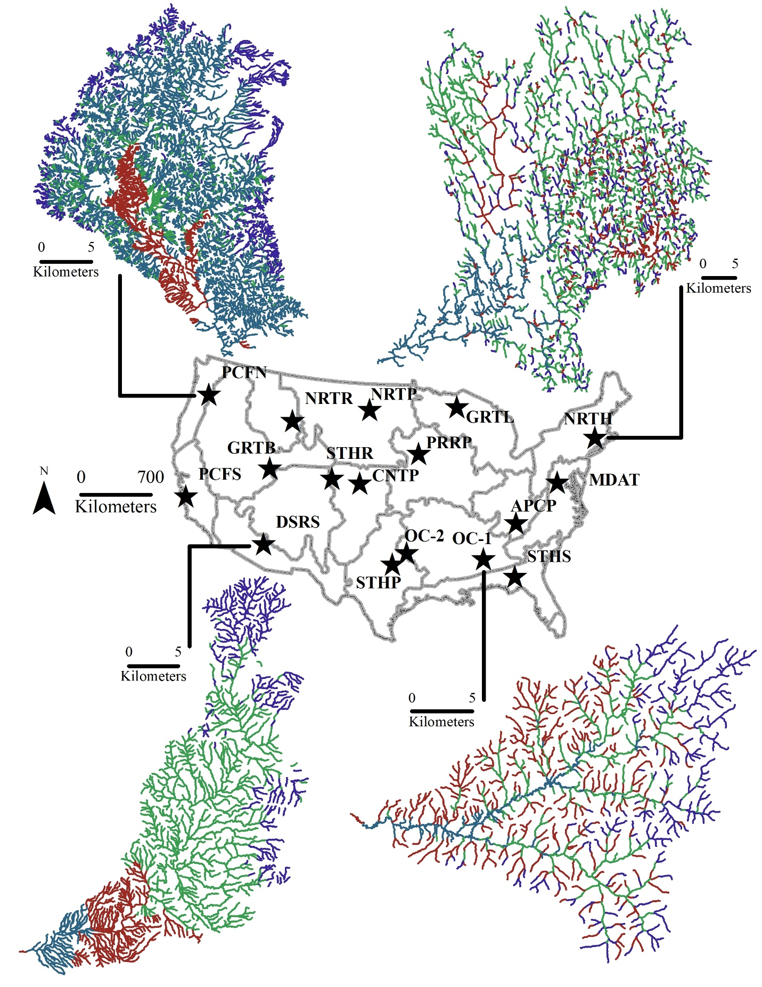
Figure 4.1
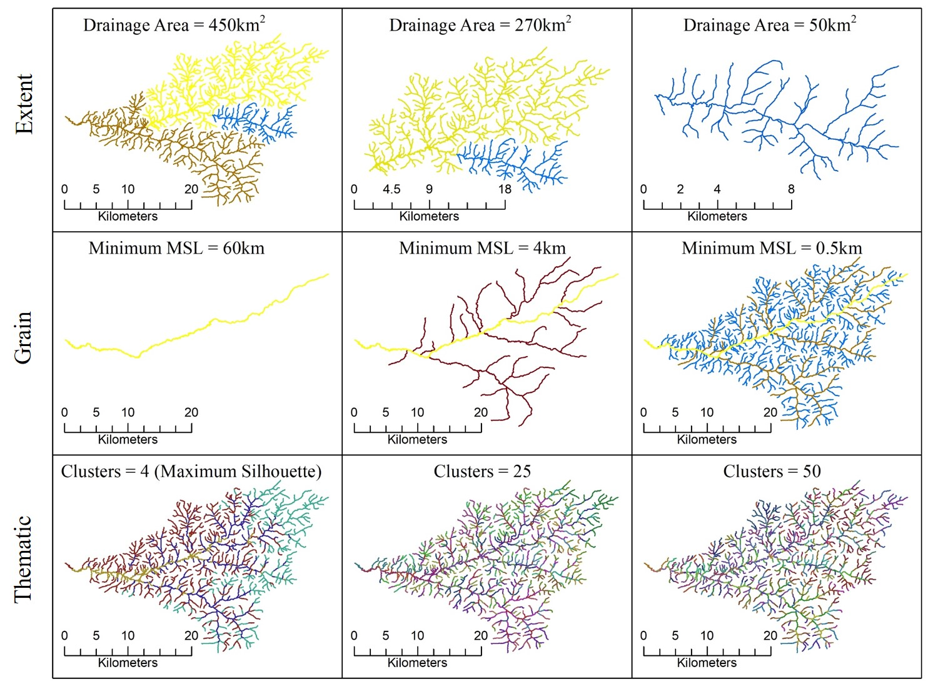
Figure 4.2

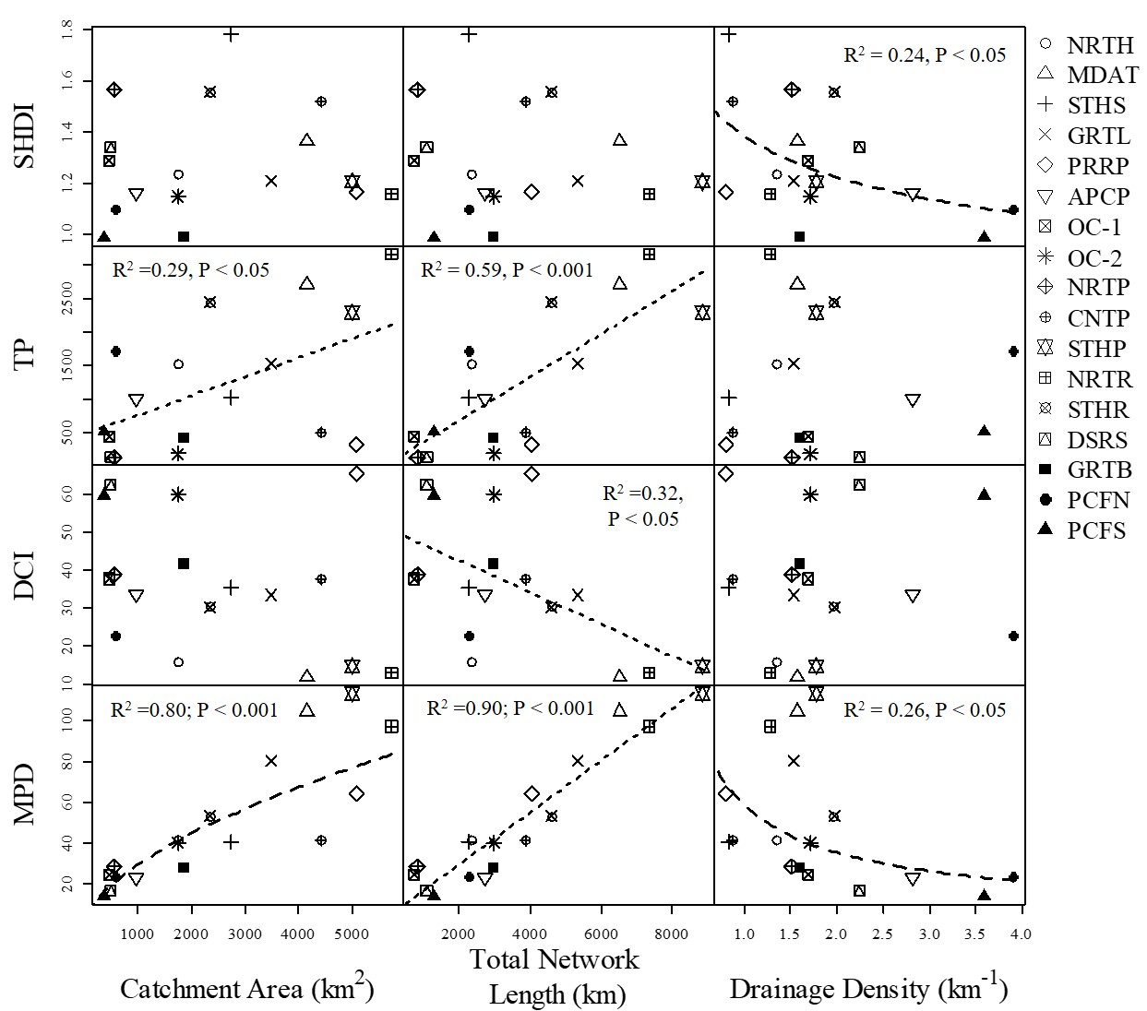
Figure 4.3

Appendix S1. Supporting Information

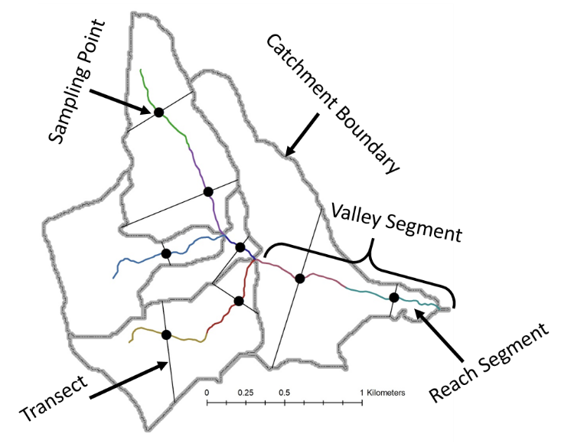
Figure S4.1. Sampling schematic for extracting Hydrogeomorphic variables used to identify hydrogeomorphic patches. Valley segments are defined as the stream section between headwaters and a confluence or two confluences. Valley segments exceeding 1 km were split into reach segments of equal length. Reach segments are indicated by different colors. Variables were calculated for all reach segments at their midpoint (points) and along transects (lines perpendicular to channel).

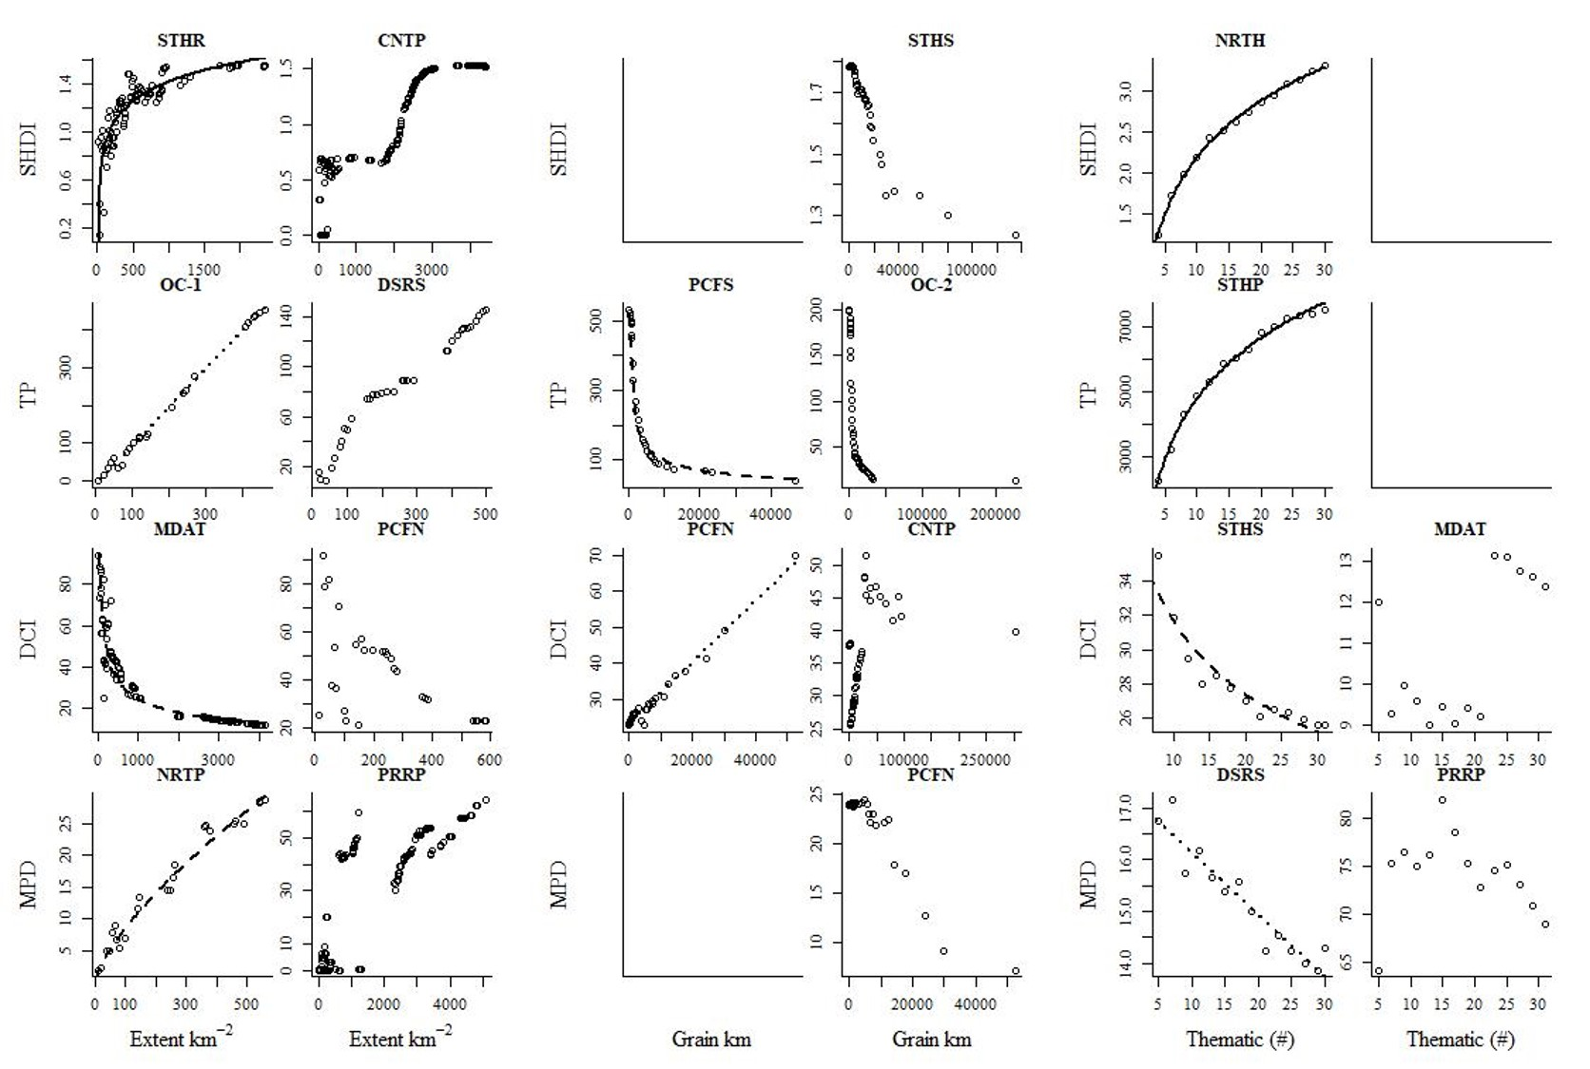
Figure S4.2 Representative scaling relationships between spatial pattern metrics and components of scale: spatial extent (left), spatial grain (middle) and thematic resolution (right). SHDI = Shannon Diversity Index, TP = total number of patches, DCI = Dendritic Connectivity Index, and MPD = mean patch distance. For each column, the left plot is an example of a predictable relationship with the line of best fit and the right plot is an example of an unpredictable relationship. NRTH = Northeast; MDAT = Mid-Atlantic; STHS = Southeast; GRTL = Great Lakes; PRRP = Prairie Peninsula; APCP = Appalachian Cumberland Plateau; OC-2 = Ozarks Complex-2; OC-1 = Ozarks Complex-1; NRTP = Northern Plains; CNTP = Central Plains; STHP = Southern Plains; NRTR = Northern Rockies; STHR = Southern Rockies; DSRS = Desert Southwest; GRTB = Great Basin; PCFN = Pacific Northwest; PCFS = Pacific Southwest

