University of Oklahoma

Graduate College

STRUCTURAL GEOLOGY OF THE WOODFORD SHALE IN THE SOUTH-EASTERN ANADARKO BASIN, GRADY COUNTY, OKLAHOMA

A thesis

submitted to the Graduate Faculty

in partial fulfillment of the requirements for the

Degree of

Master of Science

By

brian j. castro manrique
Norman, Oklahoma
2018

STRUCTURAL GEOLOGY OF THE WOODFORD SHALE IN THE SOUTH-EASTERN ANADARKO BASIN, GRADY COUNTY, OKLAHOMA

A thesis approved for the
ConocoPhillips School of Geology and Geophysics

By

______________________________
Dr. Roger Slatt, Chair

______________________________
Dr. Brett Carpenter

______________________________
Dr. Matthew Pranter

© Copyright by BRIAN J. CASTRO MANRIQUE 2018
All Rights Reserved.

ACKNOWLEDGMENTS
First, I would like to thank my advisor Dr. Roger Slatt for all his support and for giving me the opportunity to be here at OU and be part of the select group of students who have the privilege to work under his guidance.
Thank you to my wonderful wife Adriana Gomez for her invaluable help, sacrifice and unconditional love and support. Your words gave me the strength to be able to take on the challenge of getting this degree.
Thank you to Dr. Matthew Pranter and Dr. Brett Carpenter for taking the time to be part of my thesis committee and providing me with their suggestions that allowed me to deliver a better thesis.
Thank you to everyone at the Institute of Reservoir Characterization for all their help, support and great suggestions, especially Richard Brito, David Duarte, Muizz Matemilola, Carlos Molinares and Emilio Torres.
Thank you to the ConocoPhillips School of Geology and Geophysics staff and faculty as well as to all my other fellow students and friends who helped me in one way or another during my time here at OU.
Finally, I want to thank all the sponsor companies of the STACK-Merge-SCOOP Consortium (Formerly Woodford Consortium) for their continuous support to me and many other students.

Table of Contents
List of Tables vi
List of Figures vii
ABSTRACT xi
1. INTRODUCTION 1
1.1. REGIONAL GEOLOGY 4
1.2. LOCAL GEOLOGY 8
2. WOODFORD SHALE STRUCTURAL FRAMEWORK 13
2.1. METHODOLOGY 13
2.1.1. Well selection 13
2.1.2. Woodford shale top and base 15
2.1.3. Preliminary structural map 19
2.1.4. Using 2D seismic to improve map 20
2.1.5. Fault map 22
2.2. RESULTS 24
3. STRUCTURAL RELATIONSHIP TO HYDROCARBON PRODUCTION 29
3.1. METHODOLOGY 29
3.1.1. Hydrocarbon production data selection 30
3.2. RESULTS 37
4. CONCLUSIONS 41
5. RECOMENDATIONS 42
REFERENCES 43

List of Tables
Table 1. Summary of the most likely scenario of Woodford shale fracture sequence as observed from thin sections and outcrops. (Modified from Ghosh, 2017) 8
Table 2. First month Woodford production for wells located near faults (inside the one mile buffer) and first month production of wells located away from faulting (outside the one mile buffer). 38

List of Figures
Figure 1. State of Oklahoma and location of Grady County and the STACK, SCOOP and Merge plays 1
Figure 2. Grady County Hunton and Woodford shale sub surface structure maps from Molinares (2017). The detail on these maps is in the north part of the county, where the highest number of wells are located. There are very few wells to the structurally deeper southwest. 3
Figure 3. Location of Anadarko basin and surrounding geologic provinces. (Modified from Johnson, 1989) 5
Figure 4. Inferred location and limits of the southern Oklahoma aulacogen (patterned area) and generalized basement structure and fault pattern of the Anadarko basin. Contours show generalized depth to basement in the basin in thousands of feet below sea level. EA, eastern Arbuckle mountains; MF, Meers fault; MVF, Mountain View fault; NEA, northeastern Arbuckle mountains; SWA, southwestern Arbuckle mountains; WM, Wichita mountains. (Modified from Perry, 1988) 7
Figure 5. Generalized stratigraphic chart for the Anadarko basin. Formations of interest are in the interval from Late Devonian (Woodford Shale) to Early Mississippian (Meramec in the greater Anadarko basin and Sycamore in the southern part of the basin and the Arbuckle mountains). (Modified from Johnson and Cardott, 1992) 9
Figure 6. Generalized north-south structural cross section through the Anadarko basin of western Oklahoma. Although the study area (highlighted in red in the figure) is located east of the cross section, the general structure is still representative of the area. (Modified from Johnson, 1989) 11
Figure 7. Three types of structural deformation along the Wichita Mountain Front. (From Evans, 1979) 11
Figure 8. Structure fault patterns present in Grady county. (Compiled from Evans, 1979 and Axtmann, 1985) 12
Figure 9. Location of wells selected from the IHS database for the purpose of this study. 14
Figure 10. Location and log response for the well PICKARD (API: 35051234100000) demonstrating a typical log response used to pick the top and base of the Woodford shale 16
Figure 11. Woodford shale top shown in a core photo for the SKAGGS RANCH well where the contact is marked as an unconformity between the black shale beds and a shallower glauconitic sand. 17
Figure 12. Location and Gamma Ray and resistivity log for ‘ROGERS A’ well (API: 35051223160000) showing the type response for the top of the Mississippian unit that overlays the Woodford shale in this area. 18
Figure 13. Woodford shale preliminary structure map constructed from well logs located in Grady County, Oklahoma. 19
Figure 14. Use of 2d seismic to improve the structure map for the Woodford shale top. Locations of the seismic line (A-A) and well cross section (1-1). Top right: 2D seismic line. Center right: Cross section. Bottom right: Cross section overlaid on top of the seismic line with the interpreted top of the Woodford shale and the location of the created pseudo wells used to improve the structural interpretation the base of the Woodford 21
Figure 15. Location of all reported faults inside the study area. Compiled from the public database provided by the Office of Geographic Information of the Oklahoma conservation commission through the website okmaps.org. b. Filtered Woodford reported faults in the study area of Grady County, Oklahoma 23
Figure 16. Woodford shale structure map constructed from well logs and pseudo wells created from interpreted seismic lines located in Grady County, Oklahoma 26
Figure 17. 3D model of Woodford shale structure map constructed from well logs and pseudo wells. Grady County, Oklahoma 27
Figure 18. Woodford shale isochore map. Computed from the picked tops and bases from wells in Grady County, Oklahoma 28
Figure 19. Woodford shale structure map. Location of the selected area within Grady County, Oklahoma. Location of wells used to construct the structure map and wells used for the production analysis 30
Figure 20. Structural and stratigraphic cross section A-A’. 31
Figure 21. Structural and stratigraphic cross section B-B’. 32
Figure 22. Structural and stratigraphic cross section C-C’ 33
Figure 23. Structural and stratigraphic cross section D-D’. 34
Figure 24. Structural and stratigraphic cross section E-E’. 35
Figure 25. Woodford reported production from horizontal wells for the same area in Grady County referenced in Figure 19. First month production for oil and gas. A 1mile buffer around any fault trace was used to differentiate between wells close and distant to the faults 36
Figure 26. Woodford reported production overlaying the Woodford structure map produced from well logs in the last section. In blue, vitrinite isoreflectance data from Cardott (2012) 39

ABSTRACT
The Anadarko basin, especially the SCOOP (South Central Oklahoma Oil Play) and Merge areas, has become one of the most prospective and successful oil plays in the country. However, there is an increasing need to refine and improve the understanding of the general geological setting of the hydrocarbon producing formations within its boundaries, specifically the role of structure on accumulating and producing oil and gas.
The Devonian Woodford shale unconventional reservoir of the Anadarko basin is one of the main targets for exploration and production. It has been previously studied with a focus on its stratigraphy, geomechanics and geochemistry but not much about its structural geology. Most of the structural work done has been either at an outcrop level or at the state level.
This thesis uses well log analysis, 2-D seismic interpretation and well core observations to help define formation tops and construct cross sections and structural maps to provide a better developed structural framework for this productive area that comprises the northern limits of the SCOOP play and the transitional Merge play in Grady County, Oklahoma.
The resulting structural map for the Woodford shale features two structurally different regions. The first is a structurally stable region, with almost no faulting towards the central and northern part of the county and the second region, mainly in the southern half of the county is a more structurally complex region.
This work also combines this structural framework of the Woodford shale in the Grady County area with available production data to analyze and suggest that the gas production follows closely the structural setting of producing wells; increasing in the structurally stable zone and decreasing in areas with a higher number of faults. Oil production does not appear to be related to faults.

1. INTRODUCTION
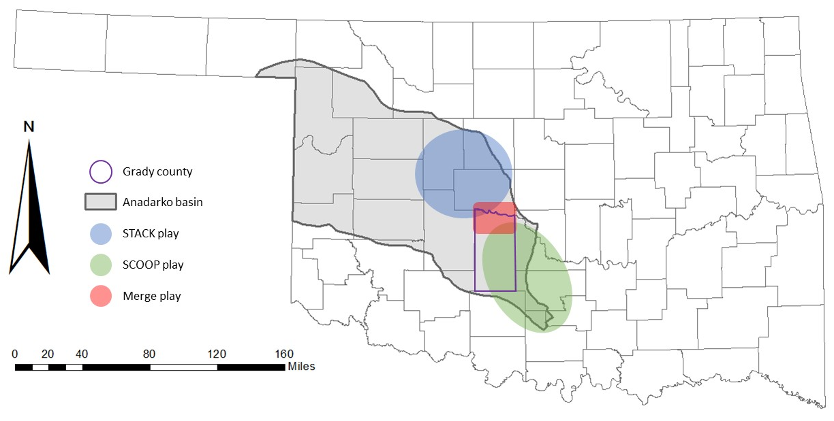
This study focuses on the sub-surface Woodford shale in the southeastern part of the Anadarko basin, in the area comprised within Grady County, Oklahoma (Fig. 1). This area is important because it's the transitional zone between two of the most important oil plays of Oklahoma today, the STACK (Sooner Trend – Anadarko – Canadian and Kingsfisher) and the SCOOP (South Central Oklahoma Oil Play) plays. The area between these two plays has unofficially been designated the Merge play. Although Grady County is mostly in the SCOOP play, the Merge is where the limits and characteristics are relatively less well known (Figure. 1).
Figure 1. State of Oklahoma and location of Grady County and the STACK, SCOOP and Merge plays

Several theses and studies, particularly from the University of Oklahoma, have been carried out in this general area of the Anadarko basin, but most have focused on the stratigraphic characterization of the hydrocarbon producing formations. So far, little structural research has been done or at least published on this complex area of Grady County (Wallace, 1953; Reedy and Sykes, 1958; Riley, 1965). With the recent development of the SCOOP play, there are now newer drilled wells and logs available to refine the description of the geological structures in the area. The Oklahoma Geological Survey (OGS) has produced various generalized geological maps of Oklahoma, in which some cross sections have been interpreted at a very regional scale, but which lack detail on the area of study.
With a mechanical stratigraphy scope in focus, Molinares et al. (2017) produced structural maps of hydrocarbon producing formations in Grady County, but those maps are lacking detail and are limited to the north part of the county, where the structural setting is simpler (Figure 2). The OGS has produced fault maps for the entire state in digital format (publicly available shape files), and while the area of this study is included, the faults are not clearly defined in terms of depth and influence on the subsurface formations
This study attempts to develop a structural framework for the Woodford shale in the area by analyzing well log data, core observations and 2-D seismic. Integrating well log-based structures with 2-D seismic lines to produce formation tops maps helps define the geological setting and dynamic history of the area.

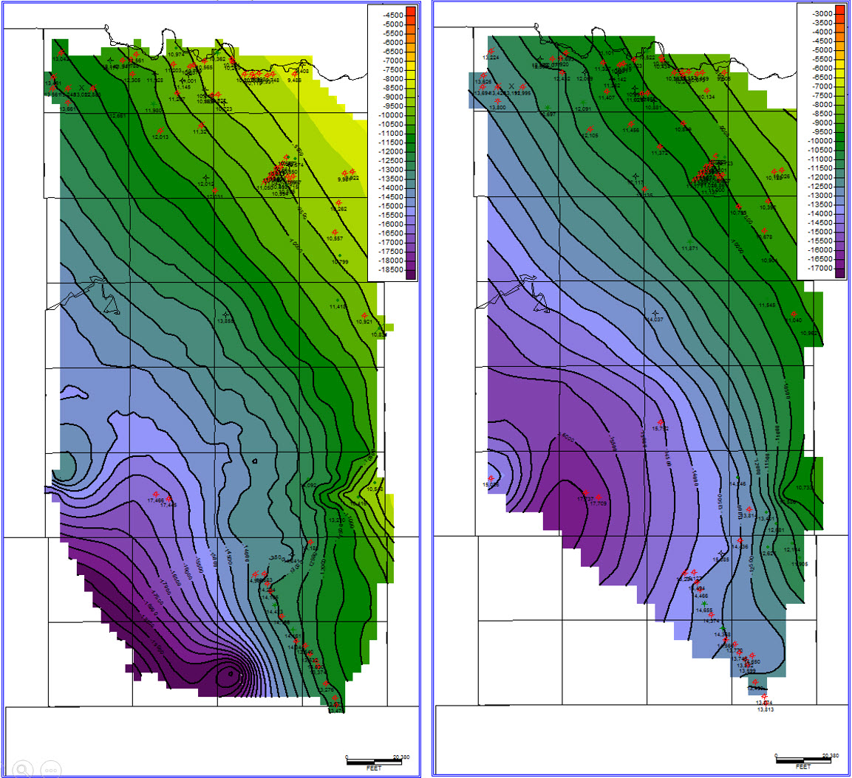
Figure 2. Grady County Hunton and Woodford shale sub surface structure maps from Molinares (2017). The detail on these maps is in the north part of the county, where the highest number of wells are located. There are very few wells to the structurally deeper southwest.

This thesis provides a structural framework for the northern limits of the SCOOP play and its transition to the STACK play (i.e. the Merge play) in Grady County which helps not only in the definition of the prospective areas within the play, but also in the correlation of any structural control on hydrocarbon production. This work also helps define new –and refine known- faults and structures that may play an important part in the definition of the reservoir characteristics for the hydrocarbon producing formations in the basin.

1.1. REGIONAL GEOLOGY
The Anadarko basin is the deepest sedimentary and structural basin in the cratonic interior of the United States. As much as 40,000 ft. of Paleozoic sedimentary rocks are present near the south margin of this asymmetrical basin, and Cambrian layered igneous rocks perhaps underlie the sediments (Johnson, 1989).
The basin is bounded on the east by the Nemaha ridge, on the north and west by a broad shelf with subsurface basement depths of less than 5,000 ft, on the south-east by the Arbuckle mountains and the Ardmore basin, and to the south by the Wichita mountains and the Amarillo uplift (Figure. 3) (Ball et al., 1991).

The history of the basin can be divided into four major episodes. The first, an igneous episode during the Precambrian and Early and Middle Cambrian, when intrusive and extrusive basement rocks were emplaced in the area of the Wichita uplift and southern part of what would become the Anadarko basin. Then, an early epeirogenic episode, from Late Cambrian through Mississippian time, allowed deposition of marine sediments in a broad epicontinental sea referred to as the Oklahoma basin. This was followed by a Pennsylvanian orogenic episode, when the Oklahoma basin was broken into a series of sharp uplifts and major basins, including the Anadarko basin. This orogenic activity consisted of folding, faulting, uplift, and downwarping. Pennsylvanian sediments deposited in the Anadarko basin include coarse clastics near the uplifts, and mostly marine shales, sandstones, and limestones throughout most of the remainder of the basin (Johnson, 1989).

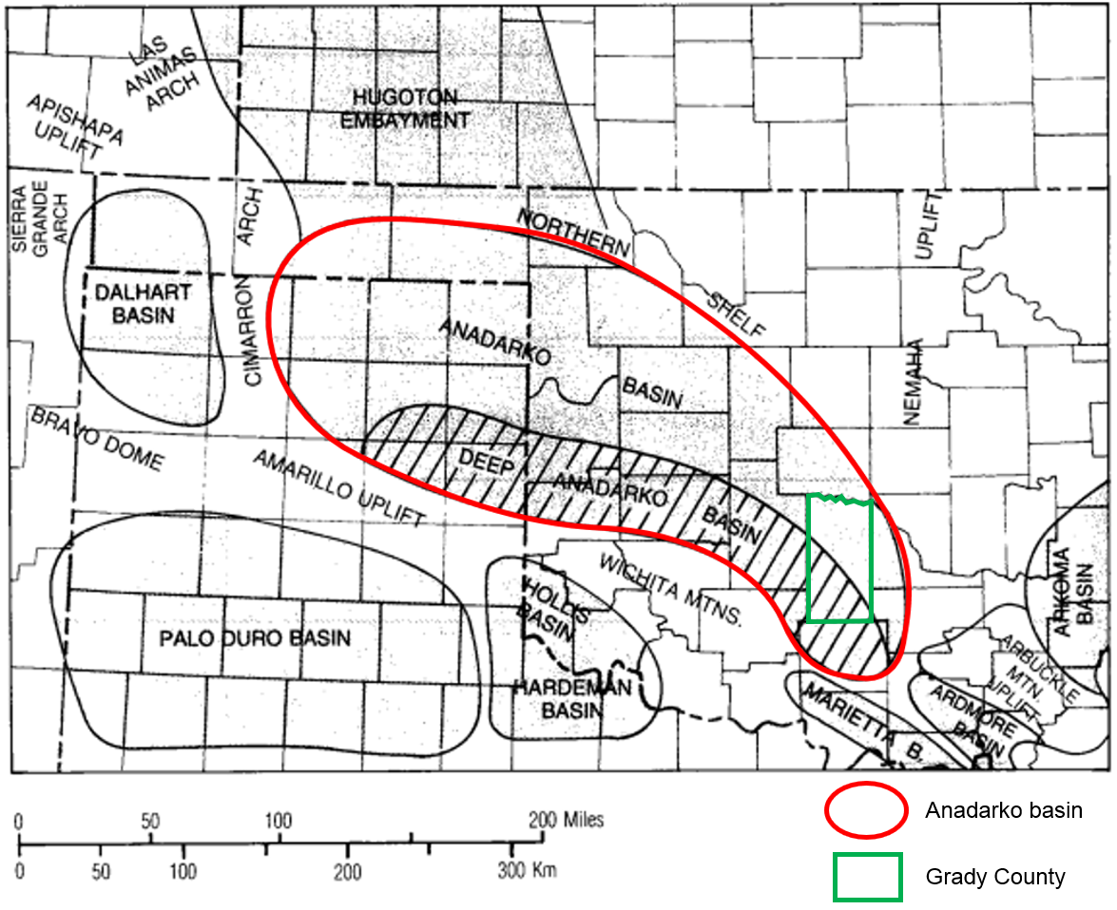
Figure 3. Location of Anadarko basin and surrounding geologic provinces. (Modified from Johnson, 1989)

Lastly, a late epeirogenic episode began in the Permian and continues today. This episode includes infilling of the basin with Permian red beds, evaporites, and carbonates, and deposition of thin post-Permian strata uniformly across the whole extent of the basin and surrounding areas. Most of these post-Permian strata have been eroded from the basin (Johnson, 1989)
The basin region's structural history can also be divided into four periods. In the first, the oldest structural events are associated with crustal consolidation and high-grade metamorphism of middle Proterozoic age from 1.3 Ga to 1.4 Ga (Ham and others in Perry 1988). Dikes in the Arbuckle mountains that were emplaced during this event trend N60W and provide evidence of the general crustal weakness direction that affects the tectonic history of Oklahoma (Perry, 1988). Then, in the Cambrian, the structural setting of southern Oklahoma is considered to be that of a failed arm of an inferred plate tectonic triple junction, known as the southern Oklahoma aulacogen (SOA) (Burke, 1977 in Perry, 1988) (Fig. 4). The northern margin of the aulacogen probably is beneath the southern part of the Anadarko basin. South dipping reverse faults of the Wichita fault system (Figure. 4) along the southern margin of the Anadarko basin may represent reactivated normal faults of late Proterozoic to Cambrian age associated with development of the SOA. The Wichita fault zone currently exhibits more than 12km (40,000ft) of up-to-south vertical separation that developed during the Pennsylvanian and Permian growth of the basin (Perry, 1988).
After the rifting phase, the rock bodies began to cool and subside, creating a trough. The axis of this trough extended northwestward from the paleocontinental margin southeast of the present Ardmore basin to the vicinity of the present-day Wichita Mountains of southeast Oklahoma (Perry, 1988).
Finally, in the Late Mississippian, the fourth period of tectonism began with the growth of the asymmetric Anadarko basin in central and western Oklahoma on the north flank of the Cambrian rift during the structural inversion of it with some evidence of structural events that consist of wrench-fault and compressional tectonics (Perry, 1988).
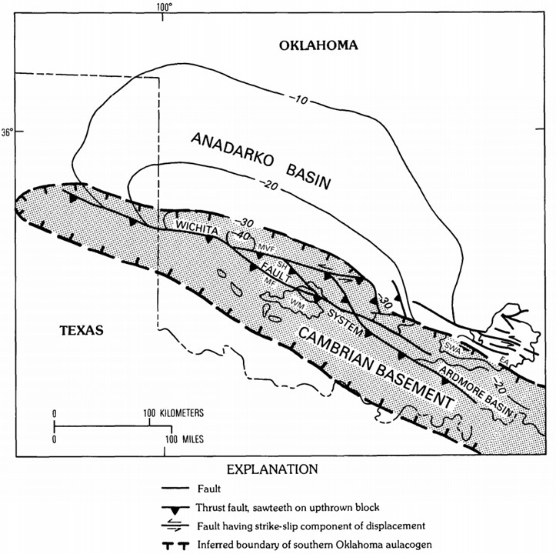
Figure 4. Inferred location and limits of the southern Oklahoma aulacogen (patterned area) and generalized basement structure and fault pattern of the Anadarko basin. Contours show generalized depth to basement in the basin in thousands of feet below sea level. EA, eastern Arbuckle mountains; MF, Meers fault; MVF, Mountain View fault; NEA, northeastern Arbuckle mountains; SWA, southwestern Arbuckle mountains; WM, Wichita mountains. (Modified from Perry, 1988)
Part of this history can be evidenced in recent Woodford shale fracture related studies. Based on outcrop studies on the Woodford shale near Ardmore, Oklahoma, Ghosh (2017) identified five different sets of fractures and suggested the most likely scenario for the sequence of their origin along with the regional stress orientation for each episode. His findings are summarized in Table 1.
Table 1. Summary of the most likely scenario of Woodford shale fracture sequence as observed from thin sections and outcrops. (Modified from Ghosh, 2017)

1.2. LOCAL GEOLOGY
The focus of this thesis is the southeastern part of the Anadarko basin, near its limits in Grady County, Oklahoma. This area is part of what is known as the South-Central Oklahoma Oil Province (SCOOP) play, which is currently one of the most competitive unconventional play areas of the U.S.A.
The target stratigraphic sections for hydrocarbon production in the SCOOP play are mainly the Devonian and the Mississippian sections (Figure. 5).

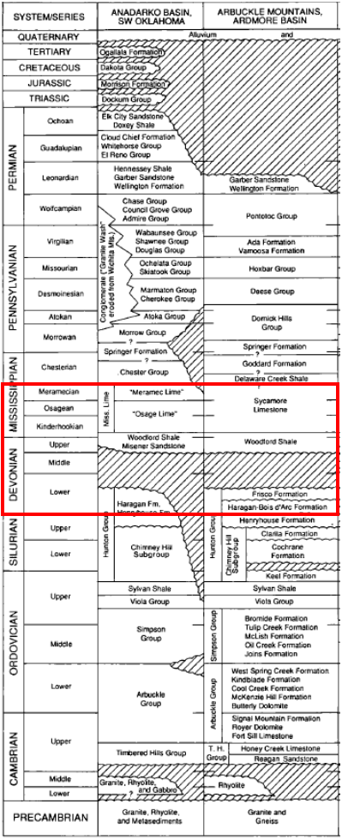
Figure 5. Generalized stratigraphic chart for the Anadarko basin. Formations of interest are in the interval from Late Devonian (Woodford Shale) to Early Mississippian (Meramec in the greater Anadarko basin and Sycamore in the southern part of the basin and the Arbuckle mountains). (Modified from Johnson and Cardott, 1992)
From a preliminary review of the available well logs, the presence of the Devonian Woodford Shale formation is well documented along with the Mississippian formations, all of them of interest for this study.
Structurally, the section deepens towards the south of the study area near the Wichita mountains. In Early Pennsylvanian time, the Wichita mountains were uplifted along a series of WNW trending reverse faults northward towards the rapidly sinking Anadarko basin. The faulting died out during Early Permian time with a total vertical displacement across faults of as much as 12km (40,000ft) (Figure 6) (Johnson, 1989).
There are three main types of structural deformation that can be recognized in the area, close to the Wichita Mountain front, that can be related to two principle movements (Figure 7).
Deformation related to vertical block uplift is characterized by a narrow zone, generally less than 3.2km (2mi) wide, where the more competent Arbuckle carbonates tend to conform with the basement to form a series of step faults that are down to the basin. The overlying shales provide the capability for folding to accommodate the space problem.
The second movement involves major left-lateral movement along this zone. This movement is demonstrated to the southeast in the Ardmore basin area. These types of shears create certain patterns of deformation such as sinusoidal anticlines that have near parallel axes that intersect the shear at an angle of approximately 30°.
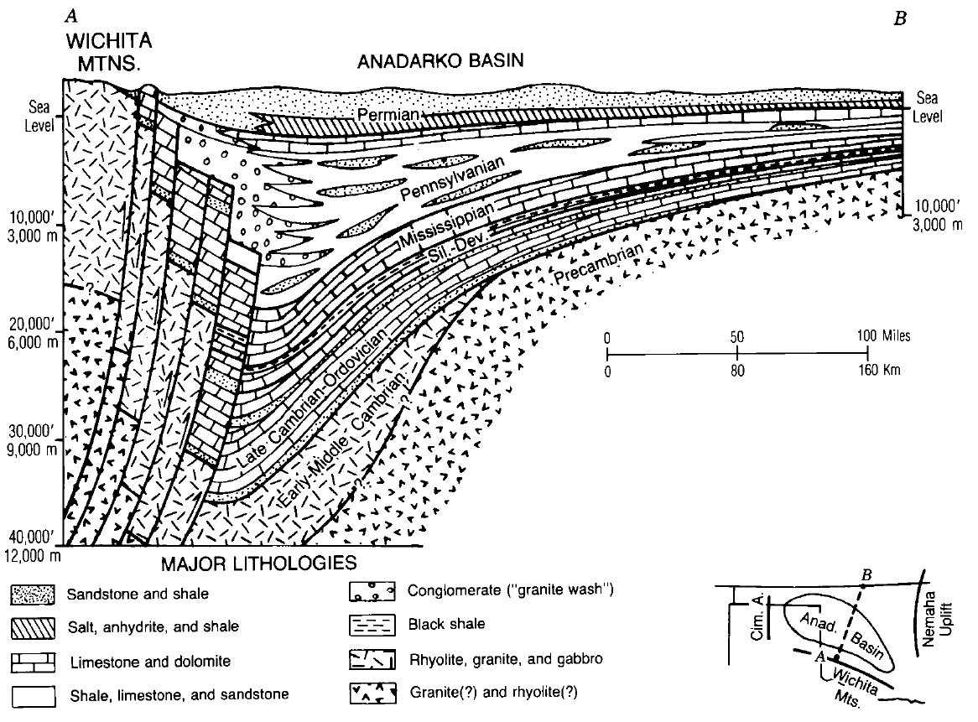Figure 6. Generalized north-south structural cross section through the Anadarko basin of western Oklahoma. Although the study area (highlighted in red in the figure) is located east of the cross section, the general structure is still representative of the area. (Modified from Johnson, 1989)

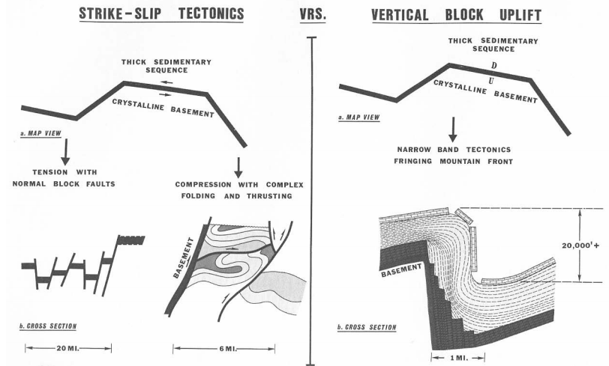
Figure 7. Three types of structural deformation along the Wichita Mountain Front. (From Evans, 1979)
In addition to regional folding in front of the shear zone, other important structural patterns are seen internal to the shear zone itself. These patterns are basically of zones of tension and normal faulting where the orientation of the shear breaks away from the plate of principal movement (oblique divergent), and zones of compression with folds and thrust faults where the shear breaks against the plate of principal movement (oblique convergent). These structural patterns are apparent along the Wichita Fault zone. (Evans, 1979).
These patterns are seen in Grady County with the presence of previously mapped faults (Figure 8).
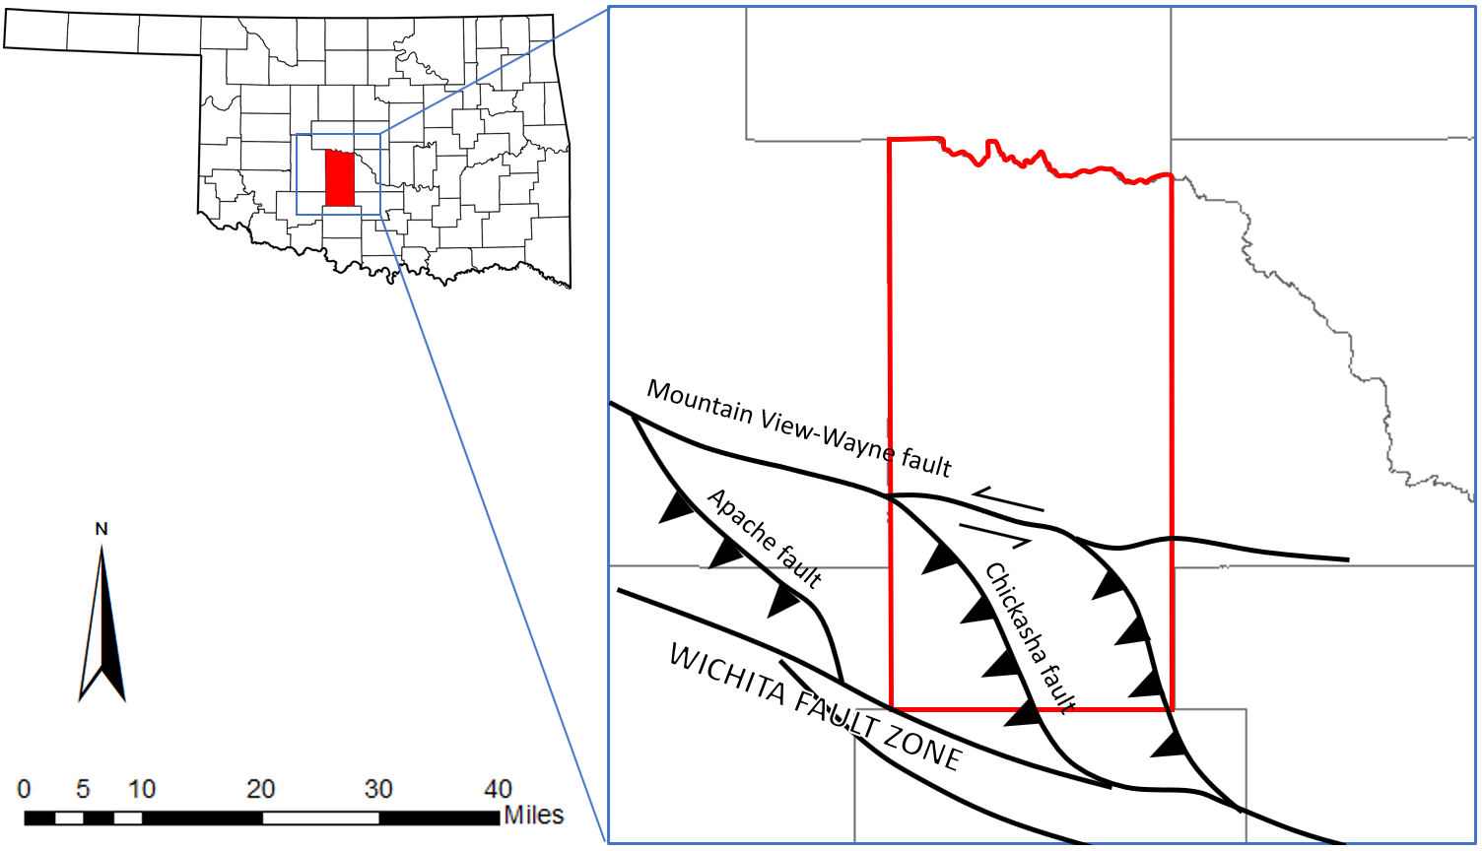
Figure 8. Structure fault patterns present in Grady county. (Compiled from Evans, 1979 and Axtmann, 1985)

2. WOODFORD SHALE STRUCTURAL FRAMEWORK
Improvement in production of reservoirs is always dependent on the level of detail and understanding that is given to a certain prospective area or play. The resulting structure map of this study contributes to increase that level of detail for the specific area of Grady County, Oklahoma.

2.1. METHODOLOGY

2.1.1. Well selection
Work began with the selection of useful wells for the purpose of this study out of the total number of wells in Grady County in the IHS database provided through the University of Oklahoma College of Earth and Energy. Initially, 7963 wells were reported in the database for the county including vertical and horizontal wells of any depth. Initially, all horizontal wells were filtered out, along with any wells that didn’t have a Raster log image available. Out of the ones left, any shallow well was also filtered out so that the new database contained only wells deep enough to contain the total thickness of the Woodford shale formation. This last selection was based on what operator companies report as top and base of formations. Since the definition of the top and the base of the Woodford shale can vary according to new development and understanding of its geology, each one of the wells had to be manually reviewed. During this review, especially in areas where well concentration started to decrease, some of the previously omitted wells were reviewed again, assuming that there could be deep enough wells that just didn’t have a good formation top report, but that could contain the totality or at least the top of the Woodford shale. After this review, a total of 284 vertical wells ended up having the necessary conditions of depth to include the entire section of the Woodford shale. The location of these wells is shown in Figure 9.
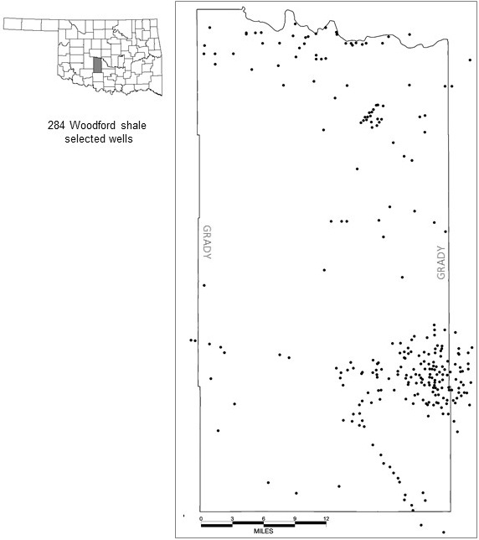
Figure 9. Location of wells selected from the IHS database for the purpose of this study.

2.1.2. Woodford shale top and base
The picking of the top of the Woodford shale formation was done manually on each selected well taking into account its typical very pronounced Gamma ray log response of very high API value typical of organic matter rich shales such as the example in figures 10 and 11. For this specific example from a well located towards the northern limit of the county, the lithological characteristic of a section of the core containing the top of the Woodford shale was observed and combined with the resistivity and Gamma Ray response in the raster well log to correlate and define a typical well response that marked the top of the formation.
The base of the Woodford shale was picked by locating the sharp unconformity from the underlying Hunton or Sylvan formation, the former being a limestone with a consistently low API value in the Gamma ray log (Figure 10).
Previous work by Duarte (2017) in the vicinity of the area was also used to define the response of the overlying formation. The exact name, geological characteristics and lateral continuity of this formation is currently subject to controversy and work is being carried out by companies and students to define it. For the purpose of giving context to this study, the overlying formation is simply named as Mississippian and its top is defined mainly in the resistivity well log response as a drastic decrease that denotes a Mississippian/Pennsylvanian unconformity (Figure 12).

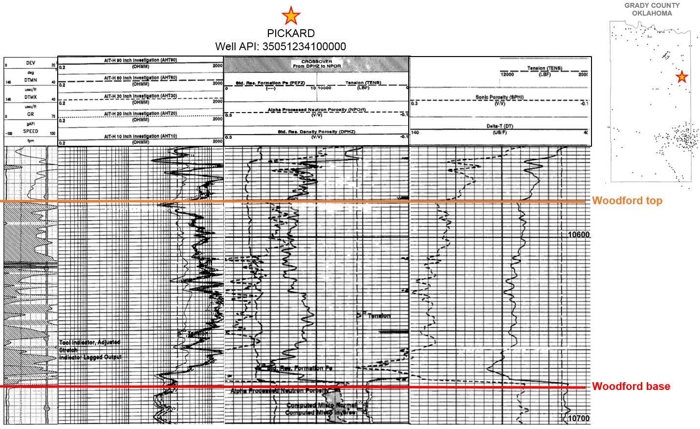
Figure 10. Location and log response for the well PICKARD (API: 35051234100000) demonstrating a typical log response used to pick the top and base of the Woodford shale

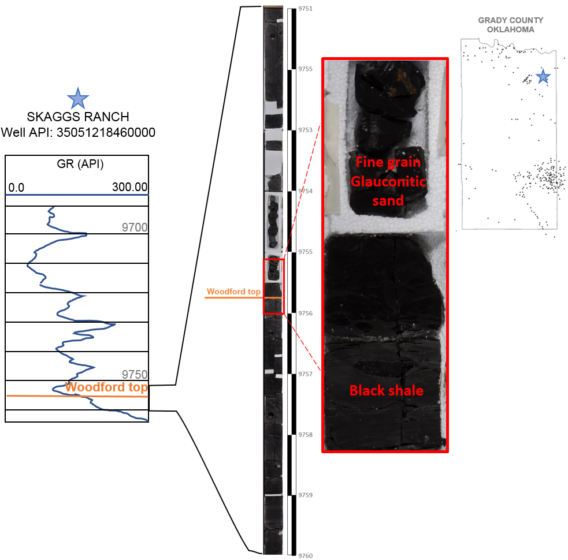
Figure 11. Woodford shale top shown in a core photo for the SKAGGS RANCH well where the contact is marked as an unconformity between the black shale beds and a shallower glauconitic sand.
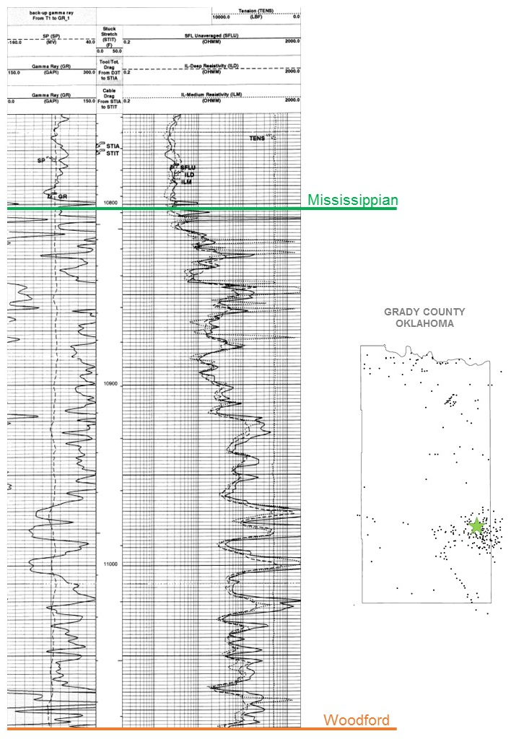
Figure 12. Location and Gamma Ray and resistivity log for ‘ROGERS A’ well (API: 35051223160000) showing the type response for the top of the Mississippian unit that overlays the Woodford shale in this area.

2.1.3. Preliminary structural map
The next step was to construct a structural top map for the Woodford shale based on the tops picked on each well using the geological mapping module found in PetraTM. The resulting map is shown on figure 13.
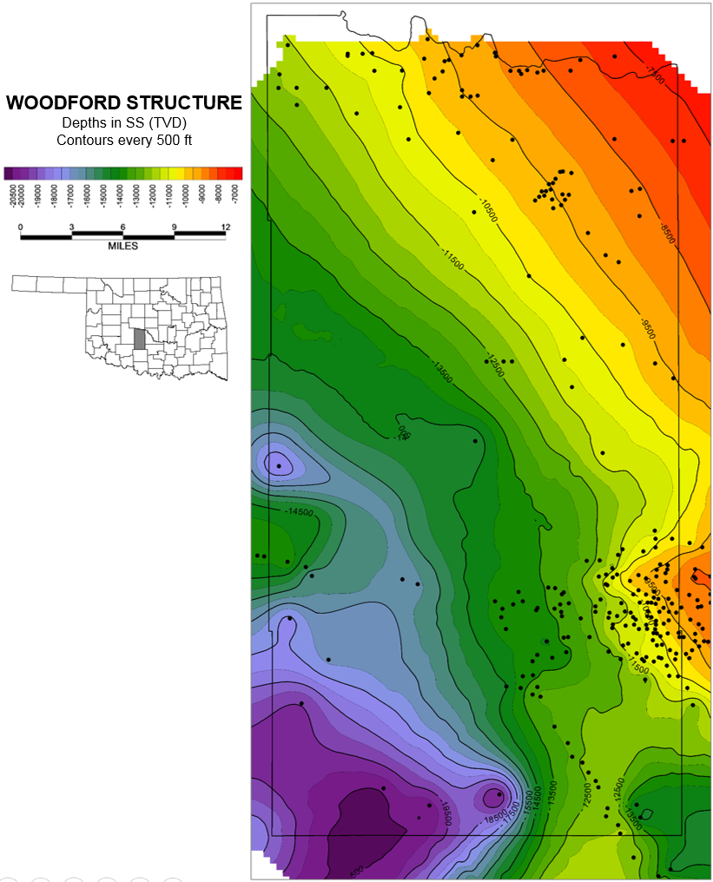
Figure 13. Woodford shale preliminary structure map constructed from well logs located in Grady County, Oklahoma.
As evidenced in the resulting map of figure 13, there are some areas of the county with a small concentration of wells, which hinders the confidence of the interpretation for the mapping. This is especially noticeable in the southern area of the county where this section of the Woodford shale deepens to around 20,000 feet, according to the very few deep wells drilled in the area.

2.1.4. Using 2D seismic to improve map
Figure 14 shows how one of three 2D seismic lines located in the southern part of the County were used to help in the definition of the structure map of the mentioned zone by using pseudo wells to include seismic interpreted Woodford top depths in the area that lacks coverage by drilled wells. The thickness of the Woodford shale in the area of study lies below the seismic resolution of these lines and therefore it was not possible to pick a top and base accurately to be able to integrate the data into an isochore map. Nonetheless, the information the lines provide is good enough to present an approximation of the top of the formation that can be integrated into the structure top map with some confidence that can be useful in at least providing a better idea of the general structure in this area.

Figure 14. Use of 2d seismic to improve the structure map for the Woodford shale top. Locations of the seismic line (A-A) and well cross section (1-1). Top right: 2D seismic line. Center right: Cross section. Bottom right: Cross section overlaid on top of the seismic line with the interpreted top of the Woodford shale and the location of the created pseudo wells used to improve the structural interpretation the base of the Woodford

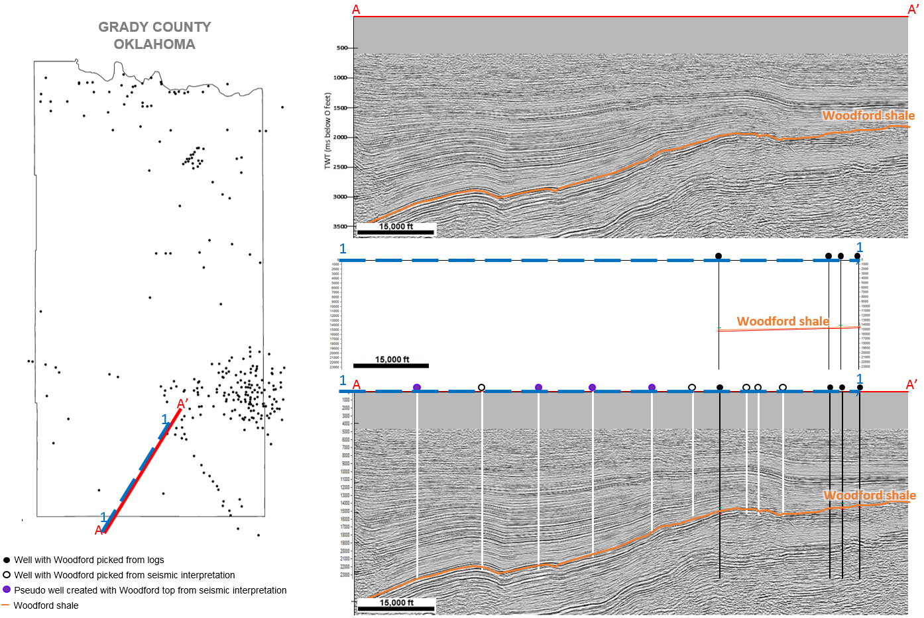

2.1.5. Fault map
A complementary fault map of the area was generated to be able to integrate the location and influence of faulting to the structural setting of the Woodford shale in Grady County using the public database provided by the Office of Geographic Information of the Oklahoma Conservation Commission throughout the website okmaps.org. This platform compiles a series of GIS databases which includes a map that records any faults reported by companies along with any geological information provided. These maps were downloaded as shapefiles to be able to analyze and make a better use of its information.
The fault map created from all reported faults is shown in figure 15a. There is an issue with this map though. This map includes all faults irrespective of whether or not they are deep enough to reach or affect the formation on which this study focuses. Using the information that comes with the shapefiles, any and all faults that didn’t report to be in contact with the Woodford shale inside Grady County were filtered out, leaving a new fault map with faults that have been reported (by the Office of Geographic Information) to affect the Woodford shale formation (Figure 15b).
The final structure top map for the Woodford Shale in Grady County is found in figure 16.

Figure 15. Location of all reported faults inside the study area. Compiled from the public database provided by the Office of Geographic Information of the Oklahoma conservation commission through the website okmaps.org. b. Filtered Woodford reported faults in the study area of Grady County, Oklahoma

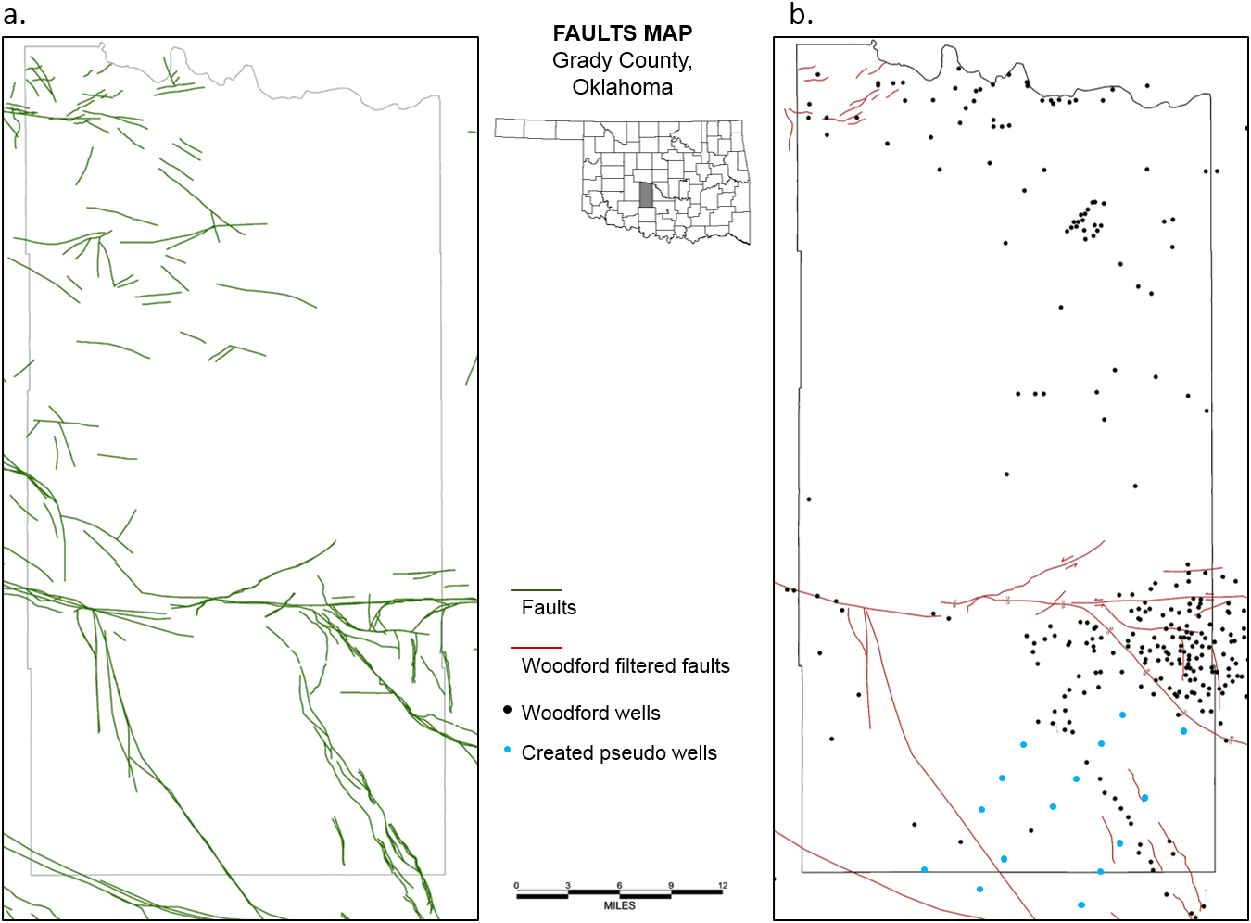

2.2. RESULTS
The main result of this study is a structure top map for the Woodford shale in the area of Grady County, Oklahoma (Figure 16) and a 3D model of the contours generated (Figure 17).
One of the first noticeable features is two structurally different regions. The first is a structurally stable region, with almost no faulting or major structures, towards the central and north part of the county where the Woodford shale deepens in the southwest direction in an almost constant and gentler slope (A in Figure 16). The second area, mainly in the south half of the county (B in Figure 16), is a more structurally complex region.
In this area, the influence of the Wichita fault zone is very clear. Towards the southern limit of Grady County, the Woodford shale deepens abruptly and steeply (C in Figure 16) against the Wichita mountains and shows a series of reverse faults resulting from the Wichita uplift as part of the events of the formation of the Anadarko basin itself.
Two faulted zone patterns are identified in this southern area. The Chickasha fault (D in Figure 16) to the west and a similar fault (E in Figure 16) to the east. These are the typical resulting pattern from a transpressive left lateral movement and a restraining bend involving the Wichita fault zone and the Mountain View-Wayne fault which can also be seen westward of the area along the Wichita fault zone across the southern limit of the Anadarko basin.
An anticlinal structure (F in figure 16) with its axis in the NW direction, following the direction of the lateral fault bend, can also be observed. This matches the evidence of the compressional tectonics taking place in this part of the area.
Another feature commonly observed in these types of transpressional settings is the structurally elevated and faulted area towards the eastern limit of the county (G in Figure 16). This illustrates the effects of the left lateral fault pushing the northern block into a restraining bend of the fault, causing it to be heavily deformed and faulted.
Having picked not only the top of the Woodford shale but also the base of the formation, an isochore map was constructed, using only wells where those two surfaces were present (ignoring the seismic interpreted pseudo wells, which only have the top of the Woodford). The resulting map is shown in Figure 18.
Taking into account that the information presented in this map is somewhat limited due to the lack of well concentration in some parts of the area, it is still useful to make some observations.
Although the thickness of the Woodford shale has been related to the paleo environmental setting of deposition and the paleo-topography of the underlying Hunton formation (Infante-Paez et al., 2017 and Torres et al., 2017), this map suggests that the structural setting may have also played a part. Although the thickness distribution is irregular throughout the area, there is a marked difference between the thickness in the northern (stable) and the southern (faulted) regions, having the southern one with the greatest thickness values of the area.
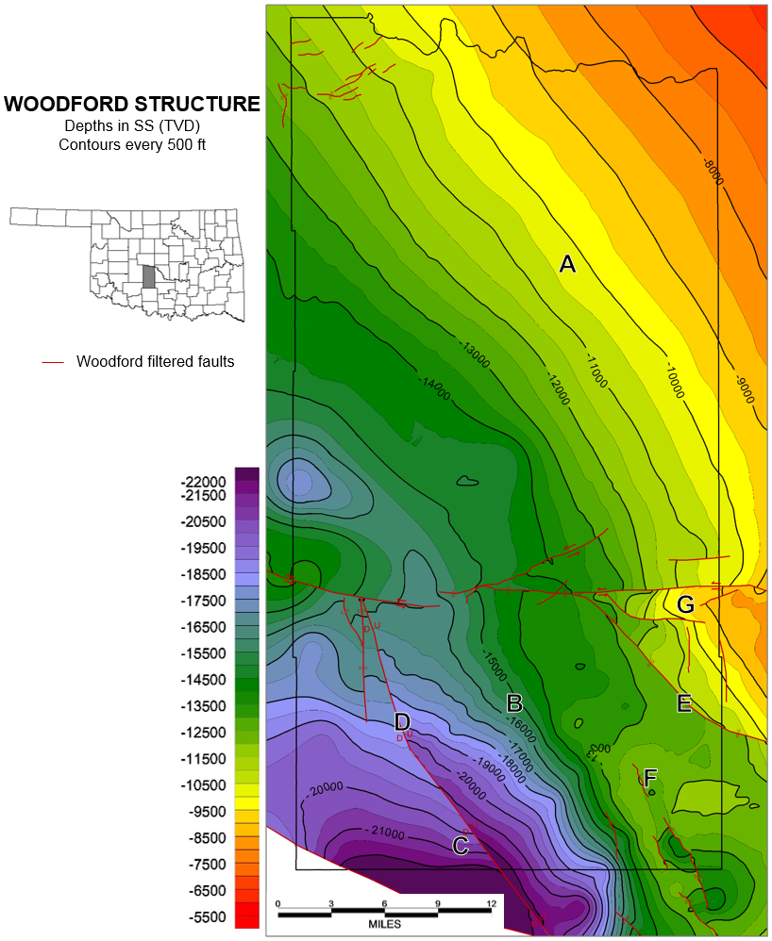
Figure 16. Woodford shale structure map constructed from well logs and pseudo wells created from interpreted seismic lines located in Grady County, Oklahoma

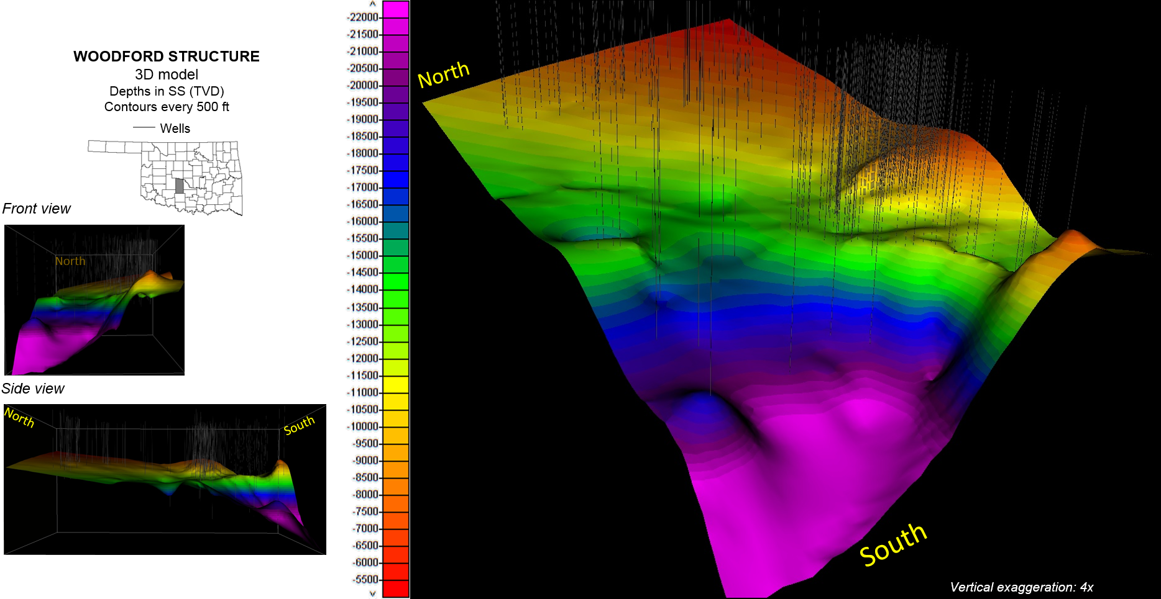
Figure 17. 3D model of Woodford shale structure map constructed from well logs and pseudo wells. Grady County, Oklahoma
This could mean that the current compressional type faulting may have followed previously emplaced weakness planes and extensional fault paths at the south of the county towards the Wichita mountains, developed during the time of deposition of the Woodford shale. Extensional syntectonic sedimentation may cause the thickness increase.
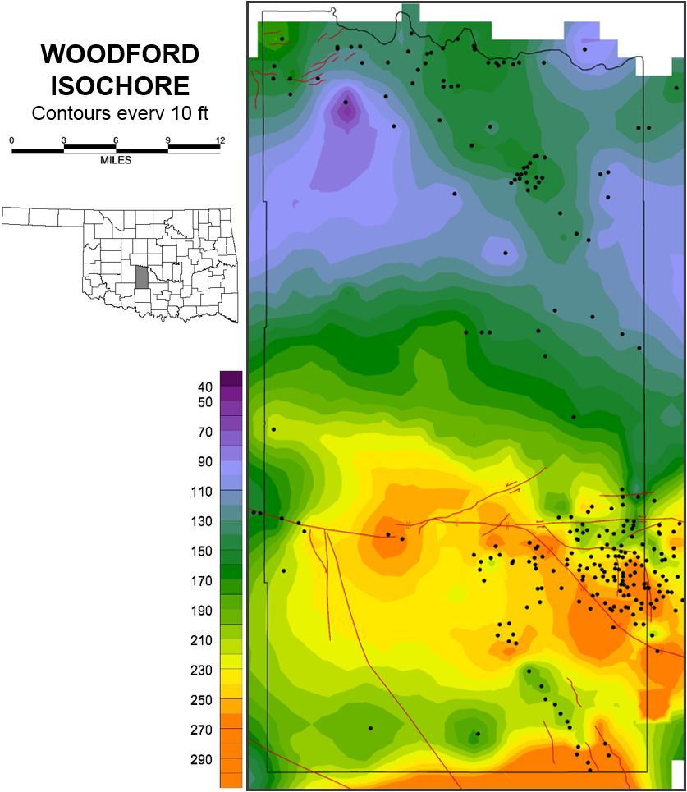
Figure 18. Woodford shale isochore map. Computed from the picked tops and bases from wells in Grady County, Oklahoma

3. STRUCTURAL RELATIONSHIP TO HYDROCARBON PRODUCTION
Combining the resulting structural framework from the last section with the production data will help identify a possible structural control or influence on hydrocarbon production in this prospective area within Grady County.

3.1. METHODOLOGY
To investigate a possible relationship between the structural characteristics of the Woodford shale in Grady County and its hydrocarbon production, a new area within Grady County was selected taking into account the fairly high number of drilled wells, which translates into better resolution and confidence of the proposed structural interpretation. This area is located at the eastern central part of the county. Another reason why this area was selected was that it is the area where the highest concentration of faulting occurs in the county (Figure 19).
The new area’s Woodford shale structural map was reproduced at a larger scale that includes an assumed offset of the faulting present based on the construction of five well log cross sections (Figures 20, 21, 22, 23 and 24). This to have a better representation of the subsurface to overlay the production data available provided by IHS for reported Woodford producing wells. Figure 19 shows the location of the new area and the location of the wells used for the construction of the map and the location of the Woodford producing wells.

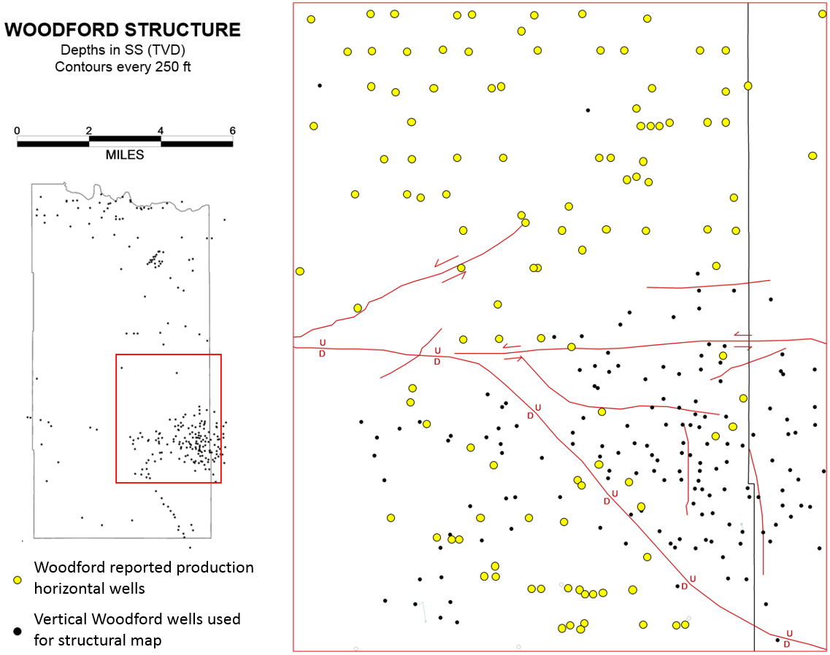
Figure 19. Woodford shale structure map. Location of the selected area within Grady County, Oklahoma. Location of wells used to construct the structure map and wells used for the production analysis

3.1.1. Hydrocarbon production data selection
The hydrocarbon production data is reported in a few different ways in the IHS database. It is differentiated by oil (bbl) and gas (MCF); and it also reports the first month production, the first twelve months production and the cumulative production for each well. To be able to have an even ground for comparison, only the first month production of oil and gas for each well was used in this study (Figure. 25). This is because there are several wells that only reported production for less than twelve months and others that have been producing for many years, which would make a huge difference in cumulative production.
Figure 20. Structural and stratigraphic cross section A-A’.

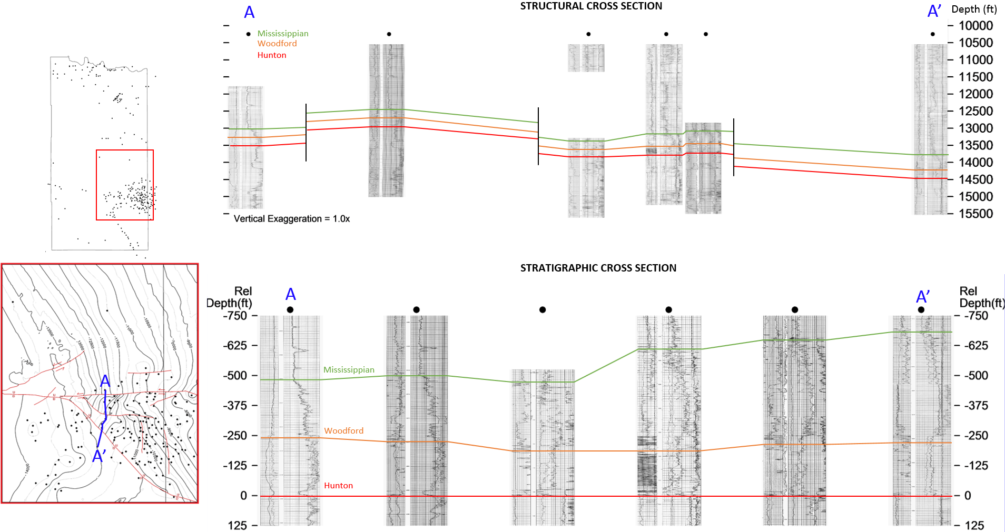

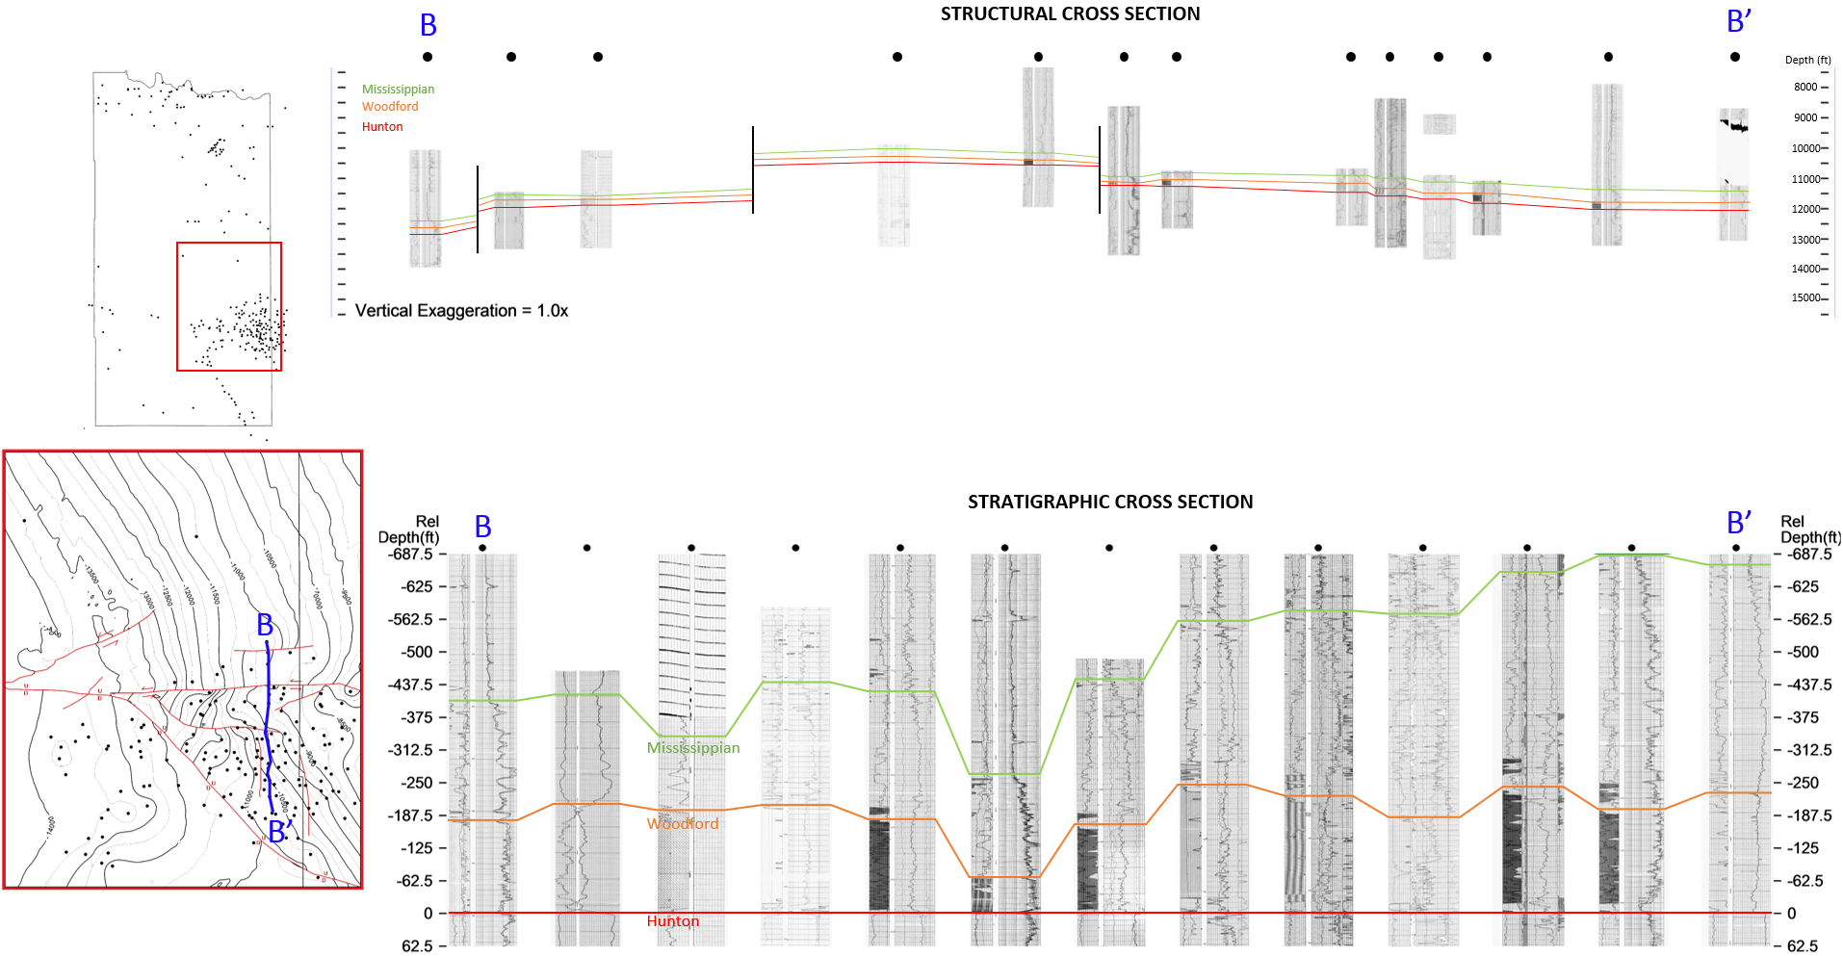
Figure 21. Structural and stratigraphic cross section B-B’.

Figure 22. Structural and stratigraphic cross section C-C’

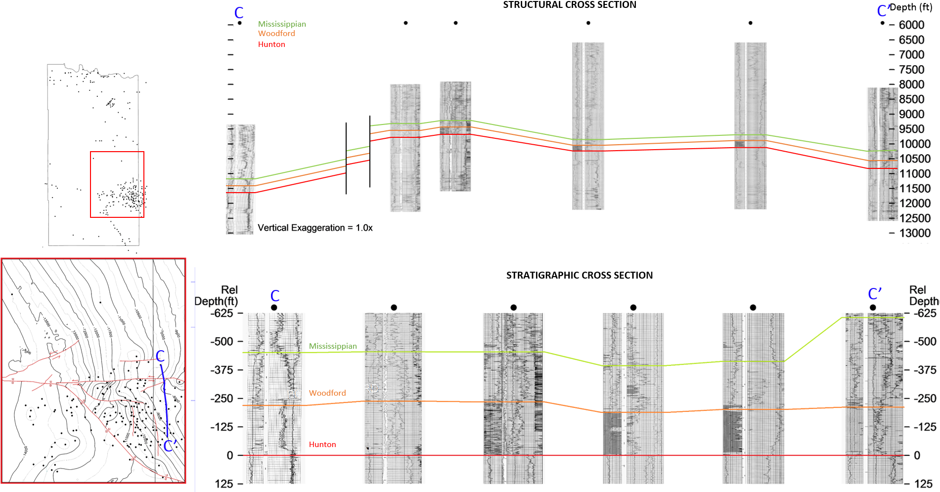

Figure 23. Structural and stratigraphic cross section D-D’.

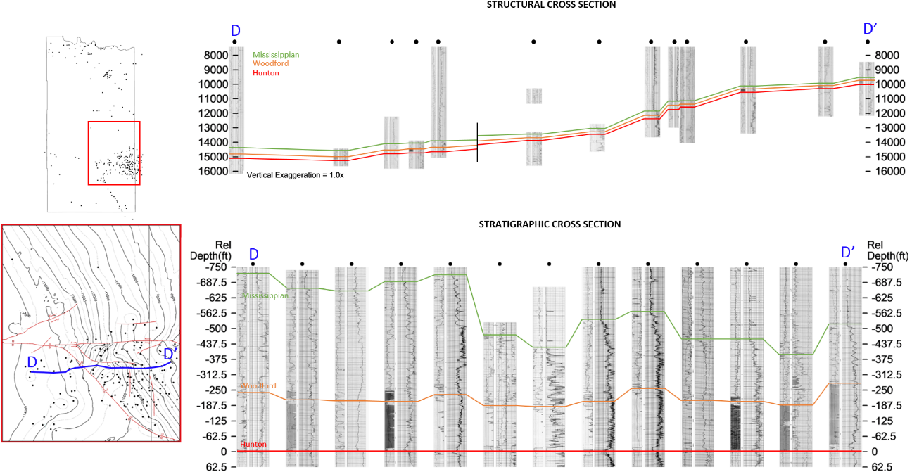

Figure 24. Structural and stratigraphic cross section E-E’.

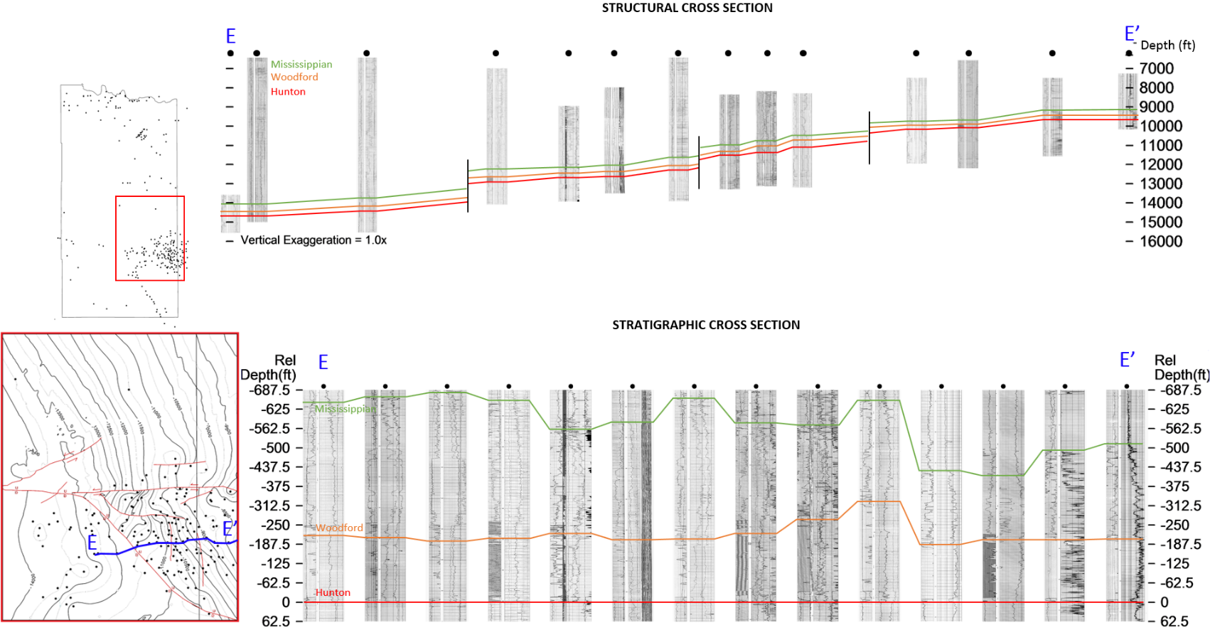

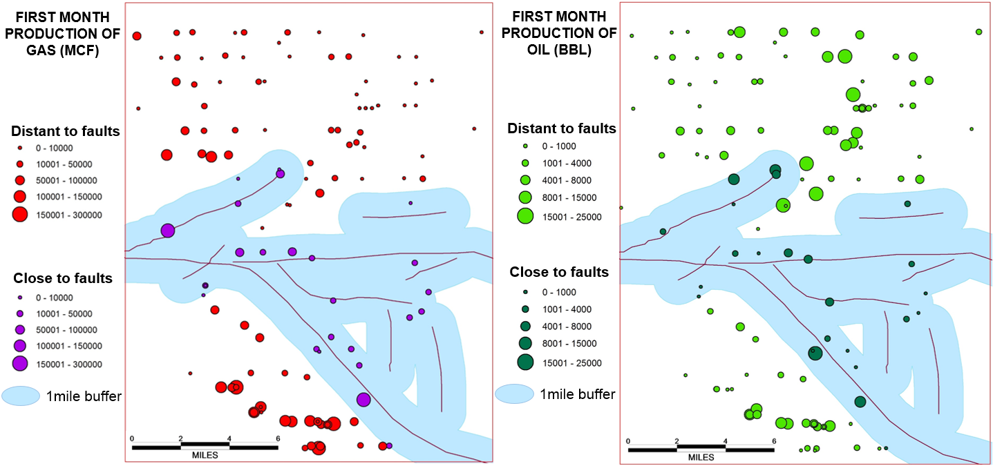
Figure 25. Woodford reported production from horizontal wells for the same area in Grady County referenced in Figure 19. First month production for oil and gas. A 1mile buffer around any fault trace was used to differentiate between wells close and distant to the faults

3.2. RESULTS
Generally, the production of an unconventional reservoir such as the Woodford shale is related to various factors like the environment of deposition, the maturity of the rock and its geochemical and geomechanical properties disregarding most of the time the influence of the structural setting as an added factor.
The idea behind using Grady County was to compare the production from highly faulted and folded zones with that of a more structurally stable zone, both in the same general area.
As mentioned before, it appears that the structural environment during the time of deposition of the Woodford Shale (Late Devonian) may have played a part in the thickness of the formation. Not only this, but the subsequent severe compressional tectonics during the late Mississippian to Permian (Axtman, 1985; Perry, 1988) to which this area was subjected may also have played an important part in the reservoir properties of the formation.
As a result of the oblique convergent shear tectonics, this particular area is a good example of extensive faulting and folding and this is why it is used to compare the quality of hydrocarbon production against that of the nearby area with a more stable structural setting.
After overlaying the structural map and the production data, with the use of the ArcMapTM software, a buffer of one mile was generated around all faults and the production data was divided into two categories: production of wells located closer to faulting (inside the one mile buffer) and production of wells located away from faulting (outside the one mile buffer). A map illustrating these results is found in figure 26 and the summary of the production results is found in Table 2.
The results in Table 2 show that the oil production data in both categories is not significantly different to indicate any kind of influence of faulting and structure in production.

Table 2. First month Woodford production for wells located near faults (inside the one mile buffer) and first month production of wells located away from faulting (outside the one mile buffer).

Interestingly, the gas production does show a significant difference between the data collected from wells close to the faults with an average of 33,303 MCF of first month production per well and the data from wells located in more stable areas with an average of 45,538 MCF of first month production per well; a 30,7% increase.
One of the reasons why this could be happening is because the faults themselves can create more extensive natural fracturing in the rock and at the same time a path that allows the gas to escape the reservoir, breaking the natural seal of the unconventional reservoir, suggesting that without a conventional seal rock, the gas was able to escape to a new reservoir resulting in a low gas production.

Figure 26. Woodford reported production overlaying the Woodford structure map produced from well logs in the last section. In blue, vitrinite isoreflectance data from Cardott (2012)

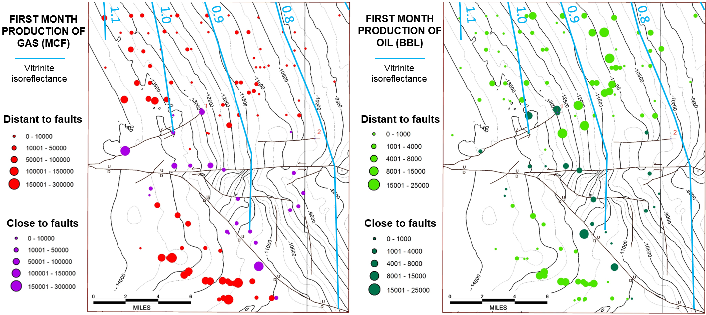

Also, the presence of extensive faulting nearby a producing well brings more challenges and difficulties such as loss of pressure at the moment of calculating and properly maximizing the amount and type of necessary fluid for a proper fracking job operation.
Normally, a good indicator for an unconventional reservoir quality would be a thermal maturity map derived from vitrinite isoreflectance. Data from such a map published by Cardott (2012) has been plotted onto the map on figure 26.
As evidenced, in the faulted zone of the area, the gas production doesn’t seem to follow the expected trend suggested by the isoreflectance map. The vitrinite isoreflectance suggests in this area that the amount of gas should be somewhat constant in the NNW-SSE direction and increasing in the EW direction. But the plotted data shows that the difference in gas production in this area is more closely following the structural setting of the location of the wells; increasing in the structurally stable zone and decreasing in the highly faulted zone.

There are certainly other variables that could be taken into account in order to have a more conclusive relationship between the structural setting and the production. A normalization of the production data by the thickness of the formation at the location of each well is one of those variables.

4. CONCLUSIONS
Plotted production data for the Woodford shale in this area suggests that the difference in gas production follows more closely the structural setting of the location of the producing wells; increasing in the structurally stable zone and decreasing in the highly faulted zone. Oil production does not appear to be related to faults in either zone.
The isochore map in Figure 18 suggests that the structural setting of the Woodford shale may have played a part in the thickness of the formation. Although the thickness distribution is irregular throughout the area, there is a marked difference between the thickness in the northern (stable) and the southern (faulted) regions, with the southern region having the greatest thickness values of the area.
The resulting maps of this thesis are being constructed so they can be used as reference and structural setting baseline for future Woodford shale (or related formations) reservoir quality and characterization work in Grady County.
The possible use of digital well logs for this type of study could help define not only other characteristics of the Woodford shale in each well, but also the possible relationship of the thickness and deposition of all members of the formation with the structural setting of the area.

5. RECOMMENDATIONS
Further study in detail of smaller areas is suggested with a higher well control not only in logs but also in the characteristics of the development of the production (type and amount of proppant, well development)
To further test the hypothesis of the faulting controlling the thickness and quality of production of the Woodford shale in this area, it is suggested the use of better quality detailed 2d or 3d seismic to help control the thicknesses changes at both sides of specific faults.
Future studies of this area not only for the Woodford shale but also for other target formations need to take a closer look at the structural setting along with other important characteristics. Although the structural setting is regarded as of lower importance when looking at unconventional reservoirs, the tectonic setting and the presence and influence of faulting seems to play a role worthy of taking into account during play development.

REFERENCES
Axtmann, T., 1985, Structural Mechanisms and Oil Accumulation Along the Mountain View-Wayne Fault, South-Central Oklahoma: The Shale Shaker Digest XI, Volumes XXXIII-XXXV 1982-1985, p. 17-45
Ball, M.M., M.E. Henry, and S.E. Frezon, 1991, Petroleum geology of the Anadarko Basin region, province (115), Kansas, Oklahoma, and Texas: U.S. Geological Survey Open-File Report 88-450W, 36 p.
Cardott, B.J., 2012. Thermal maturity of Woodford Shale gas and oil plays, Oklahoma, USA: International Journal of Coal Geology,Volume 103, p. 109-119.
Duarte, D. and R. Slatt, 2017. Integrated High-Resolution Chemostratigraphy and Sedimentological Analysis of Meramec/Sycamore Unconventional Reservoir in the Merge Area, SCOOP & STACK Plays, OK: Search and Discovery Article #80616 (2017)
Evans, J., 1979, Major Structural and Stratigraphic Features of the Anadarko Basin: Pennsylvanian Sandstones of the Mid-Continent, 1979, p. 97-113.
Ghosh, S., 2017, Integrated studies on Woodford shale natural fracture attributes, origin, and their relation to hydraulic fracturing: A dissertation submitted to the Graduate Faculty of the University of Oklahoma in partial fulfillment of the requirements for the degree of Doctor of Philosophy.
Infante-Paez, L., Cardona, L., McCullough, B. and Slatt, R., 2017, Seismic analysis of paleotopography and stratigraphic controls on total organic carbon: Rich sweet spot distribution in the Woodford Shale, Oklahoma, USA.: Interpretation, 5(1), T33-T47
Johnson, K. and Cardott, B., 1992, Geologic framework and hydrocarbon source rocks of Oklahoma: Oklahoma Geological Survey Circular 93, 1992, p. 21 – 37
Johnson, K.S., 1989, Geologic evolution of the Anadarko Basin: Oklahoma Geological Survey Circular 90, 1989, p.3 – 12.
Molinares-Blanco, C., M. Matemilola, J. Zhang, H. Galvis, D. Becerra, L. Infante, R. Slatt, 2017, Reservoir Optimization, Mechanical Stratigraphy, and Stress Field Orientation in the Woodford Shale SCOOP (South Central Oklahoma Oil Province) Play: A Case Study from Grady County, Oklahoma: Adapted from oral presentation given at 2017 AAPG Southwest Section Annual Convention, Midland, Texas, April 29-May 2, 2017. Search and Discovery Article #10984
Perry, W., 1988, Tectonic evolution of the Anadarko basin region, Oklahoma: U.S. Geological Survey bulletin; 1866-A
Reedy, H. and H. Sykes, 1958, Carter-Knox oil field, Grady and Stephens counties, Oklahoma: Petroleum Geology of Southern Oklahoma, Volume 2, p. 198 – 219.
Riley, L. R., 1965, The Challenge of Deep Exploration: The Chitwood Pool, Grady County, Oklahoma: The Shale Shaker Digest V, Volumes XV-XVII (1964-1967), p. 298-305.
Torres, E.J., R. Slatt, K. Marfurt, L. Infante and L. Castillo, 2017, Identification of Potential Lacustrine Stratigraphic Intervals in the Woodford Shale, Oklahoma, Using Multi-Attribute 3-D Seismic Displays and a Supervised Neural Network: Unconventional Resources Technology Conference (URTEC)
Wallace, D. L., 1953, Subsurface geology of the Chitwood area Grady county, Oklahoma: OCGS – The Shale Shaker Digest I, Volumes I-V (1950-1955), p. 242 – 260.

