UNIVERSITY OF OKLAHOMA
GRADUATE COLLEGE

CIRCADIAN RHYTHM VARIATION IN ENDOCRINE BIOMARKER RESPONSES TO HIGH-INTENSITY INTERVAL TRAINING IN COLLEGE AGED MALES

A THESIS
SUBMITTED TO THE GRADUATE FACULTY
in partial fulfillment of the requirements for the
Degree of
MASTER OF SCIENCE

By
Cyrus Shuler
Norman, Oklahoma
2023

CIRCADIAN RHYTHM VARIATION IN ENDOCRINE BIOMARKER RESPONSES TO HIGH-INTENSITY INTERVAL TRAINING IN COLLEGE AGED MALES

A THESIS APPROVED FOR THE
DEPARTMENT OF HEALTH AND EXERCISE SCIENCE

BY THE COMMITTEE CONSISTING OF

Dr. Michael Bemben, Chair
Dr. Debra Bemben
Dr. Rebecca Larson

© Copyright by Cyrus Shuler 2023
All Rights Reserved.

Acknowledgements

I am so grateful that I have been able to learn under such inspiring professors and colleagues who have helped along this process. I received my undergraduate degree here from the Department of Health and Exercise Science in 2021 and found my interest in exercise research shortly after. More specifically, I was intrigued by Exercise Endocrinology and how things are everchanging with regards to exercise interventions. Dr. Deb, who took me in as her final master student, was so helpful and wanted the absolute best for you not only in academia but in your personal life as well. Thank you for taking a chance on me and allowing me to pursue my goal of becoming an academic exercise scientist.

First, I would like to thank my mentor, Dr. Debra Bemben. From my first day in the grad program, Dr. Deb pushed me to always do more and that there is always something to be learned. Second, I would like to thank the rest of my committee, Dr. Michael Bemben and Dr. Rebecca Larson who have assisted in making this project run effectively. Lastly, thank you to all my friends and family that have supported along the way. From late nights in the lab to early morning teaching schedules, I would not trade it for anything. It all just makes for better stories later on in life.

List of Tables
Table 1. Anthropometric and DXA measurement (n=10) 28
Table 2. Physiological Responses to the Maximal Graded Exercise Test (n=10) 29
Table 3. Ratings of Perceived Exertion and Heart Rate at the end of Morning (AM) and Evening (PM) HIIT sessions (n=10) 30
Table 4. Salivary Hormone Responses to Acute HIIT Performed in the Morning versus Evening (n=9) 32
Table 5. Relationship between Percent Changes in Salivary Testosterone and Salivary Cortisol and Bone-Free Lean Body Mass Variables (n=9) 36

List of Figures
Figure 1. Research Design 22
Figure 2. Final Ratings of Perveived Exertion and Final Heart Rate for the Morning (AM) and Evening (PM) HIIT Sessions (n=10) 30
Figure 3. T:C ratio PRE to IP for the Morning (AM) and Evening (PM) Exercise Sessions (n=9) 33
Figure 4. Individual Salivary Testosterone and Cortisol Concentrations for Control Day Morning and Evening Time Points (n=10) 34
Figure 5. Individual Salivary Testosterone Responses to Acute HIIT Exercise Performed in the Morning and Evening (n=9) 34
Figure 6. Individual Salivary Cortisol Responses to Acute HIIT Exercise Performed in the Morning and Evening (n=9) 34
Figure 7. Percent Change in Salivary Testosterone and Cortisol in Response to Acute HIIT Performed in the Morning versus Evening (n=9) 35

Table of Contents
Acknowledgements i
List of Tables ii
List of Figures iii
Abstract vii
Introduction 1
Purpose 5
Research Questions 5
Hypotheses 5
Research Sub-question 5
Sub-hypothesis 6
Significance of the Study 6
Delimitations 6
Limitations 7
Assumptions 7
Operational Definitions 7
CHAPTER 2: REVIEW OF LITERATURE 9
Circadian Rhythm 10
Cortisol Response to Aerobic Exercise 12
Cortisol Response to HIIT 14
Testosterone Response to Aerobic Exercise 15
Testosterone Response to HIIT 17
Salivary Hormone Measurements 18
Summary 18
CHAPTER 3: METHODOLOGY 20
Participants 20
Research Design 21
Familiarization 23
Dual Energy X-ray Absorptiometry (DXA) 23
Salivary Sample Collection and Hormone Assays 24
HIIT Protocol 25
Data Analyses 26
CHAPTER 4: RESULTS & DISCUSSION 27
Participant Characteristics 27
Maximal Graded Exercise Test 28
Physiological Responses to HIIT Sessions 29
Hormonal Responses Acute HIIT Session 30
Discussion 37
Testosterone 37
Cortisol 39
T:C Ratio 41
CHAPTER V: CONCLUSIONS 44
Research Questions 44
Research Question 1 44
Hypothesis 1 44
Research Question 2 44
Hypothesis 2 45
Research Question 3 45
Hyopthesis 3 45
Practical Significance 45
Suggestions for Future Research 46
References 47
Appendices 56
Appendix A: IRB Approval Letter 56
Appendix B: Screening Checklist 57
Appendix C: Informed Consent 58
Appendix D: HIPAA 63
Appendix E: PAR-Q 66
Appendix F: Health Status Questionnaire 70
Appendix G: IPAQ 72
Appendix H: Mass Email Recruitment Script 78
Appendix I: Recruitment Flyer 79
Appendix J: Ratings of Perceived Exertion Chart 80
Appendix K: Salivary Sampling Techniques 81

Abstract
The purposes of this study were to: 1) to examine the effects of time of day on salivary testosterone (sal-T) and salivary cortisol (sal-C) concentrations following acute bouts of high intensity interval training (HIIT) exercise performed in the morning and evening; and (2) to examine diurnal variations in the T:C ratio responses to HIIT exercise; and (3) to determine if there is a relationship between sal-T and sal-C responses to acute bouts of HIIT exercise and muscle mass. Ten men between the ages of 20-25 years who reside in the Norman or Oklahoma City Metro area were recruited for this study. Eligibility for participation was assessed using medical history and physical activity readiness questionnaire as well as completing the written informed consent and HIPAA agreement. Additionally, a dual energy x-ray absorptiometry (DXA) total body scan assessing bone-free lean body mass, fat mass, and percent body fat as well as a maximal graded exercise test to determine maximal oxygen uptake (VO_{2peak}) was performed prior to participation in the intervention sessions. This randomized cross-over design assessment was aimed to determine whether or not HIIT exercise performed in the morning or evening effects sal-T and sal-C concentrations as well as determining if a relationship exists between bone-free lean body mass and the percent changes in the sal-T and sal-C responses. The findings from this study were: significant increases were observed for the sal-T exercise response (PRE to IP); significant decreases were observed for the sal-C time of day response (evening); and significant increases were observed for the T:C ratio time of day response (evening). In conclusion, sal-T and sal-C responses to acute bouts of HIIT exercise were not affected by time of day and no significant relationships existed between bone-free lean body mass variables and percent changes in sal-T and sal-C in this study.

CHAPTER 1: INTRODUCTION

Introduction
The sleep and wake cycle within humans is pivotal in determining physiological and behavioral processes during a 24-hour (h) cycle and can be referred to as the circadian rhythm (Farud et al., 2018). Moreover, the circadian rhythms that humans exhibit have internalized over evolutionary time, leading to the synchronization of physiological and behavioral responses to one's external environment (Walker et al., 2020). The circadian clock is located within the suprachiasmatic nuclei (SCN) of the hypothalamus and coordinates rhythms for differing lifestyles and environmental factors (Ahmad et al., 2020). The SCN facilitates these rhythms with the help from melanopsin, photoreceptive ganglion cells located in the retina (Ahmad et al., 2020; Çakmur et al., 2018). Stimulation of the melanopsin cells by natural light will in turn stimulate the nerve pathway in the SCN via the optic nerve (Çakmur et al., 2018). To maintain this biological process, natural light is essential and allows the brain to be reset for a 24 h cycle. Yet, in Western society, natural light exposure has become less prominent due to everchanging lifestyles and societal obligations (Thomas et al., 2020). This decline in natural light exposure has led to a society living in a chronic state of circadian disruption, which is associated with increased risk for obesity and cardiovascular disease (Thomas et al., 2020). Although humans have adapted to the control of circadian rhythms, individuals in the Western society often make use of sleep medication and alarm clocks to align their sleep and wake times (Roennenberg et al., 2012). For example, many college students use alarms clocks to adhere to their daily schedule and experience sleep disturbances throughout the night (Zhang et al., 2019). This has led to college students regularly experiencing circadian disruptions and can be associated with feelings of stress, fatigue, and poor sleep quality (Zhang et al., 2019). In addition, humans also exhibit daily oscillations for multiple hormones that have their own circadian profiles (Gnocchi & Bruscalupi, 2017). Testosterone and cortisol are two hormones under circadian control with both reaching peak serum concentrations in the early morning and subsiding as the day goes on (Gnocchi & Bruscalupi, 2017; González-Sales et al., 2015). It is well-known now that circadian rhythm and endocrine homeostasis are interconnected and deeply rooted in the behaviors humans perform each day (Gnocchi & Bruscalupi, 2017). Scientists have yet to fully understand why these two hormones are under circadian control. Nevertheless, disruptions to the circadian profiles of testosterone and cortisol can lead to mal-adaptations in endocrine homeostasis and many disorders, including cardiometabolic diseases and cancer (Gamble et al., 2014).
The endocrine system plays a vital role in the regulation of homeostasis and the adaptations that occur from exercise training (Dote-Montero et al., 2021; Hackney & Lane, 2015; Hayes et al., 2010). Chemical biomarkers are commonly assessed in the field of exercise science to investigate the responses of the endocrine system and monitor changes from an exercise intervention. To observe these changes, scientists typically collect biological samples in the form of serum or plasma. However, saliva has become more prominent in the monitoring of biomarkers due to its non-invasive methodology and time needed to collect sample (Hayes et al., 2016; Kilian et al., 2016). Furthermore, saliva has been shown to correlate well with serum values and represents the biologically active or "free" portion of the hormone under investigation (Hayes et al., 2016; Kilian et al., 2016). Two hormones that are commonly investigated are testosterone and cortisol in part to the anabolic and catabolic effects these hormones elicit on certain tissues. Testosterone is a androgenic steroid hormone that exhibits multiple physiological functions within the human body. In males, these functions include regulation of bone mass, fat distribution, and the growth and maintenance of skeletal muscle (Brownlee et al., 2005; Campbell & Jialal, 2021). Testosterone's ability to promote protein synthesis in skeletal muscle allows for the anabolic nature of the hormone (Kraemer et al., 2020). Conversely, cortisol is the primary glucocorticoid steroid hormone found in the human body and is secreted from the adrenal glands in response to increased physical or psychological stress (Anderson & Wideman, 2017; Brownlee et al., 2005). Cortisol functions to maintain blood glucose levels during exercise by increasing lipid and amino acid mobilization in adipose tissue and skeletal muscle (Brownlee et al., 2005; Campbell & Jialal, 2021; Hayes et al., 2010). The assessment of these two hormones coupled together is used within exercise science due to the biological effects of these hormones during and following exercise and often is expressed as the T:C ratio (Hayes et al., 2010). It is postulated that the T:C ratio is indicative of an anabolic:catabolic state from the protein synthesis to protein degradation rates (Hayes et al., 2010). Although prolonged and chronic increases in cortisol promotes catabolic effects on skeletal muscle, intermittent increases have been shown to promote increases in skeletal muscle recovery and performance as well as sarcolemma repair (Kraemer et al., 2020).
High-intensity interval training (HIIT) is a method of exercise that has become popular in the 20th century due to the time needed to complete, minimal equipment required, and the rapid central and peripheral adaptations like that of continuous endurance exercise (Costigan et al., 2015; Dote-Montero et al., 2021; Li et al., 2022; Monje et al., 2020). When compared to moderate-intensity aerobic exercise, HIIT has been shown to produce greater improvements in maximal oxygen uptake (VO_{2max}), cardiac contractility, and endothelial function (Kemi et al., 2005). The adaptations that HIIT can produce have led researchers to believe there are implications for the possibility of preventing the onset of cardiovascular disease (Schoenfield & Dawes, 2009). HIIT consists of alternating high-intensity and low-intensity intervals, with the high-intensity bouts performed above lactate threshold or close to an individual's VO_{2max} (Schoenfeld & Dawes, 2009). The low-intensity bouts serve as a recovery period for the individual, allowing the body to buffer and clear lactic acid produced during the working intervals (Schoenfeld & Dawes, 2009). There is a plethora of recommended HIIT prescriptions for a variety of populations. For instance, athletic populations are recommended to perform 3-5 minute working intervals with a work-to-rest ratio (W:R) of 1:1 (Reuter & Hagerman, 2008). Whereas, for the general population, it is recommended to use a 1:2 or even 1:4 W:R ratio depending on the fitness level of the individual (Rozenek et al., 2007). HIIT is a very convenient and effective exercise method for populations with limited time due to their lifestyle. It is well-known that the lifestyle of a college student consists of early mornings and long nights, which could pose obstacles when deciding to exercise. Thus, it is relevant to investigate the physiological responses following a HIIT exercise session in the morning and late afternoon to help determine if there are time of day differences.
HIIT has been shown to produce similar health benefits as continuous endurance training and can be very beneficial for individuals lacking time in their day to exercise. College students experience a new lifestyle change and encounter many obstacles regarding exercise methods, mostly due to time constraints. Circadian rhythm has its unique role in determining hormone variation and can greatly affect activities for that given day. Salivary sampling provides a quick and non-invasive method to measure hormone concentration following an exercise intervention. Although HIIT is a popular exercise method today, further research needs to be done to examine the variations in hormone response following a HIIT exercise protocol in the morning versus evening. Therefore, the effects of HIIT in the morning versus evening could be used to determine different training strategies from the assessment of testosterone, cortisol, and the T:C ratio. This study aims to examine the effect of HIIT on endocrine biomarkers during the morning and late afternoon in college males.

Purpose
The primary purpose of this study was to examine the effects of time of day on salivary testosterone (sal-T) and cortisol (sal-C) concentrations following acute bouts of HIIT performed in the morning and evening in college-aged men. The secondary purpose was to examine diurnal variations in the T:C ratio responses to HIIT.

Research Questions
1. Does time of day affect salivary testosterone and cortisol responses to an acute bout of HIIT exercise?
2. Does the pattern of the T:C ratio following an acute bout of HIIT exercise vary depending on the time of day (morning vs. evening)?

Hypotheses
1. It was expected that the salivary testosterone and cortisol responses to HIIT will be greater in the evening compared to the morning session.
2. It was expected that the evening salivary cortisol response will be greater than the salivary testosterone response, resulting in a lower T:C ratio compared to the corresponding responses to the morning acute bout of HIIT.

Research Sub-question
1. Is there a relationship between salivary testosterone and cortisol responses to acute bouts of HIIT and bone-free lean body mass (muscle mass)?

Sub-hypothesis
1. There would be a significant positive relationship between percent changes in salivary testosterone and cortisol and bone-free lean body mass.

Significance of the Study
Biorhythms dictate hormone concentrations at specific time points throughout the day, which may affect the activities within that 24 h cycle. Therefore, time of day for exercise can affect hormone concentration during and following a HIIT exercise session. Busy individuals like college students are limited on time to exercise, and HIIT can effectively combat this. Additionally, a prolonged increase in cortisol concentration with regard to the T:C ratio could potentially lead to protein catabolism and skeletal muscle degradation. Therefore, the findings from this study may help exercise scientists create effective exercise interventions using HIIT for college males aged 20-25 years that struggle to find time in their day to exercise.

Delimitations
1. The findings from this study apply to moderately active, healthy men between the ages of 20-25 years old.
2. Participants will be recruited from the University of Oklahoma.
3. All testing procedures will be performed at the Bone Density Research Lab in the Sarkey's Fitness Center in Norman, Oklahoma.
4. Participants will be limited to individuals who are not taking performance-enhancing drugs/supplements to improve muscle mass or cardiovascular function.
5. Participants will not have any known diseases affecting testosterone and cortisol production.

Limitations
1. Participants will volunteer to take part in this study and, therefore may not be representative of the general population.
2. Participants will not include sedentary individuals.

Assumptions
1. Participants will give an all-out effort for the test.
2. Participants will only consume water 60 minutes prior to all salivary sample collection.

Operational Definitions
1. Anabolism- The sequences of enzyme-catalyzed reactions by which relatively complex molecules are formed in living cells from nutrients with relatively simple structures (McCarthy & Esser, 2010).
2. Bone-free Lean Body Mass (BFLBM)- lean soft tissue, muscle + skin + organs.
3. Catabolism- The sequences of enzyme-catalyzed reactions by which relatively large molecules in living cells are broken down or degraded (McCarthy & Esser, 2010).
4. Cortisol (C) - Steroidal hormone part of the glucocorticoid family that responds to stress and stimulates substrate mobilization or degradation (Brownlee et al., 2005).
5. Circadian Rhythm- The physical, mental, and behavioral changes that follow a 24 h cycle (Brownlee et al., 2005).
6. Fat Mass (FM)- Absolute amount of fat expressed in kg.
7. High-intensity interval training (HIIT) - Alternating work and rest intervals at respective percentages of an individual's estimated maximal heart rate (ACSM, 2014).
8. Homeostasis- Any self-regulating process by which biological systems tend to maintain stability while adjusting to conditions that are optimal for survival (Brownlee et al., 2005).
9. Hormone assay- A blood, saliva, or plasma test to assess endocrine system status (Hayes et al., 2016).
10. Maximal oxygen uptake (VO_{2max})- The maximal amount of oxygen that an individual can uptake and utilize during maximal exercise (Schoenfeld & Dawes, 2009)
10. Percent Body Fat (% BF)- (Fat mass/body weight)100.
11. Salivary sample- a saliva specimen used for research (Hayes et al., 2016).
12. Testosterone (T) - Androgenic steroidal hormone that stimulates protein synthesis rates and anabolism (Brownlee et al., 2005).
12. T:C ratio- The ratio between testosterone and cortisol suggests anabolic: catabolic processes (Cofré-Bolados et al., 2019).

CHAPTER 2: REVIEW OF LITERATURE
The human body experiences changes in homeostasis when the biological clock or circadian rhythm is disrupted. Furthermore, metabolism can be referred to as the sum of all chemical processes that occur in the human body. Testosterone and cortisol are two hormones that exert anabolic and catabolic effects. There is a large body of research detailing the variations in the resting serum concentrations of these hormones throughout a 24 h cycle. Evidence shows that physical exercise leads to alterations in both and cortisol levels. However, the effect of high-intensity interval training (HIIT) and time of day on salivary hormone concentrations should be further investigated. New insights could lead to limiting catabolic effects regarding the T:C ratio following a HIIT exercise session in college males.
The endocrine system has profound regulatory effects in response to physical exercise, which helps maintain various biological processes that occur in the human body (Hackney & Lane, 2015; Lee et al., 2017). It has been well documented that physical exercise disrupts homeostasis, leading to adaptations in a human's physiology (Fragala et al., 2011; Hackney & Lane, 2015; Viru & Viru, 2001). This is done via chemical messengers or hormones on target tissues that experience an increase in physiological demands from exercise (Fragala et al., 2011). The response of these hormones to physical exercise can be characterized by the rate of hormone responses, threshold intensity, threshold duration, and the training adaptations produced (Hackney & Lane, 2015). Furthermore, the maintenance of energy metabolism, fluid and electrolyte balance, and growth and development are among the key factors exercise scientists are interested in investigating. Numerous studies have investigated the hormonal response following resistance and endurance exercise protocols (Hackney & Lane, 2015; Kraemer & Ratamess, 2005; Kraemer et al., 2020). HIIT has emerged as a new method of exercise associated with several health prevention benefits and in terms of the adaptations produced, which are similar to both resistance and endurance exercise (Wahl, 2013). For example, the acute hormonal response appears to be crucial for tissue growth and remodeling following a resistance exercise protocol, which is thought to be attributed to the high mechanical stimuli of the exercise (Kraemer & Ratamess, 2005). HIIT protocols, specifically Wingate-based training, appear to be similar to resistance exercise protocols when comparing the power output of the two modes of exercise (Wahl, 2013). Moreover, HIIT stimulates increased lactate production and lowers pH, which is crucial for endurance training adaptations and the acute hormonal response (Wahl, 2013). So, one can speculate that the high mechanical and metabolic stimuli associated with HIIT can lead to the acute hormonal response from the endocrine system and, therefore, the training adaptations produced.
The following literature review will provide more insight into the regulatory functions within the human body and how exercise may affect these functions. The following review of literature will cover circadian rhythm, cortisol responses to aerobic exercise and HIIT, testosterone responses to aerobic exercise and HIIT, and salivary hormone measurements.

Circadian Rhythm
Located in the hypothalamus, the master clock or suprachiasmatic nucleus (SCN) regulates all the biological clocks within the human body (Ahmad et al., 2020; Çakmur, 2018; Walker et al., 2020). Photoreceptor organisms like humans will experience circadian rhythms in response to the light-dark cycles and adjust sleep-wake cycles accordingly (Çakmur, 2018; Walker et al., 2020). The peripheral tissues will receive refinements coordinated by the SCN, which is regulated by clock genes and under autonomous control (Saner & Lee, 2020; Walker et al., 2020). These adaptations are vital for preserving life and ultimately dictate behavior for a 24 h cycle (Sieck, 2016). Human beings often display preferred activity due to their innate circadian rhythm and can be classified as Morning-type, Evening-type, or Neither-type (Natale & Cicogna, 2002). Recent research has focused on Morning and Evening-type individuals to investigate differences in hormone secretion and exercise performance (Bailey & Heitkemper, 2001; Rossi et al., 2015). Circadian rhythm disruptions can lead to maladaptations in homeostasis and may lead to cardiometabolic diseases throughout life (Poggiogalle et al., 2018).
Among the vast number of hormones in the human body, cortisol and testosterone are two that exhibit diurnal oscillations. Although circadian rhythmic hormone oscillations may affect resting hormone concentrations, these fluctuations in hormone secretion allow for peak values reached at specific time points throughout the day. For example, cortisol has been shown to peak between 7:00-8:00 a.m., and testosterone secretion reaches a peak between 7:00-10:00 a.m. (Gnocchi & Bruscalupi, 2017). It is thought that the rise and peak in cortisol and testosterone during these hours of the day may be due to the catabolic and anabolic nature of the two hormones. A study conducted by Hayes et al. (2012) investigated the diurnal variations of salivary cortisol and testosterone in eighteen healthy male college students. This study was two days long and consisted of saliva collection starting at 8:00 a.m. and every 60 minutes over a 12-hour waking period. Identical meals were given at 8:05 a.m., 1:05 p.m., and 6:05 p.m., and refraining from alcohol, caffeine, and exercise 24 hours before the investigation. The authors found significantly elevated salivary cortisol concentration between 8:00-9:00 a.m., but no difference was observed for salivary testosterone (Hayes et al., 2012).
Environmental factors or time cues provide information to clock genes that lead to alterations in the circadian rhythm (Kemler et al., 2020). Although light exposure is the most common environmental time cue responsible for influencing circadian rhythms, recent discoveries indicate exercise is a valid cue and should be considered (Kemler et al., 2020). Teo et al. (2011) investigated circadian rhythms in exercise performance with regard to hormonal and muscular adaptation. The authors found that circadian rhythms have a major effect on physical performance during the early evening, which is postulated to be attributed to the peak in core body temperature observed at this time. For example, an increase in force production during early evening strength training exercises has been observed compared to those performed in the morning, even with an extended warmup (Teo et al., 2011). However, the diurnal fluctuations in hormone concentration do not appear to influence exercise performance (Teo et al., 2011). Although there is little evidence to provide on whether physical exercise influences the circadian profiles of cortisol and testosterone, some researchers have suggested that implementing time-of-day specific training could modify the resting hormone levels and concentration during exercise (Teo et al., 2011).

Cortisol Response to Aerobic Exercise
The hypothalamic-pituitary-adrenal axis (HPA) regulates the synthesis and secretion of glucocorticoids (Viru & Viru, 2001). Cortisol is a glucocorticoid steroid hormone that has rapidly increased in the blood under stressful conditions and can mobilize energy lipolysis in adipose tissue and proteolysis in skeletal muscle (Hackney & Lane, 2015; Mangine et al., 2018; Viru & Viru, 2001). Several factors are associated with how cortisol concentration will be altered during exercise, including the number of active receptors in the target tissue, plasma hormone concentration, and quantity of transport proteins (Thau et al., 2022). Cortisol, with its lipid-soluble properties, will bind to specific protein receptors in the target cell's cytoplasm, creating a cortisol-receptor complex (Thau et al., 2022). This cortisol-receptor complex will then be taken to the cell's nucleus, where gene transcription is affected (Thau et al., 2022). A decrease in plasma volume during exercise will increase cortisol concentration due to the decreased capacity and affinity for binding transport proteins in the plasma. This then allows more "free" cortisol to bind receptors in the cytoplasm (Thau et al., 2022). However, plasma volume shifts due to exercise can be "corrected" to obtain the most accurate hormone assessment. Acute aerobic exercise can be a potent stimulus for cortisol secretion and has been shown to increase due to the intensity and duration of the exercise session (Hackney & Lane, 2015).
Hill et al. (2008) investigated the cortisol response in serum following a 30-minute aerobic exercise session at intensities of 40, 60, and 80% of VO_{2max} in twelve moderately trained men on a cycle ergometer. Diet was controlled by at least 50% of daily caloric intake being carbohydrates and performing each experimental session in 4-hour post-prandial state. Circadian hormone fluctuations were controlled by standardizing the time of day for each exercise session. A 30-minute resting-control session was used and randomly assigned to a sub-sample of the subjects mimicking the experimental sessions. A significant increase in circulating cortisol was observed following the 60% and 80% exercise intensity sessions but not in the 40% exercise intensity session or in the resting-control session. Additionally, a significant difference was observed between the 60% and 80% exercise intensity sessions, with the highest intensity evoking the highest cortisol response. This study's findings further support that cortisol production depends on the intensity of the aerobic exercise session (Hill et al., 2008).
Hew-Butler et al. (2008) investigated cortisol responses in serum following a 60-minute steady-state exercise (SSE), high-intensity interval exercise to exhaustion (HIIE), and a 56 KM prolonged endurance exercise session in seven endurance-trained athletes. Diurnal variations in cortisol were controlled by performing the exercise sessions at the same time of day. Subjects were asked to consume a similar diet and to refrain from any vigorous activity 24-hours prior to exercise sessions. The main finding from this study was that there was no significant increase in cortisol concentration following SSE or HIIE. However, a significant increase was observed following the prolonged endurance exercise session. Although exercise intensity is the primary catalyst for cortisol secretion during aerobic exercise, these findings further support that the duration of an exercise session is another contributing factor to cortisol secretion (Hew-Butler et al., 2008).

Cortisol Response to HIIT
HIIT has gained interest from exercise scientists in recent years and has been shown to improve cardiorespiratory health, endothelial function, substrate utilization, and hormonal responses (Dote-Montero et al., 2019). The cortisol response following an acute HIIT time of day-dependent exercise session remains unclear, though findings from previous studies provide a better understanding of the neuroendocrine response that can, in turn, lead to positive adaptations (Cofré-Bolados et al., 2019). Cofré-Bolados et al. (2019) investigated plasma cortisol responses following a 20-minute HIIT exercise bout in thirteen active young men (Cofré-Bolados et al., 2019). All conditions: a) 20-minute resting-control (CON); b) 20-minute high-intensity interval training (HIIT); c) 20-minute steady-state aerobic exercise (AEE) was performed at the same time of day (7:30 p.m.) to minimize diurnal variations. The authors found a significant increase from pre to 12 hours post following HIIT and CON. The increase of 12 hours post in CON can be partly attributed to the circadian oscillations cortisol exhibits during the morning. Therefore, it is not possible to rule out that the circadian oscillations could have been attributed to the significant increase in salivary cortisol 12 hours post following HIIT (Cofré-Bolados et al., 2019). Monje et al. (2020) examined the salivary cortisol response following an acute bout of HIIT in twenty endurance athletes with a 4:2 minute W:R ratio as the protocol and consisted of ten total working bouts. Diet was controlled by providing a standardized diet for breakfast and lunch consisting of 125 grams of carbohydrates and 21 gram of protein on the day of the intervention. Diurnal variations in cortisol were controlled by performing the exercise sessions between 3:00-6:00 p.m. and performing the HIIT protocol in a 2-hour post-prandial state. The authors found a significant increase in salivary cortisol following the HIIT protocol, suggesting that the HIIT protocol used in this study can be an effective exercise method to elicit a salivary cortisol response. Another interesting finding was that T:C ratio following HIIT was stable, indicating that the anabolic:catabolic balance was not disturbed (Monje et al., 2020).

Testosterone Response to Aerobic Exercise
The function of testosterone has effects on many tissues throughout the body and is regulated by the hypothalamic-pituitary-gonadal axis (HPG) (Küüsma et al., 2016). Testosterone is an androgenic steroid hormone secreted by the testes in men and is responsible for skeletal muscle hypertrophy and increased expression of aerobic enzymes (Kilian et al., 2016). Once testosterone enters the target cell, it will bind to androgen receptors located in the nucleus or can be reduced to 5a-dihydrotestosterone (DHT) in the cytoplasm (McEwan et al., 2000). If bound to the androgen receptor, using chaperone protein complexes or heat shock proteins will cause a disassociation in the cytoplasm, ultimately leading to a conformational change in the receptor (McEwan et al., 2000). This results in the translocation of the receptor to the nucleus, where gene transcription can occur and consequently lead to protein synthesis (McEwan et al., 2000). Like cortisol, factors such as the number of receptors in the target tissue, plasma hormone concentration, and quantity of transport proteins will alter the testosterone concentration following exercise. Furthermore, the intensity of aerobic exercise appears to be the variable that induces the largest change in testosterone concentration following exercise.
Hough et al. (2011) investigated the effects of a 30-minute aerobic exercise on salivary and plasma testosterone elevations in ten recreationally active males using a cycle ergometer. Three endurance protocols were tested: a) Continuous cycle to fatigue at 75% W max (FAT); b) one minute 60%, one minute 90% W max for 30-minutes (60/90); c) one minute 55%, four minutes 80% W max for 30-minutes (55/80). Diet was controlled by a standardized breakfast tracked with a food diary 4-hours before the exercise sessions, and subjects remained fasted until the sessions were complete. Diurnal variations were controlled by performing the tests at the same time of day during the months May-August. The authors found significant increases in salivary and plasma testosterone increases from pre to post-exercise following the 60/90 and 55/80 protocols. However, the 55/80 protocol elicited the greatest increase and prolonged elevation in salivary and plasma testosterone compared with the other protocols (Hough et al., 2011). From these findings, the 55/80 protocol could be a useful HIIT protocol when researchers seek to examine salivary testosterone concentrations following an exercise session using a cycle ergometer in healthy, recreationally active males.
Another study conducted by Hackney et al. (2012) investigated the response of serum-free testosterone following high-intensity interval and steady-state exercise in fifteen endurance-trained males using a treadmill. A 45-minute resting-control session (CON), 42-47 minutes alternating 90-sec at 100-110% and 90-sec at 40% of VO_{2max} interval exercise session (IE), and 45 minute at 60-65% of VO_{2max} steady-state endurance exercise session (SSE) was used. Diet was controlled by a standardized 60% carbohydrate diet and required subjects to be in a fasted state prior to each session. Additionally, abstaining from sexual activity, exercise training, and excessive emotional stress 24-hours prior to each session was required. Diurnal variations were controlled by performing each session at the same time of day and corresponded with the subject's typical exercising period. The authors found that free testosterone significantly increased from pre to post in the SSE and IE groups compared to the CON group. However, free testosterone in the SSE session 12-hours post-exercise was not suppressed like that of the IE session. Although free testosterone 12 post-exercise in the IE session was significantly suppressed, this session had the greatest increase immediately post-exercise compared to both the SSE and CON sessions (Hackney et al., 2012).

Testosterone Response to HIIT
It has been established that testosterone concentration increases in the body following physical exercise (Kraemer & Ratamess, 2005; Cofré-Bolados et al., 2019; Hackney & Lane, 2015). However, HIIT is still under question as to whether it provides enough stimulus to elicit a testosterone response post-exercise. Cofré-Bolados et al. (2019) investigated free testosterone response in the plasma following HIIT and continuous aerobic exercise (AEE) in 13 recreationally active college males. Three sessions consisting of a 20-minute resting-control (CON), 20-minute HIIT exercise, and 20 minutes AEE was used. The HIIT exercise protocol was performed in 15-sec intervals alternating between 110% and 40% VO2max and the AEE protocol was performed continuously at 70-75% VO_{2max}. Diet was controlled by a standardized 60% carbohydrate diet, and performing each session in a fasted state was required. Additionally, refraining from sexual activity and physical exercise 24 hours prior to each session was required. Time of day variations in free testosterone was controlled by performing each session at 7:30 p.m. on non-subsequent days. The authors found significant increases in free testosterone immediately post-exercise for both the HIIT and AEE sessions. However, the HIIT session produced the greatest increase in free testosterone immediately post-exercise compared to the CON and AEE sessions. Another interesting finding was that although free testosterone increased following AEE and HIIT, the T:C ratio remained unchanged, suggesting that both exercise modalities did not provide a sufficient stimulus to affect anabolic processes (Cofré-Bolados et al., 2019).

Salivary Hormone Measurements
Salivary sampling provides a convenient and non-invasive method to obtain hormone concentration. This method of sampling has allowed for faster handling and process times and requires minimal expertise compared to blood sampling. Unlike serum or plasma sampling, saliva sampling procedures include approximately 1.8 mL of a saliva specimen using the drool method and placed into 2 mL cryovials for storage. Biological and technical errors can occur in salivary sampling ranging from gender, training status, age, mouth position, and sample storage. Furthermore, an enzyme-linked immunosorbent assay (ELISA) is the primary method to obtain salivary hormone concentration. While salivary sampling is rarely used in clinical settings, exercise scientists have adopted this new method which provides an accurate measurement like that of blood sampling (Hayes et al., 2016). The steroid hormones cortisol and testosterone represent the "free" or non-protein bound concentration when examining saliva concentrations, which are readily available to target tissues (Crewther et al., 2010). Additionally, Gozansky et al. (2005) found that salivary testosterone and cortisol are indicative of the biologically active cortisol found within the blood (Gozansky et al., 2005). Thus, sal-T and sal-C have been validated against blood concentrations and are widely used by researchers to obtain a reliable measurement following an exercise intervention.

Summary
The circadian rhythm provides organisms a sleep-wake cycle and time of day hormone secretion. The circadian oscillations in testosterone and cortisol have been shown to affect exercise performance to some degree. Steps still need to be made to discover if exercising at a specific time of day will potentially alter the circadian profile of testosterone and cortisol or the T:C ratio. The endocrine system and SCN work side by side to provide the appropriate responses and adaptations to the environment imposed by daily behaviors and physical exercise. While aerobic exercise literature investigating hormonal responses is immense, HIIT has emerged in the past 20 years as a new and unique exercise method. HIIT has been shown to produce similar physiological benefits to continuous aerobic training and attracts many people with the amount of time needed to complete a single bout of HIIT. Saliva sampling has also emerged as a new and non-invasive method to obtain hormone concentration through ELISA techniques and correlates to blood and plasma concentrations. Determining time of day differences when examining sal-T, sal-C, and the T:C ratio while maintaining or improving the circadian profile of testosterone and cortisol is still unclear after an acute bout of HIIT exercise. Additional research is needed to investigate the biological rhythm of testosterone and cortisol circadian profiles.

CHAPTER 3: METHODOLOGY
The primary purpose of this study was to examine the effects of time of day on salivary testosterone (T) and cortisol (C) concentrations following acute bouts of HIIT performed in the morning and evening in college-aged men. The secondary purpose was to examine diurnal variations in the T:C ratio responses to HIIT.

Participants
Ten college males from the OU-Norman campus completed all study visits. A priori power analysis was performed with G*Power (v 3.1) to estimate the sample size for this study. Cofré-Bolados et al. (2019) examined plasma free testosterone and cortisol concentrations following an acute bout of HIIT. Based on their findings, the effect size for plasma cortisol is 1.54 (Cohen's d) and 1.06 (Cohen's d) for plasma free testosterone and will require 6 and 10 participants receptively for 80% power (Cofré-Bolados et al., 2019). Monje et al. (2020) examined salivary testosterone and cortisol concentration following an acute HIIT exercise session. Based on their findings, the effect size for salivary cortisol is 1.12 (Cohen's d) and 0.12 (Cohen's d) for salivary testosterone and required 9 and 532 participants, respectively, for 80% power (Monje et al., 2020). Due to feasibility, the sample size chosen for this study was 10 participants. Experimental procedures were approved by the Institutional Review Board at the University of Oklahoma. All participants provided written informed consent prior to completing a health history questionnaire, a Physical Activity Readiness Questionnaire (PAR-Q), and a physical activity questionnaire (IPAQ). Participant's height and weight were assessed using a wall stadiometer and a digital scale. Inclusion criteria for participants were: 1. males between the ages of 20-25 yr; 2. those who self-report an average of 150 minutes of moderate physical activity per week; and 3.those with no HIIT participation in the past 3 months. Participants were excluded from the study based on the following criteria: 1. if there was a history of cardiovascular or pulmonary issues; 2. taking any prescription medication that affects concentrations of testosterone or cortisol; 3. taking any performance-enhancing drug or supplements, including anabolic steroids or blood doping techniques; 4. body mass over 300 lbs; 5. height over 6’4; 6. regularly consumed any form of tobacco in the past 3 months; and 7. any joint replacement or metal implants in the legs, hips, or spine. Participants were instructed to refrain from heavy exercise 24 hours prior to exercise visits and any alterations in their diet or sleep habits over the course of this study.

Research Design
This study incorporated a two factor within-subjects repeated measures design (time of day × exercise time point) to investigate changes in testosterone and cortisol responses to a single HIIT exercise session performed in the morning (8:30-10:00 a.m.) and evening (5:00-6:30 p.m.). The test order was randomly assigned. On the first visit, participants were asked to complete a HIPAA release form and a written informed consent. A Dual Energy X-ray Absorptiometry (DXA) total body scan was taken on this visit to determine body composition varibales. For the second visit, participants were asked to complete a maximal graded exercise test on the treadmill to establish VO_{2peak}. This determined the percentages used for the work and recovery intervals during the HIIT exercise sessions. The third visit served as the control day and salivary samples were taken in the morning (8:30-10:00 am) and evening (5:00-6:30 pm) to establish baseline values for the endocrine biomarkers under investigation. For the fourth and fifth visits, participants were asked to provide a saliva sample prior to each HIIT exercise session (PRE) followed by immediately post HIIT exercise session (IP). A flowchart of procedures is presented below.
First Visit
Familiarization (n=10); Assessed for eligibility (Healthy men; age 20-25 years)
Consent, HIPAA, IPAQ, Saliva collection techniques, HIIT protocol, Treadmill
DXA: body composition, bone-free lean body mass, fat mass, percent body fat

Second Visit
Maximal graded exercise test to establish VO_{2peak} (ramp protocol)
Height and Weight measured prior to exercise test
Expired gas, Heart rate, and RPE will be measured during exercise test

Third Visit
CONTROL DAY
Baseline values for T and C will be determined by salivary sampling in the morning (8:30-10 am) and evening (5-6:30 pm)

Fourth Visit
First HIIT exercise session (Randomized)
Saliva sample prior (pre) to and immediately (IP) following exercise session
Heart rate and RPE recored

Figure 1. Research Design
Fifth Visit
Subsequent HIIT exercise session
Saliva sample prior (pre) to and immediately (IP) following exercise session
Heart rate and RPE recored

Familiarization
Participants were familiarized with the treadmill, HIIT protocol, and saliva sampling procedures to better understand what will be expected from them. The purpose of this session was for the participants to become accustomed to each step of the respective procedures and to follow them in the correct order. During this session, the participants provided informed consent, were introduced to the treadmill, and a DXA total body scan was administered. The participants were informed that they will be required to provide a saliva sample before exercise and immediately post but at least understand the procedures for salivary sampling. This day helped to minimize researcher and experimenter technical errors throughout the study.

Dual Energy X-ray Absorptiometry (DXA)
A total body scan was performed to assess body composition, including bone-free lean body mass (BFLBM), fat mass (FM), and percent body fat using Dual Energy X-ray Absorptiometry (DXA; Lunar Prodigy, GE Medical System, Madison, WI). Scans were analyzed using the enCORE v 16 software (GE Healthcare, Madison, WI). For quality assurance, a standardized block with known densities was scanned prior to each day of testing. Participant's height and weight was assessed using a digital scale and wall stadiometer. Participants were then asked to remove their shoes, excess clothing, any metal accessories, and other attenuating materials. The scan took place once the participants were in the proper supine position on the DXA table with the head about 2-3 cm below the horizontal line at the top of the table. Participants legs, hips, and shoulders were aligned to the center of the table while their arms remaind close, but not touching, their body. Participants were asked to straighten their fingers as their thumbs hold and face the ceiling for the entirety of the scan. Participants legs were held close together using two Velcro straps located just below the knee joint and the other at the ankle joint. The same trained technician conducted all scans. In the Bone Density Research Laboratory, the precision values, reported as root mean square coefficients of variation (RMS CV%), for the body composition variables, are: 2.5% for percent body fat, 1.39% for BFLBM, and 2.74% for FM.
Maximal Aerobic Capacity Test
The maximal aerobic exercise test was conducted on the second visit in order to establish working and recovery intervals for the HIIT protocol. The participants were advised to not perform any strenuous exercise activity 24 hours prior or the day of test. Participants were informed to not consume alcohol the day before or of visit. Lastly, participants were advised to eat something rich in carbohydrates and protein at least 2 hours before visit and to be adequately hydrated. The participants were given a 2 minute warmup at 2.5 mph before test began. The protocol used was the ACSM incremental speed test which began at 4 mph and increased 1 mph every minute (ACSM). Gas and flow-meter calibration preceeded all exercise testing and The PARVO Metabolic Cart was used to measure VO_{2peak} for both relative and absolute values. The mask used was the Hans Rudolph and the treadmill used was the WOODWAY Pro. Variables including heart rate, RPE, VO_{2peak}, and time to exhaustion were recorded. Participants were advised to motion a thumbs down signal when they could not go any longer and a cool down phase was utilized until participants heart rate fell below 120 beats per minute.

Salivary Sample Collection and Hormone Assays
The saliva samples were collected from participants on the third visit to serve as a control day for baseline salivary hormone concentrations and prior to each HIIT exercise session (PRE) and immediately post HIIT exercise session (IP). The participants were informed that they could not eat, brush their teeth, or drink alcohol 24 hours prior to testing. Every participant used the SalivaBio Collection Aid and perform the passive drool method for sample collection. Each sample was collected in a 1.8 mL SalivaBio cryovial and took approximately 30 minutes to collect. Participants were asked to provide a full vial of saliva, but if they could not, then what they could produce was taken for assessment. The saliva samples were stored in the Bone Density Research Lab and were used to determine testosterone and cortisol hormonal concentrations. Upon collection, samples were placed in a freezer at or below -80 C within four hours and may be stored up to 6 months. Samples were thawed to room temperature, vortexed, and then centrifuged for 15 minutes at approximately 3,000 RPM (1,500 x g) immediately before performing the assay at the Salivalab West in Carlsbad, California. Samples were tested for salivary testosterone using a high sensitivity enzyme immunoassay (Cat. No. 1-2402) and salivary cortisol (Cat. No. 1-3002). Samples test volume was 25 of saliva per determination. The salivary testosterone assay had a lower limit of sensitivity of 1 pg/ml, a standard curve range from 6.1-600 pg/ml, and an average intra-assay coefficient of varation of 4.60%, and an average inter-assay coefficient variation 9.85%. The salivary cortisol assay had a lower limit of sensitivity of 0.007 ug/dl, a standard curve range from 0.012-3.0 ug/dl, and an average intra-assay coefficient of variation of 4.60%, and an average inter-assay coefficient of variation of 6.00%. Both salivary testosterone and cortisol kits that were used are The Salimetrics® Salivary Cortisol Assay Kit (Cat. No. 1-3002) and The Salimetrics® Salivary Testosterone Assay Kit (Cat. No. 1-2402), without modifications to the manufacturer’s protocol.

HIIT Protocol
One week following the familiarization day, the first HIIT session was completed and designed to induce testosterone and cortisol responses following exercise. A warmup of 5 minutes at 25% of VO_{2peak} was used prior to the HIIT protocol. The HIIT protocol used the 1:2 W:R ratio and each participant completed 1 minute of running followed by 2 minutes of recovery, which is recommended for the general population (Rozenek et al., 2007). The working intervals were set at 81% of participants VO_{2peak} and the recovery intervals were set at 40% of participant's VO_{2peak} (Schoenfeld & Dawes, 2009). The total duration of the HIIT protocol was 20 minutes starting directly after the 5-minute warmup and consisted of seven working and seven recovery bouts. Heart rate was monitored by use of polar heart rate monitors. The participants reported their rating of perceived exertion (RPE) during the recovery periods and were instructed to rate the last completed working interval using the Borg scale. Once the participants completed the HIIT protocol, a 5-minute cool down at 25% VO_{2peak} concluded the test.

Data Analyses
Data is presented as mean ± standard deviation (SD) in the tables and mean ± standard error (SE) in the figures. Dependent variables were checked for normality using the Shapiro-Wilks test. Only one variable was not normally distributed, PRE sal-C AM (p = 0.038), therefore all data were analyzed using parametric statistics. Paired sample t-tests were used to determine time of day differences for Final RPE, Final HR, control day sal-T and sal-C, and percent changes in sal-T and sal-C in response to the acute HIIT protocol. To determine the effects of time of day (morning vs. evening) on salivary hormone responses to acute bouts of HIIT exercise, two-way repeated-measure analysis of variance (ANOVA) (time of day × exercise time point) with Bonferroni post hoc tests was used. Pearson product-moment correlation coefficients (r) were used to determine relationships between body composition variables and percent changes in hormone responses. Statistical analysis was performed using SPSS v. 28 (SPSS Inc., Chicago, IL, USA) with the level of significance set at p≤0.05.

CHAPTER 4: RESULTS & DISCUSSION
The purposes of this study were to: (1) examine the effects of time of day on salivary testosterone (T) and cortisol (C) concentrations following acute bouts of HIIT performed in the morning and evening in college-aged men; and (2) examine diurnal variations in the T:C ratio responses to HIIT. Relationships between body composition variables and percent changes in sal-T and sal-C also were investigated.

Participant Characteristics
There were a total of 12 healthy college aged men who were enrolled in this study. Two participants were excluded for using prescription medication affecting the hormones under investigation or recent participation in HIIT exercise training. A total of 10 participants attended every testing visit and were used in the final data analysis. Descriptive characterisitcs of participants are shown in Table 1. Data are presented as mean ± standard deviation for age, height, weight, DXA measurements, and weekly metabolic equivalent of tasks.

Table 1. Anthropometric and DXA Measurements (n=10) (mean ± SD)
Variables | Mean ± SD
Age (yr) | 23.15 ± 1.35
Height (cm) | 176.95 ± 6.32
Weight (kg) | 81.94 ± 11.19
Percent Body Fat (%) | 20.48 ± 7.21
BFLBM (kg) | 62.98 ± 10.92
Fat Mass (kg) | 16.17 ± 6.05
Fat-free Mass (kg) | 66.13 ± 11.31
Arm BFLBM (kg) | 8.27 ± 1.87
Leg BFLBM (kg) | 21.16 ± 3.86
Trunk BFLBM (kg) | 29.79 ± 5.22
IPAQ score (MET-min/week) | 2397.75 ± 2468.73
cm = centimeters: kg = kilograms: BFLBM = bone free lean body mass: IPAQ = International Physical Activity Questionnaire: yr = year

Maximal Graded Exercise Test
Data from 10 participants were used in the final data analyses for the maximal graded exercise test Table 2. Only one participant was able to reach their age predicted maximal heart rate and no participants were able to achieve a plateau in VO₂. However, the maximal RPE recordings showed near maximal working capacity (>17 RPE) for participants and all but one participant were able to achieve a respiratory exchange ratio (RER) of >1.10. The fitness levels of the participants were deemed to be Fair according to ACSM criteria for VO_{2max} (ACSM, 2010). The working and recovery intervals were determined by using a percentage (81% for Work Speed, 40% for Recovery Speed) of participants last mile per hour performed during the maximal exercise test.
Table 2. Physiological Responses to the Maximal Graded Exercise Test (n=10) (mean ± SD)
Variables | Mean ± SD
VO₂peak (L/min) | 3.50 ± 0.72
VO₂peak (mL/kg/min) | 42.64 ± 6.13
Maximal RPE | 18.10 ± 1.97
Maximal HR (bpm) | 189.70 ± 9.32
Maximal Speed (mph) | 9.20 ± 0.92
Work Speed (mph) | 7.46 ± 0.74
Recovery Speed (mph) | 3.68 ± 0.37
VO₂peak = maximal oxygen consumption that did not reach a steady state: L = liters: kg = kilograms: RPE = ratings of perceived exertion: mph = miles per hour: HR = heart rate: bpm = beats per minute

Physiological Responses to HIIT Sessions
Data from 10 participants were included in the physiological responses to the HIIT sessions and are presented as mean ± standard deviation for RPE and HR in Table 3. Data are presented as mean ± standard error for Final RPE in the morning and evening, and Final HR in the morning and evening in Figure 2. No significant differences were observed between the morning and evening Final RPE (p = 0.664) or the morning and evening Final HR (p = 0.494). The paired samples t-test showed a Cohen’s (d) effect size of 0.142 for Final RPE and 0.226 for Final HR. This indicated that there was a small effect size for Final RPE and a medium effect size for Final HR between the morning and evening.

Table 3. Ratings of Perceived Exertion and Heart Rate at the end of Morning (AM) and Evening (PM) HIIT sessions (n=10) (mean ± SD)
Variables | Mean ± SD
Final RPE AM | 14.00 ± 1.94
Final RPE PM | 13.70 ± 2.41
Final HR AM (bpm) | 172.90 ± 9.72
Final HR PM (bpm) | 171.30 ± 13.18
bpm = beats per minute: RPE = rating of perceived exertion: AM = ante meridiem: PM = post meridiem.

Figure 2. Final Ratings of Perceived Exertion and Final Heart Rate for the Morning (AM) and Evening (PM) HIIT Sessions (n=10) (mean ± SE)

RPE = rating of perceived exertion: HR = heart rate: AM = ante peridiem: PM = post peridiem: BPM = beats per minute

Hormonal Responses Acute HIIT Session
Data from 9 participants were used in the repeated measures data analyses for hormone responses, as the pre-test saliva sample for one participant was determined by the company to be insufficient volume to assay. Salivary testosterone (sal-T) and cortisol (sal-C) were assayed using The Salimetrics® Salivary Cortisol Assay Kit (Cat. No. 1-3002) and The Salimetrics® Salivary Testosterone Assay Kit (Cat. No. 1-2402), without modifications to the manufacturer’s protocol.
Mean sal-T and sal-C data PRE and IP exercise in the morning and evening are presented as mean ± standard deviation in Table 4. The T:C ratio PRE to IP exercise is presented in Figure 3 for both the morning and evening sessions. No significant differences were observed in sal-T for time of day main effect (p = 0.179) or time × exercise interaction effect (p = 0.223); however, significant increases in sal-T were observed PRE to IP for both the morning and evening exercise sessions (p = 0.041). There was a significant time of day main effect for sal-C (p = 0.029) with the evening session showing lower sal-C concentrations for both PRE and IP time points compared to the morning session. There was no significant exercise main effect (p = 0.503) or time of day × exercise interaction effect (p = 0.696) for sal-C. No significant differences were observed in the T:C ratio PRE to IP exercise for both the morning and evening exercise sessions (p = 0.773). However, significant differences were observed in the T:C ratio for the exercise time of day (p = 0.013).

Table 4. Salivary Hormone Responses to Acute HIIT Performed in the Morning versus Evening (n=9) (means ± SD)
 | AM |  | PM |  | Time of Day Effect | Exercise Effect | Time × Exercise Effect
Variable | PRE | IP | PRE | IP | (p) | (p) | (p)
Sal-T  (pg/mL) | 274.34 ± 91.39 | 292.16 ± 87.65 | 233.83 ± 70.50 | 281.47 ± 93.78 | 0.179 | 0.041* | 0.223
Sal-C  (µg/dL) | 0.463 ± 0.348 | 0.491 ± 0.380 | 0.210 ± 0.110 | 0.297 ± 0.244 | 0.029* | 0.503 | 0.696
T:C ratio | 0.083 ± 0.044 | 0.085 ± 0.043 | 0.132 ± 0.056 | 0.140 ± 0.073 | 0.013* | 0.773 | 0.742
SD = standard deviation: AM = ante peridiem: PM = post peridiem: PRE = pre-exercise: IP = immediately post exercise: Sal-T = salivary testosterone: Sal-C = salivary cortisol: T:C ratio = testosterone:cortisol ratio: p = p-value:

Figure 3. T:C ratio PRE to IP for the Morning (AM) and Evening (PM) Exercise Sessions (n=9) (mean ± SE)

T:C = Testosterone/Cortisol ratio: AM = ante peridiem: PM = post peridiem: PRE = pre-exercise: IP = immediately post-exercise

Individual sal-T and sal-C data for the control day are presented in Figure 4. This day served to establish baseline morning and evening sal-T and sal-C values for each participant. No significant differences were observed between the morning and evening sal-T concentration (p = 0.476) or sal-C concentration (p = 0.073). However, significant diferences were observed in the baseline T:C ratio (p = 0.019). The paired samples t-tests showed a Cohen’s (d) effect size of 0.235 for sal-T, 0.643 for sal-C, and -0.899 for the T:C ratio. This indicated that there was a medium effect size for sal-T, large effect size for sal-C, and a very large effect size for the T:C ratio between the morning and evening.

Figure 4. Individual Salivary Testosterone and Cortisol Concentrations for Control Day Morning and Evening Time Points (n=10)

AM = ante peridiem: PM = post peridiem

Indiviudal sal-T and sal-C PRE and IP exercise responses are presented in Figure 5 and Figure 6. These samples were collected prior to exercise and immediately post exercise once the participant finished the HIIT exercise bout.
Figure 5. Individual Salivary Testosterone Responses to Acute HIIT Exercise Performed in the Morning and Evening (n=9)

AM = ante peridiem: PM = post peridiem: PRE = pre exercise: IP = immediately post exercise

Figure 6. Individual Salivary Cortisol Responses to Acute HIIT Exercise Performed in the Morning and Evening (n=9)

AM = ante peridiem: PM = post peridiem: PRE = pre exercise: IP = immediately post exercise
Percent changes in sal-T and sal-C from PRE to IP for acute HIIT sessions performed in the morning and evening exercise are shown in Figure 7. No significant differences were observed in percent change sal-T between the morning and evening (p = 0.269) or in percent change sal-C between the morning and evening (p = 0.854). The paired samples t-test showed a Cohen’s (d) effect size of 0.349 for percent change in sal-T and 0.184 for percent change in sal-C. This indicated that there was a medium effect size for percent change in sal-T and a small effect size for percent change in sal-C from pre to IP exercise for the morning and evening.

Figure 7. Percent Change in Salivary Testosterone and Cortisol in Response to Acute HIIT Performed in the Morning versus Evening (n=9) (mean ± SE)

T = Testosterone: C = Cortisol: AM = anter peridiem: PM = post peridiem Percent change = ((IP – Pre/Pre) × 100)
Relationships between percent changes from PRE to IP in sal-T and sal-C for the morning and evening and Total BFLBM and Leg BLFBM are presented in Table 5. No significant relationships were observed between percent change in sal-T and sal-C morning and evening time points and Total BLFBM or Leg BFLBM
Table 5. Correlations (r) between Percent Changes in Salivary Testosterone and Salivary Cortisol and Bone-Free Lean Body Mass Variables (n=9) (means ± SD)
Variables | Total BFLBM  r (p) | r (p) | Leg BFLBM  r (p) | r (p)
 | AM | PM | AM | PM
Sal-T | -0.197 (0.611) | 0.587 (0.096) | -0.195 (0.615) | 0.482 (0.189)
Sal-C | -0.285 (0.457) | 0.134 (0.731) | -0.314 (0.411) | 0.037 (0.925)
AM = anter peridiem: PM = post peridiem Percent change = ((IP – Pre/Pre) × 100) BFLBM = bone-free lean body mass: Sal-T = salivary testosterone: sal-C = salivary cortisol:

Discussion
The primary purpose of this study was to investigate endocrine biomarker responses following acute bouts of HIIT exercise in the morning and evening in college aged males. The secondary purpose of this study was to evaluate the diurnal variations in the T:C response to the exercise bouts.
The unique findings from this study were: 1) there were no significant differences observed between the morning and evening sal-T baseline concentrations or morning and evening sal-C baseline concentrations; 2) there were no significant differences observed in sal-T for exercise time of day; 3) there were no significant differences observed in sal-C PRE to IP exercise for both exercise time points.
The confirmatory findings from this study were: 1) there was no significant differences observed between the morning and evening RPE or morning and evening HR; 2) there were significant increases in the T:C ratio for the baseline evening data compared to the morning; 3) there were significant increases in sal-T from PRE to IP exercise for both exercise time points; 4) there were significant decreases observed in sal-C for the evening exercise time of day; 5) there were significant increases in the T:C ratio for the evening exercise time of day; 6) there were no significant differences observed in the T:C ratio PRE to IP exercise for both exercise time points.

Testosterone
While numerous studies have shown that physical exercise can lead to an increase in T, many of these studies did not control for time of day differences with regards to the circadian profile of this hormone. It has been established that T follows a circadian rhythm, which reaches its peak concentration during the morning hours and subsiding as the day goes on (Gnocchi & Bruscalupi, 2017; González-Sales et al., 2015). To control for the circadian oscillations T exhibits, baseline salivary samples were taken from participants in the morning and evening for this study and served as the control day. No significant differences were observed in sal-T control values between the morning and evening. Although no differences were observed in this study, it is important to note that this is line with Hayes et al. (2012) who found no difference in sal-T when examining time of day differences in healthy young men (Hayes et al., 2012). This may have been attributed to the amount and times at which these control samples were taken. All control samples were taken between the hours of 8:30-10:00 am and 5:00-6:30 pm on the same day and only one sample was taken to establish a baseline value for sal-T. While it may seem like this methodology for determining a baseline sal-T value is valid, it is important to note that in protracted exercise interventions with no control group, the sal-T response following exercise may be a product of circadian fluctuations. This study employed acute HIIT exercise that lasted approximately 30 minutes in duration, which may have been longer in duration than most participants were used to. It is thought that time-matching may be more useful to control for circadian varaiations in sal-T when obtaining baseline values without a control group. For example, it may have been more beneficial to obtain PRE and IP baseline values like that of the HIIT exercise sessions to determine if any alterations in sal-T were exercise induced. Furthermore, participants were allowed to come in between specificed hours for the control day, it may have been more useful to deem one time point across all participants to determine the truest sal-T concentration.
Testosterone plays a pivotal role in one’s physiology following physical exercise due to its anabolic effect it has on skeletal muscle (Lane et al., 2015). This study examined sal-T following acute bouts of HIIT performed in the morning versus evening and found significant increases from PRE to IP exercise for both exercise time points. This is line with Cofré-Bolados et al. (2019) who found a significant increase in plasma T from pre to immediately post following an acute bout of HIIT exercise in recreationally active college aged males (Cofré-Bolados et al., 2019). Another study conducted by Hough et al. (2011) who investigated hormonal responses following HIIT protocols found signficiant increases in plasma and sal-T pre to post-exercise for two different HIIT protocols. Kilian et al. (2016) also examined biomarker response following a single bout of HIIT exercise in young athletes and found signficiant increases in sal-T pre to immediately post and 30 minutes post-exercise. The increases in sal-T PRE to IP exercise observed in this study can be attributed to various factors. For example, the testosterone response following exercise is typically intensity and duration dependent. This study used a HIIT protocol that required working intervals at 81% of VO_{2peak} with the total duration of exercise lasting 31 minutes. The age of the participants may have influenced the sal-T increase PRE to IP exercise as young men have been shown to have a more robust total testosterone response following heavy resistance exercise compared to their older counterparts (Raichy et al., 2020). Although changes in metabolic clearance rates and plasma volume shifts could not be analyzed or recorded for this study, these variables may have played a role in the sal-T increase PRE to IP exercise (Hackney & Lane, 2015) . Furthermore, no significant differences were observed in sal-T for exercise time of day.

Cortisol
Similar to testosterone, cortisol has been shown to undergo circadian oscillations beginning in the morning and leveling out as the day goes on. This increase in cortisol upon awakening has been observed across many studies (Adebero et al., 2020; Hayes et al., 2012; Teo et al., 2011; Zar et al., 2021). Time of day differences in cortisol could pose obstacles for exercise performance and recovery as cortisol promotes catabolic processes on skeletal muscle. This study found no significant differences when examining baseline sal-C between the morning and evening. While there were no differences for baseline sal-C between the morning and evening, it should be noted that several factors including individual living habits, social activity, and work/school schedule may have contributed to these results (Hayes et al., 2016). For example, this study did not control for the amount of social activity between participants during the control day. Most participants were involved in classes or organziations around campus which may have led to increases in sal-C throughout the day. Furthermore, the living status of each individual was not recorded as some participants either lived with roomates or alone. This may have attributed to these results in part to the psychological stressors of living with roomates or the potential of financial hardships. In addition, the dietary status of each participant was not tracked and each participant was instructed to consume their normal diet during this day. Differences in macronutrient choice between participants may have led to these conflicting results as the hormonal response may have been altered due to specific nutrient timing (Hayes et al., 2016).
While cortisol does promote degradation in skeletal muscle, this endocrine response is necessary during physical exercise (Hackney & Lane, 2015; Hew-Butler et al., 2008; Mangine et al., 2018). Factors including activating energy production pathways and mobilizing energy substrates gives cortisol its key role in response to exercise. Typically, cortisol release will begin at less than one minute into exercise by stimulation of the HPA axis. If exercise continues, cytokines like interleukin-6 will be released from skeletal muscle which affects the release of cortisol and may lead to substrate mobilization. This study examined sal-C following acute bouts of HIIT exercise and found no significant differences from PRE to IP exercise for the morning or evening sessions. Hackney & Lane (2015) determined that the endocrine response tends to be proportional to the intensity and duration of an exercise bout, although not always linear. The HIIT protocol employed in this study may not have been a strong enough stimulus to elicit a sal-C response PRE to IP exercise. This could have been due to participants individual training status as most participants were resistance trained but not aerobically trained. It is recommended to perform exercise at 60-70% of VO_{2max} to observe a cortisol response, however, a large inter-individual variability exists and this may have contributed to the findings of this study. Cofré-Bolados et al. (2019) found no significant differences pre to immediately post exercise for plasma cortisol in recreationally active college males, however, found significant increases in plasma cortisol 12 hours post exercise. The authors attributed the increase in plasma cortisol 12 hours post exercise to the circadian oscillations cortisol undergoes. In addition, significant decreases were observed when examining sal-C for exercise time of day, as the evening sessions showed lower PRE and IP sal-C concentrations compared to the morning. This is line with previous literature showing that sal-C does undergo circadian oscillations and time of day should be controlled when investigating sal-C (Hill et al., 2008; Monje et al., 2020; Zurek et al., 2022).

T:C Ratio
The T:C ratio is thought to be indicative of what physiological processes are dominating following an exercise intervention due to the anabolic and catabolic effects it has on skeletal muscle (Hayes et al., 2016). There were significant differences observed in the baseline T:C ratio as the evening data indicated a more favored ratio for testosterone. This is in line with Zar et al. (2021) who investigated responses in the T:C ratio following acute bouts of HIIT exercise in the morning versus afternoon in active young men and found significant increases for the pre afternoon time point. Implications for these results suggest that the T:C ratio during the evening may be greater compared to the morning, which may be useful for exercise scientists when it comes to choosing time of day for exercise sessions in order to optimize anabolic processes and potentially performance (Teo et al., 2011).
This study examined the T:C ratio following acute bouts of HIIT exercise performed in the morning versus evening and found no significant differences from PRE to IP exercise for the morning or evening sessions. Kilian et al. (2016) investigated responses in the salivary T:C ratio following a single session of HIIT and HVT in young athletes and found no significant differences pre to post exercise. Another study conducted by Zurek et al. (2022) found no significant differences in the salivary T:C ratio following acute bouts of sprint interval training in endurance, strength, and non-trained men. The researchers in these studies stated to minimize circadian variation in hormonal response, the participants performed the HIIT exercise at the same time of day. In contrast, this present study found significant differences in the salivary T:C ratio for exercise time of day, with the evening session showing a ratio that favored testosterone. Although the T:C ratio is a useful indicator of an individual’s physiological status following an exercise intervention, it is important to note that it should not be used to monitor exercise performance but rather used to help determine if an individual is recovering appropriately (Rowell et al., 2018).
With regards to the relationship in percent changes of sal-T and sal-C to BFLBM variables there were no significant differences observed for all variables measured for the morning and evening values. These included Total BFLBM, Arm BFLBM, Leg BFLBM and Trunk BLFBM. While this study employed HIIT exercise performed on a treadmill and requires the greatest amount of muscle mass used, a significant positive relationship was not observed for this study. There were limitations that may have attributed to these findings. For example, biological errors from salivary collection techniques may have occurred as some participants samples contained external residue. Dietary status, training regimens, and emotional strain outside of the testing environment were not recorded. Technical errors including differences in ambient temperature and improper equipment handling may have occurred during the baseline and exercise sessions. These limitations have been acknowledged by the authors and will be noted in an applied setting regarding the use of HIIT exercise in healthy college aged males.

CHAPTER V: CONCLUSIONS
The primary purposes of this study was to investigate biomarker responses following acute bouts of HIIT exercise in the morning versus evening as well as the T:C ratio in healthy college aged males. In addition, percent changes in sal-T and sal-C for the morning and evening were assessed in relation to DXA body composition variables to investigate if a potential relationship exists.

Research Questions
Research Question 1: Does time of day affect salivary testosterone and cortisol responses to an acute bout of HIIT exercise?
There was no significant time of day effect observed in sal-T. However, there was a significant exercise effect observed for sal-T. A significant time of day effect was observed for sal-C but no significant exercise effect was observed.
Hypothesis 1: It was hypothesized that the salivary testosterone and cortisol responses to HIIT will be greater in the evening compared to the morning session.
The findings of this study did not support this research hypothesis as sal-T showed no difference for time of day. It is important to note there was a significant difference observed in sal-C for a time of day effect with the evening showing lower sal-C values compared to the morning.
Research Question 2: Does the pattern of the T:C ratio following an acute bout of HIIT exercise vary depending on the time of day?
There was a signficiant time of day effect observed in the T:C ratio. This difference showed a ratio that favored sal-T for the evening session compared to the morning. No significant exercise effect or time × exercise effect was observed in the T:C ratio for the morning or evening.
Hypothesis 2: It was hypothesized that the evening salivary cortisol response will be greater than the salivary testosterone response, resulting in a lower T:C ratio compared to the corresponding responses to the morning acute bout of HIIT.
The findings of this study did not support research hypothesis 2 as the T:C ratio showed a significant increase for the evening session in response to HIIT exercise.
Research Question 3: Is there a relationship between salivary testosterone and cortisol responses to acute bouts of HIIT and bone-free lean body mass?
There were no significant relationships observed between sal-T AM and PM & sal-C AM and PM and Total BFLBM, Arm BFLBM, Leg BFLBM and Trunk BFLBM.
Hyopthesis 3: It was hypothesized that there will be a significant positive relationship between percent changes in salivary testosterone and cortisol and bone-free lean body mass.
The findigs of this study did not support research hypothesis 3 as no significant relationships were observed between percent changes in sal-T and sal-C and BFLBM variables for the morning or evening

Practical Significance
The practical takeaways for this present study suggest that acute bouts of HIIT exercise in college aged males provides enough stimulus to elicit biomarker responses and circadian hormonal oscillations should be controlled when investigating sal-T and sal-C. This is seen from significant increases in sal-T PRE to IP exercise for both exercise time points, significant differences in the evening T:C ratio compared to the morning, and significant decresases in evening sal-C compared to the morning. These findings may help exercise scientists develop HIIT exercise protocols for college aged males lacking time in their day to exercise. In addition, the circadian variations observed in this study further the debate on time of day differences in biomarker response.

Suggestions for Future Research
Future studies should include additional time points assessed for the control day. For example, if the exercise intervention has a pre and post time point, the control day should also have a pre and post time point. However, a control group would be the most beneficial along with the experimental group. In addition, a dietary log, emotional status, and training regimens outside of the testing environment should be recorded in order to better understand if the changes in hormone concentration following an intervention is exercise-induced. Finally, future research should explore gender differences for HIIT exercise and time of day variations in sal-T, sal-C and the T:C ratio, as well as employing a training protocol as opposed to the acute bouts of HIIT exercise used in this study.

References
Adebero T, McKinlay BJ, Theocharidis A, et al. Salivary and Serum Concentrations of Cortisol and Testosterone at Rest and in Response to Intense Exercise in Boys Versus Men. Pediatr Exerc Sci. 2020;32(2):65–72.
Ahmad M, Md. Din NSB, Tharumalay RD, et al. The Effects of Circadian Rhythm Disruption on Mental Health and Physiological Responses among Shift Workers and General Population. Int J Environ Res Public Health. 2020;17(19):7156.
Ambroży T, Rydzik Ł, Obmiński Z, et al. The Effect of High-Intensity Interval Training Periods on Morning Serum Testosterone and Cortisol Levels and Physical Fitness in Men Aged 35–40 Years. J Clin Med. 2021;10(10):2143.
Anderson T, Wideman L. Exercise and the Cortisol Awakening Response: A Systematic Review. Sports Med - Open. 2017;3:37.
Bailey S.L., Heitkemper M.M. (2001) Circadian rhythmicity of cortisol and body temperature: morningness-eveningness effects. Chronobiol Int. 8, 249-261.
Borer, K. T. (2013). Advanced Exercise Endocrinology. Human Kinetics.
Brownlee KK, Moore AW, Hackney AC. Relationship Between Circulating Cortisol and Testosterone: Influence of Physical Exercise. J Sports Sci Med. 2005;4(1):76–83.
Çakmur, H. (2018). Circadian Rhythm and Chronobiology. In Circadian Rhythm—Cellular and Molecular Mechanisms. IntechOpen. https://doi.org/10.5772/intechopen.75928
Campbell M, Jialal I. Physiology, Endocrine Hormones. StatPearls. Treasure Island (FL): StatPearls Publishing; 2022 [cited 2022 Aug 7 ] Available from: http://www.ncbi.nlm.nih.gov/books/NBK538498/.
Costigan, S. A., Eather, N., Plotnikoff, R. C., Taaffe, D. R., & Lubans, D. R. (2015). High-intensity interval training for improving health-related fitness in adolescents: A systematic review and meta-analysis. Br J Sports Med. 49(19), 1253–1261. https://doi.org/10.1136/bjsports-2014-094490
Crewther B, Lowe T, Ingram J, Weatherby R. Validating the salivary testosterone and Cortisol concentration measures in response to short high-intensity exercise. J Sports Med Phys Fitness. 2010;50:85–92.
Dote-Montero M, Carneiro-Barrera A, Martinez-Vizcaino V, Ruiz JR, Amaro-Gahete FJ. Acute effect of HIIT on testosterone and cortisol levels in healthy individuals: A systematic review and meta-analysis. Scand J Med Sci Sports. 2021;31(9):1722–44.
Farud D, Aryan Z. Circadian Rhythm, Lifestyle and Health: A Narrative Review. Iran J Public Health. 2018;47(8):1068–76.
Fragala MS, Kraemer WJ, Denegar CR, Maresh CM, Mastro AM, Volek JS. Neuroendocrine-Immune Interactions and Responses to Exercise. Sports Med. 2011;41(8):621–39.
Fry, A. C., Kraemer, W. J., & Ramsey, L. T. (1998). Pituitary-adrenal-gonadal responses to high-intensity resistance exercise overtraining. J Appl Phys. 85(6), 2352–2359. https://doi.org/10.1152/jappl.1998.85.6.2352
Gamble KL, Berry R, Frank SJ, Young ME. Circadian Clock Control of Endocrine Factors. Nat Rev Endocrinol. 2014;10(8):466–75.
González-Sales M, Barrière O, Tremblay P-O, Nekka F, Desrochers J, Tanguay M. Modeling Testosterone Circadian Rhythm in Hypogonadal Males: Effect of Age and Circannual Variations. AAPS J. 2015;18(1):217–27.
Gozansky WS, Lynn JS, Laudenslager ML, Kohrt WM. Salivary cortisol determined by enzyme immunoassay is preferable to serum total cortisol for assessment of dynamic hypothalamic–pituitary–adrenal axis activity. Clin Endocrinol (Oxf). 2005;63(3):336–41.
Gnocchi D, Bruscalupi G. Circadian Rhythms and Hormonal Homeostasis: Pathophysiological Implications. J Biol. 2017;6(1):10.
Hackney, A. C., & Lane, A. R. (2015). Exercise and the Regulation of Endocrine Hormones. Prog Mol Biol Transl Sci. 293–311. https://doi.org/10.1016/bs.pmbts.2015.07.001
Hackney AC, Hosick KP, Myer A, Rubin DA, Battaglini CL. Testosterone responses to intensive interval versus steady-state endurance exercise. J Endocrinol Invest. 2012;35(11):947–50.
Häkkinen, K., Pakarinen, A., Alén, M., Kauhanen, H., & Komi, P. V. (1988). Daily hormonal and neuromuscular responses to intensive strength training in 1 week. Int J Sports Med. 9(6), 422–428. https://doi.org/10.1055/s-2007-1025044
Hayes, L. D., Bickerstaff, G. F., & Baker, J. S. (2010). Interactions of cortisol, testosterone, and resistance training: influence of circadian rhythms Chronobiol Int. 27(4), 675–705. https://doi.org/10.3109/07420521003778773
Hayes LD, Grace FM, Kilgore JL, Young JD, Baker JS. (2012) Diurnal variation of cortisol, testosterone, and their ratio in apparently healthy males. Sport SPA. 9(1), 5-13.
Hayes LD, Sculthorpe N, Cunniffe B, Grace F. Salivary Testosterone and Cortisol Measurement in Sports Medicine: a Narrative Review and User's Guide for Researchers and Practitioners. Int J Sports Med. 2016;37(13):1007–18.
Herbert P, Hayes LD, Sculthorpe NF, Grace FM. HIIT produces increases in muscle power and free testosterone in male masters athletes. Endocr Connect. 2017;6(7):430–6.
Hew-Butler T, Noakes TD, Soldin SJ, Verbalis JG. Acute changes in endocrine and fluid balance markers during high-intensity, steady-state, and prolonged endurance running: unexpected increases in oxytocin and brain natriuretic peptide during exercise. Eur J Endocrinol. 2008;159(6):729-737. doi:10.1530/EJE-08-0064
Heyward VH, Wagner DR. Body Composition Definitions, Classification, and Models. In: Applied Body Composition Assessment. Champaign, IL: Human Kinetics; 2004
Heymsfield S, Lohman T, Chen Z. Dual-energy X-ray Absorptiometry. In: Human body composition. Champaign, IL: Human Kinetics; 2005
Hill EE, Zack E, Battaglini C, Viru M, Viru A, Hackney AC. Exercise and circulating cortisol levels: the intensity threshold effect. J Endocrinol Invest. 2008;31(7):587-591.
Hiller-Sturmhöfel, S., & Bartke, A. (1998). The Endocrine System. Alcohol Res Health. 22(3), 153–164.
Hough JP, Papacosta E, Wraith E, Gleeson M. Plasma and Salivary Steroid Hormone Responses of Men to High-Intensity Cycling and Resistance Exercise. J Strength Cond Res. 2011;25(1):23–31.
Kemi OJ, Haram PM, Loennechen JP, et al. Moderate vs. high exercise intensity: differential effects on aerobic fitness, cardiomyocyte contractility, and endothelial function. Cardiovasc Res. 2005;67(1):161–72.
Kemler, D., Wolff, C. A., & Esser, K. A. (2020). Time-of-day dependent effects of contractile activity on the phase of the skeletal muscle clock. J Phys. 598(17), 3631–3644. https://doi.org/10.1113/JP279779
Kilpatrick, M. W., Martinez, N., Little, J. P., Jung, M. E., Jones, A. M., Price, N. W., & Lende, D. H. (2015). Impact of High-Intensity Interval Duration on Perceived Exertion. Med Sci Sports Exerc. 47(5), 1038–1045. https://doi.org/10.1249/MSS.0000000000000495
Kilian Y, Engel F, Wahl P, Achtzehn S, Sperlich B, Mester J. Markers of biological stress in response to a single session of high-intensity interval training and high-volume training in young athletes. Eur J Appl Physiol. 2016;116(11):2177–86.
Küüsmaa, M., Schumann, M., Sedliak, M., Kraemer, W. J., Newton, R. U., Malinen, J.-P., Nyman, K., Häkkinen, A., & Häkkinen, K. (2016). Effects of morning versus evening combined strength and endurance training on physical performance, muscle hypertrophy, and serum hormone concentrations. Appl Phys Nutr Metab. 41(12), 1285–1294. https://doi.org/10.1139/apnm-2016-0271
Kraemer, W. J., Ratamess, N. A., Hymer, W. C., Nindl, B. C., & Fragala, M. S. (2020). Growth hormone(s), testosterone, insulin-like growth factors, and cortisol: Roles and integration for cellular development and growth with exercise. Front Endocrinol, 11, 33. https://doi.org/10.3389/fendo.2020.00033
Kraemer, W. J., & Ratamess, N. A. (2005). Hormonal responses and adaptations to resistance exercise and training: Sports Med. 35(4), 339–361. https://doi.org/10.2165/00007256-200535040-00004
Lane AR, Hackney AC. Relationship between salivary and serum testosterone levels in response to different exercise intensities. Horm Athens Greece. 2015;14(2):258–64.
Lee EC, Fragala MS, Kavouras SA, Queen RM, Pryor JL, Casa DJ. Biomarkers in Sports and Exercise: Tracking Health, Performance, and Recovery in Athletes. J Strength Cond Res. 2017;31(10):2920–37.
Li Q, Zhang L, Zhang Z, Wang Y, Zuo C, Bo S. A Shorter-Bout of HIIT Is More Effective to Promote Serum BDNF and VEGF-A Levels and Improve Cognitive Function in Healthy Young Men. Front Physiol [Internet]. 2022 [cited 2022 Aug 7];13 Available from: https://www.frontiersin.org/articles/10.3389/fphys.2022.898603.
Mangine GT, Van Dusseldorp TA, Feito Y, et al. Testosterone and Cortisol Responses to Five High-Intensity Functional Training Competition Workouts in Recreationally Active Adults. Sports [Internet]. 2018 [cited 2022 Feb 17];6(3) Available from: https://www.proquest.com/docview/2124084579/abstract/B024D7336D0C4FA4PQ/1. doi:http://dx.doi.org/10.3390/sports6030062.
McCarthy JJ, Esser KA. Anabolic and catabolic pathways regulating skeletal muscle mass. Curr Opin Clin Nutr Metab Care. 2010;13(3):230–5.
McEwan IJ, Brinkmann AO. Androgen Physiology: Receptor and Metabolic Disorders. In: Feingold KR, Anawalt B, Boyce A, et al., editors. Endotext. South Dartmouth (MA): MDText.com, Inc.; 2000 [cited 2022 Sep 2 ] Available from: http://www.ncbi.nlm.nih.gov/books/NBK279028/.
Monje C, Rada I, Castro-Sepulveda M, Peñailillo L, Deldicque L, Zbinden-Foncea H. Effects of A High Intensity Interval Session on Mucosal Immune Function and Salivary Hormones in Male and Female Endurance Athletes. J Sports Sci Med. 2020;19(2):436–43.
Natale V, Cicogna P. Circadian regulation of subjective alertness in morning and evening 'types'. Pers. Individ. Diff. 1996;20:491–497.
Poggiogalle, E., Jamshed, H., & Peterson, C. M. (2018). Circadian Regulation of Glucose, Lipid, and Energy Metabolism in Humans. Metab Clin Exp. 84, 11–27. https://doi.org/10.1016/j.metabol.2017.11.017
Reuter B., and Hagerman P., Essentials of Strength Training and Conditioning (3rd ed). Baechle T and Earle R, eds. Champaign, IL: Human Kinetics, (2008). pp. 499.
Riachy R, McKinney K, Tuvdendorj DR. Various Factors May Modulate the Effect of Exercise on Testosterone Levels in Men. J Funct Morphol Kinesiol. 2020;5(4):81.
Roenneberg T, Allebrandt KV, Merrow M, Vetter C. Social Jetlag and Obesity. Curr Biol. 2012;22(10):939–43.
Rossi A., Formenti D., Vitale J.A., Calogiuri G., Weydahl A. (2015) The effect of chronotype on psychophysiological responses during aerobic self-paced exercises. Percept Mot Skills. 121, 840-855.
Rowell AE, Aughey RJ, Hopkins WG, Esmaeili A, Lazarus BH, Cormack SJ. (2018) Effects of Training and Competition Load on Neuromuscular Recovery, Testosterone, Cortisol, and Match Performance During a Season of Professional Football. Front Phys.
Rozenek R, Funato K, Kubo J, Hoshikawa M, and Matsuo A. Physiological responses to interval training sessions at velocities associated with VO2max. J Strength Cond Res. 21(1): 188–192, 2007.
Saner, N. J., & Lee, M. J. C. (2020). Exercise: It's only a matter of Time. J Phys. 598(21), 4755–4757. https://doi.org/10.1113/jp280366
Schoenfeld B, Dawes J. High-Intensity Interval Training: Applications for General Fitness Training. Strength Cond J. 2009;31:44–6.
Sieck, G. C. (2016). Physiology in Perspective: Sensing Our Environment Triggers Physiological and Evolutionary Adaptation. J Phys. 31(3), 168–169. https://doi.org/10.1152/physiol.00008.2016
Thau L, Gandhi J, Sharma S. Physiology, Cortisol. StatPearls. Treasure Island (FL): StatPearls Publishing; 2022 [cited 2022 Sep 1 ] Available from: http://www.ncbi.nlm.nih.gov/books/NBK538239/.
Thomas JM, Kern PA, Bush HM, et al. Circadian rhythm phase shifts caused by timed exercise vary with chronotype. JCI Insight. 2020;5(3):e134270.
Thompson WR. ACSM’s guidelines for exercise testing and prescription. 8th ed. Philadelphia, PA: Lippincott Williams & Wilkins; 2010.
Teo, W., Newton, M. J., & McGuigan, M. R. (n.d.). Circadian rhythms in exercise performance: Implications for hormonal and muscular adaptation.
U.S. Department of Health and Human Services. (n.d.). Circadian rhythms. National Institute of General Medical Sciences. Retrieved March 22, 2022, from https://www.nigms.nih.gov/education/fact-sheets/Pages/circadian-rhythms.aspx#:~:text=Circadian%20rhythms%20are%20physical%2C%20mental,the%20study%20of%20circadian%20rhythms.
Viru A, Viru M. Biochemical monitoring of sports training. Champaign: Human Kinetics; 2001.
Wahl, P., Mathes, S., Köhler, K., Achtzehn, S., Bloch, W., & Mester, J. (2013). Acute metabolic, hormonal, and psychological responses to different endurance training protocols. Horm Metab Res. 2013; 45(11):827-33.
Walker WH, Walton JC, DeVries AC, Nelson RJ. Circadian rhythm disruption and mental health. Transl Psychiatry. 2020;10(1):1–13.
Zar A, Ahmadi F, Krustrup P, Fernandes RJ. Effects of morning and afternoon high-intensity interval training (HIIT) on testosterone, cortisol and testosterone/cortisol ratio response in active men. Trends Sport Sci. 2021;28(3):179–85.
Zurek G, Danek N, Żurek A, et al. Effects of Dominance and Sprint Interval Exercise on Testosterone and Cortisol Levels in Strength-, Endurance-, and Non-Training Men. J Biol. 2022;11(7):961.
Zhang X, Hu Y, Bridgeman T, Chou SF, Dong NX, Lee SY. 0149 Stress, Sleep, And Circadian Activity Rhythms Among College Students: A Preliminary Report. Sleep. 2019;42(Supplement_1):A61.

Appendices

Appendix A: IRB Approval Letter
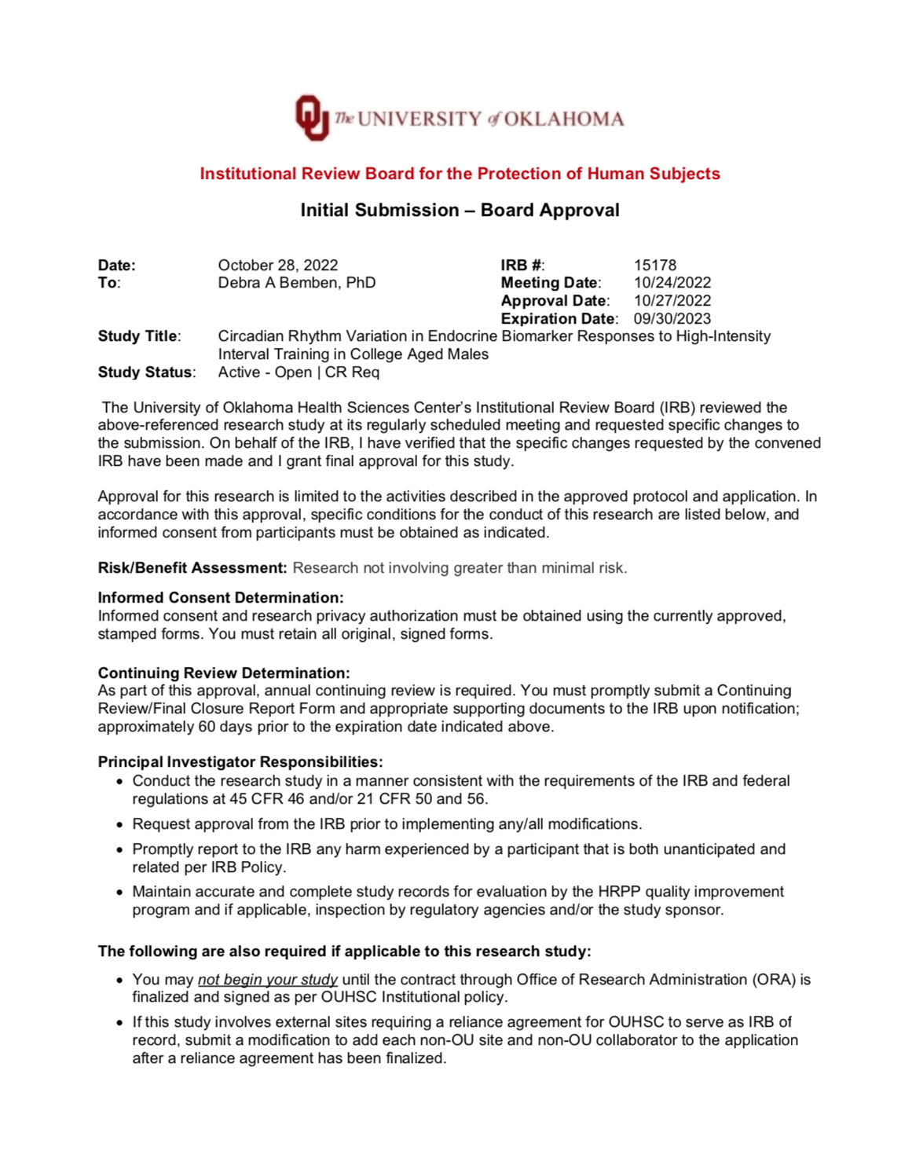

Appendix B: Screening Checklist
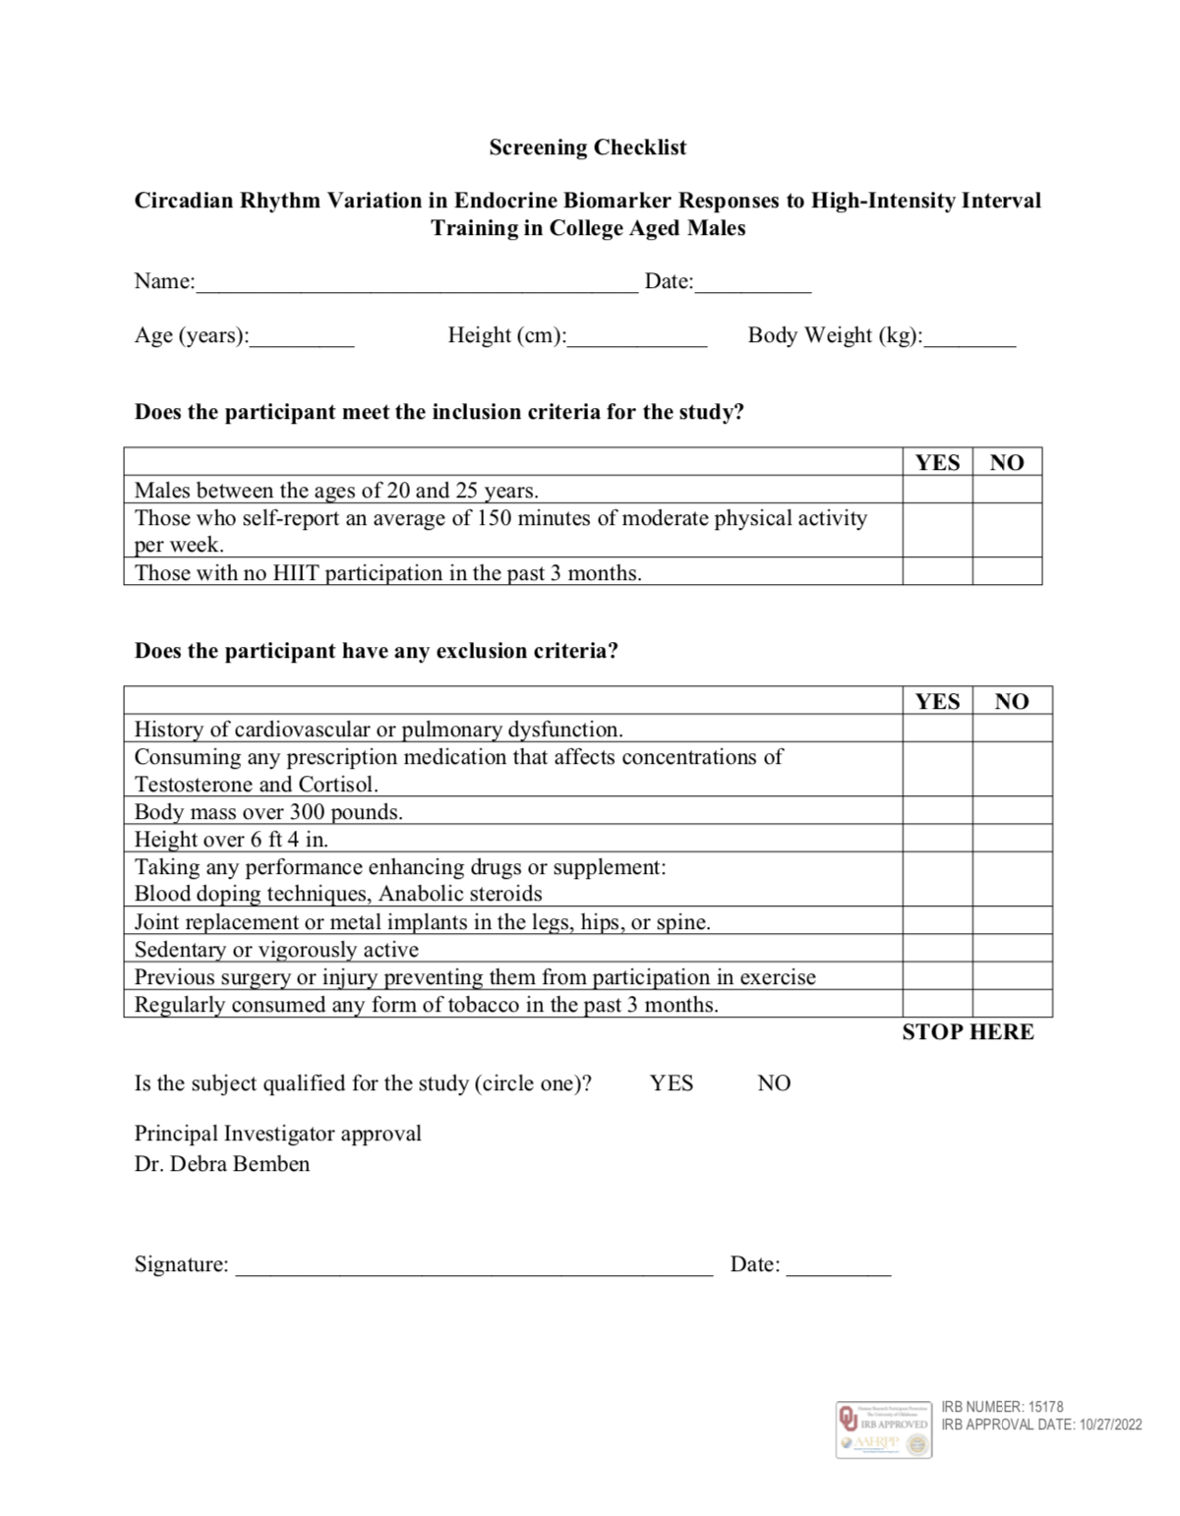

Appendix C: Informed Consent

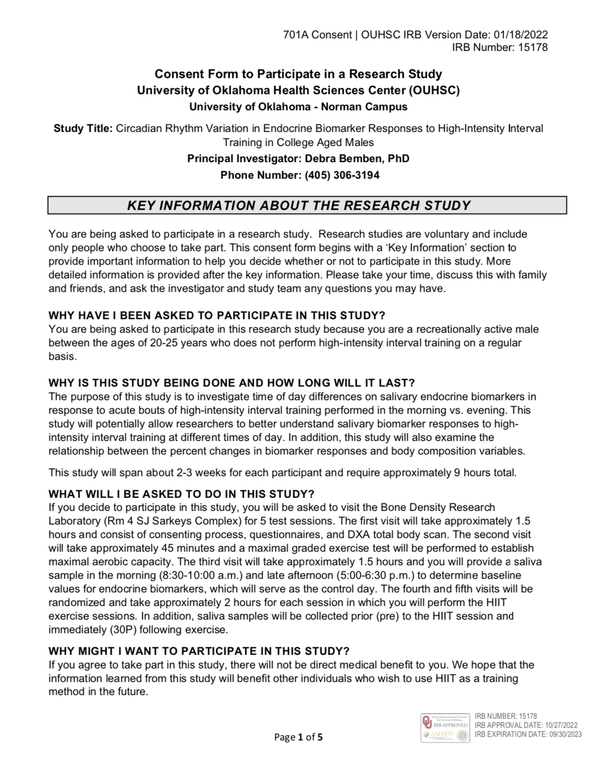

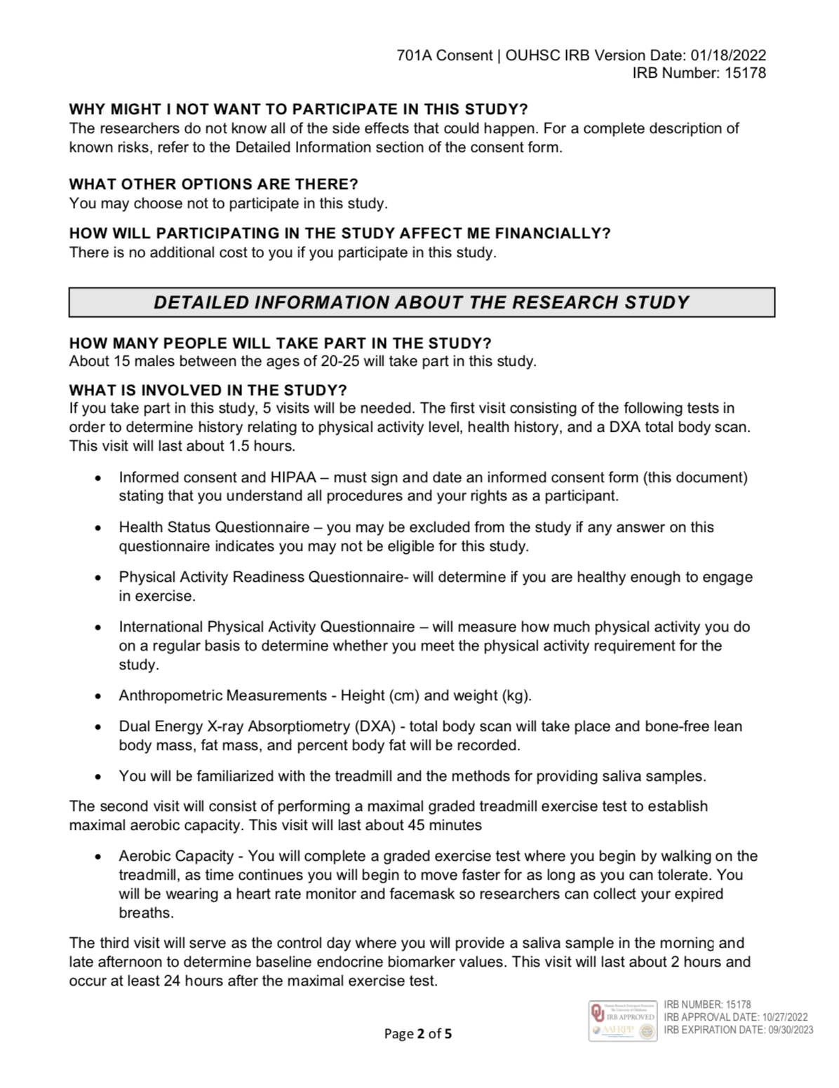

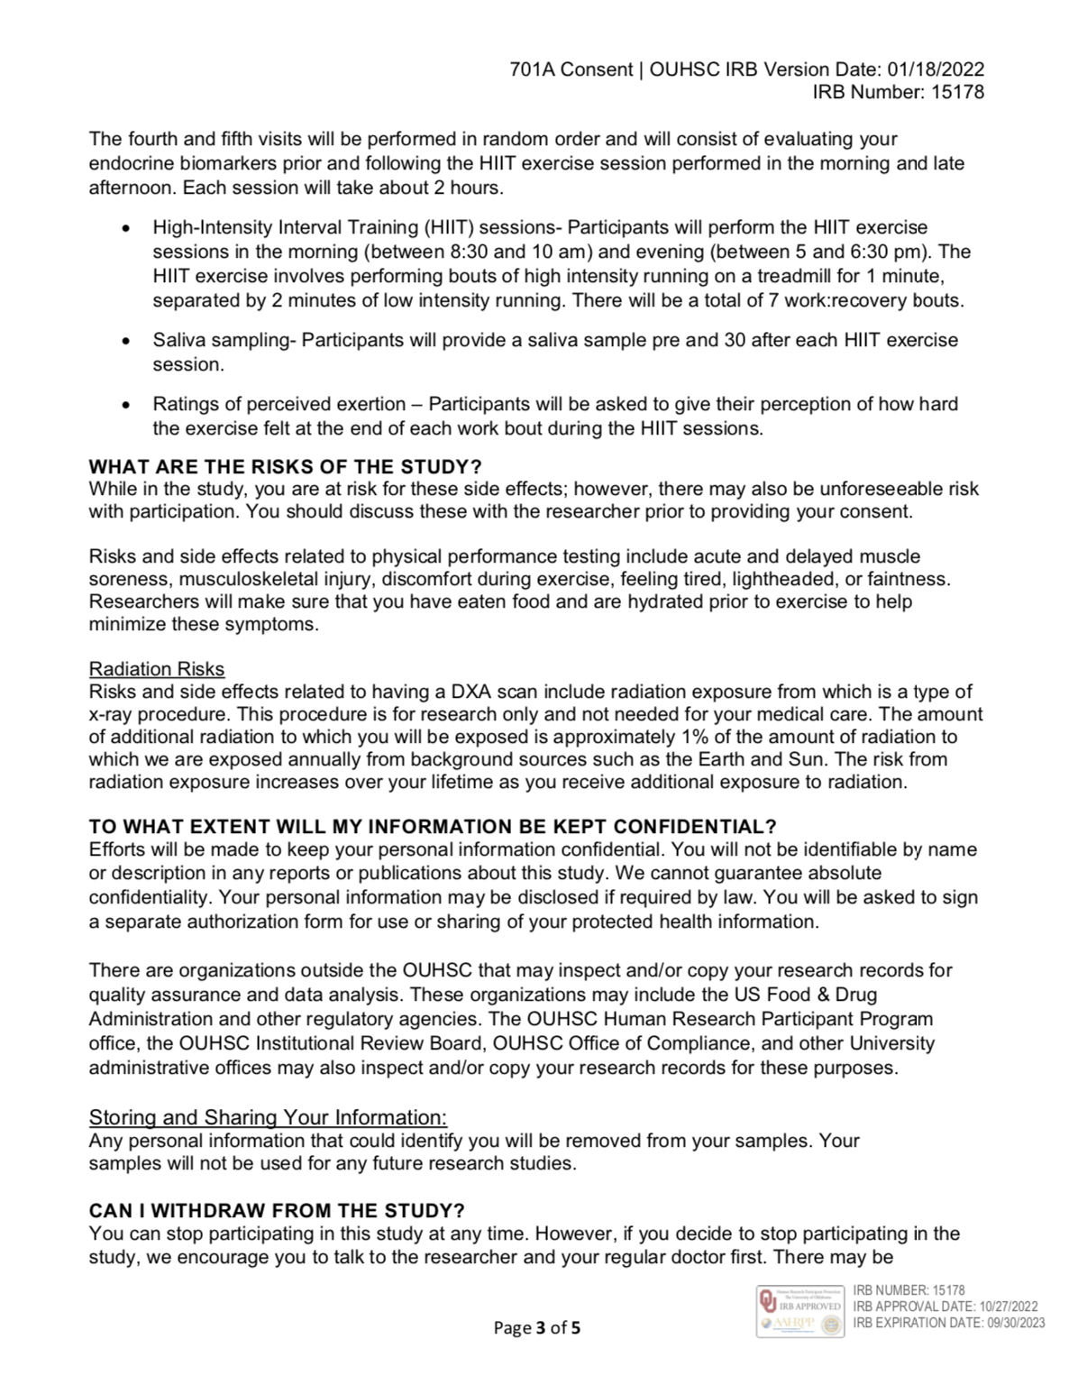

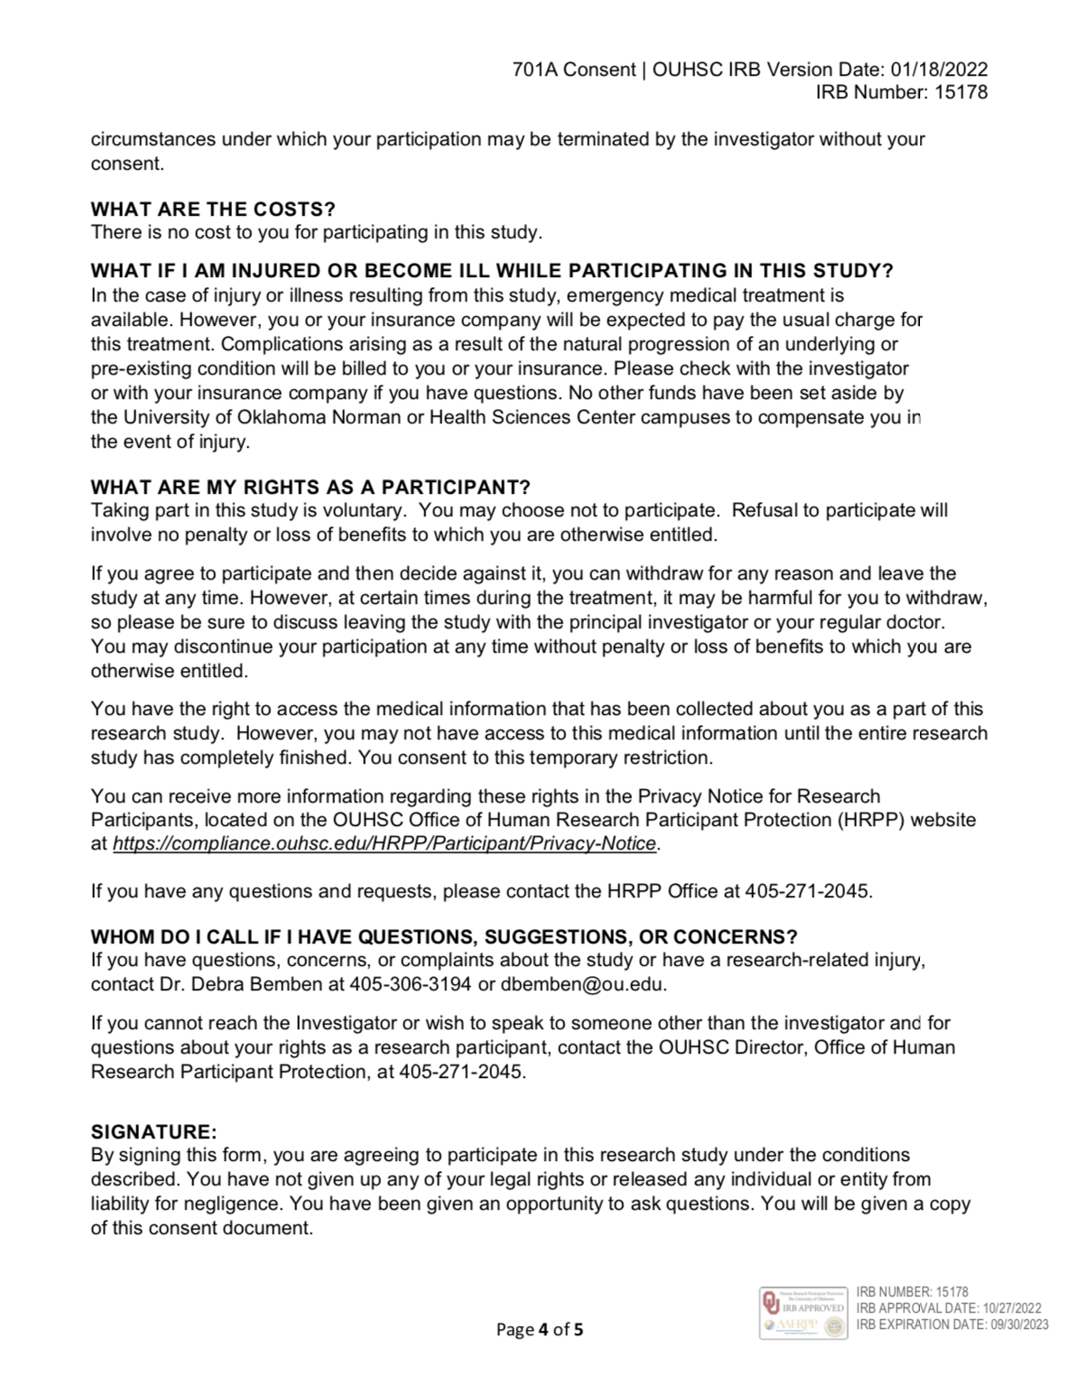

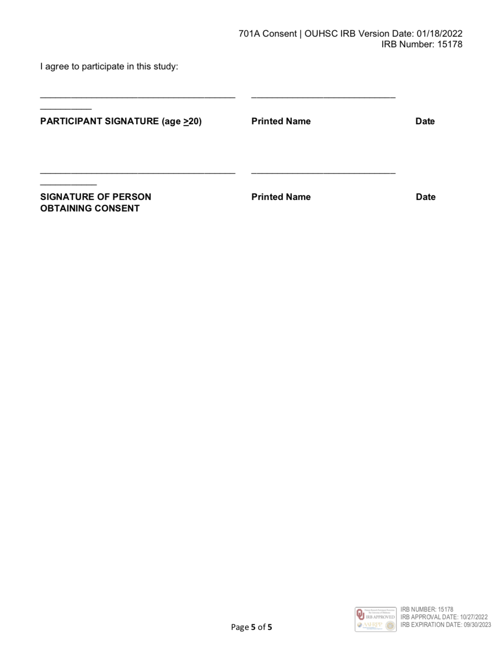

Appendix D: HIPAA
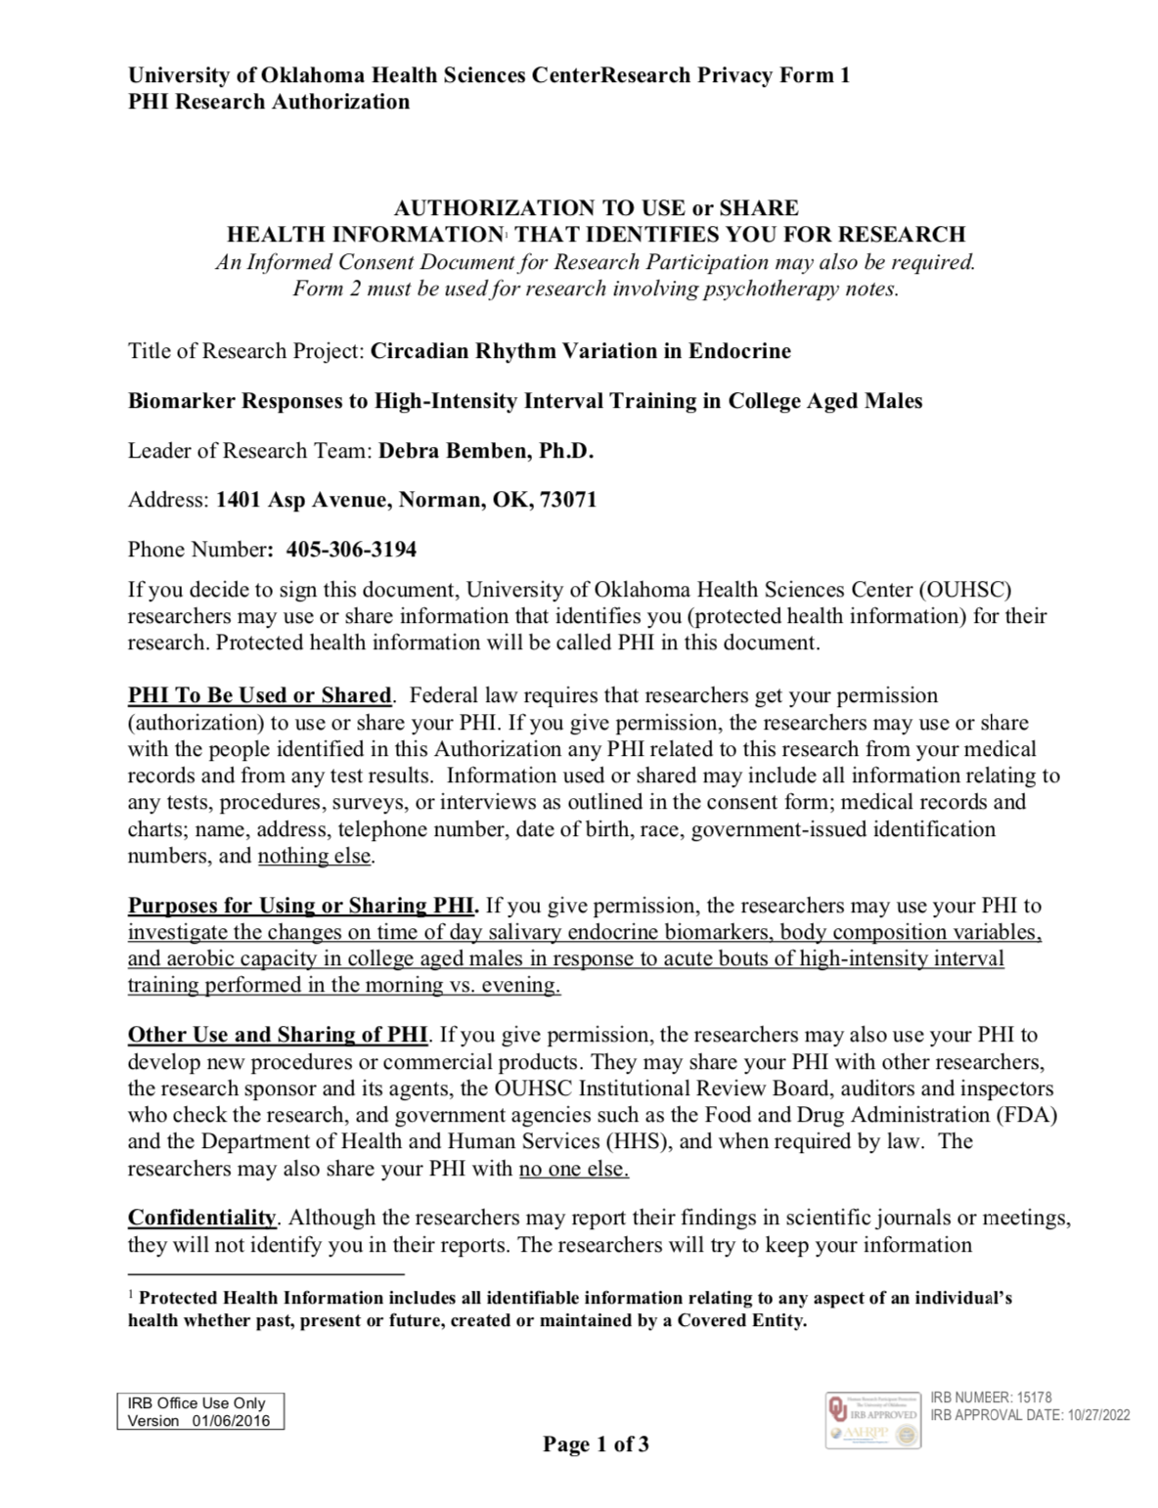

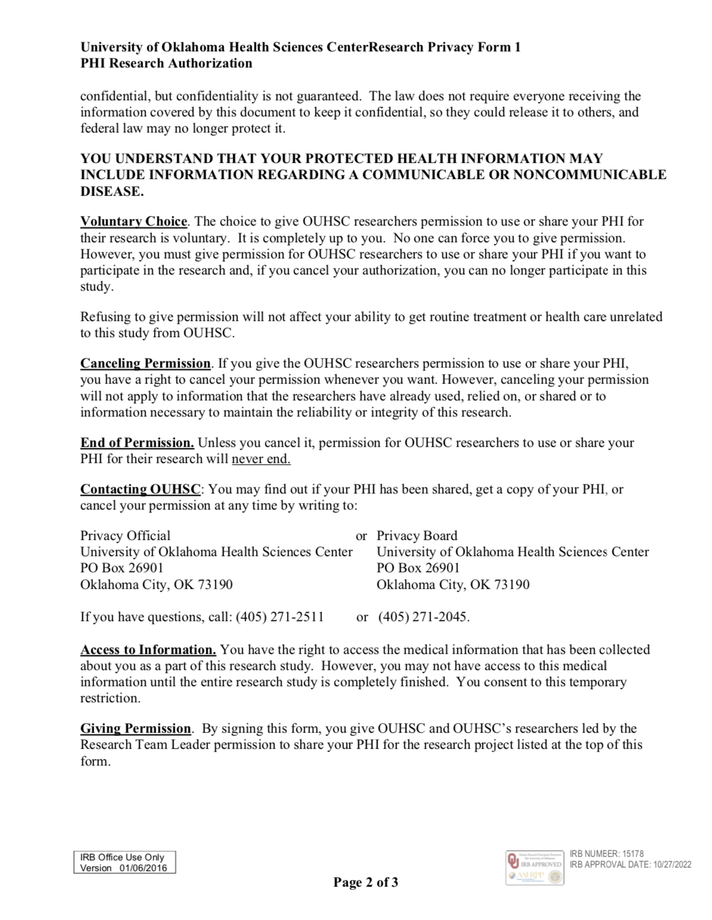

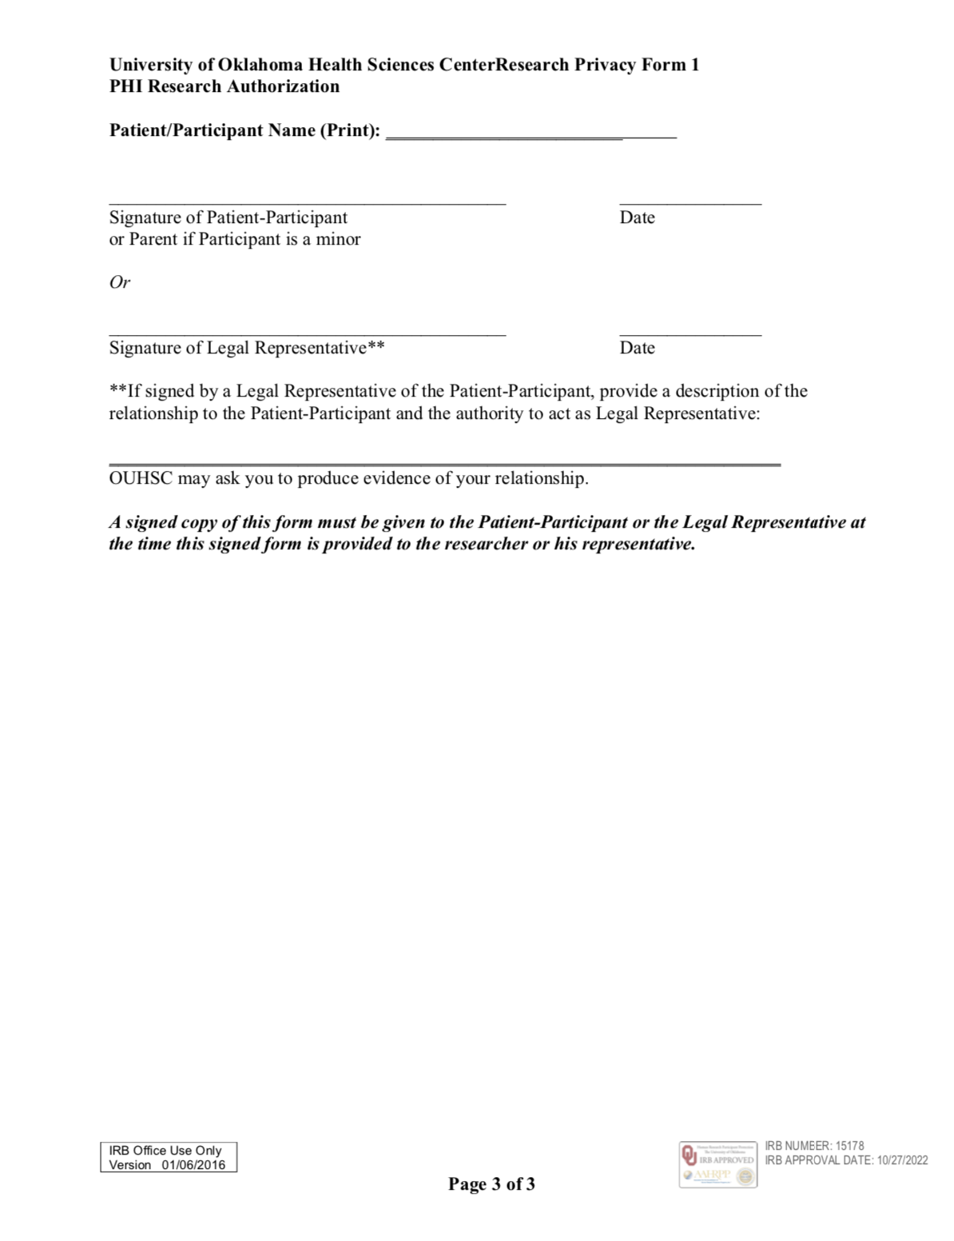

Appendix E: PAR-Q
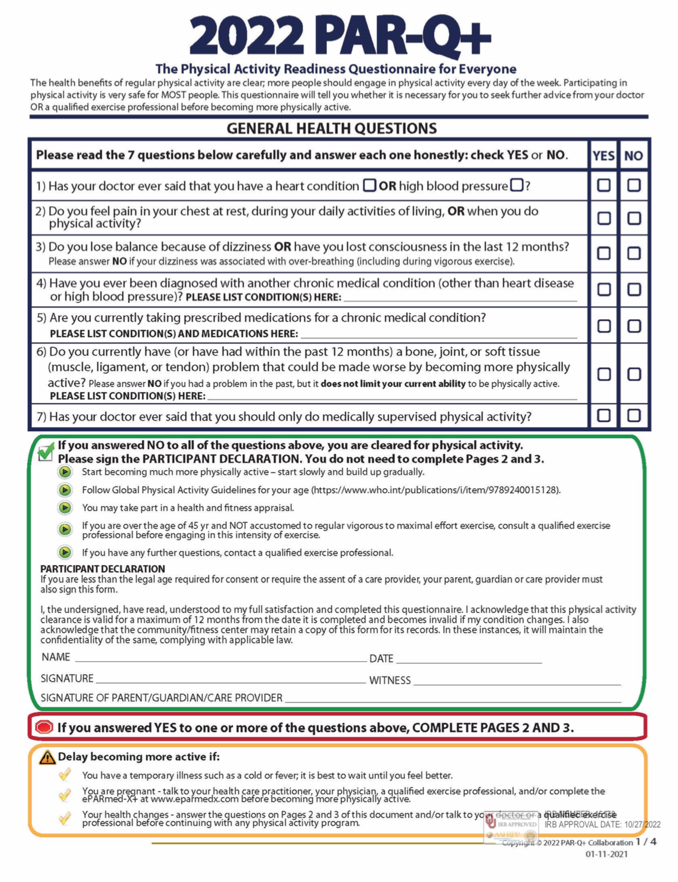

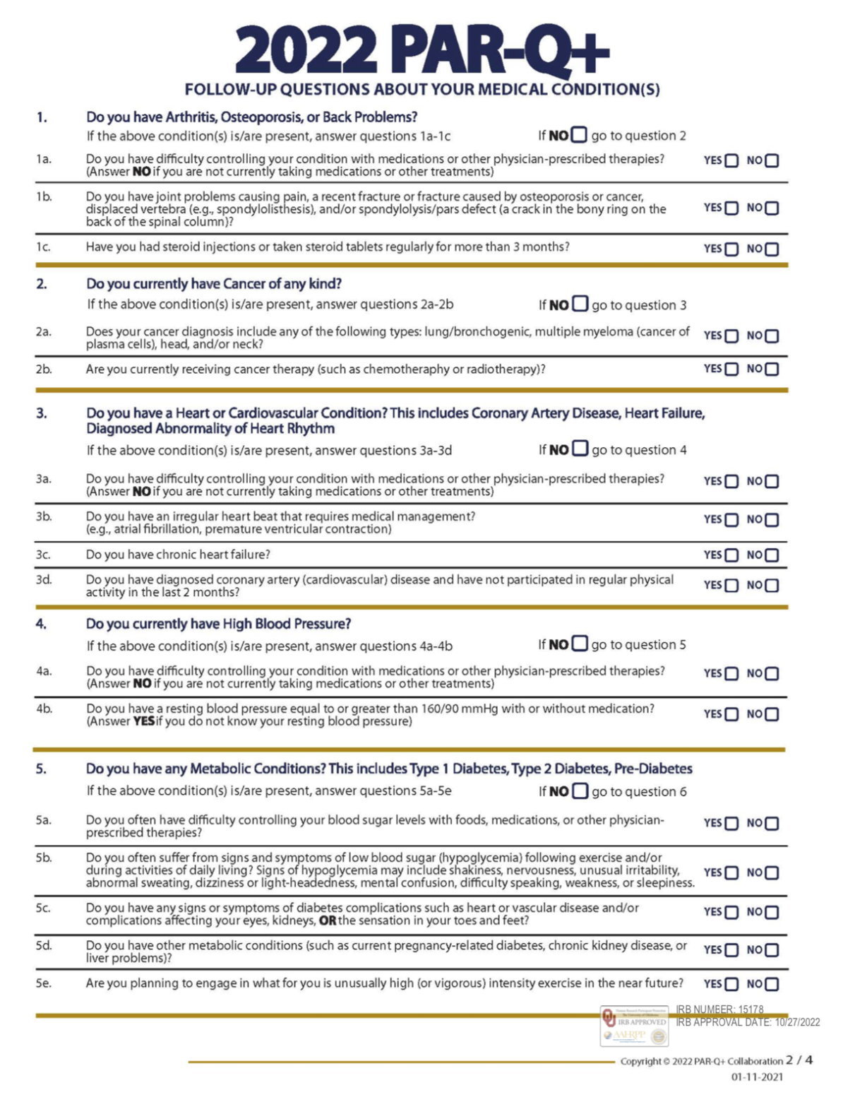

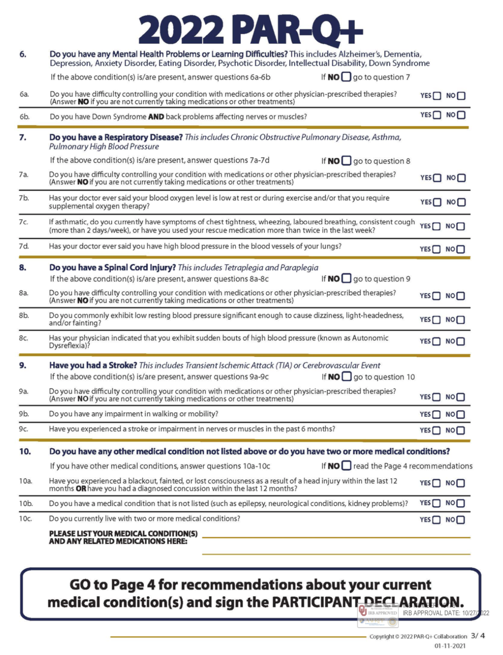

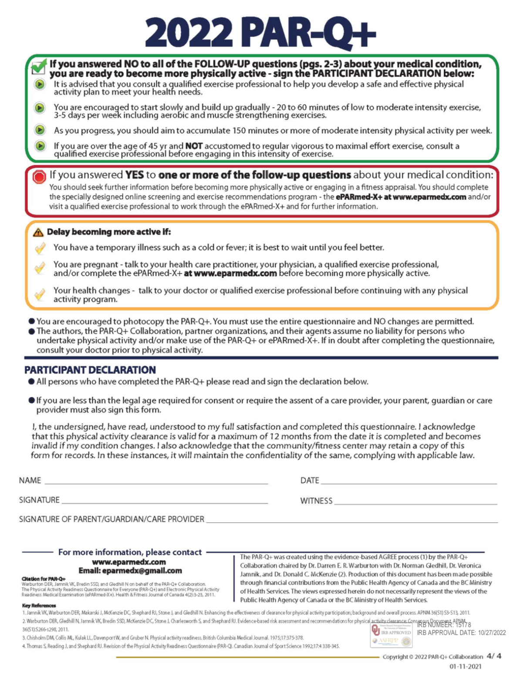

Appendix F: Health Status Questionnaire
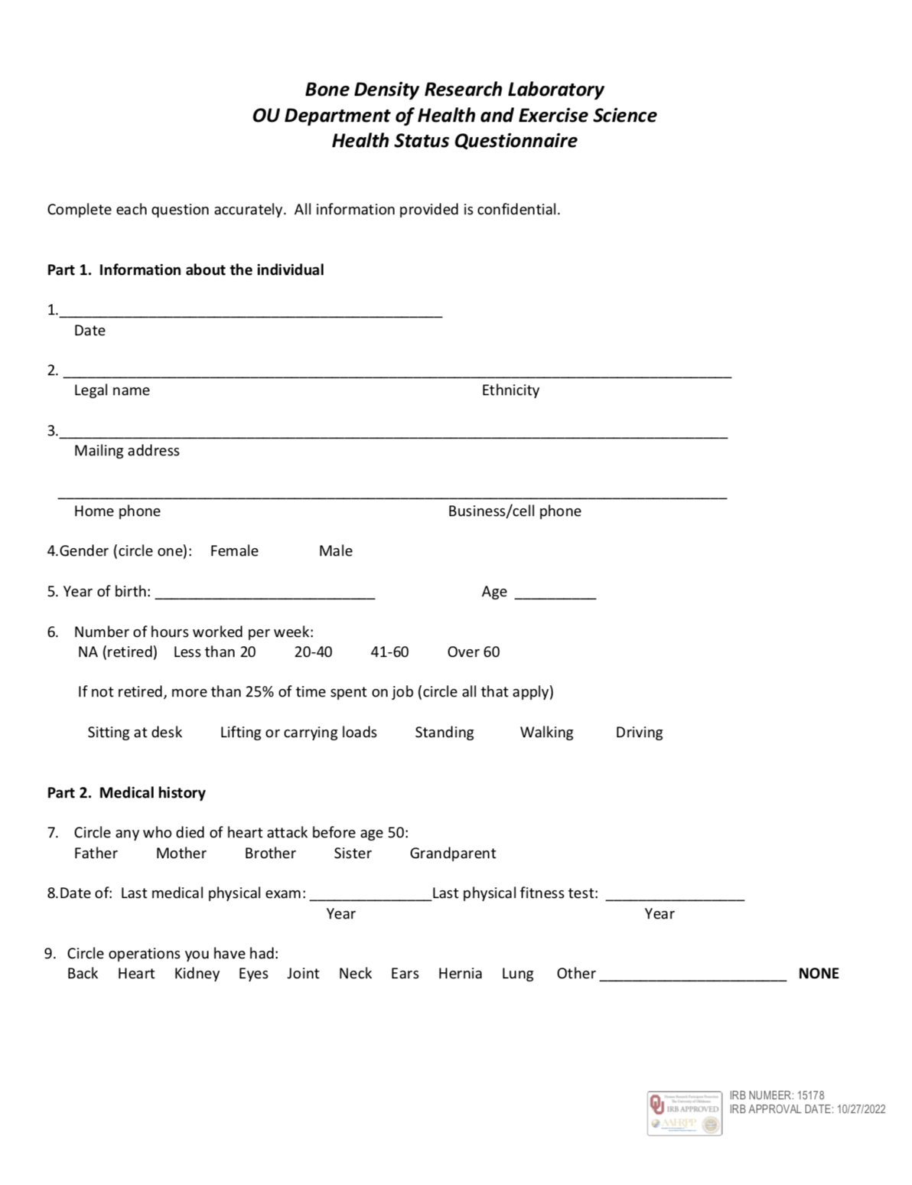

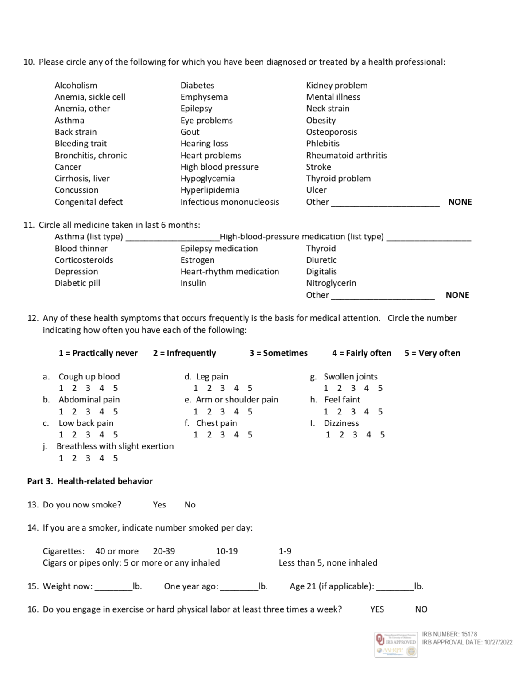

Appendix G: IPAQ
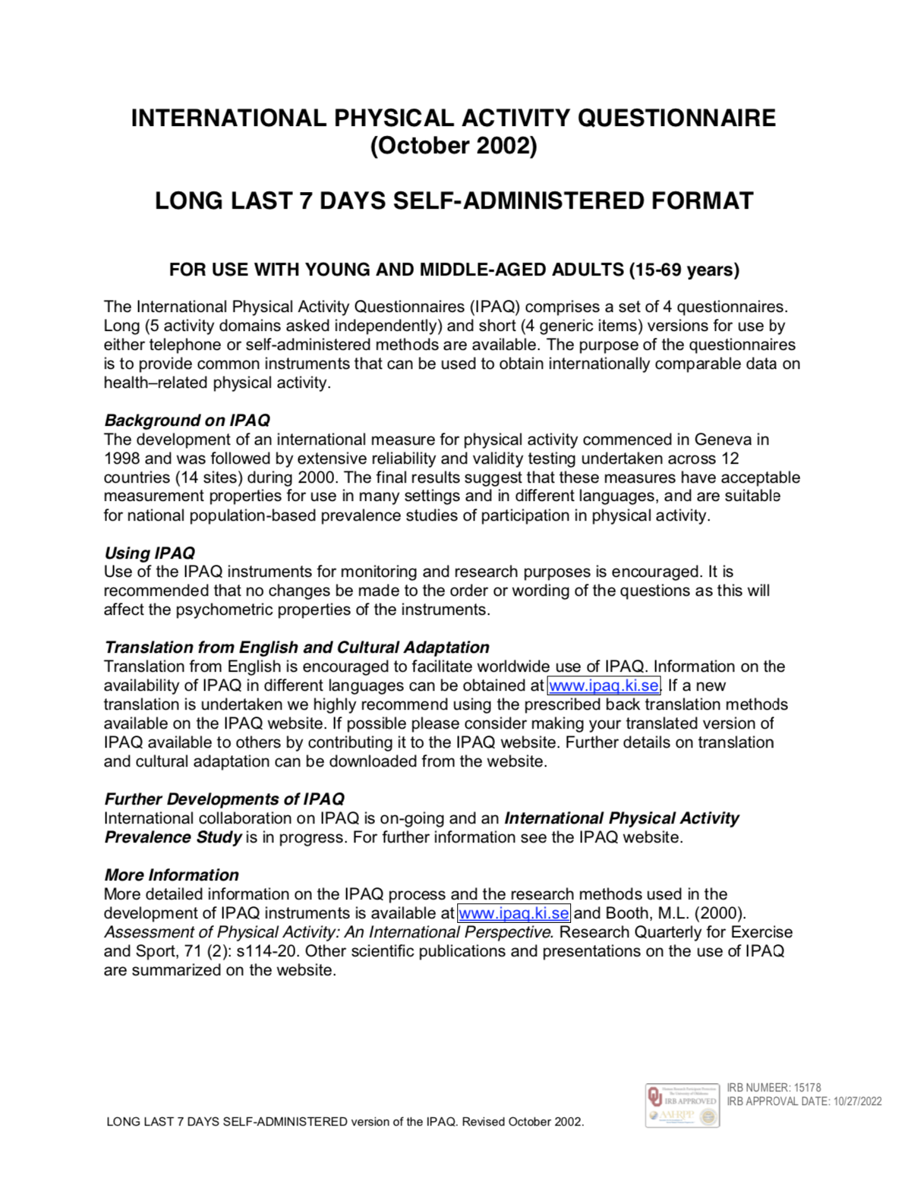

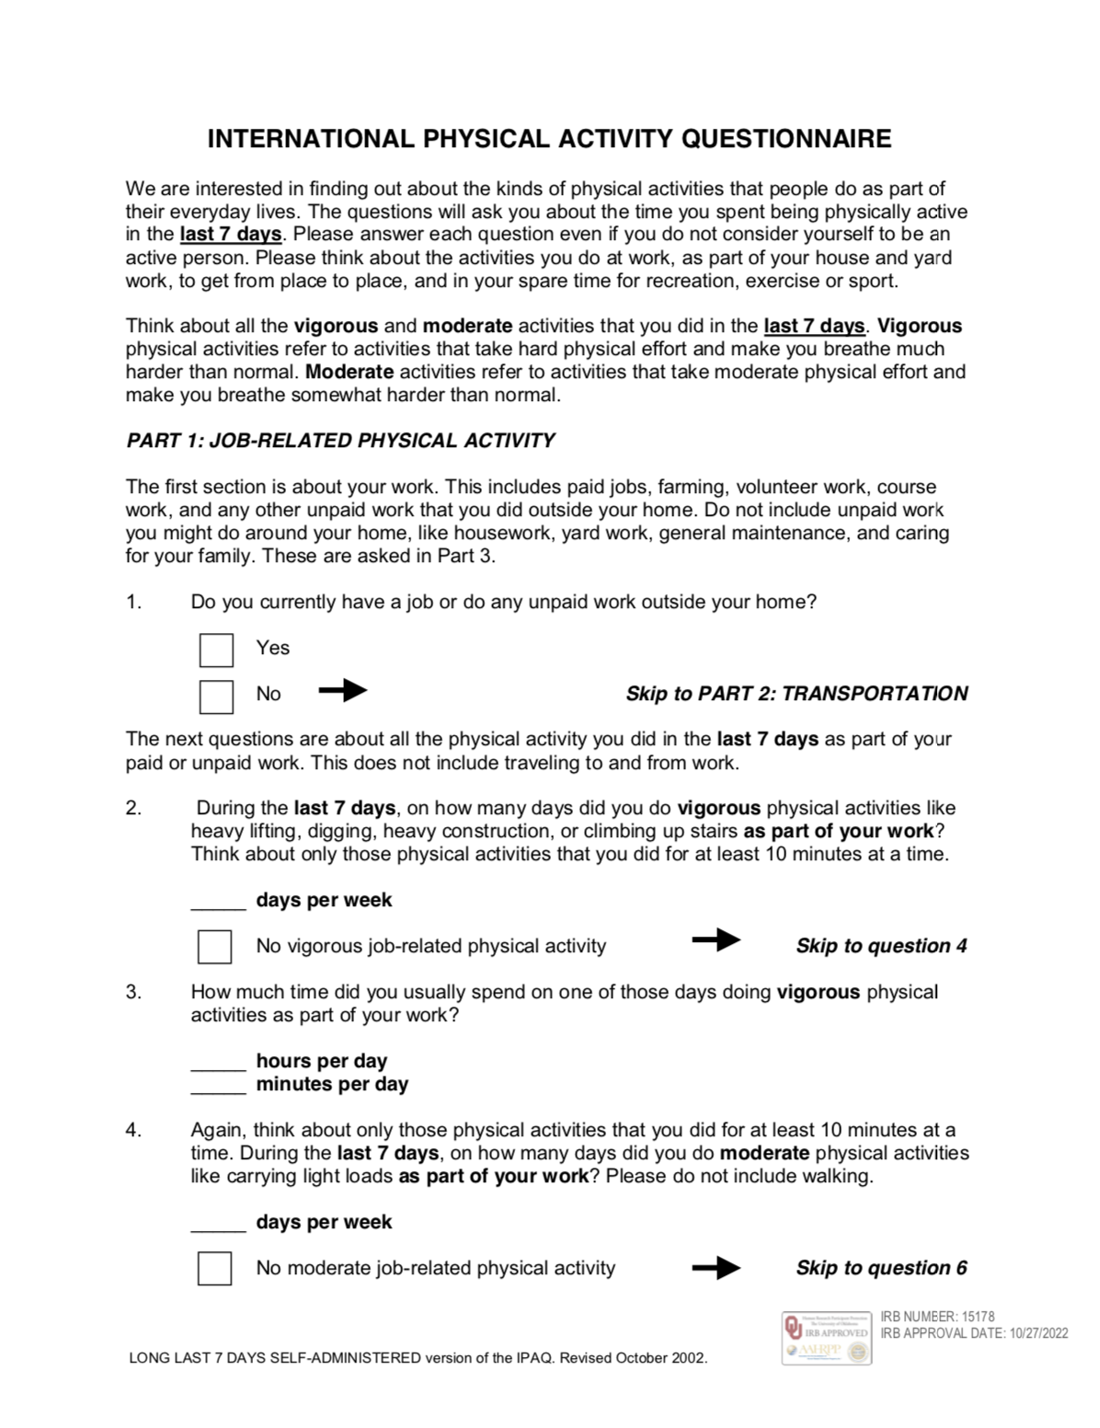

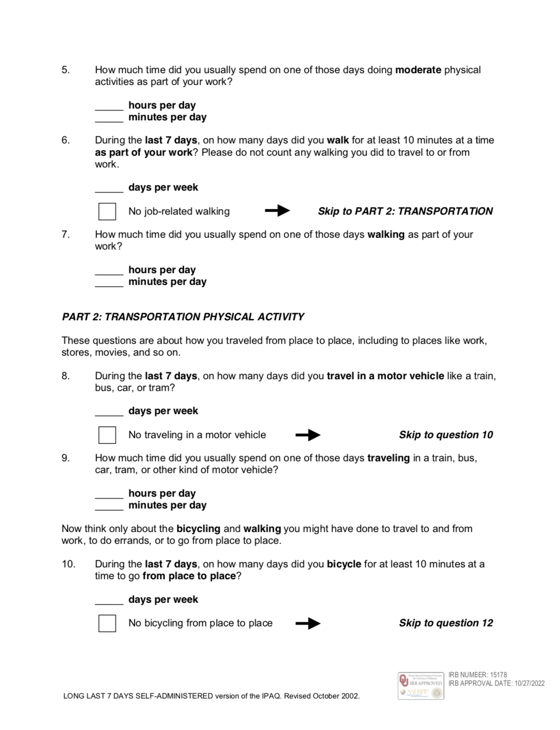

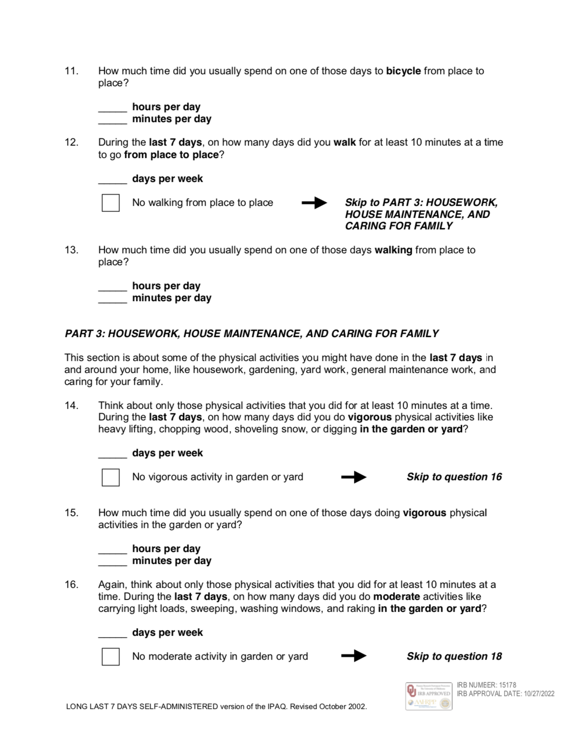

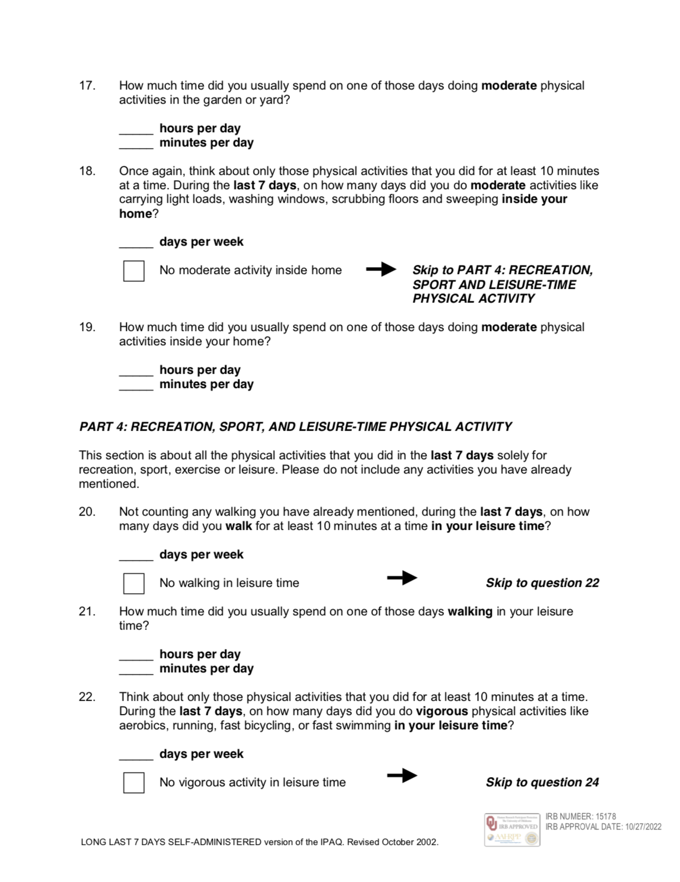

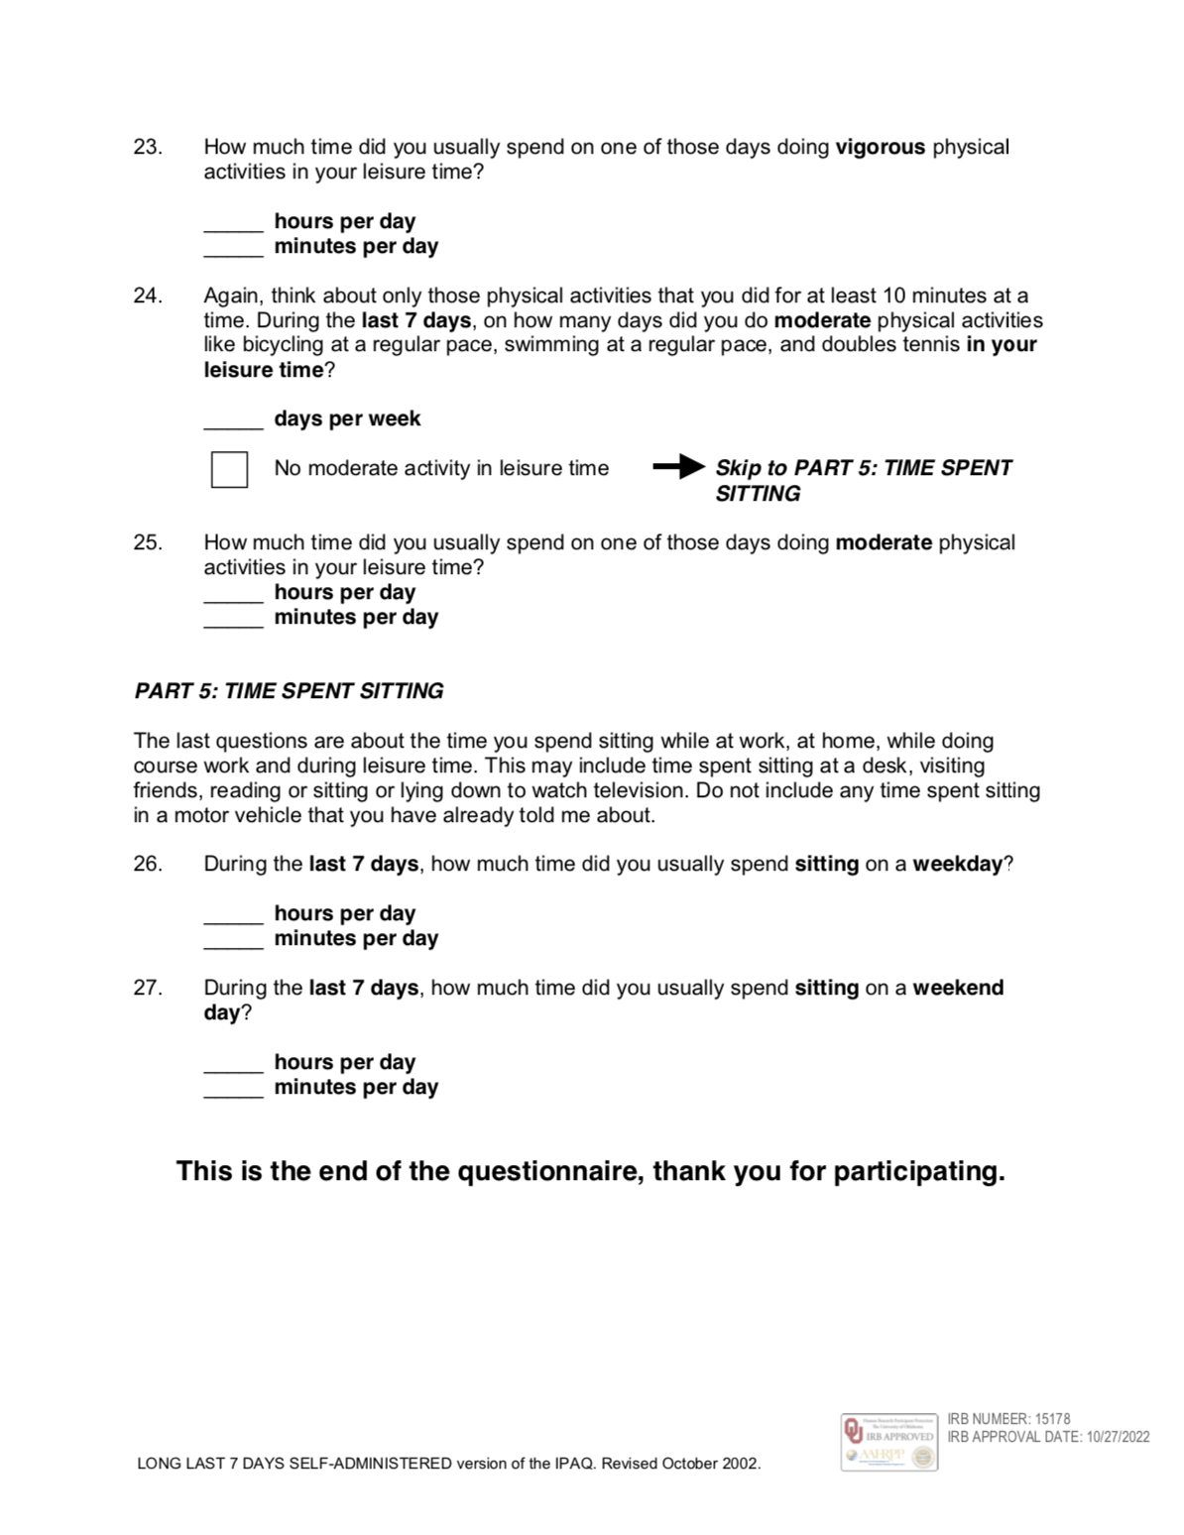

Appendix H: Mass Email Recruitment Script

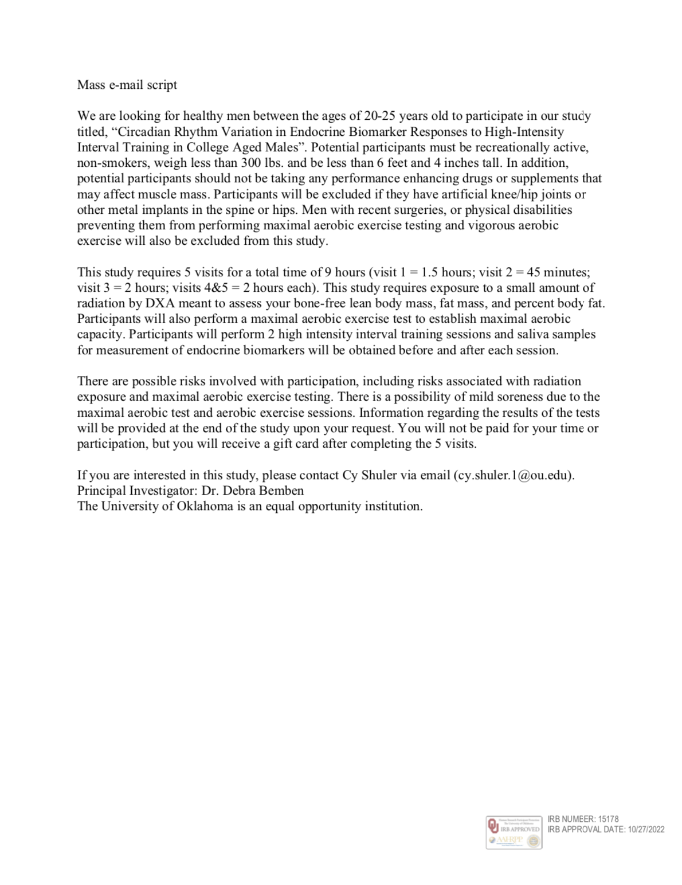

Appendix I: Recruitment Flyer
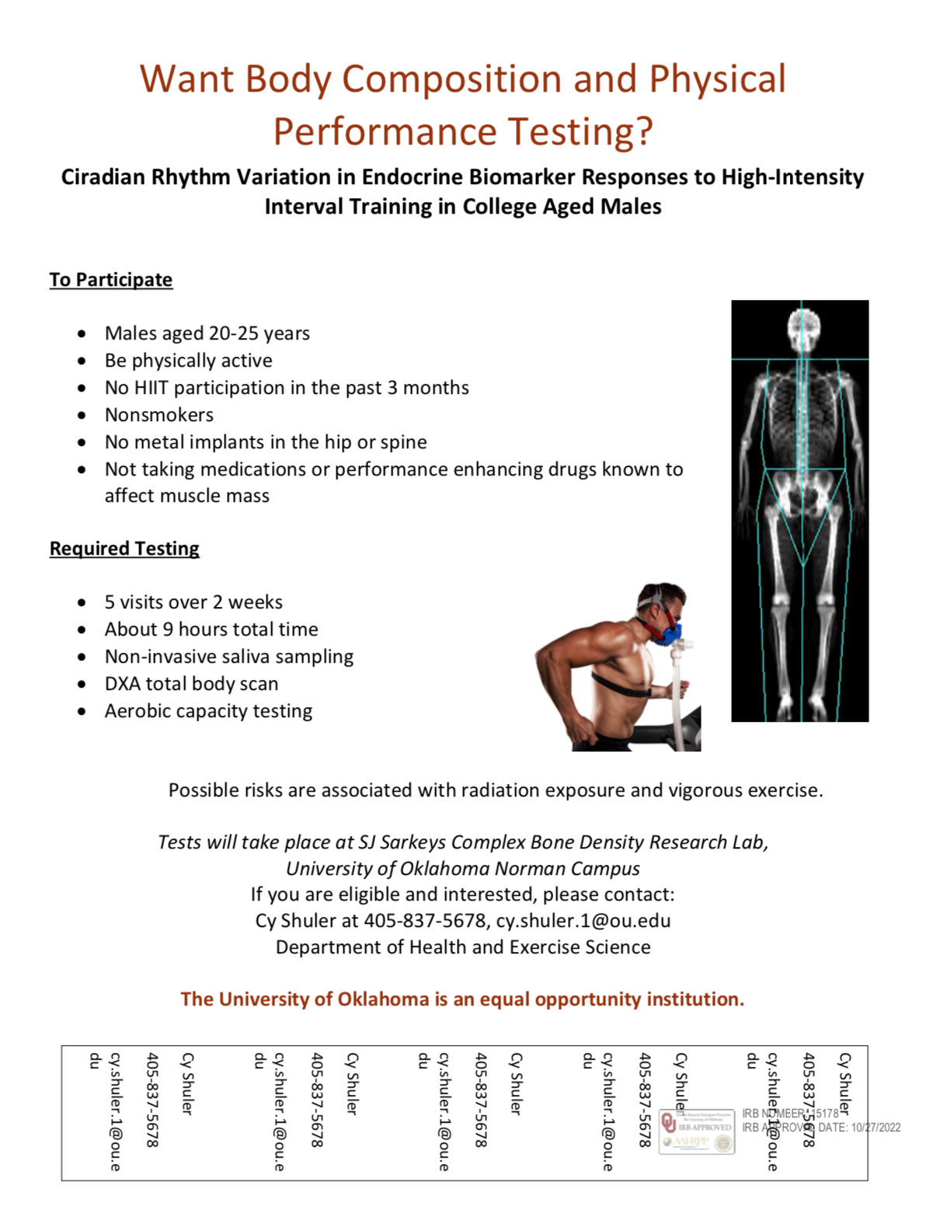

Appendix J: Ratings of Perceived Exertion Chart

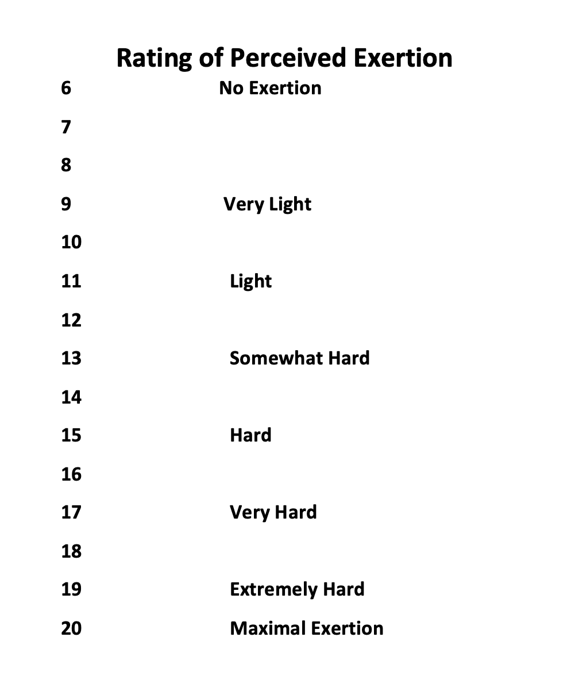

Appendix K: Salivary Sampling Techniques
