UNIVERSITY OF OKLAHOMA
GRADUATE COLLEGE

MAPS, MILKWEED, AND MONARCHS: APPLICATION OF GEOSPATIAL TECHNIQUES TO IDENTIFY HABITAT IN RIGHTS-OF-WAY FOR LEPIDOPTERAN CONSERVATION

A THESIS
SUBMITTED TO THE GRADUATE FACULTY
in partial fulfilment of the requirements for the
Degree of
MASTER OF SCIENCE

By
CHRISTOPHER ROCHA
Norman, Oklahoma
2021

MAPS, MILKWEED, AND MONARCHS: APPLICATION OF GEOSPATIAL TECHNIQUES TO IDENTIFY HABITAT IN RIGHTS-OF-WAY FOR LEPIDOPTERAN CONSERVATION

A THESIS APPROVED FOR THE DEPARTMENT OF GEOGRAPHY AND ENVIRONMENTAL SUSTAINABILITY

BY THE COMMITTEE CONSISTING OF

Dr. Bruce Hoagland, Chair
Dr. Scott Greene
Dr. Tom Neeson

© Copyright by CHRISTOPHER ROCHA 2021
All Rights Reserved.
Acknowledgements

I am very thankful for my advisor, Dr. Bruce Hoagland, for allowing me to pursue graduate school and for always extending patience, knowledge, and humor throughout my graduate school career. If not for him, I would not be here today.
Also, I want to thank my committee members, Dr. Scott Greene, and Dr. Tom Neeson, for serving on my committee and always providing useful guidance and making themselves available for questions.
Thank you to the DGES community and others that I have had the privilege of working alongside. All your support, chats, homework assignments, exams, and questions aided in my research and helped me become a better scientist. A special thanks to Iain Bennett, Alexandra Borunda, Filo Gomez-Martinez, Chelsey Grafrath, Rachel Deller, Melissa Sadir, Elyse Ellsworth, and Addison Allen for their unwavering support, help, thesis-work days, and letting me ramble on about random topics. I greatly appreciated it!
Thank you to everyone at the Oklahoma Department of Transportation Natural Resource Program. Their support, knowledge, and love for what they do is an inspiration day in and day out!
Finally, I want to thank my family who have always supported me and my school endeavors. I would not be here today without them; so, from the very bottom of my heart, thank you!

Table of Contents
Acknowledgements……………………………………………………………………………… iv
List of Tables…………………………………………………………………………………….vii
List of Figures…………………………………………………………………………………...viii
Abstract...…………………………………………………………………………………………ix
Chapter 1: Literature Review……………………………………………………………………...1
Pollinator Conservation…………………………………………………………………...1
Declining insect population numbers……………………………………………………...1
Ecosystem services………………………………………………………………………..2
Monarch butterfly conservation…………………………………………………………...4
Insect Conservation approaches and methods……………………………………….........8
Monitoring technique……………………………………………………………………11
Conclusion……………………………………………………………………………….15
Figures……………………………………………………………………………………16
Chapter 2: Using landcover scheme to locate nectaring resources to allocate conservation efforts for the monarch butterfly………………………………………………………………………...18
Abstract…………………………………………………………………………………..18
Introduction………………………………………………………………………………19
Methods…………………………………………………………………………………..22
Study Area……………………………………………………………………………….22
Spatial data analysis……………………………………………………………………...24
Results……………………………………………………………………………………25
Discussion………………………………………………………………………………..25
Conclusion……………………………………………………………………………….26
Acknowledgements………………………………………………………………………26
Tables and Figures……………………………………………………………………….28
Authors Biographies……………………………………………………………………..35
Chapter 3: Do habitat scorecard results differ between seasons?..………………………………36
Abstract…………………………………………………………………………………..36
Introduction………………………………………………………………………………36
Methods…………………………………………………………………………………..40
Study Area……………………………………………………………………………….40
Field Methods…………………………………………………………………………...42
Results……………………………………………………………………………………43
Discussion………………………………………………………………………………..44
Conclusion……………………………………………………………………………….45
Acknowledgements……………………………………………………………………...46
Tables and Figures……………………………………………………………………….47
Authors Biographies……………………………………………………………………..56
Chapter 4: Afterword…………………………………………………………………………….57
Extended Discussion……………………………………………………………………..57
Study Limitations………………………………………………………………………...58
References………………………………………………………………………………………..59
Appendix A………………………………………………………………………………………68
Appendix B………………………………………………………………………………………72

List of Tables
Table 1. Summary areas of Division 2. The 8% needed for compliance with the CCAA is 1,448.44 ha for Division 2.…………………...………………………………………………..28

Table 2. Summary areas by vegetation classification for Division 2 [n = 14]…..………………29

Table 3. Summary areas by Gametype outlined by Duck and Fletcher…………………………30

Table 4. Summary areas by Gametype outlined by Duck and Fletcher within the buffer created.………………………………………………………………………………………...…31

Table 5. Summary of field sites for the fall of 2021…………………………………………….32

Table 1. Summaries of habitat characteristics for Oklahoma Department Of Transportation’s Division 2 locations evaluated during the fall of 2020 and spring of 2021 using the Rights-Of-Ways Scorecard (University of Illinois-Chicago 2020).…………………………………………47
Table 2. Summary of habitat score and number of nectaring resources for fall and spring survey times using the Rights-Of-Way scorecard (University of Illinois-Chicago 2020).……………...48
Table 3. Summary of the additional habitat resources for fall and spring survey times using the Rights-Of-Way scorecard (University of Illinois-Chicago 2020)….……………………………49
Table 4. Total quality ratings for the fall and spring surveys using the Rights-Of-Way scorecard (University of Illinois-Chicago 2020)…………………………………….……………………...50

List of Figures
Figure 1. Duck and Fletcher’s game type map for Oklahoma (1945)…………………………..16
Figure 2. Figure 2. Map of the Oklahoma Ecological Systems Map. Each color represents a different vegetation classification (n = 165). The top seven vegetation classifications are represented in the legend. ……………………...……………………………………………….17
Figure 1. Oklahoma Department of Transportation, Division 2, Oklahoma, USA, study area and state and federal highway locations……………………………………………………………….33
Figure 2. Oklahoma Department of Transportation, Division 2, Oklahoma, USA, study area and sample plot locations (black stars) with extent of potentially desirable vegetation classification. Sampling was conducted 26 Aug- 25 September 2020…………………………….……………34
Figure 1. Study Area: Division 2 of the Oklahoma Department of Transportation, Oklahoma, USA, showing state and federal highways………………………………………………………51
Figure 2. Oklahoma Department of Transportation, Division 2, Oklahoma, USA, study area and sample plot locations (black stars) with desirable vegetation classification. Sampling was conducted 26 Aug- 25 September 2020 and again from 9 – 23 April 2021….………………….52
Figure 3. Example of navigating a plot being assessed. Note figure is not drawn to scale. Figure credit to Rights-of-Way 2020……………………………………………………………………53
Figure 4A, 4B. Histogram results for the Rights-Of-Ways Scorecard habitat scores using a bin size of 5. Data for 9A was collected 26 Aug- 25 September 2020 and data for 9B was collected 9-23 April 2021………….……………………………………………………………………….54
Figure 5. Grouped bar chart for the number of sites and the habitat quality ranking by season……………………………………………………………..……………………………...55

Abstract

“The earth is what we all have in common”- Wendell Berry
I first became interested in the Monarch butterfly (Danaus plexippus) when I was four years old. My family had a lilac bush in the front yard where I would spend hours and hours trying to catch the elusive monarchs. However, over the years, I saw fewer and fewer monarchs, but I never understood why. Initially, my child’s mind thought maybe I had caught too many. Fast forward to the present day. The monarch has been petitioned for listing as an endangered species. The United States Fish and Wildlife Service determined that the listing was warranted but precluded. Populations of this iconic species have been declining for over two decades and is attributable primarily to habitat loss. Thus, my interest in the monarch butterfly is rooted in conservation efforts to increase their population.
As a signatory of the Nationwide Candidate Conservation Agreement with Assurances for the Monarch Butterfly on Energy and Transportation Lands (CCAA), the Oklahoma Department of Transportation (ODOT) is required to locate and manage habitat for the monarch butterfly. The CCAA requires that 8% of the total land holdings of ODOT to be enrolled for the promotion of, or to facilitate the creation of, quality habitat so the actions may preclude the need to list the monarch (USFWS 2019). However, ODOT currently lacks geospatial data documenting the location of native vegetation on their properties that would foster migrating monarch butterflies. Thus, the objective of this thesis is to fill this gap by identifying and quantifying monarch butterfly and other pollinator habitat using a combination of geospatial and field techniques.
The thesis consists of four chapters. The first chapter is a review of the current literature involving pollinator conservation, and techniques for habitat assessment and monitoring. The subsequent two chapters are research orientated with the objective of improving tools for locating and quantifying nectaring resources and host plants for the monarch butterfly. Both are formatted for submission to the Natural Areas Journal. In chapter two, I analyzed landcover data to locate habitat patches with the potential for containing host and nectaring plants. We found that milkweed (Asclepias spp.), a key resource for monarchs, was present in 32% of our field sites and nearly each site had available nectaring plants. Thus, our findings suggest that ODOTs ROWs have conservation potential for monarchs and may be good candidate lands for enrollment for the CCAA. Chapter three utilized the Rights-of-Ways Habitat Scorecard, developed by the Right of Way working group at the University of Illinois-Chicago, to determine the degree to which habitat quality differs during the spring versus fall migration. Monarchs pass through Oklahoma twice each year, once in the spring as they venture northward from their roosts in Mexico, and again in the fall when they return south. Fieldwork was conducted during the spring and fall migrations of 2020 and 2021 using the pollinator scorecard to evaluate pollinator habitat. The scorecard provides a repeatable method for pollinator habitat elevation across the United States and has been adopted by signatories of the CCAA. Chapter three reports habitat structure and the potential utility (i.e., how the monarch uses the habitat) of existing patches of vegetation and the results of the chi-square test led to the acceptance of the null hypothesis that there is not a significant relationship between habitat quality ratings and seasonality. Chapter three is also formatted for submission to the Natural Areas Journal. Chapter four is an afterword that discusses study limitations and concluding remarks.
Chapter 1: Literature Review
Pollinator conservation
Declining insect population numbers
Insects are found across the globe and are the structural and functional base of many of the world’s ecosystems (Thomas et al. 2004; Sanchez-Bayo and Wychuys 2019). They provide crucial ecological services such as soil aeration, pest control, pollination, and are food source for other animal species. Despite their seemingly limitless abundance, more than 40% of insect species are experiencing dramatic population declines and a third are threatened with extinction. The total biomass of insects, which far exceeds that of vertebrates, is decreasing at a rate of 2.5% per year (Sanchez-Bayo and Wychuys 2019). The estimated rate of insect extinction is eight times greater than that of mammals, birds, and reptiles. So dire are these estimates, that Sanchez-Bayo and Wychuys (2019) speculate that all insects will vanish within a century.
The discussion of habitat loss and fragmentation has focused on agricultural expansion and intensification, and the extensive use of pesticides (Maxwell et al. 2016; Ceballos et al. 2017; Sanchez-Bayo and Wychuys 2019). These activities have the greatest impact on bees, butterflies, moths, beetles, dragonflies, and damselflies (Thomas et al. 2004; Sanchez-Bayo and Wychuys 2019). But much of the attention from conservation scientists has focused on bee species. In Oklahoma alone, approximately half of the total bee species recorded in 1949 were not recorded in a 2013 survey (Figueroa and Bergey 2015). In the United States, 26 butterfly species and 8 bee species are currently listed as threatened or endangered under the U.S. Endangered Species Act (U.S. Fish and Wildlife Service 2019).
Butterflies are the flagship species for invertebrate conservation (Butterfly Conservation Europe 2019) and are indicators of environmental quality due to their host-plant specialization and sensitivity to habitat deterioration (Erhardt and Thomas 1991; Sanchez-Bayo and Wychuys 2019). The order Lepidoptera (butterflies and moths) contains over 177,500 species worldwide (Smithsonian 2020) or approximately one quarter of all named species (Butterfly Conservation Europe 2019). The monarch butterfly (Danus plexippus Linnaeus) is one of the most iconic species in North America (Cariveau et al. 2019). As elaborated later in this literature review, it has experienced population declines over the last 20 years (Brower et al. 2012; Vidal and Rendon-Salinas 2014; Sanchez-Bayo and Wychuys 2019; Cariveau et al. 2019), which, as with other insects, is attributed to loss of habitat (Flockhart et al. 2015; Cariveau et al. 2019). The literature review elaborates upon the benefits to society by invertebrates, specifically the monarch butterfly, and their need for conservation measures. Specifically, I will review and consider habitats and monitoring efforts. First, however, I will review how society benefits from the existence of insects.
Ecosystem services
Ecosystem services are defined as benefits to humans derived from natural ecosystems and are considered essential to civilization (Dailey et al. 1997). The United Nations Millennium Ecosystem Assessment (MEA 2005) was a four-year study of ecosystem services by 1,300 participating scientists worldwide. In the MEA (2005), ecosystem services were classified broadly as provisioning, regulating, supporting, and cultural. Food and water production by natural systems is considered provisioning services. Insects contribute to provisioning through pollination services; more than 75% of the world’s flowering plants and approximately 35% of the world’s food crops rely on animal assisted pollination (Dailey et al. 1997, Natural Resources Conservation Service 2020, Food and Agriculture Organization 2016). Losey and Vaughn (2006) estimate that 15% to 30% of food production in the US relies upon pollination services. This not only includes many vegetables, oils producing plants, fruit and nut bearing plants, but forages such as alfalfa are insect pollinated and contribute to the meat and dairy industry (Losey and Vaughan 2006). Monetarily, it is estimated that pollinators contribute $9 billion USD/year (The White House 2014; Lady Bird Johnson Wildflower Center 2020). Of course, many pollinators have been imported from distant geographic locales to pollinate crops, but Morse and Calderone (2000) report that native pollinators account for $3.07 billion and insects accounted for $57 billion (Losey and Vaughan 2006) every year. Large numbers of insect species and abundant populations are required to sustain this economic boon (Cleand 2011).
Regulating services include climate dynamics (e.g., carbon sequestration) and disease amelioration. Integration of carbon into woody tissues, and the retention of carbon in soils (via decomposition, root development, dung turning and other activates) reduces net atmospheric carbon (i.e., carbon sequestration). Decomposition also liberates nitrogen into the soil which is used by plants in the production of chlorophyll, which incorporates carbon into simple sugar molecules through the process of photosynthesis (Wagner 2011). Approximately 25% of the total amount of carbon dioxide (CO₂) emitted into the atmosphere is absorbed by terrestrial vegetation (NOAA 2020). Here again, we find insects, which play a crucial role in decomposition.
Supporting services includes oxygen production, and nutrient cycling that act as natures recycling system through facilitation of primary productivity in an ecosystem. Primary producers such as non-vascular and vascular plants, algae and lichens are consumed by primary consumers (i.e., herbivores), thereby moving vital nutrients through the food chain. Finally, cultural, or the non-material benefits that people obtain that includes spiritual and recreational benefits; for example, in parts of Mexico, the Día de los Muertos (‘Day of the dead’) is celebrated in conjunction with the fall arrival of migrating monarch butterflies, which are believed to usher in the spirits of the departed. Likewise, there are butterfly enthusiasts that spend considerable time photographing and documenting the occurrence of butterflies globally (National Park Service 2021).
Ecosystem services enrich our lives by providing a stronger economy, a diverse array of food products, and contributing medical research (National Wildlife Federation 2020). In the next section, I will review the impacts of human activity on a specific pollinator: the monarch butterfly.
Monarch Butterfly Conservation
Monarch butterflies, known for their close association with milkweed species, pollinate numerous flowering plants (U.S. Forest Service 2019). The relationship with milkweed is crucial for monarch butterfly survival. An adult female monarch oviposits her eggs on only milkweed (Asclepias spp.). The larvae consume only tissue of milkweed following emergence, not only for nourishment, but for the cardenolides contained in the plant’s milk. These compounds accumulate in the tissues of the larvae and are retained in adults, providing a defense against predation. As adults, however, monarchs visit not only milkweeds but other nectar producing flowering plants as well (Cariveau et al. 2019). Thus, conservation plans focus on the presence and enhancement of populations of milkweed and nectaring species.
Across North America, monarch butterflies are distributed into two populations, one in California and the other east of the Rocky Mountains. In the last two decades, research has estimated an 80% population decline in the eastern monarch population (Brower et al. 2012; Vidal and Rendon-Salinas 2014; Semmens et al. 2016) and a 90% decline in the western population (Schultz et al. 2017). Population data are aggregated from the “Thanksgiving Count,” which was initiated by Bill Shepard of the North American Butterfly Association in 1997. Unlike eastern monarchs, which migrate to Mexico, individuals in the western population arrive on the Pacific coastline in California to overwinter in late October, then disperse in mid-February to breeding sites in California, Nevada, Idaho, and Oregon. Milkweed and nectaring resources throughout the spring, summer, and fall in those states are critical to maintain the current monarch population.
As noted previously, the focus of this thesis is the eastern populations of monarch butterflies. In the fall, monarch butterflies in the eastern populations begin a journey of 4,830km from the upper Midwest and northern Great Plains to their overwintering sites in Michoacan, Mexico. Arrival at roosts begins in November and the monarchs will overwinter until March. The roosts are located in the pine–oak forests of the Mexican Trans-Mexican Volcanic Belt at approximately 2,000-2,500m above sea-level. The monarchs roost preferentially in the Oyamel Fir (Abies religiosa) forests. Despite the attempts to protect these forests, which include the Monarch Butterfly Biosphere Reserve, illegal timber harvest is a serious threat. During their northward migration, these monarchs will breed and nectar in Texas. They continue their journey along a distinct flyway, much like migratory birds, which brings them to Oklahoma, where they seek nectaring resources.
Trends in the populations of eastern monarchs are not monitored by events such as the “Thanksgiving Count” in the west but are derived from estimates of the area occupied by monarch colonies during roosting. During 2019-2020, scientists estimated that the eastern monarch population encompassed an 2.83 hectares (Monarch Joint Venture 2020), down from 6.05 the previous year. The declining numbers of monarchs lead the Xerces Society, Center for Biological Diversity, and Center for Food Safety to petition the United States Fish and Wildlife Service (USFWS) to list the monarch butterfly as threatened or endangered on 6 August 2014. On 15 December 2020 the USFWS found that:
“Adding the monarch butterfly to the list of threatened or endangered species is warranted but precluded by work on higher-priority listing actions. With this decision, the monarch becomes a candidate for listing under the ESA and its status will be reviewed each year until it is no longer a candidate.” (U.S. Fish and Wildlife Service 2020b)
The monarch butterfly received listing priority number eight. The listing priority number is scored on a scale of 1-12 and is evaluated based on three criteria: threat magnitude (either high or moderate to low), immediacy, (either imminent or non-imminent), and taxonomy (monotypic genus, species, subspecies/populations). Priority eight is defined by the United States Fish and Wildlife (2020) as, “the magnitude of threats is moderate to low, and those threats are imminent. A priority number of eight reflects that monitoring the threats to the monarch butterfly occur at the taxonomic level of species.”
Prior to the decision, however, the Nationwide Candidate Conservation Agreement for Monarch Butterfly on Energy and Transportation Lands (CCAA) was approved by the USFWS in April of 2020. A Candidate Conservation Agreement is a formal agreement between the U.S. Fish and Wildlife Service and one or more parties, in this case Departments of Transportation, to address the conservation needs of proposed or candidate species, or species likely to become candidates, before the species is listed as endangered or threatened. Authors of the CCAA write that they anticipate “the enrollment of up to 26 million acres of energy and transportation lands, which could contribute over 300 million stems of milkweed, and 2.3 million acres of monarch foraging habitat, over the coming decades.” The CCAA requires that 8% of the total enrolled acres, which is derived from the land holdings submitted by a signatory on the application, are adopted for conservation purposes. Across the United States, many Departments of Transportation are enrolling all their lands to provide the most flexibility in determining where to adopt acres. Energy and transmission companies and state departments of transportation have voluntarily committed time and funding to carry out monarch butterfly management best practices on Rights of Ways (ROW) (U.S. Fish and Wildlife Service 2020). ROWs have the potential to provide pollinator habitat consisting of three key elements: native flowering plants, host plants, and nesting sites throughout the growing season.
The Oklahoma Department of Transportation (ODOT) is a signatory to the CCAA and, as a result, I want to locate areas within the ODOTs ROWs that would be advantageous for the creation, conservation, and restoration of habitat for monarch butterflies and other pollinator species.
Transportation ROWs provide a unique opportunity to protect and expand available habitat for pollinators. When managed correctly, ROWs can promote, and maintain both host and nectaring plants (Munguira and Thomas 1992; Ries et al. 2001; Saarinen et al. 2005; Hopwood 2008; Skorta et al. 2013; Halbritter et al. 2015; Cariveau et al. 2019) and establish habitat connectivity (Bennett 1991; Spellerberg 1998; Ries et al. 2001), all of which could result in a 20% increase in reproduction rates (Zalucki and Lammers 2010; Zalucki et al. 2016; Grant et al. 2018). Adams and Geis (1983) reported that roadside vegetation accounts for approximately 8 million hectares of land and borders nearly 6.4 million km of roadways in the United States (U.S. Department of Transportation 1998). Since their report, the extent of roadways has increased to 6.7 million km (U.S. Federal Highway 2017). Thus, well managed transportation ROWs can increase the acreage of suitable habitat available to monarchs and other pollinators.
The Oklahoma state transportation system includes state, federal, and interstate highways for a total of 48,906 km of roadways. ODOT owns and manages all lands within its purview. ODOT has subdivided the state into eight divisions, and each division has broad discretion for the management of ROWs. The focus of vegetation management in ROWs is the clear zone, a roadway border that measures 30 feet from the edge of the pavement outward. The clear zone is required to be unobstructed, traversable roadside that allows a driver to stop safely, or regain control of a vehicle (Federal Highway Administration 2017). In addition to mowing, some ODOT divisions may spot spray against invasive species such as Johnson grass (Sorghum halepense L.), while others might use broadcast herbicides. The management of ROWs is funded through state and federal dollars.
Insect conservation approaches and methods
Given the focus on ROWs as conservation opportunities for pollinators, what are and how can established insect conservation principles be employed in these situations? In this section, I will review literature related to both insect conservation planning and monitoring.
Pollinators represent a diverse suite of species with differing habitat requirements. Habitat can take on many definitions, but for this research, I have adopted the definition of Krebs’ (2001): “any part of the biosphere where a particular species can live, either temporarily or permanently.” A habitat contains the biotic and abiotic requirements of a species and therefore the attaining the correct habitat is critical to the persistence of a species. Available research on insect conservation often focuses on the biotic aspects of habitats. Species richness is a basic measure of biodiversity. It is a count of the taxa present, either plant, animal, or both, and can be measured at the scale of an ecological community, landscape, or region (Magurran 2004). For pollinators, the crucial habitat components are a diverse assemblage of flowering plants, and heterogeneous vegetation structure. Kumer et al. (2009) and Simonson et al. (2001) concluded that native flowering plant resources were positively correlated with both species richness and abundance of butterflies, a finding supported by Munyuli (2013).
As mentioned previously, species richness can be measured at multiple scales. Likewise, conservation planning often adopts a multi-scale approach. Consideration is often given to three scales of resolution: local (e.g., less than 1 km² [Brownstein et al. 2005]), regional (e.g., greater than 1km² but less than 10,500 km² [Walker and Salt 2006]), and multi-regional or global (e.g., greater than 10,500km² [Walker and Salt 2006]). Scale is contextualized relative to the system of interest and differs between studies (Du Toit 2010). Wiens and Bachelet (2010) write that conservation actions that focused on protecting habitats or managing species with declining populations or are at risk of extinction occur at a local scale of a few hectares or kilometers. Conservation policies, however, such as the United States Endangered Species Act (ESA) are often developed at the multi-regional/global scale and emphasize the preservation of a species and its habitat (Wiens and Bachelet 2010).
The local versus global scale approach has been referred to by Guerrero et al. (2013) as a scale mismatch, defined as a situation which occurs when the planning and implementation of conservation actions at a particular scale do not reflect the scale of the conservation problem. A common scale mismatch problem is with migratory species (e.g., monarchs) because their distribution is vast (Berkes 2006; Guerrero et al. 2013).
Efforts have been made to combat the issue of scale mismatch. For example, Ecoregional Planning (ERP) was implemented by The Nature Conservancy (TNC) as a multi-scale approach to conservation planning (Wiens and Bachelet 2010). The term ecoregion is defined as “a relatively large unit of land and water defined by the influences of shared climate and geology” (Prairie Team 2000). Another component of the ERP are major habitats, which are defined as “groupings of ecoregions that share similar environmental conditions, habitat structure, and patterns of biological complexity” (Wiens and Bachelet 2010). The stratification of ecoregions into major habitat types ensures broad representation of Earth’s biodiversity (Wiens and Bachelet 2010), and because ecoregions are defined by environmental and biological characteristics (Bailey et al. 1994), they provide a useful framework for conservation planning (Wiens and Bachelet 2010).
Defining and mapping ecological units has a history dating back 250 years. In North America, there are multiple ecoregional classification schemes and maps available to conservation planners. The earliest of such maps in the United States was developed by Bailey (1976) and Omernick (1987). Bailey’s map was employed by agencies such as the U.S. Forest Service and would be adapted for planning purposes by TNC. Omernick’s map was adopted by the U.S. Environmental Protection Agency. More recently, Olson et al. (2001) developed a detailed map that employed a hierarchical arrangement of ecological units, consisting of eight geographic realms, 24 biomes, and 867 terrestrial ecoregions. This map has been adopted by the World Wildlife Fund for their conservation planning efforts.
There are numerous maps that have been published at the scale of regions and states within the United States. L.G Duck and Jack B. Fletcher (1943) developed a classification and map of the Games Types of Oklahoma. Their effort was defined by the needs of wildlife conservation at a time when populations of many game species were at low levels nationally and efforts were being devised to rectify the situation. Interestingly, the fieldwork for developing the map took place during the later years of the Dust Bowl. The 12 “game types” in Oklahoma are each described in a separate publication (Duck and Fletcher 1945). Arguably, the game types represent potential natural vegetation, as the map does not include current land use. Of the 12 game types, the Post oak-blackjack (woodland) and Tallgrass Prairie (grassland) and mixed-grass-eroded plains type game types have a high probability of nectaring resources for monarch butterflies. Post oak-blackjack is described as a forest-grassland ecotone that contains dominants from both deciduous and grasslands formations; tallgrass prairie is described as areas characterized by fertile soil and low game potentiality; wheat is the principal crop in the north, and cotton in the south in Oklahoma (Duck and Fletcher 1945).
Although the Duck and Fletcher (1943) map continues to be used by state planners, it was long recognized that a true and current land cover map was needed for conservation science. To this end, the Oklahoma Ecological Systems Map (OESM) (2015) was developed. It is based upon fine scale (10m x 10m) thematic resolution vegetation maps (Figure 2) and incorporated remotely sensed data for land cover and overlaid soil type, percent slope, and stream layers. A total of 165 ecological systems defined as, “complexes of plant communities influenced by similar physical environments and dynamic ecological processes (e.g., fire or flooding)” (NatureServe 2021) were mapped across Oklahoma.
Monitoring techniques
The terms monitor and assessment often are used synonymously. Monitoring is defined as the systematic observation and recording of current environmental conditions (Environmental Protection Agency 2005) whereas an assessment can be defined as the process of collecting data to support decision making for the preservation, conservation, or the restoration of habitat for a species. Assessments require habitat elements to be defined for the species in addition to identifying one of the four levels of habitat selection: geographic range, home range, resource patches, or habitat resources (i.e., food, shelter, and water) (McComb et al. 2010).
Destruction, deterioration, and fragmentation of habitats are primary causes of biodiversity loss (Groom et al. 2006; Lengyel et al. 2008). A meta-analysis by Lengyel et al. (2008) lead to the conclusion that European monitoring programs must increase the number of monitoring efforts that focused on the changes of quantity and quality of habitat at the global, regional, and the landscape level and they must include a strong spatial component that employs field mapping or remote sensed data. Lengyel et al. (2008) analyzed monitoring schema across the European Union and found that 98 (69%) collected data for species composition and the distribution of habitat types. Species composition only was monitored in 31 (21.8%) and only habitats were monitored in 13 (9.2%) of the schemas. Of the 142 schemas, 134 (72.4%) collected data for both presence and abundance of species. The researchers concluded that there were promising developments currently in habitat monitoring, such as most schemas monitoring the distribution and species composition of the habitats and most schemes also collected data on species abundance beyond presence and absence. However, the researchers also identified weakness as more than half of schemas did not provide clear methodologies for how the data were collected and analyzed (Lengyel et al. 2008).
Insect monitoring has defined habitat at the large-scale (1 km x 1 km) with three sampling alternatives: 1) selectively sample a range of habitat types (Tylianakis et al. 2005; Holzschuh et al. 2016; Scherber et al. 2017; Scherber et al. 2019); 2) establishing transects within nested arrangement; and 3) sampling from grids with nested cells (Scherber et al. 2019). A lepidopterist often monitors butterfly populations at a finer scale. For example, pollinators and nectar providing flowers are often monitored using the transect method such as outlined in the Butterfly Monitoring Scheme Standards (Pollard 1977; Pollard and Yates 1993; Van Sway et al. 2015; Scherber et al. 2019). The design is essentially a belt transect with either a random or grid-based design to provide statistically robust data (Van Sway et al., 2015). Once a transect is established, data is recorded as individuals walk at a constant rate of 10m per minute, for a total transect length of 50m. All pollinator species and individuals and flowering plant species within 2m of either side of the transect are recorded. Ideally, the survey is conducted when temperatures are between 55ºF (13ºC) and 95ºF (35ºC), the temperature range at which butterflies are most active (Van Sway et al. 2015). Bait stations with fruit may also be deployed to enhance survey results (Scheber et al. 2019).
For finer scale habitat analysis, quadrats can be deployed of varying dimensions (e.g., 0.25 m x 0.25 m, 1.0 m x 1.0 m, 5.0 m x 5.0 m) (Cox 1990; Fidelibus and Mac Aller 1993). From within the quadrat, variables such as vegetation cover can be estimated, or counts of individual plants (i.e., abundance), etc. (Fidelibus and Mac Aller 1993; Eduterre 2010) are recorded. All these approaches are applicable to long term plot monitoring, which allows researchers to track changes in species abundance and composition over time (Wildi and Krüsi 1992) and are applied to both flora and fauna (i.e., Scheber et al. 2019).
I am adopting the pollinator scorecard, developed by the Right of Way working group at the University of Illinois-Chicago, to evaluate pollinator habitat. The scorecard provides a rapid assessment technique that is a consistent evaluation method for pollinator habitat. Signatories of the monarch CCAA across the United States have also adopted the CCAA. The scorecard consists of three assessment levels, or tiers. Tier 3 is the most rigorous site evaluation, and Tier 1 the most cursory. The Tier 1 Pollinator Scorecard allows for a very rapid site assessment and does not require the user to have extensive skills in plant identification. The only required fields to be completed ask whether 1) More than 10% cover of potentially flowering nectar plants? and 2) are Two (2) or more milkweed stems present? A site photo is also required. Optional fields are 1) an estimate of potentially flowering nectar plant cover, 2) abundance of milkweed, 3) milkweed stem count, and 4) pollinators observed.
The Tier 2 Pollinator Scorecard includes the fields Potentially Flowering Nectar Plant Cover, Additional Habitat Resources, Number of Flowering Nectar Plant Species Currently in Bloom, Abundance of Milkweed, Pollinators Observed, Adjacent Land Use, Threats, and Opportunities. The first five categories are scored, and those scores are summed. The resulting value is used to rank the habitat quality at the site (0 – 25: Improvement Opportunity, 26 – 40: Basic Habitat Quality, 41 – 55: Moderate Habitat Quality, 56+: High Habitat Quality). Unlike the Tier 1 assessment, completion of all fields is required.
The Tier 3 Pollinator Scorecard (Appendix A) provides the most detailed assessment of habitat quality. It includes the scored Tier 2 fields Potentially Flowering Nectar Plant Cover, Additional Habitat Resources, Abundance of Milkweed, Pollinators Observed, with the addition of Number of Nectar Plant Species, Number of Native Nectar Plant Species, and Invasive Species & Noxious Weed Cover. The sum of the scores for these categories are evaluated using a different ranking (0 – 20: Improvement Opportunity, 21 – 35: Basic Habitat Quality, 36 – 50: Moderate Habitat Quality, 51 – 75: High Habitat Quality, and 76+: Exemplary). The descriptive fields of Adjacent Land Use, Threats, and Opportunities are also present on the Tier 3 scorecard. The user is also required to list the species present. In the field, the assessment area is 1,500 square feet (150 ft x 10 ft, or 47.72m x 3.05m), or a 22-foot (6.71m) radius circle.
It was previously recommended by Cardno and the Energy Research Center at the University of Illinois-Chicago that surveys be completed in the summer when nectaring resources are in full bloom, which does not correspond with the spring and fall movements of monarchs through Oklahoma. For this study, sites will be sampled in spring and fall to determine which flowering plants are in bloom or potentially so when the greatest number of monarchs are in the area.
Conclusion
The intention of this research is to identify and assess potential monarch butterfly habitat on ODOT properties (i.e., ROWs) using geospatial data and a pollinator scorecard developed by the University of Illinois at Chicago Rights-of-Ways as Habitat Working Group. This research will allow for better management practices and the creation of new, viable, habitat in Oklahoma. Additionally, this research can be used by ODOT decision makers to locate and enroll adopted acreage to be in federal compliance with the CCAA agreement. In Chapter 2, I explore the methodology of locating viable pollinator habitat using a 10-m by 10-m ecological systems map. Chapter 3 explores using the locations from Chapter 2, to conduct field surveys and communicating their results and implications. This research will add literature to the growing body of research on utilizing ROWs as habitat.

Figures
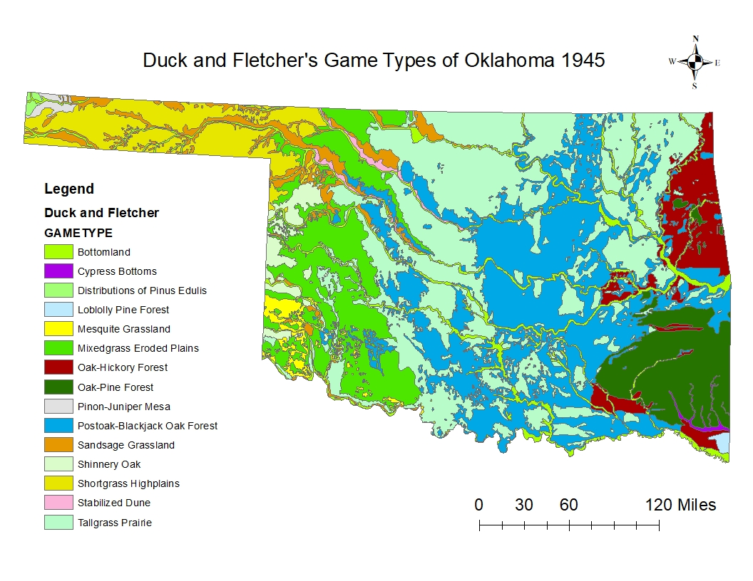
Figure 1. Duck and Fletcher’s game type map for Oklahoma (1945).
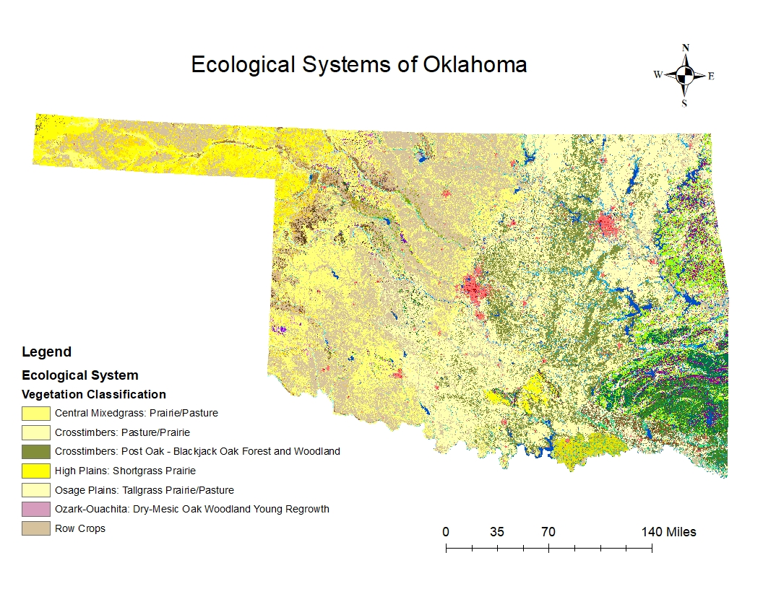
Figure 2. Map of the Oklahoma Ecological Systems Map. Each color represents a different vegetation classification (n = 165). The top seven vegetation classifications are represented in the legend.

Chapter 2: Using landcover schema to locate nectaring resources to allocate conservation efforts for the monarch butterfly
Christopher Rocha¹ and Bruce Hoagland²
¹ Christopher Rocha, rochac@ou.edu
^{1,2} University of Oklahoma, Department of Geography and Environmental Sustainability, Norman Oklahoma

Abstract: Insects across the globe are experiencing steep population declines and the monarch butterfly (Danaus plexippus) is no different. For the past couple of decades, the monarch’s population has diminished to levels that require action and as a result, a Candidate Conservation Agreement with Assurances (CCAA) was developed in collaboration with the United States Fish and Wildlife Service and the Energy Resource Group at the University of Illinois- Chicago that assures the participants that if they implement conservation activities, they will not be subjected to additional restrictions if the species becomes listed under the Endangered Species Act. Participants must enroll 8% of their total land holdings for habitat conservation for the monarch. One such land holding is rights-of-ways (ROWs). As a signatory of the CCAA, the Oklahoma Department of Transportation (ODOT) must locate and manage habitat for the monarch butterfly (pollinator) habitat, but habitat data does not exist for ODOT rights-of-ways (ROWs). We identified and quantified monarch butterfly and other pollinator habitat using a combination of geospatial and field techniques. We found that milkweed (Asclepias spp.), a key resource for monarchs, was present in 32% of our field sites and nearly each site had available nectaring resources. Thus, our findings suggest that ODOT’s ROWs have conservation potential for monarchs and may be good candidate lands for enrollment into the CCAA. Given that transportation ROWs are geographically widespread and frequently fallow, our results suggest that these lands can be managed to provide resources and habitats for high-priority conservation measures.
Key Words: Habitat, Rights-of-ways, pollinators, monarch butterfly, GIS
Introduction
Insects are found across the globe and are not only the functional base of many ecosystems, but they also provide society with ecosystem services that include soil aeration, pest control, pollination, and provide a food source for humans and wildlife (Thomas et al. 2004; Sanchez-Bayo and Wychuys 2019). In recent years, an alarming trend has emerged; the total biomass of insects has fallen at a rate of 2.5% each year, more than 40% of insect species are in decline, and a third of insect taxa are considered as endanger of extinction (Sanchez Bayo and Wychuys 2019). The taxa in greatest decline are bees, butterflies, moths, beetles, dragonflies, and damselflies (Thomas et al. 2004; Sanchez-Bayo and Wychuys 2019). Agricultural expansion/intensification and habitat loss/fragmentation are the greatest contributors to the decline in insect abundance and diversity (Maxwell et al. 2016; Ceballos et al. 2017; Sanchez-Bayo and Wychuys 2019).
Butterflies are a flagship species for invertebrate conservation (Butterfly Conservation Europe 2019) and are considered an indicator of environmental quality due to their host-plant specialization and sensitivity to habitat deterioration (Erhardt and Thomas 1991; Sanchez-Bayo and Wychuys 2019). The monarch butterfly (Danus plexippus Linnaeus) is an iconic species in North America (Cariveau et al. 2019) that has experienced significant population declines over the last 20 years (Brower et al. 2012; Vidal and Rendon-Salinas 2014; Sanchez-Bayo and Wychuys 2019; Cariveau et al. 2019). The decline in monarch abundance is a multivariate problem that includes agricultural intensification and pesticide usage, and habitat loss and fragmentation (Flockhart et al. 2015; Cariveau et al. 2019). Monarchs are valued for their role as pollinators and are sought by photographers and nature enthusiasts (U.S. Forest Service 2019). Female monarchs oviposit only on species of Asclepias. The larvae consume the Asclepias leaves, which contain cardenolides that accumulate in their tissues and discourage predation. As adults, monarchs like other pollinators require access to nectar resources in diverse flowering plant communities Cariveau et al. 2019).
The drastic decline over the past 21 years of monarch populations has triggered international conservation action. As a migratory species, the United States, Mexico, and Canada have pledged to work cooperatively to protect, improve, and expand monarch habitat (Commission for Environmental Cooperation 2008), and recommends five objectives; 1) decrease or eliminate deforestation in the overwintering habitat; 2) addresses the threat of habitat loss; 3) reduced threats of loss, fragmentation, and modification to breeding habitat; 4) promote and sustainable livelihoods for communities affected conservation actions (i.e., loggers being compensated for not logging on overwintering sites); and 5) monitor monarchs throughout the flyway (Commission for Environmental Cooperation 2008).
In 2015, the United States, developed a National Strategy to promote the health of honeybees and other pollinators that included a goal to increase the Eastern population of the monarch butterfly to 225 million individuals. Strategically, this will require the restoration or enhancement of 2.8 million ha of land for pollinators, and protection of 6 ha in the overwintering grounds in Mexico (Pollinator Health Task Force 2015).
Action plans and resources were developed for the prevention, control, and mitigation actions to promote the monarch’s population. Examples include the Best Management Practices that encourage Federal building managers to identify and plant pollinator friendly plants; the National Seed Strategy for Rehabilitation and Restoration to develop a seed bank to support restoration activities to ensure a stable supply of native plants (Pollinator Health Task Force 2015).
Transportation rights-of-ways (ROWs) present an opportunity to establish and maintain both host and nectaring plants (Munguira and Thomas 1992; Ries et al. 2001; Saarinen et al. 2005; Hopwood 2008; Skorta et al. 2013; Halbritter et al. 2015; Cariveau et al. 2019). Roadside vegetation accounts for an estimated 8 million ha of land and borders an estimated 6.4 million km of road in the United States (Adam and Geis 1983, United States Department of Transportation 1998). Since that report, the mileage of roadway has increased to 10.7 million km (U.S. Federal Highway 2017). Utilization of ROWs for conservation purposes could also restore connectivity along the monarch migration corridor (Bennett 1991; Spellerberg 1998; Ries et al. 2001). Ries et al (2001) provided evidence that roadsides could function as steppingstones between habitat fragments. Although butterfly mortality was greater adjacent to habitat patches with high flowering plant diversity as opposed to those dominated by grass cover, the likelihood of butterflies exiting a nectar plant dominated patch was lower. In addition to increasing habitat connectivity, studies have shown that roadside vegetation led to increased reproduction rates (Zalucki and Lammers 2010; Zalucki et al. 2016; Grant et al. 2018).
The Nationwide Candidate Conservation Agreement for Monarch Butterfly on Energy and Transportation Lands (CCAA), developed collaboratively by the Energy Resources Center at the University of Illinois-Chicago, the United States Fish and Wildlife Service, and 30 entities from the energy and transportation sectors, provides a conservation tool for signatories. The CCAA promotes “the landscape-scale conservation vision that has been recognized as being needed for monarch butterflies.” The CCAA strives to enhance and expand monarch habitat by adopting conservation measures like mowing later in the year to sustain host and nectaring habitat.
The Oklahoma Department of Transportation (ODOT) as a signatory of the CCAA has signaled its commitment to addressing habitat and nectar resources on ROWs. The objective of this research is to locate sites with the highest probability of diverse nectar resources and host plants in ROWs of ODOT Division 2, Oklahoma, USA. This research is motivated by the CCAA requirement that 8% of the lands managed by ODOT be managed for the conservation of Monarch butterflies (USFWS 2019). Given the spatial extent of Division 2 (it consists of nine counties), landcover products will be analyzed to locate areas with potential nectar and host habitat. Sites will then be ground-truthed using the Rights-of-Way as Pollinator Habitat Scorecard (or scorecard) developed by the University of Illinois at Chicago Rights-of-Ways as Habitat Working Group (University of Illinois-Chicago 2020).
Methods
Study Area
The ODOT Division 2 encompasses nine counties in southeastern Oklahoma (Figure 1). It lays within the Subtropical Humid (Cf) climate zone (Trewartha 1968). Summers are warm (mean July temperature 27.78ºC) and humid, and winters are relatively short and mild (mean January temperature 4.2ºC). Measurable precipitation occurs on approximately 115 days and the mean annual is 136 cm. The growing season is approximately 225 to 230 days long (Oklahoma Climatological Survey 2020).
Division 2 occupies portions of the Upper West Gulf Coastal Plain, the Ouachita Mountains, and the Arkansas Valley physiographic provinces. The Upper West Gulf Coastal Plain and the Arkansas Valley had the greatest extent of grassland vegetation as mapped by Duck and Fletcher (1945). Of the 12 Game Types (or potential natural vegetation types) mapped by Duck and Fletcher that occur within Division 2. Of these, we hypothesized that the Post oak-blackjack and Tallgrass Prairie game types will have the highest total area of nectar and host plant resources.
The post oak-blackjack, known colloquially as cross timbers, is a mosaic of forest, woodland, and grassland vegetation that represents an ecotone between the eastern deciduous forest and Great Plains grasslands (Hoagland et al. 1999). The predominant woody plants are post oak (Quercus stellata Wangenh.) and blackjack oak (Q. marilandica Münchh.). The herbaceous understory, however, consists of many of the grasses and forbs common in the the adjacent prairies. The tallgrass prairie is characterized by four perennial grasses: big blue stem (Andropogon gerardii Vitman.), little bluestem (Schizachyrium scoparium Michx.), Indiangrass (Sorghastrum nutansi Nash) and switchgrass (Panicum scoparium L.). Numerous forb taxa provide nectar resources for monarchs and other pollinators including bonesets (Eupatorium spp.), blazing stars (Liatris spp.), milfoil (Achillea millefolium L.), rattlesnake master (Eryngium yuccifolium L.), rosinweeds (Silphium spp.), tickseeds (Coreopsis spp.) and many others. Monarch host plants in the tallgrass prairie include antelope horns (Asclepias Asperula Woodson), butterfly milkweed (A. tuberosa L.), green comet milkweed (A. viridiflora Raf.), green milkweed (A. viridis Raf.) (Duck and Fletcher 1945; Buck and Kelting 1962).

Spatial Data Analysis
The Oklahoma Ecological System Map (OESM), consists of 165 ecological systems mapped at a resolution of 10-m x 10-m resolution (Oklahoma Department of Wildlife Conservation 2020), and was the primary landcover layer we used to create a map of desirable vegetation associated with ROWs. We followed a three-step process to create a new data layer. First, a raster mask using the Division 2 boundaries was overlaid on the OESM. The resulting sub-set contained 104 of the original 165 ecological systems. Second, ecological systems described as pastures, prairies, and barren (open) lands (n = 14 ecological systems), hypothesized to include the highest diversity and abundance of nectar plants, were merged into a data layer referred to as desirable vegetation. Third, all roadways within Division 2 of the ODOT system were buffered using the clear zone width of 9.1 m (Federal Highway Administration 2017) to create a layer of ROWs classified as desirable vegetation. An additional buffer of 30.48m was then extended from the clear zone layer to account for any potential mix pixel effects. The resulting Division 2 layer had 104 different vegetation categories, of which, 14 were broadly classified as desirable vegetation.
Patch and landscape metrics were used to identify connectivity of desirable vegetation. These analyses serve two functions. First, because habitat fragmentation and lack of spatial connectivity negatively impacts migration, breeding, and population size (Stoner and Joern 2004) of monarchs, only those locations aggregated to 50,000 meters were selected for field evaluation. Second, the resulting analysis provides the basis for the methodology used to locate ground-truth sites.
The Rights-Of-Ways as Pollinator Habitat Scorecard Tier 3 was adopted for field assessments. The procedure requires that all sites assessed must be at least 139.35 m² for linear sites or a 6.7 m radius circle for non-linear sites. Within the site, transects of 45.72 m were established and data for percent cover of nectar producing plants, the number of milkweed species present and their species type, adjacent land uses, the potential flowering nectar plant cover (i.e., if a plant does flower but is not at the time of surveying), and the number of butterflies observed were recorded. Visits to field sites were from 26 August- 20 September 2020 to coincide with the southward movement of monarchs through Oklahoma and again in of 2021 to coincide with the northward movement.
Results
The total area (Table 1) and distribution (Figure 2) of desirable vegetation varied spatially across Division 2. If all the locations denoted of desirability vegetation are accurate, the 8% area or - 1, 448.44 ha - required by the CCAA would be met within Division 2 alone (Table 1), though this is unlikely. The largest and most contiguous strips of desirable vegetation occurred in the western and southern portions of the division (Figure 2). In the eastern portion of the study area, which corresponds with the Ouachita Mountains and the vegetation is predominately oak-pine, there was the least extent of desirable vegetation (Table 3). This statement does not imply, however, that there is no suitable pollinator habitat, but only a lack of desirable vegetation as defined in this study. Habitat scores ranged from 3 to 37 out of 100 (Table 5). The number of nectaring species present at each site ranged from 0 to 11 (Table 5). Milkweed was present at 12 sites (Table 5).
Discussion
Stemming the decline in monarch butterfly numbers requires innovative approaches. Migratory species present many challenges for conservation planners, not the least of which is habitat fragmentation (Stoner and Jeorn 2004). The U.S. Endangered Species Act is an important tool for surmounting these challenges, and the use of CCAAs in species conservation has allowed more stakeholders to participate in the process. In the case of monarch conservation in Oklahoma, our analysis of landcover implies that there is potentially double the desirable land for enrollment in the CCAA on ODOT properties (Figure 2, Table 1). An evaluation of the ground truth sites, however, indicates the quality of desirable vegetation varies greatly. Nonetheless, the ROWs do seem to provide habitat connectivity (Figure 2). As suggested by Ries et al. (2001), ROWs in provide steppingstones between suitable habitat used by butterflies.
The rapid assessment field technique (i.e., scorecard) outlined by Cariveau et al. (2019) provides a standard methodology for describing the habitat for the monarch in roadside ROWs. The highest score at our field sites, however, was 37 (moderate habitat quality) out of a 100. Milkweed, the presence of which contributes significantly to a site score, occurred at 32% of our sites (Table 6). The highest species richness of nectar resources, another key assessment variable (Cariveau et al. 2019), was 11 (Table 6). The frequency and percent cover of plant species within the plot was used in the final calculation of the habitat score (Table 6). Although our research focused on locating sites with the highest probability of desirable vegetation, we did include adjacent sites in the final database as recommended by Huxel and Hastings (1999).
Conclusion
We conclude that the methodology adopts in this research successfully located sites that provide adequate nectar and host resources, which brings ODOT closer to compliance with the CCAA. Further, we recommend that this approach be employed in other ODOT Divisions within the Monarch Flyway. The scorecard itself allows the user to provide quantitative results to ROW managers that will facilitate the development of strategies for appropriate locations for and levels of herbicide application, and mowing schedules. Continued use of the ROW Tier 3 scorecard within any ODOT Division will establish a list of species that can in turn be used to devise seeding plans for restoration and enhancement.
Acknowledgements
This research was supported through an Oklahoma Department of Transportation grant to BWH. We thank Amber McIntyre and Vonceil Harmon of the ODOT funded Natural Resource Program at The University of Oklahoma, for their advice and field assistance.

Tables and Figures
Table 1. Summary areas of Division 2. The 8% needed for compliance with the CCAA is 1,448.44 ha for Division 2.
Land Holding | Area (ha)
Desirable Vegetation | 3,387.34
Total land | 18,105.45

Table 2. Summary areas by vegetation classification for Division 2 [n = 14].
Vegetation Classification | Area (ha) | Percent (%)
Blackland: Pasture/Prairie | 20.19 | 0.60
Crosstimbers: Pasture/Prairie | 1,213.85 | 35.83
Post Oak Savanna: Pasture/Grassland | 451.81 | 13.34
Post Oak Savanna: Sandyland Shrubland and Grassland | 1.89 | 0.06
Southeastern Great Plains: Riparian Barrens | 0.02 | 0.00
West Gulf Coastal Plain: Small Stream Barrens | 0.26 | 0.01
Barren | 29.98 | 0.88
Ozark-Ouachita: Pasture/Prairie | 714.75 | 21.10
West Gulf Coastal Plain: Pasture | 627.32 | 18.52
Ozark-Ouachita: Riparian Barrens | 0.95 | 0.03
West Gulf Coastal Plain: Northern Calcareous Prairie/Pasture | 53.35 | 1.57
Arkansas Valley: Prairie/Pasture | 267.09 | 7.88
Arkansas Valley: Sandy Prairie/Pasture | 6.1 | 0.18
South Central Interior: Riparian Barrens | 0.48 | 0.01

Table 3. Summary areas by Gametype outlined by Duck and Fletcher.
Gametype | Area (ha) | Percent (%)
Bottomland | 153,640 | 5.82
Cypress bottoms | 40,933 | 1.55
Loblolly pine forest | 31,464 | 1.19
Oak-hickory forest | 193,894 | 7.35
Oak-pine forest | 1,254,220 | 47.53
Postoak-blackjack oak forest | 719,291 | 27.26
Tallgrass prairie | 245,368 | 9.30

Table 4. Summary areas by Gametype outlined by Duck and Fletcher within the buffer created.
Gametype | Area (ha) | Percent (%)
Bottomland | 810 | 4.48
Cypress bottoms | 129 | 0.71
Loblolly pine forest | 168 | 0.93
Oak-hickory forest | 1,700 | 9.40
Oak-pine forest | 6,196 | 34.26
Postoak-blackjack oak forest | 6,054 | 33.47
Tallgrass prairie | 3,030 | 16.75

Table 5. Summary of field sites for the fall of 2021.
Name of Site | Habitat Score | Number of Nectaring Resources | Milkweed Presence
LEFL02 | 12 | 5 | N
LEFL11 | 20 | 3 | Y
LEFL16 | 9 | 3 | N
PITT18 | 12 | 3 | N
PITT23 | 8 | 5 | N
PUSH25 | 28 | 11 | Y
ATOK28 | 14 | 2 | Y
LATI32 | 22 | 4 | N
BRYA34 | 18 | 2 | Y
BRYA35 | 19 | 2 | Y
BRYA39 | 19 | 3 | Y
CHOC44 | 32 | 8 | Y
CHOC46 | 32 | 8 | Y
CHOC47 | 7 | 4 | N
PUSH50 | 13 | 5 | N
MCCU52 | 37 | 5 | Y
MCCU53 | 22 | 4 | Y
CHOC54 | 30 | 4 | Y
PUSH55 | 18 | 5 | N
MARS57 | 17 | 2 | N
MARS58 | 5 | 2 | N
BRYA59 | 18 | 4 | N
BRYA60 | 13 | 4 | N
ATOK61 | 3 | 0 | N
BRYA62 | 24 | 2 | Y
PUSH63 | 9 | 2 | N
PUSH64 | 17 | 3 | N
CHOC65 | 14 | 3 | N
PUSH66 | 12 | 3 | N
PITT67 | 13 | 2 | N
PUSH68 | 21 | 3 | N

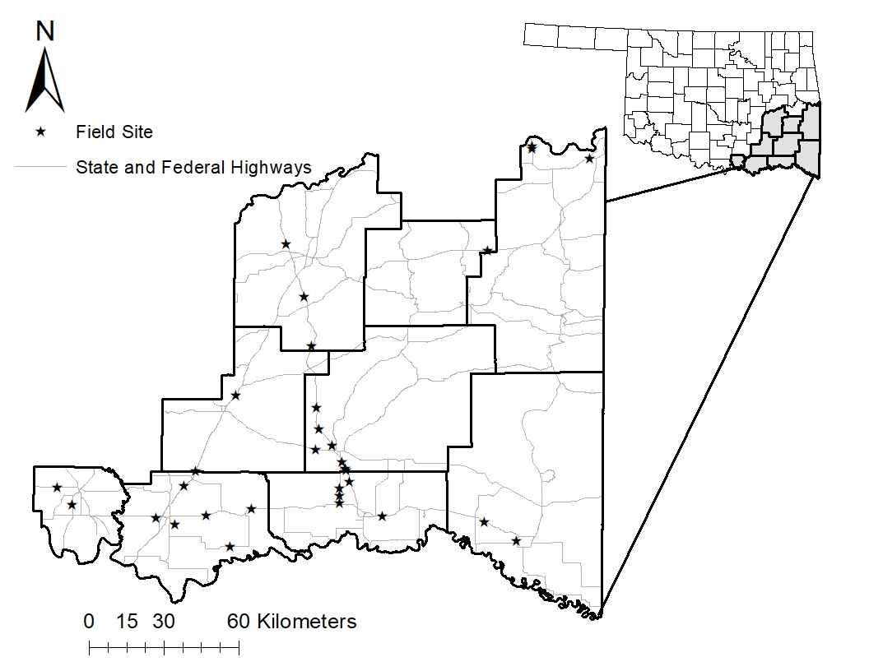Figure 1. Oklahoma Department of Transportation, Division 2, Oklahoma, USA, study area and state and federal highway locations.

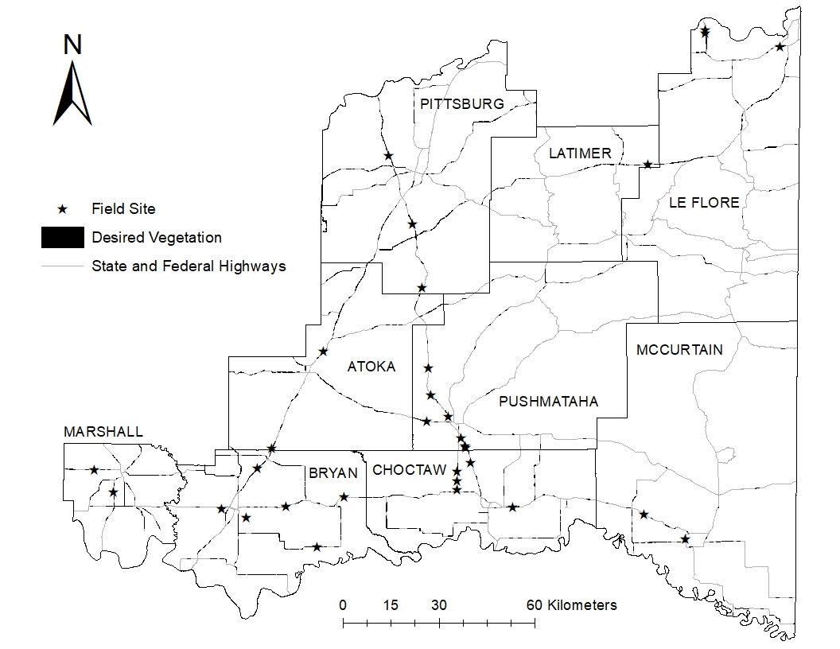
Figure 2. Oklahoma Department of Transportation, Division 2, Oklahoma, USA, study area and sample plot locations (black stars) with extent of potentially desirable vegetation classification. Sampling was conducted 26 Aug- 25 September 2020.

Authors Biographies
Christopher Rocha received his BS in Natural Resource Management from Grand Valley State University and is currently in the process of obtaining his MS from the University of Oklahoma.

Bruce Hoagland received his PhD from the University of Oklahoma and joined the faculty shortly after. He has a joint appointment with the Oklahoma Biological Survey where he serves as plant ecologist and coordinator of the Oklahoma Natural Heritage Inventory, and as a professor and associate chair of the Department of Geography and Environmental Sustainability.

Chapter 3: Do habitat scorecard results differ between seasons?
Christopher Rocha¹ and Bruce Hoagland²
¹ Christopher Rocha, rochac@ou.edu
^{1,2} University of Oklahoma, Department of Geography and Environmental Sustainability, Norman Oklahoma

Abstract: The monarch butterfly (Danaus plexippus) has experienced steep population declines over the last couple of decades. As a result, a Candidate Conservation Agreement with Assurances was created. Participants must enroll 8% of their land holdings to benefit the monarch through habitat conservation. As a signatory of the CCAA, the Oklahoma Department of Transportation will utilize their rights-of-ways for habitat conservation. Here we quantified monarch habitat during the fall and spring migrations of 2020 and 2021 within selected rights of way. The results concluded that habitat structure, habitat potential, and habitat score does differ between spring (Mean = 13.84, Median = 12, SD = 6.77, n = 31) and fall (Mean = 17.35, Median = 17, SD = 8.23, n = 31) but the results of the χ2 (1, N=62) = 1.476, p-value = 0.224 accepts the null hypothesis, that there is not a significant relationship between habitat quality ratings and seasonality.
Key Words: Habitat, Rights-of-ways, pollinators, monarch butterfly, habitat scorecard
Introduction
Recent research reports a 40% decline in insect populations globally, an alarming figure when one considers that these animals play not only an important role in ecosystem ecology, but they provide crucial ecosystem services such as soil aeration, pest control, and pollination (Thomas et al. 2004; Sanchez-Bayo and Wychuys 2019). In terms of ecosystem function, approximately 220,000 of 240,000 flowering species require animal mediated pollination for successful reproduction, one third of which are food plants for humans (Dailey et al. 1997) and provides an economic benefit of $9 billion USD year⁻¹ to the agriculture industry (Dailey et al. 1997; The White House 2014; Lady Bird Johnson Wildflower Center 2020). Maintaining species diversity is crucial in providing ecosystem resilience in the face of future environmental change (Senithipe et al. 2015). The loss and fragmentation of many natural habitats is a threat for insect biodiversity (Fahrig 2003; Steffan-Dewenter and Westphal 2008).
One group of insects experiencing dramatic populations declines are butterflies (Thomas et al. 2004; Sanchez-Bayo and Wychuys 2019). Butterflies are considered indicators of environmental quality due to their host-plant specialization and sensitivity to habitat deterioration (Erhardt and Thomas 1991; Sanchez-Bayo and Wychuys 2019). The monarch butterfly (Danus plexippus Linneaus) is one of the most iconic species in North America (Cariveau et al. 2019) and is currently experiencing drastic population declines. Monarch population size is based on estimates of the area occupied during overwintering, which is annually. Since the population estimate of 1993-1994, the monarch’s total area of occurrence peaked in 1996-1997 when they occupied 20.97 ha in Mexico. During the 2019-2020 overwintering period, however, the monarchs only occupied 2.83 ha, a decrease of over 146% percent (Brower et al. 2012; Vidal and Rendon-Salinas 2014; Sanchez-Bayo and Wychuys 2019; Cariveau et al. 2019; Center for Biological Diversity 2021). Conservation efforts for the monarch butterfly have focused on increasing milkweed abundance during the northward migration and the availability of nectar resources (Plesants and Oberhauser 2013; Pleasants 2017; Thogmartin et al. 2017; Stenonien et al. 2018), with a goal of 6 hectares of occupied overwintering habitat (The White House 2015).
The decline has been attributed to loss of habitat and increased pesticide usage. Due to a shift in land use, mainly the conversion of open prairie and pastures to row crop agriculture and an increased use of herbicides and pesticides, have exacerbated the decrease of monarch butterfly populations and their milkweed host plants. Transportation rights-of-ways (ROWs) are now viewed as potential habitat that could provide connectivity between isolated patches. When managed correctly, ROWs can promote, and maintain both host and nectar plants (Munguira and Thomas 1992; Ries et al. 2001; Saarinen et al. 2005; Hopwood 2008; Skorta et al. 2013; Halbritter et al. 2015; Cariveau et al. 2019).
The Butterfly Monitoring Scheme Standards (BMSS) provides protocols for intensive monitoring of pollinator populations (Pollard 1977; Pollard and Yates 1993; Van Sway et al. 2015; Scherber et al. 2019). The process involves locating a site that harbors pollinator populations, then data is collected along a 50m transect when temperatures range from 13ºC and 35ºC. Observations for butterflies are made within 2m either side of the transect and 2m in front of the observer (Scheber et al. 2019). Feeding stations baited with fruit are deployed along the transect to enhance the species count (Van Sway et al. 2015). These standards allow for consistent and comparable results between sites and years. Employing this methodology, Van Sway and Van Strien (2005) analyzed data from across Europe that used the Butterfly Monitoring Scheme methodology, resulting in a 50% decline in butterfly abundance from 1990 to 2004. The BMSS is effective but time consuming, but the evaluation of large areas for pollinator habitat requires rapid methods.
The Rights-Of-Ways as Pollinator Habitat Scorecard (ROWSC) provides such a method. In fact, the data collection schema provides habitat assessment at three levels, or Tiers, depending upon project needs and the expertise of the user. Unlike the Butterfly Monitoring Scheme, the ROWSC is a rapid assessment tool that collects data regarding habitat characteristics. It is not a census of butterfly populations.
The Tier 1 Pollinator Scorecard allows for the most rapid site assessment and does not require the user to have extensive skills in plant identification. The only required field asks whether 1) More than 10% cover of potentially flowering nectar plants? and 2) are Two (2) or more milkweed stems present? A site photo is also required. Optional fields are 1) an estimate of potentially flowering nectar plant cover, 2) abundance of milkweed, 3) milkweed stem count, and 4) pollinators observed.
The Tier 2 Pollinator Scorecard includes the fields Potentially Flowering Nectar Plant Cover, Additional Habitat Resources, Number of Flowering Nectar Plant Species Currently in Bloom, Abundance of Milkweed, Pollinators Observed, Adjacent Land Use, Threats, and Opportunities. The first five categories are scored, and those scores are summed. The resulting value is used to rank the habitat quality at the site (0 – 25: Improvement Opportunity, 26 – 40: Basic Habitat Quality, 41 – 55: Moderate Habitat Quality, 56+: High Habitat Quality). Unlike the Tier 1 assessment, completion of all fields is required.
The Tier 3 Pollinator Scorecard (Appendix A) provides the most detailed assessment of habitat quality. It includes the scored Tier 2 fields of Potentially Flowering Nectar Plant Cover, Additional Habitat Resources, Abundance of Milkweed, Pollinators Observed, with the addition of Number of Nectar Plant Species, Number of Native Nectar Plant Species, and Invasive Species & Noxious Weed Cover. The sum of the scores for these categories are evaluated using a different ranking (0 – 20: Improvement Opportunity, 21 – 35: Basic Habitat Quality, 36 – 50: Moderate Habitat Quality, 51 – 75: High Habitat Quality, and 76+: Exemplary). The descriptive fields of Adjacent Land Use, Threats, and Opportunities are also present on the Tier 3 scorecard. The user is also required to list the species present.
Monarch butterflies migrate through Oklahoma during the spring and fall, and individuals will encounter different habitat conditions during those times. In spring 2021, the first adult monarch reported in Oklahoma was on March 7 near Antlers. A difference between the spring and fall migrations is the composition of host and nectar plants at a site. Given phenological patterns in the region, migrating butterflies are more likely to encounter members of the sunflower family (Asteraceae) in the fall and spring ephemerals in spring. Therefore, the objective of this research is to determine if and how the fall and spring habitat scores derived from ROWSC differ between those times. For example, in the spring a diverse community of ephemeral plants could give way to non-native, warm season grasses in the fall (i.e., Johnsongrass [Sorghum halpense L.]). Likewise, butterflies arriving in the spring may encounter sites dominated by non-native, cool season forbs and grasses (i.e., tall fescue [Schedonorus arundinaceus (Schreb.) Dumort.]).
Methods
Study Area
The study area, ODOT Division 2 (Figure 1), is in the Southeast portion of the state and consists of four geomorphic provinces: the Ouachita Mountains characterized by moderate to high hills and ridges of tightly folded sedimentary rock; the Eastern Sandstone-Cuesta Plains of sandstones that overlook broad shale plains; McAlester Marginal Hills Belt that are sandstone capped broad hills and mountains that rise 91.44m – 609.6m above wide hilly plains of shale; and finally the Dissected Coastal Plain characterized by unlithified sands, gravel, clays, and some limestone (Curtis Jr et al. 2008).
Eastern Oklahoma is in the Subtropical Humid (Cf) climate zone (Trewartha 1968). The mean July temperature is 27.78º C and 4.2º C in January. The growing season lasts from 225 and 230 days. The annual precipitation is 136 cm and occurs on approximately 115 days (Oklahoma Climatological Survey 2020).
Three vegetation types, or “Game Types” occur within the study area (Duck and Fletcher 1945): Post Oak (Quercus stellata Wangenh)-Blackjack (Quercus marilandica Münchh) Forest, characterized by a mosaic of forest woodland and grassland vegetation (Hoagland et al. 1999); Oak (Quercus spp.)-Pine (Pinus spp.) Forest characterized by closed canopy, pine-mixed oak stands to open canopy woodlands; and Tallgrass Prairie characterized by predominately grasses and clean cultivation (Duck and Fletcher, 1945). Associated plants species in the Tallgrass Prairie are little blue stem (Schizachyrium scoparium Michx.), big blue stem (Andropogon gerardii Vitman), lead plant (Amorpha conescens L.), white health aster (Aster ericoides (L.) G.L. Nesom), sideoats grama (Bouteloua curtipendula Michx.), Cylinder jointtail grass (Mnesithea cylindrica (Michx.) de Koning & Sosef.), Hellers rosette grass (Dichanthelium oligosanthes (Schult) Gould), Switchgrass (Panicum virgatum L.), indian grass (Sorghastrum nutans Nash), and coralberry (Symphoricarpos orbiculatus X chenaulti Rehder). Monarch host plants in the tallgrass prairie include antelope horns (Asclepias asperula Woodson), butterfly milkweed (A. tuberosa L.), green comet milkweed (A. viridiflora Raf.), green milkweed (A. viridis Raf.). (Duck and Fletcher 1945; Buck and Kelting 1962; Hoagland 2000).

Field Methods
Field surveys were conducted in the fall of 2020 from 26 August – 20 September and again in spring 2021 from 9 April- 23 April. These dates coincide with the arrival of monarchs in the spring, and, their passage south in the fall. As noted above, sites (Figure 2) were evaluated using the ROWSC developed by the University of Illinois-Chicago Rights-Of-Ways as Habitat Working Group Tier 3 (University of Illinois-Chicago 2020). The ROWSC version 2.1 is a rapid assessment protocol. Sites must meet a minimum size criterion of either 139.35 m² for linear locations or a 6.7 m radius circle for non-linear (Cariveau et al. 2019). If a site meets one of these criteria, a transect(s) 45.72 m in length are established. The observer walks the transect and records the following variables within 1.5 m either side of the transect (Figure 3): 1) the cover of nectar producing plants actually in flower and the potential flowering nectar plant cover (e.g., a plant not flowering at the time of the survey), 2) the number of milkweed species and the number of stem of each individual present, 3) adjacent land use, and 4) animals present, whether the number of butterflies observed or the presence of other pollinators.
Habitat variables are scored on a point scale that differs with category. For example, potentially flowering nectar plant cover is estimated on a scale of 0 – 100% but is assigned to one of seven scorecard categories. The number of nectar plant species and the number of native nectar plant species present are recorded separately. Although a useful distinction, non-native invasive species such as nodding musk thistle (Carduus nutans L.) are utilized by pollinators. In both cases, the number of species present is assigned to one of six categories. The number of stems of milkweed is also assigned to one of six categories based upon the. Milkweeds are recorded in the Additional Habitat Resources assessment. The inclusion of milkweeds in two assessment categories emphasizes the importance of milkweeds and weights the ROWSC results such that a low score or absence of milkweeds de-emphasizes sites with high scores for nectaring plants.
Final assessment scores range from 0 to 110 (indicating a site consisting of only non-native plants that have no potential as nectaring resources). The scores are the basis for assignment of site quality into one of five categories: improvement opportunity (0-20), basic habitat quality (21-35), moderate habitat quality (36-50), high habitat quality (51-75), and exemplary (76+). Thus, a site with the lowest combination of scores would fall into the 1-5% cover of Potentially Flowering Nectar Plant Cover, (score = 1), 1-5 Number of Nectar Plant Species (score = 1), Number of Native Nectar Plant Species (score = 1), one individual in the Abundance of Milkweed (score = 5), zero percent Invasive Species & Noxious Weed Cover (score = 6), and Additional Habitat Resources (score = 0), would qualify as an improvement opportunity.
All habitat site scores, and number of nectar resources were analyzed with a chi-square test to determine if there was a significant relationship of the habitat quality ratings and seasonality between spring and fall surveys.
Results
Habitat scores ranged from 3 to 37 for the fall (Table 1, Figure 4A) and 6 to 39 for the spring (Table 1, Figure 4B). Thus, no site received a rating above Moderate Habitat Quality. The median habitat score was 17 for the fall and 12 in the spring (Table 2). Four sites had native bunch grasses (e.g., little blue stem) in the fall opposed to only one in the spring (Table 3). Additionally, there were two sites in the spring that had undisturbed thatch, but none in the fall (Table 3). Rock piles were present at three sites in the fall and only one in the spring (Table 3). More than 1 square foot of bare ground was found in seventeen sites in the fall and only six sites in the spring (Table 3, 4).
Twenty-six sites ranked as improvement opportunity in the fall, four as basic habitat quality, and one as moderate habitat quality for the spring surveys (Table 4). It was not the same site between fall and spring that was ranked as moderate habitat quality. The number of sites ranked as improvement opportunity increased by 18% between the fall to spring surveys, but sites ranked basic habitat quality decreased by 50% of (Table 4).
The number of species at individual sites ranged from 0 to 11 (mean = 3.75, median = 3), and totaled 116 plant taxa for all sites. The greatest number of taxa were in the family Asteraceae and the genus Asclepias. Four non-native species were reported. The number of species at individual sites ranged from 0 to 14 (mean = 3.75, median = 8), with a total of 264 plant taxa. Of these, 35 were in the family Fabaceae, and only one non-native species was reported. The species most frequently encountered was lesser trefoil (Trifolium dubium Sibth). Milkweed was present at 12 sites in the fall but was not present during the spring (Table 1).
The χ2 (p-value = 0.224) failed to reject the null hypothesis that there is not a significant relationship between habitat quality ratings and seasonality. Nonetheless, differences in habitat quality ratings between the fall and spring survey seasons shows a slight trend, suggesting an increase in sample size could affect the outcome (Figure 5).
Discussion
The fall surveys had highest habitat scores and occurrence of milkweed compared to the spring surveys (Table 1, 2). The sites at which milkweed was not present in the spring but was in the fall had an average habitat score decrease of 46.94%. A study of flowering patterns and production in an Oklahoma grassland by Anderson and Adams (1981) determined that during the month of April the average number of species present was eight, but during the months of August and September the average ranged from 24 and 32. The average number of species recorded for April during the present study was 8.52, but the fall average was 3.72. The is possibly due to the higher level of disturbance along ROWs than in relatively undisturbed grasslands.
The rapid assessment field technique we used was outlined by Cariveau et al. (2019) was similar to an insect conservation scientist’s approach to monitor habitat. Here, we sampled various habitats across the study area (Tylianakis et al. 2005; Holzschuh et al. 2016; Scherber et al., 2019) and used a transect method (Gillespie et al. 2017; Scherber et al., 2019). Unlike the BMSS (Pollard, 1977; Pollard and Yates, 1993; Van Sway et al., 2015; Scherber et al., 2019), the ROWSC protocol require neither walking at a constant pace (10 m/min⁻¹) nor the use of fruit bait stations. If the BMSS were used rather than the ROWSC, the results would have provided a more a thorough census of butterfly species and abundance. If the two approaches were combined, the ROWSC could be used to locate and provide baseline description of habitat attributes, and the BMSS could be used to census the butterfly population at sites with high habitat ratings.
Conclusion
As expected, the ROWSC tool found differences in habitat scores, milkweed presence, number of plant species, and additional habitat resources (e.g., rock piles) between survey seasons. Nearly 32% of the sites in the fall had milkweed, suggesting that ROWs can provide viable monarch host habitat in addition to documenting nectar resources that benefit the monarch. The scorecard provides an easy-to-use approach for quantifying habitat that saves time and resources. The ROWSC is designed for ease of use and within some Tiers, is approachable for individuals with limited training or knowledge in plant and animal taxonomy. A downside of the ROWSC is how milkweed influences the final rating of a site. Presently, milkweed is recorded based on the number of stems present, and in additional habitat resources that is equivalent. This appears to weight the scores in a way that under values the presence of diverse community of nectar providing species.
Acknowledgements
This research was supported through an Oklahoma Department of Transportation grant to BWH. We thank Amber McIntyre and Vonceil Harmon of the ODOT funded Natural Resource Program at The University of Oklahoma, for their advice and field assistance.

Tables and Figures
Table 1. Summaries of habitat characteristics for Oklahoma Department Of Transportation’s Division 2 locations evaluated during the fall of 2020 and spring of 2021 using the Rights-Of-Ways Scorecard (University of Illinois-Chicago 2020).
Name of Site | Fall 2020 Score | Spring 2021 Score | Number of  Fall Plants | Fall Milkweed  Presence | Number of  Spring Plants | Spring Milkweed Presence
LEFL02 | 12 | 17 | 5 | N | 6 | N
LEFL11 | 20 | 21 | 3 | Y | 7 | N
LEFL16 | 9 | 12 | 3 | N | 5 | N
PITT18 | 12 | 6 | 3 | N | 14 | N
PITT23 | 8 | 7 | 5 | N | 17 | N
PUSH25 | 28 | 12 | 11 | Y | 6 | N
ATOK28 | 14 | 8 | 2 | Y | 5 | N
LATI32 | 22 | 12 | 4 | N | 8 | N
BRYA34 | 18 | 11 | 2 | Y | 6 | N
BRYA35 | 19 | 6 | 2 | Y | 10 | N
BRYA39 | 19 | 15 | 3 | Y | 16 | N
CHOC44 | 32 | 8 | 8 | Y | 4 | N
CHOC46 | 32 | 9 | 8 | Y | 4 | N
CHOC47 | 7 | 9 | 4 | N | 3 | N
PUSH50 | 13 | 15 | 5 | N | 6 | N
MCCU52 | 37 | 13 | 5 | Y | 10 | N
MCCU53 | 22 | 13 | 4 | Y | 9 | N
CHOC54 | 30 | 16 | 4 | Y | 10 | N
PUSH55 | 18 | 15 | 5 | N | 9 | N
MARS57 | 17 | 25 | 2 | N | 10 | N
MARS58 | 5 | 15 | 2 | N | 4 | N
BRYA59 | 18 | 10 | 4 | N | 15 | N
BRYA60 | 13 | 11 | 4 | N | 14 | N
ATOK61 | 3 | 9 | 0 | N | 4 | N
BRYA62 | 24 | 24 | 2 | Y | 11 | N
PUSH63 | 9 | 8 | 2 | N | 5 | N
PUSH64 | 17 | 16 | 3 | N | 7 | N
CHOC65 | 14 | 39 | 3 | N | 9 | N
PUSH66 | 12 | 12 | 3 | N | 6 | N
PITT67 | 13 | 14 | 2 | N | 14 | N
PUSH68 | 21 | 21 | 3 | N | 10 | N

Table 2. Summary of habitat score and number of nectaring resources for fall and spring survey times using the ROWSC (University of Illinois-Chicago 2020).
Survey Time
 | Mean Habitat Score | Median Habitat Score | Mean Number of Nectaring Resources | Sum of Nectaring Plants
Fall 2020 | 17.35 | 17 | 3.75 | 116
Spring 2021 | 13.84 | 12 | 8.52 | 264

Table 3. Summary of the additional habitat resources for fall and spring survey times using the ROWSC (University of Illinois-Chicago 2020).
 | Survey Results
Additional Habitat Resources | Fall 2020 | Spring 2021
Native bunch grasses | 4 | 1
Brush piles | - | -
Undisturbed thatch | - | 2
Dead wood/snags | - | -
Rock piles | 3 | 1
More than 1 sq. ft bare ground | 17 | 6
Plants with hollow pithy stems | 1 | -
Larval host plants (e.g., milkweed) | 12 | -

Table 4. Total quality ratings for the fall and spring surveys using the ROWSC (University of Illinois-Chicago 2020).
 | Survey Results
Habitat Quality Ratings | Fall 2020 | Spring 2021
0-20: Improvement Opportunity | 22 | 26
21-35: Basic Habitat Quality | 8 | 4
36-50: Moderate Habitat Quality | 1 | 1
51-75: High Habitat Quality | - | -
76+: Exemplary | - | -

Figure 1. Oklahoma Department of Transportation, Division 2, Oklahoma, USA, study area and state and federal highway locations.

Figure 2. Oklahoma Department of Transportation, Division 2, Oklahoma, USA, study area and sample plot locations (black stars) with desirable vegetation classification. Sampling was conducted 26 Aug- 25 September 2020 and again from 9 – 23 April 2021.

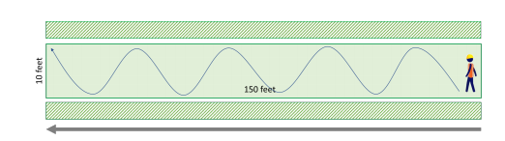
Figure 3. Example of navigating a plot being assessed. Note figure is not drawn to scale. Figure credit to Rights-of-Way 2020.

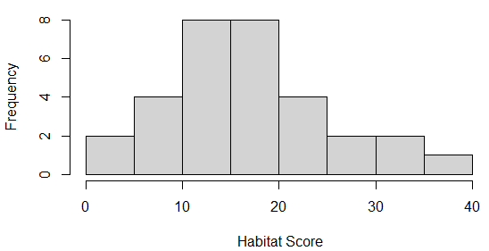
A
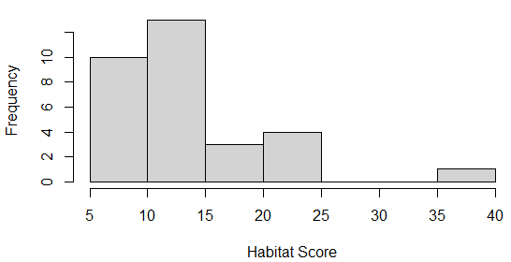
B

Figure 4A and 4B. Histogram results for the Rights-Of-Ways Scorecard habitat scores using a bin size of 5. Data for 9A was collected 26 Aug- 25 September 2020 and data for 9B was collected 9-23 April 2021.

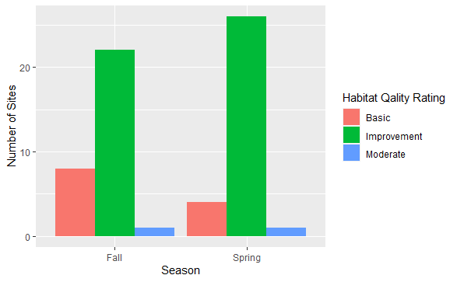
Figure 5. Grouped bar chart for the number of sites and the habitat quality ranking by season.

Authors Biographies
Christopher Rocha received his BS in Natural Resource Management from Grand Valley State University and is currently in the process of obtaining his MS from the University of Oklahoma.

Bruce Hoagland received his PhD from the University of Oklahoma and joined the faculty shortly after. He has a joint appointment with the Oklahoma Biological Survey where he serves as plant ecologist and coordinator of the Oklahoma Natural Heritage Inventory, and as a professor and associate chair of the Department of Geography and Environmental Sustainability.

Chapter 4: Afterword
Extended Discussion
The Nationwide Candidate Conservation Agreement for Monarch Butterfly on Energy and Transportation Lands (CCAA) represents a collaborative, landscape-scale conservation effort that was developed for the monarch butterfly. The decision to sign the CCAA is voluntary but doing so provides the signatory with assurances that no additional regulatory requirements will be imposed upon them if the monarch is listed as a threatened or endangered species. The intent of the CCAA is to provide a net conservation benefit to monarchs and to address the potential effects of maintenance and modernization activities along highways and energy transmission infrastructure on monarch populations. The conservation benefit measures outlined in the CCAA are expected to sustain, enhance, and restore conditions favorable for monarch breeding and foraging (Cardno 2020).
In the second chapter, I used GIS techniques to identify the locations with the highest probability for nectar resources and implemented field surveys to quantify habitat. Thirty-one sites served as groundtruth locations and were assessed using the Rights-of-Ways Habitat Scorecard. The analysis found that 32% of fall sites surveyed had milkweed present. I found that these sites provided nectar resources for the adult monarchs during their spring and fall migration through Oklahoma.
In the third chapter, the data collected at the thirty-one sites mentioned above were used to analyze differences in plant species composition in the spring (9 - 23 April 2021) and fall (26 August – 20 September 2020). Milkweed was not recorded during the spring surveys, but a greater diversity of plant taxa present was. A chi-square test revealed that there was not a significant relationship between habitat quality ratings and season sampled.
Overall, this research found viable monarch habitat on ODOT’s ROWs in Division 2 for enrollment into the CCAA. The data collected and analyzed was the first to use the Rights-of-Ways Habitat Scorecard to assess potential habitat for pollinators. Analyzing the phenological difference between sites provided a holistic approach to providing a net conservation benefit to the monarch and identifies improvement opportunities.
Study Limitations
While the GIS and the Rights-of-Ways Habitat Scorecard can contribute to ODOT’s CCAA compliance, the analysis did not consider ROW area and the Rights-of-Ways Habitat Scorecard does not collect plant abundance data. The shortcoming here is that one stem of purple coneflower (Echinacea purpurea) has equal weight in the data set as one hundred stems of black-eyed daisy (Rudbeckia hirta). Estimating the percent cover of each species present would provide a more informed picture of vegetation composition at a site, and therefore, assist mangers in the development of conservation plans.
If I were to repeat or continue this research, I would 1) visit more field sites to characterize the landscape and habitat potential in Division 2; 2) add ROW width to the GIS analysis as larger ROWs to provide a more accurate calculation of the area surveyed and how that contributes to the total acreage to be enrolled; and 3) collect vegetation abundance data to determine the actual quantity of resource available to monarchs. Finally, I am interested in monitoring sites to determine how vegetation changes in response to mowing practices, herbicide use, and re-seeding if/when implemented.
References
Åberg, J., G. Jansson, J. E. Swenson, and P. Angelstam. 1995. The effect of matrix on the occurrence of hazel grouse (Bonasa bonasia) in isolated habitat fragments. Oecologia 103:265–269.
Adams, L. W., and A. D. Geis. 1983. Effects of roads on small mammals. Journal of Applied Ecology 20:403–415.
Anderson, R. C., and Adams, D. E. 1981. Flowering patterns and production on a central Oklahoma grassland. Stuckey, R. and Rees, K. (Editors), 232-235.
Bailey, R. G. 1976. Ecoregions of the United States (map). Ogden, Utah: USDA Forest Service, Intermountain Region. 1:7,500,00.
Bailey, R. G., P. E. Avers, T. King, and W.H. McNab, editors. 1994. Ecoregions and subregions of the United States (map). U.S. Department of Agriculture Forest Service, Washington, D.C.
Bennett, A. F. 1991. Roads, roadsides and wildlife conservation: a review. Pages 99–118 in D. A. Saunders and R. J. Hobbs, editors. Nature conservation 2: the role of corridors. Surrey Beatty and Sons, Chipping Norton, New South Wales, Australia.
Berkes, F. 2006. From community-based resource management to complex systems: the scale issue and marine commons. Ecology and Society 11(1).
Brereton, T., Roy, D. B., Middlebrook, I., Botham, M., and Warren, M. 2011. The development of butterfly indicators in the United Kingdom and assessments in 2010. Journal of Insect Conservation, 15(1-2), 139-151.
Brower, L. P., Taylor, O. R, Williams, E. H, Slayback, D. A., Zubieta, R. R., and Ramirez, M. I. 2012. Decline of monarch butterflies overwintering in Mexico: is the migratory phenomenon at risk? Insect Conservation Diversity 5: 95–100.
Brownstein, J. S., Skelly, D. K., Holford, T. R., and Fish, D. 2005. Forest fragmentation predicts local scale heterogeneity of Lyme disease risk. Oecologia, 146(3), 469-475.
Buck, P., and Kelting, R. W. 1962. A survey of the tall-grass prairie in northeastern Oklahoma. The Southwestern Naturalist, 163-175.
Burghardt, K., Tallamy, D., and Shriver, W. 2009. Impact of Native Plants on Bird and Butterfly Biodiversity in Suburban Landscapes. Conservation Biology, 23(1), 219-224.
Butterfly Conservation Europe. 2019. Why Butterflies and Months Are Important. Retrieved from De Vlinderstichting | Why butterflies and moths are important.
Cardno. 2020. Nationwide Candidate Conservation Agreement for Monarch Butterfly on Energy and Transportation Lands. Monarch CCAA/CCA Development Advisory Team and the Energy Resources Center at The University of Illinois at Chicago.
Cariveau, AB, Holt H.L., Ward J.P., Lukens L., Kasten K., Thieme J., Caldwell W., Tuerk K., Baum K.A., Drobney P., Drum R.G., Grundel R., Hamilton K., Hoang C., Kinkead K., McIntyre J., Thogmartin W.E., Turner T., Weiser E.L., and Oberhauser K. 2019. The Integrated Monarch Monitoring Program: From Design to Implementation. Frontiers in Ecology and Evolution. 7:167.
Ceballos, G., Ehrlich, P. R., and Dirzo, R. 2017. Biological annihilation via the ongoing sixth mass extinction signaled by vertebrate population losses and declines. Proceedings of the national academy of sciences, 114(30), E6089-E6096.
CEC.2008. North American Monarch Conservation Action Plan. Montreal: Commission for Environmental Cooperation.
Center for Biological Diversity. 2021. Eastern Monarch Butterfly Population Falls Again. Retrieved from Eastern Monarch Butterfly Population Falls Again- Center for Biological Diversity.
Cleland, E. E. 2011 Biodiversity and Ecosystem Stability. Nature Education Knowledge 3(10):14.
Cox, G. Laboratory manual. of general ecology 6th Ed. Dubuque, Iowa: WIlliam C. Brown; 1990.
Curtis Jr, Neville M., Ham, William E., and Johnson, Kenneth S. 2008. Geomorphic Provinces of Oklahoma. Earth Sciences and Mineral Resources of Oklahoma. Educational Publication 9.
Daily, G.C., Alexander, S., Ehrlich, P.R., Goulder, L., Lubchenco, J., Matson, P.A., Mooney, H.A., Postel, S., Schneider, S.H., Tilman, D. and Woodwell, G.M. 1997. Ecosystem Services: Benefits Supplied to Human Societies by Natural Ecosystems, Issues in Ecology, 2: 1-16.
Davis, J. D., Debinski, D. M., and Danielson, B. J. 2007. Local and landscape effects on the butterfly community in fragmented Midwest USA prairie habitats. Landscape Ecology, 22(9), 1341-1354.
Debinski DM, Ray C, and Saveraid EH. 2001. Species diversity and the scale of the landscape mosaic: do scales of movement and patch size affect diversity? Biological Conservation 98:179–190.
Duck, L. G., and J. B. Fletcher. 1943. A game type map of Oklahoma. A survey of the game and furbearing animals of Oklahoma. Oklahoma Game and Fish Commission, Division of Wildlife Restoration and Research. Oklahoma City.
Duck, L. G., and J. B. Fletcher. 1945. A survey of the game and furbearing animals of Oklahoma; Chapter 2, The Game Types of Oklahoma. Oklahoma Game and Fish Commission, Division of Wildlife Restoration and Research. Oklahoma City.
Du Toit, J. T. 2010. Considerations of scale in biodiversity conservation. Animal Conservation, 13(3), 229-236.
Edenius, L., and K. Sjoberg. 1997. Distribution of birds in natural landscape mosaics of old-growth forests in northern Sweden: relations to habitat area and landscape context. Ecography 20:425–431.
Eduterre. Field studies - Quadrat sampling. 2010. Retrieved from Quadrat sampling (ens-lyon.fr).
Erhardt, A., and Thomas, J. A. 1991. Lepidoptera as indicators of change in the semi-natural grasslands of lowland and upland Europe. The conservation of insects and their habitats, 112, 213-236.
Fahrig, L. 2003. Effects of habitat fragmentation on biodiversity. Annual Review of Ecology Evolution and Systematics, 34, 487-515.
Fidelibus, M., and Mac Aller, R. 1993. Restoration in the Colorado Desert: Management Notes.
Food and Agriculture Organization of the United Nations. 2016. Climate change, agriculture, and food security.
Flockhart, D. T., Pichancourt, J. B., Norris, D. R., and Martin, T. G. 2015. Unravelling the annual cycle in a migratory animal: breeding-season habitat loss drives population declines of monarch butterflies. J. Anim. Ecol. 84, 155–165.
Gilburn, A.S., Bunnefeld, N., Wilson, J.M., Botham, M.S., Brereton, T.M., Fox, R. and Goulson, D. 2015. Are neonicotinoid insecticides driving declines of widespread butterflies?. PeerJ, 3, e1402.
Gillespie MA, Baude M, Biesmeijer J, Boatman N, Budge GE, Crowe A, Memmott J, Morton RD, Pietravalle S, and Potts SG. 2017. A method for the objective selection of landscapescale study regions and sites at the national level. Methods Ecology Evolution.
Grant, T.J., Parry, H.R., Zalucki, M.P. and Bradbury, S.P. 2018. Predicting monarch butterfly (Danaus plexippus) movement and egg-laying with a spatially-explicit agent-based model: The role of monarch perceptual range and spatial memory. Ecological Modelling, 374: 37-50.
Groom MJ, MeVe GK, and Carroll R 2006. Principles of conservation biology, 3rd edn. Sinauer Associates, Sunderland.
Groves C. R. 2003. Drafting a conservation blueprint. a practitioner’s guide to planning for biodiversity. Island Press, Washington, D.C.
Guerrero, A. M., McALLISTER, R. R., Corcoran, J., and Wilson, K. A. 2013. Scale mismatches, conservation planning, and the value of social‐network analyses. Conservation Biology, 27(1), 35-44.
Haddad, N. M., and Baum, K. A. 1999. An experimental test of corridor effects on butterfly densities. Ecological Applications, 9(2), 623-633.
Halbritter, D. A., Daniels, J. C., Whitaker, D. C., and Huang, L. 2015. Reduced mowing frequency increases ﬂoral resource and butterﬂy (Lepidoptera: Hesperioidea and Papilionoidea) abundance in managed roadsides. Florida Entomol. 98, 1081–1092.
Hoagland, BW, I. Butler, F. L. Johnson and S. M. Glenn. 1999. Ecology & vegetation of the Cross timbers in Kansas, Oklahoma and Texas. In: Anderson, R. C., Fralish, J & J.Baskins. The savanna, barren & rock outcrop communities of North America. Cambridge University Press.
Holzschuh A, Dainese M, Gonza´lez-Varo JP, Mudri-Stojnic´ S, Riedinger V, Rundlo¨f M, Scheper J, Wickens JB, Wickens VJ, and Bommarco R. 2016. Mass-flowering crops dilute pollinator abundance in agricultural landscapes across Europe. Ecological Letters.
Hopwood, J. L. 2008. The contribution of roadside grassland restorations to native bee conservation. Biological Conservation. 141, 2632–2640.
Krebs, C.J. 2001. Ecology. Benjamin Cummings, an imprint of Addison Wesley, Longman, Inc.
Kumar, S., Simonson, S. E., & Stohlgren, T. J. 2009. Effects of spatial heterogeneity on butterfly species richness in Rocky Mountain National Park, CO, USA. Biodiversity and Conservation, 18(3), 739-763.
Lady Bird Johnson Wildflower Center. 2020. Pollinator Conservation. Retrieved from Pollinator Conservation - Lady Bird Johnson Wildflower Center.
Lengyel, S., DØri, E., Varga, Z., Horvath, R., Tóthmeresz, B., Henry, P., Kobler, A., Kutnar, L., Babij, V., Selinkar, V., Christia, C., Papastergiadou, E., Gruber, B. and Henle, K. 2008. Habitat monitoring in Europe: a description of current practices. Biodiversity and Conservation, 17(14), 3327-3339.
Lima, S. L., and Zollner, P. A. 1996. Towards a behavioral ecology of ecological landscapes. Trends in Ecology & Evolution, 11(3), 131-135.

Lindenmayer, D. B., R. B. Cunningham, and M. L. Pope. 1999. A largescale “experiment” to examine the effects of landscape context and habitat fragmentation on mammals. Biological Conservation 88:387–403.
Losey, J. E., and Vaughan, M. 2006. The Economic Value of Ecological Services Provided by Insects. BioScience, 56(4), 311–323.
Mann, C. C., and M. L. Plummer. 1993. The high cost of biodiversity. Science 260:1868–1871.
Magurran, A. E. 2004. Measuring Biological Diversity. Oxford: Blackwell Publishing. 256 p.
Maxwell, S. L., Fuller, R. A., Brooks, T. M., & Watson, J. E. 2016. Biodiversity: The ravages of guns, nets and bulldozers. Nature News, 536(7615), 143.
Millennium Ecosystem Assessment (MEA). 2005. Ecosystems and Human Well-Being: Synthesis. Island Press, Washington. 155pp.
Morse, R. A., and Calderone, N. W. 2000. The value of honey bees as pollinators of US crops in 2000. Bee culture, 128(3), 1-15.
Munguira, M. L., and Thomas, J. A. 1992. Use of road verges by butterﬂy and burnet populations, and the eﬀect of roads on adult dispersal and mortality. J. Appl. Ecol. 29, 316–329.
Munyuli, M. T. 2013. Drivers of species richness and abundance of butterflies in coffee–banana agroforests in Uganda. International Journal of Biodiversity Science, Ecosystem Services & Management, 9(4), 298-310.
National Oceanic and Atmospheric Administration. 2020. Ocean-Atmosphere CO2 Exchange. Retrieved from Ocean-Atmosphere CO2 Exchange Dataset | Science On a Sphere (noaa.gov).
National Park Service. 2021. Dias de los Monarchs. Retrieved from Dias de los Monarchs | National Park Service (nps.gov).
National Wildlife Federation. 2020. Pollinators. Retrieved from Enhancing Conservation for Native Pollinators | National Wildlife Federation (nwf.org).
Natural Resource Conservation Service. 2020. Insects and Pollinators. Retrieved from Insects & Pollinators | NRCS (usda.gov).
NatureServe. 2021. Landscape Context. Retrieved from Landscape Context (natureserve.org).
NatureServe. 2021. Terrestrial Ecological Systems of the United States. Retrieved from Classification Concepts and Maps for Ecosystem Assessment, Planning, Management, and Monitoring (natureserve.org).
Noss, R. F., and L. D. Harris. 1986. Nodes, networks, and MUMs: preserving diversity at all scales. Environmental Management 10:299–309.
Noss, R. F. 1987. Corridors in real landscapes: a reply to Simberloff and Cox. Conservation Biology 1:159–164.
Oklahoma Climatological Survey. Climate of Oklahoma. 2020. [online] Available online: https://climate.ok.gov/index.php/site/page/climate_of_oklahoma (Accessed 22 April 2020).

Oklahoma Department of Wildlife Conservation. 2020. Oklahoma Ecological System Mapping. [online]. Available: https://www.wildlifedepartment.com/lands-and-minerals/eco-system-mapping (Accessed 22 April 2020).
Olson, D. M., et al. 2001. Terrestrial ecoregions of the world: a new map of life on Earth. BioScience 51:933–938.
Omernik, J.M. 1987. Ecoregions of the conterminous United States. Map (scale 1:7,500,000). Annals of the Association of American Geographers 77(1):118-125.
Pleasants, J. M., and Oberhauser, K. S. 2013. Milkweed loss in agricultural fields because of herbicide use: effect on the monarch butterfly population. Insect Conservation Diversity. 6:135–144.
Pleasants, J. 2017. Milkweed restoration in the Midwest for monarch butterfly recovery: estimates of milkweeds lost, milkweeds remaining and milkweeds that must be added to increase the monarch population. Insect Conservation Diversity. 10:42–53.
Pollard, E. 1977. A method for assessing changes in the abundance of butterflies. Biological conservation, 12(2), 115-134.
Pollard, E. and Yates, T.J. 1993. Monitoring butterflies for ecology and conservation: the British Butterfly Monitoring Scheme. Chapman & Hall, London.
Pollinator Health Task Force 2015. National Strategy to Promote the Health of Honey Bees and Other Pollinators. Available online at: https://obamawhitehouse.archives.gov/sites/default/ﬁles/microsites/ ostp/Pollinator%20Health%20Strategy%202015.pdf (accessed 23 April 2020).

Prairie, F. H., and Team, E. P. 2000. Ecoregional Conservation in the Osage Plains/Flint Hills Prairie.
Ricketts, T. H., G. C. Daily, P. R. Ehrlich, and J. P. Fay. 2001. Countryside biogeography of moths in a fragmented landscape: biodiversity in native and agricultural habitats. Conservation Biology 15:378–388.
Ries, L., Debinski, D. M., and Wieland, M. L. 2001. Conservation value of roadside prairie restoration to butterfly communities. Conservation Biology, 15(2), 401-411.
Rights-of-Way. 2020. Habitat Assessment Protocol. 1-25.
Saarinen, K., Valtonen, A., Jantunen, J., and Saarnio, S. 2005. Butterﬂies and diurnal moths along road verges: does road type aﬀect diversity and abundance? Biol. Conserv. 12, 403–412. doi: 10.1016/j.biocon.2004.12.012.
Sánchez-Bayo, F., and Wyckhuys, K. A. 2019. Worldwide decline of the entomofauna: A review of its drivers. Biological conservation, 232, 8-27.
Schultz, C. B. 1998. Dispersal behavior and its implications for reserve design in a rare Oregon butterfly. Conservation Biology, 12(2), 284-292.

Schultz, C. B., Brown, L. M., Pelton, E., and Crone, E. E. 2017. Citizen science monitoring demonstrates dramatic declines of monarch butterflies in western North America. Biological Conservation. 214:343–346.
Scherber, C., Beduschi, T., and Tscharntke, T. 2019. Novel approaches to sampling pollinators in whole landscapes: a lesson for landscape-wide biodiversity monitoring. Landscape Ecology, 34(5), 1057-1067.
Senapathi, D., Biesmeijer, J. C., Breeze, T. D., Kleijn, D., Potts, S. G., & Carvalheiro, L. G. 2015. Pollinator conservation—the difference between managing for pollination services and preserving pollinator diversity. Current Opinion in Insect Science, 12, 93-101.
Semmens, B. X., Semmens, D. J., Thogmartin, W. E., Wiederholt, R., López-Hoffman, L., Diffendorfer, J. E., et al. 2016. Quasi-extinction risk and population targets for the Eastern, migratory population of monarch butterflies (Danaus plexippus). Scientific Reports. 6:23265.
Simonson, S. E., Opler, P. A., Stohlgren, T. J., and Chong, G. W. 2001. Rapid assessment of butterfly diversity in a montane landscape. Biodiversity & Conservation, 10(8), 1369-1386.
Sisk, T. D., N. M. Haddad, and P. R. Ehrlich. 1997. Bird assemblages in patchy woodlands: modeling the effects of edge and matrix habitats. Ecological Applications 7:1170–1180.
Skorka, P., Lenda, M., Moron, D., Kalarus, K., and Tryjanowski, P. 2013. Factors aﬀecting road mortality and the suitability of road verges for butterﬂies. Biol. Conserv. 159, 148–157.
Smithsonian. 2020. Moths. Retrieved from Moths | Smithsonian Institution (si.edu).
Soule, M. E. 1991. The theory of wildlife corridor capability. The role of corridors in nature conservation.

Spellerberg, I. F. 1998. Ecological effects of roads and traffic: a literature review. Global Ecology and Biogeography Letters 7:317–333.
Steffan‐Dewenter, I., and Westphal, C. 2008. The interplay of pollinator diversity, pollination services and landscape change. Journal of Applied Ecology, 45(3), 737-741.
Stenoien, C., Nail, K. R., Zalucki, J. M., Parry, H., Oberhauser, K. S., and Zalucki, M. P. 2018. Monarchs in decline: a collateral landscape-level effect of modern agriculture. Insect Science. 25:528–541.
Stoner, K. J., and Joern, A. 2004. Landscape vs. local habitat scale influences to insect communities from tallgrass prairie remnants. Ecological Applications, 14(5), 1306-1320
The White House. 2014. Fact Sheet: The Economic Challenge Posed by Declining Pollinator Populations [Press release]. Fact Sheet: The Economic Challenge Posed by Declining Pollinator Populations | whitehouse.gov (archives.gov).
The White House. 2015. Fact Sheet: National Strategy To Promote The Health Of Honey Bees And Other Pollinators [Press release]. whitehouse.gov (archives.gov).
Thogmartin, W.E., López-Hoffman, L., Rohweder, J., Diffendorfer, J., Drum, R., Semmens, D., Black, S., Caldwell, I., Cotter, D., Drobney, P. and Jackson, L.L. 2017. Restoring monarch butterfly habitat in the Midwestern US:‘all hands on deck’. Environmental Research Letters. 12(7): 074005.
Thomas, J. A., Telfer, M. G., Roy, D. B., Preston, C. D., Greenwood, J. J. D., Asher, J., ... and Lawton, J. H. 2004. Comparative losses of British butterflies, birds, and plants and the global extinction crisis. Science, 303(5665), 1879-1881.
Trewartha, G. T. 1968. An introduction to climate 4.New York (NY): McGraw-Hill.

Tscharntke, T., and Brandl, R. 2004. Plant-insect interactions in fragmented landscapes. Annual Reviews in Entomology, 49(1), 405-430.
Tylianakis JM, Klein AM, and Tscharntke T. 2005. Spatiotemporal variation in the diversity of hymenoptera across a tropical habitat gradient. Ecology 86(12):3296–3302University of Idaho. 2009. Why Measure Biodiversity? Retrieved from Why Measure Biodiversity? (uidaho.edu).
United States Department of Transportation. 1998. Transportation statistics annual report 1998. BTS98-S-01. U. S. Department of Transportation, Washington, D.C.
United States Department of Transportation Federal Highway Administration. 2017. Clear Zones. [online]. Available: https://safety.fhwa.dot.gov/roadway_dept/countermeasures/safe_recovery/clear_zones/ (Accessed 23 April 2020).

United States Fish and Wildlife Service. 2019. Nationwide Candidate Conservation Agreement on Energy and Transportation Lands. An integrated Candidate Conservation Agreement with Assurances (CCAA) and Candidate Conservation Agreement (CCA). [online]. Available: https://www.fws.gov/savethemonarch/pdfs/Monarch%20CCAA-CCA%20Public%20Comment%20Documents/Monarch-Nationwide_CCAA-CCA_Draft.pdf (Accessed on 23 April 2020).

U.S. Fish and Wildlife Service. 2019. ECOS Environmental Conservation Online System. Retrieved from ECOS: Home (fws.gov).
United States Fish and Wildlife Service. 2020. Nationwide Candidate Conservation Agreement on Energy and Transportation Lands. [online]. Available: https://www.fws.gov/savethemonarch/CCAA.html (Accessed on 23 April 2020).
United States Forest Service. 2019. Pollinators. [online]. Available: https://www.fs.fed.us/wildflowers/pollinators/ (Accessed on 22 April 2020).

University of Illinois-Chicago. 2020. Pollinator Habitat Scorecard. [online]. Available: Pollinator Habitat Scorecard - Rights-of-Way as Habitat Working Group (uic.edu) (Accessed on February 25, 2020).

U.S. Fish and Wildlife Service. 2020. U.S. Fish and Wildlife Service Finds Endangered Species Act Listing for Monarch Butterfly Warranted but Precluded. [Press release]. News Releases - U.S. Fish and Wildlife Service (fws.gov)
U.S. Fish and Wildlife Service. 2019. ECOS Environmental Conservation Online System. Retrieved from ECOS: Home (fws.gov).
United States Forest Service. 2019. Pollinators. Retrieved from US Forest Service: Pollinators (fs.fed.us).
Van Swaay, C. A. M., and van Strien, A. 2005. Using butterfly monitoring data to develop a European grassland butterfly indicator. Studies on the ecology and conservation of Butterflies in Europe. Vol 1: General concepts and case studies, 106-108.
Van Swaay, C., Regan, E., Ling, M., Bozhinovska, E., Fernandez, M., Marini-Filho, O.J., Huertas, B., Phon, C.-K., K”orösi, A., Meerman, J., Pe’er, G., Uehara-Prado, M., Sáfián, S., Sam, L., Shuey, J., Taron, D., Terblanche, R., and Underhill, L. (2015). Guidelines for Standardised Global Butterfly Monitoring. Group on Earth Observations Biodiversity Observation Network, Leipzig, Germany. GEO BON Technical Series 1, 32pp.
Vidal, O., and Rendón-Salinas, E. 2014. Dynamics and trends of overwintering colonies of the monarch butterfly in Mexico. Biological Conservation. 180:165–175.
Wagner, S. C. 2011. Biological Nitrogen Fixation. Nature Education Knowledge 3(10):15
Walker, B. and Salt, D. 2006. Resilience thinking: sustaining ecosystems and people in a changing world. Washington: Island Press.
Wiens, J. A., and Bachelet, D. 2010. Matching the multiple scales of conservation with the multiple scales of climate change. Conservation Biology, 24(1), 51-62.
Weiers, S., Bock, M., Wissen, M., and Rossner, G. 2004. Mapping and indicator approaches for the assessment of habitats at different scales using remote sensing and GIS methods. Landscape and Urban Planning, 67(1-4), 43-65.

Wildi, O., and Krüsi, B. O. 1992. Long-term monitoring: the function of plot size and sampling design. Abstracta botanica, 7-14.
Living Planet Report. 2020. Bending the curve of biodiversity loss. Almond, R.E.A., Grooten M. and Petersen, T. (Eds). WWF, Gland, Switzerland.
Zalucki, M. P., and J. H. Lammers. 2010. Dispersal and egg shortfall in Monarch butterflies: What happens when the matrix is cleaned up? Ecol. Entomol. 35: 84–91.
Zalucki, M. P., Parry, H. R., & Zalucki, J. M. 2016. Movement and egg laying in monarchs: to move or not to move, that is the equation. Austral Ecology, 41(2), 154-167.

Appendix A
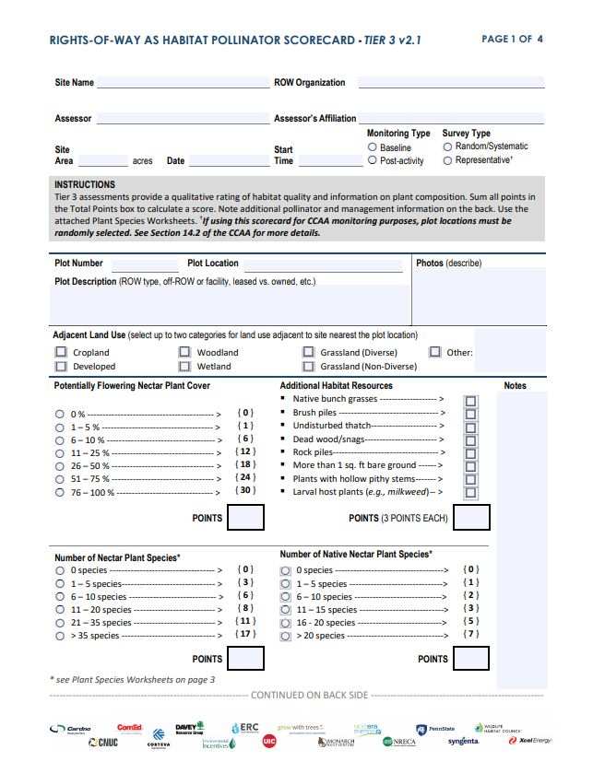
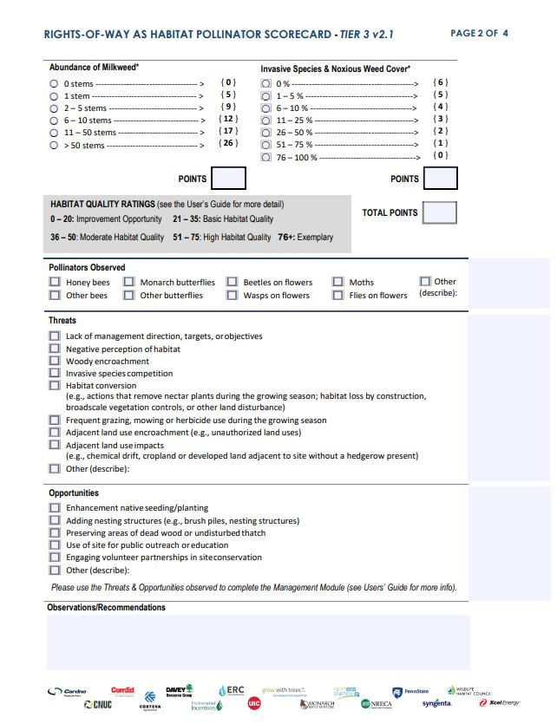
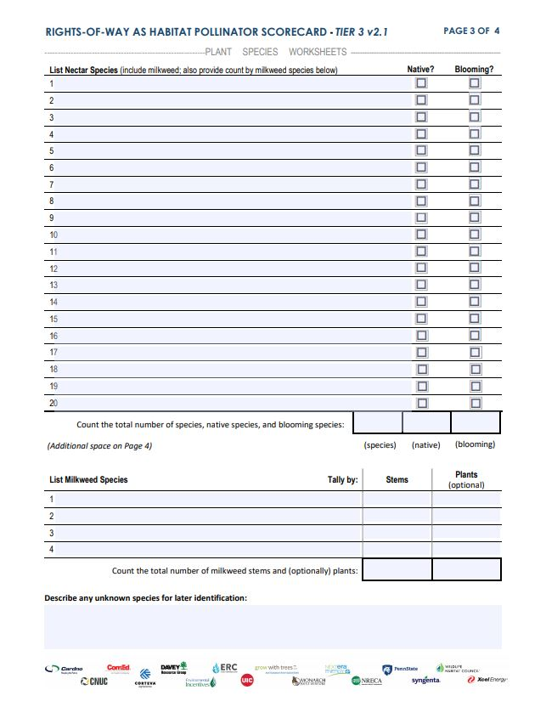
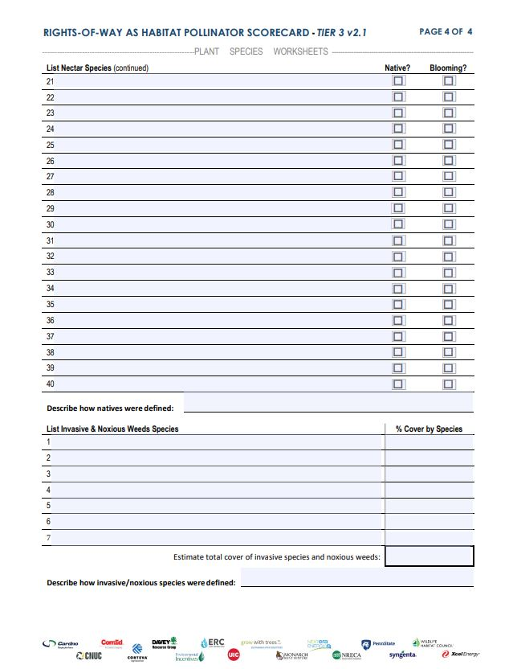

Appendix B
Plant Species Identified
Species
Scientific Name | Common Name | Fall Presence | Spring Presence | Presence at  # of Sites
Buchnera americana | American bluehearts | Y | N | 1
Chaetopappa asteroides | Arkansas leastdaisy | Y | N | 1
Sida rhombifolia | Arrowleaf sida | Y | N | 2
Helanthis mollis | Ashy sunflower | Y | N | 1
Aster sp. | Aster | Y | N | 12
Andropogon gerardi | Big blue stem | Y | N | 1
Cnidoscolus texanus | Bull nettle | Y | N | 3
Lespedeza thunbergii | Bushclover | Y | N | 2
Lespedeza cuneata | Chinese bushclover | Y | N | 1
Potentilla sp. | Cinquefoil spp | Y | N | 2
Agalinis tenuifloia | Common gerardia | Y | N | 1
Asclepias syriaca | Common milkweed | Y | N | 1
Rudbeckia sp. | Coneflowers | Y | N | 2
Pyrropappus sp. | False dandelion | Y | N | 5
Erigeron sp. | Fleabane | Y | Y | 14
Setaria sp. | Foxtail | Y | N | 9
Coreopsis tinctoria | Golden tickseed | Y | N | 2
Solidago sp. | Goldenrod | Y | N | 6
Asclepias viridis | Green milkweed | Y | N | 12
Chryopsis villosa | Hairy golden aster | Y | N | 1
Desmanthus illinoensis | Illinois bundle flower | Y | Y | 4
Vernonia sp. | Ironweed | Y | N | 1
Phyla nodiflora | Lancefoot frog fruit | Y | N | 1
Helianthus maximilani | Maximmilan sunflower | Y | N | 1
Chamaesyce nutans | Nodding spurge | Y | N | 1
Chamaecrista fasciculata | Partridge pea | Y | N | 2
Passiflora incarnata | Passionvine | Y | N | 1
Ampelopsis arborea | Peppervine | Y | N | 1
Diodia virginiana | Poor joe buttonweed | Y | N | 2
Mimosa nutalli | Powderpuff | Y | N | 1
Ruellia humilis | Prairie petunia | Y | N | 4
Oenothera sp. | Evening primrose | Y | N | 1
Tridens flavus | Purple top | Y | N | 2
Dacus carota | Queens anne lace | Y | N | 1
Symphytochum subulatum | Saltmarch aster | Y | N | 1
Erigeron speciosus | Showy fleabane | Y | N | 1
Bothriochola laguroides | Silver blue stem | Y | N | 5
Lespedeza virginica | Slender bushclover | Y | N | 1
Froelichia sp. | Snake cotton | Y | N | 1
Helenium sp. | Sneezeweed | Y | N | 1
Rhus sp. | Sumac | Y | N | 2
Persicara hydropipoides | Swamp smartweed | Y | N | 1
Verbena halei | Texas vervain | Y | N | 1
Ambrosia sp. | Ragweed | Y | N | 7
Bidens aristosa | Western tickseed | Y | N | 2
Asclepias verticillata | Whorled milkweed | Y | N | 2
Croton capitatus | wolly croton | Y | N | 2
Neptinia lutea | Yellow puff | Y | N | 2
Cyperus ovalis | NA | Y | N | 2
Croton glandulosus | Vente conmigo | Y | N | 1
Acalypha monococca | Slender threeseed mercury | Y | N | 1
Schizachyrium scoparium | Little blue stem | Y | N | 1
Potentilla sp. | Cinquefoil Spp. | Y | N | 2
Vicia sativa | Common vetch | N | Y | 19
Sonchus asper | Spiny sowthistle | N | Y | 4
Oenothera laciniata | Cutleaf evening primrose | N | Y | 2
Verbena scabra | Sandpaper vervain | N | Y | 1
Oxalis stricta | Common yellow oxalis | N | Y | 4
Trifolium dubium | Lesser trefoil | N | Y | 19
Sherardia arvensis | Blue fieldmadder | N | Y | 9
Conyza canadensis | Horseweed | N | Y | 1
Chaerophyllum tainturieri | Southern chervil | N | Y | 7
Geranium carolinianum | Carolina geranium | N | Y | 8
Erigeron tenuis | Slenderleaf fleabane | N | Y | 1
Anemone caroliniana | Carolina anemone | N | Y | 7
Gnaphalium argenteus | NA | N | Y | 2
Plantago virginica | Virginia plantain | N | Y | 1
Lithospermum arvense | Field groomwell | N | Y | 1
Taraxacum officinale | Dandelion | Y | N | 1
Cerastium sp. | Mouse-ear chickweed | N | Y | 8
Nothoscordum bivalve | Crow poison | N | Y | 6
Erysimum repandum | Spreading wallflower | N | Y | 2
Rubus sp. | Dewberry | N | Y | 13
Arnoglossum plantagineum | Indian plantain | N | Y | 4
Silphium laciniatum | Compass plant | N | Y | 2
Dalea sp. | Prairie clover | N | Y | 1
Sisyrinchium | Blue-eyed grasses | N | Y | 10
Solidago radula | Western rough goldenrod | N | Y | 1
Echinacea sp. | Coneflower | N | Y | 1
Verbena bracteata | Bracted vervain | N | Y | 3
Lithospermum incisum | Fringed puccooon | N | Y | 1
Packera sp. | Ragwort/butterweed | N | Y | 2
Claytonia virginica | Virginia springbeauty | N | Y | 3
Lamium amplexicaule | Henbit | N | Y | 1
Ranunculus sp. | Buttercup | N | Y | 13
Rumex altissimus | Pale dock | N | Y | 4
Cerastium brachypodum | Short-stalked chickweed | N | Y | 2
Lathyrus mina | Sweet pea | N | Y | 1
Oenothera speciosa | Pink evening primrose | N | Y | 2
Carex cherokeensis | Cherokee sedge | N | Y | 3
Polytoenis nuttalliana | NA | N | Y | 2
Achillea millefolium | Common yarrow | N | Y | 5
Valerianella radiata | Corn salad | N | Y | 5
Trifolium incarnatum | Crimson clover | N | Y | 3
Bromus sp. | Cheat grass | N | Y | 3
Castilleja indivisa | Indian paintbrush | N | Y | 13
Allium sp. | Garlic fam | N | Y | 1
Campsis radicans | Trumpet creeper | N | Y | 2
Cirsium arvense | Creping thistle | N | Y | 1
Callirhoe alcaeoides | Light poppymallow | N | Y | 2
Apocynum cannabinum | Indian hemp | N | Y | 2
Erigon Sp. | NA | N | Y | 4
Hypoxis hirasta | Yellow star grass | N | Y | 1
Baptisia leucophaea | Cream wild indigo | N | Y | 1
Andropogon virginicus | Broom sedge | N | Y | 4
Lamium purpureum | Red deadnettle | N | Y | 2
Festuca arundinacea | Tall fescue | N | Y | 5
Physalis mollis | Field groundcherry | N | Y | 1
Vernonia baldwinii | Baldwin's ironweed | N | Y | 2
Vicia miniata | Scarlet pea | N | Y | 1
Coreopsis filifolia | NA | N | Y | 1
Lespedeza Sp. | NA | N | Y | 2
Scutellaria Sp. | Skullcaps | N | Y | 1
Luzula bulbosa | Bulbous bullrush | N | Y | 1
Liatris Sp. | NA | N | Y | 1
Marshallia caespitosa | Barberas buttons | N | Y | 1
Tradescantia occidentalis | Prarie spiderwort | N | Y | 1
Carex Sp. | sedge | N | Y | 1
Vicia villosa | Hairy vetch | N | Y | 2
Phacilia hirsuta | Hairy blue curls | N | Y | 4
Hymenopappus scabiosaeus | Carolina woollywhite | N | Y | 1
Krigia Sp. | Dwarf dandelions | N | Y | 5
phlox pilosa | Prairie Phlox | N | Y | 1
Narcissus Sp. | Primerose | N | Y | 2
Apiaceae Sp. | Carrott family | N | Y | 3
Geranium dissectum | Cutleaf gernanium | N | Y | 2
Trifolium respipinatum | Persian clover | N | Y | 1
Cirsium horridulum | Bristle thistle | N | Y | 1
Glandularia Sp. | Mock verbena | N | Y | 1

