UNIVERSITY OF OKLAHOMA
GRADUATE COLLEGE

ECHOES OF HERITAGE: CO-CREATING A CULTURAL HERITAGE CURRICULUM WITH THE CHOCTAW NATION OF OKLAHOMA’S HISTORIC PRESERVATION OFFICE USING ARCHAEOLOGY AS A TOOL

A THESIS
SUBMITTED TO THE GRADUATE FACULTY
in partial fulfillment of the requirements for the
Degree of
MASTER OF ARTS

By
Kaylyn Moore
Norman, Oklahoma
2024

ECHOES OF HERITAGE: CO-CREATING A CULTURAL HERITAGE CURRICULUM WITH THE CHOCTAW NATION OF OKLAHOMA’S HISTORIC PRESERVATION OFFICE USING ARCHAEOLOGY AS A TOOL

A THESIS APPROVED FOR THE
DEPARTMENT OF ANTHROPOLOGY

BY THE COMMITTEE CONSISTING OF

Dr. Bonnie Pitblado, Chair
Dr. Asa Randall
Dr. Sean O’Neill

© Copyright by KAYLYN MOORE 2024
All Rights Reserved.
Acknowledgments
I would like to express my thanks to several people. Firstly, to my parents, whose support has helped me through every journey. To Emma, Steppen, Cheyenne, Sierra, Sammi, Jovie, Delaney, and Amanda, thank you for being my support system. Dr. Mel Zabecki, thank you for inspiring me to do my best in my career as an archaeologist. Dr. Bonnie Pitblado, your guidance has been instrumental in achieving my thesis goals. Special shoutout to my collaborators for their dedication in creating our curriculum and for the friendships we've built along the way. Lastly, a thank you to Scooby Doo and the gang for sparking my interest in archaeology at the age of 5.

Table of Contents
LIST OF TABLES vi
LIST OF FIGURES vii
Abstract viii
Chapter 1 1
Introduction 1
Chapter 2 5
Theoretical Background 5
Chapter 3 18
Oklahoma State Standards, Crafting Curriculums, and Introducing Lesson Plans 18
Chapter 4 24
Learning to Craft Curricula 24
Chapter 5 31
Community-Based Participatory Research with the Choctaw Nation of Oklahoma’s Historic Preservation Office 31
Chapter 6 48
Lesson 1: Introduction to Indigenous Archaeology and Cultural Heritage 48
Chapter 7 53
Lesson 2: Forgotten Voices: Exploring Narratives Through Archaeology, Primary Sources, and Oral Histories 53
Chapter 8 60
Lessons 3 to 5: Future Lessons 60
Chapter 9 66
Discussion and Conclusion 66
Appendix A 71
Appendix B 78
Bibliography 85

LIST OF TABLES
Table Page Page
Collaborative Continuum 7

Archaeology v. Indigenous Archaeology definitions 10
Oklahoma History Content Standards for Oklahoma history classes 20
Topics included and excluded in state standards (Journell 2009) 28
Details of meetings throughout the collaboration process 36
Oklahoma state standards used for the curriculum 39

LIST OF FIGURES
Figure Page
- Seven types of Public Archaeology 12
- Three components of a curriculum 22
- Planning a lesson backwards 23
- Deanna Byrd 31
- Kim Hinson 32
- Ki Jim 32
- Kyra Hornbuckle 33
- Ryan Spring 33
- Poster presented at the 79th Plains Anthropological Conference 42
- Instructional procedures of Lesson One 48
- Connections game part one created for Lesson One 49
- Connections game part two created for Lesson One 49
- First page of Lesson One 51
- Historical context of Lesson One 52
- First page of Lesson Two 55
- Contextual paragraph for Lesson Two 56
- Historical context for Lesson Two 57
- Activity for Lesson Two 58
- Activity resources for Lesson Two 59
- Contextual paragraph for Lesson Three 61
- Historical context for Lesson Three 62

ABSTRACT
Collaborative archaeology fosters relationships between communities and archaeologists to create new perspectives of the past. This thesis examines the collaborative process between archaeologists from the Choctaw Nation of Oklahoma’s Historic Preservation Office and myself, aiming to develop a curriculum focusing on Choctaw cultural heritage utilizing archaeology as a tool for Oklahoma history classes. While archaeology education seeks to educate the public about the importance of cultural preservation, it often excludes voices of the descendant communities being discussed. In Oklahoma history classrooms Indigenous voices are rarely represented hindering students’ connection to the past. Through embracing Community-Based Participatory Research (CBPR), this project outlines the collaborative process used to create a curriculum focused on Choctaw cultural heritage. This thesis seeks to provide new insights into collaborative archaeology and archaeology education, and to offer guidance to those interested in pursuing similar projects.

Chapter 1

Introduction
In archaeology education there is often a gap that remains unfilled: pedagogically trained archaeologists and archaeologically literate teachers. This gap can limit the impact of archaeology education materials, showing the need for collaboration and training to convey the significance of archaeology and cultural heritage. Typically, archaeology education is either site-based or culture based, which is important from an archaeological standpoint. However, there is a vital element that is often overlooked- the input of descendant communities into the curricula. Many archaeology curricula delve into specific communities and their lifeways, yet these lessons are missing key features like the community perspectives. With these missing perspectives, the curricula are often framed in a past tense, neglecting the very much alive and thriving cultural traditions that these groups hold. While some archaeologists make the effort to engage with these communities, such initiatives in educational content remain rare. This thesis presents a collaborative project to create an archaeology curriculum with five lessons focuses on Choctaw cultural heritage, with the goal of discussing the pivotal role that collaboration and education play in archaeology.
Entering graduate school, I was well aware that my path to a thesis would not follow a conventional route, given my fascination with the intersection of archaeology and education. Although initially daunting, I came to appreciate that the element of fear was what drove me to tackle this thesis topic. Breaking away from a traditional thesis, my thesis takes the form of an ongoing collaborative project, forged in building a relationship with an Indigenous community to create a cultural heritage curriculum using archaeology as a tool.
In my second semester of graduate school, I was introduced to the Historic Preservation Office (HPO) of the Choctaw Nation of Oklahoma through the Oklahoma Public Archaeology Network (OKPAN). Collaborating with the Choctaw Nation HPO, two interns at OKPAN created a relationship to relaunch the annual Indigenous Archaeology Day at the Choctaw Nation Cultural Center that had been on pause due to the covid-19 pandemic. During their collaborative project, it came to light that the HPO was interested in creating an Indigenous archaeology curriculum. Given my interest in public archaeology and education, the students mentioned my desire to create a curriculum for my thesis. This led to our formal introduction, during which the HPO and I recognized our common interests in education. We saw an opportunity to use our respective strengths to co-create a cultural heritage curriculum, grounded in the perspective of the Choctaw Nation of Oklahoma and to be taught in 9th grade Oklahoma history classes.
Beyond exclusively targeting the archaeology community, this thesis aims to reach teachers, communities, the public, students, and diverse readership. The motivation of this inclusivity lies in my belief that my thesis holds relevant for them. Teachers, for instance, might utilize both the curriculum and research to introduce students to archaeology and their heritage. Through my work, I aspire to convey that archaeologists are continuously learning how to be active listeners in collaborative projects. For the public, the overarching message is to show that community voices are alive and thriving. Lastly, for students, the aspiration is for them to recognize the significance and value of their own heritage.
Within this thesis, I navigate through nine chapters, each strategically presenting the significance of my argument. The background chapter serves as the foundation, delving into four topics: Community and collaborative archaeology, Indigenous archaeology, K-12 archaeology education, and pedagogy. I discuss the history and impact of Indigenous archaeology to field of archaeology. K-12 archaeology education provides an overview of its transformative role in introducing the importance of heritage preservation to the broader public. Additionally, I discuss the critical role community and collaborative archaeology plays in shaping the present and future of archaeological research. Lastly, I look at pedagogy’s influence on education, focusing on two pedagogical scholars, John Dewey and Paulo Freire.
Chapter three provides readers with information on Oklahoma State Standards, curriculum building and lesson plans. This section is essential for understanding the succeeding chapters that present the co-created curriculum. In this chapter, I discuss the role of Oklahoma State Standards in classrooms, which provide teachers with the overarching content that students are expected to know by the end of the year. I then offer an overview of curriculum building, emphasizing its importance of designing educational goals, materials, strategies, and evaluations to create effective learning. Lastly, I explain what a lesson plan is and how it provides the specific details and activities necessary to achieve a curriculum’s objectives.
Chapters four and five discuss the educational foundation and collaboration that underpin this thesis. The educational foundation examines work of various education scholars that influenced the layout of the curriculum. Chapter five discusses the collaboration with the Choctaw Nation Historic Preservation Office (CNO-HPO) through the Community-Based Participatory Research (CBPR) approach, which emphasizes reciprocal relationships that contribute new perspectives to the archaeological record. This meticulously details the relationship-building with the CNO-HPO, outlines our meetings, and the deliberate steps taken to foster the collaborative approach.
The last four chapters present the in-progress curriculum on Choctaw cultural heritage and concluding discussion. Chapters six and seven detail of the two complete lessons, Lessons One and Two, which introduce archaeology and different archaeological methods archaeologists use in their research. Chapter eight provides a glimpse into Lessons Three, Four, and Five, which explore Choctaw Nation cultural heritage, the Coalgate mining site excavation and curation, and careers in archaeology. This curriculum serves as a product of collaborative efforts to create archaeological education content. Lastly, I close with a discussion about the project, highlighting its positives, negatives, implications, and future directions.

Chapter 2

Theoretical Background
This chapter looks at the background research conducted to develop a collaborative project that is producing a curriculum for Oklahoma high school students that focuses on cultural heritage and preservation with archaeology as a tool. The research examines four concepts that shaped the project’s framework. Specifically, the progression encompasses community archaeology, Indigenous archaeology, K-12 archaeology education, and educational pedagogy. Community archaeology discusses the archaeology that is by, for, and with communities to create new perspectives on the archaeological record. Indigenous archaeology is done by, for, and with Indigenous peoples to investigate Indigenous knowledge systems and practices. K-12 archaeology education illustrates how archaeologists engage in public outreach through educational efforts in classrooms. Lastly, educational pedagogy presents the theoretical underpinnings for understanding the educational knowledge needed for this project. These are imperative to understanding the projects contribution to the field of archaeology.
Community and Collaborative Archaeology
Community collaboration is a familiar concept within the realms of social sciences and archaeology. Community archaeology seeks to engage with communities to develop archaeological research that is by and for the people (Atalay 2012, Colwell-Chanthaphonh and Ferguson 2008). Given that communities are not homogenous, there is no distinct way for practicing community archaeology. Numerous archaeologists have written about this and its attempts to practice archaeological research that includes the knowledge of descendant communities.
Community work can be practiced in multiple forms, with models provided by Colwell-Chanthaphonh and Ferguson (2008), Marshall (2010), and Atalay (2012). Colwell-Chanthaphonh and Ferguson draw upon the Collaborative Inquiry model developed by educators at Columbia University, proposing a method of reflection and action. This model involves four stages: 1) establishing a group of researchers to co-create research with, rather than on or about the community; 2) engaging in reoccurring cycles of reflection throughout the collaboration; 3) identifying research questions with shared interests; and 4) constructing group knowledge to guide the project. These four methods are pertinent to community archaeology as they emphasize the importance of collaboration as a mutual benefit, rather than taking advantage of the community’s knowledge (Colwell-Chanthaphonh and Ferguson 2008).
Alongside the Collaborative Inquiry model, Colwell-Chanthaphonh and Ferguson introduce the concept of the collaborative continuum, which frames collaboration as existing on a spectrum. The collaborative continuum consists of three stages: resistance, participation, and collaboration, each playing fundamental roles in the engagement and involvement of the partners in the research. For examples, resistance is characterized by goals, information, and lack of involvement by one party, while collaboration entails co-created goal setting, full stakeholder involvement, and needs of both partners being fulfilled, illustrating that collaboration can vary along a continuum. Table 1 expands on the continuum (Colwell-Chanthaphonh and Ferguson 2008).

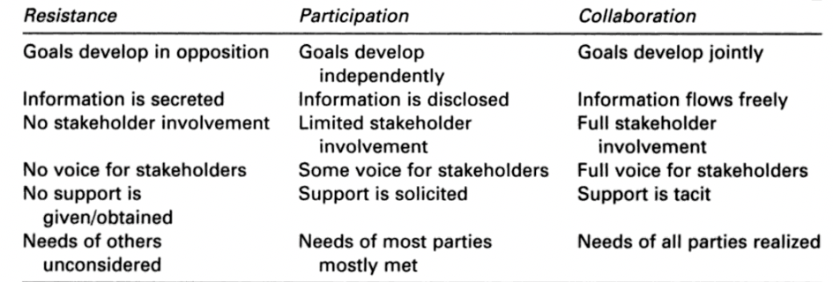

Table 1: Collaborative Continuum. Note. Adapted/Retrieved/Reprinted from Introduction: The Collaborative Continuum by Colwell-Chanthaphonh and Ferguson, 2008, Alta Mira Press.
Yvonne Marshall (2010) outlined seven components that should be considered when collaborating: research questions or interests, setup, practices, data collection, analysis, storage and dissemination, and public presentation. Marshall’s approach leans towards a focus on fieldwork activities. In her work, she defines two types of communities that arise in collaborative efforts: local residents near a site and descendant communities. When discussing these communities, Marshall cautions archaeologists to be careful when doing collaborative work. She stresses the importance of avoiding assumptions about community interests, as they can lead to negative consequences. She draws upon multiple projects to further illustrate her point. She highlights cases where descendants discover opportunities for reconciliation resulting in impact on the community. Marshall also mentions of situations where local, non-descendant communities are concerned about religious monuments not related to them, showing that care of archaeological sites extends beyond descendant communities. Furthermore, archaeologists must not rule out the potential of other communities being involved by presuming who may or may not be involved in collaborative work (Marshall 2010). While this approach looks at collaborative efforts through fieldwork, it is still vital to this project as it emphasizes the presumptions archaeologists must be cautious of when doing community archaeology.
To add onto the need for collaborative work, archaeologists must consider that collaboration and community involvement must go further than the consultation required by federal laws such as Section 106 (pertaining to potential impact of historical properties that may fall under the National Historic Preservation Act) and repatriation through the Native American Grave and Repatriation Act (returning of Native American belongings and remains to descendant communities). La Salle (2010) emphasized this by saying that collaboration transcends past formal procedures, as it is about rectifying power imbalances between archaeologists and communities to ensure equality through collaborative efforts.
Lastly, Sonya Atalay (2012), introduced Community-Based Participatory Research, which is centered on collaboration with, by, and for communities. Atalay presents the approach of community-based research that has been effective outside of archaeology. For example, a health crisis on the Navajo reservation used CBPR to incorporate traditional Navajo knowledge onto the Centers for Disease Control (CDC) website for better access to health solutions (Atalay 2012). A key objective to CBPR in archaeology is to establish a reciprocal relationship benefiting both partners, that addresses the concerns that matter most to communities, as they care deeply about their heritage (Atalay 2012).
Atalay (2012) introduces the concept of “braided knowledge,” which illustrates how community knowledge can influence archaeological interpretations of the past. Braided knowledge weaves together different knowledge systems to create a better understanding of the archaeological record. Collaborative relationships that build upon these new interpretations extend beyond archaeological discoveries, creating a deeper understanding of the past and how to present data (Atalay 2012).
An aspect of CBPR is the emphasis of learning in community research. To advance collaborative approaches, students must further their efforts and be receptive to listening and learning from community knowledge. Collaborative archaeology plays a pivotal role in the future of archaeological research by amplifying the voices of historically marginalized groups. By forging relationships through CBPR, archaeology becomes conducive to new learning opportunities, enriching knowledge systems, and benefiting from shared expertise to protect heritage sites and further inclusive archaeological research. (Atalay 2012).
Community archaeology is a long overdue approach that is becoming more prevalent in research today, see Adams et al. 2020 and Bria and Vasquez 2022. By including community voices, we open avenues to grow the field and create new interpretations of the past. As we forge relationships, archaeology moves away from its colonial past, creating a more inclusive and equitable field.
Indigenous Archaeology
Indigenous histories have historically been controlled by archaeologists by using Indigenous heritage to construct the past within a scientific lens excluding communication with descendant communities and their own understanding of the past. Conventional archaeology can be defined as the study of material culture to understand past people’s social organization, art, sense of place, and daily lives; while Indigenous archaeology is an archaeological theory and practice that is done by, for, and with Indigenous people, emphasizing the interaction with Indigenous values, knowledge, and practices (Atalay 2006; Nicholas 2008). Table 2 shows the difference between archaeology and Indigenous archaeology. This theory seeks to redress the colonial past of archaeology to incorporate Indigenous voices and broaden the interpretation of the archaeological record through Indigenous knowledge.
Archaeology v. Indigenous Archaeology | Definition | Differences
Archaeology | The study of material culture to understand the daily lives, sense of place, diet, art and social organization of people in the past (Atalay 2006). | Typically falls within a western centered knowledge system.
Indigenous Archaeology | A practice and theory that is done by, for, and with Indigenous people to investigate Indigenous experiences, knowledge systems, and practices (Atalay 2006). | Aims to deconstruct westernized archaeological practices and conduct research that is beneficial to descendant communities and archaeology.
Table 2: Archaeology v. Indigenous Archaeology definitions
Indigenous archaeology does not have one single, universally accepted definition, rather Nicholas (2008) presents eight broad components of the theory: 1) participation and consultation with Indigenous peoples, 2) a political statement concerned with Indigenous sovereignty and heritage, 3) to decolonize the discipline, 4) manifestation of Indigenous beliefs and knowledge, 5) alternative models for cultural heritage and stewardship, 6) product of actions by archaeologists, 7) empowering cultural revitalization, and 8) an extension of archaeological theory (Nicholas 2008). Each of these can be practiced alone or collectively, creating a theory that can be used in multiple ways in archaeological research. Nicholas underscores that the principal goals of Indigenous archaeology are to broaden and transform archaeological theory through Indigenous interests and concerns. He gives examples such as education, preservation, revitalization, and repatriation.
McGhee (2008) critiques the theory of Indigenous archaeology by stating it is based on essentialism, which generalizes Indigenous peoples in a way that distinguishes them from European populations. He argues that there is no significant evidence that Indigenous people possess qualities in reference to distinct views of time, understanding of the world, and oral traditions in relation to the past, following a strictly scientific view of the archaeological record ignoring the complex nature of archaeological practice in understanding the past. Therefore, meaning that by distinguishing their histories from non-Indigenous people creates a dichotomy that places Indigenous people in the “other” category.
Colwell-Chanthaphonh and colleagues (2010) challenge McGhee’s view that Indigenous archaeology is an essentialist theory by stating that the colonial legacies present a strong foundation for collaborating with Indigenous peoples on archaeological projects to incorporate new perspectives of the past. They stress that Indigenous archaeology is a multifaceted approach that does not have one goal but strives to advance archaeology to better understand the past through a new lens.
Some disagree, most agree that Indigenous archaeology does not have to be practiced by only Indigenous individuals (Atalay 2006; Colwell-Chanthaphonh et al. 2010; Nicholas 2008). Rather, Indigenous archaeology can be practiced by anyone who strives to incorporate Indigenous views, knowledge, practices, and heritage into the archaeological record, creating new perspectives of the past. By working to have inclusive archaeology, Indigenous archaeology, aims to bridge gaps between archaeologist and Indigenous peoples to create an archaeology that empowers Indigenous voices.
K-12 Archaeology Education
Public archaeology can be defined as engaging with the broader public to dispel misconceptions about archaeology and teach the importance of preserving the past (Jameson 1997; Little 2002, Meriman 2004; Moshenska 2017; Smardz and Smith 2000). Moshenska (2017) presents seven categories of public archaeology, which can be seen in Figure 1. This thesis focuses on box number 4, K-12 archaeology education, which aims to develop educational materials for schools highlighting the importance of archaeology. The US public education system aims to construct collective memory, critical thinking, and knowledge exploration throughout a student’s time in the classroom. By incorporating archaeology into classrooms, it provides an interdisciplinary approach that offers a fertile laboratory for cultivating critical thinking. For example, archaeology can be used in physics classrooms to learn about radiocarbon dating or into social studies to teach the significance of diverse perspectives. Archaeology also offers critical thinking skills through the interpretation of evidence and contextual analysis of things such as artifacts, context, and stratigraphy.

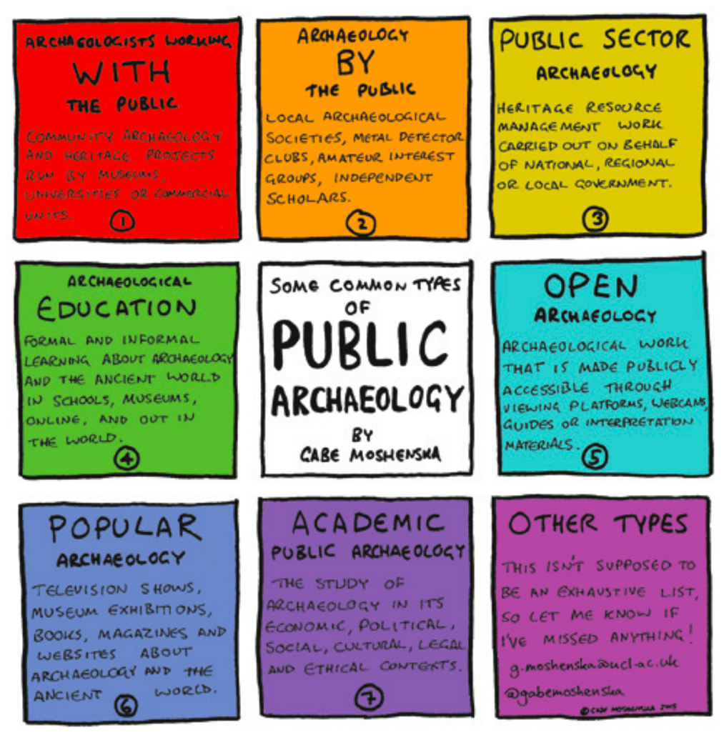

Figure 1: Seven types of Public Archaeology. Note. Adapted/Retrieved/Reprinted from Key Concepts in Public Archaeology (pg. 6) by Moshenska 2017, UCL Press.
Archaeology can play a role in education by offering students a unique perspective of the past. Smardz and Smith (2000) highlight the importance of sharing the past with kids, suggesting that it can create an appreciation for the past, potentially leading to a deeper understanding of the past and stewardship of archaeological sites (Smardz and Smith 2000). They stress that for educators, archaeology presents a new lens into the past that can align within the standards of school systems. This provides opportunities to explore shared experiences among students and create a sense of belonging within the classroom.
Due to students’ inherent fascination with the past, teachers may embrace teaching archaeology because it offers an appealing way to introduce the scientific method in the classroom (Smardz and Smith 2000). Erdman (2019) stresses that teachers should introduce the collective past at an early age, creating a space for archaeology to be introduced into the classroom. Thus, archaeology can serve as a tool to impart these skills by incorporating connections into the past.
Project Archaeology, an organization pivotal in K-12 archaeology education since the 1990’s, focuses on teaching scientific and historical inquiry, as well as the importance of protecting cultural heritage resources through educational materials (Project Archaeology 2024). Drawing from science educators, Project Archaeology has used the theoretical framework of enduring understanding to comprehend how students learn (Moe 2019). Enduring understanding is used by Project Archaeology to help create content that students will retain overtime, even after the lessons are completed. One of their curriculums, “Investigating Shelter,” designed for grades 3 through 5, teaching inquiry through exploring the role of shelters in past cultures. In this curriculum, they emphasize four enduring understandings: 1) understanding the past is essential to understanding the present, 2) appreciating culture is essential to living in a multicultural society, 3) archaeology is a way to learn about past cultures, and 4) stewardship of archaeological sites is everyone’s responsibility (Project Archaeology 2009). These understandings prioritize student engagement rather than the memorization of facts. Furthermore, the organization has equipped archaeologists with tools to create archaeology education that connects students to the past through shared experiences.
Moe (2019) emphasizes that students are not “blank slates” but rather bring prior knowledge to their learning experience. This recognition offers consideration when integrating archaeology into classrooms, as students existing knowledge may influence their understanding of archaeology. To address this, Moe stresses the importance of providing teachers with the necessary materials and knowledge of archaeology. For example, Project Archaeology’s curricula consider two questions: “What do we want students to understand and remember in twenty years? What do teachers need to guide students to that enduring understanding?” (Moe 2019). These questions show archaeologists that they must provide teachers with the tools to effectively convey the messages of the lessons. Project archaeology was innovative for its time in its inclusion of other voices, but there is more room to fully engage with communities to build education content.
A challenge faced in archaeology education in traditional K-12 classrooms is the expectation for teachers to include archaeology content without adequate support from archaeologists (Erdman 2019). This challenge has consistently hindered teachers’ willingness to include archaeology in their classrooms. White (2019) notes that the change in the American school system since the 1980’s, shifting to implementing common core standards and testing, places additional demands on teachers, leaving them with limited time to deviate from their given standards. While this presents a challenge for educators and archaeologists, there are methods for introducing archaeological concepts into classroom to alleviate some of the burdens placed on teachers. These include focusing on concepts that are already being introduced in the classroom, building curriculum based on the understanding that students have prior knowledge, and crafting lessons that teachers need little preparation and minimal materials for.
Archaeology education offers a platform for students whose voices have been historically marginalized (Henderson and Levstik 2016). By incorporating archaeological methods into classrooms, students are empowered to recognize themselves within a historical narrative. Learning about cultural belongings through an archaeological framework fosters critical thinking skills and enables students to interpret the world around them. This creates a humanistic approach where students can connect themselves to their heritage through learning about the past. Henderson and Levstik (2016) see the integration of archaeology in schools as a means for students to fully grasp what it means to be human. Consequently, archaeology should not be a sidelined program, but rather be recognized as deserving inclusion in educational frameworks.
Pedagogy
Pedagogy can be defined as the practice of teaching, applying various approaches to create an instructional process. This involves learning how to understand the needs of learners to transmit knowledge that helps develop social, emotional, and cognitive abilities (Kabulova 2023). Understanding particular forms of pedagogy, for example those from educational pioneers John Dewey and Paulo Freire, offer educators the groundwork for crafting their own teaching methods to create an environment conducive to mutual learning with their students. Education pedagogy strives to create a student-centered learning experience, aiming to promote active listening and engagement with the students. Foundational figures such as Dewey and Paolo Freire have influenced the field of pedagogy, offering critical discourse that aid educators in discovering their own methods of teaching.
Dewey (1899; 1900) is foundational to modern pedagogy as his views shaped how educators approach teaching. He viewed education as a social process that is essential for individual growth through connecting learning with students’ lived experiences. Dewey advocated for several concepts, learning by doing, being student-centered, interdisciplinary approaches, social environments, and adapting to societal changes. He believed that education should actively engage with students to foster learning and growth. Pedagogy, according to Dewey, should involve the idea of “learning by doing,” wherein education provides a space for students to learn through hands-on activities relevant to their everyday lives. Through this method, students develop new knowledge and critical thinking skills. Thus, pedagogy offers a hands-on learning experiences allow students to connect their education with real life contexts. Additionally, Dewey saw pedagogy as a means to utilize culture and history as central components of education. He underscored the importance of actively engaging students with learning about different cultures and perspectives of history, as this promotes a place for dialogue with peers and enhances their understanding of the past (Dewey 1899). Moreover, Dewey’s pedagogy serves as a guide for educators to connect students to the past through shared experiences, instilling a respect for the world around them.
Freire (1968) is another foundational figure in pedagogical studies, offering insights into teacher-student relationships and their impact on classroom environments and learning. He critiqued traditional pedagogy, often characterizing it as “banking education,” where teachers are viewed as strictly teaching students to impart knowledge via memorization. Freire introduced a new approach called, “problem-posing.” This method promotes actively engaging with students as co-learners with teachers, rather than passive receivers of knowledge. Problem-posing pedagogy strives for continuous dialogue, questioning, reflecting, and problem-solving to deepen students understanding of the past. Freire saw this approach as empowering students to make a difference in their communities by critically thinking about their own social reality (Freire 1968). Furthermore, Freire’s pedagogy emphasized creativity and agency among students, enabling them to understand the past to work towards a better future.
More recently, pedagogical studies have expanded on Dewey and Freire to emphasize the importance of inclusivity and engagement of every student. Ladson-Billings (1995) and Paris (2012) offered two approaches to pedagogy: cultural relevance and culturally sustaining practices (Ladson-Billings 1995 and Paris 2012). Culturally relevant pedagogy (CRP) highlights the significance of incorporating all students’ voices and backgrounds into classrooms to foster active learning through relevance. Culturally sustaining pedagogy (CSP) builds upon CRP to add to the importance of linguistic and cultural pluralism in pedogeological practices (Paris 2012). Both state that creating a sense of belonging in the classroom creates an interest in learning among students. Teachers must leverage the multiculturalism of their classrooms to create an inclusive space where all students are excited to learn. Therefore, pedagogy encompasses a variety of teaching methods that are aimed at building an instructional process that focuses on students’ interest in expanding their knowledge and views of society.

Chapter 3

Oklahoma State Standards, Crafting Curriculums, and Introducing Lesson Plans
This chapter overviews Oklahoma History state standards, curricula, and lesson plans, offering readers context for understanding the curriculum introduced in chapters six, seven, and eight. Understanding state standards and their purpose is vital for grasping the objective of a curriculum. Additionally, I explain what a curriculum and a lesson plan are to highlight their differences to understand the cultural heritage curriculum’s format. It is worth noting that while standards, curricula, and lesson plans are related to one another, they are different components that make up the structure of the content in this project.
Oklahoma State Standards
In 1983, during Ronald Reagan’s presidency, a report called, “Nation at Risk,” raised nationwide concerns over education. The report revealed disparities in the content being taught in schools, potentially leading to learning gaps for students transferring between school districts. In the early 1980’s, Oklahoma responded with its first state standards, called “Suggested Learner Outcomes,” aiming for consistent teaching in schools (KOSU 2014). Since then, the Common Core Standards (CCSS) (a set of educational standards for teaching) have been put into place, allowing each state to adopt methods that align with CCSS. Using the CCSS, the state of Oklahoma established the Oklahoma Academic Standards (OAS) to define what students are expected to know by the end of the school year (Cole 2024).
The Oklahoma Academic Standards aim to do six things: “1) focus on deep thinking, conceptual understanding, and real-world problem solving skills, 2) set expectations for students to be College, Career, and Citizenship Ready, 3) incorporate literacy in Science, Social Studies, and Technical Subjects, 4) emphasize the use of citations and examples from texts when creating opinions and arguments, 5) increase rigor and grade-level expectations, and 6) determine the full range of support for English Language Learners and Students with Special needs” (OK Department of Education 2024). While this is the goal of the Oklahoma Department of Education, a disconnect is present between the expectations and content being taught, which can be seen in its education rankings compared to other US states. US News reports that in 2023, Oklahoma was ranked 48th among the 50 states in the US, with K-12 schools ranked 49th and higher education 35th (US News & World Report 2024).
For social studies courses, specifically 9th grade Oklahoma History, the outcomes of the course are to examine the events and people that transformed the state of Oklahoma. Students do this by examining political movements, culture, economics, and political accomplishments, therefore leaving with an understanding of Oklahoma’s history in relation to other local, national, and global contexts (Oklahoma Social Studies Framework 2022). This course is taught as a yearlong class that progresses from before statehood to present day Oklahoma. Within the Oklahoma History state standards, there are six broad units, each with detailed subunits that outline the specific content being taught (a unit creates the framework that spreads out the content being taught throughout the year). Each unit covers a defining moment in Oklahoma history that has impacted the state. Table 3 lists the standard and objectives for each unit. Within each standard, students are expected to critically think about the influence of the state’s history and its relevance to their daily lives.

Oklahoma History Content Standards (OKH) (Oklahoma Standards 2024)
Unit (OKH) | Objective
OKH.1 | “The students will describe the state’s geography and the historic foundations laid by American Indian, European, and American Cultures.” (OK Standards 2024)
OKH.2 | “The students will evaluate the major political and economic events that transformed the land and its people from early contact through Indian Removal and its aftermath.” (OK Standards 2024)
OKH.3 | “The students will evaluate the major political and economic events that transformed the land and its people from the outbreak of the Civil War through allotment and land openings” (OK Standards 2024
OKH.4 | “The students will analyze the formation of constitutional government in Oklahoma.” (OK Standards 2024)
OKH.5 | “The students will examine the Oklahoma’s pollical, social, cultural, and economic transformation during the early decades following statehood.” (OK Standards 2024)
OKH.6 | “The students will investigate how post-war social, political, and economic events continued to transform the state of Oklahoma from the 1950’s through the present.” (OK Standards 2024)

Table 3: Oklahoma History Content Standards for Oklahoma history classes

Curricula
Different from standards, which broadly define what students are expected to learn, curricula refer to the content taught to achieve the standards (Lee 2024). A curriculum, in simple terms, is a structured guide created by teachers that encompasses the materials needed, assessments, and goals to teach the standards of the course. An ideal curriculum is expectation equitable, culturally responsive, and offers multiple ways of learning to adapt to the students (RIDE 2023). Mitchell (2017) stresses that in curriculum making educators must critically engage in what and how they want to teach within the standards. When developing a curriculum, one must understand it is not rigid; instead, it is fluid, with various components constantly evolving.
While considering the creation of a curriculum, three components should be included: 1) teachers’ choice, 2) student experiences, and 3) the diversity of the school (Mitchell 2017). Each of these offer a space for teachers to make a curriculum that provides opportunity to enhance the content required in the standards. Figure 2 illustrates the process to create a curriculum using the three components above. Lastly, it is important to note that a key difference between curricula and lesson planning (discussed below) is that curriculums are known as the ‘in between’ stages (Lambert and Morgan 2010), meaning that it is the process between state standards and lesson planning. Therefore, a curriculum is the piece that translates the two into the classroom. Moreover, curriculum is the part in education that guides teachers to create content that students are expected to learn.

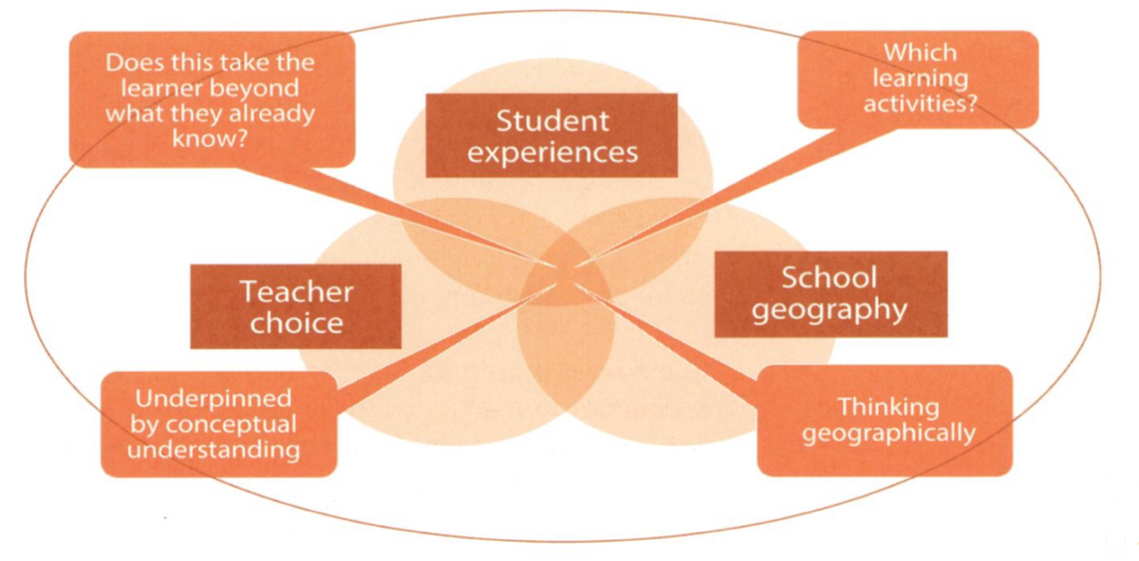

Figure 2: Three components of a curriculum. Note. Adapted/Retrieved/Reprinted from Curriculum Making, Teaching, and Learner Identities in Changing Times (pg. 99) by Mitchell, 2017, Geography: 1(2).
Lesson Plans
A lesson plan is the intricate aspect of teaching that ties in the curriculum and standards to reach the goal of educating students. Lesson plans, then are known to be the “activity” to achieve the goals of the standards in the education process (Hoover 1967). A lesson plan is as a written description of the education process that students will go through, including what methods will be taught, the time and place of the lesson, and evaluation of the students (Farhang et al. 2023). When non-traditional educators create lesson plans, they should keep in mind that teachers may not have the capacity or time to move their focus to learning materials that they are not familiar with; therefore, lessons should be designed with the idea that a beginner teacher can teach it with minimal preparation (Farhang et al. 2023). Besides simplicity, lesson planning varies from school to school, meaning that some schools or districts have curated templates heavily focused on the standards (Rann 2017).
Lastly, when crafting a lesson plan, an essential component for effectiveness is planning backwards. Planning backwards focuses on academic objectives first, then creates the lesson content that will be taught. By utilizing the backward planning technique illustrated in Figure 3, educators can determine the learning outcomes of the students before developing the lesson (Rann 2017).
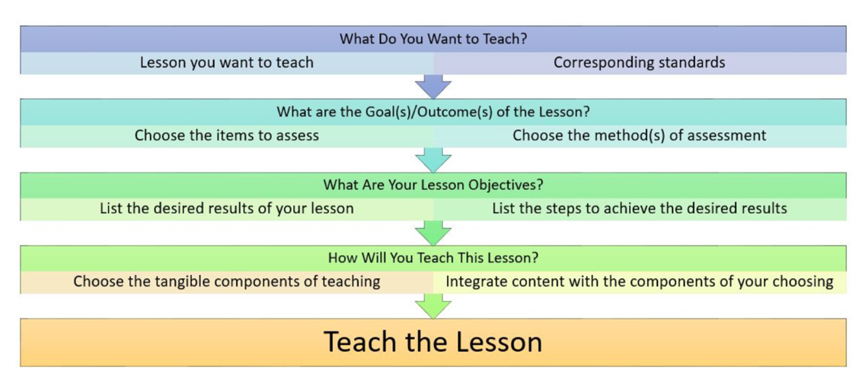
Figure 3: Planning a lesson backwards. Note. Adapted/Retrieved/Reprinted from https://urbanedmixtape.com/2017/01/31/the-tedious-art-of-lesson-planning/ by Rann 2017.
Each step offers an essential element in lesson planning, from brainstorming your topic to the logistics of the lesson. Consequently, lesson plans are a road map for teachers to use when teaching the objective of the standards.

Chapter 4

Learning to Craft Curricula
Upon undertaking this project, I quickly recognized the need to expand my education knowledge beyond archaeology if I were going to create an effective curriculum. It is one thing to know what curricula and lesson plans are; it is another to understand how to craft them. Therefore, in Spring 2023, I enrolled in the “Models of Instruction” course offered by OU’s Instructional Leadership and Academic Curriculum department. This course explored strategies to improve student-teacher relationships, teacher effectiveness, and adeptly manage teaching accessibility. Throughout the course, we delved into self-reflection as educators and its implications for curriculum building. The insights gleaned from this course taught teachers and I how to craft a curriculum tailored to the needs of students. One of the key lessons I took away from this course was the importance of fostering relationships with students. Over the course of 16 weeks, I saw the genuine care that the teachers had towards their students, highlighting the profound impact that their passion for teaching had on the classroom. This experience underscored that education transcends the classroom; it serves as a space for students to explore their interests and create a lifelong love for learning. Additionally, I gained a newfound respect for the time and effort that teachers invest into their class preparation to create an engaging and enriching learning experience for students.
Throughout the course, we consistently revisited Alfred Whitehead (1929) notion of the “joy of discovery.” Whitehead’s insights formed the cornerstone of the cultural heritage curriculum, as he saw cultures and history as the heart of education. His assertion that, “Culture is activity of thought and receptiveness to beauty and human feeling…the use of knowledge of the past is to equip us for the present” influenced the connections I saw between archaeology and education (Whitehead 1929, pg. 1). With these ideas, Whitehead’s approach guided me on how to engage with students using a subject matter that is relevant to their interests. Prioritizing the joy of discovery led me to consider the outcome I wanted students to have. Thus, the objective became understanding the past through self-discovery, using cultural heritage using archaeology as a tool to explore their heritage, identities, and how to preserve the past.
In developing the cultural heritage curriculum, I augmented Whitehead’s concept with other sources introduced in the course. James Banks (1998), for instance, identified five dimensions of multiculturalism in pedagogy. These dimensions stem from an essentialist perspective that views cultural heritage as a primary source of learning and culture as a fundamental role in the classroom. Two dimensions, in particular; content integration and construction of knowledge, sparked my thoughts on creating a curriculum that resonated with students’ interests and experiences (Banks 1998). Across these dimensions, a consistent theme emerged – the importance of culture. Banks emphasized the necessity of cultural integration due to the diversity present in classrooms, suggesting that by incorporating culture into content and knowledge construction, educators can effectively engage students and address cultural assumptions. This resonated with the theories of archaeology, where culture assumes a multifaceted role. Banks’s dimensions and archaeology are interlocked in emphasizing the importance of culture. Therefore, to develop the curriculum, I connected the two dimensions to guide and enrich the lesson plans and activities.
The first dimension, content integration, emphasizes integrating historically excluded community histories into school classrooms. This marked the first instance where I saw the alignment between archaeology and Banks’s principles. Historically, archaeologists have often overlooked marginalized communities in their research. Therefore, embracing Banks’s perspective on including diverse histories in school curricula served as a justification for integrating archaeology into the classroom. The notion of inclusion inspired the creation of lesson one: “Introduction to Indigenous Archaeology and Cultural Heritage” described in the next chapter. By incorporating the perspective of Indigenous voices in archaeology into the classroom, educators gain a way to introduce diverse historical narratives within state standards. Content creation provides a space for archaeology, showing students the array of methods available when studying history. Within the module’s framework, I regarded this as a central theme that guided the establishment of relevancy between archaeology and Oklahoma history. For example, I integrated archaeological methods like preservation techniques, cultural heritage practices, and the importance of respecting the past. These foundational principles in archaeology help equip students with the ability to see history from a new perspective.
The second dimension, knowledge construction, as delineated by Banks, focuses on the impact teachers and classroom environments have on shaping students’ worldviews. This dimension digs into the cultural assumptions that may appear in a classroom environment. I took this into account when considering the assumptions inherent to studying history. Here, Banks’s discusses the “western movement” views of history. For example, he quotes, “It wasn’t west to the Lakota Sioux. It was the center of the universe. That was their home…if it was west for one group of people, that was the Anglo Americans.” (Banks 1998, pg. 1). I recognized this as an opportunity to address the western perspective with two distinct lessons. The first focuses on how archaeologists use multiple sources, methods, and perspectives to infer about the past, and the second one teaches about the importance of respect through the lens of cultural heritage. These lessons allow both students and teachers to comprehend the impact that cultural assumptions have in a classroom setting. Therefore, this dimension fosters the understanding of all student voices and backgrounds being heard in a classroom.
When crafting the key takeaway for students, I turned to Karen Gallas’s (1991) “Art as Epistemology.” She highlights the importance of recognizing that students are not empty vessels, but rather individuals with prior knowledge. Using art, she advocates for a non-linear lesson approach to classroom discourse, to enable students to engage with materials in diverse ways and draw upon their existing knowledge (Gallas 1991). This concept resonated with me in the context of archaeology because of the role of art in archaeology. Archaeology, much like Gallas’ use of art, allows students to critically analyze the past through their prior knowledge.
Her research addresses challenges that she faced in accommodating the different types of learning styles. I took this into consideration when thinking about the different types of students in classrooms. Gallas proposed the use of storytelling to address the challenge of learning styles. As readers will see in chapter 8, my collaborators and I took her proposal into consideration for lesson three over cultural heritage, by using storytelling as a means to connect students to each other through new and shared experiences.
In addition to my education course, I took the course “Sovereignty, Law, and Policy” in the Native American Studies department. This class provided me with insights into the legal aspects of education concerning Indigenous students. During my research over inadequate funding of Native schools, I encountered Wayne Journell’s (2009) article about representation of Indigenous peoples in state social studies standards across the United States. Journell underscores the significance of incorporating Indigenous perspectives into school curricula, arguing that education prepares students for life in a multicultural world. Although published in 2009, the conclusions drawn in the article still hold relevance for Oklahoma state standards in 2024.
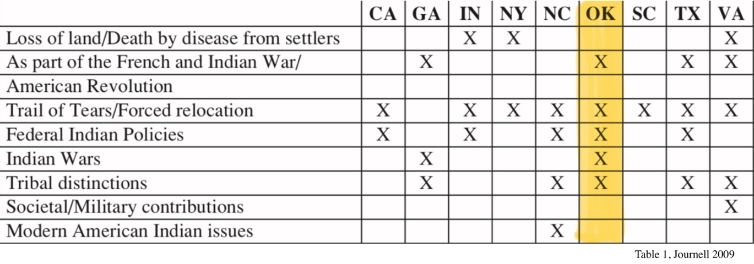
Journell’s article shaped my understanding of how to incorporate archaeology into classrooms, because it analyzes the social studies standards of nine states, including Oklahoma. One of the key highlights in the article, particularly relevant to the curriculum, is the portrayal of Indigenous peoples in the state standards. Across the states studied, the depictions of American Indians usually rooted in the 18th and 19th centuries, with Indigenous peoples often portrayed as victims (Journell 2009). This insight was fundamental in shaping the curriculum by offering ideas on how to amplify Indigenous voices within the educational standards by leveraging cultural heritage and archaeology as tools to connects students to the past through material remains. In his findings, he found that in Oklahoma, there was a significant lack of discussion of the loss of land/death by diseases brought in by settlers, contributions to society and the military past the 19th century, and contemporary Indigenous issues. Table 4 represents the topics either included or excluded in the state standards that Journell (2009) surveyed. The exclusion of topics like societal contributions and modern American Indian issues in history classes further speaks to the positioning of Indigenous peoples in the past rather than acknowledging their contemporary presence.
Table 4: Topics included and excluded in state standards. Note. Adapted/Retrieved/Reprinted from An Incomplete History: Representation of American Indians in State Social Studies Standards (pg. 23) by W. Journell, 2009, Journal of American Indian Education: 48(2): 18-32.)
Journell’s observation of the state standards resonated with me and the significance the curriculum my collaborators and I are creating can hold. He notes, “the constant sentiment of oppression may cause students to question their heritage or self-worth” (Journell 2009, pg. 25). This quote reaffirmed my belief in the importance of developing a curriculum that recognizes that potential of archaeology as a tool to empower students by affirming the value of their voices and heritage. Through the incorporation of cultural heritage via archaeology, the curriculum can demonstrate to students that their heritage holds relevance and significance in history. Archaeology, with its ability to understand the past through material culture, serves as a tool to provide teachers with the resources needed to create an inclusive classroom that engages all students.
Journell (2009) draws upon the gaps that can arise within the historical narrative taught in classrooms. The prevalence of westernized historical narratives that overlook or minimize Native history can impact how students perceive the past. Journell illustrates that romanticizing Indigenous stories in classrooms, like the portrayal of Pocahontas focusing on the relationship between her and John Smith, downplays the conflicts between tribes and European settlers, leading to inaccurate understandings of the past (Journell 2009). A curriculum centered around cultural heritage offers a unique take on how to address these issues. Cultural heritage that uses archaeology as a tool provides tangible evidence that enables students to think critically about historical context, perspectives of different cultures, and question the different versions of history.
A small, but influential component comes from Montana’s Indian Education For All (IEFA) Act of 1999. This legislation commits to integrating Indigenous heritage into the Montana state standards, fostering a sense of agency and inclusion for students in the classroom (State of Montana 2024). The implementation of Indigenous cultural heritage into the classroom, served as one model for the curriculum. By integrating cultural heritage with archaeology as a tool in the classroom provides an avenue for including Indigenous histories due to its ability to connect students’ heritage to the past through material belongings, allowing for the space to incorporate marginalized voices.
Moreover, I used the sources above for the curriculum because they provided unique insights into crafting lessons that pique students’ interest and foster a sense of belonging in the classroom. In using these I aimed to ensure that teacher’s accessibility was present, requiring little preparation for educators while maintaining clarity in the lessons. Overall, the knowledge I acquired equipped me with the education background needed to engage in collaborative efforts with a community to create a curriculum.

Chapter 5

Community-Based Participatory Research with the Choctaw Nation of Oklahoma’s Historic Preservation Office
This chapter describes the collaborative process used to develop a curriculum encompassing five lessons about Choctaw cultural heritage. Starting in 2022, archaeologists from the Choctaw Nation of Oklahoma Historic Preservation Office (CNO-HPO) and I initiated a partnership to create the curriculum with the goal of having a finished product by Fall 2024. This chapter provides readers with a comprehensive view of the work and dedication invested in our partnership. It starts with an introduction to the archaeologists from the CNO-HPO, then overviews our collaboration to develop the curriculum. The chapter ends with a table highlighting key meetings. Through this discussion, I hope others interested in collaboration gain insight from the relationship my partners and I built.
Meet the Collaborators

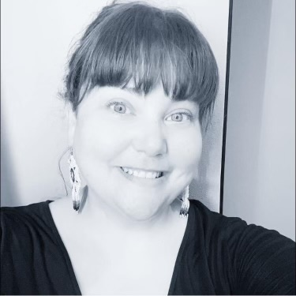
Figure 4: Deanna Byrd

Figure 4 features, Deanna Byrd is of Mississippi Choctaw and Italian-Euro-American decent. She is an enrolled citizen of The Choctaw Nation of Oklahoma and served her community as NAGPRA coordinator and Outreach-Research Program manager since 2015. She is currently the Associate NAGPRA Director for the Harvard Peabody Museum of Archaeology & Ethnology in Cambridge, MA and has stayed on contract with her Tribe to work on community projects and ongoing NAGPRA consultations. She is a mother of three, loves to bead and weave baskets, and enjoys a good sci-fi novel.

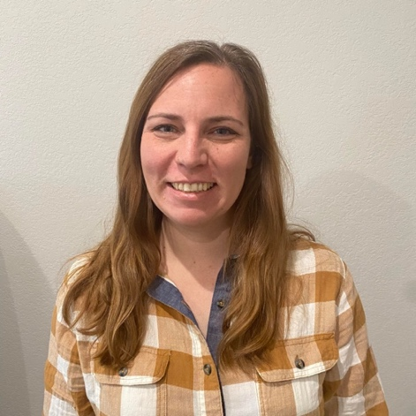
Figure 5: Kim Hinson
Figure 5 features, Kim Hinson, MA, RPA, is the Tribal Archaeologist for Choctaw Nation of Oklahoma and a member of the Historic Preservation Department. She began her career in cultural resource management during her senior year at the University of Florida in 2006. She enjoys gardening and learning the Choctaw language. She teaches Cultural Anthropology at Northeast Texas Community College. She loves being a mom and spending time outside with her two kids.

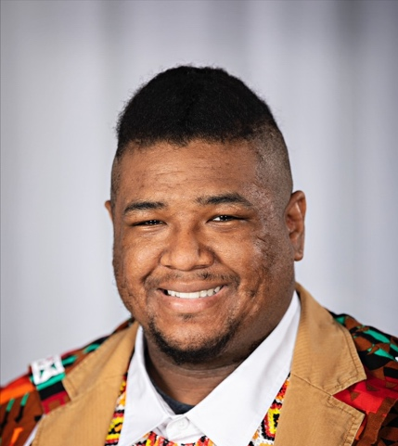
Figure 6: Ki Jim
Figure 6 features, Ki Jim is from Stringtown, OK and graduated from the Choctaw Nation boarding school Jones Academy. He has worked for the Choctaw Nation Historic Preservation Office for four and a half years. He enjoys cooking traditional Choctaw food and playing stickball. In his free time, he loves to work on cars.
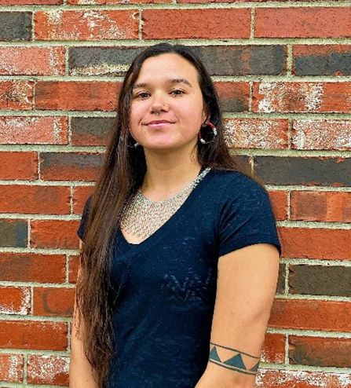
Figure 7: Kyra Hornbuckle
Figure 7 features, Kyra Hornbuckle is an enrolled member of the Choctaw Nation of Oklahoma and has Cherokee heritage. Since 2023, she has served as an archaeological technician for Choctaw Nation Historic Preservation Department, dedicated to preserving the local cultural heritage. She works on projects within reservation boundaries and demonstrates cultural games and history to the community. Outside of work, she enjoys sewing, painting, Choctaw stickball, basketball and being with nature through activities like hiking and yoga.

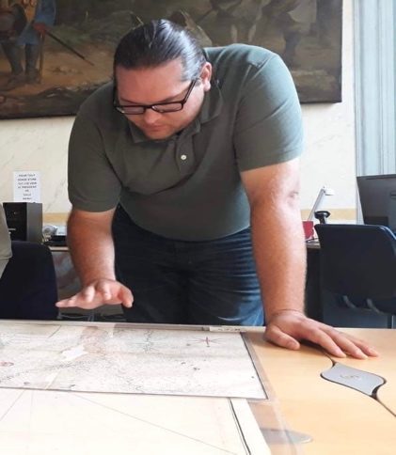
Figure 8: Ryan Spring

Figure 8 features, Ryan L. Spring is an enrolled tribal member of the Choctaw Nation of Oklahoma. He grew up in California and Arkansas, but his Choctaw roots are from Hugo, Oklahoma. He has worked for the Choctaw Nation’s Historic Preservation Department since 2011. In 2011, he obtained his B.S. in Anthropology from the University of Arkansas and in 2017 he received his M.S. in Native American Leadership from Southeastern Oklahoma State University. He takes great passion in working to assist the Choctaw community in its efforts in preserving and revitalize Choctaw traditional culture and protecting Choctaw sacred and historic sites. In his spare time, he enjoys spending time with his family and playing stickball for the Choctaw Nation’s Tvshka Homma Stickball Team. He resides in Calera, Oklahoma with his wife Kathia and his two beautiful nieces Amiya and Kinsley.
CBPR with the CNO-HPO
Collaborative archaeology aims to merge distinct and sometimes contrasting understandings of the world (Atalay 2012). In my partnership with the Choctaw Nation Historic Preservation Office (CNO-HPO), I used an array of resources to build a collaborative foundation. Collaborative efforts must be founded on forging a relationship with a common goal and creating a product that is about, by, for, and with the community partner (Clark and Gumerman 2018). Collaborative methods such as community based participatory research (CBPR) influenced how I approached relationship building. Here partners are not seen as subjects but as active members of a project who help define research questions, goals, data, and results (Atalay 2012).
In the spring of 2022 two undergraduate students enrolled in Dr. Bonnie Pitblado’s “Community Archaeology” class partnered with the Historic Preservation Office of the Choctaw Nation of Oklahoma (CNO-HPO) to revive their Indigenous Archaeology Day event, which had been on hold due to the 2020 covid-19 pandemic. Through the partnership with the students and the Oklahoma Public Archaeology Network the Indigenous Archaeology Day was a success. During the planning period of the event, the CNO-HPO expressed their interest in developing an entire curriculum focused on Indigenous archaeology for Oklahoma high school students. However, they said they lacked the resources to do so. This is where my involvement with the Choctaw Nation began. The students and Dr. Pitblado knew of my desire to create a curriculum for my master’ thesis and so in April 2022, the CNO-HPO and I met to discuss working together on such a project. Our initial meeting revealed the shared interests that we had to create a product that introduced Oklahoma high school students to heritage that includes archaeological data and has the effect of introducing students to archaeological methods. Since this meeting, the CNO-HPO archaeologists and I have met numerous times and dedicated hours to the ongoing curriculum. Table 5 highlights key meetings throughout our collaboration.

Date | Location | Participants | Topic | Meeting Details
5/9/2022 | Virtual | Bonnie Pitblado, Ryan Spring, Kieland Jim, and Kim Hinson | Introduction | Discussing the partnership
6/27/2022 | Virtual | Ryan Spring, Kim Hinson, and Kieland Jim | Thesis Layout | Discussing the prospectus of the thesis
7/1/2022 | Virtual | Ryan Spring, Kim Hinson, and Kieland Jim | Thesis Meeting | Discussing the prospectus of the thesis and collaborating on the Plains Anthropological Conference Poster
9/23/2022 | Durant, OK | Ryan Spring, Deanna Byrd, Kim Hinson, and Kieland Jim | Plains Anthropological Conference Poster | Discussing the layout and content of the poster
5/17/2023 | Hartshorne, OK | Jones Academy Superintendent, Ryan Spring, Kim Hinson, and Kieland Jim | Meeting with Jones Academy | Discussing potential partnership with Jones Academy to teach the curriculum
12/14/2023 | Virtual | Ryan Spring, Deanna Byrd, Kim Hinson, Kyra Hornbuckle, Kieland Jim, and Claire Young | Meeting with Choctaw Nation Cultural Center Curator | Discussing the details and activities of lesson four
11/30/2023 | Virtual | Chickasaw Nation Director of Research and Interpretation | Meeting to discuss Chickasaw Nation history | Discussing lesson one’s definition of Indigenous archaeology and Chickasaw history
12/08/2023 | Prague, OK | Kim Hinson and Kieland Jim | School Visit | Observing how the historic preservation office teaches Choctaw History
1/2/2024 | Virtual | Ryan Spring, Kim Hinson, Deanna Byrd, Kieland Jim, and Kyra Hornbuckle | Thesis Meeting | Discussing the final touches for lessons one and two
2/13/2024 | Durant, OK | Kieland Jim and Kyra Hornbuckle | Thesis Meeting | Discussing the cultural heritage written about Choctaw traditions
Table 5: Details of meetings throughout the collaboration process

Prior to our initial meeting in Spring 2022, I had a vision of creating a curriculum for high school students that would allow for advanced discussion of archaeological methods. To lay the groundwork, I researched archaeology curricula, examined the Oklahoma history state standards outlined in chapter 3, and identified the textbook “Story of Oklahoma” by David Baird (2020) to review its content coverage on Oklahoma history. In brainstorming the prospective curriculum’s content, I began to accumulate diverse educational resources in archaeology, from the Society of American Archaeology (SAA), American Institute of Archaeology (AIA), Project Archaeology, and the Smithsonian, among others. Each resource offered ideas for approaching topics like “Introduction to Archaeology,” videos of the daily life of an archaeologist, dating methods, and more. These resources served as inspiration for incorporating archaeology into Oklahoma classrooms. This background knowledge prepared me with the foundation for discussing a potential collaboration.
In our first meeting, my CNO-HPO partners and I identified a gap in the Oklahoma history classes: the absence of representation for historically marginalized communities such as the Choctaw Nation themselves. Together we saw Choctaw cultural heritage informed by archaeology as a potential remedy to this gap. We set our goal: to develop a curriculum for all 9th grade Oklahoma history classes that explores different avenues like cultural heritage using archaeology as a tool. With the Indigenous perspective in mind, we emphasized the importance of diversity of Indigenous archaeology practices and definitions. (Colwell-Chanthaphonh et al. 2008). Therefore, we knew it was important for us to emphasize the Indigenous archaeology practices of the Choctaw Nation Historic Preservation Office in the curriculum because it focuses on Choctaw cultural heritage.
Once our collaborative efforts began, we discussed the protentional themes and activities I had previously compiled from prior research mentioned in chapter 4 that aligned with state standards and our curriculum objectives. They centered around the significance of cultural heritage in archaeology, encompassing topics such as an introduction to archaeology, respect for cultural sites, non-invasive archaeological methods, museum engagement, careers in archaeology, and research methodologies. We saw these as versatile topics that could uplift student voices and foster meaningful connections to their own cultural heritage. Upon reviewing the state standards, we identified sections within the Oklahoma History state standards (OKH) that would be suitable for these themes, shown in Table 6. This table also illustrates the five lessons and their alignment with the selected OKH standards.

Oklahoma History State Standards (OKH) | Lesson Title | Lesson Description
- “OKH.1.1 Integrate visual information to identify and describe the significant physical and human features including major trails, railway lines, waterways, cities, ecological regions, natural resources, highways, and landforms.”  - “OKH.1.2 Summarize the accomplishments of pre-contact cultures including the Spiro Mound Builders.” | Lesson One: Introduction to Indigenous Archaeology | Students will engage in learning traditional archaeological practices and gain insights into the archaeology practiced by the Choctaw Nation Historic Preservation Office to preserve Choctaw culture. These practices include surveying, defining a site, excavation, in-situ archaeology, map reading, analysis of material remains, and remote sensing.
- “OKH2.3 Discuss the Indian Removal Act of 1830; understand the routes to Indian Territory using a map; use primary resources for students to compare different perspectives and experiences. Analyze the motivations for removal of American Indians and the passages of the Indian Removal Act of 1830; trace the forced removal of American Indian nations, including the impact on the tribal nations removed to present-day Oklahoma and tribal resistance to the forced relocations.”  - “OKH2.4 Describe the consequence of Indian Removal on the intertribal relationships with western nations, such as the Osage, Comanche, Kiowa, Cheyenne, and Arapaho.” | Lesson Two: Forgotten Voices: Exploring Narratives Through Archaeology, Primary Sources, and Oral Histories | Students will explore the multiple narratives of history through the various methodologies’ archaeologists use understand about the past. Among the techniques are descendant oral stories, topographic maps, surveying, remote sensing, and various historical documents.
- “OKC.6.5 Analyze the evolving relationship between state and tribal governments impacting tribal self-determination and control over American Indian lands and resources including issues of jurisdiction, taxations, and gaming.” | Lesson Three: Threads of Tradition: Exploring the Significance of My Cultural Heritage | Students will explore how the Choctaw Nation’s Historic Preservation Office uses archaeology to revitalize traditional Choctaw heritage. For example, the Growing Hope initiative, which employs archaeological methods to revive traditional Choctaw foodways.
- “OKH.5.4 Examine how the economic cycles of boom and bust of the oil industry affected major sectors of employment, mining, and subsequent development of communities, as well as the role of entrepreneurs including J.J. McAlester, Frank Phillips, E.W. Marland and Robert S. Kerr, and the designations of Tulsa as the “Oil Capital of the World.” | Lesson Four: Coalgate Mining Exhibit: How Archaeology Can Preserve Oklahoma Histories | Students will learn about the Coalgate Mining Site excavated by the Choctaw Nation’s Historic Preservation Office and the archaeological process employed to preserve the past. These include, excavation, protection laws, mitigation, curation, ethical procedures, and in-situ archaeology.
- “OKH.6.9 Examine ongoing issues including immigration, criminal justice reform, employment, environmental issues, race relations, civic engagement, and education.” | Lesson Five: Exploring Archaeology Careers: An Interview with an Archaeologist | Students will learn about the common misconceptions surrounding archaeology, explore the diverse career opportunities, and gain insights into the legislation designed to protect cultural heritage sites.
Table 6: Oklahoma state standards used for the curriculum

First, we selected OKH.1.1 and OKH.1.2 because of their overarching objective of teaching students about the geography and history of Oklahoma, particularly in relation to Native history and the different methods scholars use to learn about the past, therefore creating a space for an introduction to archaeology lesson. Moving to lesson two, we chose to link to standards OKH.2.3 and OKH.2.4, because we recognized their emphasis on political events that transformed Oklahoma and Indigenous sovereignty. This allowed us to delve into the archaeological record and using archaeological methods such as remote sensing and historical narratives like descendant knowledge to draw inference about the removal period. For the third lesson, we turned to standard OKH.6.5, which focuses on economic and social developments that impacted Indigenous communities, particularly mention of the control of Native lands and resources. Here, we saw that archaeology could serve as a vehicle for students to connect with their cultural heritage because of its ability to find evidence of practices and resources through analysis of material remains. We do this by having students explore the two different initiatives (introduced in chapter 7) the historic preservation office has created to preserve their heritage.
In lesson four, standard OKH.5.4 became our focus. It focuses on the early part of Oklahoma statehood and the boom of the oil and mining industries. We discussed utilizing the historic preservation offices excavation of the Coalgate mining town to illustrate the role archaeology can play in revealing details of Oklahoma history. Finally, we revisited standard OKH.6, addressing ongoing issues in the state with employment, environmental concerns, and education. This presented the opportunity to end the curriculum by discussing archaeology as a career path, while addressing the challenges highlighted in the section. Overall, we identified these sections as the best for integrating Choctaw cultural heritage with archaeology as a tool into Oklahoma history classes.
In the fall of 2022, we presented a preliminary version of the curriculum at the Plains Anthropological Conference in Oklahoma City, Oklahoma during a poster session titled “From the Ground Up: Student-Led Efforts in Social Activism on the Great Plains” (Figure 9). Our poster centered on the inception of our project and the significance of incorporating archaeology and Indigenous voices into classrooms in Oklahoma. Through our poster we conveyed the missing perspectives we encountered within the state standards, emphasizing that archaeology can serve as a tool to address such issues through methods like dietary reconstruction and traditional knowledge. For instance, we highlighted a depiction of the Choctaw Nation Labor Day Festival in which misrepresented aspects of Choctaw sovereignty, language, spirituality, and subsistence, rather than uplifting a tradition that celebrates Choctaw culture and its present-day community (Baird 2020). During this session, our poster received positive feedback from attendees, who found the project pertinent to the field of archaeology. The recognition of the poster affirmed our collaboration and commitment to producing a curriculum that includes Indigenous representation.

Figure 9: Poster presented at the 79th Plains Anthropological Conference
Throughout our meetings, the bulk of our discussion revolved around the content of the curriculum, which I added into our lesson plans after each meeting. For instance, in one meeting, we focused on lesson two, which explores the different methods archaeologists and heritage experts use to draw inferences about the past. This was chosen because students learn in-depth about the Indian Removal Act of 1830. Here, we focused on the Choctaw Removal period and the impact the change of environment had on the tribe. This decision stemmed from research that highlighted the challenges Choctaw people faced when forced to migrate through different environments during this period. One of my collaborators emphasized the contrast of the Choctaw homeland in Mississippi and that of Oklahoma. Choctaw people were not accustomed to harsh winters and faced difficulties due to inadequate clothing and footwear. Evidence of this is shown in journal entries cited in Grant Foreman’s (1932) “Indian Removal.” A journal entry from Foreman’s book quotes the New York Observer, “…many horses having died and great numbers of the Indians much frosted” (Foreman 1932), later recounted sightings of over a hundred horses frozen in mud succumbing to the cold. This emphasis of change provided us an opportunity to offer a supplemental examination of the Choctaw Removal through archaeological methods, like site recording.
Throughout the collaboration we have proactively reached out to other Indigenous communities to ensure multivocality. We believed that incorporating additional voices would strengthen the scope of our curriculum. This included collaborating with other departments at the Choctaw Nation Cultural Center and engaging with other tribal nations. For lesson one, I reached out to four other nations- Chickasaw, Quapaw, Caddo, and Osage, with the goal of fostering cultural stewardship by including other tribal histories as additional resources and including more Indigenous voices. Since reaching out, I have met with a representative from the Chickasaw Nation, who gave us valuable feedback on our definition of Indigenous archaeology and Chickasaw history. The feedback included adding the history of the relationship between the Choctaw and Chickasaw Nations in relation to their removal to Oklahoma and traditional definitions of archaeology in addition to “Indigenous archaeology” in the “contextual paragraph for teachers” in lesson one. I am still in in the process of meeting with the other tribes to further improve our curriculum. Additionally, we met with the curator of the Choctaw Nation Cultural Center to discuss lesson four, which focuses on the excavation by the CNO-HPO of the Coalgate Mining site and the curated exhibit that followed. The work done at Coalgate demonstrates the importance of preservation and how a finished product like an exhibit can educate viewers on the stories of individuals from the mining town through their cultural belongings.
To further our collaboration and curriculum development, we started to look at the future of the project, discussing ways to experiment with the implementation of the curriculum. One of my partners suggested reaching out to Jones Academy, a Choctaw Nation Boarding School established in 1891 by Choctaw Chief Wilson (Jones Academy 2024). We saw an opportunity to test the curriculum with students from the Choctaw Nation, fostering a meaningful connection for the students and their cultural heritage. In spring 2023, we met with Jones Academy about implementing the curriculum in a class. Following our discussion, they expressed interest in using it as a five-week afterschool class that I would teach. However, due to complexities and time needed to collaborate on a curriculum, we have paused working with Jones Academy until we finish developing the lessons.
In the creation of the lessons, each person had separate responsibilities that contributed to the content and layout of each lesson. To co-create lesson one, we assigned specific responsibilities for each section and reconvened upon completion of those tasks. My focus was on crafting the title, topic description, inquiry questions, materials needed, key terms, and instructional procedures. My partners were responsible for drafting the contextual and historical context paragraphs. The division of work enabled us to break down the sections into a manageable format for the lesson. After completing our work, we regrouped to review and revise as needed. Lastly, we adjusted the historical context section to incorporate other tribal histories, expanding the resources available for teachers.
For lesson two, we divided tasks similarly to lesson one, but emphasized collaborating to identify suitable sources for the lesson activity. I worked on the lesson title, topic, required materials, key terms, and instructional procedures. My partners tackled the contextual paragraph and historical context. Together, we identified sources for the lesson and created the inquiry questions. The inquiry questions aligned with the lesson objectives and asked the students to think about the insight’s archaeology can offer. These questions are: “What was the political climate in the United States leading up to the Indian Removal Act of 1830? What ways can archaeology help us understand the Choctaw Nation of Oklahoma’s removal experience?” We then curated sources that reflected the lesson, such as a survey map showing shovel tests, a video of Ryan Spring discussing GIS (geographic information systems) approaches to preserving the Trail of Tears, and interviews of descendants of removal survivors.
For lesson three, our co-creative efforts were centered around the contextual and historical content of Choctaw cultural heritage. Together, we formulated a definition of cultural heritage that aligned with the objectives of the historic preservation office. Additionally, my partners assembled a document explaining traditional Choctaw heritage practices, including stickball – a game still being competitively played- basket weaving, traditional foodways, and customs for hospitality. From there, I edited their descriptions and added in archaeological methods like organic residue analysis to show how archaeologists can contribute evidence of foodways and traditional practices. Subsequently, I added in the lesson title, topic, key terms, required materials, and instructional procedures. For the lesson 3 activity, we worked together to strategize a hands-on opportunity aimed at fostering students’ own cultural heritage while emphasizing the importance of respecting the past through preservation. As of this writing (in May 2024), we are continuing to develop lessons 4 and 5. Our collaborative efforts to date have included brainstorming and refining potential activities for the lessons. Presently, we are working on crafting the contextual paragraphs and inquiry questions.
The relationship between the CNO-HPO and I have been built on patience and trust. Through many meetings, lunches, events, and conferences, the most effective collaborative practices for our project have included active listening, having patience rather than rushing the process, acknowledging the realities of the project, and utilizing individual strengths to work together. Central to this has been our focus on listening, with me as the primary listener. While listening may seem straightforward, it becomes challenging when realizing that people are not blank slates and have biases, they may not be aware of. In entering this project, I sought to set aside my prior knowledge about archaeology to allow myself the opportunity to learn new perspectives on the field. By actively absorbing the stories, histories, life lessons, and practices shared by my partners, I have recognized the significance of being in a supportive rather than leadership role. This has allowed me to approach each interaction with an eagerness to learn about new methods and improve my understanding of archaeology.
Recognizing that active listening is vital to building relationships, I have used this opportunity to commit to being an archaeologist who strives for continuous improvement. To fully embrace my role, I confronted my own biases such as the importance of Indigenous archaeology and acknowledged that this was going to be a learning experience for both parties. From the beginning, I have aimed to convey that my intentions are not merely about creating a curriculum or forming a temporary bond. Instead, I aspire to cultivate our collaboration throughout my career as an archaeologist, with the hope to continue to grow and learn from my partners.

Chapter 6

Lesson 1: Introduction to Indigenous Archaeology and Cultural Heritage
This chapter presents the first lesson of the curriculum, “Introduction to Indigenous Archaeology and Cultural Heritage” and highlights certain sections of the lesson plan in the figures below. In the lesson, students learn about archaeology, how the Choctaw Nation of Oklahoma’s Historic Preservation Office practices Indigenous Archaeology, and an introduction to cultural heritage. Here, they will learn about what archaeology and cultural heritage is and why they matter. The teacher is given an “Instruction Procedures and Strategies” box that provides instructions for the lesson, see Figure 10. To start the lesson, students are presented with a word puzzle game called, “connections.” This game uses a grid of sixteen words and the goal is to group them into four categories that create one theme or thing, see Figures 11 and 12.
Figure 10: Instructional procedures of Lesson One
Instructional Procedures and Strategies:
- Students do a connections game based on archaeology before the class begins.
  - Ask students questions to help them group the four categories.
  - Have the students discuss.
- Share the background information and vocabulary.
- To introduce the students to archaeology, use the power point provided.
  - This power point includes a voice over of archaeologist, Kaylyn Moore, discussing an introduction to Indigenous Archaeology.
    - In the power point, students will learn the following concepts:
      - Archaeological practices
      - Indigenous Archaeology
      - Indigenous Archaeology in Oklahoma
      - The differences between archaeology and Indigenous archaeology
      - The Choctaw Nation of Oklahoma’s view of archaeology
      - CNO use of archaeology as a tool
- One minute paper to grasp what the students took away from the lesson.

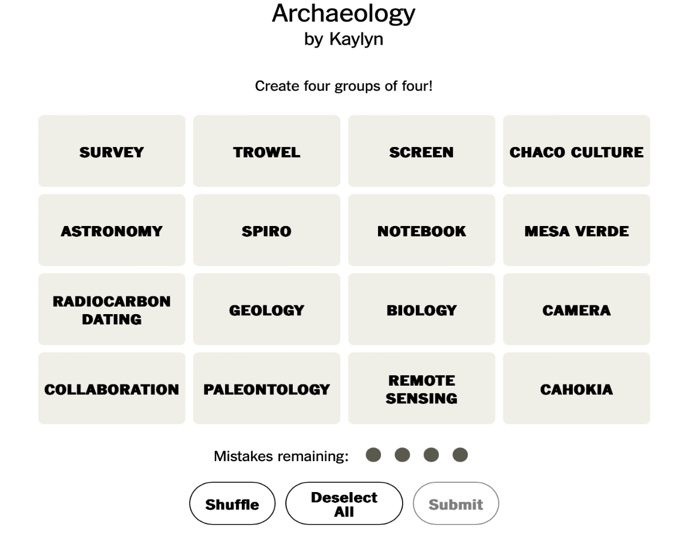

Figure 11: Connections game part one created for Lesson One

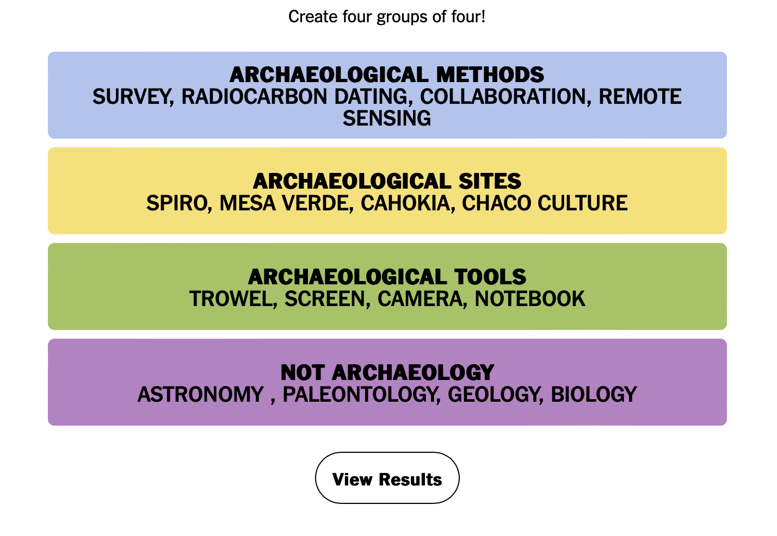

Figure 12: Connections game part two created for Lesson One
We then provide a PowerPoint (Appendix A) that offers five objectives that students will learn by the end of the lesson. These are, 1) what is the Choctaw Nation and who are its citizens, 2) definition and practices of archaeology and Indigenous archaeology, 3) what is cultural heritage, 4) the differences between traditional archaeology and Indigenous archaeology, and 5) the practice of Indigenous archaeology by the Choctaw Nation of Oklahoma. At the beginning of the PowerPoint, students are given three inquiry questions, shown in Figure 13, to think about throughout the lesson, “How does the Choctaw Nation use archaeology? How would you learn how archaeology is a tool for cultural heritage? How might other communities learn about their cultural heritage through using archaeology as a tool?” These questions draw from structured inquiry methods that employ student engagement throughout the lesson. Next, the lesson goes through the five objectives with the first being a brief history of the Choctaw Nation. This history, shown in Figure 14, is provided to students to highlight the practices of cultural heritage and archaeology by the Choctaw Nation’s Historic Preservation Office. Students are then taught about archaeology and the variety of archaeological methods used such as remote sensing, geographic information systems (GIS), and radiocarbon dating. To introduce Indigenous archaeology, students are shown the short video created by the Choctaw Nation of Oklahoma titled, “Indigenous Archaeology.” Here, students learn definitions of Indigenous archaeology and how it is practiced by the Choctaw Nation’s Historic Preservation Office.
By the end of the lesson, teachers administer a “minute paper” exercise, which has students answer the three inquiry questions. This paper assesses the lesson’s effectiveness and provides feedback to the teacher. Additionally, it gives students an opportunity to reflect on their favorite aspects of the lesson. Our aim is for students to leave the class with an understanding of the significance of archaeology in preserving and respecting the past.

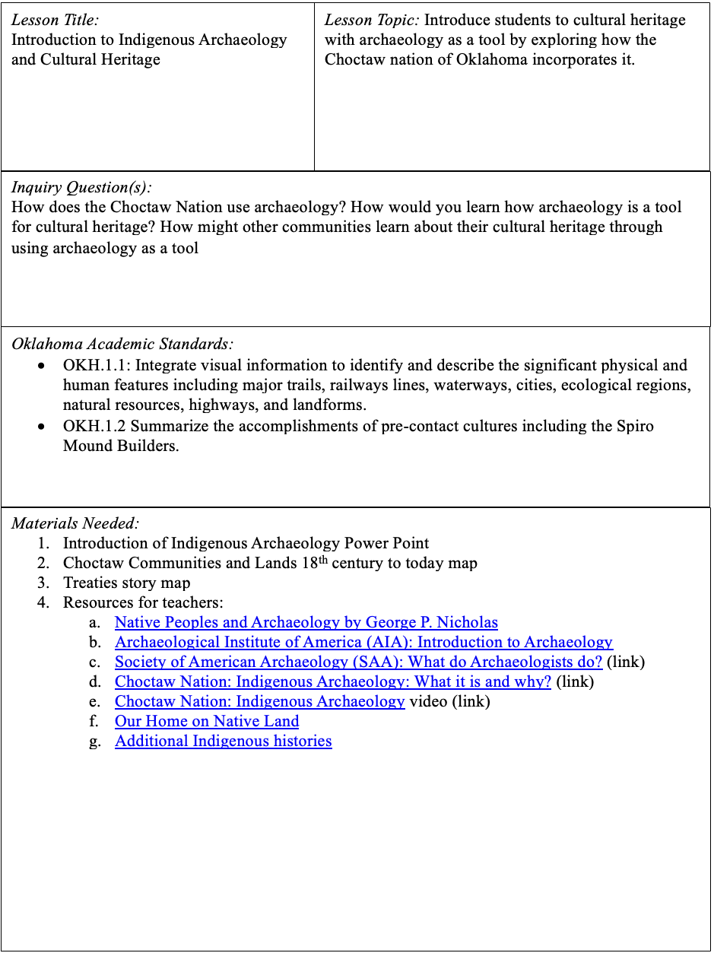
Figure 13: First page of Lesson One

Historical Context/Content: The Choctaw Nation of Oklahoma

The Choctaw are a thriving Indigenous community with a living culture. Choctaw Nation is located in southeast Oklahoma; however, the Choctaw homelands encompass parts of present-day Mississippi, Alabama, Florida, and Louisiana. In 1820, tribal leaders signed the Treaty of Doak’s Stand, which ceded rich cotton lands in the delta region east of the Mississippi River for approximately 13 million acres in the Canadian, Kiamichi, Arkansas, and Red River watersheds in southern Oklahoma. In 1830, Choctaw leaders signed the Treaty of Dancing Rabbit Creek, ceding their remaining territory in Mississippi. Beginning in 1831, groups of Choctaw were forcibly removed from their homelands. After their 1837 removal from Mississippi, the Chickasaw lived among the Choctaw in Oklahoma before moving farther west. The Choctaw Nation Reservation is located within an area that is the original homeland of the Caddo and Wichita. The Pawnee and Arikara also have ancestral ties here. In the late 1700s and early 1800s, the area was visited by the Choctaw, Osage, Kiowa, and other tribes. During this period, Shawnee, Quapaw, and Caddo settlements were in the area. The Choctaw Reservation is within lands ceded by the Quapaw Tribe to the United States. The map below shows the displacement and route to Oklahoma (CNO, HPO 2023).
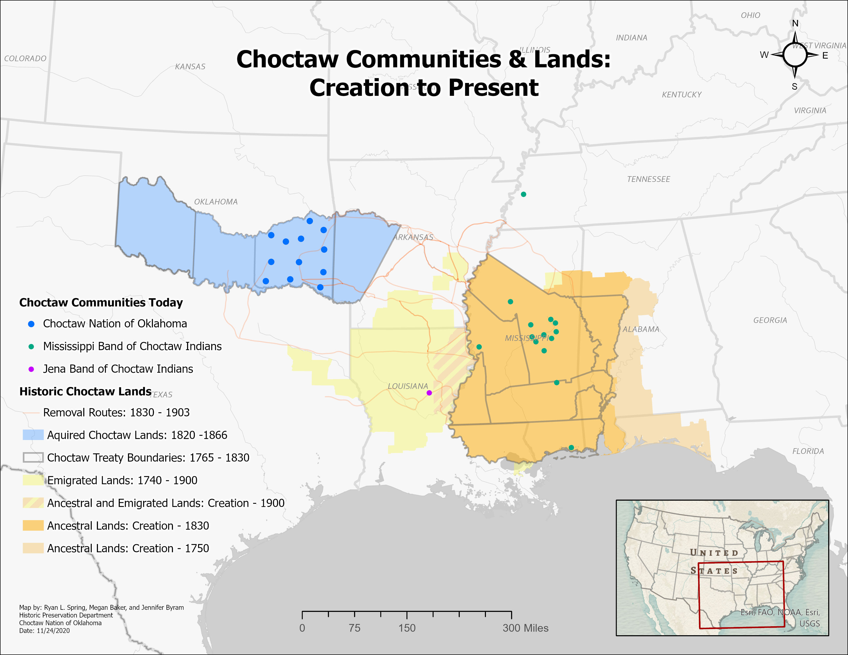

Figure 14: Historical context of Lesson One

Chapter 7

Lesson 2: Forgotten Voices: Exploring Narratives Through Archaeology, Primary Sources, and Oral Histories
Lesson two aligns with state standards, OKH2.3 and OKH2.4. By exploring various methods for understanding the past, students gain further insight into the removal period. The lesson emphasizes the importance of multiple lines of data and perspectives to analyze the effect the Indian Removal Act had on tribal sovereignty and cultural loss. Figures 15, 16, 17, 18, and 19 show the lessons’ first page, instructional process, contextual paragraph, historical paragraph, and resources for the activity. Consequently, the lesson not only meets the standards but expands on them to further discuss the significance of the removal.
In the lesson, students are given more resources to learn about the Indian Removal Act. First, there is a PowerPoint that goes through four concepts, 1) value of place, 2) multiple perspectives, 3) how archaeology can be used a resource, and 4) oral history is a resource. Within the PowerPoint (Appendix B), students learn about how multiple perspectives and methods can offer new information on historical events, for example, the use of oral stories and archaeological methods. Oral stories are used to gather knowledge about events that have been passed on through generations. Archaeological methods are used to provide data about certain events, periods, people, and places. Remote sensing is used to help archaeologists find archaeological sites in a non-invasive manor. For example, Ground-Penetrating Radars (GPR), use radar waves to detect and map underground features and structures.
For the contextual paragraphs seen in Figure 16, we chose to use the Choctaw Nation’s journal ‘Iti Fabvssa’ because it is part of the work conducted by the Historic Preservation Office and provides an excellent summary of the Choctaw Nation Removal. Each source from Figure19 for the activity was selected due to its relevance to the Choctaw Nation Removal. For example, we have articles from the Pioneer Papers discussing removal from the perspectives of descendants of Choctaw Nation tribal members who experienced the Indian Removal Act. Additionally, we included a survey map example from the Choctaw Nation Historic Preservation Office to demonstrate different ways archaeologists locate archaeological sites. Lastly, we used a video by Ryan Spring, one of my collaborators, that explains what GIS and archaeology can teach people about the Trail of Tears and Indian Removal. Each source was chosen to offer different perspectives and lines of evidence to learn more about the Indian Removal Act.
The lesson activity focuses on students analyzing resources, such as first-hand accounts, survey maps, and a video discussing the removal of the Choctaw Nation. The goal of the activity is for students to critically think about the importance of considering multiple lines of evidence and perspectives in history. Students are split up into groups, with each group assigned a different resource to analyze. After receiving the sources, students are given fifteen minutes to answer five questions: 1) What time period is this from, 2) Who is speaking, 3) What can this source tell us, 4) What can this teach us about Choctaw removal, and 5) How can archaeological methods tell us more about Choctaw removal? After fifteen minutes, groups will exchange their resources and answer an additional three questions: 1) What is missing from the narrative, 2) Where can you go to find more information, and 3) How does this change your perception of Choctaw removal? Lastly, once the added fifteen minutes are up, students will designate a speaker to present their answers. By the end of the lesson, students should gain an understanding of how diverse perspectives and archaeological methods enrich historical events.
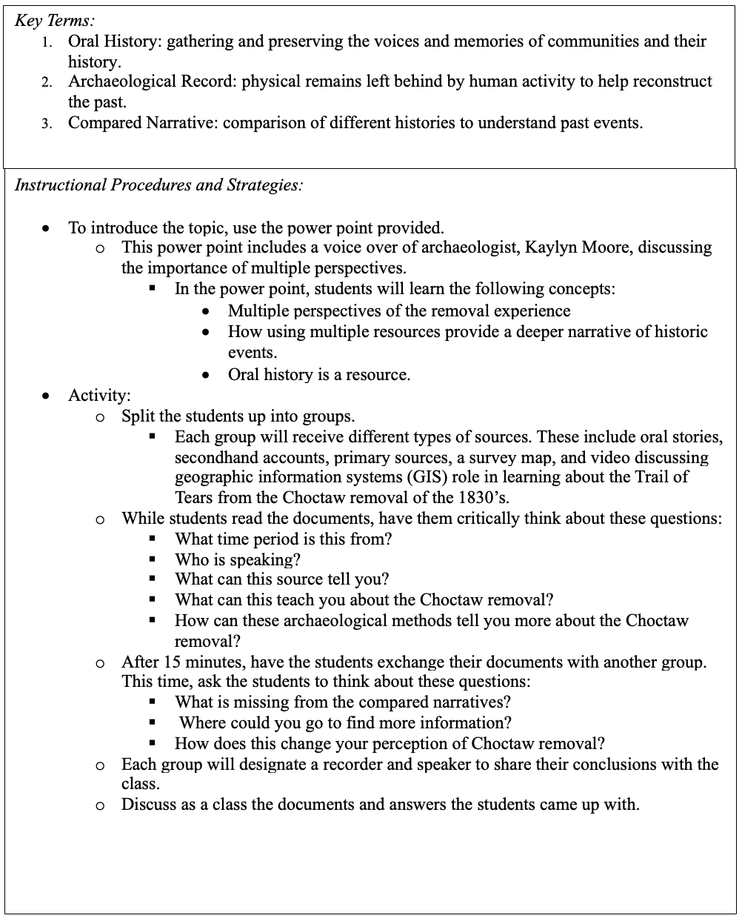

Figure 15: First page of Lesson Two

Contextual Paragraph for Teachers:

Archaeological study is often misunderstood, with many assuming that excavation is the sole method used to comprehend the past. However, archaeology encompasses more approaches. For example, archaeologists use primary data they gather through remote sensing, survey, radiocarbon dating, analysis, and site recording. When they can, they also collaborate with communities and use oral histories, documentary sources, and story maps. These approaches play a crucial role in understanding that the past is more than just digging. Working across disciplinary boundaries and with communities fosters a nuanced understanding of cultures, both past and present. Dispelling the
misconception that archaeology is primarily about excavation guides us toward cultural stewardship to preserve history. (CNO, HPO 2023)

Figure 16: Contextual paragraph for Lesson Two

Historical Context/Content: Choctaw Nation Removal

“Before U.S. Congress signed the 1830 Indian Removal Act, Choctaws had signed numerous treaties with the United States that laid the groundwork for possible removal. Yet, Choctaw leadership negotiated these treaties in the hopes that removal would not be inevitable. The 1820 Treaty of Doak’s Stand exchanged part of the Choctaw homeland for land west of the Mississippi River. In exchange for half of the ancestral homeland, the western parcel of land included the land now known as western Arkansas. An estimated 2,000 Choctaws moved to these western lands before the Trail of Tears removal. Despite this treaty, Euro-American settlers continued to pressure Choctaws into ceding more land. This ultimately resulted in Choctaws and U.S. officials signing the 1830 Treaty of Dancing Rabbit Creek on September 27, 1830. One of the most significant elements of the Treaty of Dancing Rabbit Creek was securing the new Choctaw homeland in fee simple. As a legal title regarding the property, fee simply made landownership more straightforward and uncontestable. Removal caused catastrophic losses within the numerous Choctaw communities. The removal journey was particularly devastating to elders and children and many of them passed away during the journey. The loss of these community members was terrible because it meant the loss of knowledge keepers and the next generation. As a result, some of the knowledge and political processes that Choctaw ancestors had maintained for thoughts of years could not be continued because people were focused on surviving. One such example is the collapse of the clan structure in part because people traveled in family groups rather than entire communities. This would lay the groundwork for Christian churches to become centers of the community later on. To recover from these losses, Choctaw leaders worked hard to reorganize as a government so they could provide for their people." (Iti Fabvssa, pg.1 2021)

Figure 17: Historical context for Lesson Two
Instructional Procedures and Strategies:

- To introduce the topic, use the power point provided.
  - This power point includes a voice over of archaeologist, Kaylyn Moore, discussing the importance of multiple perspectives.
    - In the power point, students will learn the following concepts:
      - Value of place (homeland) for Choctaw people
      - Multiple perspectives of the removal experience
      - How can archaeology be used as a resource?
      - Oral history is a resource.
- Activity:
  - Split the students up into groups.
    - Each group will receive different types of sources. These include oral stories, secondhand accounts, primary sources, a survey map, and video discussing geographic information systems (GIS) role in learning about the Trail of Tears from the Choctaw removal of the 1830’s.
  - While students read the documents, have them critically think about these questions:
    - What time period is this from?
    - Who is speaking?
    - What can this source tell you?
    - What can this teach you about the Choctaw removal?
    - How can these archaeological methods tell you more about the Choctaw removal?
  - After 15 minutes, have the students exchange their documents with another group. This time, ask the students to think about these questions:
    - What is missing from the compared narratives?
    - Where could you go to find more information?
    - How does this change your perception of Choctaw removal?
  - Each group will designate a recorder and speaker to share their conclusions with the class.
  - Discuss as a class the documents and answers the students came up with.

Figure 18: Activity for Lesson Two
Figure 19: Activity resources for Lesson Two
Resources:

Source One:
- “The New Jaw Bone” Poem by Israel Folsom
Source Two:
- Pioneer Paper Interview excerpts:
  - Rhonda James discussing her mother’s removal experience
  - Thomas Hunter discussing his father’s removal experience/journal
  - Eastman Ward discussion his grandparent’s removal experience
Source Three:
- F.W. Armstrong in Washington City on April 20, 1832
  - This discusses the weather that has been faced throughout the journey
Source Four:
- Journal of Lieut. J. Van Horne 1832

Source Five:
- Excerpts from Grant Foreman’s Book (1932)
  - Pages (53-54, 54, 60, 61, 62, 63, 77, 78, 91, 93, 97, and 98)
Source Six:
- Story Map of Choctaw Removal

Source Seven:
- Survey Map Example from the Choctaw Nation

Source Eight:
- Video discussing how Geographic Information Systems teach us about the Trail of Tears (TribalGIS)

Source Nine:
- Using remote sensing to understand Choctaw Removal (Web Archive)

Chapter 8

Lessons 3 to 5: Future Lessons
This chapter presents the three remaining lessons that are still in development. We aim to have lesson plans complete them by Fall 2024. Lesson three overviews the process of using archaeology as a tool to deepen students’ view of cultural heritage. Lesson four examines an excavation done by the Choctaw Nation that ultimately led to a museum exhibit. Lastly, lesson five provides students with the resources and knowledge of archaeology as a career. In the following three subsections, I provide the information to date on the three remaining lessons.
Lesson Three
Lesson three uses archaeology as a tool to deepen students’ understanding of their cultural heritage while fostering the value of respect. By delving into the standard OKH. 6.5’s focus on tribal affairs, students can expand this new knowledge to further discover their own heritage. In Figure 20, we provide teachers with a definition for cultural heritage and the different archaeological practices archaeologists use when working on revitalization. By learning about archaeological practices like residue analysis and collaborative archaeology that help revitalize traditional practices, students will understand how to foster their own cultural heritage and appreciate the importance of diverse cultures in society. To introduce students to cultural heritage, we discuss the revitalization of Choctaw traditions that the CNO-HPO have worked on. Students learn about three cultural traditions, see in Figure 21, practiced and revitalized by the nation today: stickball, traditional creations, and foodways. We emphasize two programs that initiate revitalization: the Growing Hope Program and the Historic Preservation Department. Growing Hope is an initiative that revitalizes traditional Choctaw foodways and provides tribal members with seeds and produce. The Historic Preservation Department provides the protection, repatriation, and preservation of Choctaw historic sites through archaeology (CNO 2023). These programs provide students with insights into the HPO’s mission to protect, repatriate, and preserve Choctaw heritage through archaeology and other historical approaches. The Lesson Three activity is still in progress, but we want to center it around students’ exploring and celebrating their own cultural heritage.
Figure 20: Contextual paragraph for Lesson Three
Contextual Paragraph for Teachers:

The definition of cultural heritage encompasses both tangible and intangible belongings that represent the identity of individuals or groups. These belongings are passed down through generations via stories, practices, songs, language, materials, places, and more. Cultural heritage in archaeology enables individuals to explore and understand their own identity and heritage by connecting them to the past through material culture, tangible places or the landscape. Cultural heritage allows people to connect themselves to the past through shared experiences (CNO, HPO 2023).
Archaeologists have many ways to revitalize traditional practices and understand past society's social structure, diet, and more. Some of these processes include collaborating with descendant communities to answer questions about foodways to using organic residue analysis to understand diet. Collaborative archaeology offers native perspectives on traditional practices and how they have been passed down for generations (Purcell 2023). Techniques such as residue analysis can identify foods that were processed through absorbed residues found in items like ceramics (Peres 2017)

Historical Context/Content:

One of the duties of the Choctaw Nation of Oklahoma’s Historic Preservation Department is to promote their cultural heritage. Some examples of how the historic preservation department's staff promote cultural heritage is through the revitalization of their traditional ways, including:
Stickball:
Stickball stands as one of the oldest field sports within the Choctaw Nation and among Southeastern tribes, with document records dating back to the 1700s. In the past, stickball was a peaceful way of settling disputes between communities and tribes in southeastern region of the United States. Presently, the tradition of stickball has a significant following and participation. Across generations, a profound love for the game persists, often kindled with children watching their parents play the sport. For players, the goal remains the same as in the past: securing the stickball championship title and bringing back glory to their community. Even after hundreds of years of play, the game retains its sacred and historical essence, characterized by a tacit recognition shared between players, coaches, and fans.
Traditional Creations:
From basket weaving down to the clothes worn, the Choctaw people have always been artistic and creative in fulfilling the needs and wants of the community. The women would create baskets from river cane and other reed baskets that helped with cooking, cleaning, and even a fly swatter! Others skillfully twined fibers like mulberry bark, stinging nettle, and milkweed to make clothing that could be worn in any type of weather. The patterns created were and still are beautiful and passed down generationally. Besides clothing and basket weaving, the Choctaw people used tools like the atlatl and cane knives for hunting and fishing.
Foodways and Traditions:
Food is a staple in the Choctaw way of life. From political meetings to small family gatherings, there is always a meal being shared. Hospitality is a custom for Choctaw people. In the 1400’s when explorers would travel into a Choctaw village, they would first have to share a meal with the chief before being allowed in. The agriculture and farming of the Choctaw people has helped them thrive and survive through time. In more recent years, the Choctaws cook food and have feasts no matter the occasion of a gathering. The Choctaw Nation works hard to revitalize their traditional foodways through their program called Growing Hope and in the Historic Preservation Department. (CNO, HPO 2024)

Figure 21: Historical context for Lesson Three
Lesson Four
Lesson Four familiarizes students with archaeological methods such as excavation but emphasizes that archaeology involves more than digging as excavation can destroy the material record and context of a site. Drawing from the state standard OKH.5.4 (Examine how the economic cycles of boom and bust of the oil industry affected major sectors of employment, mining, and subsequent development of communities, as well as the role of entrepreneurs including J.J. McAlester, Frank Phillips, E.W. Marland and Robert S. Kerr, and the designations of Tulsa as the “Oil Capital of the World”) (Oklahoma Academic Standards 2023) we discuss the excavation and exhibit done by the Historic Preservation Office over the Coalgate mining town. The exhibit focuses on the Irish-Italian immigrants and Black miners who lived on Choctaw land in the late 19th century. By explorating the exhibit, students gain insight into the experiences of these communities through archaeological data.
To introduce the Lesson Four topic, we highlight a few processes and laws that archaeologists employ such as traditional excavation, survey, remote sensing, protection laws, mitigation, in-situ preservation, curation, and ethical procedures. To explain the importance of these techniques, the focus is on the excavation of the Coalgate mining site and curation of an exhibit called, “Putting the Coal in Coalgate.” From the late nineteenth to twentieth century, Coalgate was a mining town operated by private companies on Choctaw land. Through the years, Coalgate brought the Choctaw Nation money and roads. To build on the history of Coalgate, the lesson discusses the excavation that the Historic Preservation Office conducted at the site. Here, we provide the rationale for conducting a traditional dig, despite the HPO’s common practice of in-situ archaeology to document sites without disturbance (HPO 2024). The decision to excavate the site emerged when the Housing Authority of the Choctaw Nation sought assistance for an Elderly Housing project in Coalgate because of the citizens’ concerns with losing an element of Choctaw history. During the excavation, the Historic Preservation Office located the foundation of a dugout house and over 4,000 material belongings (Iti Fabvvsa 2020). In the lesson, we teach students that excavation destroys the material record and context of the site but is necessary in this case. We discuss some of the excavation strategies that the Historic Preservation Office took to excavate the site including note taking, drawings, sketches, and photographs.
The activity for the lesson is still a work-in-progress, but we have identified two options. The first activity would have students analyze an exhibit to identify missing elements of the story being told. This encourages critical thinking about the perspectives, stories, and items that are significant to the curation process. The logistics behind this are still in the works because we want to make an activity that is accessible to teachers. The second option is for students to curate their own miniature museum, that builds off the cultural heritage in Lesson Three. This activity would allow students to actively engage in their own stories to create a final product. Ultimately, both activities would contribute to the goal of students learning about the importance of preservation and processes taken by archaeologist and museum professionals.
Lesson Five
The goals of Lesson Five are to provide awareness of the diverse career opportunities in archaeology, introduce laws that protect archaeological sites and cultural heritage, and dispel common misconceptions about the field. Initially, students explore popular cultural portrayals in media, such as Indiana Jones or Laura Croft, highlighting the differences between fictional and real-world careers. Then, the lesson moves into preservation acts put into place such as National Historic Preservation Act (NHPA), Safeguard Tribal Objects of Patrimony (STOP Act), Native American Graves Protection Act of 1990 (NAGPRA), and Archaeological Resources Protection Act of 1979 (ARPA). By understanding the significance of these acts, students learn about the ethical and legal frameworks that guide archaeological work. Furthermore, students explore the different jobs that archaeologists do, including those in cultural resource management, state and Tribal preservation offices, educational outreach programs, federal and state governments, academia, and museums. By showing these, it allows students to see that archaeology is a viable career path.
As with Lesson Four, our Lesson Five activity is still in-progress. We have contemplated creating an “Interview an Archaeologist” activity. This would allow teachers to reach out to a local archaeologist and have them visit or Zoom into a classroom. With this kind of activity, students would have free reign to ask questions about the everyday life of an archaeologist. A different activity would be having students explore archaeology jobs available in the world today, giving them the chance to see the academic training and job experience needed to be an archaeologist. By the end of the lesson, we hope that students leave with an understanding of what an archaeologist does, and the importance archaeology has in the world. Regardless of the activity, students will leave with the understanding of what archaeologists do and why it is important to preserve, interpret, and learn about cultural heritage.

Chapter 9

Discussion and Conclusion
This project sought to create a cultural heritage with archaeology as a tool curriculum through collaboration between an archaeology graduate student and the Historic Preservation Office of the Choctaw Nation of Oklahoma. Through this partnership, I learned valuable lessons on the responsibilities as an archaeologist and the dedication required for collaborative archaeology. In this final chapter, I discuss the positives and challenges, the contributions to the field, and outline future goals.
Discussion
The project yielded many positive outcomes, both in terms of learning and forging relationships. We gained valuable insights into the work ethic needed for successful collaboration, allowing for us to take pride in our work. The learning process was a highlight, as it provided an opportunity for experimenting with collaboration. Our minimal experience in collaborative efforts allowed for a flexible, trial-and-error approach, allowing us to explore alternative methods of collaboration, teaching archaeology, and fostering long-lasting relationships. The liberty to work in our own way empowered us to create a product that contributed to archaeology. Our relationship helped create a positive environment that showcases the work of collaborative archaeology.
Personally, one of the most significant positives was the support I received from my advisor, department, and partners. They allowed me to go beyond the boundaries of anthropology and explore avenues in other fields to further my knowledge. This freedom broadened my knowledge and provided me a unique set of skills that contributed to the project. The continued support surrounding the project has been instrumental to the positives surrounding this collaboration.
Despite the positives of the collaboration, like any project, we faced several challenges, varying in nature from distance to time constraints. The most significant challenge was logistics, stemming from the distance between my location at the University of Oklahoma in Norman and the Choctaw Nation Cultural Center in Durant, Oklahoma, which created an accessibility issue for us. With a distance of 103 miles or 2.5-hour drive between us, we had to limit face-to-face meetings, depending instead on Zoom meetings. While Zoom is commonly used post-2020, this form of communication posed difficulties for me, as my partners and I thrive in in-person interactions. Additionally, time constraints limited our availability to work on the curriculum together. Given that my partners work in the Choctaw Nation Historic Preservation Office, their main priority revolves around the preservation, protection, and identification of cultural heritage sites. As a full-time graduate student with a demanding course schedule and 20-hour graduate research assistantship, locating mutual meeting times was challenging. This has resulted in our curriculum building taking longer than anticipated. When we have made time, our meetings are often one-hour and dedicated to providing updates and allocating tasks for the next meeting. Due to the short meeting times, we do not always cover everything we had planned to discuss, which forces us to prioritize only the most pressing matters related to the curriculum.
Implications
The implications of this thesis introduce new methodologies to collaborative and educational archaeology through our unique co-creative approach to archaeological education. Similar to Project Archaeology, our aim was to instill in students the importance of understanding the past through culture (Moe 2019). However, our project distinguished itself by concentrating on a specific Indigenous community’s practice of archaeology with an emphasis on cultural heritage and by being fundamentally collaborative, rather than the approaches of traditional archaeology education. This inclusion presented a case for archaeology education to include more content on cultural heritage practices, as cultural heritage with archaeology as a tool fosters a sense of belonging in history among students.
Drawing from research such as Bria and Vasquez (2022), who used collaborative archaeology and storytelling to create new dialogues between archaeologists and communities, our collaborative efforts prioritized active listening and community needs, enhancing the impact of the collaboration. By using models like these, we were able to create our own form of collaboration that worked with our project. We hope that it inspires others to forge relationships with communities to collaborate and create community specific curricula.
Conclusion
I want to express the gratitude I have towards my partners and archaeology. This process has been an impactful experience, teaching me important lessons about the multifaceted roles one may have as an archaeologist, including being a cultural steward, listener, and continual learner. It has not only contributed to my growth as an archaeologist, educator, individual, and scholar but has also reinforced my passion for collaborative and community engagement in archaeology. My partners have been immensely supportive since the beginning, and their contributions to the curriculum are unmatched. While our process has been extensive, it is far from over. Our collaboration has extended beyond this project, forging friendships with the potential to further our endeavors in archaeology education.
For the purposes of collaboration, I asked my partners to provide their feelings about the project. To start, they mentioned that until our project began, they had not seen a clear difference between collaboration and consultation. In the past, working with students had been frustrating, due to students coming in with ideas and expectations that they expected the CNO-HPO to fulfill. They stressed that in our collaboration, we did not start with any type of expectation which led to a lot of open-ended conversations that helped us forge our relationships and create the curriculum. The most important comment to me was that our collaboration established its own community within our collaboration. This comment showed me that our partnership not only fostered a bond between us but created a friendship. Overall, my partners shared that they would love to continue to work on future projects with me because of my want to build long lasting relationships.
This process has highlighted the ongoing push of learning happening in archaeology. It has underscored the need for continuous growth and listening needed for new collaborative efforts. The growth of archaeology has provided the opportunity for me to explore different avenues of community engagement. Through this, it has shown me that I have much to learn about collaborating with other communities and teaching archaeology to effectively to uplift voices traditionally silenced.
Additionally, this project has given insights into my own personal growth. At the start of the project, I considered myself to be proficient as a public archaeologist, only to shortly realize the endless amounts of knowledge and humility needed for truly collaborative archaeology, and education work. Overall, the journey that I have embarked on has reinforced my intentions for being an archaeologist and educator, recognizing the importance of continuously learning in all forms. Moving forward, I am committed to continuing along the path of fostering relationships and learning to grow within the field of archaeology.
As previously mentioned in chapter 5, our project continues to develop, and it has a bright future ahead. Our collaboration will continue to thrive as we develop a more comprehensive curriculum that conveys the importance of preserving the past. In Fall 2024, we will reconvene to complete the last three lessons of the curriculum. Once completed, we will readdress the prospect of collaborating with Jones Academy to incorporate the new curriculum into their classrooms. Our plan is to make the curriculum available to Oklahoma educators by Spring 2025.
This project has contributed to the field by showcasing additional methods to community collaboration and creation of archaeology education materials. Also, it has spurred personal growth, fostering my development as an archaeologist, educator, and person. Ultimately, my hope is that this endeavor enriches the field of archaeology and serves as a resource for future collaborative projects. The relationship I have built with the Choctaw Nation Historic Preservation Office has demonstrated the beauty meaningful collaboration can contribute to archaeology.

Appendix A
Lesson One PowerPoint Example
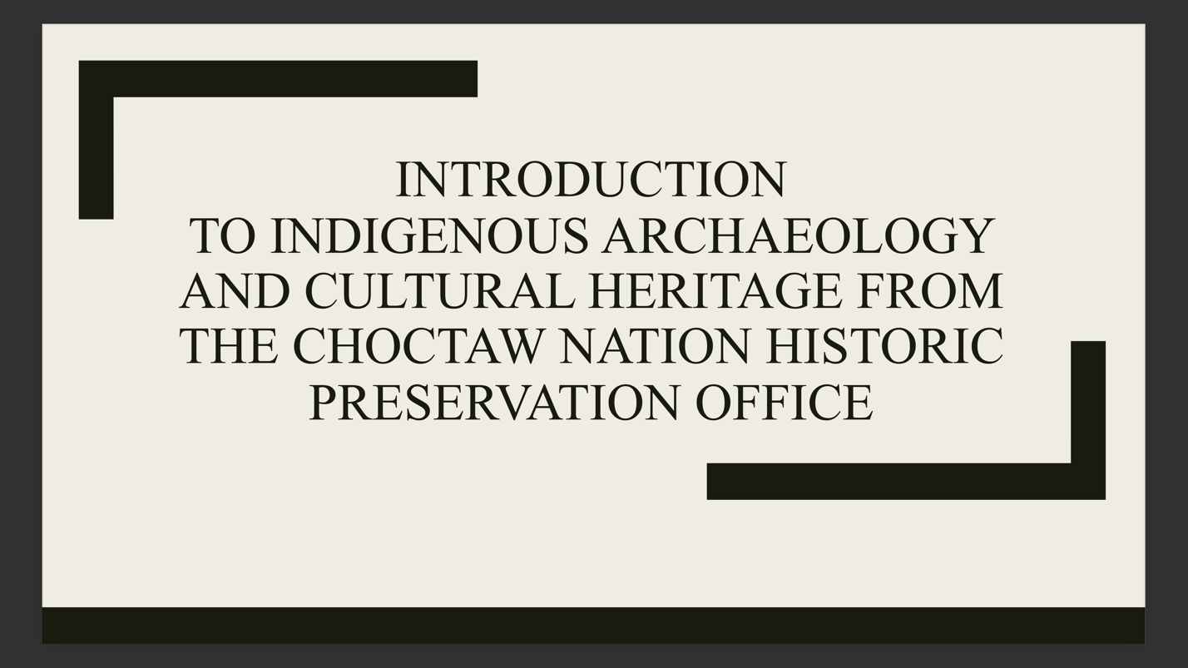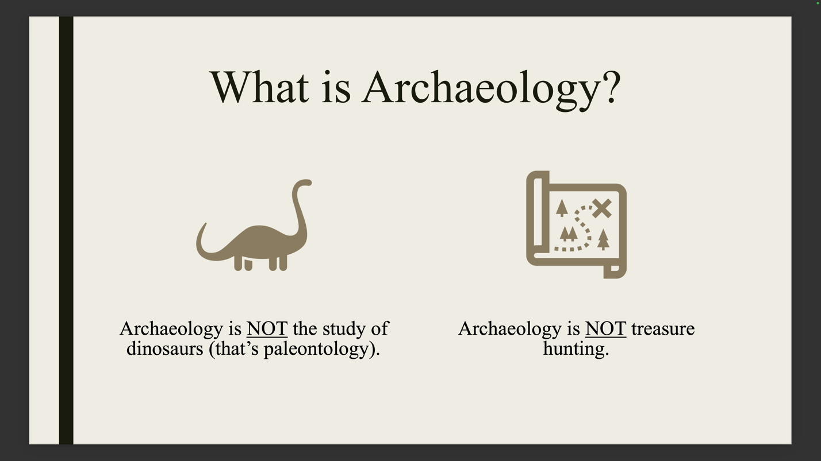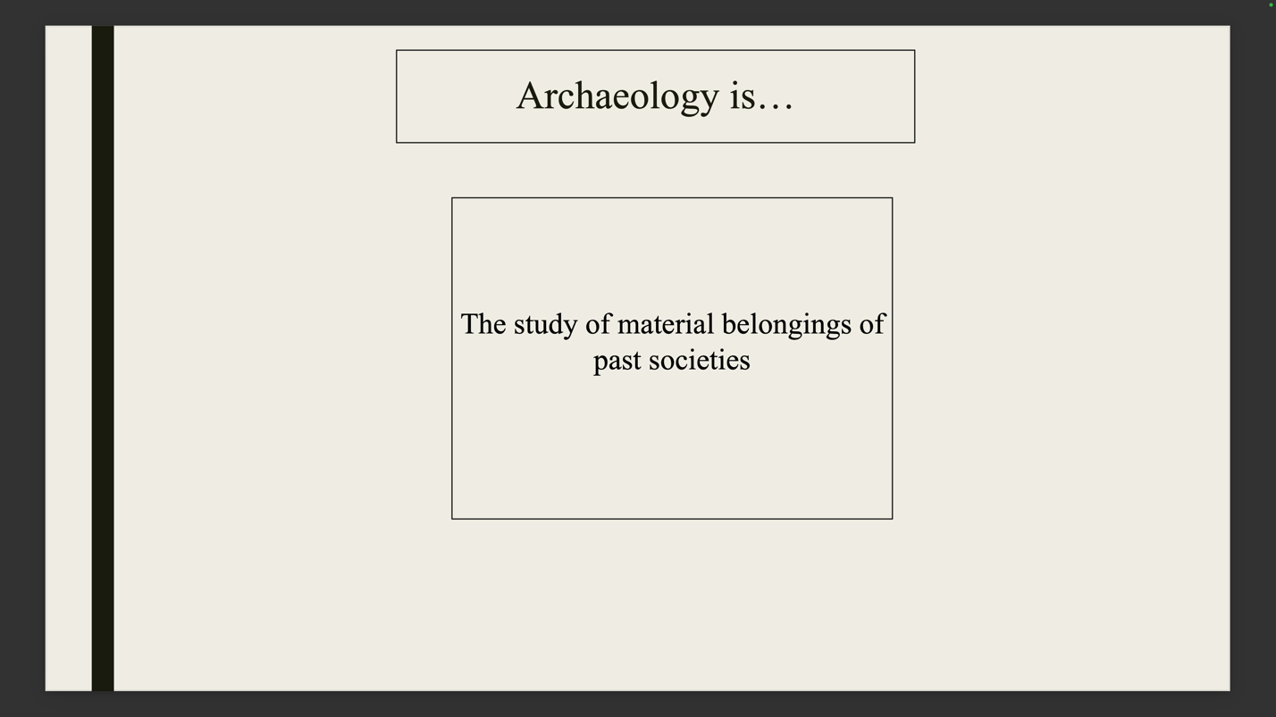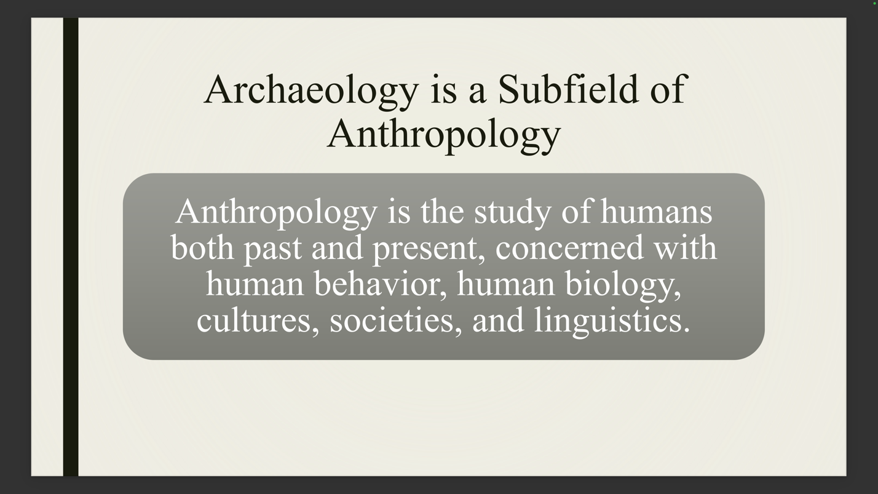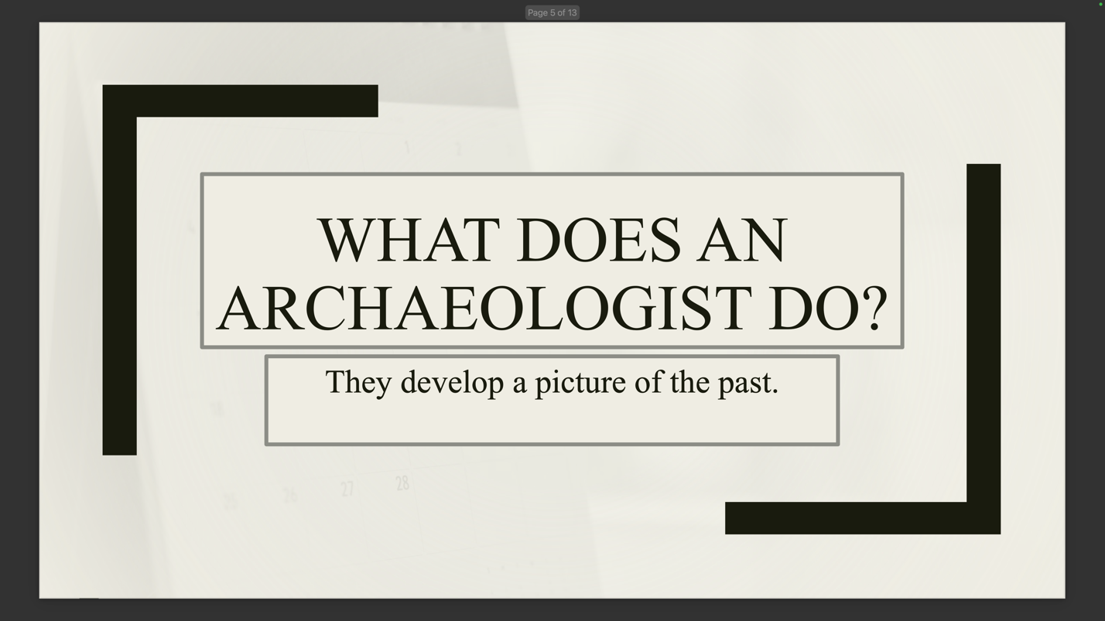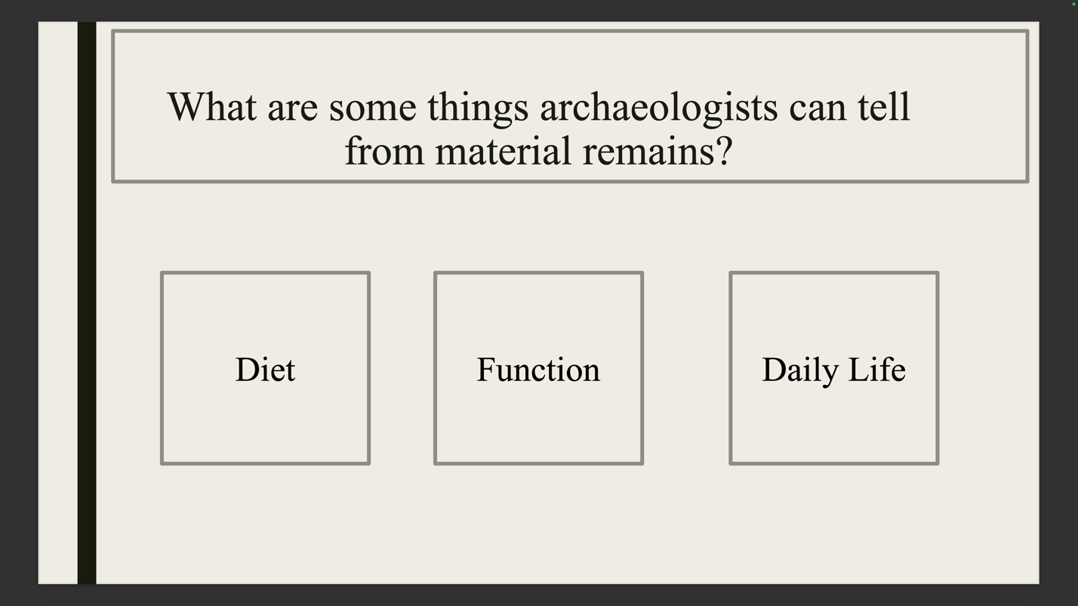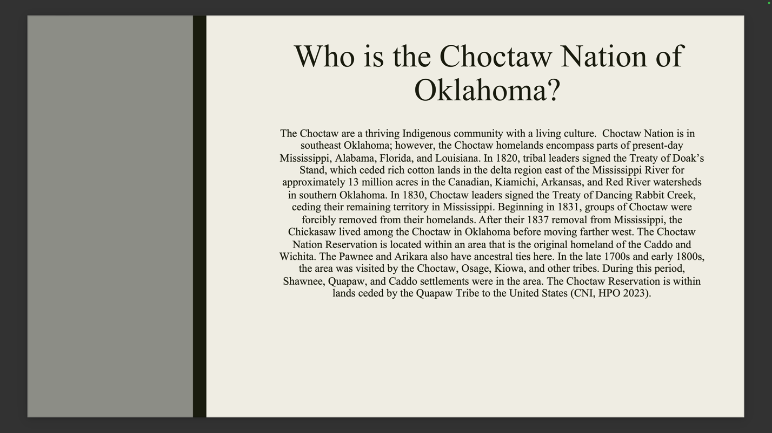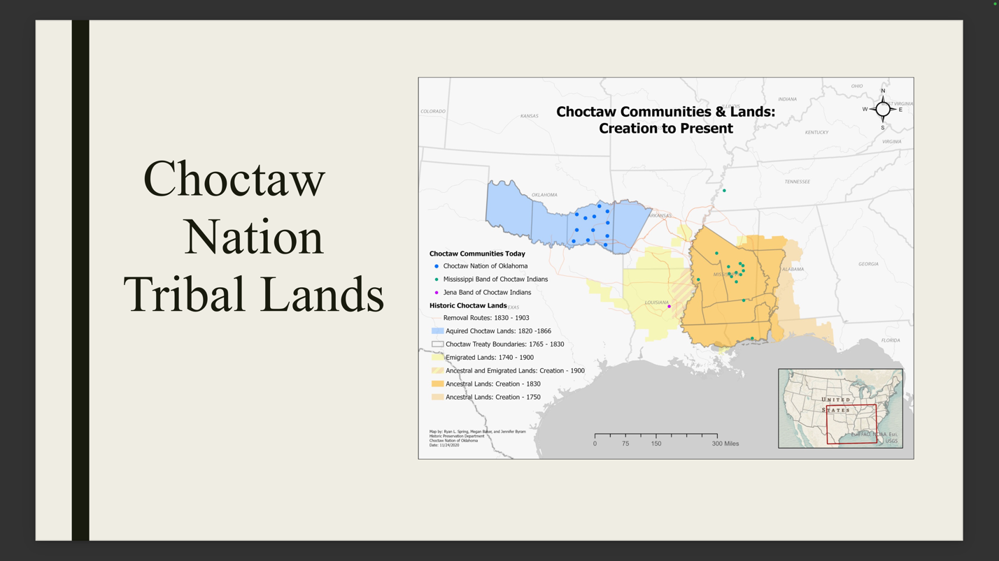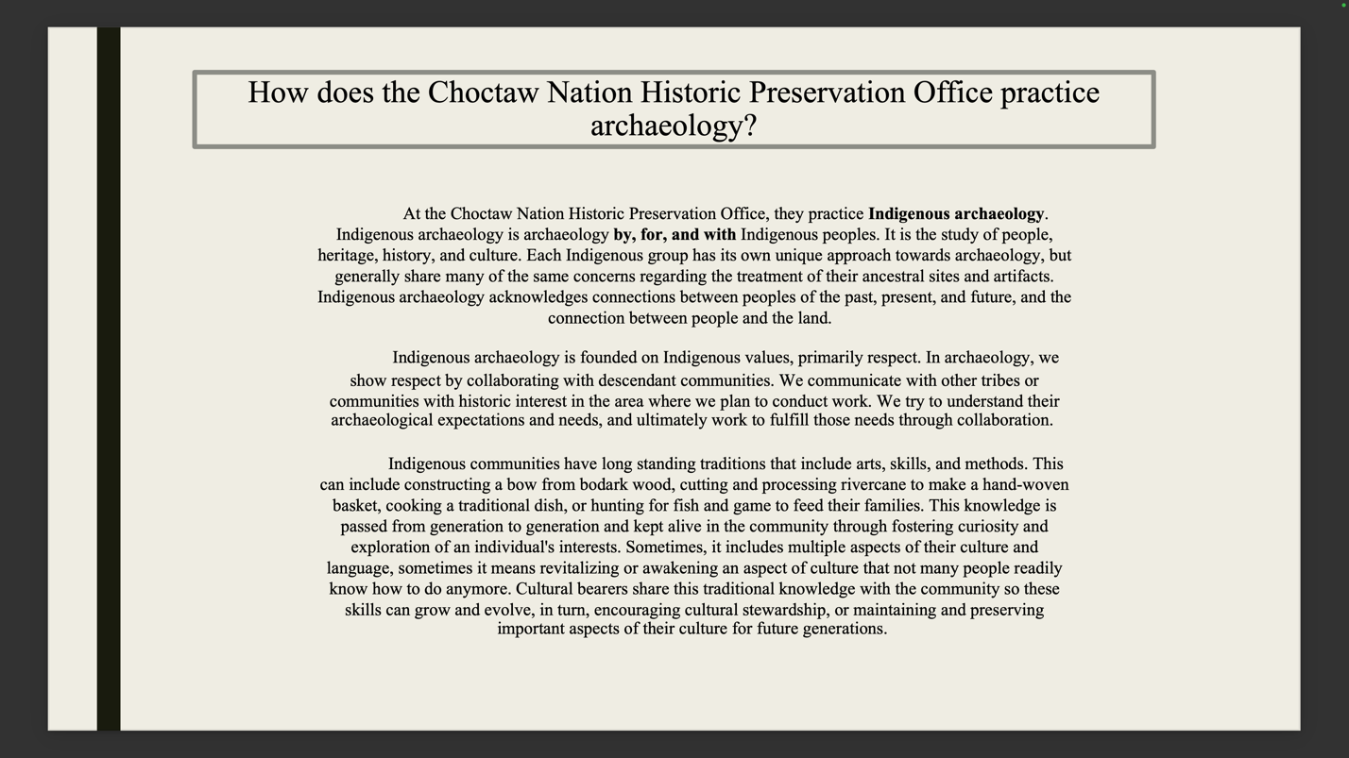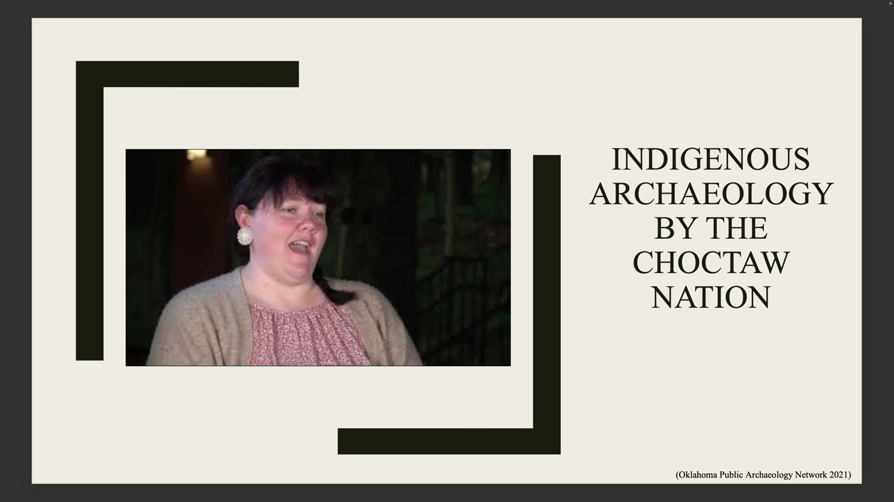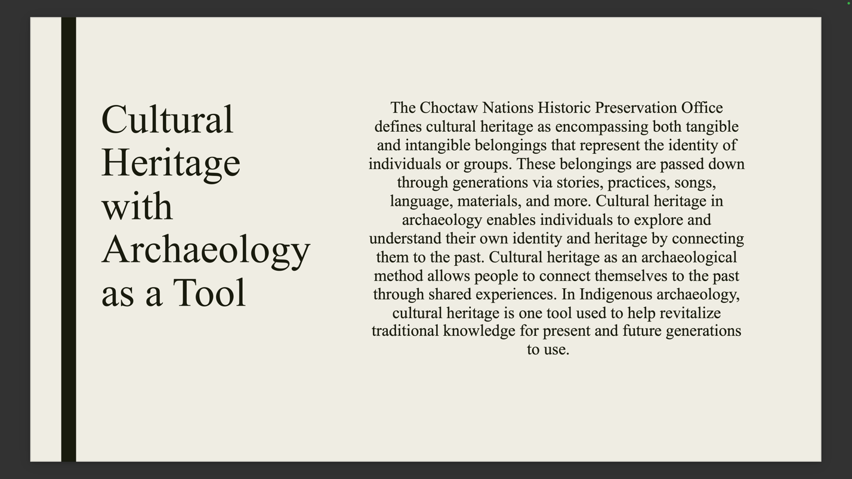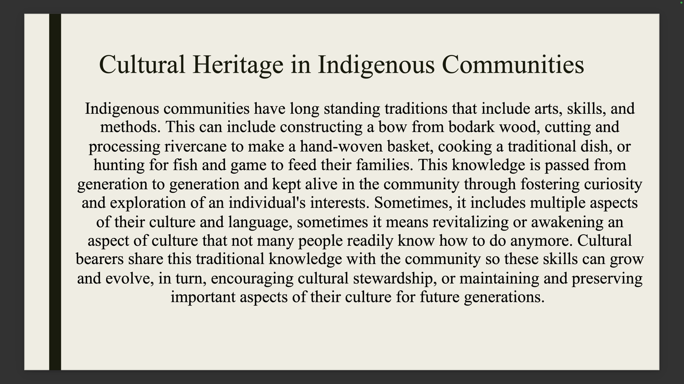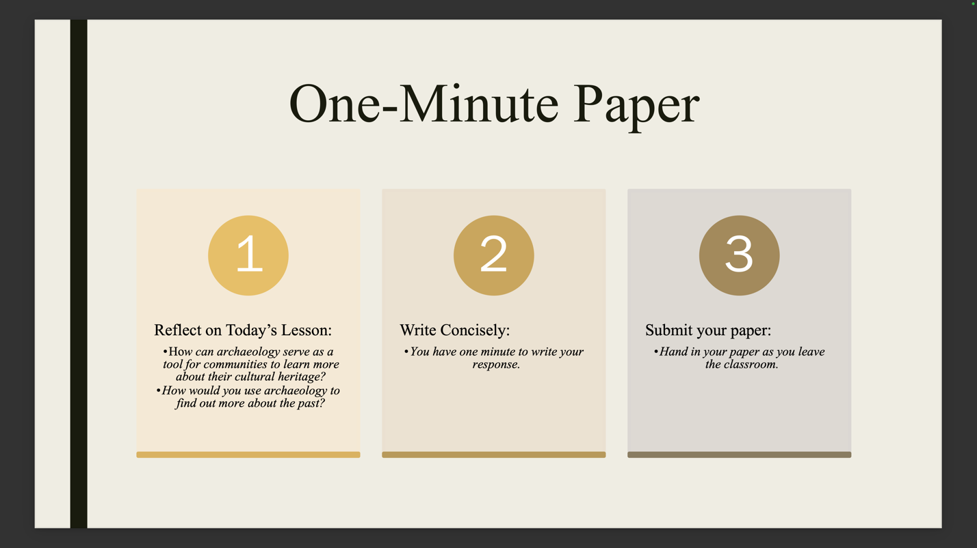

Appendix B
Lesson Two PowerPoint Example
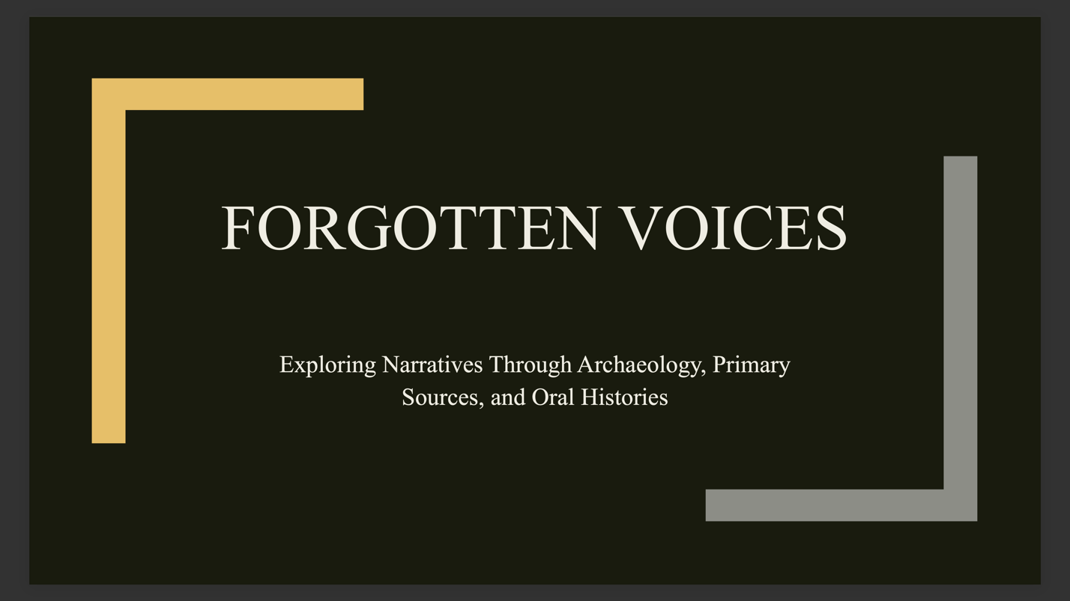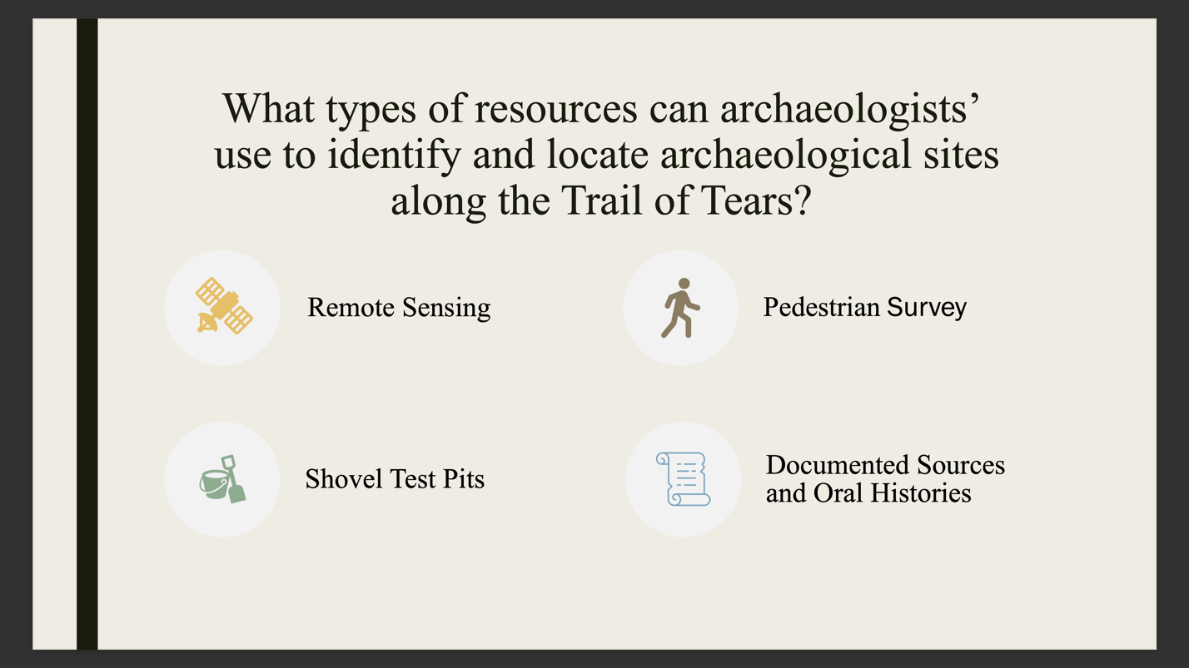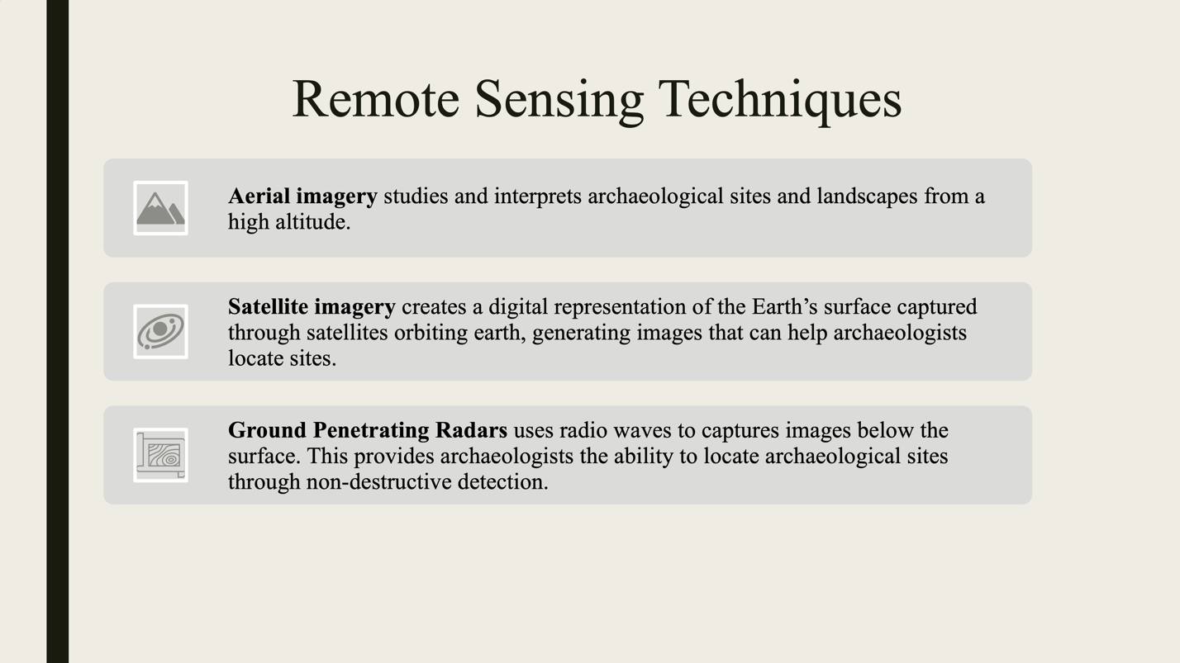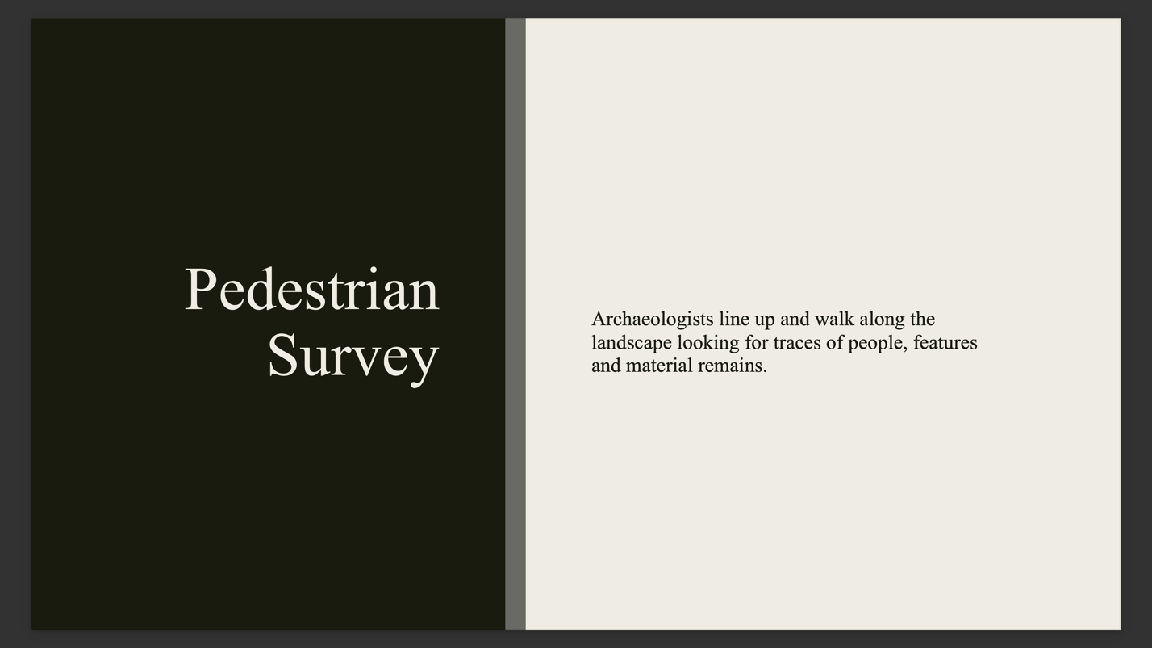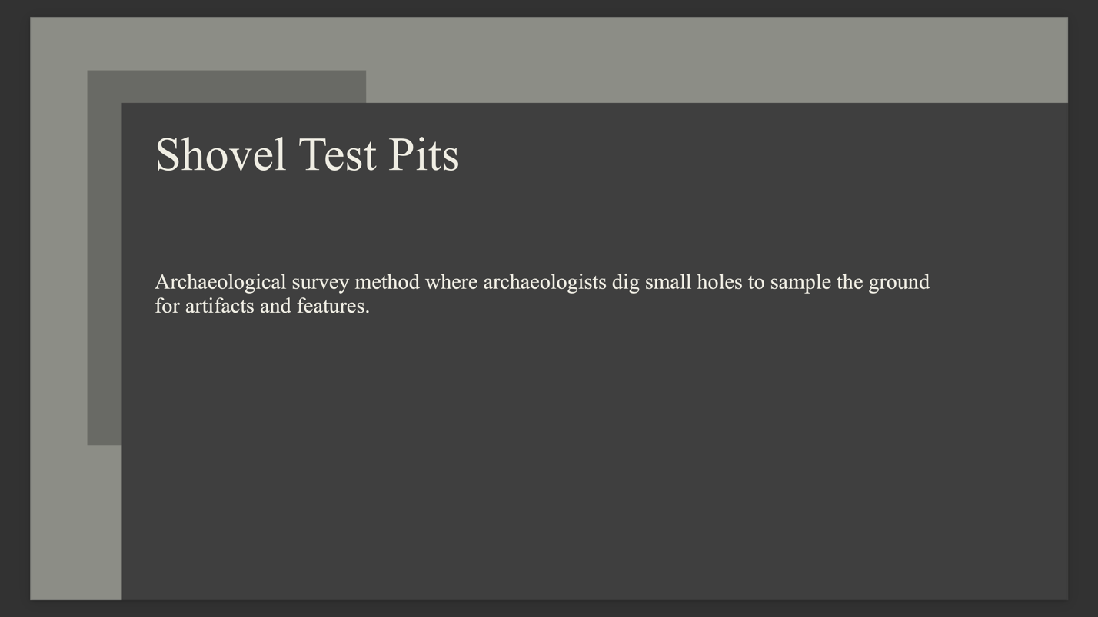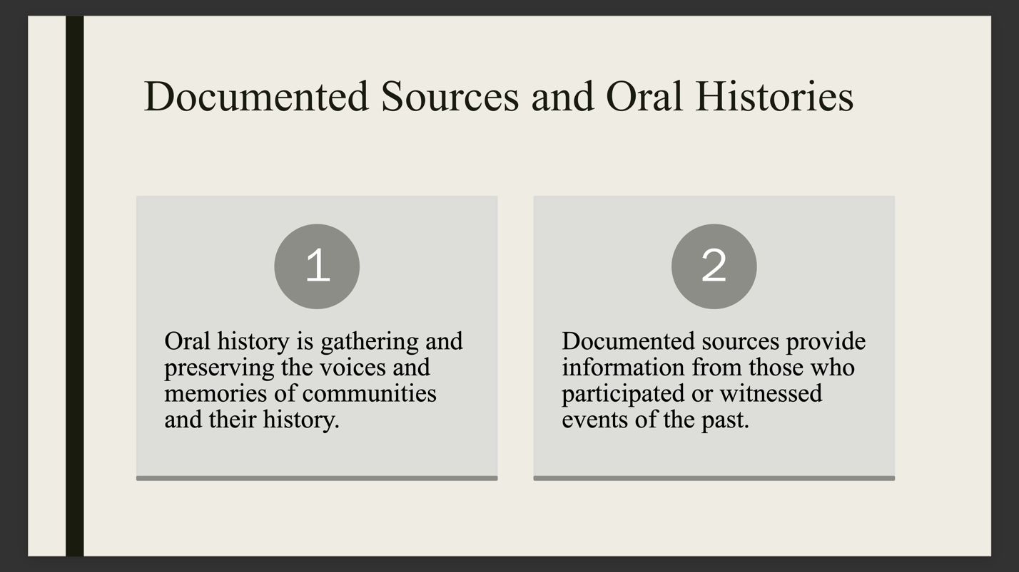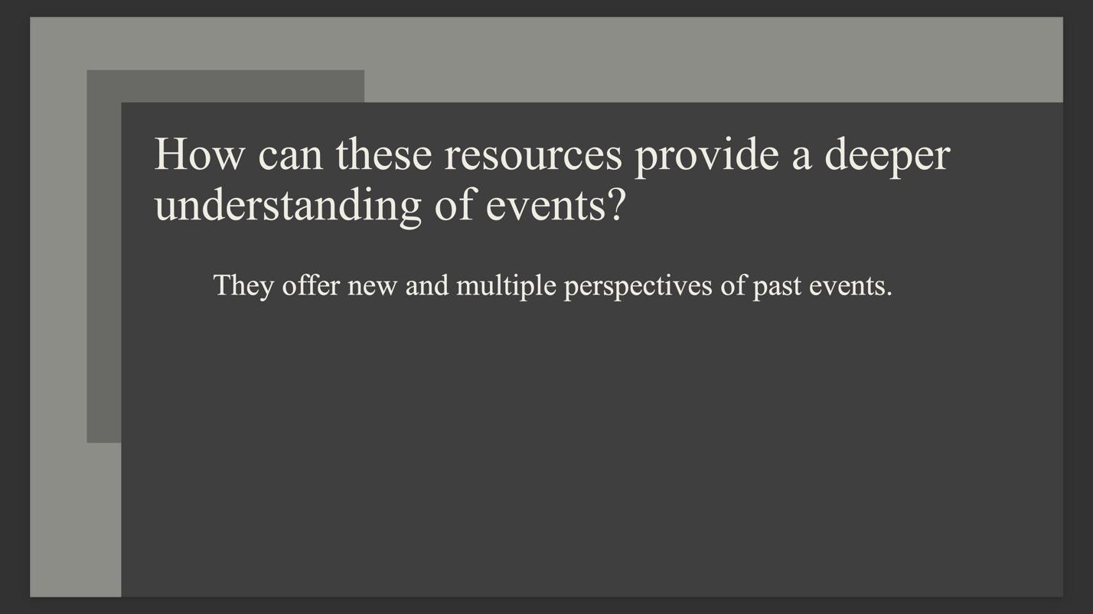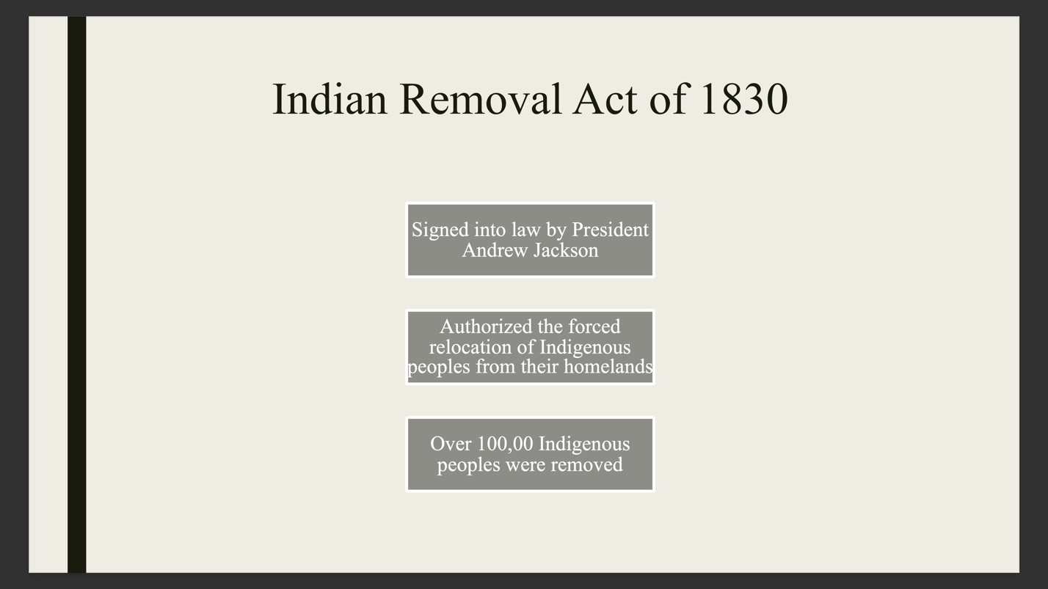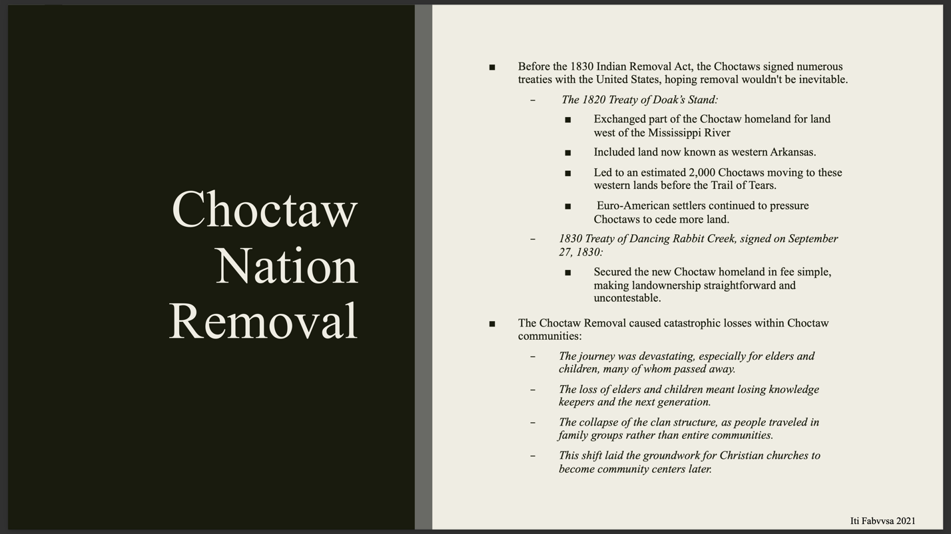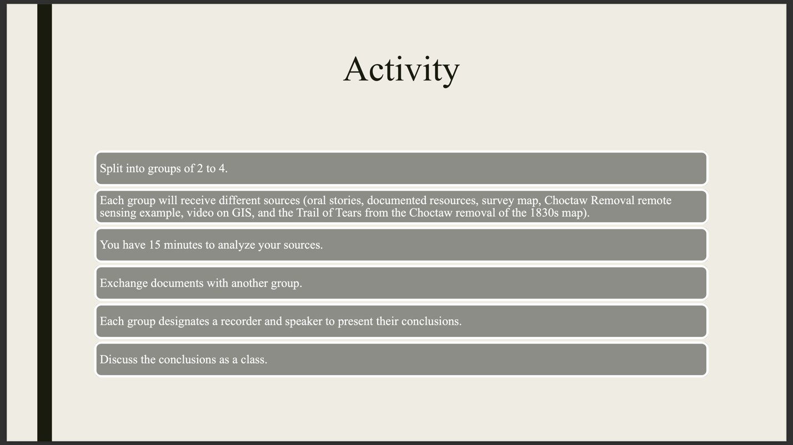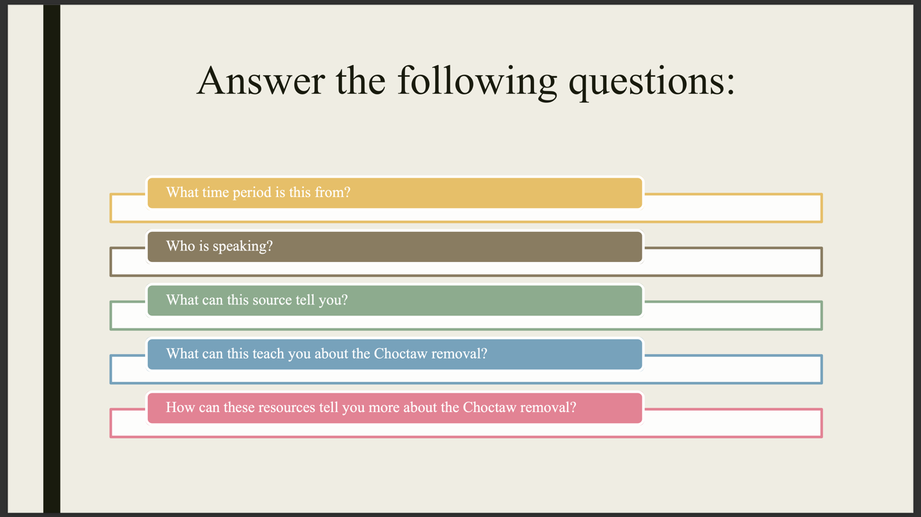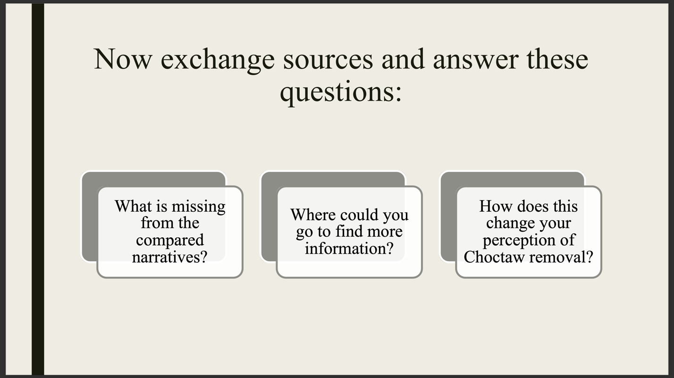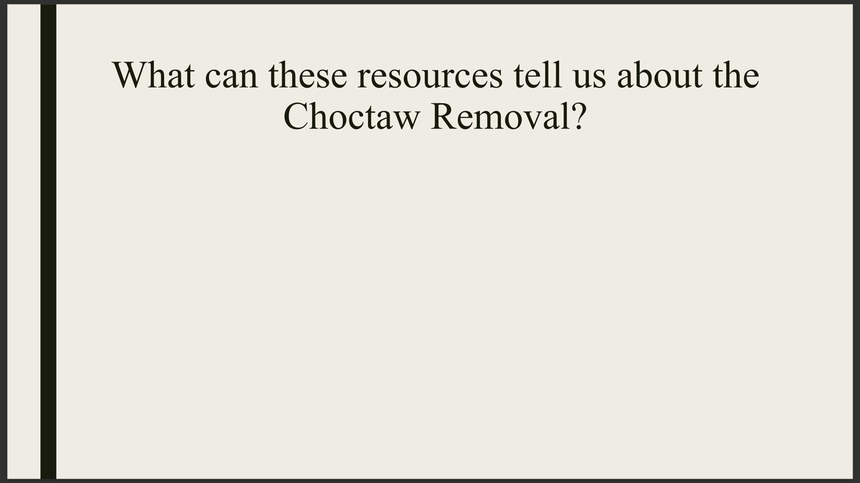

Bibliography
Adams, Shaun, Mark Collard, Doug Williams, Clarence Flinders, Sally, Wasef, and Michael C. Westaway
2020 A Community Bioarchaeology Project in the Flinders Group, Queensland, Australia. Archaeologies: Journal of the World Archaeological Congress: 436-456.

Agenten, Courtney
2024 Our History, Our Journey. Project Archaeology. https://projectarchaeology.org/our-history/, accessed April 2, 2024.

Archaeological Institute of America
2024 Introduction to Archaeology. AIA, May 8. https://www.archaeological.org/programs/educators/introduction-to-archaeology/

Atalay, Sonya
2006 Indigenous Archaeology as a Decolonizing Practice. American Indian Quarterly: 30(3): 280-301.

Atalay, Sonya
2012 Community-Based Archaeology. University of California Press.

Baird, David
2020 The Story of Oklahoma. University of Oklahoma Press.

Banks, James
1998 Multiculturalism’s Five Dimensions. NEA Today.

Bria, Rebecca and Erick Casanova Vasquez
2022 Digital Archaeology and Storytelling as a Toolkit for Community-Engaged Archaeology. In Critical Archaeology in the Digital Age, edited by Kevin Garstki. Cotsen Institute of Archaeology Press at UCLA.

Clark Joëlle and George Gumerman IV
2018 Hopi Footprints: What Really Matters in Cultural Preservation. University of Arizaona Press.

Cole Matt
2024 History of Oklahoma Academic Standards, blog, https://infobymattcole.com/index.php/2024/01/14/history-of-oklahoma-academic-standards/, accessed April 30, 2024.

Colwell-Chanthaphonh Chip and T.J. Ferguson
2008 Introduction: The Collaborative Continuum. In Collaboration in Archaeological Practice: Engaging Descendant Communities, edited by C. Colwell-Chanthaphonh and T.J. Ferguson, pp. 1-32. Alta Mira Press.

Colwell-Chanthaphonh, Chip and T.J. Ferguson, Dorothy Lippert, Randall H. McGuire, George P. Nicholas, Joe E. Watkins, and Larry Zimmerman
2010 The Premise and Promise of Indigenous Archaeology. American Antiquity: 75(3): 228-238.

Dewey, John
1897 My Pedagogic Creed. School Journal: 77-80.

Dewey, John
1900 The School and Society. The University of Chicago Press.

Erdman, Katherine
2019 Public Engagement and Education: Developing and Fostering Stewardship for an Archaeological Future. Berghahn Books.

Farhang, Qassem, Sayed Shirt Aqa Hashemi, Sakhi Murad Ghorianfar
2023 Lesson Plan and Its Importance in Teaching Process. International Journal of Current Science Research and Review: 5901-5913.

Foreman, Grant
1932 Indian Removal. University of Oklahoma Press.

Freire, Paulo
1968 Predagogy of the Opressed. Seabury Press.

Gallas, Karen
1991 Arts as Epistemology: Enabling Children to Know What They Know. Harvard Educaional Review.

Gilde, Judith’t and Monique VolmanVolman
2021 The Effects of Using Students’ Funds of Knowledge on Educational Outcomes in the Social and Personal Domain. Learning Culture and Social Interaction: 28.

Henderson, Gwynn and Linda Levstik
2016 Reading Objects: Children Interpreting Material Culture. Advances in Archaeological Practice: 4(4): 503-516

Hoover, Kenneth and Helene Hoover
1967 Lesson Planning: Key to Effective Teaching. The Clearing House: 42(1): 41-44.

Hubbard, Rachel
2014 Where Did Education Standards Come From? NPR. https://www.kosu.org/education/2014-08-25/where-did-education-standards-come-from#, accessed May 4, 2024.

Iti Fabvssa
2024 Putting the Coal in Coalgate, Exhibit Teaching about Past. Iti Fabvssa. https://choctawnationculture.com/media/41421/2020.12_choctaw_archaeology_-_putting_the_coal_in_coalgate_exhibit.pdf, accessed April 20, 2024.

Jameson, John
1997 Presenting Archaeology to the Public: Digging for Truth. Alta Mira Press.

Jones Academy
2024 History: The History of Jones Academy. Jones Academy. https://www.jonesacademy.org/page/history, accessed May 3, 2024.

Journell, Wayne
2009 An Incomplete History: Representation of American Indians in State Social Studies Standards. Journal of American Indian Education: 48(2): 18-32.

Kabulova, Zulfiya
2023 The History of Pedagogy as a Teaching Subject. Web of Teachers Inderscience Research: 1(7): 153-157.

La Salle, Marina
2010 Community Collaboration and Other Good Intentions. Archaeologies: Journal of the World Archaeological Congress: 6(3): 401-422.

Ladson-Billings, Glorial
1995 Toward a Theory of Culturally Relevant Pedagogy. American Educational Research Journal: 32(3): 465-491
Lambert, David and John Morgan
2010 Teaching Geography 11-18: A Conceptual Approach. McGraw-Hill Education.

Lee, Andrew
2024 State Academic Standards: What You Need to Know. Understood. https://www.understood.org/en/articles/state-academic-standards-what-you-need-to-know, accessed May 4, 2024.

Little, Barbara
2002 Public Benefits of Archaeology. University of Florida Press.

Marshall, Yvonne
2010 What is Community Archaeology? World Archaeology: 34(2): 211-219.

McGhee, Robert
2008 Aboriginalism and the Problems of Indigenous Archaeology. American Antiquity: 73(4): 579-597.

Meriman, Nick
2004 Public Archaeology. Routledge.

Mitchell, David
2017 Curriculum Making, Teaching, and Learner Identities in Changing Times. Geography: 1(2): 99-103.

Moshenska, Gabriel
2017 Key Concepts in Public Archaeology. UCL Press.

Moe, Jeanne
2019 Best Practices in Archaeology Education: Successes, Shortcomings, and the Future. Public Engagement and Education: Developing and Fostering Stewardship for an Archaeological Future, edited by Katherine Erdman.

Nicholas, George
2008 Native Peoples and Archaeology. The Encyclopedia of Archaeology: 3: 1660-1669.

Oklahoma Department of Education
2023 Oklahoma Academic Standards: Social Studies. Oklahoma Department of Education. https://sde.ok.gov/sites/default/files/documents/files/Oklahoma%20Academic%20Standards%20for%20Social%20Studies%208.26.19.pdf, accessed January 12, 2024.

Oklahoma Social Studies Framework
2022 Oklahoma History Learning Progression, edited by Pam Merrill.

Paris, Django
2012 Culturally Sustaining Pedagogy: A Needed Change in Stance, Terminology, and Practice. Educational Researcher: 41(93): 93-97.

Purcell, Gabrielle
2023 Connecting the Present to the Past: How Collaborative Archaeology Can Inform Us about Ancient Foodways. Ancient Foodways: Integrative Approaches to Understanding Subsistence and Society, edited by C. Margaret Scarry, Dale L. Hutchinson and Benjamin S. Arbuckle.

Rann, Brother
2017 The Tedious Art of Lesson Planning. Blog, https://urbanedmixtape.com/2017/01/31/the-tedious-art-of-lesson-planning/, accessed May 2, 2024.

Rhode Island Department of Education
2023 Social Studies: Curriculum Framework. RIDE. https://ride.ri.gov/sites/g/files/xkgbur806/files/2023-12/Social%20Studies%20Framework%20-%20Final.pdf, accessed May 2, 2024.

Society of American Archaeology
2024 Education and Outreach. Society of American Archaeology, https://www.saa.org/education-outreach/teaching-archaeology/k-12-activities-resources, accessed February 12,2024.

Smardz Karolyn and Shelley Smith
2000 The Archaeology Education Handbook: Sharing the Past with Kids. Alta Mira Press.

National Museum of Natural History
2024 Unlocking Hidden Worlds Through Archaeology and Archives. Smithsonian. https://naturalhistory.si.edu/education/teaching-resources/social-studies/unlocking-hidden-worlds-through-archaeology-and, accessed April 10, 2024.

Montana Office of Public Instruction
2024 Indian Education for All. Putting Montana Students First. https://opi.mt.gov/Educators/Teaching-Learning/Indian-Education-for-All, accessed November 20, 2023.

Tribal GIS
2022 Choctaw Trail of Tears: A GIS Approach. Tribal GIS. https://www.tribalgis.com/tribalgis-videos/video/choctaw-trail-of-tears-a-gis-approach, accessed May 2, 2024.

US News
2024 Overview of Oklahoma. US News. https://www.usnews.com/news/best-states/oklahoma, accessed May 2, 2024.

White, Charles
2019 Schools and Public Archaeology: Igniting a Commitment to Heritage Preservation. Public Engagement and Education: Developing and Fostering Stewardship for an Archaeological Future, edited by Katherine Erdman.

Whitehead, Alfred
1929 The Aims of Education. Free Press.

