UNIVERSITY OF OKLAHOMA
GRADUATE COLLEGE

MULTI-SOURCING RESILIENT SUPPLIER SELECTION UNDER OPERATIONAL DISRUPTIONS

A THESIS
SUBMITTED TO THE GRADUATE FACULTY
in partial fulfillment of the requirements for the
Degree of
MASTER OF SCIENCE

By

SREERAM GANESAN MEENA
Norman, Oklahoma
2017

MULTI-SOURCING RESILIENT SUPPLIER SELECTION UNDER OPERATIONAL DISRUPTIONS

A THESIS APPROVED FOR THE
SCHOOL OF INDUSTRIAL AND SYSTEMS ENGINEERING

BY

______________________________
Dr. Kash Barker, Chair

______________________________
Dr. Shivakumar Raman

______________________________
Dr. Theodore Trafalis

© Copyright by SREERAM GANESAN MEENA 2017
All Rights Reserved.
To my family and friends,
For all your guidance and support.

Acknowledgements
Firstly, I would like to express my gratitude to my advisor, Dr. Kash Barker, he has been a true mentor. I sincerely thank him for providing me the opportunity to be a part of his research group and for his constant support.
I am grateful to all the professors in the department of Industrial and Systems Engineering who have helped me throughout my time here at OU. I would like to thank Saptarshi Mandal who has helped me understand multi-objective optimization better.
Last, but certainly not the least, I would like to acknowledge the support of my parents, my brother and all my friends who have always motivated me.

Table of Contents
Acknowledgements iv
List of Figures vi
Abstract viii
Chapter 1.0 Introduction and motivation 1
Chapter 2.0 Literature Review 4
Chapter 3.0 Methodological Background 7
3.1 Resilience Strategies 7
3.2 Resilience Quantification 7
Chapter 4.0 Definition and Assumptions 9
4.1Network Performance 11
4.2 Disruption Scenario 14
Chapter 5.0 Model Formulation 15
5.1 Resilience Quantification 17
5.2 Mathematical Model 17
5.3 Solution Procedure 19
Chapter 6.0 Illustrative Example 21
6.1 Parameter Setting 21
6.1.1 Stable State Analysis 21
6.1.2 Disrupted State Analysis 22
6.2 Results Analysis 22
Chapter 7.0 Conclusions 27
7.1 Future Work 27

References 30

List of Figures and Tables
Figure 1: Graphical representation of network performance as a function of time 8
Figure 2: Schematic representation of the supply chain network 10
Figure 3: Depiction of network performance without absorptive capacity in scenario 1 24
Figure 4: Depiction of network without absorptive capacity in scenario 2 24
Figure 5: Depiction of network with absorptive capacity in scenario 1 25
Figure 6: Depiction of network with absorptive capacity in scenario 2 26
Figure 7: Graphical representation of network performance 27
Figure 8: Comparison of resilience of the network under disruptive scenarios 27

Table 1: Description of notations related to the suppliers 12
Table 2: Description of notations related to the warehouse selection 13
Table 3: Parameter setting related to potential suppliers 21
Table 4: Parameter setting related to warehouse locations of supplier 3 22
Table 5: Parameter setting related to warehouse locations of supplier 4 22
Table 6: Decision variables for Scenario 1 23
Table 7: Network performance for Scenario 1 23
Table 8: Network performance for Scenario 2 24
Table 9: Decision variables for Scenario 2 25
Table 10: Network performance for Scenario 1 25
Table 11: Network performance for Scenario 2 26
Table 12: Decision variables for warehouse analysis of supplier 3 in scenario 2 26
Table 13: Decision variables for warehouse analysis of supplier 4 in scenario 2 26
Table 14: Network performance for scenario 2 26

Abstract
Recognizing the inevitability of large scale disruptions, managers in supply chains have shifted their focus in decision making from prevention and protection to resilience. Resilience is the ability of a supply chain to withstand, adapt to and recover from a disruption to a desired performance level. With the rise in global interconnectivity supply chain networks have become highly dependent on suppliers located in various offshore locations. The interdependency of these networks has made them prone to disruptive events depending on their location. Disruptions are caused by events like malevolent attacks, natural disasters, production failures etc. One such event could hamper the functioning of supply chains; hence it is important for suppliers to have contingency plans to return the network to desired level of performance. The resilience capacity of the suppliers can be improved from three dimensions: absorptive capacity (their ability to pre-position inventory), adaptive capacity (their ability to subcontract proportionate goods to another party) and restorative capacity (their ability to recover lost capacity). This work addresses resilient supplier selection by improving the absorptive capacity of the suppliers. This problem has been modeled as a supplier selection decision framework that implements a multi objective optimization framework which includes traditional supplier selection objectives like cost, lead time and added objectives related to the absorptive capacity. This work demonstrates the use of the framework through an illustrative example of a supply chain network under various scenarios of disruption. These scenarios help to understand how the resilience of the network improves with added absorptive capacity.

- Introduction and Motivation
In this highly interconnected world, managers of supply chains have shifted their focus from prevention and protection from large scale disruptions to resilience. Resilience of a network is defined as its ability to withstand and recover from a disruptive event. A supply chain can be usually seen as a network with interaction between organizations like suppliers, retailers, manufacturers which are dependent on each other for operation. With rise of global interconnectivity modern supply chains have become increasingly dependent on outsourcing of goods and services. This is attributed to the lower production costs, increased quality and increased overall operational efficiency of the network. The interconnectivity of the network has made them vulnerable to disruptions rising from events like natural disasters, malevolent attacks, social unrests etc. depending the location of the network.
One such case is the 2011 earthquake in Japan which had many supply chain managers juggling with production and shipment planning to keep the supply chain networks flowing. This disaster had a General Motors plant in Louisiana to shut down its operations temporarily due to lack of Japanese made parts. Other examples which led to large scale disruptions of international supply chain networks include the 2011 volcanic eruption in Iceland which spewed ash all over Europe and grounded air travel. Car makers like BMW and Nissan had announced suspension of production in respective manufacturing units all over Europe due to unavailability of certain parts.
One of the most important problems faced by managers in manufacturing and consumer goods supply chains is supplier selection problem. The problem involves identifying and prioritizing the best suppliers from a set of available suppliers. It is generally a multi criteria decision making problem which is dependent on factors like operational costs, delivery lead time and quality. Resilient supplier selection is process of improving the supplier selection problem by making it resilient to disruptions. There is abundant literature regarding the importance of supplier selection, but resilient supplier selection is a sparsely explored area in the literature. This work intends to identify resilience as a crucial factor in supplier selection process.
The redundancy caused due to a disruption can be decreased from three dimensions: absorptive capacity (pre-positioning inventory), adaptive capacity (subcontracting proportional goods to other suppliers) and restorative capacity (recover lost capacity in a timely manner). In this study, we will focus on increasing resilience of the network using absorptive capacity. A supplier selection decision framework has been developed that includes a multi objective optimization framework considering the typical supplier selection objectives along with new resilience driven objectives.
The objective of this research is to improve supplier selection decision and the impact of considering supplier resilience as an objective in the framework. Precisely, we have developed and applied a multi-objective optimization framework which includes formulation with traditional supplier selection objectives, a specific metric for supplier resilience and a solution algorithm that addresses a self-assumed data for an imaginary supply chain network.
The remainder of this work will be structured in the following order:
Section 2 includes the relevant literature review of the concepts used to solve the resilient supplier selection problem.
Section 3 includes the proposed methodology and the mathematical model applied to the problem.
Section 4 includes the definitions and assumptions used throughout the work. Section 5 includes the model formulations and development of the mathematical model.
Section 6 illustrates the application of the developed model on a data and includes the analysis of the results.
Section 7 includes the concluding remarks and scope for future work in this research.

- Literature Review
This section includes the concepts critical to develop the methodology used to solve the above discussed problem.
Over the past decade the risk management has been identified as an important topic by both practitioners and researchers (Shi-Cho, 2008). According to (Aissaoui, Haouari, & Hassini, 2007) there are six critical decisions to be made when it comes to purchasing: ‘make or buy’, supplier selection, contract negotiation, design collaboration, procurement and sourcing analysis. Supplier selection, among these has been extensively studied. Once the organization has decided to outsource a part or raw material it needs to look at various criteria like cost, lead time, quality, reliability etc. Subsequently, the firm must decide which vendors to select and how much to order from each of the selected vendors. (Weber & Current, 1993) identify this process as supplier selection problem. (Christopher & Peck, 2004) identified many unavoidable principles that underpin resilience in supply chains. Berger et al (2004) assumed two types of catastrophes: “super-events” which affect multiple suppliers and “unique events” which disrupt a single supplier. It considered the monetary loss caused by the disruptions and solved the problem using a decision support system to decide on optimal number of suppliers by minimizing the expected cost function. (Wu, Blackhurst, & O’grady, 2007) developed a model to resolve the debate between single sourcing and dual sourcing when demand is price sensitive and the market scale increases due to a supply chain disruption. The work concluded that both strategies are equally effective depending on the magnitude of the disruption probability. Xiao and Yu (2006) studied the effect of supply disruptions on retailers in a supply chain. They used two strategies for the retailers, maximizing profit and maximizing revenue. (Blackhurst *, Craighead, Elkins, & Handfield, 2005) conducted an empirical study of different industries to depict the way supply chain disruptions is identified a mitigated in practical problems. (Ho, Xu, & Dey, 2010) surveyed the literature of the multi-criteria decision-making approaches for supplier evaluation and selection based on 78 international journal articles gathered from 2000 to 2008. They concluded that price or cost were the most widely adopted criterion along with quality of the supplied products followed by delivery and so on.
Various mathematical models have been used for the supplier selection problem, such as linear programming, mixed-integer programming and multi-objective programming. (Amid, Ghodsypour, & O’Brien, 2011) proposed an integration of an analytical hierarchy process and applied linear programming to model the problem. They integrated both quantitative and qualitative factors in the model to prioritize the suppliers and allocate the order quantities. (Ng, 2008) developed a weighted linear program for the multi-criteria supplier selection problem with goal to maximize the supplier score. (Hammami, Temponi, & Frein, 2014) developed a mixed integer programming model for the problem that considered inventory decisions, inventory capacity constraints, specific delivery frequency and transportation capacity applied to multiple products and multiple time period.
As the supplier selection problems lead to multi-objective optimization formulation, several researchers began to adopt multi-objective programming. (Narasimhan, Talluri, & Mahapatra, 2006) developed a multi-objective model to prioritize the optimal suppliers and determine the optimal order quantity. The objectives included: minimizing cost, transaction complexity, maximizing quality and delivery performance. (Xia & Wu, 2007) proposed and multi objective mathematical model to minimize the total purchasing cost, reduce the tardiness and maximize the total weighted quantity of purchasing. The model also studied the integration of price discounts on total business volume and determined the number of suppliers to select and allocate order quantity in case of multiple sourcing, multiple products with multiple criteria and with capacity constraints.(Noorul Haq & Kannan, 2006) applied a multi criteria method to the supplier selection problem, and solved it using AHP and goal programming. (Agrell, Lindroth, & Norrman, 2004) analyzed a two-period game concerned with information sharing in the context of an investment problem in the telecom industry, which also included supplier selection.
There are instances in the literature where supplier selection is closely related to inventory analysis but (Hammami et al., 2014) proposed that only a few models incorporate inventory related management issues in supplier selection. (Noorul Haq & Kannan, 2006) integrated supplier selection model with multi-echelon distribution inventory model.

- Methodological Background
This section gives a background on how resilience is quantified and describes the structure of the resilient supplier selection problem.
  - Resilience Strategies
Biringer et al (2013) suggested that resilience capacity with three categories that each represent temporal attributes before, during and after a disruptive event: absorptive capacity, adaptive capacity and restorative capacity. A resilient supplier is defined as the one with characteristics of all the three capacities.

  - Resilience Quantification
A network is usually expected to function at a desired level of performance, this state is called the stable state of the network. In this study, the supply chain network is said to be at stable state when the selected suppliers are delivering the goods within the promised lead time. At the time of disruption, the network tends to undergo changes leading to lowered level of performance. The network thus goes into a disrupted state and exists there until recovery.
For this problem, resilience has been considered as the performance of a supply chain network before and after a disruptive event. In this framework two phases of the network’s performance have been considered: vulnerability and recoverability. Vulnerability of a network is defined as to how liable or harmed a network can be to a disruptive event (Jonsson, 2008) and recoverability is the ability of a network to quickly restore its desired level of performance.(Pant, Barker, Ramirez-Marquez, & Rocco, 2014) have defined network resilience graphically as shown in Figure 1.

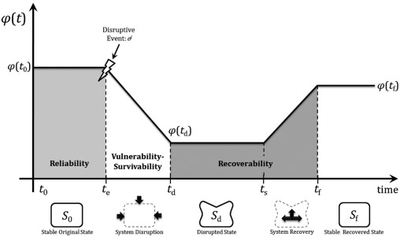
Figure 1: Graphical representation of network performance as a function of time
System performance can be represented as a function of time $φ(t)$, to mathematically quantify resilience. Network resilience, $Я$, is the ratio of time-dependent recovery to loss (i.e. $Я\left(t\right)=\frac{Recovery\left(t\right)}{Loss\left(t\right)}$ ) (Henry and Ramirez-Marquez, et al, 2012). Equation 1 elaborately describes the above relationship.
$$Я_{φ}\left(t|e^{j}\right)=\frac{φ\left(t | e^{j}\right)-φ\left(t_{d} | e^{j}\right)}{φ(t_{0})-φ\left(t_{d} | e^{j}\right)}, ∀ t ϵ(t_{s},t_{f})$$ | (1)

$φ\left(t | e^{j}\right)$ is the system performance at time $t$ following disruptive event $e^{j}$, $φ\left(t_{d} | e^{j}\right)$ is the system performance immediately following a disruption, and $φ(t_{0})$ is the system performance prior to a disruption. $Я_{φ}\left(t|e^{j}\right)$ may range between 0 and 1, where 1 means the system is fully resilient.

- Problem Definition and Assumptions
Firstly, the supply chain network is modeled as a multi-objective optimization problem. The procurement decisions to be made by a single decision maker which leads to centralized contact. The procurement decision is to be made for a single product from a set of potential suppliers for a constant demand at the customer end. Figure 2 depicts the supply chain system, where the product flows sequentially from the supplier to the retailer through to satisfy the customer demand. The set of suppliers have been assumed to have a similar customer satisfaction level with regards to quality. The customer satisfaction level includes factors like delivery assurance, maintenance, service etc.
The decision to procure the products will depend on the cost of the product, fixed ordering cost, lead time of delivery and the inventory cost. The suppliers have been assumed to hold inventories at various warehouses. The location of these warehouses is pre-determined and each of them have unique holding costs and delivery lead time. Products are supplied to the retailers from the set of suppliers and each supplier has a fixed capacity which is constant. During the time of disruptions, the supplier use the inventory held in the pre-determined warehouses to meet the unsatisfied demand.

Absorptive capacity

Figure 2: Schematic representation of the supply chain network
For the retailers, orders are satisfied as the customer demand becomes non-zero. This model determines the order replenishment policy at the supplier, but the inventory process at the warehouses is not considered in this model. It is assumed that the warehouses hold a fixed number of items for a period and replenishment of this is not to be considered in this network. The decision maker should fulfill the order quantity at the retailer by performing selection process to determine which supplier must be selected and how to regain the unfulfilled capacity at the suppliers through the warehouses in case of disruptions.
Next the mathematical model is defined where the objective of the following model is to coordinate the procurement decision for a stable state supply chain network by analyzing factors like cost, lead time and make purchase decisions for the same network under disruption. The impact of replenishing orders from pre-positioned inventories during disruption will then be quantified as the resilience of the network.

  - Network Performance
In this case the network performance $φ(t_{0})$ or the performance of the supply chain is measured as the ratio of the operation cost of the network and the total lead time to fulfill 100% demand. This acts as the metric to compare the performance of the supply chain during disruption, before and after the absorptive capacity is added to the network.

Before the mathematical model is introduced, the notations used throughout the work have been described:

Sr.No. | Notations | Description | Units
Constants
1 | $$i$$ | Suppliers
2 | $$D$$ | Demand at the retailer | /day
3 | $$N$$ | Total no. of suppliers
4 | $$P_{i}$$ | Cost of acquiring one unit of product from supplier, $i$ | $$\$$$
5 | $$F_{i}$$ | Fixed cost of ordering at supplier,$i$ | $$\$$$
6 | $$C_{i}$$ | Capacity/ Maximum order quantity at supplier,$i$
7 | $$l_{i}$$ | Lead time to procure product from supplier $i$
Decision Variables
7 | $$x_{i}$$ | No. of units of product procured from supplier, $i$
8 | $$Z_{i}$$ | Binary variable indicating whether a supplier is selected or not
Table 1: Description of notations related to the suppliers

Sr.No. | Notations | Description | Units
Constants
1 | $$j$$ | Warehouse
2 | $$T_{ij}$$ | Cost of transporting one unit of product from warehouse$j$ to supplier$i$ | $$\$$$
3 | $$M$$ | Total no. of warehouses
4 | $$h_{j}$$ | Cost of holding one unit of product at warehouse, $j$ | $$\$$$
5 | $$L_{ i j}$$ | Replenishment lead time from warehouse $j$ to supplier $i$
6 | $$Q_{j}$$ | Capacity/ quantity of product held at warehouse,$j$
Decision Variables
7 | $$y_{ij}$$ | No. of units of product procured from warehouse, $j$
8 | $$v_{j}$$ | Binary variable indicating whether a warehouse is selected or not
Table 2: Description of notations related to the warehouse selection

  - Disruption Scenario
Interdependent networks are affected by several types of disruptions. According to Wang et al. (2013) these disruptions can be divided into 3 categories: Malevolent attacks, random failures and spatial failures. Malevolent attacks targeted attacks on industries and infrastructures by act of terrorism leading to disruption in a countries economy. Random failures include man-made failures, a failure due to malfunctioning network component, etc. All disruptions occurring due to natural disasters like earthquakes, hurricanes etc. affecting a facility depending on the location are categorized as spatial disruptions scenario. (Almoghathawi et al., 2016).
In this work the network performance of the supply chain is assumed to be reduced due to occurrence of a random failure. The retailer dependent on the products to be supplied from a supplier is unable to receive the order within proposed lead time due to the disruption.

- Model Formulation
In this section, the model for Multi-sourcing resilient supplier selection under operational disruption is presented. Let, $x_{i}$ be the calculated order quantity from supplier $i$ and $Z_{i}∈0, 1$ be the binary variable, where a value of 1 means supplier $i$ is selected. Separate set of suppliers may be selected when demand at the retailer changes. The model is based on time span $T=1 day$, which means that values of calculated variables is to fulfill the retailers daily demand. Similarly, at the time of disruption let, $y_{ij}$ be the calculated order replenishment quantity from warehouse $j$ and $v_{j}∈0, 1$be the binary variable, where a value of 1 means warehouse $j$ is selected. No order splitting between the remaining suppliers is considered every time a supplier is unable to supply products due to a disruption and order is placed at the warehouse.
Firstly, a supplier selection model for stable state or non-disrupted state will be presented which results in a multi objective optimization problem with two minimization objectives. The constraints for this model are demand at the retailer, number of available suppliers and capacity at each supplier. Then a case of disruption is assumed due to which a random supplier is unable to deliver the order within its promised lead time. The performance of the supply chain is measured first during the stable state and then after the disruption.
Then the optimization model is again implemented on the supply chain network with absorptive capacity or pre-positioned inventories at warehouses in pre-determined locations. The performance of the supply chain is measured again during stable state then after the disruption.

Mathematical Model:
$$min \sum_{i=1}^{n}{P_{i}x_{i}}+\sum_{i=1}^{n}{F_{i}Z_{i}} (2)$$
$$min\sum_{i=1}^{n}{l_{i}x_{i}} (3)$$
$such that$,
$$\sum_{i=1}^{n}{x_{i}=D}, ∀ i (4)$$
$$\sum_{i=1}^{n}{Z_{i}≤N}, ∀ i \left(5\right)$$
$$\sum_{i=1}^{n}{x_{i}≤C_{i}Z_{i}}, ∀ i (6)$$
$$x_{i} ≥0, ∀ i (7)$$
$$Z_{i} ∈\left\{0,1\right\}, ∀ i (8)$$
Equation (2) is the objective function representing the operational cost of the network and (3) is the lead time. The objectives are to be minimized simultaneously. The rest of the equations are the constraints which are related to the network.
Constraint (4) is the demand constraint which makes sure that the daily demand at the retailer is fulfilled. Constraint (5) relates to number of suppliers to be chosen from while (6) is capacity constraint which specifies the capacity of each of the suppliers. Constraint (7) is the non-negativity constraint for variable. Constraint (8) specifies that the variable $Z_{i}$ which denotes if a supplier is selected or not is binary.
The above optimization model results in supply chain network with a set of suppliers’ delivering the product to the retailer according to the daily demand rate.
  - Resilience Quantification
The performance$φ(t_{0})$ of this network is calculated at stable state as well as disrupted state$φ\left(t_{d} | e^{j}\right)$ following which the Resilience of the network is calculated using equation (1).
Next, the optimization model is applied to the network with an added absorptive capacity or pre-prepositioned inventory at pre-determined warehouses in various locations.
  - Mathematical Model
$$min \sum_{i=1}^{n}{P_{i}x_{i}}+\sum_{i=1}^{n}{F_{i}Z_{i}} (9)$$
$$min\sum_{i=1}^{n}{l_{i}x_{i}} (10)$$
$$min \sum_{j=1}^{n}{.}\sum_{i=1}^{n}{T_{j}y_{ij}}+\sum_{j=1}^{n}{h_{j}v_{j}} (11)$$
$$min \sum_{j=1}^{n}{.}\sum_{i=1}^{n}{L_{j}y_{ij}} (12)$$

$such that$,
$$\sum_{j=1}^{n}{.}\sum_{i=1}^{n}{x_{i}+y_{ij}=D}, ∀ i,j (13)$$
$$\sum_{i=1}^{n}{Z_{i}≤N}, ∀ i \left(14\right)$$
$$\sum_{i=1}^{n}{x_{i}≤C_{i}Z_{i}}, ∀ i (15)$$
$$\sum_{j=1}^{n}{v_{j}≤M}, ∀ j (16)$$
$$\sum_{j=1}^{n}{y_{ij}≤Q_{j}v_{j}}, ∀i, j (17)$$
$$x_{i} ≥0, ∀ i (18)$$
$$Z_{i} ∈\left\{0,1\right\}, ∀ i (19)$$
$$y_{ij} ≥0, ∀ i,j (20)$$
$$v_{j} ∈\left\{0,1\right\}, ∀ j (21)$$
The above multi objective optimization model incorporates the previous supplier selection model for a supply chain network along with the newly added warehousing capacity of the suppliers. Equations (9), (10), (14), (15), (18) and (19) have already been discussed earlier in this section. Newly added constraints pertain to the absorptive capacity or the warehousing capacity of the network. Equation (11) is objective function containing the operation cost of the warehouse while (12) is lead time objective function. Both the objective functions are to be minimized simultaneously. Constraint (13) is the combined demand constraint to make sure the daily demand at retailer is satisfied. Constraint (16) specifies the total number of available warehouse locations. Constraint (17) relates to capacity of the warehouse. Constraint (20) non-negativity constraint for the decision variable while (21) specifies that the variable $v_{j}$ can take only binary values.
  - Solution Procedure
Weighted Sum Method (WSM) is a widely used classical method to solve multi objective optimization problems. This method scalarizes the set of objectives into a single objective by multiplying each objective with a user specified weight. In this case the weights are assumed to be decided by the decision maker making the procurement decisions.
A typical solution to a multi objective optimization model using WSM looks like: (Narzisi,2008)
$$\min{F\left(x\right)= \sum_{m=1}^{M}{w_{m}f_{m}\left(x\right)}}$$
$$such that g\left(x\right)=[g_{1}\left(x\right),g_{2}\left(x\right),……,g_{n}\left(x\right)≥0$$
$$h\left(x\right)=[h_{1}\left(x\right),h_{2}\left(x\right),……,h_{n}\left(x\right)=0$$
where $w_{m}∈[0,1]$ is the weight of the m-th objective function decided by the decision-maker. In practice, it is usual to choose weights such that $\sum_{m=1}^{M}{w_{m}=1}$.
The model generated above is a bi-objective optimization model with two minimization objectives (operational cost and lead time). It can be inferred from a theorem stated by Miettinen in the book Non-Linear Multi Objective Optimization that ‘the solution to the problem using WSM is pareto-optimal if the weights assigned to objectives are positive. Also, if $X^{*}$ is a Pareto-optimal solution of a convex multi-objective optimization problem, then, there exists a non-zero positive weight vector $W$such that $X^{*}$ is a solution of problem (Miettinen, 1998).
The weights correspond to the importance given to each objective as decided by the decision maker. The objective of the problem is to increase the resilience of the network which is defined in this case to be directly proportional to the replenishment lead time of the product. Hence, the decision maker is bound to assign a higher weight for the lead time objective when compared to the cost objective.
  - Resilience Quantification
The performance $φ\left(t_{0}\right)$of the network described above is calculated by quantifying impact of every dollar spent on the lead time of the operation. The performance of the network is then measured at stable state and then at the disrupted state$φ\left(t_{d} | e^{j}\right)$. The ratio of these performance values can then be used to calculate the final resilience of the network using equation (1).

- Illustrative Example
In this section, a data related to a supply chain network is randomly generated and has been applied to the above discussed model. The model is simulated and solved using MS-Excel, on a personal computer with an intel core i7 CPU and 12 GB RAM. The purpose of illustrating this model with an example is to apply the model on a real-time data and prove its usability and effectiveness and to demonstrate its adaptability of the model for various scenarios.
  - Parameter Setting
The supply chain network is assumed to be simulated for a period of $T=1 day$, demand rate is assumed as mentioned in the model formulation to be constant. The decision maker is the procurement manager of a retail company with requirement for a product. There are $N=4$ potential suppliers to choose from which are assumed to be locates in various parts of the world.
The demand rate is set to be D = 900 units per day. All the other variables related to the suppliers and warehouse are summarized in the following tables.

Supplier Candidate ($i)$ | 1 | 2 | 3 | 4
Cost per Item $,P_{i}$ | 83 | 82 | 85 | 84
Lead Time,$l_{i}$ | 8 | 7 | 4 | 3
Fixed Ordering Cost, $F_{i}$ | 1200 | 800 | 500 | 1150
Capacity$, C_{i}$ | 340 | 500 | 450 | 350
Table 3: Parameter setting related to potential suppliers

Next the mathematical model is applied to the network under disruption it is assumed that supplier 3 and 4 are unable to deliver the products due to occurrence of a disruptive event.
Warehouse Candidate ($j)$ | 1 | 2 | 3 | 4
Transportation Cost $,T_{ij}$ | 100 | 120 | 115 | 140
Holding Cost, $,h_{j}$ | 5 | 4 | 3 | 2
Replenishment Time, $L_{ij}$ | 2 | 4 | 3 | 6
Capacity, $Q_{j}$ | 120 | 150 | 110 | 200
Table 4: Parameter setting related to warehouse locations of supplier 3
Warehouse Candidate ($j)$ | 1 | 2 | 3 | 4
Transportation Cost $,T_{ij}$ | 110 | 115 | 120 | 140
Holding Cost, $,h_{j}$ | 4 | 3 | 2 | 3
Replenishment Time, $L_{ij}$ | 2 | 3 | 3 | 4
Capacity, $Q_{j}$ | 120 | 150 | 110 | 200
Table 5: Parameter setting related to warehouse locations of supplier 4
Each of the potential suppliers have warehouses located at $M=4$ locations. It is assumed that all the suppliers and warehouses satisfy the retailers quality criteria.
  - Results analysis
In this section, the mathematical model is tested on the data assumed above. A unique disruption scenario is assumed.
The final selection decision and network performance analysis before and after the added absorptive capacity is displayed in table below, these values correspond to the parameters set in the above section. The algorithm, WSM initially gives a set of pareto solutions for the bi-objective optimization problem. As the weights of the objective function is varied the model results in different solutions. Using the theorem mentioned in section 5, weights $W_{1 }=0.8$and $W_{2 }=0.2$ are chosen to obtain a solution to the problem.
It is seen that under such settings, supplier 2, 3 and 4 are chosen to fulfill the demand at the retailer at stable state. The model developed above does not calculate the exact quantity to be ordered from the selected suppliers rather it focuses on priority to select the suppliers for a given demand value.
The supply chain network is then analyzed under two scenarios:
- Non-disrupted/ stable state: This is the state at which the network is originally modeled to be functioning.
- Disrupted State: This is the state at which network is under operational interruption, in this state the retailer is unable to meet the daily demand due to an unexpected event.
Scenario 1: Supply chain network without absorptive capacity in non-disrupted state:

Supplier Candidate ($i)$ | 2 | 3 | 4
Order Quantity | 400 | 450 | 50

Table 6: Decision variables for Scenario 1

 | Scenario 1
Total operational cost ($) | 77700
Total lead time (mins) | 4750
Network performance | 16.36
Table 7: Network performance for Scenario 1
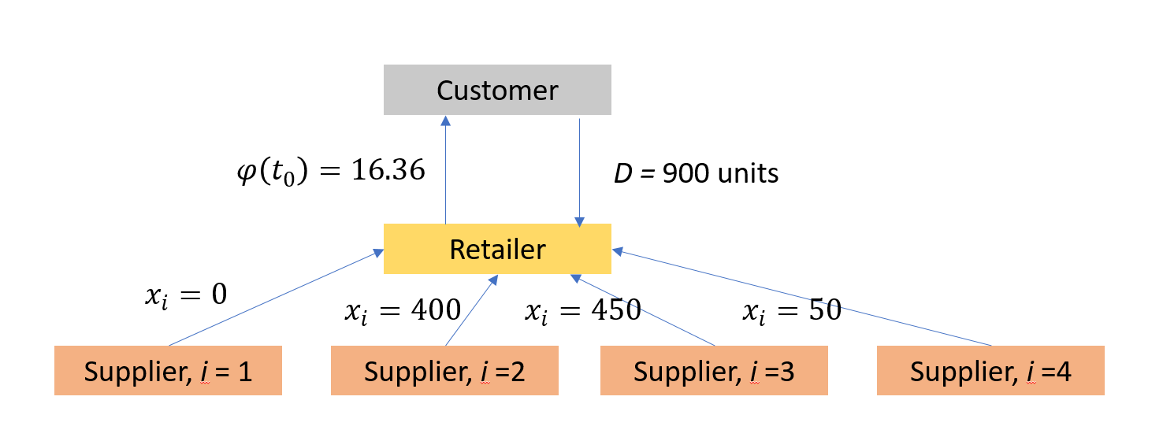
Figure3: Depiction of network performance without absorptive capacity in scenario 1
Scenario 2: Supply chain network without absorptive capacity in disrupted state:
Due to a disruption, the suppliers 3 and 4 are unable to deliver the calculated number of products within the initial lead time of 4 and 3 to 15 and 10 respectively.
The decision variables remain same while the total delivery lead time changes. The performance of the network in this Scenario is illustrated in the following table.

 | Scenario 2
Total operational cost ($) | 77700
Total lead time (mins) | 10050
Network performance | 7.73
Table 8: Network performance for Scenario 2
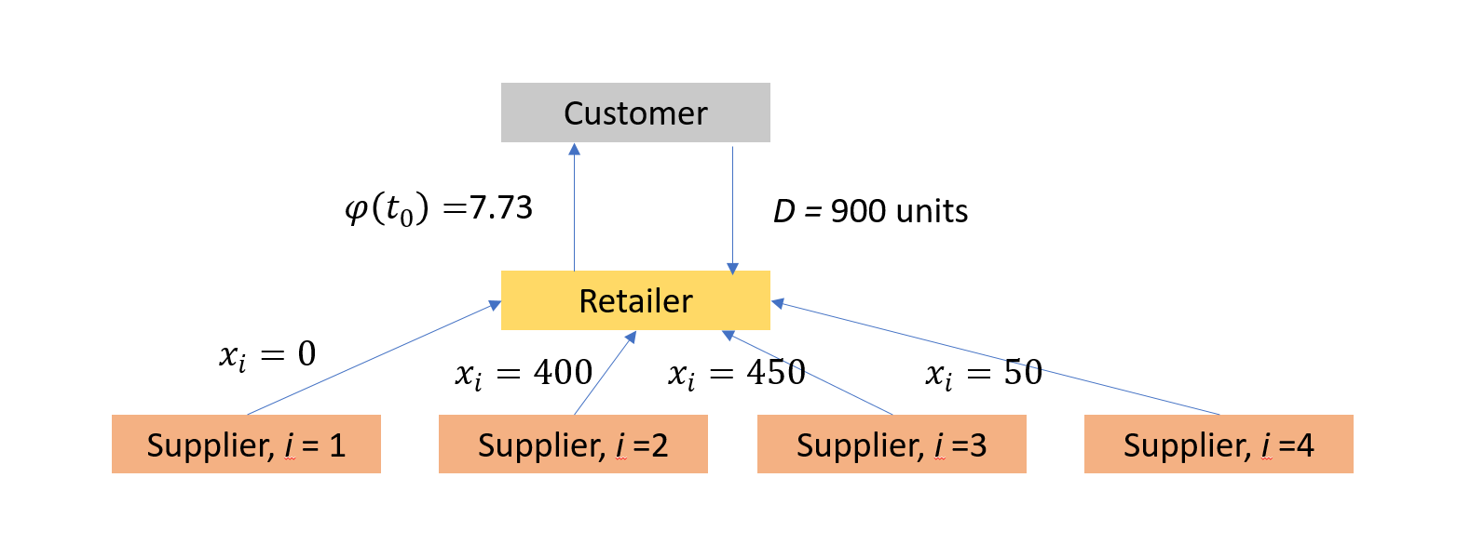
Figure 4: Depiction of network performance without absorptive capacity in scenario 2

Resilience Quantification: Using equation (1) resilience of the supply chain network without pre-positioned inventory, $Я_{φ}\left(t|e^{j}\right)=0.472$
Scenario 1: Supply chain network with absorptive capacity in non-disrupted state:
Supplier/Warehouse | 2 | 3 | 4
Order Quantity from supplier | 400 | 450 | 50
Warehouse order quantity | 0 | 0 | 0
Table 9: Decision variable for Scenario 1
 | Scenario 3
Total operational cost ($) | 80300
Total lead time (mins) | 4750
Network performance | 15.46
Table 10: Network performance for Scenario 1
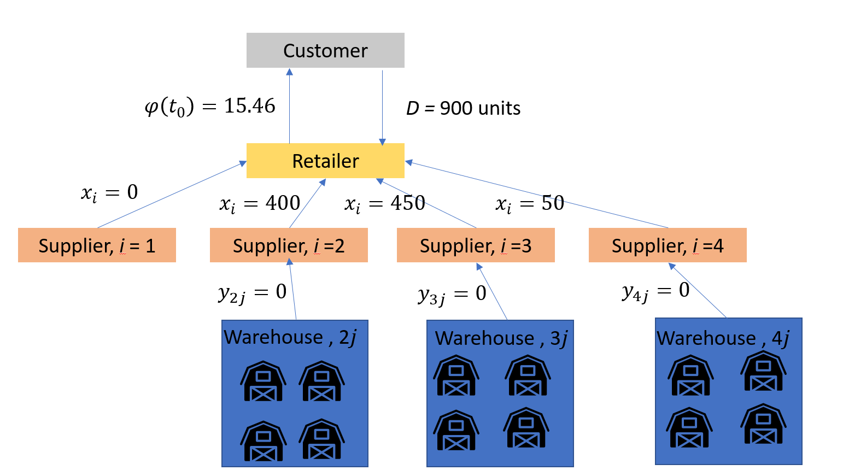
Figure 5: Depiction of network performance with absorptive capacity in scenario 1

Scenario 2: Supply chain network with absorptive capacity in disrupted state:
Supplier | 2 | 3 | 4
Order Quantity from supplier | 400 | 0 | 0
Table 11: Decision variables for Scenario 2

Warehouse | 1 | 2 | 3 | 4
Order Quantity from warehouse j to supplier $i=3$ | 120 | 150 | 110 | 70
Table 12: Decision variables for warehouse analysis of supplier 3 in scenario 2
Warehouse | 1 | 2 | 3 | 4
Order Quantity from warehouse j to supplier $i=4$ | 50 | 0 | 0 | 0
Table 13: Decision variables for warehouse analysis of supplier 4 in scenario 2
 | Scenario 4
Total operational cost ($) | 159330
Total lead time (mins) | 13380
Network performance | 11.90
Table 14: Network performance for scenario 2
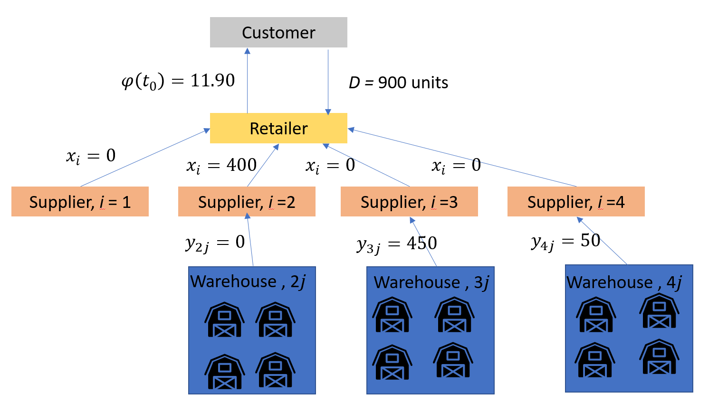
Figure 6: Depiction of network performance with absorptive capacity in scenario 2
Resilience Quantification: Using equation (1) resilience of the supply chain network with pre-positioned inventory, $Я_{φ}\left(t|e^{j}\right)$ = 0.769

Figure 7: Graphical representation of network performance

Figure 8: Comparison of resilience of the network

- Conclusions
Modern supply chain networks are highly dependent on outsourcing products and services from all over the world. Technological advancement has led to global interaction between companies making them highly dependent on each other for functioning. This interdependency has made the supply chains highly vulnerable to large scale disruptions in event of global disasters. This work identifies the threats posed by these disruptions on the supply chain networks and proposes a contingency plan that could make the companies more prepared to restore their performance during such disruptions.
This work develops a framework that can be implemented on supply chains following a disruptive event to restore the network to a desired level of performance. This work addresses the resilient supplier selection problem by implementing various strategies in a supplier selection decision framework. The framework develops a multi objective optimization model that determines optimal supplier selection under disruptions scenarios.
  - Future work
The mathematical model developed in this work should be applied to a large scale real-world problem to validate its usability in rea scenarios. The disruption scenarios assumed in this work would have a stochastic nature in real-world situations. The uncertainty of occurrence of disruption will make the problem furthermore interesting. Also, the inventory replenishment analysis is not considered in this model which makes it a good opportunity to apply various warehousing models like multi echelon inventory analysis to improve the performance of the model. The strategy used to improve the resilience of the network in this model is limited to absorptive capacity, hence future endeavors in this work may integrate the use of adaptive and restorative capacities in the network. -
The limitations of the solution algorithm WSM, used in this model can be found from the literature, they include existence of multiple minimum solutions for a specific weight vector that represent different solutions in the pareto-optimal front thus increasing the search effort. Hence, for large scale problems, application of WSM may not be the most suitable method. Other solution algorithms like genetic algorithms (NGSA-2), goal programming can be considered during future applications of the work.

References
Agrell, P. J., Lindroth, R., & Norrman, A. (2004). Risk, information and incentives in telecom supply chains. International Journal of Production Economics, 90(1), 1–16. https://doi.org/10.1016/S0925-5273(02)00471-1
Aissaoui, N., Haouari, M., & Hassini, E. (2007). Supplier selection and order lot sizing modeling: A review. Computers & Operations Research, 34(12), 3516–3540. https://doi.org/10.1016/j.cor.2006.01.016
Almoghathawi, Y., Barker, K., & McLay, L. A. (2016). Resilience-driven restoration model for interdependent infrastructure networks. Submitted to the European Journal of Operations Research.
Barker, K., Lambert, J.H., Zobel, C.W., Tapia, A.H., Ramirez-Marquez, J.E., McLay, L.A., Nicholson, C.D., & Caragea, C. (2017). Defining resilience analytics for interdependent cyber-physical-social networks. Taylor & Francis.
Amid, A., Ghodsypour, S. H., & O’Brien, C. (2011). A weighted max–min model for fuzzy multi-objective supplier selection in a supply chain. International Journal of Production Economics, 131(1), 139–145. https://doi.org/10.1016/j.ijpe.2010.04.044
Blackhurst *, J., Craighead, C. W., Elkins, D., & Handfield, R. B. (2005). An empirically derived agenda of critical research issues for managing supply-chain disruptions. International Journal of Production Research, 43(19), 4067–4081. https://doi.org/10.1080/00207540500151549
Hammami, R., Temponi, C., & Frein, Y. (2014). A scenario-based stochastic model for supplier selection in global context with multiple buyers, currency fluctuation uncertainties, and price discounts. European Journal of Operational Research, 233(1), 159–170. https://doi.org/10.1016/j.ejor.2013.08.020
Ho, W., Xu, X., & Dey, P. K. (2010). Multi-criteria decision making approaches for supplier evaluation and selection: A literature review. European Journal of Operational Research, 202(1), 16–24. https://doi.org/10.1016/j.ejor.2009.05.009 Jönsson, H., Johansson, J., & Johansson, H. (2008).
Narasimhan, R., Talluri, S., & Mahapatra, S. K. (2006). Multiproduct, multicriteria model for supplier selection with product life-cycle considerations. Decision Sciences, 37(4), 577–603. https://doi.org/10.1111/j.1540-5414.2006.00139.x
Ng, W. L. (2008). An efficient and simple model for multiple criteria supplier selection problem. European Journal of Operational Research, 186(3), 1059–1067. https://doi.org/10.1016/j.ejor.2007.01.018
Noorul Haq, A., & Kannan, G. (2006). Design of an integrated supplier selection and multi-echelon distribution inventory model in a built-to-order supply chain environment. International Journal of Production Research, 44(10), 1963–1985. https://doi.org/10.1080/00207540500381427
Pant, R., Barker, K., Ramirez-Marquez, J. E., & Rocco, C. M. (2014). Stochastic measures of resilience and their application to container terminals. Computers and Industrial Engineering, 70(1), 183–194. https://doi.org/10.1016/j.cie.2014.01.017
Weber, C. A., & Current, J. R. (1993). A multiobjective approach to vendor selection. European Journal of Operational Research, 68(2), 173–184. https://doi.org/10.1016/0377-2217(93)90301-3
Wu, T., Blackhurst, J., & O’grady, P. (2007). Methodology for supply chain disruption analysis. International Journal of Production Research, 45(7), 1665–1682. https://doi.org/10.1080/00207540500362138
Xia, W., & Wu, Z. (2007). Supplier selection with multiple criteria in volume discount environments. Omega, 35(5), 494–504. https://doi.org/10.1016/j.omega.2005.09.002

