UNIVERSITY OF OKLAHOMA
GRADUATE COLLEGE

EvaluatING Community Interactions and Carbon Flow in Methane-Rich EnvironmentS USING Methanotrophic-Heterotrophic BACTERIAL Co-cultures

A THESIS
SUBMITTED TO THE GRADUATE FACULTY
in partial fulfillment of the requirements for the
Degree of
MASTER OF SCIENCE

By
ROSA MOON-ESCAMILLA
Norman, Oklahoma
2020
EvaluatING Community Interactions and Carbon Flow in Methane-Rich EnvironmentS USING Methanotrophic-Heterotrophic BACTERIAL Co-cultures

A THESIS APPROVED FOR THE
DEPARTMENT OF MICROBIOLOGY AND PLANT BIOLOGY

BY THE COMMITTEE CONSISTING OF

Dr. Lee Krumholz, Chair
Dr. Ralph Tanner
Dr. Bradley Stevenson

© Copyright by Rosa Moon-Escamilla 2020
All Rights Reserved
Acknowledgments
I would like to begin by thanking my advisor, Dr. Lee Krumholz, for giving me the opportunity to learn from him and do research in his lab. I am truly grateful for his patience, encouragement, and wisdom through this work. His commitment to excellence in teaching is evident in everything he does.
Many thanks to Dr. Bradley Stevenson for serving on my graduate committee and pushing me to dig deeper to find answers. In addition, I would like to thank Dr. Ralph Tanner for being a source of wisdom and an advocate for me in science and in life. Huge thanks to Dr. Krithi Sankaranarayanan for his help with library preparation and Illumina genome sequencing of our bacterial isolates, as well as his support and instruction in all issues relating to bioinformatics.
Special thanks to our collaborators at Montana State University and South Dakota School of Mines and Technology. This work was funded by NSF EPSCoR Award #1736255: RII Track-2 FEC: Building Genome-to-Phenome Infrastructure for Regulating Methane in Deep and Extreme Environments (BuG ReMeDEE).
I would also like to thank Ben Fowler and Justin Willige at the Oklahoma Medical Research Foundation for their help with thin sectioning and TEM imaging our isolates.
I am enormously grateful to Dr. Chris Abin for his constant help in laboratory techniques, experimental design, and any other questions I ever had. Also, many thanks to Chuang Li for being a great lab mate and friend. And I am truly grateful to Chris Garner for being a teacher, a lab partner, a confidant, and friend through this entire process. I would also like to acknowledge his work in isolating Methylocystis sp. NLS7 and sharing it with me for my co-culture experiments.
Finally, I would like to thank my mother and sister for cheering me on and caring for me through this time in my life. They are the best support system I could have ever asked for.

TABLE OF CONTENTS

ACKNOWLEDGMENTS..........................................................................................................iv
LIST OF TABLES......................................................................................................................vi
LIST OF FIGURES....................................................................................................................vii
ABSTRACT………………………………………………………………………………...…viii
CHAPTER 1: ISOLATING METHANE OXIDIZING BACTERIA AND HETEROTROPHS FROM METHANE CONTAINING ENRICHMENTS ......………………………………........1
Introduction.......................................................................................................................1
Materials and Methods......................................................................................................2
Isolation of bacteria from methane enrichments...................................................2
16S rRNA gene sequencing...................................................................................5
Library preparation and genome sequencing.......................................................6
Results...............................................................................................................................6
CHAPTER 2: Transmission electron microscopy of isolates from methane enrichments.....................................................................................................15
Introduction.......................................................................................................................15
Materials and Methods......................................................................................................16
Fixation.................................................................................................................16
Dehydration...........................................................................................................18
Infiltration..............................................................................................................18
Trimming and Sectioning.......................................................................................18
TEM imaging.........................................................................................................19
Results................................................................................................................................19
CHAPTER 3: Co-culture construction and growth comparisons.............24
Introduction........................................................................................................................24
Materials and Methods.......................................................................................................27
Results................................................................................................................................29
CHAPTER 4: DISCUSSION..…………………………………………………………………...34
REFERENCES..………………………………………………………………………………..39

LIST of tables
Table 1: Pseudomonas chlororaphis HC Genome Statistics...........................................................9
Table 2: Cupriavidus sp. HC Genome Statistics.............................................................................9
Table 3: Flavobacterium sp. HC Genome Statistics.....................................................................10
Table 4: Methylocystis sp. NLS7 Genome Statistics.....................................................................10
Table 5: Bacterial cultures prepared for TEM analysis.................................................................17
Table 6: Quantification of heterotrophic organisms in methane-fed co-cultures by dilution plating............................................................................................................................................31
Table 7: Comparison of starting and ending heterotroph cell quantities in co-culture with Methylocystis sp. NLS7.................................................................................................................31
Table 8: Cell ratios of Methylocystis sp. NLS7 to heterotrophic species in methane-fed co-cultures......................................................................................................................................31

List of figures
Figure 1: 16S Phylogeny of Pseudomonas sp. isolated from Honey Creek..................................11
Figure 2: 16S Phylogeny of Cupriavidus sp. isolated from Honey Creek.....................................12
Figure 3: 16S Phylogeny of Flavobacterium sp. isolated from Honey Creek...............................13
Figure 4: 16S Phylogeny of Methylocystis sp. NLS7 isolated from Norman, OK landfill............14
Figure 5: TEM images of Pseudomonas chlororaphis isolate from Honey Creek........................20
Figure 6: TEM images of Cupriavidus sp. isolated from Honey Creek........................................21
Figure 7: TEM images of Flavobacterium sp. isolated from Honey Creek..................................22
Figure 8: TEM images of Methylocystis sp. NLS7 isolate from Norman landfill.........................23
Figure 9: Growth over time for Methylocystis sp. NLS7 compared to methane-fed co-cultures...........................................................................................................................................32
Figure 10: Methane levels over time for Methylocystis sp. NLS7 compared to methane-fed co-cultures...........................................................................................................................................33

ABstract
Methane oxidizing bacteria play a significant role in global methane and carbon cycling and are present in many different global environments. Isolation and enrichment for novel methanotrophic species is an important way to learn more about the diversity and behaviors of these organisms. In this study, natural sediments from a creek and a landfill in Oklahoma were sampled and enriched for methane oxidizing bacteria. One novel alphaproteobacterial methane oxidizing species (Methylocystis sp. NLS7) was isolated from a landfill in Norman, OK. In addition, three heterotrophic species (Pseudomonas chlororaphis, Cupriavidus sp. HC, and Flavobacterium sp. HC) were isolated from Honey Creek, in Davis, OK, even though methane was the only provided carbon source in the enrichments. Species identity for these isolates was determined using 16S rRNA gene sequencing and whole genome sequencing. In addition, each isolate was imaged with transmission electron microscopy to visualize internal structures, as methanotrophs have unique intracytoplasmic membranes that are useful for characterization. TEM images showed concentric membranes within Methylocystis sp. NLS7, which are characteristic of the genus. TEM of Cupriavidus sp. HC revealed bright inclusion bodies which are likely polyhydroxyalkanoates (PHAs) used for carbon storage. Pseudomonas sp. HC and Flavobacterium sp. HC TEM images were comparable to published images of their respective genera. The discovery of heterotrophic species within methane enrichments led to further investigation of methanotrophic-heterotrophic interactions in co-culture, as previous literature indicates that the addition of heterotrophic species may present certain benefits to methanotrophic species. Co-cultures were constructed using Methylocystis sp. NLS7 and each of the three heterotrophic species. Co-cultures were provided methane as a sole carbon source, and then monitored for growth and methane oxidation to evaluate any potential stimulatory effects of co-culturing, compared to a pure culture methanotroph control. Growth and methane oxidation over time for Methylocystis sp. NLS7 were unaffected by the addition of heterotrophic species. However, the heterotrophs did grow in the co-cultures, given that the concentration of heterotroph cells at the end of the log phase was significantly higher than starting cell amounts for each co-culture. The heterotrophic species in each co-culture are not capable of oxidizing methane on their own, so it is likely they were utilizing by-products of methane metabolism which might include organic molecules, amino acids, or polysaccharides. Proposed future work includes transcriptome analysis to identify a carbon source for the heterotrophs within methane-fed co-cultures and to investigate carbon and metabolite flow within these co-cultures. Methanotrophic-heterotrophic community interactions represent a significant knowledge gap in microbial ecology. Enrichment for novel species and co-culture studies like these can provide insight into the diversity, behavior, and ecology of these organisms and how they influence carbon flow in natural environments.

Chapter 1: Isolating Methanotrophs and Heterotrophs from Oklahoma Sediments
INTRODUCTION
Methanotrophs are a diverse group of chemoorganotrophs capable of oxidizing methane as their sole carbon and energy source (Knief 2015). Methane oxidizing bacteria (MOB) and archaea play a significant role in global methane cycling as the only known biological methane sink. MOB exist in a wide variety of environments including volcanic ecosystems (Lösekann et. al 2007), Arctic wetland soils (Wartianen 2006), rice paddies (Murase and Frenzel 2007), and forest soils (Kolb et al 2005). MOB are key components of their local ecosystems because they consume methane that would otherwise contribute to the greenhouse effect.
Aerobic methanotrophy has traditionally been described as an obligate metabolism, with organisms distinguished in terms of carbon assimilation. Type I methanotrophs (Gamma-proteobacteria) utilize the ribulose monophosphate pathway, while Type II methanotrophs (Alphaproteobacteria) use the serine pathway (Trotsenko and Murrell 2008). However, new research has challenged this paradigm. The discovery of a methane oxidizing, acidophilic bacterium of the phylum Verrucomicrobia revealed that methanotrophy is not exclusive to the Proteobacteria, and that traditional cultivation methods have failed to accurately capture the full breadth of methanotroph diversity (Dunfield et. al 2007). Furthermore, certain facultatively methanotrophic species have recently been discovered within Methylocella (Dedysh et. al 2005) and Methylocystis (Vorobev et. al 2014). The work of the past 15 years has more than doubled the known genera and species capable of methane oxidation (Knief 2015). Enrichment and isolation of novel MOB from natural environments presents a powerful opportunity to further expand our knowledge of these organisms and their metabolic capabilities.
In this study, we sampled natural Oklahoma sediments for methane oxidizing bacteria, with the goal of isolating novel methanotrophic species. We expected to find potentially novel MOB species due to their broad versatility to inhabit different environments and that no species had yet been characterized from Oklahoma. Sediments were collected from a landfill in Norman, Oklahoma, and from Honey Creek (a freshwater ecosystem in Davis, Oklahoma). Enrichments from the landfill led to the isolation of a novel Type II methanotroph Methylocystis sp. NLS7. We isolated three heterotrophic bacterial species from Honey Creek: Pseudomonas chlororaphis, Cupriavidus sp. HC, and Flavobacterium sp. HC. These heterotrophic species were capable of growing in methane-fed mixed cultures with methanotrophic species. This discovery led to further experiments examining the effects of co-culturing Methylocystis sp. NLS7 with each of the three heterotrophic strains.
MOB are key organisms in the global methane cycle. Isolating novel MOB species is useful for investigating their phylogeny, metabolism, and adaptability. Research relating to MOB improves estimates of methane flux within local environments and globally, which is important because methane is a potent greenhouse gas (Conrad 2009).

MATERIALS AND METHODS
Isolation of bacteria from methane enrichments
The methanotrophic organism Methylocystis sp. NLS7 used in this study was isolated from sediment sampled from the USGS landfill in Norman, Oklahoma, USA. Approximately 5 grams of the top 5 cm of soil was placed in a sealed 160 ml serum bottle and enriched with 2% (v/v) methane and ambient oxygen in the headspace. Bottles were incubated in the dark at room temperature (approx. 22ºC). The concentration of methane in the headspace of the bottles was measured once a week using a Shimadzu GC-14A gas chromatograph (Shimadzu, Kyoto, Japan) with a Porapak Q column (Supelco, Bellefonte, United States) and a flame ionization detector. Helium gas was used as the carrier. Headspace methane percentage was compared to autoclaved soil controls. Each week, bottles with no detectable methane were re-amended with 2% methane.
After 5 weeks, soil from these enrichments was then serially diluted into modified nitrate mineral salts medium, first described by Whittenbury et al. (Whittenbury et. al 1970) with 2% methane and ambient oxygen in the headspace to enrich for the organisms responsible for observed methane depletion. Modified nitrate mineral salts (NMS) medium contains (per liter of distilled water): 1 g KNO₃, 0.27 g KH₂PO₄, 1 g MgSO₄ ● 7H₂O, 0.14 g CaCl₂ ● 2H₂O, and 0.23 g Na₂HPO₄, 0.05% (v/v) acidic trace element solution (AcTES), 0.02% (v/v) alkaline trace element solution (AlTES), and 1% vitamin solution (final pH 7). AcTES contains (per liter), 2 g FeSO₄ ● 7H₂O, 0.07 g ZnSO₄ ● 7H₂O, 0.5 g MnCl₂ ● 4H₂O, 0.12 g CoCl₂ ● 6H₂O, 0.01 g NiCl₂ ● 6H₂O, 0.5 g CuSO₄, 0.01 g H₃BO₃, 0.06 g LaNO₃, 0.06 g CeNO₃, and 100 mM HCl. AlTES contains (per liter) 0.07 g SeO₂, 0.05 g Na₂NO₄, 0.2 g WO₄, and 0.04 g NaOH. The vitamin solution contains (per liter) 5 mg 4-Aminobenzoic Acid, 2 mg D-Biotin, 2 mg Folic Acid, 10 mg Pyridoxine-HCl, 5 mg Riboflavin, 5 mg Thiamine-HCl x 2H₂O, 5 mg Nicotinic Acid, 5 mg Calcium D-Pantothenate, 5 mg Thioctic Acid (α-Lipoic Acid), and 0.10 mg Vitamin B12. Tubes were laid horizontally to maximize gas exchange with the liquid medium and incubated at room temperature in the dark. Headspace methane depletion was monitored using gas chromatography.
High dilution tubes (10⁻⁵-10⁻⁶) that continued to deplete methane after three subsequent amendments with 2% methane were plated onto solid NMS medium (1.5 % agar) (BP1423, Fischer, United States). Tubes were opened and serially diluted 10⁻¹-10⁻⁶ in sterile NMS medium. Solid NMS plates were inoculated with 50 µl of culture (in triplicate) for each dilution. Plates were incubated in sealed ammo boxes with approx. 10% methane and ambient oxygen. Control plates were incubated in sealed ammo boxes with ambient oxygen and no added methane to distinguish colonies that grow on agar in the solid medium. Each week, the ammo boxes were opened, and methane plates were compared to control plates to identify unique colonies. After four weeks, individual colonies unique to the methane condition were picked with a sterile inoculation loop and re-streaked 3 times for isolation, then transferred to liquid NMS medium for further culture work and microscopy.
The three heterotrophic strains used in this study were isolated using the same techniques described above from sediments at Honey Creek in Davis, Oklahoma, USA. Sediment was collected from the shallow bank of the creek and enriched for methanotrophic isolates. After enrichment and isolation, many of our cultures were contaminated with non-methanotroph heterotrophic organisms, despite the lack of an additional organic carbon source. 16S rRNA gene and whole genome sequencing (described below) showed that supposed pure cultures of methanotrophs were actually mixed cultures of MOB and other species not previously known to oxidize methane. These organisms were isolated from the methane-oxidizing liquid cultures by streaking them out onto LB agar (12) (in the case of Pseudomonas chlororaphis HC) or Difco Nutrient Agar (for Cupriavidus sp. HC and Flavobacterium sp. HC). Pseudomonas was maintained through regular passages on LB broth or agar, and Cupriavidus and Flavobacterium were maintained on nutrient broth or agar. In addition, these isolates were each tested for growth on NMS medium with methane as the sole carbon source.

16S rRNA gene sequencing
Species identity was determined by sequencing the 16S rRNA gene of extracted DNA from pure bacterial cultures. Genomic DNA extraction was carried out using the DNeasy Blood and Tissue DNA extraction kit (Qiagen GmbH, Hilden, Germany) according to the manufacturer’s instructions for bacterial cell suspensions. The 16S rRNA gene was amplified by PCR using universal primers 27F (5’- AGA GTT TGA TCM TGG CTC AG – 3’) and 1492R (5’- CGG TTA CCT TGT TAC GAC TT -3’) both at 10 mM and DreamTaq Green PCR MasterMix (2x) (K1082, Thermo Scientific, United States). The PCR was performed as follows: 95°C initial denaturation (5 min); 30 cycles of 94°C denaturation (30 sec), 55°C annealing (1 min) and 72°C extension (1 min 15 sec); followed by final extension for 15min at 72°C. PCR products were purified using the GeneJET PCR purification kit (K0701, Thermo Scientific, United States) according to manufacturer’s protocol and submitted for Big-Dye Sanger sequencing at the Biology Core Molecular laboratory at the University of Oklahoma (Rosenblum 1997). Samples were sequenced with both 27F and 1492R primers to obtain more complete 16S rRNA gene sequences.
16S rRNA gene sequence output files were visualized using the 4Peaks analysis program. Low quality reads were trimmed from each end, and forward and reverse sequences were paired to obtain a single continuous 16S rRNA sequence for each sample, approx. 1.5 Kb. 16S rRNA sequences were compared to the NCBI BLAST database to determine species identity using online blastn. Phylogenetic relationships were determined by aligning the isolate sequences to that of reference species of the same genus using Muscle in MEGA (V7.0.26). Reference 16S sequences were retrieved from the NCBI database. Neighbor-joining phylogenies were constructed in MEGA with 1000 times bootstrapping and the Poisson model. The evolutionary distances were computed using the Maximum Composite Likelihood method [15] and are in units of the number of base substitutions per site. All positions containing gaps and missing data were eliminated.
Library Preparation and Genome Sequencing
Whole genome sequencing was performed on genomic DNA from each of the isolates. Genomic DNA was extracted as described above. DNA (1 ng/µl, 100 µl volume) was randomly sheared with the QSonica Q800R sonicator (Qsonica 457 LLC, Newton, CT). The KAPA HyperPrep PCR kit (Roche Applied Science, Pleasanton, CA, USA) was used for library preparation, according to manufacturer’s instructions. The final library was prepared using the Illumina TruSeq construct (Illumina, San Diego, California) and dual barcoded. Samples were equimolar pooled and sequenced on an Illumina MiSeq (Illumina, San Diego, California).
To perform sequence analysis, raw fastq files were quality filtered, adapters were removed, and overlapping reads were merged using AdapterRemoval (V2), Q>30, no Ns. Quality filtered reads were assembled using Newbler (Roche, V3.0) with default assembly parameters. Finally, gene identification from assembled contigs was determined using Prodigal, with default parameters for bacteria.

RESULTS
The Pseudomonas isolate from Honey Creek was called Pseudomonas chlororaphis sp. HC. Partial 16S rRNA sequencing revealed that our isolate was most similar to Pseudomonas chlororaphis based on alignment of 874 nucleotide positions across 16 different species within the genus (Figure 1). Genomic data confirms this result, and an Average Amino acid Identity value of 96.17% is reported for our isolate compared to Pseudomonas chlororaphis (Table 1) . Using a cutoff of 95% AAI for novel species (Konstantinidis and Tiedje 2005), the decision was made to treat this isolate as a member of the species rather than a unique species within the genus. Genome length ~7.5 Mb is comparable to published genomes for this species. Although this species was isolated from a methane-fed enrichment, this organism did not demonstrate the ability to oxidize methane in pure culture. Pseudomonas sp. HC grew into small (1-2 mm), round, transparent colonies on LB agar or nutrient agar, supporting the claim that this organism is heterotrophic.
The Cupriavidus isolate from Honey Creek was called Cupriavidus sp. HC. Partial 16S rRNA sequencing revealed that this isolate is most closely related to Cupriavidus necator based on alignment of 1236 nucleotide positions across 19 different species of this genus (Figure 2). Genomic comparison of Cupriavidus sp. HC to Cupriavidus necator yields an AAI value of 90% (Table 2) and the 95% cutoff AAI suggests that our isolate could represent a novel species within the genus. 2.16% contamination is reported for this isolate, which may be due to strain heterogeneity within this species, as no other unique species were identified within the genome. Cupriavidus sp. HC grows large (4-5 mm) opaque, white colonies on rich media like nutrient agar or LB agar, supporting the claim that this organism is heterotrophic. This isolate did not demonstrate the ability to oxidize methane in pure culture.
The Flavobacterium isolate from Honey Creek was called Flavobacterium sp. HC. Partial 16S rRNA sequencing shows that this isolate is most closely related to Flavobacterium gilvum based on alignment of 645 nucleotide positions across 15 different species of this genus (Figure 3). Genomic comparison of Flavobacterium sp. HC to Flavobacterium gilvum yields an AAI value of 88.8% (Table 3), which is well below the 95% cutoff for novel species. Genome size of 4.07 Mb is comparable to other members of the genus, and 0.71% contamination may be explained by strain heterogeneity within the species. Flavobacterium sp. HC produces very small (1 mm) round, white colonies on nutrient agar, and does not grow on LB agar. Growth on rich medium like nutrient agar supports the claim that this organism is heterotrophic. This isolate did not demonstrate the ability to oxidize methane in pure culture.
The methanotroph isolate from the Norman landfill enrichments was called Methylocystis sp. NLS7 (Norman landfill, shallow #7). Partial 16S rRNA sequencing shows that the closest neighbor to this isolate is Methylocystis hirsuta, based on alignment of 1100 nucleotide positions across 22 different species of the genus (Figure 4). The genome for this isolate only yielded 58.63% completion, due to a fragmented genome and incomplete marker recovery. This is further suggested by the low N50 (2 Kb) and large amount of total contigs (>3000). In addition, 7.86% contamination is reported for this genome, which could be caused by strain heterogeneity within the culture as no other distinct species were detected. Methylocystis sp. NLS7 produces small (1-2 mm) white or pale pink colonies on NMS agar plates incubated in methane. This isolate did not grow on rich media such as LB or nutrient agar.

Table 1: Pseudomonas chlororaphis HC Genome Statistics
Sequencing Method | Illumina
Genome Length | ~7.5 Mb
N50 | 80 Kb
Total Contigs | 171
Coverage | 25X
Contamination | 0%
Completion | 100%
Nearest neighbor | Pseudomonas chlororaphis
AAI | 96.17%

Table 2: Cupriavidus sp. HC Genome Statistics
Sequencing Method | Illumina
Genome Length | ~8.72 Mb
N50 | 21 Kb
Total Contigs | 825
Coverage | 125X
Contamination | 2.16%
Completion | 98.36%
Nearest neighbor | Cupriavidus necator
AAI | 90%

Table 3: Flavobacterium sp. HC Genome Statistics
Sequencing Method | Illumina
Genome Length | ~4.07 Mb
N50 | 186 Kb
Total Contigs | 62
Coverage | 194X
Contamination | 0.71%
Completion | 99.29%
Nearest neighbor | Flavobacterium gilvum
AAI | 88.8%

Table 4: Methylocystis sp. NLS7 Genome Statistics
Sequencing Method | Illumina
Genome Length | ~4.15 Mb
N50 | 2 Kb
Total Contigs | 3022
Coverage | 130X
Contamination | 7.86%
Completion | 58.63%
Nearest neighbor | Methylocystis hirsuta
AAI | 92.7%
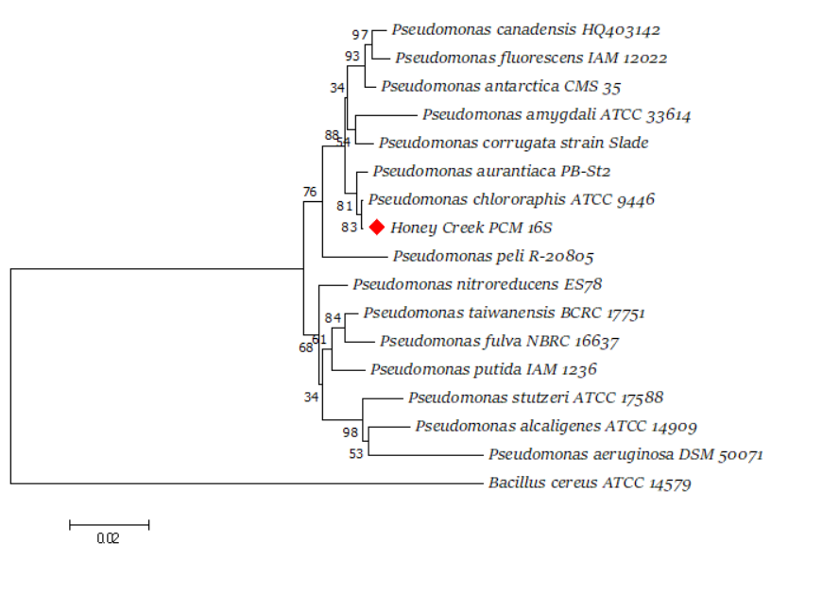
Figure 1: Phylogeny of partial 16S rRNA gene from Pseudomonas isolate from Honey Creek, Davis, OK, USA. Isolate is most closely related to Pseudomonas chlororaphis ATCC 9446. The evolutionary history was inferred using the Neighbor-Joining method (Saitu and Nei 1987). The percentage of replicate trees in which the associated taxa clustered together in the bootstrap test (1000 replicates) are shown next to the branches (Felsenstein 1985). The tree is drawn to scale, with branch lengths in the same units as those of the evolutionary distances used to infer the phylogenetic tree. The evolutionary distances were computed using the Maximum Composite Likelihood method (Tamura et. al 2004) and are in the units of the number of base substitutions per site. The analysis involved 17 nucleotide sequences. All positions containing gaps and missing data were eliminated. There was a total of 874 positions in the final dataset. Evolutionary analyses were conducted in MEGA7 (Kumar et. al 2016).

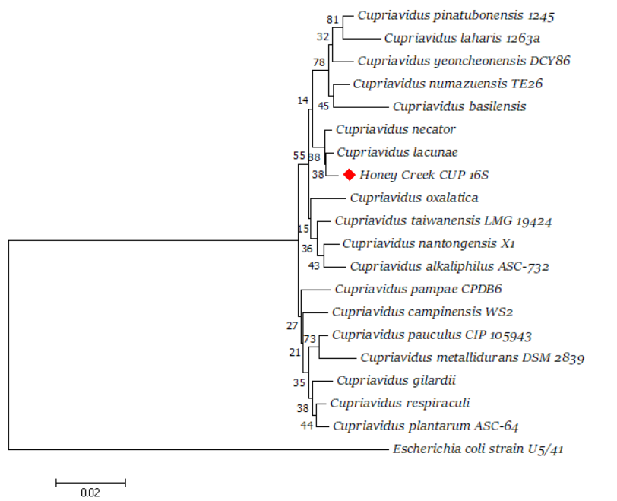
Figure 2: Phylogeny of partial 16S rRNA gene from Cupriavidus isolate from Honey Creek, Davis, OK, USA. Isolate is most closely related to Cupriavidus necator. The evolutionary history was inferred using the Neighbor-Joining method (Saitu and Nei 1987). The percentage of replicate trees in which the associated taxa clustered together in the bootstrap test (1000 replicates) are shown next to the branches (Felsenstein 1985). The tree is drawn to scale, with branch lengths in the same units as those of the evolutionary distances used to infer the phylogenetic tree. The evolutionary distances were computed using the Maximum Composite Likelihood method (Tamura et. al 2004) and are in units of the number of base substitutions per site. The analysis involved 20 nucleotide sequences. There were a total of 1236 positions in the final dataset. Evolutionary analyses were conducted in MEGA7 (Kumar et. al 2016).

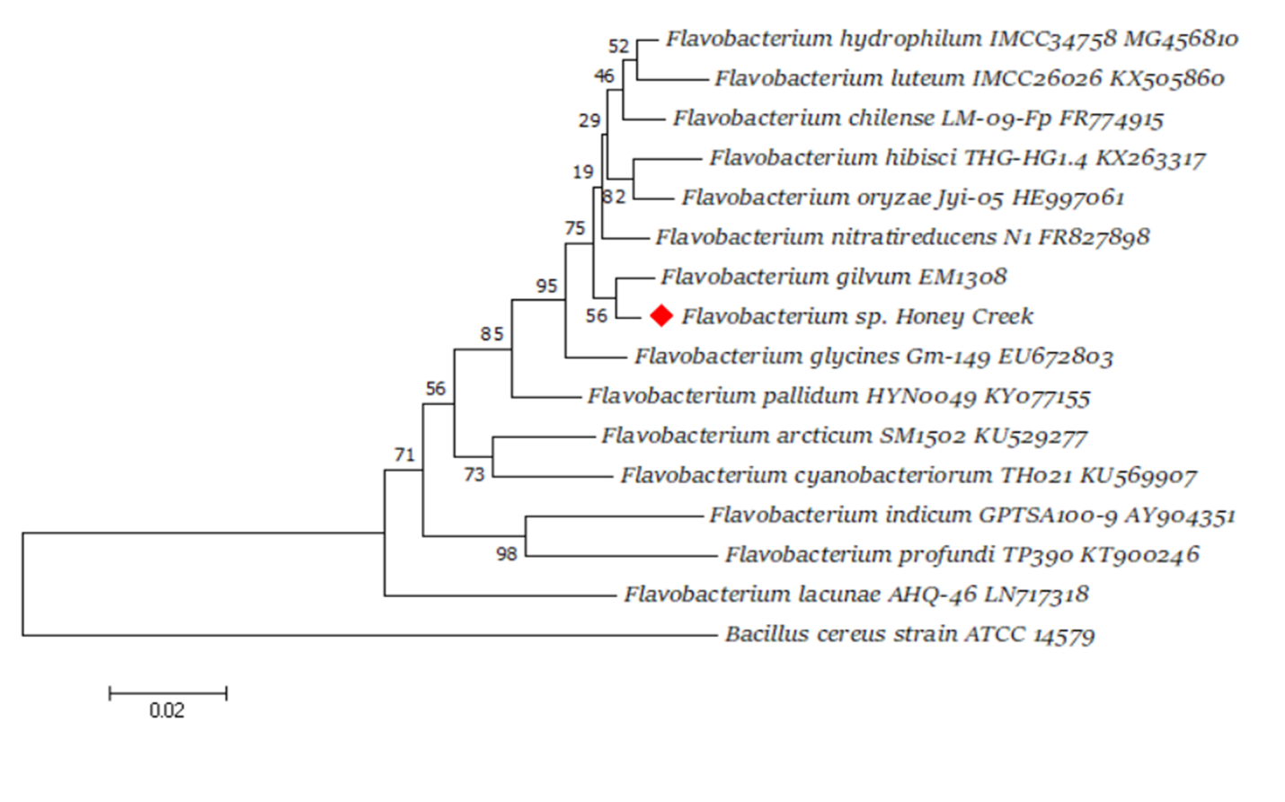
Figure 3: Phylogeny of partial 16S rRNA gene from Flavobacterium isolate from Honey Creek, Davis, OK, USA. Isolate is most closely related to Flavobacterium gilvum. The evolutionary history was inferred using the Neighbor-Joining method (Saitu and Nei 1987). The percentage of replicate trees in which the associated taxa clustered together in the bootstrap test (1000 replicates) are shown next to the branches (Felsenstein 1985). The tree is drawn to scale, with branch lengths in the same units as those of the evolutionary distances used to infer the phylogenetic tree. The evolutionary distances were computed using the Maximum Composite Likelihood method (Tamura et. al 2004) and are in units of the number of base substitutions per site. The analysis involved 16 nucleotide sequences. There were a total of 645 positions in the final dataset. Evolutionary analyses were conducted in MEGA7 (Kumar et. al 2016).

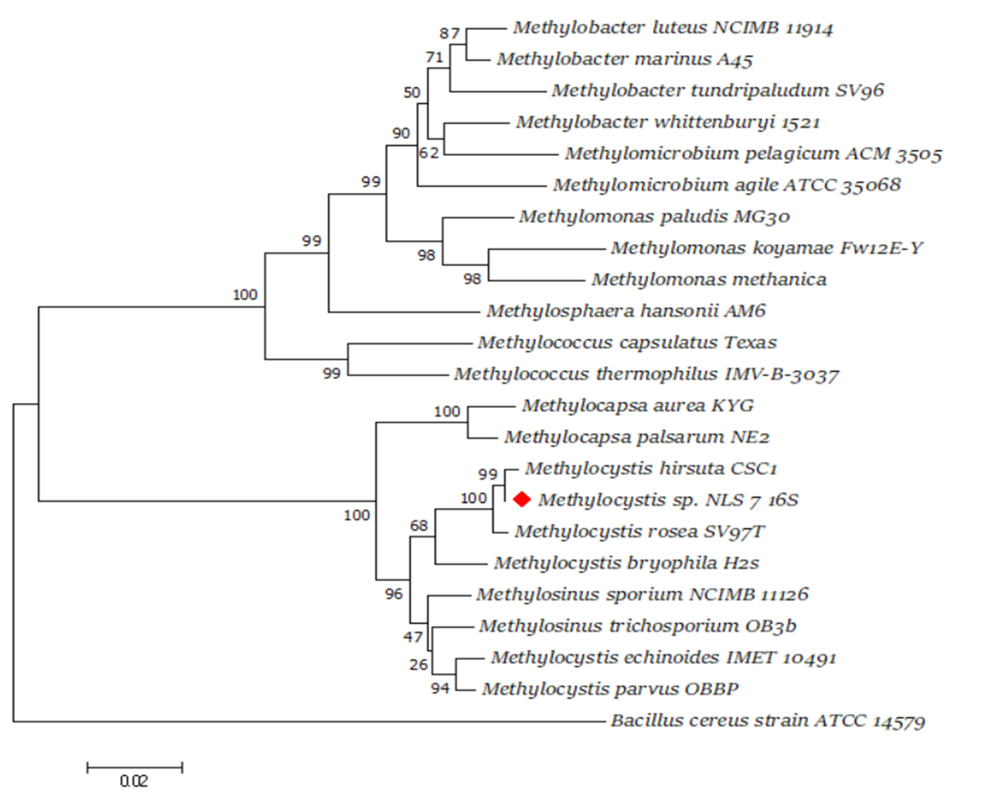
Figure 4: Phylogeny of partial 16S rRNA gene from Methylocystis isolate from a landfill in Norman, OK, USA. Isolate is most closely related to Methylocystis hirsuta. The evolutionary history was inferred using the Neighbor-Joining method (Saitu and Nei 1987). The percentage of replicate trees in which the associated taxa clustered together in the bootstrap test (1000 replicates) are shown next to the branches (Felsenstein 1985). The tree is drawn to scale, with branch lengths in the same units as those of the evolutionary distances used to infer the phylogenetic tree. The evolutionary distances were computed using the Maximum Composite Likelihood method (Tamura et. al 2004) and are in units of the number of base substitutions per site. The analysis involved 23 nucleotide sequences. There were a total of 1100 positions in the final dataset. Evolutionary analyses were conducted in MEGA7 (Kumar et. al 2016).

Chapter 2: Transmission Electron Microscopy of Isolates from Methane Enrichments
INTRODUCTION
Electron microscopy is a useful tool for describing the shape, size, and internal structures of cells. TEM visualization is a key aspect of characterizing a novel bacterial species, as specific ultrastructure is unique to certain phylogenies and metabolic capabilities. TEM is especially relevant to characterization of methane oxidizing bacterial species because they possess intracytoplasmic membranes (ICM) which serve to increase the activity of the membrane-associated particulate monooxygenase enzyme (pMMO) that catalyzes the oxidation of methane to methanol (Niederman 2006). Only one methanotroph species has been described which lacks pMMO and therefore ICM’s (Vorobev et. al 2011), which supports the importance of these structures in the function of MOB. ICM formation is a useful way of differentiating methanotrophs, as ICM in Type I methanotrophs often appear as stacked vesicular discs, while those of Type II methanotrophs present as concentric ring structures aligned along the periphery of the cell (Hanson and Hanson 1996).
Many bacteria, including Type II methanotrophs and members of the genus Cupriavidus, are also known to produce polyhydroxyalkanoate (PHA) inclusion bodies within their cells (Zhang et. al 2019). PHAs are carbon and energy stores, usually formed when available carbon is high, but some other necessary nutrient (such as nitrogen) is low (Dennis et. al 2008). These bodies appear as bright circular inclusions within cells when imaged with electron microscopy (Mravec et. al 2016). PHA production is relevant to biotechnology applications as a possible alternative to plastics (Kwon et. al 2019).
Cells from 9 different cultures were prepared for electron microscopy in this study. Of these, 6 species were novel methanotrophs and 3 species were heterotrophic species. We expected that the methanotroph isolates would possess the ICM described previously. The heterotrophic isolates were imaged to visualize membrane structure and obtain precise cell measurements. All imaged species were gram negative, so we expected to see an inner (periplasmic) membrane and an outer membrane in the images (Matias et. al 2003).

MATERIALS AND METHODS
Fixation
Cells were grown to mid-log phase and harvested by centrifugation at 10,000 X g for 10 minutes in 1.5 ml centrifuge tubes. For samples with high cell density, 1.5 ml of cell culture was sufficient to produce a large visible pellet. For samples with lower cell density, the pellets from four 1.5 ml aliquots were combined (see Table 2). The supernatant was decanted, leaving approx. 50 µl at the bottom of the tube. Pellets were resuspended in this remaining liquid, and then warmed in a water bath to 50ºC for 10 minutes.

TABLE 5. Bacterial cultures prepared for TEM analysis
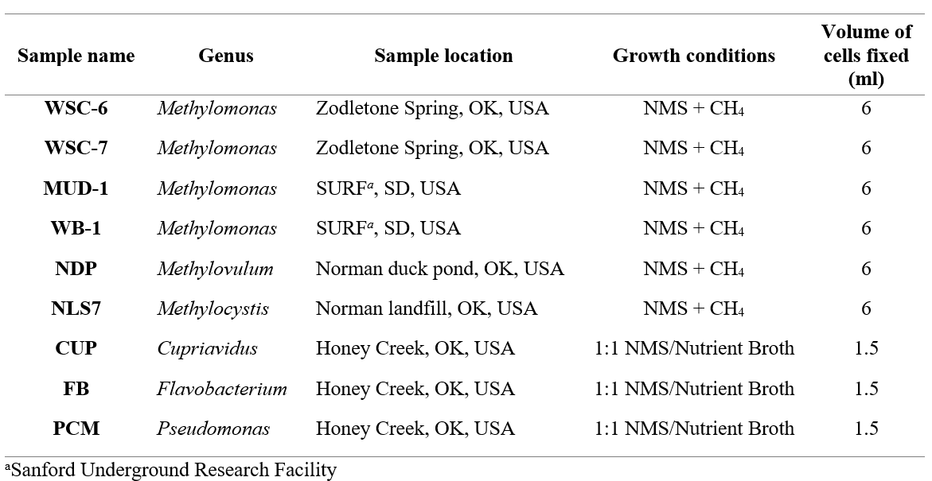
A 4% agarose solution was prepared by adding 0.4 grams low temperature agarose to 10 ml dH₂O and boiling in the microwave until melted, approx. 30 seconds and then placed into a 50ºC water bath to cool. Plastic pipette tips were pre-warmed in a 70ºC incubator and used to add 50 µl of 4% agarose to the warm cell pellets. The solution was mixed with the pipette tip to suspend cells through the agarose. Samples were then left to solidify in the bottom of the centrifuge tubes at room temperature for 10 minutes. Solid agarose blocks were removed from the tubes using a small metal spatula, and then sliced with a razor blade into 1 mm³ cubes.
The agarose blocks were then transferred to a glass vial and fixed in a solution of 4% glutaraldehyde in .2 M cacodylate buffer at pH 7.4 for 1 hour at room temperature, and then overnight at 4ºC. Cell blocks were then rinsed with 3 changes of 0.2 M cacodylate buffer, 10 minutes each, at 4ºC. Samples were post-fixed in 2% osmium tetroxide (w/v in water) for 2 hours on ice. Following post-fixation, samples were rinsed in cold buffer and stored overnight at 4ºC.
Dehydration
Samples were dehydrated in a graded ethanol series: 30%, 50%, 70%, 80%, 90%, 100%, 10 minutes each (except for 70% which was done overnight). This was followed by 2 additional changes of 100% ethanol, 10 minutes per change, then one 10 minute change of 1:1 100% ethanol : propylene oxide. The dehydration was completed with three changes of cold 100% propylene oxide, and then the samples were allowed to warm to room temperature.

Infiltration
Samples were infiltrated in Spurr’s resin in the following order: (1:2) Spurr’s resin : propylene oxide (4 hours), (2:1) Spurr’s resin : propylene oxide (overnight), two changes of 100% Spurr’s resin (2 hours each). Then one block of each sample was transferred to a silicone mold and embedded in fresh 100% Spurr’s resin. Blocks were polymerized in a 70ºC incubator for 10 hours, and then left overnight at room temperature to harden.

Trimming and Sectioning Blocks
Blocks were removed from the silicone molds and trimmed with a razor blade into a trapezoid face (approx. 0.5 mm wide) at the location of the cell material. The blocks were faced and then thin sectioned using a Leica EM UC6 ultramicrotome fitted with a diamond knife. Thin sections (50-70 nm) were collected on formvar-coated size 300 mesh copper grids, and then post-stained with 2% uranyl acetate and 2% lead citrate for 10 minutes each.

TEM Imaging
Samples were imaged by the Oklahoma Medical Research Foundation. Images were recorded at 80 kV on a Hitachi H-7600 TEM, equipped with a Kodak 2K x 2K digital camera. Image analysis was performed using Fiji imaging processing software.

RESULTS
TEM imaging revealed the morphology of each of the four isolates used in this study. Figure 5 shows that Pseudomonas chlororaphis is a rod-shaped bacterium approximately 1-1.5 microns long and 0.5 microns wide. Cellular membrane is clearly visible along the perimeter of the cells, appearing as two think dark lines with a small gap between them—likely showing the inner and outer membranes separated by a thin peptidoglycan layer.
The Cupriavidus isolate (Figure 6) has round cells, approximately 0.75 microns long and 0.5 microns wide. Bright inclusion bodies are visible within the cells, approx. 100-250 nm wide. A complete double cellular membrane is clearly visible along the perimeter of the cells, appearing as two dark lines separated by gray space, representing the inner and outer membranes separated by a thin peptidoglycan layer.
The Flavobacterium isolate (Figure 7) is a long rod-shaped bacterium, approximately 2 microns long and 0.2 microns wide. Note that some cells were sectioned along the transverse plane and appear round. All cells are likely to have similar morphology, but the orientation of the cells during thin sectioning can affect the appearance of some cells during imaging. Inner and outer membranes are visible as thin dark lines along the perimeter of the cells, separated by a thin grey peptidoglycan layer.
Methylocystis sp. NLS7 (Figure 8) is irregularly shaped and does not have a uniform morphology for all cells. This is common for the genus. Cells are approximately 0.75-1 micron in length, and concentric intracytoplasmic membranes characteristic of Type II methane oxidizing bacteria are visible along the perimeter of the cells. Double membrane is visible along the perimeter consisting of an inner and outer membrane separated by gray peptidoglycan layer.
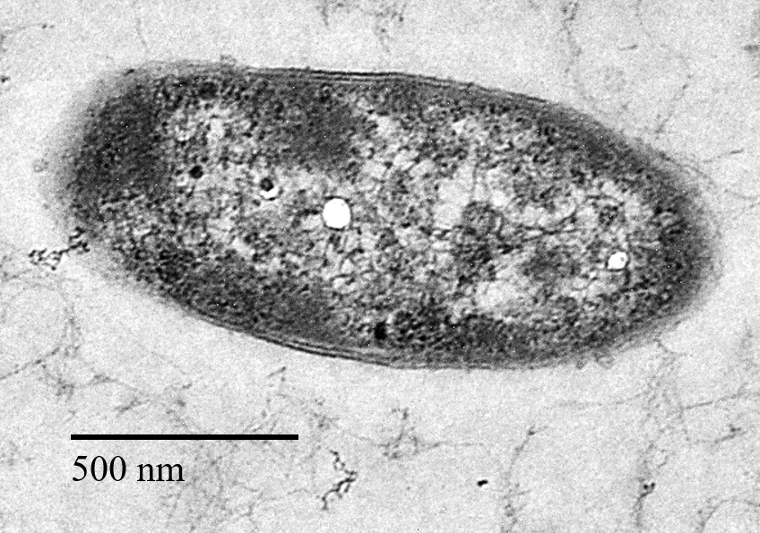
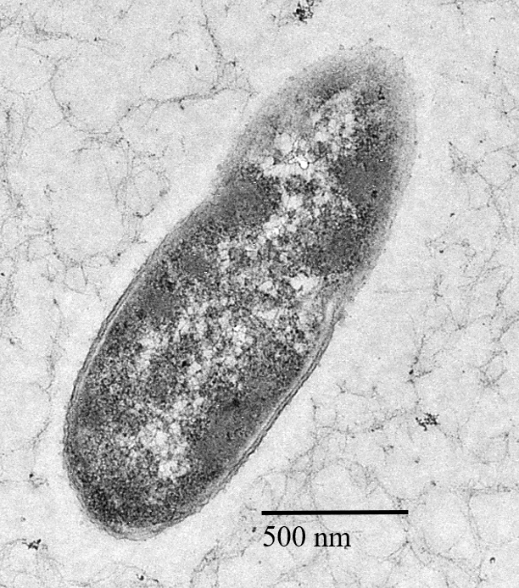
Figure 5: TEM images of Pseudomonas chlororaphis isolate from Honey Creek, Davis, OK, USA.
5000x magnification. Black bar indicates scale (500 nm).

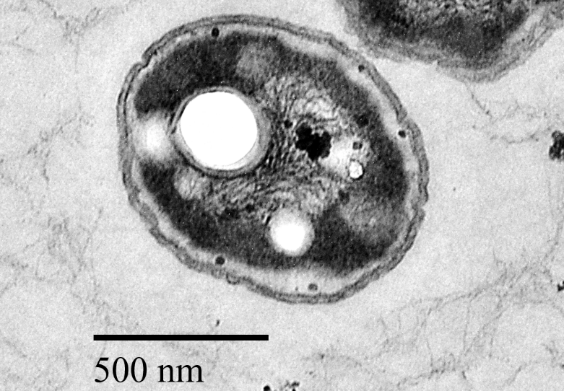
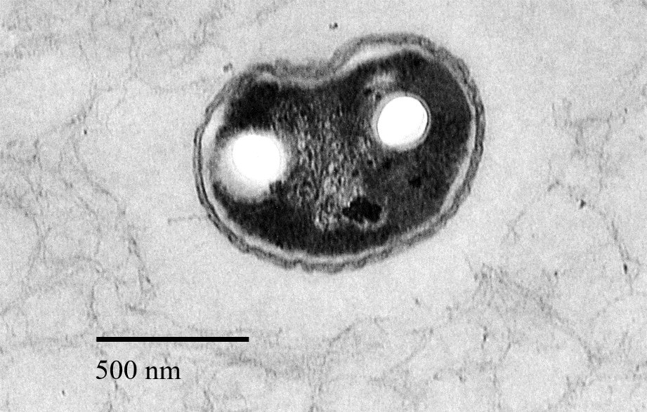

Figure 6: TEM images of Cupriavidus isolate from Honey Creek, Davis, OK, USA.
5000x magnification. Black bar indicates scale (500 nm).

500 nm
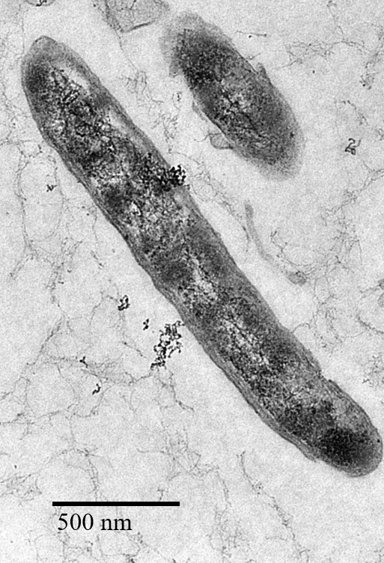
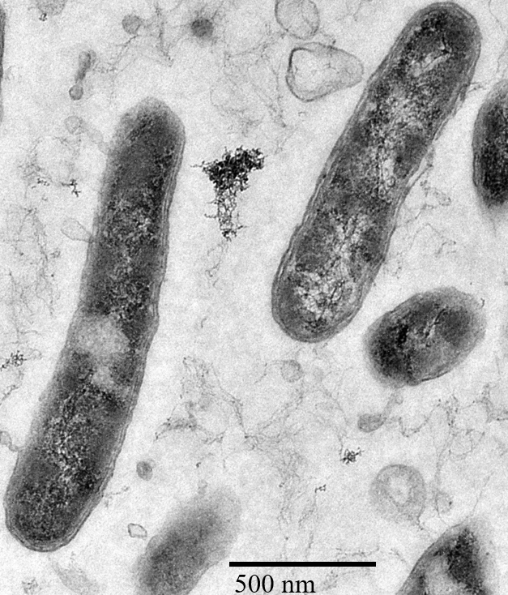
Figure 7: TEM images of Flavobacterium isolate from Honey Creek, Davis, OK, USA.
5000x magnification. Black bar indicates scale (500 nm).
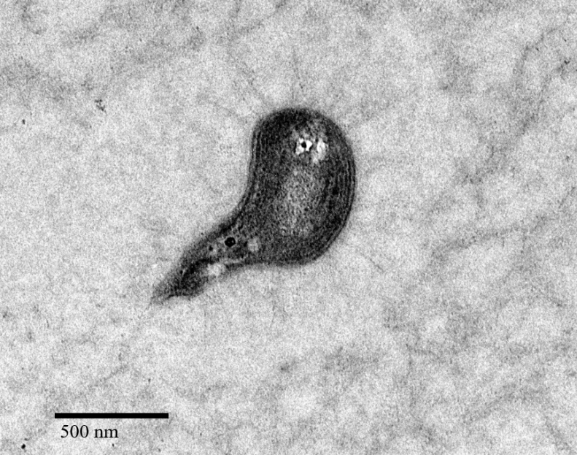
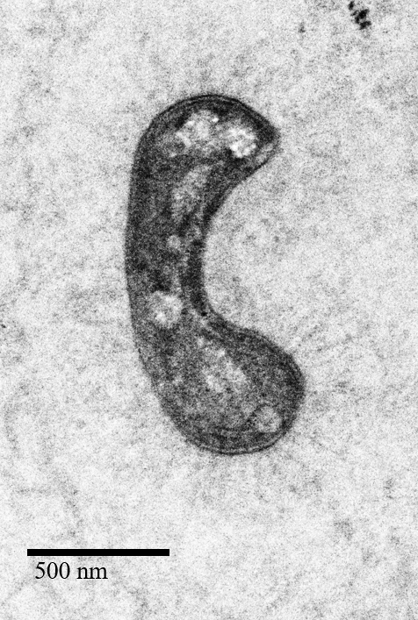
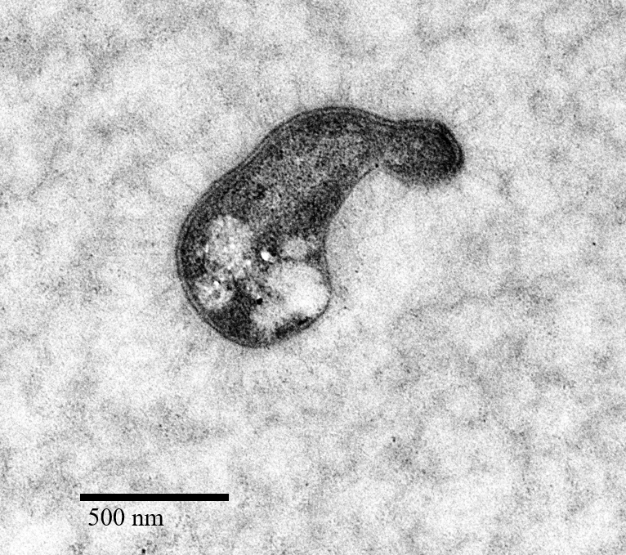

Figure 8: TEM images of Methylocystis sp. NLS7 from Norman landfill, OK, USA.
5000x magnification. Black bar indicates scale (500 nm).

Chapter 3: Co-culture Construction and Growth Comparisons
INTRODUCTION
The ability of methane oxidizing bacteria to transform methane into forms of carbon that are usable by heterotrophic organisms is an important step in the microbial food web. This is especially true in areas where methane is abundant and other forms of organic carbon are limited (Hanson and Hanson 1996) MOB presumably produce by-products of methane metabolism (ex: methanol, formaldehyde, polysaccharides, and nucleic acids) and these compounds can be consumed by heterotrophs or the heterotrophic bacteria can obtain carbon through grazing on MOB themselves (Iguchi et. al 2015). Methanotroph-heterotroph interactions in natural environments present an important knowledge gap in microbial ecology, and further study may prove useful in accurate global methane budget estimations (Conrad 2009).
For example, one study used stable isotope probing to reveal a unique ecosystem in Movile Cave, Romania which is sustained in large part by methanotrophic bacteria converting methane-derived carbon into complex organic compounds (Hutchens et. al 2004). The cave atmosphere is characterized by high (1-2%) methane concentrations, and stable carbon isotope ratios from the cave showed that a significant proportion of the CO₂ is likely derived from the oxidation of isotopically light CH₄ (Sarbu et. al 1996). A microbial mat sample from the cave was incubated with ¹³CH₄, and later DNA-SIP identified ¹³C in DNA sequences of non-methanotrophic bacteria, possibly due to cross-feeding on ¹³C-labelled biomass or organic compounds. These results suggest that carbon turnover due to aerobic methane oxidation may help sustain a diverse community of microorganisms in this environment.
DNA-SIP has been used in other studies to investigate carbon flow in methane rich environments. One study looked used ¹³CH₄ to identify species involved in cycling carbon from methane in a peat soil microcosm (Morris et. al 2002). They found labelled carbon in non-methanotrophic species of Bdellovibrio and Cytophaga, which may have resulted from carbon turnover due to predation. Another study found similar results in microcosms from acidic forest soil (pH 3-5) (Radajewski et. al 2002). The results of this study found ¹³C from labelled methane in DNA sequences from Nitrosomonas and Nitrosomonas species, which could be explained by close association and metabolite sharing between these organisms and MOB.
It has also been shown that heterotrophic species actually stimulate methane oxidation and growth of certain MOB in co-culture. One study showed that growth and methane oxidation were improved for Type I (gamma-proteobacterial) methanotrophs by co-culturing them with a rhizobial species that produced the vitamin cobalamin (Iguchi et. al 2011). It has also been proven that increased heterotroph richness can stimulate methanotrophic activity, suggesting that the community interactions in methane-rich environments can be very complex and involves multiple species working together to cycle methane through the ecosystem (Ho et. al 2014).
Previous literature describing carbon flow in methane rich environments as well as the studies showing improved methane oxidation as a result of added heterotrophic species in co-culture with methanotrophs led us to investigate the methanotrophic-heterotrophic interactions in our own isolates. In this study, we examine whether co-culturing methanotrophic Methylocystis species with each of the three heterotrophs provides an advantage to both species involved (symbiosis) or if the benefits are only one-sided (commensalism). To answer this question, co-cultures were constructed using Methylocystis strain (NLS7) isolated from a landfill in Norman, Oklahoma, USA, and three heterotrophic species isolated from methanotrophic consortia from a creek in Davis, Oklahoma: Pseudomonas chlororaphis, Flavobacterium sp. HC and Cupriavidus sp. HC. Methane-fed co-cultures were monitored for growth and methane oxidation and compared to a pure culture of Methylocystis sp. NLS7 to determine whether or not the heterotrophs in the co-cultures stimulated growth or methane oxidation for this methanotrophic species as described for other organisms (Iguchi et. al 2011) (Ho et al 2014). We expected that the heterotrophic species would grow in co-culture with methane as the only provided carbon source by predation on methanotroph biomass or utilizing by-products of methane oxidation such as polysaccharides, amino acids, or other organic compounds.
There is still much to learn about the nature of methanotrophic-heterotrophic community interactions: specifically, the benefits they provide to each organism, and how carbon and metabolites flow through the system. Association with MOB is clearly beneficial to heterotrophic species in methane-rich environments, as they are unable to utilize carbon from methane on their own (Hanson and Hanson 1996). Whether or not a given MOB will benefit from co-culturing with heterotrophic bacteria, and in which ways, presents a considerable knowledge gap in the understanding of these organisms. Constructed co-cultures are a useful means of addressing these knowledge gaps, as they provide controlled systems to monitor bacterial interactions in a more simplified way.

MATERIALS AND METHODS
Methane-fed co-cultures were constructed using Methylocystis sp. NLS7 and each of the three heterotrophic species. Methylocystis sp. NLS7 was grown for 5 days at 27ºC on NMS medium with 5% CH₄ and ambient oxygen in the headspace. Vitamin solution was omitted from the NMS medium for this experiment. Pseudomonas, Cupriavidus, and Flavobacterium were each grown overnight at 27ºC in NMS medium + 0.2% (w/v) peptones. Optical density was measured using a Spec20 D+ spectrophotometer. Cells from peptone-grown heterotrophic cultures were centrifuged at 8,000 x g and washed with sterile NMS medium. Then cells were diluted with sterile NMS medium to match the OD₆₀₀ of each of the heterotrophic cultures to that of Methylocystis sp. NLS7, so the cells could be combined 1:1 into co-cultures, inoculated at 10% of the volume of media (1 ml culture into 9 ml media). The following co-cultures were constructed in this way: Methylocystis sp. NLS7 + Cupriavidus, Methylocystis sp. NLS7 + Flavobacterium, and Methylocystis sp. NLS7 + Pseudomonas. In addition, a fifth mixed culture was created by combining Methylocystis sp. NLS7 with all three heterotrophic species (Methylocystis sp. NLS7 + Cupriavidus + Flavobacterium + Pseudomonas). Co-cultures were incubated in sealed serum tubes at 27ºC in NMS medium with ambient oxygen and 2% methane as the only added carbon source. After 5 days, co-cultures were transferred to fresh NMS medium, with a 10% inoculum (1 ml culture into 9 ml media), and again grown with 2% methane in the headspace. This second transfer was incubated to late log phase (OD₆₀₀ ~0.130) and then used as the inoculum for co-culture growth experiments and cell harvesting.
Methanotrophic-heterotrophic ratios were determined by dilution plating the co-cultures onto solid Nutrient Agar (1.5% agar) and comparing this to the total number of cells in each culture, counted with a hemocytometer. The rich nutrient agar medium selects for only the heterotrophic species in each co-culture. The number of methanotrophic cells in each co-culture was estimated as the total number of cells counted on the hemocytometer minus the number of heterotrophic cells quantified by dilution plating. For plating, 0.5 ml of co-culture was added to 4.5 ml sterile NMS, and then serially diluted to 10⁻⁵. Then 50 µl of the 10⁻², 10⁻³, 10⁻⁴, and 10⁻⁵ dilutions were plated in triplicate using a sterile glass spreader. Plates were incubated at 27ºC for 3 days and then colonies were counted. Total cell counts were determined by fixing the co-culture with 10% final concentration formalin and counting cells in 10 small squares (0.00025 mm³) of a hemocytometer at 100x magnification using phase contrast microscopy.
To evaluate the effects of co-culturing on growth and methane oxidation on the methanotrophic species, pure culture Methylocystis sp. NLS7 was grown in parallel to each of the co-cultures (NLS7 + Cupriavidus, NLS7 + Flavobacterium, NLS7 + Pseudomonas, and NLS7 + Cupriavidus + Flavobacterium + Pseudomonas). Cultures were grown (in triplicate) in a 10 ml volume in 28 ml serum tubes in NMS medium (no vitamin solution) at 27ºC with 10% methane and ambient oxygen in the headspace. Growth was measured as OD₆₀₀ over time, and methane oxidation was measured as headspace methane depletion over time using gas chromatography.
In addition, a 2% inoculum of pure Methylocystis sp. NLS7 and each co-culture were grown in 50 ml of NMS medium in 160 ml serum bottles as described above. The larger volume of cells was required to harvest cells for RNA extraction and transcriptome sequencing. After 5 days cultures were in late log phase, determined by GC methane depletion data. Bottles were opened, and cells were harvested by centrifugation in a swinging bucket centrifuge at 4ºC, at 4000 x g for 10 minutes. The supernatant was decanted using a 50 ml plastic pipette, and the remaining pellets were stored at 80ºC. Pure cultures of Cupriavidus, Flavobacterium, and Pseudomonas isolates were also grown in NMS medium + 0.2% (w/v) peptones (Difco) as a control condition, and cells were harvested by centrifugation as described above in mid-log phase (approx. OD₆₀₀ ~0.100) . This condition was to serve as a control for later transcriptome analysis of heterotrophic species in pure culture grown on peptone media compared to co-culture conditions with methane at the carbon source.
RNA extraction was performed on pelleted cells using the Zymo Fungal/Bacterial RNA miniprep kit (ZYMO research, California, USA) according to manufacturer’s instructions. RNA extracts were then stored at 80ºC for later transcriptome sequencing.

RESULTS
Dilution spread plating was used to quantify the heterotrophs (Table 6) and determine the ratio of each type of organism within the methanotrophic-heterotrophic co-cultures at late log phase (OD₆₀₀ ~0.130 for each culture) right before inoculation into growth experiment tubes and bottles. All co-cultures produced visible colonies on Nutrient agar after 3 days, and plates at 10⁻³ dilution were within the countable range (30-300). For each co-culture, only one colony type appeared on the spread plates, as methanotroph cells were inhibited by the rich medium. Colony forming units (CFU) were counted and averaged for each of the triplicate plates, and then multiplied by the dilution factor to calculate CFU/ 50 µl (volume of cell culture plated). This number was multiplied by 20 to calculate CFU/ml of heterotrophic cells in each co-culture. Cell counts ranged from 2.08 x 10⁶ – 4.34 x 10^{6.}. Cupriavidus sp. HC was present in its co-culture at almost double the amount of the other heterotrophs in each respective co-culture.
Cell counts were used to calculate total amount of cells per culture. In each co-culture, the methanotrophic species Methylocystis sp. NLS7 outnumbered the live cell counts of heterotrophs by a factor of 10. Methylocystis sp. NLS7 + Cupriavidus sp. HC had the lowest methanotroph-heterotroph ratio of 12.1:1, followed by 18.2:1 for the Pseudomonas sp. HC co-culture, and then 24:1 for the Flavobacterium sp. HC co-culture. (Table 8)
Comparison between starting numbers of heterotroph cells within the initial inoculum to observed heterotroph cell numbers in log phase (OD₆₀₀ ~0.9) shows that in each co-culture the heterotroph grew exponentially when cultured with Methylocystis sp. NLS7 on methane. (Table 7). Calculations were done to determine the number of cells that would be expected in each co-culture if the heterotroph were simply being diluted with each passage of the co-culture and not actually doubling within the culture. In each co-culture, observed heterotroph cell numbers increased approximately 100-fold compared to the number of cells in the initial inoculum.
Growth over time for Methylocystis sp. NLS7 was unaffected by the addition of heterotrophic species (Figure 3). After 5 days, the co-cultures did not show any significantly different trends in optical density compared to the pure culture control. All conditions demonstrated similar rates of growth over time and finished growing at approximately the same OD₆₀₀.
The addition of heterotrophic species also does not produce a significant effect on methane oxidation in Methylocystis sp. NLS7. Figure 4 shows that all five conditions oxidized approximately the same amount of methane in 4 days, with no significant variation in trend.

Table 6: Quantification of heterotrophic organisms in methane-fed co-cultures by dilution plating
Culture | Average CFU of Heterotroph | Dilution | AVG  CFU/ 50 µl | AVG  CFU/ml +/- st. dev.
NLS7 + Cupriavidus | 217 ± 15 | 10⁻³ | 2.17 x 10⁵ | (4.34 ± 0.30) x 10⁶
NLS7 + Flavobacterium | 104 ± 10 | 10⁻³ | 1.04 x 10⁵ | (2.08 ± 0.20) x 10⁶
NLS7 + Pseudomonas | 123 ± 2 | 10⁻³ | 1.23 x 10⁵ | (2.45 ± 0.04) x 10⁶

Table 7: Comparison of starting and ending heterotroph cell quantities in co-culture with Methylocystis sp. NLS7
Culture | Initial Conc. of heterotroph  (CFU/ml) | Dilution  (1st transfer) | Dilution  (2nd transfer) | Starting # of heterotroph cells in co-culture  (CFU/ml) | Detected # of heterotroph cells in co-culture  (CFU/ml)
NLS7 +  Cupriavidus | 2.70 x 10⁶ | 10X | 10X | 2.70 x 10⁴ | 4.34 x 10⁶
NLS7 + Flavobacterium | 2.82 x 10⁶ | 10X | 10X | 2.82 x 10⁴ | 2.08 x 10⁶
NLS7 +  Pseudomonas | 2.77 x 10⁶ | 10X | 10X | 2.77 x 10⁴ | 2.45 x 10⁶

Table 8: Cell ratios of Methylocystis sp. NLS7 to heterotrophic species
in methane-fed co-cultures
Culture | OD₆₀₀ | Total Number of Cells/ml | CFU/ml of Heterotrophic species | Methanotroph: Heterotroph cell ratio
NLS7 | 0.081 | 4.5 x 10⁷ | - | -
NLS7 + Cupriavidus | 0.101 | 5.7 x 10⁷ | 4.34 x 10⁶ | 12.1 : 1
NLS7 + Flavobacterium | 0.092 | 5.2 x 10⁷ | 2.08 x 10⁶ | 24 : 1
NLS7 + Pseudomonas | 0.084 | 4.7 x 10⁷ | 2.45 x 10⁶ | 18.2 :1

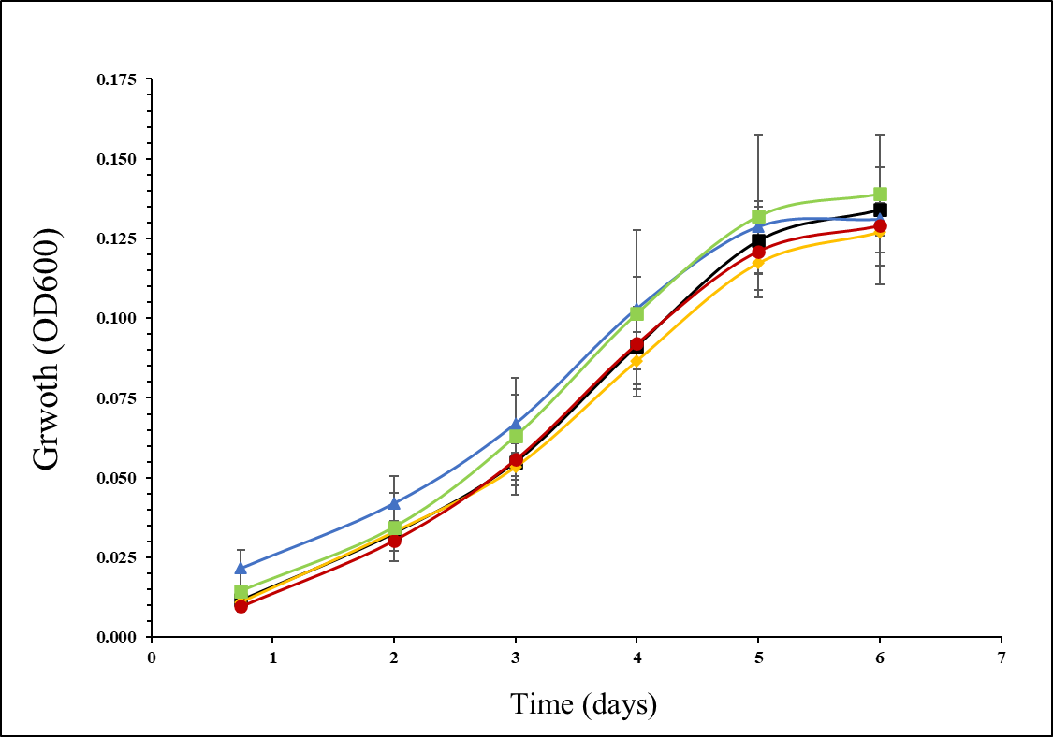

Figure 9: Growth over time (measured as OD₆₀₀) for pure Methylocystis sp. NLS7 (shown in black -■-) compared to methane-fed co-cultures: NLS7 + Cupriavidus (blue -▲-), NLS7 + Flavobacterium (orange -♦-), NLS7 + Pseudomonas (red -●-), and NLS7 + Cupriavidus + Flavobacterium + Pseudomonas (green -■-). Data points represent the average of 3 biological replicates and error bars represent the standard deviation at each point.

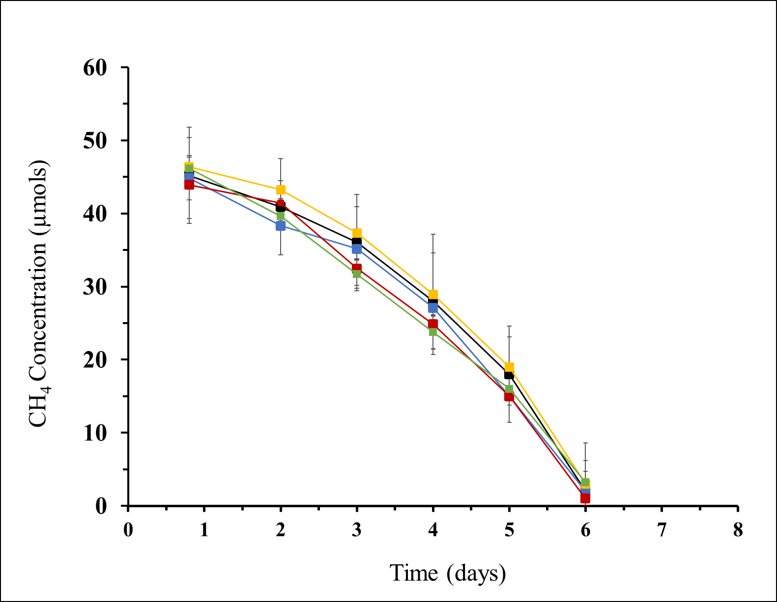
Figure 10: Methane levels over time (measured as OD₆₀₀) for pure Methylocystis sp. NLS7 (shown in black -■-) compared to methane-fed co-cultures: NLS7 + Cupriavidus (blue -▲-), NLS7 + Flavobacterium (orange -♦-), NLS7 + Pseudomonas (red -●-), and NLS7 + Cupriavidus + Flavobacterium + Pseudomonas (green -■-). Data points represent the average of 3 biological replicates and error bars represent the standard deviation at each point.

DISCUSSION
This study presents three main goals: the isolation and characterization of bacterial species from methane-fed enrichments; sample preparation and TEM visualization of isolates obtained from methane enrichments; and evaluating the nature of the interactions in methanotrophic-heterotrophic co-cultures constructed from our isolates. Isolating novel species of methane oxidizing bacteria and associated heterotrophs allows us to expand our understanding of the organisms involved, where they can be found, and how they behave in their local environments. Research from the past two decades has vastly changed our understanding of methanotrophy, with the addition of new phyla capable of oxidizing methane (Dunfield et. al 2007), new pathways of carbon assimilation (Rasigraf et. al 2014), and novel metabolic capabilities (Dedysh et. al 2005) (Vorobev et. al 2014). We sampled natural Oklahoma environments (the Norman, OK landfill and Honey Creek sediment) and enriched them with methane for MOB. The novel species Methylocystis sp. NLS7 was isolated from the Norman landfill, and future work involves characterizing this organism as a new member of the genus. Honey Creek enrichments produced three heterotrophic strains, of which two of them (Flavobacterium sp. HC and Cupriavidus sp. HC) are likely novel species within each respective genus. Isolation of heterotroph species from methane-rich enrichments led us to question the nature of their relationship with methanotrophic species in co-culture and how it relates to the microbial interactions within the natural ecosystem.
TEM imagine of the isolates in this study provided insight into the internal structures and morphology of the isolates. Given that methanotroph species have long been described in terms of their intracytoplasmic membrane structures, we expected to see concentric membranes along the perimeter of Methylocystis sp. NLS7 (Hanson and Hanson, 1996). Images of this isolate confirmed these expectations, and the characteristic membranes are visible for this isolate.
In addition, certain cells exhibit bright inclusion bodies under transmission electron microscopy, due to the accumulation of polyhydroxyalkanoates (PHAs) (Zhang et. al 2019) (Dennis et. al 2008). These bodies are carbon storage that is accumulated when carbon is readily available, but some other nutrient is limiting. TEM images of Cupriavidus sp. HC revealed bright circles within the structure of the cells that are likely PHA inclusion bodies. Concerns about these being holes in the thin sections or artifacts of the sample preparation can be addressed by the fact that the bright circles occur only within the cell bodies, while the cell membrane remains intact. If these were in fact artifacts of sample preparation, it is likely the cells would have appeared ragged or torn. In addition, no tears or artifacts are visible in the background of the images, meaning that the unique structures are associated with the cytoplasm of the cells.
In this study, we investigated whether or not Methylocystis sp. NLS7 gains any benefit from the co-culture condition with either Flavobacterium, Cupriavidus, Pseudomonas, or all three together. It was expected that the addition of heterotrophic species might stimulate growth and/or methane oxidation for the methanotrophic species, as previous works have described (Iguchi et. al 2011) (Ho et. al 2014); however, our results do not support this hypothesis. This study did not reveal any beneficial effects for Methylocystis sp. NLS7 when co-culturing with these heterotrophic species. Methane depletion and growth over time were not significantly different for the co-cultures, compared to the pure culture of NLS7.
Cell count data shows that the heterotroph did in fact grow in the methane-fed co-culture (Table 7). Initial inoculum cell counts of the heterotroph in each co-culture were calculated, based on the assumption that if the heterotrophs were not growing in co-culture, they would simply be diluted at the rate that the cultures were passaged into fresh media. Observed cell counts from spread plating the co-cultures on rich nutrient agar revealed that the numbers far exceeded what would be expected if the heterotroph was not doubling in the co-culture. In each co-culture, heterotroph numbers represented about a 100-fold increase from the initial inoculum of heterotrophic cells. Based on this data we must conclude that the methanotrophic-heterotrophic relationship in question is commensal, benefitting only the heterotrophic species, rather than symbiotic. Future work will aim to identify a carbon and energy source for the heterotrophs in these methane-fed co-cultures, where there was not an obvious source of usable organic carbon available for heterotrophic organisms.
The lack of observed stimulation for Methylocystis sp. NLS7 in this study presents several opportunities for further inquiry. The first of these is to test the effect of co-culturing other methanotrophic species with this set of heterotrophic co-species to evaluate if the observed trend is unique to Methylocystis sp. NLS7. Other works have reported that the stimulatory effects of co-culturing methanotrophic species with heterotrophs may be restricted to the type I (or gamma-proteobacterial) methanotrophs (Iguchi et. al 2011), because Methylomonas and Methylovulum species tested in co-culture demonstrated improved methane oxidation and growth over time. The genus Methylocystis belongs to the type II (or alpha-proteobacterial) methanotrophs, which may explain the lack of stimulating effect in this study. If there is a potential relationship based on vitamin synthesis like the results of this previous study, it is possible that Methylocystis sp. NLS7 already produces a sufficient quantity of vitamins required. Future work will test the effects of each of the three heterotrophic isolates on a Methylomonas isolate in co-culture, and it is possible that different growth and methane oxidation trends will result.
In addition, this experiment was performed at 20% O₂ in the headspace, to replicate ambient oxygen in a natural surface environment. However, other studies have reported that lower oxygen concentrations (as low as 3-5%) may provide additional insight into the methanotrophic-heterotrophic relationships that might exist in natural microaerophilic environments, where methanotrophs are often found (Hršak and Begonia 2000).
Finally, future work will utilize transcriptomic analysis to evaluate the effect of co-culturing on gene transcription within each species. Information about differentially transcribed genes in co-culture compared to pure culture data can give deeper insight into key interactions within methanotrophic mixed cultures. For example, a comparison of reads from heterotrophs grown in methanotrophic co-cultures to that of heterotrophs grown in peptone media may reveal the carbon source used by these organisms within the methane-fed co-cultures. If the heterotrophs are growing on methanol produced as a by-product of methane oxidation, then we could expect to see increased expression of alcohol dehydrogenases in the transcriptome of heterotrophs grown in co-culture. Other potential carbon sources include formate, amino acids, or polysaccharides excreted by the MOB.
Transcriptomic analysis is also useful for understanding how MOB respond to heterotrophs in co-culture. Although we did not observe any significant stimulation in growth or methane oxidation as a result of adding in the heterotrophic organisms, there is still much to learn about how MOB interact with surrounding species in co-culture and in natural ecosystems. Several mechanisms have been proposed to explain why it might be beneficial for MOB to associate with local taxa. One hypothesis is that heterotrophic organisms can benefit MOB by preventing methanol accumulation in methane rich environments, as methanol has been shown to inhibit methane oxidation in certain methanotrophic species (Wilkinson et. al 1974). In this case, pure culture MOB would potentially increase transcription of genes associated with stress management, induced by methanol toxicity, compared to co-cultures which might mitigate this stress. Additionally, it has been shown that heterotrophs can synthesize useful vitamins for MOB in co-culture (Iguchi et. al 2011). In this case, genes linked to vitamin metabolism would be upregulated in co-cultures compared to pure culture MOB.
This study builds on a wealth of previous knowledge about community interactions within methane oxidizing bacterial communities, yet many questions remain to be answered. Although we did not see any obvious effects of co-culturing Methylocystis sp. NLS7 with these heterotrophic species, there is still opportunity to learn from this study and expand it towards future work in the area. MOB are a diverse set of organisms, found in a wide range of environments across the globe. Learning about methane oxidizing bacteria and how they interact with other species in their natural environments provides necessary insight into the larger spheres of microbial ecology and global methane cycling. A critical implication of this area of study is that accurate methane flux estimates are important to climate change research. Many discoveries remain to be made regarding the diversity and capabilities of methane oxidizing bacteria, and how they interact with natural environments to drive carbon flow through ecosystems.

REFERENCES
Cold Spring Harbor Protocols. LB (Luria-Bertani) liquid medium. Cold Spring Harb Protoc. 2006;2006(1):pdb.rec8141. doi: 10.1101/pdb.rec8141.
Conrad, R. 2009. The global methane cycle: recent advances in understanding the microbial processes involved. Environ. Microbiol. Rep. 1, 285–292. doi: 10.1111/j.1758-2229.2009.00038.x
Dedysh, S.N., Knief, C., and Dunfield, P.F. 2005. Methylocella species are facultatively methanotrophic. J Bacteriol 187: 4665–4670.
Dennis D, Sein V, Martinez E, Augustine B. 2008. PhaP Is Involved in the Formation of a Network on the Surface of Polyhydroxyalkanoate Inclusions in Cupriavidus necator H16. JB 190:555–563.
Dunfield, P.F., Yuryev, A., Senin, P., Smirnova, A.V., Stott, M.B., Hou, S.B., et al. 2007. Methane oxidation by an extremely acidophilic bacterium of the phylum Verrucomicrobia. Nature 450: 879–882.
Felsenstein J. (1985). Confidence limits on phylogenies: An approach using the bootstrap. Evolution 39:783-791.
Hanson R.S., and Hanson T.E. 1996. Methanotrophic bacteria. Microbiol Rev 60: 439–471.
Ho A, de Roy K, Thas O, De Neve J, Hoefman S, Vandamme P, Heylen K, Boon N. 2014. The more, the merrier: heterotroph richness stimulates methanotrophic activity. ISME J 8:1945–1948.
Hršak D, Begonja A. 2000. Possible Interactions within a Methanotrophic-Heterotrophic Groundwater Community Able to Transform Linear Alkylbenzenesulfonates. Appl Environ Microbiol 66:4433–4439.
Hutchens E, Radajewski S, Dumont MG, McDonald IR, Murrell JC. 2004. Analysis of methanotrophic bacteria in Movile Cave by stable isotope probing. Environmental Microbiology 6:111–120.
Iguchi H, Yurimoto H, Sakai Y. 2011. Stimulation of Methanotrophic Growth in Cocultures by Cobalamin Excreted by Rhizobia. Appl Environ Microbiol 77:8509–8515.
Iguchi H, Yurimoto H, Sakai Y. 2015. Interactions of Methylotrophs with Plants and Other Heterotrophic Bacteria. Microorganisms 3:137–151.
Khmelenina V.N., Colin Murrell J., Smith T.J., Trotsenko Y.A. (2018) Physiology and Biochemistry of the Aerobic Methanotrophs. In: Rojo F. (eds) Aerobic Utilization of Hydrocarbons, Oils and Lipids. Handbook of Hydrocarbon and Lipid Microbiology. Springer, Cham. https://doi.org/10.1007/978-3-319-39782-5_4-1
Knief C. 2015. Diversity and Habitat Preferences of Cultivated and Uncultivated Aerobic Methanotrophic Bacteria Evaluated Based on pmoA as Molecular Marker. Front Microbiol 6.
Kolb S, Knief C, Dunfield PF, Conrad R. 2005. Abundance and activity of uncultured methanotrophic bacteria involved in the consumption of atmospheric methane in two forest soils. Environmental Microbiology 7:1150–1161.
Konstantinidis KT, Tiedje JM. 2005. Genomic insights that advance the species definition for prokaryotes. Proc Natl Acad Sci U S A 102:2567–2572.
Kumar S., Stecher G., and Tamura K. (2016). MEGA7: Molecular Evolutionary Genetics Analysis version 7.0 for bigger datasets.Molecular Biology and Evolution 33:1870-1874.
Kwon M, Ho A, Yoon S. 2019. Novel approaches and reasons to isolate methanotrophic bacteria with biotechnological potentials: recent achievements and perspectives. Appl Microbiol Biotechnol 103:1–8.
Lösekann T, Knittel K, Nadalig T, Fuchs B, Niemann H, Boetius A, Amann R. 2007. Diversity and Abundance of Aerobic and Anaerobic Methane Oxidizers at the Haakon Mosby Mud Volcano, Barents Sea. Appl Environ Microbiol 73:3348–3362.
Matias VRF, Al-Amoudi A, Dubochet J, Beveridge TJ. 2003. Cryo-Transmission Electron Microscopy of Frozen-Hydrated Sections of Escherichia coli and Pseudomonas aeruginosa. JB 185:6112–6118.
Morris, S.A., Radajewski, S., Willison, T.W., and Murrell, J.C. 2002. Identification of the functionally active methanotroph population in a peat soil microcosm by stable-isotope probing. Appl Environ Microbiol 68: 1446–1453.
Mravec F, Obruca S, Krzyzanek V, Sedlacek P, Hrubanova K, Samek O, Kucera D, Benesova P, Nebesarova J. 2016. Accumulation of PHA granules in Cupriavidus necator as seen by confocal fluorescence microscopy. FEMS Microbiology Letters 363:fnw094.
Murase J, Frenzel P. 2007. A methane-driven microbial food web in a wetland rice soil. Environ Microbiol 9:3025–3034.
Niederman R.A. 2006. Structure, Function and Formation of Bacterial Intracytoplasmic Membranes. In: Shively J.M. (eds) Complex Intracellular Structures in Prokaryotes. Microbiology Monographs, vol 2. Springer, Berlin, Heidelberg. https://doi.org/10.1007/7171_025
Oshkin IY, Beck DA, Lamb AE, Tchesnokova V, Benuska G, McTaggart TL, Kalyuzhnaya MG, Dedysh SN, Lidstrom ME, Chistoserdova L. 2015. Methane-fed microbial microcosms show differential community dynamics and pinpoint taxa involved in communal response. ISME J 9:1119–1129.
Radajewski, S., Webster, G., Reay, D.S., Morris, S.A., Ineson, P., Nedwell, D.B., et al. (2002) Identification of active methylotroph populations in an acidic forest soil by stableisotope probing. Microbiol 148: 2331–2342.
Rasigraf O, Kool DM, Jetten MSM, Sinninghe Damsté JS, Ettwig KF. 2014. Autotrophic Carbon Dioxide Fixation via the Calvin-Benson-Bassham Cycle by the Denitrifying Methanotroph “Candidatus Methylomirabilis oxyfera.” Appl Environ Microbiol 80:2451–2460.
Rosenblum B. 1997. New dye-labeled terminators for improved DNA sequencing patterns. Nucleic Acids Research 25:4500–4504.
Saitou N. and Nei M. (1987). The neighbor-joining method: A new method for reconstructing phylogenetic trees. Molecular Biology and Evolution 4:406-425.
Sarbu, S.M., Kane, T.C., and Kinkle, B.K. 1996. A chemoautotrophically based cave ecosystem. Science 272: 1953–1955.
Tamura K., Nei M., and Kumar S. (2004). Prospects for inferring very large phylogenies by using the neighbor-joining method. Proceedings of the National Academy of Sciences (USA) 101:11030-11035.
Trotsenko, Y.A., and Murrell, J.C. 2008. Metabolic aspects of aerobic obligate methanotrophy. Adv Appl Microbiol 63: 183–229.
van der Ha D, Vanwonterghem I, Hoefman S, De Vos P, Boon N. 2013. Selection of associated heterotrophs by methane-oxidizing bacteria at different copper concentrations. Antonie van Leeuwenhoek 103:527–537.
Vorobev A, Jagadevan S, Jain S, Anantharaman K, Dick GJ, Vuilleumier S, Semrau JD. 2014. Genomic and Transcriptomic Analyses of the Facultative Methanotroph Methylocystis sp. Strain SB2 Grown on Methane or Ethanol. Appl Environ Microbiol 80:3044–3052.
Vorobev A.V., Baani M., Doronina N.V., Brady A.L., Liesack W., Dunfield P.F., and Dedysh S.N. 2011. Methyloferula stellata gen. nov., sp. nov., an acidophilic, obligately methanotrophic bacterium that possesses only a soluble methane monooxygenase. Int J Syst Evol Microbiol 61: 2456–2463.
Wartiainen I. 2006. Methylobacter tundripaludum sp. nov., a methane-oxidizing bacterium from Arctic wetland soil on the Svalbard islands, Norway (78 N). International journal of systematic and evolutionary microbiology 56:109–113.
Whittenbury, R., Phillips, K.C., and Wilkinson, J.F. 1970. Enrichment, Isolation and Some Properties of Methane-Utilizing Bacteria. Journal of General Microbiology 61, 205-218.
Wilkinson TG, Topiwala HH, Hamer G. 1974. Interactions in a mixed bacterial population growing on methane in continuous culture. Biotechnology and Bioengineering 16:41–59.
Zhang, T., Zhou, J., Wang, X., & Zhang, Y. 2019. Poly-β-hydroxybutyrate Production by Methylosinus trichosporium OB3b at Different Gas-phase Conditions. Iranian journal of biotechnology, 17(1), e1866. https://doi.org/10.21859/ijb.1866.

